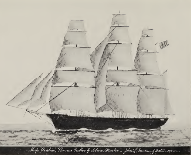Jackson's Boston Brahmin ancestors traded opium (on the ship “Eclipse” – one of 28 ships owned) for the British East India Company with their partner banker [George Peabody](https://en.wikipedia.org/wiki/George_Peabody), benefactor of the J.P. Morgan and darling of Queen Victoria.

Jackson’s Boston Brahmin ancestors include the founding editor of the Council on Foreign Relations (CFR) magazine *Foreign Affairs*, also ran State Street Bank in Boston, Mass. Hospital Insurance Company, owned *all* property in Salem, attended the League of Nations, co-founded of the Council on Foreign Relations, conspired with Cecil Rhodes in the first Boer War, conspired with Joseph Choate (Harvard roommate) (British Pilgrims Society formation), Y.M.C.A. conspiracy surrounding the Institute of Pacific Relations, conspired with the British Bolsheviks Lenin’s Soviet Union, Provident, conspired with AT&T, Western Union, Bell Telephone on Marconi Wireless takeover, Edison Electric, various insurance and manufacturing companies

Ship Arabia, owned by Jackson ancestor [John Lowell Gardner PDF p. 174](https://www.fbcoverup.com/docs/library/1933-GARDNER-MEMORIAL-Bio-and-Geneol-Recrd-of-Descendants-of-THOMAS-GARDNER-PLANTER-Cape-Ann-1624-Salem-(Naumkeag)-(1626-74)-by-Frank-A-Garner-1933.pdf#page=174)

<https://househistree.com/people/john-lowell-gardner-1804-1884>

Owned and operated these ships in trade with Russia and the British East India Company. Including co-owned ships with George Peabody, Queen Victoria’s favorite American robber baron, Rothschild business partner, and banking benefactor to Junius and J.P. Morgan :

Peabody took on [Junius Spencer Morgan](https://en.wikipedia.org/wiki/Junius_Spencer_Morgan) as a partner in 1854 and their joint business would go on to become [J.P. Morgan & Co.](https://en.wikipedia.org/wiki/J.P._Morgan_%26_Co.) after Peabody's 1864 retirement. On July 10, 1862, he was made a [Freeman](https://en.wikipedia.org/wiki/Freedom_of_the_City#Freedom_of_the_City_of_London) of the [City of London](https://en.wikipedia.org/wiki/City_of_London),

[PDF p. 174](https://www.fbcoverup.com/docs/library/1933-GARDNER-MEMORIAL-Bio-and-Geneol-Recrd-of-Descendants-of-THOMAS-GARDNER-PLANTER-Cape-Ann-1624-Salem-(Naumkeag)-(1626-74)-by-Frank-A-Garner-1933.pdf#page=174)

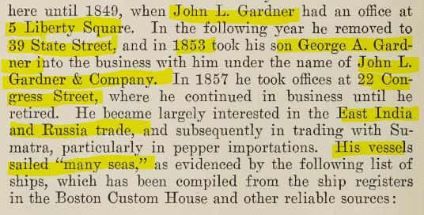

1. Arabia 1863 [PDF, p. 177](https://www.fbcoverup.com/docs/library/1933-GARDNER-MEMORIAL-Bio-and-Geneol-Recrd-of-Descendants-of-THOMAS-GARDNER-PLANTER-Cape-Ann-1624-Salem-(Naumkeag)-(1626-74)-by-Frank-A-Garner-1933.pdf#page=177)
2. Bunker Hill
3. California
4. Democrat
5. Duxbury
6. Eclipse (incl. opium) [PDF p. 177](https://www.fbcoverup.com/docs/library/1933-GARDNER-MEMORIAL-Bio-and-Geneol-Recrd-of-Descendants-of-THOMAS-GARDNER-PLANTER-Cape-Ann-1624-Salem-(Naumkeag)-(1626-74)-by-Frank-A-Garner-1933.pdf#page=177)  
   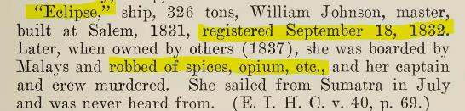
7. Gentleman
8. Grotius
9. Leonore
10. Lepanto
11. Lotos with Joseph and George Peabody  
    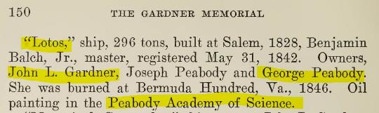
12. Marquis de Somerulas
13. Mars (steamship)
14. Monterey
15. Nabob
16. Napke
17. Naples with Joseph and George Peabody  
    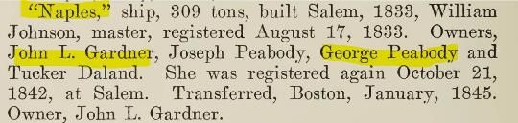
18. Pallas with Joseph and George Peabody  
    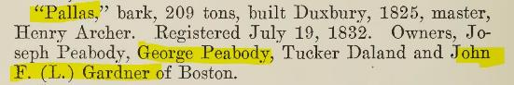
19. Pioneer
20. Plate
21. Ruble
22. Sappaho
23. Shawmut
24. St. Paul
25. Ruble
26. Sumatra
27. Thetis
28. Unicorn

Owned [Boston & Roxbury Mill Corporation](https://www.masshist.org/collection-guides/view/fa0342)

[PDF p. 182](https://www.fbcoverup.com/docs/library/1933-GARDNER-MEMORIAL-Bio-and-Geneol-Recrd-of-Descendants-of-THOMAS-GARDNER-PLANTER-Cape-Ann-1624-Salem-(Naumkeag)-(1626-74)-by-Frank-A-Garner-1933.pdf#page=182)

# John Lowell Gardner (1804-1884)

John Lowell Gardner, of Gardner & Lowell, Boston_in2 images

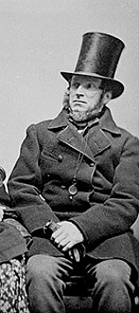

**Father**

[Samuel Pickering Gardner (1767-1843)](https://househistree.com/people/samuel-pickering-gardner-1767-1843)

**Mother**

[Rebecca Russell Lowell (1779-1853)](https://househistree.com/people/rebecca-russell-lowell-1779-1853)

**Spouse**

[Catherine (Peabody) Gardner (1808-1883)](https://househistree.com/people/catherine-endicott-peabody-1808-1883)

**Children**

[Joseph Peabody Gardner (1828-1875)](https://househistree.com/people/joseph-peabody-gardner-1828-1875)  
[George Augustus Gardner (1829-1916)](https://househistree.com/people/george-augustus-gardner-1829-1916)  
[John Lowell Gardner II (1837-1898)](https://househistree.com/people/john-lowell-gardner-ii-1837-1898)  
[Julia (Gardner) Coolidge (1841-1921)](https://househistree.com/people/julia-gardner-1841-1921)  
[Eliza (Gardner) Skinner (1846-1898)](https://househistree.com/people/eliza-blanchard-gardner-1846-1898)

Born in Boston, he graduated from Harvard and became a merchant in the firm of Gardner & Lowell. His business mainly concerned shipping and commerce in the East Indies and Russia, and to a lesser extent Sumatra from where he imported pepper. In later life, he became a shrewd property magnate in Boston and Brookline. He had houses in Salem, Boston, Brookline, and Maine. His principal residence in Boston was on Beacon Street next to the old Somerset Club on the corner Somerset and Beacon Streets (see images). He was known as the last of the East India merchants and left a fortune of $5 million. In 1826, he married Catherine Peabody and they had five children. Among others, he was the father-in-law of the arts patron [Isabella Stewart Gardner](https://househistree.com/people/isabella-stewart-1840-1924).

## Categories

[Boston Brahmin](https://househistree.com/search?q=&refinementList%5Bperson_categories%5D%5B0%5D=Boston%20Brahmin)       [Business Tycoons](https://househistree.com/search?q=&refinementList%5Bperson_categories%5D%5B0%5D=Business%20Tycoons)        [Gilded Age](https://househistree.com/search?q=&refinementList%5Bperson_categories%5D%5B0%5D=Gilded%20Age)           [Property Magnates](https://househistree.com/search?q=&refinementList%5Bperson_categories%5D%5B0%5D=Property%20Magnates)

John L. Gardner and his brother, George Gardner, inherited from their grandmother, Elizabeth Pickering Gardner, widow of John Gardner, sixth generation, No. 36, “all of the real estate in the town of Salem, consisting of about one hundred and eleven acres of pasture situated in the westerly part of said town of Salem

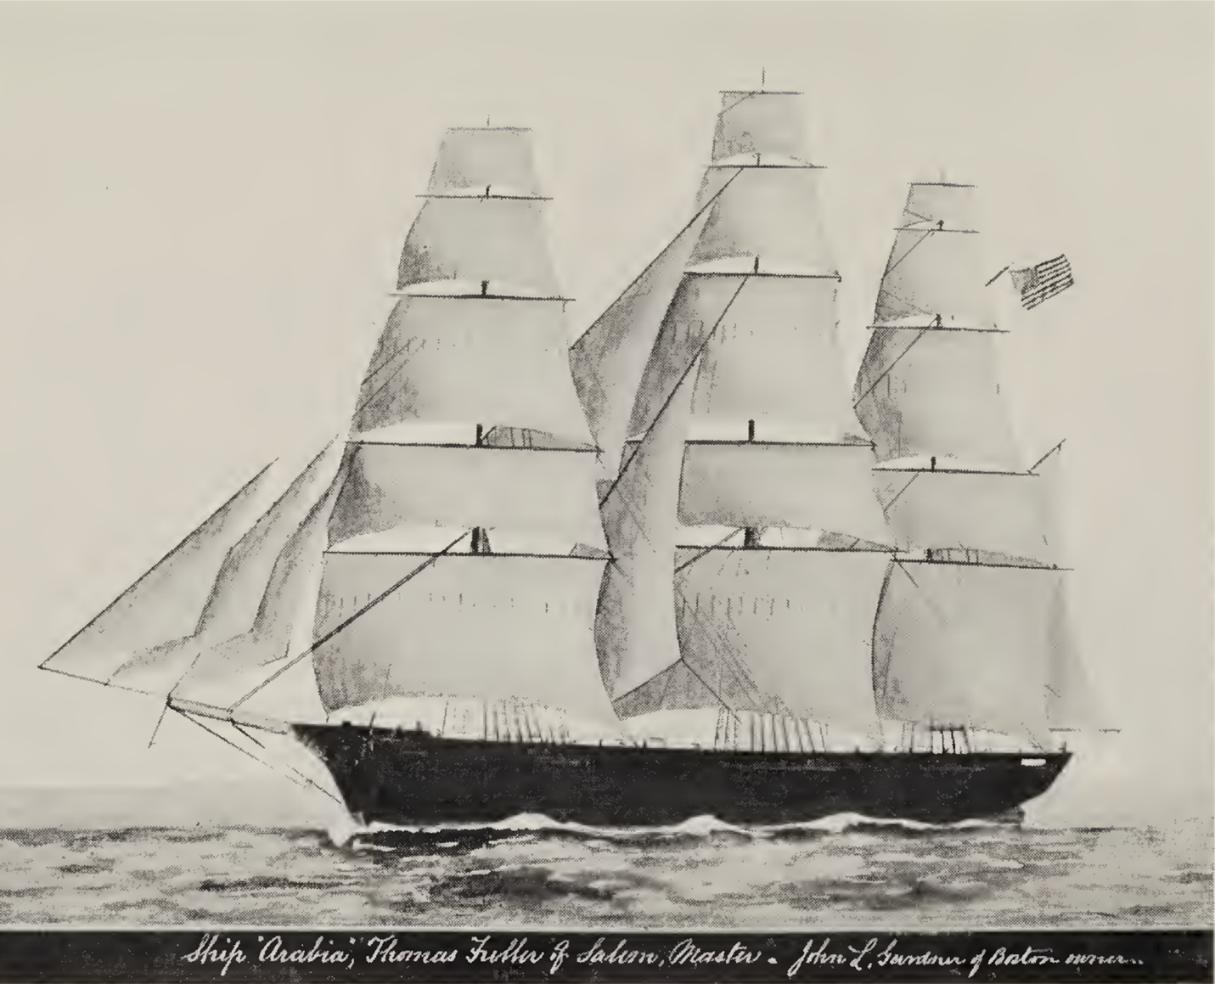

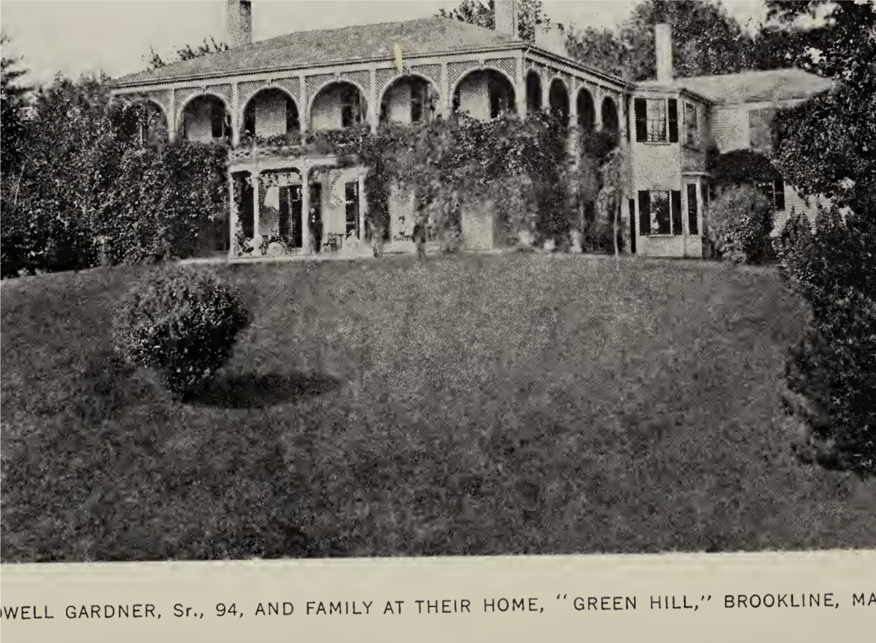

Married a Peabody,

[Catherine E. Peabody](https://familypedia.fandom.com/wiki/Catherine_Elizabeth_Peabody_(1808-1883)) (1808-1883)

in January, 1879, became president of the Massachusetts Hospital Insurance Company, which posi¬ tion he held at the time of his death.

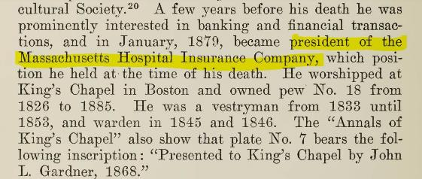

daughter:

[PDF, p. 190](https://www.fbcoverup.com/docs/library/1933-GARDNER-MEMORIAL-Bio-and-Geneol-Recrd-of-Descendants-of-THOMAS-GARDNER-PLANTER-Cape-Ann-1624-Salem-(Naumkeag)-(1626-74)-by-Frank-A-Garner-1933.pdf#page=190)

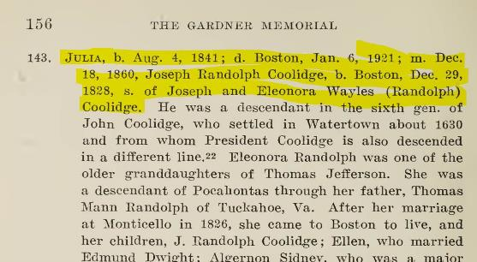

Joseph Randolph Coolidge

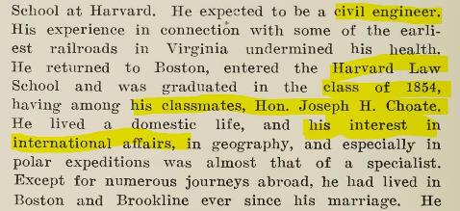

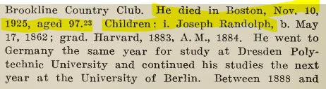

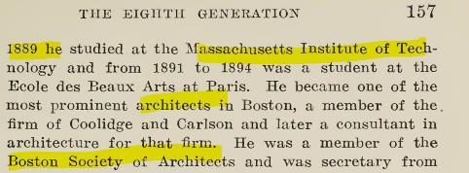

Son: John Gardiner (b. 1863)

[PDF, p. 191-92](https://www.fbcoverup.com/docs/library/1933-GARDNER-MEMORIAL-Bio-and-Geneol-Recrd-of-Descendants-of-THOMAS-GARDNER-PLANTER-Cape-Ann-1624-Salem-(Naumkeag)-(1626-74)-by-Frank-A-Garner-1933.pdf#page=191)

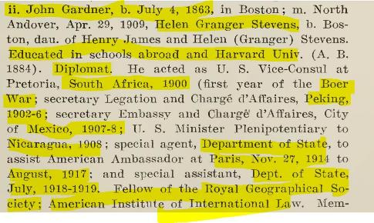

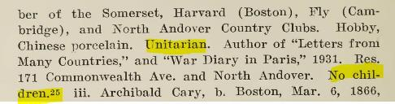

Son: Archibald Cary (Gardiner) Coolidge

Editor of Foreign Affairs (Council on Foreign Relations) from inception to his death

[PDF, p. 192](https://www.fbcoverup.com/docs/library/1933-GARDNER-MEMORIAL-Bio-and-Geneol-Recrd-of-Descendants-of-THOMAS-GARDNER-PLANTER-Cape-Ann-1624-Salem-(Naumkeag)-(1626-74)-by-Frank-A-Garner-1933.pdf#page=192)

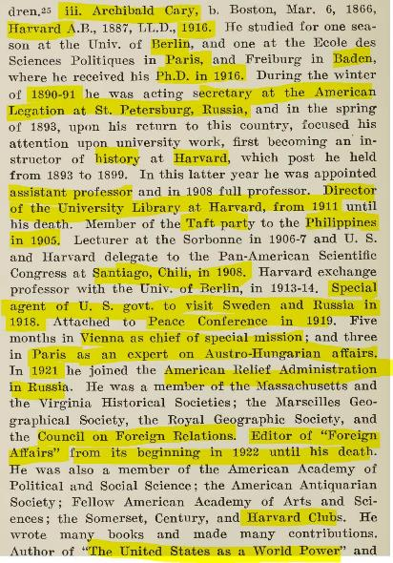

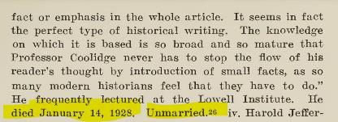

Son: Harold Jefferson (Gardiner ) Coolidge

[PDF, p. 193](https://www.fbcoverup.com/docs/library/1933-GARDNER-MEMORIAL-Bio-and-Geneol-Recrd-of-Descendants-of-THOMAS-GARDNER-PLANTER-Cape-Ann-1624-Salem-(Naumkeag)-(1626-74)-by-Frank-A-Garner-1933.pdf#page=193)

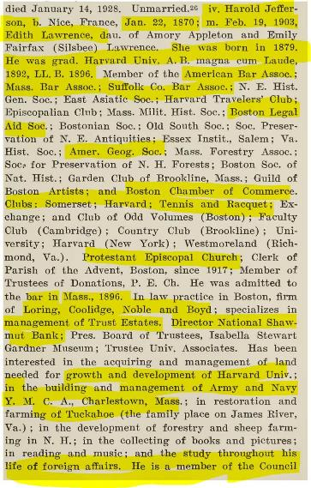

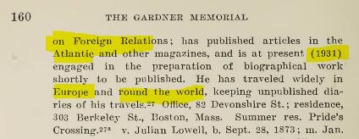

Son: Julian Lowell (Gardiner) Coolidge

[PDF, p. 194](https://www.fbcoverup.com/docs/library/1933-GARDNER-MEMORIAL-Bio-and-Geneol-Recrd-of-Descendants-of-THOMAS-GARDNER-PLANTER-Cape-Ann-1624-Salem-(Naumkeag)-(1626-74)-by-Frank-A-Garner-1933.pdf#page=194)

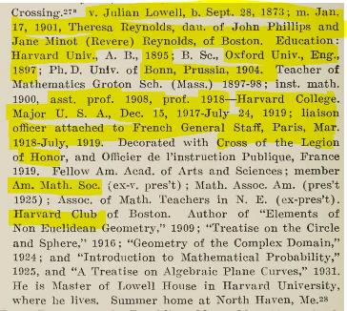

Son in law Charles W. Armory (b. 1842).

Telecom partnership with RCA, AT&T, David Sarnoff, Pilgrims Society

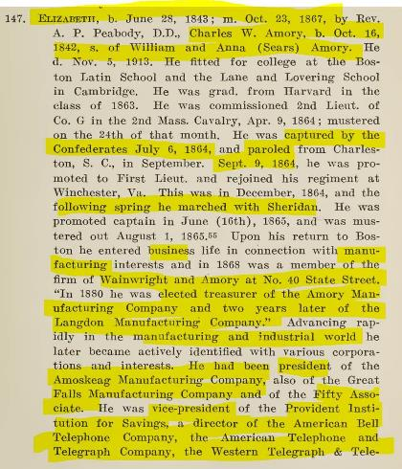

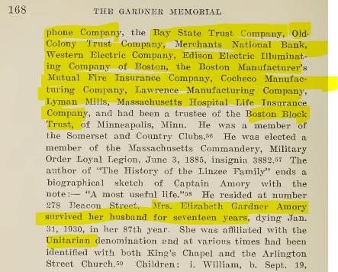

[PDF, p. 204](https://www.fbcoverup.com/docs/library/1933-GARDNER-MEMORIAL-Bio-and-Geneol-Recrd-of-Descendants-of-THOMAS-GARDNER-PLANTER-Cape-Ann-1624-Salem-(Naumkeag)-(1626-74)-by-Frank-A-Garner-1933.pdf#page=204)

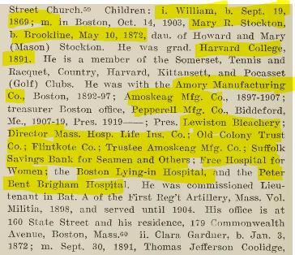

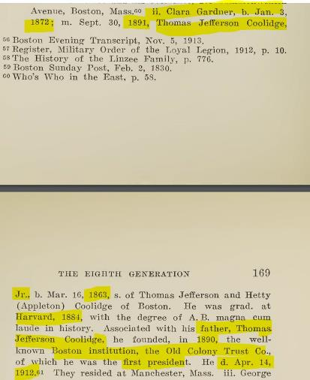

Son: George Gardner

[PDF, p. 205](https://www.fbcoverup.com/docs/library/1933-GARDNER-MEMORIAL-Bio-and-Geneol-Recrd-of-Descendants-of-THOMAS-GARDNER-PLANTER-Cape-Ann-1624-Salem-(Naumkeag)-(1626-74)-by-Frank-A-Garner-1933.pdf#page=205)



Daughter: Dorothy (Gardiner) Winthrop

[PDF, p. 205](https://www.fbcoverup.com/docs/library/1933-GARDNER-MEMORIAL-Bio-and-Geneol-Recrd-of-Descendants-of-THOMAS-GARDNER-PLANTER-Cape-Ann-1624-Salem-(Naumkeag)-(1626-74)-by-Frank-A-Garner-1933.pdf#page=205)

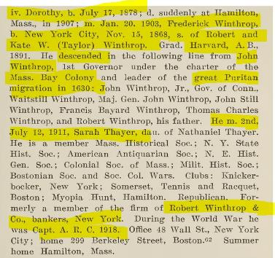

Daughter: Clara (Gardiner/Coolidge) Brooks

[PDF, p. 205](https://www.fbcoverup.com/docs/library/1933-GARDNER-MEMORIAL-Bio-and-Geneol-Recrd-of-Descendants-of-THOMAS-GARDNER-PLANTER-Cape-Ann-1624-Salem-(Naumkeag)-(1626-74)-by-Frank-A-Garner-1933.pdf#page=205)

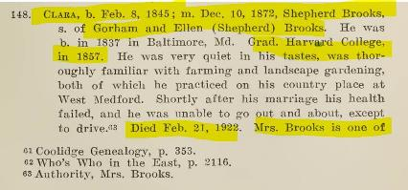

Clara daughter: Rachel (Gardiner/Coolidge) Brooks b. 1883

Married James Jackson, Jun. 27, 1904

[PDF, p. 207](https://www.fbcoverup.com/docs/library/1933-GARDNER-MEMORIAL-Bio-and-Geneol-Recrd-of-Descendants-of-THOMAS-GARDNER-PLANTER-Cape-Ann-1624-Salem-(Naumkeag)-(1626-74)-by-Frank-A-Garner-1933.pdf#page=207)

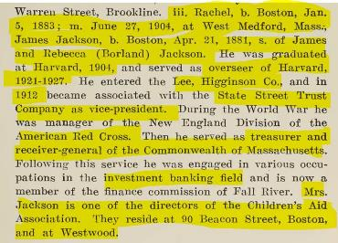

Boston Brahmins association:

<https://en.wikipedia.org/wiki/Boston_Brahmin#JacksonFamily>

