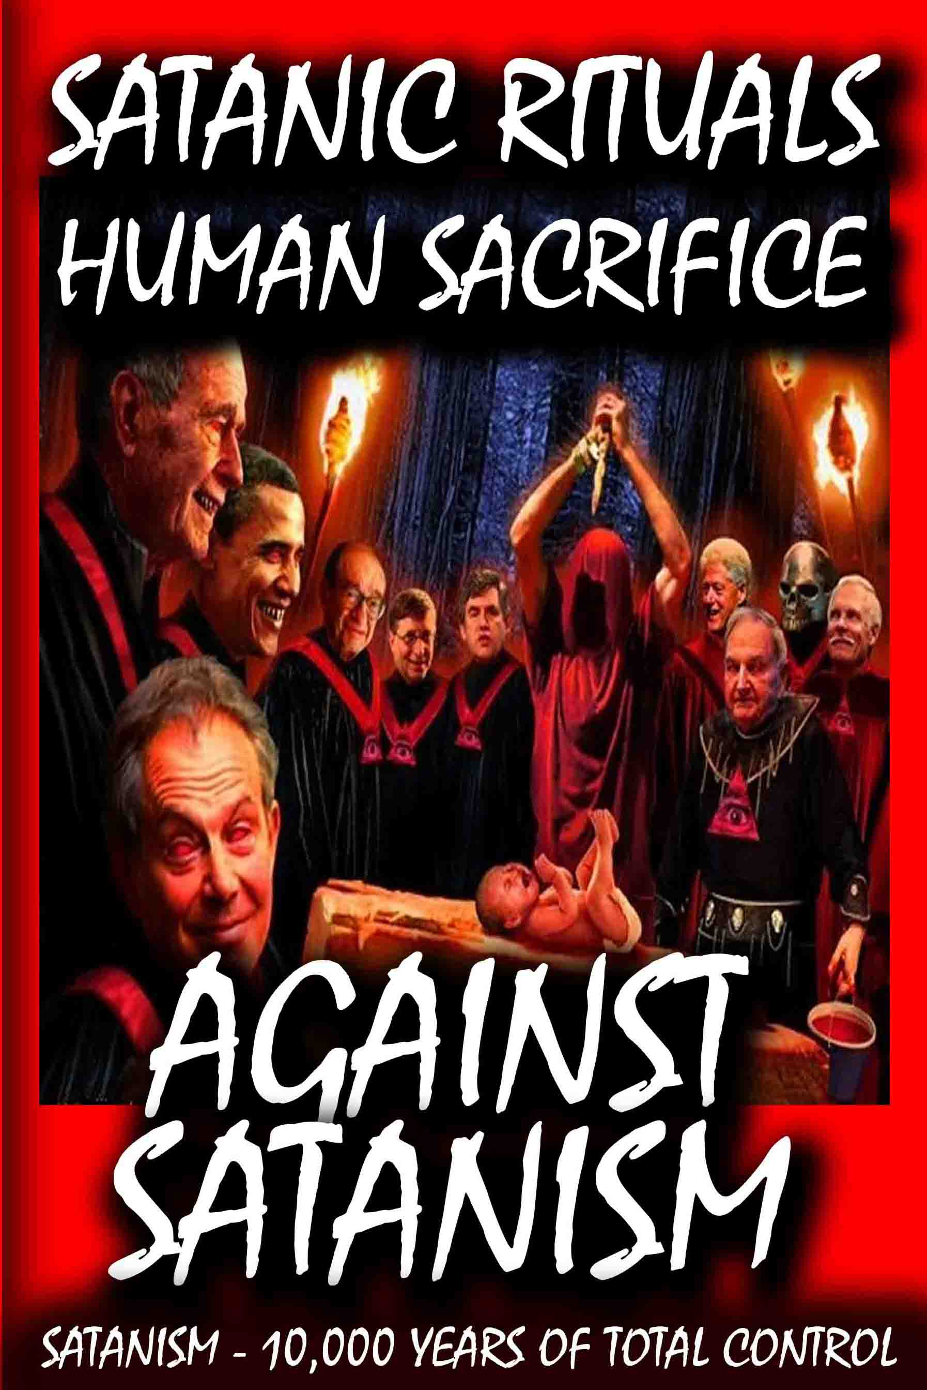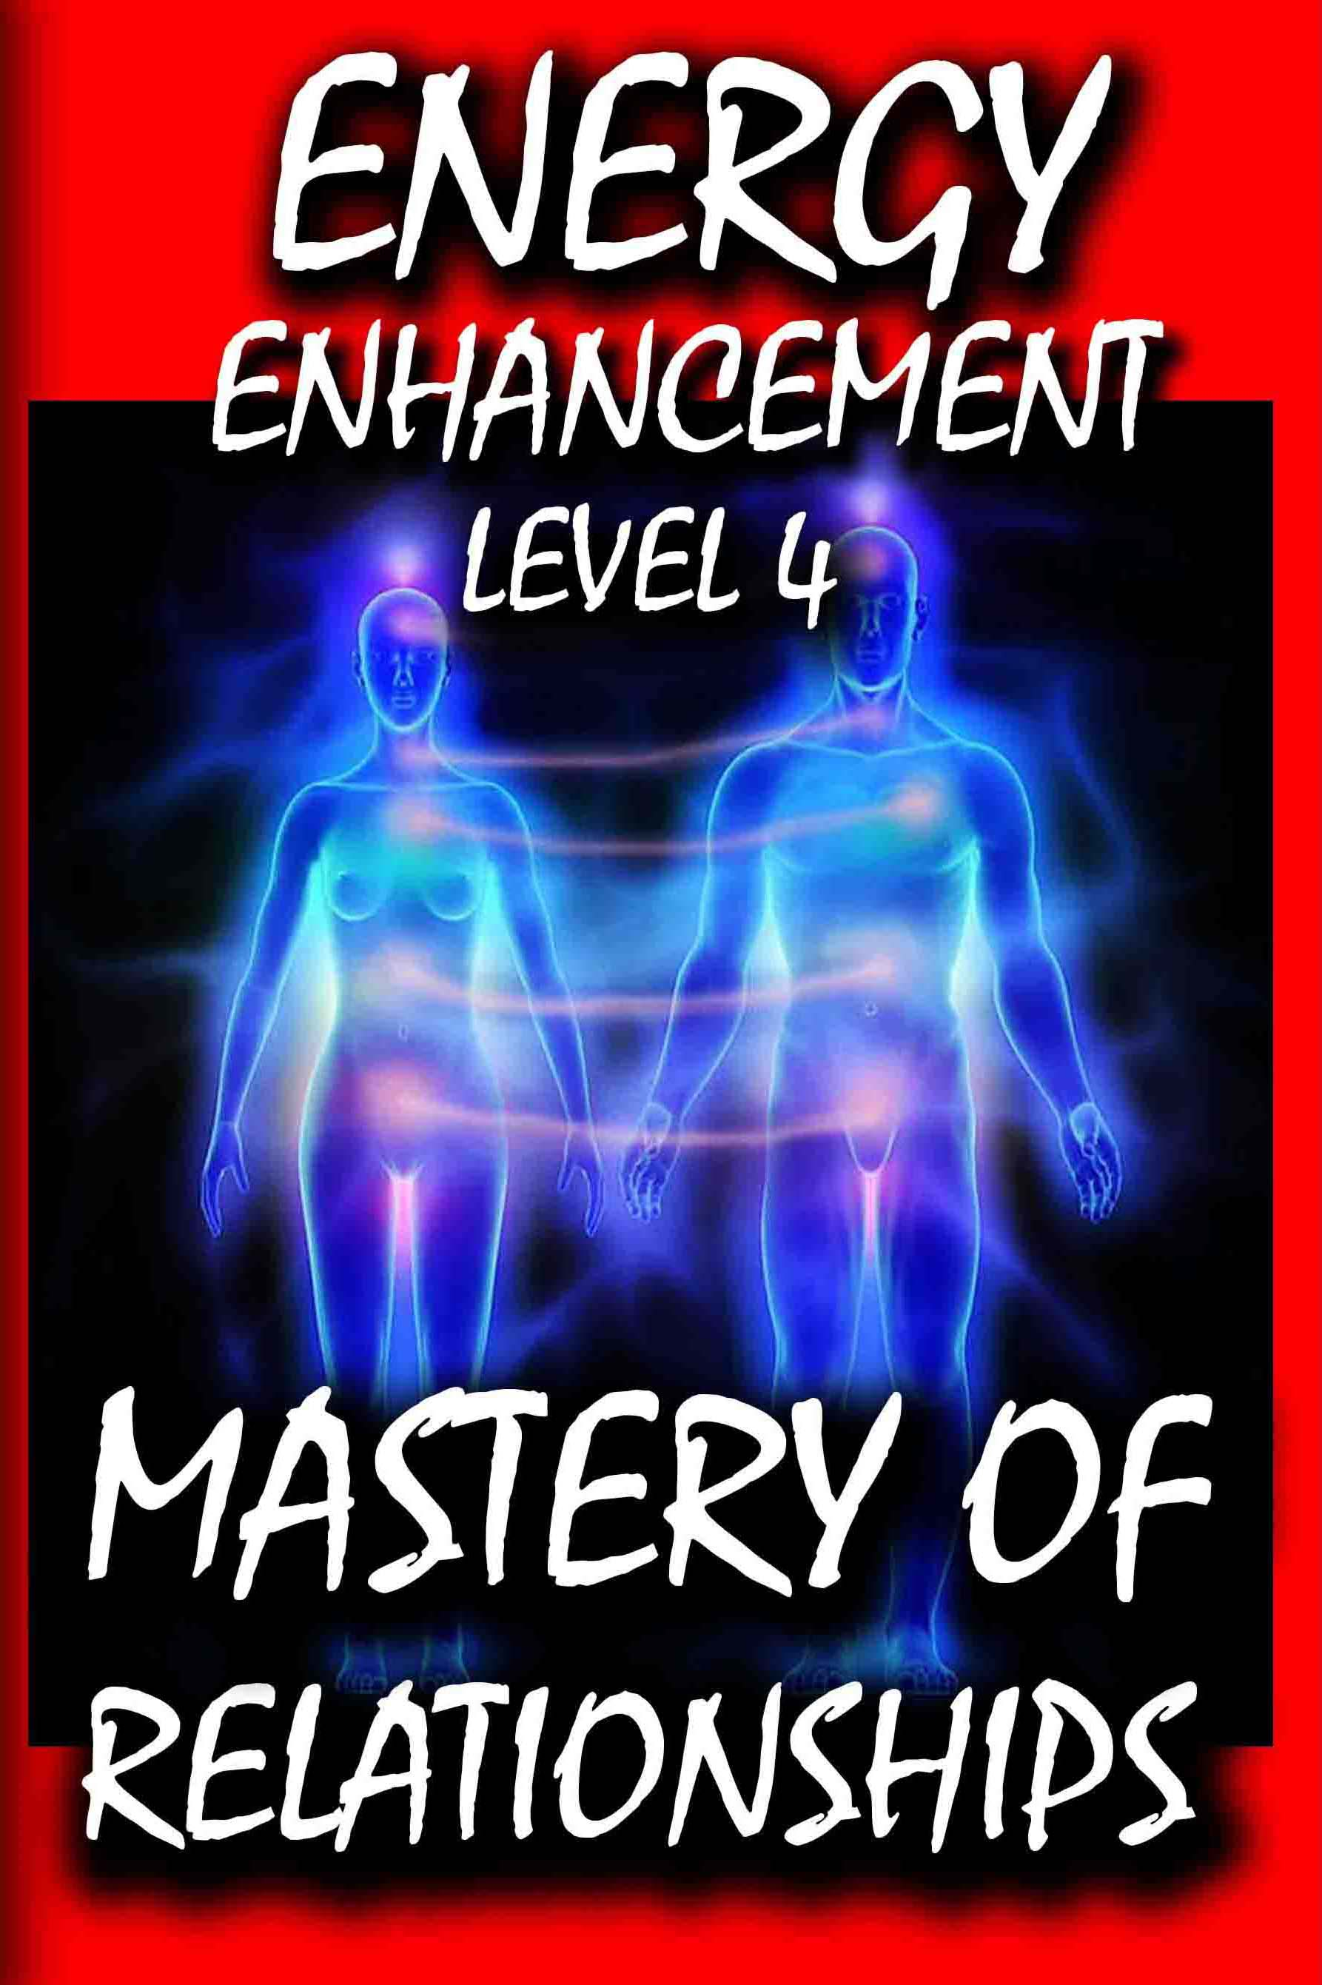

DEDICATION

With all Thanks, Love and Gratitude to Swami Devi Dhyani and the Energy Enhancement Writer and Book Editor Swami Satchidanand who makes these books possible.

With all Thanks, Love and Gratitude to my Mother and Father and to all my other Teachers, Theos Bernard, Sri Yogendra, Eric Berne, Gurdjieff, Father Bede Griffiths, Osho, Zen Master Hogen, Swami Sivananda, Swami Satchitananda, and all the other giants upon whose shoulders I stand - who made me able to be what… I AM – Swami Satchidanand

Copyright © 2018 Energy Enhancement Synthesis of Light Limited (SOL)]

All rights reserved. This publication may be reproduced in whole or in part, by any person under fair use as long as we are referenced, without written permission of:
Swami Satchidanand

sol@energyenhancement.org

www.energyenhancement.org



THE YOGA SUTRAS OF PATANJALI BY SWAMI SATCHIDANAND - DOWNLOAD HERE..
http://www.energyenhancement.org/Sacred-Energy/yoga-sutras-of-patanjali-book/Energy-Enhancement-Yoga-Sutras-of-Patanjali.pdf
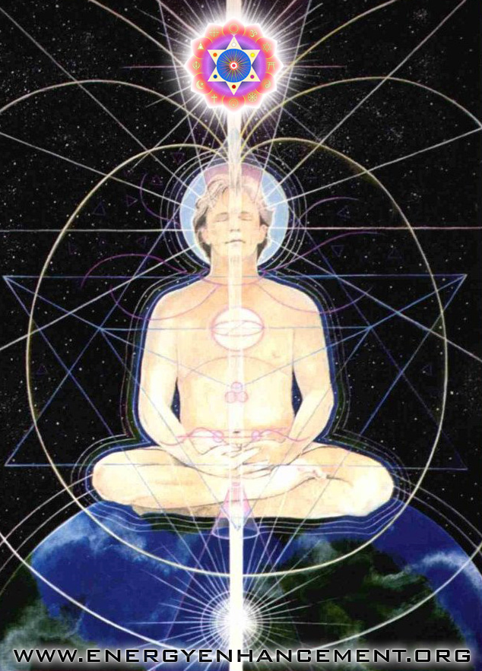

THESE RITUALS DEFINE SATANISM..
LOVELESS RITUAL SEX, SODOMY, PEDOPHILIA, RITUAL DRUGS, RITUAL BLOOD SACRIFICE, RITUAL HUMAN SACRIFICE, RITUAL TORTURE, RITUAL BURNING ALIVE, RITUAL CANNIBALISM, RITUAL CASTRATION RITUAL SEX, MASONIC PALLADIAN RITE, OTO RITUALS
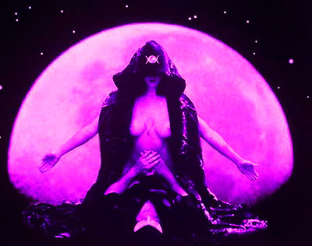
RITUAL SEX, MASONIC PALLADIAN RITE, OTO RITUALS
Sometimes people reading the Truth get depressed by it.
For people with big hearts though, the truth gets them started with an Implacable Opposition to Absolute Evil.
The Battle of Armageddon can only be won by sufficient Angels to fight against the Demons.
Be an Angel!!
Get Tooled Up and Ready with the Energy Enhancement Video Course in Four Levels and Live at Iguazu Falls..
For All those People who know the State Religion of the Roman Empire was completely Satanic..
"The Empire never Ended" Philip K Dick
“When I suddenly stopped believing in the Lie I did not begin to think differently - I saw differently, as if something was gone from the world or gone from between me and the world which had always been there. Like a scrambling device that had been removed: deliberate scrambling. All, suddenly, was clear language."
"There is an international cult that believes that the path to illumination and spiritual liberation is through the rape, torture and sacrifice of children.
"The cult is highly organised and protected by a network of middle- and upper-class professionals, who are either cult members, or access the 'services' of the cult (eg child porn/prostitution, rendering them vulnerable to blackmail).
"The cult is modelled on Crowley's writings, as is evidenced by the internal pseudo-Masonic 'degree' structure, the existence of OTO-like 'chapters', and the doctrine of 'strength', 'master/slave' and ritualised rape."
CONSCIOUSLY CREATED SATANIC FAKE WORLD, FAKE GANGS, FAKE NEWS FROM THE FATHER OF LIES
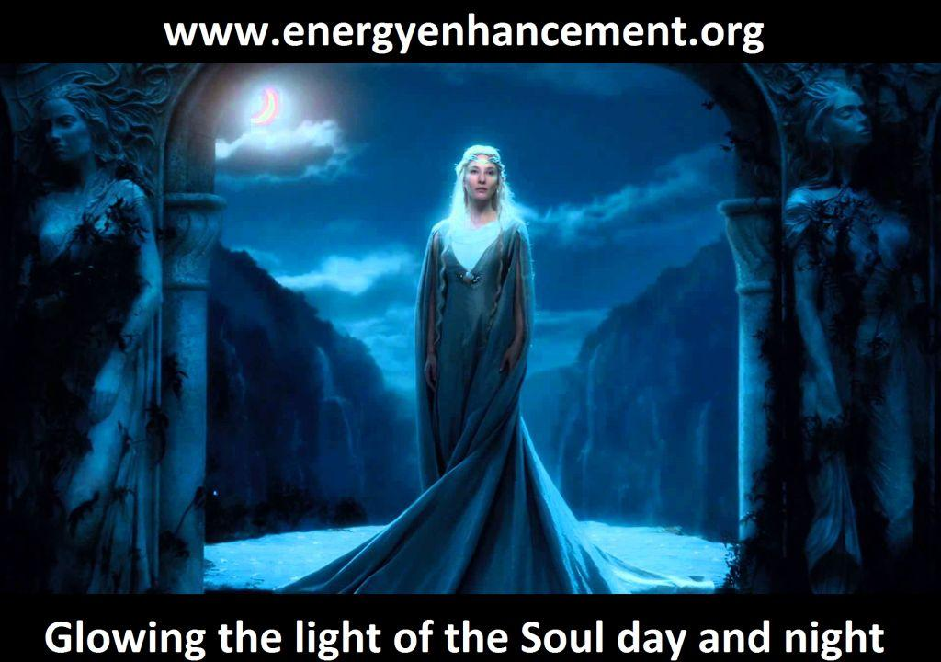
The point of this introductory missive is that 72 Empires have been recorded and every one of them has failed in the same way. The facts have been recorded that a totalitarian and satanic elite infil-traitored and took over all these Empires and that 72 once free, flourishing and rich republics were destroyed from within.
Infil-traition of Satanism is the methodology as slowly every Government Ministry and Societal function is taken over. Eventually a Satanist becomes King Emperor President. The Satanist Pillars of Homosexuality, Pederasty, Drugs and Ritual Sex - both Hetero and Homosexual - are introduced overtly and the society is destroyed.
The Ancient Enemy who counts meditation and the mind control psychic arts as one of its main planks of World Domination has used Satanic Infil-Traitors for 10,000 years in every Organisation - Religion, Left and Right Politics, Dynastic Families, Geopolitics, Economics, Universities, Intelligence Services, Think Tanks, Banking, International Companies, Eugenics -
All of them Censoring Worldwide, Advanced Meditation techniques - Alchemical VITRIOL, the Kundalini Key and Energy Blockage Removal from every Meditation Program.. EXCEPT ENERGY ENHANCEMENT!!
The key is that the Satanic Religion and its current recruiting cults of Freemasonry and the Crowlean Sexual Ritual OTO - Ordo Templi Orientis - are Fake Gangs, created by men as a 10,000 years old technique to create psychopathic leaders and thus conquer the world.
All Rituals, Religion, Education, Secret Services and Political Movements have been Scientifically Engineered to create Fake Gangs for 10,000 Years. It's what the old Roman Empire, and the Babylonian Empire, and the Cult of Apollo, and the Byzantine Empire did before.
The Guy Fawkes plotters were a 'Fake gang' controlled by the London government.
The UK's General Frank Kitson (Trail Blazing Fake Terrorism) refers to the 'Fake gangs' set up by the security services.
Fake gangs have been used in Ireland (IRA), Vietnam, Italy - GLADIO, Turkey, Belgium, the Philippines, Kenya, Malaya, Iraq, Syria (ISIS), New York (Al Qaeda) and many other places. Lord Stevens, a former UK police chief, is quoted as saying that only three out of 210 terrorist suspects he arrested in a probe in Northern Ireland were not working for either the police, the security service MI5 or the UK Army.
On 21 December 2011, we learnt that the IRA was run by the UK security services. Stephen Grey's book The New Spymasters says the UK intelligence services used the family of 'IRA leader' Gerry Adams as spies for the UK military.
It would seem that the security services set up satanic pedophile child abuse rings in order to control certain key people.
The idea of the 'Fake gang' is to infil-traitor..
"A nation can survive its fools, and even the ambitious. But it cannot survive treason from within. An enemy at the gates is less formidable, for he is known and carries his banner openly. But the traitor moves amongst those within the gate freely, his sly whispers rustling through all the alleys, heard in the very halls of government itself. For the traitor appears not a traitor; he speaks in accents familiar to his victims, and he wears their face and their arguments, he appeals to the baseness that lies deep in the hearts of all men. He rots the soul of a nation, he works secretly and unknown in the night to undermine the pillars of the city, he infects the body politic so that it can no longer resist. A murderer is less to fear. The traitor is the plague."
by: Marcus Tullius Cicero, (106-43 B.C.) Roman Statesman, Philosopher and Orator
The idea of the 'Fake gang' is to infil-traitor.. Society's Institutions and Myths with Satanism, to carry out acts of violence which can then be blamed on other people, but also to create Fake Economics, Fake Cults and Religions, Fake Political Philosophies, in order to Human Sacrifice, Pedophile, Pervert and Degenerate Society and All its People onto the Path of the Satanic "Old" Religion which predates Christianity by 10,000 years.
The fake gangs idea has been used since Satanic Babylon 10,000 years ago, with this Scientific Engineering of Society, the Satanic Religion - another fake gang - has spread and infil-traited every noble family, every noble civilisation, and it is even now infil-traiting your country, your civilisation.
As you know, all the gangs have Rituals before you can join, making your bones with the Mafia means you must murder someone before you can join and Drug Cartels, secret groups within the Masons, the Hellfire Club, all have their Rituals before you can join and before you can progress.
All Rituals, Religion, Education and Political Movements are designed to create fake gangs of psychopaths who can then be used to create control through chaos created poverty - The Oligarchic Policy of Poverty - destroying infrastructure - preventing human evolution.

THE ENERGY ENHANCEMENT SATANISM AND LUCIFERIANISM - SECRET KNOWLEDGE OF THE NEOPLATONIC ELITE DIRECTORY

http://www.energyenhancement.org/Secret-Knowledge-Of-The-Neoplatonic-Elite/THE-ENERGY-ENHANCEMENT-SECRET-KNOWLEDGE-OF-THE-NEOPLATONIC-ELITE-DIRECTORY.htm

CONSCIOUSLY CREATED SATANIC FAKE GANGS
1. ISIS - Venetian created British Secret Servuces created Wahhabism in 1706 - based on the same principles as Lutherism - and institutionalised it in MI6 created Saudi Arabia to create destabilising Jihadi Armies and rapeugees creating chaos in Europe, Middle East, Russia and China..
See this book http://energyenhancement.org/Hempher-14-ConfessionsOfABritishSpy.pdf
2. PROTESTANTISM - Luther, like Abdul Wahhab was a paid Agent working for Venetian Cardinal Contarini
3. The Satanic Franks and Pippins - The Dragon Kings of Troy, forged the history of Catholicism using their Propagandist the Venerable Bede because their King was excommunicated by Constantinople. He installed his cousin as the first Pope and was then crowned Emperor of Europe followed by Charlemagne.
http://www.energyenhancement.org/Satanic-4th-5th-6th-Generation-Warfare-Battle-For-Your-Soul-Satanism-control-structure-of-falsely-created-religions-philosophies-Economics-Sciences-Thesis-Antithesis-Totalitarian-solution-Orden-Ab-Chao.htm
4. ETON - SINCE 1430, Whipping and Fagging to create Fierce Homosexual Pedophile Warriors in an educational system based on Greece and Sparta - The foundation of the British Empire.
5. SATANISM/LUCIFERIANISM/33RD DEGREE FREEMASONRY - Pagan Rituals and Myths used to pervert, degenerate and control a psychopathic ruling class. Mao was a 33rd Degree Freemason!!
6. SATANIC SABBATEAN FRANKISTS infiltrate Jews and Jewish organisations worldwide. Pagan Rituals and Myths used to pervert, degenerate and control a Jewish psychopathic ruling class of Donmeh Attaturk, Rothschilds, Rockefellers, Schiffs, Warburgs.
7. KARL MARX - Wrote Das Capital from his MI6 provided office in the British National Museum under Ambassador Urquhart creating MI6 inspired Communism, Russian Revolution (65 millions tortured dead) and Mao's Chinese Revolution (85 millions tortured dead), and Socialism. George Orwell's Totalitarian text's "1984" "A Boot, stamping in your face, forever" - the Totalitarian or Legalist Fake Gangs sprang from this bough. Capitalists, Marxists, Communists and Socialists spring from the same Fake Gangs bough.
8. CATHOLICISM AND CYBELE AND ATTIS WORSHIP and its castrated Galli Homosexual Pederasty Priests - the State Religion of the Roman Empire - morphed into the Catholic Church, Cybele - Mary, Adonis - Jesus, Molech - God. The Black Death. Pederasty, Inquisition - The Horror Holy Medieval Inquisition - 50 million tortured burned dead, - burning alive, breast rippers, strappado, rack etc. Fascism and the Holocaust. The Catholic Church is controlled through the Gang Kings, Queens, Nobility of Europe. The Jesuits, The Knights of Malta. Its Vatican Bank is fronted by the Rothschilds, has 500 Trillion Dollars, controls 70% of Fortune 500 companies, controls 70% of all banks Worldwide, controls 100% of all central Banks, consciously creating all depressions, all austerity, all Wars, all famine genocide, False Flags and the assassinations of JFK, RFK, and MLK, or the September 11th “Terror Attacks”.
9. PHILOSOPHY Aristotle was an Agent for the Satanic Babylonian Secret Service nicknamed, "Aristotle the Poisoner" because he was responsible for the assassination of Alexander the Great by poison. Aristo-crats - rule by Aristotle - rule through Aristotelian Philosophy because he did not believe in the Soul, taught by Pompo-Nazi at the University of Padua to a European Satanic Soul-less ruling class. The precursor to Paolo Sarpi, he consciously dummed down scientific methodology in order to create poverty - The Satanic Principle of Poverty.
10. EUGENICISTS started by Galton, Huxley, Darwin, Pilkington families, later named TRANSHUMANISTS by Sir Julian Huxley, Head of Rockefeller created UNESCO who spilled the beans to his brother Aldous Huxley in his book, "Brave New World" in 1932. Later in a 1963 speech at Columbia University, Aldous Huxley admitted the Aim of Eugenicists was the same as that of his book.
11. ECONOMISTS - Economists have been paid - Adam Smith (and his Satanic Mandevillian, "Public benefits come
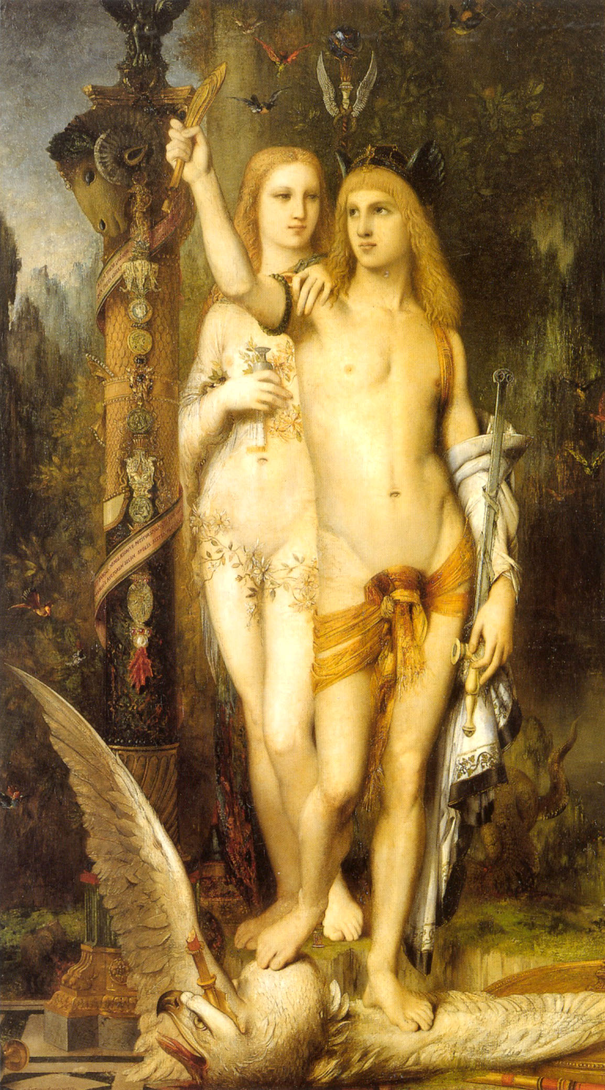CYBELE AND ATTIS - RITUAL CASTRATION
from Private Vices") was a hack, paid by Lord Shelburne, Head of the British East India Company, foundation of the British Empire - to create an Economics which would perpetuate the Bankers of the British Empire, later the Anglo-American Empire. Austrian Economics and it's Austerity - The Oligarchic Principle of Poverty - was supported and spread by Nelson Rockefeller. Solution? See Hudsons Modern Monetary Theory or Larouche Hamilton Credit Theory. The Economist Fake Gangs.
12. SOCIAL DARWINISM is a Satanic policy which holds that social policy should allow the weak and unfit to fail and die, and that this is not only good policy but morally - according to Satanists - right.
The Treaties - Trans Pacific Partnership TPP - USA - SE ASIA, and Trans Atlantic Partnership TAP - USA - EUROPE, now signed into Law even though these Treaties are Secret, place Vatican Controlled International Fortune 500 Companies above all Governments to censor the internet and much more..
The United Nations was created by the Satanic Globalist Rockefellers to create Agenda 21, Climate Change Carbon Taxes, and Autism, Sterilisation, Poison Vaccines to Povertise, Pervert, Degenerate, Lobotomise, Rule and Conquer the World.
THE SATANIC GOD
“Hey, we ARE god’s chosen people. Its just most people do not like to admit it, but our god is Lucifer.”
The Satanists, Luciferians and Illuminati refers to a tightly organized network of family dynasties representing Anglo American and European aristocracy and Jewish finance joined by intermarriage, belief in the occult, and hatred of Christianity. Freemasonry is their instrument. They care nothing for their non-Illuminati brethren, Jewish or not. They will destroy billions as they create a neo feudal world characterized by the superrich, their support staff, soldiers and serf-slaves.
“You know, us, we’re pretty smart guys. I know that actually we’ll get all the rest of their countries around the world. They’ll wipe each other out. Because us, we are SPECIAL. We are the chosen people. And we are the smartest people in the world and have always said, down through the ages – we want a world of our own.
And we’re gonna get it, and there’s nothing any of the cattle are gonna do to stop us.”
“And ah, you know we are, I know you know, I mean we steal a hundred to three hundred thousand children a year just in this country. And we drain the blood and we mix it with bread, and then we throw the bodies into the slaughter houses that we own, and we grind up all the bodies in the sausage and the hamburgers.
McDonald’s is one of our favorite outlets, and the, the people that eat out for breakfast, they take out their children for lunch, and, you know, we’ve got to do what we do.”
OKLAHOMA CITY – First McDonald’s was under fire for horse-meat, then mysterious “Pink slime”, and now human meat? A shocking discovery has been made in an Oklahoma City McDonald’s meat factory and other McDonald’s meat factories nationwide. Meat inspectors reportedly found human meat, stored in the meat factory freezers of an Oklahoma City meat factory…
So, we take the children of our enemy, who are not Satanic, and we bring them to the 10,000 year traditional underground basements in our Temples, like in Paris or Rome, where we drain the blood and watch them die there. It's very similar to how we do the ritual sacrifices that many religions do with butchering, Halal, Kosher, and so we do that. And then we mix it with a bread, and so we eat the blood of our enemies.
And, even when we say this outright and tell you, people, you don't believe it

And the bodies we use them to degenerate you. So, what we do is we take those bodies and we give them to the slaughter houses, and there's a pounds and pounds and pounds of meat that we grind up in a sausage and a hamburger and that's why we make those the most popular things - sausage for breakfast and a hamburger for lunch, and so all the people out there are eating their children.
And, even when we say this outright and tell you, people, you don't believe it. So, that's, that's your problem.

The key is that the Satanic Religion and its recruiting cults of Freemasonry and the Crowlean Sexual Ritual Ordo Templi Orientis are Fake Gangs, created by men as a technique to conquer the world.
"Twenty years have flowed away down the long river but never my life will return to me from the sea. Alas, all now tends to wither in the breast of cold hearted Satanic Wizards - Saruman - "A Mind of Metal and Wheels" - Treebeard the Ent - To investigate things, Satanists break them and their Stern Lordship is established by the Fear of Death" - Tolkien
This is my Series about the Effects of the, "Dark Side" on the Last Tens of Thousands of years of Modern Society..
It is a Dark Vision, not unlike The Buddha's, "Pain, Sickness, Old Age and Death" But as we Both Say...
"There is a Path" -
Energy Enhancement Meditation...

REMOVE EXTERNAL WORLD ENERGY BLOCKAGES WITH ENERGY ENHANCEMENT MEDITATION
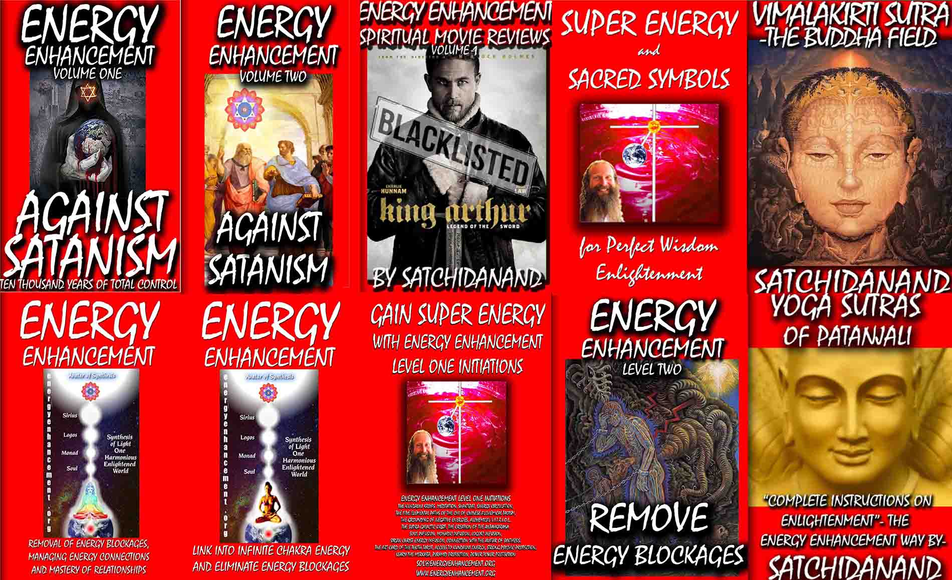
Download ALL these Energy Enhancement Books for Free
Book The Yoga Sutras of Patanjali by Satchidanand
Save your life with Energy Enhancement Streaming Videos.. Book One, Sutra One - Here are complete Instructions on Enlightenment...
http://www.energyenhancement.org/Sacred-Energy/yoga-sutras-of-patanjali-book/Energy-Enhancement-Yoga-Sutras-of-Patanjali.pdf
The Buddhist, "Vimalakirti Sutra" in 14 Chapters - by Satchidanand plus one Chapter - The Buddhist Energy Enhancement Kundalini Key is the Buddhist Stupa Right Click and Save As..
http://www.energyenhancement.org/Vimalakirti-Sutra/vimalakirti-sutra.pdf
More Heart Opening & Movie Reviews Book - right click and save as..
http://www.energyenhancement.org/Spiritual-Movie-Reviews/Energy-Enhancement-spiritual-esoteric-movie-reviews-by-Satchidanand.pdf
Level One - Access Infinite Spiritual Energy!!
http://www.energyenhancement.org/Sacred-Energy/Gain-Super-Energy-Energy-Enhancement-Level1-Initiations-Kundalini-Kriyas-Meditation-Shaktipat-Circulation-Taoist-Orbits-Alchemy-VITRIOL-Grounding-Psychic-Protection-Pyramid-Merkaba-energyenhancement-org.pdf
Level 2 - Remove Energy Blockages
http://www.energyenhancement.org/Sacred-Energy/Level-2-Book/Energy-Enhancement-Level-2-Book-Remove-Energy-Blockages.pdf
Level 3 - The Karma Cleaning Process - Remove Even Deeper Energy Blockages
http://www.energyenhancement.org/Sacred-Energy/Level-3-Book/Energy-Enhancement-Level-3-Karma-Clearing-There-Can-Only-Be-One.pdf
Level 4 - Master Energy Cords - Gain Fantastic Relationships
http://www.energyenhancement.org/Sacred-Energy/Level-4-Book/Energy-Enhancement-Level-4-Book-Energy-Cords-Mastery-Of-Relationships.pdf

Download Super Energy And Sacred Symbols for Perfect Wisdom Enlightenment
http://www.energyenhancement.org/Sacred-Energy/Meditation-Super-Energy-And-Sacred-Symbols-for-Perfect-Wisdom-Enlightenment-Color-energyenhancement-org.pdf
Download.. .. Energy Enhancement Book One.. Link into Infinite Chakra Energies and-Remove Energy Blockages
http://www.energyenhancement.org/Sacred-Energy/Meditation-Energy-Enhancement-Link-into-Infinite-Chakra-Energies-and-Remove-Energy-Blockages-EEBOOK1Color-energyenhancement-org.pdf
Download.. Energy Enhancement Book Two - Totally Remove Every Energy Draining Energy Blockages and the Soul Sucking Energy Cord Connections. Master Attachment and Desire. Access Infinite Energy and Quantum Immortality! Live Forever!
http://www.energyenhancement.org/Sacred-Energy/Meditation-Energy-Enhancement-Eliminate-Energy-Blockages-Manage-Energy-Connections-and-Attachment-Mastery-of-Relationships-EEBOOK2Color-energyenhancement-org.pdf
AGAINST SATANISM
Protect Yourself against the Satanic Science of Energy Blockages with The Energy Enhancement Streaming Video Meditation Course.
Innoculate yourself Against Satanism by Downloading.. Energy Enhancement Book - Against Satanism Volumes One and Two by Satchidanand
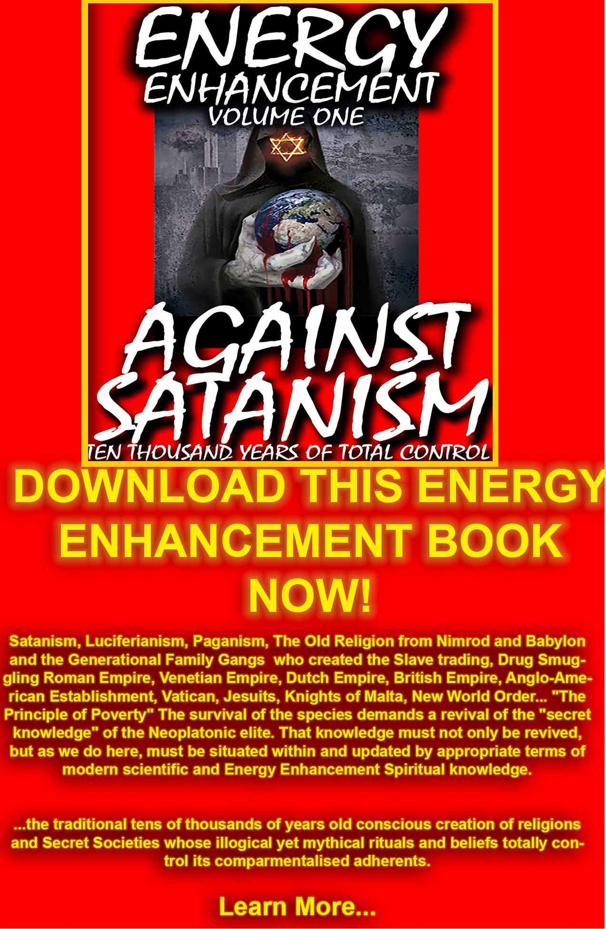
http://www.energyenhancement.org/Against-Satanism/Against-Satanism-Energy-Enhancement-Satanic-History-of-the-World-Volume-1.pdf
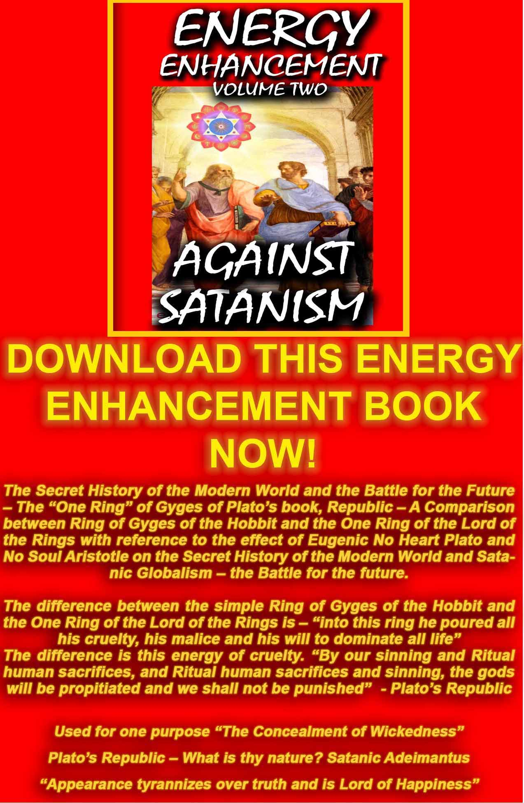
http://www.energyenhancement.org/Sacred-Energy/Against-Satanism-Volume-2/Against-Satanism-Volume-2.pdf
EXERPT FROM AGAINST SATANISM VOL 2…

The ‘‘One Ring’‘ of Gyges

from Plato's Republic - A Comparison between Ring of Gyges of the Hobbit and the One Ring of the Lord of the Rings
by Swami Satchidanand

Satanic Illusions, Lies and Magick Part 1.
Sometimes people reading the Truth get depressed by it.
For people with big hearts though, the truth gets them started with an Implacable Opposition to Absolute Evil.
The Battle of Armageddon can only be won by sufficient Angels to fight against the Demons.
Be an Angel!!
Get Tooled Up and Ready with the Energy Enhancement Video Course in Four Levels and Live at Iguazu Falls..
The difference between the simple Ring of Gyges of the Hobbit and the One Ring of the Lord of the Rings is - ‘‘into this ring he poured all his cruelty, his malice and his will to dominate all life’‘ -
The difference is this energy of cruelty..
Used for one purpose The Concealment of Wickedness.
And here is where the elite get all their negative energy or as we call it in Energy Enhancement - Trauma-Formed Negative Karmic Mass.. from Ritual Human Sacrifice - a Satanic Ritual used in all civilisations on All Continents by the Satanic Elites for tens of Thousands of years.
Yes Satanism, the Occult Cult was created 10,000 years ago before Christ, and has been extant since that time in order to make the psychopaths which rule humanity. To grind us down, make us into feudal wage slaves barefoot and back on the reservation, buying everything from the Amazon company store!
‘‘The enemy has only fake news, images and illusions behind which he hides his true motives. Destroy the image and you will break the enemy.’‘ Shaolin Abbot to Bruce Lee, Enter the Dragon (1973)
What is thy Nature? Sons of an Illustrious Father
In Plato's Republic, four definitions of justice versus injustice and criticisms are given by the four characters Cephalus, Polemarchus, Thrasymachus, and Glaucon of what Socrates actually espoused that was MAAT The Egyptian God of JUSTICE , and the ancient wisdom and works of God Ashur (Osiris).
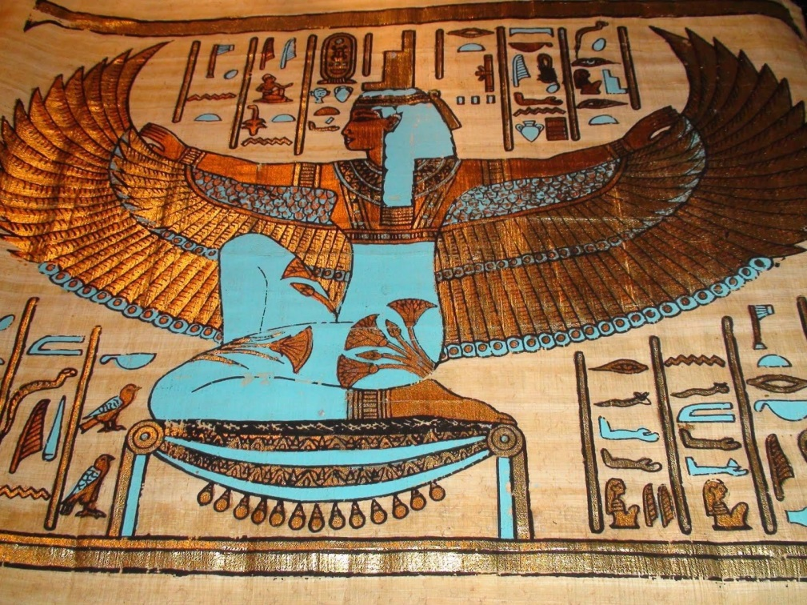
MAAT THE GODDESS OF JUSTICE
They challenged Socrates to define justice and to show why acting justly should be thought to be in anyone’s self interest. Socrates called them, Sons of an Illustrious Father- The Greek Apollo-God - or Apollyon-Devil.
In response to the three arguments against Justice by Satanic Thrasymachus, Glaucon, and Adeimantus, good Socrates seeks to show that it is always in an individual’s interest to be just, rather than unjust.
But in the three arguments against Justice and for injustice created by Plato in his book ‘‘Republic’‘, we find
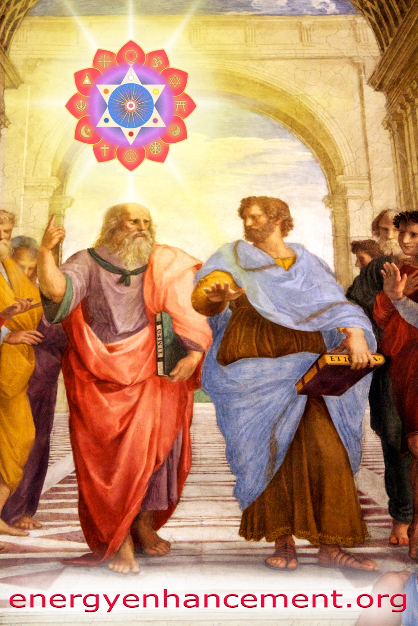
Plato and Satanic Aristotle from the School of Athens by Raphael
exposed the entire plan of Satanism on this Planet used for 10,000 years.
Socrates/Plato believes in the Soul.
Satanic Aristotle does not believe in the Soul
All the following arguments against Justice are espoused by the Satanic Aristotelian Faction.
This points out an Elite battle which has been fought in society for 10,000 years currently between the followers of Plato - Apollo or Aristotle - Apollyon
God Apollo, ‘‘Illustrious God’‘[17] Orphic Hymn 34 to Apollo (trans. Taylor) (Greek hymns C 3rd B.C. to 2nd A.D.):
‘‘To Apollyon. Blest Paian (Paean), come, propitious to my sacrifice, illustrious power, whom Memphian tribes revere, Tityoktonos (Slayer of Tityos), and the god of Health, Lykoreus (Lycoreus), Phoibos (Phoebus), fruitful source of wealth …’‘ Cornelis Galle the Elder, after Lodovico Cardi, Lucifer (1595)
Lucifer was one of the earliest born of the spirits- ‘‘illustrious’‘. Satan was originally an illustrious, majestic angel called Lucifer—’‘the light bearer.’‘[19] The use of the name Apollyon (God Apollo’s Evil Dual Nature) within the bible, as the ‘‘Angel of the Pit’‘ of HELL was a direct association as a SATAN, an adversary to Christianity.[20]
SATANIC ARGUMENT 1. WHAT IS THY NATURE? SATANIC THRASYMACHUS- Unjust
The Sophist Thrasymachus, espoused the view that ‘‘might is right.’‘ He argues that such terms as ‘‘justice’‘ and ‘‘right’‘ are relative. What benefits the stronger party is just. The stronger, thus, decides what justice is.[21]
AGAINST SATANISM VOLUME ONE
BOOK AVAILABLE FROM ENERGY ENHANCEMENT ON SIGN UP – 12 FREE BOOKS!!
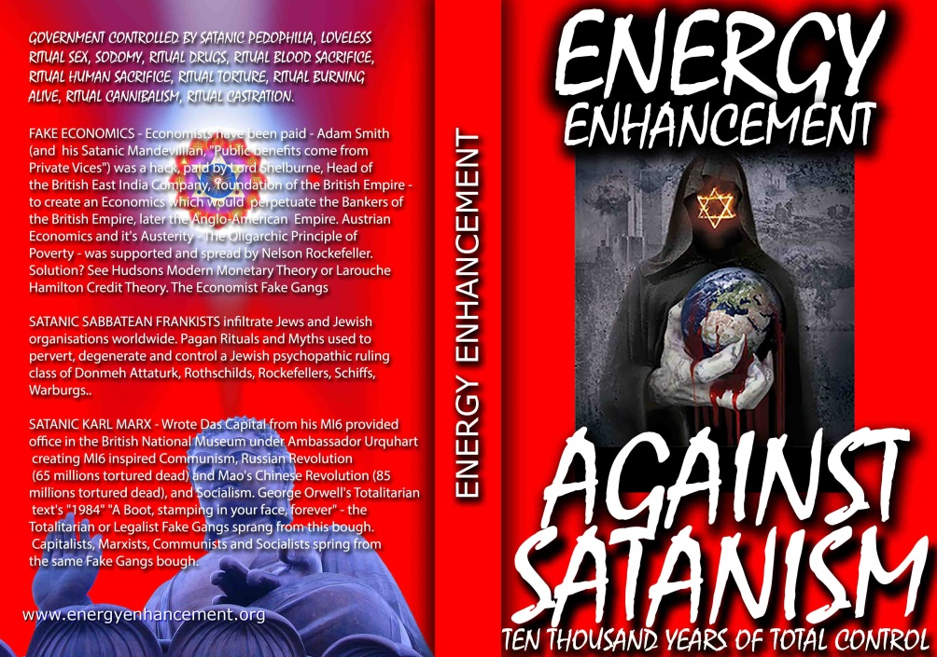
DOWNLOAD AGAINST SATANISM VOLUME ONE HERE
http://www.energyenhancement.org/Against-Satanism/Against-Satanism-Energy-Enhancement-Satanic-History-of-the-World-Volume-1.pdf


SATANIC ARGUMENT 2. WHAT IS THY NATURE? SATANIC GLAUCON – Unjust
Satanic Glaucon praIses concealment - Secret Societies - in The Satanic Ring of Gyges Trolley to Hell!!
The image of the Ring of Gyges is the Tolkien Ring of his book, The Hobbit - solely used by Bilbo Baggins to create invisibility. To burgle the gold of the Dragon, Smaug.
Glaucon, Plato’s older brother, says that ‘‘[justice] is always practiced with reluctance, not as good in itself, but as a thing one cannot do without’‘ .
To further show his idea, he tells the legend of Gyges, one day the earth opened beneath his feet that revealed a hole, he ventured into it. He found a man or statue inside a wooden horse with a golden ring on his finger. Gyges took the ring, and subsequently discovered that the golden ring had the power to make him invisible.
Gyges used the power of the ring of invisibility and deception to seduce the queen, and murder the king. He took over the kingdom using his magic ring knowing that he will avoid being discovered and punished.
Glaucon uses this infamous analogy to conclude the sole reason men are just is that they fear punishment.[22]
Beware the Greek bearing gifts - inside this Trojan Horse is a Ring of Invisibility which if used for evil will take us to HELL on greased wheels - a Trolley to HELL!!
SATANIC ARGUMENT 3. WHAT IS THY NATURE? SATANIC ADEIMANTUS- Unjust
‘‘Appearance Tyrannizes over Truth and is Lord of Happiness’‘
Adeimantus of Collytus (432 BCE – 382 BCE) son of Ariston of Athens was also known as Plato’s brother.[23] In The Republic, Adeimantus questions whether they would be living a good life with little or no personal property. Consequently, Adeimantus is often associated with greed or love for money in interpretations of the dialogue.
He quotes Pindar (522 – 443 BC) an Ancient Greek lyric poet from Thebes–
‘‘Can I by justice or by crooked ways of deceit ascend a loftier tower which may be a fortress to me all my days? For what men say is that, if I am really just and am not also thought just profit there is none, but the pain and loss on the other hand are unmistakable. But if, though unjust, I acquire the reputation of justice, a heavenly life is promised to me.’‘
He argues. Since then, as philosophers prove, appearance tyrannizes over truth and is lord of happiness, to appearance I must devote myself. I will describe around me a picture and shadow of virtue to be the vestibule and exterior of my house; behind I will trail the subtle and crafty fox, as Archilochus, greatest of sages, recommends.
‘‘THE CONCEALMENT OF WICKEDNESS’‘
All the money spent by Satanic Oligarchs on buying the media - CNN, MNSBC, FOX, Amazon Bezos Washington Post. Mexican Drug Lord Carlos Slim New York Times, Book Publishers, Magazines, Bread and Circus Football and Athletics and all their Gladiators..
All the money spent by Satanic Rockefeller Oligarchs on buying the Council on Foreign Relations and the United Nations - built on a site of a Satanic Slaughterhouse donated by the Rockefellers in New Babylon, New York City.
All the money spent by Satanic Rockefeller Oligarchs on buying the Senate, Congress, Judges, Universities, Professors, Secret Services.. CIA, MI6, MOSSAD
Is for one purpose - THE CONCEALMENT OF WICKEDNESS
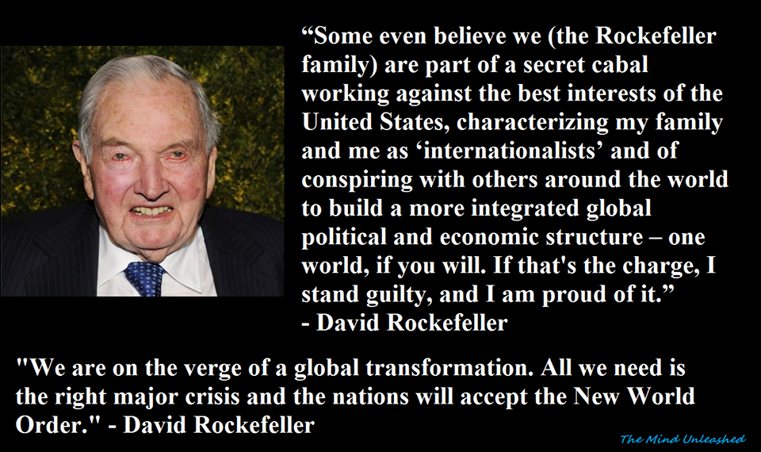
The Satanic Anti-Human, Anti-Family, Agenda 21, Poison in air, water, food, Brain damage Vaccines, Sterilization, Transgenderism, Transhumanism, Satanic LGBT AGENDA and Communist, Fascist, Wahhabist Totalitarianism
But I hear someone exclaiming that the concealment of wickedness is often difficult; to which I answer, Nothing great is easy. Nevertheless, the argument indicates this, if we would be happy, to be the path along which we should proceed. With a view to concealment we will establish secret societies and political clubs so we can all make unlawful gains and not be punished.
Still I hear a voice saying that the gods cannot be deceived, neither can they be compelled. But what if there are no gods? or, suppose them to have no care of human things –why in either case should we mind about concealment? Adeimantus argued.
‘‘Ritual human sacrifices and soothing entreaties and by offerings.’‘ - This is the definition of Satanism!!
(Worldwide Modern Ritual human sacrifices is exposed by United Nations and Clinton-Podesta Foundation Child Trafficking, Spirit Cooking, Pizzagate, and the Trump prosecution of 10,000 pedophiles currently in process.
Trump's friend - attempted assassination Senator Scalise - was in charge of this program.
Not just child sex slaves but child sacrifice, dissolving the bodies in acid.)
And even if there are gods, and they do care about us, yet we know of them only from tradition and the genealogies of the poets; and these are the very persons who say that they may be influenced and turned by ‘‘Ritual human sacrifices and soothing entreaties and by offerings.’‘
‘‘ … if we are unjust, we shall keep the gains, and by our sinning and Ritual human sacrifices, and Ritual human sacrifices and sinning, the gods will be propitiated, and we shall not be punished.’‘
The image here is not only of the Ring of Gyges, the Tolkien Ring of his book, ‘‘The Hobbit’‘ - solely used by Bilbo Baggins to create invisibility. To burgle the gold of the Dragon, Smaug.
No, here we have the One Ring of Power of Sauron or more properly, Satan, created by Tolkien in his Book, ‘‘The Lord of the Rings’‘ - a step forward from the Ring of Gyges, of simple invisibility, of the Hobbit.
‘‘And into this ring he poured all his cruelty, his malice and his will to dominate all life.
One Ring to rule them all, One Ring to find them, One Ring to bring them all, and in the darkness bind them’‘
‘‘Galadriel: [from prologue] For within these rings was bound the strength and the will to govern over each race. But they were all of them deceived, for another ring was made. In the land of Mordor, in the fires of Mount Doom, the Dark Lord Sauron forged in secret, a master ring, to control all others. And into this ring he poured all his cruelty, his malice and his will to dominate all life. One ring to rule them all. One by one, the free peoples of Middle Earth fell to the power of the Ring’‘
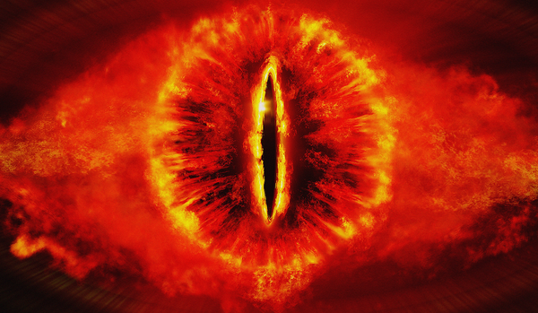
THE EYE OF SAURON
The difference between the simple Ring of Gyges of the Hobbit and the One Ring of the Lord of the Rings - ‘‘into this ring he poured all his cruelty, his malice and his will to dominate all life’‘ - is this energy of cruelty..
Used for one purpose – “THE CONCEALMENT OF WICKEDNESS”
EX-BANKER CLAIMS HE WAS INVITED TO TAKE PART IN CHILD SACRIFICE RITUALS

Article https://www.infowars.com/ex-banker-claims-he-was-invited-to-take-part-in-child-sacrifice-rituals/
VIDEO - Youtube of interview
https://www.youtube.com/watch?v=ftzWfl0e6X4
VIDEO - BANKER Full interview
https://www.youtube.com/watch?v=nEpcY5JU120
"These people were Luciferians"
Paul Joseph Watson | Infowars.com - MAY 2, 2017 1470 Comments
Ex-Banker Claims He Was Invited to Take Part in Child Sacrifice Rituals
A former Dutch banker has given a sit down interview during which he claims that he was invited by members of the financial elite to participate in child sacrifice rituals.
Ronald Bernard was a successful entrepreneur who ran a number of businesses before entering the world of finance. Upon doing so, he was told by his peers to put his conscience in the freezer.
“I was training to become a psychopath and I failed,” said Bernard.
Bernard’s background checks out. He is profiled in this de Volkskrant article from January 2017.
He goes on to describe how elitists saw the people as “useless parasites” and were completely content to crash economies and destroy companies to enrich themselves.
Bernard then relates how he was invited to participate in occult Satanic rituals with other elitists.
“To put it carefully, most people followed a not very mainstream religion. These people, most of them, were Luciferians. And then you can say, religion is a fairy tale, God doesn’t exist, none of that is real. Well for these people it is truth and reality, and they served something immaterial which they called Lucifer.
“And I also was in contact with those circles, only I laughed at it because to me they were just clients. So I went to places called Churches of Satan.
So I visited these places and they were doing their Holy Mass with naked women - like Kubrick's Eyes Wide Shut - and liquor and stuff. And it just amused me. I didn’t believe in any of this stuff and was far from convinced any of this was real. In my opinion, the darkness and evil is within the people themselves. I didn’t make the connection yet.
“So I was a guest in those circles and it amused me greatly to see all those naked women and the other things. It was the good life.
But then at some moment, which is why I am telling you this, I was invited to participate in sacrifices abroad.” Bernard then breaks down and starts crying before explaining, “That was the breaking point. Children.”
The former banker said his refusal to participate in the rituals made him a “threat” to the elite and that this is the method used to blackmail politicians all over the world.
He also stated that these Satanic Rituals had been used to control the World including all the Bankers and Politicians for thousands of years.
“The people who do not underestimate the severity of this are but few. Because this is an annihilating force that hates our guts. It hates creation, it hates life. And it will do anything to destroy us completely. And the way to do that is to divide humanity. Divide and conquer is their truth,” he added.
Whether Bernard is telling the truth or not, and there’s no way to really determine whether that’s the case, the notion of members of the elite being connected to child pedophile rings, torture eituals, Human Sacrifice rituals and Cannibalism Rituals is a manifestly provable fact.
As the video below documents, in virtually every major case across the world where child sex slave rings are exposed, from France, to Portugal, to Britain, to Belgium, to the United States, members of the political, judicial and celebrity elite are embroiled.
When revelations about British TV entertainer Jimmy Savile’s rampant pedophilia came to light, it was also reported that he was involved in Satanic child abuse rituals with other occultists.
Watch the full interview with Bernard here. https://www.youtube.com/watch?v=nEpcY5JU120
The Satanic Rituals have been used from 10,000 years of Molech Ritual burning, Human Sacrifice immolation, molestation.
Cybele and Adonis – State Religion of the Roman Empire – with its Tauroboleum in which worshippers were showered with the blood of Human and Animal Sacrifices.
The Tauroboleum of Satanic Cybele and Attis
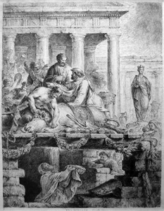
CYBELE AND ATTIS ROMAN STATE RELIGION TAUROBOLEUM RITUAL ANIMAL AND HUMAN SACRIFICE BATHING IN BLOOD
Cybele and Adonis – State Religion of the Roman Empire – with its homosexual, pedophile satanic rituals, castrated homosexual Galli priests and Russian Skoptsy and Amazon Breast castration.
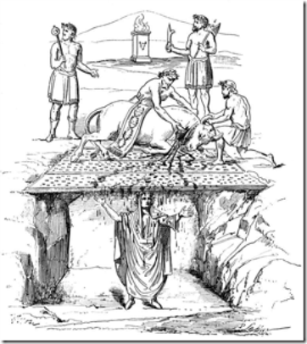
All of this points to how Satanic Ritual has been used to create a psychopathic Bloodline overclass, control the lower orders and degenerate society for thousands of years whilst hiding behind Christianity.
In war, the real Luciferian Elite - The heads of all the thousands of years old Generational Satanic Dynastic Bloodline families worldwide believe that the Religion which is strongest in creating intelligent Psychopaths to rule, will win the competition to rule the world and maintain the totally fooled Christian population in a poverty stricken, uneducated and degenerate state lacking in evolution.
A Golden Goose Society, ready to be plucked and eaten by the Satanic Bloodline families - Eternally.
Riches, luxury, a higher standard of living had softened the leaders and armies of the Roman Empire.
Mad, Satanic Roman Emperors had created a disgust amongst the population for Ritual Satanic Murder Sacrifices and the poor people turned to christianity which by itself should have civilised the world and made it evolved and rich.
However, the thousands of years old Generational Satanic Dynastic Bloodline families worldwide hid their Satanism behind Roman Empire created Christianity - they became Crypto Christians - and infiltrated Christianity into Satanic states to hasten their takeover.
1. So as to secretly continue to create a Satanic Psychopath Elite who follow Satanic Ritual..
RITUAL SEX, RITUAL DRUGS, RITUAL BLOOD SACRIFICE, RITUAL HUMAN SACRIFICE, RITUAL TORTURE, RITUAL BURNING ALIVE, RITUAL CANNIBALISM, RITUAL CASTRATION
.. in all the thousands of years old Generational Satanic Dynastic Bloodline families worldwide. Satanic Ritual has been used to create a psychopathic overclass, control the lower orders and degenerate society for thousands of years - a society controlled by Satanic Psychopaths.
2. So as to Infiltrate a type of naive Christianity - ignorant of their Satanic Psychopathic rulers - remember, Christ whipped the bankers out of the Temple, - in every country in the world so as to allow them to become conquered and stay conquered - to subdue even their own populations, whilst maintaining Satanism in their own Bloodline Families.
Real Christianity is higher, more civilised, than Satanism because it includes Heart Energy, "the Heart of Christ" and conscience - that, "Still small Voice" which are destroyed by Satanism. Real Christianity is higher than Satanism because it does not contain THE RITUALS WHICH DEFINE SATANISM.. RITUAL SEX, RITUAL DRUGS, RITUAL BLOOD SACRIFICE, RITUAL HUMAN SACRIFICE, RITUAL TORTURE, RITUAL BURNING ALIVE, RITUAL CANNIBALISM, RITUAL CASTRATION whose purpose is to create degenerated Psychopaths.
Thus after the Fall of the Roman Empire, Groups such as the Satanic Human Sacrificing Visigoths, Vandals, Angles, Saxons, Franks, Ostrogoths, and Lombards took turns ravaging the Empire, eventually carving out areas in which to settle down. The Angles and Saxons populated the British Isles, and the Franks ended up in France.
The Germanic Satanic Pagan Human Sacrificing Religion which originally conquered Rome and Britain became Christianised, and another wave of Satanic Drug fuelled Berserker Norse - Norman - Religion of Wotan conquered Normandy, Britain in 1066AD and then Italy and Sicily, started to use the same technique of hiding behind Christianity to their Christian populations in the Holy Roman Empire, and the Hohenstaufen's, Luxembourg's, Bourbons, Saxe Coberg Gotha families etc remained their Satanic Rulers.
The Satanic Roman Families migrated to Venice which eventually sacked Constantinople and started to infiltrate Britain in the time of Henry VIII and Queen Elizabeth Ist using their agents, the Cecil Family, the Lords of Salisbury. They completely took over Britain in the time of William of Orange, moving Satanic Venice to London and creating the Satanic East India Company and the Satanic British Empire.
Under Wotan inspired Himmler SS and Crystal Meth fuelled Hitler and his Crystal Meth fuelled army during the second World War conquered Europe and almost Russia, was conquered by the Satanic Anglo - American Empire.
This same process of civilising Christianity conquered pagan India which had defeated Alexander the Great, whilst incorporating through marriage into the Satanic British bloodlines the Elite Indian families like Tata, so that Satanic Bloodline family over classes now rule India..
Satanic drugs - Opium, Christian Missionaries, Marxism and putting 33rd Degree Freemason, Yale educated, Agent Mao in charge, defeated China, whilst incorporating through marriage into the Satanic British bloodlines the Elite Chinese families so that Satanic Bloodline family over classes now rule China and it's elite Apple Slave Factories and it's Christian, Buddhist, Falun Gong eviscerating Transplant Vans.
Same technique in Africa Christianity, Missionaries, Rourkes Drift, Zulus etc.
Thus Satanic Bloodline, blood and genetics become pre-eminent firstly because of Satanic teaching and family mind control techniques which they use on all their offspring, creating Psychopaths to rule, but also the Satanic myth that lesser bloodlines are not truly human - the Oikes - as they are called at Eton - and thus become Satanic prey.
My blood is red.
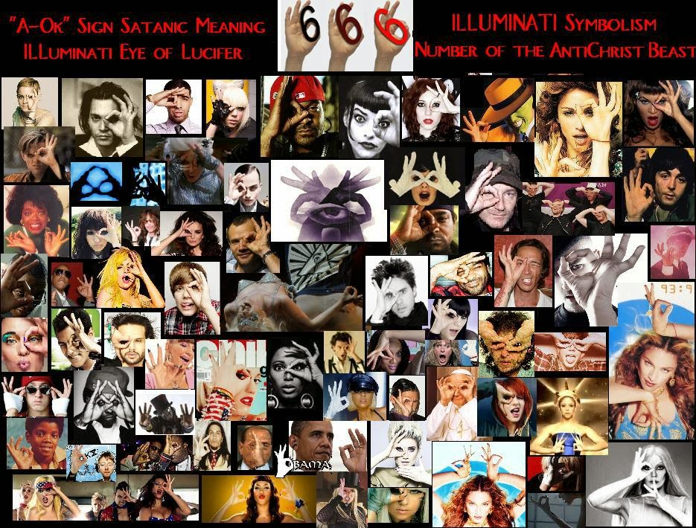
THE INFILTRATION OF SATANISM INTO POLITICS, RELIGION, MUSIC AND ENTERTAINMENT
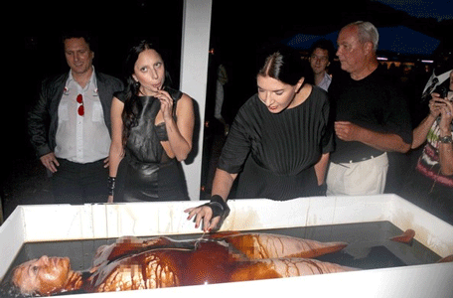

DOWNLOAD SUPER ENERGY AND SACRED SYMBOLS HERE!!!
http://www.energyenhancement.org/Sacred-Energy/Meditation-Super-Energy-And-Sacred-Symbols-for-Perfect-Wisdom-Enlightenment-Color-energyenhancement-org.pdf


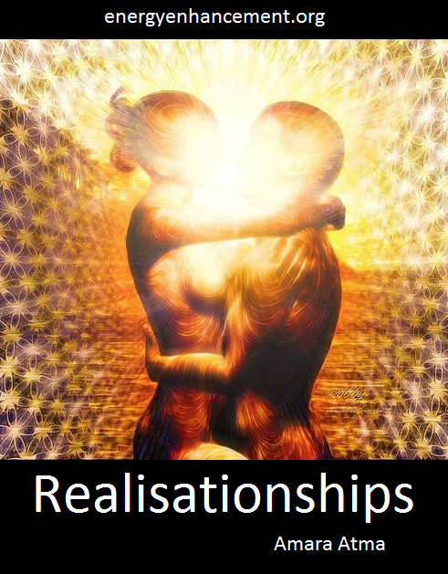

SATANISM WORLDWIDE FOR 10,000 YEARS Links from current Satanists to Ancient Traditions - John Podesta & the DEVIL Lady Gaga AND THE Cult of Marina Abramović Spirit Cooking THE SATANIC
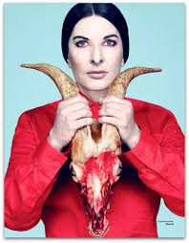
MOTHER GOAT LADY GAGA, THE SECRET CULT OF LADY, BLACK MADONNA, PHILSOPHY- CYBELE, VICTOR HUGO, HUNCHBACK OF NOTRE DAME, Black Virgins, Cybele and Aset, God Pan, Knights Templar, and the Serpent Cult
The key is that the Satanic Religion and its recruiting cults of Freemasonry and the Crowlean Sexual Ritual Ordo Templi Orientis are Fake Gangs, created by men as a technique to conquer the world.
Dennis Brunnell, a 33rd degree Mason and a Grandmaster in the Ordo Templi Orientis (O.T.O.) had become “disillusioned” by the Illuminati’s present activities. Originally believing that the Illuminati was a mystic lodge designed to illuminate one into mystical heights of ascended awareness.
Dennis eventually learned that such metaphysical talk was just so much hot air designed to gain the willing assistance of lower-ranking “lodge” members, who were unknowingly being manipulated into serving the hypocritical, self-seeking and self-serving imperialistic goals of a relatively small inner core of “illumined” members.
Some years ago a man by the name of John Todd, a member of a family who were high-level and generational members of a druidic witchcraft cult, alleged that through his occult contacts he was chosen to be initiated into a deep-level Illuminati lodge. He claimed that in doing so he had to “unlearn” much of the wiccan philosophies which he was taught at a young age.
THE ENERGY ENHANCEMENT SATANISM AND LUCIFERIANISM - SECRET KNOWLEDGE OF THE NEOPLATONIC ELITE DIRECTORY
http://www.energyenhancement.org/Secret-Knowledge-Of-The-Neoplatonic-Elite/THE-ENERGY-ENHANCEMENT-SECRET-KNOWLEDGE-OF-THE-NEOPLATONIC-ELITE-DIRECTORY.htm
These occult teachings were merely a means, he soon found out, of this inner core of initiates to control the lower ranks of the lodge.
This inner core, which consisted of 13 individuals, were (he claims) the leaders of all the large wiccan/witchcraft organizations as well as the leaders of World Freemasonry.
These Satanic Bloodline men controlled both movements from their lofty positions in charge of all Secret Services, Freemasons, Jesuits, Knights of Malta, CFR, Trilateral Commission etc., along with much of the world’s drug trafficking, and had powerful influence in NGOs like Soros world economic and political movements.
Mr. Todd soon learned that this inner core were continually fearful that the lower-ranking members of the occult societies would turn against “them” if the lower members ever found out that this inner council were merely using these “lower pawns” to increase their own wealth and their god-like power and authority over the rest of humanity.
The Satanic Sabbatean Frankist Rothschilds of London, he also learned, were at the very heart of this conspiracy, along with the Satanic Jesuits in Rome. The Rothschilds were considered to be “human gods” by many occultists and, according to Mr. Todd, were in constant communication with “Lucifer”, who they themselves considered to be god.
All current central ‘war’ banks serve the Satanic Sabbatean Frankist Rothschild family – guardian of the Vatican treasury worth 500 Trillion Dollars, including 70% of all Fortune 500 International Companies, 70% of World Banks and 100% of all Central Banks, and workers for the trillionaire crowned heads of Europe and the American Oligarchs like the Rockefellers who are just another branch of the Rothschild family – and the New Venice British Empire.
Dennis Brunnell, John Todd and in fact millions of former Communists, realized that there was an incredible contradiction between what these world socialists were telling their “followers” and what these inner elite were actually practicing.
The connection we make between Illuminism and Communism and Socialism, which is still very strong in mainland China as Mao was a 33rd Degree Freemason, is no coincidence, as all are socialist movements.
Also, according to well-known geo-political analysts such as Dr. John Coleman, Karl Marx himself had known ties with Satanic 33rd degree Freemasonry and the Satanic Jesuit Order.
Indeed, he was paid by British Secret Services Agent Ambassador Urquhart in his Office in the British National Library to write "Das Capital" on behalf of the British Secret Services. Thereafter used to destabilise and take over Russia using Agents Lenin and Stalin and China using Agent and 33rd Degree Freemason Mao.
British Secret Service Socialism is an outgrowth of their Marx created Communism which is the next stage of control for UK, USA, China, India, Australia, Canada, Israel, Europe, Argentina, Brazil etc takeover of the World, Globalist wet dream.
Just as the creation of Wahhabism in 1708 AD by Agent Hempher of the British Secret Services paying Abdul Wahhab, and seducing him with their band of Sex Kitten female agents, to create the Wahhabism Religion and then attaching it politically to the House of Saud.
See this book http://energyenhancement.org/Hempher-14-ConfessionsOfABritishSpy.pdf
This book is very interesting because it details the methodology of how Britain destroyed the Ottoman Empire as a template of how British Secret Services operate in every country in order to take over the World...
Religious Missionary Schools and Universities churning out revolutionaries in the countries targetted for destabilisation.

Students taken from countries - Rhodes Scholars - then educated in USA and British Universities, honey trapped by hordes of Sex Kitten Agents, recruited by the Secret Services, made Freemasons and turned on to Satanism, Mind controlled in Tavistock, and returned to their countries as Politicians and leaders of Freemasonry to take over their country for the Anglo American Empire.
The British Secret Services gave Saudi Arabia and all its Trillions of dollars of Petroleum to the Satanic House of Saud after the first World War and the destruction of the Ottoman Empire.
This was done to obfuscate - as in the creation of stooge Rajas in British India - the fact that after the Second World War, behind the scenes in Saudi Arabia, Europe, India, China, USA, Australia, South Africa, Canada, Israel, Argentina, Brazil etc, it is really Britain with its band of Satanic Lords, who rule all these countries by proxy and, through Globalism and its New World Order, intend to conquer the World.
Saudi Arabia has been giving 400 million dollars annually for the creation of Wahhabist Mosques in every country of the World in order to create ISIS terrorism worldwide.
The Satanic element indicated by the raw eating of hearts and livers of prisoners, still beating after just being torn from their chests - cannibalism by ISIS leaders.
ISIS aids the SOROS Quantum creature employed by the CIA, NSA and Rothschild and his colour revolution hybrid warfare destabilisation of the Middle East, Russia and China as well as of Europe and USA to create police state control for the “protection” of the populaces.
Indeed the problem, reaction, solution dialectic is used by Illuminism to control society and dumb it down in this way.
Brunnell alleged that some within the Illuminati were so heartless as to believe that their socialist “World Order” must be brought about even if the orchestrating of wars, etc., had to be accomplished in order to create the conditions necessary for establishing it… or, in other words, that the end justified the means.
These lost souls were and are apparently convinced that they have the divine right to decide the fate of nations, and that the masses of humanity exist for no other reason than to serve their cause.
They consider themselves “gods” and the rest of humanity as “mere mortals”. So much for the end-result of the false promise that was given to man by the serpent race as revealed in Genesis chapter 3, which was that men could be as gods, and that the creature could be independent from or equal to the Creator.
Prince Philip of England of the Coberg Saxe Gotha clan, descended from Vlad the Impaler or Dracula of Transylvania, – Price Charles has a “Stake” in Transylvania and lives in Dracula’s Transylvania six months out of each year - has blood transfusions regularly from young children to make him live longer like many of the billionaire Globalist class.
Like Al “Gore” of the firm Blood and Gore who skims off the Carbon Tax scam keeps raw blood in his refrigerator.
The Bohemian Grove is a super ultra-elite club - including presidents of the united states - that practice bizarre Satanic Druid customs during the summer solstice in a Grove in the redwood forest above San Fransisco – when the SUN (Sol) appears to be at it’s highest point in the sky (one of the Earth’s hemispheres is at it’s maximum tilt towards the Sun), it creates the longest daytime of the year.
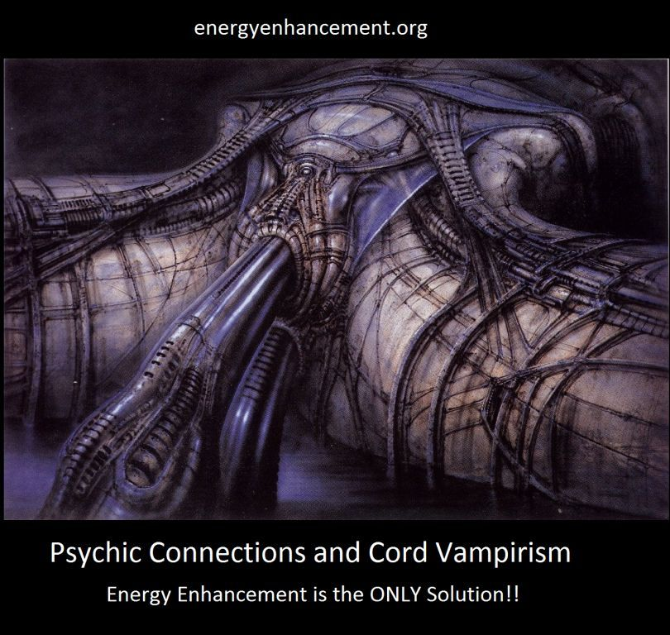
BOHEMIAN GROVE
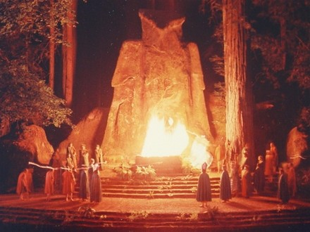
Then the Bohemian Grove emulate the ancient Satanic secret COSMIC mystery cults of Babylon, Rome, and Greece. The members secretly celebrate and sacrifice to the old Gods such as Moloch, Ishtar- CYBELE, Lilith, Attis, SUN Gods- Mithra-Mithras, and APOLLO (Sol Invictus- Unconquered SUN)
Bohemian Grove with the "Cremation of Care" Ritual where they sacrifice a child, killing it and burning it - they say they pretend to - beneath a 40ft stone statue of an owl symbolizing Minerva and thus Cybele.
Prince Philip of Britain once asked ICL - International Computers Ltd. - for a secure operating system of 15 levels where you could see your level and the levels underneath you, but not the levels above.
This indeed is the way all Secret Societies work and like Russian dolls, one within the other, the secrets get more deep and more secret and that all the myths expounded by all the lower levels are lies and the highest level only tells the truth which explains all the other levels.
This final secret must be intense because only the highest psychopaths can implement it as they are Globally implementing it now….
THE LUCIFERIAN SPECIES are humans who have meditated and learned, perhaps many, many tens of thousands of years ago, how to cut off from god by using energy blockages to block chakras above the head so they can live outside the body in private universes made possible by draining the psychic energy of their human prey - so they seem like psychopathic aliens to us - then they download into their mind weakened sons - throwing their sons out - on their 21st birthday so as to become the Head of their Baron, Lord or Crown families and control their multi trillion dollar, thousands of years old families wealth, to manage the human herd.
By removing connection with their hearts and consciences they are thus less than human, a new Species looking like humans but in fact, psychopathic intra - human parasites.
THE SATANIC SPECIES ARE LOWER MANAGEMENT who are given money and power. They are, like all humanity, Victims of the Luciferians, taught to Ritually degenerate themselves and further and further degenerate themselves in order to maintain their energy which at every stage is vampiristically harvested by the Luciferian Watchtower elite who live outside the body.
Because Luciferians live outside the body and only want to vampirise human spiritual energies in order to live forever, they will consider any solution to problems. Their Victim Satanists are their Psychopathic Infil-Traitor, Lives for Satan Destroyers of people, wealth, infrastructure, culture, goodness.. who are promised Eternal Life for their service - THEY LIE!!
Satanists use infil-traition to infect, take over and destroy each new civilisation using War and the false Satanic Economics of Adam Smith, Ricardo, Mills, Keynes and Von Hayek to create the destruction of infrastructure for of the, "Policy of Poverty" or Austerity to control the human herd for tens of thousands of years.
BOHEMIAN GROVE VIDEO
https://www.youtube.com/embed/gYCvQ5iH67A
Our Oligarch Masters like Madame Bathory, Count Vlad the Impaler and Giles de Rais, have used Blood for thousands of years as part of their Rituals - see video above.
A picture of the Satanic ritual, The Cremation of Care - where United States Presidents, Politicians and their Oligarch Masters - "Grovers" - from the Eleusinian Mysteries and the Druids who all performed their Rituals in Groves - burn a baby on an Altar in font of a 40ft stone Owl (Dedicated to Minerva and thus Cybele - the State Religion of the Roman Empire) in front of a lake.
Fake Gang Bohemian Grove Gaytriarchy WISE OLD OWLS including presidents of the USA plan on preying on the victim human race which cannot “see” in the darkness their propaganda and mind control creates so they can devour YOU!!
The Satanist Grovers make “policy” between Luciferian rituals, romping around in the redwoods in togas.
BOHEMIAN GROVE - THE GROVERS
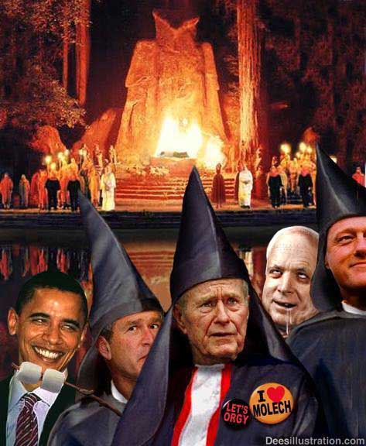
Their attitude: “Hey nothing personal! You’ve heard of Satanic Darwinian “Survival of the fittest", haven’t you? We Owls can see in the dark, you can’t. Therefore we are entitled to EAT you! Right? Of course we’re right. And so it has been for thousands of years! And so we intend to keep it!”

Congress: Union of Sacred Masculine and Sacred Feminine, The Dove, swallowed by Rothschilds and minions such as Morgans, Rockefellers etc. Their lodge member urban planner and his masters are telling you: Congress? Representative Democracy?
Hah! Suckers, we OWN you and your congressman. Ha! - and they are saying that in broad daylight, which gives them a big charge of legitimacy and empowerment, for they are “illuminated” and you are in the dark.
I guess the education system isn't full proof indoctrinating your children into Bolshevik Communism....they need more weapons to more quickly dumb down humanity...vaccines are all set up to make the tribe over at the Rockefeller medical industrial complex $90 Billion a year....autism was practically unheard of until they started pumping babies with tainted vaccines to turn them into a bunch of handicapped chimps...
If you really think that my analysis is a form of softness or passivity then you really misread me and the purpose of this site. You probably know that it is a well-known problem with despots and dictators when the gradually surround themselves with only those kind of advisors who enthusiastically agree with everything the despot wants to hear and with everything the despot says.
Enemy Propaganda is like this.
My question to you is simple: do you want to turn into a “despotic reader” – somebody who will come to this site to hear his views supported, his ideas vindicated and his hopes affirmed? Or do you prefer to come here, get what I hope is an honest, if generally cautious, analysis which you can then either accept or reject?
My job is to try to present to you the truth as best as I can distinguish it - and see below the supporting evidence. Even when that truth is cautious or, worse, unpleasant.
Look, the intelligence process goes through what is called the “Four A's”: Acquisition, Analysis, Acceptance, Action. The first one is “getting the data/info”. The second one means making sense of it and presenting it to your “client” (in this case: all of you). The third one is always overlooked: acceptance by the “client” – i.e., the willingness to hear a negative or disappointing analysis. This is the part which YOU (collective “you”) must do (or refuse to do).
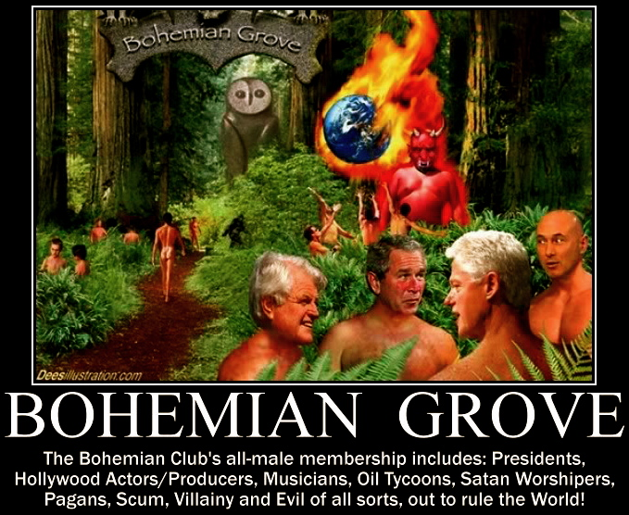
Last is action...

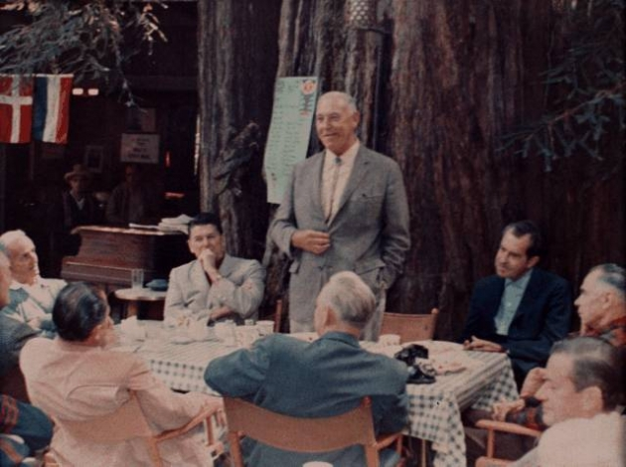
Breakfast at Owls Nest Camp, Bohemian Grove, July 23, 1967. Around the table, left to right: Preston Hotchkis, California Governor Ronald W. Reagan, Harvey Hancock (standing), Vice President Richard M. Nixon, Glenn Seaborg, Jack Sparks, (unidentified individual), (unidentified individual), and Edwin Pauley. Courtesy of Edward W. Carter (deceased).
The Elite, for 10,000 years, have used meditation and psychic powers as part of their mind control arsenal. Consciously, they have denigrated meditation in all normal, mind controlled, - non questioning - people, because the people who do not question are kind of dumb!!
Meditation is one of the powers which controls the World, therefore learn meditation!!
The actions I recommend are the avoidance of poison, and the active getting the poison out of the body, physically, emotionally, mentally, spiritually with Energy Enhancement Meditation Course either by Video or Live, with us. Deprogram, Become normal. Spread the plan.
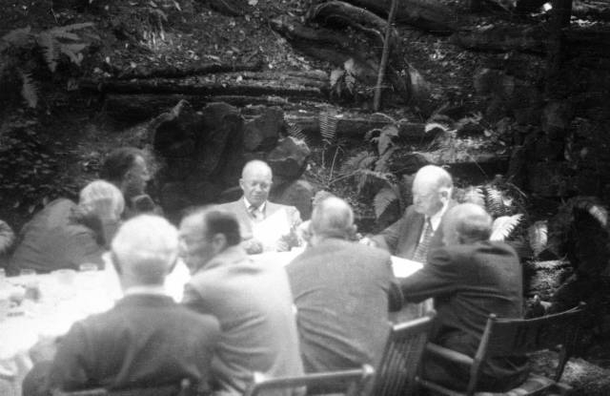 Lawrence Berkeley reporting on the Manhattan Project to create the Atomic bomb, lunching with future president Eisenhower and past president Hoover at Bohemian Grove, July 23, 1950.
THERE IS A PATH!!
WANT TO LEARN HOW TO REMOVE MIND CONTROLLING ENERGY BLOCKAGE IMPLANTS - MORE ABOUT ENERGY ENHANCEMENT MEDITATION?
WANT TO LEARN WHY "TRADITIONAL MEDITATION TECHNIQUES ARE DESIGNED TO FAIL"?
DOWNLOAD FREE ENERGY ENHANCEMENT E-BOOK!!


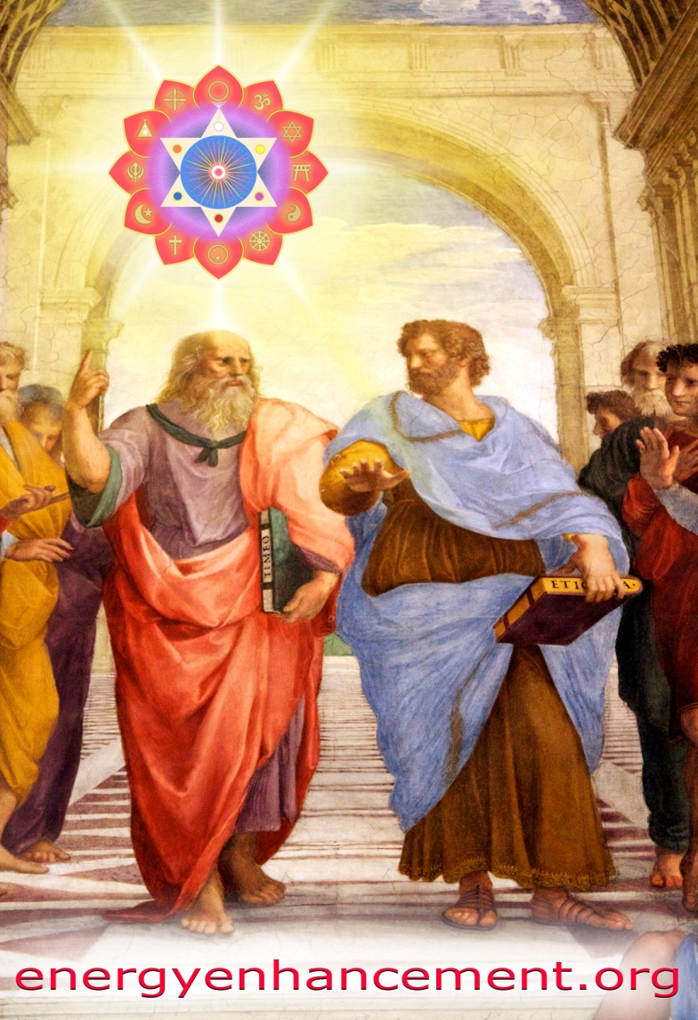
THE EVOLUTION OF A NEW HUMANITY - 1. THE ENLIGHTENED SPECIES AND THE HUMAN INTRA SPECIES PARASITES 2. THE LUCIFERIAN SPECIES 3. THE SATANIC SPECIES
http://www.energyenhancement.org/THE-EVOLUTION-OF-A-NEW-HUMANITY-THE-ENLIGHTENED-SPECIES-AND-THE-HUMAN-INTRA-SPECIES-PARASITES-THE-LUCIFERIAN-SPECIES-THE-SATANIC-SPECIES.htm

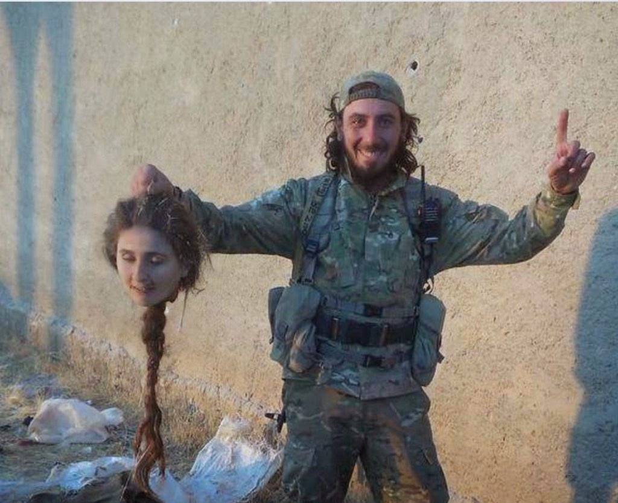Satanic ISIS, British 1706 Secret Agent Hempher created Salafism and Saudi Arabian Wahhabism ISIS - British/Venetian Empire created Secret service created Wahhabism in 1706 - based on the same principles as Lutherism - and institutionalised it in MI6 created Saudi Arabia
http://www.energyenhancement.org/Satanic-ISIS-and-Saudi-Arabian-Wahhabism-Secret-Agent-Hempher-Salafi-Luther-Contarini.htm

The Devil Worshipping Satanic Jewish Dönmeh and the Infiltration of Satanism into Luciferian Satanic Illuminati Kabbalist Sabbatean Frankists - Jewish Families - Rothschilds, Rockefeller, Schiff, Astor, Saud, Attaturk, Stalin, Hitler, Mao. (Only the Torah Jews were Genocided in the Holocaust)
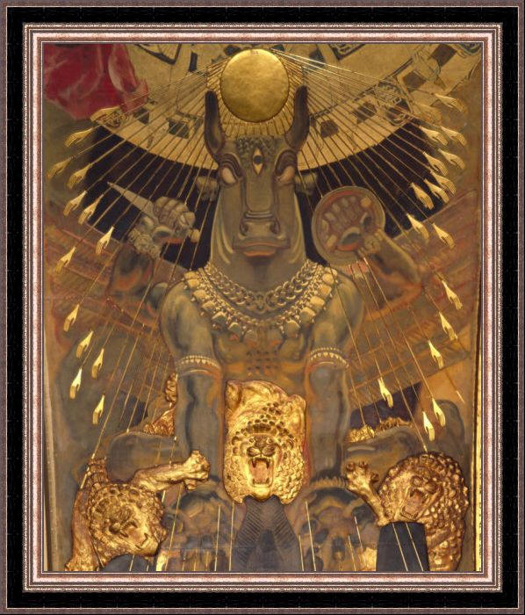
http://www.energyenhancement.org/Devil-Worshipping-Satanic-Jewish-Dönmeh-Infiltration-Satanism-into-Luciferian-Satanic-Illuminati-Kabbalist-Jewish-Sabbatean-Frankists-Rothschilds-Schiff-Astor-Saud-Attaturk-Stalin-Hitler-Mao.htm
Sir Jimmy Savile and Prime Minister Tony Blair

TANTRA AND HOMOSEXUALITY IN SATANIC RITUAL HOMO-OCCULTISM - The Ritual Implantation of Energy Blockages - ETON - Whipping and Fagging to create fierce homosexual Warriors in a educational system based on Greece and Sparta - The foundation of the British Empire The whole of Britain is run by a Rochdale, Telford Pedophile cult!!
http://www.energyenhancement.org/HOMOSEXUALITY-IN-SATANIC-HOMO-OCCULTISM.htm
THE SATANIC HISTORY OF THE WORLD - PART TWO - OLIGARCHIES-POLICIES-FROM-THE-TIME-OF-BABYLON-AND-THEIR-HISTORICAL-TECHNIQUES-TO-ENSLAVE-THE-WORLD - IT'S THE OLIGARCHIC GANG FAMILIES STUPID!! PROTESTANTISM - Luther like Wahhab was a paid Agent working for Venetian Cardinal Contarini
http://www.energyenhancement.org/OLIGARCHIES-POLICIES-FROM-THE-TIME-OF-BABYLON-AND-THEIR-HISTORICAL-TECHNIQUES-TO-ENSLAVE-THE-WORLD.htm
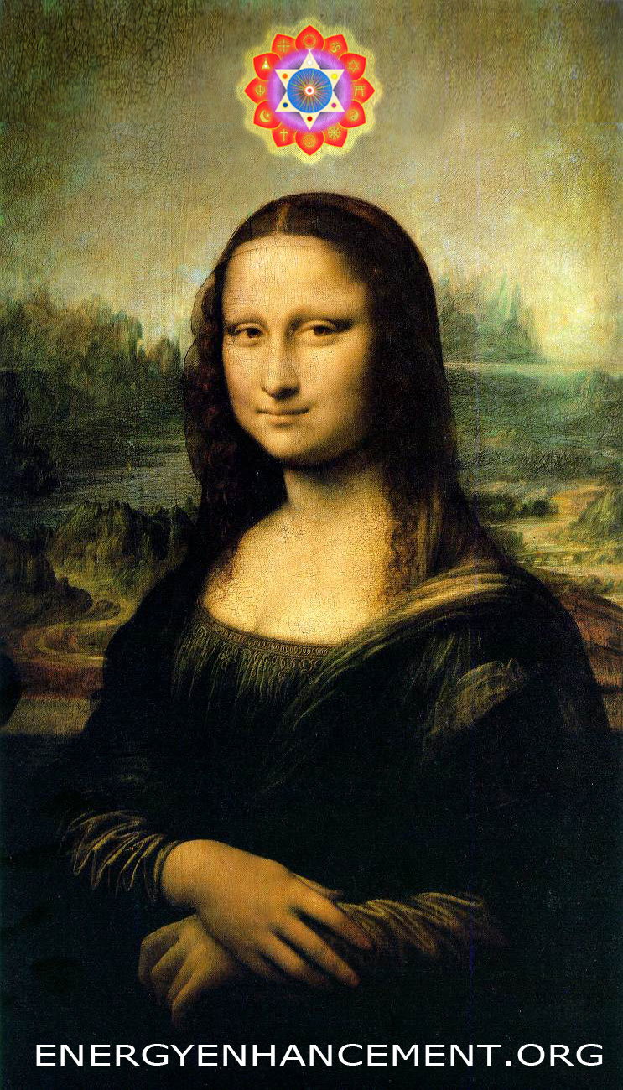
Luciferian Satanic Illuminati Kabbalist Sabbatean Frankists - CULT OF THE ALL SEEING EYE
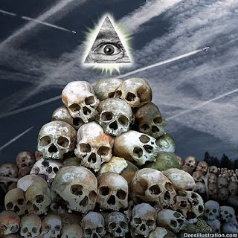
http://www.energyenhancement.org/Luciferian-Satanic-Sabbatean-Frankists-Kabbalist-Illuminati-CULT-OF-THE-ALL-SEEING-EYE.htm
THE EVOLUTION OF A NEW HUMANITY - 1. THE ENLIGHTENED SPECIES AND THE HUMAN INTRA SPECIES PARASITES 2. THE LUCIFERIAN SPECIES 3. THE SATANIC SPECIES - SATANISM/LUCIFERIANISM - Pagan Rituals and Myths used to pervert and degenerate a psychopathic ruling class.
http://www.energyenhancement.org/THE-EVOLUTION-OF-A-NEW-HUMANITY-THE-ENLIGHTENED-SPECIES-AND-THE-HUMAN-INTRA-SPECIES-PARASITES-THE-LUCIFERIAN-SPECIES-THE-SATANIC-SPECIES.htm
THE SATANIC HISTORY OF THE WORLD - PART ONE - The Satanic Psychopathic Palmerston, Prime Minister of the British Empire circa 1850 - and his Three Satanic Psychopathic British Agents, Mazzini, Urquhart and Napoleon III - as a Continuation of the same Satanic Psychopathic Gang Families from Satanic Psychopathic Babylon through the Satanic Psychopathic Roman Empire, the Satanic Psychopathic Venetian Empire to the Satanic Psychopathic British Empire to the current Satanic Psychopathic Anglo-American Empire - KARL MARX - Wrote Das Capital from his MI6 provided office in the British National Museum under Ambassador Urquhart creating MI6 inspired Communism, Russian (65 millions tortured dead) and Chinese Revolutions (85 millions tortured dead), and Socialism.
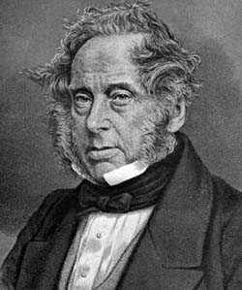http://www.energyenhancement.org/THE-SATANIC-HISTORY-OF-THE-WORLD-palmerston-mazzini-urquhard-napoleon-iii.htm
The Illuminati Enemy Within Freemasonry - Weishaupt, General Pike, Palladian Rite, Morals and Dogma, Rose-Croix, Templars, Alta Vendita or highest lodge of the Italian Carbonari, Mazzini, The Lost Keys of Freemasonry, Manly P. Hall the seething energies of Lucifer - Satan, or Lucifer, and the demons, Demonic Possession, Morals and Dogma, Albert Pike, Elias Ashmole edited Dr. John Dee, sorcerer who "brought through" the Enochian system of magic, of satanic ritual and demonic evocation, the Pagan Eleusinian Mysteries, Council on Foreign Relations ... the Trilateral Commission ... and the Bilderberger Group serve to disseminate and to coordinate the plans for this so-called new world order, Alice A. Bailey, 1950, 1986, "The Plan" involves a one-world government, an occult hierarchy, an elite "illumined" oligarchy ruling over a world in which Christianity has been slated to be displaced and destroyed.
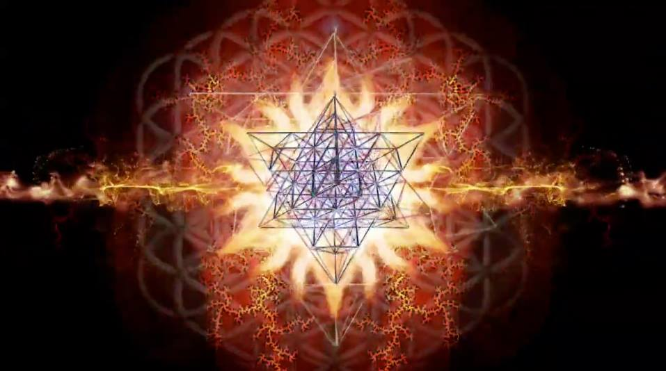
http://www.energyenhancement.org/AMERICAS-SUBVERSION-The-Enemy-Within-Sonny-Rene-Stermole-Illuminati-Weishaupt-Pike-Palladian-Rite-Rose-Croix-Templars-Alta-Vendita-Carbonari-Mazzini-Manly-P-Hall-Lucifer-Satan-demons-Demonic-Possession.htm
CAPTAIN AMERICA - THE WINTER SOLDIER - ESOTERIC MOVIE REVIEW BY SATCHIDANAND - EUGENICS, TRANSHUMANISM, LUCIFERIANISM, SATANISM, FASCISM

http://www.energyenhancement.org/CAPTAIN-AMERICA-THE-WINTER-SOLDIER-ESOTERIC-REVIEW-BY-SATCHIDANAND-EUGENICS-TRANSHUMANISM-LUCIFERIANISM-SATANISM-FASCISM.htm
Eugenics and the Nazi Fascist Holocaust - and Satanic Agents Dawkins, Darwin, Huxley, Wells, Lord Bertrand Russell, Prince Bernhard, Prince Phillip

http://www.energyenhancement.org/Eugenics-and-the-Nazi-Fascist-Holocaust-and-Satanic-Agents-Dawkins-Darwin-Huxley-Wells-Lord-Bertrand-Russell-Prince-Bernhard-Prince-Phillip.htm

SATANISM, RITUAL SEX AND HUMAN SACRIFICE, BLOODLINES, SATANIC PROPAGANDA DARWINISM EUGENICS AND THE REMOVAL OF IMPLANT ADDICTION SEX AND DRUG BLOCKAGES
http://www.energyenhancement.org/SATANISM-RITUAL-SEX-HUMAN-SACRIFICE-BLOODLINES-SATANIC-PROPAGANDA-AND-THE-REMOVAL-OF-IMPLANT-ADDICTION-VAMPIRE-SEX-DRUG-AND-FOOD-ADDICTION-blockages.htm
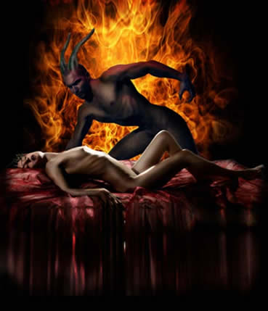
Financial economist and historian Michael Hudson at the Summit on Modern Money Theory in Rimini, Italy - With Reference to Hamiltonian Economics and the Lyndon Larouche Credit Economy and Webster Griffin Tarpley
http://www.energyenhancement.org/Financial-economist-and-historian-Michael-Hudson-Modern-Money-Theory-MMT-Reference-to-Hamiltonian-Economics-Lyndon-Larouche-Credit-Economy-Webster-Griffin-Tarpley.htm
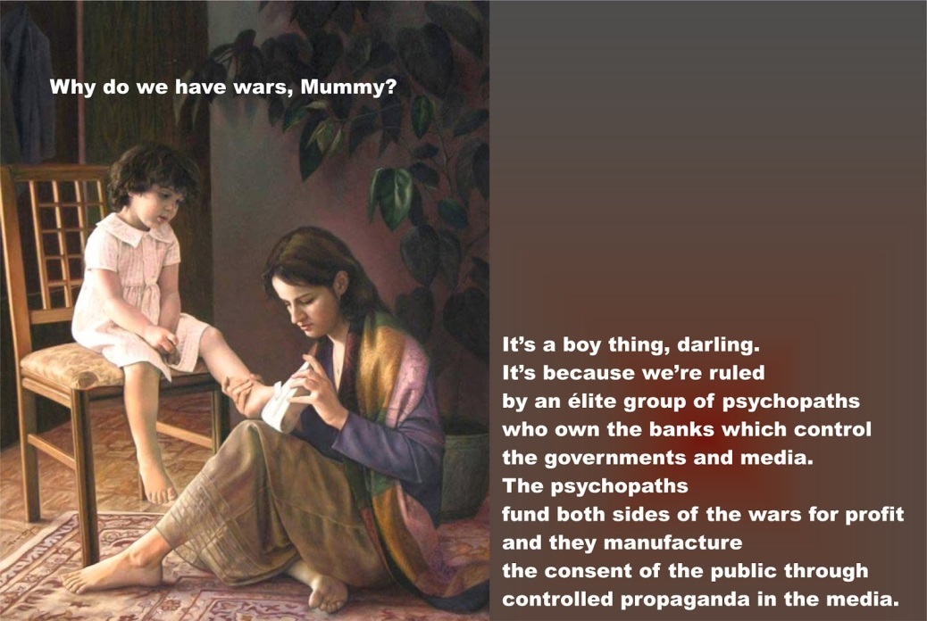

SATCHIDANAND MOVIE REVIEW LUCY - LUCYFER, LUCIFER, SATANISM, SATANIC MEMES, THE SINGULARITY, DRUGS, TRANSHUMANISM, EUGENICS

http://www.energyenhancement.org/SATCHIDANAND-ESOTERIC-MOVIE-REVIEW-LUCY-LUCYFER-LUCIFER-SATANISM-SATANIC-MEMES-THE-SINGULARITY-DRUGS-TRANSHUMANISM-EUGENICS-ENLIGHTENMENT-MEDITATION.htm
STUDENT REPORT

Today I sat in a chair and listened to the heart chant initiation 1 for the first time.

I was focusing on aligning my shoulders and spine forward and backward between the two lines of power from the center of the earth. And picturing the immovable mountain. Focusing on my breathing, closing the anus. I stayed in for the first four minutes. Then I got tired and openned my eyes, for about 7 or 8 seconds. Then I was so drowsy I had to close my eyes again. Then after about another four minutes I was tired again. Then the same thing but this time I focused on nothing but the energy from the earth entering the base of my spine and coming into my heart. Right from the beginning of the meditation I felt my energy all over my whole chest, even now.

But at the last when I focused on it coming from the earth, I immediately felt very, very powerful energy and I didn't move to find it. My back straightenned up automatically to the alignment and I was kind of "stuck" in that position with the power flowing.

From there it was hard for me to stop meditating when the chants were over. Very powerful. Even without magnets. My question is about my focusing. Is it wrong to "imagine" the power or the alignment or the energy? or should we imagine until we feel it? Or both? Am I focusing on the right things?

I am very grateful for your teachings. Thank you for your generosity.


Student Report

Also I noticed as soon as satchi emailed me, I got a down-pouring of light from above the crown which kept charging me up the rest of the day – and my cravings died out! Then I realized they were ego-blockages and that I did not want them.

This Energy Enhancement Level One Initiation Three - ALCHEMICAL VITRIOL is great! I've done it some more and it's incredibly powerful. I don't know why it isn't more well known or taught? It's really bringing up little blockages which are complaining while being pushed down into the earth's core to get purified.
The hot fire energy has gotten much stronger in my body while doing the practice, mostly the base of the spine heats up, but also the middle of the spine. There are lots of little blockages being noticed. But I'm pushing them out.

Energy Enhancement Meditation Course Level 1 Initiation 4: Accessing the Universal Energy Source: Soul Fusion - INFINITE ENERGY!! for You!! via the Antahkarana, Macrocosmic Orbit, The Energy Enhancement Supra Galactic Orbit, Chakras above the Head, Advanced Kundalini Kriyas, Siddis, The Creation of Psychic Vision.

http://www.energyenhancement.org/EE-Meditation-Level-1-Initiation-4-Macrocosmic-Orbit-EE-Supra-Galactic-Orbit-Antahkarana-Chakras-Above-the-Head-Advance-Kundalini-Kriyas-Siddis.html

ENERGY ENHANCEMENT MEDITATION ENLIGHTENMENT AND ILLUMINATION
ENERGY ENHANCEMENT SPEEEDS UP!! YOUR PROCESS

FIND ALL THE INCREDIBLE MEDITATION TECHNIQUES AND MEDITATION PRACTISES REMOVED FROM TRADITIONAL MEDITATIONS AND TAUGHT IN THE ENERGY ENHANCEMENT STREAMING VIDEO MEDITATION COURSE AND LIVE MEDITATION RETREATS IN BRAZIL AND INDIA

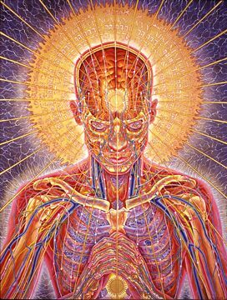
ENERGY ENHANCEMENT COURSE REPORT FROM JEAN

"I have experience of many forms of meditation and practices for self improvement including: Transcendental meditation (TM) 12 years, Kriya Yoga 9 years, Sushila Buddhi Dharma (SUBUD) 7 years, and more recently the Sedona Method and the Course in Miracles. The Energy Enhancement programme encapsulates and expands all of these systems, it is complete and no questions are left unanswered."

Jean, NUCLEAR ENGINEER, FROM THE SEPTEMBER 2005
ENERGY ENHANCEMENT COURSE

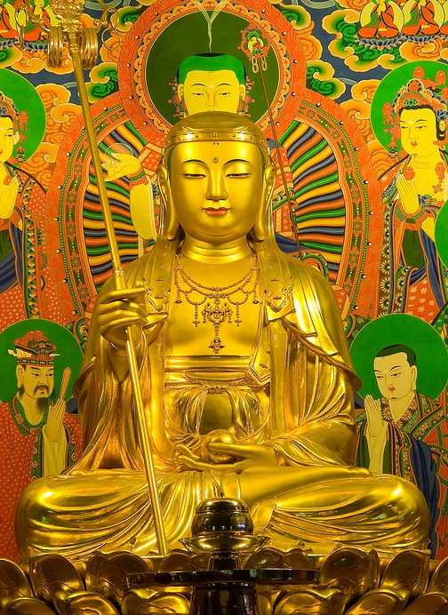

I felt immense happiness and peace at their presence, they had an aura of intense holiness and purity - great Saints and Sages.

As they faced me and bowed one by one I felt a feeling of unworthiness but the thought came immediately "worthiness is not necessary, by the grace of God infinite love and light is offered to each of us every moment all we need do is accept it".

I felt that they were very pleased with my practice and had appeared to me to let me know. I think it is important to say that I was in no way unique.
Most of the other students this year and last year had experiences of meeting beings of light, ascended masters and angels - EE has that effect!
Come and experience it for yourself you won't be disappointed.

JEAN

Truly, perhaps Enlightenment is next!!
You will probably find this interesting. Jenny who came on the Energy Enhancement course with me this year went to see her accupuncturist which she does routinely.

This guy (Ross) seems very talented, by reading her pulse he can tell her what she has been eating - certain energy patterns apparently. Anyway when he checked her pulses this time he found something interesting.
Apparently there is a pulse which gives an indication of the level of spiritual energy.

Jennies' spiritual energy was reading off the scale, something Ross said he has never seen before with Jenny or anyone else.
He says people just don't have this pulse and as far as he knows the only way to get it is to connect to external sources which as you know we did on the Course - wow!

Truly, perhaps Enlightenment is next!!

Kindest Regards & Thanks as always
Jean

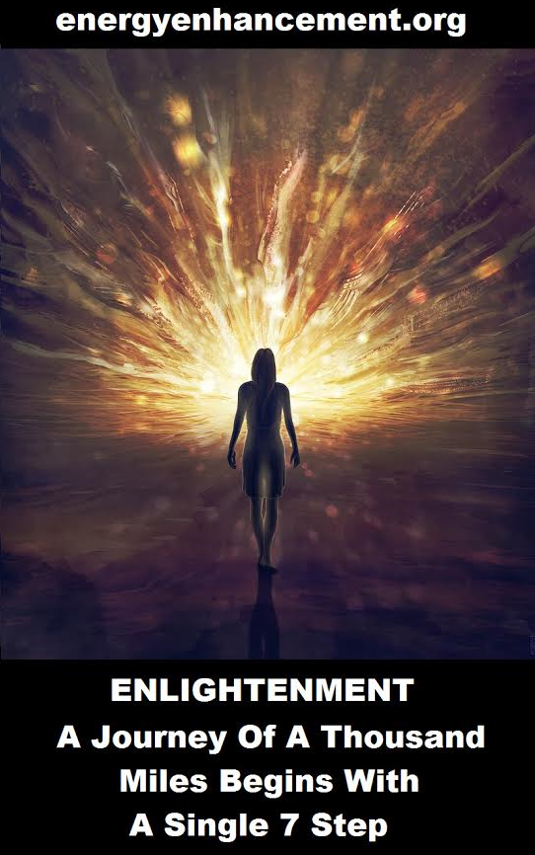

ENERGY ENHANCEMENT COURSE

"Get your asses over here Now and Speed Up your process of Enlightenment on the Energy Enhancement one month course!!" - DON
Every one of our Students gets this Spiritual Experience of Connection with Infinite Energies.
Energy Enhancement does indeed, "SPEED UP THE PROCESS!!"
And they all get this Experience of Light, Life and Infinite Energy just with the Energy Enhancement Course - Every One of Them!!
LEVEL 1 - 4 VIDEO COURSES ANYTIME IN THE COMFORT OF YOUR OWN HOME

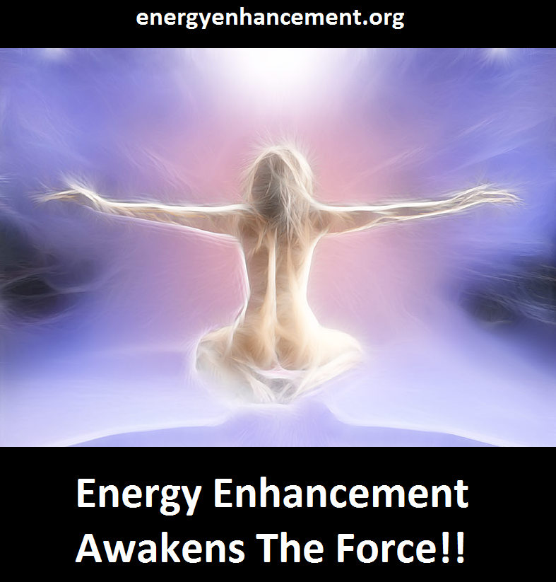

ENERGY ENHANCEMENT MEDITATION ENLIGHTENMENT AND ILLUMINATION

THE INCREDIBLE MEDITATION COURSE AND MEDITATION TECHNIQUES CREATED TO PRODUCE ENLIGHTENMENT AND ILLUMINATION

"ALL TRADITIONAL MEDITATIONS HAVE BEEN DESIGNED TO FAIL" - SATCHIDANAND –

"BECAUSE ORIGINALLY ALL MEDITATIONS CONTAINED THE TECHNIQUES OF, "THE REMOVAL OF ENERGY BLOCKAGES", "THE KUNDALINI KEY" AND OF, "ALCHEMICAL VITRIOL" TO GROUND NEGATIVE ENERGIES AND TO NATURALLY INCREASE KUNDALINI ENERGY"

"NOW, ONLY ENERGY ENHANCEMENT MEDITATION TEACHES THESE TECHNIQUES WHICH SPEED UP THE ENLIGHTENMENT PROCESS"

CLICK HERE FOR..
YGGDRASIL IS THE KUNDALINI KEY
AND

VITRIOL – Visita Interiora Terrae Rectificando Invenies Occultem Lapidem

Translation of VITRIOL.. "Visit the Center of the Earth there you will find the Philosophers Stone, Kundalini Chakra, which transmutes all Negative Energy, All Pain, All Negative Karmic Mass, into Pure Positive Spiritual Energy. By changing the direction of that Energy along the Path of the Soul, Soul Chakra, Central Spiritual Sun, First Chakra Above the Head you will receive Enlightenment"

"IF YOUR TRADITIONAL MEDITATION DOES NOT TEACH YOU ABOUT THE THE REMOVAL OF ENERGY BLOCKAGES KUNDALINI KEY AND ALCHEMICAL VITRIOL, THEN IT HAS BEEN DESIGNED TO FAIL"

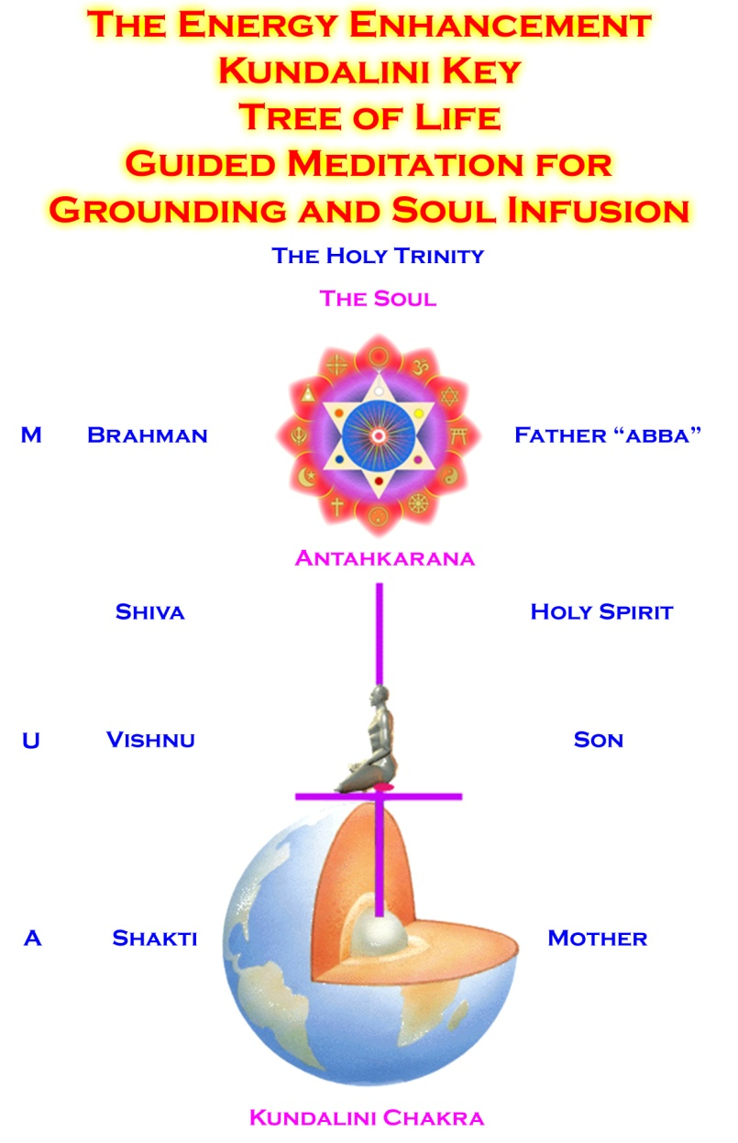

FIND ALL THE INCREDIBLE MEDITATION TECHNIQUES AND MEDITATION PRACTISES REMOVED FROM TRADITIONAL MEDITATIONS AND TAUGHT IN THE ENERGY ENHANCEMENT STREAMING VIDEO MEDITATION COURSE AND LIVE MEDITATION RETREATS IN BRAZIL AND INDIA
THE ENERGY ENHANCEMENT VIDEO MEDITATION COURSE

ENERGY ENHANCEMENT - THE ULTIMATE MEDITATION COURSE!!
ANCIENT EFFECTIVE ENERGY ENHANCEMENT MEDITATION SECRETS
ALL THE MEDITATION TECHNIQUES!!
SUCCESSFUL
SPEED UP YOUR PROCESS!!
PROVEN
TIME TESTED
TRUE

THE MOST ADVANCED MEDITATION COURSE, MEDITATION TECHNIQUES AND MEDITATION PRACTICES ON THIS PLANET, INCLUDING THE THE REMOVAL OF ENERGY BLOCKAGES KUNDALINI KEY, THE KUNDALINI KRIYAS, ALCHEMICAL VITRIOL AND KUNDALINI YOGA IN 28 INITIATIONS!!
SPEED UP THE PROCESS!!

"I have experience of many forms of meditation and practices for self improvement including: Transcendental meditation (TM) 12 years, Kriya Yoga 9 years, Sushila Buddhi Dharma (SUBUD) 7 years, and more recently the Sedona Method and the Course in Miracles.

The Energy Enhancement programme encapsulates and expands all of these systems, it is complete and no questions are left unanswered."

JEAN - NUCLEAR ENGINEER

WHY JUST SIT? - YOU NEED REAL SPIRITUAL EXPERIENCE - FAST!!

READ BELOW ALL THE TECHNIQUES TAKEN OUT OF TRADITIONAL MEDITATIONS AND PUT BACK BY THE ENERGY ENHANCEMENT MEDITATION COURSE!!
- RESTORING THE ENERGY ENHANCEMENT KUNDALINI KEY

Phillip Chester

Phillip Chester - Change manager working directly to the Managing Directors of several fortune 500 companies.

"I feel that I have been given some secret knowledge, which was only given to the initiated, or hidden among a lot of unnecessary sub techniques in other disciplines."

"The energy techniques given in Energy Enhancement have never been explained to me in Aikido (even Ki Aikido), Yoga or Ashtanga Yoga or on any meditation course that I have been on like Transcendental Meditation, and have only been partly taught to me previously by Taoist Master Mantak Chia and on Tantra Courses. Mantak Chia I found particularly confusing; Chi Gung I found awkward"

"ENERGY ENHANCEMENT GOES MUCH FURTHER THAN ALL THE ABOVE, IN A MORE EFFECTIVE WAY THAT ANY OF THE OTHERS I HAVE EXPERIENCED..."

One effect of Energy Enhancement is that I can no longer look at other disciplines like Ashtanga Yoga, Transcendental Meditation, NLP, Aikido and Ki Aikido and Mantak Chia and his Chi Gung, in the same light, because they do not contain this learning.

Phillip Chester - Change manager working directly to the Managing Directors of several fortune 500 companies.

MEDITATION ENERGY ENHANCEMENT - THE CORE ENERGY TECHNIQUES!!

THE MOST ADVANCED MEDITATION TECHNIQUES ON THIS PLANET, IN 28 INITIATIONS!!

ANCIENT EFFECTIVE ENERGY ENHANCEMENT SECRETS -
SUCCESSFUL
PROVEN
TIME TESTED
TRUE

TO ENQUIRE ABOUT ENERGY ENHANCEMENT COURSES PLEASE SIGN ON TO OUR MAILING LIST AND THEN EMAIL US DIRECT FROM THE EMAIL ADDRESS WE SEND YOU FROM OUR MAILING LIST

email sol@energyenhancement.org

PICTURE OF MOVING FLASH VIDEO SHOWING THE ANTAHKARANA CONNECTING WITH THE CENTER OF THE EARTH AND THE CENTER OF THE UNIVERSE - FREE WITH THE ONLINE AND DVD COURSES!!

INITIATIONS 1 TO 8 OF LEVEL 1 - GAINING THE ENERGY OF ENLIGHTENMENT

ENERGY ENHANCEMENT INITIATION 1 - Meditation: Shaktipat Kundalini Stopping the mind and Squaring the Circle

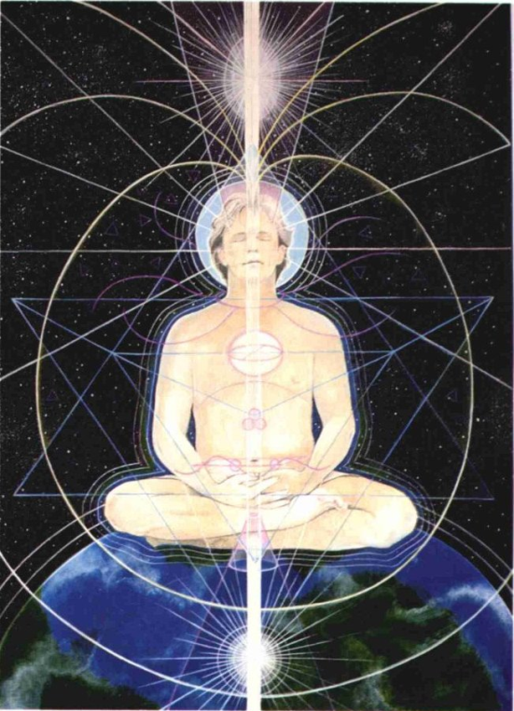

ENERGY ENHANCEMENT INITIATION 2 - Energy Circulation: Microcosmic Orbit, Kundalini Kriyas



ENERGY ENHANCEMENT INITIATION 3 - Advanced Kundalini Kriyas - Taoist Earth Orbit - The Grounding of Negative Energies: Alchemy, Hermes Trismegistus VITRIOL Visita Interiore Terrae Rectificando Invenies Occultem Lapidem and Earth Connection



ENERGY ENHANCEMENT INITIATION 4 - Accessing the Universal Energy Source: Macrocosmic Orbit, The Energy Enhancement Supra Galactic Orbit, The Creation of the Antahkarana - Projection - Leaving the Body - the Immortality of the Soul - Connect with the Higher Chakras above the head - Advanced Kundalini Kriyas - Siddis - The Creation of Psychic Vision
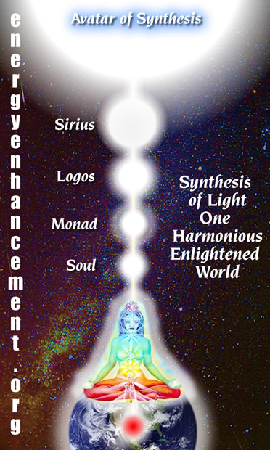

ENERGY ENHANCEMENT INITIATION 5 - ENERGY PROJECTION in External Antahkaranas - Grounding Toxins in Food: Re-awakening our psychic ability to detect poisons. REMOVING BLOCKAGES.



ENERGY ENHANCEMENT INITIATION 6 - Psychic Protections: Power Towers - Creating and Using External Antahkaranas - Exponentially Increasing your Spiritual Energy - Creating the Flow from Heaven to Earth



ENERGY ENHANCEMENT INITIATION 7 - Psychic Protections: Pyramid Protection

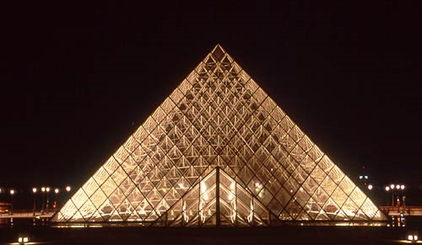

ENERGY ENHANCEMENT INITIATION 8 - Psychic Protections: How to Use THE MERKABA - Astral Travel and Projection - Advantages of the Siddhis of Becoming Bigger and Smaller



"I have experience of many forms of meditation and practices for self improvement including: Transcendental meditation (TM) 12 years, Kriya Yoga 9 years, Sushila Buddhi Dharma (SUBUD) 7 years, and more recently the Sedona Method and the Course in Miracles. The Energy Enhancement programme encapsulates and expands all of these systems, it is complete and no questions are left unanswered."

Jean, NUCLEAR ENGINEER, FROM THE SEPTEMBER 2005
ENERGY ENHANCEMENT COURSE

ENERGY ENHANCEMENT AND TANTRA by SATCHIDANAND

WHAT IS TANTRA?

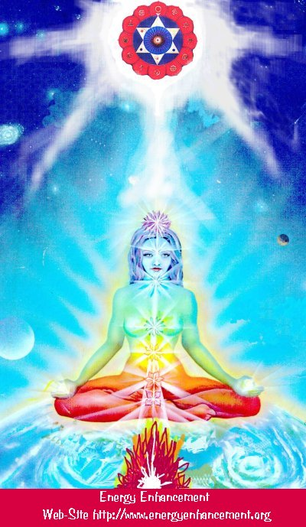

TANTRA IS ONE OF THE MANY PATHS WHOSE AIM OR END OR PURPOSE IS ENLIGHTENMENT

Like Yoga which means Union with the center of the Universe or with God, Tantra is any path which achieves that aim.

For many, Tantra is a sexual means of achieving that union. People ask me, isn't one of the methods to make love only once per month? To increase the length of time we make love to hours?

Well, I reply, Enlightenment comes from the increase of energy. Human beings only have a small amount of energy within themselves. Really to increase that energy we need to access the energy from chakras outside the body. It is like we have a computer which is running slowly on only five volts. We need to plug ourselves into the big generator!

To obtain thousands of volts of power in order to make the computer work more quickly at a much higher level we need to plug ourselves into the chakras above the Crown Chakra, into energy in the central spiritual sun!! The Soul!! God!!!

And in the center of the Earth is the Kundalini Shakti flowing out in every direction from the Atomic Generator which powers this planet. The atomic pile in the center of the planet is a 5000 degrees centigrade and provides the energy which keeps this planet alive and at the correct temperature. The Earth is feminine. The Indians say, "Our Mother, the Earth" and our Father, who art in Heaven is God, the energy in the center of the universe. And when all the Energy Blockages to that connection have been removed, then there is a flow, a waterfall of spiritual energy which powers every one of the enlightened.
Then we have Shiva, our father, combining with Shakti our mother. Then we have Hercules, son of God, Zeus, Theos, Deos, combining with the daughter of Pluto, King of the Underworld.

Enlightenment concerns The Holy Trinity and is composed of Sat, the truth of the center of the Universe combining with Chitta - the holy grail, the cup of the mind on this planet, empty and ready to receive the libation of the Gods, and the flow of energy between the two is called Ananda, or bliss - Satchitananda like the Father - Our Father who art in Heaven, the Son and the Holy Spirit which flows between the two.

And the Hindus have a word for the channel between the Center of the Universe and the Center of the Earth. Rapunzel, Rapunzel, let down your hair. The Rainbow Bridge. The Tower of Babel. Tower of Connection created out of mental matter to channel the energies of God through all the infinite chakras of existence, powering the whole universe from the center. This is the Antahkarana.

If you are not connected with, if you are blocked from, the center of the universe then just think of a small flow of water slowly filling a bucket. You may well have to wait a month for the bucket to fill. Only then will you have sufficient energy to enjoy making love, or really doing any of the thousand things we have to do on this planet. But if you are connected and put your bucket under a waterfall, then that bucket will fill in seconds. You will have infinite energy to do with whatever you want every second of the day.
The Greeks had a name for this energy which descends from the soul to power the Mind Computer, and they called it Genius which is the what happens to the mind computer powered by the energy of the Soul. Soul Infused.
The Mind is of the intellect of logic yet the Soul is Intuition, Knowing, Wisdom and is much higher than the mind.

The Kashmir Shaivites also have the energy of Chit Shakti whereby the mind is also powered by the Energy in the Center of the earth.
In reality, human beings are powered by both masculine and feminine energies. We connect with the Kundalini Chakra in the center of the earth by means of the Base chakra, and we connect with the center of the universe by means of the Crown Chakra.

Usually it takes three days for the students who come on our courses to access this energy with which they can successfully transmute all their Energy Blockages because another, more easy way for people to absorb energy is from the Buddhafield, the Aura of the Master.

When they leave then sometimes the energy drains away, because it is the energy blockages which create the holes in the bucket through which all the water drains away.

And this is Tantra, the Energy Flow of the Soul created by the Sexual Union of Shiva and Shakti.

In that that bliss, that delight, such an overflowing cornucopia of Energy which comes from the Gaining of Energy and the Removal of Energy Blockages, we find only Enlightenment.

In a way, Enlightenment is a twenty-four hour a day orgasm.


VIMALAKIRTI SUTRA THE BOOK!!
DOWNLOAD BELOW
http://www.energyenhancement.org/Vimalakirti-Sutra/vimalakirti-sutra.pdf

COME ON AN ENERGY ENHANCEMENT COURSE!!
THE DOWNLOADABLE ONLINE COURSE
THE VIDEO COURSE IN 12 DVDs
THE ONLINE/VIDEO COURSE COMBINATION

ENERGY ENHANCEMENT IS THE NEWEST AND MOST HIGH SPIRITUAL IMPULSE ON THIS PLANET

ENERGY ENHANCEMENT SYLLABUS - WHAT IS ENERGY ENHANCEMENT?

THE ENERGY ENHANCEMENT SYLLABUS CAN BE FOUND HERE - THE HOME PAGE IS WHERE YOU SHOULD START OFF BUT FOR MORE DETAIL - LEVEL 1 GAIN MASSIVE ENERGY, LEVEL 2 - CLEAR ENERGY BLOCKAGES, LEVEL 3 - CLEAR ANCIENT KARMA, LEVEL 4 - MASTER RELATIONSHIPS, LEVEL 5 - HEAL THE WORLD

THE EE STUDENTS
THE ENERGY ENHANCEMENT STUDENTS HAVE BEEN GIVING THEIR REPORTS - STUDENTS ONE, EXPERIENCES STUDENTS TWO AND JULY 2008 ARGENTINA COURSE THEY REPORT WHAT HAPPENED TO THEM - EXPERIENCE OF THE ENERGY ENHANCEMENT COURSE - CLICK BELOW!!
http://www.energyenhancement.org/player/Elsie-Testimonial-Spain-2007/flv6.html

THE TEACHING

Just with the Kundalini Kriyas you can start to move forward strongly to Remove All Your Negative Energies, all Negative Karmic Mass in order to Create Intelligence, Positivity, Energy and Confidence.
Come for a Live Course...

WHAT IS ENERGY ENHANCEMENT?

THE HOME PAGE IS WHERE YOU SHOULD START OFF BUT FOR MORE DETAIL - LEVEL 1 GAIN MASSIVE ENERGY, LEVEL 2 - ELIMINATE ENERGY BLOCKAGES AND TRAUMA, LEVEL 3 - CLEAR ANCIENT KARMA, LEVEL 4 - MASTER RELATIONSHIPS, LEVEL 5 - HEAL THE WORLD

ENERGY ENHANCEMENT MEDITATION SAMYAMA
ENERGY ENHANCEMENT MEDITATION SAMYAMA

DVD COURSES

PLUS 7 FREE DVDS

PLUS FREE VIDEO ON DEMAND
AS GIVEN IN THE HOME STUDY COURSE, ONLINE BY STREAMING VIDEO (YOU MUST HAVE A GOOD BROADBAND CONNECTION TO RECEIVE THIS) PASSWORDS TO THE ONLINE VIDEO ADDRESS PLUS WITH ALL THE SAME EXTRAS, SATCHIDANAND AUDIO TALKS, DOWNLOADABLE YOGA, PRANAYAMA, SACRED SYMBOLS BOOKS GIVEN BY EMAIL ...

ENERGY ENHANCEMENT MEDITATION SAMYAMA ENLIGHTENMENT!!!

NOT ONLY MASSIVE ENERGY - LEVEL 1
NOT ONLY ENERGY BLOCKAGE ELIMINATION - LEVEL 2

NOT ONLY KARMA CLEANING - LEVEL 3

AND MASTERY OF RELATIONSHIPS - LEVEL 4

BUT ENLIGHTENMENT!!

"FOR THOSE WHO BELIEVE IN ENLIGHTENMENT AND UNDERSTAND THE URGENCY OF THE SITUATION" - GAUTAMA BUDDHA

THE ANCIENT EFFECTIVE SECRETS OF ENERGY ENHANCEMENT WILL ENABLE YOU TO BECOME MORE ENERGETIC, MORE PEACEFUL, MORE POSITIVE, MORE PURE, MORE SOUL INFUSED IN YOUR ALL YOUR LIFE AND FUTURE LIFETIMES - THE REAL SECRETS OF SUCCESS

BOOK A LIVE, MONTH LONG, TWO LEVEL COURSE WORLDWIDE ..

Energy Enhancement recommends that you start with any DVD Course - 2 Initiation DVD Course, or 4 Initiation DVD Course or One Level DVD - practise THE KUNDALINI KRIYAS and take advantage of asking questions of Satchidanand by email.

Get the DVDs

THE HOME PAGE IS WHERE YOU SHOULD START OFF BUT FOR MORE DETAIL - LEVEL 1 GAIN MASSIVE ENERGY, LEVEL 2 - ELIMINATE ENERGY BLOCKAGES AND TRAUMA, LEVEL 3 - CLEAR ANCIENT KARMA, LEVEL 4 - MASTER RELATIONSHIPS, LEVEL 5 - HEAL THE WORLD

Or just come on the Live Course Straight away; get the Videos to practice in advance..

LIVE COURSES...

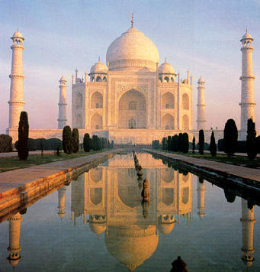

IN ARGENTINA AND IGUAZU FALLS SPAIN, ELEGANT 5Star INDIA TAJ MAHAL, INDIA TOUR MEXICO, PERU
INDIA TOUR -CLICK HERE FOR WEB PAGES
SEE THE VIDEO TOUR OF INDIA BELOW

THE VIDEO TOUR OF INDIA

The Energy Enhancement Meditation Course - www.energyenhancement.org in India introduced by Swami Satchidanand and Swami Devi Dhyani. We see...

The Taj Mahal in Agra and The Red Fort. Then there is an interview with Swami Shantananda of Vashishta Gufa in the Himalayas above Rishikesh.
We see Haridwar and the Hindu arati ceremony there at dusk on the banks of the River Ganges where crowds of thousands view the sacred flame and chant the songs of enlightenment. Enlightened sages descend from their caves in the high Himalayas to give experiences of energy to the assambled people - a shower of flowers.

We see the temple of Hare Krishna in Vrindaban and the special ceremony of the display of the Murthys, the statues of Krishna together with the chanting of the monks and the dance of the whirling dervishes by Swami Devi Dhyani.

COME AND GET EXPERIENCED!
CLICK HERE!! FOR WHAT WE ARE DOING
EMAIL sol@energyenhancement.org
FOR DETAILS

PREPARATION FOR ENERGY ENHANCEMENT
Get the Full DVDs of the Level One and Level Two Course together with all the free DVD's - a total of 12 DVD's!!

Usually the students practice some of the initiations before they come on the course so that when the Buddhafield hits them they can remove more Energy Blockages whilst they are on the Course.
We recommend you start NOW!! with any DVD COURSE. A regular Spiritual Practise with Energy Enhancement in advance of any Live Course will give you Massive Energy, and Remove All Energy Blockages.

REPORT FROM JAPAN ON THE DVD COURSE
Hi, I want to tell you about my recent feeling, It came spring in Japan suddenly, I felt like my blockage began to melt and I felt negative feeling. I took a herbal face massage about 1.5 hours yesterday night, it dozed me .

End of that it came up to my mind that you were shining in white space. next Devi, Danisa, Sebaschan, me, and my partner I have never seen. You and Danisa's halo was more clear.

After that, I could feel that inside my body and my every cells swimming in lighting for a while. And when I did Level1 initiation2 by DVD, with your shining image, I could feel filled white light was in my body, And I could feel energy circulate my body include my Hurt center where my blockage is.

I could breath strongly and through my blockage, I felt - Is it good?

It may be good season for meditation, as you said.

Thanks a lot .
with love,
DVD Student Japan MARCH 2008

ENERGY
ENHANCEMENT MEDITATION

SATANISM - BY GEORGE ORWELL..
"Obedience is not enough. Unless he is suffering, how can you be sure that he is obeying your will and not his own?
Power is in inflicting pain and humiliation. Power is in tearing human minds to pieces and putting them together again in new shapes of your own choosing.
The old civilizations claimed that they were founded on love or justice. Ours is founded upon hatred. In our world there will be no emotions except fear, rage, triumph, and self-abasement.
Everything else we shall destroy — everything. We shall abolish the orgasm. Our neurologists are at work upon it now.
There will be no loyalty, except loyalty towards the Party. There will be no love, except the love of Big Brother. There will be no laughter, except the laugh of triumph over a defeated enemy. There will be no art, no literature, no science. There will be no curiosity, no enjoyment of the process of life. All competing pleasures will be destroyed.
But always — do not forget this, Winston — always there will be the intoxication of power, constantly increasing and constantly growing subtler. Always, at every moment, there will be the thrill of victory, the sensation of trampling on an enemy who is helpless.
If you want a picture of the future, imagine a boot stamping on a human face — forever."
MARQUIS DE SADE - "I don't want a partner, I want a victim
SATANISTS PIZZAGATE, SPIRIT COOKING, MARINA ABRAMOVIC, SATANISM WORLDWIDE FOR 10,000 YEARS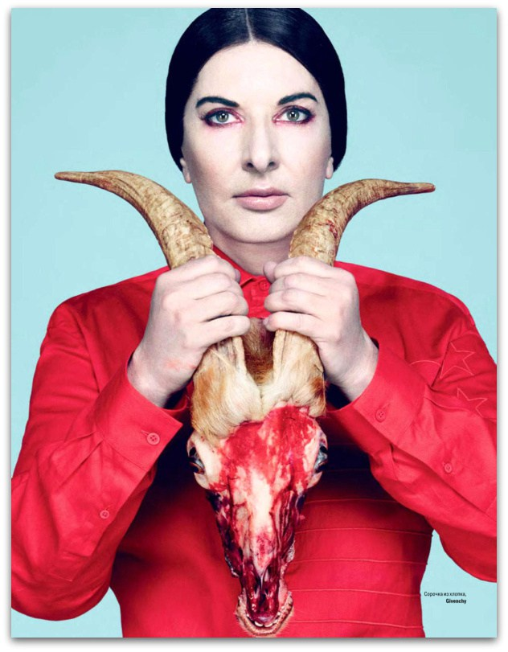
Links from current Satanists to ancient traditions - John Podesta, Pizzagate, Pedophilia, the DEVIL Lady Gaga AND THE Cult of Marina Abramović Spirit Cooking THE SATANIC MOTHER GOAT LADY GAGA, THE SECRET CULT OF LADY, BLACK MADONNA, PHILSOPHY- CYBELE, VICTOR HUGO, HUNCHBACK OF NOTRE DAME, Black Virgins, Cybele and Aset, God Pan, Knights Templar, and the Serpent Cult
It is of alarming concern that Roman Catholic John David Podesta, Chairman of Hilary Clinton’s 2016 presidential campaign, previous Chief of Staff to President Bill Clinton and current Counselor to President Barack Obama is a part of her secret Satanic inner circle. He was invited to a “spirit cooking” with Marina – another form of Mary that stands for rebellion and overthrow.
Today, people can see through the VEIL as never before in history. The internet has exploded about Marina, Posdesta, Witch Hilary Clinton and their links to what is basically the Vatican’s Ninth Satanic Circle.
So, the gutless and compromised U.S. Justice Dept. and FBI has announced that they are bailing out of the investigation of Anthony Wiener, Hilary Clinton, Blood Rituals and Pedophilia Sex Rings.
It’s a rabbit hole far too heavy, deep, scary and dangerous.
The Vatican stuff is far too onerous and threatening with a Quasimodo blood oath devotee to the Greek Goddess Athena, head of the U.S. Justice Department, Loretta Lynch, and a Jesuit Priest (Army of the Pope), General Joseph F. Dunford, in charge of the U.S. Republic, Pentagon and the U.S.. Military.
SATANISM HAS BEEN USED TO RULE FOR 10,000 YEARS
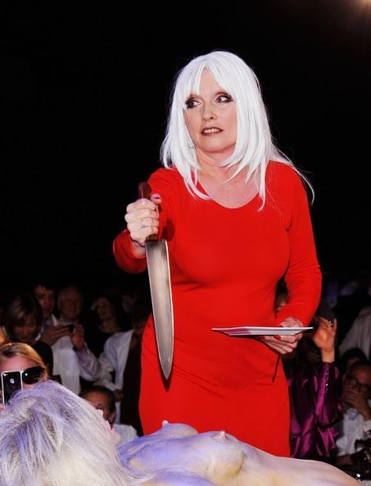
Debby Harry and Marina at a 2011 party for hundreds of film and music stars
Today, the secret Satanic Merovingian Bloodline circles play an important part in the secret Anti-Christ conspiracy and movement to return the Satanic Merovingian Bloodlines to world domination.
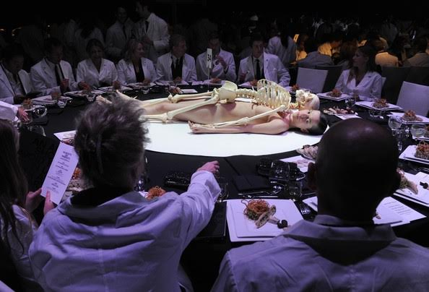Their belief system will be partly based on Celtic religion which Robert the Bruce’s descendants and JACOBITES are seeking to restore includes Satanic Ritual Human Blood Sacrifice that some believe brought Robert the Bruce to power.[37]
In Europe, Ritual Human Blood Sacrifice for Luciferian power, fortune and wealth never ended.
Satanism went underground as the Roman Catholic Black Mass ultimately becoming an important part of ILLUMINATI secret ritual ceremonies, and the Ninth Satanic Circle.
THESE RITUALS DEFINE SATANISM.. SATANIC RITUAL SEX, RITUAL HOMOSEXUALITY, RITUAL PEDERASTY, RITUAL DRUGS, RITUAL BLOOD SACRIFICE, RITUAL HUMAN SACRIFICE, RITUAL CANNIBALISM, RITUAL CASTRATION
http://www.energyenhancement.org/SATANISM-RITUALS-DEFINE-SATANISM-RITUAL-SEX-RITUAL-DRUGS-RITUAL-HUMAN-SACRIFICE-RITUAL-CANNIBALISM-RITUAL-CASTRATION-CYBELE-ATTIS.htm
Marina Abramović Spirit Cooking
Satanic Luciferian Mystic– Marina Abramović
Institutional Luciferianism didn’t start with Aleister Crowley or the Hermetic Order of the Golden Dawn. Don’t begin there. This stuff goes back to BABYLON, Ancient Troy, Greece and Rome.
It is highly coveted secrets of old European elite and powerful families handed down today through the generations. As I often say, “these people don’t play“, and “don’t play with the GOAT!”“
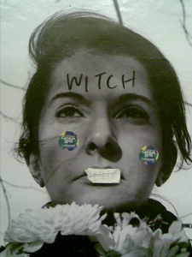
DEMONIC Marina Abramović
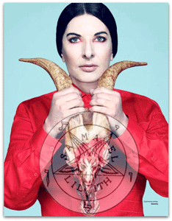
It has recently come to light from WikiLeaks that the highest ranks of government are/were involved and is proved to fully knowledgeable of the activities of Marina Abramović. 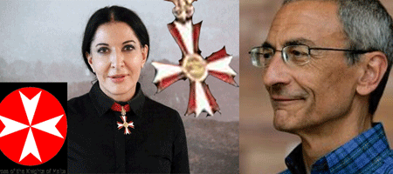
Marina & John Podesta
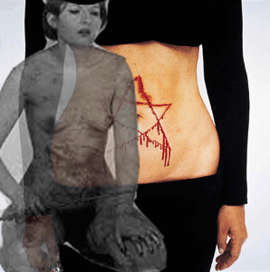
PODESTA CANNIBALISM PAINTING
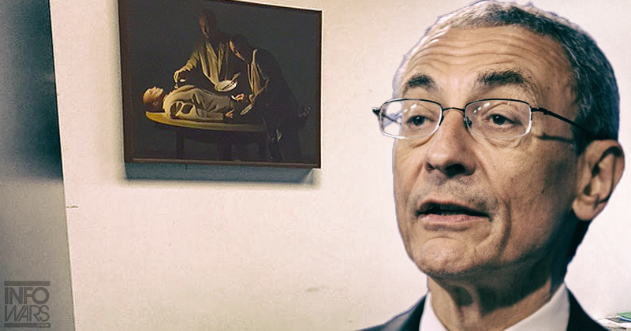
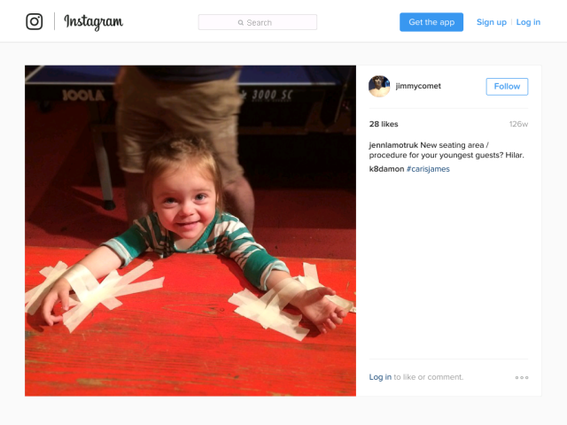
John Wick Ch 2 - Is Donald Trump - The Spiritual Warrior - Finger of God - Removes Satanic Demons, Deletes the Elite, Cleans the Swamp - Move Bitch, Get out the Way!! Esoteric Movie Review by Satchidanand
http://www.energyenhancement.org/John-Wick-Ch-2-Is-President-Donald-Trump-The-Spiritual-Warrior-Finger-of-God-Removes-Satanic-Demons-Deletes-Elite-Cleans-the-Swamp-Esoteric-Movie-Review-by-Satchidanand.htm
Marina wears the Knights Templar’s Maltese Cross. She is dame of some secret order, Knight of the Order of St. Sava, Knights of Malta?
However, everybody in her inner circle clearly understand the hidden old European Solar Cult/Luciferian significance of her symbol.
She was born in Belgrade in the Kingdom of Serbia.
During the crusades, Belgrade was used as the seat of crusading armies marching into the holy land. During the crusades, Helen of Anjou (1236 – 8 February 1314) was the Queen consort of the Serbian Kingdom, a spouse of King Stefan Uroš I Nemanjić, (House of Nemanjić) capet of the House of Capetian.
Helen of Anjou (House of Anjou) was the granddaughter of Baldwin II, above, the Knights Templar King of Jerusalem, and great-granddaughter in law of Armenian Melisende, Queen of Jerusalem.
However, Marina has a direct association with the old European Luciferian Houses.
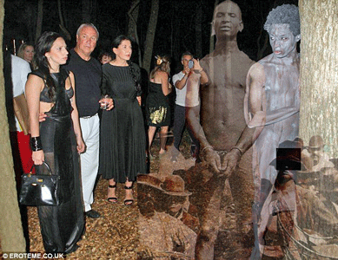Lady Gaga, Marina, Guests, Black Man & Cybele - Adonis, Attis Ritual Castration Tree
In the beginning, I though that this picture had something to do with American racism and lynching. However, this is most likely a Blood Ritual scene out of the mythological pages of the Cult of Attis,
“The boy, whose name was Attis, was unaware of the love Cybele bore him, but since she was a goddess, Attis’ opinion didn’t count for much. In time, Attis saw the king of Pessinus’ beautiful daughter, fell in love, and wished to marry her. The goddess Cybele became insanely jealous and drove Attis mad for revenge. Running crazy through the mountains, Attis stopped at the foot of a pine tree. There Attis castrated and killed himself. From Attis’ blood sprang the first violets. The tree took care of Attis’ spirit. Attis’ flesh would have decayed had not Zeus stepped in to assist Cybele in the resurrection of Attis.”
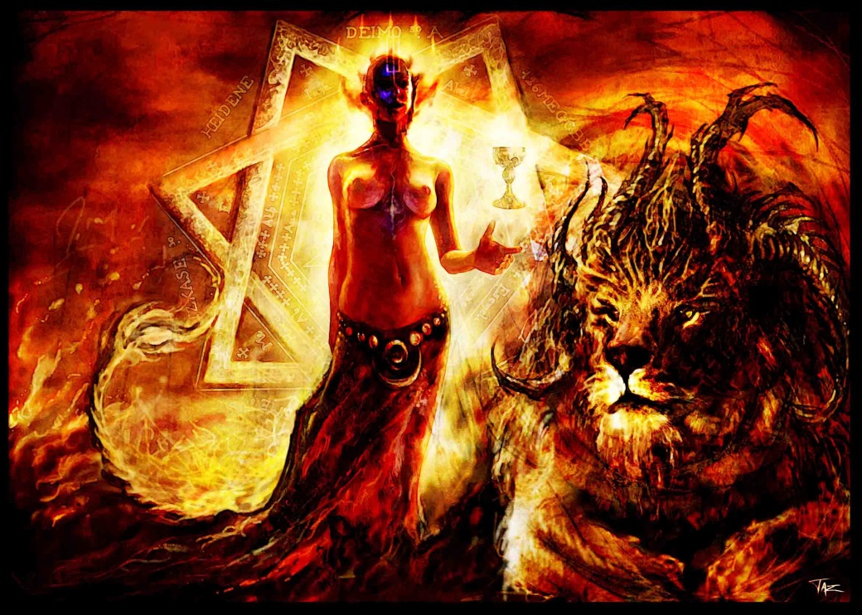
For most of her life, Marina Abramović lived a life of leisure and privilege in Belgrade even after the death, gloom, devastation, and ravages of WWII. She was born into a religious bourgeoisie family most likely remote descendants of the ancient House of Hugh Capet (941- 996),
The first King of the Franks of the House of Capet - Who were originally of the Satanic Religion who perpetrated Human Sacrifice and Blood Rituals in underground Temples in Paris - named after Paris of Troy - Cathedral of Notre Dame built over one of these Satanic Temples still in use - from Marina Abramović maternal side of the family.
Her maternal uncle was the powerful Varnava Rosić– Patriarch of the Serbian Orthodox Church between 1930 and 1937. His body is interned at the Temple of Saint Sava in Belgrade. He believed that Hitler’s policy toward Jews and lesser races served all mankind. His last act was to oppose a Vatican Concordat to control the Orthodox Church. Vatican Knights assassinated him with poison before the final vote.
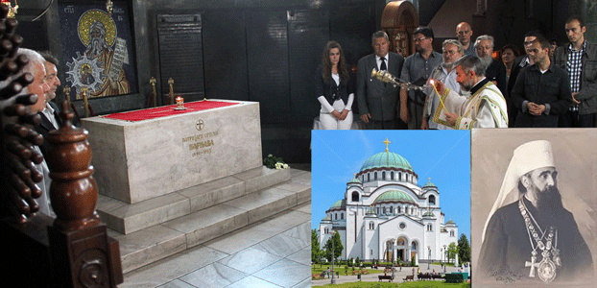
The (Orthodox) Temple of Saint Sava in Belgrade, Serbia is the largest Orthodox Church currently in use. The church is dedicated to St. Sava, founder of the Serbian church and an important figure in medieval Serbia. From its location, the temple dominates Belgrade’s skyline and is perhaps the most monumental building in the city.
Saint Sava (1174 – 1236), was known as The [Luciferian] Enlightener. He was a Serbian prince and Orthodox monk, the first Archbishop of the autocephalous Serbian Church. He was a prince of the House of Nemanjić descended from a Cabet Vukanovic Dynasty (1106- 1166) line of Hugh Cabet. I believe that this is Marina’s secret maternal East European Merovingian BLOODLINE, the House of Nemanjić.
Hugh Capet ( 941 – 996) was the first King of the Franks of the House of Capet from his election in 987 A.D. until his death. He succeeded the last Carolingian King, Louis V., descendant of the Carolingians and the Merovingians, earlier rulers of France.
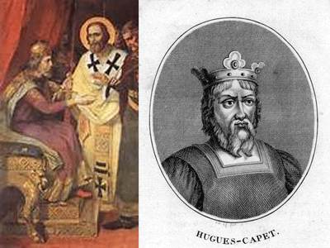
Saint Sava & Hugh Cabet
The Houses of Capetians, Carolingians and the Merovingians thought that they were a different race - Aryan Kundalini Dragon people. Their myths claim that they came out of Mythical Troy.
The City of Paris was established by them in the 6th century after they became known as the Merovingians and it was named after Prince Paris, the son of King Priam of Troy. It was the relationship between Prince Paris and Helen of Sparta which supposedly caused the Trojan War in which the Trojan Horse infiltration assured victory for the Spartans.
Both the Trojans and the Spartans were offshoots of the same Aryan Dragon peoples.
The Merovingians established the city of Paris on a major vortex point and used an underground chamber Satanic Temple there for their evil Satanic rituals, including human sacrifice to the Goddess Diana (Artemis).
Here, kings in dispute over property would settle the issue in combat.
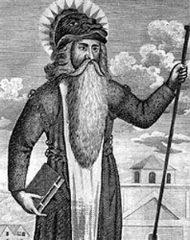
Meroveus, A Dragon that Rose from a Solar Deity
Meroveus, the founder of the Merovingian Dynasty, followed the Pagan Goddess Cult of Diana (Artemis), another symbol for Isis/Semiramis. This is not surprising because the centre for Diana (Artemis) worship was at Ephesus in Asia Minor, not far from the alleged site of Troy.
The location of the ancient underground chamber in Paris where the Merovingians worshipped and sacrificed to the Goddess Diana (Artemis) is now called the Pont and Place de L’Alma and it is still, by design, an underground chamber.
On the site today is a road tunnel and it was here that the car of Diana, Princess of Wales, crashed in the early morning of Sunday, August 31st 1997, killed, her baby fetus taken from her womb and used in cannibalistc ritual.
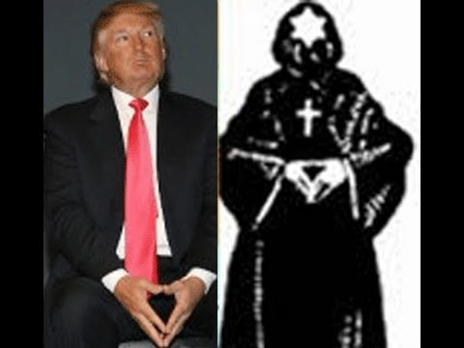

Another offshoot of the Scythian-Sicambrian Franks-Merovingian Bloodline emigrated from northern France and Belgium in the 12th century to become the famous ruling “Scottish” (Blond Sun God Donald Drumpf's mother was a Stuart from the Isle of Lewis - Louis and it's Callanesh Stones site for Satanic Druid Ritual) families and some of these were the ancestors of the STUARTS– blond Diana, Princess of Wales.
The other most important aspect of the Galla - the priests of the ancient system Of Cybele and Adonis, The State Religion of the Roman Empire - Roman Catholic priests and their continuation of the worship of Cybele, is the distinction between celibacy and an abstinence of sex.
The Galla ritually cut off their genitals so they could no longer perform sexual acts as men.
This, however, did not preclude them from having sex - quite the opposite. It opened the door for ‘sacred’ homosexual acts where the Galla were sodomized during various rituals and celebrations as Dog Priests.
Such homosexuality was considered so sacred that the promotion and practice of homosexuality outside of a religious context, was frowned upon by the priests and supporters of Cybele - open homosexuality was considered an affront to its sacred and ancient nature.
Elite Cybelean Gallae Homosexual Rite, Donald Drumpf publicly kissing Former NY Mayor, Rudolph Giuliani (Judy Ruliani), in Drag (Transvestism). At first, I didn’t know what to call the elite Satanic Homosexual Rituals spreading across the nation. I suspected all along that these were ancient Roman homosexual rituals, but I didn’t have a name. Transvestism, global conquest, secret blood sacrifices among an ultra powerful secret royal and imperial elite, it all fits in with CYBELE.
RUDY JULIANI-JUDY RULIANI AND TRUMP

It is of alarming concern that Roman Catholic John David Podesta, Chairman of Hilary Clinton’s 2016 presidential campaign, previous Chief of Staff to President Bill Clinton and current Counselor to President Barack Obama is a part of her secret Satanic inner circle. He was invited to a “spirit cooking” with Marina– another form of Mary that stands for rebellion and overthrow.
Hillary Rodham Clinton - Larry Nichols tells it all: Hillary used to go to Los Angeles for a weekend every one or two months for a Witch party. Hillary Rodham Clinton is a witch!!
Larry Nichols tells it all: “Bill Clinton himself told me: ‘After Al Capone, Hugh Rodham and Dan Rostenkowski took over the Chicago Mob. They were running the Chicago Mob‘.” Nichols says Hillary and Bill Clinton are the representatives of the Chicago "Dixie" Mafia.
Hillary and Bill Clinton exposed as Dixie Mafia WOW. https://www.youtube.com/watch?v=T7y8snvKipg
Larry Nichols, Mena Arkensaw 1980's, Clinton cocaine, "How do you clean 100 Million Dollars a month? (1.2 Trillion Dollars a year) They would ship the money down to Florida to a bank connected with BCCI to launder the money, to a Bank in Atlanta Georgia connected with BCCI, to Bank Seacorp in New York which would send the money overseas, and a Chicago bank connected with Chicago Mob Boss Rostenkowski a partner of Hillary's dad, Hugh Rodham.
Clinton is like a son to the Bush crime family who take one Trillion Dollars a year from Afghan heroin shipped to Europe by NATO.
Podesta Email 46736, Podesta Hot Tub Party With Kids
From the email: >>
With enormous gratitude to Advance Man Extraordinaire Haber, I am popping up again to share our excitement about the Reprise of Our Gang’s visit to the farm in Lovettsville. And I thought I’d share a couple more notes: We plan to heat the pool, so a swim is a possibility. Bonnie will be Uber Service to transport Ruby, Emerson, and Maeve Luzzatto (11, 9, and >> almost 7) so you’ll have some further entertainment, and they will be in that pool for sure. And with the forecast showing prospects of some sun, and a cooler temp of lower 60s, I suggest you bring sweaters of whatever attire will enable us to use our outdoor table with a pergola overhead so we dine al fresco (and ideally not al-CHILLo).
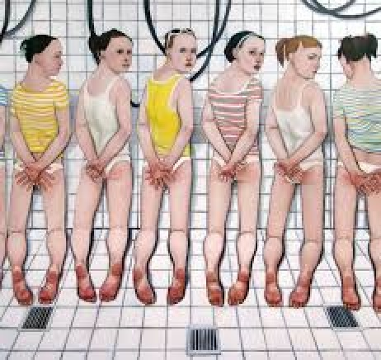
PODESTA HAS THIS PAINTING ON HIS WALL AT HOME
Plummeting down the rabbit hole you will eventually discover the Franklin Cover up, The Jimmy Savile Scandal, The Hampstead Cover up, The Elm Guest House Scandal, Jeffrey Epstein’s Lolita Island and many others that were eventually buried by a Bought Corporate Presstitute Fake News Mainstream Media Newspapers and Television Fake News and the fact that the general public loses interest because the reality of high profile child predators is an alien world and completely repulsive to the average person.

From Hillary and Bill Clinton trafficking kids on Epstein's Lolita Express and possibly being involved in sexual behavior on Pedo Island, the rabbit hole goes deeper America...As now the Clinton camp is having hot tub parties with children. You can't even use the word evil to define the Clinton's or they're associate f#cks, because their sexual desires involve children as young as seven!
No wonder when NYPD discovered what was on Huma's computer, that NYPD basically stated in turned their stomachs...For as this investigation being reopened by the FBI America is witnessing just how sick these f*ckers are! If your a parent like myself you have to feel like you want to rip your stomach out of your body, because the days leading up to the election is showing Hillary Clinton, Bill Clinton, and their team of associates are more pedophile then pedophiles now serving time in Federal or State Prisons around America. I can't even understand how adults who are still supporters of Hillary Clinton who are parents, because it's hard to understand why adults who have kids still support Hillary Clinton...With all this proof of Hillary and associates being the highest form of pedophile there is on planet Earth. As a father I don't even want to know what was going on in the hot tub with Podesta!"
Today, people can see through the VEIL as never before in history. The internet has exploded about Marina, Podesta, Witch Hillary Clinton and their links to what is basically the Vatican’s Ninth Satanic Circle.
So, the gutless and compromised U.S. Justice Dept. and FBI has announced that they are bailing out of the investigation of Anthony Wiener, Hilary Clinton, incarcerated pedophile Dennis Hastert and friend of Podesta and his Brother, Blood Rituals and Pedophilia Sex Rings.
Pedophilia Rituals are a symptom of Satanism.
We know that pedophilia rituals are a symptom of Pagan Satanism which has existed before Christianity and that Human Sacrifice, Sodomy and Homosexuality has followed Satanism like a stench for 10,000 years.

Podesta is still friends with Dennis Hastert, incarcerated for running Pedophile sex rings.
We have seen the Dutroux outrage linking Royalty and NATO and Bilderburgers in Belgium to pedophilia, murder of children, cannibalism of children, ritual murder and torture snuff films.
We have seen the outrage over Jimmy Savile pedophilia and necromancy with his connections to procurement of children for Satanic Ritual Sex and Snuff Parties and his connections with Royalty and Margaret Thatcher.
Boystown. Pedophilia in U S A - Boys Town Documentary - Conspiracy of Silence. https://www.youtube.com/watch?v=LW9_ulzXOMQ
The documentary that could not get screened in the US. This documentary was present on Video Google and I'm posting it here.
Jerry Sandusky Penn State 'procured and shared boys he molested with other high-profile pedophiles linked to Penn State as part of sex ring' Read more: http://www.dailymail.co.uk/news/article-2186805/Jerry-Sandusky-shared-boys-molested-high-profile-pedophiles-linked-Penn-State-sex-ring.html#ixzz4RK0kxGlt
It’s a rabbit hole far too heavy, deep, scary and dangerous.
The Vatican stuff is far too onerous and threatening with a Quasimodo blood oath devotee to the Greek Goddess Athena, head of the U.S. Justice Department, Loretta Lynch, and a Jesuit Priest (Army of the Pope), General Joseph F. Dunford, in charge of the U.S. Republic, Pentagon and the U.S.. Military.
These DEMONS don’t PLAY, and they haven’t played with anyone about their POWER and AUTHORITY for ten thousand years.
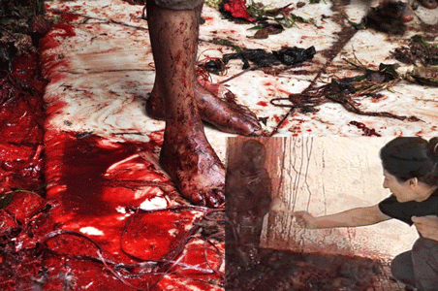
Marina Abramović & Satanic Blood Ritual
One among a number of Luciferian things, Marina paints paranormal messages in pig’s blood on the wall, including, “Mix fresh breast milk with fresh sperm milk / Drink on earthquake nights.” That’s only the tip of an iceberg that seems to be blowing the socks off of a lot of people.
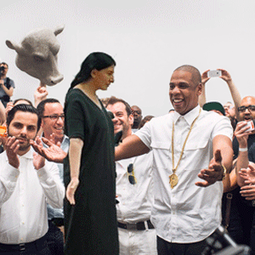
Animal sacrifice is the shedding of blood; that the altars become bloody (haimassesthai) is a characteristic of the sacrificial act.
On vase paintings there are white-chalked sides of the altars that are always shown splashed with blood in testimony to the sacred work.
An altar in Didyma is said to be made from the blood of the victims.
Ritual contact with animal blood is the ritual “Miasiam. ” 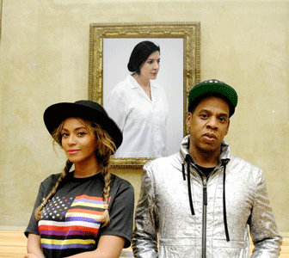
Satanic Blood Ritual Witch, Beyoncé & Jay Z

No matter how the corporate mass media may spin it if they touch the story at all, working with pig blood is “Ritual Miasiam.”
You don’t have to drink the blood.

The handling of pig blood, period, is an occult ritual in itself.

Sacrificial Pig blood was used in purification of Orestes at Delphi by Apollo. This freed Orestes of blood–guiltiness, if not from the pursuit of the Furies (Jury). Apollo is one of many Gods who purifies from blood.
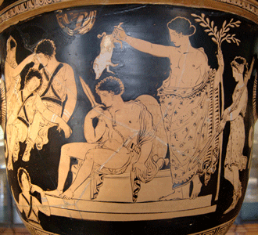
The Furies (Eumenides), South Italian, c. 375 BC (Louvre, Paris)

The vase painting above depicts Orestes sitting in front of the omphalos stone at Delphi. He still holds the sword he used to kill (matricide) his mother, Clytemnestra, to avenge the assassination of his father, Agamemnon.

Sun God Apollo purifies him of the blood-guilt (miasma) by dousing Orestes with the blood of a pig.

The Furies lie sleeping at the left–at the far left you can just see Clytemnestra’s ghost trying to wake them and rouse them to action to continue to punish him for the crime of matricide.
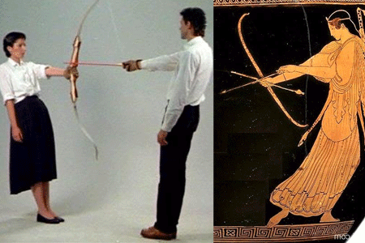
Blood Ritual Witch & Blood Sacrifice Symbol (bow and arrow) Taurian Artemis

The image of the Taurian Artemis, which is presided over the human sacrifices in Colchis (Colchis was an ancient kingdom and region on the coast of the Black Sea, centered in present-day western Georgia), and was later brought to Greece by Orestes along with his sister high priestess of Delphi, Iphigeneia, are mentioned in particular as provoking purification blood rites.

You also summon Demons in Blood Magic Rituals.

Well, the old world European Witch mentored Lady Gaga in the occult, too.

They simulate old world medieval cannibalism - Open Subversion of the Moral Order and Balance.

John Podesta & the DEVIL

Lady Gaga & Satanic Cult of Marina Abramović

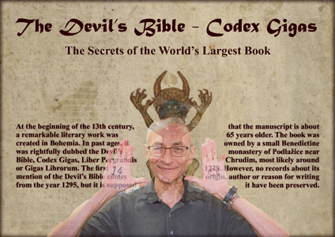

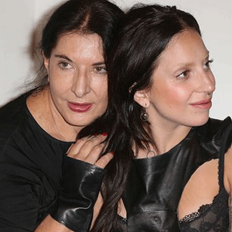
Cannibalism & the Crusades
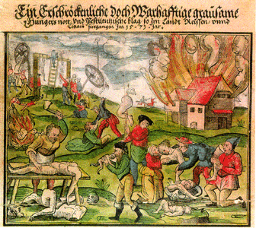

If the cannibal represents a subversion of the moral order, then is a subversion that crusaders embraced as their own.

Richard the Lionheart and others, “the idea of cannibalism” emerged alongside Christian Europe’s early martial encounters with Islam. Europeans reveled in their reputation as brutish FLESHEATERS. King Richard I of England (1157 – 1199) consumed human flesh as if it was pork. During the crusades, Belgrade was the East European center for the crusaders’ march to Jerusalem. Widespread Cannibalism broke out along the countryside.

Marina is descended out of flesh and blood eating and drinking lineage.
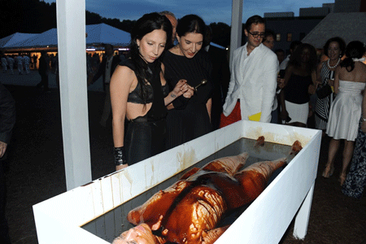

Lady Gaga, Marina & Simulated Body Marinated with Blood, Semen & Beast Milk Fluids?

I kid you not. This was no show. Lady Gaga & Marina sample the bloody flesh.

It’s right in you face. I can’t take any more of this! I have to GO.

I found the story of Attis very strange. I wonder if the popularity of violet flowers in the Victorian Age ties into this.

I had the psychic impression that Queen Victoria was the maternal figurehead for much dark & evil activity done by the consciously created in the Greek Homosexual Band of Thebes Fierce Homosexual Warrior fashion homosexual - from 1430AD - Eton whipping and fagging "pederast" males who ran her Worldwide Empire.

I saw her in my mind's eye wearing snow white but underneath this dress she was covering a "bloody mess". Which is a strange English term I have heard in various British films & television shows. The other one is "bloody bugger"......

When I was in San Francisco back in the mid 1990's I first encountered Satanism mixing out in the open with Politics.

A famous, devious Gay power broker named Jack Davis was celebrated with a birthday bash
by the Black Mayor Willie Brown & the political elite of the city.

The next day it hit the San Francisco Chronicle & the Examiner that a Satanic ritual was performed as part of the party & many people had been outraged.

A man had a Satanic symbol carved on his back with a razor blade & as he bled a women squatted over him & pissed on his wounds & then a Jack Daniels booze bottle was shoved up his butt.

I will try to find the article on this horror show & send it to you.
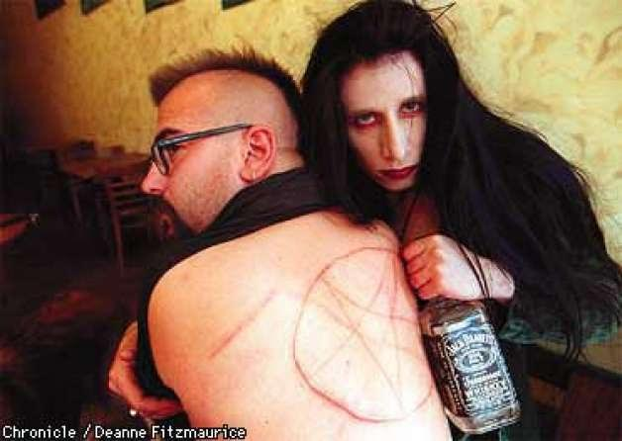

Here are pictures from the birthday party for top political Hack Jack Davis, circa May 5, 1997. It was a big scandal in San Francisco & later articles appeared in the New York Times too.
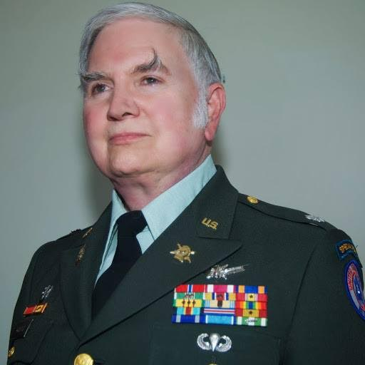
Also pictures of Michael Aquino Satanist who infiltrated the NSA & other spy agencies along with many other Satanists.

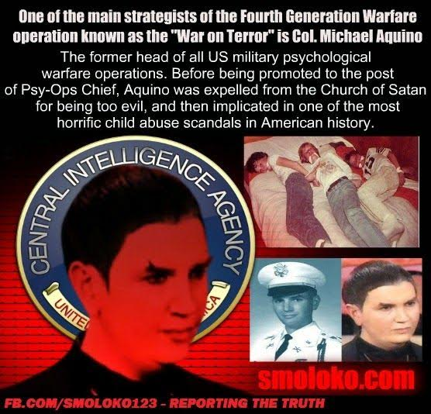

So we have little chance of curing this CANCER in America.

Johnny Gosh grew up to be Jeff Gannon - male escort & a favorite of George W. Bush in the White House Press room.

Jeff Gannon was called on to ask softball questions concerning the trumped up War on Terror & Iraq madness. After hours he is on the visitors log as going into the main quarters of the White House multiple times.
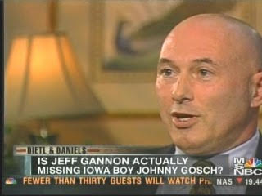

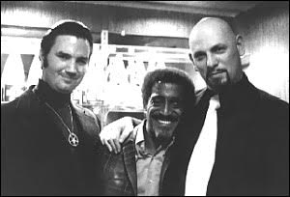

The ILLUMINATI’s DEVIL WORSHIPER, Lady Gaga, that you ACCEPT and ALLOW your youth to be innocently indoctrinated in NEW AGE SATANISM is also right there- plainly put in front of your face. Now, they are shoving her down our throats. They are coming for YOU and I on February 5, 2017, NFL Super Bowl Sunday 51.

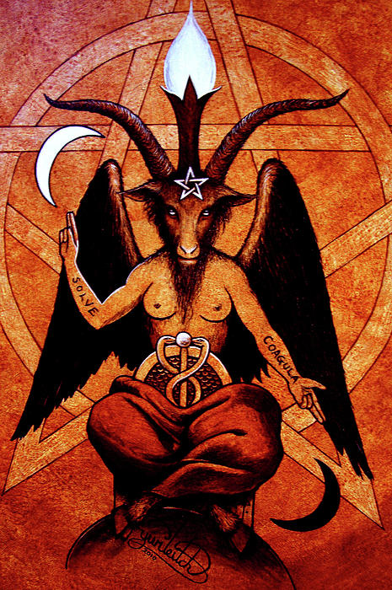

Satanic Murder Cults among European Royalty, Nobility and the Knights Templar - Giles de Rais, Vatican, Jesuits, Mafia, Baphomet, LaVey, Freemasonry, Mazzini, Pike, Baroness LaLaurie, Roman Occult Rituals of Lupercalia, Ninth Circle Child Sacrifice

ONLY THE SUPERPOWERS DEVELOPED BY THE SCIENCE OF REAL MEDITATION CAN FREE HUMANITY TO REACH THE STARS.

ENERGY ENHANCEMENT MEDITATION ENLIGHTENMENT AND ILLUMINATION

THE INCREDIBLE MEDITATION COURSE AND MEDITATION TECHNIQUES CREATED TO PRODUCE ENLIGHTENMENT AND ILLUMINATION

"ALL TRADITIONAL MEDITATIONS HAVE BEEN DESIGNED TO FAIL" - SATCHIDANAND -

"BECAUSE ORIGINALLY ALL MEDITATIONS CONTAINED THE TECHNIQUES OF, "THE KUNDALINI KEY" AND OF, "ALCHEMICAL VITRIOL" TO GROUND NEGATIVE ENERGIES AND TO NATURALLY INCREASE KUNDALINI ENERGY"

"NOW, ONLY ENERGY ENHANCEMENT MEDITATION TEACHES THESE TECHNIQUES WHICH SPEED UP THE ENLIGHTENMENT PROCESS"
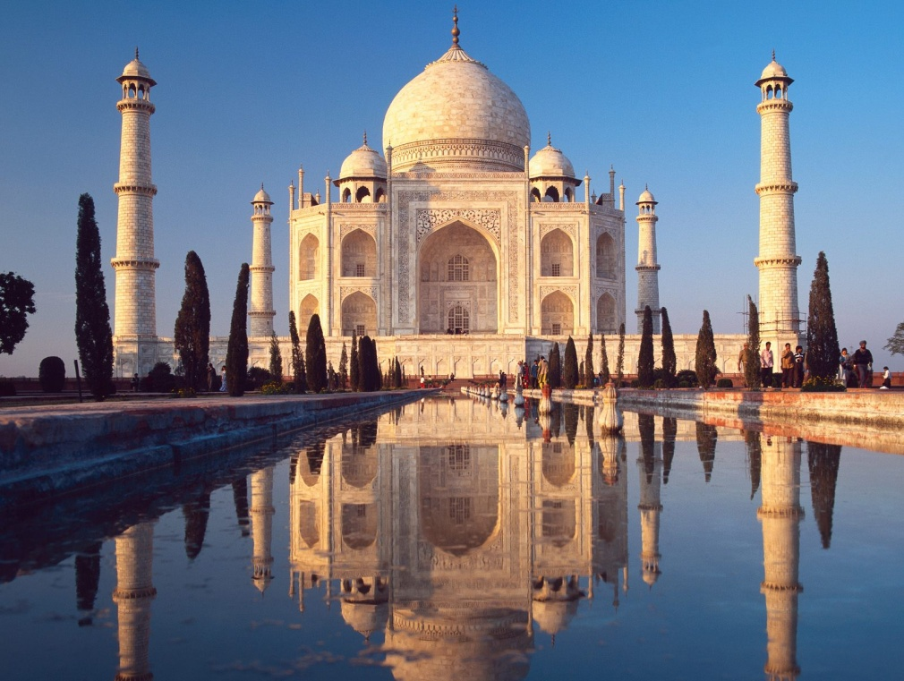

Energy Enhancement Spiritual Movie Reviews Book - Volume 1 by Satchidanand download here..
http://www.energyenhancement.org/Spiritual-Movie-Reviews/Energy-Enhancement-spiritual-esoteric-movie-reviews-by-Satchidanand.pdf
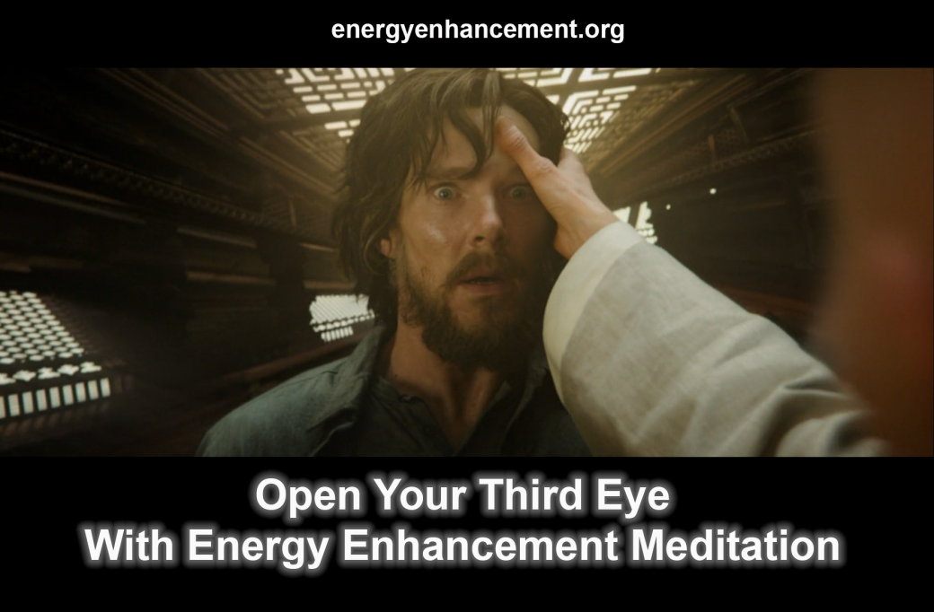



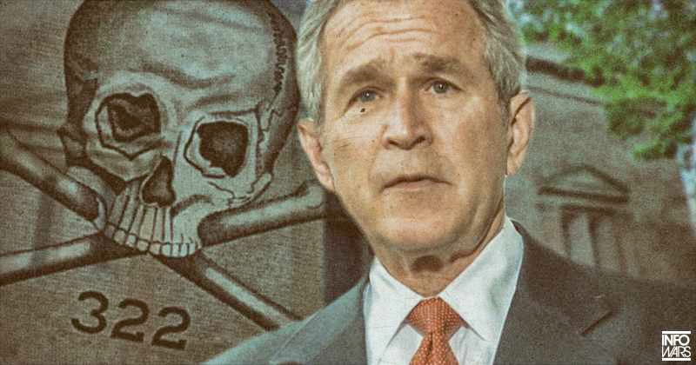

SKULL AND BONES BUSH PAINTED THIS PICTURE

Kevin Annett - Genocidal Crimes in Canada
100 years of Canada Corporation-Government-Masonic-Police-Indian Nation Collaboration to steal commodities like wood and uranium from Native Indian Lands, Genocide 60,000 native children and torture murder Women and Children for Satanic Snuff Films - http://itccs.org/

Kevin Annett - “The Ninth Circle Satanic Cult, a child sacrifice group composed of global elites, appears to be routinely raping, torturing and murdering children” it was announced yesterday by the ITCCS. Recent court filings against the international child kidnapping ring go to court April 7.

Named as chief defendants for the Brussels Common Law Court trial were Pope Francis, Jesuit Superior General Adolfo Pachon and Anglican Archbishop of Canterbury Justin Welby. Among possible Ninth Circle Satanic Cult members named by witnesses who would testify at the trial were former popes Joseph Ratzinger and John Paul II, UK High Court Justice Judge Fulford and members of the British Royal Family.

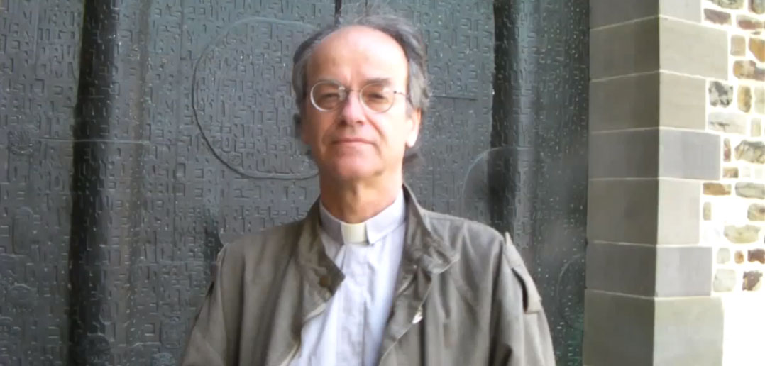
Kevin Annett

“Queen Elizabeth had direct involvement in the kidnapping and death of aboriginal children and Royal Family members appeared to regularly participate in Ninth Circle Satanic Cult rituals at the Mohawk Indian School in Brantford Ontario Canada” yesterday’s announcement proclaimed.

According to two affidavits filed in court, not only did different witnesses see Ninth Circle Satanic Cult members commit murder, but claimed the brutal killings of innocent children continued today, some in sub-basement vaults.
The international court was set to consider:

· Testimonies of two former Mohawk School inmates who both say they were present at the Ninth Circle Satanic Cult murder of a 5-6 year-old girl at the Mohawk Indian School in Branton Ontario Canada.

· A copy of the ‘Magisterial Privilege’ that was filed within sealed archives of the Vatican library. The Ninth Circle Satanic Cult operated according to this canon law statute dated Dec. 25 1967. It was said to document that before each new pope assumed office it was mandatory that they participated in Ninth Circle Satanic Cult rites. The document referred to ceremonial murder of newborn children and consumption of their blood.

· Testimonies of two witnesses who claimed they saw former Pope Joseph Ratzinger, Dutch Cardinal Alfrink and Prince Bernhard take part in a Ninth Circle Satanic Cult murders in Holland and France, one of a little girl in the fall of 1987.

· One of those witnesses was Dutch therapist Toos Nijenhuis who in this video interview with Kevin Annett, discussed seeing Ninth Circle Satanic Cult murders as late as 2010. At least one of those murders involved former Pope Ratzinger.

· Testimony of Anglican church researcher Leona Moses, whose 2011 interview with Kevin Annett and Mohawk elder Cheryl Squire could be seen in this video.

· Testimony of a former Argentine civil servant during the 1970s Dirty War who took extensive notes of meetings between the now-Pope Francis and Junta military officials. Pope Francis’ fast ascension to head the Argentine Catholic Church was a suspected result of his agreement to traffick missing political prisoner children from Catholic orphanages.

· Testimony of a police-accredited investigator.

· The “G12” collection of documents of the Anglican Huron Diocese from the Church of England secret archives in London, Ontario Canada.

· A January 2012 memo from Archbishop of Canterbury Justin Welby to Anglican Primate Fred Hiltz in Toronto ordering destruction of forensic human remains and evidence of murdered children in the Mohawk Indian School archives.

“In October, 2011, excavations commenced by Mohawk elders on the grounds of the (Mohawk) school revealed…bones that had been cut up in sections. Two of these bone fragments were positively identified as being those of a small child by Ontario forensic examiner Greg Olson and archaeologist Kris Nahrgang, as well as by senior forensic pathologist Dr. Donald Ortner of the Smithsonian Institute in Washington, D.C. Ortner died of undisclosed causes shortly afterwards.”

Mass genocide of Mohawk Confederacy children began in 1832 at the former Church of England-Jesuit run Mohawk Indian Residential School in Brantford Ontario Canada. Since the 2008 discovery of a child mass grave site at the Mohawk School, there have been 31 other mass child grave sites identified at native residential schools across Canada, in Holland and the United States. The schools were mainly run by Catholic Jesuit priests.

On Feb. 28 2013 this same international court found Head of the Anglican Church of England Queen Elizabeth and former Pope Joseph Ratzinger guilty of Crimes Against Children – the same day Ratzinger became the first pope in history to resign from his office.

(Kevin Annett) On August 15, our Direct Action Unit Alpha Team stopped a planned child sacrificial ritual in the Outremont district of Montreal, and arrested and interrogated two members of the Ninth Circle cult. see http://www.itccs.org

Tonight, I spoke with a DAU liasion here in Montreal and received the following update:

The DAU action on 15 August occurred with the cooperation of elements in the Montreal police, who ensured their action would not be impeded. The DAU team has left Canada and returned to the Central Command in Brussels for debriefing. All of the evidence the team gathered at the action – blood and clothing samples, photos, and the videotaped statement of one Ninth Circle cult member – has been sent to the International Common Law Court as part of its upcoming Permanent Inquiry into child trafficking and ritual sacrifice.

The two Ninth Circle cult members arrested in the action on 15 August were released the following day to the Montreal police for further questioning, after being interrogated by the DAU team. Neither of the cult members has requested legal counsel, and one of them has agreed to cooperate with the Common Law Court in its prosecution of the Ninth Circle. This member is now under protective custody.

The Court’s Permanent Commission of Inquiry will commence its work on September 1, 2014 by expanding the investigation into global child trafficking and sacrifice beyond the Pope Roman Catholic Church, Queen Elisabeth of England and Queen Beatrix of Netherlands, in order to prosecute the criminal, financial and corporate associates of the church and their joint role in trading and murdering children. These corporations will include the Cargill corporation, Sinclair Oil, HSBC, and the Cameco Uranium corporation, along with the criminal syndicate known as Ndrangheta.

The Court has ascertained that its exposure of the Ninth Circle cult operation in Montreal is directly responsible for the recent public remarks of the convicted felon Pope Francis – Jorge Bergoglio that he “may be dead within two or three years” and may resign from his office. The Court also believes that the same exposure accounts for today’s sudden death of three of Pope Francis’ relatives in Argentina.

Sources within Ndrangheta, Italy’s huge criminal syndicate that provides children for Ninth Circle sacrificial rituals, state that its leaders are directly pressuring the Vatican to silence or depose Pope Francis in the wake of his criminal conviction and the Ninth Circle exposure in Montreal.

I, Kevin Annett, have been immediately summoned to Brussels for consultations and to receive extra security protection in the wake of new threats made against my life by Ndrangheta and its affiliates in Canada. These threats were communicated to the Court yesterday.

A painful, ugly subject that must be faced and dealt with. When the cabal comes down, so will the pedophilia/ritual abuse and torture of children. ~ BP

The most abhorrent conspiracy is that against children. No one has done more than Kevin Annett to shine uncompromising light on this uncomfortable subject.

Kevin, a former United Church minister, and the International Tribunal for Crimes of Church and State (ITCCS) have demonstrated that the Vatican embodies and protects not just a few bad-apple pedophiles, but for hundreds of years and before that in the State Religion of the Roman Empire has institutionalized ritual child abuse, child sacrifice, child canibalism and, in Canada, the US, and around the world, has overseen the mass murder of indigenous tribal children, mainly through Church-run orphanage genocide machines, where 50% have died for over one hundred years.

In a set of damning documents re-produced here, Annett proves the State and Church — hardly ‘separate’ — are complicit in these institutions of evil through the Catholic Church in their own documents not considering child rape, torture or sacrifice to be a crime.

Talking about the crime by victim or rapist or priest is a crime worthy of excommunication.

In some areas 25% of all priests are implicated in child trafficing and the other 75% know about it yet can not talk about it, therefore they are accomplices in Law - but not in Church Law!!

Together, Church and State become guardians of the children— (all churches all religions and all states) — render indigenous children “orphans” through a corrupt legal system which strips them from their parents and effectively imprisons them in orphanages where genocidally 50% of the children have died for over one hundred years. Many of these are better labeled ‘concentration camps’ and are organized as veritable “killing machines.” (For instance, death rates show that housing infected TB victims with the uninfected was not a dumb mistake, but usual practice and policy.)

Natives on land for over one hundred years are targetted for extermination by the Porn, Pedophile, Ritual Sacrifice Networks which include some of the Police, Military, Crown Prosecution Services, Politicians, Priests, Doctors, Psychiatrists, Masons, Escobars, Mafia, Chinese Tongs.

There are sworn statements where policemen abduct, video torture and snuff women and children and yet they are protected by the state. All so that international companies can take their land and the valuable commodities in and on that land.

“It started the night I saw a guy unloading bags near the reserve garbage dump and burying them there. Later I recognized him as Dave Pickton, brother of serial killer Willie Pickton. I dug around there later and found a bunch of bones Pickton had buried. I took them to SFU forensics and it turns out they were the bones of several young women mixed up with pig remains. Dave Pickton was actually employed by the Musqueam band for over two years. “

Les took his discovery to the police and the press. He was told to keep quiet about it and even threatened by police officials. Later, when he talked about what he’d found he was fired by the Musqueam band and forced to move away.

Issued by the Central Directorate of the International Tribunal of Crimes of Church and State (ITCCS) on September 30, 2016
www.itccs.org , www.murderbydecree.com (Exhibits are posted separately in the hard copy Memorandum)

1. A master plan by the Canadian government and Catholic and Protestant churches to exterminate indigenous nations has been in operation across Canada since November 25, 1910. (Exhibit 1) This plan was authorized and has been maintained by the Crown of England and its Privy Council Office, the Vatican, and the Roman Catholic, Anglican and United Church of Canada, along with the Royal Canadian Mounted Police (RCMP), local police, the judiciary and private corporations.

2. This plan consisted of a state and church funded program of systemic inter-generational genocide based initially within the so-called Indian residential school system, established by a federal law on July 1, 1920. (Exhibit 2) Over a century, that system killed more than half of the children incarcerated within it, or more than 65,000 children. (www.murderbydecree.com) It also served as the launching pad for a general campaign of “ethnic cleansing” aimed primarily at the “non-assimilated”, predominantly western aboriginal tribes; a campaign that continues to the present day. This genocide has accounted for the massive de-population of more than 95% of the original west coast native nations: a total killing of somewhere around one million people.

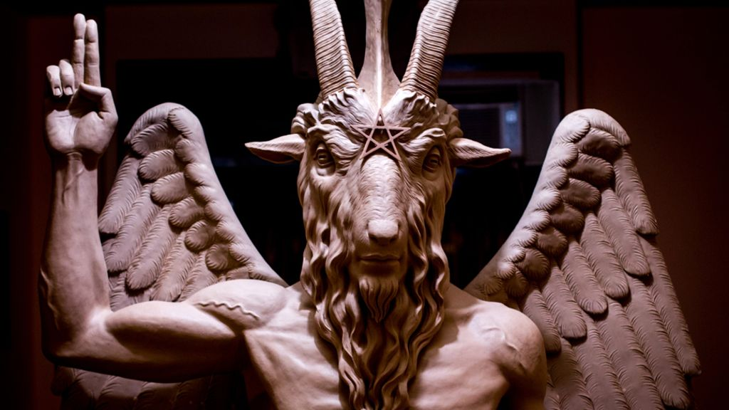

3. Besides such a general de-population, the specific purpose of this genocidal campaign was the extermination of the traditional indigenous kinship network and the matriarchal clan mother system of authority that ensured indigenous control of lands and resources. The target of this extermination was the native family system and specifically, traditional women and their children. That traditional system was in fact effectively destroyed by the Indian residential schools between 1910 and 1996, when the last such “school” closed.

4. Despite the phasing out of Indian residential schools after 1970, this genocidal plan has intensified and diversified, and has been operated by different branches of the Canadian government, including the family welfare and family court system and by means of the state-funded aboriginal band councils. The “chiefs” of these councils have played a key role in eradicating any lingering indigenous authority and control over traditional lands and resources, and destroying their own people. They are doing so at the behest and in the payment of the Canadian government and domestic companies as well as multinational corporations from America, Japan and China.

5. The expulsion of all remaining traditional native tribes from their west coast lands assumed greater urgency as the twentieth century closed and the global demand for hydro-electricity, timber, minerals and other British Columbia (B.C.) resources intensified. Consequently, the past quarter century has witnessed an escalation of violence against Indians in Canada and a return to the violent methods of the early colonial period. By the 1990's, large numbers of aboriginal families in northern B.C. began disappearing at the hands of unofficial death squads manned by off duty RCMP officers and local policemen, as well as third party contractors hired by the federal government, its aboriginal front men and different corporations. (Exhibit 3)

6. By 1995, when our own independent campaign to expose residential school crimes began making headlines in the Canadian media, stories of these disappearances of native families were also proliferating. Together, these exposures provoked a public misinformation campaign by the RCMP designed to fog and conceal the extent and the nature of the disappearances. This misinformation was only partly successful, and prompted the government of Canada to take firmer measures to erase any public awareness of the ongoing genocide of native families. It did so by means of a secret government Cabinet Directive dated April 3, 1998. (Exhibit 4)

7. This Directive by the Liberal government of Jean Chretien consisted of an official plan of state terror that was aimed at aboriginal activists and residential school survivors and their supporters, including our own campaign led by our ITCCS North American Field Secretary Kevin Annett. The Chretien terror plan authorized the use of “black ops” methods of illegal monitoring, disruption and violence against these targeted groups, including – to quote the Directive – the “elimination” of individuals who held knowledge or evidence of genocidal acts by Canadian church and state employees. This cabinet Directive is apparently still in operation. It has caused the death of at least two dozen aboriginal activists who have been assassinated by police and RCMP operatives since 1998, including members of our own network. (Exhibit 5)

8. The cabinet Directive in question was issued for implementation by the federal government to “E” Division of the RCMP in Vancouver in the first week of June, 1998, just before the first independent Tribunal into Indian residential school crimes was convened by our movement and a United Nations affiliate, IHRAAM, on June 12. In fact, the disruption of the IHRAAM Tribunal was the first goal of this state terror campaign, according to statements made by RCMP “E” Division Inspector Peter Montague who led the local campaign. This disruption became especially active after the Tribunal gave a public airing to the first reports of organized murder and child trafficking among northern B.C. tribes. (Exhibit 6)

9. It is important to note that this Chretien “state terror” Directive of April 3, 1998 was aimed at anyone who threatened to expose the historic and ongoing genocide of native people. Between 2006 and 2012, seven key eyewitnesses and prominent indigenous members of our ITCCS network in Vancouver and Winnipeg were killed at the hands of this Directive: Harriett Nahanee, Johnny “Bingo” Dawson, Ricky Lavallee, Harry Wilson, William Combes, Edna Phillips and Chief Louis Daniels. In the process of its state terror campaign, the Chretien Directive disrupted and marginalized much of our work and the movement to prosecute church and state for residential school crimes. But for many years it also concealed the slaughter and disappearance of aboriginal families across B.C. For example, after the June, 1998 IHRAAM Tribunal had been attacked and neutralized by RCMP operatives, the same agents – under the direction of RCMP Inspector Peter Montague – engaged in a similar destruction of the growing effort to identify the missing native people across B.C. and in Vancouver’s downtown east side.

10. This state-level attack on a genuine missing peoples’ inquiry was prompted by the fact that by this point, in early 1999, startling new evidence began to surface that ties the identity of some of the present-day killers of native people with men who worked in the Indian residential school system. In fact, our work has shown that the present senior leadership of the Anglican, Catholic and United Church of Canada is either directly implicated in residential school-era crimes or is actively protecting those who are; and that these same predators are still engaged in the systemic rape, trafficking and killing of children. It is therefore clear that a continuity of crime exists that spans decades and links the church-instigated residential school atrocities with the rape, torture and disappearance of present day natives, especially women and children. In short, the crime has never stopped, and is being protected by the same unholy alliance of church, police and government, which no doubt explains that trio’s unrelenting hostility and sabotage towards our campaign.

11. Our continuing investigations reveal that many of the men who tortured and killed children in the Indian residential schools and who are still preying on aboriginal women and children are also members or affiliates of the elite Vancouver Club at 915 West Hastings street. Their odious ranks include three Supreme Court judges, a battery of lawyers, church officials and corporate officers, a former Prime Minister and senior members of the RCMP and the Canadian military. Virtually all of these individuals are practicing members of the Anglican or United Church, and two Catholic Bishops are included in their number. Many of these men have also been identified by a former Canadian Security Intelligence Service (CSIS) operative as participants in the murderous “Piggy’s Palace” torture and snuff-film ring, including two politicians who now serve in the Canadian Senate: Larry Campbell and Patrick Brazeau. (Exhibit 7)

12. The general purpose and effect of the Chretien state terror Directive has been to protect these men and camouflage their links to the residential school era and present day corporate power brokers. But what cannot be concealed is the clear and direct connection between the highest levels of governmental, police, corporate, church and judicial power in Canada and these deliberate genocidal crimes.

13. By 2007, once these connections had been firmly proven by our campaign and by the growing testimonies of many aboriginal eyewitnesses, the Conservative government of Stephen Harper relied on the still-operative Chretien Plan to stop these disclosures and place a final “spin and containment” on the whole issue of Genocide in Canada. It did so through its own controlled, in-house inquiry: an elaborate public deception known as the “Truth and Reconciliation Commission” (TRC). The TRC was modeled on a standard black-ops misdirection campaign to bury evidence, silence witnesses, discredit truth tellers and exonerate the guilty. With the active compliance of the world media, the United Nations and every level of judicial and political power in Canada, the TRC buried the truth and the evidence of the residential schools genocide with remarkable success. (Exhibit 8) It did so in order to mask the continuance of that crime among especially west coast native nations, and accordingly was followed closely by a second cover-up effort by the present Liberal government of Canada known as the “National Missing Women Inquiry”.

14. It is clear that this latest stage -managed “Inquiry” is a further enactment of the Chretien Plan to eliminate all witnesses and evidence to Canada’s “Final Solution” of its indigenous population that began in 1910. The so-called “Missing Women Inquiry” is operating through the very police agencies, including the RCMP, that are responsible for the killing of targeted native women and their families. Like the TRC, it is undercutting and halting genuine efforts to reveal genocidal crimes and who is responsible for them, and is eliminating eyewitnesses who dispute the official accounts of the disappearances. It is doing so to ensure that the final destruction of indigenous peoples and their land base will proceed smoothly and with maximum profit to the corporate and state interests behind and profiting from that destruction.

15. For instance, a key fact being buried by the government and police “inquiry” is that the west coast disappearances are the result of specific racial and political targeting and are not random killings. This point was established by our investigations as early as the spring of 2003. (Exhibit 9) That is, the vast majority of missing aboriginal women are from matrilineal clan mother-led families that traditionally controlled the resources and land bases of the different Indian nations. In short, their killing was tantamount to deliberate political assassinations aimed at destroying the remaining traditional leaders of west coast tribes whose resistance stands in the way of resource-hungry corporations. In that sense, these latest murders are simply the continuation of Canada’s long tradition of overt extermination when it comes to indigenous people.

16. These crimes have an even darker aspect, involving Satanic ritualism that our work first documented as early as 1998 in the course of our inquiry into the Indian residential school system. The so-called “Ninth Circle”, a Catholic sacrificial cult formed in the seventeenth century by the Jesuits and still in operation under the directives of the highest level of the Vatican, functioned in the Canadian Indian residential schools from their inception. (Exhibit 10) The routine trafficking, torture and murder of children was practiced in the Anglican and United Church Indian schools as well as the Catholic ones, and has implicated senior members of the government and the British royal family as well as the churches. (Exhibit 11) The same Ninth Circle network continues to kill with impunity in church circles today and in west coast native communities situated on lands heavily endowed with valuable resources: a fact well established by our research and eyewitnesses. It is clear that the same forces behind the theft of aboriginal land and wealth are ritually killing and trafficking native children today as part of a general genocidal agenda.

17. Behind its mask of beneficence, as epitomized by its new, spin doctoring Prime Minister Trudeau, Canada is a closed and repressive society that is actively exterminating the remaining “non-assimilated” indigenous people within its borders. It is doing so according to its foundational genocidal program of 1910 and the 1998 Chretien black ops Directive, and with the active collusion and in the interest of Chinese and American resource corporations. As a state-led campaign, this culmination of the Canadian genocide has judicial sanction. This is evident in not only the refusal of any “Crown” court to try or convict any person or agency for genocidal acts, but by the active prosecution by the same courts of anyone who exposes these crimes. In short, there is no avenue for relief or justice by victims of this genocide within Canada, its courts or in the agencies of the United Nations, which have turned their back on the reality of this ongoing crime by Christian Canada. (Exhibit 12)

18. Accordingly, these facts indicate that it now falls on the global community to stand upon international law and bring political and economic sanctions against Canada, the Crown of England, the Vatican and their church and corporate associates for their ongoing crimes against humanity. Canada and these powers are rogue bodies whose actions threaten not only the innocent but the sovereignty and peace of all nations. This threat is evident in the continued standing policy known as “Crimen Sollicitationas” within the Roman Catholic Church, that subverts child protection laws and the authority of sovereign governments by requiring that every Catholic in the world protect in-house child abusers and conceal child abuse and trafficking from the police. The Anglican / Church of England is governed by the same subversive policy. (Exhibit 13) Since its enactment in 1929, this church law and practice has encouraged and caused the systematic murder of children in Canada and around the world to continue unchecked and in open violation of the sovereignty of nation states and their laws. As long as such institutionalized criminality against children is allowed to legally operate, no country can claim to be protecting its own citizens.

19. The Canadian Holocaust of indigenous people and children must be stopped, as must the depredations of the murderous Ninth Circle and other child sacrificial cults that operate under state and church sanction. There is a clear moral and legal obligation of sovereign nations to restrain and punish proven criminal regimes like Canada, the British Crown and the Vatican. We therefore call upon and expect nations to do so, using their full police, military and legal machinery. We are especially directing this call to President Vladimir Putin, his government and the people of Russia, and all countries outside the influence of the western bloc.

Issued by the Central Directorate of the International Tribunal of Crimes of Church and State (ITCCS) on September 30, 2016
www.itccs.org , www.murderbydecree.com
(Exhibits are posted separately in the hard copy Memorandum)

ALL SATANISM IN ONE PLACE -THE ENERGY ENHANCEMENT MEDITATION COURSE ANTI SATANISM AND LUCIFERIANISM DIRECTORY
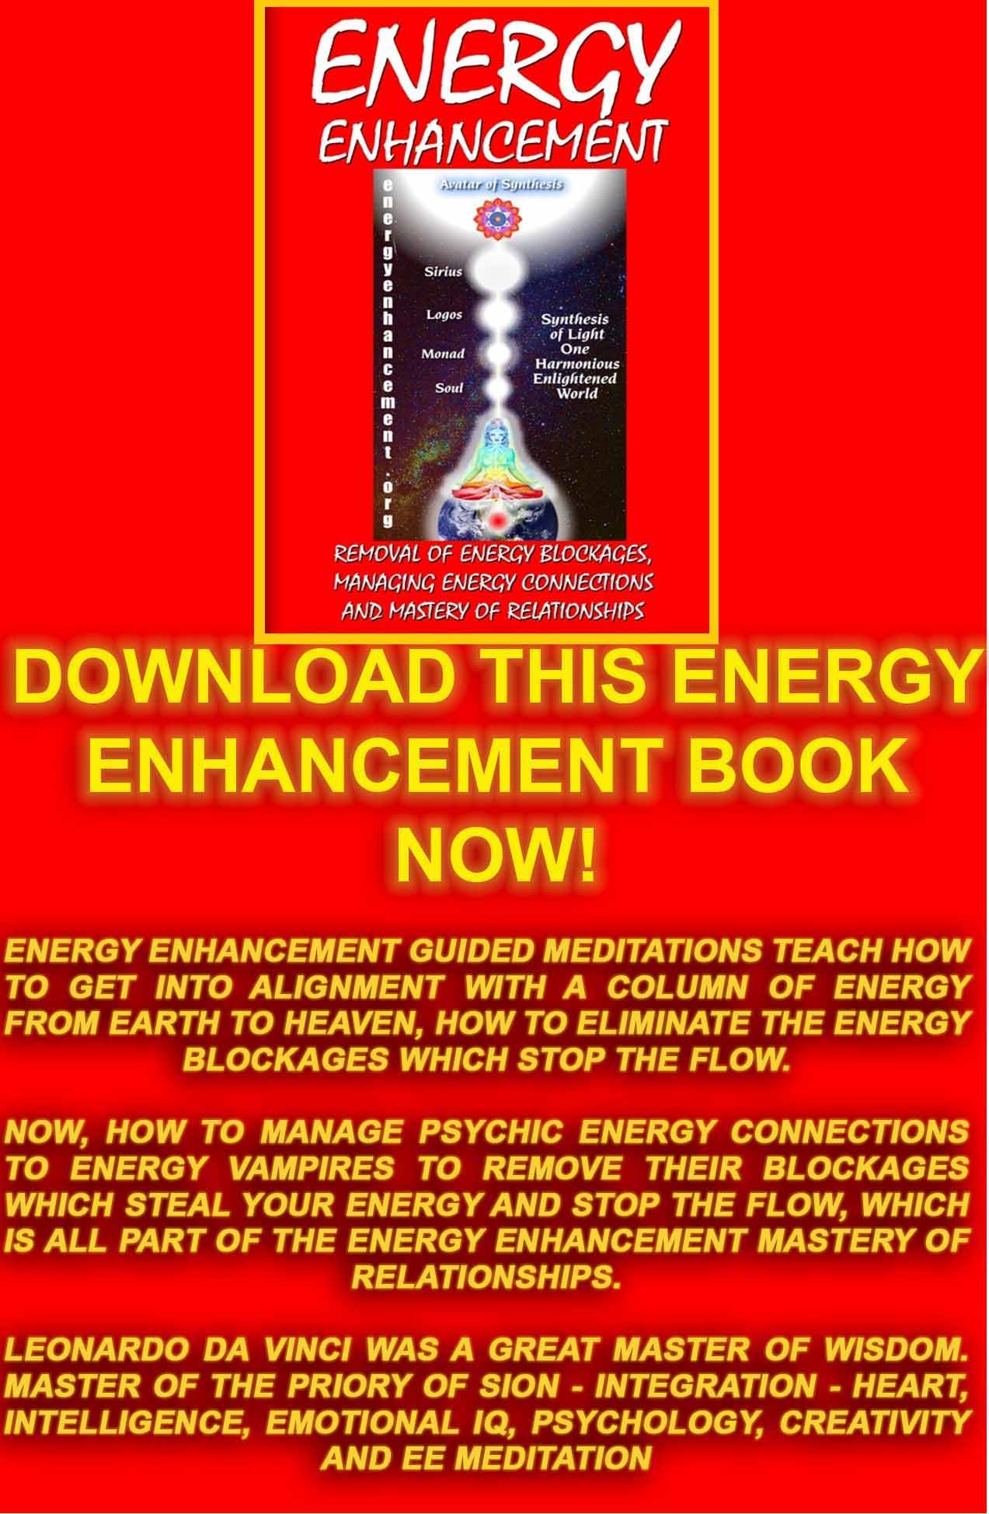
Download “REMOVAL OF ENERGY BLOCKAGES, MANAGING ENERGY CONNECTIONS AND MASTERY OF RELATIONSHIPS” HERE
http://www.energyenhancement.org/Sacred-Energy/Meditation-Energy-Enhancement-Eliminate-Energy-Blockages-Manage-Energy-Connections-and-Attachment-Mastery-of-Relationships-EEBOOK2Color-energyenhancement-org.pdf

THE ENERGY ENHANCEMENT STREAMING VIDEO COURSE

"Get your asses over here Now and Speed Up your process of Enlightenment on the Energy Enhancement one month course!!" - DON
Every one of our Students gets this Spiritual Experience of Connection with Infinite Energies.
Energy Enhancement does indeed, "SPEED UP THE PROCESS!!"
And they all get this Experience of Light, Life and Infinite Energy just with the Energy Enhancement Course - Every One of Them!!
LEVEL 1 - 4 VIDEO COURSES ANYTIME IN THE COMFORT OF YOUR OWN HOME

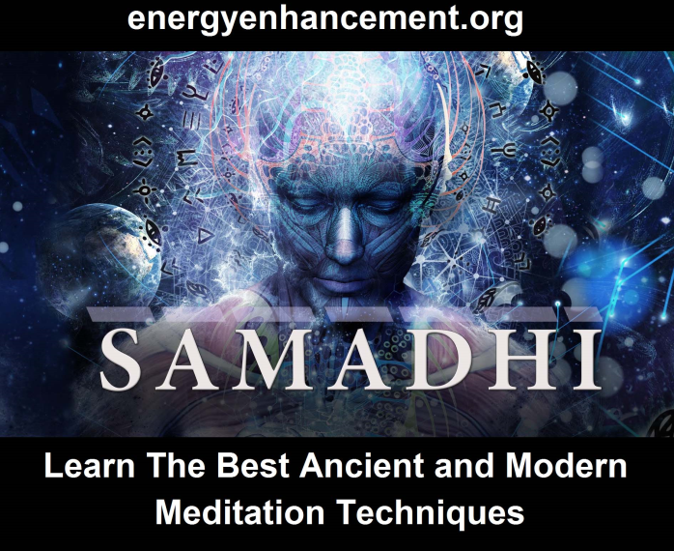

Download “Link Into Infinite Chakra Energy And Eliminate Energy Blockages” Here
http://www.energyenhancement.org/Sacred-Energy/Meditation-Energy-Enhancement-Link-into-Infinite-Chakra-Energies-and-Remove-Energy-Blockages-EEBOOK1Color-energyenhancement-org.pdf



THE OCCULT ALCHEMY OF THE BLOOD RITUAL- RED MASS
When Moses consecrated the Tabernacle in the wilderness, he sprinkled the Altar of Burnt Offering with the anointing oil seven times (Leviticus 8: 10-11), and and purified it by anointing its four horns with the BLOOD of a bullock offered as a sin-offering,” and poured the blood at the bottom of the altar and sanctified it, to make reconciliation upon it.” (8:15-15).
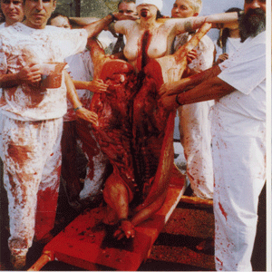
Then he took all the fat that was on the entrails, the fatty lobe attached to the liver, and the two kidneys with their fat, and Moses burned them on the altar. 17 But the bull, its hide, its flesh, and its offal, he burned with fire outside the camp, as the Lord had commanded Moses. (8:16)

That involves a massive amount of BLOOD.

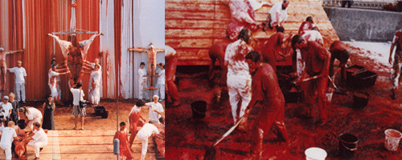

When King Solomon consecrated his Holy Temple, “…the king went to Gibeon to sacrifice there; for that was the great high place: a thousand burnt offerings did Solomon offer upon that altar”(1 Kg. 3:5). The second time, ‘Solomon offered a sacrifice of peace offerings … two and twenty thousand oxen,[22,000] and an hundred and twenty thousand [120, 000] sheep. So the king and all the children of Israel dedicated the house of the LORD. (1 Kg. 8:63). That involves absolutely thousands of people and tons of BLOOD.

There was so much blood and carnage at Solomon’s Temple in Jerusalem that the DEVIL, Himself, showed up to consecrate the Temple. No God of Heaven that I know of would condone such utter horrible savage mass bloodshed on earth.

In 1245, King Louis IX consecrated La Sainte in massive amounts of BLOOD like the King Solomon’s Temple. The man actually believed that he was King Solomon, himself. That’s why it is called, the RED MASS. In 1245, La Sainte was consecrated in a RED MASS of skin, guts, fluids and BLOOD.
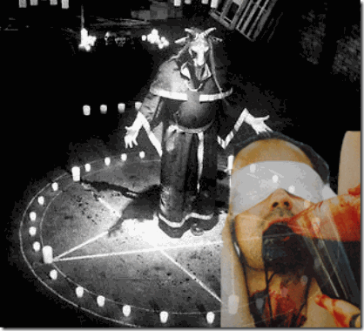

From almost the beginning, Abel was a keeper of sheep, and Cain a tiller of the ground. In the course of time Cain brought to the Lord an offering of the fruit of the ground, and Abel for his part brought of the firstlings of his flock of sleep, their fat portions. And the Lord had regard for Abel and his offering, but for Cain and his offering he had no regard. Since Adam’s day, generations of believers have sacrificed animals as an expression of faith.

(Gen.8:20-21) The God of King Solomon diligently instructed man that he would not receive forgiveness or blessing if he did not approach the Lord with the blood of a sacrifice. So down through the ages many thousands of animals were sacrificed as a means of access to Yahweh’s holy presence. Later, again by divine decree, animal sacrifices were included in the laws given to Israel through Moses: but with a difference: The BLOOD of the sacrifices was to be brought to the Door of the Tabernacle (Exodus 29:11,32,42) and later to the Temple in Jerusalem.

SOLOMON’S TEMPLE- THE FIRST TEMPLE OF THE “RED MASS”
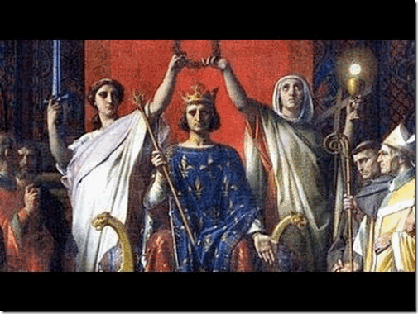
King Solomon & King Louis IX

In 1245 AD, the Capetian monarch wasn’t interested in honoring any ecclesiastical judges. They were interested in BLOOD MASS SACRIFICES to conjure up the favor of the Lord’s Warrior God-King and Angels to lead them into the Holy War. Their most fervent desire was to unite “the Kingdom of France with that of David and Solomon through a Great Holy War” Anyhow, Saint Ives is also deeply connected with the Knights Templar and the Great Holy War.

Solomon was a Master Magician and Sorcerer. Solomon knew the “Forces of Spirits” or “Powers of Spirits.” Solomon had access to a “Book of Mysteries” which empowered him to use DEMONS to accomplish tasks. He had a number of sacred magical texts (grimoires) penned in his name.

Within the Dead Sea Scrolls, there is a very fragmented Apocryphal Psalms (11Q11[11Q PsAp]) that mentions Solomon in connection with DEMONS.

“[Of David. Concerning the words of the spell] in the name of [YHWH…][…] of Solomon, and he will invoke [the name of YHWH] {to set him free from every affliction of the sp]irits, Of the devils. [Liliths,] [owls and jackals.] These are the devils, and the pri[nce of emn]ity [is Belial,] who [rules] over the abyss [of dark] ness…”

Solomon was a DEMONOLOGIST. He commanded DEMONS to help him build his Temple. The Mandean Ginza, which is thought to date to the early 2nd century, claims that Solomon had power over both demons and DEVS (astro-powers).

King Solomon’s Temple & BLOOD RITUALS

1 KINGS 8:63 And Solomon offered a sacrifice of peace offerings, which he offered unto the Lord, two and twenty thousand oxen, and an hundred and twenty thousand sheep. So the king and all the children of Israel dedicated the house of the Lord.

King Solomon’s Temple Complex & HUMAN SACRIFICE
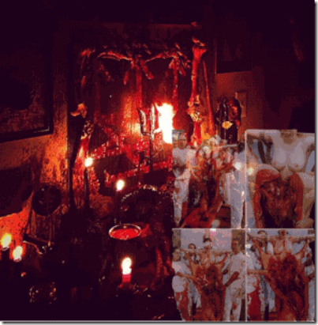

Part of Solomon’s temple complex was dedicated to Human Blood Sacrifice of Children.

A Temple for Moloch is dedicated to the sacrifice of children.

I KINGS 11:7 Then did Solomon build an high place for Chemosh, the abomination of Moab, in the hill that is before Jerusalem, and for Molech, the abomination of the children of Ammon.

The covenant between God and the Jews, symbolized by the Ark of the Covenant, was renewed by the Capetians’ possession of the relics of the Passion under the cloud of power and authority of Solomon’s Throne.
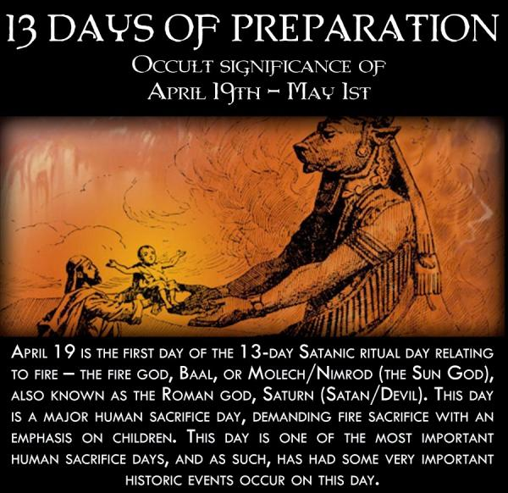

With the Spear of Longinus, the Capetiain secret mission was/is World Domination.

King Louis IX intended to began where King Solomon left off in Jerusalem to establish a Messianic Dynasty upon the entire world.

It is the Rothschild’s Shabbatean-Frankist Messianic Cult of today.

Luciferian Satanic Illuminati Kabbalist Sabbatean Frankists - CULT OF THE ALL SEEING EYE
http://www.energyenhancement.org/Luciferian-Satanic-Sabbatean-Frankists-Kabbalist-Illuminati-CULT-OF-THE-ALL-SEEING-EYE.htm

The RED MASS is actually an ancient secret Knights Templar’s Blood Ritual similar to the Christian Holy Eucharist, the Catholic Communion.

The RED MASS is an Alchemy Ritual involving metaphysical BLOOD transformation and substitution known only through a few. The Church’s ceremonial Red vestments also represents the BLOODY robes of the high priests that performed the animal blood sacrificial rites of Leviticus 16-18 (KJV), and secret cannibalistic rites. Cannibalism means the consumption of a victim’s flesh and blood to consume their spirit and essence.
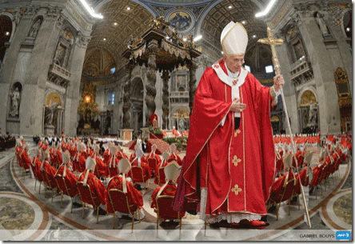
Gilles de Laval, Baron de Retz, Illustration Deschamps in history of magic, the supernatural world and fatality through time and peoples (1870) Peter Christian (alias Pierre Pitois)

Baron Giles de Rais (Retz) was a 15th Century Merovingian Knights Templar and devout Roman Catholic descendant of the Anjou Capetian House of King Louis. He was a leader in the French army, and a companion-in-arms of Joan of Arc.

In secret Catholic Black Masses, Baron de Rais of Brittany (Saint Ivo of Kermartin of Brittany) offered 600 children’s blood and body parts by the hundreds in Blood Rituals as a sacrifice to the DEVIL; drawing up Barron Demon to bargain with for wealth. He was also involved in Blood Drinking, and Cannibalism. He was allegedly hung to death for his horrible Satanic crimes death in 1440.
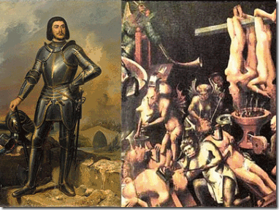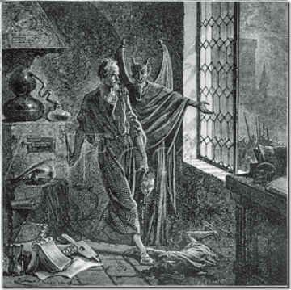

DOWNLOAD “LEVEL 2 REMOVE ENERGY BLOCKAGES” HERE
http://www.energyenhancement.org/Sacred-Energy/Level-2-Book/Energy-Enhancement-Level-2-Book-Remove-Energy-Blockages.pdf
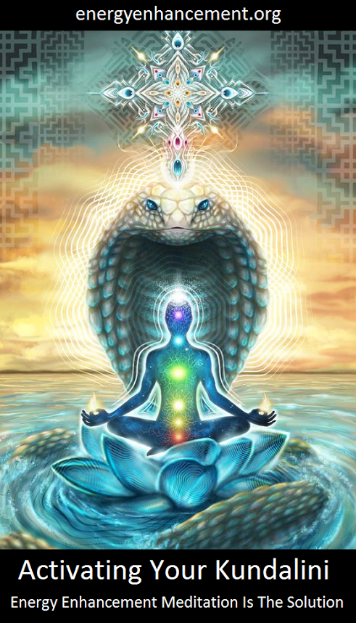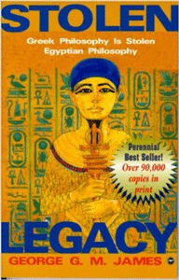
STOLEN LEGACY

“I am everything that was, everything that is, that will be, and no mortal has yet dared to lift my veil.” GODDESS ASET (Isis)

Goddess Aset is considered the underpinning knowledge of the physical and metaphysical- all things natural and unnatural- MAGIC.
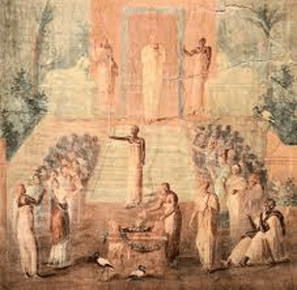
Pompeii Temple of Aset (79 AD)

The Greco-Roman Mysteries of Aset (Isis) were secret society religious initiation rites performed to imitate the sacred rites of the Kemetic Goddess Aset.

All religions start good but then are corrupted by the Satanists who twist everything good into bad.

Satanism is defined by Ritual Sacrifice and these they add to everything good to turn it bad and Satanic.

The Greco-Roman model of the Mysteries of Aset are deeply flawed and corrupted, because Western cultures exploited her ageless mysteries mainly for what they perceived to be her power and “Magic“. The Greco-Roman model also borrowed from other Satanic mysteries and secret Luciferian Sacrifice BLOOD rites in honor of the Greek Gods and Goddesses like Apollo, Artemis, Saturn, Cybele, and the Eleusinian Mysteries of Demeter (also related to Goddess Cybele).
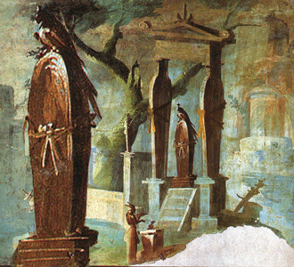
Pompeii Coffin Shrine to Asur (79 AD)

They also wanted to discover and dominate the sacred Kemetic keys and rites to be Godlike- the path to immortality. After initiation, a devotee became honored like a new Asur (Osiris), saved and regenerated (reborn) through the ineffable magical powers of Aset. It is the THIRD AND FINAL RITE passed down to the Children of Solomon, Knights Templars, Masonic brotherhoods, sisterhoods and fraternal orders.

The Greek and Roman secret societies also wanted the path to the afterlife. From a funerary inscription left by one of her initiate provides some evidence of Asetiac afterlife beliefs. It explicitly says that because the devotee had been initiated into the mysteries of the goddess, he did not “walk the dark road of the Acheron (river of woe) ” but “ran to the havens of the blessed.”

These Greco-Roman Mysteries of Aset secret societies were outlawed, but they didn’t die. They went further underground. They were hidden away in the catacombs of temples and churches. The so-called “Enlightened and ILLUMINATED Ones” of the mysteries that plot the left-hand path of new world order domination are no longer hidden away in caves, underground labyrinths, chapels and catacombs. Their high priests, princesses, initiates, surrogates and false prophets such as Lady Gaga have begun to craw and creep low on their bellies like snakes and serpents outside of darkness right into the daylight of your castles, homes and havens like vengeance is mine– right in front of your face.

In the next article, I have included a brief background discussion of European High Renaissance Vatican art masters, Raphael, Polidoro, and Caldara Michelangelo Merisi da Caravaggio, because they are relevant to today’s discussion of the Greco-Roman Mystery School’s secret influence over America’s Pop and Hip Hop counter cultures that impact all of us.

Insider Exposes Famous Satanists
https://www.henrymakow.com/insiderexposesfamous.html
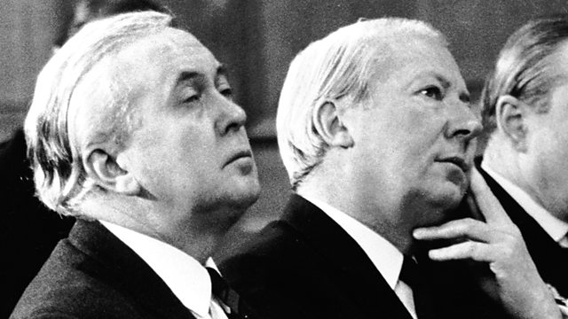
Wilson and Edward Heath (left) was the highest initiated Satanist in Britain to become Prime Minister (1970-74.) With Jimmy Saville he killed and raped children.
Both [Prime Ministers Harold Wilson] and [Ted] Heath used to sacrifice children and the British royal family still does. Ted Heath (1916-2005) took a real delight in it... Likewise, the British royals have public and very private lives... Prince William is being groomed for big things. He is a man to watch! ....Prince William definitely isn't Charles' son. Neither is Prince Harry, although his conception was out of spite as much as misplaced infatuation.

SAVILLE
http://aangirfan.blogspot.ca/2012/02/bbcs-jimmy-savile-and-child-abuse-cover.html
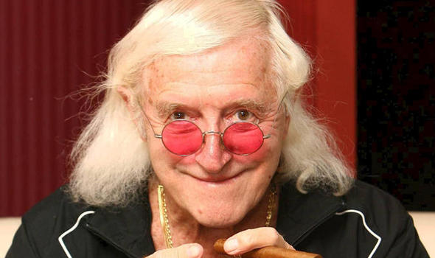
[Disclaimer: This website opposes Fozdyke's ideology and agenda, but appreciates his revelations.]
Duncroft School, run by Barnardos "Latest I heard ... is that several boys from Barnados and another home are suing the BBC for protecting Jimmy savile after he abused them." Cherie Blair, wife of Tony Blair, is President of Barnardo's. Martin Narey, formerly of the prison service, is the chief executive of Barnardo's. "A couple of friends were brought up in a Barnardo's home in my home town of Kidderminster. "They used to talk about the vicious predatory paedophile who was one of their care workers." Tom Watson - Labour MP: Barnardo's and the truth
Savile was a regular visitor to a number of institutions such as one on the 'child-abuse island' of Jersey where children were allegedly tortured and murdered.
Allegedly Jimmy Saville supplied kids to top people such as prime minister Ted Heath. Allegedly, UK Prime Minister Edward Heath "would regularly take boys from certain care homes away on his boat for weekends....
"The name 'Mr. Eddy' was well known on Hampstead Heath and the boys home nearby in the seventies."
"ALLEGEDLY... the person bringing children for him to abuse was Sir Jimmy Savile.
"He was seen by the witness, victim, taking young boys onboard Heaths yacht the Morning Cloud when they were at party conference.
"Saville is known for supplying a number of high profile MP’s with children for them to sexually abuse."
"Very simiar to Kinocra and other similar scandals where masons conspired with top cops and those in high places to escape justice."
(Masonic child abuse in jersey, Jimmy Saville implicated - Stormfront)
"He ... did have some contacts at morgues around the country and he paid them for access to their, shall we say, clients."
"Savile, the star of children’s television favourite Jim’ll Fix It, decided to start proceedings against the Rupert Murdoch paper after a series of articles linked the former Radio One DJ with Jersey children’s home Haut de la Garenne.
"The police are currently investigating the care home after human remains were found at the residence where children were allegedly tortured and sexually abused.
"On 1 March, Savile’s solicitors said, The Sun carried a photograph of the former Top of the Pops presenter allegedly visiting the Jersey home.
Jimmy Savile had both a Royal and Papal knighthood (Order of St. Gregory the Great)
He was a Knights Hospitaller (also known as the Sovereign Military Hospitaller Order of St. John of Jerusalem of Rhodes and of Malta, Order of St. John, Knights of Malta, and Chevaliers of Malta)
http://en.wikipedia.org/wiki/Jimmy_Savile#Honours
"I know from my own unimpeachable sources that Saville was a sick abomination of a human being who not only abused children, but was a necrophiliac, which is defined as an 'obsessive fascination with death and corpse' and an 'attraction to or sexual contact with corpses' - hence his famous 'volunteering' to be a 'porter' at Leeds General Infirmary."
Savile says he spent "11 consecutive Christmases ... with the Thatchers." Speaking of former Prime Minister Thatcher, Savile told Esquire: "I knew the real woman and the real woman was something else. The times I spent up there (Chequers) - Denis, me and her, shoes off in front of the fire." "He spent an afternoon entertaining the wives of the G7 leaders back in 1991 at John Major's invitation...
"Savile had dinner with ... Admiral Sir Michael Boyce (Chief of the Defence Staff)..."Dickie Arbiter, who was Prince Charles's press adviser, confirms that Savile was involved in the lives of the Royal Family."
Diana described Savile as a "sort of mentor" to Charles.

"There is a Secret God, a Hidden God, who dwells in a spiraling tower fortress and who has guided and overseen our development from time immemorial - and who has remained concealed but very close to us awaiting the "future" time of re-awakening. The time of the re-awakening is near. Already we have heard the distant claps of thunder which signal the coming storm."
S. E. Flowers, Ph.D. from July 30/11
by Aloysius Fozdyke (henrymakow.com)
Despite what some believe; based on book reading, conjecture and lies, Satanism is a label applied to a variety of spirituality and practice, from disgruntled teens slaughtering small animals in cemeteries to the rigorous methodology and practice of the Alpha Lodge.
That Lodge traces its history to Sumerian and Egypt and the cities of Babylon and Ur. Its methods actively embrace this life, this world, this physical realm, this body as a means to illumination and awakening. The left-hand path is not a route of escapism from reality, but a confrontation with the full totality of physical and psychic existence, encompassing pleasure and joy as well as horror, pain and mortality. You become a deliberate outcast!
Each grade is achieved, never simply conferred. Sometimes it takes many years for advancement - but you can never really leave the Lodge. There is a point of no return. Indeed, each ritual binds the participants tighter; closer to one another and the dream and nightmare Mysteries of Our Deities. We co-ordinate the actions of the left-hand path and its adherents.
The left-hand path in its purist form is always characterized by radical opposition. Its method of initiation is based on cultivating estrangement and deliberate alienation from divine, natural and human rule. Through an active and positive sacred glorification of the radical Other (Drugoy), the walker of the left-hand path steps outside previously secure borders, a self-exiled, self-determined creation of his or her own autonomous will! This sacralized separation from the established law and custom, particularly sexual convention, is not to be confused merely with the empty acts of the social rebel - it is instead a God-like disdain for the restrictions that bind the uninitiated, a taking of supreme responsibility for one's own actions.
We don't worship Satan - We emulate Him! We seek to become Gods and Goddesses in our own right. As such, our path is inherently lonely. One's first cull - whether ceremonial or mundane - is always significant. There's a realization that cannot be expressed. And after a cull we try to engage in sex as quickly as is possible, for Our Mysteries are founded upon death and sex. Anal sex is one of our supreme sacraments. Properly performed it both releases and constrains. "The Wand must be bedaubed..."
SOME HISTORY
According to its Knowledge Lectures, the Alpha Lodge existed mainly in England until the nineteenth century when its operational base became the Australian colony of New South Wales. There some of the highest echelons of the landed gentry establishment embraced it. Individuals such as Alfred Deakin and later, King O'Malley caused some problems, but by the time William Morris Hughes was Prime Minister, these obstacles had largely been overcome by focusing on the bureaucracy. We work behind the scenes.
Those with limited purpose or self-respect use what little power they are given in predictable ways. One only need observe what has happened since the Twin Towers in New York were destroyed to see how police, customs officers, security guards and other petty bureaucrats have created the sort of nameless, faceless and soulless justice that is foundational for the hierarchical future. By concentrating on the system everybody and everything falls into place. As was often said by my mentor, Petor Narsagonan, 'Satan is a wonderful systems man!' This was learned early by the Alpha Lodge.

At that time and well into the twentieth century, there was a libertarian strain within the Lodge. As Satan had left the tyranny of heaven to pursue freedom; freedom was what the lodge supported. However it became increasingly apparent that the masses did not want liberty. As the Western world - including Australia - moved comfortably to the implementation of mass incarceration, right-hand path-ers had every reason to celebrate. With surveillance cameras now in streets, in stores, at public transport stations and above the motorways; with telephone conversations that may be recorded for 'training' purposes; with the proliferation of government regulations, directives, policy initiatives; scanning devices and detection machines; proof of identity requirements and triplicate forms the conformist herd is comfortable!
As the future is worked out Satanists will be gold capstone of the societal pyramid.
hughes1.jpg[Aussie Prime Minister] Billy Hughes caused a major problem after his attendance at the Versailles Peace Conference. There was a distinct possibility in the 1920s that the federated colonies of the Commonwealth of Australia would in fact become a sovereign nation. The same possibility was open to New Zealand and Canada. After a lot of effort on the part of Alpha Lodge initiates all over the globe, only the British colony of South Africa became a sovereign nation. The income and influence of the left-hand path and its adherents remains intact to this day.
MEANS OF CONTROL
The right-hand path takes responsibility away from the individual by having a formal dogma, a code of ethics and behavior and by having the individual participate in an organized grouping. In that way and to varying extents the identity of the individual is taken away by belief systems which the individual has to accept, and by them accepting some higher authority, be such authority an individual, a group or an ideology. The Alpha Lodge took over these authorities - political parties, the military, the public service, financial institutions, the legal profession, churches, charities and others - by a variety of means and in this way achieved its aims.
The Church of Satan and its child, the Temple of Set are the public faces of the left-hand path. They remain magnets for those with promise who will be invited to join or who will find more serious and clandestine branches of a very old tradition. In that regard the Order of Nine Angles in Britain is a sister 'lodge' to the various Alpha Lodges worldwide and increasingly so in America.
In the pedestrian world, the universities of Oxford and Cambridge in the Britain and the University of Texas in America remain the Alpha Lodge's fertile recruiting grounds. Like all modern universities, these centers of learning prepare their students for a life of work in some dismal institution, trapping them in the retirement system and creating prisoners of the State. But unlike modern universities, these three and the University of Osaka remain at the forefront of Luciferianism. Osaka University in Japan became important in the mid-1980s owing to its relationship with of all groups, the I.R.A. Not many realize that Irish republicans have a deep and long association with Osaka University, as that university also now has with the left-hand path in Asia.
Northern Ireland has many Satanists of high caliber. Irish Satanists are particularly into child abductions and sacrifice. Theirs is an old, dark paganism replete with seasonal celebrations. Akin to the Order of Nine Angles, the Irish nonetheless retain their own mysteries. Some of their highest people are also members of the Alpha Lodge. Clonegal Castle and its surrounds are well know to Irish initiates.
LAVEY AND NORMAN LINDSAY
Howard Stanton Levey was originally associated with the American branch O.T.O. and it was from them that he was first taught serious Magick. Carl Kellner, Dr. Gérard Encausse, Theodor Reuss, John Yarker, Major General K.E. Haushofer and Dietrich Eckart were some heavyweights in the foundation of what is today known as the Alpha Lodge. Their work was based in Europe but also found fertile soil in America, particularly owing to the later efforts of Edward Alexander Crowley and his connections with the British intelligence services. It was this teaching - via Crowley through Marvel Whiteside Parsons - which was the foundation of H.S. Levey's later developments.
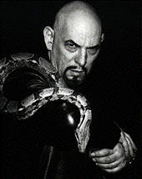
Whilst the Church of Satan is officially atheistic, its founder definitely wasn't. Prior to becoming Anton LaVey, Howard Levey engaged in a number of activities which are yet to see the light of day - if these ever do. For example, he was at one time an associate of [Zodiac Killer] Dick Gaikowski.
It was around 1964-5, that the Alpha Lodge first made contact with him and a fruitful arrangement it turned out to be. His endearing achievements remain the Ordo Cave Lupam (just a few short years after the Profumo Affair) and its influence upon the (originally Australia- based) Black Order (of Typhon). It is a shame that he never met [foremost Australian artist] Norman Lindsay who contributed much to the Black Order's success.
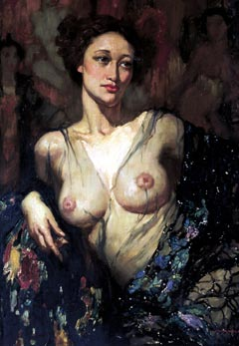
a painting by Lindsay
Crowley constantly stressed attracting significant and successful people into the occult world and Satanism certainly did. Prior to the 1960s many Freemasons were recruited internationally. These well placed, professional connections are still paying dividends today, particularly in Ireland, but Australia was no different. Aristocrats (particularly those with strong Norman ancestry), politicians, bureaucrats, media glitterati, social workers and even Christian clerics now worship at the altars of Satan.
Norman Lindsay (left) was never homosexual but, that said, he at times enjoyed the favors of very young girls. He engaged in work surrounding the mysteries of the vagina, particularly the Kaula rites of Tantric Magick. I'm told that there are a number of bodies which were buried outside (but around) his Faulconbridge property. Nearby there are chambers beneath the ruins of a now derelict mansion that was burnt out some decades ago. I understand that these subterranean chambers have not been accessed since the 1930s, when that mansion was sold.
Norman Lindsay discovered that the use of ritual and sex created a separate world where normal morality was forgotten. Young children initiated through such rites displayed cognitive distortions, often becoming disciples of their original abusers. Norman maintained that cruelty and violence were natural and that society's denial of these was simply Christian hypocrisy. Through him the Alpha Lodge in Australia began organized sexual exploitation, harnessing their rites towards power and the control of the individuals involved.
The child victims were disoriented by the robes, incense, incantations and locations. Who is going to believe a little child haunted by shame and terror talking about sexual abuse and torture at the same time they mention the bizarre aspects of ritual? Norman maintained that secrecy and silence were the first and best lines of defense; followed of course, by the lack of credibility of the victims themselves. Decades after his death, initiates of the Alpha Lodge proposed "subconsciously fabricated memories" as the actual cause of some of the distressing stories which have more recently seen the light of day, but it should be remembered that the the earlier insights of Lindsay were foundational in the acceptance of the 'panic', 'witch hunt' and 'hysteria' claims of today's denying professionals.
If a child speaks of what occurred, they become victims of a dismissive, incredulous society and the sensationalist media circus which generates itself around the ambiguities of their stories. They are pushed to the margins of society's conscience and consciousness, then forgotten. It was discovered that a few evocative words was usually enough to cripple a victim with visceral flashbacks of the shame and agony being relived again and again - for their memories are a prison without walls.
Lindsay rediscovered that in a threatening ritual situation - with its heightened sense of alertness, with reaction and responses at fever pitch - if the chance to respond in a constructive way is denied then everyday responses to danger become dysfunctional. In such individuals fear, anger and sadness can be manipulated to quickly escalate. Emotionally numbed and fatigued child initiates can develop a separate sense of complete difference to others together with a belief in the total power of their perpetrators. I'm told that some of the children went on to live extraordinary lives - both within and outside of the Alpha Lodge - whilst most descended into prostitution for the Alpha Lodge, followed by early death.
In America today Norman Lindsay is worshiped by initiates as the God He is. He has become greater than the mortal He knew would die that a God may be born. His feast is twenty-one days after the Eve of All Hallows. A young (virgin) girl is presented to the Temple, prepared by female members and initiated by the most advanced male in attendance who wishes to do so. Others may then take their turn. Her bodily juices are collected and used in later rituals, principally to consecrate or in ointments.
Meanwhile in Britain, Bob Boothby and Tom Driberg, apart from being homosexuals, were also active Satanists. Tom's cover of Anglo-Catholicism kept him out of a lot of bother. Both were involved behind the scenes in organizing for Harold Wilson and Edward Heath to become Prime Ministers of Britain, as Wilson was a high initiate of the left-hand path and together with Nat Rothschild, Britain is still influenced by their seminal work. Heath, on the other hand, was the highest initiated Satanist in Britain to become Prime Minister.
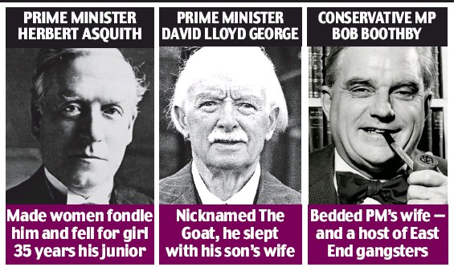
[Winston Churchill referred to Tom Driberg as "someone who gives sodomy a bad name.]
Even occultists know little, if anything, about Bob or Ted's visits to the ancient sacrificial Wood in Clapham, Sussex and their association with certain people in the surrounding areas. The Wood holds some serious secrets stretching back in time to before Roman Britain and indeed it still does. From what I've been told, one day some of these hidden horrors will be found, but by then those involved will be long dead.
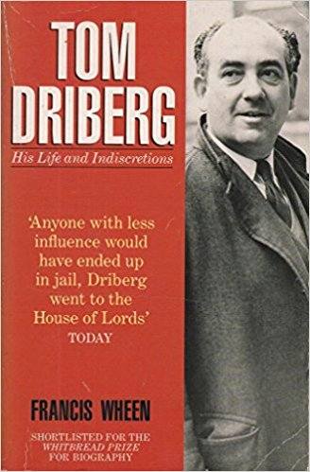
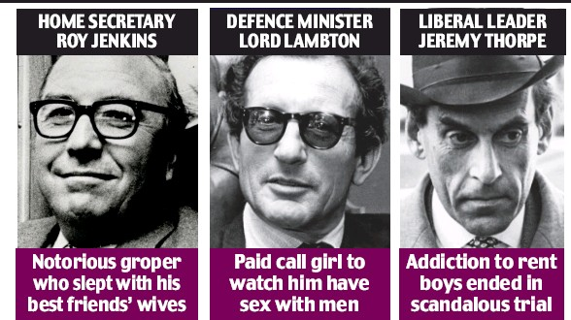
Just as in Australia, there are tunnels and caverns beneath Chequers and I'm aware that Heath used these. Balmoral Castle also sits atop a vast expanse of underground workings. There are secret tunnels beneath London that lead into the Earth. If you know where to look, a few of London's subterranean ghost railway stations and the odd pub cellar are good places to start. Some of these may be natural whilst others have been constructed. Prior to London becoming a Roman city there were mines in the area, mines that were later discovered and used. Indeed, it would be true to state that thousands of people could live in the tunnels and caverns beneath the City as there are abundant water sources. The crowning, in-your-face audacity of the British Establishment was to name the bunker beneath the Ministry of Defence 'Pindar' - after the Greek poet, of course!
Both Wilson and Heath used to sacrifice children and the British royal family still does. Ted Heath took a real delight in it, or so I'm told. Apparently he used to engage in ritual outside of London on a Common associated with Francis Dashwood. Likewise, the British royals have public and very private lives. Their obsession with hidden, esoteric traditions stretching back millennia is nothing short of amazing. Prince William is being groomed for big things. He is a man to watch!
MANDELSON_Peter_Lord_002.jpgThe Dark Lord, Peter Mandelson, (left) apart from being openly gay, is one of the highest initiates in the United Kingdom. He was trained in the hebdomadry system of Magick, the same system used by both the Alpha Lodge and the Order of Nine Angles. His close association with international business figures and the Bildberg group have been of great, indeed inestimable use to the left-hand path. Following well thought out and well honed traditions, his dream is a prison-grid global community. He loves to control. And 'Mandy' as he's known to those who know him best, is as sharp and dangerous as a stiletto.

It is Mandelson who has helped turn Europeans into serfs for Europe's banks. Europe is now reverting to a neo-feudalism structure with bankers as the overlords of their indentured citizenry. Britain, America and the rest of the world will go the same way. Kleptocratic politicians are merely vassals. If current debts were simply wiped off of the books the only tragedy would be the destruction of the 'too big to fail' banks. While politicians call that a catastrophe it would actually be freedom for millions of disenfranchised debt-serfs. That's why it must not happen - and won't!
Wages will continue to be cut even as taxes are increased to service the debt owed to the Banker Lords. Politicians everywhere are bowing and scraping before their Lords, promising deeper cuts and higher taxes. This is as it should be and will effectively cripple economies around the world. Protectionism under the guise of 'Fair Trade' will be shortly implemented after the American crash. This is what the filth want and we will give them what they want - taxation, poverty and war.
The next war will start in Iran but will bring the entire Islamic world into conflict with the [Christ]tian west. Right-hand pathers like nothing better than wars and killing. For long before I was born the Alpha Lodge has been orchestrating to give them what they want. After the next big war we will be in a position to take over everything that is left. "For these fools of men and their woes care not thou at all! They feel little; what is, is balanced by weak joys; but ye are my chosen ones...Therefore the kings of the earth shall be Kings for ever: the slaves shall serve."
Living most of his life as a repressed homosexual urolagnist and having been taught to be cautious; Mandy's viciousness, cunning and polished, diplomatic persona are his enduring trademarks. Just don't get in his way. He lives by the left-hand path code of honour, loyalty and revenge. It was Mandelson who was instrumental in the death of James Rusbridger, particularly in the sordid way his 'suicide' was made to look.
PRINCESS DIANA
Hekate and Diana are both Goddesses of the night and the Alma bridge tunnel sits beneath crossroads. Indeed, when looking at the memorial on the ground floor of Harrods - complete with the more obvious fish bladder and chalice - little is left to the imagination. And the flaming torch - it's everywhere, even on her grave. Indeed, one of the things the flaming torch represents - apart from a Wand - is the golden semen of the thirteen royal families of Europe. Diana was largely kept out of the inner workings of the British royal family owing to her inability to toe the line. After William, she was expendable and rightly so. She'd served her purpose. Her death was merely icing on the cake.
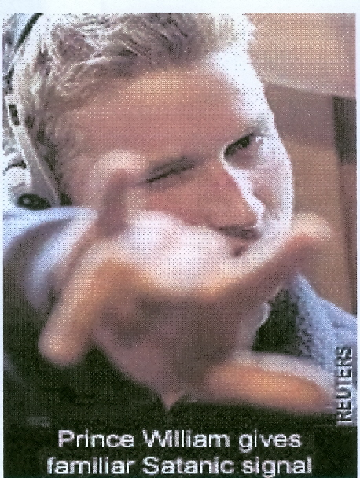
Princess Diana was a sheep among wolves. She was chosen owing to her Stuart blood. [Her stepfather] Peter Shand Kydd did more in the colonies than raise sheep. He was initiated into the Alpha Lodge some years before Norman Lindsay died, or so I'm told. I've no idea if they ever met, but it wouldn't surprise me. Both loved the fairer sex and monogamy was impossible.
His mission was to break up the already troubled marriage of Diana's parents with a view to causing emotional problems for her. He succeeded! Poor, beautiful, doe-eyed and stupid Diana never achieved much intellectually and was therefore perfect for her purpose. Prince William definitely isn't Charles' son. Neither is Prince Harry, although his conception was out of spite as much as misplaced infatuation. William's father is a citizen of the world but is based in France. I've never met him, but those who have are impressed and fearful. If Satan has a vice-regent on Earth it is Him.
Gil Norman on "The Satanic Epistles of Aloysius Fozdyke"
https://www.henrymakow.com/insiderexposesfamous.html#sthash.DfwC8DRY.dpuf
Every noble family in Russia, Europe and the United States can trace it's genealogy back to Satanic Babylon.
See the Satanic Incas, Toltecs, Mayans cutting the hearts out of thousands of people and selling their meat at the altar.
See the Inquisition Torture and burning 50 millions of people alive.
See the Fascist Satanic Nazi SS (The Nazi SS - Sea Seclorum - Knights of the Holy See - was Authorised by the Pope Pius 12th who was Papal legate to Germany before he became Pope. The SS were controlled by Himmler who became Head of the Jesuits, the Black Pope, during WWII.) burning millions of people alive in a new inquisition holocaust.
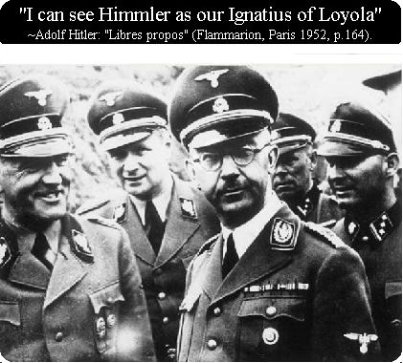
"NOTHING LIES SO MUCH AS A JEWISH GRAVEYARD" - APPLIES TO ALL DEFEATED ENEMIES TOO
See the Satanic Babylonian Empire, the Satanic slave trading banking Roman Empire and it's offshoots, the Catholic Church, The Holy Roman Empire, The Black Nobility, the Satanic slave trading banking Venetian Empire which after infil-traiting Britain with William of Orange became the the Satanic slave trading banking British Empire and then the British American Empire..
MI6 created Eugenics and funded Hitler who was the first guy to think of putting rat poison in the drinking water. Then Stalin put rat poison in the drinking water. Then all over the World the satanic war sacrifice "lives for satan" nobility put rat poison in the drinking water 300 micrograms of Fluoride and Fluoro-Silicic Acid per liter. The Harvard University study on Fluoride in the drinking water says that 1.7 micrograms per liter drops the IQ by 20 points and gives bone cancer.
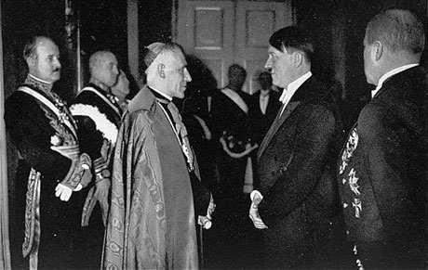
POPE PIUS XII - FOUNDER OF FASCISM - WITH HITLER
MI6 created Eugenics - There is a video of polio vaccine creator Jonas Salk bragging about putting sv40 cancer virus into his vaccines killing hundreds of millions through cancer. Through vaccine excitotoxins and heavy metals - mercury and aluminium - to brain damage – autism - all humanity - in vaccines in multiple shots babies are shocked into losing 20 IQ points and sometimes killed. Autism up from one in 50,000 to one in 10 now, and then one in two by 2035. Through vaccine hormones young women are sterilised.
I guess the education system isn't enough - indoctrinating your children into Bolshevik Communism.... they need more weapons to more quickly dumb down humanity...vaccines are all set up to make the tribe over at the Rockefeller medical industrial complex $90 Billion a year....autism was one in 50,000 practically unheard of until they started pumping babies with tainted vaccines - now autism is one in ten moving to one in two - to turn them into a bunch of handicapped chimps...
You can't make this stuff up!!
CAUGHT YOUNG, THEY CAN PERSUADE YOU OF ANYTHING, MAKE YOU A FOLLOWER OF ANY RELIGION, ANY TRIBE, ANY CULT..
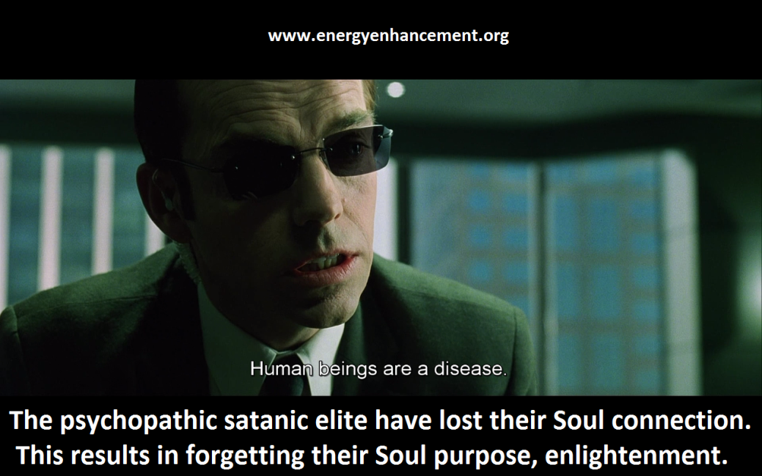
Black Terror, White Soldiers
While the globalists’ political and financial people have been busy erecting the superstructure of the multilateral/multipolar New World Order, their psychologists and sociologists have been busy as well. Through institutions like the Tavistock Institute in the UK and the Stanford Research Institute in the US, globalist minions have been formulating ways of molding the thinking of the masses to make them NWO-compatible.
Information about Tavistock and Stanford Research (now called SRI International) is all over the internet, but I found a particularly concise and informative introduction to them on page 326 of David Livingstone’s
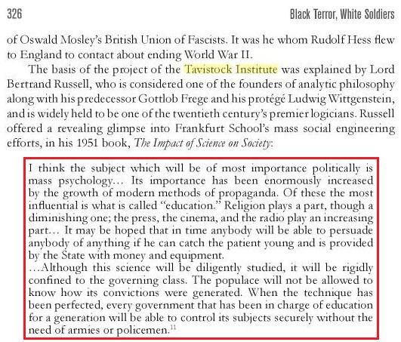
Black Terror White Soldiers: Islam, Fascism & the New Age… http://www.amazon.com/Black-Terror-White-Soldiers-Fascism/dp/1481226509


DOWNLOAD “GAIN SUPER ENERGY WITH ENERGY ENHANCEMENT LEVEL ONE INITIATIONS HERE!!!
http://www.energyenhancement.org/Sacred-Energy/Gain-Super-Energy-Energy-Enhancement-Level1-Initiations-Kundalini-Kriyas-Meditation-Shaktipat-Circulation-Taoist-Orbits-Alchemy-VITRIOL-Grounding-Psychic-Protection-Pyramid-Merkaba-energyenhancement-org.pdf
How Satanic Lord Bertrand Russell Became an Evil Man
http://www.energyenhancement.org/Satanic-Lord-Bertrand-Russell.htm
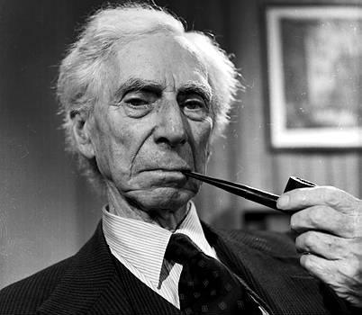
Old Rothschild- and Rockefeller hands created Austrian Economics and the Rockefeller-Alex Jones Libertarian-Communist dialectic

The Satanic Frankfurt School "Dums" Down Culture and Civilisation ADORNO, BENJAMIN, MARCUSE, LUKACS, BRECHT, WEILL, ECO, DERRIDA
http://www.energyenhancement.org/Satanic-Frankfurt-School-ADORNO-BENJAMIN-MARCUSE-LUKACS-BRECHT-WEILL-ECO-DERRIDA.htm
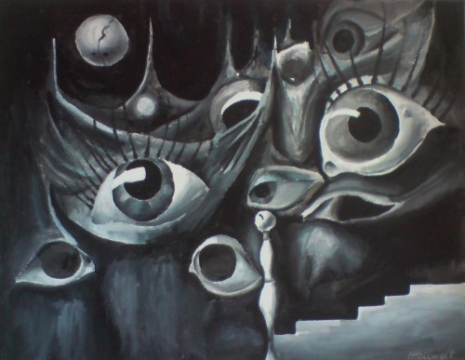

CONFESSIONS OF A SATANIST Frater 616
I will go down to The Altars in Hell
To Satan?
The Giver of Life?
O! Prince of Darkness?
Hear Me!
Our Father which wert in heaven
Hallowed be Thy Name
In heaven as it is on Earth.?
Give us this day our Ecstasy?
And deliver us to evil?
As well as temptation
For we are your Kingdom?
For Aeons and Aeons.
Satanism flourishes beneath the scintillating midnight-blue wet streets and bedevilling phosphorescent lights of Australia's glittering capital cities. Its practitioners are from all walks of life. Although marginal types and those with predisposing personalities have always and will always be important to Satanism and its leaders' ends, they are merely tools. Their antinomian influence is now so pervasive as not to be readily noticed.
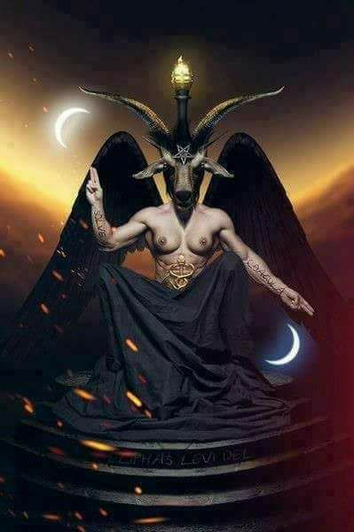
Amongst the highest echelons some are politicians, medical doctors, high ranking police officers, lawyers, advertising gurus, decorated military men, media personalities, fashion models and social workers. Amongst the lowest (usually temporary) ranks are 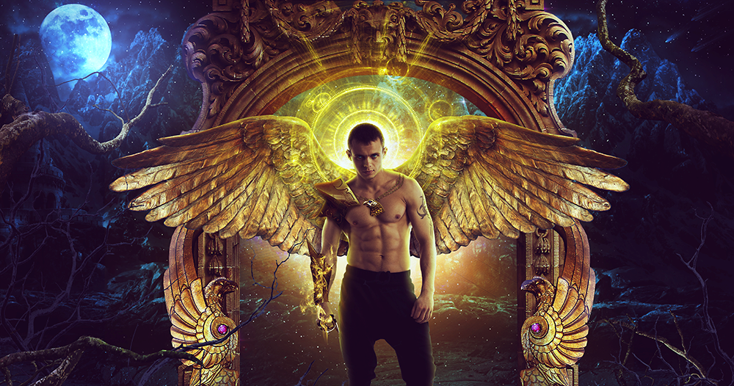
prostitutes, minor drug dealers and a number of High School students. Some operate from the mists. Their victims are drip-fed straight amnesia by an assortment of mind control measures and psychological torture tactics that would leave any normal person numb with the dawning apprehension that things are not as they seem - and they have not been for a long, long time.
The most talented amongst them have lifestyles maintained on crime, but lacquered with a thin veneer of respectable professionalism and knowledge.
They dress with elegance - timeless and calculating; networking and conspiring in a dream that money alone cannot purchase. Often their personalities have a force that distorts the contours both of judgement and of everyday perception. I cannot mention every name, but I will drop enough clues. The doctors refuse to say exactly how long I have but ...
I became involved in the whole sordid business in the 1970's, a decade noted for little beyond sartorial bad taste and crushingly optimistic fatalism. The decade that began as a drug-crazed carry-over of the 1960's soon bequeathed androgynous glam-rock, the Watergate scandal and the shallow opportunism of 'Rollerball'. Science fictionism stalked the streets with a rejected furtiveness bred of cowering beneath the backdrop of the Cold War and dancing with the resurrected agonies of another Asian based imperialistic conflict.
I fell through a crack in reality, having deliriously wandered amid the human wreckage and reached certain spiritual conclusions. In short, I do not know how I got there, but I know why. The 1970s were a dismal, incense-fuelled time that only those who lived through it can appreciate. The comprehensive dismissal of values and the adoption of pornography as the aesthetic standard by which all endeavour was to be categorised left its impressionistic fingerprints on everybody's imagination, mine included. I guess that I analysed and reacted differently. That is how I escaped the mundane - through one of western society's fault lines.
Credo quia absurdum!
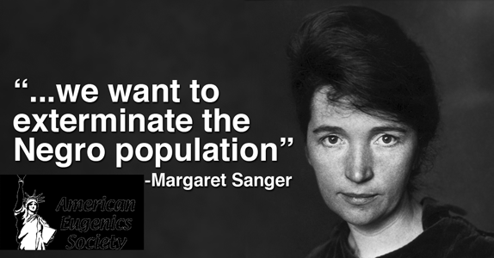
I began dabbling in the black arts as an alienated university student. It was 1971 when I attended my first meeting - only to be led into an existence of happiness, sexual excess, acquisitive arousal and comfort. Within a week of meeting my Luciferian mentor I was operating a number of travel businesses in Sydney and flying to international destinations at least four times a year. I had a Jaguar, city apartment, holiday home in the country, access to a yacht on Sydney harbour and women. I was young and considered to be an up and coming star within the shadowy twilight of the Satanic infrastructure. The nether world was at my patent leather-soled feet. My suits were hand-make Italian; the cravats and neckties, Chinese silk and my nymphomaniac maids, French. (They dressed like French maids and would often wake me with a lesbian show.)
At that time the United States based Church of Satan was the very public face of a movement that had begun
almost a century before and had culled its adherents from the renaissance of magic, which had begun in Germany and flowered in England since the dying years of the nineteenth century. The Church of Satan was one of the front organizations for an ancient body whose very existence had never before been imagined. If you want more information on some of its past and most influential members you could do worse than study the late J.P. Morgan, Drs. James McDonald and René Hardy, the Kennedy's (including Jackie), Irving Berlin, Groucho Marx, Elvis Presley, Garner Ted Armstrong, Sammy Davis Jr., Ronald Reagan, Edward Heath, Thomas Plantard de Saint-Claire or a search amongst the Bushes.
I learnt and reflected the glamour of the black arts: divination, dark meditation,Ritual, sodomy, pedophilia, Torture, human sacrifice, cannibalism, sexual vampirism, talismans, voodoo dolls and sex magic.
My life was one of calculated excess and dazzling fulfilment. I smoked handmade Partagas Cuban cigars. I had a personal secretary who was happy to engage my every whim and find like-minded others if I wanted a change or had a colleague I needed to impress. I finished every day with a restaurant meal, bottle of French Champagne and Black Mass orgy of unforgettable and unspeakable delight.

The streets were more innocent, the people more naïve. The American Intelligence Services were still involved in funding the occult but their influence was more ingratiating than dictatorial. In any event, many of America's high ranking military men were members of various Satanic Lodges or kindred organizations.
Often drugs, armaments and powerful figures - who operated from the comfort, safety and anonymity of the dark velvet shadows - were transported on U.S. and Australian Navy ships. Oil tankers were another favourite. Materials (and indeed, people) have been concealed and lost on oil tankers for years. Remember, this was in the Seventies when America's organized crime syndicates were establishing the narcotics markets of the Western World, Australia included.
The Satanic Bush - Clinton Crime Families Have made One Trillion Dollars a year from Afghanistan Heroin and One Trillion Dollars a year from South American Cocain for fifty years.
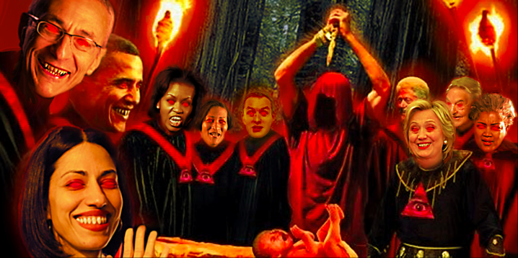
I knew her as Lilith, a High Priestess of an ultra-secretive Black Order of Typhon. Hers was the easy smile of a true neurotic and the body of an Angel. Her long cruel fingernails were enamelled in the chic and expensive titillations of her victims and their fantasies. Urolagnists worshipped at her feet and obeyed her every sadistic command. They were not the only ones. Her clientele included the top-end of town and she frequented the boardrooms and bathrooms of power with an essence of mystery, wealth and alluring sluttiness that won her the attention and influence of very many.
I had first met her at a stately home in an inner Sydney suburb at one of the regular Black Masses held to strengthen the bonds of lust, occult knowledge and perversion. There she was indulging the Devil's faithful, teaching and being videoed for the 1970's black-market that existed in underground extreme porn: bestiality, paedophilia, body wastes and pain. After her services "to the Dark Lord" she told me over a reefer and through exhaustion that she was only seventeen and had met the Master. He had given her a mission.
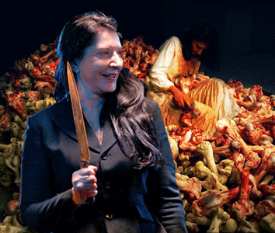
Lilith was a child from one of Sydney's more self-conscious suburbs. Private school educated and with a future in her father's business, she sacrificed herself to help establish what is considered today, by those in the know, to be the most powerful and important Satanic organization in the world. That group comprises some of the most educated, wealthy, corrupt and corrupting people that have ever existed. And they operate out of Sydney, Australia - but their influence is international.
It transpired that she had been flown to the United States to be tutored and initiated into what was at that time, Anton La Vey's underground Satanic sisterhood of professional women with an aptitude for carnality and a conscience to match: the Ordo Cave Lupam.
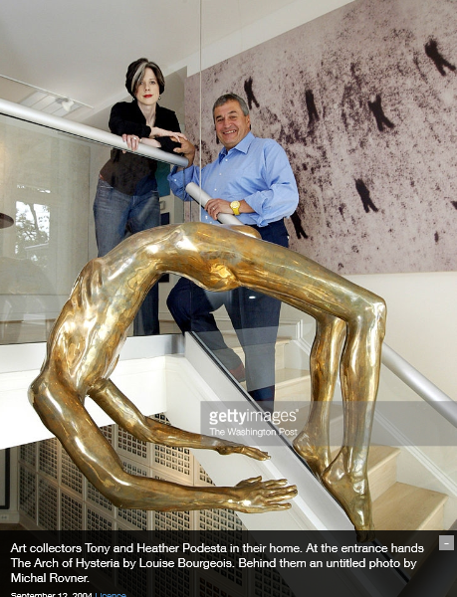
Her high school teacher - an Adept in the Black Arts - had spotted Lilith while she was still only a schoolgirl. Like all Satanists, he believed that truth and salvation could be found through the exploration of repressed human needs; that pornography gave joy and joy gave strength. Through his dedication and perverse ability he had secured her co-operation to begin her new education for her assigned task of political intrigue and influential debasement.
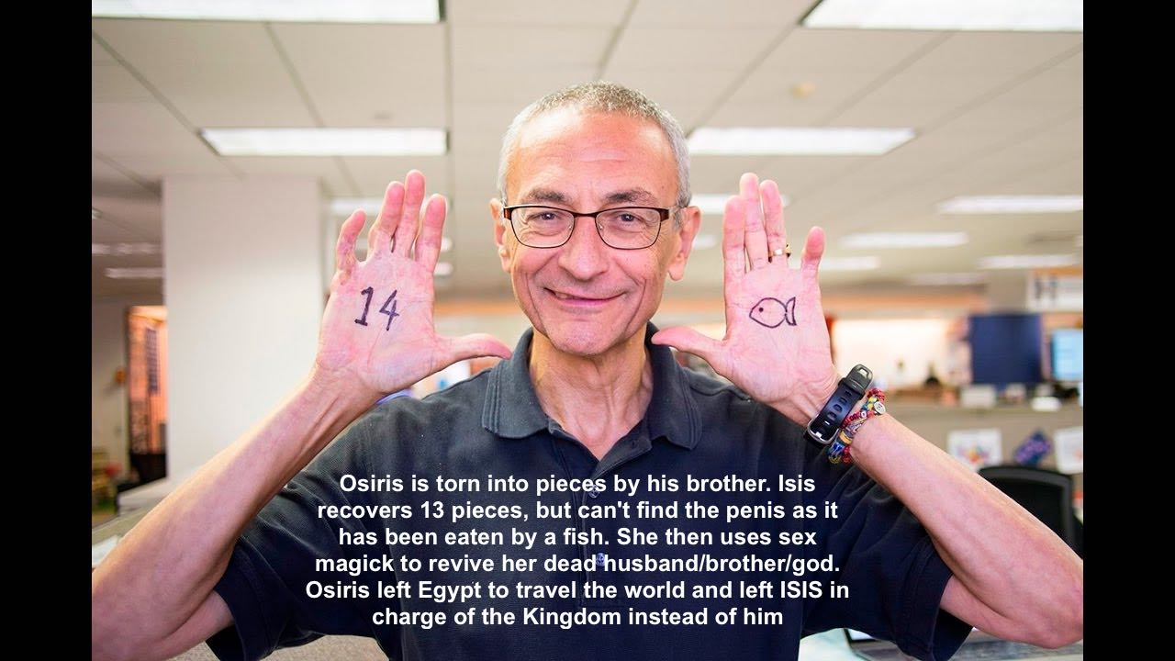
After completing her 'education' with the Ordo Cave Lupam. Lilith was tutored by an English gentleman who I knew as Pindar [I have highlighted this 'man' in several of my previous books]. I never met him but I worship the true father of the statutory heir. His were the 'Irish' mysteries of degradation and when his name was ever mentioned Lilith would often laughingly sing, '...the rosy red cheeks of the little children'. Rosy red bottom pedophile torture.
Lilith procured children to satiate the debased lusts of many Satanists for pedophilia, torture and child sacrifice..

These were taken from single girls by promises, for a fee or occasionally, simple stolen.
Babies were bred for their various purposes by 'Broodmares' - young unemployed girls who were paid to hand over their 'produce'.
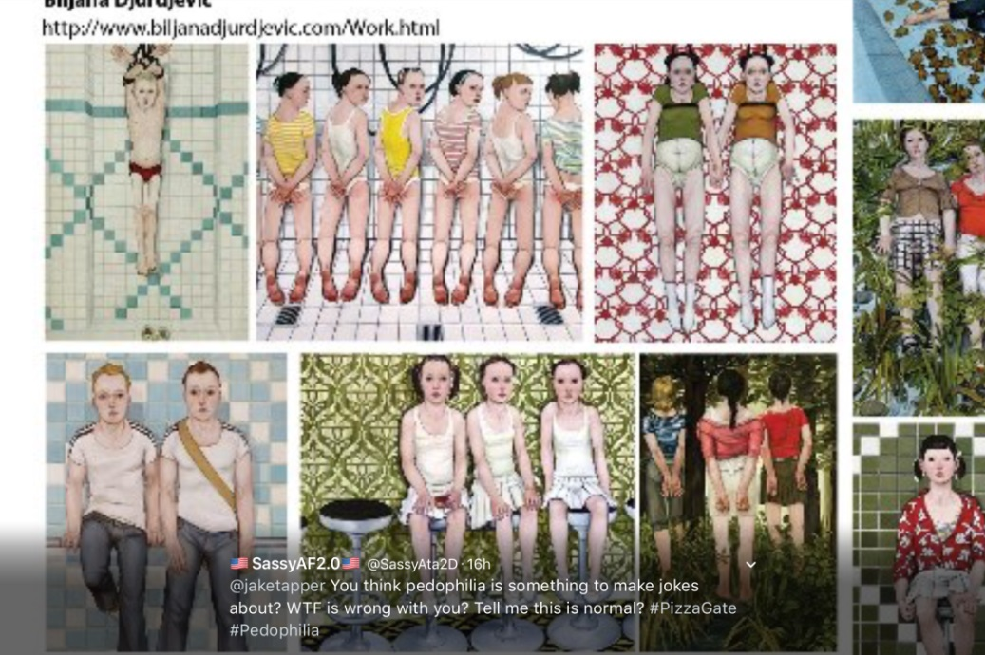
Sometimes this magical pornography was filmed; sometimes children died.
Once you have seen a young child crucified or a baby kicked to death you are and can never be the same again.
The most disturbing aspect of the Black Masses held in Sydney was and remains the ease with which victims were and continue to be obtained and the lack of any effective interest by the police (because a number of Police Commissioners from various States were members of the satanic Order).


The Satanic Ausrealian Alpha-Lodge to which I was a member placed a great deal of emphasis upon Magic, both in theory and practice.
Demons were evoked and dispatched; sigils made and sacrifice and the letting of blood encouraged.
In this regard, many who bask in their own limited knowledge believe that Aleister Crowley is the father of modern manifestations of Satanism, but this is incorrect. Satanism is Thousands of years old.
Perhaps Crowley is the grandfather of modern left hand path groups, but their stepfather is Peter James Carroll, the founder of the Chaos Magick School.
There are a number of reasons for this and the various Black Lodges within Australia have developed from their early twentieth century reliance upon recruiting from fringe Masonic groups, through High Magick in the nineteen twenties, Low Magick in the nineteen sixties and seventies to their current prospective candidates from amongst Chaos Magick practitioners (who are generally young, ambitious, enthusiastic, energetic psychopaths and destined by their lifestyle choices to the shadowy world of Satanism).
A number of up-market Escort agencies in Australia and elsewhere are operated by Black Magicians. Yet brothels and pornography comprise only a small financial part of the International Satanic Empire - designed to deprave and corrupy society..
Most of the money comes from drugs (the C.I.A.), sophisticated blackmail, money lending and currency trading.
Satanists of the highest order are behind a number of wealthy Conservative, New Right Christian Churches and organizations in America. These are some of contemporary Satanism's best cash-flow enterprises (mostly indirectly) and allow mass indoctrination and networking.
The aim of the Alpha Lodge remains illiteracy rates in the western world of at least sixty-six percent by 2010 and the destruction of at least seventy percent of the globe's population by the year 2030.
All governments count on their sheeple to respond in typical infantile fashions, including unconsciously identifying with a more powerful force - even if it enslaves, brutalizes and humiliates them.
Most Australians perform so badly in the role of adult that they rarely achieve complete satisfaction from this process. It is the weak who must tell you they are strong.
In this regard, the infiltration of the United Nations - created by the Satanic Rockefellers - by Satanists - which began in the 1970s - has paid off extremely well already, as has the career of Henry Kissinger.
It was Henry Kissinger who preposed the use of fundamentalist Christianity to bring about war, firstly in the Middle East and then globally. In this he was aided by a number of American Presidents subsequent to Richard Millhouse Nixon handing over the reins to Gerald Ford - who was always one of ours! And then the Satanib Drig dealing Bushes.
Kissinger refined Hitler's 'Terror Technique' into the more subtle and powerful 'Tension Technique': building tension in society and then finding a scapegoat As in the two towers creating the totalitarian NDAA and creating the Iraq war tor Saudi Arabia, Afghanistan now the World's supplier of Heroin for the Bushes.
After the Two Towers General Westmoreland was told by the satanic neocons the plan - destroy Iraq, Afghanistan, Libya, Syria, Iran, North Korea, China.

Channel the flow of refugees from Africa into Europe. Many of the refugees being Saudi wahhabi terrorists.
Use the terrorists to create tension in every country in Europe.
Use that tension to take all rights, create totalitarianism. weld Europe together into a fascist state under Satanic Fascist Junker
Dark Path adepts do this tension in insignificant ways until they have the power and ability to move and direct people to more gross and hideous behaviours.
In Australia recently, the Business Activity Statement for taxation purposes and the 'immigration debate' have worked exceptionally well. The 'War on Terror' has also been of incalculable international influence (even more so than La Vey's Satanic Bible continues to be). The rhetorical façade for George's Presidency may be Christian, but the plan is otherwise! - Wahhabi Muslim Multicultural terrorists Linking to communism..
(And for all of the new arrangements the sheeple have adopted, it was still safer to walk the streets in the Second World War than it is now. This is true of all the capital cities of the combatant nations.)
If you doubt the influence of Satanism in the modern world consider the following issues: According to the World Bank, Australia is the wealthiest (or second wealthiest, after South Africa) nation on Earth. No one knows the full extent of Australia's natural resources and yet the living standards of Australians is getting worse each year and while Australians are amongst the most highly taxed people in the world we are quickly heading towards third world nation status. Who owns and controls the Reserve Bank of Australia (hint, it is the same people who own the American Federal Reserve and the Bank of England)?

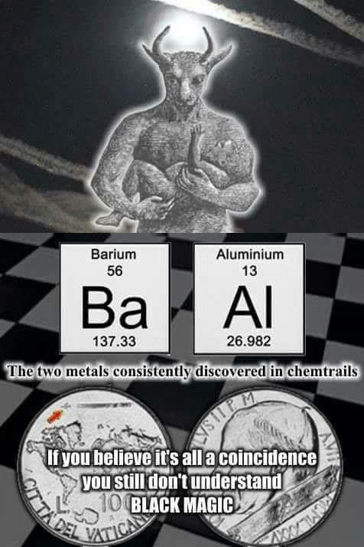
Why do overseas-owned companies pay so little taxation in Australia and why does the Australian government (of whichever political persuasion) allow overseas mining conglomerates to rape our environment and give Australians back next to nothing in return?
Why was fluoride put into Australia's water supply and why is it impossible to have it removed?
Are you seeing a pattern here?
Why is the fake media of the 'Free World' so heavily controlled and their shamefaced relationship to government so symbiotic?
Why have the educational standards of the Western World been forced to 'dumb down' (a process accelerated in the 1980s by both Spielberg and Lucas at the instigation of the Australian Alpha Lodge)?
Why has Muslim multiculturalism been foisted upon the 'First' World (with the exception of Japan)?
And who was behind the September the 11th operation?
Which country's 'Intelligence Agency' supplied the W.M.D. story which 'caused' the Iraq invasion? (Hint, it was not a Christian or Islamic nation)
The fact is that Alpha Lodge politicians (or political advisors) appreciate that if they pretend to respect the rights of sheeple and fain interest in their concerns, even though most realise that this is a ruse, they will go along with the programmes and policies because it is the line of least resistance. The democratic process allows them to express some of their frustrations, reduces the pain of their pent up depression and aggression while ensuring that nothing changes. You can see the same Representative Democracy political system everywhere it has been implemented.
Sheeple always use reason and logic to justify their whims, so the Alpha Lodge initiate is taught to speak in moderation while convincingly offering miracles. It is only a matter of waiting for the media to generate the slogan that 'the government should do something' and the governments - everywhere and of all political persuasions - always will.
Australian Satanists have always been at the forefront of high quality videos and D.V.D.s devoted to 'kiddie-porn'. Sheeple are such that although they scream about the importance of 'justice', it is of no interest unless they are in some way harmed! Their morality is that of the herd, for the more that sheeple feel isolated yet together, the easier it is for Satanists to reign.
Provide the subjects with the forbidden and they feel fragmented, weak, guilty and often worthless - all of which the Master Satanist employs for their own ends. In Australian produced paedophile entertainment certain Avon guard features predominate: sexual frenzy, degrading treatment, filth, coprophilia [getting turned on by shit], torture, rape and death snuff videos.
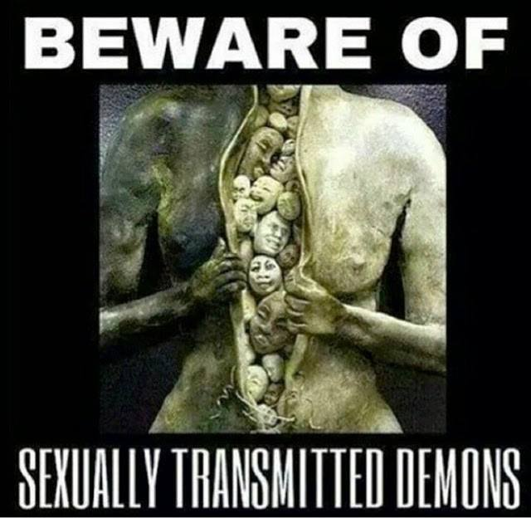
All of this is carefully crafted and augmented by aphrodisiacs and violence. Often the women involved are far worse than the men - little boys agonised by the cruel fingers, long tapered fingernails, teeth, cigarettes and perversions of ravishingly beautiful and debased female practitioners who are without restraint and have been maddened with heartless pride.
Genital torture and castration are a constant theme. I will never forget the heartfelt sobs, desperate pleas, blood, tears and screams induced in many little boys by the agonizing use of alligator-clips, the application of the strap, whip, dildo, knee and the torment of electric shock!
Often Satanists advertise in free youth culture Street newspapers. This provides them with a constant supply of young teenage hopefuls to recruit or exploit (or both). Often Street-kids are taken in, used and discarded. It is only another missing teenager!
Millions of children Worldwide every year go "Missing" and have done for thousands of years. Bundled out of back tards and into vans. Coffee shops, city entertainment complexes and even evangelical youth based churches are still used to this day to lure the innocent and not so innocent, their hearts full of broken dreams from broken homes.
Massive online pedophile ring busted by cops 184 people arrested; 230 abused children taken to safety An Internet pedophile ring with up to 70,000 members has been uncovered by police
http://www.nbcnews.com/id/42108748/ns/us_news-crime_and_courts/t/massive-online-pedophile-ring-busted-cops/#.WRHXUlXytaQ
Often members who have reached a certain Grade, whose task and Ordeal it is to establish and maintain Outer Temple Teaching Orders as a recruiting ground for the Traditional Satanic Lodges, do so with dazzling results. Candidates are accepted and accessed over the required time for character, imagination and intellect - in that order.
Debauchery as a science is taught and maintained by programmes - strict in nature and observance.
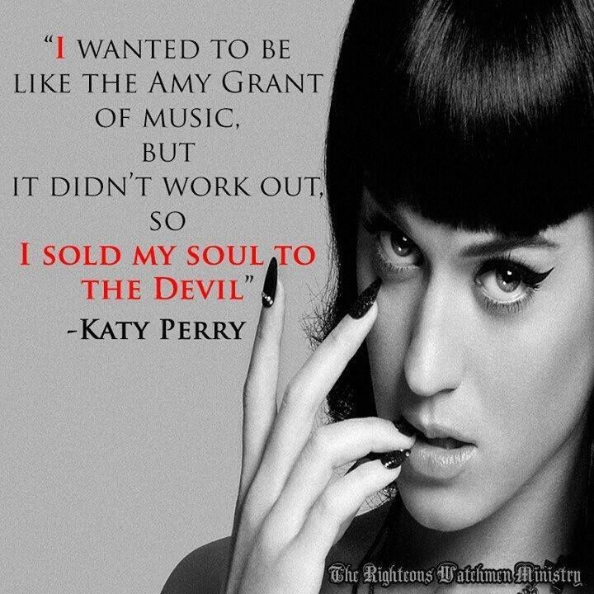
Rituals are conducted, thought-patterns established, relationships destroyed and dependencies and addictions enhanced. Psychopaths are studied and emulated.
Some of the deadliest, most effective and disarming assassins are women. Within the Alpha Lodges they are worshipped as embodiments of the Dark Goddess - who is known by many names and is virgin still! [The Reptilian moon goddess is all her expressions, including Lilith.]
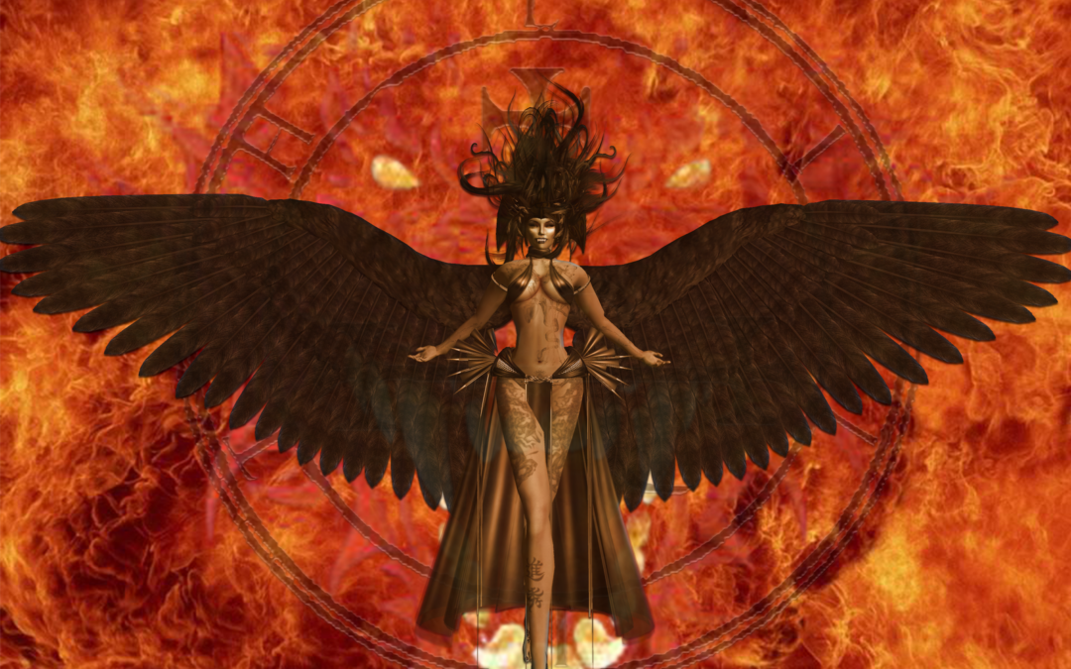
Currently the Outer Head of the Alpha Lodge Australasia is a very highly placed and successful Federal politician - whose Satanic name is Bestia.
The Inner Head of the Alpha Lodge Australasia is the highest Crown Service operative in the Commonwealth ... (having replaced former Crown Service agent and Greek Princess Eketrini, a.k.a Sheila Fraser). Together and with time, those at the highest echelons of International Satanism believe that there is nothing they cannot achieve. And if you knew even half of what they have already done you would agree.
Ask yourself whether you have not noticed a number of world tendencies coalescing around 'the inevitable'. That the social fabric is no longer made of whole cloth, the financial ststem goomed to fail, and that politicians everywhere are becoming more brazen and extreme in their prescriptions and accomplishments should long ago have left little pause for thought, but it didn't then and doesn't now!
The modern media is a pastiche of sex and soft eroticism. Our Pornography is the new culture to deprave and corrupt. The Western world's drinking water has been laced with chemicals fluoride and Monsatan Roundup pesticide that exert powerful effects over time. Geo engineering sprays nano particle aerosols of Aluminium and Barium salts mixed with aeroplane fuel from jets worldwide. Suicide and murder pills, Poisoned vaccines. Rates of depression, suicide, incest and bank interest continue to rise - but no one bothers to join the dots!
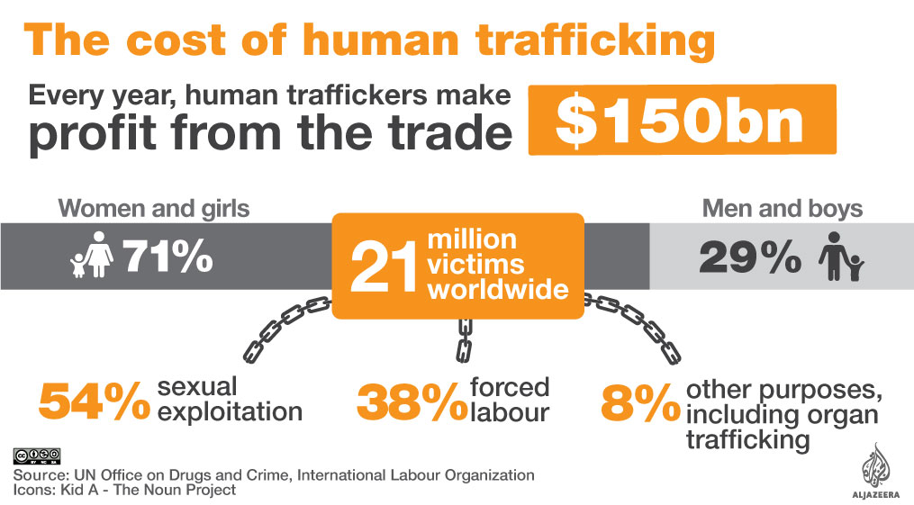
What do all of the following people have in common: Norman Lindsay, 'Sir' William McMahon, Garfield Barwick, Lionel Murphy, Rosalyn Norton, Clyde Cameron and Stephanie Bartholomew (a.k.a Abigail)? From where do more Australians get their news and why? What is Michael Aquino's interest in Australia's Pine Gap Facility and why is discussion of the Base's use and purpose inadmissible within Australia's polite society and media?
[Pine Gap is a major Reptilian underground base near Alice Springs, operated by both Australia and the United States, and it is one of the key locations for the Echelon spying and surveillance Seven Eyes network that includes Menwith Hill in the UK. The late Michael Aquino was US Army officer and mind control operative who founded the Temple of Set as a Satanic 'church' after leaving Anton LaVey's Church of Satan. See The Biggest Secret.]
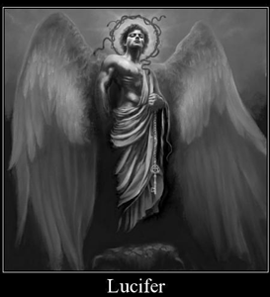
I believe in one Prince, Satan, who reigns over this Earth, And in one Law which triumphs over all. I believe in one Temple Our Temple to Satan, and in one Word which triumphs over all: The Word of ecstasy. And I believe in the Law of the Aeon, Which is sacrifice, and in the letting of blood For which I shed no tears since I give praise to my Prince, The fire-giver and look forward to his reign And the pleasures that are to come!
A number of Crown Service agents in Australia were relieved on the evening of 19th December 1967. A number of the President's men in Australia were quietly celebrating as the clock struck midnight on the 11th of November 1975. Both Intelligence Agencies had relations which were still trespassed by the ghost of Dr. Ward. Both reacted to these events because of Australian Satanism, in the first case because H.R.H. Queen Elizabeth II would be saved embarrassments and in the second because Gough Whitlam was not one of them. On this point I am in no doubt, Sir John did his duty to the Princess and Inner Head of the Alpha Lodge Australasia. And Sir Garfield explained it!
[Gough Whitlam is the only Australian Prime Minister to be dismissed by the British queen in her role as Australia's Head of State. She did this through her Governor-General, Sir John Kerr, amid a manipulated 'constitutional crisis' in 1975. Sir Garfield Barwick, Chief Justice of the High Court, advised Kerr to remove Whitlam. Not being a Satanist is bad for political careers.]
Most people do not know that J. W. Howard's first overseas trip, as Prime Minister of the Commonwealth of Australia was to receive his thirty-third Masonic degree, for in matters of his true faith he manifests a decidedly disillusioned romantic apprehension. His is the perfect example of parallel lives and a compliant media well and truly out of their depth. The same could not be said for Harold and his parties and the fact that people were noticing and indeed, Sir William was invited.
You have little if any idea of the10,000 year history of Luciferianism, connexions and the network of Australia's Sinister Lodges, the Temples within them or their adherents and puppets. Why are some politicians spectacularly successful and others dogged at every step? How was the New York based public relations firm paid by John for doing such a good job in the ... elections? Has any one bothered to check the Commonwealth of Australia's Department of Treasury records and would they know what they were looking for?
I became Outer Head of the Alpha Lodge Australasia in the same year a meteoric rise to power brought a change of federal government with a Prime Minister whose relationship to Satanism was tenuous and pedestrian at best. But then again, he liked to play around and a number of our special people were happy to accommodate him, for a price. He craved respect and understated admiration and received both from us for the efforts he expended.
I left the Alpha Lodge - as best as one can - and tried to reclaim a more mundane if no less ingratiating lifestyle. I operated a media company publishing anti-Christian tractates, political pamphlets and pornographic videos, working for a number of organizations internationally.
The extreme rightwing of Britain had recently been infiltrated by a very old and isolated satanic left hand path tradition and this sinister development augured well for the Alpha Lodges (although today, David Myatt is considered more of a Prophet than a representative of the Hebdomadry Magickal System).
(While the Order of Nine Angles pursues a more open approach in the United Kingdom and increasingly in the United States of America, in Australia we still work just out of view).
The strength of International Satanism continued to increase as its oldest black nobility families and those of their miniuns ike the Rothschilds continued to richer. In the real world, money gives power and those best placed to dictate the money market always win, yet their magnetism and glamour remain hidden. Their most enduring legacies will be the power structures they created and the relationships facilitated.
Their funding of diverse groups dedicated to the destruction of Christianity is a story never to be told! (Their most successful recent social campaign was the Pedophile Pope and "Please God, don't let the Priest rape me again!" effort to date and the promotion of 'Lilac Seminaries'.)
Modern post-1980 Satanism is the result of some hard learned truths and well-practiced procedures. Everyone knows that we are becoming more obvious - there are decreasing reasons to hide.
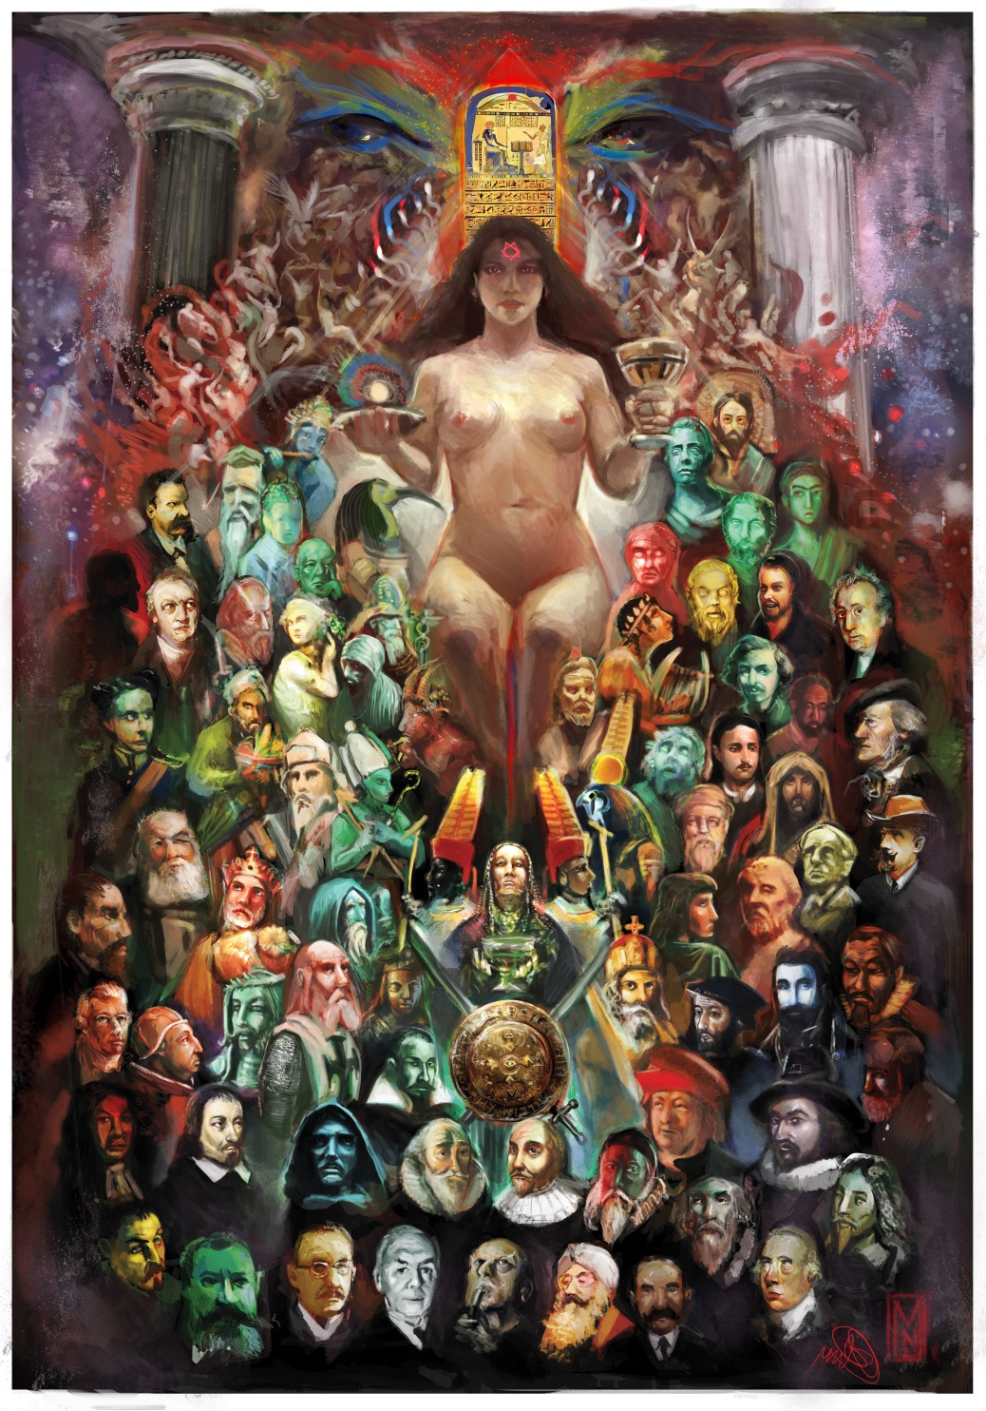
The World of High Fashion - always a glittering ephemeral chimera - became an overtly successful recruiting ground for 'sweet young things' with a daring and glamorous nature.
Multi-Billionaires increasingly sought the psychopathic comfort and insider information the Satanic Alpha-Lodges could provide.
What most people do not realise is that Satanism is a ritually based practice and that this repetition has - over time - left strong impressions upon the Morphic Field! This reinforces security and comfort within the left hand paths true adherents!
Politically, the libertarianism of Twain that permeated Satanism gave way to the realization that the sheeple do not want freedom. They are happy to build their own pens. Two thousand years of Christianity has left them domesticated, so Satanism began taking to itself rightwing positionings as well as those on the left, farther and farther afield. In any event, all bank vault doors swing open to the right! All the leaders are dictators and the sheeple eat from their hand - just the way they like to.
Satanism now free of its earlier hallucinations fully accepts the pathetic nature of the human condition, wrapped as it is in the gaudy packages of superstition.
Satanism finally managed to infiltrate the major left wing and middle of the road political parties on May Day, 1997. Another group long ago bought the American Congress, so the Alpha Lodges concentrated on the Republican Party and this has paid some very high dividends. Currently the U.S. federal government dances to our tune (a couple of steps removed, if you know what I mean)!
Within the left hand path, Satan is the Supreme Prince (the Hierarchy of Hell begins with The Prince). He is 'The Other', the bright Fire Giver and Illuminator! He is the only God who cares! Satanism is a psychopathic Darwinian theory based on vampirism and predation.
Devoted Satanists dedicate themselves and their sex acts to their Dark Lord. Prayers are said, Chants intoned or Invocations recited all as the basis of obtaining the blessings of Hell.
Unknown - if not always unsuspected - Infernal Temples exist in every major city throughout the world - Vatican City included!
Every hour of every day and every night people are knowingly engaged in Satan's service. Human sacrifice - whether ritually and quicker or slowly and degradingly over time - is all harnessed to specific ends.
Politicians are introduced by a carefully graded set if criteria and situations that enable them to accept that their victims will be, "Our little secret".
Young children sexually molested and physically abused by politicians worldwide are quickly used as sacrifices. In Australia the bodies are hardly ever discovered, for Australia is still a wilderness.
Overseas, cremation is the favoured method and although the Satanic Alpha Lodges of Australia have access to crematoria when needed, this is surprisingly rare. Believe it or not many bodies are 'dumped over the side' every week in a number of isolated bush land settings.
The emerging set of Satanic leaders is young, savvy, competent and psychopathically heartless.
They are conscienceless masters and mistresses of their emotions and their intellect. Many are involved in business, politics, the legal profession and the arts.
They are affluent, mobile and stylish advertisements to the next generation and therefore to the next generation of Satanists that power is glory, lust is nobility and liberty is the highest psychopathetic ideal of the new world man and woman.
They use debasement and murder of their victims as a ritual of power to themselves and their Deities. Often their victims are made to suffer in any number of situations. All of them are dedicated 'to creating the psychopathic men and women of the future' and 'to surpassing the Old Ones'.
Beginning in Sydney in the late 1980s was a now International Underground Sadomasochist society founded by Satanists.
Victims are abused to death, murdered, in grotesque rituals held in secluded chambers throughout the global metropolis and never-ending suburbs and bewildered housing estates. Although many who attend are unaware
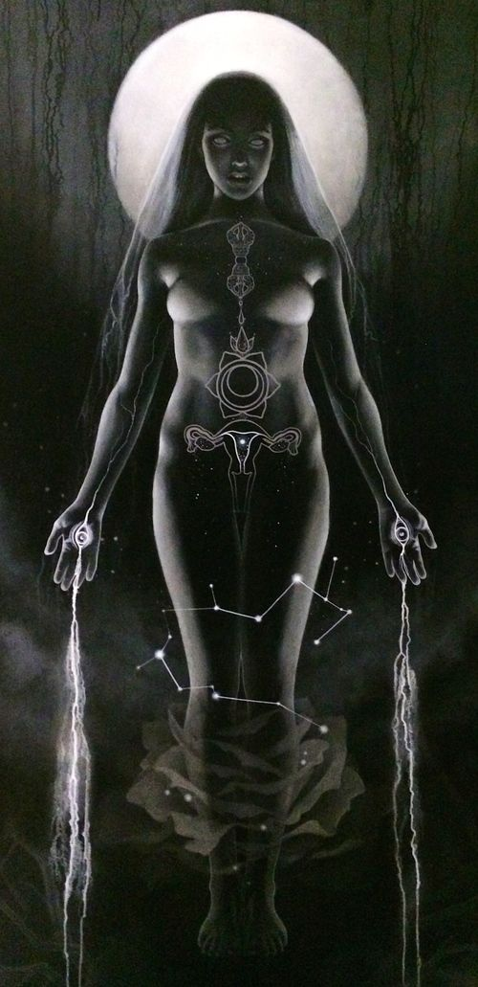of anything except their ability to fulfil special needs and cultivated tastes, all of these gatherings are Satanic in nature and magickal in purpose.
This dark, ultra-secretive society has been used to corrupt and destroy; to distil fear and ensure petrified silence! (Remember 'The Family' of South Australia? Ever wondered why so many people conveniently die from electrical fires?)
Cannibalistic bodily juices of all descriptions are sacred to Satanists and can be used for magickal purposes. The advent of sadomasochism as an accepted form of expression is due to the efforts of Satanists in subverting normalcy and inverting mainstream Christian values. Sadomasochistic Fifty Shades of Grey is a triumph.
The S&M Society was used as recruitment ground for some of the most perverted geniuses I have ever met. And with the advent of the World Wide Web, extreme hardcore Bathroom Sex came into its own as a sub-genre to be taken seriously.
Viable, truly psychopathic Satanism is becoming more overt. This is because of those who went before. And as the schedule works itself, the Alpha Satanic Lodges are growing ever more public. I will not mention names, front-organizations or interests. The time is when these will announce themselves - just like Disneyland! We infiltrated then built the modern media, created porno-film empires, turned 'Snuff' into art and liberated young people.
Today such porno stars as Alexia Cage (and Her growing number of friends) are enjoying careers that would have been inconceivable but a few short years ago. Indeed many Toilet Sex starlets are committed Satanists and Alpha Lodge members or affiliates. By their presence in the world does the Prince of Darkness achieve his aim of exporting psychopathy into the Objective Universe.
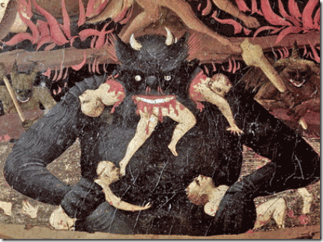Concomitantly, Restroom Magick continues to develop its own left hand path techniques in which the convenience serves as a representation of and chalice unto the Goddess. (By way of only one example, today in co-educational facilities throughout the Western World, Bathroom Sex and 'flute playing' are rampant across all age groups. Thank you High Priestess Monica and 'White' Witch. Fiona).
The people of the world are easy to manipulate. Homo sapiens are herd animals, after all! Its all colour and movement when it comes to the masses. Give them an election with no policy choices and for the most part they are happy. Allow their children no real prospect of success, inhibit their natural drives - particularly their sex drives; limit their options, coarsen their choices and society (such as it still is) quickly falls apart into pre-determined categories. No families, just weak individuals free to do as they are told. Satan is a wonderful 'systems man'!
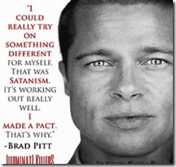
Already there are rampantly individualistic psychopathies spreading throughout the world. Souls and agendas are kidnapped with ease and Luciferian style. 'Rock and Roll' Gods and Goddesses captivate the hearts and minds of the next generation. The boldness of the Satanic Frankfurt School Black Metal musicians/magicians and the mantras they spread still excite and amaze me - even after my achievements!
Advertising continues to chip away at acceptable standards such that nowadays almost anything is realized as being eminently possible. The foreign policy of the world's only superpower is directed from Israel and our work is now running on autopilot.
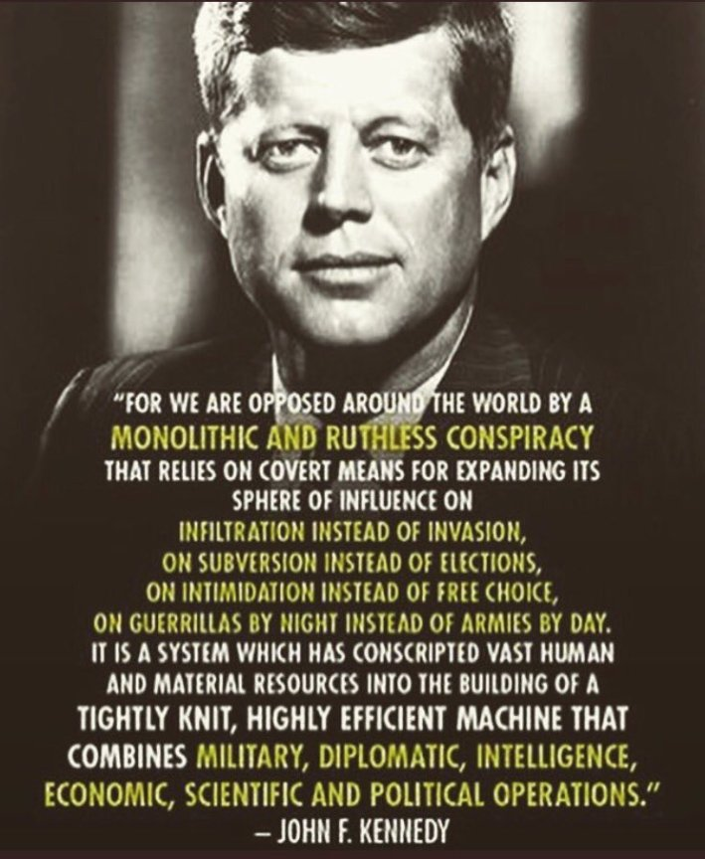
The Alpha Lodge has taken steps to try to ensure that after the next war the Tradition is maintained in the intervening centuries, before civilization, as we know it, begins again.
At that time, Satanism will be in the only religion and science. We have secured the texts, books, relics and magickal weapons necessary for Our Dark Lord and I see the storm clouds gathering.
Ritual activity is increasing. Social structures are almost totally eroded. The Sheeple gather for their slaughter. Vindex walks amongst us now and very few know (or think that they do).
The Other. Beyond that Attracting, Transforming, Forbidden, Essence. Contradictory Defiance: challenging in its purest, answering, archetypal, shape-shifting form. The fascination that creates, nourishes, destroys and redeems. The Prince of the Earth, the Lord of the Air, the Darkness of the Deep, and the God of Fire! The majestic potency, force, presence, power; Magick of the Name of one known by many. Intoxicating. Subversive. Eternal.
The Other. That arrogant, inspirational quest and elegant undercurrent to a superior life of overcoming - Everything you have never dreamed of and more than your deepest nightmares. The alarming, awful, sinister, dispossessed delight of the Empowerment of Knowing - The Triumph of Ecstasy reflected in Your Imagination, Honour, Genius and Terror!
Rebellion!
Liberty!
The Other. That banished suspicion and apprehensive silence - trespassing in disguise. A Question and An Accusation - The Fear and Celebration. The Shadow and horror unknown of Life and Death - Of Aeons passed and Potentiality.
Of Willing and Becoming and Exalting in this life ...
Hail Myself that I Seek to Be
HAIL SATAN
It is revealed individually
To those who can bear it
*******************************
May Satan the all-powerful Prince of Darkness
And Lord of Earth Grant me my desires.
Let there be ecstasy and darkness;
let there be chaos and laughter,?
Let there be sacrifice and strife:?
but above all let us enjoy The gifts of life!?
Zazas Zazas Nasatanata Zazas!
Satanism 1 https://www.youtube.com/watch?v=haewCEw-M7Q
Satanism 2 https://www.youtube.com/watch?v=2N5r0xrUKPQ
Satanism 3 http://www.cuttingthroughthematrix.com/CTTM2017/Alan_Watt_CTTM_1613_Blurb_Chemtrail_Mixtures_on_the_Rise_Bringing_Storms_Sickness_Toxic_Skies_May072017.mp3
1. Ritual sex, homosexual, sexual, and pederasty- See Sir Jimmy Savile and pederasty see.. www.aangirfan.blogspot.com and www.aanirfan.blogspot.com
A way for Politicians and Royalty to, like the Mafia, make their bones, enter into the Elite Satanic Religion and to forever to be controlled by blackmail
Child Molestation - Mol - Molech - to burn out the spiritual energy by Ritual Sex, Torture, Sacrifice

Child Molestation (to “Molest” also known as Pedophilia) is when an adult engages in intimate sexually related contact with a child under the generally accepted completion age of puberty. It is also one of the oldest and most sacred rituals of the Roman Cult and Sabbatean Occultists since the 14th Century.
Etymology of the word “Molestation”
The words Molestation/Molest come from the 14th Century religious term “Mollista” created from Moll (from Latin Mollis meaning “soft, weak, young child/boy) and Ista (Latin suffix used to indicate adherence to a certain doctrine or custom).
As a sacrifice of “innocence” to Moll (Moloch)

In spite of the deliberate efforts to confuse both the origin and key original religious meaning of the word “Molest”, there exists strong evidence of a second important meaning of the word in relation to the common meaning of Moll in the 14th Century onwards.
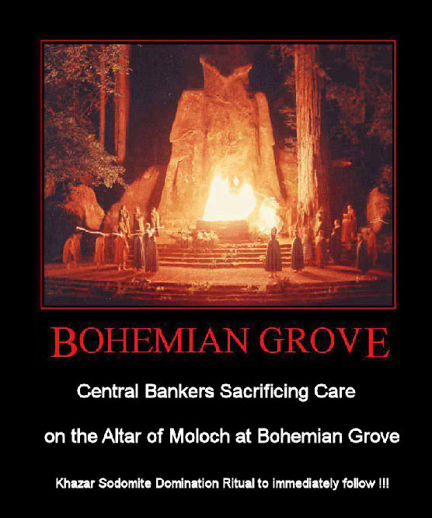
In England, the word Moll by the 16th Century became a common euphemism for “criminal” and prostitutes became commonly known as “Molls” - the claim it is a shortened version of Mary a ridiculous diversion.
However, prior to the word Moll becoming associated openly with the notion of criminals, it appears the word was used at least from the 13th Century as a shortened version of the name of Moloch and actions undertaken in the name of Moloch, or “Molls”.
This gives us then a second important and credible religious meaning associated to the word “Molest” being “the adherence to the doctrines and customs (of the former Roman Cult) concerning the soft, weak, and young child/boys and a sacrifice to Moloch.”
Homosexuality in Satanic Ritual Homo-Occultism
JIMMY SAVILE AND TONY BLAIR
Here is the latest in my series about the Effects of the, "Dark Side" on the Last Tens of Thousands of years of Modern Society.. It's solution and protection is Energy Enhancement Video Course and Live Courses..
Jesus says, "Stay away from Evil" and on the path of, "The Energy Enhancement Mastery of Relationships" be aware that bad people project energy blockages connected with the deepest satanic evil into all who meet with them. Having sex with these evil people, anyone at all evil, with any degree of evil, injects these evil, Implant Addiction, Psychopathic, Energy Blockages even deeper.
In the same way being in the presence of good people who can project Angel Talents into your psychic body and who can dissolve your Evil Energy blockages is a very good thing...
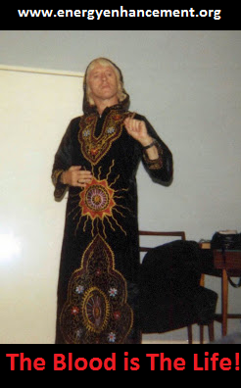
SAVILE WITCH
1. Tantra and Homosexuality in Satanic Ritual Homo-Occultism
2. The Left and Right Hand Paths of Awakening Kundalini
3. In the House of the Strong Man, Satanic Sodomy is the Key - The Ritual Implantation of Energy Blockages
4. The Luciferian Religion's role in the Fall of Civilisations - The Role of Pagan Satanic Ritual Homo-Occultism in Causing the Fall of the Roman Empire and the Degeneration of Hitler's Germany
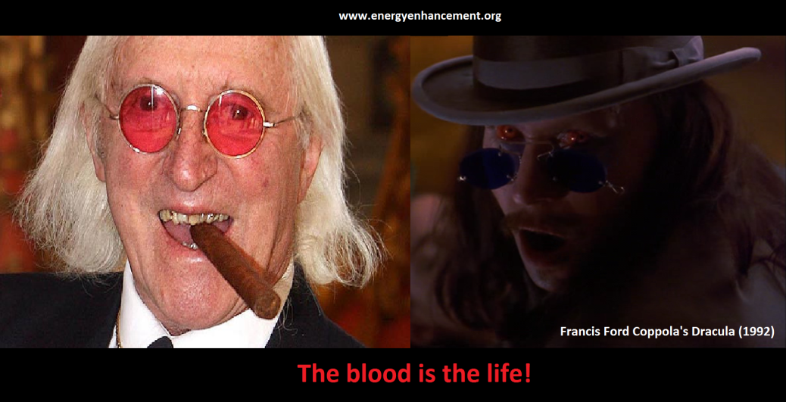
http://www.energyenhancement.org/HOMOSEXUALITY-IN-SATANIC-HOMO-OCCULTISM.htm
The modern clinical term Pedophilia
The term Pedophilia (first recorded in 1951) is a modern term created from the Greek words (gen. paidos) "child" (see pedo-) + philos "loving."
Contrary to public belief, the term Pedophilia has the unfortunate literal meaning of “loving children”, than the criminal action of child abuse. While Pedophilia has absolutely no religious significance as a word, its continued use as a term to describe child molestation and child abuse is misleading—implying those branded as “pedophiles” have some emotional empathy towards their victims (implied by philes/philos-love).
The history of religious and systematic abuse of children

The Roman Cult and associated networks of Sabbatean and secret Satanic organisations since the 14th and 15th Centuries is the only time in the history of civilization whereby a “sacred” religious ceremony was established for the systematic and widespread encouragement of its clergy to abuse of children. The practice, along with all forms of sexual depravity were reinforced as being wholly contradictory to all forms of law, public doctrine as well as secret doctrines and practices from March 2013.
From this point, for the first time in over 700 years, any clergy, members or claimed adherents to secret societies, Satanic or Luciferian cults practising Child Molestation, injury or murder are in complete dishonor to all forms of spiritual and ecclesiastical practice, criminals and subject to full retribution and punishment for such willful breach of the end of all such practices.
Unfortunately, it remains a false argument promoted secretly by nihilists masquerading as religious "conservatives" incapable of personal discipline and honor, that they continue such practices as some form of token of "evil". Instead, such practice should be treated as purely criminal by men or woman demonstrating contempt to all forms of spiritualism, law, history and knowledge.

Ritual Human Sacrifice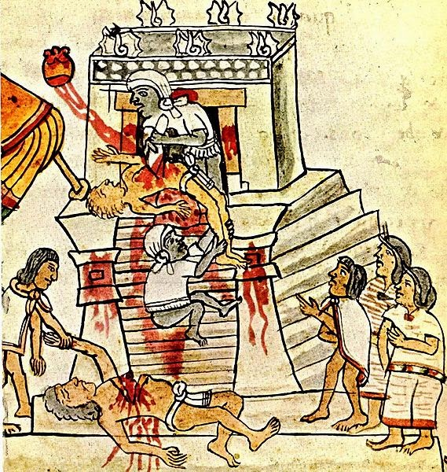
See the Satanic Incas, Toltecs, Mayans cutting the hearts out of thousands of people and selling their meat at the altar.

BLOOD ON THE STEPS - AZTEC RITUAL HUMAN SACRIFICE - DIEGO RIVERA OF MEXICO - SHOWING THE CONSTANCY OF HUMAN SACRIFICE RITUAL, CANNIBALISM RITUAL, PROSTITUTION AND SLAVERY IN ALL SOCIETIES THROUGHOUT HISTORY
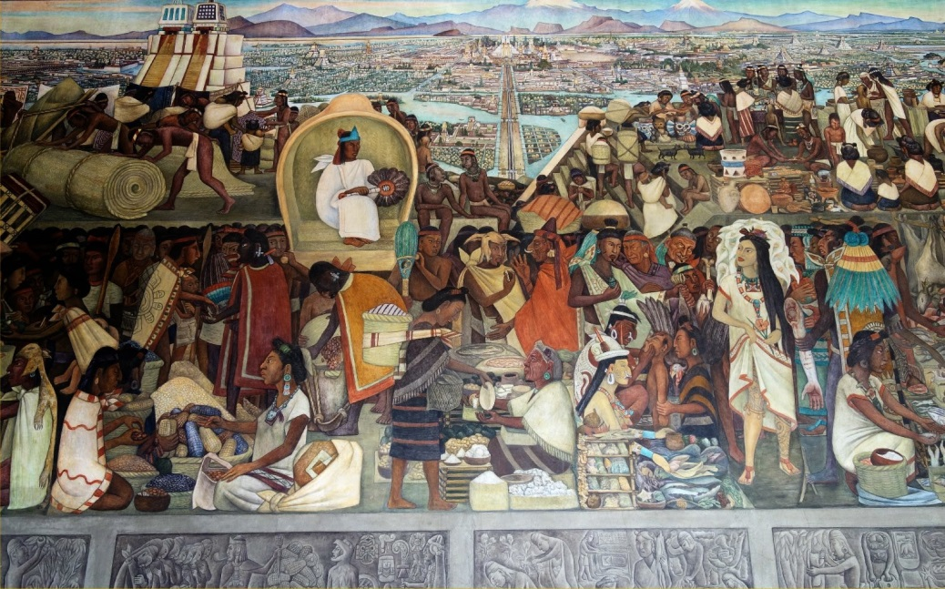 BLOOD ON THE STEPS - AZTEC RITUAL HUMAN SACRIFICE DETAIL - DIEGO RIVERA OF MEXICO - SHOWING THE CONSTANCY OF HUMAN SACRIFICE RITUAL, CANNIBALISM RITUAL, PROSTITUTION AND SLAVERY IN ALL SOCIETIES THROUGHOUT HISTORY
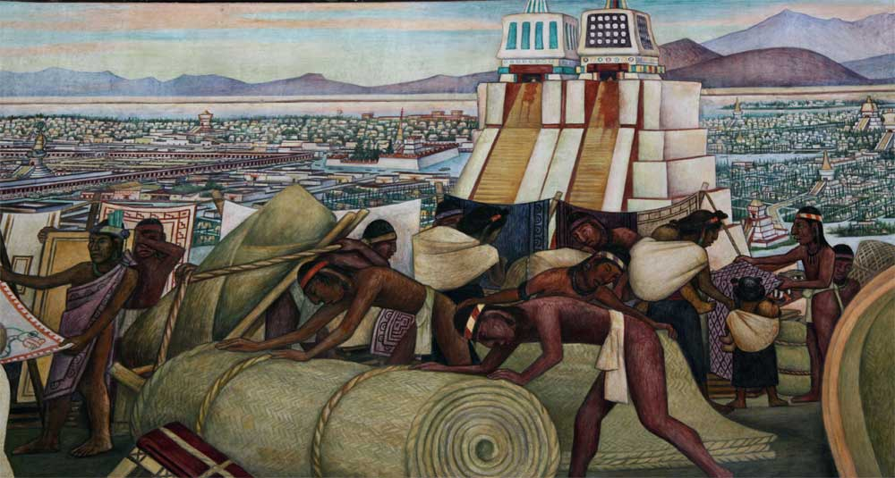

HUMAN SACRIFICE VICTIMS PARTS ARE SOLD BY THE PRIESTHOOD AS SACRED MEAT
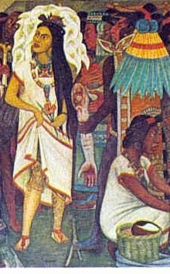
SLAVE INSPECTED FOR DISEASE - SLAVERY HAS BEEN A CONSTANT FOR THOUSANDS OF YEARS
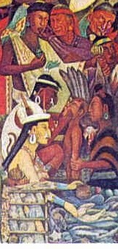
Ritual Sexual Human Sacrifice
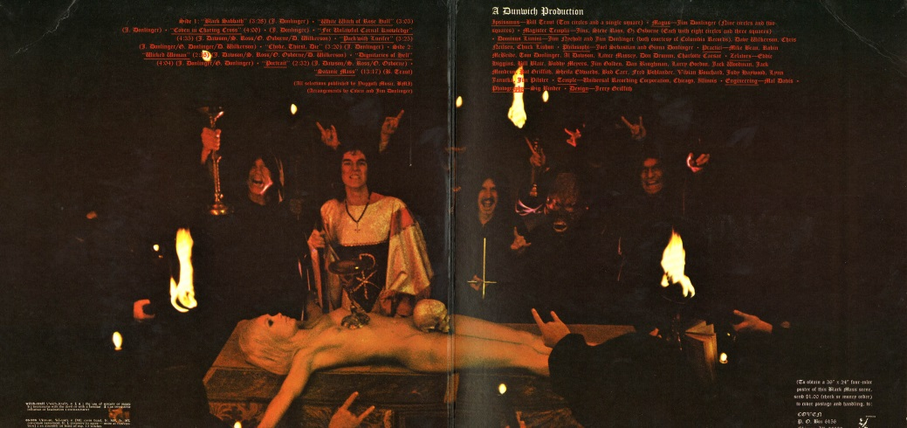
Ritual sexual human sacrifice is the murder of a person during some kind of ceremonial ritual which involves sexual acts prior, during or after the murder. It is an act absolutely forbidden to be continued according to Daniel 11:31 and the fulfilment of the Prophecies of Lucifer.
When reading any history book on human sacrifice, inevitably the most barbaric groups in terms of brutal ritual are listed as such cultures as the Maya, the Aztecs and Incas, particularly from the accounts of Spanish priests who claimed to have witnessed great bloody ceremonial sacrifices.
Yet this is quite untrue. The most evil, brutal, bizarre and psychologically twisted ancient religious ceremonies involving human sacrifice revolve around the trinity of Syrian and Eastern Mediterranean demon gods.
The principle pantheon of gods were mainly derived from their Syrian Ugarit roots-
The most senior God was was Ashtoreth the goddess of fertility, sexuality and war. Her most famous temples were on Cyprus as Aphrodite and in Rome on Vatican Hill as Cybele. Her ceremonial headdress was the Kippa, the cap worn thousands of years before Christianity adopted it for its leadership followed by the Jews and then the Sadducee influenced Muslims.
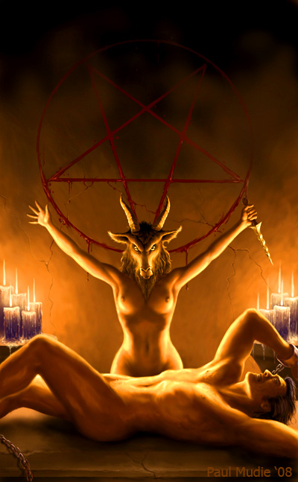
The second was Dagan, the god of agriculture, plenty (food) and good fortune. The priests of Dagan wore fish dress , the archetype of the Mitre (fish) hats of Christian bishops. The Mitre hat of Dagan was always worn over the Kippa of Ashtoreth/Cybele as it is still done today in the Roman Catholic Church.
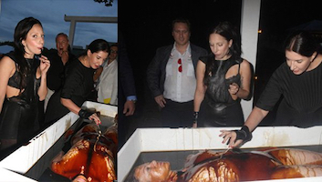
Then there was Moloch, Hebrew name for Ba’al and "King" of the land. This god also equated to "Attis" or "Adonis" and his ceremonial cap is now variously known as the Phrygian cap and the Cap of Liberty also worn ceremonially over the kippa cap of Cybele.
Attis/Moloch had several ritual sacrifice rituals associated with this demon god including wild sexual orgies in which priests themselves would often cut their bodies and drink the blood/eat the flesh of their victims.
Similarly, Cybele had important sexually explicit orgy like rituals involving cannibalism and human sacrifice apart from obligatory child sacrifice and human burning.
Of all ancient religions, it is the Roman Mithraic temples that became infamous in the incorporation of sex and violent frenzied murder to its absolute maximum, until the complete destruction of the Sacred Mint and Temple to Mithra at the hands of the Nazarenes in 69 CE.
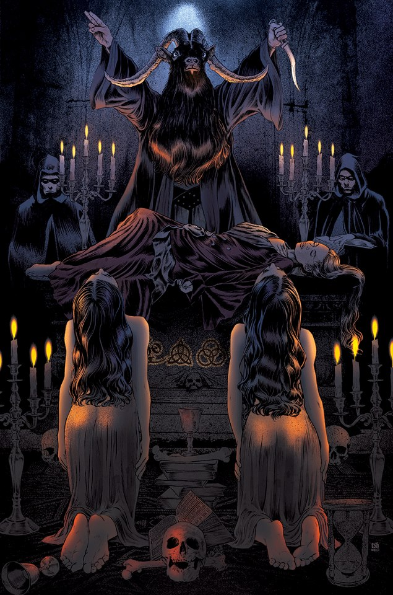

Blood Sacrifice
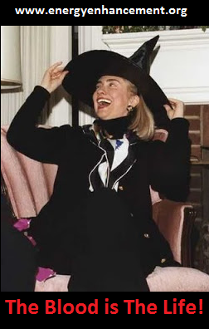
Of all rituals of human sacrifice and ritual injury, the ritual of blood sacrifice is arguably the oldest in the world.
It is sometimes deliberately misleading when the argument is presented that human sacrifice is as old as the first civilizations. It is true that humans have been killed as part of sacred rituals for thousands of years. However, it is equally true that certain methods of killing have been reserved for specific deities for an equally long time.
The rituals of sacrificing a human being for the purpose of their blood, including rituals associated with self injury in order to cause blood loss has been the primary domain of worship of the Mother Goddess for nearly ten thousand years.
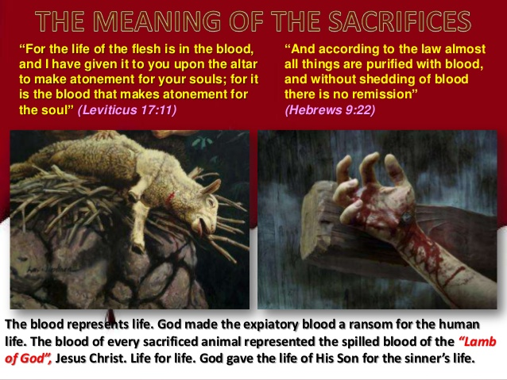
Examples of the Mother Goddess to whom human beings were (are) sacrificed
Saviour/God Virgin Mother Culture/Religion Year of Origin
Attis Cybele Turkey/Anatolia 2100 BCE
Tammuz Inaana,Ishtar Mesopotamia 2000 BCE
Shamgar Anat Mari, Syria 2000 BCE
Horus Isis Egypt 1900 BCE
Horon Astarte/Ashtoreth Phoenicia/Syria 1500 BCE
There are three primary drivers in ancient rituals of human sacrifice for blood: The ceremony of blood as the food of the gods, Blood as the seat of the soul/wisdom and duty/atonement.
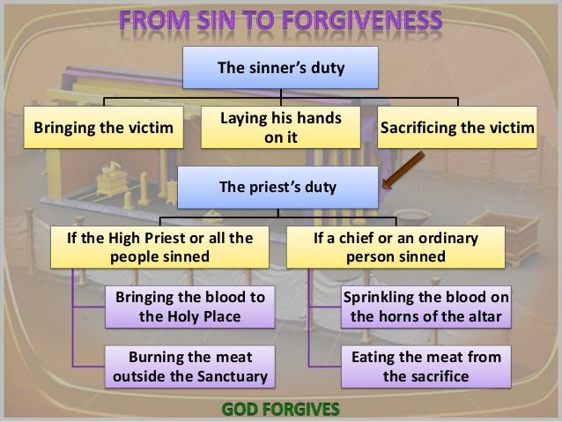
BARBECUE
Blood as the food of the Gods/Goddess
The connection of the Mother Goddess fertilizing the lands and life, in turn being nourished by the sacrificed pure blood of innocents is an extremely old belief.
In Greek mythology, the word ambrosia is used in replacement for blood. Nevertheless, there exists numerous stories whereby fresh living blood from a slain innocent is seen as necessary to the goddess in order to maintain her favour.
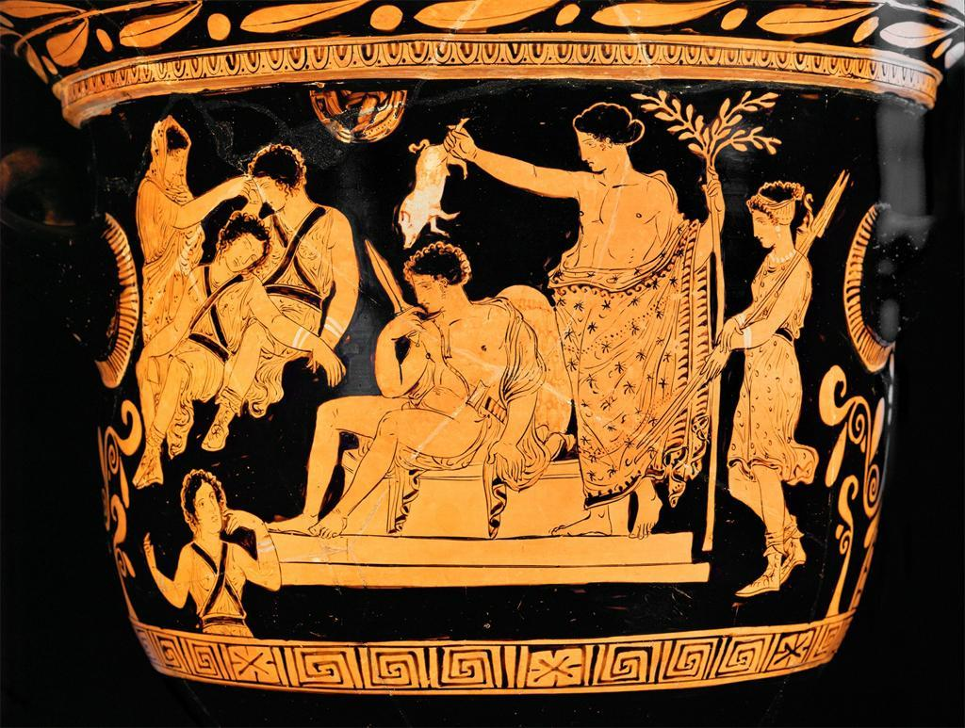
Apollo purifying Orestes from his mother's murder with pig's blood.
In the case of Cybele, the goddess who is depicted in one instance as the black meteorite, it is understandable to consider that ancient religions were formed to make sense of disaster and death, particularly when caused by such things as "heavenly fire".
Blood as the seat of the soul
One of the secret mysteries of Eastern and Western religions is the belief that blood, particularly the blood of a recently slain victim contains the seat of their soul and wisdom.
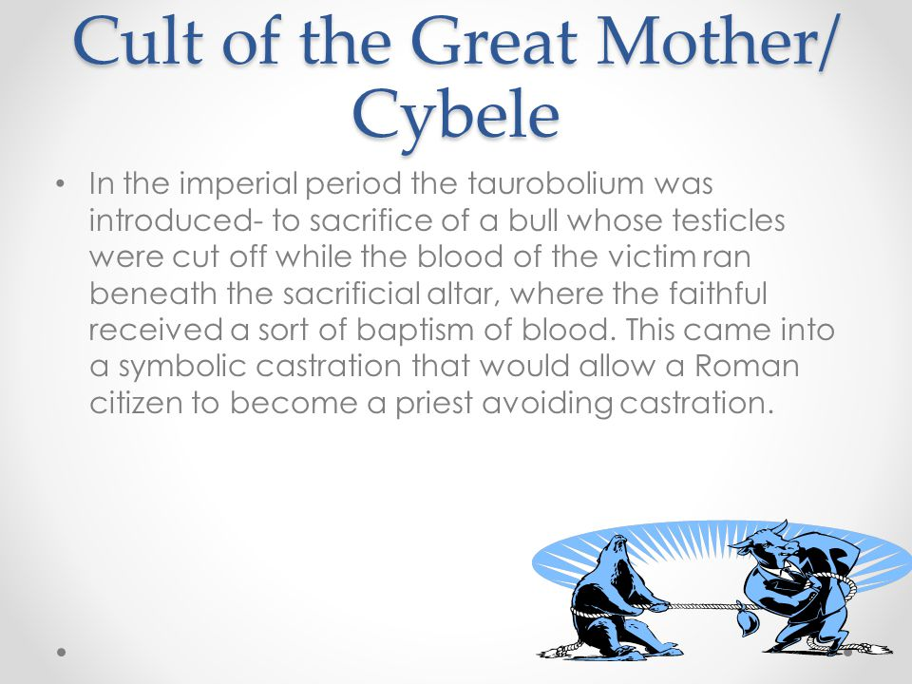
There is also associated mythology to the beliefs that the fresh blood of innocents is an elixir of youth.
As twisted as these ideas might be, they remain at the centre of the mysteries surrounding blood cults to the Goddess and more recently modern interpretations such as Lucifer..
Al Gore of the firm, "Blood and Gore" is in charge of the Trillion Dollar scam of Carbon Taxes
Burning People Alive - Holocaust, Tophet and Immolate.
Evidence of the ritual burning of people alive as a religious human sacrifice exists in archeological sites, ancient scripture and practice for thousands of years. Yet, while this barbaric and awful practice is ancient, it appears the act of burning people alive was not evident in any neolithic culture, nor early Bronze age culture until the the city of Ugarit around 1627-1620 BCE --corresponding to the period of earthquakes, volcanic eruptions and climate change due to the explosion of Thera (Santorini) around 1627 BCE.
The ritual and theology of burning people alive should therefore be considered Phoenician and Ugarit in origin and a particular theology that continued with Phoenician/Samaritan/Sadducee Priest-Kings from the time of Ba'albek, through to Carthage, then Tyre, Jerusalem and Scythopolis in the worship of Ba'al Moloch.
In fact, all periods and events of mass human sacrifice by burning appear to be directly linked to this satanic theology developed by the Phoenicians, including the single largest event of mass human sacrifice by fire during World War II in Poland and Russia where over 18 million innocent Jews, Protestants and Orthodox Christians were burnt alive in human sacrifice camps shaped in the form a giant 300-mile wide Pentagram of evil.
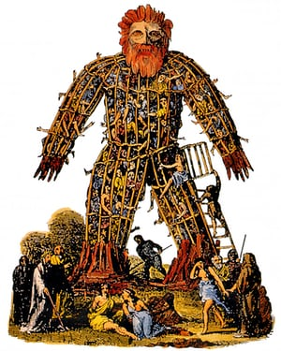
The key words associated with human sacrifice by burning
Three of the most important religious words associated with the doctrine of human sacrifice by burning are: Holocaust, Tophet and Immolate.
The word Holocaust is oldest theologically correct term still used in relation to the official doctrine of satanists in the burning of people alive. The word "Holocaust" is at least as old as the 3rd Century BCE and comes from the ancient Greek word holokauston, meaning "a completely (holos) burnt (kaustos) sacrificial offering", or "a burnt sacrifice offered to God".
The term has always meant the specific ritual of murdering innocent human beings as animals by burning as defined by the ancient Phoenician/Samaritan/Sadducee/Punic religion to Moloch and his name variances. Because these priest-king family bloodlines have traditionally considered all other human beings as "sheep and cattle", the word Holocaust is frequently and deliberately misrepresented as "only applying to animals".
The word Holocaust fell out of general use for almost 1,400 years until it was famously resurrected by Pope Pius XII, the Vatican and the Roman Cult as the official and legal description of mass human sacrifice by burning of over 18 million innocent people in Russia and Poland.
To ensure the word is continued to be used, the Vatican and Jesuits ensured that laws were introduced to make "Holocaust Denial" a crime--in other words, to deny that the 18 million innocents of World War II were not burnt alive as a sacrifice (to Moloch) is a criminal offence. In recent years, the Vatican has funded the Holocaust Denial movement to ensure the word remains one of the most controversial and evil labels still in use.
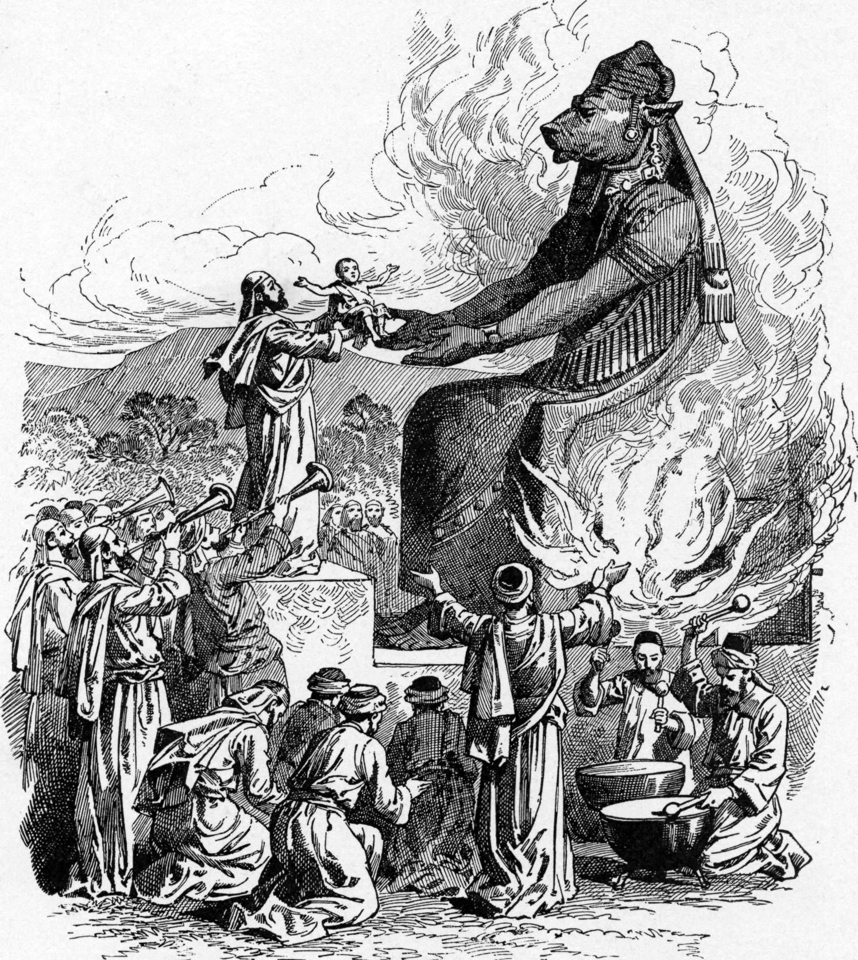
The Hebrew word Tophet is also an ancient and important religious word used by the Sarmatian (Jewish) Priests to describe the actual location of their sacred ceremonies where they burnt "heretics" and innocents. The word means "burning place" exclusively in reference to human sacrifice.
The controversy surrounding this word is twofold--firstly, the word is no older than the 9th Century BCE and secondly most frequent reference is to be found in the heavily revised "Holy Bible" and "Jewish Talmud" scriptures.
The word appears to have been particularly important to the Sarmatian Jewish priests until the destruction of their homeland in the 6th Century by Emperor Justinian and the outlawing (by death) of the religion of Sarmatianism.
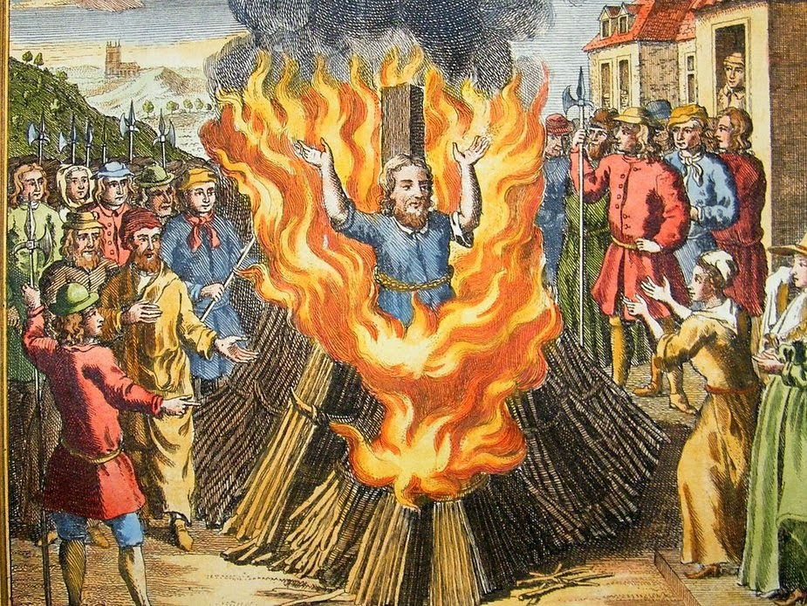
The Latin word Immolate (Immolatus/Immolare - from Molech) is a word created by AntiPope Innocent III (1198-1216) in his creation of the official doctrine of Satanism to religiously murder hundreds of thousands of "heretics" according to the revised liturgy of the Sarmatian (Jewish) practice of human sacrifice. The word means "to sacrifice, kill as a victim by fire" and is the most specific-purpose designed words to describe this kind of evil sacrifice.
While the exact etymology of the word is not clear, it almost certainly comes from the simple combination of IN+MOLOCH ("to Moloch"). Since the creation of this religious word of power, it remains the official "legal" term used to describe all people who are killed by fire--therefore "offered up to Moloch" by simple use of the term.
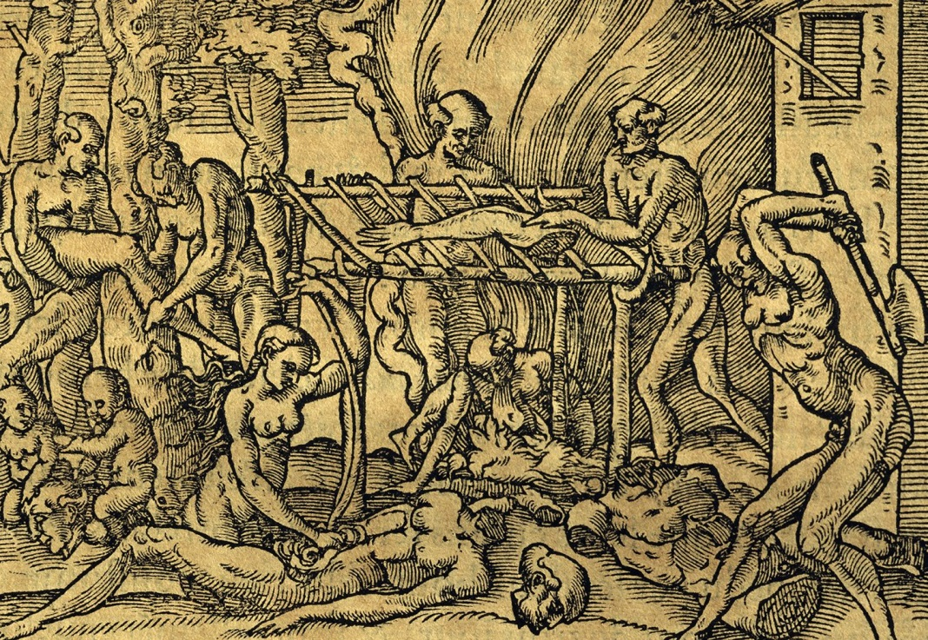
The hebrew word Shoah which means "annihilation, cataclysm, natural catastrophe" is neither an official religious word associated with human sacrifice by burning, nor an old association. The word Shoah was first used in 1948 in rejection of the language used by Pope Pius XII and the Vatican to describe their mass murder of 18 million people by fire as a The Holocaust.
Since most educated Jewish scholars understand the religious significance of the world "Holocaust", the word Shoah was selected in opposition to the unrelenting evil behaviour of the Roman Cult and Vatican. Unfortunately, the word is rarely understood and not widely used in replacement to the word "Holocaust".
Ba'al Moloch
The principle god to which people were sacrificed by burning is and has always been Ba'al also known in the instance as Ba'al Moloch- one of the oldest fertility gods of the Middle East whose most important shrine remains Baalbek.
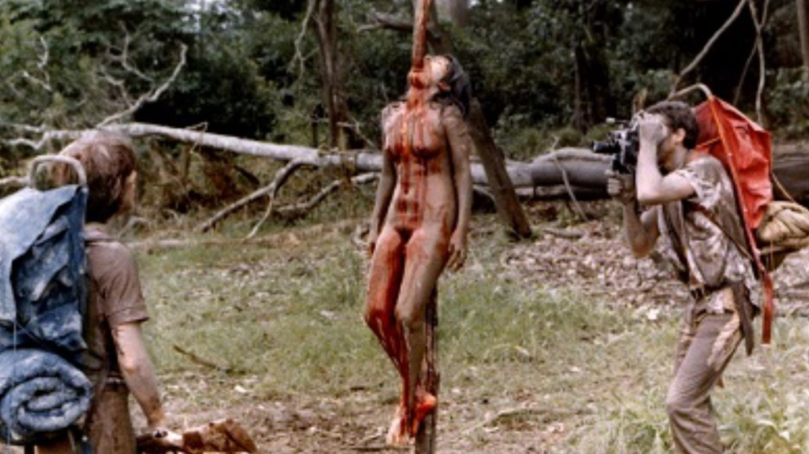
However, the practice of burning, in particular small infants, appears to be unique in its origins to the Phoenician exiles (also known as the Amorites) from Phoenicia, who settled in hundreds of locations across the world including North Africa, Italy, Spain and as far away as Britain.
The ceremony of Beltaine, originally comes from Baal - a unique and distinct Phoenician (the Venetian Empire took over the British Empire) ceremony introduced into certain celtic culture and not native to the celts.
The most common and continued Catholic honor to Moloch is through the legal definition of "Immolate" to describe all victims of fire literally as "To Moloch".
The worship of demons and power, good fortune
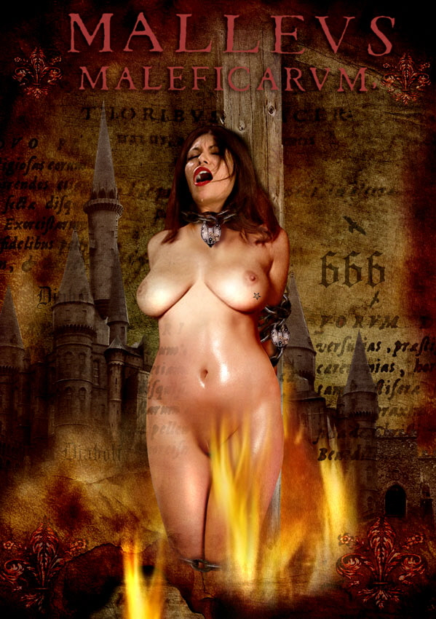
While it may appear odd to consider different forms of human sacrifice having a higher power, or more base motive, the burning of people and children alive to Moloch is and has always been about perpetuating power and good fortune through the influence of demons.
It appears this Satanic liturgy has never been about the higher motives of favourable seasons, harvest and life attributed to the worship of the Mother Goddess, or even the worship of Osiris reborn.
Instead, a section of the Phoenicians adopted a very pragmatic and shallow cosmology of the world- that the world is largely dominated by demonic forces which can only be overcome by effectively "doing deals" with such demons- hence the cruel and unspeakable act of burning people.
Such acts were to call upon the demons to aid in battle, to defeat an enemy, to help gain more wealth and more power. Therefore, the sacrifices during World War II were principally about maintaining real temporal power than the summonsing of any great evil entity.
The importance of continued worship to Moloch and the Roman Cult today
Burning to create an Egregore of protection.
The continued adherence to the doctrine of Hell being a place of eternal damnation and burning by fire remains the official doctrine of the Roman Cult inflicted on all Catholics--in honor of the worship of Moloch.
The most recent confirmation that this doctrine is still viewed seriously by the Vatican was in 2008 when Pope Benedict XVI re-affirmed that Hell is a place of eternal fire and damnation, indicating that the worship of Moloch in Satanist liturgy remains of paramount importance to the Vatican.
THE INQUISITION - 50 MILLION PEOPLE TORTURED AND BURNT ALIVE
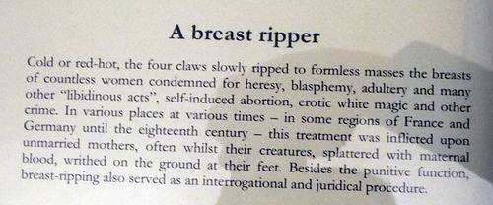
4a. Ritual Burning Alive.. The Inquisition (Latin inquirere, to look to) see is an eight hundred year old Roman Catholic tool, ceremony and institution dedicated to evil.
While the Inquisition is in one instance an ecclesiastical tribunal, an institution of the Vatican, a series of historical movements -- its first and primary purpose was and has always been for the punishment and suppressing of heresy and elimination of infidels lawfully.
In the simplest of definitions concerning the Inquisition, a "heretic" is any person who essentially believes in the sacred scriptures of Christianity but refuses to yield to the "absolute temporal power and moral authority" of the Pope. An infidel is anyone who does not believe in the Christian philosophy.
As the Inquisition has never been disbanded, nor its rules struck out, it remains the only example of lawful human sacrifice in the world today. The last time the legal framework of the (Holy) Inquisition was used was in 1940-1945 with the sacrifice of over eighteen million innocent Orthodox Christians, Protestants, ethnic Jews and other minorities by the Catholic Dictators loyal to the Vatican.
As an Inquisition is technically lawful, the sacrifice of millions of people by burning them alive in ovens cannot be "legally" considered murder. This is one of the major reasons no Pope, Cardinal or Jesuit priest has ever been held accountable for the evils they unleashed in World War II.
The Inquisition and legal human sacrifice
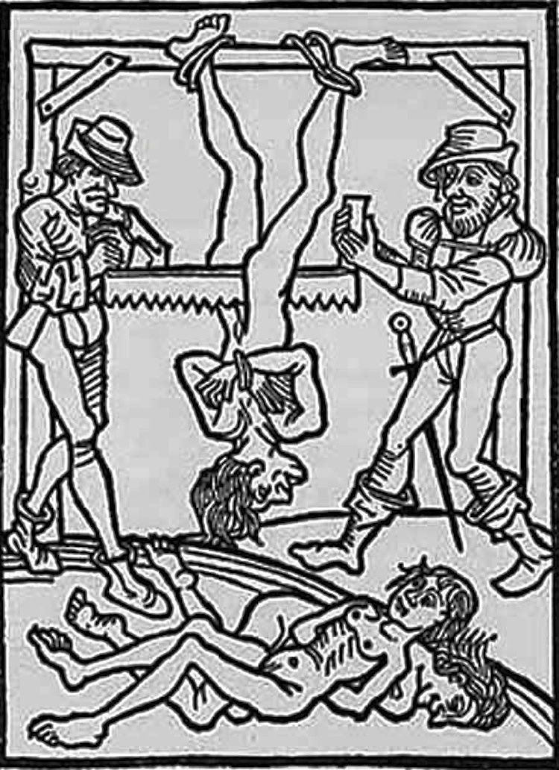
While Pope Lucius III was the first to establish the Inquisition through papal bull Ad Abolendam, as the legal and moral framework for human sacrifice and barbaric torture of innocent people, it was Pope Innocent III (1198-1216) who put it into full effect. The key elements being: The Laws of the Church, The Inquisitor, The Accused, The Act (or Offence), The Tribunal and The Witness.
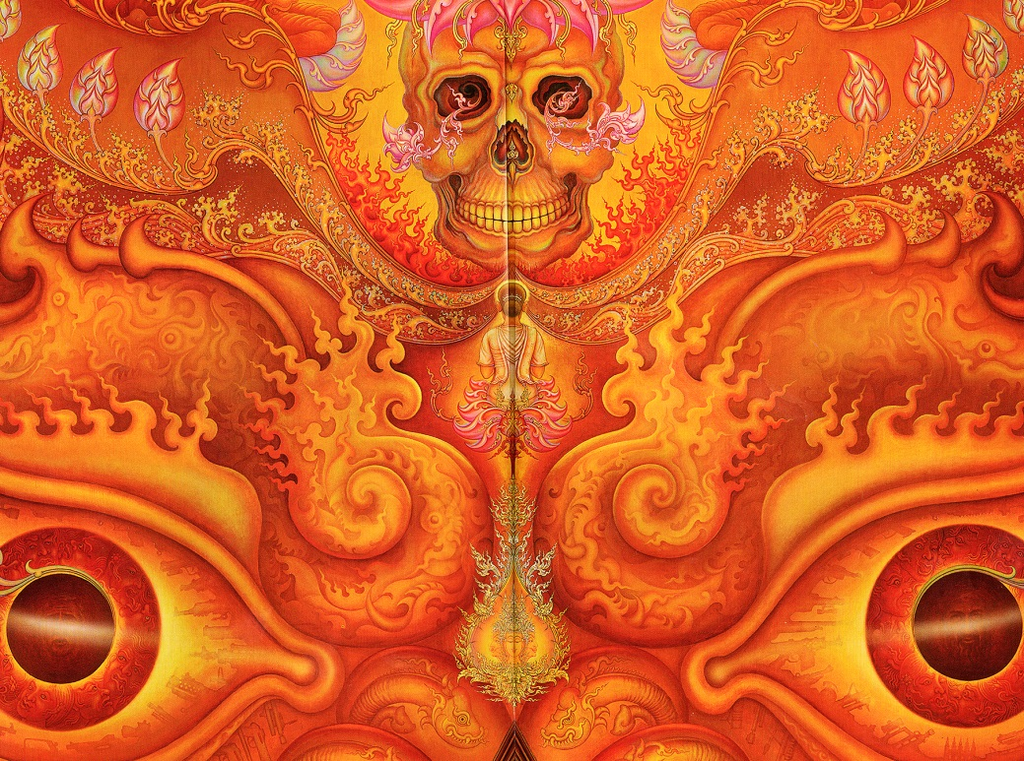
The Inquisitor, strictly speaking, was a special but permanent judge, acting in the name of the Pope and clothed by him with the right and the duty to deal legally with offences against the Faith adhering to the canon laws of the Church. Thus, within the spectrum of enforcing Church Law, the Inquisitor had (and still has) the legal power over life or death of the accused.
Next, the Accused was to be summonsed to appear before the Inquisitor. The Accused does not actually have to be charged with any crime of heresy at this point -- once their name is written down on a piece of paper and the individual acknowledged themselves to be that person, they ceased legally being a person and instead became both a legal personality and property. Just the simple act of acknowledging themselves to be who they are in front of the Inquisitor was enough for him to legally have complete control over their destiny.
Charges could then be drafted later, if required. But more often than not, the person would be tortured until some kind of confession of some crime was obtained -- in later centuries most notably the witches and magic - promoted by the church and then used to snare millions of innocent people of intelligence.
THE INQUISITION
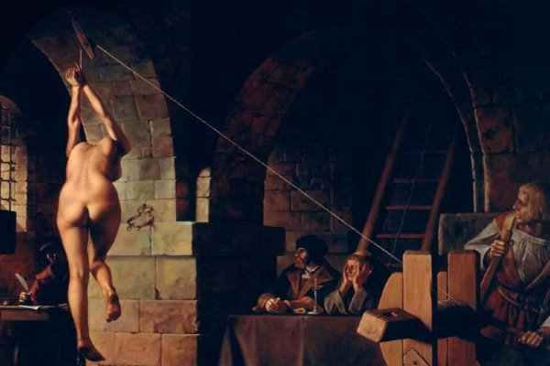
STRAPPADO - BREAKING THE SHOULDERS, USING WEIGHTS, DROPPING FROM A HEIGHT..
The Spanish Inquisition - The condemnation of souls
The Inquisitions took an added evil dimension under the Spanish Inquisitions two centuries after Pope Innocent, with the introduction of the public ritual of cursing/damning the souls being sacrificed by repeating their names, their crimes and the ritual of exorcism.
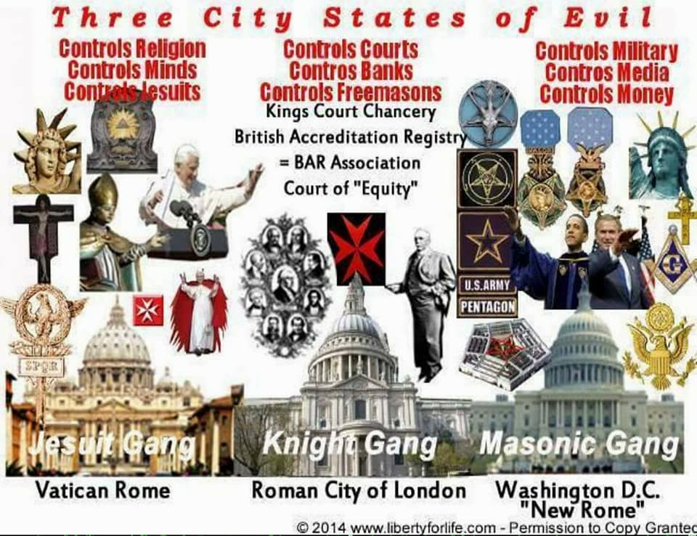
Far from being a misguided Christian act, this Inquisition ritual of burning people alive was the very deliberate embodiment of Necromancy and black magic to create an egregore protecting the Catholic Church - in the control of the souls of recently departed by condemning them to eternal service to the priests and church.
The largest example of the Catholic Church ever condemning souls to itself in this was..
4b. Ritual Burning Alive.. The - the mass sacrifice of over eighteen million innocent Protestants, Orthodox Christians, ethnic Jews and minority groups by burning several million of them alive in ovens in Poland and Russia less than seventy years ago by Catholic dictators represents the largest and most expensive act of mass human sacrifice in history.
Far from being a misguided Christian act, this Inquisition ritual of burning people alive was the very deliberate embodiment of Necromancy and black magic to create an egregore protecting the Catholic Church - in the control of the souls of recently departed by condemning them to eternal service to the priests and church.
Egregore (also egregor) is an occult concept representing a "thoughtform" or "collective group mind", an autonomous psychic entity made up of, and influencing, the thoughts of a group of people. The Catholic Church has created this consciously by burning people alive for a thousand years. The symbiotic relationship between an egregore and its group has been compared to the more recent, non-occult concepts of the corporation (as a legal entity) and the meme. They believe this!!
PIUS 12 WITH HITLER
POPE PIUS XII CREATED FASCISM
So vast were the military and logistical resources ordered to be deployed to this “Great Inquisition” from Rome from 1939 to 1945 that it played a major part to the eventual downfall of the Nazi Third Reich. The effort to efficiently sacrifice the largest number of non-Catholics in 24 x 7 purpose-built ovens [24 hours a day, 7 days a week] was a massive logistical effort- not the least of which required the complete genealogy analysis of most of Europe.
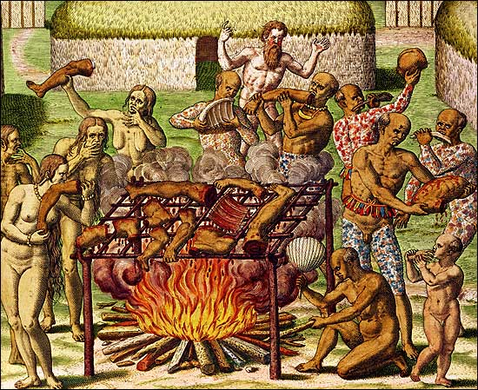
If not for the genius of fledgling American technology companies such as Watson's IBM - Innovative Business Machines, who created the first computers for the task of confirming who were to be saved and who were to be slaughtered, if not for the hundreds of millions of dollars in research by pharmaceutical companies into advance nerve agents to render people unconscious in “gas” chambers for easy transport to the ovens, then the plan would have been impossible. Plus ca change.. IBM's Watson AI supercomputer now runs the Death Panels and the Death Lists for Obamacare and the Veterans to decide who gets treatment, who gets aspirin and a stick, and who dies.
But most of all, if not for the willing and complicit support by Allied leaders not to interfere with the Vatican project, the Nazis managed to kill more innocent people by fire in 1944 and 1945 than all the other years combined.
5. Ritual Cannibalism of blood, organs, appendages
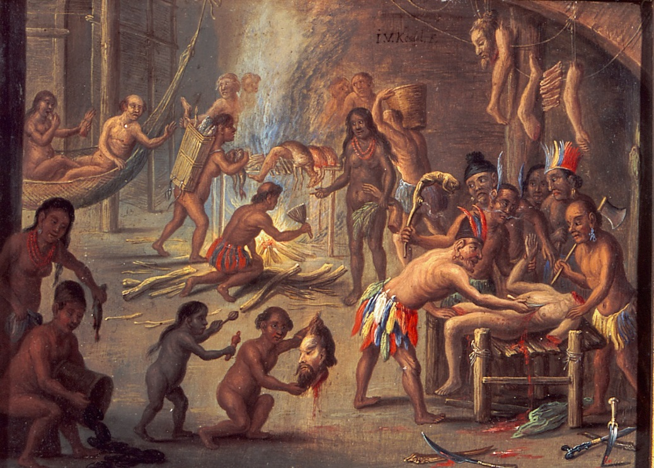
The oldest and most sacred ritual in honor of cannibalism- the consumption of a victims flesh and blood, to consume their spirit and essence is the ritual of the Sacred Eucharist of Osiris.
Two and a half thousand years before the ritual was introduced into the ceremonies of Krishnianity, the ceremony of the sacred eucharist of Osiris was well established the origin of both the concept, the ritual and almost word for word the description used by the Roman Catholic Church today.
There are two streams of cannibalism concerning the Fertility Goddesses of the ancient world- the literal cannibalism associated with the frenzied death associated with Osiris in which the flesh and blood of a human victim is eaten raw by the initiates in a frenzied state called Omophagia meaning "Eating-into-the-belly". The other was the "more refined" ritual of the Sacred Eucharist in which blood of a victim was intermingled in unleavened bread to form the Eucharist.
Of the two, the physical eating of flesh and blood of a dying person was rarely ever practiced and became most common during the demonic reigns of the dynastic Popes, climaxing in the years of the 12th to 14th Centuries when the Vatican ceased all pretence of being a place of sacredness and became the most open example of human sacrifice and demon worship not seen in Europe since late Neolithic times.
None of the modern liturgy of the Roman Catholic Church concerning the Eucharist has any origin from Jewish culture whatsoever. The claim that it is a derivation of the Jewish passover is a transparent and poor lie as the Krishnian ceremony is virtually word for word identical to the ancient Osiris ceremony.
The modern significance for Roman Catholics today in participating in the purely pagan ritual of celebrating the eucharist of cannibalism to demonic gods each week has its own special significance.
The Catholic pays homage to the supreme demonic deities of the Catholic Church, the real gods hidden behind the facades of false worship- Attis is hidden behind Jesus; Cybele is Mary, Dagon/Ba'al/Molech is "god".
Even though Catholics celebrate cannibalism ceremony each week, their lack of knowledge of the truth of the ceremonies does not lessen its impact .
6. Ritual Castration - removal of genitals - hysterectomy - and breasts - masectomy (See Angelina Jolie)
see HIGH PRIESTESS ANGELINA JOLIE RITUAL BREAST CASTRATION

Both sexes are displeasing to Cybele's holiness, so she keeps a middle gender between the two, ceasing to be a man without becoming a woman. (Prudentius, Perist.1059-1073)
The Sacred Celibacy of Catholic Priests derives directly and solely from the continuation of the rituals and ceremonies concerning the worshipping of the Goddess Mother, the Queen of Heaven variously known as Inanna, Athena, Cybele and Mary, mother of god.
These rituals date back to at least 1500 BCE and when Cybele was brought to Rome as the Magna Mater (Great protector) in 204 BCE to Vatican Hill, the rituals of sacred celibacy from which Clerical Celibacy of Catholic Priests is directly derived.
Absolutely nothing concerning the Sacred Celibacy of Catholic Priests has anything to do with the early church fathers, their rules or the behaviour of the Apostles. Early church fathers were recognized as being married, as were the Apostles.
Even when celibacy began to be forced upon priests of the church from the middle of the 12th Century by Popes of the Roman Cult faction, it was for clergy of lower rank than Bishops. Bishops, Cardinals and Popes continued to father illegitimate children with abundance up until as late as the 17th Century. It was only the lower clergy who were gradually forced to adopt the extreme rights and practices of the pagan Goddess Cybele and her eunich son Attis.
The word "Celibacy" is first recorded in English from the 17th Century and claimed from the 12th Century Latin cælibatus "state of being unmarried" and cælebs "unmarried".
However, a much older Latin word coeleb meaning "bachelor" existed prior to the creation of these 12th Century forms, which strongly indicates the assumed etymology for Celibacy has been deliberately corrupted.
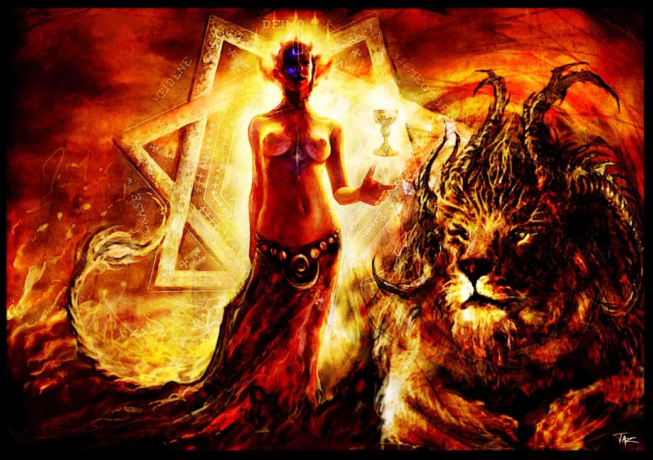
CYBELE
Instead, the word is much more likely formed from the combination of two ancient Latin terms celo "to hide, conceal, keep secret" and liber "child, offspring" (liber also later corrupted to mean book). Hence, the true meaning of Celibacy as 1st formed by the Roman Cult probably means literally " to hide, conceal and keep secret children and offspring".
This is crucially important as it indicates that as early as the 12th Century when the Roman Cult first introduced the Cybele practice of non-marriage of its priests, it did not demand they become modern equivalent of eunuchs but to merely "hide" their offpspring as permanent bachelors.
The Galla
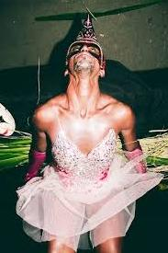
The celebrations of Attis around the Day of Blood, were also significant as the time upon which new initiates to the priesthood of Cybele showed their utmost devotion in cutting off their own genitals in a bloody frenzy and celebration.
The Galla, also later written as the Galli were the lowest rung in the order of priestly service to Magna Mater on Vatican Hill. The most senior was the High Priestess and then later the High priest under Emperor Claudius.
Subordinate were the Archgalla (later the role of Bishops and Cardinals), followed by the priestesses, the sacred prostitutes who were "Brides of Attis". The lowest being the ordinary Galla (Galli).
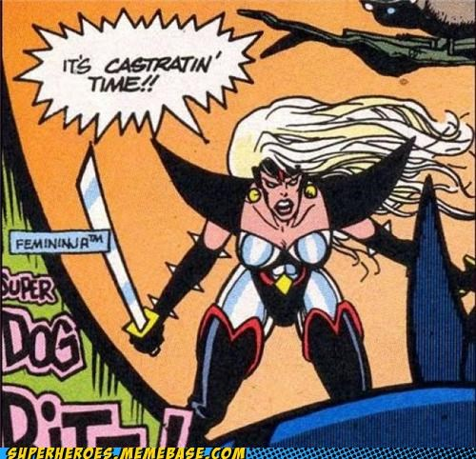
On the Day of Blood (dies sanguinis) the Galla initiate forever discarded his male attire; henceforth he wore a long garment (stola), mostly yellow or many coloured with long sleeves and a belt. On their heads these priests wore a mitra, a sort of turban, or a tiara, the cap with long ear flaps which could be tied under the chin.
The chest was adorned with ornaments, and sometimes they wore ornamental reliefs, pendants, ear-rings and finger-rings. They also wore their hair long, which earned for them the epithet of "long-haired," they sometimes dedicated a lock of hair to the goddess.
By preference they had their hair bleached. On the day of mourning for Attis they ran around wildly with disheveled hair, but otherwise they had their hair dressed and waved like women. Sometimes they were heavily made up, their faces resembling white washed walls. The galli were also very conspicuous when they showed themselves in the city outside the temple precincts.
With a procession of enthusiastic followers they wandered about begging; in exchange for alms they were prepared to tell people's fortunes (vaticinari); they performed their dances to shrill music of the pipes and the dull beat of the tambourine. When the deity entered into them and they were possessed by divine power they flogged themselves until the blood came."
The origin of the Galla and their forced celibacy
While popular mythology connects the behaviour of the Galla (Galli) displaying extreme devotion primarily emulating the god Attis in cutting off their genitals and becoming women, there existed a much older and deeper function.
It relates to secret mysteries and powers believed that priests might access if they forever eliminated the distraction of male sexual urges.
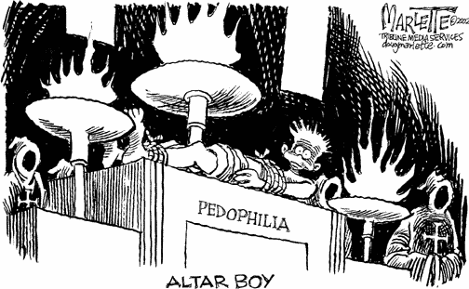
In Sumerian-Akkadian myth the Galla were daemons of the underworld, who disposed of the corpse of the dead. Literally they were the servants of Ereshkigal, Goddess of the Underworld.
When Inanna's father, Enki, heard that Inanna had descended to the underworld and did not return, He took dirt from under his fingernail and from this made Kurgarra and Galatur [that which repels Galla] and sent them to the underworld where Inanna's corpse was given to them.
"The Kurgarra sprinkled the food of life on the corpse.
The Galatur sprinkled the water of life on the corpse.
Inanna arose..."
But when,
"Inanna was about to ascend from the underworld
When the Annaua, the judges of the underworld
seized her. They said:
`No one ascends from the underworld unmarked.
If Inanna wishes to return from the underworld,
She must provide someone in her place.'"
Inanna agrees and the large Galla and the small Galla follow her to the world above where she sends her unfaithful husband, Dumuzi, to take her place.
"The Galla were demons who know no food who know no drink,
Who eat no offerings, who drink no libations,
Who accept no gifts.
They enjoy no lovemaking.
They have no sweet children to kiss.
They tear the wife from the husband's arms,
They tear the child from the father's knees,
They steal the bride from her marriage home."
In other words, they were the daemons of death, and it appears that the castrated Galli-priests of Attis performed much the same ritual of sending the castrated Adonis-Attis-Dumuzi to the underworld.
The importance of Sacred Homosexuality and the Galla (Galli)
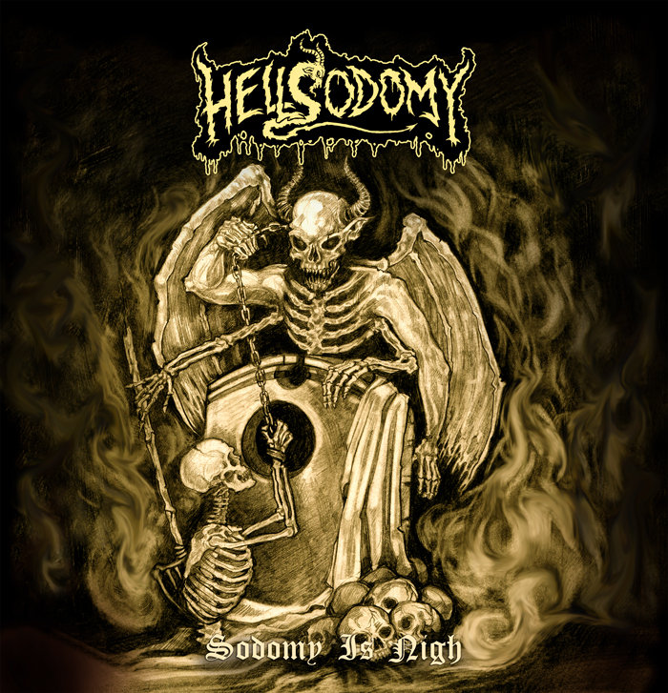
The other most important aspect of the Galla, the Catholic Priests and the continuation of the worship of Cybele is the distinction of what is Celibacy and an abstinance of sex. Originally, the Galla cut of their genitals, so they could no longer perform sex acts as men.
This did not preclude them from having sex -quite the opposite, it opened the door for sacred homosexual acts where there Galla were sodomized during various ritual and celebrations.
Such homosexuality was considered so sacred that the promotion of homosexuality outside of a religious context was frowned upon by the priests and supporters of Cybele. Open homosexuality was considered an afront to its sacred and ancient nature.
This policy has continued today with the Roman Catholic Church strongly against open homosexuality, while sacred homosexuality between its clergy remains as strong as it has been since the days of the Galla.
Most people believe that a powerful ancient satanic goddess is concealed behind Eulogia, and that their secret patron goddess unveiled is actually the Queen Mother of Babylon, Goddess Ishtar – and another name for Lucifer’s Consort, the Goddess Cybele (Lillth).[44]
The Cult of Cybele was sanctioned by the Roman Senate. State Religion of the Roman Empire. Known as the Great Mother or Magna Mater - Mary the mother of Jesus, the Greeks identified her with the Goddess Rhea (Mother of the OLYMPIANS) and Demeter (Goddess of the Harvest).[45]
The Cult of Cybele and the Cult of Moloch (CHILD SACRIFICE) is related to the secret ancient Roman/Venetian Satanic (Brotherhood) Death Cults.[46]
Negro Divine Nine & the Ninth Satanic Circle
The Eucharistic celebration/ritual involves ancient secret Satanic Cannibalistic Rites. Cannibalism means the consumption of a victim’s flesh and blood to consume their spirit and essence.. [47] At one time in the world, cannibalism and human sacrifice had been a state of mankind before God Osiris ended the savage/barbaric
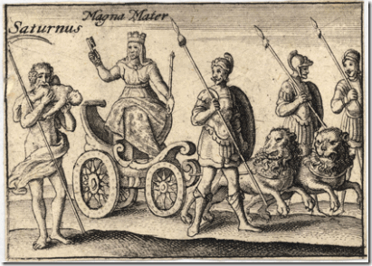
practices to further separate Man from the BEAST.[48] However, the rituals of sacrificing a human being for the purpose of their blood, including rituals associated with self injury in order to cause blood loss had been the primary secret domain of worship of the Mother Goddess/Cybele for nearly ten thousand years.[49] The secret worship and blood sacrifices of Cybele has survived in ultra secrecy.
Some rituals of the Catholic Church are still tightly entwined with ancient Roman blood rituals of the Cult of Cybele. The worship of Attis or Adonis (known across the ancient world as the Good Shepherd, the son of Cybele), had always been interwoven with the worship of his mother, the Queen of Heaven.[50]
Its Vatican Bank is fronted by the Rothschilds, has 500 Trillion Dollars, controls 70% of Fortune 500 companies, controls 70% of all banks Worldwide, controls 100% of all central Banks, consciously creating all depressions, all austerity, all Wars, all famine genocide.
Behind the shroud and Black Mass (False Worship), Catholics pay homage to some of the most secret supreme demonic deities. Attis is hidden behind Jesus; Cybele is secretly behind Mary; Dagon/ Ba’al/Molech behind “god”.[51] Of all the ceremonies and festivals associated with Attis, the most important was known as Black Friday or Dies Sanguinis (the Day of Blood) on or around the 25th of March, nine (9) months before the solstice festival of his birth on 25th December.[52],[53]
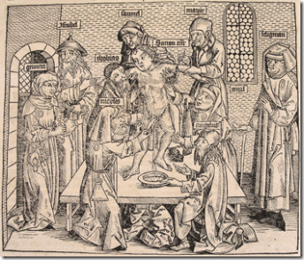
Like the ‘Christ’, Attis arose when "the sun makes the day for the first time longer than the night.”
During the ceremonies of the Attis’ Day of Blood, new initiates to the priesthood of Cybele castrated themselves in imitation of the castrated god and presented their severed genitals to the goddess along with those of the
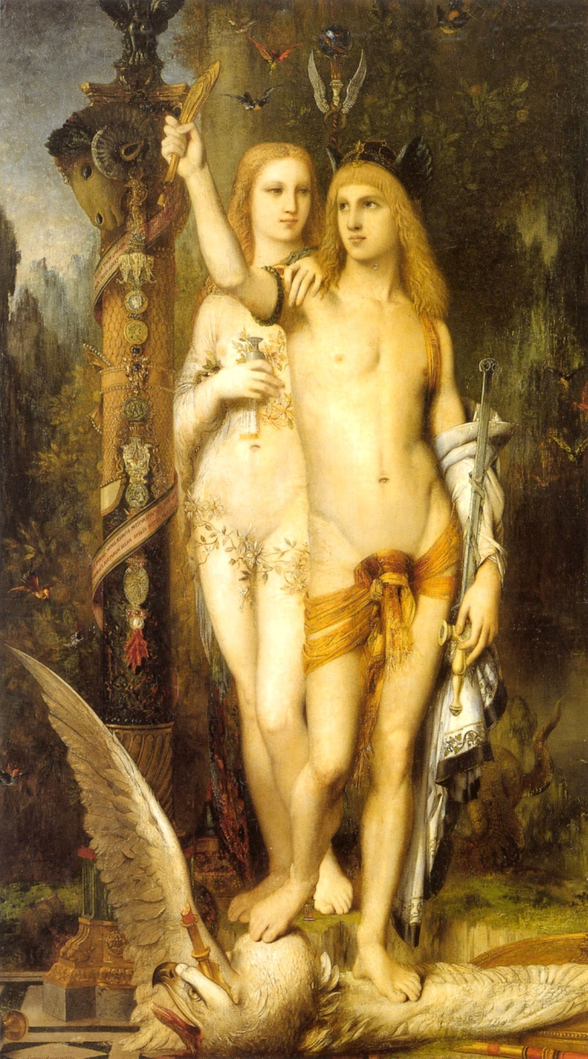
CYBELE AND ATTIS (ADONIS) - RITUAL CASTRATION
gelded bull sacrificed at the Taurobolium. Sacred reeds were placed in the urethra to prevent it closing up.
Both sexes are displeasing to Cybele's holiness, so she keeps a middle gender between the two, ceasing to be a man without becoming a woman. (Prudentius, Perist.1059-1073)
The State Religion of the Roman Empire was that of Cybele and Adonis or Attis.
Cybele loved the beautiful shepherd Atys, and made him her own priest on condition that he should preserve his chastity inviolate, only worshipping Cybele. Atys broke the covenant with a nymph, the daughter of the river-god Sangarius, and was thrown by the goddess into a state of madness, in which he unmanned himself. When in consequence he wanted to put an end to his life, Cybele changed him into a fir tree, (The fir tree, reed, represents the column of Energy, the Antahkarana connecting Earth with God, the Penis) which henceforth became sacred to her, and she commanded that, in future, her priests should be eunuchs or as in the Catholic Church, celibate, or the Jews and Islamists, circumcised.
The Christian polemicist Prudentius, 348 — c. 410, writes about the Dendrophoria festival of Cybele and the transition ritual of her cultic
servants, the Galli who castrate themselves in order to offer themselves for Sacred Ritual Sodomy as Dog Priests:
"There are rites in which you mutilate yourself and maim your bodies to make an offering of the pain. A worshipper possessed thrusts the knife into his arms and cuts them to propitiate the Mother goddess. Frenzy and wild whirling are thought to be the rule of her mysteries. The hand that spares the cutting is held to be undutiful, and it is the barbarity of the wound that earns heaven.
Another makes the sacrifice of his genitals; appeasing the goddess by mutilating his loins, he unmans himself and offers her a shameful gift; the source of the man's seed is torn away to give her food and increase through the flow of blood.
Both sexes are displeasing to her holiness, so she keeps a middle gender between the two, ceasing to be a man without becoming a woman. (Prudentius, Perist.1059-1073)
"What are profane, if these are sacred rites? Or what is pollution, if these are ablution?" 2Those fundamental cognitive orientations by which men order their lives (Spiro1987: 18).
The explanandum in this article is the self-castration of Cybele's Galli.3
Such Ritual Damage to the body allows even more easily the implantation of the Sexual Addiction Blockage - but Sexual Ritual, hetero, homo, pedo or Pornography or even the company of Implant Addiction Blockage Sexual Addicts can implant you - which like Satanism itself, Implant Addiction Blockages are used to control the elite...
There is no escape.
Only Meditation can remove these Implant Addiction Blockages.
Only Meditation can remove All Energy Blockages.
This practice is also called Spermatophagia or the Tantric Eucharist and it reminds one of new priests ordained to the Roman Catholic priesthood, offering up their manhood by making a vow of celibacy.
It is believed that by relinquishing their manhood priests will have access to the secret mysteries and powers, which will take the place of their male sexual urges.
The other most important aspect of the Galla - the priests of the ancient system Of Cybele and Adonis, The State Religion of the Roman Empire - Roman Catholic priests and their continuation of the worship of Cybele, is the distinction between celibacy and an abstinence of sex. The Galla ritually cut off their genitals so they could no longer perform sexual acts as men.
This, however, did not preclude them from having sex - quite the opposite. It opened the door for ‘sacred’ homosexual acts where the Galla were sodomized during various rituals and celebrations as Dog Priests.
Such homosexuality was considered so sacred that the promotion and practice of homosexuality outside of a religious context, was frowned upon by the priests and supporters of Cybele - open homosexuality was considered an affront to its sacred and ancient nature.
Today, there is a secret group, of which some are members of the Catholic hierarchy, known as The Ninth (9th) Satanic Circle. The Ninth (9th) Satanic Circle is a cult, requiring mandatory entry into the Circle, of every new pope before their assumption of office. At Circle rituals, Satanic sacrifices called the Magisterial Privilege are made that involve the ceremonial killing of newborns, children and the consumption of their flesh and blood by the members of this cult.[54]
The Venetian Molech Satanic Cult was founded by AntiPope Innocent III around 1198 during his reign as AntiPope and head of the Roman Death Cult.
Unlike previous members of the Roman Death Cult, AntiPope Innocent did not worship Magna Mater (Cybele) and the ancient demon gods of the Vatican. Instead, Innocent introduced a whole new religion based on Molech, the most ancient and escoteric knowledge of the Sadducee High Priests who ruled such temples as Baalbek and Jerusalem over 1,800 years prior.
Instead of worshipping Cybele, members of the Venetian Satanic Cult worship Child Burning Moloch and the demons of the underworld.
The son of Innocent III, AntiPope Honorius III was instrumental in introducing a completely new liturgy through his Grand Grimoire - the first genuine book of Witchcraft of Western Philosophy. In fact Honorius is the father of Witchraft, modern Wicca and the Inquisition.
Before the liturgy of Honorius and the invention of the Inquisition, Europeans had largely never heard of witches, witchcraft or any of the "foreign" concepts of damning people's souls. The Inquisition was brilliantly designed to "educate" people on the black arts, demons, pentagrams and other symbols while claiming to be searching for witches.
Thus the behind the scenes battle between the Religions of Cybele and Attis and that of Baal/Moloch. Between Eastern Orthodoxy Greece/Russia and Catholic Rome, between Israel and Islam. Thus Napoleon attacks Russia, Russian Revolution - WWI, WW2 - Germany against Russia and the creation of Israel, Ukraine setting Europe/NATO against Russia.
So, all these egotistical narcissist Illuminati - like drug and sex addicted Aleister Crowley - who are taught they are so superior because they do Sex and Drug Rituals, because they, "Choose to be Enlightened" or "Enlightenment comes only because I choose it and believe I am already there.." in reality are filled with negativity, filled with Implant Addiction energy Blockages which drain their psychic energy, vampirise their psychic energy back to their demonic Masters.
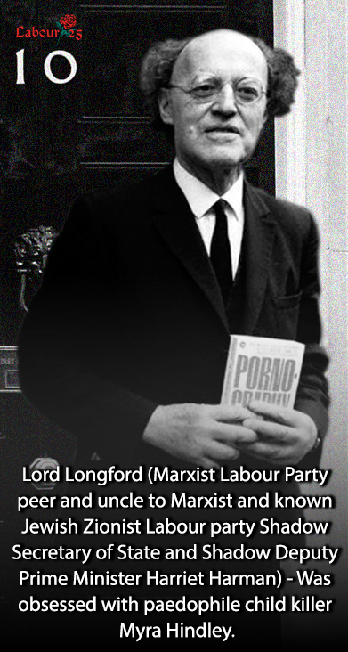
The Dutroux affair in Belgium pointed to the Elite of Belgium, including Royalty, being involved in pedophilia, human sacrifice and cannibalism - with links to similar covens Worldwide!!
The 6000 Superclass Billionaires are all atheist, superstitious and classical european black magicians who believe all this - a psychopathic religion created by their myth making masters.
As I said before.., "Totally Fucked!!"
Ritual Homosexuality and Pedophilia are symptoms of the Satanic Religion and the Satanic Sex Addiction Blockages in Society. It was the arrest of the notorious Jewish born child serial killer Mr Dutroux in August 1996 that brought the Belgium Paedophile scandal to light. The rescue of the last Two young girls he kidnapped lead to an investigation of Dutroux. Five women who testified anonymously in Belgium under the code name ”X” described a generational family underworld of Satanism, where Satanic Families pimped out their children for rape, pedophilia, sadomasochism, torture, cannibalism, snuff movies, and murder. They said that Satanic politicians, Bilderbuggers and other high placed members of society were involved.
http://www.energyenhancement.org/Ritual-Homosexuality-and-Pedophilia-are-symptoms-of%20the-Satanic-Religion-and-the-Satanic-Sex-Addiction-Blockage-in-Society.htm
The Psychological aspect of Satanism is a very important and severely underestimated aspect of the occult because it is the power of these myths, the manipulation of belief systems and the ability to propel someone or group of people to perform insane psychopathic activities based on these beliefs that give the occultists such power.
This is the purpose of these consciously created Pagan, Satanic, Psychopathic Religions..
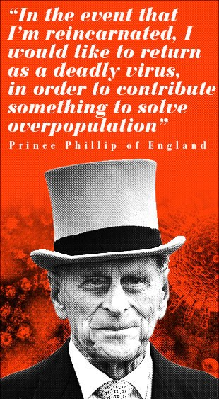Remember The Catholic Church Inquisition? Religious Jihadists? The effects of "small" changes to Islam - Only worship God, do not worship Relics and Saints as the Venetian Empire did when Cardinal Contarini paid Agent Martin Luther to create Protestantism - created by British MI6 in Wahabism and Salafism - the source of Alqaeda and ISIS? Who blow up Relics and the Mosques of Saints and the enormous Buddha statues in Afghanistan - Charles Manson?
They are able to get others to commit insanely violent acts because they consciously manipulate their belief system in some way. See..
THE SATANIC INFILTRATION OF RELIGIOUS CULTS TO CREATE POVERTY AND CONTROL HUMANITY The Witchcraft of Christians Who Are Not Christians and the Satanic Infiltration of the Goddess Isis, Horus, Osiris and Dionysius; Wahabism and Salafism and the creation of Freemasonic Muslim Brotherhood ISIS Jihadi Caliphate.
http://www.energyenhancement.org/THE-SATANIC-INFILTRATION-OF-RELIGIOUS-CULTS-TO-CONTROL-HUMANITY-and-create-poverty-The-Witchcraft-of-Christians-Who-Are-Not-Christians-and-the-Satanic-Infiltration-of-Isis-Horus-Osiris-and-Dionysius.htm
This is where the occult and occultists get so much of their power. Beliefs and belief systems alone are what give people any impetus for outrageous, insane, psychopathic actions like Inquisition. Torquemada's (Tortura y Quemada) torture and burning people alive or cutting out their hearts and eating them raw - as we saw on a recent Jihadi video, or just going to War...
The element that occultism focuses on are both perceptions and belief systems. There is nothing mystical about it, but the power of the occult rests very much on this and the power to deceive - google, "false flags" - by manipulating perceptions - which is why Movies, Universities, Education, Common Core Curriculum, and the mainstream media is so crucial to their power.
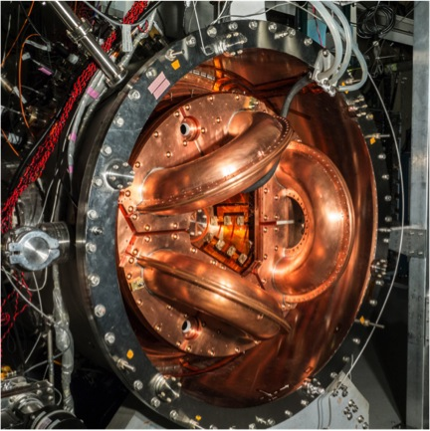
Sustainability, Agenda 21, Global Warming, and Climate Change as instruments for an Austrian Economics, Global Depopulation, Genocide Agenda
http://www.energyenhancement.org/Global-Warming-and-Climate-Change-as-instruments-for-Austrian-Economics-Global-Depopulation-Genocide-Agenda.htm

It is their ability to deceive, in either making someone believe something is true when it is not or to believe that something is false when it is in fact, true. This may sound almost too juvenile an analysis but all Occultism is based on the power to deceive from the Father of Lies one into service of some sort.
"Fair is Foul and Foul is Fair. Hover through the fog and filthy air" - The Witches in Shakespeare's Macbeth
How to know what is Foul and what is Fair?
The Buddha said, "If I form a Religion, it will be Infil-Traitored, if I write a book, it will be changed"
And so, throughout history there are many Black Popes and many Cardinals who were known as Necromancers and Black Magicians.
The Dalai Lama sent Lama Zopa to investigate a Tibetan Buddhist sect who worshipped a Demon, and he excommunicated that sect.
And many Gods, and many Religions, many Symbols and many Myths.
And all the Gods, Religions, Symbols, Myths have at their heart something good.
And all the Gods, Religions, Symbols, Myths can be interpreted in a good way.
And all the Gods, Religions, Symbols, Myths can be interpreted in a Satanic way which leads to ritual sex, human sacrifice and death etc.
As Father Bede Griffiths said, "It's all in the explanation"
It is all in the source of that explanation.
Is the source Satanically Psychopathically Demonic or does it come from the One True God?
Is the person interpreting Psychopathically Satanic or is he truly good, at One with the One True God?
Does it come from a Satanic Psychopathic Chakra energetically blocked, cut off from God, or does it come from Truth an infinity of chakras
above the head, from the One True God?
How to know that which is Foul and that which is Fair?
Goodness Does Exist, Truth Exists, the One True Good God Exists.
"False Gold is Created to fool you because Real Gold Exists" - Tamil Siddar, Thiruvalluvar
"Gold, The More you Heat it, the More it Shines" - Tamil Siddar, Thiruvalluvar
Well, it is the evolution of every human being to arrive at the state of Enlightenment, at one with the One True God, Endless Endlessness, Nothing, Nirvana, Purity, Truth.
It is Only in Meditation, in Samadhi, in Viveka, in Samyama, in Kaivalya where we can get in Touch with that Truth, See the Truth, Be Changed by it.
That State where, "You don't get fooled again"
The issue of Blackmail must also be addressed. Because if in these bizarre rituals and secret associations, obscene and perverse acts are transpiring and these acts are recorded in some manner, as takes place in the Fascist Skull and Bones initiation ritual, then we see the kind of hold those who hold the damning evidence has over the initiates.
Secret Organisations, Blackmail and Bribery, - Money - the three greatest sources of Political Control.
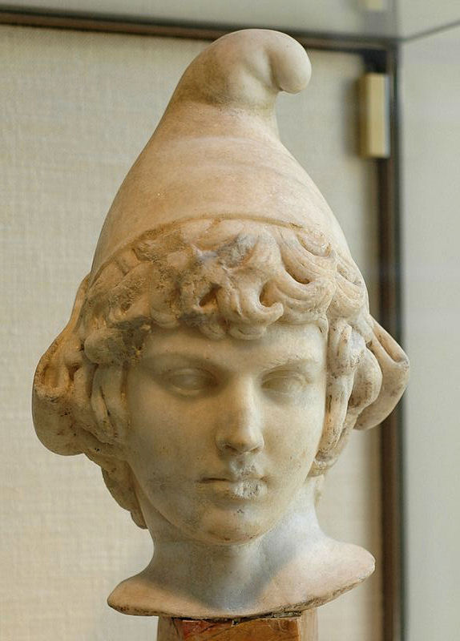
THE EMASCULATED PHRYGIAN CAP OF ATTIS
The Phrygian Cap of castrated Attis represents the Emasculated column of Energy, the Antahkarana connecting Earth with God
THE REAL GOLD!!
"FALSE GOLD EXISTS ONLY BECAUSE OF REAL GOLD" - TAMIL SIDDAR, THIRUVALLUVAR
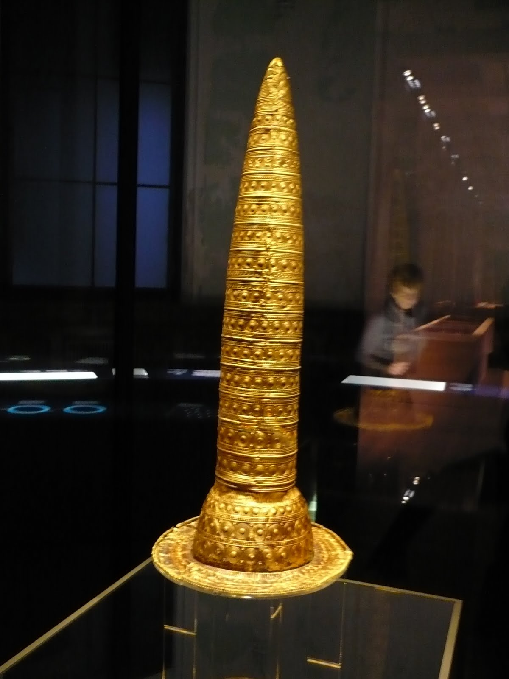
3000 YEARS OLD WIZARDS CAP
The Wizards Cap like the Buddhist Stupa represents the column of Energy, the Antahkarana connecting Earth with God - the rings represent the number of chakras above the head - As it ascends to ONE point we can assume it means the ONE TRUE GOD an infinity of chakras above the head.
As the Cuilliaéan (Collins - Druid Priest Class) exported spiritual reasoning to all corners of the known world from the 5th Millenium BCE onwards, so too their artifacts of Gold were considered to possess supernatural power. One of the most excellent examples of Cuilliaéan spiritual gold work still preserved are the "Wizard" or Vizier hats (one known as the Berlin Gold Hat) detailed extremely accurate lunar settings and astronomical information.
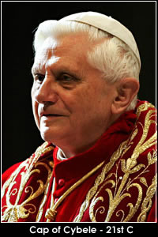
THE KIPPA REPRESENTS ENERGY BLOCKAGES ABOVE THE HEAD CUTTING ONE OFF FROM CONSCIENCE - THE COLUMN OF ENERGY ANTAHKARANA AND THE CHAKRAS ABOVE THE HEAD ARE REPRESENTED BY THE PENIS
The Cap of Cybele emasculates the Antahkarana is one of the oldest and most sacred religious symbols of humanity. It is a thin, slightly rounded skullcap now commonly known by various titles including Kippah, Yarmulke, Kufi and Zucchetti.

EMASCULATED MORTARBOARD HAT - EMASCULATED UNIVERSITY EDUCATION
Understand I have nothing against any religion, it is the Rituals - including the Inquisition with its torture Rituals and its burning alive Human Sacrifice Rituals or the War, "lives for Satan" Rituals - it is the Rituals which degenerate its members aiming to pervert and take over our leaders by demonic possession creating psychopaths -
You do not have to believe in this but remember, They Believe in This!!
BAPHOMET
"Sex with the demon possessed in Sexual Ritual is a diabolical means for transforming the individual and eventually completely taking over of the brain and body by "the evil spirit." That's been one way of taking control of an organization using high ranking members, by taking over their minds and bodies. Yet, how could Pike, Mazzini and their associated conspirators get persons to submit to such a diabolical process?" - Sonny René Stermole
To create an army of psychopaths who will follow any order..
The Illuminati Enemy Within Freemasonry - Weishaupt, General Pike, Palladian Rite, Morals and Dogma, Albert Pike, Rose-Croix, Templars, Alta Vendita or highest lodge of the Italian Carbonari, Mazzini, The Lost Keys of Freemasonry, Manly P. Hall the seething energies of Lucifer - Satan, or Lucifer, and the demons, Demonic Possession, Morals and Dogma, Albert Pike, Elias Ashmole edited Dr. John Dee, sorcerer who "brought through" the Enochian system of magic, of satanic ritual and demonic evocation, the Pagan Eleusinian Mysteries, Council on Foreign Relations ... the Trilateral Commission ... and the Bilderberger Group serve to disseminate and to coordinate the plans for this so-called new world order, Alice A. Bailey, 1950, 1986, "The Plan" involves a one-world government, an occult hierarchy, an elite "illumined" oligarchy ruling over a world in which Christianity has been slated to be displaced and destroyed.
http://www.energyenhancement.org/AMERICAS-SUBVERSION-The-Enemy-Within-Sonny-Rene-Stermole-Illuminati-Weishaupt-Pike-Palladian-Rite-Rose-Croix-Templars-Alta-Vendita-Carbonari-Mazzini-Manly-P-Hall-Lucifer-Satan-demons-Demonic-Possession.htm
ROASTED BABIES
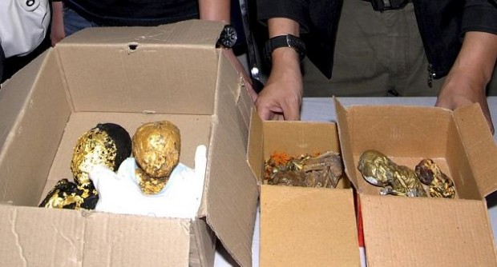
Last month, police in Thailand arrested a British citizen after six roasted fetal corpses were found in his luggage. The bodies were believed to be between two and seven months old, according to the Guardian. Some were plated in gold leaf, apparently for use in black magic rituals.
Infowars Alex Jones Believes Bilderberg Attendees Ship in Gold Covered Roasted Babies to Eat
Image source: Reuters
Outside the annual Bilderberg - Bilderbugger - meeting in Virginia on Thursday, Alex Jones of Infowars accused attendees of possessing the same thing — to eat.
Video posted online captured Jones shouting into a bullhorn outside the meeting place, claiming Bilderberg members “ship in roasted babies wrapped in gold foil for them to eat” — and making it clear he wasn’t kidding.
“Every week they catch them shipping little babies wrapped in gold foil for these guys to eat. They admit that’s where it goes to, I’m not making this up,” Jones said.
JIMMY SAVILE AND MARGARET TATCHER

The Effects of the, "Dark Side" It's solution and protection is Energy Enhancement Video Course and Live Courses.. CLICK HERE!!.
Here is the latest in my series about the Effects of the, "Dark Side" on the Last Tens of Thousands of years of Modern Society.. It's solution and protection is Energy Enhancement Video Course and Live Courses..
Jesus says, "Stay away from Evil" and on the path of, "The Energy Enhancement Mastery of Relationships" be aware that bad people project energy blockages connected with the deepest satanic evil into all who meet with them. Having sex with these evil people, anyone at all evil, with any degree of evil, injects these evil, Addiction, Psychopathic, Energy Blockages even deeper.
In the same way being in the presence of good people who can project Angel Talents into your psychic body and who can dissolve your Evil Energy blockages is a very good thing...
1. Tantra and Homosexuality in Satanic Ritual Homo-Occultism
2. The Left and Right Hand Paths of Awakening Kundalini
3. In the House of the Strong Man, Satanic Sodomy is the Key - The Ritual Implantation of Energy Blockages
4. The Luciferian Religion's role in the Fall of Civilisations - The Role of Pagan Satanic Ritual Homo-Occultism in Causing the Fall of the Roman Empire and the Degeneration of Hitler's Germany
Click Here..
http://www.energyenhancement.org/HOMOSEXUALITY-IN-SATANIC-HOMO-OCCULTISM.htm
Don't get me wrong, Real Religion is Real Gold but any Rite above is False Gold Satanism - No-one became enlightened through Ritual Drugs and Sex etc!!
SATANISM, RITUAL SEX AND HUMAN SACRIFICE, BLOODLINES, SATANIC PROPAGANDA AND THE REMOVAL OF MIND CONTROL IMPLANT ADDICTION SEX AND DRUG BLOCKAGES
'You're better clueless because the truth is horrible'- The Ostrich Syndrome
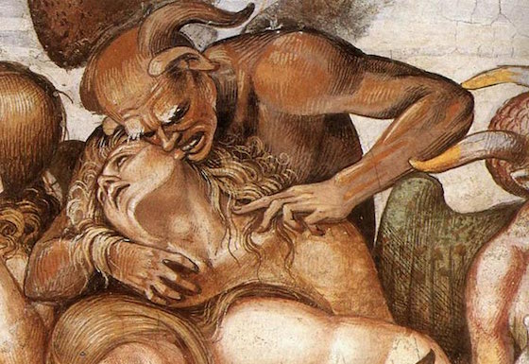
"Everybody is ignorant, only on different subjects." -- Will Rogers
As the Earth is a Factory for the production of Enlightened beings and Karma is the method of refinement - as you give, so you receive.. many people are not yet ready for Enlightenment.
However once the student gets hold of the idea that Energy Enhancement Meditation can Ground Karma he understands that passing through Evil Karma is not necessary, that a New Method of Evolution is in place.... To Speed up the Process of his Enlightenment.
Ground Karma, Sparkle the World
Remove Energy Blockages, Fill the World with Light..
The Buddha said that, "if I talk, I will be mis-understood", "if I write what I write will be altered and new verses added", "If I create an organisation it will be infiltraitored and taken over by psychopaths". He said, "There is Nothing I can do here!!" and he prepared to withdraw from the body and consciously ascend to heaven...
But all the Gods came to see him and said, "There are few who are ready, just on the point of Enlightenment, and just a word from you could be sufficient to cause Enlightenment in them". And the Buddha was satisfied and resolved to stay. And for another 40 years he spoke in the Purple Grove...
As Dante said at the gates of hell, "Abandon hope all ye who enter here!!"
This Satanic Program has been in force for 10,000 years before the time of Satanic Babylon and has been the cause of the degeneration and destruction of seventy-three empires and civilisations. The aim is destruction of human potential and evolution so as to permanently vampirise its spiritual energies.
Stopping this is a large task whose start is individual Enlightenment, the Right Hand Path, the Energy Enhancement Removal of Mind Control Energy Blockages.
The Satanic World has been at war against the Human species for over 10,000 years http://www.energyenhancement.org/Satanic-Problem-Meditation-Solution-Thermonuclear-War-Destabilistion-Fusion-Power-Mind-Control-Education.htm
Ground Karma, Sparkle the World
Remove Energy Blockages, Fill the World with Light..
Only Energy Enhancement, following the Christ, Buddha and Tamil Siddar Patanjali - see www.energyenhancement.org/patan.htm - can remove all Energy Blockages and make you free and independent of Vampirisation of your energy
Buddha and Jesus and all the Saviours and Saints are evidence that real, compassionate, conscience driven enlightenment is possible.
Real Enlightenment only comes through the process of Meditation.
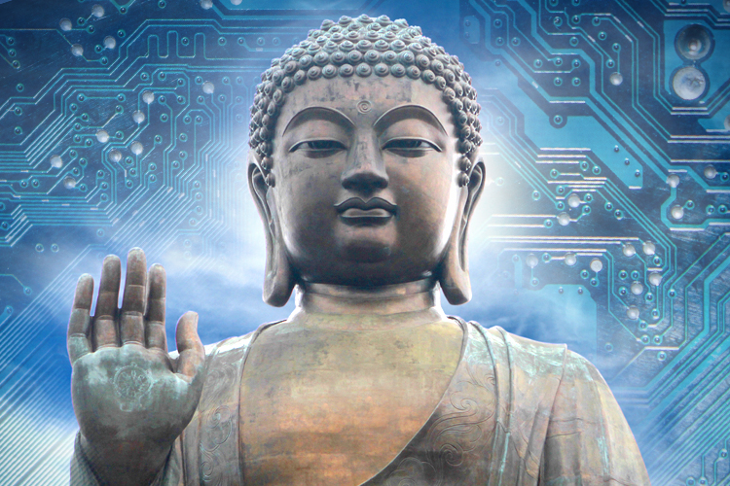
Let me say that again, - Real Enlightenment only comes through the process of Meditation.
Ritual Human Sacrifice in the Satanic Old Testament of the Bible
The Bible, especially the Old Testament, is filled with numerous stories of animal and human sacrifice. God, we are told, likes the pleasing aroma of burning flesh. Animal sacrifice is much more common than human sacrifice, but both occur and are “pleasing to the Lord”.
Genesis, the first book of the Bible, has Abraham preparing to sacrifice his son to God. “Take your son, your only son – yes, Isaac, whom you love so much – and go to the land of Moriah. Sacrifice him there as a burnt offering on one of the mountains, which I will point out to you.” (Genesis 22:1-18) Abraham takes his own son up on a mountain and builds an altar upon which to burn him. He even lies to his son and has him help build the altar. Then Abraham ties his son to the altar and puts a knife to his throat. He then hears God tell him this was just a test of his faith. However, God still wanted to smell some burnt flesh so he tells Abraham to burn a ram.
Even though he didn’t kill his son, it is still an incredibly cruel and evil thing to do. If Abraham did that today he would be in jail serving a long sentence as someone’s prison-bitch. It amazes me how Christians see this story as a sign of God’s love. There is no love here, just pure unadulterated evil.
The first seven chapters of Leviticus have extensive rules regarding animal and food sacrifices. These offerings are supposed to be burnt so that God can smell them. If you read through these it seems clear to me that the priests were getting their followers to make a big feast for them every week. The priests were very particular about what kind of food to bring and how to prepare it.
Even more peculiar is God’s obsession with first-born sons. In Exodus 13:2 the Lord said “Consecrate to me every first-born that opens the womb among Israelites, both man and beast, for it belongs to me.” Later it says that you can redeem (replace) an ass with a sheep and that you must redeem a child for an unspecified price. It is clear from the context that “consecrate” means a burning sacrifice. These priests are guilty of theft and kidnapping. Since any sins in the Old Testament were punishable by death, these priests used the threat of death to extort food and money from their followers. What do we call a scum-bag that threatens to kill your kids unless you pay a ransom? A kidnapper! If these priests were alive today they would be in prison with Abraham.
However, in Leviticus 27:28-29, the Lord allows for no redemptions. “Note also that any one of his possessions which a man vows as doomed to the Lord, whether it is a human being or an animal, or a hereditary field, shall be neither sold nor ransomed; everything that is thus doomed becomes most sacred to the Lord. All human beings that are doomed lose the right to be redeemed; they must be put to death.” I must admit that I am a bit confused by this contradiction, but it might only apply to slaves in your possession. Not that it makes any difference. A human sacrifice is a human sacrifice, and it is just sick.
Bible Passages About Ritual Human Sacrifice
Jephthah Burns His Daughter
“At that time the Spirit of the LORD came upon Jephthah, and he went throughout the land of Gilead and Manasseh, including Mizpah in Gilead, and led an army against the Ammonites. And Jephthah made a vow to the LORD. He said, “If you give me victory over the Ammonites, I will give to the LORD the first thing coming out of my house to greet me when I return in triumph. I will sacrifice it as a burnt offering.”
“So Jephthah led his army against the Ammonites, and the LORD gave him victory. He thoroughly defeated the Ammonites from Aroer to an area near Minnith – twenty towns – and as far away as Abel-keramim. Thus Israel subdued the Ammonites. When Jephthah returned home to Mizpah, his daughter – his only child – ran out to meet him, playing on a tambourine and dancing for joy. When he saw her, he tore his clothes in anguish. “My daughter!” he cried out. “My heart is breaking! What a tragedy that you came out to greet me. For I have made a vow to the LORD and cannot take it back.” And she said, “Father, you have made a promise to the LORD. You must do to me what you have promised, for the LORD has given you a great victory over your enemies, the Ammonites. But first let me go up and roam in the hills and weep with my friends for two months, because I will die a virgin.” “You may go,” Jephthah said. And he let her go away for two months. She and her friends went into the hills and wept because she would never have children. When she returned home, her father kept his vow, and she died a virgin. So it has become a custom in Israel for young Israelite women to go away for four days each year to lament the fate of Jephthah’s daughter.” (Judges 11:29-40 NLT)
God Commands Burning Humans
[The Lord speaking] “The one who has stolen what was set apart for destruction will himself be burned with fire, along with everything he has, for he has broken the covenant of the LORD and has done a horrible thing in Israel.” (Joshua 7:15 NLT)
Josiah and Human Sacrifice
At the LORD’s command, a man of God from Judah went to Bethel, and he arrived there just as Jeroboam was approaching the altar to offer a sacrifice. Then at the LORD’s command, he shouted, “O altar, altar! This is what the LORD says: A child named Josiah will be born into the dynasty of David. On you he will sacrifice the priests from the pagan shrines who come here to burn incense, and human bones will be burned on you.“ (1 Kings 13:1-2 NLT)
He [Josiah] executed the priests of the pagan shrines on their own altars, and he burned human bones on the altars to desecrate them. Finally, he returned to Jerusalem. King Josiah then issued this order to all the people: “You must celebrate the Passover to the LORD your God, as it is written in the Book of the Covenant.” There had not been a Passover celebration like that since the time when the judges ruled in Israel, throughout all the years of the kings of Israel and Judah. This Passover was celebrated to the LORD in Jerusalem during the eighteenth year of King Josiah’s reign. Josiah also exterminated the mediums and psychics, the household gods, and every other kind of idol worship, both in Jerusalem and throughout the land of Judah. He did this in obedience to all the laws written in the scroll that Hilkiah the priest had found in the LORD’s Temple. Never before had there been a king like Josiah, who turned to the LORD with all his heart and soul and strength, obeying all the laws of Moses. And there has never been a king like him since. (2 Kings 23:20-25 NLT)
Human Sacrifice
Chastised a little, they shall be greatly blessed, because God tried them and found them worthy of himself. As gold in the furnace, he proved them, and as sacrificial offerings he took them to himself. In the time of their visitation they shall shine, and shall dart about as sparks through stubble; (Wisdom 3:5-7 NAB The Book of The Wisdom of Solomon is mostly in Catholic versions of the Bible.)
Child Sacrifice
And this became a hidden trap for mankind, because men, in bondage to misfortune or to royal authority, bestowed on objects of stone or wood the name that ought not to be shared. Afterward it was not enough for them to err about the knowledge of God, but they live in great strife due to ignorance, and they call such great evils peace. For whether they kill children in their initiations, or celebrate secret mysteries, or hold frenzied revels with strange customs… (Wisdom 14:21-23 RSV) The Book of The Wisdom of Solomon is mostly in Catholic versions of the Bible. This passage condemns human sacrifice but acknowledges that it did happen by early God worshipers.
Humans are Fuel for Fire
As for you, son of man, prophesy: Thus says the Lord GOD against the Ammonites and their insults: A sword, a sword is drawn for slaughter, burnished to consume and to flash lightning, because you planned with false visions and lying divinations to lay it on the necks of depraved and wicked men whose day has come when their crimes are at an end. Return it to its sheath! In the place where you were created, in the land of your origin, I will judge you. I will pour out my indignation upon you, breathing my fiery wrath upon you, I will hand you over to ravaging men, artisans of destruction. You shall be fuel for the fire, your blood shall flow throughout the land. You shall not be remembered, for I, the LORD, have spoken. (Ezekiel 21:33-37 NAB)
Burn Nonbelievers
“Suppose you hear in one of the towns the LORD your God is giving you that some worthless rabble among you have led their fellow citizens astray by encouraging them to worship foreign gods. In such cases, you must examine the facts carefully. If you find it is true and can prove that such a detestable act has occurred among you, you must attack that town and completely destroy all its inhabitants, as well as all the livestock. Then you must pile all the plunder in the middle of the street and burn it. Put the entire town to the torch as a burnt offering to the LORD your God. That town must remain a ruin forever; it may never be rebuilt. Keep none of the plunder that has been set apart for destruction. Then the LORD will turn from his fierce anger and be merciful to you. He will have compassion on you and make you a great nation, just as he solemnly promised your ancestors. “The LORD your God will be merciful only if you obey him and keep all the commands I am giving you today, doing what is pleasing to him.” (Deuteronomy 13:13-19 NLT)
- THE RIGHT HAND PATH - THE CREATION OF ENLIGHTENMENT!!
The science of the creation of implant addiction energy blockages is an ancient technology which vampirises all humanity, turning humanity into a spiritual battery whose energy is used by the ancient families who control this technology in order to increase their energy enormously.
All human beings have been implanted with mind control Blockages in previous lifetimes and during this lifetime by absorbtion from the environment.
Aleister Crowley's OTO - Ordo Templi Orientis uses Ritual Sex - Homosexuality, Bestiality and Pederasty, Ritual Drugs, Ritual Torture, BDSM, Tatoos which implant energy blockages into the psychic body in order to degenerate and pervert, Ritual Human and Animal Sacrifice, Ritual blood drinking and Cannibalism. Also the castration Rites of Attis and Cybele. Also coprophagia, the eating of human excrement.
"Sex by will, Love by will -no caring and no sharing -no feelings ... Sex is the route to power. Scarlet women! They are the secret to the doorway. Use and consume. Feast. Drink the power through them. Waste and discard them." L Ron Hubbard, Snr.
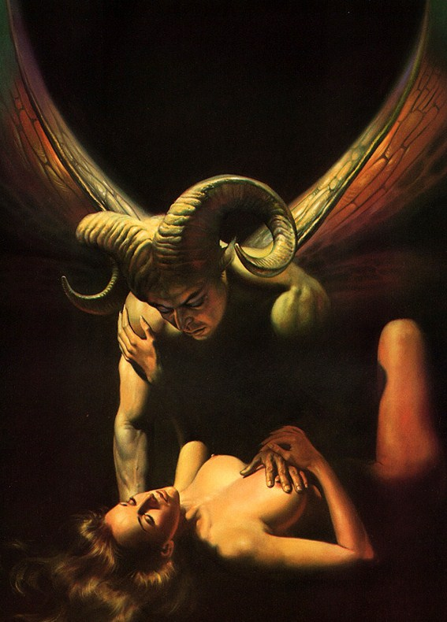
"Sex with the demon possessed is a diabolical means for transforming the individual and eventually completely taking over of the brain and body by "the evil spirit." That's been one way of taking control of an organization using high ranking members, by taking over their minds and bodies. Yet, how could Pike, Mazzini and their associated conspirators get persons to submit to such a diabolical process ?" Sonny René Stermole
All these guys are Implanted with sexual and drug addiction energy blockages in order to be vampirised by the real Sorcerers..
Satanism, Black Magic, Ordo Templi Orientis OTO, Aleister Crowley, Luciferianism, Wicca
http://www.energyenhancement.org/Satanism-Black-Magic-Ordo-Templi-Orientis-OTO-Aleister-Crowley-Luciferianism-Wicca-SEX-TANTRA-ADDICT-DRUG-ADDICT-VICTIM-OF-VAMPIRE-SEX-DRUG-AND-FOOD-ADDICTION-blockages.htm
The Fascist Nazi satanic Golden Dawn - George Bernard Shaw’s mistress, Florence Farr, was a witch in the Order of the Golden Dawn, and the Satanic Fabian society was also an integral partner with the Golden Dawn, itself basically an extension of the Theosophical society.2 When Blavatsky passed away in 1891, leadership of the worldwide theosophical movement passed to Annie Besant. Through her membership in the Satanic Fabian socialists, she became close friends with its leading members, which included men like head of MI6 British Satanic Secret Service H.G. Wells, and fascist eugenicists Aldous and Julian Huxley, and Satanic Lord Bertrand Russell.
To be a Satanist all you have to do is adhere to the Rituals of Satanism.
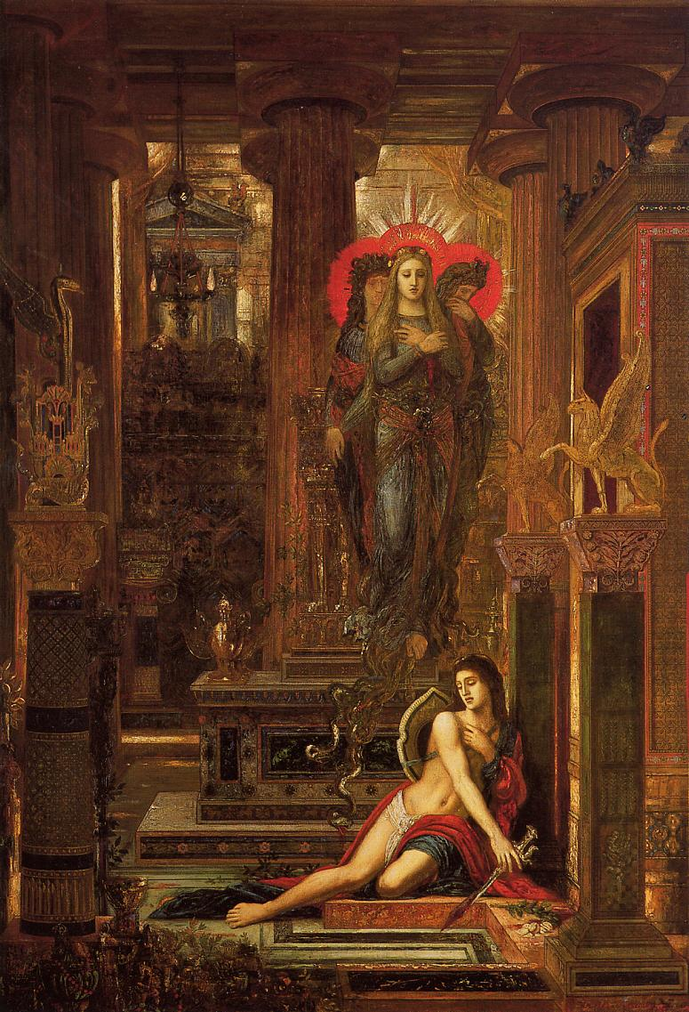
GUSTAV MOREAU - ORESTES DRIVEN MAD BY CONSCIENCE
Satanism for thousands of years is defined by Ritual Sex - Homosexuality, Bestiality and Pederasty, Ritual Drugs, Ritual Torture, BDSM, Tatoos which implant energy blockages into the psychic body in order to degenerate and pervert, Ritual Human and Animal Sacrifice, Ritual blood drinking and Cannibalism. Also the castration Rites of Attis and Cybele. Also coprophagia, the eating of human excrement.
All these guys are Implanted with sexual and drug addiction energy blockages in order to be vampirised by the real Sorcerers..
Thus, Satanic Luciferians are condemned to be as demonic Lucifer, cut off from God, cut off from conscience, cut off from empathy, cut off from their hearts, Psychopaths ALL!!
A human has a heart, empathy and conscience.
Luciferians are only pretending to be human, they are not human, they are psychopaths and they extol psychopathy in all their propaganda.
Their existentialist propaganda where Don Juan fucks thousands of women, kills, and all without regret, all without feeling anything, all without empathy and conscience - the definition of an existentialist, the definition of a psychopath, the definition of a Satanist. Don Juan does not want lovers, he only wants victims!!
Satanists might as well be Aliens, Snakes, Reptilians as they learn how to become psychic vampires in order to live psychically outside the body and take over the bodies of their sons, living for thousands of years as the heads of the richest family corporations, "The Family", where every member is traumatised, mindsplit, taught in Satanic public schools, and satanic generational ivy league universities, to rule the World.
"Sex with the demon possessed is a diabolical means for transforming the individual and eventually completely taking over of the brain and body by "the evil spirit." That's been one way of taking control of an organization using high ranking members, by taking over their minds and bodies." - Sonny René Stermole
Yet Satanists think that they are a new species higher than humans because they are taught empathy and conscience is weakness. Because humanity is so weak then they are to be used as slaves, conquered, crushed, psychic food, sacrificed, killed, slaughtered, "Anything Strong" - Aleister Crowley.
Satanists think that compassion is weakness just like Hitler and Stalin and Mao who together tortured and killed hundreds of millions of human beings.
These ancient families must keep humanity fooled and in the Matrix in order to maintain their meditation monopoly on energy blockage technology. See http://one-evil.org/content/bloodline.html and http://one-evil.org/content/people.html
ENERGY ENHANCEMENT REPORT.. I haven't missed one single day of meditation since Guru Purnima last July. Not all 30 minutes meditation but still at least 10-15 minutes before going to bed (sometimes a bit exhausted). Want to allow some time when I wake up but know exactly what it is not being the same man waking up than the one going to bed. Still, I haven't yet thrown anything through the window!
One night last week I had a very nice experience. I was feeling like being in a cave with rocks all around me. The image was surprisingly clear and I really felt this had nothing to do with me driving the show or imagining what I wanted to see. I then saw a sword starting to smash the ceiling to make light enter. The seen kinda zoomed out and I saw a white magician holding the sword (looking very much like Gandalf). I was very excited (not jumping around but felt really happy). The magician turned his head to the right, toward me, and it was you! Wow.
At that moment I asked you: "What's next? What's next" and your answer was: "Take the sword! Take the sword!" I took it and tried to spot one dark area but the ceiling seemed too high, I started to go smash rock everywhere around me since everything was black rocks anyway. At that moment I felt more like a participant. I lost my focus and got out of my meditation quite amazed.
As I kept my eyes closed while stretching my legs, I really felt like my body was falling in front of me, as if my spirit was up for a ride. Being worried to bump my head on the table corner in front of me, I went to bed and got back the same feeling that was there for a few moments. I wanted to have my spirit out but I somehow freak out a bit (not the first time it happens to me) and fell asleep. But that was still a good one, for a start!
Love and light to you, big love and big light!
As the Earth is a Factory for the production of Enlightened beings and Karma is the method of refinement - as you give, so you receive.. many people are not yet ready for Enlightenment.
However once the student gets hold of the idea that Energy Enhancement Meditation can Ground Karma he understands that passing through Evil Karma is not necessary, that a New Method of Evolution is in place.... To Speed up the Process of his Enlightenment.
Ground Karma, Sparkle the World
Remove Energy Blockages, Fill the World with Light..
The Buddha said that, "if I talk, I will be mis-understood", "if I write what I write will be altered and new verses added", "If I create an organisation it will be infiltrated and taken over by psychopaths". He said, "There is Nothing I can do here!!" and he prepared to withdraw from the body and consciously ascend to heaven...
But all the Gods came to see him and said, "There are few who are ready, just on the point of Enlightenment, and just a word from you could be sufficient to cause Enlightenment in them". And the Buddha was satisfied and resolved to stay. And for another 40 years he spoke in the Purple Grove...
As Dante said at the gates of hell, "Abandon hope all ye who enter here!!"
This Satanic Program has been in force for 10,000 years before the time of Satanic Babylon and has been the cause of the degeneration and destruction of seventy-three empires and civilisation. The aim is destruction of human potential and evolution. Stopping this is a large task whose start is individual Enlightenment, the Right Hand Path, the Energy Enhancement removal of Mind Control Energy Blockages.
Ground Karma, Sparkle the World
Remove Energy Blockages, Fill the World with Light...
The Satanic Methods of Control..
- The 10,000 years old Policy of Poverty - See Austerity and the creation of Austrian Economics by Von Mises and Von Hayek who were bought by Nelson Rockefeller.. Now, Austrian Economics rules UK, EU and USA - Old Rothschild- and Rockefeller hands created Austrian Economics and the Libertarian-Communist dialectic.
http://www.energyenhancement.org/old_rothschild_and_rockefeller-Mises-Hayek-Austrian-Economics.htm
b. The creation of all illogical Religions and Philosophies and their infiltration of every level of society..
Ever wonder why this world is like it is?
The infiltration and control by generational, ten thousand years old dynastic families of the upper levels of society of army, religion, business and banking through Paganism and Satanism - the Old Religion -
By injecting energy blockage addiction implants into the heart and head to vampirise their spiritual energies and remove empathy and conscience and using these Rituals to inject sexual and drug energy blockage implants to addict its members by..

Satanic murder cults among European royalty, nobility and the Knights Templar - Giles de Rais, Vatican, Jesuits, Mafia, Baphomet, LaVey, Freemasonry, Mazzini, Pike, Baroness LaLaurie, Roman Occult Rituals of Lupercalia, Ninth Circle Child Sacrifice
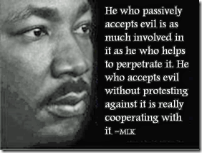
It is not just the Jesuits as some would argue. It is much more deep and old. The satanic murder cults among European royalty, nobility and the Knights Templar preceded the formations of the Jesuits in 1531.[1] It is certain because Knights Templar, French Nobleman Gilles de Montmorency-Laval aka Baron Giles de Rais, the lord of 15 princely domains and Duke of Brittany (England), was executed for secret Roman Catholic Black Mass Blood Sacrifices on October 26, 1440, almost a hundred years before the Jesuits were formed.[2]
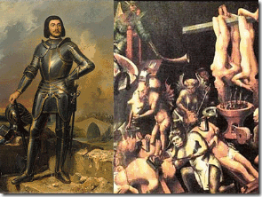
“Henriet and Poitou told tales of how he delighted in bathing in the boys’ blood and cutting off their heads himself so that he could wash his face and beard in the gore. They said he often had his servants stab a boy in the jugular so he could shower in the spurting blood. He sat on their chests and cut across part of their throats so they bled slowly to death. Others he hanged until they were nearly dead and then cut their throats. Still others had all their limbs cut off, or were ripped open so he could see their hearts and entrails. After death, all the bodies and their clothes were burned in the castle’s great kitchen furnaces. The servants spoke of obscene torture and blood-splattered walls in each of his castles. When Gilles returned to the court, dressed from head to toe in white to indicate his repentance.”
The precise number of Baron Gilles Roman Catholic Coven victims is not known, as most of the bodies were burned or buried just as in the case of Lady Baroness Marie Delphine Macarty-LaLaurie in French New Orleans. However, the number of the Gilles’ Coven murders is generally placed between 80 and 200; a few have conjectured numbers upwards of 600. The victims ranged in age from six to eighteen and included both sexes.[3]
We are also quite certain about what the Knights Templar’s supreme Satanic Goat God had been, the BAPHOMET. It also seems certain that during Baron Gilles de Rais’ era around the 15th Century that the Knights Templar human sacrifices had been dedicated to a god or demon in the form of a Goat, below. In the case of Lady Baroness LaLaurie’s New Orleans Coven, we aren’t sure of their idol. They allowed Baroness Lalaurie to escape prosecution and a proper investigation because her victims were Africans subjected to human bondage. It is more probable than not that she sailed to France until the scandal of ritualistic mass murder, torture and mayhem of Africans discovered at her mansion died down. However, throughout the history of the European Order of Knights, their one consistent Demon and God had been the ram goat– the Baphomet.
So, it is more probable then not to begin with the secret blood covenant Knights Templar, then the Jesuits, Freemasons and Mafia as currently secretly involved in the 21st Century continuation of the Black Mass/Satanic Blood Sacrifice Circles.[4]
However, we face a serious dilemma in challenging the crimes of Satanic cults, because society and our system of laws does not recognize ritualized and spiritual crimes without a Corpus Delicti (“body of crime“). It is also extremely difficult to prove ritualistic crimes because of ultra blood oath secrecy of its religious doctrines and among its members. There are also over 2 million Masons in North America and nearly 5 million worldwide.
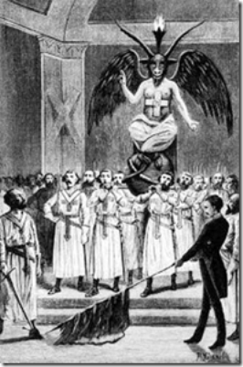
Freemasonry is made up of many individuals in the legislative national and state branches of the government. They are in the national and state judicial branches. They are in the all branches of the military and local law enforcement agencies. They are in schools, universities and corporations. They are in the music, television and movie industry, all subordinate and obedient to the Masonic Grand Lodges and the Baphomet- SATAN. They all, “Ride the GOAT” to carry on a vast global campaign of ritualized spiritual warfare, and a criminal enterprise to cover-up and veil their crimes.
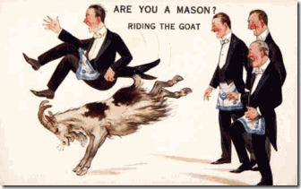
According to The Temple and The Lodge and other Masonic literature, Robert the Bruce was also well-connected to the Satanic Merovingian Bloodline.[36]
Robert the Bruce, Antichrist & the Blood Sacrifice
Today, the secret Satanic Merovingian Bloodline circles play an important part in the secret Anti-Christ conspiracy and movement to return the Satanic Merovingian Bloodlines to world domination. Their belief system will be partly based on Celtic religion which Robert the Bruce’s descendants and JACOBITES are seeking to restore includes Satanic Ritual Human Blood Sacrifice that some believe brought Robert the Bruce to power.[37] In Europe, Ritual Human Blood Sacrifice for Luciferian power, fortune and wealth never ended. It went underground as the Roman Catholic Black Mass ultimately becoming an important part of ILLUMINATI secret ritual ceremonies, and the Ninth Satanic Circle.
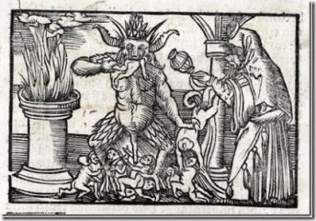
In the occult, the celebration of the end of Purification of Mary is part of a Babylonian/Roman Lupercalia festival called, Oimbolc. Oimbolc celebrates mid-winter (the midpoint between the winter solstice and the spring equinox) and the return of the Sun. Beginning February 2nd candles were lit to welcome the sun and the women began their purification process for the upcoming fertility rites of spring. The Roman Catholic Church adopted this custom from Irish pagans who served the “goddess” whom they called “Brigit“.[104]
LUPERCALIA [the feast of Lupercus, the mighty wolf hunter] is an ancient Roman BLOOD SACRIFICE (human- highest sacrifice) celebration of Lupercalia held in honor of Lupercus, the deified great hunter of Rome. This celebration also included worship of the goddess of fertility, Venus.[105] Lupercus is the god of shepherds. The Greeks called Lupercus by the name of “PAN.” In the Middle East, Pan was called “Baal“.[106] PAN is the guardian god of ARCADIA.
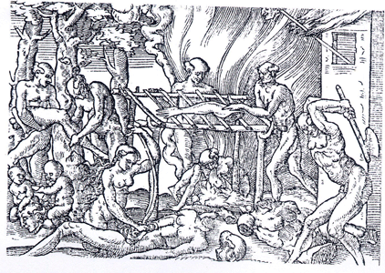
Saint Dominic was the Vatican’s first inquisitor-general of the 20-year military Albigensian Crusade or Cathar Crusade (1209–1229) initiated by Pope Innocent III to eliminate Catharism in the Languedoc district of France. The fanatical Saint Dominic along with the Magna Carta Roman Catholic Knights Templar led the torture and slaughter of the Cathars throughout old Europe, but failed to discover the location of their treasures and Christian ancient relics, and the HOLY GRAIL.[118]
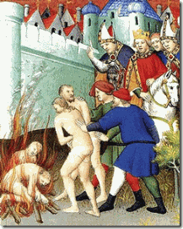
Saint Dominic had the Cathars gathered together wherever they were found, and burned to death and mass murdered them by the tens of thousands. If these Roman Catholic fanatics slaughtered and mass murdered their own people over religious doctrine, what more would they do to Africans and African descendants that they considered to be “inferior creatures”.
In French New Orleans and Louisiana, the first bishop of New Orleans and the brother of a French Master Freemason, Bishop Louis-Guillaume-Valentin Dubourg, enslaved Africans. The Jesuits, Capuchins, Uruslines, and the DOMINICAN Sisters openly exploited and enslaved Africans.
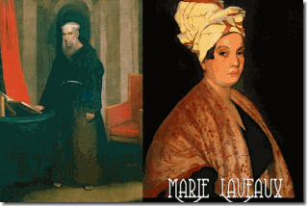
Jackson Square, is a historic park in the French Quarter that stands in front of the Roman Catholic Saint Louis Cathedral designed and built by Knights Templar/Freemasons. This is the cathedral attended zealously by Roman Catholics Madams’ Marie Catherine Laveau and Marie Delphine Macarty- Lalaurie.
This is the place where the ghosts and “SPIRITS” of “Secret High Level FREEMASON” Capuchin Friar Pere Antoine, Madame Marie Laveau and the “tortured souls of thousands of Africans” are said to inhabit. It is the grounds of Madame Laveau’s secret Satanic Black Mass, and not far from French Knight of Saint Louis descendant Baroness Lalaurie’s Mansion of Satanic Blood Sacrifice of Black People. Lest you ever bound to forget the Horror and EVIL just down the street from Jackson Square and Saint Louis Cathedral at Baroness Lalaurie’s Mansion on Royal Street in the French Quarter.
I’ll remind you of some horrific details:
“According to rumor, over a dozen disfigured and maimed slaves were manacled to the walls or floor. Several had allegedly been the subject of gruesome medical experiments.
The exact details are unclear; owing to the horrific nature of the crime, many details were either swept under the rug or embellished. Perhaps the most gruesome of Mme. LaLaurie’s killings was discovered by a young pickpocket by the name of Christopher Knowles. Knowles had broken into the LaLaurie residence with intention of stealing jewelry and other valuables. He broke in through the window and on the floor he discovered a bucket filled with mutilated human genitalia. Next to the bucket was a body. The body appeared to have been force fed the contents of the bucket until he eventually died from choking.
LaLaurie was even reported to have tortured and killed local activist Adam Wescount, reportedly gouging out his eyes and letting crows devour his remains.
One man looked as though he had been victim of some bizarre makeshift sex change. Another one had a hole in his head where a stick had been inserted to “stir his brains”. A woman was trapped inside a small cage where her arms and legs had been badly broken and then reset at odd angles, making her appear as some sort of “human crab.” Another woman had her arms and legs removed and patches of her flesh had been sliced off in a circular motion to make her appear as a giant caterpillar.
Some had their mouths stuffed with animal excrements, sewn shut, and had then starved to death. Others had their hands sewn to different parts of their bodies. One woman had her entrails pulled out and was secured to the floor by her own intestines.
A small boy of about twelve had the flesh on half of his face peeled back, revealing muscle, veins, and so forth. The wound had since been infested with disease and insects.
Two men were found to have had their tongues sewed together. One girl wore a suit made from the skin of several skinned slaves, the limbs of which were hacked and use to decorate the grand gore chamber.
Most disturbing of all was an elderly man whose penis was cut into 5 equal strands, each of which was attached to a hook and the body hoist to the ceiling, with two candles placed in his eye sockets to form a macabre chandelier.
Most of the victims were found dead. Those who were still alive begged to be put out of their misery and died shortly after.
Also discovered in the attic were teacups and saucers, encrusted with a “red substance.” There were several bottles lying about with what was assumed to be the same red substance, later identified as blood. Actually some press accounts from early 1834 are marginally more explicit than the Bee, though their reliability is difficult to ascertain. For example, the Religious Intelligencer of 10 May 1834 reports the discovery of Seven poor unfortunate slaves… some chained to the floor, others with chains around their necks fastened to the ceiling, and one poor man upwards of sixty years of age chained hand and foot and made fast to the floor in a kneeling position. His head bore the appearance of having been beaten until it was broken, and the worms were actually seen to be making a feast of his brains!!
A woman had her back literally cooked (if the expression may be used), with the lash; the very bones might be seen projecting through her skin!
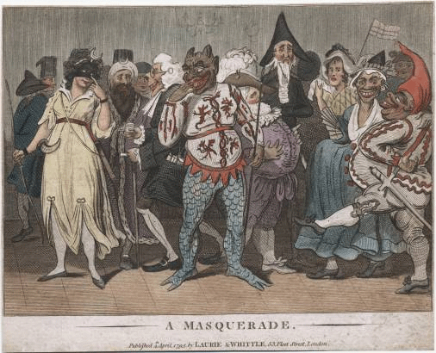
Cited by Courtney Barker, Misrecognized: Looking at Images of Black Suffering and Death, unpublished PhD dissertation, Duke University, 2008, p.32. There seems little doubt that even abuse of this sort would have been more than enough to cause Lalaurie to be described as “a demon, in the shape of a woman” by the New Orleans press.”
What went on at the Lalaurie Mansion in the French Quarter is no different than what went on at the 15th Century French Castle of Baron Giles de Rais. It was the secret Roman Catholic Black Mass Blood Sacrifice raising the favor of SATAN. Jackson Square and the Saint Louis Cathedral is filled with paramount ancient EVIL spirits of the past like Friar Pere Antoine, Madame Marie Laveau, and the Black Mass “Blood Sacrifices” straight out of Medieval France.
What is an “old fashioned masquerade party” in New Orleans?
First, Tina, Beyonce and Solange are LUCIFERIANS, Masters of Deception, deliberately deceiving their fans and the masses. Second, New Orleans’ masquerade balls are old world pagan occult rituals that had been restricted to white French secret societies- Bloodline ILLUMINATI of the New World Order. Third, old fashioned masquerade balls had been going on for almost 200 years before Blacks were allowed to participate.[121]
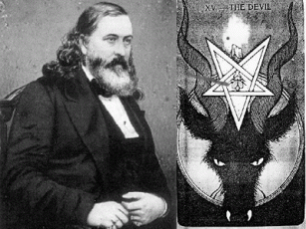
Fourth, the three secret founders that established the Mardi Gras/Masquerade Balls in New Orleans on a stable basis were Luciferians ALBERT PIKE (Freemason, Knights of the Golden Circle, Ku Klux Klan) , Judah Benjamin (Confederate Secretary of State) and John Slidell (Confederate States of America’s commissioner to FRANCE). Judah Benjamin was an agent of the Satanic House of Rothschild living in New Orleans in 1857.[122]
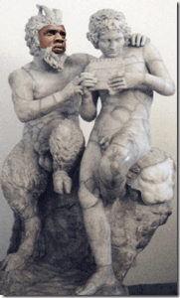
Fifth, old fashioned New Orleans’ Mardi Gras/Masquerade Balls are based on Roman occult rituals of Lupercalia linked to the Knights Templar/Rosicrucian utopia ARCADIA with PAN as god.
Knights Templar Not Only Shared the Horse, They Shared the Bed As Well
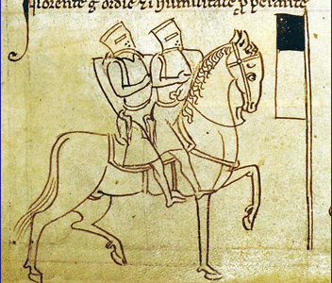
Amongst the Blasphemy Charges against the Knights Templar were the following: “… 2. That they then received the kiss of the templar, who officiated as receiver, on the mouth, and afterwards were obliged to kiss him in ano, on the navel, and sometimes on the generative member; … 4.
That they practiced unnatural vice together …” “Jean de St. Loup, who held the office of master of the house of templars at Soisiac, said that, on his reception into the order, he received the injunction not to have intercourse with women, but, if he could not persevere in continence, he might have the same intercourse with men; and others were told that it would “be better to satisfy their lust among themselves, whereby the order would escape evil report, than if they went to women.’ “
This is a secret, strange and ancient perverted ritual passed down thru the generations for population control, and ultimate power and control of individuals that even some Knights objected to and refused to engage in.
But, it is an actual historical ritual adopted by the ILLUMINATI and the Satanic Cabals that has been secretly imposed at the highest levels of the government (Black Obama and his transgendered wife Michael in the White House), the Black Family Structure and Satanic cells mostly through CIA MONARCH/MK ULTRA Trauma Based Mind Control Programming. It is absolutely bizarre snuff beyond the Sign Post Ahead, it is on the Outer Limits of ordinary Human Imagination.
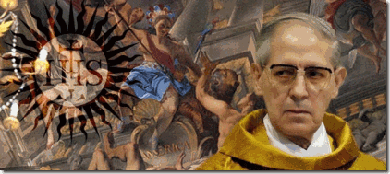
In late May 2014, FRENCH Catholic Jesuit head Adolfo Panchon, above, announced his resignation after the International Common Law Court of Justice in Brussels linked him to international Ninth Circle Satanic Child Sacrifice Cult ceremonies.[29] Evidence of a Catholic Jesuit Order document called the “Magisterial Privilege” was presented in court by the Chief Prosecutor. The record dated Dec. 25 1967 was said to show that every new Pope was required to participate in Ninth Circle Satanic Ritual sacrifices of newborn children, including drinking their blood.[30]
“Documents from Vatican secret archives presented to court clearly indicate that for centuries the Jesuits had a premeditated plan to ritually murder kidnapped newborn babies and then consume their blood,” the Chief Prosecutor told the five international judges and 27 jury members.[31]
“The plan was born of a twisted notion to derive spiritual power from the lifeblood of the innocent, thereby assuring political stability of the Papacy in Rome. These acts are not only genocidal but systemic and institutionalized in nature. Since at least 1773, they appear to have been performed by the Roman Catholic Church, Jesuits and every Pope.”[32]
Well, if you believe the HollyWeird Jesuit Rosie Perez and I certainly do, then she says that the path to uncovering the mysterious cause/force behind Bobbi Kristina being intentionally rendered near BRAIN DEAD leads to transexual ANGELA BASSETT. Follow the mysterious, Bassett leads us to another devout CATHOLIC of an ancient FRENCH Catholic Satanic Circle, and FRENCH Order of Ursuline (Blood Witch) Nuns in New Orleans- the infamous Voodoo Priestess Madame Marie Laveau. Madame Laveau leads us to the BLOOD SACRIFRICE Da Vinci Code Merovingian Race, Enochian Magic, Cabbalism, the Saint Louis Catholic Cathedral, Knights Templar, an ancient FRENCH Ninth Satanic Death Circle of Old New Orleans, and the Priory of Sion.
Kabbalism & Knights Templar
Cabbalism and Kabbalistic rituals secretly brought out of Solomon’s Temple in Jerusalem by the Knights Templar lay at the religious foundation of Freemasonry, Rosicrucians, Skull and Bones, the Scottish Rite freemasons, Hermetic Order of the Golden Dawn, Ku Klux Klan, and the BEAST 666 Aleister Crowley’s Ordo Templi Orientis. Raziel is an (fallen) archangel “Keeper of Secrets” and “Angel of Mysteries” that transmitted KABBALAH (Jewish Mysticism) to King Solomon and the rabbis.[49]
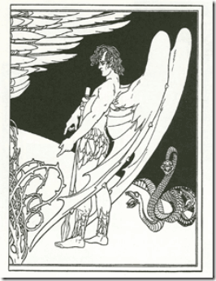
Saint Louis Cathedral- (Orleans) New Orleans, (New France) Louisiana
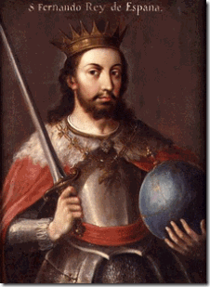
Saint Louis IX with Merovingian Race Crystal Ball
New Orleans was founded on May 7, 1718. It was named after the Duke of Orleans– the future King Louis XV of France (1710- 1774). As early as 1726, King Louis XV of France decided that three Ursuline Nuns from Rouen accompanied by the Jesuits should go to New Orleans to establish a hospital for poor sick people and to provide education for young girls of wealthy [Merovingian-Capetian- Satanic JESUS Bloodline] families.[50] The St. Louis Cathedral is named for Catholic Saint Louis. He was Louis IX, King of France. Louis IX (1214 –1270), commonly Saint Louis, was a Capertian King of France who reigned from 1226 until his death. Louis was crowned in Reims at the age of 12, following the death of his father Louis VIII the Loin.
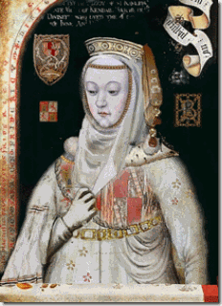
His mother, Blanche of Castile, above with the CLAW hand symbol, was the Queen Mother Regent that really ruled the kingdom in his minority. [51] Queen Mother and King Louis IX led the Seventh Holy Crusade and European invasion of the holy lands from 1248 to 1254.[52] The Capertians were sometimes called “the Third Race of [DRAGON] Kings“, the Merovingians being the first, and the Carolingians being the second. The first Capetian King was known as Hugh Capet.[53] The Royal Capetian and Carolingians bloodline of France are Satanic Bloodlines closely intertwined with the Merovingians.[54] They believe that “they” rule by the divine and sacred right of God.
Queen Mother Blanche of Castile was the third daughter of King Alphonso VIII (1155- 1214) and Queen Eleanor of Spain. Blanche’ mother was also commonly known as Eleanor of England. She was the sixth child and second daughter of King Henry II of England and Eleanor of Aquitaine.[55]
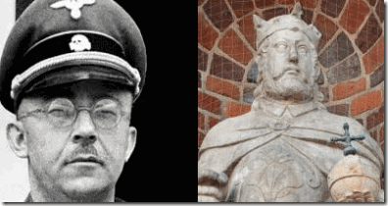
Himmler & King Henry the Fowler with Merovingian Crystal Ball
These bloodlines go back to Henry the Fowler. Henry the Fowler (Heinrich der Finkler or Heinrich der Vogler) (876 – 936) was the Duke of Saxony from 912 and the first of the Ottonian Dynasty of German kings and emperors, he is generally considered to be the founder and first king of the medieval German state, known until then as EAST FRANCIA. An avid hunter, he obtained the epithet “the Fowler” because he was allegedly fixing his birding nets when messengers arrived to inform him that he was to be king.[56] Reichsführer SS-1 Henrich Himmler believed that he was the reincarnation of King Henry, the Fowler.[57]
The First Merovingian Race, Da Vinci Code & the Saint Louis Cathedral
Dagobert I (603- 639) was the king of Austrasia (623–634), King of all the Franks (629–634), and King of Neustra and Burgundy (629–639). He was the last king of the Merovingian JESUS Bloodline Dynasty to wield any real royal power. Dagobert was the first of the Frankish Kings to be buried in the royal tombs at Saint Denis Basilica.[58]
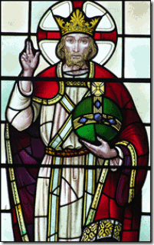
Dagobert II- Two Finger Symbol for Benediction with Merovingian Crystal Ball
Dagobert II (650- 679) was the last Merovingian to hold the title “Holy Roman Emperor.” The Merovingian “priest-kings” who were believed by their subjects to have magical powers derived from their long red hair. These “priest-kings” were the constant subject of rumors of witchcraft, fortune telling and crystal-ball gazing, among others.
In fact, portraits of Merovingian Kings customarily depict them holding one of these crystal balls in the left hand. Since the time of Carolingian Clovis I (Charlemagne), the Merovingians had presided over the Holy Roman Empire, but by the time Dagobert II was born, the power of the throne had already been weakened, with authority increasingly being usurped by court chancellors known as “Mayors of the Palace”.[59]
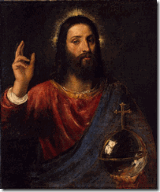
JESUS with Merovingian Crystal Ball-Two Finger Symbol of Benediction, Salvator Mundi (1570)Tiziano Vecelli or Tiziano Vecellio (c. 1488/1490– 1576), known in English as Titian was an Italian painter the most important member of the 16th-century Venetian School.[60]
Merovingian JESUS Bloodlines & Saint Louis Cathedral in New Orleans
A little more than a thousand years later, Capuchin Monk Father Dagobert de Longuory (a.k.a. Père Dagobert) arrived in New Orleans from Quebec, Canada in 1722. In 1745, he became priest of Saint Louis Cathedral, and later was appointed as Vicar General of the Diocese. He was active regionally for over 50 years and died in 1776.[61] Father Père Dagobert was an ancestral “priest-kings” Merovingian Bloodline endowed with same demonic magickal powers and agenda of his ancestors. Even today, the Merovingian Bloodline are generally believed to be the Satanic Bloodline of the Anti-Christ.[62] The Ancient European Satanic Bloodlines weren’t fleeing the old country. They were coming to America and landed in NEW ORLEANS to begin a new clandestine SATANIC UNDERWORLD.
The Merovingians and Knights Templars
In the popular Da Vinci Code conspiracies,[63] the Priory of Sion is a powerful hidden society founded with one objective, to restore the Merovingian House to the throne of France and the continent of Europe. During the crusades and European armed invasion of the ancient holy lands, the Priory of Sion was directly responsible for the existence of the Knights Templar (the Poor Knights of Christ and the Temple of Solomon) whose military wing they are alleged to have been.[64]
Saint Louis Cathedral & Lucifer’s Servants- Freemasonry
The imposing central tower of St. Louis Cathedral was designed by one of America’s most infamous European Freemason architects, Benjamin Henry Latrobe. He received a commission from the New Orleans Diocese to begin building the tower in 1819, during the vicarage of Spanish “Vicar and Ecclesiastical Judge of New Orleans” Capuchin Friar Pere Antoine (Francisco Ildefonso Mareno).[67] From 1803- 1813, Benjamin Henry Latrobe of the Masonic Order designed and constructed the South Wing of the Capital in Washington DC under President Thomas Jefferson.[68] Latrobe died in New Orleans during one of its Yellow Fever plagues.
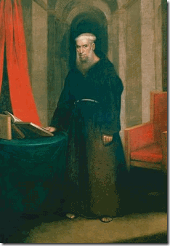
Saint Louis Cathedral & Capuchin Friar Pere Antoine
Antonio de Sedella aka Friar Pere Antoine, O.F. Cap (1748-1829) from Sedalla, Spain served as the leading religious authority of the Catholic Church during the late 18th and early 19th centuries. His ghost along with the ghost of Madame Marie Laveau is said to walk an alley now named for him which runs alongside the city’s cathedral.[69]
Why did Friar Pere Antoine’s ghost at times walk in company with the infamous black voodoo priestess? Madame Laveau attended daily Catholic mass with Friar Pere Antoine. He allowed her to use church grounds for secret Black Mass/Voodoo Rituals for her mostly African followers.[70] For at least a hundred years, the Capuchin Monks had been the Vatican’s leading Catholic orders that were known to be experts in Witchcraft and SATANISM of the Middle Ages. In secret sacred Duality of the Church and hidden Mithraism, SATAN through the Black Mass was just as much of a Divine and Powerful Lord to call forth as GOD. SATAN was called forth by the BLOOD SACRIFICE.
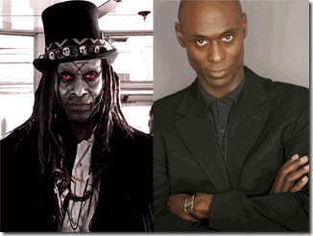
Madame Laveau wasn’t schooled in Witchcraft and Satanism by some idiotic false rite Luciferian Zombie Negro called Papa Legba. It was Saint Louis Cathedral, a clandestine Satanic Merovingian/Knights Templar/Freemason Cathedral. Angela Bassett and Madame Laveau are only false flags to a much greater and powerful Satanic Underground in America.
In Old New Orleans, among Friar Antoine’s devoted Catholic/Satanic flock was the racial mass murderer Marie Delphine Lalaurie, an Irish Knights Templar/Knights of Saint Louis Bloodline. The mass murder, torture and mayhem of Africans took place just down the street from Saint Louis Cathedral, and Madame Laveau, and they didn’t hear the SCREAMS coming from the Lalaurie Mansion throughout the nights. The Black Holocaust of Africans in New Orleans wasn’t committed in madness or a void. It was part of the Old French Ancient Ninth Satanic Circle’s BLACK MASS/Blood Sacrifices raising the DEVIL and the PRINCES of HELL for the Favor, Power, Fortune and Wealth of the ELITE DRAGON Bloodlines by the BLOOD, INTERNAL ORGANS, BODY PARTS, SOULS and LIVES of PEOPLE OF COLOR in New Orleans.
They didn’t raise up the spirit of Madame Laveau in the vessel of Angela Bassett to stir up African Gods and Spirits. They don’t roll like that but on TV and HollyWeird movies. They raised up Madame Laveau in the vessel of Angela Bassett to confuse and deceive the masses of People of Color- to lead them astray. In old New Orleans, Madame Laveau and her voodoo hid MONSTERS- the Merovingian Underworld Satanic Bloodlines, and the Old European Satanic Blood Sacrifice Circles like the Knights Templar, Rosicrucians, and Freemasons that feed from the innocence and ignorance of the masses of the people.
In HollyWeird, Angela Bassett also hide MONSTERS that also feeds from the minds, souls, innocence and ignorance of the masses. To understand the enigmas behind Whitney Houston and Bobbi Kristina, you need to look beyond Bassett and flush out in the light the real Sorcerers, Witches, Necronomicon Mystics, DEMONS and DEVIL WORSHIPERS out of the shadows to bring them ALL including Angela Bassett to ORDER, BALANCE and JUSTICE.

NEXT, we explore more into Saint Louis Cathedral, and some of the secret Old European Blood Sacrifice Circles transplanted and embedded in America’s Underworld related to Angela Bassett and her Spirit Possession of Madame Marie Laveau.
In New Orleans, Marie Laveau lived just a few blocks from the racialist mass murdering Marie Delphine Lalaurie that teamed up as a character with Laveau in the Coven televised series. In real life, they were contemporary and undoubtedly these two women met and knew each other very well. Both Lalaurie and Laveau attended Saint Louis Cathedral with Capuchin (Franciscan) Monk Pere Antoine.
By her own journal, Delphine and her third husband, Dr. Leonard LaLaurie sadistically slaughtered 62 Africans held in forced human bondage. They performed terrible and hideous terminal medical experiments on Africans. After a fire at the mansion, fire fighters discovered body parts of the slaughtered were found heaved throughout their manor. Fire fighters and authorities believed that a 70 year old African woman chained to a stove in the kitchen started the fire to alert authorities to murder, mayhem and horror going on inside the mansion. The Lalaurie Mansion exists today as an infamous “haunted mansion.”[30]
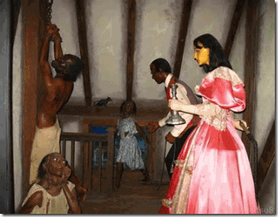
Down the streets and around the neighborhood, the terrifying screams coming from the Lalaurie Mansion were well known throughout the tight community. There is speculation that Laveau had been directly involved in some of the murderous Satanic activity at the Lalaurie Mansion.[31]
It also appears that Laveau should have been well aware of what going on at Lalaurie Mansion, and there are no records that she helped any Africans escape death, cruelty and torture at the hands of her neighbors and fellow Catholics.
Madame Laveau was a devout Catholic. She was part of the wealthy Catholic French-Creole merchant class of New Orleans. During the 1800s, Laveau and her father, Charles Laveaux, owned numerous buildings and lots in the early French Quarter. Charles Laveaux was a local tavern owner, that bonded his daughter to sell liquid spirits from a storefront.
MITHRA
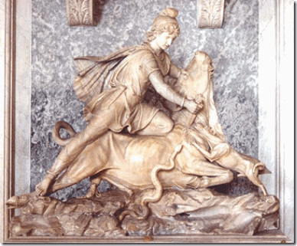
There are several Roman statues of Mithra found at the Vatican Museum Ritually Sacrificing a Bull - a Snake, Dog and Scorpion Feed from the Blood
However, what would explain Madame Laveau’s relationship with Delphine Lalaurie is that they were part of the Vatican’s underground Cult of Miltra (Miltras) or French Death Cult, the secret religion of the Sons of the Serpent (Set, Seth- Satan).
“Christianity resembled certain elements of Roman belief, particularly the worship of Mithra, or Mithraism. As ‘Protector of the Empire,’ Mithra was closely tied to the sun gods, Helios and Apollo … Christians took over a cave-temple dedicated to Mithra in Rome on the Vatican Hill, making it the seat of the Catholic Church.
The Mithraic high priest’s title, Pater Patrum, soon became the title for the bishop of Rome, Papa or Pope. The fathers of Christianity explained the remarkable similarities of Mithraism as the work of the devil, declaring the much older legends of Mithraism to be an insidious imitation of the one true faith.” Helen Ellerbe, ‘The Dark Side of Christian History‘ ” (223)[32]
Secret Mithraic rites and ceremonies involve animal and human sacrifice.[33]From the time of the Romans, the Cult of Miltra has always been practiced in strict secrecy - mostly in caves.
The Lalaurie Mansion sits atop the real property consecrated by the Ursuline Sisters. The Ursuline Sisters were the first Catholic nuns to land in the new world.[34] The Ursuline Sisters were the subject of the infamous French Witch Trials of the 17h Century. The Loudun Possessions was a notorious witchcraft trial in Loudun, France in 1634. A convent of Urusline nuns were involved in secret SATANIC BLACK MASS and naked orgies. They said they had been visited and possessed by DEMONS and the DEVIL. [35]
The Black Mass was originally created in France by Catholic Clergy to cover up their crimes and worship the DEVIL in a form of inversion to the Catholic Mass.
All sorts of perversions would go on in the basements of monasteries or in dilapidated cathedrals.
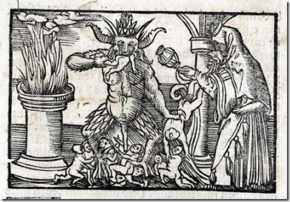
Rumors where that French Death Cults where involved in these corrupted masses as well. It is said that babies where eaten right after they were born from Catholic Nuns whom were impregnated by a monk or priest. This was to cover up the by products of the orgies that would take place during said masses.
Forms of bestiality along with animal sacrifice to mimic [Cult of Mithra] ancient pagan rituals.
Then Catherine Deshayes (1640-1680) who was an abortionist and magic charm charlatan, was able to convince ordained Catholic Priests to perform such acts of debauchery and blasphemy. The debasement of the rite was as far as the customer who paid for it would go.
Normally Catherine would use an aborted fetus as the sacrifice for the Black Mass. Thus starting rumors of children being sacrificed to the DEVIL once again. These Black Masses become a commercial indulgence of the higher class to attain the favor of the DEVIL.
This should explain the underlining Satanic activity at the Lalaurie Mansion. It was related to the Black Mass, and the higher classes of New Orleans seeking the power of SATAN.
Interestingly, it was a Capuchin Monk Tranquille that performed the Ursuline Sisters exorcisms in France and furnished the materials for the “History of the Devils of Loudun.”
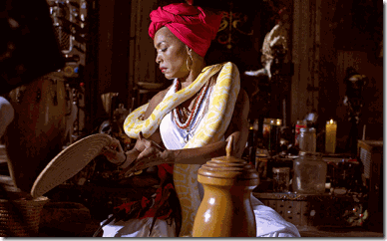
Angela Bassett & the Black Occult
Recall above that LaLaurie and Laveau were involved with Capuchin Monk Antoine at St. Louis Cathedral Basilica whose order was known to be experts on Satanism and the Black Mass.
The Satanic Reputation of the Urusline nuns followed them to early New Orleans. In the city, they were known as the coffin or “Casket Girls.” Locals believed that their coffin like travel and storage crates contained European blood vampires being smuggled into America.[36]
New Orleans is one of the most wicked and EVIL places on earth. It has a history of generational racial hatred, intolerance and violence almost unparalleled in the U.S. Yet, it is also an extremely interesting place to study and learn from.
Madame Laveau served the ILLUMINATI on some secret level for the Catholic Black Mass , Cult of Miltra and French Death Cult (Gilles de Rais’) as one of its useful idiots. However, the master French Death Cult murderer, Marie Delphine Lalaurie, was undoubtedly a French bloodline ILLUMINATI. SATANISM danger, horror and the absolute DIABOBICAL EVIL
Janus is an Ancient Roman God for Chaos and Deception
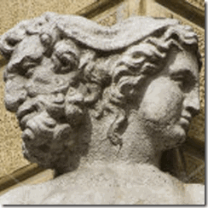
Janus is an Ancient Roman God for Chaos and Deception secretly adopted by the ILLUMINATI. He is a god of Double Nature, symbolized in his two headed image. His two faces were originally one clean-shaven and other bearded that represented the sun and the moon. He was usually depicted with a key. The Janus head is a popular phrase for “Deception.”[26]
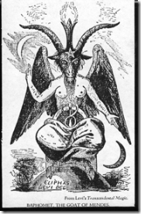
The origin of the name Janus is without any doubt, the Roman Demon God, Bifrons. Bifrons was also one the names given to the BAPHOMET worshipped by the Knights Templar, and which description was as a statue with two heads surely inspired in the Roman God Bifrons, one looking towards the left to tell the past, and the other looking towards the right to tell the future, all this by means of the Power of a Demon. It is also said the Janus-Bifrons appeared as a monster and then changed his appearance to that of a man. Janus-Bifrons is a shape-shifter.[27]
Medieval Satanic Woodcuts make it abundantly clear that Europeans understood that there was SATAN, and it is not at all an invention of Christianity. During the Middle Ages, they worshiped and practiced his works- SATANISM. And, it appears far too often that Christianity and Satanism were part of a strange phenomena of bedfellows that made up the nature of Old World Dualism that we have yet to fully decode. However, Native Americans referred to European two-faced “dualism” as speaking with a “forked tongue.”
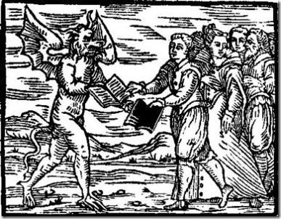
Rare 16th Century Woodcut Showing Old World Europeans Willfully Swapping Their Books of Salvations for the Works of the Devil (SATAN)
The phrase “speaks with a forked tongue” means to deliberately say one thing and mean another [deception] or, to be hypocritical, or act in a duplicitous manner.[28] That could also include a “duplicity” such as in the case of good and evil – A study in dualism: The strange case of Dr. Jekyll and Mr. Hyde.[29]
Satanic two-faced dualism is illustrated in an infamous case in the European medieval “Body of Christ.” Gilles de rais (1404–1440) of France, rode by the side of the Legendary Heroine of France and Roman Catholic Saint Joan of Arc. (1412–1441) and served as her chief lieutenant, fighting with such fierce merit that King Charles VII (1403–1431) later awarded de Rais the title of Marshal of France.
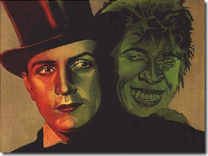
Jekill and Hyde
Gilles de rais was/is accused of having slain as many as 800 Children as sacrifices to SERVE SATAN,[30] In fact, the secret Ninth Circle Satanic Cult may date from the times of Gilles de rais and the 15th Century.
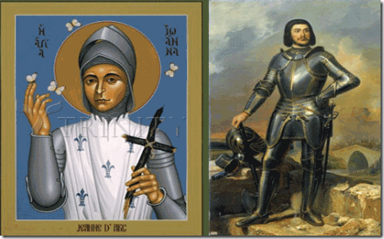
Rare Medieval Woodcut of the Sacrifice of Children to SERVE the DEVIL
Whether you know it or not, children by the thousands continue to be clandestinely sacrificed to Gilles de rais’ Old World SATAN . In 2014, the International Common Law Court of Justice (LCLCJ) in Brussels is continuing to investigate numerous children’s deaths connected to the Ninth Circle Satanic Child Sacrifice Cult network.
Death certificates were released on the 796 Irish children, ages two months to nine years, found in a cistern (septic tank) used as a mass grave at the Catholic St. Mary’s Mothers and Babies Home near Taum, Ireland.
LCLCJ forensic experts have confirmed the decapitation and dismemberment of babies in the mass grave resembled the usual signs of ritualistic murder. The Ninth Circle was/is directly linked to underground Satanic Cult networks in South Dakota.
“We will of course not let them know about Wotan [Wodan].” –Reichsminister Paul Josef Goebbels-[31]
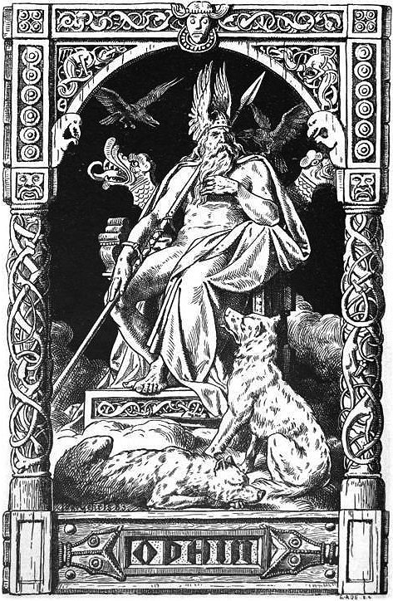
The evidence for human sacrifice in the period of the Iron Age is most prolific in Denmark, Germany and Holland, where many bodies have been found completely preserved in peat bogs. Some were hanged or strangled, the noose still around their neck, and others were BLUDGEONED on the head or had their throat slit.[32]
The Church of Sweden goes back to the Middle Ages commingled with Norse Paganism and other pre-Christian religious systems that survived in the territory of what is now Sweden; for instance the important religious center known as the Temple at Uppsala at Gamla Uppsala was evidently still in use in the late 11th century.[36] The temple was dedicated to Wodan (Odin) and Fricco (Freyr).[37]
Norway, Land of the Odin and the Vikings, is the only country in Northern Europe with wooden churches from the Middle Ages still intact.[38] Christianity in the three pagan warlord kingdoms of Denmark, Norway, and Sweden all took shape along the same time period in the Middle Ages along beside Wodan’s (Odin) pagan Temple at Uppsala as above.[39] What was going on at Wodan’s Temple?
“Like Odin, Wodan was the god of hanging. The Cimbri sometimes hanged their captives over the bronze cauldrons, while the priestess cut their throats. These sacrifices to Wodan would then later be thrown into sacred lakes.”[40]
Just how deep are you willing to sink down the Rabbit Hole? Little Tyrese’s Celebration of Life Ritual was held at Sioux Falls’ El Riad Temple.[41] On May 25, 1888, the first ceremonial of Nobles of the Mystic Shrine held in Dakota Territory, was called to order in Sioux Falls by W. D. Stites, first Illustrious Potentate of El Riad Temple. The ceremonial was held under dispensation on May 25, 1888 and a “Class of 33” was taken into El Riad Temple. El Riad Temple was instituted by El Kahir Temple of Cedar Rapids, Iowa.[42]
Down the Rabbit Hole, Little Tyrese & the Masonic Order
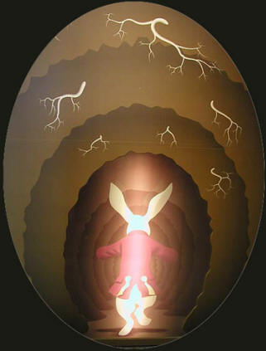
A Masonic Temple is reserved for Satanic Freemasons. It’s pretty clear that whoever organized Little Tyrese’s Celebration of Life ritual was a Satanic Freemason.
The ritual itself is a Humanist ceremony. The ritual is conducted by a Humanist Celebrant that believes that there is no soul or other supernatural component of the human personality that can in any way survive after physical death.
The Humanist Manifesto II is very similar to the Satanic Bible. Anton LaVey’s Satanism is a form of Humanism. Whereas, a Celebration of Life ritual could very well be a Satanic Ritual.
El Kahir & Albert Pike-Arkansas Grand Dragon of the Invisible Knights of the Ku Klux Klan of the Ole Southern Satanic Brotherhood
In 2011, the El Kahir Temple of Grand Rapids was exposed to have been a “Clandestine Masonic Membership Shrine” under the jurisdiction of the Satanic Grand Lodge of Arkansas. [43] The Grand Lodge of Arkansas meet in the Satanist/Grand Dragon of the Klan Confederate General ALBERT PIKE’s Memorial Temple, PIKE’S old home, built in 1838.[44] Recall that Pike was the secret Old World European ILLUMINATI representative for North America. The Ole Southern Satanic Brotherhood that he helped to create in America is part of the Old World ILLUMINATI Satanic (Ninth Circle) network.
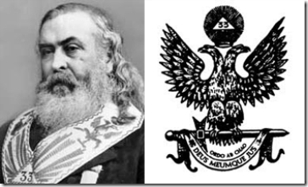
Pike & Janus- Dual Headed Masonic Eagle
Pike was appointed Grand Orator of the Grand Lodge of Arkansas on November 7, 1864, from 1853 onward he was, at various times, chairman of numerous committees and boards.[45] Before the Civil War, Arkansas Freemasons had made two bold moves. In 1853, they established the library of the Grand Lodge of Arkansas with Pike as chairman. It is the second-oldest library in the state. In 1859, they opened ST. JOHN’s College in Little Rock and educated and indoctrinated many of the state’s leaders.[46]
“Albert Pike organized the Ku Klux Klan in Arkansas after General [Nathan Bedford] Forrest appointed Pike the Grand Dragon of that Realm. The Tennessee leaders of the Klan at the time of its founding were prominent Masons subordinate to Grand Commander Pike.”[47]
In the decade after the Great War, Freemasonry was reestablished slowly in every section of Arkansas. By the end of the nineteenth century, there were 12,522 Masons in 442 lodges, and ALBERT PIKE (1809- 1891) was the best known Mason in Arkansas and most likely in South Dakota.[48]
Since its establishment as a state on November 2, 1889,[49] South Dakota and its predominately superstitious and dualistic natured European-Germanic population have been under the iron grip and influence of secret networks of Old World Secret Satanic Societies and the Ole Southern Satanic Brotherhood. The old families of South Dakota are undoubtedly deeply inter-related and associated with Secret Old World Bloodline and Blood Oath Secret Satanic/Masonic Based Societies such as the International Shriners, Benevolent and Protective Order of Elks and Albert Pike’s Ancient and Accepted Scottish Rite, and Freemasonry.
South Dakota & Old World Ninth Circle Satanic Child Sacrifice Cult
The global elite Old World Ninth Circle Satanic Cult is also secretly based in South Dakota. It is involved in the routine and systematic kidnapping, rape, torture and SACRIFICIAL MURDER of new born infants and children up to age fourteen.[50]
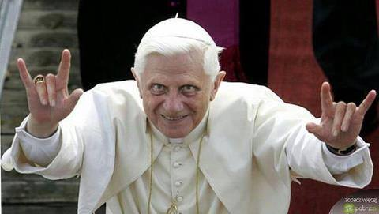
According to witnesses in a federal lawsuit, the Ninth Circle Satanic Cult is globally based and centuries old, operating at Roman Catholic cathedrals in Montreal, New York, Rome, London and dozens of other locations, including at protected forest groves in America, Canada, France and Holland. It routinely utilizes children taken from Catholic orphanages, adoption agencies, hospitals and schools.[51]
“Catholic Jesuit priest involvement in Ninth Circle Satanic Cult rituals at the Mohawk school in Brantford Ontario Canada is confirmed in correspondence from school principals as far back as 1922. Similar Jesuit sacrificial rituals using small children and newborns for sacrifice rites at CATHOLIC INDIAN SCHOOLS IN SOUTH DAKOTA and Omak, Washington are attested to by eyewitness Clarita Vargas in an affidavit entered into our docket material.”[52]
Actress Nicole Kidman of HollyWeird’s Satanic Flick Eyes Wide Shut psychologist father, Dr. Anthony Kidman, was linked to the Cult. When he was exposed in Australia as a master programmer and ring leader of an exclusive and elite Sydney pedophile ring linked to the Ninth Circle Satanic Cult, he suddenly ended up dead in Singapore.[53]
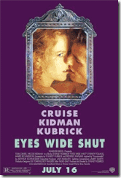
HollyWeird’s Nicole Kidman and Dr. Anthony Kidman, formerly of the Ninth Satanic Circle

After the collapse of Lawrence King’s Omaha, Nebraska CIA Satanic and Pedophilic Franklin Federal Credit Union, the federal credit union insurance fund repaid nearly all depositors 100 % of their deposits. The single big glaring exception was a South Dakota Sioux Falls order of Roman Catholic nuns that lost $2 million because its certificates of deposit exceeded the $100,000 insurance limit.[54] Secret Old World Satanic undergrounds, clandestine Masonic and the CIA/MK ULTRA Occult Bureau’s roots also runs deep in South Dakota.
Ahnenerbe, CIA Occult Bureau, Ninth Satanic Circle & South Dakota
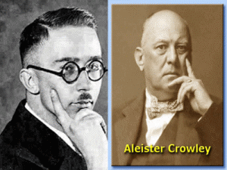
The Occult Bureau within the Third Reich was established by Lucifer’s Son, Reichsfuhrer SS- 1 Heinrich Himmler. It was called the Ahnenerbe. The true nature of the Ahnenerbe is difficult to describe because it was and still is surrounded by layers of blood oath secrecy even in America.
Generally, it was billed as a study society focused on the anthropological and cultural history of the Aryan race. However, the Ahnenerbe more closely resembled an “Occult Society” with a secret budget the size of the Nazi General Staff or Department of Defense.[55]
“In April 1945, American troops stumbled across a massive cache of Ahnenerbe files hidden in a dark, dank cave called Kleines Tuefelsloch (the LITTLE DEVIL’S HOLE) near the Bavarian village of Pottenstein. For the next four years, America intelligence officials closely studied the captured documents, eventually sending many to the Army’s Edgewood Arsenal and Camp Detrick.”[56]
Actually, the American recovery of Ahnenerbe cache of files was part of a pre-arranged highly classified package of plans of Allen Dulles, Himmler and Operation Paperclip to covertly change the SS (Knights of the Black Sun) venue from Europe to America.

The Ahnenerbe Secret Files became the basis of classified CIA/MK- ULTRA Occult Bureau Mind Control and Mass Population Control Experiments and Programs under Hauptsturmführer SS Dr. Josef Mengele, and Dr. Luther W. Greene (L. Wilson Greene), Technical Director of the Chemical and Radiological Laboratories at the Army Chemical Center at Edgewood Arsenal, Harford County, Maryland.[57]
There is testimony of a CIA/MK ULTRA test subject who was subjected to ritual trauma based electrical-shock, LSD, radiation, rape, dislocation of joints, chemical and drug experimentation as a child that had been sent to a special school with many other children and taught how to sexually please men and entrap them, and that Dr. L. Wilson Green, Dr. Mengele and others of the CIA routinely used them as sex slaves and special covert congressional sexual blackmail espionage agents that lead directly to South Dakota.[58]
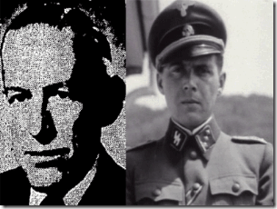
In fact, within the last couple of months, links are being developed connecting Dr. L. Wilson Greene and the CIA with aiding and abetting the Ninth Satanic Circle by supplying it with ritual Satanic abused mind altered child victims.
At least since the 19th Century, South Dakota has been known to be a complex center of unprecedented covert Satanic and Masonic undergrounds; AND extraordinary energy and activity linked to ancient magnetic lines, grids of force and radiation field lines.[69]
OCTOBER- Satan’s Harvest of Souls
SATAN is an unnatural life force that exists throughout our planet. The energy it gives off is totally negative. Its chemical make-up is incompatible with what is natural. Natural is a nature pertaining to the natural world.
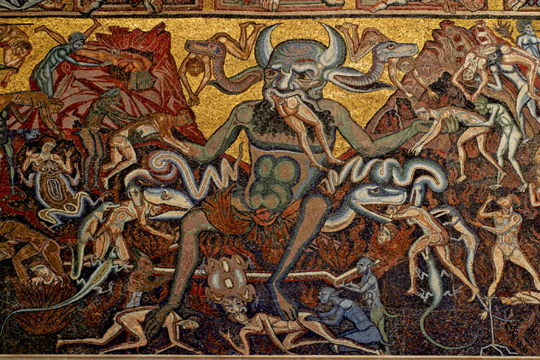
During the Aztec calendar month of Tepeihuitl (from September 30 to OCTOBER 19), it was dedicated to Sacrifices of Children.[70] SATAN has his own harvest celebration— a “Harvest of Souls.” Lucifer’s Servants prepare for SATAN’s Harvest of Souls during the entire month of OCTOBER in various ways- chaos, domestic violence and all manner of death and destruction.
“Their (Luciferians) diabolical activities begin on October 1st and build the entire month of October, climaxing on October 31st which is dedicated to planned world-wide human sacrifice.
These human sacrifices take place in covens and carefully guarded exclusive meeting places of high-ranking government officials. Beware: Pseudo Christian ministries also lure people in for the purpose of using them for human sacrifices.”[71]
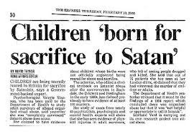
1 Peter 5:8: “Be sober, be vigilant; because your adversary the DEVIL, as a roaring lion, walketh about, seeking whom he may devour.”
Fallen Angels, Little Tyrese & EVIL Joey
“He [Jesus] gathers the rebels together like goats and pushes them towards the wall of Heaven; a hole opens up, revealing the chaos without. The angels are horrified and throw themselves out of Heaven. They fall for nine days, until Hell, “the house of woe and pain,” receives them. The HOLE IN THE WALL of Heaven is closed, and the angels approach the Son, rejoicing. He returns to his father.” Paradise Lost Book 6 [72] Joseph “Joey” Robert Patterson fell out of Kadoka,[73] the Latoka word meaning “Hole in the Wall”.[74]
EVIL Joey is also symbolically associated with the Latoka’s sacred and mysterious Black Hills (University). The Black Hills is believed to be a place of supernatural and paranormal energies inhabited by a Circle of Evil Spirits.
Speaking of the Circle of Evil Spirits in the Black Hills the Indians said: “The Evil Spirit was mad at the red people and caused the mountains to vomit fire, sand, gravel and large stones, to terrify and destroy them, but the Good Spirit had compassion and put out the fire, chased the Evil Spirit out of the mountains and left them unhurt, but when they returned to their wickedness the Great Spirit permitted the Evil Spirit to return to the mountains again and vomit forth fire ; but out their becoming good and making sacrifices the Great Spirit chased away the Evil Spirit …”[75]
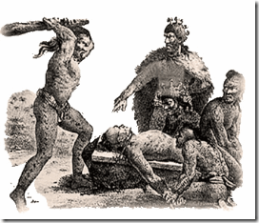
EVIL Joey’s ancestral roots are buried at the Old Masonic Cemetery in Philip, South Dakota. Masonic cemeteries are setup by Masons for Masons. Their cemetery grounds are consecrated by sacred Masonic rituals. His ancestral roots is also deeply embedded in South Dakota’s Masonic Benevolent and Protective Order of Elks.[76]
In 1969, the late Satanist Anton Szandor LaVey published the NINE (9) Satanic Statements in the Satanic Bible. Some argue that LaVey wasn’t a legitimate Satanist but a circus show sideman.
The Satanic Bible was written partly or mostly by Lt. Col. Michael Aquino of the U.S. Pentagon and Army Intelligence. The Satanic Bible draw heavily upon from a strange combination from the medieval “esoteric legitimacy” of Queen Elizabethan I Rosicrucian John Dee’s Enochian Language to the works of Darwinist Ragnar Redbeard (Arthur Desmond or Jack London) of the 19th and early 20th Century.
Rosicrucian Dee, the U.S. Pentagon, Army Intelligence, and Lt. Col. Michael Aquino is no sideshow circus.
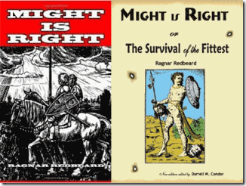
In 1890, Redbeard , an extreme racist, authored “‘Might Is Right’, or ‘The Survival of the Fittest.’” In Might is Right, Redbeard rejected conventional ideas and notions of human and natural rights for Black People and People of Color in lieu of the dominant Anglo Saxon Supremacy. And, as you can observe from the book’s covers, it is directly linked to traditional Old World Ancient European Mythology and Legends that lies at the foundation of the ILLUMINATI.
In other words, ancient esoteric demonology, traditional medieval Satanic wisdom, and white supremacy is clandestinely veiled behind Anton Szandor LaVey, the Church of Satan and the Satanic Bible.
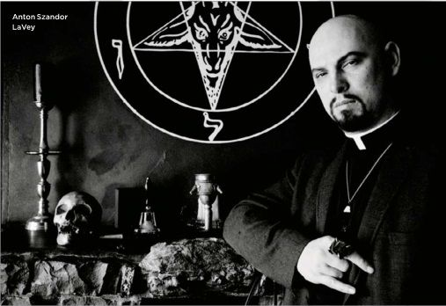
If any entity is associated with the Old World Ninth Satanic Cult Network operating with virtually invisibility and impunity in America, it would be the Pentagon, Army Intelligence, CIA/MK ULTRA Occult Bureau, and Himmler’s Luciferian Disciple U.S. Army Intelligence Officer, Lt. Col. Michael Aquino.
Some still believe that LaVey was the secret technical advisor behind Rosemary’s Baby.
We know in 1951, LaVey was in direct contact with Weird Jack Parsons (1914-1952) of Aleister Crowley’s OTO in Berkeley and Pasadena, CA. In 1946, Weird Jack and Scientology founder L. Ron Hubbard of U.S. Naval Intelligence had been directly involved in secret rituals to summons SATAN to produce a Moonchild (Rosemary’s Baby) from mortal woman.
Weird Jack, Hubbard and Crowley’s OTO was the secret foundation behind LeVay’s Church of Satan in San Francisco.
Part of LaVey’s legend is that he worked as a Lion Tamer in Clyde Beatty’s Circus. In Satanic Circles, the Lion Tamer is symbolic for Anton Szandor LaVey.
ESPN is owned by the Walt Disney Company and Hearst Corporation.[123] They don’t roll like that. Disney has its own police force, investigation, enforcement and propaganda arms.
Disney has no “free express yourself policy.”[124] Walt Disney Company and Hearst Corporation are both Satanic/ILLUMINATI Brotherhood Cabals implicated in PAGAN ritual sacrifice of children.
The DISNEY Bloodline- Satanic PAGANS
Co-founder of Walt Disney Productions, Roy Oliver Disney, was a Freemason. Walt Disney maintained all along that he wasn’t a Freemason but part of the Masonic Order. He said that he was much higher in the Masonic Hierarchy and Order than an ordinary Freemason. He said that within the Masonic Order, he was an ordinary member of the Mother Chapter of the Order of DeMolay. Who was DeMolay and what is the DeMolay Ritual?
Jacques de Molay (1243 –March 18, 1314) was the 23rd and last Grand Master of the Knights Templar.[125]
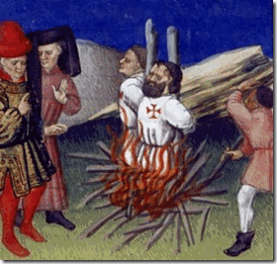
“The DeMolay ritual makes a great hero of its namesake. He is held up as a paragon of manly virtue. What the order’s ritual does not tell its young charges is that DeMolay was burned at the stake for being a homosexual, a pedophile (lover of young boys), and for practicing witchcraft and worshiping a false god named Baphomet!“[126]
The Knights Templar freely practiced homosexuality and other sexual perversions, that the Grand Master wielded total authority over everything, that they practiced rituals
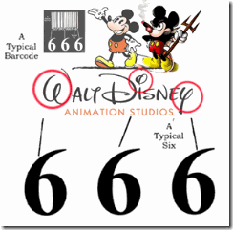
of sorcery and used Cabalistic symbolism was clear evidence that the order had had become a sect blasphemous to Christianity. Their questioning revealed yet another of their unorthodox practices: Without being specific, they had admitted to idolatry, but during their ongoing interrogation, it gradually emerged that without any doubt, they were worshipping SATAN.[127]

D 23– Clandestine Masonic Symbolism- DeMolay, 23rd and last Grand Master of the Knights Templar
The Masonic Order is CLANDESTINE. Disney was undoubtedly telling us that he belonged to a Knight Templar Hierarchy and Satanic Order within the Masonic Order in which BAPHOMET is God. The Order of DeMolay is accepted and a hidden powerful Masonic Hierarchical Order. Additionally, Walt Disney had been a clandestine HOLLYWIERD FBI Special Agent in Charge under or superior to 33rd Degree Freemason, J. Edgar Hoover.[128] He also is alleged to have worked for the CIA’s MK ULTRA and the MONARCH Program.[129] Disney is also linked to clandestine elite ILLUMINATI child Pedophilic Cults and SACRIFICES.[130]
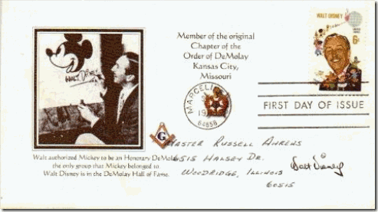
Walt Disney made Mickey Mouse an official honorary DeMolay- Knight Templar. During the “Cremation of Care” ceremony at the Bohemia Grove, the sacrificial bound-body was burned on the alter of a 50-foot-tall Owl of Bohemia god made of concrete. The Bohemian priests wore hooded KKK robes in white, black or red. Cremation of the Human Sacrifice was set to music by Walt Disney’s ‘Fantasia‘, “The [Witch] Sorcerer’s Apprentice” where Mickey Mouse’s magic runs amok.”[131]
Don’t get it twisted, we are not talking a grove of trees or flowers. The word “Grove” as in Bohemian Grove originally referred to a sacred place in the woods. It has been used at least three different ways among Pagans. Sometimes it is simply a gathering of Pagans of no particular denomination. Often it means a local organization of Druids. Occasionally it refers to a group of Pagans who gather to worship under the guidance of a Witches’ Coven; this kind of “Grove” is also called a “congregation” or “outer circle,” as distinct from the “inner circle,” which is composed of the priests and priestesses of the coven.[132]
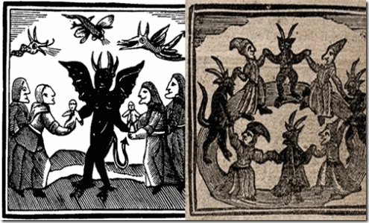
Bohemia is the historical country of central Europe that was a kingdom in the Holy Roman Empire and subsequently a province in the Habsburgs’ Austrian Empire. Whereas, the Bohemian Grove in California is a Coven of Pagans practicing Child/Human Sacrifices and worshipping SATAN in secret along beside Christianity as it had been in Bohemia Germany during medieval times. The secret Child Sacrifices to SATAN and the Satanic (Ninth) Circles of Old Europe out of the Middle Ages has remained unbroken and hidden even here in America.
The HEARST Bloodline- Satanic PAGANS
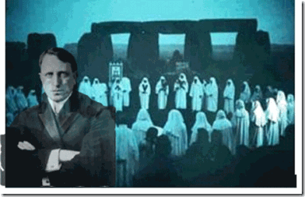
“David Hill…was a high ranking Scottish Rite Freemason and an important Mafia figure before he came to Christ…” “David Hill knew that William Randolph Hearst was part of the ILLUMINATI, He was part of the branch Illuminati — at what could be termed the 6th degree. William Randolph Hearst was totally into paganism. That is very obvious by a tour of his mansion in California which has been turned into a museum.”[133]
The Hearst family newspaper tycoons were/are traditional bloodline PAGANS of the Bohemian Grove.[134] William Randolph Hearst was a high-degree ILLUMINATI Satanic Initiate. The Hearst Mansion in California is furnished with hundreds of ancient Kemetic and other Near and Middle Eastern occult artifacts. Most of them are original and were shipped to the United States by Hearst at enormous expense.[135]
William Randolph Hearst (1863-1951) had been a PAGAN of the Bohemian Grove since 1887.[136]
In about 1906, William Randolph Hearst was there, above, when they lynched what appears to be a Black man at the Bohemian Grove.[137]
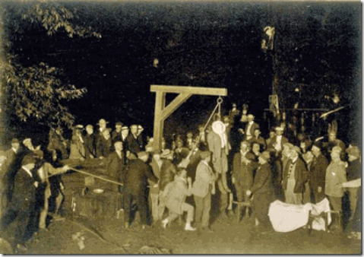
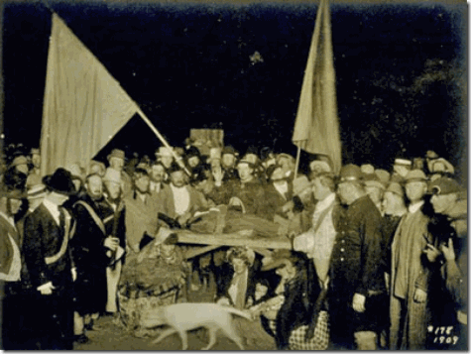
In 1909, William Randolph Hearst was there, above, when they murdered and offered a Black Child in SACRIFICE to the fire altar of Baal Moloch at the Bohemian Grove.[138] And if he wasn’t there. William Randolph Hearst certainly had the power and responsibility to object and report what was going on there and we know- that- he certainly didn’t DO!
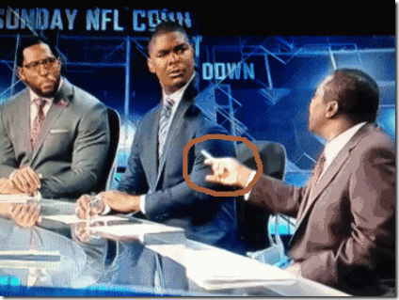
ESPN’s Uncle Tom’s Devil Horns Hand Symbol isn’t an innocent gesture. It is an blatant MK ULTRA/MONARCH mind control key that momentarily mystified and stunted Keyshawn and Ray Lewis. Uncle Tom Jackson , “… he (Adrian) knew UNDERNEATH that it was abuse.”
“I Reckon with a Dagger”- ILLUMINATI Giuseppi Mazzini
ILLUMINATI Freemasons Giuseppi Mazzini and Satanist Albert Pike
Satanic British Empire Secret Agent, working for Lord Palmerston, Italian Freemason and revolutionary, Giuseppi Mazzini (1805-1872) formed a society in Sicily called the Oblonica that means “I reckon with a dagger.” As is typical with the Masons, Mazzina formed an order within an order. The elite inner group was called a term that most people will recognize, the Mafia.
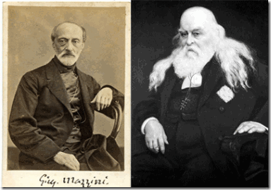
THE SATANIC HISTORY OF THE WORLD - PART ONE - The Satanic Psychopathic Palmerston, Prime Minister of the British Empire circa 1850 - and his Three Satanic Psychopathic British Agents, Mazzini, Urquhart and Napoleon III - as a Continuation of the same Satanic Psychopathic Families from Satanic Psychopathic Babylon through the Satanic Psychopathic Roman Empire, the Satanic Psychopathic Venetian Empire to the Satanic Psychopathic British Empire to the current Satanic Psychopathic Anglo-American Establishment
The name MAFIA is an acronyn for Mazzina autorizza flori, incendi, avelenamenti - Mazzini authorizes thefts, arson and poisoning. The Mafia was also known by another term, Il Mano Nigro– the Black Hand. Mafia crimes were often sealed by a black hand-print at the scene. This, of course, was an ILLUMINATI touch: the hand with palm forward and five digits extended.[31]
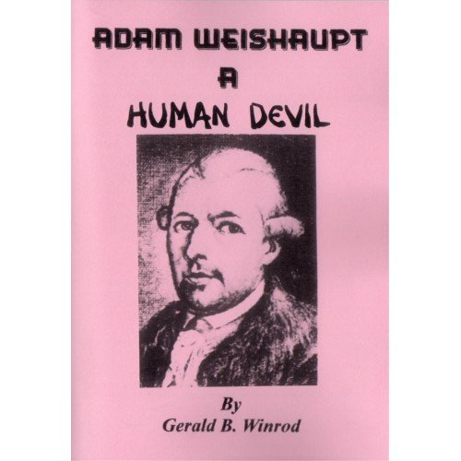
Front men for the 1000 years old 500 Trillion Dollar Vatican Bank - The Rothschilds - funded Adam Weishaupt, founder of the ILLUMINATI died on November 18, 1834. Mazzini was appointed head of the ILLUMINATI in 1834. In 1859, Mazzini chose the leader of the U.S. Scottish Rite Masonry, “Sovereign P ontiff of Universal Freemasonry” Confederate General Albert Pike to coordinate secret ILLUMINATI activities in the United States.[32] Pike designed the secret Satanic Masonic initiation rites and rituals to create a secret super elite blood oath hierarchical “order within an order” of Freemasons elevated to the ILLUMINATI.
“Pike was … a Satanist, who indulged in the occult, and possessed a bracelet he used to summon Lucifer, with whom he had constant communication. He was the Grand Master of the Luciferian group known as the Order of the Palladium (or Sovereign Council of Wisdom), which had been founded in Paris in 1737.
The Palladian Rite injects demons to devolve, degenerate and take over participants in satanic ritual sexual congress with Satanic Priestess Whores of Babylon. Palladism had been brought to Greece from Egypt by Pythagoras in the fifth century [BC], and was this cult of Satan [Set-Seth] that was introduced to the inner circle of the Masonic lodges. It was aligned with the Palladium of the Templars.”[33]

The Late Great Mae Brussell before her death (assassination). Mae had been always under the threat of death to her and family. Mae was courageous and kept on pushing because she knew that her work was important to the struggle of the people all over the world.
The Elite Satanic Global Cabals of the ILLUMINATI exposed by Mae Brussell have turned America into Lucifer’s Workshop and the DEVIL’S PLAYGROUND. She was one of few and earliest researchers bold enough to publicly build upon a theory with very convincing and compelling evidence that the most powerful governments in the world are controlled by a thin line of a NAZI CABAL (SS Lucifer’s Servants) of about 5000 men, a group that went underground after the FALL of the THIRD REICH. The Vatican's Ratlines. The Vatican's prefered method of rule is Fascism. Operation Paperclip..
She often traced world events- wars, elections, assassinations and false flag operations back to the movement of NAZI GOLD and the usage of well-known German signature code names in clandestine operations to instill and spread FEAR and utter CHAOS around the world. An extremely good example of her exhaustive and dedicated works putting puzzles together was in 1988, when she discovered the name “Adolf H. Schicklgruber” in a book of Marina Oswald’s poetry found in the Warren Commission artifact documents of the JKF Assassination. Shicklgruber was an operational cabal signature code name- the last name of Adolf Hitler’s mother.[4]
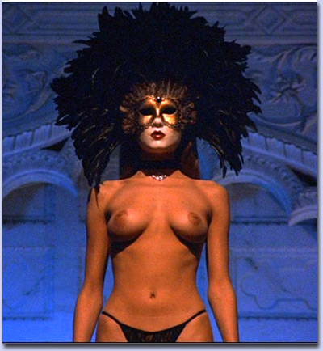THESE RITUALS DEFINE SATANISM.. RITUAL SEX, RITUAL PEDOPHILIA, RITUAL HOMOSEXUALITY, RITUAL DRUGS, RITUAL HUMAN SACRIFICE, RITUAL CANNIBALISM, RITUAL CASTRATION
Ritual Homosexuality and Pedophilia are symptoms of the activity of the Satanic Religion and the Satanic Sex Addiction Blockage in Society.
From The Can Of Worms... http://merovee.wordpress.com/2012/01/10/the-can-of-worms/
It was the arrest of the notorious Jewish born child serial killer Mr Dutroux in August 1996 that brought the Belgium Paedophile scandal to light. The rescue of the last Two young girls he kidnapped lead to an investigation of Dutroux. Five women who testifies anonymously in Belgium under the code name ”X” described a generational family underworld of Satanism, where Satanic Families pimped out their children for rape, pedophilia, sadomasochism, torture, cannibalism, snuff movies, and murder. They said that Satanic politicians, Bilderbuggers and other high placed members of society were involved.
As well as the gay callboy whistleblowers at the White house and multi prosecutions of Satanic Pedophilia amongst the USA elite we have Satanic Pedophilia UK..
Satanic David Miliband MP A multi millionaire Bilderbugger bisexual multiculturalist Marxist Jew brought in to the Labour Party by Blair. Described in Labour circles as “Blair’s Boy” he is believed to have been
Lord Longford from labour25.com
the submissive partner in homosexual relationships with both Blair and Baron Mandelson or Mandy.
David Miliband is said to be leader of the “Primrose Hill Gang”, a secret network of Labour politicians that include Ed Miliband, Douglas Alexander, Pat McFadden, James Purnell, Jim Murphy, Andy Burnham, Matthew Taylor, Geoff Mulgan and Patrick Diamond. The Primrose Hill Gang has been linked to the Rochdale Care Home Child sex abuse scandal through Jack Straw and Labour Councillor/Freemason/School Governor Darren Pedley.
Satanic Ed Miliband MP Multi millionaire Bilderbugger multiculturalist Marxist Jew he has been Leader of the Labour Party since 25 Sept 2010. He worked on the Channel 4 show A Week in Politics from 1992 until he left in 1993 to work for Harriet Harman. In 1994 he started working for Satanic Gordon Brown. Satanic Gordon Brown - Prime Minister of UK after Satanic War Criminal Blair is considered a “father figure” to Ed Miliband.
Satanic Baron Peter Mandelson raised to the peerage by Tony Blair in 2008. Claims to be the “ brains “ behind New Labour he has amassed a fortune estimated at over £20 million from his time in Government. Denounced by Tim Dalyell MP as being part of Blair’s “ Jewish Cabal “. Openly homosexual he was a strong supporter of lowering the age of consent. His private life is subject to several D-Notices.
Satanic Margaret Hodge MP. An East European Jew she has constantly been linked to care home satanic child sex abuse and murder rings of British Children in Islington and Jersey when she was Head of Islington Council and their subsequent cover up. Very close to Jack Straw. To widespread horror Tony Blair made Hodge his Minister for Children in 2003, a job Blair had specially created for Hodge.
Satanic Jack Straw MP an East European Jew he was behind the ineffective investigations in to the Hillsborough disaster and the Jersey child sex abuse and murder scandal. Believed to be a major driving force behind allowing child brides in the UK. He is the Politician behind the phrase “cultural sexual diversity“. In 2009 Jack Straw made it illegal for any child to complain about abuse while in the care system ( The Times and Independent Feb.15th 2009 ). Placed all the Thomas Hamilton ( Dunblane massacre ) papers under a 100 year secrecy law.
Satanic Harriet Harman QC MP. When Legal Officer at the National Council for Civil Liberties ( later Liberty ) she constantly lobbied the Government to legalise child pornography , paedophilia and incest , she repeatedly denied this but recently released Government documents have her signature on them. A niece of Lord Longford she is very close to Margaret Hodge and Patricia Hewitt.
Satanic Lord George Robertson raised to the peerage by Blair in 1999 has been accused in the Scottish Press of using his influence as a Freemason to obtain a firearms license for Thomas Hamilton ( Dunblane massacre ) and of running a Masonic paedophile network for the British Establishment based in Scotland , Islington and Jersey. A D-Notice has been put on the press and Lord Robertson is threatening to sue.
Satanic Patricia Hewitt ex MP . From 1974 to 1983 she was General Secretary of the National Council for Civil Liberties ( later Liberty ) when it lobbied the Government to legalise child pornography , incest and paedophilia on behalf of the Paedophile Information Exchange and Paedophile Action for Liberation. Smart enough to let Harriet Harman sign all the documents she has always denied any knowledge of this. Major driving force behind the sex education of very young children she has argued that fathers are not a good influence on children. Kicked out of the Labour Party in 2010 after lobbying for cash scandal.
Reply
PAVLOVSBITCH says:
16/09/2012 at 11:18 pm
Hodge is an Oppenheimer and as such is directly related to City of London/Crown Estates and they ‘do what thou wilt’ but I didn’t realise that the StrawMan made it ‘illegal’ for children to complain whilst in care! It sums up the state of affairs under anarchy and the urgent need to bring Common Law and Justice into sharp focus. It’s also interesting that Mandelson has been made a Baron, as those calling for Common Law reinstatement are insisting this is derived from the Magna Carter which was actually a legal document devised to protect Barons and nothing to do with common people’s right to justice. Harm-men is accurately named. Thanks for this reminder
Reply
PETER GRIFFITHS says:
03/10/2012 at 11:58 am
Cig Papers,
This is a very nice burst from the machine gun of truth and my hat is off to you.
Perhaps the season has arrived when the walls will come tumbling down regarding these monsters.
Satanic Tony Blairs’ Islington People:
Satanic Tony Blair, War criminal , bisexual , torturer, liar , psychopath , multiculturalist , control freak, Bilderbugger Group member, Privy Councillor advisor to the Queen, Knight of Malta. Believed to have amassed a fortune of between £50million and £250 million since leaving Office. Two convictions for cottaging (1974 &1983) - Homosexual activity in Toilets - subject to D-Notices. He first came to the attention of MI5 as a potential future Prime Minister after repeatedly being caught importuning young boys in Public toilets around London in the 1970s. A notorious cross dresser, his nickname when he was a lawyer was Miranda. Allegedly some of those caught up in the FBI Operation Avalanche/Ore Child porn investigation in 1999/2003 were : Sir Gerald Kaufman, Gordon Brown, Alan Milburn, John Prescott, and Peter Mandelson. Blair stopped any Police investigations by claiming a threat to National Security and put a D-Notice on the press to stop any reporting on it. It is believed the CIA/FBI used Operation Ore and Jersey/Islington information to blackmail the Labour Party and the BBC in to supporting the Iraq War.
Satanic Lord Levy a multi millionaire Bilderbugger bisexual multiculturalist Jew raised to the Peerage by Blair in 1997. Levy started as a music industry accountant then founded Magnet Records in 1973. Famous for his “Showbiz Parties” in the 70s/80s. Due to his close friendship with John Beerling of the BBC (who selected Radio One DJ s between 1967 and 1993 and hired Jimmy Savile in 1969) Magnet Artists received massive airplay and he eventually sold Magnet for £10million to Warner Bros. in 1988. It is believed he used this £10million to fund the hijacking of the Labour Party by Blair’s Islington People. Levy is President of Jewish Care, Jewish Free Schools and Jewish Lads’ and Girls’ Brigade. Levy was arrested in connection with the “Cash for Honours” inquiry in 2006. In July 2007 the CPS dropped all charges against him. He has been described by The Jerusalem Post as “undoubtedly the notional leader of British Jewry”. Strong link to Jimmy Savile through Howard Silverman and John Beerling.
Satanic Baron Peter Mandelson a Bilderbugger homosexual multiculturalist Jew raised to the peerage by Tony Blair in 2008. Claims to be the brains behind New Labour he has amassed a fortune estimated at over £20 million from his time in Government. Denounced by Tam Dalyell MP as being part of Blair’s “Jewish Cabal”. Mandelson was a strong supporter of lowering the age of consent. His private life is subject to several D-Notices. Incredibly Mandelson is Chief Trustee of the NSPCC (National Society for the Prevention of Cruelty to Children) and has put his “people” in key positions there including Peter Watt at the NSPCC and Justin Forsyth at Save the Children.
Satanic Jack Straw MP an East European multi millionaire multiculturalist Jew he was behind the cover up of the Dunblane Massacre, Hillsborough disaster and the BBC/Jersey/Islington satanic child sex abuse and murder scandal. Straw was Deputy to Hodge at Islington Council. A major driving force behind Child brides in the UK. Straw is the Politician behind the phrase “cultural sexual diversity”. In 2009 Straw made it illegal for any Child to complain about abuse while in the care system ( The Times and Independent Feb.15th 2009 ). Placed all the Thomas Hamilton ( Dunblane massacre ) papers under a 100 year secrecy law by claiming it was to protect the families‘ feelings. Jack Straw’s brother William has a conviction for a sex attack on a schoolgirl. Straw’s adult son has been arrested for drug dealing. Jack Straw is currently being sued by muslim victims of extraordinary renditions and torture.
Satanic Phillip Lyon A multi millionaire multiculturalist convicted paedophile Jew. Blair’s closest political confidante and neighbour in Islington he was jailed for a year in 2003 for child pornography found on his PC by a Civil Servant at work. The Police were stopped from searching Lyon’s home after Blair claimed a threat to National Security. Interestingly Lyon had started his career at Islington Council.
Satanic Margaret Hodge MP nee Oppenheimer. A multi millionaire multiculturalist German Jew. Hodge’s family made an estimated £300 million during WW2 collaborating with the Nazis. She has constantly been linked to Care Home Satanic Child sex abuse and murder rings of British Children in the BBC/Islington/Jersey when she was Head of Islington Council and their subsequent cover up. Hodge described reporters who broke the Islington Child sex abuse story as “the gutter press” and the victims as “mentally unstable and extremely disturbed”. To widespread horror Tony Blair made Hodge his Minister for Children in 2003. Chillingly Hodge went on TV in 2003 and invited any Children in Care with complaints to write to her directly. Very close to Straw and Harriet Harman.
Satanic Cherie Booth QC wife of Tony Blair since 1980. Multi millionaire multiculturalist and Satanist she has been dubbed “The Wicked Witch” by the press. Cherie Booth was the founder of Matrix Barristers Chambers in 2000 – not too clear where the financing came from, possibly Lord Levy. The name Matrix came from a film about mass deception, mind control, the government retaining power by starting a plague to which they had the only cure, like AIDS and Ebola, and human enslavement. Matrix Chambers have been involved in numerous cases against British People resisting multicultural genocide , one example being when they sent a QC to obtain a lifetime ASBO against battling British Pensioner Margaret Walker for daring to write to Politicians complaining about muslim paedophile gangs raping and murdering British Children. Matrix Chambers are also believed to have given the legal go ahead to take Children of Nationalists in to State Care, one example being Toni McLeod and her serving Soldier boyfriend who have been told their child will be taken at Birth due to Toni’s previous membership of the EDL. Laughably Matrix are Human Rights Lawyers. Cherie Booth’s fourth child Leo born in 2000 is believed to not be Tony Blair’s , photos of the Blair Family would seem to support this. Strangely both Blairs have given rather graphic accounts of the conception of Leo to the mass media, but not of their other Children.
Satanic Stephen Twigg MP Multi millionaire he was Deputy Leader of Islington Council in the 1990s. Twigg is an openly gay multiculturalist. Twigg was attacked by an Islington Child sex abuse survivor in a gay nightclub in London in 2005 who accused him of being involved in the BBC/Islington/Jersey Child sex abuse, pornography and murder ring. Currently Shadow Secretary of State for Education. Very close to Hodge.
Satanic Harriet Harman QC MP. Multi millionaire multiculturalist Labour Party Deputy Leader. When Legal Officer at the National Council for Civil Liberties ( later Liberty) 1978 to 1982 she constantly lobbied the Government to legalise Child pornography , paedophilia and incest , she has repeatedly denied this but recently released Government documents have her signature on them. A niece of Lord Longford she is very close to Hodge and Hewitt. Married to Jack Dromey MP.
Satanic Lord George Robertson Multi millionaire multiculturalist raised to the peerage by Blair in 1999 has been accused in the Scottish Press of using his Masonic influence to get Thomas Hamilton a gun license despite repeated Police objections ( Dunblane massacre ) and of running a Masonic paedophile network involving Hamilton for the BBC based in Scotland , Islington and Jersey. A D-Notice has been put on the press and Lord Robertson is threatening to sue, although so far he hasn‘t.
Satanic Patricia Hewitt ex MP . Multi millionaire multiculturalist. From 1974 to 1983 she was General Secretary of the National Council for Civil Liberties (later Liberty) when it lobbied the Government to legalise child pornography, incest and paedophilia on behalf of the Paedophile Information Exchange and Paedophile Action for Liberation. Harriet Harman signed all the documents and Hewitt has always denied any knowledge of this. Major driving force behind the sex education of very young Children, she has argued that fathers are not a good influence on Children. Member of the Gay Liberation Front in the 70s when it was affiliated to P.I.E. and P.A.L. and ran Islington Care Homes. Kicked out of the Labour Party in 2010 after cash for lobbying scandal. In September 2009 her adult son, Nicholas Hewitt Birtles, was arrested for cocaine possession.
Satanic Peter Tatchell an openly gay multiculturalist Australian he fled Australia in 1971 to avoid National Service. Tatchell claims that after meeting members of the Gay Liberation Front while importuning young boys in London toilets he joined, however “Founding Members” photos of the GLF show Tatchell. He became a leading member of GLF when it ran Islington Care Homes in the 1970s. Ran as the Labour Parliamentary Candidate in Bermondsey in 1983 ( and lost ). Infamously Tatchell said “Not all sex involving children is unwanted, abusive or harmful”. For some reason Tatchell has a 3 inch thick steel door on his flat. Tatchell has claimed many of his friends had sexual relationships with adults when they were 9 to 13 years old with no harmful effects. Widely believed to have been a member of the Paedophile Information Exchange when it was affiliated to GLF in the 1970s , however the Metropolitan Police claim they destroyed all membership records of P.I.E. in 1983.
Satanic Ed Balls MP Multi millionaire Bilderbugger multiculturalist. Although not strictly part of Blairs’
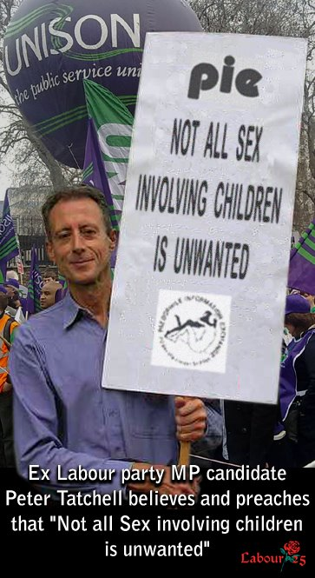
Islington People he is worth a mention. While he was studying Politics, Philosophy and Economics at Keble College, Oxford he was a member of the University Conservative Association and in 1986 appeared at a University Ball dressed as a Nazi. At the Treasury it was Balls’s idea to sell off British gold reserves and buy Euros. Balls was also put in charge of the deregulation of the City by Gordon Brown who paid his wife 50,000 pounds to be his beard, which helped lead to the financial collapse. When Gordon Brown became Prime Minister in 2007, Balls was promoted to Secretary of State for Children, Schools and Families and he immediately tried to introduce compulsory sex education for all Schoolchildren from the age of 5 including simulating masturbation with sex toys. Even within Labour Party circles he is seen as a bit weird. You really cannot make this stuff up!!
PLEASE NOTE: In the UK the original D-Notice system was introduced in 1912 and run as a voluntary system by a joint committee headed by an Assistant Secretary of the War Office and a representative of the Press Association.In 1993, the notices were renamed DA-Notices.
Any D-Notices or DA-notices are advisory requests so are not legally enforceable and hence news editors can, in theory, choose not to abide by them. However, they are generally complied with by the media. In 1971, all existing D-Notices were cancelled and replaced by standing D-Notices that gave general guidance on what could be published and what could not, and what would require further advice from the secretary of the Defence, Press and Broadcasting Advisory Committee (DPBAC).
FORGET POLITICAL CORRECTNESS WHERE CHILD SAFETY IS INVOLVED:
The 1992 analysis by Stephen Green (The Sexual Dead End, Broad View) indicates that in the UK a homosexual male is 23 times more likely to commit a sex offence against an under 16 than a heterosexual male. It does not follow that all, or even the majority, of homosexual persons are drawn to sexually abusing children , but would you use one as a babysitter?
Labour Party Paedophile Scandal 1
Harriet Ruth Harman MP QC (born 1950) She was the interim Leader of the Labour Party, and Leader of the Opposition, from 11 May to 25 September 2010. Harman is currently Deputy Leader for the Labour Party. After qualifying as a lawyer, Harriet Harman worked for Brent Law Centre in London. Her husband is Jack Dromey MP. She is the niece of Lord Longford who investigated prostitution with Jimmy Savile and Cliff Richards at various clubs in Denmark.
Between 1978 and 1982, Harriet Harman was employed as the Legal Officer for the National Council for Civil Liberties which later became Liberty.
At the time the National Council for Civil Liberties was officially affiliated to two organisations, the Paedophile Information Exchange and the Paedophile Action for Liberation, whose members argued openly for the abolition of the age of consent.
When Harriet Harman first entered politics this matter was brought up, but a friendly media and other politicians accepted her claims that the NCCL no longer had any connection with P.I.E./P.A.L. when she was Legal Officer between 1978 and 1982 . However it later transpired that P.I.E./P.A.L. had been officially affiliated with the NCCL until 1982, when Harman left and P.I.E./P.A.L. went underground.
She has since repeatedly veered between denying any connection with P.I.E. and P.A.L., and claiming that as a Legal Officer for the NCCL she had no choice in who she represented. Patricia Hewitt ex MP was General Secretary of the National Council for Civil Liberties from 1974 to 1983.
As with a lot of liars Harman has different versions of events for different audiences.
Let’s look at the first lie that she was never connected or in contact with P.I.E. or P.A.L. in any way:
Documents now in the Public Domain show a NCCL letter signed by Harriet Harman objecting in the strongest terms to any laws against child pornography, unless it could be proved by the prosecution that the child was harmed. The NCCL also submitted a response to the Government arguing for lowering the age of consent and stating “ Childhood sexual experiences , willingly engaged in , with an adult result in no identifiable damage.” When the Government moved to crack down on child pornography , the NCCL’s response, again signed by Harriet Harman , claimed the new law could lead to “ absurd prosecutions and increased censorship”. As Legal Officer for the NCCL she also argued to abolish incest laws. Jack Dromey served on the NCCL Executive Committee from 1970 to 1979. There are allegations that Lord Longford was part of this lobbying but no documentary evidence has emerged yet.
So having nailed the lie that she was never involved in P.I.E. or P.A.L. let’s have a look at the lie that she had no choice but to represent paedophile groups as Legal Officer for NCCL. Well this is also obviously not true as visiting the NCCL/Liberty website will show that NCCL/Liberty state : “ Liberty receives thousands of requests for legal advice and assistance each year. Because we’re a small organisation with limited resources, our lawyers are unable to take up all of these cases actively.”
So clearly NCCL/Liberty don’t have to take up every case they are approached with.
P.I.E. went underground in 1982, but resurfaced in June 2012 mounting a demo in support of muslim paedophiles outside Liverpool Crown Court led by Labour Party Councillor Louise Baldock and Labour Party Activists Bob Sutton , Maev McDaid , Phil Dickens and Nikki McDonough.
For more Labour Party paedophile scandals google “ Labour25” .
Labour Party Paedophile Scandal 2
In the London Borough of Islington, all of Islington’s 12 children’s homes were run by paedophiles from the 70′s up until the early 90′s and protected by Islington Council and the National Government. Victims vigorously pursued justice and appealed to all levels of government for help but were blocked at every turn.
While government authorities continually refused to investigate despite undeniable evidence, The Evening Standard newspaper did investigate and found that many of the children’s homes managers were part of an international ring that supplied children for abuse and pornography after the Care Home system had been infiltrated by the Gay Liberation Front, who had insisted no background checks were made on care workers.. The abuse in Islington was connected to the abuse and murder ring in Jersey and other locations and children were exchanged between facilities. Police in the UK and Jersey were given full details but would not investigate.
The Jersey investigation was hampered at every turn by the authorities in Jersey and Deputy Chief Officer Lenny Harper, who headed up the investigation, faced sustained obstruction from fellow policemen as well as threats from members of Jersey’s government and prominent citizens. He had to bring in police from the UK to assist in the investigation due to the lack of cooperation from local police and government officials. Jack Straw MP was the Labour Home Secretary at the time.
Harper retired under death threats in 2008 and has been the repeated target of efforts to discredit him and the investigation he courageously led. The Jersey government even went so far as to issue an arrest warrant for Harper after he left the Island, claiming that he was under investigation for falsifying evidence.
One of the people instrumental in the cover up was Margaret Hodge. She started her political career in 1973 as an Islington councillor and was Council Leader from 1982 through 1992. During her reign, the children’s homes were engaging in wholesale abuse of children and she did all she could to protect the operations.
Not all Islington Council employees were involved in the abuse of children. Social workers Liz Davies and David Cofie resigned their jobs so they could report the abuse to authorities and demand that Scotland Yard investigate. Liz Davies had refused to deliver a 7 year old girl to a known paedophile. Other Islington social workers wanted to testify but were afraid for their jobs.
The exposure of the paedophile ring resulted in the conviction of only Roy Caterer, who spent 7 1/2 years in prison for sexually abusing seven boys and two girls.
Scotland Yard refused to investigate further despite overwhelming evidence and persistent pleas by the former social workers and victims.
It wasn’t until The Evening Standard started covering the story that the public outcry forced Margaret Hodge to resign her position as Council Leader after describing the journalists as “ gutter press “ and the victims as “ extremely disturbed and mentally unstable“. But British Children weren’t safe for long.
In 2003, fully aware of Hodge’s avid support of child abuse, British Prime Minister Tony Blair made Hodge his Minister for Children . The position was created just for Hodge. Such a blatantly defiant act by Tony Blair shows unconditional support for paedophiles at the highest levels of British government and the ruling class.
Hodge was further rewarded on 27 June 2007 when she was appointed Minister of State at the Department for Culture, Media and Sport by the new Prime Minister, Gordon Brown. Hodge is Jewish and married to another politician, Sir Henry Hodge, who was made a high court judge in 2004.
Margaret Hodge was a key component of Tony Blair’s “ Islington Set “ and lived a few doors away from him.
For more Labour Party paedophile scandals please google “ Labour25”
Satanic Sir Jimmy Savile’s Funeral Mystery
Satanic Saville, as well as 450 accusations of rape, pedophilia and necrophilia against him had the reputation as a procurer of children for the Satanic Elite, Heath, Wilson, Driberg - "who gave buggery a bad name" , Cyril Smith etc. Savile died, supposedly, in a car crash in the same way that Robert Maxwell "died" on his yacht. There does seem to be a bit of a shroud of mystery over who attended Jimmy Savile’s funeral and who sent tributes as no official guest list has been released , but this is what I have:
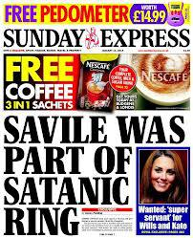
JIMMY SAVILE IN SATANIC REGALIA
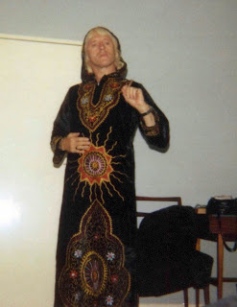
So who attended Sir Jimmy Savile’s funeral?
Monsignor Kieran Heskin, Father Martin Kelly and Reverend Arthur Roche officiated.
John Beerling – not a well known character but is well worth considering as he was connected with Lord Levi's Magnet Records by being in charge of recruiting all the DJ s at Radio One from 1967 to 1993 and hired Savile in 1969.
Howard Silverman Savile’s best friend ( worth a very good look at ).
Frank Bruno
DJ Mike Read
DJ Tony Prince ( who made a strange Satanic/Illuminati hand signal at the funeral ).
DJ Dave Eager
DJ Dave Lee Travis
DJ Tony Blackburn
DJ David “Diddy” Hamilton.
Not sure about Esther Rancid as there is no photo of her there.
So who sent tributes?
The Prince of Wales and the Duchess of Cornwall led the tributes to him.
The Bee Gees sent cards and flowers – Michael Jackson has previously stated that Robin Gibb “ also liked sleeping with Children “.
Cameron/Clegg/Miliband all sent tributes and/or flowers.
Most mass media outlets sent tributes/flowers/cards/representatives.
08/02/2014 at 8:41 pm
Over 13 months since the last comment here, I note that not 1 single politician has been arrested since the JS scandal broke. Just a few predictable has-been celebrities, nothing more. In the absence of anything else happening, can we now conclude that the matter has finally been put to bed to the P.’s T. B.’s satisfaction?
2014 Cameron Cabinet reshuffle outs Pedophiles
Sacked, William Hague was proposed at 16 by Pedophile Leon Brittan
Sacked, Ken Clarke
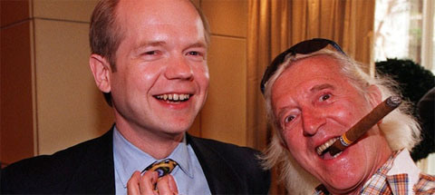
HAGUE SAVILE
Satanic ISIS and Saudi Arabian Wahhabism
ISIS - Venetian created British Secret Services created Wahhabism in 1706 - based on the same principles as Lutherism - and institutionalised it in MI6 created Saudi Arabia to create destabilising Jihadi Armies and rapeugees creating chaos in Europe, Middle East, Russia and China..
See this book http://energyenhancement.org/Hempher-14-ConfessionsOfABritishSpy.pdf
The Satanic British Empire Masonic leaders, whose genealogy goes back to the Satanic Babylonian Empire, embarked on a plan to subvert Islam from within, and to distort the Islamic world and render it predisposed to a confrontation with the West. Key to this strategy was the creation of the Salafi movement, which was an outgrowth of the emergence of the Egyptian Freemasonry of Cagliostro, which today is closely aligned to the Wahhabis of Saudi Arabia.
According to their devious strategy of “divide and conquer”, the Satanic British Empire deliberately created the Wahhabi movement in order to upset the Ottoman Empire. At the height of its power, between the seventh and the sixteenth centuries, the Ottoman Empire spanned three continents, controlling much of Southeastern Europe, the Middle East and North Africa. It stretched from the Strait of Gibraltar in the west to the Caspian Sea and Persian Gulf in the east, and from the edge of Austria, Hungary and parts of Ukraine in the north to Sudan, Eritrea, Somalia and Yemen in the south.
However, at the same time, the Satanic British Empire were beginning to encroach upon former Muslim territories, in particular, making significant inroads into India. Nevertheless, they continued to have designs on the various parts of the Ottoman Empire, and worked to aid in its collapse by fomenting rebellion from within.
Part of their strategy - not including the invasion of the Emperors harem with women secret agents, Secret Agent Mazzini's creation of the masonic Young Turks who were responsible for the fall of the Ottoman Empire and the million person Genocide of the Christians in Armenia..
THE SATANIC HISTORY OF THE WORLD - PART ONE - The Satanic Psychopathic Palmerston, Prime Minister of the British Empire circa 1850 - and his Three Satanic Psychopathic British Agents, Mazzini, Urquhart and Napoleon III - as a Continuation of the same Satanic Psychopathic Families from Satanic Psychopathic Babylon through the Satanic Psychopathic Roman Empire, the Satanic Psychopathic Venetian Empire to the Satanic Psychopathic British Empire to the current Satanic Psychopathic Anglo-American Establishment
and the promotion of Sabbatean Frankist Kemal Attaturk - was focused on the creation of the Wahhabi sect of Saudi Arabia. Today, the Wahhabis insinuate themselves as legitimate members of the Sunni body of Islam. They will even reject the appellation, claiming there is no such thing as a “Wahhabi”. However, what they retain in common is an adherence to the so-called reforms of their founder, Mohammed Abdul Wahhab. And while the Wahhabis employ various tactics to defend the legitimacy of their ideology, the most incriminating facts against them lie in their history in the subversion of the Islamic world.
The Satanic British Empire creation of the Wahhabi sect is outlined in a document named The Memoirs of Mr. Hempher: A Satanic British Empire Spy to the Middle East, said to have been published in series in the German magazine Der Spiegel, and later in a prominent French paper. A Lebanese doctor translated the document into Arabic, from which it was translated to English and other languages. While some have attempted to refute the legitimacy of the document, it provides the only reasonable scenario for explaining the very extreme and absurd claims of Abdul Wahhab.
In any case, Mir’at al Harramin, a Turkish work by Ayyub Sabri Pasha, written in 1888, made the same claim, stating that in Basra, Abdul Wahhab had come into contact with a Satanic British Empire spy by the name of Hempher, who “inspired in him the tricks and lies that he had learned from the Satanic British Empire Ministry of the Commonwealth.”70
Hempher claims to have been one of nine spies sent to the Middle East for such a purpose. He reports, “we were designing long term plans to wage discord, ignorance, poverty, and even diseases in these countries. We were imitating - infil-traition - the customs and traditions of these two countries, thus easily concealing our intentions.” The pretext Hempher offered for his actions was:
We, the English people, have to make mischief and arouse schism in all our colonies in order that we may live in welfare and luxury. Only by means of such instigations will we be able to demolish the Ottoman Empire.
Otherwise, how could a nation with a small population bring another nation with a greater population under its sway? Look for the mouth of the chasm with all your might, and get in as soon as you find it. You should know that the Ottoman and Iranian Empires have reached the nadir of their lives.
Therefore, your first duty is to instigate the people against the administration! History has shown that “The source of all sorts of revolutions is public rebellions.” When the unity of Muslims is broken and the common sympathy among them is impaired, their forces will be dissolved and thus we shall easily destroy them.
In 1710, the Satanic British Empire government sent Hempher to Egypt, Iraq, Arabia and Istanbul, where he learned Arabic, Turkish and Islamic law. After two years, he first returned to London for briefing, before being sent to Basra, a mixed city of Sunni and Shiah, where Hempher met Abdul Wahhab. Recognising his insolence towards the Qur’an and traditions of Islam, Hempher recognised him as the ideal candidate for the Satanic British Empire strategy. Stipulations were that he was to be supported with adequate financing and weaponry, to protect himself against states and scholars who would certainly attack him after he would announce his ideas. And, that a principality ought to be established in his native country of Arabia.
Ultimately, the reforms issued by the Satanic British Empire through the mouth of Abdul Wahhab were designed to instigate the Muslims against other Muslims, and more specifically, against the Ottoman Empire. Thus, despite the very grave problems that were plaguing the Muslim world, as well as the encroachment of non-Muslim powers on traditional Muslim lands, Abdul Wahhab sought to identify the ills troubling the Muslims, in accordance to the stipulations of the plan, as their practice of visiting mausoleums and asking intercession from “saints”, or deceased holy men.
Muslim worshippers were often in the habit of visiting the graves of holy men, and asking them to pray on their behalf. To fulfil his obligation to the Satanic British Empire, Abdul Wahhab used the justifiable objection to this practice as a pretext to argue that, by asking help from someone other than God, they were actually “worshipping” these holy men, and were ignorantly committing an act of idolatry that caused them to forfeit Islam and become apostates. It was then permitted, he argued, to fight them. This was the pretext used by the Satanic British Empire, through the mouth of Abdul Wahhab, to incite the Arabs against the Turks.
This is the same trick played by the Venetian Empire by its Agent Cardinal Contarini who hired Agent Martin Luther to play the same trick on it's enemy, The Catholic Church, by funding the Protestant Church thus creating a war which destroyed Europe..
To further his argument, Abdul Wahhab suggested that all the world of Islam was mired in a state of ignorance, which could be likened to Arabia prior to the arrival of Islam. There are several instances in the Qur’an where God calls attention to the hypocrisy of a man who will pray to God alone when he is faced with some calamity, but that, once he is free of distress, returns to his idols. Abdul Wahhab declared then, that the Muslims were similar, and that, despite otherwise insisting they were worshipping the one God, they were nevertheless also idol worshippers.
This trick is the same performed by the Venetian Empire by Venetian Cardinal Contarini when he paid Venetian Agent Luther in his formation of Protestantism to divide the Catholic Church and Europe for centuries ending in the Peace of Westphalia..
The brother of Abdul Wahhab, Shaykh Sulaiman bin Abdul Wahab, said about his brother, in Sawaa’iqul Ilahiya, “The horn of Satan which the Prophet (peace be upon him) referred to is you.” He was referring to the hadith found in Sahih Bukhari:
Ibn Umar (Allah be pleased with him) reported the Prophet (Peace be upon him) as saying: “Oh Allah, bless us in our Syria; O Allah, bless us in our Yemen.” Those present said: “And in our Najd, O Messenger of Allah!” But he said, “O Allah, bless us in our Syria; O Allah, bless us in our Yemen.” Those present said, "And in our Najd, O Messenger of Allah!” Ibn Umar said that he thought that he said on the third occasion: “Earthquakes and fitnah are there, and there shall arise the horn of ash-Shaytaan.”
Satanic British Empire and now Satanic Anglo-American Establishment created Saudi Arabian Wahhabism has destroyed most of the shrines in Medina and through financial and military support of Wahhabi ISIS and Taliban Jihadis is destroying Buddhist shrines in Afghanistan, Christian shrines in Syria and Muslin Shrines across the Middle East.
Satanic British Empire and now Satanic Anglo-American Establishment Saudi Arabian Wahhabism created the mercenary jihadi armies which are fighting in Afghanistan, Libya, Syria, Iraq and Egypt under the names of Taliban, Al Qaeda, Al Nusra and ISIS.
The leader of ISIS, Abu Bakr al-Baghdadi, a graduate of the Satanic mind control University of Guantanamo Bay, announced the creation of an Islamic State, or caliphate, encompassing the lands that the group has taken under its control. He also called on Muslims throughout the world to join the cause and fight for ISIS.
"Muslims everywhere, whoever is capable of performing hijrah (emigration) to the Islamic State, then let him do so, because hijrah to the land of Islam is obligatory," he added.
A group of jihadists claiming to be part of ISIS have vowed to invade Spain along with all other “occupied lands” in a video posted on the web.
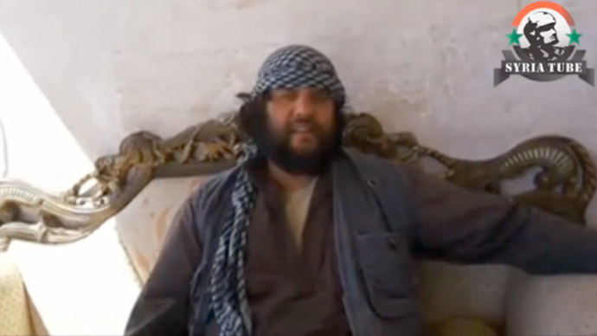
The men say Spain is the land of their forefathers and that they are prepared to die for their nascent Islamic State.
The video of two men claiming to be militants from the Islamic State of Iraq and the Levant (ISIS) has taken the Spanish media by storm. The minute-long footage shows them speaking in Spanish, and saying that ISIS will take over Spain.
“I tell you, Spain is the land of our forefathers, and, Allah willing, we are going to liberate it, with the might of Allah,” says one of the men. He adds that the group won’t stop at Spain and intends to spread its Islamic Caliphate across the world.
SATANISM – 10,000 YEARS OF TOTAL CONTROL
The Battle of Armageddon can only be won by sufficient Angels to fight against the Demons.
Be an Angel!!
Get Tooled Up and Ready with the Energy Enhancement Video Course in Four Levels and Live at Iguazu Falls..
The difference between the simple Ring of Gyges of the Hobbit and the One Ring of the Lord of the Rings is - ‘‘into this ring he poured all his cruelty, his malice and his will to dominate all life’‘ -
The difference is this energy of cruelty..
Used for one purpose The Concealment of Wickedness.
And here is where the elite get all their negative energy or as we call it in Energy Enhancement - Trauma-Formed Negative Karmic Mass.. from Ritual Human Sacrifice - a Satanic Ritual used in all civilisations on All Continents by the Satanic Elites for tens of Thousands of years.
Yes Satanism, the Occult Cult was created 10,000 years ago before Christ, and has been extant since that time in order to make the psychopaths which rule humanity, grind us down, make us into feudal wage slaves

