Many scholars claim that Phoenician/Jewish families also brought the tale of Samson to Greece, where it became the story of Hercules and the Nemean lion.

In that version, Hercules strangles the invincible lion, skins it using its own claws, and uses its indestructible hide as armor for himself. In a way, he’s living inside the lion’s carcass, just like Samson’s bees or flies - The Lord of the Flies is Satan - and is covering himself with the lion, just as the word means “cover”.

The pun works in English as well, because that is the actual etymology: “hiding” beneath a “hide”.

Hercules posing with his club and cloaked in the lion’s empty shell has been widely used as a symbol of imperial and national strength. Could he have been a different symbol for the Phoenician/Jewish families? A symbol that even in antiquity, the mighty empires and nations had already been defeated, by gay actors of all people!?

So, the symbology of Hercules is infil-traition.

We find in the book, AGAINST SATANISM VOL 6, that over thousands of years, spook Jewish/Phoenician aristocratic Families infiltrated every country, every ruling aristocracy and aristocratic, bloodline family, in Europe, Britain, America, India, China and in every other country in the World.

Bloodline Jewish/Phoenician aristocrats were never attached to any tiny nation, but were always one globalized trading empire from 2000BC, playing countries against each other for profit.

For example, burning down a farm, or stealing all their cattle, making the family bankrupt, buying the farm from their own Jewish/Phoenician aristocrat owned bank for pennies on the dollar.

Or creating a depression so no-one can pay their mortgages so the house is taken back by the bank, every bank is owned by the same rich aristocratic Phoenician/Jewish families, then the same rich aristocratic Phoenician/Jewish families buy back the house from their own bank for pennies on the dollar.

Or owning every major industry – the Military Academic Industrial Complex – and creating a False Flag, say the Gulf of Tonkin which started the Vietnam War, or the Lusitania which started World War One – then taking profits from overpriced War materials, munitions, Cruise Missiles, F35 Jets, Aircraft Carriers, Nuclear Submarines, Space Weapons, standing armies, food, clothing, funerals. A one Trillion Dollar annual budget - see Schindlers List.

Starting a fake war between ruling elites in separate countries, but all ruling elites coming from the same Bloodline Jewish/Phoenician aristocratic families, and then buying all the assets for pennies on the dollar.

Or prohibiting Alcohol, Heroin, Cocaine, and Marijuana by Law by paying their Political Stooges – also from the same thousands of years old Jewish/Phoenician aristocratic bloodline Families – including Dark Side Mafia Families which are the same thousands of years old Jewish/Phoenician aristocratic bloodline Families as who are the Political Stooges. Selling the drugs at incredibly inflated profitable prices. Destroying the potential of humanity to fight back. Sapping the Spiritual energy of Humanity. Maintaining the 10,000 year control of Humanity.

And therefore creating a trillion dollar a year business run by the Mafia and the profits laundered by the Senators from the the same thousands of years old Jewish/Phoenician aristocratic bloodline Families – after the Chinese “Free Trade” drugs and slaves - British HSBC – Hong Kong and Shanghai Banking Corporation or the British Pirates of the Caribbean Banks have laundered the money and invested in legitimate businesses, estates, land, diamonds, bribes and gold, owned by the same rich aristocratic Bloodline Phoenician/Jewish families.

Then Alcolhol is legitimized legalized to create heavy taxes and creating incredibly profitable breweries and Spirits companies owned by the same rich aristocratic Phoenician/Jewish families

Then the drugs are legalized to create heavy taxes and incredibly profitable companies – like BAT, British/American Tobacco owned by the same thousands of years old Jewish/Phoenician aristocratic bloodline Families.

With Marijuana/Soma set to follow.

Rich aristocratic Bloodline Phoenician/Jewish families came from the Fertile Crescent, Syria, Lebanon, Mesopotamia, Persia, but had that region razed many times over nonetheless. They hopped to and fro over the planet, always shifting, reshuffling and building their Empires then breaking their Empires for profit, feeding off their riches.

Second, we saw that the important conquests are not in our history books as such. Rather, Europe was colonized in the Bronze Age already, in patterns that match up with structures we see in today’s spook aristocracy. The entire upper class of colonized regions was replaced by Bloodline Phoenician/Jewish families, with common people unaware of it, to this day. Some of this colonization is cautiously admitted, just not emphasized.

Third, we saw that the spooks always held power. The secret behind their power is simply that there is no big secret. They don’t know anything special. They can’t do anything special. They never achieved anything special—other than monopolizing trade. With the power to deceive, owning all the media, - The CIA, Universities, History, Books, Magazines, Newspapers, Television, Youtube, Facebook, Google - even idiots can rule the world for millennia.

But what rulers?

Bloodline Phoenician/Jewish families who have ruled the World as one trading block for thousands of years before the Birth of Christ.

Their Gods are the 10,000 years old Evil Gods of Satan, Lucifer, Baal, Bel, Cybele and Attis, Moloch and Human sacrifice.

Evil because Satan, Lucifer, Cybele, Moloch are defined by Satanic Ritual and Human sacrifice.

The Satanic Rituals have been used from 10,000 years of Moloch Ritual burning, Ritual Human Sacrifice, Ritual Blood Sacrifice, Ritual Drugs, Ritual Sex, Ritual Homosexuality, Ritual Pedophilia, Ritual Castration, Ritual Cannibalism, immolation, molestation.

Satanic Ritual Cybele and Adonis and Mithras were the State Religions of the Roman Empire – with its Tauroboleum in which worshippers were showered with the blood of Human and Animal Sacrifices, Ritual Castration and all the Rituals above usually performed in caves catacombs deep in the earth.

Tauroboleum of Satanic Cybele and Attis

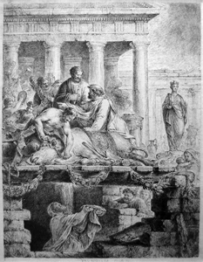

Satanic Ritual CYBELE AND ATTIS ROMAN STATE RELIGION TAUROBOLEUM RITUAL ANIMAL AND HUMAN SACRIFICE BATHING IN BLOOD

The key is that the Satanic Religion and its recruiting cults of Freemasonry and the Crowlean Sexual Ritual Ordo Templi Orientis are Fake Gangs, created by men as a technique to conquer the world.

The Satanic Rituals have been used from 10,000 years of Moloch Ritual burning, Human Sacrifice immolation, molestation.

Cybele and Adonis – State Religion of the Roman Empire – with its Tauroboleum in which worshippers were showered with the blood of Human and Animal Sacrifices.

Cybele and Adonis – State Religion of the Roman Empire – with its homosexual, pedophile satanic rituals, castrated homosexual Galli priests and Russian Skoptsy and Amazon Breast castration.

All of this points to how Satanic Ritual has been used to create a psychopathic Bloodline overclass, control the lower orders and degenerate society for thousands of years whilst hiding behind Christianity.

In war, the real Luciferian Elite - The heads of all the thousands of years old Generational Satanic Dynastic Bloodline families worldwide believe that the Religion which is strongest in creating intelligent Psychopaths to rule, will win the competition to rule the world and maintain the totally fooled Christian population in a poverty stricken, media–controlled uneducated and degenerate state lacking in evolution.

A Golden Goose Society, ready to be plucked and eaten by the Satanic Bloodline families - Eternally.

**Go to** [**http://www.energyenhancement.org**](http://www.energyenhancement.org) **for 19 Free Energy Enhancement Books.**

**To defeat Evil, you need to up your game. Learn the Energy Enhancement Meditation Course by Video or Live in Iguazu.**

Preface ……………20

Chapter 1. KABBALAH, HERMETICISM AND THE OCCULT ………….32

Chapter 2. PHILIP III THE BOLD AND THE CRUSADES………..89

Chapter 3. HENRY VII – ANOTHER JEWISH INVASION OF ENGLAND..140

Chapter 4. THRONES INFILTRATED…168

Chapter 5. ANCIENT SPOOKS Part I: The pun factor in spookery…191

Chapter 6. ANCIENT SPOOKS Part II: Spookish relations ….236

# Chapter 7. ANCIENT SPOOKS Part III: Part III: Link to a spooky past..27

Chapter 8. ANCIENT SPOOKS Part IV: Spookdom’s trail into history.. 320

Chapter 9. The Curse Of Satanic Canaan; A Satanic Demonology Of History..407

Chapter 10. PHOENICIAN SATANIC RITUALS…459

Chapter 10. PHOENICIAN WORLD CONTROL…500

Chapter 11. SATANISM HAS BEEN USED TO RULE FOR 10,000 YEARS…537

Chapter 12. Pippin the Short and the Forgery of Catholicism…548

Chapter 13. THE VENERABLE BEDE FORGED THE PROVENANCE OF THE CATHOLIC CHURCH IN EUROPE..559

Chapter 14. CHARLEMAGNE AND THE FORGERY OF THE CATHOLIC CHURCH …565

Chapter 15. "Saint" Francis of Assisi Was the Phoenician - Morosini Bloodline - Doge of the Venician Empire, Partnered in Commerce with the Pope of the Catholic Church…...575

Chapter 10.

Chapter 10.

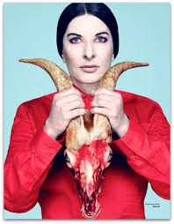

Riches, luxury, a higher standard of living had softened the leaders and armies of the Roman Empire.

Mad, Satanic Roman Emperors had created a disgust amongst the population for Ritual Satanic Murder Sacrifices and the poor people turned to Christianity which by itself should have civilised the world and made it evolved and rich.

However, the thousands of years old Generational Satanic Dynastic Bloodline families worldwide hid their Satanism behind Roman Empire created Christianity - they became Crypto Christians - and infiltrated Christianity into Satanic states to hasten their takeover.

1. So as to secretly continue to create a Satanic Psychopath Elite who follow Satanic Ritual...

RITUAL SEX, RITUAL DRUGS, RITUAL BLOOD SACRIFICE, RITUAL HUMAN SACRIFICE, RITUAL TORTURE, RITUAL BURNING ALIVE, RITUAL CANNIBALISM, RITUAL CASTRATION

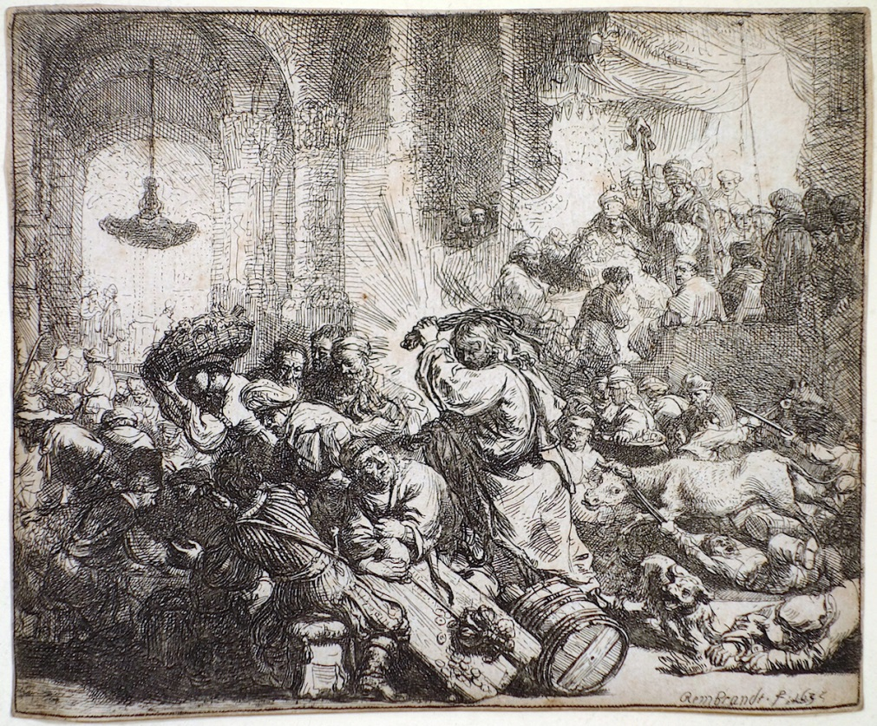

REMBRANDT – CHRIST WHIPPING THE BANKERS OUT OF THE TEMPLE..

.. in all the thousands of years old Generational Satanic Dynastic Bloodline families worldwide. Satanic Ritual has been used to create a psychopathic overclass, control the lower orders and degenerate society for thousands of years - a society controlled by Satanic Psychopaths.

2. So as to Infiltrate a type of naive Christianity - ignorant of their Satanic Psychopathic rulers - remember, Christ whipped the bankers out of the Temple, - in every country in the world so as to allow them to become conquered and stay conquered - to subdue even their own populations, whilst maintaining Satanism in their own Bloodline Families.