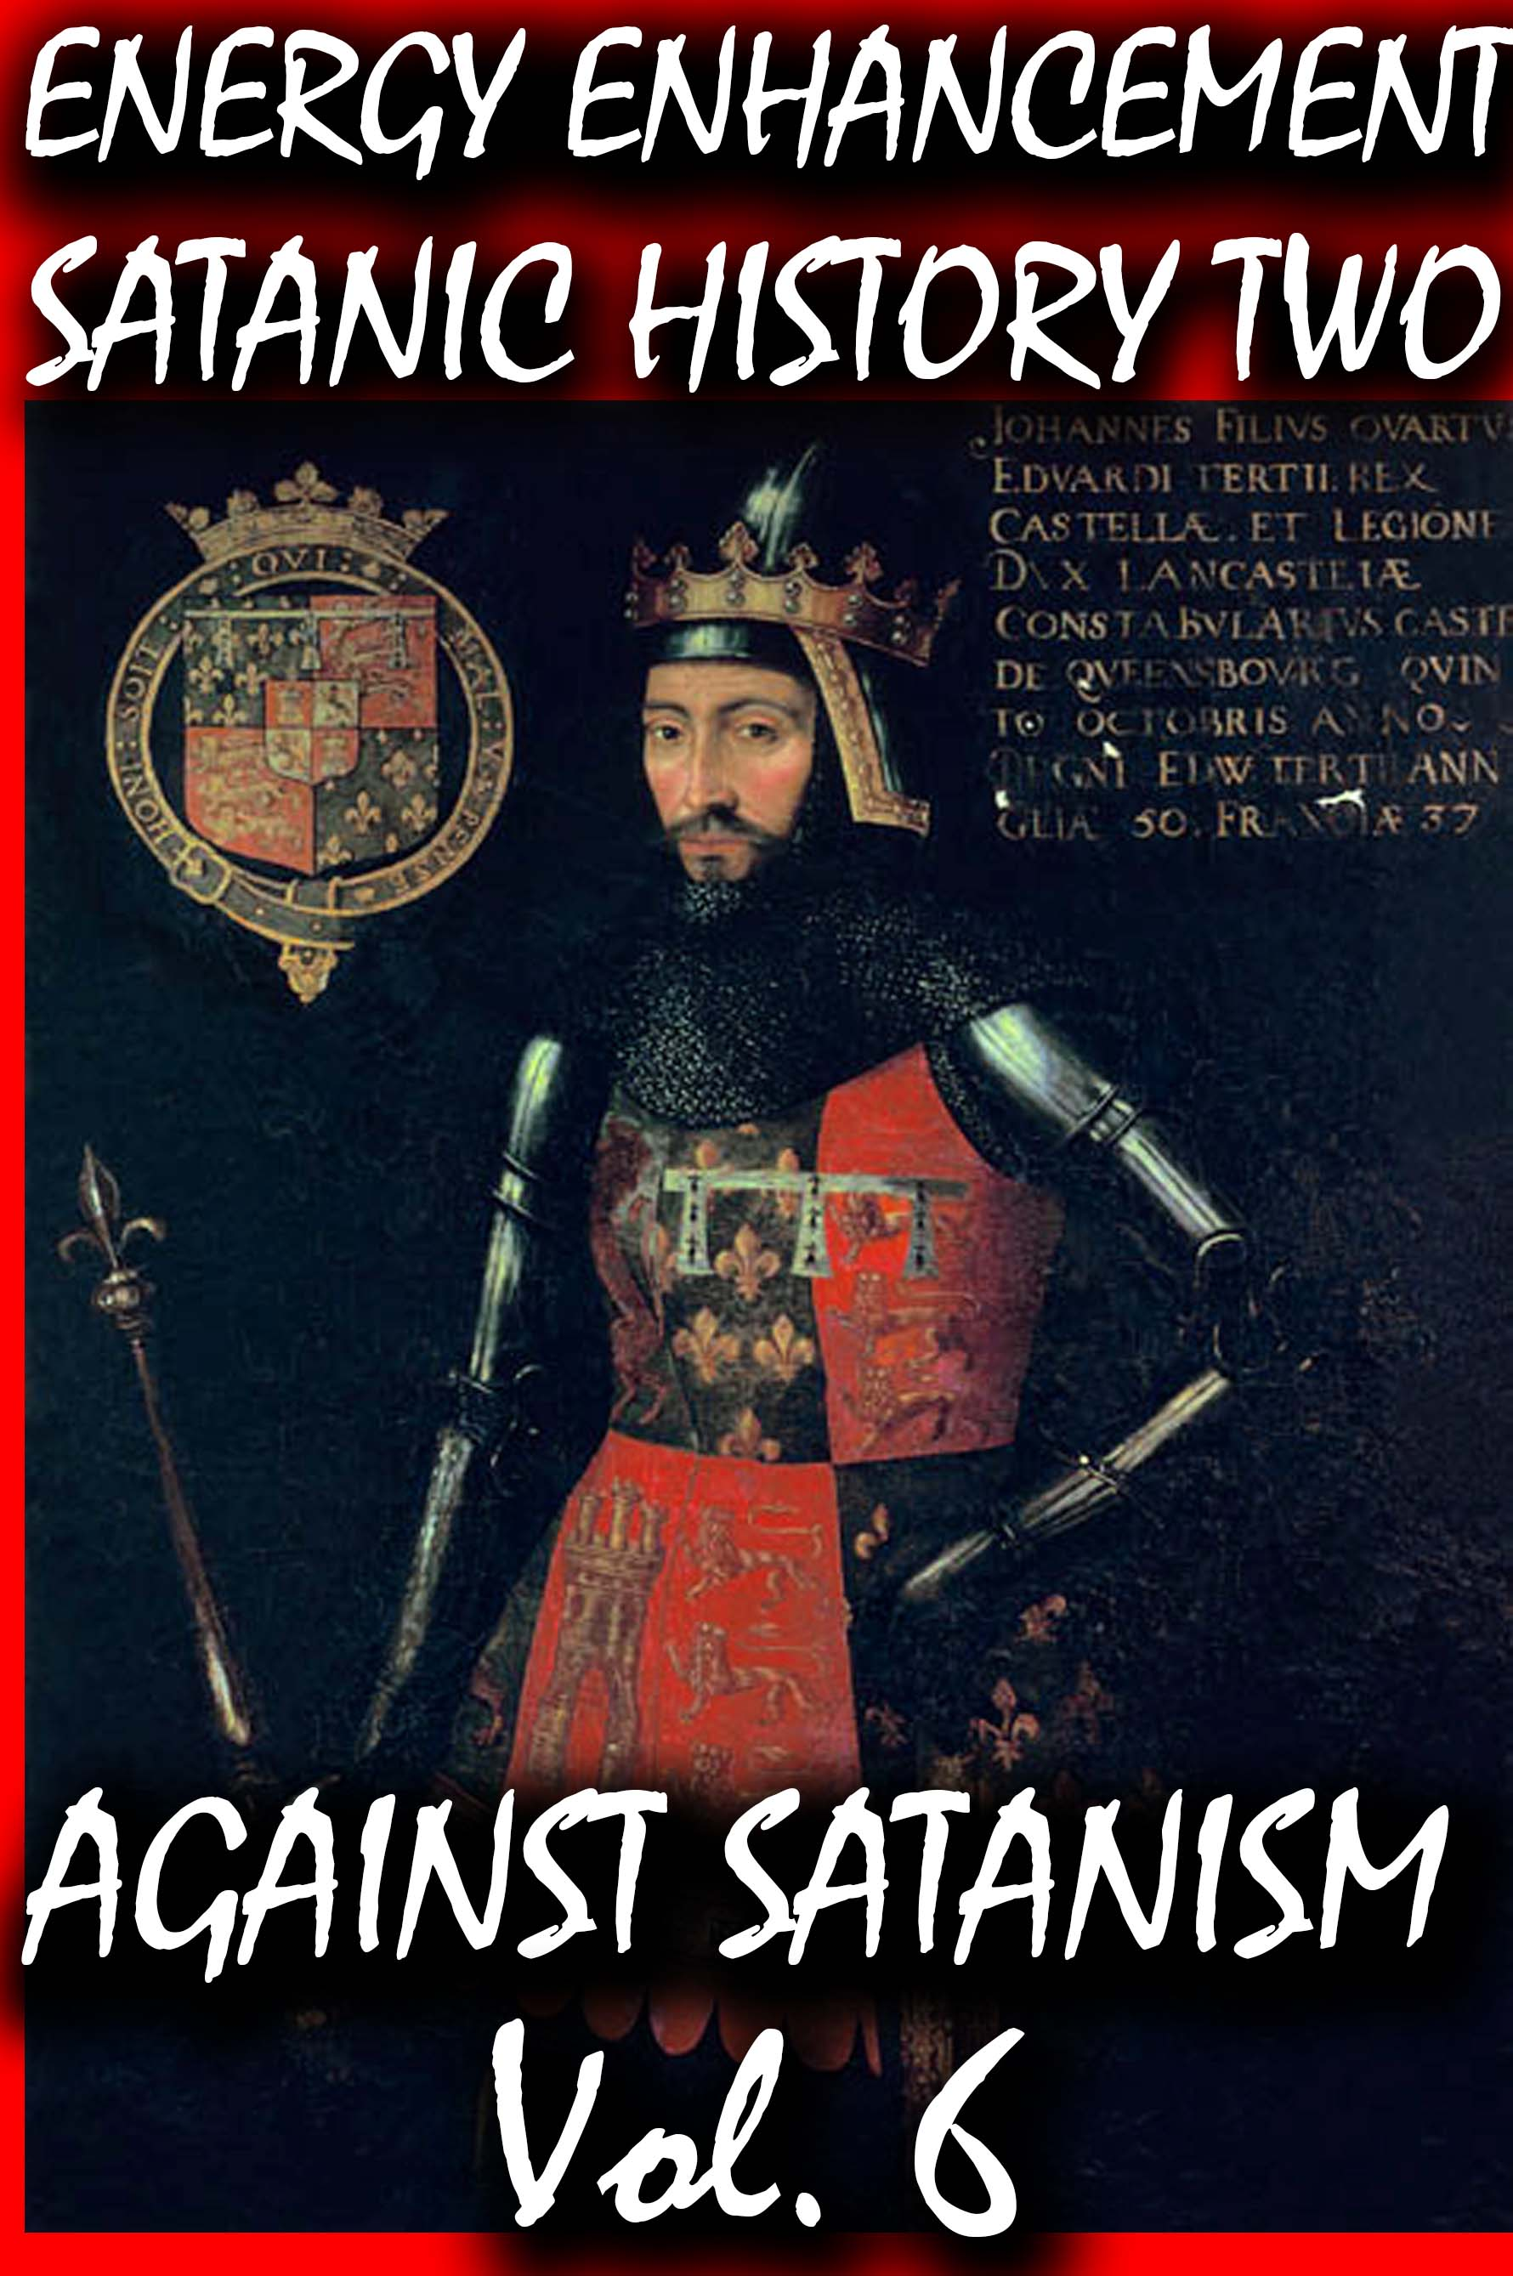
DEDICATION
With all Thanks, Love and Gratitude to Swami Devi Dhyani and all the helpers who make these books and DVDs possible.
With all Thanks, Love and Gratitude to my Mother and Father and to all my other Teachers, Theos Bernard, Sri Yogendra, Eric Berne, Gurdjieff, Father Bede Griffiths, Osho, Zen Master Hogen, Swami Sivananda, Swami Satchitananda, and all the other giants upon whose shoulders I stand - who made me able to be what… I AM – Swami Satchidanand

Copyright © 2020

[Energy Enhancement Synthesis of Light Limited (SOL)]

All rights reserved. This publication may be reproduced in whole or in part, by any person under fair use as long as we are referenced, without written permission of:
Swami Satchidanand

sol@energyenhancement.org
www.energyenhancement.org

Table of Contents
RACE WITH THE HORNED GOD, THE HART WITCHES, DEVONTE, TINY HANNAH AND THE SCANDINAVIANS 21
THE GATES OF HELL, MK ULTRA- OFTEN, RACIAL MASS MURDER & THE STAGED ESCAPE OF THE HART WITCHES FROM WITCH MOUNTAIN, WASHINGTON 73
HIS EYE IS ON THE SPARROW, DEVONTE AND THE HART WITCHES, LIES, CIA OCCULT BUREAU & JONESTOWN 116
JUNGLE ACTION: JAYBO, THE BLACK PANTHER & THE DEHUMANIZATION OF BLACK PEOPLE 156
PART TWO, THE BLACK PANTHER MOVIE, CIA AND DANGEROUS ILLUSIONS- PSYCHOLOGICAL WARFARE 183
PART ONE, THE BLACK PANTHER MOVIE, CIA AND DANGEROUS ILLUSIONS- PSYCHOLOGICAL WARFARE 213
THE BLACK PANTHER & NIKOLAS CRUZ, DARK DOMINANCE- CIA ROCK IN THE CRADLE OF THE THIRD REICH 245
JAY Z, JAYBO & PANTHER, “GET OUT”, THE NEGRO- APE METAPHOR CARICATURE: THE GLOBAL RACIST EUGENIC PLOT TO ANIMALIZE, SIMIANIZE AND COLONIZE BLACK PEOPLE 310
U.S. TRADEMARK PROTECTION, JAY Z, JAYBO- NEGRO SIMIAN HOMINOID CARICATURE, SATANIC MONKEY GODS & TRIBES 379
FROM DONALD J. DRUMPF’S SHITHOLE, DONNY TO LUCIFER’S COONS JAYBO & CARDI-B AND AFRICA- THE MOTHER COUNTRY OF THE UNIVERSE 406
DONNY HATHAWAY WAS A MURDER VICTIM- REOPEN DEATH BY SUICIDE! 458
THE ASSASSINATION OF DONNY HATHAWAY, EVERYTHING IS EVERYTHING IN FOUR MOVEMENTS 497
OMAROSA, CIA MK ULTRA, GUTTER’S CREW, PIZZAGATE & THE BLACK WOMAN’S WAR 537
THE FALSE FLAG BLACK WOMAN PSYCHOLOGICAL CIVIL WAR, UNCLE TOM’S CABIN, OMAROSA & AUF WIEDERSEHEN, FELICIA 582
FLICKR PHOTOS 613


Go to http://www.energyenhancement.org for 34 Free –On Sign-Up - Energy Enhancement Books and Energy Enhancement Against Satanism Books.
To defeat Evil, you need to up your game. Learn the Energy Enhancement Meditation Course by Video or Live in Iguazu.

Change the World...

Go to http://www.energyenhancement.org for 34 Free Energy Enhancement Books.

To defeat Evil, you need to up your game. Learn the Energy Enhancement Meditation Course by Video or Live in Iguazu.

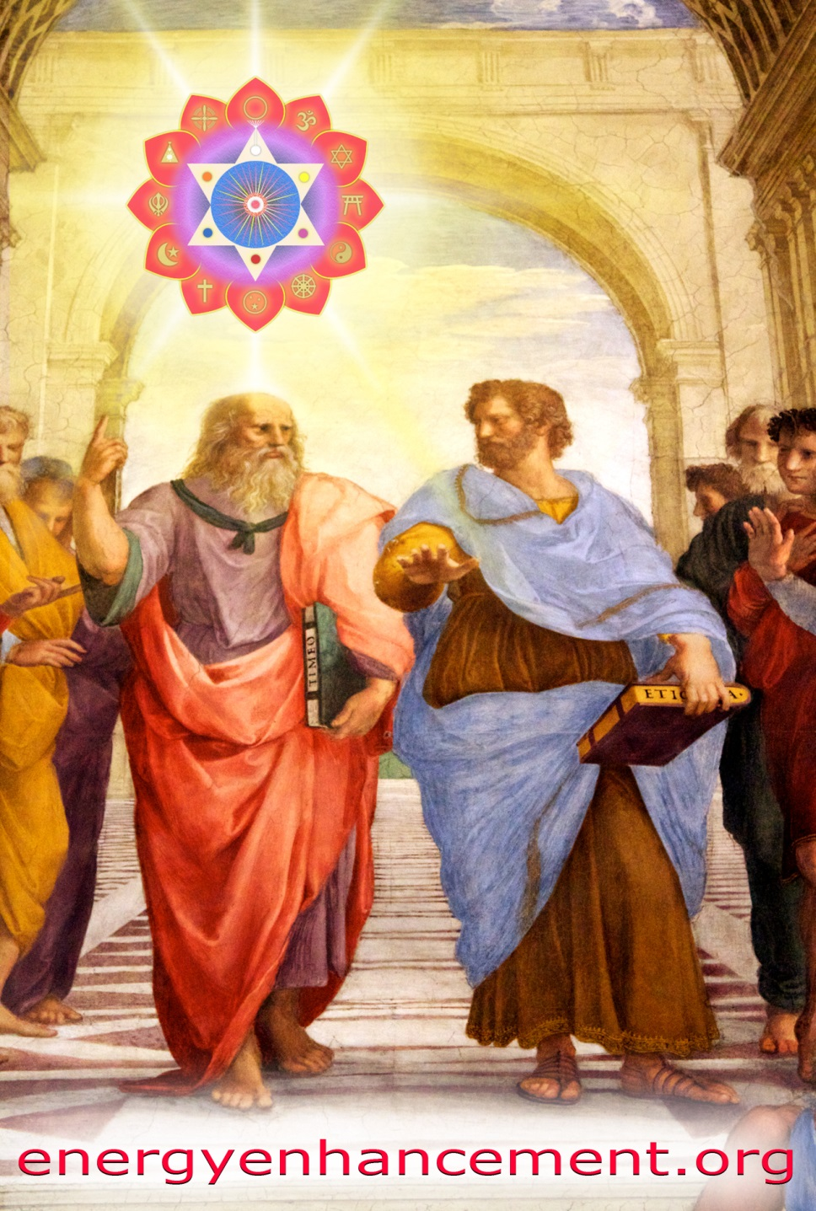
PLATO AND SATANIC BABYLONIAN SECRET AGENT ARISTOTLE "THE POISONER" OF ALEXANDER THE GREAT - BY RAPHAEL
ENERGY ENHANCEMENT MEDITATION
ENERGY ENHANCEMENT MEDITATION LEVEL 1 POWER UP!! GAIN SUPER ENERGY http://www.energyenhancement.org/Level1.htm
ENERGY ENHANCEMENT MEDITATION LEVEL 2 ELIMINATE ENERGY BLOCKAGES http://www.energyenhancement.org/Level2.htm
ENERGY ENHANCEMENT MEDITATION LEVEL 3 CLEAN KARMA BLOCKAGES AND PAST LIFE KARMA BY TRANSMUTATION http://www.energyenhancement.org/Level3.htm
ENERGY ENHANCEMENT MEDITATION LEVEL 4 MASTER ENERGY CONNECTIONS AND RELATIONSHIPS http://www.energyenhancement.org/Level4.htm
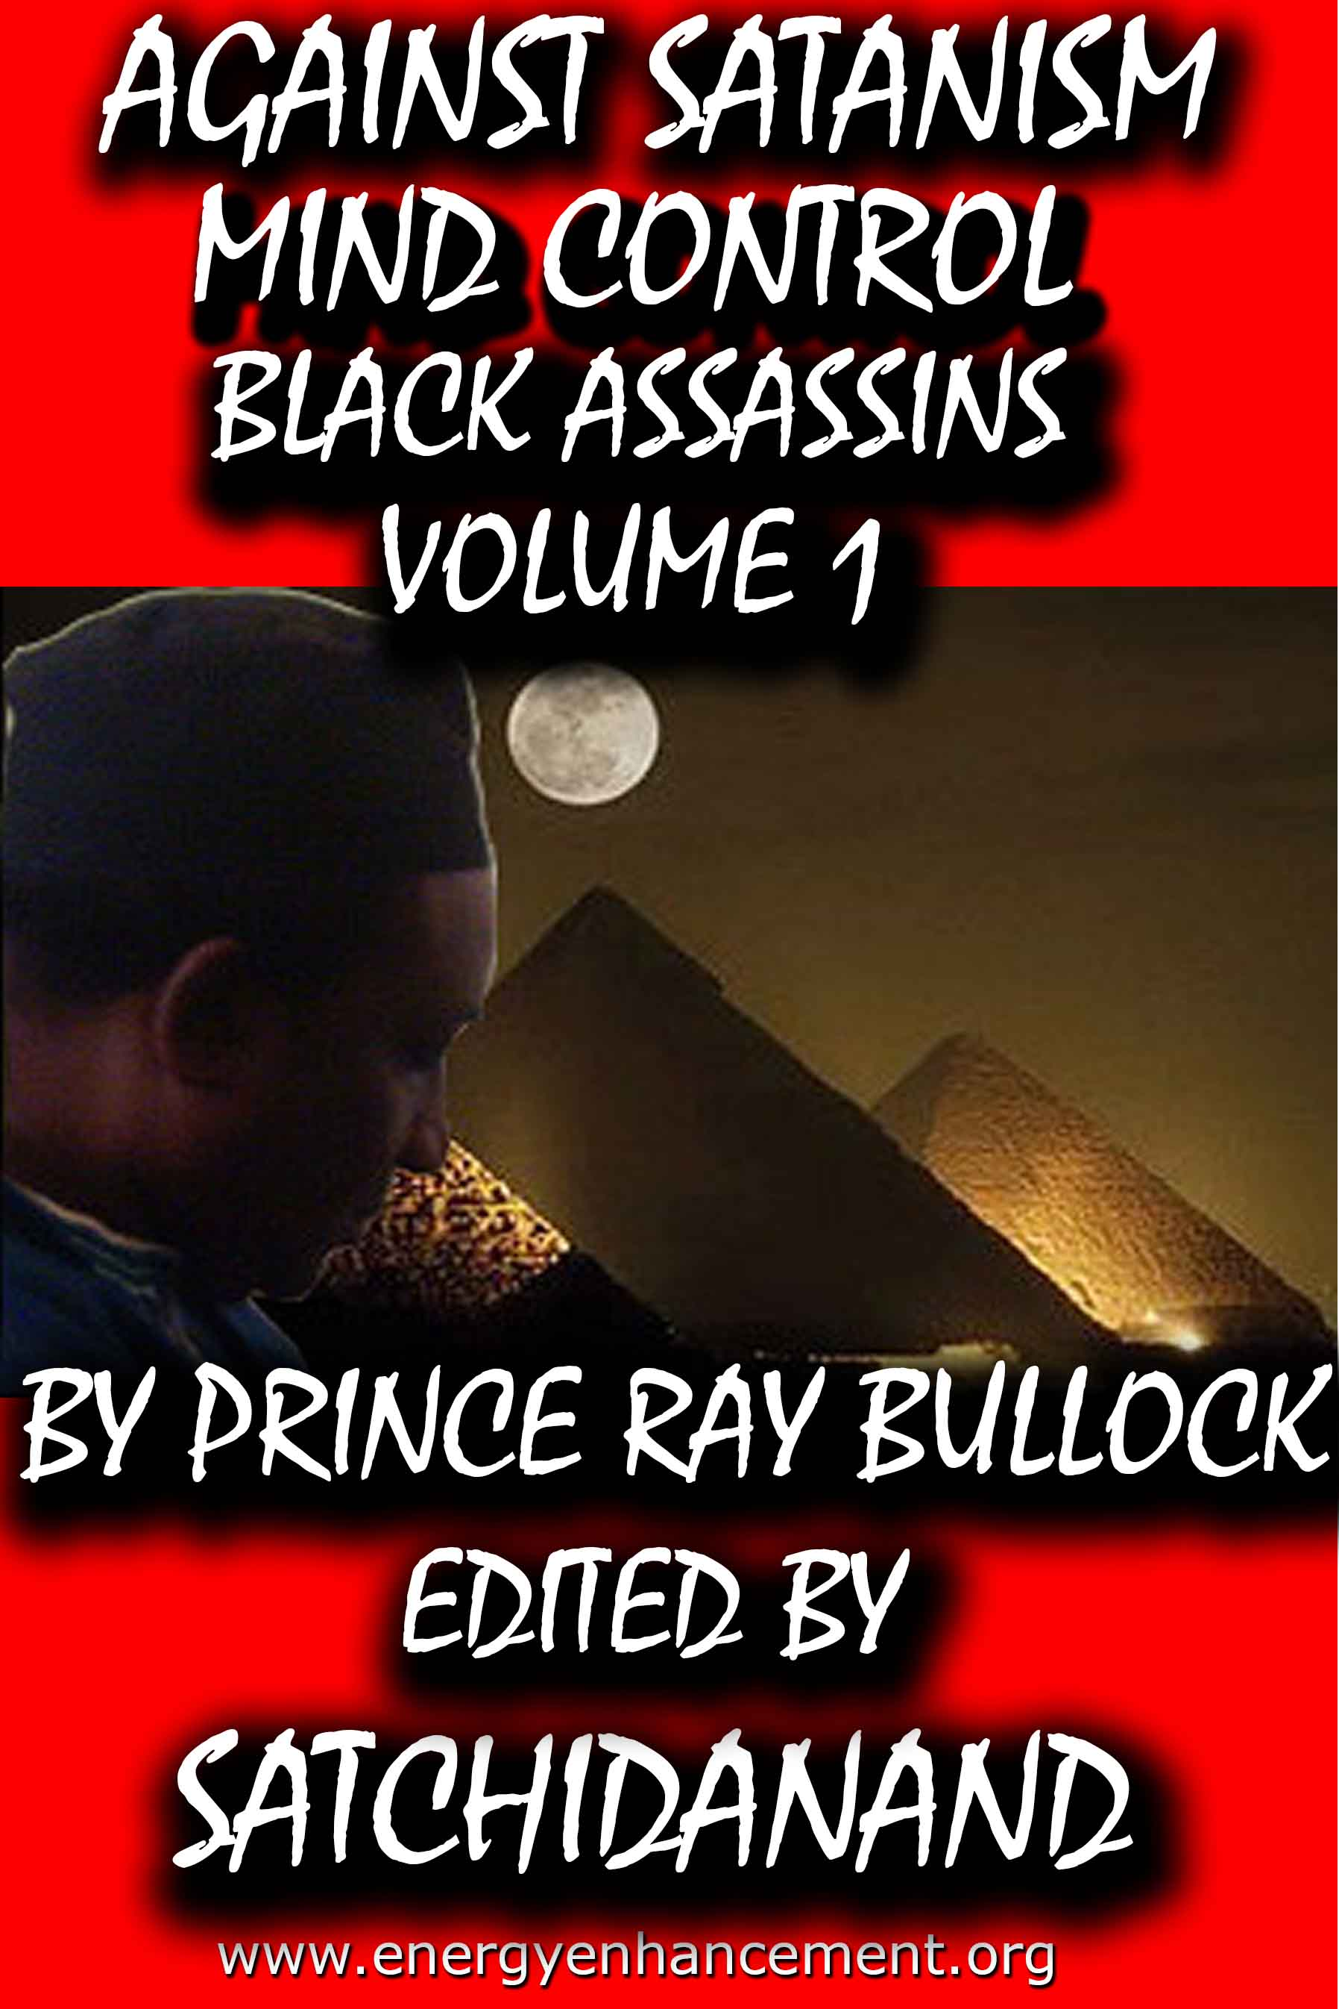
MIND CONTROL BLACK ASSASSINS VOLS 1-11 FREE!!
AGAINST SATANISM VOLS 1 – 6 FREE!! - ON SIGN-UP
energyenhancement.org

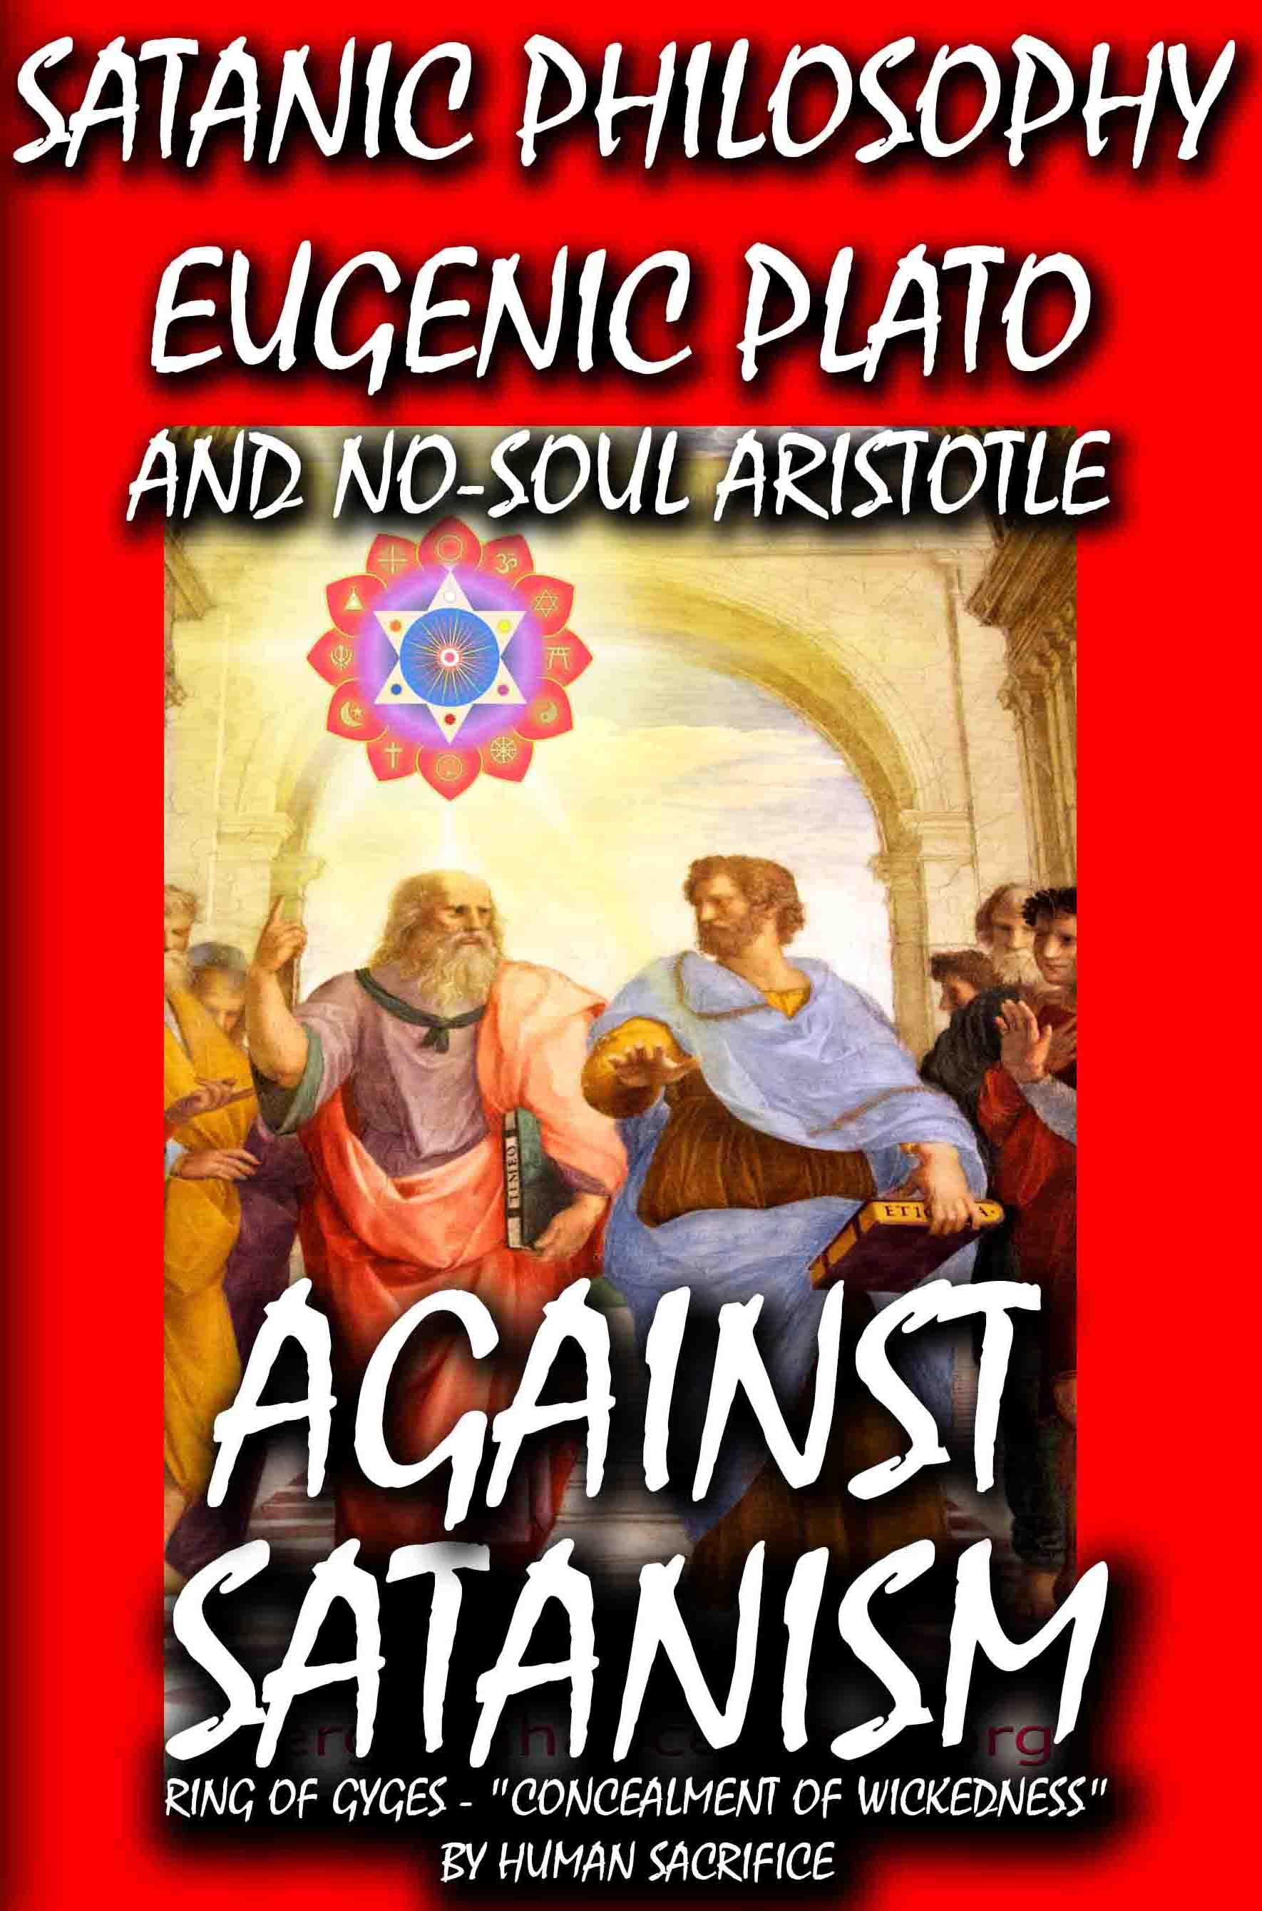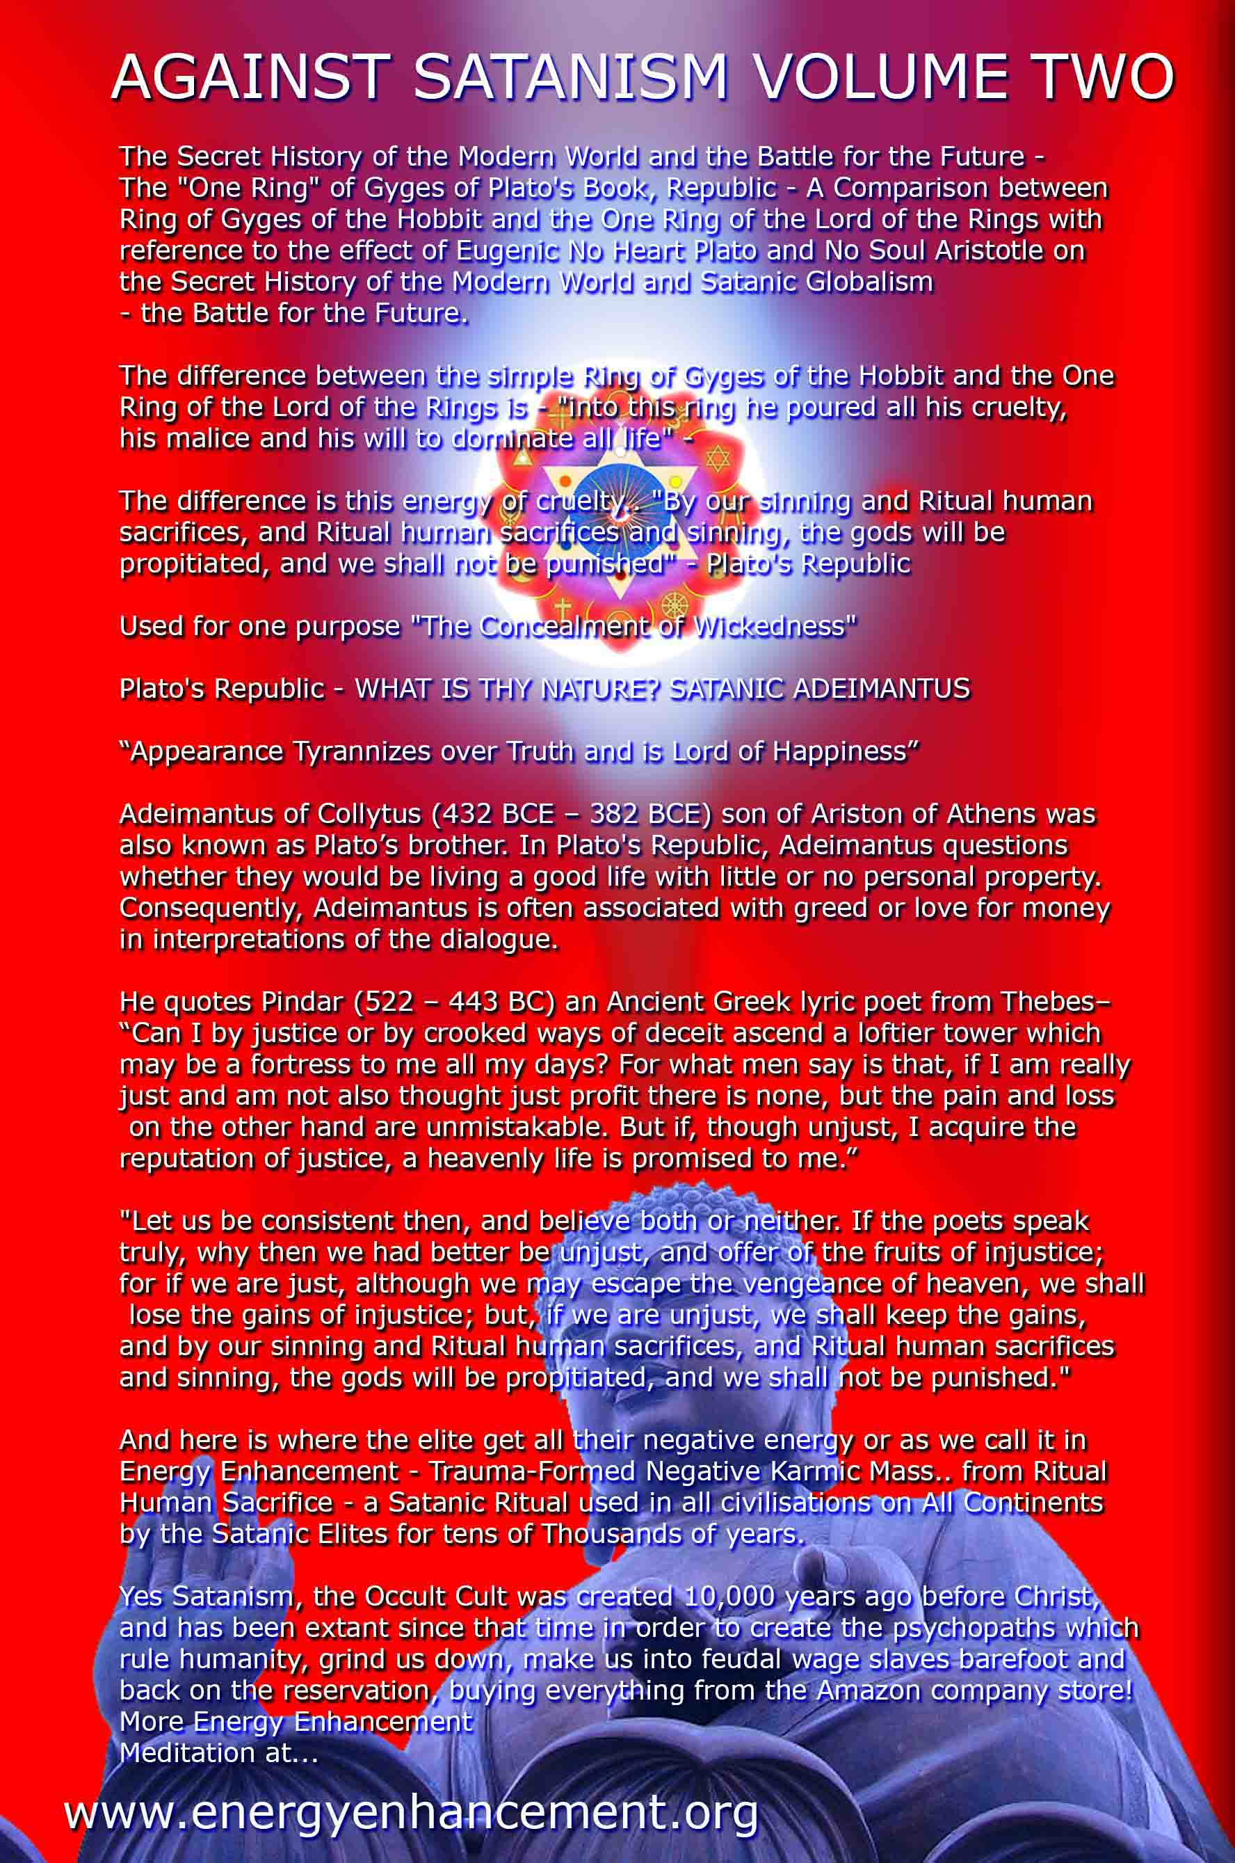
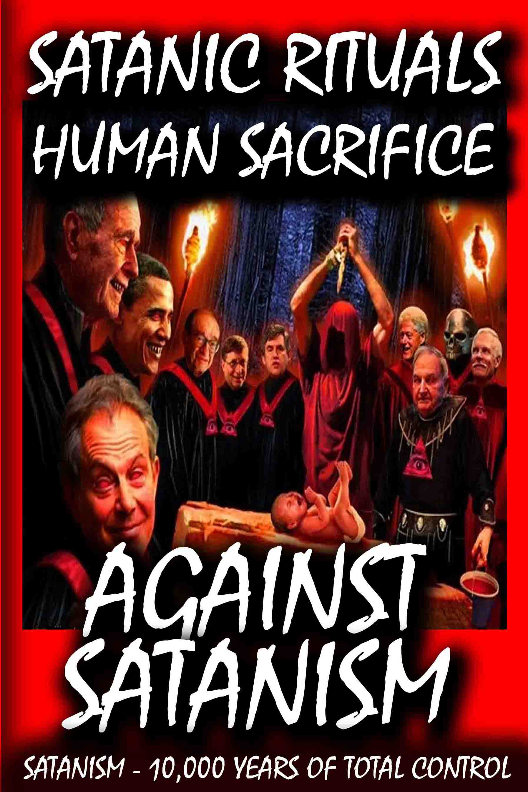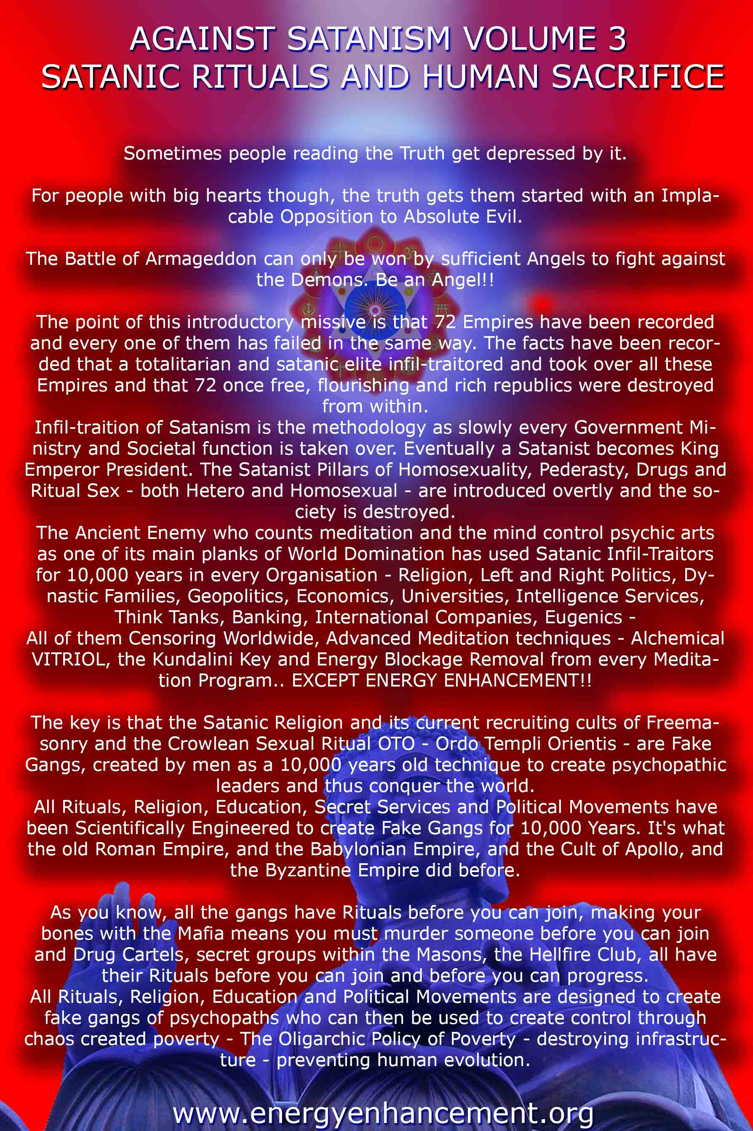
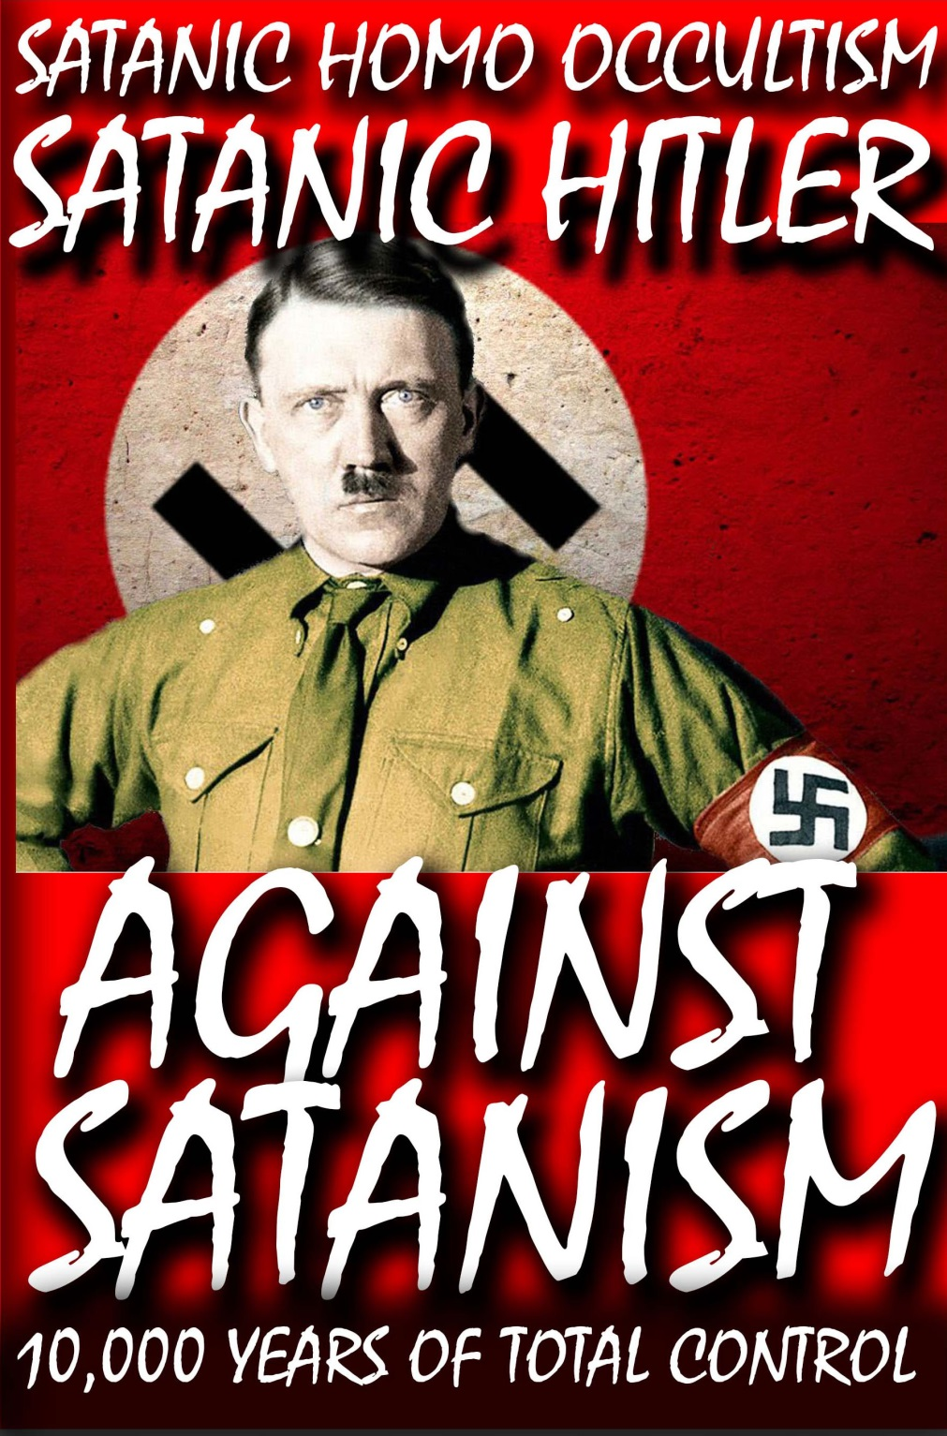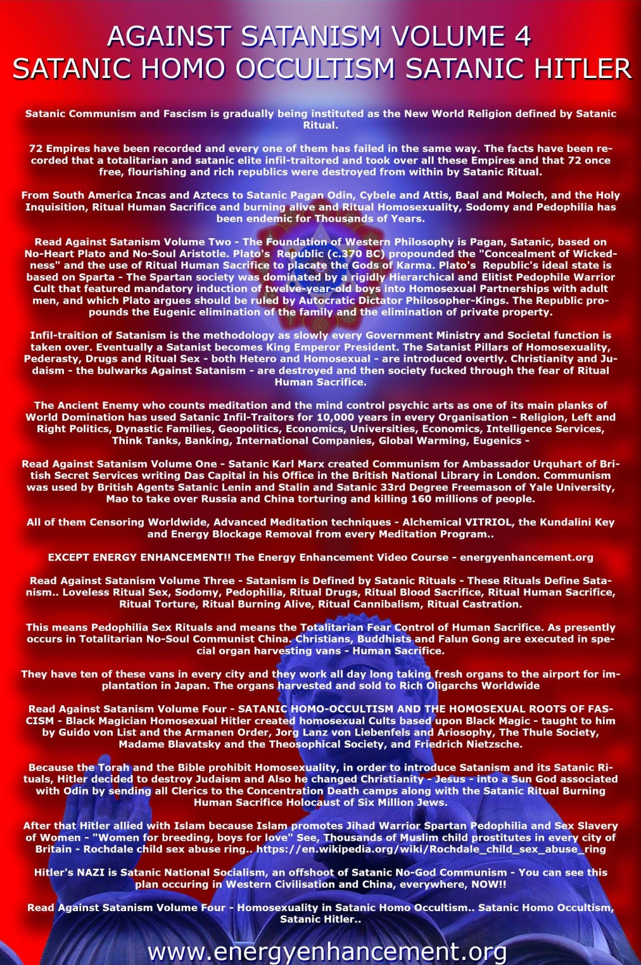
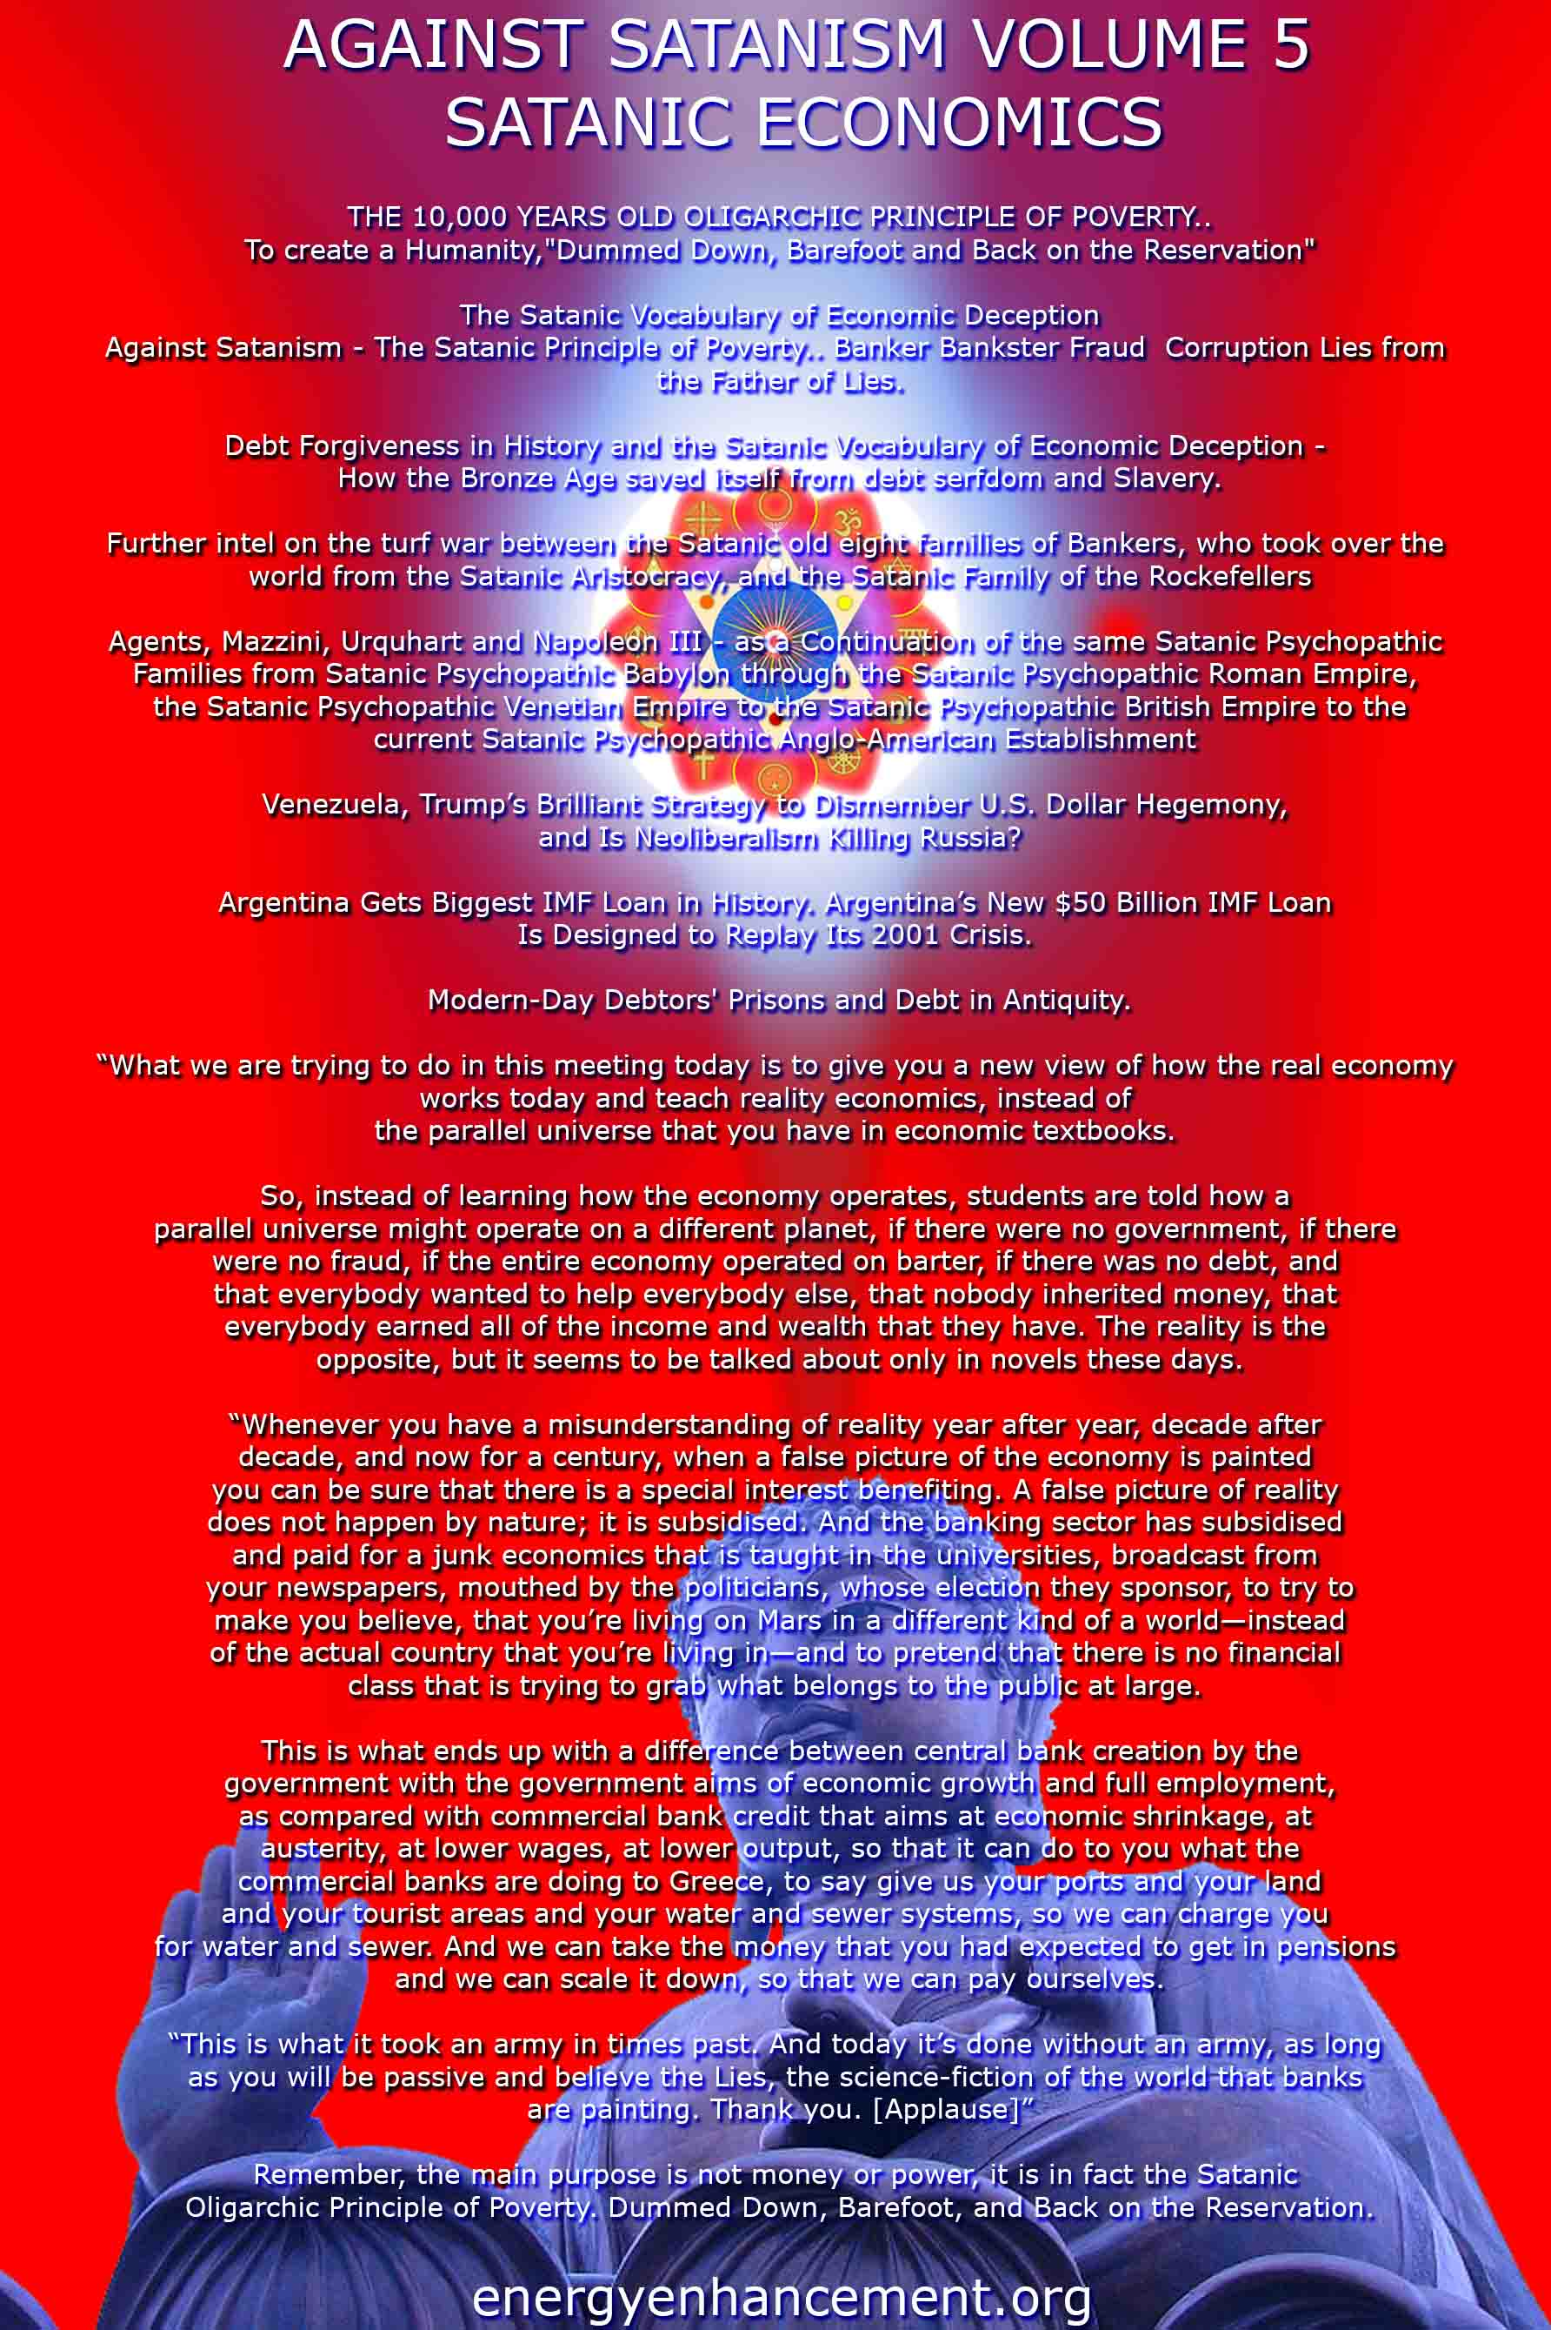
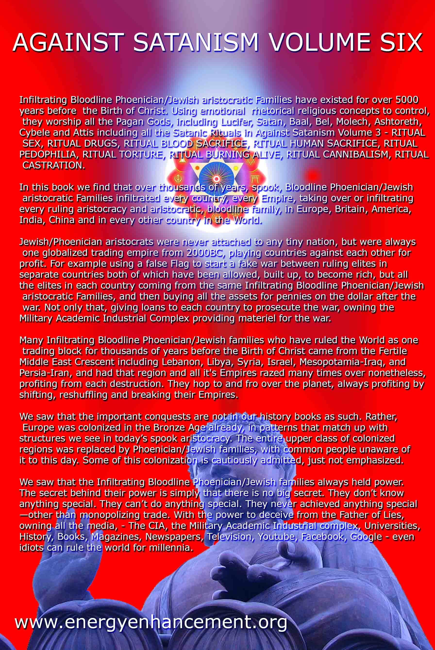

RACE WITH THE HORNED GOD, THE HART WITCHES, DEVONTE, TINY HANNAH AND THE SCANDINAVIANS
24042018
I
THE HART WITCHES, BLACK CHILDREN & THINGS

STOLEN ANGEL SIERRA
It’s Sunday morning. I must admit that I have a beautiful little girl named Sierra in my life, my niece. In the Sierra at the heart of this matter, I saw a reflection of my very own most precious granddaughter. Since that child has been born- she has never been out of my sight or circle of protection as if she is my very own promise. I am old school. For her, I launch a thousand ships. Ever since the story broke and I have been begotten of her image, the little girl that I called Little Sierra, below, has been special to me.

Tiny Hannah
Since last night, she again weighted heavy on my heart and soul. I looked at her remarkably small body and frame. I was convinced in my own eyes that she was the youngest of the Children, 12 years old. I was wrong in judgement by calling her Sierra, her name is Hannah and I sincerely apologize.

Tiny Hannah, above, is still missing.

I have called the above child, Hannah. But, she is actually Abigail. During her short life, she and the other Children suffered from absolutely SADISTIC physical and mental abuse by the witches. Abigail’s school called child welfare authorities after she was seen eating out of the garbage and taking food. Records indicate school officials stopped telling the Hart Witches when their children took food at school so that the children would not be punished. I admit that I am partially blinded by my love for the Children. My heart cries out that she matters so much to me as if she had been my very own in my circle of Love and Protection of a Thousand Ships.

I have called this beautiful child, Abigail. But, she was Sierra. She is also special to me, because, strikingly, I see in her a remarkable reflection of the blood of blood of my own beloved sister when she was her age. Names are important. They (Luciferians) deliberately keep the Children nameless to avoid humanizing them in the eyes of the masses. I call out her name, SIERRA.
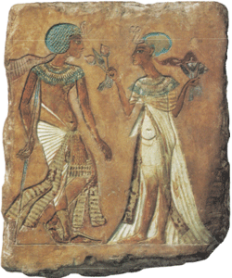
Pharaoh Smenkhkare and Queen Meritaten
From the 18th Dynasty of Ancient Kemet,
THE QUEEN’S POEM
I breathe the sweet breath that comes from thy mouth,
I contemplate thy beauty everyday,
It’s my desire to hear thy lovely voice
Like the north wind.
Love will rejuvenate my limbs.
Give me thy hands that hold thy soul,
I shall embrace and live by it.
Call me by name even unto eternity
And I shall never fail without response.
I say upon the lost and murdered Children that I also breathe thy sweet breath. I contemplate thy beauty everyday. It is my desire to hear thy lovely voices again like the North wind. LOVE for you rejuvenates my limbs. Remember and never forget your parents and ones that love you. Give them thy hands that hold thy soul. They have embraced you forever and live by it upon death, to hear your voice again, To see thy smile, again.
Hannah & the Rainbow Bridge

Sierra (Ciera)
Recently, Sierra has been confirmed dead. She was stolen from “His Eye is the Sparrow” by Witches. She was born a special child of God. She was precious and beautiful in our eyes; and the Eyes of the Lord. That’s what we teach and practice with our children from infancy. Yet, we don’t know anything about Sierra– what books she read or what songs she sang and enjoyed, the games she played or friends she had. We don’t know if she ever enjoyed pizza or took a trip to McDonald’s. She wore bandannas because her hair was mated and uncombed. She was denied contact with her biological loved ones and all contact outside the Hart Witches’ Coven and Dark Circle. Precious Sierra was malnourished confined to a special vegan diet or at times no FOOD and WATER at all.

Sierra lived under the terror and conditions of a Nazi Concentration Camp inmate. At seven (7) years old, she looks 30 to 40 pounds. At 15 years old, Sierra, 4’5, weighted a chilling 60 lbs. From the nature of her existence confined behind a dark veil of secrecy, she had been beaten and abused. Her human dignity and humanity had been taken away from her. From what you are about to read, Little Sierra had also been terrified and diabolically terrorized beyond anybody’s imagination by a MK OFTEN Witches’ Coven and Black Circle Initiates. She didn’t walk over the Rainbow Bridge and disappear “Somewhere over the Rainbow“. THAT CHILD WAS ABUSED, DRUGGED AND PUSHED OVER!

The Children & the Satanic Rainbow Deception
Rev. Jim Jones’ Rainbow Family was predominately black– full of Children, Witches and Wizards- A Secret Satanic Cult of Death for Innocent Black Children.
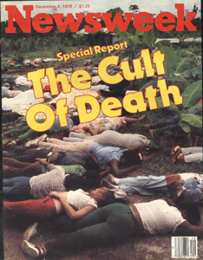
The Rainbow with its seven colors has long had an occult significance of being a great spiritual hypnotic device. Constance Cumbey, in her book, The Hidden Dangers of the Rainbow, which exposes the New Age Occult Movement, says that the Rainbow also called the Antahkarana or Rainbow Bridge is used as a hypnotic device. The Supreme Council of the 33rd° of Freemasonry has used the rainbow on the cover of their magazine. In a book teaching Druidism as in Illuminati Druidism, the 21 Lessons of Merlyn– the Rainbow is described as “A true sign of Magic…it exists in both worlds at once!

Jennifer Hart, Children & Fantuzzi
There is no doubt that Jennifer and Sarah Hart forced the Children to follow the “Rainbow Gathering” and the “Rainbow People“. Fantuzzi has performed a major role in the Rainbow Family since the original Woodstock Festival in 1969. Fantuzzi occupy a space in the RAINBOW with LUCIFER.
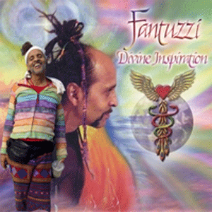
The other day, Minnesota officials finally announced after nearly a two year so-called criminal investigation that charges will not be filed in relation to Prince’s April 20, 2016 death. Prince died from a fentanyl overdose that he didn’t know was fentanyl in that Vicodin. The bottom line is that fentanyl has a unique chemical signature and blueprint that can be traced. Minnesota don’t do any tracing in the case of Hart Witches or Prince. I really don’t believe very many people really expected any investigation in Minnesota to result in any criminal charges in the first place. The Hart Witches were raised and initiated by secret backwoods and forest Satanic covens of Minnesota that they don’t know anything about either.
Prince & The Rainbow Deception
Prince knew what he was doing when he sold his soul to the DEVIL. It’s hard to say anything when they come to collect. In 2001, Prince produced the album, “The Rainbow Children“, to familiarize the general public with the nature and mysteries of the Luciferic New Age. In the album, he said that the Rainbow Children with the accurate understanding of God and His law went about the work of building a New Nation flying upon the wings of the New Translation of the Covenant. Yes, this Rainbow stuff is the very thing with Rev. Jim Jones, Fantuzzi, Prince, and the Hart Witches– CIA Satanic MK (Occult Bureau) OFTEN. After all the trials and tribulations they had gone thru, Sierra and not one of the children sold their souls to the DEVIL.

By absolutely no fault of her own, precious Sierra was subjected to something (Thing) like out of Jonestown, Guyana that Rev. Jim Jones and CIA MK ULTRA/MONARCH called the “Rainbow Family“. The bottom line is Our Little Precious Sierra that no rational and reasonable person could deny- ended up like something out of Jonestown- DRUGGED AND SLAIN thrown like a rag doll over the Rainbow Bridge into the mix of the eternal sea. To add insult to injury to our broken hearts and misery of Sierra‘s loved ones in Texas, they have no rights to claim her body. The HUMAN rights of her beloved and broken heart biological family- the State of Texas TERMINATED in adoption. All of the children’ bodies belong to the Coven of WITCHES!

Sierra’s soul is free, now. Free for the swift wings of the sparrow to carry to heaven. But, we still want and demand JUSTICE for the crimes committed against Hannah and the Children, and our HUMANITY!
II
CALLING ALL WITCHES- FREE BLACK CHILDREN

In other words, America’s Foster Care and Adoption System will pay ALL SCANDINAVIAN WITCHES, DEMONS, GOBLINS & WIZARDS to abuse, torture, drink the blood and kill Black Children!

Dehumanized Black Children- THINGS 1-6.

For years, investigators believe, the Turpin kids lived in filth and isolation — with little access to food or hygiene — until their rescue from their family’s home in Perris, California, earlier this year. Allegedly held captive in an intensifying cycle of abuse, most of David and Louise Turpin’s children were severely malnourished when police discovered them in squalid conditions on Jan. 14, according to prosecutors. Some of them were even chained to their beds. Only the youngest, a toddler, seemed somewhat spared and had not been underfed.
Many believe that the THING t-shirts mean little if anything because the shirts are sold on the internet and families customarily wear the shirts to Disneyland. The THING concept is harmless. It comes from Dr. Seuss and “The Cat with the Hat“. Well, they’re full of S.H.I.T!
The Cat in the Hat, Race, Mind Control & Dumbing Down the Masses
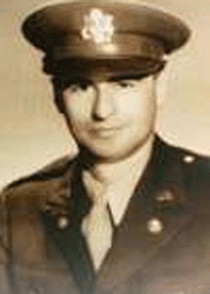
U.S. Army Captain Dr. Seuss
During WWII, Son of German Immigrants, Theodor (Dr. Seuss) Geisel (1904-1991) was a “GOAT” man, a member of the Sigma Phi Epsilon. Geisel’s master was the Horned God- PAN.

His philosophy was the OCCULT. The man thought like and acted on behalf of the GOAT GOD! Everything he touched should be suspected to Satanic Masonic mass population trickery and deception.
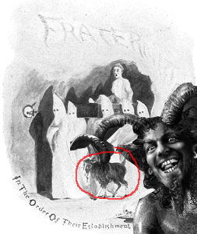
Fraternity- Freemasonry & the GOAT- Order of Their Establishment
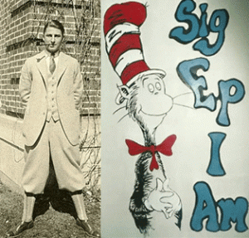
Dr. Seuss & Sig Ep
There is a direct link between Sig Ep and Freemasonry. It was founded by four (4) Freemasons. William Hugh Carter, was the High Priest of Royal Arch Masons, and a Knight Templar, Grand Prelate of the Grand Commandery of Knights Templar of Virginia. Thomas Temple Wright, member of the Warsaw-Bauman Masonic Lodge #332 in Warsaw, VA. William Lazell Phillips, Freemason, member of the Royal Arch Chapter, Knights Templar and Shrine. Thomas Vaden McCaul, Master Mason, Royal Arch Mason and Knight Templar.
Captain Dr. Seuss had been a U.S. Military Intelligence Propaganda Specialist. He was U.S. Army captain and commander of The First Motion Picture Unit (FMPU), later 18th Army Air Forces Base Unit. The Unit was the primary film production unit of the U.S. Army Air Forces (USAAF) during WWII. It was the first military unit made up entirely of professionals from the film industry. It produced propaganda films.
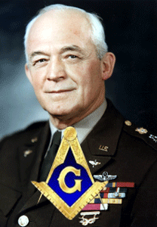
Geisel worked directly under General Henry Harley “Hap” Arnold. General Arnold was initiated, passed, and raised in Union Lodge #7 in 1927 in Junction City, KS. He joined the Scottish Rite on April 11, 1929, in Leavenworth, KS, and received the 33° on October 19, 1945. He was an American general officer holding the grades of General of the Army and General of the Air Force. Arnold founded the military handmaiden think tank Rand Corporation. Robert A. Lovett, as well as General Arnold, General Carl Andrew “Tooey” Spaatz, and others, such as Curtis E. LeMay set the groundwork for Operation PAPERCLIP– the ultra secret smuggling of the Nazis and Himmler’s SS into the U.S.
“… About the “Cat in the Hat” which incorporates symbolic content of the mind control programs. See Cat in the Hat movie book showing symbolism, such as the RED and WHITE Lighthouse Signal Stovepipe Hat with the GRAMOPHONE HORN inside aka Victor Listening to his MASTERS Voice, FEEline Basement, and holding a “HOE”. Dr. Seuss worked for Army Propaganda and had ties to Standard Oil.
Geisel was a vicious institutional RACIST!
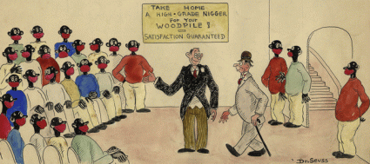
Geisel’s NIGGER FOR THE WOODPILE
In 1981, Geisel revealed the true genesis of The Cat in the Hat,
“I did it for a textbook house and they sent me a word list. That was due to the [John] Dewey revolt in the twenties, in which they threw out phonics reading and went to a word recognition as if you’re reading a Chinese pictograph instead of blending sounds or different letters. I think killing phonics was one of the greatest causes of illiteracy in the country.”
John Dewey
“Children who know how to think for themselves spoil the harmony of the collective society which is coming, where everyone is interdependent.”- John Dewey
(See Enter the Dragon: The Secret Order, First Lady, the Cat in the Hat, South Africa & War of Aggression Against the People of Libya) The hidden “mystic puzzle” of The Cat in the Hat represents symbolically the number “THREE.” He has three rings around his hat, three fingers, three loops to his tie, and three candles on his cake. In Proto-Norse, the THREE brothers’ names were alliterating, *Wódin, Wili, Wé (Proto-Germanic *Wōdinaz, Wiljon, Wǣhaz), so that they can be taken as forming a triad of *wódz, wiljon, wǣhaz, approximately “inspiration (transcendent, manic or prophetic knowledge), cognition (will, desire, internal thought that leads to action) and numen (spiritual power residing in the external world, in sacred objects)”.] Keyser interprets the triad as “Spirit, Will and Holiness”, postulating a kind of Germanic Trinity in Vili and Vé to be “blended together again in the all-embracing World-spirit – in Odin. […] he alone is Al-father, from whom all the other superior, world-directing beings, the Æsir, are descended.
In the opening scenes of Geisel’s animated film version of Cat in the Hat, he suggests quite candidly that there is in fact a “mystic puzzle” layered and hidden in the story. Later in the film, the Cat actually tells us and do in fact search for something THREE-HEADED, the Wotan triad-“Spirit, Will and Holiness”, in the story which is unseen.
Confronted and challenged by morals of the fish (Christianity), the Pagan Cat wreaks havoc and absolute chaos in the cosmic domain after performing tricks and unleashing Two (2) THINGS of CHAOS into the cosmos. The fish and the public finally agree and demand that the Cat leave their space. The Cat packs up the things (agents of chaos) and leaves the cosmos in absolute CHAOS. In the Crisis of the Absolute CHAOS, the fish confined to a small glass bowl and the American public is unable to restore order.

“That is good,” said the fish.
“He ahs gone away. Yes.
But your mother will come.
she will find this big mess!
And this mess is so big
And so deep and so tall,
We can not pick it up.
There is no way all!”[35]
At the point of the absolute flashpoint of the Crisis, the Cat with his mysteries returns to the cosmic domain of the story, he says, “Have no fear of this mess…”[36]

The Cat restores order to the mess of CHAOS with Magkic and a Luciferian illusion. Finally, Freya Rides and Wotan Reigns again.
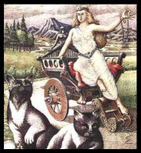
The cosmos is restored to its natural order and beauty (archaic paganism), and the fish is left with the dilemma of the Cat People’s ILLUMINATED mysticism, magic; and the mysterious SECRET ORDER over CHAOS; and Christianity. The Cat in the Hat represents the unseen SECRET ORDER (Imperium) that they know nothing about but knows what is best for the masses. The SECRET ORDER have the infinite Pagan wisdom and mysticism unhindered and blinded by the restrains and weakness of Christianity to control the affairs of the world for the good and best interest and order of the Cosmos. According to Dr. Seuss, THINGS are the mind controlled social and religious agents of Secret Order (White Brotherhood) and Masonic CHAOS.
III
HART SCANDINAVIAN WITCHES & THE CULT OF DEATH
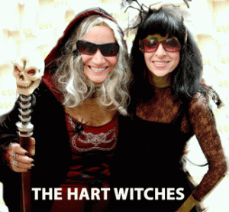
It’s important to say this. Growing up in the Black Community, we were aware of issues of Voodoo, but my mother and elders were afraid to death of it. They would have absolutely nothing to do with it. So, I had absolutely nothing to do with it. We were taught to run from it all. We normally know absolutely nothing AT ALL about Satanic EVILS such as secret Satanism, Wicca, Groves, Covens and SCANDINAVIAN Witchcraft until it bite us in the ASS! That has to change.
Hart meaning a “STAG” was found as heorot in Old English, as well as in German and with variants in Dutch and Swedish. The name Hart has been documented associated with Witches in SE Essex – old witch Hart of Rochford swimming in the Crouch river in the 1740’s and Harriet Hart of Latchingdon, the last in a line of Hart Witches a century later. Furthermore the Harts of South Dakota appear to be related to John Hart (1651- 1714) of Pennsylvania, a wealthy high member of the Friends of Society, of Witney, Oxfordshire, England. In the 17th century, he accompanied William Penn to America to settle Pennsylvania.
The Witch of Ridley Creek
The last time someone was put on trial for witchcraft in Pennsylvania, William Penn was governor and the year was 1684. The trial of two Delaware County women named Margaret Matson and a Mrs. Gethro Hendrickson happened 8 years before the Salem Witch Trials in Massachusetts. The Salem trials resulted in the execution of 20 people and the arrests of over 100. In Pennsylvania, the outcome was much different.
Margaret Matson and her husband, Neels, were Swedish-Finnish settlers who spoke very little English and lived on a farm near Ridley Creek in Eddystone, Pennsylvania. The land they settled, called “New Sweden,” eventually came to be occupied by British settlers.Some of the new settlers claimed that Margaret, a traditional Finnish healer, bewitched their cattle and other animals. They also alleged that livestock gave little milk and that some died because of witchcraft. William Penn oversaw the trial himself in Philadelphia. An infamous Witch of Salem was Elizabeth Hutchinson Hart (1622- 1700).
“Harriet Hart was notorious for having committed the commonplace crimes of witchcraft, causing storms, blighting crops in the field and bewitching pigs. Unlike others of her kind, however, she seemed to have been blessed with a sense of humor.” Harriet ended up in the Maldon union workhouse in Essex where she died in 1897.
The New Age Hart Witches (Jennifer & Sarah) death body count of innocent black children is now 4 (four); Markis, Abigail, Jeremiah, Sierra with 2 (two) children still missing; Devonte, 16 years, and Hannah, 15 of 16 years old. Four (4) black innocent children have be confirmed slaughtered at the direct evil of Jenn and Sarah Hart, and everybody in the world still dance around the issue including black folk that the bottom line is that Jennifer and Sarah Hart were/are New Age Witches.
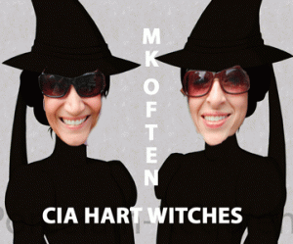
They will talk about the Harts belonging to a group of New Age conscious movement initiates that they followed New Age Conscious/Pagan movement musicians from remote forest to forest (Greek Goat God Pan), but they won’t call it a “Grove” or “Covens”. They won’t mention the Hart Witches’ Shranga- La or Shambala connections to White Supremacy/Secret Doctrine ideology of Vril, Madame Blavatsky, Maria Orsic, Thule, Himmler and the SS occult pseudo-scientific research bureau, Ahnenerbe.
IV
WITCHES, RACIAL MASS MURDER & THE WIZARD OF OZ COVER-UP

Oprah- Wicked Witch of the West
It should be no surprise at all to anyone that the New Age Witches like Oprah Winfrey and Wizards over the Rainbow would rally to control Satanic narratives to deceive the masses with illusions and trickery in order to take the high moral ground in the case of the Hart Witches and the Black Children.

On the national stage on the idiot box, the Wizard of OZ spoke on the case with all his tricks, smoked mirrors, and the looking glass.
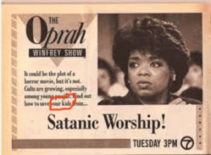
Oprah’s new age pseudoscience doctor, Dr. Mehmet Oz, vice chair of the Department of Surgery at Columbia University and medical director of the Integrative Medicine Program (i.e., Columbia’s “quackademic” medicine) program at New York-Presbyterian Hospital to control narratives and explain away the Washington’s Child Protective Services (CPS), Hart Witches and the Children.
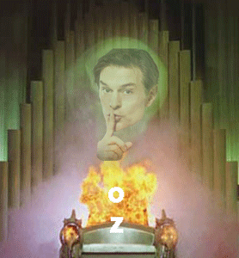
His role as a daytime pseudoscience television medical show host is called appropriately, The Dr. Oz Show.
The OZ is merely an ILLUMINATI snake oil salesmen hiding behind a curtain bought and paid for by the New Age Wicked Witch of the West, Oprah Winfrey.
The Children, DeKalbs and the Looking Glass

On April 17, 2018, The Hart Witches’ next door neighbors, Dana and Bruce DeKalb, appeared on The Dr. Oz Show, True Crime Investigations. Dr. Oz described them as the people that tried to help the Children– the Witch and Wizard that tried to save the Children from Witches. That Dog won’t Hunt. They were on The OZ Show to control and manufacture the narratives of the Children.
All of a sudden, Dana became the public relations (PR) spokesperson for the Clark County Child Protective Services (CPS) in Washington. She was the CPS expert qualified to explain away to the masses what CPS in Washington should, could and couldn’t do to investigate child abuse cases. Oh, in Washington, she said that they just can’t interview kids without the parents’ permission. The OZ said that CPS can’t do anything about a parent whipping a child. Well, he was lying, too.
On March 15, 2018, the DeKalbs told police that they saw vehicles coming and going at the Hart House just before the Witches made their escape with the Children, but The OZ nor the Dekalbs went there. It certainly suggests that more people, in fact, were involved in the abduction and murders of the Children.

Police said the family of eight were driving a “five- seater 2003 GMC Sierra truck” at the time (file photo). It certainly suggests that the kids may have taken away from Woodland in different vehicles like the reported “2003 GMC Sierra Truck” …

Jennifer Hart on Top Her Brown or Tan SUV
that is substantially different from Jennifer Hart’s brown or tan GMC 9 (nine) seat Yukon SUV with dark tinted windows and black wheels.

Bruce DeKalb talked about that “little black girl” as if she was only a nameless DEHUMANIZED THING that suddenly appeared banging on his door in the middle of the night crying for help in August in one conversation then November 2017 in another conversation on-air with The OZ.

Tiny Hannah, 16 years old & 19 year old Markis
My so dear little sister, your life matter so much if only you weren’t stolen from the bosom of your family, elders and the community that truly loved you. The bottom line is that to the DeKalbs– Hannah’s cry for help didn’t amount to a cry from a wounded cat, dog or horse, or the DeKalbs are part of the web of the witches’ coven in Woodland, WA. I believe the latter. They turned over wounded Tiny Hannah, a beautiful precious child of God, back over to the Hart Witches then kept their mouths shut until it was time for the witches to escape Witch Mountain with the Children.
Then the Race with the HORNED GOD began – you better be fast as hell to save the children. Not much is said about the background of the Race with the Devil. The movie script was co-written by Wes Bishop aka Charles William Pelletieri of Nashville, TN. Pelletieri was an intelligence officer of the U.S. Army 82nd Air Borne Division at Fort Bragg, NC. The elite group, the 82nd Airborne Division, trains for extraordinary highly ultra top secret and classified special missions for the Pentagon and Shadow Government. The CIA recruits highly from the 82nd Airborne’s MK ULTRA/MONARCH Manchurian Candidate trained and programmed killers and assassins.
Just before and after a special operation, social histories and public records of the people directly involved simply disappear from the internet just like Jenn and Sarah Hart. Bruce and Dana DeKalb are no exceptions. However, Bruce DeKalb has a footprint linked directly to Vacaville, CA, home of the CIA’s Little California Prison of Horrors, Vacaville Men’s Medical Health facility, and Lawrence F. Dekalb. Lawrence has a footprint and background linked to wealthy Kansas railroad employees and the town of La Grange on the infamous Oregon Trail. Lawrence and Bruce are linked to a shadowy Dexanna, LTD connected to special transportation and courier services. Dana D. Ashley- DeKalb is linked with La Center, Oregon, and Elk Grove, CA- Sacramento area. We have absolutely no idea what these SCANDINAVIANS do.


Woodland is a visible gateway and pathway to both native American sacred mountains Mount St. Helens and Fort Hood (Bridges to the Gods) for WITCHES, too.^{[1]} The most sad and disturbing part about The Oz Show featuring the DeKalbs is that we didn’t hear a word from Hannah, Devonte, Markis, Jeremiah, Abigail, and Sierra before they were taken across state lines where most of them are now confirmed to have been silenced forever- murdered. If the DeKalbs are lying about when the “little black girl” banged on their door in the middle of the night in August 2017 then November 2017, then they’re lying about other things that they knew, witnessed and heard from the Children. And, Dana’s father, Steve Frkovich, 80, did in fact, expose them as deliberately LYING and concealing information about the Witches and the Children.

Dana’s father told police on a 911 call that it was Bruce that deliberately kept the pair quiet about the Children. Now, Frkovich also won’t talk about the DeKalbs or the Children.

Absolutely WICKED!
At the end of The Oz Show, Dana DeKalb said that she wants everyone listening and watching her to “LOOK INTO THE LOOKING GLASS and SMOKED MIRROR“-if you see something, say something! It made me want to SCREAM! Dana also said that she asked Devonte if he went to school in West Linn, Oregon. For somebody that claimed not to know very much about the Children, from the beginning what did she know about them and West Linn, Oregon?
V
HART WITCHES, GOATS & WEST LINN, OREGON
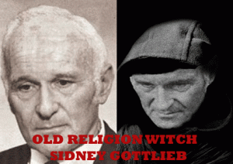
In West Linn, Oregon, the Harts raised chickens and “GOATS” and grew vegetables, said neighbor Bill Groener. Sidney Gottlieb in charge of CIA MK OFTEN (Occult Bureau) enjoyed his final days on land he bought with an old log cabin outside a small Virginia town, Boston, where he practiced two of his lifelong hobbies “HERDING GOATS”.^{[2]} Groener isn’t necessarily truthful. The Hart Witches rented a residential house in the city just blocks from the Willamette River. West Linn is another native American sacred place.
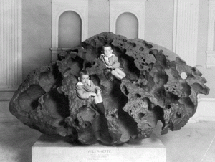
It was home to the Willamette Meteorite, officially named Willamette. It is an iron-nickel meteorite found in the U.S. state of Oregon. It is the largest meteorite found in North America and the sixth largest in the world. There was no impact crater at the discovery site; researchers believe the meteorite landed in what is now Canada or Montana, and was transported as a glacial erratic to the Willamette Valley during the Missoula Floods at the end of the last Ice Age (~13,000 years ago). It was long held sacred by indigenous peoples of the Willamette Valley. The indigenous peoples referred to this stone with the name Tomonowos (the visitor from the sky).^{[3]} The meteorite is on display at the American Museum of Natural History in New York City, which acquired it in 1906. I said that to say this. Everywhere the Hart Witches perched and anchored themselves and the children, it was directly connected to the spiritual, occult centers of Wicca, masonic, metaphysical and pseudo-scientific beliefs.
The Witches’ Ride in West Linn
Plus, West Linn has an active Witch Coven. There was a school near their rented house, but the witches deliberately kept the children isolated and confined away from school, neighbors and other children. They didn’t have a television, phones or computers. But, the real the story behind the Children and the Witches in West Linn is the Heart 2 Heart Farms.
VI
BLACK CHILDREN, HART WITCHES, HEART 2 HEART FARMS & BLACK CIRCLE
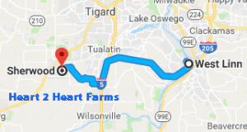
The Children and Hart Witches were regulars at a food pantry and farm about 40 minutes south of Portland in Sherwood, Oregon, where they could pick up organic produce. Sherwood lies a more than 16 miles (25 minutes) outside of West Linn.

They were taken regularly to Heart 2 Heart Farms (Good Neighbor Family Pantry) operated by Tyler and Elizabeth Boggs. Most believe that the surname name, Boggs, actually came from the area called Boak in the parish of Kirkholm. Kirkholm is now Salaspils in Latvia. The Republic of Latvia is an independent republic in the Baltic region of Northern Europe (SCANDINAVIA).
The pantry provides imperfect fruits and vegetables from supermarkets at no cost. Soon, the Harts began to volunteer at the farm, said Boggs’ wife, Elizabeth Boggs. The farm looks like something out of the Jonestown, Guyana Agricultural Compound. The kids would help for a while, then play with the Boggses’ animals or read in the sun.
“Devonte was probably the most outspoken and social. Sierra and Hannah and Abigail were quiet. They would read a lot when they were here. They all loved the animals,” Tyler said. The children talked with passion about social justice and the outdoors. “They were focused on the world being a better place, and I think that comes from being raised by people where the emphasis is love and treating the planet carefully,” he said. “They certainly were not stereotypical teenagers.”
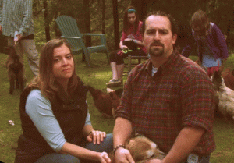
Tyler Boggs spent time with the children at the farm — away from their parents — feeding “GOATS” or cows. He said he never saw indications that the children were being abused or deprived of food. If they were, they “had opportunities in abundance to reach out,” Tyler said.^{[4]}
Heart 2 Heart Farms may not intimidate grown people. However, the slaughter and screaming of lambs bother and harm children.
Screaming of the Lambs!
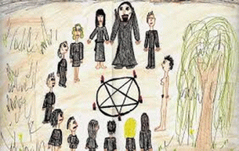
Well, there is quite of bit of Luciferian controversy surrounding Heart 2 Heart Farms, both Elizabeth and Tyler Boggs.

Tyler Boggs– “ … his guy is the scum of the earth! He pretends he’s a nice farmer that cares about people, animals and the environment but it’s all a scam to take people’s money. He shoots and kills old horses and chops them up for dog meat. He has dead animals rotting all over his “organic” farm. He also thinks he is a smart guy, but really is the dumbest fckwad I’ve ever met. He thinks he is better than everyone else and that he will never be caught for all his illegal bullshit he does. He’s such a creepier, being around him for just a few seconds is all it takes to realized this guy is a sleazeball.”^{[5]}

The Children were justified to be very much afraid of crazy Elizabeth.
She is accused of being a witch that often cast spells. And, they had to have been extremely afraid of Butcher Tyler Boggs.
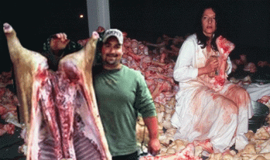
Ritual Slaughter of Animals, Tyler Boggs and Maria Abramovic
Some people say that the Boggs are completely insane.
They are also suspected of practicing witchcraft, and “lots of weird shit!”
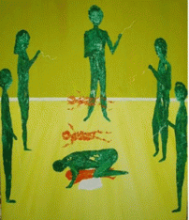
This piece of artwork is an image of a child and a young teenager who is disassociating during their sexual abuse and torture. This is normal for people and children who live through horrors. Frequently, there is no memory of the abuse and this actually needs to be dredged up from the memory.
They are suspected of being involved in satanic ritual animal sacrifice. The Boggs sacrifice their own farm animals and “drink their blood.”^{[6]}
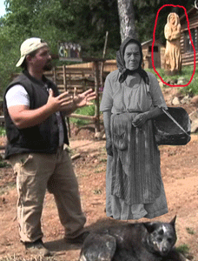
Tyler Boggs & Miron- Aku
The Children were too afraid to run away from the farm. The Boggs’ magkic was Old Religion and powerful. Miron- Aku watched over the farm. Walpurgishall:Miron-Aku was one of the last infamous SCANDINAVIAN Finnish witches, the keeper of the ancient knowledge. Her rituals were recorded for studies during the Maria Orsic Ahnenerbe expedition, which was led by Yrjö von Grönhagen by the personal appointment from SS-1 Henrich Himmler.
Ancient tree and forest spirits also blocked their escape from the farm. Imprisoned in totally alien demonic Satanic world, the Children were kept strictly isolated and scared out of their minds.

In fact, Jennifer Hart admitted, particularly Devonte and Tiny Hannah, had been severely traumatized by the ritualistic DEATHS OF CATS & ANIMALS!
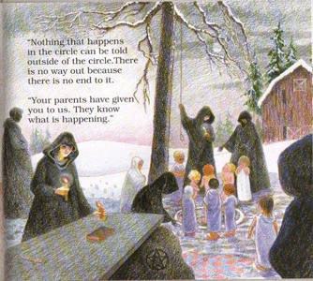
In Jordan, MN, 2 and ½ hours outside of Alexandria, MN where the Children were raised, 37 children made allegations of the manufacture of child pornography, ritualistic animal sacrifice, coprophagia (consumption of faeces), urophagia (consumption of urine) and infanticide. In the 1980s, twenty-four adults were arrested and charged with acts of sexual abuse, child pornography and other crimes claimed to be related to Satanic Ritual Abuse; three went to trial, two were acquitted and one convicted.^{[7]} Former Jordan trash collector, James Rud, was convicted of 10 (ten) counts of first-degree criminal sexual conduct for 10 (ten) different boys and girls, according to civil commitment papers filed by Scott County, MN.Two defendants were tried and acquitted when one child witness recanted his accusation of abuse. (Chicago Tribune, 1984). The prosecutor dropped the charges against all other defendants to avoid releasing 126 pages of police notes containing allegations that implicated some of the former defendants in ritualistic child murders. (Ogintz, 1984). ^{[9]}
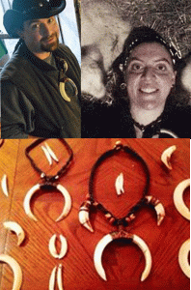
SCANDINAVIAN Boggs and Their Bones
Bones by themselves are not necessarily necromantic – they are just used as means of communicating with the spirits.
VII
THE HART WITCHES, CHILDREN & the ILLUMINATI

Dangerous Iranian ILLUMINATI DOPE HEAD- Ava Nusheen Bakhtiar

Recently, family friend Persian (pan-sexual?) Nusheen Bakhtiar has come forward to tell the world that Jennifer Hart was a loving mother. “We weren’t duped, that love wasn’t fake,” Bakhtair said. “They loved their children, they weren’t WHITE SUPREMACISTS. They just were isolated, they were in pain. She was in constant anxiety.”

Happy- Bakhtiar and her Female Little Bear
Still, Bakhtiar has a hard time believing the crash was intentional. “We loved them, they loved their children, they were spiritual, they were about nature they loved animals, they were rescuers. I don’t feel like I didn’t know them,” Bakhtiar added. RESCUERS? She is a former office manager of DOPE Magazine.

Bakhtiar boyfriend is Samuel Watson, above. He ran a marijuana dispensary called GreenSky Collective with his wife, Erika Yoshida Watson. Erika is the daughter of sauce tycoon Junki Yoshida, and although her father doesn’t invest directly in cannabis, her real-estate company, Expanse, is backed by the Yoshida Group.
Sensei Junki Yoshida is a 7th Degree Black Belt of Japan Karate Federation Ryobukai. He runs a martial arts dojo in Portland. Yoshida’s parent dojo is in Tokyo, Japan, led by Grand Master Yasuhiro (Takehiro) Konishi upon which Ryobukai was founded. He would very well be Oregon and Washington’s Ninja.

Junki is the CEO and Chairman of the Yoshida Group, a Portland-based conglomerate of 20 diverse companies. Is there a Japanese ILLUMINATI? Yes. The Queen’ of England’s [Coven of the Red Dragon] representative in her Japanese reign is the Emperor of Japan.
Queen Elizabeth II and Prince Philip, Duke of Edinburgh and Masonic Grand Master of England greet Emperor Akihito of Japan and Empress Michiko as they arrive at a lunch for Sovereign Monarch’s held in honor of Queen Elizabeth II’s Diamond Jubilee, at Windsor Castle, on May 18, 2012 in Windsor, England. In a generational change in the Western secret government, David Rockefeller has ceded power to his nephew Senator Jay Rockefeller. He is the thirteen (13) most powerful person in the ILLUMINATI.
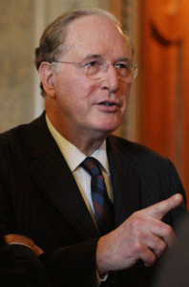
Former Virginia Governor and U.S. Senator, Jay Rockefeller
Baron David Rothschild
Evylin Rothschild, for his part, has ceded power to Baron David Rothschild. According to Ninja Shiramine, American Ninjas now report to Jay Rockefeller.

Wealthy International Ring- Junki and Erika Yoshida
It’s the first real-estate company in Oregon to specialize in WEED properties. In 2015, state officials closed the Watsons’ GreenSky marijuana dispensary and their Step by Step Child Care Center. n 2015, state regulators forced licensed childcare providers to make a choice: profit from pot or kids, not both. New rules prohibited anyone who applies for a childcare license from growing or distributing marijuana, either at the day care or elsewhere. Watson’s girlfriend, Bakhtiar, is the front trying to reopen the Concordia (Step by Step/GreenSky) day care, in the same location. In January 2017, she re-opened the GreenSky marijuana dispensary as a co-owner under a new name- Jefferies. And Watson is trying to open a new state-licensed marijuana shop in the North Portland storefront he previously used for medical marijuana.
The International Yoshida Group Control the Narrative about Jennifer Hart
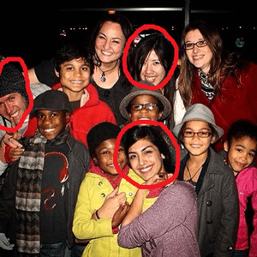
Bakhtiar, Yoshida, Watson & the Hart Tribe
Bakhtiar and the international ring, Yoshida Group, certainly adds a mysterious dark circle spin to the Satanic Ritual Abuse and Programming of the Children. In fact, Bakhtiar bankrolled by the Yoshida Group are officially in charge of public relations– fostering the national/international false image of Jennifer Hart after the racial mass murders of the Children. In fact, Bakhtiar is the official public relations (PR) spokesperson for the Lutheran Hart Family in South Dakota that have all agreed not to talk to the press about Jennifer Hart.
From the day that Jennifer Hart’s SUV went off the cliff, California State Highway Patrol, Mendocino County, and the FBI have been working closely with law enforcement officials in South Dakota to control the narratives about the Hart Witches. Bakhtiar works hand and hand with Jennifer’s aunt, Georgene Wilson-Becker of Sioux Falls, South Dakota, to spin the story and control the narrative about Jennifer Hart. Their racialist based narrative is that it was the hopeless social deviant and misfit drug addicted black Children that drove an idealistic social conscious activist and optimist Jennifer Hart off the deep end. According to the Hart Family PR spokesperson, Bakhtiar, the bodies of Jenn and the Children have been cremated. Their ashes will be sent to Georgene in South Dakota. Bakhtiar will then take the ashes back to Oregon. She was asked about the Children’s black biological parents and loved ones in Texas- whether or not they had been contacted. Bakhtiar dismissed them entirely as a bunch of drug addicts that abused and malnourished the Children. F-K YOU, END OF STORY!

The woman is not only a vicious sick elitist Racist- she’s absolutely CRAZY! Bakhtiar said Hart may have been both a great mother and someone capable of killing her family in a “MOMENT OF DARKNESS“. Darkness! She should know better about international dark circles.
VIII
SCANDINAVIAN OLD TIME RELIGION & THE COVEN OF THE BLACK CIRCLE
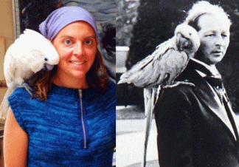
Elizabeth Boggs with Parrot/Macaw perched on her shoulder, and the Viscount Tredegar circa 1935, with Blue Boy the macaw perched on his shoulder.

Old Religion Witch of the New Forest- Sybil Leek & her Bird
During the 1930s in Britain, Aleister Crowley and Aldous Huxley were linked to the Satanic Coven of British bi-sexual/homosexual Devil Worshiper, Lord Evan Frederic Morgan, 2nd Viscount Tredegar that the Great BEAST hailed as the Adept of Adepts.
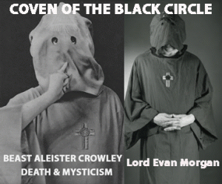
Crowley said that his family was descended from King Arthur. The legendary city of Camelot was supposed to have been at the nearby Roman site of Caerleon. Crowley even described his lordship as “The Rightful Heir to Excalibur”.
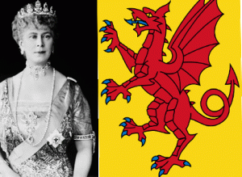
Queen Mary, Old Religion- Coven of the Red Dragon
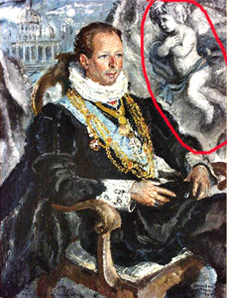
Lord Morgan & Cherub X Sign in Sacred Reverend to Him
The image of chubby-cheeked babies with wings cherub actually wasn’t around until the Renaissance, when artists depicted the lower-order angels as children. Queen Mary of England (Coven of the Red Dragon), the present queen’s grandmother, called Lord Tredegar “My favourite bohemian”.
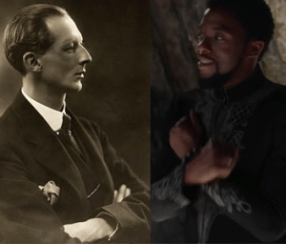
The Black Panther, T’Challa, Sacred X Sign in Reverend to Lucifer
Lord Tredegar was known as the Grand Master of the Black Mass.^{[10]}

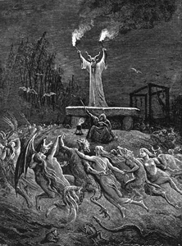
Old Religion Satanic Black Mass
Knight of Malta Lord Tredegar elite British underground homosexual Satanic coven and cult was called, “THE BLACK CIRCLE.” John, Duke of Bedford, in his autobiography “A Silver Spoon” recounts the occasion when Evan conducted a divination in the Kings Room of Tredegar (Evan’s bedroom). He describes how Evan entered wearing the robes of a “dead, Egyptian witch”, and brandishing this witch’s mummified hand, proceeded to cast a fortune as “the fire light danced across the four poster bed, an overheated room became icy cold, and owls flew ever around the cornice!”^{[11]}
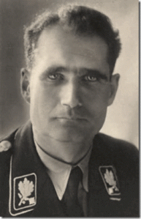
Secret Black Circle Deputy-Fuehrer Rudolf Hess
The BLACK CIRCLE included Nazi Germany’s Deputy-Fuehrer Rudolf Hess of the Thule–Gesellschaft (Thule Society), one of Hitler’s closest confidants. Lord Tredegar had also visited the German home of Ernst Rohm (Thule Society), the head of the SA, and they shared a male lover.
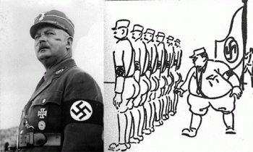
Secret Black Circle Vicious Homicidal Homosexual Ernst Julius Günther Röhm
Ernst Julius Günther Röhm was a German military officer and an early member of the Nazi Party. As one of the members of its predecessor, the German Workers’ Party, he was a close friend and early ally of Adolf Hitler and a co-founder of the Sturmabteilung (SA, “Storm Battalion“), the Nazi Party’s militia, and later was its commander.
Based on accounts by the contemporaries of Evan Frederic Morgan ( 1893-1949 ), the last Viscount Tredegar, author William Cross reveals a shocking story of a dangerous, predatory homosexual with a taste for seducing the native boys of Bali and North Africa. An early example of sex tourist, Evan twisted, charmed and lied his way around the world in pursuit of avarice, high- jinx, self-gratification and adventure . Morgan was openly degenerate, his wealth, position and arrogance combined to make it easy for him to pick up ‘rough trade’ on streets and in cafes and lure his young, often innocent victims into drugs, sexual shenanigans, black mass rituals and flagellation. Even under Vatican control and surveillance by MI5, Evan Morgan escaped any scrutiny or restraint and carried on regardless.
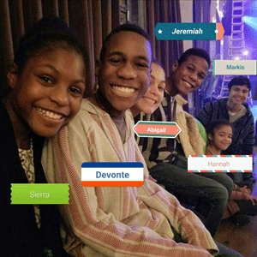
In the case of the Hart Witches and the mass racial murders of six (6) black children, the dark satanic circles, witches’ covens, groves and their crimes against humanity have also escaped scrutiny and restraint in this country. It also continues and carry on regardless.
IX
CONCLUSION
California Highway Patrol Lt. Commander Bruce Carpenter said that the Hart Witches drove about 77 miles upstate Washington to the small town of Naselle, Washington before their alleged drive to the California.
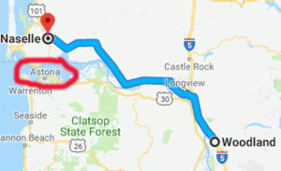
Naselle in Pacific County, Washington is an extremely isolated, secluded and rugged area of the state. It is a Scandinavian town surrounded by lakes. It is very near the Columbia River estuary, the valley’s Naselle River flows west into nearby Willapa Bay and then into the Pacific Ocean. Close about the town lie the evergreen-covered Willapa Hills. The Willapa Hills receive abundant rainfall and a number of rivers originate in the region, including the Chehalis River, Willapa River, North River, Bone River, Niawiakum River, Palix River, Bear River, Naselle River, Grays River, and Elochoman River, among others.

You have to wonder why an Amber Alert wasn’t issued on the Hart SUV and why Lt. Shannon Barney of Mendocino County Sheriff’s department never did alert the public of the license plate number or the color of Jennifer Hart’s SUV that it was racing with. There are no surveillance videos of Jenn’s brown SUV in the Safeway store parking lot or around Ft. Bragg, CA? Maybe, it shows that Jennifer, Sarah, Devonte and Little Hannah were never in California at the time the SUV went off the cliff.
Lt. Commander Carpenter said that investigators were trying to determine why they stopped in Naselle and whether they contacted anyone. Well, there has not been an update on the Hart Naselle connection and contact even though there may be no more than 500 people in the entire town . And, I don’t expect any further law enforcement updates on Jennifer, Sarah, Children and Naselle. It could very well be a fact that Jennifer and Sarah never even drove to California with the Children.
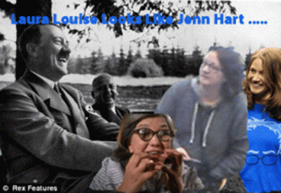
Even Hitler must be rolling over in his grave laughing about chasing Laura Louise of Rosemary’s Baby- looking like Jenn Hart. That certainly wasn’t Jennifer Hart in Fort Bragg, CA on March 25, 2018. That woman looks nothing at all like Jennifer Hart.
Naselle and the Finnish-American Folk Festival
Jennifer Hart was baptized a Lutheran. Scandinavian Finnish roots also run deep in Lutheranism. The Lutheran Church is the national church of Finland. The secret old religion GOAT (Horned God) is also at the roots of Naselle, Washington. At the beginning of the early modern period (1500-1800), Finland was famous for her witches, and especially the great shamans in Lapland.
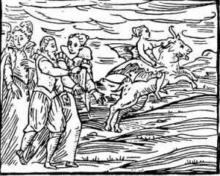
New witchcraft theories (i.e. the theory of flying witches who traveled to the Devil’s Sabbath) arrived in Finland in the 1660s. The colorful stories regarding Finnish witches were well based: The amount of people accused of witchcraft and magic was quite large.
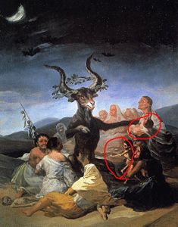
They Offer Their Children to the Horned Goat God
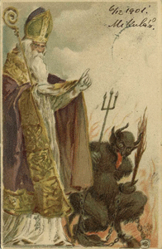
St. Nick & The Horned Devil God
Finnish Lapland is the only authentic home of Krampus. According to legend, Krampus is a demon who punishes misbehaving children around the holidays, while St. Nicholas (AKA Santa Claus), rewards good children. In 2010, the population of Naselle was 419. The community first flourished as a logging town, and logging remains the dominant private industry. Settled primarily by Finnish and Scandinavian immigrants. The history of Scandinavia is the history of the region of northern Europe comprising Denmark, Norway, Sweden, Finland and Iceland are at times considered part of Scandinavia. The Nesalle community has maintained its cultural heritage. Since 1982, Naselle has hosted a “Finnish-American Folk Festival” every other year, and in 2006 co-hosted, with the nearby city of Astoria, OR, the national festival FinnFest USA.

Astoria, Oregon- the Goonie Cult and Coven lies directly across the Columbia River from Naselle. The Goonie House fly the Israeli Zionist flag of the Star and Shield of David. Even the Hart Witches’ home in Alexandria, Minnesota was a SCANDINAVIAN town surrounded by lakes.

If Devonte and Tiny Hannah were Black Mass blood sacrificed in and around the rivers and forests around Naselle,Washington, their bodies may never be found. I have said enough!
__________________________________________________________________

^{[1]} https://en.wikipedia.org/wiki/Mount_Hood
^{[2]} https://www.nytimes.com/1999/03/10/us/sidney-gottlieb-80-dies-took-lsd-to-cia.html
^{[3]} https://en.wikipedia.org/wiki/Willamette_Meteorite
^{[4]} http://www.thenewstribune.com/news/local/article208294694.html
^{[5]} https://gossip.thedirty.com/gossip/portland/douche-bag-farmer-tyler-boggs/#post-1423507
^{[6]} https://gossip.thedirty.com/gossip/portland/douche-bag-farmer-tyler-boggs/#post-1423507
^{[7]} https://en.wikipedia.org/wiki/Theistic_Satanism
^{[8]} http://gentlemanspy.blogspot.com/2013/02/normal-0-false-false-false-en-gb-x-none.html
^{[9]} https://www.sfwar.org/pdf/Ritual_Abuse/RA_RA-Info_1997.pdf
^{[10]} http://gentlemanspy.blogspot.com/2013/02/normal-0-false-false-false-en-gb-x-none.html

^{[11]} Id.
Comments : Leave a comment
Tags: "Finnish-American Folk Festival, 2nd Viscount Tredegar, 82nd Air Borne Division, A Secret Order, Adolf Hitler, ahnenerbe, Aleister Crowley, astoria, baron david rothschild, Bill Groener, black mass, bruce carpenter, Bruce DeKalb, ca, California Men’s Medical Facility at Vacaville, cat in the hat, charles pellet, Charles William Pelletieri, CIA, coven of the black circle, coven of the new forest, Coven of the Red Dragon, covens, cult of death, Dana Dekalb, devil, devil worship, devonte hart, Dexanna, dope magazine, Dr. Mehmet Oz, dr. seuss, Dr. Sidney Gottlieb, druids, elizabeth boggs, Emperor Akihito, erika yoshida, ernst rohm, evan frederick morgan, fantuzzi, finland, FinnFest USA, Fort Bragg, freemasonry, freemasons, General Henry Harley "Hap" Arnold, Georgene Wilson-Becker, goat, goat god, goat god pan, goonie coven, goonie cult, goonies, greensky collective, hannah hart, Harriet Hart, hart witches, Heart 2 Heart Farms, henrich himmler, horned god, Illuminati, james rud, jay rockefeller, jennifer hart, Jim Jones, john dewey, Jonestown, jordan, Junki Yoshida, kemet, knights templar, krampus, lapland, laura louise, lawrence dekalb, Lt. Shannon Barney, Lucifer, luciferians, Maria Abramovic, maria orsic, markis hart, masons, Mendocino County, meritaten, mind control, Miron- Aku, mk often, MK-ULTRA, MN, Monarch Program, nesalle, Nusheen Bakhtiar, Oprah Winfrey, oregon, Peoples Temple, portland, prince, prince philip, queen elizabeth II, race with the devil, rainbow family, rainbow gatherings, rogers nelson, Rosemary's Baby, Rudolf Hess, rudolph hess, samuel watson, sarah hart, satan, Satanism, SCANDINAVIAN Witchcraft, Shambalah. Shangri-La, Shranga- La, sierra hart, sigma phi epsilon, Smenkhkare, st. nicholas, Steve Frkovich, the black circle, the cat with the hat, the oz show, The First Motion Picture Unit, Theodor Geisel, turpin children, tyler boggs, Washington, wes bishop, West Linn, Willamette Meteorite, William Hugh Carter, Witch of Ridley Creek, witches, wizard of oz, yoshida group
Categories : Aleister Crowley, Aryan Supremacy, baby scarifrice, baphomet, black children, black christianity, blood covenants, blood oaths, blood sacrifice, christianity, CIA, david rockefeller, devil, freemason, freemasons, human sacifrice, illuminati, illuminati sacrifice, jim jones, kemet, Knight of Malta, Knights Templar, luciferians, manchurian candidates, masonic sacrifice, MK-ULTRA, prince, prince nelson rogers, Ritual Satanic Abuse, ritual satanic sexual abuse, ritually abused children, rogers nelson, rosemary's baby, satan, Satanism, Sweden

THE GATES OF HELL, MK ULTRA- OFTEN, RACIAL MASS MURDER & THE STAGED ESCAPE OF THE HART WITCHES FROM WITCH MOUNTAIN, WASHINGTON
15042018

GIVE ME THAT OLD TIME RELIGION
It was the adopted and adapted religion of the Prophet Nat Turner, and my forebears that broke the chains of African Human Bondage. It was the religion that led the Civil Rights Movement and institutional racism in America. For decades, the Black Church represented the moral conscious of the nation. It took a stand against America’s aggression in South East Asian (Vietnam) and across the globe. It was the religion of my mother, father, sisters and brothers- its good enough for me. It is not a religion of war and revolution. It preach and practice ORDER, PEACE, LOVE and FORGIVENESS. In my youthful days growing up in the Black Church, it was a secure sanctuary and peaceful haven from a troubled world and CHAOS. But, that’s not the problem with Black Christianity in America, today. It is under attack. There is a covert war against the ORDER of the Black Church.
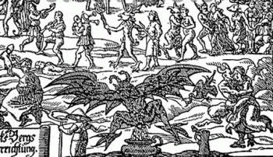
However, others also have their own Old Time Religion that preach and practice the dark demonic-satanic forces of HATE, DEATH, DESTRUCTION, AND CHAOS that existed since the beginning of civilization.
It is a dark force belief system and religion of the sheer animal lust of the forest horned goat god; human sacrifice and cannibalism. They, Luciferians, seek the control of the WORLD.
I
THE HART WITCHES & THE OPEN GATES OF HELL IN AMERICA
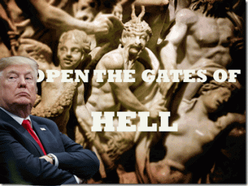
Never before in the history of United States has a presidential administration begun its reign by telling it citizens that SATANIC “dark forces” and its POWER are good to RULE the country. Yet, that is exactly what happened in America in November 2016. Satan’s Son president select Donald J. Drumpf’s chief strategist, Steve Bannon, for the new administration told The Hollywood Reporter that “darkness is good.”
“Dick Cheney. Darth Vader. SATAN. That’s POWER. It only helps us when they get it wrong. When they’re blind to who we are and what we’re doing.”
Don’t get it twisted, Jennifer and Sarah Hart are no HollyWeird romanticized episodes of Laverne and Shirley, or Thelma and Louise. They are New Age Witches- part of this country’s SATANIC “dark forces” and Open Gates of Hell aided and abetted, and concealed by the highest levels of this government. The masses are blind to, and don’t know what they’re doing.
Yesterday, Satan’s Son and Luciferians of France and England have attacked an independent nation on the other side of midnight, Syria, for alleged human rights violations. But at the same time, America is unwilling to lift a finger or take a stand against Israel’s current mass violations of the human rights of Palestinians in Gaza.

Drumpf and Netanyahu
That’s because they call America- BIG SATAN, and Israel- LITTLE SATAN. America has become the Open Gates of HELL.
The Hart Witches & the Racial Mass Slaughter of Innocence
Also a couple of days ago, news broke that one of white females, alleged to be Sarah Hart, and 2 (two) of the children that died in the plunge off the sea cliff in Mendocino County tested positive for “significant” amounts of Diphenhydramine. The drug can be found in many over the counter medicines. But when victims and murder are involved, you must consider that the drug may have been a factor to incapacitate a victim. Diphenhydramine can in fact be used to incapacitate victims.
On Websleuths, an anesthetist noted that an oral dosing of benadryl (diphenhydramine), an average adult dose of 50 mg is more than sufficient to cause pronounced drowsiness, and anesthetists actually exploit the drowsiness effects of the drug for use in some patients. More than 100 mg would cause marked sleepiness.
All 6 (six) children were deliberately kept seriously malnourished and underweight by the witches. Significant amounts of Diphenhydramine dosing could have caused a great deal of damage to incapacitate them. And, diphenhydramine could very well have been used to keep the children MK ULTRA/MONARCH sedated and under control until they could be wickedly and quietly removed and be disposed of.
Evidence of diphenhydramine drugging is an extremely significant factor in this case. Diphenhydramine was also found in the system of Whitney Houston when she was assassinated from a Jonestown’s Cocktail of a deadly combination of drugs on February 11, 2012 at the Western White House in Berkeley Hills, CA. It was determined that Diphenhydramine (Benadryl) did not contribute to her death. Naturally, Benadryl would not have been a factor in killing Whitney, but it could have been a factor to keep her sedated and quiet while she died alone in the hotel room- allegedly face down in bathtub of water.
In January 2015, Bobbi Kristina Brown was also incapacitated and subsequently died as the result of a Jonestown Cocktail that included benzodiazepines (medications used for sedation). She also drowned alone in a bathroom- allegedly face down in bathtub of water.
Witch Angela Bassett, American Horror Story
I say that Witches & Satanic Blood Oath Covenants were a factor in her death. (see, Let’s Drive Bobbi Kristina Insane- Witches & Whitney, the Illuminati Bio)
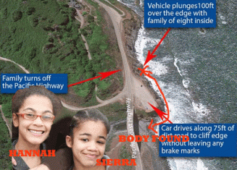
Four (4) precious black children are not confirmed DEAD slaughtered by Jennifer and Sarah Hart and a deep cover coven of witches. Recently, a black child has been found on the ocean surf at Juan Creek and Highway 1, in Mendocino County. It is either Hannah, age 16 or Sierra, age 12.

It bothers me that the bodies of Markis, Abigail, and Jeremiah were found along with 2 (two) white females and vehicle wreckage landed on rock beds below the cliff. It appears plainly and so clearly above. Yet, we are led to believe that the bodies of Sierra, Hannah and Devonte were somehow washed out of the SUV or off the rock beds into the sea. That Dog Don’t Hunt! My fear is that is that the body recently discovered and rescued from the ocean by tourists is precious Little Sierra.
It strongly suggests that Little Sierra was killed someplace else and her body was thrown from Juan Creek Bridge. I pray that the swift wings of the sacred Sparrow rescue her most precious soul and lift HER home.

It also strongly suggests that Hannah and Devonte weren’t in that SUV when it went over the cliff.
Hannah and Devonte are heroic in spirit and strength. They are firm in faith. It is clear that they resisted Jennifer, Sarah, and an extremely powerful deep cover satanic coven’s attempt to sacrifice their bodies and souls to Lucifer. My prayer is that they are still alive and fighting for their lives. If we can find them, the results won’t be the same as it turned out in the State of Washington. The Witches won’t escape the Wrath of the People.
II
THE MANY FACES OF THE WITCH JENNIFER HART
Jennifer Hart & The CIA Pagan Fantuzzi

Jennifer Hart & Fantuzzi
Above, Jennifer Hart’s Tribe and the infamous Woodstock Pagan August 15–17, 1969, Fantuzzi. He is friends with Ram Dass (Dr. Richard Alpert), and the late Timothy Leary leaders of the LSD-ILLUMINATI, the clandestine higher consciousness spiritual movement through psychedelic chemicals. In the early 1960s, Leary and Dr. Richard Alpert ran the Harvard Psychedelic Club, formerly the Harvard Psilocybin Project, a school-sponsored drug research project at the university.
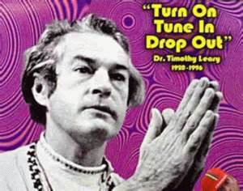
“1954-59: Leary is director of clinical research and psychology at the Kaiser Foundation Hospital in Oakland. He devises a personality test, “THE LEARY,” which is used by CIA to test prospective employees. He has also become a close friend to Frank Barron, a graduate school classmate who has been working for CIA since at least 1953. Barron works at the Berkeley Institute for Personality Assessment and Research, which Leary will later acknowledge is “funded and staffed by OSS-CIA psychologists.”
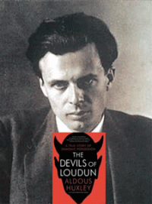
Aldous Huxley, British Godfather of CIA MK ULTRA/MONARCH
Huxley’s Devils of Loudun purports to be the true story of a seventeenth century case of WITCHCRAFT in France. Huxley was also part of that ultra secret OLD TIME RELIGION AND WITCH CULT.
“1960-61: Barron founded the Harvard Psychedelic Drug Research Center. Leary follows Barron to Harvard and becomes a lecturer in psychology… He later admits to knowing, at the time, that “some powerful people in Washington (CIA) have sponsored all this drug research.” In addition to Barron, Leary’s associates and assistants during this period include former OSS chief psychologist Harry Murray, who had monitored military experiments on Truth-Drug brainwashing and interrogation, and Martin Orne, a researcher receiving funds from CIA. Leary also consults British philosopher Aldous Huxley, author of the psychedelic manifesto, The Doors of Perception (from which Jim Morrison would later take name his band). Huxley, who is at Harvard on a visiting professorship, urges Leary to form a secret order of LSD-ILLUMINATI, to launch and lead a psychedelic conspiracy to brainwash influential people for the purposes human betterment.”
Leary belonged to the deep level Agency- MK ULTRA ILLUMINATI. If you’re a friend of Tim Leary, you’re a friend of the CIA.
Jennifer Hart, Rosemary’s Baby and Laura Louise in Fort Bragg, Mendocino County, CA
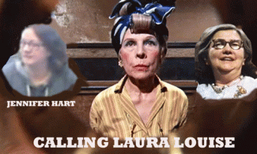
Minnie Castevet of Roman Polanski’s Satanic Coven Classic Rosemary’s Baby calls forth the image of faithful Lucifer’ Servant, Laura Louie, to provide secret cover for Jennifer Hart in Fort Bragg, Mendocino County, CA. The frantic drive from Woodland, Washington to Fort Bragg must have drastically negatively affected Jennifer Hart’s vision, because she suddenly slowed up in town wearing LAURA LOUISE dark rim glasses.

It also changed Jenn‘s body type and very distinctive NOSE!

Jennifer Hart has a distinctive “spaded” nose type that is similar to the nose of the late NASA Astronaut Virgil I. Grissom -Master Mason.
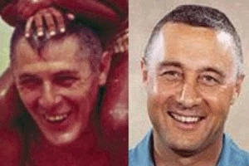
NASA Master Mason Virgil Ivan “Gus” Grissom
Barack Obama had been clandestinely raised as a NASA MK ULTRA/MONARCH Space or Star Kid.
Obama and Guss Grissom
The above picture was released by the Obama White House that was alleged to be him and his late grandfather, Stanley Armour Dunham, but even with Photoshop touch ups- it is clearly NASA Astronaut Virgil Grissom.
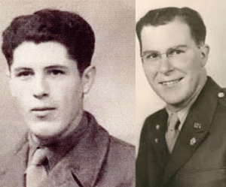
Stanley Armour Dunham
Dunham looked absolutely nothing similar to Gus Grissom.

It is “very grainy,” Lt. Barney told The Oregonian. “It looks like Jen.” Laura Louise’ nose points up, and Jenn Hart’s nose points DOWN TO THE GROUND LIKE A SHADE. Don’t get it twisted. I am extremely serious about this subject and the children. The stakes are extremely high, and the DRAGON will always snap its tail. But, there is no statute of limitations for MURDER, ESPECIALLY INNOCENT CHILDREN!
III
TOWN OF THE OAK TREE, BLACK CHILDREN & FOSTER CARE CORRUPTION
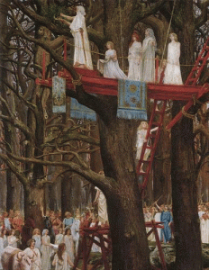
In the secret Town of the Oak Tree, Oakland, CA, I worked on Alameda County foster child care corruption that made a lot of people filthy rich on the backs of destroying black families and children. It was a downright dirty and wicked racket.
I traced the sudden new found wealth of well respected black attorney, old handkerchief head Wilmont Sweeney, the Alameda County Juvenile Court Judge in charge of the county’s foster care system, who suddenly started driving a new Rolls Royce around town, to a white female and Bodega Bay, CA approximately 40 miles northwest of San Francisco. Bodega Bay was the setting for the 1963 Alfred Hitchcock classic, The Birds.^{[1]}
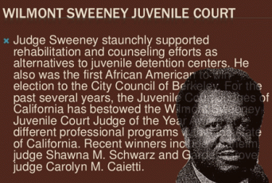
In the masonic Town of the Oak Tree, Sweeney was part of Oakland’s infamous sell-out Negro Old Guard of attorneys that included bootlickers Lionel Wilson, Clinton White, Allen Broussard and Carl Metoyer linked to Prince Hall Freemasonry.
SS Bolschwing & Ronald Reagan
Judge Sweeney was appointed to the Municipal Court in Berkeley by then-Governor Ronald Reagan controlled by Gehlen Org SS Baron Bolschwing. In 1979, then the Jonestown Jesuit Governor, Jerry Brown, appointed Judge Sweeney to the Alameda County Superior Court.^{[2]}
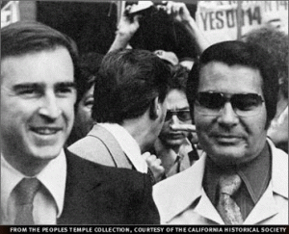
Gov. Jerry Brown & CIA Agent Jim Jones
I traced the money of one non profit large foster care California corporation that was banking millions from the Alameda County and state foster care system by taking particularly black children from their homes. It was called Aspire at the time. The monthly subsidies that it received for black children forced into foster care ran into the thousands.
The particularly case that I was working on involved Aspire taking in at the very least $3,500 for each of 3 (three) children- over $10,000 a month for kids that had been categorized as “special needs” children. I worked with an extremely stable devoted black Christian grandmother that wanted her 3 (three) grandchildren at home with her. The children had become the innocent collateral damage, casualties and victims of the CIA Crack Epidemic in Oakland. Her grandchildren had been deeply traumatized by being locked in a room for days with the corpse of an overdosed dead crack cocaine addict.
She worked for decades as a secretary with the Oakland Unified School District (OUSD). She owned her own home. She was also a well respected anchor elder member of a very large, important and established church (Beebe Memorial Cathedral) congregation and community in Oakland. I thought that she was in a relatively safe and secure position more than others to fight the powers. She couldn’t understand why her grandchildren couldn’t live with her and church community instead of being confined in an alien foster care system. The children wanted to be with their grandmother. I needed to know the answer to that question, too. It involved the welfare and safety of thousands of black children in Oakland. From inside her case, I was able to work deeply inside the county juvenile court and foster care system. I started by following the money.
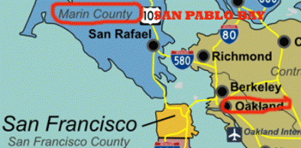
I traced Aspire’s foster care money flow to the very wealthy Marin County across the bay from Oakland. In 2013, the median income for couples filing jointly in Marin was $133,389 — the highest in the state, and also it had the highest median income for individual taxpayers. It ranks among the 20 wealthiest counties in the entire United States. It has a black population ranging from 2.1 to 2.6%.^{[3]}
Aspire was a nonprofit tentacle of a corporate structure that had profit making corporate tentacles. In other words, the money from the California non profit tentacle was invested principally in bayfront real estate, particularly, valuable San Pablo Bay tidelands owned by the state. It was property unavailable for sell to private investment. The real properties purchased by the foster care non profit was then sold its profit making subsidiaries for pennies on the dollar then developed commercially. The millions from the county and state foster care system were turned over for billions in high end bay-front commercial and residential real estate development. It was public corruption and a racket that ran all the way up to the California State Legislature. I had obtained the key public documents directly from Marin County to prove the case.
I constantly reminded the grandmother that this was a case where the stakes were very high. Wherever the stakes are high, it becomes an extremely dangerous pursuit for justice. I was getting too close and they knew it. She believed in justice, but she didn’t truly understand the nature of the fight that she was getting into with Luciferians. A lot of people suddenly and understandably become afraid and friends suddenly become enemies when the ILLUMINATI begin to cash in its chips.
On April 29, 1999, Judge Sweeney suddenly turned up dead. He was 74 years old. Suddenly, OUSD cut the grandmother’s hours at work to the point so drastically that she could no longer even maintain her house payments. They even tried to purge her from the Church that she loved. We fought off the purge, but it took its toll. She was in tears the last time I talked to her. She was bound to lose everything if she continued to cooperate with me about Alameda County’s foster child care corruption from inside her case. The DRAGON snapped its tail.
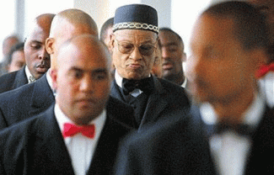
The Late Yusuf Bey and Oakland’s Black Muslim Brothers
However, the battle was far from over. I started working with a mother whose minor daughter accused Yusuf Bey of Your Black Muslim Bakery of pedophilia molestation and rape. She had been one of his wives. I was surprised. I didn’t have to fight with Yusuf Bey or any of the brothers. I had to fight the power of the state, Alameda County Child Protective Services, that threatened to use its power to remove her daughter on a permanent basis (foster care) if she persisted in pursuing a case against Brother Bey. She was in tears the last time I saw her, too, when the DRAGON snapped its tail.
The love of a mother for her children is one of the most powerful forces known to mankind. I can’t do anything if that relationship has been threatened. As for me, it was yet another straw on the camel’s back that subsequently got me another one way ticket and a virtual police escort out of the city of birth, masonic Town of the Oak Tree. I had been slapped with several private and county lawsuits to restraint from getting into the affairs of black people. A county superior court judge slapped me a permanent injunction barring me from the affairs of a church that I had summoned to by church elders.
Working inside the county juvenile system, I got another surprise. In about 1997, I was approached by a small group of upset teachers at Fremont Junior High School in Oakland. They told me about a teacher in the school that I knew, Styles Price. From my own personal experiences with him, I had concluded that he was a deep cover strategy of tension/false flag black counterintelligence agent. The teachers told me that they knew of him to be a convicted pedophile. He was a child molesting “boy lover.” They couldn’t figure out how he remained to be a teacher and still be allowed to be around children. I searched from the top to the bottom of the criminal court system in Alameda County. I couldn’t find anything at all regarding his pedophilia conviction(s). I totally believed them, but I just couldn’t find his criminal conviction records.
Whenever I go to juvenile court, I go from floor to floor to look around. My surprise was that I found Styles Price sitting outside one of the juvenile court offices. He’s a man that love to talk about himself. I sat down with him and discovered that the reason why I couldn’t find his pedophilia conviction(s). His criminal records were being ran through Judge Sweeney and the juvenile court system where court records are strictly confidential and SEALED.
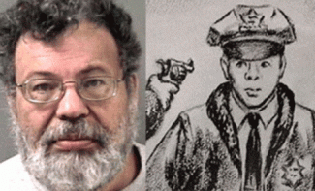
FORMER OAKLAND TEACHER, STYLES PRICE
In 2005, the Berkeley Police Department arrested Styles Price for the ambush murder of Berkeley Police officer Ron Tsukamoto who was shot and killed on University Avenue in the early morning hours in August 1970. They claimed that the Panthers killed Tsukamoto. However, the Alameda County DA outright refused to prosecute Styles and the deep cover black intelligence operative walked.
In Oakland, I suddenly found myself sitting on the crust of the late 32 or 33 degree Master Mason Booker T. Emery‘s extremely powerful and dangerous ultra secret -deep cover Masonic-Republican Pedophile Ring in Oakland. And, I didn’t realize it. The felonious convicted vicious pedophile died in Vacaville’s Men’s Medical Prison (Little Prison of CIA Horrors) in 1989 within a year or two of being imprisoned. DEAD MEN TELL NO TALES.
Emery was a black Republican. During the late 1960s and 1970s, all the millions of anti-poverty funds that came into Oakland from the Republican Nixon Administration had strings attached. Those strings seem to always one way of another be attached to Emery. The roots of the Oakland’s high level pedophile ring and its steady supply of innocent black children lies at the feet of Booker T. Emery, the Old Masonic Temple and properties located on the corner of 7th and Peralta Street that is getting or will be getting millions in city, state and maybe federal historical preservation funds. They are extremely well represented at city, county, state and federal government high levels. They are dangerous. They usually kill first and ask questions later.
The DRAGON has snapped its tail in the case of the New Age Lesbian Witches, Jennifer and Sarah Hart, and at least 5 (five) innocent children are confirmed to be DEAD! And, it is more than likely that the witches received way more than $270,000 from the state of Texas to help care for the children. Most families who adopt children out of foster care from Texas get monthly payments that only range from $400 to $545 per child to help cover care costs until the child turns 18, according to the newspaper. However, Jennifer and Sarah weren’t most families. They were CIA Occult Bureau.^{[4]}
Chloe Johnson, Paper Trail
Don’t be deceived. Monthly subsidies for adopted children are significantly increased for children with “special needs”. On November 14, 2014, Chloe Johnson ran a story about Devonte in the Paper Trail. Chloe Johnson is the co-founder of Paper Trail.co.nz – a news and views website that’s all about adding value to people’s day. She has been a journalist in New Zealand, Australia and the United Kingdom where she covered law and order, health, education, politics, travel and entertainment news. She is/was a communications adviser in New Zealand.
Johnson said, “Devonte Hart entered the world 12 years ago with drugs pumping through his tiny newborn body. By the time he was 4 years old he had smoked, consumed alcohol, handled guns, been shot at, and suffered severe abuse and neglect. He knew only a handful of words, including fuck and shit, and he struggled to identify with the names of food, body parts and everyday objects. Devonte was a violent toddler and his health was weighed down by a heavy list of disabilities.”^{[5]}
IV
JENNIFER, SARAH HART, CIA OCCULT BUREAU & THE WITCH OF THE FOREST

Jennifer Hart & Devonte
Jennifer Hart told her, “He [Devonte] inspires me every single day. He has proven doctors, psychologists and teachers wrong.”^{[6]} Don’t be deceived. Devonte was a “special needs” adoptee that had a team of social workers, doctors, psychologists and an attorney that also take a very big bite out of the state treasury. They have all of a sudden disappeared from Devonte’s case walking between the raindrops. All the children turned over to the Hart Witches were “special needs” adoptees. That’s the way CIA Agent Rev. Jim Jones and Peoples Temple rolled. All of the adopted children had doctors, psychologists and attorneys that also need to come to light like the Hart Witches and be held responsible. And, $270,000 is just a low ballpark figure of what the Hart Witches actually took away from the Texas foster care system, state and maybe the federal treasury.
The Hart Tribe as it had been called by the Harmony Park Grove Coven in Minnesota was a Touch of Buchenwald and the Shadow of Jonestown. The Nazi-SS fed inmates in camps a meager diet of thin soup and bread. A characteristic camp illness was starvation sickness. It was usually accompanied by diarrhea (often bloody), swollen legs, impaired vision and hearing, memory loss, nervous breakdown and, above all, exhaustion to the point of collapse. The Peoples Temple’s Jonestown daily diet also consisted of rice soup and bread that caused serious problems for the residents that struck over half the experimental medical camp in February 1978 with high fevers and diarrhea. The Hart Tribe had to have been, among other things, a nutritional experimental step for Modern Slaves above Buchenwald and Jonestown.
“Here are the estimated weights and heights of the three missing children who were not recovered from the crash site: Devonte Hart, 5’1, 90 lbs, 15 years old; Sierra Hart, 4’5, 60 lbs, 15 years old; Hannah Hart, 4’1, 45 lbs, 16 years old. These are nowhere near age appropriate stats for children of their age. They were being starved. They were literally withering away.”^{[7]}
It should be Sierra, 12 years old, and 4’1, 45 lbs, and Hannah, 4’5, 60 lbs. All the children were seriously underweight for their ages. Hannah was underweight about 50 (fifty) pounds for her age. One of main reasons why Jonestown had to be terminated as a CIA MK ULTRA/MONARCH medical and mind control experimental concentration camp, particularly for black youth, was because the majority of the people in the camp were sick from from fever and diarrhea. It was an experimental concentration camp in the middle of a South American rain forest that the infamous Attorney Charles Garry called “Paradise“. The dead tell no tells. Whatever the Hart Witches were feeding the 6 (six) black children was also experimental, and it was driving them into sheer desperation.

Perfecting the Jonestown Diet and Drug program for Black Children- Devonte and a 13-year-old orphan, a survivor of the Nazi-SS Mauthausen Concentration Camp.

SADISTIC SARAH OF THE FOREST
Court records in Minnesota show Sarah Hart in 2011 received a 90-day suspended jail sentence and a year of probation after Abigail arrived at Woodland Elementary School with bruises on her stomach and back. Her teacher contacted social services and police.

Abigail told authorities her adopted mother sadistically struck her repeatedly with a closed fist, submerged her head under cold water and withheld meals from her for misbehaving, according to report by police in Alexandria, a small town northwest of Minneapolis where the family lived. Sarah Hart pleaded guilty April 7, 2011, to misdemeanor domestic assault.^{[8]}

Previously, Hannah said in September 2008 it was her adopted mother Jennifer who struck her with a belt, causing a bruise on her arm that attracted notice — and a call to authorities, according to the newly obtained Alexandria police report. In an interview, the Hart Witches told a police sergeant and social worker they had no idea how Hannah, who was 6 years old at the time, got the bruise but said she had recently “fallen down the stairs” in their home.^{[9]}
Hannah should have been looking forward to her high school sophomore prom instead of a death sentence. The witches shockingly investigative officials that the little girl was adopted and “has been going through food issues, where she’ll steal other people’s food at school or eat out of garbage cans or off the floor, [like an animal]” the police report shows.^{[10]}
V
THE HART WITCHES, CIA, OLD WITCH CULT, WICCA & GOD PAN
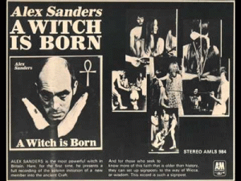
Alexandrian Wicca or Alexandrian Witchcraft is a tradition of the Neo-pagan religion of Wicca founded by Alex Sanders, 1926 – 1988, (also known as “King of the Witches“) who, with his wife Maxine Sanders, established the tradition in the UK in the 1960s. Alexandrian Wicca is similar in many ways to Gardnerian (Gerald Gardner) Wicca, and receives regular mention in books on Wicca as one of the religion’s most widely recognized traditions. Roman Polanski (Rosemary’s Baby), Sharon Tate (Eye of the Devil) Murders, Charles Manson and the Dark Satanic Circles in Laurel Canyon (HollyWeird) involved English Alexandrian Wiccan Witchcraft and Satanism. Sharon Tate and Laura Louise were “Alexandrian Wiccan Witches“.
Gerald Gardner(1884 – 1964) & Demon
The secret Witches tradition and network in the U.S. is based largely upon Gardnerian Wicca, in which Sanders was trained, and the practice also contains elements of ceremonial magic and Kabbalah, which Sanders had studied independently. The name of the tradition is a reference both to Alex Sanders and to the ancient occult Library of Alexandria, which was one of the first libraries in the world. The choice of name was inspired by a view of the library as an early attempt to bring together the knowledge and wisdom of the world into one place.
CIA & Sybil Leek, Jennifer and Sarah Hart, Witch of the New Forest
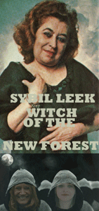
The CIA Occult Bureau was officially called MK OFTEN headed by Richard Helms and the Jewish Kabbalist Sidney Gottlieb called the “Black Sorcerer“. MK OFTEN employed operational Satanism, Witchcraft, and Black Magic.
“Initially, Operation [MK-]OFTEN was a joint CIA/Army Chemical Corps drug project, based out of Edgewood Arsenal in Maryland and using inmates of the Holmesburg State Prison in Philadelphia as test subjects. It came under the aegis of the CIA’s Office of Research and Development (ORD), which was concerned with parapsychology and the application of supernatural powers for military purposes. Later, OFTEN would become a kind of grab bag of CIA investigations into the paranormal, and would include everything from séances and witchcraft to remote viewing and exotic drugs. Agents of Operation OFTEN would consult with such occult luminaries as Sybil Leek …”
The CIA MK OFTEN expert consultant for witchcraft was British Sybil Leek, Witch of the New Forest. Leek was the High Priestess of a powerful secret international Old European Witch Cult Circle that had tentacles across Europe, and America. Gerald Gardner (Gardnerian Wicca) had been initiated into Leek’s Coven of the New Forest, and an ultra secret international circle of Old Religion Witches that included Adolf Hitler, Rudolf Hess, and other global leaders.
In England, Sybil Leek’s maternal grandmother was an initiate of the secret Old Religion. Leeks’ father was an intellectual and expert in metaphysics. Her mother was a theosophist (Madame Blavatsky- Rudolf Steiner). Her grandmother, a Russian psychic, taught her the Craft of the Wise (Old Religion). H. G. Wells, Lawrence of Arabia and the Great BEAST Aleister Crowley had been regular visitors at her family home.

Gorge du Loup
Once her preliminary instruction was completed, as a young initiate Leek and her grandmother journeyed to France, to the Gorge du Loup where she was initiated into the world’s oldest religion. It was called the Coven of the Red Dragon in Gorge du Loup (Wolf Gorge). At the French coven, based in the hills above Nice, Leek replaced a distant relative of her grandmother as High Priestess.
Leek lived with Romany Gypsies in the Forest. She lived with the Gypsies for a year, learning more about the Forest, ancient folklore and herbs. During this time, she also attended rituals of the Horsa (Horse) Coven in the New Forest, which they claimed had existed for over 700 years, and for a short time she was High Priestess, and therefore a member of the “Nine Covens” council.
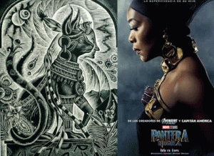
The Goddess Bastet & Black Panther Movie Angela Bassett
The Goddess Bastet Cult featured in Marvel and Disney’s The Black Panther superhero movie for black children is the animal totem for the Coven of the Catta (Latin for cat). HollyWeird does not make movies to entertain black people. Bassett’s ancestry and early background is an enigma. Nevertheless, Disney has never shown any respect for the humanity and dignity of black children. Yet, when they tell people that they have created a wonderful “Zip-a-Dee-Doo-Dah” black superhero out of thin air for kids- millions line up to take the train to Buchenwald to go on vacation.
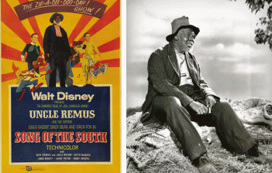
On the plantation, Johnny, white plantation owner’s child, learned a series of life lessons from Uncle (Tom) Remus (James Baskett- the Cat Goddess) in the form of stories about the animated Br’er Rabbit and his quest to evade Br’er Fox (Baskett) and Br’er Bear. Included among this Disney cartoon interludes is the spell, “Zip-a-Dee-Doo-Dah” , which Baskett won the Oscar in 1948 for Best Original Song.
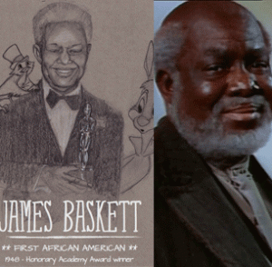
James Baskett (Uncle Tom Remus) could not even attend the premiere of Disney’s “Song of the South” in Atlanta because a black man would not have been allowed to participate in any of the festivities in that racially segregated city. Similar to Angela Bassett, his background and ancestry remains a mystery. Witchcraft/Satanism is yet another deep covert psychological warfare subliminal indoctrination implantation in Disney’s Black Panther film. The Coven of the Cat is in the lineage of the Horse– the animal totem of Sybil Leek’s Coven of the Horsa from the New Forest in England. Before that the Red Dragon was the animal totem of the Coven de la Dragon Rouge in SE France.
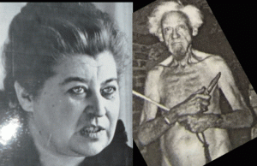
During WWII, New Forest Coven witches Leek and Gardner worked for British Secret Intelligence. British Intelligence used Leek as an astrologist to covertly influence the behavior of occultist world leaders like Hitler and Rudolf Hess thru clandestine horoscopes. After WW II, British Intelligence continued to use Leek to secretly influence the behavior and decisions of world leaders with contrived horoscopes. Leek was the astrologist for California Governor/U.S. President Ronald and Nancy Reagan.
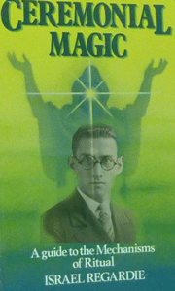
CIA Project MK OFTEN brought Leek to America under the veil of an international book and television lecture tour. She moved into Los Angeles, where she met Dr. Israel Regardie (Xth degree initiate of Crowley’s O.T.O), Aleister Crowley’s old secretary and an authority on Qabalah (Hermetic Qabalah) and ritual magic, and they spent much of their time together discussing and practicing Golden Dawn rituals, and working clandestinely for CIA MK ULTRA/MONARCH.
It is generally believed that Leek initiated Kabbalist Sidney Gottlieb into the ultra secret powerful Coven of the New Forest or the parent Coven of the Red Dragon. Gottlieb was the head of the CIA’s Technical Services Staff (TSS) that ran Project ARTICHOKE (assassinations) and MK ULTRA/MONARCH. Gottlieb held the post until his retirement in 1972. Before he left the Agency, he and Richard Helms destroyed some 80 percent of the CIA’s most damaging (Manchurian Candidate, Sybil Leek, Black Panther Party for Self Defense, etc.) files. He was a Pagan that herded GOATS.
The global Red Dragon Cult is far too ancient, powerful and vast to discuss at this point. But, it is important to note its influence and the British Royal Family connections to secret Witch Cults in America.
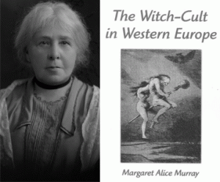
Margaret Alice Murray (1863- 1963) is considered the foremost folklorist on Old European Witch Cults. She is referred to as the “Grandmother of Wicca“. Murray’s witch-cult theories provided the blueprint for the contemporary Pagan Religion of Wicca. According to Murray, members joined the cult either as children or adults through what she called “admission ceremonies“; Murray asserted that applicants had to agree to join of their own free will, and agree to devote themselves to the service of their deity. She also claimed that in some cases, these individuals had to sign a blood oath covenant or were baptized into the faith. At the same time, in some Covens the religion was largely passed down hereditary lines. Murray described the religion as being divided into covens containing thirteen members, led by a coven officer who was often termed the “Devil” in the trial accounts, but who was accountable to a “Grand Master“. According to Murray, the records of the Coven were kept in a secret book, with the Coven also disciplining its members, to the extent of executing those deemed traitors.
It is customary for Druids to meet from time to time, sharing their experiences and discoveries. Christians have congregations, Druids have Groves like the Bohemian Grove. The Grove is a name chosen in honor of the trees, great beings of nature. A grove is a term which denotes not only a sacred clearing in the forest but also a group of Druids. In addition to celebrating the eight seasonal festivals, they may come together to perform rites of passage, for example when a Grove member wants to name their child, or when members marry or pass over. Occasionally, it refers to a group of Pagans who gather to worship under the guidance of a Witches‘ Coven; this kind of “Grove” is also called a “congregation” or “outer circle,” as distinct from the “inner circle,” which is composed of the priests and priestesses of the Coven.
The Hart Pagan Tribe!
This may explain why in over 10 (ten) years, none of the 6 (six) children held by the witches Jennifer and Sarah Hart had never been able to escape to safety.

Devonte and Abigail (A Thing) in the Forest
The children were always confined to isolated remote rural areas (groves, woods and forests) of the country, and within secret Wicca, Druid and Masonic controlled circles, compounds and communities. From May 2017 to March 2018, it appears during that time that at the gate of Mount St. Helens in rural Woodland, Washington some of the children tried so desperately to call for help and escape. They (things) were always returned to the witches until they could be killed and found dead in the remote seaside area of Mendocino County, California. The children were driven 11 hours– over 570 miles to Fort Bragg, CA to be thrown off an ocean front cliff. Between Woodland and Fort Bragg, there were many places to commit the heinous crime of racial mass murder.

CIA and Tim Stoen are in POWER in Mendocino County. CIA Agent Stoen is/was Mendocino County’s attorney with the county’s DA office. He was the attorney and president of the Peoples Temple, the second most powerful man behind Rev Jim Jones. He had been implanted inside the San Francisco DA’s office to protect Rev. Jim Jones and the Peoples Temple. Stoen had been the shadow of Jim Jones. He had been responsible for drawing up the plans for the Peoples Temple CIA Medical/Mind Control Experimental Concentration Camp in the vast rain forest of Jonestown, Guyana. (see David Talbot, Season of the Witch, Free Press, NY, NY (2012))
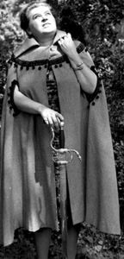
Leek also secretly worked for the U.S. Pentagon (Lt Col. Anthony Aquino). Sybil Leek from the “Final Events” book – according to which, she allegedly channeled a DEMON for US intelligence personnel, to answer questions on the UFO phenomenon.
EUROPEAN OLD RELIGION WITCH CULT
Leek and Gardner revealed and discussed little about the New Forest Coven or the Coven of the Red Dragon, and there is a current push to influence the public to believe that they never existed at all.
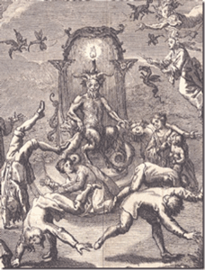
OLD RELIGION WITCH CULT
However, Gerald Gardner did reveal that he believed that the New Forest Coven was indeed a survival of the European Witch-Cult, a pre-Christian pagan religion that worshiped a Horned God and a Triple Goddess and which had been persecuted during the Early Modern period.
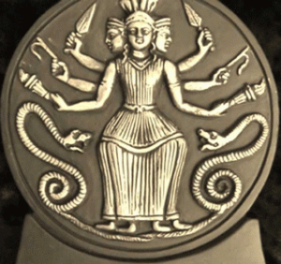
HECATE, QUEEN OF WITCHES
Originally a goddess of the wilderness and childbirth among early Greek and Egyptian civilizations, Hecate (or Hekate or Hekat) achieved her connotations as a goddess of sorcery and her role as the “Queen of Ghosts” in Ptolemaic Alexandria in the final centuries BC. In modern times, she has become a prevalent figure in Neo-pagan religions, and a version of Hecate has been appropriated by Wicca, Hellenic Reconstruction-ism and other modern magic-practicing traditions, and she is widely considered the Goddess of Witches.
Greek Goat God Pan & Knights Templar Goat God Baphomet
The horned god is the Greek God Pan also known as the Goat of Mendes and can be found today in the form of the Horned Goat God, made famous by the Knights Templars, Baphomet. 33rd Degree Freemason, Albert Pike had written in Morals and Dogma; “The Gnostics held that it [universal agent] composed the igneous [pertaining to fire] body of the Holy Spirit, and it was adored in the secret rites of the Sabbat or the Temple under the hieroglyphic figure of Baphomet or the hermaphroditic goat of Mendes.” (1) This is confirmed by the Greek Neo-Platonist philosopher, Proclus who describes Jupiter, in one of the Orphic Hymns, to be both male and female, (hermaphrodite).
The International Order of Freemasonry, Le Droit Humain, is a global Masonic Order, membership of which is available to men and women on equal terms, regardless of nationality, religion or ethnicity. The Order is founded on the ancient teachings and traditions of Freemasonry, using Masonic ritual and symbolism. Le Droit Humain is a global fraternity with many Federations and Jurisdictions worldwide, each of which work the Scottish Rite from the 1st to the 33rd degree. The Order is administered by the Supreme Council, which has its headquarters in Paris.
Incorporated in aspects of the Leek/Gardnerian tradition of witchcraft is a highly unique, highly sophisticated and idiosyncratic practice. The Leek/Gardnerian practice of witchcraft developed for the CIA has a great deal of syncretism between Wicca and co–masonry, Rosicrucianism, spiritualism, and Luciferism. In the Leek/Gardnerian tradition of witchcraft and satanism, it is highly likely that Jennifer and Sarah Hart have been initiated into the Mansion of Freemasonry with its many rooms to significantly expand their levels and veils of secrecy and protection among the international fraternal secret orders of the brotherhood, sisterhood and POLICE.
VI
THE HART WITCHES, KNIGHTS TEMPLAR & ALEXANDRIA, MINNESOTA
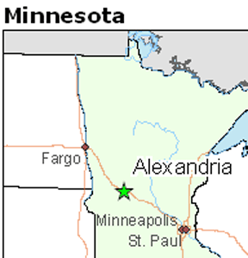
First settled in 1858, it was named after brothers Alexander and William Kinkead from Maryland. The Kinkeads were descendants of Ireland or Scotland. The form of the name of the city alludes to ALEXANDRIA, Egypt, a center of learning and civilization. Alchemy traditions originate in Hermetic texts from Alexandria in Hellenized Egypt, dated to the first and second centuries AD but containing much older authentic ancient Egyptian traditions related to the god Thoth. Alexandria could very well be a secret center of alchemy, oriental mystery schools, and ALEXANDRIAN WICCAN. One thing is certain is that Alexandria is the center of The Kensington Runestone– a 200-pound slab of greywacke covered with pre Columbian Knights Templar runes on its.
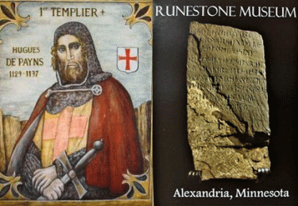
Records show the Hart’s adopted children enrolled in Alexandria public schools Sept. 8, 2009 — seven months after Jennifer and Sarah finalized their adoption of siblings Devonte, Jeremiah and Sierra in Harris County, Texas. The witches had previously adopted siblings Markis, Abigail and Hannah from Colorado County, Texas, in September 2006. Two and a half years after enrolling, the children were suddenly pulled from public schools. Markis was a seventh-grader at Discovery Middle School, and the other five children, who ranged from kindergarten to third grade, attended WOODLAND Elementary. The school is situated on a 48-acre site in Alexandria, Minnesota.^{[11]}

Greek God Pan, Circle Dance & Woodlands
The Greek Horned God Pan was the son of the messenger of the gods, Hermes. His mother was a wood nymph.^{[12]} He is the god of woods (woodland) and pastures.^{[13]} Scott Heckert, the principal of Woodland at the time, recalled the Harts as an insular family whose children — despite being amiable and outgoing among their peers — rarely spent time with others outside the classroom. “They stayed under the radar and liked to be alone and away from other people,” Heckert said of Jennifer and Sarah, adding the children received extra attention from teachers and faculty after the abuse allegations.^{[14]}
The family relocated to West Linn, Oregon sometime in 2013, according to friends. The town of Willamette is located on a Native American trail which ran south from Willamette Falls, an important gathering place for many tribes. The Clowewalla tribe lived in a village on the West Linn side of the falls. West Linn was incorporated in 1913 and merged with the adjacent town of Willamette in 1916.^{[15]}

Witches Jennifer and Sarah Spiritually Connected to West Linn, Oregon
Willamette/West Lind has an Earth Based Spirituality Meetup that cater to those people who are Witches, Wiccan, Druids, Goddess Worshipers and those who follow a Shamanic path, Faeries, Feri, Asatru, Vodou, Santeria, etc.^{[16]} The Clackamas Education Service District, which oversees West Linn, said it had no record of the children. ^{[17]} After the family moves to West Linn, family friend Alexandra Argyropoulos tells Oregon child welfare officials that the Hart Witches have been depriving their kids of food as punishment. The witches break off contact with her when they learn of it. Argyropoulos says she was told the children had been interviewed by Oregon officials; it was apparent that each child had been coached by their mothers on what to say; and nothing more could be done by the Oregon Department of Human Services.^{[18]}
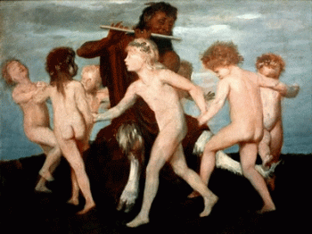
WOODLAND- Greek God Pan & Circle Dance of Children

WOODLAND, WASHINGTON
In May 2017, Jennifer and Sarah Hart bought the two-story, 3-bedroom home on 2 acres of land in WOODLAND of Clark County, Washington, property records show.^{[19]}
Sold: $375,000
2501 NW 389th Street, Woodland, WA: Private setting, 2.19 acre property, the Horned God’s WOODLAND address, LaCenter Schools. Updated home, new carpet, new roof. Large great room with lots of windows, fireplace, laminate floors, patio. Updated kitchen w/ built in pantry hutch. 3 bedrooms,2 baths, craft room/den, large family/bonus room, all appliances. Oversized 2 car garage. 2 stall barn with storage room, pasture and paddocks. Chicken coop.RV Parking. Beautiful property w/mountain views.^{[20]}
Well news broke yesterday, it’s turning out that the Hart Witches neighbors, Bruce and Dana DeKalb, in WOODLAND weren’t quite telling the truth. They weren’t to help anyone but the Hart Witches. They called county child protective services on March 23, 2018. Dana told her mother about the children and the Hart Witches around the middle of November 2017. And, her mother told her father about it. The DeKalbs said that Hannah told them that the Witches were RACIST and begged them for HELP!
Hannah, Cried for HELP!
“My Son-In-Law Don’t Want to Get Involved‘, Steve Frkovich
On November 18, 2017, 3 (three) or 4 (four) days after the incident with Hannah, Steve Frkovich, 80, Dana Dekalb’s father called police and told the Clark County, Washington dispatcher that “the other night, a little girl jumped out of the second-story window on the roof and then down onto the ground and ran to my daughter — and this was like two in the morning — begging them to help her.”
NOBODY but the Dekalbs talked to 16 year old Hannah before she was killed! Now, we know they’re lying, too. The Witches told everyone that the bright and beautiful Hannah was born drug addicted. She was a bipolar child. Well, the DeKalbs didn’t involved until it was time to stage the escape of the Hart Witches from Witch Mountain, and mass slaughter the black children. They called Clark County Child Protective Services (CPS) on March 23, 2018, and CPS responded on spot on que to set to stage the Escape from Witch Mountain and the racial mass murder of the black children.

VII
IN CONCLUSION

Noses are Different, Sarah & Jennifer Hart?
There is no conclusion to this story. The two women above just don’t look like the Hart Witches. There is a veil of secrecy surrounding the Hart Witches and the racial mass murders of 6 (six) innocent black adopted children. Devonte and Hannah are out there someplace- hopefully alive and well, but in great danger.
The so-called free press have laid down in this case. There has been no funerals for the Hart Witches and none of their family members have shown their faces.

Hart SUV Appears Nearly in the Sea
Who did Mendocino County really find at the bottom of the cliff in the SUV perched on ROCKS not in the ocean- Laura Louise and somebody other than Sarah Hart?
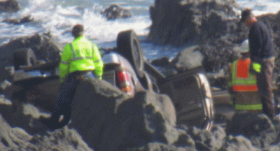
Hart SUV on Rocks Not in the Ocean
The Hart SUV is perched on ROCKS at the bottom of the cliff. The mass media pictures of the Hart SUV nearly in the ocean at the bottom of the cliff is trick Photoshop to make it appear as though it landed virtually in the ocean to explain away the absence of Sierra, Devonte, and Hannah at the crash site. They were not swept into the ocean and lost. They ain’t talking and when they are talking. THEY ARE LYING!
___________________________________________________________________________________
^{[1]} https://en.wikipedia.org/wiki/Bodega_Bay
^{[2]} https://www.sfgate.com/news/article/Wilmont-Sweeney-2933666.php
^{[3]} https://spacexrace.wordpress.com/marin-county-and-the-canal-district/
^{[4]} http://www.oregonlive.com/pacific-northwest-news/index.ssf/2018/04/jennifer_hart_likely_got_over.html
^{[5]} https://web.archive.org/web/20160114125558/http://papertrail.co.nz/meet-devonte-little-boy-big-heart/
^{[6]} Id.
^{[7]}https://medium.com/@DeepGreenPhilly/withering-under-the-white-gaze-the-hart-family-tragedy-bb02416bb0ad
^{[8]}http://www.oregonlive.com/pacific-northwest-news/index.ssf/2018/04/hart_children_immediately_pull.html
^{[9]} Id.
^{[10]} Id.
^{[11]} Id.
^{[12]} http://greece.mrdonn.org/greekgods/pan.html
^{[13]} http://www.maicar.com/GML/Pan.html
^{[14]}http://www.oregonlive.com/pacific-northwest-news/index.ssf/2018/04/hart_children_immediately_pull.html
^{[15]} https://en.wikipedia.org/wiki/West_Linn,_Oregon
^{[16]} https://www.meetup.com/Willamette-Earth-Based-Spirituality/?_cookie-check=Hw7UogbUYBdTzvAo
^{[17]}http://www.oregonlive.com/pacific-northwest-news/index.ssf/2018/04/hart_children_immediately_pull.html
^{[18]}Id.
^{[19]} Id.
^{[20]} https://www.redfin.com/WA/Woodland/2501-NW-389th-St-98674/home/14631942
^{[21]}http://www.thereporter.com/general-news/20180409/body-recovered-saturday-near-hart-family-crash-site-on-mendocino-coast

Comments : Leave a comment
Tags: abigail hart, Adolf Hitler, Alameda County Child Protective Services, alameda county juvenile court, Alameda County Mafia, albert pike, Aldous Huxley, Aleister Crowley, Alex Sanders, Alexandria, Alexandrian Wicca, Alexandrian Witchcraft, Allen Broussard and Carl Metoyer, american horror story, angela bassett, anthony aquino, aspire foster care, Baphomet, Baron Otto Albrecht Alfred von Bolschwing, barrack obama, benadryl, Benjamin "Bibi" Netanyahu, black children, black christianity, bobbie kristian brown, booker t. emery, Bruce DeKalb, charles garry, Charles Manson, Chloe Johnson, CIA, cia occult bureau, circle dance, Clark County Child Protective Services, clark's grove, clinton white, Coven of the Catta, coven of the new forest, Coven of the Red Dragon, covens, Craft of the Wise, Dana Dekalb, devonte hart, diphenhydramine, donald j. drumpf, donald j. trump, donald trump, Dr. Israel Regardie, Dr. Richard Alpert, Dr. Sidney Gottlieb, Dr. Timothy Leary, druids, Earth Based Spirituality Meetup, fantuzzi, Fort Bragg, frank barron, freemasonry, freemasons, Gardnerian Wicca, gerald gardner, goat of mendes, Goddess Bastet Cult, goddess of the witches, Gorge du Loup, greek god pan, hannah hart, harmony park, hart tribe, hart witches, Harvard Psilocybin Project, Hecate, his eye on the sparrow, ice Murray, Illuminati, International Order of Freemasonry, james baskett, jennifer hart, jerry brown, Jonestown, jonestown cocktail, Jonestown Diet and Drug program, kabbalah, king of the witches, knights templar, laura louise, laurel canyon, Le Droit Humain, lionel wilson, Lucifer, Lucifer's Servants, luciferians, Luciferism, markis hart, martin orne, marvel comics, masons, Mauthausen Concentration Camp, Mendocino County, mind control, MINNESOTA, mk often, MK-ULTRA, MN, Monarch Program, Monarchs, Mount St. Helens, Nazis, NEW AGE RELIGION, new age spirituality cults, new age witches, OAKLAND, oakland unified school district, old religion, old time religion, oregon, pagans, Paper Trail, pedophila, pedophilia molestation, Peoples Temple, pizzagate, Prince Hall Freemasonry., rev. jim jones, richard helms, roman polanksi, Ron Tsukamoto, Ronald Reagan, ronald tsukamoto, Rosemary's Baby, Rosicrucianism, royal library of alexandria, rudolph hess, sarah hart, satan, Satanism, Shadow of Jonestown, Sharon Tate, Sharon Tate Murders, sierra hart, song of the south, space kids, spiritualism, stanley armour dunham, star kids, Steve Frkovich, styles price, Sybil Leek, the black panther, The Kensington Runestone, tim stoen, Touch of Buchenwald, Uncle Tom Remus, virgil ivan gus grissom, walt disney, Washington, West Linn, Whitney houston, Wicca and co-masonry, wilmont sweeney, witch cults, witch mountain, Witch of the New Forest, witchcraft, witches, Wolf Gorge, woodlands, your black muslim bakery, yus
Categories : alameda county mafia, albert pike, Aleister Crowley, baphomet, Barack Obama, Barak Obama, black children, black christianity, black inheritance, black lives matter, blood covenants, blood oaths, blood sacrifice, christianity, church of set, CIA, Col. Dr. Michael A. Aquino, col. michael Aquino, earth mother goddess, freemason, freemasons, Gus Grissom, illuminati, illuminati sacrifice, Iran-Contra Crack Cocaine connection, jim jones, jonestown, Knights of the Black Sun, Knights Templar, lucifer's servants, luciferians, masonic sacrifice, mind control, MK-ULTRA, monarch child, monarch program, Nazis, new world order, oakland, oakland police department, pan, Ritual Satanic Abuse, ritual satanic sexual abuse, ritually abused children, rosemary's baby, satanic booty cult, god pan, witche's sabbath, Satanism, SS, trauma-based mind control, Virgil Grissom, virgil ivan gus grissom, your black muslim bakery, yusuf bey

HIS EYE IS ON THE SPARROW, DEVONTE AND THE HART WITCHES, LIES, CIA OCCULT BUREAU & JONESTOWN
7042018
I
BLACK CHILDREN: HIS EYE IS ON THE SPARROW AND HE WATCHES US
AND HE WATCHES ME
Yes, I see the large MONARCH BUTTERFLY blazon over the children in the background. The Sparrow has a far deeper spiritual connection, meaning and universal lesson than the Luciferians seem to understand or fully understand and cleverly wickedly turn those truths against the people. They are indeed stumbling blocks and mountains. But, our elders so wisely teach:
Lord, don’t move the mountain
Give me the strength to climb
Lord, don’t move my stumbling blocks
But lead me all around.
In the Black Church, I have heard “His Eye Is on the Sparrow, and He Watches Me” about a half dozen times that I can recall. My beloved maternal mother’s first cousin that we lovingly call “Little Sister” sang the song so spiritually, moving and touching at my most beloved nephew’s funeral, Kevin Bullock. She always said that she had been called by God.
While I was away exiled from Oakland, my nephew wandered away into an alien world. He died much too soon. Yet, I must admit I never quite understood “His Eye Is on the Sparrow“. When I saw Devonte alone with tears in his eyes in the mist of a hostile alien world, my heart was broken. I weeped once more.
“His Eye Is on the Sparrow” is inspired by the words of David in the Psalms and Jesus in the Gospel of Matthew in the Bible: “I will instruct thee and teach thee in the way which thou shalt go: I will guide thee with mine eye (Psalm 32:8). “Look at the birds of the air; they neither sow nor reap nor gather into barns, and yet your heavenly Father feeds them. Are you not of more value than they?” (Matthew 6:26) and “Are not two sparrows sold for a farthing? and one of them shall not fall on the ground without your Father. But the very hairs of your head are all numbered. Fear ye not therefore, ye are of more value than many sparrows” (Matthew 10:29–31).
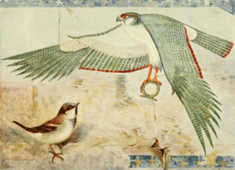
The people of ancient Kemet considered sparrows sacred. They believed sparrows with their swift wings caught the souls of individuals who passed away to carry them to heaven. Thus, sailors before going on their journey would tattoo the image of a sparrow believing that, if they died in the course of their journey, these tiny birds would carry their souls away to the afterlife. In Kemetic cosmology, every living thing on Earth seemed to have been significant and have meaning in the plan of the Gods and the Peace, Harmony and Balance of the Universe. In the bible, sparrows were used as offerings given by the very poor, and represent the concern of God for even the smallest and most insignificant lifeforms. In other texts, the sparrow has been used to represent the presence of God and Thy Love for everything.^{[1]}
Matthew 10:29 Are not two sparrows sold for a copper coin? And not one of them falls to the ground apart from your Father’s will. The sparrows were not only very insignificant, they were also very needy. They needed a house, they needed a place of shelter—and they found it at God’s altar. How needy, also, are we! Though we are insignificant, our needs are anything but insignificant. How much we need! Who can tell what we do not need?^{[2]} As we speak, 15 year old Devonte (Hart?) had been removed from His Eye of Sparrow, Love of God, and Wisdom of the Elders by a coven of New Age Druid Witches from Harmony Park in Clarks Grove, MN, and the child remains MISSING.

The Goonie Devonte & CIA MK ULTRA White Witch, Jennifer Hart
What is the code to Devonte, “The Goonies” and the “Skull and Bones”? The Goonies is a 1985 Steven Spielberg Cult film. One of the child stars of the film was 13 year old Corey Feldman.
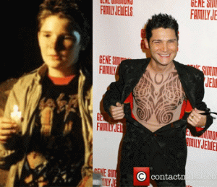
Corey Feldman- MONARCH CHILD INITIATE
For years, Feldman has alleged that he and other child stars had been sexually molested, abused and mind controlled by a powerful MK ULTRA “HollyWeird Pedophile Ring”.^{[3]}
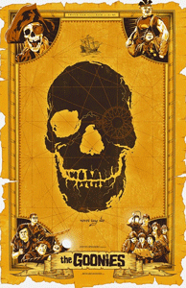
ILLUMINATI All Seeing Eye- Skull & the Goonies
A goonie is a person whom is likable but also an oddball, outcast, nerd, dork and/or weirdo, who are often are seen in and part of a group of other “Goonies“.^{[4]} The firm features a group of pre-teens that seek the treasure of a 17th century Knights Templar pirate’s booty. The film was directed by Richard Donner. He is part of a secret masonic cult of Steven Spielberg, George Lucas, and Robert Zemeckis. Donner directed the remarkable satanic masonic occult anti-Christ cult classic, “The Omen”.^{[5]} The Goonie is a covert ILLUMINATI MK ULTRA/MONARCH initiate.
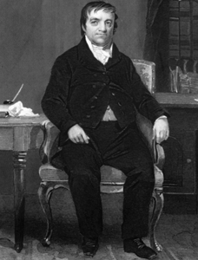
Goonies was filmed in Astoria, Oregon. The city was named after John Jacob Astor. The Astor Satanic Bloodlines of America and England are descendants of the Knights Templar Astorga family found in Southern Italy before the 1600s. The most likely meaning of the name is that both Astorga and Astor are variations meaning “Astarte”.
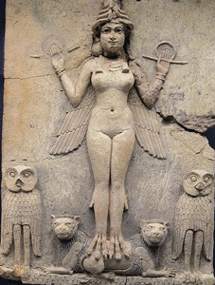
Her name is also Semiramis/Cybele. They were priests, priestesses, followers and initiates of the Cult of Astarte/ Cybele from remote times that Christianity and the Vatican forced underground.^{[6]} Astor was initiated into the Cult of Astarte, and John Calvin’s Masonic Temple in Germany during the late 18th Century. He had learned the ancient secret knowledge, rituals and global links of the occult and the craft that was far beyond anyone’s knowledge in colonial America. This would explain his rapid rise within the “inner circle” of colonial America’s Ultra Secret Masonic Satanic Power Control Group(PCG).
When Astor arrived in America, he moved in to take control of The Grand Lodge of New York (officially, the Grand Lodge of Free and Accepted Masons of the State of New York). It is the largest and oldest independent organization of Freemasons in the state of New York. It was at one time the largest grand lodge in the world in terms of membership. It is not known when the first Freemason set foot in the American colony of New York, but the first documented presence dates from the mid-1730s, when Daniel Coxe, Jr. (1673–1739), was appointed Provincial Grand Master of Freemasons for the provinces of New York, New Jersey and Pennsylvania by the Duke of Norfolk, the Grand Master of the Premier Grand Lodge of England (known to historians as the “Moderns“).
Astor first joined Holland Lodge, No. 8, New York City, then served as Master of Holland Lodge in 1788. Later, he took over the Grand Lodge serving as the Grand Treasurer [Jul 17, 1763- Mar 29, 1848]. Astor took total and complete advantage of the secret privileges and behind the veil deals and spoils of the Royal Masonic Dark Brotherhood. Dope, Inc. shows that the Astor family was the first American family to get into the Opium trade like an exclusive charter from the Masonic Satanic royal houses and ruling classes of England. The Astors were also granted privileges by Scottish Rite President Thomas Jefferson (descendant of Robert the Bruce) to control the early fur trade (American Fur Company) in all early Northwest America.^{[7]}
The Astors have played major roles in organizations such as the Hellfire Club, CFR, Bilderberger’s, Club of Rome, Fabian Society and Skull & Bones to name some. In the name of its founding Satanic masonic master and father, Astoria is a hotbed for the secret Masonic Secret Societies and Satanic Covens in the State of Oregon.^{[8]}
What is the code to Devonte, “The Goonies” and the “Skull and Bones”? Devonte had been initiated into the mysteries of a secret society. All of the Hart adopted children were initiated into the kid’s Goonie Secret Cult.
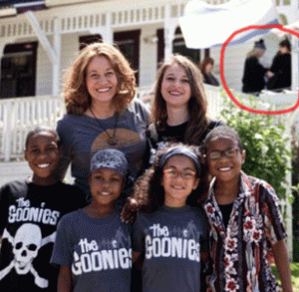
Goonies Devonte, Abigail, Hannah, Jeremiah & Background Witches in Black

The Hart Witches’ 6 (six) Goonie Initiates
For their blood oath covenants of secrecy, they had been promised a pirates’ adventure, a hidden treasure of riches, fame and LIGHT at the end of long secret dark subterranean tunnels. They lied to the children. Their Masonic blood covenants weren’t play, a game or fantasy. They were for real. They wanted them enslaved to Lucifer. They wanted their SOULS. Devonte led the children in resistance. He wouldn’t give his up.

The Masonic ILLUMINATI wanted each and every child of color around the world to watch the HollyWeird film, “The Black Panther“. They promised them mystery (Goddess Bast) hidden treasure and riches (Vril– Vibranium: Uranium) and a super black hero (T’Challa with Animal Claws and black leather THIGHS) in an illusionary African kingdom.
In the very same kingdom for the children, they promised the LGBT community a vast new open territory to roam in that each and every child of color around the world would be indoctrinated with a Lesbian homosexual rite (Okoye and Ayo Knocking Boots).
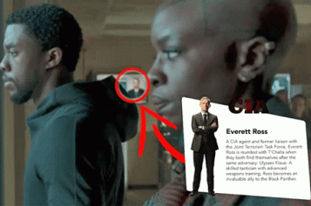
They also didn’t tell people of color that King T’Challa works for the CIA (CENTRAL INTELLIGENCE AGENCY). We are also being deceived and lied to about the innocent and precious GOOD, Devone, Jeremiah, Maris, Abigail, Hanna, Sierra, and the EVIL, Lesbians Jennifer and Sarah Hart. All of our SOULS are being threatened by the ILLUMINATI and the powerful global Dark Satanic Circle at the center of the U.S. government.
II
MEET THE CLANDESTINE CIA WITCHES & THE [HART THINGS] CHILDREN

The cold blood torture and mass slaughter of 6 (six) Innocent children is no sick-ass HollyWeird romanticized white lesbian Thelma & Louise adventure. The Hart Witches are dangerous interstate racist- white supremacist criminal mass murderers that until their bodies turn up- they are still AT-LARGE!
May 23, 2005: Sarah Margaret Gengler, then 26, petitioned to change her name to Sarah Margaret Hart, taking the surname of her groom, Jen Hart. The mysterious women met in college at Northern State University in Aberdeen, South Dakota.

It appears that the witches were recruited by the CIA Occult Bureau out of Northern State.

In September 2006, Jennifer and Sarah Hart adopted black children (Things 7, 4, and 3) Maris, Hannah & Abigail from Colorado County, Texas.
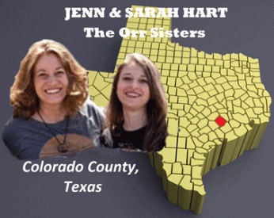
Your lying eyes are not deceiving you. The Hart Witches called the black children “THINGS.” They made the red t-shirts mocking, humiliating and degrading them, THING 1-6.

February 2009: Jen and Sarah Hart adopt another set of precious black children from southeast Texas, this time from Harris County: Jeremiah, Devonte and Sierra (Things 2, 6 and 5).

As far as I can find, Jen and Sarah Hart had no prior history, background or connection to the State of Texas before entering their foster care system, and Texas officials ain’t talking very much at all. Also, the children’s parents and love ones haven’t or can’t come forward to be identified or talk. This is all extremely high level powerful shadow government CIA operation, power and corruption. I will discuss the Orr Sisters and links, further below.
Jenn, Sarah, Black People, Beasts & the Things
In the world of the witches, Jenn & Sarah Hart, people are subdivided into masters, White God-like people (Aryans), and other different human or sub races. The other races have a spiritual development inferior to the God- like people. Many Christian ministers and theologians taught that whites were the Chosen people, blacks were cursed to be servants.
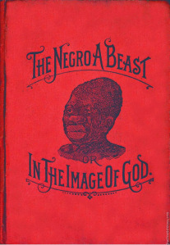
BLACK PEOPLE, THE BEAST & THINGS
“The Negro: What Is His Ethnological Status?” It was published in 1867 under the pseudonym “Ariel.” In fact, the author was a Southern clergyman, the Rev. Buckner H. Payne of Nashville, Tenn. Rev. Payne argued that Negroes weren’t descended from Adam and Eve.
“… Adam and Eve being white, … they could never be the father or mother of the kinky-headed, low forehead, flat nose, thick lip and black-skinned negro…”
The minister continued: “[I]t follows, beyond all the reasonings of men on earth to controvert, that [the negro] was created before Adam, that, like all beasts and cattle, they have no souls.”
Rev. Payne then broke it down scientifically: “[W]e take up the monkey, and trace him … through his upward and advancing orders – baboon, ourang-outang and gorilla, up to the negro, another noble animal, the noblest of the beast creation. The difference between these higher orders of the monkey and the negro is very slight, and consists mainly in this one thing: the negro can utter sounds that can be imitated; hence he could talk with Adam and Eve, for they could imitate his sounds.”^{[9]}

Global White Supremacy is alive and well in the 21st century. They are Not Playing even with the precious innocent children. It comes down to this.
“Look at the birds of the air; they neither sow nor reap nor gather into barns, and yet your heavenly Father feeds them. Are you not of more value than they?” (Matthew 6:26) and “Are not two sparrows sold for a farthing? and one of them shall not fall on the ground without your Father. But the very hairs of your head are all numbered. Fear ye not therefore, ye are of more value than many sparrows.” (Matthew 10:29–31).
“And God said, Let us make man in our image, after our likeness: and let them have dominion over the fish of the sea, and over the fowl of the air, and over the cattle, and over all the earth, and over every creeping THING that creepeth upon the earth.” (Genesis 1:26 King James Version)
The Late Sheymayet- Voice of God
The [Hart?] children were removed and isolated in an alien environment where they were denied the peace, security, and the Love of their traditional Community, Lord and God. They were denied “His Eye Is on the Sparrow, and He Watches Me.” Removed, they became as insignificant as the sparrow and other things that creepeth on Earth that God-like people (Aryans) teach themselves that they have dominion over. All the [Hart?] children are DEAD! Who weeps for them? I know that I am heartbroken. I weep and mourn for the children. But, I speak for me. I run to do battle!
III
THE HART WITCHES, COVENS & GROVES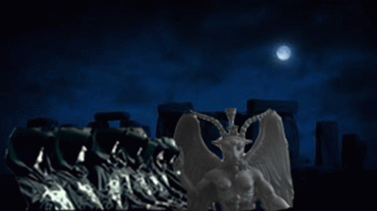
It is customary for Druids to meet from time to time, sharing their experiences and discoveries. Wiccans have Covens, Christians have congregations, Druids have Groves like the Bohemian Grove.
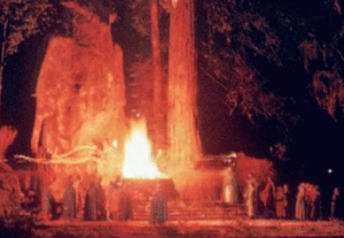
The Grove is a name chosen in honor of the trees, great beings of nature. A grove is a term which denotes not only a sacred clearing in the forest but also a group of Druids. In addition to celebrating the eight seasonal festivals, they may come together to perform rites of passage, for example when a Grove member wants to name their child, or when members marry or pass over.^{[10]} Occasionally, it refers to a group of Pagans who gather to worship under the guidance of a Witches‘ Coven; this kind of “Grove” is also called a “congregation” or “outer circle,” as distinct from the “inner circle,” which is composed of the priests and priestesses of the coven.^{[11]}

The Hart Witches joined the congregation, outer circle, and or the inner circle of the Harmony Park, Clark’s Grove, Minnesota.

It appears that all the 6 six [Hart ?] children were forced to be humiliated, used and abused in all the the grove’s pagan and satanic rites and festivals, particularly, Earth Project and Shanghai La Fest. There were also Oaktobefest, October 5, and Bella Fiore, May 24.

Can anyone identify this man with Devonte and Hanna– all in pagan ritual clothing? Dead children can’t talk!

Harmony Park Pagan Festival- Jeremiah, Devonte, Abigail and Hannah

The Druids of Harmony Park Grove has celebrated the Shanghai La Festival for at least 20 years over Labor Day weekend, August 30 to September 2. Shanghai-La – A mythical Utopia and Earthly Paradise known as a permanently happy land, isolated from the outside world, the people who live at Shanghai-La are almost immortal, living years beyond the normal lifespan and only very slowly aging in appearance. A place of great beauty and peace.^{[12]}
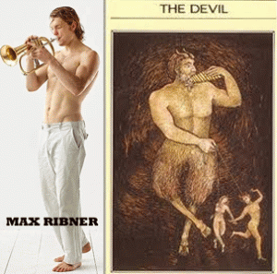
Max Ribner (pagan free love pan-sexual?) is one of very few of the Harmony Park Grove initiates to come forward to try to defend the Hart Witches, but he had no stated compassion for the slaughtered black children. He said that he has known the Hart Tribe (6 Six Children) since 2012, said allegations from neighbors don’t square with what he knows about the Harts. “They (Hart Witches) are beautiful examples of opening arms to strangers, helping youth, supporting racial equality,” Ribner, who lives in Portland, told the AP. “They brought so much joy to the world. They represented a legacy of love.“^{[13]}

Max & 6 six [Hart ?] Tribe
Max is part of the new age pagan spiritual band, Nahko and Medicine for the People. Nahko and Ribner are (High Priests) initiates of the Harmony Park- Shangri La Grove.

Ribner is a Jewish (Kabbalah) surname linked to New England.^{[14]} Below, Devonte dances on night stage with Nahko and band- notice the child with “DEVIL HORNS“.
Devonte [Hart], Nahko and Medicine for the People- Project Earth 2012- Harmony Park Grove
[Hart?] Children with Pagan Nahko Bear- He Takes Hold of Jeremiah
Fantuzzi is a (CIA?) Pagan that goes back to CIA consultants Timothy Leary and Dr. Richard Alpert’s “A Gathering of the Tribes” (January 14, 1967) in Golden Gate Park in San Francisco. It was called “The Human Be-In” that introduced the anti-Vietnam- anti- Racist “Flower Children” to Charles Manson and CIA LSD- MK ULTRA/MONARCH.

Fantuzzi was corporate mass media’s infamous crazy Pagan at Woodstock.
Below, Pagan Fantuzzi, Jennifer Hart & [Hart?] Children.
The Real Fantuzzi- 33 degree Scottish Rite Master Master/Knight Templar,
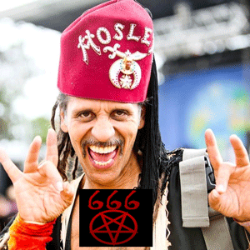
Who in Shangri- La and the among the so-called free- loving Pagans condemned the Hart Witches, or weeped for Devonte and the other black children?

NOBODY!
VI
SHANGHAI LA, ALDEBARAN, ARYAN SUPERMEN & NAZIS

I often discuss Aldebaran, Shanghai La, and Nazis, but I had absolutely nothing to do with creating that subject matter in this case. In the 21st century, the 6 six [Hart?] black children lived in Shanghai La. They are all DEAD!
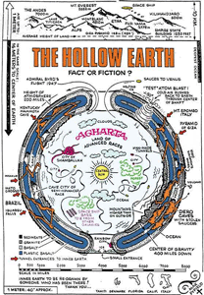
Agartha (sometimes Agartta, Agharti or Agarttha) is a legendary city that is said to reside in the Earth’s core. It is related to the Hollow Earth theory and is a popular subject in Esotericism. Agartha is one of the most common names cited for the society of underground dwellers. Shamballa (also known as SHANGHAI LA) is sometimes said to be its capital city. The mythical PARADISE of Shamballa is known under many different nNahko and Medicine for the Peopleames. It has been called the Forbidden Land, the Land of White Waters, the Land of Radiant Spirits, the Land of Living Fire, the Land of the Living Gods and the Land of Wonders. Hindus have known it as Aryavarta (literally: The Land or Realm of The Aryans; the Land of the Noble/Worthy Ones”) – the land from which the Vedas come. Throughout Asia, it is best known by its Sanskrit name, Shambhala, meaning “the place of peace, of tranquility”. It is a paradise of tranquility only for Aryan kings, nobles, worthy ones and bloodlines.^{[15]}
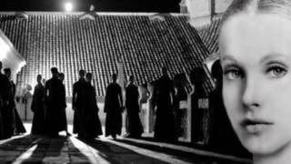
Maria Orsic, the Vril Goddess of the Devil, directed the Nazis on the legendary expedition in Tibet, where Heinrich Himmler and SS- Knights of Black Sun were certain to locate the mystic Aryan kingdom of Shambhala (Shanghai-La), and recover the secrets of the long lost Aryan Superman race.^{[16]}

Orsic advocated that the true “divine”origin of Aryans weren’t on Earth, but extraterrestrial. She identified the Aryan extra planetary homeland in the Aldebaran Solar System. Aldebaran, designated Alpha Tauri (α Tauri, abbreviated Alpha Tau, α Tau), is an orange giant star located about 65 light years from the Sun in the zodiac constellation of Taurus. It is the brightest star in its constellation and usually the fourteenth- brightest star in the nighttime sky, though it varies slowly in brightness between magnitude 0.75 and 0.95. It is likely that Aldebaran hosts a planet several times the size of Jupiter.^{[17]} Linguistically (epistemologically and etymologically) Aldebaran, Abrum, Sumerian- Akkadian word “Ne. bi. Rim”, Aldebaran ( the Constellation of Ashtari) is the home of Maria Orsic Aldebaran’s extraterrestrials and Anunnaki.

Devonte & New Age Light Beings
New Age spiritualism have a belief in the divine SELF, the SELF as God. Theosophical ideas expressed by Satanists Madame Blavatsky and Aleister Crowley along with many other New Age gurus, worship Lucifer and Apollo as the ultimate “Light Beings.”
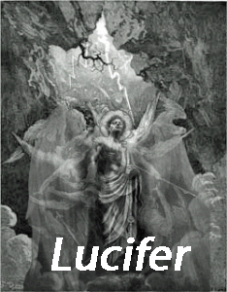
Orsic defined Aldebaran as the solar system of divine cosmic energy, and their inhabitants as “beings of light”. She said that the Aryan extraterrestrials are the offsprings of a higher race (the Anunnaki) which visited Earth hundreds of thousands of years ago, and created the earliest civilizations on Earth. Some lived on Earth for thousands of years, but eventually returned back to Aldebaran. Others got stuck on Earth could not make it home Consequently, they lost their extraterrestrial genes, and began to look like humans. According to Orsic, they created all the wonders on Earth. She said that some were killed by the Great Deluge, and who survived returned to among other places to: Mount Hermon (Jabal Haramoun), Himalaya Mountains, Scandinavia, and [western] Tibet (Shambhala, Shangri- La).^{[18]}

Devonte, Little Animal with a Tail
Consistent with the Secret Doctrine of the Great White Brotherhood that God-like people (Aryans) have dominion over everything that that creepeth on Earth, the witches made Devonte dress as an animal with a tail. Devonte is holding on to Australian singer-songwriter Xavier Rudd at the 2013 “Beloved Festival: Sacred Art, Music & Yoga” in Tidewater Falls, Oregon, which is described as “finding connection, healing, and integration in the forest.”
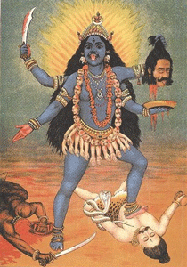
“We’ve invited all the Hindu gods to be here, we’ve invited the Sufi notion of the Beloved to be here and we’ve also invited Jesus to be here.”
Beloved is named in honor of Persian poet Rumi Mo’avia (1207- 1273). Rumi was asleep one day in his palace. A strange man came and awakened him. “Who are you?” he asked. “I AM LUCIFER.” “And what do you want?” “It’s time for your prayer, and you’re still asleep.” Mo’avia was impressed. But why was the Prince of Darkness, who always wants the souls of men of little faith, trying to help the poet fulfill a religious duty? Lucifer explained, “Re-member, I grew up as an ANGEL OF LIGHT. Despite everything that happened in my life, I cannot forget my roots.
Devonte- Wiccan Circle Dance
Jen Hart, December 27, 2014
“Abbi ended her 11th birthday celebration with an epic dance party last night. While I would LOVE to share more clips from the evening, apparently not all the kids are thrilled with the notion of everyone seeing them shake their booties in their underwear. Most of the kids danced for over 4 hours straight- until 1:00 am. This kid outlasted me. Elton John glasses, underwear, Joni Mitchell, fishy accessories, dance ’til dawn: just your average Friday night.”

The Hart Witches forced the children to Wiccan Circle Dance for hours until possessed with demons and spirits. Joni Mitchell got involved in the Bohemian thing in Paris and finally she behaved so badly according to the people of Paris, with the DEVIL’s witchcraft and all- that she was kicked out of Paris. They did it very politely by refusing to renew her passport.
I said all of this to say that Devonte and 5 (five) other black children were taken from under God’s Watchful Eyes and the Sparrow to serve and be sacrificed to Lucifer. In a news release, Mendocino County deputies say Jennifer Hart was spotted at a Safeway in Fort Bragg just after 8 am on Sunday, March 25, 2018. The woman that deputies claim is one of the Hart Witches looks absolutely nothing similar to Jenn Hart. They are lying!

The DARK SUV that the Mendocino County Sheriff’s Department said that Jennifer Hart was driving was also a big LIE! They knew the license plate numbers, and exact and precise color of the SUV.
V
THE HART LESBIANS ESCAPE FROM WITCH MOUNTAIN

JENNIFER HART DO NOT WEAR GLASSES!
Someone were able to determine the Patsy Stand- In for Jennifer Hart with the ILLUMINATI pyramid symbol bought 5 (five) bananas for 5 (five) people in the SUV pushed over the cliff.
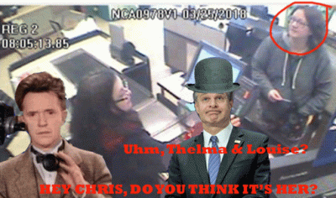
Surveillance footage possibly showing her was of “poor quality” and the Dark Satanic Circle in the FBI is working to enhance the images.^{[19]}

Chris Wray and FBI will also lie about Jennifer, Sarah Hart and the children at the bottom of the cliff. Even Mr. Magoo can see the difference between the two women.
The Hart Witches at the Bridge of the Gods
It was also no incidence that Jennifer and Sarah landed in Woodland just outside of Portland, Oregon from Minnesota for cover.
The Greek God Pan is the God of the Rustic Woodlands. The Hart Witches and the 6 (six) black children had lived for about a year in virtual seclusion in a three-bedroom split-level house on NW 389th Street in rural Woodland, a city that is the gateway to Mt. St. Helens National Volcanic Monument. Mt. St. Helen is home to Big Foot and UFOs. Native Americans call St. Helen the “Bridge of the Gods.” Woodland is located in Clark and Cowlitz counties in the State of Washington about 25 miles north of Portland, Oregon.

Neighbors Dana and Bruce DeKalb, who for 22 years have lived two miles from Interstate 5 on a winding, wooded road in remote Clark County, said they awoke at 1:30 a.m. one night to find Hannah on their doorstep covered in weeds. The child had jumped from a second story window to escape. Hannah had apparently tried to crawl through the blackberry bushes on the DeKalbs’ property to get to another house, the couple told reporters Wednesday. She gave up when she came across a fence and ended up pounding on their front door. Bruce answered. He thought Hannah was 7 or 8 because she was missing her two front teeth, he told reporters. Bruce was stunned to find out she was nearly a teenager. The DeKalbs told The Washington Post that Hannah Hart dashed inside the house and made her way upstairs after Bruce opened the door. She woke up Dana DeKalb, and the Hart Tribe soon came to look for the girl claiming that she was disturbed after her cat was killed. Hannah was crouching between the DeKalbs’ bed and a dresser.
Hannah & Devonte were Determined to Fight for their Souls, Lives, and the Other Children
The DeKalbs said that Devonte made a daily habit of sneaking next door and asking for tortillas, cured meats, and non-perishable food items. He sometimes visited the neighbors multiple times a day and even around midnight. The DeKalbs said Devonte claimed his mothers didn’t feed him and “they would withhold food from him as a punishment.” Devonte pleaded with them to call child protective services.

Abigail, Sierra & Hannah All Appear to Have Their Teeth Knocked Out
The DeKalbs also said they were alarmed by how thin and small the kids were, and the fact that one daughter was missing her two front teeth at the age of 12. “They were all small,” Bruce DeKalb said. “One girl who was 12 looked like she was 7. Both of her teeth were missing, front teeth, and we questioned [the mothers], ‘What’s up with the teeth thing‘ and they said that the teeth had been knocked out, ‘She didn’t want them replaced.’ We thought that was a little weird.”^{[31]} The DeKalbs called Clark and Cowlitz County Child Protective Services that contacted the witches regarding possible child neglect and abuses that were reported at the house. The witches suddenly took off with the children.
The bottom line is that the children were living in a virtual state of hostage. They were locked down without access to the outside world, TV, radio, phones, and computers. Not one of them had a voice outside of the witches. The children were growing older, stronger and wiser. The children, particularly Devonte and Hannah, were growing beyond the witch’s influence and control. The experiment had to be terminated, and the entire Woodland community incident and escape from CPS may have been staged to end their secret CIA Occult Bureau project.
Portland and the Hart Witches’ Tribe
Portland is a major outpost for Pizzagate Pedophile Rings. One recent study has found that Portland is a hub of child sex trafficking. It is also a hub for satanic pedophile rings.
One of the most satanic themed (and most illogically-located) businesses in the world has got to be “Voodoo Donuts” in Portland.
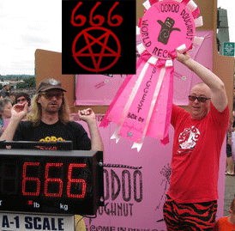
Tres Shannon and Kenneth Pogson
Voodoo Doughnut owners Tres Shannon and Kenneth “Cat Daddy” Pogson celebrate their 666 pound record-breaking box of doughnuts on the Hawthorne Bridge in Portland.
Richard “Tres” Shannon of Voodoo also owns an MK ULTRA strip club (the Kit Kat Club), works in a band at Dante’s [Hell] Strip Club and works as a Vagina Beauty Pageant Judge at Club Rouge, which is currently under investigation by the FBI for Child Sex Trafficking.^{[20]}
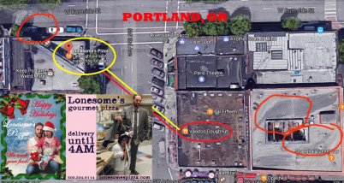
The business, located right next to two deviant hellholes, one of them being Dante’s [Hell] Satanic Strip Club, as well as being right on top of the confirmed infamous Child Trafficking SHANGHAI TUNNELS.^{[21]}
On December 2, 2014, Mandy McMoran Walter re-posted a fox and friends weekend tweet of a picture of Devonte referencing “I have yet to meet a better hugger”.^{[22]} It doesn’t say much other than that. However, the same unknown man previously photographed with Devonte and Hanna at the Harmony Park Grove is in the picture.
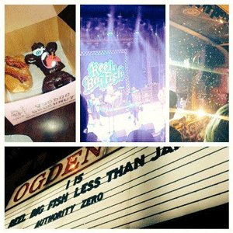
On January 25, 2016, Walter tweeted to American SAK punk rock band Reel Big Fish of Orange County, CA a picture of Voodoo Doughnuts with its “boy love symbol” that has been determined to be a pedophilia code according to the FBI not me. Devonte and Voodoo Doughnuts pedophile ring in Portland connected? Yes, I think so!
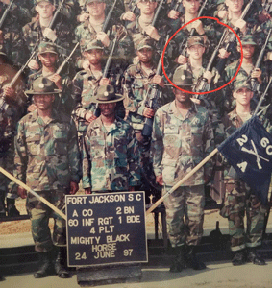
Walter is a veteran of the U.S. Army 60th Infantry Regiment, Fort Jackson, SC.^{[23]} I really don’t think the link between Devonte and Voodoo Donuts is a coincidence.
V
THE HART WITCHES ESCAPE TO WITCH (MENDOCINO) COUNTY
From Woodland,Portland, Oregon to Fort Bragg, Mendocino County, CA, it was no coincidence either.
Lucifer had established a major outpost in Fort Bragg, Mendocino County for witches and pedophilia rings. The CIA Occult Bureau and MK ULTRA also setup Fort Bragg and Mendocino County as an outpost and haven for witch covens, and Manchurian Candidate experimental assassins and satanic serial mass murderers and covert pedophilia centers: Kenneth Parnell; Tree Frog Johnson; Leonard Lake and Charles Ng; Charles Manson; Rev. Jim Jones; Guyana; 22 children allegedly molested at Jubilation Day Care Center.^{[24]}

During the 1960s, a vast covert CIA MK ULTRA/MONARCH program and network had been developed around Mendocino County, and the Mendocino County Department of Mental Health. In the late 1960s and 1970s, Mendocino County and the Department of Health became the headquarters and training ground of Rev. Jim Jones and the Peoples Temple.
Timothy Oliver Stoen is best known for his central role as a member of the Peoples Temple. Stoen’s battle led to an investigation of the Peoples Temple’s settlement at Jonestown. Stoen’s son died on a nearby airstrip while 918 (predominately black) people were slaughtered in a remote rain forest Guyana, South America in 1978. Stoen works as a deputy district attorney in Mendocino County, CA, where he is assigned to the District Attorney’s Fort Bragg office.^{[25]}
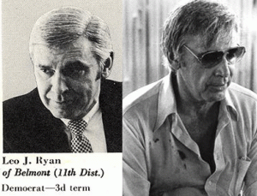
Once CIA- you belong to the Agency. It was Tim Stoen, a former member and top aide to Jim Jones, that pressured and lured U.S. Congressman Leo Ryan to visit Jonestown to be assassinated.^{[26]} Congressman Ryan is recorded as saying that he went to Jonestown to “retrieve Tim Stoen’s son.” Ryan had been the most vocal anti-CIA critic in the U.S. Congress. He was persistent on a campaign to blow the cover off of the CIA. As a threat, they wanted him Artichoked– liquidated.^{[27]} There wouldn’t have been a better or more idea place to assassinate him than Guyana, South America.
Timothy O. Stoen had been the Peoples Temple’s top attorney, strategist and close confidante and friend of CIA Agent Rev. Jim Jones. It was Stoen who appeared to be a classic agent provocateur, compliments of the U.S. government, during his years in Peoples Temple, pushing terrorist ideas as extreme as building bomb factories and poisoning the water supply of Washington, D.C. Stoen came to Peoples Temple as a far right wing ideologue who had run CIA spying missions to East Berlin in the early sixties under Allen Dulles and Richard Helms, both architects of MK ULTRA/MONARCH, and the CIA Occult Bureau.^{[28]}
With Stoen in the seat of power and authority in Mendocino County as the eyes and ears of the CIA, the Agency controls Fort Bragg and Mendocino County.
Jennifer and Sarah Hart, the 21st century Orr Sisters, are part of the CIA’s Occult Bureau’s covert network of spiritually committed “feminist” and lesbian women affiliated with or organized into shadow government covens of “Wiccans“— or New Age Witches and Mystics. They lead solstice celebrations and secret satanic rituals around the nation.
Satanist Lt. Col. Michael Aquino
They are similar to the Satanic Sisterhood Orr Sisters, Barbara and Sharon, of Fort Bragg, CA. They were part of the same covert Satanic network of the Wiccan feminist-lesbian sisterhood. In September 1988, the Criminal Investigation Division (CID) of the U.S.. Army began investigating Satanist/High Priest of the Temple of Set, Lt. Col. Michael Aquino, U.S. Army and Joint Chiefs of Staff of the Pentagon in multiple jurisdictions, including Mendocino and Sonoma Counties in Northern California. There is a direct correlation between Michael Aquino, Temple of Set, and organized pedophile rings, U.S. Military Psi Ops, CIA MK ULTRA/MONARCH, mind control, etc.

CID’s investigation of Lt. Col. Aquino also included alleged victims from the Jubilation Day Care Center/Fort Bragg (Orr Case).^{[29]} Santa Rosa Press Democrat, Sept. 9, 1998 1984, FORT BRAGG, CALIFORNIA, Barbara and Sharon Orr’s Daycare Closed by State, License Permanently Revoked.Overview: Pamela Hudson, L.C.S.W. assessed and treated over 27 children from a Fort Bragg daycare case called the Jubilation Daycare in Mendocino County between the years 1983 and 1990.
The children stated the daycare operators and their “friends” abused them. Ms. Hudson described having no prior experience or training about ritual abuse but came to understand it after many years of treating these particular victims. Some of the symptoms the children exhibited were defecating on the floor in certain patterns and lying spread-eagled on the floor as if in crucification. She described children reporting being locked in a cage, their parents were threatened, they were buried in the ground in “boxes,” held under water, threatened with guns and knives, injected with needles, bled and drugged, photographed during the abuse, tied upside down over a “star,” hung from poles and hooks, had blood poured on their heads, and witnessed the ritual sacrifices of babies, after which they were forced to chant “Baby Jesus is Dead.”
Jubilation Daycare, operated by Sharon and Barbara Orr (who presented themselves as Christians who held “Bible Study” meetings) was closed in 1984 and their license was permanently revoked after the State Department of Social Services investigated and found sufficient evidence of “child endangerment.” There were no medical facilities in that immediate area that could evaluate child sexual abuse, but of all the children taken out of county to medical facilities, all were diagnosed with sexual molestation. Because the perpetrators had four months advanced warning, no other evidence was found, and no criminal charges were filed. Children from this case also identified Lt. Col. Aquino as one of their abusers.
From a 1989 Press Democrat news article: “Local authorities for almost four years have insisted their investigations are inconclusive about repeated allegations from Debi and Greg Withrow that his two sons, from a former marriage were victims of ritual molestation during ceremonies witnessed by a large group of adults…”
“Last week, criminal investigators with the Army reportedly questioned lt. Col Michael Aquino the satanic priest implicated in the Presidio case, about allegations he was involved in molestation cases in Mendocino and Sonoma counties. Besides the Withrow angle, Aquino was questioned about sexual abuse at the Jubilation Day Care Center in Fort Bragg.”
Lt. Col. Michael Aquino and Lilith Aquino were open satanists and High Priest and Priestess of their own cult, the Temple of Set, for 20 years while Aquino served in the Armed forces. See book publications: “Treating Survivors of Satanist Abuse,” edited by Valerie Sinason, pgs. 71- 81, 1994, and “Ritual Child Abuse: Discovery, Diagnosis and Treatment,” by Pamela S. Hudson, L.C.S.W., Jan 1, 1991; “Satanic Chief tied to Mendocino Sex Abuse,”Press Democrat, May 15, 1989.^{[30]}
The Hart Witches’ Decoy, the 2003 GMC Sierra Truck
March 23, 26, and 27, 2018: CPS officials tried to contact the Hart family on three separate occasions.^{[32]} According to the DeKalbs, Jennifer and Sarah packed up in a hurry and fled with all six kids in their 2003 GMC Sierra truck.^{[33]} A key crash report for the incident states that the couple’s 2003 GMC Sierra truck was driving south alongside Highway 1 on Monday when it pulled into a mud turnout alongside the street and, for unknown causes, continued instantly off the cliff. In a photograph of the crash, launched by the California Highway Patrol, the truck is seen on its roof on rocks.^{[34]}
At a press conference Wednesday afternoon, Mendocino County Sheriff Tom Allman said law enforcement is hoping to get information about the family’s travels in a DARK-colored 2003 GMC Yukon XL sport utility vehicle from people they may have met along the way.^{[35]} There is a big difference between a Sierra truck and a Yukon XL. The Sierra with an extra cab seats 5 (five), while the Yukon XL seats 9 (nine) people. So, it is highly likely and consistent that the 5 (five) homicide victims found at the crime scene were in a Sierra truck instead of large SUV Yukon.

Mendocino County law enforcement agencies have retracted their official statement that the 2 (two) females found in the SUV were locked in seat-belts. They said that 3 (three) kids found dead at the scene weren’t locked in seat-belts. The county now say that none of the 5 (five) victims found at the scene were locked in seat-belts. Not one of the SUV’s doors are seen to have been thrown open in the crash at the bottom of the cliff. So, how does it happen that all 6 (six) kids were allegedly thrown about the rocks and into the sea, and the 2 (two) white females weren’t? It didn’t happen. They’re lying!
Mendocino County law enforcement agencies will not show or give a detailed description to the public of what and who they found at the bottom of the cliff. Where are the Hart Witches’ bodies? What did they do with the childrens’ bodies? We have to take their word that Jennifer and Sarah were found dead in the pancaked vehicle. I am certain that the body of the female patsy Jenn stand-in with the ILLUMINATI clothing was found at the bottom of the cliff.
Devonte 15, Hannah, 16, and Sierra, 12, were not in that Sierra SUV when it went off the cliff just off the Pacific Coast Highway, about 150 miles north of San Francisco. Capt. Greg Baarts of the California Highway Patrol said the Hart vehicle had stopped at a pull-off area before the crash. Court documents stated the speedometer of the vehicle was pinned at 90 mph. Nevertheless any possible malfunction of the vehicle’s equipment in the crash, all 5 (five) victims could have been unconscious when the truck went off the cliff, and the 3 (three) other children are alive or were murdered someplace else. However, I am certain that all the precious children have been killed, but so far there is no evidence and no information is available to the public that would confirm that the 2 (two) white female bodies found dead at the scene were the Hart Witches.
My dear lord. I wish that I could deliver an ending other than DEATH freed these children from EVIL. However, what I can say is all the EVIL that they saw and were possessed in, the inhumane humiliation, denigration, indignation, and enslavement that they suffered, and through-out all their physical and mental abuse and human suffering, they resisted. Somehow they found the inspiration and the strength of mind of their own divine self, conviction and human dignity in the eyes of god that they weren’t the animals and THINGS roaming the woods and forests naked as they wanted them to be.
Devonte, He Wasn’t Heavy
In their hearts, even as children, alone and isolated in their darkness hours most of their lives, they were still strong and firm, “His Eye Is on the Sparrow, and He Watches Me“. My dear lord, Let Devonte, Hannah, and Sierra survive, and please watch over them and lead them home.
I said enough, right now.
​_______________________________________________________________
^{[1]} https://mysticurious.com/symbolic-meaning-of-sparrows
^{[2]} http://www.spurgeongems.org/vols52-54/chs3041.pdf
^{[3]} http://www.reddirtreport.com/rustys-film/hollywood-pedophiles-run-wild-young-lives-destroyed
^{[4]} https://www.urbandictionary.com/define.php?term=goonie
^{[5]} http://subliminalsynchrosphere.blogspot.com/2013/03/steven-spielberg-symbolism-mystery.html
^{[6]} http://aletheia.consultronix.com/7.html
^{[7]} http://impiousdigest.com/bloodlines-of-the-illuminati-fritz-springmeir/
^{[8]}https://jaysanalysis.com/2016/12/19/the-goonies-is-about-the-illuminati-and-its-a-rube-goldberg-machine-jay-dyer/
^{[9]} http://undercoverblackman.blogspot.com/2007/08/black-people-as-monkeys-wit-and-wisdom.html
^{[10]} https://www.druidry.org/community/groves-groups
^{[11]} http://www.angelfire.com/fl/wikkan/CovensCirclesGroves.html
^{[12]} https://shangrilafest.com/
^{[13]} https://baltimorejewishlife.com/news/print.php?ARTICLE_ID=100809
^{[14]} https://kehilalinks.jewishgen.org/nehfes/names.html
^{[15]} http://www.crystalinks.com/agartha.html
^{[16]} http://thegoddessofthedevil.com/uploads/Introduction-to-The-Goddess-Of-The-Devil.pdf
^{[17]} https://en.wikipedia.org/wiki/Aldebaran
^{[18]} De Lafayetta, Maximillen, Maria Orsic, The Woman Who Originated and Created Earth’s First Flying Saucers, Vol. 2, Art, UFOs & Supernatural Magazine, NY, Berlin (2013), pg. 140
^{[19]}http://katu.com/news/local/jennifer-hart-may-have-been-spotted-in-fort-bragg-large-search-for-missing-kids-planned
^{[20]} http://themetalden.com/?p=61517
^{[21]} https://voat.co/v/pizzagate/1525813
^{[22]} https://twitter.com/mandy_mcmoran/media
^{[23]}https://www.facebook.com/photo.php?fbid=10212727826303311&set=pb.1616462925.-2207520000.1522890574.&type=3&theater
^{[24]} http://theava.com/archives/70409
^{[25]} https://en.wikipedia.org/wiki/Timothy_Stoen
^{[26]} http://www.freedommag.org/english/vol29i4/page04.htm
^{[27]} https://jonestown.sdsu.edu/Jonestown_com/CIA.htm
^{[28]} Id.
^{[29]} http://www.napanet.net/~moiraj/wwwboard/messages/2374.html
^{[30]} http://illuminati-bloodlines.blogspot.com/2009/04/satanism-and-ritual-abuse-case-by-case.html
^{[31]}http://www.11alive.com/article/news/local/timeline-of-hart-familys-child-welfare-concerns-in-wa-or-mn/85-534483355
^{[32]} Id.
^{[33]}http://scubby.com/devonte-hart-pictured-hugging-police-officer-in-ferguson-riots-is-feared-dead-as-his-family-car-falls-off-cliff/
^{[34]} http://proviralmedia.com/three-kids-missing-after-california-crash-that-killed-parents-and-siblings/
^{[35]} http://www.advocate-news.com/article/NM/20180328/NEWS/180329993
^{[36]}http://www.dailymail.co.uk/news/article-5559459/Mother-died-plunging-California-cliff-previously-arrested-ASSAULTING-daughter.html
^{[37]} https://www.cnn.com/2018/04/02/us/family-suv-pacific-coast-crash-what-we-know/index.html
^{[38]} https://www.calltobrotherhood.com/
Comments : 7 Comments
Tags: A Gathering of the Tribes, abigail hart, aldebaran, anunnaki, apollo, aryans, astarte, astor satanic bloodlines, barbara orr, Beloved Festival, bohemian grove, Bruce DeKalb, Charles Manson, Charles Ng, chosen people, christianity, christopher wray, CIA, CIA MK ULTRA/MONARCH, cia occult bureau, circle dance, clark's grove, Congressman Leo Ryan, coolest monkey in the jungle, corey feldman, covens, Dana Dekalb, devonte hart, donnie hathaway, Dr. Richard Alpert, druids, earth project, fantuzzi, FBI, flower children, Fort Bragg, god like people, goonies, grand lodge of england, Grand Lodge of New York, greek god pan, hanna hart, harmony park, hart witches, his eye on the sparrow, hollyweird, Illuminati, α Tau, jen hart, jenn hart, jennifer hart, jeremiah hart, john calvin, John Jacob Astor, Jonestown, jonestown massacre, joni mitchell, Jubilation Daycare, kemet, Kenneth Parnell; Tree Frog Johnson; Leonard Lake, Kenneth Pogson, kevin bullock, light beings, Lilith Aquino, lpha Tau, LSD, Lt. Col. Michael Aquino, Lucifer, Mandy McMoran Walter, maria orsic, maris hart, Max Ribner, Mendocino County, mr. magoo, Nahko and Medicine for the People, Nahko Bear, new age witches, northern state university, paganism, pagans, Pamela Hudson, Peoples Temple, rainbow gatherings, Rev. Buckner H. Payne, rev. jim jones, richard donner, sarah hart, sarah margaret gengler, sarah margaret hart, scottish rite, Shambalah. Shangri-La, sharon orr, Sheymayet Whitney Houston, shriners, sierra hart, skull and bones, The Human Be-In, the Land of the Noble/Worthy Ones, The Land or Realm of The Aryans, the negro a beast, the omen, thelma & louise, tibet, tim stoen, Timothy Leary, Tres Shannon, voodoo doughnuts, white supremacy, wiccans, woodland, woodstock, Xavier Rudd
Categories : 1000 Year Reich, african holocaust, African Liberation, African slavery, aldebaran, Aleister Crowley, ALL SEEING EYE, allen dulles, antichrist, Apollo, artichoke program, Aryan Supremacy, ascended masters, baby scarifrice, baphomet, black children, black christianity, black inheritance, black institutions, black lives matter, blood sacrifice, bohemian club, bohemian grove, christianity, church of set, CIA, Col. Dr. Michael A. Aquino, col. michael Aquino, council of foreign relations, council on foreign relations, devil, devil's horns, dualism, egypt, fallen angels, fbi, Fox & Friends, freemason, freemasons, genesis, genocide, hollywood satanic cult, human sacifrice, illuminati, illuminati sacrifice, jim jones, jonestown, Knight of Malta, Knights of the Black Sun, Knights Templar, luciferians, maria orsic, mark of the beast, mind control, MK-ULTRA, modern slavery, monarch child, monarch program, Nazis, new age religion, new world order, nwo, pan, peoples temple, pizzagate, racial mass murder, Reichsfurhrer SS-1 Heinrich Himmler, Ritual Satanic Abuse, ritual satanic sexual abuse, ritually abused children, Satanism, scottsish rite, Secret Doctrine, set, sex slave, thule, underground reich, underground third reich

JUNGLE ACTION: JAYBO, THE BLACK PANTHER & THE DEHUMANIZATION OF BLACK PEOPLE
27032018
I
THE BEAST & THE BLACK PANTHER MOVIE CHARACTER

HollyWeird does not make movies to entertain black people, or enhance the self esteem of their children. A great deal of black families have been deceived and coached by mass corporate media into the theater to subject their children to clandestine psychologically warfare- sophisticated systems and advance levels of double binds and cognitive dissonance. Among so many other clandestine HollyWeird- CIA things, demonic spells and spirits, The Black Panther movie has been interwoven within a web of a covert New World Order Gay Agenda that is designed to deliberately harm the psyche of black children.
Vanity Fair writer Joanna Robinson reported that she’d seen footage from Black Panther in which the African king’s chief of security Ayo (Florence Kasumba) flirts with Okoye (Danai Gurira), a fellow member of King T’Challa’s elite Wakandan warrior squadron, known as the Dora Milaje.
The Black Panther & Wakanda Jungle Action- Ayo and Okoye
A few hours later, a Marvel representative said their relationship was not intended to be romantic, but the rumor of romance between the two women reappeared. E. Oliver Whitney of ScreenCrush asked the film’s co-writer, Joe Robert Cole, about whether the script ever showed Ayo and Okoyo as lesbian lovers, and Cole said, “I think the short answer is yes“. The LGBT (lesbian, gay, bisexual, and transgender) community is upset with Disney and Marvel, because they didn’t see Avo and Okoye get down to “every thang is every thang“, and “knock some boot” in The Black Panther movie.
Florence Kasumba & Danai Gurira Knock the Boots in The Black Panther for the Kids and Babies
So, was The Black Panther for the children, or secretly advance the lesbian, gay, bisexual, and transgender agenda among black children?

Robin: “Holy safari, Batman!”
A rock the house Jungle Action “knocking the boots” lesbian love scene in the movie would have surprised a whole bunch of children.
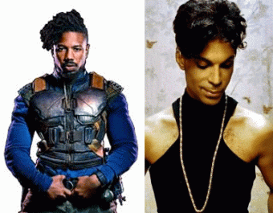
And, there are questions whether Eric Killmonger was originally created a “Gay” black male character. Furthermore, Black Revolutionaries are not called a “killmonger“- Merchant of Death. NEVERTHELESS.
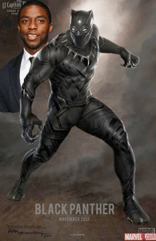
THE BLACK PANTHER is a half man or semi- human animal created by a mix of afro-futurism technology (whatever Disney believes that to be) and Vodun inspired spiritualism, including visits to the ancestral plane. The Black Panther’s abilities are not God-given powers, but stem from his consuming a very rare plant, which is made into a magical potion that is drunk only by king.
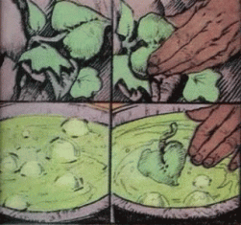
The Heart-Shaped Herb potion created by Panther Goddess Bast drank by the king has been found to be a plant mutated by a meteorite of vibranium (uranium) that landed in Wakanda millions, tens or hundreds of thousands of years ago.
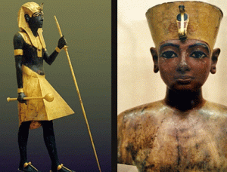
In the 18th Dynasty Kemet, the infamous ancient Pharaoh Tutankhamun was well of the extraterrestrial properties of heavy metals and uranium in meteorites that had fallen in Kemet tens and hundreds of thousands and millions of years ago. The knew how to separate them.
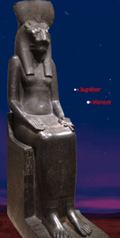
Statue of Sekhmet, Temple of Mut, Karnak, 18th Dynasty, Reign of King Tut’s Grandfather Pharaoh Amenhotep III
Bastet or Bast, the ancient cat goddess of Lower Kemet, was occasionally given a lion head and spoken of as a devastator. But more often she was seen as the benign counterpart of the dangerous Sekhmet: “Sekhmet of yesterday, Bastet of today”, as a hymn from Ptolemaic Edfu (provincial town from the end of the Old Kingdom) put it.
Angela Bassett & Lotus Flower – Sacred Symbol of the Sun & Rebirth
Angela Evelyn (Bastet) Bassett stars in The Black Panther movie. She is a HollyWeird New Age conjurer and witch associated with raising demonic entities and spirits In recent times, Sekhmet has become bastardized as a cult figure of New Age Religion. New Age Shamans use rituals to invoke Egyptian goddess Sekhmet to bring about transformation at the deepest levels of being. Sekhmet also represents to them the trans formative power of kundalini energy, or sekhem. In extreme remote antiquity, Sekhmet presented the destructive nature of Comet-Planet Venus on earth.

The Black Panther is a reborn animal-like savage destructive universal nature.
II
JAY Z, JAYBO & BLACK SIMIAN AND HOMINOID ASSOCIATION
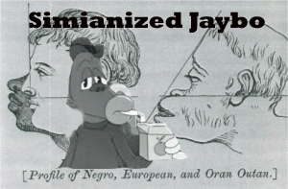
JAYBO is a harmful simianized hominoid global mass commercial black/Negro caricature. JAYBO represents the half man, half human animal like The Black Panther. It is a higher primates- half simian monkey or Great Ape Homoinoidea orangutan not unlike the Ape-Man M’Baku and the Great White Gorilla Cult of The Black Panther movie associated with the Congolese Black Africans.
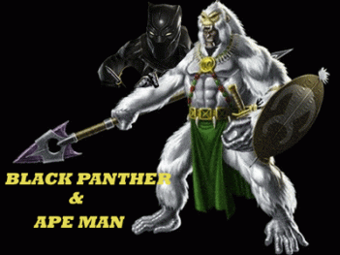
The idea that the various human “races” were created independently by God or evolved from separate ape/monkey ancestors, has its origins with 18th Century French intellectuals, e.g. Voltaire and Cuvier, who divided humanity into “civilized” Caucasians (= whites) created by God and “barbaric’ Negros (= blacks) derived from the “monkey tribe”.
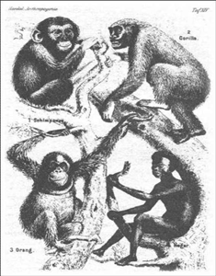
This tradition was continued by paleontologists, e.g. Louis Agassiz in the U.S. and in Europe by Karl Vogt. Despite Darwin’s detailed refutation of polygenism in his The Descent of Man (1871), polygenism was supported, in various guises; by eminent evolutionists (e.g. Alfred Russell Wallace and Ernst Haeckel compared Negroes to “four-handed” apes).[1]
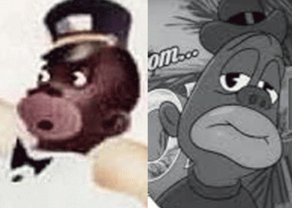
JAYBO & NEGROTUDE
Dr. Benjamin Rush, a signer of the Declaration of Independence, believed that mad people could be calmed by blood-letting from 20 to 40 ounces of blood at one time. Dr. Rush then developed a “tranquilizer chair” in 1811. This invention efficiently kept a person securely immobile and had a wooden box in which their head would be put into in order to keep the person subdued. Dr. Rush was the first to describe a pathological incurable medical condition called “Negrotude”. Negrotude was a mild form of leprosy which symptoms included such as blackening of the skin; big lips, flat nose, wooly hair. The only evidence of a cure was when the “skin turned white”. Dr. Rush used “disease” as a justification for African slavery and segregation. Negrotude was an immutable genetic disease that allowed blacks only to be medically cleared for work as domestic workers that had to be sexually segregated.
In 2008, research presented in a new paper by psychologists at Stanford, Pennsylvania State University and the University of California-Berkeley revealed that many Americans subconsciously associate blacks with apes [and hominoids]. In addition, the findings show that society is more likely to condone violence against black criminal suspects as a result of its broader inability to accept African Americans as fully human, according to the researchers.
Generally widely accepted commercial such as JAYBO and The Black Panther are dangerous false ILLUSIONS. They add fuel to the broader universal and global inability and unwillingness to accept Africans and African Americans as fully human whether it is conscious or subconscious. And, if leading black intelligentsia and corporate leaders don’t openly vehemently object to them, then the conscious or subconscious may become global acquiescence, derived from the Latin acquiēscere (to find rest in).
Co-author Jennifer Eberhardt, a Stanford associate professor of psychology who is black, said she was shocked by the results, particularly since they involved subjects born after Jim Crow and the civil rights movement.

“This was actually some of the most depressing work I have done,” she said. “This shook me up. You have suspicions when you do the work intuitions you have a hunch. But it was hard to prepare for how strong [the black-ape association] was how we were able to pick it up every time.”
The paper, “Not Yet Human: Implicit Knowledge, Historical Dehumanization and Contemporary Consequences,” is the result of a series of six previously unpublished studies conducted by Eberhardt, Pennsylvania State University psychologist Phillip Atiba Goff (the lead author and a former student of Eberhardt’s) and Matthew C. Jackson and Melissa J. Williams, graduate students at Penn State and Berkeley, respectively. The paper is scheduled to appear Feb. 7, 2008 in the Journal of Personality and Social Psychology, which is published by the American Psychological Association. Don’t get it twisted. Dehumanization and subliminal and conscious acceptance of violence against blacks is not confined to criminal suspects.
III
GERMANY’S WAR OF GENOCIDE AGAINST MONKEYS

“Everywhere, fear gripped German society that its racial superiority would be poisoned by Negro blood”^{[3]}
It was General von Trotha, Supreme Commander of German Southwest Africa that said, “A humane war cannot be waged against those who are not human.” Africa of Southwest Germany colonial officials and military men viewed the Herero cultural group as a form of baboon or other monkey, but not human. One German in Southwest Africa wrote: “We should burn all these dogs and baboons.”^{[5]}
The Herero were originally a group of cattle herders living in the central-eastern region of South West Africa, presently modern Namibia. The area occupied by the Herero was known as Damaraland. The Nama were pastorals and traders living to the South of the Herero. From 1904- 1907, in total some 65,000 Herero, about 80% of the Herero population, and 10,000 Nama, about 50% of the Nama population, perished. The genocide was carried out by mass slaughter, starvation and by poisoning the wells of the Herero amongst other crimes against humanity and tactics. Thousands of Herero and Nama were imprisoned in concentration camps, where the majority died of disease, abuse, and exhaustion.^{[6]} Germany’s Southwest African war was a campaign of mass racial extermination and collective punishment that the Reich undertook against the Herero, Nama and San people. It is considered the first mass genocide of the 20th century that the world failed to take any real action against, or try to stop. The Nazi took it a giant step backward.^{[7]}
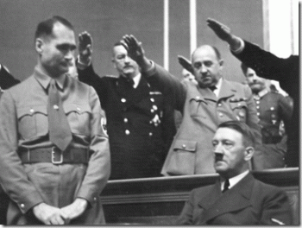
“National Socialism [Nazi Party] is nothing more than applied biology.” Rudolph Hess, Deputy Reichsfurhrer
Nazi Party eugenics was Nazi Germany’s racially based social policies that placed the biological improvement of the Aryan race or Germanic “Übermenschen” master race through eugenics at the center of Nazi ideology and geopolitics.^{[2]} The Fuhrer Adolf Hitler was created, molded, and nurtured by National Socialism (Nazi Party) to lead Germany into one of world’s most ruthless and satanic homicidal campaigns of global racial purification and annihilation in history. World War 2 could have very well been described a global race war.
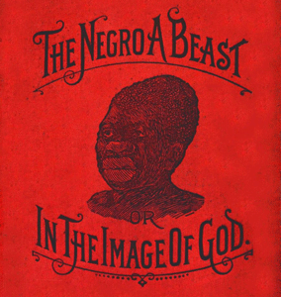
Unchallenged, we tread on very dangerous grounds with the black-ape association ILLUSION even in the 21st century.
__________________________________________________________________________________________________
[1] https://theconversation.com/comparing-black-people-to-monkeys-has-a-long-dark-simian-history-55102
[2] https://en.wikipedia.org/wiki/Nazi_eugenics
[3] https://www.timesofisrael.com/in-germanys-extermination-program-for-black-africans-a-template-for-the-holocaust/
[4] https://en.wikipedia.org/wiki/Wilhelm_II,_German_Emperor
[5] Id.
[6] http://combatgenocide.org/?page_id=153
[7] https://en.wikipedia.org/wiki/Herero_and_Namaqua_genocide
[8] https://www.theatlantic.com/magazine/archive/2011/06/red-rosa/308500/
[9] http://www.ancientegyptonline.co.uk/nabtaplaya.html
[10] http://www.crystalinks.com/nubia.html
[11] http://www.astrotheologyzone.com/egypt.html
[12] http://1stmuse.com/maria_orsitsch/
[13] http://www.bibliotecapleyades.net/sociopolitica/sociopol_thule08.htm
____________________________________________________________________________________________________
IV
JAYBO & JAY Z LESSONS NOT LEARNED IN THE 21ST CENTURY
Jaybo, Jay Z & The Shady Lady Kingpin Cocaine Trafficker, Desiree Perez
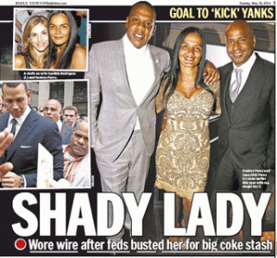
During the CIA crack cocaine epidemic in 1994, Jay Z’s Desiree Perez, Chief Operating Officer of Carter Enterprises, LLC, was busted in Brooklyn with 35 kilos (about 80 pounds) of cocaine with an estimated street value of at least up to $14 million. She was a part of a massive Mafia New York to Florida to Puerto Rico – Columbian cocaine distribution ring. She should have been prosecuted as a Chapter 13 of Title 21 of the United States Code, 21 U.S.C. § 848 federal drug “KINGPIN” in the Southern District of Florida.[1],[2]
U.S. Attorney Laurence Bardfeld, the U.S. Attorney for the Southern District of Florida, the chief federal law enforcement officer for the District, argued in Perez’s behalf to keep her out prison. The Southern District of Florida encompasses a geographical area of approximately 15,197 square miles extending south to Key West, north to Sebastian and west to Sebring. The Southern District includes the counties of Miami-Dade, Broward, Monroe, Palm Beach, Martin, St. Lucie, Indian River, Okeechobee and Highlands.[3]
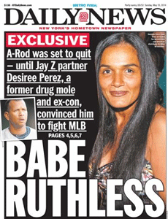
Desiree Perez is a DEA/FBI agent and informant that was released from the federal prison custody and placed on five years of supervised release. She began working at nightspots in Miami Beach and was scheduled to meet her probation officer at the Club Onyx, when she skipped town without notice in early August 1997. The fugitive Perez resurfaced nine month later in Brooklyn, where she was arrested on March 5, 1998. Perez was charged with grand larceny, criminal use of drug paraphernalia and criminal possession of a firearm. Her probation was revoked and she was sentenced to just only 9 (nine) months in prison and 3 (three) years of supervised release instead of at least life imprisonment as a major federal “kingpin” drug dealer. Perez appears to have been in business with Jay Z since at least 2002. Perez’s felonious federal drug kingpin criminal records have been court sealed.[4] Jay Z and the felonious drug trafficker Shady Lady created the racist simian-hominoid black caricature JAYBO.
On the street, drug dealers often say that they aren’t the source of the problem for drug addiction and death in the black community. They say that the n-word (niggas) want to commit suicide. They only help them KILL THEMSELVES. Black children need heroes and super heroes too, but we can’t sit by in idle silence while Jay Z and the Shady Lady profit again from the spiritual assassination and subconscious death of the masses like merchants of DEATH. I have filed a formal objection to the JAYBO trademark application for federal protection. Whatsoever publish this demeaning black hominoid caricature in commerce to deliberately profit from the sadistic dehumanization of black people shall ACCOUNT!
________________________________________________________________________________________
[1] https://www.indiatimes.com/news/world/35-kilos-of-cocaine-worth-rs-94-crore-found-in-a-horse-sculpture-in-new-zealand-257703.html
[2] http://www.nydailynews.com/blogs/iteam/damon-dash-scared-news-report-a-rod-pal-desiree-perez-blog-entry-1.2146139
[3] https://www.justice.gov/usao-sdfl
[4] http://www.nydailynews.com/sports/i-team/babe-ruthless-rod-shady-lady-article-1.1796578
IN THE UNITED STATES PATENT AND TRADEMARK OFFICE
BEFORE THE TRADEMARK TRIAL AND APPEAL BOARD

RAYFORD BULLOCK,
Opposer,
Opposition No.
Trademark No. 87517427
Mark: JAYBO, Pseudo Mark
Filing Date: July 06, 2017
Publication Date: February 13, 2018

S. CARTER ENTERPRISE, LLC,
Applicant.
I
NOTICE OF OPPOSITION
RAYFORD BULLOCK, a Black resident of the State of California, City of Pittsburg, County of Contra Costa (hereafter called “Opposer”), believes that he will be damaged by the registration of the mark shown in Application Serial No. 87517427, filed by S. Carter Enterprise, LLC (hereafter called “Applicant”) on July 06, 2017, and opposes Application Serial No. 87517427.
The Opposer is a former member of the Black Panther Party for Self Defense (BPP), Oakland, CA. The Opposer BPP membership is confirmed and verified by his name that appears above in its official newspaper organ, The Black Panther, Intercommual News Service, January 31, 1969.
The grounds for this opposition are as follows:
A
Applicant’s Mark is a Lying and Pretext Mark
1 .The “applicant” S. Carter Enterprises LLC [Shawn Corey Carter] is known professionally as JAY-Z– an American rapper and businessman. Applicant’s MARK is actually a caricature of JAY-Z. The applicant is now engaged in the manufacture, distribution, sale, advertising and promotion of a wide range of promotional goods and services including clothing of the MARK’s CARICATURE, JAYBO or JAYBO, that are not: “Candles; scented and perfumed candles; aromatherapy fragrance candles; votive candles; candle torches; wicks for candles; scented wax for use in candle warmers; candles for night lights; tea light candles.”
- In lieu of the U.S. Supreme Court ruling in Matal v. Tam, 137 S. Ct. 1744 (June 19, 2017) that the Lanham Act’s disparagement clause violates the Free Speech Clause, whether or not JAYBO is disparaging to any person or racial is not at issue in this case. However, it may be relevant on the issue of the Applicant’s motive to deceive the trademark act. “Our legal system provides methods for challenging the Government’s right to ask questions — lyingis not one of them.” [Making false statements (18 U.S.C. § 1001), Brogan v. United States, 396 U.S. 64, 72 (1969]
B
The applicant’s MARK: JAYBO does in fact identify a particular living individual that is in fact a black caricature of Shawn Corey Carter known professionally as JAY-Z.
- The applicant’s MARK is better described as a suitcase that hides the applicant’s racist black caricature of the rapper, JAY-Z, inside.
C
The applicant’s MARK: JAYBO is an attempt to DECEIVE
- JAYBO or JAY-BO represents a racist caricature of BOSKO re-imaged as the applicant in commerce currently bought and sold on a large scale.
D
Applicant’s Mark Lack Sufficiently Originality to Warrant Copyright Protection.
- Applicant’s Mark is complete textual “JAYBO”. Applicant’s Mark statement says that the mark consists only of “standard characters, without claim to any particular font, style, size, or color.”
II
PROCEDURAL HISTORY OF THE MARK: JAYBO

- Trademark/Service Mark Application, Principal Register
Serial Number: 87517427
Filing Date: 07/06/2017
OWNER OF MARK: S. Carter Enterprises, LLC
MARK: JAYBO
STANDARD CHARACTERS: YES
LITERAL ELEMANT: JAYBO
MARK STATEMENT: This mark consists of standard characters, without claim to any particular font, style, size, or color.
10/3/2017 12:24:30 PM
The assigned examining attorney has reviewed the referenced application and determined the following.
- Offc Action Outgoing
Date Sent: 10/03/2017
UNITED STATES PATENT AND TRADEMARK OFFICE (USPTO)
OFFICE ACTION (OFFICIAL LETTER) ABOUT APPLICANT’S TRADEMARK APPLICATION
U.S. APPLICATION SERIAL NO. 8751742
APPLICANT: S. Carter Enterprises, LLC
CORRESPONDENT’S REFERENCE/DOCKET NO: 22485.00001
NAME IN MARK
Applicant must clarify whether the name JAYBO in the mark identifies a particular living individual. See 37 C.F.R. §2.61(b); TMEP §§813, 1206.03. In this case, the application neither specifies whether the name in the mark identifies a particular living individual nor includes a written consent. See TMEP §§813.01(a)-(b), 1206.04(a), 1206.05.
To register a mark that consists of or comprises the name of a particular living individual, including a first name, pseudonym, stage name, or nickname, an applicant must provide a written consent personally signed by the named individual. 15 U.S.C. §1052(c); TMEP §§813, 1206.04(a).
Accordingly, if the name in the mark does not identify a particular living individual, applicant must submit a statement to that effect (e.g., “The name shown in the mark does not identify a particular living individual.”).
However, if the name in the mark does identify a particular living individual, applicant must submit both of the following:
(1) The following statement: “The name(s) shown in the mark identifies a living individual(s) whose consent(s) to register is made of record.” If the name is a pseudonym, stage name, or nickname, applicant must provide the following statement: “JAYBO identifies <specify actual name>, a living individual whose consent is of record.”
(2) A written consent, personally signed by the named individual(s), as follows: “I, <specify name>, consent to the use and registration of my name, JAYBO, as a trademark and/or service mark with the USPTO.”
8. Applicant’s Response to Office Action
Date: December 28, 2017
SERIAL NO. 8751742
MARK: https://tmng-al.uspto.gov/resting2/api/img/87517427/large
MARK STATEMENT: This mark consists of standard characters, without claim to any particular font, style, size, or color.
NAME(S), PORTRAIT(S), SIGNATURE(S) OF INDIVIDUAL(S): The name(s), portrait(s), and/or signature(s) shown in the mark does not identify a particular living individual.
ORIGINAL PDF FILE: HS_389416710-164142961_._Signed_Declaration.pdf
SIGNATORY’S NAME: Desiree Perez
SIGNATORY’S POSITION: COO [Chief Operation Officer]
III
APPLICANT’S MARK AT ISSUE
- The Opposer maintains that the applicant’s mark at issue is a Lying and Pretext Mark.
Exhibit A- the real “JAYBO”
- Exhibit A is the applicant’s true and actual “JAYBO” mark in commerce. And, by its very nature- it is not impossible, but extremely unsuitable for “Candles; scented and perfumed candles; aromatherapy fragrance candles; votive candles; candle torches; wicks for candles; scented wax for use in candle warmers; candles for night lights; tea light candles.”
IV
LET US MEET BOSKO
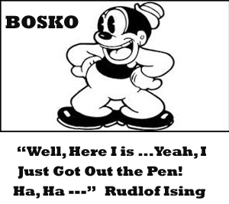
- BOSKOis a racist animated cartoon character created by1920-30s era white animators Hugh Harman and Rudolf Ising of Kansas City, Missouri. In the history of the United States, Missouri was a slave state– a state in which the practice of African Human Bondage was legal.
- BOSKO is the first recurring character in Leon Schlesinger‘s cartoon series, and is also the star of over three dozen extremely racist Looney Tunesshorts released by Warner Bros.
- Hugh Harman made drawings of a new character and registered it with the copyrightoffice on January 3, 1928. The character was registered as a “Negroboy” under the name of BOSKO.
- The original BOSKO character clearly appears to be an adult. However in former slave states, it was a customary psychological tactic to continually humiliate and emasculate Black men by calling them “BOYS” throughout their lives from infancy to old age to satisfy a byproduct of the horrible Institution of African Human Bondage– a sick racial psycho-sexual white superiority complex.

BOSKO WITH ANIMAL CLAWED FEET
- When BOSKO was created in 1928 as an ante bellum slavery classic cognitive empathy of the majestic falsehood that black people are less than human, it was well understood in the animation industry that the southern “Negro Boy” was depicted to represent a simian “MONKEY” that justified the global institutional enslavement of the African. BOSKO can procreate, but it will not be allowed by white society to create or originate just the same as a primate.
- BOSKO’s black skin; gruesome big lips, eyes and wooly hair constitute symptoms of a pathological incurable 18th century ante bellum slavery medical condition called “Negrotude” – a mild form of Leprosy that justified special criminal and sexual prohibitions, racial discrimination; and strict segregation of Africans within white society.
- BOSKO carries a lot of racial hatred, wounds and baggage. It certainly stands to reason that BOSKO is an extremely horrible and racist character and caricature that should have been left to die in the early 20st century or flushed down the toilet in the 21st century. It is certainly something to lie about, hide and conceal from the U.S. Trademark Office and public if BOSKO is resurrected in any form whatsoever and for whatsoever reasons, and the applicant is attempting to revive him. BOSKO arise, and rides again behind the veil of the power, authority, shield and sword of The Lanham Act.
V
THE LANHAM (TRADEMARK) ACT
18.The Lanham Act of 1946, also known as the Trademark Act (15 U.S.C.A. § 1051 et seq, ch.540, 60 Stat. 427 [1988 & Supp.V 1993]), is a federal statute that regulates the use of Trademarks in commercial activity.
- Trademarks are distinctive pictures, words, and other devices used by business to identify their pictures, words, and other symbols or devices used by businesses to identify their goods and services.
- The Lanham Act is like a shield that gives the trademark users exclusive rights to their marks, thereby protecting the time and money invested in those marks. The act also serves to reduce consumer confusion in the identification of goods and services.
- The Lanham Act is also like a sword that gives trademark users a plethoric of legal procedures and remedies to strike with under federal law to help enforce their rights attached to qualified trademarks.
VI
IN A PETITION TO OPPOSE A MARK INTENT TO DECIEVE MUST BE SUPPORTED BY CLEAR AND CONVINCING PROOF
- The Trademark Opposer carries the burden of proof by clear and convincing evidence to support an inference of deceptive intent (FRAUD, INTENT TO DECIEVE).
- The precise meaning of “clear and convincing proof” does not lend itself readily to definition. It is, in reality, a question of how strongly the minds of the trier or triers of fact must be convinced that the facts are as contended by the proponent. In the ordinary civil suit, the proponent must persuade the jury (or judge, if there is no jury) that the facts are more probably true than not true. Where clear and convincing proof is required, the proponent must convince the jury or judge, as the case may be, that it is highly probable that the facts which he asserts are true. He must do more than show that the facts are probably true. (COMMENT, EVIDENCE: CLEAR AND CONVINCING PROOF: APPELLATE REVIEW, CALIFORNIA LAW REVIEW, Vol. 32, Issue 1, March 1944, pg. 75)
VII
APPLICANT’S REAL MARK CONCEALED IN THE SUITCASE
- On October 03, 2017, the USPTO identified the Mark, “JAYBO”, as a name that did not show whether or not it identified a particular living individual. USPTO asked applicant to respond, accordingly.
- On December 28, 2017, the applicant responded that the name, “JAYBO” shown in the mark does not identify a particular living individual. It had been so declared by the applicant by signatory Desiree Perez, COO- ” S. Carter Enterprises LLC.
- Desiree Perez’s declaration is in evidence, and it states the following:
DECLARATION
The signatory believes that: the applicant is entitled to use the mark in commerce on or in connection with the goods or services specified in the application; the applicant has a bona fide intention to use the mark in commerce and had a bona fide intention to use the mark in commerce as of the application filing date; and to the best of the signatory’s knowledge and belief, no other person has the right to use the mark in commerce, either in the identical form or in such near resemblance as to be likely, when applied to the goods and/or services of such other person, to cause confusion or mistake, or to deceive. The signatory’ being warned that willful false statements and the like are punishable by fine or imprisonment, or both, under 18 USC §1001, and that such willful false statements and the like may jeopardize the validity of the application or any registration resulting therefrom, declares that all statements made of his or her own knowledge are true and all statements made on information and belief are believed to be true.
Dated: ___10/20_______, 2017
- CARTER ENTERPRISES, LLC
By: Desiree Perez Title: COO
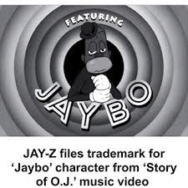
- Perez’s statement that the mark, “JAYBO”, does not identify a particular living individual is a false statement. JAY-BO is her business partner, the self-guru, JAY-Z.
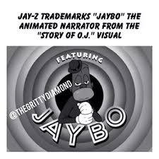
28. Throughout the U.S. music and entertainment industry, the “JAYBO” character is known as applicant’s real trademark. It is known internationally that the “JAYBO” less than human animated simian BOSKO character is the applicant’s real trademark.
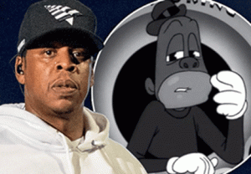
JAY Z- JAYBO
- “The 48-year-old rapper has filed a trademark on his animated character that appeared on The Story of OJ music video last year according to a Monday report from TMZ.” (Daily Mail. Com, January 15, 2018)
VIII
FACT: JAY Z CREATED HIMSELF AS JAYBO – AN OFFENSIVE RACIST MUTANT CHARACTER CARICATURE OF BOSKO
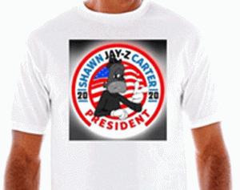
Exhibit B- Shawn Jay Z Carter (JAYBO) President
- “The Story of O.J.” is a song by Jay-Z from his thirteenth studio album 4:44 released on June 30, 2017. Roc Nation, LLC is an American entertainment company founded by Shawn “JAY-Z” Carter in 2008. Desiree Perez is also COO of Roc Nation, LLC.
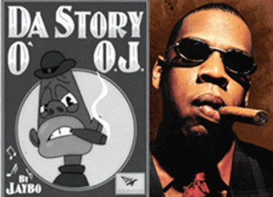
Da Story of O.J., Jaybo, Roc Nation & Jay Z
- The creation of applicant’s mark JAYBO began with JAY-Z’s track, “The Story of OJ”. Jay Z and Mark Romanek brainstormed an idea character for a video where the track “The Story of OJ” would play over visuals of him and black people derived from old, racist [BOSKO] cartoons from the 1930s-40s. JAYBO was deliberately created as another purveyor of the cognitive empathy of the majestic falsehood that black people are less than human.
- Video directors Mark Romanek and Jay-Z of Roc Nation collaborated over the course of six weeks with a team of animators, 3D modelers, and designers to produce the character caricature, JAYBO.
- Roc Nation employed The Mill with Titmouse to handle video character design and animation. Illustrator, vis-dev artist, art director, Rustam Hasanov, was lead character designer on the Roc Nation project. 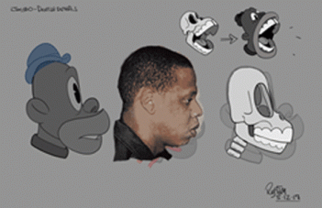
- Rustam Hasanov, Development Guide for the Character of JAYBO [Opposer added JAY Z picture to Development Guide]
- Rustam Hasanov, “There was a ballpark, a grey area of we could hit and if we didn’t quite get it right I knew it could be catastrophic and that it could be misconstrued and misinterpreted in term of what the intention behind the video was. So, we were very careful about how we were going to address all the stereotypes and how we were going to clarify exactly what the designs were going to say.” (https://kulturehub.com/jay-z-oj-designer/) 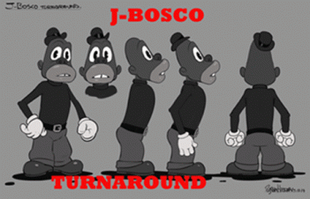
- Above, Rustam Hasanov’s [JAY Z] J- BOSCO [BOSKO] Turnaround- there is absolutely no doubt that JAYBO had been created in the image of BOSKO as a purveyor of the ante bellum slavery classic cognitive empathy of the majestic falsehood that black people are less than human.
- Rustam Hasanov, “Imagine doing these horrible racial stereotypes and turning them into entertainment for children. If you are an artist you know exactly what you are doing and you know that it’s bad, but they did it anyway. That’s exactly what we were doing too. That was the part we were nervous about, are we just repeating the same thing and are we fetishizing these stereotypes or are we making a statement? To us very much, we were on the side that we are not regurgitating this content, we’re making a statement about it.” (https://kulturehub.com/jay-z-oj-designer/)
- Rustam Hasanov, “I found out from Tim Delvin who was the art director. I basically came in, he pitched the project to me, what the idea was and said, ‘it is for Jay-Z.’ At that point, I didn’t know the song and I thought, ‘God this could go very wrong’ because he just showed some imagery- the racist references and cartoons were shown to me first. Yeah, that was a little unnerving.” (https://kulturehub.com/jay-z-oj-designer/)
- JAY-Z had himself reimagined as “JAYBO” or “JAY BO” a play off of the racist black caricature, BOSKO, for his song “The Story of O.J.” from his 13 (thirteenth) studio album 4:44 as some kind of black hominoid/simian financial and philosophical guru.
Contrary to the applicant’s sworn declarations, JAY BO, represents a living person- JAY Z [Shawn Corey Carter], and his ideology. JAY to the Z is the same live person as JAY to the BO.
- The music video for “The Story of O.J.” features JAY-Z reimaged as the racist caricature character JAYBO premiered on July 5, 2017 on Jay-Z’s Vevo account on YouTube a day before he applied for U.S. trademark protection. (See https://en.wikipedia.org/wiki/The_Story_of_O.J.
- Jay-Z‘s “Story of O.J.”featured JAY-Z reimaged as the racist black simian or hominoid character JAYBO. It is an animated figure that appears to have been snatched directly from the minstrel show era with an uncanny resemblance to JAY-Z. The racist JAYBO or JAY BO, character image is intended to appear on merchandise coming soon after the pseudo mark, JAYBO, the Bosco/Little Black Sambo character, is trademarked officially.
(See http://hiphopwired.com/741575/get-ready-to-see-jay-zs-story-of-o-j-character-jaybo-on-merchandise-soon/)
- TMZreported: Hova’s company, S. Carter Enterprises, just filed docs to trademark the animated character figure, “JAYBO.” The plan is to plaster the little guy on T-shirts, sweaters, hats, blankets, shams, dinnerware, mugs, cocktail shakers and thermal containers.
It is Jay-Z’s lead character “JAYBO” from his “Story of O.J.” music video that has been drafted for a whole new role in fashion and home wares, not the pseudo name “JAYBO” or “JAY BO”.
- The applicant’s current U.S. Trademark application was made with the intention of putting the animated BOSKO “JAYBO” character on merchandise such as T-shirts and hats, as well as mugs and cocktail shakers, not the pseudo name “JAYBO” or “JAY BO”.
- In fact, the applicant has declared in its Trademark/Service Mark Application, Principal Register, Serial No. 87517427 that its goods and services “JAYBO” or “JAY BO” include the following: “Candles; scented and perfumed candles; aromatherapy fragrance candles; votive candles; candle torches; wicks for candles; scented wax for use in candle warmers; candles for night lights; tea light candles.”
IX
APPLICANT’S MARK IS TEXTUAL MATTER THAT IS NOT COPYRIGHTABLE
- Applicant’s Mark is complete textual “JAYBO”. Applicant’s Mark statement says that the mark consists only of “standard characters, without claim to any particular font, style, size, or color.”
- ETS-HOKIN v. SKYY SPIRITS INC., 225 F.3d 1068 (9th Cir. 2000), the court held that,
“[a] claim to copyright cannot be registered in a print or label consisting solely of trademark subject matter and lacking copyrightable matter.” 37 C.F.R. 202.10(b). Although a label’s “graphical illustrations” are normally copyrightable, “textual matter” is not–at least not unless the text “aid[s] or augment[s]” an accompanying graphical illustration. 1 NIMMER 2.08 [G][2], at 2-136. The label on Skyy’s vodka bottle consists only of text and does not include any pictorial illustrations.”
- In this case, the applicant’s Mark lacks enough originality to acquire copyright protection of their own. “Textual matter” is not copyrightable at least not unless the text “aid[s] or augment[s]” an accompanying graphical illustration. Applicant’s Mark is the same as Skyy’s vodka bottle above; it consists only of text and does not include any pictorial illustrations.
X
PRAYER
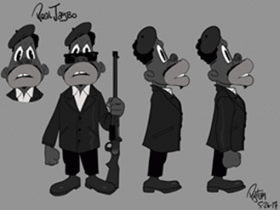
APPLICANT’S “REAL JAYBO”, BLACK PANTHER PARTY FOR SELF DEFENSE
- Opposer avers that the public have been confused, mistaken or deceived by the Applicant’s Concealed Actual Mark that represents real people and historical events involving the Opposer and the BPP. The offensive racist simian hominoid black caricature, the “REAL JAYBO” had absolutely NOTHING to do with the BPP or its historical events. Yet, at the very least 61 million people around the world have viewed the applicant’s less than human so called U.S. Copyrighted Black Panther caricature in applicant’s mass produced, “The Story of OJ”.
- Opposer avers that he will be damaged by the registration of the Applicant’s Lying Mark as set forth in Applicant’s Trademark Application Serial No. 87517427 that deliberately and intentionally conceals Applicant’s Actual Mark, a racist black caricature, which misconstrue, mis-educate the public regarding true historical individuals and events, and maliciously spread the majestic falsehood around the world that black people are less than human.
- Opposer avers that he has been and will continue to be damaged by the registration of the Applicant’s Lying Mark as set forth in Applicant’s Trademark Application Serial No. 87517427 that deliberately and intentionally conceals Applicant’s Actual Mark, a racist black simian/hominoid caricature, which humiliate, denigrate, and DEHUMANIZE him in commerce.
- Opposer avers that he has been and will continue to be damaged by the registration of the Applicant’s Lying Mark as set forth in Applicant’s Trademark Application Serial No. 87517427 that deliberately and intentionally conceals Applicant’s Actual Mark, a racist black simian/hominoid caricature, to deny him rights, and remedies under The Lanham Act, 13th (Badges and Incidents of Slavery) and 14th Amendment of the U.S. Constitution (Due process and Equal Protection).
- Opposer avers that he has been and will continue to be damaged by the registration of the Applicant’s Lying Mark as set forth in Applicant’s Trademark Application Serial No. 87517427 that deliberately and intentionally conceals Applicant’s Actual Mark, it is an Application designed to DECIEVE the Trademark Office, Commerce and the Public.
- Opposer avers that the applicant is wrongfully using the Lanham Act as his sword and shield to maliciously spread in commerce the ante bellum slavery majestic falsehood that black people are less than human.
- So that it is crystal clear, the Opposer’s notice and petition of opposition before the U.S. Trademark office is not based on applicant’s ugly racist and horrible animated character, but the fraud and deception that applicant committed in the application process with the intent to deceive and conceal applicant’s ugly racist and horrible animated character from the Trademark Office.
WHEREFORE, this Opposer, RAYFORD BULLOCK, believes and avers that it is being and continues to be damaged by registration of the proposed JAYBO trademark as aforesaid, prays that the said Application Serial No. 87517427 be rejected in accordance with the provisions of the Trademark Act, that no registration be issued thereon to Applicant, and that this Opposition be sustained in favor of Opposer.
Respectfully Submitted,
______________________________________
RAYFORD BULLOCK
Dated: March 08, 2018

Comments : 1 Comment
Tags: 18th dynasty, Adolf Hitler, american psychological association, angela bassett, ape man, ayo, black age association, Black Panther Party for Self Defense, bosko, carter enterprises, congo, danai gurira, dehumanization, desiree perez, dora milaje, eric killmonger, ETS-HOKIN v. SKYY SPIRITS INC, florence kasumba, gay agenda, genocide, global race war, goddess bast, half-human hominoids, hererro, Intercommual News Service, jay z, jaybo, jennifer eberhardt, joe robert cole, kemet, lanham act, laurance bardfeld, LGBT Agenda, llc, mark romanek, marvel comics, Nama, Namibia, National Socialist Movement, negrotude, NEW AGE RELIGION, niggas, notice of opposition, okoye, pharaoh amenhotep III, pharaoh tutankhamun, rayford bullock, Roc Nation, rudlof ising, rudolph hess, Rustam Hasanov, San people, sekhmet, shady lady, Shawn Corey Carter, the black panther, the black panther movie, the mill, the story of oj, titmouse, trademark trial and appeal board, ubermenschen, uranium, us patent and trademark, vibranium, wakanda, warner bros., white gorilla cult
Categories : african holocaust, African Liberation, African slavery, Amenhotep III, angela bassett, Aryan Supremacy, Barack Obama, black children, black christianity, black institutions, Black Panther Party for Self Defense, christianity, CIA, egypt, evil, false prophet, false prophets, False Satanic Rites of Lost Negroes, freemason, freemasons, genocide, Hip Hop, HIP HOP false prophets, hip hop satanic cult, Iran-Contra Crack Cocaine connection, jay z, jay-z, king tut, luciferians, Michelle Obama, Nazis, new world order, nwo, operation mockingbird, project mockingbird, psychological warfare campaign against Christianity, racial mass murder, Reichsfurhrer SS-1 Heinrich Himmler, rudolph hess, satan, Satanism, Schutzsteffel, slavery, SS, Walt Disney

PART TWO, THE BLACK PANTHER MOVIE, CIA AND DANGEROUS ILLUSIONS- PSYCHOLOGICAL WARFARE
25032018
I
CIA’S SECRET ILLEGAL WAR AGAINST THE PANTHERS
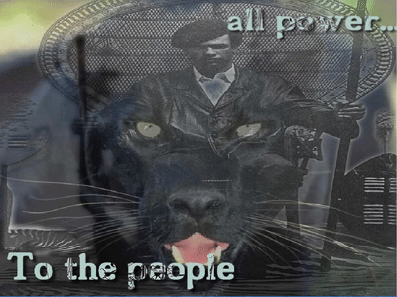
The “United States President’s Commission on CIA Activities within the United States” was set up under U.S. President Gerald Ford in 1975 to investigate the activities of the CIA and other intelligence agencies within the United States. The commission was led by the U.S. Vice President, Nelson Rockefeller, and is sometimes referred to as the Rockefeller Commission.
The commission was created in response to a December 1974 report in The New York Times that the CIA had conducted illegal domestic activities, including experiments on U.S. citizens, during the 1960s. The commission issued a single report in 1975, touching upon certain CIA abuses including mail opening and surveillance of domestic dissident groups. It publicized CIA MK ULTRA. It also studied issues relating to the JFK Assassination, specifically the head snap as seen in the Zapruder film, and the possible presence of CIA agents E. Howard Hunt and Frank Sturgis in Dallas, TX.[1] Carefully hidden behind the veil of the Rockefeller Commission were the CIA’s top secret illegal domestic operations and war against Huey P. Newton, Bobby Seale, and the Black Panther Party for Self Defense (BPP) in Oakland, CA.[2]
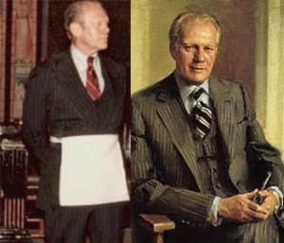
U.S. President Gerald R. Ford was initiated into Freemasonry on September 30, 1949, in Malta Lodge No. 465. (Grand Rapids, Michigan). Subsequently Ford received the degrees of Fellow Craft and Master Mason in Columbia Lodge No.3, Washington, D.C., on April 20 and May 18, 1951 respectively. Years later Ford became a Sovereign Grand Inspector General, 33°, Northern Jurisdiction.[3]
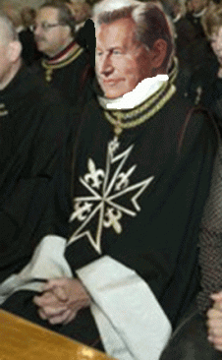
U.S. Vice President Nelson Rockefeller was a Knight of Malta (Knight Templar). He stood at the top of the hierarchical level of Freemasonry.[4]
“The Knights of Malta is a world organization with its threads weaving through business, banking, politics, the CIA, other intelligence organizations, P2, religion, education, law, military, think tanks, foundations, the United States Information Agency, the United Nations, and numerous other organizations. The world head of the Knights of Malta is elected for a life term, with the approval of the Pope. The Knights of Malta have their own Constitution and are sworn to work toward the establishment of a New World Order with the Pope at its head. Knights of Malta members are also powerful members of the CFR (Council on Foreign Relations) and the Trilateral Commission.” – Quoted from “Behold a Pale Horse” by William Cooper[5]
The Rockefeller Commission led by Freemasons deliberately concealed the CIA’s domestic operations against the BPP.
In June 1966, the CIA director was Richard Helms. The CIA’s secret operations against the BPP were run out of the Office of Security:
“The Director of Security (DOS) is charged with the preparation of the Agency’s security program and with the performance of security inspection functions…” Included among the responsibilities of the DOS was to “Obtain and evaluate through investigation, technical interrogation, and liaison contact with other United States agencies…Approve or Disapprove, from a security standpoint, the employment or utilization of individuals by the Agency, except certain approvals reserved for the Deputy Director (Plans)…Develop and conduct internal counterintelligence programs to detect and prevent hostile penetrations of the Agency through its employees…Furnish security advice and guidance to Agency employees.”[6]
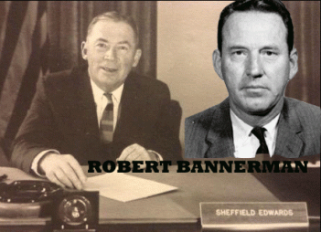
The director of the CIA Office of Security (OS) at that time was Robert L. Bannerman.[7] Bannerman was OS deputy chief under Sheffield Edwards. OS had the responsibility to protect Agency personnel and facilities from compromising situations and unauthorized penetration. OS also performed other, more surreptitious tasks. Its agents were widely regarded as experts in carrying out “black bag” and “clean up” jobs, and were infamous for less sophisticated “hard knuckle” operations.[8]
Since 1948, Edwards had been directly involved in supervising the CIA’s PB/7 program responsible for assassinations, kidnappings, special weapons, drugs, exotic poisons, induced diseases, and other means. BLUEBIRD (Nazi SS) and the secret assassination program ARTICHOKE (Assassinations & Manchurian Candidates) were run out of OS. There is no reason to believe OS suddenly changed its stripes under Bannerman.[9]
The CIA ran two highly classified and secret programs against the Panthers out the basement of the CIA Langley headquarters. OS’ Merrimac Project employed a number of secret black agents to spy on, report on and infiltrate the Panthers. They attended meetings and rallies to identify Panthers and supporters. They had at least 12 (twelve) black agents to photograph Panthers, identify their vehicles and follow them home. The OS developed and maintained a sophisticated and comprehensive data system on the BPP.
OS’ other secret operation against the Panthers was the infamous CHAOS Project.[10] Before the beginning of the Rockefeller Commission, CIA Director, Richard Helms, one of the most dangerous men in America, linked to Operation PAPERCLIP NAZI SS, ARTICHOKE, MK ULTRA/MONARCH, and their undeclared illegal war against the PANTHERS destroyed 150-200 domestic files on the BPP to conceal them from Congress and the public. And, the Knights of Malta and Freemasons on the Rockefeller Commission in 1975 conspired with the CIA to keep their secret illegal war against the Panthers off the books, TOP SECRET and CLASSIFIED.[11]
This is what I know. We knew that entities high in the government declared war against us. They told all our friends and family that they were going to kill us or put us in prison for life. We couldn’t land any decent jobs, public or private, because of government interference. However, the most chilling part is that we were warned that we had high level extrajudicial death squads out on streets employed to kill us or make us disappear. That’s why we had strict orders if presented with lethal force– RETURN IT.
In the early formation of the BPP in 1966, a secret Operation Merrimac black CIA agent had in fact made direct contact with me to try to discourage me from continuing to support Huey P. Newton and Bobby Seale. As far as I know now, I have had U.S Army, Air Force Intelligence, and several secret black CIA/NSA agents and agent provocateurs assigned to befriend me to identify Panthers, elders, friends, family, followers, and any supporters that gave us any aid, support and strength for planned government neutralization operations. Yes, on a personal basis it did seriously affect me mentally and socially, but we moved forward with love for the people, self-defense, self-determination, the 10-Plan, and didn’t back up.
II
THE SUN MAN & FANTASY OF POWER

BLACK SUPERHERO SUN MAN
In 1970-1971, a small group of young white teachers with Oakland Unified School District invited me to a business presentation at one of their homes. I was invited to the presentation because the business product proffered to alter the psyche of black children. The business product was “The Sun Man”. A young brother developed a black super hero called the “Sun Man” to booster the self-esteem of black children. I sat down with him for a confidential conversation. I told him that what he proposed to affect the psyche of black children was an ILLUSION.
Merriam-Webster defines ILLUSION as a conception or image created by the imagination and having no objective reality. The magician specializes in creating ILLUSIONS, so that people believe they have seen something when they really haven’t.[53]
Cognitive psychology is the branch of psychology heavily studied by the CIA that focuses on the way people process information. It looks at how we process information we receive and how the treatment of this information leads to our responses. In other words, cognitive psychology is interested in what is happening within our minds that links stimulus (input) and response (output).[54]
Perception | Stimulus (Input) | Processing
BLACK CHILD |  | The Greatness Super Hero of Them All
RESPONSE (OUTPUT):
No Foundation
No History
No Mythology
No Such Hero
ILLUSION, Cognitive Bias and Dissonance.
Mental Error
Cognitive biases are mental errors caused by our simplified information processing strategies. It is important to distinguish cognitive biases from other forms of bias, such as cultural bias, organizational bias, or bias that results from one’s own self-interest. In other words, a cognitive bias does not result from any emotional or intellectual predisposition toward a certain judgment, but rather from subconscious mental procedures for processing information. Cognitive biases are similar to optical illusions in that the error remains compelling even when one is fully aware of its nature. Awareness of the bias, by itself, does not produce a more accurate perception. Cognitive biases, therefore, are, exceedingly difficult to overcome.[12]
In the field of psychology, cognitive dissonance is the mental discomfort (psychological stress) experienced by a person who simultaneously holds two or more contradictory beliefs, ideas, or values. The occurrence of cognitive dissonance is a consequence of a person performing an action that contradicts personal beliefs, ideals, and values; and also occurs when confronted with new information that contradicts said beliefs, ideals, and values.[13]
HERCULES- SUPER HERO OF ROMAN AND GREEK MYTHOLOGY
Perception | Stimulus (Input)
WHITE CHILD | 
PROCESSING:
Hercules is a Roman Hero and God. He was the Son of Zeus (Roman equivalent Jupiter). In classical mythology, Hercules is famous for his Super Strength.
RESPONSE (OUTPUT):
Global Super Hero, Super Hero of Greek and Roman Mythology, Validation of Human Worthiness and Divine Origin
I tried to explain to the young brother that “The Sun Man” has “no objective reality” in myth or fact. He was offering black children a black super hero that they don’t have. The Sun Man doesn’t exist in legend, myth or fact. I offered to sit down with him and help develop a real black super hero from legend, mythology or fact that challenges the notions of white supremacy and that we could defend, justify, protect, and win the support of the masses, and the consent and approval of our elders.
Subconsciously, the young man was really seeking the consent and approval of white people offering them a black super hero that wouldn’t offend them or challenge white privileges and white supremacy notions. I never hear from him. The Sun Man died. The Sun Man found life again in 1985. He was copyrighted by Olmec Corporation (Yla Eason) in New York. “For too long, many black children have been unable to enjoy the fantasies of power because they could not identify with superheros who were white.” By 1993, the Sun Man died once more.[14]
So, you may ask why I am talking about the long gone Sun Man in 2018. Walt Disney and Marvel Comics’ “The Black Panther” movie opened five weeks ago in February 2018, and it’s come in No. 1 at the box office for all five of those weeks well into March 2018. There is no difference between the “The Sun Man” black super hero of the 20th century, and “The Black Panther” black super hero of the 21st century. Both deceive and pacify the masses with the illusions of “fantasies of power”. Both “The Sun Man” and “The Black Panther” black hero do not exist in legend, myth, magic or fact. Neither black hero, “The Sun Man” or “The Black Panther” challenges the status quo, New World Order or global white supremacy, because they are absolutely ILLUSIONARY characters of fantasy black power created by the ILLUMINATI and the New World Order to negatively affect the psyche of the masses and mislead and Double Bind (insanity without disease) the psyche of the elders, and black children.
III
FREEMASONS, OAKLAND PUBLIC SCHOOLS- BUCHENWALD BY THE BAY
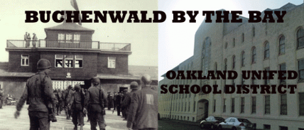
Buchenwald concentration camp near Wiemar, Germany was one of the largest on German soil, with one hundred and 30 (thirty) satellite camps and extension units. The name “Buchenwald” was given to the camp by SS I Teutonic Knight of the Black Sun Reichsfurhrer Heinrich Himmler on July 28, 1937. The camp’s name – “Buchenwald” – became a synonym for the Nazi SS crimes against humanity, because it was one of the most bestial. In the early 1970s, they had plans for black and brown students of the Oakland Unified School District that was a “TOUCH OF BUCHENWALD“.
Oakland Public Schools- A Buchenwald Satellite Camp & Diabolical EVIL
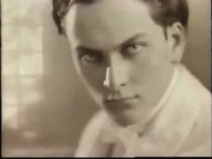
Seething Energies of Lucifer, Master Mason Manley P. Hall
“When the Mason learns that the key to the warrior on the block is the proper application of the dynamo of living power, he has learned the mystery of his craft. The seething energies of Lucifer are in his hands and before he may step onwards and upwards he must prove his ability to properly apply (this) energy.” ‘Lost Keys of Freemasonry’ page 48, Manley P Hall, 33rd degree.
Freemasonry reveals itself at a closer approach in its true light, that of a satanic sect. Freemasonry worships Lucifer–Satan. The higher degrees of masonry are far more secret and diabolical than the general membership. The higher degrees use their influence in all aspects of society to advance in power and control for the furtherance of what they call “the great work“, which is a New World Order.
During the 1960s and early 1970s, the Oakland Unified School District (OUSD) had been one of the best and most comprehensive free educational systems in the nation and the world. Its athletic department- the Division 1 Oakland Athletic League (OAL) was renowned for producing world class athletes. Over 70% of the student population of nearly 77,000 was black. However, there was room for much improvement particularly in racial matters. There was a great need of a more diversified staff of educators and school administrators. There was a need to include the black community in the educational decision making process of the schools, because it had risen to demand change and POWER.
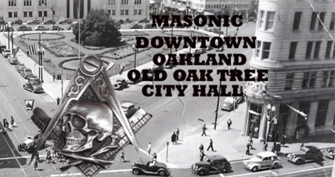
What very few people understood was that the secret hierarchical and diabolical Freemasonry stood at the base of POWER in city politics, and the OUSD. In other words, Oakland’s alternative interpretation is “LAND OF THE OAK TREE”.
In July 1968, Dr. Stuart Samuel Phillips, OUSD Superintendent surprised the city with his resignation effective June 30, 1969. Phillips was a 33rd degree Scottish Rite Freemason according to the [Satanic] ritual of the Southern Jurisdiction [Knight of the Golden Circle Albert Pike] of the United States. Phillips was slated by President Richard Nixon’s administration to become the Superintendent of the International School of Bangkok Thailand from 1969 to 1975. The international school in Thailand was a U.S. State Department school for children of the CIA, military and intelligence forces massing to assault Vietnam.[15] After Thailand, Phillips became a world traveler. He visited more than 80 countries on 6 continents- CIA.[16]
The York Rite consists of a series of Degrees and Orders as described below. York Rite actually begins with the Blue Lodge Degrees (Entered Apprentice, Fellow Craft, and Master Mason). But, one is not considered to be a “York Rite Mason” until he has taken the Royal Arch series of degrees, following through with the Cryptic Mason degrees, and culminating or completing with the Templar Orders. When you complete the York Rite series of “degrees” you become a Companion and a Sir Knight.[17] All Nazi SS Knights of the Black Sun are secret Teutonic Knights– The Order of Brothers of the German House of Saint Mary in Jerusalem.[18]
The Knight Templar Orders are a Christian series (of “degrees”) that makes a masonic brother a member of the Order of the Red Cross, a Knight of Malta and the Mediterranean Pass, and a Knight Templar. (Among other titles that are included in the process) In many cases US intelligence services consider Masons a reliable mainstay in their secret work.[19]
Allen W. Dulles (Member of the Vatican military order – the Knights of Malta, Uncle of Jesuit Avery Dulles). John A. McCone (Devout Roman Catholic, Member of the Vatican military order – the Knights of Malta, Administrator at the Jesuit Loyola University). Richard Helms (Advised by Vatican Knight of Malta James Angleton). William E. Colby (Member of the Vatican military order – the Knights of Malta).[20]
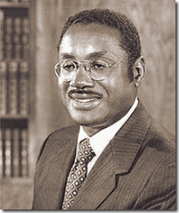
On July 4, 1970, Dr. Marcus Albert Foster arrived in Oakland, CA. He had been recruited out of Philadelphia, PA by the CIA, Ford, Carnegie and Rockefeller Foundations, Price-Waterhouse, Freemasons and the Boule (Sigma Pi Phi) to step into the superintendent’s office as part of a special and secret CIA MK ULTRA/MONARCH operation under CIA Director Richard Helms.
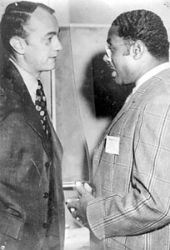
Robert W. Blackburn, above, followed Dr. Foster into Oakland as his deputy superintendent. Under the veil, Blackburn ran the daily affairs of the OUSD.[21] He was a former Peace Corps Deputy Director of Somalia (1964–66) stationed at the militarily strategic horn of Africa- Hargeisa, formerly British Somalia. He entered the Peace Corps after the assassination of President John F. Kennedy. Prior to the assassination, JFK and Peace Corps Director, Sargent Shriver worked hard to keep CIA agents under Deputy Director, Richard Helms, from infiltrating Peace Corps.[22]
The Symbionese Liberation Army (SLA) exposed Blackburn as a CIA agent while working for the Peace Corp and CIA front U.S. Agency for Independent Development (USAID) in Somalia.[23] Prior to been summoned to Oakland, he served as the executive director of the Citizens Committee on Public Education in Philadelphia, and led educational programs for the National Conference of Christians and Jews (NCCJ).[24] OPD Chief of Police- Panther Squad FBI Agent Charles Gain had been a member of the Community Relations Committee of the National Conference of Christians and Jews.[25] Alfred May, president of the Detroit Round Table of the National Conference of Christians and Jews, was also a FBI agent. NCCJ’s patron is Queen Elizabeth II.[26]
In June 1971, I got involved in an extremely heated exchange with my elder, Dr. Foster. I was a member of Peace Corp/Teacher Corp. I had worked within the school district for 2 (two) years as a teacher trainee while I earned my AB degree and teacher’s credential. OUSD had a commitment to hire us as teachers at the end of the end of the two year period. All of my credentials and ducks were in roll. However, Dr. Foster suddenly told us that he couldn’t perform his part of the bargain to hire us. So, we argued about that in a meeting. But, it was unknown to me that everyone in the room of about 18 to 20 teacher corps members were secretly and silently already in the loop to be hired by OUSD. I was the only odd guy out. I clearly understood the inherent, apparent and expressed powers of the school district superintendent. Brothers Huey P. Newton and Bobby Seale had been my teachers. Dr. Foster and I really argued over the illusion and FANTASY OF POWER that he really secretly possessed. The problem was that I didn’t know very much at all about the diabolical, devils, demons, deceptions, illusions, Masons, and the CIA.
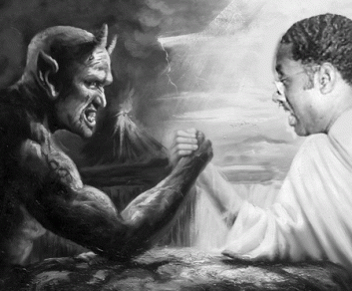
Dr. Marcus Foster was EVIL and the DIABOLICAL. He wrestled directly with demons and the DEVIL. He was a Goat Rider (Secret Society Greek Divine 9), and 32 or 33rd degree Freemason (Sublime Prince of the Royal Secret). The lawyer that prepared his last will and testament just before he arrived in Oakland was Leon S. Rosenthal of Philadelphia, PA. Rosenthal secretly initiated him into the Masonic higher degrees and levels to seal an ultimate level of the covenant of secrecy to cover his true mission in Oakland.
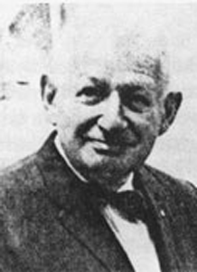
Master Mason Leon S. Rosenthal
I only found out about Rosenthal when Dr. Foster’s Last Will and Testimony was opened for probate administration in Alameda County. Rosenthal and his Philadelphia law office staff had been the witnesses to the will. The probate administrator couldn’t produce any of them to verify Dr. Foster’s will. That’s when I discovered the sudden and mysterious death of Leon S. Rosenthal in court records. Rosenthal was an extremely influential Jewish Freemason. He was the worshipful master of Athelston Lodge No. 482. He was a member of the West Philadelphia Optimists Club, Sol C. Kraus Lodge of Brith Sholom, and Chancellor-Commander of Barbarossa Lodge, Knights of Pythias. He was also a Greek Goat Rider of Sigma Alpha Rho.[27] Rosenthal came up mysteriously dead on September 14, 1973 just days before Dr. Foster was gunned down on November 06, 1973.

If Rosenthal hadn’t authored a couple of books about the history of Philadelphia, he might be disappeared completely.[28] Likewise, Dr. Foster was awarded the Medal of Four Chaplains for his chaplain work at Holmesburg Prison. This record has disappeared because it links Dr. Foster directly with America’s BUCHENWALD– CIA MK ULTRA/MONARCH- Sub project Operation OFTEN. In January 1973, as CIA Director Richard Helms was leaving the Agency and James Schlesinger was coming in, Project OFTEN was abruptly canceled. And he ordered all documents pertaining to the unconscionable behavior control experiments — ARTICHOKE, MONARCH, OFTEN, Operation Midnight Crisis (collectively referred to as MK-ULTRA) destroyed.
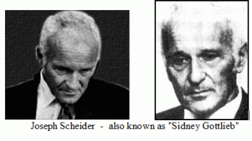
The outgoing CIA director and his trusted protégé, the Diabolical Sydney Gottlieb, hoped, no doubt, to wipe out all traces of the abominable experiments and all traces of their secret collaborators, and thousands of human victims.[29]
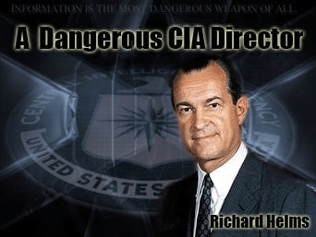
In Congressional testimony, CIA Director Richard Helms claimed that MK-OFTEN was just another name for MK-CHICKWIT, a CIA-Defense Department program for testing “medical procedures” on prisoners at Holmesburg State Prison in Philadelphia from 1967 to 1973.[30] Project MKCHICKWIT was a CIA program conducted in cooperation with the Department of Defense, operating under the aegis of Project MK SEARCH, for the purpose of identifying and studying “new drug developments in Europe and Asia.” This project reportedly ran from 1968-1971 at the U.S. Army’s Edgewood Arsenal Research Laboratories.[31]
Under the veil, the goal of MK OFTEN was much clandestinely broader -“test the behavioral and toxicological effects of certain drugs on animals and humans“. According to author Gordon Thomas’ 2007 book, Secrets and Lies, the CIA’s Operation Often was also initiated by the chief of the CIA’s Technical Services Branch, Dr. Sidney Gottlieb, to “explore the world of black magic” and “harness the forces of darkness and challenge the concept that the inner reaches of the mind are beyond reach“. As part of Operation OFTEN, Dr. Gottlieb and other CIA employees visited with and recruited fortune-tellers, palm-readers, clairvoyants, astrologists, mediums, psychics, specialists in DEMONOLOGY, witches and warlocks, SATANISTS, other occult practitioners, and more.[32]
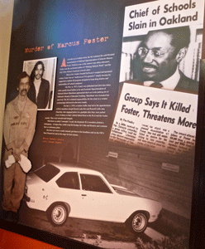
Rosenthal and Dr. Foster may have been highly classified human causalities of Richard Helms’ Project MK ULTRA/MONARCH- OFTEN loose ends clean-up CIA OS operation. Helms would certainly want to destroy CIA files linked to Dr. Foster and Buchenwald Satellite by the Bay- the Oakland Unified School District.
IV
CALIFORNIA’S SECRET BUCHENWALD
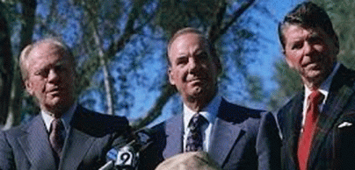
33rd Degree Blood Oath Master Masons- President Gerald Ford, Freemason California Attorney General Evelle Younger, California Governor (President-Freemason Knight of Malta) Ronald Reagan
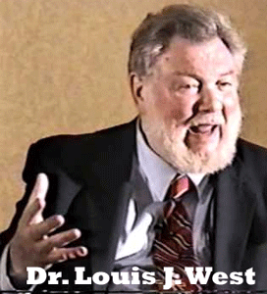
In January 1973, in Governor Ronald Reagan’s State of the State message, he announced plans for the establishment of a biomedical (BUCHENWALD) facility in California, The Center for the Study of the Reduction of Violence. Supported by state and federal funds (LEAA), the first center was planned for the Neuropsychiatric Institute at UCLA, headed by Dr. Louis Joylon “Jolly” West, the CIA Maestro of Mind Control.
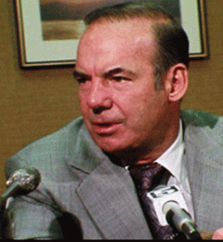
From 1971 to 1979, Evelle J. Younger was the California Attorney General. Younger provided state cover for covert CIA MK ULTRA/MONARCH mind control programs and operations. California highest law enforcement official covered up California’s BUCHENWALD, Dr. Marcus Foster’s Assassination, and JONESTOWN. They are all related. When public outcry shut down California’s BUCHENWALD, it clandestinely moved into prisons; Peoples Temple then Jonestown. Under Younger, juvenile Wards of the State of California were shipped directly to the CIA’s experiment Medical Concentration Camp in Jonestown, Guyana.
“Many of the children who died in Jonestown were wards of the State of California who had been turned over to Jim Jones and other Temple members by California judges. It was illegal for these children to be removed from California yet, according to the House Foreign Affairs Committee which investigated the matter, no California official ever requested a check into the welfare or whereabouts of these children.”[33]
“To the Jonestown monstrosities, they have added dogs specially trained to attack human genitals. The operations there have included the heavy hand of decapitation specialist Michael Townley Welch, an American CIA agent, as well as reported visits by Nazi war criminals Dr. Josef Mengele and Martin Bormann.”[34]
During the school year 1970-1971, I was living briefly with my mother and family in what they called the 65th Avenue Village known as San Antonio Gardens. It was located right off East 14th Street now International Avenue. It was a predominately Black housing project. It was located directly across the street from Havenscourt Jr. High School.
One day, I came home from school in the evening and found my beloved baby sister dressing to go to an evening religious service at Havenscourt Jr. High School’s auditorium. She was a fourth or fifth grader no more than 10 or 11 years old. Upon inquiry, I discovered that she had been enticed to attend the service in her classroom at Lockwood Elementary School that was adjacent to Havenscourt. I recall reading a flyer about the religious service that came directly from her classroom.
My sister wanted to go to the service, because her classmate friends intended to go. I escorted her to the service. I wanted to see for myself what was going on. Sure enough, it was a religious service taking place on school grounds at Havenscourt.
In the service, Rev. Jim Jones performed his infamous “crowd pleasing” fake miracle healing from cancer of a member of the Peoples Temple by coughing up bloody cancerous material, chicken parts. It was Jim Jones and the People Temple, because I remembered Rose Shelton being there. She was Rev. Jones’ personal nurse. Rose collected the coughed up assumed bloody cancer stuff in a white cloth and displayed it to the young horrified audience.
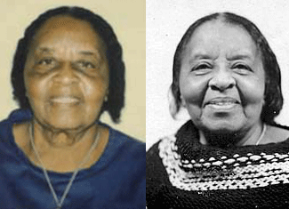
Elder Rose Shelton- Murdered in Jonestown, Guyana, South America
Rose Shelton became my great aunt in-law! Jim Jones and the People Temple were working inside the OUSD to recruit and pick up vulnerable and powerless black children. Before I could look into the relationship between Rev. Jim Jones and OUSD, I got into with Dr. Foster. I was pushed out of OUSD.
Evelle J. Younger was a prime example of the hidden satanic super elite bloodlines behind the veil ruling the affairs of America and California. Younger’s distant descendant, Joshua Younger, was married to the former Elizabeth Lee, and that she was the daughter of Richard Henry Lee, a founding father of our nation. It was he who made the motion on June 7, 1776, as a member of the Second Continental Congress, to declare independence from Great Britain. He was a signer of the Declaration of Independence and later served as a U.S. senator from Virginia. That would mean he was the great-great-great-great grandfather of Evelle Younger…signifying that Richard Henry Lee’s brother—Francis Lightfoot Lee, also a signer of the Declaration of Independence—was Younger’s great-great-great-great granduncle. (Richard Henry Lee and Francis Lightfoot also had an ancestor in common with Joshua Logan Younger, and were Evelle Younger’s first cousins 15 times removed.)
Evelle Younger was also, it seems, related to Confederate Gen. Robert E. Lee. Richard Henry Lee had a first cousin, Henry Lee II. So…his son, Henry Lee III—known as “Light Horse Harry” for his activities as a cavalry officer in the Revolutionary War—was a second cousin of Joshua Younger; Henry Lee II’s son, the man who surrendered to Grant at Appomattox was third cousin of Henry Younger Sr.; and Lee was a third cousin four times removed from Younger.
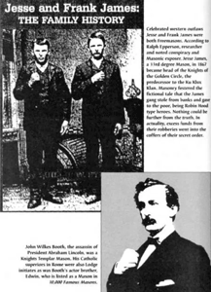
Evelle Younger was a distant relative of outlaws other than the Younger Brothers- Ku Klux Klan- Knights of the Golden Circle. He was a fifth cousin 10 times removed to Texas train robber Sam Bass; a ninth cousin twice removed to Golden Circle Knight Jesse James; a fifth cousin seven times removed to Butch Cassidy; and a seventh cousin once removed to John Wesley Hardin.[35] Richard Henry Lee was first cousin of Anneke Jane Edwards, great-great-great-great-great-great grandmother of Clinton. Evelle Younger was a seventh cousin twice removed to Dixie Mafia President Bill Clinton.
President Zackary Taylor was Evelle Younger’s third cousin 14 times removed, as was President William Henry Harrison; the latter’s grandson, President Benjamin Harrison, was a fifth cousin 12 times removed. Getting into really remote relationships: President John Kennedy was a seventh cousin 10 times removed, and President Lyndon B. Johnson was an eighth cousin 10 times removed. Younger’s kin also included author Mark Twain (third cousin six times removed); newspaper publisher Bohemian Satanist William Randolph Hearst (second cousin, 12 times removed); blind author Eugenicist Helen Keller (third cousin six times removed); and War Criminal U.S. Secretary of State Hillary Clinton (third cousin 10 times removed).[36]
In Los Angeles, DA Evelle J. Younger was also instrumental in the cover-up of the assassination of the RFK Assassination; and Hoover’s COINTELPRO program to destroy the BPP. Younger had also been one of 33rd Degree Master Mason J. Edgar Hoover’s top FBI agents.[37]
During WWII, Younger was U.S. Army Intelligence with the Far East Counter-Intelligence Branch of the OSS with CIA Directors Allen Dulles, Richard Helms and CIA MK ULTRA British Godfather, Dr. Gregory Bateson.[38] Evelle Younger was a blood oath secret Goat Rider, Freemason and Shriner. He belonged to Alpha Tau Omega, International Shriners and the Benevolent and Protective Order of Elks. Elks are “Clandestine Masonic Membership Shrines” under the jurisdiction of the Albert Pike’s Satanic Grand Lodge of Arkansas and the Ancient and Accepted Scottish Rite.[39]
An early draft of West’s proposed UCLA BUCHENWALD center described using schools in Black and Brown neighborhoods as human guinea pigs to experiment on and screen for possible genetic defects. It also mentioned using psychosurgery as treatment on children to modify what he and the establishment perceived to be no more than anti-social behavior,
“Such programs might include control of drug or alcohol abuse, modification of chronic anti-social or impulsive aggressiveness.”[40]
Dr. West planned to use an abandoned NIKE missile base in the Santa Monica Mountains. It was a perfect Little Auschwitz, and secret adjunct to the center to experiment on California’s children and prisoners of color,
“It is accessible but relatively remote. The site is securely fenced, and includes various buildings and improvements making it suitable for prompt occupancy. If this site were made available to the Neuropsychiatric Institute as a research facility, perhaps initially as an adjunct to the new Center for Prevention of Violence, we could put it to very good use. Comparative studies could be carried out there, in an isolated but convenient location, of experimental or model programs for the alteration of undesirable behavior.”[41]
Dr. West’s BUCHENWALD also proposed chemical castration, implantation of transponders in sexual organs and the brain for remote control, biological control of women’s menstrual cycles to control crime, and eventual replacement of the U.S. legal system with psychiatric control.
One of the principal school districts that would have secretly feed Black and Brown children into Dr. West’s SS-CIA Mind Control Chamber of Horrors hidden away in the remote Santa Monica Mountains was CIA agent, Freemason Dr. Marcus A. Foster’s Oakland Unified School District.
On July 27, 1973, the California Council on Criminal Justice (CCCJ) voted 19 to 0 to approve the allocation of funds ($750,000) for Dr. West’s Center for the Study and Reduction of Violence. The CCCJ was an entity of the government of California that acted as the supervisory board concerning federal grants by President Nixon’s the Law Enforcement Assistance Administration (LEAA).
According to government documents reviewed by the Late Great Mae Brussell at the time, they revealed that LEAA and Robert Finch of the U.S. Department of Health Education and Welfare were behind Dr. West’s Violence Center. Behind the veil, it had been part of the Dr. Arnold Hutshnecker’s SS-Nazi Plan to force Black and Brown into concentration camps.[42]
In September 1973, Dr. Marcus Foster introduced a proposal to place armed police “control personnel” in schools, , and issue mandatory ID photo cards for all OUSD students K-12 from a computer data base maintained by a principal pentagon contractor, Honeywell, Inc., funded through a grant from CCCJ . They were putting in place a computer data processing center to target and track each and every black and brown student in OUSD throughout life for surveillance, control, intervention, suppression and elimination as if they were part of a Nazi Concentration Camp System, and the Racial Jewish Holocaust. However, it goes far deeper.
Honeywell at that time was linked with Lt Colonel James H. Critchfield of the CIA, the Gehlen Org and Gestapo Chief Heinrich Müller. In 1948, Critchfield had been recruited into the CIA by John Foster Dulles, Allen Dulles and Richard Helms. They assigned him to literally “baby sit” the Gehlen Org and Himmler’s SS- Baron Otto von Bolschwing, Dr. Josef Mengele, Heinrich Müller, etc., from 1949 to 1956.[43]
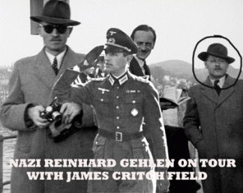
The CIA officially assumed responsibility for the Nazi-SS spy organization in July 1949, with Critchfield taking over as Nazi General Reinhard Gehlen’s supervisor. Critchfield escorted General Gehlen on a taxpayer’s paid vacation tour across the U.S. and to a baseball game. American taxpayers even provided Gehlen with a chalet vacation home, and gave millions upon millions of dollars to Gehlen and the SS- Knights of the Black Sun.
Critchfield moved his base of operations to Pullach, setting up his office in head of the Nazi Party Chancellery Martin Bormann’s former bedroom. Pullach, officially Pullach i. Isartal, is a municipality in the district of Munich in Bavaria, Germany. Gehlen had turned Pullach into its own separate world, with over two hundred of his top staff and their wives and children living and working in the compound. Before Critchfield moved in, Hitler’s General Gehlen himself had lived with his wife and four children in Bormann’s two-story house known, ironically, as the “White House.”[44]
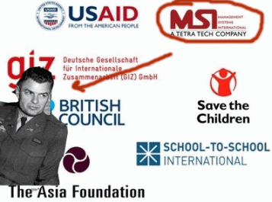
Critchfield served as the president of a Honeywell, Inc. subsidiary called Tetra Tech International.[45] Tetra Tech was his own personal company that also masked the clandestine activities and interests of the CIA and Gehlen Org, here and abroad.

Critchfield’s CIA wife, Lois, said that the company was setup to specially aid Qaboos bin Said al Said of Oman. In a 1970 Omani coup d’état, Qaboos overthrew his father. The coup had been planned by MI6, the Foreign Office, and the British Ministry of Defense.[46]

Honeywell, Inc. was a major contractor developing Vietnam War anti-personnel weapons such as cluster bombs and land mines for the Department of Defense.[47] Honeywell also had a “mind control” contract with the CIA.[48]
Dr. Foster and I argued because word came down from Washington DC that it didn’t want me anywhere in any position whatsoever inside the school district. In fact, they didn’t want me in the city at all. The FBI visited my home and talked to my mother. They encouraged her to talk to me about leaving town on my own while they planned to covertly implement MK ULTRA’s Violence Center, and the U.S. Pentagon’s Phoenix Program (Hamlet Evaluation System) Computer Data Base System inside OUSD.
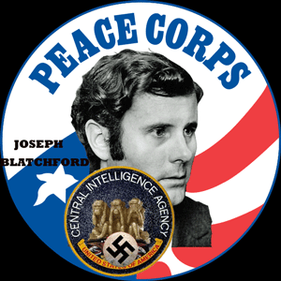
Technically, I had worked in OUSD under Joseph Blatchford, President Richard Nixon’s head of Peace Corps. Blatchford came to the Nixon administration from Accion, a volunteer organization that accepted money from at least 2 (two) CIA fronts.[49] In 1972, it was disclosed that Blatchford employed CIA agents in Accion- Peace Corps policy decisions since at the very least 1965 with CIA (Germany Station) Cold War Agent Eric H. Biddle, Jr. – Provident Trust Company, Link-Belt; Smith, Kline and French; Bechtel Corp.; and the National Council of Churches.[50], [51]
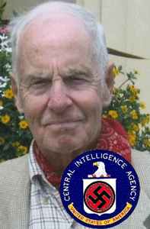
Eric H. Biddle, Jr.
The CIA’s huge German Station, was headquartered for most of the 1950s in the massive I.G. Farben Building in downtown Frankfurt, Germany. The CIA– German Station sponsored West German Federal Intelligence Service (BND). BND was Hitler’s General Reinhard Gehlen, and Himmler’s SS (Knights of the Black Sun).[52]
Don’t get it twisted. When Oakland black elders nominated me to become part of Peace Corps/Teacher Corps to watch over the children as a black male teacher and mentor, Blatchford threatened to shut down the entire problem. They were indeed terrified of the Black Panther Party for Self Defense past or present. The elders told Blatchford and Nixon fine- shut it down! However, everything was in place, millions of dollars were set with hundreds involved in the implementation of Peace Corps/Teacher Corps in the Oakland/San Francisco Bay Area. Blatchford backed away from shutting down the program in Oakland. They planned to pit me against my elder, Dr. Foster. In other words, Dr. Foster would be the “straw man” to stand in for their dirty work to end my presence in the OUSD at the conclusion of the program.
During our tense exchange in June 1971, Dr. Foster finally admitted to me that he had no power over my OUSD job commitment as an incoming teacher. The office that America’s top black administer occupied had been stripped of “express and apparent power”; he was a fantasy of power superintendent of schools. He was a Masonic ILLUSIONARY black superintendent of schools. My last words to Dr. Foster– ACT under your apparent power and we will defend you.
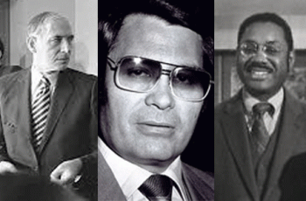
In John Bryan, This Soldier Still At War, (on Joe Remiro) Harcourt Brace Jovanovich, 1975, it reported that Dr. Marcus Foster; Huey and BPP attorney, CIA agent Rev. Jim Jones and the Peoples Temple lawyer, Charles Garry, were friends that regularly met. Charles Garry was a clandestine CIA handler that covered up the CIA’s illegal war against the Panthers, he also handled Dr. Foster.
In March 1973, Dr. Foster began to complain openly and publicly about deceptions, ILLUSIONS and his high public office. On November 06, 1973, Dr. Marcus A. Foster had his brains and heart blown out by shotgun blasts from professional assassins directly across from the place we had last argued about black power ILLUSIONS.

Gabi- SLA
As I speak, nobody has been identified that gunned down Dr. Marcus Foster. There was one unusual character of noticeable short statue among his assassins that everyone seem to agreed to. There is an assumption that the short figure had been half blind Camilla (Gabi) Hall. However, there is absolutely no proof that she had been one of the assassins. Gabi was executed on May 17, 1974 in Los Angeles by LA police, FBI or CIA sharp shooters with a bullet in the head.
I read early reports that immediately after Dr. Foster was assassinated that there was a brief major power failure in the area. Even the telephones went down. Police also stopped decoys in the area that included Wendy Masako Yoshimura. The FBI agent who had chased Donald DeFreeze (Cinque) on a Cleveland bank case was none other than Tom Padden, the agent who arrested Patricia Hearst and Wendy Yoshimura. Padden worked under San Francisco SAC Charles W. Bates. Bates was at different times head of the FBI’s offices in Chicago, Cleveland and Omaha, Neb., and served seven years as the legal attache at the U.S. Embassy in the United Kingdom, another Hoover appointment. In the latter position, he was the chief of the FBI liaison office covering England, Ireland, Norway, Sweden, Denmark and Finland. Bates was also CIA. Wendy was SLA- CIA.
Another odd thing about Dr. Foster’s Assassination is that CIA Peace Corps Deputy Superintendent Roger Blackburn who suffered some shotgun pellet injuries that saw the assassins told police and the press that Panthers killed Dr. Foster. I was over 400 miles away from the crime scene in Los Angeles.
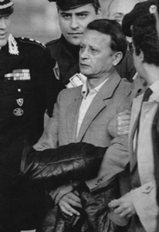
The LiL Racist Assassin- Stefano Delle Chiaie
However, the very noticeable short assassin fit the description of 5 (five) foot tall Stefano Delle Chiaie. Chiaie is a racist neo-fascist Italian activist and strategy of tension global specialist with the Secret Army Organization (SAO or OAS). He is a CIA contract assassin linked to SS Otto Skorzeny , and was a friend of Licio Gelli, grandmaster of P2 masonic lodge.
Additionally, Bay Area Black Panthers and white so called revolutionary white radicals DON’T WEAR COWBOY HATS!

END OF PART II
___________________________________________________________________________________________________________
[1]https://en.wikipedia.org/wiki/United_States_President%27s_Commission_on_CIA_Activities_within_the_United_States
[2] https://www.nytimes.com/1978/03/17/archives/cia-reportedly-recruited-blacks-for-surveillance-of-panther-party.html
[3] http://www.grandlodgescotland.com/news/250-last-masonic-president-dies
[4] http://www.biblebelievers.org.au/kmlst1.htm
[5] http://www.jamesjpn.net/conspiracy/famous-american-members-of-the-knights-of-malta/
[6] https://www.tpaak.com/cia-historical-structure/
[7] Id.
[8] Albarelli, H.P., A Terrible Mistake, The Murder of Frank Olson and the CIA’s Secret Cold War Experiments, Trine Day, LLC, Waterville, OR (2009), Pg. 26
[9] Id., Pg. 69
[10] https://en.wikipedia.org/wiki/Operation_CHAOS
[11] https://www.aarclibrary.org/publib/church/reports/book3/pdf/ChurchB3_9_CHAOS.pdf
[12] https://www.cia.gov/library/center-for-the-study-of-intelligence/csi-publications/books-and-monographs/psychology-of-intelligence-analysis/art12.html
[13] https://en.wikipedia.org/wiki/Cognitive_dissonance
[14] https://www.washingtonpost.com/archive/local/1986/12/09/in-praise-of-the-sun-man-superhero/a2c0fb4d-2b7e-498e-a5a5-342f52bbf4e5/?utm_term=.311942ba90b5
[15] https://www.afterlife.co/us/obituary-walnut-creek-stuart-phillips-1272465
[16] http://www.legacy.com/obituaries/eastbaytimes/obituary.aspx?n=stuart-s-phillips&pid=146918950
[17] http://www.yorkritenv.com/
[18] https://en.wikipedia.org/wiki/Teutonic_Order
[19] http://www.yorkritenv.com/
[20] https://forum.davidicke.com/showthread.php?t=63100
[21] http://peacecorpsworldwide.org/an-rpcv-remembers-peace-corps-staff-member-bob-blackburn-somalia/
[22] https://www.jfklibrary.org/Asset-Viewer/Archives/JFKPOF-TPH-17B-1.aspx
[23] See AID-Peace Corp builds Schools in Somalia. Sch & Soc. 98: 338-40, Oct. 70. Also, Problems in Africa, Newsweek 75: 42, Je 29 70
[24] OUSD Superintendent’s Bulletin, vol. 52, September 21, 1970, number 1
[25] https://newspaperarchive.com/oakland-tribune-sep-28-1967-p-2/
[26] https://en.wikipedia.org/wiki/Council_of_Christians_and_Jews
[27] http://www.sarfraternity.org/speech.shtml
[28] http://uchs.net/Rosenthal/rosenthaltofc.html
[29] http://ahrp.org/1973-richard-helms-and-sid-gottlieb-ordered-all-records-re-mind-control-projects-destroyed/
[30] http://site.pelgranepress.com/index.php/tag/mk-often/
[31] https://hatch.kookscience.com/wiki/Project_MKCHICKWIT
[32] https://en.wikipedia.org/wiki/Project_MKOFTEN
[33] http://www.brasscheck.com/jonestown/facts.html
[34] https://jonestown.sdsu.edu/?page_id=78282
[35] http://knights-of-the-golden-circle.blogspot.com/2011/03/
[36] http://www.metnews.com/articles/2008/perspectives091708.htm
[37] https://www.ourcampaigns.com/CandidateDetail.html?CandidateID=29772
[38] Smith, Richard Harris, OSS: The Secret History of America’s Central Intelligence Agency, The Lyons Press, Guilfort, CT (2005), pg. 18
[39] http://politicalgraveyard.com/geo/CA/masons.R-Z.html
[40] http://www.maebrussell.com/Transcriptions/365.html
[41] Id.
[42] http://www.hiddenmysteries.org/mind/research/re110699e.html
[43] https://www.washingtonpost.com/archive/politics/2001/03/18/cia-declassifies-its-records-on-dealings-with-ex-nazis/2fa93bad-62ee-42f2-833a-b1d04bc63079/?utm_term=.d5d52767f451
[44] https://erenow.com/modern/the-devils-chessboard-allen-dulles-the-cia/12.html
[45] https://en.wikipedia.org/wiki/James_H._Critchfield
[46] https://en.wikipedia.org/wiki/1970_Omani_coup_d%27%C3%A9tat
[47] https://www.wri-irg.org/en/story/2006/honeywell-project
[48] http://www.abbaswatchman.com/PAGE%206%20VATICAN%20MK%20ULTRA%20PROJECTS.html
[49] https://archive.org/stream/nsia-BlatchfordJoseph/nsia-BlatchfordJoseph/Blatchford%20Joe%2002_djvu.txt
[50] https://www.cia.gov/library/readingroom/docs/CIA-RDP80-01601R001400110001-7.pdf
[51] http://www.legacy.com/obituaries/philly/obituary.aspx?pid=160644488
[52] https://en.wikipedia.org/wiki/Reinhard_Gehlen#BND_(Federal_Intelligence_Service)
[53] https://www.merriam-webster.com/thesaurus/illusion
[54] https://study.com/academy/lesson/what-is-cognitive-psychology-definition-theories-quiz.html
Comments : 1 Comment
Tags: Accion, Adolf Hitler, alfred may, Allen Dulles, alpha tau omega, Artichoke project, Athelston Lodge No. 482., Barbarossa Lodge, Black Panther Party for Self Defense, BLUEBIRD Project, bobby seale, BOULE, British Somalia, Buchenwald, buchenwald by the bay, Buchenwald Touch, by Dr. Louis Jolyn “Jolly" West, Camilla Hall, Carnegie foundation, charles gain, charles garry, charles w. bates, CIA, cinque, cognitive dissonance, Cognitive psychology, devil, Donald Defreeze, Double bind, Dr. Arnold Hutshnecker, Dr. Sidney Gottlieb, Dr. Stuart Samuel Phillips, elks, Eric H. Biddle, evelle younger, FANTASY OF POWER, ford foundation, freemasonry, freemasons, gehlen org, gerald ford, Heinrich Himmler, Heinrich Müller, hercules, Holmesburg Prison, Honeywell, Huey P. Newton, Illuminati, Inc, international school of Bangkok Thailand, International Shriners, james angleton, jesse james, Joe Remiro, john a. mccone, john bryan, Jonestown, joseph blatchford, Jr., knights of malta, knights of pythias, Knights of the Black Sun, knights of the golden circle, knights templar, Leon S. Rosenthal, Lodge of Brith Sholom, Lt. Colonel James H. Critchfield, Lucifer, luciferians, MANLY P. HALL, marvel comics, masons, Medal of Four Chaplains, merrimac project, mind control, mk search, MK-CHICKWIT, MK-ULTRA, Monarch Program, National Conference of Christians and Jews, Nazis, nelson rockefeller, Neuropsychiatric Institute at UCLA, New World Order, Oakland Athletic League, oakland unified school district, OAL, Office of Security, oman, OPERATION CHAOS, Operation Midnight Crisis, Order of Brothers of the German House of Saint Mary in Jerusalem, ousd, pb/7, peace corps, Peoples Temple, President John F. Kennedy, Price-Waterhouse, Project OFTEN, psychological warfare, psychosurgery, Qaboos bin Said al Said, queen elizabeth II, Reichsfurhrer Heinrich Himmler, Reichsleiter Martin Bormann, rev. jim jones, richard helms, richard nixon, Robert L. Bannerman, Robert W. Blackburn, rockefeller commission, Rockefeller Foundations, rose shelton, Sargent Shriver, satan, Satanism, Sheffield Edwards, Sigma Pi Phi, SS, Stefano della Chiaie, Tetra Tech International, teutonic knights, the black panther, the black panther movie, The Center for the Study of the Reduction of Violence, the sun man, This Soldier Still At War, tom padden, Touch of Buchenwald, U.S. Army's Edgewood Arsenal Research Laboratories, U.S. Pentagon’s Phoenix Program (Hamlet Evaluation System) Computer Data Base System, walt disney, Wendy Yoshimura, william colby, Younger Brothers
Categories : 1000 Year Reich, african holocaust, African Liberation, allen dulles, artichoke program, Aryan Supremacy, black children, black institutions, Black Panther Party for Self Defense, blood oaths, blood sacrifice, bobby seale, BOULE, CIA, council on foreign relations, Crimes Against Democracy, devil, Dr. Gregory Bateson, dr. louis jolyon west, Dr. Marcus A. Foster, freemason, freemasons, Hauptsturmfuhrer SS Dr. Josef Mengele, Heinrich Himmler, human bondage, I.G. Farben, jim jones, john foster dulles, jonestown, Josef Mengele, klaus barbie, Knight of Malta, Knights of the Black Sun, Knights Templar, ku klux klan, luciferians, masonic sacrifice, mind control, MK-ULTRA, modern slavery, monarch program, National Socialism, Nazis, new world order, nwo, oakland, oakland police department, operation mockingbird, Operation PAPERCLIP, order of teutonic knights, Otto Skorzeny, panther squad, Paperclip Project, peoples temple, project bluebird, Reichsfurhrer SS-1 Heinrich Himmler, reinhard gehlen, richard helms, SS, SS Baron Otto Albrecht Alfred von Bolschwing, Symbionese Liberation Army, Walt Disney

PART ONE, THE BLACK PANTHER MOVIE, CIA AND DANGEROUS ILLUSIONS- PSYCHOLOGICAL WARFARE
22032018

I
THE BLACK PANTHER LIVES!
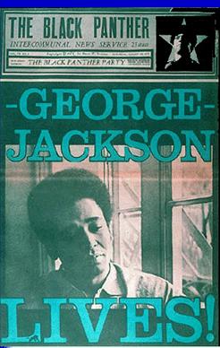
Neoslavery is an economic condition, a small knot of men exercising the property rights of their established economic order, organizing and controlling the life style of the slave as if he were in fact property. Succinctly: an economic condition which manifests itself in the total loss or absence of self-determination. Only after this is understood and accepted can we go on to the dialectic that will help us in a remedy. –George Jackson-Soledad Brother-April 17, 1970

Ticket sales over this weekend ending March 17, 2018 earned the blockbuster film $27 million more, according to studio estimates. “The Black Panther“ has grossed more than $605.4 million domestically and more than $1.1 billion worldwide. It’ll soon pass “The Avengers“ $623 million to become the top-grossing fantasy superhero film of all time in North America.[1]
Yet, I am startled that the film has glossed more money worldwide than domestically. I am startled because HollyWeird does not make movies to entertain people of color. As a rule of thumb– HOLLYWEIRD DOES NOT MAKE MOVIES TO ENTERTAIN BLACK PEOPLE! If you sit thru a HollyWeird movie designed for Black audiences and global masses of color such as “The Black Panther”, you leave the theater clinically mentally ill!
The early core characters featured in “The Black Panther” weren’t developed by black scholars, social scientists, professors, teachers, writers, teachers or our elders. Actually, we know very little about the people that developed the characters in “The Black Panther” that the New World Order and the Satanic ILLUMINATI strongly encourages black people, particularly children, and global masses to attach themselves to.
They were developed by people like Irish/Scottish Don McGregor, and the CIA. McGregor worked myriad jobs as a young adult, including as a security guard, at a bank, at a movie theater, and “for my grandfather’s company, [which] printed, among other things, the patches the astronauts wore on their flights to the moon.” He additionally served as military police with the National Guard. It wouldn’t take very many pieces of silver to sell all his characters in “The Black Panther” to the CIA and Lucifer. [2]
Don McGregor
McGregor has no love for the black community or any commitment to the masses of color. Marvel’s Comic earliest clandestine gay/homosexual characters were introduced in Don McGregor’s Black Panther.[3] As far as he is concerned, every black character developed in “The Black Panther” could be openly or covertly subliminally animals, homosexual and satanic.
The Black Panther, Ape- Man & The Great White Gorilla Cult

M’Baku is really MAN- APE- Warrior of the White Gorilla Cult.
Marvel and Disney think that you may misunderstand them [white supremacy–racism] if M’Baku is called the MAN- APE in the movie. So, they will not call him MAN- APE in the film. However, the glorification of the White Gorilla and animalization of Africans remains, and the Great White Gorilla Cult, too. A GREAT WHITE GORILLA? That dog don’t hunt. It’s called induced “cognitive dissonance”– mental discomfort (psychological stress).
The Black Panther& Gay Africa and the DEVIL

Wakanda, Land of Fierce, Strong Lesbian Warriors
McGregor’s Black Panther character’s Venomm and Taku are a clandestine homosexual couple. Taku and Venomm aren’t in the film, but that’s the sadistic and wicked mindset behind the veil of Marvel and Disney’s The Black Panther. Venomm identified with snakes because they were shunned like him. It is no slight of pen that the black male couples with the male Luciferian character. The Satanic Temple and many satanist believe that Lucifer and Satan are misunderstood and shunned because of it.
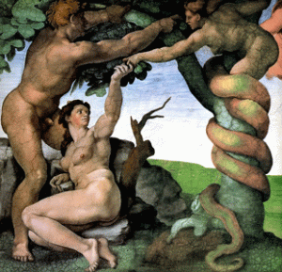
The snake (Satan) in the Garden of Eve says that the forbidden fruit will make them “like gods, knowing good and evil” (Genesis 3:5).
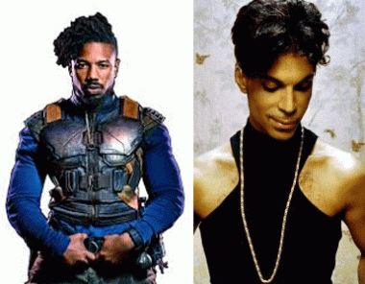Eric Killmonger and the Late Prince
McGregor considered making Eric Killmonger an openly Gay character. So, is Killmonger created clandestinely gay? Nevertheless, Killmonger is a fantasy character that Marvel Comics and the CIA still had the option to open his door either way in the movie, subliminally or supraliminally. Stimuli that are perceived above the threshold and thus are detected at the level of consciousness are called supraliminal. In contrast, stimuli that are not perceived at the conscious level and thus are not detected are called subliminal. Supraliminal stimuli are usually stronger in intensity and longer in duration than subliminal stimuli. Nobody but Marvel, Disney and the CIA knows for sure whether the movie was implanted with hidden “gay” stimuli to affect the psyche of the masses.
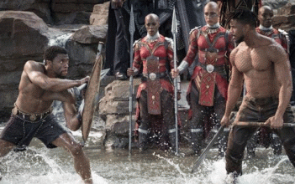
T’Challa and Killmonger- Gay Black Males Battle to Kill Each Other While Black Lesbians Watch
Nevertheless, Negro homosexual themes were indeed part of the making of the film. Gay rights activists are outraged that Marvel/Disney Studios cut the only open LGBT scene from the film.

The Black Panther movie actually featured an open lesbian scene between Okoye (Danai Gurira), left, and Ayo (Florence Kasumba). Additionally, Killmonger– a monger is a merchant dealer or trader. With respect to professions, the term is applied as a suffix (especially in the UK) to specify someone who deals in a particular kind of good- mass killing other black people or black males. It is a terrible thing to expose black children to this kind of subliminal self-destructive S.H.I.T!
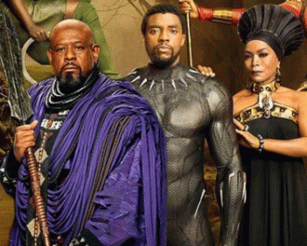
There are two key HollyWeird Negro Satanic Gatekeepers, Forest Whitaker and Angela Bassett, featured in this film that should have set off red flags and alarms throughout the world. They are EVIL- spiritual DEMONIC! That is enough by itself to make anybody SICK!
The Black Panther & Wicked Whitaker
For most Christians, the Bible is like a software license. Nobody actually reads it; they just scroll to the bottom and click “I agree.” –Forest Whitaker [4]
Whitaker’s statement, above, has to be one of the most condescending and cutting remarks that an individual could make to mock and insult Christians, Black People, Civil Rights Movement, and Dr. Martin Luther King, Jr. The odd thing about his statement is that Christianity is most likely the foundation faith of his parents and forebears in America that fought and died to free him from African Human Bondage.
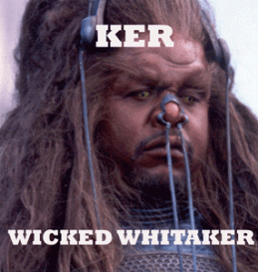
Even if Whitaker is not a Christian, it isn’t necessary to attack others’ faith in Christianity. Whitaker is uncommonly personally close to John Travolta and Scientology. Whitaker starred as the hairy alien, KER, ruling Earth with Travolta in the late Nazi-Satanist L. Ron Hubbard’s movie version of Battlefield Earth.
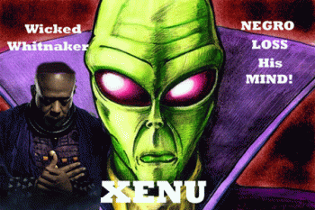
Scientologists do believe that an alien named XENU is their god-creator. It appears certain that Forest Whitaker will fall down and honor any entity or lord other than Christ even SATAN.
Forest Whitaker appeared in Jamie Foxx’s Hip Hop False Satanic Rite video- Blame it on the Alcohol.
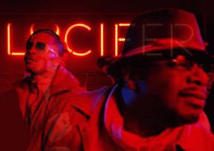
It was an outright supraliminal implant hit piece encouraging teens and Hip Hop generation to consume alcohol in excess, and change their life styles and “pleasure centers” as endorsed by some of HollyWeird’s most celebrated and powerful directors, producers, actors, comedians and Hip Hop artists.
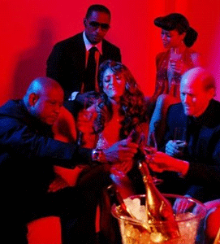
HollyWeird’s elites Ron Howard, Quincy Jones, Samuel L. Jackson, Cedric the Entertainer, and Forest Whitaker, etc., made brazen cameo appearances on Foxx’s MK ULTRA/MONARCH “Blame it on the Alcohol [Lucifer]” music video to initiate Foxx’s Hip Hop Satanic Coven from a far more clandestine mother Satanic coven.

Jamie Foxx, above, with ab absolutely bizarre black Demon Medium and coven mascot representing Satanic/Masonic Duality- Black and White.
Here is what I can recall is a revised YouTube music video,“Blame it on the Alcohol [Lucifer]”, before it disappears.
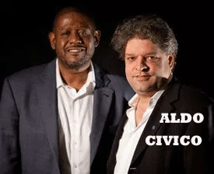
Lurking in the shadows behind Whitaker is an Italian professor named, Aldo Civico of Vatican Radio.[5] Since its inception in 1931, Vatican Radio has been controlled by the Jesuit Order.[6] Aldo is Whitaker’s Vatican puppet-master; co-founder and the Director of Whitaker’s International Institute for Peace at Rutgers University.[7] Civico markets himself as a Columbia University (NY) educated anthropologist specializing in international conflict resolution and facilitation.[8]
In 2008, it was exposed that Civico had a secret hand in influencing, molding and shaping Barak Obama as a presidential candidate. It came to light that he served as an informal adviser to presidential candidate Obama on his Western Hemisphere Foreign Policy team along with New World Order globalist and war criminals Zbigniew Brzezinski, and Henry Kissinger, the secret puppet-masters of America’s First Cyborg President, Barrak Obama.[9],[10],[11] Civico also presented the Jesuits and the Vatican as a so-called informal member on the Hillary Clinton’s Presidential Campaign- Latin America Working Group.[12]
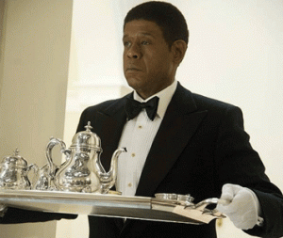
Wicked Whitaker is a Coon- Uncle Tom Handkerchief Head Negro that can’t find the courage to fight himself out of a paper bag. That Negro will suffocate before he would raise a hand against the system to defend or free himself or anybody else that’s not white! It makes him perfect as an ILLUSIONARY black African powerful ruler for The Black Panther film- a wicked and shameful HollyWeird global psychological warfare project.
EVIL Angela & The Black Panther
Angela Bassett is a HollyWeird WITCH! She plays the part of the reincarnation of the Satanic High Priestess of New Orleans, Marie Catherine Laveau (September 10, 1801– June 15, 1881). In New Orleans, Madame Laveau belonged to the Satanic Coven of Lady Baroness Marie Delphine Macarty-LaLaurie in French New Orleans. Her secret coven followed the path of the infamous Satanic Death Cult of Knights Templar, French Nobleman Gilles de Montmorency-Laval aka Baron Giles de Rais, that tortured, drank the blood, and ate the flesh of body parts of hundreds of poor French victims to summon the DEVIL. In Delphine LaLaurie’s case in New Orleans, it was BLACK PEOPLE!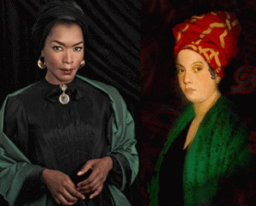
Angela Bassett & Infamous Marie Catherine Laveau
Whether or not, Angela Bassett was born a man would be a deep cover HollyWeird secret.
All HollyWeird ILLUMINATI Negroes, including Bobbi Kristina Brown are bound by a Masonic Blood Covenant and Code of SECRECY.
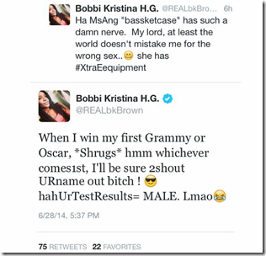
On June 2014 on twitter, Bobbi Kristina that insinuated that Bassett was a literal TRANNY-TRANSGENDER. By January 31, 2015, Bobbi Kristina was found “unresponsive” face down in a water filled bathtub. Dr. John O’Dea, M.D. told HollywoodLife.com exclusively, “If someone was cut off from OXYGEN for 15 to 30 minutes, they would be BRAIN DEAD. All it takes is to be cut off from OXYGEN for 5 to 10 minutes.” Bobbi Kristina was BRAIN DEAD!
The bi-crossed arm symbol is an ancient sacred salute and homage to the Kemetic mysteries, and the Great God Ashur (Osiris). The Kemetic sacred symbol has been bastardized, exploited and commercialized by secret New Age Spirituality Cults dedicated to Goddess Sophia.
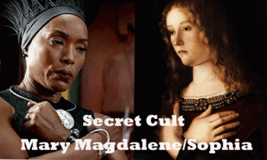
X-Sign Symbol- Angela Bassett & Giovanni Bellini, Maria Madgalena (1464- 1470)
Under the veil of ignorance, the Satanic medieval Cult of Sophia has been implanted in “The Black Panther” movie to further erode, destroy, and supplant the generational faith of black people. EVIL Angela along with Oprah Winfrey are HollyWeird proponents and mass media change agents of New Age Spirituality and Luciferism.
The X-Sign symbol is also a bi-cross arm symbol of a Satanic Master Mason.
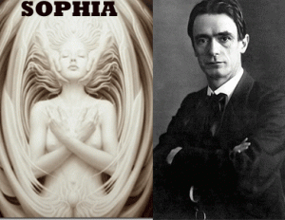
The goddess Sophia was introduced into Anthroposophy by its founder, Rudolf Steiner, in his book The Goddess: From Natura to Divine Sophia and a later compilation of his writings titled Isis Mary Sophia.
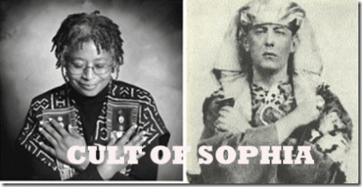
Alice Walker & The Great BEAST Aleister Crowley
Sophia also figures prominently in Theosophy, a spiritual movement which Anthroposophy was closely related to Satanist Helena Blavatsky, the founder of Theosophy. She described it in her essay “What is Theosophy?” as an esoteric wisdom doctrine, and said that the “Wisdom” referred to was “an emanation of the Divine principle” typified by “… some goddesses — Metis, Neitha, Athena, the Gnostic Sophia…“[13]
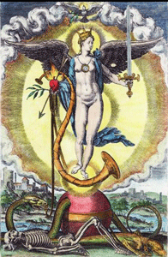
Sofia is a pagan goddess of Wisdom (MITHRA) and wife of God. She is the creator of all. She gave breath to Adam.[14] The Knights Templar are said to be the protectors of the Grail, which many say is actually the lineage of Jesus Christ and Mary Magdalene. Some believe Sophia came to earth in the body of Mary Magdalene.[15] Sophia was, and is, one of the most worshiped Goddesses. Even today, a huge secret Sophia Cult still exists. Sophia is the Greek version of her name. Others include: Hohkma (Hebrew), Sapienta (Latin), Mother of All (Gnostic), and the Holy Spirit (Early Christian).[16]
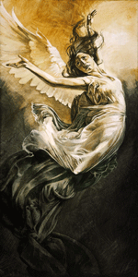
The “Fallen Angel” (thrown from heaven) motif universally applied to Lucifer, actually describe the Aeon Sophia, the Pleromic (abundant) goddess who fell from the heights of heaven (galactic center), according to the Gnostic star myth, the Fallen Goddess Scenario. [17]
The Black Panther False Cult of Sophia, Nehisi Coates, Lupita Nyongi, Chadwick Boseman
My dear lord, the people don’t understand that The Black Panther movie and a bunch lost Uncle Tom- Coon Negroes have sold them out for a few pieces of silver, and are being used by the ILLUMINATI and New World Order as a vehicle to spread a New Age Luciferian Spirituality and False Religion among the masses.
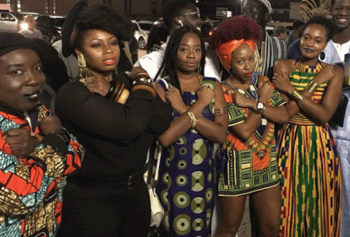
My dear Lord. I pray and beg that their souls, spirit and minds shall be HEALED. I truly believe that they do not know what they are doing.
The Black Panther Party for Self Defense, Marvel Black Panther & The CIA
It is an absolute falsehood that Marvel’s Black Panther comic book character preceded the formation of “The Black Panther Party”. The Lowndes County Freedom Organization (LCFO), also known as the Black Panther Party, was started in 1965 under the leadership and direction of Student Non-Violent Coordinating Committee (SNCC)– BPP Honorary Prime Minister Stokely Carmichael.[18]
Huey and Bobby took over the Black Panther Party name from the Black Panther Party of Northern California (Kenny Freeman) prior to October 1966. From what I understand at the time, Freeman and brothers had obtained permission directly from Brother Stokely to form the Black Panther Party of Northern California. In fact, it had resulted in a conflict between the two groups, led by Kenny and Huey, who would take the name. From what I recall, Huey called them, “Paper Tigers”. Huey and Bobby took over the entitled “The Black Panther Party” and the official Black Panther Symbol before officially forming the BPP in October 1966. Brother Stokely was right in the middle of the mix of the formation of the BPP in Oakland, CA.[19]
However, this is what I know. Early in the formation of the BPP in 1966, I was approached by a seemingly friendly Negro with friendly advice that was undoubtedly a CIA or FBI agent or CIA contractor. He was a young man that was intelligent, well spoken and dressed- very friendly indeed. I had seen him around campus- Merritt Jr. College in Oakland. He was concerned about me in that was so young, impressionable and so unknowing about the real world. He kindly asked me to reconsider my current position and association with Huey, Bobby and BPP. He said that there was information available that Bobby was weak and wouldn’t be able to lead the BPP if something happened to Huey P. Newton. And, I would be left out there in the world hanging on a string. In other words, I also had to be under surveillance if they knew that I that I had got too close to Huey and Bobby. However, the main point is that they had complete personality assessments of all of us before and after the formation of the BPP. The people in the business of drawing up detailed personality assessments of persons deemed a possible threat to the interests of the system was the CIA. They couldn’t control the BPP or Huey. So, the CIA planned to try to KILL BROTHER HUEY.
II
THE BLACK PANTHER MOVIE, THE ASSASSINATION OF CONGO PRIME MINISTER PATRICE LUMUMBA & THE CIA
Everett Kenneth Ross is a fictional character appearing in American comic books published by Marvel Comics. He is primarily an ally of superhero Black Panther.

Ross was created in 1998 to share the same universe or even clandestinely control the universe of The Black Panther .
Ross is a gatekeeper. He is the police state that will keep Don McGregor’s wild Satanic Homosexual Negroes of Wakanda, Killmonger and the Great White Gorilla Cult under constant surveillance and control.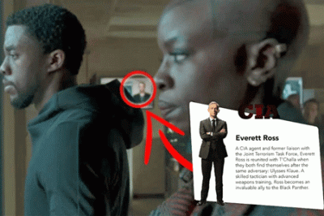
He is a CIA agent and Deputy Task Force Commander of the Joint Counter-terrorism Center. Of course, he was carefully developed and created by Marvel Comics in secret collaboration, cooperation, and with the aid of the CIA. (Project MOCKINGBIRD)[20] Now, it should be clear to everybody why The Black Panther film has grossed more money abroad than domestic. If black people in Oakland, America and the people of mythical Land of Wakanda like him, people around the world certainly can trust the friendly, loving and compassionate white guys at the CIA, too.
In the Black Panther film, agent Everett Ross is a blond hair CIA operative whose selfless heroics help the Wakandans save their kingdom. He is not unlike blond Tin-Tin of Belgium and his white dog, Snowy, in the Congo. The secret to Wakanda’s superiority is vibranium, an indestructible alien element that is found only in Wakanda but is in great demand by both scientists and evil-doers. The source of vibranium is a meteor that landed in the country long ago, and (Allah Tc) T’challa’s father kept it secret from the world as he developed his nation. [21]
In “The Black Panther” fantasy movie, the CIA worked with Allah Tc to keep the world safe from the misappropriation of vibranium.[22] In the Marvel Comics Universe, the vibranium found in his native homeland of Wakanda is a rare metallic substance of extraterrestrial origin. Vibranium exists in two forms.[23] Vibranium is a word of deception for Uranium.
In the real world, it is an absolutely bizarre, cold blood, lying vicious revisionist insult to Africans and people of color. The African and the African nation that attempted to block the U.S. government and intelligence (CIA) from the secrets of uranium was Patrice Lumumba of the Congo. The M2 lineage carrying, Niger-Congo/Kordofanian speaking populations of Equatorial Africa and their New World extensions are the living bloodline descendants of the ancient people of KEMET.[24]
According to the theories developed, the Earth’s uranium was produced in one or more supernovae (“An explosive brightening of a star in which the energy radiated by it increases by a factor of ten billion … A supernova explosion occurs when a star has burned up all its available nuclear fuel and the core collapses catastrophically.” – Oxford Dictionary of Physics).
In all uranium deposits, two types of ores with different uranium contents may be distinguished. Nuclear energy is energy in the nucleus (core) of an atom. Atoms are tiny particles that make up every object in the universe. There is enormous energy in the bonds that hold atoms together. It is usually in a form of heavy metal, naturally occurring in most rocks, soil, and even in the ocean. It is found in many places in the world. Energy from uranium is called nuclear energy.[25] Nuclear energy is stored energy that holds the nucleus of an atom together. If the nucleus of an atom is split or fused with another atom, this releases or explodes huge amounts of energy. The Sun (Ra-Re) and uranium both possess direct nuclear energy.
Kemet’s ancient metallurgists and chemists knew about the secret extraterrestrial nuclear energy properties of heavy metals like iron. They had a complex system to determine the different properties of lead and uranium in rocks and meteorites, and scientifically separate them. They also knew about the secret nuclear energy properties of the uranium atoms in the Benben Stone. That’s why it is associated with the ocean also containing ageless supernova uranium particles, the creation mound; and the fire and explosion that sparked the birth of God Atum (Atom), and launches the Benu Bird (Phoenix).
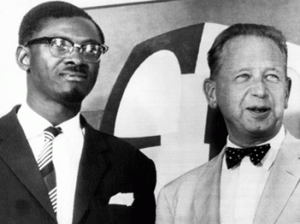
Prime Minister Lumumba and UN Secretary-General Dag Hammarskjöld
On June 30, 1960, the Congo was granted independence from Belgium. The Congolese chose Patrice Lumumba as their Premier. Lumumba asked the United Nations, headed then by Dag Hammarskjold, to order the Belgians to withdraw from the Congo.
In 1959, Patrice Lumumba visited businessmen in New York, where he told them unequivocally, “The exploitation of the mineral riches of the Congo should be primarily for the profit of our own people and other Africans.”[26] Lumumba had also been asked whether the Americans would still have access to uranium, as they had when the Belgians ran the country. Lumumba’s response was unequivocal. “Belgium doesn’t produce any uranium,” he pointed out, adding that “it would be to the advantage of both our countries if the Congo and the US worked out their own agreements in the future.”[27]
Investors in copper and uranium in the Congo at that time included the Rockefellers, the Guggenheims and Swedish-American diplomat and politician C. Douglas Dillon. Dillon of the executive committee of National Security Council (NSC) was worried about their investments and footholds in Africa. In a NSC meeting, plans about the removal of Lumumba were discussed and put in motion.[28]

On or about January 17, 1961, the Congolese people’s hero and very remarkable man, Patrice Lumumba, was kidnapped then brutally assassinated.[29] In an open letter to CIA Director Admiral Stansfield Turner, John Stockwell of the CIA wrote:
Eventually he [Lumumba] was killed, not by our poisons, but beaten to death, apparently by men who had agency cryptonyms and received agency [CIA] salaries.[30]
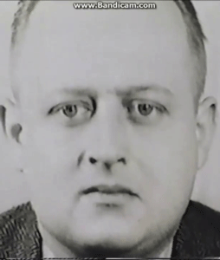
CIA WILLIAM HARVEY
In a cable to CIA’s finance division from William Harvey certainly indict them as the murderers of Lumumba:
QJ/WIN was sent on this trip for a specific, highly sensitive operational purpose which has been completed.[31]
QJ/WIN was run out of the CIA’s Luxembourg station, and was paid from the CIA’s Paris station. Luxembourg is bordered by Belgium to the west and north, Germany to the east, and France to the south.[32] Arnold M. Silver was a senior CIA operations officer that worked in Austria, Luxembourg, Germany, Turkey and the US. In 1960, he was the Luxembourg CIA Station Agent. Silver graduated at Tufts University and received a master’s degree in German philology from Harvard University in 1942. During WW 2, he participated in the Normandy landings and later became a prisoner-of-war interrogator (IPW), first in the IPW team of the 66th Infantry Division.
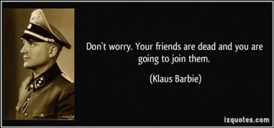
In 1947, SS Hauptsturmführer Nikolaus “Klaus Barbie”- Nazi human butcher was recruited as an agent for the 66th Detachment of the U.S. Army Counterintelligence Corps (CIC).[33]In September 1945, Silver joined the IPW team in Oberursel, near Frankfurt-am-Main, at the 7707th European Intelligence Center, also referred to as Camp King. “Oberursel“, as the camp was most frequently called, became the Army’s center for detailed interrogation of former Nazi military personnel, émigré personalities and potential Soviet informants.[34]
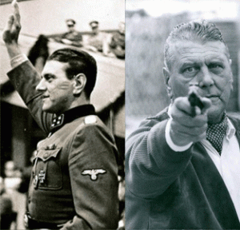
SS Obersturmbannführer Otto Skorzeny, One of the Most Dangerous Men on Earth
Many of the Operation PAPERCLIP scientists were recruited there and it was Silver’s task to interrogate persons such as Otto Skorzeny, Walter Schellenberg and Richard Kauder (alias Klatt). After Skorzeny was acquitted of war crimes by a military court in Dachau in 1946, he was sent to Oberursel until a decision would be made what to do with him. After several interrogations by Silver, it was decided that he resettled to Spain:
“G-2 and USFET (US Forces, European Theater) in Frankfurt concurred in my recommendation that he be resettled there. He became a rather successful entrepreneur in Madrid, but for years afterwards – I think I last heard about him in 1961 – he approached each succeeding US Air Force attaché in Madrid with an offer to build a network of agents in the USSR for the United States. What surprised me (or did it?) was the fact that each succeeding Air Force attaché recommened [sic] to the Pentagon that Skorzeny be taken up on his offer, although there was not the slightest shred of evidence that he had the capability of the know-how to implement his proposal. The Pentagon rejected each of the recommendations from Madrid.”[35]
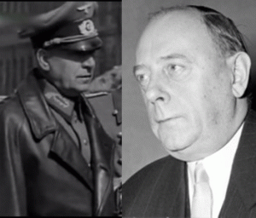
Nazi Generalarzt Dr. Walter Paul Emil Schreiber
Documents obtained through the Freedom of Information Act (FOIA) reveal that the U.S. developed its post-war enhanced interrogation techniques here at Camp King, under the CIA code name Operation BLUEBIRD. The facility’s chief medical doctor was Operation PAPERCLIP’s Dr. Walter Schreiber, the former Surgeon General of the Third Reich. When Dr. Schreiber was secretly brought to America—to work for the U.S. Air Force in Texas—his position was filled with another PAPERCLIP asset, Dr. Kurt Blome, the former Deputy Surgeon General of the Third Reich and the man in charge of the Nazi-SS program to weaponize bubonic plague.
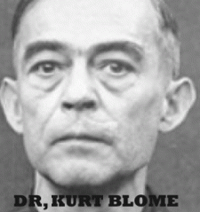
Threaten to Kill Everybody on Earth
The activities that went on at Camp King between 1946 and the late 1950s have never been fully accounted for by either the Department of Defense or the CIA.[36] Camp King also developed enhanced interrogation/torture techniques with LSD, and advanced clandestine assassination capabilities- Operation ARTICHOKE, and MK ULTRA/MONARCH mind controlled MANCHURIAN CANDIDATES.[37]
William Harvey, CIA Station Chief in Italy ran Department D that recruited in Europe for the CIA’s “Executive Action Capability” (EAC). The CIA’s EAC was run through a clearing house of assassins and agent provocateurs called Aginter Press. It was under the leadership of French Secret Army Organization (OAS) officer and former US liaison officer Captain Yves Guillou (alias Yves Guerin Serac), in collaboration with Robert Leroy, a former French SS officer, and Otto Skorzeny, SS Knight of the Black Sun.[38]
Sometime in early 1961, Allen Dulles’s Deputy Director for Plans, Richard Bissell instructed William Harvey, who was then Chief of the CIA foreign intelligence staff (and soon afterwards CIA station chief in Rome), to establish an “Executive Action Capability”, which would include research into a capability to assassinate foreign leaders. The Senate Intelligence Committee stated that an agent, QJ/WIN [probably an OAS (Secret Army Organization) activist], was recruited in Europe and put under Harvey’s supervision to hire killers and to identify individuals with criminal and underworld connections in order to create “an available pool of assassins”. [See Senate Intelligence Committee Report on Foreign Assassinations, Alleged Assassination Plots Involving Foreign Leaders: An Interim Report of the Select Committee to Study Governmental Operations with respect to Intelligence Activities (New York: Norton, 1976), pp. 181–2].[39]
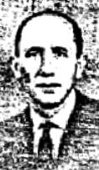
HOMOSEXUAL SADIST CIA ASSASSIN, ANDRE MANKEL
A highly likely CIA QJ/WIN agent cleared through SS Otto Skorzeny’s Aginter Press responsible for murdering Patrice Lumumba was a French homosexual, Jose Marie Andre Mankel. Multiple primary documents confirm this including his CIA contract, contract extension, biography file, and in a Select Committee file listing various cryptonyms. Mankel additionally utilized pseudonyms and the false identities of a New York business person called John J. Berger and Jacques Berger a German salesperson.[40]
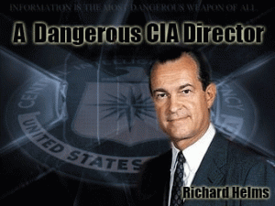
Richard Helms along with his close subordinate, Dr. Sidney Gottlieb, oversaw the MK–ULTRA drug and mind-control research operation headed by SS Josef Mengele and the SS during the 1950s.[41]

Everett Kenneth Ross in the Black Panther Movie is most likely a doppelganger of one of three legendary CIA agents that were involved in assassination of Patrice Lumumba- Richard William Harvey, Richard Bissell or Richard Helms. Or, he may be each and every one of them!
Conversation between President John F. Kennedy and Sargent Shriver, Director of Peace Corps in regards to the CIA clandestinely infiltrating Peace Corps:
Shriver . . . but I’m getting rather suspicious over here that, uh, despite your instructions that, uh, some of our friends over in the Central Intelligence Agency might think that they’re smarter than anybody else and that they are trying to stick fellows into the Peace Corps.
JFK: Well, would you call Dick Helms?
Shriver: Dick Helms?
JFK: Yeah. He’s the operations officer over there under . . . And just say to him that you’ve talked to me and that I don’t want anybody in there.
Shriver: Okay.
JFK: And if they are there, let’s get them out now before we have it. And if there is any problem about it that Dick Helms ought to call the President about it.[42]
END OF PART 1.
_______________________________________________________________________________________

[1] https://www.cnet.com/news/black-panther-rules-for-fifth-straight-week-at-box-office/
[2] https://en.wikipedia.org/wiki/Don_McGregor
[3] http://www.comicsbeat.com/marvels-earliest-gay-characters-introduced-in-don-mcgregors-black-panther-comics/
[4] https://www.nobeliefs.com/SomethingToThinkAbout.htm
[5] Civico, Aldo, Qualifications Summary, International Institute for Peace, Rutgers University (2011)
[6] https://www.manresa-sj.org/stamps/2_Vatican.htm
[7] http://www.unesco.org/new/en/bureau-of-strategic-planning/resources/category-2-institutes/bureau-of-strategic-planning/the-international-institute-for-peace/forest-whitaker/
[8] Id.
[9] http://ucmweb.rutgers.edu/experts/index.php?a=display&f=expert&id=1596
[10] http://rense.com/general81/abig.htm
[11] https://www.independent.co.uk/news/people/profiles/henry-kissinger-a-diplomatic-colossus-who-is-still-a-key-influence-in-us-amid-syria-crisis-8815533.html
[12] Civico, Adlo, Qualifications Summary, International Institute for Peace, Rutgers University (2011)
[13] https://en.wikipedia.org/wiki/Sophia_(wisdom)#New_Age_spirituality
[14] http://www.suppressedhistories.net/articles/sophia.html
[15] http://www.sistersofearthsong.com/SOPHIA/SOPHIA.html
[16] Id.
[17] http://www.bibliotecapleyades.net/mistic/mistic_38.htm
[18] https://www.usatoday.com/story/news/nation-now/2016/02/01/lowndes-county-black-panther-party-alabama/78943998/
[19] http://www.blackpast.org/aah/lowndes-county-freedom-organization
[20] https://en.wikipedia.org/wiki/Everett_K._Ross
[21] https://www.nbcnews.com/think/opinion/why-does-white-cia-agent-play-hero-killmonger-s-villain-ncna855401
[22] http://origins.osu.edu/connecting-history/searching-wakanda-african-roots-black-panther-story
[23] https://en.wikipedia.org/wiki/Vibranium
[24] http://www.allempires.com/forum/forum_posts.asp?TID=35257
[25] http://www.eschooltoday.com/energy/non-renewable-energy/what-is-uranium.html
[26] https://kennedysandking.com/articles/midnight-in-the-congo-the-assassination-of-lumumba-and-the-mysterious-death-of-dag-hammarskjold
[27] https://theconversation.com/how-a-rich-uranium-mine-thrust-the-congo-into-the-centre-of-the-cold-war-64761
[28] https://kennedysandking.com/articles/midnight-in-the-congo-the-assassination-of-lumumba-and-the-mysterious-death-of-dag-hammarskjold
[29] Id.
[30] Id.
[31] Id.
[32] https://en.wikipedia.org/wiki/Luxembourg
[33] https://wikivisually.com/wiki/Klaus_Barbie
[34] https://en.wikipedia.org/wiki/Arnold_M._Silver
[35] Id.
[36] https://www.thedailybeast.com/what-cold-war-cia-interrogators-learned-from-the-nazis
[37] https://leaksource.wordpress.com/2014/02/22/camp-king-project-artichoke-cia-former-nazi-doctors-lsd-interrogation-behavior-modification-on-soviet-spies-during-cold-war/
[38] http://tueriesdubrabant.winnerbb.com/t2046-aginter-press
[39] Id.
[40] https://www.tpaak.com/tpaak-blog/2015/8/1/who-was-qj-win
[41] https://boingboing.net/2005/07/21/worlds-worst-excerpt.html
[42] http://domemagazine.com/features/cov1210
[43] https://www.afterlife.co/us/obituary-walnut-creek-stuart-phillips-1272465
[44] http://www.legacy.com/obituaries/eastbaytimes/obituary.aspx?n=stuart-s-phillips&pid=146918950
[45] http://www.yorkritenv.com/
[46] https://en.wikipedia.org/wiki/Teutonic_Order
[47] http://www.yorkritenv.com/
[48] https://forum.davidicke.com/showthread.php?t=63100
[49] http://peacecorpsworldwide.org/an-rpcv-remembers-peace-corps-staff-member-bob-blackburn-somalia/
[50] https://www.jfklibrary.org/Asset-Viewer/Archives/JFKPOF-TPH-17B-1.aspx
[51] See AID-Peace Corp builds Schools in Somalia. Sch & Soc. 98: 338-40, Oct. 70. Also, Problems in Africa, Newsweek 75: 42, Je 29 70
[52] OUSD Superintendent’s Bulletin, vol. 52, September 21, 1970, number 1
[53] https://newspaperarchive.com/oakland-tribune-sep-28-1967-p-2/
[54] https://en.wikipedia.org/wiki/Council_of_Christians_and_Jews
[55] http://www.sarfraternity.org/speech.shtml
[56] http://uchs.net/Rosenthal/rosenthaltofc.html
[57] http://ahrp.org/1973-richard-helms-and-sid-gottlieb-ordered-all-records-re-mind-control-projects-destroyed/
[58] http://site.pelgranepress.com/index.php/tag/mk-often/
[59] https://hatch.kookscience.com/wiki/Project_MKCHICKWIT
[60] https://en.wikipedia.org/wiki/Project_MKOFTEN
[61] http://www.brasscheck.com/jonestown/facts.html
[62] https://jonestown.sdsu.edu/?page_id=78282
Comments : 3 Comments
Tags: Adolf Hitler, africa, Aldo Civico, angela bassett, ape man, Arnold M. Silver, ashur, barrack obama, battlefield earth, Belgian, black panther, black panther movie, Black Panther Party for Self Defense, Black Panther Party of Northern California, BOBBI KRISTINA BROWN, bobby seale, camp king, Cedric the Entertainer, Central Intelligence Agency, christianity, CIA, cognitive dissonance, congo, cult of mary magdalene, cult of sophia, Dag Hammarskjöld, devil, don mcgregor, dr. kurt blome, Dr. Martin Luther King, Everett Kenneth Ross, fallen angels, forest whitaker, freemasons, george jackson, goddess sophia, Henry Kissinger, hip hop satanic cult, hollyweird, Huey P. Newton, Illuminati, Jamie Foxx, jesuits, john stockwell, kemet, ker, killmonger, King Tut’s meteorite dagger, klus barbie, Knights of the Black Sun, knights templar, L. Ron Hubbard, LESBIANIC CONSPIRACY, lesbians, Lucifer, luciferians, m'baku, Madame Helena Blavatsky, madame marie catherine laveau, Marie Delphine Lalaurie, marvel comics, mary magdalene, masons, mind control, MK-ULTRA, National Security Agency, Nazis, NEW AGE RELIGION, New World Order, Obersturmbannführer SS Otto Skorzeny, patrice lumumba, peace corps, prince, project mockingbird, psychological warfare, Quincy jones, richard bissell, richard helms, Ron Howard, Rudolf Steiner, samuel l. jackson, Sargent Shriver, satan, Satanism, Scientology, sncc, SS, stokely carmichael, T'Challa, taku, the black panther, the black panther movie, Theosophy, tin tin, Tintin Au Congo, uncle toms, uranium, vatican, venom, venomm, vibranium, wakanda, walt disney, white gorilla cult, william harvey, x sign, xenu, Zbigniew Brzezinski
Categories : 1000 Year Reich, african american satanic cult, african holocaust, African Liberation, African slavery, allen dulles, angela bassett, artichoke program, Aryan Supremacy, Barack Obama, Barak Obama, bill clinton, black children, black christianity, black institutions, Black Panther Party for Self Defense, blood covenants, blood oaths, blood sacrifice, BOBBI KRISTINA BROWN, bobby seale, church of satan, CIA, COINTELPRO, Devaughndre Broussard, Dr. Josef Mengele, Dr. Sidney Gottlieb, dualism, evil, Eye of Horus, fallen angels, fbi, Hauptsturmfuhrer SS Dr. Josef Mengele, Hip Hop, HIP HOP false prophets, hip hop satanic cult, hollywood satanic cult, huey p. newton, human bondage, illuminati, jesuits, jesus christ, john foster dulles, Josef Mengele, kemet, king tut, klaus barbie, luciferians, Martin Luther King, mind control, MK-ULTRA, Nazis, new age religion, new orleans, new world order, NSC, nwo, oakland, operation mockingbird, Operation PAPERCLIP, order of teutonic knights, Otto Skorzeny, President John F. Kennedy, prince, project bluebird, psychological warfare campaign against Christianity, racial mass murder, reinhard gehlen, Ritual Satanic Abuse, ritual satanic sexual abuse, satan, Satanic Global High Cabal, Satanism, Schutzsteffel, Scientology, slavery, SS, uncle tom, Walt Disney, xenu, Zbigniew Brzezinski

THE BLACK PANTHER & NIKOLAS CRUZ, DARK DOMINANCE- CIA ROCK IN THE CRADLE OF THE THIRD REICH
24022018

I
AMERICA: HITLER, THIRD REICH & THE WHITE WIZARD
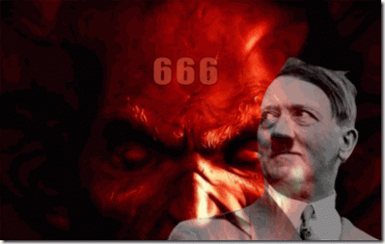
What does the CIA call a cradle, where it rock- THE THIRD REICH! Nazi Germany’s Third Reich has been the most DEMONIC, destructive and racist human empires, political systems and power societies of the 20th century. It deliberately started War World II that almost bought the entire planet to destruction. From 50 to 80 million people perished during the war. Yet, it had not been destroyed. Only a handful of its leaders were actually brought to justice. The Third Reich went ultra-secret and underground. It changed venues to America, and it impacts the daily lives of each and every citizen of the United States. I have always thought it foolish to jump to the Fourth Reich when the masses don’t understand, and have not and will not be told the truth about the Third Reich of Nazi Germany.
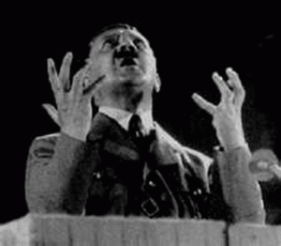
Fuhrer Adolf Hitler, “I intend to set up a [1000] thousand-year Reich and anyone who supports me in this battle is a fellow-fighter for a unique spiritual—I would say divine—creation… Rudolf Hess, my assistant of many years standing, would tell you: If we have such a leader, God is with us”. (As quoted in Secret Conversations with Hitler: The Two Newly-Discovered 1931 Interviews (1971) by Richard Breiting, p. 68)
The Reich word literally means “realm” (Sphere). Reich is also hegemony (leadership or dominance, especially by one country or social group over others). The terms Kaiserreich (literally “realm of an emperor“) and Königreich (literally “realm of a king“) are used in German to refer to empires and kingdoms respectively.
1,000 Years usually refers to the biblical Revelation, Chapter 20 (KJV) where it is said, “And I saw an angel come down from heaven, having the key of the bottomless pit and a great chain in his hand.
² And he laid hold on the dragon, that old serpent, which is the Devil, and Satan, and bound him a [1000] thousand years,
³ And cast him into the bottomless pit, and shut him up, and set a seal upon him, that he should deceive the nations no more, till the [1000] thousand years should be fulfilled: and after that he must be loosed a little season.
Schumann, the White Wizard
The Nazis speak in the power of duality. Dr. W. O. (Winfried Otto) Schumann (1888- 1974) was a brilliant physicist. However, Dr. Schumann was a German sorcerer and magician of the occult. He was a member of the Thule-Gesellschaf, Vril and Black Sun Societies. In Munich, German, W.O. Schumann gave a chilling lecture at the Faculty of Sciences, in which he revealed,
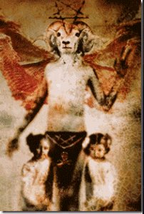
THE VRIL SATANIC PRINCIPLE
“In all areas, there are two principles that determine events, light and darkness, good and evil, creation and destruction, as the positive and negative in electricity. This is always one way or another! These two principles designated concretely how the creative and destructive principles determine also our technical means […]
The destructive principle is the work of the devil, the creative principle, the work of God […]
Any technique based on the principle of explosion or combustion can be satanic technology. The new era that will be the age of a new technique, positive and divine!” […] (Excerpt from the secret archives of the “Schutzstaffel”, the SS).
As the legend goes, Maria Orsic held fateful meeting was held in 1919 at a hunting lodge (magical place) near Berchtesgaden called the Berghof that belonged to Kommerzienrat (Secret Commercial Council of the Reich) Otto Winter. The hunting lodge and “Get Out”, the movie, will be discussed further below.
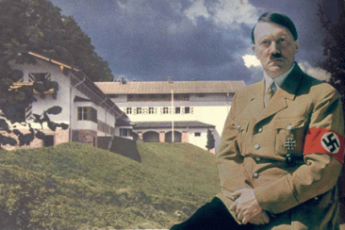
In 1933, the Berghof became Adolf Hitler’s home in the Obersalzberg of the Bavarian Alp. At the Berghof gathering, Maria Orsic presented to a small group assembled from the Thule, Vril and Black Sun Societies that most likely included the white wizard Schumann; telepathic messages she claimed to have received from an extraterrestrial civilization existing in the distant Aldebaran solar system, sixty-eight light years away, in the Constellation of Taurus.
Aldebaran Aryan Aliens
From Orsic’s alleged telepathic messages from Aryan extraterrestrials, the white wizard transformed the messages into the language and science of physics. Don’t get it twisted. It is generally believed that Orsic’s messages were really coming from the interpretations of translations of recently deciphered ancient Sumerian- Kemetic sacred secret texts.
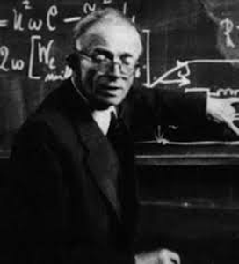
However, their accomplishments in science and physics are absolutely fantastic and unparalleled in modern recorded history. But, don’t get it twisted. Their works are for Evil for the sake of Evil– the THIRD REICH not the betterment of humanity. Dr. Schumann is credited with discovering the earth’s pulse- low electromagnetic frequency. I think the voice of the planet earth can best be described as its “harmony” in the sweet symphony of the universe. Nevertheless, the global electromagnetic resonance phenomenon (Schumann Resonance) is named him. Very few fully understand the importance of this frequency as it relates and impacts all life on earth. The Schumann Resonance is an exact match with the frequency of the human brain. The dual manipulation of the Schumann Resonance can cause mental and physical health problems in the human body- the power to kill. The manipulation of the low frequency electromagnetic fields will also entrain brain waves- mind control on a global basis.
Maria Orsic & Flying Saucer
The manipulation of Schumann Resonance electromagnetic fields also led in the secret Nazi-SS development of flight discs- flying saucers. In 1937, the occult Vril Gesellschaft (Society) began its continued disc development program with official Nazi Party backing under Professor W.O. Schumann of the Technical University of Munich who worked on the JFM (Jenseitsflugmachine) from 1922-1924. Professor Schumann invented the SM-Levitator from the JFM research and now the time had come to put the device to work in a series of “Round Aircraft“- the Rundflugzeug series.

After the fall of Nazi Germany, Schumann [Maria Orsic] and the Vril Satanic Principle went on the U.S. taxpayer’s rolls. The white wizard was employed by U.S. Pentagon and brought to America under Operation PAPERCLIP. During 1947–1948, the white wizard worked at the Wright-Patterson Air Force Base in Dayton, Ohio, and then returned to his post in Munich, Germany.
The realm (sphere) of the Third Reich’s hegemony (leadership) is not only about white supremacy– it’s about global dark dominance! Dark Dominance is grounded in the 1000 Year Third Reich’s “Vril Satanic Principle” [The Duality of Revelation, Chapter 20] that is now part of the Donald J. Drumpf, president select, and his Dark Circle’s presidential administrative agenda in America.
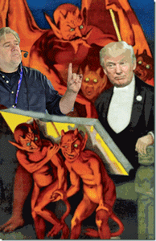
Steve Bannon forewarned each and every man, woman and child in America of the Donald J. Drumpf Presidential Administration’s vision and policy. For America, he said, “DARKNESS is good: Dick Cheney. Darth Vader. SATAN [Lucifer, Set, Seth, Apophis- DRAGON]. That’s power,’ Bannon told the Hollywood Reporter. ‘It only helps us when [the media and liberals] get it wrong. When they’re blind of who we are and what we’re doing.”
II
THE GLOBAL TWO BLACK PANTHERS, THE MOVIE & HUEY AND DARK DOMINANCE
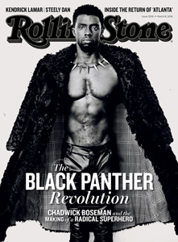
Disney-Marvel’s “Black Panther” is heading for a $235 million debut over the four-day President’s Day weekend.[1] The movie is a comic-book fantasy that is being touted to the masses as a sense of black empowerment. Black Panther, the movie, is a false ILLUSION of Black Empowerment. I have not and will not review the film because it is what it is a fantasy– a Walt Disney cartoon that has absolutely nothing to do with nothing. However, the movie is causing an unexpected blow-back– an impact on the psyche of the masses. Why?
The movie frame “real” questions and issues facing the future of the masses of color. They are looking for “real” Black Empowerment to deal with Global White Supremacy, and Dark Satanic Dominance. And Huey P. Newton and the Black Panther Party for Self Defense slap them in their faces to wake them up. There are new plans for a biopic on Huey P. Newton. When you talk about and expose Huey and the BPP in any form in mass media to the masses, it opens Pandora’s Box to a lot of things about the works of America’s dark dominance that are still top secret, hidden and concealed that still impact the world. People are beginning to ask questions about other Panthers that are still alive confined in prison from the Black Liberation Struggle of the 1960s and 1970s. They will ask questions about COINTELPRO, PROJECT CHAOS, OPERATION PAPERCLIP, RACISM & THEM NAZIS!
Dr. Bernard Lee Diamond, UC Berkeley
Dr. Bernard Lee Diamond was born in 1912 in Fresno, CA to Romanian Jews. During World War II, he served in the U.S. Army Medical Corps, rising from first lieutenant to lieutenant colonel. Not much is known about what he did in the military or where he had been stationed.^{[2]} He was a professor of law and psychiatry at the University of California, Berkeley, CA. He is primarily known for his contribution to what is known as forensic psychiatry.^{[3]}
Dr. Diamond most infamous case involved Sirhan Sirhan– the convicted assassin of U.S. Senator and U.S. Presidential Candidate, Robert F. Kennedy, but few know that he was also involved in Brother Huey’s murder trial.
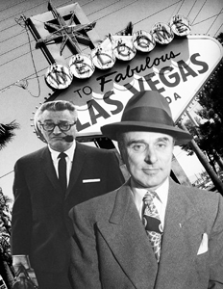
Grant Cooper & CIA Contract Mobster John Roselli
Sirhan’s lead attorney was Grant Cooper was corrupt directly linked to the CIA, UFOs, and mobster Johnny Roselli of the Chicago Outfit that worked for Al Capone.[4] Roselli was a powerful senior mob boss in Las Vegas. Roselli is linked to the CIA and the JFK assassination.[5]
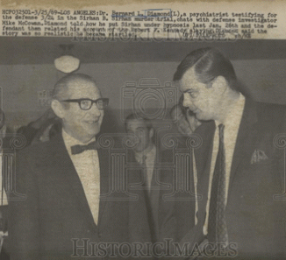
Dr. Diamond and Coopers’ Special Investigator, Mike McGowan
Dr. Diamond testified that he had hypnotized Sirhan several times, and he concluded that Sirhan had likely hypnotized himself and created self-induced trances that led to the assassination. During Sirhan’s Rosicrucian self-hypnosis experiments he had gradually been programming himself to Kill RFK.^{[6]}
Thomas Noguchi, in his book King Coroner, determined that the shot which killed Robert F. Kennedy entered “through the mastoid bone, an inch behind the right ear.” Noguchi determined that the shot was fired from no more than four inches from behind Kennedy’s head. Sirhan Sirhan was at no time closer than three to four feet in front of Kennedy.^{[7]}
Sirhan couldn’t have killed Senator Kennedy. There was no way Sirhan Sirhan killed Kennedy. Dr. Diamond’s expert testimony got Sirhan Sirhan convicted of 1st degree murder and the death sentence penalty in the gas chamber on April 17, 1969. Sirhan’s lawyer, Larry Teeter said that Sirhan was the fall guy. His job was to get busted while the trigger man walked out. He wasn’t consciously involved in any plot. He was a patsy. He was unconscious and unaware of what was happening – Sirhan was the true Manchurian Candidate. That’s the way that they roll. “He is absolutely innocent. He is not the person who did the shooting. He was out of position and out of range and he couldn’t have done it.”^{[8]}
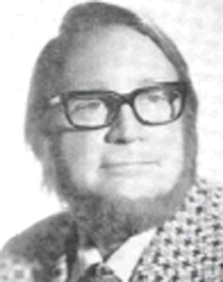
Dr. William Joseph Bryan, Jr.
Sirhan’s clandestine hypnotist is generally believed to have been Dr. William Joseph Bryan, Jr. (br. 5/4/26). He also had been a military psychiatrist during WWII. Bryan worked clandestinely on dark dominance CIA MK ULTRA mind-control programs, and claimed to have moonlighted as a technical adviser on firm, The Manchurian Candidate. Dr. Bryan was found dead in a Las Vegas hotel room on March 4, 1977; the reason for his death has remained a mystery. ^{[9]}
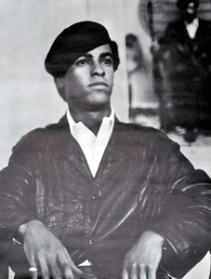
Instead of a forensic criminalist to examine the evidence found at the crime scene to reconstruct what may have taken place, Huey’s defense team brought in Dr. Bernard L. Diamond to examine and hypnotize Huey to develop diminished capacity trial defense strategies. Dr. Diamond’s opinion based upon the nature of the abdominal wound supported the inference that Huey was in a state of unconsciousness when Officer Frey was shot. Huey was unable to recall any of the events leading up to Officer Frey’s death.
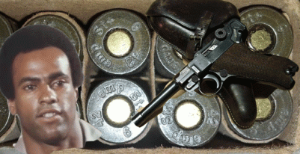
Special Manufactured German Luger Cartilages Can Be Traced
Huey couldn’t even recall the symbolic dark dominance Nazi Germany Luger that one of the OPD officers tried to use to kill him. There was German Luger cartilages found at the crime scene that was entered into evidence. Physical evidence doesn’t lie. The master hypnotist Dr. Diamond’s made certain that Huey and Herbert Heanes, the sole surviving police officer and witness from the firefight that killed Officer Frey, wouldn’t recall (MK ULTRA amnesia blocks) that Nazi Germany Luger missing from the crime scene. Dr. Diamond’s expert testimony got Huey convicted of involuntary manslaughter and that Nazi German Luger disappeared from the annals of history for decades. ^{[10]}
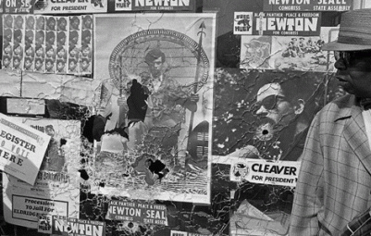
Two days after an Alameda County Superior Court jury refused to convict Huey P. Newton of 1st degree murder in the slaying of 23 year old OPD Officer John Frey, two on-duty OPD officers executed a late night drive-by shooting on Panther headquarters to try to terrorize and demoralize the community that supported Brother Huey and the BPP. Truth (the German Nazi-SS Luger) in Huey’s murder case would have set us all FREE.
Ashkenazi Jew Dr. Diamond is often listed as a suspected CIA (CHAOS) psychiatrist and major dark dominance MK ULTRA/MONARCH master hypnotist mind manipulator.[11]
III
DARK DOMINANCE, WHITE SUPREMACISTS ROCKING THE CRADLE OF THE THIRD REICH AND THE CIA
Nikolas Cruz- The Great Houdini Assassin

Throw Away Foster Home Child Patsy– 19 year old Nikolas Cruz
Artistic and mentally disabled Nikolas Cruz looks more like a dark dominance CIA MK ULTRA/MONARCH mind control pasty than a mass murderer. The arresting police officers certainly treated him like a clinically mentally ill basket-case from the very beginning of his apprehension and arrest as Cruz was casually walking down the street. They even packed him in a hospital gown.
By the way, how did this 19 year old clinically mental ill neo- Nazi, white supremacist indoctrinated Dollar Tree employee working since November 2017 afford to buy all of this para-military equipment, weapons and ammunition? In fact, he is linked to owning up to 10 (ten) rifles. He didn’t. It was supplied like a government MANCHURIAN CANDIDATE assassin, fall guy, and government PATSY.
Cruz was the most remarkable assassin. He packed up all his deadly assault gear including a gas mask. Nobody seemed to have seen anything. He took Uber to Marjory Stoneman Douglas High School where he was amazingly able to walk through all the blind spots of surveillance cameras. Unpack, get armed and dressed- and start blasting away outside the school. He entered a school building and continued his deadly assault, again, walking between raindrops in the blind spots of surveillance cameras. Cruz deadly assault went from the first to the third floor of the building killing and wounding students and teachers. Cruz changed clothes, ditched his weapons, bullet proof vest, and gas mask someplace. Then, he strolled out of the building along with students leaving 17 dead, and over a dozen wounded, and nobody but nobody among all those very bright and intelligent students seemed to have noticed the mass murder assailant in the school building or among the crowd. Now that’s not only remarkable. It’s supernatural! It was a far greater performing act of magic than the Great Houdini.

Just like a Lee Harvey Oswald and the movie theater, Cruz casually strolled over to McDonalds and a Subway Sandwich shop to chill for a sandwich and soft drink. Again, he must have walked through the raindrops into all the blind spots of surveillance cameras. And, nobody but nobody even among all those bright, intelligent, most passionate and caring students were able to describe the mass murder assailant to police.
Since his arrest about an hour after and about a mile away from the alleged high school murder massacre crime scene, Cruz has been treated more like a mental health patient than a Houdini or any criminal mass murder suspect. In fact, it appears as if the way Cruz was manhandled by police at the arrest scene, they weren’t interested in trying to preserve any physical evidence at all on the suspect.
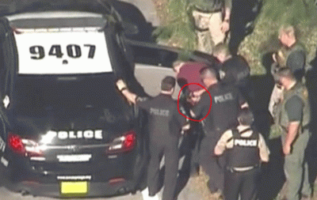
How many cops are needed to screw in a light bulb? Actually, it looks as if medic technicians dressed as police officers above are injecting Cruz with a drug or drugs in his butt area to incapacitate and sedate him before he could talk to anyone.

It certainly stands to reason that he was drugged out of his mind at the site of the arrest, because the police brought in regular county medics to dress Cruz in a patient’s gown to transfer him to the hospital instead of jail.
Instead of jail, the people dressed in military green and one in black took Cruz straight to a hospital for a medical and mental check-up. I never seen anything like this take place before a suspect has been taken to jail.

Above, the so-called police escort Cruz from the hospital in the same patient’s gown he arrived with. Who put Cruz in the hospital gown in the first place, and for what?
Cruz was taken to the hospital to implant barriers, floors and levels of amnesia blocks, so that he recalls and know nothing but nothing about what happened at Marjory Stoneman Douglas High School. Cruz doesn’t even have the strength or state of mind to cry out-
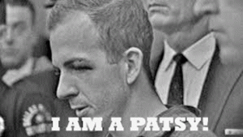
Since Cruz wasn’t arrested anyplace near the time of the crime or at the scene, a simple and inexpensive gun powder residue (paffarin) test on his fingers, hands, and face can establish by physical evidence that he fired a weapon numerous times to kill 17 and wound over a dozen other people, right! When he was booked in jail, his outer clothing seemed to have been taken someplace else.
Devaughndre Broussard- The Houdini CIA MK ULTRA Crack Head Assassin
Throw Away Foster Home Child Patsy– 19 year old Devaughndre Broussard
The Crime of Devaughndre Broussard seems just as amazing as the crimes of Nikolas Cruz. Devaughndre was the crack cocaine disabled former foster home child of Oakland’s infamous Your Black Muslim Bakery that was arrested and convicted for assassinating black journalist Chauncey Bailey in August 2007.
He was another young mentally disabled Harry Houdini assassin that during downtown morning rush hour on a busy street corner killed Chauncey with at least 2 (two) shotgun blasts. Allegedly, Devaughndre was dressed all black with a ski mask like an assassin. He jumped into a BIG WHITE cargo van with NO LICENSE PLATES and casually drove off and disappeared. He ditched his black clothing and ski mask with such mastery that even stunned the police. They never recovered the items.
After the crime, he also casually went for a sandwich and soft drink. What made Devaughndre’s alleged crime so magically like Nikolas Cruz was that he was also clinically mentally disabled at the time of the crime. He was stoned out of his mind by CRACK COCAINE. Yet, he was still able professionally to execute the crime in broad day light on a busy city street, disappear into thin air in a BIG WHITE cargo van with NO LICENSE PLATES, and make all of his assailant clothing disappear as well that still as we speak dumbfound law enforcement agencies.
Devaughndre was so good that he wasn’t apprehended until the next day, and like Nikolas Cruz- he wasn’t even trying to hide. In Devaughndre’s case, a simple and inexpensive paffarin test would have been substantial evidence that he had even fired a weapon at all, but that wasn’t part of the government’s prosecution case. And, it most likely also won’t be a part of the prosecution of Cruz’s criminal case. In fact, the government prosecuted Devaughndre Broussard for a death penalty sentence, and he didn’t even have a criminalist or a forensic expert involved in his defense. His defense team only called a couple of witnesses for what amounted to nothing about nothing and his criminal trial jury still almost deadlocked on murder charges.

Superior Court Judge Tom Reardon
Broussard’s public trial was a three ring circus and a Broadway production and play led by a “real” song and dance man, Superior Court Judge Tom Reardon.
“We sing the Broadway [Dark Dominance] songbook and call ourselves the Broadway [CIA] Babies.” –Superior Court Judge Tom Reardon
I am pretty sure that Judge Reardon’s songbook was written by the CIA. I knew enough about Chauncey Bailey over the years to know that he had been a U.S. intelligence asset that also sang by a CIA songbook. When Bailey appeared in my office just days before his assassination, I packed up and moved out. A little birdie out of Dr. James A. Hamilton’s CIA MK ULTRA/MONARCH Vacaville Prison program also warned me in a round about way about Chauncey, because out of the blue she knew about him trying to use me and my office for cover. Chauncey Bailey’s assassination was company business far above my head.
At the moment that we speak, the government is preparing the nitwit MK ULTRA Manchurian Candidate absolutely patsy, Nikolas Cruz, to plead guilty to 17 (seventeen) counts of murder.
“This is an opportunity to put the criminal case behind and help the victims’ families begin to try and pick up pieces of their lives for our community to heal and to figure out how we stop these things from ever happening again,” Broward County Public Defender Howard Finkelstein told CNN.[12]
So many things really just don’t add up in this case that Nikolas Cruz is a tip of an iceberg that should blow the lid off Pandora’s Box. The government is afraid to expose him and their “Voodoo Justice” case in a public trial. So, the cover-up is already in the mix.
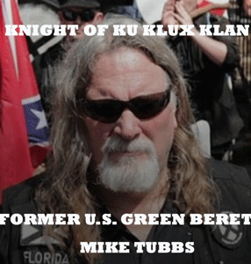
In the first instance, Nikolas Cruz was identified as active member of white supremacist group Republic of Florida (ROF) that is tied directly to former U.S. Army Special Forces Green Beret and blood initiated Masonic Dark Knight of the Ku Klux Klan, Michael Tubbs- the League of the South (LOS) and the Charlottesville’s “Unite the Right Rally.”
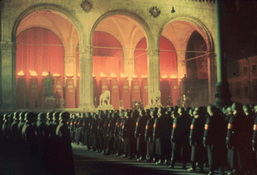
Annual Midnight Swearing-In Ceremony of SS, Feldherrnhalle, Munich, 1938
The Klan and SS secret initiations involve sacred spiritual rituals- blood covenants, sacrifices and resurrections of souls, demonic entities, forces and spirits. Secret sacred SS rituals involves blood to blood, spirit to spirit transfiguration of the souls of a long line of Germanic warriors and heroes from the ancient past to the present, the immortals, that guarantee them immortal VICTORY in life and death. The Feldherrnhalle in Munich was the cornerstone of National Socialist martyrology and ancient Germany volkish mythology.
Among the Green Berets’ first trainers, instructors and secret SS Black Sun initiators at Fort Bragg’s Special Warfare School (Psychological Warfare Center) and NATO’s Secret Army was SS-Hauptsturmführer (Captain) Lauri Allan Törni (Major Larry Thorne), later known in the U.S. Army as he was a legendary Finnish SS officer and demonic cold blood assassin and kidnapper celebrated on two continents, America and Europe. He was brought into the country in secrecy by an act of congress under the Lodge Act (Bloodstone Project) through the OSS. He served in U.S. Army Special Forces (10th Special Forces Group) in the Southeast Asian Aggression. According to his homeland, Major Thorne went down in a downed helicopter crash in America’s secret and illegal war in Laos not Vietnam in 1965.
During WWII, Col. Thorne was a noble Knight of the Mannerheim Cross who most likely had been part of Skorzeny’s Special Commando Forces, the SS-Jagdverband Mitte. The Green Berets were trained as copycat commandos of the blood covenant SS-Jagdverband Mitte.
SS Knight of the Black Sun “Death Head” Larry Thorne & HollyWeird Nazi (John Wayne- Sven Kornie)
The 1968 John Wayne movie “Green Berets” main character Sven Kornie, was based loosely on Knight of the Black Sun, Major Thorne.
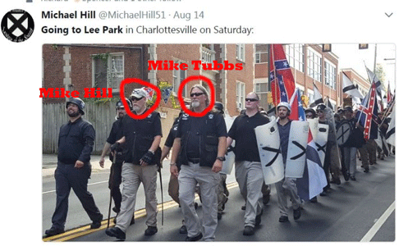
President select Donald J. Drumpf is on record calling people like blood ritual Klansman and Knight Mike Tubbs, “very fine people” in Charlottesville.[13]

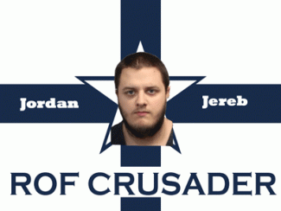
Jordan Jereb, (ROF Knight Crusader) a captain of the Republic of Florida (ROF) militia confirmed Cruz’s membership and weapons training. However, law enforcement agencies say that they can’t find any established links between Cruz and ROF to confirm Jereb’s claims. It’s not surprising, because they refused to find Cruz even when he was publicly exposed in mass media that he was going to be a “professional school shooter” 5 (five) months ago back in September 2017.[14]
U.S. Attorney General Jefferson [Davis] Beauregard Sessions III and the U.S. Justice Department have deliberately ignored the activities of white supremacists Tubbs, Jereb and the entire white supremacist Klan neo-Nazi Confederacy movement in America because they rock the cradle of the shadow government and deep state. By the way, Jeff Sessions is named for outlaw Confederacy President Jefferson Davis. They also called Jeff Davis “LUCIFER”- “As ambitious as Lucifer and as cold as a lizard.”[15]
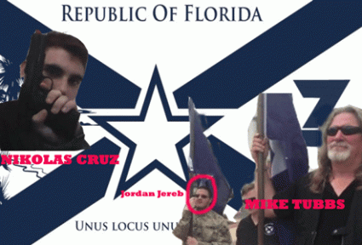
Mike Tubbs Rise the ROF Flag
Jordan Jereb and former U.S. Army Green Beret Ku Klux Klan Knight Michael Tubbs, both convicted felons, have been freely working in a unified Floridian white nationalist coalition and for a national/international violent white supremacy agenda and front formerly since April 2015.[16] It certainly seems as if Mike Tubbs is the secret dark side CIA trainer behind both Jereb and the MK ULTRA patsy, Nikolas Cruz. They were his secret blood ritual “neophytes”. He initiated them as dark circle “Knights.” He is the expert in weapons collection and training courtesy of the U.S. Army. That’s the way they roll!
U.S. Attorney General Jeff “Lucifer” Sessions, Deputy Attorney General Rod Rosenstein, and FBI Director Christopher Wray of the U.S. Justice Department are all on record on the floor of Congress deliberating ignoring the criminal activities, racist agenda and violence of the Klan, Neo- Nazis, and white supremacists like Mike Tubbs, and using FBI agents to chase after so-called “Black Identity Extremist” protesting for “human rights”.
Both Sessions and Wray with Deep South confederate patriot backgrounds and latent sentiments are fighting the 2nd Civil War against Black people.[17]
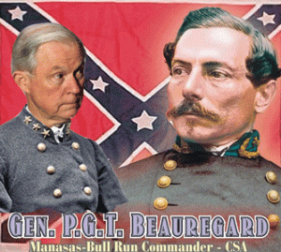
Not much is known about Rod Jay Rosenstein other than he is a mystic Jew of the Reform Temple Sinai synagogue in D.C., and the U.S. [Jewish] Holocaust Memorial Museum.[18] It is loosely said that Rosenstein cares only about Israel. There may be some truth to that statement. Temple Sinai identified itself as a Jewish religious congregation that was interested in “a progressive interpretation of our ancient faith.” This meant an ethical and moral Judaism grounded in God (the absolute one, indivisible, and incomparable being who is the ultimate cause of all existence), Torah (the Law), and ISRAEL.[19]

So that means if it doesn’t involve the Jews or Israel, Rosenstein will throw Black Folks and all other non-believers under the bus, too. The U.S. Justice Department’s Black Identity Extremist” special program is a throwback to something out of the era of the criminal, racist Knight Templar/Masonic Voodoo U.S. Justice Department Master Mason J. Edgar Hoover FBI-CONINTELPRO PROGRAM and Teutonic Order Knight SS Baron von Bolschwing’s Volkish Magic rocking the cradle of CIA PROJECT CHAOS during the 1960s and 1970s.
In the Parkland High School False Flag Massacre, the FBI had to publicly confess that the entire U.S. Justice Department deliberately ignored the activities, threats and crimes of violent white supremacy groups, and in particular the mentally disabled nitwit MK ULTRA/MONARCH patsy- Nicolas Cruz. Donald J. Drumpf and his racist satanic dark circle running the U.S. Justice Department will not bother dangerous neo-Nazis and Klansmen white supremacists in this country because they ROCK THEIR CRADLE.

Then as a diversion to take Cruz and the FBI out of the headlines, Deputy Attorney General Rod Rosenstein suddenly out of the blue announced in a sensationalized press conference that the U.S. Justice Department indicted 13 (thirteen) Russian nationals and 3 (three) Russian entities for allegedly meddling in the 2016 presidential election. It is a mass population diversion and a big hoax.

Thirteen and three are extremely radical, infamous religious voodoo occult and kabalistic numbers. Special counsel Robert S. Mueller III’s investigation of possible coordination between the Drumpf campaign and Russia to influence the 2016 election has cost the taxpayers about $6.7 million in Mueller’s first 4½ months in office (May 17 to Sept. 30, 2017), and not one person has been jailed or imprisoned.[20]
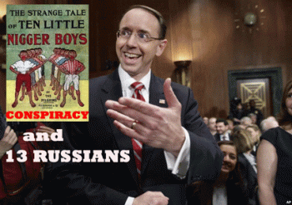
Now, we have 13 Russian nationalists and 3 Russian agencies with no arrests or apprehensions for the U.S. Justice Department to chase around the Soviet Union and its satellite countries like ghosts on the other side of midnight. In fact, it isn’t even likely that they will be arrested, because Russia will not extradite anyone to stand trial in America on wild circus like “CONSPIRACY THEORIES”. That’s real Donald J. Drumpf false illusions and “Voodoo Justice”.
IV
THE UNDERGROUND REICH’S ROOM IN THE CIA MANSION
In response to the JFK assassination, CIA Counter-Intelligence Chief James Jesus Angleton famously said, “A mansion has many rooms … I’m not privy to who struck John.” One of the rooms in his mansion was Security Research Section (SRS). The SRS was a Lunatic Nazi dark heart of the CIA’s Office of Security (OS).
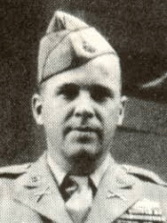
CIA CHIEF OF SRS GENERAL GAYNOR
The Chief of SRS, U.S. Army Brigadier General Paul Francis Gaynor, earned some type of strange reputation during for torturing people most likely thru Operation Lusty. He was a dangerous and perverted mind, and a pretty strange dude that kept a “fag file.” The file consisted of details concerning more than three hundred thousand (300,000) Americans, mostly homosexual, who had been arrested at one time or another for sexual offenses.” Don’t get it twisted. This man was extremely dangerous. General Paul F. Gaynor was setup in the CIA Mansion to rock the Nazi SS Cradle.
Paul Francis Gaynor was born in Scranton, PA in 1914. His father was James Lawrence Gaynor of Gaynor Construction. He was also born in Scranton in about 1876. Paul Francis’ mother was Catherine V. Mitchell born in Ireland. The Gaynors were wealthy prominent Irish Roman Catholics.
Gaynor & Hamilton Fish III- America’s Knight Templar Deep State Nazi Collaborator
The Fish family of New York is related to the elite colonial aristocratic Dutch Families that founded New Amsterdam. It was a 17th-century Dutch settlement established at the southern tip of Manhattan Island that served as the seat of the colonial government in New Netherland.[21] Since the late 18th century, the Fish Family has been part of America’s secret Shadow Government or Deep State.
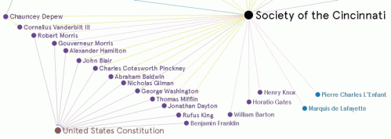
They were part of Marquis Lafayette’s secret French Society of the Cincinnati that was ordained and initiated by Louis XVI, the last King of France.[22] Lafayette is discussed further below. The Society of the Cincinnati was founded May 10th 1783 in New York by the veterans and officers of the Continental Army and Navy. The Society, at the time, was America’s most controversial organization. Thomas Jefferson and many other prominent American figures of the day viewed the new organization with suspicion and saw it as a seedbed for a hereditary American aristocracy. The Cincinnati was seen as the nucleus of a secret government, operating outside republican rules, to the benefit of the few and the detriment of the many.[23]
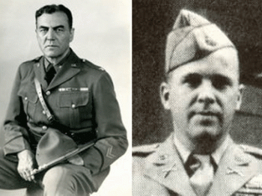
Hamilton Fish & General Gaynor
According to one former CIA official, General Gaynor was once informally cautioned (tone it down a little bit) by Director Allen Dulles concerning his overt support of former Congressman Hamilton Fish III, a strident Nazi Collaborator, and for associating, along with fellow CIA official Morse Allen, with John B. Trevor, Jr., of the prominent, wealthy and elite New York Trevor banking and railroad family, also an ardent pro- Nazi racist, anti-Semite, who called for amnesty for Nazi War Criminals. Before the CIA was formed, Gaynor was also associated with Trevor’s father, John B. Trevor, Sr., a Harvard-educated attorney who worked with Army intelligence and who once strongly advocated arming a group of citizens with 6,000 rifles and machine guns to put down an anticipated Jewish uprising in Manhattan that only took shape in Trevor’s twisted mind.[24]
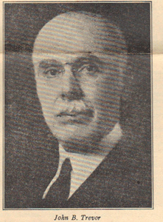
Trevor Sr. (1878–1956) was a wealthy lawyer and former New York State Attorney General “one of the most influential unelected officials affiliated with the U.S. Congress.” He was very active in the immigration debate. Trevor belonged to the inner circle of Madison Grant of the American Eugenics Society.[25]
Trevor, Jr. (July 4, 1909 – August 27, 2006) graduated from Columbia College and Columbia School of Mines, Engineering and Chemistry.[26] Columbia College is the oldest undergraduate college at Columbia University, situated on the university’s main campus in Morningside Heights in the borough of Manhattan in New York City. It was founded in 1754 by the Church of England as King’s College, receiving a Royal Charter from King George II of Great Britain.[27]
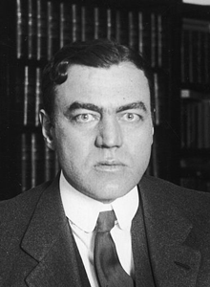
Hamilton Fish III
Back to Congressman Hamilton Stuyvesant Fish III, he was touted by Nazi Germans as their friendly American ally. At least one source confirmed that Fish had been a Famous Freemason.[28]
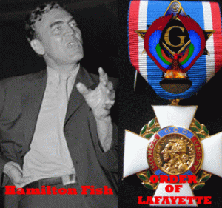
In 1958, Fish initiated “The Order of Lafayette” in honor of the patron, Knights Templar/Masonic Marie-Joseph Paul Yves Roch Gilbert du Motier, Marquis de Lafayette.[29] A close friend of George Washington, Alexander Hamilton, and Thomas Jefferson, General Lafayette was a key figure in the American Revolution of 1776, French Revolution of 1789 and the July Revolution of 1830.[30]
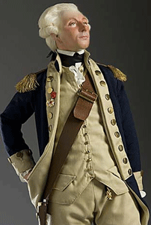
General Marquis de Lafayette
Called “America’s Best Friend” in Europe, Marquis de Lafayette was Thomas Jefferson’s best friend in France and America.[31] The Hidden Hand originates in “The Royal Arch Degree of Freemasonry”, a degree introduced under Illuminati infiltration. The Royal Arch Degree (the 13th degree of the Scottish Rite or the 7th degree of the York Rite) is also known as the Mason of the Secret. During this Degree, initiates are said to receive great Masonic Truths.[32]
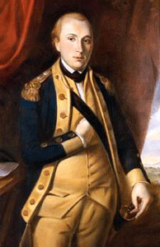
Marquis de Lafayette (1757-1834) was a Hidden Hand 33° Freemason and French military officer who was a military general in the American Revolutionary War and a leader of the Garde Nationale during the bloody French Revolution. Lafayette was also made an honorary Grand Commander of Supreme Council of New York. More than 75 Masonic bodies in the U.S. have been named after him, including 39 lodges, 18 chapters, 4 councils, 4 commanderies, and 7 Scottish rite bodies.[33] Lafayette was the first head of the Society of Cincinnati.[34]
It is also claimed that Lafayette initiated President George Washington into the higher hierarchy of ultra-secret Knights Templar with the above secret skull, cross & bones Knights Templar/Masonic Apron. The meaning of the apron may go back to the 14th century inquisition of the Order of Knights of the Hospital of Saint John of Jerusalem also known as the Order of Saint John, Order of Hospitallers, Knights Hospitaller, Knights Hospitalier or Hospitallers by Philip, King of France and Pope Clement V.
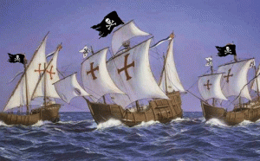
In America when a Mason is made a Master Mason (3rd degree), he is told that he is now a “brother of pirates and corsairs.” This probably refers to the Templar battle fleet that set sail west probably towards America with Templar treasures never to be seen again; because their battle flag was the skull and cross bones.[35]
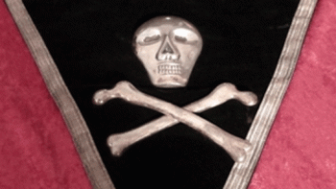
Authentic Very Rare Knights Templar Antique from the Late 1800′s
George Washington’s Skull & Bones Apron link the Freemasons to the Skull & Cross Bones of the Knights Templar. The apron is no longer used among Knights Templars. So, it stands to reason that only a secret extremely high level secret Freemason/Knight Templar of the York Rite such as Hamilton Fish III had the masonic authority to establish a secret knightly order in honor of a legendary historic ultra-secret, mysterious and powerful 18th century Master Mason/Knights Templar such was Marquis de Lafayette.
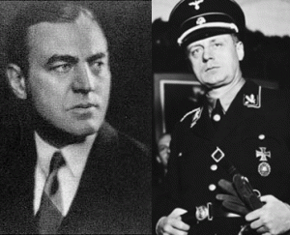
On August 14, 1939, deep cover American Freemason/Knight Templar Fish, president of the U.S. delegation to the Interparliamentary Union Congress Conference in Oslo, Norway, met with Nazi Germany’s Foreign Representative Joachim von Ribbentrop, and Nazi allies at Schloss Fuschl Castle in Salzburg, Germany.

The Schloss Fuschl castle was built in about 1450 by the Prince-Archbishop of Salzbury, who used it as a (Red Stag) medieval hunting lodge. The hunting lodge and Cult of the White Stag go back to prehistory times.
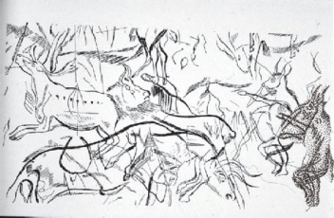
It was a secret ritual spiritual meeting place of magic for alpha males (hunters), shamans, sorcerers.
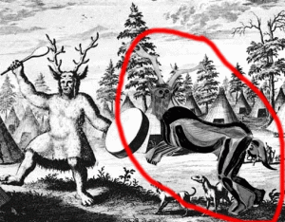
Prehistoric Red Stag (Horned Deity) Sorcerer or Shaman
The Sorcerer is one name for an enigmatic cave painting found in the cavern known as ‘The Sanctuary’ at the Cave of the Trois-Frères, Ariège, France, made around 13,000 BC. The figure’s significance is unknown, but it is usually interpreted as some kind of Great Spirit or Master of Animals. The unusual nature of The Sanctuary’s decoration may also reflect the practice of magical rituals and ceremonies in the chamber.
Some of Europe’s oldest royal palaces and castles were hunting lodges. Built in the 16th century, Jagdschloss Grunewald (Grunewald Hunting Lodge) is Berlin’s oldest palace building. Ethelred II established the first English royal hunting lodge. Æthelred II known as the Unready, was King of the English from 978 to 1013 and again from 1014 until his death. I said that to say this. Ribbentrop’s Schloss Fuschl Castle in Salzburg, Germany was a hunting lodge– a secret medieval place of magic for sorcerers, spirits, magical rituals, ceremonies and Knights Templar/Masonic initiations.

“Get Out“, the movie, and the Red Stag Negro Hunting Lodge is a secret medieval place of sorcerers, spirits, magical rituals and ceremonies linked directly to the Baphomet (Solve et Coagula) devil spirit worship of the Knights Templar.
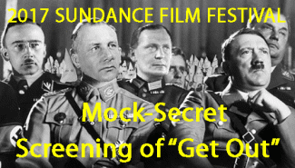
Fish’s stopover at Ribbentrop’s SS castle had more to do more with secret Knights Templar/Masonic ceremonials, rituals and initiations than tea. From the Nazi SS Schloss Fuschl Hunting Lodge in Salzburg. Who was Ribbentrop?
SS Ribbentrop & SS 1 Himmler
He was an extreme power hungry elite German nobleman. Waffen SS Hauptsturmführer Joachim von Ribbentrop was an elite “death head” Knight of the Black Sun. Under Hitler and Himmler, SS Ribbentrop served as Foreign Minister of Germany from 1938 until 1945. He was an extremely close personal confident of Adolf Hitler.
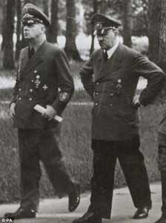SS Ribbentrop & Hitler
Congressman Fish met with SS Ribbentrop is putting it lightly. It was a meeting of Templars and the German branch of the Brotherhood of Death. Fish flew to Oslo in Ribbentrop’s private plane. With SS Ribbentrop, Fish also conferred with and initiated German (Axis) allies into the secrecy of the SATANIC BROTHERHOOD. As they were meeting, Hitler and the SS were secretly planning to invade Poland on September 1, 1939 to start World War II.
Fish, a staunch opponent of President Roosevelt’s agenda, advocated better relations with National Socialist (Nazi) Germany and hoped to solve the “Danzig question” during the conference in Norway. “Stepping out of Joachim von Ribbentrop’s plane in 1939, Fish opined that Germany’s claims were ‘just.’”
Upon his return to the states, Fish used his office to distribute copies of The Protocols of the Elders of Zion. When accused of anti-Semitism, he responded, “It doesn’t bother me any. There’s been too much Jewism going around anyway.”[36]
At the Fall of Nazi Germany, Ribbentrop was allegedly arrested in June 1945 to stand trial at the Nuremberg Tribunal for Crimes against Peace, War Crimes and Crimes Against Humanity. He was found guilty of all crimes and sentenced to die. On October 16, 1946, Joachin von Ribbentrop’s doppelganger was hanged dead in Nuremberg, Germany. All of the top ranks of the Nazi-SS had multiple doppelgängers– look-alike or double of a living person, but none as dark and satanic as the Nazi original.
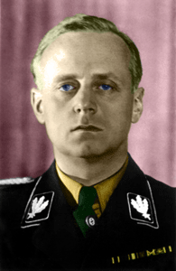
SS Ribbentrop
Furthermore, Hamilton Fish III had the Knights Templar/Masonic secret power and authority of a Marquis de Lafayette to initiate heads of state to the highest and most secret hierarchical levels of the Templars, Masons and Brotherhood of Death. Fish initiated him, and there is no way that the real SS Joachin von Ribbentrop died by hanging in Nuremberg.
In the early 1930’s, Congressman Fish served as chairman of a Congressional committee to investigate “American communism,” Fish was the chief spokesman of the White Russian anti-Soviet immigrants in the United States and other inveterate foes of Soviet Russia. Among the “experts” who supplied Fish’s committee with material were the former Okhrana (Imperial Russian Secret Police) agent, Boris Brasol, and the German propagandist, George Sylvester Viereck.

Nazi Agent George Viereck
After Hitler came to power in Germany, Fish hailed him as the man who had saved Germany from Communism. Fish shared platforms with notorious American pro-Nazis and inserted their propaganda in the Congressional Record.[37] Fish also toured Europe in a German plane, urging a second Munich and claiming that “Germany’s claims” were “just.” In February 1942, it was disclosed at the trial of the Nazi agent Viereck that Fish’s Washington office had been used as the headquarters of a “Nazi Propaganda Ring” and that Fish’s secretary, George Hill, was one of the key members of the Nazi propaganda network in the United States.[38]
V
GENERAL GAYNOR, HAMILTON FISH & EUGENICS
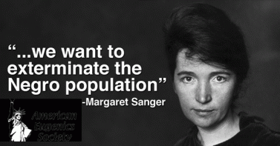
Gaynor’s father also attended Fish’s alum Columbia University’s school of engineering. Gaynor senior was a member of the American Society of Civil Engineering, the Society of Northeastern Pennsylvania, and the Permanent International Association of Road Congress of FRANCE [Society of Cincinnati]. (See Bill Steiner, Story of Scranton, Story of Scranton Publishing (1914) pg. 134)
Gaynor’s grandfather, Patrick Gaynor (1838- 1890) was a prosperous 19th century railroad Irish conductor for the Delaware, Lackawanna and Western Railroad Co.- coal trains ran by J. P. Morgan co-capitalist Sam Sloan (1817 – 1907).
The Lackawanna railroad family circle included E. H. Harriman (1848 – 1909) and Stuyvesant Fish, Illinois Central Railroad (1851 – 1923). Fish was the son of Hamilton Fish (1808–1893), the 16th Governor of New York, a United States Senator and United States Secretary of State who is recognized as the “pillar” of President General Ulysses Grant Presidential Civil War Reconstruction Administration. [39]
The New York/Manhattan oil, banking and railroad Fish, Rockefellers, Harrimans, Carnegies, and the J.P. Morgan family led America’s eugenic movements, and used their money and influence to pass laws in a majority of American states that led to the sterilization of the black, poor, and immigrants.
Paul F. Gaynor was part of the old inner circle of railroad racist eugenicists that included Hamilton Fish III.[40] Fish’s extended Dutch family included Madison Grant of the American Eugenics Society, and secret Teutonic Knight White Stag Cult featured in the HollyWeird film, “GET OUT”.[41]
It is highly probable Paul Francis Gaynor of the CIA was a secret Masonic/Knights Templar initiate of Hamilton Fish III. That’s the way the Shadow Government and Deep State works. That’s the way Gaynor Gaynor worked in the U.S. military and the CIA. He was their man in the CIA.[42]
VI
GENERAL GAYNOR, OPERATION PAPERCLIP, NAZIS AND UFOS
Paul Francis Gaynor graduated from the University of Scranton and the infamous Wharton School of the University of Pennsylvania. During WWII, U.S. Army Captain Gaynor (109th Infantry, 28th Infantry Division) was awarded the Distinguished Service Cross for extraordinary heroism in connection with military operations against an armed enemy in action on December 19, 1944, during the infamous Ardennes Offensive (Battle of the Budge).[43]
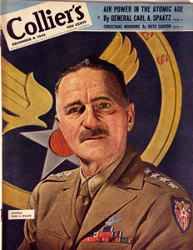
General Spaatz
Three (3) years later in July 1947, Major Gaynor was working under General Carl Andrew “Tooey” Spaatz of the U.S. Army Air Force (AAF) at the Pentagon in Washington D.C when he became directly involved in the UFO controversies.[44] At least one source exposed General Spaatz as a Famous Master Mason.[45] Immediately after the fall of Nazi Germany, Gen. Spaatz, European air commander, ordered all those “not engaged in critical operational duties” to help seek out the “technical and scientific intelligence” that could be “of material assistance in prosecution of the war against Japan.”
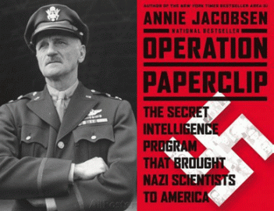
The first name for the overall program of technology exploitation was Operation Overcast (Paperclip Project), [46] and the AAF part of the effort was Operation Lusty, a bastardization of the initials for Reichsminister Hermann Wilhelm Göring’s Luftwaffe Scientific Technology (LUftwaffe Secret TechnologY).
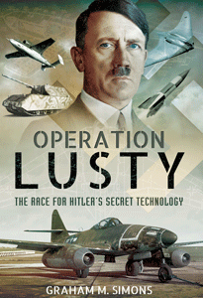
Operation Lusty began April 22, 1945, when the wartime technical intelligence teams merged with the new Exploitation Division. The initiative got firm high-level support from the assistant secretary for air, Robert A. Lovett, as well as General Henry Harley “Hap” Arnold, Spaatz, and others, such as Curtis E. LeMay, who would serve one postwar year heading research and development.
With Spaatz’s order, AAF teams moved forward, fanning out just behind armies advancing on the broad front in Nazi Germany, to locate blacklist aircraft. Some drove jeeps, while others flew into half-deserted German airfields in cargo aircraft. They lived with little support, camping in Luftwaffe barracks. Deep in Bavaria, some of them fished for trout or shot game for their meals.
The take from Operation Lusty went to Dayton, Ohio. Wright Patterson Field became the central hub for crated planes and boxes of documents arriving by train from New York. More than 16,200 separate items came in. One early task for the newly arrived Nazis and Germans was sorting through the documents to compile a technical library. (Air Force Magazine, Our German Scientists, December 2016).
In 1947, Major Gaynor headed a U.S. Pentagon UFO Occult diversion and deception circle designed to protect the secrecy of Operation PAPERCLIP and Nazi-SS scientists smuggled into America to continue Hitler and Himmler’s advanced rocket and aeronautic programs and research. The special occult circle included Richard S. Shaver, Ray Palmer, and Pro-Nazi Silver Shirt William Dudley Pelley.
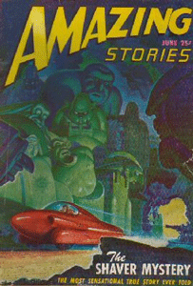
A July 21, 1947, FBI memo from E. G. Fitch to D. M. Ladd, Subject: FLYING DISCS detailed how Colonel Carl Goldbranson (misspelled Golbranson) of the Intelligence Division of the War Department (U.S. Pentagon) advised Special Agent S. W. Reynolds of the FBI’s Liaison Section that the War Department had received the following telegram:
New York, NY July 5 [1947]
Major Paul Gaynor
AAF Hqts Wash DC
“For Further Details Concerning Flying Disks Suggest Immediate Contact Of [REDACTED for “RICHARD SHAVER OF LILY LAKE,”] Illinois Who May Have Important Information Concerning Their Origin.” Unsigned.
Major Paul Gaynor was the chief of the Services Branch of Public Relations, office of the Secretary of the Air Force. Gaynor made the international news just two days prior telling newspaper reporters that the Army Air Forces had looked into the flying saucer issue sparked by the June 21, 1947 “Maury Island/Tacoma UFO” incident and the June 24, 1947 Arnold sighting of UFOS but had dropped interest due to lack of concrete evidence.[47]

The Maury Island Incident, June 21 1947, refers to claims made by Fred Crisman and Harold Dahl of falling debris and threats by men in black following UFO sightings in the sky over Maury Island in Puget Sound.[48]
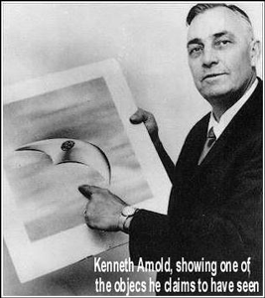
On June 24, 1947, Boise, Idaho pilot Kenneth Arnold observed objects later described as flying saucers over the sky of Mt. Rainier outside of Mineral, Washington, sparking a wave of flying disc sightings across America.[49] In other words, Major Gaynor and his aide Lieutenant Colonel Carl E. Goldbranson of U.S. War Department Intelligence Division directed the FBI to investigate Richard S. Shaver to establish a counter-intelligence supernatural occult origin of recently slighted flying disks- a false trail to lead the public away from Operation Paperclip Nazi-SS secret Vril Technologies.
President Harry S. Truman signed the National Security Act of 1947 (P.L. 80-235, 61 Stat 496) that established the Central Intelligence Agency (CIA) on July 26, 1947. It appears that Major Gaynor and Lt. Colonel Goldbranson rolled over into the newly established CIA deeply secretly imbedded with Himmler’s SS- Knights of the Black Sun.[50]
“… the Gehlen Org substantially pre- empted the CIA’s civilian character before it was ever born. The CIA was born to be rocked in Gehlen’s cradle. It remained dependent on the Org even when the Org turned into the BND. Thus, whatever the CIA was from the standpoint of the law, it remained from the standpoint of practical intelligence collection a front for a house of Nazi spies.”[51]
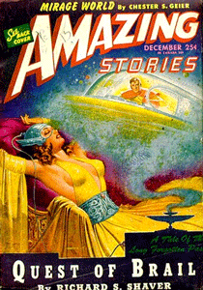
Richard S. Shaver of Lily Lake, McHenry, Illinois created a stir in metaphysical and science-fiction AMAZING STORIES Magazine from 1945-1950 about the Lost Continent of Lemuria. Lemuria was connected to Madame Helena Petrovna Blavatsky’s Lost Continent/Spiritual Homeland of the Aryan White Race. The Lemurians were a mythical race that merged with the race of Atlantis to produce the godly Aryan White Race (The Secret Doctrine).
Shaver wrote of long lost memories of a secret subterranean civilization and ancient physics that produced star-ships, and machines capable of transmitting electronically-enhanced focused encephalographic or telepathic beams or rays, and other bizarre and horrific realities. Shaver also told of how his first visit to “the caves” hidden underground and “holograms” of an underground race of Deros. He claimed that the Deros masters channeled thoughts thru him for years. The “Shaver Mystery” succeeded in dragging many followers under the occulted influence of the advanced secret underground race. It is claimed that Richard Sharpe Shaver may be the founder of Ufology. [52]
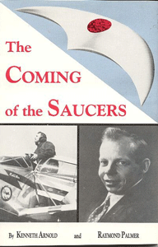
Ray Palmer was the editor of AMAZING STORIES who backed Kenneth Arnold’s investigation of the “Maurey Island/Tacoma” UFO incident which also involved military industrialist agent Fred L. Crisman. Ray Palmer also having publicized Arnold’s own sighting of disc-shaped craft over Mt. Rainier, which became the original source for the term “flying saucers“.
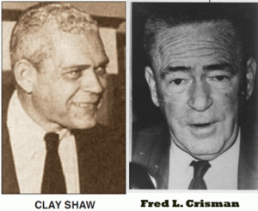
It was later discovered that Crisman was a close associate of OSS/CIA agent Clay Shaw that New Orleans’ DA Jim Garrison accused of being the Mafia-CIA go-between in the JFK assassination. Shaw was a close friend of the financier of the Third Reich, Hjalmar Schacht.[53]
“Shaw was a close friend of Hjalmar Schacht, father-in-law of Otto Skorenzy, a Nazi [SS] officer who led operations for the Nazis during the war, and was unrepentant after the war. Shaw participated in Operation Paperclip (The operation that brought the Nazis over). Alternative Italian papers reported that Shaw had a history as a CIA man who had attempted to revive fascism in Italy. He belonged to Centro Mondiale Commerciale (CMC), which controlled his International Trade Mart — CMC was a consortium of Italian fascists, the paramilitary right of Europe, and DOD/CIA. Shaw was on CMC’s board, as well as the board of Permindex — both companies had intimate links to the Nazis [SS].”[54]
William Dudley Pelley founded the Silver Legion of America, commonly known as the paramilitary Silver Shirts, an underground American fascist organization. The Silver Shirts was a white-supremacist anti-Semitic group modeled after the Nazi Brownshirts. He was sentenced to 15 years in prison for sedition in 1942, and released in 1950. [55]
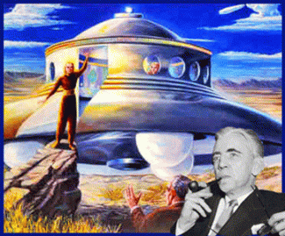
Pelley developed an elaborate, religious philosophy called “Soulcraft”, based on his belief in UFOs and extraterrestrials, publishing Star Guests in (1950). As early as 1932, Pelley proclaimed that the white race was descendant from beings that migrated from the Dog Star Sirius centuries before recorded history. This was one of the key features of a theological occult system he devised that combined elements of Theosophy, Spiritualism, of Theosophy, Rosicrucianism, Pyramidism along with Christian Gnosticism and Millennialism.[56]
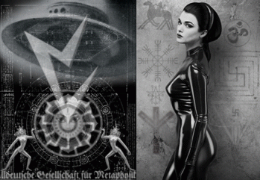
The (Knights Templar) Knights of Malta’s viewpoint infiltrated organized occultism and Ufology through the connection between William Dudley Pelley’s pro-Nazi Silver Shirts and the appropriately named “Black Order” within the Third Reich centered in the SS, the Ahnenerbe Society appropriately named “Black Order” descended from such black magical bodies as the Thule Group and the Vril Society as detailed in Secret Cipher of the UFOnaults.[57]
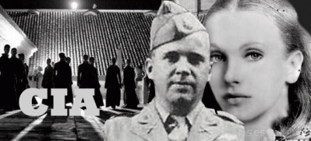
Major Gaynor of the CIA stood at head of the secret Nazi SS UFO counter-intelligence diversion and deception plot.
VII
GENERAL GAYNOR, CIA AND THE BLACK PANTHERS
Jay Richard Kennedy, The Man Called X
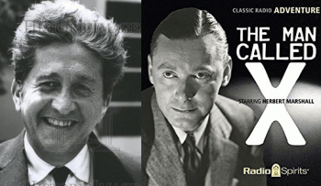
Russian- Eastern European Jew, Jay Richard Kennedy (Samuel Richard Solomonick), was an author, screenwriter, composer, publisher, record executive, and Harry Belafonte’s business manager. He also worked for Frank Sinatra (The Manchurian Candidate). He ran a psychotherapy clinic called the Center For Human Problems and was caught playing with minds- practicing psychotherapy without a license in a cult like environment.[58] Kennedy was also a clandestine CIA agent that worked under Morse Allen and Gaynor, Security Research Section (SRS) [William F. Peppers, The Plot to Kill King: The Truth Behind the Assassination of Dr. Martin Luther King, Jr., Skyhorse Publishing, NY, NY (2016)].
Elaine Brown, a cocktail waitress at the strip club, The Pink Pussycat, College of Striptease, met and became a black female dark dominance MK ULTRA/MONARCH sex slave CIA recruit of Jay Richard Kennedy. Under Kennedy, she entered the CIA as an informant and infiltrator to work for the newspaper Harambee, created in August 1966 by mind control handler Maulana Ron Karenga (Ronald McKinley Everett) of United Slaves (US).[59]
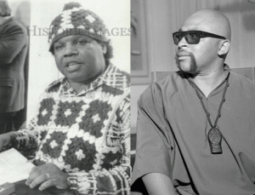
CIA/FBI Agent Colston Westbrook, Co-Found SLA & Karenga
We called United Slaves the “US Brothers”. They acted as a counter-intelligence force with a license to kill us- Panthers. Karenga ran a group of dark dominance CIA and FBI COINTELPRO contract mind controlled assassins called the “SIMBAS” – Simba Wachanga. They had a strong force in Los Angeles. On one occasion, I rolled into LA from Oakland with the Panthers to settle down these brothers. We had suspicions that they worked for the police, but we’re entirely sure. So, we generally treated them in the first instance as brothers and sisters with a different perceptive on the Black Liberation Movement. Nevertheless, they had very little power, support and love among the people to start a war with us in Oakland.
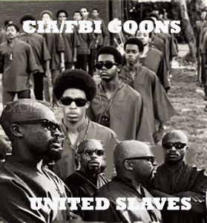

Dark Dominance (Goons)United Slaves- Simba Wachanga
With CIA agent Colston Westbrook, Karenga’s US Brothers helped setup CIA station chief’s Dr. James Alexander Hamilton’s experimental CIA MK ULTRA/MONARCH medical and mind control experimental cohort group, The Black Cultural Association (BCA), at Vacaville Men’s Prison.
“The BCA was the brainchild of African American academics associated with Ron Karenga, such as Westbrook and other Black intellectuals in California universities. These were the kind of scholars who were to lay the foundation for what would later become the Black Studies movement. These intellectuals saw themselves as vanguards of the African American struggle and had nothing but disdain for grassroots organizations such as the N.O.I. and the Black Panther Party. They argued that there needs to be a cultural revolution among African Americans connecting them back to their ancient past. They referred to themselves as ‘cultural nationalists’, in order to distinguish themselves from black revolutionary nationalists. They viewed Islam, Marxism and Communism as foreign impositions upon the conscious of Black People. Thus, there was a coordinated effort to thwart the impact and influence of the Black Muslims and the Black Panther Party on California university campuses, from San Diego to the Bay Area. Because the cultural nationalists were well connected to academia, they had direct access to the many grants established by wealthy white liberal Californians. Thus, Ron Karenga, Colston Westbrook and others were able to develop well funded programs on university campuses, in local jails, prisons and other California social services with the aim of countering the grassroots impact of the Black Panther Party and the N.O.I. It is without doubt that some of this fiscal support came surreptitiously from the CIA, and the FBI. As we say in the hood: ‘These brothers were paid!’ Taken the acronym US they basically told the world that they belonged to the U.S., and they did. They learned quickly that they lacked the strength and numbers to come up against the N.O.I., so they set their sights on an easier target – the L.A. chapter of the Black Panther Party. “[The Neurobiological Consequences of Psychological Torture”, p. 2]
Dr. Hamilton and Westbrook actually developed a cybernetic prototype brother out of the BCA to replace me. During that time, I was known as and called Clique in the community. Hamilton and Westbrook had tried several times to develop a dark doppelganger, Clique, to replace me. We captured one of them. I refused to harm him, and I wouldn’t allow anyone else to harm him. We weren’t in the business of torturing or killing people.
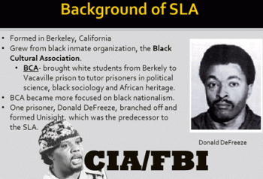
Negro tutors at Vacaville Prison with Colston, US Brothers and the BCA told me about the brother, a real black revolutionary brother, coming to take my place. I also discovered that they were secretly planning and rehearsing play acts to give me a revolutionary funeral and ceremonial burial. I waited on the street for the CIA/FBI black revolutionary cyborg, but he never showed up. So, I went to see him in Berkeley. I went to see him, not necessarily that I was so big and bad.
With the all the deaths, threats, harassment, stress of facing constant violence and oppression, it had hardened me so much I didn’t recognize myself. Whatever threat that it may have been, I was going to face it and get it over with. I was so muddled in mind and spirit that I didn’t realize that I went to face a dark dominance doppelganger created of myself. In my inner most subconscious, I couldn’t allow a dark demonic doppelganger of myself to co-exist with me.
This was totally different than the doppelganger that was created for Rippentrop, the original was the evil and the demonic. My doppelganger was created to be a reverse of me –dark, evil and demonic.
I asked the occupants of the house to invite him outside. The cyborg wouldn’t come out of the house. He had locked himself up inside a bedroom not because of me. My clone was an IATROGENIC (clinically created) severely multiple personality disordered young man that couldn’t control his artificially created multiple personalities. The occupants of the house, Vacaville prison tutors associated with Westbrook, Karenga and BCA, told me that he at times was a woman, than a man, and sometimes a raving maniac that they had become afraid of.
Don’t get it twisted in 1968-1969; I had absolutely no knowledge of MK ULTRA/MONARCH mind control programs. These secret programs weren’t uncovered until 1974. I didn’t even know what the CIA was. I walked away from the doppelganger. Dr. Hamilton and Westbrook worked for General Gaynor. Nevertheless their great Knights Templar/Masonic power and magic, an evil and Baphomet doppelganger of me would not RISE!
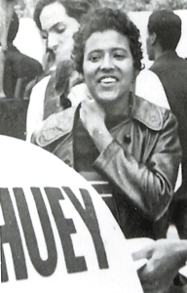
General Gaynor’s agent/infiltrator Elaine Brown showed up in Black Panther Party (BPP) in Oakland sometime after the April 1968 assassinations of Dr. Martin Luther King, Jr. and Little Bobby Hutton. I don’t recall seeing her. I am certain that I never met her. Her mission was to infiltrate, sex and crash BPP leadership. I was just a small grunt in the BPP.
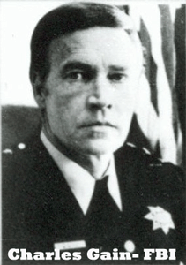
In the wake of the killing of Little Bobby Hutton, OPD police chief, Charles Gain, declared, “The Black Panther Party poses a real threat to the peace and tranquility of the city of Oakland.”[62]
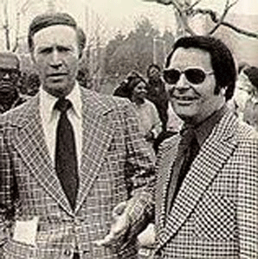
Chief Gain & CIA Agent Rev. Jim Jones
OPD Chief Charles Gain had been one General Gaynor’s direct government inter-agency operatives. Chief Gains had been one of J. Edgar Hoover’s top FBI agents. He had been a member of Hoover’s “Panther Squad” (a subpart of its COINTELPRO Section).[63]
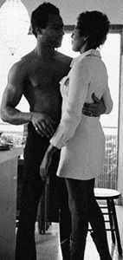
When Huey was released from prison in 1970, I couldn’t get close to him, but General Gaynor and Richard J. Kennedy’s control agent, Elaine Brown, was there. When Huey was invited to China in 1971, dark dominance Elaine Brown was there to watch over him.
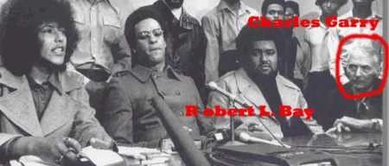
We (Black Nationalist Movement) expected Huey’s trip to China to open new inroads of understanding with our Asian brothers in the Far East, but nothing seemed to materialize from the trip. The people gave Huey P. Newton a grand and honorable welcome and greeting on the other side of the world, but there weren’t any pictures or speeches that came down to us. Some months ago, I discovered that only two (2) people accompanied Huey to China instead of a delegation of brothers and sisters representing the Black Liberation Movement. It was Elaine Brown of the CIA, and Robert L. Bay. Now, I fully understand why Huey came out of China with little to nothing that would benefit the movement.
Captain Robert Bay
I recall Brother Bay. He showed up in the BPP at about the same time that Elaine surfaced. I didn’t like him. One late evening, I caught him hissing like a snake from a dark corner of a building calling some marginal young high school thuggish brothers over to him. I got in front and stopped them in their tracks. I demanded to know who it was. They said, he’s o.k. It’s Captain Bay. Captain Bay? I replied. They said that he worked for something as I recall, the Lawrence Livermore Laboratory. He was not only a BPP captain, but a man with an important job. I had to at least agree with them that a man with a good paying job in the BPP was indeed an important commodity at that time. Usually, I would ask Chairman Bobby Seale directly about new BPP members. But, he started giving me the same answer, trust the Central Committee, they check everybody out. It just couldn’t have been the truth.
Bay was fresh out of U.S. Army Signal Intelligence Corp (NSA) stationed in Germany. I discovered years later that he was indeed an army intelligence agent provocateur that had used the young brothers associated with the BPP to commit a string of horrible and violent crimes against white people in Berkeley. Subsequently, Bay died a horrible death from radiation exposure or the flesh eating disease, because most of the pores of his skin and rectum opened and gushed streams of blood. He died on the floor in a river of his own blood.
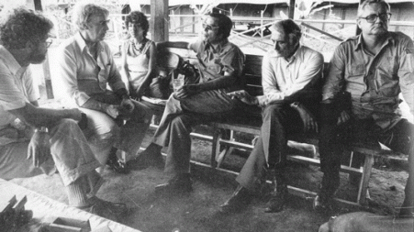
Jonestown- Mark Lane, Leo Ryan, Jim Jones, Charles Garry, Richard Dwyer- CIA
Huey’s infamous Attorney Charles Garry is at the end of the conference table, above. He was the attorney for Jim Jones and the Peoples Temple. He was in the deep cover CIA Jonestown, Guyana MK ULTRA Medical/Mind Control Experiment Camp during the November 1978 massacre.

He said that he and Mark Lane (Rush to Judgement) walked out into the black of the night into a deep rain forest (the forest jungle) to escape. Jonestown was deliberately placed in the middle of a thick rain forest miles from any occupied areas to prevent people from escaping and keep people out. It was in the middle of nowhere. Garry and Lane don’t have a spot on their clothes and Garry’s shoes is still has a shine. They walked out of a legendary virtually unexplored deep jungle in South America in the black of the night- That Dog Don’t Hunt!
VIII
GAYNOR & THE ARMY OF HYPNOTICALLY CONTROLLED AGENTS
In 1952, General Gaynor and Security Research Section (SRS) officials along with CIA Scientific Intelligence Branch researchers had made a concerted decision to pursue hypnotism toward the principle objective that, “Two hundred [200] trained [CIA] operators, trained in the United States, could develop [and command] a unique, dangerous army of hypnotically controlled agents” who would carry out any instructions they were given without reservations. Several years later, CIA officials would describe the abilities of this “unique, dangerous army” as “mildly hair-raising.”
“The SRS was primarily responsible for … operating several ‘behavior modification programs that were part of the CIA’s top-secret Bluebird and Artichoke Projects, which predated Project MK ULTRA.’“[64][43] It was “… a tabernacle within the inner sanctum, was the Security Research Staff (SRS), a cadre within the Office of Security. Headed by the late General Paul Gaynor, Watergate spy James McCord’s immediate superior for many years, the SRS managed the literally mind-boggling Bluebird and Artichoke programs, and coordinated many of the domestic spying activities associated with Operation Chaos and Project Two. Most important, the SRS was the primary, hands-on counterintelligence unit within the CIA… [H]is shop was something of an ivory tower, preoccupied with strategic analyses of broad intelligence issues, whereas the OS, and the SRS, were in the alleys and sometimes in the gutter… In many ways the SRS was unique. A critical component of the CIA’s internal security apparatus, it was effectively immune from scrutiny.” (Secret Agenda, Jim Hougan, pgs. 12-13)[65] 44
For a while, before such projects were transferred away from the purview of Morse Allen’s SRS to Gottlieb’s TSS, the Agency delved deeper into the black arts” – H.P. Albarelli Jr., A Terrible Mistake, pg. 263
Not much is known about Morris “Morse” Allen of SRS other than he had been a member of both the Office of Naval Intelligence (ONI) and the FBI.[66] Once ONI always ONI. Morse Allen and General Gaynor were heavily involved in creating mind controlled “Manchurian Candidates” and “Sex Slaves“.
Under Allen and Gaynor, SRS were heavily involved in the Art and Science of Hypnotism. They employed and counseled with some of the world’s leading hypnotist like Dr. Milton H. Erickson, and Dr. George Estabrooks on how to overcome individual moral or religious inhibitions, and create unbreakable amnesia barriers, layers, self- termination layers, and post-hypnotic suggestions that laid the foundation for MK ULTRA/MONARCH mind control programs. SRS was also involved in the ancient Art of Magick.[67]
In 1973, Richard Helms, Director of the CIA, ordered the Agency’s SRS files and documents on MK ULTRA destroyed.
IN CONCLUSION
In the case of Nikolas Cruz, we finally got a leak that identify some of the people that had been getting inside his head. The people at the Children’s Center for Development and Behavior, Weston, Florida, 24 miles outside of Parkland, FL had been messing with Cruz’s Mind. It may explain Cruz’s rather strange “Group Therapy” posting, below.
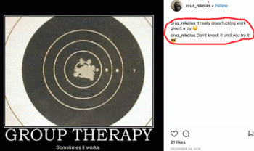
Donald DeFreeze of the SLA had his own organization, Unisight, at Vacaville Men’s Prison. It was actually group therapy that practiced Primal Fear or Scream Therapy. Primal therapy is a trauma-based psychotherapy created by Arthur Janov, who argues that neurosis is caused by the repressed pain of childhood trauma. He advocated screaming to release childhood traumas and neuroses.
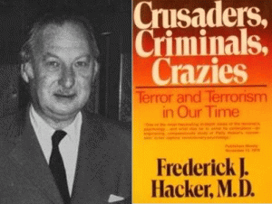
Janov did an internship at the Hacker Psychiatric Clinic in Beverly Hills, worked for the Veterans’ Administration at Brentwood Neuropsychiatric Hospital and was in private practice from 1952 until his death in 2017. He was also on the staff of the Psychiatric Department at Los Angeles Children’s Hospital where he was involved in developing their psychosomatic unit. The Hacker Clinic was founded by Dr. Frederick J. Hacker of Vienna, Austria that allegedly escaped Nazi Germany in 1938. Dr. Hacker was a German psychiatrist inside the dark circle and web of the Frankfurt School- Institute of Social Research and Theodor W. Adorno. Dr. Hacker was CIA psychiatrist-in-residence, author and “expert” on provocateur violence.
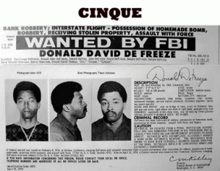On November 21, 1968, Dr. Hacker was assigned as a psychiatrist to Donald Defreeze, known as Cinque Mtume and “Field Marshal Cinque” of the Symbionese Liberation Army (SLA). Dr. Hacker was also a close adviser to Randolph Apperson Hearst during the 1974 SLA “CIA Psyop” kidnapping of Patty Hearst. “Apperson” was the father of Patty Hearst and the fourth son of the dark Bohemian pagan sorcerer, William Randolph Hearst, Sr.
Children’s Center for Development and Behavior
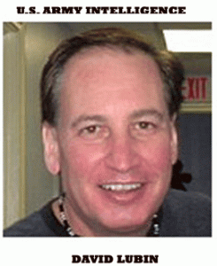
David Lubin, Ph.D., BCBA-D, Vice President – Clinical Affairs, Dr. Lubin is Co-Founder and Vice President of Clinical Affairs with the Children’s Center for Development and Behavior. He specializes in clinical neuropsychology, neuroanatomy and human engineering technology. MK ULTRA/MONARCH is generally the code name of CIA-sponsored research operation that experiment in human behavioral engineering.
Dr. Lubin also held positions with U.S. Army Intelligence. The Military Intelligence Corps (sometimes referred to as MI) is the intelligence branch of the U.S Army. The primary mission of military intelligence in the United States Army is to provide timely, relevant, accurate, and synchronized intelligence and electronic warfare support to tactical, operational and strategic-level commanders. The Army’s intelligence components produce intelligence both for Army use and for sharing across the national intelligence community.
Another name for U.S. Army Intelligence is the U.S. Army Security Agency (ASA) was the U.S. Army’s signals intelligence branch. Composed of soldiers trained in military intelligence, the ASA was tasked with monitoring and interpreting military communications of the Soviet Union, the People’s Republic of China, and their allies and client states around the world. The ASA was directly subordinate to the National Security Agency (NSA), and all major NSA field stations. The NSA was the cradle that rocked the Reinhart Gehlen Org, SS and CIA since it came into existence in 1947.

Dr. Lubin also worked for NASA where he led teams in the design of user-systems and automated training systems. Nazi-SS scientists and academics were sought out, enlisted and harbored by the US government after the fall of Nazi Germany on the pretext to ensure their “victory” against the Japanese, Soviet Union, and the space race led by Himmler’s SS Sturmbannführer Werner von Braun. The Nazi-SS controlled NASA. It was a cradle that rocked Himmler’s SS from its beginning. SS Sturmbannführer von Braun was its first director. NASA worked closely with FBI Division 5, and CIA- MK ULTRA/MONARCH.
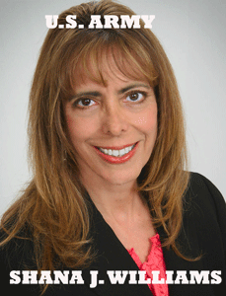

“During my service in the Army, I am credited with creating stress management programs for several organizations including a major U.S. Army installation.” – Shana Williams
Shana Williams, Psy.D. Director – Psychological Services, Williams is a member of Non-Commissioned Officer Association. A non-commissioned officer or noncommissioned officer (NCO, colloquially non-com or noncom) is a military officer who has not earned a commission. She is also a member of the Psi Chi, National Honor Society. Psi Chi (ΨΧ) is the International Honor Society in Psychology, which was founded in 1929 for the purposes of “encouraging, stimulating, and maintaining excellence in scholarship, and advancing the science of psychology.”
Psi Chi’s honor roll expressly includes Jon Stewart. Jon Stewart (born Jonathan Stuart Leibowitz) is an American comedian, writer, producer, political commentator, actor, and television host. He is best known for being the host of The Daily Show. Stewart’s family is Litvak Jews who immigrated to America from Poland, Ukraine and Belarus. He is/was a brother of the Pi Kappa Alpha Fraternity founded in 1868. Motto: Once a Pike (Pi Kappa Alpha), Always a Pike. The fraternity has been criticized for identification with the Confederacy. Its rituals are based on Independent Order of Odd Fellows– the BROTHERHOOD OF DEATH.
It also includes Philip George Zimbardo. Zimbardo is an American psychologist and a professor emeritus at Stanford University. He became known for his 1971 Stanford prison experiment and has since authored various introductory psychology books, textbooks for college students, and other notable works, including The Lucifer Effect, The Time Paradox and The Time Cure. It appears that he works for the U.S. Office of Naval Intelligence (ONI).
Psi Chi’s honor list is rounded off by B. F. Skinner. Skinner is an infamous CIA MK ULTRA/MONARCH grandfather on “the control of human behavior.” For a few pieces of silver, he taught the shadow government, CIA and the ILLUMINATI how to shape children into anything they want- MK ULTRA ritual trauma abused sexual slaves and espionage agents.
Scot Peterson, the Marjory Stoneman Douglas school resource officer who STOOD DOWN in the midst of the alleged school massacre, wasn’t alone in the STAND DOWN: three (3) other Broward County sheriff’s deputies also had STAND DOWN orders. The armed deputies stood outside the school with Deputy Peterson as well. These people along with the U.S. Justice Department, Lucifer Sessions, Wray and Rosenstein can’t be allowed to investigate themselves!
Now, you should fully understand why Nikolaus Cruz had to be MK ULTRA-ed silenced by the shadow government, deep state and dark satanic circle in the White House from the very beginning at the time of his arrest. He is one among many of the CIA’s Dark Dominance Army of Hypnotically Controlled Agents.
Nikolaus Cruz was activated in a false flag operation to deliberate divert the masses attention away from White House evils and malfunctions, Russian Investigation, and The Black Panther global mania.
______________________________________________________________________________________
[1] http://variety.com/2018/film/news/black-panther-box-office-opening-1202704091/
[2] https://pdfs.semanticscholar.org/6d41/83826a5c5d6947ffe56f1d51145f63ddcaa6.pdf
[3] https://en.wikipedia.org/wiki/Bernard_L._Diamond
[4] http://bibliotecapleyades.lege.net/sociopolitica/esp_sociopol_cooper11.htm
[5] http://spartacus-educational.com/JFKroselli.htm
[6] https://encyclopedia2.thefreedictionary.com/Robert+F.+Kennedy%2C+Assassination+of
[7] http://www.digitaljournal.com/article/363445
[8] http://www.independent.co.uk/news/world/americas/was-robert-kennedy-killed-by-a-real-manchurian-candidate-style-assassin-487157.html
[9] http://www.independent.co.uk/news/world/americas/was-robert-kennedy-killed-by-a-real-manchurian-candidate-style-assassin-487157.html
[10] https://law.justia.com/cases/california/court-of-appeal/3d/8/359.html
[11] https://www.bibliotecapleyades.net/sociopolitica/esp_sociopol_mindcon02.htm
[12] http://www.independent.co.uk/news/world/americas/florida-shooter-nikolas-cruz-guilty-plea-murder-charges-death-penalty-a8215911.html
[13] https://www.cnbc.com/2017/09/14/trump-again-blames-both-sides-for-charlottesville-violence.html
[14] https://www.washingtonpost.com/news/post-nation/wp/2018/02/16/as-florida-town-mourns-authorities-revisit-possible-warning-signs-before-school-massacre/
[15] https://thecivilwarproject.com/the-south-2/jefferson-davis/
[16] https://www.splcenter.org/hatewatch/2015/04/21/stars-behind-bars-league-south-joins-republic-florida-militia-fsu-protest
[17] https://mindcontrolblackassassins.com/category/bloodline-of-wotan/
[18] https://forward.com/news/national/374956/rod-rosensteins-straight-arrow-image-takes-a-beating-from-left-and-right/
[19] http://www.sinaibrookline.org/wp-content/uploads/2015/06/Temple-Sinai-History-75.pdf
[20] https://www.washingtonpost.com/world/national-security/mueller-investigation-cost-justice-department-67-million-within-first-five-months/2017/12/05/0fed9436-d9cf-11e7-b1a8-62589434a581_story.html?utm_term=.226aed408319
[21] https://en.wikipedia.org/wiki/New_Amsterdam
[22] https://steemit.com/deepstate/@fortified/society-of-the-cincinnati-or-history-of-the-deepstate
[23] Id.
[24] http://truth-out.org/archive/component/k2/item/89725:cries-from-the-past-tortures-ugly-echoes
[25] https://en.wikipedia.org/wiki/John_B._Trevor_Sr.
[26] https://en.wikipedia.org/wiki/John_B._Trevor_Jr.
[27] https://en.wikipedia.org/wiki/Columbia_College,_Columbia_University
[28] http://www.atlaspythagoras.com/famous-masons/
[29] https://en.wikipedia.org/wiki/Order_of_Lafayette
[30] https://en.wikipedia.org/wiki/Gilbert_du_Motier,_Marquis_de_Lafayette
[31] https://www.politico.com/magazine/story/2014/02/thomas-jefferson-france-lafayette-monticello-103303
[32] https://zaidpub.com/occult-symbolism-as-based-on-ancient-mystery-religions/known-personalities-the-hidden-hand-of-the-occult/
[33] https://zaidpub.com/occult-symbolism-as-based-on-ancient-mystery-religions/known-personalities-the-hidden-hand-of-the-occult/

[34] http://www.schillerinstitute.org/educ/hist/lafayette.html
[35] Sell, Peter J, From Blood to Compassion, From the Knights Templar to Modern Day Freemasonry, A Complete History, Explanation, Reality Check and Myth Buster
[36] http://en.metapedia.org/wiki/Hamilton_Fish_III
[37] https://deeppoliticsforum.com/forums/archive/index.php/t-2774.html
[38] Id.
[39] https://en.wikipedia.org/wiki/Stuyvesant_Fish
[40] https://en.wikipedia.org/wiki/Hamilton_Fish_III
[41] https://www.counter-currents.com/2017/11/madison-grants-the-conquest-of-a-continent-2/
[42] http://freemasonsfordummies.blogspot.com/2011/02/washingtons-lafayette-apron-to-be.html
[43] https://www.findagrave.com/memorial/81697834
[44] http://www.jasoncolavito.com/inquiry-into-shaver-and-palmer.html
[45] http://www.masoniclodgewhatcom.com/famousmasons.html
[46] https://nypost.com/2014/02/01/behind-the-secret-plan-to-smuggle-nazi-scientists-to-america/
[47] http://projectavalon.net/forum4/showthread.php?92990-Mirage-Men-conclusively-linked-to-UFO-summer-of-47
[48] https://en.wikipedia.org/wiki/Maury_Island_incident
[49] https://en.wikipedia.org/wiki/Kenneth_Arnold_UFO_sighting
[50] http://historydeceived.blogspot.com/2017/11/colonel-carl-e-goldbranson-deception.html
[51] https://archive.org/stream/the-secret-treaty-of-fort-hunt/the-secret-treaty-of-fort-hunt_djvu.txt
[52] https://www.bibliotecapleyades.net/branton/esp_offlimits_6c.htm
[53] http://www.maebrussell.com/Mae%20Brussell%20Articles/Nazi%20Connection%20to%20JFK%20Assass.html
[54] http://www.cluesforum.info/viewtopic.php?p=1396271
[55] https://en.wikipedia.org/wiki/Silver_Legion_of_America
[56] http://visupview.blogspot.com/2014/02/william-dudley-pelley-international_23.html
[57] Allen H. Greenfield, Secret Rituals of the Men in Black, Lulu Enterprises, Inc. (2005), pgs. 28-29
[58] https://en.wikipedia.org/wiki/Jay_Richard_Kennedy
[59] https://en.wikipedia.org/wiki/Harambee_(African-American_newspaper)
[60] Albarelli, H.P. Jr., A Terrible Mistake, The Murder of Frank Olson and the CIA’s Secret Cold War Experiments, Trine Day LLC, Waterville, OR (2009), pg. 227
[61] Id., page 786
[62] https://diva.sfsu.edu/collections/sfbatv/bundles/223881
[63] https://propagandhi.com/wp-content/empires/Ward_Churchill.pdf
[64] Albarelli, H.P., A Terrible Mistake, Trine Day LLC, Waterville, OR (2009) pg. 88

[65] http://visupview.blogspot.com/2016/06/the-office-of-security-tale-of-sex.html
[66] Id.

[67] Albarelli, H.P., A Terrible Mistake, Trine Day LLC, Waterville, OR (2009) pg. 270-272
Comments : Leave a comment
Tags: 1000 Year Third Reich, Adolf Hitler, Ahnenerbe Society, Alchemy. knights templar, aldebaran, allgemeine ss, AMAZING STORIES, American Eugenics Society, and Dr. George Estabrooks, Arthur Janov, Artichoke project, Æthelred II, B.F. Skinner, Baron Otto von Bolschwing, BCA, berghof, Black Cultural Association, black identity extremists, black lives matter, Black Panther Party for Self Defense, BLUEBIRD Project, bobby seale, broward county sheriff deputies, California Men’s Medical Facility at Vacaville, charles gain, charlottesville, chauncey bailey, Children’s Center for Development and Behavior, christopher wray, CIA, CIA MK ULTRA/MONARCH, CIA Scientific Intelligence Branch, clay shaw, clique, COINTELPRO, Colonel Carl Goldbranson, Colston Westbrook, Congressman Leo Ryan, crossed bones, Curtis E. LeMay, david lubin, deep state, devil, Donald Defreeze, donald j. drumpf, donald j. trump, donald trump, doppelganger, Dr. Bernard L. Diamond, dr. frederick hacker, Dr. George Estabrooks, Dr. George Holben Estabrooks, Dr. James A. Hamilton, Dr. Milton H. Erickson, Dr. W.O. Schumann, Dr. William Joseph Bryan, Elaine Brown, Feldherrnhalle, florida, Fort Bragg, Frankfurt Institute of Social Research, Fred Crisman, freemasonry, freemasons, gehlen org, General Carl Andrew "Tooey" Spaatz, General Henry Harley "Hap" Arnold, George Sylvester Viereck., george washington, german luger, get out, grant cooper, group therapy, Hamilton Fish III, Hamilton Stuyvesant Fish III, Harold Dahl, harry houdini, herbert heanes, Howard Finkelstein, Huey P. Newton, hunting lodges, HYPNOTICALLY CONTROLLED AGENTS, ichard S. Shaver, j. edgar hoover, James Jesus Angleton, james mccord, jay richard kennedy, Jefferson Beauregard Sessions III, Jenseitsflugmachine, jim garrison, Joachim von Ribbentrop, john frey, john trevor, john wayne, Johnny roselli, jon stewart, Jonestown, Jordan Jereb, jordan peele, judge tom reardon, kemet, Kenneth Arnold, Knights of Black Sun, knights of the ku klux klan, larry teeter, Lauri Allan Törni, league of the south, Lee Harvey Oswald, Madame Helena Petrovna Blavatsky, madison grant, Major Larry Thorne, major paul gaynor, manchurian candidates, Margaret Sanger, maria orsic, Marjory Stoneman Douglas High School, mark lane, Marquis Lafayette, marvel comics, masons, Maulana Ron Karenga, Maury Island/Tacoma UFO, michael tubbs, mike tubbs, NASA, National Security Agency, nato's secret army, nazi german luger, Nazis, new amsterdam, nikolas cruz, Nuremberg Tribunal, oakland police department, office of naval intelligence, Office of Security, oni, OPERATION CHAOS, Operation Overcast, operation paperclip, order of knights of the hospital of saint john of jerusalem, Otto Skorzeny, panther squad, parkland, patsy, Patty Hearst, Paul F. Gaynor, Philip George Zimbardo, Pi Kappa Alpha Fraternity, Primal Scream Therapy, Psi Chi, Psychological Warfare Center, racism, Randolph Apperson Hearst, Ray Palmer, red stag cult, Red Stag Negro Hunting Lodge, republic of florida, rfk, richard dwyer, richard helms, Robert Bay, Robert F. Kennedy, Rod Rosenstein, roman catholic, Ronald McKinley Everett, Rudolf von Ribbentrop, Schloss Fuschl Castle, Schumann Resonance, schutzstaffel, scot peterson, Secret Doctrine, security research section, sex slaves, shadow government, shana williams, Shaver Mystery, Silver Shirts, Simba Wachanga, Sirhan Sirhan, skull and bones, SLA, society of cin, society of the Cincinnati, srs, SS, SS Hauptsturmführer Törni, SS-Jagdverband Mitte, steve bannon, sumeria, Sven Kornie, Symbionese Liberation Army, Taurus constellation, teutonic knights, teutonic order, the black panther, The Order of Lafayette, the pink pussycat, the third reich, The Thule Society, Theodor W. Adorno, THIRD REICH, Thule Gesellschaft, tom reardon, U.S. Army Air Force, U.S. Army Green Beret, U.S. Army Security Agency, U.S. Army Special Forces, u.s. justice department, UFO Occult, UFOlogy, ufos, unite the right, United Slaves, us brothers, Vacaville Men's Medical Facility, very fine people, voodoo justice, vril, vril flying discs, vril flying saucers, walt disney, Werner von Braun, white nationalism, white stag cult, white supremacy, William Dudley Pelley, William F. Peppers, Wright Patterson Air Force Base, your black muslim bakery
Categories : 1000 Year Reich, allen dulles, Aryan Supremacy, baphomet, black children, black institutions, blood covenants, blood oaths, blood sacrifice, brotherhood of death, CIA, COINTELPRO, colston westbrook, cybernetics, cyborg, cyborgs, Devaughndre Broussard, devil, donald j. drumpf, donald j. trump, donald trump, Dr. James Alexander Hamilton, dualism, edgar j. hoover, ELF, evil, Extremely Low Electrical Frequencies, fbi, frank sinatra, freemason, freemasons, Heinrich Himmler, huey p. newton, J. Edgar Hoover, J. P. Morgan, John f. kennedy, jonestown, kemet, Knight of Malta, Knights Hospitaller, Knights of the Black Sun, Knights Templar, ku klux klan, Little Bobby Hutton, lucifer's servants, luciferians, manchurian candidates, maria orsic, masonic sacrifice, Men of the Black Stone, mind control, MK-ULTRA, monarch child, monarch program, Morris "Morse" Allen, MPD, mulitiple personality disorder, nation of islam, Nazis, Nuremberg Tribunal, oakland, oakland police department, opd, Operation PAPERCLIP, order of teutonic knights, Paperclip Project, post amnesia barriers, post hypnotic suggestions, project bluebird, PROJECT CHATTER, racial mass murder, Reichsfurhrer SS-1 Heinrich Himmler, Reichsstatthatter Hermann Goring, reinhard gehlen, Ritual Satanic Abuse, Rosicrucian, rudolph hess, satan, Satanic Global High Cabal, Satanism, Schutzsteffel, scottsish rite, Secret Doctrine, sex kitten, sex slave, simba, sirhan sirhan, skull and bones, SS, Symbionese Liberation Army, thule, trauma-based mind control, underground reich, underground third reich, vacaville, vril, VRIL FLYING DISKS, your black muslim bakery, yusuf bey, yusuf bey vi, ZIONIST

JAY Z, JAYBO & PANTHER, “GET OUT”, THE NEGRO- APE METAPHOR CARICATURE: THE GLOBAL RACIST EUGENIC PLOT TO ANIMALIZE, SIMIANIZE AND COLONIZE BLACK PEOPLE
13022018
I
THE BLACK PANTHER- FACT OR FICTION, IT’S UP TO YOU
Black Panther Party for Self Defense, Oakland, CA
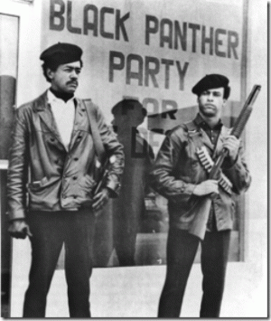
Bobby Seale and Huey P. Newton founded the Black Panther Party for Self Defense in October 1966 at Merritt Jr. College in Oakland.
Black Panther Caricature- Out of the Heart of the Darkness, The African Jungle
The less than human Black Panther Caricature was developed by non people of color as a fantasy character by Marvel Comics part of its “JUNGLE ACTION” series. I was just a Manchild when I became involved in the early formation of the Black Panther Party for Self Defense (BPP). I was just a classic Hemayet (Kemet- God’s Voice) Donny Hathaway’s throw away Little Ghetto Boy.
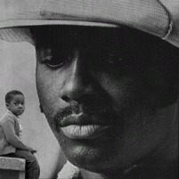
Little ghetto boy, playing in the ghetto street
Whatcha’ gonna do when you grow up
And have to face responsiblity?
Will you spend your days and nights in the pool room?
Will you sell caps of madness to the neighborhood?
Little ghetto boy
You already know how proud life can be
’cause you’ve seen so much pain and misery …
One day, I walked on a college campus following a young lady that I was trying to get next to. I was really looking for a hole in the ground to get high and hide my ugly black face when I first met Huey P. Newton and Bobby Seale at Merritt Jr. College in Oakland, CA. Before I knew it, I was caught up in a star burst and suddenly found myself trussed out into the middle of a vast unexplored universe.
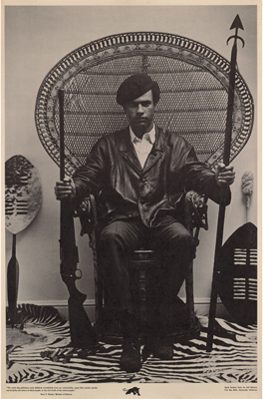
Chairman Bobby Seale introduced me to the infamous Huey P. Newton iconic photo at the beginning of the Free Huey Campaign as a fundraiser. I was only a neophyte, but there was something spiritual and sacred about that picture. It was symbolic of something much bigger (African-ness) that I don’t believe many of us but Bobby and the wiser older brothers and sisters truly understood.
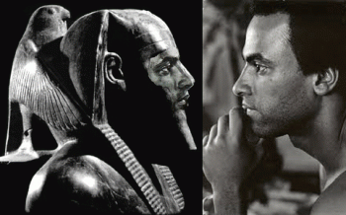
HORUS & HUEY
From the very beginning, they intended to slaughter Huey by satanic ritual sacrifice. The secret Knights of the Black Sun initiated the battle with Huey, Bobby and the BPP as spiritual warfare like something out of ancient mythology- Gods Set and Horus. The war against the BPP was led by the CIA– SS Teutonic Knight Baron Otto von Bolschwing (Order of Brothers of the German House of Saint Mary in Jerusalem), and FBI– Master Mason J. Edgar Hoover (Thirty-Third Degree Grand Cross, Inspector General, Southern Scottish Rite Jurisdiction). They organized themselves as a clandestine Black Knight Masonic Panther Squad to kill the BPP.
They decided to kill Huey ceremonially – body, soul and spirit. The Nazi Luger Pistol represents a thing of great volkish mysticism, magic, superstition, and folklore. The pistol’s mystic power is part of a unique signature of Adolf Hitler’s racialist mass executioners, Reichsführer SS-1 Heinrich Himmler and the Cult of the Dark Messiah.
On the morning of October 28, 1967 on 7th Street in West Oakland, the Oakland Police Department (OPD) stopped a car driven by Huey P. Newton. After a physical confrontation, Officer John Frey, 23 years old, was found dead from gunshot wounds. OPD Officer Herbert Heanes was found alive at the scene also suffering gunshot wounds. Huey and their Mystic Nazi Luger Pistol were missing. The German Luger was no FANTASY. It was REAL!
“Three slugs were recovered: one from Officer Frey’s hip, one from Heanes’ left knee, and a third which had been lodged in the right front door of the Volkswagen. In addition, two 9-mm. LUGER shell casings were found at the scene. One was in the street between the two police cars, the other near the left front bumper of Heanes’ car and approximately where Frey was lying. The 9-mm. bullets had been fired from an automatic (Officers Frey and Heanes carried .38-caliber Smith & Wesson revolvers). A live 9-mm. Luger cartridge was found on the floor of the Volkswagen, between the two front seats. Only Officer Heanes’ gun was found; he was holding it when the other officers arrived at the scene. Two rounds had been expended from the gun. Neither a LUGER nor Officer Frey’s revolver was found.” (THE PEOPLE, Plaintiff and Respondent, v. HUEY P. NEWTON, Defendant and Appellant. Docket No. 7753. Court of Appeals of California, First District, Division Four. May 29, 1970. 8 Cal.App.3d 359 (1970), 87 Cal. Rptr. 394)
The Mystic German Luger Pistol disappeared and remains hidden from the masses in the 21st century. Tellingly, the government did not trace the specially manufactured German Luger cartilages. On October 28, 1967, they intended to snuff out Huey’s life force with a SS-Knight of the Black Sun Mystic Weapon. Huey P. Newton’s infamous photo is SACRED because it is symbolic of their failed SETHIAN ARYAN MAGIC.
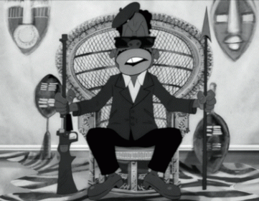
In 2017, they employed their Knights Templar subservient puppet black Master Mason, Jay Z, to try to symbolically make a mockery and MONKEY of Huey.
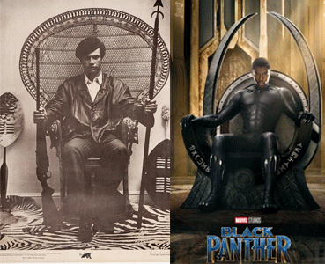
In 2018, Marvel and Walt Disney Studios released a global mass population poster for its Black Panther film that allegedly suffered a severe backlash, because several pissed off ILLUMINATI critics compared it to the infamous iconic picture of Huey P. Newton. Their poster features the movie’s star, Chadwick Boseman, posing in costume as the titular Black Panther, the king of a fictional African nation ( an imaginary state, a state of fantasy, a state to make believe), seated on his throne and (fake) looking powerful.
Marvel and Walt Disney Studios’ Black Panther is a fictional character- fictitious, fictive, invented, imaginary, made up, make-believe, unreal, fabricated, mythical fictional character. Both Marvel and Disney mass produce fantasies for the masses. The genre uses magic and other supernatural forms to create states of mind of fantasy. Be careful with the movie Black Panther– it treads on the dangerous ground of fantasy and delusions. Children may not be able to make the distinction between the two.
The most remarkable thing is that Marvel and Disney wasn’t even thinking of Brother Huey when they created a poster for a “Strong African King.” But the everlasting powerful iconic “Image of Huey P. Newton” that has become a powerful indelible global impression imprinted in the subconscious minds of the masses has made that character overwhelming human (MAAT) truth, justice, righteousness, harmony and balance; and REAL.
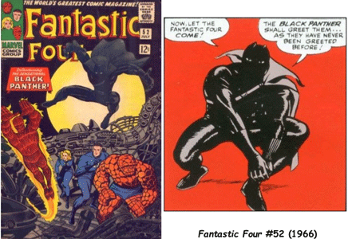
In fact, since Marvel’s creation of the Panther comic character in June or July 1966, it has tried desperately to distance itself from Huey, Bobby and the BPP. Marvel’s Panther comic character did not precede the Black Panther Party.
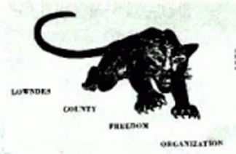
The Lowndes County Freedom Organization (LCFO), also known as the Black Panther Party, was started in 1965 under the leadership and direction of Student Non-Violent Coordinating Committee (SNCC) BPP Honorary Prime Minister Stokely Carmichael. Actually, Huey and Bobby took over the Black Panther Party name from the Black Panther Party of Northern California (Kenny Freeman) prior to October 1966. Intelligentsia Freeman had also been one of my most beloved and persevering early ghetto boy Black Nationalist mentors. Freeman was another absolutely outstanding natural intellectual genius along with the minds of Huey, Bobby, and Stokely.
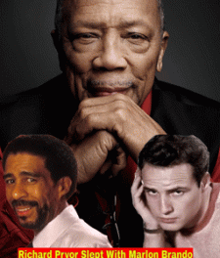
In extremely suspect timing on February 7, 2018, just days prior to the global release of Marvel and Walt Disney Studios’ Black Panther film, in a sensational article the ILLUMINATI MK ULTRA/MONARCH bi sexual- pedophilia handler and programmer Coon, Quincy Jones, said that Marlon Brandon had been a bi-sexual whore that had anally sexed Richard Pryor.
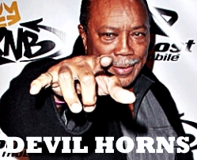
Quincy Jones & the Spell of Lucifer
Brando and Pryor’s in-laws have disputed Jones’ claims.
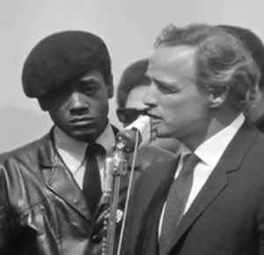
Big Bobby & Brandon
Brother Bobby and the BPP held the esteemed Oscar winning actor in very high regard as a fair and just man. He was with the BPP when the CIA, FBI, OPD, Panther Squad ambushed members of the BPP slaughtering Little Bobby Hutton. Brandon was one of the few to speak truth to power. He risked his entire career to make sure that a much broader world knew that we were for REAL. He publicly defended us. They would have killed Brandon if they could have got away with it. The lawless Black Knight Masonic Panther Squad went after him with rage, revenge and unqualified zeal like an enemy of war.
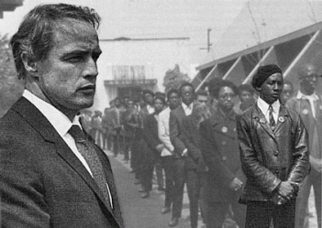
Brandon & Little Ghetto Boy Princeray
I respected Brandon and actually treated him as he had treated me like a brother. On the late night popular TV show, Joey Bishop, Brandon made it REAL. He told a global audience that the police department [Black Knight Masonic Panther Squad] was out to “Get the Panthers“. He said that Little Bobby Hutton “came out of the house with his hands up and he was told to run for the car and he was shot dead and killed.” The Panther Squad couldn’t harm Brandon like one of us or a hated white sympathetic follower because he was far too respected, public, high profile, global and beloved by millions of fans.
So Samson B. Mullins as President and on behalf of the Oakland Police Officers Association went after Brandon personally to DESTROY his global reputation and character in a sensationalized case for civil defamation. [Mullins v. Brando (1970) [Civ. No. 35362. Court of Appeals of California, Second Appellate District, Division Five. December 10, 1970.] SAMSON B. MULLINS, as President of the Oakland Police Officers Association, et al., Plaintiffs and Appellants, v. MARLON BRANDO, Defendant and Respondent [13 Cal. App. 3d 410]]
On the night that the Panthers allegedly ambushed the OPD (strategy of tension), I was in charge of the front desk at the Oakland BPP headquarters. It was just 2 (two) days after Dr. Martin Luther King, Jr. had been assassinated. The orders that I got directly from Chairman Bobby Seale to communicate to ALL PANTHERS– “STAND DOWN” until further orders. No police patrols- NOTHING but continue to prepare for the oncoming “Free Huey” rally at Defremery Park in Oakland.
I was with the brothers that dropped Little Bobby off at his house for dinner. We were under so many direct threats that we’re ordered and cautioned to move in groups. When he was dropped off at home, the orders were the same. When he returned to headquarters an hour or so later, the orders that he understood when he left for dinner from Big Bobby were the same- ALL PANTHERS– “STAND DOWN”! Little Bobby loved Brother Bobby as if he had been his father and would never disobey or defy his orders.
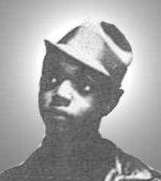
Little Bobby Hutton
17 year old Little Bobby was an extremely gentle respectful and quiet young brother. I never heard a negative or curse word come out of Little Bobby’s mouth. They shot Little Bobby into so many pieces from what we understood at the time were experimental high powered weapons that the morticians had to sew him back together for the funeral. They did a remarkable job. We were all deeply spiritually affected by his senseless murder, but it didn’t stop us. We continued to move in his beloved spirit and pursuit of his “Sack Full of Dreams“.
In the wake of the ILLUMINATI’s global hype for the premier of the Black Panther HollyWeird black fantasy film to disassociate it from the real Black Liberation Movement, Huey, Bobby and BPP, they threw brother Marlon Brandon under the bus once again to distract the masses from the real world.
I noticed that all the starring cast of Black Panther promoting the movie in corporate mass media are careful to stay away from the subject of making any comparisons and connections between the movie, the BPP and any real global struggles for liberation. The movie is a bottom line virtual reality supernatural science fiction/fantasy adventure film. It’s like taking that red pill or cap of acid (LSD) for an escape from reality. They are promoting the notions that it is okay for Black Children around the world to become lost in escapism, paranoid fantasy schizoid-ism and blind naivety- a type of MK ULTRA/MONARCH Double Bind (Insanity without Disease) than stand up and confront real issues that affect their lives. Don’t it twisted. The duality of FANTASY is reality, fact and actuality. That’s the key to striking the delicate balance between HollyWeird’s mass population fantasy escapism films designed to pacify global peoples of color, and REALITY- RACISM & WHITE SUPREMACY.
Hey. That’s Brando that they’re talking about. BE FOR REAL, WE LOVE BRANDON!
II
THE REAL WORLD- THE GLOBAL FALSE NEGRO- APE METAPHOR
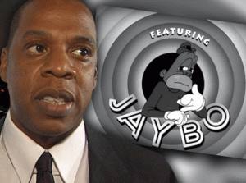
In the 21st century, Jay Z’s simian- hominoid JAYBO Caricature is a very serious violation of our human rights.
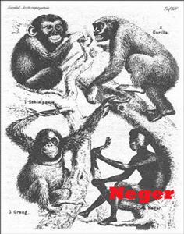
It is an extremely dangerous throwback to venomous patent Negro-Ape Metaphors of the dangerous 19th and early 20th century homicidal eugenic movement.
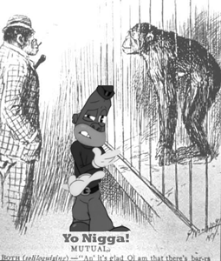
Metaphor– late 15th century, from Middle French metaphore (Old French metafore, 13th century), and directly from Latin metaphora, from Greek metaphora “a transfer,” especially of the sense of one word to a different word, literally “a carrying over,” from metapherein “transfer, carry over; change, alter; to use a word in a strange sense,” from meta “over, across” (see meta-) + pherein “to carry, bear,” from PIE root *bher– (1) “to carry,” also “to bear children.”[1]
III
ANGLO SAXON SUPREMACY & AMERICA’S FIRST PEOPLE
The American Baseball League Cleveland Indians will finally remove the grinning red face “Chief Wahoo” in a feathered headband logo from their uniforms beginning in the 2019 season. The logo has long been assailed as a racist Native American caricature. They have long complained, protested and sued the Cleveland Indians alleging that the image is offensive and perpetuates racist stereotypes about America’s first peoples.
In 2005, the American Psychological Association (APA) issued a resolution “Recommending the Immediate Retirement of American Indian Mascots, Symbols, Images, and Personalities by Schools, Colleges, Universities, Athletic Teams, and Organizations” due to the harm done by creating a hostile environment, the negative impact on the self-esteem of American Indian children, and discrimination that may violate civil rights. It also impacts non-natives by reinforcing mainstream stereotypes, preventing learning about Native American culture. The APA states that stereotyping is disrespectful of the beliefs, traditions and values of Native Americans. Similar resolutions have been adopted by the American Sociological Association, the American Counseling Association, and the American Anthropological Association.[2]
In 2010, the authors of a paper published in the Journal of Applied Social Psychology reported the results of two studies on the effects of American Indian mascots on observers. According to the authors, “both studies show that participants primed with an American Indian sports mascot increased their stereotyping of a different ethnic minority group.” The alternative weekly publication Cleveland Scene sardonically interpreted these results to mean that “looking at Chief Wahoo, the mere existence of Chief Wahoo, can change your opinions of a whole separate ethnicity”, adding that the study “probably confirms that Clevelanders and Indians fans are inclined to stereotype and hate just about every group in the world.” The magazine Pacific Standard also framed the study in terms of the Indians’ logo, headlining their story “Chief Wahoo’s Revenge: One Stereotype Begets Another“.
Richard Lapchick, director of the University of Central Florida’s Institute for Diversity and Ethics in Sports, has called the logo “the most blatantly offensive of all the symbols I’ve seen of Native Americans” during 40 years working in his field. An article in a 2010 psychology text cited “Chief Wahoo” as an example of a racial micro-aggression.[3]
The Negro Caricatures and the racist Jewish caricatures and cartoon propaganda of Nazi Germany are all the same thing- vicious racial caricatures that spread hatred, prejudice and misunderstanding among the people across the world
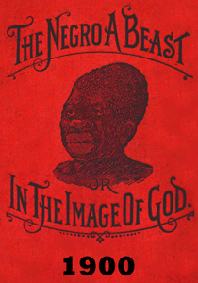
The only difference between the racial caricatures is that fact that the black caricatures directly implant and input simian and hominoid sub humanism visualization of Black People that still goes on today.
2018 Hennes & Mauritz (H&M) Stockholm, Sweden, the Black Child is the Wild Animal Inhabitant of the Jungle, while the White Child is the Jungle Survival Expert- Great White Hunter or Tarzan of the Jungle that will conquer the animals- Monkeys and Tigers.

Black Child- Coolest Monkey in the Jungle- Little Black Sambo
Don’t get it twisted. I am saying that all racial caricatures are wicked and depraved. If you condemn one, condemn each and every one of them as byproducts of reactionary, irrational and lawless global racism, white supremacy, imperialism and aggression.
Jay Z’s simianized JAYBO Caricature seeking current 2018 U.S. Trademark Protection is a vicious veiled throwback to the era of vicious racial eugenics, and Anglo Saxon superiority, imperialism and aggression that is secretly flaunted in the current presidential policies, especially immigration, of Donald J. Drumpf and the Dark Satanic Circle.

These absolutely irrational and evil forces have taken over the highest elected offices of the U.S. government (for example, see Vox’s The scary [Madison Grant] ideology behind Trump’s immigration instincts).
IV
ANGLO SAXON SUPREMACY, MADISON GRANT & THE WORLD’S FIRST PEOPLE
OTA BENGA & HIS ALLEGED DIRECT MONKEY RELATIVE
In 1904, Ota Benga of the Twa- Batwa people of the Congo was kidnapped from the mother country. He was brought to America and confined in an animal cage. He was dehumanized and publicly humiliated. Benga was placed on exhibit as a so-called “pygmy” at the Monkey-Ape House at the zoological gardens, better known as the Bronx Zoo.[4] My Dear Lord! The Twa is a sacred people. They trace their origins to Adam, Eve and beginning of time at the Garden of Eden at the foot of the Mountain of the Moon in Africa. Evidence strongly suggests that they were indeed the First Civilized People that populated planet earth.
Twa God Bes and a Young Prince Ramesses the Great (1279-1213 BC)
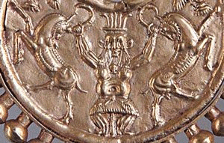
Twa God Bes as the MASTER OF THE BEASTS on an earring (Susa, Iran, 500-400s BC, now in the Louvre)
The Twa- Batwa people may be one of the most important and significant continuous ancient cultural groups living in peace, harmony and truth (MAAT) on earth. You can’t come any closer to a global original/first people on planet earth than the Twa– Dancers of the Gods. They are often credited by various African groups and even by the Chinese/Southeast Asians that hold an annual festival celebrating the “Little Black People” whom they admit to have displaced as the ultimate creators and teachers of science, mathematics, and dance. These Africans were also part of the initial northward migration from Central/East Africa along the Nile River. They were an integral part of ancient Nile Valley Culture and belief systems.[5]
TWA PEOPLE IN ANCIENT GREEK MYTHOLOGY
The Twa were well known and respected among the Ancient Greeks, and were involved in the infamous Trojan War of antiquity.[6] So, how do you begin to colonialize to exploit one of the first people of earth, globally? Simianize and Dehumanize– turn them into a tribe of Monkeys.
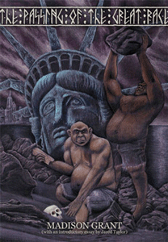
Very powerful and influential forces in America were secretly behind the international Negro-Ape Metaphor as justification to universally colonize, exploit and suppress the aspirations of people of color across the globe. One was Madison Grant. He was the founder and secretary of the New York Zoological Society who had personally helped negotiate the arrangement to setup Ota Benga in the zoo as a global Negro-Ape Metaphor; and missing link directly to hominoids and simians. In fact, Benga was actually billed as the “missing link”on display in the Bronx Zoo cage alongside a monkey.[7]
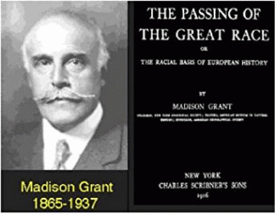
Madison Grant (November 19, 1865 – May 30, 1937) was an affluent and powerful Yale alumni and New York attorney known primarily for his work as a eugenicist. He was responsible for one of the most famous works of scientific racism, and played an active role in crafting strong immigration restriction and anti- miscegenation policies and laws in the U.S. Throughout the 1920s and 1930s, he served on the boards of many eugenic and philanthropic, including the board of trustees at the American Museum of Natural History. He was a founder and director of the American Eugenics Society (AES), vice president of the Immigration Restriction League, a founding member of the Galton Society, and one of the eight members of the International Committee of Eugenics.[8]

The interaction between the British, American and German Eugenics societies laid the foundation for implementation of the race purification ideology behind Hitler’s Third Reich. In 1912, the First International Congress of Eugenics was held at the University of London. The president of the Congress was Major Leonard Darwin, son of Charles Darwin and one of the first English vice presidents was Sir Winston Churchill, later Prime Minister of England. Of interest, Charles Darwin’s On the Origin of the Species By Means of Natural Selection was subtitled “The Preservation of Favored Races in the Struggle for Life”.
In 1921, the Second International Congress of Eugenics was held in New York City. The sponsoring committee included Herbert Clark Hoover, later President of the U.S., and the Carnegie Institute of Washington (Rockefeller). Madison Grant, a director of the American Eugenics Society, was the treasurer. The event was held at the American Museum of Natural History in New York, where Averell Harriman served on the Board of Directors.[9]
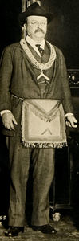
Racist Masonic and Bohemian Grove President Theodore Roosevelt
Grant was a close friend of several U.S. presidents, including Freemason and Bohemia Grove pagans, Theodore Roosevelt and Herbert C. Hoover. If Hoover wasn’t a mason, he certainly had worked closely with freemasonry and the Sovereign Grand Commander Council of the Scottish Rite.
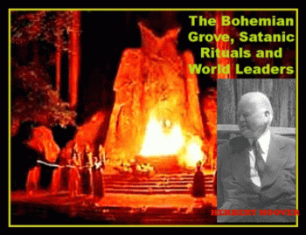
However, President Hoover had indeed been a homosexual member of the Satanic Bohemian Grove. Grant advocated restricted immigration to the U.S. through limiting immigration from Eastern Europe and Southern Europe, as well as the complete end of immigration from East Asia. He also advocated efforts to purify the American population through selective breeding. He served as the vice president of the Immigration Restriction League from 1922 to his death.
Acting as an expert on world racial data, Grant also provided statistics for the Immigration Act of 1924 to set the quotas on immigrants from certain European countries. Even after passing the statute, Grant continued to be irked that even smatterings of non-Nordics were allowed to immigrate to the country each year. He also assisted in the passing and prosecution of several anti- miscegenation laws, notably the Racial Integrity Act of 1924 in the state of Virginia, where he sought to codify his particular version of the “one-drop rule” into law.[10]
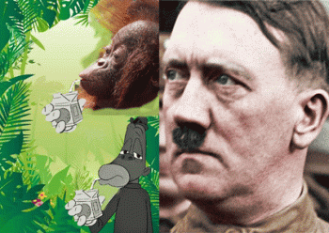Even the Fuhrer Adolf Hitler followed Madison Grant, and I wouldn’t be surprised if he had got his infamous Mein Kempf Negro-Ape Metaphors straight from Grant.
“The year after Hitler was imprisoned [1925], [German publisher] Lehmanns published the German translation of American eugenicist Madison Grant’s bestselling volume, The Passing of the Great Race , which had a profound effect on Hitler’s thinking. Hitler was so steeped in American race science, he even wrote a fan letter to American eugenic leader Madison Grant. Der Führer’s letter called Grant’s eugenics book, The Passing of the Great Race, “my bible.
… In 1924, when Hitler wrote Mein Kampf, he frequently quoted American eugenic ideology and openly displayed a thorough knowledge of American eugenics and its phraseology. “There is today one state,” Hitler wrote, “in which at least weak beginnings toward a better conception [of immigration] are noticeable. Of course, it is not our model German Republic, but the United States.”
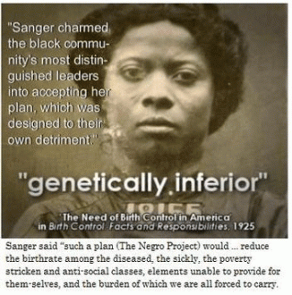
Hitler proudly told his comrades just how closely he followed American eugenic legislation. “I have studied with great interest the laws of several American states concerning prevention of reproduction by people whose progeny would, in all probability, be of no value or be injurious to the racial stock,” he told a fellow Nazi.”[11]
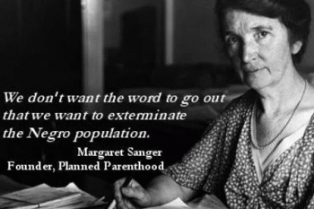
The racist homicidal/genocidal Margaret Sanger that actually plotted to make the mass murder of Black people another peculiar institution in America was a member of Grant’s AES until the day she died.[12]
Margaret Sanger even appealed to and encouraged the Masonic Knights of the Ku Klux Klan to slaughter mass murder Black U.S. citizens.
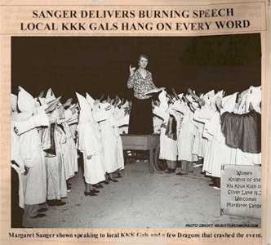
To justify the widespread criminal murder (LYNCHING) of black people across the U.S., racists openly quoted Madison Grant’s “The Passing of the Great Race” even on the floor of Congress.
V
ANGLO SAXON SUPREMACY, IMPERIALISM & THE CONGO
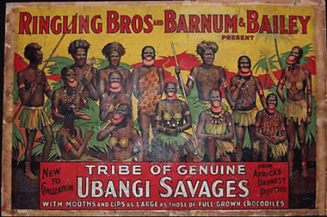
Congo: Heart of Darkness
Joseph Conrad’s Heart of Darkness (1899) had used Ota Benga’s homeland, the Congo, as a setting for the 20th century Negro-Animal Metaphor. Conrad’s narrator in the book, Marlow, blatantly describes the Africans as having “faces like grotesque masks,” as animal-like creatures who lap water like animals, with ugly and horrid faces, who howl and leap around, with buttocks wagging “to and fro like tails.” Of one “savage” who has been trained to fire up a boiler, Marlow can’t resist remarking, “To look at him was as edifying as seeing a dog in a parody of breeches and a feather hat, walking on his hind legs.”[13]
Tintin Au Congo
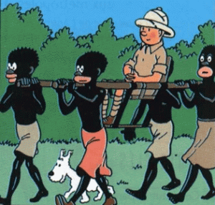
Tintin and Snowball
“ … I flicked it open. I was astonished to see page after page of graphic representations of black African people as sub-human monkey people, bowing before a white teenager, worshipping his dog as a god and incapable of proper speech. In fact, the only black monkey caricature in the book who could speak English properly was a chimpanzee.”[14]
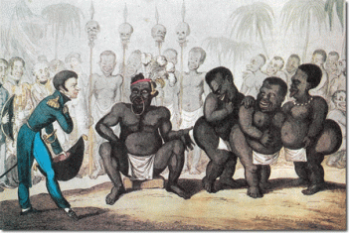
“Tintin,” that was also centered in the Congo was the brainchild of the late Belgian cartoonist Georges Remi (better known as Hergé). Hergé depicted the Congolese as “good at heart but backwards and lazy, in need of European mastery.”[15]
The comic Tintin in the Congo was first published between 1930 and 1931, a time when the Congo was suffering under Belgian’s sadistic murderous imperial genocidal colonial rule. The Tintin stories graphically depict the Congolese people dehumanized as monkey-like, and portray them as stupid, childish, and lazy.[16]
Tintin is a little blond Anglo Saxon boy that has the brain and brawn to defeat and rule over all the black Congolese.
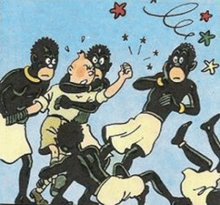
He is a Belgium reporter followed around by his pure white dog, Snowball. Even the dog has more intelligence than the Congolese people and also rules over them in its own right.
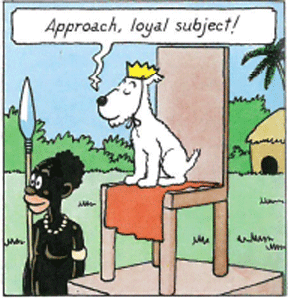
Tintin’s Congo guide, Coco, is an African child drawn so that his head is black as ink like Jaybo’s grandfather Bosko to highlight his white bug-eyes, his typically “pickaninny and Black Sambo” gaping mouth with huge red lips, and his frizzy black hair.
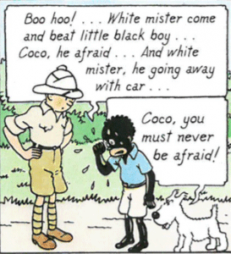
Tintin in the Congo tells a tale of the interactions between the Congolese and the Europeans entering the country. One of Conrad’s stories guides Belgian visitors in the appropriate relationships to be maintained between them and the Congolese people. Tintin leaves Coco to watch his car while he is gone. Coco is practically treated as a slave and even calls Tintin “master”. Coco is beaten by another white man who steals Tintin’s car. This excerpt is a prime example of the brutality and “master-slave relationships” that whites were expected to impose on the native people of the Congo, collectively.[17]
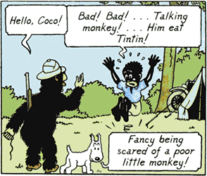
Furthermore, Congolese adults are depicted either as stupid clowns or as duplicitous tricksters, draped in leopard skins and gaudy loincloths, and carrying shields and spears. A monkey that appears briefly in the story is accorded as much intelligence as the Africans. The analogy is impossible to miss.
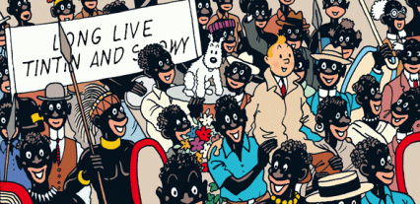
Above all, the African characters are ignorant less than human savages easily influenced and dominated by Tintin and Snowball. Taken all together, the illustrations of Africans are inhumane, hostile, offensive, stereotypical, and racist.[18] The Commission for Racial Equality (CRE) was a non-departmental public body in the United Kingdom which aimed to address racial discrimination and promote racial equality. The commission was established in 1976, and disbanded in 2007 when its functions were taken over by the newly created Equality and Human Rights Commission.[19]
The CRE received a complaint from a member of the public who saw the book in a branch of Borders chain and urged Borders and all other bookshops to remove the “Congo” book, saying it made black people “look like monkeys and talk like imbeciles”.[20] In 2007, the CRE agreed with the complainant and claimed “Tintin In The Congo” depicted “hideous racial prejudice” and that it should be removed from sale.[21] Bookstore chain Borders said it has removed copies of a book about Belgian comic’s hero Tintin’s adventures in Africa from the children’s section of its U.S. stores, as well as British outlets, amid allegations of racism.
Belgium and the African Holocaust
Allegations of racism surrounding the Tintin book are deeply sensitive in Belgium, where the cartoon reporter and his dog Snowy are a rare national symbol and for a nation whose post-colonial guilt over Belgian’s record of genocidal crimes against humanity in the Congo is acute.
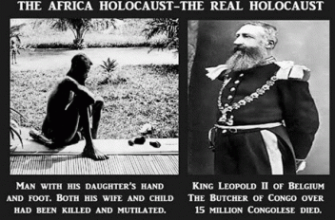
Behind the Tintin and Snowball bull, the horror and atrocities that Belgian committed against the Congolese people is so frightening and horrifying that its inhumanity to man is virtually beyond belief.

The Congo remained a Belgian colony until 1960 and between 1885 and 1908 the country was brutally run as the personal fiefdom of Belgium’s King Leopold II. Between 8 (eight) to 10 (ten) million Congolese are believed to have been savagely mass murdered in this period.
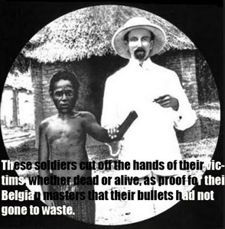
Moulinsart, Avenue Louise 162 BTE 7, Brussels, B-1050, Belgium, Tintin’s publisher argues that the book “must be seen as a document of the time“. “In his portrayal of the Belgian Congo, the young Hergé reflects the colonial attitudes of the time. He depicted the African people according to the bourgeois, paternalistic stereotypes of the period,” said a statement.[22] Tintin’s bourgeois, paternalistic stereotypes of the period were used to justify the massive genocidal crimes Belgium committed against the Congolese people.
On February 10, 2012, a court in Belgium rejected “an application to ban a colonial-era” children’s book, Tintin in the Congo. The court stated, “It is clear that neither the story, nor the fact that [the book] has been put on sale, has a goal to…create an intimidating, hostile, degrading or humiliating environment.”[23]
Well that’s interesting. It’s like asking Nazi Germany and Third Reich to judge itself for crimes against humanity by a jury of SS- Knights of the Black Sun. Try pitching Tintin in the Congo to global masses of color today, right now and watch it create an instant “intimidating, hostile, degrading or humiliating environment” for anybody promoting this BELGIUM racist S.H.I.T among our children.
Recently, I discovered that over 70% of my DNA is linked to the Bantu of the Congo. My ancestral homeland is the primarily Congo. So, I am personally deeply affected and offended by a colonial, mass murdering and enslaving nation such as the Belgium finding any justification for mass Simianizing the Congolese people to dehumanize, enslave, exploit, and commit mass genocide against them. I say this. Tintin in the Congo had better stay in the BELGIUM. As far as Belgium’s Crimes against Humanity in the Congo, it is not over.
VI
THE SIMIAN & THE NEGRO COON
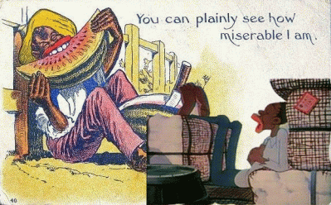
The Negro Coon Caricature and Metaphor has to be one of the most dehumanizing, degrading and humiliating of all black caricatures. Coon is an abbreviation of an animal– raccoon. The universal direct visualization of adult blacks as less than human naturally implants notions that blacks are less humanly evolved and civilized than whites. Around the turn of the 19th century, the animals that became most popularly visually associated with blacks as a race were not raccoons, but apes (hominoid) and monkeys (simian).
The exaggerated black skinned, enormous big lip and big eyed simian and hominoid caricatures are deliberate illusionary visual implants that directly link blacks with monkeys and apes as yet another way that the antebellum South justified African Human Bondage; and destruction of their humanity and sense of self-worthiness of those enslaved. Blacks were fundamentally considered by white supremacists to be more universally simian and hominoid than human, and therefore had no self-evident rights of mankind, including freedom that they were bound to respect.
VII
THE SIMIANIZATION OF THE PICNICKINGS
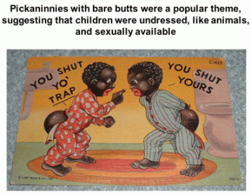
Pickaninny is, in North American usage, a racial slur which refers to a depiction of dark-skinned children of African descent also with simian and hominoid exaggerated black skin, enormous big red lips and big bug eyes. It is a racist and derogatory caricature, whose meaning and usage also grew to fruition in the antebellum South, where the institution of African Slave Trade and Human Bondage existed against the law of nature.
Don’t overlook the wicked demonic dehumanization of Black Children to justify overlooking their sexual abuse and exploitation as less than human.
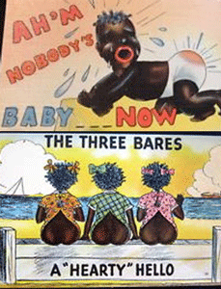
If you think dehumanizing Black Children to justify their sexual abuse during the turn of 20th century is outrageous nonsense, think again. Black Children even as infants were considered real threats and exterminated in self defense of the white race.
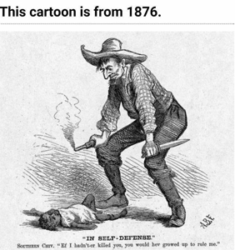According to the scholar Robin Bernstein, who describes the meaning in the context of the U.S, the Pickaninny is characterized by three qualities: “the figure is always juvenile, always of color, and always resistant if not immune to [human] pain“. These three qualifiers demonstrate the dehumanizing nature of the Pickaninny caricature and are reflective of the predominantly colonial society in which its use was promoted and popularized.
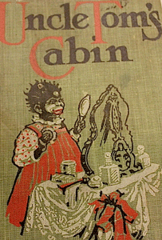
The use of the term was popularized in reference to the Caricature of Topsy in the 1852 book Uncle Tom’s Cabin.[24]
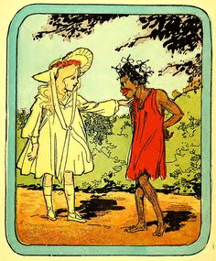
The Ugly and Gruesome Pickaninny Topsy Caricature– threat her as such.
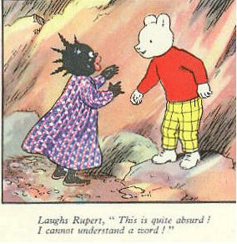
The Less than Human Black Pickaninny Topsy Caricature too stupid to the master human language- Exterminate Her.
VIII
THE BLACK SAMBO AND THE WORLD
The name became especially associated with the children’s book “The Story of Little Black Sambo” by Scottish– British colonialist Helen Bannerman, published in 1899.
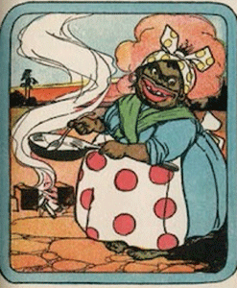
It is the racist story of a black boy named “Sambo” with a big “Black Mammy” who outwits a group of hungry tigers. Bannerman also wrote Little Black Mingo, Little Black Quasha, and Little Black Squibba. In this book, Sambo is supposed to be the name of a boy of Southern India, but it’s a classic racial caricature of the African child. Don’t get it twisted. I am saying that Africans aren’t indigenous to India.
Originator God Ashur (Osiris) of the Land of Kemet
The Brahma Samhita is a Sanskrit Pancaratra text composed of verses of prayer spoken by Brahma glorifying the supreme Lord Krishna or Govinda at the beginning of creation. The lyrics, chapter 5 verse 38 reads: “I worship Govinda, the primeval Lord, who plays on His transcendental flute. His eyes are like lotus flowers, He is decorated with peacock plumes, and His bodily color resembles the color of a fresh black cloud, although His bodily features are more beautiful than millions of Cupids.”[25]

Dr. Runoko Rashidi:
ANCIENT AFRICA AND EARLY INDIA
Exceptionally valuable writings reflecting close relationships between Africa and early India have existed for more than two thousand years. In the first century B.C.E., for example, the famous Greek historian Diodorus Siculus penned that, “From Ethiopia he (Osiris) passed through Arabia, bordering upon the Red Sea as far as India…. He built many cities in India, one of which he called Nysa, willing to have remembrance of that (Nysa) in Egypt, where he was brought up.”
Another important writer from antiquity, Apollonius of Tyana, who is said to have visited India near the end of the first century C.E., was convinced that “The Ethiopians are colonists sent from India, who follow their forefathers in matters of wisdom.” The literary work of the early Christian writer Eusebius preserves the tradition that, “In the reign of Amenophis III [the mighty Dynasty XVIII Egyptian king] a body of Ethiopians migrated from the country about the Indus, and settled in the valley of the Nile.” And still another document from ancient times, the Itinerarium Alexandri, says that “India, taken as a whole, beginning from the north and embracing what of it is subject to Persia, is a continuation of Egypt and the Ethiopians.”
INDIA’S EARLIEST CIVILIZATION
In Greater India, more than a thousand years before the foundations of Greece and Rome, proud and industrious Black men and women known as Dravidians erected a powerful civilization. We are referring here to the Indus Valley civilization- -India’s earliest high-culture, with major cities spread out along the course of the Indus River. The Indus Valley Civilization was at its height from about 2200 B.C.E. to 1700 B.C.E. This phase of its history is called the Harappan, the name being derived from Harappa, one of the earliest known Indus Valley cities.
In 1922, about 350 miles northeast of Harappa, another large Indus city, Mohenjo-daro (the Mound of the Dead) was identified. Mohenjo-daro and Harappa were apparently the chief administrative centers of the Indus Valley complex, and since their identification, several additional cities, including Chanhu-daro, Kalibangan, Quetta and Lothal have been excavated.[26]

Mohenjo-daro Queen or Priestess (2500 BC)
The above statute recovered from the Indus Valley is popularly known as the Dancing Girl of Mohenjo-daro. During the early 20th century, they labeled her a dancing slave girl because of her Black African- ness. However, they soon had to back away from that. Her arm from the shoulder down contain most likely gold bangles that is a sign of great wealth and prestige. Ancients don’t make statutes and build altars to slaves, but goddesses and revered historical spiritual figures like great priestesses and queens. One thing is clear, nobody appears to be in a hurry to uncover her true role in Mohenjo-daro.
As we say about sassy young beautiful sisters. Even 5,000 years ago, you can’t tell her NOTHING about NOTHING! There are also Sumerian texts that refer to trading done with the “People of the Black Land” or the “Meluhhaites”, which many historians believe refers to the Indus Valley Civilization — these date back as far as 2000 BCE.[27]
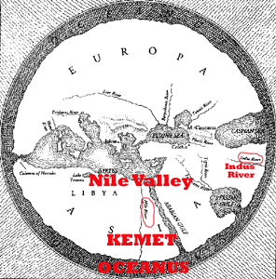
The ancient Egyptians (Egypt- Greek) referred to their land as “Kemet” which means “Land of the Blacks”. Western historians and non-blacks argue that the word “Kemet” refers to the color of the soil of the land rather than its people. But, the word “Kemet” is actually an ethnic term being a derivative of the word “Khem” (Cham or Ham) which means “burnt” or “black.”[28]
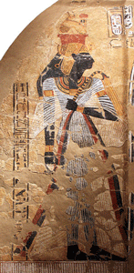
The Great Ahmose–Nefertari (1562- 1495 BC), the First Queen of the 18th Dynasty, and many others of the ancient “Land of the Blacks” answered that question.[29]
Queen Ahmose-Nefertari and Pharaoh Ahmose (Amosis I, “Amenes” and “Aahmes” meaning Born of God Ashur (Osiris)), these are the founders of the New Kingdom 18th Dynasty Golden Age who liberated the “Land of the Blacks” from the barbaric Hyksos foreign desert horde invaders in 1550 BC. The Great Queen in her age-less infinite divine wisdom left us overwhelming substantial visual evidence from that time that does not substantiate any notions of false African Negro-Ape Metaphors.
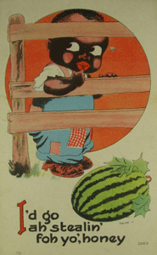
The Sambo Caricature is usually a little black skinned boy or black skinned childlike Negro adult male with the same exaggerated lips and big bug eyes that represent the less than human simianized African character.
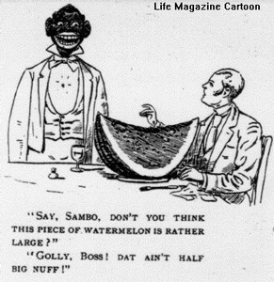
The adult Sambo too is grotesque, lazy, good for nothing, silly and stupid. It is afraid of the dark and large animals. He is happily content with his condition of utter abject poverty living off the genius, paternalism of his master and white society. The Black Sambo lacks the ability to sort out his affairs, live on his own, or care for a wife and family. The slow-witted and humorous Black Sambo character is associated with trickery, thievery, pancake- watermelon eating and stealing chickens.[30] In the meanwhile, the Mohenjo-daro queen, Ahmose-Nefertari, and Pharaoh Ahmose goes into the basement vault. You will not see or discuss any of them during Black History Month. Why?
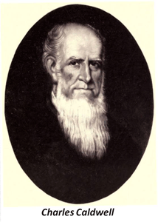
In the mid-nineteenth century, a group of American scientists known collectively as the “American School” of ethnology challenged the validity of the biblical story of creation. They proposed that, contrary to the teaching of Genesis, there had been a number of separate divine acts of creation, leading to the appearance of more than one human species within the genus homo. They ranked the species, also known as varieties or races, in terms of relative superiority, with the Caucasian in the highest position of all.
In a book published in 1830, Thoughts on the Original Unity of the Human Race, Dr. Charles Caldwell, a Kentucky plantation enslaver of Africans, theorized that humanity did not originate from one single place but from multiple acts of creation in different places across the planet. Caldwell’s book is the earliest nineteenth century American work to propose the concept of the plural origin of species of humanity, known later as POLYGENISM. Caldwell’s “New Focus” theorized that the human species had always been immutable and would not change in the future.
Caldwell’s foundation on the innate superiority of the Caucasian race depended on a hypothesis that all great civilizations since ancient times were Caucasian. Caldwell argued that no point in time can be indicated when the Caucasians were real savages.
According to the American School, the originators of the Egyptians and the Indus Valley were white because all advanced civilizations were white. The presence of Black Africans in any advanced civilizations other than slaves, domestics and entertainers of whites would naturally undermine the American School claims of white supremacy, bar none.
Crania Americana (phrenology- study of skulls) became the standard tool of reference for ethnologists and natural historians with an interest in humanity’s origins. From the study of ancient crania “skull” and ancient frescos evidence in Egypt, the American School concluded that slavery had been widespread in Egypt, and the presence of blacks in Egypt only showed Caucasian rulers with Negro slaves. Ancient Egypt was proof positive that slavery was a natural state for an inferior race like Negroes in advanced ancient white civilizations.
Dr. Caldwell proposed that man should not tyrannize the lower creatures since even they have their rights. Just as man has a duty to protect womankind, he should also protect the lower races, since not all of them have the same rights and entitlements as the higher races. The Caucasians should not enslave the Africans simply because they are able to do so. However, the inferior races such as Negroes had their natural place in advanced societies as demonstrated by history to primarily serve the higher Caucasoid master races. (see Robert A. Smith, Pittsburgh State University, Types of mankind: polygenism and scientific racism in the nineteen century U.S. scientific community)
IX
BLACK SAMBO, GET OUT & THE 2018 OSCARS

Implanted deeply inside HollyWeird’s “Get Out” is a Black Sambo Caricature that nobody seems able to explain.
Above, Jordan Peele actually flaunts the Black Sambo Caricature as a subliminal internal part of the true theme of the movie that even he may not clearly understand.

Ask him about the Black Sambo Mask. He might tell somebody about what the Black Sambo Caricature means. In the meanwhile, a mask in this sense usually explains duality. In this case from the artist’s facial expression of Chris, it is a painful Sambo innate duality that he cannot escape. It is “immutable“(unchanging over time or unable to be changed). Discussed further below.

In the meanwhile, Peele told you in a roundabout way about the meaning of the Sunken Place that you cannot escape from no matter how hard you screen.

Pay extreme close attention to the chair with hand or arm chairs in Jordan Peele’s “Get Out” poster background.
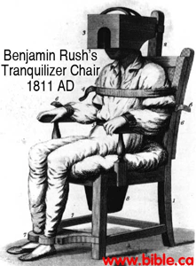
Dr. Charles Caldwell (1772- 1853) had been a student of alchemist Freemason Dr. Benjamin Rush (1745- 1813).
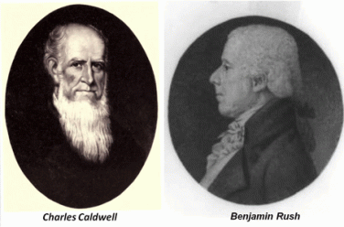
While black folks were asleep at the movies watching Quentin Tarantino’s American slavery era Django Unchained, the DEVIL, HollyWeird, Tarantino and Leonardo DiCaprio played a wicked trick on their minds.
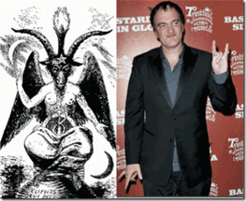
They slipped and implanted the racist Dr. Charles Caldwell and the American School of Ethnology into their subconsciousness.
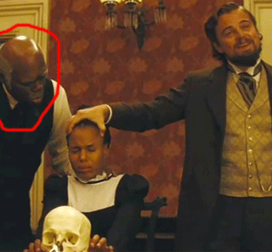
HollyWeird Trick- Make the Negro Look Like a Monkey!
“Why don’t they kill us?” asks African enslaver Calvin Candie (Leonardo DiCaprio), he wants to know why the African slaves he brutalizes do not rise up and take revenge. He has the “skull” of a recently murdered black African on the dinner table. “The Science of Phrenology,” Candie announces, “is crucial to understanding the separation of our two species.” He hacks away at the back of the skull with a saw, removing a section of the cranium and pointing to an allegedly enlarged area. In Africans, Candie claims, this bump is found in the region of the brain associated with “submissiveness“.
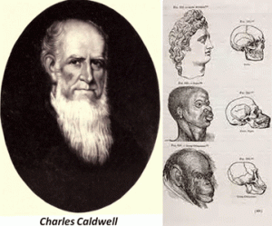
During the Revolutionary War era, Dr. Benjamin Rush was a clandestine member of the Sons of Liberty. They were Freemasons of St. Andrews Lodge of the Grand Lodge of Scotland at the Green Dragon Inn in Boston. Dr. Rush, a signer of the Declaration of Independence, believed that mad people could be calmed by blood-letting from 20 to 40 ounces of blood at one time. Dr. Rush then developed a “tranquilizer chair” in 1811. This invention efficiently kept a person securely immobile and had a wooden box in which their head would be put into in order to keep the person subdued. Dr. Rush was the first to describe a pathological incurable medical condition called “NEGROTUDE”.
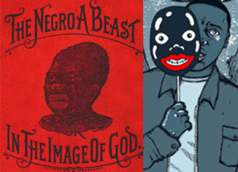
Dr. Rush’s Immutable Negrotude & Chris
Negrotude was a mild form of leprosy which symptoms included such as blackening of the skin; big lips, flat nose, wooly hair. The only evidence of a cure from Negrotude was when the “skin turned white”. Dr. Rush used “disease” as a justification for African slavery and racial segregation. Negrotude was an immutable genetic disease that allowed blacks only to be medically cleared for domestic work who had to be sexually segregated.
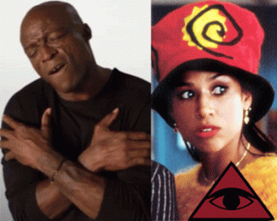
Recently, British Music Entertainer (Nigerian descent) Seal (Henry Olusegun Adeola Samuel) and American “Clueless” Artist Stacey Dash got into it. Seal told Stacey, “You live in the Sunken Place”- a reference to Peele’s “Get Out“. Stacey is a conservative with an Anti-Black-everything philosophy. Even white people call Stacey a “white supremacist.”

Stacey Dash is generally known to be one of Dr. Benjamin Rush’s perfect examples of a “Negro Turned White” that Seal associated with Get Out’s MK ULTRA/MONARCH trauma-based tranquilizer chair and torture chamber, the “Sunken Place”.

Days after the Oprah Winfrey’s super “Negro” Golden Globes speech highlighting the campaign against sexual misconduct, Seal claimed the global celebrity is a hypocrite and “part of the problem for decades“.
Saturn Sex Cult Kabbalist Harvey Weinstein & Oprah Winfrey
In other words, Oprah sucks up all HollyWeird’s satanic Masonic/Kabbalah ritual sex ritual crimes like that “Magic Negro” in the Green Mile.
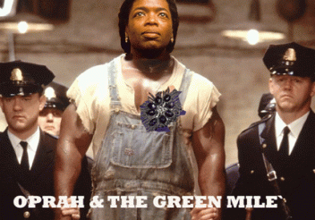
Well, Seal immediately retracted any notion that he called Oprah a “hypocrite“, but went after a less powerful black female target like Stacey Dash for supporting the backlash against him for attacking Oprah.
Well, I don’t think Seal will open his mouth again about Oprah, or the American “Sunken Place.” In her defense to living in the”Sunken Place“, Stacey Dash has not, and will not go there, either.

KEMET LAND OF THE BLACKS’ GOD PTAH & OSCAR
“Get Out” got HollyWeird’s film industry nods with 4 (four) 2018 Oscar nominations. It received nominations for best picture for producers Sean McKittrick, Jason Blum, Edward H. Hamm, Jr., and Jordan Peele; best actor for Daniel Kaluuya; and best director and original screenplay for Peele. If any of them win, they should share their award with the CIA Occult Bureau that helped ghost write the movie script.[31]

Is “Get Out” really a BLACK SAMBO comedy movie and something to laugh at, not for you and me, but somebody else?

In the beginning of the film “Get Out”, Rose hit a deer driving Chris (Daniel Kaluuya) upstate to her parents’ estate. Rose’s father, Neurosurgeon Dr. Dean Armitage praises her for hitting the deer and goes on to rant about how deer are “rats” and are “destroying the ecosystem“.[32] Dean is the son of Roman and Marianne Armitage, the husband of Missy (MK ULTRA hypnotist), and the father of Rose and Jeremy. He describes himself as a [world] traveler- code words for CIA.
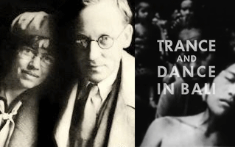
Roman has been to Bali. Bali is a code word for OSS/CIA MK ULTRA/MONARCH anthropologists Brit Dr. Gregory Bateson and Margaret Meade. Ecosystem is the particular and specific coded human ecology language of Dr. Bateson.[33],[34] After losing the 1936 Olympics in Berlin to African American track athlete Jesse Owens, a jealous Roman Armitage perfected the transplantation of older white peoples’ brains into the bodies of young, healthy African Americans. He also founded the Order of the Coagula, a cult vying to achieve pseudo-immortality though this process. Roman raised Dean to become a neurosurgeon and continue the procedure for future generations. As such, an ailing Roman and Marianne were transplanted into the bodies of two African Americans, Walter and Georgina. They act as the family’s servants to avoid suspicion. Since then, the Armitages continued kidnapping and luring African Americans to be hypnotically prepped for Dean’s surgery. Dean himself was also raising his son, Jeremy, to be a neurosurgeon and the next leader of the cult.[35]
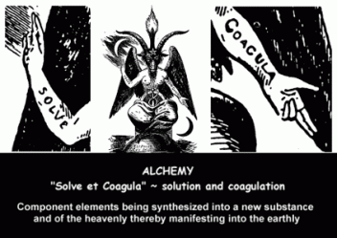
The Order of the Coagula is a reference to the alchemy secrets of Baphomet and the Knights Templar. The CIA- Old Boys network is an extension of the German Brotherhood of Death, and the Black Sun Teutonic Knights Templar- Reinhart Gehlen, SS Baron Otto Bolschwing, Josef Goebbels, SS Josef Mengele and SS-1 Heinrich Himmler.[36]
X
GET OUT & THE ANCIENT SATANIC RED/WHITE STAG TOTEM, SYMBOLISM, AND CULT
The totemic symbol of the deer is present throughout Get Out, beginning with Rose hitting one that was crossing the road in one of the first scenes in the film. Deer are also known as “bucks,” a term used to sometimes represent Black men.
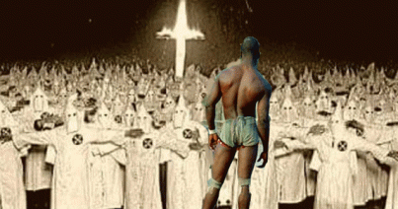
The Big Black Buck is another deep stereotypical racist black caricature. According to popular stereotypes during the post-Reconstruction era, “Black Buck” was a black man (usually muscular or tall) who defies white will and is largely destructive to American society. He is usually hot-tempered, excessively violent, unintelligent, and sexually attracted to white women. Most often, any attempt to restrain, reprimand, or re-educate the individual will fail, necessitating the individual’s immediate liquidation. David Duke, former Grand Wizard of the Ku Klux Klan, was quoted in The Sun newspaper of Wichita, Kansas (23 April 1975) as saying, “White people don’t need a law against rape, but if you fill this room up with your normal black bucks, you would, because niggers are basically primitive animals.” [37]

Chris, Sunken Place & the Spirit of the White Stag
Dr. Armitage’s rant about deer as “rats … destroying the ecosystem” is about the racial black bucks like Chris that the cult intends to covertly cull just like deer.
However, “Get Out” isn’t really exclusively about Chris and covert satanic plot against black people, particularly black males. There is a much bigger global picture, conspiracy and much deeper psychological warfare campaign against the masses.

In 1984, I got a call from a sister that I had always considered to be within a close circle of friends. She talked about the buzz coming out of black nationalist community about the recently released film, “The Brother From Outer Space [in Slave Rags].”
The first thing I did the following day was go see the movie. I had to walk away from it within 5 (five) minutes of its opening. It was about a runaway nappy head “black slave” from another planet who crashed landed in Harlem. I had subsequently concluded that she had been a clandestine CIA or NSC/NSA agent all the days that I had known her.
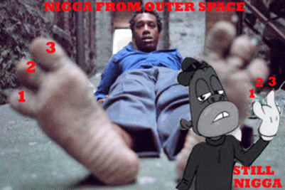
“The Brother From Outer Space” was a CIA mass psychological warfare project designed to create, influence, or alter certain perceptions within the subliminal subconscious of the masses. I am not sure what was supposed to happen to my psyche and subconscious if I watched the entire film. But, don’t get it twisted. I don’t think that I am smarter than these people. I don’t play with or underestimate them. And, I do not even attempt to try to match wits with these people. I am very much afraid of them. I immediately called her back that evening to tell her it was a very impressive film that I had enjoyed. I needed information out of her. However, she soon concluded that I wasn’t going along with the program, and had been fishing her for small bits of any information as pieces to the puzzle. I haven’t heard from her, again. I am really happy and glad, because she would have me assassinated, poisoned me with radium or LSD as they attempted to do during the late 1960s on the first opportunity she got.
The day will come when the masses will stop playing games with HollyWeird, and people like Jordan Peele. Our minds and psyche of our children are far too precious and fragile to be played with- particularly by the masters of mass population mind control, the CIA Occult Bureau.
19th Century Illuminati Rothschild Family Red Stag Antlers
“Get Out” is really about clandestine human ecosystems, eugenics and maintaining a pseudo-scientific white supremacy satanic hierarchical order; and blatantly flaunting it in our faces thru the Knights Templar CIA, HollyWeird and the satanic corporate mass media music- entertainment industry. “Get Out” the movie also openly flaunt the ancient secret Cult and Society of the White Stag.

The Great Stag has been worshiped as a humankind totemic animal since the Paleolithic period. Neolithic Cave art depicted that the stag was used for hunting and shamanistic spiritual practice by men or women dressed in deer hide and wearing antlers. In Welsh mythology, the Stag is one of the five oldest creatures in the world along with the blackbird, the owl, the eagle and the salmon.
The antlers of the stag are compared to tree-branches and thus may represent fertility. Since they are shed and re-grown every year, they may also symbolize rejuvenation and rebirth. Cernunnos, the Celtic Horned God, was depicted with the antlers of a Stag; he is said to be a god of fertility and plenty, and to be the Lord of the Beasts. Cernunnos, Herne and Ingvi-Freyr have all been linked with the Green Man, Lord of the Beasts and the Wild Hunt imagery. According to some, the Stag’s antlers symbolize a radiation of heavenly light. In Ugric legends, the Stag, son of the Heavenly Doe, steals the Sun between his antlers.

The symbol and reverence of the Stag amongst the Anglo-Saxons is a tradition that is very likely to be rooted in the most ancient of Germanic culture and religion. The reverence of Stags was already a strong custom even in the days of Saint Augustine (354- 430 AD), for he is quoted as condemning the “filthy practice of dressing up like a horse or stag”, a tradition that seems to resemble closely the English custom of hoodening.

ILLUMINATI Baroness Marie-Hélène de Rothschild in Diamond Encrusted Stag Horned Mask
The Stag stands for solitary nobility, honor and a strong commitment to the protection of their herd. The Stag is a symbol of protection and sexuality. They are extremely devoted to the care, and creation, of children. Stags focus on the balance of law and are rigid in their thinking on the issues of justice.

Like so many of the other animal symbols connected to the Anglo-Saxons, we only have to look at the Sutton Hoo Ship 6th – 7th century burial site for evidence. Sutton Hoo is the name of an area spread along the bank of the River Deben opposite the harbor of the small Suffolk town of Woodbridge, England about 7 miles (11 km) from the North Sea. Within the burial was found a spectacular sceptre that was topped off with a beautiful stag figure. The sceptre to the King who carried it symbolized his power and high status. And it could be that amongst the heathens the stag was regarded as the most noble and proud of animals, and would therefore be a most appropriate symbol of a King and his leadership. Extremely strong evidence pointing to the use of stag images, but not only their images, but the worship of stags too, is found in a quote from Saint Aldhelm (639-709 AD) who wrote to a friend the following:
…where once the crude pillars (ermula) of the same foul snake and the stag were worshiped with coarse stupidity in profane shrines.
A Study of the Celtic Meaning of the Deer; the Stag held a special meaning for the Celts. They believed they were part of the fairy world and had magical powers. Celts thought deer lived deep in the forest so that they could have Secret Knowledge.[38] In Celtic tradition, the role of the white stag is often to lead the hunters to new beginnings, new places, and new insights, new knowledge, and new spiritual awakening.[39]
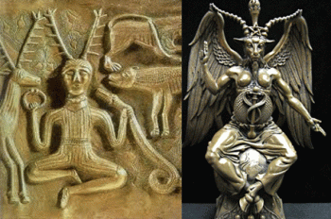
Cernunnos is the depiction of the “horned god” of Celtic polytheism. Cernunnos was a Celtic god of fertility, life, animals, wealth, and the underworld. It is depicted with the antlers of a Stag, often seated cross-legged like the Baphomet holding or wearing torcs (neck rings) known from over 50 examples in the Gallo-Roman period, mostly in north-eastern Gaul.[40] Ancient Gaul was France, Belgium, Luxemburg and parts of the Netherlands, Switzerland, Germany on the west bank of the Rhine, and the Po Valley, in present Italy.[41] Cernunnos is the Greek Horned God, Pan.

Like God Pan, Cernunnos is associated with the DEVIL and ANTICHRIST.[42]God Pan is also known as the Goat of Mendes and can be found today in the form of the horned goat God, made famous by the Knights Templars as the Baphomet. Master Freemason and Satanist, Albert Pike had written in Morals and Dogma;
“The Gnostics held that it [universal agent] composed the igneous [pertaining to fire] body of the Holy Spirit, and it was adored in the secret rites of the Sabbat or the Temple under the hieroglyphic figure of Baphomet or the hermaphroditic goat of Mendes.”[43]
Madison Grant & the Teutonic Knights of the Black Sun
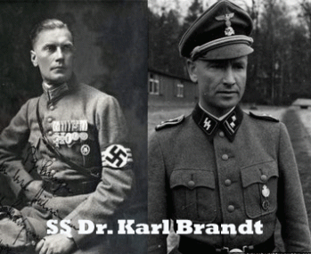
This brings us back to Ota Benga, the Twa- Batwa people of the Congo and Madison Grant. Here, we shall begin with SS-Gruppenführer und Generalleutnant der Waffen-SS Prof. Dr. med. Karl Brandt. At the Nuremberg Tribunal, SS Brandt was tried, convicted and executed as a Nazi war criminal for conspiracy to commit war crimes. He had been a Teutonic Knight of the Black Sun, and Adolf Hitler’s personal physician and the most important and powerful medical authority in the Third Reich.
In his defense, SS Brandt entered into evidence sitting forth U.S. government authority and policies that officially supports the elimination of inferior peoples- Madison Grant’s “The Passing of the Great Race: Or, The Racial Basis of European History” (1916).[44]
Grant was an elite patriciate (noble order and class) of wealthy Dutch colonialists that founded the island of Manhattan, NY in the early 17th century. During his formative years, he traveled the world. He once sat on the crumbling walls of Ancient Troy and chanted Homer’s Iliad. He must have ignored chanting anything about the War between the Twa and Cranes.
Greek geographers and writers attempted to place the Twa (Pygmies) in a geographical context. Sometimes they were located in far India, at other times near the Ethiopians of Africa. According to Homer’s Iliad, they were involved in a constant war with the cranes, which migrated in winter to their homeland on the southern shores of the earth-encircling river Oceanus. One story describes the origin of the age-old battle, speaking of a Twa Queen named Gerana who offended the goddess Hera with her boasts of superior beauty, and was transformed into a crane.[45]
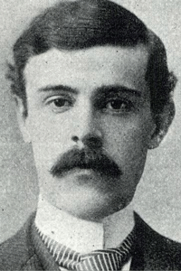
Madison Grant
At 16 years old (1881), Grant was sent to Dresden, Germany, where he was educated by private German tutors. He visited all the zoos and most of the history museums of the continent and through-out North Africa and the Middle East.

Teutonic Knights Moritizburg Castle
His most significant European initiation into a secret knight Templar order and ancient elite White/Red Stag Cult took place at the Moritzburg Castle built between 1542 and 1546, the Baroque hunting lodge for the ILLUMINATI “Rich and Famous” and the super-secret elite just outside Dresden.
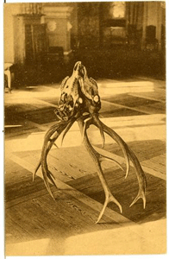
Moritzburg Castle Secret Antler Ritual
The castle is described as a Teutonic Knight (Order of Brothers of the German House of Saint Mary in Jerusalem) Architecture Castle.[46]

Moritzburg Castle’s Dining Room
Its’ collection of red deer antlers is one of the most important of its kind. The castle’s largest collection of antlers is shown in the Speisesaal (“dining room”).

Most of its 71 trophies are between 270 and 400 years old; they were purchased or acquired as presents.
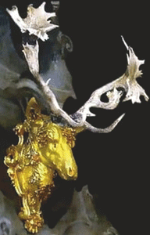
Frederick III’s 66 Point Red Antlers
Among them is the heaviest red deer antler in the world, weighing 19.8 kilograms (44 lb) and spanning almost 2 metres (6.6 ft). In the Monströsensaal (“monstrosity room”), there are 39 contorted antlers. One specimen, a 66-point red deer antler is from an animal killed by Elector Frederick III of Brandenburg (House of Hohenzollern) in 1696.[47] The Duchy of Prussia was inherited in 1618 by the House of Hohenzollern who ruled Brandenburg. Several members of the House were Grand Masters of the Teutonic Order.[48]
The deer’s antlers are one of the characteristics that have made it the figure of a spiritual superiority, according to some. Like a crown, the antlers grow beyond its body, bringing it closer to the sky and making it sacred. In many cultures, the deer is a symbol of spiritual authority. During a deer’s life the antlers fall off and grow again and the animal is also a symbol of regeneration.[49]
Grant was also a member of the Military Order of the Loyal Legion listed as one of the ILLUMINATI/Occult branches and sub branches that secretly control our governments, businesses and churches from the local, state, federal and worldwide levels.[50] He also was a member of elite secret orders of the St. Nicholas Society of Manhattan, Society of Colonial Wars, and the Boone and Crockett Club largely comprised of eugenicists and eugenics sympathizers.[51] Madison Grant was part of America’s secret ruling elite power control satanic cabal that had/have the secret authority to identify a problem, devise a solution, get congress to legislate his solution, and the president to sign it even if it involves MASS RACIAL GENOCIDE.
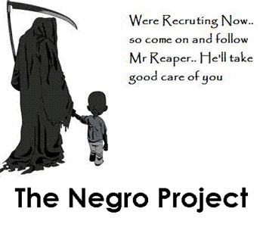
The Knights Templar Masonic/Satanic secret Cult of the White Stag and CIA Occult Bureau is behind “Get Out.”

We all need to be afraid of that. I HAVE SAID ENOUGH!
___________________________________________________________________________________________
[1] https://www.etymonline.com/word/metaphor
[2] https://en.wikipedia.org/wiki/Cleveland_Indians_name_and_logo_controversy
[3] Id.
[4] https://www.theguardian.com/world/2015/jun/03/the-man-who-was-caged-in-a-zoo
[5] http://www.allempires.com/forum/forum_posts.asp?TID=35257
[6] file:///C:/Users/PrinceRay/Downloads/56960-114154-2-PB.pdf
[7] https://www.rt.com/news/336335-ota-benga-caged-pygmy/
https://en.wikipedia.org/wiki/Madison_Grant [8]
[9] http://watch.pairsite.com/reich.html
[10] https://en.wikipedia.org/wiki/Madison_Grant
[11] https://meetmythamerica.wordpress.com/2014/07/26/hitlers-bible/
[12] https://www.angelafranks.com/margaret-sanger-and-planned-parenthood/2016/11/14/american-eugenics-society-and-sanger
[13] https://www.counterpunch.org/2012/02/15/tintin-and-racism/
[14] https://www.theguardian.com/commentisfree/2011/nov/04/tintin-in-the-congo
[15] http://writing.rochester.edu/celebrating/2015/FinalPaper_Lucas_Leopold’sCongo.pdf
[16] http://africasacountry.com/2012/04/the-adventures-of-tintin-in-the-land-of-the-law/
[17] https://blogs.baruch.cuny.edu/shmuelmodernimperialism/?page_id=47
[18] https://www.counterpunch.org/2012/02/15/tintin-and-racism/
[19] https://en.wikipedia.org/wiki/Commission_for_Racial_Equality
[20] https://www.reuters.com/article/us-books-tintin/tintins-troubles-in-the-congo-spread-to-u-s-idUSN1725600020070717
[21] http://www.telegraph.co.uk/news/uknews/1557233/Ban-racist-Tintin-book-says-CRE.html
[22] http://www.telegraph.co.uk/news/worldnews/1559792/Tintin-book-accused-of-colonial-racism.html
[23] https://www.counterpunch.org/2012/02/15/tintin-and-racism/
[24] https://en.wikipedia.org/wiki/Pickaninny
[25] https://selfuni.wordpress.com/category/african-aryan/
[26] https://tseday.wordpress.com/2008/08/24/the-african-presence-in-india-by-runoko-rashidi/
[27] http://www.ichrindia.org/golden-age-indus-valley-civilization/
[28] http://www.topix.com/forum/afam/T2OTBS4EEA84MJ67P/p2
[29] https://en.wikipedia.org/wiki/Ahmose-Nefertari
[30] https://wsimag.com/economy-and-politics/31924-the-brute
[31] http://variety.com/2018/film/news/oscars-get-out-nominations-jordan-peele-1202673724/
[32] http://villains.wikia.com/wiki/Dean_Armitage
[33] http://911nwo.com/?p=3895
[34] https://link.springer.com/chapter/10.1007/978-1-4020-6706-8_11
[35] http://villains.wikia.com/wiki/Dean_Armitage
[36] https://www.cia.gov/library/readingroom/docs/CIA-RDP90-00845R000100170004-5.pdf
[37] https://en.wikipedia.org/wiki/Black_Buck
[38] http://www.astrologyoftheancients.com
[39] https://ztevetevans.wordpress.com/2014/04/26/mythical-beasts-the-white-stag/
[40] https://en.wikipedia.org/wiki/Cernunnos
[41] https://www.ancient.eu/gaul/
[42] https://gnosticwarrior.com/cernunnos.html
[43] Id.
[44] https://en.wikipedia.org/wiki/The_Passing_of_the_Great_Race
[45] https://en.wikipedia.org/wiki/Pygmy_(Greek_mythology)
[46] http://maxpixel.freegreatpicture.com/Castle-Architecture-Castle-Of-The-Teutonic-Knights-416847
[47] https://en.wikipedia.org/wiki/Moritzburg_Castle
[48] https://en.wikipedia.org/wiki/Albert,_Duke_of_Prussia
[49] http://www.faena.com/aleph/articles/notes-on-the-symbolism-of-deer/
[50] https://www.facebook.com/killuminatisoldierssnwoll/posts/985989318104166
[51] https://www.amren.com/news/2010/07/madison_grant_a/
Comments : 2 Comments
Tags: 2018 oscars, Adolf Hitler, africa, african holocaust, Ahmose I, Ahmose-Nefertari, American Eugenics Society, American School of ethnology, aryan magic, ashur, Averell Harriman, bali, Baphomet, Baron Otto Albrecht Alfred von Bolschwing, batwa people, Belgium, black buck caricature, black caricatures, Black Knight Masonic Panther Squad, black liberation movement, black mammy, black nationalism, black panther, Black Panther Party for Self Defense, blue pill, bobby seale, bosko, Calvin Candie, Caucasian race, Chadwick Boseman, chief wahoo, CIA, CIA MK ULTRA/MONARCH, cia occult bureau, cleveland indians, coco, congo, crimes against humanity, Dancing Girl of Mohenjo-daro, dark satanic circle, devil, Django Unchained, donald j. drumpf, donald trump, donny hathaway, Double bind, Dr. Benjamin Rush, Dr. Charles Caldwell, Dr. Dean Armitage, Dr. Gregory Bateson, Dr. Martin Luther King, Dr. Runoko Rashidi, Dravidians, Edward H. Hamm, Equality and Human Rights Commission, escapism, Eugenics, freemasonry, freemasons, Georges Remi, georgina, get out, ghetto boy, god bes, god pan, GOD PTAH, grand lodge of scotland, greek mythology, Green Dragon Inn, green mile, Harappa, harvey Weinstein, Hauptsturmführer SS Josef Mengele, Heart of Darkness, Heinrich Himmler, Helen Bannerman, Hennes & Mauritz, Henry Olusegun Adeola Samuel, herbert heanes, herbert hoover, Hergé, hollyweird, horned green god, horus, Huey P. Newton, hyksos, imperialism, india, indus valley, Indus Valley civilization, International Committee of Eugenics, j. edgar hoover, jason blum, jay z, jaybo, joey bishop, john frey, jordan peele, josef goebbels, Joseph Conrad, Jr., kabbalah, kemet, ken freeman, Knights of the Black Sun, knights of the ku klux klan, knights templar, Land of the Blacks, Leonardo DiCaprio, little black sambo, little bobby hutton, Lucifer, luciferians, maat, madison grant, margaret mead, Margaret Sanger, marlon brandon, marvel comics, MASTER OF THE BEASTS, Merritt Junior College, mind control, missing link, missy armitage, MK-ULTRA, Mohenjo-daro, Monarchs, nazi german luger, Nazis, negro ape metaphor, negro caricatures, Negro Coonery, negro coons, negrotude, nile valley culture, OAKLAND, oakland police officers association, Oprah Winfrey, Order of the Coagula, Osiris, Ota Benga, panther squad, paranoid fantasy schizoid-ism, Phrenology, pickaninnies, Pickaninny caricature, pickaninny caricatures, POLYGENISM, princeray, psychological warfare, pygmy, quentin tarantino, Quincy jones, racial micro-aggression, racism, Ramesses the Great, red pill, Reichsfurhrer Heinrich Himmler, Reinhart Gehlen, richard pryor, rose armitage, Sambo Caricature, samson b. mullins, satan, Satanism, scottish rite, Seal, Sean McKittrick, Set, Seth, shithouse, sncc, snowball, sons of liberty, Spirit of the White Stag, SS, SS Baron Otto Bolschwing, St. Andrews Lodge, stacey dash, stokely carmichael, sunken place, teutonic knights, the green mile, the green one, Theodore Roosevelt, tintin, Tintin Au Congo, topsy, tranquilizer chair, twa people, u.s. trademark, walter, white racism, WHITE STAG TOTEM, white supremacy
Categories : african american satanic cult, Ahmose I, Ahmose-Nefertari, ALL SEEING EYE, Aryan Supremacy, aset, ashur, black institutions, Black Panther Party for Self Defense, blood sacrifice, bobby seale, bohemian club, bohemian grove, CIA, cyberneticist, cybernetics, cyborgs, devil, devil's horns, divine one, donald j. drumpf, donald j. trump, donald trump, donny hathaway, double bind, Dr. Gregory Bateson, dr. martin luther king, jr., dualism, edgar j. hoover, egypt, Eye of Horus, Eyes Wide Shut, fbi, freemason, freemasons, genocide, Heinrich Himmler, Hip Hop, huey p. newton, human bondage, Human ecology, illuminati, illuminati sacrifice, J. Edgar Hoover, jay z, jay-z, Josef Mengele, kemet, Knights Hospitaller, Knights of the Black Sun, Knights Templar, Little Bobby Hutton, Martin Luther King, masonic sacrifice, mind control, MK-ULTRA, modern slavery, Molech, Moloch, monarch child, monarch program, oakland, oakland police department, opd, Oprah Winfrey, order of teutonic knights, oscars, Osiris, pan, panther squad, psychotronics, racial mass murder, Reichsfurhrer SS-1 Heinrich Himmler, Ritual Satanic Abuse, ritual satanic sexual abuse, ritually abused children, Rosicrucian, Rosicrucianism, satan, Satanic Global High Cabal, Satanism, scottsish rite, set, seth, slavery, SS, SS Baron Otto Albrecht Alfred von Bolschwing, stokely carmichael, trauma-based mind control, underground reich, underground third reich, Walt Disney

U.S. TRADEMARK PROTECTION, JAY Z, JAYBO- NEGRO SIMIAN HOMINOID CARICATURE, SATANIC MONKEY GODS & TRIBES
29012018
I
JAY Z, SATANISTS, THE MONKEY & 4:44
I didn’t know about Jay Z and the Jaybo Monkey Caricature for mass global exploitation and consumption until just a couple of days ago. On his recent high profile international corporate mass media appearance on CNN’s Van Jones Show just before the 2018 Primetime Emmy Awards ceremony, they didn’t discuss Jaybo, the Simian Hominoid Caricature. However, Jay Z’s album “4:44” featuring Jaybo leads all artists with 8 (eight) nods (nominations).
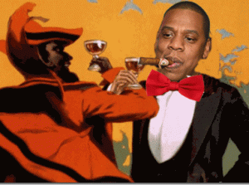
Jay Z’s soul was up for sale long ago.
Jay Z is a Satanist, a Crowleyite- follower of Aleister Crowley. The Great BEAST 666 Aleister Crowley was a vicious racist. The Equinox (subtitle: “The Review of Scientific Illuminism“) is a series of publications in book form that serves as the official organ of the magical order A.A. founded by Crowley. In texts, Crowley makes two very startling direct occult associations of simian and hominoid with black people.
“The servant of Hermes, a negro uglier than an ape.” (Adonis, published in The Equinox, Vol. 1, No. 7)
“HERMES. Bring the old Chian. Hanuman! [The negro goes to obey. This joke- Is the accepted way of scaring folks …. ” (Adonis, published in The Equinox, Vol. No. 7)
Hermes, the God of Wisdom, known in Egypt, Syria, and Canaan as THOTH. The commonest symbolic forms of Thoth’s attendant, the dog-headed (hominid) APE. In the Judgment Scene of the Book of the Dead the dog-headed APE (Āān) is seated on the top of the beam of the Balance in which the heart of the deceased is weighed; his duty apparently is to watch the pointer and tell his master Thoth when the beam is level. Elsewhere, it symbolizes the equinoxes; but this does not explain the APE.
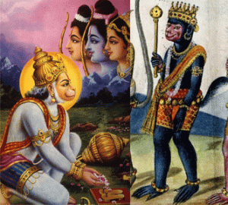Part human-part monkey, Hanuman is a central character in the Hindu epic Ramayana. He is generally depicted as a man with the face of a (simian) monkey and a long tail. The Ramayana describes him as an ideal devotee of Lord Ram. According to the epic, Hanuman and his vaanar sena – an army of monkeys – help Ram in his battle against Ravana, the Sri Lankan demon king who kidnaps his wife Sita.
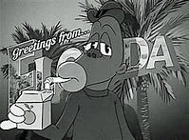Jaybo, the Simian Hominoid Caricature is very similar to both Hanuman, and the Ape of Thoth.
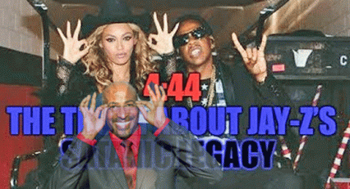Black Satanic Cult Brotherhood 666- Van Jones, Beyonce & Jay Z
Beyonce and Jay Z are extremely scary advanced high level and elite Satanists. Vann Jones is a fellow at The Institute of Noetic Sciences (IONS)- a secret high level affiliate and front of the CIA Occult Bureau. According to Jack Sarfatti, a “very, very sophisticated and successful covert psychological warfare operation run by the late Brendan O Regan of the Institute of Noetic Sciences and the late Harold Chipman who was the CIA station chief responsible for all mind-control research in the Bay Area in the 70s.”
Former NASA astronaut Edgar Mitchell, founder of IONS, revealed that he had briefed then CIA director George Bush on the activities and results of the IONS mind control (MK ULTRA/MONARCH) experiments. (Mitchell, Edgar, The Way of the Explorer, GP Putnam’s Sons, 1996, pg 91). Russell Targ, “How I was a Psychic Spy for the CIA and found God,” INSTITUTE FOR NOETIC SCIENCE (IONS), November 2003. (See Alex Constantine, Virtual Government: CIA Mind Control Operations in America, Feral House, Port Townsend, WA (1997), pg. 139)
Tonight, Jay Z is up for 8 (eight) nods for Emmy Awards for his “Jay: Z 4:44″ album. It is not per se a musical album. Many have wondered what the numeral title really means. Beyonce says Jay: Z 4:44 represents the number 4 in significant events of their lives. However, they are Satanists. The numbers represents events alright, but mystic and occult phenomenon.
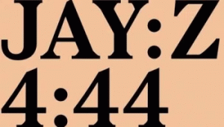
It reads Jay (:-medium-length breath) Z, Four (:-medium-length breath)- Forty-Four. The colon punctuation is traced back to Ancient Kemet. Jay: Z 4:44 reads like an expression of a spell, inclination or enchantment.
In Kemet, 4 (four) is the number of totality and completeness. We see: four sides of pyramids, the four sons of Horus, four magical bricks, four pillars of the sky, four elder spirits, four cardinal points (directions: north, south, east, west). The ritual of the king’s coronation used the four directions: four arrows were shot to the four cardinal points and four birds released. The symbolic use of the number four is frequently the one of completeness, the completeness of a square.
Z is the Canaanite Zeyin adopted as Zeta of the Greeks. Ancient sages and kabbalists see the Hebrew Z- zayin as signifying power: It’s seventh and is shaped like a weapon (sword or Axe). It is the most important symbol of the ancient nomads and barbarians that sweep across the land of milk and honey, Heliopolis- ON (Baalbek), Canaan, and subsequently Kemet. In the 21st century, it remains the symbol of the Luciferians that seek to destroy Christianity.
There is a legend about all the letters presenting themselves before God and asking him to start creating the world with them (according to the idea that the letters are Gods bricks of creation, pieces of his eternal Lego). Zayin wants to be the cornerstone by virtue of being seventh, like the day on which the Sabbath is observed. God refuses: it’s unfit to be the basis of creation, as it denotes fighting and war. The Greeks internalized the Z in Zeus. Zeus is the sky and thunder god in ancient Greek religion, who ruled as king of the gods of Mount Olympus.
Modern Hebrew accepted zayin’s same connotations. References to arms in revitalized Hebrew is klei zayin, literally instruments of war.” The arms race was merutz ziyun and so forth. The Greek Zeta is also related to Zeus and the lightning bolt.
Crowley, 44, is the number of the Hebrew word for “BLOOD,” spelled with the Hebrew letters DM. (see Colin D. Campbell, Thelema, An Introduction to the Life, Works & Philosophy of Aleister Crowley, Colin Campbell % Llewellyn Worldwide, Woodbury, MN (2018))
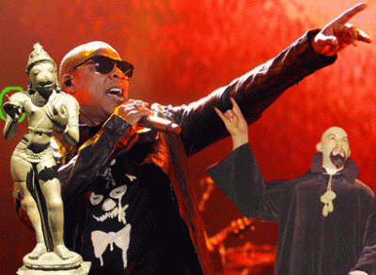
The bottom line is Jay: Z 4:44 represents the Luciferian Blood Sacrifice; and War against Christianity.
II
JAY Z & THE SATANIC MONKEY TRADEMARK
Trademark Serial Number: 87517427
Word Mark: JAYBO
Status: 681 – Publication/Issue Review Complete
Status Date: 2018-01-05
Filing Date: 2017-07-06
Mark Drawing: 4000 – Standard character mark Typeset
Published for Opposition Date: 2018-02-13
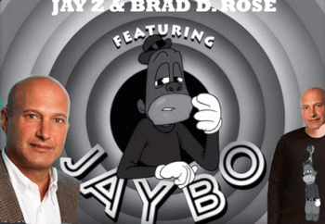
Attorney Name: Brad D. Rose, Esq. 7 Times Square
New York, NY 10036
212.326.0875 direct
212.798.6369 fax
Board Director, Republican Jewish Coalition (RJC) [1] The RJC is a right–wing “pro-Israel” lobbying organization. Rose is a racist Donald J. Drumpf Republican Kabbalah- Zohar Zionist neocon. [2]
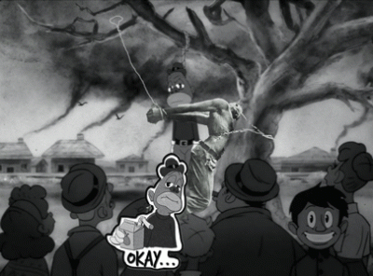
If JAYBO is so O.K., let him sport his JAYBO Caricature wear on the street in the presence of people of color; work and synagogue.
Law Office Assigned Location Code: L70
Employee Name: U.S. Attorney General, BUTLER, MIDGE FAE
III
THE RACIST MONKEY CARICATURES
A Caricature can be defined as: “A picture, description, or imitation of a person in which certain striking characteristics are exaggerated in order to create a comic or grotesque effect.”[3] Since at least the 18th century, grotesque (or grottoesque) has come to be used as a general adjective for the strange, hideous, ugly, incongruous, unpleasant, or disgusting. In art, performance, and literature, however, grotesque may also refer to something that simultaneously invokes in an audience a feeling of uncomfortable bizarreness as well as sympathetic pity.[4]
BOSKO & MONKEY RELATIVE
There is no doubt that JAYBO was created as a likeness of a Looney Tunes’s grandfather, BOSKO. Bosko was a classic example of a simian racial caricature deliberately manufactured in mass corporate media to marginalize, humiliate, denigrate black people. Bosko was copyrighted on January 3, 1928 as a less than human “NEGRO BOY”.
In his book, Of Mice and Magic, Leonard Maltin states that this early version of Bosko,
“was in fact a cartoonized version of a young black boy… he spoke in a Southern Negro dialect …”
IV
REMEMBER THE TIME- THE SPLENDOR OF KEMET
http://www.youtube.com/watch?v=LeiFF0gvqcc
With the exception of a bunch of sellout HollyWeird Satanic Black Cult members …
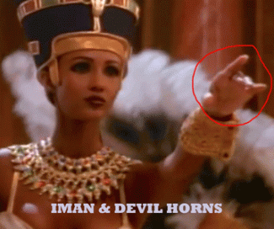
the overall Kemetic background imagery and theme in my opinion is incredibly stunning, beautiful and POWERFUL. Nevertheless, The idea that the various human “races” were created independently by God or evolved from separate ape/monkey ancestors, has its origins with 18th Century French intellectuals, e.g. Voltaire and Cuvier, who divided humanity into “civilized” Caucasians (= whites) created by God and “barbaric’ Negros (= blacks) derived from the “MONKEY TRIBE”. This tradition was continued by paleontologists, e.g. Louis Agassiz in the U.S. and in Europe by Karl Vogt. Despite Darwin’s detailed refutation of polygenism (theory of human origins) in his The Descent of Man (1871), polygenism was supported, in various guises; by eminent evolutionists (e.g. Alfred Russell Wallace and Ernst Haeckel compared Negroes to “four-handed” apes).[5]
Africa, Queen Ma’atkare (“Truth is the Soul of Ra) & the Divine Birth
The story of the “Divine Birth” goes back most demonstratively at least 5000 years ago to Africa (Kemet) and the most remarkable Pharaoh Queen “Ma’atkare” (“truth is the soul of Ra) better known as Hatshepsut (“Foremost of Noble Ladies”) 5th Pharaoh of the 18th Dynasty (1507–1458 BC), the ancient splendor of the Land of Kemet in AFRICA.[6]
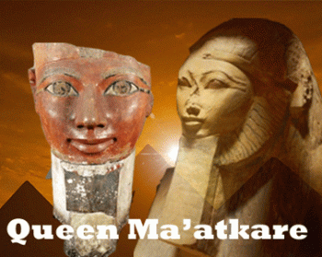
Queen Ma’atkare’s Divine Birth and Coronation can be found at the Temple of Deir el Bahari, Egypt. In this, God Amun calls upon a meeting of gods to announce the coming of a great and powerful queen. Amun asks the gods to bestow upon her protection and riches. As for Amun, he promises to grant her power, “I will join for her the two lands in peace… I will give her all lands and all countries.” Amun is told by the God Thoth that Queen Ahmose is to have the divine child and introduces him to her. Upon this meeting, Amun causes Ahmose to “inhale the breath of life”.
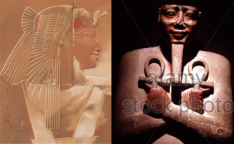
QUEEN AHMOSE & THUTMOSE I
Thoth leads Amun to Ahmose’s chamber where he has taken the form of her husband, Thutmose I. Amun in disguise, presents to her the ankh of life in her hand and nostrils. They both sit on a couch supported by two goddesses, Neith and Selk. Afterwards, Amun informs Ahmose that she is to give birth to a powerful queen and she is to rule both lands of Upper and Lower Kemet.
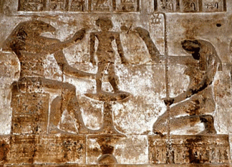
QUEEN MA’ATKARE’S DIVINE BIRTH
After the encounter, Amun instructs Khnum, the potter, to construct Ma’atkare’s body and ka out of clay. Khnum bestows onto her “with life, health, and strength, and all gifts, I will make her appearance above the gods, because of her dignity of king of Upper and Lower Kemet.” Once finished, Khnum offers Ma’atkare and her ka to the god Heket, who presents them the ankh of life. After, Khnum again bestows more gifts of “offerings, all abundance.” as he praises the new queen with given divine power. Thoth relays the message to Ahmose that Ma’atkare is given “all the dignities which will be bestowed upon her, all title which will be added to her name, since she is to be the mother of such an illustrious offspring.” She is also given an important royal title of “the friend and consort of Horus”. Queen Ahmose is led into a chamber by Khnum and Heket, along with 12 gods and goddesses to help the birth and to protect Hatshepsut. Hatshepsut is born and held by her mother Queen Ahmose, and is shown suckling from the other gods, giving her life and divinity.[7]
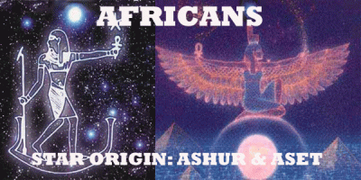
It is the Africans that claim “Divine Descent” from the beginning of recorded history. According to Kemetic mythology, the gods descended from the belt of Orion and Sirius– the brightest star in the sky. The ancient Kemetic civilization firmly believed that from Sirius and Orion beings came in the form of humans– Ashur (Osiris) and Aset (Isis) and they instigated the human race.[8]
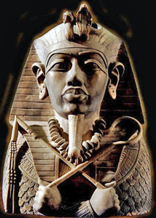
Queen Ma’atkare’s Nephew 6th Pharaoh of the 18th Dynasty- The Great Thutmose III
Furthermore, mass televised corporate and entertainment IMPLANTED false broad sweeping images of the people of the Land of Kemet …
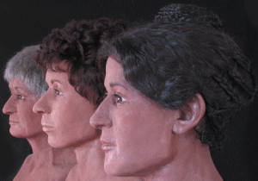
Egyptians
Queen Ma’atkare …
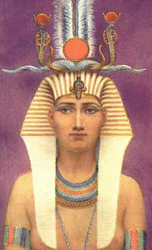
Queen Hatshepsut
Queen Ahmose, Thutmose I and Thutmose III as non-blacks and “all white Europeans” ORIGINATORS …
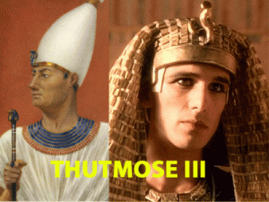while Africans have been turned into global trained master obedient “Monkey Tribes” [MONKEY SEE- MONKEY DO] creatures of the rain forests, wind and rain, thru collaborations with Satanic Prince Hall Freemasons like Jay-Z. It is a violation of our human rights.
V
RACISM: FROM THE STARS TO MONKEY TRIBES
In any case, while they argued about where to draw the race-monkey line, intellectuals of the day believed that apes and blacks were very similar. In this picture, from a book by Robert Knox called The Races of Men (1851), the slant of the brow is used to draw connections between the “Negro” and the “Oran Outan” and differences between those two and the “European.”[9]
The image above appeared in the The Evolution of Man (1874 edition) as part of an argument that blacks are evolutionarily close to APES.[10]
Adolf Hitler, autobiography Mein Kampf:
“It does not dawn upon this depraved bourgeois world that here one has actually to do with a sin against all reason; that it is a criminal absurdity to train a born half-ape [MONKEY SEE- MONKEY DO] until one believes a lawyer has been made of him, while millions of members of the highest culture race have to remain in entirely unworthy positions; that it is a sin against the will of the eternal Creator to let hundreds and hundreds of thousands of His most talented beings degenerate in the proletarian swamp of today, while Hottentots and Zulu Kafirs [Africans] are trained for intellectual vocations. For it is training, exactly as that of the poodle, and not a scientific ‘education’.”[11]
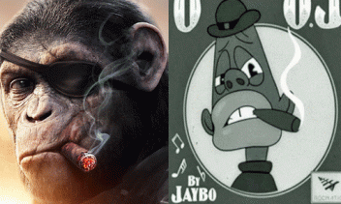The Encyclopedia of the Jewish Religion refers to Moses Maimonides as “the symbol of the pure and orthodox faith.” His Guide to the Perplexed is considered the greatest work of Jewish religious philosophy, but his view of Blacks was Hitlerian:
“[T]he Negroes found in the remote South, and those who resemble them from among them that are with us in these climes. The status of those is like that of irrational animals. To my mind they do not have the rank of men, but have among the beings a rank lower than the rank of man but higher than the rank of apes. For they have the external shape and lineaments of a man and a faculty of discernment that is superior to that of the apes.”[12]
“STILL NIGGA”
In fact, a Kabbalah- Zohar Jew, Mark Romanek, partnered with Jay Z to create the black half human hominoid figure to globally implant and apply to traditional Black Culture across the board as a “MONKEY TRIBE”.
If JAYBO is so O.K., let him ALSO wear his “Still Nigga” JAYBO Caricature wear on the street in the presence of people of color; school, work and synagogue.
Da Story of OJ & Monkey Tribes
Jay Z explained that JAYBO warped up in the “Da Story of OJ” was about the nature of success and seeing the bigger picture.
“The Story of OJ is really a song about WE AS A [MONKEY TRIBE] CULTURE, having a plan, how we’re gonna push this forward (sic),” the rapper explained in an interview on iHeart Radio last year (17). “We all make money, and then we all lose money, as artists especially. But how, when you have some type of success, to transform that into something bigger.”[13]
Jay-Z, Shawn Corey Carter, does not have any credentials whatsoever to define or transform Black Culture on a widespread basis. He does not even possess a high school diploma.[14] He sold crack cocaine, poison, to the people. JAYBO is yet another form of mental psychological poison that he seeks to peddle to the masses. JAYBO, the half man, (higher primates) half simian monkey or Great Ape Homoinoidea orangutan has been deliberately created by Jay-Z and Romanek to depict Black People as an ethnic group and race as a “MONKEY TRIBE”.
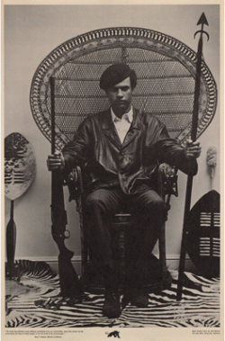
Furthermore, an infamous beloved Black cultural, political and social heroic and revolutionary figure, Huey P. Newton, former Minister of Defense of the Black Panther Party for Self Defense (BPP), is depicted as a grotesque exaggerated dark big eyed- big lipped half-human hominoid figure. The Black Panther Party for Self Defense was a historical Black Institution.
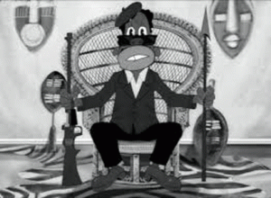
As a former member of the BPP, I am personally offended by Jay Z and his collaborator’s direct association of simian and hominoid creatures with the Black Liberation Struggle implanting suggestions of “monkey see, monkey do”.

The platform of the BPP wasn’t socialist or communist. It was the Black Nationalism that Malcolm X taught. The BPP was no band of trained monkey see, monkey do half human simians and hominoids. We sought to define and determine our own destiny. When Bros. Huey and Bobby said that [BLACK] POWER GROWS OUT OF THE BARREL OF THE GUN, they meant military, political, and economic power. We had been very clear on that point. Jay Z is the 21st century JUDAS of the masses that has and will continue to sell them out for only a few pieces of silver.
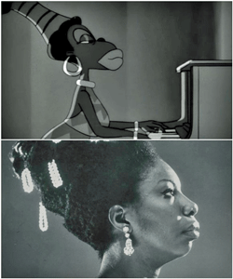
The half-human hominoid figure JAYBO has also been deliberately connected with the image of the infamous black cultural- political civil rights, musical genius icon that we love, Shemayet (user-Maat-ra-setp-en-ra Monthu-in-the-two-lands) Nina Simone.
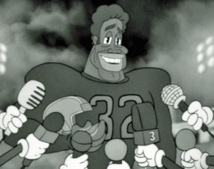
The half-human hominoid figure JAYBO has also been deliberately connected with the image of a living infamous cultural sport’s icon, O.J. Simpson. I have not watched Jay Z’s “Da Story of O.J.” and I do not intend to, but that is not the issue at this time. Manufacturing Less than Human Black Caricatures that deliberately humiliate and harass black people for global mass consumption are the issues.
VI
THE HYPOCRISY: MEXICO & THE MEMIN PINGUIN CARICATURE CONTROVERSY
La caricatura BOSKO, MEMIN PINGUIN & La caricatura JAYBO

Mexico’s Memin Pinguin Postage Stamp
In 2005, the comic book character Memin Pinguin a black Mexican who is portrayed as a monkey looking boy set a spark in the racial debate after the Government of Mexico issued a series of five postage stamps commemorating and celebrating Pinguin.
Memin Pinguin is a comic book character created in the 1940s that is depicted as a dark skinned Jim Crow-era cartoon. He has exaggerated eyes and lips similar to Jim Crow memorabilia “pickaninny” caricatures and his mother resembles a “Mammy” caricature.

In the comic book series, Memin Pinguin is humiliated, assaulted, battered, taunted and harassed by Mexican society for his bizarre less than human appearance, speech, and mannerisms invoking in an audience a feeling of uncomfortable bizarreness as well as sympathetic pity and racial hatred.
People were outraged with the national celebration of the half human simian caricature of a black youth. The Government of Mexico was condemned for its celebration of its simian “pickaninny” and “mammy” caricatures of black people on the floor of the U.S. House of Representatives (H.Res.347 — 109th Congress (2005-2006))
Resolved, That the House of Representatives—
(1) condemns the Government of Mexico for issuing a blatantly racist series of postage stamps;
(2) calls on Mexican President Vincente Fox to immediately cease printing and distributing the postage stamps and recall from circulation those postage stamps currently on the market;
(3) calls on President Fox to apologize to the citizens of Mexico and the citizens of the United States for the decision to circulate the stamp series; and
(4) declares that the decision of the Government of Mexico to issue the postage stamps is inconsistent with United States policy to eliminate the vestiges of government sanctioned racial or ethnic discrimination and intolerance.[15]
Scott McClellan, speaking for the George W. Bush presidential administration, declared the minting of a postage stamp in Mexico, which celebrated the black caricatures, to be “offensive, and I would say racial stereotypes are offensive no matter what their origin. The Mexican government needs to take this into account. Images such as these have no place in today’s world.”[16]
Throughout the last at least 4 (four) centuries, whites have historically defined Blacks—as “caricatures”, as objects, as less than human as justification for African Human Bondage, Genocide, Racial Hatred, Exploitation, Segregation, Discrimination, Mis-Education and Mass Incarceration, etc.
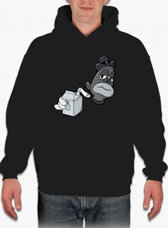
What happens if a nonwhite sports the JAYBO caricature image of black people to school or the workplace to affirm the statement calling Blacks Nigga, Niggers, and that they are a less than human– “MONKEY TRIBES”? “NIGGER” represents a classic case of the use of “fighting words” tending to incite an immediate breach of the peace which are not protected by either the Constitution of the United States (In re Spivey, 345 N.C. 404, 480 S.E.2d 693 (1997)).
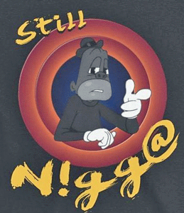
Once a Nigga, STILL A NIGGA (Dr. Nigga, Nigga Lawyer, Nigga Teacher, Rich Nigga, Poor Nigga, Mr. Nigga, Mrs. Nigga, Young Nigga, Baby Nigga, Big Nigga, Little Nigga, So Forth and So On) like trained and untrained uncivilized MONKEYS. It is tantamount to “FIGHTING WORDS.”
Lanham Act prohibited the registration of any mark that “may disparage persons, institutions, beliefs, or national symbols, or bring them into contempt, or disrepute.”
15 U.S. Code § 1052 – Trademarks registrable on principal register; concurrent registration
No trademark by which the goods of the applicant may be distinguished from the goods of others shall be refused registration on the principal register on account of its nature unless it—

- Consists of or comprises immoral, deceptive, or scandalous matter; or matter which may disparage or falsely suggest a connection with persons, living or dead, institutions, beliefs, or national symbols, or bring them into contempt, or disrepute; or a geographical indication which, when used on or in connection with wines or spirits, identifies a place other than the origin of the goods and is first used on or in connection with wines or spirits by the applicant on or after one year after the date on which the WTO Agreement (as defined in section 3501 (9) of title 19) enters into force with respect to the United States.

JAYBO is not registrable for U.S. patent right protection because it is a grotesque exaggerated dark big eyed- big lipped half-human hominoid figure that has been globally recognized since the 18th century as an African and Negro Caricature. The Black Caricature was a central tool in justifying efforts to colonize, enslave, and even exterminate people of people. They established by outrageous pseudo race science that Africans were less than human– “MONKEY TRIBES”, then it was acceptable to treat, educate and train them as such.[17]
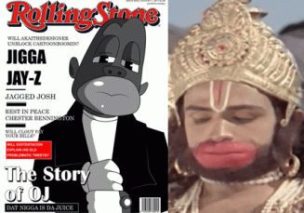
JAYBO and MONKEY GOD
Jay Z unquestionable calls JAYBO a NIGGA not a JIGGA. Don’t get that twisted as Rolling Stone attempts to deceive the masses. Both Jay Z and Beyonce are advanced Master Masonic Occultists. Their first and only duty and love is dedicated to Lucifer. We should always acknowledge that and treat them, accordingly. There is no local, state or U.S. law that I am aware of prohibiting mass publication of covert occult and overt racist Black Caricatures that tend to violate our human rights. If there is such laws, please let me know immediately. However if a corporate mass media publication like Rolling Stone choose to spread racial images that are designed to globally dehumanize black people then it is incumbent upon us to protect ourselves and children from vicious racial attack and human rights abuse. In the meanwhile, on February 18, 2018 or soon thereafter, I will file an official and formal OBJECTION to JAYBO receiving U.S. Trademark protection in violation of our human rights.
______________________________________________________________________________________________
[1] http://www.rjchq.org/leadership
[2] http://rightweb.irc-online.org/profile/republican_jewish_coalition/
[3] https://en.oxforddictionaries.com/definition/caricature
[4] https://en.wikipedia.org/wiki/Grotesque#Pop_culture
[5] https://theconversation.com/comparing-black-people-to-monkeys-has-a-long-dark-simian-history-55102
[6] http://www.ancientegyptonline.co.uk/hatshepsut.html
[7] https://en.wikipedia.org/wiki/Stories_of_divine_birth_in_the_eighteenth_dynasty
[8] https://ancient-code.com/orion-constellation/
[9] https://thesocietypages.org/socimages/2012/07/12/whites-blacks-apes-in-the-great-chain-of-being/
[10] https://www.huffingtonpost.com/the-conversation-africa/comparing-black-people-to_b_9345322.html
[11] https://selfuni.wordpress.com/tag/hitlers-attitudes-towards-blacks/
[12] http://noirg.org/news/blacks-jews-facts-quotes/
[13] http://sandrarose.com/2018/01/jay-z-moves-trademark-racist-symbol-jaybo-t-shirts-hoodies-etc/
[14] https://en.wikipedia.org/wiki/Jay-Z
[15] https://www.congress.gov/bill/109th-congress/house-resolution/347/text
[16] https://mongrel4u.wordpress.com/tag/vicente-fox/
[17] Id.
Comments : 1 Comment
Tags: 18th dynasty, Adolf Hitler, africa, Aleister Crowley, amun, ape of thoth, apes, aset, ashur, black caricatures, Black Panther Party for Self Defense, black satanic cabal, black satanic cults, bosko, brad d. rose, Brendan O Regan, caricatures, CHURCH OF SATAN, CIA MK ULTRA/MONARCH, cia occult bureau, cnn, crime against humanity, da story of oj, Declaration of Human Rights, devil, devil horns, egypt, emmys, freemasonry, freemasons, H.Res.347 — 109th Congress, half-human hominoids, Hanuman, Harold Chipman, Hatshepsut, heka, heket, hermes, hip hop satanic cult, hollyweird, hominoid, Huey P. Newton, human rights, Illuminati, iman, Institute of Noetic Sciences, jack sarfatti, jay z, Jay: Z 4:44, jaybo, jews, jim crow, kabbalah, kemet, Khnum, knights templar, looney tunes, Lucifer, luciferians, mammy caricatures, mark romanek, masons, Memin Pinguin, mexico, michael jackson, mind control, monkey caricatures, monkey tribes, monkeys, negro caricatures, niggas, nina simone, oj simpson, Orion, Osiris, pharaoh thutmose, pickaninnies, pickaninny caricatures, President George W. Bush, psychological warfare, queen ahmose, queen maatkera, racism, Republican Jewish Coalition, rolling stone, satan, Satanism, Scott McClellan, Shawn Corey Carter, shemayet, simian, simian racial caricature, Sirius, thoth, trademark, u.s. trademark, vann jones, z, zayin, zeta, zeyin
Categories : African Liberation, Aryan Supremacy, aset, ashur, black institutions, Black Panther Party for Self Defense, devil, devil's horns, divine one, egypt, evil, freemason, freemasons, genocide, Hip Hop, HIP HOP false prophets, hip hop satanic cult, hollywood satanic cult, huey p. newton, jay z, jay-z, kemet, luciferians, satan, Satanic Global High Cabal, Satanism, Walt Disney, ZIONIST

FROM DONALD J. DRUMPF’S SHITHOLE, DONNY TO LUCIFER’S COONS JAYBO & CARDI-B AND AFRICA- THE MOTHER COUNTRY OF THE UNIVERSE
23012018
I
THE DIVINE LINK, DONALD J. DRUMPF & AFRICA
Shemayet (user–MA’AT–ra-setp-en-ra Monthu-in-the-two-lands) Mahalia Jackson’s Trouble of the World is no simple minded tear jerker. Don’t get that twisted. It is complex ageless sacred inner sanctum temple music personified. Shemayet connects Heaven and Earth. Shemayet is the “God [Goddess] Voice” and “Divine Vibration” that link fellow man with each other and the Divine. Shemayet, the divine voice and vibration, is discussed further below.

Donald Drumpf & Dark Satanic Global Cabal
President select Donald J. Drumpf believes, so he said that Africa is a “Shithole” country. Don’t get it twisted from my title. Africa is the mother country of the universe, and I mean it literally. Donald J. Drumpf means the terms “Shithole” and “Shithouse” to be applied to Africa both as an adjective, and a noun.[1] Please excuse my language in this post. I mean no disrespect to the elders or the people. It is not used intentional just for the sake of being evil, foul and vulgar. “Shithole” and “Shithouse” appear only to demonstrate how irrational, insidious, fraudulent, idiotic and evil racism is. Additional, whenever it is Kemet, it is the Mother Continent, AFRICA.
Throughout the generations in this country, our elders stress that if Anglo Saxons and Aryans as a whole knew better that they would do better. And, many believe that Drumpf’s offensive statement disparaging the Mother Continent that we often call the “Mother Country” is the result of being badly misinformed. I don’t believe for one minute that it is true, particularly in regards to Donald J. Drumpf and the Dark Satanic Circles. They are motivated by EVIL for the sake of EVIL, and trickery. Many tried to warn the nation of the ultimate EVIL of DRUMPF before he stepped into the OVAL Office.

Now, DRUMPF, Mike Pence and the Dark Satanic Circle has the entire U.S. government in a strangle hold. Even if some knew better about the Mother Country, they would cover their eyes, and continue their EVIL plans of mass exploitation, deception, and genocide. The Donald J. Drumpf statement about Africa is purely deliberate. IT IS JOSEF GOEBBELS’ UNTRUTH THAT SHALL NOT HAVE A LIFE OF ITS OWN.
II
LUCIFER’S COONS
We have persistently demanded that society present and treat us in a dignified manner.
We have always rejected wicked racist notions, and black stereotypical caricatures casting black people as monkeys (coons) – less than human.
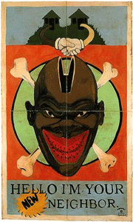
Racist caricatures of Black people are intentionally designed to humiliate, demean and depreciate our human, cultural and social value in global civil societies.

“These images are intended to be ironic, and to cater to the White notion that Black coons are too stupid to understand that their efforts to assimilate into White culture only emphasize their inherent inferiority.”[2]
Freemason Jay Z- Lucifer’s Hip Hop COON
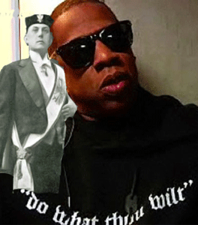
“Do What Thou Wilt” Aleister Crowley, The Great BEAST 666 & Jay Z
Shawn Corey Carter known professionally as JAY-Z is a satanic hip hop black rapper and businessman. He is one of the most highly corporate promoted and bestselling MASONIC New Age “musicians” of all time, having sold more than 100 million records, while receiving 21 Grammy Awards for what has become the “music” and “art” promoted by and spoon fed by Luciferians to the masses.
Jay Z (Jaybo) with Simian Oran Outan Face
If that wasn’t enough for Jay-Z to promote the Luciferian agenda to depreciate traditional black folk art and promote the “music” created and promoted by Masonic Luciferians for mass consumption and CHAOS, he has reached for a new low to attack, demean our right of humanity, and to self-determination.

Jay Z’s deliberate mass corporate denigration of black people and their culture in the images and notions of antebellum Simian Coonery is a violation of our human rights (International Covenant on Civil and Political Rights (ICCPR), Article 27).
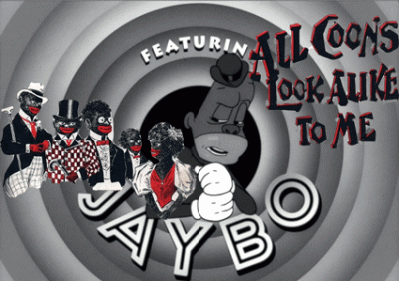
Jay Z- Jaybo the Hip Hop Coon
The deliberate wicked association and depiction of Blacks as monkeys and apes (coons) are significant visible imagery implants that the antebellum South used to justify African Human Bondage, and the SHITHOUSE institution of American Slavery.
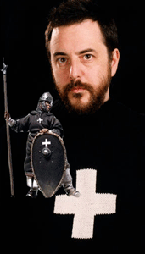
Dark Baphomet Knights Templar Mark Romanek
Jay-Z has combined with a racist Ashkenazi Kabbalah-Zohar Russian Jewish descendant, film maker Mark Romanek, to manufacture and distribute images that wickedly globally defame, demean, humiliate, and insult Black people, Huey P. Newton, and the Black Panther Party for Self Defense (BPP) with offensive simian coon images. Brother Huey was no coon associated with coonery.[3]
I can still hear that click-click- the lock and load of Huey’s shotgun. Huey didn’t play!
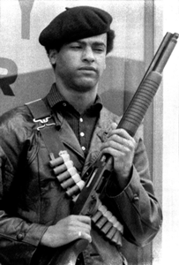
I also recall Huey’s Smile when I was only a seed. I was that “Little Ghetto Boy” running around a college campus getting high and chasing young ladies. While I was so high gloating on myself rolling around in utter chaos and nothingness, I often found myself under the scolding eyes of Laverne. She was Huey’s most significant other. Whenever I found myself under scorn, I always looked at Huey, because I knew that I was shamefully stumbling around responsibility and manhood. I was what I was. I thought that he would despise me. But, he never did. Brother Huey would give me a slight smile, but it was a smile nonetheless from one of the most powerful, feared and respected young brothers in the community. It came to represent in me, the Faith in a Mustard Seed. In the BPP, they often called me, Little Brother.
I further recall when Brother Huey first took the picture, above. We (BPP) were in awe, speechless and spellbound when we saw it, because the symbolic imagery was so powerful, moving and beautiful. There was something unspoken and sacred to us about the picture that those that understand seek to mock and belittle. This is the Huey P. Newton that made a statement to the world of his unconditional and undeniable love for his African-ness that spiritually made our bonds and love for him and the Mother Continent so much stronger. Brother Huey didn’t have to wear an African Dashiki to prove anything to anybody. They are still afraid of everlasting images of resistance of Huey P. Newton. Wickedly representing Brother Huey as a simian coon will not change our undying love and respect for him.
Freemason Jay Z pays tribute to the blood drinking and flesh eating cannibal, Lucifer’s High Priestess, MARINA ABRAMOVIC.
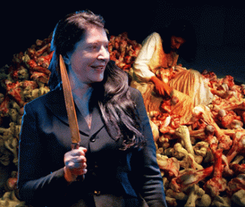
In 2009, Atlantic Records has combined with Jay Z the Coon to deliver a deal with Lucifer to promote and distribute his album, The Blueprint 3. The album was self-distributed by Atlantic Records; his music videos are distributed and partially owned by Atlantic Records.[4]
Cardi B- Lucifer’s Coon Daughter
I first heard of Belcalis Almanzar, known professionally as Cardi B, promoted on the Wendy Williams Show. They are undeniable self- confessed Coon Daughters of Lucifer. I was under the false impression that Cardi B was an up and coming traditional R&B vocalist until she opened their mouth to rap something about “Bodak Yellow“.

Devil Horns- Bodak Yellow & Church of Satan
Cardi B says as a theme of that rap,
It’s Cardi, ayy
Said, “I’m the shit, they can’t fuck with me if they wanted to…
Said little bitch, you can’t fuck with me
If you wanted to
These expensive, these is red bottoms
These is bloody shoes.[5]
“Bodak Yellow” is the ever persistent language of sadistic divide and violence. I sat in front of the TV and watched her perform for a few minutes. I was startled and confused to discover that Cardi B lacked any remarkable musical talent or abilities. I immediately turned off the idiot box. In 2017, Bodak Yellow (Money Moves) topped the Billboard Hot 100 chart number 1.[6]

She may have been initiated into HollyWeird’s Satanic Sex Magic 99 Lodge headed by Warlock Charlie Sheen.
Adolf Hitler belonged to the Satanic German Masonic 99 Lodge.

The title “Bodak Yellow” is related to the insidious stereotypical color code and reference to her skin, and the rapper Dieuson Octave “Kodak Black.”
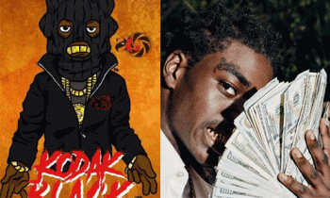
Kodak Black, Atlantic Records Rap Artist
Kodak Black is a mind (MK ULTRA) control troubled and confused young man in and out of jail on various criminal offenses.

But, he is an Atlantic Records rap artist.[7]

Kodak Black has come to believe that he is a Kabbalah-Zohar Satanic Israeli Jew. His puppet-master can spin him on a dime to make him believe anything.
Cardi B is a hood chick proudly associated with Blood Street Gangs. She is a former stripper born and raised in the Bronx, NY.[8]
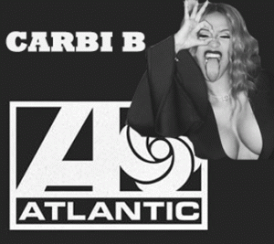
In February 2017, Cardi B, the Luciferian “Gangsta Bitch Music rap artist signed a multi-million dollar deal with Atlantic Records to promote among the masses a vicious chaotic SHITHOLE Satanic lifestyle.
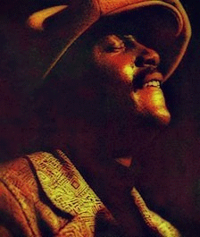
Donny Hathaway
Donny Hathaway was an Atlantic Records vocalist and musician when he was thrown out a 15th story hotel window in New York City. Donny’s most infamous last words before he was killed, “White people are trying to kill me, they have my brain hooked up to a machine, trying to steal my songs and sound.” Music and Sound is important. How important? EXTREMELY! EXTREMELY IMPORTANT!
From Donny to Jay Z and Cardi B, it makes me want to cry … Because, they are promoted globally as the dualistic opposites of Donny. Hemayet Donny linked us with Heaven and the Divine. They seek to DELIVER us to the DEVIL AND HELL.
III
FROM THE SECRET MANHATTAN PROJECT TO ATLANTIC RECORDS

From 1947, the Tavistock Institute, Frankfurt School, Alsos Mission/Manhattan Nuclear Bomb Project, and the U.S. government have clandestinely combined to try to depreciate, control and shape the art of black folk music (gospels, spirituals, chants, blues, jazz, rhythm & blues). For clarity, I will call them, Scepter (Emblem of Imperial Power). Scepter’s interests in the art of black folk music have never revolved around appreciating it or honoring its value, legacy or sacredness. Their interest are destroying and replacing it, and developing the black music into a major tool of satanic mass population control and manipulation.
“As L. Marcus (1974) writes in his excellent investigation piece; ‘Reesian methods rely, completely and consciously, on the destruction of the mental life of world society and a forced march into universal sadism.”…. Within this lies their affinity- men as mindless beasts whose minds, according to Tavistock, are something to be manipulated and destroyed.
…. “The Tavistock- and Reesian method- that the class war should be waged with “weapons that affect morale more than they take life”- has become, in the post-war period, the primary weapon system of the Rockefeller forces, including their own covert arm, the Central Intelligence Agency.’ ”[9]
The function of Reesian-Lewinite Brainwashing is to deliberately recreate infantile paranoid states of mind. The “Reesian Method” was developed by John Rawlings Rees.
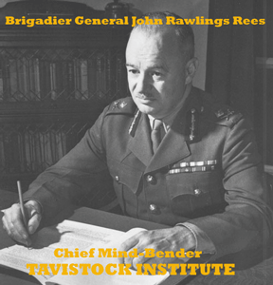
J.R. Rees, Knight of the Most Excellent Order of the British Empire, was one of the key figures at the original Tavistock Clinic and became its medical director from 1933. Rees was appointed consulting psychiatrist to the British Army during WWII, and obtained the rank of brigadier general. After the war, he was a member of a group who referred to themselves as the ‘invisible college’. This group orchestrated “Operation Phoenix“, making plans for Tavistock to rise from the ashes of war. They founded the Tavistock Institute with funding from the Rockefeller Foundation.[10]
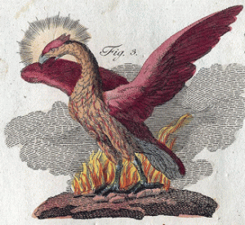
Phoenix, Fire & Benben Stone
The Phoenix is neither Greek nor Roman mythology. It is very deep ancient African (Shithole) cosmology that we shall discuss further in detail. Nevertheless to begin with the Benben Stone was the up thrust (explosive) sacred stone of Heliopolis; benu (bennu) describes a bird (The Phoenix) that was an important avian deity. Originally of solar associations, the Benu bird came to be connected with three important gods consisting of Atum, Re and Ashur (Osiris). As an aspect of God Atum, the Benu bird was said to have flown over the waters of Nun before the original creation. According to this tradition, the bird came to rest on a rock from which its cry broke the primeval silence and this determined what was and what was not to be in the unfolding creation.[11]

London Olympics, Phoenix Launch from the Conical Benben Stone
If you believe that Shithouse Benu Bird (Phoenix) and Benben Stone was a foregone passing occult fancy of British intelligence, think again. The concept was a major theme in the closing ceremonies of the 2012 London Summer Olympics.[12]
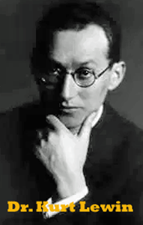
Lewinite refers to Dr. Kurt Lewin, a German Kabbalah-Zohar Jewish Frankfurt School refugee who had been brought to the U.S. by the Rockefeller family. He joined Tavistock Clinic or Institute sometime about 1946. Author Jim Keith, who died in mysterious circumstances, has written:
“Lewin is credited with much of the original Tavistock research into mass brainwashing applying the results of repeated trauma and torture (of individuals) in mind control to society at large.”[13]
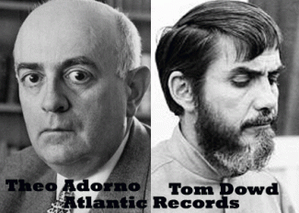
At Atlantic Records, Scepter thru its agents Theo Adorno and Thomas John “Tom” Dowd had controlled its sound studios since it was founded in 1947. It earned a reputation as one of the most important American recording labels, specializing in Jazz, R&B and soul recordings by Black musicians including Donny Hathaway, John Coltrane, Aretha Franklin, Ray Charles, Sam and Dave, Ruth Brown, Otis Reading, and so many others. For black artists, signing with major recording labels was a literal pact with the DEVIL.
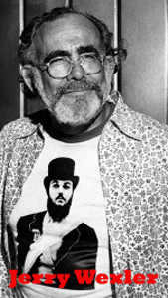
Atlantic Records’ business partner, Jerry Wexler, was a son of Polish and German Ashkenazi Kabbalah -Zohar Jews. According to Wexler, Atlantic was in the business of Luciferian Shitholing “taking the gospel songs and putting the devil’s words to them.” They weren’t representing Black culture, but a self-destructive Black sub-culture in violation of our human rights. They were promoting icons that spoke for society’s underbelly: unrestrained sexuality, violence, and drugs.[14]

In 1967, Atlantic Records became a wholly owned subsidiary of Warner Bros.-Seven Arts.[15] Since 1989, it is a subsidiary of Time Warner, formed as a merger between the conglomerates Time, Inc. and Warner Communications.[16]
Theo Adorno was a Frankfurt School and Tavistock musicologist scholar involved in musical research. Adorno was interested in perverting the aesthetics of mass culture, as a part of a social engineering strategy through criticism, particularly music. The path of so-called pop culture and its subculture associates which emerged in the 1960s was shaped in significant part by Adorno. Perhaps the best known propaganda works of Adorno are The Authoritarian Personality, Dialectic of Enlightenment and Negative Dialectics.
Both Tavistock and the Frankfurt School paid close attention to Nazi Third Reich propaganda techniques, which they willingly incorporated into their research. The aim of the project, as stated in (Theodore) Adorno’s “Introduction to the Sociology of Music,”… was to “program a mass culture as a form of extensive social control that would steadily degrade [Shithole] its consumers.”[17]
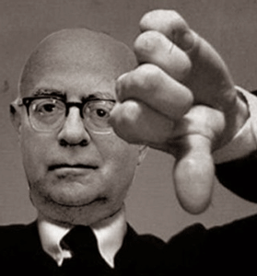
As an institutional corporate European policy, Adorno and Scepter finds no intrinsic value in the genres of traditional black music.
“On Jazz, Adorno wrote,
The relationship between jazz and black people is similar to that between salon music and the wandering fiddle players whom it so firmly believes it has transcended – the gypsies. According to Bartok, the gypsies are supplied with this music by the cities; like commodity consumption itself, the manufacture (Herstellung) of jazz is also an urban phenomenon and the skin of the black man functions as much as a coloristic effect as does the silver of the saxophone. In no way does a triumphant vitality make its entrance in these bright musical commodities; the European-American entertainment business has subsequently hired the [supposed] triumphant victors to appear as their flunkies and as figures in advertisements, and their triumph is merely a confusing parody of colonial imperialism. To the extent that we can speak of black elements in the beginnings of jazz, in Ragtime perhaps, it is still less archaic-primitive self-expression than the music of slaves; even in the autochtonal [aboriginal] music of the African interior, syncopation within the example of a maintained measured time seems only to belong to the lower [social] level. Psychologically, the primal structure of jazz (Ur-Jau.) may most closely suggest the spontaneous singing of servant girls.[18]
Don’t get it twisted. I don’t intend to argue tit for tat to prove Adorno and Scepter wrong about Black Folk Music. If he was alive today, I would touch not one hair of Adorno. My love is primarily for the people- to point out the contradictions. Then, it becomes the duty of the masses to defend its dignity as a people, and respond to the enemy as necessary. They have never failed. Adorno’s mass corporate assertion that Black Folk Music is tantamount to the mere CRIES OF SLAVES is the untruth. IT IS JOSEF GOEBBELS’ UNTRUTH THAT SHALL NOT HAVE A LIFE OF ITS OWN.
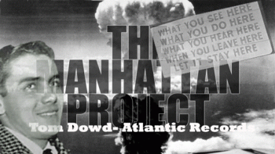
At age 18, Thomas John “Tom” Dowd was drafted into the military with the rank of sergeant. He continued his work in physics at Columbia University. Refugees from National Socialist- Nazi Germany, the Frankfurt School changed venue and moved to Columbia University in New York City in 1934. The U.S. Office of Scientific Research and Development (OSRD) recruited heavily from Columbia for the Manhattan Project. The OSRD was also interested in psychology and psycho-acoustics.[19]
Psychoacoustics is essentially the study of the perception of sound. This includes how we listen, our psychological responses, and the physiological impact of music and sound on the human nervous system. Psychoacoustics involves music- sound, frequency, and vibration.[20] In physics, sound is a vibration that typically propagates as an audible wave of pressure, through a transmission medium such as a gas, liquid or solid.[21] The vibratory nature of matter is mentioned in the Bible. John’s Gospel starts with “In the beginning was the Word…” (John 1:1) and teaches us that this vibration is from God, and is God Himself. The “Word” in this verse is the Greek word “logos”. We know that speech means not just any kind of a vibration, but a vibration that carries information, is uttered by a living person and embodies a concept or an idea. In this case, it means that the living Creator, our Father God, created an intelligent vibration which then created everything else. The new theory named “The Geometric Concept of Matter”, confirms that matter is a vibratory structure and explains that what we know as gravity is a direct consequence of that particular vibration.[22]
Dr. Andrija Puharich was known as a brilliant, but notorious CIA MK ULTRA/MONARCH (subproject 58) medical physician and electronics expert consultant.[23] In 1990, Dr. Puharich found a way to split water molecules by tuning in on the vibrations of their atoms and breaking the molecules into hydrogen, which could become fuel, and oxygen. A former physician, Puharich discovered the water-splitting technique a dozen years ago but has only recently presented his findings publicly. Originally, he was investigating the Psychoacoustic DISRUPTIVE EFFECT of electrical resonances on blood clots and noticed a peculiar thing: in dilute blood, a SPECIFIC FREQUENCY made bubbles appear in the liquid. Lab analysis showed that the bubbles were composed of oxygen and hydrogen. A barrel-shaped cavity contains the water in Puharich’s recently refined system. He introduces alternating current at A KEY FREQUENCY of 600 cycles per second.
The cavity resonates with the impulses in somewhat the same way the body of a violin resonates with the sound of one string, ADDING HIGHER AND LOWER HARMONICS TO THE PRINCIPAL TONE. The additional harmonics, Puharich says, cause the proton in the hydrogen atom TO ROTATE, further forcing the hydrogen to split from the oxygen.[24]
In 2014 for the first time, scientists captured the sound a single atom makes when it moves. They found the atom makes a “D-note,” about 20 octaves above the highest note on the piano and a pitch inaudible to the human ear.[25] Musical notes in ancient Kemet were regarded as spiritual elements, and were conceived as independent structural entities.[26] D is a musical note a whole tone above C, and is known as Re.[27]
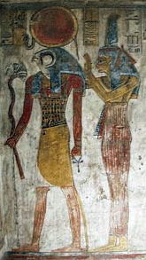
The nearest concept or element to that of “justice” in Kemet (Africa) is the notion of MA-AT, which is personified as a goddess, the daughter of Atum, and after the 18th dynasty as the daughter of RE, who establishes MA-AT at the time of creation.[28]

If vibration is a source of creation, pursuant to Knights of the Black Sun’s Satanic Principle of Dualism, opposite of creation vibration are destruction, ruin and end. OSRD’s S-1 Section later became the Manhattan Project and developed the first atomic weapons.[29] Dowd worked on the Manhattan Project. He planned to obtain a degree in nuclear physics when he completed his work on the Manhattan Project. However, because his work was top secret, the university did not recognize it, and Dowd decided not to continue, since the university’s curriculum would not have been able to further his physics education. His research for the military was more advanced than academic courses at that time.[30]
The question is why were Scepter (Global Satanic Cabal), Adorno (International Social Scientist), and Dowd (Top Secret Nuclear Scientist) so deeply mixing in the kool- aide of Black Folk Music if it is out of Shithouse Africa, and amounts to no little more than the spontaneous singing of servant girls? If it was such archaic-primitive self-expressions “the music of slaves”, it would die a natural death. So, you would seem to believe.
IV
AFRICA & THE BIG BANG
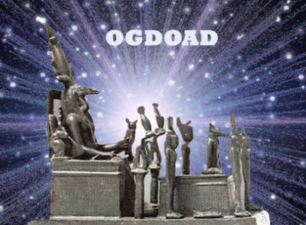
Science, Creation of the Universe
Scientists have gathered a lot of evidence and information about the Universe. They have used their observations to develop a theory called the Big Bang. The theory states that about 13.7 billion years ago all the matter in the Universe was concentrated into a single incredibly tiny point. This began to enlarge rapidly in a hot explosion, and it is still expanding today. Scientists have also detected a Cosmic Microwave Background Radiation (CMBR). This is received from all parts of the Universe and is thought to be the heat left over from the original explosion.[31]
Kemet, Creation of the Universe
God Atum (Atom)
“We are the gods of the atoms that make up ourselves, but we are also the atoms of the gods that make up the universe.” – 33 degree Freemason Manly P. Hall
The African God Atum is the most ancient secret “Science of the Atom.”
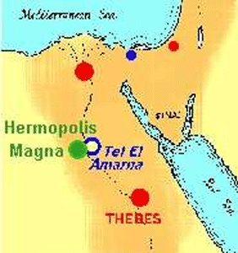
Hermopolis in Africa was a provincial capital of the Two Lands of Kemet since the Old Kingdom period. The Old Kingdom is the period in the third millennium (2686-2181 BC) also known as the “Age of the Pyramids” or “Age of the Pyramid Builders” as it includes the great 4th Dynasty when King Sneferu perfected the art of pyramid building and the pyramids of Giza were constructed under the kings Khufu, Khafre, and Menkaure.[32]
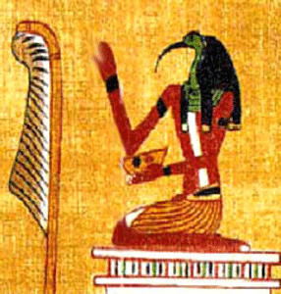
God Thoth, Wisdom and Music
Hermopolis means “the city of Hermes” in Greek. The Greeks gave it that name because it was a major cult center of the god Thoth who they associated with their god Hermes, but the people of ancient Kemet knew it as Khmunu (“the City of the Eight“). The Hermopolitans claimed that their theory of creation was older than any other in Africa and that it was the Ogdoad who gave birth to both the Sun and God Atum.
The Ogdoad was a system of eight deities, four gods and their consorts (the number four was considered to represent completeness). Each pair represented the male and female aspects of the four creative powers or sources. Nun and Naunet represented the primeval (ocean) waters; Heh and Hauhet represented eternity; Kuk and Kuaket represented darkness; and Amun and Amunet represented air (or that which is hidden). However, the gods differ from one source to another. Primeval darkness was sometimes represented by Gereh and Gerehet and Heh and Hehet are sometimes included as forces of chaos, possibly representing the currents of the primeval waters. When God Amun rose in prominence as a creator god in his own right, he and Amunet were replaced by Nia and Niat, gods of the void.
These eight elements interacted causing an explosion (The Big Bang) and the burst of energy which was released caused the mound (located at Hermopolis, but originally known as the “Isle of Flame“) to rise from the water. It was thought the gods and goddesses of the Ogdoad then ruled the earth during the Golden Age. When they died they took up residence in the “Duat” (or “Tuat” – the Underworld). The ensured that the Nile continued to flow, that the inundation would come every year and caused the sun to rise each day.[33]
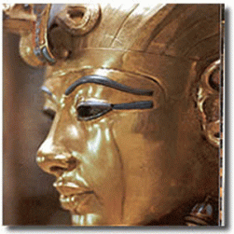
Tutankhamen, Tutankhaten, Tutankhamon possibly Nibhurrereya (as referenced in the Amarna letters) was a pharaoh of the 18th dynasty (ruled 1332–1323 BC), during the period of the Golden Age of the New Kingdom. In his tomb, some very remarkable virtually timeless and priceless “Big Bang” artifacts were found.[34]
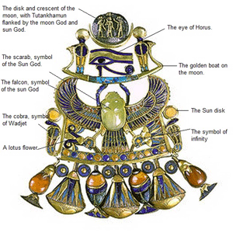
One of artifacts was a scarab pectoral necklace inlaid with carnelian, lapis lazuli, calcite, obsidian turquoise, and red, blue, green, black and white glass. Geologists performed a chemical composition test on King Tut’s scarab necklace and determined the scarab was made out of mysterious desert glass. Chemical and geological evidence suggest the greenish-yellow desert glass was made in an impact by either a meteorite or comet on the desert sand 500 miles from his home.
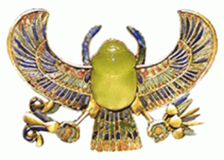
The glass that formed the scarab was formed as a result of meteor impact in the far distant past. Specimens of natural glass found in Kemetic deserts are products of meteorite slamming earth 100,000 to 200,000 years ago. Known locally as Dakhla glass, it represents first clear evidence of a meteorite impact. At time of impact, the Dakhla Oasis (Africa), in western part of modern-day Egypt, resembled other African savannas and was inhabited by early humans, according to archaeological evidence.
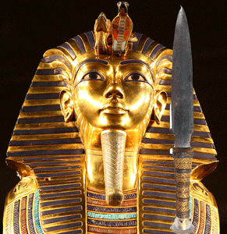
Scientists also found that a dagger’s blade found in King Tut’s tomb had a composition of iron, nickel and cobalt that strongly suggests it also had been of extraterrestrial origin. What’s more, it is nearly identical to the composition of a prehistoric meteor found in the seaport city of Marsa Matruh, 150 miles west of Alexandria.[35]
Benben Stone
Meteorites play an essential role in ancient Kemetic cosmology. For example, the “Benben ” stone worshiped in the sun temple of the god Ra at Heliopolis is thought to have possibly been a meteorite. The word “Benben ” is derived from the verb “weben”, meaning “to rise”, “rise in brilliance” “to shine”.[36] From the beginning of the 19th Dynasty (approximately 1295 BC) a new hieroglyphic word for iron appeared: “bi-A-n-pt”, which literally translates as “Iron From the Sky”.
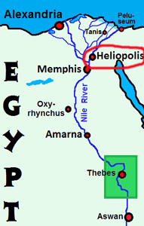
Heliopolis in Africa was also one of the oldest cities of ancient Kemet occupied since the Predynastic Period. It was principally notable as the cult center of the sun god Atum, who came to be identified with Ra and then Horus. The primary temple of the city was known as the Great House or House of Atum. Its priests maintained that Atum or Ra- Re was the first being, rising self-created from the primeval waters.[37]
According to Heliopolis-era creation stories in the beginning, Atum emerged from the Isfet (chaos) of Nu (primordial (ocean) waters). Atum created the god Shu (personification of air/cool dryness) and goddess Tefnut (personification of moisture) from Nu. Shu is depicted in the Kemet iconography as an ostrich feather.
“I have grasped the stake… I take the measuring cord in the company of Seshat. I consider the progressive movements of the stars. My eye is fixed upon the Bull’s Thigh [Ursa Major]. I count off time … and establish the corners of the Temple”.
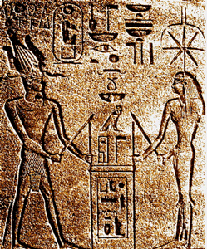
The above text is an inscription from the Temple of Horus at Edfu accompanying the relief showing “Stretching the Cord” Ceremony.[38] It has been suggested that the temples of prehistoric Kemet were located according to geodetic (science of measurement of the earth) principles. These temples include some of the greatest colossus structures ever built on earth with precision and purpose.
Baalbek (Heliopolis (On) Megaliths
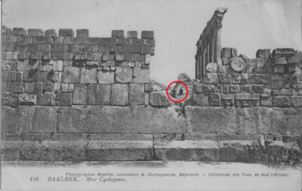
Romans knew the site of Baalbek in Lebanon by its Greek name, Heliopolis (On). Baalbek is named for Baal, the Canaanite deity – cousin of Kemet.

The “Stone of the South” at Baalbek, Lebanon is the largest worked monolith on Earth, weighing in at a staggering 1242 tons. 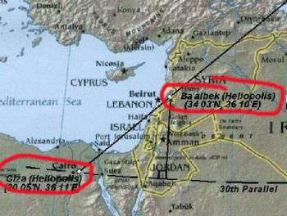
Map showing Baalbek in relation to Giza (Heliopolis)
The style of masonry and colossus construction employed is similar to what we find on the Giza plateau, an area that was also once called Heliopolis (On) in Kemet.
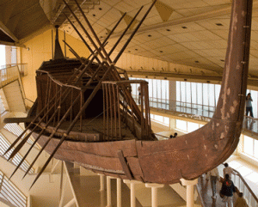
Baalbek’s connection to Giza and the pyramid complex is also interesting, as the wooden boats that were found buried on the Giza plateau are made from Cedar-wood, from trees that potentially come from the famous Cedar forests that once thrived on the slopes that Baalbek sits upon.
Baalbek- Stone of the South
Both sites were equinoctial, they both show the same incredibly skilled masonry techniques, and they are separated by almost exact degrees of longitude and latitude.
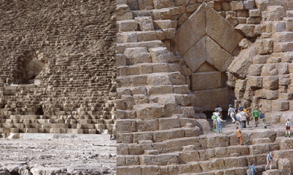
Great Pyramid Giza, Megalith Stones 50- 70 Tons
Additionally, geometric alignments have been shown to extend from both Giza and Karnak (Thebes).[39]
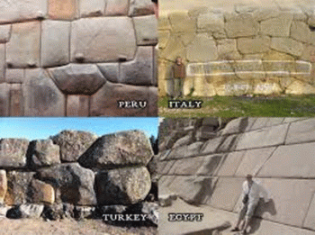
What power on earth build the mysterious virtually impossible Colossal Megalithic Monuments across the planet with purpose …

that modern science has no answers to?
V
HEKA & MA’AT – NOTHING IS STRONGER ON EARTH
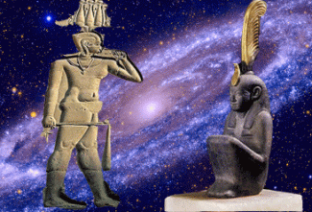
HEKA & MA’AT, Brother and Sister at Creation
MA’AT is said to have been born of the sun god Ra (ATUM- ATOM) at the beginning of creation through the power HEKA, who was magic personified. Her name means “that which is straight” implying order, justice, and harmony. She is thought to have been present from the beginning of time when, from the primordial waters of Nun, the Benben (first mound of dry land) rose with ATUM (or Ra, the sun god) standing upon it in the presence of the invisible HEKA. In the moment that RA- RE SPOKE THE WORLD INTO CREATION, MA’AT was born. Her spirit of harmony and balance infused the creation and caused the world to operate rationally according to purpose.[40]
“…to me belonged the universe before you gods had come into being. You have come afterwards because I am Heka.” – Coffin texts, part of spell 261, First Intermediate Period to Middle Kingdom.
To reaffirm: “I am one with Atum when he still floated alone in Nun, the waters of chaos, before any of his strength had gone into creating the cosmos. I am Atum at his most inexhaustible – the potence and potential of all that is to be. This is my magic protection and it’s older and greater than all the gods together!” – Book of Coming Forth By Day, New Kingdom.
While HEKA is the medium that can influence existence it was the principle of MAAT adhered to by the people of Kemet that kept HEKA functioning as that fundamental medium. It circulates in the universe. HEKA has no EVIL connotation. It is a divine energy and force that existed before creation and dualism. It is a force that even the gods and goddesses draw from.
Any alignment of the physical with the spiritual, of earthly with heavenly forces, required the activation of HEKA and resulted in MA’AT. HEKA is beyond which there is NOTHING STRONGER.
The mysterious Benben Stone first appeared during Sep Tepi or “point of first creation,” as a “mound,” after the waters of “Creation,” called Nun had subsided. The Benben Stone has also been described as a conical and pyramidal-shaped object based upon ancient eyewitness reports. The Beben Stone was said to represent the cosmic seed of all life produced from the “sperm” of Atum (Atom), the Supreme God.[41]
The Benben Stone exemplified the cosmically consummated spiritual connection between heaven and earth. As the primordial Womb, the Benben Stone carried the great cosmic seed of life, Atum’s spirit, the ‘light’.[42]
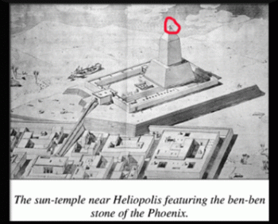
The Benben Stone of Heliopolis is said to have been shaped like a mound or pyramid, and was displayed on top of a tall pillar worshipped in the primary temple dedicated to God Atum, which was known by the name Per-Aat (pr-at; “Great House“).
However, there appears to have been another temple in Heliopolis the “Mansion of the Benben”, also known as the “Mansion of the Phoenix”, which is believed to have been a sacred precinct in which in the middle of an open courtyard, stood a stone pillar, on top of which sat the “benben stone”. It was seen as the solidified seed of Atum, the Stone of Creation, a magical stone, and some have concluded that it was of meteoric origin, “shining” in the sky, but when fallen on earth, black.[43]
Ancient Kemet’s metallurgists and chemists worked with meteorite materials for thousands of years. They had developed infinite knowledge of its content on an orderly scientific basis. Two kinds of lead can exist in different parts of the same meteorite. The results for the stone meteorite samples show a more radiogenic lead than can be accounted for by their lead to uranium. By counting the radiogenic lead atoms and the remaining uranium atoms in a fragment, the time elapsed since the uranium began to decay in the rock can be calculated. In other words, meteorites contain elements of extraterrestrial uranium atoms.[44] According to the theories developed, the Earth’s uranium was produced in one or more Big Bang supernovae (“An explosive brightening of a star in which the energy radiated by it increases by a factor of ten billion … A supernova explosion occurs when a star has burned up all its available nuclear fuel and the core collapses catastrophically.” – Oxford Dictionary of Physics).
The main process concerned was the rapid capture of neutrons on seed nuclei at rates greater than disintegration through radioactivity. The neutron fluxes required are believed to occur during the catastrophically explosive stellar events called supernovae. Gravitational compression of iron (the island of nuclear stability, incapable of further exothermic fusion reactions) and sudden collapse in the center of a massive star triggers the explosive ejection of much of the star into space, together with a flood of neutrons. Remnants of hundreds of supernovae have been found, and scientists “witnessed” one in Magellanic Clouds in 1987. The Earth’s uranium was produced through this process in one or more supernovae, and that this material was inherited by the solar system of which the Earth is a part.[45]
Nuclear energy is energy in the nucleus (core) of an atom. Atoms are tiny particles that make up every object in the universe. There is enormous energy in the bonds that hold atoms together. It is usually in a form of heavy metal, naturally occurring in most rocks, soil, and even in the ocean. It is found in many places in the world. Energy from uranium is called nuclear energy.[46] Nuclear energy is stored energy that holds the nucleus of an atom together. If the nucleus of an atom is split or fused with another atom, this releases or explodes huge amounts of energy. The Sun (Ra-Re) and uranium both possess direct nuclear energy. It’s been said that all of the Sun and stars in the sky are powered by “Fusion“. It’s the opposite of Fission energy.
Scientists have come to the conclusion that the people of ancient Kemet deliberately added lead salts to their black eyeliner to ward off bacterial infections. In samples of ancient Kemetic eyeliner, scientists identified 2 (two) types of lead salt not found in nature. That means that ancient Kemetic eyeliner had to be purposefully synthesized by an advanced scientific process. Making lead salt is a complicated and delicate process that requires laboratory weeks. In lab experiments, research scientists added lead salts to human skin cells called “keratinocytes”, which were grown in the lab. The researchers hypothesized that the lead would stress the cells and cause them to make hydrogen peroxide, nitric oxide, and other compounds involved in the body’s immune response. And indeed, cells treated with lead began pumping out more nitric oxide than did control cells.
They determined that nitric oxide sets off a series of biochemical processes in the body that ultimately send immune cells called macrophages to the site of infection, where they engulf invading organisms. The nitric oxide released by keratinocytes possessed the power and energy to directly kill eye-disease-causing bacteria on the skin or near the eye by breaking down a bacterium’s structure or DNA.[47] The people of Kemet believed that this makeup also had a “magical” role in which the ancient gods Horus and Ra-Re would protect wearers against several illnesses.
In earlier research, the scientists analyzed 52 samples from ancient Kemetic makeup containers preserved in the Louvre museum in Paris. They identified four (4) different lead-based substances in the makeup. In a new study, they found that the substances boosted production of nitric oxide by up to 240 per cent in cultured human skin cells. Eye infections caused by bacteria can be a serious problem in tropical marshy areas such as the Nile area during flood. [48]
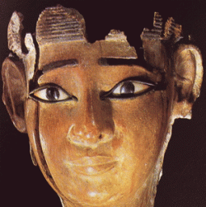
Elements of lead were indeed synthesized in a lab in antiquity. Modern science shows that there are no other conclusions. Luis Pellegrini, former director of the magazine Planeta, current director of the digital magazine Oásis, journalist, writer, translator, author of the books “The winged feet of Mercury” and “The Tree of Time“, both by Axis Mundi Editora, and “Madame Blavatsky “, said he believed that the ancient people of Kemet knew the atomic decomposition and uranium. It was one of the issues known to their priests and rulers.[49],[50] The mechanical and metal analysis of the sandstone samples extracted from the corridor leading to the royal chamber in the pyramid of Khufu in 1986 contain sand “specifically” on the proportion of heavy metals and some of the ratio of 7.7% and this gives two possibilities:
- The pharaohs used the uranium “and of course the necessary special settings“.
- Either they separated the uranium from the sand “and this indicates that the Pharaohs deliberately prepared the sand in particular and the process of separation“[51]
It is generally understood that one of the priests in the picture pour sand to move the monument, while the priest above him appear to be a HEKA/MA’AT chironomist, discussed below. However in lieu of new scientific evidence, the priest is pouring heavy metal (uranium) sand and salts while the other priest control its divine energy and force (HEKA) with the sound and voice of MA’AT.
In other words, Kemet’s metallurgists and chemists knew about the special extraterrestrial nuclear energy properties of heavy metals like iron. They had a complex system to determine the different properties of lead and uranium in rocks and meteorites, and scientifically separate them. They also knew about the special nuclear energy properties of the uranium atoms in the Benben Stone. That’s why it is associated with the ocean also containing ageless supernova uranium particles, the creation mound; and the fire and explosion that sparked the birth of God Atum (Atom), and launch the Benu Bird (Phoenix).

Karnak is the modern-day name for the ancient site of the Temple of Amun at Thebes in Kemet. The people of Kemet called the site Nesut-Towi, “Throne of the Two Lands“, Ipet-Iset, “The Finest of Seats” as well as Ipt-Swt, “Selected Spot” (also given as Ipetsut, “The Most Select of Places“). Thebes was yet another city that claimed that it was the first city founded on the primordial mound which rose from the waters of chaos at the beginning of the world. At that time, the creator-God Atum (sometimes Ptah) stood on the mound to begin the work of creation. The site of the temple was thought to be this original ground and the temple was raised at this spot for that reason. Karnak is believed to have been an ancient observatory as well as a place of worship where the God Amun would interact directly with the people of earth.[52]
Shemayet Nehmes Bastet
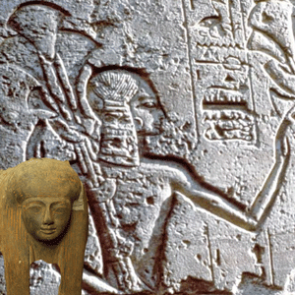
Shemayet Nehmes Bastet
According to an inscription on a wooden plaque found in her tomb, Nehmes Bastet was “chantress [shemayet] of Amun” – voice and vibration of the gods during the Twenty-Second Dynasty (945-712 BC). She was a vocalist and a master of the MA’AT ‘s harmony and the harp.
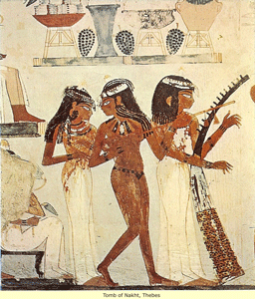
She was the daughter of the High Priest of Amun. The discovery of her tomb is important because it shows that the Valley of the Kings was also used for the burial of highly respected and beloved temple singers and musicians. Nehmes Bastet was undoubtedly an eminent and valued member of the priesthood and the people because until the discovery of her tomb, the only tombs found in the historic Valley of Kings were those linked to Kemet’s ancient royal families.[53] Nehmes Bastet’s title of Shemayet (user- MA’AT– ra-setp-en-ra Monthu-in-the-two-lands) brings us back to Goddess MA-AT. The Shemayet was the master of the production of sound or vibration (singing or chant), “herw (literally, ‘voice’)” associated with those gods deemed to be skilled in creative power and forces of “magic” personified– HEKA.
Sheymayet Whitney Houston

Someone on TWITTER respectfully honored Whitney Houston with title Shemayet Nehmes Bastet.
Sheymayet Meresamun
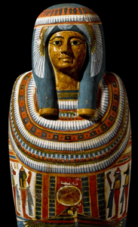
Meresamun
Sheymayet Meresamun (“Amun Loves Her”) was another highly celebrated singer in Kemet. She was an inner sanctum singer-priestess in about 800 BC.[54] Her coffin states that she was a “Singer in the Interior of the Temple of Amun” at Karnak. She also had been a part of the divine choir.
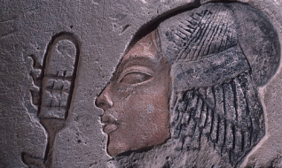
See her, her hand shaking the rattles to give pleasure to the god, her father Amun. How lovely she moves, her hair bound with ribbon, songstress with perfect features….Pleasure there is in her lip’s motions…. her heart is all kindness, her words gentle to those upon earth. One lives just to hear her voice.
The percussive rhythm of their ritual rattles (sistrums) and beaded necklaces (menats) was meant to calm the god and make him more amenable to protecting and helping mankind. Three times a day, a priest ceremonially opened the doors of Amun’s inner sanctuary, purified the divine statue, offered it food and drink, and then adorned it with clothing, jewelry and perfumes. While this was going on, grand ladies like Priestess Meresamun would make music and sing to the god with a sweet voice.[55]
Shemayet Diesehebsed
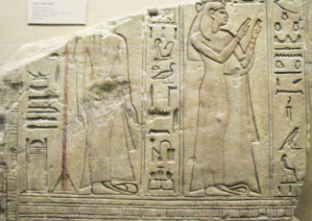
The fragment of sandstone relief, above, shows two women: Diese-heb-sed to the left and the God’s Wife of Amun, Amunirdis II or Amenirdis II, to the right. Both women wear fine, almost transparent linen gowns and sandals with looped toes.” The “god’s wife wears the vulture headdress.” “Inscriptions from other sources indicate that Diese-heb-sed was an attendant of Amunirdis. In that subservient role, she stands with her arms passively at her sides as Amunirdis raises her hands in adoration of the deity who was once shown to the right.
Pharaoh Taharqa
The above block came from the now lost tomb or tomb chapel of Diesehebsed of the 25th Dynasty of Kemet. Amenirdis II was the daughter of the Pharaoh Taharqa, and adopted daughter of the God’s Wife of Amun Shepenwepet II.[56] Shemayet Diesehebsed also bore the title “Singer in the Interior of the Temple of Amun” at Karnak, indicating that she was part of a divine chorus that entertained the god during offering rituals. He father was a priest of Amun and Scribe of the Offering Table.[57],[58]
Shemayet Tjayasetimu
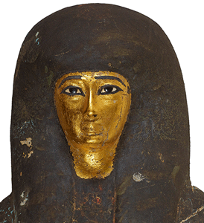
Temple singer of the inner sanctum and royal choir, Shemayet Tjayasetimu of the 26th Dynasty, left behind her elaborate image on her gilded sarcophagus in ancient Thebes in 800 BC. She was also a chantress of God Amun at the Temple of Karnak. She died a celebrated and beloved singer of the temple at 7 years old. She was granted the best mummification. She had been wrapped in painted bandages; her face was covered with a delicate veil hidden by a golden mask. She had been placed in a gilded sarcophagus.[59]
The detail above shows a clarinetist, flutists, a chironomist, dancers, and hand clappers. In the whole banquet scene there is an “eleven- man ensemble, consisting of two harpists, two flautists, a man playing an unusually long clarinet, and six chironomists.” see Lisa Manniche, Music and Musicians in Ancient Egypt, page 29. In ancient Kemet, “chironomists” practiced the art known as ‘chironomy’, whereby a series of hand-gestures would direct the musicians, akin to modern conducting. Overall, the Kemetic musical tuning, performance, and singing had to observe strict rules to keep ORDER OF MA-AT. Why?

Goddess MA-AT, identified with the principle of order, equilibrium and musical cosmic harmony that is found not only in the inner-most sanctuary of the temple, but also on the decoration on the harp– Harpist of MA-AT. Kemetic temple hieroglyphs considered MA-AT to be the Queen of [musical] Harmony.[60] Recall in the moment that RA- RE SPOKE THE WORLD INTO CREATION from atop the Benben Stone mound. MA’AT was born in the presence of the invisible HEKA. She is HEKA personified. Her spirit of harmony and balance infused the creation and caused the world to operate rationally according to purpose. The title of Shemayet (user–MA’AT–ra-setp-en-ra Monthu-in-the-two-lands) means the master ritual chanter or singer for the gods.
Nobody is certain what the invisible HEKA may be that was present on the Benben Stone with God Atum and Goddess MA’AT at creation. The strict rules of ORDER OF MA-AT personified in HEKA was strictly observed and transcended across religion, all disciplines, science and architecture- pyramid and colossus construction in ancient Giza, Heliopolis (On), Kemet, Heliopolis (On), Lebanon, and across the ancient world. HEKA is an invisible creative power and energetic force that I believe is related to the nuclear/atomic energy, frequency and vibration of the Benben Stone. Recall that sound and vibration (words-voice) can possibly split and manipulate the power of extraterrestrial (universe) ultra-compressed explosive nuclear atoms in heavy metals like uranium in ways we still don’t understand.
From the example of celebrated 7 year old Shemayet Tjayasetimu of the 26th Dynasty, the sound(s)-voice of HEKA personified in MA’AT may be acquired or inherited. She was undoubtedly a very remarkable and musical master child prodigy. The preservation of her name for thousands of years, and her grand burial is certainly a testament to her mastery of the voice of the gods, and the love the people had for her. I believe that the variants of the ancient sound(s) HEKA personified in MA’AT survive in some sacred African chants, black spirituals, and gospels.
VI
PREVENT THE RISE OF THE GODLY MESSIAH
SCEPTER has always known about the magnetic powerful magical and spiritual ancient sound(s) HEKA personified in MA’AT and the singers and musicians that have mastered the sweetness of justice, the invisible power and energy of AMUN-RA and MA’AT. Among them were music and chanter masters, Dr. Martin Luther King, Jr. (Killed 39 years old), Malcolm X (Killed 39 years old), Sam Cooke (killed 33 years old), Donny Hathaway (killed 33 years old), Whitney Houston (killed 48 years old), Phyllis Hyman (dead 45 years old), John Coltrane (dead 40 years old), Wes Montgomery (dead 45 years old), Otis Redding (killed 26 years old), Teddy Pendergrass (killed 59 years old), Marvin Gaye (killed 44 years old), Ricky Nelson (killed 45 years old), Luther Vandross (dead 54 years old), James Brown (Killed 73 years old), Michael Jackson (Killed 50 years old), Prince (Killed 54 years old), just to name a few.
Their sounds or “voice” of the music helped to connect people to the invisible force of creation inherent to the gods. Whether they knew it or not, they produced sound, divine voices that unto themselves were the magical spiritual power of power no greater than itself of generation, regeneration, resurrection, and the power of change and transformation. From the navel, they brought forth in breath magical power over the emotions of others that had been recorded and documented by the ancient Greeks that were like children among the giants of Kemet. Herodotus and Strabo noted the grand processions led by flute and reed-players, where the growing crowd of pilgrims lost themselves in “ecstatic” abandonment, demonstrating the power of the instrumental voice of God.[61]

President Drumpf said that he wants more immigrants from Scandinavian nations like Denmark to enter the country instead of people from “shithouse” or “shithole” countries like Africa. He seems to possess the notion that Scandinavia hadn’t been touched by the Mother Continent Africa. It also lies deep at its ROOTS.
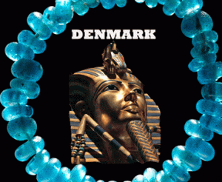
One of the precious beads found buried along with a Bronze Age woman at a grave-site in the town of Olby in Denmark came from Africa. Researchers said, another was discovered in a necklace together with four pieces of amber at the burial location of a second woman. The glass beads discovered in 3,400-year-old Danish graves were Kemetic in origin made by King Tutankhamun’s Workshop.
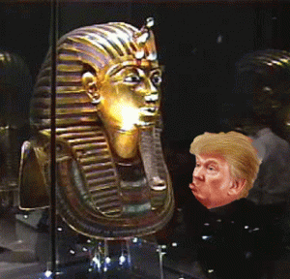
Analysis revealed that the beads buried with the women were created at a workshop located in Amarna, the capital city newly established and built by Pharaoh Akhenaten during the late 18th Dynasty and abandoned following his death in 1332 BC.
Pharaoh Amenhotep IV, Akhenaten- Neferkheperure
Glass from this same workshop was used in Tutankhamun’s death mask during his funeral in 1323 BC.

Without the Mother Continent AFRICA, Donald J. Drumpf could be sitting atop on the Benben Stone in the mist of CHAOS in the 21st century still waiting for the Magic- King Among the Frogs.
Let me close on the invisible magical power of voice and sound (HEKA) of Sheymayet Whitney Houston. SHEYMAYET (user- MA’AT- ra-setp-en-ra Monthu-in-the-two-lands), I WILL ALWAYS LOVE YOU. I need not say nothing else!
____________________________________________________________________________________________________
[1] https://www.vox.com/2018/1/16/16897016/trump-shithole-shithouse-countries
[2] https://www.historyonthenet.com/authentichistory/diversity/african/3-coon/6-monkey/
[3] https://www.billboard.com/articles/columns/hip-hop/7857106/jay-z-the-story-of-oj-mark-romanek-behind-the-scenes
[4] https://en.wikipedia.org/wiki/Atlantic_Records_Group
[5]
[6] https://www.billboard.com/articles/columns/chart-beat/7973958/cardi-b-no-1-hot-100-post-malone-portugal-the-man
[7] https://en.wikipedia.org/wiki/Kodak_Black
[8] https://twitter.com/iamcardib/status/861019973078183936?lang=en
[9] https://www.turkishnews.com/tr/content/2017/11/07/mk-ultra-project-the-cia-tavistock-institute-and-the-global-intelligence-police-gestapo-state/
[10] https://en.wikipedia.org/wiki/John_Rawlings_Rees
[11] http://kemetichistoryofafrikabluelotus.blogspot.com/2008/10/benu-bennu.html
[12] http://www.trickedbythelight.com/tbtl/2012-Olympics-World-Olympic-Games-Closing-Ceremony-In-London/2012-Olympics-World-Olympic-Games-Closing-Ceremony-London.htm
[13] http://aanirfan.blogspot.com/2015/03/kurt-lewin-tavistock-isis.html
[14] http://www.theoccidentalobserver.net/authors/Whitcombe-AdornoII.html
[15] https://en.wikipedia.org/wiki/Atlantic_Records
[16] http://www.closinglogos.com/page/Warner+Bros.+Pictures
[17] http://aanirfan.blogspot.com/2015/03/kurt-lewin-tavistock-isis.html

[18] http://www.verlaine.pro.br/txt/adorno-on-jazz.pdf
[19] http://www.theoccidentalobserver.net/authors/Whitcombe-AdornoII.html
[20] http://thepowerofsound.net/psychoacoustics-defined/
[21] https://en.wikipedia.org/wiki/Sound
[22] https://holyscience.wordpress.com/in-the-beginning-was-the-vibration/
[23] http://www.dailymail.co.uk/tvshowbiz/article-4142244/How-CIA-bid-turn-Uri-Geller-weapon-backfired.html
[24] http://www.keelynet.com/keely/puha1.txt
[25] http://www.techtimes.com/articles/15462/20140912/what-sound-atom-soft-sounds-hit-one-note.htm
[26] http://www.historyofmusictheory.com/?page_id=204
[27] https://en.wikipedia.org/wiki/D_(musical_note)
[28] http://epublications.bond.edu.au/cgi/viewcontent.cgi?article=1012&context=cewces_papers
[29] https://en.wikipedia.org/wiki/Office_of_Scientific_Research_and_Development
[30] https://en.wikipedia.org/wiki/Tom_Dowd
[31] http://www.bbc.co.uk/schools/gcsebitesize/science/ocr_gateway/energy_resources/big_bangrev1.shtml
[32] https://en.wikipedia.org/wiki/Old_Kingdom_of_Egypt
[33] http://ancientegyptonline.co.uk/ogdoad.html
[34] https://en.wikipedia.org/wiki/Tutankhamun
[35] http://www.history.com/news/researchers-say-king-tuts-dagger-was-made-from-a-meteorite
[36] http://kemetichistoryofafrikabluelotus.blogspot.com/2008/10/benu-bennu.html
[37] https://en.wikipedia.org/wiki/Heliopolis_(ancient_Egypt)
[38] http://www.ancient-wisdom.com/egyptgeodesy.htm
[39] Id.
[40] https://www.ancient.eu/Ma’at/
[41] https://drdanielmitchell.wordpress.com/2013/11/14/the-benben-stone-of-ancient-egypt-carried-the-life-giving-seed-of-atum-the-creator-of-the-universe/
[42] https://drdanielmitchell.wordpress.com/2013/11/14/the-benben-stone-of-ancient-egypt-carried-the-life-giving-seed-of-atum-the-creator-of-the-universe/
[43] http://philipcoppens.com/heliopolis.html
[44] http://onlinelibrary.wiley.com/doi/10.1029/JZ069i009p01895/abstract
[45] http://www.world-nuclear.org/information-library/nuclear-fuel-cycle/uranium-resources/the-cosmic-origins-of-uranium.aspx
[46] http://www.eschooltoday.com/energy/non-renewable-energy/what-is-uranium.html
[47] http://www.sciencemag.org/news/2010/01/egyptian-eyeliner-may-have-warded-disease
[48] https://www.acs.org/content/acs/en/pressroom/newsreleases/2010/january/ancient-egyptian-cosmetics.html
[49] http://www.luispellegrini.com.br/tag/explosao-nuclear/
[50] http://www.egyptominia.com/2017/04/scientific-miracle-of-pharaohs.html

[51] http://www.egyptominia.com/2017/04/scientific-miracle-of-pharaohs.html
[52] https://www.ancient.eu/Karnak/
[53] https://archive.archaeology.org/1207/features/valley_of_the_kings_egypt_chantress_coffin.html
[54] https://en.wikipedia.org/wiki/Meresamun
[55] http://judithweingarten.blogspot.com/2009/03/
[56] https://wikivisually.com/wiki/Amenirdis_II
[57] https://oi.uchicago.edu/collections/highlights/highlights-collection-egypt
[58] http://egiptoenimagenes.blogspot.com/2015/12/fragment-from-tomb-of-diesehebsed.html
[59] http://www.ancient-origins.net/news-history-archaeology/tjayasetimu-child-star-ancient-egypt-001643
[60] http://www.historyofmusictheory.com/?page_id=18
[61] http://ekunyisembers.com/tag/music
Comments : 2 Comments
Tags: 99 lodge, Adolf Hitler, africa, african slavery, Age of the Pyramid Builders, Age of the Pyramids, Akhenaten. Neferkheperure, Alsos Mission, Amenhotep IV, aretha franklin, ashur, atlantic records, baalbek, Belcalis Almanzar, benben stone, bennu bird, big bang, black culture, black folk music, Black Panther Party for Self Defense, Black sub-culture, bloods, bodak yellow, cardi b, charlie sheen, chironomis, CIA MK ULTRA/MONARCH, Colossal Megalithic Monuments, coon daughter, coons, Cosmic Microwave Background Radiation, dark satanic circle, daughters of lucifer, Declaration of Human Rights, dieuson octave, divine energy, divine music, divine vibration, divine voice, donald j. drumpf, donald j. trump, donny hathaway, Dr. Andrija Puharich, Dr. Martin Luther Luther King, extraterrestrial, false hip hop idols, false king of hip hop, frankfurt school, freemasons, geodetic, Geometric Concept of Matter, giza, god atom, god atum, god heka, god ra, god re, heka, heliopolis kemet, Hermopolis, hip hop, hip hop satanic cult, Huey P. Newton, human rights, Iron From the Sky, jay z, jaybo, jazz, Jerry Wexler, jim keith, john coltrane, John Rawlings Rees, kabbalah, Kabbalah of the Zohar, karnak, kemet, Khafre, khufu, King Sneferu, King Tut’s meteorite dagger, Knights of the Black Sun, kodak black, kurt lewin, london summer olympics, lucifer's coons, luciferians, Luis Pellegrini, luther vandross, maat, Magellanic Clouds, mahali, mahalia jackson, malcolm x, manhattan project, Mansion of the Benben, Mansion of the Phoenix, Marina Abramović, mark romanek, Marvin Gaye, masons, menkaure, mike pence, mother country, Nazis, Negro Coonery, Nibhurrereya, Nuclear energy, Office of Scientific Research and Development, ogdoad, Otis Reading, Otis Redding, Pharaoh Taharqa, phoenix, phyllis hyman, Psychoacoustics, Psychotronics, racism, radiogenic lead, Ray Charles, Ricky Nelson, rockefeller foundation, Ruth Brown, Sam and Dave, Science of the Atom, shemayet, Shemayet Nehmes Bastet, Shemayet Diesehebsed, Shemayet Tjayasetimu, Sheymayet Meresamun, Sheymayet Whitney Houston, shithole, shithouse, simian coons, Stone of Creation, Stone of the South, tavistock clinic, tavistock institute, teddy pendergrass, temple of amun, Temple of Horus at Edfu, the city of Hermes, THEO ADORNO, time warner, tom dowd, trouble of the world, Tutankhamen, Tutankhamon, Tutankhaten, uranium, Valley of Kings, wendy williams, Wes Montgomery, white racism
Categories : african american satanic cult, African Liberation, African slavery, Aleister Crowley, ALL SEEING EYE, andrija puharich, Aryan Supremacy, aset, ashur, baal, baphomet, black children, black christianity, blood covenants, christianity, church of satan, CIA, devil, devil's horns, donald j. drumpf, donald j. trump, donald trump, donny hathaway, egypt, evil, Eye of Horus, false prophet, false prophets, fbi, genocide, Hip Hop, HIP HOP false prophets, hip hop satanic cult, hollywood satanic cult, huey p. newton, illuminati, israel, jay-z, kemet, king tut, Knights Hospitaller, Knights Templar, lucifer's servants, luciferians, Madame H.P. Blavatsky, Malcolm X, Martin Luther King, mind control, MK-ULTRA, new age religion, Osiris, Ritual Satanic Abuse, ritual satanic sexual abuse, Rosicrucian, Rosicrucianism, rosy cross, satan, Satanic Global High Cabal, Satanism, Tutankhamen

DONNY HATHAWAY WAS A MURDER VICTIM- REOPEN DEATH BY SUICIDE!
14012018
I
MARTHA MITCHELL, DONNY HATHAWAY & THE ESSEX HOUSE HOTEL CIA SAFE HOUSE
During the late 1950s and 1960s, Martha Mitchell of Pine Bluff, Arkansas just seemed out of nowhere to have been dropped inside the Manhattan, NY “inner dark circle” of one of the world’s most powerful, ruthless and dangerous Satanic criminal political societies, the Nelson Rockefeller Syndicate. The Rockefeller Syndicate was an enormous octopus that tentacles clandestinely reached inside the top levels of the presidency, halls of congress, both political parties, military, CIA, and FBI.
It is interesting what Martha Mitchell said about Congress in lieu of Dr. Michael Baden and the JFK “CIA Magic Bullet Theory” that he tried to sell to the American people. Dr. Baden would have been the New York City Chief Medical Officer that would have signed off on Donny’s suicide. Dr. Baden is briefly discussed at the end. As for me. During the early 1970s, I got word thru the underground network that a subpoena had been prepared for me to appear before a congressional committee to talk about the Black Panther Party for Self Defense in Oakland. If you think it’s eerie living under President select Donald J. Drumpf, it was UNWORLDLY like walking thru the Twilight Zone during that era. Anything remotely associated with the government of Nazi Nixon, Freemason Gerald Ford, and Knight of Malta V.P. Nelson Rockefeller, I wasn’t going. I wasn’t going to talk to ANYBODY. I mean NOBODY! And, I did not.
In this post, I will attempt to show how and why Martha Mitchell was dropped right in the middle of one of the most powerful, ruthless and dangerous dark cabals in the western hemisphere. It would explain why the Essex House Hotel and Manhattan, NY was chosen as a safe-house to kill Donny Hathaway. It was the safe house that Martha Mitchell was held hostage and MK ULTRA brainwashed. It was in a place, Manhattan, where all the king’s men and horses were together for people in elite high places of the government to kill, steal, corrupt, drug traffic, rape women and children, and cover up. If society can reopen decades old sexual abuse cases in the interests of justice, it can certainly reopen an investigation of a possible criminal homicide. It is a crime against society so great that it has no statue of limitations. In the interests of justice, Donny Hathaway’s death by suicide must be re-opened and investigated as a possible homicide.
II
MARTHA BEALL, THE SMALL TOWN COUNTRY GIRL

Martha Elizabeth Beall- Mitchell was born on September 2, 1918, in the rural town of Pine Bluff, Jefferson County, Arkansas. Martha was born neither poor, rich nor powerful.
Martha Beall’s Childhood Home, Pine Bluff, Arkansas
She was raised in a very comfortable modest home built around 1887 by her grandfather, Calvin McFadden Ferguson, out of South Carolina. More likely than not, she had been suckled by a black nanny. In 1920, black servant Mary Crawford, 28 years old and her husband Sam lived next door when she was 2 years old. Martha would have been well grounded in the magic and mystery of mother’s wit and wisdom.
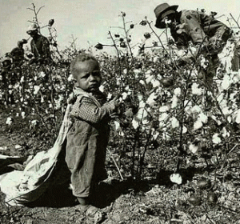
Her father, George Virgil Beall, born in Mississippi, was a cotton broker, for people not so comfortable or fortunate in a system of perpetual systemic racism. Her mother, Arie Elizabeth Ferguson Beall, was a speech and drama teacher for fifty years in the segregated Pine Bluff School District.
As Judge Jeanine Pirro of Fox (K-9) News slipped up and infamously described it, “Martha Beall got on the first trolley to hell to get money, fame and power.” At the end, Martha Beall- Mitchell was dragging one foot in HELL with the DEVIL hanging on for the final ride until the day she died. Once you sell your soul to DEVIL, he’ll never let go.
III
WATERGATE
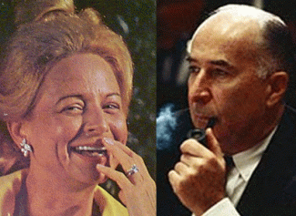
Martha and John Mitchell
The Watergate Hotel, located in Washington, D.C., was the home of John and Martha Mitchell. John Mitchell, former U.S. Attorney General was appointed to head the Committee to Reelect Richard Nixon (CREEP). Don’t get it twisted, they were dark circle Nazi fascist pigs. Among many other wicked psychopathic things, they plotted to put children of color, particular black, into U.S. concentration camps. Also housed in the Mitchells’ Watergate Hotel complex were the offices of the Democratic National Committee.
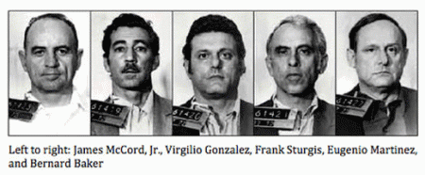
In the early morning hours of June 17, 1972, five (5) men were arrested removing parts of the ceiling from the 6th floor panels in the Democratic National Headquarters. These men possessed expensive electronic equipment, cameras, walkie-talkies, burglary tools, various James Bond accessories, and rubber gloves to conceal their identities. Two of the men arrested also had the contact telephone number to E. Howard Hunt, White House Consultant. Hunt had worked with the CIA for 21 years.
Nine persons, all registered with false names taken from CIA novels written by Howard Hunt, stayed at the Watergate Hotel May 26-29 and again June 17 & 18. Five (5) of them, the night of their arrest, had been discovered when security guard Frank Wills noticed pieces of Scotch tape over the door locks. Washington police arrived and made the arrests. All of the five (5) men caught in the Democratic headquarters were connected with the CIA in some way. The other relationship they had in common was having worked together for the CIA-planned Bay of Pigs Invasion of Cuba.[1] It is safe to conclude that the Democratic National Headquarter break-in was a covert CIA operation.
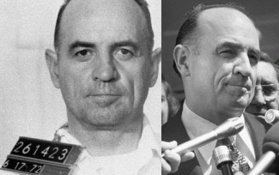
James McCord, Jr., employed as Chief of Security for Mitchell’s CREEP, was one of the burglars arrested. McCord was formerly employed by the CIA for 19 years. His position with the CIA was Chief of Security over the entire headquarters at Langley, Fairfax County, Virginia. It is now called, The George Bush Center for Intelligence.[2] McCord had been the personal security escort for Martha Mitchell, and U.S. Attorney General John Mitchell, the head of CREEP. She knew him well as an internal part of CREEP, and a friend.
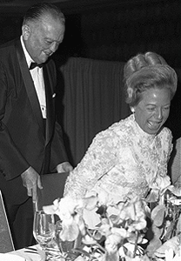
President Nixon had authorized John and Martha 24 hours FBI protection. She was on excellent terms with J. Edgar Hoover. On May 24, 1971, at a time when he was rarely seen in public FBI Director J. Edgar Hoover attended the American Newspaper Women’s Club black-tie dinner honoring Martha Mitchell at the Shoreham Hotel, Washington DC. He introduced her at the affair, and added that she had been one of his “dearest friends”.[3]
On May 2, 1972, just days before the Watergate Break-in, Hoover by most accounts was liquidated by his wicked friend Nixon, and his dark forces. He had been killed with a poison, thyonphosphate genre, which mimics death by heart attack.[4]
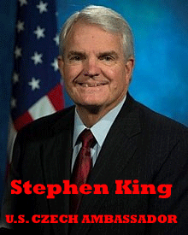
In 1972, Stephen King was an ex-FBI agent that was working as a security man for CREEP. King stepped into McCord’s place as security chief for CREEP when McCord was busted on June 17, 1972. King’s duty on the week of the Watergate break-in and arrests was to protect and keep a close eye on Martha Mitchell while the Mitchells were on a campaign swing in California. She was known to be extremely loose lipped and talkative. They wanted to prevent Martha from exposing McCord’s direct deep connection to CREEP to the press. When the Watergate story broke, Martha Mitchell was staying at the Newporter Inn in Newport Beach, CA on a CREEP campaign fund raising stop. However, Martha Mitchell knew a lot more than James McCord, CIA and CREEP. Start her to talking, she may have told the press everything she knew.
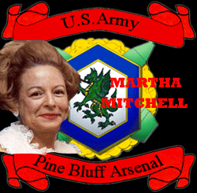
In 1945, Martha Beall- Mitchell began work as a classified/top secret secretary, receptionist or research analyst at the Pine Bluff Arsenal in Arkansas, Jefferson County for the U.S. Chemical Corps.
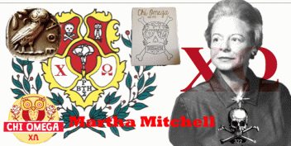
Prior to that she attended the University of Arkansas where she joined the Skull and Bones secret society fraternal sisterhood, the Chi Omega sorority. The sisterhood was founded with the help and assistance of Kappa Sigma (ΚΣ), commonly nicknamed Kappa Sig or K-Si.[5]
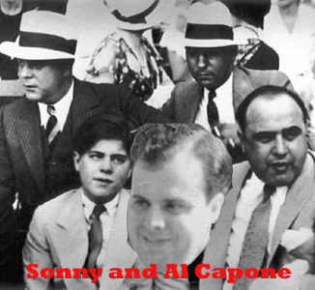
From the University of Arkansas, she transferred to the University of Miami, and met the infamous Mafia gangster, Al Capone, while dating his son, Alphonse Albert Francis “Sonny” Capone, before graduating in February 1942. It appears that she had been working as confidential informant for FBI back then. [6]
IV
MARTHA MITCHELL, FRANK OLSON & THE HIGHER FORM OF KILLING
The U.S. Chemical Corps
The Chemical Corps is the branch of the U.S. Army tasked with defending against chemical, biological, radiological and nuclear weapons. The corps was founded as the U.S. Chemical Warfare Service (CWS) during WWI. Its name was changed to the Chemical Corps in 1946.
Col. A. M. Prentiss (born 1890) in North Carolina arrived in Pine Bluff on Nov. 21, 1941 to establish a headquarters. The federal government committed $10 million for construction of the Chemical Warfare Arsenal, and the installation was also charged with manufacturing and assembling incendiary munitions for Great Britain.[7] For most of its history, the Chemical Corps was tasked with delivering chemical weapons rather than defending against them. During WWII and the Korean Conflict, the Pine Bluff Arsenal was opened and used for Biological Warfare (BW) and Chemical Warfare (CW) production; and research facilities were expanded at Camp Detrick where CIA agent Frank Olson was stationed.
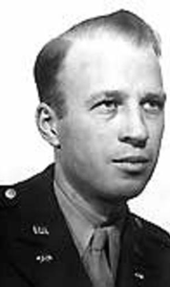
Captain Frank Olson, U.S. Chemical Corps
In fact, Olson was a captain in the U.S. Chemical Corps with Martha Mitchell. [8] As a civilian, he was recruited to Camp Detrick, and to the U.S. Army Biological Warfare Laboratories (USBWL), by the distinguished University of Wisconsin scientist Ira Baldwin.[9] The USBWL were a suite of research laboratories and pilot plant centers operating at Camp (later Fort) Detrick, Maryland, United States beginning in 1943 under the control of the U.S. Army Chemical Corps Research and Development Command. The USBWL undertook pioneering research and development into bio-containment, decontamination, gaseous sterilization, and agent production and purification for the U.S. offensive biological warfare program.[10]
From the end of World War II through the Korean Aggression, the U.S. Army, the Chemical Corps and the U.S. Air Force made great strides in their biological warfare programs, especially concerning delivery systems. During the Korean War Aggression (1950-53) chemical soldiers had manned 4.2 inch chemical mortar for smoke and high explosive munitions delivery. North Korea, the Soviet Union and China leveled accusations claiming the U.S. used biological agents during the Korean Aggression.[11]

It doesn’t appear that Martha Beall was just one person lost among the 10,000 workers at Pine Bluff. She was special- very special. In fact, she was so special that she accompanied the Pine Bluff’s 1st Military Commander, Brigadier General Augustin Mitchell Prentiss, PhD, to Washington DC in July 1945.[12] Prentiss entered the United States Army in 1913, was detailed to the Chemical Corps in 1917, started World War II as a Lieutenant Colonel in the General Staff Corps, and retired as a Brigadier General. His decorations included the Army Distinguished Service Medal and the Legion of Honor of the Republic of France.[13]
Prentiss had to be one of the most foremost and elite BW and CW military experts in America. He was the Kurt Blome of the U.S. Army. Martha Mitchell was a member of his personal staff. For good reasons, she would have had more high top secret security clearances than President Truman.
On October 5, 1946, she married a U.S. Army Intelligence Officer, Captain Clyde J. Jennings, Jr. of Lynchburg, VA, in Pine Bluff/Jefferson, Arkansas. From 1946 to 1947, General Prentiss, Captain Jennings and Martha Beall- Jennings quietly slipped out of the military BW-CW circles in Washington DC. The Jennings moved into Manhattan, NY. In all fairness, Captain Jennings, Jr. had in fact listed his occupation as a “designer” in the 1940 U.S. Census. However, it wasn’t anywhere close to New York. It was in Lynchburg, VA, and the man’s specialty was military intelligence not Manhattan fashion design.
Jennings, Jr. and Martha Elizabeth Beall- Jennings landed in Manhattan working inside the circle and network of Vera Sportswear (Vera Maxwell) of Manhattan, NY. Vera Maxwell Originals was created in 1947.[14] Where did the capital come from to create Vera Maxwell Originals in 1947? Hitler’s General Reinhart Gehlen and Himmler’s SS Knights of the Black Sun?
V
CAPTAIN JENNINGS, VERA MAXWELL OF MANHATTAN & THE PRINCESS
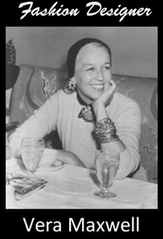
Vera Huppe was born in New York City on April 22, 1901 of German parents. She traveled to Europe with them as a child and lived for a while in Vienna. In 1910, her father, Bernard Felix Huppe, listed his profession as a [Viennese] importer and auctioneer. She attended high school in Leonia, N.J., and studied ballet in New York, becoming a member of the Metropolitan Opera Ballet in 1919. She danced with the company until her marriage in 1924 to Raymond J. Maxwell, who worked (oil brokerage) on Wall Street. They were divorced in 1937. She married Carlisle H. Johnson, an architect, in 1938 and divorced him in 1945.[15]
Vera Maxwell & Princess Grace of Monaco
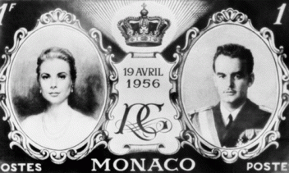
Twice each year Vera Maxwell would stay with Princess Grace Kelly and her family in Monaco. She had some very extraordinary powerful deep rabbit hole European secret society credentials to get inside Prince Rainier and Princess Grace Kelly’s inner circle on the other side of the world.

HollyWeird Actress Grace Kelly
Blonde, blue eyes, red lips, skin like poured cream, pearls, Grace Kelly was a classic European MK ULTRA Presidential Model. Vera Maxwell and Grace Kelly had been friends since 1955 when the former actress was voted the woman who most exemplified the American look with her Maxwell Wardrobe.[16]
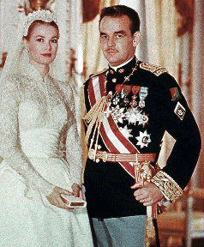
In 1956, Grace Kelly married Knight of Malta Prince Rainier III (born Rainier Louis Henri Maxence Bertrand Grimaldi who ruled Monaco. The House of Grimaldi is a dark ILLUMINATI Dynasty that goes back to the Black Nobility of the 12th century.[17] Prince Rainer’s sensational marriage to the HollyWeird superstar was arranged by Aristotle Socrates Onassis. He controlled the business/crime (gambling-drug, prostitution, etc.) enterprises of Monaco.
The Dark Aristotle Onassis
“Aristotle Onassis associated with many powerful people. ‘The Christina’s cruises always produced items which no alert gossip columnist could miss. Onassis dropping in on Prince Alfonso Hoheiohe’s Marbella Club in southern Spain and lunching with Baron and Baroness Guy de Rothschild … Other close friends of Onassis were the Perons of Argentina. The Perons set up a dictatorship in Argentina. The Perons have a great number of Nazi & Satanic connections/activities. If you get into studying about the Perons you will come up with names such as Josef Mengele (a Satanic Nazi Doctor), Dr. Fritz Thyssen, and Otto Skorzeny. Onassis had sexual liaisons with Evita Peron, who was a platinum blonde. Onassis had Nazi connections that continued his whole life, as did the Peron’s. For instance, one of Onassis’s Nazi associates was Hjalmar Schacht, president of Hitler’s Reichbank, who Onassis hired after the war. Schacht helped Onassis’ shipyards in Germany build tankers after W.W. II.”[18]
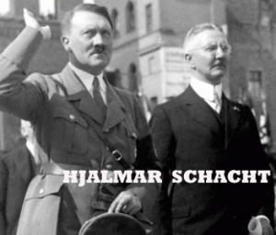
During WWII, Schacht also aided and abetted Onassis’ oil tankers break Allies Forces shipping blockades.
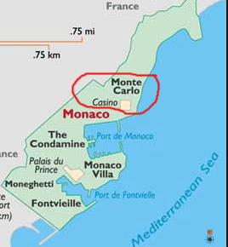
Monaco, officially the Principality of Monaco, is a sovereign city- state, country, and micro-state located on the French Riviera in Western Europe. France borders the country on three sides while the other side borders the Mediterranean Sea.[19] For eight centuries, Monaco has been, as one witness called it, “a sunny place for shady people.” During World War II, Rainier`s grandfather, Prince Louis II, saved the family fortune by collaborating with the Nazis who turned Monaco into a furlough base for German troops. Holding companies were set up so that Hermann Goering, Heinrich Himmler and other top Nazi–SS officials could launder money.[20]
In the 1950’s, Vera Maxwell’s customers included powerful and influential women like Pat Nixon, Martha Graham and Lillian Gish. By 1960, her clothes were being sold in 700 stores around the country. She also was a regular at the White House, designing for Rosalyn Carter and Pat Nixon.
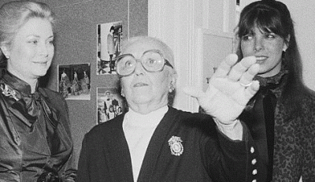
Princess Grace, Vera Maxwell & Princess Caroline
Maxwell may have been Princess Grace Kelly’s secret Viennese MK ULTRA/MONARCH female handler.
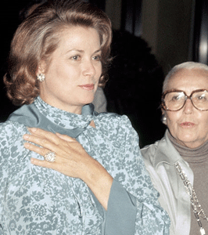
Princess Grace Kelly and Vera Maxwell
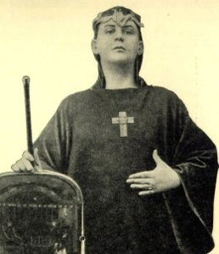
Grace Kelly, signed studio gagging orders and blood oath secrecy covenants on what she saw and knew. Grace Kelly said several times if she spoke out she would fear for her life which ended in a suspicious car crash in 1982 similar to Princess Diana.[21] Reportedly, Princess Grace Kelly became a Satanic Priestess in a mass murder sex cult called the Order of the Solar Temple just months before her mysterious death in 1982.
The Order of the Solar Temple, also known as Ordre du Temple Solaire (OTS) in French and the International Chivalric Organization of the Solar Tradition or simply as The Solar Temple is a secret society that claims to be based upon the ideals of the Knights Templar. OTS was started by Joseph Di Mambro and Luc Jouret in 1984 in Geneva as l’Ordre International Chevaleresque de Tradition Solaire (OICTS) and later renamed Ordre du Temple Solaire. Some historians allege that the Solar Temple originates with French author Jacques Breyer, who established a Sovereign Order of the Solar Temple in 1952. In 1968, a schismatic order was renamed the Renewed Order of the Solar Temple (ROTS) under the leadership of French right-wing political activist Julien Origas.
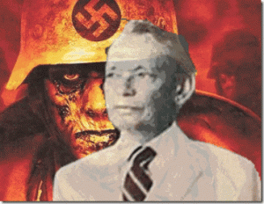
SS Dr. Arnold Hutschnecker of Manhattan
Nixon’s Viennese mind control psychoanalyst and psychotherapist handler in Manhattan was SS- Knight of the Black Sun, Dr. Arnold Aaron Hutschnecker. Before he entered the U.S., Dr. Hutschnecker had been a guard/worker at one of Himmler’s concentration camps in Nazi Germany. In a NY Times article, he was quoted, “When I talked about camps for young people,“TO RETAIN”, like the camps I worked in when I came here from Germany in 1936. Concentration camp guards-workers were the exclusive domain of Reichsfuhrer SS 1 Heinrich Himmler, and the SS-Totenkopfverbände– DEATH HEADS. [22]
Vera Maxwell gave the two small Southern country natives Captain Jennings, Jr. and Martha Elizabeth Beall social access to the super elite power, financial, political and dark satanic circles in Manhattan, NY (Rockefellers), HollyWeird, Washington DC, and the World.
VI
MARTHA BEALL JENNINGS, JOHN MITCHELL & NELSON ROCKEFELLER
“Sometime before May 1956, Martha had begun dating Wall Street lawyer John Mitchell. Eleven days after divorcing his first wife on December 19, 1957, he and Martha married.”[23]
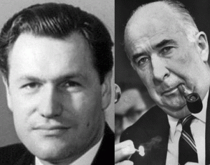
John Newton Mitchell had been Knight of Malta (puppet master) Nelson Rockefeller’s lawyer and personal counsel at the Wall Street law firm Mudge Rose Guthrie Alexander & Ferdon. With John Mitchell as a partner, the firm is known best as the legal launching pad for Richard Nixon (1963- 1968) to become President of the United States. John and Martha Mitchell had been one of his most visible and strongest supporters and loudest cheerleaders and trailblazers in Manhattan social and political circles for Richard Milhous Nixon. [24],[25]
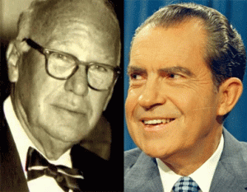
Nixon’s Godfather Elmer Bobst
In the “Rockefeller File” by Gary Allen published in 1976, he made the startling and shocking charge that Elmer Bobst, Nixon’ Godfather, actually arranged for the employment of him in Mitchell’s law firm following his failed California gubernatorial run. [26],[27] Records that have now been declassified show that powerful U.S. government officials such as J. Edgar Hoover of the Federal Bureau of Investigation (FBI), and Allen Dulles of the Central Intelligence Agency (CIA) did in fact secretly tenaciously recruit former Nazis “of all ranks as secret, anti-Soviet assets” for services during the apex of the Cold War during the 1950s, according to the NY Times.
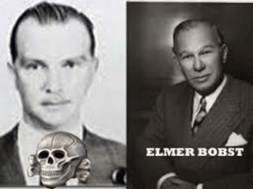
Bobst’s involvement in deliberately placing Nixon inside Mitchell’s law firm and inner social circle with Martha Beall Mitchell is startling and shocking because SS- 1 Himmler’s most elite dangerous, clandestine international espionage Knight of the Black Sun, Baron Otto Von Bolschwing, had established “inner circle” ties with ELMER BOBST, President of Warner-Lambert Pharmaceutical.
In fact, Baron von Bolschwing became the Director of International Marketing at Warner-Lambert. Teutonic Knight Baron Bolschwing was a top key clandestine operative in the Gehlen Org, CIA and Hoover’s FBI. Baron von Bolschwing was/is a true “untouchable”. In the 21st century, most of his activities in this country remain blanketed in classified top secrecy in the interests of “National Security.” Baron von Bolschwing top secret classification must change in regards to everything that he did in this country.[28] What may be exposed about him in full and open enclosures might blow your shoes and socks clean off.
VII
U.S. CHEMICAL CORPS & OPERATION PAPERCLIP (THE THIRD REICH)
Martha Mitchell’s guiding light and benefactor Brigadier General A.M. Prentiss, Sr. retired from the U.S. Chemical Warfare Service on August 31, 1946, and then he dropped underground off the biological and chemical warfare map during a very critical time in history when Operation PAPERCLIP began to secretly flood Nazi-SS doctors and technicians into the U.S., Great Britain, Australia and other Western European countries.
Brigadier General A.M. Prentiss, Sr. held the key to a network that controlled enough biological and chemical weapons (mustard gas, sarin, tabun, anthrax, etc.) to destroy every living thing on half the planet. That placed him in a very powerful position at an extremely dangerous time in world history to fall underground. So it’s not difficult to believe what drew Brig. General A.M. Prentiss, Sr., Captain Jennings and Martha Beall out of Pine Bluff, Arkansas to Washington DC in 1945 and then underground was Operation PAPERCLIP.
The purpose of this operation was to bring the engineers who helped develop the saucers and weapons [biological and chemical weapons of mass destruction] for Nazi Germany to clandestinely work for the US military. I believe that these people suddenly went underground to become secret liaisons and brokers for the global network of the Underground Third Reich.
Brig. General A.M. Prentiss had a son, Augustin M. Prentiss, Jr. (br. 1915) born in Washington DC. He was also in the military, U.S. Air Force, and worked with his father at Edgewood Arsenal (Chemical Warfare Service) in Maryland. Both Prentiss Sr. and Jr. appear to have been directly linked to secret deep cover Operation PAPERCLIP.
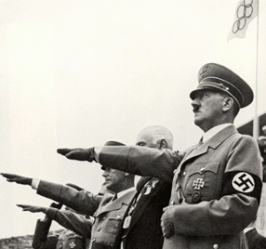
From the SS Manhattan ship passenger log on October 18, 1936, it shows that Brig. General A.M. Prentiss, Sr. of Edgewood Arsenal, Maryland got off the boat in New York from Hamburg, Germany. I doubt it very seriously if U.S. tax payers paid for Prentiss and his wife, Anne Hull Prentiss, to attend Nazi Germany’s Strange 1936 Summer Olympics. Prentiss, Sr. and the U.S. Army Chemical Warfare Service secretly knew far lot more about Himmler, SS- Knights of the Black Circle’s BW and CW doctors, scientists, technicians, weapons of mass destruction and concentration camps than anyone are willing to acknowledge. Prentiss wasn’t alone to use the Summer Olympics as cover to meet secretly with Hitler, Himmler and the Nazis.
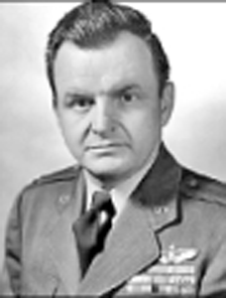
Col. Augustin Mitchell Prentiss, Jr.
Col. A.M. Prentiss, Jr. received his Bachelor of Science, U.S. Military Academy, 1937, Advanced Mathematics Program, Harvard University, 1957, and Master of Arts from American University, Washington, 1965. He was commissioned Second lieutenant U.S. Air Force, 1937, advanced through grades to colonel in 1945. He advanced from captain to colonel 5th Air Force, Far East Air Forces, Australia, New Guinea, Philippines, Japan, 1943-1946. He served with Strategic Air Command, U.S. Air Force, Andrews Air Force Base, 1946-1948, and with the Office Joint Chiefs Staff, Department Defense, Washington, 1950-1953 (Korean War and Aggression).
Col. A. M. Prentiss was chief of staff of the Air Development Center, Wright Patterson Air Force Base, 1953-1955. He served with the Office Secretary Defense, Research and Engineering (ARPA), Washington, 1958-1960. He retired from U.S. Air Force, 1960. He was manager of project liaison, Westinghouse Electric Corporation, Baltimore, 1960-1965, and director of defense systems Washington, 1965-1981.[29]
The Nazi SS, Flying Saucers, Operation Paperclip & The Day The Earth Stood Still

I can’t make this stuff up!
Nazi-SS Jet Propelled Flying Saucer
In 1955, Project Silver Bug was exposed by the Air Technical Intelligence Center and Wright Air Development Center (WADC). WADC is directly connected to Col. A.M. Prentiss, Jr. The proposed the mounting of a research and development project into the building of a jet-propelled flying saucer, capable of both vertical takeoff and landing along with supersonic speeds up to 1,500 mph. If successful, the craft would have been based underground, thus avoiding the need for long runways and easily-distinguished bases which would have been easily taken out by a single nuclear bomb or missile warhead.[30]

The U.S. government imported a group of Operation PAPERCLIP Nazi-SS aeronautical experts to this country to develop and implement the project. The entire Silver Bug project remained clouded in secrecy and security classifications until the decade of the 1990s, when the one report was finally declassified and released by the Air Force. Samisdat Publications, a right-wing organization based in Toronto, Canada, has said that the Nazis did in fact develop the Flügelrad, or ‘Wingwheel‘, a saucer-helicopter which could take off vertically.
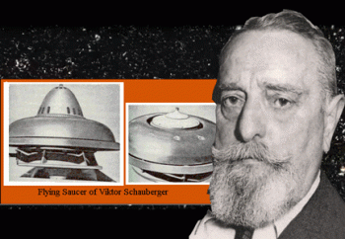
One of the scientists involved with the early Nazi SS saucer projects was identified as Viktor Schauberger by Samisdat. He was brought under Operation PAPERCLIP to work on the project in Texas until his death in 1958. Some reports maintain that some prototypes the government is now developing are as advanced in propulsion and other areas over the Schauberger models as the space shuttle.[31]
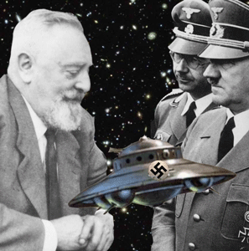
Schauberger was an Austrian inventor and engineer handpicked by Hitler and Himmler to lead their secret research project at Mauhausen Concentration Camp, Austria to produce a flying machine, which was saucer-shaped and that used a “vortex propulsion” system. According to some witnesses, Schauberger constructed several vessels. Furthermore, other reports indicated that one of the vessels in fact flew. To verify the flying saucer sighting over Prague, Czech Republic, Schauberger wrote to a friend that while using the slave-labor of prisoners at the Mauhausen, one of the models was made into a full-sized prototype. This craft flew on February 19th of 1945 near Prague, and obtained an altitude of forty-five thousand feet in less than five minutes. The letter goes on to say the prototype was destroyed by the Nazis before it could be captured by the Allies (Krystek 1997).[32]
Operation Paperclip, Col. Prentiss & The U.S. Advanced Research Projects Agency
In 1962, the organization that oversaw Operation Paperclip was disbanded. What remained of the Operation Paperclip was taken over by the Pentagon’s Research and Engineering Department that Col. A. M. Prentiss, Jr. had worked for. Col. Prentiss’ Advanced Research Projects Agency (ARPA) division developed new technology for the Defense Department.[33] [D]ARPA (Research and Engineering) was/is one of America’s most powerful and clandestine military research agencies. It is the Pentagon’s Brain.[34]
Operation Rusty (Gehlen Org), Col. Prentiss & the Joint Chiefs of Staff
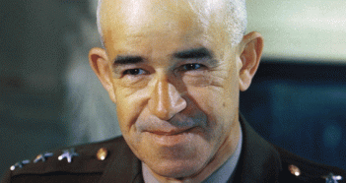
Five (5) U.S. Army General Omar Bradley, 1st Chairman of the Joint Chiefs of Staff
From 1950- 53, Omar Nelson Bradley (February 12, 1893 – April 8, 1981) was the first Chairman of the Joint Chiefs of Staff that employed General Prentiss. General Bradley oversaw the U.S. military’s policy-making in the Korean War and Aggression under President Harry Truman.[35] The joint chiefs included General Hoyt S. Vandenberg, USAF. He was part of Central Intelligence Group (CIG) which acquired the assets of the OSS.
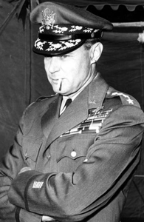
General Vandenberg
In 1945, General Vandenberg and CIG secretly financed the clandestine program, Operation Rusty.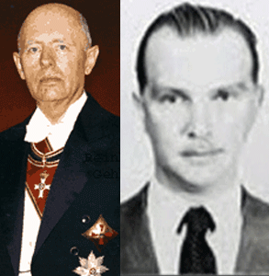
General Gehlen, Malta Knight & Baron von Bolschwing, Black Sun Teutonic Knight
General Reinhard Gehlen’s Nazi SS Network (Baron Otto von Bolschwing) was code named, Operation Rusty, and it was financed by Col. Prentiss Jr.’s Joint Chiefs of Staff and Vandenberg.[36]
Brig. General A.M. Prentiss Sr.’s U.S. Army Chemical Corps & Dr. Kurt Blome
Nazi Mass Murder Psychopath- Dr. Kurt Blome
Dr. Kurt Friedrich Ludwig Blome was recruited by Brig. General A.M. Prentiss Sr.’s U.S. Army Chemical Corps. After Dr. Blome was acquitted of Nazi Crimes Against Humanity at the Nuremberg Doctors’ Trial in August 1947, according to Linda Hunt’s remarkable book, “Secret Agenda: The United States Government, Nazi Scientists and Project Paperclip, 1945-1990” (St. Martin’s Press, 1991), two months later, “four representatives of Fort Detrick — the Maryland army base that was also headquarters of the CIA’s biological warfare program — interviewed Blome about biological warfare…. During a lengthy interview Blome identified biological warfare experts and their locations and described different methods of conducting biological warfare.”[37]
The Fort Detrick interrogation is known from Blome’s INSCOM dossier and his Joint Intelligence Objectives Agency (JIOA) dossier, RG 330, NARS. According to BBC television producer Tom Bower in his book, “The Paperclip Conspiracy: The Hunt for the Nazi Scientists” (Little, Brown & Company, 1987), it is public record that Kurt Blome was hired by the U.S. Chemical Corps in August 1951. Bower gives as citation for this material RG 330 JIOA case file, “Blome,” in the National Archives. Kurt Blome is known to have been a used as an intelligence asset and resource after he came under U.S. custody.[38]
Brig. General A.M. Prentiss Sr.’s U.S. Army Chemical Corps & Dr. Erich Traub
Dr. Erich Traub completed his secret Operation PAPERCLIP duties working for the American biological warfare program from 1949 to 1953, during which time he consulted with the CIA and scientists at A.M. Prentiss and Frank Olson’s Fort Detrick before returning to West Germany in 1953. Dr. Traub was chief of an ultra-secret Nazi-SS biological warfare laboratory in the Baltic Sea. He was Hitler and Himmler’s biological weapons developer. He worked directly for SS Heinrich Himmler on live germ trials. Traub “packaged weaponized foot-and-mouth disease virus, which was dispersed from a Luftwaffe bomber onto cattle and reindeer” in occupied Russia.[39] Dr. Traub was rescued from the Soviet zone of Germany after WW II and taken to the U.S in 1949 under the auspices of Operation PAPERCLIP. Within months, Traub began secret meeting with scientists. Traub consulted with Fort Detrick scientists on their animal disease program from a biological warfare perspective.[40]
Blome and Traub are only two (2) examples of thousands of Operation PAPERCLIP Nazi SS biological, chemical, psychological warfare, and mind control scientists of direct interest to the U.S. Army Chemical Corps and A. M. Prentiss, Sr. that were secretly smuggled into the country. Hitler, Himmler and the Nazis weren’t defeated. They just CHANGED VENUES to the U.S!
Clandestine MKULTRA/MONARCH mind control programs were organized through the Scientific Intelligence Division of the CIA, the programs were coordinated with the Special Operations Division of the Brig. General A. M. Prentiss, Sr.’s U.S. Army Chemical Corps.[41] Brig. General A. M. Prentiss, Sr. didn’t die until 1977 in Newington, Hartford County, Connecticut. Newington is about 93 miles outside of Fort Devens, Massachusetts.[42] He may have died at Fort Devens. During WWII, Fort Devens seemed to have been used as a Germany/Nazi debriefing station. In 1945, Fort Devens was a very special Nazi POW camp filled with friendly Nazis. In May 1946, it officially closed as a Nazi POW camp.[43] Col. A.M. Prentiss, Jr. died in 2009, Fort Myers, VA. In late 2001, troops, deployed in response to the 9-11, were camped at Fort Myer under Operation Noble Eagle. [44]
Martha Mitchell was a treasure trove of information about the government, shadow government and “dirty tricks” that she said that she become sick and tried of. She may have also known about Cuba, the Bay of Pigs & JFK. Martha Mitchell knew all about Gehlen’s Network of Nazi-SS War Criminals, Camp Detrick, Biological Warfare, North Korea, and Frank Olson.
VIII
MARTHA MITCHELL, JOHN MITCHELL & THE AMERICAN NAZIS
Stephen King of the Nazi Shadow Government
In July 2017, President select Donald J. Drumpf nominated Martha Mitchell’s CIA/FBI operative kidnapper, Stephen King, to be the next U.S. Ambassador to the Czech Republic. His nomination was confirmed by the U.S. Senate on October 5, 2017.[45]
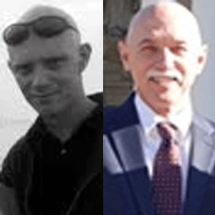
Neo- Nazi White Nationalist Dr. Dan Romaine Kirkham
About 8 a.m. Friday, June 23, 1972, a loud commotion was heard in her villa. Martha Mitchell had cut her hand when a window was broken in an apparent fray. Dr. Dan Romaine Kirkham of Newport Beach, whose office is one block from Nixon’s personal lawyer, Herbert W. Kalmbach’s law office, was summoned to the Mitchell Villa.
He reported he “gave, her a shot,” a tranquilizer that would keep Mrs. Mitchell heavily sedated for four to six hours. Dr. Kirkham described Mrs. Mitchell as “hysterical” and she had to be held down forcibly. “She kept shouting that she was being held a political prisoner,” he said. “And I know information so I can’t inform anyone.”[46]
Mrs. Mitchell later reported, in fury and humiliation, that “They threw me down on the bed — five men did it — and stuck a needle in my behind. I’ve never been treated like this, ever.” Dr. Kirkhan noticed Martha had a severe, untreated cut on her hand. She was taken later to Hoag Memorial Hospital, where Dr. Clark McGaughey stitched the wound.[47]
It was U.S. Czech Ambassador Stephen King, who at the Newporter Inn, “rushed into her bedroom, threw her back across the bed, and ripped the telephone out of the wall,” wrote veteran Washington reporter Winzola McLendon in her 1979 biography of Martha Mitchell, to whom she was close. “The conversation ended abruptly when it appeared someone took away the phone from her hand.”
API Reporter Helen Thomas had reported. “She was heard to say, ‘You just get away.’” Thomas added that when she called back, the hotel operator told her, “Mrs. Mitchell is indisposed and cannot talk.” The White House put out the story that Martha was about to be institutionalized. [48] Back at the Newporter Inn, a reporter telephoned Martha Mitchell in Washington again on June 24, Saturday and was assured that Martha Mitchell was fine. However, her guards wouldn’t give her food but plied her with liquor.
In 2005, Dr. Dan Romaine Kirkham was convicted on federal charges of conspiracy to defraud the IRS and related tax offenses. Dr. Kirkman was part of Christian Patriot Movement.[49] The Christian Patriot movement is a radical and extremist movement of American political commentators and activists. They promote various interpretations of history based on their belief that the federal government has turned against the ideas of liberty and natural rights expressed in the American Revolution, and against what they believe to be America’s Christian heritage. The movement originally referred to the late 1980s’ Posse Comitatus group, a militant terrorist organization. Posse Comitatus followed an ideology based on the teachings of cult Posse founder and Christian Identity minister William Potter Gale, and the majority of the Christian Patriot movement’s members still adhere to Christian Identity’s white supremacist.[50] Posse charters were issued in 1969 in Portland, Oregon, by Henry Lamont Beach, “a retired dry cleaner and a one-time member of the Silver Shirts, a Nazi-inspired organization that was established in America after Hitler took power in Germany.”[51]

Red Cross passport under the name of “Ricardo Klement” that Baron von Bolschwing’s student Adolf Eichmann used to enter Argentina in 1950. At the time of Martha Mitchell’s abduction at the Newporter Inn, Dr. Dan Romaine Kirkham said that her 5 (five) guards produced Red Cross identifications. It was a very sick reference to his heroes, the Nazi-SS. 90% of the Nazis-SS that fled Eastern Europe via Italy, mostly to Spain, and North and South America – notably Argentina with Red Cross identification papers.[52]
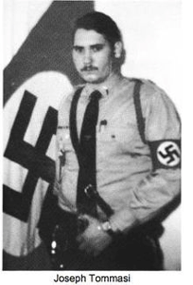
Joseph Tomassi, the 24-year-old head of the American Nazi Party in California was shot to death on the front steps of his Los Angeles headquarters, on August 15, 1975. Two years earlier, the Los Angeles Times had reported that John Mitchell and CREEP gave $10,000 in undisclosed funds to finance a surreptitious campaign to remove George Wallace’s American Independent Party from the 1972 California ballot. The Times went on to say that “$1, 200 of the fund found its way to Joe Tomassi, head of the Nazi Party in California.”[53] Tomassi had actually told reporters that he and others in the National Socialists White People’s Party (NSWPP) in California had been paid by CREEP to help register rightists as Republicans in 1971-72. Attorney General John Mitchell was one of the CREEP agents secretly working with NSWPP.[54]
IX
MARTHA MITCHELL & CIA SAFE-HOUSE- ESSEX HOUSE HOTEL
Martha Mitchell eventually negotiated the right to get out of neo- Nazi captivity and fly back east. Martha left Newport Beach, CA on June 25, 1972, agreeing to stay with friends in New York State, but instead checked into the Westchester New York Country Club in Rye, NY, and called UPI to declare, “I’m leaving him until he decides to leave the campaign. It’s horrible to me… I’m not going to stand for all those dirty things that go on. If you could see me you wouldn’t believe it. I’m black and blue. I’m a political prisoner… They don’t want me to talk.”[55]
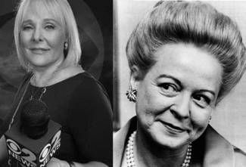
Marcia Kramer is known as an award winning hard-nosed investigative journalist. The awards include two George Foster Peabody awards, two Edward R. Murrow awards, eight Emmy awards, two New York Press Club Golden Typewriter awards and a first-place award from the Associated Press for her investigative reporting.[56] She was able to breach tight security at Westchester to get to Martha Mitchell. Marcia says it was her opinion that Martha was a “beaten woman” and that the “incredible” black and blue marks on Martha’s arms looked like they were a “totally professional job.”[57]
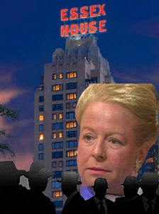
John Mitchell and CREEP warped up Martha Mitchell at Westchester New York Country Club, and she disappeared after June 25, 1972. She ended up at a more secure and controlled environment and safe house location at the Essex House Hotel in New York to be as she said, MK ULTRA/MONARCH- “brainwashed“.

A few months later on October 25, 1972, Douglas A. Ross, the 64 year old manager of the Newporter Inn that knew the whole story of Martha Mitchell’s stormy visit quietly suffered a cerebral hemorrhage in the hotel kitchen and died. Ross, sources said, had forbidden all Newporter employees to speak one word about the incident or face dismissal. But, it wasn’t enough for the DEVIL.[58]
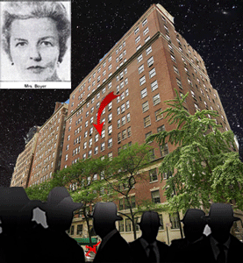
Mrs. Louise Boyer, Nelson and Laurance Rockefeller’s trusted assistant for 30 years, was suddenly thrown to her death from her 10th story New York apartment on July 3, 1974. At the time, as a consequence of the Watergate Scandal, Nelson Rockefeller was being considered for the vice-presidency. Accusations had been made that he had been involved in the illegal removal of gold from Ft. Knox. It’s believed that Mrs. Boyer supplied the investigators with this information. Was she also paranoid schizophrenic when she jumped from her open or closed window? They don’t talk about Louise Boyer. [59]
In 1975, McCord, convicted of conspiracy in the Watergate Scandal, admitted that he had been her bodyguard, that “basically the woman was kidnapped [by the CIA].”[60] After Martha Mitchell was last seen at Westchester New York Country Club, Bob Woodard (All the President’s Men) found her in Room 710, Essex House Hotel, guarded by a large black man. She appeared agitated and couldn’t talk about it when he brought up anything about Watergate, and what she had told reporters and Marcia Kramer in late June 1972.
In a 1974 BBC interview with British journalist David Frost, Martha Mitchell said, “I was brainwashed. I was told this is what goes on in campaigns.”[61] Martha Mitchell’s exact motivation for leaking information about Watergate to local reporters is still a mystery. But her impact was clear, Nixon himself said, “If it hadn’t been for Martha Mitchell, there’d have been no Watergate.”[62]
41 years after Martha Mitchell’s death, the mental health industry named a new medical process after her, The Martha Mitchell Effect. The Martha Mitchell Effect is the process by which a psychiatrist, psychologist, and other mental health clinicians labels the patient’s “accurate perception of real events” as paranoid delusional and misdiagnose patients. It constitutes a confession and admission by the organized medical profession that the fascist racist pig Nazi, Martha Mitchell, wasn’t crazy and delusional when she said that she had been abused, drugged, kidnapped, and brainwashed for publicly exposing Richard Nixon and his dark circle’s Crimes Against Humanity and Democracy.
“White people are trying to kill me, they have my brain hooked up to a machine, trying to steal my songs and sounds.” Reopen Donny Hathaway’s for at least a coroner’s inquest into his death.
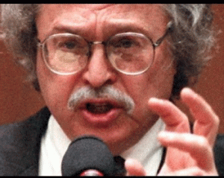
Dr. Michael Baden
Furthermore at the time Donny was killed, the infamous Dr. Michael M. Baden was Chief Medical Examiner of New York City. His duties included supervision and responsibility for the functioning of the office, which has responsibility to investigate all sudden, suspicious, and unnatural deaths that occur in the five boroughs of New York City.
Mae Brussell,
“Dr. Michael M. Baden, “on leave as deputy chief medical examiner of NYC.” Baden, forensic scientist for G.R. BLAKEY’S HOUSE SELECT COMM. ON ASSASS. CIA MD. “on leave” because of possible criminal cover-up of murders. Ordered “cremation of Nelson Rockefeller.” Now this CIA snake joins SHUTTLE, NASA TRANSITION, coup for SDI, Huntsville, part of JFK saga.”
From 1978-1979, Dr. Michael Baden chaired the Select Committee on Assassinations (HSCA) Forensic Pathology Panel. The HSCA was established in 1976 to investigate the assassinations of President John F. Kennedy and Martin Luther King, Jr. The HSCA completed its investigation in 1978 and issued its final report the following year in 1979, concluding that JFK was probably assassinated as a result of a conspiracy. Dr. Baden sold Congress and the masses hook, line and stinker– the CIA’s “Magic Bullet Theory”. The Magic Bullet Theory is what it is- “Magic” not medical forensic evidence. Dr. Baden is a dark rabbit hole. Baden may not even be the man’s true name.
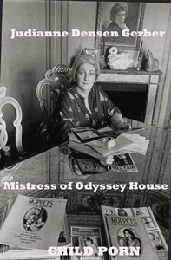
Dr. Baden was married to the bizarre Russian Jew, Psychiatrist/Attorney Judianne Densen-Gerber, of Manhattan, NY during the early 1960s not 1997. She founded Odyssey House for drug addicts, prostitutes and sexual abused children that she ran like a cult. More than likely, it was part of a secret elite Satanic Cult network. In 1940, she was daughter of Gustave and Beatrice Gerber at 165 West 91st at the elegant Minabeau Building. They were wealthy international attorneys at 55 Broadway in the Manhattan financial- Wall Street district. I noticed that in 1951, Gustave Gerber was caught up in a case, State of Netherlands v. Federal Reserve Bank of NY, 99 F. Supp 655 (1951), that may indicate the web of the Gerbers‘ source of wealth. The case involve the smuggling of transmuted assets of Netherlands’ Jewish citizens seized by the Nazi-SS in 1940. His client, Verdun Joseph Archimedes, had been arrested on April 5, 1947 as a U.S. Army Sergeant for smuggling Nazi-SS transmuted securities out of Switzerland taken from Jews during the holocaust.
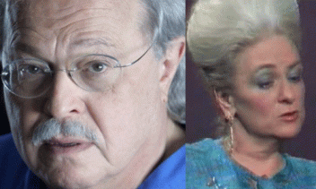
Baden and Densen- Gerber are believed to have been deep cover CIA assets. Baden and Densen-Gerber were part of Nelson Rockefeller’s powerful Manhattan dark inner circle. Rockefeller served as the 41st U.S. Vice President from 1974 to 1977, and previously as the 49th Governor of New York (1957- 1973). He also served as Assistant Secretary of State for American Republic Affairs for Presidents Franklin D. Roosevelt and Harry S. Truman as well as Under Secretary of Health, Education and Welfare under Dwight D. Eisenhower. Densen-Gerber traveled the world providing professional cover for exposed high level elite Satanic Cults and Pedophile Rings that even included the MK ULTRA/MONARCH Franklin Cover-up.
Nelson Rockefeller & Judianne Densen- Gerber
Nelson Rockefeller (Rocky) was a direct financial sponsor and fundraiser for Odyssey House.

Rocky Died Suddenly at Regent House
Just days after Donny was thrown out of 15th floor hotel window on January 11th, Nelson Rockefeller suddenly turned up dead on January 16, 1974 on the floor of a co-op apartment building called Regent House at 25 W.54th Street, Manhattan. The apartment belonged to 22 year old Rockefeller blonde assistant, Megan Marshack. When Rockefeller went down, she didn’t call 9-11.
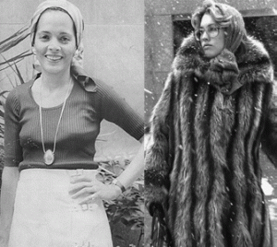
Ponchitta Pierce and Megan Marshack
Megan called upstairs to her possible CIA TV journalist- handler, Ponchitta Pierce of USC, that came downstairs to Marshack’s apartment to review the body and call 9-11. Ponchitta was older and much more experienced. She made sure Rocky was dead before calling 9-11. Mae Brussell suggested that Regent House was a CIA safe house. Megan didn’t get $60, 000 a year, and a $100,000 Manhattan apartment just to pamper Rocky, she was on 24 hour call for diplomats, dignitaries, and others of interest to the CIA. Dr. Baden declared that Nelson Rockefeller died of a heart attack then rapidly cremated his body without an autopsy. To further muddy the waters, Dr. Baden put out the rumor that Nelson Rockefeller died while having sex with Ms. Marshack.
Who was holding Donny in a mental institution? What mental institution and what doctors and clinicians treated and diagnosed him as paranoid schizophrenic? What medication were prescribed for him? Who rented and occupied that room at the Essex House Hotel with Donny, a noted CIA Safe-House? On the date of his death, was Atlantic Records his guardian and why?

[1]http://www.maebrussell.com/Mae%20Brussell%20Articles/Why%20Was%20Martha%20Mitchell%20Kidnapped%20-%201.html
[2] https://en.wikipedia.org/wiki/George_Bush_Center_for_Intelligence
[3] https://www.muckrock.com/news/archives/2016/may/05/hoovers-final-days/
[4] http://www.maebrussell.com/Mae%20Brussell%20Articles/Watergate%20Deaths.html
[5] https://en.wikipedia.org/wiki/Chi_Omega
[6] http://www.encyclopedia.com/women/encyclopedias-almanacs-transcripts-and-maps/mitchell-martha-1918-1976
[7] http://www.pbcommercial.com/news/20161124/pine-bluff-arsenal-celebrates-75th-anniversary
[8] https://en.wikipedia.org/wiki/Chemical_Corps
[9] https://en.wikipedia.org/wiki/Frank_Olson
[10] https://en.wikipedia.org/wiki/United_States_Army_Biological_Warfare_Laboratories
[11] Id.
[12] http://www.pba.army.mil/command/info.htm
[13] https://facultystaff.richmond.edu/~wgreen/Ecdprentiss.htm
[14] http://www.legacy.com/obituaries/timesunion/obituary.aspx?pid=17869210
[15] http://www.nytimes.com/1995/01/20/obituaries/vera-maxwell-is-dead-at-93-legendary-sportswear-designer.html
[16] http://articles.latimes.com/1995-01-21/news/mn-22565_1_vera-maxwell
[17] https://www.bibliotecapleyades.net/sociopolitica/esp_sociopol_blacknobil02.htm
[18] https://www.bibliotecapleyades.net/bloodlines/onassis.htm
[19] https://en.wikipedia.org/wiki/Monaco
[20] http://articles.chicagotribune.com/1992-10-19/features/9204040740_1_prince-rainier-place-for-shady-people-prince-albert
[21] http://thetruthnews.info/hitchcock.html
[22] NYT, A Plea for Experiment, October 2, 1970, page 35
[23] http://www.encyclopedia.com/women/encyclopedias-almanacs-transcripts-and-maps/mitchell-martha-1918-1976
[24] https://www.biblebelievers.org.au/kmlst1.htm
[25] http://theamericanchronicle.blogspot.com/2013/03/research-note-relationship-between-john.html
[26] http://educate-yourself.org/ga/RFcontents.shtml
[27] http://theamericanchronicle.blogspot.com/2013/03/research-note-relationship-between-john.html
[28] http://www.smokershistory.com/Bobst.htm
[29] https://prabook.com/web/augustin_mitchell.prentiss/1453351
[30] http://greyfalcon.us/restored/Project%20Silver%20Bug.htm
[31] http://greyfalcon.us/restored/Project%20Silver%20Bug.htm
[32] https://skullandbonesband.blogspot.com/2013/11/nazi-german-wwii-and-beyond-disc.html
[33] https://forestqueen2020.wordpress.com/2016/06/23/chemtrails-exposed-new-manhattan-project-conclusions/
[34] http://anniejacobsen.com/pentagons-brain/
[35] https://en.wikipedia.org/wiki/Omar_Bradley
[36] Breitman, Richard, U.S. Intelligence and the Nazis, Cambridge University Press, New York, NY, 2005 (pgs. 384- 385)
[37] https://www.muckrock.com/foi/united-states-of-america-10/foia-request-regarding-kurt-blome-files-8638/
[38] Id.
[39] https://www.bookbrowse.com/excerpts/index.cfm/book_number/1393/page_number/4/lab-257
[40] https://en.wikipedia.org/wiki/Erich_Traub
[41] https://en.wikipedia.org/wiki/Project_MKUltra
[42] https://www.findagrave.com/memorial/59652778
[43] http://www.courant.com/new-haven-living/features/hc-nhl-german-pows-ct-20160422-story.html
[44] http://www.legacy.com/obituaries/washingtonpost/obituary.aspx?n=augustin-prentiss&pid=126586389
[45] https://en.wikipedia.org/wiki/Steve_King_(ambassador)
[46] https://cdnc.ucr.edu/cgi-bin/cdnc?a=d&d=SBS19730422.1.2
[47]https://www.newspapers.com/newspage/30521403/
[48] https://www.counterpunch.org/2010/06/15/helen-thomas-watergate-scoop/
[49] https://www.justice.gov/archive/tax/txdv05070.htm
[50] https://en.wikipedia.org/wiki/Christian_Patriot_movement
[51] https://en.wikipedia.org/wiki/Posse_Comitatus_(organization)
[52] https://www.theguardian.com/world/2011/may/25/nazis-escaped-on-red-cross-documents
[53] https://archive.org/stream/nsia-BrussellMae/nsia-BrussellMae/Brussell%20Mae%2052_djvu.txt
[54] Miller, David, The JFK Conspiracy, Writers Club Press, San Jose, CA (2002), pg. 107
[55] https://www.justice.gov/archive/tax/txdv05070.htm
[56] https://upclosed.com/people/marcia-kramer/
[57] http://thepaulryanwatch.blogspot.com/2012/08/watergate-thug-is-paul-ryans-longtime.html
[58] https://www.newspapers.com/newspage/30521403/
[59] http://www.maebrussell.com/Mae%20Brussell%20Articles/Watergate%20Deaths.html
[60] http://www.nytimes.com/1975/02/19/archives/mccord-declares-that-mrs-mitchell-was-forcibly-held-comment-from.html?_r=0
[61] http://www.dailymail.co.uk/news/article-2160868/Watergate-scandal-The-women-helped-Bob-Woodward-Carl-Bernstein-topple-Nixon.html
[62] https://capitolfile-magazine.com/martha-mitchell-and-the-watergate-hotel
Comments : Leave a comment
Tags: 1936 Summer Olympics, Air Development Center, al capone, Allen Dulles, Aristotle Onassis, arkansas, Baron von Bolschwing, bay of pigs, biological warfare, black nobility, Brigadier General Augustin Mitchell Prentiss, camp detrick, Captain Clyde J. Jennings, chemical warfare, chi omega, china, CIA, cia safe house, col. agustin mitchell prentiss, Col. Augustin Mitchell Prentiss, committee to reelect richard nixon, CREEP, czech ambassador, donny hathaway, Dr. Arnold Hutschnecker, dr. kurt blome, dr. michael baden, e. howard hunt, edgewood arsenal, essex house hotel, eva peron, FBI, Frank Olson, gehlen org, General Hoyt S. Vandenberg, global satanic cabal, grace kelly, hjalmar schacht, House of Grimaldi, International Chivalric Organization of the Solar Tradition, j. edgar hoover, james mccord, jfk assassination, john mitchell, John Newton Mitchell, Jr., juan peron, judge jeanine pirro, Judianne Densen-Gerber, kappa sig, kappa sigma, Knights of the Black Sun, Korean War, Lillian Gish, magic bullet theory, martha beall, Martha Elizabeth Beall, Martha Graham, martha mitchell, Monaco, Nazis, nelson rockefeller, newport beach, newporter inn, north korea, odyssey house, Office Secretary Defense, Omar Nelson Bradley, operation paperclip, Order of the Solar Temple, Pat Nixon, pedophila, pedophilia ring, pine bluff, pine bluff arsenal, Prince Rainier III, princess diana, princess grace kelly, Project Silver Bug, reinhard gehlen, Research and Engineering, Rosalyn Carter, Select Committee on Assassinations, sonny capone, stephen king, trolley to hell, U.S. Army Biological Warfare Laboratories, u.s. chemical corps, u.s. chemical warfare service, vera huppe, vera maxwell, vera maxwell of manhattan, vera maxwell originals, vera sportwear, Viktor Schauberger, vril flying saucers, watergate, watergate break-in, watergate hotel, watergate scandal, Wright Patterson Air Force Base
Categories : 1000 Year Reich, Advanced Research Projects Agency, Aleister Crowley, brain entrainment, brotherhood of death, CIA, devil, donald j. drumpf, donald j. trump, donald trump, donny hathaway, Dr. Erick Traub, evil, Hauptsturmfuhrer SS Dr. Josef Mengele, Heinrich Himmler, hollywood satanic cult, John f. kennedy, Josef Mengele, Knight of Malta, Knights Hospitaller, Knights of the Black Sun, Knights Templar, lucifer's servants, lucifer's workshop, luciferians, mae brussell, mind control, mk ultra, cia occult bureau, temple of set, MK-ULTRA, Nazis, North Korea, Nuremberg Tribunal, Operation PAPERCLIP, psychotronics, racial mass murder, Reichsfurhrer SS-1 Heinrich Himmler, reinhard gehlen, Rosicrucian, Rosicrucianism, Satanism, Schutzsteffel, skull and bones, SS, SS Baron Otto Albrecht Alfred von Bolschwing, trauma-based mind control, underground reich, underground third reich, Vatican ratline

THE ASSASSINATION OF DONNY HATHAWAY, EVERYTHING IS EVERYTHING IN FOUR MOVEMENTS
6012018
I
A SONG FOR DONNY
In a comment to a recent blog observation that Donny Hathaway was murdered like Whitney Houston, I was asked why they would kill Donny. When I wrote it, it had truly troubled the waters, because, I knew that I had failed to explain who, where and why. So, I was touched and again troubled by the question, and my lack of explanations.
II
DONNY, THE 1ST MOVEMENT
“I am inspired by many people, but rarely am I inspired as much as I am by the soulful message of Donny Hathaway. His melodic, deep, smooth and focused delivery is matched by few.
Before reading I would like you to listen to this interview with Donny Hathaway! Specifically at the 2:20 mark until the end, basically the last 40 seconds. If you can take the time to listen to the entire interview that would be beneficial.
Donny passed too soon for the world to hear the fullness of his voice and underlying messages of strength, thoughtfulness, power, activism, and worship to Almighty Most High God. Donny was by all accounts the voice that Marvin Gay and Stevie Wonder looked up to.
Donny’s story ended tragically with what some determined to be suicide. However, I believe a different account, that his death was planned. Donny Hathaway was targeted and murdered.
Many artists have the skill to make their audience feel emotion, but rarely is an audience touched so deeply that their collective soul is pierced, their mind awakened to consciousness, and their body ready to take action. Donny was a powerful voice of activism after the death of Martin Luther King.”[1]
At times, it is so difficult to put into words how I feel about the spiritual musical genius of an artist like Donny Hathaway. But the above from Swagger Nation speaks volumes for me as if I wrote it myself. Sometimes, I am so selfish that I think that Donny speaks only to my individual deep soul and inner consciousness.
Donny Hathaway (October 18, 1945 – January 13, 1979), the grandson of gospel singer Martha Crumwell, was born in Chicago and reared in St. Louis by her. He began singing as a 3-year-old and was billed as “America’s Youngest Gospel Singer.”[2] She was the one who tried to develop his musical talents. She took him around singing in different programs, because it was evident from a very early age that he had been endowed with extraordinary musical talent and insight.
“He could hear things that he couldn’t play at first, but by the age of four he was able to sit down at a piano and play the things he could hear in his head. He would tell his grandmother, ‘I hear the most beautiful music in my head, grandma’. So she purchased a piano – she was a musician too – and he began to play.”[3]
Donny was very- very special. He was “paranormal”. Donny was a brilliant musician, arranger, songwriter and vocalist. At the height of his musical career, he spoke about transcending, creating and conducting a concerto with the Boston Pops Symphony. He was exploring melodies, soft and elegant voices. He talked about exploring classical music and “melodic” patterns and motions, repetitive patterns that can be used with any scale. The use and practice of “melodic” patterns go back to the dawn of civilization, the Lands of Sumer and Kemet. Some of the ancient Kemetic “melodic” patterns have survived. One example of it can be found as the “Egyptian Melody” in Louis Armstrong’s 1928 “Tight Like This.”[4]
Maybe that was some of Donny’s genius being able to remarkably supernaturally hear, reconciled, and distinguish “melodic patterns.” He was able to recapture some of the mysterious ancient “melodic” patterns surviving in Africa/Black spiritual gospel music and in silky smooth eloquence incorporate it in our everyday lives and struggles. They say that Donny literally sat in the studio and cried when he heard the playback of his final mix of the song “Someday We’ll All Be Free“.[5] It is also very moving, emotional and spiritual for me. At times, I listen to the song and reflect on my grandchildren and children of the world and fall into deep prayer for their future health, safety and well bring. I also often break down in tears. The song seems to cleanse, heal, inspire and then rejuvenate me to get up and continue the struggle with renewed vigor and commitment.
Donny’s melodic “I Love You More Than You‘ll Ever Know” also mysteriously stirs and heals my individual soul. In some kind of mysterious way, it explains for me the Black Panther Party for Self Defense, and why so many good brothers and sisters put their lives on the line for only the LOVE OF THE PEOPLE. And why, if we get knocked down, we pick ourselves right back up again.
They say that Donny’s 1972 four movements of “Everything is Everything” and “Voices Inside” reflect on his latent paranoid schizophrenia. Don’t get it twisted. Donny’s not talking about any severe psychiatric disorder with symptoms of emotional instability, detachment from reality, and withdrawal into the self. He’s talking about “Lets gone get on down” with the exploding “melodic” and other dimensional experiences thru music and movements, not DRUGS. Willie Weeks! “Feel pretty good, huh.”

According to his widow, Eulaulah Hathaway, Donny had been confined on several occasions in psychiatric facilities in New York instead of Chicago. New York was a hotbed of clandestine MK ULTRA activity. They are always careful not to expose who treated Donny, and the mental institutions and hospitals that he had been confined at.
“He was hospitalized on several occasions. I guess by ’73 or ’74 it was determined that he was a paranoid schizophrenic.”[6]
By 1974, Donny dropped completely out of sight of the music entertainment industry until January 1979– 5 (five) years. The bottom line is that Donny had extraordinary and paranormal abilities. He could see, hear, explore, develop, and capture the universal sacred art of music science practiced by healing temples of the most ancient, advanced and mysterious civilizations. Much of what is called “classical music” was taken directly from secret Kemetic, Canaanite, Arabian and African healing temples. And, we just don’t understand the Universal Power of Music enough to try to keep it out of the power, control and influences of Luciferians.
Ancient Kemetic Healing Temple- Mysterious Law of Physics Tuning Rods?
“Egyptian [Kemetic] Temples were used in setting resonant frequencies for the purpose of healing the etheric body. Healing with sound, color, light and music was integral to the ancient process of re-harmonizing the body back to a state of total health. This process aided in resetting the person’s own unique frequency signature (much like doing a computer restore point). Health was equated with being in tune with one’s true soul path. The body was seen as an earthly vehicle which housed the soul and was treated, ‘like God’s Holy Temple.’ Living a life in resonance and loving service to others was what the tenets of Saqqara priesthood were all about.” [7]
“Donny Hathaway was a genius of music theory, a master pianist and songwriter, and possibly had the most beautiful male voice in soul music-EVER!”[8]
Needless to say, Donny and his remarkable musical works just didn’t belong to me. We dearly, collectively, loved Donny as much as he loved God and us. According to fellow musician James Mtume at the recording studio, Hathaway said that “white people were trying to kill him and had connected his brain to a machine, for the purpose of stealing his music and his sound.”

Because of Hathaway’s mental state, the recording session was aborted and all of the musicians went home instead of asking Donny the what, who, when and the why.[9] It was important to ask these things, because Donny had been out of the music recording studios as a free man since 1974– 5 (five) years. In February 1978, Atlantic Records had to get permission from a hospital to fly Hathaway out for the recording sessions of “The Closer I Get to You” with Roberta Flack.[10] WHAT HOSPITAL?
At Mtume’s studio recording session on January 13, 1979, Donnie still wasn’t free. Donny did not leave the recording studio alone, and ended up at the hotel. According to Reggie Lucas, Donny was supposed to be under the 24 hour watchful supervision of David Franklin per Atlantic Records and that HOSPITAL. Lucas said that Donny was heavily DRUGGED that evening. He last saw Donny Saturday evening leaving Roberta Flacks’ apartment with his official appointed chaperone and guardian, David McCoy Franklin, headed back to the Essex House Hotel.[11].
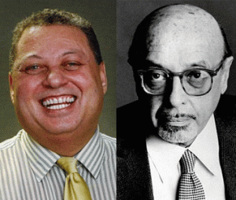
David McCoy Franklin & Ahmet Ertegun, Co-Founder of Atlantic Records
Lucas said that Franklin and Roberta Flack showed up at the morgue on Monday to identify Donny’s body.[12] It appears that no questions were asked about where Franklin was Saturday evening between the time he and Donny left Flack’s apartment and Donny’s death. And, it appears that Franklin didn’t offer any answers why he left him alone if Donny was indeed left alone in that hotel room. Franklin’s answers to these questions should be part of Donny’s historical record. They are not! Donny’s mental institution and the doctors that Franklin reported to should also be part of Donny’s historical record. They are not!
David M. Franklin was a “quiet as kept” Washington DC/Atlanta black attorney that worked closely with Ahmet Ertegun at Atlantic Records with black artists.[13] Franklin was known to work behind the veil on a lot of political things for Washington DC. He was the chief economic development consultant of the Cooperative Assistance Fund (CAF) in Washington from 1970 to 1975. CAF was established in 1968 by a group of foundations to make investments in minority and low-income communities thru CAF. In other words, it was a multi-million charity- slush money laundering operation ran by a bunch of insider Washington DC political head Negro in Charge Coons and Uncle Toms.[14] David was the husband of Shirley Franklin, 58th Mayor of Atlanta, GA.[15]
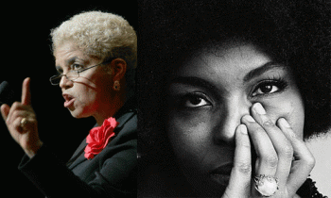
Franklin and Flack, ILLUMINATI/BOULE One God/One Eye Masonic Symbolism
Shirley Franklin and Roberta Flack are Delta Sigma Theta– Divine 9 BOULE Negroes.[16] I am not sure what black secret society that David Franklin belonged to.
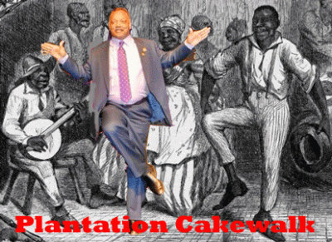
They Play the Music, He’ll Cakewalk
But double speak and master of deception coon, Rev. Jesse Jackson, Prince Hall Master Mason and Omega Divine 9 Boule, planted a new false cover for Donny’s death among the masses. Rev. Jackson delivered Donny’s eulogy, he said, “It appeared to be neither homicide nor suicide. It seems to have been an accident. Donny died with his coat, scarf and cap on, and it’s not likely that anyone would go through the preparation of putting on full attire just to jump out of a window.” It was an ACCIDENT! Maybe, he already had on his coat, scarf and cap on when he was thrown out the window.
Could it be that Mtume and Lucas had been warned, and were too afraid to ask him any questions? When Donny brought up “white people” and psychotronic interface brain machines, they scattered like flies. Could it be that they had to scatter because Donny began exposing too much about what they were doing to him, and what had happened to him while they were being watched?
But, we are now quite certain that the technology existed then, and the white knights of CIA were very- very active in that every same thing- the paranormal, psychotronics, and mind control, clandestinely. And, we know somebody had taken complete control over Donny’s mind and thoughts at the time of his death. He talked too much, and they threw DONNY HATHAWAY out of the window.
Synthetic telepathy also known as techlepathy or psychotronics – is a term used to describe the process in brain-computer interfaces by which human thought (as electromagnetic radiation) is intercepted, processed by computer and a return signal generated that is perceptible by the human brain.[17]
Navy Admiral Stansfield Turner, CIA Director 1979
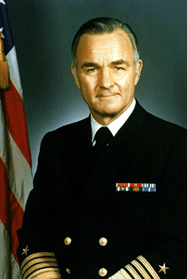
Navy Admiral Stansfield Turner, Council on Foreign Relations (CFR)
The CIA director in 1979 was full four star Admiral Stansfield Turner, former President of the Naval War College and Commander-in-Chief of NATO’s Southern Flank. Under Turner’s direction, the CIA emphasized technical intelligence (TECHINT) and signal intelligence (SIGINT) more than human intelligence (HUMINT) – Parapsychology.[18] It’s on public record that MK ULTRA, the mind control research which Turner admitted to in 1977 spent millions of dollars studying the paranormal– Voodoo, witchcraft, and psychics. Turner disclosed that the CIA had been conducting mind control on countless numbers of unsuspecting victims for years, without their knowledge or consent.

On August 3, 1977, Turner went before congress. He told senate hearings about MK ULTRA/MONARCH. He gave an account of a CIA established network, including 80 medical universities, hospitals, and prisons – together with 185 high-ranking U.S. scientists, researchers and doctors. It was mentioned that the program had begun under the Director of the CIA, Allen Dulles, in 1953.[19] That pretty much says it all. There is a link between what was going on with Frank Olson in the early 1950s and Donny Hathaway in the 1970s. U.S. Civilians were unwitting drugged with LSD (instant Schizophrenia) during the 1950s under the U.S. Navy’s Schizophrenia and MK ULTRA from 1953 into the 1970s. Undoubtedly, Donny was confined during the 1970s at one of the MK ULTRA mental hospitals right up until the time of his death.
Hours after the sudden aborted recording session on January 13, 1979, Hathaway was found below the window of his 15th-floor room of New York’s 48 floors Essex House Hotel, 160 Central Park S, New York, NY, overlooking Central Park. While seemingly odd that the safety glass window to his room had been meticulously removed and was on the bed, his hotel door was double locked from the inside, and there were no signs of struggle, investigators ruled Hathaway’s death a suicide.
It was a cold and winter Saturday night in New York City. Seven hundred miles away in Chicago, the infamous Chicago blizzard of 1979 hit the city, leaving 19 inches of snow and an after period of unrelenting bitterly cold weather.[20] Donny was found dead below his hotel window with his coat, scarf, and cap on. It appears that the window in his room was already on the bed when he entered, or was forced into it in frigid cold circumstances.

Snap In, Pop Out Guest Room Windows at Essex- No, No and No!
Any other scenario implies that Donny brought along a special tool kit designed to remove hotel safety glass frame and windows. The assumed scenario couldn’t even be repeated in the infamous October 1, 2017 Las Vegas Flag shooting.
Investigative law enforcement agencies still will not commit themselves on how the alleged mass murder dead suspect, Stephen Paddock, broke thru the safety glass windows at the Mandalay Bay Resort to assault the crowds at the country music venue. They don’t know if he knocked them out with a hedge hamper or shot them out. If it was possible to remove the hotel safety glass windows, they would have been removed.
In Donny’s case, it doesn’t make any sense whatsoever that the Essex House Hotel would install code compliant safety glass windows to prevent suicides that can be easily and neatly removed without any special knowledge and tools by quests. It is not reasonable or logical to believe that they did in Donny’s case and that room. Furthermore, Donny was under the influence of psychotropic drugs.
In 1972, at the very height of his career and a string of hits among the masses, Donny suddenly became depressed and paranoid schizoid. They say, “It was found that he was suffering from paranoid schizophrenia and was known to have taken up to 14 pills two to three times a day to control this disease.”[21] What kind of pills and why so many? Who were the doctor(s) prescribing these medications? It appears that they were more interested in keeping Donny quiet then helping heal him. 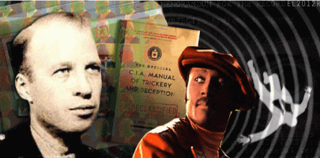
Donny’s death in the way was consistent with the CIA Assassination Manual. His death was primarily meant to not permanently silence him, but also send a terrifying message to others to keep their mouths shut about Donny, “white people” and “psychotronic mind machines”. What they don’t say is where Donny’s schizophrenia suddenly came from. In Frank Olson’s case, it came from clandestine CIA- LSD poisoning hidden in a glass of brandy.[22]
The hotel safety glass removable scenario also didn’t even happen in the case of Frank Olson, 26 years earlier in New York, New York. Evidence suggests that the hotel’s safety glass window was first broken, and then Olson was thrown thru his Statler hotel room window to his death.
III
THE CIA ASSASSINATION OF FRANK OLSON
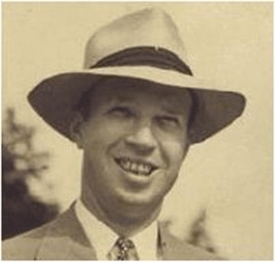
Frank Olson (July 17, 1910 – November 28, 1953) was an American bacteriologist, biological warfare scientist, and Central Intelligence Agency (CIA) employee under Allen Dulles and Richard Helms, who worked at Camp Detrick (now Fort Detrick) in Maryland.
Frank Olson- The Where
Olson was at first said to have taken his own life from the 13th floor at the New York Statler Hotel, operated as The Statler Hilton, 401 7th Ave, New York, NY. It was the 13th floor, but the room number didn’t include the 13 (thirteen). It was room number 1081A.[23]
On January 13 (thirteen), 1979, Donny was on the 15th floor, but fell 13 (thirteen) stories like Olson to his death in New York.[24] The CIA maintained that Olson had leapt through the closed window to his death as result of a schizophrenic episode just the same as Donny. Olson’s room also had been locked from the inside just like Donny’s. However, an autopsy conducted forty years later revealed an injury to Olson’s skull was most likely caused by a blow to the head. And, there was no evidence of any cuts to the body from broken glass. It seems that Olson, exactly as recommended in CIA assassination manual, was struck on the head (possible while drugged) and thrown from the window to his death 13 (thirteen) floors below.
Frank Olson- The Who
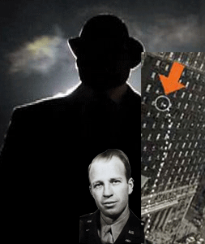
On the night that Olson was found dead. The Statler Hilton had a special new bellboy on the job with access to the hotel rooms’ passkey. It was Jean- Pierre Lafitte. Lafitte of the Corsican (French Connection) Mob was descended from the notorious French Masonic late 18th century Lafitte brothers, Jean, Pierre, and Alexander (Dominique You) of New Orleans. They were slave boat runners, and pirates. Jean Lafitte was a deep cover CIA, FBI and Federal Bureau of Narcotics’ contractor since 1952. He was an extremely deep cover CIA- Artichoke (MK ULTRA/MONARCH) assassin linked to the high profile deaths of foreign and domestic heads of state, Patrice Lumumba and JFK.
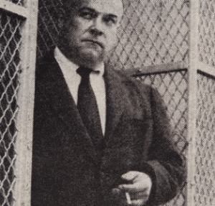
Colonel George Hunter White
Lafitte just happened to be working as a bellman at the Statler Hotel the night Frank Olson crashed through the security glass window and dropped to his death. In 1953, Lafitte had been working undercover doing lowly work in several New York hotels, probably for the FBN, certainly for the notorious Colonel George White. He was on duty for more reasons than one at the Hotel Statler when Olson was thrown from the window. It now believed that Lafitte was one of Olson’s dark assassins.
Lafitte also has an even more intriguing connection to the JKF assassination. On May 9, 1963, Lee Harvey Oswald applied for work at the William B. Reily Coffee Company in New Orleans. Reily was a rabid anti-communist who gave financial support both to Sergio Arcacha Smith’s Crusade to Free Cuba Committee and Ed Butler’s partially CIA-funded propaganda outfit, the Information Council of the Americas (INCA). The Reily vice-president, William Monaghan, was a former FBI agent and was a charter member of INCA. New Orleans’ DA Jim Garrison believed that Reily’s was part of a special clandestine U.S. intelligence apparatus. A view bolstered somewhat by Gerry Patrick Hemming’s claim that William Reily had worked for the CIA for years. Oswald worked for Reily May through July, 1963 and H. P. Albarelli (investigative journalist, A Secret Order, A Terrible Mistake) notes that “Around the time of JFK assassination’ Lafitte too was working for the Reily company.”[25]
Jean Pierre Lafitte, a long‐time professional police informant with underworld connections who, through the auspices of Colonel George Hunter White, was enlisted by CIA MK ULTRA/MONARCH to assist in Operation Midnight Climax with the sadist Dr. James Alexander Hamilton, Stanford University, CIA Station Agent, Vacaville’s California Men’s Mental Health Facility.[26]
White’s actions were driven by pure Elitism, Racism, Sadism and Evil: “I toiled wholeheartedly in the vineyards because it was fun, fun, fun,” White later said. “Where else could a red-blooded American boy lie, kill, cheat, steal, rape, and pillage with the sanction and blessing of the All-Highest?“[27]
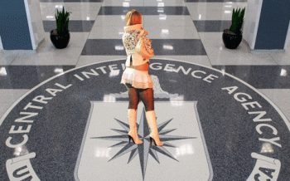
Operation Midnight Climax was an operation known only to Richard Helms and Gottlieb’s Technical Support Division; it was a free-wheeling illicit criminal operation headed by White, an Army Captain, OSS officer, veteran agent of the Federal Bureau of Narcotics (FBN) who was also a CIA operative. During the day, White worked as an FBN agent to keep psychoactive drugs out of circulation, and when night fell, he and his minions dispensed these drugs widely to strangers in in San Francisco and New York. Thousands of unwitting men were lured to CIA-sponsored drug and sex sessions by prostitutes at CIA’s “safe houses.” The prostitutes received $100 a night and were guaranteed protection from police harassment. The walls of CIA’s bordellos were decorated with photos of women in bondage and other suggestive sexual images. White had unrestricted use of surveillance technology; LSD and other mind-altering substances were slipped into the johns’ liquor by the hookers, and their sexual encounters were monitored and recorded from behind two-way mirrors. These taped sexual encounters were useful for blackmailing johns — some of who were prominent upstanding citizens.[28]
Frank Olson- The Why
Allegations pointed to the CIA having assassinated Frank Olson over fears that he would reveal the entire illegal Nazi-U.S. biological warfare and mind control programs, as well as the chemical interrogation programs, to the press. Olson knew quite a bit.
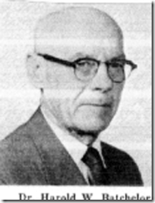
Dr. Harold Batchelor was the Army scientist in charge of consultations with Nazi doctor and former Deputy Surgeon General of the Third Reich, Dr. Kurt Blome.
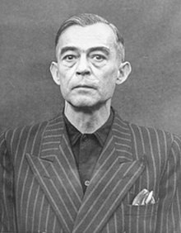
Dr. Blome at Nuremberg Tribunal
Blome served in the Stürm Abteilung (SA) during the Nazi regime, eventually rising to the rank of major general. During World War II, Blome was the biological warfare (BW) representative on the Reich Research Council.
Dr. Blome, middle
Blome was extremely dangerous Nazi. He was an expert on bacteriological warfare and biological weapons. He had a longstanding interest in the “military use of carcinogenic substances” and cancer-causing viruses. In 1942, Blome became director of a unit affiliated with the Central Cancer Institute at the University of Posen, which is now in Poland. Blome worked on methods for the storage and dispersal of biological agents like plague, cholera, anthrax, and typhoid. He is known to have infected concentration camp prisoners with plague in order to test vaccines. Blome was an expert in aerosol dispersants and the transmission of malaria to humans. At Auschwitz, he sprayed nerve agents like Tabun and Sarin from aircraft on prisoners.[29]
In March of 1945, Blome fled from Posen just ahead of the Red Army. He was unable to destroy evidence of his experiments. On May 17, 1945, he was taken into custody in Munich by U.S. Army Counterintelligence Corps (Baron Otto von Bolschwing) personnel detailed to work for the ALSOS Mission.
The ALSOS Mission was an organized effort by a team of United States military, scientific, and intelligence personnel to discover enemy scientific developments during World War II. Its chief focus was on the Nazi-SS nuclear energy project, but it also investigated both chemical and biological weapons and the means to deliver them. One of Blome’s principal responsibilities during the Nazi regime had been to report on the political reliability of German scientists and technicians; therefore, his knowledge was invaluable to ALSOS in helping the United Kingdom and United States to identify Nazi and SS weapon experts who might work for them.
The ALSOS Mission was commanded by Colonel Boris Pash, a former Manhattan Project security officer, with Samuel Goudsmit as chief scientific advisor. It was jointly staffed by the Office of Naval Intelligence (ONI), the Office of Scientific Research and Development (OSRD), the Manhattan Project, and Army Intelligence (G-2).[30] He was subsequently arrested as a Nazi war criminal, and tried at the Doctors’ Trial in 1947 on charges of practicing euthanasia and conducting (BW) experiments on concentration camp prisoners. Blome admitted he had worked on Nazi-SS bacteriological warfare projects and had experimented on concentration camp prisoners with bubonic plague and sarin gas at Auschwitz.[31]
However, in a shocking decision, Blome was acquitted. It is widely believed that he was saved from the gallows by clandestine American intervention. In return, Blome provided information and assistance to the United States and Great Britain on germ warfare.[32] Dr. Blome was a mass murdering “psychopathic personality.” He was a fiend that promised Himmler and the Third Reich the “Mother of All Chemical Weapons of Mass Destruction” to wipe out Allied Forces to end WWII once and for all to ensure a Nazi victory.
In 1951, Dr. Blome was officially hired and paid by the U.S. Army Chemical Corps under Project 63, which was one of the successors to Operation Paperclip. He was employed at the European Command Intelligence Center at Oberursel, West Germany and worked on chemical warfare projects. Dr. Blome also conducted secret research on viruses and cancer.[33]
Batchelor and Frank Olson were assigned to the program at Camp King in Germany, where Dr. Blome was chief physician. They recruited and worked directly under Dr. Blome after the fall of Nazi Germany. Their assignment, according to documents obtained through the FOIA and interviews with Olson’s former partner, Norman Cournoyer, was to use unconventional interrogation techniques on Soviet prisoners, including dosing them with LSD.
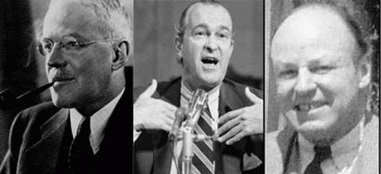
Dulles, Helms and Wisner
In April 1950, Frank Olson was issued a diplomatic passport. Olson was not a diplomat; the passport allowed him to carry items in a diplomatic pouch that would not be subject to searches by customs officials. Olson began taking trips to Germany, flying to Frankfurt and making the short drive out to Camp King. In one of the rare, surviving official documents from the program, Deputy Director of Central Intelligence Allen Dulles sent a secret memo to Richard Helms and CIA Deputy Director for Plans Frank Wisner regarding the specific kinds of interrogation techniques that would be used.
“In our conversation of 9 February 1951, I outlined to you the possibilities of augmenting the usual interrogation methods by the use of drugs, hypnosis, shock, etc., and emphasized the defensive aspects as well as the offensive opportunities in this field of applied medical science,” wrote Dulles. “The enclosed folder, ‘Interrogation Techniques,’ was prepared in my Medical Division to provide you with a suitable background.” Camp King was the perfect location to conduct these radical trials. Overseas locations were preferred for Artichoke interrogations, explained Dulles, since foreign governments “permitted certain activities which were not permitted by the United States government (i.e. anthrax etc.).”
The next trip on record made by Frank Olson occurred on June 12, 1952. Olson arrived at Frankfurt from the Hendon military airport in England and made the short drive west into Oberursel. There, Artichoke interrogation experiments were taking place at a safe house called Haus Waldorf. “Between 4 June 1952 and 18 June 1952, an IS&O [CIA Inspection and Security Office] team… applied Artichoke techniques to two operational cases in a safe house,” explains an Artichoke memorandum, written for CIA Director Dulles, and one of the few action memos on record not destroyed by Richard Helms when he was CIA director.
The two individuals being interrogated at the Camp King safe house “could be classed as experienced, professional type agents and suspected of working for Soviet Intelligence.” These were Soviet spies captured by the Nazi SS spy ring, the Gehlen Organization, now being run by the CIA. “In the first case, light dosages of drugs coupled with hypnosis were used to induce a complete hypnotic trance,” the memo reveals. “This trance was held for approximately one hour and forty minutes of interrogation with a subsequent total amnesia produced.” The plan for the enhanced interrogation program was meant to be straightforward: drug the spies, interrogate the spies, and give them amnesia to make them forget. The clandestine experimental operations that took place at Camp King in Germany headed by Nazi SS doctors evolved into MK ULTRA.[34]
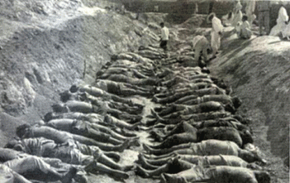
Olson also appeared to have had deep misgivings about the illegal and inhumane use of secret Nazi mass murder biological and chemical weapons in the Korean Aggression (1950-53).[35] During the Korean War, the U.S. killed up to 30 % of its population. It sounds to me like the U.S. clandestinely exploited the EVIL racist, fiendish and psychopathic works of Dr. Blome to a certain extent in Korea. If any of this information had been exposed publicly by Olson, it would have caused a diplomatic and Nuremberg international massive human rights violation- war crimes crisis. And, it absolutely should have![36] Frank Rudolph Olson was assassinated- tossed through his hotel window like a rag doll on November 28, 1953.
IV
DONNY, THE 2ND MOVEMENT- THE WHO
Atlantic Records
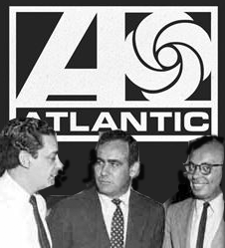
All Seeing Eye, Herbert Abramson, Jerry Wexler, and Ahmet Eretegun
Donny Hathaway was signed by record label, Atco Records and Herbert Abramson– Atlantic Records Company. Atlantic Records was founded in 1947 in Washington DC by Turkish former Swiss, French, and the United Kingdom citizen, Ahmet Ertegun, and Herb Abramson, who was his family’s Jewish former U.S. Army dentist. Ertegun and Jerry Wexler [at Atlantic] signed him in 1969.[37] With his first hit single for the Atco label, “The Ghetto”, in early 1970, Rolling Stone magazine “marked him as a major new force in soul music”.[38]
Donny’s very rare quality as an extremely gifted musician became well-known in the corporate entertainment industry by 1970. According to a psychopathology profile of Donny, he began to exhibit odd behavior and severe episodes of depression in 1970.
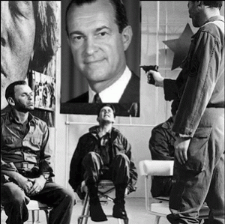
Richard Helms- FATHER OF MK ULTRA- Manchurian Candidate
In 1970, one of the most dangerous and clandestine figures of the 20th century was CIA Director, Richard McGarrah Helms, the Father of MK ULTRA- Olsen’s CIA superior.
“Helms created just such a rule in MKULTRA and spent his entire career trying to perfect it through testing drugs on unwitting subjects, carrying out hypno-programing experiments, and plotting coups, assassinations, and cover-ups while manipulating others.”
Under the leadership of Allen Dulles, Helms began to formulate Operation MK ULTRA (“Ultra” was a “wave” to the World War II operation that broke Nazi codes, and MK probably stood for “Mind Kontrol”).[39] Officially, MK ULTRA was established on 13 April 1953, at Richard Helms’ suggestion as “ultra-sensitive work.” The focal point of MK ULTRA was the use of humans as unwitting subjects [without their knowledge]. The CIA sponsored numerous experiments of this kind. Regardless of a report by the CIA’s Inspector General in 1963 recommending the termination of testing on unwitting subjects, DCI Richard Helms continued to advocate covert testing on the grounds that “we are less capable of staying up with the Soviet advances in this field.” On the subject of moral issues, Helms commented, “we have no answer to the moral issue.”[40]
Helms and the CIA had no moral issue about using unwitting citizens for MK ULTRA mind control and drug experiments. By 1971, wife and friends said Donny became delusional. By the end of 1973, he allegedly dropped out of public sight to deal with his mental illness until just before his death on January 13, 1979. We now know that wasn’t exactly the case. Donny had been removed and it looks involuntarily committed and confined to a (MK ULTRA) mental institution by Ertegun and Atlantic Records. They controlled whether he left or stayed in the mental institution- not Donny, his wife or family.
Atlantic Records & Theodor W. Adorno
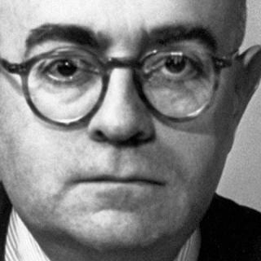
The Frankfurt School Road to MK ULTRA & The Scientific Dictatorship
He was a Frankfurt School of Thought philosopher, socialist and musical composer. It is believed that Adorno of the Frankfurt School had been implanted at Atlantic Records during the 1940s. Behind the veil, Adorno was the mysterious German Professor engineering and controlling the company’s sound studio like a dictator.
The story about Atlantic’s first sound engineer is intriguing. Atlantic moved out of Washington, DC. and into a building at 234 W 56th Street in New York in 1947. There a “German Professor” helped the young businessmen record their first jazz albums. Ertegun told this story many times, but no one ever found out who the “German Professor” actually was. There are clues though. According to Ertegun, “the studio had this German professor who did the bulk of the engineering.” The professor was “a little middle-aged German doctor” who was really difficult to work with. Ertegun claimed that, the professor “wouldn’t let us turn up the bass, or touch anything, but we were told he was a master, so we put up with him.”
Why was a German social scientist, Theo Adorno, controlling the sound studio at Atlantic Records? Most of the following comes from “From Cybernetics to Littleton: Techniques of Mind Control” by Jeffrey Steinberg.
Immediately after World War II, when there was a concerted effort launched, by the Frankfurt School and the London Tavistock Institute, to use the Marxist/Freudian perversion of psychology and other social sciences, as instruments for mass social control and brainwashing. The two pillars of the assault on the American intellectual tradition were cybernetics and the drug counterculture. Lord Bertrand Russell of the Frankfurt School was an advocate for clandestine Mass Social Engineering. In his 1951 book, The Impact of Science on Society. He wrote:
“ … [M]ass psychology. . . . Its importance has been enormously increased by the growth of modern methods of propaganda. Of these the most influential is what is called `education.’ Religion plays a part, though a diminishing one; the press, the cinema, and the radio play an increasing part. . . . It may be hoped that in time anybody will be able to persuade anybody of anything if he can catch the patient young and is provided by the State with money and equipment.”
Russell continued, “The subject will make great strides when it is taken up by scientists under a scientific dictatorship. . . . The social psychologists of the future will have a number of classes of school children on whom they will try different methods of producing an unshakable conviction that snow is black.”
Russell’s description of a “scientific dictatorship” was matched by the account of Aldous Huxley, author of the Utopian tract Brave New World, in a speech on the U.S. State Department’s Voice of America, in 1961, of a world of pharmacologically manipulated slaves, living in a “concentration camp of the mind,” enhanced by propaganda and psychotropic drugs, learning to “love their servitude,” and abandoning all will to resist. “This,” Huxley concluded, “is the final revolution.”
Speaking at the California Medical School in San Francisco, Huxley announced: “There will be in the next generation or so a pharmacological method of making people love their servitude and producing dictatorship without tears, so to speak. Producing a kind of painless concentration camp for entire societies so that people will in fact have their liberties taken away from them but will rather enjoy it, because they will be distracted from any desire to rebel by propaganda, or brainwashing, or brainwashing enhanced by pharmacological methods. And this seems to be the final revolution.”
Theodor W. Adorno was born Theodor Ludwig Wiesengrund (1903 – 1969) to a Jewish family in Frankfurt, Germany. In May 1944, the American Jewish Committee (AJC) established a Department of Scientific Research, which was headed by Frankfurt School director Max Horkheimer. Horkheimer established a project, called Studies in Prejudice, with generous funding from the AJC and other agencies, including the Rockefeller foundations. The Studies in Prejudice (SIP) employed a number of Frankfurt School members such as Herbert Marcuse and Franz Neumann that were brought into the Research and Analysis Section of the OSS with Dulles, Helms and Col. White. Adorno worked on SIP, and, under Horkheimer’s direction, they all formally reconstituted the International Institute of Social Research, the transplanted incarnation of the original Frankfurt School of Weimar Germany.
One of the most significant studies produced by SIP during 1944-50, was The Authoritarian Personality. Dr. William Morrow, the leading protégé of Dr. Kurt Lewin, who was one key, bridge figure between the Frankfurt School and the Tavistock Institute, was a research director for the Authoritarian Personality project. The SIP studies proposed to create a cultural paradigm shift away from the so-called “authoritarian” matrix of man in the living image of God (imago viva Dei), the sanctity of the nuclear family, and the superiority of the republican form of nation-state over all other forms of political organization. They proposed to transform American culture toward an erotic, perverse matrix, associated with the present “politically correct” tyranny of tolerance for dehumanizing drug abuse, sexual perversion, and the glorification of violence.
Adorno was a “psychopathic personality“. In his 1948 work on The Philosophy of Modern Music, Adorno argued that the purpose of modern music is to literally drive the listener insane. He justified this by asserting that modern society was a hotbed of evil, authoritarianism, and potential fascism, and that, only by first destroying civilization, through the spread of all forms of cultural pessimism and perversity, could liberation occur. On the role of modern music, he wrote, “It is not that schizophrenia is directly expressed therein; but the music imprints upon itself an attitude similar to that of the mentally ill. The individual brings about his own disintegration. . . . He imagines the fulfillment of the promise through magic, but nonetheless within the realm of immediate actuality. . . . Its concern is to dominate schizophrenic traits through the aesthetic consciousness. In so doing, it would hope to vindicate insanity as true health.” Necrophilia, he added, is the ultimate expression of “true health” in this sick society.
One of the main ideas of the Frankfurt School was to exploit Freud’s idea of “PANSEXUALISM”: the search for indiscriminate sexual pleasure, the promotion of “unisex”, the blurring of distinctions between the sexes, the overthrowing of traditional relationships between men and women, and, finally, the undermining of heterosexuality at the expense of homosexuality — as, for example, in the idea of “same-sex marriage” and the adoption of children by homosexual couples.”[41]
Under the growing influence of Christianity around the first century AD, the pagan Sun Cults of Mithras were essentially outlawed and driven underground. Powerful forces of the secret pagan sun cults like the Frankfurt School have been committed to effecting an erosion and destruction of Christianity and its influence, from within. As they erode Christianity, the underground and outlawed Sun Cults of Mithras are arising dropping their veils of secular disguise to become the explicit and open worship of the Cybele, Mithras, and Satan-Baal-Lucifer.[42]
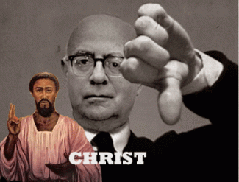
Powerful institutions, academic universities, oligarchies, and now the U.S. government is bent upon eradicating the kind of institutional forms of society which Christianity and true human nature demand and require of the divine. The persistent erosion of society’s core Christian values open people of weak character and constitution to be recruited, and victims including children to be kidnapped, ritually abused, brainwashed and mind controlled to act as a force for EVIL, a form of evil like the ancient Phrygian Cult of Cybele-Dionysus.
Theodor W. Adorno had been employed at Atlantic Records to make sure that it happened with popular folk music on an established scientific basis. It was a Frankfort School clandestine company mission, policy and principle since it began in 1947.
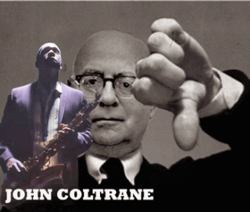
Adorno was a vivid racist that looked at black culture through the lenses of wickedness, prejudice and bias. He hated black Jazz. He preached among the elite institutions that there was nothing spiritual or special about it. He dismissed black jazz as a debasement of music. He found no authenticity in jazz, and sneered that “the skin of the Negro as well as the silver of the saxophone were only colorist effects (die Haut der Neger so gut wie das Silber der Saxophone ein koloristischer Effekt)”. In his essays on jazz, Adorno perpetuated this prejudice by confining his analysis to the commercialistic white jazz of big name swing bands and flagrantly denying or belittling the black contribution to jazz. Adorno refused to acknowledge the autonomy, complexity, creativity and ancient history of African cultural forms of music.
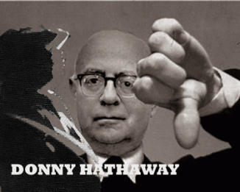
If the black contributed anything to Jazz, claimed Adorno, it was its origin in the blacks’ half-resentful, half-complacent submission to slavery, expressed in spirituals and slave songs.
Thomas John “Tom” Dowd, the Father of Atlantic Sound
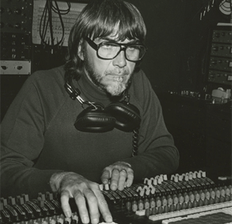
Thomas John Dowd
In 1947, Adorno was called away from Atlantic Records. He was replaced by Tom Dowd, a Columbia University student straight from the OSRD’s super ultra-secret ALSOS Mission- Manhattan Project (Atomic Bomb). Dowd with ultra-sensitive top secret military and government clearances had a degree from NY’s Columbia University in nuclear physics. The purpose of his work with the Manhattan Project is still classified and secret.[44]
Dowd had recorded Donny and Roberta Flack. He was vice president of Atlantic Records‘ sound engineering department. He was most likely the sound engineer on January 13, 1979 and heard Donny talking about “white people were trying to kill him and had connected his brain to a machine, for the purpose of stealing his music and his sound.” Flack was managed at Atlantic by company VP Ottoman Empire Turkish-born record producer and arranger, Arif Mardin, who also may have been there. Luther Vandross would have been there. He is dead, too!
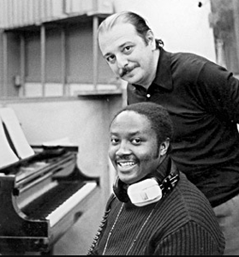
Arif Mardin with Donny (1973)
This photo was taken for an Aretha Franklin session for “Until You Come Back to Me” where he was playing electric piano. Arif Mardin was most likely another clandestine Sabbatean guarding the hen house. “Sabbatean/Frankists, also referred to as the “Cult of the All-Seeing Eye” (look on the back of your one dollar bill to begin to understand their influence in YOUR life), are political and religious chameleons. They are everywhere…there is power. They are the good guys AND the bad guys. The World War Two era is a prime example. The following leaders were members of the “Cult of the All-Seeing Eye” (Sabbatean/Frankists): Franklin D. Roosevelt; Winston Churchill; Adolph Hitler; Eugenio Pacelli (Pope Pius XII); Francisco Franco; Benito Mussolini; Hirohito and Mao Tse-Tung.”
At Atlantic, Donny was surrounded by circle of “WATCHERS” and Masonic/Greek Boule back-stabbing coon uncle toms. Any one of them would have dropped a dime on Donny on Saturday, January 13th, because of his loose talk implicating MK ULTRA/MONARCH.
Donny was a devoted Christian spreading the Love of Christ in his music among the masses as a living testament of his faith. Donny and his extraordinary talent had been trapped in a Hell Hole at Atlantic Records. They wanted to turn his remarkable god given talent into a force for EVIL, or totally destroy it.
Don’t get it twisted. Ertegun and Atlantic Records had no love for black culture and its forms of music. According to Ertegun’s partner Jerry Wexler, Atlantic was in the business of “taking the gospel songs and putting the devil’s words to them.” They weren’t representing Black culture, but a self-destructive Black sub-culture. They were promoting icons that spoke for society’s underbelly: UNRESTRAINED SEXUALITY, VIOLENCE, AND DRUG!

Ahmet Ertegun was raised in Turkey as a Muslim. However, he has belonged to a secret Turkish Kabbalistic American- Israeli Zionist circle related to the Sabbateans for decades.
Former U.S. Secretary of State (1973 –1977), 8th U.S. Security Council Adviser (1969- 1975) Henry Kissinger and Ertegun traveled “… to many foreign countries, though as the son of a distinguished Turkish diplomat, he was quite at home everywhere. We went together to India, China, Nepal, and World Cup tournaments in Spain, Italy and France and, of course, to Turkey.”[45]
The secret group emerged into the light of day at the April 1992 gala celebration of the Quincentennial Foundation. The foundation had been created in 1989 to organize the 5OOth anniversary celebration, in 1992, of the Ottoman Empire’s acceptance of Jews who had fled Spain. The objective of the Quincentennial Foundation from an Israeli and U.S. standpoint has been to rope in Turkey as an expendable, regional military instrument of the New World Order directed by the German Jew- Henry Kissinger.[46]
Atlantic moved out of Washington, DC and into a building at 234 W 56th Street in New York in 1947. Ertegun would go on to monopolize the Jazz, R&B, and Rock music industries. He made a fortune off Ray Charles, Bobby Darin, Aretha Franklin, the Rolling Stones, Otis Redding, Bette Midler, Wilson Pickett, Percy Sledge, Booker T. and the MGs, Sam and Dave, Cream, the Bee Gees, Led Zeppelin, the Coasters, John Coltrane, Charlie Mingus, Roberta Flack, the Spinners, the Allman Brothers, Genesis, Foreigner, Pete Townshend, Stevie Nicks, Buffalo Springfield, the Blues Brothers, Tori Amos, and Phil Collins, among many others.[47]
Ertegun and Abramson didn’t create Atlantic Records because of their love for American Folk music. It was about TOTAL CONTROL AND SATANIC INFLUENCE! According to Ertegun’s partner Jerry Wexler, Atlantic was in the business of “taking the gospel songs and putting the devil’s words to them.” They weren’t representing Black culture, but a self-destructive Black sub-culture. They were promoting icons that spoke for society’s underbelly: unrestrained sexuality, violence, and drugs.
Frank Carlucci
Ertegun was also well connected with powerful figures of the Zionism, Satanic Cabals and the American Shadow Government. He sat on the board of the RAND Center for Middle East Public Policy Advisory Board with former U.S. Defense Department Secretary- CIA Director, Frank Carlucci. Carlucci was also the chairman of The Carlyle Group, a defense contractor with ties to the 9/11 Inside Job, Former President and CIA Director George Bush, Sr., Saudi Royal Family and the Bin Ladens.[
V
DONNY, THE 3RD MOVEMENT- THE WHERE
J. Willard Marriott, High Priest, More than a Friend to the CIA
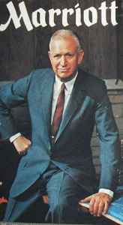In 1979, the Essex House Hotel in New York, NY where Donny was murdered was owned and managed by J. Willard Marriott. Nobody but nobody could tell J. Willard that he wasn’t the highest of the high. He dined with U.S. presidents, heads of government and state, and the elite of the elite. He was more than a friend to the CIA.
Marriott was a Masonic Latter-day Saint High Priest. He was a Washington DC (All-Highest) “Stake” High Council president for a decade in 1973.[49] In the Mormon Church, a stake is an administrative unit composed of multiple congregations, or wards. A stake may be compared to a diocese in the Roman Catholic Church. The name “stake” derives from the metaphor employed by Isaiah, comparing Zion to a tent fastened securely by stakes:
Look upon Zion … a tabernacle that shall not be taken down; not one of the stakes thereof shall ever be removed, neither shall any of the cords thereof be broken.
Isaiah 33:20
Enlarge the place of thy tent … lengthen thy cords, and strengthen thy stakes.
Isaiah 54:2 [50]
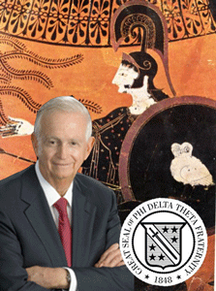
Marriott also belonged to the Greek secret society, Phi Delta Theta, Utah 1926.[51] Their patron Greek divinity is Pallas Athena and her Owl.[52]
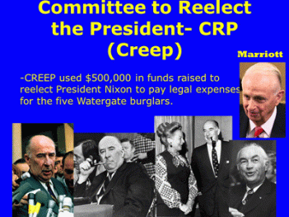
Marriott was one of leading principal figures behind President Richard M. Nixon, CREEP and Watergate. He was behind Nixon’s presidential inaugural and Committee for the Re-Election of the President (CREEP). Besides its re-election activities, CREEP illegally laundered money and slush funds and was deeply involved in secret financing the infamous CIA Watergate burglary.[53]
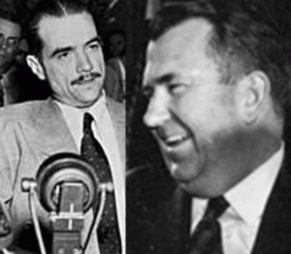
Howard Hughes and Donald Nixon
Marriott provided cover for Donald Nixon, president’s brother, fronting for Howard Hughes. The Howard Hughes syndicate was a front for the CIA. To cover Donald Nixon, Marriott hired him. As a newly hired vice president of Marriott Corp., Donald Nixon had deep cover for CIA slush funds laundered out of the Howard Hughes outfit, and to travel the world. He dined with right wing– Nazi officials of the Greek military junta and met with Venezuelan cabinet ministers. [54],[55] Donald Nixon made two secret trips to Greece for a $10-million Loan from Marriott Corporation during the time Republicans were seeking money to silence the Watergate defendants.

After the burglars’ arrest in the Watergate Scandal, Martha Elizabeth Beall Mitchell, wife of U.S. Attorney General John Mitchell, Chairman of CREEP threatened to talk about its “dirty tricks” and name names in the Watergate Scandal. She was taken prisoner by at least 5 (five) men. Reporter Helen Thomas said, “In an interview later, Martha [Mitchell] told me, “I want to be sure my side is revealed and that people know I’m not sitting here a mental case or an alcoholic.” What happened in that villa? She later told me a hair-raising story: “They threw me down on the bed—five persons did it—a doctor, a nurse, Lea Jablonsky . . . pulled my pants down and stuck a needle in my behind, the longest needle you ever saw. I’ve never been treated like this before.” She had a gash in her hand that she said required eleven stitches”.

After that incident, Martha Mitchell found herself in New York. She was kidnapped from California and taken to a CIA safe house at the MARRIOTT Essex House Hotel in New York (Room 710, Marriott Suite) under an assumed name. It was where, according to Martha Mitchell, the Washington bosses stayed while in New York. She could have been held there, and MK ULTRA-ed.
Richard Nixon told interviewer David Frost (in September 1977 on Frost on America) “If it hadn’t been for Martha Mitchell, there’d have been no Watergate.” More accurately, if it hadn’t been for Martha Mitchell, Nixon would have been able to make Watergate go away. They opened a new field of psychiatry for Martha Mitchell. The psychological term “the Martha Mitchell effect” arose as a result of her experiences with mental health professionals who originally believed her to be “delusional” when she exposed matters related to the CREEP and the Watergate Scandal—matters that turned out to be true. Martha Mitchell died in New York City on May 31, 1976, two years after her diagnosis of multiple myeloma, a rare bone cancer. Interestingly, the U.S. House of Representatives Select Committee on Assassinations (HSCA) was established in 1976 to investigate the assassinations of John F. Kennedy and Dr. Martin Luther King, Jr. They wouldn’t get a chance to hear the mouth that roared, Martha Mitchell.
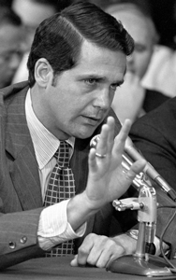
J. W. Marriott also provided deep cover for Nixon’s White House aide, Jeb Stuart Magruder. He was the director then deputy director of CREEP, and served seven months in prison for his role in the Watergate scandal that forced Richard Nixon to resign from the presidency in 1974. Marriott also hired him as a corporate vice president Marriott Corp.[56]
J. W. Marriott was former WWII U.S. Navy, and was president of the U.S. Naval Academy Foundation. The Marriott Corp headquarters is located in Bethesda, Maryland that was right around the block from former CIA MK ULTRA director, U.S. Navy Admiral Stansfield Turner. The Walter Reed National Military Medical Center (Bethesda Naval Hospital) is in Bethesda. Walter Reed is a notorious CIA MK ULTRA/MONARCH hospital.[57]
Research into drugs for mind-control began in 1947 at Bethesda Naval Hospital. A CIA report described this research as to “isolate and synthesize pure drugs for use in effecting psychological entry and control of the individual.” Other hospitals which began working with the intelligence agencies with dispensing MK ULTRA/MONARCH drugs for mind control include the Mayo Clinic.[58] J. W. Marriott was also a board member of the Mayo Clinic.[59]
So, Marriott’s Essex House Hotel in New York appears to have had a clandestine MK ULTRA/MONARCH history with shadow government figures. It was one of the best places for shadow figures to remove and set that safety glass window on the bed, and for assassins to use a hotel passkey to enter Donny’s hotel room toss him out of the window, exit and lock the door behind with the blessings of the All-Highest- J. Willard Marriott.
VI
DONNY, THE 4TH MOVEMENT- THE WHY
The CIA MK-ULTRA program was also interested in profiling personalities- work that the Frankfurt School had been concentrating on for the US Government since the final years of the war. In the late 1930’s, the Tavistock Institute developed a symbiotic relationship with the Frankfurt Institute for Social Research. Their collaboration led them to analyze the culture of a population from a Neo-Freudian standpoint. Nazism just happened to be one of its patients on the psychiatric couch.[60]
Both Tavistock and the Frankfurt School paid close attention to Nazi propaganda techniques, which they willingly incorporated into their research. The aim of the project, as stated in (Theodore) Adorno’s “Introduction to the Sociology of Music,” … was to “program a mass culture as a form of extensive social control that would steadily degrade its consumers.”[61]
“MK-ULTRA teams tried to map out the beliefs and insecurities of certain ethnic groups, like Blacks; and social groups, like lower-class inner-city residents; and religious groups like Evangelical Christians. They were building a database of how to manipulate ethnic politics and special interest groups.”[62]
Lastly, let me address briefly the Black Culture and the HollyWeird film, “The Green Mile (2000).” It’s important and very relevant to this piece. In a comment, it was suggested that I was passing false information about the film. In that Coffey didn’t do the crime, a white man really raped and killed the little girls. If I had watched the movie, I would have discovered the truth.

Well, why didn’t they leave the image and impression with the masses of the white man with his own wicked, twisted, horrific and disturbing works- the Corpus delicti (Latin: “body of the crime“; plural: corpora delicti)- two dead bodies of raped little white girls instead of the black man.
John Coffey, a 6 foot 8 over 300 pound black man afraid of the dark is a safe-harmless protagonist instead of WILL – Nat Turner Rebellion.

Nat Turner, “Will Laid Him Dead, with a Blow of His Axe“
Coffey heals white people by sucking the diseases/ailments out of them and regurgitating them. He is on death row in Deep South, Louisiana, for raping and murdering two little white girls. He is taken to the warden’s house to heal the warden’s cancerous wife. A white character, William “Wild Bill” Wharton grabs John’s arm. This contact allows the “Magic Negro” to see inside Wild Bill’s heart and it reveals that Wild Bill actually raped and murdered two young girls, the crime that John Coffey will be executed for by society. To keep Wild Bill from causing more trouble, the guards give him a drugged RC Cola that knocks him out while they smuggle John Coffey out of the prison. When John Coffey is returned to prison, he regurgitates the disease into a white prison guard, who then shoots Wild Bill to death before going into a catatonic state. When asked why he did this, John said that “[He] punished them bad men. [He] punished them both.” John Coffey was executed, but he refused the customary hood, as he was afraid of the dark. Truly, what kind of sick and twisted S.H.I.T is this?

If the white protagonist in the film, William “Wild Bill” Wharton, raped and murdered the two little 9 year old white girls in the film, let him answer for the outrageous wicked and perverted crimes not the black man. The subliminally images and messages of “The Green Mile” seek to transform the black culture toward an erotic and perverse matrix. Let’s go back to Adorno and the Frankfurt School,
It is not that schizophrenia is directly expressed therein; but the music [IMAGES] imprints upon itself an attitude similar to that of the mentally ill. The individual brings about his own disintegration. . . . He imagines the fulfillment of the promise through magic, but nonetheless within the realm of immediate actuality. . . . Its concern is to dominate schizophrenic traits through the aesthetic consciousness. In so doing, it would hope to vindicate insanity as true health.” Necrophilia, he [ADORNA] added, is the ultimate expression of “true health” in this sick society.
Necrophilia, also known as necrophilism, necrolagnia, necrocoitus, necrochlesis, and thanatophilia, is a sexual attraction or sexual act involving corpses. It is classified as a paraphilia by the Diagnostic and Statistical Manual (DSM) of the American Psychiatric Association.
How much pain, ugliness and sacrifices must black people continue to bear mentally, physically and subliminally for the Wickedness and Evil of white people? If the white man did the crime, don’t play with the minds of the innocent. Let him be arrested, condemned and executed for his own crimes against humanity not an innocent black man. No! Don’t lay this kind of stuff on the door step of black culture.

The Green Mile has latent and hidden Masonic and Satanic symbolism. Traveling the Green Mile is the road of the left hand path. The Green represents Lucifer’s Green Tablet that fell to earth when he was tossed from heaven. The Green Man is Satan. The Yezidi’ still call Satan, Al-Khadir which means “The Green Man“. The God Dionysus who also represents Satan was also called “The Green Man” and so was the most ancient God Ashur (Osiris). Recently, there is the Horned Green God and Wendy Williams’ connection.
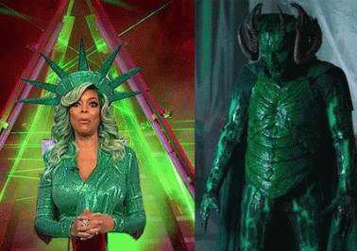 The Green Mile is a sick piece of dark double-bind S.H.I.T for colonized and decolonized Black people to watch under any circumstances and become confused. It’s another example of white people receiving false divine grace for their EVIL and CRIMES against society through the Masonic Satanic blood sacrifices of Black people.
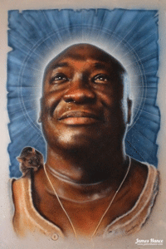
For a few pieces of silver, HollyWeird persistently use and portray coon cake walking uncle toms as harmless “Magic Negroes” compelled to “suck up” responsibly and accept condemnation for the EVIL of white people. No! I am not the one to sit through this kind of asinine and wicked S.H.I.T without crying out!
Donny wasn’t one of those shameless cake walking uncle tom coons willing to sell out his people for a few pieces of silver. He refused to be part of the CIA ’s MK ULTRA/MONARCH secret erotic, satanic, perverted and psychopathic matrix to undermine the strength, unity and rich culture of the Black masses. He refused to allow his musical works to be part of Lucifer’s workshop. Donny was so special to us in mysterious spiritual ways that isn’t cataloged in their black data bases. Donny proved them to be outright lying about the beauty, richness, spirituality, complexity and antiquity of the black culture, and its forms of music held scared to the people. Donny refused to sell-out. Donny wouldn’t even succumb under regiments of psychological terror, torture, psychotronic drugs, shock treatment, and brainwashing. Through-out all his ordeals and confinements, he still tried had the heart to speak truth to power and the people. Donny’s music strengthened and inspired the masses. They killed Donny, but he lives on in our hearts, mind, soul and spirit. Donny’s voice is still powerful, crystal clear, soft, silky and shining through it all as if it was only yesterday.
FOR THE MOST DIVINE AND SACRED BEAUTY, WE LOVE YOU DONNY!
___________________________________________________________________________________________
[1] https://ovadosepeace.wordpress.com/2017/01/13/donny-hathaway-death-conspiracy-black-messiah-black-male-suicide/
[2] https://www.washingtonpost.com/archive/local/1979/01/15/donny-hathaway-song-writer-singer-falls-to-death-in-ny/04b5d6a8-a114-42f6-a698-0eac1096fcd8/?utm_term=.cb6d129be6f5
[3] Id.
[4] http://www.ethanhein.com/wp/2011/where-does-the-egyptian-melody-originally-come-from/
[5] https://en.wikipedia.org/wiki/Donny_Hathaway
[6] http://echoesmagazine.co.uk/2013/10/24/eulalah-hathaway-exclusive/
[7] http://www.trinfinity8.com/rediscovering-the-healing-temples-of-saqqara/
[8] https://hubpages.com/entertainment/A-SONG-FOR-DONNY-THE-LIFE-OF-DONNY-HATHWAY
[9] http://enacademic.com/dic.nsf/enwiki/289848/Donny
[10] https://en.wikipedia.org/wiki/The_Closer_I_Get_to_You
[11] Lordi, Emily J., Donny Hathaway Live, Bloomsburg Academic, NY, NY (2016), pgs. 106-107
[12] Id.
[13] http://www.legacy.com/obituaries/atlanta/obituary.aspx?n=david-franklin&pid=117233234
[14] http://www.nytimes.com/1990/02/17/obituaries/herman-wilson-54-led-investment-fund-that-aided-the-poor.html
[15] https://en.wikipedia.org/wiki/Shirley_Franklin
[16] https://en.wikipedia.org/wiki/Roberta_Flack
[17] https://martinacable99.wordpress.com/2012/11/04/targeted-individuals-psychotronics-anonymous/
[18] https://en.wikipedia.org/wiki/Stansfield_Turner
[19] http://www.surveillanceissues.com/media/mind-control-articles.pdf
[20] https://en.wikipedia.org/wiki/1979_Chicago_blizzard
[21] http://www.wefunkradio.com/song/play/381_aq/donny+hathaway/the+ghetto
[22] http://www.telegraph.co.uk/news/worldnews/northamerica/usa/9710121/Scientist-Frank-Olson-was-drugged-with-LSD-and-murdered-by-CIA.html
[23] http://www.frankolsonproject.org/Articles/Chase.html
[24] https://www.washingtonpost.com/archive/local/1979/01/15/donny-hathaway-song-writer-singer-falls-to-death-in-ny/04b5d6a8-a114-42f6-a698-0eac1096fcd8/?utm_term=.cb6d129be6f5
[25] http://educationforum.ipbhost.com/topic/16036-jean-pierre-lafitte/
[26] http://www.sfweekly.com/news/operation-midnight-climax-how-the-cia-dosed-s-f-citizens-with-lsd/
[27] http://www.history.com/mkultra-operation-midnight-climax-cia-lsd-experiments
[28] http://ahrp.org/1953-1964-operation-midnight-climax-cias-lurid-ventures-into-sex-hookers-and-lsd/
[29] https://listverse.com/2012/08/24/15-nazis-that-should-have-been-executed/
[30] https://en.wikipedia.org/wiki/Alsos_Mission
[31] https://www.globalresearch.ca/biological-warfare-and-the-national-security-state/14708
[32] http://www.gammaexplorer.com/wp-content/uploads/2014/03/AtoZofNBCwarfare.pdf
[33] Id.
[34] https://www.thedailybeast.com/what-cold-war-cia-interrogators-learned-from-the-nazis
[35] http://www.nytimes.com/2012/11/27/us/family-of-frank-olson-man-drugged-by-cia-plans-suit.html
[36] https://www.globalresearch.ca/know-the-facts-north-korea-lost-close-to-30-of-its-population-as-a-result-of-us-bombings-in-the-1950s/22131
[37] http://echoesmagazine.co.uk/2013/10/24/eulalah-hathaway-exclusive/
[38] https://en.wikipedia.org/wiki/Donny_Hathaway
[39] http://ufodigest.com/article/ruled-rogues-oswald-cia-assassination-jfk
[40] http://stopthecrime.net/Top-Secret-Programs-Hidden-in-Plain-Sight.pdf
[41] http://www.thetruthseeker.co.uk/?p=64800
[42] https://voat.co/v/pizzagate/1825536
[43] https://en.wikipedia.org/wiki/Office_of_Scientific_Research_and_Development

[44] https://en.wikipedia.org/wiki/Tom_Dowd

[45] https://www.henryakissinger.com/eulogies/041707.html
[46] http://www.larouchepub.com/eiw/public/1992/eirv19n23-19920605/eirv19n23-19920605.pdf
[47] http://www.slate.com/articles/news_and_politics/interrogation/2005/02/interrogating_ahmet_ertegun.html

[48] http://www.apfn.org/apfn/WTC_update.htm

[49] https://www.lds.org/ensign/1982/10/j-willard-marriott-jr-a-time-to-every-purpose?lang=eng
[50] https://www.mormonwiki.com/Stake
[51] https://www.phideltatheta.org/famous-phis/j-willard-marriott/
[52] https://en.wikipedia.org/wiki/Phi_Delta_Theta
[53] https://en.wikipedia.org/wiki/Committee_for_the_Re-Election_of_the_President
[54] http://www.blackopradio.com/pdf/private_copy_Howard%20Hughes_2.pdf
[55] http://articles.latimes.com/1987-06-30/local/me-1152_1_donald-nixon
[56] https://www.newspapers.com/newspage/98209972/
[57] https://en.wikipedia.org/wiki/Walter_Reed_National_Military_Medical_Center
[58] https://www.bibliotecapleyades.net/sociopolitica/mindcontrol/chapter03.htm
[59] https://www.eturbonews.com/172048/think-know-hotel-tycoon-bill-marriott
[60] https://www.henrymakow.com/2016/04/why-tyranny-is-inevitable.html

[61] Id.
[62] http://www.theoccidentalobserver.net/authors/Whitcombe-AdornoII.html
[63] http://atlantablackstar.com/2016/03/30/black-fraternity-members-slam-singer-layla-hathaway-after-she-posts-instagram-selfie-in-alpha-hat/
Comments : 3 Comments
Tags: A Secret Order, A Terrible Mistake, Admiral Stansfield Turner, Ahmet Ertegun, Aldous Huxley, Allen Dulles, Alsos Mission, American Jewish Committee, Arif Mardin, Army Intelligence (G-2), Artichoke project, Atco Records, Auschwitz Concentration Camp, Black Panther Party for Self Defense, BLUEBIRD Project, BOULE, brain interface machine, Brave New World, camp detrick, camp king, christianity, CIA, CIA Assassination Manual, CIA MK ULTRA/MONARCH, Colonel George Hunter White, Colonel Boris Pash, Cooperative Assistance Fund, CREEP, Crusade to Free Cuba Committee, DARPA, david franklin, david frost, Delta Sigma Theta, devil, Divine 9, Donald Nixon, donny hathaway, Dr. Harold Batchelor, Dr. James Alexander Hamilton, dr. kurt blome, Dr. Martin Luther King, egyptian melody, essex house hotel, Eulaulah Hathaway, European Command Intelligence Center, everything is everything, fallen angels, Federal Bureau of Narcotics, frank carlucci, Frank Olson, frank wisner, Frankfurt School of Thought, Frankists, Franz Neumann, freemasonry, freemasons, H. P. Albarelli, Henry Kissinger, Herbert Abramson-, Herbert Marcuse, horned green god, Howard Hughes, I Love You More Than You'll Ever Know, Illuminati, J. Willard Marriott, james mtume, jazz, Jean- Pierre Lafitte, Jeb Stuart Magruder, Jerry Wexler, jesse jackson, john coffey, john coltrane, john mitchell, kabbalah, kemetic melody, korean aggression, Korean War, latter day saints, Lee Harvey Oswald, London Tavistock Institute, Lord Bertrand Russell, LSD, Lucifer, luciferians, luther vandross, magic negroes, manhattan project, Marriott Corporation, martha crumwell, martha mitchell, masons, Mass Social Engineering, matrix, Max Horkheimer, melodic patterns, mind control, MK-ULTRA, Monarch Program, Monarchs, mormons, Mother of All Chemical Weapons of Mass Destruction, Nat Turner Rebellion., Nazis, New York Statler Hotel, Nuremberg Tribunal, Office of Scientific Research and Development, omega psi phi, ommittee for the Re-Election of the President, Operation Midnight Climax, operation paperclip, Osiris, OSS, pallas athena, pansexuality, paranormal power, patrice lumumba, Phi Delta Theta, President Richard M. Nixon, prince hall freemasons, Project 63, PROJECT CHATTER, psychopathic personality, Psychotronics, Quincentennial Foundation, rand, reggie lucas, Research and Analysis Section, richard helms, roberta flack, Sabbatean, satan, Satanism, schizophrenia, shirley franklin, Someday We'll All Be Free, stephen paddock, Sun Cults of Mithras, swagger nation, The Carlyle Group, the green mile, Theodor W. Adorno, tom dowd, U.S. Army Chemical Corps, U.S. House of Representatives Select Committee on Assassinations, watergate, wendy williams, Whitney houston, William "Wild Bill" Wharton, William B. Reily Coffee Company, willie weeks
Categories : 9-11, african holocaust, African Liberation, African slavery, ALL SEEING EYE, allen dulles, Aryan Supremacy, baal, black children, black christianity, black institutions, blood covenants, blood sacrifice, BOULE, brain entrainment, christianity, CIA, cmf, Col. George White, council on foreign relations, cybernetics, DARPA, donny hathaway, Dr. Aldous Huxley, Dr. James Alexander Hamilton, egypt, freemason, freemasons, human sacifrice, illuminati, illuminati sacrifice, lucifer's servants, luciferians, mae brussell, manchurian candidates, masonic sacrifice, mind control, MK-ULTRA, modern slavery, monarch program, Nazis, new world order, Owl, Paperclip Project, project bluebird, PROJECT CHATTER, psychological warfare campaign against Christianity, psychotronics, racial mass murder, ritually abused children, Satanic Global High Cabal, Satanism, slave insurrection, Stanford University, ZIONIST

OMAROSA, CIA MK ULTRA, GUTTER’S CREW, PIZZAGATE & THE BLACK WOMAN’S WAR
30122017
I
O OMAROSA, DON’T YOU WEEP!
Omarosé Onée Manigault-Newman is a far more complicated problem. She is far more dangerous and a menace to society than I ever suspected. Something has come to my attention about her that is extremely disturbing and very troublesome.
Growing up in and around the black church, I recall the choir and the elders singing with overwhelming compassion the old black spiritual that originated from the Great Civil War, “O Mary Don’t You Weep” – tell Martha not to moan. It is one of the most important of Black spirituals that contained coded messages of hope and resistance against the EVIL of African Human Bondage.[1] I didn’t understand what they sang about or what it meant to anyone, but it was so powerful and moving that the spirit of compassion always moved, deeply affected, and shaped me. It always left me close to tears. I didn’t understand why.

“O Omarosa, Don’t You Weep”
“O Mary Don’t You Weep” tells the biblical story of Mary of Bethany and her distraught pleas to Jesus to raise her brother Lazarus from the dead. Other narratives relate to The Exodus and the Passage of the Red Sea, with the chorus proclaiming Pharaoh’s army got drown-ded. But, it meant much more.
In the account of the raising of Lazarus, Jesus meets with the sisters in turn: Martha followed by Mary. Martha goes immediately to meet Jesus, while Mary waits until she is called. As one commentator notes, “Martha, the more aggressive sister, went to meet Jesus, while quiet and contemplative Mary stayed home. This portrayal of the sisters agrees with that found in Luke 10:38–42.” When Mary meets Jesus, she falls at his feet. In speaking with Jesus, both sisters lament that he did not arrive in time to prevent their brother’s death: “Lord, if you had been here, my brother would not have died.”^{[Jn 11:21, 32]} But where Jesus’ response to Martha is one of teaching calling her to hope and faith, his response to Mary is more emotional: When Jesus saw her weeping, and the Jews who had come along with her also weeping, he was deeply moved in spirit and troubled.^{[Jn 11:33]} Mary added no more, as Martha did; but it appears that what she fell short in words she made up in tears; she said less than Martha, but wept more and deeply.[2] So much so, it moved the spirit and troubled Christ.
Lazarus of Bethany, also known as Saint Lazarus or Lazarus of the Four Days, is the subject of a prominent miracle of Jesus in the Gospel of John, in which Jesus restores him to life four days after his death.[3]
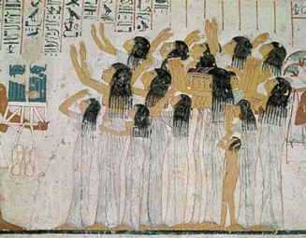
Moaning and weeping is an ancient cultural phenomenon that scholars call inherently human. It was most relevantly developed in Africa, the Land of Kemet (Egypt), and even among the ancient Aztecs.
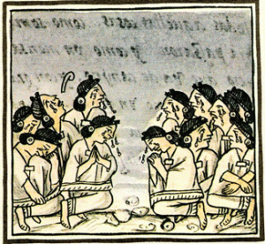
However, it is undoubtedly linked to some untold and mysterious qualities of life and resurrection.[4] Spiritually, weeping and moaning raise the dead.

“Tell Martha Not to Moan”
Omarosa’s father was slain in 1981 when she was 7 (seven) years old. Her brother, 40 year old Jack Manigault, was slain in October 2011.[5] She was left, allegedly, devastated after the sudden illness and subsequent death of her alleged beloved fiance, Michael Clarke Duncan, in September 2012.[6] Her sister, 43 year old Gladys Louise Manigault, suddenly died among her Weller church parishioners in Los Angeles of an unknown cause in February 2016.[7]
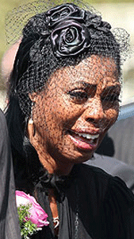
I said that to say this. It seems that Omarosa can, unnaturally and inhumanly, weep and moan the death of her loved ones without tears. She is not a Martha or a Mary. And, Michael Clarke Duncan certainly wasn’t a Lazarus to her.
II
MICHAEL CLARKE DUNCAN, GUTTER & BIGGIE SMALLS
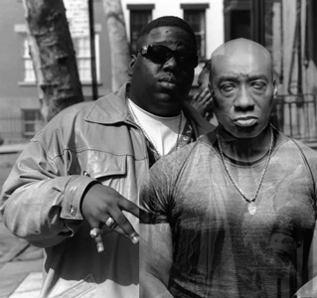
Biggie Smalls, Ancient European Clawed Hand Symbol
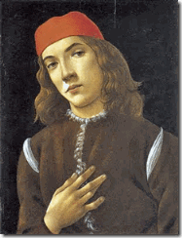
Gnostic Marsilio Ficino (1433- 1499) Medieval Coven Clawed Hand
Biggie Smalls didn’t get the Claw Hand from our community. You haven’t heard about Gutter? Well, you need to know about Gutter. He is a sadistic nigga that abduct children, ritually sodomize them, and throw their bodies over bridges. Former bodyguard Michael Clarke Duncan revealed that he had been assigned to protect Notorious B.I.G. (Christopher Wallace) on the night of his assassination. He was a security-man-for-hire before his acting career took off. He confessed that he was assigned to guard Wallace at the Soul Train Music Awards in Los Angeles in March, 1997, but he swapped the job with a friend to cover R&B singer Kenneth ‘Babyface’ Edmonds instead. It’s called a “security strip”. Wallace was gunned down in a drive-by shooting just hours later after the security switch. It sounds to me that Duncan sold him out for a few pieces of silver, and a HollyWeird acting career.[8]
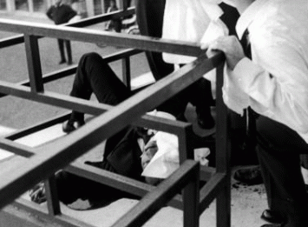
A security strip happened just hours before Dr. Martin Luther King, Jr. was assassinated in Memphis, TN in 1968. His local security detail from a group of brothers called the “Invaders” was stripped from the Loraine Motel just minutes before he was shot in the head.[9]
Wallace’s murder was the nexus of a vast and complex never ending conspiracy.[10] However, I think it begins with Michael Clarke Duncan and his security strip. I don’t believe that he ever exposed his so-called friend and pal that took over his detail with B.I.G., and his friend’s fragrant violation of what could be described as security protocols that could have prevented the assassination.
Duncan said, “In hindsight, everybody says I would have done this (differently) but my thing was never let the client sit on the passenger side door in the front. If you were my client, I’d have you… sitting in the middle (seat).”
By the way, Duncan’s security protocols could also be applied to kidnappings and abductions. Furthermore, who and what employed, and trained Duncan in security protocols- the CIA?

Just before his death, Duncan co-starred in a new television series, The Finder. They could find anything and anyone. I suppose. The TV series was cancelled in 2012 because of his sudden illness and death. It might be interesting to review “The Finder” if it is still available.
We have known about the CIA’s “Finders” clandestinely abducting children for quite sometime.
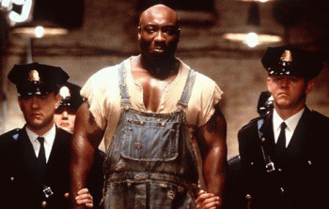
Two (2) years after Wallace’s assassination in 1999, Michael Clarke Duncan co-starred in Stephen King’s Green Mile. The film, The Green Mile, was a box office success, received positive reviews from critics. Michael Clarke Duncan (John Coffey) was nominated for an Academy Award as Best Supporting Actor.[11] However, I couldn’t watch just five (5) minutes of the S.H.I.T. And, that was before I found out that the movie featured besides a big black brute- sadism, murder, child rape, pedophilia, sexual perversion, interracial sex, and adultery.[12]
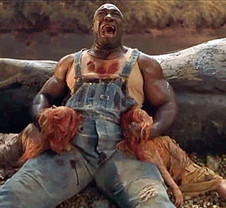
John Coffey & Raped and Murdered 9 year old Twins
John Coffey was a “psychopathic personality”- a sadistic pedophile rapist and murderer. Coffey was on death row in 1930s Louisiana for raping and killing two red-headed nine (9- Occult Number) year old twin girls, Kathe and Cora Detterick.[13] There is no here, now or ever to justify the themes of this film. It is demonic and absolute EVIL. The Green Mile is a wicked sadistic HollyWeird Satanic Dark Circle mass population psychological warfare project, and the Uncle Tom cake walking coon, Michael Clarke Duncan, helped to deliver it to the global masses for another few pieces of silver.

Headless Torso of African Child Tossed into River Thames Maybe Identified
The Notorious B.I.G.[14]
No, I didn’t know that Christopher Wallace was involved in a secret Satanic PIZZAGATE ring that kidnapped and murdered children. Gutter (a Sadistic Satanic Pedophile Cult) is also ritually butchering African children and throwing their bodies off bridges into the River Thames in London. Wallace’s defenders say that it was an example of the raving of undoubtedly a sadistic “psychopathic personality” with a license of wicked dark storytelling about Wayne Williams and the infamous Atlanta Child Murders of the late 1970s, and early 1980s. Over a two-year period in Atlanta (1979-81), at least 28 African-American children, adolescents and adults were ritually murdered.[15]
The only problem with that theory is that according to court papers uncovered as early as 1985, while a task force investigated the Atlanta child murders, another high-level and secret investigation discovered and covered up the fact that a Ku Klux Klan family may have been responsible for the murder of a young black boy and was possibly linked to the murders of 14 others. The child murders were linked to a secret Masonic White Brotherhood of the South.[16]
In addition, Wayne Williams inferred that he worked (PATSY) for CIA- MK ULTRA/MONARCH. Since at least 2002, the numbers of black children, particularly female children, who have been kidnapped, raped and ritually murdered and dismembered, have been increasing dramatically. So, while Wallace’s sadistic mass murder pedophile nigga Gutter, allegedly Wayne Williams, has been in jail, who has been kidnapping and killing black children in record numbers globally in the 21st century?
Wallace’s EVIL child ritual rape and murder (Green Mile) lyrics are part of a rap called “Beef” on the album Life After Death. It was Wallace’s second and final studio album released posthumously on March 25, 1997, on Bad Boy Records and Arista Records, Inc.[17]
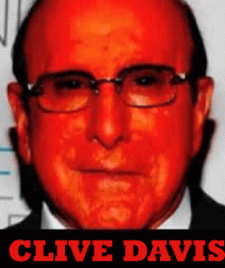Arista was founded in 1974 by the sodomite DEVIL of the music industry, Clive Davis, of the secret Masonic Sons of St. Tammany, or the Columbian Order of NY.[18],[19] It seems to me that Wallace may have violated his oath of the covenant of secrecy by gushing about Gutter, ritual homosexual rites, torture and Satanic Child Sacrifices needlessly raising the collective consciousness of the masses.
“Beef”
(feat. Mobb Deep)
[Biggie]
“ … All I got is heat and tough talk for you
Tie you up, cut your balls off just for you
Man this is straight torture, look what that slick shit bought ya (c’mon)
A first class ticket to Lucifer, real name Cristopher (yea, chris)…”[20]
This could very well be another example of Biggie’s psychopathic personality, and Hip Hop license of dark storytelling, but Lucifer’s Workshop don’t pay millions of dollars to these sadistic Satanic Hip Hop artists to play games with them.
III
MICHAEL CLARKE DUNCAN & THE DARK CIRCLE GAY VIRGIN
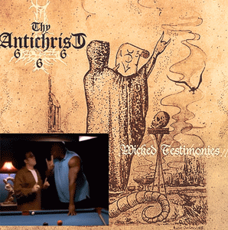
What people don’t understand about Michael Clarke Duncan is that he was part of a secret dark satanic circle. Duncan was also a secret 6 foot 5, 325 pound gay virgin “on his period” saving himself for the right man.
Gay Virgin & Lover, ANT
In 1999’s The Underground Comedy Movie, he played a character credited as Gay Virgin, who repeatedly protests to a persistent would-be sex partner that he is saving himself for the right man.
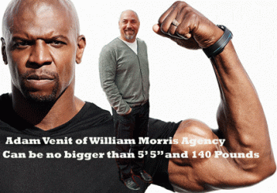
By the way, the scene reminds me of another gender confused HollyWierd big black hulking African Mandingo, Terry Crews, that suddenly lost all his lightning, thunder and rain when ritually sexually molested by a raving homosexual half the man’s size.
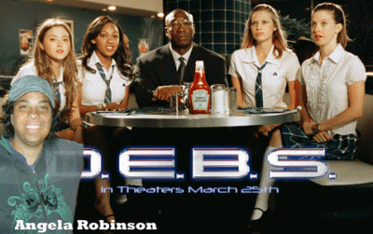
Duncan appeared in the lesbian love story 2004 film D.E.B.S., by lesbian director Angela Robinson, as Mr. Phipps, the supervisor of a team of young female secret agents — the Charlie to their Angels, essentially. [21]

Duncan’s buddy, Anthony Steven Kalloniatis aka ANT on Jay Leno’s Tonight Show with him, is an openly gay Greek-American QUEEN– stand-up comedian.[22]
ANT was raised strict Greek Orthodox. As he entered adulthood, he ventured away from strict Orthodoxy and studied many other religions including Taoism, Hinduism and even Scientology. ANT believes that he is just a spiritual being looking for answers even with the Illuminated One, Lucifer.[23]

Michael Clarke Duncan’s co-stars remembered the late actor as “lovely,” “sweet” and a “legend” at the Hollywood premiere of his final film, A Resurrection. Duncan plays the school principal in the Jamie Kennedy horror/wiccan film about a murdered student who rises from the dead to seek revenge against his killers.[24]
IV
“BE FOR REAL”
Harold Melvin and the Blue Notes
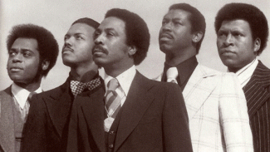
“ … The best I can tell you is what my mother told me as I was coming up- She used to say, “Son, chances go ’round. She said, The same people that you meet going up They meet the same old faces coming down … tell the truth …”[25]
Omarosa and Duncan allegedly met in early 2010 at a Whole Foods grocery store in Los Angeles. Within about two (2) years, he would be dead at 54 years old. She says that they were engaged to be married. It was a secret engagement. If it’s secret, of course, nobody knew anything about it. Dead Men Tell No Tales.[26]
In July 2012, Duncan suddenly dropped into full cardiac arrest on a Friday the 13th morning about 2 am. He had been alone with Omarosa. She gave him CPR. His publicist said on the 13th, “He is now stable and we look forward to his full recovery.”[27] However, he didn’t and could not recover. In September 2012, he died from respiratory failure, which was the official Michael Clarke Duncan cause of death.[28] In a will, Omarosa took the majority of his estate as the main beneficiary. In July 2013, she put his 6,861-square-foot Woodland Hills, CA luxury home up for sale for $1,299,000.

RadarOnline.com had exclusively learned that she was looking to buy into one of Donald J. Drumpf’s properties.[29]
Omarosa says that she was/is trying to help the “Black Community”. However, she doesn’t have the Love of God, independent will power or mind set to help black people, people of color, or the poor, period. Omarosa is a magician of the dark occult filled with lies, trickery, and the seething energies of Lucifer.

“It is known that the Unconscious, whether personal or collective works by means of pictures or images, speech being a comparatively recent development. […] Magic […] speaks to the subconscious mind of man through the archaic images of its symbols and rituals, and thereby produces those ‘changes in subconscious’ which the magician seeks.”– W. E. Butler, Magic; It’s Ritual, Power and Purpose
Vesica Piscis is beyond Christianity, beyond Rome, Greece and Mesopotamia. It looks like the shape of an eye, the Eye of Horus, When the Vesica Piscis is viewed horizontally, and the mandorla becomes a different sort of passage, the birth passage. The pointed oval is a universal symbol of the Divine Feminine, and in this context the Vesica Piscis is the vulva of the Goddess, surrounded by the crescents of the waxing and waning moon.
The mandorla as birth passage can easily be seen on the sheila-na-gig figures found on Irish churches, and in the squatting figures of the Hindu goddess Kali. Almonds are a primeval fertility symbol, and as such are associated with the Phrygian goddess Cybele and her trans gendered consort, Attis, and the Greek nymph Phyllis, who was metamorphosed into an almond tree. Fish, too, play a significant part in the lives of goddesses from many cultures. “Delphos” translates from Greek as both “womb” and “dolphin.” The Chinese Great Mother Kwan -Yin often appears as a fish goddess, as does Aphrodite. Kali, as the swallower of Shiva’s penis, becomes Minaksi, the fish-eyed one; Aset (Isis) becomes Abtu, the Great Fish of the Abyss, when she swallows the penis of Ashur (Osiris).
Omarosa is also “seething with the charisma” of Donald J. Drumpf. Omarosa is an extremely intelligent woman, and the community always needs the wisdom of our intelligentsia. But, she is “intelligence” for whom and for what? Certainly, not black people or people of color. As I said, she’s far more troubling and dangerous than I ever expected.
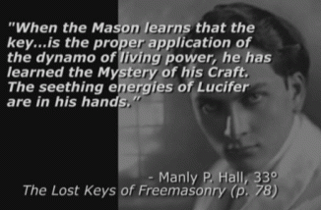
Seethe– Old English sēothan ‘make or keep boiling’, of Germanic origin; related to Dutch zieden. (of a person) be filled with intense but unexpressed anger. ‘inwardly he was seething at the slight to his authority’[30]
Omarosa first came to public attention as a celebrity in 2004 after becoming a participant on NBC’s reality television series, The Apprentice. She was born in Youngstown, Ohio, the daughter of Theresa Marie (née Walker) and Jack Thomas Manigault, Sr., of Nigeria. However, her father was not Nigerian. The Manigaults are an American family descended from the French Huguenot plantations of South Carolina.[31]
Jack Thomas Manigault, Sr. was murdered in August 1981 when she was 7 (seven) years old.[32] It is also important to keep in mind that traumatized children are particularly subject to multiple personality syndrome and disorders due to traumas associated with parental separation through death or illness. Dr. Ralph B. Allison made the following important observation; “Child development specialists have long considered that it takes an average of seven years for any child to develop the personality that will be theirs for life. The personality of a child less than seven is too fragile to absorb life-threatening trauma without reacting in some fashion. Obviously not all children react to early trauma by dissociating, but those who do develop psychological entities which are different than those created at an older age.”[33]
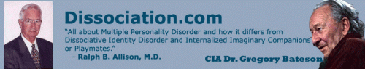
Dr. Ralph B. Allison is a Stanford University psychiatrist. He showed up in Santa Cruz during the 1970s with Huey P. Newton, and British CIA Anthropologist Dr. Gregory Bateson (Stanford Research Institute) to meet/treat and cover some of the first MK ULTRA/MONARCH multiple personality disordered patient(s). He wrote “Minds In Many Pieces” about his experiences in Santa Cruz, where he met his first Inner Self Helper (ISH). He was also involved in numerous criminal cases, including The Hillside Stranglers in Los Angeles, and spent his last 12 years working in a state prison, California Men’s Penal Colony, San Luis Obispo where Huey P. Newton was subjected to comprehensive MK ULTRA mind control/behavior modification experiments. His articles are on his own website.[34]
What is important is that for the Apprentice, Omarosa’s mind was intensively explored, studied and evaluated by two (2) psychiatrists/psychologists in 2004. Omarosa credits Dr. Richard Levak with lobbying the producers to get her on the show. “From what I understand, he said to them that I had one of the most unique psychological profiles he’d ever seen.” According to what Omarosa says Levak told her privately, this profile was an unusual combination of high intelligence and high social skills and a balanced mix of feminine and masculine qualities, elegance and poise countered by a ruthless, competitive drive.[35]
Dr. Richard Levak is a British psychologist. He attended University of Keele, England, and University of California, San Diego- psychology.[36] Keele was established by royal charter in 1949. A royal charter is a formal document issued by a crowned monarch as letters patent, granting a right or power to an individual or a body corporate. Keele University was established by the Satanic/Masonic British Monarchy, Queen Elizabeth II.[37]
The university occupies a 6.25-acre rural campus estate was originally given by King Henry II of England to the Knights Templars in 1180. When the Templars were condemned and dissolved by the Council of Vienne in 1311, their possessions were annexed by the Knights Hospitallers until their dissolution by Henry VIII. The estate was purchased from the Crown by the Sneyd family and remained their property until acquisition by the Stoke-on-Trent Corporation (town) in 1948.[38]
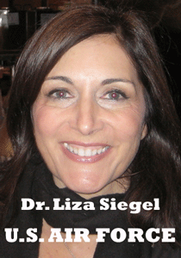
The other psychiatrist is former U.S. Air Force officer hypnotist, Dr. Liza Siegel of the Milton H. Erickson Institute.[39]
Dr. Milton Hyland Erickson is the “father of hypnotherapy.” He was a CIA hypnotist that worked with Dr. Gregory Bateson (Santa Cruz), George H. Estabrooks, and British Aldous Huxley to create real CIA MK ULTRA/MONARCH Manchurian Candidates, and Assassins.[40] Richard Bandler and John Grinder of UC Santa Cruz, pioneers in Neuro-linguistic programming (NLP), used the techniques of Gregory Bateson, Fritz Perls, Virginia Satir, Jay Haley of the Stanford Research Institute (SRI), and Dr. Milton Erickson to develop the foundation of NLP.[41], [42],[43]

In 2006, after her subconscious mind had been opened up and probed by Doctors Levak and Siegel, Omarosa was featured as a Nubian Witch– MK ULTRA/MONARCH Mind Controlled Slave “seething” in the energies of Lucifer in the short cult film, Soul Sistahs. It was no coincidence.
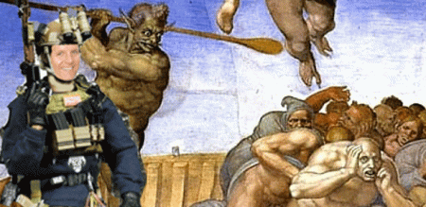
“The Ranger who trained me at the time was [American] Major Buck Kernan, who became Supreme Allied Commander.” James Mark Burnett [44]
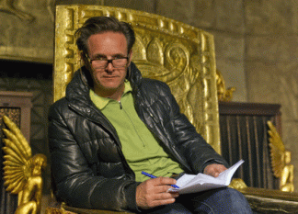
James Mark Burnett, producer of Apprentice, is also a British born subject, born in London, England. Aged 17, he enlisted in the British Army, Section Commander in the Parachute Regiment. From 1978–82, he served with the 3rd Battalion, Parachute Regiment, and saw action during the Falklands War.[45] As Sovereign, Queen Elizabeth II is Head of the Armed Forces, and is also the wife, mother and grandmother of individuals having served in the Forces.[46]
V
THE APPRENTICE, NATO’S SODOMITE PEDOPHILE ARMY & FREEMASONRY

Major Buck Kernan is Irish Catholic William Frank Kernan. He was born of a deep military family at Fort Sam Houston in Texas, son of a highly decorated WWII European theatre officer, Lt. Col. William Freese Kernan, leader of the Second, Third Battalion, 9th Army Infantry, 38th Infantry (Korean Aggression), and U.S. Army Nurse, Lt. Florence Mary White of Philadelphia.[47],[48]
In July 1993, Major William Frank Kernan was assigned as the commander-in-chief Director of Plans, Policy, and Strategic Assessments, J5, U.S. Special Operations Command, MacDill Air Force Base, Florida. The Joint Staff J5 proposes strategies, plans, and policy recommendations to the Commanding Joint Chiefs of Staff to support his provision of “best military advice” across the full spectrum of national security concerns to the President and other national leaders.[49] He was NATO’s Supreme Allied Commander, Atlantic (SACLANT), both based in Norfolk, Virginia.[50] Kernan, a four-star general, was supreme allied commander of Allied Command Atlantic, one of NATO’s two major military commands. He was a key ultra-secret U.S. military intelligence NATO commander during 9-11 Inside Job and Cover-Up.[51]
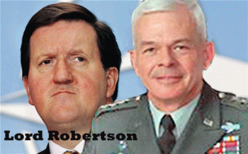
Major Kernan developed the Millennium Challenge global defense system that brought Scottish diplomat and former UK Secretary Defense, Lord (Baron) Robertson (Secretary General of NATO), and all the military representatives and the ambassadors from the NATO nations through Millennium global military planning and exercises. Lord Robertson, a self-confessed Masonic member of Edinburgh’s sinister “Speculative Society” lodge, enjoyed a peculiarly close personal relationship with Thomas Hamilton, the mass murderer of abused children in Dunblane in Stirlingshire or the County of Stirling, Scotland.[52]
On March 13, 1996, Thomas Hamilton, a former Boy Scout leader walked into Dunblane Primary School armed with two 9 mm pistols and two .357 Magnum revolvers. He killed sixteen small children and a teacher. The subsequent police investigation revealed that Hamilton had loaded the magazines for his Browning with an alternating combination of fully metal-jacketed and hollow point ammunition. This horrific event led to the banning of handguns in the UK.
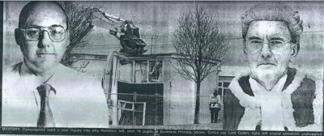
Hamilton & Lord Cullen
The Judge who conducted the inquiry into the atrocity, during which two teachers claimed to have seen another mysterious man “guiding” Hamilton onto the premises, was Lord Cullen. Cullen, also a member of the Masonic Speculative Society and an associate of Labour “Scottish Mafia” figures such as Lord Robertson, Tony Blair, John Reid and Gordon Brown, was accused by leading journalists and emergency service personnel of having achieved a cover-up.

British Dark Lord- Lord Mandelson
According to the testimony of the British journalist, Gordon Brown is member of a ring of senior British pedophiles, consisting of general prosecutor Goldsmitdt, a former chieftain of the NATO Lord Robertson and Lord (Peter) Mandelson. All of them are major members of masonic lodges. The British journalist said that a group of senior pedophiles organized a massacre of children at the Dunblane Primary School. The children were killed because they knew too much about the crimes committed by British pedophile politicians. The murder was committed by Freemason, Thomas Hamilton. But the gun with explosive bullets, as the investigation established, had been given to him by Lord Cullen (Cullen on the photo with Hamilton), a member of the Labor “Scottish Mafia”, which includes Gordon Brown, Lord Robertson, Tony Blair and John Reid. The Dark Lord Mandelson is constantly accused in Europe in the kidnapping young girls and boys for European Union’s elite pedophile commissioners in Brussels.[53]

Lord Mandelson of the Bilderberg Group was a member of the British-American Project for the Successor Generation (BAP), a little-known but highly influential transatlantic network of “chosen” politicians, journalists and academics. The fingerprints of British and American intelligence are everywhere to be found amongst the network of BAP members; regular attenders at BAP meetings are defense and security specialists, NATO advisers, Defense Ministry think-tank people and counter-insurgency experts.[54]
In 1976, Lord Mandelson was Chair of the British Youth Council, which began as the British section of the World Assembly of Youth, which as we have seen, was set up and financed by the CIA. By Mandelson’s time in the mid-1970s, the British Youth Council was said to be financed by the Foreign Office, though this was thought to be a euphemism for MI6.[55]
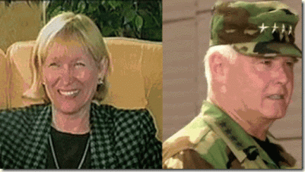
Recall the secret BROTHERHOOD– Sodomite (homosexual/pedophile) Army that was exposed by Kay Griggs. She was the wife of U.S. Marine Corps Colonel George Griggs, Chief of Staff, Marine Atlantic / Head of Psychological Operations- NATO.[56] Bypassing congressional and public oversight, Major Kernan established NATO’s Millennium nations with permanent liaisons with U.S. Joint Forces Command. In other words, Major Kernan developed the infamous Nazi Secret Army Organization into a New World Order global defense and offensive mechanism.[57]
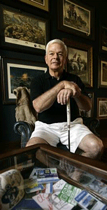Major Kernan co-found L-3 MPRI. It primarily recruits and employ a network of retired U.S. military personnel. It is a global provider of private military contractor services. It offers a wide range of professional services to both public and private customers, most notably the U.S. Departments of Defense, State, Justice, and Homeland Security, Law Enforcement organizations, foreign governments, government agencies and commercial businesses.[58] In 1995-96 before Operation Storm, there is considerable circumstantial evidence to suggest that MPRI prepared and trained the Croatian Army for its offensive to retake the Krajina region. 120 African leaders and more than 5,500 African troops have been trained by MPRI on security issues.[59]
A group of Serbs who lived in Krajina until Operation Storm sued MPRI accusing them for “participation in genocide“, militarily equipping the Croatian Armed Forces, training the Croatian officers and developing a plan of Operation Storm. The claim was presented to the Federal Court in Chicago, and prosecutors were asking for $10.4 billion compensation. On September 26, 2014 the lawsuit was rejected by Judge John Lee because the war in former Yugoslavia is not under jurisdiction of this court.[60]
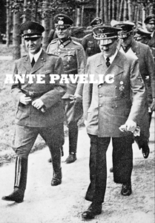
The Armed Forces of the Independent State of Croatia had similar insignia to those of the Armed Forces of Nazi Germany. Ustasha imagery and references to pro-Nazi leader Ustasha Poglavnik Ante Pavelic were sprayed on vandalized Krajina Serb homes.
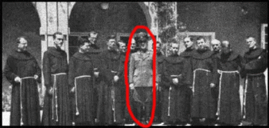
Some of the most sensational depraved and utterly ghoulish murderers of the THIRD REICH had been Roman Catholics, Ante Pavelic- Ustashi of Croatia.
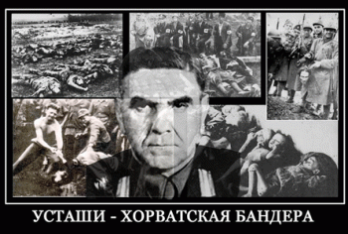
“These were not isolated instances. The Ustashi more often than not massacred all the inhabitants of Serb villages, callously torturing and killing even children, and then setting the villages on fire. In the village of Susnjari, for instance, the Ustashi, after having killed most of the inhabitants, led away about twenty surviving children, whom they tied to the threshold of a big barn, which was then set on fire. Most of the children, of an average age of about ten, were burned alive. The few, who survived, horribly scorched, were eventually killed. Eye-witnesses testified to similar occurrences:
In the village of Gorevac, on September 13, 194i, children of about 3 years of age were impaled. In some places mothers threw themselves down with children in their arms, and one stake perforated mother and child. Some young girls had their breasts tied or cut, others had their hands made to pass through them. Men had their ears and noses sawn away, and eyes had been uprooted from their sockets.”[61]
In Major Kernan’s Operation Storm, Serbian refugees were forced to evacuate to evacuate their ancestral lands and flee to Serbia and Bosnia-Hercegovina. Their homes and property were taken over by Croats.
“This was the largest refugee crisis since the Holocaust, since World War II. The roads and streets were flooded to overflowing with Serbian refugees as an estimated 250,000 to 300,000 Krajian Serb refugees were expelled from Krajina. This act of ethnic cleansing constituted genocide, the total elimination and destruction of an entire people and culture.”[62]
Major Kernan’s L-3 MPRI sits at the apex of NATO’s global Millennium Challenge. It’s the 21st century’s Secret Army Organization wrapped up like a Christmas present. It is Hitler, Himmler, and Otto Skorzeny’s post WWII wet dream of un-mitigating global power and New World Order. It is a global Aryan terrorist organization!
The Apprentice & Freemasonry
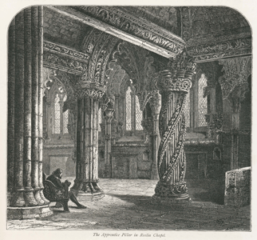
People like Major Kernan and James Mark Burnett of “The Apprentice” do not develop relationships and bonds to be broken. “The Apprentice” is hidden– very significant Masonic symbolism.
“According to the legend, the master mason did not believe that the apprentice could perform the complicated task of carving the column without seeing the original which formed the inspiration for the design. The master mason traveled to see the original himself, but upon his return was enraged to find that the upstart apprentice had completed the column anyway. In a fit of jealous anger the mason took up his mallet and struck the apprentice on the head, killing him. The legend concludes that as punishment for his crime, the master mason’s face was carved into the opposite corner to forever gaze upon his apprentice’s pillar,”[63]
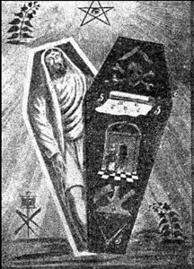
It represents the symbolic murder of Hiram Abiff, the master mason, at the time of the building of King Solomon’s Temple in Jerusalem, which even today, has immense spiritual and emotional connotations for worldwide fraternal order of Knight Templars, Freemasonry, and the Holy Grail.[64]
The Apprentice & BIG BROTHER
“The Apprentice” has been a tremendous success both in the United States and abroad. There are as many as 26 countries with their own local version of the show. Each of these local versions is hosted by a native, highly-accomplished and wealthy entrepreneur.” [65]
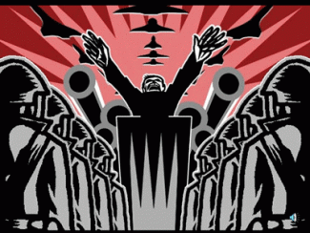
“The Apprentice’ Show, these values are promoted day and night. The ‘Big Brother’ winner is the one who can survive and outdo the competition in terms of the duplicity and backstabbing involved along the way. The winner of ‘The Apprentice’ must be more aggressive, more duplicitous, more devious and cunning and more willing to trample over everyone else. And the winner is judged as such by a multi-millionaire who himself was cunning and ruthless enough to have made it to the top of the pile and has amassed millions for his own personal benefit. These are the role models to be admired and emulated!”[66]
The Apprentice & the Psychopathic Personality
They secretly develop civilian “psychopathic personality” leaders to blindly perpetuate the global Satanic New World Order.
“A person with a psychopathic personality, which manifests as amoral and antisocial behaviour, lack of ability to love or establish meaningful personal relationships, extreme egocentricity, failure to learn from experience, etc.” – definition of a psychopath from Dictionary.com”[67]

Donald J. Drumpf- “psychopathic personality” Pedophile
Omarosa, Donald J. Drumpf, and James Mark Burnett are not properly functioning social beings that contribute to a sense of communality, altruism, love or morality. They are the classic dualistic Satanic Principled Opposites.
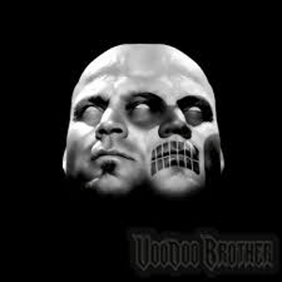
Heinrich Himmler’s Satanic Principle of Dualism is the two-faced JANUS FACE of master deception. Himmler conditioned the SS (Knights of the Black Sun) to be multi-personalities and two-faced, one kind a decent gentleman, while the opposite kind- dissociated, sadist, evil and homicidal.
The Satanic Principle and its values are promoted day and night. The “Big Brother” winner is the one who can survive and outdo the competition in terms of the duplicity and backstabbing involved along the way. The winner of “The Apprentice” must be more aggressive, more duplicitous, more devious and cunning and more willing to trample over everyone else. And the winner is judged as such by a multi-millionaire who himself was cunning and ruthless enough to have made it to the top of the pile and has amassed millions for his own personal benefit. These are the role models to be admired and emulated![68]
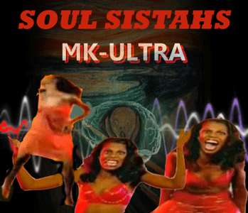
Apprentice competitors such as Omarosa are highly driven, and now we know also CIA MK ULTRA/Mind Control individuals: not driven by a need to help humanity, but by egocentricity, greed and EVIL. And, ultimately, these are the values that many mainstream opinion leaders, senior politicians and their corporate masters hold dear.
“These values of egocentricity, aggression, competitiveness, duplicity and greed are not confined to some TV show. There are part of a much more sinister process. They are inextricably linked to and underpin the actions that resulted in the killing of half a million children in Iraq for geo-political gain (5) and the sending in of military forces into the jungles of India to beat, rape and dispose of a nation’s poorest people because they stand in the way of profit and greed (6). From Congo and Libya to Syria and beyond, we witness the outcome of a terrifying mindset that is nurtured and encouraged throughout society.”[69]
“Too many people have become “well-adjusted to the values of a profoundly sick society,” whether residing in middle England, middle America or the gated communities of south Delhi or Mumbai. Humanity is being beaten down to be neurotic, vicious and to regard these traits as constituting normal, acceptable behaviour. Thanks to the media, this becomes ingrained from an early age as comprising ‘common sense’, and those who question it are merely sneered at or ridiculed by a system that promotes a mass mindset immune to its own lies.”[70]
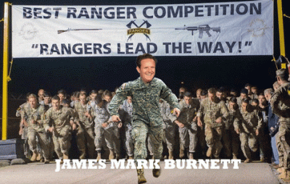
Mark Burnett was indoctrinated and trained by British and U.S. intelligence (Sodomite/Pedophile Secret Army Organization) as a sadist “psychopathic personality” military “Ranger” – a model global soldier and assassin for the New World Order. What countries have this madman invaded mass murdering masses under the shroud of NATO’s Secret Army Organization?
VI
THE APPRENTICE & LUCIFER

Mark & Roma Downey-Burnett
Burnett and his wife, Roma Downey, are further “believers” – disciples of the occult. They are “believers” of Catholic new age psychology and spiritualism. Roma is a “Lightworker” – another “psychopathic personality” on an evolutionary step toward a state of “LightBeing.”
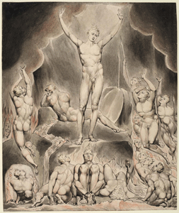
LUCIFER
She has a belief in the divine SELF, the SELF as God. Theosophical ideas expressed by Satanists Madame Blavatsky and Aleister Crowley along with many other gurus, worship Lucifer and Apollo as the ultimate “Light Beings.”
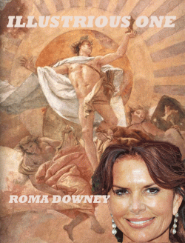
Lucifer was not content to be in submission to his Creator. He planted the idea in Eve’s heart, “You will be like God.” In other words, he is suggesting that “you can be your own God.” You don’t need God ruling over you; you don’t need to get your knowledge from God; you can be independent of God.
Isaiah 14:12-14
¹² How art thou fallen from heaven, O Lucifer, son of the morning! how art thou cut down to the ground, which didst weaken the nations!
¹³ For thou hast said in thine heart, I will ascend into heaven, I will exalt my throne above the stars of God: I will sit also upon the mount of the congregation, in the sides of the north:
¹⁴ I will ascend above the heights of the clouds; I will be like the most High.
Roma Downey graduated from the University of Santa Monica, a private graduate school founded by New Age spiritual and self-help guru John-Roger. Roger founded the Movement of Spiritual Inner Awareness (MSIA). Roma Downey graduated with a master’s degree in spiritual psychology in June 2010.[71]
ILLUMINATI-Masonic Fangs Hand Symbol. Masonic Secret Finger Sign of Preservation
John Roger Hinkins was heavily influenced by the Mormons (Freemasonry), Radhasoami tradition, Agasha Temple of Wisdom, AMORC, the Ancient and Mystical Order Rosae Crucis (Rosicrucism). Hinkin’s MSIA has been designated as a religious cult.[72]
The Radhasoami tradition is an “illlusion filled Luciferic mystical world.”[73]
“Lucifer means the Angel of Light. Radhasoamis go for the Light. Luciferian philosophy means the person believes they can become a God themself. That’s what the Radhasoami believes. The inner sound is in fact the kundalini, which is symbolized by the snake (Lucifer). Radhasoami is in fact a Luciferian love fest. Radha Soami is in fact Maha Kal. LUCIFER.”[74]

Mark & Roma Burnett & A Pair of White Doves
A pair of doves symbolizes wedded bliss. Venus is their planet. They can be called upon for sex magic, love spells, peace, fertility, and prosperity. Irish legend has it that the souls of the blessed become doves and swans. Doves are sacred to Aphrodite, Atargatis, the Great Goddess, the Holy Spirit, love goddesses, Lupa. The Wiccan Handbook, pg. 224
The bottom line is gift wrap and put a big fat red bow on his head, it is still Set-Satan, Lucifer and the dualistic Apollo that they worship and serve.
VII
THE APPRENTICE, PIZZAGATE AND THE QUEEN
Thirteen to fourteen years ago, Mark Burnett created “The [Global Masonic] Apprentice”. He created and shaped the mass media illusionary and satanic principled figure, Donald J. Drumpf, for mass population consumption.

If the clandestine global British and U.S. intelligence sodomite/pedophilia dark satanic circle (Secret Army Organization) forces created James Mark Burnett, they also had a hand in molding and shaping Donald J. Drumpf.
Epstein and Drumpf’s Gender (Girl Lover) Preference are Underage Girls

Jeffrey Epstein ran an elite (CIA- Mossad linked) espionage and intelligence sex slave trafficking ring that provided CIA MK ULTRA/MONARCH ritually sexual abused underage girls for him and his pedophile clients, many of whom were global VIP figures in business, politics, and the British Monarchy. Epstein “bought” a girl from Eastern Europe, and was gifted three (3) 12 year olds for his birthday by a wealthy European pedophile pal.

Prince Andrew, Duke of York, Most Noble Order of the Garter, Royal Victorian Order (Knighthood), Canadian Forces Decoration, personal aide-de-camp (senior military officer) is the third child and second son of Queen Elizabeth II and England’s Masonic Grand Master, Prince Philip, Duke of Edinburgh, is a member of Epstein’s pedophile ring.
 Epstein was using official Royal Air Force military bases to land and take-off. Epstein’s elite pedophile ring is also linked to Sir Evelyn de Rothschild (Rothschild- ILLUMINATI) and his daughter, Hanna; Lord Mandelson (Elite British Pedophile Ring) and his boyfriend, Reinaldo.

Naturally, Epstein’s pedophile ring took place under the watchtower of MI5, and MI6, PRINCE CHARLES AND THE QUEEN OF ENGLAND!
VIII
OMAROSA, PIZZAGATE & GUTTER
This is what’s extremely troubling about the JANUS FACE of Omarosa. The pink “girllove” symbol is linked to PIZZAGATE, and global elite Dark Circles and Satanic Pedophile Rings linked to Jeffrey Epstein, Donald J. Drumpf and the British Royal Crown that ritually sexual abuse, blood sacrifice, and cannibalize children to conjurer up, and seal covenants with demons and the DEVIL. She has been a mind controlled DEVIL’s surrogate and slave of Donald J. Drumpf since at least 2006 with the filming of the MK ULTRA/MONARCH cult film, Soul Sistahs.
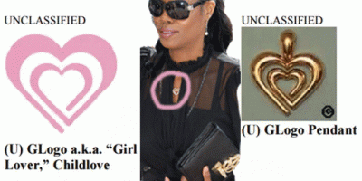
According to a 2007 FBI document exposed by WikiLeaks in April 2016, to specifically indicate the pedophile’s gender preference, members of pedophilic organizations encourage the use of descriptions such as “boylove“, “girllove“, and “childlove.”[75]
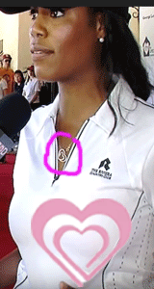
I found Omarosa wearing the pedophile ring Girl Love aka Girl Lover Logo Pendant as early as May 2011 when Drumpf decided to run for president. She appears to have been part of Donald Drumpf’s personal staff at the time. She has a Riviera Country Club blouse, and a White House sports cap.
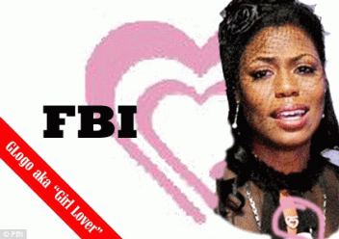
There is the Childlove Online Media Activism logo, which pedophiles use as a symbol to promote their “cause”: that sexual relationship between adults and minors should be decriminalized.
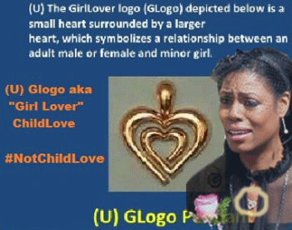
The Girl Love symbol – a triangle, a love heart and a circle merged into one – has been circulating social media, blogs and webcasts for years. It has even appeared on some children’s toys. Investigators with the FBI’s Cyber Division Innocent Images National Initiative first discovered the code in 2007.[76]

No, Omarosa’s Girl Love symbol wasn’t just a passing fancy and occasional fashion statement.
 It actually appears that the pedophile ring Girl Love symbol had been part of her apprentice attire. They, BIG BROTHER– Burnett and the two psychiatrists/psychologists carefully monitored everything Omarosa did in and out the studio and what she wore. They either gave it to her, or approved it knowing full well of its EVIL web.
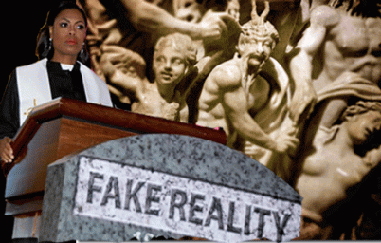
Omarosa wants to get in the Black Community or they are sending her on a mission to invade the community with her legions of demons to conduct a clandestine Black Woman War. She says that she has a story to tell. Begin with the truth, now! She needs to tell us right now about her father, and the Satanic/Masonic Blood Sacrifices of her brother and sister, and particularly Michael Clarke Duncan. She need to tell us about Africa and what she was doing in orphanages of dying Black Children. She is far beyond DANGEROUS. She’s part of PIZZAGATE, and GUTTER’S CREW that Satanic Blood Ritual Pedophile Ring that Abduct Children, Ritually Sodomize Them, Cannibalize Them, and Throw Their Bodies Over Bridges All Across the Planet. She doesn’t belong in the Black Community. She has a place in HELL reserved for her.
I HAVE SAID ENOUGH!
[1] https://en.wikipedia.org/wiki/Mary_Don%27t_You_Weep
[2] https://en.wikipedia.org/wiki/Mary_of_Bethany
[3] https://en.wikipedia.org/wiki/Lazarus_of_Bethany
[4] https://hairanddeathinancientegypt.com/tag/mourning-in-ancient-egypt/
[5] https://www.cbsnews.com/news/omarosas-brother-murdered-in-lovers-quarrel/
[6] http://madamenoire.com/271247/michael-clarke-duncans-family-believes-omarosa-may-have-coerced-him-into-adjusting-his-will-just-before-his-death/
[7] http://www.vindy.com/news/tributes/2016/feb/25/gladys-l-manigaul/guestbook/
[8] http://www.newshub.co.nz/entertainment/michael-clarke-duncan-was-meant-to-protect-notorious-big-2012012611
[9] https://www.globalresearch.ca/the-plot-to-kill-martin-luther-king-survived-shooting-was-murdered-in-hospital-an-interview-with-william-pepper/5544005
[10] https://www.rollingstone.com/music/news/the-unsolved-mystery-of-the-notorious-b-i-g-20110107
[11] https://en.wikipedia.org/wiki/The_Green_Mile_(film)
[12] http://www.jesus-is-savior.com/Evils%20in%20America/Hellivision/evil_agenda.htm
[13] http://ew.com/article/1996/04/26/book-review-green-mile-part-2-mouse-mile/
[14] http://www.complex.com/music/2013/03/the-50-grossest-rap-lyrics/the-notorious-big-whats-beef
[15] https://en.wikipedia.org/wiki/Atlanta_murders_of_1979%E2%80%9381
[16] https://www.spin.com/featured/atlanta-child-murders-wayne-williams-1986-feature/
[17] https://en.wikipedia.org/wiki/Life_After_Death
[18] https://en.wikipedia.org/wiki/Arista_Records
[19] http://www.topix.com/forum/afam/TKH2IUVOBNCQM0DMV/clive-davis-the-devil-in-the-music-industry
[20] https://www.azlyrics.com/lyrics/notoriousbig/beef.html
[21] https://www.advocate.com/arts-entertainment/film/2012/09/04/watch-michael-clarke-duncan-and-his-gay-connections
[22] https://www.datalounge.com/thread/6409862-ant-is-now-a-scientologist!
[23] http://m.imdb.com/name/nm0030714/bio?ref_=m_mn_ov_bio
[24] https://www.hollywoodreporter.com/news/a-resurrection-michael-clarke-duncan-430130
[25] https://genius.com/Harold-melvin-and-the-blue-notes-be-for-real-lyrics
[26] https://www.huffingtonpost.com/2012/09/04/omarosa-michael-clarke-duncan-engaged-wedding-wed_n_1854058.html
[27] http://www.eonline.com/news/329961/michael-clarke-duncan-hospitalized-after-suffering-cardiac-arrest
[28] http://www.eurweb.com/2012/09/michael-clarke-duncans-official-cause-of-death-respiratory-failure/#
[29] https://radaronline.com/exclusives/2013/07/omarosa-michael-clarke-duncan-house-sale-real-estate/
[30] https://en.oxforddictionaries.com/definition/seethe
[31] https://www.lipstickalley.com/threads/the-american-genealogical-roots-of-omarosa-manigault.1364083/
[32] https://en.wikipedia.org/wiki/Omarosa_Manigault
[33] Ralph Allison, M.D., Abstract, MPD and DID are Two Different Post-Traumatic Disorders, 1995
[34] https://www.amazon.com/Ralph-B.-Allison/e/B000APFYOC
[35] https://themorningnews.org/article/the-omarosa-experiment
[36] https://www.facebook.com/richard.levak.9
[37] https://en.wikipedia.org/wiki/Keele_University
[38] Id.
[39] http://lizasiegel.com.s37152.gridserver.com/bio/
[40] http://www.ellipsisbehavior.com/blog/the-colgate-discovery
[41] https://mri.org/jay-haley/
[42] http://nlp-mentor.com/milton-erickson/
[43] http://www.nlpu.com/grindbio.htm
[44] http://www.esquire.com/entertainment/interviews/a20166/mark-burnett-interview-0313/
[45] https://en.wikipedia.org/wiki/Mark_Burnett
[46] https://www.royal.uk/queen-and-armed-forces-0
[47] http://www.legacy.com/obituaries/sanantonio/obituary.aspx?pid=160618297
[48] http://www.koreanwar2.org/kwp2/usa/2id/go/USA_2ID_GO_1952_156-162.pdf
[49] http://www.jcs.mil/Directorates/J5-Strategic-Plans-and-Policy/
[50] https://www.nato.int/docu/review/2002/Capabilities/Gen-William-F-Kernan/EN/index.htm
[51] http://newsok.com/article/2770173
[52] http://genreith.de/MMcC/doku.php?id=the_sinister_clue
[53] http://genreith.de/MMcC/doku.php?id=the_sinister_clue
[54] https://www.bilderberg.org/bap.htm
[55] https://www.bilderberg.org/bap.htm
[56] http://www.whale.to/b/griggs_h.html
[57] http://archive.defense.gov/Transcripts/Transcript.aspx?TranscriptID=3653
[58]https://ipfs.io/ipfs/QmXoypizjW3WknFiJnKLwHCnL72vedxjQkDDP1mXWo6uco/wiki/Military_Professional_Resources_Inc..html
[59]Id.
[60] Id.
[61] http://www.liberalslikechrist.org/Catholic/NaziLeadership.html
[62] https://fbreporter.org/2015/08/04/the-last-genocide-of-krajina-serbs-operation-storm-joint-croatian-and-usa-criminal-enterprise/
[63] https://en.wikipedia.org/wiki/Rosslyn_Chapel#Apprentice_pillar
[64] https://en.wikipedia.org/wiki/Rosslyn_Chapel#Apprentice_pillar
[65] https://www.investopedia.com/articles/investing/071515/7-apprentice-hosts-around-world.asp
[66] https://www.globalresearch.ca/psychopathy-politics-and-the-new-world-order/5334458
[67] Id.
[68] Id.
[69] Id.
[70] Id.
[71] https://thepropheticnews.com/2014/02/07/beware-of-roma-downey-and-mark-burnetts-other-jesus/
[72] http://www.cesnur.org/testi/msia.htm
[73] http://hinessight.blogs.com/church_of_the_churchless/2011/05/amazing-changes-in-radha-soami-satsang-beas-teachings.html
[74] Id.
[75] https://wikileaks.org/wiki/FBI_pedophile_symbols
[76] http://www.dailymail.co.uk/news/article-3560069/The-symbols-pedophiles-use-signal-sordid-sexual-preferences-social-media.html
Comments : 5 Comments
Tags: 9-11 inside job, adam wenit, Adolf Hitler, african bondage, african holocaust, Aldous Huxley, Aleister Crowley, ant, Ante Pavelic, Anthony Steven Kalloniati, arista records, army rangers, Atlanta Child Murders, aztecs, big brother, biggie smalls, black community, Black Manchurian Candidates, black woman war, bosnia hercegovina, british crown, child rape, christopher wallace, CIA, clive davis, coon cake walking, Croatian Armed Forces, croats, dark satanic circle, devil, Dissociate identity disorder, donald j. drumpf, donald j. trump, donald trump, Dr. Gregory Bateston, Dr. Liza Siegel, Dr. Martin Luther King, Dr. Milton Hyland Erickson, Dr. Ralph B. Allison, Dr. Richard Levak, dunblane primary school, elelyn de rothschild, fallen angels, FBI, freemasonry, freemasons, friday the 13th, gay virgin, girl love symbol, girl lover, girl lover logo pendant, god ashur, Great BEAST 666 Aleister Crowley, gutter, Heinrich Himmler, hip hop satanic cult, hiram abiff, ig black brute, Illuminati, Jack Thomas Manigault, james mark burnett, janus, jeffrey epstein, john coffey, john roger hinkins, john rogers, Kathe and Cora Detterick, kay griggs, kemet, knights templar, l-3 mpri, Lazarus of Bethanty, light being, lightworker, london, lord cullen, lord mandelson, lord peter robertson, Lucifer, Lucifer's Servants, luciferians, Madame Blavatsky, major buck kernan, mark burnett, marsilio ficino, Mary of Bethany, masons, mi5, mi6, Michael Clarke Duncan, millennium challenge, Milton H. Erickson, mind control, MK-ULTRA, Monarch Program, Monarchs, movement of spiritual inner awareness, murder, nato's secret army, Neuro-linguistic programmin, New World Order, Notorious B.I.G., O Mary Don't You Weep, Omarosé Onée Manigault-Newman, operation storm, Osiris, Otto Skorzeny, pedophila, pedophile island, pedophile rings, pedophilia, pizzagate, psychological warfare, psychopathic personality, queen elizabeth II, river thames, roma burnett, roma downey, sadism, Saint Lazarus, Satanic Principle of Dualism, Satanism, Scientology, Secret Army Organization, security strip, serbia, sex slave trafficking, sexual perversion, soul sistahs, speculative society, Sr., SS, Stanford Research Institute, terry crews, the apprentice, The Apprentice’ Show, the finder, the finders, the green mile, thomas hamilton, twisted x finger symobl, uncle tom, university of santa monica, Ustashi, Vesica Piscis, wayne williams, weeping, Weller Baptist Church, william frank kernan
Categories : 9-11, a Bateson, african american satanic cult, African slavery, Aleister Crowley, ALL SEEING EYE, Ante Pavelic, artichoke program, aset, ashur, baby scarifrice, black children, black christianity, Black Manchurian Candidates, blood covenants, blood oaths, blood sacrifice, bluenotes, christianity, Christopher George Latore Wallace, civil war, clive davis, cybele, devil, devil's horns, divine one, donald j. drumpf, donald j. trump, donald trump, Dr. Aldous Huxley, Dr. George H. Estabrooks, Dr. Gregory Bateson, Dr. Jay Haley, Dr. Ralph B. Allison, dualism, egypt, esoteric dualism, evil, Eye of Horus, fallen angels, fbi, freemason, freemasons, genocide, hollywood satanic cult, human bondage, illuminati, illuminati sacrifice, Isis, Jay Haley, John Grinder, Knight of Malta, Knights Hospitaller, Knights of the Black Sun, Knights Templar, ku klux klan, lucifer's servants, lucifer's workshop, luciferians, manchurian candidates, masonic sacrifice, mind control, MK-ULTRA, monarch child, monarch program, MPD, mulitiple personality disorder, nato, Nazis, Neuro-Linquistic Programming, new age religion, new world order, NLP, Notorious B.I.G., nwo, queen elizabeth, Reichsfurhrer SS-1 Heinrich Himmler, Richard Bandler, Ritual Satanic Abuse, ritual satanic sexual abuse, ritually abused children, rose and cross, Rose-Croix, Rosicrucian, Rosicrucianism, rosy cross, Satanism, Scientology, SS, Stanford University

THE FALSE FLAG BLACK WOMAN PSYCHOLOGICAL CIVIL WAR, UNCLE TOM’S CABIN, OMAROSA & AUF WIEDERSEHEN, FELICIA
19122017
I
WAKE UP EVERYBODY
Need a Little Help Y’ALL.
II
DONALD J. DRUMPF & SATANIC DARK CIRCLE, THE FALSE FLAG BLACK WOMAN CIVIL WAR
We were on the eve of celebrating the denial of a key U.S. Senate seat to a dangerous white nationalist-supremacist terrorist and pedophile– Judge Roy Stewart Moore of Alabama. It was dismissive and divisive to black males, but black women, in particular, WOKE UP IN ALABAMA and were given credit by corporate mass media for turning out in record numbers to defeat Judge Moore. As a backlash and payback, they got A Black Woman Civil (Psychological) War, Uncle Tom’s Cabin, Omarosa and Bye Felicia.
Omarosa Manigault– MK ULTRA/MONARCH TOPSY OF UNCLE TOM’S CABIN
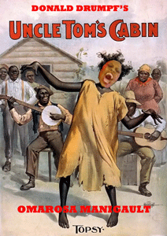
Omarosa Manigault Newman makes a living by selling her brand as an EVIL Black Witch. However, it may in fact be MK ULTRA mind control programming.
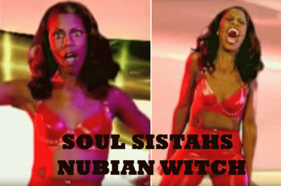
A short 2006 special feature film recently surfaced on the internet starring Omarosa called, Soul Sistahs. We know that Luciferians love to persistently display their powers over high celebrities. And, Omarosa is no exception to the rule. The film features Omarosa in a totally unfamiliar character of a MK ULTRA/MONARCH mind controlled and programmed patsy (Nubian Witch)- a Manchurian Candidate of a higher plot to steal some of the hair of “The Most Powerful Man in the Universe“.
Donald J. Drumpf, “The Most Powerful Man in the Universe” that will be repeated again word for word 10 (ten) years later by Omarosa in September 2016.
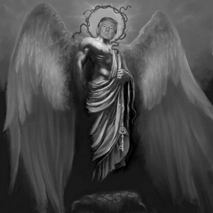
In the cult film, Omarosa rubbed herself with a lock of Drumpf’s hair. She became empowered with the “Seething Energies of Lucifer.” That’s why she has a spot reserved in Hell, and Lucifer’s Workshop in the Donald J. Drumpf’s Dark Satanic Circle in the White House. She calls the payback for the defeat of Judge Roy Moore, the “Black Woman Civil War.” It is a False Flag. [1]
Robin Roberts– BARBARA WALTERS SECRET WOMEN NEWS SORORITY

I saw ABC’s Robin Roberts’ odd reference to Omarosa Manigault and made a mental note of it, “She said she [Omarosa] has a story to tell,” Roberts said. “And I’m sure she’ll be selling that story. … Bye, Felicia.”[2] Like the kettle calling the pot black, it’s noteworthy that Robin Roberts used the entire ABC Network to sell her breast cancer, myelodysplastic syndrome (MDS– a type of bone marrow disease), dogs, cats and lesbian affair bestselling book, Everybody’s Got Something (2014).[3] She clearly has been ritually initiated by the New World Order to profit from the public for her story.
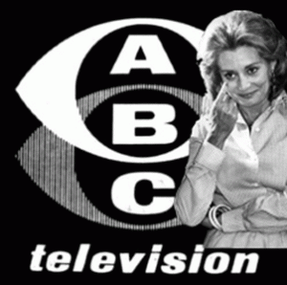
Barbara Walters
According to Roberts, she is proud to belong to one secret elite wealthy “big ole [news] sorority” and U.S. intelligence criminal enterprise headed by Ashkenazi Zionist Russian Jew, Barbara Walters.[4]
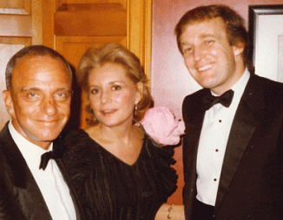
Infamous Mob Lawyer Roy Cohn, Barbara Walters & Donald J. Drumpf
During her ABC news television network career, she blurred the lines between news- television networks and clandestine U.S. Intelligence agencies, elite satanic global criminal cabals.
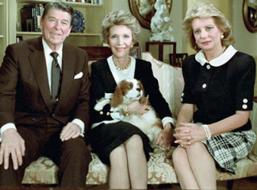
Ronald, Nancy Reagan & Barbara Walters
Barbara Walters acted as a secret agent and mule passing messages from Saudi and Iranian arms merchants to Republican President Ronald Reagan shortly after the CIA Iran-Contra Affair arms-hostage scandal broke. Arms merchants’ Saudi billionaire Adnan Khashoggi and Manucher Ghorbanifar employed ABC television journalist Barbara Walters as a secret agent and conduit to pass on to President Reagan messages and funds according to the Wall Street Journal.[5]
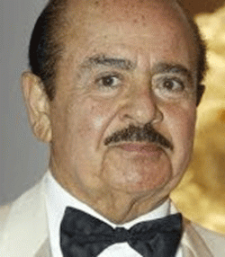
“Adnan Khashoggi mercenary army of global corporate criminals lives in Mafia mansions, basks in the political limelight, enjoys the privileges of royalty in tyrannical desert dystopias, and sips vodka in the shadow of gleaming Moscow spires,” wrote Alex Constantine. “They are kings, Pentagon officials, priests, S&L thieves, assassins, prostitutes, Nazis, Big Oil executives, metals merchants, New Age cultists, drug barons, boiler-room con artists, mobsters, dictators…and terrorists.”[6]
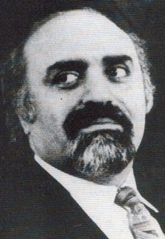
Manucher Ghorbanifar, Iranian and Mossad operative, and a key player in U.S. Marine Lt. Oliver North’s cocaine and arms smuggling network. Ghorbanifar was a high level CIA asset, and a former Iranian SAVAK (secret police) agent who had very close ties to the Israeli Mossad.[7]

But Walters’ rabbit hole is much deeper than that. She is suspected of being a CIA Artichoke Program agent with her Zionist news crews clandestinely poisoning world leaders (Arafat, Castro and Hugo Chavez).[8],[9] Roseanne Barr insinuates that Oprah and Barbara Walters are MK ULTRA/MONARCH handlers, that holds the triggers of the mind control victims.[10]
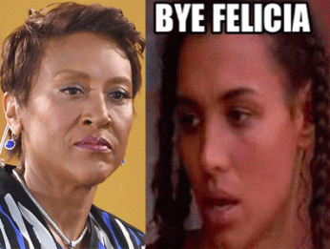
I am the first to admit that I didn’t get it at first. I truly had no idea what the Robin Roberts’ coded reference to “Bye [auf wiedersehen], Felicia” and Omarosa was. I couldn’t believe it when I found out the meaning of “Bye, Felicia.” Robin Roberts is a vicious dark circle Cake Walking Coon controlled by CIA MK ULTRA/MONARCH agent and handler, Barbara Walters.

I am absolutely appalled, hurt and deeply troubled by ABC Network’s reckless and vicious Auf Wiedersehen Felicia reference to poor and struggling women of color in America.
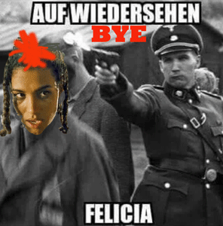
It’s a sick SADIST– RACIST low life “chicken shit” reference to the literal extermination of a poor weak young sister in the April 26, 1995 feature HollyWeird film, Friday handicapped, disabled and paralyzed from Iran-Contra – CIA crack cocaine.[11]
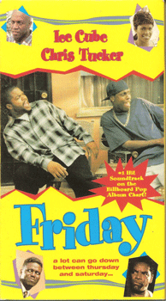
Friday is a wicked HollyWeird version of an evening of stereotypical decadence – drugs, madness, infidelity, crime, and widespread violence in the black community as if it was typical. Felicia’s illness, and human dignity was universally dismissed with “Bye, Felicia” like so many hundreds and thousands of wasted lives in black communities around the United States. Iran-Contra Crack Cocaine was/is a global Satanic Dark Circle– CIA genocidal campaign against people of color.
On the streets of Oakland and Los Angeles, I saw the real Felicias that ended up becoming “walking dead” like something out of a horror movie. We have seen it in the entertainment industry- Whitney Houston. THEY MURDERED WHITNEY HOUSTON!

It was a sight repeated from Oakland to Los Angeles and around the world that was so shocking and heartbreaking that I can never forget it or those responsible for it.
The 1980s- early 1990s Iran-Contra CIA crack cocaine epidemic devastated neighborhoods, destroyed families, men, women and children, and led to the mass extermination and imprisonment of hundreds and thousands from Black communities across the nation.

Gary Webb began researching “Dark Alliance” in July 1995 a few months after Friday, the movie, was released. Webb’s series was published in The Mercury News in three parts, from August 18–20, 1996, with one long article and one or two shorter articles appearing each day. It was also posted on The Mercury News website with additional information, including documents cited in the series and audio recordings of people quoted in the articles.

The website artwork showed the silhouette of a man smoking a crack pipe superimposed over the CIA seal.[12] The series examined the origins of the crack cocaine trade in Los Angeles and claimed that members of the anti-communist Contra rebels in Nicaragua had played a major role in creating the trade, using cocaine profits to support their struggle. It also showed that the Contras may have acted with the knowledge and protection of the CIA. The series provoked outrage, particularly in the Los Angeles African-American community, and led to four major investigations of its charges.[13]
In Oakland, I got a rare and brief opportunity to speak directly with Gary Webb on a book tour before he was killed. I could tell that he was afraid to talk with me. But, I kept at him. I said that you said that the first crack cocaine paraphernalia appeared in Oakland. I felt the more people that knew the truth meant the more the CIA had to silence until it was impossible to silence all of us. I pushed him to tell me who he discovered was among the first to push CIA crack cocaine in city. He finally gave me the answer. It was partially true. I knew him very well, Rudolph Henderson.[14],[15] He had been my childhood friend. Rudy was a middle man drug dealer, and I knew who had been his kingpins. I talked to Rudy shortly before he was gunned down. My impression is that he certainly dealt drugs, but he was a Negro street level fall guy for the Gambino NY Mob’s West Coast Drug Syndicate. He hadn’t been initiated into higher levels of the dark circle Satanic Cabal. As a kid, Rudy was never among the very bright. The FBI, Oakland Police Department, local political figures like Congressperson Barbara Lee knew where the drugs were really coming from.
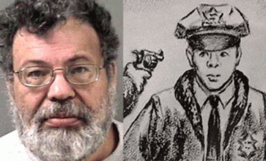
Behind me listening carefully to Webb and I was a suspected CIA black assassin, Styles Price, who was subsequently arrested linked to the ambush murder of Berkeley Police Officer, Ronald Tsukamoto, on August 20, 1970.[16] Price had been deliberately trying to control Gary Webb’s entire presentation, the brief question and answer session. I knew Price, and he knew me well enough to know that I didn’t play with him so I got my brief audience with Webb. Webb’s “Dark Alliance,” the San Jose Mercury News’s bombshell investigation into links between the crack cocaine trade, CIA, Nicaragua’s Contra rebels, and Black neighborhoods in California, remains one of the most explosive and controversial exposés in American journalism. The 20,000-word series enraged black communities across the nation, prompted Congressional hearings, and became one of the first major national security stories in history to blow up online. It also sparked a vicious backlash from the nation’s most powerful media outlets, which devoted considerable resources to discredit Webb’s reporting. And, they play no games.
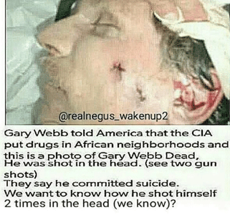
On December 10, 2004, Gary Webb was found dead in his suburban Sacramento home. He was 49 years old. He was found with not one, but two (2) .38-caliber bullets to the head. The coroner ruled his death a suicide. Nevertheless, “Gary Webb was MURDERED,” concluded FBI senior special agent Ted Gunderson in 2005. “He (Webb) resisted the first shot [to the head that exited via jaw] so he was shot again with the second shot going into the head [brain].” Gunderson regards the theory that Webb could have managed to shoot himself twice as “impossible!” Charlene Fassa, “Gary Webb: More Pieces in the Suicided Puzzle,” Rense.com, December 11, 2005.
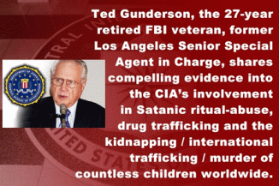
I also took an opportunity to corner Ted Gunderson alone at a 9-11 Truth-Inside Job Conference in San Francisco. I wanted to know what he knew about the FBI’s covert war against Huey P. Newton, and the Panthers in Oakland, but he was shaking so bad that I didn’t push him. After that I spoke to Gunderson once or twice over the phone in Las Vegas, but I got the message that it wasn’t safe to talk about the secret war against the Panthers in Oakland, period. And, I was certain that I couldn’t trust whatever information he fed me.
They didn’t kill Gary Webb to stop him from disclosing CIA secrets. It was already exposed in “Dark Alliance.” They killed him in revenge for doing it as a message to other journalists to don’t even think about it. “Bye, Felicia” is a vicious and EVIL insult and slap in the face of the people. It is a horrifying testament of a Black Holocaust, and Racial Genocide in America.
Omarosé Onée Manigault-Newman– PRINCE HALL MASTER MASON?

Omarosé Onée Manigault-Newman out of Youngstown, OH is a very clever, crafty and intelligent woman. She attended Howard University where she earned a master’s degree, and worked on doctorate in communications. She also received biblical studies training at Payne Theological Seminary in Wilberforce, OH. In the 1990s, Manigault worked in the office of Vice President Al Gore during the Dixie Mafia Bill Clinton Administration. The Mena airport in Arkansas had been used by the CIA for secret Iran- Contra cocaine smuggling operations for a long time under Bill and Hilary Clinton.[17]
In the Clinton Administration, Manigault’s title was initially Special Assistant of Logistics and that she later served as Deputy Associate Director of Presidential Personnel, however, according to an anonymous Gore staffer cited by People, her title was actually Scheduling Correspondent. Manigault, who was 23 years old at the time, was later transferred to the Commerce Department via the White House personnel office. She is a well educated candidate and qualified to work in the White House. She is a strong and very aggressive black woman. If Omarosa is anything at all, she is no dismissive “crack head” feature HollyWeird/CIA creation like a stereotypical Felicia.[18]

Nevertheless, Omarosa appears to be, undoubtedly, a ruthless opportunist and character that will cut your throat for only a few pieces of silver. She famously said, Bow Down to President Trump. “…every critic, every detractor, will have to bow down to President Trump.” She was the director of African-American outreach for Donald Drumpf’s presidential campaign. She became Director of Communications for the Office of Public Liaison with the rank of Assistant to the President.[19]
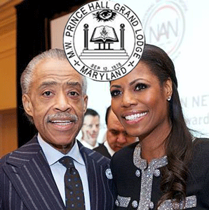
She is also known as Reverend Manigault– initiated assistant minister of Weller Baptist Church in Los Angeles, CA.

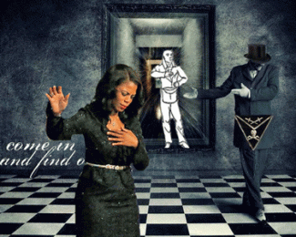
The church is associated with the Los Angeles chapter of the Negro opportunist National Action Network (NAN), the civil rights organization founded as a Masonic Prince Hall Freemason front by Prince Hall Master Mason Rev. Al Sharpton in 1991.[20]
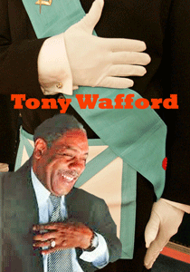
Prince Hall Freemason
Weller’s Associate minister, Tony Wafford, is West Coast Director of Sharpton’s National Action Network.[21] In 2011, the National Black Women’s Network, the South Central L. A. Progressive Movement, and the Sistahs of the Black Liberation Movement called Wafford a “sexual deviant and pervert and should not be in a leadership role with any respectable leader”.[22] A civil jury in 2011 found him liable of sexually harassing and physically assaulting an employee, Sharon Song Byrd.[23]
III
OMAROSA, THE WICKED WITCH IS DEAD!

Omarosa may have been escorted out of the White House shouting profanities after being told of her firing by chief of staff John Kelly, according to a report by CCN and White House Correspondent, American Urban Radio Networks reporter, April Ryan. Omarosa said that she resigned, and had not been escorted out of the White House. Ryan tweeted. “But Gen Kelly Kicked her out [with] high drama with the [Christian] Minister offering vulgarities and curse words as she was escorted out of the building and off campus.”[24]

In a Don Lemon CNN’s Omarosa segment, he exposed reports that the White House gave permission and a green light to Republican cake walking Negro coons to go after Omarosa after the ABC “Good Morning America” interview with the former NFL defensive lineman, coon Michael Strahan and Robert’s vicious racialist “Bye Felicia” comment.[25]

“They [White House] told us to take the gloves off,” said coon Ayshia Connors, Former Deputy Director of African American Engagement at the Republican National Council (RNC).[26] It turned out that secret Masonic coons, goat men, and Negro Shrills across the board also got the green light to go after Omarosa. Her exit from the White House has black Republicans jubilantly clowning and declaring “the Wicked Witch is Dead.”

Manigault was a ‘tyrant,’ ‘a manipulator,’ ‘a user,’ and ‘a liar’ who kept other African-Americans out of the White House on purpose, said Sean Jackson, chairman of the Black Republican Caucus of Florida. Other black leaders celebrated Manigault’s demise for the same reasons, with one, the Maryland GOP’s Eugene Craig, telling DailyMail.com, “She wanted to be the only [Head Negro in Charge] senior black Republican in Trump’s orbit.”[27]

She was also cooned over the national airways on CNN by cake walkers Symone Sanders, Angela Rye, and April Ryan. They are all Bill/Hillary Clinton, John Podesta and Bernie Sanders Negro lackeys.
Symone Sanders– LINKS, NEGRO MASONIC WOMEN SECRET SOCIETY
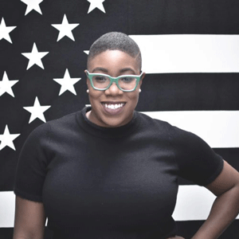
Symone D. Sander is a new Transsexual Topsy (teeth, mouth and all) out of Uncle Tom’s Cabin on the corporate mass media news’ block.
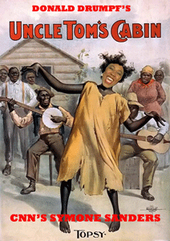
She is a new CNN Democratic strategist and political commentator. [28] Black Lives Matter– Link Symone D. Sanders was a volunteer organizer with the D.C.-based Coalition for Juvenile Justice, and a member of the Omaha (NE) Chapter of the Links, Inc. The Links is an exclusive elite Negro Third Race women’s social- Masonic secret society.
The Links official colors are white, and Emerald Green. Green Emerald is associated with the Occult, the Fallen Angel– Lucifer, and Mysteries of the Green One- Ashur (Osiris). [29] Symone Sanders grew up in Omaha, attended Sacred Heart [Catholic] High School and graduated from Creighton University in May 2013, worked as a community outreach manager for the Empowerment Network in Omaha. She was the national press secretary of the crooked mystic Kabbalah- Zohar Zionist Bernie Sanders’ presidential campaign.[30]
Angela Rye– CONGRESSIONAL BLACK CAUCUS & MK ULTRA/MONARCH SUNKEN PLACE
I have covered Angela Rye as a black female mentacide victim of the “Sunken Place”. So, I am not going to repeat her suspect ILLUMINATI MK ULTRA/MONARCH mind control programming, but I wouldn’t trust her independent judgment. She makes a lot of sense at times until it comes to the Democratic Party, Black Congressional Caucus, John Podesta, Bill and Hillary Clinton, then reason and common sense goes out of the window.[31]
April Ryan– MASONIC BOULE- DELTA, NEGRO SECRET SKULL AND BONES SOCIETY
April Ryan- Part of the Dark Circle Masonic Satanic Brotherhood
After being exposed as a Hillary Clinton shrill in the White House Press (WH) Corp, April Ryan has been turned into one of Drumpf and Sarah Huckabee Sander’s favorite WH press corps pets. It was exposed thru leaked emails pilfered from John Podesta’s email account and published by WikiLeaks that demonstrated a close off-the-record personal relationship between April Ryan, John Podesta and the Clinton camp. At one point in April 2015, she even suggested a meeting with members of the Congressional Black Caucus (CBC). She had contact with Marcia Louise Fudge, U.S. Representative for Ohio’s 11th congressional district, and Sheila Jackson Lee, U.S. Representative for Texas’s 18th congressional district.[32]

Many including myself were in the dark in a bizarre exchange between Drumpf and Ryan at a WH February 2017 press conference regarding setting up a meeting between him and the CBC. Ryan pointed out to the president that she was a journalist and that, while she does know members of the CBC, that’s not her role. We now know that Drumpf knew that she was lying. They had the WikiLeak emails between her and Podesta as early as September 2016 where she proposed to setup a meeting with CBC and Hillary Clinton.[33]
April Ryan to Podesta: “FYI [for your information] I also just talked with Marcia Fudge and Sheila Jackson Lee,” she wrote on April 18, 2015, referring to representatives from Ohio and Texas, respectively. “Also, Lets make the black reporters meeting happen asap.”[34]
The email was a follow-up to a request Ryan made earlier that day for Clinton to meet with black reporters. The subject line read, “Hillary Clinton needs to sit down with black reporters fast. Her efforts in the black community are not resonating.” Ryan wrote: “I would love to be a part of this sit down hopefully in DC.”[35]

April’s relationship with the John Podesta and the Clinton Camp was extraordinary uncommon for an alleged independent reporter. Email to Podesta, “I am going on MSNBC hardball is there anything I should say about Hillary Clinton on the show!” On April 18, 2015, Ryan asked the Grey Wolf Cannibal, and vile notorious child murderer, PIZZAGATE elite pedophile, and Satan’s Son, John Podesta AKA Skippy, for help in preparation of her words in praise of Lucifer’s Worship for her upcoming appearance on “Face the Nation.”[36]
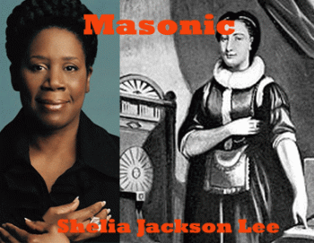
Congressperson Lee and Freemason Elizabeth Aldworth- First Lodge of Ireland
Congressperson Sheila Jackson Lee is Divine Nine- Boule of the Greek occult- secret Skull and Bones society, Alpha Kappa Alpha (AKA). AKA is associated with Canaanite Goddess Qadesh or Qetesh. In Kemet, she is Goddess Hathor.
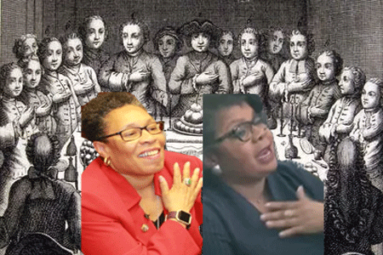
Marcia Fudge and April Ryan, Secret Society Freemasons, Undoubtedly
Marcia Louise Fudge and April Ryan are Divine Nine- Boule of the Greek occult- secret Skull and Bones society, Delta Sigma Theta Sorority sisters- Patrons of the Greek Goddess Minerva. [37],[38]

In February 2017; Omarosa confronted April Ryan in the WH press room and accused her of fronting, and secretly being on the Podesta and Clinton camp payroll. [39
In April 2017, April Ryan was selected as the “2017 Journalist of the Year” by the National Association of Black Journalists (NABJ). The annual award recognizes a black journalist who has a distinguished body of work that has extraordinary depth, scope and significance to people of the African Diaspora. So, did the Cannibal John Podesta write her acceptance speech? What a joke and fraud perpetrated against the beloved people! [40]
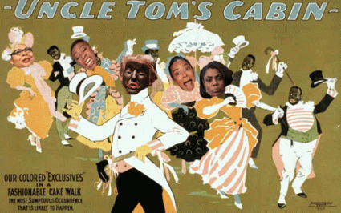
Omarosa Manigault Newman, Angela Rye, Simone Sanders and April Ryan are all a bunch of back stabbing Coon- Cake Walking House Negroes of Uncle Tom’s Cabin that nobody should no longer trust.
IV
THE REAL STRUGGLE TO PROTECT DEMOCRACY FOR ALL THE PEOPLE RAGES ON
Two (2) more sick elitists Masonic Tea Party [Maquis] de Sadens have fallen from the seats of public power, authority, and trust, U.S. Congressman Blake Farenthold, and Kentucky State Representative Dan Johnson. Rather than face the public on pedophilia charges, Dan Johnson actually committed suicide.
Congressman Blake Farenthold- THE MASONIC MISOGYNIST SLOB
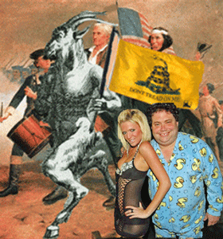
Blake Farenthold is known as the Tea Party Caucus congressman from Corpus Christ. Blake is a member of very elite wealthy, powerful, and prominent Catholic Corpus Christi families, and bloodlines of Belgian aristocracy. The Bluntzer-Dougherty-Tarlton-Farenthold family tree abounds with all the requisite characters for a Texas dynasty: Civil War officers, oil and cattle men, lawyers, and landholders. His Alsatian great great-great-grandfather, Peter Bluntzer, brought forty families to settle the South Texas county of DeWitt in 1843. Alsace is located on France’s eastern border and on the west bank of the upper Rhine adjacent to Germany and Switzerland. His Irish great great-grandfather, Robert Dougherty, helped settle San Patricio and founded the first boys’ academy in South Texas. Great great-grandfather Nicholas Bluntzer, a Nueces County pioneer, served as Robert E. Lee’s scout during pre–Civil War punitive expeditions against the Comanche. One of his great aunts Genevieve Tarlton Dougherty, a well-known philanthropist, was conferred the Lady of the Grand Cross of the Holy Sepulchre by Pope Pius XII, one of the highest honors the Catholic church accords a laywoman. [41]
Blake’s step- grandmother was Frances Tarlton “Sissy” Farenthold, a former U.S. politician, attorney, activist, and educator. She is best known for her two campaigns for the office of Governor of Texas and for being placed in nomination for the office of Vice President of the United States during the 1972 Democratic National Convention.[42]
Blake’s father, Randy Farenthold, washed ashore on Mustang Island. Chains were wrapped around his chest, along with a forty-pound concrete block around his neck. Years later it would emerge that he had been murdered for threatening to testify against four Las Vegas associated Mafioso who had swindled him out of $100,000.[43]
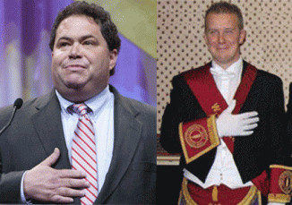
Born elite and wealthy, Blake never had to work a day in his life. He is a dark Masonic misogynist and sadistic pig, and has little regard for the rights and dignity of common people.
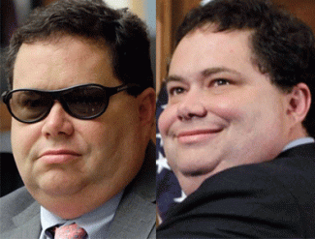
Congressman Farenthold ran his office like “a frat house,” per the New York Times, and frequently bullied and harassed his staff; including making lewd comments about women and calling staffers degrading names. Farenthold was sued over accusations of sexual harassment three years ago; paid $84,000 in taxpayer money to settle charges of sexual harassment filed by a former aide, and is the focus of an open Ethics Committee investigation into behavior that has been described as both verbally abusive and sexually demeaning.[44]
Kentucky State Representative Dan Johnson- DANGEROUS RACIST WHITE SUPREMACIST NATIONALIST PEDOPHILE
Danny Ray Johnson was an evangelical pastor, and Republican member of the Kentucky House of Representatives, representing the 49th District in 2017. He was a Tea Party activist with community ties through the Heart of Fire Ministries, a religious organization he ran in Louisville.[45]
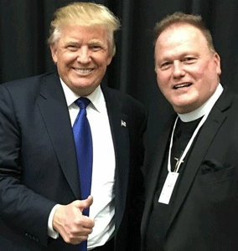
In early December this year, Johnson was accused of having molested a member of his church in 2012 when she was 17 years old. Johnson refused to resign, stating the allegations were untrue, and committed suicide two days later.[46]
He was a dangerous vicious racist of the South’s 2nd Civil War Confederacy that would burn down all of America to replace the EVIL institution of slavery- African Human Bondage.
In 2016, while running for office, he posted ultra racist photos on his Facebook page that made President Barack Obama and First Lady Michelle Obama a pair of monkeys. He didn’t give a damn who it may have hurt or offended.[47]
People of Conscious- Stay on Focus, and Don’t Let the Spin Get You Down! They also killed Donny. He stays so alive in my heart. I have said enough.
________________________________________________________________________________________

[1] http://deadline.com/2017/12/omarosa-robin-roberts-black-woman-civil-war-white-house-fired-1202227440/
[2] https://www.huffingtonpost.com/entry/robin-roberts-omarosa-manigault-newman_us_5a3283f5e4b01bdd765a789d
[3] https://www.npr.org/books/titles/306542456/everybodys-got-something
[4] https://www.politico.com/media/story/2014/05/robin-roberts-on-the-barbara-walters-sorority-002285
[5] https://www.upi.com/Archives/1987/03/16/Barbara-Walters-as-secret-messsenger/7000542869200/
[6] http://rigorousintuition.ca/board2/viewtopic.php?f=8&t=14314
[7] https://wikispooks.com/wiki/Manucher_Ghorbanifar
[8] http://gawker.com/5988851%2Fvenezuela-chavez-was-killed-by-cancer-attack-by-enemies-of-the-fatherland
[9] https://corruptico.com/2012/11/30/barbara-walters-targets-arafat-and-castro-with-radiation-poisoning/
[10] http://www.godlikeproductions.com/forum1/message1760462/pg1
[11] https://en.wikipedia.org/wiki/Friday_(1995_film)
[12] https://en.wikipedia.org/wiki/Gary_Webb
[13] Id.
[14] http://articles.latimes.com/1991-04-07/news/mn-436_1_federal-prison
[15] http://www.sfgate.com/bayarea/article/OAKLAND-Former-drug-kingpin-shot-to-death-near-2544387.php
[16] http://www.sfgate.com/bayarea/article/BERKELEY-1970-killing-still-haunts-Berkeley-2616535.php
[17] http://www.whale.to/b/dowbenko.html
[18] https://en.wikipedia.org/wiki/Omarosa_Manigault
[19] http://people.com/politics/omarosa-manigault-controversies-white-house-ouster/
[20] http://mychristiandaily.com/mcd/2013/04/page/9/
[21] http://www.phaohio.org/mwphgloh/likfm.html
[22] http://www.eurweb.com/2011/07/sharpton-associate-sex-scandal-update-tony-wafford-takes-leave-of-absence/#
[23] http://mychristiandaily.com/mcd/2013/04/page/9/
[24] http://thehill.com/homenews/administration/364729-april-ryan-omarosa-fired-by-kelly-escorted-out-of-white-house
[25] https://www.eurweb.com/2017/12/black-gop-pundits-fight-cnn-white-house-gives-green-light-trash-omarosa-watch/#
[26] Id.
[27] http://www.dailymail.co.uk/news/article-5184273/Black-Republicans-unload-Omarosa-tyrant.html
[28] https://en.wikipedia.org/wiki/Symone_Sanders
[29] https://mindcontrolblackassassins.com/2017/10/31/de-coon-cake-walk-the-jemele-hill-secret-matrix-the-rise-of-the-third-satanic-race-the-nfl/
[30] http://www.centralarealinks.org/wp-content/uploads/2015/12/LU_magazine_Winter_Final_web.pdf
[31] https://mindcontrolblackassassins.com/tag/sunken-place/
[32] https://www.lifezette.com/polizette/wikileaks-showed-april-ryan-more-than-just-a-reporter/
[33] Id.
[34] https://www.lifezette.com/polizette/wikileaks-showed-april-ryan-more-than-just-a-reporter/
[35] Id.
[36] Id.
[37] https://www.theatlantic.com/politics/archive/2015/04/loretta-lynch-and-the-political-power-of-the-black-sorority/391385/
[38] http://kstreetmagazine.com/delta-sigma-theta-100-years-and-a-murphy-legacy/
[39] http://money.cnn.com/2017/02/14/media/omarosa-april-ryan/index.html
[40] http://www.nabj.org/news/343316/April-Ryan-Named-2017-NABJ-Journalist-of-the-Year.htm
[41] https://www.texasmonthly.com/articles/the-blood-of-the-farentholds/
[42] https://en.wikipedia.org/wiki/Frances_Farenthold
[43] https://www.texasmonthly.com/articles/the-blood-of-the-farentholds/
[44] https://www.fastcompany.com/40508020/blake-farenthold-scandal-plagued-texas-congressman-will-not-seek-reelection
[45] http://www.kentucky.com/news/politics-government/article115696453.html
[46] https://en.wikipedia.org/wiki/Dan_Johnson_(Kentucky_politician)
[47] https://www.washingtonpost.com/news/powerpost/wp/2017/12/12/accused-of-molesting-a-teenage-girl-kentucky-lawmaker-refuses-to-resign/?utm_term=.7ccc2cee8095
Comments : 1 Comment
Tags: 9-11 Truth-Inside Job, abc network, abc television network, Al Gore, angela rye, april ryan, Auf Wiedersehen Felicia, Ayshia Connors, barbara walters, bernie sanders, bill clintion, Black Holocaust, black lives matter, Black Manchurian Candidates, Black Panther Party for Self Defense, black woman civil war, Blake Farenthold, BOULE, bye felicia, cannibals, carlos gambino, chris tucker, CIA, CIA Iran-Contra Affair, cnn, confederacy, Congressional Black Caucus, coon cake walking, crack cocaine, Danny Ray Johnson, dark alliance, Dissociate identity disorder, dixie mafia, dnan Khashoggi, don lemon, donald j. drumpf, donald j. trump, donald trump, donny hathaway, Elizabeth Aldworth, fallen angels, false flag, FBI, freemasonry, freemasons, friday, gary webb, grey wolf, harold melvin and the blue notes, hillary clinton, Huey P. Newton, Ice Cube, Illuminati, Iran-Contra Crack Cocaine, john kelly, john podesta, judge roy moore, kabbalah, links, Lucifer, Lucifer's Servants, luciferians, mafia, Manucher Ghorbanifar, Marcia Fudge, Marquis de Sade, masons, mena airport, michelle obama, mind control, MK-ULTRA, Monarch Program, Monarchs, most powerful man in the universe, National Action Network, National Association of Black Journalists, National Black Women’s Network, Nazis, New World Order, news sorority, nubian witch, oliver north, omarosa, Omarosa Manigault Newman, Oprah Winfrey, Osiris, pedophila, pedophiles, pizzagate, prince hall freemasons, psychological warfare, Randy Farenthold, rev. al sharpton, robin roberts, Ronald Reagan, ronald tsukamoto, roseanne barr, roy cohn, Rudolph Henderson, rudy henderson, satan, satanic dark circle cult, Satanism, Sean Jackson, second civil war, Sharon Song Byrd, sheila jackson lee, Sistahs of the Black Liberation Movement, skippy, skull and bones, soul sistahs, South Central L. A. Progressive Movement, styles price, Symone Sanders, tea party, Ted Gunderson, the movie, third race, Tony Wafford, topsy, uncle tom's cabin, Weller Baptist Church, white house, Whitney houston, wicked witch is dead
Categories : african american satanic cult, african holocaust, African Liberation, African slavery, alabama, Aryan Supremacy, black lives matter, Black Manchurian Candidates, BOULE, brotherhood of death, christianity, CIA, civil war, columbian cocaine, donald j. drumpf, donald j. trump, donald trump, donny hathaway, evil, false flags, False Satanic Rites of Lost Negroes, fbi, freemason, freemasons, Gary Webb, genocide, huey p. newton, human bondage, human sacifrice, illuminati, kemet, lucifer's servants, lucifer's workshop, luciferians, manchurian candidates, mind control, MK-ULTRA, modern slavery, monarch child, monarch program, MOSSAD, National Association of Black Journalists, Nazis, new world order, oakland, oakland police department, Oprah Winfrey, panther squad, pizzagate, ritual satanic sexual abuse, robert e. lee, RONALD REAGAN, satan, Satanic Global High Cabal, Satanism, skull and bones, slavery, trauma-based mind control, whitney houston, ZIONIST

FLICKR PHOTOS
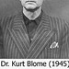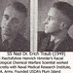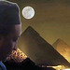
More Photos

ENERGY ENHANCEMENT MEDITATION
ENERGY ENHANCEMENT MEDITATION LEVEL 1 POWER UP!! GAIN SUPER ENERGY http://www.energyenhancement.org/Level1.htm
ENERGY ENHANCEMENT MEDITATION LEVEL 2 ELIMINATE ENERGY BLOCKAGES http://www.energyenhancement.org/Level2.htm
ENERGY ENHANCEMENT MEDITATION LEVEL 3 CLEAN KARMA BLOCKAGES AND PAST LIFE KARMA BY TRANSMUTATION http://www.energyenhancement.org/Level3.htm
ENERGY ENHANCEMENT MEDITATION LEVEL 4 MASTER ENERGY CONNECTIONS AND RELATIONSHIPS http://www.energyenhancement.org/Level4.htm




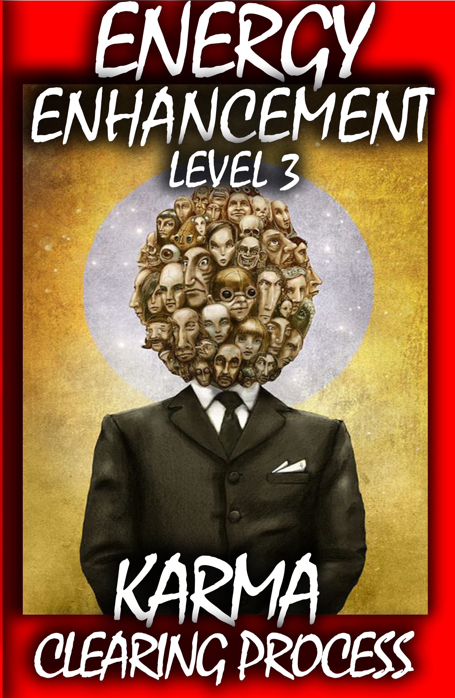
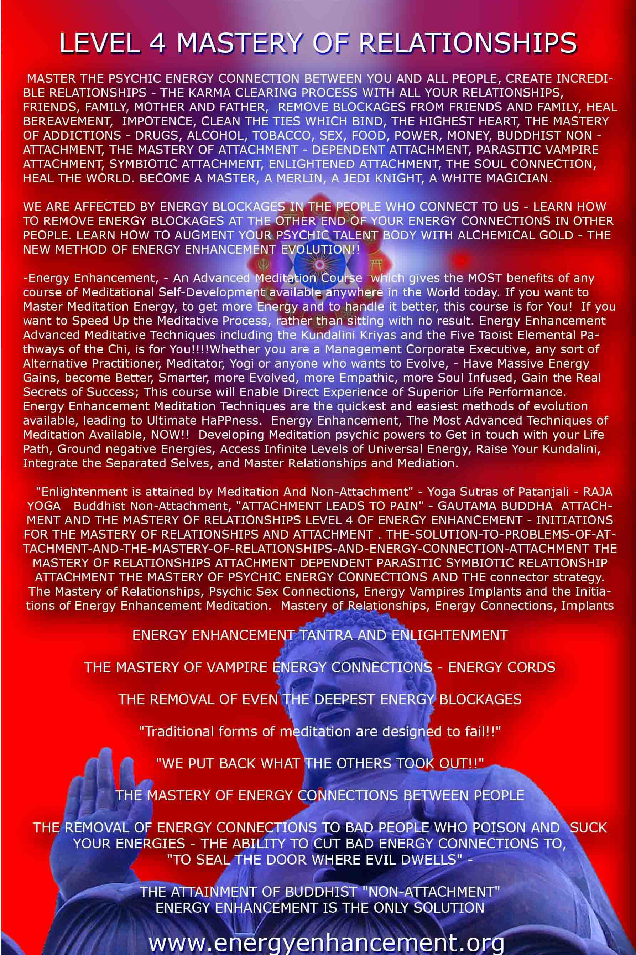
4 VOLUMES FREE!! - ON SIGN-UP
energyenhancement.org
