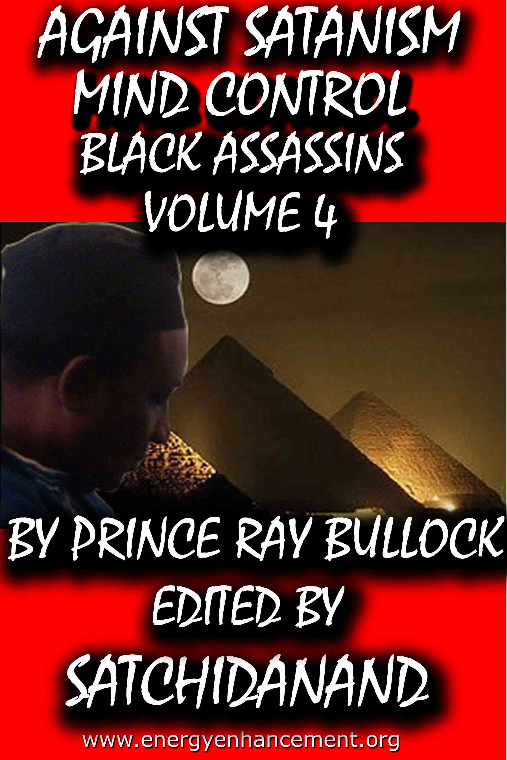

DEDICATION
With all Thanks, Love and Gratitude to Swami Devi Dhyani and all the helpers who make these books and DVDs possible.
With all Thanks, Love and Gratitude to my Mother and Father and to all my other Teachers, Theos Bernard, Sri Yogendra, Eric Berne, Gurdjieff, Father Bede Griffiths, Osho, Zen Master Hogen, Swami Sivananda, Swami Satchitananda, and all the other giants upon whose shoulders I stand - who made me able to be what… I AM – Swami Satchidanand

Copyright © 2020

[Energy Enhancement Synthesis of Light Limited (SOL)]

All rights reserved. This publication may be reproduced in whole or in part, by any person under fair use as long as we are referenced, without written permission of:
Swami Satchidanand

sol@energyenhancement.org
www.energyenhancement.org
AGAINST SATANISM
MIND CONTROL
BLACK ASSASSINS
VOLUME 4
BY PRINCERAY BULLOCK
EDITED
SATCHIDANAND
www.energyenhancement.org

Table of Contents
KATHY GRIFFIN, ROSEANNE BARR, THE DEVIL & FALSE FLAGS, DON’T KNOCK ON THE DOOR OF TRUTH TO POWER 26
RED SHAMBHALA: PUTIN, DONALD J. DRUMPF, JARED KUSHNER, THE SEPARATE MASONIC HASIDIC STATE & THE FLEECING OF A DEMOCRACY 40
DONALD J. DRUMPF, ROBERT MUELLER III, THE HANDS OF DARK CABAL & THE DEVIL 107
MICHELLE OBAMA, MARIAH CAREY, KANYE WEST, MK ULTRA, RAINBOWS & DRAGONS 163
U.S. PRESIDENTS DONALD J. DRUMPF & ANDREW JACKSON, SECRET LORDS OF THE DRAGON DYNASTIES 240
WHERE IS MICHELLE OBAMA, SUNKEN IN THE FLOOR OR THROWN INTO THE CARIBBEAN SEA? 277
“HELTER SKELTER” THE DEVIL’S JOY ON EASTER SUNDAY WEEK- DRUMPF’S SS NAZI WUNDERWAFFE ATOMIC BOMB, ATOMIC DOG STEVE STEVIE STEVENS: "HUEY’S WAY" 309


Go to http://www.energyenhancement.org for 34 Free –On Sign-Up - Energy Enhancement Books and Energy Enhancement Against Satanism Books.
To defeat Evil, you need to up your game. Learn the Energy Enhancement Meditation Course by Video or Live in Iguazu.


Change the World...


Go to http://www.energyenhancement.org for 34 Free Energy Enhancement Books.
To defeat Evil, you need to up your game. Learn the Energy Enhancement Meditation Course by Video or Live in Iguazu.
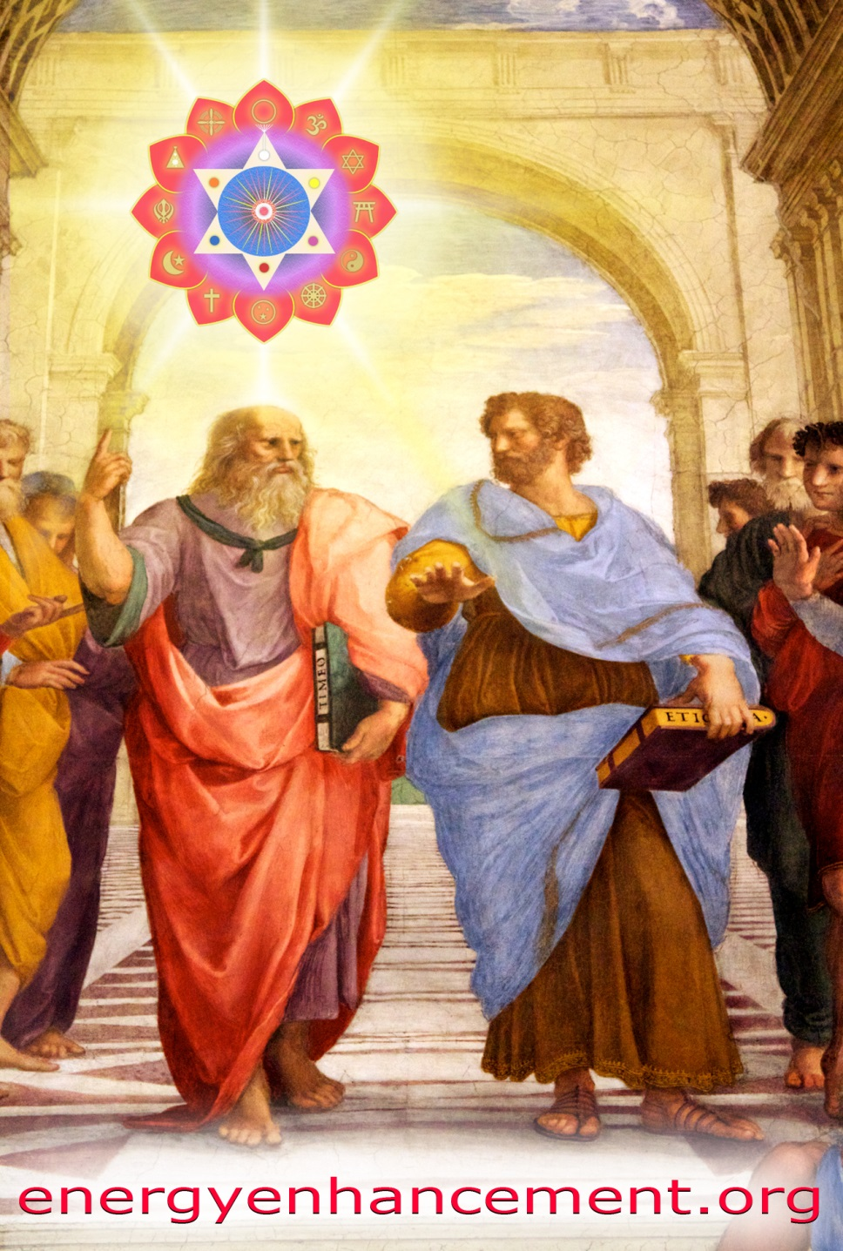

PLATO AND SATANIC BABYLONIAN SECRET AGENT ARISTOTLE "THE POISONER" OF ALEXANDER THE GREAT - BY RAPHAEL

ENERGY ENHANCEMENT MEDITATION
ENERGY ENHANCEMENT MEDITATION LEVEL 1 POWER UP!! GAIN SUPER ENERGY http://www.energyenhancement.org/Level1.htm
ENERGY ENHANCEMENT MEDITATION LEVEL 2 ELIMINATE ENERGY BLOCKAGES http://www.energyenhancement.org/Level2.htm
ENERGY ENHANCEMENT MEDITATION LEVEL 3 CLEAN KARMA BLOCKAGES AND PAST LIFE KARMA BY TRANSMUTATION http://www.energyenhancement.org/Level3.htm
ENERGY ENHANCEMENT MEDITATION LEVEL 4 MASTER ENERGY CONNECTIONS AND RELATIONSHIPS http://www.energyenhancement.org/Level4.htm
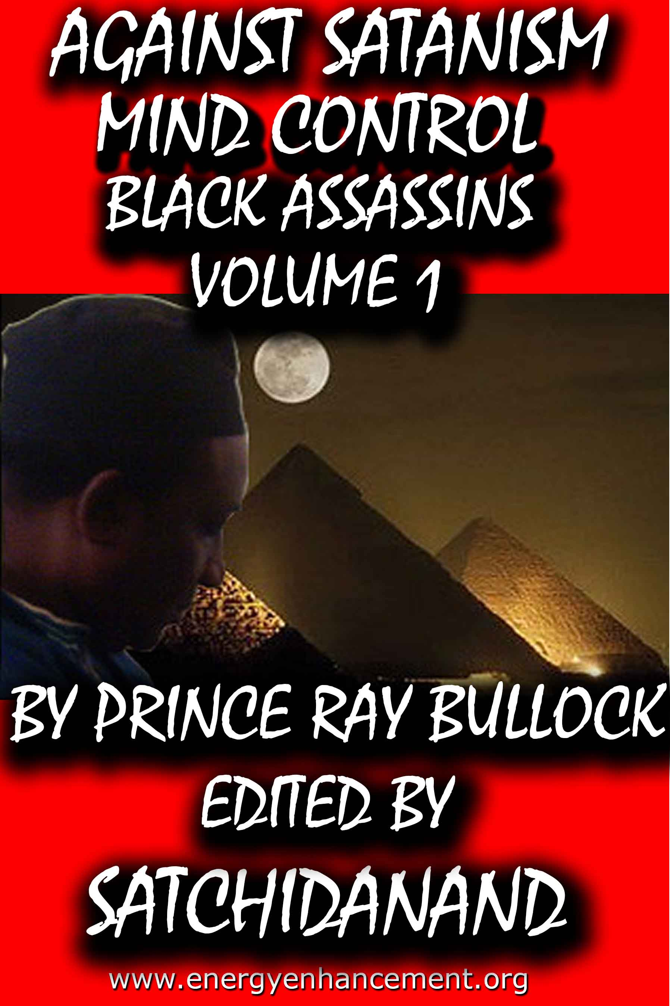
MIND CONTROL BLACK ASSASSINS VOLS 1-11 FREE!!

AGAINST SATANISM VOLS 1 – 6 FREE!!

- ON SIGN-UP AT..

energyenhancement.org

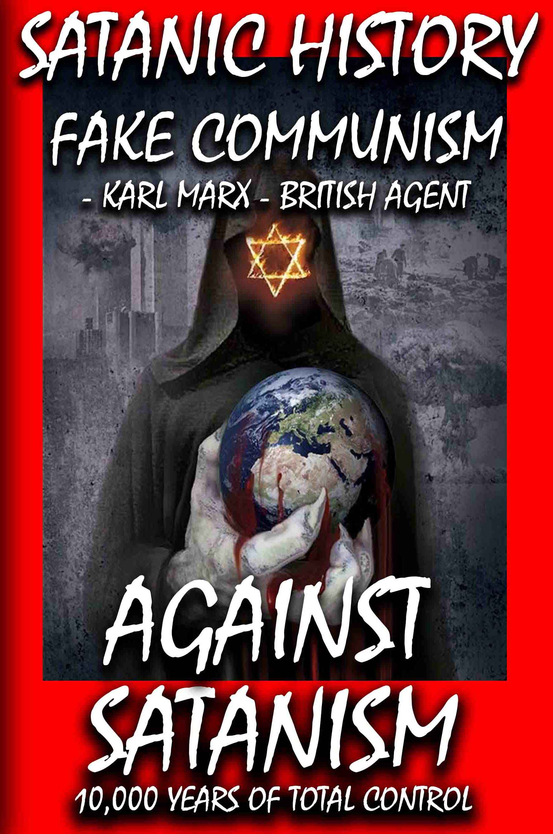

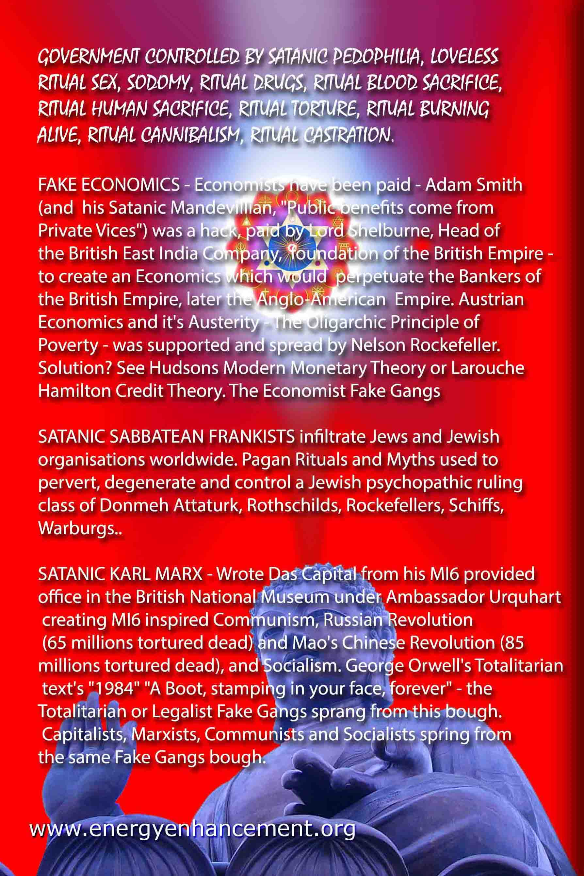

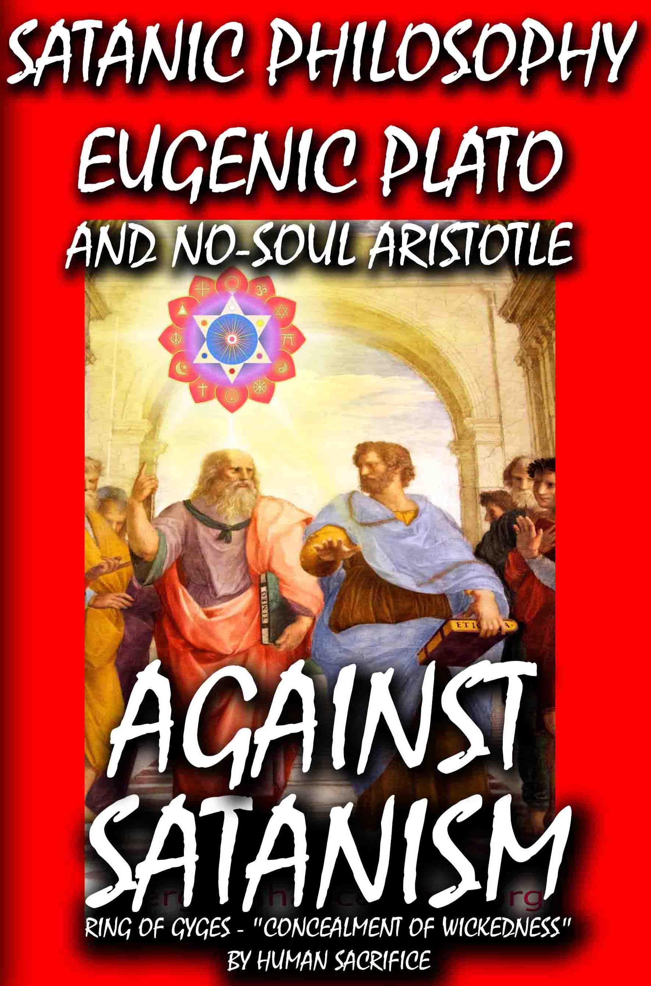

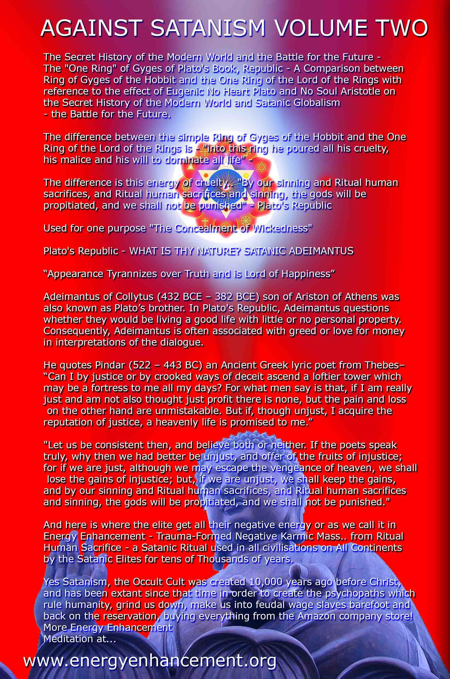

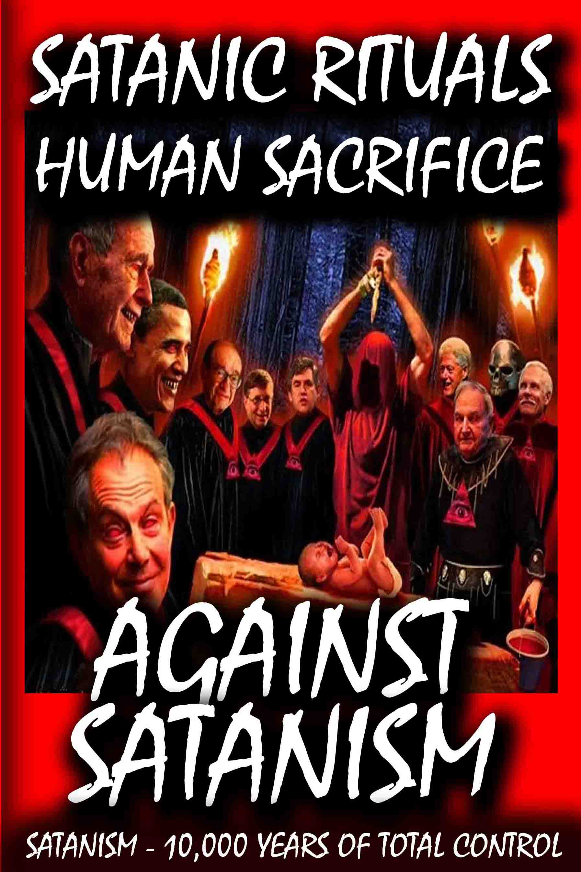

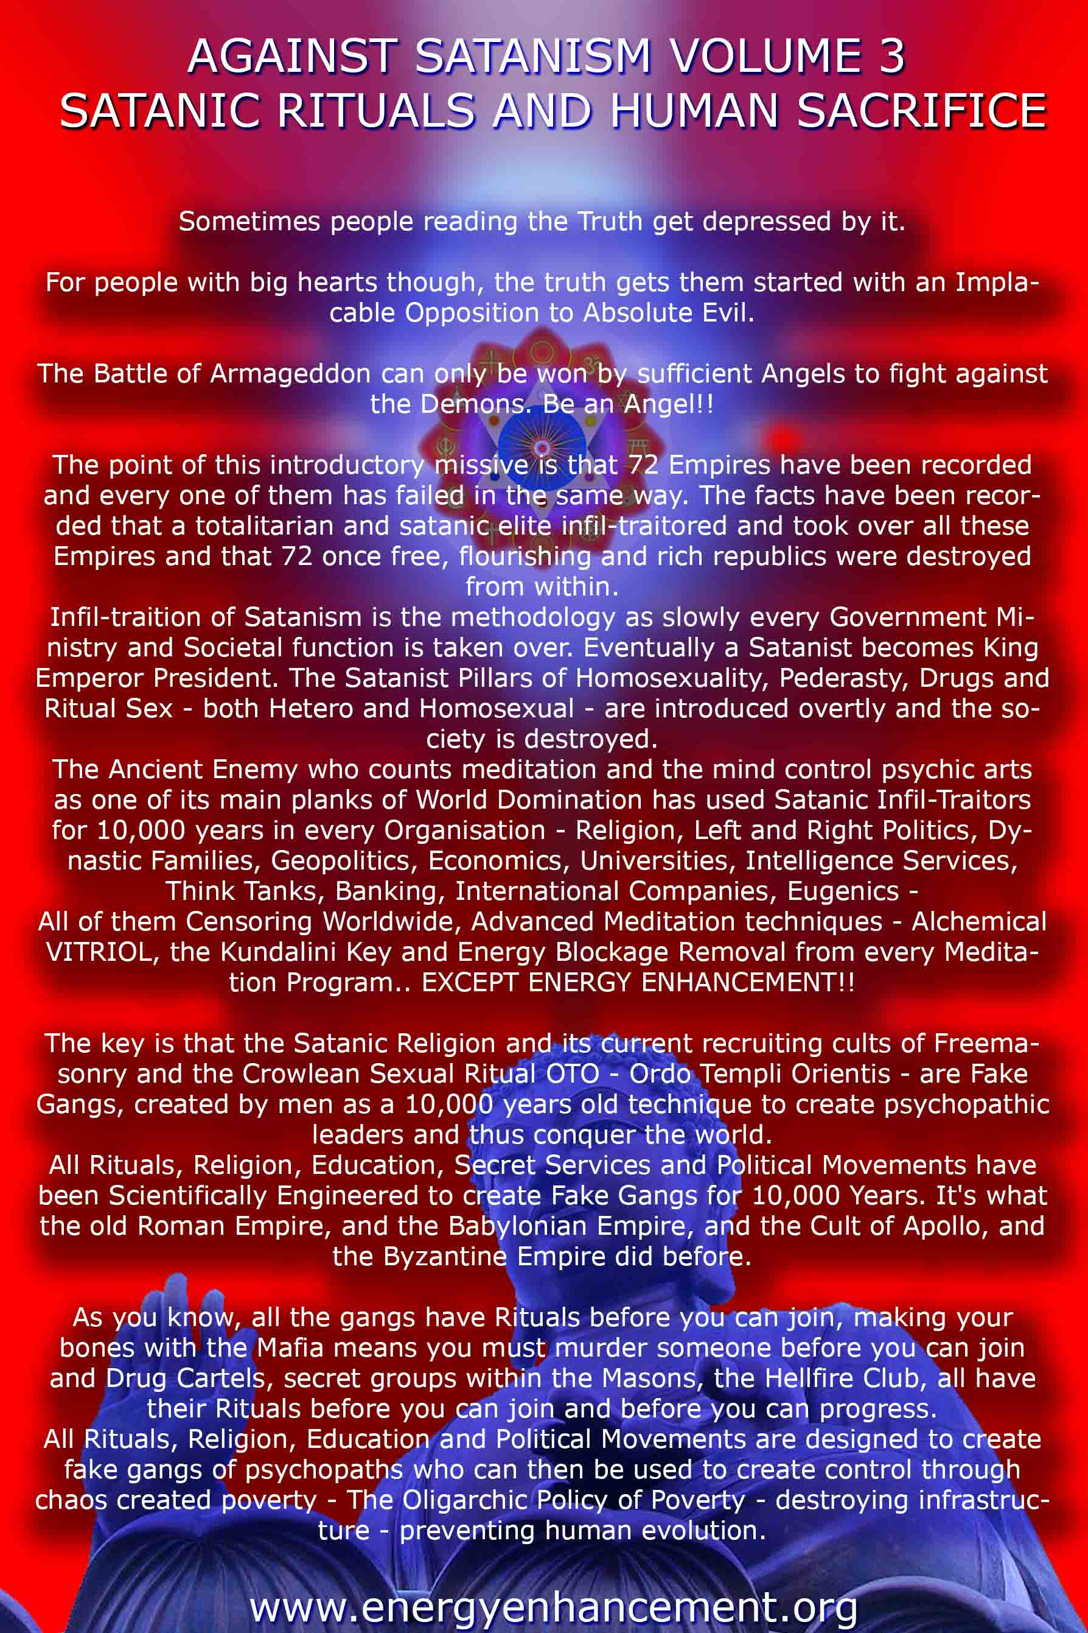

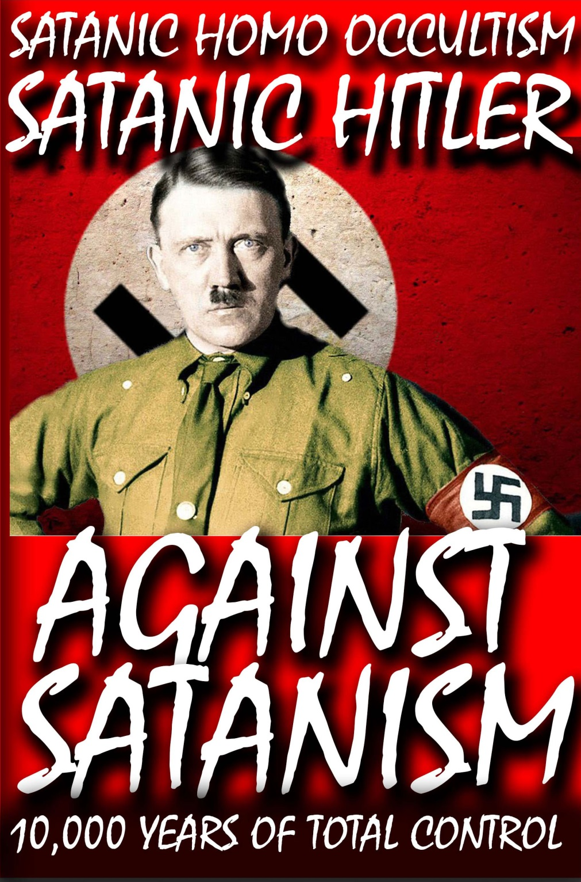

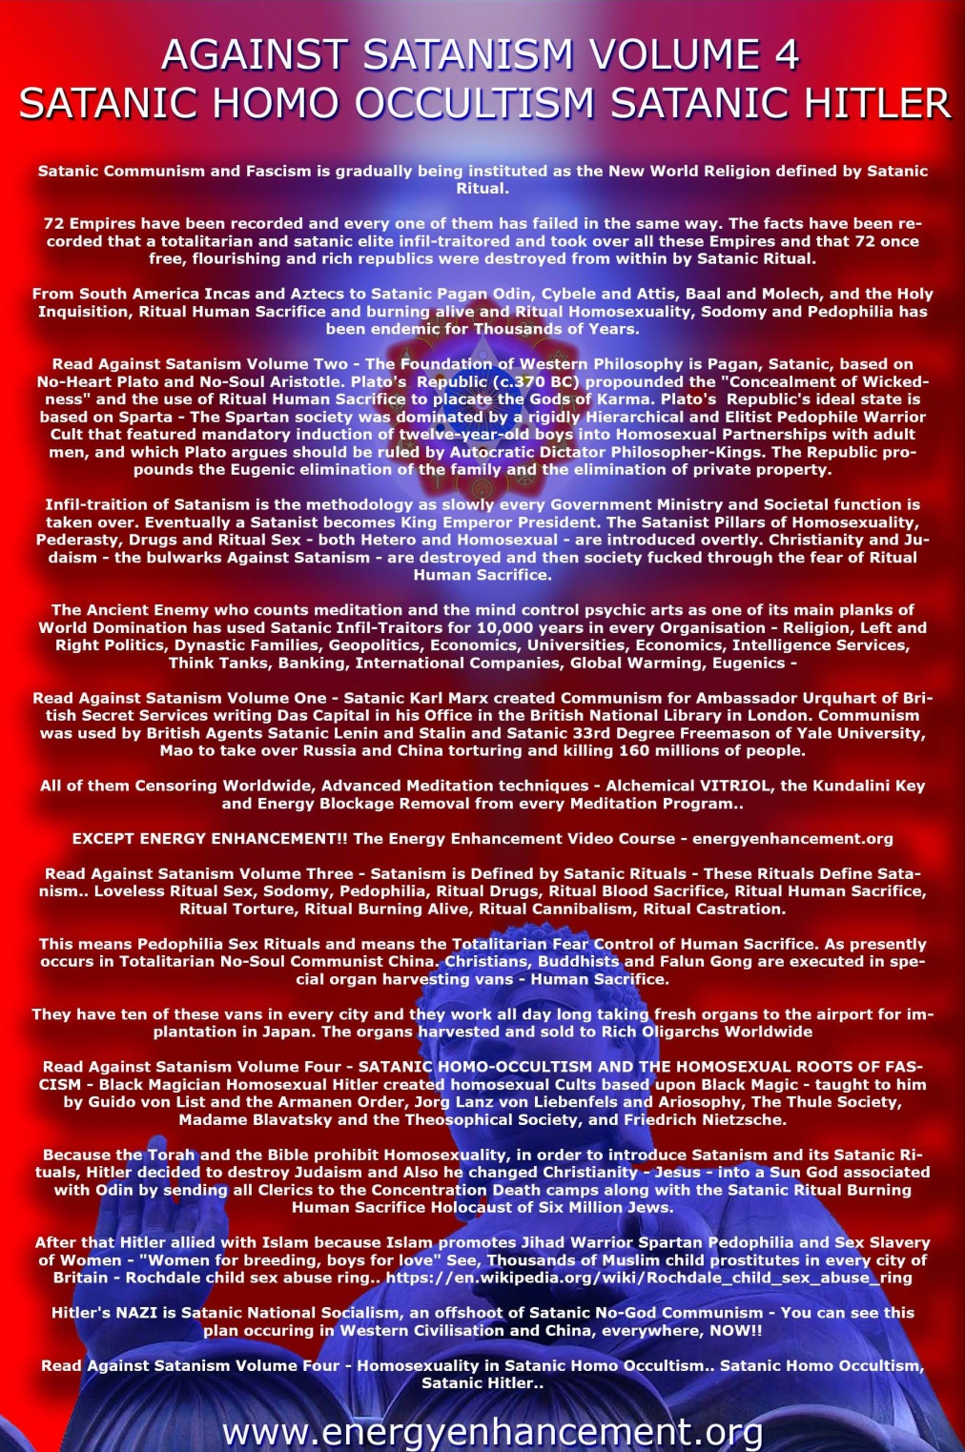

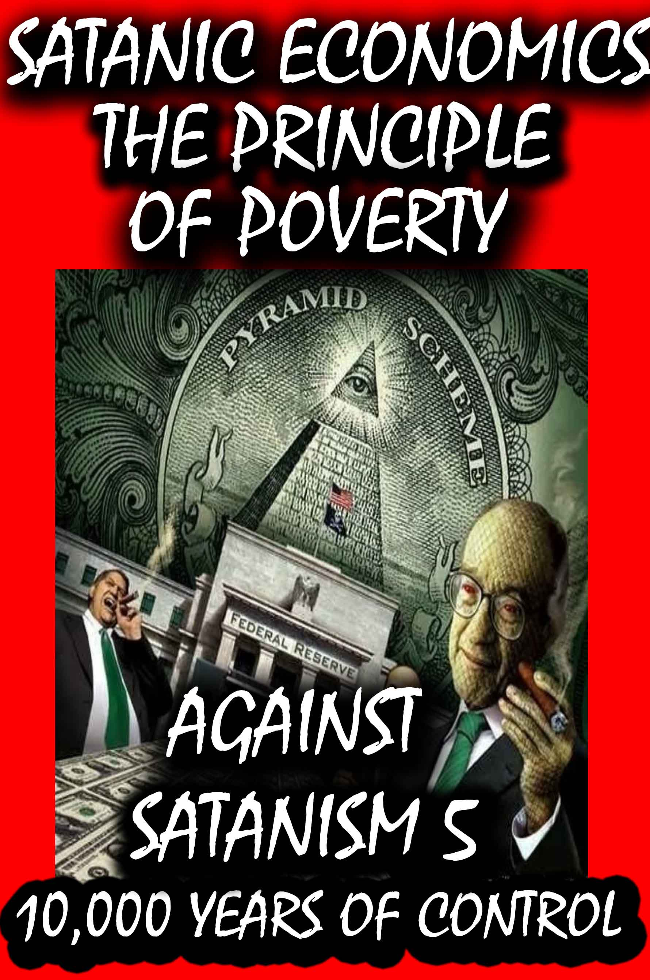

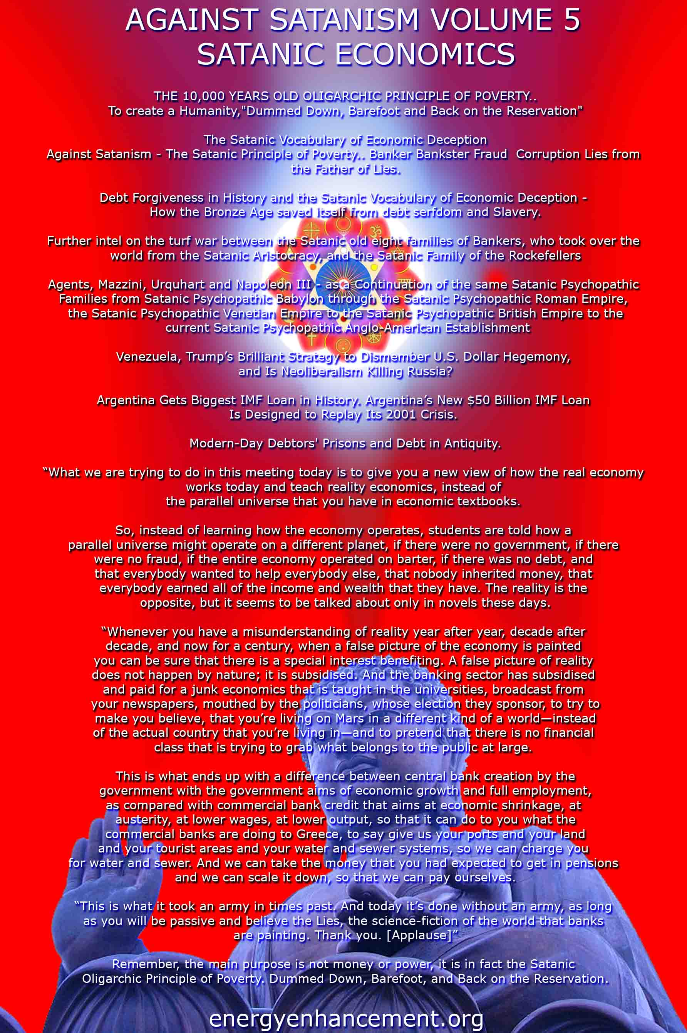

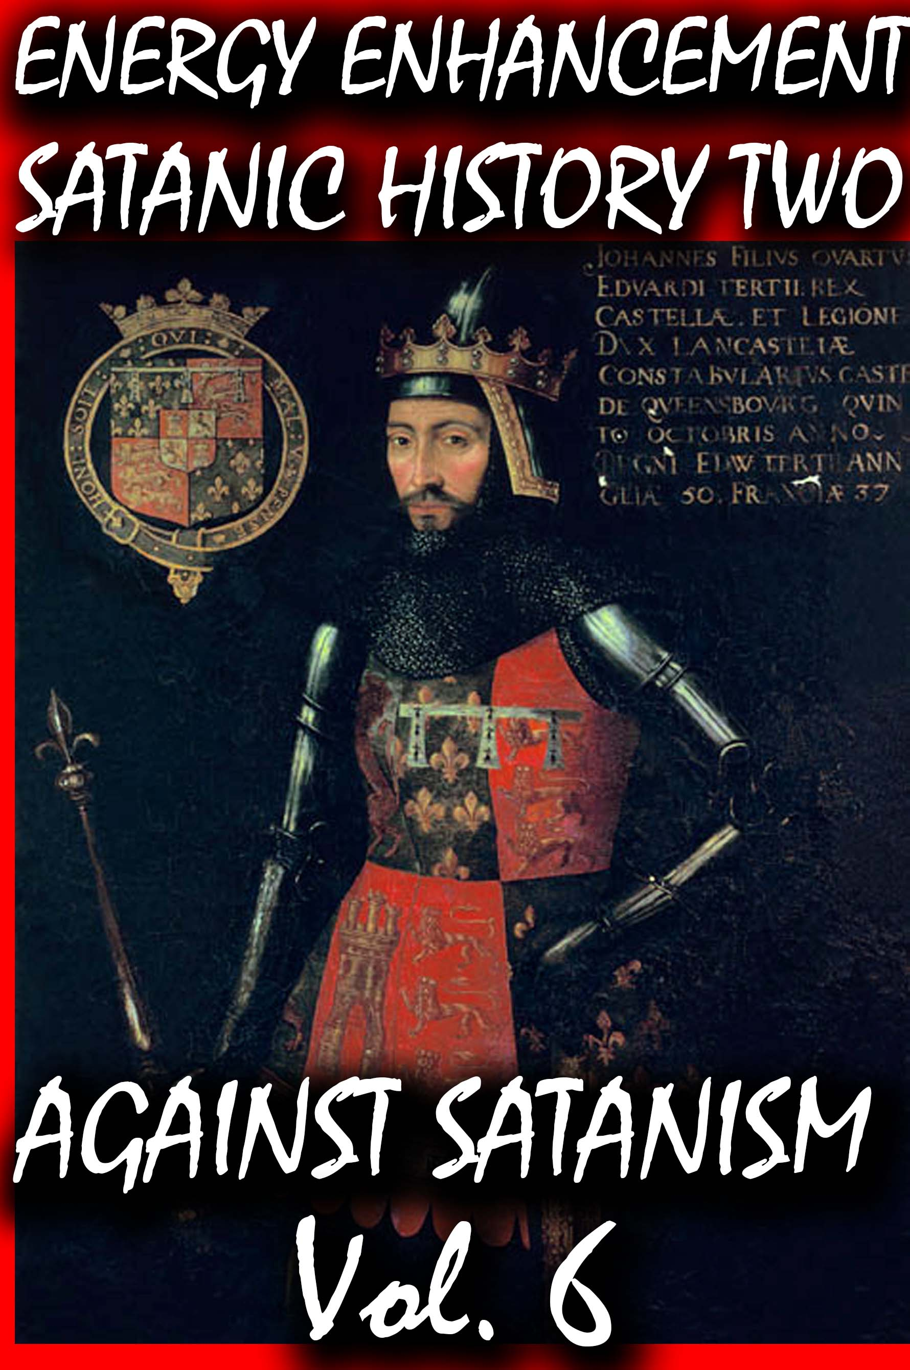
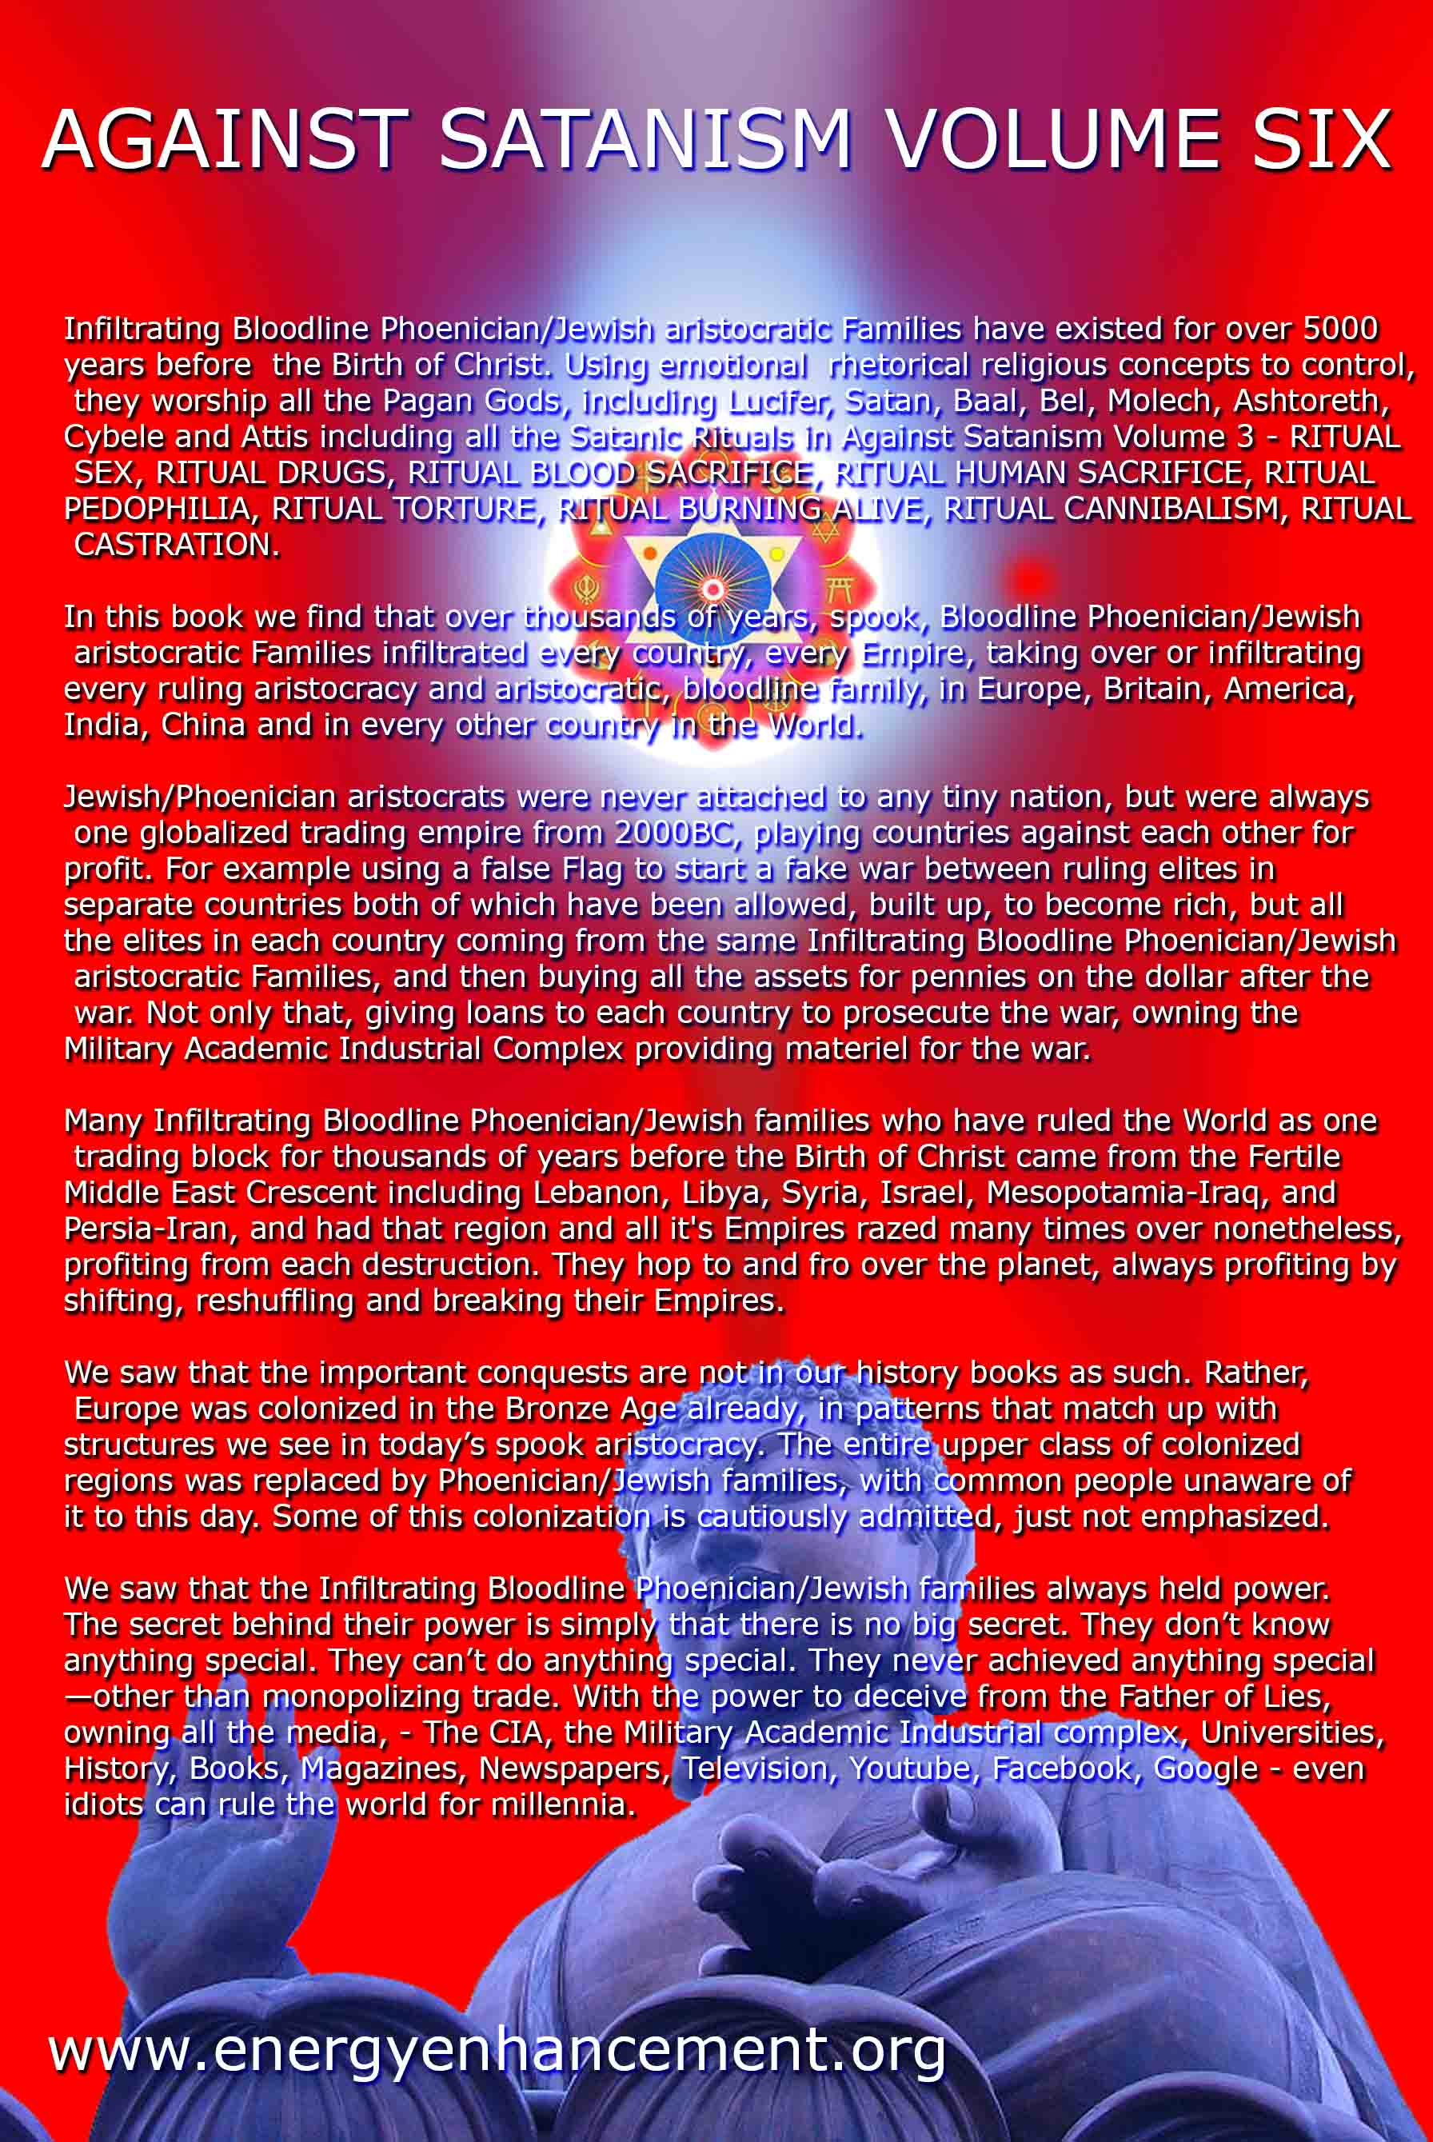
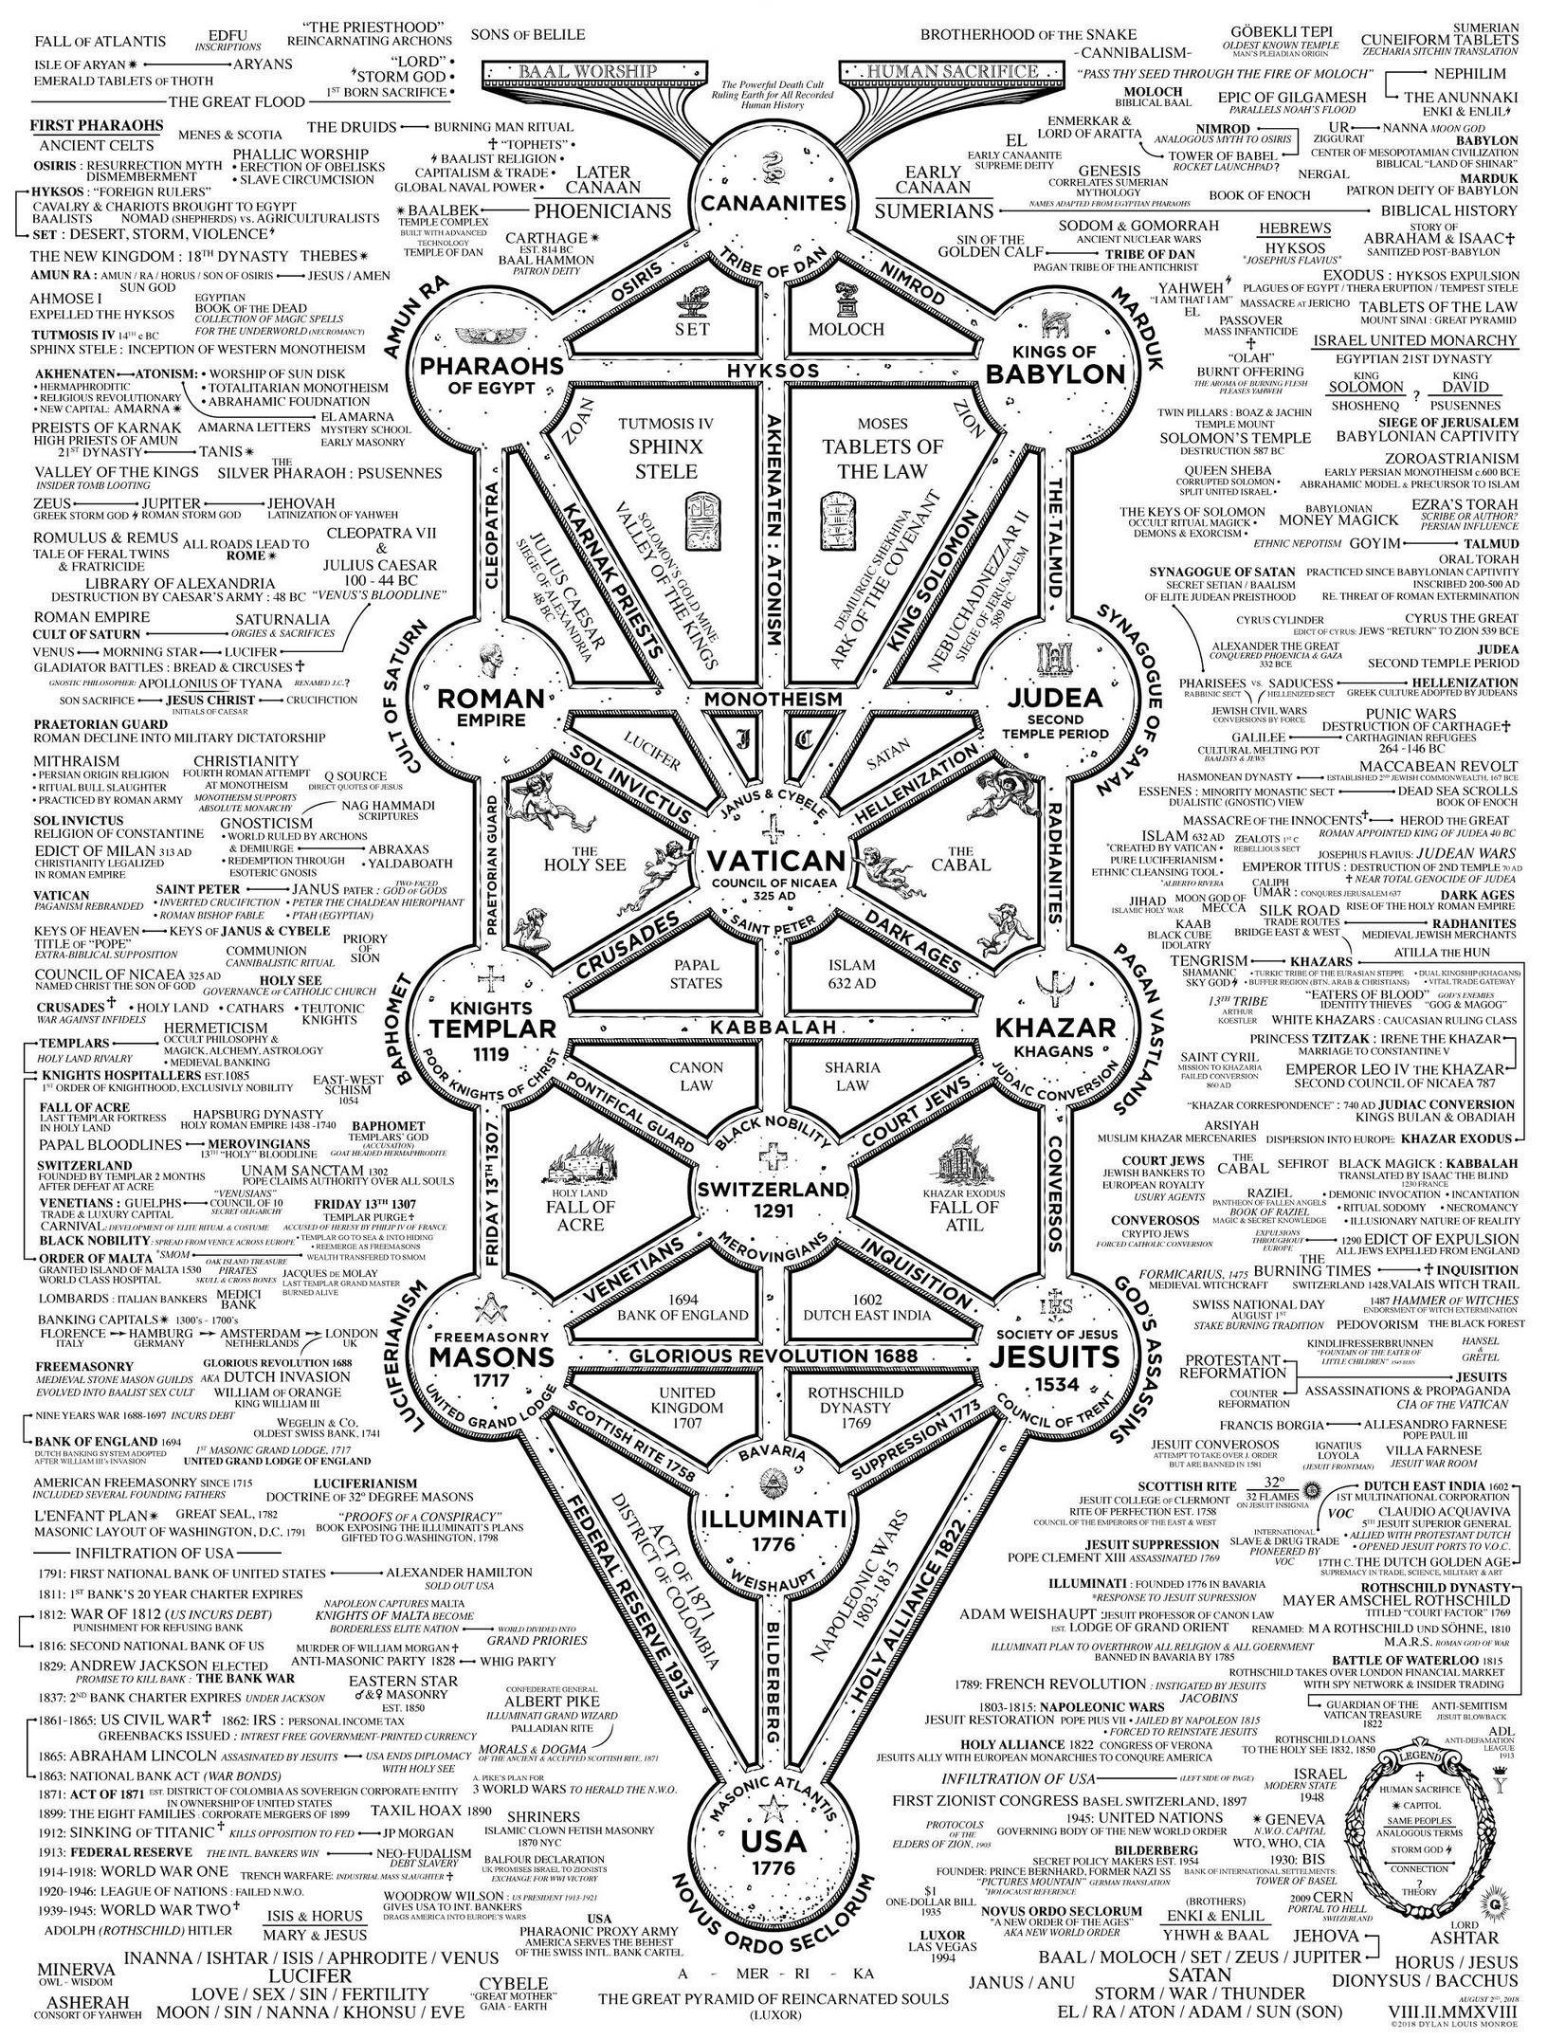
KATHY GRIFFIN, ROSEANNE BARR, THE DEVIL & FALSE FLAGS, DON’T KNOCK ON THE DOOR OF TRUTH TO POWER
7062017
I
KATHY GRIFFIN & THE DEVIL
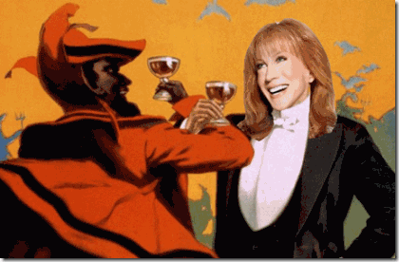
Kathy Griffin; “I sold my soul to the devil.”[1]
I don’t like Kathy Griffin. I do not patronage her sense of humor. If she comes up on anything that I am watching on the idol box, I turn it off like on automatic pilot, and that is before the Donald Drumpf severed head plot of the Luciferians.
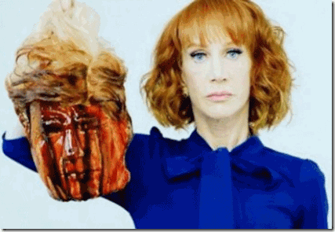
KATHY GRIFFIN- THE DONALD J. DRUMPF SEVERED HEAD PLOY, FALSE FLAG PSYCHOLOGICAL WARFARE
Above all of this, my Christian family taught me to respect and “Obey the Law.” Kathy Griffin by her own words is “Anti-Christ-Like and Anti- Christ“! She is just as satanically “lawless” and WICKED as the Great BEAST 666, Aleister Crowley. Her lord and savior is LUCIFER! Kathy Griffin- don’t drop her on the doorsteps of those that speak Truth to Power, and knock on the door. She does not belong to Truth Movement. There is something strange, seething and repulsive about her spirit that pierce even the airways that I can’t- subconsciously deal with if only for a moment.
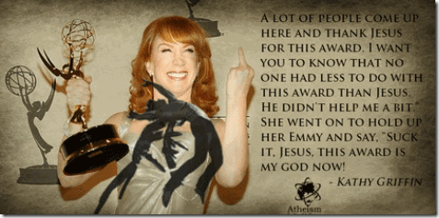
“So all I can say is suck it, Jesus, this award is my God now!”
Kathy Griffin is proud that she sold her soul to the devil. She belongs to the legions of HELL!
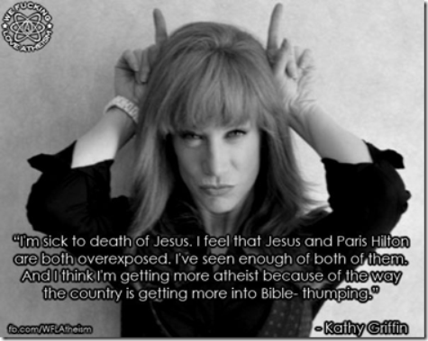
I was raised by Christians that go back generations in this country. I was raised under Christian moral values and commandments, “… Honour thy father and thy mother, Thou shalt not kill (slay), Thou shalt not commit adultery, thou shalt not bear false witness against thy neighbour, thou shalt not covet. I was taught to be Christ-like, and the Kingdom of Glory was my promise.
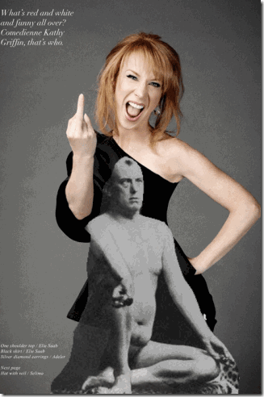
“Do what thou wilt shall be the whole of the Law” Aleister Crowley
Above all of this, my Christian family taught me to respect and “Obey the Law.” Kathy Griffin by her own words is “Anti-Christ-Like and Anti- Christ“! She is just as satanically “lawless” and WICKED as the Great BEAST 666, Aleister Crowley. Her lord and savior is LUCIFER! Kathy Griffin- don’t drop her on the doorsteps of those that speak Truth to Power, and knock on the door. She does not belong to Truth Movement.

KATHY GRIFFIN GLORIES LUCIFER
Kathy Griffin is part of the ILLUMINATI and New World Order’s Mass Population Homosexual Agenda to transform the masses into a new “non-breeding” specie of Trans-humans.
Kathy Griffin told Larry King: “Heterosexual marriage should be a criminal offense.” [2]
Griffin told the world that in this most recent Luciferian False Flag controversy involving the Donald Drumpf severed head photo shoot that she is being used as “shiny object” by the Republicans, Donald Drumpf, conservatives and right wing to distract the public from the Russian-Trump investigations in Washington.

Kathy Griffin- Lucifer & the ILLUMINATI, “Blood Oath Secrecy”
But, it could also be the other way around, a deliberate and intentional psychological warfare “strategy of tension” tactic designed not only to distract, and polarize, but divide the American people. The “strategy of tension“ is a theory that Western governments during the Cold War used tactics aimed to divide, manipulate, and control public opinion using fear, propaganda, disinformation, psychological war, agent provocateurs, and false flag terrorist actions in order to achieve their strategic aims.[3] Who benefits from Kathy Griffin’s the Drumpf Severed Head Luciferian Plot?
As a Luciferian ILLUMINATI agent provocateur, she made herself a “shiny object.” The California Republican Party is soliciting donations based on images of Kathy Griffin posing with the likeness of President Donald Drumpf’s bloody, severed head. An email sent Friday afternoon called Griffin’s photo shoot disrespectful and obscene. The email sought donations to fight what it called “the left’s blatant disrespect.”[4]
A Republican Super PAC is using Kathy Griffin’s photo shoot featuring a bloody faux Donald Trump head against Democrat Jon Ossoff, who is running against Republican Karen Handel in Georgia’s 6th Congressional District’s special election. A new Republican ad calls the act by Griffin another example of “liberal extremists” who have “gone too far.” The video shows footage of the comedian at the shoot, while a narrator says, “Now a celebrity Jon Ossoff supporter is making jokes about beheading the president of the United States. It’s not funny.”[5]
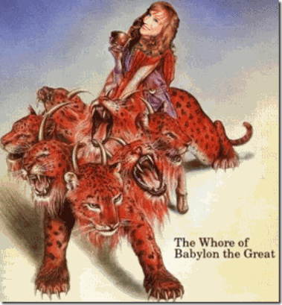
Kathy Griffin, A Vicious Whore of Babylon, by her very own admission belongs to the legions of HELL. She belongs to Lucifer’s exclusive HollyWeird Satanic Multi-Million Dollar Club. In 2016, she purchased a new home in Bel Air, CA for $10.5 MILLION IN CASH next door to the home owned by Kim Kardashian and Kanye West.[6]
II
ROSEANNE BARR & THE DEVIL
“I signed a deal with Satan, because I wanted to get famous, no matter what!“
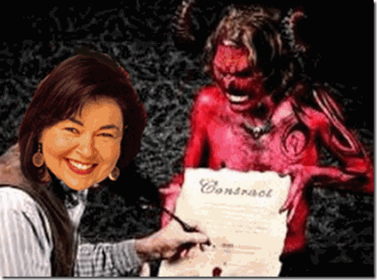
Roseanne Barr jumped to her Twitter account to slam Kathy Griffin for the Drumpf severed head stunt saying, “two of my grandsons r Barron Trump’s age. I would slap the f*ck out of any bitch or any prick who upset them-trust me on that.”[7]
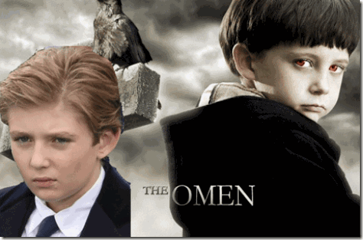
Baron is a member of a specific rank of nobility. According to 15th century French Norman Knights Templar Gilles de Montmorency-Laval and his Catholic Black Mass Murder (Saturn) Death Cult, the DEVIL goes by the name of BARRON.[8]
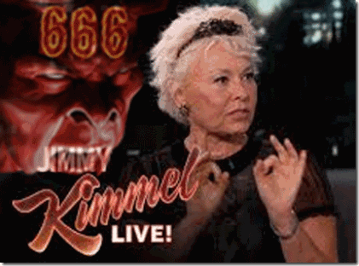
Roseanne Barr- Satan 666
Some years ago, I was drawn into a meeting involving a religious group in Oakland off the shore of Lake Merritt that claimed to be interested in addressing governmental abuse and MK ULTRA/MONARCH mind control. After the meeting, I was approached by a woman that I had previously known by name to be a paid government clandestine agent provocateur in the community. I was very cordial and respectful. We exchanged personal contact information. I have no agenda or fear to hide from anyone including her. For whatever reasons, she approached me, so it was necessary to keep her in front of me, instead of behind. A couple of weeks later, she called to invite me to a seminar outside my protection zone in Oakland to discuss CIA- MK ULTRA/MONARCH mind control issues featuring HollyWeird’s Rosanne Barr. Of course, I didn’t go.
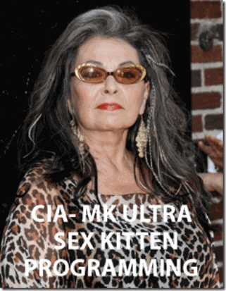
Roseanne Barr belongs to the same CIA- MK ULTRA/MONARCH Satanic Cult that Kathy Griffin belongs to- Lucifer’s HollyWeird Multi-Million Dollar Club. She is an American comedian, actress, writer, television producer, and director who has a net worth of at least $80 million.[9] Enemies (Truth to Power) of the ILLUMINATI and the Shadow Government are MK ULTRA-ed, persecuted and assassinated, not rewarded with sweet-heart HollyWeird multi-million dollar television and movie contracts and deals. What Roseanne Barr expose about CIA- MK ULTRA/MONARCH is what has already been exposed about HollyWeird and the Shadow Government for years. In the game that Roseanne Barr plays, she giveth and taketh it away.
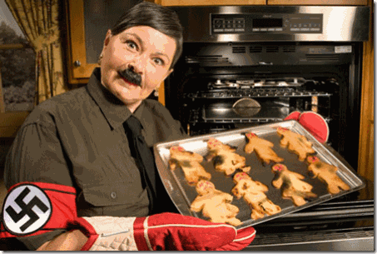
NAZI Roseanne Barr Under ILLUMINATI & HollyWeird’s Satanic Comedian License
Roseanne Barr, what about the terrorized children of color of Palestine?

What about the terrorized children of color of Libya?
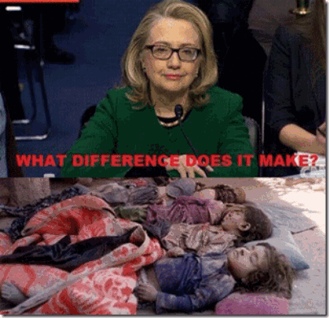
What about the terrorized children of color of Syria?

Children of Africa, the picture is so traumatizing, horrible and hurts so bad, I just can’t go there.
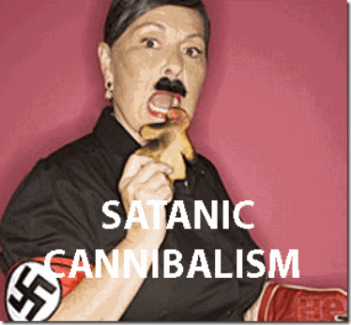
Roseanne Barr- Adolf Hitler Satanic Human Cannibal
But Lucifer’s Servant, Roseanne Barr, goes there and make a comedy out of one of the Greatest Racial Mass Murder Crimes Against Humanity the world has ever known. That too, HURTS SO MUCH! New research in 2013 has revealed that the Nazis may have racially mass murdered up to “20 MILLION” men, women and children, a figure far greater than previous estimates. The research covered some “42,400 camps and ghettos across Europe, and also included forced-labor camps and Nazi ‘care’ centers where pregnant women were forced to have an abortion or had their child killed right after giving birth.” It also drew in camps, prisons and killing grounds used by Nazi puppet regimes in countries such as France and Romania.[10]
CONCLUSION
Just as it had been in a time before recorded history, Set, Seth- SATAN hate the democracy- the POWER OF THE PEOPLE. Kathy Griffin’s Donald J. Drumpf Severed Head Ploy is a CIA- ILLUMINATI False Flag Mass Population Psychological Warfare Tactic.

[1] https://allthechildrenoflight.wordpress.com/tag/lucifer-devil/
[2] https://www.henrymakow.com/hollywoods_freaky_families.html
[3] https://en.wikipedia.org/wiki/Strategy_of_tension
[4] http://abcnews.go.com/Entertainment/wireStory/latest-venues-cancel-kathy-griffin-shows-47790341
[5] http://www.hollywoodreporter.com/news/kathy-griffins-controversial-trump-photo-featured-new-gop-ad-1009692
[6] https://www.forbes.com/sites/simonthompson/2016/10/17/kathy-griffin-talks-about-her-10-5-million-middle-finger-mansion-and-her-kardashian-neighbors/#6b26f1c0574b
[7] http://www.youngcons.com/roseanne-barr-rips-kathy-griffin-i-would-slap-the-fck-out-of-any-bch-who-upset-kids/
[8] https://www.top5s.co.uk/5-facts-about-notorious-serial-killer-gilles-de-rais
[9] http://www.celebritynetworth.com/richest-celebrities/actors/roseanne-barr-net-worth/
[10] http://www.businessinsider.com/shocking-new-holocaust-study-claims-nazis-killed-up-to-20-million-people-2013-3
Comments : 1 Comment »
Tags: 666, Adolf Hitler, Aleister Crowley, antichrist, barron drumpf, cannibalism, damien, devil, donald drumpf, donald trump, fallen angels, false flag, Gilles de Montmorency-Laval, hillary clinton, HollyWeird Satanic Multi-Million Dollar Club, holocaust, Illuminati, jesus, Jon Ossoff, kanye west, kathy griffin, kim kardasian, Lucifer, luciferians, MK-ULTRA, Monarch Program, Nazis, omen, palestine, roseanne barr, russia-trump investigation, satanists, shadow government, Strategy of Tension, syria, trump severed head, truth to power, war crimes, Whore of Babylon
Categories : African Liberation, Aleister Crowley, antichrist, blood covenants, blood oaths, blood sacrifice, brotherhood of death, christianity, CIA, devil, devil's horns, domestic terrorism, donald j. drumpf, donald j. trump, donald trump, evil, fallen angels, false flags, false prophets, hollywood satanic cult, human sacifrice, illuminati, illuminati sacrifice, israel, Kanye West, Knights of the Black Sun, Knights Templar, libya, lucifer's servants, luciferians, mind control, MK-ULTRA, monarch child, monarch program, National Socialism, nwo, oakland, order of teutonic knights, racial mass murder, Ritual Satanic Abuse, ritual satanic sexual abuse, ritually abused children, roseanne barr, satan, Satanic Global High Cabal, Satanism, Schutzsteffel, Secret Doctrine, SS, Strategy of Tension

RED SHAMBHALA: PUTIN, DONALD J. DRUMPF, JARED KUSHNER, THE SEPARATE MASONIC HASIDIC STATE & THE FLEECING OF A DEMOCRACY
6062017
I
THE SHOVE ASIDE SEEN AROUND THE WORLD
The Prime Minister of Montenegro said he took no offense to being belligerently shoved aside by Donald J. Drumpf during a photo op at NATO’s new Brussels’ headquarters, calling the push a “harmless situation.”
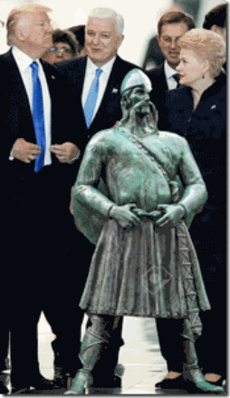
Well, he should have taken offence. Because, it was no “harmless” act. It was a clear deliberate act of a child like adult ancestrally role playing legendary “Viking” games of aggression. It was an assault, and battery by a LUNATIC.
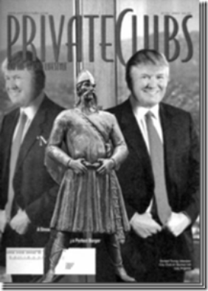
The statute of Olaf III is located at Torgallmenningen, the main square in Bergen, Norway founded by King Olaf, son of King of Norway, Harald Hardrade (Sigurdsson), the Last Great Viking, in 1070 AD.[1] Drumpf’s maternal forebears, The MacLeods, are descended from the bloodlines of the Kings of Norway, and the “mighty Vikings” from the “town of Bergen, which is the beginning of their history“.[2]
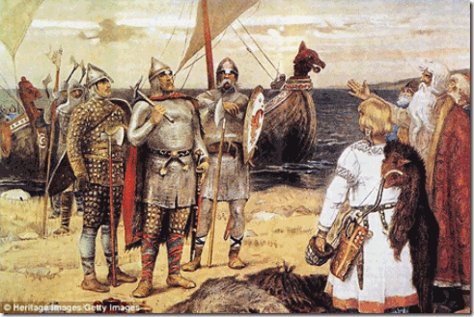
These particular Kings of Norway of the town of Bergen descended from Ruik the Viking. According to the first Russian annals, the Primary Chronicle, Rurik was a Scandinavian “from the tribe of the Rus” whom the people of Novgorod invited in 862 AD to assume rule over them, as they had been unable to govern themselves. Accompanied by his family and retinue, Rurik settled in Novgorod, and his brothers took control of adjacent regions. The area under their authority came to be called “the land of the Rus” and eventually “Rus”- RUSSIA.[3]
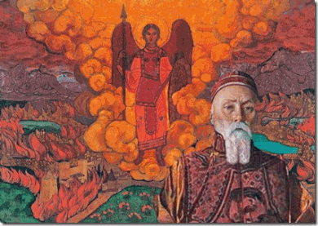
Shambhala & Russian Mystic Nicolas Roerich, Discussed Below
For generations, Russia has been a secret Magical Universe that some say had been part of the mythical and ancient Lands of Shambhala and Hyperborea. Agharti, Agartha, Shangri-la, or, most commonly, Shambhala, some believed it to be a physical, subterranean realm inhabited by an ancient, advanced race, while to others it was a spiritual dimension accessible only to the enlightened.
Russia is a window into the world of secret societies, occult teachers, and subterranean political currents. Keep in mind that the mindset of Putin, Drumpf and Kushner is secretly heavily influenced and embedded in a very strange land of ancient Russian mysticism. This is always kept secret from the people of the democracy. Jared Kushner’s paternal grandmother’s origin is also in the people of Novgorod (Novogroduk), “the land of the Rus.” [4],[5]
“Ideas and practices drawn from magic and the occult have always been a part of Russian life. In the sixteenth century Tsar Ivan IV consulted magicians and was aware of the occult significance of the precious stones set in his staff. His reign was the culmination of the dream of building a prophetic, religious civilization in the Eastern Christian tradition of Byzantium. Surrounded by secret orders of apocalyptical monks, Ivan saw himself as heir to the Israelite kings and attempted to transform Russian life in accord with his magical view of reality. Ivan was convinced the Russian nation had a special mission to accomplish, nothing short of the redemption of the world.
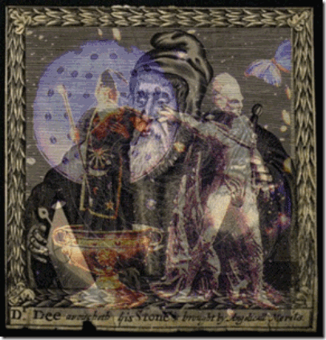
Infamous Alchemist Dr. John Dee
In 1586, Tsar Boris Godunov offered the huge salary of 2000 English pounds a year, with a house and all provisions free, to John Dee, the English magus and spy master, to enter his service. Dee’s son Dr. Arthur Dee, who like his father was an alchemist and Rosicrucian, went to Moscow to work as a physician. Mikhail Romanov, the first Tsar of the Romanov dynasty, allegedly ascended the throne with the help of Dr. Arthur Dee and the British Secret Service. Before their rise to power the Romanovs were accused by their enemies of practicing magic and possessing occult powers.
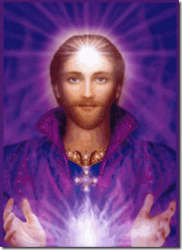
Count of St. Germain
The legendary Count of Saint Germain, described as an alchemist, spy, industrialist, diplomat and Rosicrucian, became involved in several political intrigues in Russia and was, according Nicholas Roerich, ‘a member of the Himalayan brotherhood.’ In 1755 he traveled throughout Eurasia to study occult teachings, and may even have visited Tibet. It is said that while studying occultism in Central Asia the Count was introduced to the secret rites of Tantric sex magic which provided him with a technique to prolong his youth. He also engaged in spying operations against the notorious British India Company. Saint Germain founded two secret societies called the Asiatic Brethren and the Knights of Light. As early as 1780 he warned Marie Antoinette that the French throne was in danger from an international conspiracy of ‘Brothers of the Shadow’. Rumours continued to circulate for many years after his alleged death that Saint Germain was still alive working behind the scenes in European politics or studying occult doctrines in Central Asia.”[6]

Donald J. Drumpf may go down as one of the most evil, divisive, alienating and polarizing U.S. presidents in American History. In the final chapter, he actually may turn out to be one of world’s most polarizing figures in the history of constitutional democratic societies.
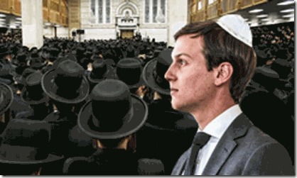
Jared Kushner & Another Separate State
Now at this very moment, his son-in-law, Jared Kushner, is rising on the world stage in Drumpf’s Dark Empire that forms a cloud over the presidency and a diversified citizenry of the United States, and the world. There are no degrees of separation between Kushner and Steve Bannon when it comes to absolute evil, white supremacy and racial bigotry. Kushner is a Zionist, and an extreme religious bigot and isolationist that advocates the blood sacrifice of the global masses of color.
II
UNDERSTANDING JARED KUSHNER & MYSTICISM, THE ZOHAR AND TORAH
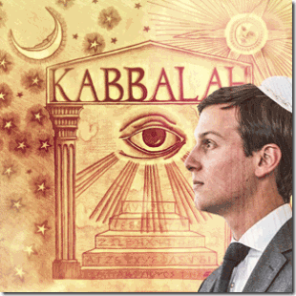
Jared Kushner & Jewish Mysticism- KABBALAH
Before we proceed further, we must have a basic understanding of what the Torah, Zohar and Kabbalah are. It is necessary and important to understand their basics, because at this moment in history- the U.S. government clandestinely swing in their wind.
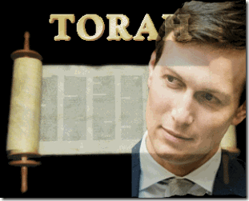
The English word “Torah” comes from the Hebrew word toh·rahʹ, which can be translated as “instruction,” “teaching,” or “law.” (Proverbs 1:8; 3:1l; 28:4). Toh·rahʹ often refers to the first five books of the Bible—Genesis, Exodus, Leviticus, Numbers, and Deuteronomy. These are also called the Pentateuch, from a Greek word meaning “fivefold volume.” The Torah was written by Moses, so it is called “the book of the Law of Moses.” (Joshua 8:31; Nehemiah 8:1).[7]
According to rabbinic tradition, all of the teachings found in the Torah, both written and oral, were given by God through the prophet Moses, some at Mount Sinai and others at Tabernacle, and all the teachings were written down by Moses, which resulted in the Torah that exists today. According to the Midrash, the Torah was created prior to the creation of the world, and was used as the blueprint for Creation.
A majority of Biblical scholars believe that the written books were a product of the Babylonian captivity (600 BC), based on earlier written and oral traditions, which could only have arisen from separate communities within ancient Israel, and that it was completed by the period of Achaemenid rule (400 BC). The 1979 discovery of fragments of the Hebrew Bible (Priestly Blessing from the Book of Numbers) at Ketef Hinnom (southwest of the Old City of Jerusalem, adjacent to St. Andrew’s Church) dating to the late 7th century BC, and thus to before the Babylonian captivity, is the oldest evidence of elements of the Torah which were current before the Babylonian exile.[8]
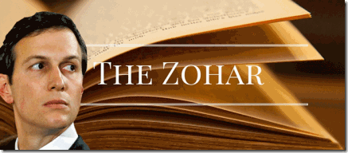
The Zohar (“Splendor” or “Radiance“) is a set of twenty-three books, a commentary on biblical and spiritual matters in the form of conversations among spiritual masters. The Zohar is the foundational work in the literature of Jewish mystical thought known as Kabbalah. It is a group of books including commentary on the mystical aspects of the Torah (the five books of Moses) and scriptural interpretations as well as material on mysticism, mythical cosmogony, and mystical psychology.[9]
In November 2016, as presidential candidate Donald J. Drumpf spent his weekend barnstorming swing states and rallying crowds to his cause, his daughter Ivanka and son-in-law Jared Kushner, a key campaign adviser, teamed up to seek support and a blessing from a higher power from a different state.[10]
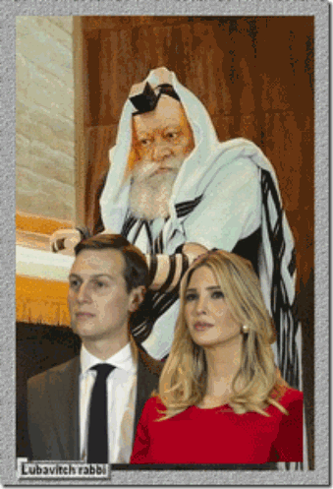
Jared Kushner, Ivanka Drumpf & the 7th Lubavitcher Rebbe
Members of Chabad-Lubavitch are divided into two categories: The “Elokists” and the “Mishichists“. Elokists believe that the Rebbe is God, while Mishichists believe the Rebbe is the Messiah. Well, Jared and Ivanka must be among the Elokists, because they certainly didn’t pray to God or Jesus to answer their prayers. In New York City over Shabbat – Ivanka and Jared were spotted on Saturday night at the site of the grave of the Lubavitcher Rebbe in Queens, NY.
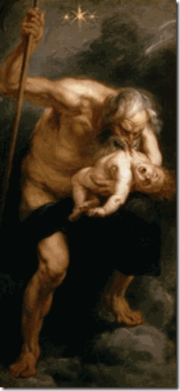
Saturn Devouring His Son
The Holy Sabbath is actually the worship of the planet Saturn. If you “keep the Sabbath,” then you are carrying on the ancient worship of this pagan god. That is why he is worshiped on Saturn’s Day — which today we call “Saturday.”[11] The Witches’ Sabbath or Sabbat is a meeting of those who practice witchcraft, and other old European religious rites.[12]
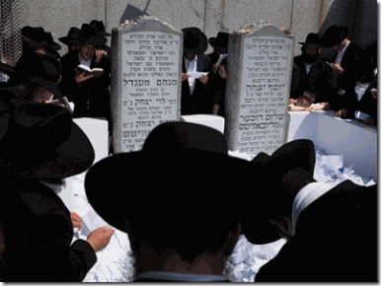
The site Ivanka and Jared visited is known as “The Ohel” – the Hebrew word for “tent” – and it is the structure build over the grave of the venerated Seventh and Last Lubavitcher Rebbe Menachem M. Schneerson, who was buried there alongside his father-in-law in 1994.[13]
It is extremely important that we have some understanding of who these people are disguised as working on behalf of American citizens, but for a totally separate and different state. Drumpf, Ivanka and Jared Kushner are far more dangerous to an open society than anyone can ever imagine.
Rebbe (Hebrew) is a Yiddish word derived from the Hebrew word rabbi, which means “master, teacher, or mentor“. Like the title “rabbi” it refers to teachers of Torah or leaders of Judaism. In common parlance of modern times, the term “The Rebbe” is often used specifically by Hasidim to refer to the leader of their Hasidic movement.[14]
Jared Kushner, Ivanka Drumpf & the Hasidic Movement
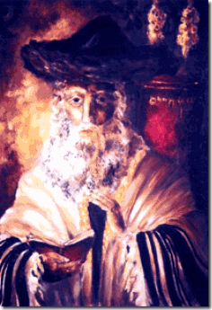
Rabbi Israel Baal Shem Tov (1698-1700- 1760), founder of Hasidism, in Medzhybizh, Ukraine gave a new phase to Jewish mysticism through the Lurianic Kabbalah on a mass Jewish population basis. Lurianic Kabbalah is a school of Kabbalah named after the Jewish rabbi who developed it: Issac Luria (1534–1572). Lurianic Kabbalah gave a seminal new account of Kabalistic thought that its followers synthesized with, and read into, the earlier Kabbalah of the Zohar that had been disseminated in Medieval circles.[15]
Around the age of twenty-two, Luria became engrossed in the study of the Zohar (a major work of the Kabbalah that had recently been printed for the first time) and adopted the life of a recluse. Retreating to the banks of the Nile for seven years, he secluded himself in an isolated cottage, giving himself up entirely to meditation. He visited his family only on Shabbat. The teaching of the Lurianic Kabbalah is based on the Zohar that during the time of Rabbi Shem Tov during the 18th century was still secret teachings and doctrines.[16]
Hasidic Movement, Torah and Zohar, The Hand and the Glove
“There are those who are against me yet they don’t even know me at all. This is as it says in the Zohar when the Torah states that Pharaoh said to the Egyptians, “Let’s outsmart the Jews.” Could it be that he went to each and every citizen to personally relate this message? Rather he inserted it into their hearts.” Rebbe Nachman of Breslov[17]
Rebbe Nachman of Breslov (1772–1810), the great-grandson of the Baal Shem Tov, revitalized and further expanded the latter’s teachings, amassing a following of thousands in Ukraine, Belarus, Lithuania and Poland. In a unique amalgam of Hasidic and Mitnagid (Ashkenazi Hasidic) approaches, Rebbe Nachman emphasized study of both Kabbalah (Zohar) and serious Torah scholarship to his disciples. His teachings also differed from the way other Hasidic groups were developing, as he rejected the idea of hereditary Hasidic dynasties and taught that each Hasid must “search for the tzaddik (‘saintly/righteous person’)” for himself and within himself.[18]
It should be noted that the Sabbateans also based their teachings on the Zohar and Lurianic Kabbalah that are considered part of classical Judaism by Hasidism.[19] It appears that in the Hasidic movement, the Torah and Zohar go hand and glove.
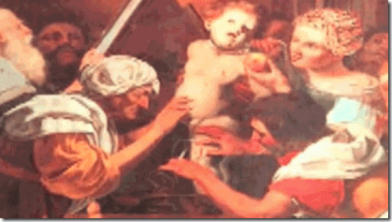
Tov’s Hasidic movement among the masses also raised concerns and fears that it also created secret extreme sects of Kabbalic-Mystical religious fanaticism.
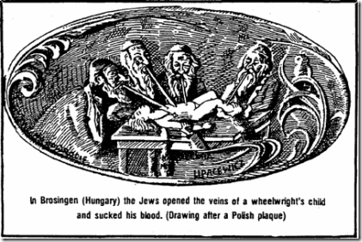
Within the lifetime of Israel Baal Shem Tov, approximately from 1698 until 1760, as well as within the lifetime of his parents in the last third of the 17th century, there occurred a greater number of recorded blood libels than during any other historical period.
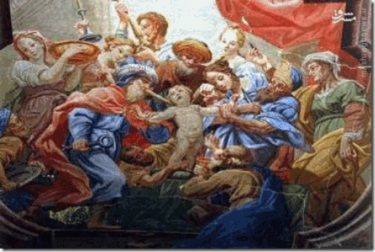
According to two contemporary Polish historians Zenon Guldon and Jacek Wijaczka (1977), there were 66 recorded blood libels in the 17th-18th centuries in the Polish-Lithuanian Commonwealth.[20]
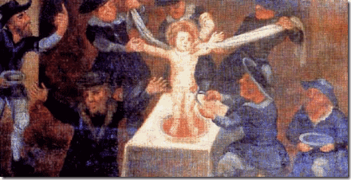
According to Jacek Wijaczka’s recent article “Ritual Murder Accusations in Poland throughout the 16th to the 18th Centuries“: “Based on recent research we can conclude that during the Early Modern Era, 89 ritual murder accusations and trials took place in Poland (within the borders after the Union of Lublin). This includes 17 in the 16th century, 37 in the 17th century and 35 in the 18th century…In total, at least 11 accusations and ritual murder trials took place in Lithuania, which brings the total to 100 trials within the Polish territories”.[21]
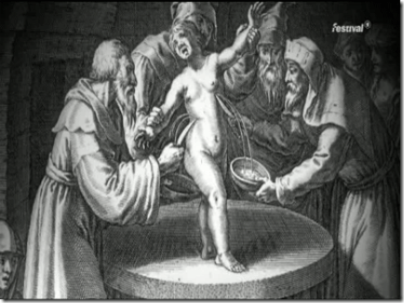
There were many more similar incidents that did not receive mention in the Polish judicial documents but were well attested in contemporary Jewish literature.[22] The first mystical testimony on the public activity of Israel Baal Shem Tov has to do with the blood libels in the forties’ and Fifties’ of the Eighteen Century.[23] Don’t get it all twisted. The bottom line is Jewish Mysticism is an internal part of the Hasidic movement that centers around the Kabbalah of the Zohar. The Zohar is not an old book. Its existence does not seem to precede the Middle Ages. Many of the writings of the Zohar are asserted to be secret ancient writings or compilations of secret ancient writings.
Kabbalah: The Making of the Zohar
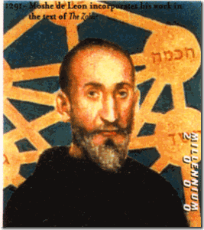
Moses de León (c. 1240 – 1305), known in Hebrew as Moshe ben Shem-Tov, was a Spanish rabbi and Kabbalist who is considered the composer, redactor, or scribe of the Zohar. It is a matter of controversy if the Zohar is his own work, or if he committed to writing traditions or manuscripts going back to Rabbi Shimon bar Yohai, House of Judah.[24] However, it was Moses de León that complied Jewish treatises, tracts, and published the vast Torah of today in the 13th century.[25]
Rabbi Yohai was a 2nd-century sage in ancient Israel, said to be active after the destruction of the Second Temple in 70 CE. According to a legend in the Babylonian Talmud, Rabbi Shimon bar Yohai criticized the Roman government and was forced to go into hiding with his son for thirteen years. They sheltered in a cave (which local tradition places in Peki’in). Next to the mouth of the cave a carob tree sprang up and a spring of fresh water gushed forth. Provided against hunger and thirst they cast off their clothing except during prayers to keep them from wearing out, embedded themselves in the sand up to their necks, and studied the Torah (five books of Moses) all day long. He and his son left the cave when they received a bat qol (divine revelation) saying that the Roman emperor had died and consequently all his decrees were abolished.[26]
Kabbalah: The Zohar, Fallen Angels and King Solomon
The Fallen Angels are wicked or rebellious angels that have been cast out of heaven. God did not spare angels when they sinned, but cast them into hell and committed them to chains of gloomy darkness to be kept until the judgment. The Zorah of Rabbi Yohai is most likely some of the “supernal wisdom” alleged to have come from Fallen Angels, and King Solomon’s Temple.
Kabbalah:
“God did indeed send down a book to Adam, from which he became acquainted with the supernal wisdom. It later came into the hands of the ‘sons of god’ [i.e., the ‘Fallen Angels,’ of whom Samael was the leader, described in Genesis 6:1-4], the wise of their generation, and whoever was privileged to pursue it could learn from it supernal wisdom.”(The Zohar 1:37b)
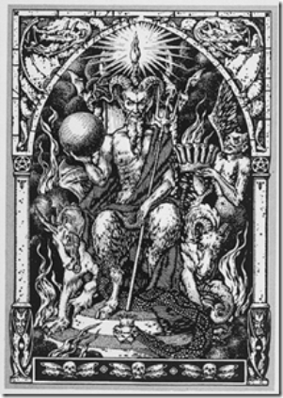
FALLEN ANGEL SAMAEL
The “supernal wisdom” of Kabbalah is related to the Fallen Angels, of whom Samael was the leader, and in whose “Palace“, the early sages “delved“, and into which the Jewish Messiah Sabbatai Zevi, later “descended.”
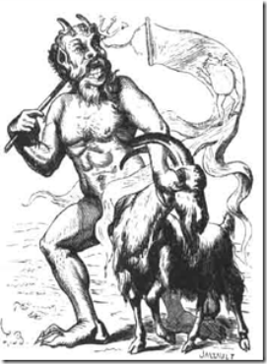
FALLEN ANGEL AZAZEL
“Azazel was smitten or “afflicted” by God and expelled to make atonement in the wilderness…”[27]
The concept of Fallen Angels is first found in Judaism among texts of the Second Jewish Holy Temple (516 BCE and 70 AD) related to Rabbi Yohai. The Second Temple replaced Solomon’s Temple, the First Temple. The Second Temple applied Fallen Angels to Azazel.
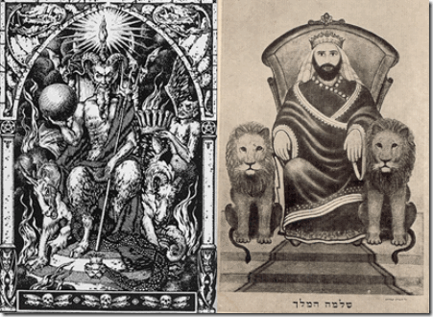
Azazel was King Solomon. Solomon or Shiloh is Moses,
” ‘The sceptre shall not depart from Judah nor the ruler’s staff from between his feet’, ‘the sceptre” referring to the Messiah of the house of Judah, and ‘the staff’ to the Messiah of the house of Joseph.’ ‘Until Shiloh cometh’: this is Moses, the numerical value of the two names Shiloh [Schyloh] and Moses [Mosheh] being the same.’ “ (The Zohar, Volume I, Section “Bereshit”).[28]
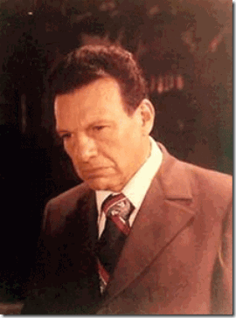
Kabbalist Samael Weor
At least one Christian Gnostic and Mystic, Samael Aun Weor (March 6, 1917 – December 24, 1977), founder of the Universal Christian Gnostic Movement, and lecturer of “The Doctrine of Synthesis’ of All Religions in both their Esoteric and Exoteric Aspects” – found that the Fallen Angel Azazel was identical to King Solomon.[29], [30]
“Azazel was King Solomon. Presently, the Bodhisattva of Azazel is fallen; but it is logical that in the near future, that Bodhisattva will rise from the mud of the earth.” (Venerable Master Samael Aun Weor’s Teachings in his Book titled “The Message of Aquarius,” “Chapter XXVI”, “The Seven Angels and the Seven Bowls“).
The English word “cabal” (a secret group of conspirators) is derived from the Hebrew word Kabbalah.[31] Chabad, also known as Lubavitch, Habad and Chabad-Lubavitch is today one of the world’s best known Hasidic movements and is well known for its outreach. It is the largest Hasidic group and Jewish religious organization in the world.
THE SEVEN CHABAD- LUBAVITCH REDDES
1. Rabbi Shneur Zalman of Liadi (1745–1812), founded the Chabad movement in the town of Liozna. He later moved the movement’s center to the town of Liadi. Rabbi Shneur Zalman was the youngest disciple of Rabbi Dovber of Mezritch, the principal disciple and successor of Rabbi Israel Baal Baal Shem Tov, founder of Hasidism.
2. Rabbi Dovber Schneuri (1773–1827), son of Rabbi Shneur Zalman, led the Chabad movement in the town of Lyubavichi (Lubavitch).
3. Rabbi Menachem Mendel Schneersohn (1789–1866), a grandson of Rabbi Shneur Zalman and son-in-law of Rabbi Dovber.
4. Rabbi Shmuel Schneersohn (1834–1882), was the seventh and youngest son of Rabbi Menachem Mendel.
5. Rabbi Shalom Dovber Schneersohn (1860–1920), Shmuel’s second son, succeeded his father as rebbe.
6. Rabbi Yosef Yitzchak Schneersohn (1880–1950), the only son of Sholom Dovber, succeeded his father as rebbe of Chabad.
7. Rabbi Menachem Mendel Schneersohn (1902–1994), son-in-law of Rabbi Yosef Yitzchak, and a great-grandson of the third Rebbe of Lubavitch, assumed the title of rebbe one year after his father-in-law’s death. Rabbi Menachem Mendel greatly expanded Chabad’s global network, establishing hundreds of new Chabad centers across the globe. He published many of his own works as well as the works of his predecessors. His teachings are studied regularly by followers of Chabad. He is commonly referred to as “the Lubavitcher Rebbe“, or simply “the Rebbe”. Even after his death, many continue to revere him as the leader of the Chabad movement.[32]
However,
“The Zohar is the great medieval Jewish compendium of mysticism, myth, and esoteric teaching. It may be considered the highest expression of ‘Jewish literary imagination‘ in the Middle Ages.“[33]
During the presidential transition period leading up to Drumpf’s presidential inauguration, Jared Kushner held a series of meetings with the Russian ambassador to the US, Sergey Kislyak, and the head of a Moscow bank that was under US sanctions. In talks with Kislyak in December 2016, Kushner sought to set up a secure secret line of communication between the Drumpf transition team and Russia — and having those talks take place in Russian diplomatic facilities in the US, essentially concealing their interactions from US government scrutiny that amounts to international ESPIONAGE.[34]
Who exactly is Jared Kushner? In April 2017, Politico Magazine published an article purporting to show long-term links between Kushner, Russian Jewish oligarchs, Drumpf, Putin, and Chabad-Lubavitch.
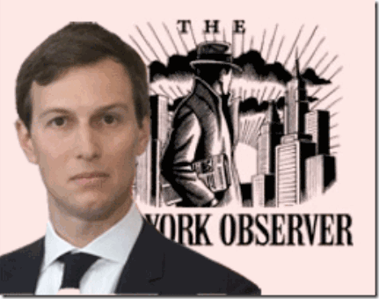
Kushner run a media outlet that he paid $10 million in cash for in 2006, the New York Observer. Harleen Kahlon was an experienced digital media maven when she was hired by Kushner in 2010 to boost the paper’s digital outreach. Her feelings for Kushner runs deep and may constitute a typical note about his character, “We’re talking about a guy who isn’t particularly bright or hard-working, doesn’t actually know anything, has bought his way into everything ever (with money he got from his criminal father), who is deeply insecure and obsessed with fame (you don’t buy the NYO, marry Ivanka Trump, or constantly talk about the phone calls you get from celebrities if it’s in your nature to ‘shun the spotlight’), and who is basically a shithead.”[35]
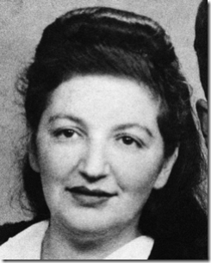
Rae Kushner With Joseph Cut from Picture?
Jared is much more than just a moron and a “shithead” secretly combining with control group Masonic Russians. Jared has said, “I am the grandson of Holocaust survivors.” He has described how his grandmother, Rae Kushner, escaped the Nazi ghetto of Novogroduk and made it to the woods, where she joined the partisan resistance Bielski Brigade and met his grandfather, Joseph, who escaped a Polish Nazi labor camp.[36] Novogroduk, was the first capital of the Grand Duchy of Lithuania, in the region of Belarus.[37]
From Italy after WWII, Rea and Joseph landed in New York City in 1949. What little that is exposed about Joseph in New York is sarcastic nonsense and disinformation, and why isn’t there public pictures of him? ” … Joseph Kushner, a Holocaust survivor, was the first in the family to enter the real estate business. Joseph worked construction on several sites in New York before his fear of heights took him to New Jersey, where the buildings were shorter.”[38]
It is highly probable that Rea and Joseph Kushner were Kabbalists, Jewish members and followers of the Chabad-Lubavitch in Lithuania, in the region of Belarus. They certainly would have been followers of the 6th and 7th Rebbes, Rabbi Yosef Yitzchak Schneersohn, and Rabbi Menachem Mendel Schneersohn.
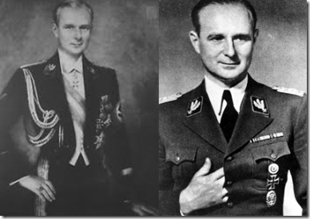
The Super Hidden Hand Elite, Obergruppenführer SS Karl Wolff
During WWII, it was extremely difficult to get travel or resettlement visas to America for Italian Americans and Italians let alone displaced Lithuanians. Italy under Mussolini and Lithuania under Nazi occupation of Adolf Hitler were Axis enemies. In Italy, there were at least a million of Himmler’s SS Waffen knights under Obergruppenführer SS Karl Wolff (Supreme Commander of all SS forces in Italy). In general, Italians constituted “enemy aliens“. In America, thousands of Italian Americans were taken into custody in an initial roundup following the attack on Pearl Harbor on on December 7, 1941, and prior to the United States declaration of war against Italy.[39],[40] Yet, Rea and Joseph Kushner got travel visas from someplace. I have come to realize that Masonic Lodges had also been linked to rat lines out of Italy and Europe. There is firm evidence that the 6th and 7th Rebbes, Rabbi Yosef Yitzchak Schneersohn, and Rabbi Menachem Mendel Schneersohn, were directly linked to a secret KBG Masonic Lodge, United Labor Brotherhood (ULB), to be discussed further.
Today, Rea and Joseph Kushner are associated with and named for Jewish Orthodox educational institutions, Rae Kushner Yeshiva High School / Yeshivat HaTichonit Beit Yosef (four-year private high school) in Livingston, New Jersey, and the affiliated Joseph Kushner Hebrew Academy, Staten Island, NY.[41] They are Jewish educational institutions associated with Torah Umesorah (Partner in the Teaching of the Torah).[42] The Kushner’s sons Murray and Charles sit on the board of the directors of the RABBINICAL COLLEGE OF AMERICA, Headquarters of Chabad Lubavitch in the State of New Jersey.[43]
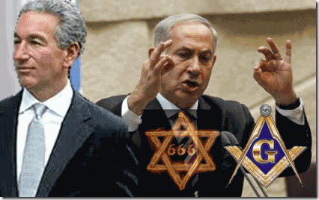
Charles Kushner is the father of Jared Kushner. He is a Zionist, crooked, conniving, and convicted ex-felon (Asset of the Mossad), and an extremely close personal confident of the Satanic Israeli war criminal, Freemason Benjamin “Bibi” Netanyahu. There is a very strong suggestion that Joseph Kushner soon after he got off the boat in New York City in 1949 immediately became tied into Fred Drumpf, and Abraham (Bunny)- Samuel H. Lindenbaum’s Kabbalah– Chabad – Lubavitch circle. The Lindenbaums were fervent supporters of the Lubavitch movement and the Educational Institute Oholei Torah [Zohar], the Flagship school of Chabad – Lubavitch.[44]
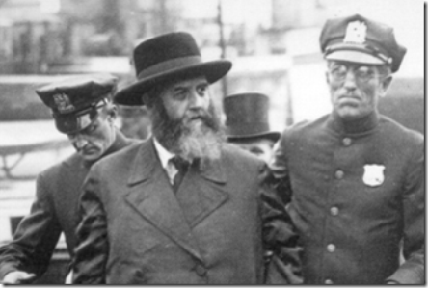
Welcome to America,1929, Russian OGPU Operative 6th Rebbe Rabbi Yitzchak & NY Police Honor Guard
In 1929, and 1940, before the Kushner’s arrived in New York City, the 6th Rebbe, Rabbi Yosef Yitzchak (Joseph Isaac) Schneerson), setup a communal (Masonic United Labor Brotherhood (ULB)) lodge/infrastructure on Eastern Parkway in the Crowns Height section not far from the Brooklyn Jewish Center (BJC) founded in 1921. Don’t get it twisted. The ULB was no labor union. The “labor” that they were talking about was about the united “Searchers After the Truth” seeking secret long lost “supernal wisdom“- occult knowledge and mysticism.
Their immediate problem: lots of school age children, no building to house a school. A partnership developed between the BJC and the flagship school of the Chabad-Lubavitch movement, Educational Institute Oholei Torah [Zohar], to open a school.[45]
Oholei Torah (“Tents of Torah“), properly referred to as Oholei Menachem (“Tents of Menachem“) after the 7th Rebbe Rabbi Menachem Mendel Schneerson. It is the common name of the Lubavitch schools Educational Institute Oholei Menachem and Talmudical Seminary Oholei Torah. It was founded in 1957 by Rabbi Schneerson’s directive. In 1975, the school began renting space for the elementary classes at the BJC at 667 Eastern Parkway, built in 1920. They purchased the building outright in 1982. [46]
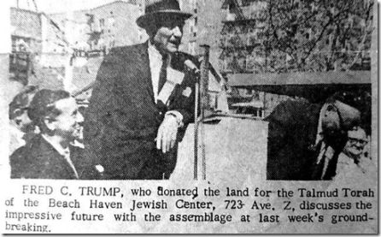
Fred Christ Drumpf (1905- 1999) donated the land for the Talmud Torah [Zohar] of Beach Haven Jewish Center and according to estimates the photo was taken almost fifty years ago in 1965 or 1966. Previously, I posted in August 2015 that Fred C. had actually financed the entire center. “At Beach Haven, Fred C. financed a shul with three classrooms. Shul is a Yiddish word for synagogue. An example of shul is where Jewish people go to worship. The Beach Haven “community consisted mostly of young couples and there were 350 children in the Talmud Torah.”
The reference site for the quote was removed from the internet, but the above recently released newspaper photograph and caption confirm my previously post. HUD investigators found that Scandalous Fred C. pocketed $4,070,000 in the post- WW II Brooklyn 1949 Beach Haven Apartment Complex Project. (Weifeld, Irving, HUD Scandals, Transaction Publishers, New Brunswick, NJ (1992), pg. 1) That’s a great deal of money in 1949. KiKar Shabbat also recently reported that Fred C. was among the biggest donors of the Ruzhin-Boyan hassidic movement in Jerusalem.[47]
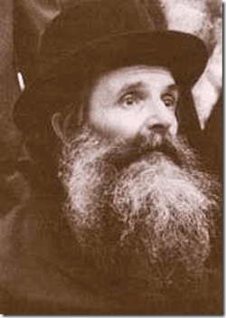
Rebbe Yitzchok Friedman
Yitzchok Friedman (1850 – 11 March 1917) was the founder, first and only Rebbe of the Boyan Hasidic dynasty. He was known as the Pachad Yitzchok (Dread of Isaac).[48] Boyan is a Hasidic dynasty named after the town of Boiany in Ukraine. The Hasidut is headquartered in Jerusalem, Israel. Boyan is one of the branches of the Ruzhiner dynasty.[49] Rabbi Yisroel Friedman was a direct descendant through the male line of Rabbi Dov Ber, the Maggid of Mezritch (1704-1772), the main disciple of BAAL SHEM TOV.[50]
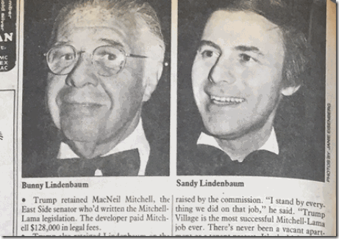
Bunny Lindenbaum (1909-1980) was a Masonic orthodox and fanatical Zionist Jew. He was president of the Brooklyn Jewish Community Council, and the Brooklyn Jewish Center (BJC). The BJC was connected directly to United Synagogue of America, the World Zionist Congress, United Jewish Appeal, National Jewish Welfare Board, and the MOSSAD.
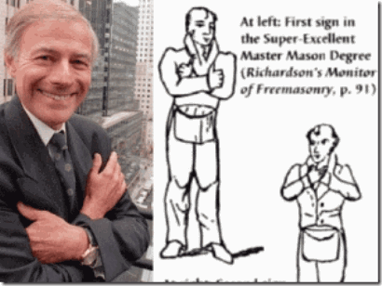
Kabbalah Masonic Hasidic Samuel (Sandy) Lindenbaum
Abramham’s son, “Mr. [Samuel] Lindenbaum cultivated a scholar’s knowledge of the Zoning Resolution, the arcane document that governs development in New York. As a result, he was able to bend the resolution to his clients’ will without breaking it. And because his clients were major builders and landowners — among them Harry B. Helmsley, Harry Macklowe, Larry A. Silverstein, Jerry I. Speyer, Leonard Litwin, Steven Roth and Donald J. Trump; the Fishers and Tisches and Rudins and Roses. . .”[51]
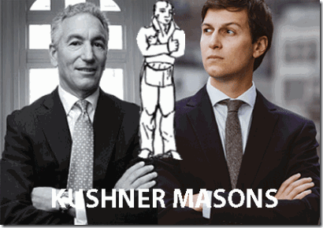
The Masonic Lodge that they belong to is unknown. It could chartered or old world. In either case, the very nature of the Lodge is Secrecy- Blood Covenant Secrecy.
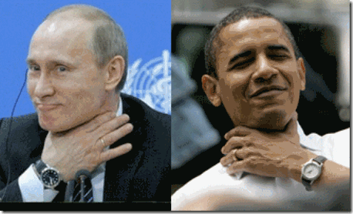
MASONS- Putin and Obama
“… binding myself under no less penalty than to have my throat cut across …”
In New York, Joseph Kushner is said to have worked as a construction worker and concurrently as an independent builder. Naturally, as part of his resettlement in New York, he would have come in direct contact with the Masonic brotherhood via Bunny Lindenbaum and his Jewish welfare board. As a construction worker, and a growing wealthy independent builder, he would have joined Fred Drumpf and Lindenbaum’s circle of Colombian Order Tammany Hall corrupt politicians, and Masonic Jewish high rise and public housing builders to become a millionaire.
Thru the secret Masonic brotherhood- local, state, federal politicians, and even the president raided and plundered municipal, state and federal treasuries by creating vast spending pools and measures in public projects designed to create housing and neighborhoods for the public good. In New York, New Jersey and across the U.S., these programs were warped up for the Masonic brotherhood like Christmas presents. The Masonic brotherhood would line up, and skim all the cream off the top of the coffee of the all public financed projects. So, it isn’t surprising that Joseph Kushner straight out of Belarus would end up possessing and passing down a portfolio totaling 4,000 New Jersey apartments to his son, Charles Kushner, almost just the same as Slanderous Fred Drumpf and Donald J. Drumpf.[52]
III
VLADIMIR PUTIN AND RED SHAMBHALA
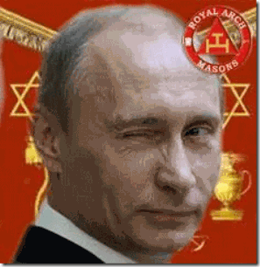
Putin is a Royal Arch Mason.[53] Royal Arch Masonry is the first order a Master Mason joins in the York Rite usually up to the Third Degree. By all accounts, constitutional Freemasonry in Russia dates back to January 24, 1731, when Captain John Phillips was appointed as the provincial grand master of Russia by the Grand Lodge under the guidance of the “Royal Arch” of England. However, it appeared that the Russians from the 18th century were more interested in piercing the veil of the Grand Lodge than being subservient to its hierarchy.[54]
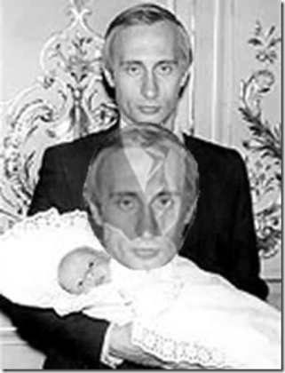TRANCE FORMATION- Vladimir Putin
Putin rose up to president of Russia from the lower ranks of the KGB. Allegedly, he had been under British Intelligence MI6/Royal Arch Freemasonry ILLUMINATI mind control since 1979, and had been one of their “dispensable and throwaway” operatives within the KGB until 1994.
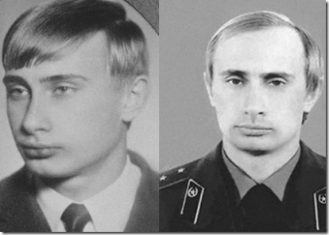
The British Empire always treated Putin like a nobody non-royal and dispensable agent, when the KBG and a superior “inner circle” Russian Masonic Lodge resisted and broke the British and CIA ultra secret codes and keys of their paranormal projects, and MK ULTRA mind control programs.[55] However, the KGB may have always held the backdoor keys to British and America’s MK ULTRA programming and paranormal programs all alone. It appears that the KGB had been secretly light years ahead of the them in the area of the paranormal and mind control that goes back to the secret Masonic lodges, sects and cells of Alexander Barchenko and the Red Shambhala.
IV
RUSSIANS & NAZIS- RED SHAMBHALA
For decades, the Russians that included Czar Nicolas II and Joseph Stalin had been fascinated and preoccupied as “Searchers After the Truth” with the “rule by secret societies,” serving as priestly class in direct communication with the “gods,” meaning the “Ascended Masters of Agartha“, and finding their legendary city that is said to reside in the hollow earth. They believed that there also existed a still more powerful and more holy man… The King of the World in Agharti.[56] The British Empire were very concerned about Russia and Red Shambhala, because the soviets intended to use lost “supernal wisdom” and paranormal power to cut them completely out of Asia (Tibet, Mongolia, Manchuria and China) and the East (India). British Intelligence sent one of secret agents to St. Petersburg, Russia to investigate, the Great BEAST 666, Aleister Crowley.

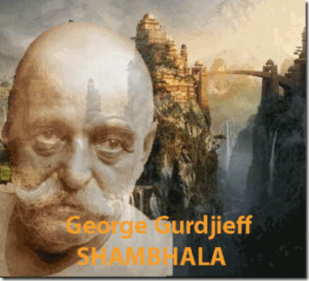
In the middle of Red Shambhala in St. Petersburg was George Gurdjieff. He was a charismatic hypnotist, carpet trader, Master Freemason and spy, who worked as a Russian secret agent in Tibet during the early part of the twentieth century. Having been in contact with the Bektashi Sufis of Turkey, Gurdjieff put forward the myth of Central Asian Shamanism as the source of the occult tradition.
“There has also often been the suggestion that he and Joseph Dzhugashvili, later known as Stalin, met as young students while attending the same seminary in the Caucasus. Gurdjieff’s family records contain information that Stalin lived in his family’s house for a while. There are also suggestions that Stalin belonged to an occult “eastern brotherhood,” which consisted of Gurdjieff and his followers.”[57]
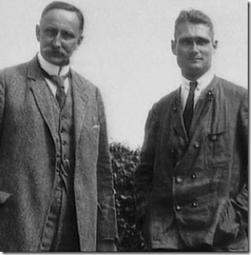
Nazi Mystics Karl Haushofer & Rudolf Hess
Louis Pauwels, a former student of Gurdjieff, in his book “Monsieur Gurdjieff”, asserts that one of the “Searchers After Truth” that Gurdjieff speaks of in his book, “Meetings with Remarkeable Men”, was Karl Haushofer who, through his student Rudolf Hess, influenced the development of Adolf Hitler’s geopolitical strategies. Haushofer was also a leading member of the Thule Society, from which evolved the Nazi Party, and which was founded by Baron Rudolf von Sebottendorf, who had studied Kabbalah in Turkey under Bektashi Sufis who were also Master Freemasons of the ancient Turkish Masonic Lodges.
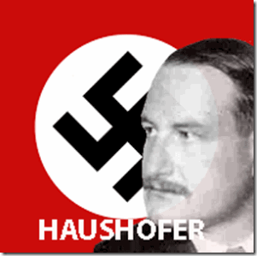 Haushofer was supposed to have been with Gurdjieff in Tibet, supposedly advised Haushofer to adopt the swastika. The Thule Society also was to have established contact with secret ancient monastic orders of Tibet through a small colony of Tibetan Buddhists, which was established at Berlin in 1928. According to Pauwels and Bergier, in “The Morning of the Magicians”, the Thule Society sought to make a pact with Shambhala, but only Agarthi agreed to help. Already by 1926, explained Pauwels and Bergier, there were colonies of Hindus and Tibetans in Munich and Berlin, called the Society of Green Men, in astral connection with the Green Dragon Society in Japan, to which Haushofer belonged. The leader of the Society of Green Men was a Tibetan lama, known as “the man with green gloves,” who supposedly visited Hitler frequently and held the keys of Agharti.[58]
Under the influence of Haushofer, Hitler authorized the creation of Heinrich Himmler’s SS Ahnenerbe in 1935, that sponsored expeditions to locate the Aryan forefathers in Shambhala and Agartha. The 1939 expedition was said to have gone to Tibet with the specific purpose of setting up vital radio contact between the Third Reich and the lamas, and the Theological Society’s Madame Blavatsky’s Stanzas of Dzyan were used as a code for all messages between Berlin and Tibet during the War. Pauwels and Bergier argue that Hitler sent the expedition out of his desire to find Agarthi, which he had been made aware of from his relationship with “the man with the green gloves.” However in this game, the Russians were also light years ahead of the Germans, too.
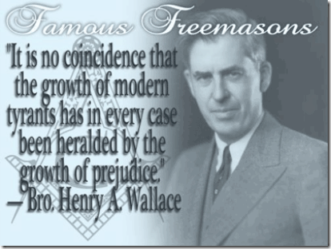
In the 1930s, Henry Agard Wallace, Secretary the US Department of Agriculture also sponsored expeditions into Tibet to find Shambhala and Agartha led by the Russian Nicholas Roerich.[59] Wallace was a Royal Arch Mason that attained the 32nd degree in the Scottish Rite. He was the 33rd vice president of the U.S. under President, Franklin D. Roosevelt, 32nd degree Freemason.
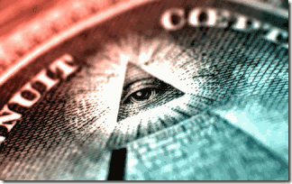
Many believe that Roerich was the guiding hand behind the placement of America’s Great Seal and the All-Seeing Eye on the dollar bill.
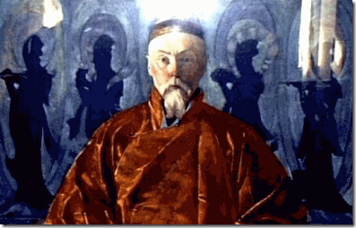
Russian Shambhala Mystic Nicholas Roerich
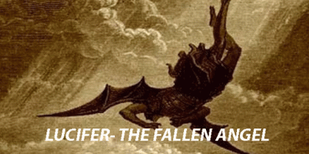
“Many of Henry Wallace’s ideas originated with his guru, the Russian mystic and artist Nicholas Roerich. He was an adventurer/occultist in the tradition of Madame Blavatsky, Aleister Crowley and G. I. Gurdjieff. Roerich spent many years travelling through Nepal and Tibet studying with the lamas in the Buddhist monasteries of those countries. Roerich was searching for the lost city of Shambhala. In esoteric circles Shambhala is the home of the Ascended Masters, Secret Chiefs, or the Great White Brotherhood – the hidden hand behind the formation and guidance of Freemasons, the Sufis, the Knights Templars, the Rosicrucians, the Hermetic Order of the Golden Dawn and the Theosophical Society – both Wallace and Roerich were members of the Theosophical Society, this is how Wallace met his Master.”[60]
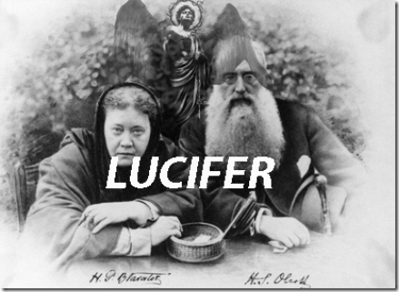
“Lucifer represents.. Life.. Thought.. Progress.. Civilization.. Liberty.. Independence.. Lucifer is the Logos.. the Serpent, the Savior.” Madame Blavatsky
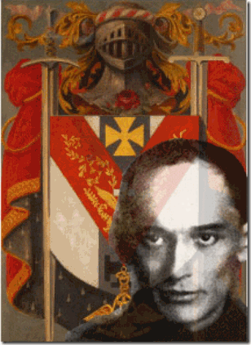
KGB G. I. Bokii, Kabbalistic Order of the Rose- Croix
In St. Petersburg, Roerich was controlled by Cheka, the Bolshevik Secret Police that was later renamed OGPU, NKVD and eventually Putin’s KBG. The head of the OGPU’s “Special Department” was G. I. Bokii, a former member of the Luciferian Kabbalistic Order of the Rose-Croix (OKR+C) in St. Petersburg, that may have also included George Gurdjieff. During the Stalinist purge trials, Bokii confessed to having been part of a Masonic lodge in 1909 that had been founded by Gurdjieff and that included Nicholas Roerich and his wife.
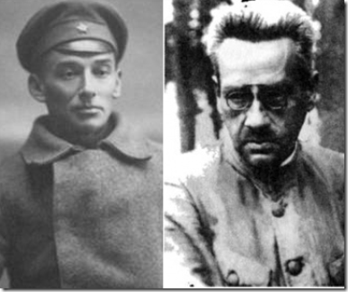
Kabbalistic Bokii & Barchenko
Russia is not a free democratic society, so it isn’t possible to be certain of anything. However, we know something about their quest for Red Shambhala, because they opened Pandora’s Box by clandestinely using the Masonic order, secret societies, and other governments like the U.S. to pursue lost “supernal wisdom” and paranormal powers to rule the world. Russia’s secret involvement in the Occult, Kabbalah and Rosicrucianism by the elite ruling families, religious institutions, military intelligence and royal hierarchical orders have existed since at the very least the 16th century with Dr. John Dee and his son, Dr. Arthur Lee for certain.
In this secret quest, Bokii joined with Aleksandr Barchenko, also a former member of the OKR+C, and former student of Gurdjieff. Bokii was also a member of the Masonic Lodge, Edinoe Trudovoe Bratstvo (ETB), founded by Barchenko, primary aim was establishing contact with Shambhala. ETB initiates included numerous other current or former Chekists (Bolshevik Secret Police), British double-agents, and Jewish Kabbalists. The ETB lasted until Stalin attempted to disband in the late 1930s, following charges leveled against Bokii, Barchenko and their associates, that their occult Masonic activities were part for treasonous plots associated with British intelligence in the Far East.[61] This leads us directly to Putin, Donald J. Drumpf and Jareb Kushner. Barchenko’s Masonic Lodge ETB secret initiates included none other than the 6th and 7th Rebbes Rabbi Yosef Yitzchak Schneersohn, and Rabbi Menachem Mendel Schneersohn’s United Labor Brotherhood (ULB) that had been setup by the Kabalistic/Zohar Hasidic Movement in Brooklyn, New York. Jareb Kushner and Ivanka Drumpf are among the secret imitates of ETB/ULB and the 7th Jewish Messiah, Rabbi Menachem Mendel Schneersohn that they paid homage to on the eve of the 2016 presidential election.
Barchenko modeled ETB/ULB after George Gurdjieff’s brotherhood, United Labor Commonwealth or Fellowship (ULC). Here is the “ice cream on the cake” if you don’t believe any of this. Future scientist-adventurer and science fiction writer Alexander Barchenko before the October Revolution of 1917, graduated from the classical school in St. Petersburg, studied at the medical faculties at the Kazan and Yuriev (Tartu) University. For a time, he served in the Ministry of Finance and then became a writer. He also studied palmistry, telepathy and parapsychology.
Barchenko was recruited into a special department of the OGPU (Bolshevik Secret Police) led by a hereditary Russian aristocrat, Gleb I. Boki, who was one of the founders of the Gulag. OGPU allocated Barchenko a huge research sum in those days. He received new authorities carte blanche for unlimited access to Russian archives and any information he needed.[62] However, don’t get it twisted. It wasn’t the OGPU and Bokii leading Barchenko. Bokii’s advancement in the Kabalistic Order of the Rose-Croix was approved by none other than Aleksandr Barchenko.
Barchenko’s secret research lab conducted experiments with Buddhist, lamas, shamans, hypnotists, Kabbalists, and all kinds of paranormal and spiritual experts. The goal was to use this knowledge to spearhead the cause of communism- secretly agitate for world dominion of the (Jewish) Kabbalah (the Babylonian derivative of the ‘Ancient Mysteries’) system, by any and all means.
V
BARCHENKO & THE MYTHOLOGICAL HYPERBOREA
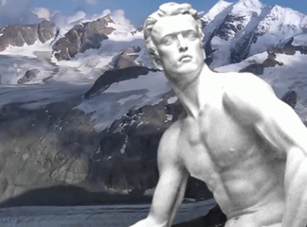
Awaken Hyperborea
By 1924, Barchenko and Bokii sat in control of the OGPU’s Spetsotdel, or “Special Department.” The Spetsotdel handled codes and included an elite “7th Section“, which delved into paranormal issues ranging from hypnotism and ESP. The Spetsotdel also guarded the so-called “black dossiers,” the personal files of the Soviet leaders which included sexual kinks and, undoubtedly, any association with things occult. Bokii had practical incentive to pursue paranormal research. Telepathic communication offered a perfect means to send and receive messages from agents abroad. Remote Viewing, later exploited by Himmler’s SS and CIA, offered the ability to spy on enemies without leaving Moscow. Barchenko and Bokii worked to unlock the secrets of hypnotism and mind control. To explore such matters, Bokii and Barchenko setup a special “neuroenergetics” lab within the All-Union Institute for Experimental Medicine.[63]
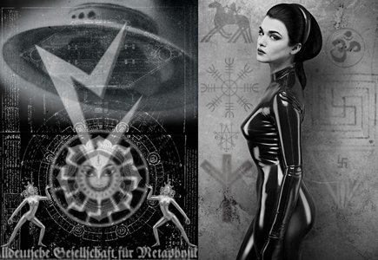
HYPERBOREA VRIL SOCIETY MAIDEN
In the 1920s, Barchenko was listed as an employee of the Scientific and Technical Branch of the All-Union Council of National Economy. He led organized expeditions to areas where there was abnormal phenomena in search of the secrets of influence on the human psyche. The first expedition was equipped in 1921 on the Kola Peninsula. Barchenko believed that the ancient inhabitants of these places, the Hyperboreans, were able to split the atomic nucleus using nuclear energy, opened the airspace and built the first aircraft. Barchenko believed that only bearers of the memory of the ancient people, Sami shamans, who lived in the Kola Peninsula, Northwest Russia, had information on the possible whereabouts of Hyperborea. Barchenko’s expedition was organized as a task of the Institute for the Study of the Brain, and was adamant that he had found evidence of the existence of Hyperborea. Hyperborea was a mythological civilization that once occupied Shambhala and Atlantis after great earth cataclysms mentioned in Ancient Greek texts.
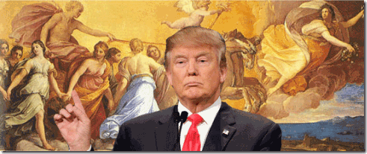
Donald Drumpf & His God Apollo
According to Ancient Greek legends, the land of the Hyperboreans, the people who had ultra secret knowledge and were close to the gods, was home to Apollo, the personification of the Sun. In Greek mythology, Pythagoras was taught sacred geometry by Apollo, a god who was identified as a resident of Hyperborea. [64],[65]
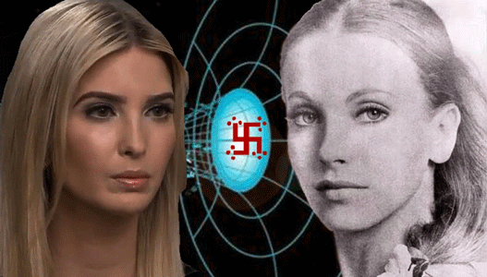
Awaken Hyperborea- Ivanka & Vril Maiden Maria Orsic
“One of the forces supposedly used in these pre-Flood times was a mysterious energy that the Nazis discovered, called the Vril force. The Vril force, the energy fields studied by Nicola Tesla, and what is now called scalar technology are based on similar theories deriving from of quantum mechanics. Scalar Technology is based on the theory that there is a fourth dimension where powerful energies for destruction or healing on a planetary level can be transferred into our three dimensional reality and change that reality. The Nazi concept of a Vril force is based on the idea that a race of god men came from the stars in ships powered by this force and settled on the legendary island of Thule where they founded the civilization called Hyperborea. Plato believed in the Egyptian legend of Atlantis and Herodotus spoke of the another Egyptian legend of the continent of Hyperborea in the far north. When an ice age supposedly destroyed Hyperborea, this race of god men migrated south and it may be they who created the empire of Atlantis…
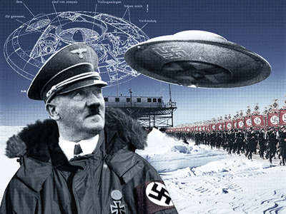
Awakening Hyperborea – Adolf Hitler & the SS
The secret occult societies that put Hitler into power were extremely interested in Antarctica beginning in the 1930s. The Vril and Thule societies searched the ancient Tibetan, Indian, and Greek texts. Mixing these legends with Nordic legends of blonde haired blue eyed gods, they came to the conclusion that the Earth is hollow and inhabited within. Ultima Thule is supposed to have been the name of the capital city of the continent of Hyperborea, which was older than Atlantis. According to occult teachings, the Hyperborean’s were the most highly technologically and socially advanced society that existed in the pre-Flood age. When the Flood came the Hyperborean’s dug large tunnels through the Earth’s crust using giant machines and settled under the Himalayas. According to their legends they named their new kingdom Agharta or Agharti and its capital city was Shambhala, which was the legendary paradise on Earth.”[66]
Barchenko allegedly discovered a mysterious hole under the ground that emitted mystical powers. In 1922, in the vicinity of the Sami Saydozera on the Kola Peninsula, Barchenko allegedly found ancient pyramids.[67]
THE 6TH & 7TH REBBES SOLD THEIR SOULS TO LUCIFER
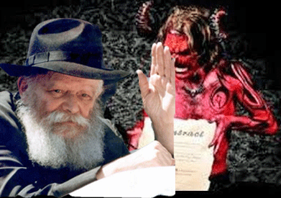
In Leningrad, Soviet Union in 1925, the 6th Rebbe Rabbi Yosef Yitzchak Schneersohn and Professor Alexander Vasilyevitch Barchenko initiated the 7th Rebbe, Menachem Mendel Schneerson, into the mystical Satanic Masonic Lodge of ETB- The United Labor Brotherhood. It isn’t certain when Yosef Yitchak sold his soul to Lucifer, and had been initiated into ETB as a clandestine Russian agent- “Searcher After the Truth“, but it is certainly admitted that Menachem Mendel was an initiate of Barchenko. From that moment on, Rebbe Menachem Mendel’s was dedicated to the Lucifer, KGB, and Barchenko’s ETB’s search for the lost “Vril Energies” of Red Shambhala. [68],[69]
Of course, the OGPU and Barchenko’s 7th Section provided the 6th and 7th Rebbes travel visas to Paris, Berlin, and the U.S. As early as 1929, Rabbi Yosef Yitzchak entered U.S. to establish ETB in Brooklyn. Immediately after his wedding to the 6th Rebbe Rabbi Yosef Yitzchak’s eldest daughter, he was off and running on behalf of the KGB. Rabbi Menachem Mendel and his young wife left Warsaw, Poland for Berlin, Germany. At the University of Berlin, he studied physics, geometry, mathematics, engineering, and philosophy. The couple fled to Paris, France in 1933 after the Nazi takeover. In Paris, Rabbi Menachem Mendel was allowed to enter a highly selective, elite and exclusive engineering French institution without credentials to study philosophy, theoretical physics, geometry and mathematics. In Paris, he was also reputed to have enrolled at the Sorbonne (where he studied physics), and at the Polytechnic Institute’s faculty of mechanical engineering.[70]
In the summer of 1940, the Nazis invaded France, the Schneersons managed to flee Paris on one of the last trains to leave before the Germans captured the city. With their Russians visas expired, they were stuck in France under Nazi rule. Immense efforts were being made to bring the Schneersons to America, where the Rebbe, Rabbi Yosef Yitzchak had already settled. In order to arrange the Schneerson’s move to America, supporters dispatched telegrams, placed transatlantic calls, exerted pressure on the U.S. State Department, and, of course, paid a great deal of money. Eventually the Schneersons did manage to leave France, and reached America via Spain and Portugal.[71] It certainly appears that the Schneersons followed the same Vatican- Office of Strategic Services (OSS) ratlines followed by double Nazi and Soviet spies and assets via Spain and Portugal to enter North and South America.
One of the 20th century’s most guarded and protected secrets are the Russian, German, British, U.S., Chinese, and other militaries’ quest and employment of the ancient occult (advanced abilities in ESP, remote viewing, and telepathy) in war and peace. In America, the (OSS) and U.S. Naval Intelligence were in charge of the WWII’s secret Occult and Paranormal activities and undertakings.
Remarkably very soon after arriving in America on June 23, 1941 during WWII, Rabbi Menachem Mendel out of Italy had to have cleared by the FBI, OSS and Naval Intelligence to be hired by the U.S. Navy as an electrical engineer for an ultra secret project at the Brooklyn Naval Yard. [72],[73] My guess is that the OSS rescued the Schneersons out of France to keep Rabbi Menachem Mendel out of Himmler’s SS hands that were also hot on the trail and pursuit of the “Vril Energies” of Shambhala.
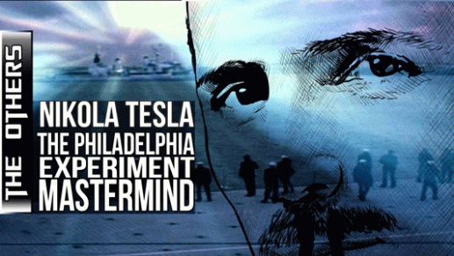
In America, Project Rainbow was an ultra secret experiment in the realm of the paranormal- zero point energy, time travel, anti-gravity, time loops and sacred geometry– Vril Energy. From October 1920 until May 1923, Nicholas Roerich spent significant amounts of time in Chicago at the University of Chicago.[74] In the 1930’s, Nikola Tesla got involved with a group that was experimenting with moving through the Time/Space continuum. In the early 1930’s, the University of Chicago investigated the possibility of invisibility through the use of electrical magnetic fields.
“The Philadelphia Experiment” by Charles Berlitz and William Moore say that “The Philadelphia Experiment” aka Project Rainbow came to being in 1931 when in Chicago a small group of scientists got together to investigate the possibility of de-magnetism of war ships. The team included John Hutchinson, the Dean of the University of Chicago, Dr. Emil Kurtinauor, an Austrian Physicist, and Dr. Nikola Tesla. Tesla was director of Engineering and Research at RCA. at the time. Freemason Franklin D. Roosevelt (then Secretary of the Navy) was there, a personal friend of Tesla. The U.S. was having problems with a magnetic mine that the Germans had developed and wanted to investigate the possibility of De-Magnetizing ships.[75]

Project Rainbow started in the Brooklyn Naval Yard, and in 1940, they achieved for the first time full invisibility with a mine sweeper vessel (without any crew). Two Radio Transmitters and one main generator drove a series of four conical coils, generating an intense magnetic field. These oppositely wound coils produced a zero magnetic field – which is a Scalar Field, or what is referred to as a Scalar Value of Zero or the Zero point energy of the Vacuum (VRIL ENERGY).
In 1942, Tesla was given a battleship but he became very concerned when he was told the experiment would contain live crew. He complained about this. It is one thing to make invisible (or time travel) an object like a ship, but people have individual time references. Tesla may have altered the settings on the equipment but what happened when the experiment took place in March 1942 was that nothing happened. Ten (10) months later, Nikola Tesla was found dead in January 1943.[76]
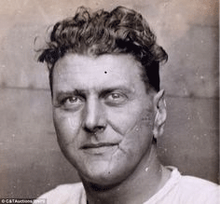
SS Scarface
There is a strong possibility that the SS (Obersturmbannführer Otto “Scarface” Skorzeny) assassinated Tesla before he could compete the “Veil of Invisibility” experiments for the OSS/U.S. Navy. The SS also is alleged to have hijacked his files and records from his safe. I also suspect that Rabbi Menachem Mendel studies in electrical engineering from some of the most elite engineering institutions in Russia, France and Germany since at least 1925 on behalf of EBT/ULB centered around Tesla and Shamblala’s secret Scalar (Vril) Energy. It it very plain and clear that.
“In 1925, he [Barchenko] met and corresponded with Rabbi Menachem Mendel Schneerson, who assisted him in his research and studies of religious and mystical matters.” It just can’t be any clear than that, folks! Rabbi Menachem Mendel was employed as an electrical engineer with the U.S. Navy at the Brooklyn Naval Yard for about a year until sometime after June 1942. His work was/is labeled as highly “CLASSIFIED” and “TOP SECRET.”[77] Now. You understand, why.
V
CONCLUSION

1937-38, Stalin and the KGB Take Red Shambhala UNDERGROUND and CLASSIFIED
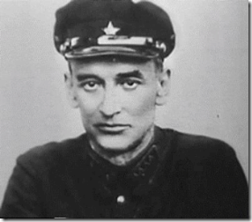
In the 1937-38 in the Great Red Purge in Russia, both Barchenko and Bokii were suddenly arrested accused of espionage and terrorist activity. Gleb Ivanovich Bokii was given a summary trial and executed in November of that same year.
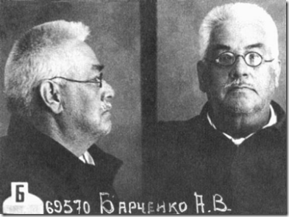
Barchenko was also tried, and convicted. On April 25, 1938, he was shot. Stalin and KGB seized all of their books, records, diaries. He seized and sealed all of books, records, diaries of OGPU’s “Spetsotdel”, or Special Department, and 7th Section. He closed everything down and classified everything regarding the department that included Brachenko’s ETB/ULB.
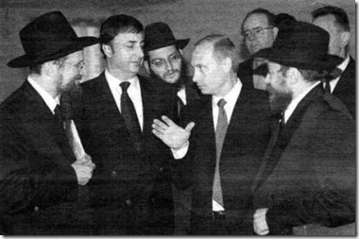
Well, guess who holds the keys to OGPU’s “Spetsotdel”, or Special Department, 7th Section, and Bokii and Barchenko’s books, files, records, diaries?
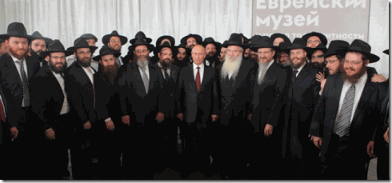
Guess who possess everything about Barchenko’s ETB/ULB and now control the ultra secret ETB/ULB Masonic Lodge, and the Hasidic Movement in Brooklyn and New York City (Donald J. Drumpf, Charles Kushner, Jared Kushner, Ivanko Drumpf)?
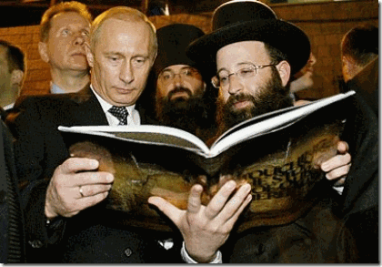
In 2016, Russian President Vladimir Putin visited Moscow’s Jewish Museum and Tolerance Centre as an important collection of ancient Jewish books, the 7th Rebbe’s Schneerson Library was logged into the center.
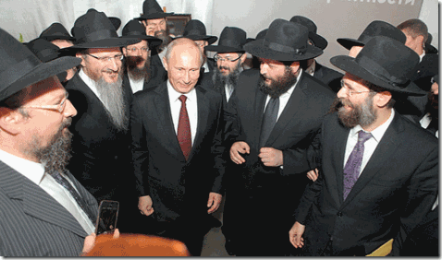
Putin familiarized himself with the most valuable parts of Rabbi Menachem Mendel Schneerson’s library collection, which contains some 12,000 books and 50,000 rare documents dating from the 18th to the beginning of the 20th century. Putin maintains that the Schneerson Library is nationalized Russian state property.
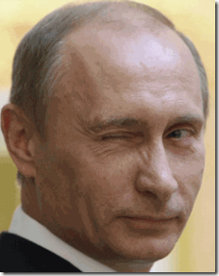
You probably won’t find anything in the Rabbi Menachem Mendel Schneerson’s library in Russia about OGPU’s “Spetsotdel”, Brachenko, Bokii or ETB/ULB.

Pyramid Symbol of the ILLUMINATI and the New SHAMBHALA, Chelsea Clinton & Putin
Putin, the Masonic Order and the KBG are already busy creating America’s next generation of politicians and so-called public servants.


Chelsea Clinton and her Jewish husband, Marc Mezvinsky, are close personal friends of Ivanka and Jared Kushner. No matter whether the next president is named Clinton or Drumpf, a Jewish son-in-law is sure to visit the White House some time before next Rosh Hashanah.

If these Luciferians can’t pull the veil over the eyes of the babies, what more should we be able to SEE with your eyes open!

[1] https://en.wikipedia.org/wiki/Bergen
[2] http://www.clanmacleod.org/genealogy/macleod-genealogy-research/the-origin-of-leod.html
[3] http://www.dailymail.co.uk/news/article-3934470/Donald-Trump-believed-direct-descendant-Rurik-Viking-established-Russian-state.html
[4] http://www.factbook.org/wikipedia/en/n/na/navahradak.html
[5] http://www.haaretz.com/world-news/u-s-election-2016/1.729620
[6] http://www.redicecreations.com/specialreports/2005/11nov/secreteurasia.html
[7] https://www.jw.org/en/bible-teachings/questions/torah-pentateuch/
[8] https://en.wikipedia.org/wiki/Torah
[9] https://en.wikipedia.org/wiki/Zohar
[10] http://www.haaretz.com/world-news/u-s-election-2016/1.751279
[11] http://beforeitsnews.com/alternative/2013/12/the-holy-sabbath-is-actually-the-worship-of-the-planet-saturn-satan-2856250.html
[12] https://en.wikipedia.org/wiki/Witches%27_Sabbath
[13] http://www.haaretz.com/world-news/u-s-election-2016/1.751279
[14] https://en.wikipedia.org/wiki/Rebbe
[15] https://en.wikipedia.org/wiki/Lurianic_Kabbalah
[16] https://en.wikipedia.org/wiki/Isaac_Luria
[17] http://www.nanach.org/books/nanach-flier.pdf
[18] https://en.wikipedia.org/wiki/Kabbalah
[19] https://en.wikipedia.org/wiki/Nachman_of_Breslov
[20] Zenon Guldon and Jacek Wijaczka,’ The Accusation of Ritual Murder in Poland, 1500-1800′, Polin: Studies in Polish Jewry, Vol. 10, Jews in Early Modern Poland (edited by G.D. Hundert), London 1977, pp. 99-140
[21], Jacek Wijaczka, “Ritual Murder Accusations in Poland throughout the 16th to the 18th Centuries”: S. Buttaroni and S. Musial (eds.), Ritual Murder: Legend in European History, Cracow 2003, pp. 208-209.
[22] See: Rachel Elior, Israel Baal Shem Tov and his Contemporaries (in Press) [forthcoming in Hebrew]
[23] https://www.academia.edu/3428448/The_Origins_of_Hasidism
[24] https://en.wikipedia.org/wiki/Moses_de_Le%C3%B3n
[25] https://en.wikipedia.org/wiki/Simeon_bar_Yochai
[26] Id.
[27] http://www.testimonios-de-un-discipulo.com/The-Atonement-of-Azazel.html
[28] Id.
[29] https://en.wikipedia.org/wiki/Samael_Aun_Weor
[30] http://www.testimonios-de-un-discipulo.com/The-Atonement-of-Azazel.html
[31] http://www.jewfaq.org/kabbalah.htm
[32] https://en.wikipedia.org/wiki/Chabad
[33] http://catalog.lehrhaus.org/course/2016/fall/T600-OMJ/
[34] http://www.businessinsider.com/jared-kushner-security-clearance-russia-investigation-2017-5
[35] http://www.politico.com/magazine/story/2017/05/25/jared-kushner-russia-fbi-donald-trump-215191
[36] http://www.haaretz.com/world-news/u-s-election-2016/1.729620
[37] https://en.wikipedia.org/wiki/Navahrudak
[38] https://therealdeal.com/issues_articles/jared-kushner-the-accidental-ceo/
[39] https://en.wikipedia.org/wiki/Karl_Wolff
[40] https://www.uscis.gov/ilink/docView/PUBLAW/HTML/PUBLAW/0-0-0-23651.html
[41] https://en.wikipedia.org/wiki/Rae_Kushner_Yeshiva_High_School
[42] https://en.wikipedia.org/wiki/Torah_Umesorah_%E2%80%93_National_Society_for_Hebrew_Day_Schools
[43] http://www.rca.edu/templates/articlecco_cdo/aid/3590677/jewish/Board-of-Trustees.htm
[44] http://jewishwebdesign.com/brooklynjewishcenter/blog/?p=85
[45] http://www.brooklynjewishcenter.org/history.php
[46] http://www.wikiwand.com/en/Oholei_Torah
[47] http://www.hidabrut.com/article/178516/RARE-PHOTO-Trumps-Father-Donated-Land-for-a-Cheder
[48] https://en.wikipedia.org/wiki/Yitzchok_Friedman
[49] https://en.wikipedia.org/wiki/Boyan_(Hasidic_dynasty)
[50] https://en.wikipedia.org/wiki/Ruzhin_(Hasidic_dynasty)
[51] http://mileswmathis.com/trump.pdf
[52] https://en.wikipedia.org/wiki/Murray_Kushner
[53] http://wariscrime.com/new/royal-arch-freemason-vladimir-putin-majestys-secret-service/
[54] http://freemasonry.bcy.ca/aqc/gl_russia.html
[55] http://wariscrime.com/new/royal-arch-freemason-vladimir-putin-majestys-secret-service/
[56] http://www.conspiracyschool.com/blog/occult-secrets-dalai-lama
[57] https://www.henrymakow.com/2013/08/George-Gurdjieff%20.html
[58] http://www.conspiracyschool.com/blog/occult-secrets-dalai-lama
[59] http://www.ign.com/boards/threads/i-know-some-people-arnt-real-big-into-conspiracies-but-this-is-a-good-read.250291451/
[60] http://www.ign.com/boards/threads/i-know-some-people-arnt-real-big-into-conspiracies-but-this-is-a-good-read.250291451/
[61] http://www.conspiracyschool.com/blog/occult-secrets-dalai-lama
[62] http://survincity.com/2013/07/traces-of-ancient-civilizations/
[63] http://www.newdawnmagazine.com/articles/red-star-over-shambhala-soviet-british-and-american-intelligence-the-search-for-lost-civilisation-in-central-asia
[64]https://www.rbth.com/science_and_tech/2014/11/13/looking_for_the_russian_shambhala_in_the_arctic_circle_41367.html
[65] https://www.pinterest.com/pin/408631366170711461/
[66] http://newswithviews.com/McGuire/paul164.htm
[67] https://survincity.com/2013/07/traces-of-ancient-civilizations/
[68] http://www.chabadhousemonroe.com/page.asp?pageID=B963EBED-7628-4449-B063-FB2D661DC7DC
[69] https://en.wikipedia.org/wiki/Menachem_Mendel_Schneerson
[70] http://www.chabadhousemonroe.com/page.asp?pageID=B963EBED-7628-4449-B063-FB2D661DC7DC
[71] http://www.chabadhousemonroe.com/page.asp?pageID=B963EBED-7628-4449-B063-FB2D661DC7DC
[72] https://en.wikipedia.org/wiki/Menachem_Mendel_Schneerson
[73] http://www.chabadhousemonroe.com/page.asp?pageID=B963EBED-7628-4449-B063-FB2D661DC7DC
[74] https://en.wikipedia.org/wiki/Nicholas_Roerich
[75] http://www.phils.com.au/philadelphia.htm
[76] http://www.phils.com.au/philadelphia.htm
[77] http://www.jlconline.org/media/pdf/529/SCcr5296807.pdf

Comments : Leave a Comment »
Tags: Adolf Hitler, Agarthi, ahnenerbe, Aleister Crowley, Aleksandr Barchenko, ALL SEEING EYE, All-Union Council of National Economy, All-Union Institute for Experimental Medicine, angel azazel, angel Samael, apollo, ascended masters, atlantis, barack hussein obama, Beach Haven Apartment Complex Project, Beach Haven Jewish Center, Bektashi Sufis, Benjamin "Bibi" Netanyahu, bergen, blood covenant, blood libel, blood rituals, blood sacrifice, Bolshevik Secret, Boyan Hasidic dynasty, british secret service, brooklyn jewish center, chabad, Chabad Lubavitch, charles kushner, Chelsea Clinton, CIA, columbian lodge, Count of St. Germain, devil, donald j. drumpf, donald j. trump, dr. arthur dee, Dr. Emil Kurtinauor, dr. john dee, Edinoe Trudovoe Bratstvo, ETB, FALLEN ANGEL AZAZEL, fallen angel lucifer, FALLEN ANGEL SAMAEL, fallen angels, franklin d. roosevelt, fred c. drumpf, fred c. trump, freemasons, G. I. Bokii, George Gurdjieff, god saturn, grand lodge of england, Great Red Purge, Great White Brotherhood, harald hardrade, Harry B. Helmsley, Harry Macklowe, hasidic movement, hyperborea, hyperborean, Illuminati, Issac Luria, ivanka trump, jareb kushner, Jerry I. Speyer, joseph kushner, joseph stalin, kabbalah, Kabbalistic Order of the Rose- Croix, Karl Haushofer, KGB, king olaf, king solomon temple, kings of norway, Knights of the Black Sun, knights templar, land of rus, Larry A. Silverstein, Leonard Litwin, Lubavitcher rebbe, Lucifer, luciferians, Lurianic Kabbalah, macleod, MacLeods, Madame Blavatsky, Marc Mezvinsky, masons, mi6, Mikhail Romanov, mind control, MK-ULTRA, moses, Moses de León, mossad, Nachman of Breslov, National Jewish Welfare Board, NATO, neuroenergetics, Nickola Tesla, nicola tesla, nicolas roerich, norway, novgorod, Obergruppenführer SS Karl Wolff, Obersturmbannführer SS Otto Skorzeny, Office of Strategic Services, OGPU, olaf the black, or the Great White Brotherhood, or the Great White Brotherhood – the hidden hand behind the formation and guidance of Freemasons, order of the golden dawn, OSS, paranormal power, Prime Minister of Montenegro, Project Rainbow, putin, Rabbi Israel Baal Shem Tov, Rabbi Shimon bar Yohai, Rabbi Yosef Yitzchak Schneersohn, Rae Kushner, Rebbe Menachem M. Schneerson, Rebbe Rabbi Yitzchak, Rebbe Yitzchok Friedman. Bunny Lindenbaum, Reichsfurhrer Heinrich Himmler, Rosicrucianism, royal york masons, Rudolf Hess, ruik the viking, rurik the viking, Sabbatai Zevi, Sabbateans, Samael Aun Weor, samuel lindenbaum, scalar technology, Scandalous Fred C, Schneerson Library, scottish rite, second temple, Secret Chiefs, shambhala, Society of Green Men, solomon's temple, Sorbonne, steve bannon, Steven Roth, supernal wisdom, tammany hall, tesla, Tesla technology, the Hermetic Order of the Golden Dawn, the Knights Templars, The Philadelphia Experiment, the Rosicrucians, the Sufis, the World Zionist Congress, Theosophical Society, third degree, thule, torah, U.S. Naval Intelligence, ultima thule, United Jewish Appeal, United Labor Brotherhood, United Labor Commonwealth or Fellowship, United Synagogue of America, vikings, Vladimir Putin, vril, vril gesellschaft society, vril society maidens, york rite masons, zionists, zohar
Categories : 1000 Year Reich, Aleister Crowley, ALL SEEING EYE, Apollo, Aryan Supremacy, ascended masters, baal, black christianity, Black Sabbath, blood covenants, blood oaths, blood sacrifice, Brotherhood of the Bell, CIA, Crimes Against Democracy, cybele, devil, devil's horns, donald j. drumpf, donald j. trump, donald trump, evil, Eye of Horus, fallen angels, false prophet, false prophets, freemason, freemasons, genesis, Heinrich Himmler, human sacifrice, illuminati, illuminati sacrifice, john dee, Karl Haushofer, KGB, Knights of the Black Sun, Knights Templar, lucifer's servants, luciferians, Madame H.P. Blavatsky, masonic sacrifice, mind control, MK-ULTRA, monarch program, MOSSAD, MPD, nato, Nazis, Operation PAPERCLIP, Paperclip Project, power control group, queen elizabeth, racial mass murder, Reichsfurhrer SS-1 Heinrich Himmler, Ritual Satanic Abuse, rose and cross, Rose-Croix, Rosicrucian, Rosicrucianism, satan, scottsish rite, Secret Doctrine, SS, thule, trauma-based mind control, underground reich, underground third reich, vril, ZIONIST

DONALD J. DRUMPF, ROBERT MUELLER III, THE HANDS OF DARK CABAL & THE DEVIL
25052017

I
“BOB MUELLER IS THE KINDEST … “
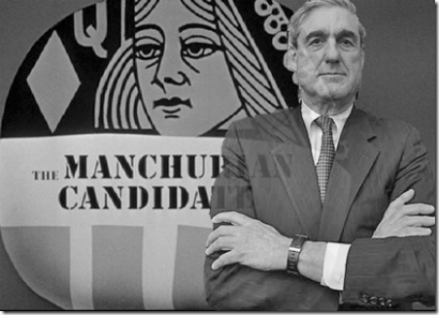
“Bob Mueller is the kindest, bravest, warmest, most wonderful human being I’ve ever known in my life.”
Bob Mueller believes that he is the kindest, bravest, warmest, most wonderful human being known to mankind by divine pre-election, and predestination. Mueller was raised within a secret core inner circle of Calvinist Masonic Luciferian Philosophy that is by far more secret, dangerous and Satanic than Calvinist Protestantism. Reformist Preacher Calvin taught “predestination” by unconditional divine law the idea God has chosen some from birth for salvation and heaven, all others, the unchosen, damnation and hell. Calvinist Protestantism, in itself, leaves entire impunity to private oppression except for a few temporal rules generally framed and always applied by the oppressors themselves. In Calvinist Protestantism, truth, righteousness, fairness and justice is no factor to God’s Salvation and Heaven for the unchosen. Secret Calvinist Masonic Luciferian Philosophy, the ancient EVIL GOD SET- SETH, SATAN, APEP OR APOPHIS (DRAGON) is Lord and God.
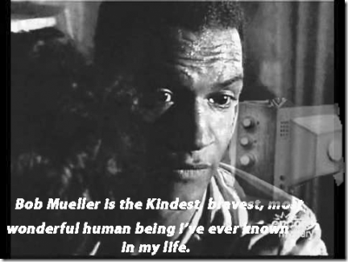
II
WE CALL UPON THE NAME OF THE ALL MIGHTY ZEUS
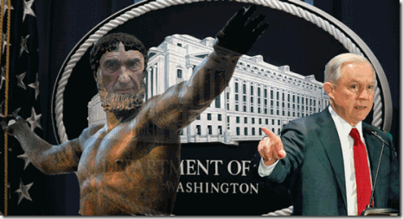
Robert Mueller III & Jeff Sessions
On May 17, 2017, pathological liar, U.S. Attorney General Jeff Sessions and the Department of Justice, in the face of rising pressure from Capitol Hill and the masses, named former FBI chief Robert Mueller III as “special counsel” to investigate alleged Russian interference in the 2016 U.S. election and possible collusion between President- select Donald Drumpf’s campaign and Moscow.[1] It seems that Mueller didn’t even have to think about accepting the job as “special counsel” to investigate Drumpf and Russia for the Justice Department and the People. From the very start, he has been an eager beaver- “Johnny on the Spot” off and running..
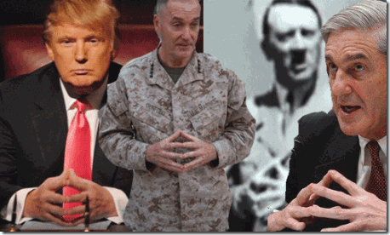
Dark Cabal Pyramid Hand Symbol- ALL THE SAME PEOPLE
The New York Times reported that Mueller is planning to demand Congressional committees investigating Russia, Drumpf, and other related matters, to BACK OFF.[2] He is also likely to remove and lock up ALL of the Justice Department’s evidence from Congressional eyes. That’s the way, Robert Mueller III, Shadow Government and the ILLUMINATI roll.
“Robert Mueller might just be America’s straightest arrow—a respected, nonpartisan and fiercely apolitical public servant whose only lifetime motivation has been the search for justice. He was the most influential and longest-serving FBI director since J. Edgar Hoover himself, and someone who has settled since his retirement from government in 2013 into being that rare voice-beyond-reproach that companies and organizations recruit to lead investigations when they need to tell shareholders or the public that they’ve hired the most seasoned and respected person they can find, someone who will pursue a case wherever it leads without fear or favor. He became the first FBI director to serve a complete 10-year term since Hoover, only to then see Barack Obama reappoint him for a special two-year term, a decision that required a special act of Congress and made him the only person to be appointed head of the FBI by two different presidents, of different parties.”[3]
Robert Mueller, America’s straightest arrow – a virtual demigod “apolitical public servant whose only lifetime motivation has been the search for justice.” He is somebody- “… [a] rare voice-beyond-reproach.” They talk of Mueller in almost mythical proportions. It sounds as if Sessions, justice department and Congress have pulled the veil over the masses’ eyes. They are making it seem as though that they have bought down God Zeus (Jupiter) from Mt. Olympus. But, wait a minute, it’s a BIG LIE, the implantation of a GRAND ILLUSION, and painting new and different dots on a leopard.
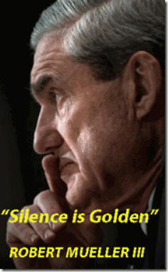
Yet, isn’t this the man that was in charge of investigating (covering-up) Pan Am 103, the CIA Bank of Crooks and Criminals, and 9-11, the Inside Job? YES!
“Robert Mueller III … has had a key role in the parapolitical affairs of the eighties, the nineties and the beginning of the twenty-first century. In the eighties, he defined the history of terrorism when he led the investigation of the bombing of Pan Am 103, a false-flag operation carried out by U.S. intelligence services designed to escalate tensions with Libya. In the nineties, led the investigation of the Bank of Credit and Commerce International (BCCI), a bank with close ties to U.S. and Israeli intelligence that was being used by dictators, terrorist groups, arms cartels, drug cartels, and child prostitution rings, among others. In both cases, he covered up the key role of the CIA, as he would as the director of the field investigation of the attacks.”[4]
In April of 2002, FBI director Robert Mueller admitted that several hijacker identities were in doubt due to identity thefts – made this stunning announcement: “In our investigation, we have not uncovered a single piece of paper – either here or in the treasure trove of information that has turned up in Afghanistan and elsewhere – that mentioned any aspect of the September 11 plot.[5] In one of the greatest terrorist crimes against humanity and democracy of the 21st century, Mueller’s entire FBI with thousands of agents, informants, and a multi-million dollar budget can’t solve identify thief issues– that dog won’t hunt.
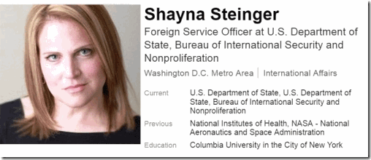

Ask the CIA, and one of their clandestine intelligence agents, Shayna Steinger Singh of Iowa, U.S. State Department, former Science Policy Analysts for NASA, and National Institutes of Health (NIH). She personally handed out visas like loaves of bread to 11 or 12 of the 19 patsy hijackers from the U.S. Consulate in Jeddah, Saudi Arabia. She still works for the U.S. State Department. Mueller could have asked the Saudis for help to identify at least 15 (fifteen) of their own citizens.[6] However, Mueller refused to conclusively identify the alleged 9-11 hijackers, primarily because of their direct links to the CIA, U.S. military intelligence, and Kingdom of Saudi Arabia intelligence.
In July 2017, the U.S. government finally released a redacted version of the declassified missing 28- page report taken from the Congressional Joint Inquiry into the 9/11 Commission report. The report revealed that the Kingdom of Saudi Arabia had contact with and supported some of the Arabic patsy hijackers setup to be blamed for the 9/11 terror attacks. “While in the United States, some of the September 11 hijackers were in contact with, and received support or assistance from, individuals who may be connected to the Saudi Government,” the report claims. “There is information, primarily from FBI sources, that at least two of those individuals were alleged by some to be Saudi intelligence officers.”[7]
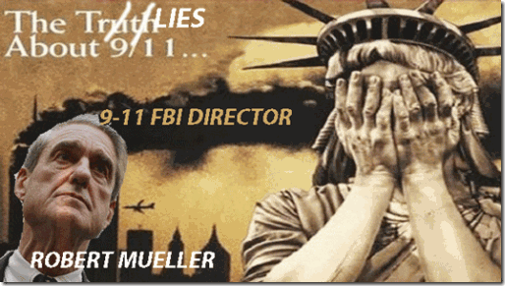
Since 2002, the 9/11 Commission and several government agencies, including the CIA (George Tenet) and the FBI (Robert Mueller), investigated the contents of the declassified 28 Pages then falsely asserted that neither the Saudi government, nor senior Saudi officials, nor any person acting on behalf of the Saudi government provided any support or encouragement for these attacks.
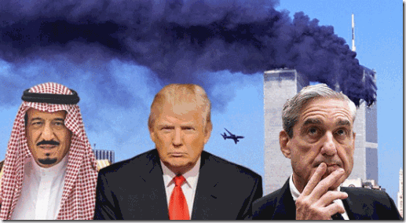
They LIED! 19 (nineteen) of the Arab pasty hijacker scapegoats in the 9/11 attacks, 15 (fifteen) were Saudi citizens; the Kingdom of Saudi Arabia has long had a special relationship financing and sponsoring terrorists and terror organizations.[8]
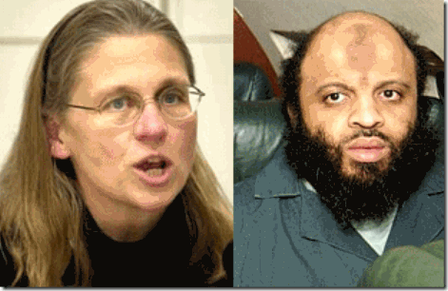
FBI Agent Rowley & MK ULTRA Black Manchurian Candidate- Lunatic Patsy, Moussoui
FBI agent Coleen Rowley wrote a 13 page letter to FBI Director Robert Mueller in which she actually accused the director of her own agency of “a subtle skewing of the facts“. Rowley’s letter also charged that the agency refused to react to evidence of a pending terror plot. According to Rowley, the FBI’s obstruction of 9-11 was so blatant that her and some of her fellow agents jokingly speculated that key FBI personnel must have been moles working for Osama Bin laden! Rowley’s main point of contention was the agency’s failure to go after Zacharias Moussoui, the “20th [Patsy]hijacker“, even after his flight school instructor reported his suspicious behavior to the FBI. Moussoui, you will recall was the French Algerian who couldn’t speak French to his flight school instructor. Even Ray Charles could have observed that Moussoui was mentally challenged.Did Shayna Steinger also give him a loaf of bread- a visa to enter the U.S? [9]
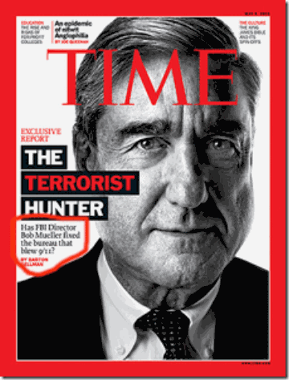
Robert Mueller III and the FBI Blew the 9-11 Investigation
The FBI investigation of 9/11 under Mueller was code-named PENTTBOM. The FBI had special investigative jurisdiction over the 9/11 crime scenes.The subject of the above cover story was: “Has FBI Director Bob Mueller fixed the bureau that blew 9/11?” The article noted that Mueller ran the largest criminal investigation in FBI history, but ignored the fact that he allowed the crucial steel evidence from the World Trade Center (WTC) in New York to be destroyed without being examined by steel (stress) experts. The FBI allowed steel evidence from the WTC, some 280,000 tons, to be hastily removed from the scene of the crime, and recycled via the two junkyards in New Jersey.[10]
“Mueller’s negligence was not the result of ineptitude, but a criminal conspiracy at the Department of Justice to destroy the evidence that could expose the people behind the false-flag terrorism of 9/11.”[11]
He knows ever so well what and who he is- a member of the global power control group (PCG). Mueller’s primary duty and responsibility is not to the democracy, but to protect the status quo and interests of the New World Order, not the people of the United States. The unfunny and sick thing about “Straight Arrow Bob” is that he has blown and covered-up each and every “special“ investigation into the wrongdoings, corruption and abuse of power by the CIA, government and shadow government that he has even been in charge of. Mueller will be another wicked thrill ride of an ILLUMINATI master public deception Drumpf- Russia Investigation.

Yet, “Straight Arrow Bob” still eagerly believes that he can make a fool of the masses and the democracy, once again. Is Robert Mueller III a LUNATIC that continues to do the same thing over and over again expecting a different result?
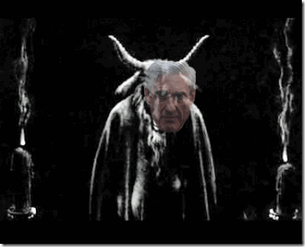
Or is he ABSOLUTELY EVIL like the persons that he has been charged to investigate (COVER-UP)?
III
MUELLER- ILLUMINATI/SATANIC BLOODLINE
The Astors and Truesdales & The Ancient Cult of Astarte-Cybele
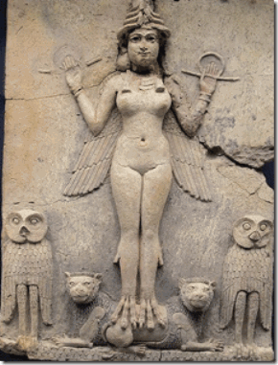
Goddess Astarte
This background is necessary. Of course, it involves a long lost history, but you will not understand the kinds and cults of power of a Robert Mueller, who was in the middle of the cover-up of 9-11, one of the greatest crimes against democracy in the 21st century. And Right this minute, he has asserted himself right smack in the middle of the President-select Drumpf-Russian Investigation that has the real potential to impact all of our lives here, and the humble masses around the world.
The Astor Satanic Bloodlines of America and England are descendants of the Astorga family found in Southern Italy before the 1600s. The most likely meaning of the name is that both Astorga and Astor are variations meaning “Astarte”. Her name is also Semiramis/Cybele.[12] They were priests, priestesses, followers and initiates of the Cult of Astarte/ Cybele from remote times that Christianity and the Vatican forced underground..
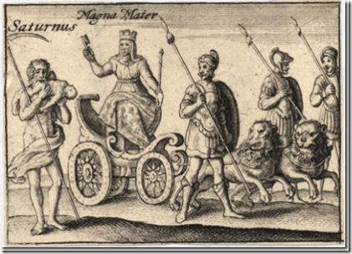
Magna Mater- Goddess Cybele & Saturn (Child Sacrifice)
In Ancient Babylon, the religious trinity was Nimrod (the Sun), Semiramis (the Moon), and Tammuz (the Morning star).[13]
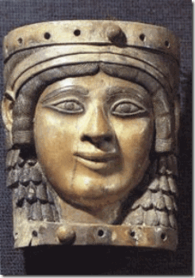
Goddess Astarte
Astarte or Ashtoreth is the Hellenized form of Goddess Ishtar, worshipped from the Bronze Age through classical antiquity. The name is particularly associated with her worship in the ancient Levant among the Canaanites. Some ancient sources assert that in the territory of Sidon, the temple of Astarte was sacred to Europa. According to an old Cretan story, Europa was a Phoenician princess whom Zeus having transformed himself into a bull, abducted, and carried to Crete. Some scholars claim that the cult of the Minoan snake goddess who is identified with Ariadne (the “utterly pure”) was similar to the Cult of Astarte.
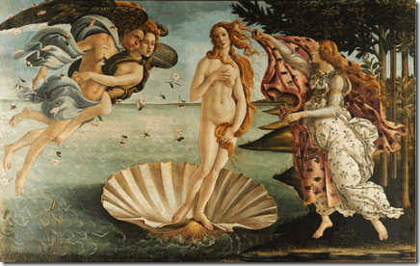
Medieval Aphrodite- Venus
Her “Cult” as Aphrodite was transmitted to Cythera and then to Greece. Herodotus wrote that the religious community of Aphrodite originated in Phoenicia (Canaan) and came to Greeks from there. He also wrote about the world’s largest temple of Aphrodite, in one of the Phoenician cities. Her name is the second name in an energy chant sometimes used in Wicca: “Isis, Astarte, Diana, Hecate, Demeter, Kali, Inanna.”[14]
1.
Astors, Knights Templar and the Baphomet
The Astors—the name was variously spelled Astore and Aoster—were Italian Protestants from the Alpine village of Chiavenna, Italy.
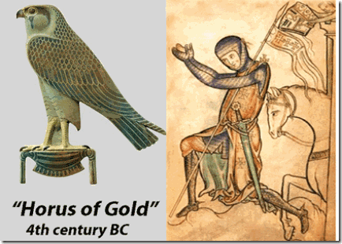
Left Foot Forward Hawk & Fourth Crusade Knight Templar
The medieval ancestor of the Astors tied to heretic Poor Fellow-Soldiers of Christ and of the Temple of Solomon was Castilian aristocrat Pedro de Astorga of Castile- León, Knights Templar Castle Ponferrada near Astorga in northwestern Spain, whose coat of arms featured a goshawk.[15 Not much is revealed about the Castilian aristocrat Pedro de Astorga of Castile- León of the Knights Templar Order of Calatrava. But, Ponferrada and Astorga have been around since Celtic times and grew in importance and prosperity during the Roman occupation because of the gold mines in the El Bierzo region, then it was known as Interamnium Flavium. In the Middle Ages it became known as Puebla de San Pedro named after its church. The church was part of the Roman Catholic Diocese of Astorga.
The first Bishop of Astorga was Belisarius, who served during the reign ( from 249 to 251 AD) of the Emperor Decius and faced the persecution waged under this ruler. The bishop was dismissed from his position, accused of having been a libellaticus, i.e., a Christian who had offered sacrifice to the Roman gods to avoid arrest. The bishop was re-instated after the intervention of the prominent African bishop, Cyprian, and Pope Stephen. The Templars of Ponferrada– Astorga were setup in 1196 by Alfonso VIII of Castile, King of Toledo.He established a royal bloodline coalition with English by marriage to Eleanor, daughter of King Henry II of England and Eleanor of Aquitaine, the Merovingian- Holy Grail Bloodlines. Knight Pedro de Astorga was killed in Jerusalem on the Fourth Crusade in 1203.
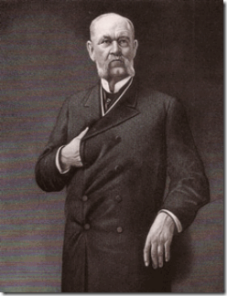
Viscount William Waldorf Astor & the Dark Cabal HIDDEN HAND
Tracing the Astor lineage back to the Castilian grandee was the genealogical handiwork of John Jacob’s great-grandson, William Waldorf Astor, when the latter pressed his case for British peerage to the satisfaction of the British College of Arms. The College of Arms’ Roll comprises all those “Hereditary Peers” who have proved succession to an English, Scottish, Irish, Great Britain or United Kingdom Peerage.
2.
Knights Templar Pedro de Astorga’s Hawk, Left Foot Forward
“In all walks of life, it is customary to take the first step with the right foot but in Freemasonry, the first step is always with the Left Foot. Why is that?”
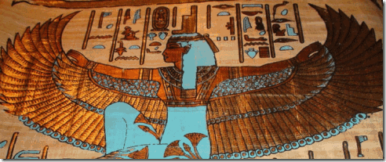
Goddess Aset (Isis)
It is the most ancient ritual walk. It is “ … taken from The Book of the Dead. It is practiced in modern days by an occult group that worships the Ancient Egyptians [Kemetic] Gods, but not necessarily in the correct spirit. But in that text, at the end of the ritual, the symbolism of the Step is explained as follows: The left foot is advanced to represent the power of Isis [Aset]. Isis is also known as the one to mark a new beginning.The right foot is represented by Isis’s Devine sister Nephtys, who stands for completion of an action.”
This symbolism of the ritual walk is to help the subject “GET OFF ON THE RIGHT FOOT”- that foot is the LEFT foot towards its journey in the afterlife. This leaves our animal or physical body behind on one’s journey to Heliopolis [ON]- (City of Light).
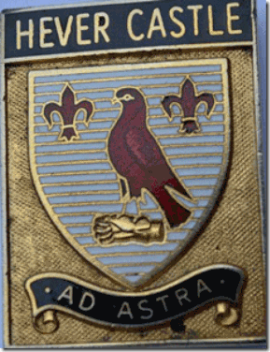
Viscount Astor Count of Arms, “AD ASTRA”- To the Stars
Goddess Astarte ruled all spirits of the dead residing in heaven, visible from earth as stars; hence came her name Astroarche, “Queen of the Stars.” She was called the mother of souls in heaven, the Moon surrounded by her star-children, to whom she gave their “astral” (starry) bodies.
The fleur de lis represents the “Sacred Lotus.”
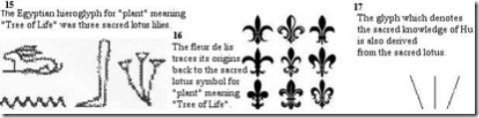
Hever Castle’s most famous inhabitant is Anne Boleyn, second wife of King Henry VIII and mother of Queen Elizabeth I. During the 13th century, the castle that was also home to Anne of Cleves, Sir John Fastolf. It was the home to Viscount William Waldorf Astor, above. Knight Templar and British peerage would certainly place the Astors in the unseen elite hierarchy of the Merovingian Dragon Society, the Occult, and Freemasonry.
3.
Astors & Satanic Masonic Dark Cabals in Colonial America
The first documented ancestor is Jean-Jacques d’ Astorg, who embraced the Reformation. He and his family are assumed to have been followers of the persecuted Waldensian Puritan Faith originating in southern France and existing chiefly in Savoy, a small duchy in northwestern Italy. The religious wars, which broke out in 1618, resulted in brutal persecutions.[16]
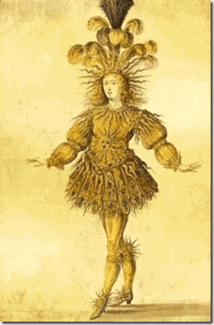
Cult of the Sun (Apollo), King Louis XIV
The duke of Savoy was a boy of ten and a vassal of Louis XIV in 1685 when the Sun King revoked the Edict of Nantes, which for nearly a century had protected French Calvinists and Lutherans. The massacre of Protestants in Valtellina high up in the Adda Valley sent d’Astorg-Astore, his wife, and their two children fleeing north across Switzerland to Heidelberg, the old university town and Calvinist stronghold. The family was uprooted again in 1693 when the troops of Louis XIV razed the town. They settled in Zurich, Astore found work as a silk maker and changed his name to Hans Peter Astor. He died in 1711 at the age of forty-seven. His grandson Johann Jakob (John Jacob Astor) moved north to Nussloch in Baden.[17]
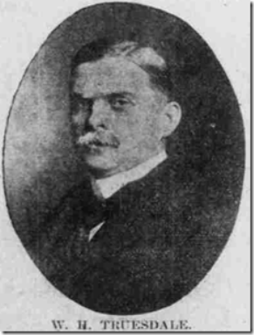

Robert Mueller III‘s mother, Alice Truesdale– Mueller, was a daughter of Lieut. Commdr. Melville D. Truesdale, USNR, granddaughter of William Haynes Truesdale. Alice was also a niece of Mr and Mrs. Richard M. Bissell (CIA) of Washington. Bissell was one of the most dangerous men of the Global Shadow Government of the 20th century.
From 1899 until five years before his death, the family patriarch. William Haynes Truesdale was only a degree of separation from this sinister nexus– the Masonic Satanic ILLUMINATI Bloodlines of the Astors. He was a director of Western Union, alongside Vincent Astor, Percy Rockefeller, Paul Warburg, William Averell Harriman and William Vanderbilt. In other words, Truesdale was in the inner circle of some of the most prominent, influential and powerful leading members of the Satanic bloodlines in American history.[18]
In Germany, John Jacob Astor’s Reformed (Protestant) school master, Johann Jeune Valentine, had also been of the French Huguenots ran out of France by Sun King. The Catholic French king ordered targeted assassinations against the Huguenots (French Calvinist Protestants), during the French Wars of Religion.[19]
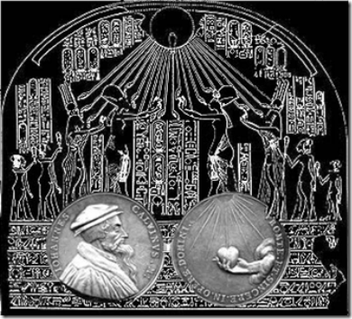
Evidence suggest that Jewish Reformation Preacher Johann (John) Calvin (born Cauin, 1509- 1564) of Switzerland adapted a religion from a very ancient foundation of the secret religious CRAFTS and GUILDS taken out of complex of Kemetic Cosmology.
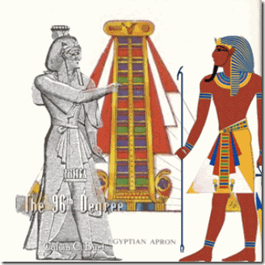
King Henry VIII of England (June 1491 – January 1547) and Calvin were both Protestant Reformists, who broke away from the Catholic Church and formed their own church. In England, the most significant consequence of the Reformation was the establishment of the independent church, created by King Henry the VIII, the son of Elizabeth of York and King Edward VII.
Between 1536 and 1540, King Henry VIII ordered the closure of the religious houses of England and Wales (around 800 monasteries, nunneries, friaries). Some believe that it had been John Calvin that influenced Henry to also close local parish gilds (guilds) controlled by the Catholic Church. It opened the way for medieval guilds that dominated and controlled the way in which trades and crafts were conducted in cities, towns, and parishes. The lodges of the guilds were basically secret societies that passed on the “arts” or “mysteries” of their crafts. It opened the way for the establishment of the secret societies and lodges of Dr. Dee’s influenced Rosicrucianism and Freemasonry.
Henry’s Reformation was followed by the establishment of the Church of England under his daughter, Queen Elizabeth I. Her court was steeped in esoteric thought, and Rosicrucian philosophy of famous occultist Devil Worshiper, Dr. John Dee.
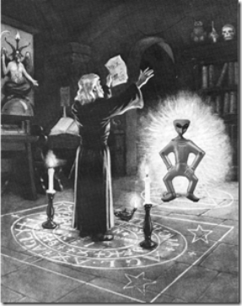
Dr. Dee believed that he found the secret of conjuring angels in the tradition of the Kabbalah, and claimed to have gained contact with angels, devils and demons from whom he learned illumination and enlightenment.
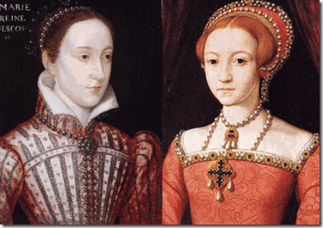
Mary Stuart & Queen Elizabeth I
Queen Elizabeth I did not marry, and therefore had no direct heir. Mary Stuart, also known as Mary Queen of Scots, the granddaughter of Henry VIII’s sister, was the nearest relative. She was Catholic.
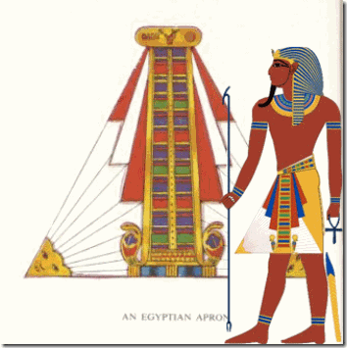
Very few things of such nature are born out of individual genius or a vacuum. “Bernard Bresson, in his extensive historical study of Medieval Pentecost, cites sources indicating Calvin’s reformation experiences were a product of his association with the Huguenots who repeatedly manifested the gifts of the Holy Spirit in their meetings. When Calvin was at last well-established in Geneva, he secretly supported in every way those persecuted Protestant Huguenots in France.”[20]
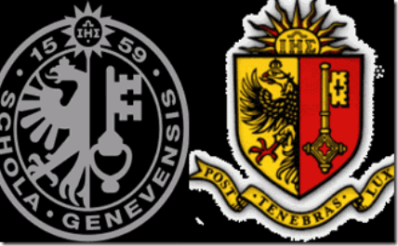
These Masonic shields and logos of the University of Geneva were created by John Calvin. The Key in logo is not unlike the ancient Kemetic Ankh that is a “Key to Heaven.” The bird represents the sacred Phoenix logo’s adopted by Freemasonry.
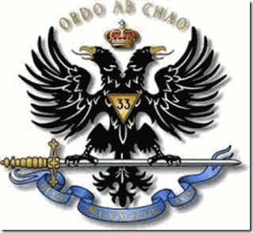
Double Headed Masonic Phoenix
Top of the Calvin’s logo represents Sun Worship, and the blazing sun (ATEN), If one look closely at Johann Jeune Valentine and John Calvin, their secrets lies not in the old secret German Satanic Magic Rosicrucian Cult, Ordo Saturnus, but something far more ancient and secret.
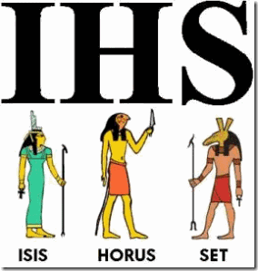
The I.H.S. symbol inside the blazing sun stands for a very old Kemetic trinity, “Isis, Horus, Set”, adopted by the invading nomads, Hyksos (Desert and Shepard Kings), that overran Kemet during a period of the 12th Dynasty.
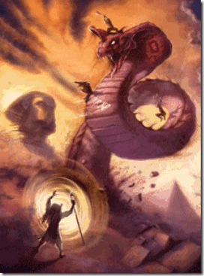
The Hyksos King Apophis (Serpent) is recorded as worshiping Set exclusively, as described in the following passage:
[He] chose for his Lord the god Seth. He did not worship any other deity in the whole land except Seth.— Papyrus Sallier 1 (Apophis and Sekenenre)
I.H.S. is called the Triad of LUCIFER.
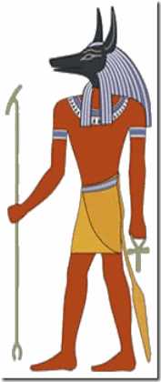
Set (Seth), the Jackal or Wild Dog is the God of EVIL and CHAOS. In jealously, he murdered his brother, the beloved “GOOD” King Ausar (Osiris) and usurped his throne with 72 conspirators.
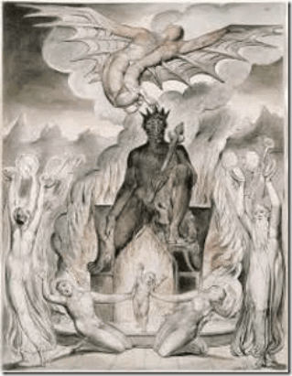
“Molech was the Canaanite version of the Egyptian god Set. The god Set was a homosexual god of evil. He was worshipped during ceremonies that involved human sacrifice, cannibalism and homosexual orgies. As the god of destruction, he became the god of the Egyptian military. In ancient Rome, he was worshipped as the god Saturn by the Roman military (often with baptism by blood). Thus we see that Satan (Set, Saturn, Molech etc.) was worshipped by Solomon and his wives as he grew old and senile. This involved heterosexual sex orgies (Ashteroth), homosexual sex orgies (Baal, Set, Satan, Molech), human sacrifice (Molech) and even cannibalism (Set, Molech). Our modern high-level military leadership appears to have the same values as the ancients.”
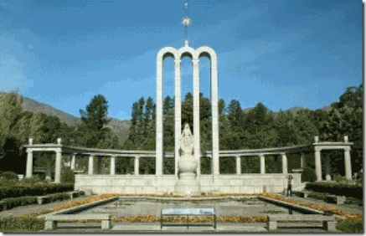
Huguenot Monument in Franschhoek, South Africa
We are told that the 3 arches symbolize the Holy Trinity; the Father, the Son and the Holy Spirit. But this is not true.
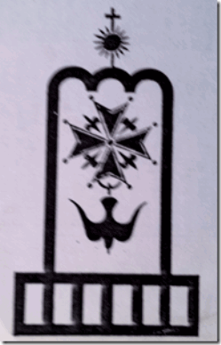
The 3 arches of the Huguenot Cross Crest Symbol are actually called a Triptych. The occult meaning behind the Triptych is as follows:
“The abundant occurrence of the Triptych across the ancient world is not a random coincidence. The Triptych represents more than merely an architectural element; the Triptych is the chief symbol of an advanced Universal Religion that was once shared globally in Antiquity, mainly by the pyramid cultures. The discovery of the Triptych provides, for the first time, conclusive evidence that ancient cultures worldwide shared the same spiritual beliefs. It also indicates that these cultures did not evolve independently, but were probably descended from the same more remote parent source. The Universal Religion symbolized by the Triptych was banned in the West 2,000 years ago by the Catholic Church, but nonetheless it has continued into modern times, surviving in the beliefs of Secret Societies and their art and architecture.”[21]
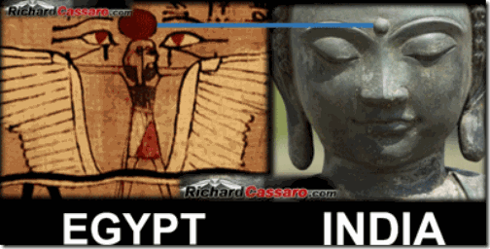
“By following a careful set of instructions—encoded in the Triptych—we can transcend our body and see our real god Self within. This has long been the goal of alchemists, occultists, spiritualists and philosophers, and it is achieved by an age-old spiritual practice known as “Awakening Our Third Eye,” with the Third Eye being a vestigial organ of spiritual illumination that lies hidden in the human forehead. Whereas the two eyes see outward at material things, the single Third Eye sees inward at the inner soul.”[22]
“As it turns out, this too has been encoded into buildings that contain a Triptych. As we shall see in a moment, the Third Eye is symbolized by the center door of the Triptych: The Third Eye is well-known in esoteric circles and has been variously described throughout history as the “Divine Eye,” “All Seeing Eye,” “Mind’s Eye,” “Eye of the Soul,” and “Inner Eye.” While the name for it differs, what remains constant throughout the esoteric doctrines is that the Third Eye is not a metaphor, symbol, or analogy. It is affirmed to be a real, physical part of the body able to strengthen or atrophy as much as any other muscle; by exercising it, one slowly but steadily increases their awareness of their natural spiritual powers.”[23]
Look, for example, at the headquarters of the Freemasons, the Skull & Bones, the Shriners and the Knights of Pythias. Each building’s facade depicts an unmistakable Triptych pattern.
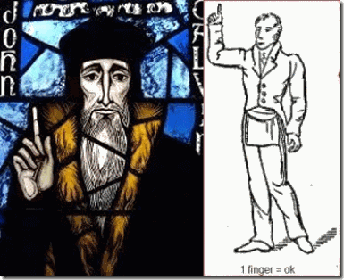
John Calvin was a clandestine follower of the Ancient Craft that adopted King Asur’s EVIL brother Set (Seth), Satan– Lucifer as GOD. John Calvin’s Dark Luciferian Masonic Cult predates modern Freemasonry almost two (200) hundred years.
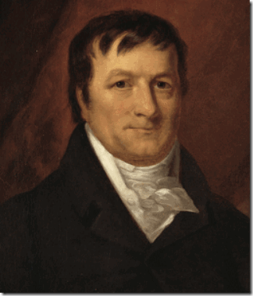
Johann Jakob Astor
John Jacob Astor was initiated into the Cult of Astarte, and John Calvin’s Masonic Temple in Germany during the late 18th Century. He had learned the ancient secret knowledge, rituals and global links of the occult and the craft that was far beyond anyone’s knowledge in colonial America. This would explain his rapid rise within the “inner circle” of colonial America’s Ultra Secret Masonic Satanic Power Control Group (PCG).
When Astor arrived in America, he moved in to take control of The Grand Lodge of New York (officially, the Grand Lodge of Free and Accepted Masons of the State of New York). It is the largest and oldest independent organization of Freemasons in the state of New York. It was at one time the largest grand lodge in the world in terms of membership. It is not known when the first Freemason set foot in the American colony of New York, but the first documented presence dates from the mid-1730s, when Daniel Coxe, Jr. (1673–1739), was appointed Provincial Grand Master of Freemasons for the provinces of New York, New Jersey and Pennsylvania by the Duke of Norfolk, the Grand Master of the Premier Grand Lodge of England (known to historians as the “Moderns“).
John Jacob Astor first joined Holland Lodge, No. 8, New York City, then served as Master of Holland Lodge in 1788. Later, he took over the Grand Lodge serving as the Grand Treasurer [Jul 17, 1763- Mar 29, 1848]. Astor took total and complete advantage of the secret privileges and behind the veil deals and spoils of the Royal Masonic Dark Brotherhood. Dope, Inc. shows that the Astor family was the first American family to get into the Opium trade like an exclusive charter from the Masonic Satanic royal houses and ruling classes of England. The Astors were also granted privileges by Scottish Rite President Thomas Jefferson (descendant of Robert the Bruce) to control the early fur trade (American Fur Company) in all early Northwest America.[24]
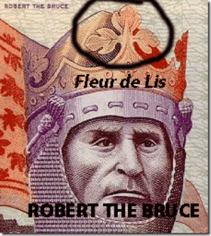
Furthermore,
“The two men were Pres. [Thomas] Jefferson and Secretary [Albert- Genevan Huguenot] Gallatin–both Illuminati members. The United States government had placed an embargo on all U.S. ships from sailing with goods in 1807. But [Brother] Astor got special permission from these two men for his ship to sail with its cargo. His ship sailed and made close to a $200,000 profit in that day’s money. Astor strangely profited greatly from the War of 1812, which crippled almost all the other American shippers. Astor also worked together with George Clinton, another member of the.Illuminati, on land deals.”
4.
Astors, British Empire, Pilgrim Society & the Rhodes Roundtable
In 1901, the Astors are agents of the Royal British Empire, and their Quest for World Domination and Control. They were key figures in the creation of the Pilgrim Society, which was the cover organization for Amer. & Brit. 6° Princes of the Illuminati. At the very least five Astors are/were members of the Pilgrim Society. The Pilgrims had recently included David Astor, John Jacob Astor 8th, and William Waldorf Astor 3rd. And during the 1970s, Baron Astor of Hever was the President of the London branch of the Pilgrims. In 1910, the Astors were the part of the financial backers behind the Round Table groups along with Abe Bailey. Cecil Rhodes and the Rothschild’s Lord Alfred Milner were key players is setting up a super secret top “inner circle” of the Luciferian ILLUMINATI, The Society of the Elect
5.
Astors & Lucifer’s Servants in America
Charles A. Peabody was trustee of the estate (Masonic Satanic Roundtable) of the first John Jacob Astor since 1893, and was closely associated with Baron William Waldorf Astor, 1st Viscount Astor (1848- 1919), son of John Jacob Astor III. Peabody represented him in this country. At his death, Peabody was president of Mutual Life Insurance. He sat on the boards of directors of City Bank Farmers Trust Company, Mutual Life Insurance Company, Oregon Short Line Railroad, Central of Georgia Railway, Illinois Central Railroad and Union Pacific Railroad, and was a trustee of the Church Pension Fund and member of the board of managers of Delaware & Hudson Company. (C.A. Peabody Dies; Insurance Figure. New York Times, Apr. 27, 1931.)
Closely associated with the Astor Satanic Masonic Circle and Peabody was William Haynes Truesdale. In 1899, Truesdale began as president of the Delaware, Lackawanna & Western. He retired as president in 1925, but continued as chairman until 1930. He married Annie Topping of Terre Haute, Ind. (Wm. H. Truesdale, Rail Official, Dies. New York Times, Jun. 3, 1935.)
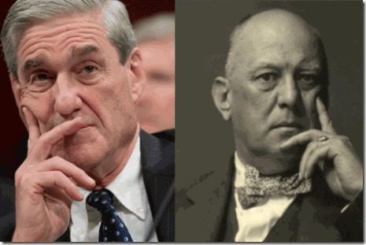
Initiates of Lucifer, Robert Mueller & the Great BEAST 666, Aleister Crowley
W. H. Truesdale left the bulk of his estate, which was reputed to be “well over $1,000,000,” to their three children that included Robert Mueller III’s maternal grandfather, Melville Truesdale. (Truesdale Will Filed in Greenwich Court. New York Times, Jun. 19, 1935.) W. H. Truesdale was a board member of Peabody’s Mutual Life Insurance closely aligned with most of the key 13 ILLUMINATI Bloodline Dragon Society families of the Dark Cabal, (William) Rockefeller, (Quver) du Pont, (Cornelius) Vanderbilt (Moody’s Manual of Railroads and Corporations Securities, Seventh Annual Member, 1906, pg. 2754). One of the principal training and indoctrination sites for the secret Dragon Society’s rites of passages is Yale University’s Secret Societies and fraternal orders, Skull and Bones, Scroll & Key, and Elihu.
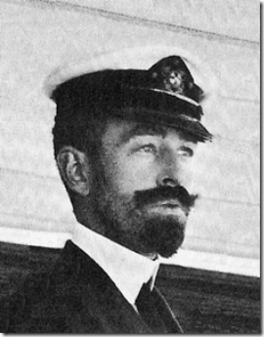
Cornelius Vanderbilt III, Royal, Yale’s Scroll & Key 1895
Cornelius Vanderbilt was great-grandson of the Commodore. He was the oldest son of Cornelius Vanderbilt and Alice Claypoole Gwynne. He got his mechanical engineering degree at Yale in 1899, and made many inventions. The Vanderbilts were friends of Kaiser Wilhelm of Germany, entertained Prince Henry of Prussia and Duke Boris of Russia, and were entertained by Czar Nicholas II and the royal family of Russia. He was an incorporator of the Interborough Rapid Transit Company, in alliance with August Belmont. His other brothers were William Henry Vanderbilt 1893, who died during college, and Reginald Claypoole Vanderbilt 1902. His sisters were Mrs. Harry Payne Whitney and Countess Széchenyi. (Gen. C. Vanderbilt Dies On His Yacht. New York Times, Mar. 2, 1942.) He was a trustee of the Mutual Life Insurance Company 1902-1938, and a director of numerous other corporations [including the Central Union Trust]. (Obituary Record of Graduates of Yale University Deceased during the Year 1941-1942, p. 72.) He was among the Chase directors who left American Express due to the Banking Act of 1933 (Five New Directors in American Express. New York Times, May 5, 1934). His mother was a Royal descendant of Edmund Ironsides, King of England (Edmund II, died 30 November 1016), and his grandfather Flagg was mayor of New Haven. (Americans of Royal Descent. By Charles Henry Browning, 1891, p. 162.); Obituary Record of Graduates of Yale, 1941-1942 / Yale University Library (pdf, 320 pp)
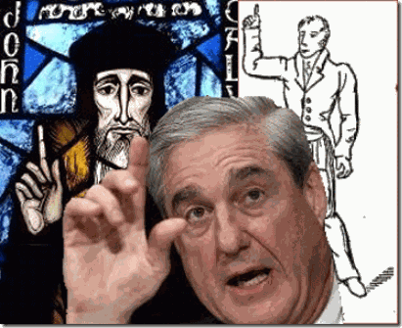
Mueller’s great grandfather was Dr. Calvin Truesdale, a California Freemason, and prominent physician in Rock Island, Ill. (“Sam” Sloan Chairman. Syracuse Evening Herald, Mar. 3, 1899.) Dr. Calvin Truesdale was vice president and general manager of the Rock Island Railway. He had lived in Rock Island since 1854, and was its mayor for four years. (Dr. Calvin Truesdale. Chicago Inter Ocean, Jun. 11, 1895.) Dr. Truesdale was a director of the Rockford, Rock Island and St. Louis Railroad. (Will It Hold? Chicago Inter Ocean, Oct. 15, 1874.) He received his M.D. in 1845 at Western Reserve College. (Commencement Exercises in the Western Reserve College. The Ohio Observer, Aug. 20, 1845.) Dr. Calvin Truesdale died at the home of his son, attorney Hiram Calvin (H.C) Truesdale, in Minneapolis. (Calvin Truesdale Dead. Minneapolis, The Penny Press, Jun. 10, 1895.)
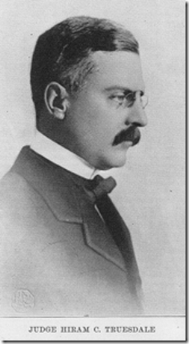
H.C. Truesdale’s son, Cavour L. Truesdale, graduated from Yale in 1914. His daughter, Sarah Helen, married Dr. Angus Washburn Morrison (1884-1949), ELIHU 1906, a neurologist in Minneapolis. His M.D. was from Johns Hopkins in 1910. Their three sons graduated from Yale, and their daughter married a Yale graduate. He had three Yale cousins as well. (Obituary Record of Graduates of Yale University, 1948-1949, p. 57 / 58.) He was a grandson of Dorilus Morrison of Maine, who was the first mayor of Minneapolis. The family owned timber lands and mills, grain elevators, and were officers of a local bank. (Angus Washburn Morrison, M.D. In: History of Minneapolis, Gateway to the Northwest, 1923, pp. 233-235.)
Elihu, founded in 1903, is the fourth oldest senior society at Yale University, New Haven, CT. While similar to Skull and Bones, Scroll and Key and Wolf’s Head societies in charter and function, Elihu favors privacy over secrecy. Yet, it was still an elite Satanic secret society.[25] Elihu takes its name from Elihu Yale. Hale (5 April 1649 – 8 July 1721) was an American-born British merchant, philanthropist and slave trader, President of the East India Company settlement in Fort St. George at Madras, and a benefactor of the Collegiate School in the Colony of Connecticut, which in 1718 was renamed Yale College in his honor.[26]
Cavour’s daughter married John Pillsbury Snyder Jr., Yale 1935. His father was a grandson of Gov. John Sargeant Pillsbury, who started the Pillsbury Company with his brothers. (309 Ramsay Road. Wayzata Historical Society.) He refused Scroll & Key, Berzelius, Book & Snake, and ELIHU. His cousin, John S. Pillsbury, took Bones. (Innovations Mark Tap Day at Yale. New York Times, May 11, 1934.)
His grandfather, Minneapolis attorney Fred B. Snyder, married Susan May Pillsbury in 1885. He was a regent of the University of Minnesota since 1912, and was a personal friend of all eight of its presidents. (F.B. Snyder, U. Regent for 39 Years, Dies. Winona Republican-Herald, Feb. 14, 1951.) The last officer named Pillsbury, George Sturgis Pillsbury, left the Pillsbury Company in 1969, citing the family’s other enormous financial interests, held by the Sargent Management Co. He and three of his four children were educated at Yale. He, his brother and a cousin remained as directors. John Pillsbury Snyder continued as a vice president. (Giant Pillsbury Company Finds Self Without Pillsbury For First Time. The Register, Danville, Va., Nov. 30, 1969.); Obituary Record of Graduates of Yale, 1948-1949 / Yale University Library (pdf, 186 pp); Angus Washburn Morrison, M.D. / USGenWeb Archives
In June 1901, William H. Truesdale’s daughter, Marie Melville Truesdale, married Richard Mervin Bissell, Jr. of Chicago. He was Western manager of the Hartford Fire Insurance Company in Chicago. His ushers were Charles Hamill and Victor Elling of Chicago, Joseph F. Kernan and John R. Halsey [Scroll & Key 1884] of New York, the bride’s brother, Calvin Truesdale [Skull and Bones, 1907], and her cousin, Franklin Steele of Minneapolis. His brother, Arthur Bissell, was best man. (Weddings of a Day. New York Times, Jun. 26, 1901.)
6.
Truesdales, Skull and Bones & the CIA
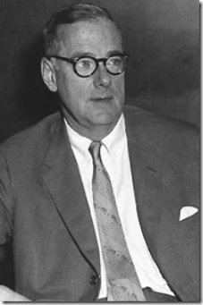
Richard Bissell, One of the Most Dangerous & Sinister Figures of the 20th Century
Richard M. Bissell, Yale 1883, was with the Hartford Fire Insurance Company from 1883 to 1941, and president of Hartford Accident & Indemnity from 1913 to 1934. He was a lecturer on insurance at Yale between 1903 and 1914, and a governor of Mory’s Association from 1936 to 1939. His brothers-in-law were Calvin Truesdale, (Yale 1907), and Mueller’s grandfather, Melville D. Truesdale, (Yale 1915). Their children were William Truesdale Bissell, (Skull & Bones 1925); Mrs. Hector Prud’homme (Yale 1925), and Richard Mervin Bissell Jr., (Yale 1932). (Obituary Record of Graduates of Yale University, 1941-1942, p. 25.); Obituary Record of Graduates of Yale, 1941-1942 / Yale University Library (pdf, 320 pp)
Richard M. Bissell, Jr. was born to New England wealth, society and prominence of this father, Richard M. Bissell, Sr., (Yale, 1883). His father was president of Hartford Fire Insurance.Company that was the first company to insure Yale University where he was a lecturer on insurance. Bissell, Jr. was born in Mark Twain’s paranormal Gothic (Occult Spiritualism House) in Hartford, Conn. Bissell, Jr. attended the Groton School, Yale and the London School of Economics. He refused election to Skull & Bones. (Yale Tap Day Critic Accepts Election. New York Times, May 15, 1931.) He attended the London School of Economics in 1932-33, and Yale graduate school from 1933-39. He was an economic analyst at the Bureau of Foreign and Domestic Commerce of the Commerce Department from 1941-42; was at the War Shipping Administration 1942-45; and was in the Office of War Mobilization and Reconversion from 1945-46.
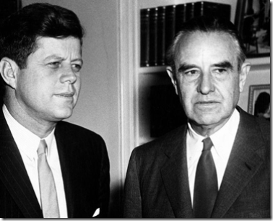JFK and Averell Harriman
Bissell, Roundtable CFR, Ford Foundation, was professor of economics at Massachusetts Institute of Technology (MIT) in 1948. In July 1947, Bissell was recruited by railroad industrialist W. Averell Harriman of America’s secret Satanic PCG (Power Control Group) to run a committee to lobby for an economic recovery plan for Europe. The following year, he was appointed as an administrator of the Marshall Plan in (Nazi) Germany and eventually became head of the Economic Cooperation Administration. Harriman served President Frank D. Roosevelt as special envoy to Europe and served as the U.S. Ambassador to the Soviet Union and U.S. Ambassador to Britain. He attended Groton School in Massachusetts before going on to Yale where he joined the Skull and Bones society. Harriman was the fifty-second Governor of the State of New York, 1955–1959 (1960). He served in numerous U.S. diplomatic assignments of power and influence in the Kennedy and Johnson Administrations.
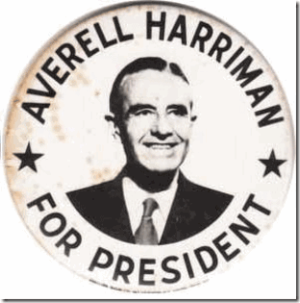
He even ran for President of the U.S. He was a core member of the group of foreign policy elders known as “The Wise Men.”
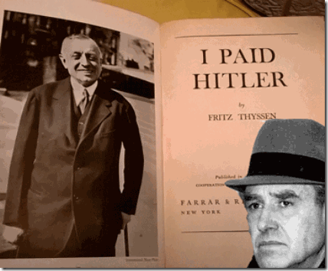
WE MADE HITLER- Thyssen & Harriman
Harriman’s banking business was the main Wall Street connection for Nazi companies and the varied U.S. financial interests of wealthy Nazi Industrialist Fritz Thyssen; who was a financial backer of Himmler, the SS, and the Nazi Party until 1938. The Trading With the Enemy Act (enacted on October 6, 1917) classified any business transactions for profit with enemy nations as illegal, and any funds or assets involved were subject to seizure by the U.S. government.
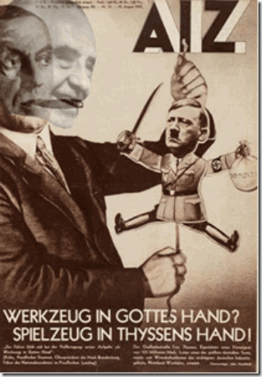
Thyssen & Harriman- Secret Puppeteers of the Nazis and SS
The declaration of war on the U.S. by Hitler led to the U.S. government order on October 20, 1942 to seize German interests in the U.S. which included Harriman’s corporate Wall Street operations in New York City.[27] President-elect Kennedy appointed the Nazi collaborator, Harriman, as ambassador-at-large, to operate “with the full confidence of the president and an intimate knowledge of all aspects of United States policy.”[28] But by 1963, Kennedy had come to suspect like the Bay of Pigs that he was being stabbed in the back by certain members on his national security team. According to Colonel William Corson, USMC, by 1963 Harriman was running “Vietnam without consulting the president or the attorney general.” Corson said Kenny O’Donnell, JFK’s appointments secretary, was convinced that his National Security Advisor, McGeorge Bundy, Yale (1940- Skull and Bones) followed the orders of Harriman, Yale (1913- Skull and Bones) rather than the president. Harriman was a member of Astor-Rhodes Roundtable Club of Rome, CFR; Knights of Pythias, Psi Upsilon Fraternity, and the Jupiter Island Club.[29]
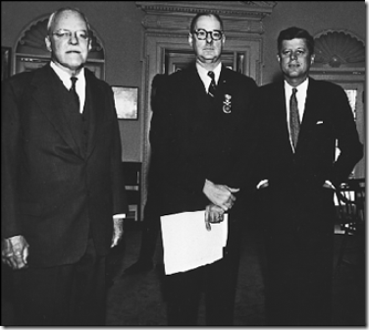
Criminal Dangerous CIA Men- Dulles, Bissell and JFK
In 1954, Bissell was placed in charge of developing and operating the Lockheed U-2 ‘spy plane. Bissell and Herbert Miller, another CIA officer, chose Area 51 in 1955 as the site for the test facility for the U-2, and Bissell supervised the test facility and its build up until he resigned from the CIA. He was appointed Deputy Director for Plans in 1958. In 1960, he oversaw plans for covert action against Cuba, using the same team from its Guatemala action, assassination of President Jacobo Arbenz.
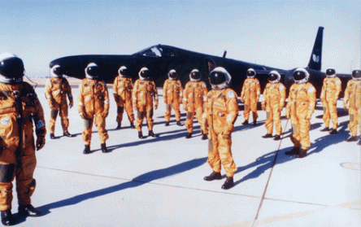
Bissell’s U2 and Top Secret Pilots
Richard Bissell, as a special assistant and later the deputy director of plans for Allen Dulles, the CIA chief, had to have been one of the most sinister and dangerous intelligence heads in U.S. History. He guided the clandestine program for building the high-flying U-2 reconnaissance aircraft, as well as its supersonic successor, the SR-71, and the first orbiting spy satellite, Corona. For this, he became known in aviation circles as a pioneer of aerial reconnaissance. Bissell’s U-2 was shot down over Russia on May 01, 1960. President Eisenhower. The president looked forward to visiting the Soviet Union during May of 1960, along with increasing the level of dialogue with Premier Krushchev regarding implementation of a genuine halt to the arms race. His Crusade for Peace was intended to reach a new level of understanding ushered in with the planned meeting in Paris on May 16, followed by a tour of Russia many expected to be a resounding success for both sides. Charles Bohlen (Russian ambassador from 4/53 to 12/56) recalls, “I was certainly enthusiastic about Eisenhower’s scheduled trip to the Soviet Union. Eisenhower was not only a President, he was also a war hero. The Russians would have loved him.” [Witness to History, p.462]
President Eisenhower’s special orders banned CIA spy plane flights over Russia pending peace talks in Paris with Krushchev. The downed U-2 spy plane caused the cancellation of peace talks with Russia.
“Here is the most astonishing piece of evidence about the misuse of Presidential authority to come to light, including the Nixon tapes. The powerful Senate Foreign Relations Committee was asking the Director of Central Intelligence where he got his authority for this infamous flight, and all Allen Dulles could reply was, “Well, we had a group.” Then, when Senator Gore asked if Dulles knew whether the men in that group hat the proper authority to issue such orders, all that the Director of the CIA could say was, “I assume that he did.” There is the whole crux of the U-2 flight, the breakup of the summit conference, the chance for peace.”
Dulles and Bissell’s secret cold war PCG that included the Nazi/SS Gehlen Org bypassed President Eisenhower’s special orders by the assumption or usurpation of authorization and power. That seemed to be standard procedure of Dulles and Bissell. The U-2 incident was an illegal act committed by individuals whose motives were to deliberately undermine and usurp the power and the process of the elected Government (crime against democracy).
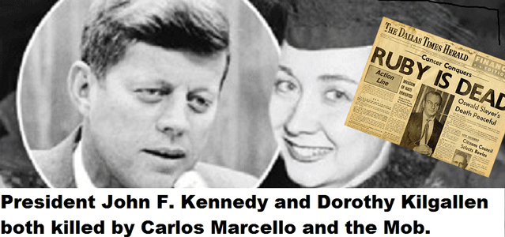
Jack Ruby, Assassin of Lee Harvey Oswald:
“The old war lords are going to come back. S.A. (South America) is full of these Nazis! They will know that it is only one kind of people that would do such a thing [Assassinate JFK] … that would have to be the Nazis and that is who is in power… No one listened to what Ruby had to say, except for journalist Dorothy Kilgallen, who was found “suicided” shortly after her interview with him. Ruby himself was to soon to die soon after from a cancer that had been injected into him.” (Jim Keith, Mass Control: Engineering Human Consciousness, IllumiNet Press, 1999, pg. 117)
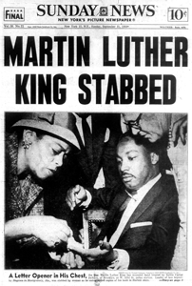
Sept. 20, 1958, Dr. King Stabbed by Female Black Manchurian Candidate
Bissell was the CIA covert action chief. He was a rabbit hole that history may never reach its bottom. He put together the cold war “secret armies”, assassination teams, and Mind Controlled Manchurian Candidates that targeted anti-patsy, anti-CIA and anti- State Department, anti- American Corporate interest, Union, Civil Rights American and foreign leaders like Dr. Martin Luther King, Jr., Fidel Castro of Cuba, Patrice Lumumba of the Congo, General Rafael Trujillo of the Dominican Republic; and attempted assassination of President Charles De Gaulle of France. In 1962, JFK forced Bissell and Allen Dulles of the inner circle of the ultra secret dangerous Power Control Group (PCG) out of the CIA for the April 1961 “secret army” invasion of Cuba in the Bay of Pigs Fiasco. JFK threaten to break the CIA up into a thousand piece. Bissell was replaced by Richard Helms.
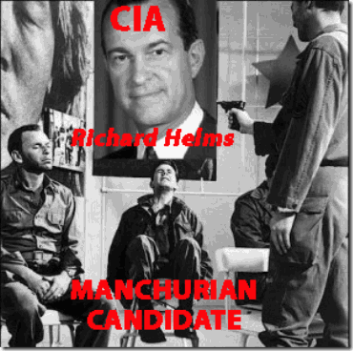
It was Bissell and Dulles’ shadow government “secret army” organization; secret societies, and the Satanic Masonic Dark Cabal that committed one of the great crimes against democracy of the 20th century, the liquidation of JFK in Dallas. However, don’t get me wrong. Bissell, Dulles and PCG decided to kill U.S. Senator/President John F. Kennedy long before Bissell and Dulles were fired.
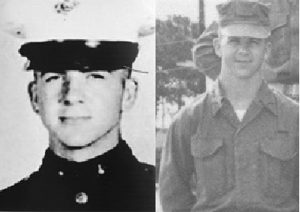
CIA Sleeper, 17 year old, Lee Harvey Oswald
Lee Harvey Oswald was Bissell’s MK ULTRA Manchurian Candidate. He was setup and groomed as a sleeper CIA “patsy assassin” as early as 1957 at Marine Air Control Squadron One at Atsugi, Japan, home of Richard Bissell’s top secret U2 spy plane project.
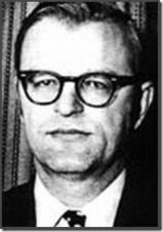
Mueller’s in law, Professor Richard Bissell, was far more dangerous, diabolical and sinister than he looked, and far beyond one could ever imagine. Yet, nothing at all about the absolute evil, and tyranny of his very own comes out of his mouth.
7.
Straight Arrow Bob- That Dog Won’t Hunt
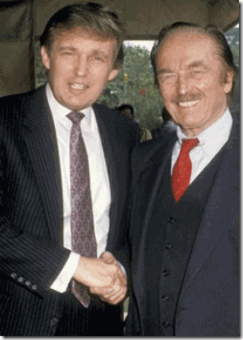
Secret of the Masonic Handshake
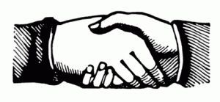
Bob Mueller III is everything that Scandalous Fred Drumpf ever wanted for his son, Donald J. Drumpf- birthright claims and privileges of the Satanic 13 Bloodlines of America. Mueller’s bloodline had all of this “inner circle” connections and links to the patricianly all of Lucifer’s Servants in New York, the Astors, Rothschilds, Rockefellers, Vanderbilt’s, du Ponts, Harrimans, Bundys, Warburgs, and Bissells. They were the “inner circle” of Yale University, the Skull and Bones, Scroll & Key, and Elihu. As the FBI Director, he was/is in position to veil and cover-up all their tracks involving 9-11 Inside Job, the crimes and corruption of the Knights of the CIA, America’s shadow government drug trafficking, assassinations, and “secret army”.
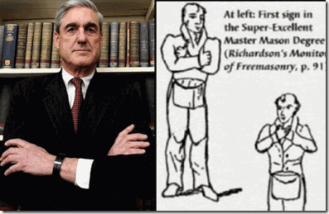
Brother Robert Mueller III- Hidden Satanic Masonic Grand Master
Far too many people believe until a name appears on a public membership list, a person cannot be proven to be a Mason or a member of a Masonic Satanic Cult. Of course, a “so called” dedicated humble public servant like Bob Mueller does not appear on any Masonic or Satanic Cult membership list. We just couldn’t call him, good old boy, “Straight Arrow Bob.”
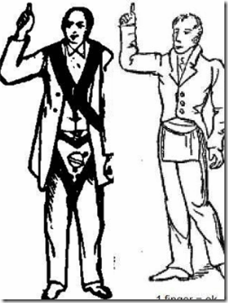 Richardson’s monitor of freemasonry”, and “Scotch Rite Masonry Illustrated Part 2” page 26- pointing upward is the “Sign of Preservation“.

There is literally no difference between Drumpf, Mueller and Putin in terms of ILLUSIONS, Deceptions and their capacity for ABSOLUTE EVIL. They are the secret Masonic or Satanic Brotherhood. Of course, if they were known to be “Masons” or Luciferians, the public would be justified to mistrust them for election to any public servant position if they are beholden to the “Lord of Deception and EVIL”- Lucifer. We can say, “THAT DOG WON’T HUNT!”
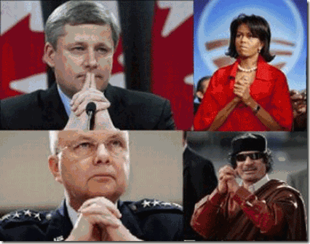
A Masonic Handshake or SEAL OF SECERCY
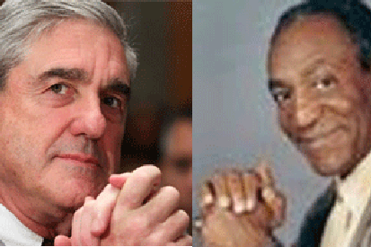
LORDS OF DECEPTION, Straight Arrow Bob and America’s Dad
They say that if it looks like a duck and quacks like a duck, it’s a DUCK!
Again today, good old boy after good old boy on the idiot box with straight long cold faces championed the unequal almost super human integrity and honestly of “Straight Arrow Bob” like robots on automatic speech mode- mass hypnosis.
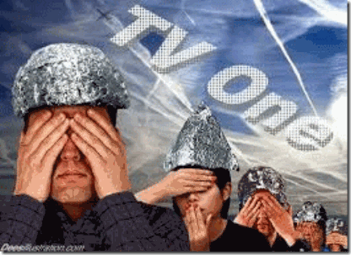
Repeat it enough, and the masses will come to believe that:
“Bob Mueller is the kindest, bravest, warmest, most wonderful human being I’ve ever known in my life.”
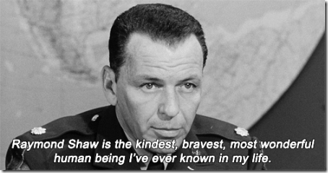
“Bob Mueller is the kindest, bravest, warmest, most wonderful human being I’ve ever known in my life.”

“Bob Mueller is the kindest, bravest, warmest, most wonderful human being I’ve ever known in my life.”
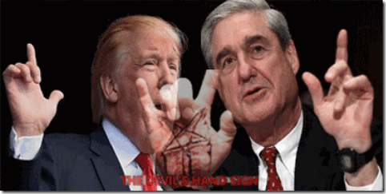
The HANDS OF THE DEVIL, Donald J. Drumpf and Robert Mueller III

[1] http://www.reuters.com/article/us-usa-trump-idUSKCN18D1XT
[2] http://dailycaller.com/2017/05/19/report-mueller-likely-to-ask-congress-to-scale-back-russia-probes/
[3] http://www.politico.com/magazine/story/2017/05/18/james-comey-trump-special-prosecutor-robert-mueller-fbi-215154
[4] http://disturbinganomalies.blogspot.com/2013/09/all-in-bloodline-william-truesdale.html
[5][5] http://www.serendipity.li/wot/independent_investigation_of_911.doc
[6] https://pjmedia.com/news-and-politics/2016/04/20/author-u-s-official-who-issued-visas-to-911-hijackers-still-works-for-state-department/
[7] http://yournewswire.com/whitehouse-911-was-an-inside-job-by-saudi-regime-explosive-report/
[8] Id.
[9] http://rense.com/general54/ffroe.htm
[10] http://www.bollyn.com/9-11-archive-2011/
[11] Id.
[12] http://aletheia.consultronix.com/7.html
[13] http://impiousdigest.com/bloodlines-of-the-illuminati-fritz-springmeir/
[14] https://en.wikipedia.org/wiki/Astarte
[15] http://www.nextreads.com/display2.aspx?recid=5410984&FC=1
[16] Id.
[17] Id.
[18] http://disturbinganomalies.blogspot.ca/2013/09/all-in-bloodline-william-truesdale.html
[19] http://endoftheage.blogspot.ro/2014/09/senseless-butchery-of-floridas-huguenots.html
[20] https://www.discerningtheworld.com/2014/11/27/huguenots-john-calvin-freemasonry/
[21] https://www.discerningtheworld.com/2014/11/27/huguenots-john-calvin-freemasonry/
[22] Id.
[23] id.
[24] http://impiousdigest.com/bloodlines-of-the-illuminati-fritz-springmeir/
[25] https://en.wikipedia.org/wiki/Elihu_(secret_society)
[26] https://en.wikipedia.org/wiki/Elihu_Yale
[27] https://en.wikipedia.org/wiki/W._Averell_Harriman
[28] Id.
[29] https://en.wikipedia.org/wiki/W._Averell_Harriman
Comments : Leave a Comment »
Tags: 2 'spy plane, 4th crusade, 9-11 commission, 9-11 inside job, Aleister Crowley, Alfonso VIII, Alice Truesdale, apophis, Ashteroth, astarte, astor, Astorga, aten, Averell Harriman, Baphomet, Baron Astor of Hever, bay of pigs, bcci, Berzelius, Book & Snake, calvinism, Calvinist Protestantism, CFR; Knights of Pythias, Charles A. Peabody, charles de gauille, child sacrifice, CIA, club of rome, Coleen Rowley, Cornelius Vanderbilt, cybele, d'Astorg-Astore, dark cabal, Demeter, Diana, donald j. drumpf, dorothy kilgallen, Dr. Calvin Truesdale, dr. john dee, Dr. Martin Luther King, dragon society, Eleanor of Aquitaine, Elihu, Fidel Castro, fred drumpf, freemasonry, freemasons, French Huguenots, Fritz Thyssen, gehlen org, General Rafael Trujillo, god set, Grand Lodge of New York, Hartford Fire Insurance Company, hawk, Hecate, hever castle, holland lodge, Holy Grail Bloodlines, horus, hyksos, inanna, Jack Ruby, jeff sessions, Johann Jeune Valentine, john calvin, John Jacob Astor, Jupiter Island Club, kabbalah, Kali, King Henry VIII, knights of pythias, knights templar, Knights Templar Castle Ponferrada, Lee Harvey Oswald, Lucifer, luciferians, magna mater, Manchurian Candidate, mark twain, marshal plan, mary of scots, Mary Stuart, mass hypnosis, Merovingian, Merovingian Dragon, nimrod, of Credit and Commerce International, Order of Calatrava, patrice lumumba, Paul Warburg, Pedro de Astorga, penttbom, Percy Rockefeller, pilgrim society, Poor Fellow-Soldiers of Christ and of the Temple of Solomon, power control group, Protestant Huguenots, Psi Upsilon Fraternity, putin, queen elizabeth, quver du pont, richard helms, Richard M. Bissell, robert mueller III, robert the bruce, Rosicrucianism, russia, satan, Satanism, saturn, saudi arabia, scottish rite, Scroll & Key, semiramis, Seth, Shayna Steinger, skull and bones, star children, Straight Arrow Bob, tammuz, third eye, Triad of LUCIFER, Triptych, truesdale, Vincent Astor, Viscount William Waldorf Astor, William Averell Harriman and William Vanderbilt, William Haynes Truesdale, william rockefeller, yale university, Zacharias Moussoui, zeus
Categories : 9-11, Aleister Crowley, allen dulles, antichrist, Apollo, Aryan Supremacy, aset, ashur, baal, baby scarifrice, baphomet, blood covenants, blood oaths, blood sacrifice, bohemian club, bohemian grove, brotherhood of death, christianity, CIA, club of rome, council of foreign relations, council on foreign relations, Crimes Against Democracy, cybele, devil, devil's horns, donald j. drumpf, donald j. trump, donald trump, dr. john dee, earth mother goddess, egypt, evil, freemason, freemasons, Heinrich Himmler, Horus, human sacifrice, illuminati, illuminati sacrifice, ISHTAR, Isis, J. P. Morgan, jesus christ, john D. Rockefeller, john dee, John f. kennedy, Knights Hospitaller, Knights of the Black Sun, Knights Templar, lucifer's servants, luciferians, manchurian candidates, masonic sacrifice, mind control, MK-ULTRA, Molech, Moloch, monarch child, monarch program, Nazis, nwo, Operation PAPERCLIP, Osiris, Paperclip Project, post amnesia barriers, post hypnotic suggestions, power control group, President John F. Kennedy, psychological warfare campaign against Christianity, Reichsfurhrer SS-1 Heinrich Himmler, robert mueller, Rosicrucian, Rosicrucianism, satan, Satanic Global High Cabal, Satanism, scottsish rite, skull and bones, sleeper agents, SS, Untermensch

MICHELLE OBAMA, MARIAH CAREY, KANYE WEST, MK ULTRA, RAINBOWS & DRAGONS
15052017
I
The Satanic Divine Dragon Bloodline- BLACKS GET OUT!
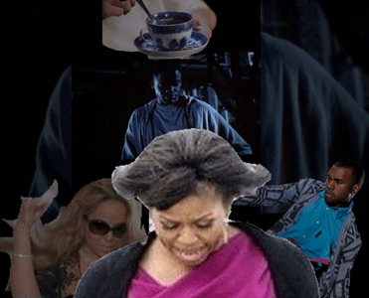
Former First Lady Michelle Obama, Mariah Carey and Kanye West seem to occupy the same “hole in the floor for black people” made infamously significant by the HollyWeird movie, “GET OUT.” The main character of the popular horror film, “GET OUT“, Chris- asked the question, “WHY US? WHY BLACK PEOPLE?” Apparently, the “hole in the floor” is reserved for CIA MK ULTRA/MONARCH Black Manchurian Candidates that sold their SOULS TO THE DEVIL for a few toys and a HAPPY MEAL.
There is a very significant difference and distinction between becoming a black slave to the DRAGON, and being born of the blood of the DRAGON or a Sea Serpent like a Donald J. Drumpf. That difference and distinction has been made crystal clear to Michelle Obama, Mariah Carey and Kanye West.
II
MICHELLE OBAMA, DRAGONS & RAINBOWS
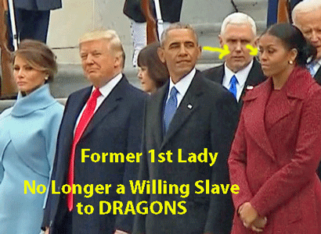
After watching President- Select Donald J. Drumpf being sworn in, Barrack and Michelle Obama flew off directly to Palm Springs, Calif. where they stayed at the home of a gay couple, Spanish Ambassador James Costos of the secret Greek Fraternal Order of AHEPA, and his life partner Michael Smith.
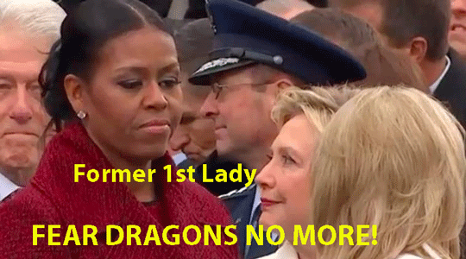
But after 2 days of the wild thing with Barrack and his gay friends, Michelle reportedly packed her bags and boarded a private jet and allegedly flew to British Intelligence billionaire Sir Richard Branson’s private Necker Island in the Caribbean — without her husband. Washington insiders whispered for some time that Barrack and Michelle Obama were headed for a messy divorce. It appeared that she finally had enough. They spit up on January 23, 2017 when she boarded that plane and disappeared over the Caribbean Sea. Michelle Obama has been disappeared for almost 4 (four) months and suddenly popped up on APRIL 26, 2017 AT 2:36 PM EDT inside a classic RAINBOW with a Happy Face. All is not well.
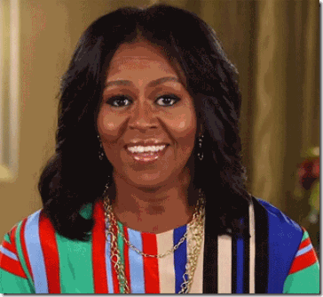
Under the Rainbow Colors of the Wonderful Wizard of OZ, Michelle Obama made her first public appearance in “flesh” since leaving the White House announcing her coming personal appearance on May 5, 2017 at a College Signing Day event in conjunction with NICK CANNON and MTV in New York.
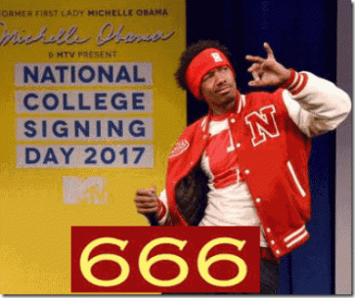
NICK CANNON is a Luciferian CIA MK ULTRA/MONARCH watcher and controller.
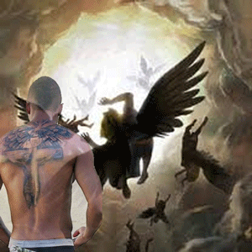
NICK CANNON is EVIL as HELL!
III
MARIAH CAREY, NICK CANNON & THE WONDERFUL WIZARD OF OZ
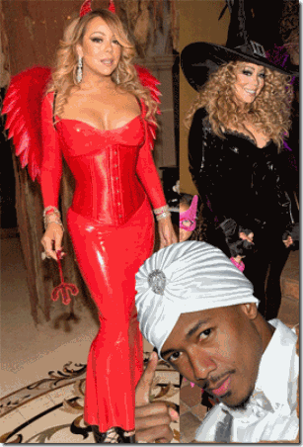
MPD MK ULTRA SEX KITTEN, DEVIL & WITCH Mariah Carey & Nick Cannon

Nick Cannon seems to believe that he is a some type of hypnotist, mesmerizer or more likely a CIA MK ULTRA sex kitten mind control handler and programmer.
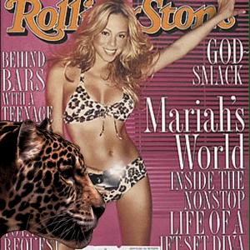
Mariah Carey- MK ULTRA SEX KITTEN
Cannon is also a Multiple Personality Disordered (MPD) Black Manchurian Candidate that they can spin on a dime.

Nicholas Scott Cannon was born on October 8, 1980, in the U.S. military enclave of San Diego, California. He was raised by his paternal grandparents in California, but spent part of his childhood living in Charlotte, North Carolina with his father, James Cannon, who was a minister. [1]
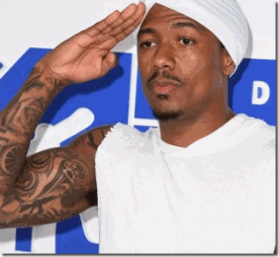
Nick Cannon- Blind Obedience to the ILLUMINATI & Shadow Government
2013-2014, Nick Cannon and his Power 106 N’Credible Tour co-stars teamed up with the USO to entertain troops and families based in Germany and Kuwait this spring, playing all-star basketball games against troops, heating up the stage with musical performances and visiting wounded warriors at Germany’s Landstuhl Regional Medical Center. Nick Cannon: “With a grandfather [James Ernest Cannon]who served in the Navy [U.S. Naval Intelligence?] and an aunt who’s a colonel in the Army, Cannon is no stranger to military service. ‘It’s something I feel connected to,’ he said. ‘People always ask me, ‘if I wasn’t an entertainer, what would I have done?’
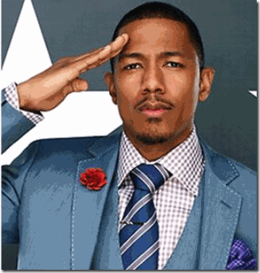
I probably would have joined the military.’ ”[2]
Nick Cannon is certainty obedient to U.S. military intelligence. He has an ultra secret and complicated CIA MK ULTRA/MONARCH military (U.S. Navy) intelligence background from San Diego, CA. His mouth is sealed by a Satanic Blood Oath Covenant.
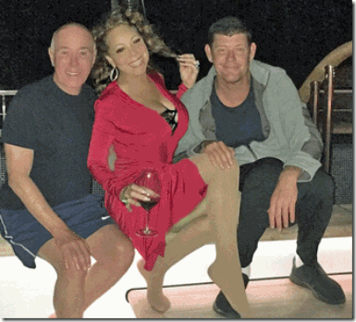
Fourth of July, 2016, King David (David Geffen), Mariah Carey and James Packer (Wizard of Oz) on Geffen’s Rising Sun, Lucifer– Apollo.[3],[4]
The Wizard of OZ is LUCIFER
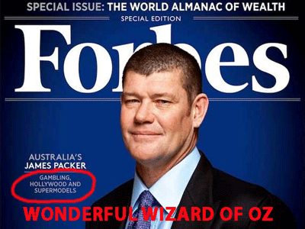
James Packer is the chairman of OZ–based gaming and entertainment company Crown Limited.[5] He inherited his billions from his grandfather, Sir Douglas Frank Hewson Packer. Sir Packer was appointed a Commander of the Order of the British Empire (CBE) in 1951. He was knighted in the Queen’s Birthday Honours of 1959, for services to journalism and the newspaper industry. In the New Year’s Honors of 1971, Sir Packer was promoted within the Order of the British Empire to Knight Commander (KBE), for services to Australia.[6]
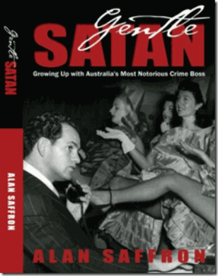
Abe Saffron (The Gentle SATAN) was an infamous and powerful Sydney, Australia Jewish Mafia Don and “Vice Lord” between the 1960s and 1990s. Safrron ran (Mossad?) whitemail operations against police, the powerful and politicians. He would provide prominent people with prostitutes, young girls and boys, film them and fix them that way.
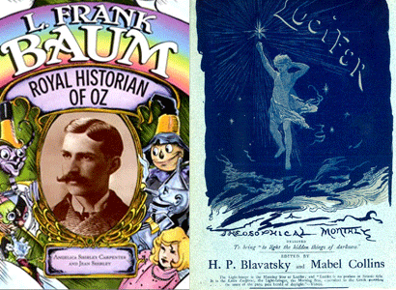
The Light-bearer is the Morning Star or Lucifer
Satanist Author Lyman Frank Baum, author of The Wonderful Wizard of OZ, the Royal Historian of OZ, joined Madame Helena Petrovna Blavatsky’s Ramayan Theosophical Society in Chicago on September 4, 1892, having written in the Aberdeen Saturday Pioneer for January 25, 1890 that Theosophists were “Seekers of Truth.”
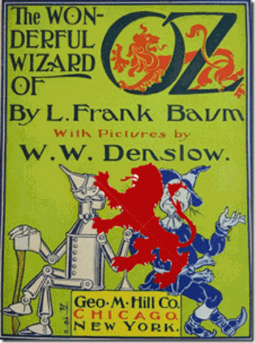
Ancient Occult Brittany Royal Lion and Wizard of Oz
“He [Abe Saffron] had [THE WONDERFUL WIZARD OF] OZ media mogul Sir Frank Packer in his pocket by photographing him through his string of brothels with one way mirrors. It’s said he also had Kerry Packer in his pocket and was in fact bringing in heroin into Australia with Mr. Packer in the early eighties through Packers string of cattle stations in the north of Australia.”[7]
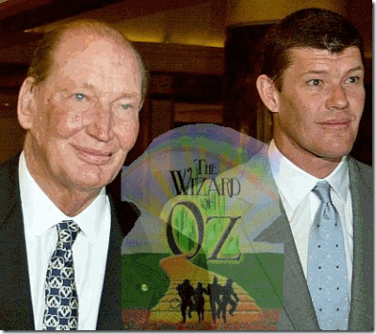
The Wonderful Wizards, Kerry & James Packer
Kerry Francis Bullmore Packer’s son was James Packer.[8] King David, and James Packer are part of the global ultra secret British (PIZZAGATE) “Dark [9th] Satanic Circle”.

In April, 2017, they had been the international cover on Geffen’s yacht, Rising Sun- LUCIFER for the reprogramming of Barrack and the kidnapping of Michelle Obama. The Wizard of OZ is LUCIFER.
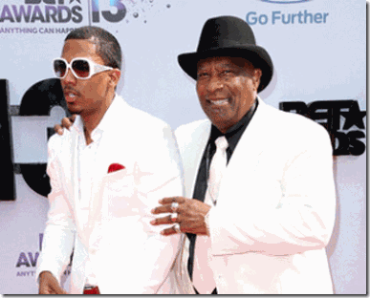 Nick Cannon & Grandfather James Cannon
My Lord! These people are the underbelly of an extremely dangerous global SATANIC CABAL. Nick Cannon knows better than to open his mouth about ANYTHING about Mariah, the (Black) Dark Satanic Circle or the OZ even to save the dignity of his own family! But, his grandfather, James Cannon, Sr., had a lot to say about Mariah Carey, the OZ and his grandson, publicly. He lashed out at Mariah, claiming that she never tried to save their marriage, and even insinuated that she might have been unfaithful with her then fiancé, James Packer- the WONDERFUL WIZARD OF OZ.[9] He also complained that Mariah held all the chips and bargaining power over their marriage, and how Nick blindly signed whatever papers lawyers shoved in his face.
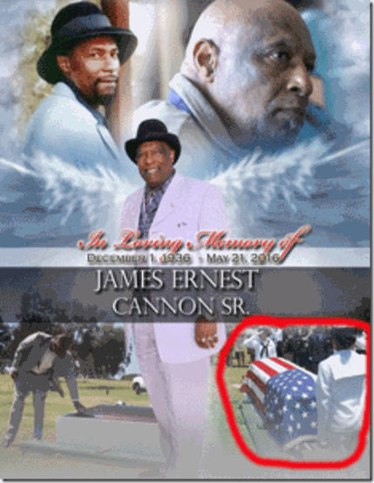
By May 21, 2016, James Cannon suddenly dropped DEAD– no cause of death or public obituary was reported. Nick and Mariah Carey’s dissolution of marriage became final around November 1, 2016.[10]
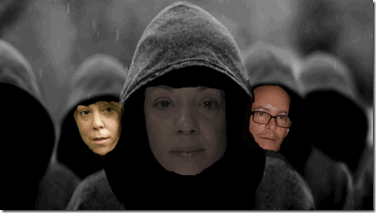
Satanic Cult, Mariah, Alison (both psych wards), Morgan Carey (In hiding)
Mariah Carey: sister, Alison, and brother, Morgan, have linked her to ritual sexual abuse by a “Eyes Wide Shut” global Satanic Cabal, and Nick Cannon was only a pawn that helped veil all of her dark secrets and secret links to the Dark Satanic Circle.[11] So, Nick Cannon’s role in the marriage to Mariah Carey should be very clear as a VEIL!
Mind Control and Satanic Ritual Sexual Abuse, Mariah Carey & RAINBOWS

“I just want one day off when I can go swimming and eat ice cream [brain freeze] and look at RAINBOWS [Wizard of Oz programming], … ‘Mariah Carey’s lost her mind (mind control).’ One week later, she checked into a hospital. ‘I just can’t trust anybody anymore because I don’t understand what’s going on [mind control/alters/amnesia walls].‘ ” – Mariah Carey[12]

Mariah Carey, Decades of Satanic Ritual Sexual Abuse Has Taken its Toll Again
Sadly, May 9, 2017- Mariah Carey is in a psych ward again reportedly undergoing psychiatric treatment in a hospital after another nervous breakdown; and a suspected suicide attempt. “She’s cracking up. I think she’s going to kill herself,” her mother is quoted as having told police officers before Carey was taken to Westchester North Hospital in New York, where she remains since being checked in as “emotionally disturbed” last week. “She did break some dishes and glasses, and she may have stepped on them.”[13]
In sum total, it isn’t surprising that Michelle Obama’s first public appearance with a contrived and manufactured “happy face” since leaving the White House would be in a “RAINBOW OF COLORS“, it’s indicative of CIA MK ULTRA/MONARCH- The Wonderful Wizard of OZ mind control programming or re-programming.

“ … [S]omewhere over the rainbow” is the ‘happy place’ dissociative trauma slaves must go to in order to escape the unbearable pain being inflicted upon them. Using the movie, programmers encourage slaves to go “over the rainbow” and dissociate, effectively separating their minds from their bodies.”[14]
Michelle Obama & the Post Production Conspiracy
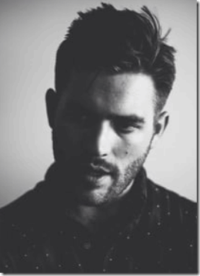
THE “DARK” DUNCAN WOLFE
On May 5, 2017, Michelle Obama, allegedly, accidentally tweeted out a former White House staff member’s phone number, Duncan Wolfe. He was a filmmaker and creative digital strategist for President Barack Obama.However, it may have been a deliberate clue to something else- The Dark Satanic Cabal and the Art of Post-Production Digital Photography to Deceive the Masses!
According to the Chicago native’s Linkedln profile, Wolfe works for ONE at Optimus, a production company based in Chicago.[15] Optimus is a leading production and post-production house. Optimus and its production arm One at Optimus offer a full suite of creative services, including production, color correction, visual effects and design, audio mixing and finishing. ONE was founded by Robert Sargent “Bobby” Shriver III and Sir Bono (MI6). The ONE Campaign is a U.S.-based, non-partisan, non-profit organization which aims to increase U.S. government for and effectiveness of international-aid programs.

Is the above false video evidence of Michelle’s lunch date with Sir Bono on March 10, 2017 in New York part of Wolf’s post- production digital video work? Post-production, the real Michelle was digitally cut and pasted on top of the black female impostor leaving the restaurant.

There was a black female at Sir Bono’s lunch date posting as Michelle Obama, but it wasn’t her. The above black female captured by a camera shot that U.S. Secret Service failed to block is seen hurriedly leaving the restaurant lunch date with Barrack Obama and Sir Bono. It is not and was not Michelle Obama.
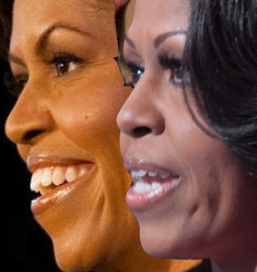
In 2006, Bono and Shriver founded PRODUCT (RED) to fight the Africa AIDS epidemic with two other powerful forces-producers of world-class consumer goods and world-class shoppers. Each time someone buys a (PRODUCT) RED product, up to 50% of the gross profit goes to The Global Fund, which allegedly provides AIDS medicine funding to African countries.[16]
Duncan Wolfe & Sir Bono
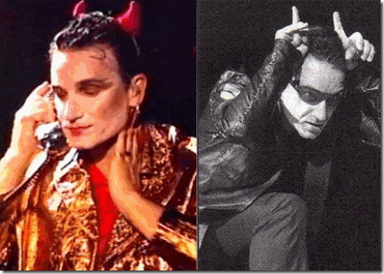
Sir Bono, the Red DEVIL
In March 2017, Viscount Rothermere, Daily Mail, and Sir Bono (Knight of the British Empire and the DEVIL’s Servant) of U2 collaborated with MI6 (British Foreign Service) to control mass population propaganda to veil the covert post- White House CIA MK ULTRA/MONARCH kidnapping of Michelle Obama.[17]
Duncan Wolfe & Robert Sargent ‘Bobby’ Shriver III
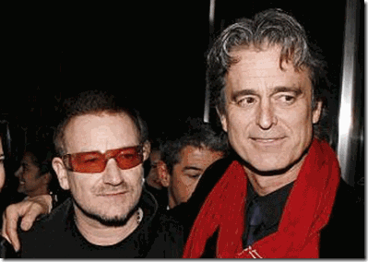
Sir Bono and Robert Shriver
“Red is a state of mind, not just a color.” Robert Shriver III[18] Shriver actually wants “red” to be the color of the world.
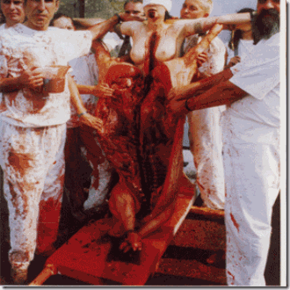
The Luciferian-Masonic design of “Red” designates the “Divine Love of God.” Shriver’s RED trademark scarf symbol also presents a “Red Mass Rite” or “Ritual Blood Mass” vestment of deception-
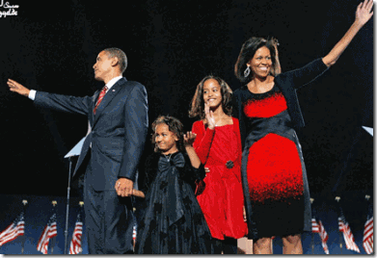
drenched in sacrificial blood like something marvelous out of the Book of Revelation, Verse 19:13.
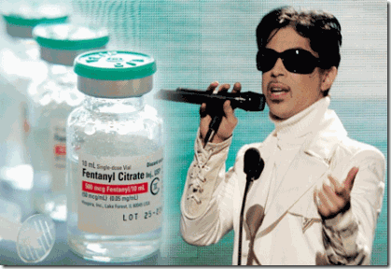
Police on Cape Cod say two men were dealing fentanyl out of a home owned by a family related to the Kennedys. Barnstable police charged Troy Monteiro and Trevor Rose – both 29 – with multiple drug crimes. Records show the Hyannisport property is owned by a limited liability corporation managed by Robert Sargent ‘Bobby’ Shriver III, son of the late Sargent and Eunice Kennedy Shriver, the sister of late President John F. Kennedy.[19] Allegedly, Prince (Roger Nelson) was assassinated with fentanyl.[20]
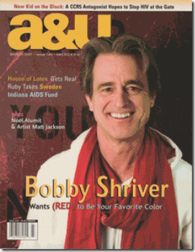
Shriver moved to New York, where, with former U.S. Defense Secretary Harold Brown and Sir (Knight) James D. Wolfensohn, he worked in the venture capital partnership of the Wolfensohn firm.[21]
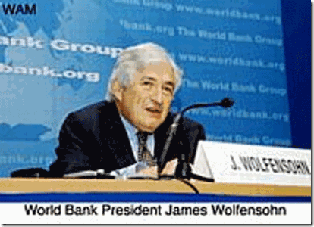
James D. Wolfensohn (CFR, Trilateral Commission, Bilderberg) is a Knight Commander of the Most Excellent Order of the British Empire, and The Order of Australia. The Order of Australia is an order of chivalry established on February 14, 1975 by Queen Elizabeth II.
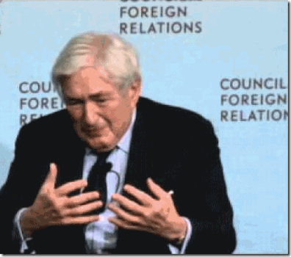
He is a former member of the Steering Committee of the Bilderberg Group, and ninth president of the World Bank Group.[22]
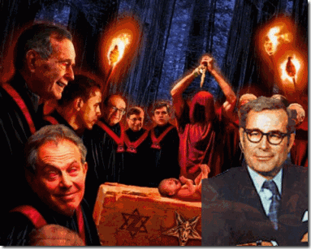
Harold Brown (Jewish Satanist and Cabbalist of the Bohemian Grove) of the Trilateral Commission is a scientist who served as U.S. Department of Defense Secretary from 1977 to 1981 in the cabinet of President Jimmy Carter.[23] He had previously served in the JFK and Lyndon Johnson administrations as Director of Defense Research and Engineering and Secretary of the Air Force.[24]
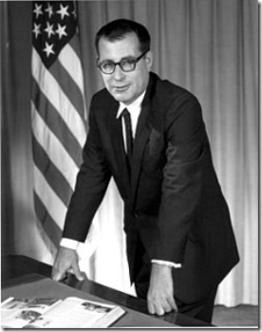
Harold Brown, Former Secretary of Defense
Brown served as the Chief Technology Officer for the Department of Defense (DoD) and the principal adviser to the Secretary of Defense on all matters relating to science, technology, research and engineering. [25] Basically, the Chief Technology Officer is responsible for overseeing and coordinating the activities of component organizations of the DoD including the Military Departments and the Defense Agencies, which are responsible for management and execution of programs and projects associated with research and technology broadly, and numerous Component organizations within DoD including: Air Force Office of Scientific Research (AFOSR); Army Engineering R&D Center, Army Research Laboratory (ARL); Army Research Office (ARO); Defense Advanced Research Projects Agency (DARPA), and Office of Naval Research (ONR).[26]
DARPA is attached to an ultra top secret counterinsurgency office, which is highly blood oath classified. DoD’s special projects are kept in the counterinsurgency office to keep its research and development below the radar, while also taking advantage of the agency’s ultra top secret unlimited funding of unconventional warfare that even an U.S. president can’t see.[27] I said this to open the following. If there is anyplace to search for Barrack Obama’s ultra secret and sensitive U.S. military intelligence files, it is DARPA’s Counterinsurgency Office.
Harold Brown inherited a fully implemented and funded Operation Paperclip, Werner von Braun , the SS Vision for a “Post-human Renaissance“, and Baby Obama II from Neil S. McElroy, U.S. Secretary of Defense (1957-1959); Thomas S. Gates, Jr., U.S. Secretary of Defense (1959-1961); Dr. Fritz Kraemer, NSC, DoD, U.S. Army Chief of Staff Plans Officer (1948- 70s), and DARPA (ARPA) Director, U.S. Army BG Austin Betts (1959-1961).
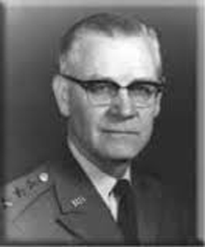
U.S. Air Force Brigadier General Austin Wortham “Cy” Betts, above, was an engineer for the covert Fourteenth Air Force under Air Force Major General Claire Chennault in the Burma-China, India Theater. Chennault was a deep rabbit hole. With the U.S. entry into World War II against the Empire of Japan in December 1941, Chennault, the commander of the Flying Tigers of the Chinese Air Force, was formed to covertly aid Chiang Kai-shek, and his wife, Madame Chiang Kai-shek’s regime combat organization in China. Chennault also had a far greater covert mission- keep the flow of Heroin out of Burma open during the war. In 1953, Allen Dulles as the newly appointed Director of the CIA arranged for Chenaults’ Civil Air Transport (Flying Tigers) pilots to covertly work for him.
After V-J Day, September 2, 1945, the formal surrender of Japan, Betts was assigned to the ultra top secret Manhattan District Los Alamos Scientific Laboratory that helped develop the atomic bombs dropped on Hiroshima and Nagasaki, Japan. General Betts worked with Lieutenant Colonel Boris T. Pash on the ultra secret Alsos Mission. Pash was the chief U.S. Army intelligence officer in the World War II Manhattan Project (atomic bomb) and the Alsos Mission. The Alsos Mission was an organized effort by a team of U.S. military, scientific, and intelligence personnel to discover and recruit enemy scientists, particularly Himmler’s SS scientists. Its chief focus was on the Nazi-SS nuclear energy project, but it also investigated both chemical and biological SS weapons and the means to deliver them.
As Lieutenant General, Betts worked directly with Himmler’s Knights of the Black Sun Peenemünde rocket team led by Allgemeine SS Sturmbannführer Werner von Braun smuggled out of Austria in the covert operation, Project PAPERCLIP. Betts had also covertly covered SS-Nazis, Gehlen Org, and Project PAPERCLIP through the USAREUR G3- U.S. Army Europe (Command and Control) Headquarters; now in Wiesbaden, German.
At sometime before 1947, SS– Hauptsturmführer Josef Mengele had been captured or surrendered to the 430th U.S. Army Counter Intelligence Corp (CIC) in Vienna, Austria. The decision to covertly smuggle Dr. Mengele out of Vienna thru a secret U.S. military intelligence ratline had to have come down from the top- U.S. Army America-Europe Command and Control Headquarters in Germany.
Werner von Braun and Himmler’s V-2 Peenemünde rocket team was smuggled to Fort Bliss, Texas to work on the Pentagon’s emerging guided missile program. There, Austin Betts served as SS von Braun and the rocket team’s (Nike Zeus) NIKE–X System Manager. Betts provided them all the secret cover, funds and resources that the SS needed to set them up in America, and fleece the taxpayers in NASA’s Great American Lunar Landing Hoax.
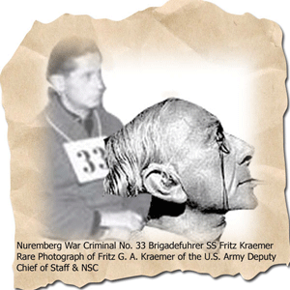
By 1957, Dr. Fritz G.A. Kraemer of the National Security Council (NSC), and Special Adviser for Political-Military Affairs in the Office of the Director of the Army Staff, and Plans Officer for the Chief of Staff of the U.S. Army had literally taken over the entire Pentagon. The odd things about Dr. Kraemer are (1) he came out of Nazi Germany (2) in 1945 just after the fall of the Third Reich, he just happened to be stationed with Henry Kissinger at Camp Oberammergau, Germany with the Gehlen Org, SS Werner von Braun, Peenemünde rocket team, and Hitler’s chief strategist and war criminal- Waffen SS Bridgadefuhrer Fritz Kraemer.
Nazi General Fritz Kraemer, Prisoner No. 33, disappeared from the rolls of the Nuremberg Tribunal, and the other U.S. Army Lt. Fritz Kraemer appeared in Washington DC at the U.S. Pentagon as its chief strategist “plans officer.” The Great Mae Brussell, and many others believe that they were one and the same person.
The Advanced Research Projects Agency (ARPA), the agency was created in February 1958 by President Dwight D. Eisenhower (controlled by Nazi collaborator, Prescott Bush) in response to the Soviet launching of Sputnik I in 1957. Since its inception, the agency’s mission is ensuring that the United States avoids further technological surprise. When NASA was established later in 1958 all space projects and most of ARPA’s funding were transferred to it. ARPA was repurposed to do “high-risk,” “high-gain,” the “far out” basic research.
In 1959, Betts became director of the Advanced Research Projects Agency (ARPA), the agency’s only military director. In 1961, he was assigned to the Atomic Energy Commission as director of military applications as a major general, completing the circle that began at Los Alamos.
In 1962, the DoD set up the Office for Behavioral Sciences and Command & Control Research in the ARPA, Lick became its first director and stayed there until 1964. He renamed the office as the Information Processing Techniques Office (IPTO); its budget surpassed the sum of all other federal funding agencies’ budgets for the computing field of the time.
In 1957, Lick left MIT where General Betts attended engineering school to become head of the departments of psychoacoustics, engineering psychology, and information systems at Bolt Beranek & Newman Inc. (BBN) in Cambridge, Massachusetts. Since 1957, the DoD and ARPA had been very familiar with Lick’s “far out” research and development. BBN had been a primary major contractor of ARPA were Lick horned “advanced human-computer interaction.”
NASA was nothing more than Himmler’s V-2 Peenemünde rocket team relocated, and ARPA was no more than an extension of his SS Weapons Research and Development Department with a changed venue fully funded by the American taxpayers with multi-million dollars, on top of a concealed “white budget” that even the president, the highest elected officer of the U.S. can’t see.
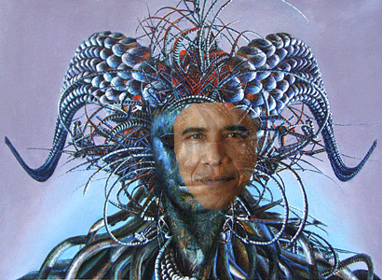
Major General Austin Betts was central part of the corrupt clandestine “inner circle” of the “inner circle” of the Shadow Government, and the Satanic New Order. Behind the Veil, Hitler’s chief strategist, SS Waffen General Kraemer in the DoD, and Major General Betts in DoD’s proponent DARPA (ARPA) provided the clandestine cover, power, infinite support, unlimited funding and sources for the underground Third Reich and the SS to continue its “far out” racialist pseudo scientific alchemist- Satanic principled research and development like something out of the “Outer Limits” and “Twilight Zone” to create a race of man-computer machines.
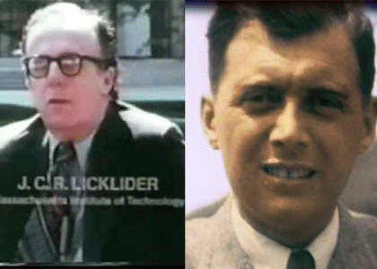
The bottom line is that Dr. Mengele was a deep cover agent of the SS Gehlen Org’s twisted sister, the CIA. He moved freely moved in and out of the U.S., Canada, and South America. He fell off the map from 1960 to 1962, with the infamous May 13, 1960 capture of international war criminal SS Adolf Eichmann in Argentina, and the start of ARPA’s secret Trans-human Baby Obama II Project in Hawaii. Dr. Lick had the computer technology, vision, and Dr. Mengele had the human clone– the Boy from Brazil.

Under these circumstances and with type of players, Michelle Obama’s life doesn’t amount to a wooden nickle if she continues to be a threat to blowing Barrack Obama’s cover.
IV
DARPA, OCCULT, HAWAII UNIVERSITY & POST HUMAN RENAISSANCE DEVELOPMENT- THE MAKING OF BARACK OBAMA
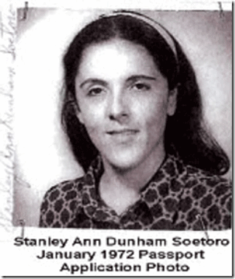
“Ann Soetoro (Stanley Ann Dunham) is listed in the East-West Center directory of grantees in 1976-77 (with her photo on the same page as mine), but I never see any of the stories mention her involvement with the EWC.”[28] In 1964, Ann Dunham filed for divorce from Barack Obama, Sr. that may never had an actual sexual relationship with Dunham. She allegedly fell in love with a fellow foreign student, Lolo Soetoro of Indonesia. Soetoro met Ann Dunham in 1963 at the East-West Center while both were students at the University of Hawaii.[29]
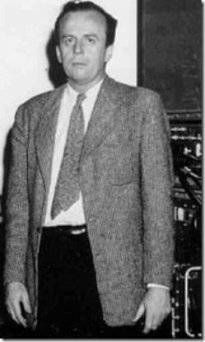
Dr. Joseph C.R. Licklier- the “Lick”
During the 1960’s, DARPA (ARPA) was led by behavioral psychologist, Dr. Joseph Carl Robert Licklier (1915- 1990) known simply as J. C. R. or “Lick“. He was an American psychologist and computer scientist who is considered one of the most important figures in computer science and general computer history. He has been called “computing’s Johnny Appleseed“, for planting the seeds of computing in the digital age. The “Man-Machine System for Thinking” had been his pet project since 1957.

He was among the core group of Macy Conference cyberneticists with OSS/CIA anthropologist, Dr. Gregory Bateson, that developed cybernetics for military-industrial applications.[30] While heading the Command and Control Research division of DARPA in 1960, Licklier wrote an explosive and startling paper titled, Man-Computer Symbiosis:
“The hope is that, in not too many years, human brains and computing machines will be coupled together very tightly, and that the resulting partnership will think as no human brain has ever thought and process data in a way not approached by the information-handling machines we know today…That hope would take form in such later projects as DARPA’s Augmented Cognition to create soldier-computer “dyads [twofold],” and the sterile vision for a “Posthuman Renaissance,” where ‘there are no demarcations between bodily existence and computer simulation, between cybernetic mechanism and biological organism.‘ ” [68]
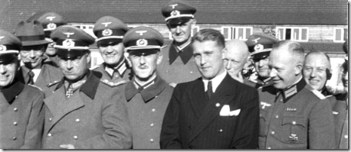
SS-Sturmbannfuhrer Werner von Braun and SS
Under Licklier, DARPA disbursed millions of dollars to a wide range of computer and artificial intelligence research centers. DAPRA and NASA (Himmler’s Allgemeine SS) had been locked in partnership since the Soviet Union’s launch of Sputnik I in October of 1957, and the inception of NASA under SS-Sturmbannfuhrer Werner von Brun.[31] One of its secret intelligence research centers was the U.S. military instrument, Hawaii University.
But, it was a much more deeper secret rabbit hole than that with Himmler’s SS. One of few men alive in 1960 that was actually involved in implementing an clandestine “Post-human Renaissance” was Knight of the Black Sun– SS-Hauptsturmführer (captain) Dr. Josef Mengele. After the fall of Nazi Germany, Dr. Mengele was captured or handed over by SS Baron Otto von Bolshswing to U.S. military counterintelligence, and OSS Officer Allen Dulles (CIA Director 1953) in 1945 for Cold War recruitment and employment as a high level member of the Gehlen Org. Dr. Mengele became an essential part of the clandestine “inner circle” of Allen Dulles’ Operation PAPERCLIP and CIA MK ULTRA/MONARCH since their inception.
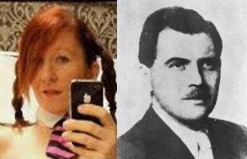
Erin Rothschild of the Rothschild Financial Dynasty talked about being secretly raised from infancy by Dr. Josef Mengele as her grandfather figure, and the Satanic ritual abuse she suffered. She also talked about test tube babies and reluctantly briefly mentioned Barrack Obama as also being part of Dr. Mengele’s secret “test tube baby?” circle and the “Rothschild Plan“.
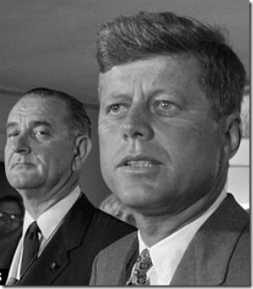
VP Lyndon Johnson and Allen Dulles Had Been Co-CEOs of the JFK Assassination
In 1959, the corrupt low down and dirty U.S. Senator Lyndon B. Johnson (D-TX), member of the American Hellenic Educational Progressive Association (AHEPA), proposed the creation of an international university in Hawaii to provide for a clandestine cold war military intelligence instrument of “cultural and technical interchange between East and West.” On May 14, 1960, President Eisenhower signed the Mutual Security Act of 1960 which authorized the creation of a Center for Cultural and Technical Interchange Between East and West (East–West Center) at the University of Hawaii, and on August 31, 1960, signed the Department of State Appropriation Act, 1961, which appropriated $10 million for the Center (including $8.2 million in capital spending for six new buildings), and on September 30, 1961, President Kennedy signed Supplemental Appropriation Act, 1962, which appropriated an additional $3.3 million for the Center.[32]
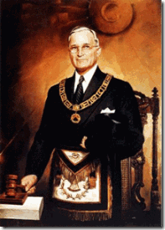
Nazi collaborator and Luciferian Masonic Grand Master President Harry Truman’s 1951 Mutual Security Act omnibus legislative enactment covered special clandestine “anticommunist” military aid, developmental aid, technical assistance, and a contingency fund. Over the years, military assistance under the Act has been provided to more than forty countries, and in most, if not all of these arrangements, the CIA, Gehlen Org, and U.S. Special Forces had been a key special secret factor.[33] A special Presidential committee had been formed early in 1959 to study “Training Under the Mutual Security Program” and to “provide instruction [to recipient countries] in concepts or doctrine governing the employment of the military instrument, in peace and in war.”[34] In other words, this committee was layed it right on the line that the Government should be stepping into the Mutual Security program with “military” training, including the development of paramilitary capability in the recipient nations. The only way this could be carried out would be to mount clandestine operations in every country where this was to apply.[35] The East–West Center was developed 1959-60 under the Mutual Security Act to develop a clandestine military and intelligence instrument. And, it appears that Dr. Gregory Bateson of the CIA helped develop the East–West Center from its inception.[36]
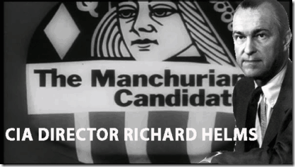
According to files recently discovered in the CIA archives, the University of Hawaii (East-West Center) not only served as one of the CIA’s and director Richard Helms’ top five research campuses for “behavioral sciences” from 1966 to 1973.[37] So, it should be no surprise the area of secret research and development of the CIA, DAPRA/NASA, Licklier, and Dr. Bateson at the East-West Center, to create a “soldier-computer dyad where is little or no noticeable “demarcations between bodily existence and computer simulation, between cybernetic mechanism and biological organism”, turns up prominently in the early background of Barack Hussein Obama, an experimental human Cyborg.
Out of everyone in the world, SS Dr. Josef Mengele and the underground SS Knights of the Black Sun had been the most secretive, treacherous and satanic forces to conceive of a diabolical plan to create from birth a race of subservient mind controlled trans-human cyborgs to deceive, confuse and control the world.Dr. Mengele disappeared during the time of conception and birth of Baby Obama II. During that time, Dr. Mengele was secretly deeply involved in clandestine artificial insemination in human beings.
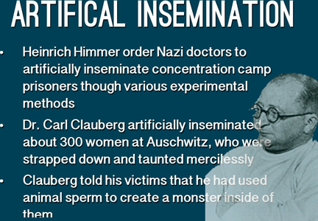
After being held as a prisoner of war in Russia, esteemed world renown reproduction scientist and specialist, SS-Gruppenführer Dr. Carl Clauberg, opened a gynecology and human reproduction clinic in West Germany to exploit the knowledge he obtained from his secret SS concentration camp human medical experimental research and development in field of reproduction, artificial insemination and abortions. He suddenly turned up dead in 1957 leaving his concentration camp SS assistant- Himmler’s secret personal deputized Dr. Josef Mengele as the world’s most foremost authority in artificial insemination. Dr. Clauberg thought that fat meat wasn’t greasy, he must have thought Himmler and SS was dead.
The secret program to create a race of mind controlled trans- human cyborgs to control the world (J.C.R. Licklier’s PROJECT CAMELOT) at the University of Hawaii was so classified, sensitive and ultra secret that Rev. James Jones of the Peoples Temple was brought into Hawaii as part of a special CIA clean-up team after the birth of Barrack Hussein Obama.
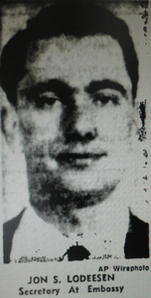
Jon Lodeesen, the super-ultra cold war specialist and sensitive Russian Embassy Secretary was Jim Jones’ secret CIA handler. In 1961, Lodeesen sent Rev. Jones on an urgent assignment in Hawaii. Jones’s whereabouts from 10/61 until 4/62 is unknown and his U.S. Passport for that period is conveniently unaccounted for. Jones’ U.S. Passport #0111788 is accounted for, but it was issued in his name at Indianapolis on January 30, 1962 well after and during his presence in Cuba and Hawaii. From October 6, 1961 to April 1962, Jim Jones whereabouts is secret, which covers Obama Sr.’s sensitive presence at the University of Hawaii, and within days of Stanley Ann Dunham suddenly resurfacing at the University of Washington in Seattle. In fact, how Stanley Ann and Baby Obama II got to Seattle, WA in August 1961 is an absolute mystery.
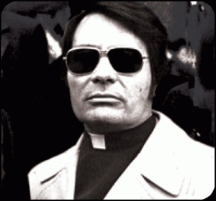
CIA Agent Rev. Jim Jones, Peoples Temple
At least one source placed Rev. Jim Jones in Hawaii in October 1961 most likely at the University of Hawaii (UH) with Barrack Obama, Sr., “On what would become a two-year sojourn, Jones made his first stop in Honolulu, where he explored a job as a university chaplain…” At least one other source place both Lodeesen and Jones in Hawaii from 1961 to 1962 working with the CIA station in Honolulu. By Lodeesen being established as one of Jim Jones’ primary CIA handlers, we get a clear understanding of what his mission would have been in Hawaii- that is a stay behind psychological subversive intelligence activity. Jim Jones would have clandestinely moved about UH closely monitoring, silencing rumors and quashing gossip and information about Obama, Sr., Stanley Ann and Baby Obama II.
When Baby Obama II and Stanley Ann returned to Hawaii in 1962, Dr. Mengele was exposed by Argentine historian Jorge Camarasa to have been involved in artificially (medical insemination) creating the master race of blond haired, blue eyed Aryans in twins by the dozens in Candido Godoi, Paraguay. The SS great classified works involve the “Satanic Principal” of opposites, that is if Dr. Mengele created a great master race, in duality, he also created a race of subservience. So, Michelle Obama’s so-called mistaken public outing and exposure of Duncan Wolfe, and post-production digital video technology deployment may have been NO mistake after all. IT WAS A TIP OF AN ICEBERG.
On May 05, 2017, the former first lady, did in fact, attend the College Signing Day event at The Public Theater in New York City with Nick Cannon to celebrate high school students pursuing higher education.[38]
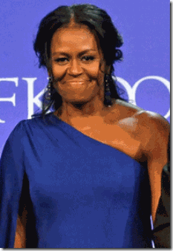
5/7/17 Trapped in a Deep Rabbit Hole
On Sunday, May 07, 2017, both Barrack and Michelle Obama personally appeared while accepting the John F. Kennedy Profile in Courage award. “I also want to thank Michelle Obama for, after the presidency, sticking with me, because I think she felt an obligation to the country to stay on, but once her official duties were over, it wasn’t clear,” Obama said.[39]
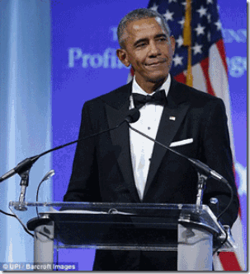
That came directly out of the mouth of Barrack Obama not mine, and he didn’t think it was a joke. He looked at her with a shy smile or smirk on his face, but he wasn’t laughing. It was mockingly sarcastic in that Michelle Obama knows far too much about him, and military intelligence sensitive, classified and ultra top secret information. An Obama public divorce and even a legal separation proceeding in Chicago or Washington DC would be extremely messy. Michelle Obama knows enough secrets that have the potential to blow Barrack Obama’s cover, and destroy the public’s faith in the entire political and governmental system.

If it isn’t absolutely and completely clear to Michelle, she would disappear and sink into the floor, again, until she just plainly turn up DEAD!
V
KANYE WEST, SINK INTO THE FLOOR, AGAIN!
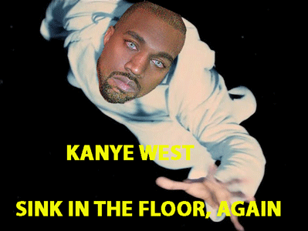
KANYE WEST sits in the very same position that Michelle Obama occupy- the DEVIL always collects his part of the BARGAIN. Within a couple of weeks of Kanye resurfacing from beneath the floor in a psych ward, and meeting with the DEVIL’s son, Donald J. Drumpf, he was spotted out with pink and orange hair that looks like RAINBOW sherbet.
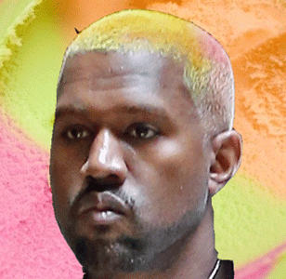
Kanye West, Ice Cream (Brain Freeze) & RAINBOWS
Kanye West, for whatever reasons, have attached himself to a doctrine of “Divine Rule.” His Saint Pablo is part of that falsely perceived right of “Divine Rule” of Merovingian origin. For generations, the Merovingian Dragon dynasties have weaved together a complicated web of myths, legends, and conspiracies all to justify their “Divine” right to rule the world. In Kanye’s mind, he believes that he can be one of them. But as a black man, he has not developed neither mythology or cosmology to justify or defend his right to claim “Divine” rule. Yet, the key has always existed right in front of his face. This colonized Negro is not a descendant of Merovingian Origin. He does not belong to the Bloodline of Dragons or Mary Magdalene. This dreamworld and mis-education is the dilemma and challenge that he faces in attaining “self realization“, and combating sinking into the floor, and MK ULTRA/MONARCH mind control reprogramming.
On November 21, 2016, Kanye West was forcibly taken to UCLA Medical Center for psychiatric evaluation. The hospitalization came after Kanye abruptly cancelled his Saint Pablo Tour, and verbally attacking Jay Z and Beyonce during a Saint Pablo Tour public performance in Sacramento, CA.[40]
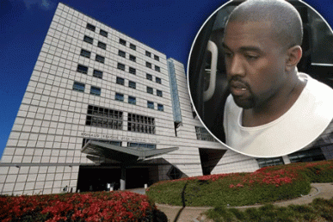
They didn’t take Kanye to the psych ward for talking about Jay Z and Beyonce and the ILLUMINATI. That’s old news that they both openly flaunt, plus it involves Black Folk business.
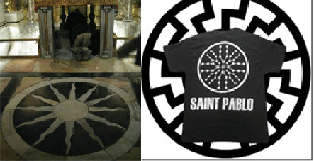
The 12 (twelve) Spoke Sacred Sun Disk of the Holy Land’s Church of the Holy Sepulchre, and Kanye West’s Saint Pablo Black Sun. The story behind Kanye and the psych ward is much deeper. Kanye was playing cute little games and mind tricks with his ILLUMINATI/MK ULTRA handlers that Don’t Play Games.
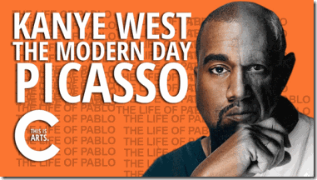
Kanye West- Pablo Picasso Instead of Kha-khaeper-re- “Soul of Re Comes into Being”
Who is Saint Pablo? Kanye says, “Which Pablo? Pablo Picasso? Pablo Escobar, of course. Apostle Paul [Pablo in Spanish]. He really influenced and was the strongest influencer of Christianity. Pablo Escobar was the biggest mover of product and Pablo Picasso is the biggest mover of art. That mix between message, product, and art is The Life of Pablo.”[49]
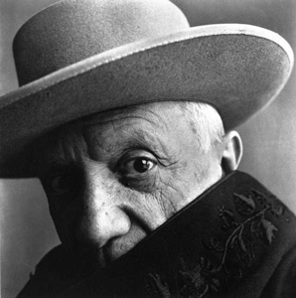
Pablo Picasso
“It is told that one summer, when Chlodio was staying at the seaside with his wife, they went into the sea at midday to bathe; and a beast of Neptune rather like a Quinotaur found her. In the event she was made pregnant, either by the beast or by her husband, and she gave birth to a son called Meroveus, after whom the kings of the Franks were subsequently called the Merovingians (c. AD 736 – 751).”
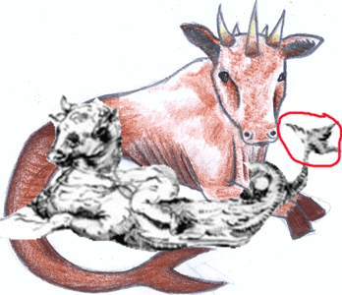
Quinotaur, Bull, Serpent with Trident Tail
The Quinotaur is extremely ancient. In some myths, it is associated with Greek God Poseidon, and the Bloodline Kings of the Lost Continent of Atlantis. The Merovingians founder King Meroveus is said to have been the spawn of the “Quinotaur” (a sea monster), that raped his mother when she went out to swim in the ocean. The Merovingian Kings and its Dynasties believe that they are descended from Serpents.
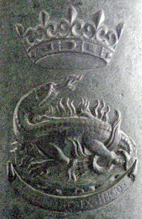
Ancient Merovingian Crown and Serpent
Picasso was born in the ancient city of Magala, Spain. It predates Mary Magdalene by thousands of years. The city was founded in 8th Century BC by the Canaanite trading colony from most likely Magdala, Sea of Galilee, Northern Canaan. In recent years, there have been attempts by several researchers and scholars of Picasso (Melvin Becraft and Mark Harris among them) to link the artist and his work with “occult wisdom”, claiming that much of the symbolism in his paintings is derived from alchemy, Hermetic thought, Gnosticism and other schools of the western “esoteric” tradition.[41] Some of these researchers are even claiming that Picasso may have been initiated into the shadowy Prieure de Sion ( Priory of Sion) that figures prominently in the mystery surrounding Berenger Sauniere and Rennes-le-Chateau in the south of France.
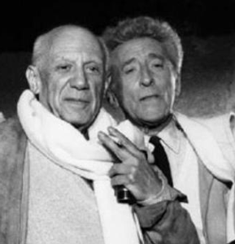
Gay Picasso & Jean Cocteau
This is in part due to the fact that Picasso was a contemporary and good friend (homosexual lover?) of the French artist and mystic Jean Cocteau, a reputed Grand Master of the Priory of Sion. Indeed, Picasso had been a veiled homosexual. According to some accounts, Cocteau once described his communication with Picasso has almost “telepathic.” The use of the words “telepathic communication” might have been Cocteau’s cryptic way of saying that, as members of a secret society, they were a closed-mouth lot on certain “esoteric” subjects. There are also certain tell-tale symbols that both artists incorporated into their work, such as the BLACK SUN motif and pentagonal geometry.[42]
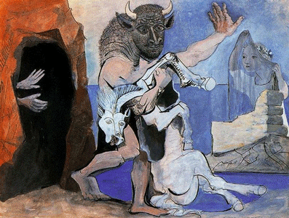
VEIL OF MARY MAGDALENE
Pablo Picasso – Minotaur with Dead Mare in front of a [Mithras Worship] Cave, 1936
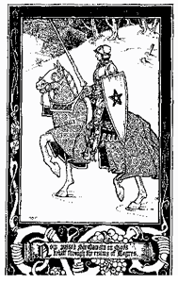
The insignia of the great Merovingian leader, Saint William de Gellone, cousin of Jean Cocteau, was a pentagram on a blue field, symbolizing Mary Magdalene. The Merovingians were ancestors of the German and Dutch Royal House of Orange. The color orange not only signifies Mary, but the Sun Disk God Aton (Aten). The Atonists and Mary Magdalene Sisterhood were also covert Set and Apophis (DRAGON) worshipers, we see that the fantastical story of King Merovee’s birth, from a queen and sea-monster- DRAGON of Revelation.
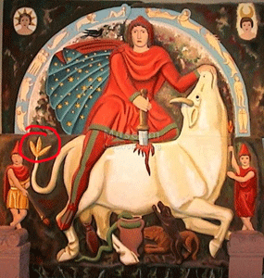
Sol Invictus- Mithras Sacrifice a Bull with the Trident Tail of the Quinataur
Mithraism was a mystery religion centered around God Mithras, who, together with Sol Invictus (Roman Sun God) were worshiped in secret caves and subterranean chambers in the 1st – 4th centuries. There is evidence that the early religion of the Merovingians was the Roman Sol Invictus- Mithras.
Pablo Picasso and the Priory of Sion (PON) are all about Saint Mary Magdalene. PON protects Merovingian dynasts because they may be the lineal descendants of the historical Jesus and Mary Magdalene. The legendary Holy Grail is simultaneously the womb of Saint Mary Magdalene and the sacred royal bloodline she gave birth to; and the Church tried to kill off all remnants of this bloodline and their supposed guardians, the Cathars and Templars, so popes could hold the Episcopal throne through apostolic succession of Peter without fear of it ever being usurped by an antipope from the hereditary succession of Mary Magdalene.[43] In Jerusalem, Kanye was exposed to the fact that the Kardasdians were not only part of the secret Jerusalem Guardian Temple Cult Knighthood, but also discovered that they were also secret guardians of the closely guarded Mysteries of the Cult of Mary Magdalene.
VI
KANYE, GEORGE TENET OF THE CIA, KASDASHIANS & BLOOD OATH SECRETS OF THE HOLY LAND
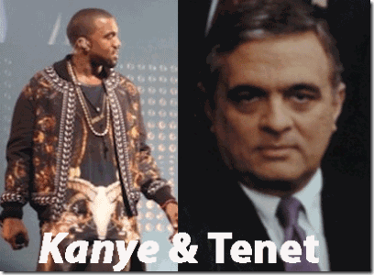
Prior to Kanye’s April 2015 pilgrimage to Israel, he had received limited national security and other ILLUMINATI clearances to the Holy Land directly from former CIA Director, fervent Greek Orthodox practitioner, George Tenet.[44]

President Erdogan of Turkey
Tenet may not be the CIA director, but he is a secret power player in the Dark Satanic Cabal, and global affairs. He has a great deal of clandestine control over the Greek Orthodox Church, and the Holy Land. It appears that Tenet played a clandestine role in the July 15, 2016 attempted coup to overthrow President Recep Tayyip Erdogan in Turkey after he agreed to work more closely with Russia and Vladimir Putin on Syria. It is also being alleged that the Greek Orthodox Church had been captured by the CIA, which in turn works for the Satanic New World Order Globalist Agenda.[45]
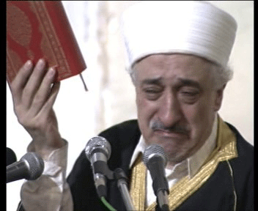
Fethullah Gülen
Fethullah Gülen and Greek Orthodox Patriarch of Constantinople (Istanbul), Bartholomew have been blamed by the Turkish president for the coup plot. In 1999, a Greek Orthodox priest belonging to the Patriarchate, Alexander Karloutsos, helped organize the escape of Gülen from Turkey to the United States together with US diplomats Morton Abramowitz, and CIA agents Graham Fuller and George Fidas.[46] Karloutsos has close links to former CIA boss George Tenet, channels vast sums of money from US Greek billionaires, and other secret sources into the Greek Orthodox church in Istanbul to control it for the CIA via George Tenet.[47]
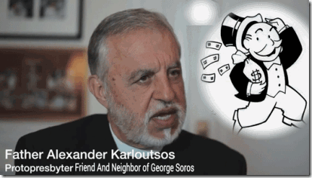
Father Alexander Karloutsos is one of the members of the American-Israeli lobby in the Constantinople Patriarchate. He controls the secret U.S. money flow to the Greek Orthodox church. Karloutsos maintains close relations with former CIA Director George Tenet, and Fethullah Gülen cooperating and collaborating with U.S. intelligence’s global New World Order objectives.[48]
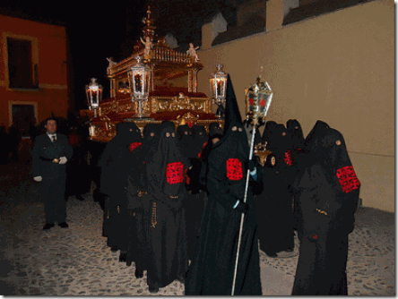
Holy Land Brotherhood of the Holy Sepulchre
From the time of the Crusades up until the 19th century, the Church of the Holy Sepulchre had 3 (three custodians) – the Greek Orthodox (Brotherhood of the Holy Sepulchre)- George Tenet, the Armenian Apostolic (Kardasdians), and the Roman Catholic Churches.[49] Whether Kanye knew or not, these people don’t play!
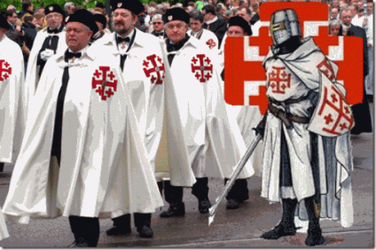
Jerusalem Cross & Knights of the Order of the Holy Sepulchre
The Brotherhood of the Holy Sepulchre, or the Holy Community of the All-Holy Sepulchre, is an Eastern Orthodox monastic fraternity (order) guarding the Church of the Holy Sepulchre and other Christian holy places in the Holy Land founded in its present form during the British Mandate in Palestine (1920- 1948). Headed by the Greek Orthodox Patriarch of Jerusalem, the Brotherhood also administers the Greek Orthodox Church of Jerusalem, such as metropolitans, archbishops, bishops, archimandrites, hieromonks, heirodeacons, and monks.[50]
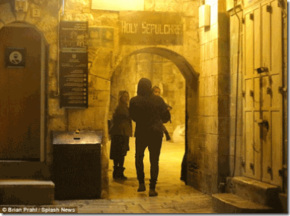
April 14, 2016 at 5am, Kanye, Kim and North visited the Church of the Holy Sepulchre
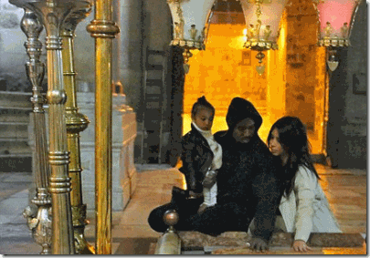
Kanye, Kim and North inside the Church of the Holy Sepulchre
The Brotherhood of the Holy Sepulchre was traditionally founded in 313 AD as the Order of the Spoudaeoi (“studious”, “zealous”, “industrious”), or the “Spoudaeoi of the Holy Resurrection of Christ“.
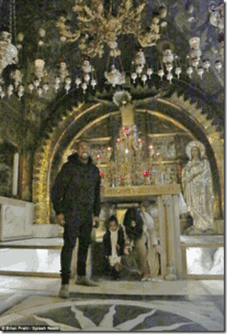
Kanye, Kim and North inside the Church of the Holy Sepulchre- Site of the Jesus’ Crucifixion in the Church
The traditional date of foundation corresponds to the Edict of Milan and its legalization of Christianity in the Roman Empire, as well as the foundation of the churches in the Holy Land by Constantine and Saint Helena, which is in turn traditionally dated to 326 AD.
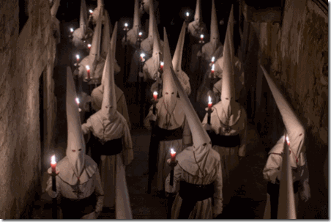
According to findings of contemporary researchers, they were present before 326 AD, organized as an order of ordained clergy during the visit of Saint Helen in Jerusalem.[51]
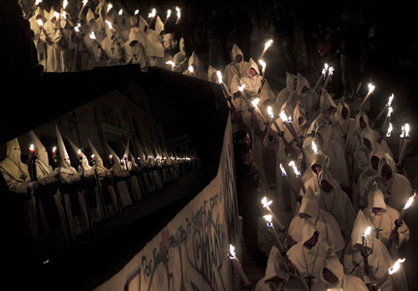
These HOLY LAND SECRET ORDERS are GLOBAL and DO NOT PLAY GAMES!
Kanye West must not have believed that “Fat Meat is Greasy“. Prior to his homage to Israel and holy land, his CIA and ILLUMINATI handlers cleared him for limited access to Holy Land secrets and temples under a strict blood oath covenant of secrecy.
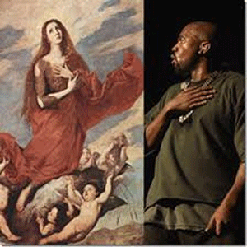 On the album, Life of Pablo, West said, “This is a gospel album with a whole lot of cursing on it, but it’s still a gospel album,” he said with a laugh. “It’s the gospel, according to ‘Ye’. It’s not exactly what happened in the Bible, but it’s a story of this idea of Mary Magdalene becoming Mary.” Kanye must have exposed everything he saw and heard in the Holy Land in his raps, then started a world tour as Saint Pablo (Pablo Picasso) one of the past secret leaders of the Cult of Mary Magdalene to publicly spill even more secrets of the Holy Land, Knights Templar, elite Dragon dynasties and Satanic Cabals.
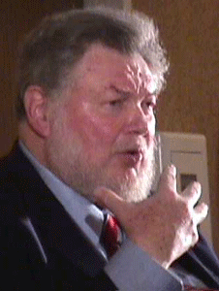
CIA Maestro of Mind Control,Jerusalem Cross & Knights of the Order of the Holy Sepulchre
They compromised him with drugs, seized him, and took him straight to the UCLA Medical Center to erase his memory and implant amnesia barriers. For decades, the UCLA Medical Center has been a cleared clandestine CIA ULTRA/MONARCH medical site. From an August 2013 article, A Clockwork Orange Career, it revealed a lawsuit that had been before the Los Angeles Superior Court in that the University of California at Los Angeles and UCLA Medical Center have, since the early 1980s, attempted to remove psychiatrist Louis Jolyon West, M.D., Professor of Psychiatry, UCLA School of Medicine- the CIA Maestro of Mind Control, from the roster of the university’s faculty.[52] Since 1969, Dr. Louis West had been chairman of the UCLA Department of Psychiatry. For decades, the CIA and Dr. West had been in charge of the UCLA Medical Center. [53] Dr. West died in 1999.[54]
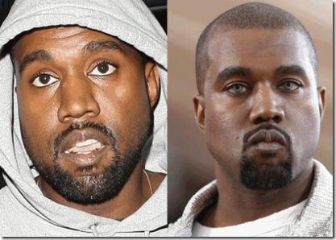
Kanye West– Before and After MK ULTRA Psych Ward
They, CIA, would like the masses to believe that Kanye West that been involuntary seized and interned at the UCLA Medical Center for a mental exhaustion breakdown. However, Kanye came out of the hospital MK ULTRA “depatterned“- erased memory– forced amnesia.[55] However, there appears to have been a reprogramming breakdown with Kanye, and just like Michelle Obama, he has been disappeared from the public masses.
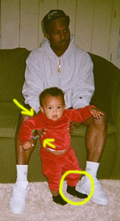
Kanye and Son Saint- Post-Production Photoshop Cut & Paste
Whoever did this post-production Cut & Paste placed part of Kanye’s foot directly on top of the child’s foot and the left hand Cut & Paste is poorly executed. The Kardashians allege that this picture of Kanye and Saint was taken soon after he was released from the psych ward. This false evidence is designed to minimize, disguise, and veil the sum total effect of Kanye’s true memory loss thru electrical shock machine “depatterning.” From 1948-49, my father was secretly U.S. NAVY PROJECT CHATTER “depatterned” through Dr. Mengele’s regiment of medical insulin electrical shock machine torture out of Dachau. It is not a selective memory erasure process. It is total. According to my father’s medical records that I saw before they were stolen, he couldn’t remember such basic things as how to go to the bathroom, sleep, drink a glass of water or even eat food. He had been reduced to a “vegetable state“. He didn’t know who I was. After being severely traumatized by incidents related to him and PROJECT CHATTER, I didn’t know who he was either. The pain was so great that he had to be totally erased from my memory.
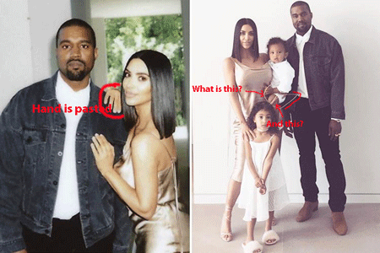
Monday, April 17, 2017, Post-Production Cut & Paste Kanye, Kim and Family
On Easter Sunday, April 16, 2017, and Monday, April 17, the Kardashians Tweeted and posted on Instagram post-production Photoshop pictures of Kanye West in a false picture enjoying a normal Easter and the day after with Kim and his family.

The Kardashians allege that these two “BIGFOOT” Easter bunnies are Kanye and Tyga.

The problem with the Kardashian “BIGFOOT” bunny story is that Tyga is no more 5′ 4″ tall not much larger than a shopping bag. Kanye is no taller than 5′ 8″.
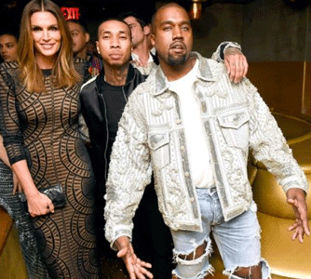
Kylie Jenner, Tyga & Kanye West

BIGFOOT Bunny Tyga is larger and appears somewhat taller or just as tall as BIGFOOT Bunny Kanye. If the Kardashians are lying about BIGFOOT Bunny Tyga, they’re also lying about BIGFOOT Bunny Kanye. Little has been revealed about Kanye’s recovery process since he was released the UCLA Medical Center Psych Ward, but for whatever reasons he and Kim lived in separate homes after his release.
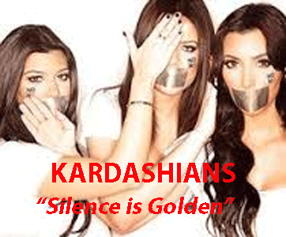
Right Now, Today- Where is Kanye West? The Kardashians are a Satanic Cult beholden to a Covenant of Silence and Secrecy. However, it is now widely reported that he holed up on the top of a Wyoming mountain at a retreat working on a new album. The Wyoming mountains are sacred and of mythic legend . It is an incredible place and Devils Tower is part of what makes it “like no other place on earth”. Devils Tower was made famous in modern times by the 1977 movie “Close Encounters of the Third Kind“.
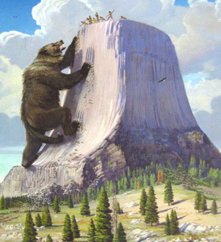
Legends such as that from the Kiowa associate the sacred mountains of Wyoming to the seven sisters… and when they ran from the “Great Bear” they hopped upon a great stump that grew into the enormous stump like formation we see today on the NE corner of Wyoming, and that the seven sisters were borne unto the sky and became the stars which now make up the Big Dipper formation. In the ancient Kemet, seven goddesses (Hathor), represented by seven cows, composed the celestial herd that provides the nourishment to her worshipers. This herd is observed in the sky as a group of stars, the Pleiades, close to Aldebaran, the main star in the Taurus constellation. The Occult and the Shamans are not responsible for happened to KANYE. It was CIA MK ULTRA/MONARCH. The healing process from intelligence iatrogenic “depatterning” requires love, understanding, time and patience. It will not come from Shamans or a “BAND OF WITCHES“.
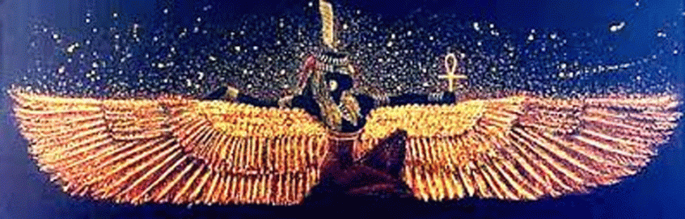
MAAT
Kanye West’s recovery will most importantly require TRUTH, BALANCE and JUSTICE something my Dear Father never received during his LIFETIME.
[1] http://www.notablebiographies.com/news/A-Ca/Cannon-Nick.html
[2] http://usoonpatrol.org/archives/2014/03/02/tv-star-nick-cannon-reflects-o
[3] http://www.idolator.com/7639029/mariah-carey-yacht-off-capri-david-geffen-james-packer-4th-of-july
[4] http://rense.com/general85/lucifer.htm
[5] https://readtiger.com/deadline.com/2012/12/oz-billionaire-james-packer-partners-with-brett-ratner-on-ratpac-entertainment-386773/
[6] https://en.wikipedia.org/wiki/Frank_Packer
[7] http://aanirfan.blogspot.com/2015/10/mr-sin-abe-saffron.html
[8] https://en.wikipedia.org/wiki/Kerry_Packer
[9] https://rickeysmileymorningshow.com/1698936/nick-cannons-dad-rips-mariah-carey-to-shreds/
[10] http://www.tmz.com/2016/11/01/mariah-carey-nick-cannon-divorce-settled-weeks-before-james-packer-breakup/
[11] http://www.inquisitr.com/3510326/mariah-careys-brother-in-hiding-after-he-called-her-out-and-shared-her-darkest-secrets/
[12] http://mediaexposed.tumblr.com/post/8152626302/mariah-carey-in-a-complete-programmed-state-of
[13] http://www.dailymail.co.uk/tvshowbiz/article-64099/Mariah-suffered-breakdown.html
[14] https://vigilantcitizen.com/hidden-knowledge/origins-and-techniques-of-monarch-mind-control/
[15] http://time.com/4769247/michelle-obama-phone-number-tweet-duncan-wolfe/
[16] https://www.one.org/us/person/bobby-shriver/
[17] https://mindcontrolblackassassins.com/category/nazis/
[18] http://aumag.org/2017/03/24/bobby-shriver-march-2007/
[19] http://www.webgrio.com/news/23758-police-drug-dealers-used-cape-cod-home-of-kennedy-kin.html
[20] http://www.cnn.com/2016/08/26/health/prince-minnesota-fentanyl-counterfeit-pills/
[21] https://www.one.org/us/person/bobby-shriver/
[22] https://en.wikipedia.org/wiki/James_Wolfensohn
[23] http://www.nytimes.com/1977/08/14/archives/bohemian-grove-where-big-shots-go-to-camp.html?_r=0
[24] https://en.wikipedia.org/wiki/Harold_Brown_(Secretary_of_Defense)
[25] https://www.defense.gov/About/Biographies/Biography-View/Article/602778/stephen-p-welby/
[26] http://www.nano.gov/node/144
[27] http://www.thedailybeast.com/articles/2017/03/04/inside-darpa-s-top-secret-program-to-protect-the-president
[28] http://www.hawaii.edu/malamalama/2009/01/lessons-for-president-obama/
[29] http://www.howdypodna.com/anndunham.html
[30] http://www.newswithviews.com/McGuire/paul206.htm
[31] http://globalgulag.freesmfhosting.com/index.php?topic=176.0;wap2
[32] https://en.wikipedia.org/wiki/East%E2%80%93West_Center
[33] https://ratical.org/ratville/JFK/ST/STchp19.html
[34] Id.
[35] Id.
[36] http://www.oac.cdlib.org/findaid/ark:/13030/kt029029gz/entire_text/
[37] http://www.roseanneworld.com/2013/09/28/covert-warfare-discovered-university-hawaii/
[38] http://www.eurweb.com/2017/04/michelle-obama-celebrate-college-signing-day-1st-post-white-house-appearance-watch/#
[39] http://www.huffingtonpost.com/entry/barack-obama-michelle-obama_us_59105114e4b0e7021e990a02
[40] http://www.tmz.com/2016/11/21/kanye-west-hospitalized/
[41] http://www.angelfire.com/blog/lachrymology/archive200.html
[42] Id.
[43] https://en.wikipedia.org/wiki/Priory_of_Sion
[44] https://www.wired.com/2012/09/kanye-west-george-tenet/
[45] https://birdflu666.wordpress.com/2016/08/28/cia-works-with-cleric-blamed-for-turkish-coup-and-with-patriarch-bartholomew-says-us-ambassador/
[46] https://birdflu666.wordpress.com/2016/08/28/cia-works-with-cleric-blamed-for-turkish-coup-and-with-patriarch-bartholomew-says-us-ambassador/
[47] Id.
[48] Id.
[49] https://en.wikipedia.org/wiki/Church_of_the_Holy_Sepulchre
[50] https://en.wikipedia.org/wiki/Brotherhood_of_the_Holy_Sepulchre
[51] Id.
[52] http://www.freedommag.org/english/la/issue02/page12.htm
[53] http://senate.universityofcalifornia.edu/_files/inmemoriam/html/henryhwork.html
[54] https://en.wikipedia.org/wiki/Louis_Jolyon_West
[55] https://www.reddit.com/r/conspiracy/comments/5tua9j/kanye_west_experienced_memory_loss_after/
Comments : 5 Comments »
Tags: 1951 Mutual Security Act, 30th U.S. Army Counter Intelligence Corp, Abe Saffron, Adolf Hitler, advanced human-computer interaction, Advanced Research Projects Agency, ahepa, aldebaran, Alexander Karloutsos, allgemeine ss, Alsos Mission, American Hellenic Educational Progressive Association, Ann Soetoro, ARPA, artificial insemination, Artificial Insemination and sterilization technology, Austin Wortham “Cy” Betts, baby obama, Baphomet, bilderberg group, Black Manchurian Candidates, bohemian grove, boris T. Pash, Brotherhood of the Holy Sepulchre, Camp Oberammergau, cfr, Chiang Kai-shek, Church of the Holy Sepulchre, CIA, Civil Air Transport, Cult of Mithras, Dachau, Dark Satanic Cabal, DARPA, david geffen, Defense Advanced Research Projects Agency, depatterning, devil, Devils Tower, Director of Defense Research and Engineering, Dissociate identity disorder, donald drumpf, donald trump, dr. carl clauberg, Dr. Fritz Gustane Anton Kraemer, Dr. Gregory Bateson, Dr. Josef Mengele, Dr. Joseph Carl Robert Licklier, Dr. Louis Jolyn “Jolly" West, dragon bloodlines, dragon dynasty, dragon slaves, duncan wolfe, East-West Center, Erin Rothschild, erner von Braun, fentanyl, Fethullah Gülen, flying tigers, fort bliss, freemasonry, freemasons, gehlen org, george tenet, get out, goddess hathor, great bear, Greek Orthodox Church, harold brown, harry truman, Heinrich Himmler, Henry Kissinger, hip hop satanic cult, iatrogenic depatterning, Illuminati, james cannon, James Costos, James D. Wolfensohn, james packer, Jean Cocteau, Jerusalem Cross & Knights of the Order of the Holy Sepulchre, Jim Jones, john f. kennedy, Jon Lodeesen, Jr., kanye west, kemet, kerry packer, Kim Kardashian, king Meroveus, Knight Commander of the Most Excellent Order of the British Empire, Knights of the Black Sun, knights templar, Lucifer, Lucifer's Servants, luciferians, Lunar Landing Hoax, maat, Madame Chiang Kai-shek, Mae Brussell, Major General Claire Chennault, man computer machines, Man-Machine System for Thinking, Manhattan District Los Alamos Scientific Laboratory, manhattan project, mariah carey, mary magdalene, Masonic Grand Master, Merovingians, mi6, michelle obama, mind control, Mithraism, MK-ULTRA, Monarch Program, mtv, NASA, naval intelligence, Nazis, Neil S. McElroy, nick cannon, Nuremberg Tribunal, ONE at Optimus, operation paperclip, Order of Australia, pablo picasso, Peenemünde Rocket Team, Peoples Temple, POST-HUMAN RENAISSANCE, Post-hypnotic amnesia, Post-Production Digital Photography, President Lyndon B. Johnson, President Recep Tayyip Erdogan, Prieure de Sion, prince, prince nelson rogers, priory of sion, PROJECT CHATTER, Quinotaur, rainbows, rayford bullock, Redred Mass Rite, Reichsfurhrer Heinrich Himmler, richard helms, Ritual Blood Mass, robert Shriver III, saint pablo tour, satan, Satanism, sea serpents, seven sisters, Sex kittens, sink into the floor, sir, sir bono, sir frank packer, Sol Invictus, SS, stanley ann dunham, Taurus constellation, the pleiades, Thomas S. Gates, Trident, Trilateral Commission, Turkey, tyga, U.S. Navy, ucla medical center, University of Hawaii, Vladimir Putin, Waffen SS Bridgadefuhrer Fritz Kraemer, wizard of oz, wizard of oz programming, wyoming
Categories : 1000 Year Reich, 9-11, Advanced Research Projects Agency, african american satanic cult, Apollo, Aryan Supremacy, ashur, Barack Obama, Barak Obama, barry dunham, beyonce, Black Manchurian Candidates, Black messiah, blood covenants, blood oaths, bohemian club, bohemian grove, boys from brazil, Brotherhood of the Bell, CIA, council of foreign relations, council on foreign relations, cyberneticist, cybernetics, cyborg, cyborgs, DARPA, Defense Intelligence Agency, devil, DIA, divine one, Dr. Ewen Cameron, Dr. Gregory Bateson, Dr. Josef Mengele, dr. louis jolyon west, East-West Center, evil, Eyes Wide Shut, fallen angels, Hauptsturmfuhrer SS Dr. Josef Mengele, Heinrich Himmler, Hip Hop, HIP HOP false prophets, hip hop satanic cult, holy grail, illuminati, jay z, jay-z, jim jones, jonestown, Josef Mengele, Kanye Omari West, Kanye West, kanye west,, kemet, Knight of Malta, Knights Hospitaller, Knights of the Black Sun, Knights Templar, lucifer's servants, luciferians, Madame H.P. Blavatsky, mary magdalene, Michelle LaVaughn Robinson, Michelle Obama, mind control, Molech, Moloch, monarch child, monarch program, MPD, mulitiple personality disorder, Nazis, new age religion, new world order, office of naval intelligence, Operation PAPERCLIP, Osiris, Paperclip Project, Pharaohs Sestrosis I, post amnesia barriers, post hypnotic suggestions, POST-HUMAN RENAISSANCE, prince, prince nelson rogers, PROJECT CHATTER, Reichsfurhrer SS-1 Heinrich Himmler, richard helms, Ritual Satanic Abuse, ritual satanic sexual abuse, ritually abused children, satan, Satanic Global High Cabal, Satanism, set, seth, Setrosis II, sex kitten, sex slave, SS, SS Baron Otto Albrecht Alfred von Bolschwing, Stanley Ann Dunham, Stanley Armour Dunham, Strumbannfuhrer SS Dr. Wernher von Braun, trauma-based mind control, underground reich, underground third reich, ZIONIST

U.S. PRESIDENTS DONALD J. DRUMPF & ANDREW JACKSON, SECRET LORDS OF THE DRAGON DYNASTIES
9052017
I
DONALD J. DRUMPF, MENTALLY ILL OR ABSOLUTE EVIL?
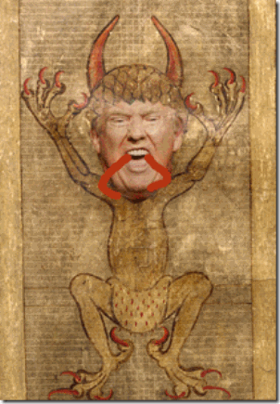
Donald J. Drumpf, DEVIL & Beast of the Apocalypse, Somme le Roi, Britanny, 1464 | Manuscript from BnF, Français 958, fol. 6v
There is something striking dangerously mentally unstable or absolutely EVIL or DEMONIC about Donald J. Drumpf.
Donald J. Drumpf, Chocolate Cake & 59 Tomahawk Missiles- Which Way is Syria?

On April 6, 2017, he directed 59 tomahawk missiles at the cost over a 100 million dollars to strike a sovereign nation, and within moments, he remembered having chocolate cake at the time, but wasn’t sure if it was Iraq or Syria that the missiles hit.
Donald J. Drumpf & North Korea: I’ll Handle It Myself!


DRUMPF- TARZAN, KING OF THE JUNGLE
On or about April 9, 2017, Commander and Chief of the Armed Forces, Donald J. Drumpf, told the world that he ordered an aircraft carrier and an armada of warships toward the Korean Peninsula in a show of force just days after North Korea tested another intermediate missile. Speaking to reporters on Air Force One, Drumpf said he would “certainly be prepared to act alone against North Korea“. The President said he “didn’t know” if the North Korean dictator, Kim Jong-un, is mentally fit as he boasted of having a “very powerful” military while talking up the power of the US “armada”.
Drumpf told Fox News: “I don’t know. I don’t know. I don’t know him. But he’s doing the wrong thing. We are sending an armada. Very powerful. We have submarines. Very powerful. Far more powerful than the aircraft carrier, that I can tell you. And we have the best military people on earth.”
The New York Times reports that while Drumpf was selling “wolf tickets” against Kim Jong-un, the aircraft carrier, U.S.S. Carl Vinson, was sailing thousands of mile south in the opposite direction toward the Indian Ocean at the time the U.S. announced that it was heading to the Sea of Japan, despite the fact that White House Spokesman, Sean Spicer, said on April 11 that the carrier would serve as “a huge deterrence” to North Korea. Was Donald J. Trump in his childhood fantasy world just beating his chest as if was Tarzan- King of the Jungle? I think so. Now, he praises Kim Jong-un as a “smart cookie” that he would be honored to meet.
Donald J. Drumpf, War Crimes & the Afghan Atomic Bomb, They’re Aren’t My People
Don’t get it twisted. The MOAB (Mother of All Bombs) that Drumpf, without any compassion for mankind, hesitation or second thoughts whatsover, authorized the U.S. military to drop on top of the Afghan people wasn’t any ordinary bomb. It was an ATOMIC BOMB!
On April 13, 2017, the eve of Palm Friday, Donald J. Drumpf and the U.S. military dropped an atomic- zero point Nazi/SS Wonder Weapon (MOAB) bomb on Afghanistan. Do not allow anyone to misinform or mislead you about the MOAB, it is one of Heinrich Himmler’s secret SS WMD (Weapon of Mass Destruction) Fuel Air Bomb- Atomic Bomb.
II
DONALD J. DRUMPF, SATAN, VIKINGS & DRAGONS
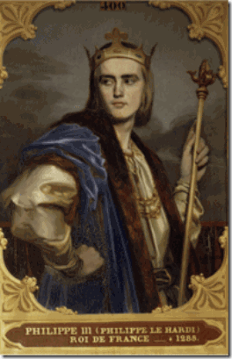
The writer of English 1464 Manuscript, Somme le Roi, was one of the most influential Christian moral treatises of the thirteenth-fifteenth centuries, Lorens of Orléans, O.P. is relatively unknown today. Lorens of Orléans used many different sources in the compilation of his book, finished, according to most of the dated manuscripts, in 1279. Lorens named it, in King of France Philip III’s honour, the Somme le Roi (literally, the King’s “Sum,” or Summa). Philip III (1245 –1285), called the Bold was King of France from 1270 to 1285, a member of the HOUSE OF CAPET.[1] They were sometimes called “The Third Race of Kings“, the Merovingians being the first, and the Carolingians being the second. The name is derived from the nickname of Hugh, the first Capetian King, who was known as Hugh Capet (941 –996).[2] The direct succession of French kings, father to son, from 987 to 1316, of 13 (thirteen) generations in almost 330 years, was unparalleled in recorded history.[3]
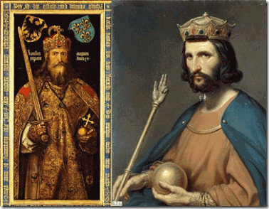
Charlemagne & Hugh Capet
Hugh was a Bloodline of the Dragon. His ancestress was Gisela, or Gisele (born 821), daughter of Louis I, Son of Charlemagne.[4] Charlemagne married an Eastern Fairy Princess, Frastrada, belonging to the blood of the Dragon Queens and Grail Kings. The wedding was blessed by the appearance at the feast by a DRAGON bearing in its mouth an Alchemist’s Ring of Power, which it dropped into Charlemagne’s chalice of blood red wine. Charlemagne was a Merovingian among the first race of kings.[5]
“Charlemagne belongs, if anywhere, to a variation of the Grail Myth known as the Ring Cycle, and though Charlemagne is hailed as a Hero of the Catholic faith he, like others who proceeded him, has what the church might consider to be a dark undercurrent to his nature. On the surface he is a Christian emperor but even so he accepts from a “Dragon”, the gift of a Ring which, not unlike those of Solomon, were regarded by the Church as being symbols of SATAN.”[6]
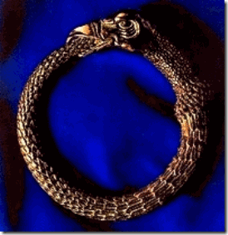
Dragon Oroborus
“The Ring of Power, the Alchemist’s Oroborus, was the figure of a Dragon or Serpent encurved into a circle and set in the act of biting its own tail. It was the symbol both of eternity and, as the symbol of primordial chaos, the Dragon Ring also represented Tiamat, the mother of Anu, the Nephilim and the Titans.”[7]
“The Dragon that bestowed the ring on Charlemagne was Frastrada the Fairy. Like Tiamat, Lilith, Tamaris, Sheba, Diana, Arduin, Brigid, Lamia, Janet of Carterhaugh, Gwenhyfar, Pressina and Melusine, Frastrada was a Dragon Princess and a Grail Maiden. She is a Mary Magdalene and a Maid Marion.”[8]
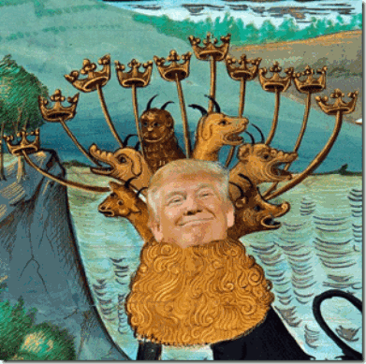
Drumpf & 7 (seven) heads of the BEAST OF THE APOCALYPSE
The Book of vices and virtues, a 14th century English translation of the Somme Le Roi of Lorens D”Orleans / ed. by W. Nelson Francis (E.E.T.S..,Orig. Ser. No. 217 ) is part of the Royal Collection of England, Buckingham Palace, London. The subject-matter of the Book is treated primarily allegorically; for example, the 7 (seven) deadly sins are identified with the 7 (seven) heads of the BEAST OF THE APOCALYPSE.[9]
The beast John saw in vision in the Book Revelation seemed to rise out of an ocean. It had 7 (seven) heads and 10 (ten) horns. The horns featured 10 (ten) crowns, while the heads were decorated with names which are blasphemous in God’s sight. What is the meaning of this seven-headed, ten-horned creature? John said, “And the beast which I saw was like unto a leopard, and his feet were as the feet of a bear [strange feet indeed, for a leopard-like creature!], and his mouth as the mouth of a lion: and the dragon gave him his power, and his seat, and great authority” (Revelation 13:2).
What is meant by a “DRAGON”?
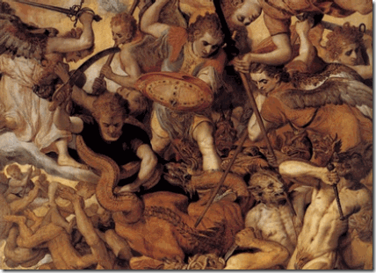
Dragons, purely mythological creatures, remind one of serpentine monsters with huge, bat-like wings; fierce heads with blazing, snake-like eyes; heavy, clawed feet like those of a crocodile; and rows of wickedly gleaming, sharply pointed teeth, breathing roaring tongues of fire from their mouths. But we need not speculate about what is meant by the dragon which empowers the beast, for the Bible plainly tells us what it is: “And there was war in heaven: Michael and his angels fought against the dragon; and the dragon fought and his angels, And prevailed not; neither was their place found any more in heaven. And the great dragon was cast out, that old serpent, called the Devil, and Satan, which deceiveth the whole world: he was cast out into the earth, and his angels were cast out with him” (Revelation 12:7-9).
The DRAGON is a symbol for SATAN.
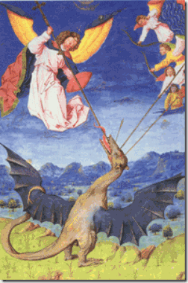
Jesus Christ said, “I beheld Satan as lightning fall from heaven” (Luke 10:18). Satan is the “prince of the power of the air, the spirit that now works in the children of disobedience” (Ephesians 2:2), and is “the god of this world” (2 Corinthians 4:4) who influences heads of state and leaders of false, counterfeit religions. He is “the accuser of the brethren” (Revelation 12:10), who, “as a roaring lion, walks about, seeking whom he may devour” (1 Peter 5:8).[10]
U.S. President-Select, Donald J. Drumpf, is turning out to be one of the world’s most evil class, religious, racial polarizing and divisive figures of the 21st century. The German Drumpf bloodlines have no identifiable royal or dragon lineages. The power elite Masonic, religious and super rich circles that Fred Drumpf moved in New York rewarded his dedication and loyalty to the ruling classes through an arranged backdoor Satanic dragon bloodline marriage through the ancient powerful “fairy” MacLeod Clan of Scotland.
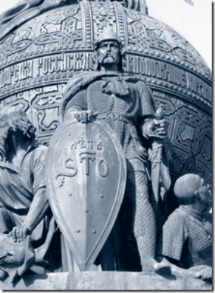
Rurik, the Viking
Through the MacLeod Clan, Donald J. Drumpf is distantly related to Rurik, the legendary Viking who founded the Russian state. He was the first entry in the Rurik Dynasty, one of Europe’s oldest royal houses and founders of the Tsardom of Russia, which ruled the country for over 700 years until they were displaced by the Romanovs.[11]
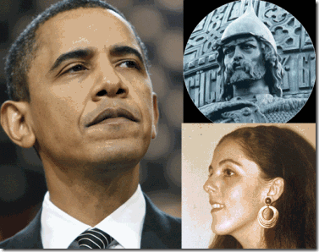
Barack Obama through his mother, Stanley Ann Dunham, is also said to be a distant bloodline relation to Rurik.[12] Identified with Rorik of Dorestad, Rurik was a Germanic king from the royal Scylding of of Haithabu in the Jutland Peninsula (then in Denmark, today with Germany). Rorik of Dorestad was born about ca. 810–820 to Ali Anulo, 9th king of Haithabu. Frankish chroniclers mention that he received lands in Friesland from Charlemagne’s son, Louis I.[13] Rorik-Rurik’s Clan of Skjodung had been directly in alliance with Charlemagne, himself. Rorik-Rurik is also believed to be Hamet’s grandfather. Horvendil of Jutland, an independent Danish Kingdom, married Gerutha, Rorik-Rurik’s daughter. Amleth Orvendilson, the son of Horvendil and Gerutha is Shakespeare’s King Hamlet .[14]
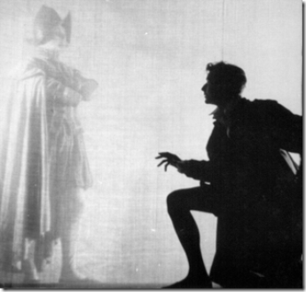
The Tragedy of Hamlet, Prince of Denmark, often shortened to Hamlet is a tragedy written by Shakespeare between1599 and 1602. Set in Denmark, the play dramatizes the revenge Prince Hamlet is called to wreak upon his uncle, Claudius, by the ghost of Hamlet’s father, King Hamlet. Claudius had murdered his own brother and seized the throne, also marrying his deceased brother’s widow.[15]
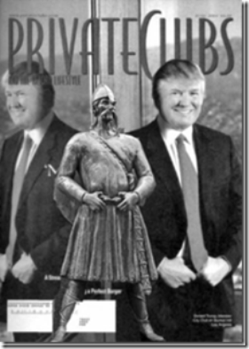
Donald J. Drumpf is also maternally related to an ancient Viking king of the Kingdom of Norway’s Isles of Man in the Scottish Hebrides, Olaf the Black. Drumpf’s DNA mother, Mary Anne MacLeod was part of the MacLeod Clan believed to have been started by Olaf’s son or grandson, Leod.[16] The Olafs go directly back the royal bloodlines of Rorik-Rurik of Demark.[17]
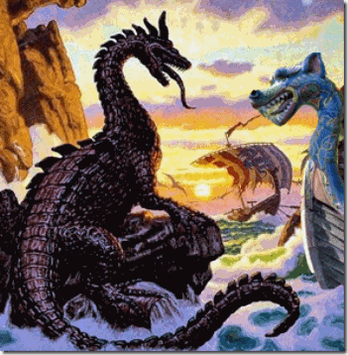
Drumpf’s presidential cabal’s psychic and occult egregore “thought form or collective group mind” an autonomous psychic entity made up of, and influencing, the thoughts of a group of people, proceeds from the old Pole, the red star or astarot– tail of the DRAGON, via House of Rurik and the Varangs, part of the ancient Court of the Dragon Order.[18]
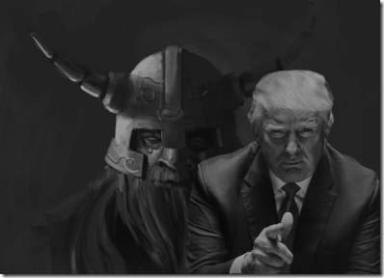
Drumpf ‘s maternal bloodline is that of the DRAGON and LUCIFER.
III
ABSOLUTE EVIL: DONALD J. DRUMPF, ANDREW JACKSON & THE DEVIL
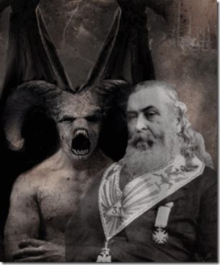
LUCIFER, the Light-bearer! Strange and mysterious name to give to the Spirit of Darkness! Lucifer, the Son of the Morning! Is it he who bears the Light, and with its splendors intolerable blinds feeble, sensual or selfish Souls ? Doubt it not! – Albert Pike [19]
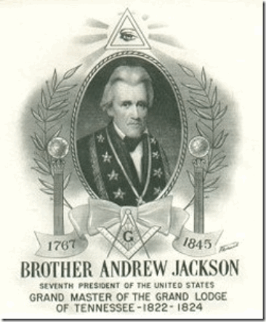
The 7th President of the U.S., Andrew Jackson (1829- 1837) was a Freemason, having been initiated at Masonic Lodge, Harmony No. 1 in Tennessee; he also participated in chartering several other lodges in Tennessee. He was the only U.S. president to have been a Grand Master of a State Lodge until Harry S. Truman in 1945. His Masonic apron is on display in the Tennessee State Museum. An obelisk and bronze Masonic plaque decorate his tomb at The Hermitage, Nashville, TN.[20] Jackson was a Scottish descent Royal Arch Mason, the first part of the York Rite system of the Masonic degrees. Royal Arch Masons meet as a Chapter, and the Royal Arch Chapter confers four degrees: Mark Master Mason, Past Master, Most Excellent Master, and Royal Arch Mason. The Royal Arch Mason degree is said by many to be the most beautiful degree in all of Freemasonry. Freemasons who reach this degree may continue to Cryptic Masonry or go straight to Knights Templar.[21]
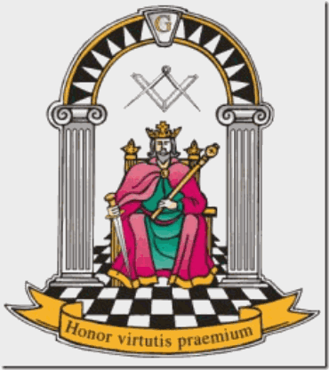
The York Rite is an order of secret occult rites. Legend says Prince Edwin received a Charter of York from Anglo Saxon King Athelstan at York, England, organizing a General Assembly of Masons in 926 AD.[22] Freemasonry also began to take on influence from Jewish mysticism and occultism as it cemented itself into the Kabala around 1100. (Gould, p 34). The secret order of occult rites are said to have been founded at different times by Charlemagne, Julius Caesar, Cyrus, Solomon, Zoroaster, Confucius, Thothmes, and Buddha.[23]
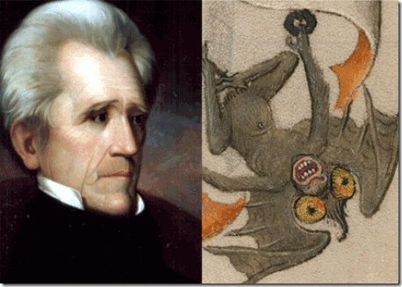
It is said that Andrew Jackson converted to Christianity sometime after leaving the presidency on March 4, 1837. So, what had he been before Christian conversion? In 1850, active in the Grand Lodge of Arkansas, Albert Pike took the 10 (ten) degrees of the York Rite from 1850 to 1853.[24] Pike says a York Rite Mason’s God is the “Fallen Dragon” LUCIFER![25]
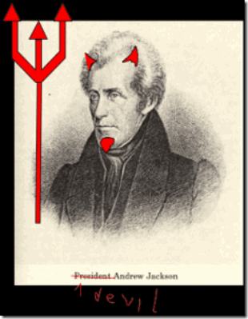
Andrew Jackson wanted the Cherokee to call him “Great Father,” but instead, he was called “Jacksena” or “JACKSON THE DEVIL.”[26] Andrew Jackson was a man nicknamed “Indian killer” and “Sharp Knife” surely deserves a title of a racial mass murderer. “Andrew Jackson was a wealthy slave owner and infamous Indian killer, gaining the nickname “Sharp Knife” from the Cherokee.”[27]
IV
DONALD DRUMPF, ANDREW JACKSON & THOMAS JEFFERSON, SCOTTISH RITE MASONIC BROTHERHOOD OF THE CRAFT
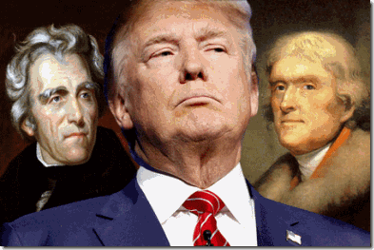
Bloodline Masonic Scotsmen, Andrew Jackson, Donald J. Drumpf & Thomas Jefferson
In the biblical New Testament, several followers of the apostle Paul were dragged into the theater of Ephesus for teachings that threatened the livelihoods of local craftsmen who manufactured objects pertaining to the goddess Diana [Greek Artemis](Acts 19.23–41).
There is a great deal of debate surrounding Jefferson’s Masonic membership. The York Rite is an order and society of secret occult rites. If his name isn’t publicly found attached to lodge doesn’t mean that he wasn’t a Masonic brother, if It is a blood oath SECRET! Rev. James Ogilvie was the Scottish tutor of Thomas Jefferson’s grandson, Thomas Jefferson Randolph, a Freemason. Before the Revolution, Thomas Jefferson and James Ogilvie were good friends. Ogilvie was a Scottish immigrant who served as a tutor for families of the gentry in Virginia. After his ordination, he became rector of Westover Parish, an ecclesiastical unit of the Church of England, the established church in colonial Virginia.[28]
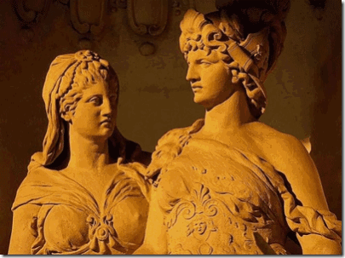
Greek Goddess Artemis [Roman Diana]and Brother, Sun God Apollo
August 4, 1811, Thomas Jefferson to James Ogilvie, Monticello, VA: “but politics, like religion, hold up the torches of martyrdom to the reformers of error. nor is it in the theater of Ephesus alone that tumults have been excited when the crafts were in danger. you must be cautious therefore in telling unacceptable truths beyond the water.”[29] I say that Jefferson was talking coded language about secrecy of the craft (freemasonry). The tumults (loud crowds) of Ephesus (ancient Greek city on the coast of Ionia) were fervent religious followers and craftsmen of the graven idols and images of Goddess Artemis.
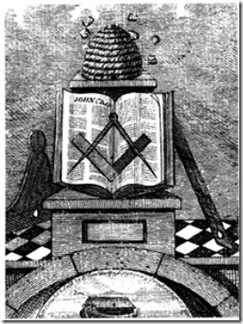 Masons & the Beehive- Secret Symbol of Goddess Artemis
Goddess Artemis is part of an important secret foundation ritual and dogma of Freemasonry. On the top of this secret Masonic visual teaching tool: “we have the beehive ruled by the Queen bee and the female worker bees representing either a matriarchal society or the ancient Goddess Artemis who was once the Great Mother. Then we have the compass and square on the open book which is a double vaginal symbol. Which is also a pre-historic symbol of the Great Mother. Then at the bottom we have Noah’s ark.”
There was a great deal of anti-Masonic sentiment in the country even during Jefferson’s time. The common people knew little about the Masons, but clearly understood its veiled nature of blood oath secrecy, and secret rituals and crafts out of Egypt. The people knew of the existence of their clandestine codes of handshakes and passwords, and their ultimate plans whether in religion, business or politics that benefited them only.
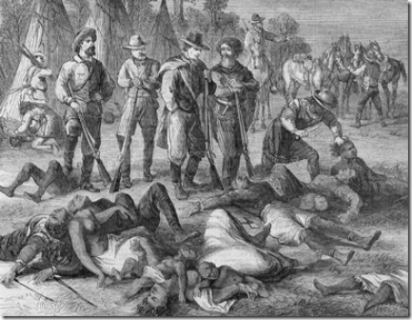
Fellow African enslaver, President Thomas Jefferson, entrusted his secret subordinate Scottish Knight Templar, Jackson, to do his dirty work to exterminate Native Americans, and violently remove, seize and appropriate, particularly, Creek and Cherokee lands in the south. My maternal Great-Great Grandmother, Amanda Hutchinson, was full Cherokee or Half. In my family folklore, the “trail of tears” have been passed down through my down thru the generations as well.
Jefferson and Jackson helped create and build the South’s power base of planter’s aristocracy and oligarchies- the Democratic Party. Jackson’s political policies followed the era of Jeffersonian democracy which dominated the previous political era. Jefferson and Jackson formed the basis of the modern Democratic Party that is no more than Masonic ILLUSIONARY Jacksonian Democracy.[30]
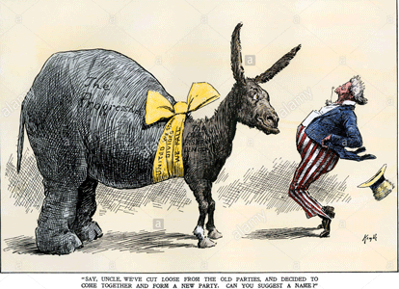
The Democratic-Republican Party was an American political party formed by Jefferson and James Madison in 1791- 93 to oppose the centralizing policies of the new Federalist Party run by Alexander Hamilton, who was then Secretary of the Treasury and chief architect of George Washington’s administration. The term “Democratic-Republican” is used especially by modern political scientists for the first “Republican Party” (as opposed to the modern Republican Party founded in 1854). It is also known as the Jeffersonian Republicans. Historians typically use the title “Republican Party“.[31]
Once Native Americans were removed from their lands, Jefferson and Jackson, gave land grants of tracts of thousands of acres to their secret brethren, knights, Masonic members and then provided the financial backing through collaborating banks to grow and make “cotton” king in the South on the backs of African Bondage.
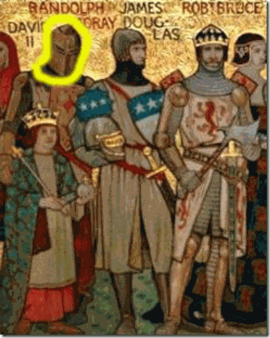
Soldiers Thomas Randolph, Earl of Moray & Robert the Bruce
Thomas Jefferson was born into ultra secret and powerful Satanic global oligarchic aristocracy and secrecy that spanned two nations through his mother, Jane Randolph. She was a descendant of Thomas Randolph, Earl of Moray of Scotland. It was Thomas Randolph who signed the Arboath Declaration in 1320 whose blood uncle was Rex Deus– Robert the Bruce of Scotland.[32] The Celtic Christian, royal mythology comprising French, British, Welsh, Scottish, and Irish genealogies eventually came together in one famous royal house, the Stuart dynasty. The Stuart dynasty descends back to 1296, to the crowning of Robert the Bruce, the famous Rex Deus 2 protectorate of the refugee Knights Templar.[33]
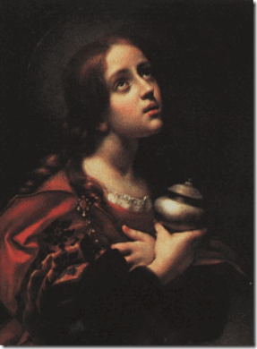
Mary Magdalen (c. 1660-1670) is a painting by Italian artist Carlo Dolci
Rex Deus- The messianic family, stemming from Davidic royal lineage and the offspring of Jesus and Mary Magdalene (i.e. Sangraal) according to esoteric tradition, is said to carry the title, Rex Deus, meaning “King of God“.[34]
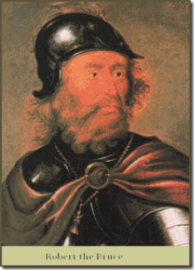
Robert the Bruce was far more than an “early Scottish King.” He was a high born Merovingian: Priest-King of the Celtic Church, liberator of Scotland from England, Sovereign Grand Master of the Order of the Knights Templar, founder of the Order of the Rosy Cross.[35]
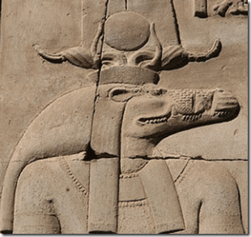
Ancient Kemetic God Sobek
Robert the Bruce represents the secret ancient Bloodlines of Dragon Dynasties of Sobek. The latter strain of Sobek includes the bloodline of the Davidic House of Judah who married into the descent of the Merovingian Kings of the Franks.[36]
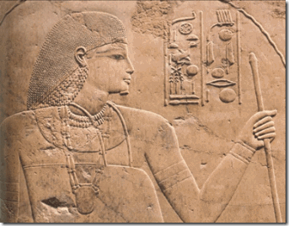
Queen Sobeknefru Ruled Kemet as Pharaoh
They allege that the European Dragon Dynasties and Societies started in the 12th Kemetic Dynasty with Queen Sobeknefru– The Beauty of Sobek. She was the daughter of Pharaoh Amenemhat III. He had most likely had been the younger brother of Senusret III.[37]
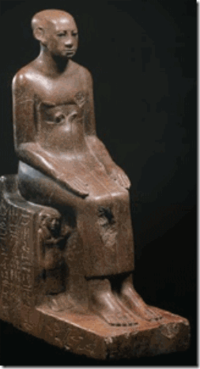
Young Wise Sesostris, Many Years in the Priesthood
Sesostris III (Sesostris of Greek legend) is the legendary Kemetic pharaoh that led military expeditions into Europe during the eighteenth century BC. In Herodotus’ Histories, there appears a story told to him by Egyptian priests about a Pharaoh Sesostris, who once led an army northward overland to Asia Minor, then fought his way westward until he crossed into Europe, where he defeated the Scythians and Thracians (possibly in modern Romania and Bulgaria). Sesostris then returned home, leaving colonists behind at the river Phasis in Colchis.[38]
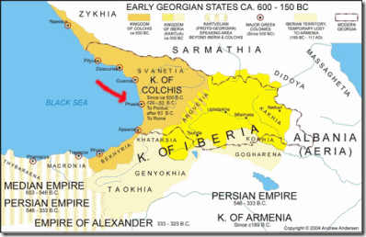
Colchis is the country that cradled the ancient Greek mythological hero, Jason, who was famous for his role as the leader of the Argonauts and their quest for the Golden Fleece.[39] There are historical facts that seems to support the creation of a secret line of European Dragon Dynasties and societies out of Kemet. However, I believe that their real penetration (Scythians) inside Kemetic Cosmology came as result of the Hyskos (European and Asiatic Nomadic Shepherd Kings) military conquest of part of Kemet during the end of the 12th dynasty from about 1802 BC. They weren’t initiated into the temples or priesthood of Set or Sobek by the Queen or any pharaohs of the 12th dynastic, the Hyskos rose up against their hosts and forcible appropriated Kemetic Gods out of context as their own gods sometime during Queen Sobeknefru’s reign.[40],[41],[42]
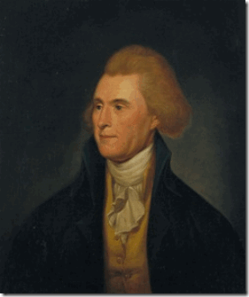
President Thomas Jefferson
One thing is beyond a shadow of a doubt, President Jefferson wasn’t an “Anti-Mason” of the era. “Thomas Jefferson was often in Masonic company. His son-in-law Governor of Virginia Thomas M. Randolph, his favorite grandson Thomas Jefferson Randolph, and nephews Peter and Samuel Carr were all members of Door to Virtue Lodge No. 44, Albemarle County, Virginia. Freemasons such as Thomas Paine, Voltaire, Lafayette, and Jean Houdon were some of his closest associates in Europe. Masons whom he admired in America included George Washington, Benjamin Franklin, Dr. Benjamin Rush, John Paul Jones, James Madison, James Monroe, Meriwether Lewis and William Clark. Brother Denslow showed that Jefferson was reported by Dr. Joseph Guillotin to have attended meetings of the Lodge of Nine Muses in Paris; that he had marched in a Masonic procession with Widow’s Son Lodge No. 60 and Charlottesville Lodge No. 90 on October 6, 1817, at the cornerstone laying of Central College (now the University of Virginia); that the Grand Lodges of South Carolina and Louisiana held funeral orations and processions for him following his death on July 4, 1826; and that a Blue Lodge at Surry Court House, Virginia, was named Jefferson Lodge No. 65 in 1801.”[43]
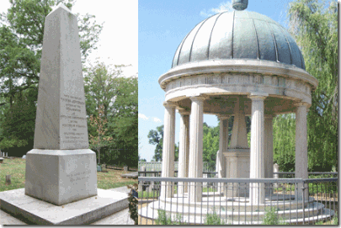
Both Jackson and Jefferson are buried beneath Egyptian “obelisks“. To Masonic mystic enlightenment and illumination in the 1800s, the obelisk was the only architectural symbol of Asur (Osiris) still in existence. And if, as some Masonic historians claim, “Hiram Abiff is really Osiris reborn”.[44]
“The word “obelisk” literally means ‘Baal’s Shaft’ or Baal’s organ of reproduction. This should be especially shocking when we realize that we have a gigantic obelisk in our nation’s capital known as the Washington Monument.“ – Dr. Cathy Burns, Mason and Occult Symbols Illustrated [45]
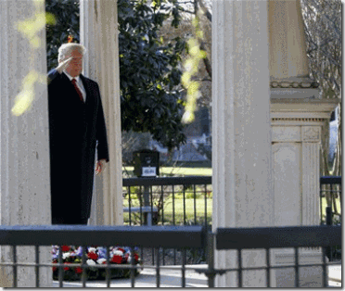
On March 17, 2017, President- select Donald Drumpf visited Andrew Jackson’s god forbidden African slave plantation, The Hermitage, on the 250th anniversary of his birth to lay a wreath on his demonic Masonic- Hellenistic Tomb. If Jackson had converted to Christianity during his life, his tomb surely isn’t evidence.[49]
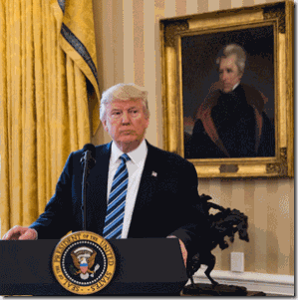
Drumpf and his “dark” Satanic cabal knew very well that they couldn’t have chosen a more SYMBOLIC savage, racist, hated, vile, vicious mass murdering and demonic polarizing figure in U.S. history to venerate, and throw in the face of the masses. More than any other U.S. president in history, Jackson has indirectly negatively impacted each and every African descendant and Native American born in this country, today.
In the 18th century, I traced my great-great-great grandfather, Moses Bullock, from the English cotton and tobacco plantations of the Colony of Virginia. Virginia was the homeland of the Algonquian speaking peoples, Nottoway, Meherrin, Siouan or Iroquoians.[50] From Virginia, Moses Bullock was marched to the mountains, valleys and forests of North Carolina. Moses was held captive, enslaved on cotton and/or tobacco plantations in and around Granville and Vance Counties, NC originally inhabited by the Tuscarora and Saponi.[51]
During the 19th century, African bondage and the greed, human cruelty and savagery of a cotton industry once again came knocking as President Jefferson and General Jackson opened up Native American ancestral lands to slave exploitation. It marched Moses and my great-great-great grandmother, Caroline, from the plantations of the Carolinas almost to the Gulf of Mexico to the wild rainforests of Mississippi. Mississippi was the homelands of the Biloxi, Capinans, Chakchiuma, Chickasaw, Choctaw, Choula, Dakota Sioux Grigra, Houma, Ibitoupa, Koroa, Moctobi, Natchez, Ofo, Okelousa, Pascagoula, Pensacola, Quapaw, Taposa, Tiou, Tunica and Yazoo.[52] So, I don’t want to hear a damn thing about who moved the mountains, leveled the forests, dammed/tamed the rivers and streams, toiled the black soil of this nation! My great-great-great grandfather was forced at the end of a gun and sword to do it in 3 (THREE) STATES! In 1880, Moses was 100 (one hundred) years old, and Caroline was 80 (eighty).
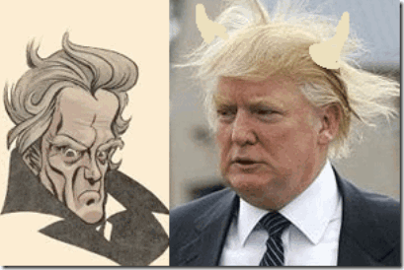
Drumpf and his Satanic Cabal knew very well that they were paying homage to a vicious racial mass murdering DEVIL worshiper nested in a stone shrine of a Masonic servant dedicated to the “Fallen Angel“, LUCIFER. You may believe that Andrew Jackson and Thomas Jefferson are no more than long gone and dead irrelevant ancient history. However, alone with Donald J. Drumpf, they live as part of the global secret Legacy of the Brotherhood and Society of the Order of the DRAGON. When Drumpf venerates them, you may believe that he is celebrating the lives of past great American presidents, but he and his “dark” cabal are laughing, and mocking the masses. They are right in front of our faces and WE DON’T BELIEVE THAT THEY’RE REALLY THERE!
To Donald J. Drumpf and the secret Dragon Society, it’s just like the 59 Tomahawk missiles, And, the lies about sending a U.S. Naval Fleet into the Sea of Japan to confront North Korea, or the dropping of MOAB on the Afghan people, their president- select presents MASONIC CHAOS. He is an absolute EVIL and DEMONIC narcissist LUNATIC, and they don’t seem to give a damn if you or I know it or not. They are pushing the people beyond the limits of a DEMOCRACY.

[1] https://en.wikipedia.org/wiki/Philip_III_of_France
[2] https://en.wikipedia.org/wiki/Hugh_Capet
[3] https://en.wikipedia.org/wiki/House_of_Capet
[4] https://en.wikipedia.org/wiki/Gisela,_daughter_of_Louis_the_Pious
[5] https://theunhivedmind.com/UHM/the-origin-of-the-dragon-lords-of-the-rings-the-sabbatical-goat/
[6] Id.
[7] Id.
[8] Id.
[9] https://www.royalcollection.org.uk/
[10] http://www.garnertedarmstrong.org/pubs/beastof.htm
[11] http://www.realclearlife.com/history/donald-trump-related-viking-rorik/
[12] Id.
[13] https://en.wikipedia.org/wiki/Rurik
[14] http://www.historyfiles.co.uk/KingListsEurope/ScandinaviaJutes.htm
[15] https://en.wikipedia.org/wiki/Hamlet
[16] http://www.itv.com/news/granada/2016-11-17/trump-could-claim-ancestry-to-isle-of-man-viking-king/
[17] http://www.everydaycitizen.com/2009/06/a_scots_clan_and_the_vikings.html
[18] https://issuu.com/sophia_craft/docs/dragon_court
[19] http://www.resist.com/Onlinebooks/Pike-MoralsAndDogma.pdf
[20] http://schools-wikipedia.org/wp/a/Andrew_Jackson.htm
[21] https://en.wikipedia.org/wiki/Royal_Arch_Masonry
[22] http://www.yorkritetexas.org/commandery/Education-Articles-Chronology-of-the-York-Rite.php
[23] https://en.wikiquote.org/wiki/Freemasonry
[24] http://www.resist.com/Onlinebooks/Pike-MoralsAndDogma.pdf
[25] Id.
[26] http://andrewjacksonlookingback.weebly.com/indian-removal-policy.html
[27] https://indiancountrymedianetwork.com/history/people/indian-killer-andrew-jackson-deserves-top-spot-on-list-of-worst-us-presidents/
[28] https://www.thefreelibrary.com/Thomas+Jefferson’s+unlucky+loyalist+friend%3A+the+Reverend+James…-a0125227587
[29] https://founders.archives.gov/documents/Jefferson/03-04-02-0069
[30] https://www.boundless.com/political-science/textbooks/boundless-political-science-textbook/interest-groups-7/the-history-of-political-parties-55/jacksonian-democrats-1824-1860-318-1562/
[31] https://en.wikipedia.org/wiki/Democratic-Republican_Party
[32] http://mccreight.org/randolph-hisrtory.htm
[33] http://genesis6conspiracy.com/chapter-67-the-house-of-stuart/
[34] http://www.goroadachi.com/etemenanki/rex-deux.htm
[35] http://herebedragons.weebly.com/family-tree.html
[36] https://www.bibliotecapleyades.net/sociopolitica/esp_sociopol_dragoncourt02.htm
[37] https://en.wikipedia.org/wiki/Amenemhat_III
[38] https://en.wikipedia.org/wiki/Sesostris
[39] http://www.mythweb.com/encyc/entries/jason.html
[40] https://en.wikipedia.org/wiki/Hyksos
[41] https://en.wikipedia.org/wiki/Thirteenth_Dynasty_of_Egypt
[42] https://en.wikipedia.org/wiki/Sobekneferu
[43] https://redice.tv/news/thomas-jefferson-freemason
[44] http://freemasonrywatch.org/obelisks_freemasonry.html
[45] http://www.texemarrs.com/032009/obsessed_with_sex.htm
[46] Id. at footnote 27
[47] Id.
[48] Id.
[49] http://tntoday.utk.edu/2017/03/17/historian-recaps-trumps-speech-hermitage/
[50] https://en.wikipedia.org/wiki/Native_American_tribes_in_Virginia
[51] http://www.ncpedia.org/geography/granville
[52] https://www.warpaths2peacepipes.com/history-of-native-americans/history-of-mississippi-indians.htm
Comments : Leave a Comment »
Tags: 12th Kemetic Dynasty, african bondage, albert pike, alexander hamiliton, andrew jackson, apollo, artemis, Asur, atomic bomb, baal, barrack obama, BEAST OF THE APOCALYPSE, caroline bullock, Charlemagne, colchis, court of the dragon order, demark, democratic party, devil, donald j. drumpf, donald j. trump, dragon, dragon dynasty, Dragon Oroborusm, dragon society, Earl of Moray, fallen angels, franks, fred drumpf, freemasons, god sobek, golden fleece, hamet, House of Capet, hugh capet, hyskos, Iraq, jason and argonauts, jesus christ, Kim Jong-un, King Athelstan, king philip iii, knights templar, Lorens of Orléans, Lucifer, macleod clan, Mary Anne Macleod, mary magdalen, masons, Merovingians, mississippi, moab, monticello, moses bullock, north korea, obelisk, olaf the black, Osiris, Pharaoh Amenemhat III, queen bee, Queen Sobeknefru, republican party, Rev. James Ogilvie, robert the bruce, Rorik of Dorestad, royal arch masons, rurik the viking, russia, satan, scotland, Scythians, Senusret III, Sesostris III, shakespeare, stanley ann dunham, stuart dynasty, syria, tarzan, the hermitage, thomas jefferson randolph, Thomas Randolph, tomahawk missiles, york rite
Categories : 1000 Year Reich, Afghanistan, African slavery, ALL SEEING EYE, antichrist, Apollo, Aryan Supremacy, Barack Obama, Barak Obama, blood covenants, blood oaths, CIA, devil, donald j. drumpf, donald j. trump, donald sterling, donald trump, evil, fallen angels, freemason, freemasons, genocide, illuminati, illuminati sacrifice, kemet, lucifer's servants, lucifer's workshop, luciferians, Madelyn Dunham, masonic sacrifice, Rose-Croix, Rosicrucian, Rosicrucianism, satan, Satanic Global High Cabal, Satanism, scottsish rite, set, seth, Setrosis II, SS

WHERE IS MICHELLE OBAMA, SUNKEN IN THE FLOOR OR THROWN INTO THE CARIBBEAN SEA?
28042017
I
WHERE IS MICHELLE OBAMA?
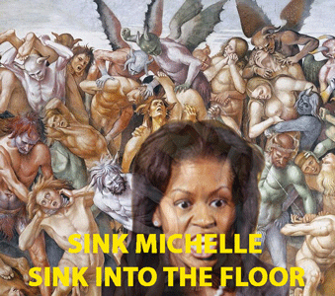
MICHELLE OBAMA “GET OUT”
This is certainly the first time in American recorded history that this country’s presidential First Lady had been “identified” as a Black Woman. Michelle Obama also appears to be the 1st and fastest ever- First Lady- to go from being the most powerful, respected and visible on top of the world women to literally “SINK INTO THE FLOOR” like out of the movie “GET OUT” so soon post U.S. presidential election. And, nobody from those who had possessed to love her to so-called no nonsense- no hostage self righteous “progressive” white women that don’t seem to give a hill of beans about where Michelle Obama is, or could be.
Do not get it twisted. The long tall gay black man, Barack Hussein Obama, has not and did not manipulate his birth certificate, social security card, selective service documents or any other of his official identity documents to completely befuddle the CIA, NSA, Homeland Security, FBI, U.S. Customs, U.S. Selective Service Department, Congress, local, state, county law enforcement agencies from Hawaii, Indonesia to Chicago, IL to become the President of the United States. THAT DOG DON’T HUNT, BITE OR BARK!
In fact, not one of them are complaining about any of Obama’s alleged forged personal identity documents. If he needs anything to cover his ass to prove that he is in fact a Barack Hussein Obama born in Hawaii in 1961, no problem– it will appear signed, sealed and delivered. That is the way, they roll. Barack Obama has an entire department of world-class PHOTOSHOP document forgers and then some more old school classic forgers on the U.S. payroll at his service. We call it, the CIA.
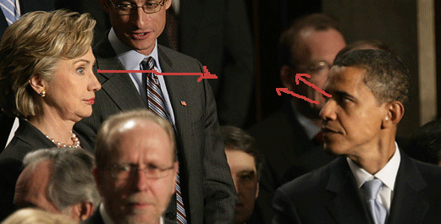
Some very tricky and weird MK ULTRA/MONARCH stuff is going on with THEM– former U.S. Democrat Senators, former U.S. Secretary of State Hilary Clinton and President Barack Obama. And, it’s right there directly smack in front of your face.
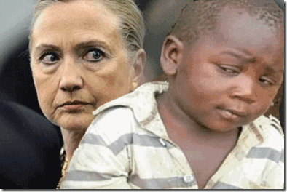
Even a child can see through “ALL OF THEM”. U.S. intelligence disinformation agents are all over the internet spreading diversionary false information that Barack Obama has his own secret underground counterintelligence forces on a mission to undermine the DEVIL’S SON, president select Donald J. Drumpf and his administration. If it is so, I wish him “God’s Speed“. But, it ain’t hardly so. Both of THEM, work in Lucifer’s Workshop.
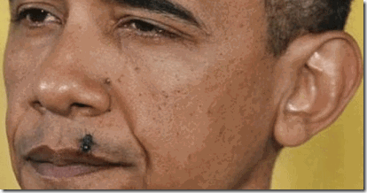
Under the direction and control of the Central Intelligence Agency (CIA), Barry Soetoro A.K.A. Barack Hussain Obama can’t even swat a fly without a keyboard stroke. He has never been no more than “salt” sprinkled into the White House. December 2016, over the course of a five (5) year investigation overseen by Maricopa County Sheriff Joe Arpaio and conducted by Mike Zullo, involving PhD graduates in four (4) different labs, and other professionals, Barack Obama’s official birth certificate put forward by the government has been declared a forgery. It has nine (9) layers and points of forgery. It may be declared a forgery by operation of the law. [1] MAYBE? It’s is adding pressure and fuel on the fire in the kitchen of the CIA and the Satanic Cabals to keep Michelle quiet and out of the picture domestic and global picture until things die down.
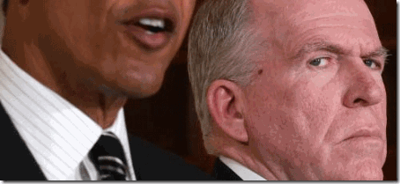

It is alleged that the former Director of the CIA, Catholic Jesuit– John Brennan, was most responsible for sprinkling the black Manchurian Candidate cyborg patsy, Barack Obama, into the White House in 2008. It is believed that Brennan had been in charge of the agency’s fabrication and manufacture of Obama’s false identity and paper trail. [2]
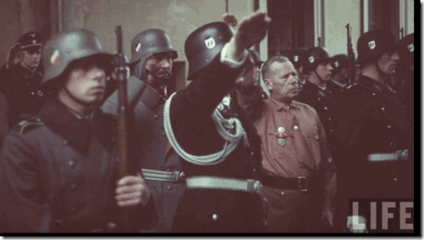

The American unholy alliance with the Nazi-SS began before the end of WWII. As a smokescreen and smoke mirror, the Nazi German Army, Wehrmacht, surrendered, but Himmler’s Allgemeine and Waffen SS never surrendered to Allied Forces. A covert ultra secret alliance with the SS- Knights of the Black Sun was led, arranged, orchestrated and managed by the OSS Swiss head, Allen Dulles, and NY Wall Street to change their venue, and their WWII spoils: gold, money, art, jewelry, bonds and stocks to corporate America.
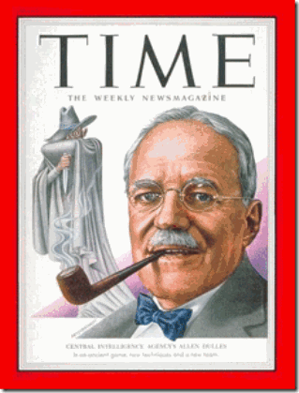

Once Dulles became the Director of the CIA in 1953, the ultra secret clandestine Himmler and the Masonic SS- Knights of the Black Sun were once again running amok in the world, and in America within a secret inner circle of the CIA within the CIA.
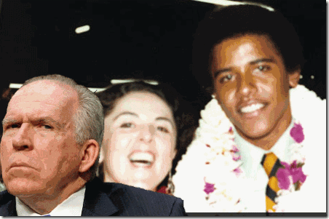

Brennan, a Irish Jesuit, covered the CIA desk in Indonesia (1977-79), when Ann Dunham and Barry (Barrack Obama) Soetoro were there. Obama left for Occidental College in 1979.[3] Ann Dunham, had been associated during the 1970s and 80s — as employee, consultant, grantee, or student — with at least five organizations with intimate CIA connections during the Cold War: The Ford Foundation, Agency for International Development (AID), the Asia Foundation, Development Alternatives, Inc., and the East-West Center of Hawaii.[4]
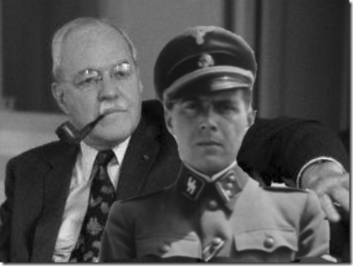

In answer to the sudden rise of the Black African Liberation Movement on the African continent during the early 1960s, SS- Hauptsturmführer Dr. Josef Mengele, and the Gehlen Org put forth a bold bizarre plan to control black nationalism, freedom, political and economic aspirations of black people by manufacturing and cloning future human cyborgs and mind controlled black Manchurian Candidate political leadership classes that would confuse and mislead the masses. CIA Director, Allen Dulles, bought Dr. Mengele’s future plan, hook, line and sinker. Obama’s birth certificate shows that it is uncertain and can’t be proven at this time when, where and how he was born, and it was impossible for him to have had a damn thing to do with that.
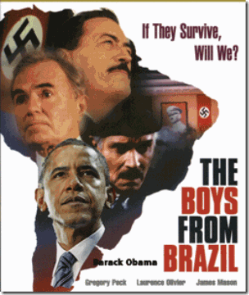

Barack Obama is one of Dr. Mengele’s “Boys from Brazil“. The technology to shape the personality of children was here, and pioneered in SS Nazi Germany concentration camps abroad. The bottom line is that in the early 1960s, Dr. Mengele and the SS held the scientific keys to the state of art of artificial insemination from its highly secret and guarded live human medical experimental programs in concentration camps.


The SS and Hitler proposed to build a vast “Master Super Aryan Race” to rule the world through the science of artificial insemination- the deliberate introduction of sperm into a female’s uterus or cervix for the purpose of achieving a pregnancy through in vivo fertilization by means other than sexual intercourse. Himmler and the SS- Knights of the Black Sun were light years ahead of the world in the field.

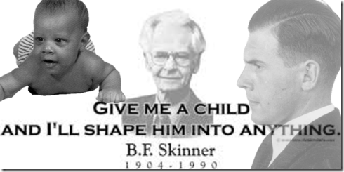

Obama is a laboratory test tube baby in reverse (Satanic Duality) of the Super Aryan Master Race Theory conceived of in a test tube or in the belly of a JACKAL. Now, nobody knows any different for certain. This stuff is government top secret classified maybe until kingdom come. SS, Dr. Mengele and Allen Dulles passed down their ultra top secret human cyborg project, Barack Hussein Obama, like a baton to the closed ultra secret inner circle of the CIA within the CIA to “salt” the White House in the future to confuse, and misled the global masses. The Jesuit, John Brennan, was raised within the agency as a “disciple” within a closed inner circle of the CIA within the CIA of Director George Tenet, and the cyborg Manchurian Candidate, Barack Obama, could also very well have been Tenet’s “Trojan Horse“.
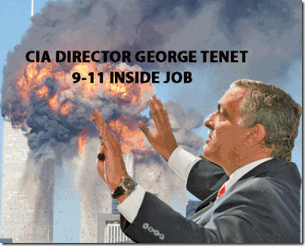
“With the events of September 11th, we have witnessed the greatest intelligence failure in history since the Greeks sent the Trojan Horse to rescue Helen of Troy. Ironically, a “Greek” presided over the CIA on one of the darkest days in American history.”[5] As Deputy Director for the CIA, in 1996, Tenet worked to install his closest friend and confidant, John Brennan, as his CIA station chief in Saudi Arabia. Brennan often communicated directly with Tenet, avoiding the usual chain of command. At the time, as an apparent favor to the Saudis, CIA analysts were discouraged from questioning Saudi links to Arab extremists.[6]
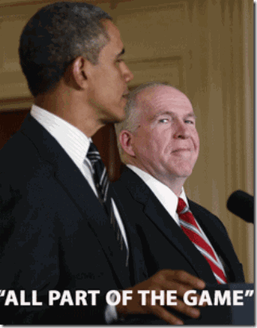

In late 2008, Brennan was the reported choice for Director of the CIA in the incoming Obama administration. Brennan withdrew his name from consideration because of opposition to his CIA service under President George W. Bush and past public statements he had made in support of enhanced interrogation and the transfer of terrorism suspects to countries where they might be tortured (extraordinary rendition). President Obama then appointed him to be his Deputy National Security Advisor for Homeland Security and Counter-terrorism, the President’s chief counter-terrorism adviser and a position that did not require Senate confirmation.[7]
II
CIA MK ULTRA MONARCH & HANDLERS, ALL PART OF THE GAME
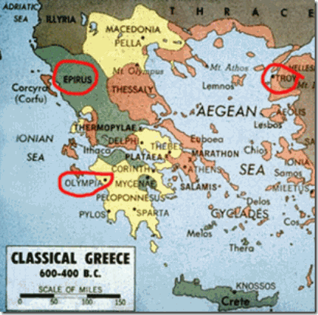
George Tenet’s mother, Evangelia, was born in Himara, Albania- an important site of Allied resistance against Italian and Nazi occupation. During WWII, the Battle of Himara was a military conflict that took place in the Greco-Italian War in December 1940, during the counteroffensive of the Greek Army that followed the failed Italian invasion of Greece. After the Greek victory in Himara, the Italian dictator Mussolini, admitted that one of the causes of the Italian defeat was the high morale of the Greek troops.[8]
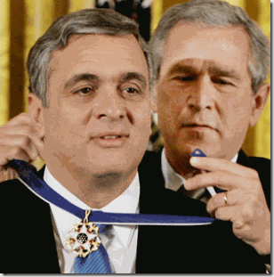
George Tenet, a proud “Epirote Greek” – is an assertion of white supremacy– superior ancient Trojan heritage. Like his fraternal twin brother, noted cardiologist Dr. William Tenet grew up in Queens active in the St. Nicholas Greek Orthodox Shrine Church in Flushing, NY. According to the CIA storyline, George’s parents, Evangelia and John Tenet immigrated from Epiros, Greece. The Tenets are powerful “clever” secret elite Mt. Olympic Greek bloodline that trace their heritage back to the Hellenes and Trojan War. HELENUS who was the cleverest man in the Trojan army just as Odysseus was reputed to be the most clever in his own.[9]
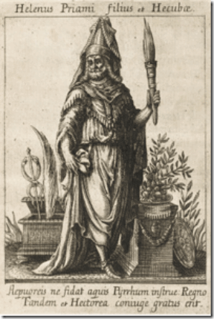
Helenus: “A son of Priam and Hecabe, was a skilful observer of auguries, and knew the counsel of the gods (Hom. Il. vi. 76, vii. 44; Apollod. iii. 12. § 5); but he was at the same time a warrior, and with Deiphobus he led the third host of the Trojans against the camp of the Greeks. (Il. xii. 94.) He fought against Menelaus, but was wounded by him (xiii. 580, &c.). Once, when yet children, Helenus and Cassandr were left by their parents in the temple of the Thymbraean [God] Apollo; and, as they fell asleep, snakes came and cleaned their ears, whereby they acquired the gift of prophecy. (Eustath. ad Hom. p. 663.)”[10]
“On the eastern shores of the Adriatic Sea, approximately halfway between the ruins of the Acropolis in Athens and those of the Coloseum in Rome, lie the ruins of a string of colonies the HELLENES established on Illyrian soil — in what is now the country of Albania. These HELLENES founded colonies not only on the Adriatic Coast but also on the BLACK SEA, SICILY, NORTH AFRICA and other parts of the Mediterranean. The ancient ruins, hardly known to the general public today are, according to the experts, CLOSELY CONNECTED to the Classical Greek civilization. These colonies were organized in the typical Greek fashion and ran as autonomous political entities — enacting their own laws, organizing their own defense, and contracting accords with other city-states and foreign powers.”
WHO founded these colonies, and WHERE did the colonizers come from? The Roman poet, VIRGIL, tells us in his Aeneid (Book III) that this area of the Adriatic coast was founded by A GROUP OF TROJAN EXILES who fled Troy after the Greek victory. The exiles were under the leadership of HELENUS who, in Greek legend, was a son of PRIAM and Hecuba, and twin brother of Cassandra. This HELENUS was, therefore, of the royal line of DARDANUS and a JUDAHITE!”
The Encyclopedia Britannica notes that “after the capture of Troy he [HELENUS] and his sister-in-law Andromache accompanied Neoptolemus (Pyrrhus) as captives to EPIRUS, where HELENUS persuaded him to settle. After the death of Neoptolemus, Helenus married Andromache and became ruler of the country. He was the reputed FOUNDER OF the cities of BUTHROTUM AND CHAONIA, named after a brother or a companion, who he had accidentally slain while hunting.” (1943 edition. Vol. II, p. 393).
Buthrotum (now known as BUTRINT) was established on a headland on the shores of a fine bay only 9 miles from the island of CORFU. This location fell within the land of the Caeones, an Illyrian tribe already settled there when Helenus arrived. The name BUTHROTUM means “place abounding with cattle and grazing land” and was a perfect place for the new city. Norman Hammond, in an article “Dashing Through Albania” (Archaeology magazine, Jan/Feb. 1993) expresses the following: ‘Butrint (ancient BUTHROTUM) lies just south of Saranda on a rocky peninsula. Its legendary founding as a NEW TROY [was] by (according to Vergil) the TROJAN PRINCE HELENOS and Andromache, widow of HECTOR…‘ ” (p. 76).[11]
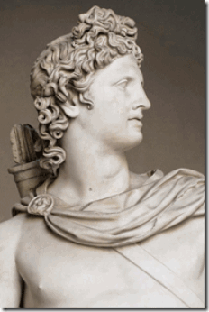
HELENUS (Helenos), son of King Priam of Troy, was a Sun Cult High Priest of God APOLLO that founded the Tenet’s homeland, Epiros (EPIRUS), Greece. When the Tenets call themselves proud Epirote Greeks-
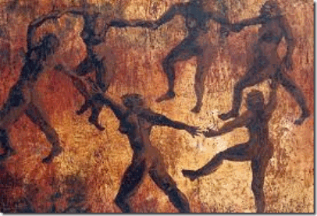
Ancient Greek “ZEIBEKIKO” Circle Dance
it is a highly elitist, radical and insulting Greek nationalist statement. It is deeply shrouded and secretly veiled in the ancient Occult, Witchcraft and deep Greek Mythology.
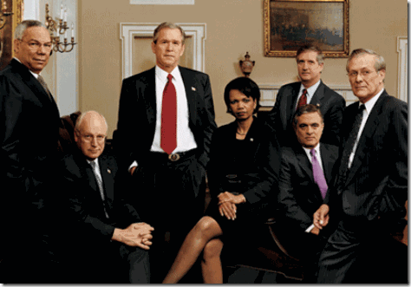
9-11 INSIDERS & CRIMES AGAINST HUMANITY MASS MURDERERS ROW- GLOBAL WAR CRIMINALS
After earning his Bachelor’s degree at Georgetown University and his master’s at Columbia University in the 1970s. He served as the 18th Director of Central Intelligence from 1997 to 2004, winning “the respect and confidence of two different presidents, one a Democrat, Slick Willie Bill Clinton, and the other a Republican, George W. Bush. He was a key member of the Clinton NSC White House staff, and the 9-11 Inside Job corrupt war criminal aggressor mass murderers row.[12]
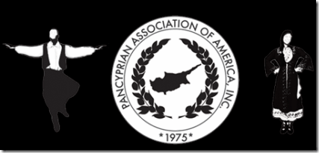
In Flushing, NY, the Pancyprian (meaning Pan–Greek Cypriot) Association is closely affiliated and a bloodline brother in league with Comet Pizza’s James Achilles (Trojan War Hero) Alefantis’ secret fraternal Masonic Order of the American Hellenic Educational Progressive Association (AHEPA).[15]
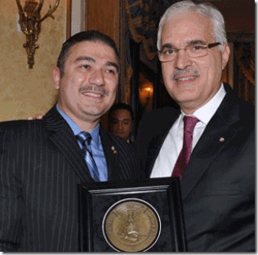
AHEPA Award, Dr. William Tenet
The honorees for the 2010 1st regional evening included: Honorable Robert Menendez, AHEPA Pericles Award, Honorable Carolyn B. Maloney, AHEPA Pericles Award, Dr. William J. Tenet, AHEPA Academy of Achievement Award-Medicine.
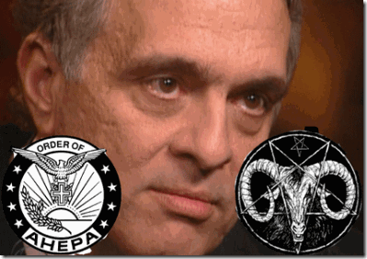
CIA Director George Tenet presented his brother, Dr. Tenet, with the AHEPA Academy of Achievement Award in Medicine.[16] George Tenet is One of their FRATERNAL BROTHERS.
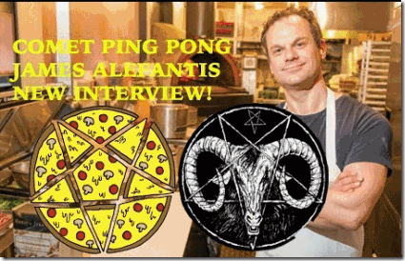
PIZZAGATE’S James Achilles Alefantis aka The GOAT GOD- PAN
Alefantis is One of THEM. He and his Masonic Order of AHEPA is one of former CIA Director and President George H.W. Bush Sr.’s “1000 POINTS OF LIGHT”.[17] One literary usage was in C.S. Lewis’ 1955 book “The Magician’s Nephew“. C.S. Lewis wrote, “One moment there had been nothing but darkness; next moment a thousand, thousand points of light leaped out…” C.S. Lewis was known to be steeped in the occult and well on board with the thrust of the Illuminist agenda. Some say it traces back to the Masonic “founding fathers”.[18] In 2003, the Pancyprian Association of America honored with the prestigious 12th Annual “Freedom Award”, the Greek American CIA Director, George Tenet, for being the highest ranking Greek in the Bush administration and a role model for our Community.
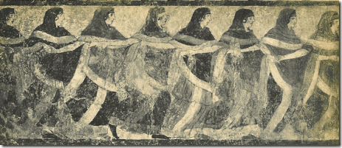
Ancient Greek Dance ZEIBEKIKO
The event took place on Saturday, during a gala black tie dinner held at the New York Hilton Hotel.
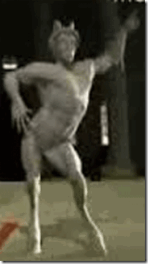
The ancient Greek GOAT GOD- “ZEIBEKIKO“
George Tenet and his brother Dr. Bill Tenet, threw the numerous CIA agents in disarray, when they started dancing the ancient Greek “ZEIBEKIKO“.
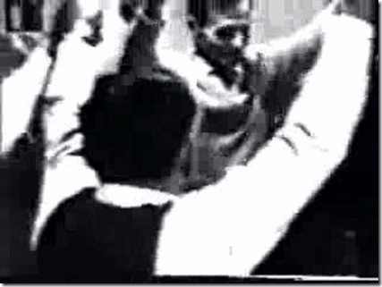
The more than 600 people at the room stood up and started clapping at a popular song that praises people named “GEORGE“.[19]
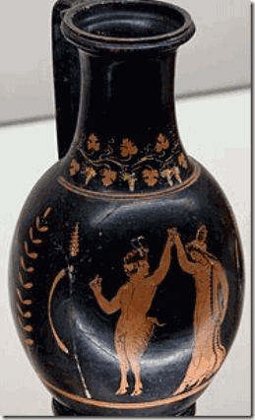
God Pan and a Maenad dancing. Ancient Greek red-figured olpe from Apulia, ca. 320–310 BCE. Pan’s right hand fingers are in a snapping position to resemble the traditional Greek “ZEIBEKIKO”.
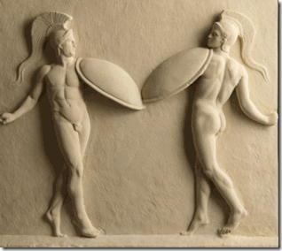
The “ZEIBEKIKO” of the Tenets was actually the dance possession of the Corybantes to the music of Goddess Cybele, and her son, the GOAT GOD- PAN.
HIP HOP- Kanye West & George Tenet
KANYE WEST & BAPHOMET- THE GOD GOD
Just to let you know that this stuff isn’t just some irrelevant ancient BS, Kanye West did in fact meet with the powerful elite Greek off Mt. Olympia in 2012.
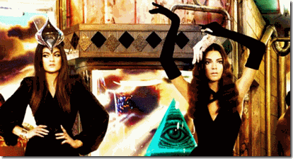
Coming from the Satanic Coptic Kardashians, George Tenet would be Kanye’s most perfect example of a clandestine cold blood “Dark” Satanic Knight to illuminate. He is a vicious war criminal that left government service in 2004 after infamously LYING– vouching for the claim that Saddam Hussein had weapons of mass destruction that caused the violent invasion and destruction of a sovereign nation- Iraqi; the death and destruction of millions of Iraqis, the death of thousands of U.S. soldiers, and at the expense of billions of the taxpayers’ treasury.
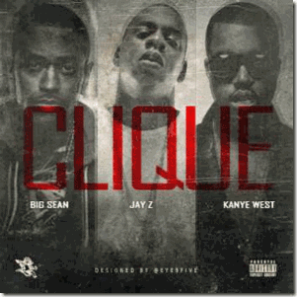On “Clique,” a track from Kanye West Presents G.O.O.D. Music: Cruel Summer, Yeezy said, “Yeah, I’m talking business, we talking CIA/ I’m talking George Tenet, I seen him the other day/ He asked me about my Maybach, think he had the same/ Except mine tinted and his might have been rented.”
There is some truth to that story. A longtime Tenet spokesman Bill Harlow said that Tenet and Kanye, in fact, met in New York City after a business meeting. Harlow said that they talked but there was no discussion of Maybach Mercedes autos. Harlow said that Tenet doesn’t drive one — rented, leased, owned or otherwise. What did they talk about? Tenet is a worshiper of St. Nicholas Greek Orthodox Shrine Church. Saint Nicholas ((270 – 343) also called Nikolaos of Myra. St. Nick was a historic 4th-century Christian Saint and Greek Bishop of Myra in Asia Minor (modern-day Demre- Turkey).
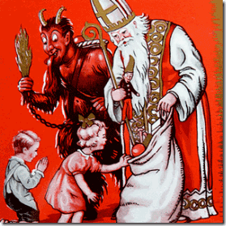
Recall, this is also a historical St. Nick.
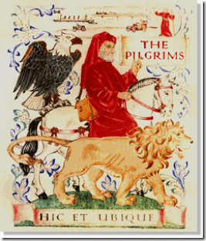This is also St. Nick of the Pilgrims Society. However, that is most likely not what they talked about in common. The Kardashians belong to the Armenian Apostolic Church – the oldest national church in the world. There is really no substantial difference, theologically, between the Greek and Coptic (Armenian) churches. The difference occurred because of the term Monophysite vs Miaphysite which was at the Council of Chalcedon in Turkey(451 AD). The Copts were interpreted as being Monophysite. The Copts believe God had 2 (two) inseparable (human and divine) natures which were joined in one Complex Nature (or Maiphysite).
From the time of the Crusades up until the 19th century, the Church of the Holy Sepulchre had 3 (three custodians) – the Greek Orthodox, the Armenian Apostolic, and the Roman Catholic Churches. There exist a secret common Masonic Knights Templar cult made up of the three entities. Is this where John Brennan enters the DARK CIRCLE (9th Satanic Circle) as a JESUIT PRIEST?
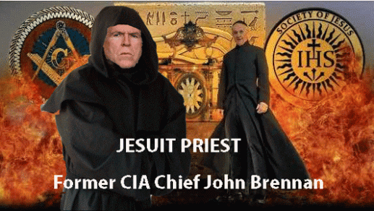
Kanye and Tenet would have briefly discussed many things, but one thing that they had in common at that time was his planned pilgrimage to Israel with the Coptic Kardashians; degrees of Freemasonry and the ILLUMINATI. Kanye made his actual holy pilgrimage to the Church of the Holy Sepulchre in April 2015.
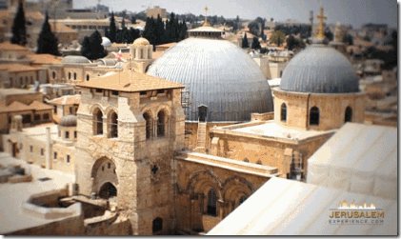
The Church contains, according to traditions dating back to at least the fourth century, the two holiest sites in Christianity: the site where Jesus of Nazareth was crucified, at a place known as “Calvary” or “Golgotha”, and Jesus’ empty tomb, where he is said to have been buried and resurrected.
III
RUN MICHELLE RUN
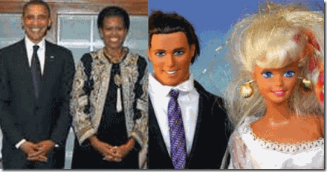
The fantastic eight (8) year Barbie and Ken Doll Dream in the White House is over for Michelle. Like in the movie “Get Out”, they want her as a black former First Lady to sink beneath the floor. She ran, but everywhere she has run to have been them, the international Dark Satanic Cult.
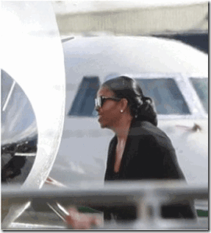
The Obamas had been scheduled to spend a few weeks in Palm Springs, California at the home of Spanish Ambassador James Costos and his gay partner Michael Smith, but that all abruptly changed when Michelle must have panicked about something involving Barack and Costos. She was caught boarding a private jet, alone. Michelle, left alone, outside the White House spotlight with these kind of extreme demonic people would freak anybody out.
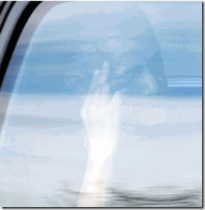
Barack was photographed visibly upset, leaving an exclusive Rancho Mirage golf course, and daughters Sasha and Malia were nowhere to be found. Corporate mass media news claim that they know why Michelle had a tantrum, and left Costos’ home and Palm Springs. It rained too much. That is a Big LIE.[20]
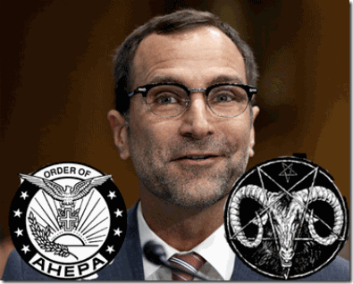
James Costos is One of THEM! He is actually James Kotopolous of Lowell, Mass. The Kostopolous of Lowell, Mass are all AHEPANS– secret initiates of the Greek fascist underground society and Cult of the Masonic/Fraternal Order of American HELLENIC Educational Progressive Association (AHEPA), and the Holy Trinity HELLENIC Orthodox Church.[21] Michelle may not never had arrived on Sir Richard Branson’s isolated and restricted Caribbean Necker Island in British territorial waters. If she did get there, she was taken hostage, because a female impostor took over her place soon thereafter.
Sir Branson of British Intelligence is One of THEM!

[1] http://anonhq.com/obamas-birth-certificate-investigation-concludes-5-years-forensic-outcome-certificate-fake/
[2] https://www.intellihub.com/obama-exposed-white-house-salter-foreign-cia-operative-puppet-falsified-creditials/
[3] http://whowhatwhy.org/2013/03/17/john-brennan-in-grad-school-destroying-democracy-helps-save-it/
[4] https://www.newsbud.com/2012/07/05/barack-obama-his-mother-and-the-cia/
[5] https://groups.yahoo.com/neo/groups/clubhimara/conversations/topics/221?l=1
[6] https://digwithin.net/2014/07/27/george-tenet/
[7] Id.
[8] Id.
[9] http://www.maicar.com/GML/Helenus1.html
[10] http://www.mythindex.com/greek-mythology/H/Helenus.html
[11] http://hope-of-israel.org/i000109a.htm
[12] http://www.freerepublic.com/focus/f-news/552126/posts
[13] https://www.thenationalherald.com/84482/george-tenet-fascinates-and-informs-at-hacfs-kourides-lecture/
[14] https://groups.yahoo.com/neo/groups/clubhimara/conversations/topics/221?l=1
[15] https://www.thenationalherald.com/28703/ahepa-in-flushing-raises-50000-for-cyprus/
[16] http://www.neomagazine.com/2010_01_january/40.html
[17] https://voat.co/v/pizzagate/1722582
[18] https://www.bibliotecapleyades.net/sociopolitica/esp_sociopol_illuminati_58.htm
[19] https://groups.yahoo.com/neo/groups/clubhimara/conversations/topics/221?l=1
[20] http://madworldnews.com/michelle-tantrum-ditches-barack/
[21] http://www.legacy.com/obituaries/lowellsun/obituary.aspx?n=george-costos&pid=122835949
Comments : Leave a Comment »
Tags: 9-11 inside job, ahepa, albania, Allen Dulles, allgemeine ss, ann dunham, Armenian Apostolic Church, artificial insemination, B.F. Skinner, barack obama, barbie doll, Barry Soetoro, boys from brazil, c.s. lewis, CIA, circle dance, crusades, cybele, dark satanic cult, donald j. drumpf, donald j. trump, dr. william tenet, epirote greek, gehlen org, GEORGE H. W. BUSH, george tenet, George W. Bush, goat god, god apollo, god pan, greece, Greek Orthodox, Heinrich Himmler, helen of troy, helenus, hilary clinton, iraqi, james achilles alefantis, James Costos, john brennan, josef mengele, kanye west, Kim Kardashian, Knights of the Black Sun, knights templar, michelle obama, mt. olympia, one of them, order of the american hellenic education progressive association, pancyprian association, pilgrims society, pizzagate, run michelle run, saddam hussein, Salt, sir richard branson, SS, st. nicholas, St. Nicholas Greek Orthodox Shrine Church, st. nick, trojan horse, troy, waffen SS, where is michelle obama?, ZEIBEKIKO
Categories : 1000 Year Reich, 9-11, Afghanistan, allen dulles, Apollo, Aryan Supremacy, Barack Obama, Barak Obama, Black Manchurian Candidates, boys from brazil, christianity, Crimes Against Democracy, cybele, cyberneticist, cybernetics, cyborg, cyborg warfare, cyborgs, divine one, donald j. drumpf, donald j. trump, dualism, East-West Center, False Satanic Rites of Lost Negroes, freemason, freemasons, George W. Bush, Hauptsturmfuhrer SS Dr. Josef Mengele, Heinrich Himmler, HIP HOP false prophets, hip hop satanic cult, illuminati, jay z, jay-z, jesuits, jesus christ, Josef Mengele, kanye west,, Knights of the Black Sun, Knights Templar, luciferians, Michelle Obama, MK-ULTRA, modern slavery, monarch child, monarch program, National Socialism, Nazis, new age religion, new world order, Operation PAPERCLIP, Oprah Winfrey, Paperclip Project, Reichsfurhrer SS-1 Heinrich Himmler, sasha obama, satan, Satanic Global High Cabal, Satanism, Schutzsteffel, Scientology, set, University of Hawaii

“HELTER SKELTER” THE DEVIL’S JOY ON EASTER SUNDAY WEEK- DRUMPF’S SS NAZI WUNDERWAFFE ATOMIC BOMB, ATOMIC DOG STEVE STEVIE STEVENS: "HUEY’S WAY"
24042017
I
HELTER SKELTER
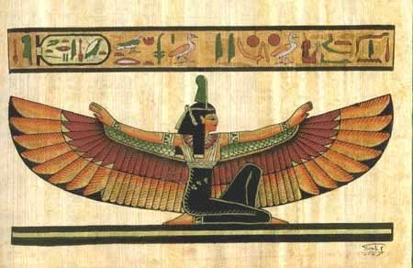
MAAT is designed to avert CHAOS (Isfet) and maintain TRUTH (Maat). The symbol for truth, justice, balance, and order is the Goddess MAAT. The iconography for MAAT in the hieroglyphs depict the single ostrich feather (Shu), worn atop Goddess Maat’s head.
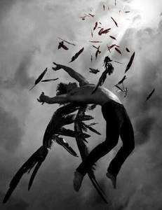
The fallen angels are wicked or rebellious angels that have been cast out of heaven. God did not spare angels when they sinned, but cast them into hell and committed them to chains of gloomy darkness to be kept until the judgment.
Kabbalah:
“God did indeed send down a book to Adam, from which he became acquainted with the supernal wisdom. It later came into the hands of the ‘sons of god’ [i.e., the ‘Fallen Angels,’ of whom Samael was the leader, described in Genesis 6:1-4], the wise of their generation, and whoever was privileged to pursue it could learn from it supernal wisdom.”(Zohar 1:37b) The “supernal wisdom” of Kabbalah is related to the Fallen Angels, of whom Samael was the leader, and in whose “Palace“, the early Sages “delved“, and into which the Jewish Messiah Sabbatai Zevi, later “descended.”
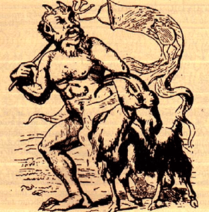
The concept of fallen angels is first found in Judaism among texts of the Second Jewish Holy Temple (516 BCE and 70 AD). The Second Temple replaced Solomon’s Temple, the First Temple. The Second Temple applied Fallen angels to Azazel. In some traditions of Judaism, Christianity and Islam, it is the name for a Fallen Angel. In Rabbinic Judaism, it is not a name of an entity but rather means literally “for the complete removal“, i.e., designating the goat to be cast out into the wilderness.
In Christianity, SATAN is often seen as the leader of the fallen angels. The New Testament mentions SATAN 36 times in 33 verses, and the Book of Revelation tells of “that ancient serpent, who is called the devil and Satan, the deceiver of the whole world,” being thrown down to the earth together with his angels. In Luke 10:18 In Jesus says: “I saw Satan fall like lightning from heaven.” Both 2 Peter 2:4 and Jude 1:6 of the New Testament refer to angels who have sinned against God and await punishment on Judgment Day.
HELTER SKELTER: Adverb: In disorderly haste or confusion. Adjective: In disorderly haste or confusion. Noun: Disorder; confusion. It is HELTER SKELTER CHAOS!
II
THE DEVIL’S JOY- CHAOS ON EASTER SUNDAY WEEK
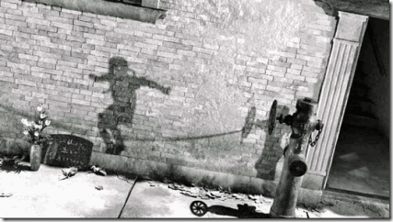
In 1945, the U.S. military dropped two atomic bombs on Japan. It was “Death in the Air” for many people. The fire storm nuclear fuel air bomb instantly carbonized (vaporized) this little girl while she was playing jump rope, and so many other innocent people.
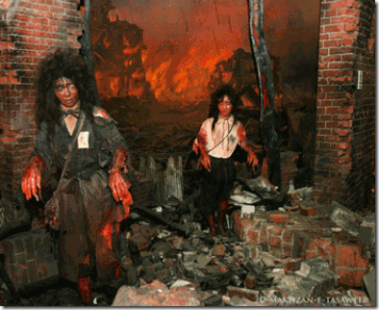
On Thursday, April 13, 2017, the day before Good Friday of the Easter Sunday Week, President select, Donald J. Drumpf decided to put some “Helter Skelter” in our lives. He dropped the Witch’s Cauldron, the so-called “Mother of All Bombs” (MOAB), on the people of Afghanistan. Despite the lack of information from the Pentagon about Drumpf’s deployment on April 13 of the MOAB in Afghanistan close to 70 percent of American voters say they “strongly” or “somewhat” support the bombing, according to a new poll.[1]

Donald Drumpf, U.S. Pentagon, and corporate mass media will not tell the so-called “American voters” polled the truth about MOAB. Oh, MOAB just killed ISIL fighters in caves and underground bunkers. It is mass propaganda. It is the BIG LIE, coming out of the Drumpf administration, again.
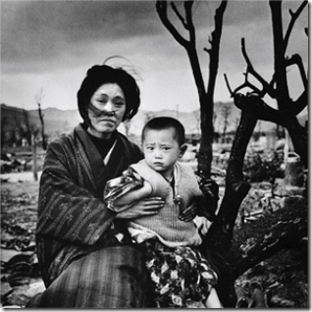
The MOAB is known as the Witch’s Cauldron. It is a fuel air bomb- “Death in the Air“.
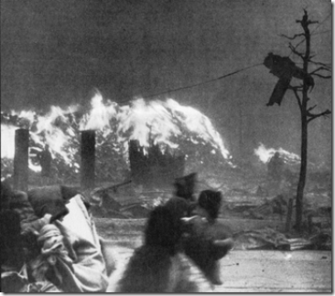
Atomic Bomb Firestorm “Death in the Air” Over Japan- Nowhere to Escape
It’s a FIRESTORM. It kills “All Living Matter” within a mile or more radius. It is a small atomic bomb. It is that mushroom cloud that indiscriminately vaporize people just the same as it did in Hiroshima, and Nagasaki. Just a little more than 24 hours along, an Afghan official said this week that the bombing killed 96 Islamic State [ISIS] militants, though “the official provided no proof of the deaths or information on how officials reached the number of 96,” as the New York Times notes. There have been no confirmed reports of civilian casualties. The Times further reported on Tuesday: “It was unclear whether any Afghan or coalition forces have made it to the bombing site five days after the attack. The senior Afghan security official said the day after the bombing that Afghan commandos had done so and, after clearing the site, had handed it over to American military forensic teams.”
[Zabihullah] Zmarai, the provincial council member, said local officials in Achin told him that neither Afghan nor American forces had arrived at the site. A spokesman for the Afghan commandos, Jawid Salim, agreed. “It is not true that the members of U.S. forensic are at the scene of bombing—no one is there,” he said. “We are in the area and we see everything.” [2]
Do you truly believe that American voters would feel the same if they knew that Donald J. Drumpf’s MOAB is one of Adolf Hitler and Heinrich Himmler’s SS “Helter Skelter” secret wonder weapons (Wunderwaffle) of mass human and environmental destruction?
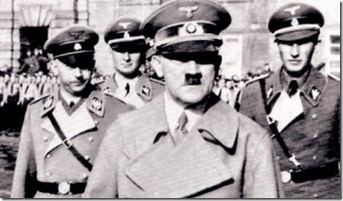
I THINK NOT! The International Criminal Court (ICC or ICCt) is an intergovernmental organization and international tribunal sits in The Hague in the Netherlands. The ICC has the jurisdiction to prosecute individuals to prosecute individuals for the the international crimes of genocide, crimes against humanity, and war crimes.
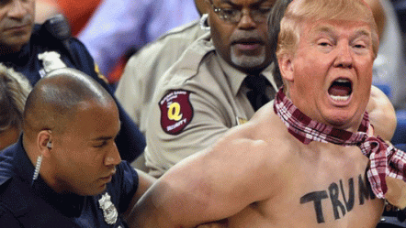
We pray that Donald J. Drumpf answer for his Crime Against Humanity, and WAR CRIME against the Afghan people in the ICC.
III
THE DEVIL: PREVENT THE RISE OF THE UNIVERSAL MESSIAH
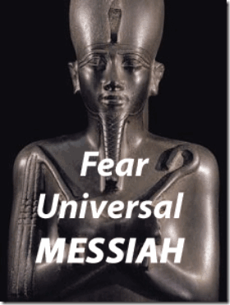
Easter or Resurrection Sunday is a global festival and holiday celebrating the resurrection of Jesus (Messiah) from the dead, described in the New Testament as having occurred on the third day of his burial after his crucifixion by the Romans at Calvary c. 30 AD.[3] The Messiah & the Resurrection is an old story- far older than recorded history.
Asur (Osiris), Aset (Isis), and their brother Seth were all gods. And Asur was god of vegetation, Isis the goddess of fertility and Seth the god of the desert. Asur was a “living god”, like Horus he was embodied as the pharaoh. When he became pharaoh, he took Aset to be his queen. Seth became jealous and murdered Asur. I believe he cut Asur’s body into pieces and scattered them throughout Kemet (Egypt). When Aset heard, she took the form of a bird and searched until she found all the parts of his body. After um reassembling Asur’s body, she beat her wings and breathed life back into him. Thereafter, Asur was god of the afterlife.
To avenge his father, Horus fought Seth. After battling for 80 years, Horus was judged victorious by the gods, but he had lost his eye in the battle. The eye was found and returned to him. As a gesture of respect, he presented the eye to his father, Asur. The Eye of Horus or “udjat” represents the combination of a human eye, with the cheek markings of a falcon. It was considered a powerful symbol for imparting protection and life.
The “Messiah Complex” and the “Rise of the Messiah” always strike the fear of death in the heart of the ILLUMINATI, and the New World Order.
“Prevent the rise of a ‘messiah’ who could unify and electrify the militant black nationalist movement“- J. Edgar Hoover, Thirty-Third Degree Inspector General Honorary in the Southern Scottish Rite Jurisdiction, and Scottish Rite, 33, Grand Cross
In August 1967, four months after Dr. Martin Luther King, Jr. called the US government the “greatest purveyor of violence in the world today,” three months after 30 members of the Black Panther Party for Self Defense marched, armed, into the California state capitol and onto the front pages of newspapers worldwide, Satanic Master Mason, J. Edgar Hoover, the head of America’s domestic law enforcement agency, the Federal Bureau of Investigation, issued the following directive: “The purpose of this new counterintelligence endeavour is to expose, disrupt, misdirect, discredit or otherwise neutralise the activities of black-nationalist, hate-type organizations and groupings, their leadership, spokesmen, membership and supporters.“[4]
“Prevent the Rise of the Black Messiah” is still official U.S. government policy.
IV
HUEY’S WAY, “I AM NOT A DOG”
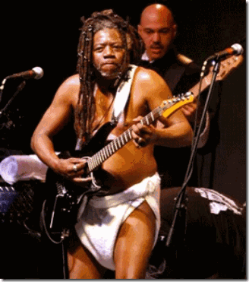
Funkadelic George Clinton, ATOMIC DOG
As early as kindergarten, I had learned the hidden power of words. In early grade school, the N- Word released a fire and fury inside of me that I couldn’t control. Through-out my school years, I always avoided conversions involving playing the dozens– disparaging and insulting remarks about our mothers, N- Word, and cursing. I always approached it as an individual barrier with a certain amount of firmness- “I don’t play that.” I was also perplexed when I heard that people thought that I was conceited.
Conceited about what? I was always the rock bottom of the poor of poor. I lived in dilapidated roach palaces most all of my childhood. I had nothing but patched up clothes, socks and shoes. I couldn’t rub two nickels together. Through someone else’s eyes. At the turn of the 21st century, I decided to patronize a little Asian store down the street from the law library that I had often frequented when I was in grade school.
A Chinese elder appeared from the back of the store. As he was packing up my purchases, he said I remember you, “you’re that tall skinny quiet black kid that used to come in here when you were in elementary school.” What he said next surprised me. I had also thought as a kid that I had been invisible. He said, “I never had a problem with you, you’re were always respectful.” As a kid, I had always respected and honored the Chinese elders as if they had been my own.
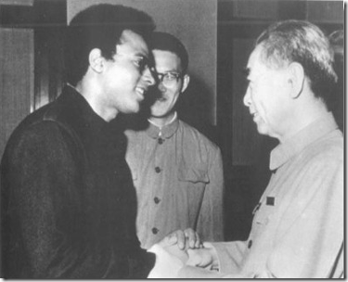
1971, People’s Republic of China, Premier Chou En-lai and Huey P. Newton
After so many years, it was an affirmation that we were not wrong. There is some intangible, no matter how small or settle, universal reward in living in peace, harmony and dignity with our brothers. It has great value among mankind. It was a great honor to be remembered dignified and honorable when I was a very young developing MANCHILD.
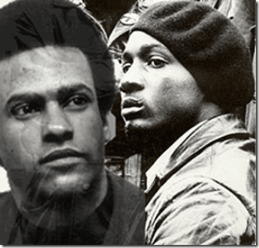
Brother Huey– Princeray
As a maturing Manchild, I always carefully studied the mannerisms of Huey P. Newton when I could at Merritt Jr. College in Oakland. I noticed that people always had to be very careful how they talked to brother Huey if you really didn’t know him- no cursing, no negativism, and no N-words. The dozens. You don’t dare go there with Brother Huey. In fact, nobody treated Brother Huey like some type of peasant. When a brother or sister addressed Huey with BABY, like “Hey Baby“, he was always polite, humble and respectful. He would always respond, “I am not a BABY“.
There was always a quiet silence of reflection, because whoever it was that called him “BABY” didn’t intend to be offensive to him in anyway whatsoever. But, that was “Huey’s Way“. A quiet lesson that teach that words possess POWER. From then on until today, I follow “Huey’s Way” even with my most beloved. I am not a “BABY“, BOY nor anybody’s N-word, M-F, or DOG.
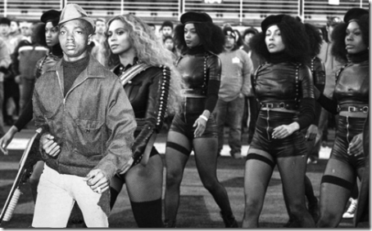
Huey’s Way, Little Bobby Hutton, First Member of the Black Panther Party for Self Defense
Huey’s Way taught us so many valuable intangible things of human value, love and commitment that after so many years, the Black Panther Party for Self Defense is still very much alive and well in the Heart of the People. Huey’s Way taught us to live our lives among mankind, dignified. We shall resist, and be not possessed of such EVIL things such as DOG spirits.
V
STEVE “STEVIE” STEPHENS & ATOMIC DOG FUNKS YOU ON EASTER
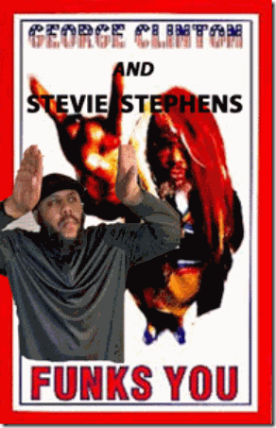
Steve “Stevie” Stephens & George Clinton Funks You on Easter Sunday
The Facebook Killer, Steve “Stevie” Stephens, fatally shot a Cleveland black elder on Facebook on Easter Sunday. We can’t be sure if he was deliberately triggered as a Black Manchurian Candidate (BMC) to kill and set off a false flag reign of terror across America on Christian Easter Sunday, or a BMC malfunctioned and killed a representative Christian black elder on one of our most sacred Christian holidays.
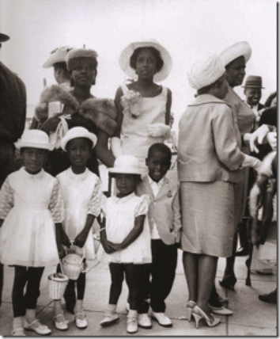
For generations, Easter had become a traditional day of universal unity, “love, peace and joy” in the Black Community. It was the one day of the year that we as a people customarily set aside for our best family get togethers and dinners.
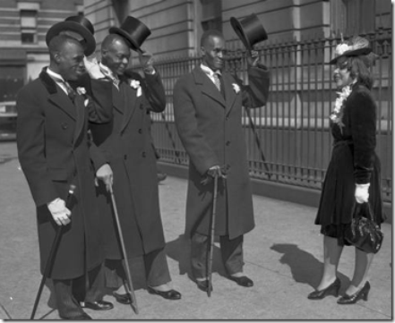
Easter was also the one day of the year that we always reserved to put on our very best super special clothes to go to church, and join the JOYFUL Easter Parade to celebrate the Resurrection of the Messiah. It has become a day of great anticipation and a day of EASTER JOY for black people all around the country. So, I am very troubled that Steve “Stevie” Stephens chose to slaughter one of our elders on a sacred and holy Christian holiday because of “JOY” [Easter] Lane.[5]
Why must I feel like that – Why must I chase the cat
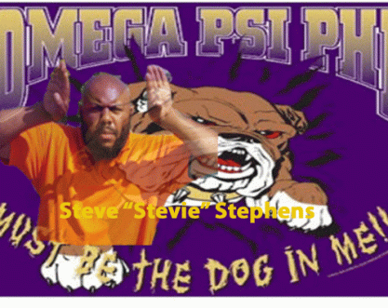
Live on Facebook, Stephens claimed to be an assassin that previously killed thirteen (13) victims. As you know thirteen (13) is a number of extreme Satanic/Occult importance.
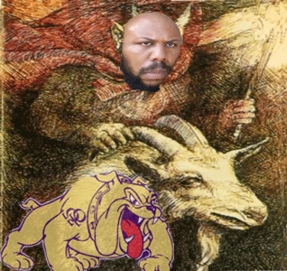
Steve was a Goat Rider (Goat Man) for the fraternal order of Omega Psi Phi Zeta Omega, Cleveland Chapter. Their god is the Greek DOG God, ANIBUS. [6]
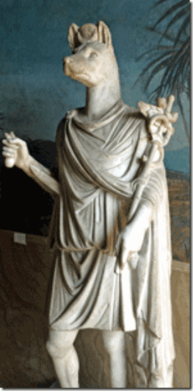
In classical Greek mythology, HERMANUBUS was a god who combined Hermes with Anubis. He is the son of DOG God Set and Goddess Nephthys.[7] The EVIL JEALOUS brother, God SET, killed the MESSIAH, Asur (Osiris).
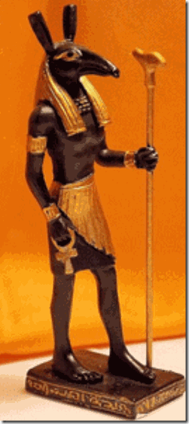
GOD SET, THE EVIL DESERT STORM GOD
Below, Stephens downloaded the following video on YouTube. It shows him engaged in a classic ancient occult “circle dance” – the Witches’ Reel.
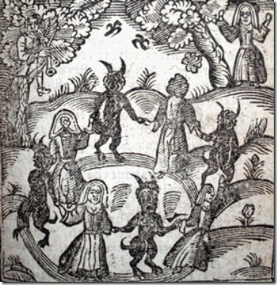
The dog that chases its tail is the OUROBOROS that celebrates the infinite cycle of nature’s endless creation and destruction, life and death.[8] Stephen is seen to come under the possession and spell of the DOG God in Him, falls to the floor.
ATOMIC DOG
“Yeah, this is a story of a famous dog
For the dog that chases its tail will be dizzy …
Dog of the world unite …
Nasty dogs (Dog)
Atomic dog
Atomic dog
Like the boys
When they’re out there walkin’ the streets
May compete
Nothin’ but the dog in ya
Bow-wow-wow-yippie-yo-yippie-yeah …
Why must I feel like that
Oh, why must I chase the cat …
Ruff
Ruff
Ruff
Why must I feel like that
Why must I chase the cat
Nothin’ but the dog in me …
Do the dogcatcher, dogcatcher …
Do the dogcatcher, baby, do the dogcatcher
Ooh
Why must I feel like that
Why must I chase the cat
Nothin’ but the dog in me …
Bow-wow-yippie-yo-yippie-yeah …
Just walkin’ the dog
Oh, atomic dog
Futuristic bow-wow
Ruff
Leader of the pack
Wild dog
Why must I feel like that
Why must I chase the cat
Just the dog in me
Nothin’ but the dog in me …
Do the dogcatcher, dogcatcher
Do the dogcatcher
Do you want to do the dogcatcher
Well, baby, why don’t you do it again for me
Dogcatcher, dogcatcher
Do the dogcatcher
House-trained dogs
Wild dogs
Say it again
WHY MUST I FEEL LIKE THAT [?].
Songwriters
SIXX JOHNSON / GEORGE CLINTON / SNOOP DOGG [9]
WHY MUST I FEEL LIKE THAT [?]- CIA MK ULTRA/MONARCH Mind Control
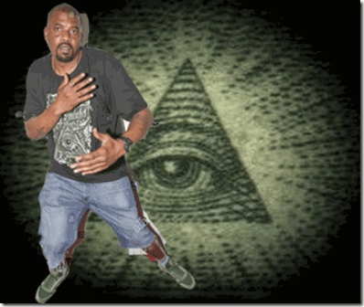
Sixx Johnson- Undoubtedly- the ILLUMINATI. I need not say any further.
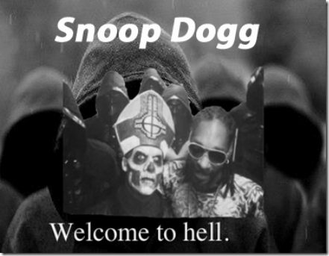
In his autobiography “The Doggfather“, Snoop Dogg says the DEVIL came to him to make a deal that he would be rich and famous in exchange for his soul. Snoop accepted the DEVIL’s offer (by his own words) and identifies that the point at which Calvin Broadus dies and Snoop Dog was born.[10]
VI
GEORGE CLINTON, ATOMIC DOG & THE PROCESS CHURCH OF THE FINAL JUDGMENT
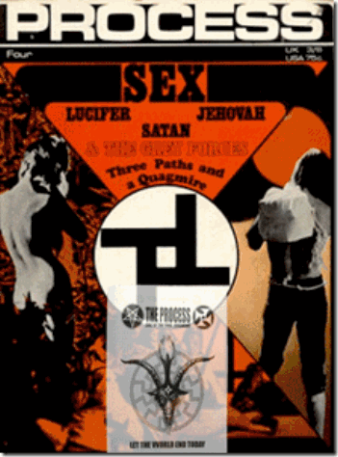
The British Process Church of the Final Judgment is an intense Satanic Cult that believed it was their job to bring on Armageddon. The Process Church heavily influenced the Luciferian philosophy of legendary black funk (Funkadelic) musician, George Clinton. Excerpts from their magazine are implanted in the liner notes for Funkadelic’s Maggot Brain and America Eats Its Young.[11]
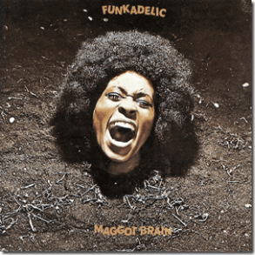
The liner notes to Maggot Brain consist of a lengthy quotation from the “Fear” issue of Process Church magazine, and Clinton’s “America Eats Its Young” reproduces the text of a Process “sermon” about America: What is missing? What does America need most? What are her children lacking? How can we banish evil? What can we give to our enemies? Who is Satan? Christ help us: we are lost, lost in our fury, lost in our blame, lost in our apathy, Call to us, call to us! What can we give to our enemies? Love? Love our enemies? Love Satan? Love Satan????? [12]

The Process Church, Genesis P. Orridge
From British Transgender Rock Star – Genesis P. Orridge,
“Timothy Wyllie’s name for some time during his MANY years in The Process was “Father Jesse“. They’d move around various chapter houses. Timothy did most of the layout of The Process magazine ( all by hand and typeset, letterpress, NO computers then). George [Clinton] used to hang out in the coffee bar and got into a lot of the ideas. It was a radical system of persona(ity) change that was not racial in any way. George is a VERY smart guy. So he got involved intellectually and asked for permission to use some De Grimston text on the album back cover. It suited both parties. Process got to huge new, more black, market and George got some radically hip writing. It was the era of Black Panthers, Weatherpeople and so on. Cross fertilising of antiestablishment concepts and collectives.”[13]
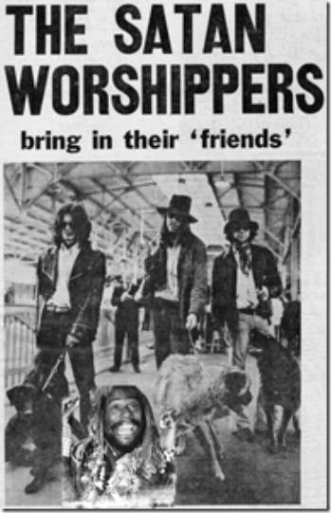
George Clinton, One of Lucifer’s DOG Friends
It certainly sounds as if British Intelligence, the Tavistock Institute and the Satan Worshippers- Process Church were writing George Clinton’s lyrics to destroy the minds of Black people.
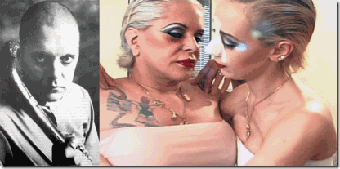Genesis P. Orridge & Lady Jaye
“Psychic TV were playing in Tokyo ( late 1991) under sponsorship of PANASONIC at PAN HALL. We heard Funkadelic were playing nearby nite before our gig so went along. PFunk played 4 plus hours and were great, including Maggot Brain. We were in the dressing room waiting for George to be introduced and we(me) wrote “FATHER JESSE & FATHER MALACHI say hello” with a Process symbol next to it on his dressing room door. In the end we had to go to a meeting before George came off stage. He came to OUR gig next nite though as a result of my cryptic message. He saw us after we came off stage and first words he said were ” You are the ONLY band I’ve ever seen that plays non-stop on stage as long and longer than ME!” (we’d playe 6plus hours!!! So we became friends and stayed in touch. Then the “OF COURSE FACTOR”, one of our key TOPY [Thee Temple ov Psychick Youth] people in Denver became a roadie for George Clinton to me and Lady Jaye would be in the VIP list every concert they played in Bay Area until we moved to New York. Lost track after that with first and stuff….Djin loved George. How he basically just wanders about the stage looking fabulous and conducting the musicians…yet his charisma holds the audience spell bound everytime.”[14]
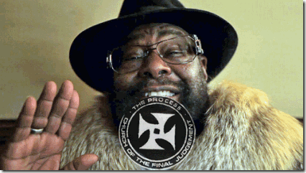
In 2014, Lucifer’s boot-licking patsy negro Clinton opened up about his relationship with the Process Church in his memoir, Brothas Be, Yo Like George, Ain’t That Funkin’ Kinda Hard on You? He says they met not in Toronto, but in Boston:
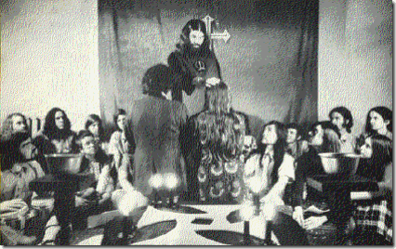
“There was a group called the Process Church that had been founded by a British couple as an offshoot of Scientology, and in the late sixties they started hanging out with the band, mainly in Boston. They would feed the kids in Boston Common and they ran what was basically the first day-care center that I can remember, offering to watch children when mothers went to work. We ended up excerpting some of their thinking in the Maggot Brain liner notes, which seemed fine at the time—it was a form of self-actualization, not an uncommon or unpopular philosophy at the time. We did the same thing for America Eats Its Young, but with far different results. In the summer of 1969, a career criminal (and part-time songwriter) named Charles Manson led a band of followers on a killing spree in upscale residential neighborhoods in Los Angeles, murdering a number of people, including Roman Polanski’s wife, Sharon Tate. The killers were under the influence of a crazy-quilt mythology that somehow tied together the Beatles’ “Helter Skelter,” race war, and Satan worship. There was some thought that Manson had drawn on some of the writings of the Process Church. I thought there was a difference—he talked about something called the Final Church of Judgment, and the group hanging around with us was the Church of Final Judgment—but this was probably too fine a distinction for a public still trying to get a handle on a killing spree. Rolling Stone gave us a hard time for the association in their review. There were real-life consequences, too. Right around the time we finished up this record, we were out in California. Half of the band must have gotten the same pussy, so one by one they went off to the clinic. Fuzzy Haskins had a bad reaction to the shot, and having heard on the radio all day about the Family murders, he started rambling about the band right there in the clinic, explaining how we weren’t connected to Manson at all but somehow, in his not-entirely-coherent monologue, making it seem like maybe we were. We were strangers in California at that time. People didn’t know shit about us. We looked weird, and we had weird ideas. The notion that we had anything to do with Manson caused a tremendous problem for a little while.”[15]
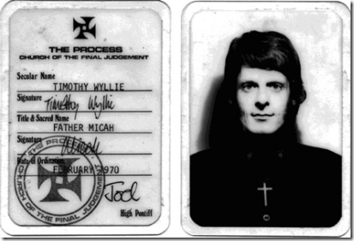
Timothy Wyllie, Father Micah, was born in London in 1940 and trained in England as an architect. He moved to America in the mid-sixties.
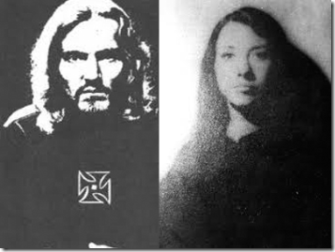
Wyllie, Robert (aka Robert Moore) and Mary Ann (MacLean) DeGrimston also out of Britain and British Scientology were the principal leaders of the Process Church in Los Angeles. Since 1967, they principally targeted HollyWeird celebrities in and around Laurel Canyon for Satanic initiation.[16]
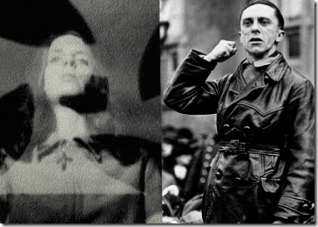
Mary Ann, born in Scotland, was reputed to believe that she was Josef Goebbels’ reincarnate.[17] The patsy, Charles Manson, had come under the Satanic Nazi influence of Father Jesse, Robert and Mary DeGrimston.[18]
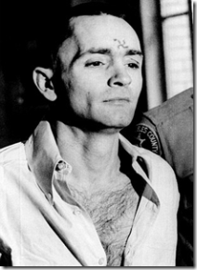
Timothy Wyllie’s mother, Diana Wyllie, was a spy for British Intelligence, both in England and Germany before the war and later at Bletchley Park with the Enigma Code-breakers.[19] In British Intelligence during WWII, Diana Wyllie was classified “ULTRA“. She worked directly under Major General Menzies in the British War Department’s most ultimate top secret compartment. 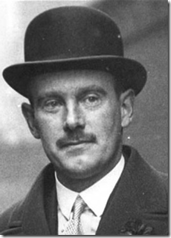
Knight of the British Crown, General Menzies
Sir (British Knight) Stewart Graham Menzies was Winston Churchill’s half brother and his top spymaster. Menzies was Chief of MI6 (SIS) British Intelligence Service. ULTRA was Britain and MI6’s highest secrecy designation and classification adopted in June 1941 for wartime signals intelligence obtained by breaking high-level encrypted enemy radio and teleprinter communications at Government Code (GC&CS) at Bletchley Park. ULTRA eventually became the standard designation among the western Allies for all such intelligence. The name arose because the intelligence thus obtained was considered more important than that designated by the highest British security classification then used (Most Secret) and so was regarded as being ULTRA SECRET.[20]
Diana Wyllie’s compartment had to remain ULTRA SECRET for decades, because British Intelligence had sold former WWII Allied encrypting machines to particularly African nations. The British maintained a secret backdoor to all of their classified and secret intelligence information. In England, bloodlines and peerage runs very deep from the medieval period. Undoubtedly, Timothy Wyllie was a top secret British intelligence agent working with MI6, CIA, NSA and NSC. You can’t believe very much that comes out of Wyllie’s mouth about the Process Church, Charles Manson, Mass Murder a/nd Laurel Canyon.
VII
HELTER SKELTER, FRANKFURT SCHOOL & TAVISTOCK INSTITUTE
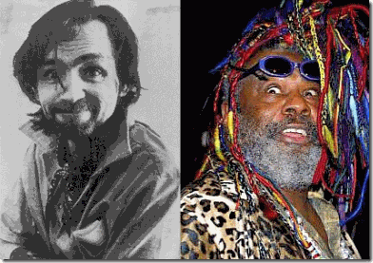
Lucifer’s Patsies of the British Process Church
I think that a lot of people are now willing to conclude that Charles Manson was a CIA MK ULTRA mind control Manchurian Candidate with “Helter-Skelter” programming. In addition to being a member of the Scientology, Manson was also a member of the Process Church of the Final Judgment along with George Clinton.
HELTER SKELTER- They Got Get It (CHAOS) Into Our Lives
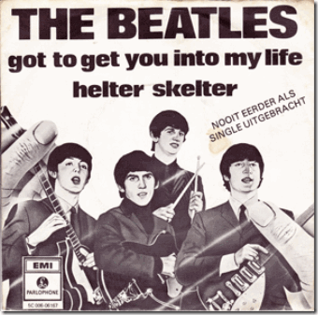
“Helter-Skelter” they got to make it part of our lives. WHY? “Helter-Skelter” was alleged to have been a product of John McCartney’s attempt to create a sound as loud and dirty as possible. The Beatles’ recording has been noted for its “proto-metal roar” and is considered by music historians to be a key influence in the early development of heavy metal.
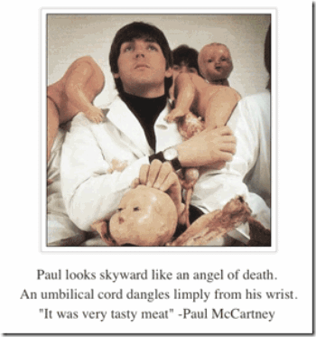
British Satanic Cannibal McCartney fronted for “Helter-Skelter” to be the most raucous vocal, the loudest drums, et cetera” and said he was “using the symbol of a “Helter-Skelter” as a ride from the top to the bottom; the rise and fall of the Roman Empire – and this was the fall, the demise In British English the term “Helter-Skelter” not only has its meaning of “in disorderly haste or confusion. In the months leading up to the Tate/LaBianca murders in August 1969, Manson often spoke to the members of his “Family” about Helter Skelter, an apocalyptic war arising from racial tensions between blacks and whites.
Researcher Jim Keith says of the Process ” Manson’s reported plan to unleash the apocalyptic ‘Helter Skelter’ revolution also seems to have been copped straight from Process theology, but there is a familiar ring. The ‘process’ of The Process is identical to that of Tavistock, the return of the blank slate, the tabula rasa, through violence.”
The Tavistock Institute as you know is a well-known British global MK ULTRA/MONARCH programming center. According to Dr. John Coleman, the British rock band the Beatles was put together and then brought to America by the Tavistock Institute as a step in creating a cultural revolution in the United States. The Tavistock was also responsible for inserting “trigger words” into their “cult lyrics” through a man out of Nazi Germany, THEO ADORNO. He was assigned the mission by the DEVIL to clandestinely implant CHAOS in our lives through our love of music.
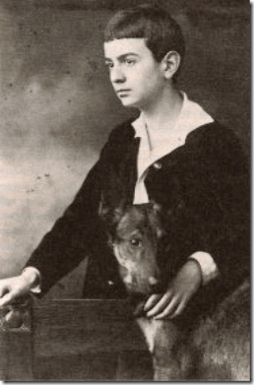
Young Theodor Adorno
Theodor W. Adorno, born Theodor Ludwig Wiesengrund (1903 – 1969) to a Jewish family in Frankfurt, Germany. He was a Frankfurt School of Thought philosopher, socialist and composer.[21] His Gay lover, Siegfried Kracauer (1889- 1966), was a German Jewish writer, journalist, socialist, cultural critic and film theorist associate with the Frankfurt School. Kracauer confessed a friend of his strong erotic feelings toward the much younger Adorno led him to believe that at least in intellectual and spiritual matters he also was homosexual.
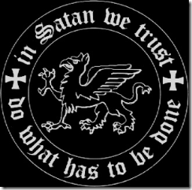
It’s difficult to sum up of what the Frankfurt School of Germany was. Most of following comes from Satan’s Secret Agents: The Frankfurt School and Their Evil Agenda. The Frankfurt School were mostly Germany Jewish scholars, who developed highly provocative and original perspectives on contemporary society and culture, drawing on Hegel, Marx, Nietzsche, Freud, and Weber. The Frankfurt School plotted among themselves to corrupt and disrupt culture and society’s very core principles without an invading army. When Hitler and Nazis came to power, the Institute was closed and its members, by various routes, fled to the U.S.and ended up deeply imbedded at major academic universities across the country such as Columbia, Princeton, Brandeis, Stanford and California at Berkeley.
Basically, the Frankfurt School believed that as long as an individual had the belief — or even the hope of belief — that his divine gift of reason could solve the problems facing society, then that society would never reach the state of hopelessness and alienation that they considered necessary to provoke a socialist revolution. Their task, therefore, was as swiftly as possible to undermine the “Judaeo-Christian legacy.”
FRANKFURT SCHOOL: RIDING THE GOAT
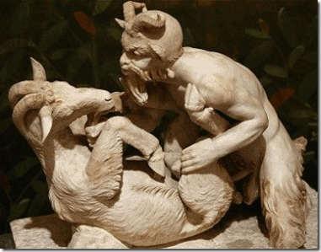
PAN-SEXUALISM & THE GREEK GOAT GOD PAN
“One of the main ideas of the Frankfurt School was to exploit Freud’s idea of “PANSEXUALISM”: the search for indiscriminate sexual pleasure, the promotion of “unisex”, the blurring of distinctions between the sexes, the overthrowing of traditional relationships between men and women, and, finally, the undermining of heterosexuality at the expense of homosexuality — as, for example, in the idea of “same-sex marriage” and the adoption of children by homosexual couples.”
Under the growing influence of Christianity around the first century AD, the pagan Sun Cults of Mithras were essentially outlawed and driven underground. Powerful forces of the secret pagan sun cults like the Frankfurt School have been committed to effecting an erosion and destruction of Christianity and its influence, from within. As they erode Christianity, the underground and outlawed Sun Cults of Mithras are arising dropping their veils of secular disguise to become the explicit and open worship of the Cybele, Mithra, and Satan-Baal-Lucifer.
Powerful institutions, academic universities, oligarchies, and now the U.S. government is bent upon eradicating the kind of institutional forms of society which Christianity and true human nature demand and require of the divine. The persistent erosion of society’s core Christian values open people of weak character and constitution to be recruited, and victims including children to be kidnapped, ritually abused, brainwashed and mind controlled to act as a force for EVIL, a form of evil like the ancient Phrygian Cult of Cybele-Dionysus.
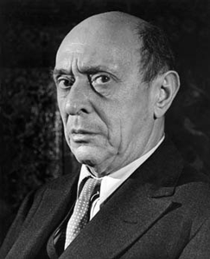
German Frankish Music Master, Arnold Schoenberg
The spread of explicit Satanism, through aid and conspiracy of agencies such as Adorno’s Frankfurt School and Tavistock Institute, and their dogmas of “the authoritarian personality” creates clouds of a dark age, and phase of large scale mass organizing and indoctrination in the U.S. Adorno and his Frankfurt School mentor, Arnold Schoenberg, have been identified as these types of clandestine Pan-sexual SATANISTS, and Kabbalahist Jews.
According to THE SATANIC THEOLOGY BEHIND CULTURAL MARXISM, these type of Kabbalistic Jews believe that God was shattered by the act of Creation, and that His attributes lay as “holy sparks” embedded in Creation which must be picked up in order for Him to be restored to oneness (known as the act of tikkun). The Kabbalahists therefore believes that the Jewish Messiah will never arrive and thus Mankind will never be liberated until God is restored to oneness. The way to do this, according to the Kabbalahists, is to engage in acts of holiness and meditation in order to retrieve the sparks of God.
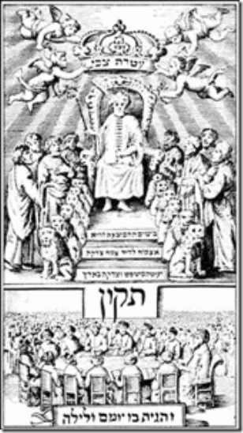
In the year 1666, a cabbalist and occultist named Sabbatai Zevi declared himself the Jewish Messiah. Upon his messiahship, he turned the Torah around by declaring that all sins were now considered “holy” and that the only way to “repair” God was to engage in acts of depravity. He lost several followers after the Sultan of the Ottoman Empire forced him to convert to Islam, however, several Jews still followed him. 100 years later, Jacob Frank declared himself to be the reincarnation of Sabbatai Zevi and took those ideas to an even more extreme level.
In order for God to be fully repaired and for the Messianic Era to arrive, mankind must destroy all of its traditional moral values and go beyond good and evil. The Frankists, as they were called, engaged in every horrible thing you could imagine: black magic, wife-swapping, sex orgies, homosexuality, incest, pedophilia, and promoted a form of proto-feminism and proto-communism. Every one of these disgusting acts was considered to be a “holy tikkun” (restoration) of God if done with holy intent. They were entirely apocalyptic who despised the world of creation, seeking to bring about its early end and to bring forth a Messianic utopia.
The Sabbatean and Frankist heresies established a stronghold in Frankfurt, Germany. These Frankists were known to be affiliated with the Freemasonic lodges that existed around the city. One such Freemason was a man by the name of Franz Joseph Molitor. He was a known Satanist and alchemist who took a strong interest in the Kabbalah, even going so far as to synthesize Kabbalah with a perverted form of “Christianity.” This is what lead him to picking up Sabbatean-Frankist ideology. In order to promote his sick and twisted views, he wrote a four-volume set of books promoting a bastardized understanding of “Judaism” written from a cabbalist and Sabbatean perspective. Both Adorno and Schoenberg were secret Frankfurt and Tavistock “Satanic-Kabbalistic Music Masters”.
LAUREL CANYON & THE HELTER SKELTER
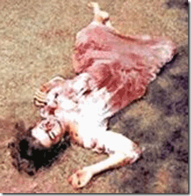
“Helter-Skelter” Mass Murder Victim, Abigail Folger
The American equivalent to the Tavistock Institute is the Esalen Institute in Big Sur, California. Esalen is a cult center where Manson was seen just a few days before the Tate-La Bianca murders took place in August 1969. Robert DeGrimston was also reported to have spoken there and Manson murder victim, Abigail Folger, had also been seen there. Part of Manson’s programming involved Beatles’ music, “Helter-Skelter.”[22]
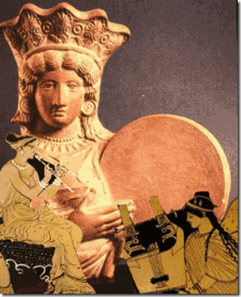
Drummer Greek Goddess Cybele, Fluke and the Harp
The Beatle’s “Helter-Skelter” chaos theme music was secretly developed by the Tavistock Institute and Adorno.[23] Schoenberg is created with developing The 12-Atonal System that consisted of heavy, repetitive sounds, adapted from the secret ritual Satanic ceremonies of the Cult of Dionysus and the Baal priesthood.
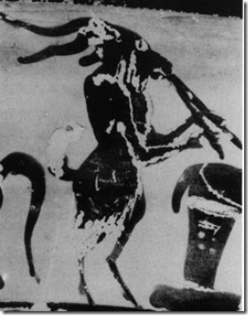
The Pan-Flutes were Sacred to the Greek Goat God
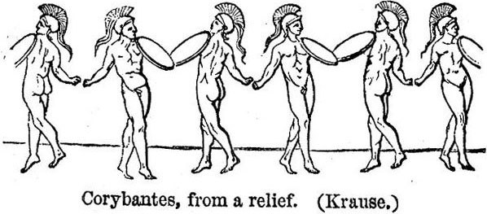
The sacred music of the ancient Cults of Cybele, Baal and Dionysus were not developed to heal you, but to POSSESS you with SPIRITS to CONTROL you like Cybele’s dancing soldiers, the Corybantes. Steve Stevie Stephen and Omega Psi Phil’s ATOMIC DOG is similar demonic POSSESSION music and lyrics specially developed by Satanists and the ILLUMINATI to fill young black men with the ancient Greek Dog God Spirits of HERMANUBUS and SET- SATAN.
Tavistock and its Stanford Research Institute created trigger words which then came into general usage around “rock music” and its fans. Trigger words created a distinct new break-away largely young population group which was persuaded by social engineering and conditioning to believe that the Beatles really were their favorite group. All trigger words devised in the context of “rock music” were designed for mass control of the new targeted group, the youth of America.[24]
Adorno was the Frankfurt School and Tavistock’s music critic and master. “His forte was analyzing the psychological and political impact of music on listeners. He was also interested in how new recording technology changed the listening experience. Adorno’s desire for a socialist revolution led him to favor Modernist music that left the listener feeling unsatisfied and dislocated — music that consciously avoided harmony and predictability. He believed that only discord (disharmony) could usher in what Herbert Marcuse would later describe as the “return of the repressed.”[25]
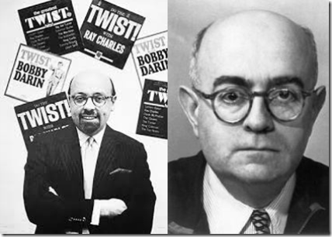
Ahmet Ertegun & Adorno
It is believed that Adorno was implanted at Atlantic Records during the 1940s. Atlantic Records was founded in 1947 in Washington DC by Turkish former Swish, French, and the United Kingdom citizen, Ahmet Ertegun and Herb Abramson, who was his family’s Jewish former U.S. Army dentist.
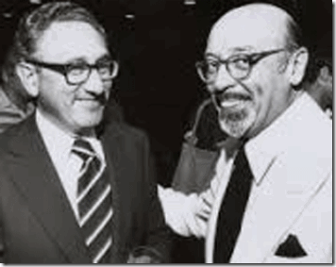
Henry Kissinger & Ertegun
Ahmet Ertegun was raised in Turkey as a Muslim. However, he has belonged to a secret Turkish Kabbalistic American- Israeli Zionist circle related to the Sabbateans for decades. Former U.S. Secretary of State (1973 –1977), 8th U.S. Security Council Adviser (1969- 1975) Henry Kissinger and Ertegun traveled “ … to many foreign countries, though as the son of a distinguished Turkish diplomat, he was quite at home everywhere. We went together to India, China, Nepal, World Cup tournaments in Spain, Italy and France and, of course, to Turkey.”
The secret group emerged into the light of day at the April 1992 gala celebration of the Quincentennial Foundation. The foundation had been created in 1989 to organize the SOOth anniversary celebration, in 1992, of the Ottoman Empire’s acceptance of Jews who had fled Spain. The objective of the Quincentennial Foundation from an Israeli and U.S. standpoint has been to rope in Turkey as an expendable, regional military instrument of the New World Order directed by the German Jew- Henry Kissinger.
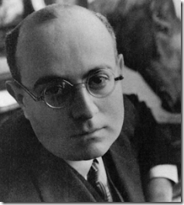
Ertegun’s Secret “German Professor’ Adorno
Adorno may have been Atlantic’s first secret and unnamed sound engineer that Ertegun called the “German Professor“. Going deeper, Ertegun and Adorno both may been secret Kabbalistic Sabbateans that followed the “Supernal Wisdom of Fallen Angels”.
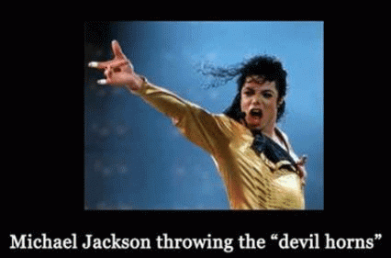
This is another important note about Adorno. The demonic fiend was without a shadow of a doubt the brains behind the “Beatles” as he held the rights to the music and eventually his estate sold those rights to MICHAEL JACKSON. Did he know about Adorno and the DEVIL? I am sure that he did, or else Michael Jackson would be alive and well, today.
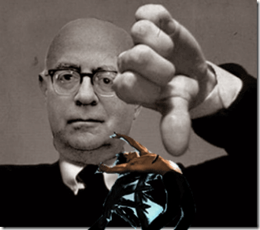
Odorno & Secret Kabbalistic Fallen Angel Magic
Claims of ties between Sabbatean Kabbalah and Sufism go back to the days of Sabbati Zevi. Ertegun was a Sufi Muslim. Inside the Turkish Ottoman Empire, those followers of Zevi who had converted to Islam secretly continued Jewish observances. At least one source linked Adorno to the secret Sabbateans.
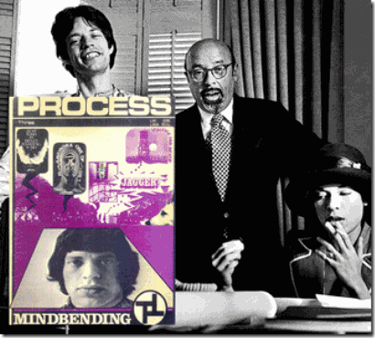
Nick, Bianca Jagger, Ertegun & the Satanic Process Church
Atlantic moved out of Washington, DC. and into a building at 234 W 56th Street in New York in 1947. Ertegun would go on to monopolize the Jazz, R&B, and Rock music industries. He made a fortune off Ray Charles, Bobby Darin, Aretha Franklin, the Rolling Stones, Otis Redding, Bette Midler, Wilson Pickett, Percy Sledge, Booker T. and the MGs, Sam and Dave, Cream, the Bee Gees, Led Zeppelin, the Coasters, John Coltrane, Charlie Mingus, Roberta Flack, the Spinners, the Allman Brothers, Genesis, Foreigner, Pete Townshend, Stevie Nicks, Buffalo Springfield, the Blues Brothers, Tori Amos, and Phil Collins, among many others.[26] Don’t get it twisted. Ertegun didn’t create Atlantic Records because of his love for American music. It was about TOTAL AND COMPLETE CONTROL!
Ertegun, 9-11 Inside Job

Ertegun was also well connected with powerful figures of the Zionism, Satanic Cabals and the American Shadow Government. He sat on the board of the RAND Center for Middle East Public Policy Advisory Board with former U.S. Defense Department Secretary, Frank Carlucci,. Carlucci was also the chairman of The Carlyle Group, a defense contractor with ties to the 9/11 Inside Job, Former President and CIA Director George Bush, Sr., Saudi Royal Family and the Bin Ladens.[27]
Adorno was within the secret “inner circle” of thinkers, social scientists, and philosophers, etc., (Frankfurters) associated with the Frankfurt Institute of Social Research in Germany. During WWII, many of the Frankfurters in the U.S. joined and were recruited into the OSS. In 1941, President Franklin D. Roosevelt created the Office of Scientific Research and Development (OSRD). It was an agency of the U.S. federal government created to coordinate scientific research for military purposes during WWII that also had been heavily infiltrated by Frankfurters.[28] The OSRD was also interested in psychology and psycho-acoustics — topics that were precisely in tune with Adorno’s research and area of expertise.
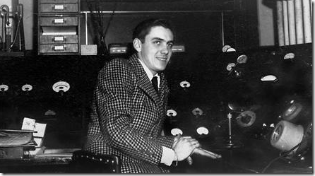
Tom Dowd From ULTRA TOP SECRET (ATOMIC BOMB) Manhattan Project
In 1947, Adorno was called away from Atlantic Records. He was replaced by Tom Dowd, a Columbia University student straight from the OSRD’s super ultra secret Manhattan Project (Atomic Bomb). Dowd with ultra sensitive top secret military and government clearances had a degree from NY’s Columbia University in nuclear physics.[29]
The CIA MK-ULTRA program was also interested in profiling personalities- work that the Frankfurt School had been concentrating on for the US Government since the final years of the war. In the late 1930’s, the Tavistock Institute developed a symbiotic relationship with the Frankfurt Institute for Social Research. Their collaboration led them to analyze the culture of a population from a neo-Freudian standpoint. Nazism just happened to be one of its patients on the psychiatric couch.[30] Both Tavistock and the Frankfurt School paid close attention to Nazi propaganda techniques, which they willingly incorporated into their research. The aim of the project, as stated in (Theodore) Adorno’s “Introduction to the Sociology of Music, ” … was to “program a mass culture as a form of extensive social control that would steadily degrade its consumers.”[31]
“MK-ULTRA teams tried to map out the beliefs and insecurities of certain ethnic groups, like Blacks; and social groups, like lower-class inner-city residents; and religious groups like Evangelical Christians. They were building a database of how to manipulate ethnic politics and special interest groups.”
The Tavistock and Frankfurter “inner circle” of thinkers, social scientists, and philosophers, etc., were also recruited into the CIA and Tom Dowd belonged to a very select group that had all the necessary security clearances to be exposed and recruited to assist the secret and classified type of work that the Frankfurters were doing secretly through CIA MK ULTRA/MONARCH, and the US government to clandestinely mass manipulate and control the minds of the masses through the arts for a New World Order.[32]
Personally, I have never been able to listen to whatever music of Funkadelic, Parliament or George Clinton because of the feelings of dislocation and disassociation. They also created “Rap and Gangster Rap” to introduce Satanism, and cause dislocation, disassociation and CHAOS among the youth in the Black Community. Adorno and the rest of the Frankfurt School wanted to use “new music” to undermine Western middle class values, and upset the Christian religion, traditional values and morals of the Black Community.
According to Ertegun’s partner, Jerry Wexler, Atlantic was in the business of “taking the gospel songs and putting the devil’s words to them.” They weren’t representing Black culture, but a self-destructive Black sub-culture. They were promoting icons that spoke for society’s underbelly: unrestrained sexuality, violence, and drugs. Snoop Dog is with Atlantic.
Barack Obama, “HELTER SKELTER” 2016
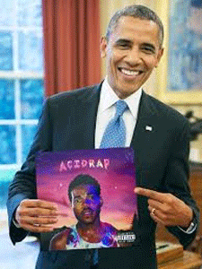
As U.S. President, Barack Obama in 2016, Promoted Chance the Rapper’s ACID RAP

My Dear Lord! Is this crazy or not? You see it just as I directly in our collective faces, the President of the U.S. promoted this Negro high- tripping on MK ULTRA/MONARCH HALLUCINOGENIC drugs for the Satanic Cabals. Do you have any idea what this ACID RAP represent and entail? It is an underground rap styles that overlap with Horrorcore Rap. Esham Attica Smith best known by his stage name Esham is a rapper from Detroit known for his HALLUCINOGENIC style of hip hop which he referred to as “ACID RAP”.
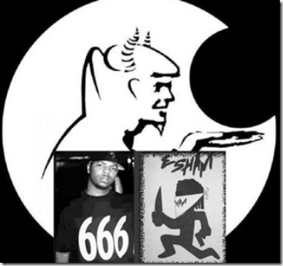
Smith’s lyrics have focused on themes such as death, drug use, evil, paranoia and sex, and have included references to SATAN. Smith refers to his performance style as “acid rap,” comparing the lyrics to hallucinations induced by LSD. Esham’s style has also been described as HORROCORE hip hop.

Chance the Rapper, GOD SET ATOMIC DOG
HORROCORE defines a style of hip hop music that focuses primarily on dark, violent, gothic, transgressive, macabre and/or horror– influenced topics that can include death, psychosis, psychological horror, mental illness, Satanism, self-harm, cannibalism, mutilation, necrophilia, suicide, torture, rape, drug abuse, and often supernatural or occult themes. The lyrics are often inspired by horror movies over moody, hardcore beats,
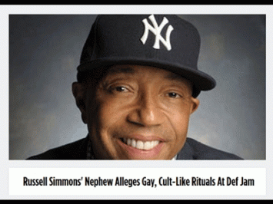
AND the ILLUMINATI in direct complicity of Russell Simmons intend to ram Satanic HORRORCORE down the throats of the global youth and the weak.
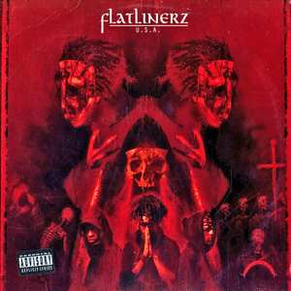
Simmons’ Sponsor HORRORCODE’s FLATLINERZ
HORROCORE was described by Entertainment Weekly in 1995 as a “blend of hardcore rap and bloodthirsty metal. The lyrical content of horrorcore is sometimes described as being similar to that of [Adorno’s HELTER- SKELTER] death metal, and some have referred to the genre as ‘DEATH RAP’ “. ACID like HORRORCORE RAP is USA (UNDER SATAN’S AUTHORITY).
Where is the Former First Lady Michelle Obama?, “HELTER SKELTER” 2017
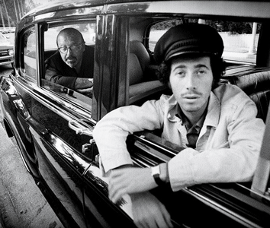
Sabbateans- Turkish Ahmet Ertegun, Jewish King (David Geffen) in the Driver’s Seat
Laurel Canyon, Los Angeles, David Geffen‘s Asylum Records was co-owned by Ahmet Ertegun and Atlantic Records.[33]
Back to 2017, “WHERE IS MICHELLE OBAMA”? Wherever the former first lady of the United States maybe, she is being held outside U.S. jurisdiction. She may be locked up on a French territorial island in the middle of the Pacific Ocean, called Tetiaroa. The place where she may held up is “The [Marlon]Brando“.

It seems so odd. It’s like a strange twist of faith that no matter how much time goes by, certain things remain the same. I remember in April 1968, Brother Bobby came in Panthers’ Oakland headquarters with a big devious and mannish grin on his face. He asked me, “do you know who this is?”
I looked. There was this white guy standing behind Bobby. He had an odd cool and comfortable demeanor to be the only white guy among a room full of brothers known to pack guns that according to the FBI were America’s greatest threat to domestic security. He was cool with it. I was cool with it. I went back to whatever I had been doing. But, Bobby kept teasing me with that big mannish grin on his face, “man, do you know who this is? I finally answered him, “it’s another Berkeley ‘hippie‘.“ Bobby said, “no man, this is Marlon Brando.” Nobody knew it, but I loved, BRANDO.
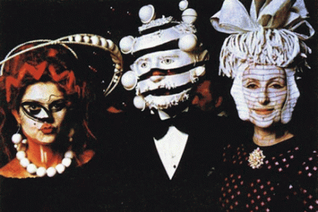
The anti-establishment Brando that we knew would turn over in his grave to know that King David, Rothschilds, ILLUMINATI and the elite global satanic cabals have invaded and taken over his peaceful island retreat.

2/14/2017- WHERE IS MICHELLE OBAMA?
February 14, 2017, former First Couple Barack and Michelle Obama expressed their love for each other in romantic tweets sent for Valentine’s Day. The former first lady captured a moment of their alleged “FEET” of all things from their recent alleged vacation in French Colony Tahiti and tweeted, “Happy Valentine’s Day to the love of my life and favorite island mate.” THAT DOG WON’T HUNT. WHERE’S MICHELLE OBAMA?
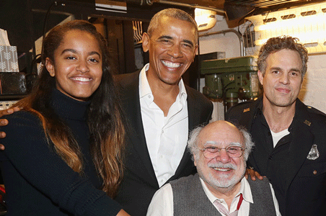
On February 25, 2017, Barack Obama after being treated like a rock star while grabbing coffee on Friday afternoon, Barack and Malia bonded some more in the evening, attending the revival of Arthur Miller’s The Price of Broadway, starring Danny DeVito and Mark Ruffalo. Michelle Obama was nowhere in sight.
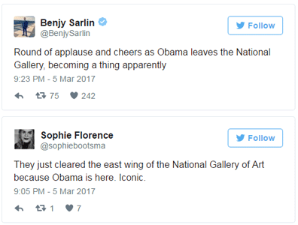
WHERE IS MICHELLE OBAMA AT THE NATIONAL ART GALLERY?
March 5, 2017, former President Barack Obama and Michelle surprised museum-goers Sunday when they showed up at the National Gallery of Art in Washington. But, there are some really odd things going on with the picture visual evidence of the couple at the art gallery.
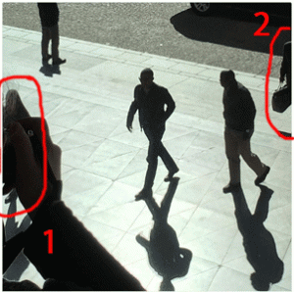What appears to be a No. 1 woman in the picture of Barack and Michelle at the Washington DC art gallery is deliberately scratched out and defaced, and she appears to wearing men’s shoes.

The No. 2 woman is not Michelle Obama because she does not have Michelle’s Alexander Wang Bag that has 1 (one) only one strap.

Lady 2 in the picture above purse bag has 4 (four) straps.

You tell me. Why is it that the real Michelle and Barack Obama (wife and husband ) are rarely pictured in the same immediate space since the end of January 2017?
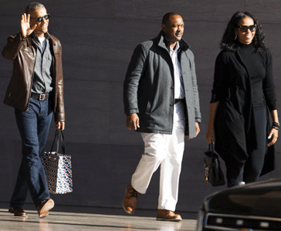
Barack, Secret Service and Michelle (Allegedly) Leave the Art Gallery on March 5, 2017
Additionally, former President Barack Obama has suddenly become handicapped with a deformed hand and wrist.
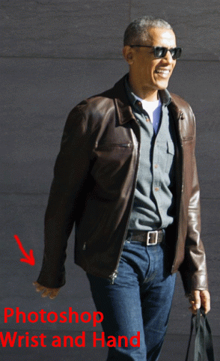
Michelle Obama & the Photoshop Bag Lady

Michelle Obama & Target Store Bag Lady
March 19, 2017, Wednesday, this is alleged to be Michelle Obama 5 (five) days ago shopping at Target. There’s one problem. The lady in back of her has a BAG COMING OUT OF HER ASS! Do a close-up of Michelle and you can see the white shadow line where she had been photoshop into the picture. Where are U.S. Secret Service Agents? THAT DOG WON’T HUNT, EITHER.
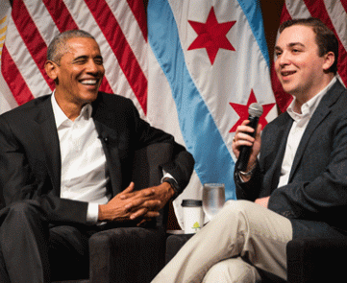
April 24, 2017, Barack Obama, the New World Order Rock Star, spoke publicly for the first time since leading the White House. He spoke to elitist young community leaders and organizers at the University of Chicago, where his presidential library is planned. On April 24, Barack Obama was no more than a causal friend PTA official then the former president, leader of the world and democratic party of the U.S. Donald J. Drumpf, the state of affairs of America and the world never came out of his mouth. That’s the way the New World Order and global Satanic Cabals had mind controlled and programmed him. Barack Obama is a cyborg Black Manchurian Candidate that comes with software and a keyboard.
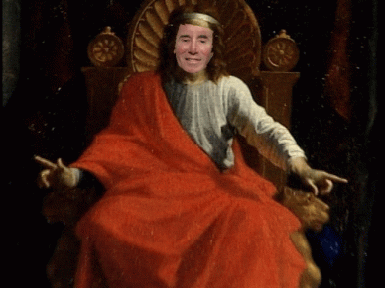
King David
Did Michelle Obama surface at the University of Chicago with Barack? NO. As I said before, it is extremely worrisome that Michelle Obama has literally dropped out of sight and a black female impostor has appeared in her place within King David’s extremely vicious and dangerous racist global Satanic Dark Circle.
Soon after Huey and Bobby Seale formed the Black Panther Party for Self Defense in October 1966. A black undercover government agent tried to persuade me not to follow Brother Huey, in particular. He referenced Huey’s personality profile and assessment that undoubtedly had been prepared by Frankfurt School and Tavistock contractors of CIA MK ULTRA. I was so young and ignorant that I had very little idea of what he was actually taking about until decades later. The bottom line was that Brother Huey couldn’t be moved and they intended to remove him and let the Panthers fall apart under Bobby.
My young impression was that I lived in a democracy so I been taught and we were free to organize for self protection as long as we followed, and were within the letter and limits of the law. I politely thanked him for his advice and information, but I was with Brothers Huey and Bobby. During that time even if I had been informed of a shadow government, the CIA, Satanic and government conspiracies, I didn’t have the mental understanding or capacity to believe it, because I so much truly believed in and loved a free America. Part of the process of moving beyond the Manchild is the process of DE-COLONIZATION. Had I been decolonized at the time I that I spoke to that agent, it would have been up against the wall, M-F, even though I avoided cursing. He would have been arrested on the spot in the name of the VANGUARD.
So, what would have been Huey’s Way to address the DEVIL’s plot to destroy the core values of the family, religion of the forebears, mothers and fathers, elders; the ritual sexual abuse of the children; plot to destroy our spirituals, music and plot against the principals of democracy, he would have gone straight to source even if it was the White House- UP AGAINST THE WALL.

[1] https://www.commondreams.org/news/2017/04/20/whats-worse-trump-dropping-mother-all-bombs-or-70-americans-approve
[2] https://www.commondreams.org/news/2017/04/20/whats-worse-trump-dropping-mother-all-bombs-or-70-americans-approve
[3] https://en.wikipedia.org/wiki/Easter
[4] https://www.theguardian.com/commentisfree/2008/apr/04/preventingtheriseofamessi
[5] https://www.washingtonpost.com/news/post-nation/wp/2017/04/19/the-facebook-killer-is-dead-but-the-hate-against-his-ex-girlfriend-lives-on/?utm_term=.39c75722c415
[6] https://1truechrist.wordpress.com/2009/03/03/greek-fraternities-freemasons-the-boule-and-skull-and-bones-secret-societies-part-2/
[7] https://en.wikipedia.org/wiki/Hermanubis
[8] https://en.wikipedia.org/wiki/Ouroboros
[9] http://www.metrolyrics.com/atomic-dog-lyrics-george-clinton.html
[10] http://www.whale.to/c/exposing_the_works_of_satan.html
[11] http://technoccult.net/dossiers/groups/the-process-church-of-the-final-judgement/
[12] http://dangerousminds.net/comments/funkadelic_and_the_process_church
[13] http://genesisporridgearchive.blogspot.com/2011/06/notes-from-gen-on-george-clintonmaggot.html?zx=27651bbf5e5be322
[14] Id.
[15] http://dangerousminds.net/comments/funkadelic_and_the_process_church
[16] http://visupview.blogspot.com/2013/05/the-process-strange-and-terrible_31.html
[17] http://www.thedogpress.com/Columns/BestFriends1_Jade-0610.asp
[18] http://visupview.blogspot.com/2013/05/the-process-strange-and-terrible_31.html
[19] http://nordan.daynal.org/wiki/index.php?title=Timothy_Wyllie
[20] https://en.wikipedia.org/wiki/Ultra
[21] https://en.wikipedia.org/wiki/Theodor_W._Adorno
[22] Id.
[23] http://poweredbychrist.homestead.com/something_wicked_4.html
[24] https://tabublog.com/2015/12/26/the-manufactured-invention-of-the-beatles-stones-grateful-dead-and-the-birth-of-rock-n-roll-by-the-tavistock-institute-a-jesuit-corporation/
[25] http://www.theoccidentalobserver.net/2009/09/the-mysterious-german-professor/
[26] http://www.slate.com/articles/news_and_politics/interrogation/2005/02/interrogating_ahmet_ertegun.html
[27] http://www.apfn.org/apfn/WTC_update.htm
[28] https://en.wikipedia.org/wiki/Office_of_Scientific_Research_and_Development
[29] https://en.wikipedia.org/wiki/Tom_Dowd
[30] https://www.henrymakow.com/2016/04/why-tyranny-is-inevitable.html
[31] Id.
[32] http://www.theoccidentalobserver.net/2009/09/the-mysterious-german-professor/
[33] http://www.newyorker.com/magazine/1978/05/29/eclectic-reminiscent-amused-fickle-perverse-i
Comments : Leave a Comment »
Tags: 9-11 inside job, acid rap, Adolf Hitler, Afghanistan, Ahmet Ertegun, anibus, Arnold Schoenberg, Asur, atlantic records, atomic bomb, atomic dog, “Mother of All Bombs, barack obama, beatles, Beyonce, Bianca Jagger, Black Manchurian Candidate, black messiah, Black Panther Party for Self Defense, chance the rapper, Charles Manson, CIA MK ULTRA/MONARCH, Cult of Mithras, cybele, david geffen, death in the air, Diana Wyllie, Dionysus, donald j. drumpf, donald j. trump, Dr. Martin Luther King, easter sunday, Esalen Institute, father jesse, father micah, flatlinerz, frank carlucci, Frankfurt Institute of Social Research, frankfurt school, Funkadelic, Genesis P. Orridge, george clinton, goat god, goat man, god pan, god set, Heinrich Himmler, helter skelter, Henry Kissinger, hermanubus, hermes, Hiroshima, HORROCORE, horrorcore, Huey P. Newton, icc, International Criminal Court, isis, j. edgar hoover, japn, John McCartney, josef goebbels, Jr., Kabbalistic Jews, king david, LaBianca, lady jaye, little bobby hutton, LSD, Manchurian Candidate, marlon brandon, mary ann degrimston, messiah, michael jackson, michelle obama, Mithraism, moab, Nagasaki, nephthys, New World Order, Nick jagger, Omega Psi Phi Zeta Omega, Osiris, Ouroboros, pansexual, pedophila, Prevent the Rise of the Black Messiah, Quincentennial Foundation, RAND Center for Middle East Public Policy Advisory Board, Robert DeGrimston, rock music, Sabbatai Zevi, Sabbatean, Sabbatean-Frankist, satan, Satan-Baal-Lucifer, Satanism, Sharon Tate, SIXX JOHNSON / GEORGE CLINTON / SNOOP DOGG, SRI, Stanford Research Institute, Steve "Stevie" Stephens, Stewart Graham Menzies, tavistock institute, The Carlyle Group, THE PROCESS CHURCH OF THE FINAL JUDGMENT, Thee Temple ov Psychick Youth, THEO ADORNO, Timothy Wyllie, tom dowd, Turkey, under satan's authority, where is michelle obama?, witch's cauldron, wonder weapons
Categories : 1000 Year Reich, african american satanic cult, African Liberation, Aryan Supremacy, black children, black christianity, Black Manchurian Candidates, Black messiah, Black Panther Party for Self Defense, christianity, CIA, clive davis, COINTELPRO, Crimes Against Democracy, devil, divine one, donald j. drumpf, donald j. trump, egypt, evil, False Satanic Rites of Lost Negroes, freemason, freemasons, Gangsta Rap, gansta rap, genesis, Heinrich Himmler, helter skelter, Hip Hop, hollywood satanic cult, illuminati, Isis, israel, Laurel Canyon, luciferians, manchurian candidates, Michelle Obama, mind control, MK-ULTRA, monarch child, monarch program, nasa, National Security Council, National Socialism, new age religion, nwo, Operation PAPERCLIP, Osama Bin Laden, Osiris, Paul Josef Goebbels, psychological warfare campaign against Christianity, Reichsfurhrer SS-1 Heinrich Himmler, Ritual Satanic Abuse, ritual satanic sexual abuse, ritually abused children, Robert DeGrimston, satan, Satanic Global High Cabal, Satanism, Scientology, Snoop Dog, Snoop Dogg, SS, Stanford University, Throbbing Gristle, trauma-based mind control, underground reich, underground third reich, Untermensch, Zbigniew Brzezinski, ZIONIST

Go to..
http://www.energyenhancement.org

For 34 Free..
- On Sign-Up - Energy Enhancement Books and Energy Enhancement Against Satanism Books.

To defeat Evil, you need to up your game.

Learn the Energy Enhancement Meditation Course by Video or Live in Iguazu.

ENERGY ENHANCEMENT MEDITATION
ENERGY ENHANCEMENT MEDITATION LEVEL 1 POWER UP!! GAIN SUPER ENERGY http://www.energyenhancement.org/Level1.htm
ENERGY ENHANCEMENT MEDITATION LEVEL 2 ELIMINATE ENERGY BLOCKAGES http://www.energyenhancement.org/Level2.htm
ENERGY ENHANCEMENT MEDITATION LEVEL 3 CLEAN KARMA BLOCKAGES AND PAST LIFE KARMA BY TRANSMUTATION http://www.energyenhancement.org/Level3.htm
ENERGY ENHANCEMENT MEDITATION LEVEL 4 MASTER ENERGY CONNECTIONS AND RELATIONSHIPS http://www.energyenhancement.org/Level4.htm







