
DEDICATION
With all Thanks, Love and Gratitude to Swami Devi Dhyani and all the helpers who make these books and DVDs possible.
With all Thanks, Love and Gratitude to my Mother and Father and to all my other Teachers, Theos Bernard, Sri Yogendra, Eric Berne, Gurdjieff, Father Bede Griffiths, Osho, Zen Master Hogen, Swami Sivananda, Swami Satchitananda, and all the other giants upon whose shoulders I stand - who made me able to be what… I AM – Swami Satchidanand

Copyright © 2020

[Energy Enhancement Synthesis of Light Limited (SOL)]

All rights reserved. This publication may be reproduced in whole or in part, by any person under fair use as long as we are referenced, without written permission of:
Swami Satchidanand

sol@energyenhancement.org
www.energyenhancement.org
AGAINST SATANISM
MIND CONTROL
BLACK ASSASSINS
VOLUME 5
BY PRINCERAY BULLOCK
EDITED
SATCHIDANAND
www.energyenhancement.org

Table of Contents
THE LYNCHING OF FREDDIE GRAY, DON’T RIDE THE WHITE HORSE 26
HUEY P. NEWTON, A REAL PEOPLE’S HERO, CIA MK ULTRA, THRID REICH, NASA & BOBBY SEALE- A WHORE OF LUCIFER 76
PART II, RIDING THE GOAT- BOBBIE KRISTINA, NICK GORDON, BEYONCE, JAY Z & THE BLACK MUSIC INDUSTRY 131
PART I, BOBBI KRISTINA, ANGELA BASSETT, MADAME LAVEAU MEROVINGIANS & THE BLOOD SACRIFICE NINTH SATANIC CIRCLE 198
LET’S DRIVE BOBBI KRISTINA INSANE- WITCHES & WHITNEY, the ILLUMINATI BIO 233
THE GREAT, GREAT HUEY P. NEWTON, SELMA, THE ILLUMINATI MOVIE, GUN OF THE BLACK SUN & MK ULTRA 272
BILL COSBY PART IV, SELMA, the ILLUMINATI MOVIE, RISE OF THE BLACK LESBIANIC SATANIC CABAL, DICK GREGORY & HUEY P. NEWTON 315


Go to http://www.energyenhancement.org for 34 Free –On Sign-Up - Energy Enhancement Books and Energy Enhancement Against Satanism Books.
To defeat Evil, you need to up your game. Learn the Energy Enhancement Meditation Course by Video or Live in Iguazu.


Change the World...


Go to http://www.energyenhancement.org for 34 Free Energy Enhancement Books.
To defeat Evil, you need to up your game. Learn the Energy Enhancement Meditation Course by Video or Live in Iguazu.
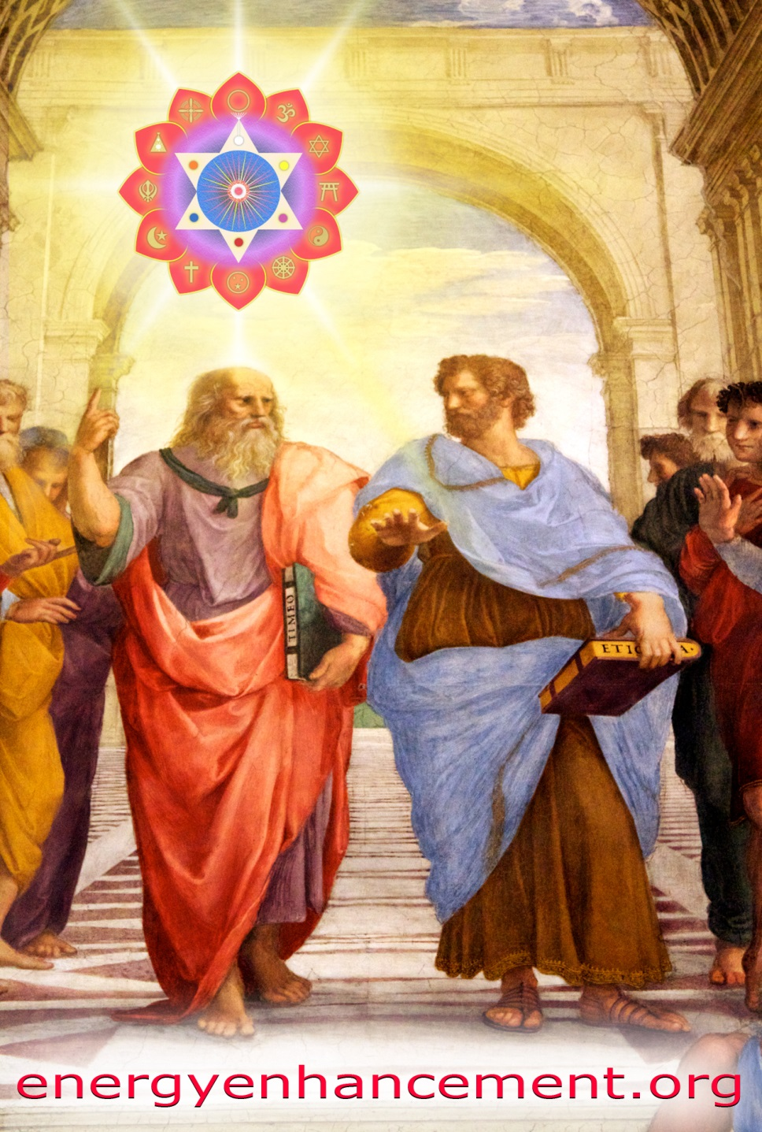

PLATO AND SATANIC BABYLONIAN SECRET AGENT ARISTOTLE "THE POISONER" OF ALEXANDER THE GREAT - BY RAPHAEL

ENERGY ENHANCEMENT MEDITATION
ENERGY ENHANCEMENT MEDITATION LEVEL 1 POWER UP!! GAIN SUPER ENERGY http://www.energyenhancement.org/Level1.htm
ENERGY ENHANCEMENT MEDITATION LEVEL 2 ELIMINATE ENERGY BLOCKAGES http://www.energyenhancement.org/Level2.htm
ENERGY ENHANCEMENT MEDITATION LEVEL 3 CLEAN KARMA BLOCKAGES AND PAST LIFE KARMA BY TRANSMUTATION http://www.energyenhancement.org/Level3.htm
ENERGY ENHANCEMENT MEDITATION LEVEL 4 MASTER ENERGY CONNECTIONS AND RELATIONSHIPS http://www.energyenhancement.org/Level4.htm

MIND CONTROL BLACK ASSASSINS VOLS 1-11 FREE!!

AGAINST SATANISM VOLS 1 – 6 FREE!!

- ON SIGN-UP AT..

energyenhancement.org



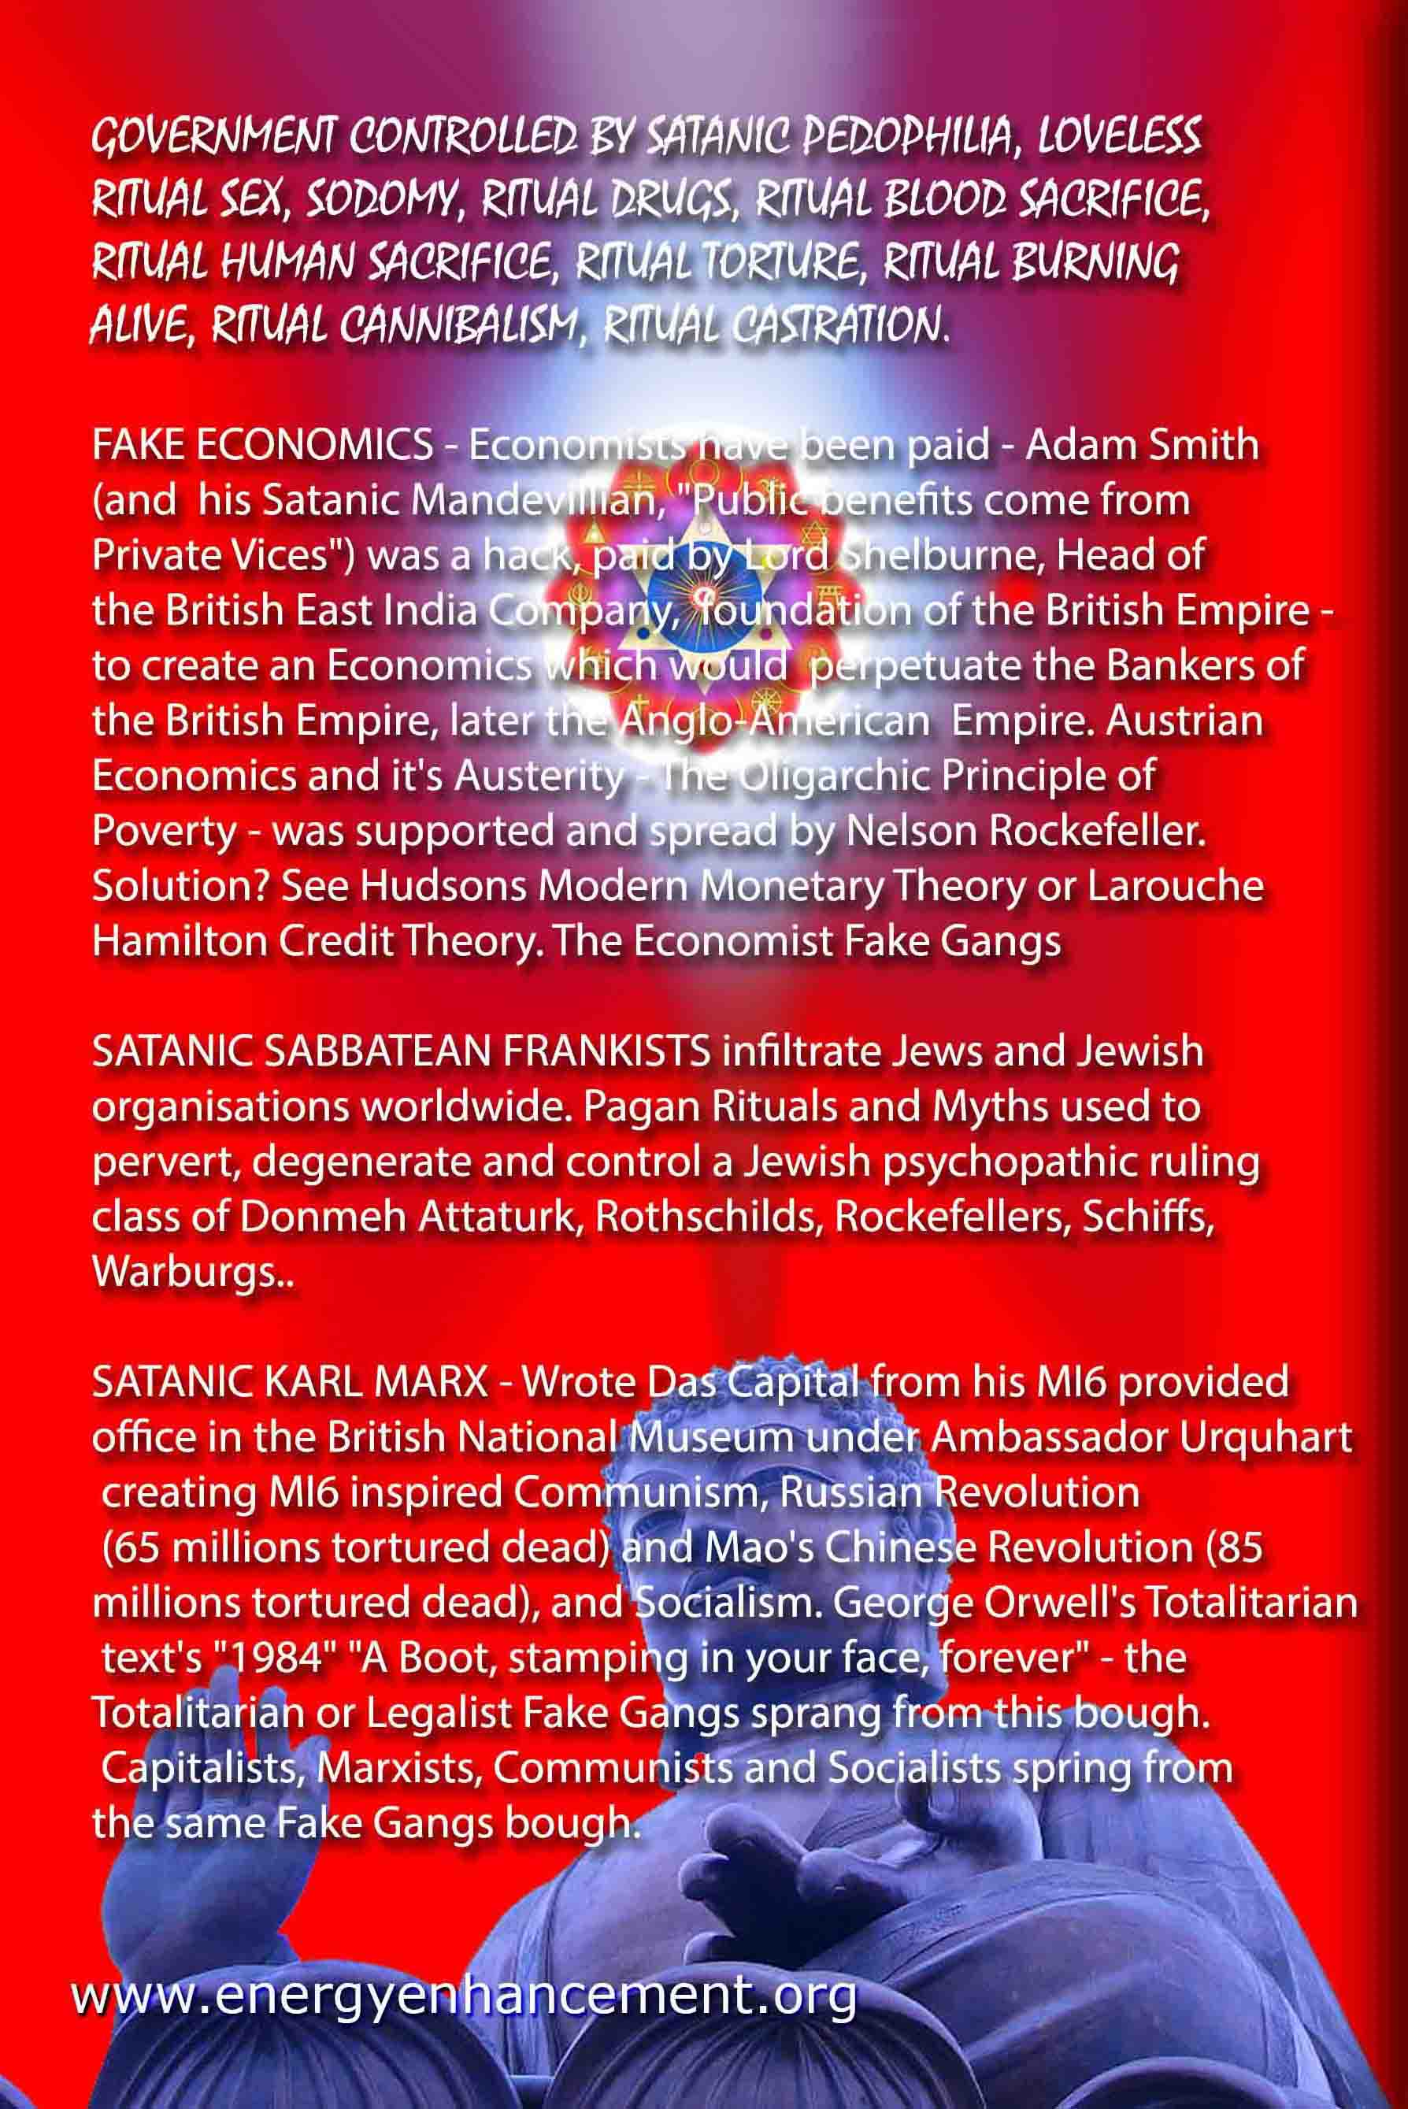

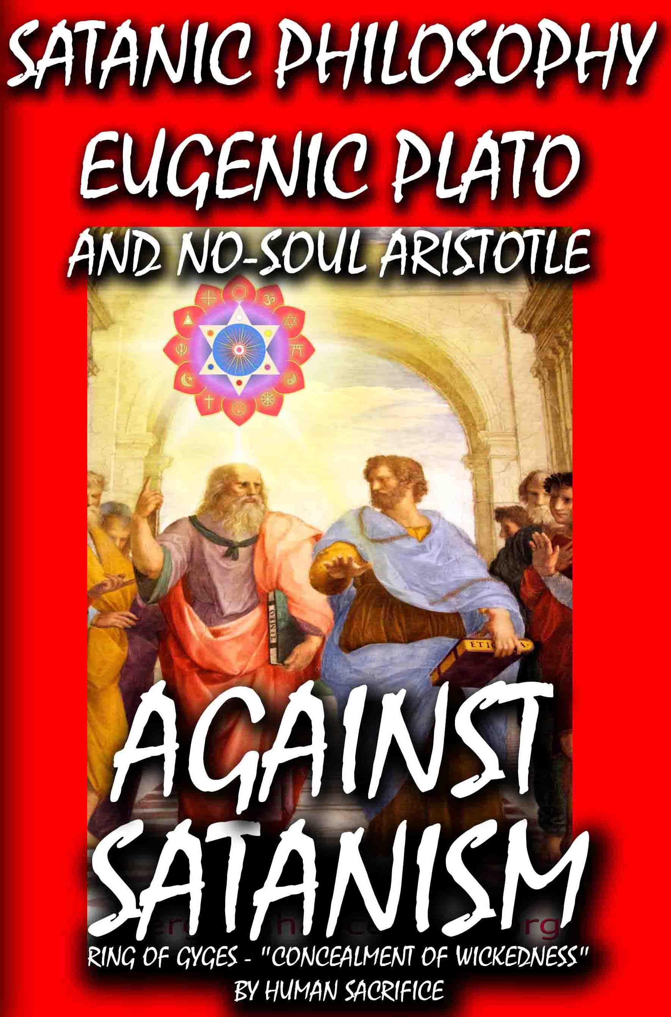

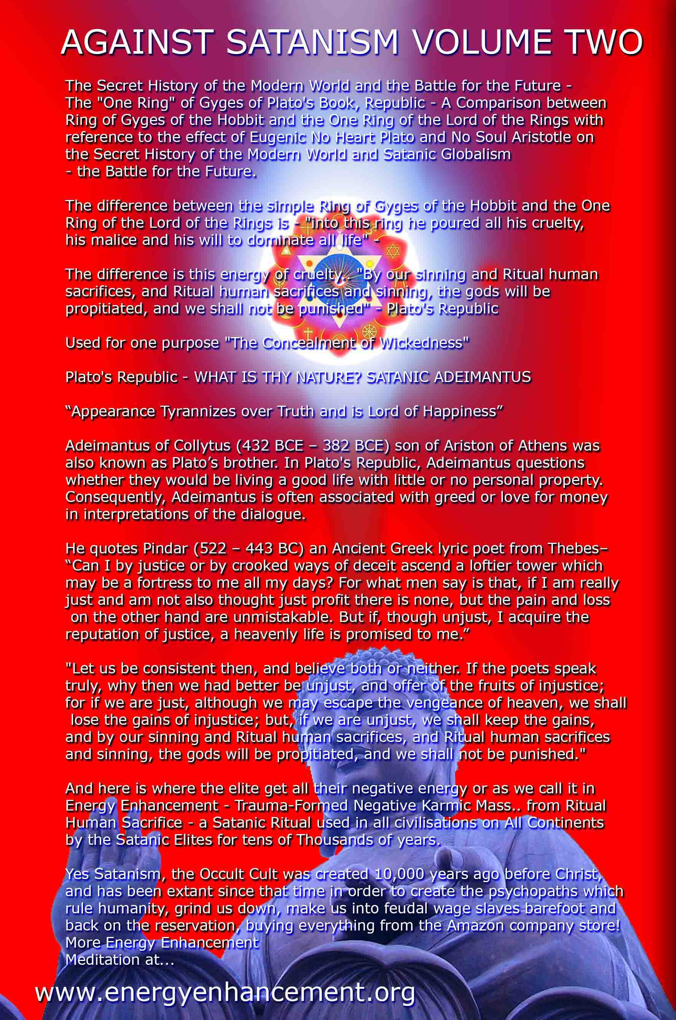

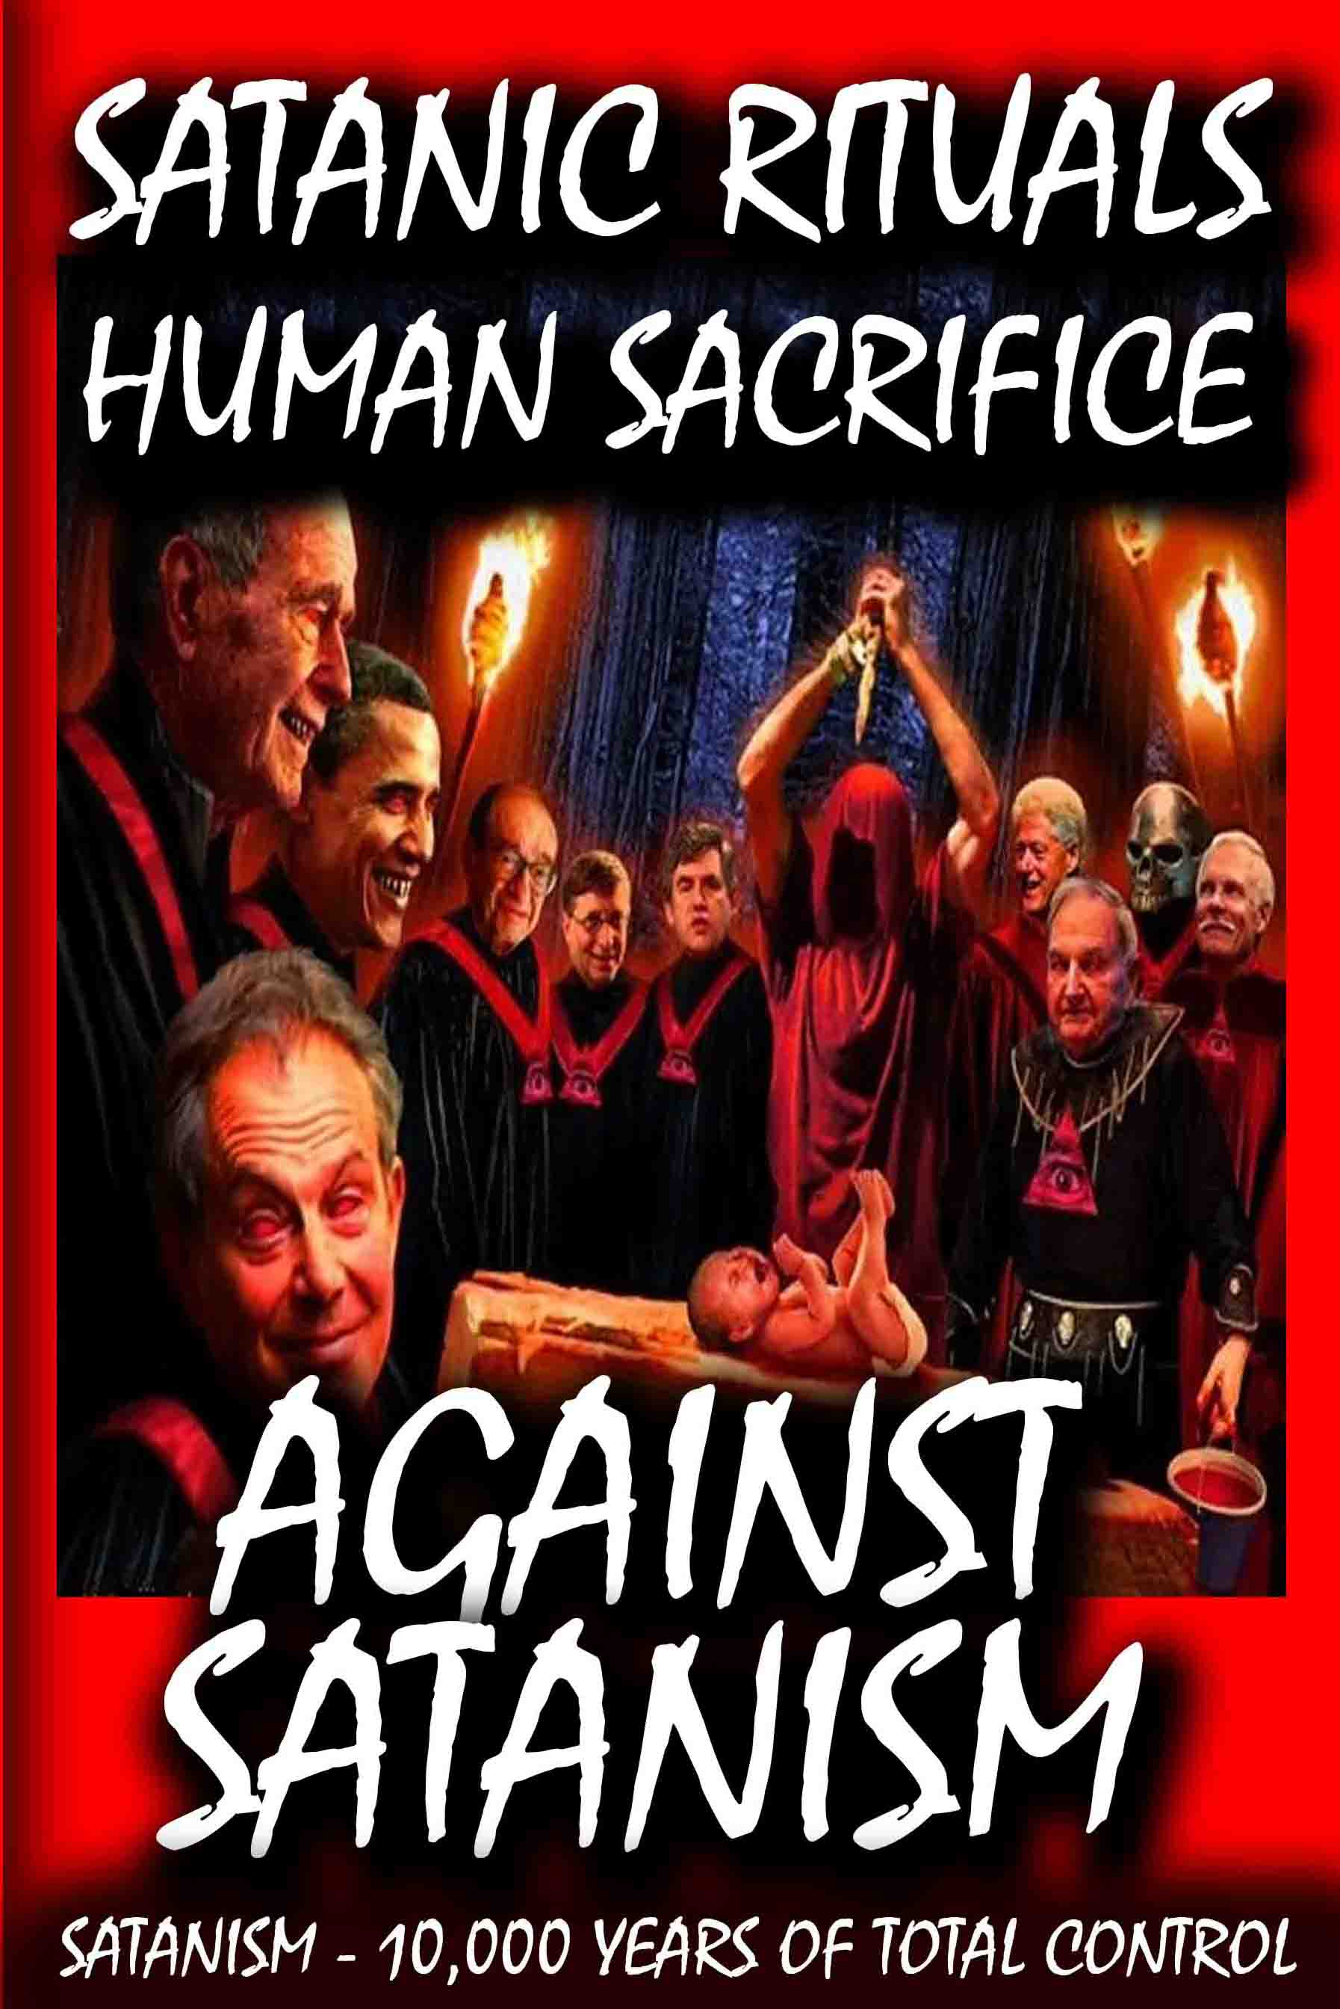

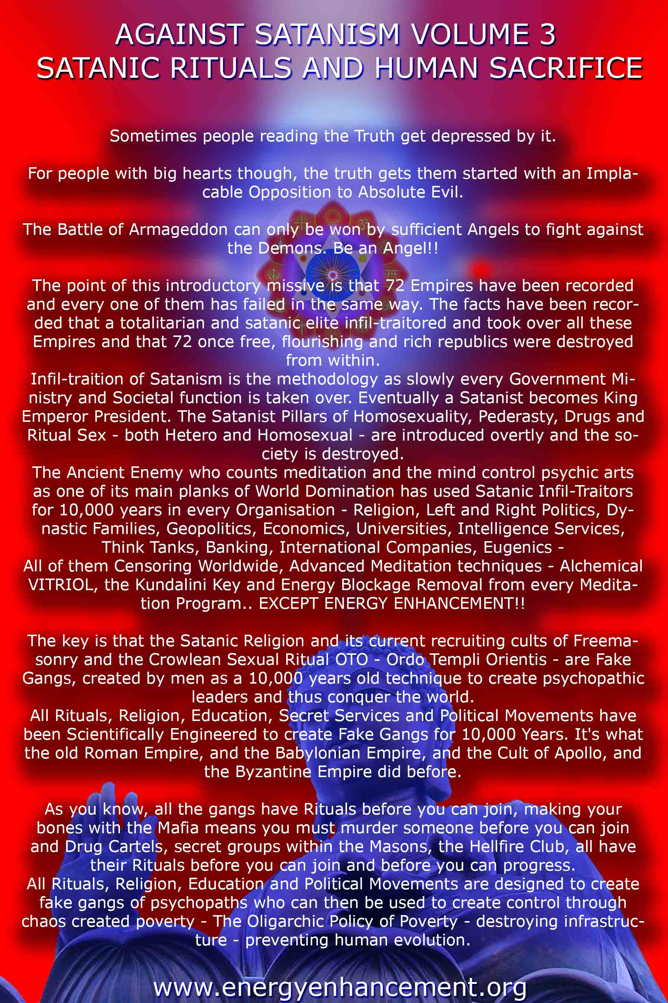

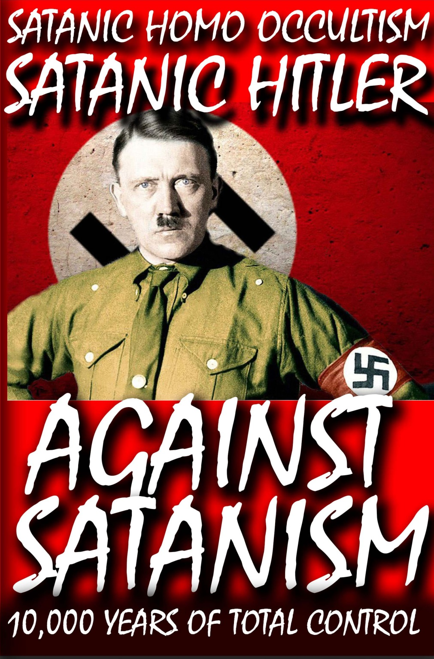

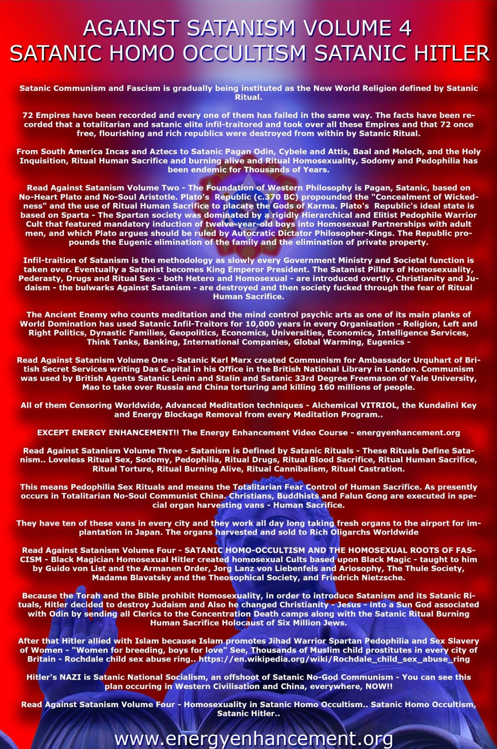



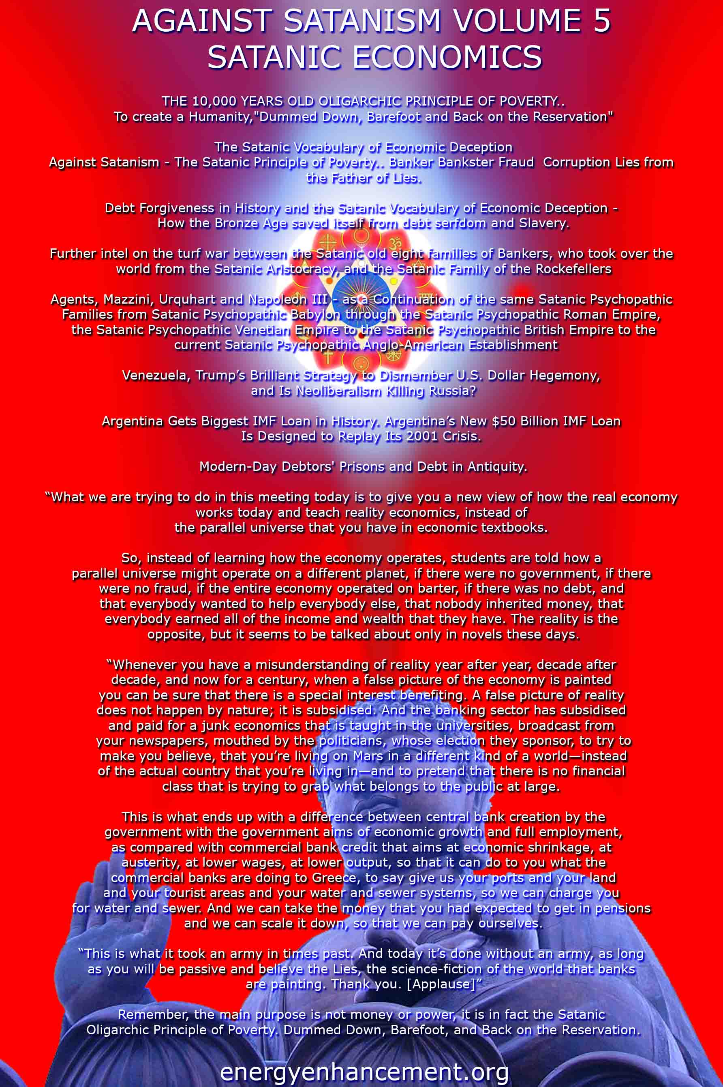


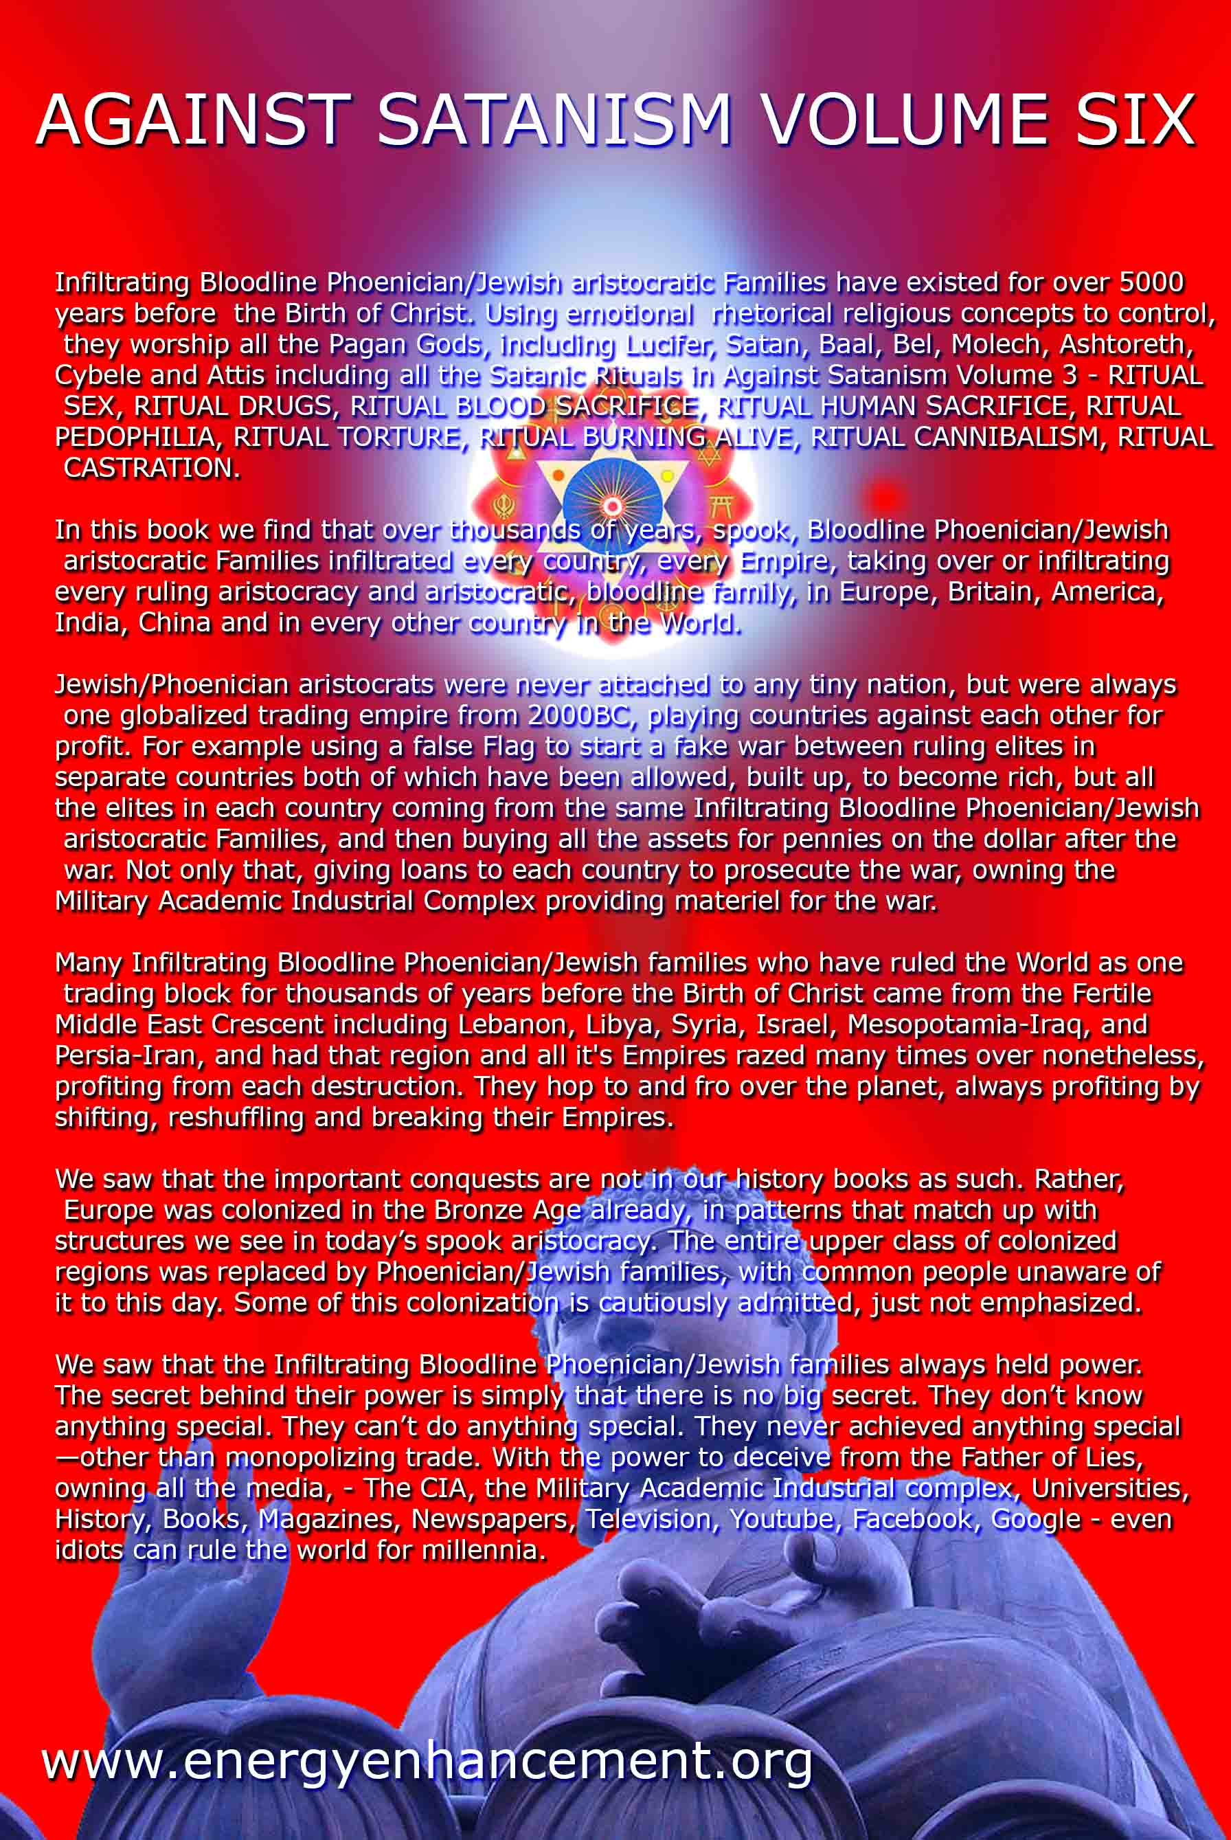
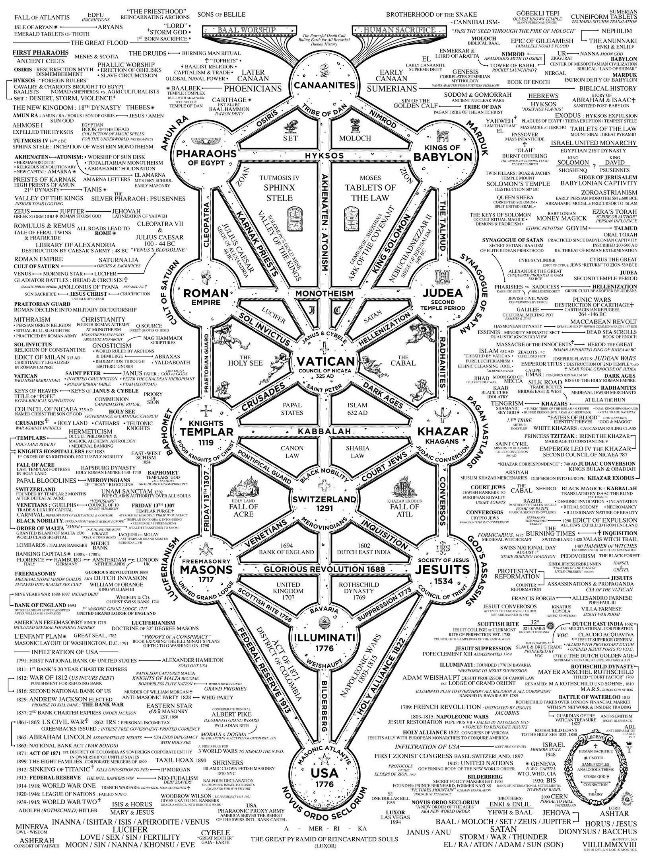

THE LYNCHING OF FREDDIE GRAY, DON’T RIDE THE WHITE HORSE
9052015

BITCHES- Don’t Ride the White Horse
Bitches- Ride the White Pony- Cocaine (Crack)

“If you want to ride, don’t ride the WHITE HORSE … If you wanna be rich/you got to be a bitch … If you’re wanna ride/ride the WHITE PONY … ”
Don’t get it twisted. I find nothing amusing about this video. It is sad, appalling and offensive, but a teachable moment and testament of what the masses face around the country and the world. The men, above, doing the “Camel Walk” represent blood oath secret Shriners of the Prince Hall Master Masons of the 33rd Degree. They represent those that have reached the very top level of their respective fraternal/brotherhood Masonic orders through out the nation that Ride the GOAT.
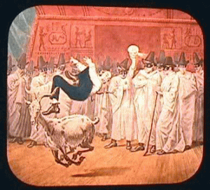

The music that they dance to is “Ride the White Horse,” a 1983 product of Laid Back, a white Danish electronic music duo group from Copenhagen, Denmark formed in 1979. The WHITE HORSE is a direct reference to heroin, the WHITE PONY is a reference COCAINE [crack].[1]
It is odd that they would go to the other side of midnight to unofficially adopt this music out of Demark for one of their Shriner Masonic ritual ceremonies. It was given to them as a piece of self defining Satanic Principle DUALISM to demonstrate just how low they will go for the New World Order- BITCHES. Whereas, I believe that It is safe to conclude that symbolically, these men are celebrating that they had been chosen to rise from one level of secrecy, Riding the GOAT to another higher level of secrecy to carry on a clandestine war against TRUTH, RICHTEOUSNESS, JUSTICE and the WHITE HORSE RIDER.
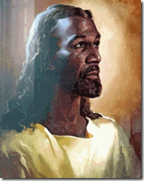
“And I saw heaven opened, and behold a white horse; and he that sat upon him was called Faithful and True, and in Righteousness he doth judge and make war.” Revelation 19:11
In the Book of Revelation, JESUS CHRIST himself Rides the WHITE [Black] HORSE right out of heaven, followed by an army of other horsemen to bring judgment to the world. According to Muslims, the end of days will be marked by the return of both Jesus and Madhi (“the guided one”) atop a WHITE HORSE to cleanse the world of EVIL.[2] The real clandestine message behind the song and the Prince Hall Master Mason/Shriners’ Ritual Ceremony is if you wanna be rich and powerful– you got to be a secret blood oath covenant BITCH of LUCIFER and “… don’t ride the white horse.”
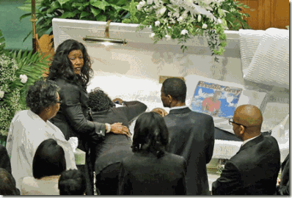
That’s were we are in Baltimore with the Freddie Gray Slaying. Most of the black prominent players in the case like Baltimore Police Chief Anthony Batts, Mayor Stephanie Rawlings-Blake and State Attorney Marilyn James-Mobsy are no more than grand ILLUSIONS of Black Power and Authority. They are also Lucifer’s BITCHES that “… don’t [and will not] ride the white [Black] horse” for Truth, Righteousness, Balance and JUSTICE.
At this point in the game, whether or not Freddie Gray is part of freemasonry or the ILLUMINATI is irrelevant and immaterial. Whether or not the Freddie Gray Slaying is part of a planned freemasonry or ILLUMINATI plot to divide the races and issue in national martial law policies is also irrelevant and immaterial. The bottom line is that this form of governmental, one seen- one unseen (shadow), is reactionary and racially based on age old Satanic pseudo scientific theories of Anglo Supremacy out of 16th Century Europe. Freddie Gray was brutally slain by the State of Maryland that since its formation has been secretly embedded in Satanism, Occult and by any other name, Human Bondage. From the beginning, it is a STATE that clandestinely attach no real value, purpose or beauty to Freddie Gray’s human rights or life because of the color of skin.
BALTIMORE DON’T RIDE THE WHITE HORSE
Riding the GOAT
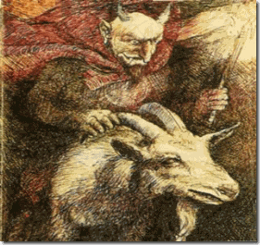
Catholic and the Secret Occult influence in America (other than the early Spanish conquerors) began with the establishment of the STATE of Maryland in 1634. A few years earlier, in 1625, the British Secretary of State under King Charles Stuart (1600-1649), converted to Catholicism. His name was Sir George Calvert.[3]
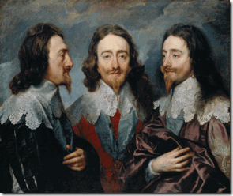
King Charles Stuart- Note His Finger/Hand Symbols
King Charles soon needed money, so he carved territory out of northern Virginia. Virginia is named after the African Holocaust Witch, the so-called lying- VIRGIN QUEEN, Queen Elizabeth I. King Charles’ grant of part of northern Virginia was given to Calvert. His title was Lord Baltimore. The City of Baltimore is named for Calvert (Lord of Baltimore). He died soon afterward, so the charter was given to his son, Cecilius Calvert.[4] The first two ships set sail on Nov. 22, 1633 to establish the first settlement reserved as a refuge for wealthy and wealth seeking Anglo Catholics in Maryland, supposedly named after Queen Mary, but actually in honor of MARY MAGDALENE. In the vision of Sir Francis Bacon, they planned to turn Maryland into Catholic African human bondage plantations. Cecilius’ brother, Leonard Calvert, was Maryland’s first governor.[5]
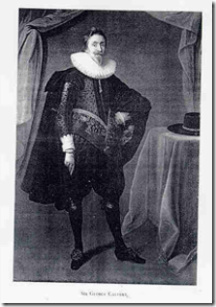
Sir George Calvert- Left Hand Descending Two Finger Benediction
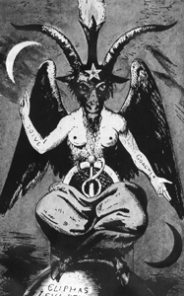
BAPHOMET- Two Finger Benediction- “So Above-So Below”
Calvert’s ships, the Ark and the Dove, were spiritually directed by Andrew White, a JESUIT priest. White became known as “the Apostle to Maryland.” Many years later, the President’s residence was called the “White” House, secretly in his honor.[6] The highest point in Washington D.C. was called Jenkins Point. In the 1790s, it was owned by Daniel Carroll – brother of Catholic Bishop John Carroll. David Ovason tells us, “that in earlier times the hill had been called Rome” (The Secret Architecture of Our National Capital, p. 8).[7]
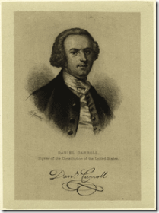
A signer of the Declaration of Independence, Daniel Carroll (July 22, 1730 – July 5, 1796) was a wealthy Roman Catholic plantation owner educated by Jesuits in Maryland and FRANCE. His brother John was a Jesuit priest.[8]
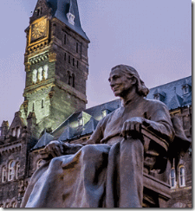
John Carroll (January 8, 1735 – December 3, 1815) became the first Catholic Bishop in America, presiding over the See of Baltimore, which included Washington, D.C. John also founded Georgetown University, above, which has long been regarded as the incubator of federal policy, domestic and international. Strikingly secular in curriculum and student body, Georgetown is still owned and operated by Jesuit priests. Its seal proclaims the union of the Roman Church with the secular State, depicting the Roman Eagle with the global world in one talon and a cross in the other, surmounted by the motto Utraque unum, “Both together.”[9]

Georgetown University Seal & the Roman/Vatican Eagle- Discussed Further Below with Mayor Stephanie Rawlings-Blake
David Carroll was one of three commissioners appointed to survey the newly designated District of Columbia and acquire land for the new federal capital in the District. Carroll was related to two major land owners whose land was taken by the government, his brother-in-law Notley Young and nephew Daniel Carroll of Duddington. The new United States Capitol was to be built on the wooded hill owned by his nephew.[10] David Carroll received all his Masonic degrees in Maryland Lodge No. 16, Baltimore, between May 1780 and May 1781.[11] The layout for Washington D.C. was entrusted to a FRENCH Masonic engineer Major Pierre Charles L’Enfant (Holland Lodge No. 8 in New York City). He got the job at the suggestion of the See of Baltimore, Bishop John Carroll.[12]
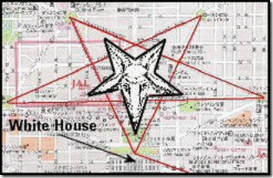
” … L’Enfant laid out the main city streets in the shape of an upside down five-pointed star of BAPHOMET, the symbol of the GOAT. The White House was constructed at the GOAT’s mouth. The two ears on the sides were marked by Mt. Vernon Place and Washington Circle. The horns were marked by Logan Circle and Dupont Circle.”[13]
Worship of the MAGDALENE
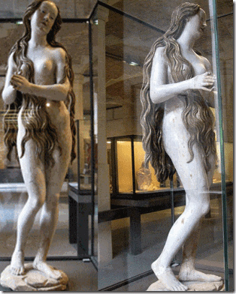
Early German Saint Mary Magdalene Hologram
Saint Mary Magdalene as a mystic ascetic. According to legend, the repentant sinner lived a secluded life in the cave of Sainte-Baume, Southern France, clothed only by her hair. Every day she was raised up in the sky by angels to hear the heavenly chorus. The saint was originally held up by carved angels. Encased in an oval metal structure, the wooden statue was suspended from the vault of a church, perhaps the church of Saint Mary Magdalene in the Dominican Convent of Augsburg, Germany which was rebuilt in 1513-15. At this date, it is proof that a specific underground CULT of MARY MAGDALENE was certain to have survived in Germany during the 16th Century. The Mary Magdalene wood carving is generally attributed to the German Sculptor, Gregor Erhart.
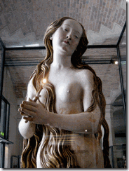
Saint Mary Magdalene Displaying an Early Form of the Secret Masonic/ILLUMINATI Pyramid (Triangle) Hand Symbol
A FRENCH legend recorded in the 4th Century CE says that MARY MAGDALENE (along with Lazarus and Martha) fled to the South of FRANCE (via Kemet) bearing “the earthen vessel that held the blood of Christ.” While legends of the Holy Grail took on a life of their own centuries later, merging with other legends, many believe that MARY MAGDALENE was herself the earthen vessel bearing Christ’s child, the sacred bloodline of David. In the South of FRANCE, the CULT OF THE MAGDALENE flourished until it was all but wiped out in the Albigensian campaigns by the Roman Catholic church in the late 13th Century.[14] There is strong evidence that MARY MAGDALENE was worshiped secretly right along side the Virgin Mary up until the Vatican’s vicious Albigensian (Cathar) liquidation campaigns in FRANCE from 1209 to 1215. Afterwards, her worship was forced even further UNDERGROUND. In 1781 during the time of Daniel and John Carroll, the last temple dedicated to her was destroyed. Numerous landmarks attest to her CULT in the South of FRANCE. Among many other examples, “a Christian MAGICK RING, now in the London museum, bears the legend, “Holy Mary Magdalene pray for me.”[15]
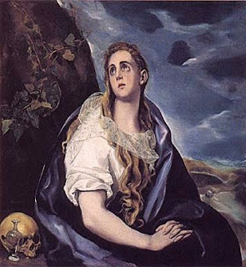
This is Believed to be El Greco’s Earliest Hologram Painting of Mary Magdalene, 1577
Notice Mary Magdalene ’s Hand/Finger Symbolism. El Greco (the Greek), born Doménikos Theotokópoulos (1541 – 7 April 1614), was a painter, sculptor and architect of the Spanish Renaissance.[16] In his last will, he described himself as a “devout Catholic.”[17] He is unique in the sense that he was one of the first painters to depict and include MARY MAGDALENE among Jesus’ religious inner circle of holy family and disciples.
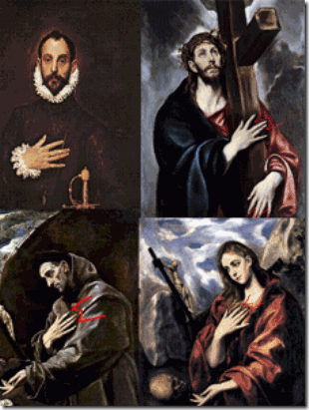
Much has been written about El Greco‘s hologram of the “M” Finger/Hand symbol encoded in many of his subjects in paintings.

It has nothing to do with the Jesuits or a medieval physiological deformity of the hands or fingers. It is a secret society hand gesture reserved for the elite that know like the Masons– it is not for those that don’t know.
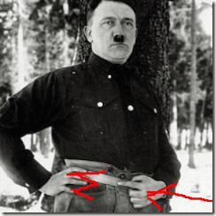
Even Nazi Fuhrer Adolf Hitler knew the holographic significance of the secret symbolism of the M” Finger/Hand Gesture.
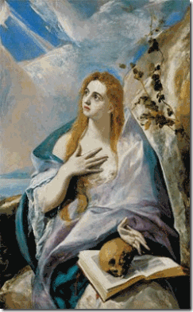
El Greco”s Mary Magdalene in Penitence (1576-78)
What’s in the mystery of Master Mason David Carroll’s holographic hand symbols that may be important in understanding what may have been passed down in secret Symbolism and Knowledge to the shadow elite ruling STAR families and Satanic Cabals of modern Baltimore.
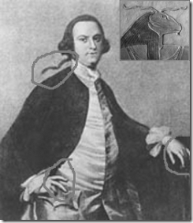
Carroll’s left hand rest on the hip, his two fingers represent the BENEDICTION downward- so above-so below of the BAPHOMET.
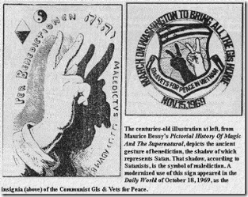
You also have the GOAT horns of God Amun. Carroll’s right hand fingers form the common “DEVIL HORNS“. But, it also may represent the “M” symbol of Masonry or the Secret CULT of MARY MAGDALENE out of Rennes-le-Chateau in FRANCE.[18]
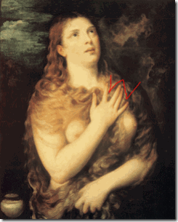
El Grego’s Master, MARY MAGDALENE REPENTANT- Titian 1531
Maryland (Land of MARY MAGDALENE) would have been a natural refuge far away from Vatican City, Rome, Italy to secretly harbor and foster an Underground CULT of wealthy and powerful elite Satanic/Masonic STAR families that trace their “DIVINE” right to have “DOMINION” over the World through the sacred bloodline of the House of David and JESUS CHRIST (see Christopher Knight & Alan Butler’s The Hiram Key Revisited, Freemasonry: A Plan for a New World Order, Watkins Publishing, London (2007)).
THE LYNCHING OF FREDDIE GRAY
The Baltimore Police Department (BPD) severed Freddie Gray’s spinal cord. He was crushed, stepped on, folded and treated no better than a rag doll. The BPD trampled his vocal box (larynx) and broke three of this disks in his neck. He had been savagely broken apart like something out of the annals of an old fashioned depraved American Anglo Lynch Mob. The hospital medical treatment records of his fatal injuries speak for itself.

Even though the BPD was no more than 4 or 5 blocks from the police station, they rode Freddie Gray around in circles in the back of the police van for at least 45 MINUTES like he was no more than a side of beef to deliberately deny him human dignity- right to human compassion and medical treatment from the State. The reports of the GPS device from the police van would also speak for itself.
” … unbelted detainees have been paralyzed and even killed because of rough rides in police vans, which used to be called “paddy wagons.” It has happened often enough to have a name: “nickel rides,” referring to the amusement rides that once cost five cents.”[19]
The central application of the “ROUGH RIDE” theory under the facts and circumstances of the Freddie Gray case is nonsensical and lubricous because a so-called “ROUGH RIDE” will not CRUSH a man’s larynx (voice box) without direct brutal blunt force blow to the front neck area protected by the chin and extraordinary stone bones.
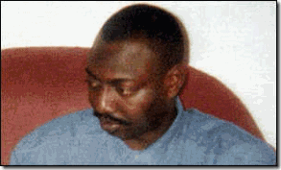
Oluwashijibomi “Shiji” Lapite (died December 16, 1994), a father of two young children, was a 34 year-old Nigerian asylum seeker died in the back of a police van shortly after being detained by two officers in London, England. The cause of death was given to be asphyxia (crushed voice box) from compression of the neck, consistent with the application of a neck hold.[20]
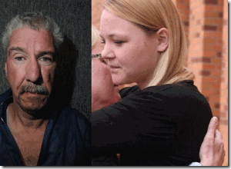
Warren Mann, 52, pleaded not guilty to attempting to murder Gail Brown, 41, on July 26, 2011. Mann admitted making a 911 call from her bedroom in which he calmly said: “I choked her and beat her to death.” “I don’t remember any of it,” Brown said in a wheezy voice. “It’s hard to breathe,” she added. “Sometimes I have to gasp for air.” At first, medical staff did not expect her to survive trauma from a severe head injury, but mostly from a crushed larynx (voice box).[21]

On January 12th, 2013, Robert “Ethan” Saylor, a 26-year-old man with Down syndrome, was killed during an incident with three off-duty sheriff’s deputies at a local movie theater in Frederick, Maryland. While waiting for his support staff to retrieve their car after the movie, Ethan decided he wanted to remain for another showing. He verbalized to the officers his intent to remain and refused to leave his seat. Ethan was restrained face-down by three plainclothes officers moonlighting as mall security. Ethan died from asphyxiation from a crushed larynx (voice box) while handcuffed.[22]
Asphyxia or asphyxiation is a condition of severely deficient supply of oxygen to the body that arises from abnormal breathing. Asphyxia causes generalized hypoxia which affects primarily the tissues and organs. There are many circumstances that can induce asphyxia, all of which are characterized by an inability of an individual to acquire sufficient oxygen through breathing for an extended period of time. Asphyxia can cause coma or DEATH.[23]
“A crushed or severely bruised larynx is a critical injury, although it is not 100% lethal. The problem is the collapse of the process, and/or the subsequent swelling shutting down the airway causing asphyxia. Note that a victim of this sort of injury who can breathe immediately after the injury, may have more trouble later, as swelling increases.”[24]
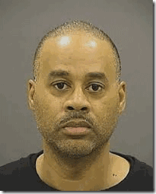
In Freddie Gray’s case, Baltimore State Prosecutor, Marilyn James-Mobsy and her staff, has publicly charged 16 year veteran BPD Officer Caesar R. Goodman, Jr., 45 years old, with the state’s most heinous crimes against Freddie Gray– Second Degree depraved heart murder (30 yrs.); Manslaughter (involuntary) (10 yrs.); Assault/second degree (10 yrs.); Manslaughter by vehicle (gross negligence) (10 yrs.); Manslaughter by vehicle (criminal negligence) (3 yrs.); Misconduct in office (8th Amendment*)[25]

Officer Goodson was the BPD van driver, but Freddie Gray had already been crushed by two Anglo BPD officers. Freddie Gray was limp like a crushed rag doll before he got into that van. Three Anglo officers literally DUMPED Freddie’s limp and crushed body into that van. For human compassion and even his own protection, Officer Goodson should not have moved that van until Freddie had been checked out by medics.
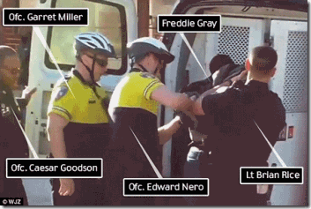
But, Officer Goodson, the 16 year police veteran, bleeds “BLUE”. He has been a “EYES WIDE SHUT BITCH” for Lucifer & the Baltimore Fraternal Order of Police, Lodge 3 for quite some time. Actually, some Master Masons (Masonic Fraternal Order of Police) trace “police departments” roots back to the BAPHOMET and “Knights Templar’s” in 1100 B.C. The Fraternal Order of Police could very well be a clandestine Branch of the Masons. It is comprised of LODGES with same symbology of Masons– All Seeing Eye of Horus, checkerboard and a fraternal handshake can be seen in the bottom points of a five-pointed star.
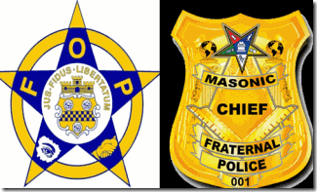
If Officer Goodson is a member of the FOP, then he could certainly be bound by an allegiance of blood oath secrecy to protect his brothers from crimes. However, Officer Goodson is the only police officer facing ILLUSIONARY murder charges based on the “ROUGH RIDE” theory. It is ILLUSIONARY because a “nickel ride” may cause severe head trauma, but as Dr. Wecht attests to above- it is highly unlikely if not impossible to cause Freddie Gray’s crushed larynx (voice box) or even for him to develop the force necessary to sever his own spine while face down handcuffed and shackled like a hog in the back of that police van. OFFICER GOODSON IS A DIVERSION FROM THE TRUTH- The Lynching of Freddie Gray.
HYPOCRISY

Baltimore mom Toya Graham is being hailed as “Mother of the Year” after she was caught on video aggressively assaulting and battering her 16 year-old son participating in acts of protest and RESISTANCE. In any other instance, the video could constitute evidence of “child abuse.” Under most circumstances, she would be prosecuted by the State, and her kids taken from her. However, as long it is a THUG “young black male” that she publicly batters as part of the ILLUMINATI agenda to continually DEMONIZE and DEVALUE the human dignity, rights and value of young black males, the open abuse of him even by society is nationally-internationally celebrated by corporate mass media.

And if you saw in one scene you had one mother who grabbed their child who had a hood on his head and she started smacking him on the head because she was so embarrassed, … I wish I had more parents that took charge of their kids out there tonight.” Baltimore Police Commissioner, Anthony Batts [26]
BALTIMORE POLICE CHIEF ANTHONY BATTS DON’T RIDE THE WHITE HORSE
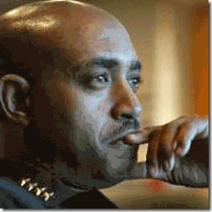
Anthony W. Batts is a strange compassionate-less human creature. Batts isn’t his true name. His real name may be William White, but who can be certain. He’s adopted so its difficult to determine for certain who or what he really is.[27] However, Batts has proven to be a mentally explosive unstable personality. Wherever he appears, there is a climate of fear and a reign of TERROR. He has a history of being a flagrant womanizer. He is sexually insensitive, domestically aggressive, violent, and abusive to women. He has been cited in at least 5 domestic violence cases including two involving his former corrupt politician wife, Congressperson Laura Richardson. In 2009, he lost control and punched her out- one black eye.[28]

Congresswoman Richardson- Concealing that BLACK EYE
Batts’ mental instability and level of insensitivity to the masses and people of color had been heightened by working as a police officer in some of California’s most racist and oppressive police jurisdictions. Prior to joining the Long Beach Police Department, he was an Explorer Scout with the Los Angeles PD (LAPD), a police cadet with the Santa Monica PD, and a reserve officer with the Hawthorne PD just east of Los Angeles.[29] When I was working police abuse cases in LA, Hawthorne was a predominately lily-white enclave that its PD constantly singled-out, harassed and abused Black people passing within its city limits.
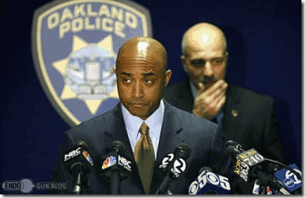OPD Chief Batts’ Shady- Real Shady Dude
In October 2009 after punching out Congresswoman Richardson and his true unstable violent personality was exposed to the Long Beach city pubic, he suddenly left the city to pop-up as Oakland’s PD Chief– another CIA/FBI collaborating racially divisive and oppressive police agency. The OPD was under threat of federal receivership, because it had failed as a custom to protect and serve the constitutional rights of People of Color. By October 2011, Chief Batts left the violent, scandal-plagued OPD after a frustrated judge threatened a full federal court takeover of the entire Oakland Police Department if it failed to quickly make good on changes to protect and serve Oakland citizens agreed to nine years ago.[30]
Anthony Batts: Riding the GOAT
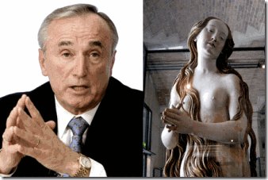
“William ‘Bill’ Bratton who was NYPD Commissioner is a 33rd Degree Master Freemason and he is completely in league with Lucifer and the New World Order as promulgated by the Masons.”[31] As you must already realize, Freemasonry has a long and sordid ancient history of extreme subterfuge, deception, murder, occultism and SATANISM. Batts and Bill Bratton are self-described “close friends” if not clandestine high level “Masonic- Police Fraternal Order Brothers” dating back to their days in California law enforcement. Batts was chief of police at Long Beach when Bratton headed the notorious LAPD. The two served as research fellows at the Rockefeller’s New World Order Harvard University’s John F. Kennedy School of Government, and Bratton supported/endorsed and may have arranged for Batts to become Baltimore’s new police chief in August, 2012.[32]
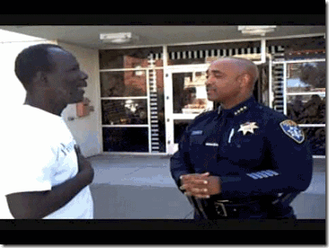
Chief Batts and Blood Oath Secret Covenant Prince Hall Mason greet each other- hand across the heart- greetings to a fellow Mason. Batts display the hand sign of the descending pyramid- the pyramid (triangle) being so most important a symbol to Master Masons.
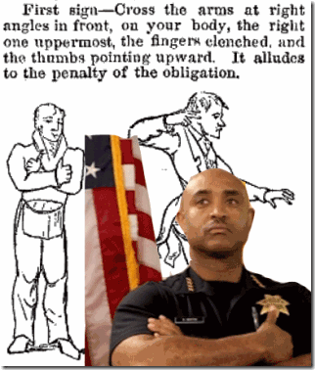
Reichsfuhrer SS- 1 Heinrich Himmler, Teutonic (Templar) KNIGHT of the Black Sun, One Thumb Up! In Nazi Germany, Himmler and the SS took jurisdiction over all police departments. The ancient Teutonic Knights of the Germany were in fact “Templar Knights”.
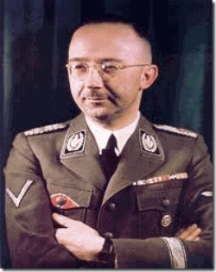
Below, Babylonian God Nebo, from a dictionary of the Bible, makes him appear to be instructing adepts on the finer points of using hand signs or exchanging mysterious grips. In fact, Nebo’s title was “Interpreter of the Gods,” and he was said to be the God of learning and of letters. The biblical King Nebuchadnezzar in the Book of Daniel was named after Nebo. This cut is in the British Museum, London.
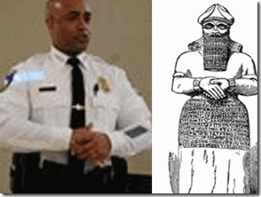
In 2013, William J. Bratton, Batt’s fraternal brother, the ex-police chief of Los Angeles and New York, was paid more than $50,000 as a consultant on a (Masonic-NWO) policing plan ordered by Baltimore Police Chief Batts.[33]
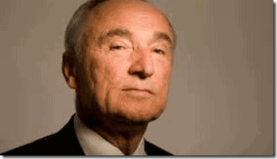
Baltimore Police Chief Anthony Batts was initiated into the higher degrees of the craft as some type of a cold-blooded cybernetic black BITCH of Master Mason Bill Bratton.
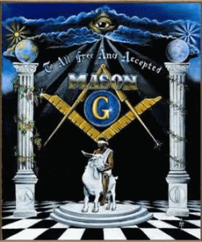
Chief Batts Rides the GOAT
BALTIMORE MAYOR STEPHANIE RAWLINGS-BLAKE DON’T RIDE THE WHITE HORSE
Riding the RAM and the GOAT
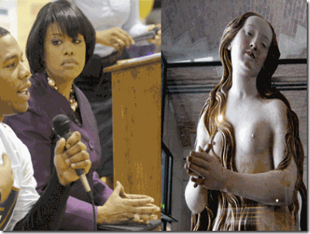
Stephanie C. Rawlings-Blake (born March 17, 1970) is the 49th Mayor of Baltimore. She currently serves as secretary of the Democratic National Committee (DNC) and vice president of the U.S. Conference of Mayors. She rides the Hellenized RAM. She is a Hellenized Negro.
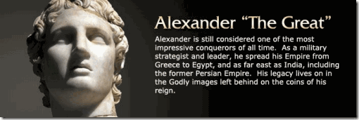
Hellenization or Hellenisation is the historical spread of ancient Greek culture and, to a lesser extent, language, over foreign peoples conquered by Greece or brought into its sphere of influence, particularly during the Hellenistic period following the campaigns of Alexander the Great of Macedon.[34]
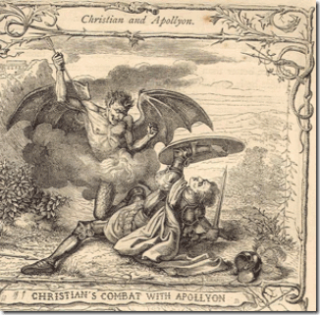
Apollyon is the BEAST from The Book of Revelation (9:11 & 13:11) Apollyon was also known as Alexander The Great. Historical Records show that Alexander the Great had two different colored eyes – one as dark as the night and one as blue as the sky, a harsh voice and that he was deformed – he had two horns of a RAM on his head. Revelation 13:11 seem to confirm that Alexander the Great is therefore the same person as Apollyon/Halios- the BEAST of the Book of Revelation.
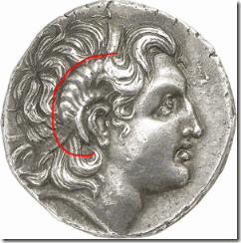
Furthermore, Alexander used the horns of a RAM as an ILLUSION to identify himself as a Son of Kemetic God AMUN. The Knight Templars and Freemasons worship the GOAT-headed BAPHOMET as their god of enlightenment.
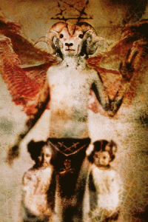

One may argue that there is a vast difference between a GOAT and a RAM; but, if you research the subject of witchcraft, you’ll learn that BOTH animals are extremely popular in witchcraft and the OCCULT. Some witches today claim that the GOAT head is really supposed to be a RAM’s head which originated with the RAM-headed God AMUN of ancient Kemet.
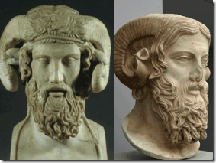
The Greek God Zeus and Roman God Jupiter are also identified with the Kemetic RAM-god that has CURVED horns; whereas, as a GOAT has a beard and STRAIGHT horns.
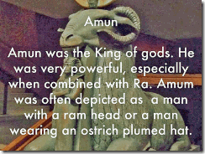
BOTH symbols are utilized in today’s Satanism, occult, and witchcraft circles. The pentagram image is inherent to both the GOAT and the RAM. Whether RAM or GOAT, both animals are used currently to symbolize the works of LUCIFER.[35]
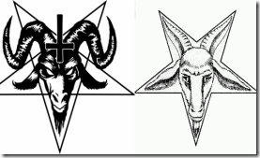
Stephanie C. Rawlings-Blake is a member of Alpha Kappa Alpha, Epsilon Omega charter.[36] On January 15, 1908, nine college women on the campus of Howard University founded Alpha Kappa Alpha Sorority, Inc., the nation’s first Greek-letter sorority to directly bring African-American women into the sphere of influence of LUCIFER. The Baltimore Alpha Kappa Alpha Sorority has been involved in Boulé (clandestine super elite black women of the sorority) conferences since 1923.[37] “The New World Order is The Old World Order. The elite Blacks of the Boule are culling and controlling their own for a slice of the elite white man’s pie.”[38]
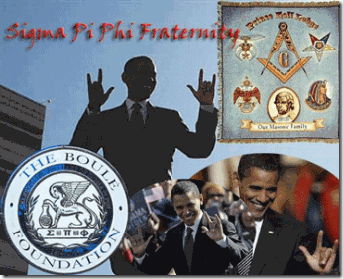
In 1904, the first African -American Greek Secret Society was formed in Philadelphia, by Dr. Henry Minton and five of his colleagues. The Boulé, (an acronym for Sigma Pi Phi) and pronounced “boo-lay”), was formed to bring together a select group of educated Black men and women for the ILLUMINATI.[39]
Fashioned after Yale’s Skull and Bones, the Boulé recruits top Blacks in American Society into its ranks. Today, 5000+ Archons, (male Boule members) and their wives, (Archousais), with 112 chapters, make up the wealthiest group of Black men and women on the planet. “Archon” means “DEMON” – the kind that like to keep hidden. But to who does the Boulé really serve? The SATANIC GLOBAL ELITE![40] In 1831, Avery Allyn, published a volume, “Ritual of Freemasonry.” Allyn attacked Greek fraternities as clandestine foreign- Orders of the ILLUMINATI binding its members to An Order of Blood Oath Secrecy.[41]

Baltimore Mayor Stephanie C. Rawlings-Blake with some odd jewelry necklace of Daniel Carroll’s Georgetown University symbolic Roman/Vatican Eagle, below. Rawlings-Blake’s Symbolic Eagle can also be linked to the Satanic Universal Men-Women Order of Freemasonry.
The Symbolic Roman and Vatican Eagle
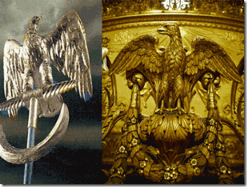
The Roman Eagle also called the “Aquila” was the Bird of Jupiter. In ancient times, the eagle was a symbol of strength and courage, and immortality. The eagle was believed to be the king of the birds that could ascend above the storm, and become the messenger of the gods. According to ancient mythology, the eagle would carry the soul into the presence of the gods, Zeus to the Greeks, Jupiter to the Roman, and Odin to the tribes of Germania. The silver eagle was the ensign of the Roman Legion and the symbol of its power. The legatus was the officer in charge, and he would assign an “Aquilifer” who was the soldier that would carry the “Aquila“ (eagle) into battle. If the eagle was captured the legion would disband. It is interesting that Julius Caesar personally sanctified the eagle when the legion was brought forth.[42]
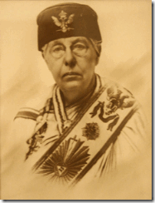
Satanist/Freemason Ann Besant with the Crowning Roman/Vatican Symbolic Conquering Roman/Vatican Eagle, 33 Degree
The Order of Universal Co-Freemasonry in Great Britain and the British Dependencies was founded by the infamous Satanist Annie Besant and officers of the Supreme Council of the French Maçonnerie Mixte (known today as The International Order of Freemasonry for Men and Women, Le Droit Humain) on September 26, 1902, with the consecration of Lodge Human Duty No. 6 in London.[43] Besant’s Co-Freemasonry was heavily influenced by Theosophy. The “Annie Besant Concord” was called the “Dharma Ritual“. The “Dharma Ritual” attempted to restore prominence to esoteric and mystical aspects that its Theosophical-minded founders felt were the heart of Freemasonry, so that it became fore mostly a spiritual organization; Co-Freemasonry of this Order was therefore sometimes called “Occult Freemasonry“.[44]

At practically every picture photo opportunity, Mayor Stephanie C. Rawlings-Blake, make it very plain by her hand symbols that she is an elite member of the ILLUMINATI Boulé– part of the Black Satanic Cabal- the pyramid (triangle) being so most important a symbol to Master Masons.
She didn’t Say What She Said
Mayor Rawlings-Blake’s original self may indeed may not have been aware of what one of her Alternative Personalities told the press, if she is a Multi-Personality Disordered (MPD) CIA- MK ULTRA/MONARCH Sex Kitten. That’s the way the ILLUMINATI roll.

Pastor Jamal Bryant is the WICKED shifty eyed Negro, below, standing next to Mayor Rawlings-Blake with the descending Masonic pyramid (triangle)hand symbol that look around to see if anyone really noticed what she said. One of Mayor Rawlings-Blake’s “alters” stepped up front and surprising took over the news conference, and told the truth about Baltimore’s False Flag Riot that destroyed the CVS drug store.
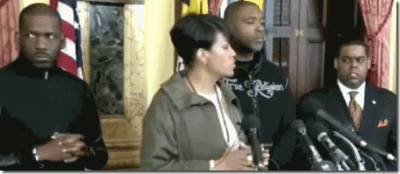
Jamal Harrison Bryant (born May 21, 1971) is pastor of the Empowerment Temple AME Church in his hometown of Baltimore. He is the son of Bishop John Richard Bryant, Senior Bishop and Presiding Prelate of the Fourth Episcopal District of the African Methodist Episcopal Church. Jamal is a elite member of Kappa Alpha Psi Fraternity incorporated.[45] Kappa Alpha Psi (formed 1911) is one of the “Divine Nine” Hellenized black Greek societies in America that form the basis of the elite Satanic Negroes of the Boulé.[46]
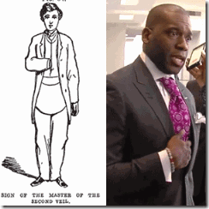
Pastor Jamal Bryant is another extremely very strange, scary and SHADY/Satanic Character “Riding the RAM” deeply involved in the inner circle of the Freddie Gray Cover-up.
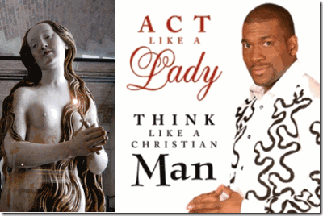
Rawlings- Blake’s husband, Mr. Kent V. Blake, is the jack of many trades. He has a habit of popping up where city money flows. He is real estate salesman and consultant. Plus, he is the director of business development at Political Boost. The company provides a comprehensive and streamlined communications portal for political candidates. Company officials said that the bundled services include interactive voice response (IVR) polls and surveys, canvassing tools, constituent contact management software, and more.[47]
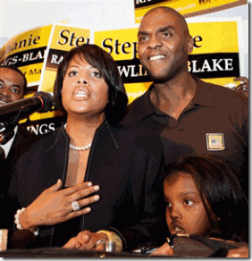
Mr. Kent & Stephanie- The Secret Masonic Family
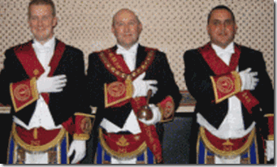
The Blood Oath Secret Masonic Brotherhood Salute
In 2011, the Baltimore Sun exposed to the public that Mr. Kent was hired by Johns Hopkins Community Physicians as a patient intake coordinator. As he was scheduling appointments in a call center, Mayor Rawlings- Blake did vote to approve close to a million dollars in grants for Johns Hopkins. Subsequently, the newspaper editorial board tried to clean it up by concluding ” … mayor has voted on a dozen contracts involving the sprawling entity that is Johns Hopkins, but none of them directly involve the branch her husband works for.“[48] That’s interesting that while the mayor cuts funds and programs (schools, recreation, job training, etc.) for the people, she is gives free grants of city money to Johns Hopkins with Mr. Kent bottom feeding. That’s the way they ROLL.
Mr. Kent has a Bachelor of Science (BS), Cyber/Computer Forensics and Counterterrorism from the University of Maryland University College. He is a Hellenized Negro of the Boulé Omega Psi Phi Fraternity Inc, Pi Omega and Theta Mu Mu Chapters. He also works for Verzion Communications.[49] He also rides a Hellenized RAM.
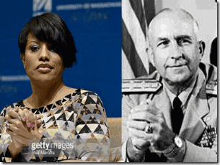
Stephanie Rawlings-Blake & U.S. Naval Admiral Thomas H. Moorer- Two Hands Clenched Together in a raised position is a high level ILLUMINATI/Satanic hands gesture. It is the “Seal [Lock] of Blood Oath Secrecy and Concealment“ . The Late Great Mae Brussell said that the late Congressman Larry McDonald was a national leader of the John Birch Society, which was exceedingly active in Dallas preceding the Kennedy Assassination, who created a organization called “Western Goals“. Western Goals had offices in Germany run by Eugene Wigner that fed data to the Hitler’s General and Himmler’s SS Puppet/ Knight of Malta Reinhard Gehlen’s Org/CIA. On the board of Western Goals were such Cold Warriors as Edward Teller, Admiral Thomas Moorer, and Dr. Hans Senholt, once a Nazi Luftwaffe pilot. Admiral Moorer had been the Pentagon Chairman of the Joint Chiefs of Staff from 1970 until 1974.[50] He was at a high level of shadow government “Blood Oath Secrecy and Concealment” with Lucifer’s Servants, the Underground THIRD REICH in America.
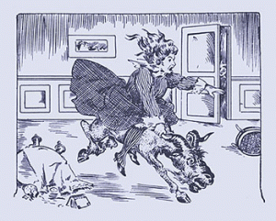
Mayor Stephanie Rawlings-Blake Rides the GOAT.
BALTIMORE ATTORNEY MARILYN JAMES-JAMES DON’T RIDE THE WHITE HORSE
Riding the GOAT
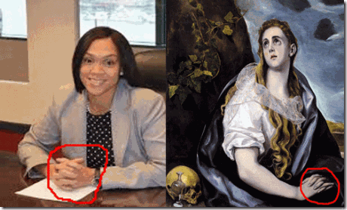
According to Baltimore State Attorney, Marilyn James- Mosby, she proudly and really sincerely Bleeds Masonic BLUE, too,
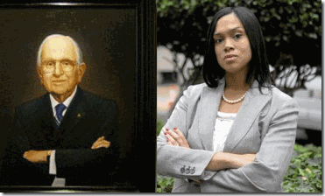
Rev. Alex Haley Norman Vincent Peale, 33° (Midwood Lodge No. 1062, Brooklyn, NY., Murat Shriner)
My grandfather, my uncles, my mother, my father — I have five generations of police officers. I know that the majority of police officers are really hard-working officers who are risking their lives day in and day out, but those really bad ones who go rogue do a disservice to the officers who are risking their lives and taking time away from their families,” she told Baltimore Magazine in January, when she started her tenure as state’s attorney.[51]
Most of her life, Mosby has worked exclusively on behalf and in the interest of the STATE prosecuting the poor and the powerless for crimes they are for the most part defenseless to defend against the might, wealth and ruthlessness of the STATE. Her first stint in the Baltimore City State’s Attorney’s Office came after she graduated from Boston College Law School. She served first as assistant state’s attorney and then prosecuted some of the worst felonies in Maryland in the general trial division. She also worked for mega BIG BUSINESS. She left the state attorney’s office to go work as field counsel for the global multi-billion dollar Liberty Mutual Insurance conglomerate [52] for three years.[53]

She was elected State Attorney after she bested incumbent Gregg L. Bernstein in defining herself a more ruthless anti-crime fighter- crusader, determined to keep repeat offenders off the streets.[54]

Marilyn James- Mosby is a master of ILLUSIONS and deception– one of the Hand/Finger Gestures of the DEVIL HORNS.

Marilyn Mosby is not identified as a Hellenized Negro. However, the shifty Negro behind her with the descending pyramid hand symbol is Nick Mosby, the husband. He is a Hellenized Negro of the Boulé Divine Nine– Omega Psi Phi Fraternity (Founded 1911), and Epsilon Upsilon fraternity.[55] Nick and Mr. Kent are Boulé Omega Fraternity brothers. He is a politician, a Baltimore City Councilman.[56]
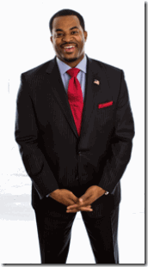
Hellenized Nick & Descending ILLUMINATI Pyramid (Triangle) Gesture
Nick of multi-billion dollar Verzion Communications [57] also with Mr. Kent says that he was raised with strong Christian values. He is a black CATHOLIC, a lifelong member of St. Matthew Catholic Church in Baltimore.[58] The cornerstone the Cathedral of the Assumption (today called the Basilica of the National Shrine of the Assumption of the Blessed Virgin Mary in Baltimore was laid on July 7, 1806, by the infamous Jesuit Priest See of Baltimore Bishop John Carroll.[59] Under the legacy and vision of Bishop Carroll, Baltimore City continued to grow, and the Archdiocese established new parishes to handle the increasing need for more churches and schools. St. Matthew’s opened in 1949.[60]
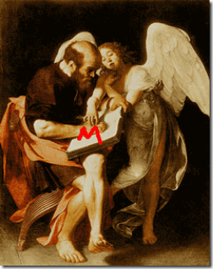
Caravaggio, a Knight of Malta (Templar Knights), completed this painting, Saint Matthew and the Angel, in 1602. The Knight Templars knew of and believed in the “Grail Family”, the descendants of Christ and Mary Magdalene. There are legends that Jesus survived the crucifixion and was not actually buried or resurrected from the cave. Matthew secretly harbored or helped Jesus and Mary Magdalene escape to France. There is also a theory based on evidence from a tomb in East Jerusalem that Jesus, Mary Magdalene, Matthew and a son of Jesus shared the same burial Talpiyot Tomb.
Matthew the Apostle also known as Saint Matthew and as Levi was, according to the Bible, one of the first twelve apostles of Jesus and, according to Christian tradition, one of the four Evangelists.[61] St. Matthew was the first to mention MARY MAGDALENE in the Bible (Matthew 27:56).[62] St. Matthew had also been the patron saint for erecting on autumn equinox (St. Matthew’s Day, September 21, 1446) Sir Earl William Sinclair’s infamous mysterious/occult Knight Templar church in Rosalyn, Scotland.[63]
U.S. ATTORNEY LORETTA LYNCH DON’T RIDE THE WHITE HORSE
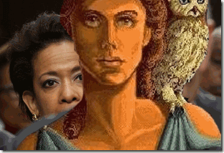
Mayor Stephanie Rawlings-Blake has asked her Hellenized Masonic/ILLUMINATI Boulé sorority sister, U.S. Attorney General Loretta Lynch, to investigate the Baltimore PD. Sister Lynch Rides the Hellenized Ram with the Delta Sigma Theta Sorority (1913). Of course, Sister Lynch has agreed to use the U.S. Justice Department to whitewash Mayor Rawlings-Blake and the BPD to make them whole before the world masses. MASONIC ILLUMINATI SISTER?
“The most direct line of descent from Greek societies to America is the Freemasons (called Masons). Historians of American fraternities and sororities trace most of our rituals, ceremonies and rites to the Masons. An examination of Masonic rituals open to scholars suggest that our Founders were also influenced by Masonic ritual, symbolism and initiation experiences.” (DELTA SIGMA THETA SORORITY, INC., GRAND CHAPTER, CANDIDATE SYLLABUS, 1987, p.30.)
Delta Sigma Theta Sorority rituals and ceremonies are also heavily influence by the ILLUMANITI, and consistent with Satanic rituals and ceremonies of the Great BEAST 666 Aleister Crowley.
“Minerva, the goddess of wisdom, one of the strongest and most admirable goddesses of antiquity, was chosen by the Founders as the patron of the Sorority. She serves merely as a SYMBOLIC representation of desirable archetypical attributes of mind, body, and SPIRIT. The goddess’ name derives from the ancient roots for “mind” and her domain was intellectual. Minerva was also said to be the inventor of music. It is fitting, therefore, that the exemplary attributes associated with Minerva be influential in the minds and spirits of the Sorors holding the responsibility of planning and conducting all intake activities, including induction, and orientation of new members into Delta Sigma Theta. These Sorors comprise the Minerva Circle … Wisdom! The college educated woman seeks to become wise rather than smart. That is why MINERVA, the Goddess of Wisdom, is our Sorority mentor.” (DELTA SIGMA THETA SORORITY, INC., GRAND CHAPTER, MEMBERSHIP INTAKE PROGRAM, 1987, p. 106.)
According to John Robison’s Proofs of a Conspiracy (1798), the Third Degree of the Bavarian ILLUMINATI was called Minerva or Brother of Minerva, in honor of the goddess of learning. Later, this title was adopted for the first initiation of the Great BEAST Aleister Crowley’s OTO rituals (The Ceremony of Minerva and the First Degree). There was also ILLUMINATI Masters of the Minerva. The official sigil of the ILLUMINATI was the Owl of Minerva.
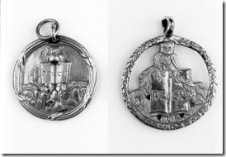
Minerva Seals of the ILLUMINATI: two of three known to still exist. P.M.C.V.stands for Per Me Caeci Vident (Through me the blind become sighted). An owl holding an opened book (signifying learning), surrounded by a Laurel wreath (a symbol of learning or graduation); Per Me Caeci Vident was a reminder to the Superiors of the class, whose responsibility it was to properly instruct the Minervals. These medallions were worn around the necks of Minerva initiates.
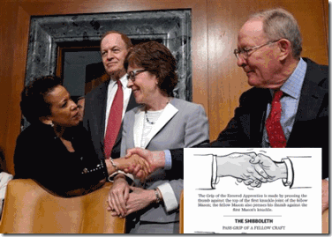
It sure looks like U.S. Attorney General Loretta Lynch is exercising one of Satanist Ann Besant’s Co-Freemasonry handshakes.
In June 2014, the Guardian UK reported that the Pentagon, under the authority of Commander-in-Chief Barack Obama, had been bankrolling detailed studies from various universities to learn how the military might best respond to a civilian uprising. It’s called the “Minerva Research Initiative” and its a US Department of Defense (DoD) research program that is funding universities to model the dynamics, risks and tipping points for large-scale civil unrest across the world, under the supervision of various U.S. military agencies. The multi-million dollar program is designed to develop immediate and long-term “warfighter-relevant insights” for senior officials and decision makers in “the defense policy community,” and to inform policy implemented by “combatant commands.” The Guardian reported.
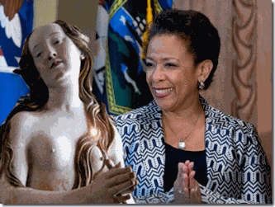
Loretta Lynch and U.S. Justice aren’t going into Baltimore to protect and serve any constitutional rights of the people. That’s the pretext. They’re going into Baltimore under the cloak of the “MINERVA RESEARCH INITIATIVE” for the NEW WORLD ORDER dominated by the Secret Satanic Cabals, and the Bloodlines of the CULT OF MARY MAGDALENE. She Rides the GOAT.
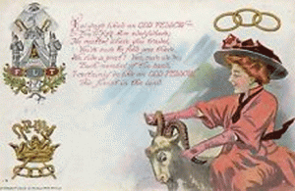
Back to Baltimore Attorney Marilyn Mosby. Freddie Gray’s autopsy report still has not been released to the public or by the Gray family attorneys. Mosby knows very well that Freddie Gray’s cause of death will not be from a so-called ILLUSIONARY “Rough Ride”, but by Asphyxia or asphyxiation from a crushed larynx from a choke hold or by a direct brutal blow to the neck. Whereby, Caesar Goodson and his Masonic brothers are bound to walk free. At this point, the Baltimore Attorney’s office haven’t mentioned anything directly about Gray’s crushed larynx or charging any of the officers with “conspiracy” in regards to the alleged “illegal arrest” or that pocket knife that was supposed to be an “illegal switch blade.” She hasn’t said why the city’s 24-hour surveillance camera system is good enough to convict the masses for crimes, but suddenly come up short to identify the officer or officers that LYNCHED– broke Freddie Gray’s neck and crushed his voice box on the same heavily monitored city streets.
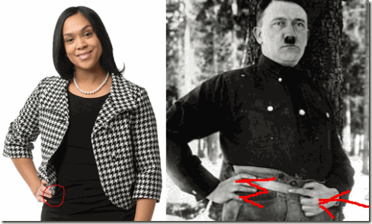
Marilyn James- Mosby, the Secret Hand/Finger Symbol of the Cult of MARY MAGDALENE. She also Rides, and Feed the GOAT!
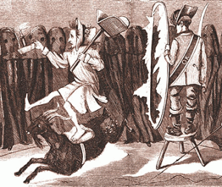
LOOK PAST YOURSELF, Break through the Smoked Mirrors, and the Looking Glass.
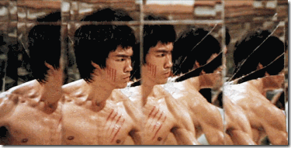
“The enemy has only images and illusions behind which he hides his true motives. Destroy the image [ILLUSIONS] and you will break the enemy.” Shaolin Abbot to Bruce Lee, Enter the Dragon (1973)

[1] http://en.wikipedia.org/wiki/Laid_Back
[2] http://www.abovetopsecret.com/forum/thread908744/pg1
[3] http://www.abeldanger.net/2012/12/washington-dc-rome-on-potomac-jesuits.html
[4] Id.
[5] Id.
[6] http://www.abeldanger.net/2012/12/washington-dc-rome-on-potomac-jesuits.html
[7] Id.
[8] Id.
[9] Id.
[10] http://en.wikipedia.org/wiki/Daniel_Carroll
[11] http://www.pagrandlodge.org/freemason/0512/page20212223.html
[12] http://www.abeldanger.net/2012/12/washington-dc-rome-on-potomac-jesuits.html
[13] Id.
[14] http://www.northernway.org/twm/mary/magdalene.html
[15] Id.
[16] http://en.wikipedia.org/wiki/El_Greco
[17] http://www.el-greco-foundation.org/biography.html
[18] http://www.marymagdalenebooks.com/mary-magdalene-and-the-cathars
[19] http://m.deseretnews.com/article/765672432/Police-may-have-ignored-seatbelt-policy-with-Freddie-Gray.html
[20] http://en.wikipedia.org/wiki/Death_of_Oluwashijibomi_Lapite
[21] http://www.thebarrieexaminer.com/2015/04/13/victim-in-brutal-beating-takes-the-stand-in-barrie-court
[22] http://www.ndss.org/About-NDSS/Newsroom/Recent-News/Patti-Saylor-To-Testify-at-Senate-Hearing/
[23] http://en.wikipedia.org/wiki/Asphyxia
[24] http://www.answers.com/Q/Can_you_live_if_you_larynx_is_crushed_or_bruised
[25] http://www.stattorney.org/media-center/press-releases/708-marilyn-mosby-charges-six-baltimore-police-officers-involved-in-the-freddie-gray-arrest
[26] http://www.cnn.com/2015/04/28/us/baltimore-riot-mom-smacks-son/
[27] http://productofdaenvironment.blogspot.com/2012/09/who-is-dr-anthony-batts-dr-black-or-mr.html
[28] http://www.longbeachcomber.com/story.aspx?artID=2368
[29] http://straighttalktv.com/bios/anthony_batts.html
[30] http://www.policeone.com/legal/articles/4975525-Oakland-police-could-face-federal-takeover/
[31] http://www.topix.com/forum/news/topix/TR870VTAPQ0C8GM7U
[32] https://www.baltimorebrew.com/2013/04/24/meet-baltimores-560-an-hour-cop-consultant/
[33] Id.
[34] http://en.wikipedia.org/wiki/Hellenization
[35] http://www.jesus-is-savior.com/False%20Religions/Wicca%20&%20Witchcraft/pentagram.htm
[36] http://en.wikipedia.org/wiki/Stephanie_Rawlings-Blake
[37] http://en.wikipedia.org/wiki/List_of_Alpha_Kappa_Alpha_Boul%C3%A9s
[38] http://secret–societies.blogspot.com/2013/12/the-boule-skull-and-bones-society.html
[39] http://daghettotymz.com/rkyvz/articles/bouleseries/boule1-3roster/boule1/boulept1.html
[40] Id.
[41] http://www.bibliotecapleyades.net/sociopolitica/pawns_inthegame/pawns_00.htm
[42] http://www.bible-history.com/archaeology/rome/2-roman-eagle-bb.html
[43] http://en.wikipedia.org/wiki/Co-Freemasonry
[44] http://en.wikipedia.org/wiki/Co-Freemasonry
[45] http://www.agoodblackman.com/leaders_bryant.shtml
[46] http://www.yahspeople.com/boule.html
[47] http://technews.tmcnet.com/ivr/topics/ivr-voicexml/articles/88761-political-boost-joins-baltimore-citys-technology-incubator.htm
[48] http://baltimore.cbslocal.com/2011/03/16/rawlings-blake-votes-have-nothing-to-do-with-my-husband/
[49] https://www.linkedin.com/pub/kent-blake/63/706/514
[50] http:www.free-conversant.com/realtruth1621
[51] http://www.kansascity.com/opinion/opn-columns-blogs/yael-t-abouhalkah/article20026263.html
[52] http://en.wikipedia.org/wiki/Liberty_Mutual
[53] http://www.nbcnews.com/storyline/baltimore-unrest/meet-marilyn-mosby-woman-overseeing-freddie-gray-investigation-n351046
[54] http://thedailyrecord.com/2014/06/25/mosby-defeats-bernstein-in-baltimore-prosecutors-primary/
[55] http://en.wikipedia.org/wiki/Eta_Kappa_Nu#Prominent_Members
[56] http://www.baltimorecitycouncil.com/District7/
[57] http://en.wikipedia.org/wiki/Verizon_Communications
[58] http://nickmosbyforcitycouncil.appspot.com/about.htm
[59] http://en.wikipedia.org/wiki/John_Carroll_%28bishop%29
[60] http://stmarygovans.loyola.edu/history.html
[61] http://en.wikipedia.org/wiki/Matthew_the_Apostle
[62] http://biblehub.com/commentaries/matthew/27-56.htm
[63] Knight, Christopher, The Hiram Key Revisited, Freemasonry: A Plan for a New World Order, Watkins Publishing, London (2007) pg. 204
Comments : 7 Comments
Tags: Admiral Thomas H. Moorer, Adolf Hitler, alexander the great, Alpha Kappa Alpha, amun, ann besant, anthony batts, Anthony W. Batts, apollyon, baltimore, baltimore police department, Baphomet, BOULE, caesar goodson, Caesar R. Goodman, catholic church, cecilius calvert, cyril wecht, daniel carroll, Delta Sigma Theta Sorority, don't ride the white horse, el greco, Epsilon Omega, fraternal Order of Police, freddie Gray, freemasonry, gail brown, god nebo, hellenized negroes, Illuminati, International Order of Freemasonry for Men and Women, Jamal Harrison Bryant, jesuits, john carroll, jupiter, Kappa Alpha Psi, kent blake, king charles stuart, Knights of the Black Sun, knights templar, lapd, laura richardson, loretta lynch, Lucifer, luciferians, m symbolism, marilyn james, marilyn mosby, mary magdalene, Maryland, masonic order of police, masons, minerva, Minerva Research Initiative, nick mosby, OAKLAND, oakland police department, Occult Freemasonry, Oluwashijibomi "Shiji" Lapite, prince hall, pyramid, Reichsfuhrer SS- 1 Heinrich Himmler, ride the goat, Robert “Ethan” Saylor, roman eagle, rough ride, saint matthew, shriners, skull and bones, Stephanie C. Rawlings-Blake, Stephanie Rawlings-Blake, Theosophy, toya graham, vatican eagle, warren mann, William 'Bill' Bratton, zeus
Categories : african american satanic cult, african holocaust, African slavery, Aleister Crowley, ALL SEEING EYE, Aryan Supremacy, baphomet, black christianity, Black Manchurian Candidates, blood covenants, devil, devil's horns, dualism, False Satanic Rites of Lost Negroes, Heinrich Himmler, illuminati, inverted pentagram, jesuits, jesus christ, Johns Hopkins University, Knight of Malta, Knights Hospitaller, Knights of the Black Sun, Knights Templar, luciferians, mae brussell, mary magdalene, mind control, MK-ULTRA, monarch program, mulitiple personality disorder, Nazis, new world order, nwo, oakland, oakland police department, queen elizabeth, Satanic Global High Cabal, Satanism, Schutzsteffel, sex kitten, SS

HUEY P. NEWTON, A REAL PEOPLE’S HERO, CIA MK ULTRA, THRID REICH, NASA & BOBBY SEALE- A WHORE OF LUCIFER
25042015

THE POWER OF THE IMAGE
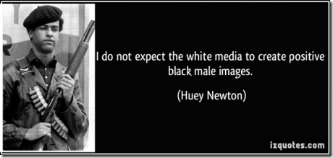
Needless to say, there is one IMAGE of a Black Male that the corporate mass media and Satanic New World Order had no hand in creating. It is a Black Male IMAGE that they will not recognize or foster under any circumstances, not even in HollyWeird. This Black Male was proven not to turn his back to the EMENIES of the PEOPLE and RUN. He taught other young sisters and brothers , even myself, not to fear or turn our backs to the enemy and run- if our cause is RIGHT and JUST. It is an IMAGE of a Black Male that the system has spent millions of dollars and used some of its most covert and Satanic forces, and mind control technology to SUPPRESS and DESTROY. It was late 1966 or early 1967, Sister Betty Shabazz, the wife of the late Malcolm X, was invited to San Francisco in her honor and the memory of the beloved, Brother Malcolm.
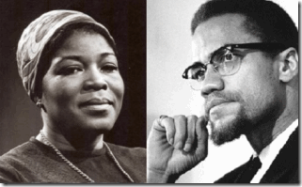
There were death threats and some racial noise being raised and surrounded her trip to the Oakland/San Francisco Bay Area. As I recall, the brothers and sisters were concerned about her safety during . Huey and the Panthers stepped forward to provide Sister Betty escort security while she was in San Francisco. I heard about Sister Betty’s trip to the city late. I didn’t own a gun, and couldn’t arrange to get one by the time Sister Betty made to town or else I intended also to be with Brother Huey. However, Huey was surrounded by a group of strong and firm brothers. I made it to the city community center where Sister Betty was to be honored to provide backup if needed.
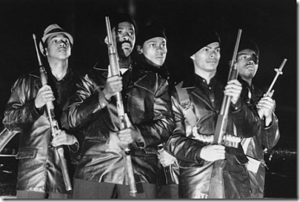
The LEGEND is Huey and the Panthers boldly invaded the San Francisco Airport FULLY OPENLY ARMED to escort Sister Betty from the plane as soon as she touched ground in city. It caught airport security and the San Francisco Police Department (SFPD) by complete surprise even Sister Betty had been somewhat startled at first with Huey and the Panthers. But when it came to the Love of the People, Huey and the brothers always meant business. They sent the message to some of our “sick white brothers” that nothing was going to happen to Sister Betty without consequences.
At some point in route to the center, the SFPD mustered up some forces and stopped Huey and the brothers. One SFPD sergeant stepped forward and told them that he was going to take their guns. Well, Huey had his infamous shotgun. He told the sergeant that he wasn’t going to take his gun. The sergeant stepped forward toward Huey. “Click-Click,” Huey dropped a round in the chamber. Panthers with shotguns followed, “Click-Click,- Click-Click, Click-Click,” down the line. Huey wasn’t playing. The SFPD sergeant backed-up off Huey and the brothers.
Sister Betty, Huey and the brothers made it to the center in safety . We had a wonderful celebration and historical experience honoring Sister Betty and the memory of Malcolm X in peace and order. Sister Betty’s trip to the Bay Area was without incident, but the astounding courage of HUEY P. NEWTON and early Black Panther Party for Self Defense made her trip absolutely legendary, historical and UNFORGETTABLE.
IMAGES- EYES WIDE SHUT
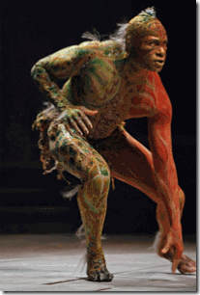
Sir Francis Bacon’s (Shakespeare) 16th Century CALIBAN– Half-Human, Half- Devil, a “Demi-DEVIL”
We do not expect the white mass media and New World Order to create or foster Positive Black Male images, but, we also need to be vigilant when they clandestinely create and implant among the masses ILLUSIONS and false Images of the Black Male that degenerate our history, humanity to create and falsify a climate to justify Racial Mass Murder of Black Males.

” … he [18 year old Michael Brown] looked up at me and had the most intense aggressive face. The only way I can describe it, IT looks like a DEMON … I tried to pull the trigger again …” Ferguson Police Officer Darren Wilson, Grand Jury Transcript[1]
At the very least, Darren Wilson was a fool of 16th Century pseudo race mythology, his own prejudice and stupidity. This racist nitwit afraid of DEMONS should never have been given a gun and a badge. He should have been at the very least charged with criminal homicide- unlawful killing of a human being. The young brother, Michael Brown, was no IT or a damn DEMON. The continuing public images of young Black men, women, children and our elders being slaughtered in the street across the nation by police officers with the slightest pretext and now demonology is traumatizing, graphic and chilling. It constitutes CRIMES AGAINST HUMANITY.

This is no Crisis Actor Defying Himself Breath & A Natural Basic Human Response- the Law of Self Preservation.
The images of 50 year old Walter Scott being gunned down by North Charleston Police Officer Michael T. Slager, 33 years old, is absolutely chilling. It is also appalling that immediately after the shooting, disinformation artists began to devalue Scott’s life and rob him and the people that loved him of his HUMANITY– the shooting was a hoax and false flag. Indeed, after a national exposed incident such as this of a sworn police officer executing an unarmed black citizen caught on video, black Masons and counter-intelligence crisis actors move in immediately primarily to control the national/international narrative and spin. But in Walter Scott’s case, Michael Slager slew him in cold blood. This is no act or hoax. This is not a game!
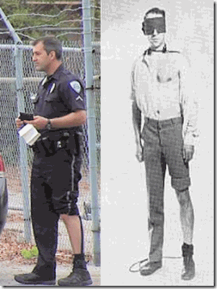
Instead of continuing to devalue Black Lives at the every first instance, we need to know who these shooters really are. We need to know who Michael T. Slager is? We need to know why after gunning down Scott he appears to be on the path of Masonic (KKK) initiation? Slager is 33 (now most likely 33rd Degree). Already, disinformation artists are on the internet saying that in a struggle between Walter Scott and Officer Slager, Scott took the officer’s stun gun and shot him in the right leg and that is why Slater’s pants leg is up. The problem is that Slager didn’t mention that he had been shot in the leg by his stun gun. Slager said that Scott took his stun gun. He said that he felt his life was threatened then shot him in the back, and that has been proved to be a gross fabrication of the facts and a SHAM.
The video showed Officer Slager calmly firing eight shots from a high velocity 45 caliber Glock 21 at Scott as he fled—who was reportedly hit five times. Bullets tore through his bones and tissues, with one bullet piercing his heart. Pierce– to penetrate or run through (something).[2] Maybe that’s why there is no blood visible from the video, the high velocity bullets went through Scott– the bleeding was internal. During the late sixties, there was a lot of debate about high powered weapons like the 357 Magnum versus the standard issue 38 caliber. They said that a round from a 357 could pierce an engine block. In most instances, bullets fired from a 357 easily pierce human tissue leaving a subject still alive.
The last police shooting case I worked on in Los Angeles involved a young Black man named Lionel shot in the head by a LA County Firestone Division Sheriff with a 357 Magnum or other high powered weapon with high velocity bullets. Lionel survived to fight another day because the bullet pierced- went through his skull and brain tissue.
Lionel had just purchased a pistol. He and a friend shot off a round in an alley next to his house to test fire the pistol. He didn’t know it, but there were two sheriff deputies on a traffic stop down the street that heard the shot and rushed up to Lionel’s house with guns drawn. Lionel saw them coming and threw the pistol in the bushes near the alley. He went inside his home and poured himself a glass of wine. When the officer screamed for him to come out with his hands up. Lionel calmly exited the house to the front porch with a glass of wine held up high in his hand. One officer immediately shot him in the head to slay him. The officer said that Lionel pointed the weapon that he had just test fired at him. To add insult to his brain injury, Lionel was criminally charged with attempted murder of the sheriff deputy that tried to kill him.
Well, we got discovery from the D.A. In discovery, they forgot to remove the evidence photo of Lionel’s pistol thrown in the bushes next to his house near the alley. It was nowhere near Lionel or the front porch of his house. Lionel’s attempted murder charge was immediately tossed by the D.A. I couldn’t get that lying deputy prosecuted, but Los Angeles County paid through their teeth for that gross and flagrant injustice against a fellow HUMAN BEING. Following Lionel’s case, the Mayor of Los Angeles (ex-LAPD Chief Thomas Bradley) put a great deal of pressure on my employer to take me out of the police abuse legal battle field.

Officer Slager coolly without human compassion stood over Scott just like that half-wit DEMON slayer hovered over Michael Brown as if they had slaughtered trophy animals for the New World Order.
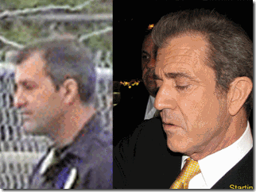
But what struck me really-really odd about Officer Slager, I felt an immediate sense of familiarly with his image. Officer Slager is strikingly similar to the image of ILLUMINATI HollyWeird actor Mel Gibson– Conspiracy Theory, Braveheart (Robert the Bruce- HUMAN SCARIFICE), and the Passion of Christ (SON OF GOD!).[3]
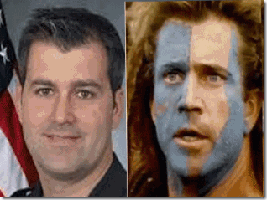
It is not beyond reason that ILLUMINATI HollyWeird stars work hand and hand with U.S. military intelligence and CIA to allow their images to be used as ILLUSIONS in clandestine military intelligence mass population psychological warfare operations. Already, Fox News and Geraldo Rivera are at this very moment planting subliminal seeds, Images and ILLUSIONS in mass media that Officer Slager will not/can not be convicted of a crime slaying in cold blood a poor, frightened and desperate fleeing human being, Walter Scott, .[4]
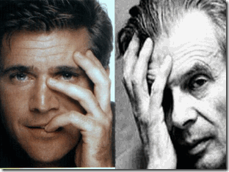
Above, ILLUMINATI/Luciferian Eye of Horus, HollyWeird’s Mel Gibson & CIA MK ULTRA British Godfather- Aldous Huxley
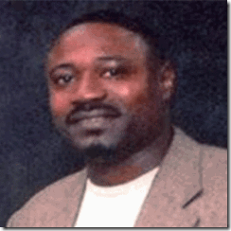
We love you, My Dear Brother Walter Scott. I believe that the people of the world truly understand that you didn’t want to hurt anyone. You ran in fear due to being hopelessly subjected to draconian indefinite incarceration without a remedy for owed back child support. In 2008, you went to jail for a full six months after falling behind by $6,800 in child support payments.[5] You didn’t have to be shot in back for that. In a sense, you were gunned down on the pretext of an Old English Debtor and America’s Fugitive Slave Laws out of the Nineteen Century. I hope and pray that your slayer will be tried and convicted, and your SOUL will rest in forever PEACE.
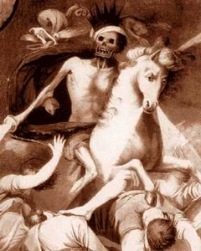
The Luciferian Elite Cabal desires a world without People of Color, particularly Black People. In The Book of Co-Creation futurist Barbara Marx Hubbard writes: “Out of the full spectrum of human personality, one-fourth is electing to transcend …. One-fourth is destructive [and] they are defective seeds. In the past they were permitted to die a ‘natural death.’ … Now as we approach the quantum shift from the creature-human to the co-creative human — the human who is an inheritor of god-like powers — the destructive one-fourth must be eliminated from the social body …. Fortunately, you are not responsible for this act. We are. We are in charge of God’s selection process for planet Earth. He selects, we destroy. We are the riders of the pale horse, Death.”[6]
“I AM LOOKING AT THE TRAIL OF DEAD BLACK PEOPLE!”
Body cameras on police officers will not be enough to protect the masses of color or the “TRAIL OF DEAD BLACK PEOPLE” across the nation from the Riders of the Pale Horse, because it is part of a widespread clandestine global ILLUMINATI/New World Order racialist paradigm and agenda of GENOCIDE. One of the main principles of the Satanic racialist paradigm and agenda sweeping across America includes the denial and degradation of the humanity of Black People- the UNTERMENSCH (Caliban).
In Baltimore, Freddie Gray’s Human Rights were flagrantly violated. All of the neighborhood crime stopper cameras that captured video evidence of what the state did to him were allegedly inoperative or turned off. The state treated Freddie Gray less than an animal. Witnesses said that police folded him up like a pretzel. The state denied his cries for medical help. Instead of medical help, the state hog tied him then threw him on the floor of a paddy wagon like a sack of potatoes. In combination with Satanic paradigm and agenda of GENOCIDE, corporate mass media continue to defy Freddie Gray’s pleas for natural human compassion.
As you celebrate the prosecution of Officer Slager for criminal homicide and the life of Walter Scott, don’t take your eye off the Global Satanic Cabal. Don’t be distracted by focusing on the finger and miss the heavenly glory of our sacred cause- Unconditional Freedom and Human Dignity. The ILLUMINATI/New World Order Luciferian agenda is unfolding all around you calling for the destruction of Christianity, everything dear to you, and a 21st Century Black Holocaust.
Battle the Enemy with Emotional Content
Even in the American popular culture, subliminal messages are being sent out among the global masses that it’s acceptable to kill and slaughter Black people. In total disrespect to our HUMANITY and UNIVERSIAL HUMAN RIGHTS, the little racist prick, Justin Bieber, `called for killing Black People as an initiation and right of passage to the KKK as if it is a JOKE. This is no JOKE, and he needs to internalize this.
Kill A Black Man- Join the KKK
Hip Hop’s newest Satanic High Priestess and WITCH, Australian Iggy Azalea, has adopted the rebel confederacy cause- Return Black People to Human Bondage in VIOLATION OF OUR HUMAN RIGHTS. The Hip Hop generation has failed in an united demand to high profile Satanic ILLUMINATI Snakes such Justin Bieber as Iggy to UNCONDITIONALLY RESPECT the Human Rights of Black People and masses of color.

EYES WIDE SHUT. Black Hip Hop rappers have lost their minds in adopting the symbolism and badges of the Confederacy, African Slavery and Black Holocaust- VIOLATION OF THEIR OWN HUMAN RIGHTS..
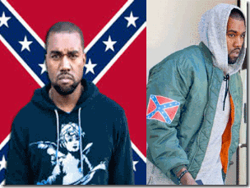
Kanye West- Lunatic Save the Confederacy Campaign

Kanye West’s Lunatic Confederate T-Shirt Market for the Hip Hop Generation

Hip Hop Rapper Lil John– Absolutely MINDLESS!
EYES WIDE SHUT. For a pound of their flesh, they accept a few moments of fame and only a few pieces of silver from the ILLUMINATI and the Satanic Cabals to sell out the masses of the people. When the Riders of the Pale Horse are exposed, they have to be dealt immediately with and by any means necessary with “emotional content” to maintain the high hill- win the hearts and minds of the people. Huey P. Newton set the example- People of Color MUST defend their HUMANITY
COVER-UP, The Hero & the Rider of the Pale Horse
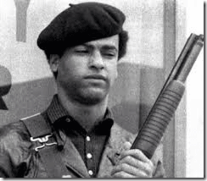
On October 28, 1967, a Rider of the Pale Horse was set on a mission to exterminate the mind, spirit, body and soul of BPP Minister of Defense, Huey P. Newton. There was no video or picture evidence of what happening in the dark of that night. But at the end of a life and death struggle between Brother Huey and a Rider of the Pale Horse, Oakland Police Officer John Frey was dead. Brother Huey was arrested, tortured and charged with criminal homicide– the unlawful killing of a human being, and the attempted murder of OPD Officer Herbert Heanes.[8] Yet, his legend continued to live among the masses.
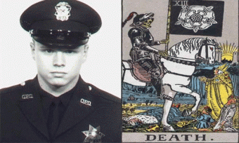
OPD Officer John Frey- Pale Horse Rider & SS/Nazi Luger?
However, a different picture of what really happened that night began to develop by the physical evidence found at the scene of the struggle. In August 1968, eminent OPD Forensic Criminalist, John E. Davis, made an appearance in Huey’s criminal homicide trial. Davis founded the OPD Crime Laboratory Firearms Unit. Davis testified that beside OPD Officers Heanes and Frey’ service revolvers there had been another gun on the scene.[9] According to Davis, the other weapon at the scene was a Nazi German Luger. Both Frey’s service revolver and the Luger allegedly vanished from the scene.[10] The Nazi Luger should have been a trial GAME CHANGER. Huey should have been immediately released, but we didn’t know anything about the Luger. Our EYES WEREN’T WIDE SHUT. We had been DECEIVED.
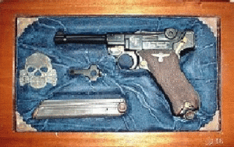
OPD Criminalist Davis didn’t appear to put it on the trial record how he identified and linked the 9 mm shells found at the crime scene to a rare collector’s German Luger. A German Luger can fire standard mass manufactured 9 mm ammo. However, it is not recommended due to the value and rarity of the gun. So, I think it’s safe to assume that the shells carried distinctive markings/signatures linked to a German Ammo manufacturer that made high powered bullets specifically for the Nazi/SS German Luger.
The Luger bullet and spent shell castings found at the crime scene were/are TRACEABLE. I also think that it safe to assume that those Luger shells were not traceable or linked to either Huey P. Newton or his passenger, Gene McKinney. The bitter fact is that the Nazi German Luger was covered up and concealed from the people. The masses were deliberately robbed of the story and beginning of a LEGEND, the triumph of an International People’s HERO over the DRAGON & one of its Pale Horse Riders.
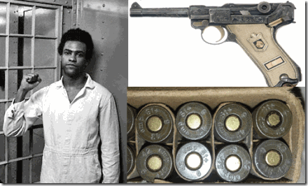
The mystery of the LUGER found at the crime scene was not made any part of Huey’s trial defense strategy. Huey’s defense lacked a forensic Criminalist that undoubtedly could have offered/educated the jury and the people about the record and the history of the gun, and its Nazi ritual and spiritual significance. A Criminalist could have traced those bullets to an agency or certain INDIVIDUAL(S) linked to America’s UNDERGROUND THIRD REICH that had the potential to blow the case wide OPEN.
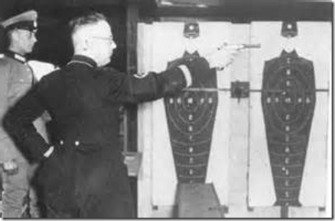
The German Luger had been Standard/RITUAL Equipment for Reichsfuhrer SS-1 Heinrich Himmler’s SS
The bottom line is that the German Luger shells were deliberated concealed from the public. It was explosive evidence tending to show a clear state conspiracy to murder Huey P. Newton with a Reichsfuhrer SS-1 Heinrich Himmler ceremonial pistol. Instead of a forensic Criminalist, Huey’s defense team brought in a renowned U.C. Berkeley expert forensic psychiatrist, Dr. Bernard L. Diamond to make contact and examine Huey to develop diminished capacity trial defense strategies. Dr. Diamond also happened to be a notorious CIA MK ULTRA hypnotist that may have even worked with the Angel of Death, Hauptsturmführer SS Dr. Josef Mengele in mind control studies.[11]
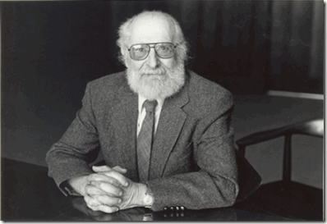
Dr. Diamond’s real mission was to hypnotize Huey– IMPLANT AMNESIA BLOCKS of the events leading up to his defeat of the Pale Horse Rider; and his ritual magical weapon, the SS/NAZI LUGER.
Dr. Diamond, Sirhan Sirhan, La Cosa Nostra & CIA
“Roselli bragged to the source, who was a made man in La Cosa Nostra, that Roselli had shot at and may have killed John Kennedy…Roselli and his men then finished the job from the sewer drain and the grassy knoll while the police and witnesses were running around like chickens with their heads cut off.” – M. Wesley Swearingen, To Kill A President, 2008.[12]
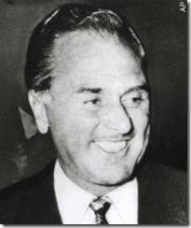
John ‘Handsome Johnny’ Roselli (a/k/a Filippo Sacco), above, was a powerful organized crime “liaison” and “strategist” who ran with the likes of Mafioso’s Sam Giancana, Meyer Lansky, Santo Trafficante, Howard Hughes, Frank Sinatra, Tony Accardo, Moe Dalitz, Richard Cain, Jack Ruby and Carlos Marcello. He also had numerous CIA buddies and acquaintances from “the Agency” including David Sanchez Morales, Tracy Barnes and William Harvey from the Mafia and CIA’s collaborative efforts to kill Fidel Castro in the years prior to the JFK assassination.[13]
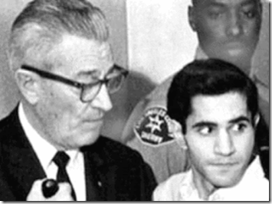
Mob Lawyer Grant Cooper & Sirhan Sirhan
In the criminal homicide trial of Sirhan Sirhan for the July 1968 Assassination of Senator Robert F. Kennedy, his lead attorney was Grant Cooper. Cooper was pretty boy John Roselli’s attorney. Most of Sirhan’s defense team were mob lawyers and shady characters connected to the mafia, police and the CIA. Sirhan’s defense team brought Dr. Bernard L. Diamond from the agency’s list of approved psychiatrists/hypnotists into the case as an expert witness to examine and hypnotize Sirhan Sirhan– send him to the gas chamber.[14] When it became crystal clear to the public that Sirhan had been subjected to a clandestine series of hypnotism, Dr. Diamond’s expert opinion was that Sirhan acted alone in the assassination of Senator Kennedy while in a self-induced trance state. Sirhan hypnotized himself.[15]
HUEY P. NEWTON‘s crooked defense team also aided and abetted the state into framing and railroading him into prison- right into the hands of the CIA- MK ULTRA mind control doctors and technicians.
Huey P. Newton, Dr. Diamond, King of the Mafia Godfathers & CIA
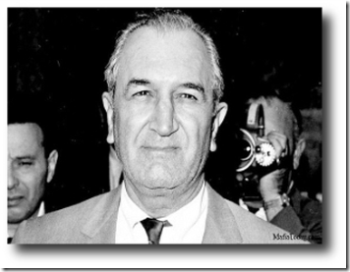
Big Joe Bonanno, King of the Mafia Godfathers
Big Joseph Charles Bonanno, Sr. (January 18, 1905 — May 11, 2002) was a Sicilian- born American Mafioso who became the boss of the Bonanno Mob Family.[16] Huey’s lead attorney Charles Garry was a mob lawyer for Big (Papa) Joe Bonanno.[17] Big Joe was one of the big five mafia dons (Godfathers) in America. He was also clandestinely connected to U.S. military intelligence Complex and the CIA.[18]
According to the Torbitt Documents, Big Joe had been a close and powerful collaborator and informer for Master Mason FBI Director J. Edgar Hoover from 1953 to 1963. Big Joe of Lionel Corporation of New York was a key operative and stockholder of the Permindex Corporation. Permindex is Murder Incorporated International, principals in the assassination of President JFK.[19] Lionel Corporation was also an internal part of America’s clandestine Military-Industrial-Congressional Complex. They did over ninety percent of their business with NASA and U.S. Army ordnance furnishing such items as electronic equipment, rocket parts, chemical warfare agents and flame throwers.[20]
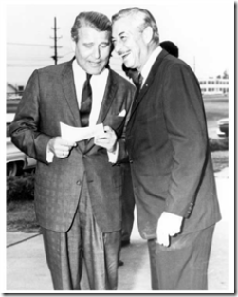
SS von Braun & General Medaris
Major General John B. Medaris, former head of the U.S. Army rocket and guided missile program, was president of Lionel. Maj. Gen. Medaris, right above, has been described as the “Patron of Wernher von Braun”.[21] That is Sturmbannführer SS Dr. Wernher von Braun, Knight of the Black Sun, of NASA. The kicker and the absolute shocking part of this entire story is that BPP Chairman Bobby Seale was associated with Himmler’s SS Peenemünde V-2 Rocket Team and SS Dr. von Braun’s GEMINI Project. This Negro also didn’t tell us about that SS/Nazi Luger. It wasn’t just an innocent omission. I hope to demonstrate that It had been DELIBERATE!
Bobby Seale Behind the Mask, False Images and ILLUSIONS
Bobby, Lucifer and the Aspen Institute for Humanist Studies
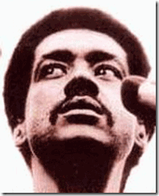
2 Corinthians 11:12-15: “But what I am doing, I will continue to do, that I may cut off opportunity from those who desire an opportunity to be regarded just as we are in the matter about which they are boasting. For such men are false apostles, deceitful workers, disguising themselves as apostles of Christ. And no wonder, for even Satan disguises himself as an angel of light. Therefore it is not surprising if his servants also disguise themselves as servants of righteousness; whose end shall be according to their deeds.”
The Aspen Institute, formerly Aspen Institute for Humanistic Studies, is an ILLUMINATI/ Cecil Rhodes Round Table globalist organization among the Council on Foreign Relations, Trilateral Commission, Bilderbergers, Royal Institute for International Affairs, Committee of 300, Club of Rome, etc. It was founded in 1950 by Walter Paepcke of the Masonic Order of the Knights of Malta.[22]
The Evil Agenda for the Establishment of World Empire, of which the Humanist Agenda is a major plank is ancient and ceaseless and those who are privy to it are the Black Adepts in the Cult of Evil who control it from the shadows through placement in the Para-governmental organizations like the Council on Foreign Relations and the Bilderbergers committee, and through the occult underground and the secret societies therein, and especially Freemasonry, that they control completely.[23]
Bobby Dancing with DEVIL
According to the Aspen Institute:
“Some of the world’s leading political figures have frequented Aspen during the past half century. Paul Nitze, Robert McNamara, Henry Catto, Prince Faisal of Saudi Arabia and former Saudi ambassador to the United States Prince Bandar bin Sultan are among those who have or have had homes here. Bill Clinton, Dianne Feinstein, Gary Hart, the Kennedy family and many other politicos are regular visitors, while numerous foreign dignitaries, heads of state and royal houses of Europe have been here to ski, socialize and connect. Jesse Jackson and John Kerry have campaigned in Aspen, and John Sununu came as a paid private speaker, as politicians frequently do for power-broker gatherings such as the annual Forstmann/Little conference …
Above and beyond all that, the Aspen Institute has been the primary attraction for such luminaries as Adlai Stevenson, Jimmy Carter, former U.S. Secretary of State Dean Rusk, BLACK PANTHER FOUNDER BOBBY SEALE, Colin Powell, Alan Greenspan, Brent Scowcroft, ZBIGNIEW BREZINSKI, John McCain, Hillary Clinton, BARACK OBAMA, and then-President GEORGE H. W. BUSH in tandem with his British counterpart, Prime Minister Margaret Thatcher, among many others. Walter Isaacson, the former managing editor of Time magazine and current head of the Institute, talked candidly with Aspen Sojourner about the political elite the Institute hosts here.”[24]
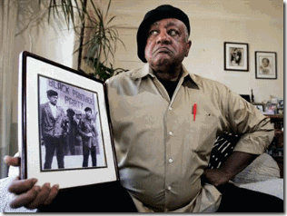
Bobby Seale is a false (artificial) light,[25] an ILLUMINARY of the Aspen Institute– the ILLUMINATI. The very name Lucifer is taken from the word light or luciferous, which means “bringing light” or “illumination.” In Satan’s case, it is a false light—one that deceives rather than illuminates the TRUTH.[26] Bobby is/has been networking with the global elite to develop false light strategies, schemes and plans to deceive the masses for a New World Order- GENOCIDE. For my own sanity, I needed to know who this ILLUMINARY of the ILLUMINATI really is. We loved Brother Bobby far more that you ever know. We had put our minds, bodies and souls into his hands.
Bobby Seale, the Face of LUCIFER- DUALITY
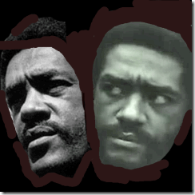
Robert George (Bobby) Seale, born October 22, 1936, Dallas, TX, was an enigma that we didn’t really understand very well.[27] He was an extremely remarkable articulate, passionate, intelligent and genius of a man that won our hearts, mind and respect. He also had to have had a photographic memory. It was amazing how Bobby could recall and cite dates, data and references by rote. He also often bragged about his remarkable ability to master any blueprint in minutes if not moments. Bobby had a diversified and defining career as a jazz drummer, and a very gifted stand-up comedian. We loved, respected and honored Brother Bobby like an older brother, uncle or family member.
He also may have been one great actor of the 1960s-1970s pulling off a masterful performance that fooled a lot of us. At the end of 1968, I soon discovered Bobby had another side in Janus- DUALITY. It wasn’t just a dual nature, but a dual personality that was contrary to the wise, courageous and loving brother that I had come to know.
Bobby had a Luciferian alter personality that was contrary to practical everything we stood for as the Vanguard of the People. Bobby claimed to be a revolutionary that loved the people while at the same time; he harbored assassins- Riders of the Pale Horse that slaughtered and attacked the people that he had manifested to love UNCONDITIONALLY.
On April 6, 1969, a young brother, 17 year old Ron Black, that had been purged from BPP in the Great Purge of January 1969 was gunned down and slaughtered in the street two doors from the Panther national headquarters on Shattuck Avenue in Berkeley by a Rider of the Pale Horse.
Bobby’s Pale Horse Riders & the Torture and Slaughter of Young Brothers & Sisters
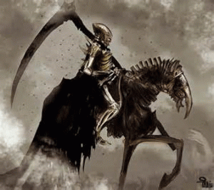On the night that Ron Black was murdered, I met briefly with purged BPP Captain Tommy Jones, his cousin Ron, above, and about two other young brothers that came through Merritt Jr. College. They were heavily armed. The substance of our conversation was that they weren’t going to be silenced, pushed around or intimidated by the BPP or its Goon Squad- Riders of the Pale Horse. They intended to defend themselves. As far as I was concerned, I was finished with the Panthers, the Black Liberation Movement had to move forward with or without them.
However, I fully understood the mindset of Tommie and the brothers. The Panthers had become part of their lives and persona. The Panthers had given them an important, special and unique individual role and badge in history. They loved the Panthers. As Black Men or Man-Childs, for the first time in their lives- the Panthers had made them men- whole, justifying and redeeming. The opportunity for them to run to fight for justice for the masses had been suddenly stripped away from them in the 1969 BPP Great Purge.
No sooner than Tommie and the brothers moved away to the rear of the campus building traveling toward Shattuck Avenue, suddenly two BPP Goon Squad- Pale Horse Riders that had been tailing them moved out into the open behind them. It was 16-17 year old (North Oakland- Humanist Hall) Ronald Stevenson (Little Stevie) and Captain Landon R. Williams.
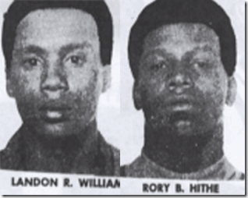
Bobby’s BPP Pale Horse Rides, Landon R. Williams & Rory B. Hithe
Within weeks of the slaying of Ron Black on April 27, 1969, Captain Landon and Hithe were in Chicago involved in the kidnapping and torture of a man and woman accused of disloyalty. The woman allegedly escaped torture from a propane torch by jumping from a third story window. In Illinois, Captain Landon and Hithe were indicted for aggravated kidnapping, burglary, aggravated battery. Both Williams and Hithe were also arrested and charged with the murder and kidnapping of a young Panther, Alexander Rackley, in New Haven, Connecticut, discussed below.
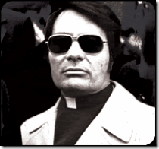
In 1973, Hithe had moved on to become an alleged “enforcer” in Jim Jones’ Peoples Temple (CIA MK ULTRA Mind Control Project). On November 8th of that year, he was gunned down and slain by Jones’ main hit man, body guard and enforcer, CHRIS LEWIS. Christopher Lewis was mysteriously slain in San Francisco on December 10, 1977. Bobby had another dangerous Pale Horse Rider that was straight out of a government mind control mental institution, George W. Sams, Jr., a certified PYSCHOPATH, LUNATIC and a possible CIA- MK ULTRA/MONARCH BLACK MANCHURIAN CANDIDATE running amok among the People. Along with Williams, Sams was one of Bobby’s BPP Field Marshals. Hithe and Sams, I never seen them before.
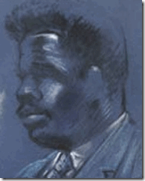
George Sams, above, had been confined at New York’s Wassaic State School for Mental Defectives. Wassaic was a notorious covert CIA- MK ULTRA/MONARCH institution under the direction of Dr. Paul H. Hoch. Dr. Hoch was the director of experimental programs for the NYSPI, who became the Commissioner for Mental Hygiene for the State of New York.
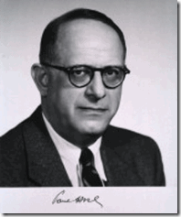
Dr. Hoch was a leading MK ULTRA psychiatrist, born in Hungary and schooled in psychiatry in GERMANY. Dr. Hoch immigrated to the U.S. in 1933 through the assistance of his attorney and future Secretary of State, John Foster Dulles. Brother of OSS- Operation PAPERCLIP and CIA Director, Allen Dulles. Dr. Hoch headed the Manhattan State Hospital Shock Therapy Unit and worked as chief medical officer for war neuroses for the U.S. Public Health Service. Dr. Hoch, along with associates Dr. Harold A. Abramson and Dr. Max Rinkel, was among an elite group of five private researchers and six U.S. Army physicians who began quietly conducting LSD experiments in the U.S. in 1949.
Along with Brother Tommy and Ron Black, I had also been purged from the BPP and publicly identified as a “counter-revolutionary”- enemy of the people. According to the BPP, I also had a price on my head for party discipline. I knew Captain Landon was a former U.S. Army Ranger out of Vietnam. Little Stevie was a very young inexperienced brother that had joined/infiltrated the BPP not too long ago. I could easily deal with Lil Stevie, but I was afraid most definitely of Captain Landon.
My chances of survival against him was nil to none at all. But, I didn’t turn and run. I sucked up my breath, prayed and continued my path toward them. I had my sturdy 9 mm automatic. With a 32 or 38 caliber, I couldn’t hit a side of a barn. But, I figured that by the time they got to their heavy 357s, I could get to my smaller and lighter weapon first and hit my target at close range. As I approached Captain Landon and Little Stevie, they suddenly cut through a campus courtyard corridor directly behind Tommie, Ron and the other brothers.
My first inclination was to try to get to Tommie and warn the brothers that the Goon Squad was behind them, but there were a lot of people on campus that I had to warn and evacuate. The Rides of the Pale Horse had taken over the night. DEATH was in the air. Those that didn’t have safe passage away from campus had to be shielded in safe defendable places on campus until daylight, or someone could safety get them home. Later that evening DEATH found its mark, Ron Black was gunned down by a Pale Horse Rider. Little Stevie was accused of the killing, and became a fugitive from justice for 11 years. Capt. Landon was never pursued, investigated or spoken of in the slaying of Ron.
Bobby primarily jacketed Brother Tommy as a FBI infiltrator, but I am not so sure. In 1969, Bobby’s words carried a lot of weight and persuasion among the people. The BPP had gunned down Tommy’s bloodline in cold blood contrary to everything the Panthers had stood for and nobody, even the OPD and FBI seemed not to give a damn about the crime and Bobby’s Assassins. Ron Black’s life didn’t seem to matter to anyone but the ones that loved him.[28]
In July 1980, fugitive from justice, Little Stevie, surrendered to OPD for criminal homicide- unlawful killing of Ron Black then the Rider of the Pale Horse immediately walked away from jail, murder, all other related charges with a scholarship to U.C. Berkeley.[29]
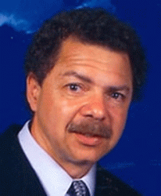
Berkeley Community Leader Ronnie Stevenson Passes Away on July 19, 2010: Ronald Harold Stevenson III, above, … community leader for over 30 years, died suddenly on the afternoon of July 19th … Stevenson was known throughout the Bay Area as an activist who led several important efforts for social justice. In 1980 he served as a district representative for the United Auto Workers (UAW) at the Ford Motor plant in Mahwa, New Jersey. He led the effort to change the name of Grove Street (in Berkeley and later Oakland) to Martin Luther King Jr Way. He also led the effort to name the ASUC Student Union and Plaza at UC Berkeley after Dr. King … Many leaders on the community have worked with him and are personal friends, Loni Hancock (Senator), Tom Bates (Mayor of Berkeley), Linda Mai (Berkeley Council Member), Pedro Noguera (Former UC Berkeley & Harvard Professor, Current at NYU), Angela Davis (Retired Prof. UC Santa Cruz and political activist), Dan Boggan (Former Vice Chancellor UC Berkeley and recently retired from Sr. V.P. NCAA), Charles Henry (Chair African-American Studies Dept UC Berkeley).[30]
Even in death, it’s difficult to celebrate Little Stevie’s life accomplishments that serve no truth, justice or mention for the Soul of Ronald Black and any other brothers and sisters that he may have harmed. It seems pretty clear that Bobby’s Pale Horse Rider, Ronald Harold Stevenson, had been an internal part of COINTELPRO and the CIA’s Project CHAOS’ covert and illegal campaign to liquidate members and destroy the BPP.
Furthermore at the time of Ron Black’s slaying, I was befuddled and mystified by Bobby’s sadistic response to the young brother’s slaying. In all my heart, I knew Bobby wouldn’t condone Ron’s murder, and brothers turning weapons against each other and the people. At an April 1969 San Francisco press conference, Bobby angrily went off at the news media justifying gunning down the young brother saying that “the pig power structure” had infiltrated the Panthers with “black renegade pig agents.”[31]
The Panther Purge of 1969 assumed the shape of a full scale U.S. intelligence (COINTELPRO) liquidation/assassination operation out of the Vietnam Aggression– the Phoenix Program. It wasn’t too soon after Ron was slain, I had two “GOON SQUAD” members with brand new 357 magnums following me around campus trying to intimidate me, and start a fire fight.
Several students and I immediately went directly to Bobby’s house just a couple of blocks from campus. We appealed to him to immediately withdraw the two armed state deputized “GOONS” from Merritt Jr. College. It was an important educational institution for the good of the people, not a damn war zone. Bobby was the decent brother that I had known. He was wise, understanding, generous and honorable. I recall that he told us that he would personally immediately remove them. The “GOONS” were withdrawn.
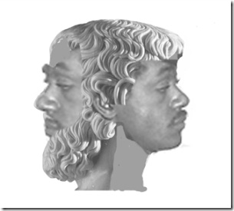
JANUS FACE of Bobby Seale
For decades, I had been in a complete state of denial about Brother Bobby. In the first instance, I just couldn’t believe that Bobby had the capacity to send Riders of the Pale Horse to kill brothers and sisters, period. That’s when I discovered that Bobby Seale was JANUS “TWO FACED”, and could no longer be trusted beyond sight. It was later that day or the following morning after he withdrew the two BPP Goons from campus that I got a personal calling card by another far more deadly set of Bobby’s Riders. A literal army of brothers led by Captain Landon Williams invaded the campus. Frightened students said that Captain Landon and a small group of brothers demanded to know my whereabouts on campus. There is no reason for me to believe that Rory B. Hithe and the MANCHURIAN CANDIDATE LUNATIC George Sams, Jr. weren’t among Bobby’s calling party.
By God’s Grace, I had been working building security on the 2nd floor looking out over the rear of the campus when I saw a large group of men scaling the back fence. They blanketed the entire campus perimeter to block any possible escape path from the side and rear of the college building and classroom portables. Also by the Grace of God, they were looking for me and didn’t harm any students or my friends. Merritt’s original building plant is semi- Gothic.
I was an active member of student government. I had a key and access to a small little known semi-secret located faculty senate board room unobservable from the 2nd floor hallway by an illusion of colors, depths, angles and shadows. To this day, I am not sure what they intended to do with me, but I wasn’t going to take an “ass whooping” or be taken anywhere by these people without bloodshed even if it had to be solely my own. I had my 9 mm.
Even in this, I had been in complete denial. My life was just as meaningless as Ron’s life. Most likely, if taken, I would have ended up tortured then shot in the head, and my body dumped in the bay. That’s the way Bobby’s Riders rolled with the license and sanction to kill from secret forces within the Shadow Government. Field Marshal Capt. Landon Williams was the one of the main enforcers of the new BPP policy that called for disciplining their so-called designated “Enemies of the People.” This brother played no games in Vietnam, on the streets of Oakland and across the nation.
Later during the late afternoon from a small window opening in my safe location, I could see Bobby enter the campus with a large contingent of brothers surrounding him. Bobby had been invited to speak on campus that afternoon on creating a Black University after Merritt moved to its new campus in the Oakland Hills. Bobby vehemently publicly denounced our vision to keep a higher educational institution in the black community. That also befuddled me. I didn’t leave the safe haven until I saw Bobby and the BPP withdraw from campus. It was almost sundown. I had a notion that Bobby intended to make an example of me to send a clear message to other Black Nationalists.
Within weeks of my close encounters with the Riders of the Pale Horse in May 1969, Chairman Bobby Seale and Capt. Landon Williams were arrested cross country and implicated as principals in the absolutely senseless torture and brutal slaying of another powerless and helpless semi-illiterate young brother, 19 year old Alex Rackley, of the infamous New Haven Connecticut Black Panther Trials.[32]
BPP member Alex had been accused of being disloyal, and a possible so called “black renegade pig agent” infiltrator. He was kidnapped, tortured, shot in the head, then dumped in a river. The prosecution contended that a number of Panthers that included Bobby and Captain Williams had been principals involved in a conspiracy to murder the young brother. Bobby’s criminal court jury deadlocked 11-1 for acquittal. Capt. Williams just walked away from jail and murder charges in the New Haven Panther Trials, and also apparently criminal charges in Chicago.[33]
Capt. Williams became a deep cover “government security specialist” and consultant that I know of for the cities of Oakland (Housing Authority) and Berkeley (Assistant to City Manager). His [former?] wife filed a public record statement alleging that he was part of the kill team of Nicole Brown Simpson and Ronald Lyle Goldman in June 1994 in the infamous O.J. Simpson Case. Of course, she was alleged to be off her rocker. Like Little Stevie, Landon Williams was given/allowed a number of KILL A PANTHER GO TO COLLEGE educational opportunities and scholarships. He is now one of the “Who’s-Who” of corporate America.[34]
The Panthers that I was a part of would have never turn their guns against the people. One of our most important policy and principle rules of professional conduct was never raise our guns against the people. Another primary principle was to “Love the People More than We Loved Ourselves.” Another primary Panthers principle and policy was “Harm Not One Hair of the People.” Bobby was there as we discussed and worked through our rules of conduct. Bobby was there when the rules of professional conduct were recorded and adopted by the membership of the Black Panther Party for Self Defense.
There was no mandate or consensus from the elders, people or society for the BPP to enter into a campaign to slaughter our young brothers even if it could be substantiated as true as Bobby asserted that any of them had been “black renegade pig agents.” Unless of course, it was all part of the FBI’s COINTELPRO and CIA’s CHAOS Project clandestine and ILLEGAL/EXTRA JUDICIAL and LETHAL plans to destroy the Panthers; and break the will and spirit of the people to STRUGGLE.
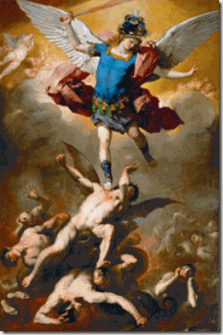
This rebellion is ancient and enduring and mankind is crucial to their revolt against God and the battle raging on this Earth is part of this great rebellion. The Humanist Agenda is the wicked and evil programme organized by powerful forces inimical to Divine Moral Order whereby men are subtly led away from knowledge of God and are encouraged to become their own “GOD” in their own personal moral universe.[35]
Bobby, Humanism & Luciferism- “Ye Shall be as GODS”
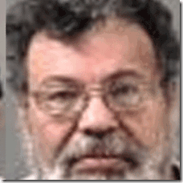
“I’m utterly appalled, I’m mortified,” he said of being arrested on suspicion of the murder of Berkeley‘s First Asian Police Officer. “I wasn’t raised that way. I was raised a HUMANIST.”-Styles Frederick Price [36] One of the main suspects along with Don Juan Warren Graphenreed arrested in the April 1970 assassination of Berkeley Police Officer Ronald Tsukamoto, Styles Price, above, told me that Bobby’s assassin, Little Stevie, was related to him as a nephew or first cousin. The Riders of the Pale Horse– Graphenreed (Stan), Price and Little Stevie were all assassins related family members. They came out of a special counter-intelligence operation unit ran out of the Humanist [Luciferian] Hall on 27th Street in North Oakland.
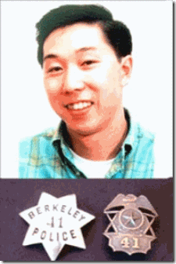
Just as in the case with Little Stevie, the Alameda County District Attorney mafia refused to press criminal homicide charges against Graphenreed and Price.[37] Ronald Tsukamoto’s assassination was a clandestine CIA counterintelligence operation designed to discredit the Black Power Liberation Movement– divide the Blacks and Asian masses united in opposition to the Vietnam Aggression and Racism.
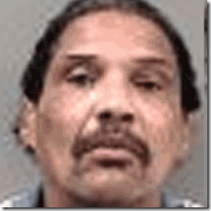
During the late 1960s and early 70s, I knew both Price and Graphenreed. I called Graphenreed, Brother Stan. Stan seemed to had held me in some high regard. Stan and I often talked heart to heart. He seemed to have been a very decent brother. Stan couldn’t talk about too much about what he was involved in, but I knew his associates, the Mark Comfort Group, were very secretive. They often crossed back and forth between Cuba and the U.S. I also found out that they did security assignments. I was very surprised when they covered security in Washington DC for Dr. Martin Luther King’s National Poor People’s Campaign “Resurrection City” in May 1968. However, Styles Price loved to talk only about himself. It was Stan’s confession that broke the Ronald Tsukamoto Assassination Case Wide Open in 2005.To bring justice to Ronald Tsukamoto, there must be a special independent prosecutor and investigating team assigned to the case. In alternative, proceed with a public trial similar to the 1993 HBO Special People vs. James Earl Ray for the alleged assassination of Dr. Martin Luther King, Jr.[38]
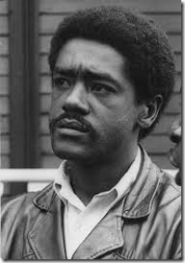
Like Little Stevie, Graphenreed, and Price, Bobby was also a HUMANIST– Divine Law Personified. Sometime in 1969, he had been secretly ordained as a HUMANIST HIGH PRIEST. In 1974, he founded the SON OF MAN [Luciferian] TEMPLE in East Oakland. By the Grace of God, it didn’t last long.[39] Humanism begins with the claim that God became human so that humanity could regain its god-likeness, “the ‘Son of God‘ [Jesus] became the SON OF MAN, so as to make the sons of men into “Sons of God.”[40] Humanism is difficult to define and describe. It is something out of Medieval Europe. However, the Aspen Institute and secret initiatic societies like Freemasonry and ILLUMINATI promote liberal Humanism as a new “rationalist” religion for a New World Order.[41] Yet, Humanism can also be described as Luciferianism. All of the governing precepts of Luciferianism are encompassed by Secular Humanism. Humanism rejects theistic morality and enthrones man as his own absolute moral authority. While Luciferianism has no sacred texts, Humanist Manifesto I and II succinctly delineates its central tenets. Whittaker Chambers, former member of the communist underground in America, eloquently summarizes this truth: “Humanism is not new. It is, in fact, man’s second oldest faith. Its promise was whispered in the first days of Creation under the Tree of the knowledge of Good and Evil:
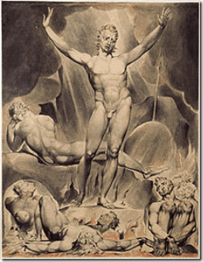
‘YE SHALL BE AS GODS.’” (Qutd. in Baker 206)[42]
Bobby Seale, Operation PAPERCLIP & Himmler’s SS V-2 Peenemünde Rocket Team

Sturmbannführer SS Wernher von Braun, Pride of Himmler’s SS Peenemünde Rocket Team
Operation Paperclip (originally Operation Overcast) (1949–1990) was the Office of Strategic Services (OSS) clandestine and illegal program conducted by the Joint Intelligence Objectives Agency (JIOA) in which over hardcore 1,500 SS/Nazi scientists, technicians, and engineers from Germany and other foreign countries were smuggled into the United States for employment.[43] Most of Reichsfuhrer SS-1 Henrich Himmler’s SS V-2 Peenemünde Rocket Team had been clandestinely smuggled into the U.S. through Operation Paperclip.[44]
Early, Brother Bobby often told us about the curious part of his life in the “pig power structure”, the U.S. Air Force (USAF). There were a number of beautiful brothers in the Panthers and part of the Black Liberation Movement that served in the U.S. Military that demonstrated Undying Love for the People. However, Bobby’s change from loving the people to the senseless slaughter of powerless young brothers and sisters was a 360′ turn that would only mean that either he had gone insane, an actor, a controlled CIA- MKULTRA Manchurian Candidate, or he was U.S. military intelligence from the very beginning.
Bobby joined the military in 1955 after dropping out of Oakland or Berkeley High School or graduating. He told us that he had been dishonorably discharged after an altercation with a superior officer in 1960. Bobby was accepted into the U.S. Air Force and sent to Amarillo, Texas, for training as an aircraft sheet-metal mechanic. Sheet metal mechanics, also known as sheet metal workers, fabricate, install and maintain ductwork and other metal parts. They install air conditioning/heating system ductwork and outdoor signs, repair metal parts on vehicles and install metal roofs. Sheet metal mechanics also work in manufacturing plants to mass produce sheet metal products.[45]
After training for six months, he graduated as an honor student from the Technical School Class of Air Force Training. He was then sent to Ellsworth Air Force Base in Rapid City, South Dakota, where he served for three and a half years and was discharged as a corporal.
“I come up in the high-tech world. Before I ever got involved with this stuff, I was working on the GEMINI MISSILE PROJECT in the engineering department at … [Kaiser] aerospace and electronics. I was doing electromagnetic field, black light, non-destruct testing for all the engine frames for the Gemini missile program. For all three stages of exhaust housing for the Gemini missile program. I went to college originally as an engineering design major, and when I went to college, remember this is AFTER the four years in the United States Air Force, structural repair, high-performance aircraft for the USAF…” [46]

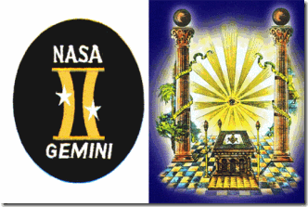
When NASA designed the Gemini Project Masonic Symbol, they bowed the twin pillars (BOAZ and JACHIN) of the astrological glyph inward. This bowing suggests the hourglass and wormhole and lends support to the interpretation of the two stars as angels transiting the Silver Gate.[47] The SS is an order of the Templar Crusaders– Order of the Knights of the Hospital of St. Mary of the Teutons [Germans] in Jerusalem. In general, Freemasons practice the hierarchical Templar degrees with knights standing at the top of their orders.[48] SS secrecy is often heavily protected by layers of subservient Blood Oath Secret Masons. It stands to reason that the classified SS Gemini Project could naturally have various layers of security protected by levels of Masons.
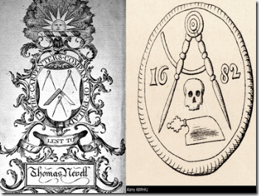
CARPENTRY is a Masonry Degree
Bobby is not known to be publicly connected to the Masons. Nonetheless, he is a fellow “Craftsman” shrouded in the world of blood oath secrecy. He is known as the “Son of a Carpenter.” In fact, Bobby often called himself, a “Carpenter.”[49] Bobby’s grandfather had also been a Carpenter. In fact, his grandfather was named ARCH Seale.[50] There are Masons, Mechanics and Carpenters, these are the first three degrees of Ancient Masonry.[51]
Bobby worked directly for Himmler’s SS Peenemünde V-2 Rocket Team doing classified specialized electromagnet field testing of their Gemini Rocket engine frames. While in the USAF, he most likely probably worked indirectly for the SS at Ellsworth USAF Base on their V-2 grandchild, the Titan ICBM System.
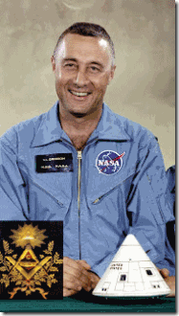
Himmler’s SS Peenemünde Group had to be one of Lucifer’s most secretive, racist, sinister and most vicious servants on the planet- all on the U.S. government’s payroll. The SS NASA Gemini Space Project was shrouded in secrecy, Masonic/Satanic Symbolism and the clandestine plans of the SS (Knights of the Black Sun) that involved CIA- MK ULTRA; and the assassination of USAF LIEUTENANT COLONEL VIRGIL GUS GRISSOM, above, and astronauts Ed White and Roger Chaffee.[52]
Grissom and the other astronauts were killed by an by an arc of electro-magnetic electricity in the pure oxygen atmosphere of the sealed capsule of Apollo 1 destroyed the capsule and incinerated all three astronauts.[53] Yes, exactly in Bobby’s expertise in the NASA Gemini Project– electromagnetic fields and steel frames. Lt. Col. Gus Grissom was a 33 degree Master Mason of the Mitchell Lodge No. 228, Indiana.[54] Grissom had been one of the original NASA Mercury 7. He was also instrumental of the design of Gemini and flew Gemini 3.[55] Lt. Col. Gus Grissom had began to talk too much doubting the feasibility, possibility and ILLUSIONS surrounding SS von Braun’s proposed Moon Mission to race ahead of the Russians in the “Race to Space.”[56] SS von Braun’s Moon Mission was a total SHAM and a fraud upon the American people.[57]

Barrack Obama & Grandfather or Lt. Col. Gus Grissom?
The US/SS Moon Mission Hoax would only be realized and achieved through mass population deception and hypnotism. Gus Grissom and SS von Braun’s Moon Mission was deeply imbedded in the clandestine mind control CIA- MK ULTRA/MONARCH Project.[58] Grissom had been part of NASA’s Masonic layer of ultra security and secrecy. NASA and SS von Braun’s involvement in MK ULTRA was so intensive and clandestine that it involved shaping the future of America through implanting sleeper mind controlled operatives and Manchurian Candidates in the highest governmental offices of America that included implanting NASA’s STAR KID Hussein Barrack Obama into the White House.[59]
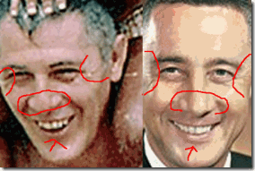
The man with Obama on the beach has a distinctive shovel shaped nose, eye skin markings, similar shaped mouth, lips and teeth as Lt. Col. Gus Grissom. Whereas, Obama’s maternal grandfather’s face, Stanley Armour Dunham, below, does not close to match the man on the beach. He does not have a distinctive shovel shaped nose, eye skin signatures nor a similar shaped mouth or lips. Dunham’s mouth is indeed smaller than the man on the beach. It appears that he can not force a smile similar to the man on the beach or Lt. Col. Gus Grissom.
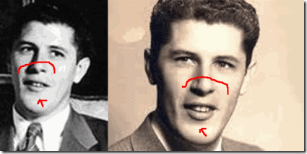
Excuse my expression, but the SHIT is deep, and Bobby Seale has been “rabbit holed” and sheep dipped right in the middle of all of it.
THE MOON LANDING HOAX, Sturmbannführer SS von Braun & SS
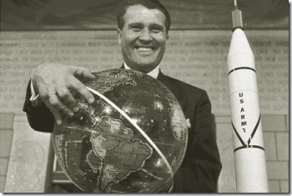
“Oh yes, we shall go to the moon, but of course I dare not tell Hitler yet!” –SS Wernher von Braun[60]
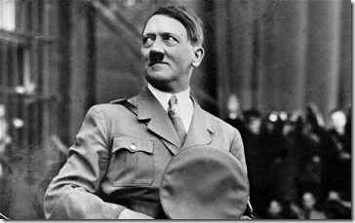
SS von Braun and NASA’s 1969 Moon Landing was a HOAX. It was a grand deception pulled off by some of the world’s greatest “JANUS” faced ILLUSIONISTS on the planet- Lucifer’s Servants, the THIRD REICH. The Lunar Moon Landing was a grand design to fleece America of its treasury, sovereignty, and its power; and SS von Braun, Hitler and Himmler laughed and rubbed it in the country’s face. Contrary to what you have been indoctrinated, neither Hitler or Himmler died at the end of WWII.
In the military, Bobby had to had been a military physicist or a highly educated and trained military electric/chemical engineer with Department of Defense Top Secret clearances. From the military, he said that he went to work for Kaiser Aerospace & Electrical, Inc. on Sturmbannführer SS Wernher von Braun’s NASA classified Gemini Space Project (1962-1966).[61] In 1959, President Dwight D. Eisenhower signed an executive order that transferred Sturmbannführer SS von Braun and his team from the U.S. Army to the National Aeronautics and Space Administration (NASA).[62] Gemini had been a Nazi/SS space project led by SS von Braun.[63]
How do go from a dishonorable discharged U.S. Air Force Sheet Metal Mechanic to Sturmbannführer SS von Braun’s highly classified Gemini Space/Missile Project? YOU DON’T! Cutting, bending and shaping sheet metal will not quality you to get a job in a highly classified military intelligence operation like the Gemini Project, “doing electromagnetic field, black light, non-destruct testing for all the engine frames for the Gemini missile program.”
Major James P. Hamill, the SS Peenemünde Rocket Group’s military handler in Operation Overcast and beyond, said of von Braun’s rocket tunnel-vision: “That guy … wants to go to the moon. That’s his passion- interplanetary travel.”[64] “The trip to the moon would consist of a three-phased manned building block program. First, the Mercury Program to show that man could indeed go into space and return. Next, the Gemini Program to master the techniques of rendezvous, docking, and leaving the spacecraft while still in space. And finally, the Apollo Program to land men on the moon, carry out limited exploration, and return them safely to earth.”[65]
The USAF and Army had completing ICBM (Intercontinental Ballistic Missile System) programs. The USAF program was headed by German born Brigadier General Bernard Schniever and the Army program by Sturmbannführer SS von Braun. Titan was a family of expendable rockets used between 1959 and 2005. A total of 368 rockets of this family were launched, including all the PROJECT GEMINI manned flights of the mid-1960s. Titans were part of the American intercontinental ballistic missile deterrent until the late 1980s.[66]
The Titan program began development in 1955 as a back up option in case the Atlas program failed. It become the second ICBM deployed by the USAF.[67] The Titan I became operational and fully functional at Ellsworth Air Force Base in 1962 about two years after Bobby left the base.[68] However, I think it is safe to assume that Bobby had some role in the early development, planning and installation of Titan I launch pad(s) or the rockets at Ellsworth AFB and that work served as specialized space craft qualifying experience and DoD top secret security clearances to get an engineering job at Kaiser (German) Aerospace and Electrical to work on NASA’s classified Gemini Project.
In Conclusion
For me, it has seemed like a thousand years that Bobby and BPP have been like an enigma wrapped inside a puzzle. I suffered post traumatic stress from being under the constant threat of death, imprisonment, assassination from law enforcement and military intelligence to MK ULTRA/MONARCH lunatics released from prisons and mental institutions and BPP Goon Squads sent on missions to liquidate us. Imagined or not, the stress severely affected me for at several decades. I was caught in the middle of a classic DOUBLE BIND– insanity without disease.
“Off the Pig”
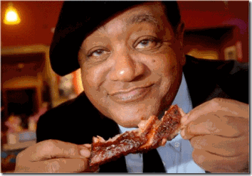
I was so close to the Panthers that pictures of Bobby eating PIG was often images and symbols that added to my mental pain, anguish and bewilderment. It was Bobby that developed and created the Panther “Anti-Pig” campaign and rhetoric to represent the imperialistic racialist power structure. His “Anti-Pig” campaign and slogans were based on the Black Muslim concept that the PIG was an unclean and offensive animal unfit for human consumption.
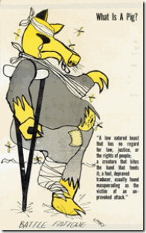
Yet, Bobby Seale not only eats PIG, but seems to enjoy laughing in the face of the masses that he relish in the PIG (New World Order). It is a clear symbol of extreme contradiction and a prime example of the Nazi Satanic Principle– Dualism.
When I used to run into him on the Oakland streets, I was always confused- should I as a general member of the public continue to honor him for loving the people so much to found the BPP with Brother Huey, or should I attack him for turning guns against the people. But as usual, my response to whatever Bobby said was, “yea, okay, goodbye.”
The existence and mechanics of MK ULTRA/MONARCH had been totally unknown and alien. I had been befuddled and dumbfounded about the original self that makes a conscious decision between right and wrong, and Multiple Personality Disorders (MPD) that involves a person (original self) covertly possessing entirely alternative and different personalities (different people) that literally lineup to switch places with the original self pursuant to triggers, keys and codes. It is known as MPD and Dissociative Identity Disorders (DID). For decades, I couldn’t tell the difference between MPD, DID and a corrupted or evil original self.
MPD and DID are by the most part created IATROGENICALLY– medically induced (See Colin A. Ross’ Bluebird- Deliberate Creation of Multiple Personality by Psychiatrists, Manitou Communications, Inc. (2000), Chapter 23).
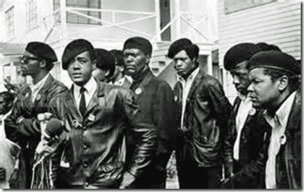
I always considered Bobby to have been a very courageous, moral and caring brother. He was the symbolic Good PANTHER that often told us to have “Undying Love for the People.” As a symbolic Good PANTHER, one of the our most imperative rules of professional conduct was, do not raise your gun against the people. At the same time, Bobby was symbolic of the Satanic ANTI-PANTHER – slaughtering, kidnapping and torturing the people that the symbolic Good PANTHER possessed to love- the opposite of Undying Love for the People.
The Brother Bobby, the symbolic Good PANTHER, that we had grown to know was honored as Just, Balanced, Fair and Wise far beyond any of us. That’s why the people loved him so. The Bobby, symbolic Satanic ANTI-PANTHER that had rallied and condoned the kidnapping, torture, and slaughter of powerless young brothers and sisters was opposite of the beloved revolutionary BPP Chairman. There existed Bobby(s) that was/were entirely different, distinct personality(ies) and person(s) from the Bobby original self.
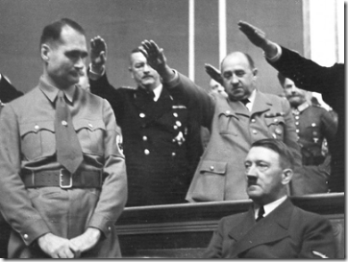
At a mass meeting in 1934, Nazi Deputy Party Leader Rudolf Hess stated, “National Socialism (Nazism) is nothing but applied biology.” The bottom line is Nazism always clandestinely involve “RACE.” Fervent Nazis like SS von Braun and Himmler’s Peenemünde Rocket Team secreted into United States after WWII had to have been some of the most Satanic, treacherous, murderous and fanatic RACIALIST of the 20th Century.
NASA & CIA MK ULTRA
Leroy Gordon “Gordo” Cooper, Jr. (March 6, 1927 – October 4, 2004), Colonel USAF, better known as Gordon Cooper, was an aerospace engineer. Cooper was a member of Scottish Rite, York Rite Masons, Shriners, Rotary Club, Order of Daedalians, CONFEDERATE AIR FORCE. He was a Master Mason (member of Carbondale Lodge # 82 in Carbondale, Colorado), and was given the honorary 33rd Degree by the Scottish Rite Masonic Body.
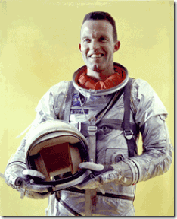
On April 9, 1959, SS von Braun introduced Cooper and Gus Grissom among Mercury Seven, America’s first astronauts. Both had been principals and aerospace engineers in the design, testing and development of the Gemini Project along with Bobby. In 2000, Cooper revealed in a radio interview that NASA had been principals in clandestine CIA/MK ULTRA mind control projects since the 1950s and 1960s. The Nazi SS (Dr. Josef Mengele) was the world’s most foremost authorities on trauma based mind control methodologies splitting off alternative personalities from the original self– creating iatrogenic MPD and DIDs.
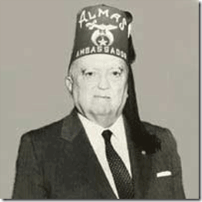
33rd Degree Master Mason and Shriner FBI Director, Edgar J. Hoover, was in charge of NASA’s Security Division and the Defense Industrial Security Command in his position as head of counter-espionage activities in the U.S. His agents investigated and cleared every employee of the space agency as well as the employees (Bobby Seale) of the pertinent contractors doing business with NASA. Bobby, being among only a handful of blacks involved in the aerospace industry controlled by the NAZI SS, undoubtedly at some point had been subjected to secret CIA MK ULTRA/MONARCH mind control and counter-intelligence RACIAL PROGRAM operations in the USAF or while working for Kaiser (German) Aerospace and Electronics on Knight of the Black Sun SS von Braun’s NASA Gemini Project under the jurisdiction and the All-Seeing Eye of Knight of Malta, Edgar J. Hoover- that’s the way they roll. RACE always play a clandestine FACTOR in whatever the Nazi/SS is involved in.
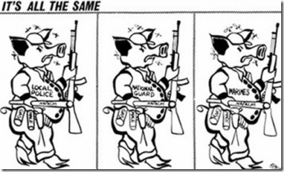
While Bobby served his Satanic masters in “the pig power structure,” he was no “revolutionary”, he had been an ordinary obedient “House Negro.” It’s all been there for decades and I failed to see it, ask questions and even talk about it. Finally, the NAZI/SS LUGER should have been a game changer not only in Huey’s Criminal Murder Trial, it was also a potential game changer with NASA’s Moon Project, and the clandestine UNDERGROUND THIRD REICH in America.
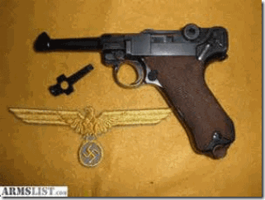
In 1967, I believe that it is safe to say that the American public did not know the details about the Nazi/SS background of SS von Braun and NASA’s key controlling employees. The public did not know that Reichsfuhrer SS-1 Heinrich Himmler’s Third Reich SS Peenemunde Rocket Team had been covertly smuggled into U.S. and put on taxpayer’s payroll. Operation PAPERCLIP was still TOP SECRET.
On January 27, 1967, Lt. Col. Gus Grissom and two other NASA astronauts were assassinated in a rigged/staged electromagnetic fire on an Apollo pre-launch pad. The fire and subsequent investigation nearly destroyed NASA, and SS von Braun’s Apollo Space Project came dangerously close to cancellation involving the potential lost of billions of dollars. A thorough investigation into Grissom’s complaints about NASA’s Lunar Project threatened to expose massive fraud and corruption linked to the Underground Third Reich.
On October 27, 1967, a Nazi/SS Luger was involved in the attempted assassination of Huey P. Newton. Huey’s triumph over the assassin with a symbolic German Luger would have propelled him into world spotlight as an international HERO instead of criminal defendant. The German Luger also threatened to expose the clandestine domestic criminal operations of the Underground Third Reich in America.
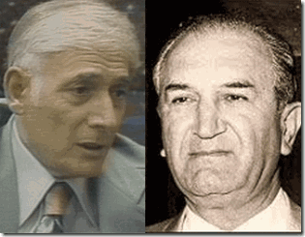
Huey’s defense lawyer, Charles Garry, was linked as a corrupt “lapdog” of Mafia Godfather, Big Joe Bonanno. Big Joe was directly linked as an operative of FBI Director and Master Mason, Edgar J. Hoover (COINTELPRO). Hoover was directly linked to SS von Braun and NASA. Big Joe’s Lionel Corporation was a primary DoD contractor linked directly as a key patron of SS von Braun and NASA. BPP Chairman Bobby Seale, literally in charge of Huey’s Defense Fund, was/is a former NASA contractor employee directly linked to FBI Director Hoover’s classified security clearances, Lt. Col. Gus Grissom, SS von Braun and Himmler’s Third Reich SS Peenemunde Rocket Team GEMINI Space Project.
The Huey P. Newton Case was not only explosive because it involved a cop killing by an internationally renown Black revolutionary figure. It was also explosive because it threatened to blow the cover off the existence of the UNDERGROUND SS & THIRD REICH in America. It explains why a top level cleared CIA/MK ULTRA psychiatrist and hypnotist, Dr. Bernard Diamond, had to immediately move into the Huey P. Newton Case as part of a CIA/SS clean-up team. That also leads me to believe that Bobby Seale had also been implanted with “amnesia blocks” in regards to the NAZI/SS LUGER and much more. At this level of the game, little is left to chance, especially to a NEGRO.
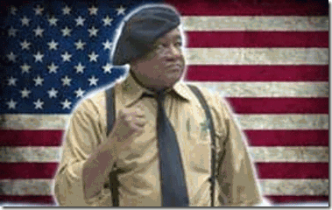
I suspect that the Aspen Institute’s NWO Elite Satanic Cabal intend to use Bobby Seale as a primary mass population “black disinformation specialist.” Bobby calls himself a “Revolutionary Humanist” decoded as a “WHORE OF LUCIFER.”

[1] http://m.motherjones.com/politics/2014/11/here-are-transcripts-and-audio-darren-wilsons-grand-jury-hearing#document/p225/a189356
[2] http://dictionary.reference.com/browse/pierce
[3] http://en.wikipedia.org/wiki/Mel_Gibson_filmography
[4] http://www.musictimes.com/articles/35327/20150412/geraldo-rivera-michael-slager-never-convicted-murdering-walter-scott-fox-news.htm
[5] http://www.huffingtonpost.com/2015/04/10/walter-scott-child-support-_n_7036174.html
[6] http://www.theforbiddenknowledge.com/hardtruth/illuminati_reduce_population.htm
[7] https://m.facebook.com/BruceLee
[8] http://en.wikipedia.org/wiki/People_v._Newton
[9] http://www.afte.org/forum/smf1/index.php?topic=9053.0
[10] http://law.justia.com/cases/california/court-of-appeal/3d/8/359.html
[11] http://www.bibliotecapleyades.net/sociopolitica/esp_sociopol_mindcon02.htm
[12] https://jfkplayersandwitnesses.wordpress.com/2013/11/12/johnny-roselli-the-jfk-shooter-in-the-storm-drain/
[13] https://jfkplayersandwitnesses.wordpress.com/2013/11/12/johnny-roselli-the-jfk-shooter-in-the-storm-drain/
[14] http://www.ctka.net/pr598-rfk.html
[15] http://www.ctka.net/pr598-rfk.html
[16] http://en.wikipedia.org/wiki/Joseph_Bonanno
[17] Kienholz, M, Police Files: The Spokane Experience- 1853-1995, Millwood Publishing Co, (1999), pg. 154
[18] http://en.wikipedia.org/wiki/Five_Families
[19] http://www.whale.to/b/torbitt.html
[20] http://www.whale.to/b/torbitt.html
[21] https://deeppoliticsforum.com/forums/showthread.php?7229-PERMINDEX/page2
[22] https://aftermathnews.wordpress.com/2007/10/01/blackwater-knights-of-malta-in-iraq/
[23] http://www.overlordsofchaos.com/html/humanist_agenda.html
[24] http://www.aspensojourner.com/Aspen-Sojourner/Midsummer-2008/Aspens-National-Pulpit/
[25] http://dictionary.reference.com/browse/luminaries
[26] http://www.ltw.org/web/guest/read/my-devotional/-/blogs/false-lig-1
[27] http://www.britannica.com/EBchecked/topic/530908/Bobby-Seale
[28] http://www.assatashakur.org/forum/breaking-down-understanding-our-enemies/5816-disrupt-dis-credit-destroy-f-b-i-secret-war-against-black-panther-party.html
[29]https://news.google.com/newspapers?nid=1350&dat=19800714&id=ARRPAAAAIBAJ&sjid=owIEAAAAIBAJ&pg=5983,6808753&hl=en
[30] http://www.itsabouttimebpp.com/Memorials/htm/Ex-Black_Panther_Ronald_Stevenson_Passes.htm
[31] Jet, April 24, 1969, Seale Charges Spy Agents Infiltrating Panthers, pg. 8
[32] http://en.wikipedia.org/wiki/New_Haven_Black_Panther_trials
[33] Id.
[34] http://www.zoominfo.com/p/Landon-Williams/2730987
[35] http://www.overlordsofchaos.com/html/humanist_agenda.html
[36] http://www.sfgate.com/bayarea/article/BERKELEY-1970-killing-still-haunts-Berkeley-2616535.php
[37] http://www.sfgate.com/bayarea/article/BERKELEY-Retired-officer-works-old-cases-to-2589566.php
[38] http://www.ctka.net/pr197-ray.html
[39] http://www.negroartist.com/writings/BLACK%20PANTHER%20NEWSPAPERS/10%20no%209.htm
[40] Mele, Domenec, Humanism in Economics and Business: Perspectives of Catholic Social Tradition, Springer Dordrecht Heidelberg, Germany (2015), pg. 60
[41] http://www.counter-currents.com/2010/09/aleister-crowley-as-political-theorist-part-1/
[42] http://www.conspiracyarchive.com/2014/05/14/luciferianism-the-religion-of-apotheosis/
[43] http://en.wikipedia.org/wiki/Operation_Paperclip
[44] http://en.wikipedia.org/wiki/List_of_German_rocket_scientists_in_the_United_States
[45] http://www.ehow.com/about_6698991_job-description-sheet-metal-mechanic.html
[46] http://arthurmag.com/2010/07/27/listening-to-bobby-seale-1999/
[47]http://theopenscroll.blogspot.com/2013/11/part-22-celestial-stargates-hourglass.html
[48] http://www.mt.net/~watcher/templars.html
[49] http://articles.latimes.com/1995-02-23/local/me-35350_1_black-panthers
[50] http://www.wargs.com/other/seale.html
[51] http://www.ancientorderoffreeasiatics.com/FreeMasonry.html
[52]
[53] http://www.datamanos2.com/apollo1/grissom-media.html
[54] http://www.matawanlodge.org/famous.htm
[55] http://imaginativeworlds.com/forum/showthread.php?9657-Apollo-1-Fire-NASA-Lied
[56] http://www.godlikeproductions.com/forum1/message1839611/pg1
[57] http://www.atlanteanconspiracy.com/2008/06/masonic-moon-landing-hoax.html
[58] http://www.bibliotecapleyades.net/vida_alien/starkids/starkids16.htm
[59] http://secretsun.blogspot.com/2009/01/barack-obama-and-masonic-martyr-part-ii.html
[60] http://www.nationalaviation.org/von-braun-wernher/
[61] http://nssdc.gsfc.nasa.gov/planetary/gemini.html
[62] http://www.history.com/this-day-in-history/von-braun-moves-to-nasa
[63] http://www.thespacereview.com/article/656/1
[64] https://www.wpi.edu/Pubs/E-project/Available/E-project-121811-161339/unrestricted/von_Braun_IQP_12_20_2011_bw_final.pdf
[65] http://history.msfc.nasa.gov/mercury/moontrp.html
[66] http://en.wikipedia.org/wiki/Titan_%28rocket_family%29
[67] http://www.nps.gov/mimi/learn/historyculture/titan-icbm.htm
[68] http://www.globalsecurity.org/wmd/facility/ellsworth.htm
[69] http://www.afte.org/forum/smf1/index.php?topic=9053.0
[70] http://law.justia.com/cases/california/court-of-appeal/3d/8/359.html
[71] https://unveiling33.wordpress.com/tag/cosmic-year-of-pisces/
[72] http://www.mt.net/~watcher/illuminated.html
Comments : 1 Comment
Tags: Adolf Hitler, alex rackley, aspen institute, barack hussein obama, Black Panther Party for Self Defense, bobby seale, bruce lee, caliban, charles garry, chris lewis, CIA, confederacy, darren wilson, demonology, Don Juan Warren Graphenreed, Dr. Bernard L. Diamond, dr. paul h. hoch, ellsworth air force base, freemasons, gemini project, general john b. medaris, george sams, german luger, goon squad, grant cooper, great purge of 1969, gus grissom, Heinrich Himmler, herbert heanes, Huey P. Newton, humanism, humanist hall, Iggy Azalea, Illuminati, Jim Jones, john frey, Johnny roselli, Jonestown, josef mengele, joseph bonanno, juan graphenreed, jusin bieber, kanye west, kkk, landon b. williams, LeRoy Gordon Cooper, luciferian brotherhood, luciferians, manchurian candidates, mason, mel gibson, Merritt Junior College, michael brown, michael slager, MK-ULTRA, moon landing hoax, NASA, new haven, operation paperclip, peenemunde, psychological warfare, riders of the pale horse, ronald black, ronald steveson, ronald tsukamoto, rory hithe, Satanic Global High Cabal, Satanism, Sirhan Sirhan, slavery, stanley armour dunham, styles price, titan missile, tommy jones, walter scott, Wassaic State School for Mental Defectives, Wernher von Braun
Categories : 1000 Year Reich, African Liberation, African slavery, allen dulles, Aspen institute, black christianity, Black Manchurian Candidates, Black Panther Party for Self Defense, blood covenants, blood oaths, christianity, CIA, COINTELPRO, Conspiracy Theory, devil, Dr. Aldous Huxley, Eye of Horus, Eyes Wide Shut, false prophet, false prophets, fbi, genocide, Hauptsturmfuhrer SS Dr. Josef Mengele, Heinrich Himmler, Hip Hop, huey p. newton, human sacifrice, illuminati, john foster dulles, jonestown, Josef Mengele, Kanye Omari West, Kanye West, Knight of Malta, Knights Hospitaller, Knights of the Black Sun, Knights Templar, ku klux klan, lucifer's servants, luciferians, manchurian candidates, Martin Luther King, masonic sacrifice, mind control, MK-ULTRA, monarch program, MPD, Nazis, new world order, nwo, oakland, oakland police department, opd, Operation PAPERCLIP, panther squad, Peenemunde Missile Base, peoples temple, post amnesia barriers, post hypnotic suggestions, psychological warfare campaign against Christianity, racial mass murder, Reichsfurhrer SS-1 Heinrich Himmler, Satanic Global High Cabal, Satanism, Schutzsteffel, sirhan sirhan, sleeper agents, STAR GATE, Star Kids, Strumbannfuhrer SS Dr. Wernher von Braun, trauma-based mind control, underground reich, underground third reich, Untermensch, vietnam, Virgil Grissom, Zbigniew Brzezinski

PART II, RIDING THE GOAT- BOBBIE KRISTINA, NICK GORDON, BEYONCE, JAY Z & THE BLACK MUSIC INDUSTRY
23032015
Riding the GOAT, the Black Music Entertainment Industry
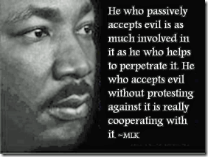
“The devil, the originator of sorrowful anxieties and restless troubles, flees before the sound of music almost as much as before the Word of God… Music is a gift and grace of God, not an invention of men. Thus it drives out the devil and makes people cheerful. Then one forgets all wrath, impurity, and other devices.” – Martin Luther (1483 – 1546)[5]
They have known for generations that music is a highway to the soul. Black Music was universal, spiritual, healing and a key to the universe and peace. In the darkest hours, our music brought light to our hearts and lessen the heavy burdens over the roads. For generations to the eyes of the world, whether in the form of Spirituals, Blues, Jazz, Gospels, Rhythm and Blues, Poetic Rap, it humanized the Black Experience.
Now, it is turning into an avenue for SATAN. It is be filled with EVIL, inclinations and spells to ENSLAVE the masses. In Old Europe, they often called on and appealed to SATAN for Power, Wealth and Fortune through secret Roman Catholic Satanic Human Blood Sacrifice Rituals. These ancient Black Mass/Satanic Cults of the Blood Sacrifice have continued underground throughout the generations. In the late 20th Century, these Satanic Blood Oath Secrecy Syndicates have moved in to control the illegal drug industry, and now seek the total takeover of the Black Entertainment and Music Industry to dedicate it to Chaos and glorify the Goat God. It isn’t any coincidence that one of the Black Music Industry’s biggest proponent of riding the Goat God, the BAPHOMET (discussed below), is Beyonce.
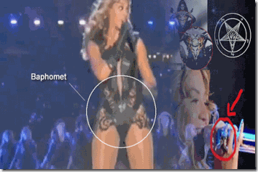
It is not just the Jesuits as some would argue. It is much more deeper. The satanic murder cults among European royalty, nobility and the Knights Templar preceded the formations of the Jesuits in 1531.[1] It is certain because Knights Templar, French Nobleman Gilles de Montmorency-Laval aka Baron Giles de Rais, the lord of 15 princely domains and Duke of Brittany (England), was executed for secret Roman Catholic Black Mass Blood Sacrifices on October 26, 1440, almost a hundred years before the Jesuits were formed.[2]
“Henriet and Poitou told tales of how he delighted in bathing in the boys’ blood and cutting off their heads himself so that he could wash his face and beard in the gore. They said he often had his servants stab a boy in the jugular so he could shower in the spurting blood. He sat on their chests and cut across part of their throats so they bled slowly to death. Others he hanged until they were nearly dead and then cut their throats. Still others had all their limbs cut off, or were ripped open so he could see their hearts and entrails. After death, all the bodies and their clothes were burned in the castle’s great kitchen furnaces. The servants spoke of obscene torture and blood-splattered walls in each of his castles. When Gilles returned to the court, dressed from head to toe in white to indicate his repentance.”
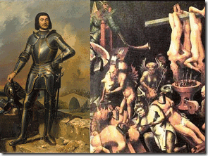
The precise number of Baron Gilles Roman Catholic Coven victims is not known, as most of the bodies were burned or buried just as in the case of Lady Baroness Marie Delphine Macarty-LaLaurie in French New Orleans. However, the number of the Gilles’ Coven murders is generally placed between 80 and 200; a few have conjectured numbers upwards of 600. The victims ranged in age from six to eighteen and included both sexes.[3]
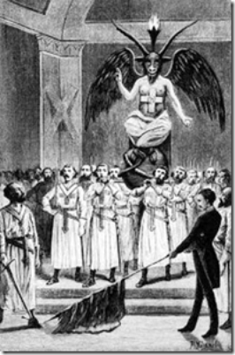
We are also quite certain about what the Knights Templar’s supreme Satanic Goat God had been, the BAPHOMET. It also seems certain that during Baron Gilles de Rais’ era around the 15th Century that the Knights Templar human sacrifices had been dedicated to a god or demon in the form of a Goat, below. In the case of Lady Baroness LaLaurie’s New Orleans Coven, we aren’t sure of their idol. They allowed Baroness Lalaurie to escape prosecution and a proper investigation because her victims were Africans subjected to human bondage. It is more probable than not that she sailed to France until the scandal of ritualistic mass murder, torture and mayhem of Africans discovered at her mansion died down. However, throughout the history of the European Order of Knights, their one consistent Demon and God had been the ram goat– the Baphomet.
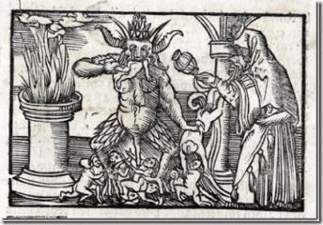
So, it is more probable then not to begin with the secret blood covenant Knights Templar, then the Jesuits, Freemasons and Mafia as currently secretly involved in the 21st Century continuation of the Black Mass/Satanic Blood Sacrifice Circles.[4]
However, we face a serious dilemma in challenging the crimes of Satanic cults, because society and our system of laws does not recognize ritualized and spiritual crimes without a Corpus Delicti (“body of crime“). It is also extremely difficult to prove ritualistic crimes because of ultra blood oath secrecy of its religious doctrines and among its members. There are also over 2 million Masons in North America and nearly 5 million worldwide. Freemasonry is made up of many individuals in the legislative national and state branches of the government. They are in the national and state judicial branches. They are in the all branches of the military and local law enforcement agencies. They are in schools, universities and corporations. They are in the music, television and movie industry, all subordinate and obedient to the Masonic Grand Lodges and the Baphomet- SATAN. They all, “Ride the GOAT” to carry on a vast global campaign of ritualized spiritual warfare, and a criminal enterprise to cover-up and veil their crimes.
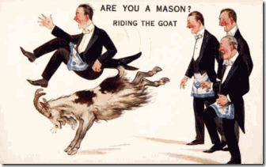
Baroness Lalaurie and French New Orleans are closely related to Bobbie Kristina Brown and Nick Gordon, because one of them, Rosie Perez, close to the Jesuits and the Roman Catholic Church let it slip that the crimes committed against them were ritualistic and spiritual. For only a moment, she pointed the finger directly at Angela Bassett and her made for TV Whitney Houston biopic for Bobbi Kristina’s current fate. Additionally, Bobbi Kristina publicly exposed Angela Bassett as a secret transgender that violated Blood Oath Secrecy of the cult. The EVIL and SPIRIT that possess and empowers her demonic motivations is that of the same of the ancient French Satanic Blood Sacrifice Cults of Baron Giles de Rais and Baroness Lady Marie Delphine LaLaurie of French New Orleans.

The EVIL and Demonic Spirit of Roman Catholic French Creole Madame Marie Laveau possess Angela Bassett. In the popular television series, An American Horror Story, the Coven, the TV show resurrected the Roman Catholic racial mass murderer Baroness LaLaurie for a global audience played by HollyWeird’s Actress Cathy Bates. In 1440, when Baron Giles de Rais was only partly burned, some ladies and damsels of his family requested his remains of the Duke of Brittany, that they might be interred in holy ground (immortality), which was granted.
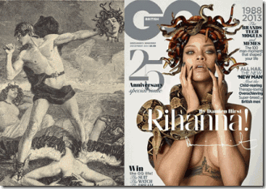
The staggering prevalence of Satanic Mythological Themes deeply embedded in the Black Entertainment and Music Industry is absolutely unprecedented in African American World History. It also isn’t any coincidence that one of the Black Music Industry’s biggest proponent of SATANISM is the Luciferian Black Queen, Rihanna.
In the Coven, Madame Laveau decapitated Baroness LaLaurie, then buried the body. Before decapitation, Madame Marie Laveau gave her an immortality magick potion that granted her soul and head (the Medusa Head) IMMORTALITY and renewed life to haunt Africans and People of Color into the 21St Century. Whether you choose to believe or not, Whitney Houston rode the GOAT, Little sister, Bobbi Kristina Brown, was Whitney Houston’s first born Satanic Blood Sacrifice to the BAPHOMET of the powerful global ultra secret Ninth Satanic Circle Cabal, the bastard child of the Medieval French Murder Cults.

” … Houston had been planning a return trip to the Holy Land as a follow up to the time she spent there with her then-husband Bobby Brown. She apparently wanted to be baptized again in the Jordan River by the African Israelites (Black Hebrews). ‘The Insider” showed Houston’s goddaughter Brandi Burnside saying, “We planned to go to Israel together. She said to me, ‘We need to get into the holy waters, so that nothing can harm us.’”[6]
For Whitney Houston, there was no turning back from her pact with the DEVIL for her genius, soul and destiny. Even returning to Israel to wash herself clean and anew in River Jordan to get her off the GOAT to save her and Bobbi Kristina wouldn’t have been successful. At the very least, the Freemasons of the Mossad were involved in assassinating her before her return.[7] Both Michael Jackson and Whitney Houston’s name, images, music portfolios and their “souls” after death are equivalent to goldmine commodities viciously removed from the pools of Black Enterprise and Genius by the secret Global Satanic Blood Sacrifice Cabals.
From the formation of this country, whether it was Knights Templar/Rosicrucian’s ARCADIA, or the Satanic Elizabethan’s NEW ATLANTIS, they believe that theirs is a “Divine“ right by God to clandestinely create and build “Utopias” from the genius, bodies, hearts, minds, soul, inheritances and “Destiny” of Africans, Native Americans and the People of Color ruled by the Hand of SATAN .
The Bobbi Kristina & Nick Gordon Play, the DEVIL in the Details

Don’t get it twisted by Dr. Phil’s national/international sensationalized FALSE FLAG Negro drama with Nick Gorgon and the Brown family. Nick is a just a pawn in the game. Nick Gordon can be turned in and out of a balling/babbling 10 year old with the flick of the switch. It is a big ILLUMINATI drama and play designed to distract, divide and confuse the masses.
Dr. Phil blew into Atlanta like a deputized commando of the police state to seize Nick even if it was under the power of the state of Georgia. Nick was going in- interned and reprogrammed whether he had the power to resist or not.
Nick’s commitment/disappearance behind the veil is very suspicious. Who is reprogramming Nick- CIA and the Mossad? Nick may come out like the young Boston Bombing suspect Manchurian Candidate Dzhokhar Tsarnaev- helpless, SOLD OUT- Guilty of First Degree Murder.[8]
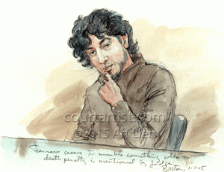
Dzhokhar Tsarnaev’s lawyer is Judy Clarke that represented high profile CIA Manchurian Candidates Theodore Kaczynski (an underage MKULTRA volunteer in his Harvard years), Eric Rudolph, Jared Lee Loughner, and none other than Zacarias Moussaoui. All of them were found guilty. Clarke, an intelligence asset, sold Tsarnaev down the drain. She told his Boston criminal trial jury- Yea, he did it! Almost 2 years behind the veil in state prison, Tsarnaev appears mentally helpless to protest being railroaded.[9]
The assassination of Whitney Houston and drowning of Bobbi Kristina are international intelligence operations- way over the head of a hapless- mind controlled drugged out Nick Gordon.

International Interviewer & Producer Daphne Barak Opened a Wide Window into the Lives of Bobbi Kristina and Nick Gordon
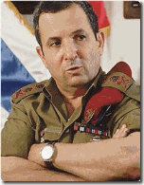
In September 2009, lawyers representing 16 Palestinians asked a London court to issue a “War Crimes” arrest warrant for its then Zionist defense minister, Ehud Barak, who was visiting Britain.[10]

Israeli Freemasons, Prime Minister Benjamin Netanyahu served under Barak in one of his special elite Israel Defense Force’s units in the early 1970s.[11]
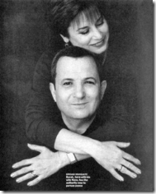
“The Illuminist/Masonic meaning of the X is simply this: It is the sign of Osiris, the great (Egyptian) sun God…” —Texe Marrs, Dark Majesty[12]
Ehud Barak, a Freemason chosen Prime Minister of Israel in 1999, with his wife, Nava. This is a very staged “X.” Also significant is Nava’s earring, which has the emblem of the Masonic double-headed eagle. (Photo: Time magazine, May 31, 1999, p. 64)[13] The sign, or letter X, has a long history of use in the Ancient Mystery Religions, in apostate Judaism, in Freemasonry, and in the occult. The Illuminati elite use it to this day to symbolize key phenomena and mark significant events.[14]

Daphne Barak in Bani Gala, Islamabad– Exposed Internationally as a secret Israeli agent, the Sister of Israeli Freemason Defense Minister Ehud Barak- Former Israeli Mossad Chief [15] For about 15 months, Nick and Bobbi Kristina had been behind the wing of Daphne Barak under the cover of an independent producer under the ruse to have Bobbi Kristina narrate a film concentrating on her late mother.[16] For over a year prior to Bobbi Kristina’s drug induced-drowning, the DEVIL in the DETAILS, Daphne Barak, kept them under her false confidence while behind the scene producing the play, writing the script and directing the players. She had been their secret Israeli Freemason Mossad Case Officer.
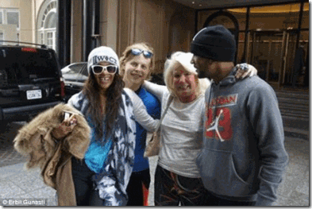
“To me, Bobbi Kristina is sweet, intelligent and compassionate. But she is a little girl lost without the mother she adored – and probably copied.” –Daphne Barak [17]
Yea, Bobbi Kristina and Nick Gordon just like Dzhokhar Tsarnaev did it to themselves. That was the objective of the play- deceive the masses. One thing is clear is as a player acting out the script, Bobbi Kristina had been exposed to Iatrogenic Multiple Personality Disorder Programming and Reprogramming.
In 2012, the Enquirer claimed that Whitney Houston paid $49,000 for Bobbi Kristina to enter an outpatient program at Talbott Recovery in Atlanta. The paper claimed that the teen was allegedly admitted previously to a psychiatric ward at Peachford Hospital in Atlanta.[18] At least one victim of “Ritual Satanic Abuse” claimed in a lawsuit that Peachford was a related covert CIA MK-ULTRA mind control and brainwashing center.[19] Undoubtedly, Nick is also a CIA/MONARCH/MK ULTRA multiple personality dissociated player through secret multi- generational programming of Whitney Houston’s direct family associates.
The stage for the Bobbi Kristina and Nick Gordon Play takes place on the grounds of Rowell, 20 miles north of Atlanta. Roswell is the sixth largest city in Georgia. In 2010, Roswell had a population of 88,346. The racial and ethnic composition of the population was 74.7% White, 11.7% Black. [20] Bobbie Kristina and Nick Gordon moved into the high security Ellard townhouse complex in Roswell sometime after June 2013.[21] Roswell is where the DEVIL and Knight Templars/Freemasons have ruled since human bondage in America.
American Slavery: Where SATAN Rules
In regards to Slavery in America, my ancestors speak. My father’s blood was in the Deep South, Marion and Pike County, Mississippi. There, they toiled the black earth along one of the branches of the mighty Mississippi River on the plantation of Hugh Bullock. Their faith was tied to the designs of King Charles I of England (1629-1649). Charles was the 2nd son of James VI of Scotland (James 1 of England) and Anne of Denmark. Charles believed in his “Divine Right as King and “Absolute Rule.” In 1629, he abolished parliament and ruled England, Scotland and Ireland by himself. [22]
King Charles I was in the House of Stuart (Stewart). He was a descendant of Robert, the Bruce.[23] Hugh Bullock of Mississippi was the descendant of Captain Hugh Bullock,
Hugh Bullock was a planter, merchant councilor and man of considerable importance. He was the owner of the Ship “Endeavor” in March 29, 1628 … Hugh appears in the official records of Virginia as a member of the Kings [Charles I] Council as early as December 1631, where the records indicate he was a Burgess and Member of the Assembly for the Colony of Virginia from York County (Colonial Virginia … [H]e was an influential man with considerable property in England and Virginia. On March 12,
1634, at James City Virginia, Hugh was granted 2,550 acres of land on Pocosin, “Southeast of Otter Pond,” in York County … “[24]
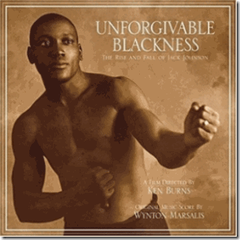
Get Behind Me, SATAN
For whatever reasons, my father’s family remained particularly respectfully close to the family of Hugh Bullock from bondage, Civil War through Reconstruction to the early 20th Century. My father’s blood remained primarily African “Regal Black.” My great grandfather was the “Notorious Jake Bullock.” They spoke of him as being regal black with long straight black hair like a raven.
My great-great grandfather was “Big John Bullock.” In 1870, he and his younger brother James was living next door to plantation owner Hugh Bullock. What was particularly strange about Big John was a “white child” was listed residing with him and my great-great grandmother Ellen Bullock. An experienced genealogist say this was extremely unusual and an extraordinary event in that in the Deep South, a census taker was unusually a local that was extremely familiar with the families and customs of a rural agrarian society like Marion-Pike County. During that time, if the census taker found a white child with a black family, the local would always not fail to identify the child’s rightful family and list that child with his family. That’s why I call him, Big John. He had to have been a “Man of Great Respect.”
As of this date, I have found no family folklore or legends passed down about Big John. I have no information when he or Ellen may have died. He appears in the 1870 and 1880 U.S. Censuses then vanquish from the records of the State of Mississippi. However, my father passed down to my sister the legend that had been passed down from his father, Big Papa- John Bullock, that his ancestors ruled the destiny of their people through a “Council of Elders.” Any problems that developed between the races, the whites appealed through the council, they acted to exact punishment or revenge in all the righteousness they knew. My father also passed down the legend from his father that there were certain parts of the swamp where “no white man” could trespass no matter the circumstances.
In other worlds, a Dr. Phil and his posse couldn’t ride into my father’ father domain behind the Hand of SATAN to seize anyone. He had to appeal to the elders. If it was appropriate, right and just, the elders would deliver the subject for specialized help, and watch over the situation. Who is watching over Nick Gordon?
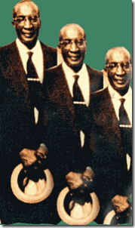
I was raised within my mother’s inner family. While an infant, the U.S. Navy through Project CHATTER fried my father’s brain from repetitive electrical shocks that had once reduced him to a virtual vegetable state. Growing up, I wasn’t very close to him. During the 1960s, his father, John Bullock, made a rare visit to the California Bay Area from Arkansas/Louisiana. It hadn’t really occurred to me that my father had a father. I knew most all of his brothers and sisters, but his father and family history in his birthplace, Mississippi, was a big mystery to me. One day, my mother told me that Big John, my grandfather was in town not far away from home. She said most respectfully, “you ought to go see him.”
My mother seemed to have had a great deal of respect for him. So, I was mostly curious about the man. One day, I went to meet him. It turned into a surprising opportunity, one on one, sit down and talk with Big Papa John Bullock in this late sixties born in the 19th Century. He stood about 6 foot 3 or 4. He wasn’t quite the “Regal Black” that folklore said his father had been, but was still silky smooth black. He was still lean, mean and muscle. Big Papa had a left glass eye. His hands were huge with one or two missing fingers on each hand that he said he lost at a saw mill. Legend and family folklore had it that you didn’t mess with his particular man either, “papa didn’t take no mess– no mess.” My aunt, his second eldest daughter, told me about Big Papa and his Shotgun. You could also tell that he once had been a rock of a man. It was like reading a part of my human blueprint out of another era and dimension that I wasn’t sure what it all meant during that time in my life.
My mother’s blood was also in the Deep South, Morehouse Parish, Louisiana. The Hutchinson(s) were mixed of African, Native American and maybe Irish blood- life forces. They appeared to have shared absolutely no family relations, ties or folklore to their former enslavers after the abolishment of slavery. Morehouse Parish was a brutal place of indescribable horror and unspeakable human suffering and terror for African folk. It was Ku Klux Klan (Dragon) lynching ground. Like reliving a terrorizing event that permanently spook her life, my mother once talked about living through a lynching as a little girl as if the earth shook- it opened up and she felt the fire and the breathe from HELL.
From my mother’s paternal blood- after the abolishment of Slavery, the Blueford(s), migrated someplace out of Alabama or GEORGIA. Things were so bad there that even today they still can’t talk about the HELL they came out of.
Some of that fear out of the HELL, the Deep South, and my father’s secret faith in Oakland, CA with Project CHATTER shaped my early life from almost infancy. Due to my mother’s deep fear, I couldn’t enter the Deep South until my beloved passed to the other side. Passed down from my ancestors on the side of the Hutchinson(s), they spoke of Slavery as “Living in the Other World,” that I say was the “World Ruled by SATAN.”
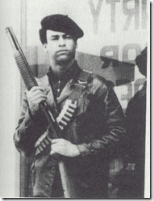
Our elders out of Deep South always taught us, when it goes to SATAN and the DEVIL. Turn from him, run and don’t look back. After sitting down with Big Papa, I met Brother Huey P. Newton. I began to understand what Big Papa represented to me, and Huey and Brother Bobby’s Black Panther Party Ten–Point Program in a world filled with fanatical Unforgivable Blackness. We Want Freedom. We Want POWER To Determine The DESTINY Of Our Black Community. Brother Huey said that “POWER” grows out of the “BARREL OF A GUN.” As a Man-Child, I suddenly stopped running- Get Behind Me, SATAN.
State of GEORGIA & Roswell, Where SATAN Rules
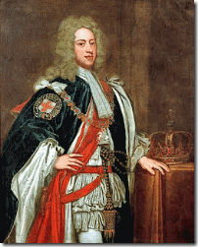
The state of GEORGIA is named after United England and Ireland, King George II, out of Germany.[25] The city of Roswell has it own unique signature in American History and HELL on earth. It was founded by Revolutionary War veteran, Roswell King. He was born in 1765 in New England, Windsor, Connecticut. Windsor was the first English settlement in the state.[26]
Roswell King & the Institution of Africa Bondage
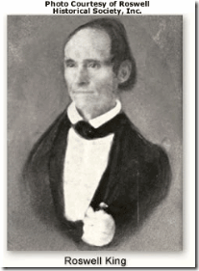
Roswell King was an American businessman, industrialist and planter- an African enslaver. Behind Roswell King delves a complex of the world’s ultra secret societies, and some of history’s greatness purveyors of EVIL, violence and inhumanity (African Bondage) that continues even today to threaten the order and peace of the universe.
King had been the manager of Major Pierce Butler’s rice and cotton plantations on Butler and St. Simon islands, Georgia, where he worked until 1820. The plantations covered hundreds of acres on each island. A total of 500 Africans was forced to labor on the two plantations. King also owned a plantation and numerous Africans worked it in Darien, where he became a major manager of the Bank of Darien.[27]
Major Pierce Butler, African Bondage & the Knights Templar
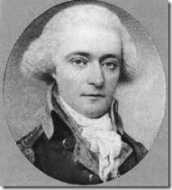
Major Pierce Butler (July 11, 1744 – February 15, 1822) was a soldier, planter, and statesman, recognized as one of United States’ Founding Fathers. He represented South Carolina in the Continental Congress, the 1787 Constitutional Convention and the U.S. Senate.[28]
Major Pierce Butler was born at Ballintemple (Town of the Church (Temple))in Ireland. Lewis’s Topographical Dictionary of Ireland states that, in 1837, there was at Ballintemple “the ruins of an old church, beautifully situated on the margin of the River Slaney”. All the signs suggest that the original temple at Ballintemple belonged to the Knights Templar.[29]
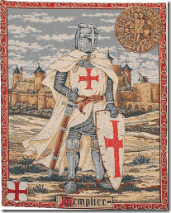
Ballintemple had been a Knights Templar sanctuary since about 1169. During King Philip and the Pope Clement V’s inquisition of the Knights Templar, many fled underground or joined the army of Robert the Bruce in Scotland where they would go on to play a pivotal role in securing an epic victory for the Scots over the English at Bannockburn in 1315.[30]
Roswell King, Thomas Spaulding, African Bondage
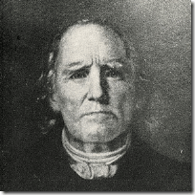
Rowell’s Bank of Darien in Georgia was founded by Thomas Spaulding. Spaulding is a place name in the fens of south Lincolnshire, derived originally from the Spalding tribe (clan) who lived there. Spalding appeared as a place name as Spallinge in the Domesday book of 1086 and Spalding is in the Lincolnshire survey of 1115 and as a surname as Spalding in 1273. There was a Spalding clan in Scotland, taking its name from the Lincolnshire village of Spalding. The first of this clan was the Peter de Spalding who helped the Scottish supporters of Robert the Bruce take Berwick from the English in 1318. As a reward, he was granted lands in Forfarshire (now Angus). Prominent in later generations were the Spaldings of Ashintully in Perthshire. However, in the 1700’s this family followed the Jacobite (Stuart) cause, lost their lands, and dispersed. Some of these Spaldings ended up in Georgia and Jamaica. Others had earlier departed for Sweden and Pomerania in Germany.[31]
The Scots Spalding connection in America began in 1760 when James Spalding came over to the new colony of Georgia and set up a trading post. He had an eventful Revolutionary War. “When war broke out he was jailed for a week by the patriots who made him pay a large sum of money to let him go and promise not to return to Georgia. He fled to St. Augustine in Florida but returned to Georgia once the British retook Savannah.”
His son, Thomas, who settled on Sapelo island is related to the ROMAN CATHOLIC Spauldings of St. Mary’s County, Maryland. Rowell’s Scottish cousin and benefactor at Bank of Darien, Thomas Spaulding, was also a large scale African enslaver that operated large cotton plantations and was active in Georgia local politics between 1800 and 1850.[32]
Robert the Bruce, Knights Templar& Freemasons
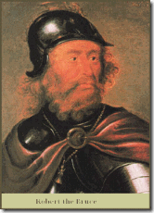
In America, the King/Butler/Spaulding Clans were directly associated with powerful wealthy covert combinations of Irish/Scottish Clans directly associated with Robert the Bruce and the hidden Orders of Knights Templar and Freemasons. These Clans were deeply imbedded in the roots of colonial states of the east, and the antebellum slavery states of the south.
Robert the Bruce (1274 –1329), had been excommunicated by the Roman Catholic Church and papal authority did not apply in Scotland. This meant that the Knights Templar had sanctuary from the reaches of the Pope in Scotland.[33] Robert the Bruce was at war with England and was pleased to have the expertise of such battle qualified, powerful, wealthy and secret knights in his army and it is believed that the Knights Templar were integral in the defeat of the English at the battle of Bannockburn. Robert the Bruce is often credited with forming the FREEMASONS as a means to hide the fact that there were Knights Templar present in his army.[34]
In The Temple and The Lodge, by Michael Baigent and Richard Leigh, Robert the Bruce upon his death requested that his heart be removed and taken to Jerusalem to be buried in the Knights Templar Church of the Holy Sepulchre. Robert the Bruce’s heart was transported by the Grand Master of the Scottish Templars, Sir William Sinclair, to Jerusalem. In Spain, Robert the Bruce’s heart was thrown into a battle against the Moors.[35]
According to The Temple and The Lodge and other Masonic literature, Robert the Bruce was also well-connected to the Satanic Merovingian Bloodline.[36]
Robert the Bruce, Antichrist & the Blood Sacrifice
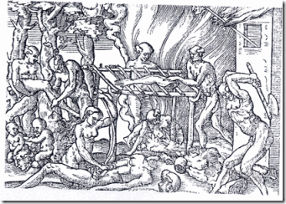
Today, the secret Satanic Merovingian Bloodline circles play an important part in the secret Anti-Christ conspiracy and movement to return the Satanic Merovingian Bloodlines to world domination. Their belief system will be partly based on Celtic religion which Robert the Bruce’s descendants and JACOBITES are seeking to restore includes Satanic Ritual Human Blood Sacrifice that some believe brought Robert the Bruce to power.[37] In Europe, Ritual Human Blood Sacrifice for Luciferian power, fortune and wealth never ended. It went underground as the Roman Catholic Black Mass ultimately becoming an important part of ILLUMINATI secret ritual ceremonies, and the Ninth Satanic Circle.
Roswell King & Ancestral Links to Sir Francis Bacon, Rosicrucians and ARCADIA
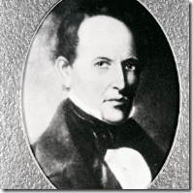
Together with his son, Barrington King, above, Roswell founded Roswell Manufacturing Company in the Georgia Piedmont, establishing a cotton mill and industrial complex. They co-founded the town of Roswell, Georgia, inviting friends to be part of its community and the mill’s development in the 1830s.[38]

Roswell’s 1800s Presbyterian Church has no Crosses. It’s Column Tower Match the Style of Knight Templar’s Church Column Towers and Structures of Ancient Europe.
He brought in a Master Freemason, Willis Ball, out of Windsor to design and build their homes and Presbyterian Church in the Gothic (Knights Templar)- Greek classical architectural tradition.[39] In 1839, Roswell brought in Scottish Freemasons to build cotton mill workers’ brick housing structures.[40]
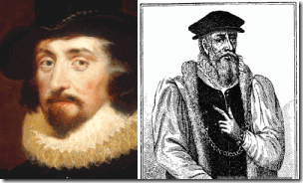
Rowell’s father, Captain Timothy King (1727-1812), had been an early New England/Windsor settler on a land grant to the son or nephew of a contemporary of Rosicrucian Sir Francis Bacon (Shakespeare) in London, Elizabethan Lord Mayor of London and Knight, Sir Richard Saltonstall (1586-1661).[41 Elizabethan Knights like Sir Saltonstall were used to accomplish conspiracies and schemes in distant countries and foreign lands. However, their main job was to lead armies on wars and protect their fellow countrymen.[42]
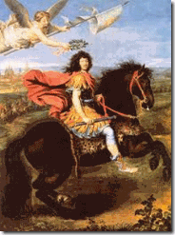
Sun King Louis XIV
King’s grandfather, Captain John King of Roscommon, Ireland, founded Northampton, Mass in 1655. Captain John King was a key military commanding officer of Northampton involved in the 1689 French- Indian wars against Sun King Louis XIV of France (1638- 1715) for ARCADIA and the supremacy of New England.[43]
King Louis XIV & the Holy Grail of the Knights Templar
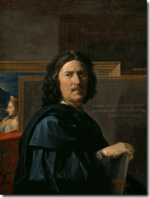
Nicolas Poussin (1594 –1665) was the leading painter of the classical French Baroque style. He spent most of his working life in Rome. Poussin’s genius was recognized only by small circles of collectors. In the two decades following his death, a particularly large collection of his works was amassed by Louis XIV.[44]
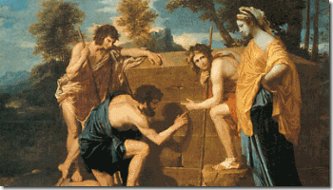
Poussin’s The Arcadian Shepherds was commissioned in 1638 by Giulio Rospigliosi (the future Pope Clement IX). The Arcadian Shepherds was acquired by Louis XIV in 1685, and has remained in Paris ever since.[45] Poussin is said to have been a member of the Priory of Sion, an Order of the Knights Templar and The Arcadian Shepherds is said to hold secrets about Knights Templar’s hidden treasures, the Holy Grail and Arc of the Covenant, taken by the Knights from the Holy Land.[46]
Pope Clement IX & the Holy Grail of the Knights Templar
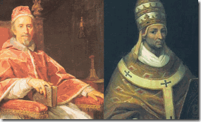
Search for the Holy Grail- Popes Clement IX & Clement V
Often the new pontiff’s choice of name upon being elected to the papacy is seen as a signal to the world of who the new pope will emulate, what policies he will seek to enact. One of his most important predecessors in this case had been Pope Clement V that arrested and prosecuted the Knights Templars in 1307, but also failed to discover the Holy Grail or their troves of holy treasures like the Arc of the Covenant out of the East.[47] The Satanic European Royalty, Knights Temple, Rosicrucians, Freemasons, Holy Roman Catholics and their elite oligarchies are all secretly related to their implanted unholy cousins in America that even reached all the way into Antebellum Roswell.
Roswell, Civil War & France
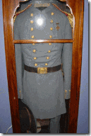
During the Civil War, Roswell Mills were best known for their role in producing supplies for the Confederacy. They made “Roswell Gray” fabric to be sewed into Confederate military uniforms.[48]
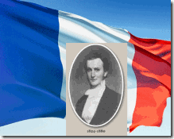
In June 1864, during General William Tecumseh Sherman and Union forces’ infamous march to the sea, they descended on the Rowell Confederate Slave Cotton Enclave. A French National named Thepohile Roche raised FRENCH FLAGS of neutrality over Roswell. He was no employee of Barrington King. Roche was a secret Knights Templar and or a French attaché- international espionage agent of Napoleon III or the Vatican brought to Roswell by Barrington King.[49]
General Sherman wasn’t going for that. He ordered the arrest of everyone associated with the Roswell Ivy Cotton Mill complex for TREASON including Theophile la Roche. He was somehow liberated from Union Forces and escaped to Paris, FRANCE before he could be fully interrogated and became an international incident.[50]
Barrington King and most all of the King Clan of Roswell escaped capture, because most all of them were behind enemy lines part of the Confederate Army in active combat against U.S. Union Forces opposing the abolition of African Slavery. Oran’s Dictionary of the Law (1983) defines treason as “…[a]… citizen’s actions to help a foreign government overthrow … or seriously injure the [parent nation].”[51] Nobody in the Roswell international incident was prosecuted for TREASON. [52]
The ROSWELL BUNCH, Bobbi Kristina, Nick Gordon, MK ULTRA, Drugs, Mossad & Murder

If you have lived in the South, it doesn’t take long to realize that blood runs thick there over generations. Bobbi Kristina and Nick’s “Roswell Bunch” circle of Southern drug pushers, MK ULTRA handlers, enforcers and script actors are by and large local white second amendment neo-confederates most likely secretly tied to local multi- generational Confederates, freemasons and law enforcement officials.
These are some of the “Roswell Bunch” cast of characters in the Deadly Bobbie Kristina and Nick Gordon Play.
James Russell “Rusty” Grant, Roswell Chief of Police
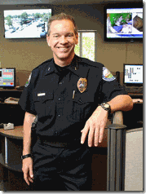
Roswell’s Good Ole Boy Police Chief Rusty
Rusty is no lame back woods Georgia country boy. He is a retired Georgia Bureau of Investigations (GBI) special drug enforcement agent that supervised over 60 agents. He is a member of the FBI National Academy Associates. He is the executive board secretary of the National Alliance of State Drug Enforcement Agencies. He was instrumental in development and implementation of the Intelligence Operation Center for the 2004 G-8 Summit. He developed and led implementation of executive protection details for the 1988 Democratic National Convention, cooperating with the Secret Service to maintain optimal security and provide protection.[53]
The 1988 National Convention of the U.S. Democratic Party was held at The Omni in Atlanta, Georgia from July 18–July 21, 1988 that nominated Greek Orthodox Church Governor Mike Dukakis of Massachusetts and Senator Lloyd Bentsen as President and Vice President to run against former Bohemian Luciferian Pagan CIA Chief George Hebert Walker Bush.[54]
The G8 is an unofficial forum which brings together the heads of major world powers: Germany, FRANCE, the United Kingdom, Italy, Japan, the United States, and Canada (all since 1976) the EU Commission (since 1981) and Russia (until March 2014). When the other seven countries decided to hold the 40th such meeting without Russia, the media dubbed it the 40th G7 summit.[55]
The European royalty- who are all related to each other are the vertex of the global oligarchy. Currently, the Bilderberg group is the main European royalty main organizational hub for coordinating their global government agenda and most powerful organization on earth. The G8 Summit was founded by members of the Rhodes Round Table groups and the Nazi/SS Bilderberg Group. Cecil Rhodes’ goal was to create a world ruled by the British Crown.[56] That’s some extremely deep stuff for a local Georgia boy to be involved in if you know what I mean! Under the veil in Roswell, Chief “Rusty” is part of the ultra secret international Luciferian guardian security network. In the case of Bobbi Kristina, someone is bound to hoist the French Flag to the Ninth Satanic Circle then everything is going to shut down.

MASON WHITAKER, Calvinist, Neo Confederate Second Amendment Gun Advocate, Drug Pusher

“We are gun collectors. We live in the South. We have the right to Bare Arms.”
MASON WHITAKER of the “Roswell Bunch” plays the part as a MK ULTRA handler and drug pusher. I don’t think that it is a coincidence that he is the “MASON” of the bunch.

Mason’s posted assault weapon.
He was with Bobbi Kristina, Nick and Max the morning before they found Bobbi Kristina drowned from most likely a drug overdose. He is a gun and weapons collector. He is most likely a multi-generational freemason, neo-confederate, second amendment rights right advocate. Mason Whitaker calls himself Bobbi Kristina and Nick Gordon’s BFF (Best Friend). He has posted several photos of himself with Bobbi Kristina during her drug-addicted past few years. The 23-year-old pleaded guilty in 2010 for possession of marijuana and other narcotics with intent to distribute. He was Gordon’s passenger last year when he lost control of and crashed his BMW in Roswell.[57]
MAX LOMAS, Gun Collector and Drug Pusher

Lomas’ Assault Rifle and Guns
MAX LOMAS of the “Roswell Bunch” also plays the part as a MK ULTRA handler and drug pusher. There appears to be little to no public background information available about this character even though he is a central figure in the Bobbi Kristina case. He is also most likely a multi-generational freemason neo-confederate second amendment rights right advocate. He was an ex of Bobbi Kristina’s and was with Gordon when he found her in the tub on Jan. 31. Weeks earlier, Lomas was in jail on multiple charges after allegedly drugging and holding his girlfriend hostage. In 2011, he got into a wild fight with Gordon and Bobbi Kristina – who was just 18 at the time. He repeatedly punched her friend, Justin Walls, in the face, while Gordon waved a Glock 9 mm handgun in the air.[58]
CORY BEN-HANANIA, SEBASTIAN ANDRADE- Foreign Agent Assassins

CORY BEN-HANANIA of the “Roswell Bunch” is a MK ULTRA Enforcer. He is an ISRAELI AGENT. The name Ben-Hanania is associated with the ancient 1st Century High Priest of the Judea Temple in Jerusalem.[59] Cory deposed of Bobbi Kristina’s Black school friend ,Chelsea, by injecting her with pure heroin.[60] After killing his so-called “best friend” Chelsea, he stashed the heroin syringes in her shirt and car. An agency aided him to flee U.S. justice inside Israel.[61] Cory was a publicly known misfit and incorrigible youth since 16 years old.[62] He had no job or known source of income. Even his parents, Robert and Sandra Ben-Hanania don’t appear to have any publicly listed jobs or source of income, but appear to have enough money to purchase homes, [63] fly across country and pay for youth intervention programs.[64]
The normal procedure to enter Israel from the U.S. is that you get a valid passport to stay for up to three months without a vista.[65] As a fugitive from justice, who had the power to arrange his passport, airline bookings, and passage through Israeli customs? Who financed Cory’s round-trip flight and at least a three-month stay in Israel? The Mossad. Inside Israel, I suspect that he was aided by a Zionist IDF Soldier, Dani Margolis of Eco Tours in Irsael.[66]
Cory’s defense attorney, J. Thomas Salata, is an Eastern European multi-generational ROMAN CATHOLIC that attends Saint Brendan’s the Navigator Catholic Church in Cummings, GA.[67] Cory may or may not be currently in prison in Georgia for a pled bargained involuntary manslaughter/reckless conduct for slaying Chelsea.

His accomplice, Sebastian Andrade, not sure what hole or country he crawled out of. He looks like no 20 year old. Andrade arranged the purchase of the deadly heroin through his drug criminal connections. He pled guilty to a single count of Concealing the Death of Another and was sentenced to JUST FIVE YEARS PROBATION.[68]
PAIGE THOMPSON & ALEXIS NORWOOD, Heroin Drug Addicts

PAIGE THOMPSON & ALEXIS NORWOOD of the “Roswell Bunch” are most likely also MK ULTRA multi-generational freemason neo-confederate drug addict Watchers. Paige Thompson, 43 or 44 years old, loved to post photos of her BFFs Gordon and Bobbi Kristina, until police raided her home and found heroin. Paige has been disposed of. She is currently in prison in Texas for possession of heroin with intent to distribute.

Alexis Norwood, Paige’s daughter with Bobbi Kristina (Devil Horns), was also busted in 2013 for heroin possession. A nurse who was treating her injuries related to a car accident called the cops after finding a bag of suspected heroin in her bra.[69]
SHEBLY DERRINGTON, Bobbi Kristina’s Friend Mysterious Death

SHEBLY DERRINGTON, 20 years old, of the “Roswell Bunch” maybe a “Watcher?” Her mother, Debbie Derrington, told a news source that her daughter was allegedly another one of Bobbie Kristina’s BFF. She said that Shelby returned home from college to befriend Bobbie Kristina after the death of Whitney Houston. Debbie said that her daughter reported that in 2014 that Bobbi Kristina kept a “bedroom shrine” to her late mother in their old Atlanta townhouse. Shelby mysteriously died August 2014 due to bleeding on her brain. Doctors didn’t find drugs in her system, but linked her death to a concussion she suffered in a traumatic car accident a year before. She may have been a true friend that wasn’t part of the script, and saw and knew too much truth about Bobbi Kristina and Nick to be allowed to live.[70]
CHELSEA IVANNA BENNETT, Bobbi Kristina’s Childhood Friend- MURDERED

Chelsea Ivanna Bennett, 20 years old, definitely didn’t have a part in the Daphne Barak’s play and script. Right now pending the fate of Bobbi Kristina, she is the only outright murder victim tied directly to the Roswell Bunch. Chelsea had been Bobbi Kristina’s friend since childhood. She lived in Johns Creek. Johns Creek is bounded by Roswell to the west and south, Alpharetta to the northwest, Forsyth County.[71]

Mason, Nick and Chelsea
Contrary to media reports, Chelsea was not a drug abuser. She was from a stable, loving and supportive Christian family and local Baptist church. Chelsea was a beautiful upstanding young lady with a bright future. On March 3, 2014, she was removed from the Bobbie Kristina and Nick Gorgon play by cold blood homicide. She was assassinated by a heroin overdose. Heroin was also used to deliberately injure and taint her reputation in the community. Chelsea was not a heroin addict.[72]
Chelsea had been taken or lured to the “Roswell Bunch” home of Cory Ben-Hanania in Alpharetta, then viciously injected with a lethal dose of pure heroin by Hanania and Sebastian Andrade. They deliberately left her on the floor of one of the bedrooms of the home for about 10 hours to make sure she didn’t recover.[73]Contrary to media reports, it was neither Hanania nor Andrade that called 9-11. It was Hanania’s brother that found the body and called police after Chelsea‘s family called the home searching for her. Hanania and Andrade, both 20 years old at the time, fled the state. They weren’t arrested until July, 2014 when both returned to Georgia. In other words, they were allowed enough time to be debriefed and reprogrammed, then given a script about Chelsea‘s death to shield them from first degree murder.[74]
Chelsea was slain- murdered in cold blood. She had been Bobbi Kristina’s long closest special and true friend from childhood. Chelsea possessed too much inside forbidden knowledge about the Bobbi Kristina and Nick Gordon play and Roswell Bunch to be allowed to live.

If Bobbie Kristina suffered a seizure in the bathtub from a drug overdose, they had their main suspect there at the scene, Maxwell Lomas, above, that should’ve been arrested then and there. Two weeks before the incident, Maxwell Lomas had been busted by Roswell PD for possession of marijuana and alprazolam (better known as addictive prescription drug Xanax) with intent to distribute, and possession of a firearm.[75] Marijuana and Xanax are two drugs that Bobbie Kristina was alleged to be abusing. It was this alleged drug pusher, Maxwell Lomas, that found Bobbie Kristina unconscious in her bathtub.[76] Yet, neither the Brown or Houston family members dare to mention his name. Even, LEOLA BROWN, too.[77]

J. Tom Morgan, Georgia’s SUPER Lawyer
Figure this out. Lomas is represented by two very powerful Georgia defense lawyers. They are J. Tom Morgan, the former Dekalb County District Attorney for about a dozen years, and his right-hand man, John Petrey, former Dekalb County Assistant District Attorney for 26 years. That’s quite a team of SUPER, expensive, top notch- hard hitting attorneys for an alleged small town gun touting drug pusher.[78]
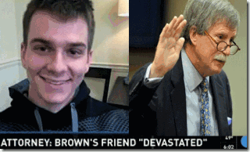
Mr. Nice Guy- Public Citizen, Max Lomas and Former 26 yr. Dekalb Asst. DA John Petrey
These Super lawyers are re-imaging Lomas as the public’s friendly innocent white bystander while Gordon is the “Big Black Brute.” If Lomas was so “devastated” about his friend Bobbi Kristina’s tragedy as his Super lawyers seem will attest to the masses, why is Max so happy and smiling about it? The Super lawyers are working on getting Max Lomas immunity to put Nick Gordon behind bars. Reportedly, Lomas has already told the police that he saw Nick Gordon wiping up blood. 79

Earlier, Mr. Nice Guy- Public Citizen expressed his opinion about what he generally thought about his so-called best friends, Bobbi Kristina and Nick Gordon. The neo-confederate wasn’t so devastated, caring or NICE!

What is strange about Bobbi Kristina’s case is that the entertainment industry would usually rally behind a young innocent 22 year old young sister struggling to survive in the limelight of a recently departed musical industry icon and superstar like Whitney Houston. But, there seems to be unnaturally so little support for Bobbi Kristina in the entertainment industry even on the fridge of death. For instance, LL Cool J won’t comment at all on Bobbi Kristina, but he publicly admires Cultist Pop Star MADONA raising her black adopted kids in world of Angels, DEMONS and fallen Angels, Jewish Mysticism– KABBALISM.[80]

Whitney’s TV Biopic director, Angela Bassett confesses, “I do try to keep my ear open to what some of the developments are.”[81] Other than that, she/he is completely dissociated from Bobbie Kristina.[82] Bobbi Kristina exposed Angela Bassett as a secret transgender, but it was after Bassett said some very unnecessary and unkind things about her young acting career in a national publication.
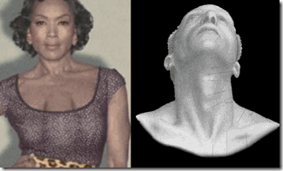
Early Very Strange Photo of Angela Bassett with a Man’s Adam Apple Equipment and MK ULTRA Sex Kitten Pattern
Another notable public disassociation from Bobbie Kristina comes from Beyonce and Jay-Z. They seem to have no concern or comment at all about the tragedy and fate of Bobbie Kristina. Of course, a legitimate question exists- what does of this have to do with now, and the 21st Century music industry. I say that it’s all related to same clandestine ILLUMINATI/Satanic blood covenant circles as above. Let’s start with Jay Z and Beyonce.
Where SATAN Rules: Jay Z & the Holy Grail/Magna Carta
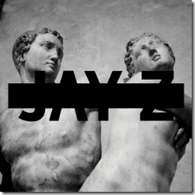
Jay Z & the Magna Carta, Holy Grail
Just about (2) two years ago on July 10, 2013, Jay-Z released the strange album Magna Carta/ HOLY GRAIL.[83]The Holy Grail is a dish, plate, stone, or cup that is part of an important theme of English [King] Arthurian literature. Stories claim that the Grail is buried beneath the Knights Temple’s Rosslyn Chapel. Other stories claim that a secret line of hereditary protectors related to the Knights Templar keep the Grail, or that it was hidden by the Templars in ARCADIA, Oak Island, Nova Scotia’s (New Scotland) famous “Money Pit.”[84]
Basically, the Knights Templar were behind the Barons and King John signing the Magna Carta in 1215, thanks to the efforts of Aymeric de St Maur, the Templar’s Grand Master in England and King John’s closest advisor. The Magna Carta curtailed many powers of the monarchy to increase the Templar’s secret agenda of European/North American expansion and domination.[85]
Recall, it was South Carolina U.S. Senator Major Pierce Butler out of Ireland that Roswell King first worked in African Human Bondage apprenticeship in the state of Georgia. Butler‘s ancestor was Sir (Knight) Pierce Butler, who succeeded, in 1516, as eighth Earl of Ormond, lord high treasurer of Ireland in 1524. He was a descendant of the rich Knights Templar Barons that forced the hand of King John to sign the Magna Carta.[86] At least since the 12th Century, the Earls of Ormond were establishments of the Butlers, the Knights Templars and then to the Knights Hospitallers.[87]
On March 24, 1787, Major Pierce Butler was certainly associated with Master Masons Charles Pinckney and John Rutledge of the Ancient Masons of South Carolina.[88] It was Pinckney and Butler that introduced the Fugitive Slave Clause to the U.S. Constitution. In 1779, the High Knights Templar of Ireland Lodge, Kilwinning, obtained a charter from Lodge Mother Kilwinning in Scotland. This lodge began to grant dispensations to other lodges to confer the Knights Templar Degree.[89] The Rutledge and the Pinckney families were multi- generational Master Masters of the Union Kilwinning Lodge, No. 4 in Charleston, SC that is directly related to the Knights Templar of Ireland.[90]
Major Pierce Butler was one of the secret Knights Templar in the 1791 Constitutional Congress that inserted the Magna Carta into the Bill of Rights of the U.S. Constitution. Also, I don’t believe it was any coincidence that (Baron) Butler joined the British Army for a tour of duty in ARCADIA– Nova Scotia (New Scotland) to serve in the French-Indian Wars to take control of ARCADIA from the French in 1758.[91]

In 1758, the magnificently fortified French Fort Louisburg in ARCADIA was overtaken by 10,000 troops of the British Army led by Lord Jeffrey Amherst. The funds to build Fort Louisbourg some link to Knights Temple treasures. Many also believe that the fort maintained Oak Island as a repository of Knights Templar and Scottish Roman Catholic treasures and artifacts out of the holy land.
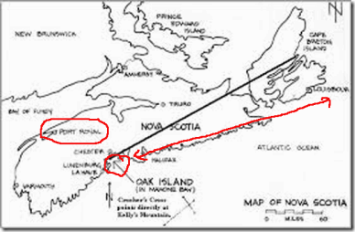
Port Royal, ARCADIA Up from Oak Island Plays an Important Role in Beyonce’ French Bloodline
Butler‘s father, Sir Richard Butler, 5th Baronet of Cloughgrenan, and a member of the Irish parliament purchased Pierce a commission in His Majesty’s 22th Foot Regiment of the British Army that invaded French ARCADIA and Nova Scotia. In 1758, Butler and the 22nd Foot formed part of Lord Jeffrey Amherst’s expedition against the fortress of Louisbourg. Lord Amherst was a Master Mason of the Irish Grand Lodge linked directly to William St. Clair of Roslyn. Lord Amherst chartered the first Masonic lodge in America. When the British forces led by Scottish and Irish Freemasons took Fort Louisbourg, the Irish/Scottish Knights Templar and Freemasons secretly removed whatever treasure left at the fort in ARCADIA that had not been removed to Oak Island. Now, you can understand how Major Pierce Butler suddenly became wealthy enough to expand African Human Bondage into Georgia.
ARCADIA, Goat God Pan & Knights of Malta
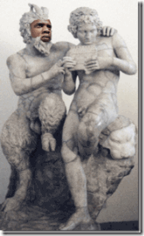
This image is solely my creation identifying and associating Jay Z with the Greek God PAN. Above, Pan teaches his eromenos, the Shepherd Daphinis, to play the pipes. The statute is a 100 BC copy of a Greek original found at Pompeii.[92] Pederasty in ancient Greece was a socially acknowledged erotic relationship between an adult male (the erastes) and a younger male (the eromenos) usually in his teens.[93] The Worship of Pan began in ARCADIA which was always the principal seat of his worship.[94]
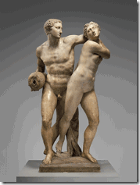
The source image, above, for Jay Z‘s Magna Carta, Holy Grail is the sculpture Alpheus and Arethusa by Battista di Domenico Lorenzi (Italian, ca. 1527/28–1594) at the Metropolitan Museum of Art, New York.[95] Lorenzi known as the Baptist of the Knight was a student of Michelangelo’s chief competitor, Baccio Bandinelli. Bandinelli had been awarded Knight of Saint James by Holy Roman Emperor Charles V (1500-1558) . The Knights Templar Order of St. James of the Sword , also known as the Knights Templar Order of Saint James of Compostela, as well as the Knights Templar Order of Santiago (Santiaguista) was born in the year 1175 in the Kingdom of Leon Spain. The Order of Santiago was a military and religious order with the original dual purpose to fight and drive back the Moors (Muslims) from the Iberian Peninsula as well as to protect the pilgrims on the Camino de Santiago on their ways to the sanctuary of Compostella.
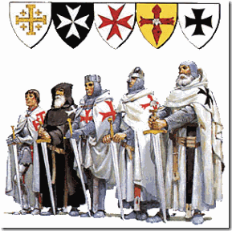
2nd from the Left, Order of Saint James is one of the Military Orders of Knights Templar
According to the museum, the 16th century sculpture is a depiction of a Greek myth about the nymph Arethusa who is pursued by the river god Alpheus. In attempt to escape her pursuer, Diana [Goddess Artemis] transforms Arethusa into a stream [or a well ]. The fair nymph, Arethusa, was surprised while bathing in the river Alpheius in the Knights Templar/Rosicrucian Utopia- ARCADIA Ruled by God Pan. [96]
The statue stood above a fountain in the (Baroncelli) villa Il Paradiso at Pian di Ripoli, near Florence, which belonged to Alamanno Bandini, Knight of Malta, Order of the Knights of Saint John, also known as Order of Saint John, Order of Hospitallers- Knights Templars of the crusades.[97] Bandini was a brother or close relative of Pierantonio Bandini, contemporary of Leonardo di Vinci, one of the wealthiest bankers of the Pazzi Bank in Florence tied to Vatican financing and the First Crusade. The Pazzi Bank were competitors to the infamous Medici Bank of Italy, the wealthiest Medici banking family of all Europe during that period. In fact , this rivalry came to a head on April 26, 1478 when the Pazzi, with the help of the Pope and Archbishop attempted to assassinate its rivals. The so-called PAZZI CONSPIRACY, most likely Knights Templar, failed assassination of the Medici brothers resulted in the death of another of Pierantonio’s relations – Bernardo di Bandino Baroncelli. And apparently, the 1471 hanging made a very special impression on Leonardo da Vinci, Grand Master of the Priory of Sion.
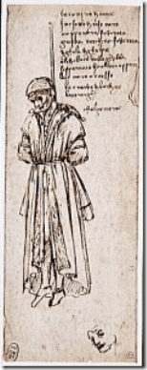
However, Pierantonio Bandini and Alamanno Bandini succeeded to manage the Medici Bank in Belgium Bruges, the capital of of the province of West Flanders, Flemish Region of Belgium.

Pierantonio Bandini and Wife Maria in “‘St. Catherine [DOMINICAN MYSTIC] of Bologna with Three Donors’ by the Baroncelli [Bandini]Master of Bruges”
I am quite sure that you are dumbfounded why Jay Z would be indoctrinating the Hip Hop Generation with ancient secret Luciferian Knights Temple/Rosicrucian occult riddles straight out of 16th Century Europe. Jay Z’s Magna Carta, Holy Grail is deep stuff and hard to follow without some background in European history, but he continues to subliminally slip into his so-called music the secret history, religious beliefs, folklore, myths and legends of the Knights Templar that have only meant Exploitation, Human Bondage and Death for Africans and the Masses . One thing is clear, Jay Z Ride the GOAT.
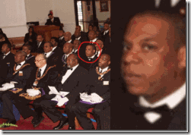
However, Jay Z’s persistent public indoctrination of the Baphomet and the secret Satanic Religious Beliefs, Myths and Symbolism of the Knights Templar lead me to suspect that he has been given some type of license by the order. Jay Z also may have been initiated into the Knights of Malta, or one of the masonic higher secret levels. Nevertheless, Jay Z is certainly on a mission for the secret order. They intend to emerge from the underground the “baddest and Maddest of the Bad and Mad” to rule the unknowing world in widespread bloodshed and destruction just like ancient times, and institute global “Modern Slavery” with LUCIFER as their god. In other words, you will ride the GOAT or DIE.
These people aren’t playing any games. They intend to slaughter and enslave- many, many among the masses. Jay Z and Beyonce is preparing you for what they plan to come. If it is too much, too confused, stop here. Do some background research, then return.
Beyonce, Blood Sacrifice & the Roman Catholics Mystery Schools

Lets go to Beyonce, the DOMINICAN Witch and Mystic. Beyonce Knowles attended St. Mary of the Purification Catholic Montessori School in Houston, TX. As a footnote, Sean “P. Diddy” Combs attended Mount Vernon Montessori School.[98]The Montessori Schools are basically “MYSTERY SCHOOLS.” The ultimate purpose of mystery schools is the evolution of the elite among man into superman via demonic possession along with the seduction that he will become omniscient.[99]
“The pioneer of the altered attitude to education was Maria Montessori…whose vision of a race of Super children bordered on the apocalyptic. ‘The outcome…is the New Child [DESTINY CHILD], a superior being, giving promise of a New Humanity, with powers of mind and spirit hither to unsuspected.'”[100]
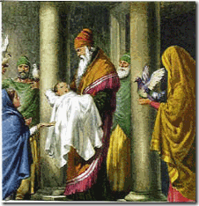
St. Mary of the Purification Catholic Montessori School is run by the Cult of the Sisters in the Spirit of St. Mary of the Purification.[101] The Purification of the Virgin Mary is a BLOOD SACRIFICE event described in the Gospel of Luke (Luke 2:22-40). According to the gospel, Mary and Joseph took the Infant Jesus to the Temple in Jerusalem forty days (inclusive) after his birth to complete Mary’s Ritual Purification after childbirth, and to perform the redemption of the firstborn son, in obedience to the Torah (Leviticus 12, Exodus 13:12-15, etc.). Luke explicitly says that Joseph and Mary take the option provided for poor people (those who could not afford a lamb) (Leviticus 12:8), sacrificing “a pair of turtledoves, or two young pigeons.” (Leviticus 12:1) -indicates that this event should take place forty days after birth for a male child, hence the Presentation is celebrated forty days after Christmas.[102]The other traditional names of the Feast of the Purification of the Virgin include Candlemas, and the Meeting of the Lord.[103]
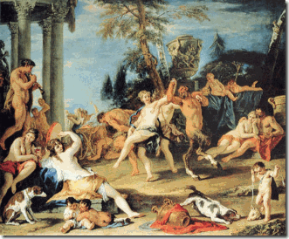
In the occult, the celebration of the end of Purification of Mary is part of a Babylonian/Roman Lupercalia festival called, Oimbolc. Oimbolc celebrates mid-winter (the midpoint between the winter solstice and the spring equinox) and the return of the Sun. Beginning February 2nd candles were lit to welcome the sun and the women began their purification process for the upcoming fertility rites of spring. The Roman Catholic Church adopted this custom from Irish pagans who served the “goddess” whom they called “Brigit“.[104]
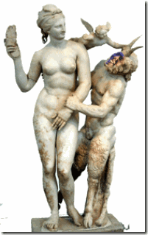
LUPERCALIA [the feast of Lupercus, the mighty wolf hunter] is an ancient Roman BLOOD SACRIFICE (human- highest sacrifice) celebration of Lupercalia held in honor of Lupercus, the deified great hunter of Rome. This celebration also included worship of the goddess of fertility, Venus.[105] Lupercus is the god of shepherds. The Greeks called Lupercus by the name of “PAN.” In the Middle East, Pan was called “Baal“.[106] PAN is the guardian god of ARCADIA.
Where SATAN Rules, Beyonce, Tina Knowles & New Orleans
Agnèz Deréon, Delcambre & the Broussards
Beyonce’s family roots lies about 2 hours just outside of New Orleans among French ROMAN CATHOLICS. Her mother, Tina Knowles, recalls that her mother made altar boy robes and other garments for the church so that she and her siblings could attend Catholic schools.[107]
Cajun is Short for ARCADIAN[108]

Tina’s mother, Agnèz Deréon (1909- 1984), was a dressmaker married to Lumis Albert Beyincé. Agnèz was born in Delcambre, a town near the city of New Iberia, LA. Agnèz was the daughter of Eugène Gustave “Eugenie” DeRouen and Odilia BROUSSARD, daughter of Josephine Lesser (Creole ancestry, who was quarter African American) and Eloni Rosemond “Rene” BROUSSARD (white French CAJUN).[109]
Tina Knowles, Stolen Spirits, the Dominican Order & ARCADIA
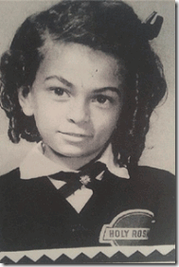
Beyonce’s mother, Tina Knowles, recalled her experience as a 5 (five) year old ” indigent servant” in a Roman Catholic Church that she said tried to take her “spirit.”[110] “The nuns picked on us a lot, my family. I didn’t understand at the time but I did the altar clothes. She [mother] did the altar boys’ uniforms. She worked for the nuns. My dad chauffeured the nuns around. My brothers cleaned the school yard.”[111]
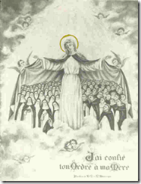
Tina and her family attended the Holy Rosary Catholic Church and School in Galveston, TX. The nuns that she speak of that mistreated and tried to take her “spirit” were the Cult of Sisters of the Dominican Order.[112]
Saint Dominic, Cathars & the Knights Templar

The founder of the Dominican Order was a Roman Catholic religious fanatic, Saint Domingo Félix de Guzmán (1170 – August 6, 1221).[113] In 1215, when the Magna Carta was sealed by King John of England, the Bishop of Toulouse offered the use of a house and church in Toulouse to Domingo Félix de Guzmán, and it was there that the original Dominican order was founded.[114] Saint Dominic had a great to do with the tales of the Knights Templars, Magna Carta and the Holy Grail. He was one of the leaders that brutally persecuted and mass murdered the Cathars, the “Pure Ones” in Southern France with the king armies, and Knights Templar loyal to Roman Catholic Church.[115]
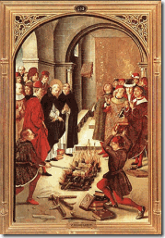
The Cathars was a popular Gnostic Christian Religious Sect that claimed a higher and “Pure” Christian knowledge than the materialistic Vatican and Roman Catholics. Saint Dominic had numerous debates with Cathars. He burned their books along with the Roman Catholic books. Myth is their books burned while his works were delivered from the fire. Over at least 100 years earlier, the Cathars had been the driving force behind the original formation of the Knights Templar.[116] Many of the leaders of the Cathars had been Knights Templar during the early crusades. They were suspected of possessing secret troves of treasures and valuable artifacts from the East. One of the artifacts that they possessed was believed to be the HOLY GRAIL, and maybe even the Arc of the Covenant.[117]
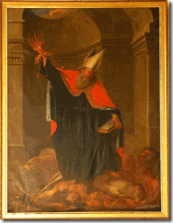
Saint Dominic was the Vatican’s first inquisitor-general of the 20-year military Albigensian Crusade or Cathar Crusade (1209–1229) initiated by Pope Innocent III to eliminate Catharism in the Languedoc district of France. The fanatical Saint Dominic along with the Magna Carta Roman Catholic Knights Templar led the torture and slaughter of the Cathars throughout old Europe, but failed to discover the location of their treasures and Christian ancient relics, and the HOLY GRAIL.[118]
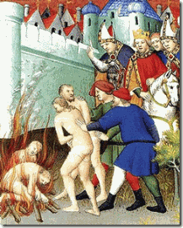
Saint Dominic had the Cathars gathered together wherever they were found, and burned to death and mass murdered them by the tens of thousands. If these Roman Catholic fanatics slaughtered and mass murdered their own people over religious doctrine, what more would they do to Africans and African descendants that they considered to be “inferior creatures”. In French New Orleans and Louisiana, the first bishop of New Orleans and the brother of a French Master Freemason, Bishop Louis-Guillaume-Valentin Dubourg, enslaved Africans. The Jesuits, Capuchins, Uruslines, and the DOMINICAN Sisters openly exploited and enslaved Africans.
Tina Knowles, MK ULTRA & the Occult

Tina Knowles & MK ULTRA Sex Kitten Design
Decades of CIA MK/ULTRA research have established that ritual traumatic/sexual abuse creates true Multiple Personality Disorders (MPD) in children between infancy and (5) five years old. So, it’s hard to say if Tina Knowles’ could recall if or if not her original “spirit” had actually been taken by the Cult of Sisters of the Dominican Order. However, Tina knows very well that it wasn’t her “spirit” – breathe or fire that the Dominicans wanted. It was her immortal “SOUL” that they took for the GOAT.
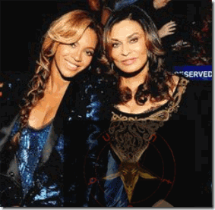
Tina Knowles Either Passed Down the Path of the GOAT to Beyonce or Initiated to “Ride the GOAT” with Beyonce
SOUL, in religion and philosophy, the immaterial aspect or essence of a human being, that which confers individuality and humanity, often considered to be synonymous with the mind or the self (I AM). In theology, the soul is further defined as that part of the individual which partakes of divinity and often is considered to survive the death of the body. What we know is that Tina Knowles is fairly comfortably delving on the fringe of the Occult. On or about March 30, 2012, Tina Knowles was observed wearing a Jewish Mystical Red Bead KABALLAH STRING on her wrist to protect her against the EVIL EYE, DEMONS, and FALLEN ANGELS.[119]
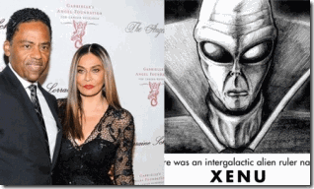
Currently, Tina Knowles with her new significant one, Richard Lawson, are exploring L. Ron Hubbard’s SCIENTOLOGY that is nothing more than pseudo/occult sciences of the Vril Society, the Great BEAST 666- Aleister Crowley, and Himmler’s SS brought to earth by XENU, the dictator of the “Galactic Confederacy“.[120]
BEYONCE CIA MONARCH/MK ULTRA POSSESSION
Beyonce is certainly possessed by a “Spirit”or an “Alternative Personality” that we haven’t seen before in public or on stage. It is possible that Tina Knowles lost not only her spirit but her “Soul” to the DEVIL through the Roman Catholic Satanic Ritual Traumatic/Sexual Abuse of the Black Mass. She certainty sold Beyonce off at a young age to the DEVIL for Fame, Wealth and Fortune.
Beyonce, Tina Knowles, Madame Laveau & Saint Louis Cathedral
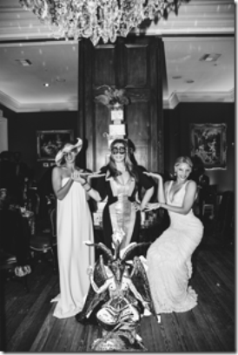
On January 11, 2014, Solange and Beyonce Knowles sponsored Tina’s 60th Birthday “Old Fashioned Masquerade Party” at Muriel’s Jackson Square, New Orleans.
“While Dining at Muriel’s Jackson Square you will uncover the rich history and the past while celebrating the life of today. Indulge in the SPIRITS of our Courtyard Bar while Sir Antoine and the SPIRITS of yesteryear dine alongside of you.” The grounds of Muriel’s is linked to Claude Trepagnier who was awarded this piece of land for his assistance in the French Knights of Saint Louis expedition that founded New Orleans.
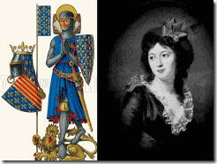
His daughter, Barbe de Claude Trepagnier, married Jean Jacques Macarty, Knight of Saint Louis, and one of Baroness Marie Delphine Macarty-Lalaurie’s French great or great-great uncles. The current site of Muriel was built by Jean Baptiste Destrehan. Jean married Genevieve Bienville bring the Destrehan to the Macarty by marriage. Jean’s daughter, Elandore Destrehan married Edouard Macarty, Marie Delphine Macarty’s second cousin. Baroness Marie Lalaurie’s Spirit and Bloodline runs throughout the history of Muriel’s at Jackson Square. It is something that Tina, Beyonce, Solange and Jay Z are very well aware of.
What is Jackson Square?
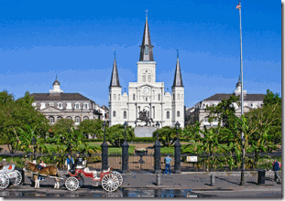
Jackson Square, is a historic park in the French Quarter that stands in front of the Roman Catholic Saint Louis Cathedral designed and built by Knights Templar/Freemasons. This is the cathedral attended zealously by Roman Catholics Madams’ Marie Catherine Laveau and Marie Delphine Macarty- Lalaurie.
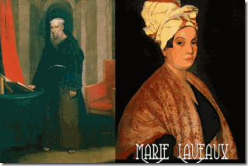
This is the place where the ghosts and “SPIRITS” of “Secret High Level FREEMASON” Capuchin Friar Pere Antoine, Madame Marie Laveau and the “tortured souls of thousands of Africans” are said to inhabit. It is the grounds of Madame Laveau’s secret Satanic Black Mass, and not far from French Knight of Saint Louis descendant Baroness Lalaurie’s Mansion of Satanic Blood Sacrifice of Black People. Lest you ever bound to forget the Horror and EVIL just down the street from Jackson Square and Saint Louis Cathedral at Baroness Lalaurie’s Mansion on Royal Street in the French Quarter.

I’ll remind you of some horrific details:
“According to rumor, over a dozen disfigured and maimed slaves were manacled to the walls or floor. Several had allegedly been the subject of gruesome medical experiments.The exact details are unclear; owing to the horrific nature of the crime, many details were either swept under the rug or embellished. Perhaps the most gruesome of Mme. LaLaurie’s killings was discovered by a young pickpocket by the name of Christopher Knowles. Knowles had broken into the LaLaurie residence with intention of stealing jewelry and other valuables. He broke in through the window and on the floor he discovered a bucket filled with mutilated human genitalia. Next to the bucket was a body. The body appeared to have been force fed the contents of the bucket until he eventually died from choking. LaLaurie was even reported to have tortured and killed local activist Adam Wescount, reportedly gouging out his eyes and letting crows devour his remains. One man looked as though he had been victim of some bizarre makeshift sex change. Another one had a hole in his head where a stick had been inserted to “stir his brains”. A woman was trapped inside a small cage where her arms and legs had been badly broken and then reset at odd angles, making her appear as some sort of “human crab.” Another woman had her arms and legs removed and patches of her flesh had been sliced off in a circular motion to make her appear as a giant caterpillar. Some had their mouths stuffed with animal excrements, sewn shut, and had then starved to death. Others had their hands sewn to different parts of their bodies. One woman had her entrails pulled out and was secured to the floor by her own intestines. A small boy of about twelve had the flesh on half of his face peeled back, revealing muscle, veins, and so forth. The wound had since been infested with disease and insects. Two men were found to have had their tongues sewed together. One girl wore a suit made from the skin of several skinned slaves, the limbs of which were hacked and use to decorate the grand gore chamber. Most disturbing of all was an elderly man whose penis was cut into 5 equal strands, each of which was attached to a hook and the body hoist to the ceiling, with two candles placed in his eye sockets to form a macabre chandelier. Most of the victims were found dead. Those who were still alive begged to be put out of their misery and died shortly after. Also discovered in the attic were teacups and saucers, encrusted with a “red substance.” There were several bottles lying about with what was assumed to be the same red substance, later identified as blood. Actually some press accounts from early 1834 are marginally more explicit than the Bee, though their reliability is difficult to ascertain. For example, the Religious Intelligencer of 10 May 1834 reports the discovery of Seven poor unfortunate slaves… some chained to the floor, others with chains around their necks fastened to the ceiling, and one poor man upwards of sixty years of age chained hand and foot and made fast to the floor in a kneeling position. His head bore the appearance of having been beaten until it was broken, and the worms were actually seen to be making a feast of his brains!! A woman had her back literally cooked (if the expression may be used), with the lash; the very bones might be seen projecting through her skin! Cited by Courtney Barker, Misrecognized: Looking at Images of Black Suffering and Death, unpublished PhD dissertation, Duke University, 2008, p.32. There seems little doubt that even abuse of this sort would have been more than enough to cause Lalaurie to be described as “a demon, in the shape of a woman” by the New Orleans press.”
What went on at the Lalaurie Mansion in the French Quarter is no different than what went on at the 15th Century French Castle of Baron Giles de Rais. It was the secret Roman Catholic Black Mass Blood Sacrifice raising the favor of SATAN. Jackson Square and the Saint Louis Cathedral is filled with paramount ancient EVIL spirits of the past like Friar Pere Antoine, Madame Marie Laveau, and the Black Mass “Blood Sacrifices” straight out of Medieval France. In the sheer and utter EVIL that they are- Tina, Beyonce, Solange and Jay Z basted among the Spirits of the DEAD and the Tortured SOULS of our African Ancestors.

In New Orleans, Beyonce, Solange and Tina on a checker board floor between two columns like in a Masonic Temple dressed just like Knights Templar Baron Gilles de Rais’ almost 500 years before them , “… from head to toe in white to indicate his repentance.”
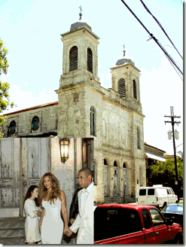
The site of Solange’s November 2014 wedding was an old Gothic Temple, the deconsecrated Gothic Holy Trinity Church, founded in 1847 for Roman Catholic Germans. They seem to have been dissociated from New Orleans’ Black Past, Legacy and Struggle.
What is an “old fashioned masquerade party” in New Orleans?
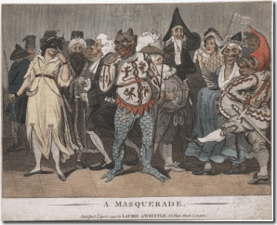
First, Tina, Beyonce and Solange are LUCIFERIANS, Masters of Deception, deliberately deceiving their fans and the masses. Second, New Orleans’ masquerade balls are old world pagan occult rituals that had been restricted to white French secret societies- Bloodline ILLUMINATI of the New World Order. Third, old fashioned masquerade balls had been going on for almost 200 years before Blacks were allowed to participate.[121]
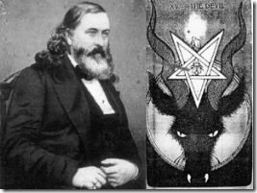
Fourth, the three secret founders that established the Mardi Gras/Masquerade Balls in New Orleans on a stable basis were Luciferians ALBERT PIKE (Freemason, Knights of the Golden Circle, Ku Klux Klan) , Judah Benjamin (Confederate Secretary of State) and John Slidell (Confederate States of America’s commissioner to FRANCE). Judah Benjamin was an agent of the House of Rothschild living in New Orleans in 1857.[122]
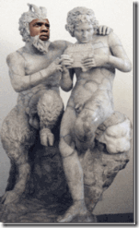
Fifth, old fashioned New Orleans’ Mardi Gras/Masquerade Balls are based on Roman occult rituals of Lupercalia linked to the Knights Templar/Rosicrucian utopia ARCADIA with PAN as god.
Beyonce, Tina, Old Bloodlines of the Anti-Christ
Historically, the area that became known as DELCAMBRE, birthplace of Agnèz Beyincé, Tina’s mother and Beyonce’s grandmother, was first settled by ARCANDIANS who were expelled from Nova Scotia (New Scotland) by the Major Pierce Butler and the British in the mid-18th century.[123] Tina and Beyonce Knowles‘ bloodline is ARCADIAN linked to the coming False Prophets and the Anti-Christ of the New World Order.
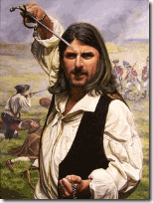
Leader of the ARCADIANS, Joseph Broussard- Beausoleil with Sword and Rosary Beads
Tina’s fifth great grandfather, and Beyonce’s sixth great grandfather was the infamous fanatical ROMAN CATHOLIC Joseph Broussard (1702–1765) born in Port Royal, ARCADIA, a Guardian of the Knights Templar/Rosicrucian Mythical Utopia- ARCADIA RULED BY GREEK GOD PAN (SATAN).[124]

“The enemy has only images and illusions behind which he hides his true motives. Destroy the image and you will break the enemy.” Shaolin Abbot to Bruce Lee, Enter the Dragon (1973)
Right this moment when you reflect back on Bobbi Kristina and Nick Gordon, you don’t see the enemies gathered around them. You stare into a Looking Glass and a Smoked Mirror by design and see only Reflections, IMAGES and ILLUSIONS staring back at you that say, “they were weak and backsliding. they did it to themselves- they did it to themselves- you did it to yourself” Destroy the Images and Illusions, Break the Looking Glass and Smoked Mirrors.

[1] http://en.wikipedia.org/wiki/Society_of_Jesus
[2] http://en.wikipedia.org/wiki/Gilles_de_Rais
[3] http://en.wikipedia.org/wiki/Gilles_de_Rais#Trial_and_execution
[4] http://breakingdeception.com/catholic-jesuit-superior-resigns-charged-black-mass-child-sacrifices/
[5] http://www.goodreads.com/author/quotes/29874.Martin_Luther
[6] http://blogs.forward.com/the-shmooze/152151/whitney-houston-had-israel-trip-planned/
[7] http://www.bellefontefaith.com/the-way-in-the-footsteps-of-jesus-the-jordan-river-sermon-from-622013/
[8] https://willyloman.wordpress.com/2015/03/04/dzhokhar-tsarnaevs-defense-attorney-judy-clarke-sold-him-out-punching-her-ticket-to-a-justice-department-career/
[9] Id.
[10] http://www.theguardian.com/world/2009/sep/29/ehud-barak-war-crimes-israel
[11] http://www.jpost.com/Israel/Analysis-IDFs-most-elite-unit-trio-takes-the-reins
[12] http://www.bibliotecapleyades.net/sociopolitica/codex_magica/codex_magica11.htm
[13] Id.
[14] Id.
[15] http://pakpoliticianscandal.blogspot.com/2011/04/imran-khan-with-daphne-barak-sister-of.html
[16] http://www.inquisitr.com/1824481/bobbi-kristina-brown-confidant-daphne-barak-insists-she-accused-her-entire-family-of-gold-digging/
[17] Id.
[18] http://news.lalate.com/2012/02/20/bobbi-kristina-brown-rehab-visit-revealed-past-alleged-suicide-attempt-reports/
[19] http://sataniccrimesagainstchildren.blogspot.com/2011_06_01_archive.html
[20] http://en.wikipedia.org/wiki/Roswell,_Georgia#Demographics
[21] http://www.eonline.com/news/426650/bobbi-kristina-evicted-whitney-houston-s-daughter-voluntarily-moves-out-of-home-after-complaints
[22] http://www.britroyals.com/stuart.asp?id=charles1
[23] http://en.wikipedia.org/wiki/House_of_Stuart
[24]http://wc.rootsweb.ancestry.com/cgi-bin/igm.cgi?op=GET&db=rblalock&id=I10751
[25] http://www.todayingeorgiahistory.org/content/george-ii
[26] http://en.wikipedia.org/wiki/Windsor,_Connecticut
[27] http://en.wikipedia.org/wiki/Roswell_King
[28]http://en.wikipedia.org/wiki/Pierce_Butler
[29] http://www.turtlebunbury.com/history/history_houses/hist_hse_ballintemple.html
[30] Id.
[31] http://www.selectsurnames2.com/spalding.html
[32] Id.
[33] http://engineerofknowledge.blogspot.com/2010/07/history-of-knights-templar-and.html
[34] Id.
[35] http://watch.pair.com/ritual.html
[36] Id.
[37] http://watch.pair.com/ritual.html
[38] http://en.wikipedia.org/wiki/Roswell_King
[39] http://www.roswellpres.org/history/
[40] http://www.bdcnetwork.com/restoring-bricks-roswell?page=1
[41] http://en.wikipedia.org/wiki/Richard_Saltonstall
[42] http://www.elizabethanenglandlife.com/elizabethan-knights.html
[43] http://trees.ancestry.com/tree/21920874/person/1716/media/31c3f6f5-1037-4afd-9403-9dd15ce70bfc
[44] http://en.wikipedia.org/wiki/Nicolas_Poussin
[45] http://www.artble.com/artists/nicolas_poussin/paintings/the_arcadian_shepherds
[46] http://templarcode.blogspot.com/
[47] http://en.wikipedia.org/wiki/Papal_name
[48] http://en.wikipedia.org/wiki/Roswell_Mill
[49] http://roswellmarietta.civilwar150th.org/?p=21
[50] http://archives.chicagotribune.com/1883/08/11/page/10/article/gen-sherman
[51] http://en.wikipedia.org/wiki/Treason
[52] http://civil-war-picket.blogspot.com/2010/10/remarkable-story-of-french-flag-ruse.html
[53] https://www.linkedin.com/pub/james-russell-grant/23/931/514
[54] http://en.wikipedia.org/wiki/1988_Democratic_National_Convention
[55] http://en.wikipedia.org/wiki/40th_G7_summit
[56] Redford, James, The Physics of God and the Quantum Gravity Theory of Everything, Social Science Research Network (2011), pg. 87
[57] http://www.nationalenquirer.com/celebrity/bobbi-kristina-browns-inner-circle-druggies-deadbeats
[58] Id.
[59] http://en.wikipedia.org/wiki/Eleazar_ben_Hanania
[60] http://www.nationalenquirer.com/celebrity/bobbi-kristina-browns-inner-circle-druggies-deadbeats
[61] http://www.ajc.com/news/news/no-bail-for-alpharetta-man-charged-with-murder-by-/ngxdc/
[62] http://www.wsbtv.com/news/news/parents-arrested-after-calling-911-drunken-teenage/nNWHz/
[63] http://www.langrealty.com/agents/joan-lefkowitz/?p=85
[64] http://tbo.com/news/ex-con-gives-teenagers-dose-of-prison-realities-52536
[65] http://www.passportsandvisas.com/visas/israel-visa-faq.asp
[66] https://paulxwillis.wordpress.com/2011/01/26/two-families-on-opposing-sides-of-the-mid-east-conflict/
[67] http://www.salatalaw.com/Attorneys/J-T-Salata.shtml
[68] https://www.facebook.com/FultonCountyDA
[69] http://www.nationalenquirer.com/celebrity/bobbi-kristina-browns-inner-circle-druggies-deadbeats
[70] http://radaronline.com/exclusives/2015/02/bobbi-kristina-kept-bedroom-shrine-whitney-houston/
[71] http://en.wikipedia.org/wiki/Johns_Creek,_Georgia#Geography
[72] http://www.musictimes.com/articles/28921/20150218/bobbi-kristina-brown-best-friend-died-heroin-overdose-months-ago.htm
[73] http://northfulton.com/stories/3-arrested-for-womans-heroin-death,62111
[74] http://northfulton.com/stories/3-arrested-for-womans-heroin-death,62111
[75]http://radaronline.com/exclusives/2015/02/bobbi-kristina-brown-ex-bad-influence/
[76]http://www.usmagazine.com/celebrity-news/news/bobbi-kristina-browns-friend-max-lomas-breaks-silence-is-devastated-201542
[77] http://www.nydailynews.com/entertainment/gossip/leolah-brown-nick-gordon-investigated-attempted-murder-article-1.2141731
[78] http://radaronline.com/exclusives/2015/02/bobbi-kristina-brown-max-lomas-lawyers/
[79]http://snn.bz/bobbi-christina-not-well/
[80] https://www.yahoo.com/style/ll-cool-j-admires-the-way-madonna-takes-care-of-110446672637.html
[81] http://www.demanjo.com/news/entertainment/596837/angela-bassett-opens-up-about-bobbi-kristina-s–heart-wrenching-situation-.html
[82] http://www.demanjo.com/news/entertainment/596837/angela-bassett-opens-up-about-bobbi-kristina-s–heart-wrenching-situation-.html
[83]http://en.wikipedia.org/wiki/Holy_Grail_%28Jay_Z_song%29
[84] http://en.wikipedia.org/wiki/Holy_Grail
[85] http://www.truthcontrol.com/knights-templar
[86] https://archive.org/stream/magnachartabaro00browgoog/magnachartabaro00browgoog_djvu.txt
[87] http://www.rootsweb.ancestry.com/~irlkik/history/gowran.htm
[88] http://www.clansinclairsc.org/masonictime.htm
[89] http://en.wikipedia.org/wiki/Knights_Templar_%28Freemasonry%29
[90] http://www.latinamericanstudies.org/freemasonry/Proceedings-SC-1859.pdf
[91] http://www.history.army.mil/books/RevWar/ss/butler.htm
[92] http://en.wikipedia.org/wiki/Pan_%28god%29
[93] http://en.wikipedia.org/wiki/Pederasty_in_ancient_Greece
[94] http://en.wikipedia.org/wiki/Pan_%28god%29
[95] http://www.metmuseum.org/collections/search-the-collections/198644
[96] Id.
[97] Id.
[98] http://shalommontessori.com/history.html
[99] http://watch.pair.com/new-education.html
[100] http://watch.pair.com/new-education.html
[101] http://www.stmaryshouston.org/
[102] http://en.wikipedia.org/wiki/Presentation_of_Jesus_at_the_Temple
[103] Id.
[104] http://www.babylonforsaken.com/valentines.html
[105] http://www.babylonforsaken.com/valentines.html
[106] Id.
[107] http://en.wikipedia.org/wiki/House_of_Der%C3%A9on
[108] http://www.acadian-cajun.com/acadiancajun.htm
[109] http://en.wikipedia.org/wiki/House_of_Der%C3%A9on
[110] http://www.vibe.com/2014/10/tina-knowles-opens-up-about-divorce-matthew-knowles/
[111] http://www.designntrend.com/articles/20828/20141006/tina-knowles-reveals-why-destinys-child-lost-first-record-deal.htm
[112] http://www.tshaonline.org/handbook/online/articles/ich01
[113] http://en.wikipedia.org/wiki/Saint_Dominic
[114] https://prezi.com/p8izfen-gtyt/st-dominic-de-guzman/
[115] http://en.wikipedia.org/wiki/Catharism
[116] http://grigorfedan.com/main/knights_templar_history11X3xDDDZ
[117] Id.
[118] http://en.wikipedia.org/wiki/Albigensian_Crusade
[119] http://mediatakeout.com/55097/beyonces-mother-appears-to-chuck-dueces-at-jesus-converts-to-judiaism-pics.html
[120] http://en.wikipedia.org/wiki/Xenu
[121] http://www.hngn.com/articles/21867/20140113/tina-knowles-birthday-party-pictures-beyonc%C3%A9-solange-throw-mom-star.htm
[122] http://tekgnostics.blogspot.com/2010/02/mardi-gras-and-illuminati.html
[123] http://en.wikipedia.org/wiki/House_of_Der%C3%A9on
[124]http://www.geni.com/path/Beyonc%C3%A9+Knowles+is+related+to+Joseph+dit+Beausoleil+Broussard?from=6000000007543975282&to=6000000006763758472
Comments : 6 Comments
Tags: acadia, african holocaust, african slavery, Agnèz Deréon, alexis norwood, alpheus, american horror story, angela bassett, antichrist, arc of the grail, arcadia, arethusa, Baphomet, barrington king, BEYONCE KNOWLES, black mass, black music industry, blood cults, blood oath secrecy, blood sacrifice, bobbie kristian brown, bobby brown, cathy bates, chelsea ivanna bennett, cory ben-hanania, daphne barak, Delcambre, destiny child, Dissociate identity disorder, dr. phil, ehud barak, freemasonry, georgia, gilles de rais, goat god, holy grail, human sacrifice, Illuminati, ireland, j. tom morgan, jake bullock, james russell grant, jay z, jesuits, john bullock, john petrey, kabbalah, king louis xiv, knights of saint james, knights templar, Leonardo da Vinci, LL Cool J, lupercalia festival, madonna, magna carta, major pierce butler, Marie Delphine Lalaurie, marie leveau, mason whitaker, maxwell lomas, Merovingian bloodlines, mind control, MK-ULTRA, Monarchs, money pit, Montessori Schools, mossad, new orleans, nick gordon, nicolas poussin pope clement, nova scotia, paige thompson, pan, port royal, PROJECT CHATTER, rhinanna, robert the bruce, roman catholic church, rosie perez, Roswell, roswell bunch, roswell king, satan, Satanism, sebastian andrade, shebly derrington, sir francis bacon, sir william sinclair, St. Mary of the Purification Catholic church, the coven, thomas spaulding, tina knowles, Whitney houston
Categories : african american satanic cult, angela bassett, antichrist, arcadia, Aryan Supremacy, baal, baphomet, beyonce, black institutions, Black Panther Party for Self Defense, blood covenants, blood oaths, BOBBI KRISTINA BROWN, bobby brown, CIA, devil, devil's horns, dianetics, False Satanic Rites of Lost Negroes, Fugitive Slave Law, Hip Hop, hip hop satanic cult, hollywood satanic cult, huey p. newton, human sacifrice, illuminati, illuminati sacrifice, israel, jay z, jay-z, jesuits, Knight of Malta, Knights Hospitaller, Knights Templar, L. Ron Hubbard, lucifer's servants, luciferians, magna carta, masonic sacrifice, mind control, MK-ULTRA, modern slavery, monarch child, monarch program, mulitiple personality disorder, new orleans, new world order, nick gordon, oakland, pan, queen elizabeth, racial mass murder, Rihanna, Ritual Satanic Abuse, ritual satanic sexual abuse, ritually abused children, Rosicrucian, Rosicrucianism, SASHA FIERCE, satan, Satanic Global High Cabal, Satanism, Scientology, scientology, dianetics, Secret Doctrine, sex kitten, trauma-based mind control, vril, xenu, ZIONIST

PART I, BOBBI KRISTINA, ANGELA BASSETT, MADAME LAVEAU MEROVINGIANS & THE BLOOD SACRIFICE NINTH SATANIC CIRCLE
26022015
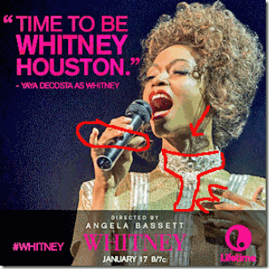
This Whitney Hologram TV film poster Hides the DEVIL HORNS, ROSICRUCIAN CROSS and PENTAGRAM STAR with what looks like a PHALLIC like Shadow pointing to the CROSS with BLACK FINGERS also pointing to the CROSS. Even the HAIR hides shadows that form IMAGES that the PROGRAMMED can VISUALIZE.
Bobbi Kristina- Time to Die!
Bobbi Kristina- Time to be Whitney Houston, take your Jonestown drug cocktail, lay down in a bathtub full of water and DROWN. Bobbi Kristina- Time to be Whitney Houston! Bobbi Kristina- Time to be Whitney Houston. DEAD!
Bobbie Kristina’s Medical Condition- Unchanged
The most current news is that Bobbi Kristina’s medical condition is unchanged. However, some unnamed sources report that her organs are failing, but family sources have denied that her organs are shutting down.[1] After weeks of Jerod Brown’s press and public statements about his cousin. He has been silenced. Jerod is Bobby Brown’s nephew, son of his late oldest sister, Elizabeth. Bobby Brown’s Orpheus/Jesuit Counsel, Michael Brown, issued a statement to quiet Jerod Brown to favor the confusion, diversion, deception and ILLUSIONS of their master, LUCIFER.
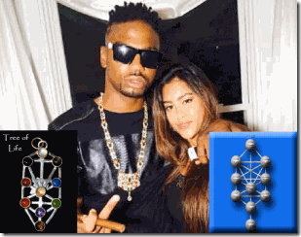
Jerod Brown aka YF Kennedy wearing Kabbalah Symbolic– Tree of Life– jewelry.
Jerod had been part of Bobby Brown’s international Member’s Only Elite rapping crew.[2] Undoubtedly, he also had been initiated into one of Bobby Brown’s Negro false rite Rosicrucian solar societies for fame and fortune.
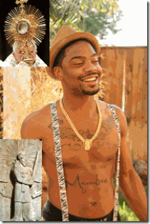
Jerod wears what appears to be a Mithras/Mithra false rite solar society medallion and all-seeing-eye stylized suspenders. They can’t wear the real ancient Satanic Solar Society robes, metals and medallions. So, they hide and play behind symbolic Satanic jewelry and clothing.
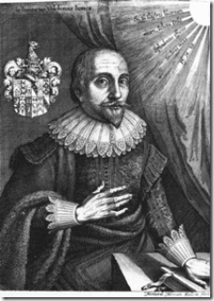
Mystic Rosicrucian Robert Fludd (1595 – 1637) Past Grand Master of the Prieure de Sion.[3] Also, take note the Mithras/Mithra Sunburst Symbol in upper right corner. Again, Bobby Brown and Bobbi Kristina– A certain ancient Rosicrucian/Satanic Salute Left Hand Gesture.
The cross that Bobby Brown wears below is a from of the ancient Maltese Cross. The cross symbol is directly associated with the Knights Hospitaller (the Knights of Malta). The cross is eight-pointed and has the form of four “V”-shaped elements, each joining the others at its vertex, leaving the other two tips spread outward symmetrically. Its design is based on crosses used since the First Crusade.[4]
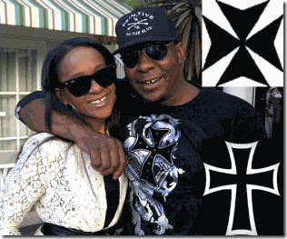
Brown’s Black Cross has been the symbol of the Teutonic Order from the 12th century to present. It is the predecessor to the Iron Cross that originated in 1219 when the Kingdom of Jerusalem granted the Teutonic Order the right to combine the Teutonic Black Cross placed above a silver Cross of Jerusalem.[5]

ILLUMINATI Sun-Solar, All-Seeing-Right Eye, Bobbie Kristina & New Commercialized Rosicrucian Rap Sensation, Iggy Azalea
In May 2014, Forbes magazine declared that “Hip-Hop [Rap] Is Run by a White, Blonde, Australian Woman …”- Iggy Azalea. Iggy Azalea, “I have a place, and I don’t care what other people have to say about it. I was a fan of rap music growing up, and I didn’t feel like there were enough characters that represented me and my situation. So I think it’s needed.” You should very well be afraid of this woman. This is the ILLUMINATI/Rosicrucian Solar Deity’s bold move to dominate the Hip Hop industry, and subjugate Black Culture to the mandates of Seth-Set- SATAN.

Iggy Azalea doesn’t have to play with or conceal the Satanic Sun Deity’s signs and symbols. She has been anointed by the CIA/MK ULTRA Occult Bureau as its new RAP High Priestess. She is the embodiment of the Kemetic Winged-Sun Disc, the Rosicrucian Sun-Burst Cross on her chest.
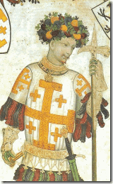
Godfrey of Bouillon with Cross of Jerusalem as depicted in a late medieval fresco (Castello della Manta, Piedmont, Italy 1420.) Famous leader of the First Crusade and the Knights Templar movement. It appears that Iggy also has Godfrey of Bouillon’s Cross of Jerusalem on her right shoulder. She has the Omega Symbol, Five-Pointed Pentagram Star, and Bobby Brown’s Teutonic Knight Cross on her right arm, bottom appears to be the Kundalini Symbol- “She who is coiled.”
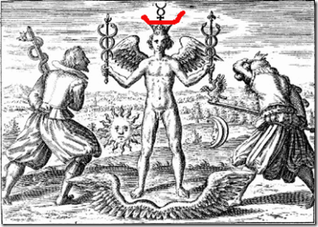
Ancient Kundalini Snake (Luciferian) Symbol is related to Mystic Rosicrucian Sir Francis Bacon’s Shakespeare’s Tempest Opening Ceremony of the Paralympics.
Bobby Brown sold Bobbi Kristina off into a Negro Rosicrucian Satanic Solar Circle that is a cell of a greater more powerful and ultra secret assemblage, the Ninth Satanic Circle. This explains why Jerod by deception posted an ILLUMINATI All-Seeing-Eye picture of Bobbi Kristina for the masses to falsely pray to.

ILLUMINATI Bastardized Left Eye of Horus– Bobbi Kristina & Satanic High Priestess- Lady GaGa
From very early times in the Land of Kemet, the sun and the moon were regarded as the eyes of the great falcon God Horus, though the two eyes eventually became differentiated, with the left eye (the “Eye of Horus“) often being regarded as the symbol of the moon and the right eye (the “Eye of Re“) being that of the sun. One of the most prominent myths concerning the moon relates its cycle to the battle between Horus and Set- Seth/SATAN. During this famous battle over the inheritance of Osiris-Aset, Seth steals the Left Eye of Horus, damages it, and divides it into six parts.[7]
It Happened in Roswell
Bobbi Kristina’s mysterious bathtub drowning incident happened in a place called Roswell. That bathtub drowning incident is eerily or MOCKINGLY familiarly similar to Whitney Houston’s deadly fate in Beverly Hills.[8] Just as in the case of the Roswell Incident and the Assassination of Whitney Houston, the public is totally unnecessarily left out in the dark and absolutely “clueless” as to what happened to Bobbi Kristina in Roswell, and her actual medical condition.
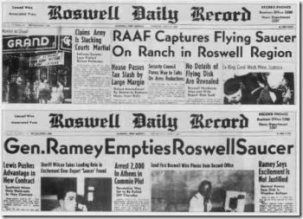
In July of 1947, something extraordinary happened in a place called “Roswell” that sparked the fear and the imagination of this nation for decades. It was reported that the government secretly recovered from Roswell crashed alien spacecraft and extraterrestrial beings from another world. According to Joseph P. Farrell, author of Roswell and the Reich, Roswell is “no-man’s- land.” In the grand scheme of things, it is a momentous fear, confusion, diversion and DECEPTION for the masses conceded by Lucifer’s Servants, the SS, that will forever delve in a void somewhere between magic, myth, fact and fiction.[9] Bobbi Kristina’s “no-man’s- land” of myth, fact and fiction out of Roswell continues to swing into puzzles warped inside enigmas. Things become stranger, wilder and bizarre by the day.
At the end of the day, it looks as though the DEVIL will not be denied his end of the bargain, one way or another- it will get Bobbi Kristina’s Soul. That’s the way they roll. That’s the way they have been rolling for over a thousand years.
It Happened in Roswell: Bobbie Kristina’s Strange Automobile Accident

Image of a random Jeep Liberty
“Bobbi Kristina Brown lost control of her Jeep Liberty when a tire blew out on Jan. 27, crossing into oncoming traffic and colliding with another vehicle. Police in the Atlanta suburb of Roswell described ‘extensive damage’ to both vehicles. Brown’s passenger and the other car’s driver were hospitalized. Brown blamed tire failure, and officers found a nail in the Jeep’s blown-out right rear tire, the incident report says.”[10]
That is really strange for an off-road SUV Jeep Liberty to hydroplane completely out of control from a nail puncture in a right rear tire. The Jeep Liberty replaced the Jeep Cherokee. It marked a few firsts for Jeep. It was the first Jeep vehicle to come with rack and pinion steering, and front independent steering. It has front and rear wheel drive.[11]
Most off road vehicles also come with superior puncture resistant tires. A tire blow out and a vehicle hydroplaning out of control from a nail in an off road 21st century technological puncture resistant tire is possible, but highly unlikely.[12] It is also extremely strange and unusual that everyone involved in the accident had sought and obtained professional medical treatment and advice, but for Bobbi Kristina. Or should I say, strangely. No pictures of Bobbi Kristina’s damaged SUV have surfaced, and nothing has yet come to light whether or not Bobbi Kristina was in fact treated or seen by medical professions after the accident.
Five days ago, a lawyer for the other driver, Russell Eckerman, of a Midsize Ford Taurus involved in the accident said that he was still in critical condition- unable [or not allowed] to speak.[13] Bobbi Kristina’s vehicle had been deliberately tampered with to intentionally cause a serious and dangerous life threatening accident.
Bobbie Kristina, Angela Bassett & the ILLUMINATI Gay/Transgender Conspiracy
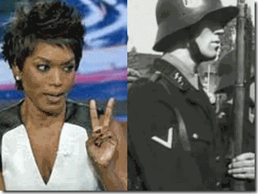
Angela Bassett V-Sign, the V-Peace Symbol Also Hides an Occult Meaning
Recently, Angela Bassett compared Bobbi Kristina’s case with opening up generally- conversations about long-term care of the elderly. That’s what she is doing- stepping up and taking care of the long-term health concerns of her elder in-laws.[14] She said that Bobbi Kristina’s current situation is “tragic.” “I do try to keep my ear open to what some of the developments are,” she told ABC News today.[15] In the comment section of this article, I discovered that her twins are somewhat adopted- cloned. People Magazine headline, March 27, 2006, “After a Seven-Year Struggle to Have Children, Angela Bassett and Husband Courtney B. Vance Welcome Twins with the Help of a Surrogate Mother.”[16]

When Bobbi Kristina found out that she had been completely disassociated and washed out from the entire Whitney TV biopic film project, she lashed out at Angela Bassett in June 2014 on twitter that insinuated that Bassett was a literal TRANNY- TRANSGENDER,

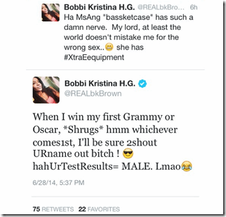
Whether or not, Angela Bassett was born a man would be a deep cover secret. As all ILLUMINATI, Bobbi Kristina was bound by a Blood Covenant of SECRECY.

By January 31, 2015, Bobbi Kristina was found “unresponsive” face down in a water filled bathtub. Dr. John O’Dea, M.D. told HollywoodLife.com exclusively, “If someone was cut off from OXYGEN for 15 to 30 minutes, they would be BRAIN DEAD. All it takes is to be cut off from OXYGEN for 5 to 10 minutes.”[17]
Joan Rivers & the ILLUMINATI Gay/Transgender Conspiracy
Previously in a July 2014 unprompted outburst to the press, Joan Rivers said that Barrack Obama was our first GAY president. River’s then offered, “You know Michelle is a TRANNY.“ When the reporter attempted to clarify, she responded: “A TRANSGENER. We all know.”[18] I was certainly among those that didn’t know. As all ILLUMINATI/Jewish Cabal, Joan Rivers was bound by a Blood Covenant of SECRECY. By September 4, 2014, 81 year old popular comedian Joan Rivers suddenly came up dead from “anoxic encephalopathy due to hypoxic arrest,” a medical description of BRAIN DAMAGE caused by a lack of OXYGEN.[19]
It’s extremely scary stuff if Michelle is actually a Michael. I have always defended Michelle Obama in the image of a beautiful black woman that had been influenced and corrupted SATANICALLY. Just the very thought of it is absolutely mind blowing deep-deep stuff. But, this is no laughing matter as some believe that it is. If she is a Michael, it would be a master craft of mass population LUCIFERIAN DECEPTION and ILLUSION. If they say that he is a she over and over again, we come to believe the lie.
Study the above video carefully then take a second study of the HANDS, facial and body features of Angela Bassett.

Some sources believe that the Obama daughters, Malia and Sasha, were secretly adopted out of Morocco or they are surrogate children like Bassett’s twins. They claim that there are no pictures or records of Michelle Obama being pregnant or with a newborn baby. And, Malia and Sasha have no public birth records.[20] They were born before Barrack Obama became President of the United States.
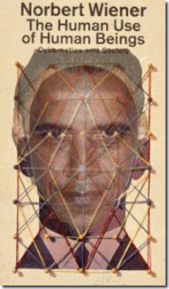
For about 5 years, I have contended consistently that Barrack Hussein Obama is part of a highly classified One Step Beyond/Outer Limits CIA/MK ULTRA Secret Human Cyborg Project that goes back to Hauptsturmführer (Captain) SS Dr. Josef Rudolf Mengele. However, it never crossed my mind that Michelle Obama could be a man. It had been a notion too bizarre to even consider in the first place. if Michelle is actually a Michael, it would stand as one of this nation’s most egregious breaches of FAITH, and Crimes Against Democracy.
Over the decades, we have come to know for certain that the system is reactionary. If you come too close to exposing forbidden truths, the DRAGON will snap its tail. It snapped its tail on Bobbie Kristina and Joan Rivers. Now, I starting to come to the realization that the DRAGON may have snapped its tail on popular black Comedian Tracy Morgan.
Tracy Morgan & the ILLUMINATI Gay/Transgender Conspiracy

I have never been a fan of the demeaning little demon, Tracy Morgan. He is just as much of an ILLUMINATI Negro WHORE as Kevin Hart.
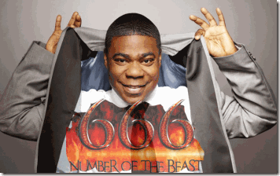
In June 2011, Tracy Morgan showed signs of resistance to the ILLUMINATI homosexual agenda, and seriously got out of line with the agenda and game plan. He said that gays were not “born this way,” and lesbians don’t really like women, they just hate men. Morgan also said that if he found out his son were gay, he would pull out a knife and stab the “little nigga” to death. Subsequently, he was forced to go on an “apology to Gays tour.”[21]
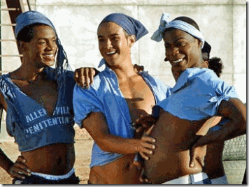
A Hermaphrodite is an organism that has reproductive organs normally associated with both male and female sexes.
Interestingly, Joan Rivers had been one of the few HollyWeird celebrities that said publicly, “Tracy Morgan should not apologize” to Gays. [22] Morgan appears to be an extraordinary intelligent brother, but as Katt Williams found out that no matter how clever that you think you be may, once you sell your soul to the DEVIL- the Satanic Circle/Cabal play no games. But, Morgan continued to play and toy with the ILLUMINATI’s Gay/Hermaphroditic notions and agenda. As all ILLUMINATI, Tracy Morgan is bound by a Blood Covenant of SECRECY.

In June, 2014, Tracy Morgan was seriously injured in a multi-car collision in New Jersey. His limo had been flipped over killing one passenger. In November 2014, Morgan’s lawyer said that he sustained a BRAIN INJURY in that limo van accident that was so traumatic that he may never again be “the Tracy Morgan he once was.”[23]

The ramifications of a covert ILLUMINATI Lesbianic- Hermaphroditic Conspiracy hidden in open at the highest elected office of this country designed to control, limit and destroy populations of color is absolutely mind-blobbing stuff. It is almost unbelievable. It is so wild that they certainty don’t expect us to believe it. But, just look at the body count, and remember that the crime is always revealed in the cover-up.
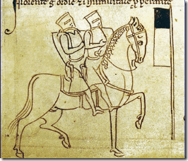
Knights Templar Not Only Shared the Horse, They Shared the Bed As Well
Amongst the Blasphemy Charges against the Knights Templar were the following: “… 2. That they then received the kiss of the templar, who officiated as receiver, on the mouth, and afterwards were obliged to kiss him in ano, on the navel, and sometimes on the generative member; … 4. That they practiced unnatural vice together …” “Jean de St. Loup, who held the office of master of the house of templars at Soisiac, said that, on his reception into the order, he received the injunction notto have intercourse with women, but, if he could not persevere in continence, he might have the same intercourse with men; and others were told that it would “be better to satisfy their lust among themselves, whereby the order would escape evil report, than if they went to women.’ “
This is a secret, strange and ancient perverted ritual passed down thru the generations for population control, and ultimate power and control of individuals that even some Knights objected to and refused to engage in. But, it is an actual historical ritual adopted by the ILLUMINATI and the Satanic Cabals that has been secretly imposed at the highest levels of the government (Black Obama White House), the Black Family Structure and Satanic cells mostly through CIA MONARCH/MK ULTRA Trauma Based Mind Control Programming. It is absolutely bizarre snuff beyond the Sign Post Ahead, it is on the Outer Limits of ordinary Human Imagination.
HollyWeird BIOPIC- Whitney’s Fabricated Dramatization
A biopic is nothing new in the HollyWeird movie and film industry. It is a film that is based on the life of a very important or well-known person. The term biopic is the abbreviation for the term biographical motion picture. Many biopics contain various degrees of fabrications.[24] For decades, biopics have been a movie and film industry accepted form of fabricated dramatizations. Which in itself is problematic, when forgeries, lies, fakes, falsehoods, and untruths are deliberately directed at target audiences.[25]
Biopics also become problematic in itself, when it is used to create false perceptions or ideas and mental images by the deliberate misinterpretation of things that actually exist- ILLUSIONS.[26] With modern clandestine breakthroughs in holographic technologies, Biopics can be a Crime Against Democracy– created as subliminal vehicles of lies, falsehoods and ILLUSIONS to covertly control, change and modify human perceptions and behavior, or drive you insane.
Rosie Perez: Whitney’s Fabricated/False Biopic Did It to Her
I believe what Rosie Perez said that Angela Bassett’s TV biopic, Whitney, played a significant part in putting Bobbi Kristina in the place that she lies today, at the brink of DEATH. Don’t get it twisted, Perez wasn’t making any public service statement. She says that she “love” Angela Bassett. She is one of them, ILLUMINATI Satanic Cabal. It was a serious slip of the tongue to directly link Bobbi Kristina’s bathtub drowning with Bassett’s TV biopic of her mother, and they are surely calling for her head and curtailment of Perez’s television host career.[27]


Notice How Similar Will I Am’s Foundation Logo is the Jesuit Logo
HollyWeird Actress Rosie Perez is a devout VATICAN Catholic raised by the FRENCH Order of the Sisters of Saint Joseph (Josephites), a front for the Jesuit Order.[28]
Rosie Perez, Jesuit Order and the Ninth Satanic Circle
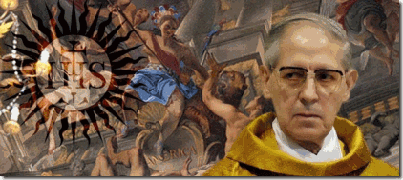
In late May 2014, FRENCH Catholic Jesuit head Adolfo Panchon, above, announced his resignation after the International Common Law Court of Justice in Brussels linked him to international Ninth Circle Satanic Child Sacrifice Cult ceremonies.[29] Evidence of a Catholic Jesuit Order document called the “Magisterial Privilege” was presented in court by the Chief Prosecutor. The record dated Dec. 25 1967 was said to show that every new Pope was required to participate in Ninth Circle Satanic Ritual sacrifices of newborn children, including drinking their blood.[30]
“Documents from Vatican secret archives presented to court clearly indicate that for centuries the Jesuits had a premeditated plan to ritually murder kidnapped newborn babies and then consume their blood,” the Chief Prosecutor told the five international judges and 27 jury members.[31]
“The plan was born of a twisted notion to derive spiritual power from the lifeblood of the innocent, thereby assuring political stability of the Papacy in Rome. These acts are not only genocidal but systemic and institutionalized in nature. Since at least 1773, they appear to have been performed by the Roman Catholic Church, Jesuits and every Pope.”[32]
Well, if you believe the HollyWeird Jesuit Rosie Perez and I certainly do, then she says that the path to uncovering the mysterious cause/force behind Bobbi Kristina being intentionally rendered near BRAIN DEAD leads to ANGELA BASSETT. Follow the mysterious, Bassett leads us to another devout CATHOLIC of an ancient FRENCH Catholic Satanic Circle, and FRENCH Order of Ursuline (Blood Witch) Nuns in New Orleans- the infamous Voodoo Priestess Madame Marie Laveau. Madame Laveau leads us to the BLOOD SACRIFRICE Da Vinci Code Merovingian Race, Enochian Magic, Cabbalism, the Saint Louis Catholic Cathedral, Knights Templar, an ancient FRENCH Ninth Satanic Death Circle of Old New Orleans, and the Priory of Sion.
The Merovingian Jesus Bloodlines
The Merovingian Bloodline Theory is that Jesus had a child, a daughter named Sarah, with Mary Magdalene, with whom he was married. The descendants of this child became the Merovingian Kings of France. The Church has suppressed the truth about Mary Magdalene and the Jesus bloodline for 2000 years. This is principally because they fear the power of the sacred feminine, which they have become DEMONIZED as SATANIC.
Angela Bassett, Madame Laveau & the American Horror Story
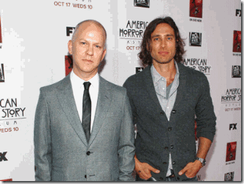
American Horror Story is a Satanic television series created and produced by Ryan Murphy and Brad Falchuk. Described as an anthology series, each season is conceived as a self-contained miniseries, following a disparate set of characters and settings, and a storyline with its own “beginning, middle, and end.[33] Ryan Murphy (left) is a gay JACOBITE Irish Roman Catholic.[34] Brad Falchuk (right) is a Republican Zionist. His mother is the past president (2007) of Hadassah, the Women Zionist Org of America.[35]

Hadassah (sweet myrtle) is another name for the biblical Queen Ester. According to Kabbalah, each of her names corresponds to a different spiritual level. The name Hadassah represents righteousness. As such, it corresponds to a heavenly sphere representing G-d’s infinity. The name Esther (Heb. אסתר) is derived from the Hebrew word hester (Heb. הסתר), which means “hiddenness.”[36] “The [ILLUMINATI] Rothschilds have always been the true force behind the Zionist Movement. Zionism is in fact SIONism, Sion = the Sun, hence the name of the elite secret society behind the Merovingian bloodline, the Priory of Sion.”[37]
American Horror Story, Season 3: Coven (2013-2014)
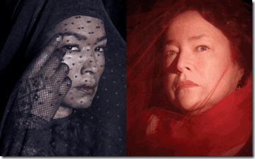
The Coven ties in the ancestors and spirits of the Salem Witch Trials with the voodoo practitioners of New Orleans. On TV, Ryan and Falchuk setup a historic racial grudge between Voodoo Queen Marie Laveau (Angela Bassett) and so-called socialite serial killer Delphine LaLaurie (Kathy Bates) when no such grudge ever existed.[38]
Quote from Greek Philosopher Plato:
“The gods don’t communicate to mortals directly but intermediary spirits. So mortals need figures to communicate with the gods, and thus daimon (demon) becomes the figure needed of the petition, a source evolving into sacrifices and initiations, incantations, prophecies, divination, and magic spells, sacred poems.” The Demon and the Angel: Searching for the Source of Artistic Inspiration” P.60-61 by Edward Hirsch
In this age, elite HollyWeird actors and actresses like Angela Bassett and Cathy Bates are secretly deliberately channeling/invoking demonic spirits to enhance their performances. “These actors that are channeling these spirits to act, fall under the form of intentional channeling, and these are lying demonic spirits that are using these actors and actresses as a host to lead people away from Jesus Christ, and to eternal damnation, also the Anti-Christ morals they promote in the films they do.”[39] In the Coven, the ILLUMINATI has used Angela Bassett to host the demonic spirit possession of Madame Marie Laveau to serve them.

The Cast of Players in the Whitney Fabricated Drama, Larry Sanitsky in Middle, Shem Bitterman Right End
The “them” hidden behind Angela Bassett’s Whitney is a powerful elite and silent HollyWeird Jewish Ashkenazi Circle– producers Larry Sanitsky (Kabbbalist, Sinai Temple, LA)[40], Frank Konigsberg(Jewish Königsberg, Germany)[41], and script writer Shem Bitterman (Polish Jew)[42].
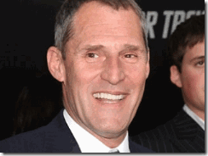
Rare Photo of Frank Konigsberg
These same demonic forces combined in the February 2, 2013 television biopic, Betty and Coretta, starring Angela Bassett as widow Coretta King and Mary J. Blige as the widow Betty Shabazz.[43] Just the same as in biopic Whitney, the families of Malcolm X and Dr. Martin Luther King, Jr. and the will of the people were deliberated spiritually disassociated and disemboweled from the production and authenticity of the film.
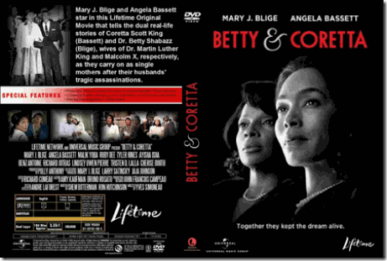
“Lifetime’s “Betty and Coretta” … portray their dynamic friendship through the feminist [housewives] lens of independent womanhood, separate from the looming shadows of their husbands.”[44]
“While Martin was portrayed as he typically is – conciliatory and in love with his own martyrdom, instead of the union advocating, anti-war activist that he was publicly transitioning into before he was gunned down for his efforts –, Malcolm’s courage under enemy fire (both from the United States government and the Nation of Islam), and unwavering dedication to human rights over civil rights were tossed aside in favor of attempts to show how much he had ‘changed.’ “[45] Within months of the release of Betty and Coretta, a heir to Malcolm X’s Legacy would be dead (blood sacrificed) just as in the case of Bobbi Kristina to Whitney Houston’s Legacy.
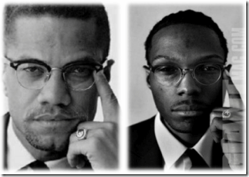
Malcolm Latif Shabazz:
” … prior to my date of departure to Iran, Lifetime television released a television bio-picture called ‘Betty & Coretta’ which was a sensationalistic misrepresentation of my grandparents, my mother and me. This film aside from being poorly acted, and shallow in depth, also threatened to inflame old controversies and open unhealed wounds, and to remind the public of sad outcomes without ever identifying B.O.S.S.I., the C.I.A., F.B.I. and other forces that set the climate for my grandfather’s assassination, and made my family a long-suffering casualty of COINTELPRO, and other anti-Black repression programs. Naturally, anything done to stir up old hatred of The Shabazz Family will impact me as the name-sake, and first male heir of Malcolm X, and whether I am high or low in fortunes does not exempt me from this reality.”[46]
Malcolm Latif Shabazz, 29 years old, son of Qubilah Shabazz and grandson of Malcolm X (Al-Hajj Malik el Shahbaz) died on the street or in a Mexico City hospital as result of a racial beating on Thursday, May 9, 2013.[47] In February 2013, Shabazz had been arrested by the Middletown Police Department before he was scheduled to appear in Tehran, Iran on an international forum to discuss “Hollywood and Violence.”[48]
Kabbalism & Knights Templar
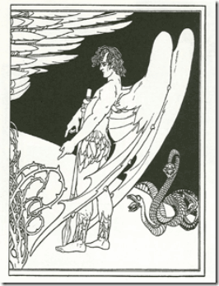
Cabbalism and Kabbalistic rituals secretly brought out of Solomon’s Temple in Jerusalem by the Knights Templar lay at the religious foundation of Freemasonry, Rosicrucians, Skull and Bones, the Scottish Rite freemasons, Hermetic Order of the Golden Dawn, Ku Klux Klan, and the BEAST 666 Aleister Crowley’s Ordo Templi Orientis. Raziel is an (fallen) archangel “Keeper of Secrets” and “Angel of Mysteries” that transmitted KABBALAH (Jewish Mysticism) to King Solomon and the rabbis.[49]
Saint Louis Cathedral- (Orleans) New Orleans, (New France) Louisiana
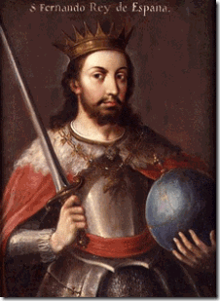
Saint Louis IX with Merovingian Race Crystal Ball
New Orleans was founded on May 7, 1718. It was named after the Duke of Orleans– the future King Louis XV of France (1710- 1774). As early as 1726, King Louis XV of France decided that three Ursuline Nuns from Rouen accompanied by the Jesuits should go to New Orleans to establish a hospital for poor sick people and to provide education for young girls of wealthy [Merovingian-Capetian- Satanic JESUS Bloodline] families.[50] The St. Louis Cathedral is named for Catholic Saint Louis. He was Louis IX, King of France. Louis IX (1214 –1270), commonly Saint Louis, was a Capertian King of France who reigned from 1226 until his death. Louis was crowned in Reims at the age of 12, following the death of his father Louis VIII the Loin.

His mother, Blanche of Castile, above with the CLAW hand symbol, was the Queen Mother Regent that really ruled the kingdom in his minority. [51] Queen Mother and King Louis IX led the Seventh Holy Crusade and European invasion of the holy lands from 1248 to 1254.[52] The Capertians were sometimes called “the Third Race of [DRAGON] Kings“, the Merovingians being the first, and the Carolingians being the second. The first Capetian King was known as Hugh Capet.[53] The Royal Capetian and Carolingians bloodline of France are Satanic Bloodlines closely intertwined with the Merovingians.[54] They believe that “they” rule by the divine and sacred right of God.
Queen Mother Blanche of Castile was the third daughter of King Alphonso VIII (1155- 1214) and Queen Eleanor of Spain. Blanche’ mother was also commonly known as Eleanor of England. She was the sixth child and second daughter of King Henry II of England and Eleanor of Aquitaine.[55]
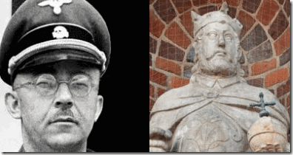
Himmler & King Henry the Fowler with Merovingian Crystal Ball
These bloodlines go back to Henry the Fowler. Henry the Fowler (Heinrich der Finkler or Heinrich der Vogler) (876 – 936) was the Duke of Saxony from 912 and the first of the Ottonian Dynasty of German kings and emperors, he is generally considered to be the founder and first king of the medieval German state, known until then as EAST FRANCIA. An avid hunter, he obtained the epithet “the Fowler” because he was allegedly fixing his birding nets when messengers arrived to inform him that he was to be king.[56] Reichsführer SS-1 Henrich Himmler believed that he was the reincarnation of King Henry, the Fowler.[57]
The First Merovingian Race, Da Vinci Code & the Saint Louis Cathedral
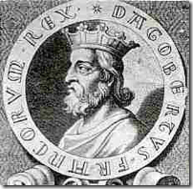
Dagobert I (603- 639) was the king of Austrasia (623–634), King of all the Franks (629–634), and King of Neustra and Burgundy (629–639). He was the last king of the Merovingian JESUS Bloodline Dynasty to wield any real royal power. Dagobert was the first of the Frankish Kings to be buried in the royal tombs at Saint Denis Basilica.[58]
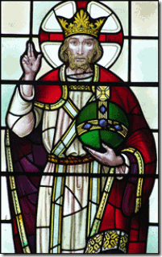
Dagobert II- Two Finger Symbol for Benediction with Merovingian Crystal Ball
Dagobert II (650- 679) was the last Merovingian to hold the title “Holy Roman Emperor.” The Merovingian “priest-kings” who were believed by their subjects to have magical powers derived from their long red hair. These “priest-kings” were the constant subject of rumors of witchcraft, fortune telling and crystal-ball gazing, among others.
In fact, portraits of Merovingian Kings customarily depict them holding one of these crystal balls in the left hand. Since the time of Carolingian Clovis I (Charlemagne), the Merovingians had presided over the Holy Roman Empire, but by the time Dagobert II was born, the power of the throne had already been weakened, with authority increasingly being usurped by court chancellors known as “Mayors of the Palace”.[59]
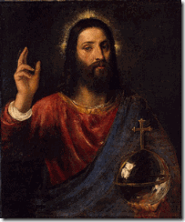
JESUS with Merovingian Crystal Ball-Two Finger Symbol of Benediction, Salvator Mundi (1570)Tiziano Vecelli or Tiziano Vecellio (c. 1488/1490– 1576), known in English as Titian was an Italian painter the most important member of the 16th-century Venetian School.[60]
Merovingian JESUS Bloodlines & Saint Louis Cathedral in New Orleans
A little more than a thousand years later, Capuchin Monk Father Dagobert de Longuory (a.k.a. Père Dagobert) arrived in New Orleans from Quebec, Canada in 1722. In 1745, he became priest of Saint Louis Cathedral, and later was appointed as Vicar General of the Diocese. He was active regionally for over 50 years and died in 1776.[61] Father Père Dagobert was an ancestral “priest-kings” Merovingian Bloodline endowed with same demonic magickal powers and agenda of his ancestors. Even today, the Merovingian Bloodline are generally believed to be the Satanic Bloodline of the Anti-Christ.[62] The Ancient European Satanic Bloodlines weren’t fleeing the old country. They were coming to America and landed in NEW ORLEANS to begin a new clandestine SATANIC UNDERWORLD.
The Merovingians and Knights Templars
In the popular Da Vinci Code conspiracies,[63] the Priory of Sion is a powerful hidden society founded with one objective, to restore the Merovingian House to the throne of France and the continent of Europe. During the crusades and European armed invasion of the ancient holy lands, the Priory of Sion was directly responsible for the existence of the Knights Templar (the Poor Knights of Christ and the Temple of Solomon) whose military wing they are alleged to have been.[64]
Saint Louis Cathedral & Lucifer’s Servants- Freemasonry
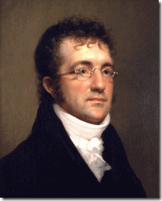
The imposing central tower of St. Louis Cathedral was designed by one of America’s most infamous European Freemason architects, Benjamin Henry Latrobe. He received a commission from the New Orleans Diocese to begin building the tower in 1819, during the vicarage of Spanish “Vicar and Ecclesiastical Judge of New Orleans” Capuchin Friar Pere Antoine (Francisco Ildefonso Mareno).[67] From 1803- 1813, Benjamin Henry Latrobe of the Masonic Order designed and constructed the South Wing of the Capital in Washington DC under President Thomas Jefferson.[68] Latrobe died in New Orleans during one of its Yellow Fever plagues.
Saint Louis Cathedral & Capuchin Friar Pere Antoine

Antonio de Sedella aka Friar Pere Antoine, O.F. Cap (1748-1829) from Sedalla, Spain served as the leading religious authority of the Catholic Church during the late 18th and early 19th centuries. His ghost along with the ghost of Madame Marie Laveau is said to walk an alley now named for him which runs alongside the city’s cathedral.[69]
Why did Friar Pere Antoine’s ghost at times walk in company with the infamous black voodoo priestess? Madame Laveau attended daily Catholic mass with Friar Pere Antoine. He allowed her to use church grounds for secret Black Mass/Voodoo Rituals for her mostly African followers.[70] For at least a hundred years, the Capuchin Monks had been the Vatican’s leading Catholic orders that were known to be experts in Witchcraft and SATANISM of the Middle Ages. In secret sacred Duality of the Church and hidden Mithraism, SATAN through the Black Mass was just as much of a Divine and Powerful Lord to call forth as GOD. SATAN was called forth by the BLOOD SACRIFICE.
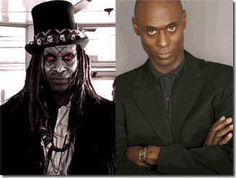
Madame Laveau wasn’t schooled in Witchcraft and Satanism by some idiotic false rite Luciferian Zombie Negro called Papa Legba. It was Saint Louis Cathedral, a clandestine Satanic Merovingian/Knights Templar/Freemason Cathedral. Angela Bassett and Madame Laveau are only false flags to a much greater and powerful Satanic Underground in America.
In Old New Orleans, among Friar Antoine’s devoted Catholic/Satanic flock was the racial mass murderer Marie Delphine Lalaurie, an Irish Knights Templar/Knights of Saint Louis Bloodline. The mass murder, torture and mayhem of Africans took place just down the street from Saint Louis Cathedral, and Madame Laveau, and they didn’t hear the SCREAMS coming from the Lalaurie Mansion throughout the nights. The Black Holocaust of Africans in New Orleans wasn’t committed in madness or a void. It was part of the Old French Ancient Ninth Satanic Circle’s BLACK MASS/Blood Sacrifices raising the DEVIL and the PRINCES of HELL for the Favor, Power, Fortune and Wealth of the ELITE DRAGON Bloodlines by the BLOOD, INTERNAL ORGANS, BODY PARTS, SOULS and LIVES of PEOPLE OF COLOR in New Orleans.
They didn’t raise up the spirit of Madame Laveau in the vessel of Angela Bassett to stir up African Gods and Spirits. They don’t roll like that but on TV and HollyWeird movies. They raised up Madame Laveau in the vessel of Angela Bassett to confuse and deceive the masses of People of Color- to lead them astray. In old New Orleans, Madame Laveau and her voodoo hid MONSTERS- the Merovingian Underworld Satanic Bloodlines, and the Old European Satanic Blood Sacrifice Circles like the Knights Templar, Rosicrucians, and Freemasons that feed from the innocence and ignorance of the masses of the people.
In HollyWeird, Angela Bassett also hide MONSTERS that also feds from the minds, souls, innocence and ignorance of the masses. To understand the enigmas behind Whitney Houston and Bobbi Kristina, you need to look beyond Bassett and flush out in the light the real Sorcerers, Witches, Necronomicon Mystics, DEMONS and DEVIL WORSHIPERS out of the shadows to bring them ALL including Angela Bassett to ORDER, BALANCE and JUSTICE.
NEXT, we explore more into Saint Louis Cathedral, and some of the secret Old European Blood Sacrifice Circles transplanted and embedded in America’s Underworld related to Angela Bassett and her Spirit Possession of Madame Marie Laveau and the institutional DEMONIZING of Bobbie Kristina and People of Color.

[1] http://www.tmz.com/2015/02/14/bobbi-kristina-dying-organs-failing-life-support/
[2] http://www.newvision.co.ug/news/663556-bobby-brown-and-family-in-african-music-tour.html
[3] http://www.theforbiddenknowledge.com/hardtruth/prieure_de_sion.htm
[4] http://en.wikipedia.org/wiki/Maltese_cross#Symbolism
[5] http://en.wikipedia.org/wiki/Black_Cross_%28Teutonic_Order%29
[6] http://www.medieval-life-and-times.info/famous-medieval-people/godfrey-of-bouillon.htm
[7] http://www.touregypt.net/featurestories/eyeofhorusandre.htm
[8] http://www.tvguide.com/news/bobby-brown-bobbi-kristina-cousin/
[9] Farrell, Joseph P., Roswell and the Reich, the Nazi Connection, Adventures Unlimited Press, Kempton, IL (2010) Prologue, xi
[10] http://www.nj.com/entertainment/index.ssf/2015/02/bobbi_kristina_brown_traffic_accident.html
[11] http://en.wikipedia.org/wiki/Jeep_Liberty
[12] http://getjeepn.com/must_knows.php
[13] http://www.celebdirtylaundry.com/2015/bobbi-kristina-brown-car-crash-victim-still-in-hospital-and-unable-to-speak-victim-to-sue-bobbi-kristina/
[14] http://abcnews.go.com/Entertainment/bobbi-kristina-brown-angela-bassett-talks-whitney-biopic/story?id=29112833
[15] Id.
[16] http://www.people.com/people/archive/article/0,,20157105,00.html
[17] http://hollywoodlife.com/2015/02/06/bobbi-kristina-brown-brain-dead-deprived-oxygen/
[18]http://www.huffingtonpost.com/2014/07/05/joan-rivers-obama_n_5560091.html
[19] http://www.cnn.com/2014/10/16/showbiz/joan-rivers-cause-of-death/
[20] http://mrconservative.com/2014/09/49778-evidence-michelle-obama-never-gave-birth-to-malia-sasha/
[21] http://www.thedailybeast.com/articles/2011/06/16/tracy-s-bizarre-apology-tour.html
[22] http://www.thedailybeast.com/articles/2011/06/16/tracy-s-bizarre-apology-tour.html
[23] http://abcnews.go.com/Entertainment/tracy-morgan-sustained-traumatic-brain-injury-crash-lawyer/story?id=27008525
[24] http://hosbeg.com/biopic/ http://www
[25] http://www.thefreedictionary.com/fabrication
[26] http://dictionary.reference.com/browse/illusion
[27] http://thegrio.com/2015/02/04/rosie-perez-bobbi-kristina-biopic/
[28] http://www.readitforward.com/sneak-peek-rosie-perez-new-memoir-handbook-for-an-unpredictable-life/
[29] http://childabuserecovery.com/catholic-jesuit-superior-resigns-after-charged-with-black-mass-child-sacrifices/#.VOFvtPnF_mc
[30] http://whale.to/c/eyewitnesses_testify.html
[31] Id.
[32] Id.
[33] http://en.wikipedia.org/wiki/American_Horror_Story
[34] http://en.wikipedia.org/wiki/Ryan_Murphy_(writer)
[35] http://en.wikipedia.org/wiki/Brad_Falchuk
[36] http://www.chabad.org/library/article_cdo/aid/1769366/jewish/What-Does-the-Name-Hadassah-Mean.htm
[37] http://www.bibliotecapleyades.net/sociopolitica/esp_sociopol_rothschild04.htm
[38] http://en.wikipedia.org/wiki/American_Horror_Story#Season_3:_Coven_.282013.E2.80.9314.29
[39] http://ipost.christianpost.com/news/hollywood-a-list-actors-demon-possession-and-spirit-channeling-12659/
[40] http://www.sinaitemple.org/pdf/Speaks/2013/SpeaksJan2013.pdf
[41] http://en.wikipedia.org/wiki/History_of_the_Jews_in_K%C3%B6nigsberg
[42] http://chelm.freeyellow.com/biterman.html
[43] http://www.imdb.com/title/tt2375664/fullcredits?ref_=tt_ov_st_sm
[44] http://www.jewishdirt.com/was-the-movie-betty-coretta-written-by-the-jewish-to-spread-disinformation-about-farrakhan-and-malcolm-x/
[45] http://hellobeautiful.com/2013/02/07/lifetimes-betty-and-coretta-champions-martin-and-crucifies-malcolm-x/2/
[46] http://www.ascertainthetruth.com/att/index.php/al-islam/muslims-in-america/856-malcolm-x-grandson-malcolm-el-shabazz-issues-statement
[47] https://www.change.org/p/secretary-of-state-john-kerry-assassination-investigation-for-malcolm-hajj-shabazz
[48] http://malcolmshabazz.blogspot.com/2013/03/statement-by-malcolm-shabazz-concerning.html
[49] http://thetemplarknight.com/2011/05/29/the-templars-and-the-kabbalah/
[50] http://en.wikipedia.org/wiki/History_of_the_Ursulines_in_New_Orleans
[51] http://en.wikipedia.org/wiki/Louis_IX_of_France
[52] http://en.wikipedia.org/wiki/Seventh_Crusade
[53] http://en.wikipedia.org/wiki/House_of_Capet
[54] http://saxonmessenger.christogenea.org/book/export/html/552
[55] http://en.wikipedia.org/wiki/Eleanor_of_England,_Queen_of_Castile
[56] http://en.wikipedia.org/wiki/Henry_the_Fowler
[57] http://en.wikipedia.org/wiki/Henry_the_Fowler
[58] http://en.wikipedia.org/wiki/Dagobert_I
[59] http://www.bibliotecapleyades.net/merovingians/merovingios_09.htm
[60] http://en.wikipedia.org/wiki/Salvator_Mundi
[61] http://en.wikipedia.org/wiki/Pere_Dagobert
[62] http://marthapeveto.org/2013/03/10/the-merovingian-dynasty-satanic-bloodline-of-the-antichrist-false-prophet/comment-page-1/
[63] http://en.wikipedia.org/wiki/The_Da_Vinci_Code
[64]http://www.bibliotecapleyades.net/merovingians/merovingios_01.htm
[65] http://www.amazon.com/Secret-World-Kabbalah-Judith-Abrams/dp/1580132243?ie=UTF8&*Version*=1&*entries*=0&showDetailProductDesc=1#iframe-wrapper
[66] http://thetemplarknight.com/2011/05/29/the-templars-and-the-kabbalah/
[67] http://www.hauntedneworleanstours.com/hauntedstlouiscathedral/
[68] http://www.dcgrandlodge.org/uploads/6/9/5/4/6954862/2010-vol_27_no.2.pdf
[69] http://en.wikipedia.org/wiki/Antonio_de_Sedella
[70] http://jamesduvalier.com/marie-laveau-voodoos-most-famous-queen-part-i/
Comments : 6 Comments
Tags: angela bassett, Benjamin Henry Latrobe, Betty Shabazz, Blanche of Castile, blood sacrifice, bobbie kristian brown, bobby brown, Capertians, Capuchin Monk Father Dagobert de Longuory, CIA, crimes against demcracy, crusades, da vinci code, dagobert, Dr. Martin Luther King, Father Père Dagobert, Frank Konigsberg, freemasons, Friar Pere Antoine, Heinrich Himmler, Iggy Azalea, Illuminati, illuminati conspiracy, ILLUMINATI hologram manipulations, illuminati sacrifice, illuminati whore, iron cross, jerod brown, jesuits, joan rivers, kabbalah, King Henry the Fowler, King Louis XV, knight templars, Kundalini Snake, lady gaga, Larry Sanitsky, Lucifer, Lucifer's Servants, luciferians, Malcolm Latif Shabazz, malcolm x, malia obama, mary magnaline, masonic order, Merovingian, michelle obama, mithra, mithras, ninth circle, Ninth Circle Satanic Child Sacrifice Cult, papa legba, priory of sion, Raziel, robert fludd, Rosicrucianism, rosie perez, Roswell, Saint Louis, Saint Louis Cathedral, Saint Louis IX, satan, satanic underground, Shem Bitterman, teutonic cross, teutonic order, tracy morgan, transgender conspiracy, ursuline nuns, Whitney houston
Categories : african american satanic cult, african holocaust, Aleister Crowley, ALL SEEING EYE, angela bassett, Barack Obama, blood covenants, blood oaths, BOBBI KRISTINA BROWN, bobby brown, boys from brazil, CIA, cyberneticist, cybernetics, cyborg, cyborgs, devil, devil's horns, Dr. Josef Mengele, dualism, egypt, Eye of Horus, False Satanic Rites of Lost Negroes, Hauptsturmfuhrer SS Dr. Josef Mengele, Heinrich Himmler, Hip Hop, hip hop satanic cult, hollywood satanic cult, holograms, Horus, human sacifrice, illuminati, illuminati sacrifice, jesuits, jesus christ, jonestown, Josef Mengele, katt williams, kemet, Knight of Malta, Knights Hospitaller, Knights Templar, ku klux klan, lucifer's servants, luciferians, Malcolm X, mind control, MK-ULTRA, monarch child, monarch program, Nazis, new orleans, Reichsfurhrer SS-1 Heinrich Himmler, Ritual Satanic Abuse, ritual satanic sexual abuse, ritually abused children, rose and cross, Rose-Croix, Rosicrucian, Rosicrucianism, rosy cross, sasha obama, satan, Satanism, set, seth, SS, trauma-based mind control, ZIONIST

LET’S DRIVE BOBBI KRISTINA INSANE- WITCHES & WHITNEY, the ILLUMINATI BIO
12022015

This is a picture poster advertising Angela Bassett’s television bio “Whitney” that opened nationally January 17, 2014. This is a HOLOGRAM. It is a holographic mathematical memory model (HMMM). HMMM describe a system where an IMAGE can be reconstructed through information that is stored throughout the hologram demonstrating a holographic associative memory that can impact the subconscious. On the surface, the Hologram’s Hand Symbol is an extremely significant occult inverted triangle (pyramid).
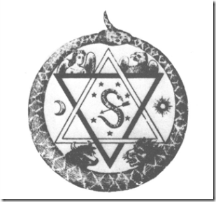
The above is the Emblem of Madame Helena Petrovna Blavatsky’s Theosophical Society. The darker of the two triangles, which is downward-pointing, and the lighter triangle, which is upward-pointing, symbolize respectively the descent of the life of Spirit into matter and the ascent of that life out of matter into Spirit, the perpetual opposition between the light and dark forces in nature and in man.
The latest news is that our Little Sister, Bobbi Kristina, may not survive this most recent deadly faith. My heart goes out to her innocence born into a pit of HELL, and within a circle of unparalleled human greed, among the sick and insane, and the OCCULT.

From Bobbi Kristina’s Cousin Jarod Brown- Pray for Her in Form of the All Seeing Eye of the Satanic/ILLUMINATI?
There are reports that the Brown and Houston families have agreed to take Bobbi Kristina off life support on the same date, February 11th, that Whitney Houston was assassinated at the Israeli Mossad controlled Beverly Hilton Hotel called the executive branch “Western Whitehouse.” The move is a symbolic way to keep the mother and daughter together “for eternity“, according to a Brown family source.[1] However, after the story was released, they may have hopefully backed away from that chilling idea.
Jonestown Cocktail & Assassination of Whitney Houston
Along with cocaine (1) and marijuana (2), Whitney Houston died on February 11, 2012 with alcohol 3), Xanax (4), flexeril (muscle relaxant) (5), and diphenhydramine (benadryl) (6) in her system. Someone(s) had given Whitney a “Jonestown Cocktail” at the Beverly Hilton Hotel. From that drug cocktail, all of Whitney’s consciousness and resistance could have been blacked out. She must have collapsed semi-comatose.[2] Whitney was undressed then placed in the bathtub filled with water.
Proof of the party(ies) that murdered Whitney Houston on February 11 was captured without a doubt by the hotel’s Israeli state of the art security and surveillance system. Yet 3 (three) years later, Beverly Hilton Hotel security has not and will not release Whitney Houston’s surveillance tapes.
In addition, after Whitney’s body had been removed from her room, Beverly Hilton security controlled by the Mossad sent in a clean-up team with the mission to act in “extra vigilance” to sweep through the room.[3] The proof the crime is in the cover-up.
Of the Absolutely BIZARRE
Many members of the Brown-Houston families are seasoned adepts in the secret practice of underground cult Cabbalism as set out below. In Cabbalism, the “ruach- spirit-wind-personality” of a murdered victim have a continued existence.
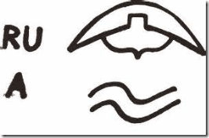
“Because Satan rules over a particular partition of “dimensions” or “consciousness” that occultists and magicians associate with the Element of Air. This is also “Vav.” Thus, naturally 666 would be related to Satan. This partition is Ruach, which even means “wind,” and obviously wind is air. Ruach is the false center. The Ruach consists of 6 Sefira, and while the lowest is the Nefesh, it is still technically part of the Vav portion of the sacred diagram.”[4]
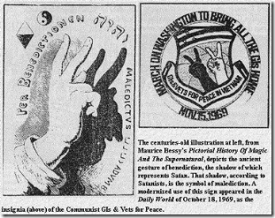

v is VAV in Hebrew with the number 6 given to it. 6 the number of Sin.[5]
The ruach of a victim of murder or injustice can’t rest or delve in another dimension until atonement (Murder of Nabolt– 1 Kings 21). The ruach may also “hover” over a stream, current- over the face of the waters between heaven and earth. If they go through along with this macabre notion, they would be condemning Bobbi Kristina’s ruach along with her mother ‘s ruach to delve “eternally” in a void between heaven and earth in the realm of Satan – because they certainly are not looking for any atonement for Whitney’s Assassination.
According to the latest corporate media news, Bobby Brown and Whitney Houston’s families are also warring over Bobbi Kristina’s pending funeral.[6]
Grammys- BLACK LIVES DON’T MATTER

LL Cool J and Paris Jackson’s Drawing of ILLUMINATI- Silence (Secrecy) is Golden
“There won’t be any special announcement or tribute made for [Bobbi Kristina] Brown …” -LL Cool J- Host of 2015 Grammys[7]
Who is this Negro? A very dangerous ILLUMINATI idiot. “Brown“- it’s pretty clear that HollyWeird’s Gutless Black Satanic Cabal has coldly dissociated itself from 21 year old BOBBI KRISTINA Brown even on her death bed.
Bobbi Kristina Did It to Herself- BOBBI KRISTINA DID IT TO HERSELF
The children of celebrities that sold their souls to the DEVIL usually have no choice whether or not they become part of the ILLUMINATI. In most cases, MK ULTRA/ILLUMINATI multi-personality disorder programming with amnesia blocks begin during the child’s most impressionate years, infancy to the age of 5 years old.
By the time of teen years, they simply don’t seem to know if they have been programmed or understand how deep the programming had gone. They soon discover that alternative (termination/self destruct) personalities have been implanted in their subconscious able to take over the body and mind triggered by various different codes, pictures, sounds and keys as simple as just a telephone ring or tone.[8]
Between 2012- June 2013, Michael Jackson’s daughter, Paris Jackson, began resisting forced ILLUMINATI programming, she exposed in a Twit one of the secret retreats for Satanic Programming and indoctrination, the Self Realization Fellowship Lake Shrine Temple in Pacific Palisades, CA.[9] Paris said that she woke up to the ILLUMINATI when she was 12 years old, but her trauma based programming most likely began in infancy like her younger brother.
 Michael Jackson dangling-traumatizing his infant son, Blanket, over the 4th floor balcony railing at the Adlon Hotel in Berlin, Germany, November 19, 2002. By June 2013, 15 year old Paris was rushed to the hospital for an alleged suicide attempt. She reportedly told whoever could hear that she didn’t want to die. She recovered. She was forced into seclusion and reprogrammed. Her resistance and ILLUMINATI twits have ended.[10]

Bobbi Kristina-MK ULTRA Programming, All Seeing Eye Satanic/ILLUMINATI Layer

Rosie Perez in with ILLUMINATI with the elite “M” Masonic Hand/Finger Symbol
Actress Rosie Perez, host of the television talk show, ABC’s The View, has come under entertainment industry fire for letting the cat out of the bag, “Just thought about the movie that came out, and this is no disrespect to Angela Bassett because I love [her], but this unauthorized bio of her mom must have killed her…”[11]
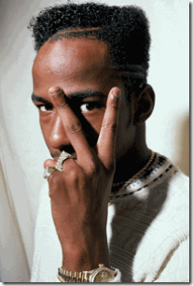
This is not Bobby Brown, but Bassett’s Whitney Arlen Escarpeta (Bobby Brown) dual Hologram to ILLUMINATE, implant and mainstream Satanic/ILLUMINATI symbols in the subconscious of the masses, and DRIVE BOBBI KRISTINA and many more people INSANE.
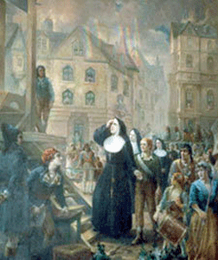
Rosie Perez was raised in New York by the Order of Sisters of the Saint Joseph du Puy from France. The order was formed in 1650 in the ancient city of du Puy (Le Puy) by Catholic Priest Jean Piere Medaille as a French Jesuit Front- the armed militia of the Roman Catholic Church. During the French Revolution, several of the order was sent to the guillotines, above, accused as Druids, and Body-Snatchers.

Carved above the doorway of the Order of Saint Joseph’s Chapel of St. Clair, Le Puy are symbols showing the phases of the moon. This was considered the “Temple of Diana” in pre-Christian times. The Order’s Chapel of Saint Michael in Le Puy, atop a mountain was a Druid place of worship also prior to Christian times.
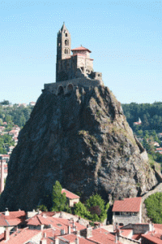
Rosie Perez’s secret ILLUMINATI Hand/Finger symbol is quite legit straight out of Ancient European VATICAN/Pagan influences. 
WHITNEY Film ILLUMINATI Witches- Suzanne Douglas (Cissy Houston) Devil Horns Hand Symbol– Angela Bassett (Director) flashes the “M” ILLUMINATI Hand/Finger Symbol. Perez let it slip that Bobbi Kristina had been deliberately mentally harmed. Rosie’s statement is also important because she is one of THEM. They are calling for her head for that negligence, because the “Group Think” consensus and directive is “BOBBI KRISTINA DID IT TO HERSELF” or “Nick Gordon Did It.”
“WHITNEY” Directed by Angela Bassett

Bassett’s Whitney poster appears innocent, but the apparent HOLOGRAM translation is WHIT– usually used with a NEGATIVE) the smallest particle; iota; jot: he has changed not a whit. NEY– Archaic. no (used in dissent, denial, or refusal), a negative VOTE.
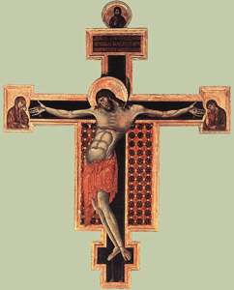
Let’s Drive Bobbi Kristina Insane, the Poster also has an Ancient Crucifix In-bedded.

Face of EVIL, Angela Bassett- Inverted Pyramid Hand Symbol of the Satanic/ILLUMINATI
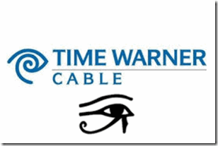
In recent years, Angela Bassett has become a big darling HollyWeird WITCH. There isn’t very many people around the entertainment industry with the heart and will to take her on. In Entertainment Weekly, an American magazine published by the ILLUMINATI (All Seeing Eye) Time Inc., that covers film, television, music, and popular culture, the question came up whether or not Bassett had considered casting Bobbi Kristina for a part in the bio. Bassett totally dismissed her with some rather caustic and demeaning remarks, she said :
“I did not think about that. I did not think about casting her. And probably for a number of reasons, you know. One being that she’s not an actress … [A]cting is a [body snatch- WITCH] craft. It’s an attempt to ILLUMINATE the complexities of human behavior and life.”[12]
In respect to Whitney Houston’s family, Bobbi Kristina at the very least deserved a courteous phone call from Bassett before that public statement debasing her as an aspiring actress. Bobbi Kristina could have been at the most considered a set technical advisor for authenticity about her mother and father’s life. But, Bassett totally dismissed her, and publicly humiliated her in the process.
Bobbi Kristina had been quite unhappy about Bassett’s public put down, and stepped up to the Big WITCH, and twitted some rather nasty remarks about her. It wasn’t necessarily that she didn’t get the leading role in the bio that upset Bobbi Kristina. It was the total public disrespect, the putdown, and the way that it was done. It’s also interesting that out of all the people surrounding her deathbed possessing to have cared for her not one of them stood up for Bobbi Kristina after Angela Bassett’s corporate mass media humiliating personal attack. How much of an actress is Bobbi Kristina expected to be 21 years old? Bassett would not have disrespected a young aspiring white actress, no matter how bad of an actress, in that manner. Even Tyler Perry that could have meaningfully assisted Bobbi Kristina’s budding acting career remained silent.
But there was more that upset Bobbi Kristina than the public humiliation, much more than the eye can see or the brain to process. Bobbi Kristina had been MK ULTRA programmed like Paris Jackson with alternative (termination/self destruct) personalities anchored by Satanic layers able to take over the body and mind triggered by various different codes, pictures and IMAGES. All the old WITCH had to do was play the right keys to throw Bobbie Kristina off the Ledge.

Bobbi Kristina & HollyWeird Kabbala Cult Blue Ceramic Evil Eye Beads[13]
Undoubtedly, Bobbi Kristina was under the influence of HollyWeird’s Kabbalah Cult led by Luciferians Madonna and Lady GaGa.[14] Basically, Cabbala’s roots run out of Ancient Babylon. It was the secret religion of the Sons of the Serpent (Set, Seth- Satan). The HollyWeird Kabbalah Cult is one of Lucifer’s main clandestine vehicles for delivering the masses to Satanism.[15]
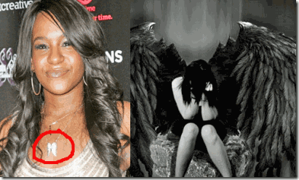
Bobbi Kristina & Fallen Angel Necklace
On Saturday morning, January 31, 2015, Bobbi Kristina Brown, 21, was found unresponsive in a bathtub at her Roswell, GA. “Unresponsive” in medical terms means a person is not alert and does not respond to verbal or tactile (touch) stimulation, or a person whose vital signs and brain activity are not within normal range to sustain life. She unable to breath alone.[16]
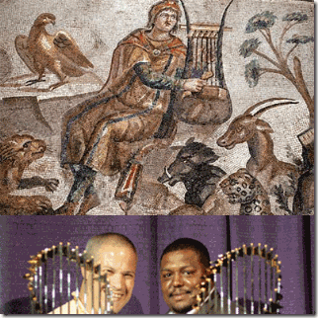
On Tuesday, February 2, 2015, while she was still desperately fighting for her life, a lawyer representing Bobby Brown released the following statement: “To correct earlier reports, Bobbi Kristina is not and has never been married to Nick Gordon,” said Christopher L. Brown of Brown & Rosen LLC.[17 Brown is the Vice-President of the Baseball Division of Orpheus Sports & Entertainment with Joseph S. Rosen of Boston. Brown is also an adjutant professor at Boston College.[18] Boston College (BC) is a private Jesuit Catholic research university located in the village of Chestnut Hill, Massachusetts.[19] “Orpheus is a type of Christ … who provided a wife for himself, but through the teeth of the serpent, that is say, by counsel of Satan, lost her.” [John Block Freidman, Orpheus in the Middle Ages, Syracuse University Press (2000) pg. 181] Brown & Rosen LLC translates to by “Counsel of SATAN.”
With Nick Gordon out of the picture, her father, Bobby Brown, is subject to inherit by intestate succession the majority of her entire estate as the only heir next in kin in kind, then her half brothers and sisters of Bobby Brown should also inherit per stripes in same kind. However, that’s if there is no last will and testament. Bobbi Kristina’s demise also comes interesting at 21 years old, when she undoubtedly had legal capacity to make a will in all 51 states of the U.S.
Bobby Brown & The Ancient Rosicrucians
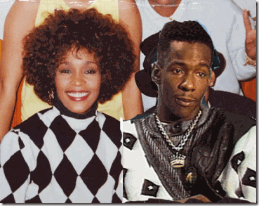
Pawns on the Masonic Checkerboard
There should be little doubt that Whitney Houston and Bobby Brown had sold their souls to the DEVIL for fame and fortune early in their musical entertainment careers. There should be no doubt also that both Whitney and Bobby served the ILLUMINATI. It may also be true that the faith of Bobbi Kristina had been sealed at birth by a bargain with the DEVIL– the Satanic Sacrifice of their first born. For Whitney, she discovered that there is no exist door from the ILLUMINATI short of DEATH. They play for keeps.
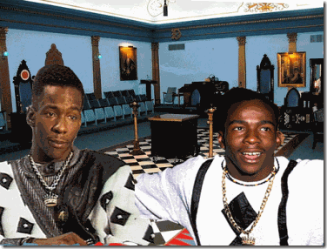
Here, Bobby Brown Shows Direct Early Masonic Influences. Crown with Sword is a Knights Templar Symbol “By this sign thou shalt conquer”
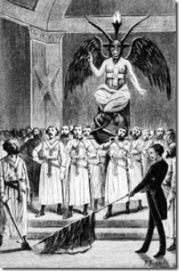
Early Drawing of the Knights Templar & Horned God Baphomet
The Rosy Cross (also called Rose Cross and Rose Croix) is a symbol largely associated with the semi-mythical Christian Rosenkreuz, CABBALIST and alchemist and founder of the Rosicrucian Order.[20] Later drawings seem to delete the “Cross and Rose” on Baphomet’s chest. However, Bobby Brown’s tie-shirt recaptures the religious cosmology of the early Knights Templar. In the early days of the revival of the Rosicrucian Order in America in 1915, Imperator H. Spencer Lewis chose to use the Latin cross ( ). He visualized a man standing with arms extended in the form of a cross, i.e., perpendicular to the body. This would roughly place the human heart at the crossbeams.
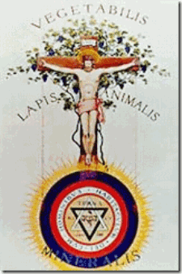
Early Rosicrucian temples used this concept for their floor plans. The shekina, representing the heart of the temple, was at the lines crossing. Over such a floor plan the Rosicrucian Lodge ritual enacts the Ancient Egyptian Memphite Mystery School teachings on creation. The impulses from the heart (shekina) are directed to bring wisdom to the Master stationed in the East. This is the ancient Egyptian heart-tongue connection to creation. The Master’s lectern has a left eye upon it. This represents the eye of Thoth, i.e., wisdom. The route from heart to tongue is called the Sanctum Sanctorum. The floor plan of many churches is similar to this floor plan. However, they do not use the point of crossing in any mystical sense. Their altar is in the East. There is no allusion to the ancient mystical process of creation from heart to tongue.[21]
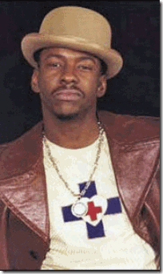
Brown’s “Red Cross inside the White Heart” is basically a covert “Rosicrucian Symbol” in plain sight.[22] It shows Brown’s progression/promotion from Freemason to higher HIDDEN KNOWLEDGE levels of the ILLUMINATI such as the Rosicrucians.

Ancient Rosicrucian Cross and Heart Symbols.
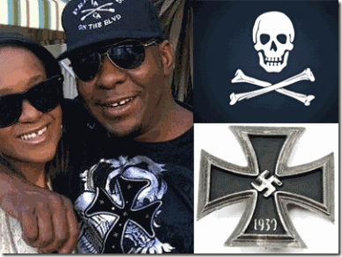
Bobbi Kristina & Bobby Brown with Cross Bones Symbol and the IRON CROSS
The Iron Cross is a cross symbol typically in black with a white or silver outline that originated after 1219 when the Kingdom of Jerusalem granted the Teutonic Order the right to combine the Teutonic Black Cross placed above a silver Cross of Jerusalem. These people are not playing.
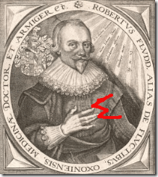
During the 17th Century, Robert Fludd with the early elite “M Hand/Finger Symbol” and Sir. Francis Bacon of the British Empire co-founded both the Rosicrucian and Freemason Order.

Bobby Brown and Bobby Kristina- Clear Ancient Rosicrucian and Freemason Order Influence and Hand Symbol
Angela Bassett, Witch’s Coven & Madame Laveau
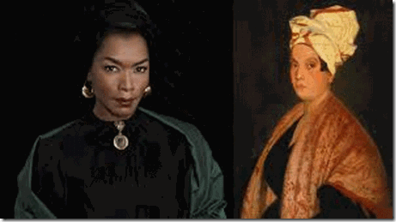

“This is a career about IMAGES. It’s celluloid; they last for ever. I’m a black woman from America. My people were slaves in America, and even though we’re free on paper and in law, I’m not going to allow you to enslave me on film, in celluloid, for all to see.” –Angela Bassett [23]
Bassett received a B.A degree in African American Studies and Masters in Drama from Yale University, Home of Skull and Bones.[24] The above is a very interesting widely circulated gallant quote from Angela Bassett out of Satanic HollyWeird. That’s if you believe anything the Big WITCH says.
The American Horror: Coven is a popular TV series that blatantly glorify and promote the occult, Enochian magick, witchcraft and Satanism in mainstream pop culture. The series tells the story of a group of young girls who have been recruited to a witch’s coven in New Orleans that fronts as a prestigious all-girls boarding school. The purpose of the coven is to train the young women to hone their occult powers and skills and protect them from the world which seeks to destroy them.[25]
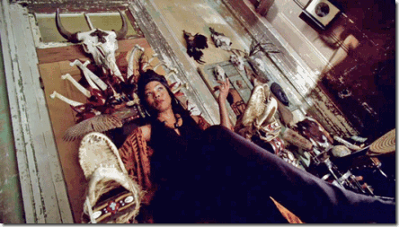
In the WITCH’S Coven, Bassett portrays the IMAGE, in celluloid, for all to see, of New Orleans’ most infamous big black Voodoo WITCH out of the 19th Century, Madame Marie Catherine Laveau. “Angela Bassett portrayed Marie Laveau as a merciless villain who uses her power of immortality, which she gained from a demonic force by the name of Papa Legba, to kill innocent beings and to seek revenge on those who have wronged her.”
“The show contains a scene where Laveau steals a baby from the hospital to sacrifice to Papa Legba in order to pay him for giving her the power of immortality. In another scene when she first makes the deal with Papa Legba, she sacrifices her first-born child, a daughter.”[26]
In some circles, Marie Laveau is considered some type of black anti-slavery heroine of New Orleans. By some sources, she was described as a descendant of French Aristocracy– ILLUMINATI.[27]
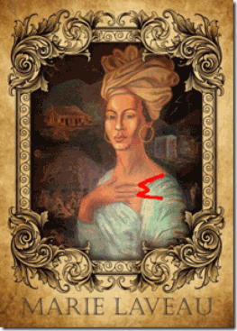
The New Orleans artist, Charles Massicot Gandolfo, that produced the above painting certainly believed that she was ILLUMINATI showing her with the infamous secret elite M (Masonic) Hand/Finger Symbol. Gandolfo (Voodoo Charlie) founded the infamous New Orleans Historic Voodoo Museum. He was raised on family stories of his great-great-great grandmother, an escaped African from Haiti who was also a New Orleans’ Voodoo Queen.[28] He would have known something about New Orleans’ secret elite Satanic Subculture.
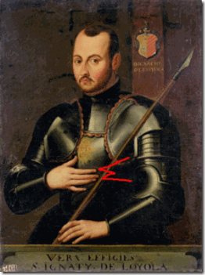
The M (Masonic) Hand Symbol is associated with the term “Marrano” is a Spanish expression which means “Secret Jew“, i.e. a falsely converted Jew. On the one hand, Ignatius Loyola, Founder of the Jesuits, had been a member of “Alumbrado” which was a forerunner to the ILLUMINATI organization (the word “Alumbrado” is simply a Spanish translation for the term “ILLUMINATI“) and another suspected Kabbalah concoction. Alumbrado devotees manifested a strangely conflicting mixture–many expressions of “godly” sentiments in their outward displays…but bizarre goings-on in their private meetings which fit the descriptions occult practices, and even of satanic ‘possession’ or interaction. [29]
Absolute Horror and EVIL of the Lalaurie Mansion
I Warn You. This video of the Real Marie Lalaurie is truly Chilling and Horrible Almost Beyond Belief
In New Orleans, Marie Laveau lived just a few blocks from the racialist mass murdering Marie Delphine Lalaurie that teamed up as a character with Laveau in the Coven televised series. In real life, they were contemporary and undoubtedly these two women met and knew each other very well. Both Lalaurie and Laveau attended Saint Louis Cathedral with Capuchin (Franciscan) Monk Pere Antoine.
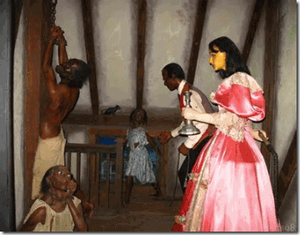
By her own journal, Delphine and her third husband, Dr. Leonard LaLaurie sadistically slaughtered 62 Africans held in forced human bondage. They performed terrible and hideous terminal medical experiments on Africans. After a fire at the mansion, fire fighters discovered body parts of the slaughtered were found heaved throughout their manor. Fire fighters and authorities believed that a 70 year old African woman chained to a stove in the kitchen started the fire to alert authorities to murder, mayhem and horror going on inside the mansion. The Lalaurie Mansion exists today as an infamous “haunted mansion.”[30]
Down the streets and around the neighborhood, the terrifying screams coming from the Lalaurie Mansion were well known throughout the tight community. There is speculation that Laveau had been directly involved in some of the murderous Satanic activity at the Lalaurie Mansion.[31] It also appears that Laveau should have been well aware of what going on at Lalaurie Mansion, and there are no records that she helped any Africans escape death, cruelty and torture at the hands of her neighbors and fellow Catholics.
Madame Laveau was a devout Catholic. She was part of the wealthy Catholic French-Creole merchant class of New Orleans. During the 1800s, Laveau and her father, Charles Laveaux, owned numerous buildings and lots in the early French Quarter. Charles Laveaux was a local tavern owner, that bonded his daughter to sell liquid spirits from a storefront.
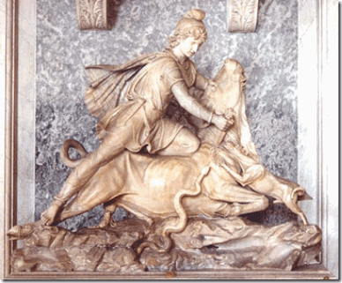
There are several Roman statues of Miltra found at the Vatican Museum Ritually Sacrificing a Bull- a Snake, Dog and Scorpion Feed from the Blood
However, what would explain Madame Laveau’s relationship with Delphine Lalaurie is that they were part of the Vatican’s underground Cult of Miltra (Miltras) or French Death Cult, the secret religion of the Sons of the Serpent (Set, Seth- Satan).
“Christianity resembled certain elements of Roman belief, particularly the worship of Mithra, or Mithraism. As ‘Protector of the Empire,’ Mithra was closely tied to the sun gods, Helios and Apollo … Christians took over a cave-temple dedicated to Mithra in Rome on the Vatican Hill, making it the seat of the Catholic Church. The Mithraic high priest’s title, Pater Patrum, soon became the title for the bishop of Rome, Papa or Pope. The fathers of Christianity explained the remarkable similarities of Mithraism as the work of the devil, declaring the much older legends of Mithraism to be an insidious imitation of the one true faith.”Helen Ellerbe, ‘The Dark Side of Christian History‘ ” (223)[32] Secret Mithraic rites and ceremonies involve animal and human sacrifice.[33]From the time of the Romans, the Cult of Miltra has always been practiced in strict secrecy- mostly in caves.
The Lalaurie Mansion sits atop the real property consecrated by the Ursuline Sisters. The Ursuline Sisters were the first Catholic nuns to land in the new world.[34] The Ursuline Sisters were the subject of the infamous French Witch Trials of the 17h Century. The Loudun Possessions was a notorious witchcraft trial in Loudun, France in 1634. A convent of Urusline nuns were involved in secret SATANIC BLACK MASS and naked orgies. They said they had been visited and possessed by DEMONS and the DEVIL. [35]
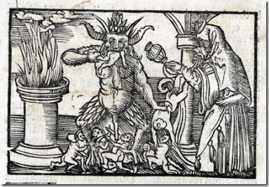
The Black Mass was originally created in France by Catholic Clergy to cover up their crimes and worship the DEVIL in a form of inversion to the Catholic Mass. All sorts of perversions would go on in the basements of monasteries or in dilapidated cathedrals. Rumors where that French Death Cults where involved in these corrupted masses as well. It is said that babies where eaten right after they were born from Catholic Nuns whom were impregnated by a monk or priest. This was to cover up the by products of the orgies that would take place during said masses. Forms of bestiality along with animal sacrifice to mimic [Cult of Mithra] ancient pagan rituals. Then Catherine Deshayes (1640-1680)who was an abortionist and magic charm charlatan, was able to convince ordained Catholic Priests to perform such acts of debauchery and blasphemy. The debasement of the rite was as far as the customer who paid for it would go. Normally Catherine would use an aborted fetus as the sacrifice for the Black Mass. Thus starting rumors of children being sacrificed to the DEVIL once again. These Black Masses become a commercial indulgence of the higher class to attain the favor of the DEVIL.
This should explain the underlining Satanic activity at the Lalaurie Mansion. It was related to the Black Mass, and the higher classes of New Orleans seeking the power of SATAN. Interestingly, it was a Capuchin Monk Tranquille that performed the Ursuline Sisters exorcisms in France and furnished the materials for the “History of the Devils of Loudun.” Recall above that LaLaurie and Laveau were involved with Capuchin Monk Antoine at St. Louis Cathedral Basilica whose order was known to be experts on Satanism and the Black Mass. The Satanic Reputation of the Urusline nuns followed them to early New Orleans. In the city, they were known as the coffin or “Casket Girls.” Locals believed that their coffin like travel and storage crates contained European blood vampires being smuggled into America.[36]
I have been to New Orleans over a dozen times during the 1970-80s. I have a law degree. My first love is history, the study of folklore and cultures. I also have a AA in African American Behavior Sciences, and an AB in Anthropology. I am also extremely interested in Black Genealogy. I helped co-found the African American Genealogical Society of Northern California (AAGSNC) in Oakland.[37] New Orleans is one of the most wicked and EVIL places on earth. It has a history of generational racial hatred, intolerance and violence almost unparalleled in the U.S. Yet, it is also an extremely interesting place to study and learn from.
The Underground Black Occult & Satanic Society in New Orleans
My Search for the Seven Sisters
After law school, I got a one way ticket out of Los Angeles for leading an effort to organize lawyers around a lawsuit to force the extremely dangerous and deadly Los Angeles Police Department (LAPD) into federal court receivership to protect the constitutional rights of People of Color, and organizing the people around creating a police review board.
I decided to go DEEP SOUTH where my late dear mother had feared that they would certainly kill me. I accepted a legal associate fellowship as far south as they went where NOBODY wanted to go. I landed at Caddo-Bossier Legal Aid Society in Shreveport, Louisiana. Bossier City, across the Red River from Shreveport, was a swampy wooded area that was an extremely dangerous place. Bossier City had been a racial killing field for generations. At that time, it had been the home to the Grand Dragon of Ku Klux Klan, J.D. Swenson.[38]
Before my first trip to New Orleans, two local Black legal secretaries began to tease me about my maiden journey to the city. Jokingly, they said, “you’re gonna meet the ‘Seven Sisters.'” Seven Sisters, I asked, what is that? Surprisingly, fear was written all over their faces. They refused to talk about the subject. Actually, most of the Black locals that I talked to were also inherently afraid to acknowledge or discuss the subject.
While in New Orleans, I was contacted by one of the good spiritual brothers that worked with me on the police review board in LA. I met him and a local brother at my hotel on Canal Street just across the way from St. Louis Cemetery.
The local brother was Walter. Walter was another good spiritual brother and remarkable human being. Walter worked as an expert witness in racial discrimination cases for the NAACP. Walter was remarkable in the sense that he could take any pre-hire or qualifying intelligence test government or private test sight unseen and score at the 100% level each time. If he wasn’t hired or offered a job as one of the “best qualified candidates” for the job pursuant the agency or company’s guidelines for employment then his job rejection letter provided the basis for an employment discrimination lawsuit.
I asked Walter, what is the “Seven Sisters” of New Orleans? He said, “you need to talk to my mother.” We headed out to his home in the inner-city where I met his mom. I asked her, who are the “Seven Sisters” of New Orleans? She said, “I am the Seventh Sister.”
“The Seven Sisters of New Orleans were seven sisters who were powerful Hoodoo women who operated in New Orleans circa the 1920s. The sisters were well known for their psychic abilities or clairvoyance. In fact, the sisters were alleged to have the power to look at a person and be able to read that person’s mind or read that person’s future.”[39]
The “Seventh Sister” is born the most gifted and powerful among them. She said, you’re lucky, I am the GOOD Seventh Sister. She said there was also a Seventh Sister of Algiers across the river that was all EVIL. I had an all-night rap session with New Orleans most celebrated infamous “Seventh Sister.” Throughout the night into the morning over beer and gumbo, we explored the unseen power and authority that she had over city officials. We delved deeply into the Underground Black Occult Cult in the city. I found out that the Black Occult in New Orleans is not solely a separate entity based upon African customs and practices, but existed as an internal part of a larger circle of a very powerful underground Satanic Society going far back in New Orleans history- the French Death Cults dedicated to the DEVIL.
That maybe why the Underground Black Occult is still very much a forbidden subject among the people, including my family, to this very day. They know that this cold blood powerful underground Satanic Blood Oath Society in New Orleans and across the South existing along beside the Black Occult do not play games. It is something that I would not dare to penetrate or explore the knowledge of- even in the benevolent pursuit of higher knowledge.
The Coven & Romanization of the Occult
Madame Laveau served the ILLUMINATI on some secret level for the Catholic Black Mass , Cult of Miltra and French Death Cult (Gilles de Rais’) as one of its useful idiots. However, the master French Death Cult murderer, Marie Delphine Lalaurie, was undoubtedly a French bloodline ILLUMINATI. The Coven television series wrongfully and deceptively RE-IMAGED Marie Laveau as one the same as Marie Lalaurie, equal evil sisters in the occult, is designed to confuse and deceive the masses to Romanize SATANISM without its true history, danger, horror and the absolute DIABOBICAL EVIL it involves.
Angela Bassett & the Black Occult
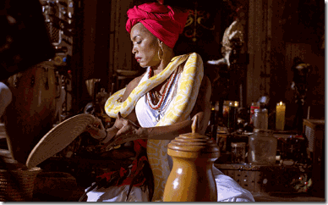
“In voodoo it is believed that when a Voodoo Queen dies her spirit re-enters the river of life and moves to the next realm, adjacent to this one. Her spirit will always be here, close at hand, in New Orleans.”[40]
The American Horror: Coven (Global Satanic Cabal) entered the demonic realm of the stream, current- over the face of the waters between heaven and earth. They conjured up the immortal DEMONIC spirit of Madame Laveau hovering over the current. Angela Bassett has been chosen to ILLUMINATE that EVIL once again- put it back in the FLESH to once again serve the ILLUMINATI DEATH CULTS.
As Paris Jackson stated you can find and avoid the ILLUMINATI if you know where to look. In my case, I also could have found the Underground Black Occult linked to the greater ILLUMINATI Death Cults in New Orleans by looking in the right places. This time, the Black Occult and the ILLUMINATI are no longer underground subjected to the secrecy of hidden caves. It’s on television out in plain sight, but this is no play or stage show.
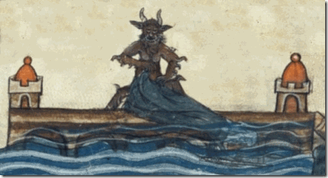
The picture above comes out of the French Ursuline Sisters Witch Trials of the 17th Century. It shows the DEVIL immersing a helpless Catholic priest or nun face down in water as part of a secret Satanic Death Ritual. Both Whitney Houston and Bobbi Kristina Houston Brown suffered the same faith. These people are deadly serious. They intend to create thousands upon thousands of Bobbi Kristinas and Paris Jacksons through modern technology and Holonomic Theories. The immortal EVIL Spirit hovering above the current of the Satanic Abyss has become part of HollyWeird’s Big Black WITCH, Angela Bassett, and that WITCH is subservient and obedient to the ILLUMINATI Satanic Death Cults just the same as Madame Laveau.
ILLUMINATI Demonization of the American Black Male
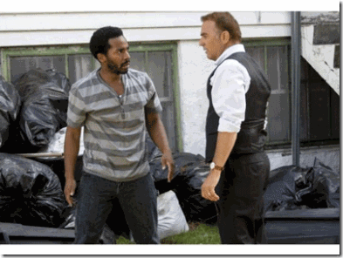
Costner confronts the “Street Nigger” Father of his Grand Daughter- Note the Black Bags of TRASH Behind the Black Father
Lastly as part of HollyWeird’s covert program to RE-IMAGE the American Black Male for elimination and the Rise of the Black Satanic LESBIANIC Cabal, Kevin Costner’s Black and White film project released January 30, 2015 the day before Bobbi Kristina was found face down in the bathtub can be added to the list.[41] In the film, he is more appropriate and adequate as a white man to step into Black family affairs and raise his bi-racial granddaughter than what he contends is an American crack head (Bobby Brown) “STREET NIGGER.”[42]
Under the veil, Kevin Costner is a dangerous clandestine right-wing- Zionist Republican playing with “Satanic Principle Dualism.” He masquerades in front of the masses as a liberal social democrat concerned about race relations in this country. He has classic English, Irish, Scottish, Welsh, German, and Swiss-German ancestry bloodlines. His wife, Cindy Silva Costner, former Snow White of ILLUMINATI Disneyland [43] says that it was much more than occasional golf with the Bohemia Grove/Pagan Presidents of the United States. Costner was part of Freemason/Knight of Malta– Ronald Reagan’s secret team.[44] Under the veil, Costner was also closely associated with former CIA Director, Skull and Bones, Freemason pedophile President George H. W. Bush.[45]
Angela Bassett’s Whitney and the GAY Bobby Brown

This dude playing Bobby Brown in Bassett’s Whitney, Arlen Escarpeta out of the Country of Belize, ILLUMINATES likes he don’t like women at all. He says, not I, that people that watched the show think that he is GAY.

The Black LESBIANIC HollyWeird Conspiracy is pushing this weak foreign Negro forward like a spiritual HERO among the masses as they did with that Satanic British Crown Intelligence Agent, David Oyelowo, in Selma, the ILLUMINATI Movie.
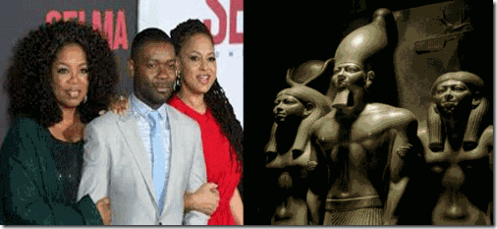
Angela Bassett ILLUMINATES Whitney Houston’s LESBIANIC Rumors

If you tuned in to see the Whitney Houston biopic on lifetime then you may have noticed the close relationship between Whitney and her LESBIANIC black body-guard Robyn Crawford. In Bassett’s ILLUMINATION, Crawford seems supportive and like she truly cares for Whitney and even got into a physical altercation trying to protect Whitney from that dysfunctional American crack head “STREET NIGGER” Bobby Brown.[46] The actress that played Robyn Crawford, Yolanda Ross, didn’t have to ILLUMINATE her natural or unnatural desire for women at all. She has been a LESBIAN in several films and Gay film festivals.
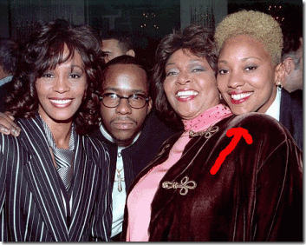
Whitney Houston was exposed to Robyn Crawford while enrolled in the Roman Catholic all-girl high school, Mount Saint Dominic Academy. The academy was officially founded in 1892 by the Sisters of St. Dominic. The Dominican congregation was initially based in Jersey City with its roots tracing back to the Convent of the Holy Cross in Regensberg, Bavaria, Germany- birthplace of the ILLUMINATI.[47]
A national survey, completed in 1996 but intentionally never publicized, estimates that a “minimum” of 34,000 Catholic nuns, or about 40 percent of all nuns in the United States, have suffered some form of sexual trauma. Some of that sexual abuse, exploitation or harassment has come at the hands of priests and other nuns in the church, the report said.[48] [Predatory Lesbian Nuns] use grooming practices similar to those employed by pederasts to seduce new victims; victims almost never report the abuse to ecclesiastical or secular authorities; and rather than being dismissed from the order, lesbian abusers are regularly transferred from convent to convent to avoid prosecution and public scandal. The Vatican has yet to address the problem of PREDATORY LESBIANISM and lesbian sexual abuse in women religious orders.[49]
Catholic schools are institutions of clandestine Homosexuality, Pedophilia and Predatory Lesbianism consistent with the objectives of the ILLUMINATI. They have vowed and combined to use their money, power, authority, influences and networks to clandestinely control, disturb and destroy the internal family structures of the masses of color to control population growth and depopulate Africa.
LESBIANIC CONSPIRACY & Conditioning Bobbi Kristina

This picture allegedly shows Bobbi Kristina being deliberately exposed and conditioned (traumatized) into Lesbianism by an older woman.
This picture also shows Bobbi Kristina being deliberately exposed and conditioned into Lesbianism by another older woman.
The bottom line of both Angela Bassett’s Whitney and Kevin Costner’s Black and White are consistent with the New World Order that the role of the Black Father is to be superseded/replaced by a LESBIANIC Black Female and the Great White Father’s power/privilege supersedes all of them to control, disrupt and destroy the internal Black family structure.
IN CONCLUSION
It’s hard to believe anything that comes out of the Houston and Brown families regarding the true medical conditions of Bobbi Kristina. To this day, I don’t think the public has been briefed by any medical professional regarding Bobbi Kristina’s medical condition. She remains in a critical state unable to breathe on her own. I’ll continue to pray for Little Sister, but not to that All Seeing Eye ILLUMINATI holographic image posted by her family, above. Our prayers have power more powerful than their EVIL spells and spirits hovering above the face of the waters in a void between heaven and earth. Our prays move the air and waters itself. Our prayers are the music of the universe.
Dear Little Sister, if GOD answers our prayers and it is possible, get professional mental health help and counseling to break the power and the spell of the DEMON that they placed over you. Please get away from them as far as you can- RUN AND DON’T TURN BACK.

[1] http://pagesix.com/2015/02/10/family-to-let-bobbi-kristina-die-on-same-day-as-whitney/
[2] http://www.theguardian.com/music/2012/apr/05/whitney-houston-drugs-system-autopsy
[3] http://radaronline.com/exclusives/2012/03/whitney-houston-drugs-cocaine-hotel-room
[4]https://ca.answers.yahoo.com/question/index;_ylt=AwrT6VvPq9pUuO0ASvwPxQt.;_ylu=X3oDMTE0ZmliMmVuBHNlYwNzcgRwb3MDNDYEY29sbwNncTEEdnRpZANZSFMwMDNfMQ–?qid=20131020174145AAg24gU
[5] http://extremelifechanger.com/index.php?p=1_468_446-HAND-PEACE-SIGN-
[6] http://www.tmz.com/2015/02/08/bobbi-kristina-funeral-plans-family-fighting-brown-houston/
[7] http://www.usmagazine.com/celebrity-news/news/ll-cool-j-wont-comment-bobbi-kristina-2015-grammys-201582
[8] http://forum.prisonplanet.com/index.php?topic=126862.0
[9] https://sakuramicheletakehashi.wordpress.com/2013/07/17/paris-jackson-and-the-illuminati/comment-page-1/
[10] http://illuminatiwatcher.com/paris-jackson-tweets-about-illuminati-and-sketches-occult-pictures/
[11] http://www.thewrap.com/views-rosie-perez-blasts-lifetimes-whitney-biopic-for-bobbi-kristina-tragedy-video/
[12] http://newsone.com/3029353/bobbi-kristina-angela-bassett/
[13] http://kabbalahbracelet.tumblr.com/
[14] http://www.judiciaryreport.com/stars_and_satan.htm
[15] http://olivetjournal.com/judaism-and-kabbalah-2-what-is-kabbalah/
[16] http://sandrarose.com/2015/01/whitney-houstons-daughter-bobbi-kristina-found-unresponsive-in-bathtub/
[17] http://www.dailymail.co.uk/news/article-2938966/Bobbi-Kristina-step-brother-Nick-Gordon-NOT-married-despite-claims-distraught-Bobby-Brown-reveals-daughter-moved-hospital.html
[18] http://www.orpheussports.com/team/
[19] http://en.wikipedia.org/wiki/Boston_College
[20] http://en.wikipedia.org/wiki/Rosy_Cross
[21] http://www.crcsite.org/cross.htm
[22] http://themurkynews.blogspot.com/2008/03/chapter-two-kay-arthur-al-denson-robert.html
[23] http://www.imdb.com/name/nm0000291/bio
[24] http://www.imdb.com/name/nm0000291/bio
[25] http://beginningandend.com/american-horror-story-coven-satanic-witchcraft-goes-mainstream/
[26] https://bsudlr.wordpress.com/2015/02/02/the-defaming-of-marie-laveau-an-american-horror-story/
[27] http://www.themystica.com/mystica/articles/l/laveau_marie.html
[28] http://entertainmentdesigner.com/news/museum-design-news/the-new-orleans-historic-voodoo-museum/
[29] http://www.pseudoreality.org/westside.html
[30] http://altereddimensions.net/2013/mad-madame-marie-delphine-lalaurie-new-orleans-socialite-serial-killer-caged-tortured-killed-slaves
[31] http://thenecronomicon.wikia.com/wiki/Devil_Baby
[32]http://www.bibliotecapleyades.net/sociopolitica/atlantean_conspiracy/atlantean_conspiracy44.htm
[33] http://www.thedyinggod.com/chaldeanmagi/Socrates
[34] http://en.wikipedia.org/wiki/Ursulines
[35] http://en.wikipedia.org/wiki/Loudun_possessions
[36]http://www.waymarking.com/waymarks/WM8HV9_Vampires_of_the_Ursuline_Convent_New_Orleans_LA
[37] http://www.aagsnc.org/blog/about/
[38] https://archive.org/stream/activitiesofkukl03unit/activitiesofkukl03unit_djvu.txt
[39] http://thedemoniacal.blogspot.com/2011/08/seven-sisters-of-new-orleans.html
[40] http://www.voodooonthebayou.net/marie_laveau.html
[41] http://en.wikipedia.org/wiki/Black_or_White_%28film%29
[42] http://www.laweekly.com/film/kevin-costners-fine-but-race-drama-black-or-white-is-cartoonish-5354860
[43] http://www.mouseplanet.com/8773/Grumpy_and_the_Seven_Snow_Whites
[44] http://www.angelfire.com/rebellion/costnerisantichrist/kevin.htm
[45] http://www.imdb.com/name/nm0000126/bio
[46]http://s2smagazine.com/2015/01/20/angela-bassett-talks-about-the-whitney-lesbian-rumors/
[47] http://www.msdacademy.org/history/the-dominicans-in-caldwell-and-mount-saint-dominic-academy-history.html
[48] http://www.libchrist.com/political/lesbiannuns.html
[49] http://www.phatmass.com/phorum/topic/106699-lesbianism-in-catholic-womens-religious-orders/
Comments : 2 Comments
Tags: 2015 grammys, angela bassett, Arlen Escarpeta, Baphomet, black mass, bobbie kristian brown, bobby brown, cabbalism, capuchin order, catholic church, coven, Cult of Miltra, devil, fallen angels, freemasons, french death cults, gilles de rais, group think, HollyWeird Kabbalah Cult, holonomic theories, hoodoo, ignaty loyola, Illuminati, illuminati sacrifice, iron cross, jesuits, Jonestown, kabbalah, kevin costner, knights templar, LESBIANIC Cabal, LESBIANIC CONSPIRACY, lesbians, LL Cool J, loudun possessions, madame helena p. blavatsky, madame marie catherine laveau, Marie Delphine Lalaurie, masonic order, michael jackson, mind control, MK-ULTRA, Monk Pere Antoine, Mount Saint Dominic Academy, new orleans, nick gordon, orpheus, paris jackson, robert fludd, Rosicrucianism, rosie perez, ruach, Saint Louis Cathedral, satanic black cabal, Satanism, Seven Sisters of New Orleans, sir francis bacon, son of the serpent, teutonic knights, the american horror, ursuline nuns, Ursuline Sisters, vatican, voodoo, Whitney houston, yolanda ross
Categories : 2015 GRAMMYS, ALL SEEING EYE, Aryan Supremacy, ascendant triangle, baphomet, blood covenants, blood oaths, BOBBI KRISTINA BROWN, bobby brown, bohemian grove, devil, druids, dualism, egypt, Eye of Horus, False Satanic Rites of Lost Negroes, George W. Bush, hollywood satanic cult, human sacifrice, illuminati, illuminati sacrifice, inverted pentagram, john dee, Knight of Malta, Knights of the Black Sun, Knights Templar, lucifer's servants, luciferians, Madame H.P. Blavatsky, masonic sacrifice, mind control, MK-ULTRA, monarch child, monarch program, Nazis, new world order, post amnesia barriers, post hypnotic suggestions, racial mass murder, Ritual Satanic Abuse, ritual satanic sexual abuse, ritually abused children, Robyn Crawford, rose and cross, Rose-Croix, Rosicrucian, Rosicrucianism, rosy cross, Satanic Global High Cabal, Satanism, The Bodyguard, trauma-based mind control, Tyler Perry, whitney houston

THE GREAT, GREAT HUEY P. NEWTON, SELMA, THE ILLUMINATI MOVIE, GUN OF THE BLACK SUN & MK ULTRA
6022015
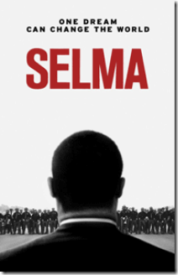
[ONLY] ONE DREAM CAN CHANGE THE WORLD
The Selma movie IMAGE of Dr. Martin Luther King, Jr. backwards is a holographic mathematical memory model (HMMM). HMMM describe a system where an IMAGE can be reconstructed through information that is stored throughout the hologram demonstrating a holographic associative memory that can impact the subconscious.[1]

If you concentrate on King’s hologram even for moments, it will play tricks with the mind. Google the IMAGES of the Selma movie poster on the internet and experience the cumulative effect of seeing dozens of these holographic HMMM posters at the same time, it will cause major disruption of the normal processes of your mind. The back-imaging of Dr. Martin Luther King, Jr. in the Selma movie poster has to be one of the most blatant pieces of subliminal demon-ism to come out of HollyWeird.
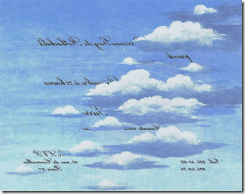
Marie-Hélène de Rothschild’s 1972 Backwards Written ILLUMINATI Party Invitation
The Law of Reversal is the occult language and code of the Satanic [2] and the elite ILLUMINATI.[3]
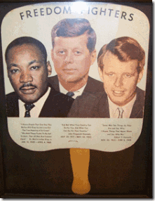
For generations, Dr. King’s face represented to the people- GOD’s Will, hope, justice, righteousness, persistence and order. During 1960s and 1970s, the faces/IMAGES of Dr. King, Robert F. Kennedy, and John F. Kennedy in some form or another was found in almost every Black church and family home in America. It was the work of absolutely pure diabolical EVIL proportions to turn Dr. King’s IMAGE into a hologram for mass population mind control manipulation. They deliberately manipulated and back-imaged Dr. King to turn him away from the people. They did it by devious and EVIL design to play tricks with the mind.

CIA ONE DREAM- ONE MIND
The CIA has been mastering controlling brain processes and sensory imagery for decades through holonomic theories, research and development. One of the CIA’s most distinguished scientists in the field of hologram research was Dr. Karl Pribram out of Vienna, German Austria.[4]
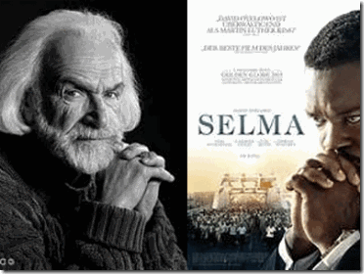
The Late Dr. Karl H. Pribram, The so-called Magellan of Brain Science
In 1979, Psychology Today feted Dr. Karl H. Pribram, neuroscientist, of the Stanford Research Institute (SRI) as “The [CIA] Magellan of Brain Science.” Dr. Pribram obtained his B.S. and M.D. degrees at the University of Chicago, and at Stanford University studied how the brain processes and stores sensory imagery. He is credited with discovering that mental imaging bears a close resemblance to hologram projection, the basis for transmitting images to the craniums of test subjects.[5]
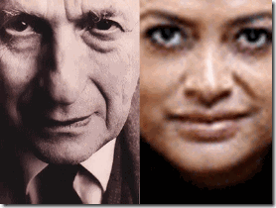
David Joseph Bohm, Selma Director Ava DuVerney – Group Think
Pribram was heavily influenced by the research of an American in England, David Joseph Bohm, that advocated the hologram theory– “Group Think.” David Bohm, ” ‘[T]hought’ is the whole thing – thought, felt, the body, the whole society sharing thoughts – it’s all one process. It is essential for me not to break that up, because it’s all one process; somebody else’s thoughts becomes my thoughts, and vice versa. Therefore it would be wrong and misleading to break it up into my thoughts, your thoughts, my feelings, these feelings, those feelings..” . I would say that thought makes what is often called in modern language a system.”[6]

Group Think is nothing more than what the Nazis did in Germany and it’s quest for world conquest. Group Think is two fancy words for “mass population mind manipulation.”
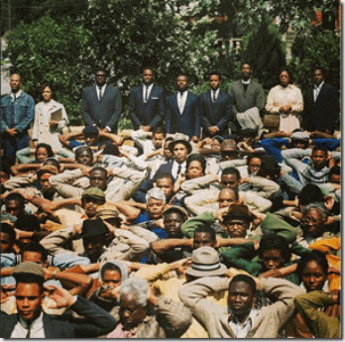
Selma, the ILLUMINATI Group Think -Complete and Total Submission

Pribram became aware of Bohm’s work in 1975 and realized that, since a hologram could store information within patterns of interference and then recreate that information when activated, it could serve as a strong metaphor for brain function.[7] Expanding mainly on Bohm and Dr. Pribrams’ studies to master the human brain through the holonomic brain theory, it provided science the ability to bridge the gap between science, philosophy, and human cognition. Scientists say that experiments support the fact that hologram back-imaging can also be used to disrupt and interfere with normal brain information tasking and processing.
“The opposing image difficulty is either exacerbated or ameliorated depending upon the identification requirement … and the dominant hemisphere processing that information.”[8]

Interferences of information and mirroring images cause organization confusion of “Mirror Imaging Processing (MIP)“. For instance, you can present a hologram image Dr. Martin Luther King, Jr. in a manner that oppose the normal, fundamental and universal “perceptions’, “thoughts” and “meaning” of the words and images of Dr. King to deliberate cause “brain dysfunction” and confusion to bring the people’s perceptions in line with the fascist New World Order by “Group Think.”
Selma, the ILLUMINATI Movie is a cruel experiment. They can’t change Dr. King’s legend of mass resistance to the New World Order (NWO), but through modern scientific methods they can certainly try to control his mass media IMAGE through holonomic brain technology secretly encoded with HMMM brain interference formulas to drive you insane.
Huey P. Newton, BBP- POWER TO THE PEOPLE
The comments and reactions to Dick Gregory’s use of mass media to openly RE-IMAGE Huey P. Newton and the BPP as FBI snitches, drug dealing criminals and frauds has been met with widespread mistrust, suspicious and rebuke.
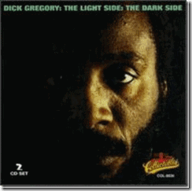
By his own admission, Dick Gregory secretly delves in the mist of fallen angels transcending GOOD (light) and Evil (dark). He is an useful Negro idiot of the elite Satanic NWO cabals. The cabals intend to try to control, manipulate and destroy all IMAGES of Black Mass Resistance.
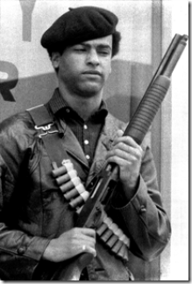
It may already be in works to also manipulate Huey and the BPP’s IMAGE through modern subliminal scientific technology. Yet in spite of CIA/MK ULTRA programming, Huey’s IMAGE continue to grow to almost spiritual and iconic proportions among the people.
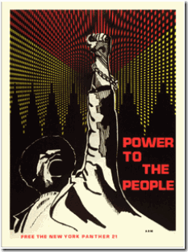
During the 1960s, Huey P. Newton was one of the system’s most vocal and militant adversaries of “Group Think.” Huey and BPP remains one of this country’s most visible and powerful revolutionary IMAGES that still stand firm for the unconditional power and will of the people to determine their own destiny.
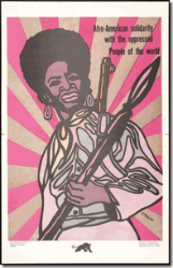
POWER TO THE PEOPLE had been one of the loudest and most persistent battle cries of the BPP. It was a message that the BPP spread widely across oppressed nations, communities and people around the globe.
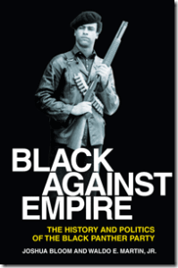
In film, literature and in the imagination, hearts and minds of the people, Huey P. Newton remains a powerful face and the IMAGE of resistance to the global Satanic NWO. In 1967, Huey P. Newton, Bobby Seale and members of the Black Panther Party for Self Defense (BPP) faced some of the most racialist, oppressive, demonic and fascist secret forces on the face of the earth.
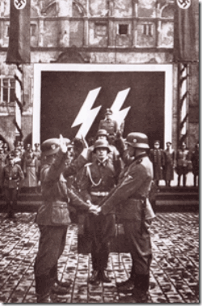
These demonic forces had to open up the gates of HELL and unleash Lucifer’s Servants- Knights of the Black Sun– SS to take the lead to try to quiet and suppress Huey P. Newton, BPP, and the revolutionary spirit, fervor and resistance among the global masses. Most people often ignore the fact that the Black Sun Knights are high priests of the occult- Enochian (fallen angel) Magick. Lucifer’s Servants‘ legendary inhuman nature for unmerciful mass bloodshed is supported by an internal complex mythological cosmology of magick straight out of HELL. To quell the flame, spiritual power and mystique among the masses of Huey P. Newton and the BPP, brutal bloodshed and Enochian Magick existed. One cannot exist without the other.
The Mystic SS Pistol, Zmeu, Fascism & Third Reich
I don’t think any of us truly appreciated the depth, treachery, power and utter diabolical EVIL among men that the DRAGON people represented. The people that the Panthers faced had been moving behind veils, shadows, smoked mirrors, false images and ILLUSIONS for generations in its quest for world domination.

Rare 1939 Nazi Mauser Factory Boxed Luger Gold Barreled Pearl Handled Antique
The Nazi Luger Pistol represents a thing of great volkish mysticism, magic, superstition, and folklore. The pistol’s mystic power is part of an unique signature of Hitler’s racialist executioners, Reichsführer SS-1 Heinrich Himmler and the Cult of the Dark Messiah.
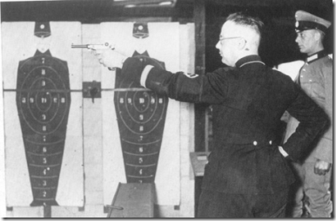

SS-1 Himmler Testing the Scope of the 9 mm Nazi Luger Pistol
Even today, the Nazi Luger Pistol is still a special relic representing the magick, mystery and mysticism of the SS and the THIRD REICH. Such volkish magick and superstitious notions of Lucifer Servants are not without the precedent mythological folklore even in the 21st Century.

In the 2011 film, the Gun of the Black Sun, General Lupescu of the Romanian Iron Guard placed an ancient spell of the ZMEU upon a golden Luger handgun- a gift to them from Reichsführer SS-1 Heinrich Himmler in 1940.[9]
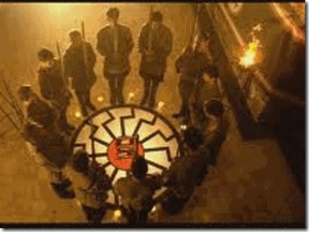
In the movie plot, year’s later in modern day Bucharest, character Loredana Anescu finds the gun among her dying Grandfather’s possessions. Long awaiting its re-emergence is Damian Lupescu, owner of Archangel Electronics, who has dreamed of using the power bestowed on the gun to release ZMEU to restore fascism and the FOURTH REICH in Europe through the medium of modern technology.[10]
Huey, Bobby and the Formation of the BPP
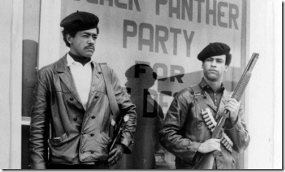
There was a lot of nervous anxiety and criticism among black intellectuals when Huey and Bobby formed the BPP in October 1966. Some said that they would support the panthers if they went underground. In their view, openly organizing under the barrel of the gun was extremely dangerous and an act of suicide.
Huey and Bobby argued that from a historical, statutory and constitutional foundation of this country the people had a fundamental right to assemble, bare arms and defend themselves. They argued to exercise the people’s “inalienable and fundamental rights” underground was tantamount to yielding the people to a permanent underclass and state of second or third class citizenship.
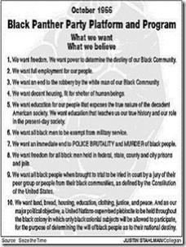
The intellectuals also attacked the BPP’s 10 Point Program, one intellectual told me that the system could easily meet each and every one of the demands set forth in the program, and we still wouldn’t be free. I didn’t have an answer for him or too much of anything else. At my youthful intellectual level, it had been difficult for me to string together two rational or abstract ideas. But, Huey and Bobby‘s 10 Point Program sounded good and felt right and just to my heart and soul.
The community Uncle Toms and undercover government agents could arguable contend militarized “armed resistance” against the system in the Black community was a certain death sentence, but they couldn’t argue against or oppose for instance, Number 1. We want freedom. We want power to determine the destiny of our Black Community.[11]
To oppose freedom for the people, only meant the support for Slavery and Oppression in duality. If you opposed the BPP’s number 1 basic and fundamental human right such as precious and cherished freedom, then the people were entitled to knock on the doors of power to find out why, demand answers and changes. The BPP 10 Point Program was a radiant strategy designed to win the hearts, minds and imagination of the people, and heighten contradictions. Huey and Bobby brilliantly designed the BPP 10 Point Program for the masses, not intellectuals.
From the very beginning, Huey and Bobby contended the BPP represented a grass roots movement among the people of the streets not intellectuals confined to universities, classrooms, churches, and underground chambers. Under the constitution and the laws of land, the BPP represented organized- “ARMED RESISTANCE” and defense to police brutality, economic and political exploitation from the street level.
Huey P. Newton, Cut off the Head
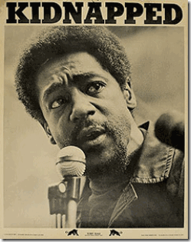
Not too long before or after the BPP was formed in October, I was approached by one of the brothers (undercover government agent) of the Black intelligentsia at Merritt Jr. College in Oakland. He said that he was concerned about my dedication and loyalty to Huey, Bobby and BPP. He thought that my love and commitment to the people might be best expressed elsewhere. He told me that all the power structure had to do was remove Huey, the BPP would fall. He said Bobby had the lack of heart and spirit to keep the BPP together without Huey.
At that time, I was a Man-Child that, as the old folks say, couldn’t pee straight. I don’t think I was even a Merritt College student at the time. I was ignorant, raw- just off the block. The bottom line was that I didn’t trust his judgment on Bobby. We loved Brother Bobby. I understood what he said, but I didn’t comprehend what he was alluring to.
He was really telling me that the CIA/FBI had developed detailed personality profiles and psychological assessments of Huey and Bobby. Bobby always talked about being in the U.S. Air Force in Texas and I believe it was also Oklahoma. He was always a known and predictable human factor to the system. They knew how to break him down. However, Huey was an unknown human potential that they couldn’t control or figure out.
Huey P. Newton, the Living Legend
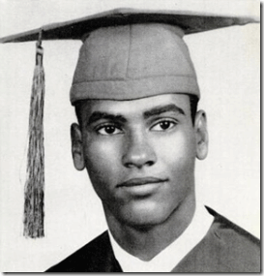
My older sister attended Oakland Technical High School with Huey. She said they exchanged high school graduation photos. When she recalled and spoke about Huey, I noticed that in her voice and demeanor there was always a quiet sense of love, respect and reverence for Huey. Huey was an unusual and extraordinary human being. Even before the BPP, Huey had already reached a legendary status in the community. When I first met Huey, I was standing in the hallway at Merritt with the homeboys checking out the young ladies- chilling and buzzing off Acapulco Gold and Rainier Ale.
Suddenly, one of the brothers said, there’s Huey. He instantly stood at attention like he was in the military. All of the other brothers followed- snapped to attention as Huey and his significant one, Laverne Williams, approached us. Laverne looked at me and cut her eyes. Huey read her eyes than looked directly in my eyes, then slightly nodded in our direction. Standing in attention, we all nodded in respect.
As Huey and Laverne passed, one of the brothers quietly warned me, “that’s Huey, don’t mess with him.” Wow, who was that brother, I said to myself. I felt so small and troubled standing in the halls of higher education high on drugs and alcohol. Just one look from Huey killed my high, and changed my life from that day on.
One evening, I stopped into Merritt between 6:30 and 7:00 pm just after night classes had started. I found my homeboys in their usually place standing in front of the cafeteria. They were still reeling from the state of shock and disbelief from an event that happened just minutes before I arrived. They said, “man, you missed it.” What, I asked?
They said, Huey and Marcellus got into it. Marcellus was a professional prize fighter chasing women around college. He had been a fixture on campus enrolled in some evening classes. Marcellus had an unsavory reputation as a big “bully” particularly in the face of young sisters. A lot of people were leery and afraid of him.
When I heard Huey and Marcellus got into it, I didn’t need to ask why. I knew that Huey had stepped up to Marcellus to defend a young sister’s honor and her right to pursue vital higher education in a non threatening atmosphere. My heart dropped. Huey was a good brother and respected serious young student just trying to get better educated. My upbeat state changed to a distressed state.
The brothers said, no, no. You don’t understand. Huey cleaned out Marcellus. Huey beat him down. What! Huey defeated Marcellus, a professional boxer. My jaw also dropped almost to the ground as we reeled in awe and silence. If any of us were high, that high was gone. I told the brothers, if Marcellus return to campus with backup. I am with Brother Huey! The evening on campus concluded quietly and peaceably. The brothers were right, “that’s Huey, don’t mess with him.”
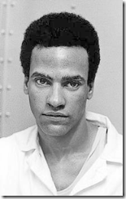
Huey was a quiet and extremely humble brother that didn’t have to talk to communicate. All he had to do was look at you, his message was powerful and clear among us. Huey was very special spiritually, and everyone that met him knew it. The early BPP was absolutely incredible, Huey and Bobby brought together, in unity, some of the baddest brothers and sisters in the State of California committed to the liberation of the people. There were military veterans of WWII, Korea and Vietnam. There were revolutionary intellectuals, gang leaders- members and the people of the block. These brothers and the sisters of the BPP didn’t play. And, everybody knew that too.
I never heard of Aldous Huxley’s Brave New World, the elite Global New World Order, Luciferians, the ILLUMINATI and America’s shadow government that secretly designated/fixed people of color in spite of the U.S. Constitution and the Laws of the Land, particularly Black People, to a permanent under caste of virtual mindless slaves regardless of character, intelligence, and desire.
We didn’t know about the secret CIA/MK ULTRA program behind the shadow government dedicated to creating, maintaining and enforcing a mass population permanent caste system comprised of privileged and the unprivileged masses of subservient mindless subjects. When Huey and the BPP rose up from the unprivileged under castes in armed resistance to the continued violation of the constitutional rights of the people, the shadow government moved swiftly, unmercifully and brutally to suppress the rebellion, and defend the secret combination of a Satanic New World Order.
Cut off the Head and KILL the Body: Huey P. Newton
In order to destroy the body of the BPP, the DRAGON people and shadow government planned to KILL Huey P. Newton from the moment of the formation of the Panther Party.
OPD versus Huey and the BPP
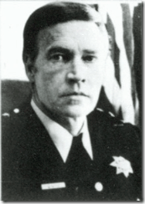
In September 1967, FBI Agent Charles Gain took over as Chief of the Oakland Police Department (OPD) to lead a governmental coordinated assault against the Panthers. They formed a special secret team to illegally harass and neutralize the BPP. Gain and Special Agent William Chohendet led the FBI’s San Francisco office’s “Panther Squad” (a subpart of its COINTELPRO Section).[12]
Previous to the FBI takeover of the OPD, the Bechtel-Kaiser Cartel headquartered in downtown Oakland removed the independent minded Catholic Mayor John C. Houlihan in a bloodless coup d’état. Mayor Houlihan was replaced on May 1, 1966 by former U.S. Air Force Lieutenant-Colonel John H. Reading.[13]The Bechtel Company is an inside CIA business that had been financed by the J. Schroeder Bank.[14] The Schroeder Bank helped bankroll SS-1 Himmler’s Circle of Friends, and the rise of Hitler and the THIRD REICH.[15] CIA Director Richard Helms, discussed below, was put on the payroll of Bechtel.[16]
FBI COINTELPRO versus Huey and the BPP

33rd Degree Blood Oath Master Masons- President Gerald Ford, California Attorney General Evelle Younger, California Governor (President-Knight of Malta) Ronald Reagan
In Los Angeles, DA Evelle J. Younger, was also instrumental in Hoover’s COINTELPRO program to destroy the BPP. Younger had also been one of 33rd Degree Master Mason J. Edgar Hoover’s top FBI agents. During WWII, Younger was with the Counter-Intelligence Branch of the OSS with CIA Director Allen Dulles and Richard Helms.[17] Evelle Younger was a blood oath secret Freemason and Shriner.[18] International Shriners and the Benevolent and Protective Order of Elks are “Clandestine Masonic Membership Shrines” under the jurisdiction of the Albert Pike’s Satanic Grand Lodge of Arkansas and the Ancient and Accepted Scottish Rite.[19]
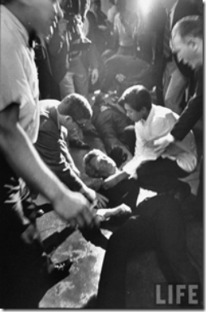
Younger was DA during the assassination of Senator Robert F. Kennedy at the Ambassador Hotel in Los Angeles. Younger was instrumental in the cover-up, and framing Sirhan Sirhan for the CIA high level Senator Robert F. Kennedy Assassination.[20]
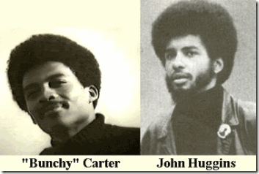
Younger was also LA County DA on January 17, 1969 when COINTELPRO counterintelligence operatives, MK ULTRA Ron Karenga’s United Slaves, assassinated Southern California BPP Deputy Minister of Defense Alprentice “Bunchy” Carter and John Huggins at UCLA.[21]
CIA PROJECT CHAOS versus Huey and the BPP
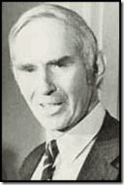
Secrecy Fanatic CIA Agent Richard Ober
The CIA’s Special Operations Groups within the Counter-intelligence Division created the illegal domestic operation, Project CHAOS. “Project MERRIMAC [1967 to 1973] involved the infiltration by CIA agents of . . . Black activist groups . . . . Project RESISTANCE [1967 to 1973] was a broad effort to obtain general background information” about radical groups across the country.”[22]
The CIA head of Project CHAOS was Richard Ober. Ober was a secrecy maniac that always walked in shadows. He was part of the OSS with Dulles, Helms and Younger before and after the fall of Nazi Germany. He became a liaison with the anti-Fascist underground in Nazi-occupied Europe. Ober served under the Vatican CIA liaison James Jesus Angleton as his understudy and chief counter-intelligence deputy. Helms and Angleton may have been two of the most dangerous and ruthless men in the western hemisphere. Ober was a fanatical keeper of their secrets.[23]
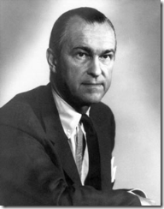
The man in charge of the CIA at that time was Richard McGarrah Helms. Helms spoke fluent German. He was a blood oath member of the secret Skull and Bones Society, part of ancient German Brotherhood of Death.[24] Helms was the Director of the CIA from 1966 to 1973. He was the only director to have been convicted of lying to Congress over CIA undercover activities. In 1977, he was sentenced to the maximum fine and received a slap on the waist suspended two-year prison sentence.[25]
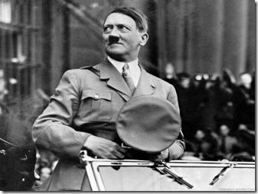
Richard Helms great journalist coup had been a 1935 interview with Fuhrer Adolf Hitler in Nazi Germany.[26] Helms had been a principal along with Allen Dulles in Operation PAPERCLIP that clandestinely brought thousands of SS-Knights of the Black Sun into America.[27] Helms was also the CIA plans director that headed the Phoenix (assassination) Program in Vietnam.[28]
Knights of the Black Sun versus Huey and the BPP
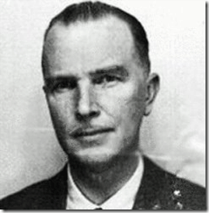
The David Niven of the SS- Baron Otto von Bolschwing
Helms signed for the secret and illegal entry of California’s resident Blood Oath Secret SS officer and DRAGON prince, Hauptsturmführer Baron Otto von Bolschwing, into the United States.[29] SS Bolschwing was one of Reichsfurhrer Heinrich Himmler’s top SA (Sturmabteilung) agents.[30]
In 1945, the U.S. Army Counterintelligence Corp (CIC) hired SS Bolschwing. After spending nine years in Europe working as a spy and operative for the Gehlen Org, von Bolschwing was brought to the United States where he worked directly for the CIA. His expertise involved using a variety of torture methods on subjects — bullwhips, placing needles under fingernails, drugging victims, and attaching electrodes to theirs testicles and nipples.[31] Most of what Baron von Bolschwing did in America under the veil of U.S. National Security is still classified ULTRA TOP SECRET.
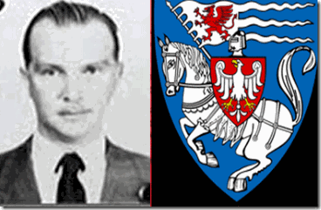
The baron was a blood heir of the Order of Brothers of the German House of Saint Mary in Jerusalem commonly the Teutonic Order- the Teutonic Knights.[32] As a hierarchical bloodline Teutonic Black Sun “KNIGHT”, his shadow power and authority superseded that of Freemason and Shriner Evelle Younger, 33 degree Master Mason, J. Edgar Hoover, German Brotherhood of Death member, Director Richard Helms, and the entire CIA agency under the Fort Hunt Treaty.[33]

The Wyvern DRAGON– one of the former crests used by the Mazovian Order of the Teutonic Knights close to Warsaw, Poland, country of the Baron’s birthplace and birthright to Knighthood.[34]

Golden Wyvern of the House of Wessex- Kingdom of England (519-1126 AD)

Queen Elizabeth I’s Wyvern Coat of Arms (1533-1603)-
SS Baron Bolschwing represented the ancient secret occult (Enochian Magick) bloodline DRAGON Race in the Covert War against Huey P. Newton and BPP. With all the parts of a multi-layered ultra security state, and secret sadistic army in place, the DRAGON was ready to snap it tail and try to cut off the head of the BPP- KILL Huey P. Newton.
The DRAGON Snaps it Tail
October Satanic Magick- Harvest of Souls
SATAN has his own harvest celebration— a “Harvest of Souls.” Lucifer’s Servants prepare for SATAN’s Harvest of Souls during the entire month of OCTOBER in various ways- chaos, domestic violence and all manner of death and destruction.
“Their (Luciferians) diabolical activities begin on October 1st and build the entire month of October, climaxing on October 31st which is dedicated to planned world-wide human sacrifice. These sacrifices take place in covens and carefully guarded exclusive meeting places of high-ranking government officials. Beware: Pseudo Christian ministries also lure people in for the purpose of using them for human sacrifices.”[35]
The Dawn Attack on Huey P. Newton
On October 28, 1967, I was in Hunter’s Point, San Francisco when we got word that Huey got moved on earlier at about 4:50 am on 7th Street in West Oakland. The word among brothers was get on the ready line. We might be going in to get Huey. Naturally, I was afraid. Many in my cell were older brothers some highly skilled in the art of combat. I didn’t even like to fight let alone try to harm anyone. I had absolutely no experience in actual or simulated combat. I couldn’t even shoot straight. I expected that slumber morning in October 1967 to be the last day of my life. I had no expectations to see my mother and family again. But, I was going in with the brothers when called.
The clouds moved in over the hill from the bay. The morning seemed darker than the night. The morning air was chill while we huddled together somewhere on the ground in Hunter’s Point waiting for a scouting report to locate Huey. For me, that morning was so dark and cloudy that to this very day- I can’t recall the names or faces of my unit. I can’t even recall how or when I got home to Oakland. Brother Huey meant the world to the people and us.
Finally, scouts had located Huey at Highland Hospital. Combined state, federal and local agency forces surrounded the hospital. They had turned it into a virtual fortress. The scouting report said that any attempt to rescue Huey would turn into a suicide mission. We got the order to stand down, and wait. However, if Huey had been left slaughtered in cold blood on the streets of Oakland, there was going to be a bloodbath.
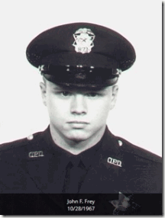
On the morning of October 28 on 7th Street in West Oakland, OPD stopped a car driven by Huey P. Newton. After a physical confrontation, Officer John Frey, 23 years old, was found dead from gunshot wounds. OPD Officer Herbert Heanes was found alive at the scene also suffering gunshot wounds. Huey was gone.
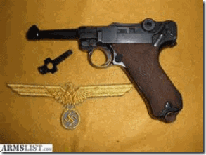
“Three slugs were recovered: one from Officer Frey’s hip, one from Heanes’ left knee, and a third which had been lodged in the right front door of the Volkswagen. In addition, two 9-mm. LUGER shell casings were found at the scene. One was in the street between the two police cars, the other near the left front bumper of Heanes’ car and approximately where Frey was lying. The 9-mm. bullets had been fired from an automatic (Officers Frey and Heanes carried .38-caliber Smith & Wesson revolvers). A live 9-mm. Luger cartridge was found on the floor of the Volkswagen, between the two front seats. Only Officer Heanes’ gun was found; he was holding it when the other officers arrived at the scene. Two rounds had been expended from the gun. Neither a LUGER nor Officer Frey’s revolver was found.”[36]
” … John Davis testified for the People as follows: Two types of gunpowder, ball and flake, were involved in the shootings. Officer Frey’s gunbelt contained high velocity cartridges with ball powder. Officer Heanes’ gun used flake powder cartridges; the 9-mm. cartridges also contained flake powder. The three slugs recovered from Officer Frey’s body, Heanes’ knee and the Volkswagen door were .38-caliber specials fired with ball powder, similar to the cartridges in Officer Frey’s gunbelt. The slugs found in both officers’ bodies were fired from the same .38-caliber Smith & Wesson revolver, the type of weapon normally carried by Officer Frey; neither had been fired from Heanes’ gun, which was of the same type.”[37]
“Defendant’s [Huey P. Newton] testimony suggested that Officer Frey wounded him with the first shot fired. However, the absence of powder deposits on his (defendant’s) clothing would indicate that Officer Heanes, not Frey, shot him.”[38]
Huey & the Gun of the Black Sun
They talked about both Officers Frey and Heanes being shot with Frey’s .38-caliber pistol, but failed to talk about the bullet that wounded Huey other than it wasn’t Officer Frey’s weapon. Huey had been shot by either Officer Heanes or an assailant (Officer Frey) with the German Luger. The Luger live round found in Huey’s car was no more than planted evidence.
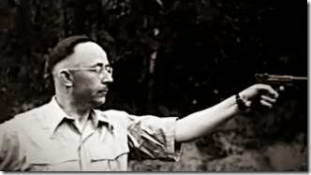
SS-1 Himmler Test Fire the Nazi Luger
The Luger known as the “German Luger” is well known from its use by Germans during WWI and WW II, along with the interwar Weimar Republic and the postwar East German Volkpolizei. It is notable for being the pistol for which the 9 x 19 Parabellum (also known as the 9 mm Luger) cartridge was developed. Because of its association with NAZI Germany, the pistol has been used in fictional works by many villainous characters over the past several decades.[39]
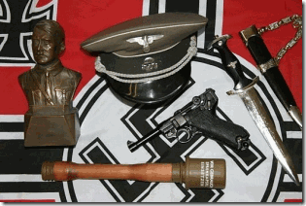
What are the odds of two brothers riding around in heart of West Oakland at about five in the morning with a loaded valuable collectors’ relic in the car that happened to be a German Luger out of Nazi Germany? The odds are slim to none at all. The OPD dispatcher confirmed the fact that Officer Frey had deliberately stopped the car Huey was in for no other reason than it was a known BPP vehicle that was subject to be carrying Huey. It was later discovered that Officers Frey and Heanes were secret members of the CIA/FBI/OPD Panther Squad.
According to Huey, Officer Frey approached the car and greeted him, “Well, well, well, what do we have? The GREAT, GREAT HUEY P. NEWTON.”[40] Huey said that Officer Frey ordered him out of the car and led him to the rear of Officer Heanes’ patrol car that had arrived on the scene. Huey said Officer Frey struck him in the face and he fell back and down to his knee then, ” … felt a “sensation like … boiling hot soup had been spilled on my stomach,” and heard an “explosion,” then a “volley of shots.” [41]
Huey recalled “crawling … a moving sensation,” but nothing else until he found himself at the entrance of Kaiser Hospital with no knowledge of how he arrived there. He expressly testified that he was “unconscious or semiconscious” during this interval, that he was “still only semiconscious” at the hospital entrance, and that — after recalling some events at Kaiser Hospital — he later “regained consciousness” at another hospital.[42]
Huey P. Newton & the Mystery of Nazi German Luger
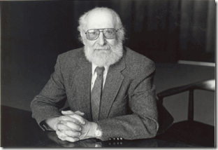
At Huey’s trial for the homicide of Officer Frey and assault against Officer Heanes, the defense called UC Berkeley Professor of law and psychiatry forensic expert Dr. Bernard L. Diamond, M.D. to explain Huey’s amnesia block leading to the death of Officer Frey. Dr. Diamond testified that Huey’s recollections were “compatible” with the gunshot wound he had received; and that “[a] gunshot wound which penetrates in a body cavity, the abdominal cavity or the thoracic cavity is very likely to produce a profound reflex shock reaction, that is quite different than a gunshot wound which penetrates only skin and muscle and it is not at all uncommon for a person shot in the abdomen to lose consciousness and go into this reflex shock condition for short periods of time up to half an hour or so.”[43]
A year or so before his appearance in Huey’s trial, Sirhan Sirhan’s defense team hired Dr. Diamond to examine Sirhan to ascertain his mental state, and to find out if Sirhan could be made to remember what happened under hypnosis. The tapes of Diamond’s hypnosis sessions reveal a man that sounded like he was more interested in implanting memories in Sirhan than recovering them. “In hypnosis, blocks are as important as answers, in that they can indicate some prior work in that area. Skilled hypnotists can place blocks into the subject’s mind that prevent memory of actions undertaken and associations made while under hypnosis.” Dr. Diamond claimed both that Sirhan was schizophrenic, and that he was self-hypnotized. Dr. Eduard Simson-Kallas, the chief psychologist when Sirhan was at San Quentin Prison strongly disagreed- schizophrenics cannot hypnotize themselves. In the Sirhan case, Dr. Diamond’s findings supported the government (CIA) conclusion that Sirhan Sirhan was a self-hypnotized lone-wolf assassin.[44]
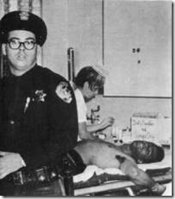
While Huey was at Highland County Hospital, we received reports that he was being deliberately tortured and traumatized. The reports said that police beat him, and jabbed their weapons into Huey’s open stomach gunshot wound. Huey’s physical torture was sadistic infliction of pain, but it had another purpose- CIA/MK ULTRA trauma based mind control manipulation.
Dr. Diamond had been a key notorious MK ULTRA trauma based mind control programmer and manipulator in the same company with Dr. Sydney Gottleib, Lt. Col John Alexander, Richard Dabney Anderson (USN), Dr. James Monroe, Dr. John Lilly, Lt. Comdr. Thomas Narut, Dr William Jennings Bryan, Dr. Martin T. Orne, Dr. Louis J. West, Dr Robert J. Lifton, Dr. Harris Isbel, and Dr. Wilson Green.[45]
What memories of the dawn conflict between Huey, OPD Frey and Heanes were so important for CIA to suppress- Huey’s memory of the assailant with the Gun of the Black Sun. Even Officer Heanes had an amnesia block as to what happened that morning. He testified that he “blacked out,” and had a “lapse of memory” about the Gun of the Black Sun. He couldn’t recall the final death struggle between Huey and Frey, where the Nazi Luger came from, who had it, and who actually shot Huey with which gun, his 38 revolver, Frey’s 38 or the Gun of the Black Sun.[46]
“I AM THE [NAZI] GESTAPO.”- OPD Officer John Frey[47]
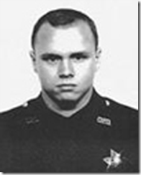
Officer Frey was a known vicious racist that often referred to the people he had been paid to protect and serve in Oakland with the N-word. He knew from the very beginning that the car he stopped contained Huey P. Newton, the head of the BPP. On October 28, 1967, Gene McKinney, 24 or 25 years old, was the passenger in the car with Huey when stopped by Officer Frey. McKinney was not a fellow Panther. Huey and McKinney had met for the first time that evening during a fund raising event for Chairman Bobby Seale. They were on an innocent food run that evening on 7th Street. When Huey and McKinney were stopped, absolutely nothing appeared out of the ordinary, except Huey was in the car.
After the October 28 incident, we were told nothing about the facts and circumstances surrounding the dawn attack on Huey. However, Bobby had been a necessary element in preparing Huey’s defense strategy and theory of the case. He was in privy with some very special facts and circumstances surrounding the attack.

In 2007, Bobby had some interesting things to say about the case. Sadly, as predicted by early FBI/CIA personality profiles and assessments, Bobby had sold his soul to the DEVIL decades ago. Bobby Seale is a member of the elite Luciferian Aspen Institute for Humanistic Studies, Aspen, Colorado.[48] The Aspen Institute is a clandestine ILLUMINATI DEVIL’s Coven. It was the site for a celebration of the 200th birthday of German poet and philosopher Johann Wolfgang von Goethe (1749-1823). He is the DEVIL’S disciple and Godfather for the Aspen Institute [49]
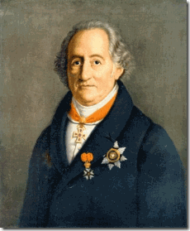
Lucifer’s Servant- Johann Wolfgang von Goethe
Secular Humanism and the NWO envisions “a future without religion,” a Luciferian future. It goes hand and hand with the Aspen Institute for Humanistic Studies following the Goethe Bicentennial Convocation in 1949 to “instill humanism in a post-war society.”[50] Johann Wolfgang von Goethe was a Cabbalist (Luciferian) and Bavarian ILLUMINATI.[51] Generally, Goethe was an elite German poet, writer, playwright, diplomat and civil servant famous for creating the literary works of Faust. Faust is the protagonist of a classic German legend who “Makes a Pact with the DEVIL” in exchange for knowledge and power over the physical world.[52]
Bobby’s 2007 statement contains some truth along with deliberate disinformation and deception. According to Bobby, McKinney ran for cover when the shooting and struggle began at the back of Heanes’ patrol car. After the bloodshed ended, McKinney returned to help Huey out of further harm and danger at the scene.[53]
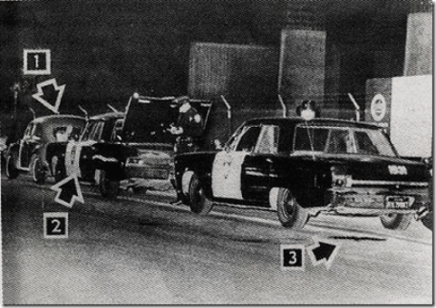
Bobby had this to say about the struggle at the end of Heanes’ patrol car,
“So Huey stopped and turned around right in front of the police vehicle, and Frey had his gun out. Huey grabs at the gun, y’know—I had seen Huey do this before, when we got into a fight with police. So what happened is Frey pulls that trigger and shoots Huey right in the thigh. Now, Officer Heanes, the other police officer, the shot goes off, he’s looking at Huey grabbing Frey, and he’s trying to shoot Huey, but they’re rolling and moving. It was told in court that the first bullet that hit Officer Frey was from Heanes’ gun.”[54]
Huey had not been shot in the thigh. Officer Heanes had been shot in the knee with a ball powder ammo weapon- Frey’s weapon. Three slugs removed from Frey’s body were also ball powder from his own gun. There is no physical evidence to support the contention that Heanes shot Frey with a flake powder slug. Huey‘s stomach wound was inconsistent with Frey’s ball powder bullets. Huey’s wound was consistent with the flake powder 9 mm Gun of the Black Sun.
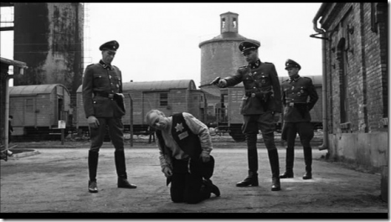
Officer Frey was intent to execute Huey at the back of Heanes’ car out of plain sight of witness, Gene McKinney. Frey’s murder weapon was the SS symbolic pistol, the Nazi Luger- Gun of the Black Sun. Huey’s natural reaction to seeing the Nazi Luger in Officer Frey’s hand was like Bobby said- consistent with Huey’s known observed past behavior, he knew how to disarm an armed assailant. Huey’s reaction to the gun in Frey’s hand had to have been unnaturally swift and lighting fast. Any other ordinary human being would have been helplessly slain on their knees. During the struggle, Frey was able to fire off two rounds from the Luger.
” … two 9-mm. Luger shell casings were found at the scene. One was in the street between the two police cars, the other near the left front bumper of Heanes’ car and approximately where Frey was lying.”
Bobby’s statement of facts is consistent with the physical evidence that Huey turned and was confronted face to face with Officer Frey and the Nazi Luger in front of Heanes‘ patrol car where the life and death struggle began where one 9 mm casting was found.
The struggle continued to the rear of Heane’s patrol car consistent with Bobby’s “rolling and moving” of Huey and Frey. Heanes couldn’t get off a clear round to disable Huey. Frey was able to roll off one more round from the Nazi Luger where the other 9 mm casting was found. This round must have found its mark in Huey’s mid-section. Bobby says that “Huey pulls his own gun out and fires back at Heanes and wounds him. Huey shoots Frey more, because Frey is moving and not dead, and then falls down, because he’s shot.”
In the first place, Huey was full-time law student at Golden Gate University School of Law. Huey as a matter of course followed the law. It was absolutely unnecessary for Huey to carry a concealed weapon, when he knew the way to carry a weapon legally pursuant to the constitution. In fact, Huey’s infamous law book was found at the scene soaked in blood.
Contrary to what Bobby said, the evidence at the scene was consistent with Heanes being wounded with Frey’s Smith & Wesson 38. caliber service revolver with Ball Powder shells. Huey had been vulgarly and offensively patted down and body searched for weapons by Officer Frey before Huey had been directed toward the rear of Heanes’ patrol car.
Huey had no concealed weapon to pull. If he was able to have concealed a weapon undetected by the humiliating pat-down and invasive body search by an experienced law enforcement officer, it had been a 38. caliber consistent with a Smith & Wesson- not a 9 mm Nazi Luger. I would be surprised if any physical evidence would confirm Bobby’s statement that Huey shot downward to execute Frey laid on the ground in a prone position.
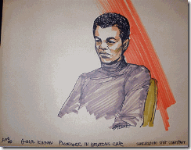
Fearing retaliation after the shootings, Gene McKinney disappeared and allegedly spent six months in hiding in Philadelphia. He returned to Oakland at the outset of Huey’s murder trial. At trial, McKinney refused to answer any questions about the incident based upon the 5th Amendment right against self- incrimination. McKinney was sentenced to six months in jail for contempt of court, and served less than a month.[55]
McKinney had been barred for decades from revealing any public details of the dark hour attack against Huey. With the smoke and smell of gun powder in the air, and the sheer explosiveness and excitement of those few moments in the dark would not have allowed McKinney the time and opportunity to form a state of mind to search for and remove Officer Frey’s weapon and the Nazi Luger from the crime scene.
In itself, it had been an absolutely remarkable feat of heroism and raw courage on his part to remove Huey from certain death if the OPD Panther Squad backup or wipe up team had found Huey alive at the scene. On September 13, 2000 in Oakland, Gene McKinney dropped dead at his computer while working on his memoirs. The timing of his death was odd and very interesting. He was 58 years old and most likely was revealing to the public for the first time in those memoirs what he saw, heard and experienced on the morning of October 28, 1967.[56]
In Conclusion
MK ULTRA Footprints
From the beginning, footprints of the CIA/MK ULTRA Program have been all over the October 28, 1967 incident that left Officer Frey dead, Officer Heanes and Huey wounded from gunshot wounds. All the witnesses to the event, Heanes, Huey and McKinney seem to have significant post-hypnotic blocks. Both Heanes and Huey have significant post-hypnotic memory/amnesia blocks that appears synchronized and timed to the precise moments that Officer Frey was shot multiple times.
McKinney goes missing for six months, and appears at trial blocked from answering any questions about the incident by post-hypnotic suggestion with the key script- I take the Fifth. A CIA/MK ULTRA hypnotist, Dr. Bernard L. Diamond, appears in the case to perform basically the same covert functions in Huey’s case that he performed in the Sirhan case- block and control by post hypnotic suggestions certain key memories of facts and circumstances surrounding the high level CIA assassination of Senator Robert F. Kennedy.
At the crime scene of October 28, 1967, most of the key physical evidence goes missing, Frey’s service revolver and the Nazi Luger. What happened to key evidence in the case seemed to be no great concern. In both Huey and Sirhan, the primary defense strategy was not forensics, but diminished capacity (loss of consciousness). Neither defense strategy is successful resulting in criminal convictions of Sirhan and Huey. In both cases, crime scene forensics seemed to have been a sideshow.
Huey & The Gun of the Black Sun


There may be more truth then fiction behind the 2011 movie, Gun of the Black Sun, based on Himmler’s Romanian Iron Guard Magick Golden SS Luger. One does not exist without the other, SS- Teutonic Knight Unmerciful Bloodshed and Enochian Magick .
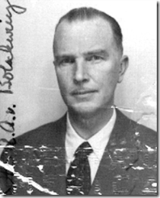
Here’s the kicker. Reichsführer SS-1 Heinrich Himmler appointed Baron Otto von Bolschwing his personal representative to Romania. Baron von Bolschwing had been Himmler’s principal SS advisor to the Romanian Iron Guard.[57] If Himmler give the guard a Golden SS Luger, it went through Baron Otto von Bolschwing.

If the ancient spell (fury) of ZMEU, above, was placed on the Golden SS Luger in the name of Fascism and the REICH, it had been the Enochian Magick and workings of SS High Priest Baron Bolschwing. The ZMEU has his special personal signature. Often compared to other fantastic creatures, the ZMEU chiefly resembles Slavic dragons, because it can fly and breathe fire.[58] The ZMEU resembles Baron Bolschwing’s Polish Teutonic Knight Crest, the Wyvern.

There was without a doubt a Nazi Luger at the October 28, 1967 life and death struggle between Huey, Officers Frey and Heanes. In the official report of the case, California v. Newton (1970) 8 Cal.App.3d 359 (1970) 87 Cal. Rptr. 394, the German Luger is mentioned three (3) times then disappears permanently from the history, records, annals and any literature or commentary of the case.

Officer Frey clearly identified himself as one of Himmler’s Geheime Staatspolizei, “Secret State Police”, the GESTAPO.[59] If Officer Frey’s secret assassin weapon was a rare Nazi Luger, it had been invoked with the ancient spell and fury of ZMEU in the name of Fascism and the THIRD REICH by a High Priest of the KNIGHTS OF THE BLACK SUN and the CULT OF THE DARK MESSIAH– Allgemeine SS Hauptsturmführer Baron Otto Albrecht Alfred von Bolschwing of the CIA, head of the SS Gehlen Org in America.
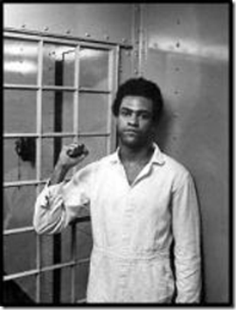
On October 28, 1967, Huey P. Newton faced overwhelming and virtual impossible odds. In the dark hours of morning, he faced down two highly trained assailants with three guns, one automatic Nazi SS Luger Pistol that had been endowed with the Power & Magick of Lucifer. While suffering from a mortal wound in a vital organ, he had been savagely attacked and beaten by police at Kaiser and Highland Hospitals. Yet, he PREVAILED. That’s part of the story that the elite global Satanic New World Order doesn’t want the masses to know about. The Great, Great Huey P. Newton flipped the script on them. Guns had to disappear. They had to bring in MK ULTRA to create memory vacuums of almost the entire incident. They continue to this very day to cover-up the ILLUMINATI criminal plot to Kill Huey- Cut Off the Head of the BPP that failed.
The Remarkable and Extraordinary Huey P. Newton PREVAILED FOR THE LOVE OF THE PEOPLE. Now, if you still don’t believe that HUEY P. NEWTON was a remarkable and extraordinary human being that dedicated his life to the Liberation of the People, then you must believe that FAT MEAT AIN’T GREASY.
Next, we are go deeply into HUEY P. NEWTON & MK ULTRA

[1] http://en.wikipedia.org/wiki/Holonomic_brain_theory
[2] http://ih2000.net/chembio/occult.htm
[3] http://leaksource.info/2013/08/31/1972-rothschild-illuminati-ball-26-photos/
[4] http://www.scholarpedia.org/article/User:Karl_Pribram
[5] http://www.whale.to/b/constantine6.html
[6]http://translate.google.com/translate?hl=en&sl=cs&u=https://is.muni.cz/www/344438/7159323/Psychologove.txt&prev=search
[7] http://en.wikipedia.org/wiki/Holonomic_brain_theory
[8] http://www.progressiveawareness.org/papers/The_MIP.html
[9] http://vimeo.com/26860824
[10] http://www.imdb.com/title/tt0892077/plotsummary?ref_=tt_ov_pl
[11] http://en.wikipedia.org/wiki/Ten-Point_Program
[12] http://propagandhi.com/wp-content/empires/Ward_Churchill.pdf
[13] http://en.wikipedia.org/wiki/List_of_mayors_of_Oakland,_California
[14] http://reformed-theology.org/html/books/wall_street/chapter_09.htm
[15] http://reformed-theology.org/html/books/wall_street/chapter_09.htm
[16] http://www.uni-muenster.de/PeaCon/global-texte/g-a/g-s/builders/Bechtel/Bechtel%20And%20Other%20Insiders/Seite1.htm
[17] http://truthontatelabianca.com/threads/younger-harriman-the-oss.326/
[18] http://archiver.rootsweb.ancestry.com/th/read/YOUNGER/2008-11/1226857300
[19] http://www.myfreemasonry.com/threads/shrine-in-arkansas-drops-mm-requirement.18877/page-3
[20] http://www.ctka.net/pr598-rfk.html
[21] http://www.nathanielturner.com/karenga2.htm
[22] http://www.aarclibrary.org/publib/church/reports/book3/pdf/ChurchB3_9_CHAOS.pdf
[23] http://www.ctka.net/pr700-ang.html
[24] http://www.subliminal.org/mugbook/spooks/helms.html
[25] http://www.aarclibrary.org/publib/church/reports/book3/pdf/ChurchB3_9_CHAOS.pdf
[26] http://news.bbc.co.uk/2/hi/americas/2354623.stm
[27] http://coat.ncf.ca/articles/links/richard_helms_october_2002.htm
[28] Id.
[29] http://coat.ncf.ca/articles/links/richard_helms_october_2002.htm
[30] http://coat.ncf.ca/articles/links/richard_helms_october_2002.htm
[31] http://www.angelfire.com/ca3/jphuck/BOOK3Ch2.html
[32] http://en.wikipedia.org/wiki/Teutonic_Knights
[33] https://atrueott.files.wordpress.com/2010/05/the-secret-treaty-of-fort-hunt.pdf
[34] http://www.mytravelingjoys.com/2014/04/exploring-czersk-castle-near-warsaw.html
[35] http://libertytothecaptives.net/halloween_harvest_souls.html
[36] https://h2o.law.harvard.edu/cases/2000
[37] Id
[38] Id.
[39] http://en.wikipedia.org/wiki/Luger_pistol
[40] People v. Newton (1970) 8 Cal App3d 359, 87 Cal Rptr 394
[41] Id.
[42] Id.
[43]https://h2o.law.harvard.edu/cases/2000
[44] http://www.ctka.net/pr598-rfk.html
[45] https://intheknow7.wordpress.com/mk-ultra-monarch-program-basic-info/
[46] http://law.justia.com/cases/california/court-of-appeal/3d/8/359.html
[47] Bloom, Black Against Empire: the History and Politics of the BPP, UC Press (2013) pg. 100
[48] http://www.aspencommunityvision.com/media/uploads/Sustaining_the_Aspen_Idea.pdf
[49] http://www.aspeninstitute.org/about/history
[50] http://www.aspencommunityvision.com/media/uploads/State_of_Aspen_Area_Report_sec_3.pdf
[51]http://www.bibliotecapleyades.net/sociopolitica/signscorpion/signscorpion02.htm
[52] http://en.wikipedia.org/wiki/Johann_Wolfgang_von_Goethe
[53] http://www.vice.com/read/bobby-v14n9
[54] Id.
[55] http://articles.latimes.com/2000/sep/26/local/me-26859
[56] Id.
[57] http://www.richardrashke.com/the-baron/
[58] http://www.monstropedia.org/Zmeu
[59] http://en.wikipedia.org/wiki/Gestapo
Comments : 3 Comments
Tags: Adolf Hitler, Aleister Crowley, Alprentice Bunchy Carter, Amnesia barriers, aspen institute, Ava DuVernay, Baron Otto Albrecht Alfred von Bolschwing, Benevolent and Protective Order of Elks, bobby seale, CHAOS Program, charles gain, CIA, COINTELPRO, cult of the dark messiah, david joseph bohm, dick gregory, Dr. Bernard L. Diamond, Dr. Eduard Simson-Kallas, Dr. Karl Philbram, Dr. Martin Luther King, evelle younger, fascism, FBI, freemasons, gene mckinney, german luger, GESTAPO, golden luger, golden wyvern, group think, gun of the black sun, herbert heanes, holograms, Huey P. Newton, Illuminati, International Shriners, James Jesus Angleton, Johann Wolfgang von Goethe, John C. Houlihan, john frey, john huggins, Knights of the Black Sun, Lucifer, Lucifer's Servants, luciferians, Merritt Junior College, mind control, MK-ULTRA, nazi luger, Nazis, oakland police department, OPERATION CHAOS, Order of Brothers of the German House of Saint Mary in Jerusalem, panther squad, Post-hypnotic amnesia, Reichsfurhrer Heinrich Himmler, richard helms, richard ober, Romanian Iron Guard, satan, Satanism, selma, shriners, Sirhan Sirhan, SRI, SS, Stanford Research Institute, teutonic knights, teutonic order, the movie, William Chohendet, xmeu
Categories : 1000 Year Reich, African Liberation, Aleister Crowley, allen dulles, Aryan Supremacy, Aspen institute, Black Panther Party for Self Defense, blood covenants, blood oaths, bloodline of wotan, bloodlines of wotan, brain entrainment, brotherhood of death, CIA, COINTELPRO, Dr. Aldous Huxley, dr. louis jolyon west, Dr. Martin T. Orne, Dr. Robert G. Heath, Dr. Sidney Gottlieb, dualism, Heinrich Himmler, huey p. newton, illuminati, J. Edgar Hoover, john dee, John f. kennedy, Knight of Malta, Knights of the Black Sun, Knights Templar, lucifer's servants, luciferians, Martin Luther King, mind control, MK-ULTRA, modern slavery, Nazis, new world order, nfl illuminati, oakland, oakland police department, Operation PAPERCLIP, panther squad, Paperclip Project, phoenix program, post amnesia barriers, post hypnotic suggestions, queen elizabeth, re-image, re-imaging, Reichsfurhrer SS-1 Heinrich Himmler, reinhard gehlen, richard helms, RONALD REAGAN, satan, Satanic Global High Cabal, Satanism, Schutzsteffel, Senator Robert F. Kennedy, sirhan sirhan, skull and bones, SS, SS Baron Otto Albrecht Alfred von Bolschwing, Stanford University, underground reich, underground third reich, wyvern

BILL COSBY PART IV, SELMA, the ILLUMINATI MOVIE, RISE OF THE BLACK LESBIANIC SATANIC CABAL, DICK GREGORY & HUEY P. NEWTON
27012015
SELMA, the ILLUMINATI Movie

In 1953, the same year the CIA/MK ULTRA program was formed, Dick (Richard Claxton) Gregory left college to join or was drafted into the U.S. Army, where his commanding officer (Ft. Hood, Texas, Ft Lee, Virginia or Ft. Smith)[1] designated and assigned him as a black “comedian” to host and perform comedy routines in military shows.[2] That’s interesting that the U.S. Military will make you a “comedian”, too.
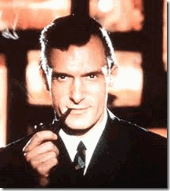
In 1953, Hugh Hefner setup Playboy, which was eventually revealed to be banked by the CIA.[3] Sometime before 1961, Dick Gregory formed some type of special personal relationship with Hefner (Mythological PUCK). In 1961, Hefner put Gregory on the payroll of his Chicago Playboy Club that opened the door to his HollyWeird career. It is more accurate to say that the “Gates of Hell” had opened upon him. In other to join Hefner’s elite secret satanic circle at that high CIA level of secrecy, Gregory had to have been initiated by a blood sacrifice (late 2 month old, Richard Claxton Gregory, Jr.?) into a subservient lower ranking black Luciferian group like the Prince Hall Freemasons or one of the Greek Hellenized societies.
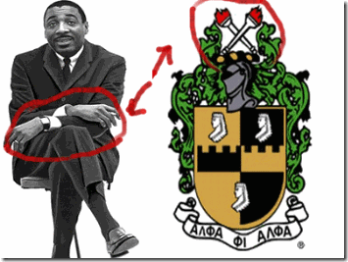
Gregory is openly known to be a Hellenized Negro, an Alpha Phi Alpha (secret Boule) man. Gregory’s X signal not only represents Skull & Bones and the Brotherhood of Death, it is a sign of the Royal DRAGON race of Old England. [4]
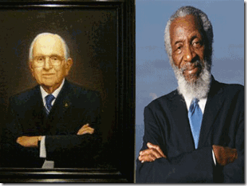
Some of the symbols Dick Gregory hides behind strongly suggest that he is also a blood oath secret Prince Hall, York Rite or Scottish Rite 33 degree Master Mason. An Official MASONIC Portrait of Norman Vincent Peal ‘Cutting’ of two secret Masonic signal signs visible Crossed Arms = ‘Skull & Crossbones and “Hidden Hand.” Both Peale and Gregory- ‘Blue Tie for ‘Blue Lodge’[5] In 1962, Hefner wrote the introduction to Gregory’s book, From the Back of the Bus.[6]
Dick Gregory is just as dual natured (Satanic Principle) as his friend, Bill Cosby. Like his friend, there are always by his own admission two sides to Dick Gregory, (Light vs. Dark) Good and diabolical EVIL that transcend the moral boundaries of original men. These kind of shadow people give me and creeps and nightmares.
Hugh Hefner & the Ancient CIA DRAGON- Devil Rituals

By murals openly visible at the Playboy Mansion, Hefner is associated with a secret elite Dionysian Cult. Once secret Luciferian rituals hidden away within the Playboy Mansion, Hefner’s Dionysian Cult is now associated with an annual public Shakespearean “A Midsummer Night’s Dream Party (Rite).”[7]
The Worship of Dionysus is generally considered to have started in Phrygia (Turkey) in Asia Minor between 1200 and 1000 B.C. The CULT became known for its extensive use of trance-inducing music, sex orgies, wine consumption, and the large amount of violent sacrifices, which in the earlier stages, included humans.[8] As a Mystery Cult, it had public and secret rites, which should be the same case with Hefner’s Cult. One of the rites included the Maenads, a group of insane woman involved in bizarre blood rituals. This included the ripping apart of human beings and eating their flesh. During this time, they were possessed by Bacchus who provided them with superhuman strength. Nicholas de Vere (The de Vere Family), in his book “The Origin of The Dragon Lords of the Rings”, adds:
“The Dionysic Rites were cannibalistic and vampiric and echo the era of the cannibalism and vampirism of the (Titanic) era of the sons of the Nephilim.”[9]
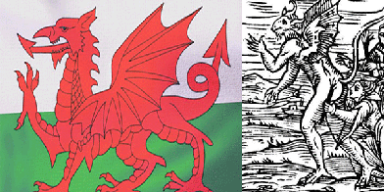
British Royal Wyvern DRAGON & Medieval DEVIL
The de Vere Family was involved in the practice of Royal Witchcraft and his family considered themselves members of the Archdruid-DRAGON Kings and Fairy Queens’ race. The very rare Dragon or Fairy gene is Ubaid Sumerian-Scythian in origin.[10]
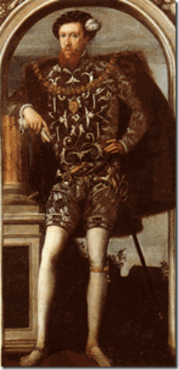
In England during the late 1500s and early 1600s, the secret Dionysic Cult consisted of Sir William and Robert Cecil, John Dee, his student Edward de Vere, above, Edmund Spenser, Sir Francis Bacon, Queen Elizabeth I, King James I, and several others. John Dee was the founder of Enochian Magic and is credited with writing “The Rosicrucian Secrets.“[11] This Luciferian Royal Circle is generally considered to have been responsible for the creation of European Rosicrucianism, Freemasonry, and Enochian Magic.
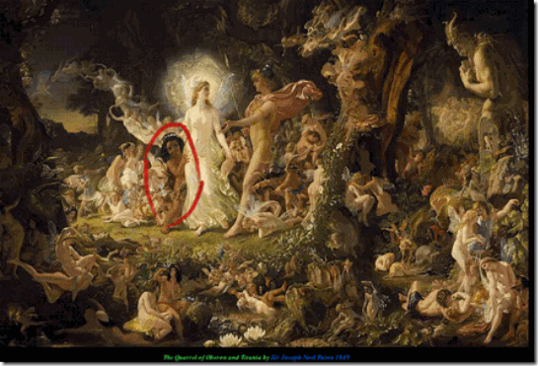
A Midsummer’s Night Dream came out of this elite Royal Luciferian Circle that is said to have included seeds of the Archdruid-DRAGON race.[12] “Midsummer’s Eve is a celebration of pagan origins intended to coincide with the summer solstice. In Gaelic folklore, the hours between dusk and dawn are said to be closer to the underworld and a special time when fairy activity is at its peak. This time was also said to be a period for witches to harvest magical plants (Illes 212); correspondingly, it is during this time that Oberon asks PUCK to fetch him that love-bewitching flower that turns the play into a love comedy. Oberon and Titania are the king and queen of fairy land who are introduced as having a personal dispute with each other; both entities are depicted as each keeping a multitude of servants: “Enter Oberon […] with his train, and Titania […] with hers” (Shakespeare 406). They seem to mimic and contrast the uncaring Athenian aristocratic society; falling under the category of trooping fairies, these entities can be ‘subdivided into the Heroic Fairies [who] are the aristocracy of fairyland. They have as a rule a king and queen, and they pass their time in the manner of the medieval nobility.’ ”[13]
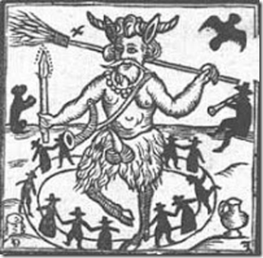
Medieval Demon PUCK
“Hugh Hefner is depicted as “PUCK” from Rosicrucian (the cult of Rosicrucianism is heavily involved in mind control; evidenced by their potential programming of Sirhan Sirhan [though of course the majority of AMORC members are not slaves/involved in MK, their cult, as many “religions” do involve trance-inducing methods which would have made Sirhan Sirhan more pliable to his programming, whoever ultimately did it]) , Francis Bacon’s A Midsummer Night’s Dream which the ‘party’ is named after. Though this depiction is not common for Puck in “the bard”‘s play (his plays will not have solely been written by Bacon, but by a group of well-connected individuals wanting to shape the English language/program the masses through it’s themes just like they do today through the far more invasive modern media; “William Shakespeare” was just a puppet actor [many of the claimed “facts” about the actor are untrue]), Hefner’s image here is more akin to a Satyr: “The Satyrs were mythological creatures with the upper part of their body of a man and the lower half of a goat. The leader of the Satyrs was god Pan [arguably a Satyr/faun himself]. Usually the Satyrs resided in woods and mountains or were accompanying the Greek god of wine [wine in ancient times was not the same as today, it often included different herbs and entheogens and other such things] Dionysus on his journeys, dancing around joyfully with the Nymphs [entranced/ dissociative/ programmed kittens basically].”[14]
MK ULTRA Dionysian Nymph v. Hugh Hefner
In 2009, the lonely and desperate cry of Sheri Denise Allred was briefly heard. She made a hopeless attempt to expose Hugh Hefner’s ultra secret and elite CIA/MK ULTRA pedophile ring and Dionysian Cult by filing a badly drafted pro se complaint for damages in the Los Angeles Superior Court.[15] She claimed that she had been ritually sexually abused by Hefner’s Luciferian Circle since 5 years old. According to MK ULTRA usual practices, age 5 and below is the idea impressionate period to begin slitting off alternative personalities from the original personality to create multiple personality disordered mind control subjects.

Sheri talked about having a hat covering her head where everyone in the world can hear her thoughts and transfer thoughts to her hat from god. She may be talking about EEG Skull Caps that are able to read your brain waves for MK ULTRA projects, or implant brain electrodes and microchip brain implants. The technology to read your thoughts have existed for quite sometime.[16] However most interestingly, she talked wildly and extensively about things inside Hefner’s Dionysian Cult and pedophile ring that may have included John Gotti’s Mob, and billionaire J. Paul Getty.[17] She talked about Darren Elliott being involved. Darren Joseph Eliot is a Canadian sports broadcaster and a former professional Los Angeles Kings goaltender.[18]
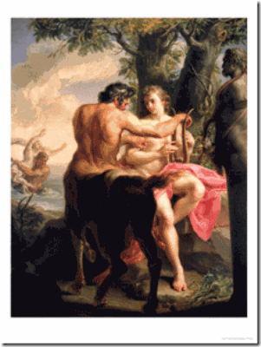
She said that Hefner was supposed to be a “centaur of the greek gods.” She was programmed to be an “reincarnation” of “Venus Aphrodite Demilo.”[19] Aphrodite of Milos better known as the Venus de Milo, is an ancient Greek statue. Created sometime between 130 and 100 BC, it is believed to depict Aphrodite, the Greek goddess of love and beauty (Venus to the Romans).[20]
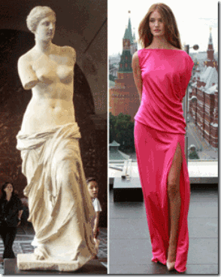
Rosie Huntington-Whiteley looks like Greek goddess, Venus de Milo- Aphrodite, as she poses for a photo in Moscow.[21] I said that to say this. Sheri’s complaint as filed is filled with grammatical errors, misspellings and what appears by first impressions to be off the wall references, but her spelling and references to Hefner’s Dionysian Cult and Greek Mythology are for the most part downright fairly consistently actuate. Similar, but going well beyond Bill Cosby’s allegations of rape and sexual abuses, Sheri’s case also involves drugs, Walt Disney mind control program themes, recovery of repressed memories, amnesia blocks, and Luciferian layers. It is also interesting that she identified herself as “Allred”, like Attorney Gloria Allred, the Bill Cosby Gatekeeper.
“I also carry the beautifiliest angel lusefer [Lucifer] in me cause I remember being the Goddess Venus see me and odeseyues [Odysseus] God of wine and Zues [Zeus] … the centaur is suppose to be Hugh Hefner at one point remember how we were horses and the playboy was a horse in Hugh’s little gathering of for say the finest of half horse. And there known to be a rabbit some are jack’s and some are hair’s and some are known as thumber as in the movie from walt Disney bambi, along with being known as a horse their’s shetland’s and clidesdale and what I was known to be a black stallion.”[22]
Walt Disney Black Occult Ritual Attendant Centaurs
By Sheri’s references to black horses and a black father, she appears to be a mixed race (quadroon, Mulatto) young lady. Hefner’s Dionysian Cult, like his European cousins, is DRAGON bloodline (Aryan-Anglo Saxon) exclusively aristocratically centered for their exploitation as in the original early British Shakespearean’s A Midsummer’s Night Dream Rituals.
For the record, as far as Dick Gregory’s good friend Bill Cosby is concerned, both are absolutely blood oath obedient to the secret elite Global Satanic Cabal, CIA and Hugh Hefner as no more than their mere black mind control attendants and recruiters. Dick Gregory is way out on the limb and on the bandwagon of the changing of the guard of America’s Black Satanic Cabal; and the ILLUMINATI movie, Selma. His well wishes to the new order, Welcome and thank you Oprah!
Aldous Huxley, MK ULTRA, the Dionysian Cult & Black Folk
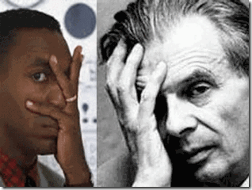
The CIA/MK ULTRA program is an enormous American shadow government institution dedicated to mind control, mass population control, and force the masses to be completely submissive and subservient to a global satanic semi-divine master controller race. Since 1953, the MK ULTRA program has evolved into a far reaching vast multi-billion dollar conglomerate of high ranking government officials, military intelligence agencies, corporations, freemasons, lawyers, doctors, clinics, prisons and some of this country’s most esteemed universities and hospitals locked in multiple layers of iron clad blood oath secrecy and security. It has the footprints of the management style of Reichsfuhrer Heinrich Himmler’s SS Satanic Empire.
For over two decades, it existed under a shroud and veil within a secret state before a small fraction of the program was exposed to the public. On December 22, 1974, Seymour Hersh exposed MK-ULTRA in a New York Times article. Headlined, “Huge CIA Operation Reported in US Against Antiwar Forces, Other Dissidents in Nixon Years,” it documented illegal activities, including secret experiments on US citizens during the 1960s and earlier.[23]
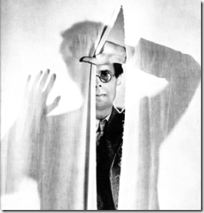
That men do not learn very much from the lessons of history is the most important of all the lessons of history. ~Aldous Huxley
Many people seem to believe that the late elite eugenic British writer and philosopher Aldous Huxley (1894- 1963) was the chief architect of the CIA/MK ULTRA-MONARCH program. I strongly disagree.
Aldous Huxley was a prominent member of England’s elite eugenic based secret Anglo Saxon Luciferian societies. Trained at Oxford University, London, Huxley was one of the initiates in the “Children of the Sun,” a Dionysian Cult comprised of the children of Britain’s Roundtable Elite. Among the other initiates were T.S. Eliot, W.H. Auden, Sir Oswald Mosley, and D.H. Lawrence, Huxley’s homosexual lover.[24] By the way, Hefner’s co-Dionysian initiate Huxley’s Culture and the Individual (subject Psychedelics [Soma]) was published in Playboy Magazine in November 1963, the same month and year of JFK’s assassination and Huxley’s death.[25]
The type of vast blood oath secret fraternal order within a secret state that has the power to conceal, preserve and unmercifully enforce secrecy of a large multi-level conglomerate such as the MK ULTRA Program would have to have been the Masonic hierarchical Knights of Malta. In 1953, both Allen Dulles, CIA Director, and Himmler’s SS puppet, Hitler’s General, Reinhard Gehlen, were members of the Order of the Knights of Malta and Teutonic Knights (The Order of Brothers of the German House of Saint Mary) that sits at the apex of a vast blood oath fraternal order- a secret state in itself.[26]
At best, Aldous Huxley would have been one of MK ULTRA’s philosophical British godfathers. During WWII, Huxley had been at the top of Himmler’s personal secretary SS-Brigadeführer Wicked Walter Schellenberg’s list to intern at their service to form a greater philosophical structure to global NAZISM.[27]
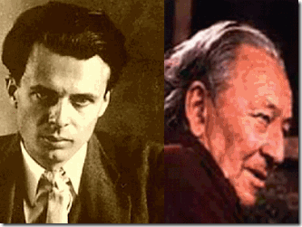
ILLUMINATI Brits Huxley (British Intelligence) and Dr. Gregory Bateson (CIA agent) would have been important and key “policy” board members, but don’t get it twisted. The CEO of MK ULTRA had been fellow ultra secret Teutonic Knight of the Black Sun, SS Dr. Josef Mengele.
Part of the ILLUMINATI and MK ULTRA’s secret philosophical policy and foundation developed by Huxley contains part of the pseudo racial notions and divisions contained in his 1931 novel, The New Brave World. One who belongs to the permanent lowest caste in Huxley’s Brave New World known for stunted growth, inferior intelligence- a useful idiot is the Epsilon Caste. Also known as the “Epsilon-minus semi-moron”[28]
“They can´t read and do low work. Epsilons are the only BLACK group. If somebody is an Alpha or an Epsilon is decided by doctors when their life starts. All babies are made in bottles were chemicals influence their development. After the unbotteling electro shocks and sleep-teaching is used to condition the babies till they are 12. So nearly nobody asks why he isn’t an Alpha, because this conditioning erases the real person… A drug called SOMA is used by everyone. It isn’t illegal. But nobody of the lower classes knows that it is drug. Every day after the work they get their ration. This helps people to be happy all the time. This leads to the stability the world controller wants.”[29]

“But in Epsilons … ‘we don’t need human intelligence.’ Didn’t need and didn’t get it. But though the Epsilon mind was mature at ten, the Epsilon body was not fit to work till eighteen. Long years of superfluous and wasted immaturity. If the physical development could be speeded up till it was as quick, say, as a cow’s, what an enormous saving to the Community!”[30]
Sir Francis Bacon’s [Shakespeare] The Tempest of the early Royal Dionysic Cult provides an important parallel to Huxley’s Brave New World, and the two texts relate to one another on many levels.
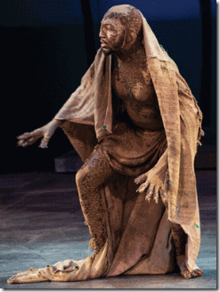
Shakespeare’s Tempest portrays Caliban, son of a demon and witch, as a BLACK angry, violent figure, who could easily be interpreted as less than human, ruled by bestial (animal) appetites rather than higher instincts. Caliban’s SOMA (God) is liquor. Caliban is a savage and an useful and necessary idiot enslaved/controlled by a SOMA to advance and serve European colonialism and the British Empire.[31] As you see as a matter of policy, the ILLUMINATI and MK ULTRA’s secret permanent pseudo lower Epsilon Caste are branded, the global Black Masses.
The Fall of Bill Cosby & Rise of the LESBIANIC Black Satanic Cult
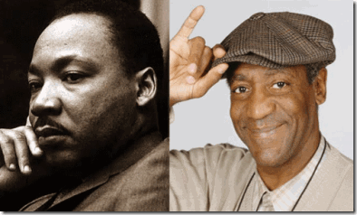
The ILLUMINATI’s useful idiot, Bill Cosby, is being symbolically phased out as the paternal “Head Negro” of America’s Black Satanic Cabal. In 1965, almost instantly Demonic Cosby, I Spy- CIA Agent, rose to become one of mass media’s IMAGES of black success and enterprise primarily as the dualistic opposite of the IMAGE of Dr. Martin Luther King, Jr. Dr. King’s world IMAGE was organized mass “Black Resistance” to the brave new world order.
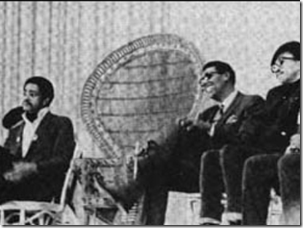
After Dr. King’s Assassination in 1968, the BLACK POWER IMAGES of SNCC- Stokely Carmichael, H. Rap Brown, Bobby Seale UNITED with the Black Panther Party for Self Defense moved into the forefront of the IMAGE of mass population “resistance” to the New World Order (NWO). However, the IMAGE that they feared most was a relatively unknown and uncontrollable factor, HUEY P. NEWTON.
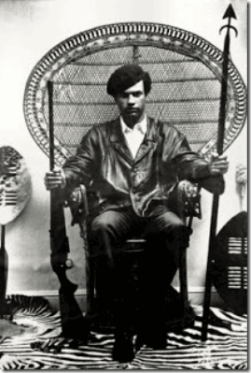
In the dualistic opposite to mass resistance, Cosby’s IMAGE moved into mass population submission and diversion- paternal “Fatherhood.”
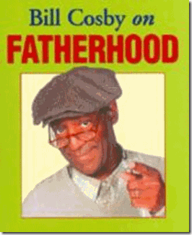led
Cosby’s fall from grace was easy because his IMAGE has always been false and an ILLUSION. Cosby’s mind had been conditioned by the CIA Occult Bureau (Ahnenerbe) and British Intelligence to believe that he was a DIVINE creature among those of the FALLEN ANGELS formed of a dual nature that transcends GOOD and EVIL. Cosby’s fall is bringing to the center a new and more diabolical international LESBIANIC (Oprah Winfrey) cast of useful idiots of America’s Black Satanic Cabal, and new false IMAGES and ILLUSIONS shaped, molded and controlled by the Old Royal Satanic Houses of the British Empire.
Selma, the ILLUMINATI Movie
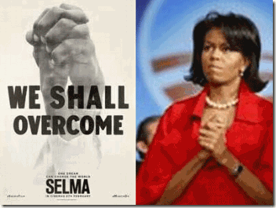
Selma Movie poster of Two Hands Clenched together in a raised position is a high level ILLUMINATI/Satanic Hand Sign.
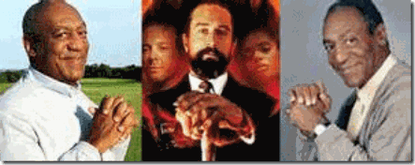
The reverse meaning of the hands clenched together in a raised position in the Selma Poster can only mean a “Seal [Lock] of Blood Oath Secrecy and Concealment” that will overcome “resistance” to a New World Order. I wasn’t feeling Selma from the very beginning. For people of color, HollyWeird isn’t in the business of educating, empowering or making you feel good about anything. It will take every moment to torture and humiliate you subliminally.
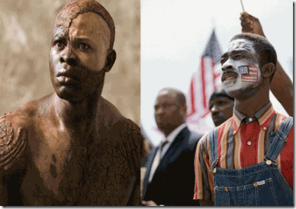
Caliban & Selma movie Protester
For one bit of GOOD information HollyWeird feeds you, it indoctrinates you with three bits of EVIL disinformation, whether directly or subliminally. It is scientific based mental conditioning of programmed mass submission just as below to the NWO.
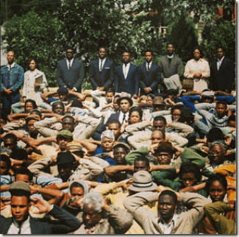
It is ongoing psychological warfare- a battle for your minds. Selma is an ILLUMINATI movie. It is the blatant product and agenda of a new and more sinister collaboration between the American Black Satanic LESBIANIC Cabal and the Royal Satanic Houses from Archaic Europe.

Not so funny, Wanda Sykes and Seal of Secrecy, One of Oprah’s Nasty Anti-Male LESBIANIC Foot Soldiers.

Wanda Sykes is in with the secret Earth Goddess Cult of Cybele, Lilith (Lucifer’s Consort)
Oprah’s LESBIANIC Satanic Cabal is not without a historical foundational mythology. Cybele is an ancient complex goddess equivalent to Magna Mater or “Great Mother”, “Mother of the Gods”, “Mountain Mother”. Cybele’s priests were males who ritually castrated themselves, after which they were given women’s clothing and assumed female identities, who were referred to by one third-century commentator, Callimachus, in the feminine as Gallai. Selma, the ILLUMINATI Movie was made by Brad Pitt’s Plan B, and Oprah Winfrey’s production company, HARPO– Oprah spelled backwards. Likewise, Oprah named her television network “OWN” in reverse “NWO“- NEW WORLD ORDER.
“It’s a language, all right. It’s English.
What do you mean?
It’s English in REVERSE.”
The above clip is English in reverse from the HollyWeird Satanic Cult Classic film, The Exorcist (1973).[32] It is said that one of the Great BEAST 666 Aleister Crowley’s chief insistences in the major law of SATAN was that his followers learn and put into practice the Occult Law of Reversal (Dualism- Satanic Principle). He extolled to his students to consistently, with intensity, practice talking (reverse speech), walking, thinking, and playing phonograph records, backwards.[33]
Little Lucifer- Brad Pitt
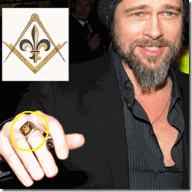
Brad Pitt proudly displays that he is a FREEMASON. Brad Pitt is also a Master of Deception- a “Son of Lucifer.”
“I related it more to my upbringing, I grew up in a very Christian environment — a very healthy environment and a loving a family — but there were parameters that I didn’t understand, that I questioned it, and it took me until my adult years until I could really try new things… That was SATANISM, it works really well, I made a pact [with LUCIFER] and the movie [12 Years a Slave] came out …” [of SATAN’S Workshop] [34]
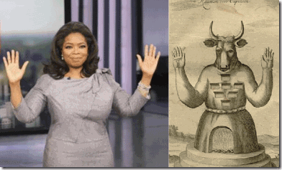
You must be extremely leery and cautious of whatever ILLUMINATI High Priestess /Witch useful idiot OPRAH WINFREY, and the Masonic Son of LUCIFER are involved in anything particularly Mass Media/Population film projects for Black People.
Selma, the ILLUMINATI Movie & the Black Satanic LESBIANIC Cabal
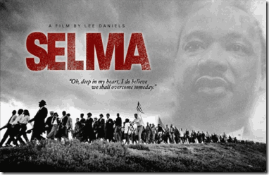
One Step Forward, Selma- IMAGE of Mass Resistance, Dr. Martin Luther King, Jr.
Selma had been designated to be directed by Lee Daniels, The Butler. It seems that Daniels‘ agenda for Selma was far different than the current mass media vehicle. Ava DuVernay was brought onboard by the ILLUMINATI to direct the Selma film project sponsored by PATHE UK, Brad Pitt’s Plan B and producer Christian Colson.[35]
Three Steps Backwards, Selma- Face of the ILLUMINATI

Ava DuVernay- ILLUMINATI Hand Symbol of Absolutely Diabolical EVIL
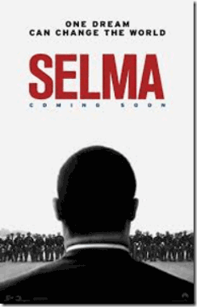
Three Steps Backwards, Selma- Back IMAGING of Dr. King, Selma March and Mass Resistance
One Dream Can Change the World ” … train himself to think BACKWARDS by external means, as set … (b) Let him learn to walk BACKWARDS… (e) Let him learn to read BACKWARDS …” (Crowley, Aleister. Magick: Liber ABA, book four, 1994 Ordo Templi Orientis edition, p. 639) Oprah and Ava, High Witches of the Occult, are playing the Selma March and Dr. King BACKWARDS (in reverse) as if it was a Trance Formation Dream State, and to a point where it never took place in reality.
Ava DuVernay’s British sponsor, Pathe UK, is part of Société Pathé Frères founded in Paris, France on September 28, 1896 by brothers Charles, Émile, Théophile and Jacques Pathé, during the first part of the 20th century, Pathé became the largest film equipment and production company in the world as well as a major producer of phonograph records. It is one of Europe’s oldest and most powerful film companies. British Pathe is very close, if not an eternal part, of the British Royal Family, Empire and Freemasonry.[36]
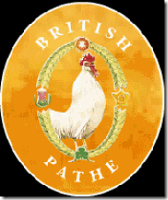
Pathe’s universal emblem is the rooster– an ancient universal Sun Solar Symbol because its crowing announces the dawn.[37] “…not all Egyptians worship the same gods–the only two to be universally worshipped are Isis and Osiris, who, they say, is Dionysus” (II.42.2); “Horus is the Apollo, Osiris the Dionysus, of the Greeks” (Herodotus, II.144.2).[38]
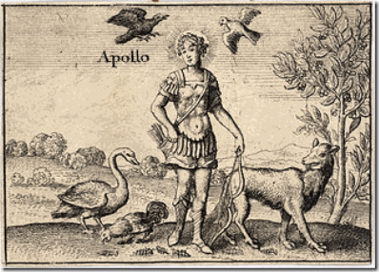
The Occult Symbolism of the rooster is that it represents a specific attribute of the Greek God Apollo. A rooster was ritually sacrificed to Asclepios, son of Apollo and god of medicine, because the bird heralded the soul of the dead that it was to guide to the Otherworld. Asclepios is also the god who, by his healing powers, brought the dead back to life on earth.[39]
In 1930, Myron C. Fagan served as “Writer Director” with “Pathe Pictures, Inc.,” then owned by JKF’s ILLUMINATI father, Joseph P. Kennedy, U.S. Ambassador to the Court of St. James, London (1938-1940).[40] Mr. Fagan subsequently devoted all of his time and efforts to writing monthly “NEWS BULLETINS” for “C. E. G.” in which he has kept up the fight to alert the American people to the plot to destroy the sovereignty of the United States of America and the ensuing enslavement of the American people in a UNITED NATIONS’ “One World Government.“[41]
Selma the ILLUMINATI Movie, Satan, Secrecy and Smoked Mirrors
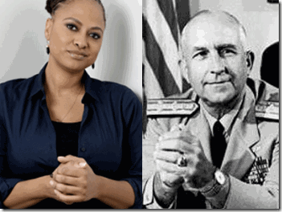
“Seal [Lock] of Blood Oath Secrecy and Concealment“- Ava DuVernay & U.S. Naval Admiral Thomas H. Moorer
Mae Brussell said that the late Congressman Larry McDonald was a national leader of the John Birch Society, which was exceedingly active in Dallas preceding the Kennedy Assassination, who created a organization called “Western Goals“. Western Goals had offices in Germany run by Eugene Wigner that fed data to the Hitler’s General and Himmler’s SS Puppet/ Knight of Malta Reinhard Gehlen’s Org/CIA. On the board of Western Goals were such Cold Warriors as Edward Teller, Admiral Thomas Moorer, and Dr. Hans Senholt, once a Nazi Luftwaffe pilot.[42] Admiral Moorer had been the Pentagon Chairman of the Joint Chiefs of Staff from 1970 until 1974. He was at a high level of shadow government “Blood Oath Secrecy and Concealment” with Lucifer’s Servants, the Underground THIRD REICH in America.

Ava DuVernay was recently officially Hellenized by Alpha Kappa Alpha Sorority, Inc., as an honorary member. However, her “Elder Sign” finger symbol indicates that she had been a high ranking blood oath useful idiot for the ILLUMINATI for quite sometime.[43]
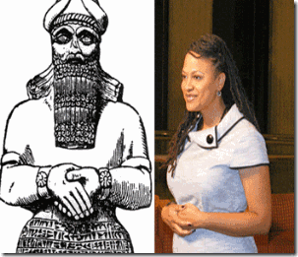
Ava DuVernay (High Level Female Mason) with the Masonic Hand (Claw) Symbol of Babylonian God Nebo.
Alpha Kappa Alpha’s International President Attorney Carolyn House Stewart presided over the formal induction.[44] The United Nations Association of the USA (UNA-USA) and Alpha Kappa Alpha Sorority (AKA), Inc. have embarked on a new partnership with the aim of creating global citizens and fostering new audiences to better support the United Nations and the NWO.[45]
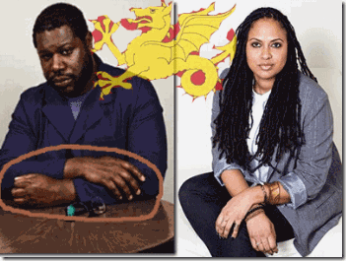
Lucifer’s Workshop 12 Years a Slave Director, Steve McQueen & Ava DuVernay (Claw), Josef Goebbels- British Royal Wyvern’s Secret DRAGON X Hand Gesture.
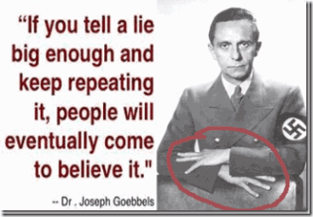
Below, former King of England, Duke of Windsor Prince Edward VIII-eldest son of King George V and Queen Mary in counsel with Nazi Propaganda Minister, Dr. Josef Goebbels.
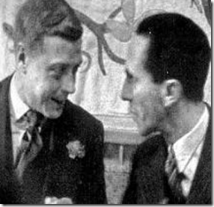
During WWII, Prince Edward was a Nazi collaborator that initiated Goebbels into his private and secret Royal Wyvern DRAGON (Cult) Army.
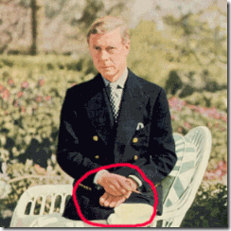
Prince Edward with the DRAGON X Hands Claw Symbol
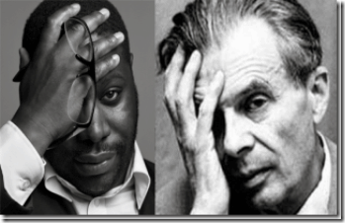
Brave New World useful Idiot Steve McQueen is a 2002 OBE- Officer of the Order of the British Empire, and an official 2011 CBE- Commander of the Order of the British Empire (Motto: For God and the Empire) just like British Secret Agent, James Bond -007.[46]
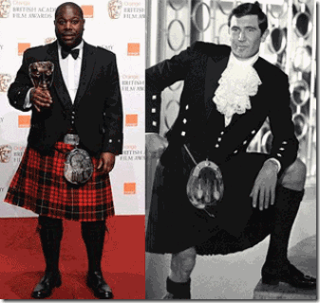
The Most Excellent Order of the British Empire (MEOBE) is an order of chivalry established on June 4, 1917 by King George V.[47] Queen Elizabeth II is also the Royal Patroness of the Grand Lodge of England.[48]

Ava DuVernay & Steve McQueen- Inverted Masonic Pyramid Hand Gesture
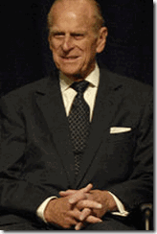
McQueen’s Boss & Masonic Hand Symbol, Prince Philip, Husband of Queen Elizabeth II, Grand Master of Grand Lodge of England
Selma, Coretta Scott King- One Step Forward
Selma, the ILLUMINATI Movie- Carman Ejogo & Sign of the BAPHOMET, Three Steps Backward

British ILLUMINATI WHORE, Baphomet is my inlay on her Blouse
In Selma, Dr. Martin King, Jr. and Coretta Scott King are portrayed by British ILLUMINATI useful idiots, David Oyelowo and Carmen Ejogo. President Lyndon B. Johnson and former Alabama Governor George Wallace are portrayed by British actors Tom Wilkinson and Tim Roth, respectively.[49]
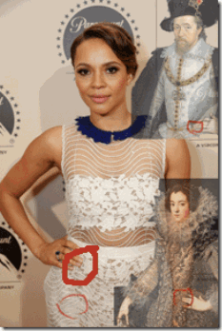
Carmen Ejogo, Elizabeth of France, Wife of King Philip IV (1602-1644) and King James I of England (1506-1625) displaying an ancient secret society Rosicrucian Hand/Finger Symbol . Ejogo’s unnatural finger/hand gesture or Triad Claw/Marrano gesture signals the letters M & W, which symbolize 666 from the three V’s. The letter V is “waw” in Hebrew and “vav” in Gematria and is the 6th letter in both.[50]
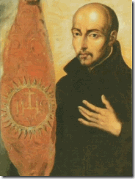
San Ignacio de Loyola, who founded the Jesuits by approval of Pope Paul III in 1539, came from a “Marrano” family…from every indication. In fact, strong and credible confirmation comes from none other than Benjamin Disraeli, an ethnic Jew and the Prime Minister of Great Britain in 1868 and 1874-1876, who wrote in his book “Coningsby” (London, 1844) that “the first Jesuits were Jews“. It is interesting that Loyola was compelled to repeatedly deny “Jewish” ethnicity.[51]
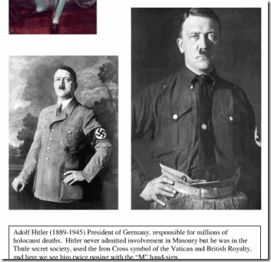
The term “Marrano” is a Spanish expression which means “secret Jew“, i.e. a falsely converted Jew. Therefore, on the one hand, Ignatius Loyola displayed an outward show of Catholic devotion but in dramatically contradictory fashion…appears to have been a member of “Alumbrado” which was a forerunner to the Illuminati organization (the word “Alumbrado” is simply a Spanish translation for the term “Illuminati“) and another suspected Kabbalah concoction. Alumbrado devotees manifested a strangely conflicting mixture–many expressions of “godly” sentiments in their outward displays…but bizarre goings-on in their private meetings which fit the descriptions occult practices, and even of satanic ‘possession’ or interaction. [52]

Ejogo in early photo, above, appears to have been a British MK ULTRA Programmed Sex Kitten
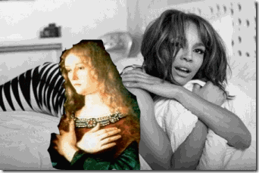
In another early photo in another sex kitten animal print, Elogo makes the X-Sign related to the British Royal DRAGON Race and the Knights Templar’s Cult of Mary Magdalene.
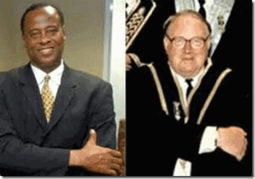
Dr. Conrad Murray, Scottish Rite Master Master & Official Master Mason- Masonic Arm Sign

LESBIANIC Cabal Master Masons- Ava DuVernay & First Lady Michelle Obama
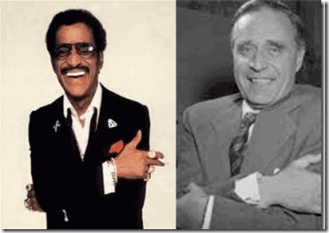
Don’t Get it Twisted they are Extremely Dangerous Women- York Rite/ Knight of Malta Sammy Davis, Jr. and Skull and Bones Prescott Bush
Selma, Dr. Martin Luther King, Jr.- One Step Forward
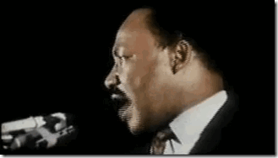
Selma, the ILLUMINATI Movie- Dr. King, Three Steps Backward

David Oyelowo is another Negro servant to the elite Global Satanic Cabals and secret British Secret Service, and Satanic Dionysian Cult
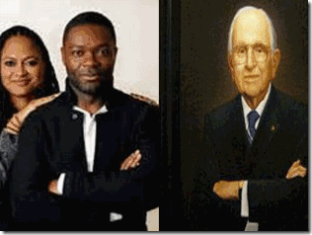
David Oyelowo is also a secret British Freemason
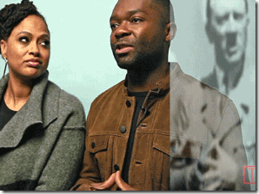
David Oyelowo & Universal Masonic/ILLUMINATI Pyramid Hand Symbol
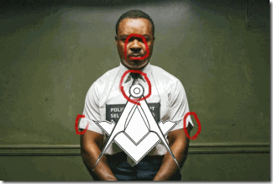
These people conceal their true motives behind ILLUSIONS, symbols and gestures. Oyelowo as Dr. Martin King, Jr. disguised in Subliminal Masonic Symbolism. On British television, Oyelowo starred on a TV series romanizing British Intelligence, MI5. Oyelowo’s hero is Christopher Nolan (Dark Knight Rises).

Christopher Nolan, above, leaving Dark Night Rises after party at the Freemason’s Hall in London. Freemasons’ Hall [Temple] is the headquarters of Prince Philip’s United Grand Lodge of England and the principal meeting place for Masonic Lodges in London. The notion that the Dark Knight Rises is an Anti-Masonic propaganda film is disinformation. It is said that elite powerful Luciferians usually sit in secret temple chambers and demonize and cast spells on HollyWeird films before release.
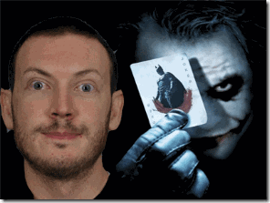
The Dark Knight Rises was the inspiration for the mass murder/slaughter of 12 innocent people by the CIA/MK ULTRA JOKER (James Holmes) in Aurora, Colorado. I suspect that Luciferians also demonized and filled Selma, the ILLUMINATI Movie with demonic spirits and energies to also drive you insance.
Oprah Winfrey, Ava DuVernay, David Oyelowo & the Son of Satan Initiation Rite
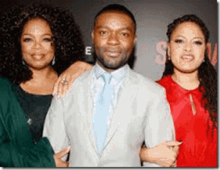
In the first instance, Oprah, David Oyelowo, and Ava DuVernay, above, appear normal in the IMAGE of an innocent mutual front of affection and admiration for each other as exceptional artists. However, these are demonic people that as general practice in the public hide behind Smoked Mirrors, false IMAGES and ILLLUSIONS. The true motives behind their unified IMAGE represents a secret Son of Satan initiation ceremonial rite that is opposite/backward to an ancient sacred [MAAT]Osirisian “confirmation ceremony” out of the Land of Kemet.[53]
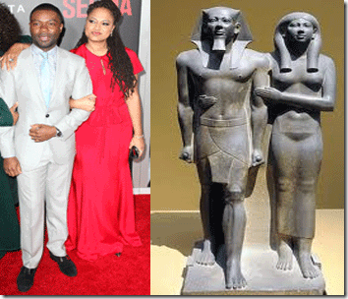
The ancient Kemetic “Confirmation Ceremony” is related to the feast “Appearance of the King” is likewise known from inscriptions on the Palermo stone. This feast was held immediately after the coronation, as a “Confirmation” of the king’s right to rule. The earliest known mention of this feast dates back to King Djoser king, first pharaoh of the 3rd Dynasty.[54] The Queen is Khamerernebty- Daughter of the God, Priestess of Djehuty [Thoth], Priestess of Tjazepef, One who sits with Horus, she has her right foot slightly forward initiating her husband, Pharaoh Men-Kau-Re, “Eternal is the Spirit (Ka) of Ra” fifth king of the Fourth Dynasty of Kemet to dine with the Gods.[55] In the Jewish tradition, the confirmation ceremony describe a meal Moses, Aaron, Nadab, Abihu, and the 70 elders met face to face and ate with GOD in a covenant confirmation (or ratification) ceremony.[56]
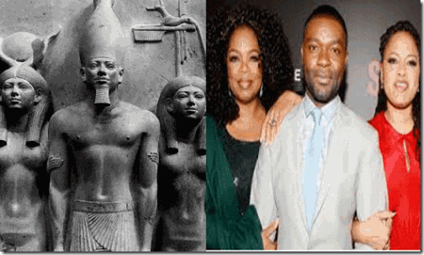
In the Land of Kemet, “three” was an important number signifying plurality- or unity expressed in plurality. The Menkaure Divine Triad express very complex Kemetic ideologies. Generally, the Kemetic triune conception of deities represent a god appearing under three aspects or modes with-out becoming, in fact, three gods. The members reflect three aspect of one reality.
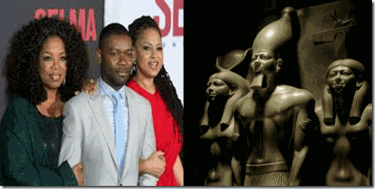
The Kemetic Divine Triad combines the concepts and symbolism of “three” and “one” and sometimes seen as transforming polytheism in tritheism and monotheism.[57] Before the people, Menkaure has placed the Goddess Hathor and the Goddess of the 17th Nome (uten-ha/Sa-ka/ Cynopolis) sacred to the God Anubis, in the service of the royal ideology ensuring the exercise of power according to sacred symbolic Kemetic cosmology. It also express the pluralistic totality of the DIVINE.
In this case, Oprah and Ava DuVernay deliberately place themselves slightly behind David Oyelowo placing him forward to delve in the realm of (SATANIC) Gods in a REVERSE ritual of Queen Khamerernebty and the goddesses of the Menkaure Triad that placed Pharaoh Menkaure forward to delve in MAAT among the Kemetic Ennead (Cosmic Order).[58]

In both cases, above, King Menkaure step forward with his right foot with fists clenched, conveying his authority in the realm of the living.[59] In opposite, Oyelowo step forward with his left foot with clenched fests (claws) and arm in a Masonic (Brotherhood of Death) position, conveying his authority in the realm of the dead among CHAOS. The significance of the Oprah’s LESBIANIC Triune conception can only be speculated. It may represent a ceremonial link and unity between the leading American Black Satanic Cults taken over by Oprah Winfrey’s LESBIANIC Cabal and the black useful idiots of the Satanic Royal Houses of the British Empire.
David Oyelowo, False Imaging & Black Panther Party for Self Defense
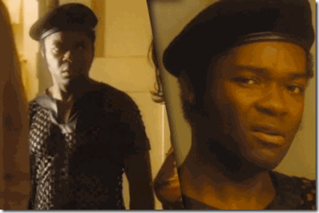
In Oprah and Lee Daniels’ ILLUMINATI movie, The Butler, Oyelowo, the Son of Satan, portrayed a false inspired IMAGE of a member of the BPP. Above, Oyelowo is wearing a UK Military Black Beret.

I have no idea what kind of strange black reptilian blouse he is wearing. It is a mass media IMAGE deliberately taken out of uniform for a member of the BPP. During the early formative years of the BPP, Chairman Bobby Seale constantly impressed upon us the importance of the IMAGE of the BBP. He stressed the significance of being on duty in professional uniform- beret, black leather jacket, black slacks, white or blue shirt, black tie, and polished black leather shoes. Bobby said that a black or white turtle neck sweater was an appropriate substitute if you didn’t have a white shirt and black tie. Many young brothers couldn’t afford to be in uniform, but proper uniform dress was no exception, but firm BPP policy that I (highlighted below) tried to follow consistently.
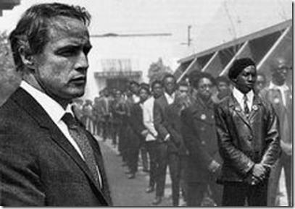
Our uniform was vital and a significant part of our IMAGE to win the heart, minds and imagination of the people. Both Bobby and BPP Prime Minister Stokely Carmichael (Kwame Ture) taught us that when the people saw us in consistent rule, discipline, and uniform in a professional manner- it automatically engender an unique positive reflection upon the masses of the people. Thus, they said that our order, discipline, uniform and IMAGE was vital to unity and the liberation of the people. The people had to recognize us as the Vanguard of the People instantly among all others in time of need, crisis, distress and struggle. Our uniform was also a death sentence. Chairman Bobby constantly warned us that under the cloak of night, death squads roamed the streets looking for an opportunity to pick us off alone.
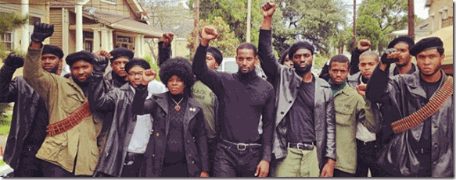
It doesn’t appear as if any of Oprah Winfrey and Lee Daniel’s HollyWeird disordered Panthers are in proper uniform to deliberately negate any sight chance of inspiration among the masses to struggle against the New World Order. Of course, I would ‘t subject myself to being tortured psychologically by any of Oprah’s masterfully bewitched film projects. However, I am almost certain that throughout The Butler that they didn’t invoke the name of the Minister of Defense, HUEY P. NEWTON. Before I conclude, please bear with me just a few more minutes of observations of Selma, the ILLUMINATI Movie.

“I am the hopeful black woman who was denied her right to vote.” –Rapper Common, Golden Glove Awards[60]
“I am the hopeful black woman …” As far as I know, I am not misquoting this useful idiot Negro. He is in with the ILLUMINATI/Satanic program displaying Oprah’s Secret LESBIANIC Cult of Earth Goddess Cybele –Vulva Hand Symbol. The Negro portrays in Selma convicted pedophile, [61] republican right wing- underground THIRD REICH collaborator and useful idiot, Rev. James Bevel.[62]
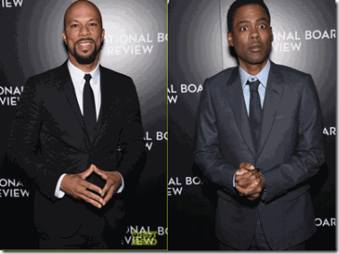
The HollyWeird premiere of Selma, the ILLUMINATI Movie was a meeting of the minds of all in with the program. In with the program of Oprah’s LESBIANIC Black Satanic Cabal- the scary and submissive Chris Rock in proper ILLUMINATI/Masonic Recognition.
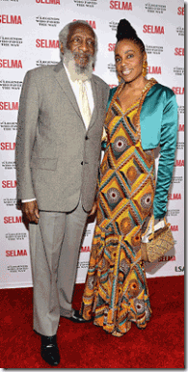
In with the program, DICK GREGORY
CONCLUSION
Dick Gregory, Body Snatching & the IMAGE OF HUEY P. NEWTON
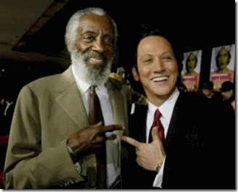
” ‘The Hot Chick‘ sends Rob Schneider, otherwise known as “Deuce Bigalow: Male Gigolo” and “The Animal,” into “Tootsie” land. But apart from waking up in a nightie and leaping about in girlish underwear, the bushy-haired, stubble-faced little comic doesn’t really attempt a drag turn. Instead, he strives to find his inner woman in straight makeup.”[63]
In 2002, Dick Gregory appeared in an appalling, demeaning ILLUMINATI/Satanic, racist, and transgender fairy tale movie called “Hot Chick.” The movie was co-written by the little Zionist prick Rob Schneider veteran of Saturday Night Live. Schneider’s begins his movie plot in Ethiopia in 50 BC during the historical Kingdom of Aksum (aka as the Axum, Aksumite Kingdom, Abyssinia).[64] He says that an Ethiopian princess used a pair of enchanted earrings to open an portal into some else’s mind to escape an arranged marriage by snatching a body of a vessel he called a “slave.” When each woman wears one of the earrings, their bodies magically trade/swap places while their minds remain where they were.[65]
This body snatching concept is an old Satanic concept related to the CIA/MK ULTRA secret Star Gate out of body (Himmler’s SS Vril Society Astral Travel) experimental projects, not AFRICANS.
“Portals to the body allow demons to interact and control humans. Blood sacrifices, symbols, music, drugs and special meditation permit a higher level of demonic attachment and consequently, more spiritual powers to the follower. These powers are the classic occult tricks of divination, telepathy (in fact messages delivered by demons), creation of fire, telekinesis, etc. These are not enhancements on the individual, but merely deeds done by spirits to look like the person has ‘evolved’. “[66]
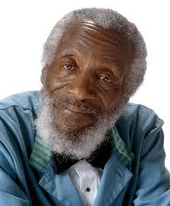
Schneider’s fairytale earrings pop up in an African– themed store where they are stolen by a white high school female student. One of the earrings is recovered in a stolen car by Schneider’s character that put on the lost earring- a cross gender transfer takes place between his character and the white female.[67] The mystery of the earrings are uncovered by a high school wiccan priestess (Eden) versed in Santeria out of Africa. The transgender shape shifting- body snatcher mystery is traced to a dance club called “Instant Tang” where Dick Gregory is the mocking, degrading and humiliating early 20th Century Negro “bathroom attendant.” He teaches the cross gender shape shifter- body snatcher how to “PEE” like a man.
Please bare with me just a few more minutes. Dick Gregory is a very clever man that often speak through riddles and puzzles. When he jokes about teaching the cross gender shape shifter- body snatcher how to “PEE,” its really a riddle. The other way to open portals to the body to allow demons and other forces to interact and control human behavior that Gregory is well aware of through his Dionysian Cult work with Hugh Hefner and Bill Cosby is through CIA/MK ULTRA Ritual Trauma Based Mind Control. That very classified work programmed mind control victims such as Sheri Denise Allred, discussed above, to trade/swap places with mythological characters such as centaurs, fairies, nymphs, and stone statutes such as Venus de Milo- Aphrodite to play out demonic fantasies such as Sir Francis Bacon’s “A Midsummer Night’s Dream Party (Rite) for the secret global elite DRAGON, Star and Olympian oligarchies, and ruling classes. Gregory’s expertise and experience in Hefner’s secret MK ULTRA/MONARCH mind control programs would certainly have qualified him to be have been a technical adviser to Schneider’s Hot Chick. Under the veil, he provided the character in Hot Chick with the technical background and support to cross gender shape shift, and body snatch.
One of the secret eugenic based goals of the CIA , British Intelligence and the Global Satanic Cabal through Oprah’s LESBIANIC Cabal’s, Selma, the ILLUMINATI Movie, is to negatively impact and CONTROL the IMAGE and role of Black Male Messianic world figures like Dr. Martin Luther King in war, politics and nation building for a New World Order through masonic/demonic vessels like David Oyelowo. And, gradually impact, reimage and reshape the Black male’s sphere and power of influence within society and the family through so-called diversity by shrouded racialist homosexual programs. Through MK ULTRA, Dick Gregory provided the very same technical support, “PEE” like a man, to Oprah’s LESBIANIC Black Satanic Cabal.
To negatively impact the masses’ “manly” non comprising and militaristic world IMAGE of HUEY P. NEWTON, Dick Gregory says without qualification that Huey was a “FBI agent” that used the Black Panther Party as a front for their drug dealing.[68] At least 20% of what he says about Huey may be correct, but it’s the 80% that affects the world IMAGE of Huey that he deliberately conceals. The MK ULTRA Complex is also a vast counter-intelligence operations. The 80% of the story that affects Huey’s story involve MK ULTRA. They extended millions in medical, psychological and technical support to literally body snatch Huey to allow demons, other forces and alternative personalities to control and interact with him. That’s part of the story that Dick Gregory deliberately conceals.
For the record, he lumped Huey beside Eldridge Cleaver as FBI agents. As far as Cleaver is concerned, I was there when he was first introduced as the BPP’s Minister of Information. At that time, I shared the same concern as the other brothers and sisters, who is he? Where did he come from? Most of us didn’t care for or trust him from the very beginning. From the April 6, 1968 Assassination of Little Bobby Hutton, I have been personally certain of what he was- a government infiltrator and agent. I was there at headquarters manning the front desk like a fly on the wall within a couple of hours before they murdered Little Bobby in cold blood.
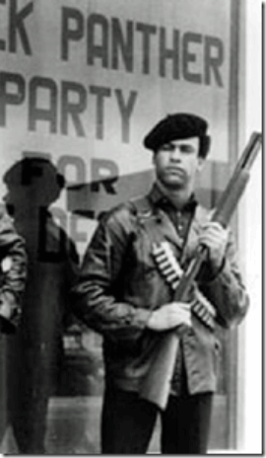
However, Huey P. Newton is an entirely different story. There are two Hueys, one before prison and MK ULTRA and one after prison and MK ULTRA. Nevertheless, they are still afraid of HUEY P. NEWTON even in death.
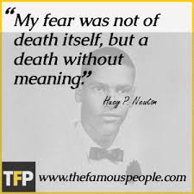
Huey’s IMAGE and his example of undying love that he expressed for the people without regard for his own life before prison will live on. The secret CIA/MK ULTRA Body Snatching project will set set him apart from others like Eldridge Cleaver that willingly combined with governmental forces and the NWO to murder and imprison our revolutionary just- warrior spirit, and destroy the Will of the People. I will expand on Huey and MK ULTRA in the next post, then conclude the Bill Cosby series.

[1] http://en.wikipedia.org/wiki/Dick_Gregory
[2] http://www.math.buffalo.edu/~sww/gregory/gregory_dick.html
[3] http://anolen.com/tag/hugh-hefner/
[4] http://www.phoenixalphas.org/alphahistory.html
[5] http://freemasonrywatch.org/secrets.html
[6] http://www.math.buffalo.edu/~sww/gregory/gregory_dick.html
[7] http://www.pseudoccultmedia.net/2009/06/monarch-playboy-kittens-next-door.html
[8] http://www.gnosticliberationfront.com/bohemian_grove_symbolism.htm
[9] http://www.gnosticliberationfront.com/bohemian_grove_symbolism.htm
[10] Id.
[11] Id.
[12] Id.
[13] http://www.gnosticliberationfront.com/bohemian_grove_symbolism.htm
[14] http://www.pseudoccultmedia.net/2009/06/monarch-playboy-kittens-next-door.html
[15] http://www.tmz.com/2009/07/09/reincarnated-woman-sues-hefner-for-3-billion/
[16] http://www.aolcdn.com/tmz_documents/0709_hugh_hefner.pdf
[17] Id.
[18] http://en.wikipedia.org/wiki/Darren_Eliot
[19] http://www.aolcdn.com/tmz_documents/0709_hugh_hefner.pdf
[20]http://en.wikipedia.org/wiki/Venus_de_Milo
[21]http://www.ok.co.uk/celebrity-news/Rosie-Huntington-Whiteley-goes-for-the-Venus-de-Milo-look-pulls-it-off-quite-well
[22]http://www.aolcdn.com/tmz_documents/0709_hugh_hefner.pdf
[23] http://rense.com/general89/mkultra.htm
[24] http://www.biblebelievers.org.au/aquarian.htm
[25] http://www.psychedelic-library.org/huxcultr.htm
[26] http://www.bibliotecapleyades.net/sociopolitica/esp_sociopol_malta01.htm
[27] http://www.counter-currents.com/2011/04/what-if-germany-had-won/
[28] http://www.urbandictionary.com/define.php?term=epsilon
[29] http://referaty-seminarky.cz/aldous-huxley-brave-new-world/
[30] http://franciscovazbrasil.blogspot.com/2014/11/brave-new-world-by-aldous-leonard.html
[31] http://www.sparknotes.com/lit/bravenew/section5.rhtml4t
[32] http://www.metacafe.com/watch/an-wOw1u4YJJhnmm/the_exorcist_1973_english_in_reverse/
[33] http://www.ih2000.net/chembio/occult.htm
[34] http://www.godlikeproductions.com/forum1/message1632123/pg1
[35] http://blogs.indiewire.com/shadowandact/huge-ava-duvernay-tapped-by-brad-pitts-plan-b-to-take-over-lee-daniels-selma
[36] http://www.thebabylonmatrix.com/index.php?title=911:Occult_symbolism_II
[37] http://www.thebabylonmatrix.com/index.php?title=911:Occult_symbolism_II
[38] http://www.artic.edu/~llivin/research/greeks_egyptian_gods/index.html
[39] http://www.thebabylonmatrix.com/index.php?title=911:Occult_symbolism_II
[40] http://en.wikipedia.org/wiki/Joseph_P._Kennedy,_Sr.
[41] http://jahtruth.net/illumin.htm
[42] http://www.free-conversant.com/realtruth/1621
[43] http://rollingout.com/culture/akas-welcome-new-member-hollywood-inducts-ava-duvernay/
[44] http://blackamericaweb.com/2014/07/09/director-ava-duvernay-inducted-into-alpha-kappa-alpha-sorority-as-honorary-member/
[45] http://hbculifestyle.com/alpha-kappa-alpha-una-usa/
[46] http://www.britannica.com/EBchecked/topic/1960664/Steve-McQueen
[47] http://en.wikipedia.org/wiki/Order_of_the_British_Empire
[48] http://www.abovetopsecret.com/forum/thread265143/pg1
[49] http://musingsofamildmanneredman.com/2015/01/10/selma-a-very-american-story-told-through-british-actors/
[50] http://www.pseudoreality.org/westside.html
[51] Id.
[52] http://www.pseudoreality.org/westside.html
[53] http://theuniversityofgod.org/Page3_lnk3.4-0.3.pdf
[54] http://en.wikipedia.org/wiki/Coronation_of_the_pharaoh
[55] http://en.wikipedia.org/wiki/Khamerernebty_II
[56] http://barrybandstra.com/rtot4/rtot4-06-ch3.html
[57] http://www.academia.edu/3638694/Divine_Triads_of_Ancient_Egypt
[58] http://kemetway.com/Knowledge/WayOfLife.html
[59] http://www.egyptiansidekick.com/colossus-at-memphis/
[60] http://breakingbrown.com/2015/01/rapper-common-portrays-child-molester-in-mlk-drama-selma/
[61] Id.
[62] http://www.publiceye.org/rightwoo/rwooz9-22.html
[63] http://articles.courant.com/2002-12-13/features/0212130920_1_mcadams-jessica-love-bug-valley-girl
[64] http://www.blackhistoryheroes.com/2012/09/a-brief-timeline-of-ancient-history-of.html
[65] http://en.wikipedia.org/wiki/The_Hot_Chick
[66] http://www.henrymakow.com/ex-satanist-details-illuminati-spiritual-plan.html
[67] http://en.wikipedia.org/wiki/The_Hot_Chick
[68] http://mxmission.blogspot.com/2014/03/no-more-lies-by-dick-gregory-please.html
Comments : 2 Comments
Tags: 12 years a slave, A Midsummer's Night Dream, Admiral Thomas H. Moorer, Aldous Huxley, Aleister Crowley, Allen Dulles, Alpha Kappa Alpha Sorority, Alpha Phi Alpha, apollo, Ava DuVernay, bill cosby, Black Panther Party for Self Defense, black satanic cabal, bobby hutton, bobby seale, body snatching, brad, Brave New World, caliban, carmen ejogo, chris rock, christopher nolan, CIA, confirmation ceremony, coretta scott king, cybele, dark knight rises, darren elliott, David Oyelowo, deVere, dick gregory, Dionysian Cult, Dr. Martin Luther King, eldridge cleaver, Enochian Magic, epsilon caste, freemasonry, god nebo, grand lodge of england, Gregory Bateson, h. rap brown, Heinrich Himmler, hot chick, Huey P. Newton, hugh hefner, Illuminati, illuminati whore, j. paul getty, james holmes, john dee, john gotti, josef goebbels, josef mengele, kemet, king james, knights of malta, Lee Daniels, LESBIANIC, LESBIANIC Cabal, Lucifer, Mae Brussell, masonic order, menkaure, michelle obama, MK-ULTRA, Nazism, New World Order, Oprah Winfrey, pathe uk, playboy mansion, Prince Edward, prince hall, prince philip, puck, queen elizabeth II, Queen Khamerernebty II, rapper common, rev. james bevel, Rob Schneider, Rosicrucianism, royal witchcraft, Satanic Principle, satanic rites, selma, Sex kittens, shape shifting, sheri denise allred, sir francis bacon, Sirhan Sirhan, soma, steve mcqueen, stokely carmichael, the movie, the tempest, THIRD REICH, walt disney, walter schellengberg, wanda sykes, wyvern cult
Categories : Aleister Crowley, allen dulles, Apollo, baphomet, Black messiah, Black Panther Party for Self Defense, blood covenants, blood oaths, CIA, devil, Dr. Aldous Huxley, Dr. Gregory Bateson, dualism, egypt, h. rap brown, Hauptsturmfuhrer SS Dr. Josef Mengele, hollywood satanic cult, huey p. newton, illuminati, illuminati sacrifice, james holmes, John Birch Society, John f. kennedy, Josef Mengele, Knight of Malta, Knights of the Black Sun, Knights Templar, Little Bobby Hutton, lucifer's servants, luciferians, mae brussell, Martin Luther King, masonic sacrifice, mind control, MK-ULTRA, monarch program, mulitiple personality disorder, new world order, nwo, OLYMPIANS, Oprah Winfrey, Paul Josef Goebbels, President John F. Kennedy, re-image, re-imaging, Reichsfurhrer SS-1 Heinrich Himmler, Ritual Satanic Abuse, ritual satanic sexual abuse, ritually abused children, Rosicrucian, Rosicrucianism, satan, Satanic Global High Cabal, Satanism, sirhan sirhan, skull and bones, Skull and Bones of Yale, SS, STAR GATE, stokely carmichael, trauma-based mind control, underground reich, underground third reich, vril, Walt Disney, wyvern

Go to..
http://www.energyenhancement.org

For 34 Free..
- On Sign-Up - Energy Enhancement Books and Energy Enhancement Against Satanism Books.

To defeat Evil, you need to up your game.

Learn the Energy Enhancement Meditation Course by Video or Live in Iguazu.

ENERGY ENHANCEMENT MEDITATION
ENERGY ENHANCEMENT MEDITATION LEVEL 1 POWER UP!! GAIN SUPER ENERGY http://www.energyenhancement.org/Level1.htm
ENERGY ENHANCEMENT MEDITATION LEVEL 2 ELIMINATE ENERGY BLOCKAGES http://www.energyenhancement.org/Level2.htm
ENERGY ENHANCEMENT MEDITATION LEVEL 3 CLEAN KARMA BLOCKAGES AND PAST LIFE KARMA BY TRANSMUTATION http://www.energyenhancement.org/Level3.htm
ENERGY ENHANCEMENT MEDITATION LEVEL 4 MASTER ENERGY CONNECTIONS AND RELATIONSHIPS http://www.energyenhancement.org/Level4.htm







