
DEDICATION
With all Thanks, Love and Gratitude to Swami Devi Dhyani and all the helpers who make these books and DVDs possible.
With all Thanks, Love and Gratitude to my Mother and Father and to all my other Teachers, Theos Bernard, Sri Yogendra, Eric Berne, Gurdjieff, Father Bede Griffiths, Osho, Zen Master Hogen, Swami Sivananda, Swami Satchitananda, and all the other giants upon whose shoulders I stand - who made me able to be what… I AM – Swami Satchidanand

Copyright © 2020

[Energy Enhancement Synthesis of Light Limited (SOL)]

All rights reserved. This publication may be reproduced in whole or in part, by any person under fair use as long as we are referenced, without written permission of:
Swami Satchidanand

sol@energyenhancement.org
www.energyenhancement.org
AGAINST SATANISM
MIND CONTROL
BLACK ASSASSINS
VOLUME 6
BY PRINCERAY BULLOCK
EDITED
SATCHIDANAND
www.energyenhancement.org

Table of Contents
BILL COSBY PART III- SAMMY DAVIS, JR., SHARON TATE, SATANISM & BLACK SATANIC CABAL 27
BILL COSBY PART II, ANNA NICHOLE SMITH, PLAYBOY MANSION AND THE SATANIC CIRCLE OF THE VRIL AND THE DARK MESSIAH 52
BILL COSBY, PROJECT ARTICHOKE, MENGELE & THE DARK MESSIAH, PART I 80
ADRIAN PETERSON, LITTLE TYRESE & THE NINTH SATANIC CIRCLE CHILD SACRIFICE CULT 105
DRAGON CREEPTH: THE NFL, ADRIAN PETERSON, FALLEN ANGELS, & CEREMONIAL SLAUGHTER 160
LIFT THE VEIL OF SATAN, RAY RICE, FALSE FLAGS & NFL ILLUMINATI 210
UNWORLDLY, GENOCIDE IN GAZA, EBOLA AND THE GHOST OF SS BARON OTTO VON BOLSCHWING 252
Mae Brussell: Elmer Bobst & Nixon’s “Kitchen Cabinet” 268
“Gehlen pioneered the setting up of dummy fronts and cover companies to support his far flung covert operations… By the time the Gehlen Organization became part of the West German state, Gehlen already had his agent-in-place in the United States. He was Otto Albrecht von Bolschwing, who had been a captain in Heinrich Himmler’s dreaded SS and Adolph Eichmann’s superior in Europe and Palestine. Von Bolschwing worked simultaneously for Dulles’ OSS. When he entered the U.S. in February 1954, he cleverly concealed his Nazi past. He was to take over Gehlen’s network not only in this country but in many corners of the globe. He became closely associated with the late Elmer Bobst [Pilgrim’s Society; SMOM; anti-Jewish; accused of sexual abuse granddaughters and great-great-granddaughters] of Warner-Lambert Pharmaceutical, a godfather of Richard Nixon’s political career. In 1969, he showed up in California with a high-tech firm called TCI that held classified Defense Department contracts. His translator for German projects was Helene van Damme, Governor Ronald Reagan’s appointment secretary.” [45] 268


Go to http://www.energyenhancement.org for 34 Free –On Sign-Up - Energy Enhancement Books and Energy Enhancement Against Satanism Books.
To defeat Evil, you need to up your game. Learn the Energy Enhancement Meditation Course by Video or Live in Iguazu.


Change the World...


Go to http://www.energyenhancement.org for 34 Free Energy Enhancement Books.
To defeat Evil, you need to up your game. Learn the Energy Enhancement Meditation Course by Video or Live in Iguazu.


PLATO AND SATANIC BABYLONIAN SECRET AGENT ARISTOTLE "THE POISONER" OF ALEXANDER THE GREAT - BY RAPHAEL

ENERGY ENHANCEMENT MEDITATION
ENERGY ENHANCEMENT MEDITATION LEVEL 1 POWER UP!! GAIN SUPER ENERGY http://www.energyenhancement.org/Level1.htm
ENERGY ENHANCEMENT MEDITATION LEVEL 2 ELIMINATE ENERGY BLOCKAGES http://www.energyenhancement.org/Level2.htm
ENERGY ENHANCEMENT MEDITATION LEVEL 3 CLEAN KARMA BLOCKAGES AND PAST LIFE KARMA BY TRANSMUTATION http://www.energyenhancement.org/Level3.htm
ENERGY ENHANCEMENT MEDITATION LEVEL 4 MASTER ENERGY CONNECTIONS AND RELATIONSHIPS http://www.energyenhancement.org/Level4.htm

MIND CONTROL BLACK ASSASSINS VOLS 1-11 FREE!!

AGAINST SATANISM VOLS 1 – 6 FREE!!

- ON SIGN-UP AT..

energyenhancement.org

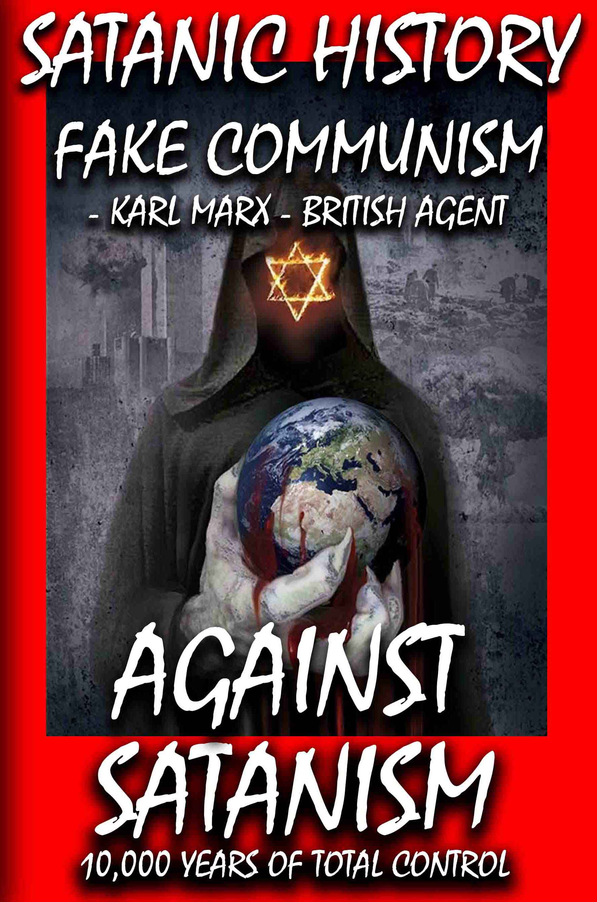





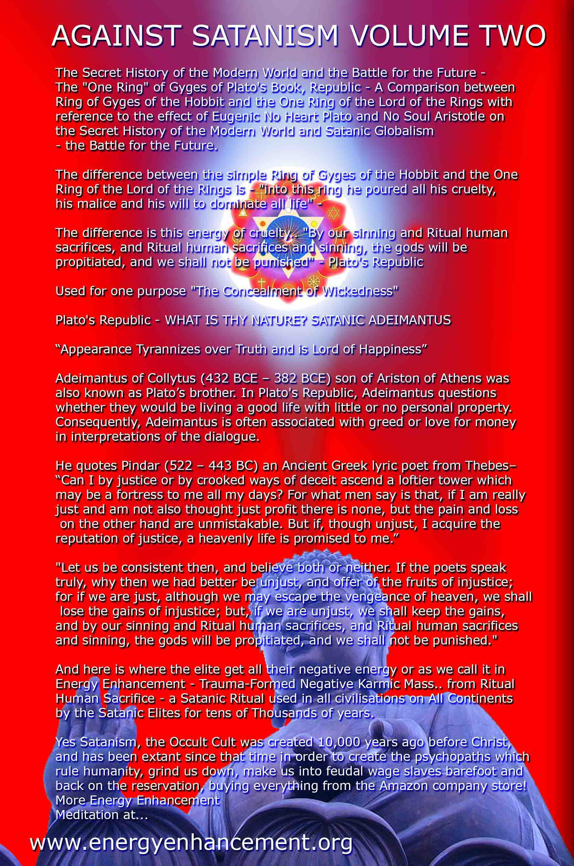

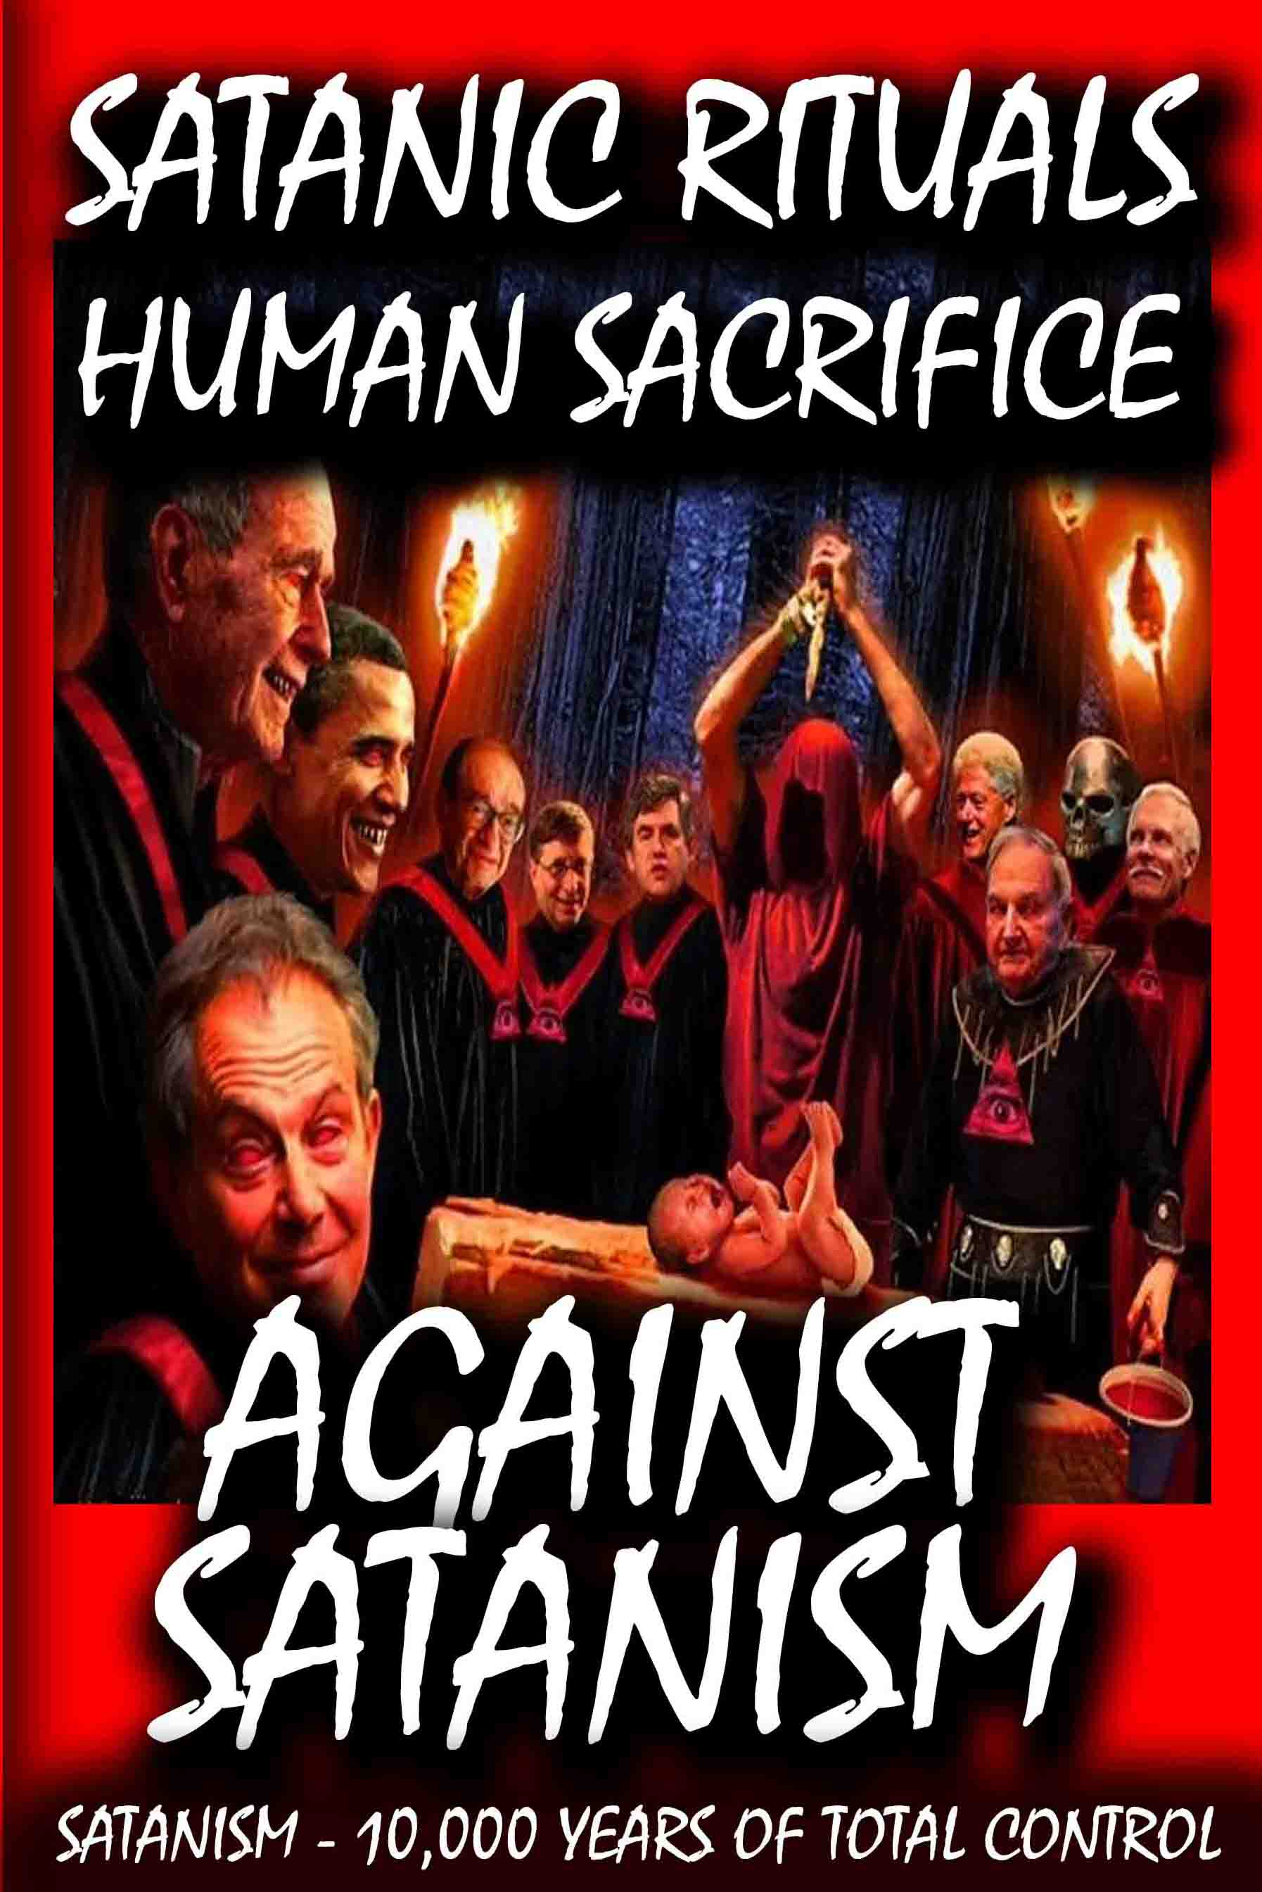

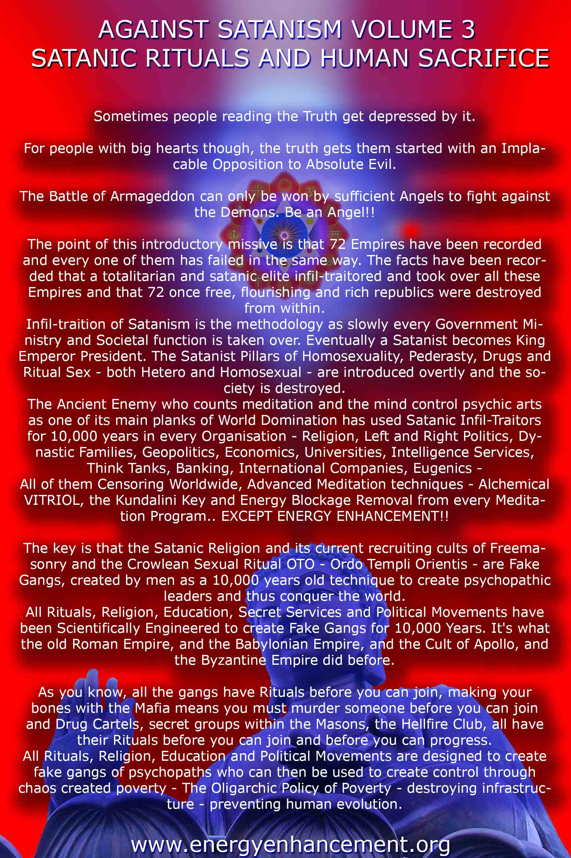

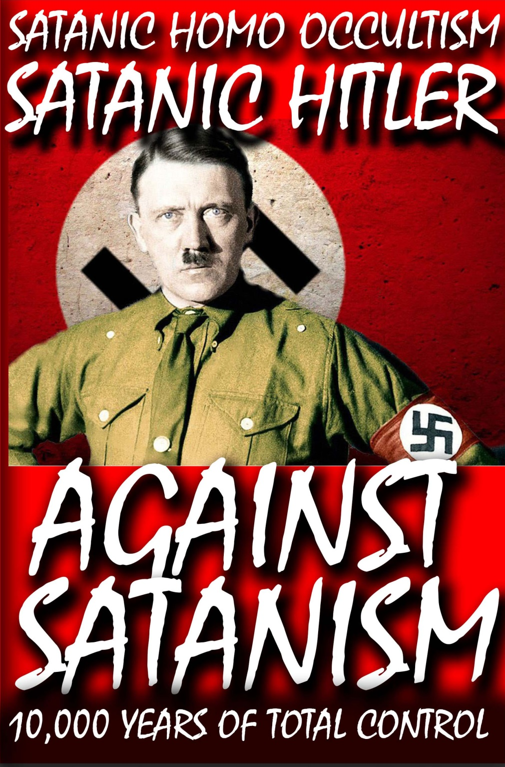

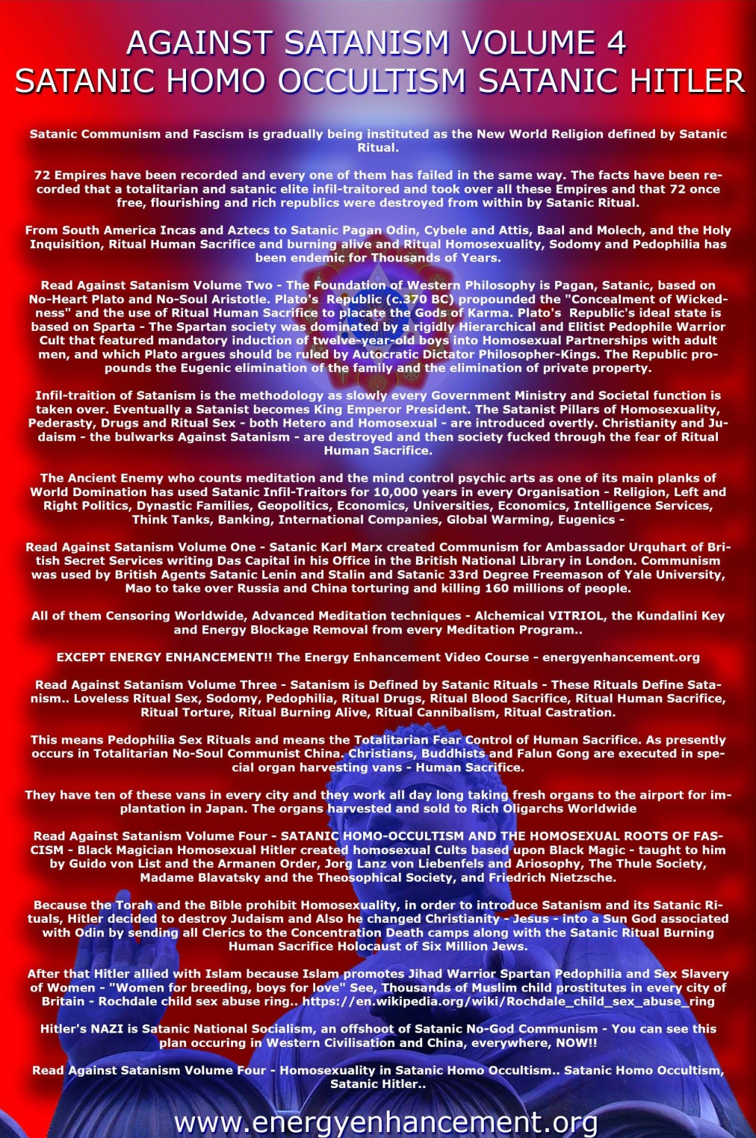






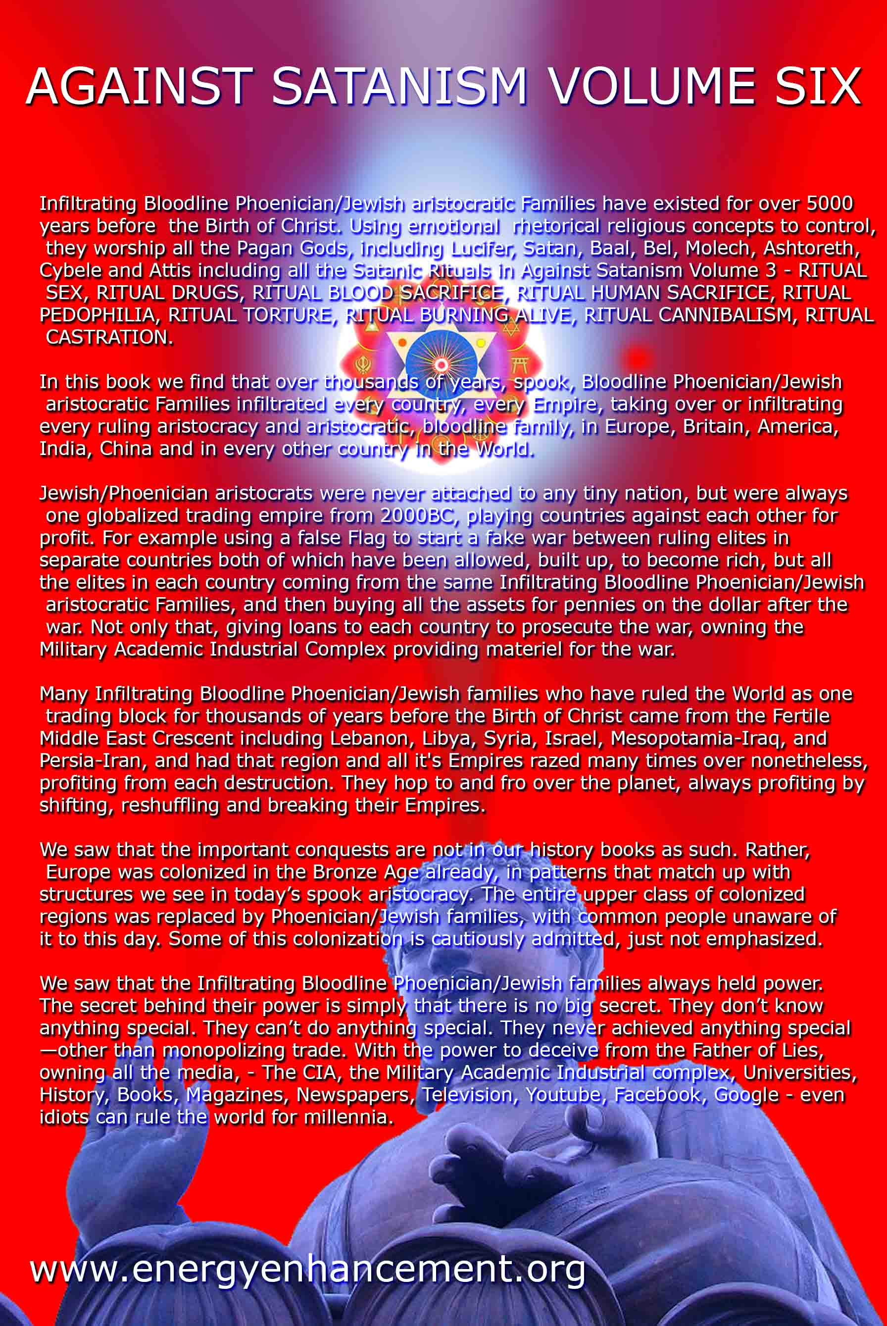
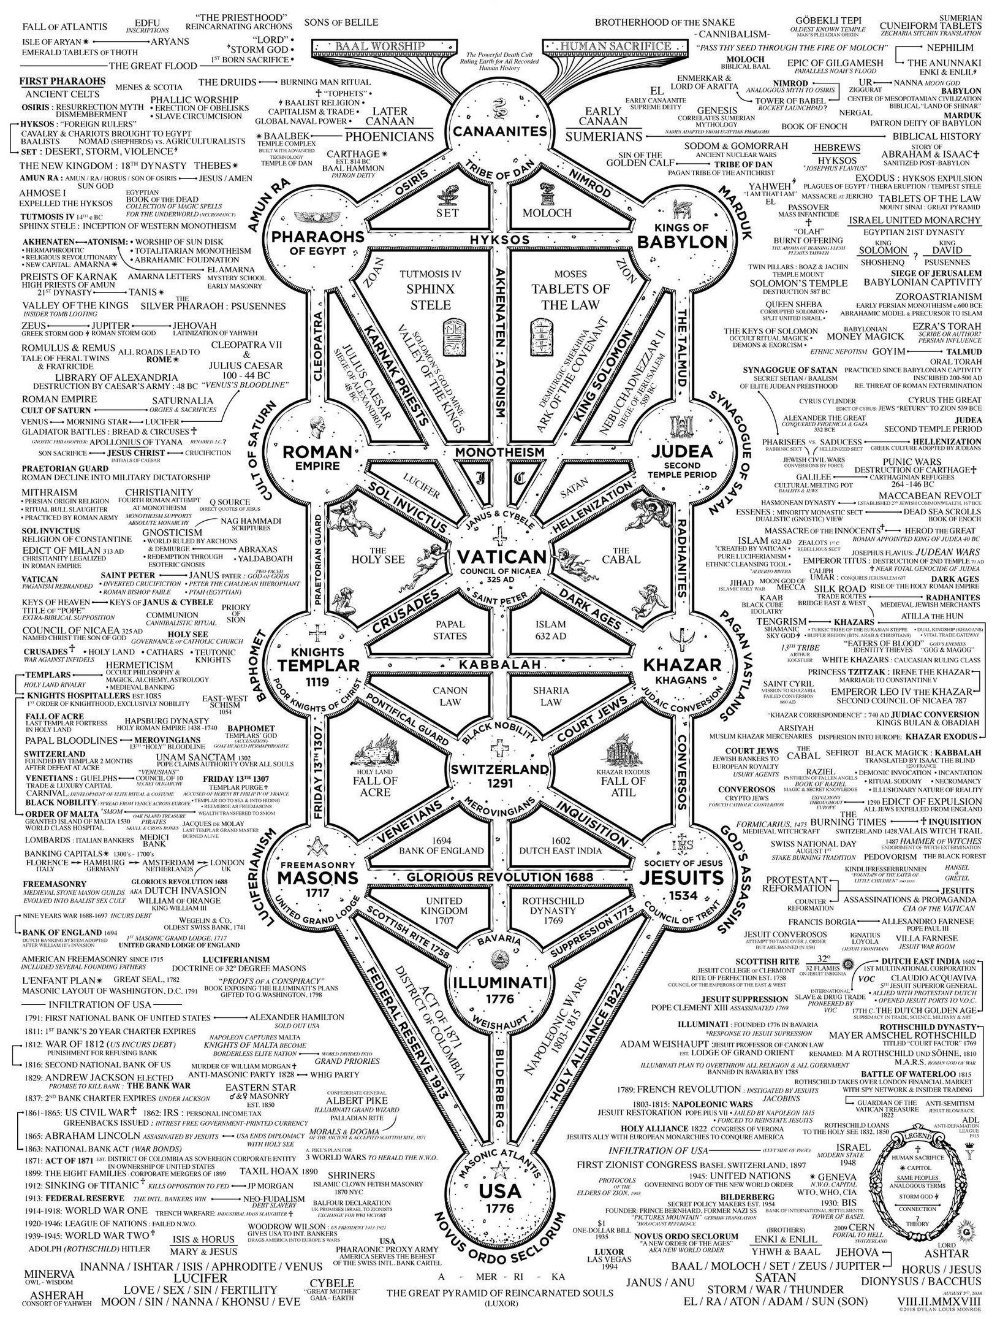

BILL COSBY PART III- SAMMY DAVIS, JR., SHARON TATE, SATANISM & BLACK SATANIC CABAL
12012015
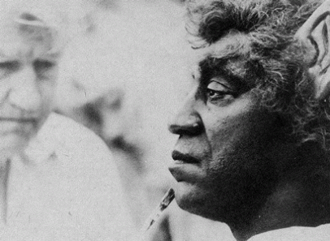
I have been openly critical of Bill Cosby as a very dangerous soul-less creature of CIA/MK ULTRA/MONARCH for quite sometime. He had been a CIA tool (I [Bill Cosby] Spy), and mind control facilitator, handler and programmer for decades. However, it has never been my intention to try to single him out from the EVIL institutions and the BIG PICTURE that he plays a very small but significant supporting role and part among the CIA-Military Industrial Complex’s long list of cast of characters.
Corporate Mass Media’s EVIL agenda through a Smoke Mirror is once again to demonize a black face, Bill Cosby, yet veil the role of the CIA and Hugh Hefner in MONARCH Sex Kitten programming. They crucify black and powerless Cosby within the Elite Global Satanic Cabal, while at the same time continue to celebrate his confederate Hefner’s commercialized mass industry of normalizing trauma based ritual sexual abuse and mind control of women. It’s another example of mass population psychological warfare and DOUBLEBIND– insanity without disease.

New Jersey State Governor and likely 2016 U.S. Republican Presidential Candidate Chris Christie celebrate NFL Dallas Cowboys’ 2014 playoff/rip off victory with owner Jerry Jones.
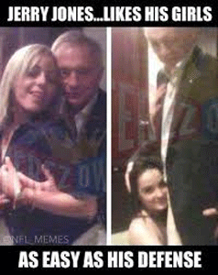
It amounts to insanity to demonize Ray Rice, Adrian Peterson and other high profile black athletes for domestic violence, then celebrate white privilege, wealth and power like a soul-less JERRY JONES of the Dallas Cowboys that exploit, brutalize, sexually abuse, and rape poor, powerless and marginalized women with utter impunity.[1]
They demonize Cosby and yet remain silent to the EVIL/Demonic institutions that as a black man- he can only play by virtue of his race a marginal supporting role in the BIG PICTURE. Don’t get it twisted, Cosby is a problem and a menace to society, but he is only the tip of an iceberg that seek to drown all of us when it surfaces. During the 1960s, dealing with black collaborators of the EVIL empire that sought only to kill us has always been problematic.
I still maintain that unless it is a state of war, and we have express permission of our elders- they are not to be harmed. However, Cosby and the Black Satanic Cabal is still very much alive-well, growing and dangerous. It is our duty to continue to expose them as treacherous cold blood creatures of the shadow government and soul-less puns of the New World Order, and WARN the masses to be forever VIGILANT.
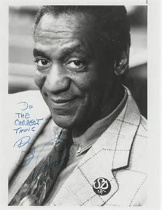
William Henry Cosby, Jr. is a such a black collaborator to warn the masses to watch and stay away from. He is a clandestine/covert BLOOD OATH SECRET high level MASTER MASON, and a BLOOD OATH SECRET hierarchical member of Negro section of the ancient BOULE [2] that serves the underground THIRD REICH, and Reichsfuhrer Heinrich Himmler’s SS Cult of the Dark Messiah, the SHADOW power behind the throne. Cosby is a Master of Deception, ILLUSIONS and DUALITY.
ILLUMINATI– “Their whole insane doctrine is based on the supposition that black is white, that good is evil, that two plus two equals five. They are men of insane minds. And they have developed an equally insane ‘scientific‘ system, designed to reprogram and recreate social material and spiritual reality to fit their perverted, upside down theology.”[3]
Their scientific system, actually a form of Witchcraft, is based on alchemy and magic. Its process is one of Universal Motion, designed to purposely foment diabolical chaos so that order may come out of two dynamic competing forces, Ordo Ah Chao. Their objective is the Great Work, the changing of man created in God’s image into the image of a serpent-being void of morality and void of righteous, just values. In other words, the Great Work is designed to create and produce a race of soul-less satanic creatures.
goTo effect their Great Work, to transform and transmute the world and humanity into the “new soul-less creature,” heaven and earth must be destroyed, crushed, and thoroughly converted into a new paradigm. In essence, heaven and earth are to become hell. The will of Satan shall be done on Earth as it is in hell. This is the exalted, “Royal Secret.”[4]
Luciferian Albert Pike of the Knights of the Golden Circle, the former Sovereign Grand Commander of the Scottish Rite taught that out of the ongoing universal motion of the conflict of OPPOSITES, a potent and magical force could be created or energized, so powerful that,
“a single man, who could possess himself of it, and should know how to direct it, could revolutionize and change the face of the world.” [5]
Cosby has the IMAGE of America’s idea heavenly FATHER.
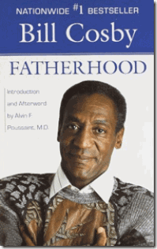
He is SATAN
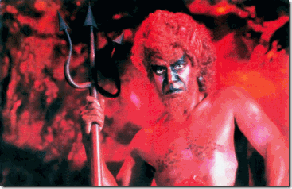
Bill Cosby, DEVIL and Mr. Devlin
Cosby has the IMAGE of innocent FUN and GOODNESS.
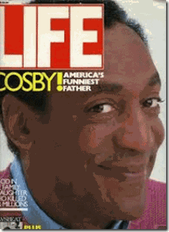
He is Diabolical EVIL.
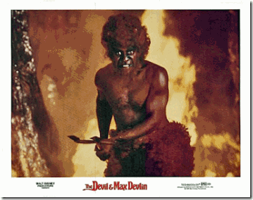
Cosby has the IMAGE of a MORTAL.
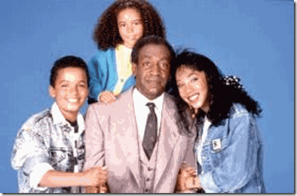
He is the UNDEAD.
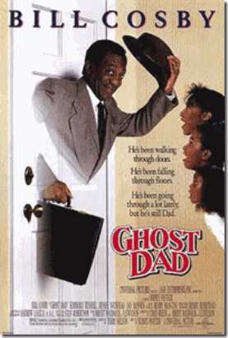
Cosby’s 1990 Universal Studio film, Ghost Dad, directed by Sidney Poitier plot centers on SATAN. Lucifer had been the cause of his mortal death. He returned from the dead as a Ghost. In the movie, Cosby declared, “I AM SATAN.”[6]
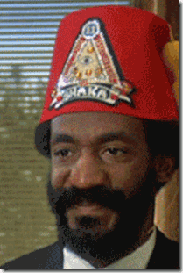
Cosby’s true motives are hidden behind his SYMBOLS. The Fraternal Order of the Sons and Daughters of Shaka from the 1975 Warner Bros. film, Lets Do it Again, is indeed fictional, but the Satanic theme of the film is the same, and number and symbols below Cosby’s Pineal Gland (THRID EYE) are real.

The Occult Power and Mystic Virtue of NUMBER 11
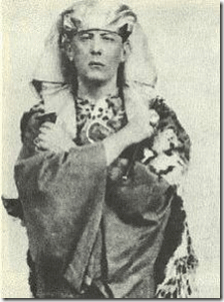
The NUMBER 11 at the pyramid apex of Cosby’s Fez is the number most important to the Great BEAST 666, Aleister Crowley. Crowley was a member of the Satanic-Occult group in England, The Hermetic Order of the Golden Dawn. According to its demonic teachings, the NUMBER 11 has Occult Powers and Mystic Virtue: “Upon the Number Eleven. This seems to have been the type of number with a evil reputation among all peoples… [E]leven is the essence of all that is sinful, harmful and imperfect; with the Ten Sephiroth they contrasted the Eleven Averse Sephiroth, symbols of destruction, violence, defeat, and death.”
The Great BEAST wrote about the NUMBER 11 frequently, and emphasized it’s significance: “Firstly”, 11 is the number of Magick in itself. It is therefore suitable to all types of operation. “Secondly”, it is the sacred number par excellence of the new Aeon. As it is written in the Book of the Law: …11, as all their numbers who are of us.” Crowley‘s infamous phase “Do What Thou Wilt Shall Be The Whole Of The Law” (which he considered the dictum of the New Age), has eleven (11) words and eleven (11) syllables. [7]
The Occult Power and Mystic Virtue of the MASONIC PYRAMID
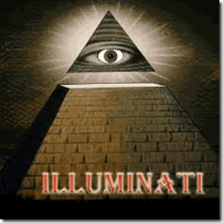
The PYRAMID and the “Eye of Horus” on the back of the dollar bill are ILLUMANTI symbology. The pyramid is an ancient form based on the holiness of the NUMBER 3 to the ancient mystery religions (it, not 6, is considered the most spiritual number), and Freemasonry has perverted the pyramid to represent a structure used specifically to call up the demonic, or occult, a point of psychic activity.
The Occult Power and Mystic Virtue of the MASONIC ALL SEEING EYE
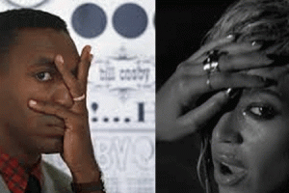
Bill Cosby and Beyonce- ILLUMINATI ALL SEEING EYE
Cosby is usually extremely very careful and coy about displaying ILLUMINATI ALL SEEING EYE Symbolism publicly, but this is Cosby early in his career. Lets Do it Again central theme involves the clandestine use of HYPNOTISM. In the film, lodge brother, Sidney Poitier is a MASONIC MASTER HYPNOTIST that creates a Manchurian Candidate boxer to rig a boxing match to win a substantial amount of prize money to save their lodge from foreclosure. [8]
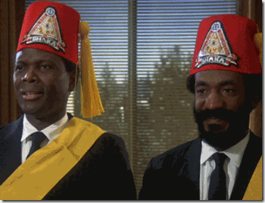
The All-Seeing Eye on Poitier and Cosby’s Masonic fez is used to represent the planet Sirius. Sirius is important to the Hermetic magicians, and some mind control programmers are deeply into hermetic magic. SATAN is said to come from Draco or Sirius, esp. the Dog Star Canis Major. Masonic Programming may well have the “blazing star” portrayed in the programming as a pentagram, with the name Sirius. Sirius may represent the Master, the creator of the system in some systems where the programmer is steeped in MASONIC PHILOSOPHY.[9] Cosby’s Lets Do it Again also shows without a shadow of a doubt that he was aware before 1975 of the use of HYPNOTISM to destroy individual free will within the framework of Satanic and Masonic Mysticism.
It would be interesting to know who the HYPNOTISM film set technical advisor had been, William Joseph Bryan (Manchurian Candidate, Sirhan Sirhan) or William Henry Cosby, Jr.? Bryan wasn’t suicided until 1977 two years after Lets Do it Again had been released.[10]
SATAN SWINGS: Bill Cosby and Sammy Davis, Jr.
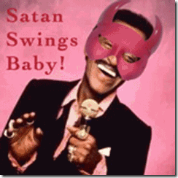
Of all the people of HollyWeird in Bill Cosby’s young television- film career-
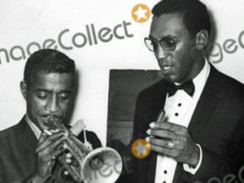
he developed an unholy bond and decided to SWING with a notorious SATANIST- Sammy Davis, Jr.
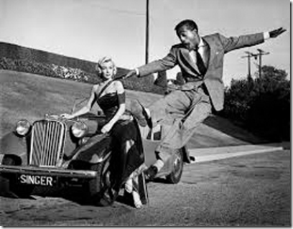
1954- Sammy Davis, Jr. and Marilyn Monroe (How to Marry a Millionaire)
In the public eyes, Davis was a little harmless carefree driving force of individual artistic freedom while on the hidden side- he was a high level ILLUMINATI Negro whore also connected hand in hand to the Black Hand- the MAFIA. Davis was also a covert master of deceptions, duality and ILLUSIONS. It remains forbidden knowledge which Masonic lodge Davis or Cosby belonged to, and when they were first initiated into freemasonry. However, we are certain beyond a shadow of a doubt that Davis was a Freemason.
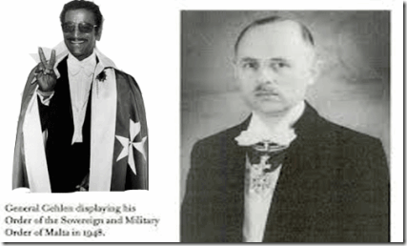
He was an ultra secret and well established Luciferian 33 degree York Rite Master Mason. At sometime for extraordinary services to the craft, he was promoted to the highest degree of the clandestine York Rite Freemasonry, KNIGHTS OF MALTA. As a clandestine crusading European KNIGHT, he moved among an ultra secret elite global cabal of Olympians, Nazis, and the IMPERIUM.[11] The founding fathers and architects of Project PAPERCLIP and the CIA, William “Wild Bill” Donovan, Allen Dulles and Himmler’s SS Puppet GENERAL REINHARD GEHLEN, were among Davis’ covert order of the Sovereign Military Order of Malta.[12]
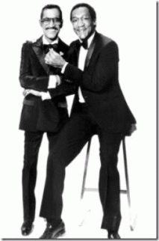
These Negroes aren’t hardly two fun filled loving buffoons. This picture represents an ancient Initiation Rite. Cosby with right foot slightly forward is presenting Davis for entry into another realm of a blood oath fraternal order or cult of ultra secrecy.
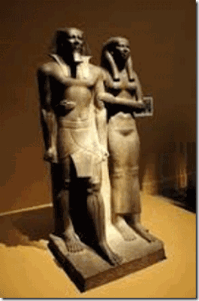
This is Queen Khamerernebty- Daughter of the God, Priestess of Djehuty [Thoth], Priestess of Tjazepef, One who sits with Horus, she has her right foot slightly forward initiating her husband, Pharaoh Men-Kau-Re, “Eternal is the Spirit (Ka) of Ra” fifth king of the Fourth Dynasty of Kemet, to the next level to delve into the realm of Gods.[13]
What ILLUMINATI lodge, sect, or cell Cosby initiated Davis into also remains secret and forbidden knowledge. Undoubtedly, they were two of the HollyWeird’s most powerful and diabolical EVIL figures that led the BLACK SATANIC CABAL. This cabal turns out to be much older and more established than you would suspect.
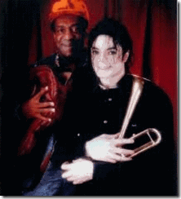
It’s more likely than not that both Bill Cosby and Sammy Davis, Jr. initiated a young Michael Jackson into the Occult and the BLACK SATANIC CABAL.
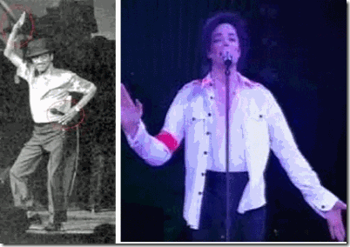
Sammy Davis, Jr. & Michael Jackson- Baphomet- So Above- So Below
Sammy Davis, Jr. & The Lookout Mountain Satanic Cult
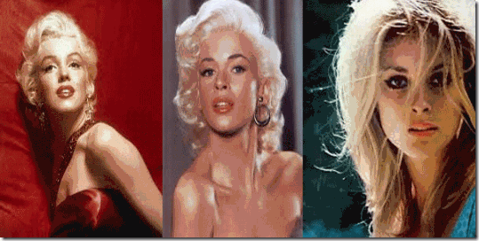
In HollyWeird, anywhere there were hot blondes like actresses, Marilyn Monroe, Jayne Mansfield, SHARON TATE, naked white women, drugs, booze, orgies, mind control and SATAN-
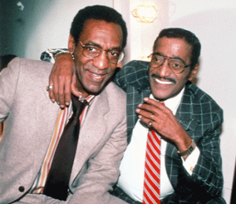
you can be assured that Cosby and his ultra covert little DEMONIC weasel sidekick, Sammy Davis, Jr. were in on or around the action. And, the body count begins to stack up.

Marilyn Monroe linked to Satanist Anton LaVey’s initial sex kitten programming during the early 1950s was among the first celebrities generally believed to have been subjected to CIA MONARCH/MK ULTRA mind control experiments. Through trauma and psychological programming, Monroe became a high level puppet of the shadow elite, even became JFK’s Presidential Model. When Monroe’s programming lost its effect and she started to break down, some argue that she was “thrown off the freedom train” on August 5, 1962, an MK ULTRA term for designating slaves that are killed when they are not useful (and potentially dangerous) to their handlers.[14]
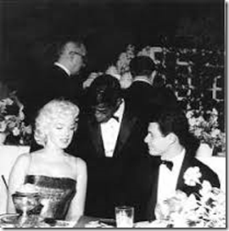
Also during same early 1950s, Sammy Davis, Jr. (Freemasons) and Frank Sinatra (Mafia) had been some of the secret handlers entrusted with the codes, keys and triggers to Sex Slave Marilyn Monroe. In many instances, she had been in company with Davis or Sinatra, when she had been used and abused in numerous high level CIA, presidential, diplomatic and mob “sex parties” and orgies.[15]
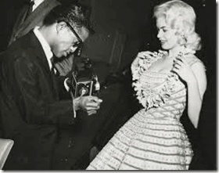
Sammy Davis, Jr. & Satanist Jayne Mansfield
Satanist Jayne Mansfield was also associated with Sammy Davis, Jr. through underground Satanic Circles and the CHURCH OF SATAN. On June 29, 1967, her fate was grisly sealed on a dark narrow stretch of road near New Orleans. Her head was fatally severed in a head on collision that the CHUCH OF SATAN believes was the result by one of Anton LaVey’s curses.[16]
On August 8, 1969, HollyWeird’s infamous Hair Stylist of the Stars, JAY SEBRING and SHARON TATE’s fate were sealed among five victims of that infamous grisly Demonic Torture/Slaughter at Satanic (Rosemary’s Baby) film director Roman Polanski’s estate in Laurel Canyon.
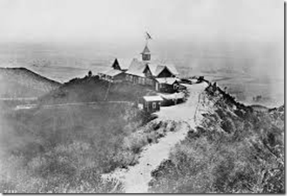
The panorama below was taken from Lookout Mountain at the top of Laurel Canyon in 1906.[17]
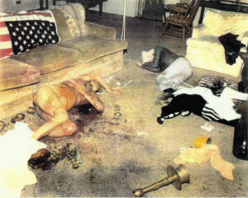
SHARON TATE was 8 months pregnant when she was slaughtered. Some reports said that she had been hung from the rafters in the living room. She had a noose around her neck, attached to her friend JAY SEBRING. There were four deep stab wounds in her chest and a deep knife wound to her belly killing her unborn.[18] The Satanic blood slaughter at 10050 Cielo Drive, Benedict Canyon just a couple miles to the west of Laurel Canyon was like something out of the 19th century horrors of Jack the Ripper.

Nested in the hills overlooking HollyWeird, Lookout Mountain Laboratory was originally envisioned as a U.S. Air Defense Department center. Built in 1941 and nestled in two-and-a-half secluded acres off what is now Wonderland Park Avenue, the installation was hidden from view and surrounded by an electrified fence.
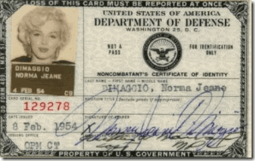
Marilyn Monroe’s February 8, 1953 Secret Pentagon ID to Lookout Mountain Lab
By 1947 on the eve of Operation PAPERCLIP and formation of the CIA, the facility became a TOP SECRET and clandestine military intelligence fully operational movie studio. HollyWeird’s leading technicians, directors, producers, actors and actresses such as John Ford, Jimmy Stewart, Howard Hawks, Ronald Reagan, Bing Crosby, Walt Disney and Marilyn Monroe had special U.S. Defense Department secret clearances to work at the facility on undisclosed highly classified projects like something out of the pages of Reich Minister Josef Goebbels’ Department of Public Enlightenment and Propaganda.[19]
With 100,000 square feet of floor space, the covert studio included sound stages, screening rooms, film processing labs, editing facilities, an animation department, and seventeen climate-controlled film vaults. It also had underground parking, a helicopter pad and a bomb shelter.[20] The existence of the facility remained unknown to the general public until the early 1990s when Svali, an ILLUMINATI Defector, stated that the HollyWeird Satanic Cult had a location in California which made all of the training films for “Trauma-based mind control”. No other place has been identified besides this one, Lockout Mountain Laboratory. These training films were undoubtedly also a part of the CIA/MK-ULTRA program.[21]
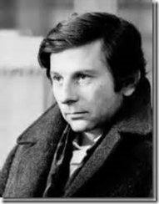
During the 1960s, international stuff film and pedophile ring fugitive, HollyWierd’s ROMAN POLANSKI had been a leading figure in an extremely dangerous and chilling Hollywood star studded Satanic Coven in Laurel Canyon below and linked to the Lookout Mountain Lab.
Lockout Mountain’s clandestine Satanic (Dark Messiah) HollyWeird Cult was directly involved with the the 1968 CIA assassination of U.S. Senator and presidential hopeful, Robert F. Kennedy; and Manchurian Candidate MK ULTRA/Satanic murderer, Nazi and pasty Charles Manson.
“Allegedly, on the night before Senator Robert Kennedy’s assassination (June 5, 1968), RFK had dinner with director John Frankenheimer and Roman Polanski and his wife Sharon Tate. Frankenheimer was of course the director of the original The Manchurian Candidate and Seven Days In May. John F Kennedy apparently spoke with Frankenheimer about both projects. Technical adviser on The Manchurian Candidate was MK-ULTRA programmer, William Jennings Bryan, who has links to Candy Jones and Sirhan Sirhan (amongst many other notables).”[22]
POLANSKI and SHARON TATE’s Laurel Canyon Coven of Lookout Mountain had also been linked to drug trafficking, mind control child sex slaves, pornography, snuff films, murder, and the Occult and Sex Magik of the BEAST 666, Aleister Crowley.

Panther Signature: PIG written in Victim’s Blood at the Polanski Mansion
At the beginning, the gristly, senseless and horrific massacre of human beings in Laurel Canyon was laid by law enforcement agencies at the feet of Black Nationalists and Black Panther Party for Self Defense. It was later, they took down the Lookout Mountain – Nazified Mind Controlled Manson Family for the gruesome crimes.[23]
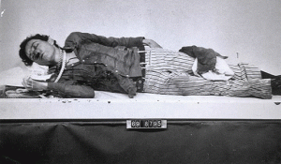
At the absolutely horrendous murder scene, Sammy Davis, Jr.’s Satanic coven leader, SEBRING had been savagely beaten about the face- left eye and nose then repeatedly stabbed in the chest and the back then he was shot in the left lung. However, the fatal stab wound was to the chest that severed the aorta, the main artery in the human body.[24] Sebring’s assassins were no crazed strung out drug addicts. These were professional counterintelligence killers that created the murder scene to appear as if the crimes were committed by demonic dope fiends.
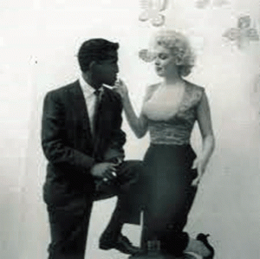
Davis with Marilyn Monroe in “Trance Formation” in front of Strange Symbol Wallpaper
Sammy Davis, Jr. was directly part of the ultra secret Lookout Mountain Satanic Murder Cult of Charles Mansion, Roman Polanski, SHARON TATE, and JAY SEBRING.[25], [26] He was definitely linked to MARILYN MONROE and U.S. Department of Defense (Pentagon) as a “handler” when she was MK-Sex Kitten programmed on Lookout Mountain.
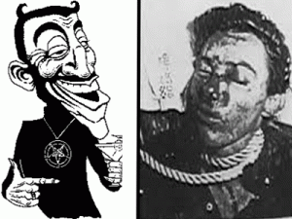
The little weasel Sammy Davis, Jr. didn’t abandon his Satanic Coven because the thrill and the fun with Dick and Jane were gone. He left the “Coven” because its leader, JAY SEBRING and some of its key grove like SHARON TATE, WOJTEK FRKOWSKI, and ABIGAIL FOLGER had been viciously slaughtered below Lookout Mountain. Whatever his mission had been with the “Coven,” it had been completed.
The CHURCH OF SATAN, Bill Cosby and Sammy Davis, Jr.
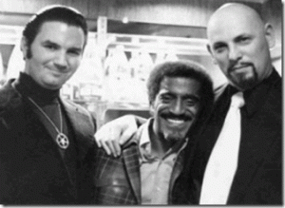
For Sammy Davis, Jr., the CHURCH OF SATAN was far from being a groovy 1960s-70s thrill ride or tip toe through the tulips as many would lead you to believe. Satanist Anton LaVey could arguable have been part of a three-ring circus of the church, but U.S. Army Lt. Col. Anthony Aquino, left, was absolutely no sideshow. Lt. Col. Aquino, U.S. Army and Joint Chiefs of Staff of the Pentagon authored a significant portion of LaVey’s Satanic Bible. Lt. Col. Aquino is a CIA/MK ULTRA trauma based multiple personality disorder programmer and a “Dark Disciple” of Reichsfuhrer SS-1 Heinrich Himmler directly connected to the infamous FRANKLIN SCANDAL.
There seems no evidence that Bill Cosby was a members of the church. However, in an odd note, Audrey Quimby author of the book, Sodom, Satan and Sinatra, identified Bill Cosby as a leading member of the CHURCH OF SATAN during the 1960s. In regards to Sammy Davis, Jr., he said that Davis had been introduced to Satanism and the Occult in 1956 by Rex Ingram. There may be some grains of truth in Quimby’s story to be flushed out. However to begin with, there were two HollyWeird Rex Ingrams.[27]
One Rex Ingram (January 15, 1892 – July 21, 1950) was an Irish film director, producer, writer and actor connected to HollyWeird’s silent film industry that had been connected to the Great BEAST 666 Aleister Crowley. In 1956, he had been dead for six years.[28] Whereas, the extraordinary black actor, Rex Ingram, was directly professionally linked to Sammy Davis, Jr. In 1959, Ingram and Davis starred in the United Artists film, Anna Lucasta.[29]
Rex Ingram and HollyWeird’s Early Black Satanic Cult
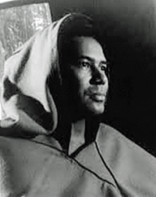
Ingram was born near Cairo, Illinois, on the Mississippi; his father was a steamer fireman on the riverboat Robert E Lee. Ingram graduated from the Northwestern University Medical School in 1919.[30]
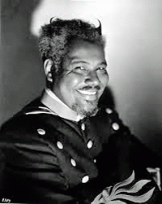
In 1943, Rex Ingram starred in all Black cast film, Cabin in the Sky. In a segregated heaven and hell, he presided over colored HELL as “LUCIFER JR.” and also starred as the stereotypical “De Lawd “ in the 1936 Green Pastures,[31] was thus perhaps the only actor besides George Burns to play both God and Satan in HollyWeird film and television industry as if they in themselves are among the “DIVINE” and the “FALLEN ONES” that transcend GOOD and EVIL.[32]
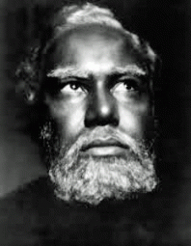
Rex Ingram “De Lawd”
Ingram was the first African American man to be brought into the sphere of influence of the Greek-Hellenized fraternity of scholars by accepting a Phi Beta Kappa Key from Northwestern University.[33] In 1776, the Phi Beta Kappa was founded at the ancient William and Mary College in Williamsburg, Virginia.[34]
Hellenization or Hellenisation is the historical spread of ancient Greek culture and, to a lesser extent, language, over foreign peoples conquered by Greece or brought into its sphere of influence, particularly during the Hellenistic period following the campaigns of Alexander the Great of Macedon.[35]
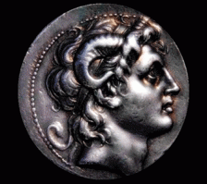
Apollyon is the BEAST from The Book of Revelation (9:11 & 13:11) Apollyon was also known as Alexander The Great. Historical Records show that Alexander the Great has two different colored eyes – one as dark as the night and one as blue as the sky, a harsh voice and that he was deformed – he had two horns on his head, above. Revelation 13:11 confirms that Alexander The Great is therefore the same person as Apollyon/Halios- the BEAST.
In 1831, a member of the fraternity, Avery Allyn, published a volume, “Ritual of Freemasonry to which is added a Key to Phi Beta Kappa, the Orange and Odd Fellows Societies with Notes.” Allyn attacked the fraternity as foreign- Order of the ILLUMINATI binding its members to an order of Blood Oath Secrecy.[36]
In 1919, Phi Beta Kappa was not a dance class or a dress rehearsal. It was deadly serious. Ingram accepted his key to share in the secrets of the ILLUMINATI, and entered the Gate of the BEAST.
A fully licensed physician with a Key to the Gates of Hell and the ILLUMINATI, Ingram entered HollyWeird where he said that he had been literally discovered on a street corner by the casting (couch) director for the silent film- Tarzan of the Apes (1918).[37]
Ingram was by all accounts a great and well respected HollyWeird actor, but behind the veil, doctor was a very strange man with other strange passions. He had been arrested twice in Harlem on assault charges and had served a brief jail sentence in New Jersey for multiple driving violations.
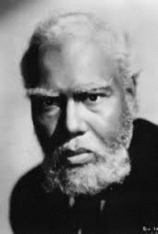
In 1948, Ingram, 53 years old, pleaded guilty to charges under the Mann Act that he transported a 15-year-old girl from Kansas to New York for “immoral purposes.” He served over nine months in prison before being released on parole from an 18-month sentence. In his Ebony essay, Ingram set out his side of the story, he said that his trouble with the law was the result of a “casual, genuinely warm friendship” with a minor 15 year old white girl. The Negro was a true lover or an unrelenting “soul less” Satanic ILLUMINATI pedophile. I think the latter.[38]
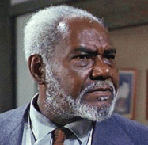
Ingram also shared a quiet but unholy bond with Bill Cosby. Ingram played a prominent role (Dr. Bingham) in Season 1 Episode 11 (Dec. 1, 1965)- I Spy, Weight of World.[39] Cosby also made sure that sure Ingram was part of the popular Bill Cosby Show. Ingram’s last performance before he died in September 1969 was on the Cosby Show.[40]
In the real and cold blood oath secret “soul less” Satanic Circles that only play for keeps, Ingram, Davis and Bill Cosby would have been subservient to an initiated black High Priestess of the Ancient Sethian Order of the Royal Houses of Europe. Both Ingram and Sammy Davis, Jr. would pay homage to her in Anna Lucasta (1958). And Bill Cosby would pay homage to the woman (black SATANIC QUEEN) that “HE WAS INTERESTED IN”– Season 1, Episode 6 (Oct. 20, 1965), I [Bill Cosby] Spy.[41]
END OF PART III

[1] http://deadspin.com/mystery-woman-linked-to-jerry-jones-scandal-tells-her-s-1631235709
[2] http://www.daghettotymz.com/rkyvz/articles/bouleseries/boule1-3roster/boule1/boulept1.html
[3] http://www.bibliotecapleyades.net/sociopolitica/codex_magica/codex_magica12.htm
[4] Id.
[5] Id.
[6] http://filmdrops.blogspot.com/2012/07/ghost-dad-dvd-1990.html
[7] http://www.henrymakow.com/false_flag_terror—the_occult.html
[8] http://en.wikipedia.org/wiki/Let%27s_Do_It_Again_(1975_film)
[9] http://www.whale.to/c/symbol_q.html#All_seeing_eye_
[10] http://en.wikipedia.org/wiki/William_Joseph_Bryan
[11] http://www.conspirazzi.com/tag/knights-of-malta/
[12] http://www.bibliotecapleyades.net/sociopolitica/esp_sociopol_malta01.htm
[13] http://en.wikipedia.org/wiki/Khamerernebty_II
[14] http://vigilantcitizen.com/vigilantreport/the-hidden-life-of-marilyn-monroe-the-original-hollywood-mind-control-slave-part-i/
[15] http://www.dailymail.co.uk/news/article-1289077/The-Mafia-orgies-Marilyn-English-link-JFKs-assassination.html
[16] http://www.maryellenmark.com/text/magazines/rolling%20stone/920S-000-004.html
[17] http://laurelcanyonassoc.com/LookoutViews.html
[18] http://letsrollforums.com/warning-graphic-crime-scene-t26364.html
[19] http://www.whale.to/b/lookout_mountain_laboratory.html
[20] http://www.whale.to/b/lookout_mountain_laboratory.html
[21] http://www.whale.to/b/lookout_mountain_laboratory.html
[22] https://deeppoliticsforum.com/forums/showthread.php?2306-Strange-Timing-amp-Motive-In-Polanski-Arrest/page3
[23] http://letsrollforums.com/mkultra-survivor-naming-names-t17696.html
[24] http://www.truthontatelabianca.com/threads/autopsy-of-jay-sebring.2312/
[25] http://www.whale.to/b/sammy_davis_jr.html
[26] http://whale.to/b/laurel_canyon6.html
[27] http://thesleaze.co.uk/hollywoodsatan.html
[28] http://en.wikipedia.org/wiki/Rex_Ingram_(director)
[29] http://en.wikipedia.org/wiki/Anna_Lucasta_(1959_film)
[30] http://en.wikipedia.org/wiki/Rex_Ingram_(actor)
[31] http://en.wikipedia.org/wiki/The_Green_Pastures_(film)
[32] http://en.wikipedia.org/wiki/Cabin_in_the_Sky
[33] http://aaregistry.org/historic_events/view/rex-ingram-20th-century-actor-stage-films-and-tv
[34] http://en.wikipedia.org/wiki/Phi_Beta_Kappa_Society
[35] http://en.wikipedia.org/wiki/Hellenization
[36] http://www.bibliotecapleyades.net/sociopolitica/pawns_inthegame/pawns_00.htm
[37] http://www.imdb.com/name/nm0002270/bio
[38] http://www.lipstickalley.com/showthread.php?t=558086&page=18
[39] http://www.imdb.com/title/tt0609491/
[40] http://www.fandango.com/rexingram/biography/p216452
[41] http://ispy65.tripod.com/id64.htm
Comments : 4 Comments
Tags: Aleister Crowley, anthony aquino, Baphomet, bill cosby, Black Panther Party for Self Defense, black satanic cabal, blood oath secrecy, BOULE, cabin in the sky, chris christie, CHURCH OF SATAN, dallas cowboys, devil and mr. devlin, frank sinatra, freemasons, ghost dad, green pastures, I Spy, Illuminati, jay sebring, jayne mansfield, jerry jones, Jr., knights of malta, lets do it again, lookout mountain lab, marilyn monroe, menkaure, michael jackson, phi beta kappa, Queen Khamerernebty II, reinhard gehlen, rex ingram, roman polanski, sammy davis, satan, Sharon Tate, Sharon Tate Murders, sidney poitier, The Franklin Scandal
Categories : adrian peterson, african american satanic cult, albert pike, ALL SEEING EYE, allen dulles, anton lavey, anton LeVay, artichoke program, ascendant triangle, baphomet, bill cosby, Black Manchurian Candidates, Black Panther Party for Self Defense, brotherhood of death, church of satan, church of set, COINTELPRO, Col. Dr. Michael A. Aquino, col. michael Aquino, devil, Devil’s Bible, dualism, Eye of Horus, frank sinatra, Howard Hawks, illuminati, illuminati sacrifice, imperium, Knight of Malta, Knights Hospitaller, Knights of the Black Sun, Knights Templar, Lookup Mountain Laboratory, luciferians, manchurian candidates, Marilyn Monroe, Michael Jackson, MK-ULTRA, new world order, Paperclip Project, Paul Josef Goebbels, post amnesia barriers, post hypnotic suggestions, Reichsfurhrer SS-1 Heinrich Himmler, Reichsstatthatter Hermann Goring, reinhard gehlen, Ritual Satanic Abuse, ritual satanic sexual abuse, rosemary's baby, sammy davis, satan, Satanic Global High Cabal, Satanism, Schutzsteffel, sex kitten, sex slave, sidney poitier, sirhan sirhan, the cosby show, third eye, trauma-based mind control, underground reich

BILL COSBY PART II, ANNA NICHOLE SMITH, PLAYBOY MANSION AND THE SATANIC CIRCLE OF THE VRIL AND THE DARK MESSIAH
7012015
Donald Trump, ILLUMINATI & SATAN
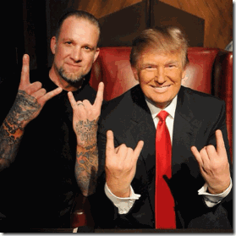
This picture is so arrogant and blatantly Satanic that it doesn’t really need an explanation and the mouthy Donald Trump doesn’t seem to have attempted to create a Smoked Mirror or ILLUSION to explain it away. I accept it for what it is worth- A SATANIC STATEMENT by an elite Diabolical EVIL Cabal. The man pictured with Donald Trump is Jesse James, the husband of popular HollyWeird screen actress Sandra Bullock. He is a distant ILLUMINATI BLOODLINE of the infamous 19th century racialist and vile criminal, Jesse James.[1]
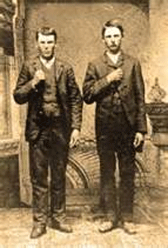
Outlaws Jesse and Frank James with the CLAW Hand Sign of the Knights of the Golden Circle (Dawn)
The outlaw Jesse James was a 33rd Freemason and a clandestine high ranking Satanic Knight of the Golden Circle linked to the assassination of President Abraham Lincoln and the re-institution of African Human Bondage- Slavery in America.[2]

Bloodline Jesse James- Hail HITLER
Not only is Jesse James, above, a blatant Bloodline Satanic High Priest in HollyWeird’s secret Satanic Cult Underground that undoubtedly Sandra Bullock also belong to, he is a NAZI. The Nazi female shown with Jesse is his Satanic lover, Michele McGee. In child custody documents filed January 2010, her ex-husband says she “makes the Nazi salute“, and has a swastika tattooed on her stomach.[3] A photographer who reportedly worked with McGee on a raunchy photo shoot accused the model of having a split (Classic Dual Satanic Principle) personality that “flips instantly” from angel to DEVIL.[4]
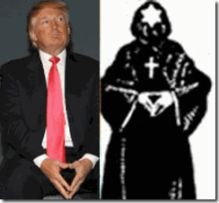
This image of Donald Trump and the drawing of a hooded member of Ancient Germanic Brotherhood of Death displacing the hand gesture of the Satanic “inverted pyramid“ also doesn’t require a great deal of explanation.
Donald Trump & the ILLUMINATI National Humiliation of Rudy Huxtable
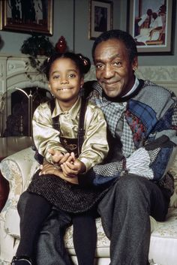
Most recently on primetime Sunday night, Celebrity Apprentice show host, Donald Trump, used his national television show to deliberately humiliate a MK ULTRA traumatized Keshia Knight Pulliam. As an impressionable child actress, Keshia starred as Rudy Huxtable on the Bill Cosby Show.[5]
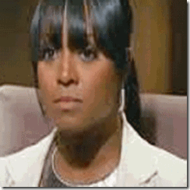
Trump asked Keshia if she had contacted Bill Cosby to ask him for a donation in a Celebrity Apprentice team challenge. Notice that she immediate went into an instance temporary POST HYPNOTIC “Trance Formation” when confronted with his name.
Trump: “Did you call Bill?

Keshia Crying in Tears: “I did not. I have not talked to Bill Cosby on the phone in I don’t know how long. So for me to pick up the phone, having not talked to you for five years, except for when we run into each other for a Cosby event- I feel that’s not my place to do.”[6]
Trump immediately fired her from show. He says that he had advised Keshia to contact Cosby before the recent Cosby Sex Scandal exploded. Trump said the show was taped before the recent scandal.[7] Later Keshia Knight Pulliam tried to defend Bill Cosby on a national televised morning program, “What I can say is this: I wasn’t there. No one was there except for the two people who know exactly what happened. All I can speak to is the man that I know and I love.”[8]
Does the very mention of the name of the man that she know and love immediately draw SHOCK and TEARS? No. It doesn’t.
For Keisha, the very mention of his name exploded into some subconscious HORROR that she experienced in the past and couldn’t explain. Donald Trump of the ILLUMINATI was well aware that she had allegedly been drugged and sexually abused by Cosby. Trump demanding that Keisha contact Cosby was like some kind of sick and demented inside MK ULTRA joke, an act of absolute Diabolical EVIL.
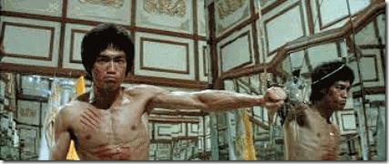
Destroy the images and ILLUSIONS, look beyond the trick and smoked mirrors, in the rear of the LOOKING GLASS; just behind the shadows lurk the absolute diabolical EVIL of the Bloodlines of WOTAN.

Anna Nicole Smith in POST HYPNOTIC dissociated “Trance Formation“
Just a rare peek behind Bill Cosby, Hugh Hefner, the Playboy Mansion and the tragic picture of former Playboy Bunny Anna Nicole Smith (November 28, 1967- February 8, 2007), you will discover that same diabolical EVIL exist.
Anna Nicole Smith, Mexia & the Satanic Cult of the Dark Messiah
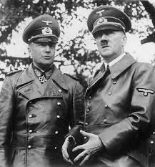
Mexia, Limestone County is a small town that sits approximately 164 miles outside of Houston, Texas. During WWII, the town held a prisoner of war camp for members of General Field Marshal Erwin Rommel’s Afrika Korps.[9] Rommel had been Hitler’s favorite general.[10]
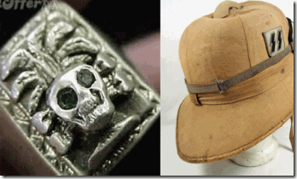
It is generally believed that the Afrika Korps were part of the Wehrmacht– regular German soldiers. Some may have been. However, their identified insignias also show them to have been primarily the dreaded blood oath Waffen- SS forces led by Generalfieldmarshal Rommel of the elite Allgemeine SS- Knights of the Black Sun.
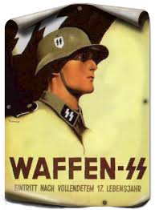
At the Nuremberg Tribunal, the Waffen-SS was condemned as a criminal organization due to its connection to the Nazi Party and involvement in numerous war crimes and Crimes against Humanity.[11]
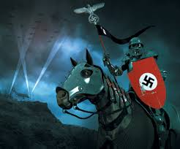
The Waffen-SS is a circle of blood oath covenant crusading BLACK KNIGHTS of the VRIL and the DARK MESSIAH. Their covenant is to do the will of their master and father, they are LUCIFER’S SERVANTS. After WW II, they should have been taken to Nuremberg Prison and prosecuted for Crimes Against Humanity instead of vacationing in Texas. Naturally or unholy, the people of Mexia and Limestone County developed a lot of love, affection, trans-generational links and Hidden Bloodlines with their Luciferian Nazi cousins.[12]

Heil to the Same Lord- LUCIFER
These grand lords, Knights of the Black Sun, masters of deception, were expected by their EVIL CREED to develop and setup clandestine networks with local chapters of their hierarchical subservient blood oath secret freemasons and Knights of the Ku Klux Klan. They developed covert Lebensborn liaisons with local Aryan women to carry their demonic seeds in America. That’s the way they roll under the veil of Inner Circle of the VRIL and the DARK MESSIAH. Why could it be any different in America that they intended from the very beginning to win by CONQUEST.
After the Fall of Nazi Germany in May 1945, members of Himmler’s elite Allgemeine SS rocket team including Sturmbannführer (Major) SS Werhner von Braun moved into Fort Bliss, El Paso, Texas. Dr. Hubertus Strughold of Reichsminister Hermann Wilhelm Göring’s Luftwaffe Air Force and his “Inner Circle of the VRIL and the DARK MESSIAH” setup station at the U.S. Air Force’s School of Aviation Medicine (SAM) at Brooks Air Force Base in San Antonio- just miles outside of Mexia.

From the ninth grade, Anna Nichole Smith was raised by an aunt in Mexia whose primary industry from 1943 had been looking after 3000 to 4000 foot soldiers and officers of Reichsführer Heinrich Himmler’s elite blood covenant Schutzstaffel (SS). From 1943 to the early 1950s, Mexia to El Paso running down to Houston and San Antonio became a SS Nazi corridor in Texas. It stand reason to assume that Anna Nichole Smith’s family bloodline roots; and her sudden mysterious rise to international fame and fortune within a Satanic Circle of the Dark Messiah and the BLOODLINES OF WOTAN lies within the SS Nazi Texas corridor.
Prince von Anhalt, SECOND & THIRD REICH 
Prince von Anhalt & Hungarian Wife, HollyWeird Actress Zsa Zsa Gabor
Enter Prince Frédéric Prinz von Anhalt born Hans Robert Lichtenberg on June 18, 1943 in Bad Kreuznach, Germany to the Chief of Police of Frankfurt, Nazi Germany.[13] On June 17, 1936, Hitler decreed the unification of all police forces in the Reich and named Himmler as Chief of German Police. This action effectively merged the police into the SS.[14] If Prince von Anhalt’s father wasn’t SS or Gestapo, he was certainly under Himmler and a high collaborating Nazi Party official.[15]
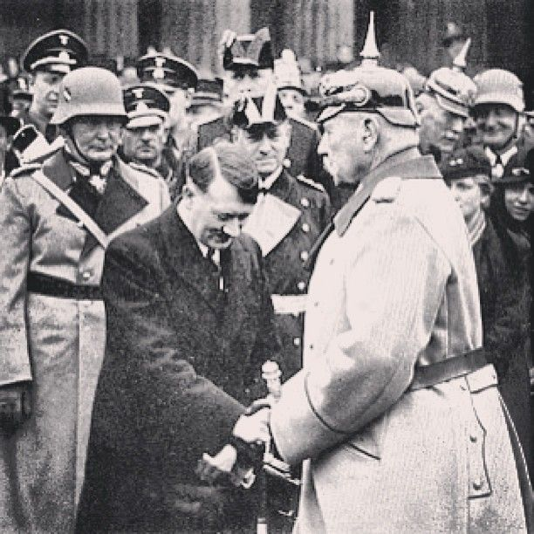
Herman Goering, Hitler and Kaiser Wilhelm II
Whatever the case, Prince von Anhalt‘s family ties had enough wealth, influence and power after WW II to buy his royal title from inside the House of the last German Emperor of the SECOND REICH (Kaiser) and King of Prussia, Kaiser Wilhelm II or William II, the foundation of the 1000 Year THIRD REICH.[16]
Wilhelm’s mother was Victoria, Princess Royal, the eldest daughter of Britain’s Queen Victoria.[17] Prince von Anhalt’s royal title attached to Kaiser and King of Prussia, Wilhelm II and the Queen of England, was extremely important in that it arguable immediately put him within the hierarchy of hidden power and influence of the ultra clandestine, influential and powerful German and English Freemason Lodges.[18]Anna Nicole Smith & HughHefner’s MK ULTRA Factory

In 1992, Anna Nicole Smith, stripper of that absurd place in Texas called Mexia, started her so-called modeling career at Hugh Hefner’s Playboy Mansion. Out of all the beautiful women of HollyWeird and the World, Hugh Hefner sent Anna Nicole Smith a plane ticket out of town to join his stable of blood oath covenant guest playmates at the mansion. The Playboy Mansion is a state of the art CIA MK ULTRA Factory.

“The “White Rabbit”in Disney’s primary MK Prog’mg film “Alice In Wonderland” reinforces MK Prog’mg (ALTERS) or mind files as does Playboy bunny logo for Hugh Hefner’s MK factory, Playboy Enterprises …”[19]

Anna Nicole Smith in Classic Sex Kitten- Leopard Pattern Background
Hefner’s Sex Kittens are raised in communal type environments to centralize programmers/handlers’ supervision of individuals, group sessions and rituals. It also provides a centralized location for sex trade– twinning- among the women, and a place for clients of Hefner’s inner circle orgies that reinforce Sex Kitten/Slave programming and training.

Within a year, out of Hefner’s stable of women, it was Anna Nicole Smith of Mexia that rose to a high level ultra secret multiple personality disorder (MPD) mind controlled Presidential Model. In 1993, Hefner anointed her as the PLAYMATE OF THE YEAR.[20]
J. Howard Marshall, the Cult of the Dark Messiah
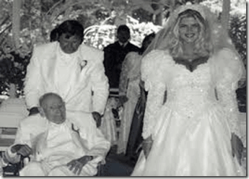
In August 1994, Smith’s Playboy Mansion handlers married her off to wheelchair bound 89 year old Texas oil tycoon, J. Howard Marshall, believed to worth $500 million.[21] Marshall was described as a fascist oil tycoon and a Hitler devotee.[22]
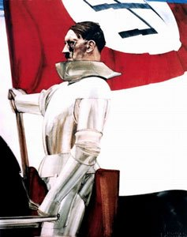
“Germany has been transformed into a great house of the Lord where the Fuhrer as our mediator stands before the throne of God.” Josef Goebbels, 1936[23]
“His [Adolf Hitler] quality is Messianic; his spiritual trend is ascetic; his reaction is medieval …” Phillips: Germany Today and Tomorrow[24]
Hitler envisioned that, once he had cleansed the earth, he would institute a Reich that would last for 1,000 years. He called this kingdom his “1,000 Year Reich”. This period was a Satanic duality of Jesus’ Millennial Reign, which Christ will set up after he has cleansed the earth of sinners. (Revelation 20:7)[25]
In other words, as a devotee, Marshall looked at Hitler as the Nazis viewed him as the Satanic “Messiah of the 1,000 Year Reich.” More importantly, Prince von Anhalt was part of Marshall‘s Nazi inner circle where he said that he met Anna Nicole Smith. Prince von Anhalt considered adopting Smith to place her within the German House of the King of Prussia, Wilhelm II, the Second Reich. Then, he decided to impregnate her with an heir to something hidden within the NAZI Underground inner circle.
Anna Nicole Smith, Prince von Anhalt & the Dr. Clauberg Factor
On September 7, 2006, Smith gave birth to Dannielynn Hope Marshall Stern in Nassau, Bahamas. J. Howard Marshall died August 4, 1995. Smith died February 8, 2007.[26] After the birth of Dannielynn and the death of Smith, Prince von Anhalt stepped forward to claim her as his natural child. He claimed to have had a secret ten-year sexual relationship with Smith.
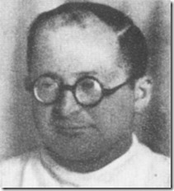
The Little Diabolical EVIL Genius SS Gruppenführer Clauberg
In Freeman’s Perspective, his theory is that Prince von Anhalt is a secret Nazi genetic clone product of SS Gruppenführer (colonel general) Dr. Carl Clauberg.[27] In other words, he was one of those “Boys From Brazil.” Where or how Freeman developed this particularly theory linking Prince von Anhalt with Dr. Clauberg is unknown, but it is an extremely interesting hypothesis to say the least.
From my background and education, some of these subjects are like spinning free in the Twilight Zone. However, let’s get one thing straight, Dr. Clauberg was extremely legit and is a important factor in the secret future racialist plans of the THIRD REICH that is often overlooked. Professor Dr. Clauberg was the SS doctor most germane to the Nazi’s revolutionary pioneering breakthrough experiments in artificial insemination.
Dr. Clauberg was widely accepted as an accomplished scientific medical genius and specialist on his merits. He was an internationally renowned university professor. He had published numerous peer review papers and books on the subjects of gynecology under his name. However, his medical research and development in artificial insemination for the SS was Blood Oath Secrecy. In this regard, Himmler played no games. Himmler maintained in most instances a triple layer or more of state security. Violate Himmler’s SS secrecy code, you’re a dead man!1
In 1941, two years before the birth of Prince von Anhalt, Dr. Clauberg desperately sought and subsequently received Himmler’s permission to gain access to human material at Auschwitz to conduct human experiments in the Satanic duality principled science of artificial insemination, in vitro fertilization (positive eugenics); and its opposite- sterilization (negative eugenics).
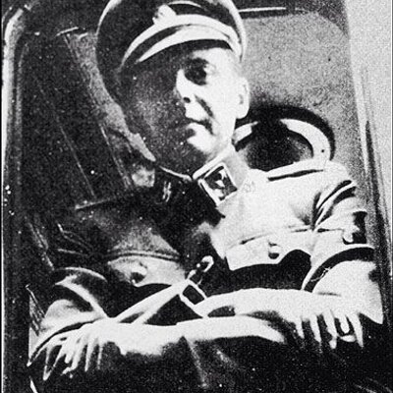
At Auschwitz with Himmler’s special clearance, he worked with SS Dr. Josef Mengele in positive and negative eugenic live human experiments, but it was really Mengele working along beside Dr. Clauberg to keep a keen eye on him and his experiments for Himmler and the SS. Dr. Clauberg also opened an university in vitro fertilization (positive eugenics) research clinic focused on female infertility just outside of Auschwitz.
At the Fall of Nazi Germany, Russian intelligence were well aware of reports of Dr. Clauberg’s secret work for the SS in positive eugenics- artificial insemination. A special Russian classified security and investigate team was sent out to get him, and they brought him in on June 8, 1945.
For 10 years, Dr. Clauberg had disappeared behind the Soviet Union. In October 1955, Dr. Clauberg suddenly re-appeared in Germany among a massive German- Russian prisoner of war exchange. On November 21, 1955, a little more than a month after Dr. Clauberg was mysteriously released possibly as a double agent by Russians, German officials (SS Gehlen Org) picked him up. Dr. Clauberg tried to open an institute to continue his artificial insemination practice in Germany for a profit.
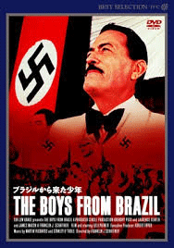
On August 9, 1957, almost two years later, Dr. Clauberg was dead. Dr. Mengele was now the exclusive CIA/SS top secret artificial insemination expert. The Boys From Brazil, it all came from the secret foundational work of Dr. Clauberg of the SS.
Dr. Clauberg fits within the timeline to have covertly cloned a Prince von Anhalt. It also appears apparent that his family had the resources and power to hire Dr. Clauberg’s special services. Also lets be perfectly clear. Dr. Clauberg expertise and work in pioneering research and development in female infertility is still widely referenced even today in the medical field. Whether or not, Dr. Clauberg was successfully able to clone the human species is a tightly guarded secret of Germany intelligence, CIA and the Russians.
However, one thing is clear in that whatever success that Dr. Mengele developed in cloning the human species lies at the feet of that mad little SATANIC genius, Gruppenführer (colonel general) SS Dr. Carl Clauberg .
Himmler’s Wewelsberg Castle, Empire House of the Gruppenführer- Carl Clauberg

Reichsführer Himmler conducted numerous black magick rituals at Wewelsburg Castle. These rituals were conducted in the utmost secrecy. They included necromancy [communication with the dead]. Wewelsburg had many powerful Satanic symbols, most of these were white-washed and removed from walls and pillars in early 1945.[28] In 1945, under orders from Himmler, Wewelsburg was blown up to keep it from the invading armies. True Paganism which is synonymous with Satanism is known for its emphasis on the Sun -666– the number of the BEAST.[29]
“Himmler stayed quite often – alone or with guests – in the castle. He wanted to hold annual meetings with the highest SS officers in Wewelsburg, along with initiation ceremonies. Even towards the end of the war, Himmler was trying to make Wewelsburg the ‘Empire House of the SS-Gruppenführer’“.[30]
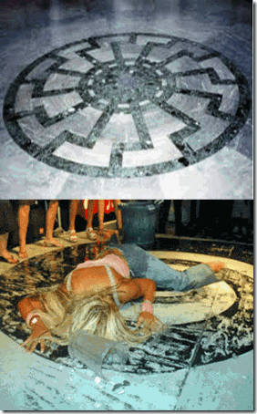
Black Sun Symbol on the floor of the “Obergruppenführersaal” (SS Generals’ Hall) This one of the last photos of Anna Nichole Smith collapsed but still alive inside a swirl at the Seminole Hard knock Hotel and Casino in Hollywood, FL. The spiral is occult symbolism for the Black Sun 666. Anna Nicole Smith either suffered a fatal flashback to a Nazi Satanic Ritual or someone triggered a “termination alter” locked inside the Black Sun. What is so special about Anna Nicole Smith and her offspring, Dannielynn, to the Underground THIRD REICH? – Hidden SS Bloodlines of WOTAN implanted in America. One thing is certain is that Anna Nicole Smith and her oldest son, David Wayne Smith (1/22/1986- 9/10/2006) had been sacrificed to pave the way for Dannielynn to ascend as a heir apparent to some Diabolical Horror and EVIL of the Cult of the Dark Messiah.
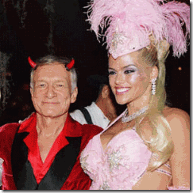 October 30, 2004, Hugh Hefner (the DEVIL) and Anna Nicole Smith– Halloween Party at the Playboy Mansion. I suspect that a very select group of Hefner’s Guest Playmates (Presidential Models)- ultra secret MK ULTRA/MONARCH “Sex Toys” like Anna Nicole Smith come packaged with preset codes, keys and triggers programmed special to served a very select elite and powerful Satanic circle.
Anna Nicole Smith & the Secret Dark Messiah MONARCH Code
On August 12, 2006, Attorney Howard K. Stern, Smith’s domestic partner and business manager along with a character named Ford Shelley, a Myrtle Beach, South Carolina Real Estate Developer, deliberately triggered and keyed Smith’s 4 year old MK ULTRA/MONARCH alter and videotaped her because the DEMO was worth a lot of money among the ILLUMINATI.[31]
Within six (6) months of Smith’s MONARCH DEMO tape, she would be found dead in February 2007. After her death, Stern’s secret DEMO video tape of Smith in a multiple personality disorder (MPD) alter was thereafter covertly removed from her home in the Bahamas by Shelley, who allegedly held title to the home.
It was Shelley that exposed MK ULTRA/MONARCH Anna Nicole Smith in mind controlled “trance formation” to the worldwide internet as a possible insurance policy to keep he and his family alive.[32] Smith’s DEMO video tape was reportedly recorded in his home. His wife, Gina Shelley, painted Smith’s face with lipstick. After Smith’s death, Shelley also removed computers, hard drives and other video tape evidence. Shelley claims to have broke Smith’s secret MK ULTRA/MONARCH codes and triggers.[33]
It stands to reason that Smith’s Satanic ritual abuse began around the age of 4 years old, and Shelley by evidence of the DEMO video tape was able to open Smith’s “protective” original personality. It is unknown whether he broke through to any of her other alters protected by the original personality. It also stands to reason that Smith had a wide variety of alters that included ultra secret presidential and executive mission alters. That’s the way they roll.
In November 2011, Stancil Ford Shelley, Jr., age 47, was disposed of by feds. He pled guilty in federal court in Florence, South Carolina to mail fraud in regards to shady real estate transactions. He is serving time at Bennettsville Federal Correctional Institution.[34]
Anna Nicole Smith & MK ULTRA Hypnotic Chemicals
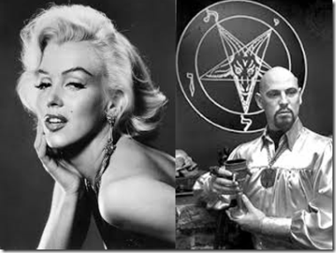
Smith’s autopsy established that her body contained large amounts of MK ULTRA experimental hypnotic drug- Chloral Hydrate.[35] Presidential MONARCH Sex Slave Marilyn Monroe’s body was also found to contain large amounts of Chloral Hydrate.[36] During the 1950s, SATANIST Anton LaVey found and promoted Monroe career out of a strip club. LaVey was an early MK ULTRA Occult Bureau programmer and handler.[37],[38]
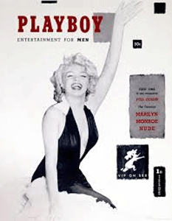

Marilyn Monroe opened Hefner’s first issue of Playboy Magazine in December 1953, the year MK ULTRA began.[39]

Large supplies of Chloral Hydrate was also discovered at Jonestown, a secret CIA Medical Mind Control Experiment and Concentration Camp at an isolated offshore site in Guyana, South America.[40]
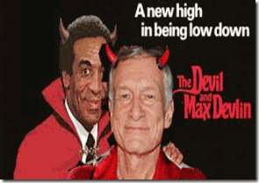
Hugh Hefner and Bill Cosby– is it at all possible that one would be more absolutely diabolical EVIL than the other?
“MK-Ultra Monarch Programmer/Handler … Hugh Hefner has enriched himself as America’s # 1 MK Pimp for over 50yrs, supplying Global Mgt. Team and whoever else has codes “triggers” and enough money to afford “state of the art” Oz-Dorothy, Jewel prog’md DID (MPD) lovelies. This NSA-CIA asset w/his degree in psychology (read Mind Control Prog’mr) controls an army of BETA-trained Sex Slaves available for blackmail, espionage (honeypots), underground porn and whatever else their ”ALTERS” (mind files) are Prog’md for. Hefner works closely w/MK Prog’mr/handler Heinz (Henry) Kissinger, and operates under full protection of NSA/CIA military-apparatus.”[41]
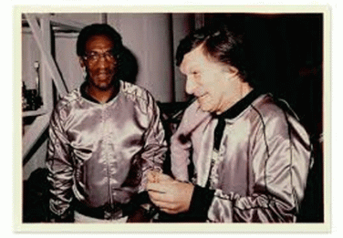
Hefner and a very close ultra secret inner circle held the overriding backdoor keys to Anna Nicole Smith and the women coming out of the Playboy MK ULTRA Factory. In my opinion, Bill Cosby, attached to Hefner, would be one of few people cleared since the 1950s to be in this type of highly classified Korean War MANCHURICAN CANDIDATE- trauma based mind control business straight from the SS- Knights of the Dark Messiah right out of Dachau and Auschwitz.
Smooth Criminal & the Magical Drug
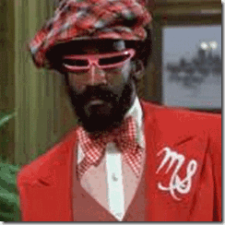
In 1969, Bill Cosby joked and bragged about poisoning women with Spanish Fly. Spanish Fly acts as an enhancer of the female libido and is taken by females to help them achieve better arousal levels and better orgasms. It also may be used as medicine in some occasions.[42]
At a 2008 Hugh Hefner Playboy Mansion Party, Cosby allegedly fixed 18 year old aspiring model and dancer, Cloe Goins, a drink on the side, then she said, “everything kind of went a little foggy … dizzy.” Cosby escorted her to a bedroom; she doesn’t remember entering the bedroom. Goins said her next memory was waking up “butt naked.”
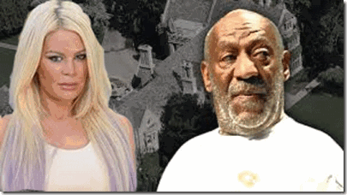
Goins: “I came to remember seeing this big man crouched over me, and he was at my feet, kind of licking and kissing them and I think he bit my toe that’s what woke me up.”[43]
Most of Cosby’s victims associate chemicals with rape and sexual abuse that produce clear definitive dissociated states, decades long memory loss and amnesia barriers. Many of these incidents of narco rape and sexual abuse involving Cosby go back to the late 1960s.[44],[45]
Spanish Fly is not a natural chemical associated with dissociated states, memory loss and amnesia barriers. Yet, what he said above definitely represents his man’s state of mind from a very early period to callously use chemicals clandestinely to overcome and violate individual free will. Nevertheless, it is not evidence that Cosby in fact used Spanish Fly to violate anyone’s rights or the laws of society.
However, no matter how compelling Goins’ story is, she like the other women have absolutely no corroborating physical evidence other than their controversial repressed memories that any wrongdoing between them and Cosby ever took place. Repressed memories are hypothesized memories having been unconsciously blocked, due to the memory being associated with a high level of stress or trauma. The theory postulates that even though the individual cannot recall the memory, it may still be affecting them consciously.[46]
According to the American Psychological Association, it is not possible to distinguish repressed memories from false ones without corroborating evidence. The term repressed memory is derived from the term dissociative amnesia, which is defined in the DSM-IV as “an inability to recall important personal information, usually of a traumatic or stressful nature, that is too extensive to be explained by ordinary forgetfulness.”[47]
It is almost unbelievable that in over six (6) decades of allegations of rape and sexual abuse that not one of Cosby’s victims can come forward with corroborating physical evidence that he committed any offenses against them. There are no witnesses that saw Cosby spike anyone’s drinks. There is no chemical evidence of any drugs that Cosby could have used to commit any crimes. There are no rape kits- DNA. There is no evidence of any blood, bruises, scarred or torn tissues to tie him to criminal activity.
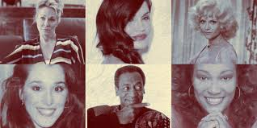
For these women’s stories of rape and sexual abuse against Cosby to be true, he would have to be a revolutionary new, powerful, smooth and magical criminal that has access to an equally new and magical miracle drug that causes in itself prolonged memory and amnesia blocks- long enough to allow physical evidence of any wrongdoing to naturally lapse.
In fact, I believe that there isn’t a chemical drug alone that can cause dissociated states; memory loss and amnesia barriers without some forms of subliminal suggestions and hypnotism. However, the quest for such a magical chemical/drug and science to destroy individual free will points only in one direction. It’s called Narco-hypnosis.
The CIA & the Magical TRUTH Drug

Since 1953, the CIA, U.S. Navy and the U.S. Army Chemical Corps through Project CHATTER, BLUEBIRD, ARTICHOKE rolled into MK ULTRA have been in search of such a miracle and magical drug to obliterate individual free will with amnesia blocks.
Again going back to the Navy’s ultra secret Project CHATTER, it duplicated and expanded the SS’ Dachau Concentration Camp “aviation series” terminal experiments that also involved “mind control” experiments by hypnosis and narco-hypnosis using experimental chemicals and drugs, particularly mescaline, on victims.
Additional mind control/behavior modification research was conducted at the Auschwitz Concentration Camp under Dr. Josef Mengele, using a range of chemicals including various barbiturates, morphine derivatives and electrical shock torture.[48]
Expanding on the Dachau Narco-hypnosis Experiments, CIA psychiatrists attempted to induce a trance state after administering a mild sedative. A second technique involved a combination of two different drugs with contradictory effects. A heavy dose of barbiturates was given to knock the subject out, and then the subject got an injection of a stimulant, usually some type of amphetamine. As the subject started to come out of a somnambulant state, the subject would reach a certain ineffable point prior to becoming fully conscious. Described in CIA documents as “the twilight zone“, this groggy or “foggy- dizzy” condition as described by Goins above was considered optimal for interrogation, suggestions and hypnotism.[49]
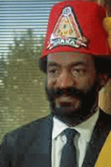
Bill Cosby’s MODUS OPERANDI producing dissociated states, memory loss and amnesia barriers in women that he violates is an advanced and sophisticated form of experimental CIA MK ULTRA/MONARCH trauma based Narco-hypnosis straight out of DACHAU and Auschwitz.
The DEVIL’s Playmate Body Count
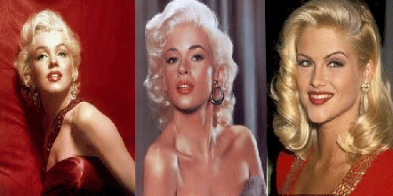
Highly unusual automobile accidents, drug overdoses, homicides, a plane crash all have claimed the lives of at least 17 of Hefner’s young Playmates including the infamous Marilyn Monroe, Jayne Mansfield and Anna Nicole Smith.[50]
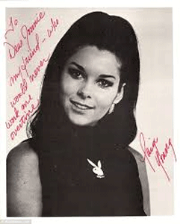
The 1974 death of 1968 Playmate of the Month, Paige Young, is linked to Hugh Hefner and Bill Cosby who used her as a personal “Sex Toy.” When Paige took her life on a Palm Sunday, she wanted to make a STATEMENT and stir an investigation into Hefner’s Satanic Playboy Circle, she left pictures of Hefner labeled the DEVIL, and a large PENTAGRAM that had nothing to do with the five wounds of Christ on the floor of her Hollywood apartment. Undoubtedly, she was trying to tell us about repressed memories of a PENTAGRAM being a central part of a Ritual to indoctrinate her into the Cult of the DARK MESSIAH.
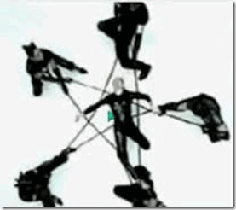
Paige wasn’t far off. Look at Madonna’s odd PENTAGRAM showing a HollyWeird mind control Satanic Cult Ritual with Diabolical EVIL and DEMONIC anchors at each of the five points.

Paige Young and the Satanic PENTAGRAM
In HollyWeird, Paige’s STATEMENT was as it is today a forbidden subject. Palm Sunday was originally to commemorate Christ’s triumphal entry into Jerusalem. Later on it was combined with pagan activities; today the palm and willow are blessed and carried in the procession. It is ascribed to a pagan holiday where olive and willow are blessed. Powers attributed to the palm are exorcising evil spirits, and warding off DEVILS.[51]
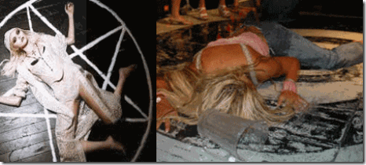
Hugh Hefner and Bill Cosby’s Narco-hypnosis Sex Kitten Programming- trauma based MK ULTRA/MONARCH multiple alters are undoubtedly anchored in the occult- SATANISM. That is one of the messages that the tragic Paige Young was trying to tell us.
END OF PART II

[1] http://www.smh.com.au/lifestyle/celebrity/sandra-bullocks-husband-jesse-james-apologises-asks-for-forgiveness-20100318-qiur.html
[2] http://henrymakow.com/john_wilkes_booth_killed_by_je.html
[3] http://www.tmz.com/2010/03/20/jesse-james-sandra-bullock-michelle-mcgee-nazi-swastika-mistress-photos/
[4] http://www.smh.com.au/lifestyle/celebrity/sandra-bullocks-husband-jesse-james-apologises-asks-for-forgiveness-20100318-qiur.html
[5] http://en.wikipedia.org/wiki/The_Cosby_Show
[6]http://www.thesuperficial.com/keshia-knight-pullam-celebrity-apprentice-bill-cosby-rape-fired-donald-trump-01-2015
[7] http://www.thesuperficial.com/keshia-knight-pullam-celebrity-apprentice-bill-cosby-rape-fired-donald-trump-01-2015
[8] http://www.thesuperficial.com/keshia-knight-pullam-celebrity-apprentice-bill-cosby-rape-fired-donald-trump-01-2015
[9] http://en.wikipedia.org/wiki/Mexia,_Texas
[10] http://www.eyewitnesstohistory.com/rommel.htm
[11] http://en.wikipedia.org/wiki/Waffen-SS
[12] http://www.tshaonline.org/handbook/online/articles/qug01
[13] http://en.wikipedia.org/wiki/Fr%C3%A9d%C3%A9ric_Prinz_von_Anhalt
[14] http://en.wikipedia.org/wiki/Gestapo
[15] Id.
[16] http://en.wikipedia.org/wiki/Fr%C3%A9d%C3%A9ric_Prinz_von_Anhalt
[17] http://aangirfan.blogspot.com/2014/01/kaiser-wilhelm-ii-gays-freemasons-jews.html
[18] http://davidmeyerson.net/the-myth-of-freemasonic-conspiracy/
[19] http://intheknow7.wordpress.com/2010/05/24/50yrs-of-mk-ultra-beta-sex-slaves-graphic-wvideos/
[20] http://en.wikipedia.org/wiki/Anna_Nicole_Smith
[21] http://www.people.com/people/article/0,,1536410_20011436,00.html
[22] http://www.godlikeproductions.com/forum1/message342517/pg1
[23] http://net-abbey.org/hitler-as-god.htm
[24] http://www.nizkor.org/hweb/people/h/hitler-adolf/oss-papers/text/oss-profile-02.html
[25] http://www.cuttingedge.org/news/n2246.cfm
[26] http://en.wikipedia.org/wiki/Anna_Nicole_Smith
[27] http://thefreemanperspective.blogspot.com/2007/02/httpwww2bloggercomimggllinkgifanna.html
[28] http://spiritualwarfare666.webs.com/Reichsf%C3%BChrer_SS.htm
[29] Id.
[30] http://www.wewelsburg.de/en/wewelsburg-1933-1945/historischer-hintergrund.php
[31] http://en.wikipedia.org/wiki/Howard_K._Stern
[32] http://thefreemanperspective.blogspot.com/2007/02/httpwww2bloggercomimggllinkgifanna.html
[33] http://www.artharris.com/2007/12/08/bald-truth-flashback-ford-shelley-locked-out-was-he-friends-with-anna-when-she-died/
[34] http://www.myrtlebeachonline.com/2013/07/18/3591643_court-denies-myrtle-beach-developer.html?rh=1
[35] http://abcnews.go.com/Health/story?id=2982406
[36] http://www.davidicke.com/forum/showthread.php?t=147710
[37] http://www.whale.to/b/lavey_q.html
[38] http://www.thetruthseeker.co.uk/?p=71446
[39] http://www.nydailynews.com/entertainment/playboy-re-releases-iconic-marilyn-monroe-issue-60-years-gallery-1.1758786
[40] http://www.truedemocracy.net/hj37/36a.html
[41] http://intheknow7.wordpress.com/2010/05/24/50yrs-of-mk-ultra-beta-sex-slaves-graphic-wvideos/
[42] http://health.blurtit.com/46946/what-effect-does-spanish-fly-has-on-women-and-how-is-it-to-be-used-to-be-effective-if-it
[43] http://www.hollywoodreporter.com/news/woman-claims-bill-cosby-drugged-758243
[44] http://www.tmz.com/2014/11/24/bill-cosby-accuser-class-action-lawsuit-rape-louisa-moritz/
[45] http://www.nydailynews.com/entertainment/gossip/woman-sues-bill-cosby-claiming-molested-article-1.2031073
[46] http://en.wikipedia.org/wiki/Repressed_memory
[47] http://en.wikipedia.org/wiki/Repressed_memory
[48] http://artificialtelepathy.blogspot.com/2006/06/telepathy-and-technology-of-mind.html
[49] http://robertscourt.blogspot.com/2008/02/effexor-withdrawal.html
[50] http://listoftheday.blogspot.com/2010/08/17-dead-centerfolds-of-day.html
[51] http://www.demonbuster.com/holiday.html
[
Comments : 7 Comments
Tags: Adolf Hitler, anna nicole smith, Anton Szandor LaVey, Auschwitz Concentration Camp, bill cosby, boys from brazil, Chloral Hydrate, cloe goins, Dachau, Dachau Doctors Tribunal, dark messiah, donald trump, dr. carl clauberg, Dr. Josef Mengele, ford shelley, Heinrich Himmler, Howard K. Stern, hugh hefner, Illuminati, J. howard marshall, jayne mansfield, jesse james, Jonestown, Knights of Black Sun, knights of the golden circle, marilyn monroe, mexia, MK-ULTRA, Monarch Program, narco hypnosis, Paige Young, playboy bunnies, playboy mansion, Prince von Anhalt, sandra bullock, Satanic Global High Cabal, waffen SS, wewelsburg castle, wewelsburg working
Categories : antichrist, anton lavey, anton LeVay, artichoke program, Aryan Supremacy, bill cosby, blood covenants, blood oaths, bloodline of wotan, bloodlines of wotan, boys from brazil, brotherhood of death, church of satan, CIA, devil, devil's horns, Dr. Josef Mengele, dualism, false prophet, false prophets, Hauptsturmfuhrer SS Dr. Josef Mengele, Heinrich Himmler, hollywood satanic cult, illuminati, illuminati sacrifice, Josef Mengele, lucifer's servants, luciferians, manchurian candidates, Marilyn Monroe, mark of the beast, Millennium Trilogy, mind control, mk ultra, cia occult bureau, temple of set, MK-ULTRA, monarch child, monarch program, mulitiple personality disorder, Nazis, Nuremberg Tribunal, Paperclip Project, Paul Josef Goebbels, post hypnotic suggestions, PROJECT CHATTER, racial mass murder, Reichsfurhrer SS-1 Heinrich Himmler, Reichsstatthatter Hermann Goring, Ritual Satanic Abuse, ritual satanic sexual abuse, ritually abused children, satan, Satanic Global High Cabal, Satanism, Schutzsteffel, sex kitten, sex slave, SS, Strumbannfuhrer SS Dr. Wernher von Braun, the cosby show, trauma-based mind control, underground reich, underground third reich, unholy trinity, vril, wotan

BILL COSBY, PROJECT ARTICHOKE, MENGELE & THE DARK MESSIAH, PART I
29122014
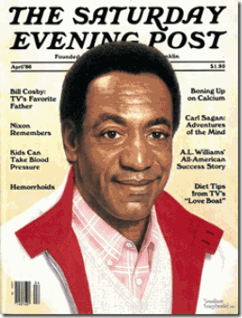
Bill Cosby,“TV’s Favorite Father,” is certainly being thrown under the bus by the ILLUMINATI. He is also certainly being used as a major mass media diversion and circus so that no matter what takes place in this nation’s collective conscious in resistance to the blatant injustices of state sponsored police violence against people of color, and BLACK LIVES MATTER, the face of EVIL in America will always be concentrated on the face of a black man.
Bill Cosby didn’t necessary have to piss anyone off to be cast adrift in the sea alone on the tip an iceberg without a paddle. To set himself off from the masses as one of the gods of Mount Olympus, he had to be Aryan. To the gods and goddesses of Mount Olympus like the high executives of HollyWeird’s Sony Pictures Entertainment Global Luciferian Cabal, his very skin color and mere existence has always been an abomination among them.

Cosby in Classic Satanic Duality. Father in HEAVEN and Satan in HELL. Cosby’s silly and harmless American “Favorite Father” persona while displaying the ancient forbidden knowledge St. John‘s Finger Gesture– One God, Lucifer.
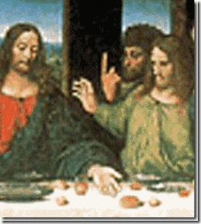
I probably looked at Rosicrucian Leonardo da Vinci’s Last Supper a thousand times and not once noticed disciple Thomas openly challenge and defy Christ.
When he acts like he is one of them on Mount Olympus- that he has the same EVIL desire and privilege of the ILLUMINATI to waste the mind, body and soul of the masses at WILL by the divine authority of the cosmos, it only irritate them and his EVIL deeds only became an open register to justify hanging him in the eyes of the masses and setting him out alone into the deep blue sea on the tip of an iceberg. Bill Cosby has always been the subject of their sniping remarks, and backroom racialist humor and ridicule. Behind his back, they call he and his people, CALIBAN.

The chic mocking and sniping racialist remarks exposed by Sony Luciferians only confirm that the so-called Black Cinema (Django Unchained, 12 Years a Slave, The Butler, The Help, etc.) are sophisticated ILLUMINATI vehicles of psychological warfare. Their sole agenda has always been to penetrate the sub consciousness via mass media scientific “entrainment” of our brains inducing lunacy, and senses of overwhelming powerlessness to resist a New World Order.

They deliberately with EVIL design over saturate the masses with pathetic images of Negro buffoonery like cross dressing Kevin Hart that even his employers, the Sony Luciferian Cabal, interesting enough, admitted is a “whore“[1]– AN ILLUMINATI WHORE that has abandoned his own consciousness of history. The Negro has lost his mind.
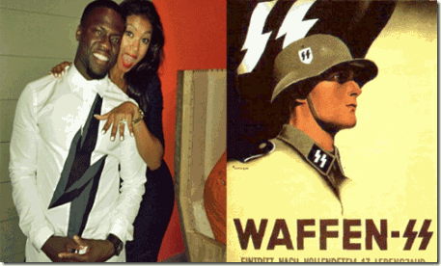Their agenda for Black Cinema has never been to create a meaningful script, plot or images to inspire the masses. It wasn’t created out of any genuine dialogue or concern for the aspirations of Black People or people of color that would validate and provide empowerment to their Identity and BEING. Bill Cosby has never been about empowerment of the masses in art or his life. Viewed through the Smoked Mirror, the ILLUMINITI intend to keep the masses’ focus on his art and life- the Big Black Brute that wasted, injured and harmed so many young women.

Attorney Gloria Allred has entered the Bill Cosby Sex Scandal picture as a “Gatekeeper” to help steer him out to sea on the tip of an iceberg. Allred’s mission is to keep all of his victims on cue and silent about anything other than Cosby. None of them will be allowed to stir away from the script. It virtually guarantees that the masses’ focus will remain exclusively confided to the brutish Cosby, his EVIL nature to harm and exploit women, and nowhere beyond the tip of the iceberg.

Recently, the Dr. Phil Show moved inside the sensationalized Bill Cosby Sex Scandal. On the popular television program, he featured Attorney Gloria Allred and seven women that told their stories of rape and sexual abuse encounters with America’s “Favorite Father.”[2] The Dr. Phil Show also featured some of Hugh Hefner’s Playboy Bunnies that were raped and sexually abused by the Big Black Brute. However, the Dr. Phil Show and Allred had Hefner’s back. It steered him away from Cosby and the iceberg. The bottom line of the show when it came to Hugh Hefner and the Black Big Brute at the Playboy Mansion, Hefner, “I would never tolerate this kind of behavior, regardless of who was involved.”[3]

The above image of Hefner as the Greek God Pan is a mural made for Playboy’s annual Dionysian orgy. According to the forbidden knowledge, Pan is “man himself” who falls as LUCIFER from the heavens onto the world of matter. According to Anton LeVay’s Satanic Bible, Pan is one of infernal names of SATAN.[4]
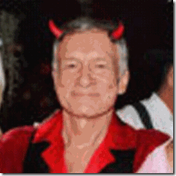
Yes, Hugh Hefner the Sethian DEVIL, is the man that made an industry out of handling and exploiting CIA/MK ULTRA/MONARCH trauma based mind controlled sex slaves and kittens.[5]
There is another side to Bill Cosby, AN ILLUMINATI WHORE, that has shielded him from the liability and exposure of his EVIL throughout the decades. A side that is absolute Satanic, classified top secret linked to the covert programs of the U.S. Government- Operation PAPERCLIP, U.S. Navy, the CIA- Project BLUEBIRD, ARTICHOKE and MK ULTRA. As a Guardian of Forbidden Knowledge, Cosby’s memory is loaded with a ton of dynamite. His memory is a liability to a lot of people in HollyWeird and outside. It could open Pandora’s box and rattle a lot of bones in the skeleton closet of HollyWeird, Naval Intelligence, Mafia and the CIA.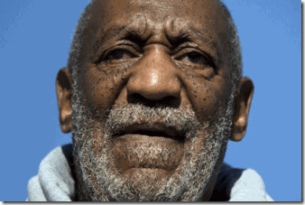
I also suspect that Cosby’s continued silence in the mounting wave of rape and sexual abuse accusations against him is not due to any issues of senility, but mainly because his mind has been wiped clean. DOWN THE RABBIT HOLE
The Rise of the Dark Messiah
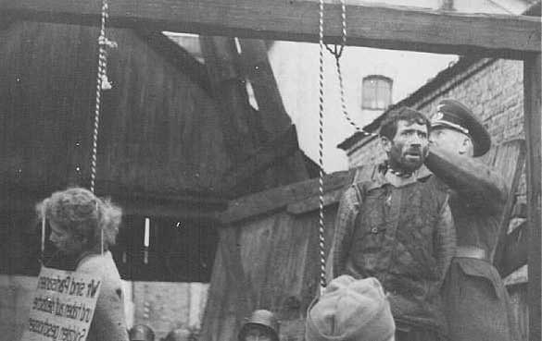
Banality of EVIL- SS Stringing Them Up- Normal Day at the Office
There has been many theories that sought to explain what happened in Nazi Germany. Banality of EVIL is a thesis that the Holocaust- Racial Mass Murder were not executed by fanatics or sociopaths, but by ordinary people like Oberstumbannfuhrer (lieutenant colonel) SS Otto Adolf Eichmann and Hauptsturmführer (Captain) SS Dr. Josef Mengele that just happened to accept the premises of their state and therefore participated with the view that their actions were normal, just “the way things are done.”[6]
After WW II, there was those that sought the prosecution and punishment of Nazis for war crimes and CRIMES AGAINST HUMANITY. Some sought “denazification” to re-educate Nazis that its state campaign of Racial Mass Murder and Aryan Domination based upon pseudo racial and scientific theories was/is not normal and that is not “the way things are done.”
At the Fall of Nazi Germany, thousands of its leading ardent Nazi and SS scientists, physicians, military and business leaders that had not been prosecuted and punished, and had not been “denazified” were clandestinely smuggled into America on the basis of National Security.
In most cases, those secretly smuggled into America, their membership in the Virl Society, SS- Knights of the Black Sun, Nazi Party and evidence of their executed CRIMES AGAINST HUMANITY only became a note of paper clipped (Operation PAPERCLIP) to their files.
“The Nationalist Socialists derived power from one source: … a fanatical autohypnosis
which convinced disciples, succumbing to the totalitarian discipline in the promise of reaching transcendent reality, that they were the new men the age was waiting for.. ..that they were endowed with a secret energy which would enable them to take over Germany and the world. If they were properly prepared, mysteries would be revealed to them which would give them SATANIC POWERS.” Dusty Sklar, Gods and Beasts – The Nazi’s and the Occult, 1977
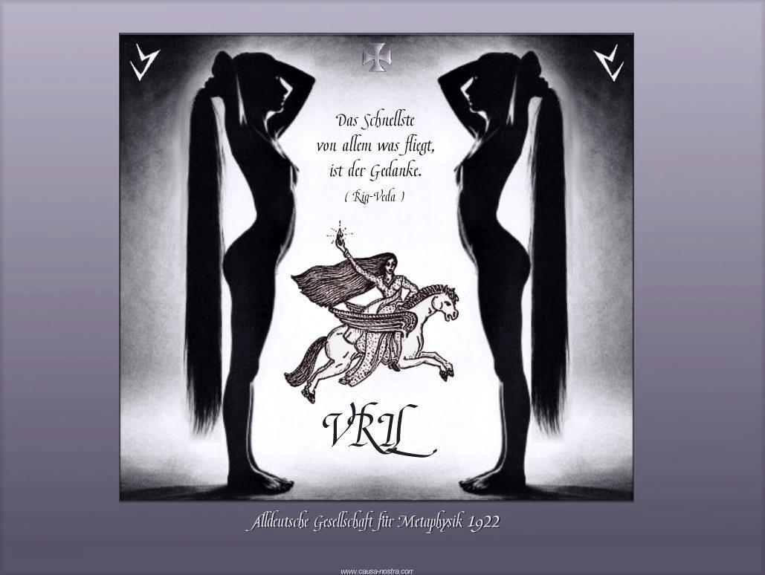
“The VRIL SOCIETY was dedicated to EVIL,” says historian Michael Fitzgerald…Through their control of the Nazi party they committed the greatest acts of EVIL in the 20th Century.”[7]
“At first glance, the large circular room in the basement of Wewelsburg Castle … you can see thirteen lanterns flickering on the curved walls. But it’s only when you look directly upwards that the room’s significance becomes shockingly clear. At the centre of the dome lies a giant swastika. This room was the central temple of the Satanic cult that created and directed Germany’s Nazi party. This so called VRIL SOCIETY counted many of Hitler’s henchmen as members, including Himmler, Bormann, and Hess. Central to the whole cult was Hitler, who they believed to be a psychic medium in contact with powerful forces that would create an all-conquering Aryan nation. Some saw him as the Dark Messiah.”[8]
It wasn’t the premises of the State that they had followed in virtual “autohypnosis” to commit the greatest acts of EVIL in the 20th Century. It was Set, Seth, Satan, Devil– The Dark Messiah- LUCIFER! During the late 1940s and 1950s, LUCIFER’s Servants- his greatness deceivers and “inner circle” had been clandestinely brought to the United States to continue a campaign of racial mass murder and EVIL across the globe.
Guardians of the VRIL, Temple of the Dark Messiah

William Henry “Bill” Cosby, Jr.’s (born July 12, 1937) secret Blood Covenant with the DEVIL began long before he entered HollyWeird. It began sometime after 1956 during the CIA-MK ULTRA mind control program when the young U.S. Naval Hospital Corpsman was transferred to Bethesda Naval Hospital. The Bethesda Naval Hospital is the Walter Reed National Military Medical Center (WRNMMC), formerly known as the National Naval Medical Center located in the community of Bethesda, Maryland, near the headquarters of the National Institutes of Health.
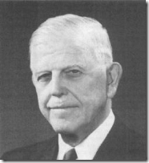
The original Medical Center was composed of the Naval Hospital, and Naval Medical Research Institute (NMRI). The NMRI was founded in 1942 under Dr. Andrew C. Ivy. He was a Special Consultant to the Secretary of War regarding war crimes of a medical nature at the Nuremberg trials, 1946-1947. [9 During the 1947 Dachau Doctors Tribunal, the chief prosecutor, U.S. General Telford Taylor, relied on the guidance of Dr. Ivy as an advisor and expert medical ethnics witness, a representative of the American Medical Association.

Under Operation PAPERCLIP, Dr. Ivy became one of the key guardians of the “VRIL Satanic Inner Circle” in America. On March 3, 1950 a space medicine symposium, “The Biological Aspects of Manned Space Flight” was held at the University of Illinois Medical School in Chicago. It was sponsored by Major Gen. Harry G. Armstrong, USAF Medical Corp (MC) and Dr. Andrew Ivy, Vice President of the University of Illinois.[10]
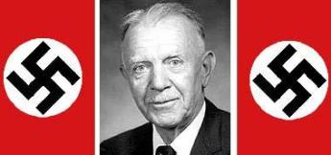
Dr. Ivy’s space medicine symposium was attended by international Nazi war criminals- Knight of the Black Sun- SS- Sturmbannführer (Major) Werner von Braun and Dr. Hubertus Strughold, above, formerly of the Aviation Medical Research Institute of the Reich Air Ministry in Berlin who had been listed on the Central Registry of War Criminals and Security Suspects.[11] After the fall of Nazi Germany, General Armstrong setup the U.S. Army Air Force Aero Medical Center in Heidelberg to harbor fifty-eight (58) Luftwaffe-SS doctors under Dr. Strughold, thirty-four (34) of whom followed him under Operation PAPERCLIP to the U.S. Air Force School of Aviation Medicine (SAM) in Texas, where he served as commandant.[12]
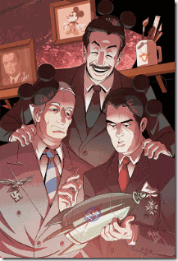
At the symposium, Heinz Haber, Ph.D. presented a paper on Astronomy and Space Medicine. “Heinz Haber was a German Luftwaffe reconnaissance aviator until 1942. He worked for the Luftwaffe Institute for Aviation Medicine; In order to assess the risks faced by German air force pilots, the institute performed experiments on hundreds of inmates at the Dachau concentration camp near Munich. The inmates who survived these experiments were usually killed and then dissected. “[13] During the 1950s and 1960s, the CIA loaned Heinz Haber to Walt Disney for secret mass media psychological warfare (pysops) projects.[14] The Nazi Haber may have been the inspiration for the Disney character, Ludwig Von Drake.[15]

St. John Finger Gesture- One God- LUCIFER
At Dr. Ivy’s symposium, Konrad Buettner Ph.D. presented a paper on Bioclimatology of Manned Rocket Flight. At a conference in Germany, a Nazi researcher, identified as Professor Ernst Holzloehner, presented his findings through experiments he conducted on Dachau concentration camp inmates “who were frozen to death in vats of ice water in the camp yard during winter.”
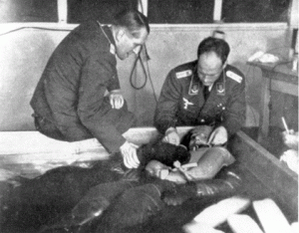
Dachau Concentration Camp, Germany, Prof. Ernst Holzloehner (left) and Dr. Sigmund Rascher holding a political prisoner in ice water during an experiment. According to Holzloehner’s presentation, the human subjects suffered excruciating pain before they died from having various body parts frozen. Linda Hunt, author of the book Operation Paperclip, discovered at least five other Paperclip scientists who worked at SAM who knew about the Dachau Experiments through their participation at the same 1942 conference. These were Drs. Walter Schreiber, Hans Clamann, Ulrich Luft, Konrad Buettner, and Richard Landenberg.[16]
Author H.P. Albarelli of A Secret Order found Konrad Johannes Karl Buettner’s work for the U.S. government at SAM particularly intriguing. Buettner was brought to America in 1947 by Project Paperclip to work with Maj. General Armstrong’s SAM. According to Air Force files, Buettner conducted extensive research on the “effects of extreme heat on humans.”[17]
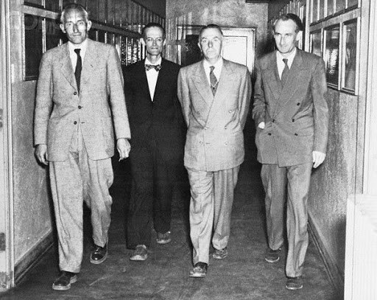
VRIL Satanic Inner Circle 1959 Randolph Air Force Base, Texas- Dr. Fritz Haber, Konard Buettner, Strughold, and Dr. Heinz Haber
In April 1952, Buettner made minor headlines in the United States when he announced the findings of a study he conducted for the UCLA engineering department. The main finding being: “[That] NEGROES would be in special danger of heat from an atomic explosion” due to their “heavily-pigmented skin.”[18]
Bethesda Naval Hospital & The High Priest of the Satanic VRIL
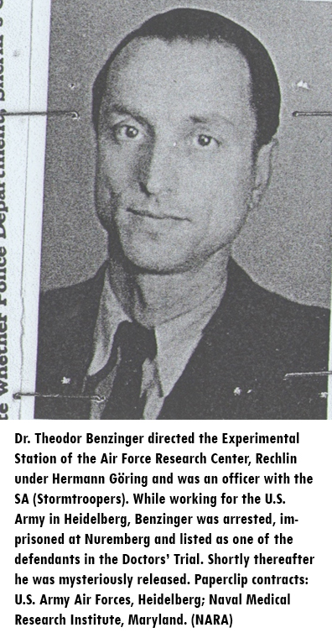
In 1947, Dr. Ivy’s Naval Medical Research Institute (NMRI) brought in ardent Nazi, Luftwaffe Colonel Dr. Theodor Benzinger, of the “Dark Messiah“ to take over the institute at Bethesda Naval Hospital.
Dr. Benzinger and Nuremberg
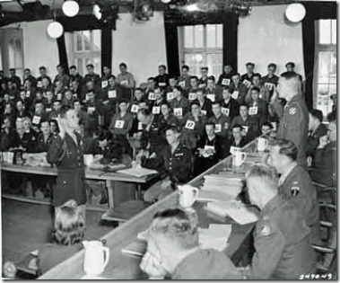
On October 12, 1946, Dr. Benzinger had been named as a major Nazi defendant in the American controlled Dachau Doctors Tribunal. He had been a leading Luftwaffe principal doctor involved in the Dachau Terminal Experiments. Eleven days thereafter, Dr. Benzinger was dropped from the defendants’ list and walked out of Nuremberg Prison without an explanation.[19] Dr. Benzinger rejoined General Armstrong and Dr. Strughold at the U.S. Army Air Force Aero Medical Center in Heidelberg. One of the first doctors out of Aero Medical Center to head to America in February 1947 was Dr. Theodor Benzinger.[20]
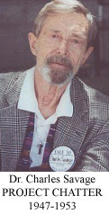
In 1947 at NMRI– Bethesda Naval Hospital, Naval Lieutenant MC Dr. Charles Savage was attached to Dr. Benzinger not vista versa. Dr. Benzinger was the Scientific Director of NMRI, and Dr. Savage was the paper director of the Navy’s ultra Top Secret Project CHATTER.[21]
Immediately after the Fall of Nazi Germany, SS- Dachau drug-mind control and “truth serum” experiments were written up by the US Naval Technical Mission. In 1947, the US Navy initiated Project CHATTER at NMRI to continue to expand secret Nazi/SS mind control and interrogation tools developed out of the joint SS/Luftwaffe Dachau Concentration Camp “aviation series” terminal human medical experiments.[22]
“Project CHATTER was a Navy program that began in the fall of 1947. Responding to reports of ‘amazing results’ achieved by the Soviets in using ‘truth drugs,’ the program focused on the identification and testing of such drugs for use in interrogations and in the recruitment of agents. The research included laboratory experiments on animals and human subjects involving Anabasis aphylla, scopolamine, and mescaline in order to determine their speech-inducing qualities.”[23]
Under Dr. Benzinger, NMRI also became a secret major front for the newly formed CIA first exposed in 1977 by the Select Committee on Intelligence and the Subcommittee on Health and Scientific Research investigation into the CIA’s MK ULTRA program.[24]

Dr. Benzinger was no ordinary Nazi even if there could be such a thing. In the THIRD REICH, he held the extraordinary secret title Obermedizinalrat. Even the meaning and definition of Secret Obermedizinalrat and Privy Obermedizinalrat (Medical Officer Secret) is veiled. It can be viewed as of the blood, soil and soul of Germany- the VRIL.[25] He was among the Inner Circle of the Vril Empire of EVIL– the Third Reich’s 1000 Year of Aryan Supremacy. That’s why Dr. Bezinger walked out of Nuremberg Prison pursuant to America’s secret pact with Lucifer’s Son, Reichsfuhrer SS- 1 Heinrich Himmler, to transfer venue of the Nazis and the Knights of the Black Sun- SS to North and South America. Under Dr. Benzinger, NMRI at Bethesda Naval Hospital also became a temple of a VRIL Satanic Cult dedicated to Aryan Supremacy, and the same EVIL of the DARK MESSIAH.
Bethesda Naval Hospital, Along Comes Bill
According to the Navy, Bill Cosby served from 1956 to 1960 in naval hospitals, including Bethesda Naval Hospital, where he allegedly helped Marines recover from Korean War injuries.[26] The subject of Korean War injuries was of particular interest to the CIA, Dr. Bezinger and Lt. Savage at NMRI.
The Korean War -“Fatherland Liberation War” began June 25, 1950 and ended July 27, 1953. On April 10, 1953 just days before the end of the Korean War, in a speech at Princeton University to justify rounding out Project CHATTER, Bluebird and Artichoke into MK ULTRA, CIA director Allen Dulles warned that the human mind was a “malleable tool,” and that the “brain perversion techniques” of the Reds [North Korean-Russian] were “so subtle and so abhorrent” that “the brain becomes a phonograph playing a disc put on its spindle by an outside genius over which it has no control.”[27]
The CIA had well been into mind control and “brain perversion techniques” developed out of the Dachau Experiments well before the Korean War. Operation BLUEBIRD was approved by Roscoe Hillenkoetter, Director of the CIA, on April 20, 1950. In August 1951, the Project was renamed ARTICHOKE.[28]
Operation BLUEBIRD-ARTICHOKE Nazi/SS and Naval mind control and interrogation tools developed out of Project CHATTER was in full effect and expanded in the U.S. North Korean aggression. In a recently released CIA hand written document, a doctor involved in Operation BLUEBIRD-ARTICHOKE– Hypnotic Messenger said,
I have developed a technic which is safe and secure (free from international censorship). It has to do with the conditioning of our own people. I can accomplish this as a one man job. The method is the production of hypnosis by means of simple oral medication. Then (with no further medication) the hypnosis is re-enforced daily during the following three or four days. Each individual is conditioned against revealing any information to an enemy, even though subjected to hypnosis or drugging. If preferable, he may be conditioned to give false information rather than no information.
This should be repeated every six months in each case, in order to be sure that the suggestions established have not “worn off.”I would be glad to go anywhere in the world (including Korea) to accomplish this for you. I think that the greatest security would be in my travelling as a naval flight surgeon doing research in aviation medicine especially with the project of “motion sickness” in mind. Of course I would be willing to undertake more hazardous investigative methods if you should deem them advisable.[29]
Of course, the doctor was referring to working secretly under the auspices of Dr. Benzinger’s Aviation Studies and Research at NMRI, a CIA front.
Operation CHATTER, BLUEBIRD-ARTICHOKE also involved “The Problem of Disposal of Subjects.” and the creation of “amnesia barriers with hypnosis” by electric shock mind control and interrogation tools developed out of Auschwitz Concentration Camp by Hauptsturmführer (Captain) SS Dr. Josef Mengele that was expanded by his student, Dr. Ewen Cameron of McGill University.[30]
An extremely important and revealing ARTICHOKE document dated December 3, 1951 read:
Immediately after the conference on Friday, 30 November 1951,[whited out] succeeded in finding [whited out] and [whited out], and the writer discussed electric-shock devices and certain related matters from about 3:30 to 4:45 with [whited out].
[Whited out] is reported to be an authority on electric shock. He is a professor at the Medical School of the [whited out] and, in addition, is a psychiatrist of considerable note. Pro-[whited out] is, in addition, a fully cleared Agency consultant.
[Whited out] explained that he felt that electric shock might be of considerable interest to the “Artichoke” type of work. He stated that the standard electric-shock machine (Reiter) could be used in two ways. One setting of this machine produced the normal electric-shock treatment (including convulsion) with amnesia after a number of treatments. He stated that using this machine as an electro-shock device with the convulsive treatment, he felt that he could guarantee amnesia for certain periods of time and particularly he could guarantee amnesia for any knowledge of use of the convulsive shock.
[Whited out] stated that the other or lower setting of the machine produced a different type of shock. He said that he could not explain it, but knew that when this lower current type of shock was applied without convulsion. it had the effect of making a man talk. He said, however, that the use of this type of shock was prohibited because it produced in the individual excruciating pain and he stated that there would be no question in his mind that the individual would be quite willing to give information if threatened with the use of this machine. He stated that this was a third-degree method but, undoubtedly, would be effective.
[Whited out] stated that he had never had the device applied to himself, but he had talked with people who had been shocked in this manner and stated that they complained that their whole head was on fire and it was much too painful a treatment for any medical practice. He stated that the only way it was ever used was in connection with sedatives and even then it was extremely painful.
The writer asked [whited out] whether or not in the “groggy” condition following the convulsion by the electro-shock machine anyone had attempted to obtain hypnotic control over the patient, since it occurred to the writer that it would be a good time to attempt to obtain hypnotic control. [Whited out] stated that, to his knowledge, it had never been done, but he could make this attempt in the near future at the [whited out] and he would see whether or not this could be done.
[Whited out] and [whited out], as well as all others present, discussed the use of electro-shock at considerable length and it was [whited out] opinion that an individual could gradually be reduced through the use of electro-shock treatment to the vegetable level. He stated that, whereas amnesia could be guaranteed relative [to] the actual use of the shock and the time element surrounding it, he said it would obtain perfect amnesia for periods further back. He stated several instances in which people who had been given the electro-shock treatment remembered some details of certain things and complete blanks in other ways.
[Whited out] said that a [whited out], who is practicing in [whited out] has perfected a battery-driven machine which, according to [whited out] is portable. [Whited out] said that the standard electro-shock machine is a very common machine in medical offices and in the major cities there must be several hundred of them in use at all times.[31]
In 1956, with Lucifer’s Servants’ secret MK ULTRA torture, mind control and Manchurian Candidate assassination programs out of Dachau running amok at the Bethesda Naval Hospital- NMRI, Bill Cosby enters the scene.
In the March/April 2011 issue of “Anchor Watch” magazine that is published by Navy Information Operations Command Maryland, it clearly says that Bill Cosby had been stationed at Naval Hospital Argentina.[32]
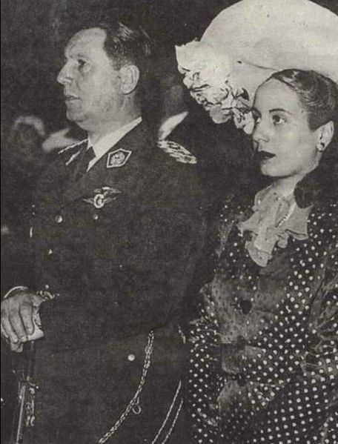
The Naval Hospital Argentina institution was founded in 1947 [33] under the presidential term of Nazi collaborators, Juan Domingo and Eva Perón.[34] It serves Argentina Navy personnel.[35]

This strange window less fortress type building built in 1977 is the current Naval Hospital Argentina located in the Caballito section of Buenos Aires.[36] I assume that Perón’s old 1956 naval facility sat on this site or was located nearby.
There weren’t any injured U.S. Korean War soldiers in Perón’s old naval hospital. He certainly wasn’t passing out good will, pudding and Jell-O to the poor and needy. There can be only one reason why Cosby under the auspices of the U.S. Naval Hospital in Bethesda would be in Argentina, a Nazi haven, at former president Juan Peron’s Naval Hospital.
He was an ARTICHOKE/CIA MK ULTRA team member technician that had horned his EVIL with Dr. Benzinger and NMRI working on top secret projects involving Korean War soldiers and veterans with truth serums, torture and the experimental drugs and interrogation tools straight out of Dachau. Cosby was in town to Artichoke– wipe clean some very sensitive CIA agents, assets or enemies at secret off shore sites, or he helped dispose of some of Perón’s regime’s loose change. On September 19, 1955, Perón had been deposed in a military coup.[37]
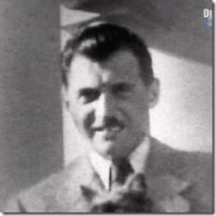
More importantly from 1956 to 1960, CIA torture- interrogation/genetic human cloning expert Dr. Josef Mengele was also working as an affluent physician and businessman of Perón’s elite German entourage in Buenos Aires. It was only after Israeli Mossad agents kidnapped that normal German mass murdering war criminal SS- Oberstumbannfuhrer Otto Adolf Eichmann in Buenos Aires in April 1960 that Mengele fled the city.[38] It is also possible that Cosby had been involved in advance torture- interrogation training sessions with Dr. Mengele at the secured Naval Hospital facility, or he was Artichoked– mind wiped clean of the most sensitive details of the program with memory blocks implanted by Dr. Mengele before Cosby left the service. It is also possible that along with amnesia blocks, Cosby has a termination switch and alter implanted too.
Cosby: From Bethesda, Mengele to HollyWeird Glamorizing the CIA
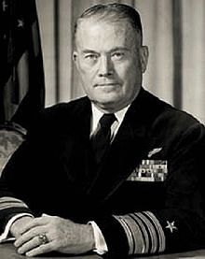
From April 28, 1965 to June 30, 1966, the CIA director was a Navy man, Director of the Navy’s Central Intelligence, Vice Admiral William Francis Rabon, Jr.[39] Vice Adm. Rabon had been very familiar with the Nazi VRIL Satanic Inner Circle. After the Fall of Nazi Germany, the director of Navy Intelligence (Rabon) lobbied the War Department General Staff to circumvent State Department regulations so that an ardent Nazi VRIL guided missile expert Dr. Herbert Wagner of the Nazi Party and Knights of the Black Sun- SS and four of his assistants could be smuggled directly into Washington DC on military aircraft with blackened windows.[40]
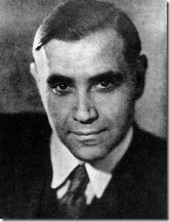
SS Dr. Herbert Wagner- High Priest of the VRIL
During the early 1960s, Rabon directed the Navy’s Polaris Submarine Ballistic Missile Program. The Navy’s submarine ballistic missile system was developed primarily by one of SS Wagner’s assistants, Willy Fielder. Fielder had been a member of SS Wernher von Braun’s V-1 missile team. Fielder was brought into the U.S. in 1948 under Project PAPERCLIP.[41]
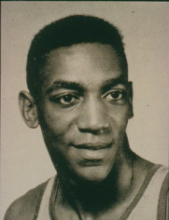
In September 1965 within a mere five (5) years after Cosby’s discharge from the U.S. Navy and with absolutely no acting experience, he popped up in the supporting role in one of America’s most ground breaking, popular and award-winning television series of the 1960s- I Spy.[42] Cosby was hardly a polished mass media HollyWeird candidate. Former Naval Medial Corpsman Cosby was most likely selected for the special mass propaganda assignment with the recommendation and approval of Vice Admin. Rabon, Director of the CIA, another high level guardian of the Nazi Satanic Inner Circle of the VIRL and Dark Messiah. Cosby played a black CIA agent in a HollyWeird’s mass media TV propaganda program romanticizing the CIA. In a magazine Interview, he let it slip that the CIA- Admiral Radon and MK ULTRA Richard Helms had direct creative input and censorship over content in the production of the I Spy series.
Playboy: How did you feel about playing and, in a real sense, glamorizing a CIA agent?
Cosby: “Well, actually, the CIA NEVER LET US say we were CIA agents.”[43]
Cosby & HollyWeird’s MK ULTRA/MONARCH Sex Kitten Circle
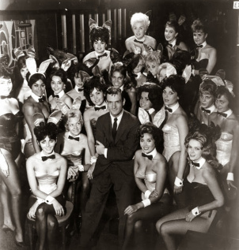
In HollyWeird, Cosby’s immediately circle of influence became composed of Hugh Hefner (Playboy Buddies), Dean Martin (Gold diggers), etc. and the Mafia– the television/film industry’s most powerful players, handlers and programmers of CIA MK ULTRA/MONARCH trauma based mind controlled “Sex Slaves and Kittens.”[44]

What Cosby did as a Project ARTICHOKE/MK ULTRA mind control technician for Dr. Benzinger, Navy and CIA, he did for the principal handlers and programmers of HollyWeird’s “Sex Slaves and Kittens.”
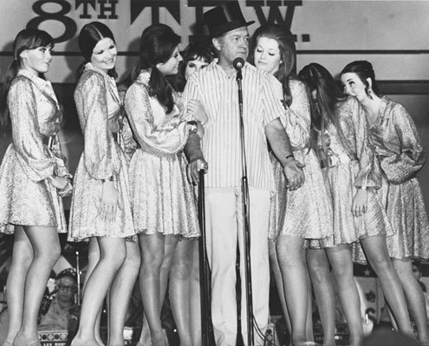
With CIA and Naval Intelligence approval and clearances, Cosby most likely provided sex slave/kitten handlers with MK ULTRA experimental drugs, technical support, and the implantation of the “Dark Messiah Satanic Layers” in young women victims.

Paige Young was out of Hugh Hefner’s Stable of MONARCH Sex Kittens. Paige was used, exploited, abused and programmed by Hefner and Cosby to be a virtual “Sex Slave” of HollyWeird’s rich and elite like legendary director, John Huston. She had been Cosby’s personal drugged Sex Toy for sometime when on April 7, 1974, she was found dead in her apartment from a 38 caliber head wound.[45]

“There was a large American flag draped across her bed and there was a PENTAGRAM laid out on the wooden floor.”[46] “There were news clippings, magazine articles, everything you could think of. Written across it was something like: ‘Hugh Hefner is the DEVIL‘.”[47]
The UK Daily Mall covered up the Satanic link to Paige’s death, it said, “A PENTAGRAM is the shape of a five-pointed star drawn with five straight strokes and was used in ancient times as a Christian symbol for the five wounds of Christ.”[48]
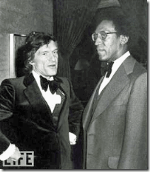
A pentagram representing the five wounds of Christ in itself is a true statement of some of its early, selective and most absurd history.[49] Hugh Hefner– DEVIL and the PENTAGRAM with Bill Cosby & MK ULTRA in the background associated with CIA, I really don’t think anyone really believed Paige was trying to make any connection with her death and an ancient absurd symbol of the five wounds of Christ. It was a clever devise to confuse the masses. It was a cover-up.

The Pentagram is also known as the Sigil of Baphomet. The Sigil of Baphomet is the official insignium of the CHURCH OF SATAN, and is trademarked by the organization.[50] Both Hefner and Cosby were Luciferian/ILLUMINATI within HollyWeird’s close circle of influence of Anton LeVay and the CHURCH OF SATAN. END OF PART I

[1] http://www.businessinsider.com/sony-exec-calls-kevin-hart-whore-2014-12
[2] http://www.drphil.com/shows/show/2333/
[3] http://www.huffingtonpost.com/2014/12/07/hugh-hefner-bill-cosby-sexual-assault-allegations_n_6284676.html
[4] http://theforbiddenknowledge.com/symbology/1o5.htm
[5] http://www.pseudoccultmedia.net/2009/06/monarch-playboy-kittens-next-door.html
[6] http://dictionary.sensagent.com/banality%20of%20evil/en-en/
[7] http://www.freerepublic.com/focus/chat/2164567/posts
[8] http://www.freerepublic.com/focus/chat/2164567/posts
[9] https://americanheritagecenter.wordpress.com/2011/11/10/a-c-ivy-papers-document-medical-history-and-cancer-research/
[10] http://spacemedicineassociation.org/sma/history1950/
[11] Jacobs, Annie, Operation Paperclip, the Secret Intelligence Program that Brought Nazi Scientists to America, Little Brown and Company, NY, NY (2014) pg. 455
[12] Id. at pg. 466
[13] http://tolma.blogspot.com/
[14] http://tolma.blogspot.com/
[15] http://en.wikipedia.org/wiki/Donald_in_Mathmagic_Land
[16] https://deeppoliticsforum.com/forums/showthread.php?6630-Operation-Paperclip-CIA%E2%80%99s-Denial-of-Protecting-Nazis-is-Blatant-Lie-Part-1
[17] Albarelli, Jr., H.P., A Secret Order, Investigating the High Strangeness and Synchronicity in the JFK Assassination, Vol. 1, Trine Day LLC, Walterville, OR (2013) pgs. 149-150
[18] Id., pgs. 149-150
[19] Jacobs, Annie, Operation Paperclip, the Secret Intelligence Program that Brought Nazi Scientists to America, Little Brown and Company, NY, NY (2014) pg. 243
[20] Id. at pg. 244
[21] http://www.topsecretwriters.com/2012/02/project-chatter-navy-lsd-experiments/
[22] http://www.mygen.com/users/ufo/The_Sequoia_Seminars_History.html
[23] http://www.topsecretwriters.com/2012/02/project-chatter-navy-lsd-experiments/
[24] Id.
[25]http://translate.google.com/translate?hl=en&sl=de&u=http://de.wikipedia.org/wiki/Geheimer_Medizinalrat&prev=search
[26] http://www.navytimes.com/story/military/2014/12/04/bill-cosby-sexual-assault-navy-chief-honor-revoked/19897577/
[27] http://forum.prisonplanet.com/index.php?topic=153737.40
[28] https://sites.google.com/site/mcrais/bluebird
[29]https://sites.google.com/site/mcrais/bluebird
[30] http://intheknow7.wordpress.com/2010/03/25/kissinger-palin-mengele-how-deep-does-the-rabbit-hole-go-monarch-mind-control-global-management-team-pt-1/
[31] https://sites.google.com/site/mcrais/bluebird
[32] http://www.public.navy.mil/fcc-c10f/niocmd/AnchorWatch/AW_2011_04-18.pdf
[33] http://en.wikipedia.org/wiki/Hospital_Naval
[34] http://en.wikipedia.org/wiki/Juan_Per%C3%B3n
[35] http://en.wikipedia.org/wiki/Hospital_Naval
[36] Id.
[37] http://www.history.com/this-day-in-history/peron-deposed-in-argentina
[38] http://en.wikipedia.org/wiki/Adolf_Eichmann
[39] http://www.nndb.com/gov/234/000043105/
[40] Jacobs, Annie, Operation Paperclip, the Secret Intelligence Program that Brought Nazi Scientists to America, Little Brown and Company, NY, NY (2014) pgs. 103-105
[41] http://www.scientistsandfriends.com/rockets3.html
[42] http://tvtropes.org/pmwiki/pmwiki.php/Series/ISpy?from=Main.ISpy
[43] http://ispy65.tripod.com/id64.htm
[44] http://www.pseudoccultmedia.net/2009/06/monarch-playboy-kittens-next-door.html
[45] http://www.dailymail.co.uk/news/article-2857873/Passed-Bill-Cosby-Hugh-Hefner-dozens-Hollywood-honchos-Playboy-Playmate-Month-felt-used-abused-powerful-leading-men-took-gun-shot-head.html
[46] Id.
[47] Id.
[48] Id.
[49] http://en.wikipedia.org/wiki/Pentagram
[50]http://en.wikipedia.org/wiki/Sigil_of_Baphomet
Comments : 7 Comments
Tags: Allen Dulles, anton levay, Artichoke project, aryan supremacy, Banality of EVIL, Bethesda Naval Hospital, Big Black Brute, bill cosby, black cinema, BLUEBIRD Project, Bob Hope, caliban, CHURCH OF SATAN, Dachau, Dachau Doctors Tribunal, dark messiah, Dean Martin, Dr. Andrew C. Ivy, Dr. Charles Savage, Dr. Herbert Wagner, Dr. Hubertus Strughold, Dr. Sigmund Rascher, Dr. Theodor Benzinger, Ernst Holzloehner, eva peron, ewen cameron, frank sinatra, gold diggers, greek god pan, Heinz Haber, holocaust, hugh hefner, I Spy, Illuminati, john huston, josef mengele, Jr., juan peron, kevin hart, Knights of the Black Sun, Konrad Johannes Karl Buettner, Korean War, last supper, Leonardo da Vinci, Lucifer, Ludwig Von Drake, mafia, Major Gen. Harry G. Armstrong, MK-ULTRA, Naval Hospital Argentina, Naval Medical Research Institute, Negro buffoonery, north korea, operation paperclip, otto adolf eichmann, Paige Young, playboy bunnies, PROJECT CHATTER, sammy davis, satan, Satanic Principle of Dualism, Sex kittens, sex slaves, sony, sony pictures entertainment, SS, st. john's gesture, U.S. Army Air Force Aero Medical Center, Vice Admiral William Francis Rabon, vril, VRIL Satanic Inner Circle, vril society, Walter Reed National Military Medical Center, Willy Fielder
Categories : 1000 Year Reich, Aryan Supremacy, baphomet, Black Manchurian Candidates, blood covenants, blood oaths, bloodline of wotan, brain entrainment, church of satan, CIA, Crimes Against Democracy, devil, Devil’s Bible, Dr. Charles Savage, Dr. Josef Mengele, dualism, frank sinatra, genocide, gloria allred, Heinrich Himmler, illuminati, inverted pentagram, jesus christ, Josef Mengele, Knights of the Black Sun, leonardo da vinci, lucifer's servants, luciferians, manchurian candidates, mind control, MK-ULTRA, monarch child, monarch program, Nazis, Obersturmbannführer SS Otto Adolf Eichmann, OLYMPIANS, Operation PAPERCLIP, Paperclip Project, Peenemunde Missile Base, project bluebird, psychological warfare campaign against Christianity, racial mass murder, Reichsfurhrer SS-1 Heinrich Himmler, Rosicrucian, sammy davis, Satanism, set, seth, sex kitten, sex slave, SS, Strumbannfuhrer SS Dr. Wernher von Braun, trauma-based mind control, underground reich, underground third reich, vril, Walt Disney

ADRIAN PETERSON, LITTLE TYRESE & THE NINTH SATANIC CIRCLE CHILD SACRIFICE CULT
30102014
“This case is SO MUCH BIGGER than you think. It goes to the very HIGHEST Levels; we have to keep pulling the strings.”
-William Colby, Former Director of the CIA, Investigator of the Franklin Cover Up (WHY JOHNNY CAN’T COME HOME)
HAIL SATAN
Hail Adrian!
The name Adrian has become associated with MYSTERY, evil and darkness, “The Dark One.” [1] The name Adrian is particularly associated with Roman Polanski’s HollyWeird’s blatant Satanic/ILLUMINATI cult movie, Rosemary’s Baby. Polanski is no joke. He is an international sex crime criminal and fugitive from justice. Polanski is an elite member of a secret powerful international Luciferian Pedophile Ring that is linked to the Ninth Gate– the Ninth Satanic Circle. If you have not seen Polanski’s movie, the Ninth Gate, I suggest that you review it.
HAIL ADRIAN!
“Satan is his father, not Guy. He came up from hell and begat a son of mortal woman. Satan is his father and his name is ADRIAN. He shall overthrow the mighty and lay waste their temples. He shall redeem the despised and wreak vengeance in the name of the burned and the tortured. Hail, ADRIAN! Hail, Satan! God is dead! Satan lives! The year is One, the year is One! God is dead”[2]
Nike & Adrian- Reptilian or Satanic Maybe Both
In the above odd and strange Nike commercial video, look at Adrian‘s skin- reptilian or the DEVIL consistent with Rosemary’s Baby? It appears that Adrian would only go so far with the Luciferian Agenda. It also appears that he didn’t execute the Satanic Covenant of Secrecy, Fame and Fortune. If he did, he would still be playing professional football.
Nevertheless, the name Adrian is actually associated with “water” and the ancient Etruscan port and settlement of Adria in Northern Italy, situated between the mouths of the rivers Adige and Po.[3] Its classical period is associated with between 530 and 520 BC.[4] There is considerable controversy surrounding the settlement of Adria more ancient than the Etruscans. Even among some of the ancients, Adria and the early Bronze age Villanovan settlement was an outpost of the Tyrrhenians (Ancient Land of Tyre).[5]
Tyre was one of the main cities of Ancient Canaan (Phoenicia).[6] Canaan‘s most ancient mystery schools were based on the Kemetic Mysteries and Drama of Osiris and Isis.[7] Ancient Canaan is known as the Land of PALESTINE.[8] In the ancient world, the Greeks knew the Canaanites as Phoenicians– Greek for “PURPLE.”[9]
DEUTERONOMY 20:16-17
“But of the cities of these people, which the LORD thy God doth give thee for an inheritance, thou shalt save alive nothing that breatheth; But thou shall utterly destroy them; namely the … CANAANITES …; as the LORD thy God hath commanded thee …”
The widespread murder and genocide committed by the barbaric desert tribes of Ashkenazi/Hyksos against innocent CANAANITE elders, women and children has caused quite a bit of theological debate and controversy. Often, the genocide is based on the Divine Command Theory. God has the right to command an act, which, in the absence of a divine command, would have been sin (thou shall not kill), which is morally obligatory in virtue of God’s Command.[10]
The LORD that ordered the invading nomadic Ashkenazi/Israelites to murder the CANAANITES (Children of Osiris and Isis) recounted in DEUTERONOMY was the adopted LORD of the barbarian Hyksos, Osiris’ JEALOUS brother GOD SET– SETH, SATAN, LUCIFER.
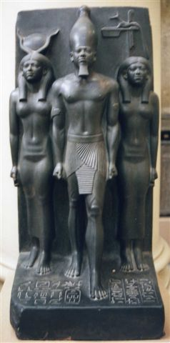
In 2013, the Sphinx of the Great Pharaoh Menkaure was uncovered at an ancient site in Tel Hazor National Park, north of the Sea of Galilee in Israel. Menkaure was a Pharaoh of Kemet’s Great Pyramid Age, the 4th Dynasty. He is the builder of the 3rd great pyramid in the infamous Gaza Plateau. Menkaure’s pyramid at Giza is called Netjer-er-Menkaure which means “Menkaure is Divine“. Israeli archeologist falsely claim that they don’t know where Kemetic artifact came from. The Great Pharaoh Menkaure was in the Land of Canaan before the Ashkenazi/Hyksos invasion. Menkaure was one of the Sons of Osiris (Ausar).
SATAN versus PURPLE JESUS OF PALESTINE
For the Luciferians, the Battle for Adrian Peterson’s Soul is as old as it is SYMBOLIC. There is old saying in HollyWeird, God give you the talent, but SATAN give you the fame. Luciferians are under the assumption that Adrian Peterson owe the ILLUMINATI for his fame, glory and fortune. What belongs to the Canaanite of Palestine is theirs to take. These people intend to collect from Adrian with “absolutely no moral imperatives at all.” So COMMANDS the Lord of Darkness, King of Hell, Ruler of the Earth, God of this World! God- Who invites us to become as gods.[11
Adrian Peterson isn’t particularly known as a crusader of any real issues, controversial causes or opinions. He isn’t known for his radical conscious, any intellectual or educational endeavors or accomplishments. Adrian is a man from humble beginnings- born and raised in the back woods of PALESTINE, Texas with all its Badges, Ravages and Horrors of Slavery, and Reconstruction.

However, he’s not just an ordinary regular country brother, either. Mind, body and soul, Adrian transformed himself into an awesome world class, prominent and respected athlete of color. In 2011, he signed a 6 year / $86.28 million contract with the Minnesota Vikings, including a $12,000,000 signing bonus, $36,000,000 guaranteed, and an annual average salary of $14,380,000.[12]
In 2013, he was named as the NFL’s most valuable player. In a league dominated by accomplished and well publicized quarterbacks, it was quite a compliment and acknowledgement of his achievement in America’s greatest past time. Adrian earned the MVP award over Denver Broncos Quarterback Peyton Manning after receiving 30.5 of the 50 votes by an Associated Press panel of NFL writers.[13]
In 2013, Adrian had one of the more remarkable seasons in NFL history. Just eight months after tearing his anterior cruciate ligament (ACL) and his medial collateral ligament in a game in December 2012, , he managed to put together one of the best seasons ever by a running back. Adrian rushed for 2,097 yards and 12 touchdowns and came just eight yards shy of Eric Dickerson’s single-season rushing record.[14]

It takes a normal human being up to a year to recover from ACL surgery alone. But within four months of ACL surgery, this remarkable and awesome human being was back on the practice field that left even the medical profession in utter AWE.[15] In the game of football, we have come to expect excitement each time Adrian touches the ball, he’ll reach almost epic and heroic proportions on the field of play that he gives the Glory to Christ.

“Without Him [Jesus Christ], doing this recovery, I had no chance – at all! No chance to do this on my own. He kept my mind at ease, doing the rehab. For me, because I’ve used this principle my whole life, it was so easy to buy into it and know; put this in God’s hand, have faith; that simple process, your principles that you have, having faith and believing …”[16]
Adrian has always been outspoken about his Christian Faith. His immense success on the field has gained him the nickname “PURPLE JESUS,” a title which he has said he understands, but doesn’t necessarily support due to his Christian Faith.[17]
“The Klansmen Pins his Faith to the Bible as the Revealed Will of GOD.”[18]
In fact, many active Klansmen were/are ordained ministers of the Christian Faith.[19] However, Adrian‘s unbroken connection to the faith, doctrine and practices of Christianity is not necessarily as that biblically revealed by the Will of God, but is still deeply rooted in the Faith in the Will of God in the African Struggle for justice, freedom and liberation in America. Christianity for Black people has become almost equivalent to the Rod, Sword and Shield to overcome by the Will of God- the constant STRUGGLE against racism, and the principalities of EVIL (Ephesians 6:12).
Throughout his career, Adrian Peterson has remained basically a “God, Country and Football” man. When a man of color reach the global public prominence and heights that Adrian has reached by Faith in the Will of God, he becomes a global SYMBOLIC threat to the New World Order (NWO). He becomes a target by some of the most clandestine, powerful, cold-blooded and dangerous Luciferians on the face of the planet.
Either he must do the work of SATAN or be reduced to a condition akin to that of slavery. He will no longer be a symbol, hero or an inspiration to anyone to struggle against universal racism, and the principalities of EVIL, the NWO.

Erica Syion, Mother of One of Adrian’s Sons, shows off her Classic MK ULTRA/MONARCH Sex Kitten Leopard Spots
Needless to say, Adrian’s prominent celebrity status along with an annual salary over $14 million draw a lot of attention and clandestine company with a Satanic/ILLUMINATI agenda to appeal to his weaknesses for the flesh of STRANGE and DANGEROUS WOMEN that he has been left deliberately DISABLED to decode. In fact, once a target of Luciferians very few people understand the codes to overcome a comprehensive offensive program to destroy them by legions and networks of the Secret Satanic Brotherhood.
The Secret ILLUMINATI Ninth Circle Satanic Child Sacrifice Cult network
the Nines & Child Sacrifices
The video above was published in November 2012 before the widespread international exposure of the Ninth Circle this year. Five international judges are examining evidence of child rape, torture, murder and kidnapping allegedly done by global ILLUMINATI elite members of the Ninth Circle Satanic Child Sacrifice Cult network that includes British Royalty and the Bilderberg Group. Regular Ninth Circle child sacrifices were said to take place in the catacombs of Catholic Cathedrals, the Vatican, on private estates and Groves and government military bases in Belgium, Holland, Spain, Australia, Ireland, France, England and the United States.
A prior ICLCJ document claimed other Ninth Satanic Circle members included Montreal Catholic Archbishop Christian Lepine and a prominent billionaire- George Soros has been identified by eyewitnesses as being at Ninth Satanic Circle hunting parties in the Netherlands. Children were stripped naked, raped, hunted down and killed – as were children in an Australian CIA/MK ULTRA mind control program according to an eyewitness.
In August 2014, officials of the International Common Law Court of Justice (ICLCJ) in Brussels, Belgium in conjunction with Montreal police raided a secret Ninth Satanic Circle gathering where two children were scheduled to be sacrificed. Among those arrested were two Americans from bordering states of South Dakota, Cargill Corporation Executive Kerry Brick of Wayzata, MINNESOTA, and Sinclair Oil Executive Stephen Holding of Sun Valley, IDAHO.
MURDER IN SOUTH DAKOTA, Little Tyrese

MURDER is the unlawful killing, with malice aforethought, of another human. Most societies both present and in antiquity have considered MURDER a most serious crime worthy of the harshest of punishment, under the justification that commission of MURDER is highly detrimental to good order within society.[20] Since the beginning of recorded history, MURDER has been one of mankind’s most heinous crimes against society and civilization. The cold blood MURDER of Adrian’s beautiful and innocent 2 year old son Tyrese Robert Ruffin (Peterson) in South Dakota under odd and strange circumstances as set out below is completely outside the area of arguable conspiracy theories and Satanic/ ILLUMINATI and New World Order speculative theories. When their activities involve the high crime of MURDER involving an innocent two year old child, the debate ENDS and the search for his true clandestine Assassins BEGINS.
Racial MURDER & Satanism in South Dakota
The remote State of South Dakota has been a virtual open killing ground for institutional racial murder for several generations. This virtual cult of murder is now veiled and shrouded in the occult. It is buried deeply underground protected by Masonic and Satanic blood oath covenants of secrecy. South Dakota is remote and far from the public eye and any significant populations of color. This hidden cult of racial murder and of the occult surrounded defenseless Little Tyrese Robert Ruffin (Peterson) in South Dakota.
Racial Genocide- Wounded Knee, South Dakota
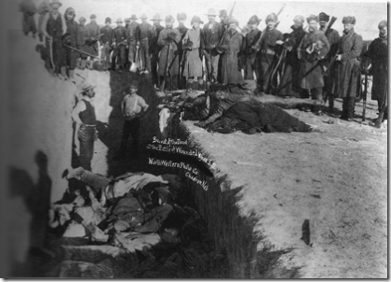
“And here I find the great distinction between the faith of the Indian and the white man. Indian faith sought the harmony of man with his surrounding; the other sought the dominance of his surrounding. In sharing, in loving all and everything, one people naturally found a due portion of the thing they sought, while, in fearing, the other found need of conquest.“
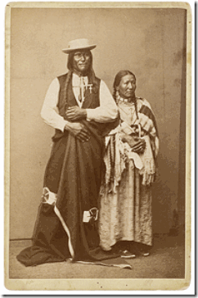
Chief Luther Standing Bear, above, (1868-1939), Chief of Oglala Sioux Tribe- he witnessed the slaughter of unarmed men, women, and children at Wounded Knee in 1890.[21]
It was after a night so cold in the winter that the Lakota called it “The Moon of the Popping Trees” because as the winter winds whistled through the hills and gullies at Wounded Knee Creek on that morning of December 29, 1890, one could hear the twigs snapping in the frigid air.
When a soldier of George Armstrong Custer’s former troop the 7th Cavalry tried to wrest a hidden rifle from a deaf Lakota warrior after all of the other weapons had already been confiscated from Sitanka’s (Big Foot) band of Lakota people, the deafening report of that single shot caused pandemonium amongst the soldiers and they opened up with their Hotchkiss machine guns upon unarmed men, women and children. Thus began an action the government called a “battle” and the Lakota people called a “massacre.” The Lakota people say that only 50 people of the original 350 followers of Sitanka survived that morning of slaughter.[22]
The Wounded Knee bloodbath and massacre wasn’t necessarily the result of the U.S. Bureau of Indian Affairs feared militancy of the Lakota Ghost Dance. Wounded Knee was part of veiled general plan for racial genocide and Lakota removal from tribal lands on a permanent basis. Approximately 90 million of the 138 million acres of Native American territory became white-owned in just forty-five years.[23]
As the House Indian Affairs Committee Minority Report of 1880 attests:
The real aim of [the Dawes Act] is to get at the Indian lands and open them up to settlement. The provisions of the apparent benefit of the Indian are but the pretext to get at his lands and occupy them. With that accomplished, we have securely paved the way for the extermination of the Indian races upon this part of the continent. If this were done in the name of Greed, it would be bad enough; but to do it in the name of Humanity, and under the cloak of an ardent desire to promote the Indian’s welfare by making him like ourselves, whether he will or not, is infinitely worse.
House Indian Affairs Committee, Minority Report, H.R. Rep. 46-1576, at 7-10 (1880)
South Dakota is bordered by the states of North Dakota, Minnesota, Nebraska, Wyoming, and Montana. The state is named after the Lakota and Dakota Sioux Native American tribes.[24] South Dakota has an estimated population of 833,354. In 2012, the Census Bureau estimated that 86.2% of South Dakotans were White, 8.9% were American Indian or Alaskan Native, 3.1% were Hispanic or Latino, 1.7% were Black or African American. In the 2000 census, the five largest ancestry groups in South Dakota were: German (40.7%), Norwegian (15.3%), Irish (10.4%), Native American (8.3%), and English (7.1%).[25]
Little Tyrese & Old World European Dualism

Janus is an Ancient Roman God for Chaos and Deception secretly adopted by the ILLUMINATI. He is a god of Double Nature, symbolized in his two headed image. His two faces were originally one clean-shaven and other bearded that represented the sun and the moon. He was usually depicted with a key. The Janus head is a popular phrase for “Deception.”[26]
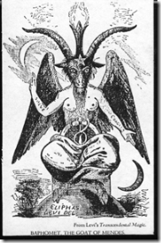
The origin of the name Janus is without any doubt, the Roman Demon God, Bifrons. Bifrons was also one the names given to the BAPHOMET worshipped by the Knights Templar, and which description was as a statue with two heads surely inspired in the Roman God Bifrons, one looking towards the left to tell the past, and the other looking towards the right to tell the future, all this by means of the Power of a Demon. It is also said the Janus-Bifrons appeared as a monster and then changed his appearance to that of a man. Janus-Bifrons is a shape-shifter.[27]
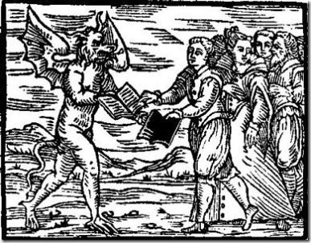
Rare 16th Century Woodcut Showing Old World Europeans Willfully Swapping Their Books of Salvations for the Works of the Devil (SATAN)
Medieval Satanic Woodcuts make it abundantly clear that Europeans understood that there was SATAN, and it is not at all an invention of Christianity. During the Middle Ages, they worshiped and practiced his works- SATANISM. And, it appears far too often that Christianity and Satanism were part of a strange phenomena of bedfellows that made up the nature of Old World Dualism that we have yet to fully decode. However, Native Americans referred to European two-faced “dualism” as speaking with a “forked tongue.”
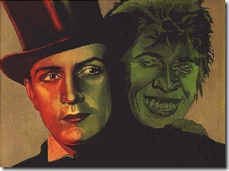
The phrase “speaks with a forked tongue” means to deliberately say one thing and mean another [deception] or, to be hypocritical, or act in a duplicitous manner.[28] That could also include a “duplicity” such as in the case of good and evil – A study in dualism: The strange case of Dr. Jekyll and Mr. Hyde.[29]
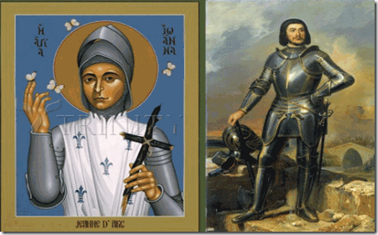
Satanic two-faced dualism is illustrated in an infamous case in the European medieval “Body of Christ.” Gilles de rais (1404–1440) of France, rode by the side of the Legendary Heroine of France and Roman Catholic Saint Joan of Arc. (1412–1441) and served as her chief lieutenant, fighting with such fierce merit that King Charles VII (1403–1431) later awarded de Rais the title of Marshal of France. Gilles de rais was/is accused of having slain as many as 800 Children as sacrifices to SERVE SATAN,[30] In fact, the secret Ninth Circle Satanic Cult may date from the times of Gilles de rais and the 15th Century.
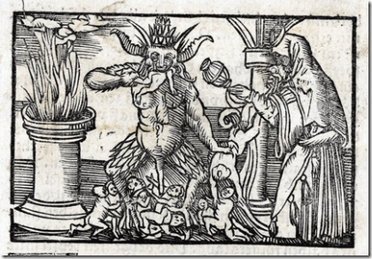
Rare Medieval Woodcut of the Sacrifice of Children to SERVE the DEVIL
Whether you know it or not, children by the thousands continue to be clandestinely sacrificed to Gilles de rais’ Old World SATAN . In 2014, the International Common Law Court of Justice (LCLCJ) in Brussels is continuing to investigate numerous children’s deaths connected to the Ninth Circle Satanic Child Sacrifice Cult network. Death certificates were released on the 796 Irish children, ages two months to nine years, found in a cistern (septic tank) used as a mass grave at the Catholic St. Mary’s Mothers and Babies Home near Taum, Ireland. LCLCJ forensic experts have confirmed the decapitation and dismemberment of babies in the mass grave resembled the usual signs of ritualistic murder. The Ninth Circle was/is directly linked to underground Satanic Cult networks in South Dakota.
Little Tyrese & Wodin
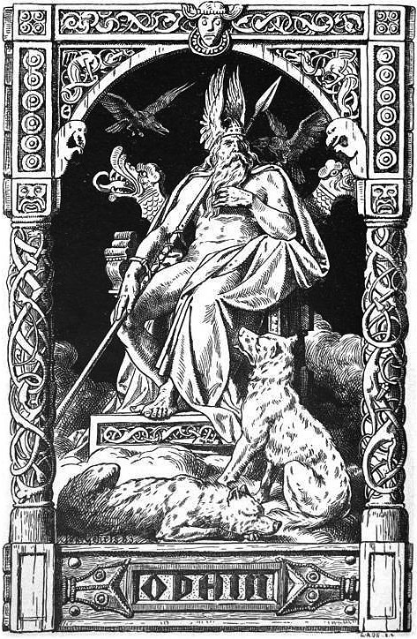
“We will of course not let them know about Wotan [Wodan].” –Reichsminister Paul Josef Goebbels-[31]
The evidence for human sacrifice in the period of the Iron Age is most prolific in Denmark, Germany and Holland, where many bodies have been found completely preserved in peat bogs. Some were hanged or strangled, the noose still around their neck, and others were BLUDGEONED on the head or had their throat slit.[32]
In fact, Little Tyrese’s October 22nd gathering of fellowship for friends and acquaintances was held at the First Evangelical Free Church in Sioux Falls.[33] The Evangelical Free Church of America (EFCA) is an evangelical Christian denomination that also pin their faith like the Klan to the Bible as the Revealed Will of God.[34] EFCA was formed in 1950 from the merger of the Swedish Evangelical Free Church and the Norwegian-Danish Evangelical Free Church Association.[35]
The Church of Sweden goes back to the Middle Ages commingled with Norse Paganism and other pre-Christian religious systems that survived in the territory of what is now Sweden; for instance the important religious center known as the Temple at Uppsala at Gamla Uppsala was evidently still in use in the late 11th century.[36] The temple was dedicated to Wodan (Odin) and Fricco (Freyr).[37]

I doubt very seriously if Adrian truly understands what’s really going on Underground in and around Minnesota and a Viking Culture.
Norway, Land of the Odin and the Vikings, is the only country in Northern Europe with wooden churches from the Middle Ages still intact.[38] Christianity in the three pagan warlord kingdoms of Denmark, Norway, and Sweden all took shape along the same time period in the Middle Ages along beside Wodan’s (Odin) pagan Temple at Uppsala as above.[39] What was going on at Wodan’s Temple?
“Like Odin, Wodan was the god of hanging. The Cimbri sometimes hanged their captives over the bronze cauldrons, while the priestess cut their throats. These sacrifices to Wodan would then later be thrown into sacred lakes.”[40]
Down the Rabbit Hole, Little Tyrese & the Masonic Order

Just how deep are you willing to sink down the Rabbit Hole? Little Tyrese’s Celebration of Life Ritual was held at Sioux Falls’ El Riad Temple.[41] On May 25, 1888, the first ceremonial of Nobles of the Mystic Shrine held in Dakota Territory, was called to order in Sioux Falls by W. D. Stites, first Illustrious Potentate of El Riad Temple. The ceremonial was held under dispensation on May 25, 1888 and a “Class of 33” was taken into El Riad Temple. El Riad Temple was instituted by El Kahir Temple of Cedar Rapids, Iowa.[42]
A Masonic Temple is reserved for Satanic Freemasons. It’s pretty clear that whoever organized Little Tyrese’s Celebration of Life ritual was a Satanic Freemason. The ritual itself is a Humanist ceremony. The ritual is conducted by a Humanist Celebrant that believes that there is no soul or other supernatural component of the human personality that can in any way survive after physical death. The Humanist Manifesto II is very similar to the Satanic Bible. Anton LaVey’s Satanism is a form of Humanism. Whereas, a Celebration of Life ritual could very well be a Satanic Ritual.
El Kahir & Albert Pike-Arkansas Grand Dragon of the Invisible Knights of the Ku Klux Klan of the Ole Southern Satanic Brotherhood
In 2011, the El Kahir Temple of Grand Rapids was exposed to have been a “Clandestine Masonic Membership Shrine” under the jurisdiction of the Satanic Grand Lodge of Arkansas. [43] The Grand Lodge of Arkansas meet in the Satanist/Grand Dragon of the Klan Confederate General ALBERT PIKE’s Memorial Temple, PIKE’S old home, built in 1838.[44] Recall that Pike was the secret Old World European ILLUMINATI representative for North America. The Ole Southern Satanic Brotherhood that he helped to create in America is part of the Old World ILLUMINATI Satanic (Ninth Circle) network.
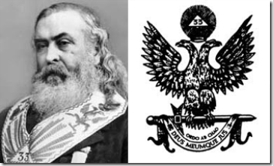
Pike & Janus- Dual Headed Masonic Eagle
Pike was appointed Grand Orator of the Grand Lodge of Arkansas on November 7, 1864, from 1853 onward he was, at various times, chairman of numerous committees and boards.[45] Before the Civil War, Arkansas Freemasons had made two bold moves. In 1853, they established the library of the Grand Lodge of Arkansas with Pike as chairman. It is the second-oldest library in the state. In 1859, they opened ST. JOHN’s College in Little Rock and educated and indoctrinated many of the state’s leaders.[46]
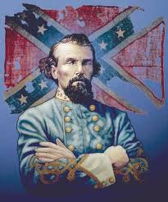
“Albert Pike organized the Ku Klux Klan in Arkansas after General [Nathan Bedford] Forrest appointed Pike the Grand Dragon of that Realm. The Tennessee leaders of the Klan at the time of its founding were prominent Masons subordinate to Grand Commander Pike.”[47]
In the decade after the Great War, Freemasonry was reestablished slowly in every section of Arkansas. By the end of the nineteenth century, there were 12,522 Masons in 442 lodges, and ALBERT PIKE (1809- 1891) was the best known Mason in Arkansas and most likely in South Dakota.[48]
Since its establishment as a state on November 2, 1889,[49] South Dakota and its predominately superstitious and dualistic natured European-Germanic population have been under the iron grip and influence of secret networks of Old World Secret Satanic Societies and the Ole Southern Satanic Brotherhood. The old families of South Dakota are undoubtedly deeply inter-related and associated with Secret Old World Bloodline and Blood Oath Secret Satanic/Masonic Based Societies such as the International Shriners, Benevolent and Protective Order of Elks and Albert Pike’s Ancient and Accepted Scottish Rite, and Freemasonry.
South Dakota & Old World Ninth Circle Satanic Child Sacrifice Cult

The global elite Old World Ninth Circle Satanic Cult is also secretly based in South Dakota. It is involved in the routine and systematic kidnapping, rape, torture and SACRIFICIAL MURDER of new born infants and children up to age fourteen.[50] According to witnesses in a federal lawsuit, the Ninth Circle Satanic Cult is globally based and centuries old, operating at Roman Catholic cathedrals in Montreal, New York, Rome, London and dozens of other locations, including at protected forest groves in America, Canada, France and Holland. It routinely utilizes children taken from Catholic orphanages, adoption agencies, hospitals and schools.[51]
“Catholic Jesuit priest involvement in Ninth Circle Satanic Cult rituals at the Mohawk school in Brantford Ontario Canada is confirmed in correspondence from school principals as far back as 1922. Similar Jesuit sacrificial rituals using small children and newborns for sacrifice rites at CATHOLIC INDIAN SCHOOLS IN SOUTH DAKOTA and Omak, Washington are attested to by eyewitness Clarita Vargas in an affidavit entered into our docket material.”[52]
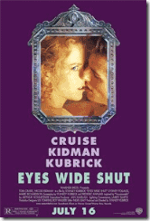
Actress Nicole Kidman of HollyWeird’s Satanic Flick Eyes Wide Shut psychologist father, Dr. Anthony Kidman, was linked to the Cult. When he was exposed in Australia as a master programmer and ring leader of an exclusive and elite Sydney pedophile ring linked to the Ninth Circle Satanic Cult, he suddenly ended up dead in Singapore.[53]

HollyWeird’s Nicole Kidman and Dr. Anthony Kidman, formerly of the Ninth Satanic Circle
After the collapse of Lawrence King’s Omaha, Nebraska CIA Satanic and Pedophilic Franklin Federal Credit Union, the federal credit union insurance fund repaid nearly all depositors 100 % of their deposits. The single big glaring exception was a South Dakota Sioux Falls order of Roman Catholic nuns that lost $2 million because its certificates of deposit exceeded the $100,000 insurance limit.[54] Secret Old World Satanic undergrounds, clandestine Masonic and the CIA/MK ULTRA Occult Bureau’s roots also runs deep in South Dakota.
Ahnenerbe, CIA Occult Bureau, Ninth Satanic Circle & South Dakota
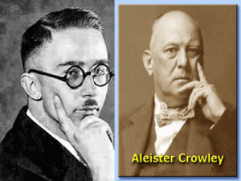
The Occult Bureau within the Third Reich was established by Lucifer’s Son, Reichsfuhrer SS- 1 Heinrich Himmler. It was called the Ahnenerbe. The true nature of the Ahnenerbe is difficult to describe because it was and still is surrounded by layers of blood oath secrecy even in America. Generally, it was billed as a study society focused on the anthropological and cultural history of the Aryan race. However, the Ahnenerbe more closely resembled an “Occult Society” with a secret budget the size of the Nazi General Staff or Department of Defense.[55]
“In April 1945, American troops stumbled across a massive cache of Ahnenerbe files hidden in a dark, dank cave called Kleines Tuefelsloch (the LITTLE DEVIL’S HOLE) near the Bavarian village of Pottenstein. For the next four years, America intelligence officials closely studied the captured documents, eventually sending many to the Army’s Edgewood Arsenal and Camp Detrick.”[56]
Actually, the American recovery of Ahnenerbe cache of files was part of a pre-arranged highly classified package of plans of Allen Dulles, Himmler and Operation Paperclip to covertly change the SS (Knights of the Black Sun) venue from Europe to America.
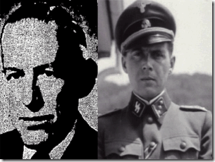
The Ahnenerbe Secret Files became the basis of classified CIA/MK- ULTRA Occult Bureau Mind Control and Mass Population Control Experiments and Programs under Hauptsturmführer SS Dr. Josef Mengele, and Dr. Luther W. Greene (L. Wilson Greene), Technical Director of the Chemical and Radiological Laboratories at the Army Chemical Center at Edgewood Arsenal, Harford County, Maryland.[57]
There is testimony of a CIA/MK ULTRA test subject who was subjected to ritual trauma based electrical-shock, LSD, radiation, rape, dislocation of joints, chemical and drug experimentation as a child that had been sent to a special school with many other children and taught how to sexually please men and entrap them, and that Dr. L. Wilson Green, Dr. Mengele and others of the CIA routinely used them as sex slaves and special covert congressional sexual blackmail espionage agents that lead directly to South Dakota.[58] In fact, within the last couple of months, links are being developed connecting Dr. L. Wilson Greene and the CIA with aiding and abetting the Ninth Satanic Circle by supplying it with ritual Satanic abused mind altered child victims.
Ninth Satanic Circle Network, White House & South Dakota

“[T]he D.C. resident expert on South Dakota politics” and the underground pinnacle of its POWER was Jeff Gannon aka James D. Guckert- male prostitute/ escort and Republican right wing activist that worked as a quasi-press reporter without credentials at the George W. Bush White House.[59]
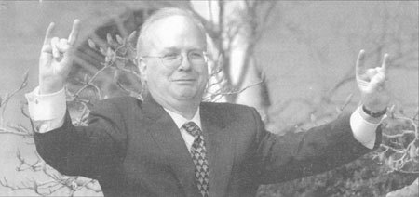
Hail SATAN- President George W. Bush’s Senior Advisor and Deputy Chief of Staff- Karl Rove
Jeff Gannon had been part of Karl Rove’s subversive Satanic “Dominant Political Creed in America.”[60] Gannon “nom de ho Bulldog“[61] says that he met Rove only once, at a White House Christmas party.[62] Well, I don’t think anyone in the “Beltway” really believes that. Around Washington, Gannon had been known as Rove’s “Good Friend.”
“Karl [Rove] used to hang out at JR’s, which is on 17th between P&S, before he became so well-known. This is a “respectable” gay bar for discreet people who do not wear mesh panties, high-heeled pumps and wear terrible wigs.”[63]
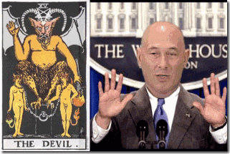
Some maintain that Gannon, above, was issued U.S. Secret Service press credentials by Karl Rove at President George W. Bush’s request.[64] Rove has secret ties to a powerful and vicious underground (UNDERNEATH) conservative political homosexual creed (circle) of national political bloggers such as “nom de ho Bulldog“ Jeff Gannon.
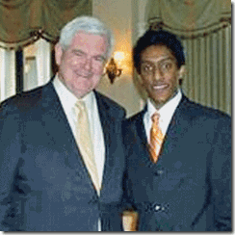
Bulldog National Blogger Ali Akbar & Republican Heavy Newt Gingrich
Rove is said to have been a lover of a conservative Texas Republican Party national political blogger, Ali Akbar. Akbar is another one of Rove’s secret CREED of dominant conservative Republican homosexual bulldogs. Akbar is traced to Ellis County, Texas, where he worked for a news web site called the Ellis County Observer.

Akbar’s work apparently involved covering up the misdeeds of a former police chief named Michael Meissner, who was charged with posing as a woman and soliciting photos of under- aged boys.[65] That’s the way Rove’s “Dominate Satanic Creed “roll.
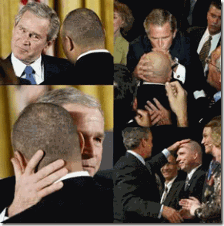
President Bush and Rove’s Favorite Bulldog Fake White House Reporter- Jeff Gannon
“Cable television news reports have recently linked an alleged male prostitute to the present White House since George W. Bush permitted James Guckert to use an unprecedented Secret Service-approved alias (Jeff Gannon) while having access to the White House for two years as a pool reporter serving the younger Bush–before which Gannon had advertised himself on internet pornography sites as a male “escort” charging $200 an hour. [Gannon is the subject of independent news reports which have referred to him as the former kidnapped Des Moines, Iowa paperboy JOHNNY GOSCH–forced into child sex-slavery.] John DeCamp told this writer “I believe Johnny Gosch and Jeff Gannon are one and the same person–but I am not in a position to know positively.”[66] Recall, Iowa is a border state of South Dakota.
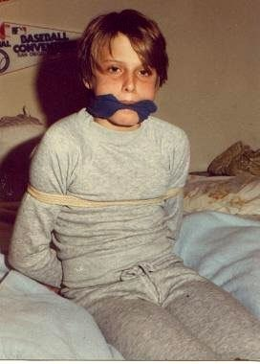
On February 5, 1999, in a civil action in a U.S. District Court in Lincoln, Nebraska, Paul Bonacci, a former child CIA/MK ULTRA sex slave at the center of a secret powerful and elite pedophile ring (Franklin Scandal and Cover-Up) exposed some enormously chilling and explosive details involving the JOHNNY GOSCH aka JEFF GANNON abduction linked directly to the White House, CIA, Lt. Col. Michael Aquino, Pentagon and the U.S. Military Industrial Complex.
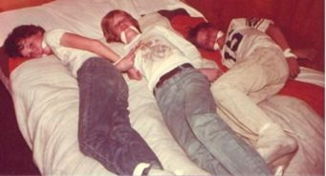
Bonacci revealed in federal court that he and Gosch and a number of other children were forced to participate in an elite government sponsored pedophile sex slave ring, that dehumanized and controlled its young victims using techniques such as drugs, MURDER, satanic rituals, sexual abuse, and torture, resulting in iatrogenic MPD (multiple-personality disorder). The children were systemically programmed and “zombified” as part of the CIA’s ongoing, under-the-radar MK-ULTRA vast clandestine mind control program.[67]
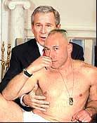
“George W. Bush has not explained how Guckert/Gannon–who had advertised himself as a male escort–could apparently operate in the White House as a reporter for two years using a Secret Service-approved alias and regularly be called upon by George W. Bush and press secretary Scott McClellan during nationally televised presidential press conferences.”[68]
At least since the 19th Century, South Dakota has been known to be a complex center of unprecedented covert Satanic and Masonic undergrounds; AND extraordinary energy and activity linked to ancient magnetic lines, grids of force and radiation field lines.[69]
OCTOBER- Satan’s Harvest of Souls
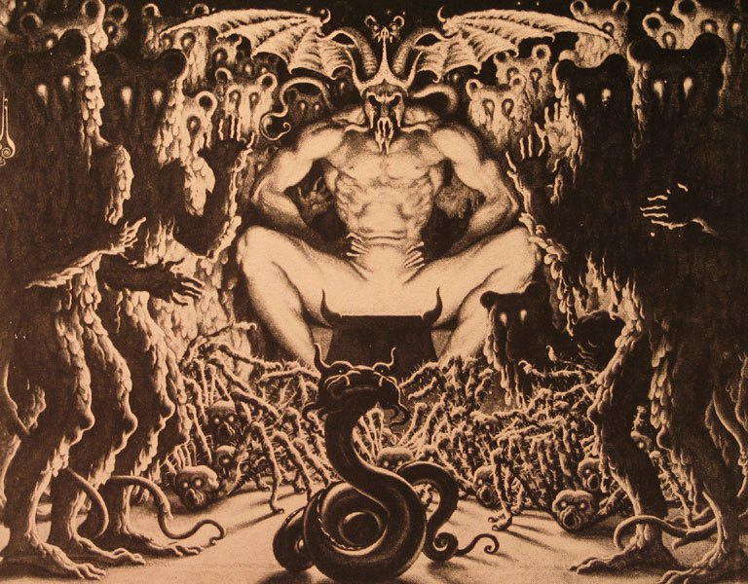
SATAN is an unnatural life force that exists throughout our planet. The energy it gives off is totally negative. Its chemical make-up is incompatible with what is natural. Natural is a nature pertaining to the natural world.
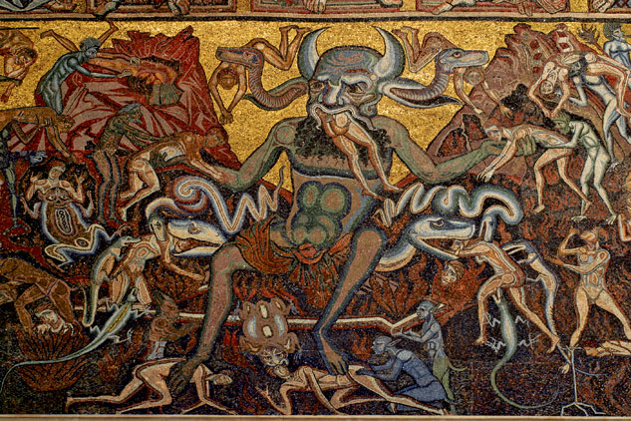
During the Aztec calendar month of Tepeihuitl (from September 30 to OCTOBER 19), it was dedicated to Sacrifices of Children.[70] SATAN has his own harvest celebration— a “Harvest of Souls.” Lucifer’s Servants prepare for SATAN’s Harvest of Souls during the entire month of OCTOBER in various ways- chaos, domestic violence and all manner of death and destruction.
“Their (Luciferians) diabolical activities begin on October 1st and build the entire month of October, climaxing on October 31st which is dedicated to planned world-wide human sacrifice. These sacrifices take place in covens and carefully guarded exclusive meeting places of high-ranking government officials. Beware: Pseudo Christian ministries also lure people in for the purpose of using them for human sacrifices.”[71]
Fallen Angels, Little Tyrese & EVIL Joey

“He [Jesus] gathers the rebels together like goats and pushes them towards the wall of Heaven; a hole opens up, revealing the chaos without. The angels are horrified and throw themselves out of Heaven. They fall for nine days, until Hell, “the house of woe and pain,” receives them. The HOLE IN THE WALL of Heaven is closed, and the angels approach the Son, rejoicing. He returns to his father.” Paradise Lost Book 6 [72] Joseph “Joey” Robert Patterson fell out of Kadoka,[73] the Latoka word meaning “Hole in the Wall”.[74] EVIL Joey is also symbolically associated with the Latoka’s sacred and mysterious Black Hills (University). The Black Hills is believed to be a place of supernatural and paranormal energies inhabited by a Circle of Evil Spirits.
Speaking of the Circle of Evil Spirits in the Black Hills the Indians said: “The Evil Spirit was mad at the red people and caused the mountains to vomit fire, sand, gravel and large stones, to terrify and destroy them, but the Good Spirit had compassion and put out the fire, chased the Evil Spirit out of the mountains and left them unhurt, but when they returned to their wickedness the Great Spirit permitted the Evil Spirit to return to the mountains again and vomit forth fire ; but out their becoming good and making sacrifices the Great Spirit chased away the Evil Spirit …”[75]
EVIL Joey’s ancestral roots are buried at the Old Masonic Cemetery in Philip, South Dakota. Masonic cemeteries are setup by Masons for Masons. Their cemetery grounds are consecrated by sacred Masonic rituals. His ancestral roots is also deeply embedded in South Dakota’s Masonic Benevolent and Protective Order of Elks.[76]
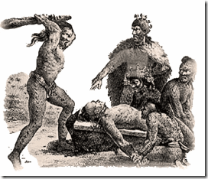
On OCTOBER 10, 2013, 2 year old, Tyrese Robert Ruffin, born in Minneapolis, MN, on August 22, 2011 was suspected of being BLUDGEONED to death by Joey Patterson. Little Tyrese died from blows from a “blunt impact instrument” in a manner that caused the child’s head to sustain impact that causes bleeding or swelling on the brain. The “blunt impact instrument” that was used to bludgeon Little Tyrese to death remains UNKNOWN, whether it was a fist, stick, hammer or a CLUB.
At 5:43 pm (5+4+3= 12), called 9-11 EVIL Joey reported that the child was non responsive. Little Tyrese was probably already dead, but for how long nobody is saying. Little Tyrese didn’t show any activity on his brain when admitted at the hospital, Sioux Fall’s T. Denny Sanford USD Medical Center.[77]

Little Tyrese was officially dead on Friday, OCTOBER 11, 2013.[78] His death occurred within weeks of discovering through a DNA test that Adrian was his actual biological and BLOODLINE father. Previously, the assumed father of the child at birth had been Bobby Ruffin.
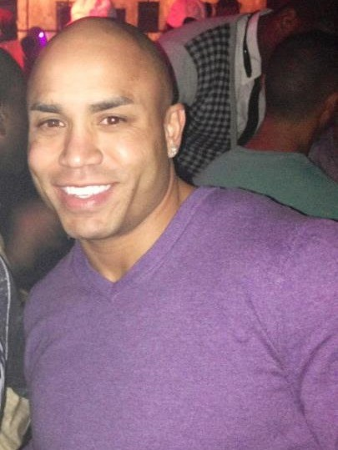
Bobby Ruffin (Robert Lee Ruffin) is a former running back for the Minnesota State University Mavericks of the Northern Sun Intercollegiate Conference (Division II) that never reached the pinnacle of an Adrian Peterson.[79] He is an Account Executive for American Clinical Solutions and DNA STAT.[80]

UNNATURALLY in a case of such national interest and involving a heinous crime of MURDER committed against a 2 year old, Ann Doohen’s occupation remains UNCERTAIN. Nonetheless, she MAY in fact be some type of medical NURSE.[81] I suspect that she is a secret Nurse and BREEDER that is part of the network of the secret Ninth Satanic Circle. She had been deliberately paired with Adrian. Little Tyrese’s faith may have been sealed from the very beginning at birth.
1 Peter 5:8: “Be sober, be vigilant; because your adversary the DEVIL, as a roaring lion, walketh about, seeking whom he may devour.”
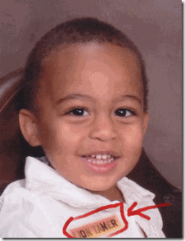
As a child, to be a Lion Tamer may appear innocent and NATURAL enough. But in this case, Satanism involve Clandestine Symbolism. According to the Late CIA Director, William Colby, Satanism in this country “ … is SO MUCH BIGGER than they you think. It goes to the very HIGHEST level …” (WHY JOHNNY CAN’T COME HOME, Noreen N. Gosch ). In Clandestine Satanism, very little is left to chance or coincidence. In 1969, the late Satanist Anton Szandor LaVey published the NINE (9) Satanic Statements in the Satanic Bible. Some argue that LaVey wasn’t a legitimate Satanist but a circus show sideman. The Satanic Bible was written partly or mostly by Lt. Col. Michael Aquino of the U.S. Pentagon and Army Intelligence. The Satanic Bible draw heavily upon from a strange combination from the medieval “esoteric legitimacy” of Queen Elizabethan I Rosicrucian John Dee’s Enochian Language to the works of Darwinist Ragnar Redbeard (Arthur Desmond or Jack London) of the 19th and early 20th Century. Rosicrucian Dee, the U.S. Pentagon, Army Intelligence, and Lt. Col. Michael Aquino is no sideshow circus.
–
In 1890, Redbeard , an extreme racist, authored “‘Might Is Right’, or ‘The Survival of the Fittest.’” In Might is Right, Redbeard rejected conventional ideas and notions of human and natural rights for Black People (Little Tyrese) and People of Color in lieu of the dominant Anglo Saxon Supremacy. And, as you can observe from the book’s covers, it is directly linked to traditional Old World Ancient European Mythology and Legends that lies at the foundation of the ILLUMINATI.
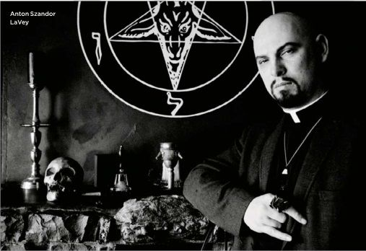
In other words, ancient esoteric demonology, traditional medieval Satanic wisdom, and white supremacy is clandestinely veiled behind Anton Szandor LaVey, the Church of Satan and the Satanic Bible.

If any entity is associated with the Old World Ninth Satanic Cult Network operating with virtually invisibility and impunity in America, it would be the Pentagon, Army Intelligence, CIA/MK ULTRA Occult Bureau, and Himmler’s Luciferian Disciple U.S. Army Intelligence Officer, Lt. Col. Michael Aquino.
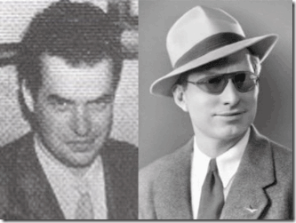
Some still believe including myself that LaVey was the secret technical advisor behind Rosemary’s Baby. We know in 1951, LaVey was in direct contact with Weird Jack Parsons (1914-1952) of Aleister Crowley’s OTO in Berkeley and Pasadena, CA. In 1946, Weird Jack and Scientology founder L. Ron Hubbard of U.S. Naval Intelligence had been directly involved in secret rituals to summons SATAN to produce a Moonchild (Rosemary’s Baby- ADRIAN) from mortal woman. Weird Jack, Hubbard and Crowley’s OTO was the secret foundation behind LeVay’s Church of Satan in San Francisco. Part of LaVey’s legend is that he worked as a Lion Tamer in Clyde Beatty’s Circus. In Satanic Circles, the Lion Tamer is symbolic for Anton Szandor LaVey.
Robert Lee Ruffin’s employer, American Clinical Solutions, is a leading provider of urine drug confirmation services, offering accurate testing for both prescription and illicit narcotics using the most advanced equipment available.[82] DNA Stat provides a DNA test to help determine how individuals process, or “metabolize” different medications.[83]
On OCTOBER 15, 2013, within days of Tyrese’s death, Ruffin UNNATURALLY reserved his public NEGATIVE ENERGY for Adrian instead of the child’s alleged psychopathic killer. The Zionist TMZ reported that Ruffin was expressly sick and tired of people feeling sorry for Adrian Peterson.[84] When someone you know has experienced the death of someone close to him or her, particular a child of such a young age, it is a NATURAL IMPULSE to want to reach out and offer the aggrieved sympathy, condolences, and support.[85]
“AP met my son for the first time yest when my son was already in coma. I was here today when we pulled the plug, not him. He was happily practicing and has no problem playing on Sunday.”[86]
It’s interesting that neither Ruffin or Doohen consulted Adrian, the NATURAL biological father, before “we pulled the plug.” Apparently soon after they “pulled the plug”, they also decided to HARVEST Little Tyrese’s organs. It is UNNATURAL to HARVEST the organs of a MURDER victim during an active homicide investigation. Now that Little Tyrese’s organs are MISSING, Joey Patterson’s defense is making an issue out of it, because the prosecution can’t now rule out NATURAL accidental causes for the child’s death.
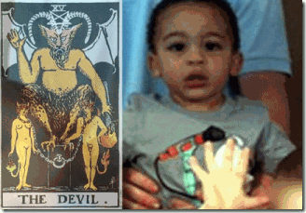
The Clandestine Masonic Shriners with likely open access to the inner circles of Sanford Medical Center, and Joey’s defense team knew all along that Ann Doohen intended to HARVEST Little Tyrese’s organs before they (Doohen and Ruffin) pulled the plug. They planned it from the very beginning to Sacrifice Little Tyrese to SATAN. Either the prosecution or the defense could have moved the court for a protective order to preserve Little Tyrese’s organs as material evidence in the case.[87]
Black Children, MURDER Victims & The Clandestine HARVESTING of Organs
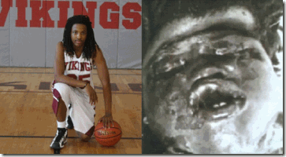
Kendrick Johnson, 17, was found dead in a Georgia high school. Authorities said he was trapped upside down in a high school wrestling mat in January 2013. Kendrick was reported missing by his parents when he didn’t come home from school. His body was found the next day in a rolled-up mat in his high school gym. Police said Kendrick apparently fell in while reaching for a shoe and suffocated in the thick padding. Kendrick’s family never believed he died accidentally.[88] Kendirck’s parents recently learned their son was buried without his organs. Kendrick’s organs were HARVESTED, and his body was stuffed with newspaper. They had Kendrick’s body exhumed and examined by an independent medical examiner who identified a wound to Kendrick’s neck that indicates murder.[89]The clandestine HARVESTING of the organs of Black Children is not an isolated incidence here or abroad.
Bobby Ruffin:
“So yea this isn’t all out yet but I’m sick of the poor AP sh*t. He didn’t know or even meet my son. Sorry for the outburst but put yourself in my place.”[90] Once Ruffin discovered that he wasn’t the NATURAL father of Little Tyrese, nor was he married to Doohen. His legal “PLACE” in the affairs of Little Tyrese was reduced to the status of a BYSTANDER. He had no legal or NATURAL right to supersede Adrian in any medical or legal decisions involving Little Tyrese.
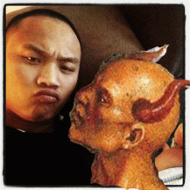
It was absolutely UNNATRUAL for Ruffin to vent any public annoyance, resentment and negative energy against Adrian when it was Ann Doohen’s serial child and female abuser boyfriend Evil Joey that was involved in the slaughter of Little Tyrese.
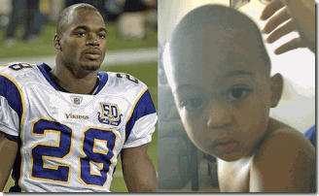
Adrian had nothing to do with the child’s death other than but for to HARVEST THE SOUL and WASTE THE BLOOD OF ADRIAN‘S ISSUE FOR SATAN.
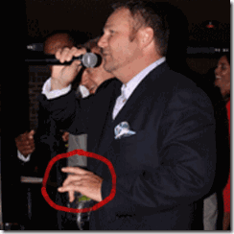
Brain makes it clear with the “Devil’s Horn” Symbol that he belongs to the Secret Satanic Brotherhood
Ruffin’s employer American Clinical Solutions was founded by Brian Matthew Artze.[91] Artze is a Jewish root name.[92] Brian was born in the small town of Decatur, IL. A town that he said his father, grandfather, and great-grandfather built together from the ground up.[93] Undoubtedly, he is referring to the family of Adolf Carl Artze (br. 1884) a (brick) Mason out of East Prussia (Germany).[94]
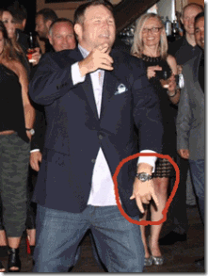
At his birthday party in Florida, Brian makes sure everyone understands that he is one of Lucifer’s Servants.
The German word for a bricklayer is Maurer. German brick masons belong to an ancient guild/fraternity that members have a Secret Ceremony which they are not allowed to describe just the same but before the fraternal order of “Freemasons.”[95]

By the way, Ashley Ann Doohen’s father is Michael P. Doohen of Sioux Falls, South Dakota.[96] Michael Doohen works for the Dunham Company in Sioux Falls owned by Karen Dunham of the Masonic Benevolent and Protective Order of Elks, and All Seeing Eye Fraternity, Omega Tau Rho.[97] In South Dakota, it fits the saying that “Birds of a Feather Flock Together.”

After the Slaughter of Little Tyrese, one of Adrian‘s so-called baby mamas, Erica Syion, was also given mass media air time to UNNATRUALLY direct negative energy against and slander Adrian before the masses. She has the Mark of the DRAGON (BEAST), the MONARCH– Butterfly. It is a sign of a mind controlled CIA/MK ULTRA Sex Kitten.[98] She is also a tool of the Luciferian ILLUMINATI.

In June 2014, Ashley Ann Doohen was found to be still co-habituating with the killer Fallen Angel, EVIL Joey, out of the Hole in the Wall.[99] How UNNATURAL and absolutely bizarre and absurd is that? Unless in fact, they are all part of a high level clandestine Network Masonic/Satanic Cult or Coven that sacrificed Little Tyrese to HARVEST his soul for SATAN for the Blood of Adrian Peterson.
Adrian & Child Abuse: The Works of the Ole Southern Satanic Brotherhood

Cuts instead of Welts- OPEN WOUNDS? In September 2014 a month after widespread public exposure of the Ninth Satanic Circle , Adrian was indicted in Texas for “reckless or negligent injury to a child” in racist-lynching Montgomery County, Texas. Montgomery County is a evil, vicious and UNNATURAL place in the Texas backwoods where a Black man (Clarence Lee Brandley) in this era can be elected in a courtroom by police, prosecutor, and a redneck jury for a capital offense and subsequent death penalty solely because of his (“nigger”) race.[100]
According to Sports Radio 610: “Peterson’s son had pushed another one of Peterson’s children off of a motorbike video game. As punishment, Peterson grabbed a tree branch — which he consistently referred to as a ‘switch‘ — removed the leaves and struck the child repeatedly.”[101] More via Sports Radio 610: Peterson allegedly told the child’s mother via text message that he “felt bad after the fact when I notice the switch was wrapping around hitting I (sic) thigh.”[102]
Peterson also acknowledged accidentally striking the child’s scrotum (around the testacies) with the “switch”, saying in the text message, “Got him in nuts once I noticed. But I felt so bad, I’m all tearing that butt up when needed! I start putting them in timeout. N save the whooping for needed memories!”“Never do I go overboard!” Peterson continued. “But all my kids will know, hey daddy has the biggie heart but don’t play no games when it comes to acting right.”[103]
During my childhood, this is exactly what my mother and elders would have done. If the methodology of discipline of children by my own mother and elders with a deep southern based traditional “switch” that customarily leave superficial “welts” on the skin was a criminal offense, my mother, in-laws and elders out of Louisiana would all have died in prison serving life sentences.
The Texas Education Code, Subtitle G, Chapter 37: Discipline: Law and Order, Section 37.0011, Use of Corporal Punishment states that corporal punishment includes ” ‘the deliberate infliction of physical pain by hitting, padding, spanking, slapping, or any other physical force used as a means of discipline,’ and relinquishes the control of whether or not it is allowed within a school district to the board of trustees…”[104]
In the State of Texas, corporal “traditional” punishment (deliberate infliction of physical pain) of children doesn’t constitute the usual “Mens rea (the act is not culpable unless the mind is guilty)”.[105]
Traditional corporal punishment is “abusive” only if ” ‘observable and material impairment‘ occurs as a result or if it causes ‘substantial harm’ or exposes the child to risk of ‘substantial harm.’ “[106]
In most instances, Adrian has confessed to be a reasonable and God-fearing man. If he crossed the line of state law in disciplining his children in the tradition of our elders, a good faith intervention, warning or diversion program would have been sufficient to change or influence his future behavior.

There is no reason to “mercilessly” attempt to destroy him, children, family and his livelihood. Unless it is the secret works and network combination of the Ole Southern Satanic/ILLUMINATI Brotherhood of Montgomery County and their mission to reduce Adrian to a condition akin to that of slavery- so that he will no longer be a black-skinned “Purple Jesus” hero or an inspiration to anybody.
Nevertheless, Adrian, a man of newly acquired wealth and prominence should have been surrounded by life-style changing coaches and counselors at the very least for his own personal growth and self preservation in a new and unfamiliar station of life with an entirely different set of expectations, CODES, and new powerful and elite ENEMIES without moral or legal boundaries.
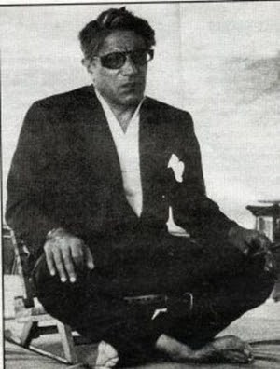
The ruthless Greek Tycoon Aristotle Socrates Onassis that married former First Lady Jackie Kennedy after the assassination of JFK has been described as a raw little foul mouthed- ape like creature.[107] Onassis’ right-hand man, Yannis Georgakis, called him “a charming PSYCOPATH” bound by “absolutely no moral imperatives at all.”[108]
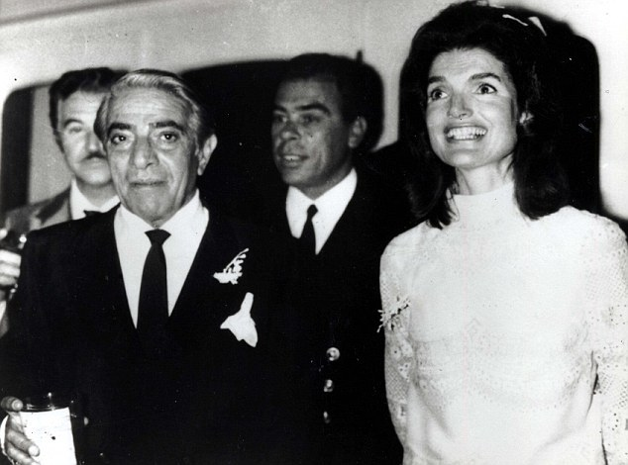
On the way to becoming a world renown shipping magnate and billionaire in the public eye through Nazi Dr. Hjalmar Schacht, President of Hitler’s Reichbank and underground networks of the Third Reich, Onassis was surrounded by life-style changing coaches, managers and counselors. Now, the Onassis Bloodline is identified with New World Order oligarchies, and mass population grand ILLUSIONS of Power, Wealth, Class and Privilege.[109]

I said this to say that by an extreme example that once you reach a certain pinnacle of wealth, fame and prominence such as obtained by Adrian Peterson, you should NATURALLY go through life-style changing processes, whether ILLUMINATI or not. Raw deep southern based culturally and traditional sensitive terms such as “whoopings” and “switches” shouldn’t have been part of his vocabulary. In fact, Adrian‘s role as an active “parental disciplinarian” should have been supplanted by an educational and financial management staff dedicated to the future of his children.

In the same sense of life-style changing counseling, by virtue of Michael Vicks’ wealth ($100 Million NFL Contract), fame and prominence before the global masses, he shouldn’t have been openly associated with a brutal and illegal dog fighting racket. Vick financed his family members’- CIA Dark Alliance Crack Cocaine Addicts‘ enterprise of dog fighting that he had been introduced to as a child by his father, Michael Boddie.
They openly operated “Bad Newz Kennels,” which housed and trained over 50 pit bull dogs to stage dog fights, and was allegedly involved in an underground (UNDERNEATH) high stakes gambling ring as if they didn’t know any better, or they had been aided, encouraged and supported clandestinely to do so openly as a backdoor to sensationally entrap Vick on a global stage.[110] When Vick’s cousin Devon T. Boddie was arrested for crack cocaine possession, the police was well aware all along of all the details of the “Bad Newz Kennels” dog fighting operation as if they had set it up all along to sensationally topple Vick to the ground when he was at the pinnacle of global success.[111]

NATURALLY, Vick, an equally awesome Black professional athlete as Adrian Peterson, had been surrounded by teams of financial managers, counselors and advisors. He wasn’t hiding anything from anyone. Vick and his family on his paternal side of Newport News, Virginia openly paraded around in tee-shirts advertising “Bad Newz Kennels” as if it was a legitimate commercial enterprise.
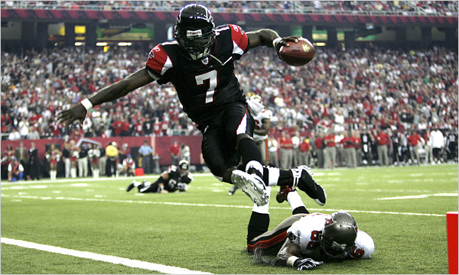
In 2007, lucky No. 7, Vick was a four time NFL All Pro. He was playing at an astounding peak level on the football field. He had to had been one of the world’s most celebrated, visible and gifted professional athletes. As the late great bluesman, Howlin’ Wolf, would say, Michael Vick had been “Sittin’ on Top of the World.” [112]

Karl Rove- Hail SATAN
Deputy Attorney General, Michael R. Gill, prosecuted Vick. Gill was a running dog for Deputy Attorney for the Eastern District of Virginia, Republican Paul McNulty,[113] a direct running dog for Bohemian Grove Satanic Two-faced Pagans Karl Rove, and President George W. Bush.[114] McNulty became a subject of a Congressional investigations for firing federal deputy attorney generals to make way for Republican bootlickers.

During the investigation, Deputy Attorney General McNulty told Congress that a confident and popular deputy attorney general, Harry Earnest “Bud” Cummins III, had been removed from federal office for no reason except to install a former aide to Karl Rove, Tim Griffin, in his place. Griffin was Bush’s former Republican National Opposition Research Director.[115] Federal prosecutors Gill and McNulty were undoubtedly also part of Rove’s underground (UNDERNEATH) Bohemian “Dominant Political Creed in America.”[116] How deep does the Rabbit Hole go?
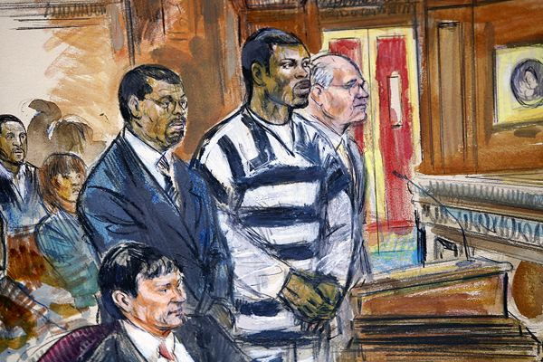
In 2007, it was an absolutely bizarre, mind-bogging and sad moment in sports history and before the masses of color when Vick was taken off the football field and sentenced to 23 months (almost two years) in federal prison on one count of interstate conspiracy to sponsor dog fighting while demonstrators from People for the Ethical Treatment of Animals carried signs outside the Richmond courthouse reading, “Dogs Deserve Justice.”[117]

People for the Ethical Treatment of Animals (PETA) is an organization that publicly claims to represent the best interest of animals – their “ethical treatment.” Yet approximately 2,000 animals pass through PETA‘s front door every year and very few make it out alive. In fact, in the last 11 years, PETA has killed 29,426 dogs, cats, rabbits and other domestic animals.[118] A supermarket dumpster full of garbage bags above. When police officers looked inside, they found the bodies of dead animals – killed by PETA.[119]

It is an almost $35 million animal rights front with the substantial financial support of the likes of the Rockefeller Foundation and ILLUMINATI “All Seeing Eye” Time-Warner- Viacom Media Networks – Comedy Central Network.[120] The whole town was laughing at Michael Vick. Vick, an once $100 million man, had been toppled down to a state of utter bankruptcy[121]– reduced again to a condition akin to that of slavery.
However, it is often not by indifference or a coincidence that global prominent millionaire Black professional athletes such as Adrian and Vick do not go through life-style changing processes to protect them, but it is by the deliberate plans and schemes of the ILLUMINATI to keep them vulnerable and ignorant of the need for decoding skills to protect them and their families from CLANDESTINE enemies.
Likewise, the ILLUMINATI doesn’t intend to allow Black Professional Athletes, Families or Heirs with their newly acquired access to millions to become or ascend to any permanent status of Power, Wealth, Class and Privilege to aspire the masses in the New World Order. Adrian and Michael Vick’s raw culturally and traditional sensitive life-styles are intentionally left intact, clandestinely supported and encouraged as a backdoor to subsequently topple them in the public eye as a necessary means of psychological warfare to polarize the races, confuse and destroy the will- spirit of the masses of color.
Adrian & ESPN’s Uncle Tom’s Sports Cabin
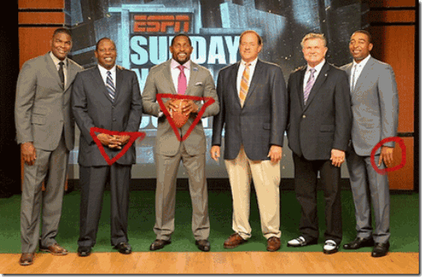
ESPN’s Uncle Tom’s Cabin of subservient Satanic/ILLUMINATI Negroes include Keyshawn Johnson, Uncle Tom Jackson with the Inverted ILLUMINATI Pyramid Hand Symbol, Ray Lewis also with a ILLUMINATI Pyramid Symbol, and Chris Carter with the One Finger- One God- SATAN gesture.
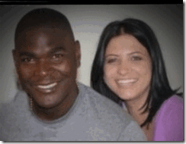
By the way these Negroes have distanced themselves from Ray Rice, Jonathan Dwyer, Adrian and domestic violence, you wouldn’t have known that Keyshawn Johnson had also been arrested in 2014 for domestic violence against his significant one.[122] But of course, Keyshawn is one of them- the ILLUMINATI- the Black Satanic Cabal. Some of Adrian’s most sensationalized corporate mass media criticism have come from ESPN’S Uncle Tom’s Sports Cabin, particularly bootlicking Black Satanic Assassins for the New World Order, NFL Hall of Famers, Uncle Tom Jackson and Chris Carter.
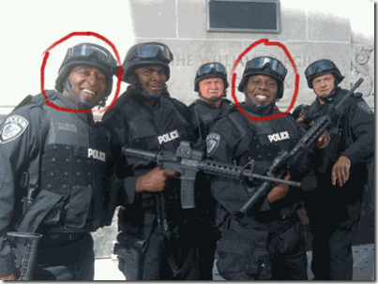
Some have come to the opinion that Carter’s delirious public criticism of Adrian on ESPN was innocent, honest, and genuinely soul searching. That’s absolutely B.S. ESPN is owned by the Walt Disney Company and Hearst Corporation.[123] They don’t roll like that. Disney has its own police force, investigation, enforcement and propaganda arms.

Disney has no “free express yourself policy.”[124] Walt Disney Company and Hearst Corporation are both Satanic/ILLUMINATI Brotherhood Cabals implicated in PAGAN ritual sacrifice of children.
The DISNEY Bloodline- Satanic PAGANS
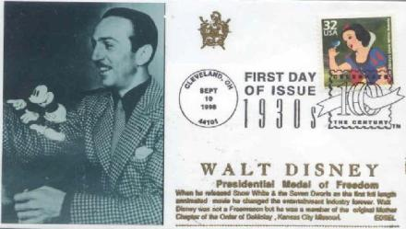
Co-founder of Walt Disney Productions, Roy Oliver Disney, was a Freemason. Walt Disney maintained all along that he wasn’t a Freemason but part of the Masonic Order. He said that he was much higher in the Masonic Hierarchy and Order than an ordinary Freemason. He said that within the Masonic Order, he was an ordinary member of the Mother Chapter of the Order of DeMolay. Who was DeMolay and what is the DeMolay Ritual?
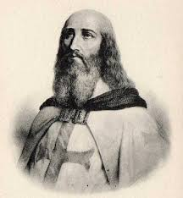
Jacques de Molay (1243 –March 18, 1314) was the 23rd and last Grand Master of the Knights Templar.[125]
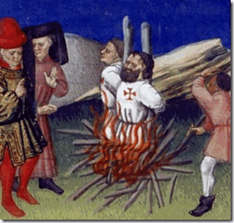
“The DeMolay ritual makes a great hero of its namesake. He is held up as a paragon of manly virtue. What the order’s ritual does not tell its young charges is that DeMolay was burned at the stake for being a homosexual, a pedophile (lover of young boys), and for practicing witchcraft and worshiping a false god named Baphomet!“[126]

The Knights Templar freely practiced homosexuality and other sexual perversions, that the Grand Master wielded total authority over everything, that they practiced rituals of sorcery and used Cabalistic symbolism was clear evidence that the order had had become a sect blasphemous to Christianity. Their questioning revealed yet another of their unorthodox practices: Without being specific, they had admitted to idolatry, but during their ongoing interrogation, it gradually emerged that without any doubt, they were worshipping SATAN.[127]

D 23– Clandestine Masonic Symbolism- DeMolay, 23rd and last Grand Master of the Knights Templar
The Masonic Order is CLANDESTINE. Disney was undoubtedly telling us that he belonged to a Knight Templar Hierarchy and Satanic Order within the Masonic Order in which BAPHOMET is God. The Order of DeMolay is accepted and a hidden powerful Masonic Hierarchical Order. Additionally, Walt Disney had been a clandestine HOLLYWIERD FBI Special Agent in Charge under or superior to 33rd Degree Freemason, J. Edgar Hoover.[128] He also is alleged to have worked for the CIA’s MK ULTRA and the MONARCH Program.[129] Disney is also linked to clandestine elite ILLUMINATI child Pedophilic Cults and SACRIFICES.[130]
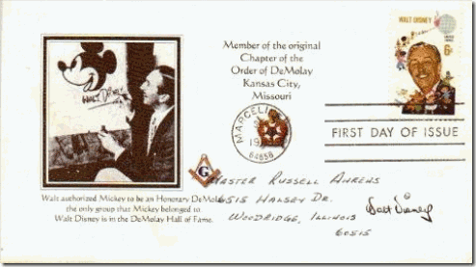
Walt Disney made Mickey Mouse an official honorary DeMolay- Knight Templar. During the “Cremation of Care” ceremony at the Bohemia Grove, the sacrificial bound-body was burned on the alter of a 50-foot-tall Owl of Bohemia god made of concrete. The Bohemian priests wore hooded KKK robes in white, black or red. Cremation of the Human Sacrifice was set to music by Walt Disney’s ‘Fantasia‘, “The [Witch] Sorcerer’s Apprentice” where Mickey Mouse’s magic runs amok.”[131]
Don’t get it twisted, we are not talking a grove of trees or flowers. The word “Grove” as in Bohemian Grove originally referred to a sacred place in the woods. It has been used at least three different ways among Pagans. Sometimes it is simply a gathering of Pagans of no particular denomination. Often it means a local organization of Druids. Occasionally it refers to a group of Pagans who gather to worship under the guidance of a Witches’ Coven; this kind of “Grove” is also called a “congregation” or “outer circle,” as distinct from the “inner circle,” which is composed of the priests and priestesses of the coven.[132]
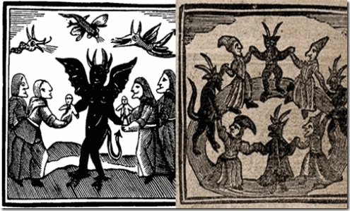
Bohemia is the historical country of central Europe that was a kingdom in the Holy Roman Empire and subsequently a province in the Habsburgs’ Austrian Empire. Whereas, the Bohemian Grove in California is a Coven of Pagans practicing Child/Human Sacrifices and worshipping SATAN in secret along beside Christianity as it had been in Bohemia Germany during medieval times. The secret Child Sacrifices to SATAN and the Satanic (Ninth) Circles of Old Europe out of the Middle Ages has remained unbroken and hidden even here in America.
The HEARST Bloodline- Satanic PAGANS
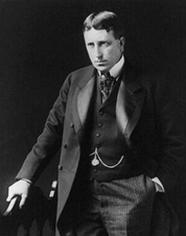
“David Hill…was a high ranking Scottish Rite Freemason and an important Mafia figure before he came to Christ…” “David Hill knew that William Randolph Hearst was part of the ILLUMINATI, He was part of the branch Illuminati — at what could be termed the 6th degree. William Randolph Hearst was totally into paganism. That is very obvious by a tour of his mansion in California which has been turned into a museum.”[133]
The Hearst family newspaper tycoons were/are traditional bloodline PAGANS of the Bohemian Grove.[134] William Randolph Hearst was a high-degree ILLUMINATI Satanic Initiate. The Hearst Mansion in California is furnished with hundreds of ancient Kemetic and other Near and Middle Eastern occult artifacts. Most of them are original and were shipped to the United States by Hearst at enormous expense.[135]
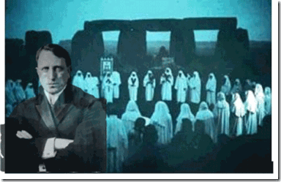
William Randolph Hearst (1863-1951) had been a PAGAN of the Bohemian Grove since 1887.[136]
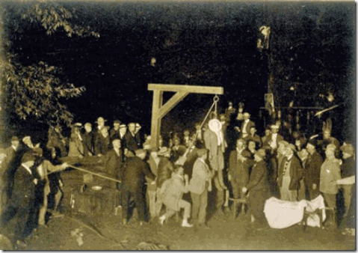
In about 1906, William Randolph Hearst was there, above, when they lynched what appears to be a Black man at the Bohemian Grove.[137]
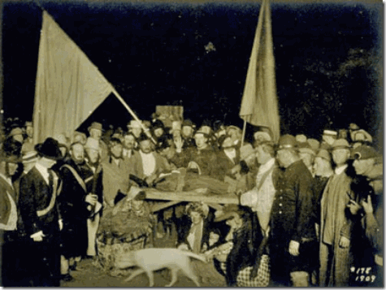
In 1909, William Randolph Hearst was there, above, when they murdered and offered a Black Child in SACRIFICE to the fire altar of Baal Moloch at the Bohemian Grove.[138] And if he wasn’t there. William Randolph Hearst certainly had the power and responsibility to object and report what was going on there and we know- that- he certainly didn’t DO!
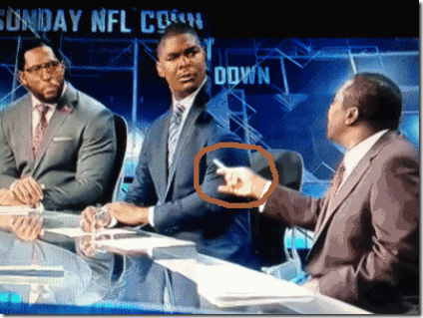
ESPN’s Uncle Tom’s Devil Horns Hand Symbol isn’t an innocent gesture. It is an blatant MK ULTRA/MONARCH mind control key that momentarily mystified and stunted Keyshawn and Ray Lewis. Uncle Tom Jackson , “… he (Adrian) knew UNDERNEATH that it was abuse.”
The command from the prompt word “UNDERNEATH” and the DEVIL’S HORNS sign was the trigger for weak assed CIA Dark Alliance Crack Cocaine Victim Chris Carter to go off on Adrian on the national public airways.
IN CONCLUSION
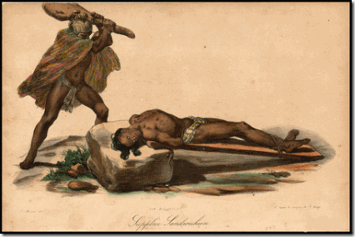
EVIL Joey or someone(s) bludgeoned 2 year old Little Tyrese to death in cold blood like a ritual out of the distant past. It’s like Little Tyrese’s head had been bashed in at the Altar of Baal-Moloch.
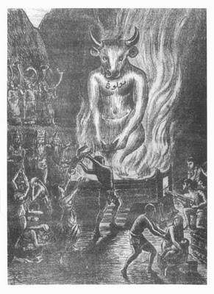
It’s been a year since Little Tyrese had been murdered by unknown blunt forces to the head. I was hopeful that EVIL Joey’s murder trial would have begun this month, October 2014, as scheduled, and more facts about Joey and the slaying of Little Tyrese would become public record. Now, I am fearful that a public trial may not take place at all. While EVIL Joey was in jail pending homicide investigation, they gutted Little Tyrese of his organs like a spring lamb. EVIL Joey couldn’t have did that alone- destroy physical evidence of his or crimes of others in such a blatant manner. It took a powerful and high level combination to pull that off, and then divert the masses’ attention away from the high capital crimes against children committed by EVIL Joey and the Ninth Satanic Circle with the sensational public indictment of Adrian for child abuse.
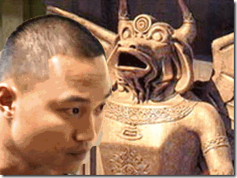
Baal-Moloch and SATAN’s psychotic assassin is out there walking around. EVIL Joey is free continue to serve his masters, and work to earn a living unlike Ray Rice, Jonathan Dwyer, Greg Hardy and Adrian. EVIL Joey is free to go wherever or serve whoever he wishes on the planet that he so desires. There are no protests from liberals, women or Child Protection groups. There is no outrage from any commercial, political figures or bodies. Nobody seems to be objecting to Joey, a psychotic menace to society, walking the street free on a heinous murder charge, threatening and violently attacking women and CHILDREN– “Children Deserve Justice.”
In fact, Joey, may never be prosecuted for the slaughter of Little Tyrese, because Tyrese’s body may also now be stuffed with newspaper blocking any further autopsy or medical examination to determine the actual cause of his death. Recall, October is the symbolic month of SATAN’S human harvest of souls as a testament of faith of his believers and followers. Joey will not come to a public trial this October 2014 for the homicidal death of Little Tyrese. There has been no public explanation coming out of South Dakota why Joey’s homicide trial has not yet begun as scheduled or delayed.
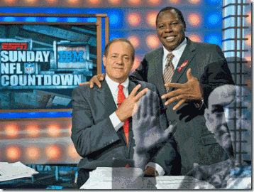
ESPN’s Chris Berman; Uncle Tom Jackson and the Great BEAST 666 Aleister Crowley with the Hand of the DEVIL– ILLUMINATI
What’s really going on in the Slaughter/Sacrifice of Adrian‘s Innocent and Infant Bloodline, Little Tyrese, in South Dakota. It is virtual buried news that nobody is talking about even the Satanic Cabal Negroes of ESPN’s Uncle Tom’s Cabin. The way things are stacking up here in America, it seems as if Adrian has more of a chance to spend time locked up in prison for “whooping” his son with a “switch” than Joseph Robert Patterson for a Capital Offense of MURDER of a two-year old child. It also seems as if we will get better results from an International Common Law Court of Justice investigation out of Brussels into the death of Little Tyrese and its link to the Ninth Satanic Circle Child Sacrifice Cult Network than the CIA, FBI, local police, and U.S. Investigative Journalism. THINK ABOUT THAT.

[1] http://www.babynamespedia.com/search/m/dark
[2] http://vigilantcitizen.com/moviesandtv/roman-polanskis-rosemarys-baby-and-the-dark-side-of-hollywood/
[3] http://en.wikipedia.org/wiki/Adria
[4] http://en.wikipedia.org/wiki/Adria
[5] http://disc.yourwebapps.com/discussion.cgi?disc=177754;article=8349;
[6] http://realhistoryww.com/world_history/ancient/Canaan_1a.htm
[7] http://www.blackherbals.com/african_roots_of_humanity_and_ci.htm
[8] http://en.wikipedia.org/wiki/Land_of_Israel
[9] http://www.ancient.eu/canaan/
[10] http://en.wikipedia.org/wiki/Divine_command_theory
[11] http://theisticsatanism.com/invocation.html
[12] http://www.spotrac.com/nfl/minnesota-vikings/adrian-peterson/
[13] http://profootballtalk.nbcsports.com/2013/02/02/adrian-peterson-takes-home-league-mvp-award/
[14] http://profootballtalk.nbcsports.com/2013/02/02/adrian-peterson-takes-home-league-mvp-award/
[15] http://sports.yahoo.com/news/nfl—adrian-peterson-effect–leaves-doctors-in-awe-and-players-rushing-to-return-031136811.html
[16] http://www.christianpost.com/news/nfl-minnesota-vikings-adrian-peterson-says-im-juicing-on-the-blood-of-jesus-102847/
[17] http://www.christianpost.com/news/nfl-minnesota-vikings-adrian-peterson-says-im-juicing-on-the-blood-of-jesus-102847/
[18] http://home.wlu.edu/~lubint/Touchstone/KKK-Fisher.htm
[19] Id.
[20]http://en.wikipedia.org/wiki/Murder#Origins_and_history
[21]http://www.danielnpaul.com/WoundedKnee.html
[22] http://www.danielnpaul.com/WoundedKnee.html
[23] http://xroads.virginia.edu/~HYPER/INCORP/Native/reservation.html
[24] http://en.wikipedia.org/wiki/South_Dakota#History
[25] http://en.wikipedia.org/wiki/Demographics_of_South_Dakota#Race_and_ethnicity
[26] http://www.zengardner.com/janus-illuminati-god-of-chaos-and-deception/
[27] http://www.zengardner.com/janus-illuminati-god-of-chaos-and-deception/
[28] http://en.wikipedia.org/wiki/Forked_tongue
[29] http://www.ncbi.nlm.nih.gov/pmc/articles/PMC2738358/
[30] http://www.unexplainedstuff.com/Religious-Phenomena/The-Rise-of-Satanism-in-the-Middle-Ages-Gilles-de-rais-1404-1440.html
[31] http://daimonas.com/pages/medusa-apollon-odin-jesus.html
[32] http://www.bbc.co.uk/history/ancient/british_prehistory/human_sacrifice_01.shtml
[33] http://www.legacy.com/obituaries/argusleader/obituary.aspx?pid=167592851
[34] http://knowinggodsf.org/#/about-us/what-we-believe
[35] http://en.wikipedia.org/wiki/Evangelical_Free_Church_of_America
[36] http://en.wikipedia.org/wiki/Church_of_Sweden#Middle_Ages
[37] http://en.wikipedia.org/wiki/Temple_at_Uppsala
[38] http://www.visitnorway.com/us/about-norway/history/stave-churches/
[39] http://en.wikipedia.org/wiki/Vikings
[40] http://www.timelessmyths.com/norse/teutonic.html
[41] http://www.legacy.com/obituaries/argusleader/obituary.aspx?pid=167592851
[42] http://www.elriad.org/#!about2/c4nz
[43] http://masonicleaks.com/tag/arkansas/
[44] http://www.myfreemasonry.com/threads/general-albert-pike.21179/
[45] http://www.whale.to/b/pike.html
[46] http://www.encyclopediaofarkansas.net/encyclopedia/entry-detail.aspx?entryID=4122
[47] http://thetruth81901.yuku.com/topic/1424/Albert-Pike-Mason-racist-and-KKK-member#.VEcbiPnF_kg
[48] http://www.ozarksmountaineer.com/albertpike.pdf
[49] http://en.wikipedia.org/wiki/South_Dakota
[50] http://childabuserecovery.com/popes-global-leaders-may-link-to-ninth-circle-satanic-cult-murders/#.VEP9ePldV-I
[51] http://childabuserecovery.com/popes-global-leaders-may-link-to-ninth-circle-satanic-cult-murders/#.VEP9ePldV-I
[52] http://childabuserecovery.com/popes-global-leaders-may-link-to-ninth-circle-satanic-cult-murders/#.VEP9ePldV-I
[53] http://one-vibration.com/forum/topics/nicole-kidman-s-father-dies-amid-pedophile-child-murder-ring-alle#.VEhC6vnF9-I
[54] http://www.franklincase.org/index.php?option=com_content&view=article&id=164:king-expands-into-food-service-something-on-every-burner-jan-12-1985-&catid=6:news-articles&Itemid=14
[55] http://visupview.blogspot.com/2012/05/lsd-chronicles-part-ii.html
[56] http://visupview.blogspot.com/2012/05/lsd-chronicles-part-ii.html
[57] http://www.viewzone.com/mkmk.html
[58] http://www.illuminati-news.com/2007/0718a.htm
[59] http://www.puppstheories.com/forum/index.php?showtopic=3849&st=30
[60] http://www.cbsnews.com/news/rove-gannon-connection/
[61] http://www.pensitoreview.com/2009/12/31/did-karl-rove-leave-his-wife-for-jeff-gannon/
[62] http://www.cbsnews.com/news/rove-gannon-connection/
[63] http://www.apfn.net/messageboard/03-01-05/discussion.cgi.64.html
[64] http://www.texemarrs.com/122006/white_house_bordello.htm
[65] http://legalschnauzer.blogspot.com/2012/07/connecting-dots-between-karl-rove-and.html
[66] http://whatreallyhappened.com/WRHARTICLES/Franklin/FranklinCoverup/franklin.htm
[67] http://www.rense.com/general67/gannn.htm
[68] http://whatreallyhappened.com/WRHARTICLES/Franklin/FranklinCoverup/franklin.htm
[69] http://www.spacedaily.com/news/earth-magnetic-99d.html
[70] http://en.wikipedia.org/wiki/Human_sacrifice_in_Aztec_culture
[71] http://libertytothecaptives.net/halloween_harvest_souls.html
[72] http://www.shmoop.com/paradise-lost/book-6-summary.html
[73] http://rapidcityjournal.com/news/local/kadoka-man-held-in-death-of-adrian-peterson-s-son/article_bb13585d-87fd-561f-b2c6-28e5254ea2bd.html
[74] http://www.kadokasd.com/
[75] http://archive.org/stream/pahasapahorblack00rose/pahasapahorblack00rose_djvu.txt
[76] http://www.rushfuneralhome.com/cms/plugin_obituaryview.php?obituary_ID=499
[77] http://www.sanfordhealth.org/Locations/1834119252
[78] http://fabwags.com/ashley-ann-doohen-is-adrian-petersons-baby-mama-whose-boyfriend-joey-patterson-killed-their-son/
[79] http://sdsufans.com/board/archive/index.php/t-4229.html
[80] http://www.linkedin.com/pub/bobby-ruffin/b/3b/4b5
[81] http://fabwags.com/ashley-ann-doohen-is-adrian-petersons-baby-mama-whose-boyfriend-joey-patterson-killed-their-son/
[82] http://acslabtest.com/about-us/
[83] http://dnastat.com/
[84] http://www.tmz.com/2013/10/15/adrian-peterson-son-bobby-ruffin-ty-facebook-son-child/
[85] https://www.everplans.com/articles/when-is-the-right-time-to-offer-condolences
[86] http://www.tmz.com/2013/10/15/adrian-peterson-son-bobby-ruffin-ty-facebook-son-child/
[87] http://www.wday.com/content/joseph-pattersons-defense-concerned-medical-records
[88] http://marylovesjustice.blogspot.com/2013/10/killing-children-for-organs-or-to-hide.html
[89] Id.
[90] http://www.tmz.com/2013/10/15/adrian-peterson-son-bobby-ruffin-ty-facebook-son-child/
[91] http://www.bizapedia.com/people/BRIAN-ARTZE.html
[92] http://www.avotaynu.com/books/Gorr.htm
[93] http://www.abcactionnews.com/news/local-news/getting-to-know-hands-across-the-bay-dancing-with-stars-contestant-brian-artze-with-10-questions
[94] http://www.findagrave.com/cgi-bin/fg.cgi?page=gr&GRid=22245618&ref=wvr
[95] http://en.wikipedia.org/wiki/Bricklayer
[96] http://fabwags.com/ashley-ann-doohen-is-adrian-petersons-baby-mama-whose-boyfriend-joey-patterson-killed-their-son/
[97] http://www.dunhamresidential.com/karen-dunham.html
[98] http://rollingout.com/entertainment/adrian-petersons-7th-baby-mama-erica-syion/#_
[99] http://newsone.com/3026321/adrian-peterson-joseph-patterson/
[100] http://www.witnesstoinnocence.org/exonerees/clarence-brandley.html
[101] http://www.cbssports.com/nfl/eye-on-football/24706732/report-adrian-peterson-indicted-in-child-injury-case-in-texas
[102] Id.
[103] Id.
[104] http://www.examiner.com/article/corporal-punishment-still-allowed-texas-schools
[105] http://en.wikipedia.org/wiki/Mens_rea
[106] https://www.texasattorneygeneral.gov/ag_publications/txts/childabuse1.shtml
[107] http://didyouknow-mariahardy.blogspot.com/2012/08/assassination-of-robert-kennedy.html
[108] http://www.express.co.uk/expressyourself/199541/Did-Aristotle-Onassis-kill-Bobby-Kennedy
[109] http://www.bibliotecapleyades.net/bloodlines/onassis.htm
[110] http://aldf.org/resources/laws-cases/animal-fighting-case-study-michael-vick/
[111] https://storify.com/dkwilsonisland/the-real-what-if-michael-vick-was-white
[112] https://www.youtube.com/watch?v=IuZ36pZWIdI
[113] http://articles.dailypress.com/2007-08-27/news/0708270150_1_paul-mcnulty-richmond-office-money-laundering
[114] http://www.apfn.org/apfn/grove.htm
[115] http://en.wikipedia.org/wiki/Bud_Cummins
[116] http://www.washingtonpost.com/wp-dyn/content/article/2005/06/24/AR2005062400097.html
[117] http://usatoday30.usatoday.com/sports/football/nfl/2007-12-10-vick-sentence_N.htm
[118] http://www.huffingtonpost.com/nathan-j-winograd/peta-kills-puppies-kittens_b_2979220.html
[119] http://www.huffingtonpost.com/nathan-j-winograd/peta-kills-puppies-kittens_b_2979220.html
[120] https://www.activistfacts.com/organizations/21-people-for-the-ethical-treatment-of-animals/
[121]
[122] http://ballerwives.com/2014/04/30/keyshawn-johnson-arrested-for-domestic-violence-says-he-never-physically-struck-his-girlfriend-details/
[123] http://en.wikipedia.org/wiki/ESPN
[124] http://www.bibliotecapleyades.net/bloodlines/disney2.htm
[125] http://en.wikipedia.org/wiki/Jacques_de_Molay
[126] http://www.chick.com/bc/2005/demolay.asp
[127] http://www.bibliotecapleyades.net/sociopolitica/templars/knights_templars01.htm
[128]http://www.bibliotecapleyades.net/bloodlines/disney2.htm
[129] http://anti-illuminati-group.weebly.com/mickeys-cult.html
[130] http://www.glparchives.com/hollywood/the-walt-disney-agenda/
[131] http://www.armageddononline.org/forums/archive/index.php/t-1879.html?s=c212f20184a145b318d6e8a90048b0a5
[132] http://www.angelfire.com/fl/wikkan/CovensCirclesGroves.html
[133] http://newjerusalemchronicle.blogspot.com/2010/05/problem-with-billy-graham-part-two.html
[134] http://www.gnosticliberationfront.com/bohemian_grove.htm
[135] http://www.bibliotecapleyades.net/biggestsecret/matrix/matrix16.htm
[136] http://www.gnosticliberationfront.com/bohemian_grove.htm
[137] http://www.bibliotecapleyades.net/sociopolitica/esp_sociopol_bohemiangrove02.htm
[138] http://www.bibliotecapleyades.net/sociopolitica/esp_sociopol_bohemiangrove02.htm
Comments : 5 Comments
Tags: adrian peterson, ahnenerbe, albert pike, Aleister Crowley, ali akbar, Allen Dulles, ann doohen, anthony kidman, Anton Szandor LaVey, Aristotle Socrates Onassis, Ashley Ann Doohen, Bad Newz Kennels, Baphomet, Benevolent and Protective Order of Elks, bifrons, black satanic cabal, bobby ruffin, bohemian grove, brian matthew artze, camp detrick, canaan, cargill corporation, catholic church, child sacrifice, chris berman, chris carter, crack cocaine, devil, devil horns, Dr. Luther W. Greene, edgewood arsenal, El Kahir Temple, El Riad Temple, elks, Erica Syion, espn, etruscans, eyes wide shut, First Evangelical Free Church, Franklin Cover-up, franklin credit union, freemasonry, freemasons, Freyr, George W. Bush, gilles de rais, grand lodge of arkansas, greg hardy, Heinrich Himmler, hole in the wall, human sacrifice, ICLCJ, Illuminati, international common law court of justice, International Shriners, jack london, Jack Parsons, james guckert, janus, jeff gannon, joan of arc, joey patterson, john dee, johnny gosch, jonathan dwyer, josef goebbels, josef mengele, joseph robert patterson, kadoka, karl rove, kendrick johnson, kerry brick, keyshawn johnson, king charles vii, knight templars, Knights of Black Sun, ku klux klan, L. Ron Hubbard, l. wilson greene, Lawrence E. King, Lucifer, Lucifer's Servants, luciferian brotherhood, masonic order, michael aquino, michael mouse, Michael R. Gill, michael vick, minnesota vikings, MK-ULTRA, Moon Child, nathan bedford forest, national football league, New World Order, nfl, nicole kidman, ninth circle, Ninth Circle Satanic Child Sacrifice Cult, odin, ole southern satanic brotherhood, Order of DeMolay, organ harvesting, Osiris, OTO Lodge, paganism, palestine, paul mcnulty, pedophilic cults, purple jesus, ragnar redbeard, ray lewis, ray rice, Rosemary Baby, satan, satanic bible, satanic rites, Satanism, Set, Seth, Sex kittens, sex slaves, shriners, sinclair oil, south dakota, stephen holding, tmz, tom jackson, tyrese ruffin, uncle tom jackson, uncle tom's cabin, walt disney, why johnny can't come home, william colby, William Randolph Hearst, wodin, wotan, wounded knee
Categories : adrian peterson, african american satanic cult, African Liberation, African slavery, albert pike, Aleister Crowley, ALL SEEING EYE, allen dulles, anton lavey, anton LeVay, Aryan Supremacy, baal, baphomet, black children, black christianity, blood covenants, blood oaths, bloodline of wotan, bloodlines of wotan, bohemian club, bohemian grove, christianity, church of satan, church of set, CIA, Col. Dr. Michael A. Aquino, col. michael Aquino, Conspiracy Theory, Dark Alliance, devil, devil's horns, Devil’s Bible, dianetics, Dr. Josef Mengele, Dr. Luther Wilson Greene, druids, dualism, ed sanders, egypt, esoteric dualism, Eyes Wide Shut, genocide, human sacifrice, illuminati, illuminati sacrifice, Isis, israel, jesus christ, kemet, Knights of the Black Sun, Knights Templar, L. Ron Hubbard, lucifer's servants, luciferians, mind control, mk ultra, cia occult bureau, temple of set, MK-ULTRA, Molech, Moloch, monarch child, monarch program, mulitiple personality disorder, Nazis, new world order, nfl illuminati, nwo, Osiris, Paperclip Project, Paul Josef Goebbels, racial mass murder, Reichsfurhrer SS-1 Heinrich Himmler, Ritual Satanic Abuse, rosemary's baby, Rosicrucian, Rosicrucianism, Satanism, Scientology, scientology, dianetics, set, seth, sex kitten, sex slave, SS, trauma-based mind control, underground reich, underground third reich, ZIONIST

DRAGON CREEPTH: THE NFL, ADRIAN PETERSON, FALLEN ANGELS, & CEREMONIAL SLAUGHTER
3102014
THE DRAGON CREEPTH: Adrian Peterson, ESPN and FALLEN ANGELS
Notice in the beginning of this video (clips 04-07), just before Chris Carter begins to go off. ESPN’s Tom Jackson give Carter the Devil Horns Symbol to start.
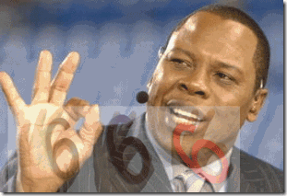 ESPN’s NFL Former Great “Uncle Tom” Jackson- Secret Black Satanic Cabal
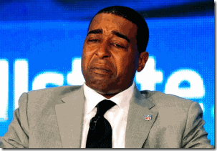
“When I got to Minnesota I was a different person because of the circumstances and what Buddy[Ryan] put me in, do you understand that? But I was on the path [to recovery]. I had five months clean off of CRACK COCAINE.” –Chris Carter, NFL Hall of Fame[1]
Dear Chris Carter, ESPN Negro Drama Queen,
I, by no means demean or condemn you for failing to take heed of history and the lessons of your elders including your MAMA– falling prey to the Dark Alliance, CIA/MK ULTRA Crack Cocaine. You may sincerely believe that you have subsequently become ILLUMINATED in the 21st Century beyond most of us and your MAMA by your experiences, and prominent place on the idiot box– television. Nevertheless your present state of ILLUMINATION, if you fell so easily to one patent genocidal plan of the Shadow Government and Deep State, YOU are subject to fall to other equally deep cover sinister and diabolical genocidal projects.

As regards to Adrian Peterson and corporal punishment of children, Texas is one of the most lenient states when it involves parental corporal punishment. According to the Texas‘ Office of Attorney General, May 2010,
“The law specifically excludes ‘reasonable’ discipline by the child’s parent … , corporal punishment is not in itself abusive under the law. An act or omission is abusive only if ‘observable and material impairment‘ occurs as a result or if it causes ‘substantial harm’ or exposes the child to risk of ‘substantial harm.’ “[2]
The Texas Education Code, Subtitle G, Chapter 37: Discipline: Law and Order, Section 37.0011, Use of Corporal Punishment states that corporal punishment includes ” ‘the deliberate infliction of physical pain by hitting, padding, spanking, slapping, or any other physical force used as a means of discipline,’ and relinquishes the control of whether or not it is allowed within a school district to the board of trustees…”[3] Corporal Punishment and the right of a parent along with school districts- to discipline their children by the infliction of pain on their children is allowed in the State of Texas.
Even for your own sake and survival, please show the same level of emotional detail and commitment to the human rights and justice of a Michael Brown of Ferguson, the CIA/MK ULTRA Project NAOMI’s Ebola genocidal victims of West Africa, and the People of Color of Gaza, Palestine than continuing chasing ILLUMINATI Pipe Dreams, False Flags and Illusions.
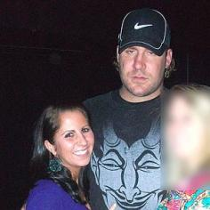
Or even closer to home in the NFL, YOU and your ESPN Negro Amen Corner aren’t equally concerned about or outraged about the Crimes against Women and Society of the NFL’s Drunken Satanic Serial Racist, BIG Ben Roethlisberger. Even at ESPN in the 21st Century, the white man’s ice is still a little cooler than everyone else.
Mr. Carter, what THEY are doing to your brother and NFL colleague Adrian Peterson is much deeper and sinister than you are willing to admit or can see. The extremely violent forces that are moving covertly against Adrian also want you put in your PLACE. As you will discover. You are in no better place or value to this society in the 21st Century than William Faulkner’s “Guinea Man”set out below. According to the secret powerful and elite Satanic Societies in this nation, YOU and your ISSUE shall have no place to run and hide by the Grace and Power of their God (SATAN) from the global ultimate fate of Black People- Symbolic and Ritual DEATH.

“And the great DRAGON was cast out, that old [Ole] SERPENT, called the DEVIL, and SATAN, which deceiveth the whole world: he was cast out into the earth, and his angels were cast out with him.” Revelation 12.9
The name, LUCIFER, means ‘day star,’ or ‘Son of the Morning.’ Many recognize it as an alternate name of SATAN, the FALLEN ANGEL.[4]
The DRAGON CREEPTH & the NFL
I have been a fervent fan of football since elementary school. Like so many fans, my wife and in-laws ask the same question over and over again at the end of the season, what are going to do now that football season is over? Every year, my answer has remained the same, if God is willing- wait for upcoming season next year.
For decades, football fans has rejected the DRAGON’s attempt to creep and overshadow the game of football with right-wing or neo-conservatism racialist politics and agendas.

In 2000, Monday Night Football (MNF) added the so-called Comedian Dan Miller to the broadcast booth. Dennis Miller is a right-wing conservative ideologue first and a so-called comedian second. NFL fans weren’t fooled. On air, his comments like, “the ref is whipping out that flag like it’s the only lighter at a crack house.” wasn’t funny and had nothing to do with football.[5]
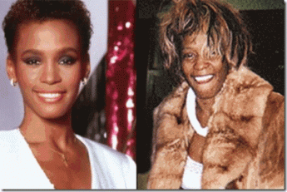
It Still Hurts Bad. Our Most Young, Beautiful and Gifted, Wasted on CIA Crack Cocaine
CIA Crack Cocaine as a U.S. Military-Industrial Biological Chemical agent has slaughtered and caused a great of human despair, pain and suffering to a generation of people. Miller’s comment was a deliberate and offensive slab in the back to a lot of poor families and fans of color that tuned to MNF just to enjoy the game, not to be insulted and humiliated. Fans rejected the DRAGON CREEP of Dennis Miller into America’s greatest pastime. Miller lasted about two years on MNF before he was shown the door OUT.
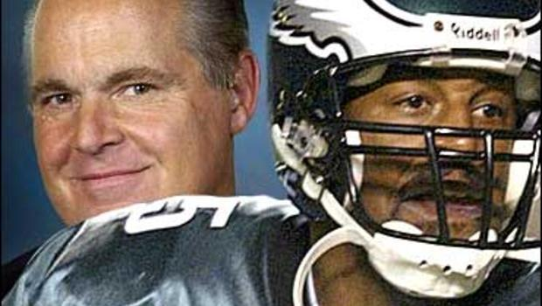
In 2003, ESPN inserted conservative talk host Russ Limbaugh into a broadcast slot in Sunday Night NFL Countdown. Almost immediately, Limbaugh tried to bait the game that we love with polarizing racial tension and divide by singling out Black Pro Bowl Philadelphia Eagles Quarterback Donovan McNabb for racially sensitive and divisive criticism. On air, he told millions of fans that McNabb received undeserved credit for his team’s success that came from media outlets with “social concern” and “very desirous that a black quarterback do well.”[6] Limbaugh’s comments about McNabb as a Black Athlete caused an uproar and revolt from fans around the country that again had to rise up and reject the DRAGON CREEP to infect the game with racial divide, Limbaugh was forced to immediately resign from ESPN.[7]
The bottom line is fans want to enjoy football as we have for decades free of self righteous ideologues, racial division, political and social agendas and indoctrination. We want to enjoy the game of football without the insidious prejudices and biases that plague this society. The NFL Commissioner Bob Goodell has set himself up as the intervener and regulator of the conduct of professional football players’ domestic relationships and disputes in the “Passion of the Species.” It sets up a very dangerous precedent that has already spiraled completely out of control. It has negatively impacted the game that we love.

The passion among men and women has been one of the world’s most complex, volatile and conterminous relationships since the beginning of time. Even the chapter of Genesis of the bible tells us that even God had issues. It is an ageless complex issue of MANKIND itself. What makes an elitist silver spoon mouth like Roger Goodell or a committee of women (witches) think that they can tackle the world’s most timeless issue of the “Passion of the Species” and the SERPENT that even God couldn’t or wouldn’t conquer? Just as in the Garden of Eve at the beginning of time, the DRAGON (Serpent) CREEPTH in the garden. The SERPENT was partly responsible for the Fall of Man. (Genesis 3.1-20)
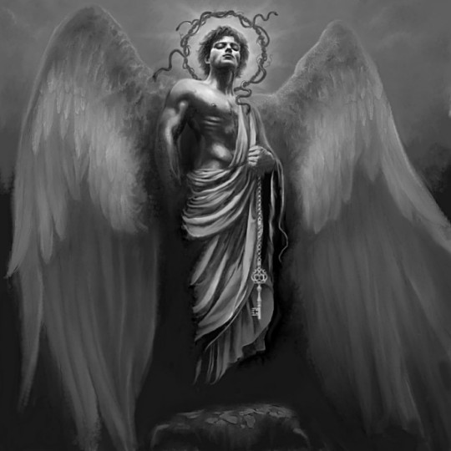
Roger Goodell has opened the back GATE to HELL and released the DRAGON- Fallen Angel, we may be witnessing the Fall of America‘s Greatness Pastime, THE GAME OF FOOTBALL.
The DRAGON CREEPTH: Jonathan Dwyer & The Big Pay Back
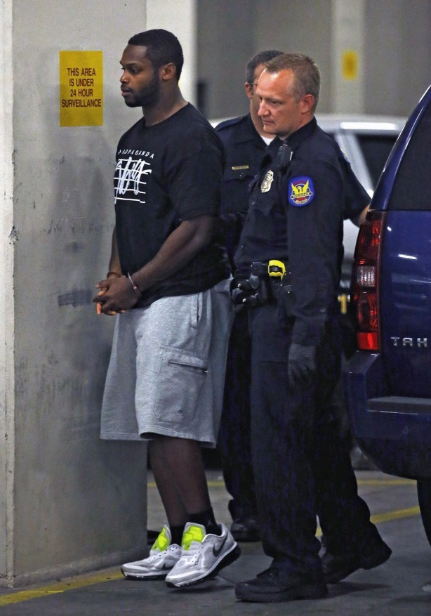
Well, the secret Hounds of the DRAGON and brutal Police State Action have been released against Black Professional Football Players. NFL Arizona Cardinal Running Back Jonathan Dwyer has been the most recent Big Black Brute subjected to America’s notorious savage historical Lynch Mob Mentality. Dwyer has been sensationally apprehended and arrested by the hounds and Police State Action for investigation into two domestic dispute altercations that occurred BACK on July 21 and 22, 2014.

In lieu of the national and global mob reaction to the false flag Black male VIOLENCE hysteria propaganda and the widespread global demonization of NFL Big Black Brutes Ray Rice, Greg Hardy, Ray McDonald, Adrian Peterson, Kayla Tobin Dwyer sent out the Arizona Lynch Mob to apprehend and nationally humiliate her husband at his employers’ training facility in Temple for the Big Pay Back.
On September 11, 2014, she filed charges for the first time against Jonathan Dwyer for domestic violence incidents that occurred BACK almost two months ago. I am quite sure if the police had informed him, Dwyer would have peacefully surrendered instead of being publicly humiliated globally- sensationally handcuffed, arrested and led away from the Arizona Cardinal‘s locker room by a posse of police.
On July 21, 2014, neighbors reported to police of some disturbances occurring at their home. When police responded to the disturbance, Kayla Dwyer, told responding officers, Phoenix Police Department, there had been just a verbal dispute and Jonathan had left the residence.[8]
On September 11, 2014, the Phoenix Police Department reported that she changed her story about July 21. She now says that there was an argument with the Big Black Brute that began on the morning of July 21 when she rejected Dwyer’s stereotypical brutal sexual advances when he, “attempted to kiss her and remove her clothing even though she repeatedly told him to stop. She bit his lip to get away from him and stop his advances and he allegedly responded by head butting her in the face, which she later learned had caused a nasal bone fracture … ABC reports.”[9]
The next assault Kayla allegedly told police took place on July 22 when she returned home.
” ‘According to the police report, [mad dog] Dwyer punched walls, causing visible damage, an threw a shoe at their son’s stomach. His wife threaten to call police and Dwyer allegedly threw her cell phone out a second story window, which witnesses saw. They also heard her screaming ‘he f****** hit me, I’m calling the police’ while holding her face and their 17-month- old child, the report states,’ details ABC News.”[10]
“Kayla reportedly packed and fled the state, calling officers once she felt safe”– fifty-one (51) days later on September 11, 2014.[11]
On September 17, 2014, six (6) days after Kayla reported the belayed incidences of Dwyer’s domestic VIOLENCE, the Phoenix Police Department, Maricopa County, Arizona cavalry and posse took to their horses to charge in and bag the monster. Prior to his arrest, it doesn’t appear that due to the lapse of time (51 days) between the incidents and the report of the incident that the police posse ever interviewed or questioned Dwyer about Kayla’s deferred allegations of abuse before he was trapped, caged and charged as a national nuisance to society.
The Big Black Brute, Jonathan Dwyer, 25, was thrown up against the wall and taken into custody by a police posse and booked into Maricopa County Jail with the book thrown against him for one count of aggravated assault causing a fracture, one count of aggravated assault involving a minor, two counts of criminal damage, one count of preventing the use of a phone in an emergency, and assault.[12]
Immediately at his arrest, the corporate mass media lynching mob set in to manufacture global public opinion to demonize and convict the Big Black Brute of high crimes against women and civilization, and the posses of Maricopa County, Arizona were happy to have bagged the menace to society that threatens the world; and the global view- value of the NFL. By that evening, without any questions asked or an opportunity to defend himself, the Arizona Cardinals with the blessings of the Roger Goodell and NFL deactivated Dwyer from all team activities in the BIG PAY BACK.
Maricopa County & The Invisible Empire- KKK
Since 2008, Maricopa County and its police posses has been subject to one of 17 probes the U.S. Justice Department’s Civil Rights Division has conducted of police and sheriff’s departments for the universal constitutional and civil rights violations of people of color– the most in its 54-year history.[13] In 2011, Sheriff Joe Arpaio of Maricopa County accepted the Sons of Confederate Veterans’ J. Edgar Hoover [33 Degree- Albert Pike Southern Jurisdiction Freemason] Law and Order Award.[14] Sheriff Arpaio believes it is a honor to be called KKK because it means that he is doing something, “It means we [Maricopa County and others] are doing it”- KEEPING NIGGERS IN THEIR PLACE, and slaughtering them.[15]
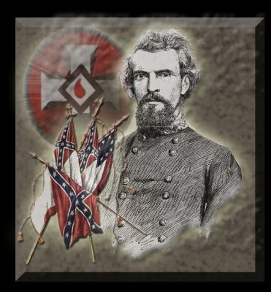
“That’s a good thing [Ku Klux Klan]. We can use that to keep the niggers in their place.” –Nathaniel Bedford Forrest [16]
General Nathan Bedford Forrest (July 13, 1821–October 29, 1877), one of the founders of the KKK, was the Confederacy most SINISTER Freemason RACIALIST killers, and Satanic human rights/war criminals of the Civil War.
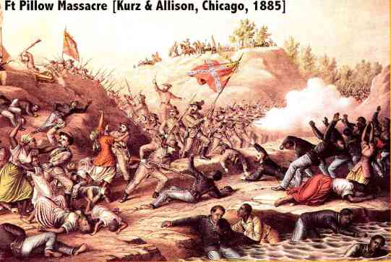
U.S. STEAMER “SILVER CLOUD.” Mississippi River, April 22nd, 1864.
“I was sent out with a burial party to bury our dead. I found many of the dead lying close along by the water’s edge, where they had evidently sought safety; they could not offer any resistance from the places where they were, in holes and cavities along the banks; most of them had two wounds. I saw several colored soldiers of the Sixth United States Artillery, with their eyes punched out with bayonets; many of them were shot twice and bayonetted also. All those along the bank of the river were colored. The number of the colored near the river was about seventy. Going up into the fort, I saw there bodies partially consumed by fire. Whether burned before or after death I cannot say, anyway, there were several companies of rebels in the fort while these bodies were burning, and they could have pulled them out of the fire had they chosen to do so. One of the wounded negroes told me that “he hadn’t done a thing,” and when the rebels drove our men out of the fort, they (our men) threw away their guns and cried out that they surrendered, but they kept on shooting them down until they had shot all but a few. This is what they all say.”[17]
It was Confederate General Nathaniel Bedford Forrest that led the rebel Fort Pillow savage slaughter of defenseless Black People. Forrest initially described the river as “dyed with the blood of the slaughtered for 200 yards,”[18] He was the first Grand Wizard [DRAGON] of the Ku Klux Klan (KKK).[19]

On Sunday, April 7, 2013, a 16 year old unarmed and defenseless teen, Alexander Wilson, was slaughtered in cold blood in West Phoenix, Maricopa County, by the Arizona Department of Public Services (State Highway Patrol). Reportedly, as soon as Alexander and another young Black male exited a SUV that allegedly was stolen, an officer of the DPS posse opened fire on Alexander, shooting him in his eye with an AR-15 military assault rifle, killing him instantly.[20]

On August 14, 2014 just days after Michael Brown was gunned down in Missouri, the Phoenix Police Department/ Maricopa County was called by social workers to serve a court order to a bring a virtually defenseless mentally ill 50 year old Black woman, Michelle Cusseaux, to a mental health facility. Since she was holding a hammer, the Phoenix Police Posse decided to save the state money; and slaughtered her in cold blood.[21]
The Hounds of the DRAGON of Maricopa County was certainty happy to accommodate society and put a uppity Big Negro like Jonathan Dwyer in his place with the full blessings and endorsement of Commissioner Roger Goddell and the mighty NFL. Goodell and the NFL’s sensationalized intervention into the players’ domestic relationships have created a very dangerous virtual carnival like atmosphere and feeding frenzy surrounding their extra-judicial punishment of players for off-the-field conduct. The fire of prejudice against Black professional football players has been set ablaze. Goodell and the NFL have done nothing but stoke and fan its flames. It has done little to extinguish the fire. It has encouraged the awakening and set some very covert dangerous and violent racialist elements in this country on the march to deal with the “Negro Problem” with corporate mass media and the NFL’s momentary manufactured consent of the masses. It is already too late to save Adrian Peterson’s INNOCENT CHILDREN.
The DRAGON CREEPTH: The Virtual Defenseless Adrian Peterson

For most of his life, Adrian Peterson has lived in the part of the country where “Football is King.” If football was a religion, AD would be its High Priest. He is a rare raw physical specimen of a man that football has come natural too. Just give him the ball, baby! It is a picture of natural beauty, grace and power.

“For the love of money is the root of all evil: which while some coveted after, they have erred from the faith, and pierced themselves through with many sorrows.” Timothy 6:10 (KJV)
However on the professional level of football, its GOD that give you the raw and natural talent, but it is SATAN that give you the fame, Glory and fortune. AD has a net worth of $20 million and annual salary of $14 million.[22] He has money and resources that understandingly attract a lot of attention from desperate and financially challenged people in America. It also place him on a pedestal of being a global vision of an independent prominent, powerful and successful Black Man.
It suddenly becomes a strange and treacherous world for a southern rooted pretty Simple Man of God who only wants to go to work, play the game of football and raise his family. He now has to face secret powerful and sinister forces that believe that the Architect of the Universe’s grand plan is only DEATH for him and his kind. AD is out on a limb with very little knowledge and actual real power to protect himself or his children from the DRAGON. And, it appears that very few in society even his high and mighty fraternal NFL brotherhood has stood up to object, challenge or condemn the steer racialist malicious and insidious global mockery of AD, and blatant indifference to the right of privacy and safety of his minor aged innocent children.
The DRAGON CREEPTH: the Slaughter of Little Tyrese

On October 10, 2013, Peterson’s beautiful innocent 2 year old son, Tyrese Doohen or Tyrese Robert Ruffin, was viciously slaughtered by Joseph Robert (Joey) Patterson. AD had only recently discovered that the boy was his son and had been planning to meet him in Sioux Falls, South Dakota that fall.

According to police, Tyrese died from traumatic injuries to the head. Lincoln County State’s Attorney Tom Wollman argued that the autopsy showed that they were four impact areas on the boy’s head, which led to bleeding in the brain. Wollman says the injuries were fresh and were the result of blunt-force trauma.[23]
But unlike Adrian Peterson’s current sensationalized child abuse case, few details of the child’s injuries or autopsy have been publicly released to the public. There are only sketchy details available about Little Tyrese, the suspect or the mother. Corporate mass media appears to be deliberately indifferent to the details to this case. It appears also that anything that could possibly tend to engender any public sympathy, sentiment or support for Peterson or his issue has been minimized by the ILLUMINATI. And for whatever reasons, the ILLUMINATI went on a diversionary offensive against AD to deliberately disparage him globally, in particular, for stereotypical NFL “Baby Mama Dramas.”
Ray Lewis is at the top of the list of NFL players with some of the most out of wedlock children- 6 kids by four different women.[24] He’s one of them- the Secret Black Satanic Cabal. Ray Lewis is protected even from murder.
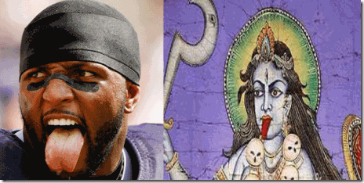
Lewis is member of the ILLUMINATI with a Satanic ritualistic taste for blood. He has a murder BODY COUNT as a NFL Baltimore Raven that he and the Baltimore Ravens refuses to this very day to bring to LIGHT.[25]
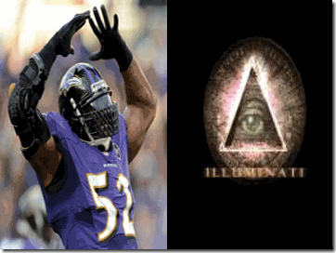
The “Hook” is an unofficial ILLUMINATI sign of Omega Psi Phi Fraternity. Lewis was initiated into the fraternity as an honorary member on October 12, 2012.[26] On ESPN, his presence in itself is a grand contradiction that constantly flash ILLUMINATI Pyramid Hand Signs and Gestures among the masses.
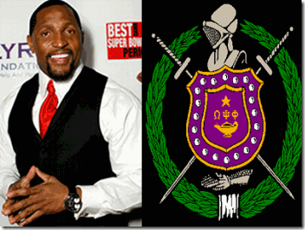
The Omega fraternity is a clandestine Negro fraternity of Arthurian “Knights.”[27] They are a “Skull and Bones” secret society, part of the ILLUMINATI Black Satanic Hellenized (Pan) Cult Network– the “Boule.”[28]
Within a week of Little Tyrese’s death, the Zionist TMZ began a campaign to TARGET AD for global humiliation, denigration, and re-image one of NFL’s most respected and dominate running backs as a degrading “Sperminator” for allegedly fathering and taking care of babies by at least 6 (six) stereotypical ghetto “Baby Mamas.”[29]

In this Picture with Erica Syion and Son. AD has the Appearance of Being a Proud Father of a Healthy Son.
Around October 18, 2013, mass media began to circulate stories that in addition to being an out of control “Sperminator,” AD was a low life dead beat dad that care little about his children. The so called mass media entitled “Baby Mama,” Erica Syion, the mother of one of Adrian‘s son claimed that he hadn’t paid child support in years to defame him. Yet, court documents showed that the allegation was the BIG LIE, a false flag.[30]
Erica Syion is billed by corporate mass media as a former gentleman club dancer that AD met in Houston. She has the Mark of the DRAGON, the MONARCH butterfly. Notice where the MONARCH oversees, the Vagina. It is a sign of a mind controlled CIA/MK ULTRA Sex Kitten.
Was Peterson’s son, Little Tyrese, ritual abused, slain or sacrificed by Gothic Parties, Satanic Cult or Luciferians?

Unlike Erica, there is no indication how, why and under what circumstances brought AD and Ann ‘Ashley’ Doohen of Sioux Falls, South Dakota together most likely in Minnesota. And, its seems that corporate mass media isn’t willing to share that information with the public for some reason.

Joey Patterson leading two boys about the same age through the HARVEST. One may be his son and other Tyrese?
Doohen took Tyrese off life support after two days, and his ORGANS were immediately removed and HARVESTED that may compromise Joey’s criminal prosecution case.

Night explores the Satanic symbolism of black. The Gothic color par excellence, black has long been associated with death, danger, and evil, but also mystery.[31]

Reichsfuhrer Heinrich Himmler’s SS black and silver detailed uniforms of the Third Reich were designed for Gothic horror, and appeal to the Satanic aristocracy and the upper classes.[32]
Around June 25, 2014, Little Tyrese’s murder case took a more bizarre and intriguing twist when it was discovered that the child slayer, Joey Patterson, was still co-habituating with the mother of AD’s slaughtered son, Ann ‘Ashley’ Doohen. From pictures posted on the internet, it appears on the surface that Doohen truly loved Little Tyrese, but how do you explain her continuing to co-habituate with the slayer that killed her beloved son with blunt-force trauma to the head? Unless, they are part of a Secret Satanic Cult or Coven.

Joey and unidentified Infant (Symbolic Gothic Black)Taught One Form of the Devil Horns Hand Sign
Joey is the son of a prominent Kadoka, South Dakota farming and land developer family, Grant and Susan Patterson.[33] Joey is a man with a history of mental instability, and background of VIOLENCE against women and children. He has a prior 2012 misdemeanor for beating a 3 year old child and assaulting his mother INSIDE A CHURCH.[34] There is evidence that suggest that 2 year old Little Tyrese had some justification to have been terrified of Joey. Joey was/is involved in some type of ritualistic traumatic infliction of pain on children under the age of 5 years old, classic CIA/MK ULTRA multiple personality disorder impressionate years.
Kadoka, originated from “Hodoka“, meaning “Hole in the Wall“. Native Americans thought Kadoka was a fitting name because it sits at the mouth of a gap leading into the Badlands. The Patterson Family of Kadoka, South Dakota with a population of no more than 700 people have a historic connection to the Benevolent and Protective Order of Elks, Denver, CO and Freemasons– most likely Kadoka’s historic Mt. Moriah Masonic Lodge and Temple #155, charter through the Grand Lodge of AF&AM of SD recognized by the United Grand Lodge of England.[35] The Elks Lodges are in many ways similar to their earlier prototype, the Masonic Order. Their rituals, secrets, terms of membership, objects and purposes have in varying degree characteristics like those of Masonry.[36]
Joey’s grandparent(s) are buried at the Old Masonic Cemetery in Philip, SD.[37] Masonic cemeteries are setup by Masons for Masons. Their cemetery grounds are consecrated by Masonic rituals- “The Grand Master, his Deputy, or the Master of the Lodge—as the case may be—should stand in the East, looking toward the West.[38]
In the June 2014 twist in the case, Joey violently attacked Doohen and was arrested on charges of kidnapping, aggravated assault, interference with emergency communications and third-degree burglary in Minnehaha County, South Dakota.[39]
On September 20, 2014, to add insult to injury, a mockery to justice and another glaring hypocrisy of America, Joey Patterson, an alleged slayer of Peterson’s son and a man with history of domestic VIOLENCE against women and children had been released from jail.[40] There has been no public outrage from women, women’s groups or global mass media pundits! Joseph Robert Patterson is free to resume his life, and pursue a living without public outcry unlike Ray Rice, Adrian Peterson, Greg Hardy, and now Jonathan Dwyer of the NFL.
Lest you forget, the State of Minnesota is part of the ancient Mississippi River Culture. For decades, South Dakota, Iowa and Nebraska have been a beehive for a secret powerful Satanic Underground involved in Pedophile Rings, Child Abductions and CIA/MK ULTRA Mind Control Programs that reach all the way to the Ronald Reagan/George H.W. Bush White House- The Franklin Cover-Up Child Abuse, Satanism, and Murder in Nebraska.
The DRAGON CREEPTH: Necromantic Ceremonial LEAVES & Adrian Peterson’s 4 Year Old
It is widely reported in corporate mass media that the Montgomery County- Texas DA says that AD’s 4 year old son told them something more chilling than odd and strange in that his father had stuffed his mouth with LEAVES while he was beating him.[41]
Adrian Peterson and family will tell you that he is a young man of deep Black Southern Roots and Traditions. I am also a person of southern roots and a student of our traditions, legends and folklore from forced servitude to freedom. I have also been the subject of the “switch” during my upbringing, but there is no history or folklore in regards to “stuffing LEAVES” in the mouths of Black children while under the stress of a classical southern “whooping.”
The 4 year old child’s story about ” LEAVES” being stuffed in his mouth to mute his cries doesn’t fit. It’s out of place in our history and folklore. It is not the invention of AD’s 4 year old son. The age of 4 is one of the classic formative impressionate periods to implant IATROGENIC multiple personality disorders- MK ULTRA. With AD son’s bush with the Old Southern Brotherhood, he has reason to be concerned for his future mental health and well-being.
However, the reference to “LEAVES” being stuffed in body cavities of slaughtered Black Children particularly the mouth and nose is chillingly related to secret signatures- Satanic Human Sacrifice & Necromancy (Worship of the Dead) rituals and folklore of the Ole Southern Brotherhood.
The DRAGON CREEPTH: LEAVES & the Ritual Slaughter of Ryan Harris
William Faulkner wrote, having lived in the American South where history never goes away, where understanding history is the only way to understand today, “The past is never dead. It’s not even past.”[42]

My particular interest in use of symbolic “LEAVES” in ceremonial ritual human sacrifice began with the rape and murder of the beautiful 11 year old Ryan Harris in Chicago on July 28, 1998. She was found brutally raped and slain in a vacant lot at 6600 South Parnell Avenue near railroad tracks in the Englewood section of Chicago. She had disappeared on July 27, 1998 while riding her bike.
The first officers that arrived at the scene found her face covered in blood. They found her T-shirt pulled over her chest. Ryan’s shorts were pulled down to her ankles and legs were spread apart with “genital laceration.” She appeared to have been raped and “strangled manually.” Her skull had been crushed from blows from a brick found nearby. Ryan’s ripped underwear was stuffed in her mouth .[43]
Her panties were reportedly stuffed so far down her throat that it pushed her tonsils down her esophagus. She reportedly had grass, shrugs, and twigs pushed up into her nose and ears. Ryan had put up a courageous and valiant fight and struggle to save her life.[44] When Ryan’s body was found, police additionally discovered a unique detail and signature in the murder. The killer(s) had taken the time to carefully stuff “LEAVES” into each of her nostrils. The “LEAVES” had been ritualistically and ceremonially folded over more than four times.[45]
This had not been the work and deeds of any 7 or 8 year old Black boys that the Chicago Police Department told global corporate mass media that they had committed capital crimes to steal Ryan’s brand new BIKE.[46] The sensationalized arrest of the pre-adolescent black males for rape and murder was without doubt a special false flag propaganda operation that not only was used to demonized “Black Children,” but it gave the killer(s) a cover and almost 4 (four) month window of opportunity to move away or continue to prey on Chicago’s Children of Color.

Cook’s Red Leaves is a novel about haunting tales of lost souls. Look at the (Ryan’s) BIKE! The carefully folded “LEAVES” stuffed in Ryan’s nose represented a death ritual and ceremony performed by Priest(s) of NECROMANCY (Worship of the Dead). It is a signature ritual of a special group of deep cover/secret society killers preying on Black Children that I needed to explore and understand.
The DRAGON CREEPTH: William Faulkner & Southern Gothic Horror and LEAVES
The Horror of the GOTHIC South
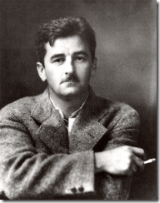
The Hidden Hand Gesture
I’m bad and I’m going to hell, and I don’t care. I’d rather be in HELL than anywhere where you are.” -William Faulkner [47]
SATANIC William Cuthbert Faulkner (born Falkner, September 25, 1897 – July 6, 1962), the “Inspiration of Southern Gothic Literature”, was an infamous American writer from Oxford, Mississippi. Faulkner is one of the United States’ most distinguished novelists. He was awarded the Nobel Prize, highest in literature, in 1949 and received the Pulitzer Prize for his novel “A Fable.” Most of his work deals with the South and Mississippi and the intricate patterns of race relations in that area.[48] Faulkner wrote novels, short stories, a play, poetry, essays and screenplays during his career. He is primarily known and acclaimed for his novels and short stories, many of which are set in the fictional Yoknapatawpha County, a setting Faulkner created based on his own native Lafayette County, Mississippi.[49]
Gothic fiction, which is largely dominated by the subgenre of Gothic horror, is a genre or mode of literature that combines fiction, HORROR and ROMANTICISM.[50] The genre also influenced American writing to create the SOUTHERN GOTHIC GENRE, which combines some Gothic sensibilities (such as the Grotesque- fantastic, ugly, incongruous, unpleasant, or disgusting) with the setting and style of the Ole South– the Master of SOUTHERN GOTHIC is Lucifer’s Servant, William Cuthbert Faulkner.[51]
Red Leaves & the GOTHIC Horror of the Ole South
The Negro Problem
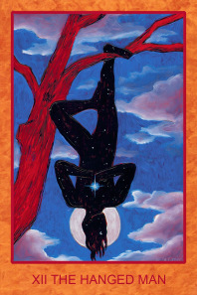
In 1908, 11 year old Faulkner witnessed the brutal sadistic slaughter/lynching of a black man, Nelse Patton, who was shot dead, then castrated, beheaded, and finally hung naked by the feet from a tree within feet of his home.[52]

On October 25, 1930, Faulkner published the short story “RED LEAVES” in the Saturday Evening Post. The story involved the ceremonial sacrifice/ritual murder of another Black man among the Mississippi Chickasaw Nation.[53] The name Mississippi comes from the French “Messipi” – the French rendering of the Anishinaabe (Ojibwe or Algonquin) name for the river, “Misi-ziibi,” meaning “Great River.”[54]
The Chickasaw Nation had ceded Faulkner’s Oxford, Mississippi to the U.S. government in 1832. African Forced Servitude (slavery) was an institution among the Chickasaw alongside that of the Ole South. In 1860, the Chickasaw Nation held about 4,600 Africans in forced servitude. In “Red Leaves“, the Native American enslavers considered a cannibalistic approach to the Negro Problem, they couldn’t eat them to get rid of them all, it is a “bitter taste of the Negroes’ black flesh.”[55]
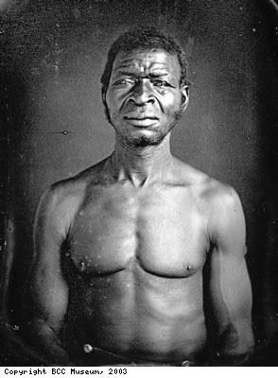
Red Leaves involves the ceremonial sacrifice/ritual slaughter of an African– Guinea Man. In the story at the death of his master, Issetibbeha, the Guinea man (African Body Servant) has to be ceremonially sacrificed to his master along with his horse and the DOG.[56] At the pending death of Issetibbeha who had been interned on a Mississippi Riverboat, Guinea man knew his fate was ceremonial death. He ran away and hide in the swarms, but was bitten by the Cottonmouth snake that he called “Ole Grandfather“- the SERPENT.
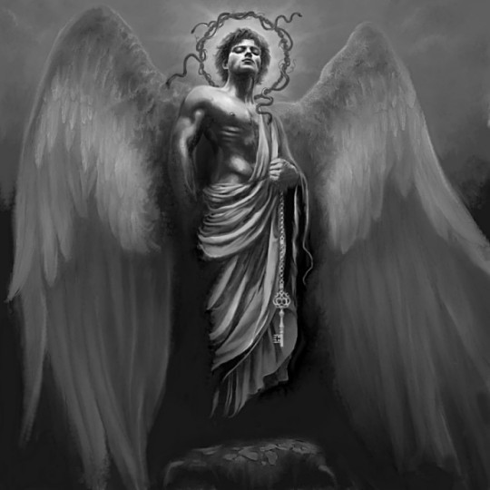
Faulkner interpretation of the SERPENT that struck Guinea man, it is “the old one, the ancient and accursed about the earth, fatal and solitary … evocative of all knowledge and an old weariness of a pariah- hood and of death.” Faulkner also called the Serpent, “FALLEN ANGEL, the unregenerate immortal” – SATAN.[57]
General Nathan Bedford Forrest & FORT PILLOW- Ritual Slaughter of Africans
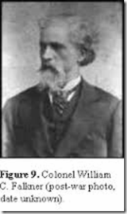
Faulkner had been the great grandson of Colonel William Clark Falkner of the Confederate States of America. The “Old Colonel” had been known in this own time as a cold blood killer of several men, and the slaughter of Africans with impunity and the grace of a god (SATAN). Among others than Africans, he is known to have stabbed and killed Robert H. Hindman with a Bowie knife in 1849 and shot and killed Erasmus Norris in 1851. On November 5, 1889, Col. Falkner was himself shot and killed by a former partner of the Ripley Railroad.[58]
During the Civil War, Col. Falkner fought at Antetam, Second Bull Run, Seven Days Battles, Seven Pines, Wilderness, Gaines’ Farm, Malvern Hill and Appomatox.[59] Sartoris is a novel, first published in 1929, by Faulkner. It portrayed the decay of the Mississippi aristocracy following the social upheaval (Black Reconstruction) of the Civil War. The folklore and legends of Old (Ole) Colonel Falkner served as Faulkner’s model for SARTORIS.[60]
Tellingly enough, Faulkner wrote that after the Battle of Second Manassas (Second Bull Run, August 28-30, 1862) Sartoris (Ole Colonel Falkner) had been deposed of his Captain position with the 2nd Mississippi Infantry and returned home for a while. Later, he mustered up a small group of irregular cavalry, 1st Mississippi PARTISAN RANGERS (authorized guerrillas), and joined General Nathan Bedford Forrest in Tennessee.[61]
During the American Civil War, groups of so-called “Partisan Rangers” engaged in bloody campaigns of guerrilla attacks, murder, assassinations, raiding and psychological warfare against rival military units and civilians that persisted after the war and during the Reconstruction Era. These units had tenuous ties to the regular Confederate and were led by men who often operated outside the recognized rules of warfare.[62]
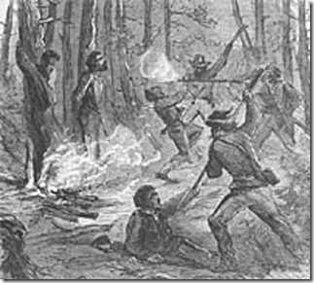
Some of history’s most infamous “Partisan Rangers” and Negro killers had been Albert Pike’s Knights of the Golden Circle– William Quantrill, Jesse and Frank James, and the assassin of President Abraham Lincoln, John Wilkes Booth.[63]
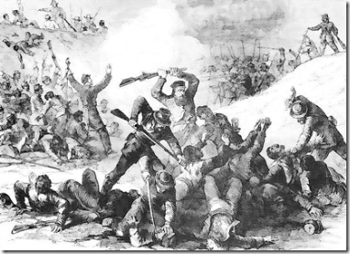
Falkner’s Rangers had been attached to Major General Nathan Bedford Forrest forces during the infamous April 1864 Fort Pillow Massacre when they slaughtered over 300 defenseless Black Union Soldiers and African freedmen, elders, men, women and children. Major General Forrest was also the official leader of Falkner’s Rangers.[64]
General Nathan Bedford Forrest, Ritual Slaughter of Africans & the KKK

Before the Civil War, Nathan Bedford Forrest was a rags to riches Memphis, Tennessee enslaver and trader. He was also a riverboat owner. During the war, General Forrest had been a “Masonic Wizardry” student of the Scottish Rite’s Satanic General Albert Pike. General Forrest was also a member of Pike’s secret counterintelligence Knights of the Golden Circle (KGC).[65]

Pike developed the secret Satanic rites, rituals and ceremonies for the KGC and KKK that General Forrest always had been a student. General Forrest became the first Invisible Grand WIZARD of the Knights of the Ku Klux Klan between 1867 and 1869.[66]
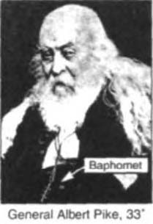
General Forrest was an apprentice Mason. He had been subordinate to Pike at all times. Pike had the power to secretly move General Forrest into the 33 Degree like President Andrew Johnson after the assassination of President Abraham Lincoln. Albert Pike relocated to Memphis to move behind and under the shadow of General Forrest and the KKK. General Forrest appointed Pike as the Grand DRAGON of that Realm, and its chief judicial officer. Pike organized the KKK in Arkansas under General Forrest.[67]
In November 1861, Pike commanded the Department of Indian Affairs. The Confederacy appointed Pike to negotiate treaties with among others the Five Civilized Tribes that included the Mississippi Chickasaw and Chippewa. Pike left the Civil War as the only Southerner to lead an all-Native American force in battle.[68] Pike and his student, General Forrest, were Masonic Wizards– participators of ancient magic and witchcraft. According to the Talmudic legends, King Solomon understood the mysteries of the Qabbalah (Mysticism). He was also an alchemist and a necromancer, being able to control demons, and other inhabitants of the invisible worlds.[69]
From Native American Shamans to Masonic Wizardry, Pike and General Forrest were intermediaries between the physical and spiritual planes. Along with their Native American Confederates particularly the Mississippi Chickasaw, Pike and General Forrest were students associated with and interested in the folklore and darker forms of Native American shamanism, associated with lower energies and older magical practices, including shapeshifting, demonology, and NECROMANCY.[70] The Mississippi River Band Chippewa (Ojibwa People) Shamans that lived along the great river from ancient times[71] place “FRESH LEAVES” IN THE NOSTRILS as protection when “WORKING WITH THE DEAD.”[72]
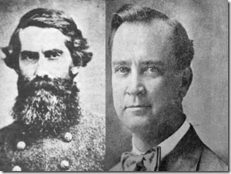
General Forrest and Grand Dragon Grandson- Nathan Bedford Forrest II
General Forrest’s son, William “Willie” Montgomery Forrest, Capt. CSA served in CSA with his father, wounded 3 times married Jane Cook of Oxford, MS in 1868. The issue of William and Jane, Nathan Bedford Forrest II (1872-1931), was born in Oxford, is best known for his tenure as the General Secretary of the Sons of Confederate Veterans as a Grand Dragon of the KKK.[73]

These local contacts with Oxford certainly leads credence to a local legend that General Bedford had traveled personally to Oxford, MS to recruit, initiate and setup a secret Order of Southern Brotherhood- KKK that undoubtedly must have included his trusted partisan commander, Ole Colonel William C. Falkner. During the 1930s and 40s, William Faulkner belonged to a pro-KKK, neo-confederate secret circle called the Agrarians linked to a Masonic Lodge in Murfreesboro, Tennessee created, directed, and controlled by the British Empire, to undermine the democratic institutions of the United States.[74]
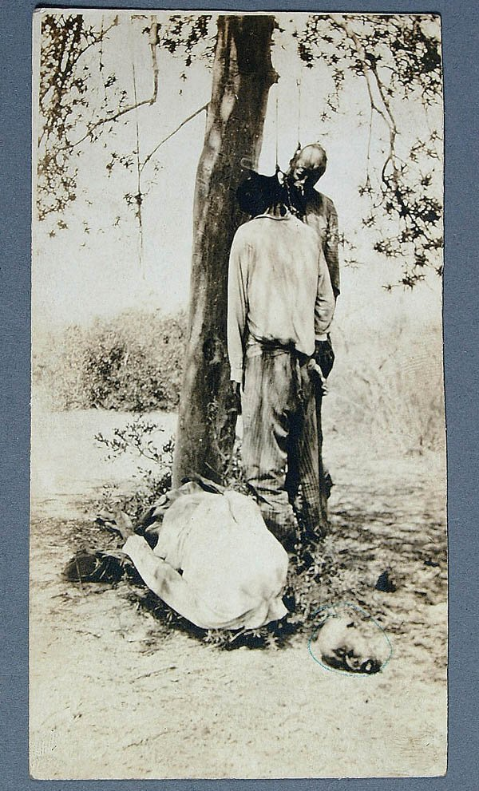
William Faulkner’s fascination and Demonic/Satanic taste for the blood of slaughtered Black People had been well established in his formative years as a child through the secret traditions and rituals of Old Colonel Falkner and Major General Nathan Bedford Forrest passed down thru his family. Faulkner’s works is linked to General Forrest in no less than nine of his novels and eight of his short stories.[75]
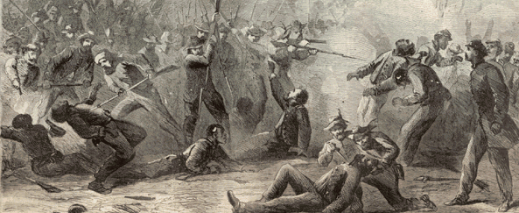
I said that to say this, William Faulkner had been no strangler or outsider to the secrets, Masonic rites and Satanic rituals of the KKK from the very inner circle of the Order of Southern Brotherhood whose “taste of the Negroes’ black flesh and blood” is unparalleled and established history in the United States. Guinea man represents the ultimate fate of Black People in “Red Leaves.” He had nowhere to run or hide from his fate- DEATH by the “DIVINE PLAN” of the Great SERPENT, the FALLEN ANGEL. LEAVES represents rituals of the secret Order of Southern Brotherhood to appease the unquiet rest of the slaughtered.
General Nathan Bedford Forrest, Racial Ritual Slaughter & the Nazis

In the Ritual Slaughter of Black People, Faulkner’s Symbolic Theme again is the “LEAVES”
In response to a question about Percy Grimm, the vigilante executioner responsible for the lynching of yet another Black man, “nigger- blooded criminal“ Joe Christmas,[76] in Faulkner’s 1932 novel, Light in August,[77] remarked that he had created a Nazi Storm Trooper before [Hitler] he had even heard of one.[78]
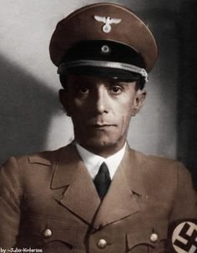
Nazi Germany‘s prime mover in censorship was the Minister of Propaganda (1928-1945), the Little EVIL genius, Paul Josef Goebbels. It was his responsibility to see that the German people were fed with material acceptable to the Nazi State. Newspapers, radio and all forms of media were put under the control of Goebbels.[79] In 1935, Faulkner’s Light in August- Gothic ritual symbolic slaughter of Black people was approved for general circulation and publication by Goebbels. Light in August received much attention from Nazi literary critics because they were right about Faulkner. He was a conservative Agrarian positively depicting white supremacy and the “struggle of racial purity.”[80]
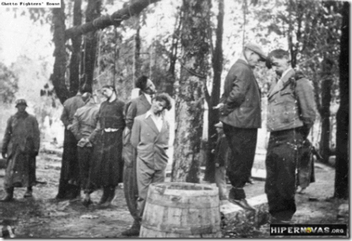
There are certainly many parallels to be drawn between the treatment of Blacks by the secret Brotherhood of the Ole South and treatment of Jews by the Brotherhood SS– Knights of the Black Sun.
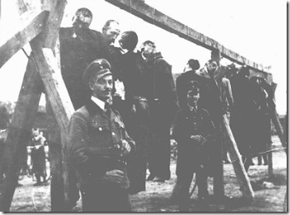
Too Many Frightening Parallels
Faulkner and the SS

In June 1937, five of Lucifer’s Servants– Nazi officers, traveling under assumed names, arrived in New York on their way to Oxford, Miss., where an R.O.T.C. professor of tactics at the University of Mississippi is to explain to them the fighting methods (open and covert symbolic and ritualistic slaughter of masses of color) of the Confederate General Nathan Bedford Forrest.[81] There is also a myth that Generalfieldmarshal Erwin Rommel, the infamous “Desert Fox” of World War II also made a special trip to Oxford to study General Forrest and spent his evening(s) with William Faulkner.[82]
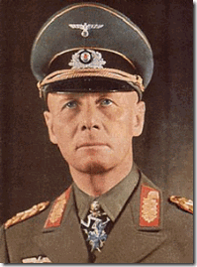
Field Marshal Rommel was a staunch SS Officer of the Reichsfuhrer Heinrich Himmler’s elite Allgemeine SS- Knights of the Black Sun and his military forces, the Waffen SS.[83]
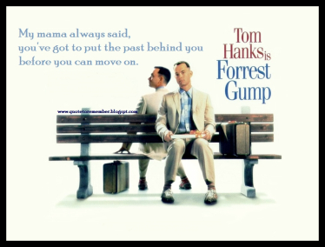
In 1994, HollyWeird’s Paramount Pictures slipped a popular movie and character pass the masses with a so-called American epic romantic comedy drama film, Forrest Gump. The mother of the film named Forrest after GENERAL NATHAN BEDFORD FORREST.[84] It’s more like Mama said “Conceal, Re-Define and Re-Image the Past.” Forrest Gump had to have been a major secret military industrial subliminal psychological warfare project.
The DRAGON CREEPTH: Ryan Harris & The Hidden Hand of the Secret Order of Southern Brotherhood

President Ulysses Grant (1869-1877) said that the KKK worked “by force and terror to prevent all political action not in accord with the views of the members; to deprive colored citizens of the right to bear arms and of the right to a free ballot; to suppress [i.e. burn] schools in which colored children were taught and to reduce the colored people to a condition akin to that of slavery.”[85]
The World’s Youngest Murderers and Violent Rapists
The 7 and 8 year old Black males arrested and charged by the State of Illinois for the murder and rape of Ryan Harris were sensationalized by global mass media as the United States‘ Youngest Murder Defendants. The touches were lit and they got on their horses to reign in innocent Black Children across the world to reduce the colored people to a condition akin to that of slavery. [86]
In Chicago’s UNDERGROUND, the generational [CIA/MK ULTRA] killers, serial rapist, abductors and pedophilic Durr Brothers lived in Ryan Harris’ Chicago Englewood neighborhood. Over the years, they had killed, attempted to kill, assaulted, battered, abducted, robbed and raped women and little girls in the neighborhood by the dozens as if they had a Hidden Hand to rape and kill. When Ryan was murdered, the Durr Brothers didn’t just fall under police radar as suspects, a hand to shield them was honored by the Chicago Police Department that led directly to the slaughter of Ryan Harris.
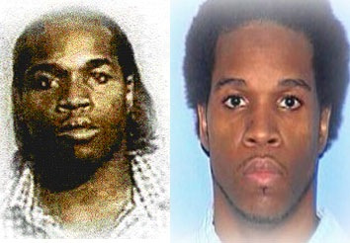
Months later, Floyd Durr was subsequently arrested and convicted of raping and murdering Ryan Harris. He had been a well-known extremely dangerous and violent Englewood “serial rapist.” Durr had been a suspect in Ryan’s case that the Chicago Police Department didn’t seem to have the power nor authority to question, or even arrest for similar recent assaults and rapes on little Black girls (10 and 11 year old girls).
The Durr Brothers weren’t just the run-of-the mill neighborhood ruffians, bullies or petty criminals. They were among an extremely dangerous elite class of trained paramilitary criminals with a license (Hand) from the Chicago Police Department to abduct, torture, rape and KILL. On January 14, 1998, Floyd abducted the 10- year old girl as she walked back from a store. She said that he threatened her life with a gun. With a gun in her side, he led her across the street from her home to the back of an abandoned building. He forced her to perform oral sex on him, “He eventually ejaculated into her mouth, and when she jerked her head away, he struck her in the face with the gun.”[87]
Then, he raped the little girl, “While defendant had his penis in M.L.’s vagina, he stuck the gun into her mouth.” While she cried, ” … defendant told her to be quiet or he would ‘blow [her] brains out.’”[88]
In fact six days before Ryan disappeared on July 27, 1998, an analyst at the state crime lab told Chicago police that DNA evidence linked Floyd Durr to a sexual attack on another 11-year-old girl. But police did absolutely nothing.[89]
Three days later, and still three days before Ryan disappeared, the analyst told police that DNA testing linked Durr to a sexual attack on the 10-year-old girl, and she urged police to get a sample of Durr’s blood or, at the very least, conduct a photo lineup. Again, Chicago police did absolutely nothing.[90]
Floyd’s tag team member that along side him committed homicides, abductions and pedophilic sexual crimes which terrorized Englewood was his older brother, Eddie Durr. Oddly enough, I couldn’t find any mug shots or pictures of Eddie even though he is a convicted life sentence sexual predator.
Some Hand and entity took very good care of the Durr Brothers. They were raised on milk and honey. The corporate mass media has failed to develop their story in that we still don’t know anything about who they worked for, their friends and associates, full arrest and conviction records or the places they traveled.

Floyd and Eddie’s younger brother, Eric, above, is also a convicted serial rapist.[91] The Durr Brothers were born one year within each other. According to Floyd, the formative years of the Durr Brothers’ ritual traumatic sexual abuse (multiple personality disorders) took place in Belzoni, Mississippi.[92]
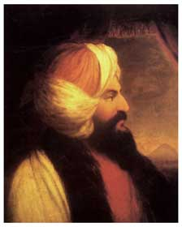
The deep delta town of Belzoni was once called “Bloody Belzoni” notoriously known for lynchings of Blacks (First Modern Unsolved Civil Rights Leader Murdered, Rev. George W. Lee), and an oppressive and murderous “Order of Southern Brotherhood” White Citizens Council.[93] The one- horse plantation town of Belzoni in Humphrey County, Mississippi is named for the “Great” Giovanni Battista Belzoni. Belzoni (1778-1823) was an Italian adventurer and explorer. He was the first to penetrate into Pharaoh Khafre’s Pyramid at Giza. The Great Belzoni was an illusionist, Freemason, Knight Templar, and a magical WIZARD.”[94]
According to court records, Floyd said that his family moved to Mississippi when he was at about the age of 10 and lived there for about 6 years (1978 to 1984).[95] According to Floyd’s timeline, Eddie Durr was the first to bush the State of Mississippi back in 1981, when he was found delinquent in Juvenile Court at age 14. His first rape charge came the next year at age 15 (1982), and he was sentenced to 6 years in state prison again that must have bushed the State of Mississippi.[96]
While on parole for that conviction, he bushed the State of Mississippi again in 1986 at about the age of 19 with criminal sexual assault, was convicted and sentenced to 12 years in prison.[97] In Mississippi, Black children bushing the state exhibiting even “hyperactive” and “aggressive” behavior were subjected to secret bizarre and barbaric medical experimentation.

One of these programs were exposed at Ole[Satanic]Miss (University of Mississippi) in William Faulkner’s Oxford. Dr. Orlando Andy, head of the Department of Neurosurgery from 1955 to 1979 was given black incorrigible state wards for psychosurgery and implant experimental electrodes into their brains. A report by one researcher stated, “Their brains were being implanted with electrodes that were HEATED UP TO MELT AREAS of the BRAIN that regulate emotion and intellect”.[98]
In 1979, Dr. Robert R. Smith was appointed chairman of the “Ole Miss” neurosurgery (Lobotomy) department after serving several years on the faculty. Dr. Smith was one of the premiere neurovascular surgeons in the country.[99] Dr. Orlando Andyand his “Ole Miss” psychosurgery team had also been working out of the G.V. “Sonny” Montgomery Veterans Affairs Medical Centers centered in Jackson,Mississippi. Veteran’s medical centers often provided cover for classified CIA MK ULTRA mind control experiments.[100]
The DRAGON CREEPTH: The Hand of Death & the Tag Team of HELL
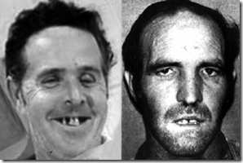
Henry Lee Lucas and Ottis Elwood Toole
Lucas and Toole (the cannibal) were two of the America’s most infamous ritually traumatic sexual abused necromantic homicidal maniacs, rapists and ABDUCTORS of children. It has been said that Lucas and Toole KILLED more than three hundred people across the U.S. and internationally.[101] Both bi-sexual admitted to working as assassins and terrorists for a secret elite and powerful Satanic Elite Cult, the no joke- HAND OF DEATH.[102]
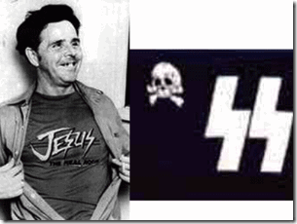
It is also interesting to note that Henry Lee Lucas received some type of Nazi indoctrination, and had also bushed the State of Mississippi. On June 30, 1970, he was released from custody for the January 2, 1960 murder of his mother, Viola Lucas, in Tecumseh, Michigan and paroled from a state hospital for the insane to JACKSON, MISSISSIPPI– home to Dr. Orlando J. Andy of Ole Miss?[103]
According to the book, Hand of Death, by Max Call,
“Henry tells of his indoctrination into a nationwide Satanic cult, and says that he was trained by the cult in a mobile paramilitary camp in Florida Everglades in the fine art of killing. Other training involved abduction and arson techniques. The first task he was given was the murder of one of the “students” a young black homosexual, who had betrayed his oath to the DEVIL. He slit the man’s throat and later that evening, a [necromantic] Satanic ritual was performed … “[104]
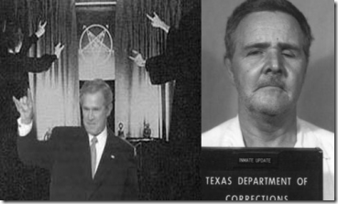
Former U.S. President/Texas Governor George Walker Bush was also directly associated with the elite Hand of Death Cult through a Satanic Cult Ring centered in Brownsville, TX.[105] On or about June 26, 1998, approximately one month before the slaying of Ryan Harris, Texas Governor Bush commuted Henry Lee Lucas’ death sentence for at least 11 murders to life imprisonment. It had been Governor Bush’s only and sole death sentence pardon.[106] Within a couple of years, Lucas was silenced forever on March 13, 2001 at 64 years old.
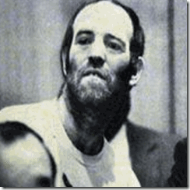
Ottis Toole, the Cannibal, is also called the “SOUTHERN GOTHIC”[107]
In March 1993, Toole knew the end for he and Lucas was near. White in prison, he drew a picture of his Hand of Death “Texas Cowboy” executioner- George H.W. Bush of Skull and Bones, the Brotherhood of DEATH.
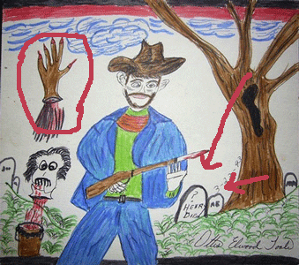
On September 15,1996, Ottis Elwood Toole, at the age of 49, was also silenced forever. He also died in prison of natural causes. Toole also had his death sentence commuted, but in the State of Florida.
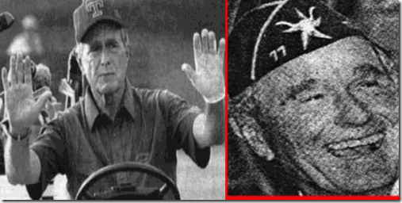
It is a state controlled by George H.W’s son, Jeb Bush (Governor 1998-2007) and the “HANDS OF DEATH”.[108]
As a decades long football fan, America is much too racist at its foundation and roots for an elitist like Commissioner Roger Goodell and the NFL to try to get involved in the extra-judicially regulation and punishment for domestic relation disputes and crimes against women and children when the NFL is predominately, 66% Black, because as you see already, all the sensationalized violators of the NFL code of conduct have turned out to be “Black Faces.”
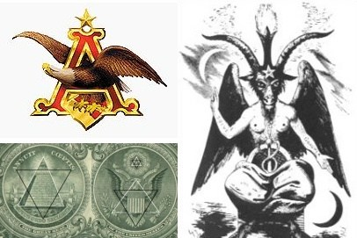
Even the ILLUMINATI/Bohemian Anheuser-Busch weighed in vocally on the NFL for not cracking down harder on the deviant-antisocial behaviors of Big Black Brutes, particularly, Adrian Peterson and Ray Rice. Talk about Opening Up the Floodgates of Hell into the NFL to single out, target and attack Black Professional Athletes! Anheuser-Busch calling out the NFL to reign in on the behavior of its predominately Black players is worst than the “Pot Calling the Kettle Black.”

Busch, a old German Roman Catholic line, is also spelled Bush. Anheuser-Busch is connected to the HAND OF DEATH and George H.W. and Barbara Bush Satanic Family Clan through Knight of Malta Prescott Sheldon Bush, Jr. Prescott Bush, Jr. (1922-2010) was the uncle of George W. Bush, and older brother of George H.W. Bush. Anheuser-Busch list Prescott, Jr. as a “Consultant” and “BLOODLINE Relative.”

18° Knight of the Rose Croix jewel (Masonic Scottish Rite) Similar Design to Anheuser-Busch’s Logo
Anheuser-Busch: Satanic/Imperium Bloodline & Privilege
In 1934, August Busch Sr., who was president of the company, killed himself with a revolver at Grant’s Farm. In 1976, Peter Busch, the son of August Busch Jr. and half-uncle of August Busch IV, shot and killed a friend, David Leeker. Peter Busch claimed the gun went off accidentally as he tossed it on a bed. He pleaded guilty to manslaughter and received five years’ probation.[109]
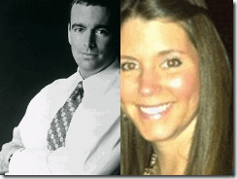
In 1983, Busch IV, the former Anheuser-Busch CEO and heir to the Budweiser fortune, then a 19 year old University of Arizona student frequented a nightclub called “Dirtbags.” A 22-year-old female bartender, Michele Frederick, working there made the mistake of hitching a ride home with him. Busch IV’s black Corvette crashed and the woman was killed. Busch was found hours later at his home. He suffered a fractured skull and claimed he had amnesia. After a seven-month investigation, authorities declined to press charges against him, citing a lack of evidence.[110] Two years later, Busch IV was acquitted by a jury in St. Louis on assault charges resulting from a police chase that ended with an officer shooting out a tire on his Mercedes-Benz. Undercover narcotics officers began the chase after Busch’s car nearly struck them, police said at the time. Busch was also accused of trying to run down two detectives. He said he was fleeing because he thought the unmarked police car carried would-be kidnappers.[111]

In December 2010, an aspiring young model, Adrienne N. Martin, was found dead in the gated St. Louis- Biechroeder home of August Busch IV. According to Busch IV, his 27 year old girlfriend just died- no big shit for a man in his secret privileged class and bloodline hierarchy. [112] There has been no public outrage from women, women’s groups or global mass media pundits to the Crimes of the Busch Family, the Rich and Powerful of the Country.
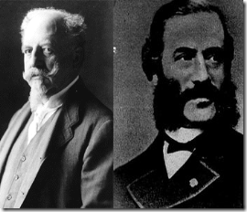
Adolphus Busch “King of the Beers” (1839-1913), left above, the second-youngest of twenty-two children- some of them half-siblings, was an elite German occultists who acquired President/ Civil War General Ulysses Grant’s St. Louis property and built a magnificent castle on it called Grant’s Farm- Bleichroeder.[113] Gerson von Biechroeder (1822-1893), right, was a leading German banker of the Rothschild ILLUMINATI. He was a notorious and important Freemason and Satanist.[114] Biechroeder was a director of KKK Grand DRAGON Albert Pike’s supervisory Council of the Palladian Rite in Berlin.[115]
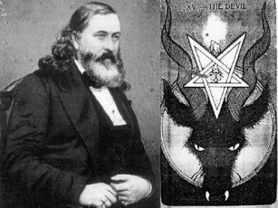
Well, I had my last BUD this last week.
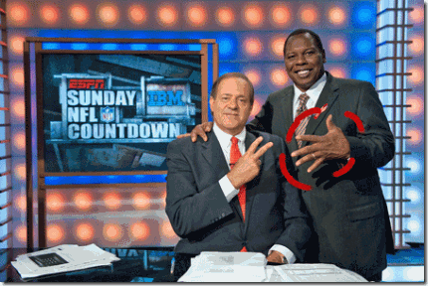
The invisible Hand of the ILLUMINATI seems to run throughout the NFL now. This football season just doesn’t have the same thrill or passion for the game as before. This Thursday Night’s Minnesota Vikings game without its star running back Adrian Peterson against the Green Bay Packers was yet another NFL lifeless and national embarrassing blowout that Stink to the High Heavens. During the game, I put ESPN on MUTE.
THE DRAGON HAS CREEPTH throughout the NFL tainting it with Racial Bias, Badges and Ravages of Slavery, Extrajudicial Denial of Fair Play, Equal Protection and Due Processes of the Law. It’s doesn’t pass the smell test anymore.
Our beloved NFL has come under the VEIL of SATAN and the secret universal global grand master plan of the DRAGON– the FALLEN ANGEL, and Legions of the DARK. It’s up to fans to clean it up. Expose it to the LIGHT OF THE DAY or we may be witnesses to the Fall of America’s Greatness Pastime, AND THE GLOBAL MASS SLAUGHTER OF PEOPLE OF COLOR.

[1] http://philadelphia.cbslocal.com/2014/04/04/cris-carter-firm-on-his-comments-about-eagles-desean-jackson/
[2] https://www.texasattorneygeneral.gov/ag_publications/txts/childabuse1.shtml
[3] http://www.examiner.com/article/corporal-punishment-still-allowed-texas-schools
[4] http://www.sharefaith.com/guide/christian-ministries/angels/lucifer-the-fallen-angel.html
[5]http://bleacherreport.com/articles/50977-monday-nights-with-dennis-miller
[6] http://usatoday30.usatoday.com/sports/football/nfl/2003-10-02-limbaugh-resigns_x.htm
[7] http://usatoday30.usatoday.com/sports/football/nfl/2003-10-02-limbaugh-resigns_x.htm
[8] http://www.wcnc.com/story/sports/nfl/2014/09/17/cardinals-jonathan-dwyer-arrested-on-assault-charges/15805717/
[9] http://www.jrn.com/fox47news/now-trending/Jonathan-Dwyer-allegedly-head-butted-wife-275687961.html
[10] http://www.jrn.com/fox47news/now-trending/Jonathan-Dwyer-allegedly-head-butted-wife-275687961.html
[11] http://www.jrn.com/fox47news/now-trending/Jonathan-Dwyer-allegedly-head-butted-wife-275687961.html
[12] http://espn.go.com/nfl/story/_/id/11544985/jonathan-dwyer-arizona-cardinals-arrested-two-counts-suspicion-aggravated-assault
[13]http://www.washingtonpost.com/politics/justice-to-sue-arizona-sheriff-joe-arpaio-saying-he-violated-hispanics-civil-rights/2012/05/10/gIQAYfFwFU_story.html
[14] http://blogs.phoenixnewtimes.com/bastard/2012/12/joe_arpaios_top_ten_reasons_fo.php
[15] https://www.youtube.com/watch?v=VFTUQ71Aq0o
[16] http://www.newworldencyclopedia.org/entry/Nathan_Bedford_Forrest
[17] http://deadconfederates.com/2012/08/02/what-they-saw-at-fort-pillow/
[18] http://www.blackpast.org/aah/fort-pillow-massacre-1864
[19] http://www.history.com/topics/american-civil-war/nathan-bedford-forrest
[20] http://opnateye.com/?p=678
[21] http://azinformant.com/family-of-michelle-cusseaux-calls-for-justice-department-investigation/
[22] http://www.celebritynetworth.com/richest-athletes/nfl/adrian-peterson-net-worth/
[23] http://www.cbsnews.com/news/adrian-peterson-update-joseph-patterson-sd-man-charged-with-murder-in-death-of-nfl-stars-son-released-on-bond/
[24] http://newsone.com/2105655/ray-lewis-child-support/
[25] http://www.nydailynews.com/sports/football/ray-lewis-ray-rice-cover-article-1.1947343
[26] http://kollegekidd.com/news/baltimore-ravens-lb-ray-lewis-throws-up-omega-psi-phi-hooks-in-afc-championship-game
[27] http://daghettotymz.com/rkyvz/articles/bouleseries/boule1-3roster/shields/shields.html
[28] http://letsrollforums.com/boule-sigma-pi-phi-t18970.html?s=9ea6e2196beafaf56bab4845d8f77ccb&amp;
[29] https://www.youtube.com/watch?v=HODh3g0Iodc
[30] http://perezhilton.com/perezitos/2013-10-18-adrian-peterson-court-docs-say-never-missed-child-support-baby-mama-reacts-twitter/?from=post
[31] http://sites.fitnyc.edu/depts/museum/Gothic/night.html
[32] http://www.craiggottlieb.com/engine/inspect.asp?Item=1327`
[33] http://www.rushfuneralhome.com/cms/plugin_obituaryview.php?obituary_ID=499
[34] http://www.argusleader.com/story/news/crime/2014/09/09/joseph-patterson-in-court/15341791/
[35] http://www.masonpost.com/sd/mtmoriah155/
[36] http://opc.org/GA/masonry.html
[37] http://www.rushfuneralhome.com/cms/plugin_obituaryview.php?obituary_ID=499
[38] http://www.sacred-texts.com/mas/gar/gar73.htm
[39] Id.
[40] http://www.foxsports.com/nfl/story/suspect-in-death-of-adrian-peterson-s-son-free-on-bond-092014
[41] http://www.people.com/article/minnesota-vikings-adrian-peterson-reinstated
[42] http://bobmschwartz.com/category/history/
[43] http://missing87975.yuku.com/topic/2125/t/MURDERED-GIRL-RYAN-HARRIS.html
[44] Id.
[45] http://articles.chicagotribune.com/2007-12-14/news/0712140064_1_floyd-durr-death-penalty-sabrina-harris
[46] http://missing87975.yuku.com/topic/2125/t/MURDERED-GIRL-RYAN-HARRIS.html#.VB4s7fldV-I
[47] http://www.bebo.com/c/profile?MemberId=10460596200
[48]http://www.mindfully.org/Reform/Emmett-Till-Faulkner24sep55.htm
[49] http://en.wikipedia.org/wiki/William_faulkner
[50]http://en.wikipedia.org/wiki/Gothic_fiction#Southern_Gothic
[51] http://en.wikipedia.org/wiki/Gothic_fiction#Southern_Gothic
[52] http://www.twoop.com/people/william_faulkner.html
[53] http://findarticles.com/p/articles/mi_m2455/is_n1_v30/ai_14085637/
[54] http://www.statesymbolsusa.org/Mississippi/MissNameOrigin.html
[55] Id.
[56] http://literaturesave2.files.wordpress.com/2009/12/william-faulkner-red-leaves.pdf
[57] http://www.questia.com/library/journal/1G1-14085637/sacrificial-rituals-and-anguish-in-the-victim-s-heart
[58] http://www.geni.com/people/Col-William-Clark-Falkner-CSA/6000000013363567183
[59] Id.
[60] http://en.wikipedia.org/wiki/Sartoris
[61] Fargnoli, A. Nicholas, Critical Companion to William Faulkner, Facts on File, NY, NY (2008) pg. 239
[62] http://www.history.com/topics/american-civil-war/civil-war-guerilla-leaders
[63] http://www.angelfire.com/nb/rockman/Page40.html
[64] http://www.rootsweb.ancestry.com/~mscivilw/history/rangers.htm
[65]http://www.angelfire.com/nb/rockman/Page40.html
[66] http://en.wikipedia.org/wiki/Leaders_of_the_Ku_Klux_Klan
[67] http://www.theforbiddenknowledge.com/hardtruth/scottishriteproject.htm
[68] http://www.civilwarvirtualmuseum.org/1861-1862/native-americans-in-the-war/albert-pike.php
[69] http://www.sacred-texts.com/eso/sta/sta43.htm
[70] http://www.angelfire.com/mi3/tomekeeper/resources/articles/OnNecromancy.txt
[71] http://en.wikipedia.org/wiki/Mississippi_River_Band_of_Chippewa_Indians
[72] http://plants.usda.gov/plantguide/pdf/cs_arfr4.pdf
[73] http://en.wikipedia.org/wiki/Nathan_Bedford_Forrest_II
[74] http://www.larouchepub.com/eiw/public/1997/eirv24n46-19971114/eirv24n46-19971114_064-william_faulkner_the_great_ameri.pdf
[75] http://articles.sun-sentinel.com/1992-10-25/features/9202250609_1_civil-war-nathan-bedford-forrest-ku-klux-klan
[76] http://www.novelguide.com/reportessay/literature/novels/grimm-truths-about-society-and-joe-christmas
[77] http://en.wikipedia.org/wiki/Light_in_August
[78] http://www.h-net.org/reviews/showrev.php?id=24653
[79] http://www.historylearningsite.co.uk/censorship_in_nazi_germany.htm
[80] http://en.wikipedia.org/wiki/Light_in_August
[81] http://www.nytimes.com/1986/03/16/books/a-nazi-at-ole-miss.html
[82] Id.
[83] http://www.feldgrau.net/forum/viewtopic.php?f=42&t=5928
[84] http://en.wikipedia.org/wiki/Forrest_Gump_(character)
[85] http://www.theforbiddenknowledge.com/hardtruth/scottishriteproject.htm
[86] http://articles.chicagotribune.com/2006-04-16/news/0604160456_1_floyd-durr-ryan-harris-sexual-assaults
[87] http://caselaw.findlaw.com/il-supreme-court/1016569.html
[88] Id.
[89] http://articles.chicagotribune.com/2001-04-01/news/0104010395_1_crime-lab-sexual-attack-chicago-police-department
[90] Id.
[91]https://groups.google.com/forum/#!msg/alt.true-crime/GEUIDBjA_w4/Rh5cuj1C3ywJ
[92] http://articles.chicagotribune.com/2006-04-16/news/0604160456_1_floyd-durr-ryan-harris-sexual-assaults/2
[93] http://themiddleoftheinternet.com/OnlineBooks/Rebels/14.pdf
[94] http://freemasonry.bcy.ca/biography/belzoni_g/belzoni_g.html
[95] http://articles.chicagotribune.com/2006-04-16/news/0604160456_1_floyd-durr-ryan-harris-sexual-assaults/2
[96] http://articles.chicagotribune.com/2006-04-16/news/0604160456_1_floyd-durr-ryan-harris-sexual-assaults/2
[97] id.
[98] http://archive.org/stream/MonarchTheNewPhoenixProgram_441/Monarch_djvu.txt
[99] http://www.umc.edu/Education/Schools/Medicine/Clinical_Science/Neurosurgery/About_Us.aspx
[100] http://www.umc.edu/Education/Schools/Medicine/Clinical_Science/Neurosurgery/About_Us.aspx
[101] http://aboutserialkillers.blogspot.com/2009/10/henry-lee-lucas-and-ottis-toole.html
[102] http://www.skyscrapercity.com/showthread.php?t=299036
[103]http://www.vicfeazell.com/html/Confirmed%20Travel%20Movements%20Of%20Henry%20Lee%20Lucas.PDF
[104] http://floridazone.blogspot.com/2013/11/the-hand-of-death.html
[105] http://www.cbsnews.com/news/bush-commutes-death-sentence/
[106] http://occult101.wordpress.com/tag/jeb-bush/
[107] http://jaxpsychogeo.com/ottis-toole/stalking-ottis-toole-chapter-53/
[108] http://zosotruthtalk.wordpress.com/2011/04/22/entering-the-netherworld-of-highly-organized-very-corporate-global-pedophile-pornography-ring-and-mkultra-mind-control/
[109] Id.
[110] Id.
[111] Id.
[112] http://alpha411.blogspot.com/2010/12/budweiser-death-illuminati-cover-up.html
[113] http://alpha411.blogspot.com/2010/12/budweiser-death-illuminati-cover-up.html
[114] http://real-world-news.org/Satan-WGCarr.html
[115] http://libermundus.org/the-world-at-war/the-conspiratorial-nature-of-history.html
Comments : 1 Comment
Tags: Adolphus Busch, adrian peterson, albert pike, Alexander Wilson, Anheuser-Busch, Ann 'Ashley' Doohen. ann doohen, august busch, barbara bush, Ben Roethlisberger, black chlidren, black satanic cabal, Brotherhood of the Ole South, chicago police department, Chickasaw, chris carter, Colonel William Clark Falkner, crack cocaine, dark alliance, deep politics, deep state, dennis miller, Donovan McNabb, Dr. Orlando J. Andy, DRAGON CREEP, Eddie Durr, engelwood, eric durr, Erica Syion, Erwin Rommel, espn, fallen angels, ferguson, Floyd Durr, forrest gump, fort pillow, Franklin Cover-up, freemasons, FRESH LEAVES" IN THE NOSTRILS, gary webb, GEORGE H. W. BUSH, George W. Bush, Gerson von Biechroeder, Giovanni Battista Belzoni, greg hardy, hand of death, henry lee lucas, Illuminati, joey patterson, jonathan dwyer, joseph robert patterson, Kayla Dwyer, kkk, knights of malta, Knights of the Black Sun, knights of the golden circle, knights of the golden dawn, ku klux klan, Light in August, Lucifer, luciferian brotherhood, luciferians, lynch mob menality, lynchings, Maricopa County, masonic order, michael brown, Michelle Cusseaux, minnesota vikings, MK-ULTRA, nathan bedford forrest, Nazis, NECROMANCY, Nelse Patton, nfl, Old Colonel Falkner, ole miss, Ottis Elwood Toole, ottis toole, paul josef goebbels, phoenix police department, Prescott Sheldon Bush, ray lewis, ray mcdonald, ray rice, red leaves, roger goodell, Russ Limbaugh, Ryan Harris, satan, Sex kittens, shadow government, Sheriff Joe Arpaio, skull and bones, SOUTHERN GOTHIC, Sperminator, SS, tom jackson, Tyrese Doohen, Tyrese Robert Ruffin, university of mississippi, William Faulkner, william kaulkner
Categories : adrian peterson, african american satanic cult, albert pike, antichrist, Aryan Supremacy, baphomet, black children, bohemian grove, civil war, Dark Alliance, devil's horns, genocide, George W. Bush, Heinrich Himmler, human sacifrice, illuminati, illuminati sacrifice, Knights of the Black Sun, Knights Templar, ku klux klan, lucifer's servants, lucifer's workshop, luciferians, mark of the beast, mind control, MK-ULTRA, monarch child, mulitiple personality disorder, Nazis, nfl illuminati, order of teutonic knights, Paul Josef Goebbels, ray rice, re-image, re-imaging, Reichsfurhrer SS-1 Heinrich Himmler, revelations, Ritual Satanic Abuse, ritual satanic sexual abuse, ritually abused children, ryan harris, satan, Satanism, sex kitten, sex slave, skull and bones, SS, Symbionese Liberation Army, underground reich, underground third reich, ZIONIST

LIFT THE VEIL OF SATAN, RAY RICE, FALSE FLAGS & NFL ILLUMINATI
18092014
I didn’t particularly respect the opinions of Stephen A. Smith before. Many expected Smith to crawl into a corner and tempter his opinion about VIOLENCE against women after he had been suspended by CNN for voicing a sense of judgment in the Ray Rice Affair that offended some women. However, I now certainly respect his BACKBONE and HEART to stand up to the ILLUMINATI on this particular issue.
In the first instance, Smith told a national televised audience on air, “Let’s make sure we don’t do anything to provoke wrong action… we got to also make sure that you can do your part to do whatever you can to make, to try to make sure it doesn’t happen again.”[1]
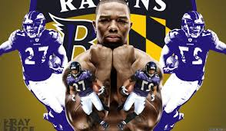
I gather that he was talking about how Janay Palmer didn’t use reasonable judgment when she passionately stepped up to and tried to batter and combat Ray Rice as if he was “LESS THAN A MAN” that he is. Likewise, Rice didn’t exercise the “Osirian Will” in knocking out the young lady that he loves. However, the Ray Rice Affair does not justify mass global sensationalism under any circumstances.
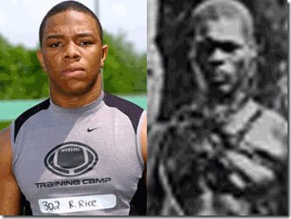
Black professional football players like Ray Rice are seen as high profile, powerful and millionaire athletes, but they carry a heavy chain around their necks by the NFL ILLUMINATI like the beautiful and defiant brother Paul Reed just moments before he was douched with oil and burned alive. They sought no mercy of SATAN. The Defiant Ones, Paul Reed and Will Cato were lynched- tied to a tree with ropes and chains then burned alive by a drunken white mob in Statesboro, Bulloch County, Georgia in 1904. The following day, two white youngsters presented the judge that ruled over their murder conviction by an all white jury with charred pieces of Cato and Reed’s bones as savage souvenirs of the mob’s deeds.
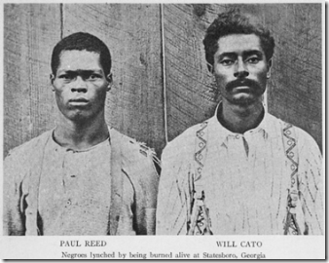
The hypocrisy and mass mental disorder of America is that it is usually blind to VIOLENCE as long as there is a Dark Face at the end of it.

How in the world did the lonely Black face of Ray Rice suddenly get put out on a limb to become a sensationalized global whipping/poster boy for VIOLENCE? It sets an extremely dangerous precedent and diversion from the TRUTH that out of all the horrible acts of VIOLENCE and INHUMANITY TO MAN taking place on a daily basis nationally and global that somehow the conduct of American Black Males require special attention, surveillance and regulation beyond the laws of civilization that all men are mandated to live by.

The ILLUMINATI, “… portrays black men as innately savage, animalistic, destructive, and criminal — deserving punishment, maybe death. This brute is a fiend, a sociopath, an anti-social menace. Black brutes are depicted as hideous, terrifying predators who target helpless victims, especially white women.”[2]
The Black Brute Syndrome and Negrophobia (Fear of or contempt for Black people and their culture) are some of the seemingly ageless mass social and mental diseases that the racist and satanic ILLUMINATI implant among the people to polarize the global masses to prevent unity with Black People in the spiritual struggle against them. It is also used as a propaganda tactic; and system of mass population hysteria, control, diversion and deception.

George T. Winston (1901), a Hellenized [3] “Negrophobic” writer, claimed:
When a knock is heard at the door [a White woman] shudders with nameless horror. The black brute is lurking in the dark, a monstrous beast, crazed with lust. His ferocity is almost demoniacal. A mad bull or tiger could scarcely be more brutal. A whole community is frenzied with horror, with the blind and furious rage for vengeance.[4]
What did Ray Rice do? Generally. “It’s not because she [Janay Palmer-Rice] did ‘X.’ It’s not because she touched [slapped] him first. It’s not because she spit in his face”… “It’s because he [Ray Rice] punched her in the face and in the head. That’s why we are talking about this.”[5]
On the elevator, Janay seems to deliver a back hand slap to Rice’s face. He pushes/drives her back with a left hand or a left jab. She becomes enraged and clearly lounged toward Rice with fists drawn to deliver a punch or head shot and got caught coming in with a short round house or straight right to the head knocking her unconsciousness. Neither one of them appears to have any domestic violence and abuse history. It appeared to be an recorded isolated highly emotional domestic dispute and incident that because of Rice’s celebrity status as a highly paid professional successful Black football athlete was marketed to go viral.
On February 15, 2014, both Ray and Janay were arrested and charged for simple assault for the mutual altercation on the elevator at the Revel Hotel and Casino in Atlantic City, New Jersey. For whatever reasons, Janay’s charges were dropped while Rice’s charges were elevated by indictment to third degree aggravated assault on March 27, 2014 that carried a possible state prison sentence.[6]
In May 2014, Rice pled not guilty and then entered into a pre-trial intervention program for FIRST-TIME OFFENDERS that would eventually clear his record, and continue family counseling with his wife.[7]
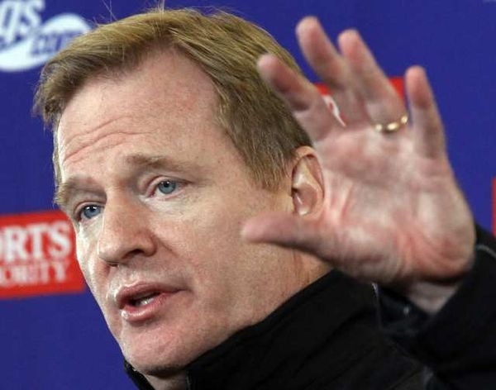
Roger Goodell, ILLUMINATI TOUCH- The Hand with Palm Forward and Five Digits Extended.
In July 2014, NFL Commissioner Roger Goodell suspended Rice for two games of the season along with a fine that exceeded $500,000. Goodell released a statement regarding Rice that included the following,
“I believe that you are sincere in your desire to learn from this matter … and move forward toward a healthy relationship and successful career.”[8]

That’s right. In July 2014, everything was over and well. Ray was punished by the criminal justice system and the NFL. Ray and Janay moved on with theirs lives as a young couple with a beautiful infant daughter out of their marriage bond. Ray looked forward to continuing his NFL career after a two game suspension. Does this isolated Ray Rice/Janay Palmer-Rice highly passionate domestic incident justify sensationalism; national and global public/governmental attention, intervention and condemnation? Yes, when it is False Flag Propaganda.
Ray Rice, Zionists & False Flags
False Flag Operations usually describes covert military or paramilitary operations designed to deceive in such a way that the operations appear as though they are being carried out by entities, groups or nations other than those who actually planned and executed them. Operations carried out during peace-time by civilian organizations, as well as covert government agencies, may by extension be called false flag operations if they seek to hide the real organization behind an operation.[9]
False Flags have become more complex operations that have evolved into methods used by the deep states (shadow government, corporations, organizations and ILLUMINATI) as a form of deep politics– “generally, covert politics, the conduct of public affairs not by rational debate and responsible decision-making but by indirection, collusion, and deceit.”[10]

In early September, TMZ released publicly the full video of Ray and Janay’s February 2014 mutual elevator altercation for some unspecified desired deep state objective, agenda or mass media propaganda diversion campaign. Ashkenazi Jewish/Gay Harvey Levin is the creator and managing editor of All-Seeing Eye Luciferian Time Warner’s TMZ.[11]
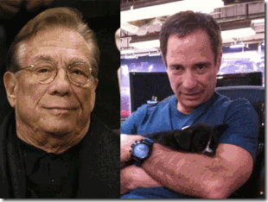
In May 2014, the New York Times reported that former NBA ILLUMINATI Los Clipper owner Donald Sterling’s discussion of how blacks are treated “Like DOGS” in Israel was deliberated edited out of TMZ‘s publicly released video to veil Israel’s racism and shield its image from public scrutiny. That’s right. Harvey Levin and TMZ carry a shrouded Zionist/Satanic/ILLUMINATI agenda.[12]
The sensationalized Ray Rice Affair is part of a complex Luciferian/ILLUMINATI global propaganda program and agenda of mass media diversions. Its objective appears to be twofold to shape, manufacture, divert and control public opinion/debate on national/international in false flag episodes, incidents and issues; divide and conjure; polarize races and agitate racial tensions to the point of mass population “Negrophobic” hysteria and mental illness.
The NFL, ILLUMINATI & the GLASS HOUSE
People who live in glass houses shouldn’t throw stones!
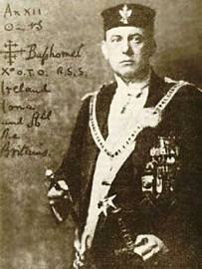
“Do what thou wilt shall be the whole of the Law” –the Great BEAST 666, Aleister Crowley
Eddie DeBartolo & San Francisco 49ers: Do what thou wilt.

On February 11, 1992, a 24-year-old woman, Regina Baross, complained that the 49ers owner, EDDIE DeBARTOLO, JR., had sexually assaulted her in his home in Menlo Park, CA, the police who investigated the complaint asked the San Mateo County prosecutor to issue a criminal complaint accusing DeBartolo of sexual battery, a misdemeanor, and penetration with a foreign object (broom stick), a felony. However, the prosecutor, James Fox, just dismissed the case and her complaint.[13]
Fox said he would not prosecute DeBartolo, Jr. because he didn’t think he could get a conviction, although there was evidence that could support Baross’ allegations, such as the woman’s torn pantyhose and underwear, and some bruises.[14] The Office of the California Attorney General, Dan Lungren, took jurisdiction over the case to investigate.[15] The DeBartolos were large contributors to Republican Presidents Ronald Reagan and George H.W. Bush and were active in the inner circle of California politics. Edward DeBartolo, Jr. referred to the California Attorney General as “Danny” and had contributed to his campaign war chest. They were room mates at the University of Notre Dame.[16] Baross’ sexual assault case was put on the shelf to collect dust.
Down the Rabbit Hole: 49ers, Black Hand/MAFIA and Meyer Lansky

Mob Brain, Edward DeBartolo, Sr.
According to Dan Moldea in his book, Interference, an exhaustive expose on the links between Professional Football and the Mafia, Youngstown native Edward DeBartolo, Sr., who in 1977 bought the San Francisco 49ers football team for his son Edward, Jr. DeBartolo, Sr. had built his fortune in the Mob-influenced construction industry and his company facilities were bombed 6 times between 1952-1954.[17]
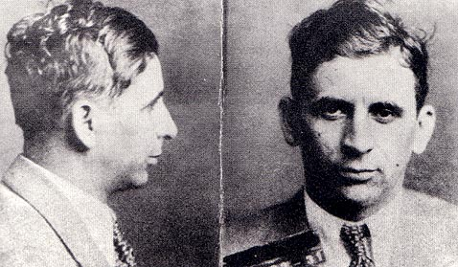
Mafia Brain, Meyer Lansky
“For example, the U.S. Customs Service had received information from one of its special agents, William F. Burda, in January, 1981 that the DeBartolo organization ‘through its control of particular state banks in the state of Florida is operating money-laundering schemes, realizing huge profits from narcotics, guns, skimming operations, and other organized-crime-related activities. This organization is reported to have ties to [Carlos] Marcello, [Santos] Trafficante, and [Meyer] Lansky and because of its enormous wealth and power has high-ranking political influence and affiliations.’ “[18]
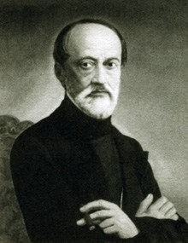
The Italian Freemason/ILLUMINATI Giuseppe Mazzini, a 33rd degree Mason, discussed further below, founded the notorious P2 Masonic Lodge, which “made men” belong to, such as Lucky Luciano and Meyer Lansky. According to U.S. Customs, Lansky, the financial wizard “the Brain” of the Mafia was considered by most to have become senile and getting out of the business. One of his successors and new financial wizard “the Brain” and Luciferian/ILLUMINATI “Made Man” of the Mafia was recognized as Edward DeBartolo, Sr.[19]
Ben Roesthlisberger & Pittsburgh Steelers: Do what thou wilt.

The Reign of the Drunken NFL Serial Racist
In 2008, a former Harrah’s Lake Tahoe casino host, Andrea McNulty, claimed Pittsburgh Steelers quarterback Ben Roethlisberger raped her while he was visiting Lake Tahoe for a celebrity golf tournament. Reportedly, the police didn’t investigate the rape case because McNulty had “ONLY FILED A CIVIL COMPLAINT AGAINST ROETHLISBERG AND NOT A CRIMINAL COMPLAINT.”[20]

NFL Super Bowl Champion Ben Roethlisberger, a serial rapist, has escaped prosecution from at least (3) three rape cases without much feminist, public/governmental outage, condemnation or NFL peer denigration.[21]
Down the Rabbit Hole: Steelers and the Luciferian Secret Deep State
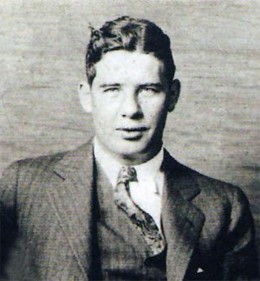
The Pittsburgh Steelers has been owned for decades by the Rooney Family. Art Rooney, “The Chief“, founded the Pittsburgh Steelers franchise in 1933. In 1936, Rooney won a parlay at Saratoga Race Course which netted him about $160,000. He used the winnings to hire a coach, give contracts to his players and almost win a championship. The winnings funded the team until 1941.[22]
That is the romanticized and lying version of Art Rooney and the Steelers. Secret files made public decades later show that the federal government linked “the Chief” with the Western Pennsylvania Mafia. The Western Pennsylvania mob is one of 24 traditional Mafia families in the United States.[23]
In an FBI report dated Oct. 29, 1946, a confidential informant said Rooney, some unidentified associates and a group headed by the Mannarinos owned slot machines in the Pittsburgh area. “Under an agreement between these organizations, Rooney operated all slot machines north of the Allegheny River and the Mannarino brothers operated those south of the river,” the report said.[24]

The Sicilian Immigrant Mob Boss, Sebastian John LaRocca
In another document, which was heavily censored, an informant reported Rooney obtained slot machines long before the local Sicilian Mafia Boss, Sebastian John LaRocca, and (Rooney) controlled the entire Pittsburgh vicinity in this regard.”[25]
The Mannarino brothers, Gabe and Sam, were lieutenants of the Sicilian LaRocca. In 1957, LaRocca was busted by police along with his lieutenant under bosses Michael Genovese and Gabriel “Kelly” Mannarino at the infamous meeting of mob leaders at a house in Apalachin, N.Y.[26]
The Apalachin Meeting was a historic summit of the American Mafia held at the home of mobster Joseph “Joe the Barber” Barbara in Apalachin on November 14, 1957. Allegedly, the meeting was held to discuss various topics including loan sharking, prostitution, narcotics trafficking and gambling along with dividing the illegal operations controlled by the late Albert Anastasia.[27]

Rooney’s mob under boss and partner in crime, Gade Mannarino, above, ran his own empire in New Kensington with his brother Sam and became a local legend, enjoying a cozy relationship with politicians. Mannarino’s influence stretched from New York to Cuba.[28] The Mannarino Brothers weren’t just minor mobsters. These guys were major players in America’s “Deep State“ and “Deep Politics.” Gabe was part of the CIA-Hoffa connection.

CIA Gangster, Sam Trafficante
Gabe was also a close associate of Meyer Lansky; and co-owned the pre-Castro Sans Souci Club and syndicate in Cuba along with a key mob player heavily implicated in the JFK assassination and close associate of Edward DeBartolo, Sr., Santo Trafficante.[29]
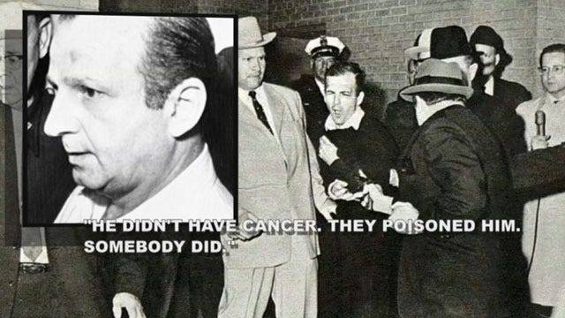
Trafficante employed Jack Ruby (Harvey Lee Oswald Assassin) and mob bagman Lewis McWillie.[30]
“I Reckon with a Dagger”- ILLUMINATI Giuseppi Mazzini
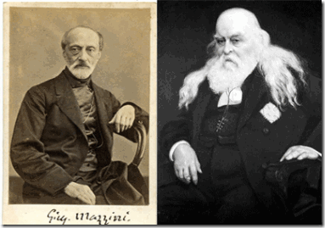
ILLUMINATI Freemasons Giuseppi Mazzini and Satanist Albert Pike
Italian Freemason and revolutionary Giuseppi Mazzini (1805-1872) formed a society in Sicily called the Oblonica that means “I reckon with a dagger.” As is typical with the Masons, Mazzina formed an order within an order. The elite inner group was called a term that most people will recognize, the Mafia. The name is an acronyn for Mazzina autorizza flori, incendi, avelenamenti- Mazzini authorizes thefts, arson and poisoning. The Mafia was also known by another term, Il Mano Nigro– the Black Hand. Mafia crimes were often sealed by a black hand-print at the scene. This, of course, was an ILLUMINATI touch: the hand with palm forward and five digits extended.[31]

Adam Weishaupt, founder of the ILLUMINATI died on November 18, 1834. Mazzini was appointed head of the ILLUMINATI in 1834. In 1859, Mazzini chose the leader of the U.S. Scottish Rite Masonry, “Sovereign Pontiff of Universal Freemasonry” Confederate General Albert Pike to coordinate secret ILLUMINATI activities in the United States.[32] Pike designed the secret Satanic Masonic initiation rites and rituals to create a secret super elite blood oath hierarchical “order within an order” of Freemasons elevated to the ILLUMINATI.
“Pike was … a Satanist, who indulged in the occult, and possessed a bracelet he used to summon Lucifer, with whom he had constant communication. He was the Grand Master of the Luciferian group known as the Order of the Palladium (or Sovereign Council of Wisdom), which had been founded in Paris in 1737. Palladism had been brought to Greece from Egypt by Pythagoras in the fifth century [BC], and was this cult of Satan [Set-Seth] that was introduced to the inner circle of the Masonic lodges. It was aligned with the Palladium of the Templars.”[33]
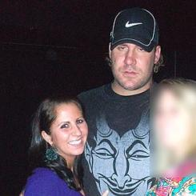
Satanic Serial Rapist Ben Roethlisberger Reckons with the Dagger for the DEVIL
The woman blurred out above is one of Roethlisberger’s rape victims. The Pittsburgh Steelers was part of the Mazzini/Pike ILLUMINATI Secret Cabal’s illegal lucrative professional sport’s bookmaking operations. Art Rooney was the front man for Mazzini and Pike’s Satanic Black Hand- Mafia, and Roethlisberger is their initiates and boy in the NFL.
Jerry Jones of the Dallas Cowboys: Do what thou wilt.

Of the High and the Mighty and Beyond the Law, Jerry Jones is a CEO, entrepreneur, and the owner of the NFL’s Dallas Cowboys, who has a net worth of $3.1 billion.[34] Jerry Jones and the ILLUMINATI would feed a thousand black faces like Ray Rice to the lions to feed the feeding frenzy racial mental illnesses of America to veil the face of SATAN for a New World Order.

In May or June 2009, Jerry Jones allegedly did the following to former exotic dancer, JANA WECKERLY, without her consent in a local hotel room as outlined in Weckerly v. Jerry Jones and the Dallas Football Club, Ltd., Case No. DC-14-10061 in the District Court of Dallas County, TX. Jones forcibly rubbed and/or grabbed Weckerly’s buttocks multiple times. He forcibly rubbed and/or grabbed her breasts multiple times, and forced her to touch and/or rub on his penis multiple times.[35]

Jones forcibly kissed Weckerly’s neck, shoulder and lips multiple times. Jones penetrated her vagina with his fingers without consent. Jones forced her to watch him engage in oral sex. Jones conspired with others to conceal this sexual assault, and threatened Weckerly not to report the sexual assault and battery to the police. She is in imminent fear of her life, safety and well being. She very well may be in danger. She had to expose him publicly. Weckerly signed a covenant (blood oath) not to disclose any details of Jerry Jones’ Bunga Bunga- exploitation, rape and sexual abuse of women.[36]

Weckerly’s secret photos of Jerry Jones and two other women involved in Jones’ Bunga Bunga collaborating her story surfaced on the internet beginning in the first couple of weeks of August 2014.[37] The above civil case for damages against Jones and the Dallas Cowboys describing his volatile and criminal conduct was filed and MADE PUBLIC on September 8, 2014.[38]
The Ray Rice ILLUMINATI Diversion- One Day Later
On September 9, 2014, the secret Zionist TMZ released the infamous Ray Rice- Janay Palmer elevator surveillance video showing Rice knocking out Janay. Hours later like clockwork, the Baltimore Ravens terminated Rice’s contract and NFL Commissioner Roger Goodell publicly announced Rice’s indefinite suspension from the NFL.[39] Goodell is a totalitarian despot and ILLUMINATI puppet, who codified player behavior into the NFL Personal Conduct Policy based on capricious puzzles warped inside of enigmas of eugenics in a quest to turn the NFL into New World Order global enterprise.[40]
Goodell had been selected to succeed the retirement of Paul Tagliabue by a selection committee headed by Dan Rooney of the Pittsburgh Steelers’ Rooney Family Mob. He officially began his tenure as a $10 million a year NFL Commissioner on September 1, 2006.[41] Goodell was the NFL Commissioner during Ben Roethlisberger’s Drunken Serial Rapist reign of sexual VIOLENCE against women.
In 2010, Roethlisberger was suspended by the NFL in April for six games for violating the league’s personal-conduct policy, but Goodell said at the time that he would review the quarterback’s behavior over the next few months. After meeting with Roethlisberger and “the Mob Chief” Art Rooney, Roethlisberger’s suspension was reduced to just only four games.[42]
Down the Rabbit Hole with Jerry Jones & the Cowboysf
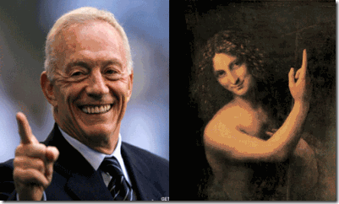
From ILLUMINATI Jerry Jones to Rosicrucian Leonardo Da Vinci’s Saint John the Baptist, There is One God- Set/Seth- SATAN
Like the NBA, the NFL is controlled and ran by the secret New World Order Luciferian/ ILLUMINATI Cabals. Dallas Cowboys owner oilman billionaire Jerral Wayne “Jerry Jones” is also part of the powerful Luciferian cabals. Jones was chosen by the cabal to purchase the Cowboys from an extreme arch-conservative John Bircher, Harvey “Bum” Bright, a person of interest also linked to the assassination of JFK in Dallas, TX November 22, 1963.[43]
The John Birch Society (JBS) was founded by 32nd degree Mason Robert Welch. The JBS were also comprised of high-ranking Freemasons, members of the CFR and of other subversive organizations:
“You may object: ‘Look at all the great things Welch has done – he has exposed the Illuminati.‘ Baloney. The Illuminati was merely a branch of the Conspiracy. How can one attack the Illuminati without attacking the diabolical power behind it: organized Freemasonry? Welch has provided the most valuable service of all time to the Conspiracy. He founded an organization to neutralize millions of Americans from discovering what the true power behind the Illuminati really was. And we concede the Mason’s chose an extremely clever man to do the job. Welch, with the help of the Belmont Brotherhood, plays his role very effectively.”[44]
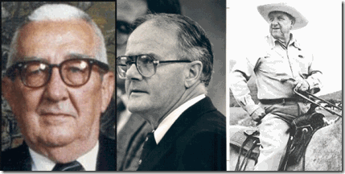
NFL ILLUMINATI & Part of the Secret Shadow Government, Bum Bright, Lamar Hunt, Clint Murchinson
Bum Bright out of the Texas A& M Good Ole Boy Network was part of the Texas’ “Deep State” and “Deep Politics” circle of Right Wing Bircher oil men, Lamar Hunt (NFL Kansas City Chiefs owner), Nelson Bunker Hunt, Clint Murchison, Jr. (former NFL Dallas Cowboys owner), and insurance executor Edgar Crissey. On November 21, 1963, they paid for the printing and distribution of the infamous JFK “Wanted for Treason” poster in Dallas- “framed by a funeral black border” leading up the assassination of JFK.[45]

Bum also attended the infamous Clint Murchinson Sr. Dallas party on November 21, 1963 that Vice President Lyndon B. Johnson, Richard Nixon, J. Edgar Hoover and his lover, Clyde Tolson, H. Lamar Hunt and others attended- part of the “Permindex Connection” JFK Assassination Cabal.[46]
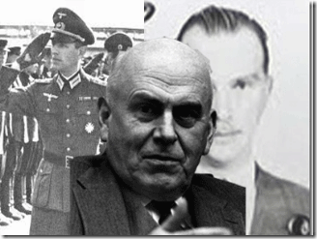
John J. McCloy was also there.[47] McCloy was president of the World Bank, U.S. High Commissioner for (Reinhard Gehlen- SS Baron Otto von Bolschwing Org) Germany, chairman of the Rockefeller Chase Manhattan Bank, and chairman of Cecil Rhodes Roundtable’s Council on Foreign Relations. He later became a prominent United States presidential adviser, served on the Warren Commission that allegedly investigated the JFK assassination, and was a member of the foreign policy establishment group of elders called “The Wise Men.”[48]
Ray Rice & Deep Politics
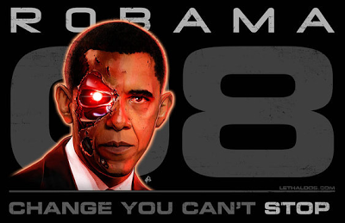
The Shadow Government’s Cyborg President Barrack Obama of the U.S. Executive Branch has also been programmed to implement and puff up the Ray Rice False Flag Propaganda Campaign on a national and international political level. In the strongest terms after the allegedly shocking video of Rice striking his fiancée Janay Palmer emerged on August 9, White House spokesman Josh Earnest released a short statement following special consultations with the president about the false flag Ray Rice Affair, after TMZ released the alleged shocking footage of Ray Rice punching unconscious in an Atlantic City elevator in February,
“The President is the father of two daughters. And like any American, he believes that domestic violence is contemptible and unacceptable in a civilized society … Hitting a woman is not something a REAL MAN does, and that’s true whether or not an act of violence happens in the public eye, or, far too often, behind closed doors.”[49] Once again from the highest elected office of this nation, American Black Males seem to be the only men on the planet that the direct racialist attack on their MANHOOD is encouraged by society, and now from the highest offices of this government.

V.P. Joe Biden- Hands of the ILLUMINATI
U.S. Vice President Joe Biden has also been programmed to weight in on the sensationalized false flag Ray Rice Affair, “And then when the video was out there, and saw how BRUTAL it was, the Ravens did the right thing — fired him immediately.”[50]

U.S Congress has inserted itself in the false flag Ray Rice Affair. Above, ILLUMINATI- One God Satan- Black Satanic Cabal Bootlicker Congress persons John Conyers, Jr. and Sheila Jackson of the judiciary committee signed a Congressional Ray Rice Condemnation Letter. Yet, they remain obedient and silent on the Palestine/Gaza Mass Genocide. Twelve (12) congressional House Judiciary Committee members have fired off a letter to NFL Commissioner Roger Goodell demanding that he come clean about Ray Rice’s alleged BRUTAL video showing him striking his wife.[51]

ILLUMUNATI Senate Leaders Diane Feinstein and Barbara Boxer of California
Sixteen “white women” of the Democratic House of the U.S. Senate are also expected to send a letter asking the NFL to adopt a “real zero-tolerance policy for domestic violence that will ensure that this type of violence and abuse has no place” … “We were shocked and disgusted by the images we saw this week of one [Ray Rice] of your players violently assaulting his now-wife and knocking her unconscious …” “The NFL’s current policy sends a terrible message to players, fans and all Americans that even after committing a terrible act of violence, you can quickly be back on the field.”[52]
The letter was signed by Senators Barbara Boxer (D-Calif.), Debbie Stabenow (D-Mich.), Kelly Ayotte (R-N.H.), Amy Klobuchar (D-Minn.), Patty Murray (D-Wash.), Jeanne Shaheen (D-N.H.), Kirsten Gillibrand (D-N.Y.), Barbara Mikulski (D-Md.), Susan Collins (R-Maine), Heidi Heitkamp (D-N.D.), Dianne Feinstein (D-Calif.), Mazie Hirono (D-Hawaii), Elizabeth Warren (D-Mass.), Tammy Baldwin (D-Wis.), Kay Hagan (D-N.C.) and Maria Cantwell (D-Wash.).[53]
Ray Rice, NOW and FEMINISM: ILLUMINATI Divide and Conquer Policy
“When there is no male figure in the family, kids start seeing the State as their family who provide and protect.”[54]
The National Organization for Women(NOW) is the largest Feminist organization in the United States. Feminism was created to destabilize the society and undermine the institution of family. Most major women organizations in America including NOW were funded by Rockefeller Foundation who claims in their website, “By funding a strategic mix of organizations, institutions, and projects; the Foundation is fostering smart golobalization. “Most feminist “Women Studies” funding comes from big foundations like Rockefeller Foundation, Ford Foundation, Carnegie Foundation etc and of course USAID, UNIFEM, UN, and the CIA.[55]
At the top of National Organization of Women (NOW) Charlotte Chapter’s list for poster boys for VIOLENCE against women are predominately “Big Black Brutes”, Ray Rice, of course, leads their list of:
Greg Hardy, NFL Carolina Panthers, The NFL ILLUMINATI’s Nordic Sea Monster

NOW: “Greg Hardy is still playing for the Carolina Panthers, even after being convicted in July of choking his former girlfriend and threatening to kill her.”[56]

Around 4 am in the morning of a night of drinking and partying, Greg Hardy and his girlfriend, cocktail waitress Nicole Holder, got into a heated argument over an alleged former relationship between Holder and recording artist Nelly. Hardy was thought to be upset about it when he allegedly “snapped” and became violent that may have involved mutual pushing, shoving [57] and “throwing” Holder around.[58]
Ray McDonald, NFL 49ers,

NOW: “Days after announcing the NFL’s new domestic violence policy, you said that Ray McDonald of the San Francisco 49ers, who is facing a felony domestic violence charge, could play in the team’s season opener against the Dallas Cowboys.”[59] McDonald was “involved in an altercation” with his 10 weeks-pregnant fiancée during a birthday party at his home, according to the Sacramento Bee, and was arrested after police found bruises on her arms.“[60] They still don’t who his pregnant fiancée is or was.
Jerry Jones, NFL Dallas Cowboys,
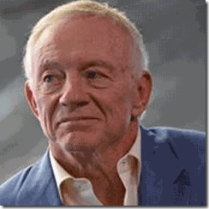
As far as exploitation and VIOLENCE against women by the rich and powerful ILLUMINATI, in their patent hypocrisy, Jones is only the “accused.” NOW: “You [Roger Goodell] have been SILENT in the face of accusations that Dallas Cowboys owner Jerry Jones sexually assaulted a woman.”[61] Even if they were legitimate, neither the NFL Commissioner Roger Goodell or NOW have the power and authority to carry Jerry Jones’ boots.
Ray Rice & the UltraViolet National Campaign: #GoodellMustGo
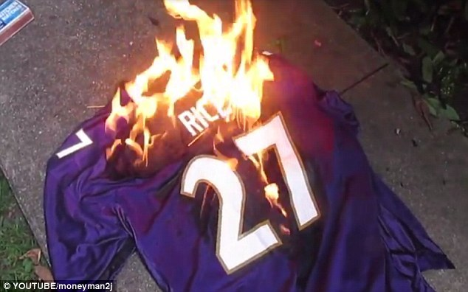
A so-called “anti-sexism” activist organization, UltraViolet, said it will fly banners reading, ” #GoodellMustGo,” over stadiums in Cleveland, New Jersey and San Francisco ahead of Sunday NFL games. The group says it also will fly the message before a Monday night game to be played in Indianapolis. They are calling on NFL Commissioner Roger Goodell to resign over his handling of former Baltimore Ravens star “RAY RICE’S DOMESTIC VIOLENCE CASE”, the group said.[62]
UltraViolet is funded by Citizen Engagement Laboratory (CEL).[63] CEL is funded by ILLUMINATI/Eugenic Master [64] Ebola George Soros’ Open Society Institute.[65]
Ray Rice & Feminist: To Hate the Black Man

Gloria Steinem of the ILLUMINATI
CIA: Re-image and Define the Future of Black Relationships for a New World Order
“[America’s Renown CIA Feminist Activist]Gloria Steinem first came across the radar of Black men in 1978 when Steinem put a book called “Black Macho and the Myth of the Superwoman” on the cover of Ms. Magazine, the magazine which she controlled. The book was “written” by a Black “feminist” and “activist” named Michele Wallace who came out of nowhere. Wallace was in her early twenties at the time, yet she was being touted as the “leader” of Black feminism. In the book, Wallace called abolitionists like Harriet Tubman and Sojouner Truth “ugly” and “stupid” for supporting Black men. She called Black Revolutionaries “chauvinist macho pigs” and advised Black women to “go it alone.” Gloria Steinem said that Wallace’s book would “define the future of Black relationships” and she pushed hard to make sure the book received massive publicity. Gloria Steinem’s work triggered a flood of “Hate Black Men” books and films that continues to this day. Needless to say, some were quite suspicious of Ms. Magazine and Gloria Steinem. Why was Steinem sticking her nose into the affairs of the Black community? So people started doing some research on Steinem. When it came out that Gloria Steinem was probably the ghost writer of the book with Michele Wallace’s name on it, Wallace had a nervous breakdown and went into hiding for two years. However, the damage was already done and the “Hate Black Men” movement was off and running.”[66]
Ray Rice & the ILLUMINATI Global Propaganda Campaign of Diversion
Ray Rice & The Gaza Genocide

The false flag Ray Rice Affair has suddenly propelled and spring to the top of national and international news superseded even the urgency of the Gaza- Israeli [U.S] War Crime Aggression against a virtual defenseless sovereign nation of color. The 50-day Israeli War of Aggression slaughtered over 2,100 Palestinians, mostly civilians, and injured around 11,000. Shelter Cluster, an international organization engaged in the assessment of post-war reconstruction, released a report in late August, putting the number of housing units destroyed or severely damaged by Israel’s bombardment at 17,000. According to United Nations International Children’s Emergency Fund (UNICEF), around 500,000 Gazans were internally displaced during the Israeli aggression. By the thousands, Gazans are still living in schools, where they took refuge during weeks of Israeli air strikes, which turned their utility (water, gas and electrical) and governmental infrastructure, homes, businesses, hospitals, buildings and schools into oceans of rubble at U.S. Taxpayer expense:
“We don’t know where to go or whom to turn to. The only place to call home is a UN school. Our kids and our families are living a miserable life. It is very hard for me to watch my mother and my wife living this way. We need a solution to our calamity. We need to live a decent life,” said a Gaza resident.[67]
Ray Rice & Project NAOMI Ebola Outbreak
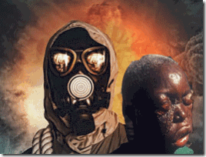
The sensationalized false flag Ray Rice Affair has supplanted the urgency of the largest Ebola Outbreak/Crisis in history that is spreading across West Africa. The Nazi/CIA MK ULTRA Project NAOMI’s Biological Warfare Agent, EBOLA, in West Africa has killed 2,288 people, the World Health Organization (WHO) says. It said that 47% of the deaths and 49% of the total 4,269 cases had come in the 21 days leading up to September 6, 2014.[6]
Ray Rice & ISIS
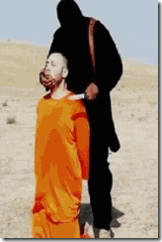
The sensationalized false flag Ray Rice Affair has almost superseded the urgency of the ISIS (The Islamic State of Syria and Iraq) brutal war crime and human rights violating deadly aggression in the Middle East. According to Jordanian intelligence sources, the United States (U.S. Taxpayers) along with Israel were actually responsible for training 10,000 so-called “moderates” Islamists in the hope that they would follow American interests in the region that is now being used to destabilize Iraq in wars of aggression and campaign of genocide.[69]
Ray Rice & Ukraine Crisis

The sensationalized false flag Ray Rice Affair has also overshadowed the urgency of the Russian-Ukraine Crisis that has been principally masterminded by U.S. and Israel secret government intelligence services that has the potential to spark a World War III. More than 3,000 people have been killed in the conflict in Ukraine between pro-Russian separatists and the Ukrainian government in which the count also includes the 298 passengers aboard Malaysia Airlines Flight MH17 that was shot down over rebel-held territory on July 17.[70]
Ray Rice, Michael Brown & Ferguson

The false flag Ray Rice Affair has eclipsed the urgency of the Ferguson Missouri Crisis and the gunning down of Michael Brown on August 9, 2014. Darren Wilson, the police officer that gunned down the unarmed teen didn’t report the stop or shooting to dispatch as required. Wilson was taken away from the scene of the shooting with a fractured eye socket, because he had been allegedly brutally attacked by Brown. Wilson‘s eye socket fracture story was a corporate mass media BIG LIE.[71]
As of the date of this post, the officer’s incident report or statement still has not been released to the public. Wilson has not been arrested or charged with a crime by the U.S. Justice Department or the local DA. Wilson has been allowed to sit around rally reactionary right wing police support, collect witness statements, autopsy reports and a government paycheck before he has to say a word about exterminating Michael Brown.
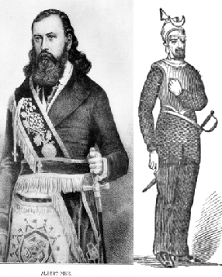
Michael Brown wasn’t gunned down as a fleeing felon or criminal. Missouri is a former “slavery” state once openly and violently controlled by Confederate General Albert Pike’s (I reckon with a dagger) ILLUMINATI Knights of the Golden Dawn. Michael Brown was slaughtered for the unwritten “Code of Insolence.” Like Trayvon Martin, Jordan Davis and so many others young Black males, if a white man challenge you, you are not supposed to move a muscle to defend your rights or yourself. We are supposed to believe that in each instance of their deaths that these young men were suddenly transformed into uncontrollable and raging Big Black Brutes that threw themselves into a hail of bullets.
The grim realty of racism in America is that man, woman, child, even cats and dogs (Michael Vick) have the authority backed by the “Power of the State” to challenge and attack the authority and manhood of a Black male.
“Few months ago, a video showing Solange Knowles physically attacking Sean ‘Jay-Z’ Carter circulated across the internet and it created a certain buzz. Not the buzz a rational, unbiased, non-feminist-oriented society would experience. Rather, Mr. Sean Carter was the butt of many jokes. His masculinity (or lack of therein) was called into question. In the video, he was clearly being physically attacked/assaulted/threatened/battered – call it whatever you may … Social and Entertainment media were more concerned with the reason behind such aggravated assault by Solange and the peculiar passiveness of Beyonce as this man, Jay-Z, was being clobbered. It seemed fairly normal [Normal as America’s Cherry Pie Violence] to society.”[72]
The perverted American system of justice and military industrial police state has given society a general license to challenge, fight, strike, and spit in the face of a Black men like Ray Rice and a Jay-Z then out of the other side of the mouth verbally emasculate them if they struck back or not, “You’re not a MAN!” The insecure white chauvinism Satanic ILLUMINATI constantly exploit Black Females as a pre- textual victims to systematically challenge, demonize, emasculate, destroy, re-image and criminalize the masculinity of Black Males on the world stage.
As brothers in racist America, no matter how infatuated or in love that we may be with a woman, if she humiliates me in public, as a rule, I have to let them go and as the bluesman say- walk the back streets and cry.
In once instance, I had been with a potential female companion for about 3 months before she began to as we say, “show out in public.” At a Whole Food Market in Berkeley, I had spent my entire weekly check on an entire organic grocery food bill because she had asthma, but for $50 for gas and lunch for a week. When the clerk returned $50 to me as change, she ran across the grocery isles and picked up a $35 bottle of organic molasses and shouted out across the entire predominately white store, “If you were any kind of MAN, you would buy this for me!” I had to let her go- walk the back streets and cry.
In another instance, I had been with another potential female companion for about 6 months before she began to as we say, “show out in public.” Due to her education, work experience and background, she was constantly unemployed. I had developed an independent source of income and employed her as partner on certain business contracts. In advance of one job, she asked for an advancement in pay and borrow my new expensive SLR Canon camera. She had been a consistently reliable worker. I gave her the money and the camera. She didn’t show up for the weekend job, but I wasn’t worried. She had established an excellent work history. I was confident that some type of emergency must have come up. It was a two man job, but I completed the work assignment within 24 hours. She showed up that Monday evening and asked me to take her to a movie. While we were waiting for the movie to open, I casually asked why she hadn’t shown up for work. She suddenly jumped up in the partially predominately white crowded theatre and shouted, “You’re not my MAN. It isn’t none of your business where I been and who I been with. My MAMA is the only person I answer to. You can take your ass home. I don’t need you. I can call someone to pick me up and take me home to my MAMA.” Calmly, I told her that I picked her and would return her to the safety of her mama and home. I had to let the young lady go and walk the back streets and cry.
About two to three weeks later, she called me to pick her up from Oakland’s Kaiser Hospital Emergency Room. She had been involved in a physical altercation with her current suitor in a motel room. He hit and roughed her up. She waited until he was sleep then busted him in the head with a lamp. He was in the hospital emergency room in critical condition. She walked free of charges and her suitor was arrested, CONVICTED for domestic violence and sent to state prison. She told me that I had once confessed to have LOVED her. I did. But for my survival, health, safety and well-being in this racialist society, I had to move on. I still pretty much had a price on my head and special code when police entered the picture with me. As BB King says, the THRILL IS GONE.
Don’t get it twisted, I am not a wimp because of my approach to combative and misdirected sisters that I will always love. On the contrary, I had a modest reputation but not the usual temperament of a competitive street fighter off the streets of Oakland, CA. I had learned the skills to knock out or rock a man senseless with one punch.
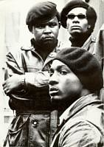
Here I am, above in April 1968, just after the extra-judicial CIA/FBI/OPD Panther Squad shot to pieces our beloved 17 year old Little Bobby Hutton. I was sitting there looking out into space. I wasn’t sure if I was going to see my family again or Live or Died. During the late 1960s, I was most often heavily armed for Love of the People. Carrying a lethal weapon for defense of the people was an awesome responsibility. I had no military or formal training and experience to handle stress with a weapon. Personally, it was extremely dangerous for me to attempt to resolve confrontations with a gun, Red Book and a “street fighter” mentality.

During that time, the late our Most Beautiful and Legendary Brother, Bruce Lee sent a personal bloodline emissary to Oakland to train brothers on the frontline Black Struggle in the martial arts. I had become disillusioned with the Black Panther Party (BPP) Political Education classes that had become dominated by former PHOENIX program Vietnam U.S. Army Ranger assassins and clandestine infiltrators. The ex- army rangers never expressed any remorse for murdering our yellow Vietnamese brothers and sisters for U.S. Imperialism or showed any particular love or knowledge of Black Nationalism.
In most political education classes, there were some technical weapons training, but in most cases, we flipped pages word for word of Chairman Mao Tse-tung’s Little Red Book. To be excused from political education classes and avoid any potential conflicts with these brothers, I convinced Chairman Bobby Seale and my BPP elders that as a young brother I and the BPP could benefit mentality and physically from the rare and special martial arts training offered by Bruce Lee.
The black former U.S. Army Rangers that dominated the political education classes subsequently became the leaders and trainers of PHOENIX Program type BPP Goon Squads of the Panther’s Second Wave that were assigned to eradicate and neutralize BPP and Black Nationalist dissidents across the nation.
To my surprise in the martial arts training classes, we went thru long exhaustive intensive mental and physical conditioning before we threw any punches or kicks. I was introduced to Bruce Lee’s invaluable philosophical “Art of Fighting without Fighting.” I learned how to with confidence to fight offensively and defensively without throwing a punch or a kick that would harm the people or community I love. I was introduced to concept of “dualism.” When an opponent is enraged- I become passive, calm, relaxed and idle. When an opponent throws a punch or kick, I learned the confidence and art to redirect and change energy to empty space.
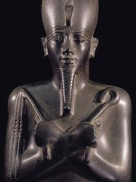
All in all, it was mental conditioning and exercises to re-awaken the oppressed “Osirian Will”- order, balance, harmony, righteousness and JUSTICE that the Chinese Masters had retained throughout the Ages, “According to Plutarch, he [Osiris] made the Egyptians give up their destitute and brutish mode of life, showing them the fruits produced by civilization, and giving them laws, and teaching them how to worship the gods. After doing this, he traveled the whole world and introduced civilization by means of persuasion, reasoning and music, rather than weapons.”[73] Don’t get it twisted, if persuasion, reasoning and direction of the force of positive and negative energy didn’t work and deadly force was imminent or first used, our orders were to return deadly force.
In my opinion, it is not sufficient to tell our children what it is to be “Black” in America to survive. It also requires deep philosophical mental and physical “Osirian Will” conditioning or re-conditioning not only to survive, but move into the leadership of a spiritual battle to restore the world to order, balance, harmony, righteousness and JUSTICE– Maat.
Adrian Peterson & Montgomery County, TX of the Confederate States of America

In regards to the ILLUMINATI’s most recent NFL “patsy” and poster boy for VIOLENCE in America, Adrian Peterson of the Minnesota Vikings, once again the insecure white chauvinism ILLUMINATI constantly exploit Black Females and “OUR CHILDREN” as pre-textual victims to systematically challenge, demonize, emasculate, destroy, re-image and criminalize the masculinity of Black Males on the world stage.

Montgomery County, Texas- Confederate States of America (CSA)
On September 11, 2014, Montgomery County Assistant DA Phil Grant out of Texas A& M announced the indictment of Adrian Peterson for reckless or negligent injury to a child. The incident took place vaguely sometime over the summer. Local police refused to arrest Peterson, and initial reports was that a first grand jury had chosen not to indict Peterson.[74] This was three (3) days after the Ray Rice/Janay Palmer video was released by TMZ.
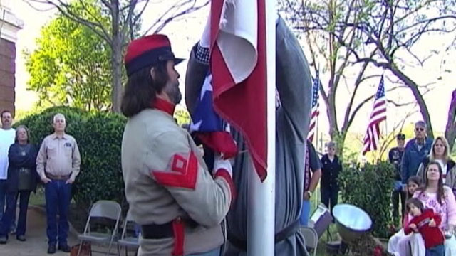
Peterson was born and raised in Palestine, Smith County, TX. Palestine is a northeastern Texas one-horse town that still fly the Confederate Flag over the county courthouse, and celebrate “Confederate History Month.”[75] Some still refer to “Palestine, Texas, the rural part Ku Klux Klan county.” [76] It is an area of Texas infamously historically known for mass barbaric and savage violence, lynchings and massacres of Blacks.[77] On August, 8, 1898, Dan Ogg, 21 years, was extra judicially lynched in Palestine, TX, and 18 unidentified blacks had been savagely murdered in Palestine by July 30 1910.[78]

Adrian Peterson- Booking Mug Shot
Peterson doesn’t appear to be the brightness or the lest or most courageous among us. He is a big and “Raw” country boy that is probably obedient to everything the “Old South” requires of him to survive in that part of the country- stay home, play video games, raise his children, stay out of trouble, keep his nose out of white folk’s business, and play football. He is also obedient to his “Old South” roots and traditions of raising children that over the generations have his kept his family safe and alive in the South, and “the rural part Ku Klux Klan county.”
Texas, Missouri like Florida are among some of the most barbaric racist and far right states in America that are also “locked in the traditions of the “Old South“- pseudo-psychotic racial notions of superiority, and racialist cultural traditions out of the 19th century institution of African slavery.” The history of Montgomery County, Texas of the “Old South” is particularly telling and CHILLING!
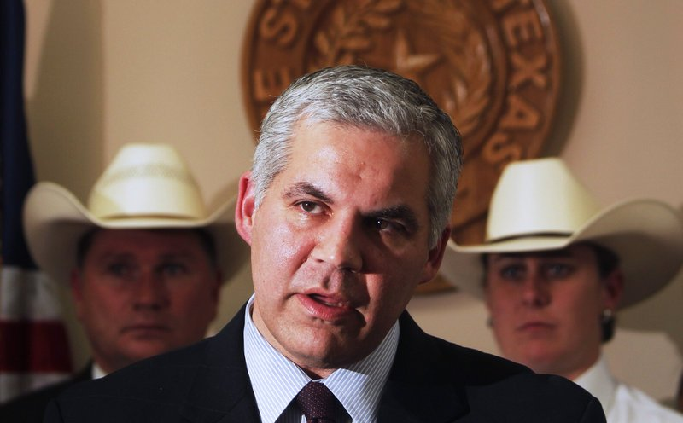
Republican and former Houston Police Department Union Lawyer, Brett Ligon, is District Attorney of Montgomery County that has an extremely odd Southern barbaric celebration. For each “Life Sentence” won of most often defenseless Black or Hispanic defendants, “they have a party for the assistant District Attorney …. They have cake and cookies and speeches, lots of clapping and back slapping, and then, a gold coin is given to that prosecutor to memorialize their “Queen for a Day” status.” Reportedly, they also party for each “Death Penalty Sentence.”[79] Montgomery County is also a backwater red neck community located just outside of Houston ravaged by corruption and a similar sordid history of barbaric and savage lynchings and other horrible racial VIOLENCE against black men. One of the worst was the public slaughter of mill worker 19-year-old Joe Winters on the Montgomery County Courthouse Square in May 1922.
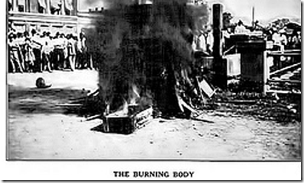
Winters’ only crime was being an universal playboy and having an inter-racial affair with a white girl. Newspapers advertised the Winter’s lynching and a crowd packed the county square like the opening of a circus. Winters was chained to a metal fence peg in the public square. They stacked gasoline soaked wooden boxes around him, and a match was applied to his clothing also saturated with gasoline. He was burned alive.[80]
On August 23, 1980, a white 16-year-old junior at Bellville High School, Cheryl Dee Fergeson, was murdered. Fergeson had been part of a school volleyball team playing a match against another high school in Conroe, Montgomery County, Texas. Conroe is a “Town that Love Lynching.” Her body was found in the loft above the school auditorium. Suspicion immediately fell on two of the custodians, Clarence Brandley and Henry (Icky) Peace, who had found the body. During their joint interrogation — as Peace would recount — Texas Ranger Wesley Styles told them, “One of you is going to have to hang for this” and then, turning to Brandley, added, “Since you’re the NIGGER, you’re elected.”[81]
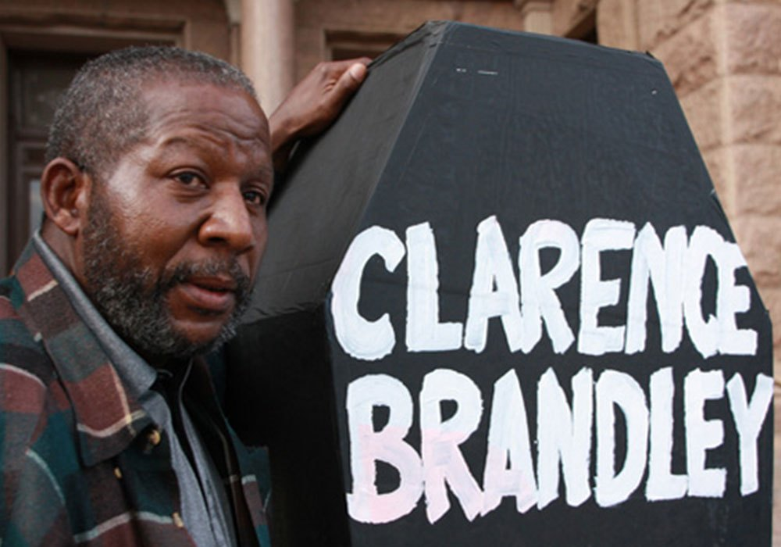
Brandley was sentenced to death but was released after 10 years on death row later after the killer, a white male whom the evidence pointed to all along, confessed. The only evidence needed to convict Brandley of capital murder was the mental disease of Negrophobic hysteria. In fact, the evidence that Montgomery County used to convict Brandley of murder has suddenly disappeared under Ligon’s watch.[82] The Good Ole Boys of the South out of Bum Bright’s Texas A& M like DA Brett Ligon play games with Brandley wrongfully, and wickedly deny him reasonable compensation for the county’s unlawful conviction.[83] Albert Pike’s Ku Klux Klan still meets regularly in the county, and the grand jury that indicted Peterson was most likely a traditional mentally ill Montgomery County “ Negrophobic (Fear of or contempt for Black people and their CULTURE) “All Lily White” jury.

Elite ILLUMINATI Jerry Jones- One God, LUCIFER
According to sources, Peterson testified before the grand jury the week of August 18, 2014 following the internet release of Weckerly’s compromising pictures of Jerry Jones’ Bunga Bunga threesome.[84] DA Ligon probably had that infamous party in Montgomery County when Peterson was indicted. Jerry Jones, Roger Goodell and the ILLUMINATI NFL also most likely were all smiles that one of their boys out of Texas A&M hand warped, packaged and delivered yet another high profile professional football Black patsy athlete to the ILLUMINATI false flag agenda as a VEIL for SATAN for disciplining his 4 year old son with a customary age old Black cultural “SWITCH” –a narrow tree limb.
Don’t believe the hype of corporate mass media pundits. The American Police- Military- Industrial System and Montgomery County of the Confederate States of America has no concern for the welfare and safety of Peterson’s Black Children. If we don’t love our children enough to discipline and shape them for the world, they will gladly step in the void.
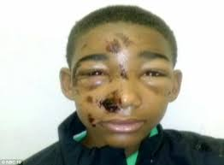
Joseph Williams, 14 years old, of Buck County, Pennsylvania, was taught a lesson in discipline. “He was handcuff but they say he resisted arrest that yall tazzed (Tased) him in his face (sic).” The police broke his nose and both his eyes were beaten swollen shut. They have plans to discipline the children and you won’t like what the Satanic ILLUMINATI have in plan for them.
America’s Secret War Against Black Children
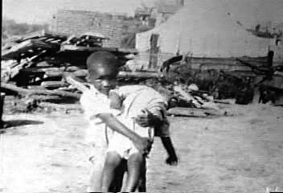
There was no Help from the Terror of the Klan even for the Children
June 1, 1921, Black Wall Street, Tulsa, OK – ILLUMINATI Albert Pike’s Ku Klux Klan led the (Wipe Them off the Face of the Earth Campaign) to the Genocide of 3,000 Black Men, Women and Children and firebombed about 35 blocks of the Black Community destroying 1,500 Homes. Our parents and elders know and fear that as Black Children– one bush with them no matter what age- may be your last and most CHILLING experiences in America even at school.
Black male child no more than 7 years old appears to be arrested at school is confronted by a corporate mass media local news crew to make a statement to the public about his alleged criminal conduct.

The criminalization and demonization of Black Children in schools or wherever they may be isn’t confined to Black male children.

During most of her life, my mother’s greatness fear was that they were going to kill me. My mother was born, raised and reared in the “Deep South” of Morehouse Parrish, Louisiana that also had a sordid history of barbaric and savage lynchings and other horrible racial VIOLENCE against black men. It was that same southern rooted fear and trepidation of barbaric and savage mental illness of Negrophobic violence, and psychotic notion of racial superiority that my mother and my elders out of the grand “Old South” took that “SWITCH” to my ass to try to save me the best way they knew how in AMERIKKA. Don’t believe the hype of corporate mass media pundits. The American Police- Military- Industrial System and Montgomery County of the Confederate States of America has no concern for the welfare and safety of Peterson’s Black Children.

There is a secret ILLUMINATI “Prison and Concentration Camp Pipeline Agenda” even for our children for a New World Order.
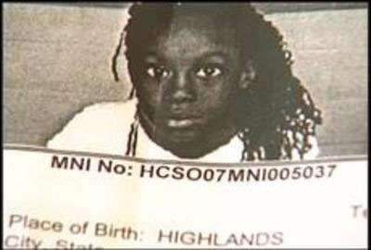
Avon Police Department 2007 Felony Booking Mug Shot of Kindergartner Desre’e Watson
Desre’e had a run-in with her kindergarten teacher in Florida that developed into a child’s tantrum. She was arrested by local police and booked for felony assault and battery against the teacher.
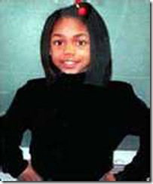
In 1998, our Beautiful 11 year old Little Sister, Ryan Harris, was brutally raped and killed in Chicago. Chicago Police Department Detectives James Cassidy and Allen Nathaniel arrested two children, 7 and 8 year old Black boys, for Ryan’s murder The boys that most likely couldn’t reach an erection confessed to the rape and murder of Ryan after the police offered the children Big Macs and a trip home. Nevertheless, Ryan’s skull had been bashed in with a rock, her panties had been stuffed down her throat and there was semen found in her body parts left by an adult. The male children became poster boys to internationally demonize Black Children. Needless to say, it was a pedophile straight out of a CIA/MK ULTRA prison program that raped and murdered Ryan that had been allowed to terrorize, traumatize and prey on Chicago’s Black Children.
Our parents and elders fear is justified that instead of trying to enslave, kill and oppress them as in the past and tradition of the Grand Old South– there is an absolutely diabolical plan and blueprint across America to re-image and demonize children of color as useless global criminal classes to justify millions of dollars and resources being poured over into the prison-military industrial system for profiling, classification, de-education and mass incarceration- Modern Slavery and Genocide of Black Children.
As Bruce Lee and the Ancients would say, RELAX– Unless YOUR (GOD) WILL BE DONE at less then what you are proficient at!
Dedicated to Janay Palmer-Rice, Adrian Peterson’s Four Year Old Son, Desre’e Watson, Ryan Harris, Joseph Williams, the children, elders, mothers, fathers, sisters and brothers of the Struggle- “You are Our Greatest Inspiration.” IT AIN’T OVER BY A LONG SHOT!

[1] http://www.foxnews.com/entertainment/2014/07/29/espn-suspends-stephen-smith-for-comments-about-provoking-assault/
[2] http://www.ferris.edu/jimcrow/brute/
[3] http://en.wikipedia.org/wiki/George_T._Winston
[4] http://www.ferris.edu/jimcrow/brute/
[5] http://www.ksat.com/content/pns/ksat/news/2014/09/09/local-family-violence-expert-on-rice-domestic-violence.html
[6] http://abc7chicago.com/sports/who-is-janay-rice-a-look-at-the-woman-behind-the-ray-rice-scandal/300996/
[7] http://articles.baltimoresun.com/2014-05-20/sports/bs-sp-ray-rice-pretrial-program-20140520_1_rice-and-palmer-ray-rice-janay-palmer
[8] http://www.nytimes.com/2014/07/25/sports/football/a-penalty-for-abuse-is-less-than-for-steroids-.html?_r=0
[9] http://en.wikipedia.org/wiki/False_flag
[10] http://en.wikipedia.org/wiki/Deep_politics
[11] http://hollywoodilluminati.com/2011/10/23/satanic-secrets-of-hollywoods-a-list-warner-bros-initiations/
[12] http://www.economicpolicyjournal.com/2014/05/tmz-edited-out-sterlings-comments-about.html
[13] http://www.nytimes.com/1992/03/28/sports/sports-people-football-debartolo-case-review.html
[14] http://articles.latimes.com/1992-03-13/sports/sp-3805_1_eddie-debartolo-jr
[15] Id.
[16] http://www.brasscheck.com/stadium/moldea.html
[17] http://www.americanmafia.com/Feature_Articles_1.html
[18] http://www.brasscheck.com/stadium/moldea.html
[19] http://www.brasscheck.com/stadium/moldea.html
[20] http://www.nydailynews.com/sports/football/truth-lies-steelers-qb-ben-roethlisberger-andrea-mcnulty-article-1.379886
[21] http://www.politicolnews.com/roethlisberger-3rd-rape/
[22] http://en.wikipedia.org/wiki/Art_Rooney#Pittsburgh_Steelers
[23] http://old.post-gazette.com/regionstate/20001106mobhistory2.asp
[24] http://www.apnewsarchive.com/1996/FBI-Report-Paints-Steelers-Patriarch-as-Underworld-Gambling-Boss/id-ed8e973670f41d4ea7a47516b78fc368
[25] Id.
[26] http://old.post-gazette.com/regionstate/20001106mobhistory2.asp
[27] http://en.wikipedia.org/wiki/Apalachin_Meeting
[28] http://old.post-gazette.com/regionstate/20001106mobhistory2.asp
[29] http://www.lacndb.com/php/Info.php?name=Gabriel%20Mannarino
[30] Scott, Peter Dale, Deep Politics and the Death of JFK, University of California Press, 1993, pgs. 200-201
[31] http://www.holygrail-church.fsnet.co.uk/Freemasonry.htm
[32] http://www.american-buddha.com/giuseppemazz.htm
[33] http://www.american-buddha.com/giuseppemazz.htm
[34] http://www.celebritynetworth.com/richest-businessmen/jerry-jones-net-worth/
[35] http://cdn-jpg.si.com/sites/default/files/download/documentfragment_11170018.pdf
[36] http://cdn-jpg.si.com/sites/default/files/download/documentfragment_11170018.pdf
[37] http://www.huffingtonpost.com/2014/08/05/jerry-jones-women-photos_n_5651702.html
[38] http://cdn-jpg.si.com/sites/default/files/download/documentfragment_11170018.pdf
[39] http://www.cnn.com/2014/09/09/us/ray-rice-timeline/index.html
[40] http://arnieskingdom.com/features/roger-goodell
[41] http://en.wikipedia.org/wiki/Roger_Goodell#NFL_commissioner_selection
[42] http://www.nfl.com/news/story/09000d5d81a3eb23/article/goodell-reduces-roethlisbergers-suspension-to-four-games
[43] http://en.wikipedia.org/wiki/Jerry_Jones
[44] http://www.angelfire.com/journal2/watch-unto-prayer/JBS.html
[45] http://spartacus-educational.com/JFKbrightH.htm
[46] https://groups.google.com/forum/#!topic/alt.conspiracy.jfk/Ag4X7r55Y1Q
[47] http://en.wikipedia.org/wiki/Clint_Murchison,_Sr.
[48] http://en.wikipedia.org/wiki/Clint_Murchison,_Sr.
[49] http://www.dailymail.co.uk/news/article-2747891/Shocking-new-video-shows-Ravens-star-Ray-Rice-punching-fianc-e-face-Atlantic-City-elevator-received-just-two-game-suspension.html
[50] http://www.washingtonpost.com/blogs/the-fix/wp/2014/09/09/joe-biden-sounds-off-on-ray-rice/
[51] http://www.tmz.com/2014/09/10/us-congress-roger-goodell-letter-ray-rice-domestic-violence-video/
[52]http://www.politico.com/story/2014/09/url-ray-rice-nfl-senators-letter-110855.html
[53] http://www.politico.com/story/2014/09/url-ray-rice-nfl-senators-letter-110855.html
[54] http://beforeitsnews.com/alternative/2012/05/the-rockefeller-foundation-funded-womens-lib-for-the-same-reason-the-cia-funded-ms-magazine-2173980.html
[55]http://beforeitsnews.com/alternative/2012/05/the-rockefeller-foundation-funded-womens-lib-for-the-same-reason-the-cia-funded-ms-magazine-2173980.html
[56] http://www.charlottenow.org/
[57] http://www.sbnation.com/nfl/2014/7/15/5903515/greg-hardy-domestic-violence-case-18-months-probation
[58] http://thinkprogress.org/sports/2014/09/09/3565086/here-are-the-two-other-domestic-violence-cases-facing-nfl-players-right-now/
[59] http://www.charlottenow.org/
[60] http://thinkprogress.org/sports/2014/09/09/3565086/here-are-the-two-other-domestic-violence-cases-facing-nfl-players-right-now/
[61] http://www.charlottenow.org/
[62] http://news.yahoo.com/womens-group-fly-banners-over-nfl-stadiums-calling-034655499–nfl.html
[63] http://engagementlab.org/
[64] http://say-no-to-agenda-21-de-population.blogspot.com/p/top-american-eugenicists-now.html
[65] http://www.aim.org/aim-column/fox-news-hires-soros-funded-activist/
[66] http://www.whale.to/b/how7.html
[67] http://www.presstv.ir/detail/2014/09/09/378170/displaced-people-still-homeless-in-gaza/
[68] http://www.bbc.com/news/world-africa-29131065
[69] http://guardianlv.com/2014/06/isis-trained-by-us-government/
[70] http://www.ibtimes.com/ukraine-crisis-death-toll-above-3000-sporadic-shelling-threatens-cease-fire-1681350
[71] http://www.politicususa.com/2014/08/21/right-wing-media-caught-lie-darren-wilson-suffer-eye-fracture.html
[72] http://onafuwa.konfirmed.com/2014/09/was-ray-rice-simply-emulating-solange.html
[73] Reid, Patrick V, Readings in Western Religious Thought: the Ancient World, Paulist Press, Mahwah, NJ, (1987) pg. 32
[74] http://www.dailynorseman.com/2014/9/13/6144753/montgomery-county-da-press-conference-adrian-peterson
[75] http://abcnews.go.com/US/confederate-flag-display-raises-racial-tensions/story?id=13282963
[76] https://files.nyu.edu/cch223/public/usa/info/mdc_ripperinter.html
[77] http://dissidentvoice.org/2013/02/a-forgotten-slaughter-of-african-americans-in-texas/
[78] http://genforum.genealogy.com/tx/cooke/messages/371.html
[79] http://blog.bennettandbennett.com/2010/12/shame-on-you-brett-ligon.html
[80] http://www.nickdavies.net/1991/02/01/the-deadly-secrets-of-a-small-town-in-texas/
[81]http://en.wikipedia.org/wiki/Clarence_Brandley
[82] http://www.yourhoustonnews.com/courier/news/article_4842f745-6aa1-5156-8084-af2e3ec67585.html
[83] Id.
[84] http://repubhub.icopyright.net/freePost.act?tag=3.13807?icx_id=20140913-BC-FBN-VIKINGS-PETERSON
[85] http://onafuwa.konfirmed.com/2014/09/was-ray-rice-simply-emulating-solange.html
Comments : 3 Comments
Tags: adrian peterson, albert pike, Aleister Crowley, art rooney, Barbara Boxer, Baron Otto Albrecht Alfred von Bolschwing, Baron Otto von Bolschwing, barrack obama, Ben Roethlisberger, Big Black Brute, Black Brute Syndrome, black hand, Black Panther Party for Self Defense, black satanic cabal, black wall street, bruce lee, bunga bunga, clarence brandley, clint murchison, cyborgs, dallas cowboys, dan rooney, darren wilson, deep politics, deep state, devil, diane feinstein, donald sterling, ebola, ebola outbreak, ebola virus, eddie debartolo, false flag operations, feminism, ferguson, Gade Mannarino, gaza, giuseppi mazzini, gloria steinem, greg hardy, harvey bum bright, harvey levin, Illuminati, israel, Jack Ruby, jana weckerly, janay palmer, janay rice, jay z, jerry jones, joe biden, John Birch Society, john conyers, john f. kennedy, john j. mcCloy, knights of the golden dawn, ku klux klan, lamar hunt, Lucifer, lynchings, mafia, meyer lansky, michael brown, michael vick, minnesota vikings, MK-ULTRA, Montgomery County, national association of women, negrophobia, negrophobic, now, osirian will, Osiris, palestine, Phoenix Assassination Program, pittsburgh steelers, project naomi, ray mcdonald, ray rice, reinhard gehlen, roger goodell, Ryan Harris, san francisco 49ers, Santo Trafficante, Satanism, Sebastian John LaRocca, sheila jackson lee, solenge knowles, stephan a. smith, Texas, time warner, tmz, ultraViolet, zionism
Categories : adrian peterson, african american satanic cult, african holocaust, African slavery, albert pike, Aleister Crowley, ALL SEEING EYE, Aryan Supremacy, Barack Obama, Barak Obama, black children, Black Panther Party for Self Defense, blood covenants, blood oaths, bunga bunga, CIA, confederate states of america, council of foreign relations, council on foreign relations, cyborg, cyborgs, fbi, janay palmer, jay z, jay-z, jerry jones, john the baptist, jordan davis, Knights Templar, ku klux klan, Lee Harvey Oswald, leonardo da vinci, Little Bobby Hutton, MK-ULTRA, Nazis, nfl illuminati, racial mass murder, ray rice, re-image, re-imaging, roger goodell, RONALD REAGAN, Rosicrucian, Rosicrucianism, ryan harris, satan, Satanic Global High Cabal, Satanism, set, seth, SS Baron Otto Albrecht Alfred von Bolschwing, switch

UNWORLDLY, GENOCIDE IN GAZA, EBOLA AND THE GHOST OF SS BARON OTTO VON BOLSCHWING
9082014
“Israel Strikes 34 ‘Terror Targets’ in Gaza After Bodies of Israeli Teens Found” July 1, 2014- ABC News Headline [1]
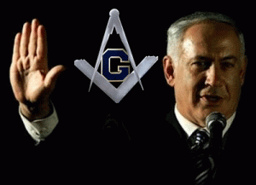
“Human Animals’ Murdered Eyal, Gilad and Naftali” July 1, 2014, BreakingIsraelNews Headline [2] “’ They were abducted and murdered in cold blood by HUMAN ANIMALS. On behalf of the entire Jewish People … Vengeance for the blood of a small child, SATAN has not yet created …” Israeli Prime Minister Benjamin Netanyahu [3]

In regards to VENGEANCE raining down on the Palestinian People (Human Animals), Israeli Prime Minister Netanyahu promised on behalf of the Jewish People to burn another chapter in SATAN‘s book of- “Man’s Inhumanity to Man.“ The so-called western humanitarian and civilized nations of the world and their puppet mass media propaganda pundits, including Aljazeera, don’t intend to talk about Israel’s (GOD’S CHOSEN PEOPLE) retribution against “HUMAN ANIMALS” in the name of SATAN. Meanwhile, SATAN’S new chapter is manifesting and unfolding itself in Gaza. It is graphic and horrific playing out right before our eyes. It is being televised.
As Netanyahu promised the type of terrifying horror- Man’s Inhumanity to Man– unfolding in Palestine in the 21st Century defiles words to describe and even human imagination to vision. It’s precedence in this age can only be found in the National Socialist State of Nazi Germany (GOD’S CHOSEN PEOPLE- ARYANS) that brought the entire planet to brink of human disaster.
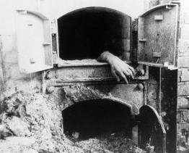
The international community refused to believe that a 20th Century Western nation would be exterminating human beings in gas showers and burning their bodies in industrial ovens by the millions upon millions. The so-called Israel-Palestinian [HUMAN ANIMALS] Conflict is no war like the Nazi-SS leveling the Warsaw Ghetto [UNTERMENSCH-Sub Humans] was any war.[4] Warsaw and Gaza is like shooting 2-ton mortars and dropping 1 ton bombs into a “FISH BOWL” filed with an ensnared terrorized mass of humanity.

The American Institution of Slavery was also a brutal new chapter in SATAN‘s book of –Man’s Inhumanity to Man– burnt into human history on a pseudo perception that Africans were SUB-HUMAN, uncivilized, and inferior to Europeans.[5] Even during that time, the horrific systemic murders, violence, cruelty and suffering inflicted on human beings defiled words to describe and human imagination to vision. My ancestors that survived Slavery passed down a phase that is still chilling now as it was then. They said that they had lived in “THE OTHER WORLD” – Another Dimension.

As we witness the virtual- OTHER DIMENSIONAL horror, death, violence and suffering- GENOCIDE of the Palestinian People inside a “FISH BOWL” filed with almost 1.8 people; see and hear so-called fair and balanced western journalist like CNN’s Wolf Blitzer from station to station 24/7 almost foaming at the mouth calling for more and more Palestinian blood, it has a certain sense of UN-WORLDLY-NESS about it as if we’re living in another era, time or space. It is a channel that you can’t turn off or turn away from.
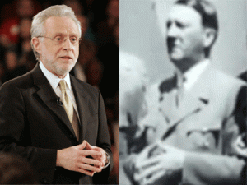
Secret Hand Symbol- Brotherhood of Death
By the way, Wolf Blitzer is part of clandestine Israeli Fifth Column in America, “the people in between.” These people play a dominant force in mainstream American media, comprising a fifth column in support of those skilled at “waging war by way of deception.” Wolf Blitzer at Cable News Network (CNN) typifies how “the people in between” manipulate public opinion in plain sight and, to date, with legal impunity.[6]
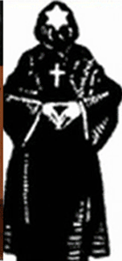
Ancient German Secret Brotherhood of Death
Wolf Blitzer is the son of Polish Ashkenazi émigrés. Blitzer served as an editor of Near East Report, a publication founded by Isaiah Kenen, a registered foreign agent of Israel, who also founded the American Israel Public Affairs Committee (AIPAC). AIPAC coordinates a network of transnational political operatives known loosely as “the Israel lobby.” Neither AIPAC nor Blitzer has yet registered as a foreign agent in the U.S.[7]
No matter how Blitzer and Israel propaganda pundits spin the facts about Hamas’ so called high velocity hand made rockets with 5-10 pound warheads- they have caused only 40 Israeli deaths in the entire history of Israeli-Gaza conflict, iron dome or not.[8] In three weeks of Palestinian resistance and offensive capability, only three (3) Israeli civilian deaths have occurred. That tells you just how much of a threat that Hamas’ “High Velocity Rockets” and so-called “Terror Tunnels” have been to the security of Israel.

The Israeli 24/7 rain of 500 pound to 1 ton bombs turning Gaza into piles of rubble have left hundreds of thousands of Palestinians, one fourth of the population of Gaza, dispossessed and “Homeless.”[9] The most recent figures collected by the Palestinian Centre for Human Rights (PCHR) indicate that at least 1,817 Palestinians have been mass murdered. Of these, 1,545 — an incredible 85 percent — are civilians.[10]
Israeli puppet mass media pundits cry that Hamas is using Palestinians as “Human Shields”- it’s like Jonestown (Lucifer’s Servants/CIA MK ULTRA Mind Control-Medical Experiment).[11],[12],[13] The original body count of the Jonestown dead, predominately Black children, women and elders, was 408 counted. Within a couple of days, the death toll spiked to 913 counted dead. That’s a quite bit of a discrepancy between the bodies found immediately after the mass murder and a few days later when an additional 505 people showed up dead at Jonestown. President Jimmy Carter’s administration official and final explanation for the gross discrepancy to the world masses was that 505 weren’t originally part of the earlier body count because -bodies had fallen on top of other bodies, adults covering children.[14]
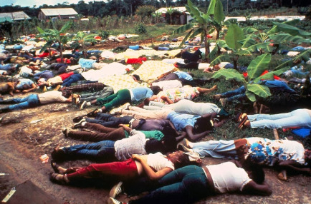
“It was a simple, if morbid, arithmetic that led to the first suspicions. The 408 bodies discovered at first count would have to be able to cover 505 bodies for a total of 913. In addition, those who first worked on the bodies would have been unlikely to miss bodies lying beneath each other since each body had to be punctured. Eighty-two of the bodies first found were those of children, reducing the number that could have been hidden below others.[ A search of nearly 150 photographs, aerial and close-up, fails to show even one body lying under another, much less 500… Close shots indicate drag marks, as though the bodies were positioned by someone after death. Is it possible that the 700 who fled were rounded up by these troops, brought back to Jonestown and added to the body count?”[15]

I said that to say this. If the Israeli Defense Forces murdered 1,817 Palestinians, at the least 85%- 1,545 were admittedly international law protected civilian populations, then each resistance fighter killed- 272, he or she used approximately 5.6 dead Palestinians as “Human Shields.” That kind of VOODOO nonsense just doesn’t add up but for the same ILLUMINATI Morbid Satanic Arithmetic that doesn’t care if it doesn’t make any sense to the masses of people, when you add the 10,000 Palestinians injured. That means that each Hamas’ resistance fighter killed used approximately 42.4 Palestinians as “Human Shields.” The same outlandish Morbid Satanic Arithmetic of Jonestown applies in the outlandish argument that the masses of Palestinians slaughtered by the Israelis are the result of Hamas hiding behind and using them as “Human Shields.”

The ILLUMINATI Morbid Satanic Arithmetic gets even more bizarre when the Israelis bombed over 27,000 Palestinian homes into rubble as July 31, 2014, turning 440,000 Palestinians into homeless- among the dispossessed to disable no more than 33 so-called “Hamas Terror Tunnels.” That turns out for each so called “Terror Tunnel” disabled and destroyed, 13,333.3 Palestinians had their homes turned into a pile of dust.[16]
As I write, at least 10,000 Palestinians are injured in Gaza entrapped and encircled by the homicidal- merciless Israeli Defense Forces with sabotaged hospital facilities, blocked off from medicine, shelter, food, water, electricity and sewage, human dignity and FREEDOM.[17]
As of August 1, 2014, Israel declared a three kilometer buffer zone inside Gaza’s borders last week, an area that represents a staggering 44 percent of Gaza‘s territory. Anyone within the zone has been warned by the Israeli military to leave or risk being bombed.
Now after a month after Israel has done exactly what PM Benjamin Netanyahu by God and the Right of the Jewish People had promised revenge against HUMAN ANIMALS– “NOT YET CREATED BY SATAN”, there is still no substantial or circumstantial evidence that Hamas had been responsible for the alleged kidnapping and murder of the three Israeli teens that served as a pretext for Israel’s latest mass and most deadly onslaught on the Palestinian people.
“ORDER OUT OF CHAOS”
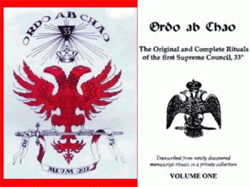
Satanist Albert Pike’s Scottish Rite Banner
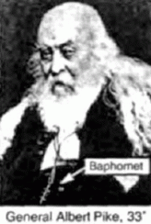
The ILLUMINATI and Freemasonry’s motto is “Ordo ab chao“, meaning “Order out of Chaos“. The motto on the banner below means “God and my Right“.[18] The ILLUMINATI uses “World CHAOS” as a cover and pretext to implement their New World Order (NWO) plans. They cause a problem and provide a solution that aligns with their Luciferian NWO Agenda.
The murders of the Israeli three teens was only a pretext to a solution that aligns with the Luciferian NWO Agenda- Genocide of People of Color. God’s Chosen People genocidal onslaught against the Palestinian People was planned in advance by an absolutely diabolical mindset that is UNWORLDLY by any historical civilized standard and norms since the beginning of recorded history.
Solomon’s [Masonic]Temple in Jerusalem and a NWO with LUCIFER (SET-SETH) as god will arise out of WORLD CHAOS cleansed of SUB-HUMANS [every creeping thing that creepeth upon the earth] that God has given God’s Chosen People dominion over.
The Israel’s UNWORLDLY genocidal onslaught upon the Palestinian People; and SATAN and his loyal SERVANT’S INVOCATION OF THE EBOLA VIRUS should SCARE THE HELL OUT OF ALL OF US . HERE’S WHY.
Lucifer’s Servants-SS & the Founding of the Zionist State of Israel
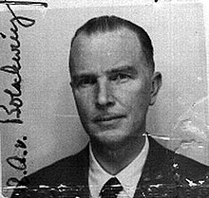
Hauptsturmführer SS Baron Otto Albrecht Alfred von Bolschwing was known to be aristocratic, influential, and big within Reichsfuhrer SS-1 Heinrich Himmler’s secret and classified inner circle. Even among high ranking officers of the SS, Baron von Bolschwing was said to be too big and secretive for their “boots.” Baron von Bolschwing was one of few SS officers that had the choice and privilege not to wear the Nazi- SS uniform.[19]
In prewar Palestine in the mid-1930’s, Baron von Bolschwing operated as a Sicherheitsdienst (SD) agent under the BLOND BEAST Obergruppenführer SS Reinhard Heydrich, first as a MONK in Nazareth and then under commercial cover in Haifa. His reports were sent to a bureau in SD that studied the activities of “Freemasons and Jews.”[20]
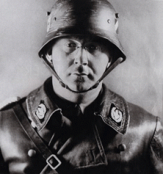
Baron von Bolschwing had been one of Himmler- SATAN SON’s leading, foremost and expert intelligence officers for the Middle East and Palestine. He had been operating clandestinely in and out of Palestine since the early 1930s; and the formation of the 1933 Ha’avara Agreement– immigration of German Jews to Palestine.
in January 1933, Adolf Hitler became Chancellor of Germany and on August 7, 1933, he entered into the Ha’avara (Moving House) Pact with representatives of the World Jewish Agency, the future Leaders of Israel. Hitler considered the Ha’avara Agreement to be a top priority for his administration and by November of 1933 it was in full swing and it kept functioning until at least 1942. The German Interior Ministry was made responsible for the logistics of the scheme and the Reichsbank and the German Treasury were responsible for financing the mass immigration of German Ashkenazi Jews to Palestine to form the future foundation of the Zionist State of Israel.[21]
“GOEBBELS HAS A SPECIAL COIN MINTED TO CELEBRATE ZIONISM”
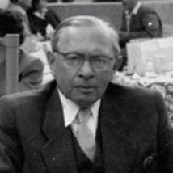
In 1933 and 1934, Untersturmführer SS Leopold Itz von Mildenstein, above, from the SS Office for Jewish Affairs, traveled to Palestine on fact finding missions accompanied by a number of Zionist officials. He became a welcome guest for six months.[22]

SS von Mildenstein’s pro-Zionist report, later printed in the Reich’s propaganda Ministry Official magazine “ANGRIF” with the title “A Nazi travels to Palestine” (Ein Nazi fährt nach Palästina) was so filled with praise and compliments about the work being done by the German Jewish settlers in Palestine that Josef Goebbels had a special coin minted in honor of the co-operation. The coin had a Star of David on one side and a Swastika on the other side. In recognition of this coin, Palestine’s largest fruit growing firm decorated its placard advertising signs for Jaffa Oranges with a huge portrait of King David flanked by Swastika flags.[23]
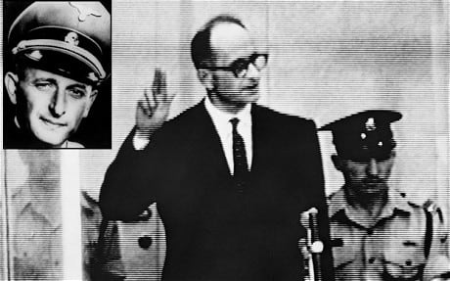
According to convicted and executed war criminal Obersturmbannführer SS Adolf Eichmann, the Nazi-SS nobles, Untersturmfuehrer SS von Mildenstein and Baron von Bolschwing, were the major operatives-originators behind the Ha’avara Agreement.[24]
In Palestine, Baron von Bolschwing stayed behind to establish a clandestine paramilitary group of Zionist-Nazi Jews and Arabs to conduct counterintelligence operations against the British. Baron von Bolschwing hoped that the Arabs would stage a diversion of their own to coincide with the Jewish revolt against the British Authority.[25]
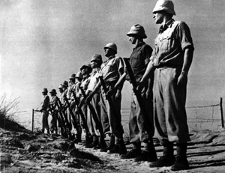
The Zionist group Baron von Bolschwing helped establish in Palestine was the Haganah, the Underground Zionist-Nazi Paramilitary in Palestine during the British Mandate (1920-1948). Immediately after the establishment of the Israel, the Haganah became the ISRAEL DEFENSE FORCES (IDF) transferred.[26]
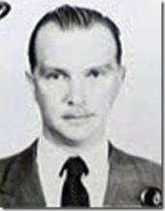
IDF whose your DADDY? One of Lucifer’s most high clandestine and diabolical global strategist, the noble loyal Satanic Servant, Hauptsturmführer SS Baron Otto Albrecht Alfred von Bolschwing. He would do anything for EVIL for the sake of EVIL. That should also SCARE THE HELL OUT OF ALL OF US!
The Underground THIRD REICH, Monkey Viruses and the CIA
The Psychology of GENOCIDE

At a mass meeting in 1934, Nazi Deputy Party Leader Rudolf Hess stated, “National Socialism is nothing but applied biology.”
“The entire Nazi regime was built,” Robert Jay Lifton (The Nazi Doctors-Medical Killing and the Psychology of Genocide (1986) writes, “on a biomedical vision that required the kind of racial purification that would progress from sterilization to extensive killing.”[27] As early as the publication of Mein Kampf (1924-26), Lifton indicates, “Hitler had declared the sacred racial mission of the German people to be ‘assembling and preserving the most valuable stocks of basic racial elements [and]… slowly and severely raising them to a dominant position’…”[28]
The underground THIRD REICH and its networks and tentacles of Nazi Gold wherever it raises its ugly Satanic head always involves SATAN, and clandestine genocidal “RACIAL PURIFICATION PROJECTS.”
Ebola, The THIRD REICH Change of Venue
Majorgeneral Reinhard Gehlen was chief of Fremde Heere Ost (FHO), the General Staff’s Eastern Front Intelligence Service of the Wehrmacht.[29] The Wehrmacht was the unified armed forces of Germany from 1935 to 1946. Gehlen was not officially initiated into Himmler’s Allgemeine-SS, the “General Elite SS”, or Waffen- SS, “Protective Squadron”.[30]
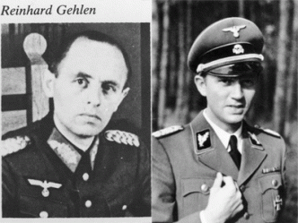
Wicked Walter Displays the “CLAW”- Secret Symbol International Brotherhood of Death
In 1944, Gehlen’s foreign service, the FHO, was absorbed into Reichsfuhrer SS Heinrich Himmler’s Reichssicherheitshauptamt (RSHA) SS-command headquarter offices. In RSHA, Gehlen’s overseer and superior was Himmler’s Personal Staffer, Brigadeführer SS (Wicked) Walter Schellenberg. Gehlen worked under Wicked Walter as Himmler’s patsy in the secret pact (Operation Sunshine) with the United States and British to turn them against the Russians and Communism in a Cold War; and on post-war clandestine underground plans for the SS.[31]
The Nuremberg Tribunal rightfully declared the SS a war criminal and human rights violating organization. Post-WWII, Himmler and the SS couldn’t be sold to the Man in the Moon. As early as 1943, the SS had begun developing elaborate and extensive underground plans during their failed Russian campaign and the lost Battle of Leningrad. They needed collateral collaborators- feeble German cousins like Gehlen to sell and front to the West. Part of their plans also included sheep dipping some of their most subversive, dangerous espionage SS agents like Hauptsturmführer SS Baron Otto von Bolschwing, the BEAST of Bucharest Romania, inside occupied U.S. Army Counterintelligence Corps (CIC) just before the end of the war.[32]
Ebola, THIRD REICH & America‘s War on Cancer
“DO NOT TAKE ANY VACCINATIONS. This is the standard deceptive way you
are given the Establishment’s Biological Warfare infections.” Dr. William D. Kelley[33]
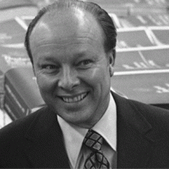
In November 1953, Litton Industries was acquired by Roy L. Ash’s Electro Dynamics Corporation financed by LEHMAN BROTHERS just as SS Baron von Bolschwing was being wiped lily white clean by the CIA and U.S. State Department to enter the United States.[34] I suspect that the arrival of SS Baron von Bolschwing in the country and founding of Litton Industries wasn’t just a coincidence as shown by Litton’s major role in America’s clandestine highly classified offensive chemical and biological-viral warfare programs.

Nazi Germany’s postwar government, Allied Military Government, setup in the offices of the IG Farben building in Frankfurt was headed by Lieutenant General Lucius [Lucifer] Clay that became a partner of LEHMAN BROTHERS bankers in New York.[35]
In Germany, Reinhard Gehlen and the Gehlen’s SS superior Baron von Bolschwing had a direct line and spear of influence over Lieutenant General Lucius Clay,[36] “Eastern European and Russian émigré groups supplied by Gehlen were the [OSS-CIC] personnel initially trained for these missions at a special camp set up at Oberammergau in 1946, under the command of General Sikes and General [Sturmbannführer] SS [Karl] Burckhardt, and with the assistance of Henry Kissinger and Lucius Clay.”[37]
Additionally, SS Baron von Bolschwing had been Himmler’s SS clandestine expert operative in “Freemasonry.” They knew exactly what they were doing when they established the SS as a secret knightly Teutonic Order of the Black Sun. After the War, I don’t believe that it was a coincidence that the BERLIN 49 OUTPOST LODGE 895 (Berlin Lodge U.D., F&AM) composed of U.S. military personnel freemasons was established in July 1947 and setup in the former Berlin headquarters of Herman Goering and the Luftwaffe renamed Clay Allee as a compliment to Lieutenant General Lucius D. Clay. Like Cecil Rhodes and British Roundtable, Himmler and Baron von Bolschwing intended to use the Blood Oath Secret Hierarchical Order of Freemasonry as underground cover and FIFTH COLUMN of the SS.
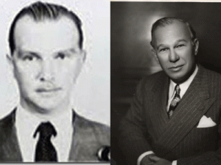
In the United States, SS Baron von Bolschwing moved in close personal ties with Elmer Bobst, president of Warner Lambert Pharmaceutical Co. becoming the assistant to the director of international marketing at Warner Lambert Pharmaceuticals Co.[38] Bobst was initiated into the BLOOD OATH SECRECY of Knighthood of the Knights of Malta, the Knights Hospitaller, also known as the Hospitallers, Order of Hospitallers, Knights of Saint John and Order of Saint John, were among the most famous of the Western Christian military orders during Crusades of the Middle Ages.[39]
Gehlen had also been initiated into ancient Knighthood of the Knights of Malta. In pre-republican Germany all the Knightly families of the Holy Roman Empire eventually were recognized as of baronial rank, some literally translate “BARON” for “KNIGHT“.[40]
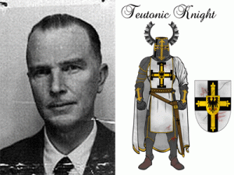
In the hierarchic Western Knighthood, Gehlen and Bobst had been subservient to Baron Bolschwing– a Holy Roman Empire Knightly bloodline to the ancient Order of Brothers of the German House of Saint Mary in Jerusalem-Teutonic Order. The Teutonic Knights also served as a crusading military order along with the Knights Hospitaller in the Middle Ages.[41], [42]
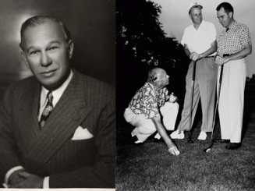
Bobst and Billy Graham Molding a Young Richard Nixon
Since 1953, Bobst had played the crucial role in making it possible for Richard Milhous Nixon to become president that placed his knightly superior Baron Bolschwing, one of the Himmler’s most dangerous SS agents, right in the middle of the highest elected office of the United States.[43] Elmer H. Bobst, Chairman of the Warner-Lambert Pharmaceutical Company was a leading member of the Board of Trustees of the Richard Nixon Foundation. [44]

Mae Brussell: Elmer Bobst & Nixon’s “Kitchen Cabinet”

“Gehlen pioneered the setting up of dummy fronts and cover companies to support his far flung covert operations… By the time the Gehlen Organization became part of the West German state, Gehlen already had his agent-in-place in the United States. He was Otto Albrecht von Bolschwing, who had been a captain in Heinrich Himmler’s dreaded SS and Adolph Eichmann’s superior in Europe and Palestine. Von Bolschwing worked simultaneously for Dulles’ OSS. When he entered the U.S. in February 1954, he cleverly concealed his Nazi past. He was to take over Gehlen’s network not only in this country but in many corners of the globe. He became closely associated with the late Elmer Bobst [Pilgrim’s Society; SMOM; anti-Jewish; accused of sexual abuse granddaughters and great-great-granddaughters] of Warner-Lambert Pharmaceutical, a godfather of Richard Nixon’s political career. In 1969, he showed up in California with a high-tech firm called TCI that held classified Defense Department contracts. His translator for German projects was Helene van Damme, Governor Ronald Reagan’s appointment secretary.” [45]
During the 1930s, Bobst had been head of the U.S. arm of the international Swish Hoffman-La Roche drug company.[46] Hoffman-La Roche was part of the IG Farben Cartel linked directly to Himmler’s Allgemeine-SS. Immediately post WWII, the U.S. Treasury Department became deeply involved in “Operation Safe Haven” in an attempt to trace and seize Nazi-SS Gold and Flight Capital. OSS military record evidence directly link Hoffman- La Roche to Nazi-SS Gold and Capital Flight Assets. Bobst would have been a leading figure and asset in burying Nazi-SS flight capital in America.[47]
Elmer Bobst had been a primary mover in the financing and organizing the American Cancer Society. Uncle Bobst had little trouble in persuading Nixon to authorize a new and expensive “War on Cancer.” At Bobst’s instigation, Nixon signed the National Cancer Act in 1971, which transformed the National Cancer Institute at Bethesda into a new monolithic government bureaucracy.[48] Under Nixon’s National Cancer Program, the National Cancer Institute took over Fort Detrick– the world’s largest and most active biological weapons facility. Bobst was a member of the National Advisory Cancer Council of the National Cancer Institute.[49]
“The Establishment politicians passed legislation to declare WAR upon CANCER. Thus, they went to Fort Detrick and took down the U.S. Army Chemical and Biological Warfare department SIGN. They then placed two signs on the front gate of the facility: on the left, NATIONAL CANCER INSTITUTE (NCI), and on the right, WORLD HEALTH ORGANIZATION (WHO).”[50]
Litton Bionetics, a subsidiary of Ron L. Ash’s Litton Industries, operated the entire administration of the NCI’s adopted chemical and biological warfare programs. Litton’s military contracts during the first Nixon administration exceeded $5 billion. Litton Bionetics received approximately $2 million a year during this time under one NCI contract entitled, “Investigations of Viral Carcinogenesis in Primates.” Another contract called for Bionetics to supply NCI researchers throughout the world with primates for cancer studies.[51]
In Nixon’s Kitchen Cabinet along with Elmer Holmes Bobst had been Litton’s Roy Lawrence Ash- Nixon’s Director of Management and Budget, he had “become a surrogate president, administering the Nixon policies,” the White House correspondent John Herbers wrote in The New York Times Magazine in 1974.[52] Ash had also been Nixon’s National Security Adviser Henry Kissinger’s understudy.[53]
During WWII, Kissinger was a German national that served in the U.S. Army Counterintelligence Corps from 1943-46. At the close of the war, he stayed on active duty in occupied West Germany as a translator assigned to the U.S. Army 970th Counter Intelligence Corps Detachment, among whose ‘official’ functions included the secret Operation Sunshine/Operation Paperclip recruitment of Himmler’s Allgemeine-SS intelligence officers under Gehlen for among other things, anti-Soviet operations inside the Soviet bloc, just as Reichsfuhrer SS Heinrich Himmler and Wicked SS Walter Schellenberg had planned all along.[54]
Ebola- the BLOODY Fever: Henry Kissinger & Project MKNAOMI
At Fort Detrick, Ash’s Litton Bionetics secretly administered Project MKNAOMI through the fort’s U.S. Army Special Operations Department (SOD) ran in concert with the Baron von Bolschwing’s tutored SS CIA’s Technical Services Staff (TSS).[55]
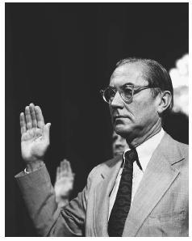
Testifying before Congress in 1975, former CIA director William Colby explained that the US had developed “biological weapons for covert operations including depopulation programs” under the direction of Dr. Henry Kissinger. The secret program was code-named MKNAOMI.[56]
The objectives of the secret program had been set out in Kissinger’s declassified 1974 National Security (Council) Study Memorandum 200 (NSSM 200) entitled, Implications Of Worldwide Population Growth For U.S. Security And Overseas Interests, that called for the secret depopulation of Africa through biological and genetic warfare agents.[57]
Kissinger’s daddy, literally, had been German National Fritz Kraemer. It’s not what I say. Kissinger himself referred to Kraemer in an emotional eulogy as ”the greatest single influence of my formative years.” In 2000, Alexander Haig told James Rosen, author of The Strong Man: John Mitchell and the Secrets of Watergate, that Fritz Kraemer “detests Henry today, even though he was Henry’s father in the United States.”[58]
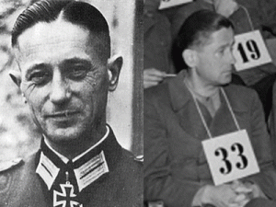
Veteran of the brutal Nazi Russian Military Campaign, SS Kraemer, as you see above, was a battle hardened soldier while the man posing as SS Kraemer No. 33 at the Nuremberg Tribunal appears like a baby-oiled college professor that just stepped off the campus. No 33 disappeared from Nuremberg.
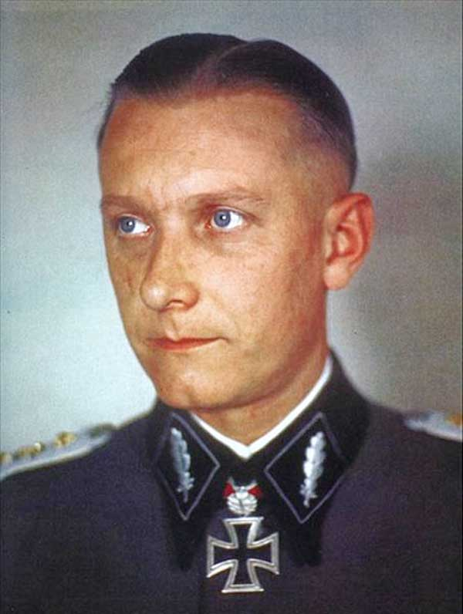
The Late Great Mae Brussell on Fritz Kraemer, “One of the key individuals that Mae fingered as a high perpetrator of the sour direction the country had taken since the death of JFK was F. G. A. Kraemer, Plans Officer for the Chief of Staff of the U.S. Army. Through extensive research, Mae hypothesized that he was the same person as SS-Brigadeführer Fritz Kraemer, who was tried at Dachau in 1946 for his involvement in the Malmedy Massacre.”[59]
SS Fritz Kraemer was another of Himmler’s high ranking SS officers that was sheep dipped and deeply imbedded in the U.S. Army leading to the end of WWII. SS Kraemer and Henry Kissinger had been attached to the headquarters of Maj. Gen. Alexander Russell Bolling, the commanding officer of the 84th Division in the European theatre that sat just outside of Berlin at the end of the war while Hitler, Bormann and Goebbels faked their deaths from Hitler’s bunker in Berlin and went underground.[60] Gen. Bolling was one of select U.S. Army officers involved in the secret highly classified 1945 Fort Hunt Treaty that wined and dined with good old boy German cousin Brigadier General Reinhard Gehlen in America allowing Himmler’s SS and underground THIRD REICH to change venue to America.[61]
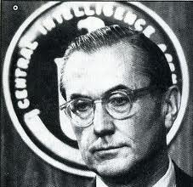
Colby was like the late Bluesman Sonny Boy Williamson, he tended to tell you virtually everything he knows about the CIA if asked by Congress. On April 28, 1996, William Colby went on a routine canoe trip at Rock Point in Maryland. He never came back home alive. His body was found several days later.[62] Dead men tell no tales.

Ashkenazi Jewish Former CIA Chief, John Deutch
Among other things suspected in Colby’s assassination included him publicly exposing what secrets that he knew about the JFK assassination, “It is interesting to note further that Colby’s death came at a critical time when the Israeli lobby in Washington was engaged in a major behind-the-scenes effort to substantially expand the power of the CIA and its then director, John Deutch, a Belgian born Jewish refugee and longtime Washington figure known for his close ties to Israeli intelligence...“[63]
EBOLA OUTBREAK

The disease Ebola Hemorrhagic Fever (EVF) is named after the Ebola River Valley in the Democratic Republic of the Congo (formerly Zaire), which is near the site of the first recognized outbreak in 1976, in a mission hospital run by Flemish nuns.[64]
The Ebola Virus is a RNA virus. An RNA virus is a virus that has RNA (ribonucleic acid) as its genetic material. It is a Viral Hemorrhagic Fever (VHF). All types of VHF are characterized by fever and bleeding disorders and all can progress to high fever, shock and death in many cases. The horrific “VHF syndrome” involves capillary leak, bleeding diathesis, and circulatory compromise leading to shock appearing in a majority of patients with filovirus hemorrhagic fevers [65]
Ebola is not a virus that just all of a sudden sprang out in 1976 of the Congo rainforest, caves or from fruit bats. Western mass media propaganda continue to spread the absolute falsehood that the Ebola Plague began when a local may have slaughtered contaminated monkey- BUSH MEAT.[66]
Both the origin of HIV and Ebola are still deliberately shrouded in layers of enigmas, puzzles and mysteries. However, the origins of these diseases persistently lead to secret combinations of powerful New World Order cabals and Lucifer’s Servants clandestinely involved in culling human populations, particularly people of color, to raise the white Anglo Saxon races to dominant positions in a New World Order.

The so-called Ebola Virus originated from the Marburgvirus developed in a laboratory in Marburg Germany.[67] Marburgvirus is a hemorrhagic fever virus first noticed and described during small epidemics in the German cities Marburg and Frankfurt and the Yugoslavian capital Belgrade in the 1960s. Workers were accidentally exposed to viral contaminated tissues from dissected Grivets (Old World Monkeys) of East Africa. The Grivet is closely related to the families of the Green Vervet Monkey.[68]
Marburgvirus came out of a Behringwerke laboratory, part of Hoechst AG, that was involved in introducing horrific RNA and DNA viruses into caged monkey gang colonies (simian mixers) out of Uganda-East Africa for vaccine research and development. During the early 1950-60s, Behringwerke was the world’s largest vaccine manufacturers.[69
During the Marburgvirus epidemics in Marburg, Frankfurt and Belgrade, thirty-one (31) people became ill, initially laboratory workers followed by several medical personnel and family members who had cared for them. Seven deaths were reported. The vaccines developed out of the Behringwerke and European contaminated labs and monkey colonies were experimentally introduced back into the Nile region of Zaire (Congo), Uganda and East Africa.[70],[71] Behringwerke’s parent corporation, Hoechst AG, was a major German chemicals then life-sciences company. In 1916, it co-founded IG Farben, a powerful cartel of Germany’s chemicals industry.[72]
The United States of America vs. Carl Krauch, et al., also known as the IG Farben Trial, was the sixth of the twelve trials for major Nazi war crimes and crimes against humanity the U.S. authorities held in Nuremburg, Germany. IG Farben and 24 directors were indicted for planning, preparation, initiation, and waging of wars of aggression and invasions of other countries.
Among the indicted charges were IG Farben’s membership in Reichsfuhrer Heinrich Himmler’s SS, Lucifer’s Servants- Knights of the Black Sun; enslavement and deportation to slave labor on a gigantic scale of concentration camp inmates, civilians and prisoners of war and the mistreatment, terrorization, torture, and murder of enslaved persons.[73] After the end of WWII and the Nuremburg Trials, I.G. Farben nevertheless war crimes and crimes against humanity convictions remained intact, then joined with underground SS, rouge U.S. government elements in secret enterprises to continue to develop clandestine chemical-biological warfare agents.[74] I.G. Farben had created the lethal Zyklon B gas that was used to exterminate Jews.[75]
During the 1960s and early 1970s, Litton Bionetics was the chief military and industrial supplier of primates for cancer virus experimentation. Bionetics is cited in the US Congressional Record as a leading biological weapons contractor and nonhuman primate supplier for the US military.[76]
One of Bionetics Research Laboratories’ most important NCI contracts was a massive virus inoculation program that began in 1962 and ran until at least 1976, and used more than 2,000 monkeys. Dr. Robert Gallo, the controversial head of the current U.S. AIDS research program at NCI and the chief of its tumor cell biology laboratory, and Dr. Jack Gruber, formerly of VCP and then NIH, were project officers for the inoculation program. The monkeys were injected with everything from human cancer tissues to rare viruses and even sheep’s blood in an effort to find a transmissible cancer. Many of these monkeys succumbed to immunosuppressant after infection with the Mason-Pfizer monkey virus, the first known immunosuppressive retrovirus, a class of viruses that includes the human immunodeficiency virus. . .”[77
Bionetics chief John Landon reported an experiment begun in 1965 when he inoculated 18 monkeys with rhabdovirus (rod like viral particles) simian—a rabies virus known to cause Ebola-like hemorrhagic fever in monkeys. “Nine [monkeys] died or were transferred,” to allied laboratories or vaccine production facilities. Bionetics shipment of 500 monkeys to Europe was likely to have started the first hemorrhagic fever “Marburgvirus” outbreak among the Behringwerke laboratory workers in 1967. As noted by the world’s leading simian virus expert at the time, Dr. Seymour Kalter, the Marburgvirus was apparently manmade.[78]
According to the Church commission hearings [(i.e., Senator Frank Church of Idaho) which investigated the activities of America’s intelligence community in the mid-1970s], the U.S. government, working through the DOD and the CIA, ordered the development and stockpiling of biological weapons, including immune-system-destroying viruses functionally identical to HIV (AIDS). The principal military scientists and industrialists involved in these projects, which may have involved Ebola and Marburg-like rhabdoviruses, included Robert Gallo of the National Cancer Institute; John Landon and Robert Ting of Litton Bionetics; Litton Industries president Roy Ash; research affiliates of MSD (the Merck, Sharp & Dohme Pharmaceutical Company), including Maurice Hilleman; and a handful of researchers at the New York University Medical Center, the New York Blood Bank, the University of California, and the CDC. Additional institutions which may have played a role in the development of such germs during the 1960s and early 1970s include the Massachusetts Institute of Technology, the Navy’s Biomedical Research Laboratory, Hazelton Laboratories, Inc., the NIAID (National Institute for Allergies and Infectious Diseases), and the AEC (the Atomic Energy Commission).[79]
EBOLA: MSF & the Second Wave Outbreak in West Africa

The outbreak of the deadly strain of Zaire Ebola reportedly began out of the blue in West Africa’s former French Colony of Guinea in February, 2014. Around 90 people died as the disease traveled to neighboring Sierra Leone, Liberia and Mali.[80]
In April 2014, a angry crowd in Macenta, 265 miles south-east of Guinea’s capital, Conakry, reportedly accused medical charity Médecins Sans Frontières (MSF) health workers of bringing the disease to town, where at least 14 people died from Ebola. “We have evacuated all our staff and closed the treatment centre,” the MSF spokesman Sam Taylor said.[81]
In Guinea, MSF claimed that mobs began attacking its health workers. Two years earlier in 2012, Doctors Without Borders concluded its response to an Ebola outbreak in Uganda, “The Doctors Without Borders/Médecins Sans Frontières (MSF) emergency response to an outbreak of Ebola in Uganda has come to an end. The MSF team handed over the Ebola treatment center it set up in Uganda’s western Kibaale district to the Ugandan Ministry of Health (MoH).”[82]
Médecins Sans Frontières (MSF) or Doctors Without Borders, is a French- founded (now international and federal) humanitarian-aid non-governmental organization, and Nobel Peace Prize laureate, best known for its projects in war-torn regions and developing countries facing endemic diseases. Its headquarters are in Geneva, Switzerland.[83]
MSF and the Doctor of GENOCIDE
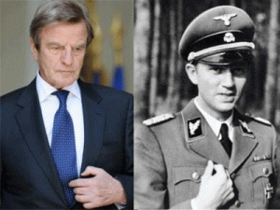Dr. Kouchner and Wicked Walter- the CLAW
Médecins Sans Frontières (MSF) was co-founded by the French Ashkenazi Jewish Dr. Bernard Kouchner that can best be described as an ILLUMINATI cabal puppet of Édouard Étienne Alphonse de Rothschild of the French branch of the Rothschild Family.[84]
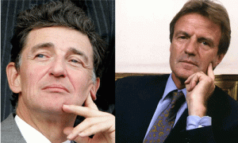ILLUMINATI Édouard Rothschild and Dr. Kouchner- Luciferian Hand Symbol
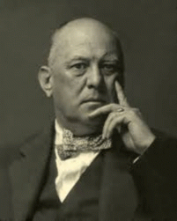The Great BEAST 666, Aleister Crowley
Kouchner is a very strange and scary individual packaged and sold as an internationally renown “Humanitarian.” In France, Bunga-Bunga President Nicolas Sarkozy designed a state post especially for Dr. Kouchner “Secretary of State for Humanitarian Affairs.” Dr. Kouchner’s special ILLUSIONARY post allowed him to intervene in international affairs like a “wolf in sheep’s clothing” in the interest of the CIA and the Rothschild- ILLUMINATI- CLANDESTINE MASS DEPOPULATION PROGRAMS.

In the Biafran Conflict, Dr. Kouchner was on the scene on the side of the French backed Igbo Tribes. The Nigerian Civil War, also known as the Biafran War, July 6, 1967 – January 15, 1970, was an ethnic and political conflict caused by the attempted secession of the southeastern provinces of Nigeria as the self-proclaimed Republic of Biafra. The conflict was the result of economic, ethnic, cultural and religious tensions mainly between the Hausas of north and the Igbo of the southeast of Nigeria. Over the two and half years of the war, 1 million civilians died from famine and fighting.[85]

In the horrific Rwandan Genocide, Dr. Kouchner was on the scene in the role as head of a French humanitarian aid organization on the side of the French backed RGF Hutu Army.[86] The French elite military forces came into Rwanda under the pretext of being a UN Humanitarian Mission (called Operation Turquoise) to set up camps for Tutis and displaced Hutus. But the reality is that they didn’t bring any humanitarian supplies, just military supplies and Dr. Kouchner.

French Troops Escorting Hutus to the Slaughter
The French weren’t there as neutrals to help victims of the genocide, they were there as allies of the Hutu Army fighting the Tutsi Army. Their “humanitarian” role was just that, a “role” acting out on the world stage. Often the French camps the Tutsis were taken to turned into slaughter camps where the French abandoned them to the war criminal GENOCIDAL HUTUS.[87] 500,000 to a million Africans were slaughtered in the Rwandan Genocide.[88]

KLA Leader Hashim Thachi, UNIMIK Chief Dr. Kouchner, Sir Michael Jackson, NATO Command and KLA
In the Kosovo War, Dr. Kouchner entered Kosovo in 1999 as (Humanitarian War) Head of the UN Mission in Kosovo (UMIK) in support of the Kosovo Albanian Rebel (terrorist- war criminal) Group, Kosovo Liberation Army (KLA), that was supported in the war by North Atlantic Treaty Organization (NATO) and Albanian ground forces. France had been a NATO combatant on behalf of the KLA that resulted in reviving and complementing Hitler and Himmler’s plans for a pasty Nazi state of “Greater Albania.”[89]
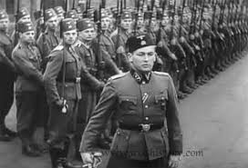
“Kosovo Albanian nationalist militias called the “Balli Kombëtar” (or “Ballistas”) carried out a campaign of deportation and murder of Serbs in 1943 and 1944. Then, on Hitler’s express order, the Germans formed the 21st “Waffen-Gebirgs Division der SS” – the Skanderbeg Division. It was hoped that Skanderberg Division Albanians could achieve it’s well-known political objective of creating a viable “Greater Albania” including Kosovo.”[90] Kouchner, the former UMIK Head is accused of bigotry, corruption and robbing the African countries for personal gain. The Serbs from Kosovo and Metohija Province charge him with far more grievous crimes in condoning ferocious pogroms of Kosovo Serbs and involvement in the atrocious harvesting of vital organs from kidnapped Serbs for sale, by the Albanian terrorists and mafia.[91]
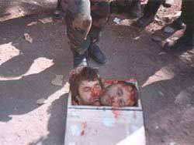
Allegedly KLA butchered and Harvested Kidneys from Live Serbians
The Kosovo organ theft/trafficking or Serbian Organ Harvesting (often referred to as Yellow House Case) is an alleged atrocity of organ theft and killing of 300 ethnic Serbs during and after the Kosovo War in 1999, committed by the Kosovo Liberation Army (KLA).[92]
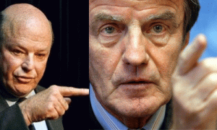
Frank Wisner and Dr. Kouchner- Sethian/ILLUMINATI Index Finger Symbol- ONE GOD
In December 2005, President George W. Bush’s appointed Frank G. Wisner, Jr. as U.S. Special Representative to Kosovo.[93]
“If his name sounds familiar that is because he is the son of Frank Gardiner Wisner, Sr., the CIA agent most responsible for the recruitment of Nazis by the US government after World War II. A former member of the Office of Strategic Services (OSS), the World War II precursor to the CIA, Frank G. Wisner, Sr., was one of the most infamous CIA agents, the man behind Operation Bloodstone, the US government program of recruiting Nazis and SS members.”[94]
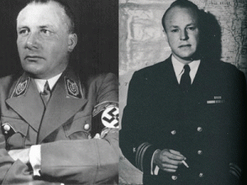
“Apparently sometime not long after the Kennedy assassination, as Wisner’s daughter Wendy recalled to author Burton Hersh, her father became obsessed with the world he had been so enmeshed in creating. Wisner began talking about his belief that Martin Bormann, Hitler’s leading henchman, had escaped Berlin at the end of the war and resettled in Latin America. ‘He was on a thing about this,’ Hersh quotes Wendy Wisner in his 1992 book The Old Boys, ‘that we should pool our sources and resources and get Bormann. He talked about the ‘mysterious and sinister figure of Martin Bormann.’ He wrote millions of letters. If there really was a CIA connection to Bormann in South America, who knows if he wasn’t feeling terrible about it? If he’s starting to yell and scream about these Nazis, who in the CIA is starting to get worried about it?’” (Idem.) (Hersh’s book has been reissued in paperback, by Tree Farm.)”[95]
On October 29, 1965, Frank Wisner, Sr. put a twenty-gauge shotgun owned by Frank Jr. to his head and pulled the trigger and blew out his brains.[96]
Frank Wisner, Jr., who took over Pentagon’s political planning from the Zionist Ashkenazi Jewish Paul Wolfowitz,[97] insisted Dr. Kouchner become French President “Bunga Bunga” Nicolas Sarkozy’s foreign affairs minister with a priority for Kosovo independence and termination of pro-Arab policy. With National Endowment for Democracy funding, Kouchner participated in Zbigniew Kazimierz Brzezinski’s anti-Soviet Afghan operations, alongside Osama bin Laden and the Karzaï Brothers. Under President Hamid Karzaï brother’s control, Afghanistan became the world’s largest producer of opium. US Air Force transports the heroin to Camp Bondsteed, from where the Thaçi Mafia distributes it to the West. The profits finance CIA’s illegal operations. Karzaï and Thaçi are long-time personal friends of Dr. Kouchner, who “doesn’t know” of their criminal activities despite international reports on the subject.[98]
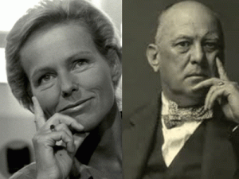
Luciferian/ILLUMINATI Christine Ockrent
Christine Ockrent, his wife, is one of the most influential TV journalists in France and head of the holding company that owns all the radio and TV channels that France broadcasts abroad. She is also a regular invitee to the meetings of the Bilderberg Group (Bormann Group, see below) and the European (NWO) Council on Foreign Relations.[99]
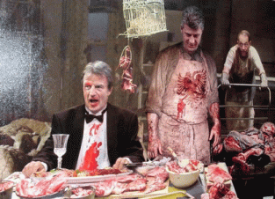
Humanitarian? Wherever a Dr. Bernard Kouchner goes under the veil of humanitarian, a wolf in sheep clothing, particularly in Africa, he leave behind mountains of dead bodies and a sea of the blood of humanity. Whatever he is associated with should be suspected of collaborating with the ILLUMINATI clandestine policy of CHAOS, and mass DEPOPULATION-GENOCIDE of planet’s People of Color.
EBOLA: MSF, Goldman Sachs, Nazis and the Bilderberg Group
In August 2013, it was exposed that Doctors Without Borders/Médecins Sans Frontières (MSF) were directly involved in collaborating, aiding and abetting CIA/Western intelligence backed Islamist terrorists attempting to overthrow the sovereign nation of Syria. They are involved in setting up emergency treatment centers in combat zones controlled by the terrorists.

“Over the past months, we’ve [Doctors Without Borders] had a surgery that was opened inside a cave. We’ve had another that was opened in a chicken farm, a third one in a house. And these structures, we’ve tried to outfit them as best as we can with enough modern technology and with full medical teams. They originally were dealing mainly with combatant injuries and people who were – civilians who were directly affected by the conflict.”[100]
As an international renown medical authority, they were accused of propagandizing evidence of the “Syrian Chemical Weapons Attack” to provide CIA/Western intelligence forces with the pretext for an unilateral United States led allied aerial onslaught and possible invasion of Syria that could have possibly led to a world crisis and World War III.[101]
“To begin with, Doctors Without Borders is fully funded by the very same corporate financier interests behind Wall Street and London‘s collective foreign policy, including regime change in Syria and neighboring Iran. Doctors Without Borders’ own annual report … includes as financial donors, Goldman Sachs, Wells Fargo, Citigroup, Google, Microsoft, Bloomberg, Mitt Romney’s Bain Capital, and a myriad of other corporate-financier interests. Doctors Without Borders also features bankers upon its Board of Advisers including Elizabeth Beshel Robinson of Goldman Sachs.”[102]
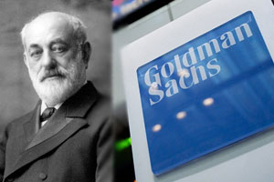
Goldman Sachs was founded in New York in 1869 by the German born Zionist Ashkenazi Jewish Marcus Goldman.[103] In 1882, Goldman’s son in law Samuel Sachs joined the firm. In 1885, Goldman took his son Henry and son in law Ludwig Dreyfuss into the business and firm adopted its present name, Goldman Sachs & Co.[104]
Sachs was a close friend of another person of German Ashkenazi Jewish stock of Bavaria, Philip Lehman. Philip, a partner in Lehman Brothers that financed Litton Industries. Whether or not Goldman Sachs and Lehman Brothers are part of the Old World secret Ashkenazi Solomon Temple group called the “the Treasury” or the Rothschild Ashkenazi ILLUMINATI, Goldman Sachs & Co, particularly, is part of and a prominent member of Lucifer’s Servant’s Bilderberg Group.[105]
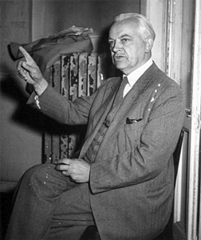
IG Farben’s SS Herman Schmitz- “ONE GOD” Gesture
At the Nuremberg Tribunal, SS Hermann Schmitz, head of I.G. Farben and director of I.G. Farben’s Industrial Espionage Unit, N.W. 7, was prosecuted for war crimes and crimes against humanity; and membership in Reichsfuhrer Heinrich Himmler’s SS– war crimes organization. In Paul Manning’s classic, Martin Bormann: Nazi in Exile, Schmitz testified in absolute defiance and confidence that the SS underground was alive and well after the war: “We can continue. We have an operational plan. However, I don’t believe our board members will be detained long. Nor will I. But we must go through a procedure of investigation before release, so I have been told by our N.W. 7[SS] people who have excellent contacts in Washington.”[106]

Leonardo da Vinci’s John the Baptist- Secret Rosicrucian Symbol “ONE GOD”- LUCIFER
Schmitz had been in charge of IG Farben’s foreign empire and the principal architect of the program for camouflaging the company’s vast overseas holdings.[107] SS Herman Schmitz had also been one of the masterminds behind SS Martin Bormann, Party Chancellery and Private Secretary to Adolf Hitler, and the SS’s secret flight capital plans and underground schemes.[108]
With certain defeat looming, Himmler and Wicked SS Walter were apparently assigned to developing a secret pact between the SS and United States with OSS Chief Wall Street Banker Allen Dulles through Operation Sunshine. While Bormann and Schmitz were primarily assigned to diversifying, cloaking and camouflaging the vast blood treasuries of the Nazis and the SS reserved for the rise of the THIRD REICH underground.
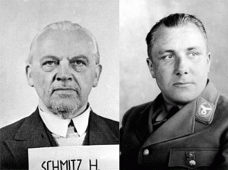
“Bormann and Schmitz developed a more aggressive self-contained approach to the problem of the looming military defeat. The central concept of which was that large numbers of Nazis would have to leave Europe and at least for a time, find places in the world in which to recover their strength.”[109]
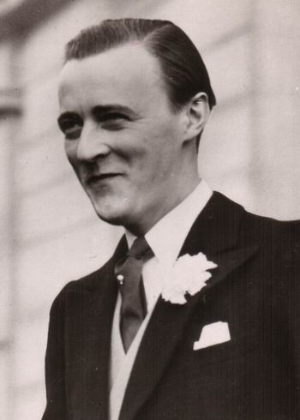
Prince Bernhard of the Netherlands formed the Bilderberg Group- the BORMANN GROUP. Prince Bernhard of the Netherlands had been a member of Schmitz’s I.G. Farben’s secret Industrial Espionage Unit N.W. 7 and SS- Knight of the Black Sun.[110]
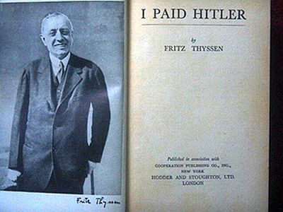
In his book, I Paid Hitler, multibillionaire steel magnate Fritz Thyssen admitted that the Nazis themselves had been obliged to recognize the services rendered by the Jewish Simon Hirschland Bank in Essen, which had arranged Wall Street loans for Hitler through another Jewish bank in New York, GOLDMAN SACHS & CO.[111
Goldman Sachs is a Zionist Organization and one of its aims is to protect and secure the Zionist State of Israel at all costs for the Luciferian New World Order. GOLDMAN SACHS- Who’s your real DADDY? The CIA, ILLUMINATI and Lucifer’s Servants– the Bormann [Bilderberg] Group.
The people of Guinea could very well be correct that the second wave of Ebola Outbreaks in the country is part of a greater clandestine campaign of GENOCIDE. Dr. Bernard Kouchner and MSF have been found to be patsies and collaborators of the Western military-industrial intelligence complex, CIA and the Ashkenazi Zionist ILLUMINATI.
Ebola: In Summary
The 1967 etiology (causes of the disease) of “Marburg Virus” (Cercopithic Hemorrhagic Fever) also called “Rhabdovirus simiae” is linked to infection appearing after contact with the blood and organs of the green monkey, Ceropithecus acthiops. GERMAN scientists along with participation of representatives from primarily NATO countries, England, United States, USSR, Yugoslavia and Austria were “preparing cell cultures” from green monkeys after they had brought from Uganda in experimental reproduction (inoculation) of diseases “until the appearances of clinical symptoms”. (Army Materiel Command, U.S. Army Foreign Science and Technology Center)
Additionally, Litton Bionetics was doing the same thing to monkeys in Uganda two years earlier. The West Nile District of Uganda had been the home of the International Agency for Research in Cancer (IARC) that collaborated with Litton Bionetics.[112] The International Agency for Research on Cancer is an intergovernmental agency forming part of the World Health Organization (WHO) of the United Nations.[113] WHO take directions from the Bilderberg- Bormann Group.[114]
Bionetics chief Dr. John Landon reported an experiment begun in 1965 that he had inoculated 18 monkeys with rhabdovirus (rod like viral particles) simian—a rabies virus known to cause Ebola-like hemorrhagic fever in monkeys. “Nine [monkeys] died or were transferred,” to allied laboratories or vaccine production facilities in Europe.[115]
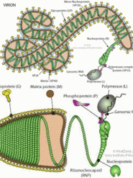
Marburg/Ebola Virus Above, Rhabdovirures (Rabies) Below
“Dr. John Landon, took minced tissue containing Rhabdovirures along with numerous hybrids (Hybrid Rhabdoviruses were made by cross-breeding them with simian sarcoma and leukemia viruses to form mutant strains called “Rhabdomyosarcoma and leukemia viruses to form mutant strains called “Rhabdomyosarcoma or Rhabdomyosarcoma L”) and inoculated them into dozens of monkeys. Most died or were transferred.”[116]
After the 1967 “Marburg Virus” (Cercopithic Hemorrhagic Fever) or Rhabdovirus simiae outbreak in Europe, it fell off the map in human or primate infections until it reappeared in three (3) non laboratory related individuals in South Africa in 1975 after it had been WEAPONIZED as biological warfare agent.[117]
The Tropical Diseases Bulletin reported that the Marburg, Ebola Zaire and Ebola Sudan were “morphologically [structure and makeup] indistinguishable…”[118] Ebola Sudan, and Ebola Zaire came from the laboratories of “Behringwerke, the Paul Ehrlich and the Institute for Sera and Vaccines Torlak” far away from Africa or any green monkeys in their natural habitat, caves, fruit bats or monkey- BUSH MEAT.[119]
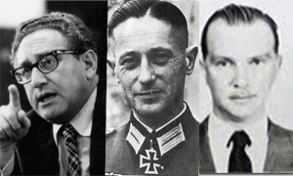
Ebola Outbreaks were signed and directed to Africa as plagues to clandestinely DEPOPULATE Africa through Henry Kissinger/ Brigadeführer SS Fritz Kraemer’s joint Department of Defense/Baron SS von Bolschwing CIA SECRET PROGRAM- MKNAOMI.
For alternative studies on MKNAOMI, Ebola and AIDS, please see Alan Cantwell, Jr. MD, AIDS AND THE DOCTORS OF DEATH, AN INQUIRY INTO THE ORIGIN OF THE AIDS EPIDEMIC, Aries Rising Press, LA (1988) and Leonard G. Horowitz, D.M.D, M.A, M.P.H, EMERGING VIRUSES: AIDS & EBOLA, NATURE, ACCIDENT OR INTENTIONAL?, Tetrahedron Publishing Group, Sandpoint, Idaho (1999).
In regards to Dr. Horowitz, there is a lot of buzz on the internet that he has been initiated into the Knights of Malta. During the early 2000s, I made very limited and brief contact with Dr. Horowitz in San Francisco to get some clues on some local clandestine vaccine programs including Project CHATTER that I was working on.
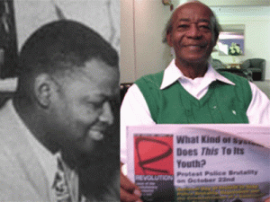
Oakland’s Past Secret Black Masonic/Luciferian Cabal- the Late Clinton White and Harold Perry
One day while I was in the public library after approaching Dr. Horowitz, I got a tap on my shoulder from one of my Black elders- like “Hey, I working on the same thing.” The elder turned out to be former Civil Rights Attorney, Harold Perry, an extremely dangerous old school CIA/FBI Negro Ghetto Informant that had been a law partner of Clinton White. White had been a major secret Negro Blood Oath MASONIC gatekeeper in the clandestine SS patent “Unworldly” CIA/MK ULTRA MANCHURIAN CANDIDATE Zebra Murders- Black Angel Murders in the San Francisco-Oakland Bay Area of the early 1970s. White had been the defense attorney for the convicted alleged Zebra Killers.
What I was able to decode from Perry was that he was shadowing Dr. Horowitz in the Bay Area. He was following all of his speaking, TV- radio engagements and people that had come in contact with him like myself. One day, Perry asked to study and review my copy of Dr. Horowitz’s EMERGING VIRUSES: AIDS & EBOLA (1999) and working notes to narrow some related issues that he, allegedly, was working on. Well, I gave them to him because I didn’t want THEM breaking in my home or car to get them. For safety and security concerns, I always try to work only from public records. Perry gathered up my book and notes then hurriedly limped out of the library door. That was the last time I saw him, book and notes.
I said that to say this. if Dr. Horowitz was one of THEM, Perry would not have been shadowing him. If EMERGING VIRUSES: AIDS & EBOLA was ILLUMINATI coded, Perry would not have seized it or most of my working notes based on the book.
In Conclusion
It would be like America (Great SATAN) and Israel (Little SATAN) burning another new chapter in SATAN’S 21st Century Book of – Man’s Inhumanity to Man to have planned Israel’s “unworldly” Satanic genocidal onslaught on the Palestinian People of Gaza to coincide with the peak of the Second Mass African Ebola Virus Outbreak that they manufactured to shroud their tracks in another sea of mass racial bloodshed- GENOCIDE.
The Second Mass Ebola Outbreak began to show definite signs of infection around March 25, 2014 in four southeastern districts: Guekedou, Macenta, Nzerekore and Kissidougou of Guinea.[120] On January 21, 2014, the White House Press Secretary announced that President Obama would be hosting an African Leaders Summit.[121] It was just days before the virus was released in southeastern Guinea.
World and U.S. Health officials maintain that Ebola’s incubation period is two to 21 days and early symptoms aren’t specific.[122] That indicates that the Ebola Virus was released into the population around at least early March or late February 2014.
Like the Litton Bionetics’ experimental bio-weapons lab in Uganda links to the sudden 1976 Ebola Zaire Virus Outbreak, look for a remote Western bio-weapons lab or vaccine research facility near the sudden outbreak of the disease, because transporting and handling Ebola is tantamount to an atomic bomb in a capsule.
At the epicenter of the current Ebola Epidemic is the Kenema Government Hospital in Sierra Leone, which houses a US bio-security level 2 bio-weapons research lab with links to the eugenic billionaire “Good Club“[123] Bill and Melinda Gates Foundation and Soros Foundation that seek to cull the world’s human populations, especially in Africa, with vaccines.[124]
The partners and people leading the viral fever bioweapons lab inside Kenema Government Hospital read like a roll call of New World Order organizations. “”The Consortium is a collaboration between Tulane, Scripps Research Institute, Broad Institute, Harvard University, University of California at San Diego, University of Texas Medical Branch, Autoimmune Technologies LLC, Corgenix Medical Corporation, Kenema Government Hospital (Sierra Leone), Irrua Specialist Teaching Hospital (Nigeria) and various other partners in West Africa. …The Consortium intends to expand this program to include other important infectious agents such as Ebola, Marburg and other Arenaviruses that are of great concern to public health and bioterrorism,” states the bio-weapons lab website.[125]
Kenema, Sierra Leone is near the Guekedou District on the southeastern broader of Guinea where the Ebola outbreak began. The Kenema Government Hospital (KGH) is located 300km east of Freetown, in Kenema, Eastern Province, Sierra Leone, an area with the highest incidence of LASSA FEVER (fatal hemorrhagic illness) in the world.[126]
According to the authors of Biological and Toxin Weapons Today (Oxford University Press, 1986) Marburg and Ebola, LASSA FEVER, “these agents have been regarded by U.S. Army scientists as among those ‘putative BW agents having the highest liability for operational use.'”[127]
“For the last several years, researchers from Tulane University have been active in the African areas where Ebola is said to have broken out in 2014. These researchers are working with other institutions, one of which is USAMRIID, the US Army Medical Research Institute of Infectious Diseases, a well-known center for biowar research, located at [Litton Bionetics] Fort Detrick, Maryland. In Sierra Leone, the Tulane group has been researching new diagnostic tests for hemorrhagic fevers.”[128]
“The underlining aim of the US, is to take stock: to know the number of for and against, and those still holding unto the non-aligned policy. The US seems to be saying: if you are still loyal, find your way to DC, if you are having a second thought, you know what we can do to create unrest in your domain. And as expected, they went in droves, driven by a manic desire to appease the mephistophilian [Wicked; fiendish] master, else they lose their much coveted fiefdom through machinations like Boko Haram.”[129] Or EBOLA.
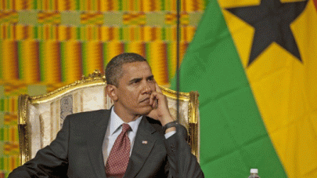
At the Africa Leaders Summit, I expected the Luciferian Robotoid Barrack Hussein Obama to be programmed by the ILLUMINATI to be cold, condescending and freaking EVIL toward the African leaders. Day one, Obama told them that he didn’t intend to meet with any of assembled leaders on an one-to-one basis on anything- anything even Ebola-Phobia.[130]
Like God Caesar on the throne, he sternly lectured them from above like the emperor’s subjects from one thing to another, and told them not to expect any handouts. They were humiliated by being singled out among invited foreign dignitaries to Washington DC to be subjected to mandatory EBOLA medical screenings. It shows that Great SATAN has the capability to screen for Ebola. America even has a “secret antidote or serum” for Ebola [131] that was most likely developed by Litton Bionetics from the American and European (NATO) 1970s Marburg Virus experiments. Neither the Ebola screens or the secret serum have been shared with African nations- absolutely unworldly EVIL.

That’s the way the Luciferian ILLUMINATI roll beyond the UN-WORLDLY-NESS EVIL OF SATAN.
I am willing to bet my bottom dollar that not one of the African countries lined up like ducks in a shooting gallery that attended Obama’s Africa Leaders Summit will dare to vocally pledge solidarity for Palestinian Unity and Freedom from Israeli unworldly oppression, call for or support a Little SATAN Israeli war crimes tribunal before the International Criminal Court (ICC) or any other international body. IT HAS TO BE DONE.
Nor will they dare to demand any African or international investigation in Great SATAN or Little SATAN’S role in the manufacture and distribution of EBOLA and AIDS in Africa. I would be overwhelming happy to be proven wrong and witness in my lifetime a united front calling for an Israel/America War Crimes Tribunal for the GENOCIDE in Gaza; and an international investigation into their collective roles in unworldly spreading bio-warfare agents like EBOLA and AIDS mass murdering the masses around the WORLD.
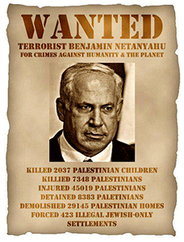
If world and nation leaders won’t do it for the dignity and sake of mankind, then the people must empower themselves to open “Peoples Tribunals” all over the globe to try the “Forces of Evil” and “Lords of CHAOS” for war crimes and crimes against humanity. The Ghosts of Lucifer’s Most Loyal Servants- Baron Otto von Bolschwing, Heinrich Himmler and the SS that lies hidden in the fabric (Blood Oath Masonic/Satanic Secret Societies) of our communities, and the bowels and shadows of corporations and governments across the planet must be finally exposed, exorcised and buried once for all time.
POWER TO THE PEOPLE

[1] http://abcnews.go.com/International/israel-strikes-34-terror-targets-gaza-bodies-israeli/story?id=24373639
[2] http://www.breakingisraelnews.com/17407/netanyahu-human-animals-murdered-eyal-gilad-naftali/#dxMr6oLHbCcQrl8r.97
[3] http://www.breakingisraelnews.com/17407/netanyahu-human-animals-murdered-eyal-gilad-naftali/#dxMr6oLHbCcQrl8r.97
[4] http://en.wikipedia.org/wiki/Untermensch
[5] http://discoveringbristol.org.uk/slavery/after-slavery/wider-world/black-white-in-britain/racist-ideas/
[6] http://www.intifada-palestine.com/2009/08/israels-fifth-column-the-people-in-between/
[7] http://www.intifada-palestine.com/2009/08/israels-fifth-column-the-people-in-between/
[8] http://mondoweiss.net/2014/07/rocket-deaths-israel.html
[9] http://electronicintifada.net/content/one-fourth-gazas-population-displaced-israels-violence/13694
[10] http://electronicintifada.net/content/why-gaza-ceasefire-isnt-enough/13692
[11] http://jimhougan.com/wordpress/?tag=jonestown
[12] http://en.wikipedia.org/wiki/Jonestown_conspiracy_theory
[13] http://www.ratical.org/ratville/JFK/JohnJudge/Jonestown.html
[14] http://www.ratical.org/ratville/JFK/JohnJudge/Jonestown.html#p2
[15] http://www.ratical.org/ratville/JFK/JohnJudge/Jonestown.html#p2
[16] http://news.sky.com/story/1310566/440000-gazans-displaced-as-israel-boosts-troops
[17] http://electronicintifada.net/content/one-fourth-gazas-population-displaced-israels-violence/13694
[18] http://thebiggestsecretpict.online.fr/nwo.htm
[19] Breitmann, Richard, U.S. Intelligence and the Nazis, Cambridge University Press, Cambridge, MD (2005), pg. 344
[20] Id.
[21] http://www.thebirdman.org/Index/Others/Others-Doc-Jews/+Doc-Jews-IntimateRelationToNazis/ThePactBetweenHitler&TheZionists.htm
[22]Id.
[23]Id.
[24] http://www.nizkor.org/hweb/people/e/eichmann-adolf/transcripts/Sessions/Session-090-02.html
[25]Id.
[26] http://de.wikipedia.org/wiki/Hagana
[27] http://www.bibliotecapleyades.net/sociopolitica/sociopol_germany02.htm
[28] http://www.bibliotecapleyades.net/sociopolitica/sociopol_germany02.htm
[29] Reese, Mary Ellen, General Reinhard Gehlen, the CIA Connection, George Mason University Press, Fairfax, VA (1990) pgs. 13-14
[30] http://en.wikipedia.org/wiki/Wehrmacht
[31] Reese, Mary Ellen, General Reinhard Gehlen, the CIA Connection, George Mason University Press, Fairfax, VA (1990) pgs. 15-18

[32] http://en.wikipedia.org/wiki/Otto_von_Bolschwing
[33] http://educate-yourself.org/cn/2001/bioweaponscancerwars01oct01.shtml
[34] http://oztypewriter.blogspot.com/2012/06/littons-typewriter-empire.html
[35] http://www.bilderberg.org/bernhard.htm
[36]http://www.democraticunderground.com/discuss/duboard.php?az=show_mesg&forum=104&topic_id=1695779&mesg_id=1696658
[37] http://www.theforbiddenknowledge.com/hardtruth/fire22.htm
[38] http://spitfirelist.com/news/ex-nazi%E2%80%99s-brilliant-u-s-career-strangled-in-a-web-of-lies/
[39] http://en.wikipedia.org/wiki/Knights_Hospitaller
[40] http://en.wikipedia.org/wiki/Baron#Germany
[41] https://tourpoland.wordpress.com/2010/11/
[42] http://en.wikipedia.org/wiki/Teutonic_Knights
[43] http://www.whale.to/b/acs1.html
[44] http://www.nixonlibrary.gov/virtuallibrary/documents/PDD/1973/114%20December%2016-31%201973.pdf
[45] http://www.bibliotecapleyades.net/sociopolitica/sociopol_lecercle02.htm
[46] http://www.smokershistory.com/Bobst.htm
[47] http://www.archives.gov/research/holocaust/finding-aid/military/rg-226-3g.html
[48] http://www.bibliotecapleyades.net/salud/salud_defeatcancer07.htm
[49] http://www.smokershistory.com/Bobst.htm
[50] http://educate-yourself.org/cn/2001/bioweaponscancerwars01oct01.shtml
[51] http://www.hiddenmysteries.org/review/rev/item239.html
[52] http://www.nytimes.com/2012/01/13/business/roy-ash-who-reorganized-the-executive-branch-dies-at-93.html?pagewanted=all
[53]http://www.tetrahedron.org/articles/aids
[54] http://www.bibliotecapleyades.net/exopolitica/esp_exopolitics_F_2.htm
[55] Albarelli, H.P., A Terrible Mistake, The Murder of Frank Olson and the CIA’s Secret Cold War Experiments, Trine Day LLC, Waterville, OR (2009) pg. 181
[56] http://www.americascomingjudgment.com/VolumeII/index149.html
[57] http://www.americascomingjudgment.com/VolumeII/index149.html
[58] http://beforeitsnews.com/power-elite/2012/03/mae-brussel-and-nixon-tapes-who-was-fritz-kraemer-and-why-we-should-care-1850110.html
[59] http://www.worldwatchers.info/about/
[60] http://www.nytimes.com/2003/11/19/us/fritz-kraemer-95-tutor-to-us-generals-and-kissinger-dies.html
[61] http://atrueott.files.wordpress.com/2010/05/the-secret-treaty-of-fort-hunt.pdf
[62] http://aangirfan.blogspot.com/2008/01/william-colby-heroin-israel-and-child.html
[63] http://aangirfan.blogspot.com/2008/01/william-colby-heroin-israel-and-child.html
[64] http://www.news-medical.net/health/What-is-Ebola.aspx
[65] http://en.wikipedia.org/wiki/Viral_hemorrhagic_fever
[66] http://www.irinnews.org/report/96160/drc-bushmeat-blamed-for-ebola-outbreak
[67] http://en.wikipedia.org/wiki/Marburg_virus
[68] http://en.wikipedia.org/wiki/Grivet
[69] http://de.wikipedia.org/wiki/Behringwerke
[70] http://de.wikipedia.org/wiki/Behringwerke
[71] http://www.whale.to/v/nile.html
[72] http://en.wikipedia.org/wiki/Hoechst_AG
[73] http://en.wikipedia.org/wiki/IG_Farben_Trial
[74] http://miningawareness.wordpress.com/2014/07/03/sarin-nerve-gas-i-g-farben-and-the-nazis/
[75] http://www.angelfire.com/music2/fullcircle/rothschild.html
[76] http://www.whale.to/v/nile.html
[77] http://spitfirelist.com/for-the-record/ftr-606-project-paperclip-and-aids/
[78] http://www.bibliotecapleyades.net/ciencia/supressed_inventions/suppressed_inventions06.htm
[79] http://www.antipasministries.com/html/file0000081.htm
[80] http://www.independent.co.uk/news/world/africa/panic-as-deadly-ebola-virus-spreads-across-west-africa-9241155.html
[81] http://www.independent.co.uk/news/world/africa/panic-as-deadly-ebola-virus-spreads-across-west-africa-9241155.html
[82] http://journal-neo.org/2014/04/13/the-troubling-truth-behind-the-ebola-outbreak/
[83] http://en.wikipedia.org/wiki/M%C3%A9decins_Sans_Fronti%C3%A8res
[84] http://en.wikipedia.org/wiki/%C3%89douard_de_Rothschild
[85] http://en.wikipedia.org/wiki/Nigerian_Civil_War
[86] http://www.iol.co.za/news/africa/france-faces-its-role-in-rwanda-genocide-1.1641284
[87] http://www.orwelltoday.com/rwandafrance60min.shtml
[88] http://en.wikipedia.org/wiki/Rwandan_Genocide
[89] http://en.wikipedia.org/wiki/Kosovo_War
[90] http://www.veteranstoday.com/2012/08/27/kosovo-americas-nazi-colony/
[91] https://deeppoliticsforum.com/forums/showthread.php?750-A-new-book-about-Bernard-Kouchner-show-him-to-be-a-sleaze-bag-extraordinare#.U-GptPldXLc
[92] http://www.mamaleh-larisa.com/ap1.html
[93] http://serbianna.com/blogs/savich/archives/26
[94] http://serbianna.com/blogs/savich/archives/26
[95] http://spitfirelist.com/for-the-record/ftr-366-whats-going-on-here/
[96]Id.
[97] http://www.rense.com/general36/zinf.htm
[98] http://piotrbein.wordpress.com/2009/12/30/judeocentrics-and-mass-crimes/
[99] http://www.theamericanconservative.com/articles/bombs-without-borders/
[100] http://landdestroyer.blogspot.com/2013/08/doctors-behind-syrian-chemical-weapons.html
[101] http://landdestroyer.blogspot.com/2013/08/doctors-behind-syrian-chemical-weapons.html
[102] http://landdestroyer.blogspot.com/2013/08/doctors-behind-syrian-chemical-weapons.html
[103] http://en.wikipedia.org/wiki/Marcus_Goldman
[104] http://en.wikipedia.org/wiki/Goldman_Sachs
[105] http://www.theguardian.com/world/2013/jun/05/bilderberg-2013-goldman-sachs-watford
[106] https://www.mail-archive.com/pepis@googlegroups.com/msg00329.html
[107] http://www.bibliotecapleyades.net/sociopolitica/sociopol_igfarben02h.htm
[108] http://atrueott.files.wordpress.com/2010/05/the-secret-treaty-of-fort-hunt.pdf
[109] http://atrueott.files.wordpress.com/2010/05/the-secret-treaty-of-fort-hunt.pdf
[110] http://www.bilderberg.org/bernhard.htm
[111] http://www.heretical.com/miscellx/zionism.html
[112] http://www.whale.to/vaccines/uganda_h.html
[113] http://en.wikipedia.org/wiki/International_Agency_for_Research_on_Cancer
[114] http://wotraceafg.voila.net/aids.htm
[115] http://www.bibliotecapleyades.net/ciencia/supressed_inventions/suppressed_inventions06.htm
[116] Horowitz, Leonard, Emerging Viruses: AIDS and EBOLA, Nature, Accident or Intentional, Tetrahedron, Inc., Sandpoint, Idaho (1999), pg. 447
[117] Id., pg. 461
[118] Horowitz, Leonard, Emerging Viruses: AIDS and EBOLA, Nature, Accident or Intentional, Tetrahedron, Inc., Sandpoint, Idaho (1999), pg. 387
[119]Id.
[120] http://en.wikipedia.org/wiki/2014_West_Africa_Ebola_outbreak#Timeline_of_the_outbreak
[121] http://www.whitehouse.gov/the-press-office/2014/01/21/statement-press-secretary-announcing-us-africa-leaders-summit
[122] http://www.usatoday.com/story/money/business/2014/08/01/ebola-airlines-screening-world-health-organization/13434517/
[123] http://www.engdahl.oilgeopolitics.net/Swine_Flu/Gates_Vaccines/gates_vaccines.html
[124] http://dublinsmick.wordpress.com/2014/07/25/us-bioweapons-lab-with-links-to-the-bill-and-melinda-gates-foundation-at-core-of-ebola-epidemic/

[125] http://dublinsmick.wordpress.com/2014/07/25/us-bioweapons-lab-with-links-to-the-bill-and-melinda-gates-foundation-at-core-of-ebola-epidemic/
[126] http://vhfc.org/consortium/partners/kgh
[127] Horowitz, Leonard, Emerging Viruses: AIDS and EBOLA, Nature, Accident or Intentional, Tetrahedron, Inc., Sandpoint, Idaho (1999), pg. 509
[128] http://truthfrequencyradio.com/what-are-us-biowar-researchers-doing-in-the-ebola-zone/
[129] http://www.theheraldng.com/us-africa-summit-genuflection-stop/
[130] http://www.cctv-america.com/2014/08/04/day-1-of-the-u-s-africa-leaders-summit
[131] http://www.dw.de/secret-serum-liberia-ebola-drug-used-on-brantly-is-only-one-of-many-in-development/a-17654230
Comments : 2 Comments
Tags: Adolf Hitler, aids, albert pike, Aleister Crowley, Baron Otto von Bolschwing, Benjamin Netanyahu, biological warfare, Brigadefuhrer SS Dr. Fritz Gustane Anton Kraemer, brotherhood of death, Cameron, CIA, clinton white, DOCTORS OF DEATH, doctors without borders, Dr. Alan Cantwell, dr. bernard kouchner, Dr. Fritz Gustane Anton Kraemer, ebola, ebola outbreak, ebola virus, elmer Bobst, EMERGING VIRUSES: AIDS & EBOLA, fort detrick, freemasonry, freemasons, gaza, genocide, great satan, guinea, Ha'avara Agreement, Haganah, harold perry, Heinrich Himmler, Henry Kissinger, Illuminati, israel defense force, israeli defense forces, Knights of the Black Sun, LEHMAN BROTHERS, Leopold Itz von Mildenstein, Liberia, little satan, litton bionetics, litton industries, Lucifer, Lucifer's Servants, luciferians, lucius clay, Mae Brussell, marburg virus, mk naomi, mknaomi, National Cancer Institute, Nazis, Nigeria, palestine, palestinians, project naomi, rabies, Reichsfurhrer Heinrich Himmler, reinhard gehlen, Rhabdovirures, Rhabdovirus simiae, Richard Milhouse Nixon, roy ash, satan, Satanism, Senegia, slavery, teutonic order, untermensch, warsaw ghetto, west Africa, who, wolf blitzer, world health organization
Categories : 1000 Year Reich, african holocaust, African slavery, albert pike, Aleister Crowley, allen dulles, Barack Obama, blood covenants, blood oaths, Brigadefuhrer Waffen SS Dr. Fritz Gustane Anton Kraemer, Brigadefuhrer Waffen SS Dr. Fritz Gustane Anton Kraemer, brotherhood of death, CIA, council on foreign relations, Crimes Against Democracy, cyborg, devil, Dr. Leonard Horowitz, Emerging Viruses: AIDS & Ebola-Nature, genocide, Hagarah, Heinrich Himmler, I.G. Farben, illuminati, israel, J. Edgar Hoover, jonestown, Knight of Malta, Knights Hospitaller, Knights of the Black Sun, Knights Templar, lucifer's servants, luciferians, mae brussell, MK-ULTRA, National Socialism, nato, Nazis, new world order, Nuremberg Tribunal, Obersturmbannführer SS Otto Adolf Eichmann, operation mockingbird, Operation PAPERCLIP, order of teutonic knights, Paul Josef Goebbels, peoples temple, racial mass murder, Reichsfurhrer SS-1 Heinrich Himmler, Reichsstatthatter Hermann Goring, reinhard gehlen, rudolph hess, satan, Satanic Global High Cabal, Satanism, Schutzsteffel, SS, SS Baron Otto Albrecht Alfred von Bolschwing, Tulane University, underground reich, underground third reich, ZIONIST

Go to..
http://www.energyenhancement.org

For 34 Free..
- On Sign-Up - Energy Enhancement Books and Energy Enhancement Against Satanism Books.

To defeat Evil, you need to up your game.

Learn the Energy Enhancement Meditation Course by Video or Live in Iguazu.

ENERGY ENHANCEMENT MEDITATION
ENERGY ENHANCEMENT MEDITATION LEVEL 1 POWER UP!! GAIN SUPER ENERGY http://www.energyenhancement.org/Level1.htm
ENERGY ENHANCEMENT MEDITATION LEVEL 2 ELIMINATE ENERGY BLOCKAGES http://www.energyenhancement.org/Level2.htm
ENERGY ENHANCEMENT MEDITATION LEVEL 3 CLEAN KARMA BLOCKAGES AND PAST LIFE KARMA BY TRANSMUTATION http://www.energyenhancement.org/Level3.htm
ENERGY ENHANCEMENT MEDITATION LEVEL 4 MASTER ENERGY CONNECTIONS AND RELATIONSHIPS http://www.energyenhancement.org/Level4.htm

















