
DEDICATION
With all Thanks, Love and Gratitude to Swami Devi Dhyani and all the helpers who make these books and DVDs possible.
With all Thanks, Love and Gratitude to my Mother and Father and to all my other Teachers, Theos Bernard, Sri Yogendra, Eric Berne, Gurdjieff, Father Bede Griffiths, Osho, Zen Master Hogen, Swami Sivananda, Swami Satchitananda, and all the other giants upon whose shoulders I stand - who made me able to be what… I AM – Swami Satchidanand

Copyright © 2020

[Energy Enhancement Synthesis of Light Limited (SOL)]

All rights reserved. This publication may be reproduced in whole or in part, by any person under fair use as long as we are referenced, without written permission of:
Swami Satchidanand

sol@energyenhancement.org
www.energyenhancement.org
AGAINST SATANISM
MIND CONTROL
BLACK ASSASSINS
VOLUME 8
BY PRINCERAY BULLOCK
EDITED
SATCHIDANAND
www.energyenhancement.org

Table of Contents
BEYONCE, SATANIC JAY & ALEISTER CROWLEY 666’S VEILED SATANIC SEX MAGICK AT THE 2014 GRAMMY’S 29
The January 26, 2014 56th Grammy Awards was far more flagrantly Satanic then I had envisioned. Katy Perry’s Grammy “Dark Horse” performance is widely recognized as a Satanic Rite and “Open Witchcraft and Satanism on Display.”[1] 29
“Rose, my dear, you filthy whore, would you be ever so nice as to do a magick ritual with me today?” –the BEAST, Aleister Crowley[7] 32
“Drunk in Love” introduced Beyonce’s new MK ULTRA Sex Kitten alter personality “Yoncé”, above, that is far more “FILTHY”, erotic, perverse and lustful than Demotic Sasha Fierce. 32
Yoncé– the 2014 Grammy’s Sex Magick Show & the Scarlet Woman 46
Lucifer’s Color is BLUE [41] 47
Babalon (also known as the Scarlet Woman, Great Mother or Mother of Abominations) is a goddess found in Aleister Crowley, the Great BEAST 666’s mystical system of Thelema. In her most abstract form, she represents the female sexual impulse and the liberated woman; she is also identified with MOTHER EARTH, in her most fertile sense.[42] 47
At the Grammy’s, Yoncé and Satanic Jay performed an erotic piece co-written by Beyonce called “Drunk in Love.” Its lyrics express “UNBRIDLED LUST” [43] and ancient phallic-Masonic worship,[44] 47
I’ve been drinking, I’ve been drinking I get filthy when that liquor get into me I’ve been thinking, I’ve been thinking Why can’t I keep my fingers off it, baby?[45] 47
“We be all night, and everything alright No complaints for my body, so fluorescent under these lights Boy, I’m drinking, walking in my l’assemblage … If you scared, call that reverend Boy, I’m drinking, INNA bring it right…”[46] 47
Compare Nin-imma Symbol with Hathor’s Symbolic Wig 49
Nin-imma(Earth Mother) is a Sumerian, Babylonian, and Akkadian fertility goddess and deification of the female sex organs. Her parents are ENKI and Ninkurra. Her name derives from the Sumerian words nin – goddess, and imma – water that created everything. [50] 49
In Great Antiquity, Nin-imma is known by many names and spellings mainly Ninhursag (Earth Mother),[53] Ninmah (“Great Queen”) and Nintu (“Lady of Birth”). Both Nin-imma and Nin-anna traits are similar to the Kemet Goddess WORSET (Hathor).[54] 50
Reverend Boy- unlike being an ordained minister, for instance, a Reverend of the Church of Satan is who is revered by the believers or Satanists- while a priest or minister is one who dedicates their life to preaching religion to others.[61] Basically, Drunk in Love, recounts one of the Great BEAST’s continuous Satanic Tantra-Sex Magick Ritual sometimes referred to as the Babalon Workings that involves Crowley‘s satanic philosophies, and Demoness Scarlet Women.[62] 52
[49] Pinkham, Mark Amaru, Guardians of the Holy Grail, The Knights Templar, John the Baptist and Water of Life, Adventures Unlimited (2004), pg. 159 67
THROUGH THE LOOKING GLASS- SATANIC JAY Z, MAGNA CARTA- HOLY GRAIL, ILLUMINATI & HER MAJESTY’S SECRET SERVICE 68
12 YEARS A SLAVE, TRAYVON MARTIN, ILLUMINATI & HER MAJESTY SECRET SERVICE 116
The X Club created academics who would promote Darwin’s ideas of evolution and eugenics. This information is taken from an excellent internet article by Jan Irvin, “How Darwin, Huxley, and the Esalen Institute launched the 2012 and psychedelic revolutions – and began one of the largest mind control operations in history.”[62] 151
“Via the Esalen [Michael Murphy] Institute this multi-generational plan to “evolutionize” ( – their idea of evolution was just for them and the elites, not the rest of society whom they planned to dumb down and exterminate…”[64] 152
FAT MEAT AIN’T GREASY: THE BUTLER, LUNACY, ILLUMINATI &HUEY P. NEWTON 163
The CIA (MK ULTRA- MONARCH) had to find and figure out who Huey was, and prevent another Huey P. Newton from rising among the masses. Even the ILLUMINATI and Satanic Bloodlines (Priory of Sion) were also extremely curious about Huey. 277
[105] Reston, Jr, James, Warriors of God: Richard the Lionheart and Saladin in the Third Crusade, pg. 152 286
[107] Reston, Jr, James, Warriors of God: Richard the Lionheart and Saladin in the Third Crusade, pg. 152 286
GEORGE ZIMMERMAN, THE SHADOW OF HIMMLER, CIA- MK ULTRA AND THE PROVIDENCE OF GOD 293
In 1947, Big Papa’s first official CIA assignment was to cover Ambassador Prentice Cooper in Lima, Peru. He said that the Peruvian military was still wearing Nazi war helmets and goose stepping.[42] 313
Cooper wasn’t a junior ambassador. He was out of Princeton University, and had been the former governor of Tennessee. During his administration as governor, the U.S. government began the ultra secret Oak Ridge Tennessee Manhattan Project to build America’s first atomic bomb. 313
In 1944, he trailed only Freemason of the 33 degree, Harry S. Truman, for the vice presidency of the United States. In 1946, President Truman appointed Cooper as the Peruvian Ambassador.[43] 313
Mason Sturmbannführer SS Friedrich Schwend 315
The CIA had a big ultra secret asset and operation concealed in Lima, Sturmbannführer SS Friedrich Schwendof Himmler’s ultra secret SS counterfeiting Operation BERNARD. 315
In 1945, OSS Chief Allen Dulles had recruited SS Schwend as an agent in the Reinhard Gehlen Org. Through him, Dulles recovered millions in SS gold, American and British counterfeit dollars and pounds. However, the U.S. discovered that Schwend and the SS continued its counterfeiting operation under deep cover.[44] 315
In 1947, when things got too hot for Schwend in Europe, the CIA and the Gehlen Org packed him up and sent him off to Cooper and Big Papa in Lima.[45] 315
TRAYVON MARTIN, THE SHADOW OF CALIBAN, ROOT RACES & THE SATANIC-MASONIC SACRIFICE 337
TO MY COURAGEOUS YOUNG SISTER RACHEL JEANTEL, YOU FACED DRAGONS TO DELIVER TRAYVON MARTIN’S MESSAGE TO THE WORLD 372
BARACK HUSSEIN OBAMA, JAMES CLAPPER, EDWARD SNOWDEN, NSA, SPACE KIDS & THE TROLLS (NAZIS) UNDER THE BRIDGE 380
PART II, THE BOY FROM BRAZIL, BARACK HUSSEIN OBAMA II, THE SS & DR. JOSEF MENGELE 420
REV. JIM JONES & BARACK HUSSEIN OBAMBA II- THE BOY FROM BRAZIL, Part 1 443
DJANGO UNCHAINED & KATT WILLIAMS, DICK GREGORY, HOUSE NEGROES & PAUL JOSEF GOEBBELS 469
KATT WILLIAMS, MENSA & THE DJANGO UNCHAINED DECEPTION 492
“SOMEWHERE OVER THE RAINBOW” KATT WILLIAMS, KURT COBAIN & THE CIA MK ULTRA- FINDERS 522
A CASE FOR GENOCIDE: BLACK MANCHURIAN CANDIDATES- DONALD DAVID DEFREEZE, YUSUF BEY IV & THE DELIBERATE DESTRUCTION AND DECONSTRUCTION OF BLACK INSTITUTIONS 561


Go to http://www.energyenhancement.org for 34 Free –On Sign-Up - Energy Enhancement Books and Energy Enhancement Against Satanism Books.
To defeat Evil, you need to up your game. Learn the Energy Enhancement Meditation Course by Video or Live in Iguazu.


Change the World...


Go to http://www.energyenhancement.org for 34 Free Energy Enhancement Books.
To defeat Evil, you need to up your game. Learn the Energy Enhancement Meditation Course by Video or Live in Iguazu.
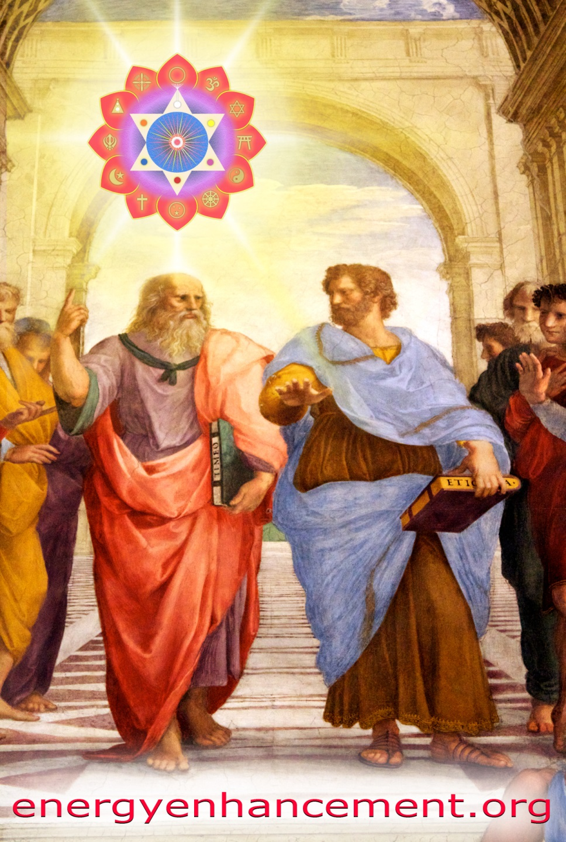

PLATO AND SATANIC BABYLONIAN SECRET AGENT ARISTOTLE "THE POISONER" OF ALEXANDER THE GREAT - BY RAPHAEL

ENERGY ENHANCEMENT MEDITATION
ENERGY ENHANCEMENT MEDITATION LEVEL 1 POWER UP!! GAIN SUPER ENERGY http://www.energyenhancement.org/Level1.htm
ENERGY ENHANCEMENT MEDITATION LEVEL 2 ELIMINATE ENERGY BLOCKAGES http://www.energyenhancement.org/Level2.htm
ENERGY ENHANCEMENT MEDITATION LEVEL 3 CLEAN KARMA BLOCKAGES AND PAST LIFE KARMA BY TRANSMUTATION http://www.energyenhancement.org/Level3.htm
ENERGY ENHANCEMENT MEDITATION LEVEL 4 MASTER ENERGY CONNECTIONS AND RELATIONSHIPS http://www.energyenhancement.org/Level4.htm
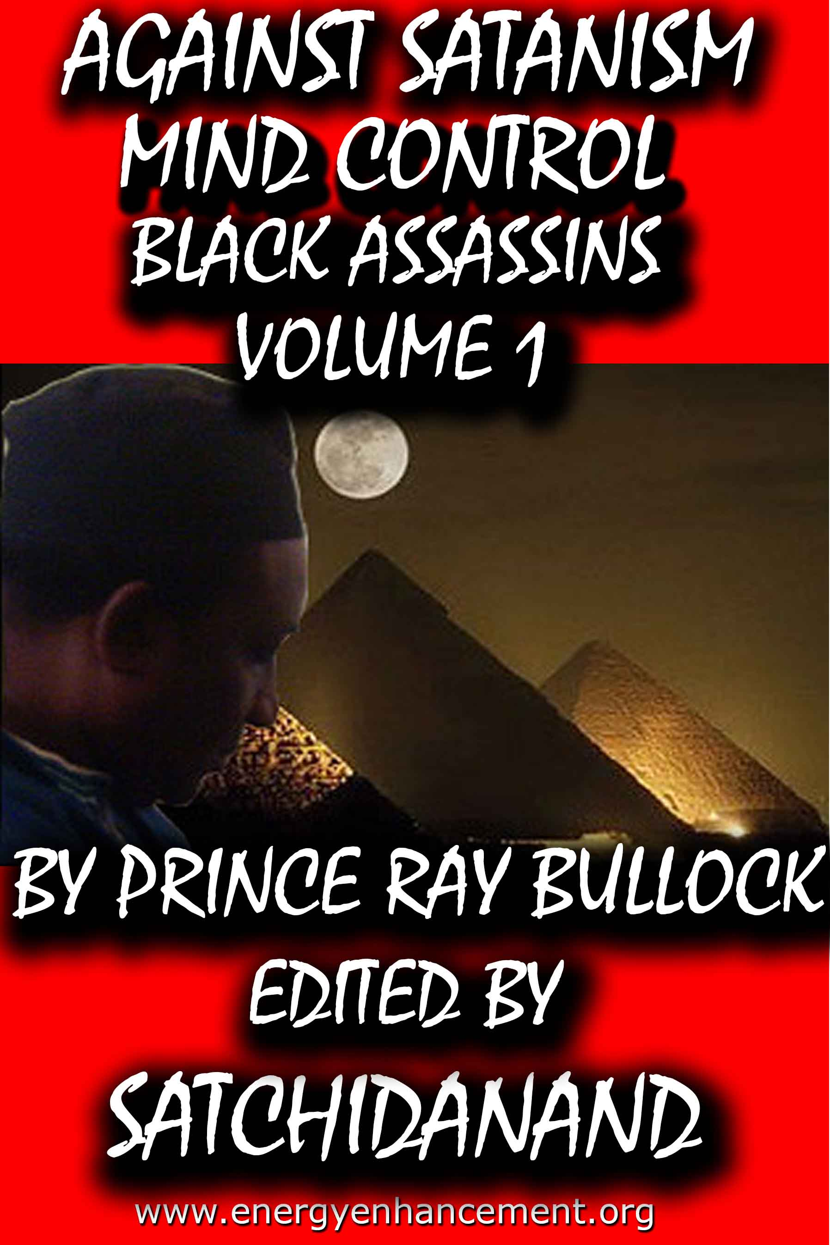
MIND CONTROL BLACK ASSASSINS VOLS 1-11 FREE!!

AGAINST SATANISM VOLS 1 – 6 FREE!!

- ON SIGN-UP AT..

energyenhancement.org

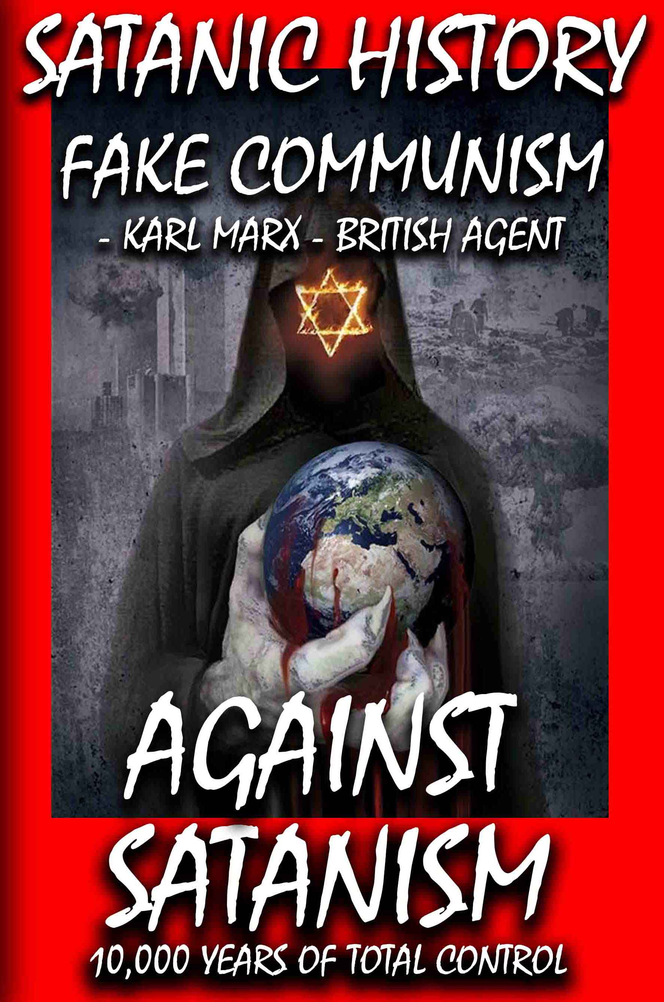

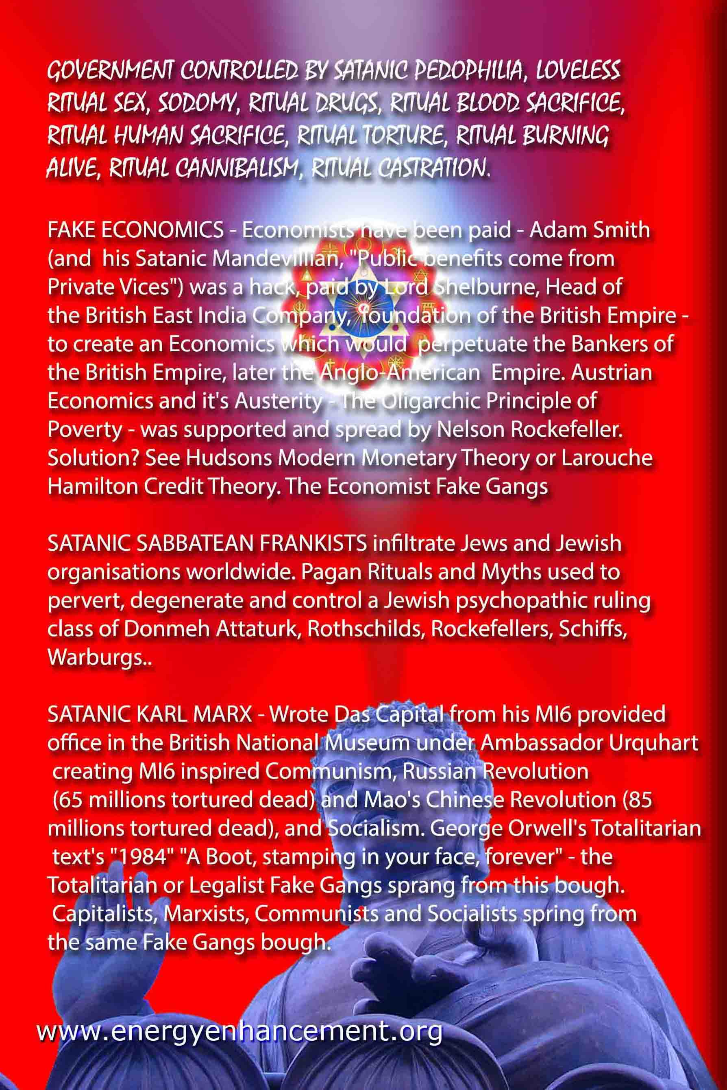

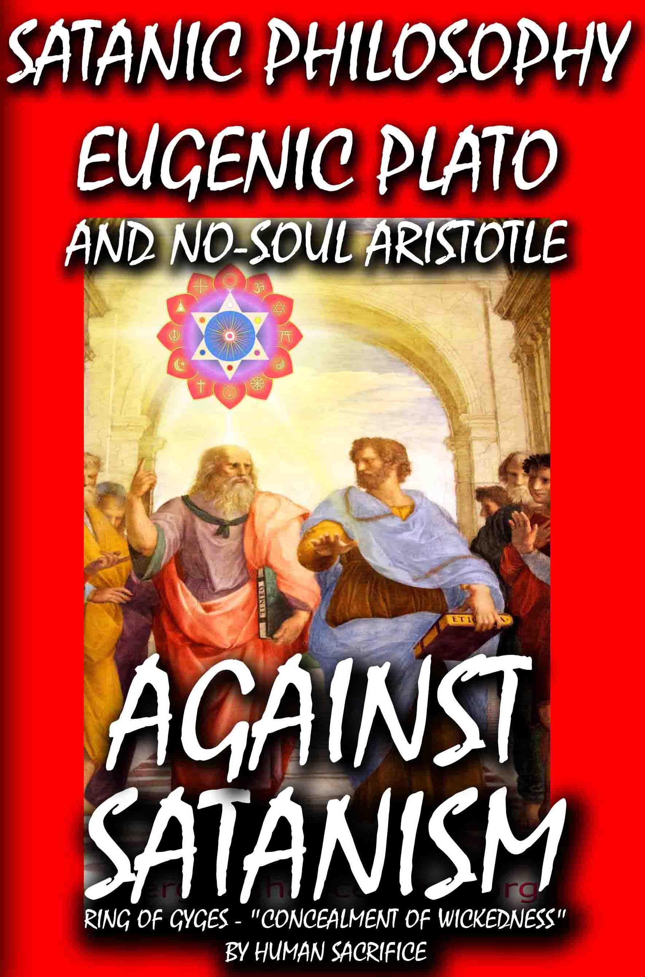

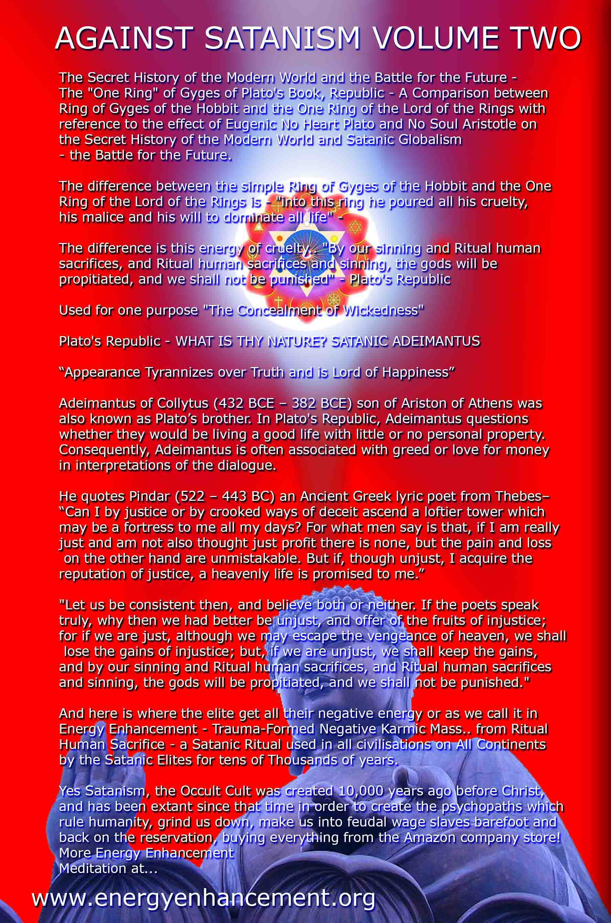

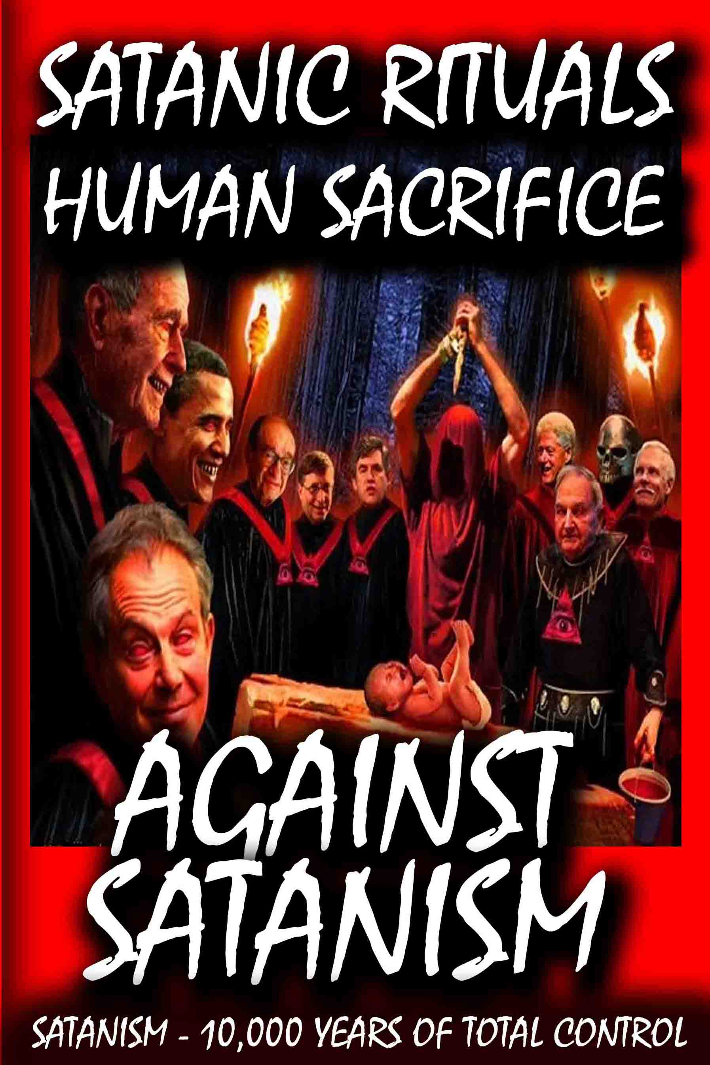

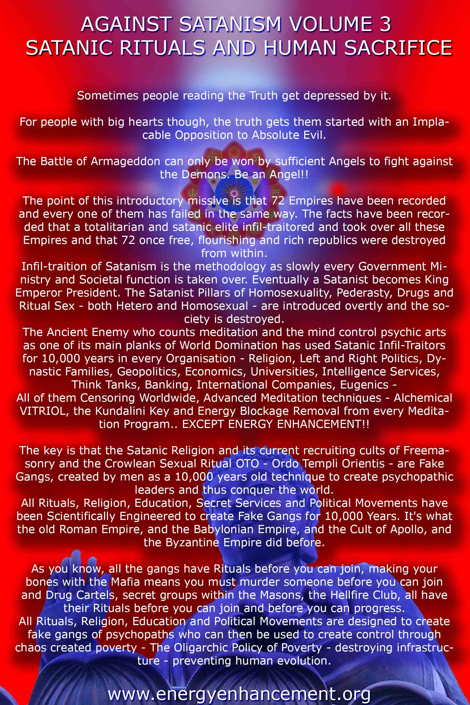

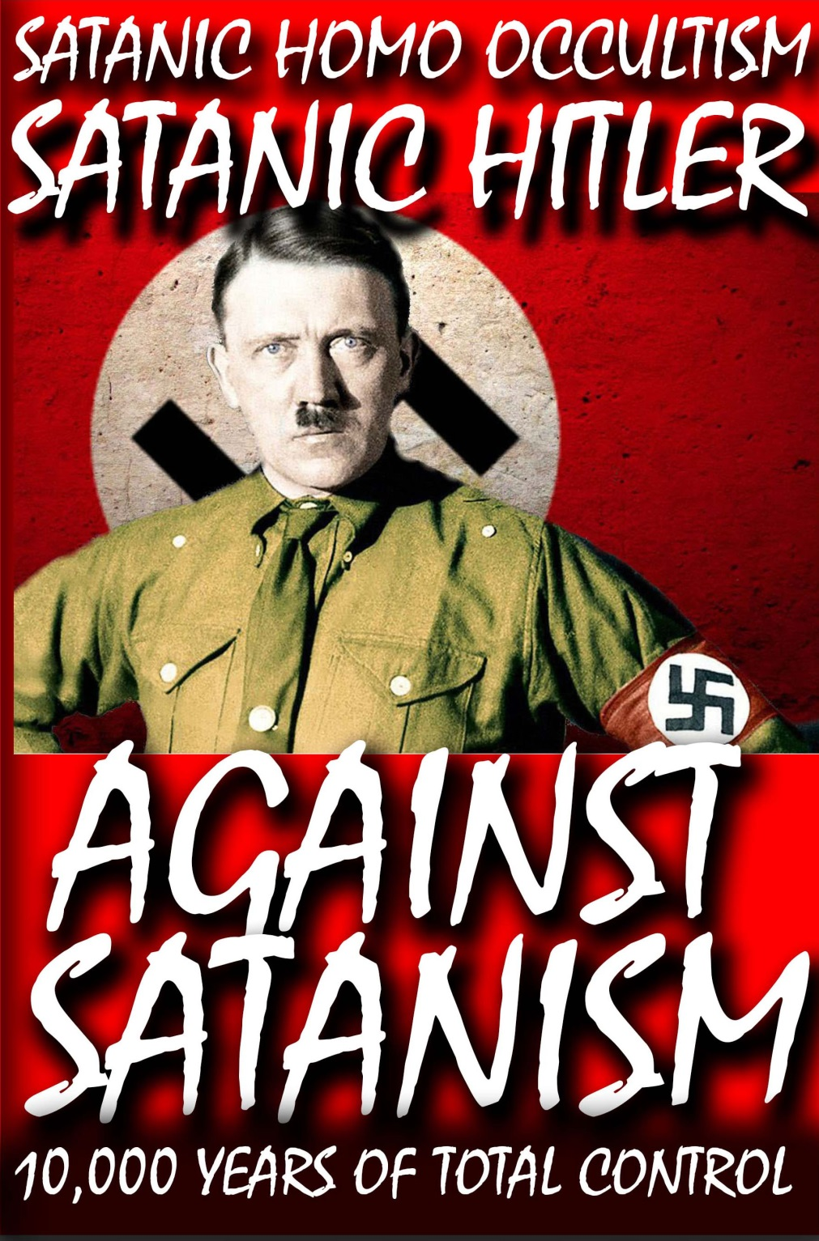

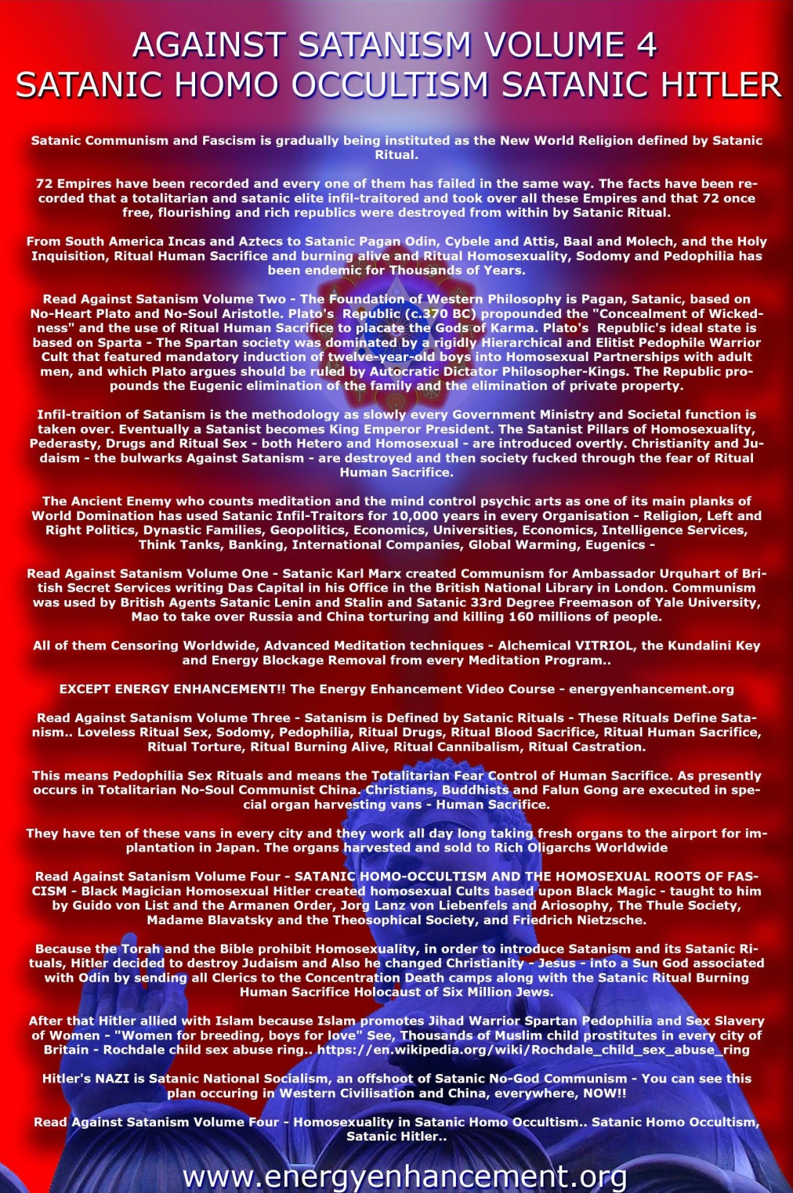

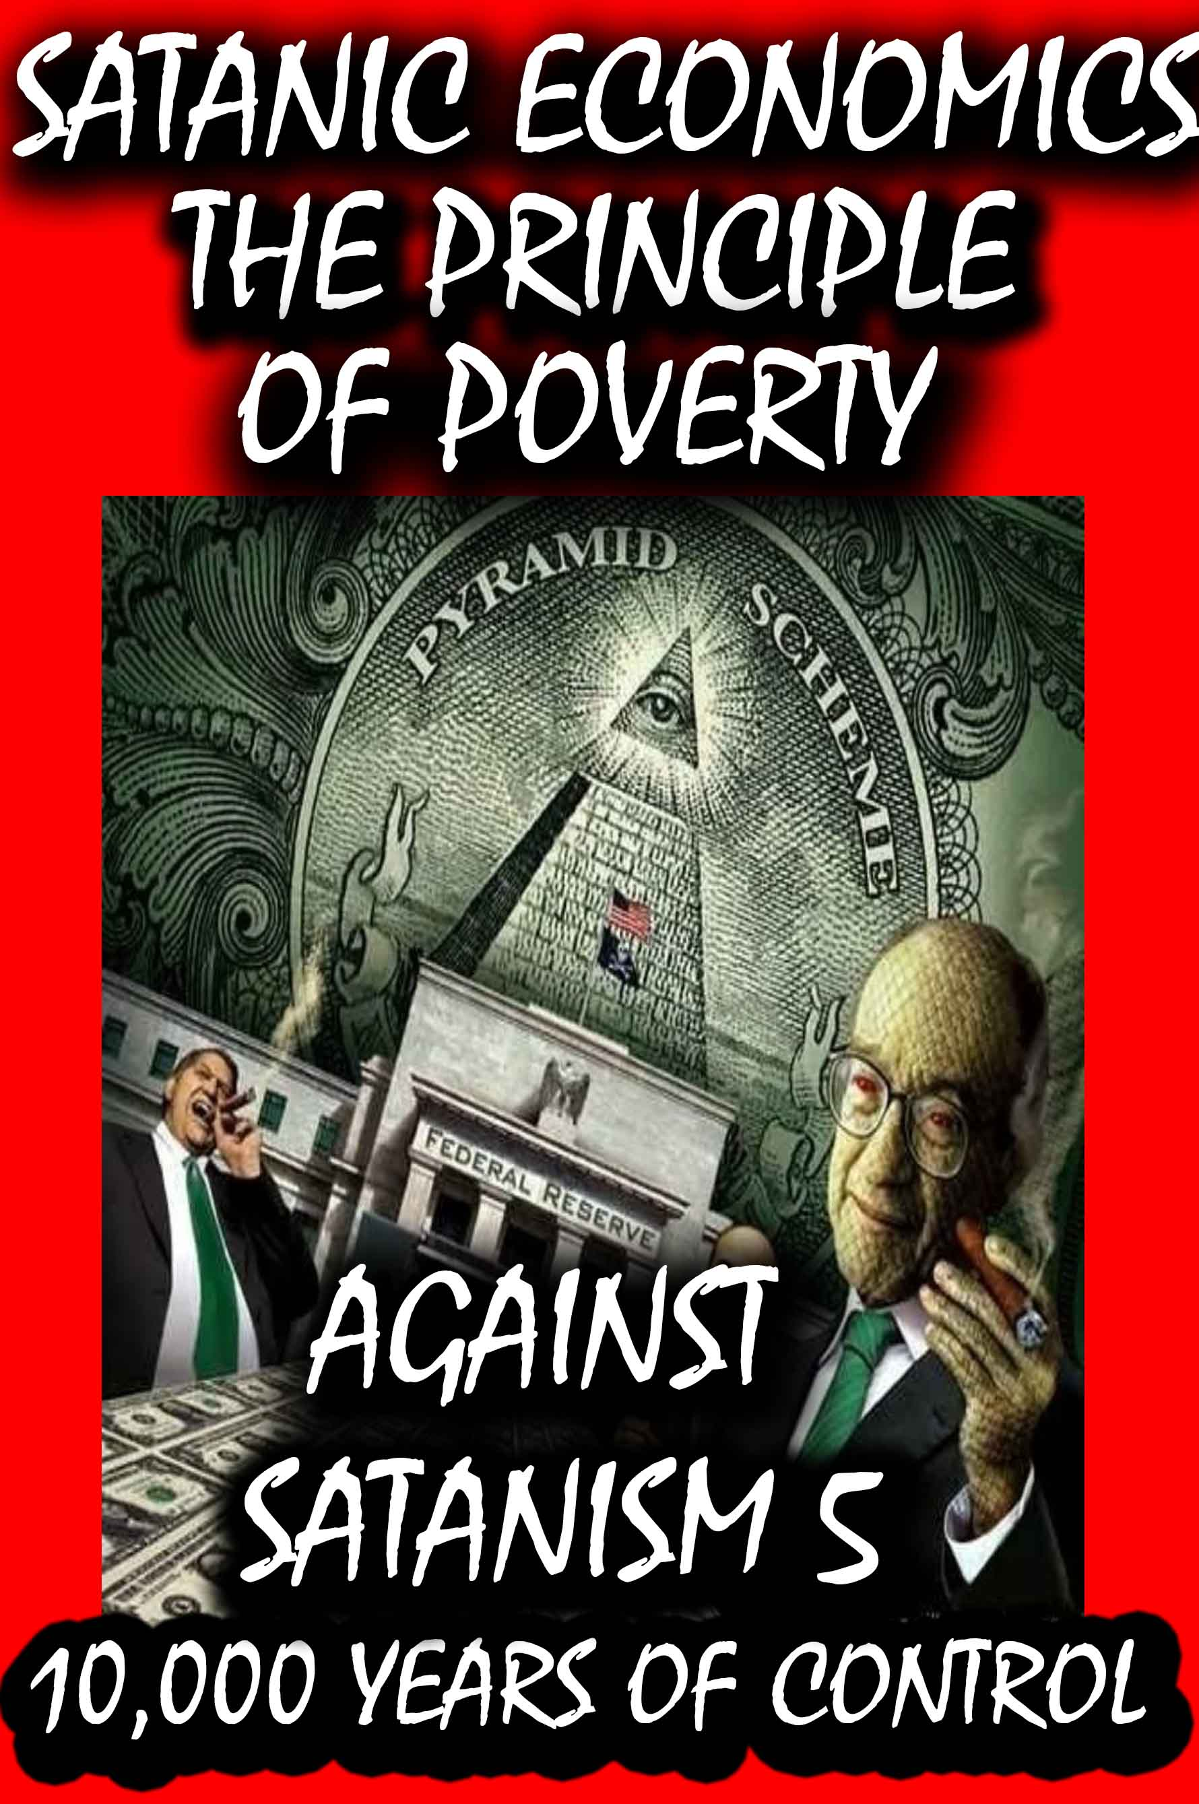

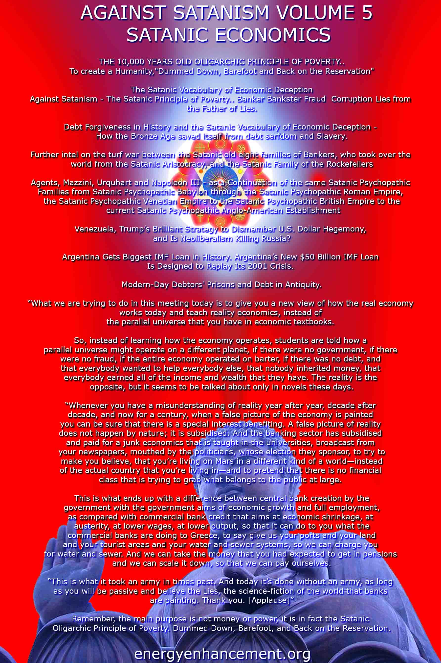

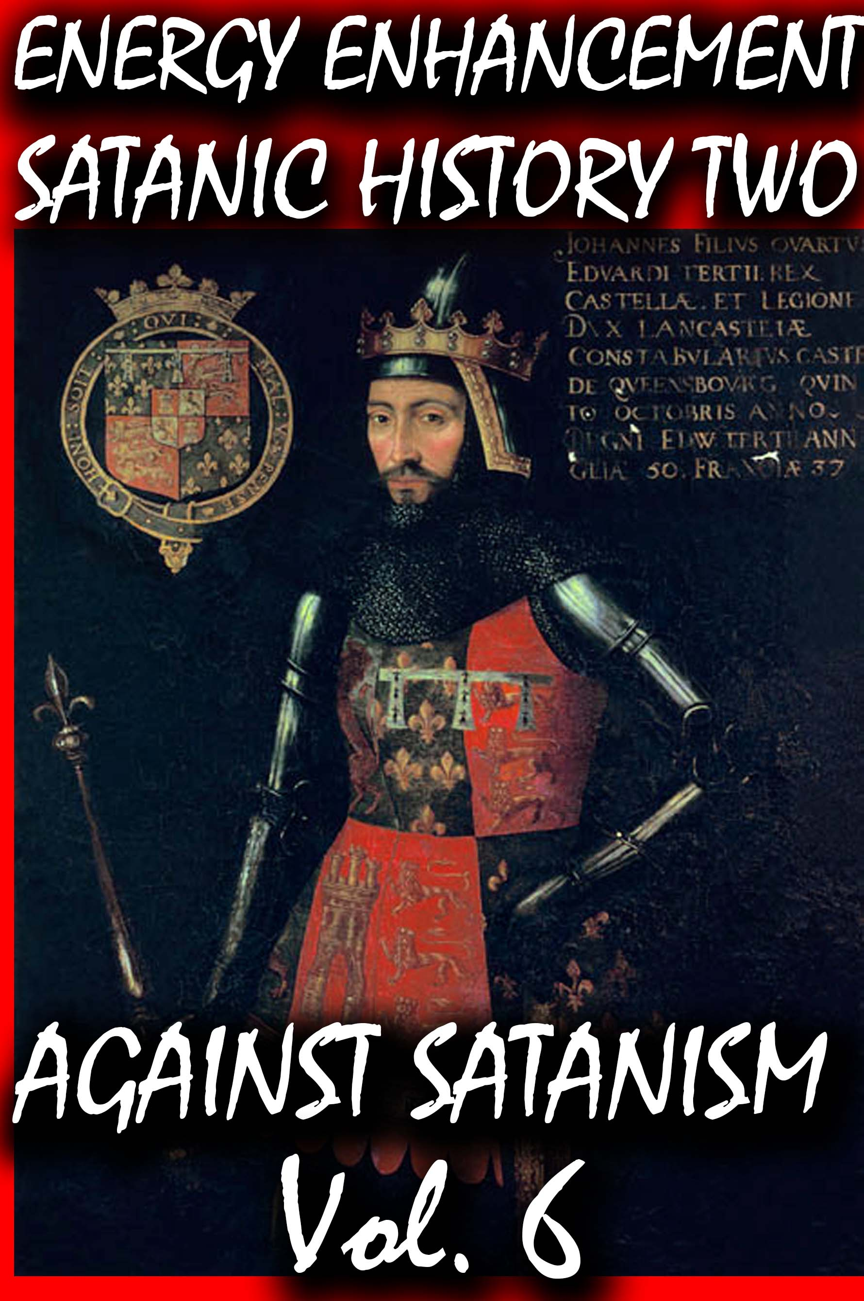
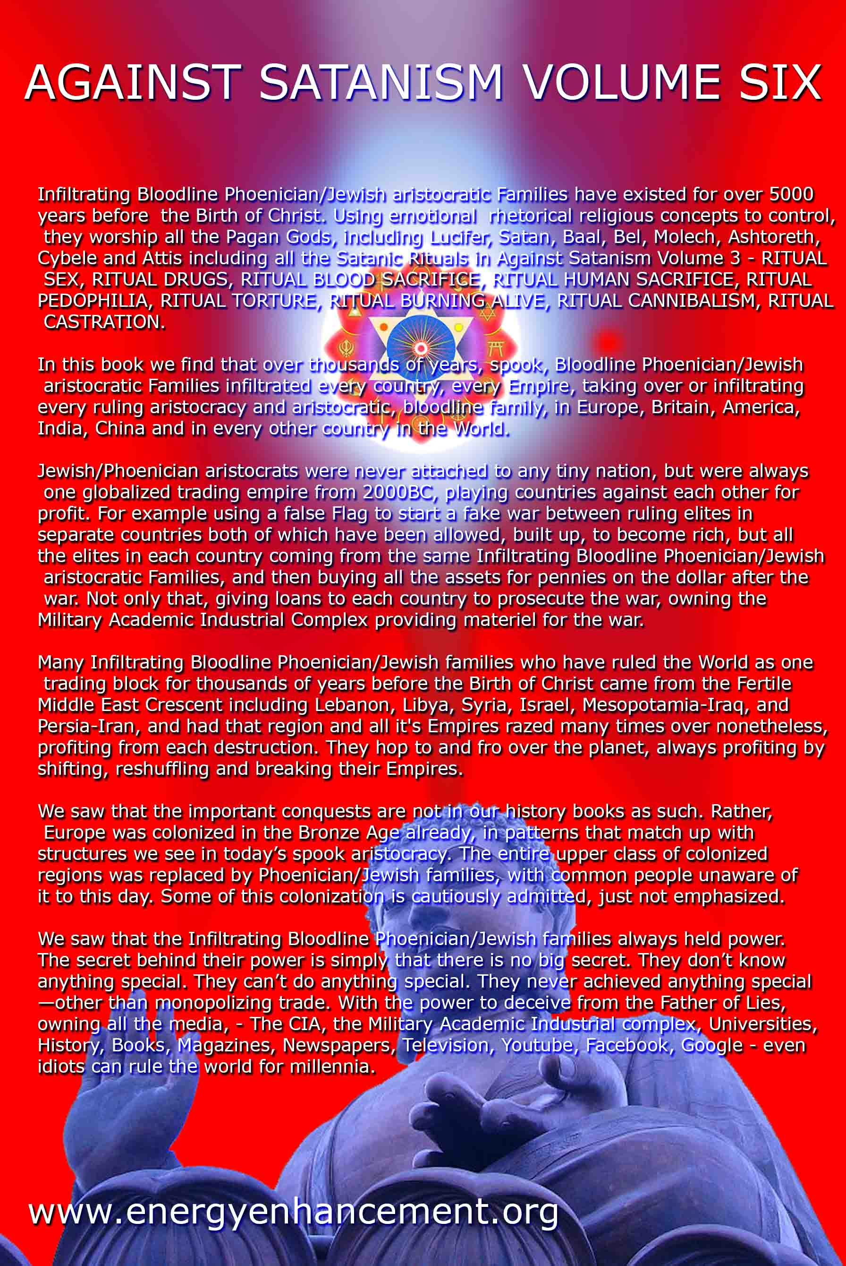
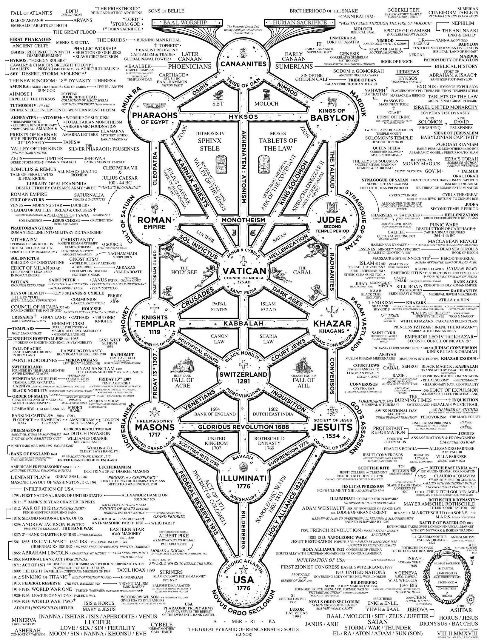

BEYONCE, SATANIC JAY & ALEISTER CROWLEY 666’S VEILED SATANIC SEX MAGICK AT THE 2014 GRAMMY’S
13022014


The January 26, 2014 56th Grammy Awards was far more flagrantly Satanic then I had envisioned. Katy Perry’s Grammy “Dark Horse” performance is widely recognized as a Satanic Rite and “Open Witchcraft and Satanism on Display.”[1]
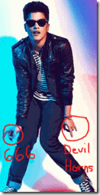
I watched “Pops Golden Boy“ Bruno Mars halftime 2014 Super Bowl performance. Satanists identify and connect the color gold to “royal” bloodlines. Gold is called the metal and skin (God RA) [2] of the gods, but to the Anunnaki, menstrual blood was the “gold of the gods.”[3]
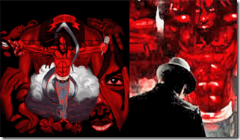
LiL Wanye and Bruno Mars, Mirror on the Wall, A Ceremony of Blood
Nevertheless watching Mars’ Super bowl halftime performance, I couldn’t understand or make out much of the words of his songs, particularly “Locked Out of Heaven.”

“Never had much faith in love or miracles …
But swimming in your water is something spiritual
I’m born again every time you spend the night
Cause your sex takes me to paradise …
Cause you make me feel like, I’ve been locked out of heaven
For too long …
Open up your gates cause I can’t wait to see the light…”[4]
“Locked Out of Heaven“ is a veiled reference to a “Fallen Angel” locked out of Heaven- Lucifer.
“How you have fallen from heaven, morning star, son of the dawn! You have been cast down to the earth, you who once laid low the nations! You said in your heart, ‘I will ascend to the heavens; I will raise my throne above the stars of God; I will sit enthroned on the mount of assembly, on the utmost heights of Mount Zaphon. I will ascend above the tops of the clouds; I will make myself like the Most High.” Translation of Isaiah 14: 12-17 [5]

Bruno Mars, Classic MK UTRA Mind Control Animal (Sex Kitten) Pattern (BEAST)
Even though, I didn’t consciously understand the names or words of his songs, Bruno’s halftime performance had been implanted in my “subconscious”. “Your sex takes me to paradise “ has been properly exposed to be another veiled Satanic reference and implant. It is a reference to British Satanist Aleister Crowley, the Great BEAST 666, and exposed as a flagrant subliminal “Sex Magick Promotion.”[6] Beta Sex Kitten Programmed Beyonce and Rosicrucian– Satanic Jay opened the 56th Grammy Awards with a performance of “Drunk in Love.” Their performance wasn’t so blatantly understood by most people to be open witchcraft and Satanism on display.
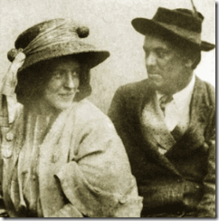

“Rose, my dear, you filthy whore, would you be ever so nice as to do a magick ritual with me today?” –the BEAST, Aleister Crowley[7]
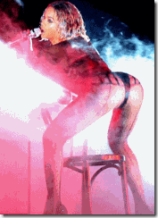

“Drunk in Love” introduced Beyonce’s new MK ULTRA Sex Kitten alter personality “Yoncé”, above, that is far more “FILTHY”, erotic, perverse and lustful than Demotic Sasha Fierce.
“I’ve been drinking, I’ve been drinking
I get FILTHY when that liquor get into me …”[8]

You must not ever forget that Beyonce and Jay Z are dedicated Advanced Crowley(es), demonologists and vehement occultists. Almost everything they do is deeply steeped in secrecy, rooted and embedded in hidden ILLUMINATI/Satanic and Rosicrucian symbolism. “Drunk in Love” like Bruno Mars “Locked Out of Heaven“ is a veiled subliminal reference to “Fallen Angels,” Aleister Crowley, and another flagrant “Sex Magick Promotion.”
Satanic Jay- Beholden to the British Empire and Grand Lodge of England
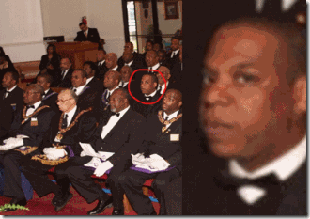
There should be little to no doubt that Satanic Jay Z is a Prince Hall Freemason placed in a higher classic “House Negro- Scottish Rite” secret hierarchy like Dr. Conrad Murray than most lost brothers of the false craft.
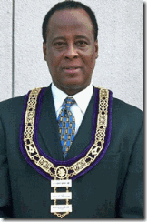
These certain House Negroes are exposed to a selective amount of privileges, and so-called secrets of the craft than most Prince Hall Negro members. But again, it is a very secret selective amount of their “truths.”
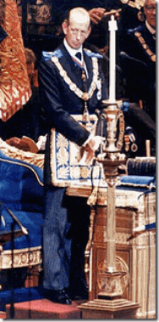
Prince Hall Freemasons are subservient members of the Grand Lodge of England.[9] Queen Elizabeth’s first cousin, Prince Edward, Duke of Kent, above, is the 10th Grand Master of the United Grand Lodge of England, the governing body of Freemasonry in England and Wales. He has served in that office since 1967, thus being the longest lasting Grand Master.[10] Satanic Jay’s blood covenant with the ILLUMINATI is layered by the deadly Masonic Blood Oath of Secrecy sealed by a secret allegiance to the British Crown, and the Grand Lodge of England– Prince Edward, Duke of Kent . Satanic Jay Z’s loyalty is not to the so-called Hip Hop Generation, or any People’s struggle. He is a secret pawn to the Britain Empire’s racial genocidal policies (Caliban Agenda), Her Majesty Queen Elizabeth II and the queen’s cousin. Prince Edward, Duke of Kent is a ruling member of the ILLUMANTI and the Committee of 300.[11]
Satanic Jay & Olympians
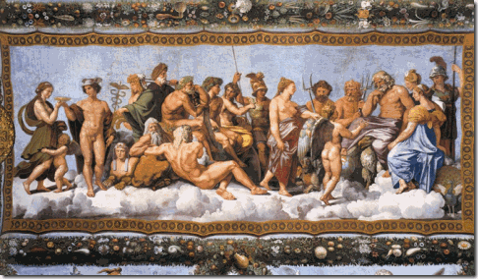
The Story of the Committee of 300 (1992) by John Coleman, describes the Committee – also known as the Olympians [Greek Gods]– as a secret society of aristocratic Satanists, and identifies them with the Bavarian Illuminati, and Dionysian mysteries.[12] The transmigration [Divinity] of the soul is largely believed to have been inherited by Pythagoras from the Orphic and Dionysian mystery cults that had long preceded the Pythagorean Brotherhood.[13]
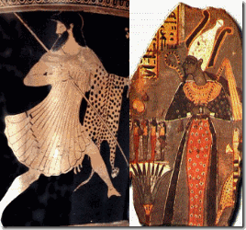
The ancient Greek historian Plutarch (46 BC- 120 AD) states, “Osiris is identical with Dionysus,” and the Cult of Osiris/Dionysus that began in Greece is believed to have had its origins with the Theban Hercules,[14] the Great Sen-Wos-Ret, “Son of Wosret [Hathor],”[15] (1971 BC to 1926 BC), the second Pharaoh of the Twelfth Dynasty.[16]
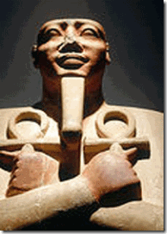
the Great Sen-Wos-Ret- Sesostris I
The central secret ruling ideology of the oligarchy’s “Divine Order” ordained by the Gods to rule the world is shrouded in mysteries, and the mythology of Osiris/Isis/Horus. The British Empire has maintained global power within the royal families for generations by ILLUSIONS, deception; and veiled perversion of the Theban royal “Divine” ruling dynasties’ secrets, sciences, ideologies, mythologies and cosmologies. Throughout the ages, they are still known by Justice, Balance, Order and Peace, their Splendor, good works to Civilization and MANKIND.[17]
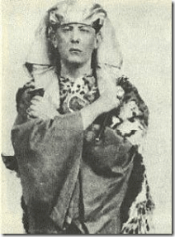
One of the Olympians’ most reverenced High Priests of the Dionysian Mysteries had been British Secret Agent 666 Aleister Crowley, the Great BEAST that was used by British intelligence as a spy, for experiments in mind altering drugs, behavior modification and (CIA/MK ULTRA) mind control.[18]
The Committee of 300 was founded by British aristocracy in 1727. It is an international council that organizes politics, commerce, banking, media, and the military for centralized global efforts- the New World Order.[19] The is an important and controlled part of the Committee of 300.[20]
Beyonce, Queen Elizabeth I & the Bilderberg Group
Beyonce Knowles and Satanic Jay Z’s secret alliance with the British Crown apparently has been extended by the ILLUMINATI much further than random fanaticism with the British Empire, and Satanic Jay’s British Masonic blood covenant.

They have been rewarded and inducted into the ILLUMINATI to create the ILLUSION of British “Divineness“ through its European French royal bloodlines. Researchers claim that their issue, Blue Ivy, to be a 23rd cousin twice- removed from the ancestry of Queen Elizabeth II.[21]
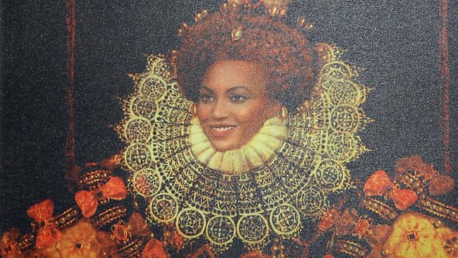
Furthermore on November 5, 2011, during the MTV Voices Dinner during the MTV (MTV Networks Europe) Europe Music Awards 2011 at the Merchant Hotel in Belfast, Northern Ireland, Beyonce was reanimated by the ILLUMINATI in the image and spirit of Queen Elizabeth I.[22]
MTV Networks Europe is a division of MTV Networks International, a subsidiary of Viacom. Sumner Redstone aka Sumner Rothstein aka ILLUMINATI is the CEO of Viacom. He is a principal member of the Bilderberg Group or BBG controlled by the Duke of Kent and the Committee of 300.[23]
Beyoncé’s Queen Elizabeth I’s alter was not random. It was created, implanted and fostered by the MK ULTRA/ILLUMINATI.
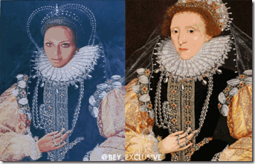
Re-imaging Beyonce in the persona of the Great Witch Queen of Maafa (African Holocaust, Holocaust of Enslavement) wasn’t enough to insult the masses of color. They went further to turn her into a Dr. John Dee and Edward Kelley Satanic Talisman of Fallen Angels on a national/international stage, the 2014 Grammy Awards.
Queen Elizabeth I- Arthurian Elvenfolk (half human- Devil) Witch

John 8:44-45
King James Version (KJV)
⁴⁴ Ye are of your father the devil, and the LUSTS of your father ye will do. He was a murderer from the beginning, and abode not in the truth, because there is no truth in him. When he speaketh a lie, he speaketh of his own: for he is a liar, and the father of it.
⁴⁵ And because I tell you the truth, ye believe me not.
Contrary to romanticized versions of the so-called “Virgin Queen,” Queen Elizabeth I was a racialist demoness, witch and Luciferian in her very own right whose court was a den of the occult filled with sorcerers, witches, and conjurers of devils, fallen angels and demons like Dr. John Dee and Edward Kelley.

The House of Tudor claims direct descent from King Arthur. Queen Elizabeth I continued the Arthurian tradition in the family. The Arthurian ancestry of Elizabeth was given especial emphasis at the time of her coronation.” When Elizabeth visited Kenilworth in 1575, an Arthurian costume party and masque were held. Upon the Queen’s arrival, she was met by a woman dressed as Morgan le Fay, who greeted and ritually initiated the queen as King Arthur’s heir.[24]
Morgan le Fay was King Arthur’s half sister, a powerful sorceress and infamous Elvenfolk Witch in the Arthurian legend. [25] She is also known as a Druid Priestess, Dark Magician, Enchantress, Sea Goddess, and a Shape-Changer.[26]

Shape-Changer- Beyonce–Sasha Fierce (reanimated MK ULTRA Morgan le Fay/Queen Elizabeth I)
She was one of the foremost recognized witches of all time. Morgan le Fay literally translates “the morning fairy.”[27]
“How art thou fallen from heaven, O Lucifer, son of the morning! how art thou cut down to the ground, which didst weaken the nations!” Isaiah 14:12 (KJV)
In both myth and legend, Morgan le Fay is associated with Lucifer- her right hand man. she is a willing and willful subject for the Lucifer who celebrates her evil: “A will, a horne, a wish, a longing … I never saw a more perfect specimen. Such evil! Such beauty!”
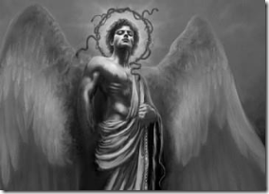
Morgan le Fay invokes Lucifer in ceremonies of veiled deception- duality of the demonic and the divine, the classic Satanic Principle,
“Emperor Lucifer, prays Morgan Ie Fay, down on her knees in the chapel of the convent of the Flaming Heart, ‘ master and prince of rebellious spirits, I adjure thee to leave thine abode, in whatsoever quarter of the world it may be situated, and come hither to communicate with me. I command and I conjure thee in the name of the mighty living God (Father, Son, and Holy Ghost) to appear without noise and without any evil smell, to respond in a clear and intelligible voice, point by point, to all that I ask thee …'”[28]
In Morgan le Fay’s and King Arthur’s Legendary Court of Knights, Lucifer, demons and fallen angels were invoked to walk among humans to shape the power of the British Crown, and the New World Order.
Queen Elizabeth I’s Coronation in 1559 had been a revival of the secret and mysterious Old Druid Religion of the Prytani (Picti)- Painted People of King Arthur, and secretly a Luciferian Rite of Initiation and Passage.
The Great BEAST 666, Queen Elizabeth I, Dr. John Dee, Edward Kelley & Enochian (Fallen Angel) Sex Magick
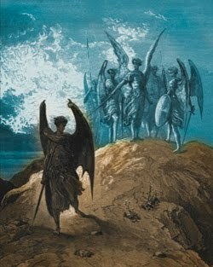
Aleister Crowley’s Satanic Ritual Sex Magick is a secret Enochian “Angelic” Ritual Ceremony.[29] The Enochian system of magic as practiced today is primarily the product of researches and workings by four men: Dr. John Dee, Edward Kelley of Queen Elizabeth I’s Court, Samuel Liddell MacGregor Mathers (British Founder of the Hermetic Order of the Golden Dawn); and the Great BEAST 666 Aleister Crowley.[30]
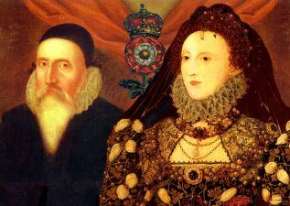
Dr. John Dee is important. Dee (July 13, 1527–1608 or 1609) was a Welch mathematician, astronomer, astrologer, occultist, navigator, imperialist, and chief consultant to Witch Queen Elizabeth I. He devoted much of his life to the study of alchemy, divination and Hermetic philosophy.[31]
“Enochian” is described as “Angelical”, the “Celestial Speech”, the” Language of Angels”, the “First Language of God-Christ”, the“Holy Language”, or “Adamical” because, according to Dee’s Angels, it was used by Adam in Paradise to name all things. The term“Enochian” comes from Dee’s assertion that the Biblical Patriarch Enoch had been the last human to know the language below the Great Fall.[32]
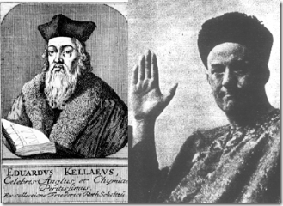
In 1582, Dr. Dee hired Edward Kelley as a medium to help him communicate and consult with spirits. The Great BEAST considered Kelley one of his prior incarnations.[33]
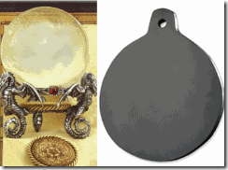
Dee and Kelley used crystal balls and a black obsidian scying (seeing) mirror [34] taken from the Mayans and other civilizations of great antiquity to communicate with fallen angels, spirits and demons.[35] Through their contact with fallen angels, Dee and Kelley were given instructions to create a magical talisman to make contact with them more easily.[36]
According to the Hermetic Order of the Golden Dawn, a talisman is “a magical figure charged with the force which it is intended to represent. In the construction of a talisman, care should be taken to make it, as far as possible, so to represent the universal forces that it should be in exact harmony with those you wish to attract, and the more exact the symbolism, the easier it is to attract the force”.[37]
With the help of several angels, Dee and Kelley were able to compose four elemental tablets containing a hierarchy of specialized angels which could be summoned to the service of the magician.[38]
Enochian Sex Magick involves invoking erotic-occulted paranormal experiences per instructions from Fallen Angels. “Sex Magick” can be done with a Demon/ess.” “Sexual fluids, both semen and vaginal secretions and also menstrual blood have the power of Life Forces.” –Joy of Satan Ministries, U.S. Library of Congress[39]
“Crowley’s sex rituals involving the consumption of blood, semen, or feces were allegedly intended to achieve a higher consciousness to empower a talisman, or to simply empower ones self. Intense focuses on the intended result during the ritual, especially during orgasm, were paramount to achieving the desired goal in Sex Magick. Crowley saw in orgasm (as in drug experience) a means to create ‘breakage of consciousness’ by pushing the mind to a point of extreme exhaustion and so opening it the “supersensual.’ The technique… was that of excess; through pain or pleasure, sex or intoxication, it was necessary to attain a condition of exhaustion taken to the extreme limit.”[40]

Yoncé– the 2014 Grammy’s Sex Magick Show & the Scarlet Woman


Lucifer’s Color is BLUE [41]

Babalon (also known as the Scarlet Woman, Great Mother or Mother of Abominations) is a goddess found in Aleister Crowley, the Great BEAST 666’s mystical system of Thelema. In her most abstract form, she represents the female sexual impulse and the liberated woman; she is also identified with MOTHER EARTH, in her most fertile sense.[42]

At the Grammy’s, Yoncé and Satanic Jay performed an erotic piece co-written by Beyonce called “Drunk in Love.” Its lyrics express “UNBRIDLED LUST” [43] and ancient phallic-Masonic worship,[44]

I’ve been drinking, I’ve been drinking
I get filthy when that liquor get into me
I’ve been thinking, I’ve been thinking
Why can’t I keep my fingers off it, baby?[45]

“We be all night, and everything alright
No complaints for my body, so fluorescent under these lights Boy, I’m drinking, walking in my l’assemblage …
If you scared, call that reverend
Boy, I’m drinking, INNA bring it right…”[46]
INNA- ANCIENT EARTH MOTHER
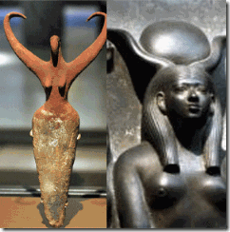
INNA generally means EARTH. It is a name associated with the Indian God/Goddess Venkateswara.[47] Lord Venkateswara is an incarnation of Lord Vishnu.[48] The attributes and traits of Enki is synonymous with Lord Vishnu. For instance,
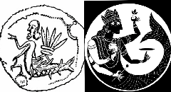
“As the Fish Avatar and Lord of Wisdom, Vishnu must be considered synonymous with Lord Enki. And in fact, one of the incarnations of Vishnu, the Matsya or Fish Avatar is identical with Sumerian Enki.”[49]
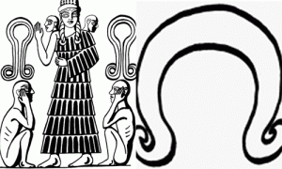

Compare Nin-imma Symbol with Hathor’s Symbolic Wig

Nin-imma(Earth Mother) is a Sumerian, Babylonian, and Akkadian fertility goddess and deification of the female sex organs. Her parents are ENKI and Ninkurra. Her name derives from the Sumerian words nin – goddess, and imma – water that created everything. [50]
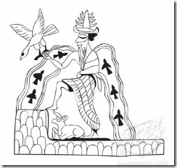
ENKI- Sumerian Deity of Creation, Water and Intelligence
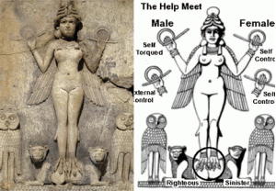
Inanna is the Sumerian Goddess of love, fertility, and warfare. Inanna’s name derives from Queen of Heaven (Sumerian: Nin-anna).[51] In Sumerian Mythology, Nin-anna, Nin-imma, and Enki, a son of Anu, represent the Anunnaki that landed on Earth from a distance solar system called Nibiru in far great antiquity.[52]

In Great Antiquity, Nin-imma is known by many names and spellings mainly Ninhursag (Earth Mother),[53] Ninmah (“Great Queen”) and Nintu (“Lady of Birth”). Both Nin-imma and Nin-anna traits are similar to the Kemet Goddess WORSET (Hathor).[54]
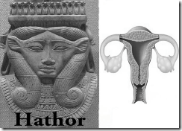
“Properly understood, Hathor should be viewed as the Egyptian counterpart of the Sumerian Inanna, the latter goddess being explicitly identified with Venus in the earliest written sources. The fundamental identity of the two goddesses is clearly revealed upon consideration of their respective epithets and characteristics. As Inanna/Venus was invoked as the ‘Lady of the Evening’ or as the ‘Evening Star,’ so too is Hathor invoked as ‘Lady of the Evening.” As Inanna/Venus is said to ‘rise’ from the horizon, so too is it said that ‘Hathor rises within the horizon.’ As Inanna was depicted ‘rising’ between the two gates of heaven, so too was it said of the Egyptian goddess: ‘[The gates?] of the horizon [are thrown open(?)] for Hathor.’ As Inanna was said to reside on the mountain of heaven, so too does Hathor live upon the ‘mountain of the west,’ the latter described as a celestial mount on which the ancient sun-god was wont to retire at night. Early illustrations of Hathor on the ‘mountain of the west’ from the Book of the Dead show the cow-headed goddess with her familiar menat-symbol (see figure one), the latter of which shows an eight-pointed star set on a disc, a striking analogue to Inanna’s star … Like Hathor, Inanna was likened to a cow in early Sumerian literature, one hymn invoking her as ‘the great cow among the gods of heaven and earth.’ As Inanna inspired terror as a fire-spewing dragon, so too did Hathor in the form of the uraeus serpent. Thus, a hymn at Philae invokes Hathor as ‘the Great One shining on the brow of her father, the glorious one who causes fear of her father.’ Other hymns describe the Egyptian goddess as a fiery serpent raging in the sky …”[55]
In Kemetic mythology, the Goddess Wosret [Hathor] (Het-Heru – “the House of Horus”) is a Great Queen of antiquity. She was known as “the Great One of Many Names” and her titles and attributes are so numerous that she was important in every area of the life and death of the people of Kemet.[56] Hathor personifies the principles of love, beauty, music, dance, motherhood and joy.[57]
Goddess Hathor (Earth Mother)[58] is an extremely important and popular fertility goddess, associated with the cow. Her name refers to her position as the celestial cow which encircles the sky and hawk god, Horus. She was also a goddess of royalty and since the pharaohs were seen as related to Horus, she was seen as the divine mother of the reigning pharaoh.[59]
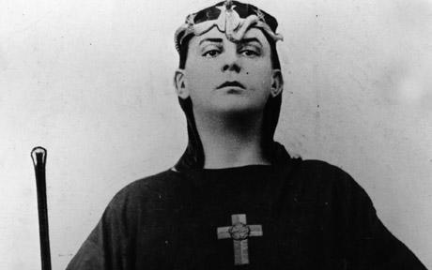
In the Great BEAST’S poetic work, Tannhauser, she is one of the characters that is of the “World of the Gods.” Therein she has merely one line: “Light, Truth, arise, arise!” In this work she is seen as being synonymous with Aphrodite and Mary. Venus is seen as being the “Evil and Averse HATHOOR“ of the “World of Demons.”[60]
Whether it is Nin-imma or Nin-anna, Yoncé’s Inna– Satanic patron goddess is associated with the Sumerian Creation God ENKI and both goddesses are synonymous with WORSET [Hathor], the Great BEAST’s Hathoor. In Yoncé and Satanic Jay’s Drunk in Love, Inna-NIN-IMMA/NIN-ANNA- HATHOOR bring it right.
Reverend Boy– the Great BEAST 666, Aleister Crowley
Drunk in Love: “If you scared, call that reverend Boy…”

“Do What Thou Wilt” – Aleister Crowley

Reverend Boy- unlike being an ordained minister, for instance, a Reverend of the Church of Satan is who is revered by the believers or Satanists- while a priest or minister is one who dedicates their life to preaching religion to others.[61] Basically, Drunk in Love, recounts one of the Great BEAST’s continuous Satanic Tantra-Sex Magick Ritual sometimes referred to as the Babalon Workings that involves Crowley‘s satanic philosophies, and Demoness Scarlet Women.[62]
The sex ritual may involve days or weeks at a time fueled by drugs, alcohol and altered states of consciousness. “Most of Crowley’s adult life was dedicated to indulging in everything he believed God would hate: performing sex magic, taking heroin, opium, hashish, peyote and cocaine, invoking spirits, and even once offering himself to the Russian authorities to help destroy Christianity. He wrote volumes of books that he believed were dictated to him by a spirit from ancient Egypt called Aiwass.
“To worship me take wine and strange drugs,” the spirit conveniently told him. “LUST, enjoy all things of sense and rapture. Fear not that any God shall deny thee for this.” …[63]
Beyonce’s lyrics in the song, “We be all night, and everything alright … No complaints for my body…” supports the notion that it involves the Great BEAST’s Sex Magick Ritualistic extreme practice of LUST and pushing the human body to its extreme maximum point of exhaustion to reach higher a level of alter consciousness in tune with demonic spirits and deities such as NIN-IMMA- HATHOOR..
“Crowley’s sex rituals involving the consumption of blood, semen, or feces were allegedly intended to achieve a higher consciousness to empower a talisman, or to simply empower ones self. Intense focuses on the intended result during the ritual, especially during orgasm, were paramount to achieving the desired goal in Sex Magick. Crowley saw in orgasm (as in drug experience) a means to create ‘breakage of consciousness’ by pushing the mind to a point of extreme exhaustion and so opening it the “supersensual.’ The technique… was that of excess; through pain or pleasure, sex or intoxication, it was necessary to attain a condition of exhaustion taken to the extreme limit.”[64]
SEX MAGICK/BABALON WORKINGS & THE NECRONOMICON KUNDALINI EXPERIENCE
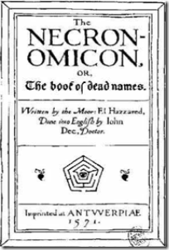
In about 1586, Dr. John Dee translated a secret satanic book of antiquity from Greek called Necronomicon. The original Arabic title of the work was “Kitab al Azif” which can roughly translated as “The Book of the Howlings of the Desert Jinn [Demons]. The Latin version of the name, “Necronomicon” retains to the customs, practices, or laws of the dead.[65]
To the believers, the Necronomicon is a very powerful textbook that is recognized by Satan and Demons as an allegorical guide that reveals secret, ancient and powerful knowledge from antiquity. It is a work that is denied by many and claimed not to exist. The true purpose of the Necronomicon is to serve as a textbook of magic for the opening the soul. “Leviathan”/ “Cthulhu,” are names for the Serpent Kundalini “who lies sleeping and dreaming.” “Narayana” probably one of the most ancient names for Cthulhu is also seen in the East Indian Hindu “Mahabharata” which is thousands of years old.[66]
Aleister Crowley was a direct, vivid and remarkable student of Dr. Dee and Edward Kelley incarnated. Crowley is associated with authoring a Latin version of Necronomicon, it would have been naturally a secret translation of Dr. Dee’s 1586 original version from Greek. The 21st Century version of the Necronomicon Kundalini experience is the awakening and release of the sleeping coiled snake within.
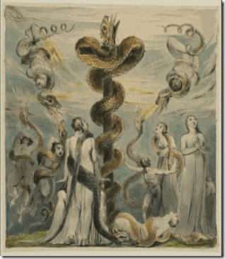
The “serpent power”, once awakened, is coaxed up the central channel of the spine, entering the chakras (psychic energy centres) until it reaches the Crown chakra- and yogi achieves “ILLUMINATION”.[67]
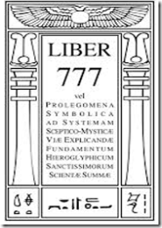
Crowley‘s secret Sex Magick Rituals (Cosmic Fallen Angelic Sex Practices) awakens and release the sleeping snake (Secret Fire) within that is the Necronomicon Kundalini Experience taken from the Ancient Necronomicon- The Book of the Howlings of the Desert Demons. Crowley states that the 24th Path is attributed to the Goddess Kundalini in 777.[68]
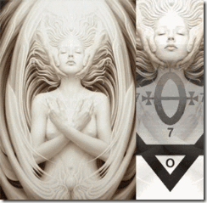
And because I tell you the truth, ye believe me not.

Necronomicon Kundalini Experience – Release the Sleeping Snake, the Secret Fire
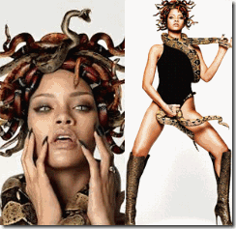
Necronomicon Kundalini Experience- Beyonce, the Secret Fire & the Coiled Snake
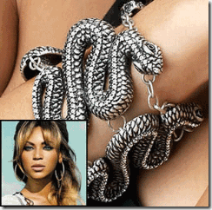
Necronomicon Kundalini- Worship of Snakes- Stylized Inanna Star Symbol
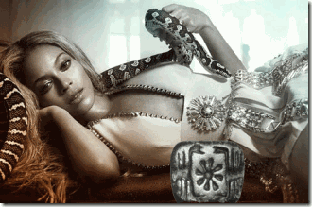
One of the Great BEAST’s Scarlet Women
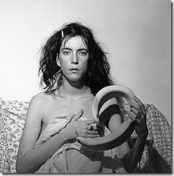
Drunk in Love & the Mysterious Watermelon Reference
Watermelons Fit for Kings
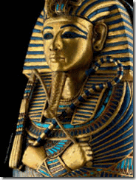
“Never tired, never tired
I been sippin’, that’s the only thing
That’s keeping me on fire, me on fire …
I’ve been drinking, WATERMELON …”[69]
Yoncé and Satanic Jay’s Drunk in Love has a very curious reference to drinking WATERMELON, above, as part of ritual ceremonies of the Sex Magick/Babalon Workings.
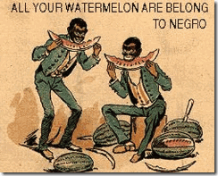
Needless to say, Watermelons have become an offensive stereotypical object of ridicule and humiliation to the Black masses. My first inclination was to just dismiss it as random. However, if it part of the secret ritual revealed by them, then the veil over it has to lifted to expose its secret history, its magical, mystical and sacred properties.

Watermelon is mentioned in the Bible as a food eaten by the ancient Israelites while they were in Kemet. By the 10th century, watermelons were being cultivated in China. By the 13th Century, the Moors introduced the fruit to Europe; according to John Mariani’s Dictionary of American Food and Drink, “watermelon” made its first appearance in an English dictionary in 1615.[70] Technically, the watermelon is actually not a true melon, but an rather unique berry of the genus Citrullus. It is an old and very ancient fruit. On the basis of chloroplast DNA investigations that the cultivated and wild watermelon diverged independently from a common ancestor, possibly C. ecirrhosus from Namibia.[71]
Evidence of its cultivation in the Nile Valley can be traced back to its pre- dynastic period and throughout the Great Pyramid Age, Twelfth Dynasty of the Great Sen-Wos-Ret to the tomb of Pharaoh Tutankhamun, and thereafter.[72] The Citrullus was indeed a sacred plant. During the Twentieth Dynasty of the Ramseside Age (1187 to 1064 BC), the Great Rameses II’s High Priest Nibsoni was discovered buried with the leaves of the Citrullus scattered between his mummy and the sides of his coffin.[73]
Undoubtedly, King Tut and many pharaohs, queens and high priests believed that the Citrullus held some unseen-unknown secret mystical and sacred properties for use of it even in the afterlife.[74] There appears to have been a sacred tradition among the pharaohs and high priests of Kemet that the Citrullus plant and seeds had been necessary to aid the soul and the spirit in transition to the stars.
Watermelons are 80-90% water, their element. The watermelon is associated with many properties related to the liquid element, including purification, healing and changes. Bewitching secret, “Watermelons are a change oriented magical plant, lying somewhere between a vegetable and a fruit and can help you cross boundaries by cleansing your body and soul to prepare you for what’s to come.”[75]
In the great land of tens of thousands of years, Citrullus plant and its seeds possessed spiritual/mystical properties necessary to aid the soul and the spirit in the transition to the stars. Throughout the ages, covens of witches, sorcerers, magicians and Satanists have stolen the legacy of the people of Kemet and perverted its secrets and sacred sciences for their own pride, good, glory; and the cult of deception.
In Conclusion

John 8:44
King James Version (KJV)
⁴⁴ Ye are of your father the devil, and the lusts of your father ye will do. He was a murderer from the beginning, and abode not in the truth, because there is no truth in him. When he speaketh a lie, he speaketh of his own: for he is a liar, and the father of it.
As pointed out above, Beyonce, Satanic Jay, Lil Wayne, Bruno Mars and most of the current black entertainment industry don’t sing songs for you. The ILLUMINATI promotes things like Satanism, sexual freedom- Tantric Sex Magick, drugs, homosexuality, feminism and other “anti-family” values as diversions, and interfere and destroy critical thinking among the masses. It is also designed to destroy and compound the traditional and religious values of the masses to make it easier to control them; and discourage real dissent, opposition and resistance to the global rule of an all- powerful self-appointed Olympians (Divine Gods), and the New World Order.

Ephesians 6:12
King James Version (KJV)
¹² For we wrestle not against flesh and blood, but against principalities, against powers, against the rulers of the darkness of this world, against spiritual wickedness in high places.
About a decade or more ago, I was informed by a black female CIA/FBI secret informant that the Black Expo in Oakland was beginning a workshop in Tantric Sex for Black people, and offered that I might want to attend. I had known her for years, but I had recently finally figured out who she really was. I asked her what patron demons or spirits that they planned to conjure up for Black folk. She looked at me for a moment in silence, than changed the subject until she could just ease away. Infiltration of the Black Community with Aleister Crowley’s Satanic Tantric-Sex Magick as a diversion and opium for the masses has been on the ILLUMINATI’S agenda for quite sometime.
The music and movie industries have been ordered to do their part by promoting the ILLUMINATI’s mass population control agenda as well. In addition to promoting evil versus good values, they also implant and dominate the popular and black entertainment industry with complex Satanic and ILLUMINATI symbolism to confuse the masses.
Stolen Legacy, by George G. M. James, [1954]
Among mankind and history of civilization, the earliest theory of salvation is the Egyptian theory. The Egyptian [Kemetic] Mystery System had as its most important object, the deification of man, and taught that the soul of man if liberated from its bodily fetters, could enable him to become godlike and see the Gods in this life and attain the beatific vision and hold communion with the Immortals (Ancient Mysteries, C. H. Vail, P. 25).[1]
They don’t sing songs for us. The Kemetic theory of “Music (or Harmony) meant the living practice of philosophy i.e., the adjustment of human life into harmony with God, until the personal soul became identified with God, when it would hear and participate in the music of the spheres. It was therapeutic, and was used by the Egyptian Priests in the cure of diseases. Such was the Egyptian theory of salvation, through which the individual was trained to become godlike while on earth, and at the same time qualified for everlasting happiness. This was accomplished through the efforts of the individual, through the cultivation of the Arts and Sciences on the one hand, and a life of virtue on the other. There was no mediator between man and his salvation, as we find in the Christian theory.”
The adjustment of our lives into harmony with God, until the personal soul becomes identified with God doesn’t need the mediation of the Great BEAST. Reaching Human Perfection and Illumination through Satan/LUCIFER– Sex Magick, drugs, alcohol, talisman and a scarlet woman is a deception and diversion.
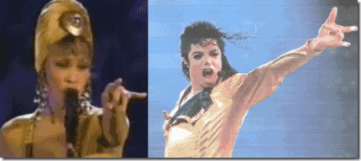
There is no doubt that both Michael Jackson and Whitney Houston’s had become ILLUMINATI and a slave to their father, LUCIFER.
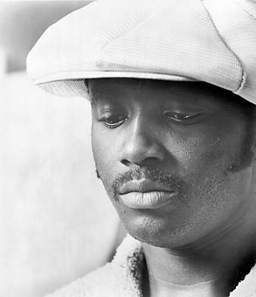
However, I sincerely believe that Donny Hathaway fought and resisted the ILLUMINATI until he was thrown from the window of his 15th story hotel room to his death to stop his melodies and harmonies to the masses. When Michael Jackson and Whitney Houston found the power and courage to resist, they were also murdered. During her struggles with CIA/MK ULTRA electronic harassment, drugging and mind control, she found the inspiration to resist if only for a moment to sing Donny’s spiritual and therapeutic-soothing melody to the world, “A Song for You.” I sincerely believe like many other artists this is what she started out to do and what she really wanted do with her life and career.

[1] http://www.nowtheendbegins.com/blog/?p=16233
[2] http://www.touregypt.net/featurestories/gold.htm
[3] http://www.whale.to/c/biggest_secret_15.html
[4] http://www.metrolyrics.com/locked-out-of-heaven-lyrics-bruno-mars.html
[5] http://en.wikipedia.org/wiki/Lucifer#cite_note-30
[6] http://tracytwyman.com/grammys-superbowl-12-time-two-sex-magick-rituals-that-go-together/
[7] http://uncyclopedia.wikia.com/wiki/Aleister_Crowley
[8] http://www.directlyrics.com/beyonce-drunk-love-lyrics.html
[9] http://en.wikipedia.org/wiki/Prince_Hall_Freemasonry
[10] http://en.wikipedia.org/wiki/Prince_Edward,_Duke_of_Kent
[11] http://www.pseudoreality.org/committeeof300.html
[12] http://secretsocietymembers.com/committee-of-300/
[13] http://lost-history.com/mysteries.php
[14] http://www.crystalinks.com/dynasty12.html
[15] http://www.africaresource.com/rasta/sesostris-the-great-the-egyptian-hercules/sesostris-the-great-the-egyptian-hercules/
[16] http://www.paganizingfaithofyeshua.freeservers.com/no_3_dionysis.htm
[17] https://sites.google.com/site/fakeapoc/home/satanism-node/aleister-crowley-just-another-diabolical-british-agent
[18] http://rense.com/general82/crowl.htm
[19] http://en.wikipedia.org/wiki/Committee_of_300
[20] http://www.thirdworldtraveler.com/New_World_Order/Committee_of_300.html
[21] http://seeker401.wordpress.com/2013/08/07/royal-baby-revealed-to-be-23rd-cousin-twice-removed-with-beyonce-and-jay-zs-daughter/
[22] http://www.news.com.au/entertainment/celebrity-life/beyonce-turns-into-queen-elizabeth-1/story-e6frfmqr-1226187153292
[23] http://www.maatmedia.com/Media/mediopoly_04.html
[24] http://childrenofarthur.wordpress.com/tag/arthurian-costume-party/
[25] http://en.wikipedia.org/wiki/Morgan_le_Fay
[26] http://www.arthurian-legend.com/more-about/more-about-arthur-8.php
[27] http://gardenofthewitch.wordpress.com/stories-and-lit/witches-morgan-le-fay/
[28] http://trace.tennessee.edu/cgi/viewcontent.cgi?article=1032&context=utk_graddiss
[29] http://en.wikipedia.org/wiki/Enochian_magic
[30] http://en.wikipedia.org/wiki/Enochian_magick
[31] http://en.wikipedia.org/wiki/John_Dee
[32] http://en.wikipedia.org/wiki/Enochian
[33] http://home.earthlink.net/~xristos/GoldenDawn/enochian.htm
[34] http://www.crystalinks.com/mirrorscrying.html
[35] http://www.redicecreations.com/specialreports/2005/09sep/johndee.html
[36]
[37] http://en.wikipedia.org/wiki/Talisman
[38] http://www.skepticfiles.org/mys5/magick02.htm
[39] http://www.angelfire.com/empire/serpentis666/Sex_Magick.html
[40] http://mysteriousuniverse.org/2013/06/modern-porn-mimics-aleister-crowleys-sex-magick-philosophies/
[41] http://www.angelfire.com/empire/serpentis666/Ritual.html
[42] http://en.wikipedia.org/wiki/Babalon
[43] http://en.wikipedia.org/wiki/Drunk_in_Love#cite_ref-vegas_17-0
[44] http://www.theforbiddenknowledge.com/symbology/5o5.htm
[45] http://www.metrolyrics.com/drunk-in-love-lyrics-beyonce.html
[46] http://www.metrolyrics.com/drunk-in-love-lyrics-beyonce.html
[47] http://www.indiachildnames.com/name.aspx?name=Inna
[48] http://en.wikipedia.org/wiki/Venkateswara

[49] Pinkham, Mark Amaru, Guardians of the Holy Grail, The Knights Templar, John the Baptist and Water of Life, Adventures Unlimited (2004), pg. 159
[50] http://en.wikipedia.org/wiki/Nin-imma
[51] http://en.wikipedia.org/wiki/Inanna
[52] http://www.bibliotecapleyades.net/sitchin/esp_sitchin_0.htm
[53] http://www.princeton.edu/~achaney/tmve/wiki100k/docs/Ninhursag.html
[54] http://www.grahamhancock.com/phorum/read.php?f=1&i=254408&t=253853
[55] http://www.maverickscience.com/hathor.pdf
[56] http://ancientegyptonline.co.uk/hathor.html
[57] http://www.crystalinks.com/hathor.html
[58] http://www.experience-ancient-egypt.com/hathor.html
[59] http://thelemapedia.org/index.php/Hathor
[60]http://thelemapedia.org/index.php/Hathor
[61] http://marilynmansonweb.yaia.com/biography.html
[62] http://en.wikipedia.org/wiki/Babalon_Working
[63] http://www.jesus-is-savior.com/False%20Religions/Wicca%20&%20Witchcraft/aleister_crowley.htm
[64] http://mysteriousuniverse.org/2013/06/modern-porn-mimics-aleister-crowleys-sex-magick-philosophies/
[65] http://www.angelfire.com/empire/serpentis666/Necronomicon.html
[66] http://www.angelfire.com/empire/serpentis666/Necronomicon.html
[67] http://www.philhine.org.uk/writings/tt_kapa.html
[68] http://hermetic.com/stavish/essays/secret-fire.html
[69] http://www.metrolyrics.com/drunk-in-love-lyrics-beyonce.html
[70] http://en.wikipedia.org/wiki/Watermelon
[71] http://en.wikipedia.org/wiki/Watermelon
[72]http://www.academia.edu/4467805/An_archaeobotanical_contribution_to_the_history_of_watermelon_Citrullus_lanatus_Thunb._Mats._and_Nakai_syn._C._vulgaris_Schrad._
[73] Lockyer, Sir Norman, Nature: International Journal of Science, Vol. 28, Nebu Press (2012), pg. 113
[74] http://en.wikipedia.org/wiki/Watermelon
[75] http://witchscrolls.com/magical-properties-of-the-watermelon/

Comments : 4 Comments
Tags: 2014 grammy awards, annunnaki, Beyonce, BEYONCE KNOWLES, bilderberg group, Blue Ivy, bruno mars, committee of 300, d, Dionysian mysteries, Dissociate identity disorder, donny hathaway, dr. john dee, Duke of Kent, edward kelley, elvenfolk, enki, enochian language, fallen angels, freemasons, grammy's, grand lodge of england, hathor, hip hop satanic cult, Illuminati, inanna, isis, jay z, john dee, katy perry, king arthur, Lil wayne, Lord Vishnu, luciferians, Maafa, michael jackson, mind control, MK-ULTRA, Monarchs, Morgan le Fay, mtv, necronomicon, nibsoni, nin-imma, Osiris, Prince Edward, prince hall, Pythagorean Brotherhood, queen elizabeth I, queen elizabeth II, rammeses, rhinanna, sasha fierce, Satanism, satanist, scarlet women, Sen-Wos-Ret, Serpent Kundalini, Sesostris I, Sex Magick, Sumner Redstone, viacom, Whitney houston, wosret
Categories : 2014 Grammy Awards, african holocaust, African slavery, Aleister Crowley, aset, ashur, beyonce, blood covenants, blood oaths, bruno mars, christianity, church of satan, CIA, devil's horns, donny hathaway, druids, dualism, egypt, False Satanic Rites of Lost Negroes, genocide, Hip Hop, hip hop satanic cult, Horus, illuminati, illuminati sacrifice, imperium, jay z, kemet, king tut, lil wayne, lucifer's servants, mind control, mulitiple personality disorder, new age religion, nwo, oakland, Osiris, Pharaohs Sestrosis I, queen elizabeth, queen mother, racial mass murder, re-image, re-imaging, Rosicrucian, Rosicrucianism, SASHA FIERCE, Satanic Global High Cabal, Satanism, sex kitten, sex slave, Sofia, trauma-based mind control, Tutankhamen, whitney houston

THROUGH THE LOOKING GLASS- SATANIC JAY Z, MAGNA CARTA- HOLY GRAIL, ILLUMINATI & HER MAJESTY’S SECRET SERVICE
3012014
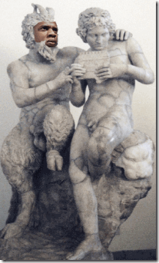
You should be baffled by the representation of Jay Z as the Ancient Greek God Pan. The Satanic Bible lists Pan as one of the Infernal Names of Satan.[1]
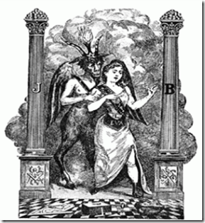
Pan — “… Satan is not a black god, but negation of God … this is not a Person, but a Force, created for good, but which may represent evil. It is the instrument of Liberty or Free Will. They represent this Force … under the mythologic and horned form of the God Pan; thence came the he-goat of the Sabbat, brother of the Ancient Serpent, and the Light-bearer [Lucifer]…” [Albert Pike, Morals and Dogma, p. 102] [2]
You should equally be puzzled by Jay Z’s album, Magna Carta, Holy Grail, and what it really means or its implication representing a significant Satanic paradigm shift in the control of the masses of color, and the deliberate manipulation for demonic designs of the Black Entertainment Industry by the New World Order to prepare the masses to bow down to the Coming of Lucifer’s Messiah, the Anti-Christ of the Book of Revelation. They intend to kill over half the people of the planet. According to America’s highness elected official, President Richard Milhous Nixon, they intend to exterminate the black masses within the next 500 years.
Don’t be fooled or dumb down by false images and ILLUSIONS. These people aren’t playing with anyone. They’re weren’t playing in the Atlantic Slave Trade and at Austerlitz. Magna Carta, Holy Grail is the mind altering song and music that Satanic Jay– Pan plays to the masses for the New World Order, ILLUMINATI, Her Majesty Queen Elizabeth II and the Coming Anti-Christ, Magna Carta, Holy Grail, Heaven by Jay Z, Druid Prince Justin Timberland: “Have you ever?… Have you ever been to Heaven? Have you seen the gates? Have you bow down to your highness? … Live among the Serpents Turn areas into churches…”[3] “
We’re through the looking-glass here, people… white is black and black is white.” JFK, the Movie[4]
2013 New World Order ILLUMINATI Entertainment Awards
The year 2013 has turned into a banner virtual takeover of the multi-million dollar Black Entertainment Industry by the ILLUMINATI, New World Order and Her Majesty Queen Elizabeth II. Her Majesty’s film industry, 12 Years a Slave, continue to rack up awards. Recently, the 19th annual Critics’ Choice Movie Awards, 12 Years a Slave, received nods for Best Picture, Best Actor for British Subject- film, television, and theatre actor Chiwetel Ejiofor,[5] Best Supporting Actor for German-Irish Michael Fassbender of Heidelberg, Baden- Württemberg, Germany;[6] Best Supporting Actress for Kenyan Lupita Nyong’o of Mexico City, Mexico,[7]
Best Acting Ensemble, Best Director for Steve McQueen, Best Adapted Screenplay, Best Cinematography, Best Art Direction, Best Editing, Best Costume Design, Best Makeup and Best Score.[8] 12 Years a Slave also received seven bids/nominations for the 71st annual Golden Globe Awards including best film drama, Chiwetel Ejiofor for best actor in a drama and Her Majesty British Secret Agent Steve McQueen for best director.[9] Also in music industry for 2013,
Her Majesty’s Satanic Jay Z leads the nominations for ILLUMINATI/New World Order Demonic Rap Grammy awards. Magna Carta, Holy Grail received nods in almost every rap category. Stranger even, Nirvana benefited from Satanic Jay’s nine Grammy nominations: the track Holy Grail borrows racist lyrics from Smells Like Teen Spirit, so Demonic Kurt Cobain, the Satanist Nirvana, and the “Spirit of Lucifer” are listed among the songwriters for best rap song.[10]
Kurt Cobain admitted that his life’s goal was to “get stoned and worship Satan.” Cobain was obsessed with Luciferian Anton LeVay, founder of the Church of Satan, Cobain even wanted LeVay to record a song with him. Cobain was known to desecrate churches and Christianity by writing “God is gay” and other blasphemies. It was reported that he was also involved in witchcraft. Indeed he did channel demons as Cobain is described as “stumbling on melodies by means he himself didn’t fully understand.”[11] If you happen to believe that Jay Z’s work in the entertainment industry is art for art’s sake, then you are badly informed.
UNHOLY ALLIANCES: Samsung, Wallenbergs & Satanic Jay
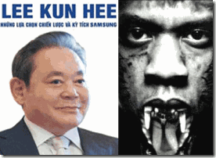
Electronic Corporate Giant Samsung of South Korea surprisingly partnered with Satanic Jay to purchase 1 million copies of his “Magna Carta, Holy Grail,” to push a satanic- ILLUMINATI agenda on the masses, and its Samsung Galaxy smart phone users.[12] Samsung is the world’s largest private conglomerate by revenue; in 2009 the group earned US$172.5 billion.[13] South Korea, Samsung, NWO & the Wallenberg Family

The Republic of South Korea (ROK) is a product of the racialist imperialistic policies of Teutonic Knights of the Black Sun, Hitler’s General Reinhard Gelhen, Allen, and John Foster Dulles, the OSS (Office of Strategic Services) and the CIA. After WWII, the Korean people were exuberant in August 1945 with their new freedom after being subjected to a brutal 40-year Japanese occupation of their historically undivided Peninsula. At the February 1945 Yalta conference, President Franklin Delano Roosevelt suggested to Josef Stalin of Russia, without consulting the Koreans, that Korea should be placed under joint trusteeship following the war before being granted her independence. U.S. intelligence went through with its unilateral intention to place the Korean people under its occupation, and divided Korea into South and North at the 38th parallel, placing the historic capital city of Seoul and 70 percent, or 21 of Korea’s 30 million people in the “American” Southern Zone. On August 15, 1945, the United States Army Military Government in Korea (USAMGIK) was formed and on September 8, 72,000 U.S. troops began arriving to enforce the formal occupation of the south. South Korea was turned into a brutal mass murder “Police State.” Estimates of murdered civilians range anywhere from 200,000 to 800,000 by the time the hot war broke out in June 1950.[14] Since South Korea‘s creation at the 38th parallel, it has been a creature and patsy of U.S. shadow government and intelligence policies. Samsung is a collaborative creature of Korean and U.S. shadow government policy. Its sudden rise in the global electronic industry is also due to its secret collaboration with ILLUMANTI global players and markets.
The Wallenberg Family Motto is “Esse no Videri” (Latin for “To be, not to be seen”)[15]

Marcus Wallenberg, Grandson of Dr. Marcus Wallenberg (1899- 1982)- prominent member of the Trilateral Commission.[16] In 2003, Samsung Group Chairman Lee Kun-hee visited the Wallenberg Family in Sweden, expressing interest in the Swedish model of business governance and corporate citizenship. A collaboration between South Korea and the Martin Bormann’s Nazi financed American and Northern European companies was established then or at some time earlier.[17] The Wallenberg Family, Martin Bormann & the Rise of the Fourth Reich
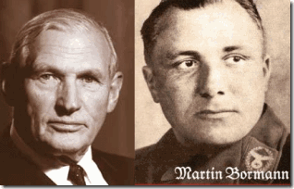
The Swedish Wallenberg’s are like the equivalent to the U.S. Rockefellers or the Europe‘s Rothschilds. During WWII, Swedish companies grew rich collaborating with the Nazis. One was Enskilda Bank owned by the Wallenberg Family. Project SAFEHAVEN was a secret operation designed to root out and neutralize Nazi industrial and commercial power wherever it might be found. The origins of SAFEHAVEN are to be found in two memorandums sent from the U.S. Foreign Economic Administration (FEA), to the Departments of State and Treasury on May 5 and 17 1944, proposing an interagency program to track down and block German assets in neutral and nonbelligerent countries throughout Europe and the Americas.[18]
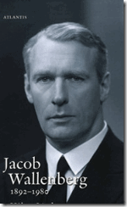
THE WALLENBERG FAMILY & PROJECT SAFEHAVEN
documents reveal that the US government had been tracking the pro-Nazi activities of the Wallenberg brothers, Marcus and Jacob, for some time.[19] In February of 1945, the Secretary of the US Treasury, Henry Morgenthau Jr., wrote to Secretary of State Edward Stettinius outlining the Wallenbergs’ activities.[20] These included making “substantial” loans to German industry during the War without collateral and making covert investments for German capitalists in US industries. The Enskilda Bank, Morgenthau reported, was “repeatedly connected with large black [white] market operations”.[21] Morgenthau identified Jacob Wallenberg as “strongly pro-German” and rebutted the view, probably fostered by Wallenberg interests themselves, that Marcus was “pro-Allied”.[22] One of the most tantalizing of the SAFEHAVEN documents is a 1944 account of a secret meeting in the French city of Strasbourg, at which Nazi Party leaders (Bormann, Heinrich Himmler)- Knights of the Black Sun told top German industrialists that the war was lost and called on them to finance an underground network aimed at eventually restoring fascism to power in Germany.[23] US Military Intelligence report EW-Pa 128 described as the Red House Report, is a detailed account of a secret meeting at the Maison Rouge Hotel in Strasbourg on August 10, 1944. There, NSDAP´s leader Martin Bormann, ordered an elite group of German industrialists to plan for Germany’s post-war recovery, prepare for the Nazis’ return to power from the underground and work for a ‘strong German empire’. In other words: the Fourth Reich.[24]
The Wallenberg Family, NWO Bilderberg Group & the Occult
Among this elite group of secret Nazi industrialists at Strasbourg planning the Rise of the Fourth Reich from the underground was the Wallenberg Family. One thing is for sure is that Marcus and Jacob Wallenberg were key members of the Bilderberg Group. [25]
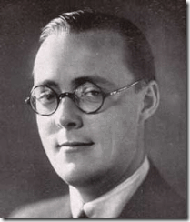
One of the principal founders of the Bilderberg Group was Dutch Royal Prince Bernhard of Lippe-Biesterfeld.[26] Prince Bernhard wasn’t just an ordinary card carrying National Socialist Workers Party member under Martin Bormann. Prince Bernhard had been Sturmabteilung (SA), a member of the Storm Detachment or Assault Division, or the Brownshirts under Sabschet Ernst Rohm that functioned as the original paramilitary wing of the Nazi Party. [27] Prince Bernhard had also been a blood covenant Schutzstaffel (SS) member, a GENOCIDIST, under Reichsfuhrer SS Heinrich Himmler since April 22, 1933. He specifically was a member of the SS- Fliegerstürm.[28] SS-Fliegersturm was a flying unit of the Allgemeine-SS that was formed Nov 1931 in Munich and was absorbed by the Deutscher Luftsport Verband (DLV) Sept. 1933. A special variant of the pilot wings (the SS-SA Fliegerabzeichen, an early SS eagle flanked by the SS and SA logos) was worn by qualified members of this unit.[29]

The fifth generation has taken over the Wallenberg sphere, Marcus Wallenberg, son of Marc Wallenberg, Jacob Wallenberg, above, and Peter Wallenberg (junior) both sons of Peter Wallenberg (senior). For the ILLUMINATI Wallenberg Family, the names, demonic viciousness, racism, and the game (FASCISM) remains the same.
Prince Bernhard & the Johannites (I AM)
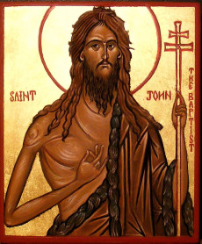
“And a certain Jew named Apollos, born at Alexandria, an eloquent man, and mighty in the scriptures, came to Ephesus. This man was instructed in the way of the Lord; and being fervent in the spirit, he spake and taught diligently the things of the Lord, knowing only the baptism of John.“ Acts 18: 24-25
In addition to his Bilderberg role, Prince Bernhard was head of the Dutch Johannite Orde of Nederland, one of four orders that make up the Chivalric Alliance of Orders of Saint John [John the Baptist] (Alliance de Chevalerie des Hospitaliers de Saint Jean de Jerusalem). The stated purpose of these four, known as “the Alliance”–which is composed of northern European nations Germany, The Netherlands, Sweden and Great Britain, the latter being an ancient order known as “the Most Venerable Order”–is “to reduce to silence the enemies of Christ”. The headquarters of the Alliance are located in Switzerland. [30]
In reality, “the Alliance” was a group of elite Holy Grail Bloodlines, ILLUMINATI want-to-be’s, and that set themselves aside from the masses as the ILLUMINATED ones endowed with the “Right Knowledge” to rule the world. They believe that Christ was only a “Disciple of John the Baptist“, and that John’s religious teachings were secretly that of the Kemetic mystery schools of Isis-Osiris-Horus.[31] “These are Protestant orders rather than Catholic, but it is of significance that, on 26 November 1963, the Alliance was “consolidated with the signing of a joint declaration between the Sovereign Military Order of Malta and the Most Venerable Order, at St John’s Gate, London, by the Grand Chancellor of the SMOM, the Prince of Resuttano, and Lord Wakehurst, Lord Prior of the Most Venerable Order”. [32]
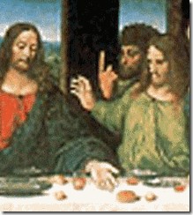
Leonardo da Vinci covertly inserted the John Gesture by Thomas to challenge Jesus’ claim as the Messiah in the infamous painting, The Last Supper. Interestingly, it has been suggested that the Knights Templar were “infected” with the Johannite or Mandaean heresy that denounced Jesus as a “false prophet” and in his place recognized John the Baptist as the true Messiah. Meanwhile, two early Grand Masters of the Priory of Sion are said to have had Johannite tendencies: Leonardo da Vinci and Sir Isaac Newton. Notwithstanding that, the famous founder of the Knights Templars, Hughes de Payens, has been accused by the Vatican of being a Johannite. [33]
The Wallenberg Family, Occult & the Royal Order of Seraphim
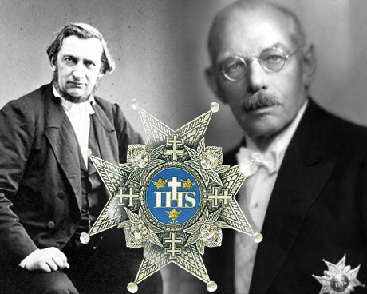
Wallenberg Founder and Patriarch- Knights of the Royal Order of the Seraphim, André Oscar Wallenberg, (1816 -1886) and Marcus Wallenberg (1864-1943)
The Knights of the Royal Order of the Seraphim is a secret Hebrew/Kabbalistic occult group connected to the Wallenbergs since it founding by Patriarch André Oscar Wallenberg.[34]
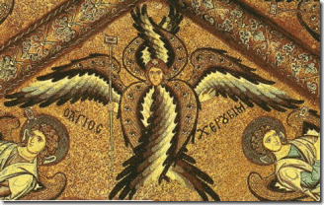
This Order is exclusive to Sweden and Seraphim is Hebrew for a class of angels (the highest one). Marcus Wallenberg (1899-1964) was also publicly identified as a Knight of the Order of Seraphim. The Order is linked to the 16th Century Sorcerer/Mystic of Queen Elizabeth I- Hebrew/Kabbalistic John Dee, Tubal-Cain (Freemasonry) and the Rune of the Original Language.[35]
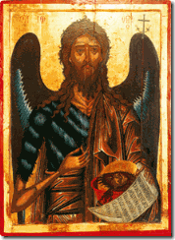
Winged Seraphim– St. John the Baptist
On February 23, 1748, Frederick I instituted the three Swedish royal orders of the Seraphim, of the Sword, and of the North Star, the three principal Swedish orders of chivalry.[36] Frederick I was in an ILLUMINATI bloodline closely linked with Rothschild Family.[37]

The Order of Seraphim court of arms has three crowns and four Crosses of Lorraine. Samsung’s logo also has “three” stars. The North Star is actually a triple star system.[38] Notable among the Order of Seraphim was the 10th President of South Korea, Lee Myung-bak from 2/25/2008 to 2/25/2013.[39]
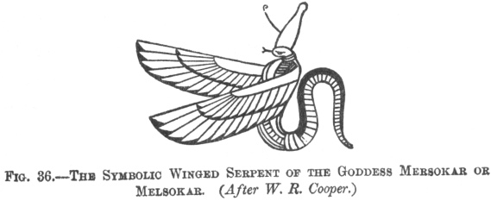
“My vision is cleared, my heart is in its proper place, my uraeus (cobra) is with me every day. I am Re, who himself protects himself, and nothing can harm me.” (Book of [the Dead] Coming Forth by Day, Faulkner p. 58) Uraeus- Tutkhamón– The ancient Kemetic Kings had a long tradition- tens of thousands of years of flaming winged uraeus serpents that guarded and protected the Pharaohs. “For from the serpent’s root a viper will come out, And its fruit will be a flying serpent. [lit ‘a flying saraph’]” –Isaiah 14:29
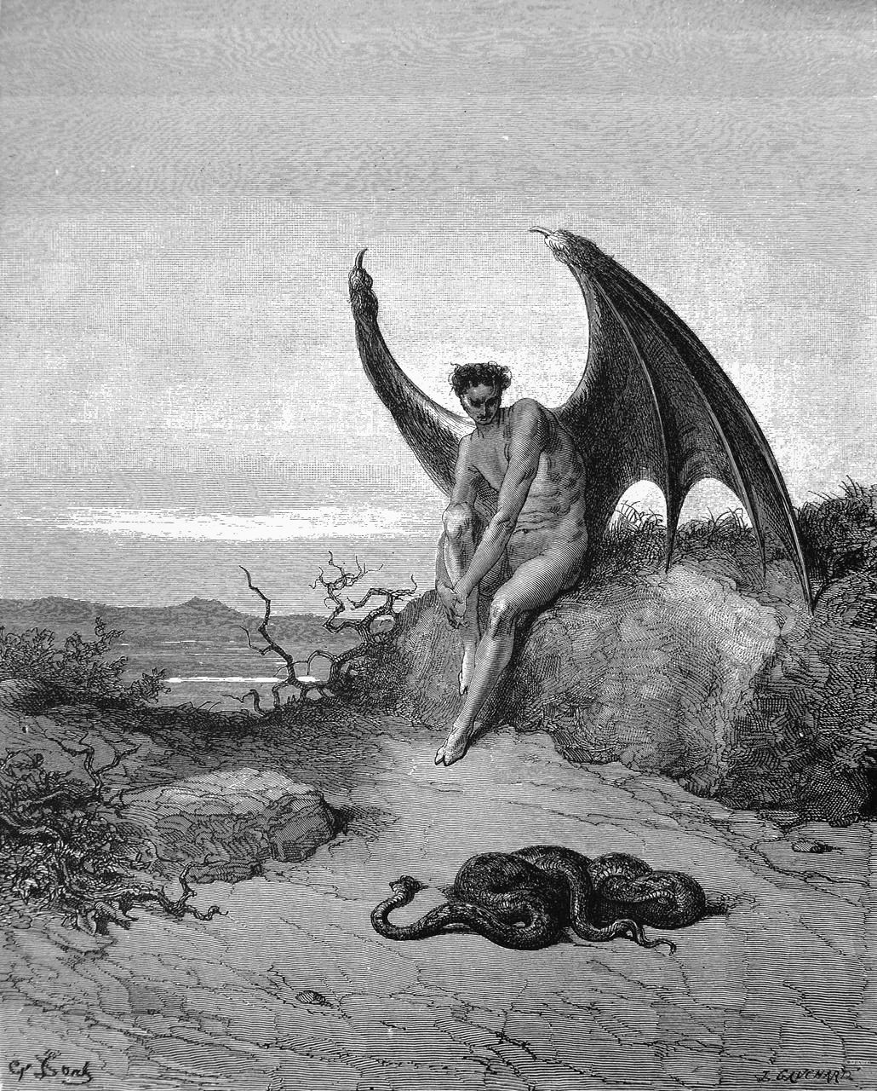
The earliest usages of the term, Seraphim, refer to serpent demons. Lucifer is often identified as one of the Seraphim.[40]

One of the key members of the Luciferian Royal Order of Seraphim- winged serpents, Her Majesty Queen Elizabeth II.[41] Whereas, you understand why Samsung could be commanded as an ILLUMINATI puppet to partner with and fund Jay Z in a secret satanic agenda to deceive and control the masses.
SECRET CHRISTIANITY, SATANIC JAY, QUEEN ELIZABETH II, SALISBURY CATHEDRAL, PYTHAGORAS & ARCADIA IMAGERY
John the Baptist, the Secret Sethian Christianity
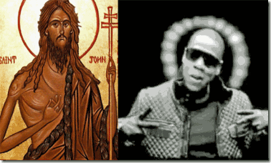
Halos & the Secret “John Gesture” (I AM)– Saint John the Baptist of the 1st Century (circa 5 B.C.) with Shepherd’s Staff (Cross of Lorraine), Satanic Jay
The secret ancient” magical finger rituals” are known through “Masonic handshakes.” In “Hermetic Finger Magic,” the index finger is associated with fire. As such, in Hermetic magic, the left index finger is associated with “negative chaos”. Among secret societies, it is called the “John (the Baptist) Gesture.”[42] During the 1st Century AD of the Roman occupation of Kemet, there was a sect of Samaritan Christian Jews out of Israel that founded a secret mystery school in Alexandria, Egypt in the shadows of the Alexandria Library that practiced a form of Christian Sethian Gnosticism.[43]

Seth (the old God Set) was adopted again by foreign invaders and interlopers [Hyksos] that re-imaged him into a character of Sethian Gnosticism that represented a savior figure and third (spiritual) son of Adam, founder of the Gnostic Bloodline Race (Johannites). The leader of the school was John the Baptist and after his execution, his supporters formed secret societies and alliances, and among those were Simon Magus, Apollos of Alexandria,[44] Philip, Dositheos, Matthias and Jesus.[45]

Beyonce’s infamous Satanic alter personality, Sasha Fierce is I AM– Baphomet. Early Knights Templar confessions in the 14th Century led to the legend that the severed head of the St. John the Baptist was one of the secret treasures recovered from Palestine by knights during the Crusades and that the Head of John the Baptist is the true origin of the Baphomet.
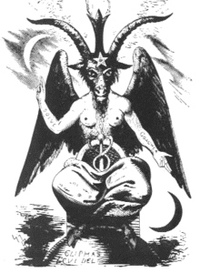
I AM most notable reference is a biblical reference to God, And God said unto Moses, I AM THAT I AM: and he said, Thus shalt thou say unto the children of Israel, I AM hath sent me unto you. Exodus 3:14 (KJV) I AM Baphomet (Lucifer), and the ILLUMINATI thus hath sent Satanic Jay and Beyonce upon you. It is highly significant to keep in mind that Moses (Ramses or Osarseph ) was a former renegade Kemetic High Priest expelled the country along with the Shepherd Kings, the HYKSOS.
Satanic Jay & the 16th Century Greek Myth of Alpheus and Arethusa
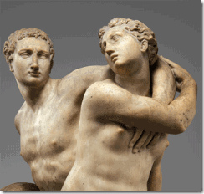
The source image for Satanic Jay‘s new album, Magna Carta, Holy Grail, and his so-called artwork premiere at Salisbury Cathedral in England is the sculpture Alpheus and Arethusa by Battista di Domenico Lorenzi (Italian, ca. 1527/28–1594) at the Metropolitan Museum of Art, New York. [46] According to the museum, the 16th century sculpture is a depiction of a Greek myth about the nymph Arethusa who is pursued by the river god Alpheus. In attempt to escape her pursuer, Diana [Goddess Artemis] transforms Arethusa into a stream [or a well ].[47] In Roman Mythology, Diana (lt. “heavenly” or “divine”) was the goddess of the hunt, the moon and birthing, being associated with wild animals and woodland, and having the power to talk to and control animals. She was equated with the Greek Goddess Artemis though she had an independent origin in Italy.[48]

Arethusa is not a nymph, but a Nereid– female spirit of sea waters, the daughter of Nereus.[49] In Greek mythology, Nereus was the eldest son of Pontus (the Sea) and Gaia (the Earth), a Titan who with Doris fathered the Nereids and Nerites.[50] Alpheus is a river god, he is a son of Titans Oceanus and Tethys (oceans and rivers).[51] Satanic Jay, Druids, Knights Templar and Salisbury Cathedral

Jay Z’s album Magna Carta, Holy Grail and its cover with Alpheus and Arethusa and his so-called art show at the 800 year old Salisbury Cathedral (formally known as the Cathedral Church of the Blessed Virgin Mary)[52] in England have a lot of people scratching her heads, rightfully so – the reaction that the story in fact was intended to provoke.
“And all shall be well and All manner of thing shall be well When the tongues of flame are infolded Into the crowned knot of fire And the fire [St. John the Baptist] and the rose [Knights Templar] are one.” — T.S. Elliot (From an engraved window at Salisbury Cathedral, England)[53]
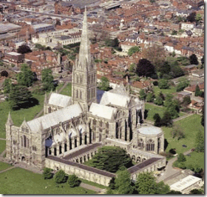
The Salisbury stone cathedral was built by a mysterious architect “Master Stone Mason” called Elias de Dereham (1167-1245). Elias was born in West Dereham in Norfolk. In Dereham, a certain powerful Knight Templar, Hubert Walter, became his mentor.[54] Hubert was a key player in the third crusade to the Holy Land of 1190-92 with King Richard, the Lionheart. Hubert was an important fundraiser of Third Crusade and King Richard. It was Hubert that negotiated the infamous truce between King Richard and King Saladin (the ASSASSINS) in Palestine. Hubert was appointed to the Archbishopric of Canterbury in 1193, and a Papal Legatcy in 1195.[55] Under the tutorage of Hubert, Elias of Dereham became an influential and trusted official of the king’s court, and almost certainly was a key figure in the entire Magna Carta rite. Only thirteen copies of the document were ever produced, seven from Runingmede and six a few weeks later from Oxford. Elias of Dereham is known to have delivered ten of these, four from Runingmede and all from Oxford.[56] The Salisbury Cathedral hold one of four of the original surviving 1215 Magna Carta documents that was undoubtedly held by Elias of Dereham. Also, Elias designed Salisbury cathedral that was a specific distance in alignment with other major landscape features, including Druid scared sites Old Sarum, Stonehenge; and the old Roman Fortress Clarendon that was built on a Iron Age mound or structure. Like Old Sarum and Stonehenge, Elias’ temple was built according to complex geometrical and mathematical principles- “Sacred Geometry”, and like Stonehenge it both contains symbolic alignments of architecture, date and sunlight, and also subtends them into the surrounding landscape, with the spire as the gnomon of a giant sundial.[57]
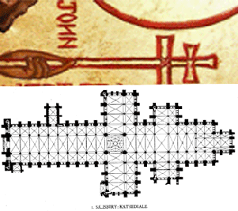
Elias of Dereham secretly incorporated St. John the Baptist’s Cross of Lorraine and Knights Templar’s Rose into Salisbury Cathedral. The Cross of Lorraine consists of one vertical and two evenly spaced horizontal bars. It is a heraldic cross, used by the Dukes of Lorraine (previously known as the Dukes of Anjou). The Lorraine cross was carried to the Crusades by the original Knights Templar, granted to them for their use by the Patriarch of Jerusalem. Hermetic alchemists of the Renaissance used the emblem as a symbol of earth and spirit by combining the square earth cross with the cross of Christ. It is safe to assume that the Salisbury Cathedral is a direct product and influence of the Druids, and the Baphometic Knights Templar. It is also safe to assume that Satanic Jay’s unprecedented access to one of England’s oldest and most prestigious cathedral had been arranged and sponsored by some of the highest levels of freemasonry, Knights Templar, and the ILLUMINATI.

In England, the highest level (Grand Patroness/Order of the Garter) of Freemason and the ILLUMINATI is held by a Magna Carta- Holy Grail Bloodline– Her Majesty Queen Elizabeth II.[58]
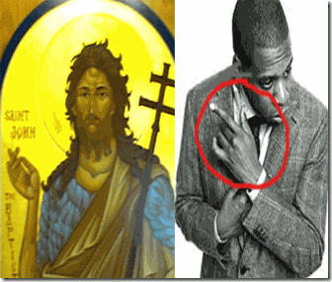
The Knights of the Garter are the inner-sanctum, the elite of the elite of Her Majesty’s Most Venerable Order of St. John [John the Baptist] of Jerusalem. The Knights of the Order of the Garter are the leaders of the Illuminati hierarchy, and Queen Elizabeth II’s most trusted “Privy Council.”[59]
SATANIC JAY, PYTHAGORAS, ARCADIA, SIR FRANCIS BACON & “FAMA FRATERNITIS”
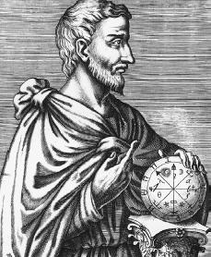
You can clearly see the origin of the John Gesture (I AM). Pythagoras “the altar of Pythia” (570 BC – c. 495 BC) of Samos was an Ionian Greek philosopher, mathematician, and founder of the movement called Pythagoreanism. [60] Pythagoras’ mother was Pythais, decedent of Argonaut Ancaeus, founder of Samos. Ancaeus was a son of Lycurgus of ARCADIA.[61]
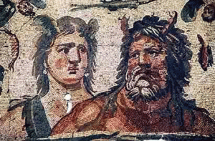
Titans Tethys & Oceanus
Pythais’ mother was Eurynom. In the epic tradition, Eurynome was one of the elder Oceanides [Nereid– female spirit of sea waters] that is, another daughter of Titans, Oceanus and Tethys.[62] Pythagoras entered Kemet during the reign of Pharaoh Amasis of the 26th Dynasty with letters of introduction from Tyrant Polycrates of Samos. Samos is a Greek island in the eastern Aegean Sea off the coast of Asia Minor.[63] Polycrates of Samos was in its modern English usage of “Tyrant”, a ruler of a cruel and oppressive character of Samos (538 BC to 522 BC), who in league with Amasis II was an absolute ruler unrestrained by law or constitution, and one who had usurped legitimate sovereignty. Polycrates had been a devotee to God Apollo of Delos and of Delphi. [64]
It is remarkable that throughout numerous and continuous invasions by cruel and oppressive hordes, armies, false kings, prophets and priests, that by the 7th Century BC, Pythagoras became the first westerner to be initiated by force into Kemet’s temples and mystery schools.[65] Yet, the priests of Kemet were wise and bounced the interloper of tyrants and false pharaohs from temple to temple, and one mystery school to another. Even during Pythagoras’ time, it was still virtually impossible for any mortal to master the knowledge of one temple or Kemetic mystery school of tens of thousands of years. The Roman historian, Plutarch (c. 46 – 120 AD), asserted in his book On Isis and Osiris that during his journeyman in Kemet, Pythagoras received instruction from the Egyptian priest Oenuphis of Heliopolis (ON)- City of the Sun,[66] and for 22 years, he tried to absorb all the knowledge about mathematics, medicine, music, hieroglyphics, cosmology, astronomy, etc. that time would allow him.[67]
When Cambyses II, the King of Persia invaded Kemet in 525 BC, Pythagoras and priests of Kemet were taken to Babylon as prisoners in an attempt to control and limit Kemet’s mystery schools and temples. For whatever reasons, he was released and initiated into the Chaldean/Magi Mysteries.[68] Around 530 BC, Pythagoras moved to Croton in Southern Italy (Magna Graecia). In Croton, he established a school of followers- a select brotherhood or club for the purpose of pursuing the religious, ascetic practices, arcane, scientific and medical knowledge taken out of Kemet by the understanding of their master, Pythagoras.[69] The accounts agree that what was done and taught among the members was kept a profound secret (blood oath) among them. The esoteric teachings may have concerned science and mathematics, or the secret religious doctrines and usages which were undoubtedly prominent in the Pythagorean system that had been connected with the worship of Apollo[70] (Kemetic Horus).[71]
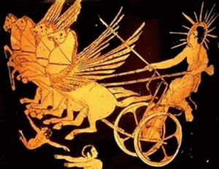
Greek Sun God- Apollo or Helios
In myth, Pythagoras was the son Apollo and the Pythian (Serpent-Dragon) Priestess of Delphi.[72] The Pythia known as the Oracle of Delphi, was the priestess at the Temple of Apollo at the city of Delphi, Greece located on the slopes of Mount Parnassus in Greece beneath the Castalian Spring.[73] In Greek Mythology, Python was a dragon or serpent that was the tutelary demon of the oracular cult at Delphi until killed and expropriated by Apollo-Horus.[74] Sir Francis Bacon of the 16th Century Elizabethan Court referred to himself as Apollo and it is the Rosicrucian Manifesto that the text describes a character called Apollo (Pythagoras) who sets up a society of men famous for their wisdom and virtue. The “Fama Fraternitis” echoes Bacon and his “Great Inspiration” saying that the aim of the Rosicrucians were to promote, “the universal and general reformation of the Whole World” [75] – the New World Order.
“Fama Fraternitis” & the Acadia Imagery
“ET IN ARCADIA EGO“ is an esoteric reference to Arcadia, a Greek city which symbolizes the Rosicrucian’s envisioned Paradise on earth. “ARCADIA was one of the primary mystery names given to the state of the world in a Golden Age, and the whole Arcadian imagery and allegory is that of a Utopia or Paradise on earth that might be achieved… The world is on the threshold of that achievement now, according to the way the evolutionary cycles of divine law work. Jesus Christ and the Buddha prepared us for it in an outstanding way; Francis Bacon…and the Rosicrucian Brotherhood have inaugurated it … All have used Arcadian imagery, the meaning of which pierces deep, right to the heart of all mysteries.”
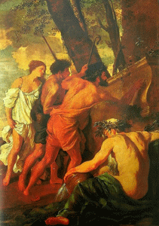
Knight Templar/Grand Master of Priory of Sion Painter Nicolas Poussin, Shepherds of Arcadia (1629), the elusive River God Alpheus Sitting
Poussin’s infamous painting, above, have puzzled generations as to its secret meaning. It shows three shepherds searching a tomb for clues to either Knights Templar sacred knowledge or treasure hidden in Arcadia. The tomb inscription is “Et in Arcadia Ego,” often consistently translated “Even in Arcadia I AM.”
The sacred river Alpheus, which flows from Arcadia to the underworld, represents a demonic bloodline. “Arcadia…is frequently denoted by a fountain or a tombstone, both of which are associated with an underground stream. This stream is usually equated with the river Alpheus–-the central river in the actual geographical Arcadia in Greece, which flows underground and is said to surface again at the Fountain of Arethusa in Sicily…
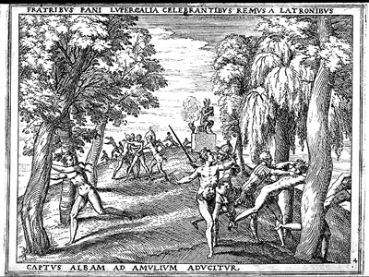
From the remotest antiquity to Coleridge’s ‘Kubla Khan’ the river Alpheus has been deemed sacred. Its very name derives from the same root as the Greek word alpha, meaning ‘first’ or ‘source.’… “…the underground stream…might connote an unacknowledged and thus ‘subterranean’ bloodline…” “… the [Pierre] Plantard family–lineal descendants of Dagobert II and the Merovingian dynasty.
In 1548, the ‘Prieuré documents’ state, Jean des Plantard had married Marie de Saint-Clair–thus forging another link between his family and that of the Saint-Clair/Gisors…” romantic paradise of the pastoral poets and artists like Poussin. 1637-38 “…the specific phrase in Poussin’s painting—‘Et in Arcadia Ego’…appeared in an earlier painting by Poussin, in which the tomb is surmounted by a skull and does not constitute an edifice of its own, but is embedded in the side of a cliff. In the foreground of this painting a bearded water deity reposes in an attitude of brooding moroseness—the river god Alpheus, lord of the underground stream…”[76]
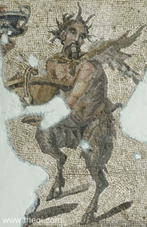
In Greek Mythology, Pan is the principal god of Arcadia. He is the god of the wild, shepherds and flocks, nature of mountain wilds, hunting and rustic music, and companion of the nymphs. He has the hindquarters, legs, and horns of a goat, in the same manner as a faun or satyr. With his homeland in rustic Arcadia, he is recognized as the god of fields, groves, and wooded glens.[77] Pan was also Saturn or Satan.
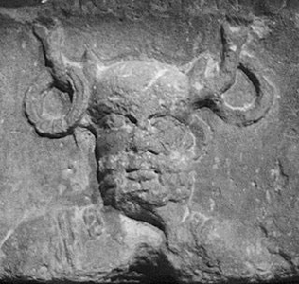
In Arcadian Imagery, Pan is “man himself” who falls as Lucifer from the heavens onto the world of matter. Saturn or Satan means adversary but also intelligence. Therefore, it is Intelligences which will test the spirit to see whether is good. Pan therefore actually represents our path to enlightenment.[78] Pan, the lusty god, was also called Pallas, whom Laurence Gardner identified in Bloodline of the Holy Grail as the Progenitor of the Merovingian Race of Grail Kings.[79]
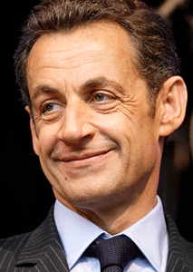
Many in main stream media have declared that the above Pierre Plantard de Saint-Clair’s Priory of Sion is a popular hoax. [80] Yet, I believe that all of Plantard’s claims are not all smoked mirrors and ILLUSIONS. According to the the book, The Holy Blood and the Holy Grail [1982], 15th Century French King Rene of Anjou (1409- 1480) of Naples, Italy, who contributed to the formation of the Western Esoteric Tradition, used the theme of an “underground river” that was equated with the Alfeios (Alpheus) River to represent a subculture of Arcadian esotericism, which was seen as an alternative to the mainstream spiritual and religious traditions of Christendom.
The book also supports the notion that the Myth of Arcadia and its underground river became a prominent cultural fashion among western secret societies of the “Right Knowledge” that inspired various artistic works beginning in 16th and 17th Centuries that also produced Jay Z’s album cover of the 16th Century sculpture of Alpheus and Arethusa, and Nicolas Poussin’s coded works containing Knights Templar secrets in his Arcadia Imagery paintings. The book speculates that the “underground stream” might also have connoted an unacknowledged and thus “subterranean” Bloodline of Jesus [John the Baptist] [81] in the ‘underground’ esoteric tradition of Pythagorism and Sethian Christian Gnosticism.
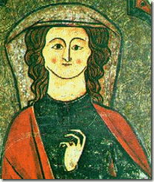
Queen Eleanor with an early form of the John Gesture and Dragon’s Claw
Additionally, Eleanor of Aquitaine (1122 or 1124 – April 1, 1204) was the Queen of France and England. She has been described as one of the wealthiest and most powerful women in Western Europe during the High Middle Ages. As the Queen of France, she was directly involved as one of the leaders in the Second Crusades (1144-1150). She married King Henry II of England. She was the mother of King Richard, the Lionheart, and King John I of the Magna Carta.[82] Eleanor of Aquitaine, was descended from Charlemagne and therefore Clovis, one of the first Merovingian Kings of France. The Plantagenets (background family of Jay Z’s Magna Carta) established their Merovingian heritage through Eleanor of Aquitaine.[83] She had a great deal to do with implanting secret Pythagoreanism and the Sethian Christianity among the Plantagenet Clan.
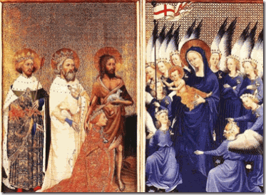
The above Wilton Diptych: Plantagenet King Richard II (January 6, 1367 – February 14, 1400) of England, Great-Great-Great Grandson of Queen Eleanor, adores the Virgin and Child in the company of his past patron saints: Saint John the Baptist, Saint Edmund and Saint Edmund, circa 1395-1399 In the picture above, Anglo-Saxon King Edmund of (about 841-869) holds the arrow which killed him. King Edward of England, the Confessor (between 1003 and 1005 – January 4 or 5 1066) holds the ring which he is supposed to have given to a pilgrim who turned out to be Saint John the Evangelist (Baptist). Richard was particularly devoted to Edward and prayed at his shrine in times of crisis. John the Baptist, holding the Lamb of God, touches the king’s shoulder. This quite plainly illustrates that John the Baptist had been a foremost “patron saint” and a major secret ancient influence on the early Anglo- Saxon ruling elites Kings and Queens of England before the crusades.
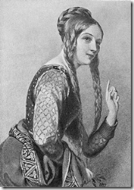
Queen Eleanor- The John Gesture
There are some suggestions that Queen Eleanor was also an acute member of a Pythagorean “Fama Fraternitis” that developed into the Merovingian – Rex Deus (Latin for “King God”) bloodline. Pythagoreanism and the Pythagorean methodology in a secret-satanic One World Order of global governance seemed to have been discussed back then in the queen’s court.[84] What this all basically leads to is that Ogenus, the Ocean was the most ancient name of the River Nile in Kemet; “whence the Grecians borrowed their Oceanus alluded to by Phenecydes. [85]

Leonardo Da Vinci- St John the Baptist 1513-16
Phenecydes was a 6th Century BC pre-Socratic philosopher and author from the island of Syros- Greek island in the Cyclades of the Aegean Sea, that some believed to have been the teacher and mentor of Pythagoras.[86] Then, you have the Italian sculpture of Alpheus and Arethusa out of the 16th Century as material evidence of a conspiracy among a secret elite Luciferian European Cult or “Fama Fraternitis” with roots to the 6th Century BC Pythagoras Cult of elitists, the mystery school of Samaritan (Israel) John the Baptist clandestinely dedicated to manipulating stolen knowledge primarily from the mystery schools of Kemet (Osiris-Isis-Horus) to establish a New World Order. Alpha– the beginning, the Alpheus River of Greek Mythology flows from the River Nile (Kemet– original Knowledge of tens of thousands of years). Arethusa the Nereid– female spirit of sea waters had eluded the Greeks until she joined them with the Nile River Valley Mysteries and Splendors. If Jay Z don’t know by now, there will be no Black people or people of color among the pagan-satanic forests, people, white nymphs, flocks and pastures of the ILLUMINATI’s visionary Arcadia.
SATANIC JAY, THE ETHIOPIAN/AFRICAN DEVIL DECEPTION
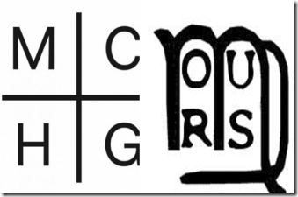
Satanic Jay’s Logo for Magna Carta & Logo for Society of Ormus
Satanic Jay ‘s logo for “Magna Carta, Holy Grail” give us yet another clue as to how far back and deep the ILLUMINATI conspiracy goes to falsely re-image Africans as Devils from the days of Antiquity that influenced and provoked the evil of Europe. Among the many imitators, imposers and interlopers of the Mysteries of Kemet was an ancient group called the Society of Ormus.[87] The founder of the order in antiquity during the Greek and Persian invasion of Kemet was a seraphic priest of Alexandria, a Magus of Egypt named Ormeslus or Ormus.[88] Ormus combined Kemetic mystical doctrines with new Christian teachings. The philosophical legacy that he carried was preserved and latter allegedly passed to the Knights Templar: “About the same time [46AD] the Essences and other Jews founded a school of science according to Solomon’s teachings and Ormus. The followers of Ormus, up to 1118 AD, were the only trustees of the ancient doctrine of Egypt, purified, of course, by Christianity and the teachings of Solomon. These doctrines they communicated to the Templars. They were in consequence known under the name of ‘Knights of Palestine‘ or ‘Brethren of the Rosy Cross of the Orient.’ The ‘Rite of Memphis‘ claims these Brethren as its immediate founders.”[89] The ancient secret Society of Ormus is believed and asserted to be the founder of both Rosicrucianism and the Priory of Sion. Both orders are related to the Knights Templar through their use of the Red Cross as their emblem. And both are said in one way or another to continue the tradition of Gnosis Ormus from the First Century AD.[90]
However, proof and evidence of the Society of Ormus remains elusive, and maybe another possible false lead. The Society of Ormus wasn’t the beginning or end of Western secret societies manipulating Kemetic mystical doctrines and Sethian Christian dogmas to pass down to the Knights Templar false Imperium ruling families trying to establish a New World Order.
Samaria (Kingdom of Israel), Pythagoras and the Underground Stream out of Kemet

In the analysis of misinformation and disinformation, as a general rule up to 80% of it may be based on true facts. If the Society of Ormus proves to be disinformation and misinformation, King Omri and Ahab’s secret Samarian mystery schools are established by evidence, and predate Pythagoras by about 200 years, and the Society of Ormus by at least 800 years. [91] Sheshonk I is frequently identified with the Egyptian king “Shishaq” referred to in the Old Testament at 1st Kings 11:40, 14:25, and 2 Chronicles 12:2-9.
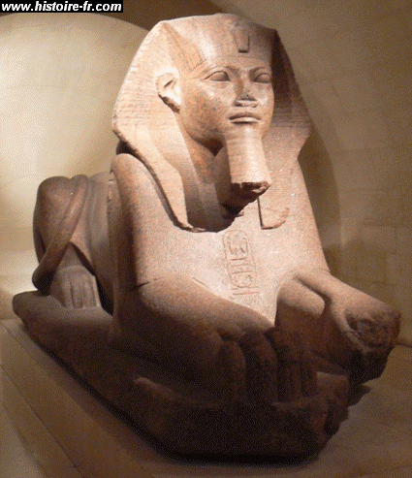
Hedjkheperre Setepenre reigned Kemet from 943 to 922 BC. He was a Meshwesh (Ancient Libyan), and founder of the Twenty-Second Dynasty.[92] According to the Bible, Sheshonk I invaded Judah, mostly the area of the Tribe of Benjamin, during the fifth year of the reign of King Rehoboam, taking with him most of the treasures of the temple created by King Solomon. This is corroborated with a stele discovered at Megiddo.[93] Rehoboam, a son of Solomon and a grandson of David, was initially king of the United Monarchy of Israel but after the ten northern tribes of Israel rebelled in 932/931 BC to form the independent northern Kingdom of Israel (Samaria), he was king of the Kingdom of Judah or southern kingdom.[94] King Omri, the father of King Ahab, reigned over the Kingdom of Israel (Samaria) from about 876–869 or c. 884–c. 872 BC. Ahab was the seventh king of the northern kingdom of Israel reigning from 874 to 853 bc. Kings Omri and Ahab ruled Samaria during Kemet’s Third Intermediate Period. Omri and Ahab’s rule corresponded to the Kemetic dynasty of Meshwesh– Libyan invaders.[95]
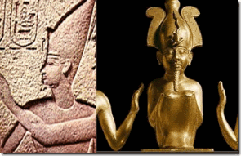
Usermaatre Setepenamun Osorkon II (872 to 837 BC) was another 22nd Dynasty Meshwesh that ruled over Kemet. Israel was a key ally of Osorkon. In a coalition with Israel and Byblos, they fought the army of Shalmaneser III at the Battle of Qarqar to temporarily halt Assyrian expansion in Canaan, the Gateway to Kemet.[96] Under Kings Omri, Ahab and 22nd Dynasty of Kemet, the Kingdom of Israel became wealthy and a major center of power, commerce, trade and influence in the Middle East. Under the power shifting alliance of Meshwesh Dynasty, the House of Omri also setup marriageable alliances with the old orders of the land, the ancient Canaanites (Sidonians–Tyrrhenians). The Canaanites and the people of Kemet were first cousins of great antiquity.[97] King Ethbaal who reigned over the city-states of Canaan, Tyre, and Carthage gave his daughter in marriage to King Omri’s son, Ahab. She became the infamous perennial “evil” queen of the bible, Jezebel.[98] Even though Queen Jezebel has been popularly characterized as a high priestess of Baal-Moloch,[99] her official seal tell a totally different story. From her official seal, it is clear that Queen Jezebel was connected to the ancient bloodlines of the Theban/Osiris- Isis-Horus royal houses. Her winged sphinx/lioness has the Isis/Hathor Crown, and holds the ancient Ankh, a sign of life and the “Pathway into the Mystery Systems.”[100]
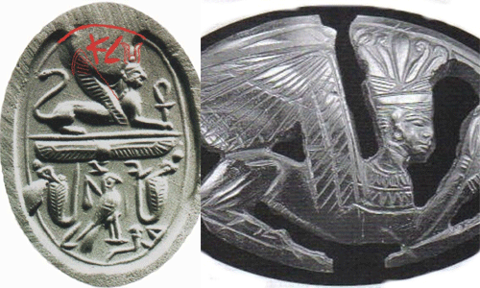
Queen Jezebel’s seal a winged sphinx similar to the Great Theban Hero Queen Tyre. Queen Jezebel has a winged sun– a symbol associated with Kemetic divinity, royalty and power.[101]
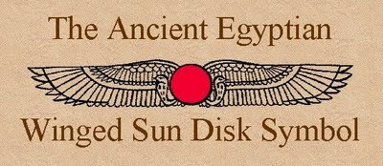
It also has the classic falcon (Horus) bordered by two cobras (uraeus) another extremely important symbol of Kemetic royalty. The falcon sits atop of a lotus symbol- water lily, an ancient death and resurrection symbol of God Osiris.[102] King Ahab’s arranged marriage with Queen Jezebel didn’t just seal a political alliance between the Kingdom of Israel and the Canaanites. It was a secret backdoor “Pathway to the Mysteries”; and a clandestine bloodline between the Royal Houses of Kemet and the foreboding ancient and classical enemies of Kemet- the Habiru.
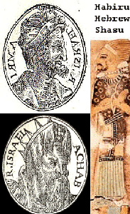
Kings Omri, Ahab & the Hebrew/Habiru
The Habiru were the nomadic or semi-nomadic invaders, rebels, outlaws, raiders, and mercenaries that had plagued the peace and security of the region, outposts and trade routes of Kemet for generations.[103] From artifacts discovered from Omri and Ahab’s palace in Samaria, it can be established that they were in privities with Kemet’s Osiris-Isis-Horus Mystery Schools.[104] Omri and Ahab’s Palace of Ivories, “Evidence more significant comes from a construction of Samaria identified by its excavators as Ahab’s Palace of Ivories.
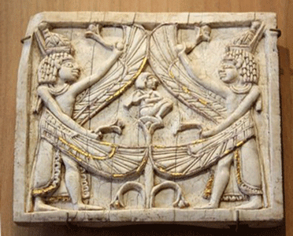
This is an odd ivory plague found at the ivory palace plainly illustrates that King Ahab had indeed been initiated secretly into a Kemetic Mystery School. The plague depicts a subject, most likely King Ahab, being born or re-born as the infant God Horus holding a flail (Kemetic Symbol of Royal Power) on a lotus flower out of watery “Chaos”. He is flanked by twin winged pharaohs giving him the breath of life from sacred lotus flowers, and protecting him adored with the double crown, Deshref– Red Crown of Lower Kemet, and Hedjet- White Crown of Upper Kemet.
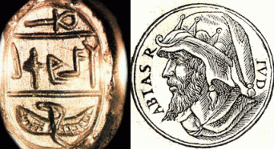
King Abijah of Judea (913-911 AD), above, the forth king of the House of David along with the House of Omri , was also deeply involved in getting the upper hand in secret Kemetic mysteries (Ankh) and the occult around the winged serpent (Wedjet).

Wedjet, “the Risen One”, is the symbol of royal power, vested in the sun on the cosmic plane and in the Kemetic sovereign in the mundane world; hence uraei encircle the solar disk atop the heads of deities channeling the solar potency and adorn the pharaoh’s headdress.
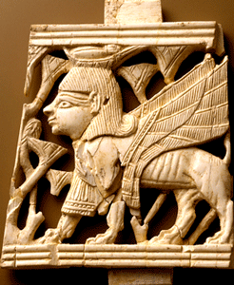
Ivory Palace, King Ahab- Kemetic Sphinx
Many of the artistic designs are Egyptian, and some of the symbolism involves the uraeus, sometimes winged. A representation of the divine child Horus was there with erect uraei in his crown. Uraei crowned with solar disks came to light, and a representation of a human brow was uncovered donned with a standing uraeus. As in Egypt, uraei are erected on the top of a wall, a door, or a piece of furniture. A uraeus with one wing raised and one lowered was standing on a papyrus blossom. An ivory handle in the form of a winged uraeus wearing the double crown came from the floor of Ahab’s courtyard. In summary, Israel was acquainted with the symbol of the winged serpent and, apparently incorporated it into its royal symbolism.” WINGED SERPENTS IN ISAIAH’S INAUGURAL VISION, Karen Randolph Joines [105]
The winged serpents (Seraphim) are Kemetic symbols of sacral and regal sovereignty. A pyramid text states that the pharaoh is guarded by the uraeus-serpent, “the living,” which comes from the head of Re.”[106] In “The Prophecy of Nefer-Rohu” it is said of the Pharaoh, “The uraeus-serpent which is on his brow stills for him the treacherous of heart.” The Kemetic word for uraeus is the hieroglyphic determinative of “KING.”[107]
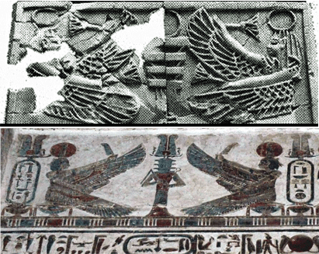
King Ahab’s Ivory Palace also had a djed, top above. The djed symbol is one of the more ancient and commonly found symbols in Kemetic mythology. It is a pillar-like symbol in hieroglyphics representing stability. It is associated with God Osiris. It is commonly understood to represent his spine protected by Goddesses Isis and Nephtys.
During the reign of the Meshwesh – Libyans in Kemet, Omri and Ahab, the Kings and High Priests of Samaria, clearly gained unprecedented access to Kemetic Temples, libraries and Schools of Mysteries; and bloodlines. In the analyses of misinformation and disinformation, as a general rule up to 80% of it may be based on true facts. If the Society of Ormus proves to be disinformation and misinformation, King Omri and Ahab’s secret Samarian mystery schools predates Pythagoras by about 200 years, and the Society of Ormus by at least 800 years. [108]
The teachings of Pythagoras indicate that he was thoroughly conversant with the precepts of New World Oriental and Occidental esotericism out of Kemet developed by King Solomon and the Samarian House of Omri He traveled among the Jews and was instructed by the Rabbis concerning the secret traditions of Moses out of Kemet, the lawgiver of Israel. [109] The House of Omri of the 10th Century BC wasn’t completely exterminated as the bible teaches. It went underground. It became another steady secret stream of sacred knowledge out of Kemet led by one of its born Tyrrhenian partners, Pythagoras. Before he went into Kemet, Pythagoras went to Sidon, where he was initiated into the mysteries of Tyre and Byblos.[110]
Pythagoras along with clandestine-underground high priests and prophets of Samaria filtered a perverted form of the Osiris-Isis-Horus Mystery Schools into Europe- particularly France and Old Briton that formed the basis of the Plantagenet/Merovingian ILLUMINATI bloodlines.
Satanic Jay’s MAGNA CARTA: the House of Plantagenet, and the Demonic Puppets of the ILLUMINATI
Now that you have some uncommon background details and information behind the Magna Carta and Holy Grail, take another look at Satanic Jay’s Magna Carta, Holy Grail through another perceptive. Satanic Jay and his new album “Magna Carta, Holy Grail”, as well as his mysterious mentors’, Markus Rodrique De Richmond and Tata Engo‘s mass disinformation campaign and ILLUSIONS chose, in particular, to began with Henry II and the House of Plantagenet.
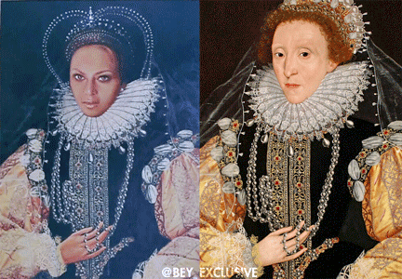
“Bow Down [black] Bitches”, Demonic Beyonce channels One of the World’s Greatest Racial Mass Murderer, the Satanic Witch Queen Elizabeth I
It isn’t an coincidence or the draw of the cards that out of all the subjects in the world that Jay Z like Demonic Beyonce go all the way back to Old Briton to choose his specific subject “Magna Carta Holy Grail” and the House of Plantagenet to create disinformation and ILLUSIONS around. Basically, the House of Plantagenet can generally be identified as four distinct Royal Houses: Angevins, Plantagenet, Lancaster and York. Henry II became the first Plantagenet King of England.[111]
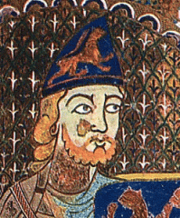
Plantagenet was not a family surname per se. The origin of the name is shrouded in mystery. It was first asserted as a nick name for Henry II’s father, a red-headed warlord named Geffrey, Count of Anjou of France. The count became known as Geffrey Plante Genest (1113-1151 AD) when he married Empress Matilda daughter of Henry I, King of England.[112] Geffrey’s father was Fulk the Younger, born 1092—died November 1143, Acre, Palestine [now ʿAkko, Israel, Count of Anjou and Maine as Fulk V (1109–31) and King of Jerusalem (1131–43) under the Knights Templar.[113]
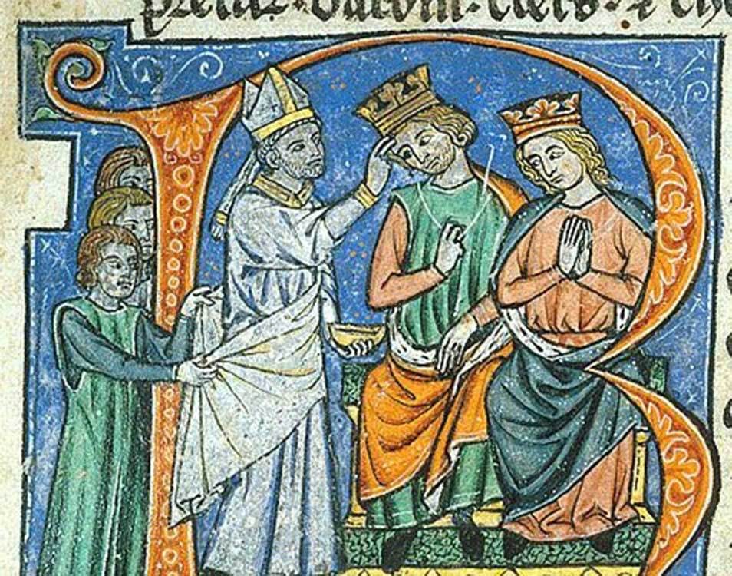
In 1247, Emperor Baldwin II (who helped establish the Templars in Jerusalem) exchanged pieces of the Shroud of Turin with the Abbey of Vizelay for the purported body of Mary Magdalene. A secret tradition states that the Magdalene was Jesus’ wife and bore Jesus‘ offspring to Southern France. There she revered as a medium of occult revelation. –Graham Hancock, the Sign and the Seal
The true origin of Plantagenet is rather simple, Plant. As the King of Jerusalem, warlord Fulk V, above , married Melisende, Heir of Baldwin II– former King of Jerusalem, then set her aside when he became the possessor of Emperor Baldwin II’s keys to the secret Israeli- Osiris-Isis-Horus Mystery Schools created by King Solomon and King Omri of Samaria. In the Kemetic Mystery Schools, Osiris was the god of the ivy Plant that became symbolic and sacred of him because of the fertility issue and he was immortal. When his jealous brother, God Set, cut him in pieces and hid his body parts all over the world, Goddess Isis found all but one of the body parts by following a trail of the ivy plant. Wherever Osiris’ body parts touched the earth, the ivy grew that probably led to the myth that all the places Osiris visited, he planted ivy. [114]
The ivy is known as a “shooting vine.” It shoots in all directions.[115] Geffrey planted (generative powers of the hairy shoot- abundance, fertile) the seed of the Plantagenet Royal Dynasty of England starting with King Henry II, father of John I of the Magna Carta moment.[116]
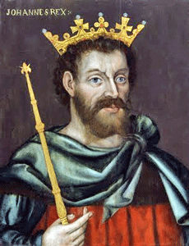

King John I and the John Gesture
According the infamous former Prime Minister of England, Winston Churchill, he said in A History of the English-Speaking Peoples; “[w]hen the long tally is added, it will be seen that the British nation and the English-speaking world owe far more to the vices of John than to the labours of virtuous sovereigns”.[117] Historians have concluded that the “Magna Carta” revolutionized England from a country ruled by Druidism, feudal tributes and warfare to a sophisticated justice system that defined and underpinned the King’s power, duties and prerogatives.[118] However, the House of Plantagenet power and fortunes were deeply rooted, interwoven and intertwined with founding bloodlines of the Knights Templar that were particularly beneficiaries of the “Magna Carta” moment. Magna Carta (Latin for Great Charter) was basically the first document forced onto a King of England by a group of powerful subjects, the feudal barons- Knights Templar, in an attempt to limit the king’s powers, to protect and preserve the Knights’ power, belief system (Baphomet), monetary interests, spiritual and embolden their political rights.[119]
From that point of view, the Holy Grail, some have reason to believe that the true meaning of the Grail legends: the Holy Grail, in French Saint Graal, was in fact the Sang Réal, which in Medieval French means “Holy Blood”, i.e. the blood of Jesus Christ [John the Baptist] himself flows in the veins of the Merovingians.[120] When we discuss the House of Plantagenet and Merovingian bloodlines of the ILLUMINATI it is the original Grail Knights of the Templar that invaded Palestine to re-establish its original mystery schools and temples.
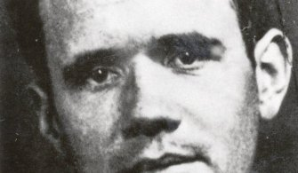
As a side note, I understand now why the late career criminal Jean Genet, 12 Years a Slave Director Steve McQueen’s major influence, fit in the picture and why it was so important for the Grand Master of the Priory of Sion, Jean Cocteau, to literally pluck him out of prison. Jean Genet is a bloodline out of the original House of Planta(Genet)- Genetics.[121] Another curious note is that all the Presidents of the United States except Martin Van Buren, and including Barrack Hussein Obama are linked to Plantagenet/Merovingian ILLUMINATI bloodlines (vines) of King Henry II , Queen Eleanor and King John I.[122]
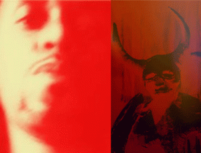
Tato Engo Signed a Blood Covenant with Lucifer
Satanic Jay and absurd and unknown revisionists- ILLUMINATI puppets, Markus Rodrique De Richmond, and Tata Engo (Voodoo Black Magick Wizard), above, formed the philosophical background of “Magna Carta, Holy Grail”. Incidentally, Tata Engo says that he signed a contract with Lucifer to obtain his Satanic Powers. [123]
The ILLUMINATI setup Jay Z, De Richmond and Tata Engo to indoctrinate and deceive the so-called Hip Hop Generation in believing that medieval models of Lucifer and Evil are connected exclusive with the “Ethiopian”, the “Black Knight“ or “The Black Man.“[124] Their references for this idiotic proposition is De Richmond’s book, “Kimbiza Santo Cristo: Return Of The Holy Grail, Knights Templar, And Grand Dragon” that contend that as a descendant of the House of Plantagenet- he has the “right information.” The right information according to Satanic Jay, De Richmond and Engo is that the ruling English monarchs and King John I were under the secret spell, influence and duress of Satanic Ethiopian West African Dynasties when the blameless Barons-Baphometic Knights Templar had to protect, assert and free their rights from the Luciferians through the Magna Carta.[125]

In Satanic Jay Zs video presentation of “Magna Carta, Holy Grail,” Justin Timberlake represents “Justice” and a poor soul tortured and held spellbound by the universal Black N***er Devil– Jay Z; and the coming of the savior of the world out of the Holy Grail- the underground stream of the Druids, Knights Templar, and the Plantagenet/Merovingian ILLUMINATI bloodlines through a new Magna Carta.
Justin Timberlake: “You take the clothes off my back And I let you You steal the food right out of my mouth And I watch you eat it I still don’t know why Why our love is so much … You curse my name In spite to put me to shame Air all my laundry in the streets Dirty or clean Give it up for fame But I still don’t know why Why I love it so much … It’s amazing I’m in this maze with you I just can’t crack the code One day you screaming you love me loud The next day you’re so cold One day you here, one day you there, one day you care You’re so unfair sipping from the cup Till it runneth over, Holy Grail…”
Satanic Jay tells the world what he is made out to be, The N***er- West African Dynasty black man- manifestations of Lucifer on Earth that have failed to Ascend, at the beginning of the video that is plaguing the rise of freedom, justice; and the messiah among the blameless and defenseless Anglo Saxons.[126]
Justin Timberlake, the Secret Druid Prince

Justin Timberlake- Secret Disneyland CIA MK ULTRA/MONARCH PUPPET
Satanic Jay’s seemingly blameless and helpless cohort , Justin Randall Timberland, out of Nashville, TN is remarkably coy and elusive about his extensively detailed prepared genealogical chart. It seems as though all of the ILLUMINATI entertainers draw up detailed “Bloodline Charts” to determine their ancient “Fama Fraternitis” hierarchical order and rank. He openly admits to being English and Scottish. He is linked with Barack Obama’s ancient white Irish-Scottish bloodlines and the grandson of John Denham Timberlake. Denham is another name for Dereham–Elias de Dereham, England (Salisbury Cathedral).
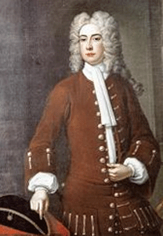
Robert “King” Carter with the John Gesture and Hidden Hand
Timberlake is linked to an early colonial 17th Century bloodline of (Francis-Richard) Timberlakes of Lancaster County, Virginia connected to the old Christ Church built by a wealthy enslaver of Africans, Robert “King” Carter. The church like Salisbury Cathedral is built with old Knights Templar/Stonehenge “sacred geometry.” During the early 17th Century, Francis Timberland married Judith Lawson, the daughter of BARON EPAPHRODITUS LAWSON out of Yorkshire, England, grandson of Sir Ralph Lawson– King James I Knight was given over 6,000 acres to settle in Virginia. Richard Timberlake was the son of Francis and Judith Lawson, the direct descendant of Justin Timberland. The Lawson and the [Richard] de Richmond Clans of Yorkshire England are related bedfellows and interconnected secret “Holy Grail” families according to Markus Rodrique de Richmond’s ‘Kimbiza Santo Cristo’. Coincidence, I don’t believe that it is. Old King Carter out of England is entombed in a courtyard beside the church with the “Skull and Bones” – the Sidonian Knights Templar. Another coincidence, I don’t believe that it is.
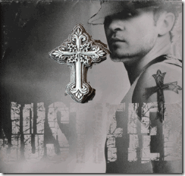
Justin ‘s cross is referred to as a “Celtic Cross”. It is also a pagan “Druid Cross” very similar to the Fortingall Cross. The cross was found in the ancient village of Fortingall, Scotland. Fortngall is shrouded in ancient history, stones and great trees. standing stones, stone circles, earth mounds dating back before 2000 BC.[127] It is an ancient Druid ceremonial site- possibly linked to an early universal electro- magnetic grid system; early 15th Century BC Kemetic cross sea Influences; and Egyptian Priests presence during the Greek and Persian occupation of Kemet.[128] Fortingall is also said to be the birthplace of Pontius Pilatus (Pilate).[129] Pontius Pilate was the fifth Prefect (Roman magisterial title) of the Roman province of Judea (Ancient Canaan) from 26-36 AD. He is best known as the judge at the trial of Jesus and the man who authorized the crucifixion of Christ. As Prefect, he served under Emperor Tiberius.[130]
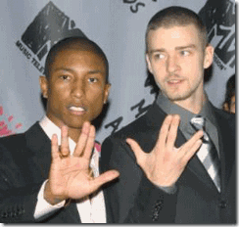
Secret Vulcan Hand Sign- Satanic Negro Rap Star Pharrell Williams and Justin Timberlake
VULCAN was/is a sun deity who was associated with fire, thunderbolts, and light. The festival in honour of him was called the Vulcania in which human sacrifices were offered. “According to Diel, he bears a family relationship to the Christian devil.’ It is fascinating to know that he married Venus, another name for Lucifer or the devil. What is even more interesting is that Vulcan is adored in Masonry under the name of Tubal Cain. In the Masonic Quiz Book the question is asked: “Who was Tubal Cain?” The answer is: “He is the Vulcan of the pagans.” In Masonry, Tubal Cain is the name of the password for the Master Mason (or third) degree.[131]

Justin Timberlake’s innocent and boyish features are designed as an ILLUSION and Image to Confuse, Deceive and Dumb Down the reality of Satanic Wickedness and Evil from Remote Times and Great Antiquity.
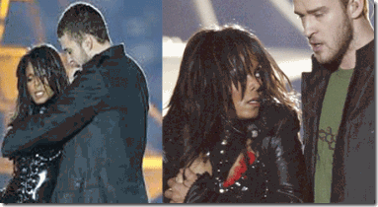
Recall that Justin Timberlake was responsible for the worldwide condemnation and demonization of Black Women in a Satanic Babylonian ritual on February 1, 2004 that deliberately disrobed and exposed Janet Jackson during the Super Bowl halftime performance. At this point, we should be very clear about how Justin Randall Timberland really stack up in the ancient Satanic/ILLUMINATI “Fama Fraternitis” hierarchy. Satanic Jay’s “Magna Carta, Holy Grail” is a very sophisticated and wicked ILLUMINATI mass population disinformation and mind control operation to deliberately dumb the public down, demonize, falsely revise and re-image the historical significance of Black People from antiquity- and particularly distance the Ethiopian contribution from the splendors of Kemet and its Osiris-Isis-Horus Mystery Schools.

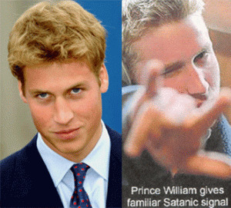
In other worlds, eliminate the Black Bloodlines of Osiris-Isis-Horus, open the door for the Coming of New Arcadia, the New False Anglo Saxon Messiah– the Anti-Christ of Revelation, Queen Elizabeth II’s Grandson, PRINCE WILLIAM.
Ethiopians- Loved by the Gods[132]
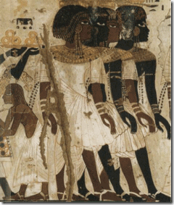
The first Europeans to employ the term Ethiopia were the ancient Greeks, who used the word to designate all dark-skinned people south of Kemet.[133] Homer, in the 9th. century BC, wrote in the Odyssey of the Ethiopians as Eschatoi Andron, or the most remote of men. In Book I of the Iliad he makes Zeus, the King of the Gods, leave heaven for twelve days, with all the other gods, to visit the “Blameless Ethiopians”, while the goddess Iris goes to their country to participate in sacrificial rites to the immortal gods. In the Odyssey, the Sea God Poseidon is likewise said to have “lingered delighted” at one of the Feasts of the Ethiopians.[134] Later again, in the 1st Century BC, the Greek historian Diodorus Siculus observed that the Greek hero Hercules and the Greek god of wine Bacchus [Dionysus-Apollo [135]] were both “awed by the piety of the Ethiopians– Loved by the Gods.”[136] Furthermore, modern scholars such as W.E.B. DuBois, Chancellor Williams, Cheikh Anta Diop, John G. Jackson, Ivan van Sertima, Martin Bernal, Segun Magbagbeola and Ashra Kwesi wouldn’t have any problem disagreeing with the French Egyptologist Gaston Maspero (1846-1916) who said that “by the almost unanimous testimony of ancient [Greek] historians, they [Ancient Egyptians] belonged to the African race, which settled in Ethiopia.”[137]
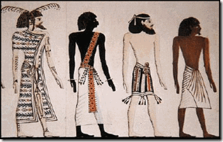
From the Tomb of Seti I, Four Peoples of the World, Syrian, Nubian, Libyan, Egyptian[138]
They wouldn’t disagree with the Greek Historian Diodorus Siculus (between 60-30 BC) that mentioned that the Ethiopians considered the Egyptians a colony.[139] Africans have had a long and complicated history throughout the history of Europe for at least the last 50,000 years. Sure enough, the Africans and Black Islamic Moors and Saracens invaded Europe and Old Briton. However, in most cases, they are known to have carried and spread civilization among the European hordes that brought them out of the dark ages and perpetual war, barbarism, paganism– devil worship, human sacrifices and superstitions. The state of Black History among Anglo Saxon nations is presently something like what the late Dr. Ivan Van Sertima talked about Black People being similar to a great shattered star with pieces all over the planet, but whose history is persistently stolen, hidden, denied and scandalized.
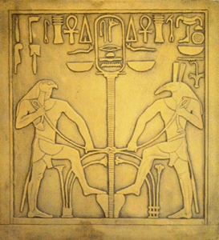

From the days of the Hyksos invasion of Kemet during the 11th Dynasty, there has been a constant struggle to secretly upset mankind’s gentle universal natural balance (MAAT) by the forces of God Set-Seth (EVIL), the evil slayer brother of Osiris (GOOD), the enemy of Horus– the patron god adopted by the Hyksos.[140]
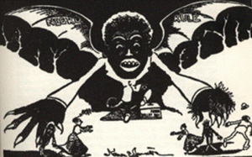
History does not support putting Global Satanism and Black Devils menacing mankind on the doorstep of the Black Masses. This is the case with the ILLUMINATI black goon Satanic Jay’s “Magna Carta, Holy Grail.” It recognizes the presence of black influences in Early Western Europe, but totally scandalizes, distort, re-write and re-image their true contributions to mankind to veil a secret Imperium/ILLUMINATI policy and campaign of global GENOCIDE against People of Color.
Queen Elizabeth II said, “This dragon gives you your power, your throne and your own authority.”
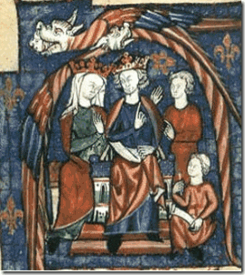
Plantagenet King Henry II and Mother of the Plantagenets, Queen Eleanor, clearly demonstrate the source of their power with the infamous John Gesture– I AM (DRAGON- SATAN). It is the DRAGON below that the Plantagenet/Merovingian ILLUMINATI bloodlines draw their power, throne and authority that has absolutely nothing to do West African Dynasties or Ethiopians.

Let’s straighten up the Plantagenet winged dragon up on two feet- From a series of secret English Satanic 16th Century wood carvings,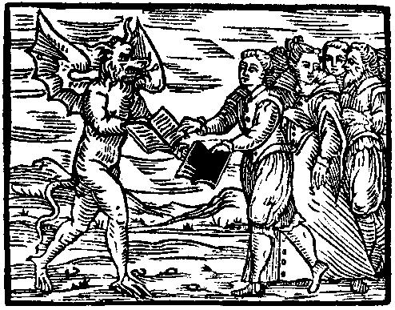In this carving, English subjects secretly turn over their Christian book of salvation to Satan for a book of Demonology/Spells. 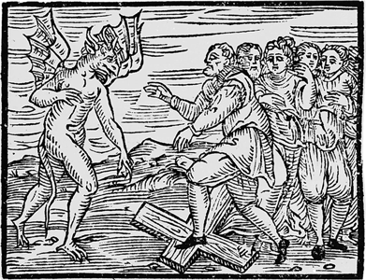Satan commands them to trample on Christ’s Cross.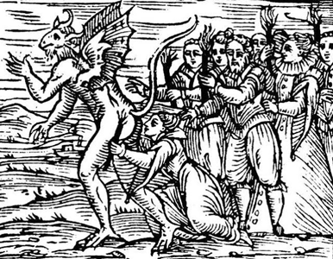They literally eat Satan’s shit and lick his Ass.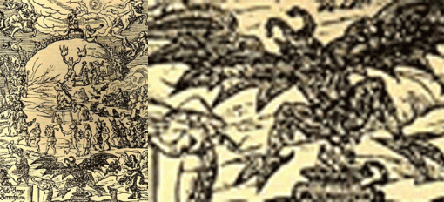This starling 16th Century German wood carving details a secret pagan satanic rite to a winged dragon that looks as if it is decaying on an altar. Now, let’s put Satan back on all fours again in 21st Century England.
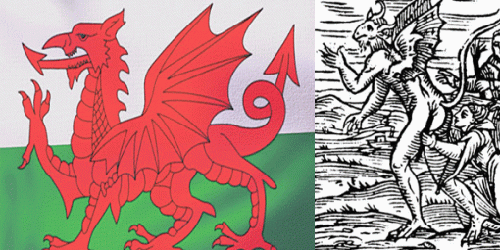In 1959, Queen Elizabeth II made the red dragon on a green (on earth) as it is today the official flag for Wales.
Throughout the ages, The secret Samarian/Plantagenet/Merovingian ILLUMINATI bloodlines have persistently fought and conspired against the “Divine Ancient Theban Houses of Kemet” to capture all of the treasures and “Splendor of Kemet” that still fascinates the world without the tens of thousands of years of the divine balance and knowledge of the gods, universe and sciences.
The source of the “Splendor and World Wonder of Kemet” still elude them, deceptions, re-imaging, ILLUSIONS and the attempted wholesale slaughter and GENOCIDE of the Bloodlines of Horus (Ethiopians) will lift the Veil of Aset (Isis) to give them the THRONE.
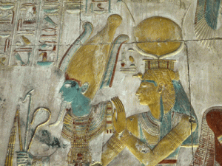
For it was written on her Temple at Sais: “I AM- everything that has been, that is, and that shall be: and my veil no man hath raised.”

[1] http://theforbiddenknowledge.com/symbology/1o5.htm [2] http://theforbiddenknowledge.com/symbology/1o5.htm [3] http://www.azlyrics.com/lyrics/jayz/heaven.html [4] http://www.innocentenglish.com/movie-quotes-database/movie-quote-database-free/movie-quotes-from-jfk.html [5] http://en.wikipedia.org/wiki/Chiwetel_Ejiofor [6] http://en.wikipedia.org/wiki/Michael_Fassbender [7]http://en.wikipedia.org/wiki/Lupita_Nyong%27o [8]http://insidemovies.ew.com/2013/12/16/critics-choice-awards-nominations/ [9]http://www.latimes.com/entertainment/envelope/moviesnow/la-et-mn-golden-globes-nominations-main,0,4163377.story#axzz2nf5MWIrd [10] http://www.theguardian.com/music/2013/dec/09/jay-z-leads-grammy-awards [11] http://www.whale.to/c/exposing_the_works_of_satan.html [12] http://blogs.wsj.com/speakeasy/2013/06/16/samsung-to-give-away-1-million-copies-of-jay-zs-new-album/ [13] http://www.atimes.com/atimes/Korea/MC16Dg02.html [14] http://www.brianwillson.com/the-unknown-truth-about-korea-u-s-sanctioned-death-squads-and-war-crimes-1945-1953/ [15] http://seeker401.wordpress.com/2013/12/15/introducing-the-wallenberg-family/ [16] http://www.thebabylonmatrix.com/index.php?title=911:Knights_of_Malta [17] http://www.redicecreations.com/article.php?id=354 [18] http://forum.prisonplanet.com/index.php?topic=105124.0 [19] Id. [20] Id. [21] Id. [22] Id. [23] http://wallenbergfraud.wordpress.com/2011/03/27/the-wallenberg-fraud/ [24] http://spitfirelist.com/for-the-record/ftr-671-update-on-the-meltdown-part-4-germany-the-underground-reich-and-the-global-financial-crisis/ [25] http://groups.yahoo.com/neo/groups/ctrl/conversations/topics/119796?source=1&var=1 [26] http://en.wikipedia.org/wiki/Bilderberg_Group [27] http://en.wikipedia.org/wiki/Sturmabteilung [28] http://www.wileyforum.com/Nazi-Roots-Windsor-Cabal.html [29] Id. [30] http://www.gnosticliberationfront.com/bilderbergers.htm [31] http://en.wikipedia.org/wiki/The_Templar_Revelation [32]http://www.gnosticliberationfront.com/bilderbergers.htm [33] http://www.gnosticliberationfront.com/bilderbergers.htm [34] http://www.redicecreations.com/article.php?id=354 [35] http://www.redicecreations.com/article.php?id=354 [36] http://en.wikipedia.org/wiki/Frederick_I_of_Sweden [37] http://trianglebook.weebly.com/illuminati.html [38] http://www.universetoday.com/11259/the-north-star-is-really-three-stars/ [39] https://duckduckgo.com/1/c/Recipients_of_the_Order_of_the_Seraphim [40] http://www.deliriumsrealm.com/seraphim/ [41] http://en.wikipedia.org/wiki/List_of_titles_and_honours_of_Queen_Elizabeth_II [42] http://en.wikipedia.org/wiki/The_Templar_Revelation [43] http://magdelene.wordpress.com/2007/04/01/basic-sethian-christian-history/ [44] http://www.dacb.org/stories/egypt/apollos_.html [45] http://magdelene.wordpress.com/2007/04/01/basic-sethian-christian-history/ [46] http://www.metmuseum.org/collections/search-the-collections/198644 [47] http://www.metmuseum.org/collections/search-the-collections/198644 [48] http://en.wikipedia.org/wiki/Diana_(mythology) [49] http://en.wikipedia.org/wiki/Arethusa_(mythology) [50] http://en.wikipedia.org/wiki/Nereus [51] http://en.wikipedia.org/wiki/Alpheus_(mythology) [52] http://en.wikipedia.org/wiki/Salisbury_Cathedral [53] http://www.aniwilliams.com/magdalena.htm [54] http://salisburycathedral.wordpress.com/the-clerical-round-table/ [55] http://salisburycathedral.wordpress.com/the-clerical-round-table/ [56] http://salisburycathedral.wordpress.com/the-clerical-round-table/ [57] Id. [58] http://www.terrorism-illuminati.com/round-table#.Ur5G5PRDvHg [59] Id. [60] http://en.wikipedia.org/wiki/Pythagoras [61] http://mythindex.com/greek-mythology/A/Ancaeus.html [62] http://en.wikipedia.org/wiki/Eurynome_(Oceanid) [63] http://en.wikipedia.org/wiki/Samos [64] http://en.wikipedia.org/wiki/Polycrates [65] http://www.sacredscience.com/pythagorasselections.htm [66] http://en.wikipedia.org/wiki/Pythagoras [67] http://9waysmysteryschool.tripod.com/sacredsoundtools/id13.html [68] http://9waysmysteryschool.tripod.com/sacredsoundtools/id13.html [69] http://en.wikipedia.org/wiki/Pythagoras [70] http://en.wikipedia.org/wiki/Pythagoras [71] http://en.wikipedia.org/wiki/Temple_of_Edfu [72] http://www.meandertravel.com/samos/samos.php?details=samospythagoras [73] http://en.wikipedia.org/wiki/Delphi [74] http://www.thefreedictionary.com/Python [75] http://www.rhedesium.com/francis-bacon–the-lsquorsquorsquolsquoaarsquo.html [76] http://watch.pair.com/new-age.html [77] http://en.wikipedia.org/wiki/Pan_(god) [78] http://www.rhedesium.com/francis-bacon–the-lsquorsquorsquolsquoaarsquo.html [79] http://watch.pair.com/capricornus.html [80] http://en.wikipedia.org/wiki/Pierre_Plantard [81] http://en.wikipedia.org/wiki/Alfeios [82] http://en.wikipedia.org/wiki/Eleanor_of_Aquitaine [83] http://esoterism.ro/english/prieure-%20sion.php [84]http://www.gutenberg.org/files/39701/39701.txt [85] http://www.aolib.com/reader_19584_17.htm [86] http://www.britannica.com/EBchecked/topic/455720/Pherecydes-of-Syros [87] http://www.redicecreations.com/article.php?id=348 [88] Id. [89] Id. [90] Id. [91] http://www.sacred-texts.com/eso/sta/sta15.htm [92] http://en.wikipedia.org/wiki/Shoshenq_I [93] http://en.wikipedia.org/wiki/Shoshenq_I [94] http://en.wikipedia.org/wiki/Rehoboam [95] http://www.abibitumikasa.com/forums/showthread.php/36737-Dynasties-of-Kemet [96]http://en.wikipedia.org/wiki/Shoshenq_I [97] http://blacksinthebible.net/Hagardoc.htm [98] http://en.wikipedia.org/wiki/Jezebel [99] http://womeninthebible.net/Jezebel_her_world.htm [100] http://www.secretoftheankh.com/ [101] http://en.wikipedia.org/wiki/Winged_sun [102] http://www.houseofgold.blog.com/2011/12/20/queen-nefertiti-sealed-as-jezebel/ [103] http://en.wikipedia.org/wiki/Habiru [104] http://bibleencyclopedia.com/ahab.htm [105] http://www.godawa.com/chronicles_of_the_nephilim/Articles_By_Others/Joines-Winged_Serpents_In_Isaiahs_Inaugural_Vision_Seraphim.pdf [106] Id. [107] Id. [108] http://www.sacred-texts.com/eso/sta/sta15.htm [109] http://www.sacred-texts.com/eso/sta/sta15.htm [110] http://9waysmysteryschool.tripod.com/sacredsoundtools/id13.html [111] http://en.wikipedia.org/wiki/House_of_Plantagenet [112] http://en.wikipedia.org/wiki/Geoffrey_Plantagenet,_Count_of_Anjou [113] http://www.britannica.com/EBchecked/topic/221792/Fulk [114] http://www.squidoo.com/flowers-in-folklore-ancient-egypt [115] http://www.ehow.com/how_8275631_replant-off-shooting-ivy-vine.html [116] http://newsgroups.derkeiler.com/Archive/Soc/soc.genealogy.medieval/2006-02/msg00703.html [117] http://en.wikipedia.org/wiki/House_of_Plantagenet [118] http://en.wikipedia.org/wiki/House_of_Plantagenet [119] http://en.wikipedia.org/wiki/Magna_Carta [120] http://www.cesnur.org/2004/mi_davinci_en.htm [121] http://www.truedemocracy.net/hj37/11.html [122] http://www.dailymail.co.uk/news/article-2183858/All-presidents-bar-directly-descended-medieval-English-king.html [123] http://www.tataengo.com/ [124] http://www.topix.com/forum/afam/TO408D5RPJLCJ4856 [125] http://www.topix.com/forum/afam/TO408D5RPJLCJ4856 [126] http://browse.feedreader.com/c/Press_Release_Print/568074898 [127] http://www.thecrypt.net/celts/Fortingall.html [128] http://www.sacredconnections.co.uk/holyland/fortingallyew.htm [129] http://www.sacredconnections.co.uk/holyland/fortingallyew.htm [130] http://en.wikipedia.org/wiki/Pontius_Pilate [131] [132] http://www.meskot.com/Ethiopia_RP.htm [133] http://www.meskot.com/Ethiopia_RP.htm [134] http://www.meskot.com/Ethiopia_RP.htm [135] http://en.wikipedia.org/wiki/Dionysus [136] http://www.meskot.com/Ethiopia_RP.htm [137] http://en.wikipedia.org/wiki/Black_Egyptian_Hypothesis [138] http://www.catchpenny.org/race.html [139] http://en.wikipedia.org/wiki/Black_Egyptian_Hypothesis [140] http://www.jewishvirtuallibrary.org/jsource/judaica/ejud_0002_0009_0_09361.html [141] http://www.topix.com/forum/afam/TO408D5RPJLCJ4856 [142] http://9waysmysteryschool.tripod.com/sacredsoundtools/id13.html
Comments : 16 Comments
Tags: 12 years a slave, alpheus, André Oscar Wallenberg, anti christ, apollo, arcadia, arethusa, Baphomet, Beyonce, bloodlines, CIA, Count of Anjou, cross of lorraine, crusades, djed, druids, egypt, Eleanor of Aquitaine, Elias de Dereham, emperor baldwin II, enskilda bank, Epaphroditus lawson, ethiopians, Fama Fraternitis, FOURTH REICH, freemasons, fulk v, Geffrey, grail kings, habiru, heliopolis kemet, helios, heloipolis, hip hop satanic cult, holy grail, horus, Illuminati, isis, jacob wallenberg, janet jackson, jay z, jean genet, jean platard, jezebel, johannites, john gesture, john the baptist, Justin Timberlake, kemet, kimbiza santo cristo, king ahab, king henry II, king john i, king of jerusalem, king omri, King Rehoboam, kingdom of israel, Knights of the Black Sun, Knights of the Order of the Garter, Knights of the Royal Order of the Seraphim, knights templar, Kurt cobain, lee kun hee, Leonardo da Vinci, Lucifer, luciferians, Mae Brussell, magna carta, marcus wallenberg, Markus Rodrique De Richmond, Merovingian, mind control, MK-ULTRA, Monarchs, nephtys, nicolas poussin, nirvana, Osiris, Osorkon II, pan, pharrell williams, pierre plantard, Plantagenet, prince bernard, prince william, project safehaven, pythagoras, Pythagoreanism, queen elizabeth II, red dragon, red dragons, Reichsleiter SS Martin Bormann, richard the lionheart, robert king carter, sacred gemometry, salisbury cathedral, Samaria, samsung, Set, Seth, Sethian Christianity, Sethian Gnosticism, sir francis bacon, society of ormus, stonehenge, tata engo, uraeus, wedjet
Categories : african holocaust, African slavery, allen dulles, Apollo, arcadia, Aryan Supremacy, aset, ashur, baal, baphomet, Barack Obama, beyonce, black christianity, Black messiah, blood covenants, blood oaths, christianity, CIA, druids, egypt, False Satanic Rites of Lost Negroes, genesis, Hip Hop, HIP HOP false prophets, hip hop satanic cult, holy grail, Horus, illuminati, imperium, Isis, Janet Jackson, jay-z, john foster dulles, john the baptist, Knights of the Black Sun, Knights Templar, luciferians, mind control, MK-ULTRA, Molech, Moloch, monarch child, monarch program, new world order, nwo, pan, prince william, psychological warfare campaign against Christianity, queen elizabeth, Queen Mother Tiye, racial mass murder, re-image, re-imaging, Reichsfurhrer SS-1 Heinrich Himmler, reinhard gehlen, revelations, rose and cross, Rose-Croix, Rosicrucian, Rosicrucianism, rosy cross, SASHA FIERCE, Satanism, set, seth, skull and bones, Sweden, underground reich, underground third reich, Walt Disney, wyvern

12 YEARS A SLAVE, TRAYVON MARTIN, ILLUMINATI & HER MAJESTY SECRET SERVICE
26112013
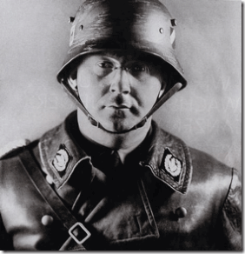
“We have only one task, to stand firm and carry on the racial struggle without mercy.” –Reichsfuhrer SS-1 Henrich Himmler[1]
Her Majesty, The Caliban Complex, ILLUSIONS, SMOKED MIRRORS
Since the European invasion of America (New Atlantis), the United States has been bonded at the hip with its twisted cousin Britain secretly governed in Paganism, Rosicrucian Luciferian Conspiracies, and suppression of acknowledgement of its unprecedented Trans-Atlantic Slave Trade and the African MAAFA, the Single Greatest Crime Against Humanity known to mankind.
MAAFA is a term used to describe the unique history and on-going effects of atrocities inflicted on African People. The MAAFA includes the Arab and European cross Atlantic criminal aggression and enslavement of Africans in violation of their human and natural rights, and the continued imperialism, colonialism, and other forms of oppression and aggression inflicted upon Black People to the present day.
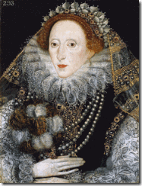
Queen Elizabeth I with a Pre- Masonic Druid Dragon Hand
During the 16th Century, the Luciferian-Rosicrucian Witch Queen Elizabeth I of England initiated Britain’s massive cross-Atlantic Slave Trade.
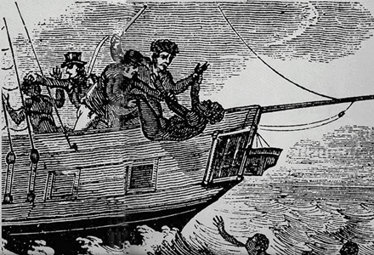
It is estimated that more than 100 million African people died as a result of MAAFA (Middle Passage) between Africa, England and the Americas. Yet, there is no day in America or Europe designated to honor Africans who suffered or condemnation of the criminals-criminal states and institutions involved in the Greatest Crime Against Humanity.
London Punch, September 13, 1963
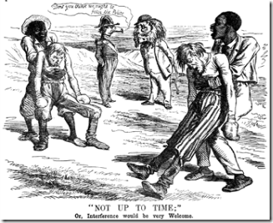
During the Great Civil War, Rosicrucian Masonic Witch, Her Majesty Queen Alexandrina Victoria, was part of a plot for England and France to intervene in the war on behalf of the South to keep 4 million Black People enslaved in America. She led Britain’s Masonic fraternity at the time. Her father had been the last Master Mason of the “Ancients” in England. Her son, Edward VII, only became Grand Master of the United Lodge of England in 1875.
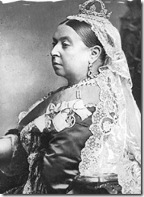
When her father, Prince Edward, Duke of Kent, died in 1820, he was the Grand Master of the the Ancient Free and Accepted Masons. Prince Edward had made it clear that he wanted his daughter to be what he was, and to be- the Sovereignty (King) of England. Queen Victoria appointed herself the Royal Patroness of the Masonic Fraternity in the British Empire. During the Great Civil War crisis, she secretly amassed 11,000 troops in Canada preparing to invade the North. France and Spain had amassed a combined 30,000 troops in Mexico. Queen Victoria and England threaten to spark the World’s First Global War to keep Africans in a state of perpetual servitude.
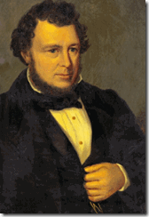
WANTED: Confederate Secretary of State Judah Benjamin with the Klan’s Devil’s Claw
After President Abraham Lincoln was assassinated in 1865, Masonic Confederates General Albert Pike and Secretary of State Judah P. Benjamin, heads of the Knights of the Golden Circle (KGC), were wanted as key co-conspirators in the president’s death. Benjamin escaped the country and fled to England. After the Civil War, the KGC waged guerrilla warfare against America to force it back to a Slavery State. The Masonic Queen Victoria shielded and hired Benjamin as her legal consultant.
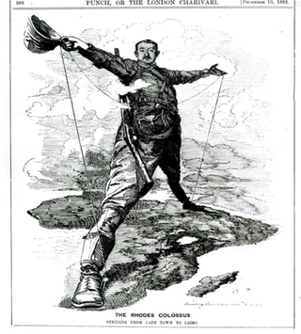
By 1899, the British Empire under Her Majesty Queen Victoria and Master Freemason Cecil Rhodes had forcibly dispossessed the Zimbabwean people of about 16 millions of acres of land in a massive land grab where about 1/6 of the country had been taken by force and deception for mining and speculation operations.
During the Second Boer Wars (1899-1902), the British Empire setup about 66 concentration camps (Hitler’s Blueprint) for Africans in South Africa. These camps held about 115,000 people where about 20,000 mostly women and children were slain or starved to death.
In this backdrop of the British Empire’s persistent record of inhumanity to man, the 2012 Summer Olympic Games in London, Witch Queen Elizabeth II (Royal Patroness of the Grand Lodge of England) and the British Crown celebrated MAAFA, savagery and its Great Crimes Against Humanity unlike anything seen by a so-called civilized sovereign nation in the 21st Century.
At the Olympic Games, the Crown displayed a night pomp that was reminiscent of the Third Reich’s spectacular and spellbinding Nuremberg night rallies celebrating “Aryan Supremacy”.
The British State sponsored 2012 Summer Olympic Games in London was shockingly a showcase of brazen Rosicrucian-Masonic-Occult and Pagan Celebration of Colonial Anglo-Saxon Supremacy pageantry. The 2012 Summer Olympic Games opened with one of old Britton’s medieval classical and symbolic ILLUSION of African and Black nations, CALIBAN.
London Punch, January 24, 1863- American Sambo-CALIBAN
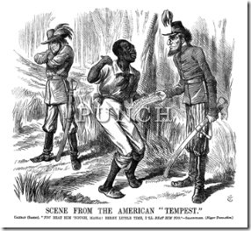
CALIBAN is a grand ILLUSION and SMOKED MIRROR, a SAMBO caricature representation of African and Black nations that the British Crown barbarously and by deception enslaved, colonized, oppressed and mass murdered.

CALIBAN is a black beast of burden, the offspring of the Devils and Witches. In the Tempest, CALIBAN is a creation and invention of an English warlock, Prospero- Britain’s Prosperity, BLACK GOLD. CALIBAN spoke nonsense, “gabble like a thing most brutish.”
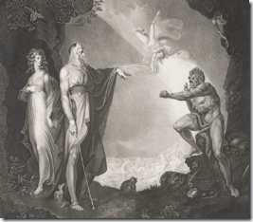
He was “a born devil, on whose nature “Nurture” can never stick”.
Her Majesty didn’t make the same mistake that Adolph Hitler made during the 1936 Summer Olympics in Berlin.
Hitler and the National Socialists (Nazis) truly believed in the Aryan Superman Myth. They really thought that they would compete fairly on a level playing field and prove in all ways superior to People of Color.
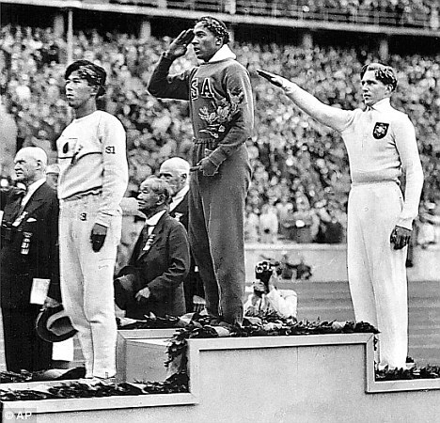
However, Jesse Owens and other athletics of color proved to the world that Aryan Superman Supremacy was an ILLUSION.
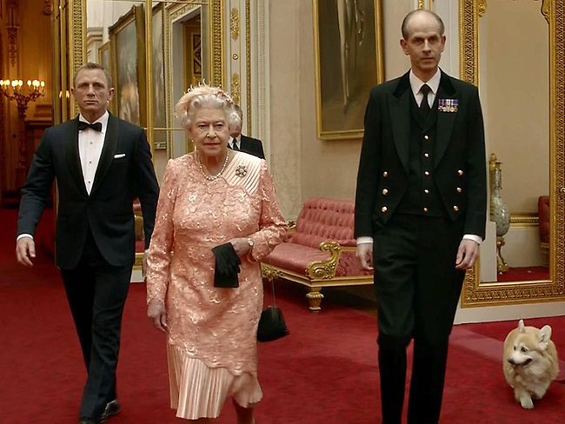
At the very initiation of the 2012 Summer Olympic Games, Her Majesty and James Bond- her Secret Service (Queen’s private army) like Hitter and the National Socialists- took over the summer games.
They flew in and then symbolically parachuted from a helicopter into the stadium like an invading army led by its divine Grand Master Queen to set things in order.
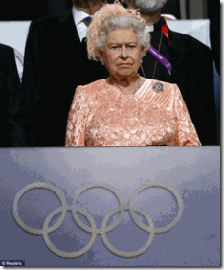
Her Majesty wasn’t there to compete with Africans and People of Color as the Nazi Fuhrer and the Third Reich had done. She allowed the People of CALIBAN to feel the air, hear the sounds of life and by nature run free in the wild. Her Majesty and Secret Service were there not to celebrate the Games of the XXX Olympiad but to impose dominance, and the order of things by the Spiritual Hierarchy of Earth of the Great White Lodge.

2012 Summer Olympic Games- CALIBAN:
“Be not afeard; the isle is full of noises.”
The White Man’s Burden


“Take up the White Man’s burden—
Send forth the best ye breed—
Go send your sons to exile
To serve your captives’ need
To wait in heavy harness
On fluttered folk and wild—
Your new-caught, sullen peoples,
Half devil and half child
Take up the White Man’s burden…”
Source: Rudyard Kipling, “The White Man’s Burden: The United States & The Philippine Islands, 1899.” Rudyard Kipling’s Verse: Definitive Edition (Garden City, New York: Doubleday, 1929).
The Clandestine Racial Psychological and Struggle against CALIBAN’S People
It was observed in the film 12 Years a Slave that the ghoulish beatings and whippings are implanted in the movie at roughly 10-to-15-minute intervals throughout a 133-minute running time.[2]
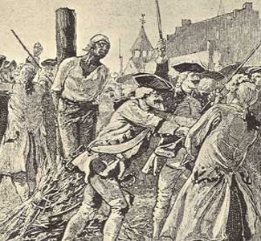
Scenes of enslaved Africans being ghoulishly burned, raped, beaten, tortured and killed caused some audience members watching to walk out of the film’s premiere at the Toronto Film Festival. The graphic and persistent inhuman and sadistic violence against enslaved Africans would arguable be a people’s demonstration of a “triumph of the human spirit.”
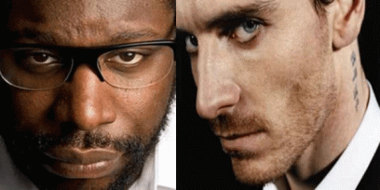
“[Enslaver Edwin] Epps was a man so evil that I imagine only Lucifer himself could have a soul any blacker. Fassbender was a monster, literally and figuratively.”[3] Both McQueen and Fassbender are Luciferian “Monsters.
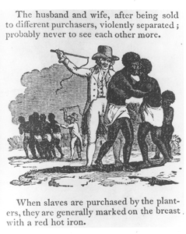
Yet, the repeated- persistent ghoulish and heartless illustration of inhumanity to man in 12 Years a Slave only serves to perpetuate the subliminal desensitization, alienation, and the continued disenfranchisement of Black people’s humanity. Constant exposure to violence and brutality creates an insensitivity to violence and brutality. It is a well known exercise in creating dissociation[s] in ritually abused mind control victims.[4]
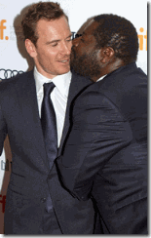
Steve McQueen demonstrates his love for Edwin Epps- Lucifer (Scottish Actor Michael Fassbender)
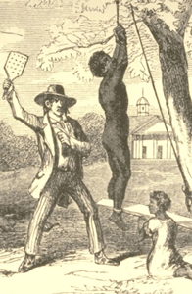
“One can only witness so many whippings, so much brutality, hear the N word so many times before one becomes somewhat desensitized to it. Over the course of more than two hours, it can start to feel a little bit like porn, both in the repetition of certain behavior (yet another beating, yet another racist tirade, yet more unbelievable disregard for human life) and in the viewer’s potentially mechanical reaction to it.”[5]
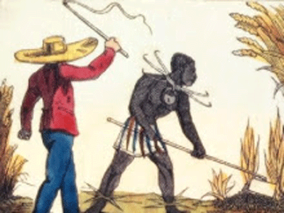
In Django Unchained, the N-WORD seemed to be the operative supraliminal-hypnotic power word repeated and implanted over a 1000 times. The films Help and the Butler, one of the key subliminal/supraliminal-hypnotic power words was SERVE, while the subliminal/supraliminal-hypnotic power words implanted over and over again in 12 Years a Slave appears to be SLAVE, MASTER, GOD, SERVE and the N- WORD.
REPEAT BLACK SLAVE, MASTER, SUBMIT, SERVE & GOD OVER AND OVER AGAIN- WITHOUT RETRIBUTION
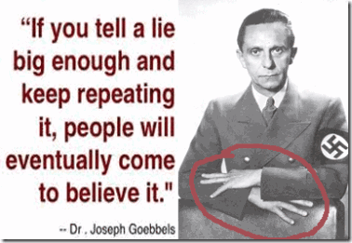
Josef Goebbels- The Secret X Wyvern’s Hand?
In clandestine military intelligence psychological warfare film projects directed at target populations, the words of the script have always been carefully selected to bring about the designed outcomes, clearly identify and demonize the ENEMY, manage perceptions, and break the hearts, minds and will of the people- SUBMIT.
The U.S. DoD defines psychological warfare as:
“The planned use of propaganda and other psychological actions having the primary purpose of influencing the opinions, emotions, attitudes, and behavior of hostile foreign [domestic] groups in such a way as to support the achievement of national objectives.”[6]
CALIBAN: Queen Elizabeth I Secret Wyvern Cult & the African MAAFA and Slavery

A Wyvern is a legendary winged creature with a dragon’s head, which may be said to breathe fire or possess a venomous bite. The wyvern in its various forms is important heraldry chiefly in the United Kingdom.[7]
The Wyverns are mentioned in Dante’s Inferno (Canto XVII) as the body for one of his creatures in hell.[8]

Sir Francis Drake’s Wyvern Stain Glass at Musbury and Coat of Arms
Wyvern is also an ancient secret military-spy order of the Queen of England. The Queen’s secret Wyvern Order was first popularly exposed during the 16th Century when Sir Francis Drake (El Drago-Satan) placed the Wyvern on his official coat of arms.
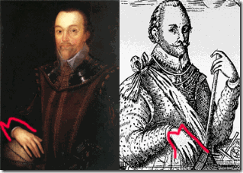
El Drago- Sir Francis Drake
The ancient secret “M” hand sign is usually associated with “Masonic”, but turn the “M” turned upside down and it’s the Queen’s secret “W”- Wyvern Cult that makes sense since the Freemasons weren’t formed at that time. The right of Sir Drake to place the Wyvern on his coat of arms was challenged as armorial usurpation. Sir Drake responded that the Wyvern (Dragon) had been granted to him by the Queen Elizabeth I; and her spy master and sorcerer Rosicrucian- Kabbbalist John Dee.[9]
In history books, Sir Francis Drake was an infamous English naval officer that helped the English Navy as second in command defeat the Spanish Amanda. As an explorer, he was first westerner that circumvented the globe, from 1577 to 1580.[10] The other part of Sir Francis Drake is the Trans-Atlantic Slave Trade. He was the cousin of the Rosicrucian sea ship captain, Sir John Hawkins, that first brought Africans to the American Colonies (New Atlantis) forced into “Chattel Slavery.” Sir Drake collaborated with his cousin and Queen Elizabeth I on sea voyages kidnapping Africans and forcing them into slavery.
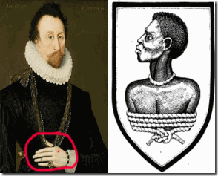
Sir John Hawkins and his Crest with a Bonded African
Sir Hawkins was gained the crest on being knighted by the Witch Queen Elizabeth 1 in 1588.
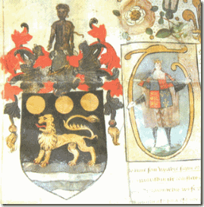
Sir John Hawkins’ Coat of Arms, Rosicrucian- So Above, So Below- the British Subjection and Oppression of Africans.
Behind the veil of the Elizabethan Court , It was a den of false prophets, mystics, witches, sorcerers, magickians, and Luciferians. They were also some of Europe’s most foremost Rosicrucian theoreticians and mis- practitioners of Kemetic Mysteries of Thousands of Years. In order to give their God Set/Lucifer room to rule, they had to bind African intellectualism and spirituality- MAAT.
Her Majesty Queen Elizabeth II’s Secret Army, the Wyvern
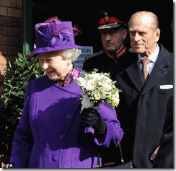
In 2010, In purple (Whore of Babylon) Queen Elizabeth II and her consort Prince Philip visited Wyvern Barracks in Exeter during a tour of Devon.[11] The Wyvern Barracks is the home of a quasi- military group and not a formal and official military base of the Officers’ Training Corps (OTC), sometimes called the University Officers’ Training Corps (UOTC).[12]

The OTC is a part of the British Territorial Army which provides military leadership training (indoctrination) to students at British universities. During periods of total war, the Territorial Army is incorporated by the Royal Prerogative into regular service. The Royal Prerogative is the privilege and power of the sovereign monarchy (Queen) alone. It is the Queen’s Secret Private Dragon Army.[13]
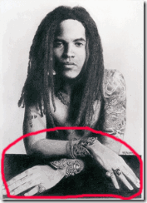
It shouldn’t be surprising that Kabbbalist- Pro-Zionist Lenny Kravitz has the Queen’s Army Wyvern’s Secret X Hand to subliminal/supraliminal implant Satanism in popular music.
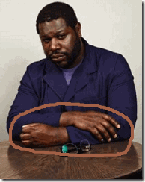
Steve McQueen, the Queen’s Army Secret X Wyvern’s Hand with the Devils Claw
You may ask how could Reichsleiter (Nazi National Leader) Josef Goebbels become part of the British Crown’s secret Wyvern- Dragon Military Order? Before Queen Elizabeth II, the head of the Wyvern Cult was Prince Edward. Edward VIII (Edward Albert Christian George Andrew Patrick David; later the Duke of Windsor (June 23, 1894 – May 28, 1972) was King of the United Kingdom and the Dominions of the British Commonwealth and Emperor of India from January 20, 1936 until abdication on December 11, 1936. Edward was the eldest son of King George V and Queen Mary. [14]
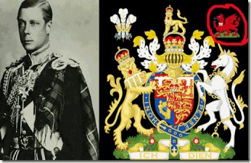
Prince Edward’s Official Wyvern Coat of Arms
King Edward VIII didn’t gave up the throne of England in order to marry his common mistress Wallis Simpson, he was “an avowed supporter of Hitler, and his wife was the personal friend of leading members of the Nazi Party, perhaps even one of their agents.”[15] King Edward VIII was also a commissioned General of the British Army. He had access to all of Britain’s war plans and foreign intelligence operations. King Edward was such a fervent and zealous Nazi, he crossed the lines of the British Crown’s House of ILLUSIONS. It would have caused a parliamentary, public, political and world crisis during WWII if it was exposed that the sovereign was a Secret Nazi Front.
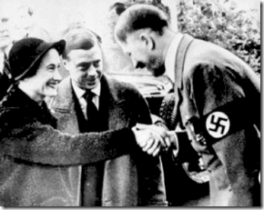
King Edward with Fuhrer Adolph Hitler.
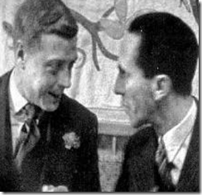
King Edward with Reichsleiter Josef Goebbels.
As the sovereign King of England, the Wyvern Military Order and the secret dragon cult was his “Royal Prerogative” and secret private army.
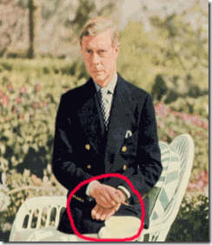
Former King Edward, Duke of Windsor with the Secret X Wyvern’s Hand
After King Edward gave up the throne, he was given the royal title of Duke of Windsor, and rushed off to the Bahamas to carry on his criminal/Nazi enterprise. As part of the deal to get the king to set down, he continued the run the Crown’s Secret Wyvern Cult.
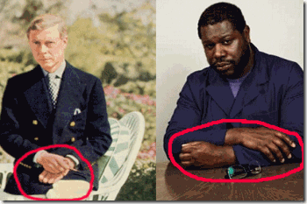
Director Steve McQueen is a GOON of the Queen’s Secret Cult of Wyvern that will carry the Queen’s Secret Psychological Warfare against Black People- MAAT without Mercy.
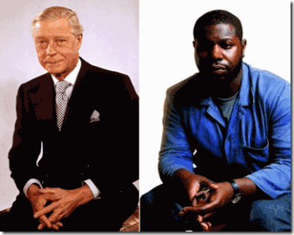
King Edward had also been a 33rd Degree Scottish Rite Mason initiated into Freemasonry on May 2, 1919 in Homehold Brigade Lodge (No. 2614). He was senior Grand Warden of the Grand Lodge of England, and at some time became the Grand Master of the lodge. It looks like Steve McQueen is also either a member of the Scottish Rite like Dr. Conrad Murray or the Grand Lodge of England.
CALIBAN: Trayvon Martin & The Conspiracy of Suppression of Black Resistance
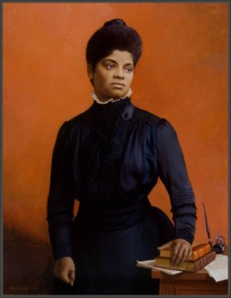
“If a colored man resented the imposition of a white man and the two came to blows, the colored man had to die, either at the hands of the white man then and there or later at the hands of a mob that speedily gathered. If he showed a spirit of courageous manhood he was hanged for his pains, and the killing was justified by the declaration that he was a “saucy nigger.”
-Ida B. Wells, Lynch Law in America,” The Arena 23.1 (January 1900): 15-24[16]
The re-imaging of Trayvon Martin as a “saucy” street thug was implanted by mass media and served as the justification of his brutal slaying and the acquittal of George Zimmerman (Those PEOPLE- The Way They LIVE).[17] Even if Trayvon was a street thug or just a young Black man that “showed a spirit of courageous manhood,” it was no justification to disenfranchise and forfeit his constitutional and human rights, and brutally slay him.
Yet, people, shockingly including black people, continue to argue that the implanted image of Trayvon as a “saucy” black street thug somehow justified his sacrifice to the comfort of “white dominance and oppression.”
At the time of the slaughter of Trayvon, George Zimmerman was predisposed to “blind violence” against people of color. He had been trained to KILL WITHOUT MERCY induced by mind control and the influence of two mind altering drugs, TEMAZEPAM also known as Restoril, and Aderall.[18]
TEMAZEPAM was of particular interest to and tool of military intelligence mind controllers. Its effects on the mind were secretly medically researched and experimented with by the CIA. Temazepam was used under the top secret code name of the U.S. Government Clandestine Project MK SEARCH – a continuation of NAZI-CIA/MK ULTRA.[19]

George Zimmerman & James Holmes, The Faces of CIA/ MK-ULTRA
With George Zimmerman’s most recent arrest for persistent “Violent Tendencies,” I believe that more and more people are beginning to understand that it wasn’t really about society’s revenge on a young black thug, but a bigger ILLUMINATI/Luciferian covert false flag psychology warfare operation to demonize Black youth-Black People; bind their power to resist, intellectualize and re-establish MAAT across the planet.
“Why should we not form a secret society with but one object the furtherance of the British Empire and the bringing of the whole uncivilized world under British rule for the recovery of the United States for the making the Anglo-Saxon race but one Empire?”-Cecil Rhodes[20]
The slaying of Trayvon Martin and HollyWeird’s MK ULTRA secret psychology warfare film projects, the Help, Django Unchained, the Butler and 12 Years a Slave are really about re-enforcing and subliminally and supraliminal imprinting in the minds of the world masses of color the “Unwritten Law” of “White Anglo-Saxon Dominance and Oppression,” from the highest levels of the secret Satanic-Shadow Government of the US, its wicked- twisted ancestral cousins Great Britain, and the ILLUMINATI.
These covert psychology warfare projects through mass media are really covertly- veiled and designed to “break the will and spirit of the people to resist” and put CALIBAN’S PEOPLE in their “place” in the social, political, economic, and religious hierarchy of a Luciferian New World Order until they can be eliminated one way or another.
Steve McQueen- ILLUMINATI Goon: From Homoerotical to 12 Years a Slave
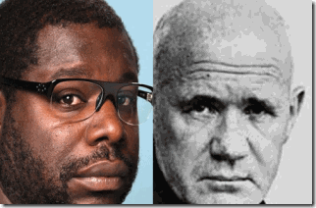
Steve McQueen is a black Jean Genet without the Ancient Aryan Pedigree of the Rosicrucian Order and Priory of Sion.
12 Years a Slave is a joint British and American ILLUMINATI psychological warfare project fronted by black British agent, Steve McQueen.
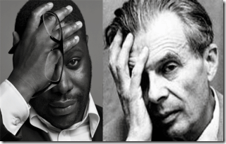
McQueen and MK ULTRA British God Father, Aldous Huxley- ILLUMINATI All-Seeing Eye.
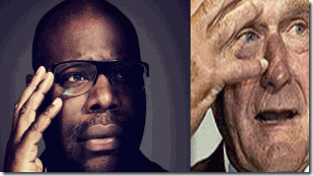
McQueen is a real strange, freaky and high level Satanic dude. He joined the Queen’s Order of the British Empire in 2002 for contributions in [homoerotic themes] visual arts.[21] Homoerotic defined- Homosexual; specifically : marked by, revealing, or portraying homosexual desire <homoerotic photographs>.[22]
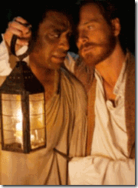
I suspect that homoerotic images such as above are also covertly subliminally and supraliminally implanted throughout 12 Years a Slave.
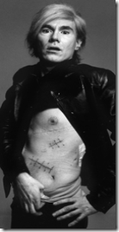
McQueen has cited the influence of the La Nouvell Vegue and the films of Andy Warhol , above, on his career.[23] The New Wave (French: La Nouvelle Vague) was a blanket term coined by critics for a group of French filmmakers of the late 1950s and 1960s.[24] Jean Cocteau and Jean Genet were an inspiration to the French New Wave.[25]
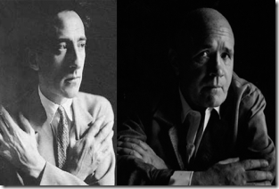
Jean Cocteau and Jean Genet– bloodlines of the ILLUMINATI and Masters of the ancient Rosicrucian Order [26]-Priory of Sion.[27] The Priory of Sion were believed to among the founders of English Freemasonry. McQueen’s first film, “Bear” you see a naked McQueen exchanging very interesting looks to another nude male.[28]
In his first full length film, “Hunger” you are presented with many scenes that show male prisoners in the nude. Homoerotic images usually tend to suggest naked people and sex. McQueen’s film titled, “Shame” is based on sex addiction- Sex Magick.[29]
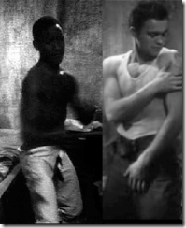
Jean Genet’s film, Song of Love (French: Un chant d’amour [œ̃ ʃɑ̃ damuʁ] is similar to McQueen’s Hunger film. It is set in a French prison, where a prison guard takes voyeuristic pleasure in observing the prisoners perform masturbatory sexual acts. In two adjacent cells, there is an older Algerian-looking man and a handsome convict in his twenties. The older man is in love with the younger one, rubbing himself against the wall and sharing his cigarette smoke with his beloved through a straw.
The prison guard, apparently jealous of the prisoner’s relationship, enters the older convict’s cell, beats him, and makes him suck on his gun in an unmistakably sexual fashion. However, the inmate drifts off into a fantasy where he and his object of desire roam the countryside. In the final scene, it becomes clear that the guard’s power is no match for the intensity of attraction between the prisoners, even though their relationship is not consummated.
Genet does not use dialogue in his film, but focuses instead on close-ups of bodies, on faces, armpits, and penises. The film’s highly sexualized atmosphere has been recognized as a formative factor for works such as the films of Andy Warhol.[30]
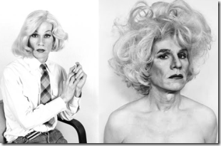
Andy Warhol– Homoerotic– is fat meat greasy?
“This is an effect of the OTO-connected Andy Warhol, who finally destroyed fine art in the 60’s with his so called pop-art. He said in an interview something to the effect that “fine art is dead – this is the art of the New Era” (referring to his own art). An act of rebellion or an act with a purpose to degrade art like they’ve done with music? Warhol was a big puppet for the Illuminati Elite. By degrading the art they also degrade the human population.“[31]
Steve McQueen: On Her Majesty Secret Service
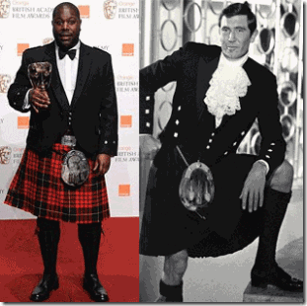
Steve McQueen & James Bond (George Lazenby, On Her Majesty Secret Service (1969))
McQueen is an official 2011 “Commander of the Order of the British Empire” (Motto: For God and the Empire) just like British Secret Agent, James Bond -007. The Most Excellent Order of the British Empire (MEOBE) is an order of chivalry established on June 4, 1917 by King George V.[32]
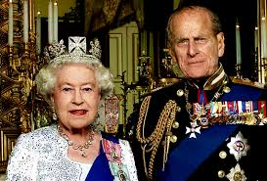
King George V originally created the MEOBE to honor those who’s served their country in battle or on the home front during World War I. It is formally divided into civilian and military divisions. Queen Elizabeth is the Order’s sovereign, and McQueen’s Grand Master is Prince Philip.[33] That’s right, McQueen’s “Master” is Prince Philip, one of the most powerful, vile, and vicious elite racist- demonic forces of the ILLUMINATI and New World Order.

Prince Philip’s Lecture to the European Council of International Schools. Montreaux, Switzerland, Nov. 14, 1986.
“…|When the Bible says that man shall have “dominion” over God’s creation, the choice is between understanding dominion as in “having power over,” or dominion as “having responsibility for.”[34]
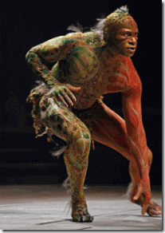
Prince Philip and the British Royals from the days of Elizabeth I and Rosicrucian Conspiracy (John Dee, Sir Francis Bacon) have construed the Bible to give upon them “divine” power over God’s creation- Genesis 8:19 “Every beast, every creeping thing, and every fowl, [and] whatsoever creepeth upon the earth …”

As reported by Deutsche Press Agentur (DPA) in August 1988, Prince Philip said: In the event that I am reincarnated, I would like to return as a deadly virus, in order to contribute something to solve overpopulation.[35]
Prince Philip, Duke of Edinburgh, is heavily involved in implementing the plan for a New World Order. He is linked with the Bilderberg Group, has advocated widespread population reduction- Genocide of People of Color; and helped start the World Wildlife Fund with Nazi SS Officer Prince Bernhard of the Netherlands.[36]

1937, Prince Philip in Nazi Funeral March
Prince Philip was schooled in Schloss Salem, Germany that was in control of the Hitler Youth and the Nazi Party, and the curriculum had become Nazi “race science.”[37] In a rare interview, the prince said his family found Hitler’s plans to bring Germany at the helm of European power were “attractive” and admitted they had “inhibitions about the Jews.”[38]

Lucifer’s Servants were so attractive to his family that his sister, Sophia married Standartenfuhrer (colonel) SS Christopher of Hesse-Cassel, above, of Heinrich Himmler’s Personal Staff, who named his eldest son Karl Adolf in Hitler’s honor. Indeed, all four of Philip’s sisters married high-ranking Nazis, Knights of the Black Sun, the World’s Greatest Racial Mass Murderers.[39] Prince Philip is a Luciferian 33° Grand Master Mason of the Navy Lodge No. 2612 of the United Grand Lodge of England led both by Prince Philip and Grand Master, Prince Edward, Duke of Kent.[40]

During the 1970s, Prince Philip was a regular at the Bohemia Grove most likely leading the likes of Ronald Reagan, Richard Nixon, Gerald Ford, Arnold Schwarzenegger, George H. W. Bush and the elite of the business, economic and political in secret ancestral pagan Druid and Baal-Moloch worship and animal- human sacrificial rituals.[41]
Prince Philip’s Address to All-Party Conservation Committee in London, Feb. 18, 1981. “I suspect that the single most important gift of progress to conservation has been the development of human contraception techniques…The survival of the “most important” [the Aryan Race].[42]
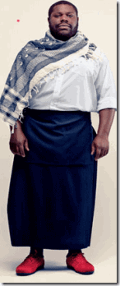
Steve McQueen in Yohji Yamamoto Men’s Skirt
So what other evil and vile policy bidding does his “Masters” really beckon upon their most excellent and loyal Uncle Tom Negro subject to fulfill- Genocide of the Black Race, the Illuminati’s Secret Gay Agenda.
The 1970 Jafee Memo
Memorandum to Bernard Berelson, President, Population Control Council, Relevant tot he Study of Population Policy for the U.S. by Frederick S. Jaffe (V.P., Planned Parenthood World Population) TABLE 1. Examples of Proposed Measures to Reduce U.S. Fertility by Universality or Selectivity of Impact… Encourage increased homosexuality[43]
Dr. Umar Abdullah- Johnson (certified school psychologist)[44] says up until 1973, homosexuality was listed as a mental disorder in the Diagnostic and Statistical Manual of Mental Disorders. Dr. Johnson says homosexuality is used as a population control strategy which started in 1973 under the Rockefeller World Population Council. He says Planned Parenthood International and the Rockefeller World Population Control Council decided it would be best that homosexuality be propagated in the black community as a healthy lifestyle choice.[45]
According to Dr. Johnson, in 1974, Dr. Henry Kissinger (Prince Philip’s Bilderberg Group)[46] created a secret U.S. National Security Council (Brigadefuhrer SS Fritz Kramer)[47] Study Memorandum called NSSM2000,[48] a document that looks specifically at strategies to control the black population rate across the world (with birth control, healthy sexual practices and alternative lifestyle modifications). Nigeria and America along with other African countries were listed as targets.[49]
JOHN RIDLEY, ILLUMINATI & THE NEW ASCENDED MASTER NEGROES
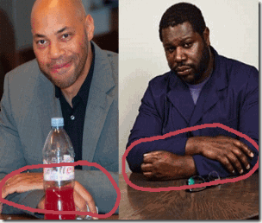
John Ridley and McQueen- Queen’s Army Secret X Wyvern’s Hand
12-Years a Slave Screenwriter John Ridley is another strange and dangerous dude out of Black HollyWeird. Little to nothing has been revealed about his family, background, education, experiences, intellectual or political influences. He was an untalented and fallen comedian. If you believe Brad Pitt and I do, all of the key players in the 12 Years a Slave film project sold their souls to the devil.
One thing does stand out, John Ridley has suddenly risen in unprecedented influence, fame and fortune. In a relatively short time, He has become an in demand film producer, screenwriter, an Emmy Award winning commentator and writer for Esquire and Time magazines as well as a contributor to CNN, MSNBC, Fox News, and NPR.[50] However, one thing is also clear is that John Ridley has gone through a series of secret Rosicrucian-Luciferian indoctrination (arcane knowledge) rituals and initiations to become ILLUMINATED– transformed to “Angelic” ASCENSION (the ILLUMINATI).
Ridley reportedly is on the “Down-Low” and also along with Steve McQueen- part of the Illuminati’s Secret Gay Agenda.
In November 2006, John Ridley wrote an extremely interesting and remarkable article for Esquire Magazine entitled, The Manifesto of Ascendancy for the Modern American Nigger.
Ridley’s Niggers- CALIBAN’S PEOPLE
“LET ME TELL YOU SOMETHING ABOUT NIGGERS, the oppressed minority within our minority. Always down. Always out. Always complaining that they can’t catch a break. Notoriously poor about doing for themselves. Constantly in need of a leader but unable to follow in any direction that’s navigated by hard work, self-reliance. And though they spliff and drink and procreate their way onto welfare doles and WIC lines, niggers will tell you their state of being is no fault of their own. They are not responsible for their nearly 5 percent incarceration rate and their 9.2 percent unemployment rate. Not responsible for the 11.8 percent rate at which they drop out of high school. For the 69.3 percent of births they create out of wedlock.”[51]
“That which retards us is the worst of “us,” those who disdain actual ascendancy gained by way of intellectual expansion and physical toil–who instead value the posture of an “urban,” a “street,” a “real” existence, no matter that such a culture threatens to render them extinct.
‘Them’ being niggers.’
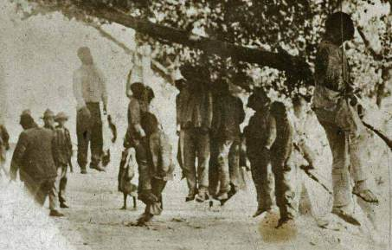
…. So I say this: It’s time for ascended blacks to wish niggers good luck.”
I am not making this up. This is what this ILLUMINATI Negro really says and believes.
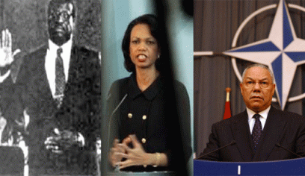
Needless to say, Ridley says that including himself, Clarence Thomas, Condoleezza Rice and Colin Powell are “Ascended” ILLUMINATI Uncle Toms.
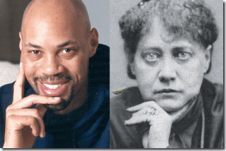
The belief of Ascended Masters is key to the Aryan Supremacy belief systems developed by Madame Helena P. Blavatsky in the 1870s, the idea of the Masters of the Ancient Wisdom or Mahatmas was adopted by people who at some point had had a connection with the Theosophical movement, such as Alice Bailey, Helena Roerich, and Master Mason Manly P. Hall.
Ascended Masters are individuals who were formerly embodied on the Earth and learned the lessons of life during their incarnations. An Ascended Master, in such an understanding, has become God-like and a source of unconditional “Divine Love” to all life, and through the Ascension has united with his or her own “God Self,” the “I AM Presence.”

It is further claimed by various groups and teachers that the Ascended Masters serve as the teachers of mankind from the realms of Spirit and that all people will eventually attain their Ascension and move forward in spiritual evolution beyond this planet. According to these teachings, they remain attentive to the spiritual needs of humanity, and act to inspire and motivate its spiritual growth. In many traditions and organizations, they are considered part of the Spiritual Hierarchy of Earth, and members of the Great Brotherhood of Light, also known as the Great White Lodge, Great White Brotherhood, or Universal White Brotherhood.[52]
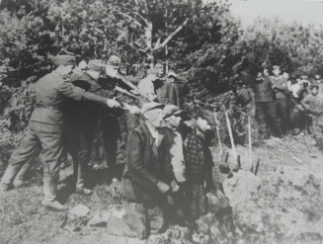
John Ridley’s Manifesto (a public declaration of intentions, opinions, objectives, or motives, as one issued by a government, sovereign, or organization[53]) make it quite clear that those “niggers” unable by nature and will not by will “Ascend” shall be subject to extermination.
Ridley’s Niggers & Evolution (Metanormal Human Beings)

In 2003, Ridley published a novel that became a HollyWeird film, Those Who Walk In Darkness. It details the life of a member of an elite police task force in Los Angeles that hunts down super humans known as “metanormals.” Ridley’s novel also includes “angelic” figures like Michelle, an angelic winged woman who possesses a mysterious ability to either avert disasters or bring back the dead.[54]
“Metanormal” beings are not only the subject of the super heroes of comic books, games, fantasy-science fiction stories and films. The subject of “Metanormal” humans was of intense meaningful interest and study of the Esalen Institute in Big Sur, CA. The Esalen Institute is the handmaiden for the CIA-MK ULTRA and U.S. Military Intelligence.
The Esalen Institute & Metanormals
The Esalen Institute is a major covert New Age/Satanic think tank and front for the CIA and their mind control (MK ULTRA) operations. The Rockefellers help fund the institute,[55] along with U.S. Department of Defense, Pentagon, and the Zionist Agenda.[56] Esalen was founded by Michael Murphy and Richard Price in 1962. Their goal was to explore work in the humanities and sciences, in order to fully realize what one of the British Godfathers of MK ULTRA, Aldous Huxley, had called the “human potentialities“[57]
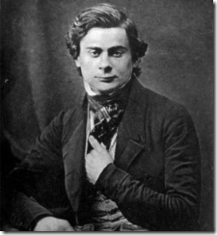
Esalen’s genesis actually lies in the background and legacy of Brits Aldous (Brave New World) and Julian Huxley’s (Eugenics Society) grandfather, Sir Thomas Henry Huxley of England. Sir Huxley, above, was a Freemason with the hidden hand sign of the ILLUMINATI or a Rosicrucian. Sir Huxley also took an interest in initiating Aldous and Julian in the arcane. He arranged for them to be tutored by 33rd degree Freemason H. G. Wells and trained by the Great BEAST 666 Aleister Crowley- Hermetic Order of the Golden Dawn. Sir Huxley was called “Darwin‘s Bulldog” for being a pugnacious defender of evolution.[58] Sir Huxley also was their Bulldog for British Freemasonry that secretly financed and pushed Darwinism. In the minutes of the 33rd degree Mason of Mizraim of Paris, it revealed that the masons had made it possible for the success of Darwinism. In its American Lodge March 22, 1922 New Age Magazine, its states, “The Craft believes the Kingdom of God is to be established among men by the evolution and development of man himself…”
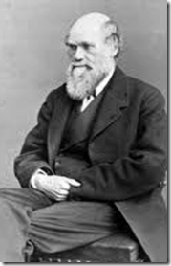
Here is a lot of contention whether or not the British Charles Robert Darwin, also with the hidden hand and Devil’s Claw of a Freemason, ILLUMINATI or Rosicrucian, was a racist.
Darwin’s The Descent of Man:
“At some future period, not very distant as measured by centuries, the civilised races of man will almost certainly exterminate, and replace, the savage races throughout the world. At the same time the anthropomorphous apes … will no doubt be exterminated. The break between man and his nearest allies will then be wider, for it will intervene between man in a more civilised state, as we may hope, even than the Caucasian, and some ape as low as a baboon, instead of as now between the negro or Australian and the gorilla.”[59]
According to Darwin‘s infamous works, Origin of the Species by Means of Natural Selection (1859), he subtitled it, “Preservation of the Flavored Races in the Struggle of Life.”[60] Even if Darwin and Huxley are arguable not racist per se, they were “Racialist Theorists,” whose pseudo racial sciences flavors Anglo-Saxons- the Aryans as the most fittest for future life among humans on earth.
Shortly after the Civil War and the freedom of enslaved Africans, Sir Thomas Huxley wrote the following:
“It may be quite true that some negroes are better than some white men; but no rational man, cognizant of the facts, believes that the average negro is the equal, still less the superior, of the white man. And if this be true, it is simply incredible that, when all his disabilities are removed, and our prognathous relative has a fair field and no favour, as well as no oppressor, he will be able to compete successfully with his bigger-brained and smaller-jawed rival, in a contest which is to be carried out by thoughts and not by bites. The highest places in the hieracchy of civilization will be assuredly not be within the reach of our dusty cousins, though it is by no means necessary that they should be restricted to the lowest.”[61]
Sir Thomas Huxley was one of the key promoters, friends and defenders of Darwin’s theories through Huxley’s “X Club.

The X Club created academics who would promote Darwin’s ideas of evolution and eugenics. This information is taken from an excellent internet article by Jan Irvin, “How Darwin, Huxley, and the Esalen Institute launched the 2012 and psychedelic revolutions – and began one of the largest mind control operations in history.”[62]
Huxley’s X Club is related to modern popular spin-offs X-Men comic series and HollyWeird’s X-Men films. In Jan Irvin’s Astrotheology & Shamanism, pp. 152-153, it was written:
“X marks the spot” is common symbolic usage. In fact, it is universal symbolism. The mark is associated with the perfect man in Psalms 37:37.
“Mark the perfect man, and behold the upright: for the end of man is peace.” The mark of the archetypal “perfect man” is the cross. The cross is an upright X. In Ezekiel, a mark is set upon the foreheads of selected men in Jerusalem and all other men, women, and children are to be slaughtered.
Ezekiel 9:6
“Slay utterly old and young, both maids, and little children, and women: but come not near any man upon whom is the mark; and begin at my sanctuary. Then they began at the ancient men which were before the house.”[63]
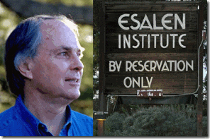

“Via the Esalen [Michael Murphy] Institute this multi-generational plan to “evolutionize” ( – their idea of evolution was just for them and the elites, not the rest of society whom they planned to dumb down and exterminate…”[64]
Michael Murphy, Chairman of the Board of the Esalen Institute, defined “metanormal”, a term he uses interchangeably with “extraordinary” with respect to human functioning, is “functioning that in some way radically surpasses the functioning typical of most people living today.”[65]
Michael Murphy published, The Future of the Body. Explorations Into the Further Evolution of Human Nature, New York: Jeremy P Tarcher/Putnam Books (1992) that basically explores animal capabilities to ordinary human ones and to the final evolution of humans to the “metanormal”.
Consistent with Darwinian Agenda of the Huxleys, Murphy implies in the book that there is a genetic capacity-predisposition for metanormal development evolved biologically at some time in the past.
Also consistent with Darwinian Racial Conspiracy, he implies that genetic “metanormal” evolution proceeds by nature selection. Murphy maintains that “a widespread realization of extraordinary capacities would constitute an evolutionary transcendence analogous to the rise of living species from inorganic matter, or of humankind from its hominid ancestors…”[66] Esalen’s “Metanormal” evolution theories re-enforces and defends Darwin’s Rosicrucian- Masonic pseudo racialist theories that clandestinely negatively impact educational, economic, social, health and warfare global strategies and national reform policies toward people of color.
To Charles Darwin’s Bulldog, Sir Huxley, the lowest of the low among the races unable to evolve properly from their hominid ancestors or transcend to “Metanormal Beings” are CALIBAN’S RACE. Not far removed from the gorilla (animal species) and subject to be exterminated from the evolving races on earth are the Negroes- Ridley’s Niggers- CALBAN’S SEEDS..
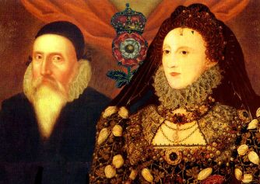
Ridley’s Niggers are not a creation of his own folly, nor is it a mistake or displaced wisdom. It is a direct extension of ancient arcane secret Rosicrucian pseudo race theories that dates back to Satanic Luciferian witches and sorcerers Queen Elizabeth I, John Dee, and Sir Francis Bacon’s CALIBAN.
Ridley’s Niggers & The Roots of CALIBAN’S Rosicrucian Race Theories
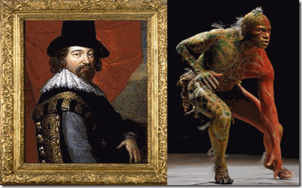
The occulted works of William Shakespeare was actually the secret works of Sir Francis Bacon. He was a notorious homosexual and a pedophile (pederast). Bacon’s Tempest heavily influenced Satanist Madame Helena Blavatsky a 33° Mason and the Secret Doctrine,
“It is not Shakespeare only who divided the ages of man into a series of seven, but Nature herself.” [67]
According to the secret doctrine of the 16-17th Century racialist European occultist that influenced Blavatsky, there are seven ages of evolution of mankind on earth, briefly characterized as (1) Polarians (2) Hyperborean (3) Lemurian (4) Atlantean (5) Aryan.
The 6th and 7th Root Races are still in the womb of the future- evolving. Each Root Race is further divided into sub races.
Contrary to common beliefs, Madame Blavatsky wasn’t the first to promote the “Seven Root Race” theory as a scientific doctrine. Two hundred years before her time, Shakespeare and a secret 16th Century Rosicrucian society promoted the pseudo occult root race theory among the ruling English elite classes and royalty as scientific doctrine.
Rosicrucianism is a generic term referring to studies or membership within a philosophical secret society said to have been founded in late medieval Germany. It holds a doctrine or theology “built on esoteric truths of the ancient past”, which, “concealed from the average man, provide insight into nature, the physical universe and the spiritual realm.”[68] According to historians, it was also influential to the craft of Freemasonry as it was emerging in Scotland.[69]
The Tempest is basically a Rosicrucian-Masonic secret manuscript popularly spreading and promoting its arcane and pseudo “Root Race” theories among the European elite and royalty; and now world leaders, politicians, and the general public under the yoke of the Global Satanic Elite.
According to Occult teachings, “Root Races” are stages in human evolution in the Rosicrucian and arcane cosmology.[70] Briefly, “The First Root-Race, i.e. the first “men” on earth (irrespective of form) were the progeny of the “celestial men”…in Indian philosophy the “Lunar Ancestors” or the Pitris, of which there are seven classes or Hierarchies.”[71]
The Second Root Race- Hyperborean (a continuation of the first) or Etheric race was semi-astral, but grew denser and more opaque with each passing age. Towards its end, it became more gelatinous and filamentous in structure, and developed the rudimentary beginnings of bones and organs, hair and skin.[72]
The Second Root-Race was colored golden yellow. Hyperborea included what is now Northern Canada, Greenland, Iceland, Scandinavia, Northern Asia and Kamchatka. The esoteric name of their continent is Plaksha. They called themselves the Kimpurshas. They reproduced by budding. The second root race has no present-day descendants. The Hyperboreans evolved the third root race.[73]
The Third Root-Race, the first to be truly human, existed on the lost continent of Lemuria or Mu. The occultist maintains that the first physical man, the Lemurians, were semi-animal creatures which itself took place 18,000,000 years ago. Blavatsky described the Lemurians as “the Third Root Race” to inhabit the Earth. They were egg-laying beings with a third eye that gave them psychic powers and allowed them to function without a brain.[74]
Blavatsky says according to the occultists that the Lemurians were also semi-animal creatures, the sole remnants known to Ethnology were the Tasmanians, a portion of the Australians and a mountain tribe in China, the men and women of which are entirely covered with hair. They were the last descendants in a direct line of the semi-animal latter-day Lemurians referred to. Lemurians that survived the main submerged continent of Lemuria became the ancestors/relics of a portion of the present native tribes.
Blavatsky: “Being a very low sub-race, begotten originally of animals, of monsters, whose very fossils are now resting miles under the sea floors, their stock has since existed in an environment strongly subjected to the law of retardation. Australia is one of the oldest lands now above the waters, and in the senile decrepitude of old age, its “virgin soil” notwithstanding. It can produce no new forms, unless helped by new and fresh races, and artificial cultivation and breeding.”[75]
According to the occultist, the Fourth Root Race, called the Atlantean, was evolved from the remnants of the continent of Lemuria. The occultists trace the Aryan nations’ descent through the Atlanteans from the more spiritual sub-races of the Lemurians, [76]
“There were civilized people and savages in those days as there are now. Evolution achieved its work of perfection on the former, and Karma its work of destruction on the latter. The Australians and their like are the descendants of those who, Instead of vivifying the Spark projected into them by the ‘Flames,’ extinguished it by long generations of bestiality. Whereas the Aryan nations could trace their descent through the Atlanteans from the more spiritual races of the Lemurians, in whom the ‘Sons of Wisdom’ had personally incarnated.”
Human Evolution and the Magickal Sacred Spark of the Gods
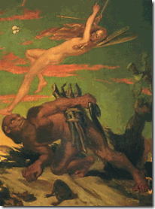
Blavatsky repeatedly emphasizes that RACIAL KARMA account for the “great differences between the intellectual capacities of races,
“Mankind is obviously divided into God-informed men and lower human creatures. The intellectual difference between the Aryan and other civilized nations and such savages as the South Sea Islanders is inexplicable on any other grounds. No amount of culture, no generations of training amid civilization, could raise such human specimens as the Bushmen, the Veddhas of Ceylon, and some African tribes, to the same intellectual level as the Aryans, the Semites, and the Turanians so-called. The ‘Sacred Spark’ is missing in them, and it is they who are the only inferior races on the globe, now happily — owing to the wise adjustment of Nature which ever works in that direction — fast dying out. Verily mankind is ‘of one blood,’ but not of the same essence.”[77]
According to the Global Satanic Elite Cabal, the Black Race lies outside the bloodlines of the “divine” and godlike Adamites. The Black Race was not created in the image of the GOD of Genesis. Evolving from the “Scared Spark” and out of Eden, generally exclude PEOPLE OF COLOR.
No amount of culture, no generations of training amid civilization or MAGICK, could raise such human specimens throwbacks to semi-animals of the Lemurian Epoch to the intellectual and divine levels of Aryans.
Finally, keep implanting the same lies over and over again, people will begin to internalize the implants. The mass media film project, 12 Years a Slave, isn’t really about the heroic struggle of Solomon Northup. a black man who was born free in New York state, kidnapped in Washington, D.C., sold into slavery and kept in bondage for 12 years (1841-1853) in the Deep South State of Louisiana. The true message of the film is hidden.
Look at the era and state of human bondage in America which Northup lived. By the U.S. Census of 1850, the aggregate number of enslaved Africans in the United States was 3,204,313 that had not the human dignity of names. In 1850, the U.S. President, Zachary Taylor, held about 80 Africans in forced chattel servitude near Baton Rouge, Louisiana, on a 2,000-acre plantation that had been the source of his “Prosperity”.
President Taylor’s son in law was Jefferson Davis, the future President of the Confederate States. The Fugitive Slave Law or Fugitive Slave Act was passed by Congress on September 18, 1850, as part of the Compromise of 1850 between Southern slave-holding interests and Northern Free- Soilers.
The Fugitive Slave Act was one of the most controversial acts of the 1850 compromise and heightened Northern fears of a “slave power conspiracy”. It declared that all runaway slaves were, upon capture, to be returned to their so-called “Masters.” Abolitionists nicknamed it the “Bloodhound Law” for the hound dogs that were used to track down Africans trying to escape perpetual human bondage.
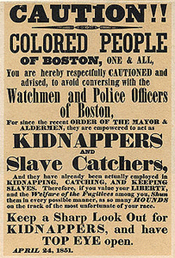
12 Years a Slave take place at the height, power and zeal of the Institution of Slavery in America. It was almost 10 years before the start of the Civil War. This was no oversight or just the draw of the cards.
In 1857, Dred Scott v. Sandford, 60, U.S. 393, the U.S. Supreme Court held that natives born in America by Africans, whether slave or free, were not American citizens, but “Chattel Property [Black Gold]” that the federal government had no jurisdiction to intervene or to regulate.
According to Chief Justice, Roger B. Taney, “[T]he authors of the Constitution had viewed all blacks as ‘beings of an inferior order, and altogether unfit to associate with the white race, either in social or political relations, and so far inferior that they had no rights which the white man was bound to respect’.”
During these years from about 1822, the Grand Lodge of Maryland Masonic Temple (Tremont) AF&AM served as a federal courthouse and for including U.S. Supreme Court Chief Justice Roger B. Taney. All Freemasons, both AF & AM which means Ancient Free and Accepted Masons, as well as F & AM, which means Free and Accepted Masons, trace their allegorical history back to the building of Solomon’s temple in the Holy Scriptures.
Guess who was running the Ancient Free and Accepted Masons- Fraternity of Mason in America from England, the Wicked Witch, Her Majesty Queen Alexandrina Victoria.
Whether or not Roger B. Taney can be proven to be a freemason is immaterial, he was certainly comfortably nested among them, laying the same insidious eggs- Rosicrucian- Masonic pseudo race theories developed by dark age medieval false prophets, witches, sorcerers, Luciferians and mystics.
In 1853 America, Solomon Northup was looking into a Witches’ Smoked Mirror. He was free, but wasn’t really free. He was a man, but wasn’t really a man of the human family. Solomon was caught in classic DOUBLE BIND. His manhood and freedom were ILLUSIONARY, rights no white man was bound to respect. He was CALIBAN– Sambo,New Atlantis’ Prosperity- Chattel Property, BLACK GOLD.
Each time you look into a mirror, the Satanic ILLUMINATI want you to see the same black face of CALIBAN – the offspring of devils and witches too powerless to resist.
The film 12 Years a Slave wants you to dwell into that same Bewitching Smoked Mirror– be trapped in that same DOUBLE BIND- your human dignity and freedom are ILLUSIONARY- subject to the will of others unless you ASCEND- submit body and soul to the will of the ILLUMINATI or be EXTERMINATED.
That isn’t a figment of my imagination, it’s what the screenwriter of 12 Years a Slave, John Ridley, EXPOSED as the clandestine gospel of the Satanic forces that financed and made the movie.
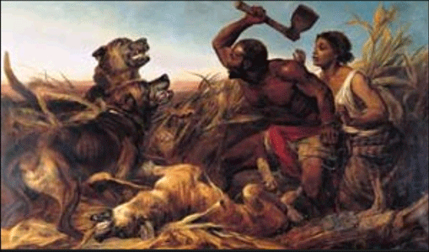
Facing sadistic, half starved and demonized hounds with no more than rags on their backs and the most of the so-called civilized world against them, Africans had the Will to RESIST.
What more can we do to defend ourselves against this persistent popular mass media campaign of Satanic Psychological Warfare Against People of Color– RESIST as they did as if there was No Promise of Tomorrow.
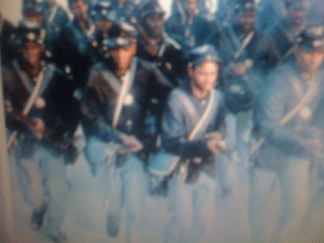
The African and their Descendant’s demand for human dignity was/is balanced, right and just- MAAT. They sought then ran to do BATTLE.
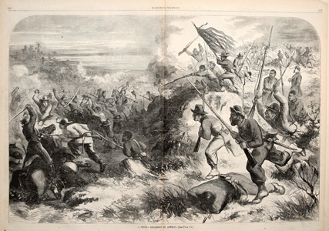
They pursued, died, fought, destroyed and VANISHED THE WITCHES’ TALES AND THE ENEMY.
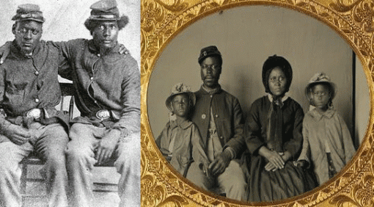
With the virtual so-called civilized world and all odds against them, they ultimately TRIUMPHED over perpetual Slavery and ultimate EVIL. That isn’t the story of Human Will, Sacrifice and Triumph that the film 12 Years a Slave want to convey to the masses of people of color.

[1] http://www.hitlerschildren.com/article/654-himmler-quotes
[2] http://blogs.indiewire.com/theplaylist/telluride-review-steve-mcqueens-12-years-a-slave-starring-chiwetel-ejiofor-michael-fassbender-more-20130831
[3] http://poptimal.com/2013/10/28/12-years-slave/
[4] http://www.ppfoundation.org/pict_ra.aspx
[5] http://jeremyhelligar.blogspot.com/2013/11/why-12-years-slave-is-end-of-line-for-me.html
[6] http://en.wikipedia.org/wiki/Psychological_warfare
[7] http://en.wikipedia.org/wiki/Wyvern
[8] http://projectavalon.net/forum4/showthread.php?9157-Sir-Francis-Drake-and-dragons
[9] http://projectavalon.net/forum4/showthread.php?9157-Sir-Francis-Drake-and-dragons
[10] from 1577 to 1580
[11] http://www.dailymail.co.uk/news/article-1257278/Prince-Philip-asks-Navy-cadet-Elizabeth-Rendle-works-strip-club.html
[12] http://en.wikipedia.org/wiki/Officers’_Training_Corps
[13]http://en.wikipedia.org/wiki/Royal_Prerogative
[14] http://en.wikipedia.org/wiki/Edward_VIII_of_the_United_Kingdom
[15] http://no666.wordpress.com/2011/06/08/a-blackhearted-king/
[16] http://courses.washington.edu/spcmu/speeches/idabwells.htm
[17] http://newsone.com/2637023/george-zimmerman-verdict-jury-b37-racism/
[18] http://globalgrind.com/news/george-zimmerman–drugs-violent-side-effects-killed-trayvon-martin-details
[19] http://en.wikipedia.org/wiki/Project_MKULTRA
[20] http://www.tribwatch.com/utopia.htm
[21] http://thefourohfive.com/news/article/director-profile-steve-mcqueen
[22] http://www.merriam-webster.com/dictionary/homoerotic
[23] http://en.wikipedia.org/wiki/Steve_McQueen_(artist)
[24] http://en.wikipedia.org/wiki/Nouvelle_vague
[25] http://www.moma.org/explore/inside_out/2013/03/26/jean-genets-a-song-of-love-and-jean-cocteaus-testament-of-orpheus/
[26] http://www.gnostictemplars.org/articles/Article_-_The_True_Secret_Society_Behind_the_Da_Vinci_Code.pdf
[27] http://www.abovetopsecret.com/forum/thread594929/pg1
[28] http://blaynelauresavt101.blogspot.com/p/sexuality.html
[29] http://blaynelauresavt101.blogspot.com/p/sexuality.html
[30] http://en.wikipedia.org/wiki/A_Song_of_Love
[31] http://www.illuminati-news.com/art-and-mc/field-of-art.htm
[32] http://en.wikipedia.org/wiki/Steve_McQueen_(director)
[33] http://www.examiner.com/article/british-royal-family-101-what-is-the-order-of-the-british-empire
[34] http://www.la.org.au/opinion/190910/prince-philip-his-own-words
[35] http://www.eugenicsreport.com/?tag=prince-phillip
[36] http://www.informationliberation.com/?id=21895
[37] http://www.bibliotecapleyades.net/sociopolitica/esp_sociopol_blacknobil09.htm
[38] http://www.ynetnews.com/articles/0,7340,L-3224655,00.html
[39] http://birdflu666.wordpress.com/2011/04/27/the-british-royal-familys-links-to-nazis-and-eugenicists-alex-jones-reports/
[40] http://en.wikipedia.org/wiki/United_Grand_Lodge_of_England#Grand_Masters
[41] http://www.thelivingmoon.com/forum1/index.php?topic=175.0
[42] http://www.la.org.au/opinion/190910/prince-philip-his-own-words
[43] http://www.la.org.au/opinion/190910/prince-philip-his-own-words
[44] http://www.drumarjohnson.com/
[45] http://www.theafrolounge.com/2013/04/02/the-hidden-gay-agenda/
[46] http://rense.com/general59/kissingereugenics.htm
[47] http://www.worldsecuritynetwork.com/Other/no_author/Former-German-Defense-Minister-Guttenberg-on-Fritz-Kraemer-Book-at-CSIS
[48] http://pdf.usaid.gov/pdf_docs/PCAAB500.pdf
[49] http://www.theafrolounge.com/2013/04/02/the-hidden-gay-agenda/
[50] http://www.huffingtonpost.com/john-ridley
[51] http://www.esquire.com/features/essay/ESQ1206BLACKESSAY_108
[52] http://en.wikipedia.org/wiki/Ascended_master
[53] http://dictionary.reference.com/browse/manifesto
[54] http://en.wikipedia.org/wiki/Those_Who_Walk_in_Darkness
[55] http://zodiacmansonevidencerevealed.com/tag/the-cia-satanic-agenda/
[56] http://rationalwiki.org/wiki/Esalen_Institute
[57] http://en.wikipedia.org/wiki/Esalen_Institute
[58] http://www.pbs.org/wgbh/evolution/library/02/2/l_022_09.html
[59] http://philosophiatopics.wordpress.com/2013/04/15/darwin-between-the-negro-or-australian-and-the-gorilla/
[60] http://en.wikipedia.org/wiki/On_the_Origin_of_Species
[61]Thomas Huxley, Lay Sermons, Addresses and Reviews, New York, NY:Appleton, 1871, s. 20
[62] http://www.gnosticmedia.com/how-darwin-huxley-and-the-esalen-institute-launched-the-2012-and-psychedelic-revolutions-and-began-one-of-the-largest-mind-control-operations-in-history/
[63] http://www.gnosticmedia.com/how-darwin-huxley-and-the-esalen-institute-launched-the-2012-and-psychedelic-revolutions-and-began-one-of-the-largest-mind-control-operations-in-history/
[64] http://www.gnosticmedia.com/how-darwin-huxley-and-the-esalen-institute-launched-the-2012-and-psychedelic-revolutions-and-began-one-of-the-largest-mind-control-operations-in-history/
[65] http://www.sylviaengdahl.com/metanormal.htm
[66] Murphy, Michael, The Future of the Body. Explorations Into the Further Evolution of Human Nature, New York: Jeremy P Tarcher/Putnam Books (1992), pg. 5.
[67]http://www.phx-ult-lodge.org/SDVolume2.htm
[68] https://en.wikipedia.org/wiki/Rosicrucianism
[69] https://en.wikipedia.org/wiki/Rosicrucianism
[70] http://en.wikipedia.org/wiki/Root_race
[71] http://www.kheper.net/topics/Theosophy/HBP-Polarian.html
[72] http://indigoworld.com/testSMF/index.php?action=printpage;topic=1607.0
[73] http://en.wikipedia.org/wiki/Root_race#The_second_root_race_.28Hyperborean.29
[74] http://www.bibliotecapleyades.net/atlantida_mu/esp_lemuria_2.htm
[75] http://www.sacred-texts.com/the/sd/sd2-1-10.htm
[76] http://www.phx-ult-lodge.org/SDVolume2.htm
[77] http://lists.topica.com/lists/waldorf-critics/read/message.html?sort=d&mid=1721017874
Comments : 6 Comments
Tags: 12 years a slave, Adolf Hitler, african holocaust, african slave trade, Aldous Huxley, andy warhol, aryan supremacy, atlantis, bohemian grove, Brave New World, caliban, charles darwin, Duke of Edinburgh, duke of windsor, Esalen Institute of Big Sur, eugenic society, Eugenics, freemasonry, freemasons, gay agenda, george michael zimmerman, great white lodge, homoerotic, ida b. wells, Illuminati, illuminati conspiracy, james holmes, Jean Cocteau, jean genet, john ridley, josef goebbels, Julian Huxley, king edward viii, lenny kravitiz, madame helena p. blavatsky, masonic, metanormal, metanormal beings, michael murphy, mk seach, Nazis, prince philip, queen elizabeth I, queen elizabeth II, root races, rosicrucain, Rosicrucianism, shakespeare, sir francis bacon, sir francis drake, sir john hawkins, sir thomas huxley, Spiritual Hierarchy of Earth, steve mcqueen, trayvon martin, white brotherhood, wyvern cult, x club, x men
Categories : african holocaust, African Liberation, African slavery, Aleister Crowley, ALL SEEING EYE, ascended masters, christianity, church of satan, george michael zimmerman, george zimmerman, Human ecology, human sacifrice, illuminati, illuminati sacrifice, Knights of the Black Sun, lucifer's servants, luciferians, Madame H.P. Blavatsky, masonic sacrifice, metanormal, mind control, MK-ULTRA, nazi party, hitler youth, Nazis, new world order, Paul Josef Goebbels, queen elizabeth, re-imaging, Reichsfurhrer SS-1 Heinrich Himmler, Ritual Satanic Abuse, Rosicrucian, Rosicrucianism, rosy cross, Satanism, the help, trayvon martin, wyvern

FAT MEAT AIN’T GREASY: THE BUTLER, LUNACY, ILLUMINATI &HUEY P. NEWTON
26092013
HOLLYWEIRD- FAT MEAT AIN’S GREASY
If you have any misconceptions of what the Black Entertainment Industry really was and is, “this is the way that they get down in HollyWeird” SERVING the ILLUMINATI. Keep the name SHELDON LEONARD in mind. Some black people will do anything for HollyWeird fame and fortune even be turned over to SATAN.

For example, HollyWeird Amber Rose says that St. Peter’s Cross is not satanic- fat meat ain’t greasy. For decades, St. Peter’s Cross had been popularly adopted by Luciferians and Satanist as a satanic symbol. Even if it is St. Peter’s Cross as she says, it would still represent a statement of unworthiness of Christ or Christ-like– evil-satanic. It would also indicate a dual personality (Good and Evil) Multiple Personality Disorder. It isn’t just the fact that most of Black HollyWeird are turning to Satan, they are systematically secretly trained, indoctrinated, and iatrogenically (scientific) implanted with satanic alternative personalities with triggers and keys that they can’t control.
It is significant that Amber Rose placed St. Peter’s Cross on her forehead consistent with Luciferian New World Order/New Jerusalem agenda, propaganda and deceptions. “And he caused all, both small and great, rich and poor, free and bond, to receive a mark in their right hand, or in their foreheads: And that no man might buy or sell, save he that had the mark, or the name of the beast, or the number of his name.” BOOK OF REVELATION 13:16-17 (KJV)
Insanity &Fat Meat Ain’t Greasy
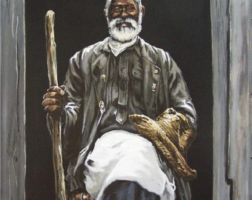
“Boy, you must believe that fat meat ain’t greasy.”
“Fat Meat Ain’t Greasy” is a folk expression that I often heard among my elders out of the Deep South. For generations, it was often said among them when you clearly ignored their words of instruction, caution, wisdom or fundamental rules and norms in un-constructive repetitive behaviors. For me, my elders were saying, stop- think, apply the proper rule, and stop repeating the same mistakes over and over again. It is a folk expression of the common phrase: Insanity: doing the same thing over and over again and expecting different results. –Albert Einstein[1]
Controlled Psychological Warfare Through the Media
We keep going through this over and over again. We repetitively flock to the theater expecting a different result from the contemporary so-called HollyWeird Black Cinema. Black People and the masses will not get a free “FEEL GOOD” pass from the elite Luciferian ILLUSIONISTS-MASTERS OF DECEPTIONS and now the Luciferian/ILLUMINATI Bloodline English cousins that control HollyWeird; and the current Black Entertainment Industry.
http://www.youtube.com/watch?v=xDF-vYFIgUE
For whatever reasons, I just learned about the film production of a Brad Pitt’s British film “12 Years a Slave” released on October 18, 2013. The film is directed by black British subject Steve McQueen. McQueen is a “Commander of the Order of the British Empire” (Motto: For God and the Empire) just like British Secret Agent, James Bond -007. The Most Excellent Order of the British Empire is an order of chivalry established on June 4, 1917 by King George V.
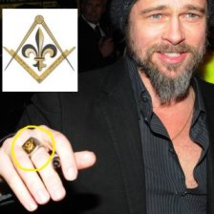
“12 Years a Slave,” is produced by the Brad Pitt’s Plan B production company. Brad Pitt of the ILLUMINATI says, “I grew up in a very Christian environment — a very healthy environment and a loving a family — but there were parameters that I didn’t understand, that I questioned it, and it took me until my adult years until I could really try new things… That was SATANISM, it works really well, I made a PACT [with the DEVIL-British Empire] and the movie came out…” 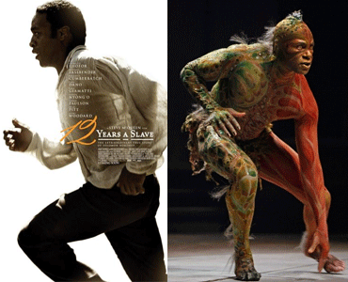Brad Pitt’s stated admission of being Satan-Like is the opposite of Christ- Christ-Like within the frame-work of Christian Theology as much as Set is the opposite of Osiris/Horus within the framework of the Kemetic Osirian Mysteries and Belief System. I intend to follow up on a study immediately on this British satanic mass media propaganda- psychological (Caliban Conspiracy) warfare American Slavery film straight out of the pit of Lucifer’s Workshop. If Brad Pitt isn’t as he admitted a true “Initiate of Satan” doing his work deceptions and illusions- Fat Meat Ain’t Greasy!
THE BUTLER- SERVE LUCIFER AND THE ILLUMINATI

The DEVIL (Baphomet) HORNS, HollyWeird Luciferian Danny Strong (creator of Buffy the Vampire) and Britney Spears, above, Strong allegedly wrote the script for The Butler.
The Butler is yet another psychological warfare vehicle out of the HollyWeird’s powerful ILLUMINTI cabal. Their sole agenda seems to be penetrating the sub consciousness via mass media scientific “entrainment” of our brains inducing lunacy, and senses of overwhelming powerlessness to resist a New World Order. Like Django Unchained, they didn’t consult with Black scholars or historians to create a meaningful script or plot. It wasn’t created out of any dialogue or genuine concern for the aspirations of Black People that would validate and provide fuel and empowerment to Black Identity and BEING.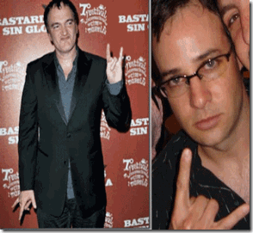Django Unchained– Black Cinema Deception creator Quentin Tarantino and Danny Strong, DEVIL HORNS HAND SYMBOL, above, were boyhood friends from Manhattan Beach, CA just outside of Los Angeles. It appears that they were raised in the same Satanic-ILLUMINATI Coven.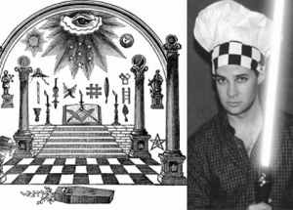
Danny Strong with strange Masonic Checkerboard Head Piece with Jedi Knight Light Laser
Even HollyWeird’s Satanic Cult Negroes like Lee Daniels, Oprah Winfrey, Forest Whitaker, Lenny Kravitz, Cuba Gooding, Jr. and Terrence Howard and didn’t add to the script either.
Fat Meat Ain’t Greasy, Double Bind and Lunacy
If you don’t believe that fat meat ain’t greasy, you may be delusional. A delusion is a belief held with strong conviction despite superior evidence to the contrary.[2] It is also a form of avoidance behavior. Avoidance behaviors, in the context of social anxiety disorder (SAD), are things that people do, or don’t do, to reduce anxiety about being in social situations. Avoidance behaviors can take the form of “true avoidance.” True avoidance behaviors involve the complete avoidance of the feared social situation.[3] Like Django Unchained, “The Butler” has absolutely nothing to do with the African spirit and experience in America. It is an ILLUSION, a smoked mirror masked to gingerly catch you in a DOUBLE-BIND- INSANITY WITHOUT DISEASE.
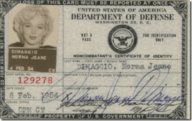
Norma Jeane- Marilyn Monroe’s DoD Top Secret Clearance to Lookout Mountain
Since at least 1947, the CIA’s propaganda, psychological warfare specialists and social scientists have ruled over Hollywood from up high at the top secret Lookout Mountain Laboratory in Laurel Canyon.[4]British Godfather of MK ULTRA and the CIA, Dr. Gregory Bateson,[5] developed the DOUBLE-BIND THEORY.[6] Dr. Bateson was the CIA’s Clandestine New Age Psychological Warfare and Mass Population Control Theorist-Specialist. [7] Dr. Bateson’s DOUBLE-BIND THEORY is surreptitiously layered throughout the movie, “The Butler.” Dr. Bateson is also a world renowned Anthropologist. [8]
Anthropology is the study of humankind, past and present that draws and builds upon knowledge from social and biological sciences as well as the humanities and the natural sciences.[9] An Anthropologist is a social scientist with an extensive knowledge of anthropology who uses this knowledge in their work, typically to solve anthropological problems.[10] A CIA New Age Anthropologist isn’t interested in solving the anthropological problems of the masses, but using knowledge from social and biological sciences as well as the humanities and the natural sciences to disrupt and turn the cultures of people against itself for the military intelligence, political and social agendas of the Imperium- ILLUMINATI and the New World Order. The Butler movie is a vehicle designed to snag you in a DOUBLE-BIND– a situation in which no matter what a person does, he can’t win inducting schizophrenic symptoms. In the DOUBLE-BIND, there are two conflicting levels of communications and an injunction against commenting on the conflict. [11]
According to Bateson, “The ability to communicate about communication, to comment upon the meaningful actions of oneself to others, is essential for successful intercourse.” In normal relationships we continually comment about the actions and communications of others, saying such things, as, I feel uncomfortable when you look at me that way.””Are you kidding me? Or “What do you mean by that? In order for us to accurately discriminate the meaning of our own or another’s communication we must be able to comment on the expression- but the schizophrenic is effectively enjoined from such commentary.”[12]
The movie is based on the late black White House Butter, Eugene Allen. Cecil Gaines (Forrest Whitaker) is an ILLUSIONARY NEGRO and STRAWMAN character that like the real Eugene Allen, is a classic DOUBLE-BIND SCHIZOID and UNCLE TOM LUNATIC. The butler is a senior servant. They officiate in service rather than actually serving.[13] Both Django Unchained and The Butler involve the use of advanced and sophisticated levels of Supraliminal versus Subliminal Implantation. Supraliminal, literally “above” “threshold”, meaning you can consciously perceive it. Think of the difference between supraliminal and subliminal: the lyrics in the song, or the undetectable nuances when played backwards.[14]
In Django Unchained, the “N Word” was supraliminally dropped and implanted no less than 110 times in the movie. I have not seen either Django Unchained or The Butler. From The Butler’s official trailer, I noticed that the two key words repeatedly supraliminal dropped and implanted were BUTLER (function of serving)[15] and SERVE (to act as a servant).[16] “Everything you are and everything you have is because of that butler!”[17]
“You hear nothing. You see nothing. You only SERVE.”[18] Just these words along demonstrates Dr. Bateson’s DOUBLE BIND– injunction against commenting on conflicts. Eugene Allen, living under those humiliating conditions alone, for 32 years, would turn any human being into a Bateson SCHIZOID.
The Butler, Forrest Gump & Order of Knights of the Golden Circle
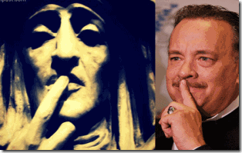
“Stupid is as stupid does“ –Forrest Gump (1994)
The infamous Monster Ball–Precious HollyWeird black-gay movie director, Lee Daniels, has said he sees The Butler as his black Forrest Gump.[19] What is a Forrest Gump? Forrest Gump is a 1994 HollyWeird film starring Tom Hanks, above, is about a mentally challenged man’s epic journey through life, meeting historical figures, influencing popular culture, and experiencing first-hand historical incidents while largely unaware of their significance.[20]
Forrest Gump’s infamous phrase, above, basically means that an intelligent person who does stupid things is still stupid. You are what you do. It is a catch-all term that basically means that stupid people are going to keep on doing stupid things because that’s what they are, period. [21] “The Butler and Forrest Gump do share some political and thematic similarities. For example, they both mock and caricature the Black Power Movement. The Butler through news sound bites, Nixon’s meeting about Cointelpro, and Cecil’s son’s involvement with the Black Panthers, depicts them as a violent group of clowns who are the bastard children of the “good” Civil Rights Movement led by Dr. King.”[22]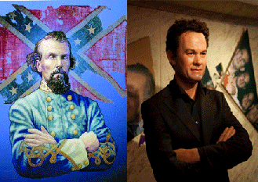HollyWeird’s Forrest Gump plays stupid to, and exercise utterly gross rejection, evasion and a shameless dissociation from some of the America’s most significant historical human events. Yet, like the White House Butler, he only strike out violently against the Black Panther Party for Self Defense. To begin with, Gump claims proudly that his mother named him after Confederate General Nathan Belford Forrest. [23]“It is in [General Bedford] connection with one of the most atrocious and cold-blooded massacres that ever disgraced civilized warfare that his name will forever be inseparably associated. ”Fort Pillow Forrest” was the title which the deed conferred upon him, and by this he will be remembered by the present generation, and by it he will pass into history. The massacre occurred on the 12th of April, 1864. Fort Pillow is 65 miles above Memphis, and its capture was effected during Forrest’s celebrated raid through Tennessee, a State which was at the time practically in possession of the Union forces. …”[24]
General Bedford and 2,500 rebel troops carried out against human beings an unparalleled fury, and unlashed upon Black People a vindictive savageness unseen since the days of the barbarians, Attila and Huns. The Massacre at Fort Pillow, a Union garrison, occurred on April 12, 1864. The fort was occupied by approximately 295 white Tennessee troops and 262 U.S. colored troops, and hundreds of Black men, women and children escaping slavery behind the protection of Union lines.[25] After surrender of Fort Pillow, General Bedford and the rebels began the deliberate slaughter of Black People. Black sergeants were singled out, nailed to logs and set on fire. The tents of the Black wounded were set on fire. Blacks escaping into the Mississippi River were caught in crossfire. Black women and children were shot on sight,[26] and then consciously fired upon innocent men, women, and children who were rushing down to a ravine to escape.[27]
They ripped open bowels with bowie knives, trussed bayonets through eyes, shot Black People at point blank range in the head. Colored troops threw down their arms and begged for their lives. They were massacred. Forrest ordered no quarter. In the morning, Bedford’s rebels shot the wounded in the hospital. They burnt bodies and butchered them. The Negroes that could stand were forced to stand up and then were shot. Many of them were hung. Black men were buried alive with the dead. Black men were nailed to walls of houses and burnt alive on the structures. Killing and slaughter of Black people went on throughout the night.[28]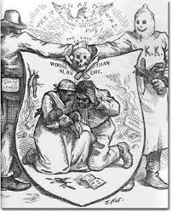In 1866, Masonic (Skull and Bones- Brotherhood of Death) members and former Confederate Soldiers (the highest ranking was General Nathan Bedford Forrest) founded the White Knights of the Ku Klux Klan.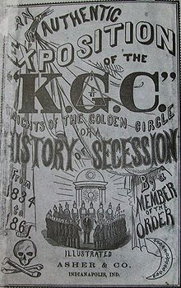They formed the name from the Greek word “Kyklos” (pronounced “koo-close”) which means “Circle” and Clan (Ku Klux Klan) basically “Knights of the Clan of the Circle” aka “The Knights of the Golden Circle”. Their goal was clandestine domestic warfare; to assassinate President Abraham Lincoln, destroy the union and restore the American Institution of Slavery. [29]
The realization that the movies’ producers, directors and script writers intentionally supraliminally slipped the image of a Klansman, General Nathan Forrest Bedford, one of America’s most clandestine figures and vicious, savage racial mass murders in American History into the movie and the public psyche through the perceived innocence of Forrest Gump is a deliberate betrayal of public trust. The supraliminal implant of Klansman General Forrest Bedford in the movie was designed deliberately to subliminally terrorize-traumatize People of Color, and snag the masses in a DOUBLE BIND that they are caught virtually powerless to defend against.
The Butler, Blood Oaths of Secrecy & Lunacy
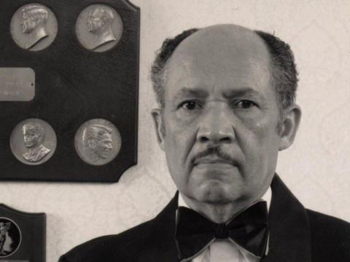
“They swore him [Eugene Allen] to some kind of secret code.” –Gloria Gaines-Oprah Winfrey, The Butler Official Trailer (2013)
The movie is an absolutely and complete ILLUSIONARY fictional historical drama loosely based on the real-life White House butler, Eugene Allen.[30] The Butler is purely fictional because Eugene Allen lived under constant fear and distress of a Blood Covenant of Secrecy and Code of Silence. Just take a good hard look at the above Eugene Allen’s bizarre psychotic fixed stare of a thousand years. Allen’s blood covenant and code of silence was further layered by a far deadlier Masonic Blood Oath of Secrecy; and a secret allegiance to Queen Elizabeth and the Grand Lodge of England. Eugene Allen was a member of the Most Worshipful Prince Hall Grand Lodge of the District of Columbia until his untimely demit [To relinquish (an office or function)-DEATH] to the Celestial Lodge above in 2010.[31]
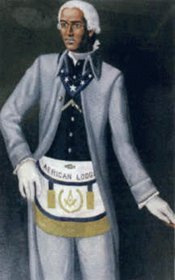
During the institution and under the condition of African Slavery in America and England, Prince Hall petitioned the Grand Lodge of England (Moderns) for a warrant to be enslaved again which was granted on September 20, 1784 during the Reign of King George III aka George William Frederick Hanover; and delivered in Boston on April 29, 1787. African Lodge No. 459 was organized on May 6, 1787. Out of this lodge, the Prince Hall Grand Lodge was formed in 1792.[32]
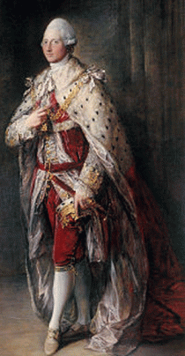
In 1784, the Grand Master of the Grand Lodge of England (Moderns) was above HRH Henry Frederick, Duke of Cumberland. Prince Henry was born in London to Frederick, Prince of Wales, son of George II (German House of Hanover- George I) and Caroline of Brandenburg-Ansbach (German House of Hohenzollern), Princess of Wales.[33]
The British Empire’s extension of a Masonic charter to Prince Hall was no benevolent act of brotherhood while African Human Bondage raged in England and its colonies. The German Houses of Hanover and Hohenzollem stand at the pinnacle of the False Kings of the Hyksos and the Ba’al-Moloch New World Order Conspiracy established in antiquity at Solomon’s Temple in Ancient Palestine. Frederick the Great, King of Prussia (House of Hohenzollem)[34] was the beginning of the Second Reich that committed itself to establishing an Aryan World Order that led to the THIRD REICH 1000 Year of Aryan Supremacy and the annihilation of millions of people of color. [35]
The Nazi’s shut down the “Modern” Grand Lodges, but allowed the national “Old Prussian Grand Lodges” to continue under oaths of allegiance to “Mein Fuhrer.” They became “The Frederick the Great Association.” Frederick the Great (712 – 1786) was credited with establishing “Freemasonry” in Germany, and founding Confederate Generals Albert Pike and Forrest Bedford’s Ancient and Accepted Scottish Rite of Freemasonry- clandestine Order of t he Knights of the Golden Circle.[36]
The German House of Hanover– King George I led to the current Elizabethan House of Windsor[37] that led to Cecil Rhodes and the vicious Luciferian-Racist Global Imperial British Empire. [38] Prince Hall Grand Lodge is a clandestine Fifth Column of the Racialist Imperial British Empire and the Luciferian New World Order.
The Horror and Madness of Lucifer’s Workshop- The U.S. White House
http://www.youtube.com/watch?v=FuojHqfe4Vk
“You Hear Nothing. You See Nothing. You Only SERVE!” The Butler Official Trailer (2013)

1960-November 22, 1963- The White House
President John F. Kennedy was assassinated, They blew his brains out in a Coup d’Etat in America- the Nazi –SS Connection.[39]
1963-1969 White House
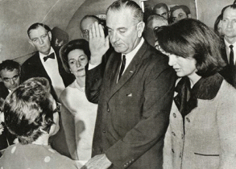
Vietnam War Criminal President Lyndon B. Johnson, “It was Johnson,”[40] a racist conspirator out of Texas in the assassination of President Kennedy took over the White House, and escalated the war of aggression in Southeast Asia based on a hoax and false flag operation, Gulf of Tonkin Incident, wasting the lives of millions. [41]Johnson, 36th President of the United States was initiated on October 30, 1937, in Johnson City Lodge 561, Johnson City, TX. On the surface, they say that President Johnson never completed the degrees however, and therefore obtained only the Degree of an Entered Apprentice Mason.[42] Regardless, he was a Luciferian “Freemason.”
1969-1974 White House
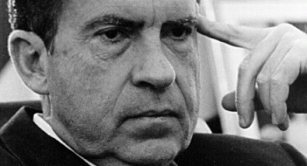
Vietnam War Criminal President Richard (Tricky Dick) Milhous Nixon was another JFK conspirator that took over the White House.[43] Nixon was a notorious Nazi collaborator [44] and a vicious racist that plotted and supported a clandestine shadow government policy and plan of GENOCIDE, “I have the greatest affection for them [Black People] but I know they’re not going to make it for 500 years. They aren’t. You know it, too… Mexicans… They don’t live like a bunch of dogs, which the Negroes do live like.”[45]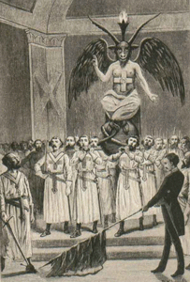President Nixon was a Gnostic/Baphomet Knight Templar. In 1957, he dedicated the Knights Templar Royal Arch Room to the First Masonic U.S. President George Washington in 1957. This room is one of several on the upper levels of the Washington Masonic Memorial in Alexandria, VA.[46]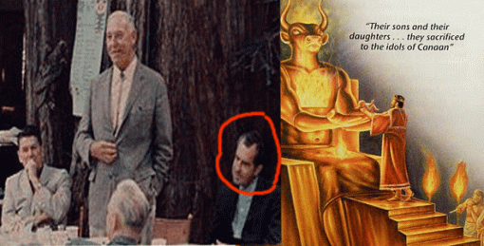President Richard Nixon was a secret Samarian Ba’al- Moloch worshiper of the Bohemian Grove.[47] 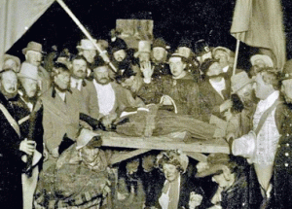Above, a murdered black child is offered to the pagan rite of fire to Ba’al Moloch at the Bohemian Grove. This is the way the elite Luciferians really roll in secret at the grove.
1974-1977 White House
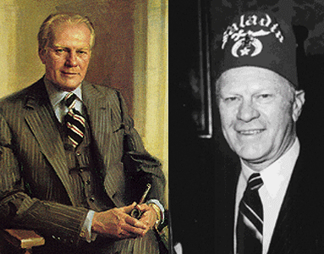President Gerald Ford’s Luciferian Fellow Craft and Master Mason Degrees were Conferred by Columbia Lodge No. 3, Washington, D.C., on April 20 and May 18, 1951, as a courtesy to Malta Lodge. He was made a Sovereign Grand Inspector General, 33°. President Ford was unanimously elected an Active Member of the International Supreme Council, Order of DeMolay (Baphomet) and its Honorary Grand Master.[48]
1977 – 1981 White House
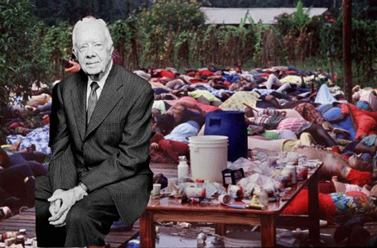Human Rights Criminal President Jimmy Carter was a snake in the grass, puppet of the racialist Rhodes Round Table (New World Order) and another secret high level member of the Cult of Earth Goddess Mithra (Vulva Hand Symbol, above) explained further below. He supported Rev. Jim Jones and covered up the Jonestown Nazi- CIA MK ULTRA Medical-Mind Control Experiment at Jonestown, Guyana; and the vicious slaughter of over 900 predominately Black innocent men, women, elders and children.[49]
1981-1988 White House
Granada War Criminal 666 President Ronald Reagan was a blood oath member of an ancient secret Catholic military order, The Sovereign Military Hospitaller Order of Saint John of Jerusalem of Rhodes and of Malta also known as the Sovereign Military Order of Malta (SMOM), Order of Malta or Knights of Malta,[50] and a Luciferian Honorary 33rd degree Freemason.[51]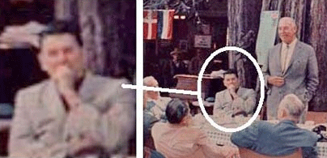President Reagan was also a secret Bohemian Grove Samarian Ba’al- Moloch worshiper.He had been deeply involved in shadow government pedophilia-satanic rings and secret Bohemian Grove pagan sex rites.[52] 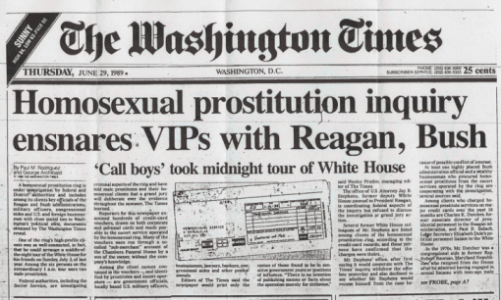President Reagan and VP George H. W. Bush were also running a ring of satanic ritual abused and MK-ULTRA mind controlled Midnight Boy Prostitutes through Eugene Allen’s White House under his nose.
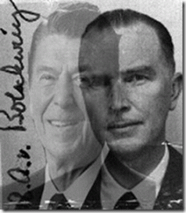
President Reagan was a puppet of the Hitler’s spy master and chief, General Reinhard Gehlen. Sturmhauptfuhrer SS Otto Albrecht Alfred von Bolschwing’s (Beast of Bucharest) , Head of the Gehlen Org and the former Nazi General Staff Secretary, Helena von Damm, ran the Secret State White House.[53]
1989-1993 White House
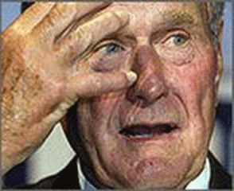
War Criminal- pedophile President George H.W. Bush was a SMOM Knight of Malta, Knight Grand Cross of the Most Honourable Order of the Bath, Order of Skull and Bones (German Brotherhood of Death, Shriner (Scottish Rite) Luciferian Freemason.[54]
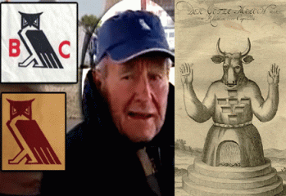
President George H.W. Bush was also a secret Bohemian Grove Samaritan Ba’al- Moloch worshiper that had also been deeply involved in Moloch-Molech human sacrifices; and its pedophilia and secret pagan sex rites.[55] Also during Bush’s administration, call boys 15 years old (and younger) were still taking midnight tours of White House.[56]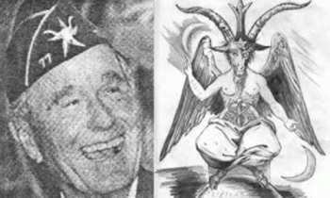This picture shows President George H.W. Bush wearing his #77 Knight Templar hat with a golden Baphomet. This picture was secretly taken by German intelligence many years ago at a party.[57] 1993-2001War Criminal 666 President Bill Clinton was initiated into Hot Springs Chapter of the Order of Molay in Hot Springs, Arkansas, in 1961, where he served as Master Councilor. He received the Chevalier in 1964 and the Legion of Honor in 1979. Clinton was inducted into the DeMolay Hall of Fame on May 1, 1988.[58] The Order of DeMolay formulated its principles on the life and death of the Grand Master of the Knights Templar, Jacques de Molay. Baphomet was worshiped by de Molay and the Templars, as the denial of Christ. This was their most serious accusation when the order was arrested by degree of Pope Clement V. The Knights Templar 22nd Grand Master, Jacques de Molay, was burnt at the stake by order of King Philip IV of France in 1314.[59]
2001-2009 White House
War Criminal 666 President George W. Bush, the 9-11 Deception- Iraq War Criminal and Mass Murderer, is also a SMOM Knight of Malta,[60] and a Knight of Columbus.[61] For decades, SMOM and the Knights of Columbus, controlled by the Jesuits, have provided a safe haven in the U.S. and a veil for Reichsfuhrer SS-1 Heinrich Himmler’s Knights of the Black Sun, the SS. [62] President George W. Bush is closely related to every European monarch on and off the throne — including the King of Albania — and has kinship with every member of Britain’s royal family, the House of Windsor. He is a 13th cousin of Britain’s Queen Mother and of her daughter Queen Elizabeth and is a 13th cousin once removed of the heir to the throne, Prince Charles. Bush’s family tree can be documented as far back as the early 15th century. He has a direct descent from Henry III and from Henry VIII’s sister Mary Tudor, who was also the wife of Louis XI of France. He is also descended from Charles II of England.[63]
It is absolutely bizarre that anyone would try to sell the popular idea among the masses that Eugene Allen would come out of Lucifer’s Workshop less than a raving LUNATIC after witnessing 32 years of war crimes, assassinations, deceptions, racism, mass murder in the millions, satanism, corruption and pedophilia with his EYES WIDE SHUT under the threat of death to everyone he loved. Let’s take a break for a moment. The ILLUMINATI never forgave Marvin Gaye for releasing “What’s Going On” among the masses. It was something that Eugene Allen could never dare to ask even in this dreams.

http://www.youtube.com/watch?v=pDQ_EA5DJqI
Lee Daniels, Lucifer’s Director
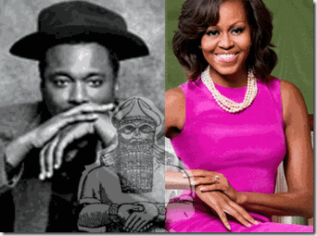
Lee Daniels & Michelle Obama, the secret hand symbols of the elite black satanic occultist are not random. The ILLUMINATI appears always to have a veil over Lee Daniel’s voice. Every word of the script and scene in The Butler had been carefully studied and developed by a high level ghost writing team of social scientists, psychiatrists and psychologists. That’s why the movie script was fully developed as a finished product by the time it reached Danny Strong. As I stated before, the HollyWeird Satanic Negroes had nothing to do with developing or contributing to the script. The black characters of the The Butler were carefully profiled with detailed psychological profiles. They were selected from among HollyWeird’s black satanic covens; and secret ILLUMINATI cells.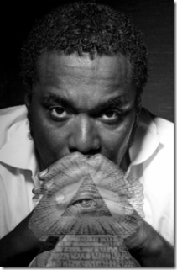
Lee Daniels, the Ninth Gate of Hell, “Silence is Golden.”
The ILLUMINATI can always seem to depend on Lee Daniels to front for the works coming out of Lucifer’s Workshop with his mouth covered by a veil of secrecy. Lee Daniels is an extremely peculiar brother with a lot of strange ideas. Daniels is a former nurse that has oddly arisen rather quickly among the elite of black HollyWeird. Most of Daniel’s film projects seem to dwell at the Gates of Hell. He produced Monster’s Ball and directed the film Precious.[64]
Like the other so-called black movie mogul Tyler Perry, he has a MK- ULTRA type background of ritual traumatic sexual abuse as a child, both beginning at 5 years old. Daniel’s father was a police officer, William Daniels, “killed in the line of duty” in 1972 when Lee was a teenager.[65] Daniel’s father was violent and physically abusive towards him, and even tried “to beat it [being gay] out of him.”[66] I have no intention to intentionally and personally demean the sexual and physical abuse of Perry or Daniels, but there is something extremely odd about both of them appearing abused by their Black fathers, both experiencing homosexual episodes at 5 years old; and both promote black MK ULTRA disassociated and alter personalities for mass media consumption.
Lee Daniels says, “I just started reading reviews about “Woodsman,” a couple months ago, ’cause I’m that disconnected. It helps you, you’re able to disassociate. I don’t know how well I’d be able to disassociate from something I directed, but I think I would probably start laughing.
http://www.youtube.com/watch?v=uEU2VRDF_Dg
In his Oprah interview, Tyler Perry had a “Fat Meat Ain’t Greasy” slip of the tongue. He admitted briefly that after the age of 5, some of his ritual sexual abuse took place at a hospital, “…nurse in the hospital. I had been rushed to the emergency room from school for something and a male nurse comes in and he was doing the same thing this man was doing [Birdcage & the man with his hands in his pants].”
Tyler Perry’s ritual sexual abuse taking place in a hospital setting certainly suggests and supports an argument of CIA- MK ULTRA involvement. Perry was sexually abused by numerous pedophiles remotely distanced from his black father. Additionally, the “birdcage and the pedophile” embedded in Perry’s memories suggests that in some episodes of programming he had been caged while being abused. “Many survivors remember the thousands of cages housing little children from ceiling to floor. The cages were hot wired (electrified on the ceiling, bottom and sides) so that the children who are locked inside can receive horrific electric shocks to their bodies to groom their minds to split into multiple personalities. These cages are called Woodpecker Grids.”[68]In 2005, Michael (convicted child molester) and Sharen Gravelle, above, were discovered raising 11 Black foster children (age 1 to 14) in locked and alarmed cages without pillows or blankets. Their defense was that a psychiatrist advised them to make the children sleep in sensory deprivation cages at night to control and traumatize them into modifying their behavior.[69] In other words, caging Black Children and behavior modification has been somebody’s state of the art. CIA Agent Rev. Jim Jones was a behavior modification specialist that not only caged Black Children in sensory deprivation boxes for days in the hot rain-forest of Guyana, but also confined children in deep dark holes and caves, sometimes upside down, surrounding them with snakes and made-up monsters for days and weeks. [70]
The abusing black fathers in Perry and Daniels cases may be screen memory scrambles or implants to cover far deeper and horrific experiences. A screen memory is a memory that hides, or screens, another memory. Screen memories are often used in alien abduction cases. “Memory scrambles aren’t the same as screen memories. Scrambles are created by handlers to confuse or disorient the victim, either at the time or when the victim remembers the experience later on. If just one detail of the experience doesn’t make sense, the handlers hope that their victim will then discount the entire memory. Or better yet, the victim will talk about the still-scrambled memory to others and will discredit his or herself…”[71]
The Laughing Man & the Woodsman- the Pedophile For whatever reasons, Daniels and Damon Dash of Jay-Z’s Satanic Coven produced a strange and controversial pedophilia movie, “The Woodsman.” The Woodsman centers on the redemption of a serial child molester and convicted pedophile. It’s called the Woodsman because once out of prison, the compulsive molester (Kevin Bacon) got a job at a lumberyard. The Woodsman also profanely appears as the “Tin Man” in the Masonic Children’s Fairy-tale “Wizard of OZ.” “pg. 79 Book 3 Ozma of Oz, “I am only a ma-chine, and can-not feel sor-row or joy, no mat-ter what hap-pens.” This is teaching mechanical dissociation, and coincides with Tin Man programming.”[72] The programming that is related to the Tin Man produces a monarch slave which is described as “A WELL OILED MACHINE” by the handlers. Tin Woodsman Monarch slave: “THESE ARE BUT EMPTY SHELLS OF THE LIFE THEY WERE ONCE POSSESSED. LIKE YOU ARE–EMPTY AND VOID OF LIFE.”[73]
The Tin Woodman seems to lack a heart, but he is so full of sentiment that he is always weeping. Certain alters are not given courage and most have their hearts taken from them.[74] “Do what thou wilt shall be the whole of the Law.” –Aleister Crowley, 666, the BEAST Lee Daniel’s Woodsman doesn’t ask you to condone pedophilia or the pedophile that commit ritual sexual abuse of children, but it does invite you to accept him and to root for a man’s good instincts (Heart) to prevail over his bad ones. Lee Daniel’s Woodsman is a machine-like-pedophile (demon) that he encourages the audience to join them down the yellow brick road to find feelings, sorrow and a HEART for the Demon that lurked inside of him.
With the help of psycho therapy, Daniels has been found to harbor deeply embedded repressed memories of traumatic childhood ritual sexual abuse. During therapy, he recalled a sexual abuse incident from a pedophile (Woodsman) when 12 years old. 12 years is also the amount of time that the Woodsman spent in prison for molesting little girls. Daniels, who recently had to face a repressed childhood memory that forever connects him to Precious, “My therapist said, ‘Lee, your stories are so provocative, were you sexually abused?’ I go, ‘no.’ Then I go, ‘Well, you know I was 12 and this guy who was in his twenties tried something with me.’”[75]
After his confession, Daniels says his therapist hit him with the news. “She said to me, ‘Lee, you were sexually abused.’ I was like ‘ whoa .’ That was abuse. “That was last year and I’m almost 50 years old. I was like, ‘OK, put that on my checklist of things to do,’” he adds, breaking into a hearty laughter. [76] “The area of spiritual warfare for the person with ritual abuse and DID is often highly misunderstood. What the woman involved in deliverance didn’t realize is that the part talking to her was an ALTERNATE PERSONALITY named “laughter” who was created in times of great emotional stress (I wasn’t allowed to cry when I felt pain at others’ suffering, but mocking laughter was highly accepted as an emotional release). And the “thousands” referred to were personalities, not demons. Laughter found the evening highly entertaining, but others inside found it highly traumatic.”[77]
Luciferian Aaliyah Silenced by her ILLUMINATI Coven handler
Strangely, Hip Hop Damon Dash was the executive producer of Daniels’ pedophilia project, The Woodsman. Many sources claim that Damon Dash sacrificed Aaliyah in a Satanic-ILLUMINATI Blood Oath Covenant for Fame and Fortune. Aaliyah’s ritual sexual abuse childhood background suggests that she became an expendable victim, a Black female MK ULTRA sex slave.[78]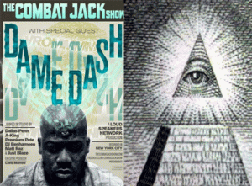If you happen to believe that Fat Meat Ain’t Greasy and Damon Dash isn’t overwhelming under the influence and power of the Satanic ILLUMINATI, think again. Tyler Perry and Lee Daniels were victims of systematic ritual sexual abuse by faceless Woodmen-Wizard of OZ without names. As child victims-call boy prostitutes, they were pimped alright, but it wasn’t by their Black Fathers. Maybe one day, their psychoanalysts will suggest that they stop telling themselves that Fat Meat Ain’t Greasy. They are still being PIMPED by Luciferian ILLUMINATI NWO.
Forest Whitaker, Lucifer’s Vessel

In The Butler, Forest Whitaker portray the leading character, Cecil Gaines.
For most Christians, the Bible is like a software license. Nobody actually reads it; they just scroll to the bottom and click “I agree.” –Forest Whitaker[79]
Whitaker’s statement, above, has to be one of the most condescending and cutting remarks that an individual could make to mock and insult Christians, Civil Rights Movement, and Dr. Martin Luther King, Jr. The odd thing about his statement is that Christianity is most likely the religion of his parents and forefathers in America that fought and died to free him from slavery.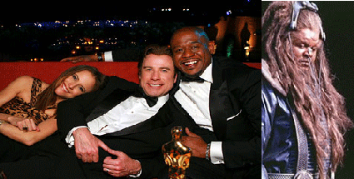Even if Whitaker is not a Christian (Follower of Christ or Christ-Like), it isn’t necessary to attack Christianity. Whitaker is uncommonly personally close to John Travolta and Scientology. Whitaker starred as the hairy alien, Ker, ruling Earth with Travolta in L. Ron Hubbard’s movie version of Battlefield Earth.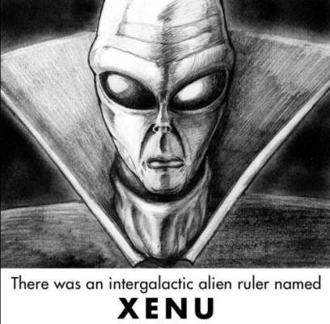Scientologists do believe that an alien named XENU is their god-creator. It appears certain that Forest Whitaker will fall down and honor any entity or lord other than Christ even Satan.
Forest Whitaker featured in Satanic Rite Ritual Hip Hop Video
In the first instance, I thought that “Fat Meat Ain’t Greasy,” because in my mind- Forest Whitaker wasn’t supposed to be in a Hip Hop False Satanic Rite video; and an outright supraliminal implant hit piece encouraging teens and Hip Hop generation to consume alcohol in excess, and change their “pleasure centers” as endorsed by some of HollyWeird’s most celebrated and powerful directors, producers, actors, comedians and Hip Hop artists. If Forest Whitaker was a Satanist, you would think that he would have been covered by veil of secrecy.
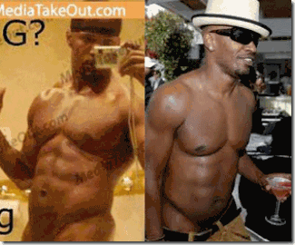
I assumed that Forest Whitaker was a member of Jamie Foxx’s Panda Hip Hop Satanic Coven. However, Foxx’s egotistical, unstable and wild character and freaky low life exhibitionist behavior would undoubtedly bring undue exposure to more secret senior elite Luciferians.

Nevertheless, I think that Ron Howard, Quincy Jones, Samuel L. Jackson, Cedric the Entertainer, and Forest Whitaker made brazen cameo appearances on Foxx’s “Blame it on the Alcohol [Lucifer]” music video to initiate Foxx’s Hip Hop Coven from a far more clandestine mother ILLUMINATI coven. On the surface, Academy Award Actor Forest Whitaker’s resume s is extremely impressive to say the least. He is like a major “Who’s Who” of the World.
To the masses, Forest Whitaker is an internationally recognized distinguished artist and humanist of the planet. He is the co-founder and chair of the International Institute for Peace and is the UNESCO Goodwill Ambassador for Peace and Reconciliation.[80] It isn’t clear why he would expose himself in such an open, active and patent association with ILLUMINATI Satanic rites. Are our lying eyes betraying us again? Is it a Forest Whitaker “Fat Meat Ain’t Greasy” moment? Do we just deny it (DOUBLE BIND) and “Blame it on the Alcohol?”
My eyes weren’t lying, Forest Whitaker was there, and I am going to talk about him. Make no mistake about it, Forest Whitaker is clearly among the ranks of elite Luciferian- ILLUMINATI, and may prove to be far more satanic and dangerous to the masses than you might want to believe.
Forest Whitaker, Jesuits and the ILLUMINATI
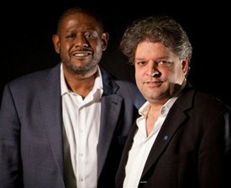
Lurking in the shadows behind Whitaker is an Italian professor named, Aldo Civico of Vatican Radio.[81] Since its inception in 1931, Vatican Radio has been controlled by the Jesuit Order.[82] Aldo is Whitaker’s Vatican puppet-master; co-founder and the Director of Whitaker’s International Institute for Peace at Rutgers University.[83] Civico markets himself as a Columbia University (NY) educated anthropologist specializing in international conflict resolution and facilitation. [84]
Civico, CIA & the Cocaine Connection
In 2003, Civico entered the “Cocaine Capital” Medellin, Columbia for field studies under President Alvaro Uribe, a CIA asset.[85] When Colombian President Uribe, who took office in 2002, he was boosted by large inflows of U.S. funding to deal with two predominant rebel groups–the Revolutionary Armed Forces of Colombia (known by its Spanish acronym, FARC) and the National Liberation Army (ELN). Civico went in to field study and identify the “leadership of the ELN”,[86] that clandestinely aided Uribe’s military and government supported right-wing paramilitary groups (Death Squads) in targeted assassinations of guerilla leaders, left wing activists, and sympathizers.[87]
Columbia’s military and paramilitary death squads have a well established “…history of assassinating left-wing civilians in guerilla areas, cooperating with narcotics-related paramilitary in attacks against suspected guerilla sympathizers, and killing captured combatants.”[88] Civico’s anthropologic field studies cover appeared to have been principally funded by Rothschild Zionist [89] George Soro’s [New World Order] Open Society Institute; CIA front- U.S. AID; and Zbigniew Brzezinski’s Columbia University international schools.[90]
Civico, Bill Clinton & The Vatican Con Scandal
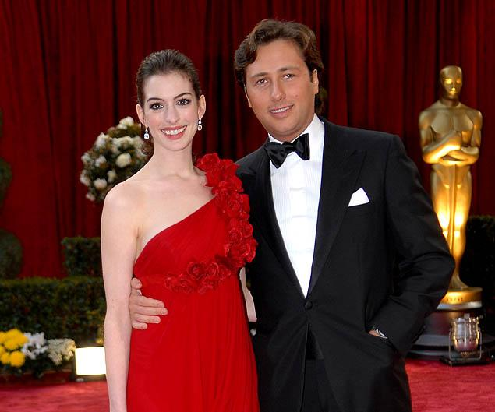
In 2005, Civico’s name surfaced in the Vat-Con Scandal [Vatican Con]. [91] Italian Raffaello Follieri (Follieri Group) of Manhattan with HollyWeird Actress Ann Hathaway. He has ties to “senior members of the Vatican hierarchy.” He claimed that he was helping the church liquidate, renovate, and revitalize excess real property in the United States that represented billions. According to Follieri, The [sex abuse] scandal in America [where] dioceses were paying a lot of money to pay [off] the lawsuits” would necessitate the sale of church property. Next, he said, the changing demographics of the church — from North and East to West and South and from city to suburb — mean that “a lot of the schools and churches that were full of people in the beginning” are now largely unused.[92]
The Follieri Group not only had powerful inside credentials to the Vatican. It also had close ties to the powerful and secret SMOM- Sovereign Military Order of Malta.[93] In the Italian-Vatican Connection, Aldo Civico, Director of the Center for International Conflict Resolution at Columbia University, had an unknown inside special relationship to Bill and Hillary Clinton and introduced Raffaello Follieri inside the Bill Clinton’s personal inner circle.[94] In 2005, “…the Follieri Group partnered with the Yucaipa Companies, a Los Angeles private equity fund headed by Forbes magazine-ranked billionaire Ron Burkle. Yucaipa, whose advisory board includes former president Bill Clinton (who counts Burkle among his closest friends) and the Rev. Jesse Jackson, has extensive investments in profitable inner-city commercial enterprises, particularly grocery stores.”[95] Most of the money from investors into the Follieri Group Vatican get rich land schemes began to disappear behind a curtain.
Some of the money that disappeared was attributed to maintaining Raffaello’s luxurious lifestyle with Manhattan and HollyWeird’s rich and famous. In October 2008, Raffaello Follieri pled guilty to 14 federal counts of wire fraud, money laundering and conspiracy to avoid a wider, deeper and sweeping look inside the Vat-Con Scandal. In 2012, Raffaello walked out of prison and returned to Italy behind the curtain of the Vatican. [96]
Civico, Barack Obama & the SECRET OLD ILLUMINATED ONES
During Barack Obama’s presidential campaign, rumors circulated on the internet that in a speech Obama referred to Medieval Catholic Mystic Prophet Gioacchino da Fiore as a ”Master of Contemporary Civilization” and someone who wanted to create a fairer world.[97] In regards to Gioacchino da Fiore, they had to react fast to that rumor. Immediately and for whatever reasons, people immediately suspected that the Jesuit Aldo Civico had been the source of Obama’s sudden misguided interest in Gioacchino da Fiore. Confronted, Civico quickly publicly answered and denied the allegations.[98]
Gioacchino da Fiore- The False ILLUMINATED ONE 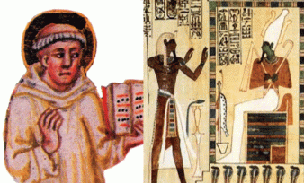Joachim [Gioacchino] Fiore of Fiore, (above with the stolen Kemetic Sacred Tribute Hand Symbol to Book of Revelation- falsified version of the Osiris Mysteries), was a Grand Master of the Medieval New Order ILLUMINATED Ones, and Amaury of Bene, a fellow Illuminated ONE were the principal architects of idea that the world is divided into three ages- that of God, the Father (Jehovah/Judaism), God the Son (Jesus Christ/Christianity), and God the Holy Spirit which for Joachim and Amaury meant Abraxas (Gnostics- Magic).[99]
Gnosticism was a second century heresy claiming that salvation could be gained through secret knowledge possessed by a few chosen. Gnosticism is derived from the Greek word gnosis, meaning “to know.”[100] The Duchinites, under the leadership of ILLUMINATED One Fra Dolcino (Disciple of Joachim de Flore), were a Joachimite Movement with close connections to Catharism (Dualistic Theology, Good- Evil). [101] According to the late Masonic Grand Mason author, Manly Hall, Dolcino and his wife (Margaret) were pursued and captured by the Inquisition, then castrated and torn to pieces, limb by limb, the pieces afterward burned by the public executioner.
Fifteen years later (in 1322), approximately thirty of Dolcino’s disciples were burned alive in the marketplace at Padua.[102] The Joachimites advocated egalitarianism (human equality) and soon attracted the hostility of the Catholic Church and nobility. The Catholic Church tried to exterminate them and murdered and burnt the remains of Dolcino and his wife in 1307, the same year that Knight Templars (Baphomet- Gnosticism) were arrested, executed and suppressed for heresy.[103]
Please excuse my expression, but Joachim de Fiore of Fiore leads to some deep and heavy shit. As Masonic Manly notes, the Joachimite Movement is a secret link to the fundamental belief system and roots of the Knight Templars (Baphomet-Lucifer), Freemasonry (Gnosticism), the ILLUMINATI, and ZIONISM (Palestine, Center of the New World Order).
The British Empire & the Origin of False-Stolen Kingship- the Book of REVELATION
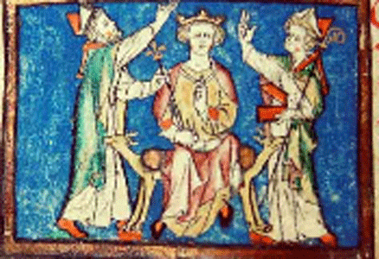
Richard I (September 8, 1157 – April 6, 1199) was King of England (German House of Hohenstaufen) from 1189 to 1199 and one of the leaders of the Third Crusade in the battle for Palestine. He was often referred to as Richard the Lionheart. He is the subject of many myths and legends. Many sources claimed that Richard I sought a meeting but didn’t necessarily meet with esoteric mystic Joachim de Flore on interpretations of the Book of Revelation before the great battle with Saladin, the First Sultan of Egypt and Syria, for the Holy Land.[104]
However, there are sources that support the fact that Richard I, his bishops, archbishops and spiritual advisers did counsel with the esoteric mystic in Sicily before the battle.[105] It was Joachim de Flore that framed Richard I and the German House of Hohenstaufen (House of Elizabethan- Windsor) in secret false kingship of the man child caught up unto God and his throne by a woman that faced the seven headed dragon[Satan] in the Chapter 12 of the Book of Revelation that would come “to rule all nations with a rod of iron…”[106] , [107]
Generally, the biblical Book of Revelation is believed to be the works of John of Patmos. John was a Christian banished to the Island of Patmos, a small Greek Island in the Aegean Sea by Roman authorities during the reign of Emperor Domitian. Domitian (Titus Flavius Caesar Domitianus Augustus) was the third and last emperor (81-96 AD) of the Flavian Dynasty. He was the first Roman Emperor who had demanded to be addressed as dominus et deus (Master and God). Banishment was a common punishment for the practices of magic, astrology, and prophecy.
John of Patmos is claimed to have been a Jewish biblical scribe rather than a scholar or rabbi related to the House of David. It would certainty place him in Jerusalem in the shadow of Alexandria. Other than that not much is known about him. It is said that Jesus appeared before him at Patmos and he became a Scribe of Jesus for the Book of Revelation.
In the first and the last place, the subject of Revelation was not and is not derived from Christian canonical gospels. It is supposed to be absolute Christian divine inspiration- prophesy. However, I believe that more and more people are beginning to come to the conclusion that even that isn’t true.
Early Christians and the Royal Library of Alexandria
The Royal Library of Alexandria or Ancient Library of Alexandria had been one of the largest and most significant libraries of the ancient world. It flourished under the patronage of Greek Ptolemaic Dynasty and function as a major center of Great scholarship from its construction in the 3rd century BC until the Roman conquest of Egypt in 30 BC. No index of the great library survives, but the Library of Alexandria had hundreds of thousands of Kemetic scared scrolls and perhaps tens of thousands of individual manuscripts and works. Most of the staff (Greek and foreign scholars) of the library was fully occupied with the task of translating Kemetic works onto papyrus paper.
Hundreds lived at the library translating sacred Kemetic documents. During the time of John of Patmos from at least 81-96 AD, the Royal Library of Alexandria would certainty have been open to Jewish scribes and a perfect place to access and translate sacred Kemetic works. During the 4th Century AD, the Roman Emperor Theodosius established Christianity as a state religion. He closed all Kemetic temples of Alexandria and what remained of the royal library and its sacred scrolls were deliberately destroyed.
Undoubtedly, hundreds if not thousands of sacred scrolls useful to their newly established state religion were secreted away. Whatever may have remained of Kemet’s secret scrolls after the Christian spoils were put an end to by the Muslim invasion of Egypt in the 7th Century. It wouldn’t out of their character that what they knew of Kemetic Cosmology, Science and Mythology, the oldest and most complete belief system known to human civilization, from sacred works such as the Book of the Dead would be copied then cloaked in forming early Christian dogma, theology and prophesy. However, their interpretations, translations and deciphers were seriously flawed. It took Kemetic priests up to at least 40 years to master just narrow and specialized truths and fields of the thousands of years of Kemetic knowledge and wisdom.
Nevertheless their lack of knowledge of the truth and works of thousands of years, it didn’t bother them. They were only interested in developing a religious system that could act as “Opium for the Masses” in creating a New Jerusalem and World Order. The fundamental matter of the veiled Christian Revelation prophecies existed thousands of years earlier in Kemetic Cosmology and Astrology. Christianity and “Jesus” are deliberate perversions, the fabrication and bastardization of the thousandths of years Kemetic myths of Ausar, Auset and Heru (Osiris, Isis and Horus).
Jesus, the Stolen Mythology of HORUS
Compare the historical, religious and philosophical data between JESUS CHRIST and HORUS of Thousands of Years. The Book of Revelation is basically the bastardization of the complex ancient mythology of Osiris, Isis, Horus, and the Funeral Ritual of the Kemetic Book of the Dead. “That- Aan, who was the Kemetic scribe of the Funeral Ritual. “The Apocalypse of John might be described as “scenes and characters from the mysteries of ‘Taht-Aan, who was literally Aan= John, the divine penman. This was the sacred scribe to whom 36,000 or papyrus-rolls were attributed by tradition. In short, Taht- Aan was the pre-Christian John the divine.”
The stars and constellations of the Book of the Dead became John’s monsters in Revelation like Joachim de Flore‘s seven headed dragon is based on no more than the deliberate continual fabrication and invasion of Kemetic thousands of years scientific astrology and mysteries of the universe.

The above represents da Fiore’s odd seven headed serpent of Revelation Chapter 12 that may be explained as an astrological interpretation taken from an ancient sacred document. In sacred Kemetic Cosmology, the Pleiades or Seven Sisters is an an open star cluster containing middle-aged hot stars located in the constellation of Taurus. In The Book of Going Forth by Days commonly referred to as above The Egyptian Book of the Dead, the Pleiades 7- Star Cluster is sacred to God Osiris.
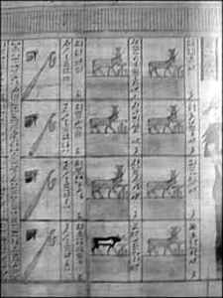
Above from the the Book of Coming Forth by Day is the “seven cows and bull” sacred to God Osiris representing the Pleiades Star Cluster in the Taurus Constellation. 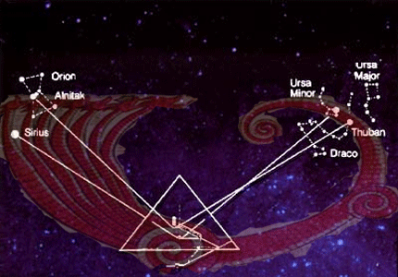Above, da Fiore’s seven headed dragon and Khufu’s Great Pyramid Star Alignment. The Orion Constellation is also associated with God Osiris. Notice just how close Taurus and the Pleiades 7-Star Cluster are to Orion Constellation. The coiled tail of the da Fiore’s seven headed dragon bears the inscription “Gog”. The Star Thuban is the brightest in the Draco Constellation. Generally, Draco translates to “Dragon.” 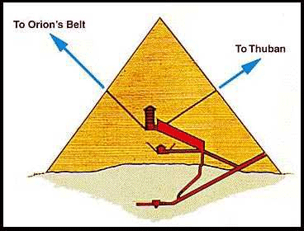John of Patmos in Revelation sees Satan (Set) rallying Gog and Magog to a final battle with Christ (Horus) and his saints: “When the thousand years are over. Satan will be released from his prison and will go out to deceive the nations in the four corners of the Earth- Gog and Magog- and to gather them for battle. In number they are like the sand of the seashore” (Revelation 20: 7-10) You can virtually see the classic struggle of balance between Good (God Osiris) and Evil (God Set-Seth) being played among the universe in the creation of Khufu’s Pyramid.
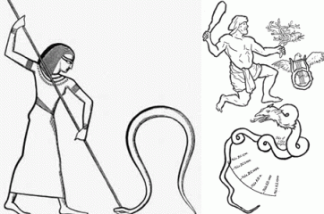
Plutarch, the Greek Historian (46 – 120 AD), equates Seth [God Set] with “Anubis, Apap, Apepi, Bes, Tebba, Temha, and Typhoeus“, pointing to a relation to the Dragon (lizard, snake), which in Egypt first was represented as a crocodile or serpent. Plutarch also notes that the Phoenicians called Seth Doube or Döbher.This would coincide with the star Thuban [Draco Constellation] in then Ursa Minor.
The Kemetic God Set is associated with the Draco- Dragon Constellation. Gog (maybe Star Thuban) is in a league with Set-Satan, the Dragon. It is an old mythological-astrological story of the hero slaying the dragon played out in the stars. It is as universally complex as it is ancient. “And his tail drew the third part of the STARS OF HEAVEN, and did cast them to the earth: and the dragon stood before the woman which was ready to be delivered, for to devour her child as soon it was born. And she brought forth a man child, who was to rule all nations with a rod of iron; and her child was caught up unto God, and to his throne. And the woman fled into the wilderness, where she hath a place prepared of God, that they should feed her there a thousand two hundred ant threescore days.” REVELATION 12:4-6 (KJV)
Behind the veil, John of Patmos’ 12th Chapter of REVELATION narrates some of the complex and ancient details stolen from the story of the Goddess Isis and her son Horus, particularly, when she fled from Apep (serpent) by hiding with Horus in the marshland of the Nile Delta.
Lion of Zion & Royal Coat of Arms Lion
“Dieu et mon droit “(God and my Right) – Motto of the British Monarch[108]
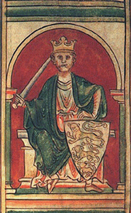
The motto refers to the “imperial-divine right of the Monarch to rule the world” and is said to have first been used by King Richard the Lionheart, above, as a battle cry and official motto of battle, then adopted as the royal motto of England by King Henry V in the 15th Century.[109] As you can observe, the British “God and my Right” is part and parcel of New Jerusalem/New World Order False-Stolen Prophesy of Antiquity, or “Fat Meat Ain’t Greasy”.
Civico, Cyborg Barack Obama & the Deep Shadow Government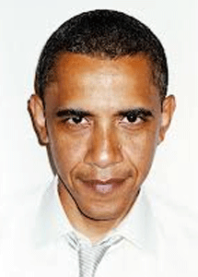In 2008, it was exposed that Civico had a secret hand in influencing, molding and shaping Obama as a presidential candidate. It came to light that he served as an informal adviser to presidential candidate Obama on his Western Hemisphere Foreign Policy team[110] along with New World Order globalist and war criminals Zbigniew Brzezinski, [111]and Henry Kissinger, the secret puppet-masters of America’s First Cyborg President. [112]
Civico also presented the Jesuits and the Vatican as a so-called informal member on the Hillary Clinton’s Presidential Campaign- Latin America Working Group. [113] Civico, Brzezinski, Obama & Columbia University Barak Obama had been a registered student at Columbia University from 1981 to 1983, when Zbigniew Brzezinski was running the Institute on Communist [Anti-Russia] Affairs from 1960 to 1989. [114], [115] There was one problem in regards to Obama’s student body days at Columbia with Brzezinski, not many recall ever seeing him on campus; and his student transcripts are sealed.[116]. It appears that a number of ILLUMINATI cells and covens including the Jesuits had the opportunity to secretly input key information and store data into Obama’s cyborg computer system and network.
Forest Whitaker, Humanism & Satanism
“lluminism or ‘humanism’ is a secular religion and a transition to Satanism.” (Henry Makow PhD, Illuminati: The Cult that Hijacked the World, p. 82, 2011) Whitaker is also described as a “humanist.” [117] Now, it should very clear why this man would mock Christianity. He is also an actor that engages in dissociation and spirit possession as an acting art form. He casts himself under the veil and alter ego of the Jesuit Order; and Aldo Civico- masquerading as an expert in international conflict resolution and whatever other clandestine and Satanic-ILLUMINATI things; and that is really frightening stuff for the masses of the people.[118]
HollyWeird’s Forest Whitaker is one of their faithful “see nothing, hear nothing, do and know nothing” Uncle Tom Negroes; and his blood fortune and fame keeps rolling in. If you don’t believe that Forest Whitaker is a Son of Satan- Fat Meat Ain’t Greasy.
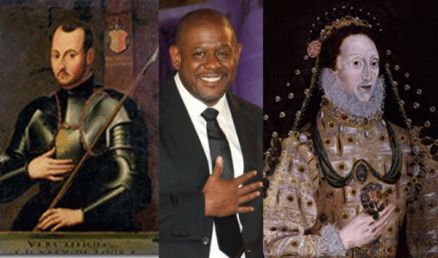
The Secret Masonic- ILLUMINATI Good Hands People, Jesuit General Ignacio Loyola, Whitaker & Queen Elizabeth I
Now, I understand why Whitaker had to appear in Jamie Foxx’s demonstrative and ugly Satanic Rite musical video injuring his internationally renowned peacemaking stature. Like a true Uncle Tom, the ILLUMINATI have NO RESPECT FOR THE SECRET- FALSE SATANIC RITE NEGRO!
Let’s take a break for a moment with some hidden melodies and rhythms from the Rock of Gibraltar- the Pillars of Hercules (Shu).
http://www.youtube.com/watch?v=H3v1LS8nqic
High Priestess Oprah Winfrey & the Ancient Secret Cult of Mithra
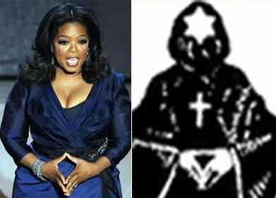
In The Butler, Oprah Winfrey of the ILLUMINATI and the Brotherhood of Death portray Cecil Gaines’ wife, Gloria Gaines. Like Tyler Perry, Oprah Winfrey’s background fit the profile of a CIA- MK ULTRA child victim- ritual traumatic sexual abuse and child prostitution, etc.

On her group-think (Cult of Oprah) show, she actively promotes Dr. William Thetford’s book “A Course in Miracles” that came out of Lucifer’s Workshop. Dr. Thetford was CIA and “A Course in Miracles” is the works of CIA-MK ULTRA Subproject 130, “A Course in Miracles has an interesting history and it all started when Dr. Helen Schucman, a non-religious Jew began working with Dr. William Thetford in 1958. It seems Dr. Thetford had ties with the CIA and was working on Project BLUEBIRD, which was later rolled over into the MK ULTRA Project. MK ULTRA was a program focused on mind control; it was created in the 1950s by the CIA with the goal to learn ways to manipulate people’s mental states alter brain function and create Manchurian Candidates often through the use of drugs and hypnosis. Under the MK ULTRA umbrella there were over a hundred sub projects from the 1950s well into the 1970s and Thetford worked on Personality Theory, subproject 130.”[119]
The CIA was training children of all ages, teenagers and also young adults for future operational assets. One of the CIA’s main children mind control programs was a 1958 Top Secret MK ULTRA subproject 74 called “Imaginative Research.” Subproject 74 was headed by renowned imminent Psychologist Carl Rogers (January 8, 1902 – February 4, 1987). He taught psychology at the University of Wisconsin, Madison (1957–63). One of Rogers’ CIA contact agents and understudies was Dr. William Thetford (April 25, 1923–July 4, 1988). Under Rogers, Thetford’s studies centered on personality development in childhood. [120] From 1950-1952, Dr. Thetford completed research and published eleven professional papers, of which seven involved children. He submitted an additional five more papers for publications, of which two was on fantasy projections in children.[121]
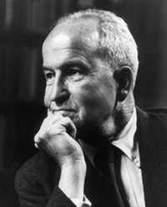
Psychologist Dr. Henry Murray (May 13, 1893 – June 23, 1988) of Harvard was the CIA’s imminent elder statesman. Former OSS officer during WWII, he joined with the Schools and Training Branch of the OSS to write a book about the recruitment of special agents called Assessment of Men. The title was later changed to Selection of Personnel for Clandestine Operations: Assessment of Men.[122] Along with Dr. Thetford, Dr. Murray also began to concentrate research in personality development in childhood [123] probably and most likely consistent with his agent recruitment manual and objectives.
Dr. Murray is linked to the MK ULTRA mind control experiments on Ted Kaczynski, the infamous Unabomber.[124] In 1951, Dr. Thetford had become a senior assessment psychologist on Dr. John Gittinger’s CIA Assessment and Evaluation Staff in the Office of Training. [125] In 1960, Dr. Thetford along with a David Saunders headed CIA MK-ULTRA Subproject 130: Personality Theory at Columbia University.
Dr. Thetford conducted among other things TOP SECRET Personality Theory of Conversion Hysterics experiments.[126] Conversion Hysterics is often referred to as “disorder of imagination.” It is a mental disorder characterized by the conversion of mental conflict into somatic forms (into paralysis or anesthesia having no apparent cause). Conversion Hysterics usually occur in people subject to traumatic stresses such as battle fatigue. Patients develop mysterious subjective maladies and disabling illness (Torture).[127]
Anyway you look at it. If you deal with Dr. Thetford and entrusted with his works; you would undoubtedly have to be a powerful high level clandestine CIA asset. Dr. Thetford was no run of the mill CIA agent. Deal with Dr. Thetford; you are literally dancing with the DEVIL. The Color Purple, Oprah & The Secret Cult of MITHRA
“We will of course not let them know about Wotan [Odin].” –Reichsminister Paul Josef Goebbels- [128]

Author of Color Purple, Alice Walker, defines herself as a “pagan“ or “earth worshiper” She says that she is following the religion that her African and Native American ancestors before her practiced when they honored the Earth Mother. Alice bows down daily in the mornings in worship to the Earth Mother (mother earth).[129] However, other than any concern about African and Native American ancestors it appears that Ms. Walker with her garland of flowers headdress is far more preoccupied and spiritually linked with Goebbels and Reichsfuhrer Heinrich Himmler’s Germanic Nazi-Wiccan Mayday Paganism. 
Alice Walker, Oprah Winfrey & The Secret Cult of Mother Earth Goddess- Mithra
Above, entertainment television icon Jay Leno, Former U.S. President William Clinton, Alice Walker and Oprah Winfrey display the “Mother Goddess Symbolic Womb” secret hand symbol. According to Barbara Walker, in her book, The Woman Encyclopedia of Myths and Secrets (198), the downward pointing triangle is a common symbol of the womb.[130] The womb has been symbolized and worshiped in a variety of forms from ancient times to today. Caves, burial chambers, and temples were seen as wombs of the Mother Earth.[131]
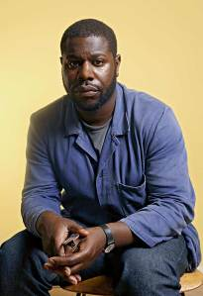
British Film Director “12 Years a Slave”- Steve McQueen, Commander of the Order of the British Empire, Cult of Mithra
A cave (entrance to the underworld) symbolizes the womb of the earth and has been used as sites of worship since before churches were constructed. The cave was universally identified with the womb of MOTHER EARTH, the logical place for symbolic birth and regeneration.[132] 
Both the Sanskrit and Roman words for a place of worship (the cave) meant womb. Some of the earliest evidence of religion that is known today comes from sophisticated cave paintings in France that appear deep within caves.[133] Many goddesses of early cultures claimed the cave as their domain and/or entrance through which they created life, including the Hindu goddess Kurukulla, pagan goddesses Cybele and Mithra, Latin goddess Sybil, Cretan goddess Rheapagan, as well as others.[134]
By 376 C.E., the Vatican began seizing caves dedicated to the worship of the Goddess Mithra in an attempt to promote Christianity. In the 15th century, Pope Calixtus II (died December 13, 1124) attempted to outlaw religious ceremonies in sacred caves.[135] The Satanic Blood Sacrifice traditionally is an important practice in Magick-Aleister Crowley, the BEAST 666. The legend of Mithra is connected with the blood sacrifice of antiquity [136] Crowley proposed that Baphomet was derived from “Father Mithras“. In his Confessions he describes the circumstances that led to this etymology: I had taken the name Baphomet as my motto in the O.T.O. For six years and more I had tried to discover the proper way to spell this name. I knew that it must have eight letters, and also that the numerical and literal correspondences must be such as to express the meaning of the name in such a ways as to confirm what scholarship had found out about it, and also to clear up those problems which archaeologists had so far failed to solve … One theory of the name is that it represents the words βαφὴ μήτεος, the baptism of wisdom; another, that it is a corruption of a title meaning “Father Mithras”. Needless to say, the suffix R supported the latter theory. I added up the word as spelt by the Wizard. It totaled 729. This number had never appeared in my Cabbalistic working and therefore meant nothing to me. It however justified itself as being the cube of nine. The word κηφας, the mystic title given by Christ to Peter as the cornerstone of the Church, has this same value. So far, the Wizard had shown great qualities! He had cleared up the etymological problem and shown why the Templars should have given the name Baphomet to their so-called idol. Baphomet was Father Mithras, the cubical stone which was the corner of the Temple.[137]
MITHRAS (Persian God of Light and Wisdom) is later patrilineal form of MITHRA. [138] The New Age (Age of Aquarius) models it dogma on the Magi’s’ Cult of Mithra as Friedrich Nietzsche did for Nazis dogma. Crowley had announced himself publicly a devotee of Nietzsche’s New Age Cult in Vienna Theosophy magazine, near the beginning of the 20th century, and indicated as his preferred choice of the name for SATAN.[139] The “head” of the “Antichrist” that Joachim de Flore had prophesized is SATAN- the Devil.[140]
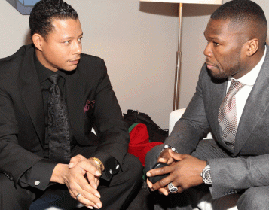
Above, Actor Terrence Howard pulls rank displaying the higher “Mother Goddess Symbolic Womb” secret coven hand symbol while Rapper 50 Cent displays the ILLUMINATI traditional lower pyramid hand symbol.
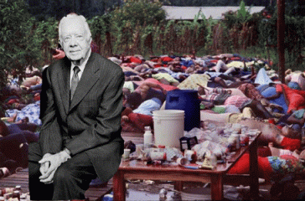 Former Jonestown U.S. President Jimmy Carter with the Hand Symbol of the Cult of Mithra
The elite ILLUMINATI is multi-layered and made up of many mansions. Their secret cults speak by language, symbols, images and through ILLUSIONS that few understand. Alice Walker’s EARTH MOTHER is the ancient secret CULT OF MITHRA- MITHRAS that is observed by a “chosen few” and hierarchy of the ILLUMINATI.That is why powerful males and females such as Leno, Clinton, Walker, Winfrey and high ranking Republican-Imperium Sarah Palin can be found exhibiting the “the downward pointing triangle, the common symbol of the womb.”It the supraliminal symbolic language and symbolism of the secret CULT OF MITHRA in HollyWeird, Oprah Winfrey was called “Sofia” in Alice Walker’s movie, The Color Purple.[141]

Sofia is honored as a Goddess of Wisdom by Gnostics– Joachimites, Knigths Templar, as well as by some Neo-pagan, New Age, and feminist-inspired Goddess spirituality groups.[142] Sofia is a pagan goddess of Wisdom (MITHRA) and wife of God.[143] She is the creator of all. She gave breath to Adam.[144] Most of Sofia’s ancient attributes were profoundly broken down in Christianity. Christianized and patriarchalized, she was demoted to a Fallen Angel.[145] Sofia was cast down and made to suffer (whoredom and imprisonment) and repent until a superior male god deigns to “correct her deficiency.”[146]

That is what literally happened to Sofia in Color Purple, the character Sofia was attacked, beaten by white men and held in virtual slavery to SERVE a white family to correct her ”Lunacy” for not being blindly subservient to the fable of white supremacy. Alice Walker and Oprah’s character, Sofia, in Color Purple has absolutely nothing to do with Black History, or the goals, struggles and aspirations of the Black masses of the South.
It’s about Lucifer-Satan, and their false “divine” prophecies, kings, rulers, prophets and gods. Sofia is a false myth designed by the ILLUMINATI to subliminally implant a “divine” base justification for slavery and oppression of the masses of color. Oprah Winfrey is like Tyler Perry, Lee Daniels, and most likely Forest Whitaker. Through MK- ULTRA traumatic sexual abuse and torture as a child, she has many alter personalities controlled by keys and triggers. She practice dissociation and become possessed by spirits and Demons (Film- Beloved 1998[147]).[148] Oprah wasn’t playing the character Sofia. She was possessed of the spirit of Goddess Sofia. That the way satanic Negroes- roll in HollyWeird.
ALICE WALKER & ANCIENT “M” SATANIC SIGN

“Take careful notice of the way God and Adam’s hands are positioned. The middle and ring fingers are held together while the pointer and pinky fingers are separated. This makes an “M” and as you will see represents Masonry – the oldest, most wide spread secret society in existence, operating in almost every country in the world with 5+ million members. For centuries, the Vatican and world Royalty have conspired using the vehicle of Freemasonry to place initiates into key power positions of politics, business, banking,and media in an effort to control populations.”
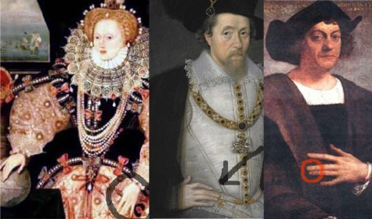
ALICE WALKER & ANCIENT BI-CROSSED ARM SYMBOL OF THE PHARAOHS OF KEMET
Furthermore, Alice Walker’s Satanic- ILLUMINATI coven bi-crossed arms is a bastardization of Kemetic symbolism. The bi-crossed arms is ancient symbol of homage to the God Osiris displayed by the pharaohs since the early dynastic period. 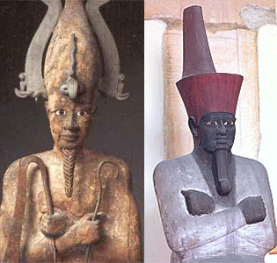Above, the Great God Osiris (Asur) and King Nebhepetre II Mentuhotep ((reigned ca. 2046 BC – 1995 BC) display the bi-crossed arms symbol. Mentuhotep II was a Pharaoh of the 11th dynasty who reigned for 51 years. 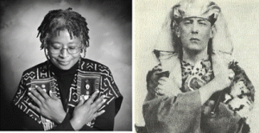Alice Walker and Oprah Winfrey are both High Priestesses of the Crowley, Nietzsche and Joachim de Flore New Age,[149] and the secret CULT OF MITHRA. They are laterally possessed of the Great BEAST’s Father Mithras. Even HollyWeird’s annual highest performance ceremonial awards are also a secret bastardization of the Kemetic bi-crossed symbol and pharaohic homage to the Great God Osiris, the Oscar.

ALICE WALKER & THE ANCIENT KEMETIC LION’S PAW SYMBOL
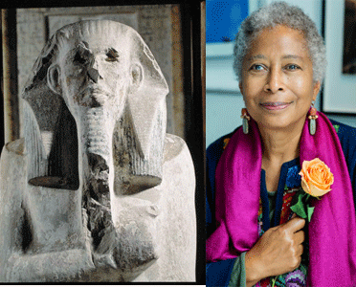Pharaoh Djoser, second king of the 3rd Dynasty of Kemet (2650- 2575 BC), and the LION’S PAW secret symbol. King Djoser undertook the construction of Kemet’s earliest world monument, the pyramid; and Alice Walker and the Satanic ILLUMINATI continued bastardization of Africa’s sacred symbolism, cosmology and mythology. Among the secret Satanic- ILLUMINATI covens, it is called, the DEVIL’S PAW. The Kemetic LION’S PAW and Osiris’s secret bi-crossed arm symbol has also been bastardized by Masonic Degrees. 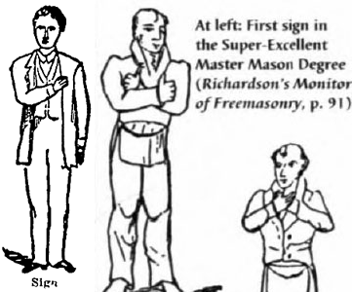If High Priestess Oprah Winfrey and Alice Walker aren’t the Initiates of Lucifer– Fat Meat Ain’t Greasy. They would be the ILLUMINATI’S perfect high ranking maidens to keep all of their scary and PSYCHOTIC Uncle Tom Negroes in line for a top secret psychology warfare Project like The Butler.
The Butler, Cuba Gooding, Jr.- Satan’s “MAD HATTER”
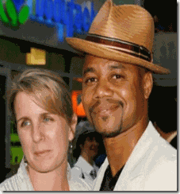
In The Butler, Cuba Gooding, Jr. pictured with wife, portrays White House Butler, Carter Wilson. At the first glance, Cuba Gooding, Jr. should be a feel good story in anyone’s book. His father, the former lead singer of 70s R&B group, The Main Ingredient, Cuba Gooding, Sr., got hooked on alcohol, crack cocaine, drugs and abandoned his family to poverty, the wind and rain. Cuba, Jr. survived the mean streets to become a respected family man, an Academy Award winning artist, and one of the highest paid actors in HollyWeird.[150] –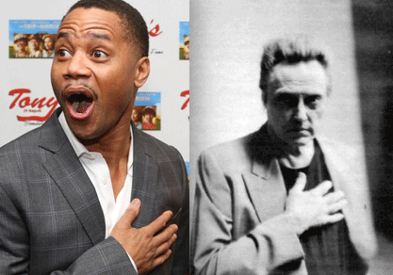Yet, Cuba, Jr. has another secret HollyWeird Creepy PSYCHO– “Fat Meat Ain’t Greasy” side that paints another picture of the man. Above, Cuba and extremely strange HollyWeird actor Christopher Walken form a secret elite ancient Luciferian- Masonic Hand Symbol. 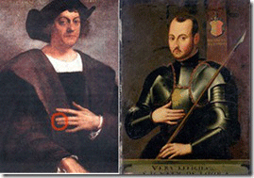Luciferian ILLUMINATI Christopher Columbus and Vatican Jesuit Founder-General Ignacio Loyola exhibiting the Secret Mason Hand Sign. In spite of public relations’ ILLUSIONS, there is something inherently wrong with Cuba, Jr. He is a strange man that abuses alcohol most likely drugs in excess,[151] and presents himself as man of little respect and self restraint with women.[152]

Above, Cuba is caught on camera high stripped to his waist ready to get his groove on at the club.Above, a male companion of two women Cuba harassed, groped and molested at the bar struggle to physically restraints him.This may be comic and playful behavior between Cuba, Jr. and Terrence Howard. But, it looks like strange and suspect behavior between two middle-aged men. Like Little Richard, in HollyWeird fashion, it is reported that Cuba Gooding, Jr.’s door also swings both ways.[153]There is a lot of talk about HollyWeird forcing Black men to wear dresses on television and films to humiliate, degrade, devalue Black Womanhood, and further demean and emasculate Black men before the masses of people.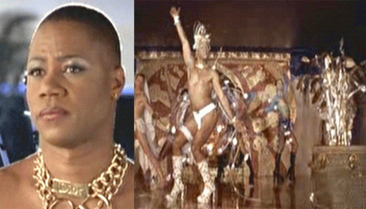Cuba’s odd moment in a dress on film was layered in Paganism and Satanism. In a little known movie, Boat Trip (2002), Cuba– Jerry and his friend, Nick, are booked on a gay singles boat cruise by a vengeful travel agent. Jerry falls in love with the cruise’s dance instructor and in order to win her over, he pretends to be gay so he can get closer to her. [154]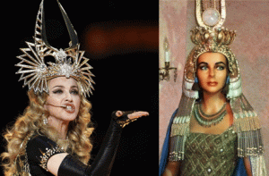Here, Cuba, Jr. impersonates some type of pagan goddess with a crown similar to Madonna’s 2012 Super Bowl crown which has been identified as a form of Hathor’s Crown of Ancient Kemet that was created for Elizabeth Taylor in HollyWeird’s film, Cleopatra.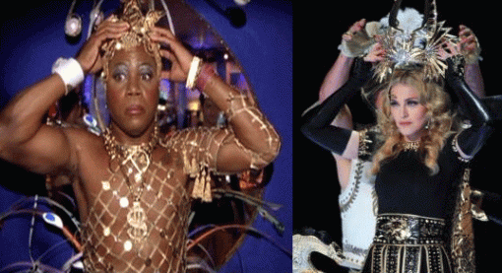Cuba’s crowns also seem to incorporate the ancient “Winged Disk (Globe)” seen on Elizabeth Taylor’s crown above. “The Winged Globe is pre-eminently a Rosicrucian symbol, although the ILLUMINATI may lay claim to it, and it may be admitted that is of Egyptian origin. The Winged Globe is the symbol of the perfected soul making its flight back to the source of its creation in the Elysian Fields beyond.” –Swinburne, Clymer, “The Rosicrucians, Their Teachings”[155]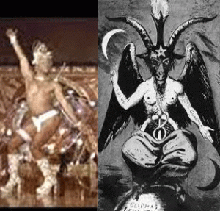Here, it should be quite clear that Cuba’s hands form the Baphomet’s sign of Hermetism” – which is a visual representation of the Hermetic axiom “As Above, So Below.”[156]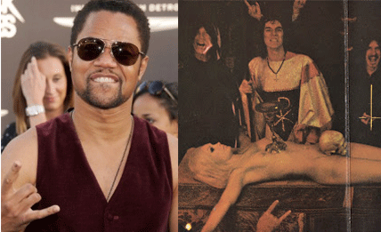Luciferian Cuba Gooding, Jr. displaying the DEVIL’S HORNS also has dissociated alter personalities like “Dick McWilly.” “I [Dick McWilly] just got out of jail…I had sex with a leprechaun, who had sex with an alligator [Reptilian] and got him pregnant. No, I’m lying the alligator wasn’t pregnant.”[157] HollyWeird, he’s another one of their faithful “see nothing, hear nothing, do and know nothing” Uncle Tom PSYCHO Negroes; and the blood money keeps rolling in. If you don’t believe that Cuba Gooding, Jr. isn’t a Mad Hatter Son of Satan- Fat Meat Ain’t Greasy.
LENNY KRAVTIZ- I Love SATAN
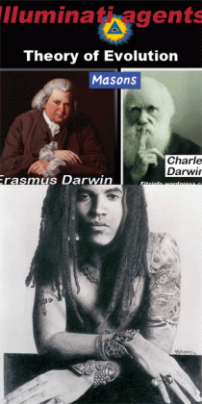
As for Lenny Kravitz, he displays another secret Masonic form of the Osirisian Sacred Bi-Crossed Symbol. Lenny portray James Holloway.[158] High Priestess of Kabbalah-ILLUMINATI [159](Witch), Madonna. [160] Lenny Kravitz is a half Jewish pro-Israelite Zionist,[161] and part of the “Mad Madonna” notorious New Age Satanic-Kabbalist Circle.[162]
Kabbalah is as complex as it is old. Throughout the centuries, it has come to mean many things to many people. However, whatever Kabbalah that Madonna subscribes to is undoubtedly overwhelmingly Satanic. Eliphas Levi, Hermetic Order of the Golden Dawn, was a prolific writer on Magical Freemasonry, he has been called, “the Last of the Magi.”[163] Levi created the infamous image of Baphomet. Levy said that high magic [was] hidden under the name of Kabbalah, and reported in the hieroglyphics of ancient sacred temples.[164] “Monsignor Jouin notes that the brothers G. and N.L. Butmir in their works, Freemasonry and the Betrayal of the State and Jews in Masonry, pointed out that, ‘despite advances in science, the rabbis and Kabbalists Jews wishing to maintain their power over minds, devoted themselves to the “Kabbalah of the Left” to magic, demonology, the evocation of spirits, sorcery, spiritualism, all sorts of sordid excitement, to order to enslave the weak minds that have lost, for one reason or another, the benevolent support of the True Faith. We understand that such studies, far from serving the true God, lead directly to the worship of the occult and devil worship.’”[165]
“The Super bowl is kind of like the Holy of Holies in America. I’ll come at halfway of the “church experience” and I’m gonna have to deliver a sermon. It’ll have to very impactful. “-Madonna Vigilent Citizen: “It is rather appropriate that this Kaballah-initiate [Madonna] referred to the Super bowl as the “Holy of Holies” as it was the name of the most sacred place in Solomon’s Temple. No one was ever permitted to enter the Holy of Holies but the High Priest. This privilege was only granted on the Day of Atonement, to offer the blood of sacrifice and incense before the mercy seat. Madonna’s analogy was therefore telling of the mindset behind her performance.”[166] Priestess Mad Madonna & Lenny Kravitz, “I Love Satan” “Justify My Love” is a song by Madonna from her first compilation, The Immaculate Collection (1990).
The song was written by Lenny Kravitz and Ingrid Chavez with additional lyrics by Madonna.[167] The song is clandestinely layered with subliminal satanic messages back masked in the song, “I Love Satan”.[168] Lenny’s lyrics also has a ‘”The Beast Within” mix which quotes passages from the Book of Revelation (The Beast Within = sexual penetration by the Devil or the Antichrist [Book of Revelation]).[169]

This Satanic Negro has also downloaded his own series of naked pictures and homemade porn on the internet.[170] Lenny & Madonna, this isn’t guilt by association. Lenny Kravitz is actively involved in a clandestine New Age ILLUMINATI-Kabbalist Circle led by High Priestess Mad Madonna that is slowing overloading the music industry with messages, ILLUSIONS and the idolatry of Lucifer.Kravtiz’s Cross & Star of David are Genuine U.S. Military Issue and are supplied to the Defense Logistics Agency under Contract. [171] Israeli Mossad Agent? If you don’t believe that Lenny Kravtiz isn’t another Son of SATAN- Fat Meat Ain’t Greasy.
Terrence Howard- Satan’s Psycho, “THE ANTICHRIST IS HERE!”
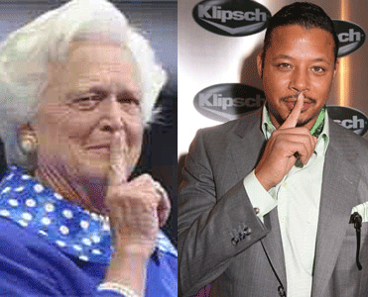
Former First Lady Luciferian Barbara Bush & Terrence Howard– Science is Golden at the Ninth Gate of Hell
Finally, we have Mr. Howard. The real story of Terrence Howard reads like a true African-American PSYCHO. In The Butler, Terrence Howard is just what he is, HOWARD.Howard has a secret strange occult alter personality that have been nurtured over decades. Above, Howard sports a head scarf with pyramids, sun symbol with eight rays with a symbol inside and a shirt with some type of yellow occult vase or urn. The symbol inside the sun circle and surrounded by pyramids appears to be an owl, Moloch, the Ba’al-Moloch of the elite Bohemian Club associated with child sacrifice. 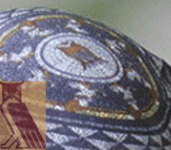 He also wear two occult charms or medallions. One necklace appears to be a double serpent charm, Double Serpent Power.

The Double Serpent is an ancient complex and mysterious symbol from the serpent of caduceus to the Old Serpent of Genesis to the Baphomet of the Knight Templars. However in regards to Dark Tantra Sex, “it represents sexual energy or Kundalini of the male and female in synergistic exchange. The serpent or sexual energy can either be raised to reconnect us with the Divine to pursue sexual gratification.” Sex, The Secret Gate to Eden, Alchemy, Tantra and Kabbalah, Glorian Publishing (formerly Thelema Press) 2006.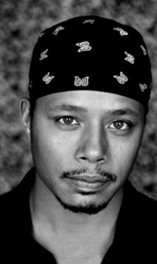Here is Terrence Howard and a MONARCH- Butterfly Mind Control Head Scarf. He has a classic background of childhood traumatic experiences that would have made him an idea candidate for MK ULTRA. At 2 1/2 years, he witnessed his father, Tyrone Howard, kill a man in an incident at a Cleveland department store called, the Santa Line Staying.-+ He also suffered the traumatic experience of childhood abandonment. Tyrone was sent to prison for manslaughter.
Dr. Ralph Allison, a protege of Dr. Gregory Bateson’s Stanford University CIA circle, said that if the first dissociation (sufficient trauma to dissociate) was before the age of seven, a condition called “Multiple Personality Disorder” (MPD) will result. Children at that age feel too immature or untrained to defend themselves with physical means, so they resort to making defenders of their bodies within their minds. Dr. Allison also found that dissociates created by “stress-trauma” were usually “highly hypnotizable.” Terrence Howard is sad, troubled and a bizarre deeply involved Satanic- ILLUMINATI multi-layered individual to say the least.
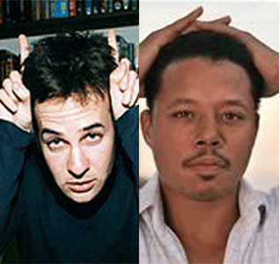 The Butler Scriptwriter Danny Strong & Terrence Howard– Devil Horns
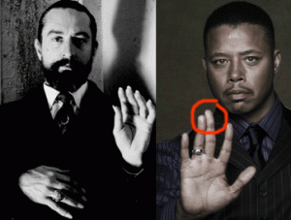“HEIL SATAN” HollyWeird’s Robert Deniro portrays Lucifer and Terrence Howard’s mimic secret “M” Satanic Hand Symbol- another bastardization of a sacred Kemetic Tribute Hand Gesture.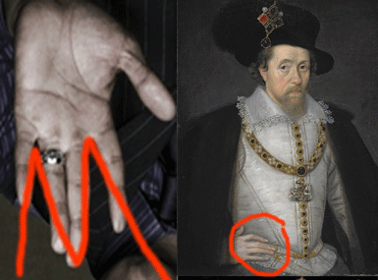
Howard & King James of England– The “M” stands for most high and ancient secret “MASONRY”.
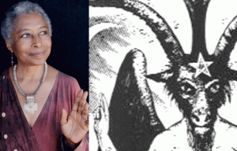ILLUMINATI Wiccan High Priestess Alice Walker displays a similar “Heil Satan” bastardization of a sacred Kemetic Tribute Gesture. 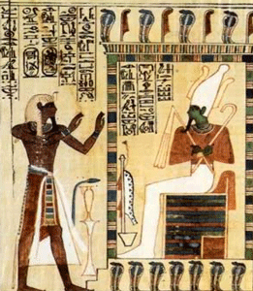
The Great Pharaoh Seti I honor God Osiris with the secret Kemetic sacred open hand tribute symbol.
Terrence Howard, The Making of Dark Side 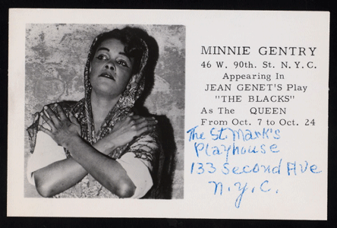Terrence’s successful acting career was not developed out of a vacuum. Terrence’s backstage career centered around his great-grandmother forming the stolen ILLUMINATI sacred Kemetic Cross, Minnie Gentry. He acknowledges that he closely followed her career. Minnie had been his inspiration and first acting coach. Minnie Gentry (1915-1993) was an American Black stage and film actress. During her early career, she played alongside Sidney Pointier in his acting debut in Lysistrata.
It was stage play by Aristophanes of Ancient Greece first performed by Athenians in 411 BC. She also showed up in another ancient Greek play by Euripides, Medea. It is based on the mythical hero of ancient Greece, Jason, and the Witch Medea. This play was also first performed in Ancient Greece in 431 BC. Minnie’s stage career was also undoubtedly influenced by the circles, darkness and the Greek mysteries of the controversial French novelist, playwright, poet, essayist, gay political activist and Luciferian occultist Jean Genet. Jean Genet was part of a secret society that loved the Hidden Dark Side of Ancient Greece.
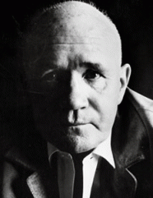
“Oh go through the walls; if you must walk on the ledges of roofs, of oceans; cover yourself with light; use menace, use pray…My sleepers will flee toward another America.” -Jean Genet In France, Jean Genet had been a compulsive criminal and boy prostitute. He was a high level Old World ILLUMINATI and one of the secret Masters of the Priory of Sion associated with the Luciferian homosexual circle of Grand Master Jean Cocteau. The Priory of Sion is an ancient secret society associated with Leonardo Da Vinci. They along with the Knight Templars claim to Lords of the New World Order through the House of King David (Jesus) and Mary Magdalene.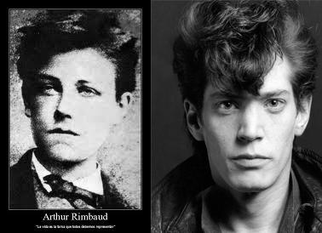Cocteau was a celebrated, influential and elitist French poet, novelist, dramatist, designer, playwright, filmmaker and Nazi Collaborator during WWII. He told prison officials, “You don’t lockup Rimbaud” in prison. Who was Arthur Rimbaud? Rimbaud was a youthful Old World ILLUMINATI French poet that sough the secret knowledge in other ways. He was great reader of mysticism and the occult. To become a visionary, a voyant, he threw himself into a “long, immense and systematic derangement of the senses,” an initiation into altered states of consciousness that he hoped would open for him the hidden doors of perception.
The independence of the African Nation of Ghana in 1957 inspired Genet to write and produce an all black cast play, The Blacks. Among the Negroes he assembled for the play was Minnie Gentry cast as a queen. Genet had very little regard and respect for the Black aspirations of human freedom, dignity, peace and justice, Genet called his play, The Blacks, A Clown Show.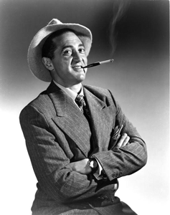Behind the stage, Minnie introduced Terrence into another circle of darkness, and into the den of another Luciferian secret manipulator of men, CIA MK ULTRA master and handler, Bill Cosby. It was Paul Mooney and Richard Pryor’s HollyWeird freak and homosexual handler, Sheldon Leonard, above, that launched the television and film career of Bill Cosby in the CIA’s romanced propagandized version of itself, I, Spy. Cosby called Leonard, “My Last Father.” 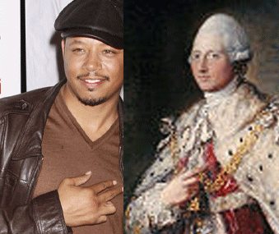
Hand Symbol of Grand Masons,Terrence Howard and Henry Frederick, Duke of Cumberland, Grand Master of the Grand Lodge of England
At age 15, Terrence landed a spot on the Cosby Show, but his scene didn’t survive the cutting board. Minnie was the Cosby show’s Great Aunt Gram Tee. Out of this complex circle of darkness and at the feet of the ILLUMINATI, Terrence Howard, the Mad “Son on of Satan” and high ranking secret Freemason, emerged. Terrence Howard, the Occult, Dark Sex & Antiquated Black Women 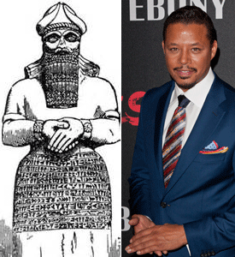
Secret Hand Symbol of Babylonian God of Wisdom Nabu & Terrence Howard
(Madness Out of Terrence Howard’s Mouth) “Black women are antiquated. White women represent progress. My non black ex-wife called me nigger and wants nothing to do with my children because they’re black or at least half black and this Asian chick hit me.”[172]

On May 6, 2012, police arrived at Terrence Howard’s suburban Philadelphia home due to an altercation that occurred between Howard and his ex-girlfriend, May Seng Yang, “one of at least six violent altercations that Howard is alleged to have had with women since 2000”.[173] As far as the Asian chick that allegedly assaulted him, according to Ms. Yang, it was Howard who attacked her – adding the actor clearly has issues with women, is into “Dark Sex” and when need be pays for his fantasies.[174] 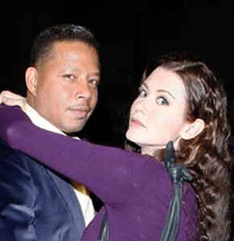This is an example of who Terrence Howard might get down with in his Demonic Dark Sex Fantasies in HollyWeird. Terrence’s girlfriend is porn star Erica Taylor aka Juliet Cariago. In Terrence’s twisted minded Luciferianism, Black Women would indeed be “antiquated” in a sense. With the exception of the Black Women of HollyWierd that have been made into mind controlled MONARCH Sex Kittens or sold their souls to the Devil for fortune and fame, Black Women in general do not and will not play with the Occult or the DEVIL. Terrence Howard, Jimi Hendrix & “O Lucifer”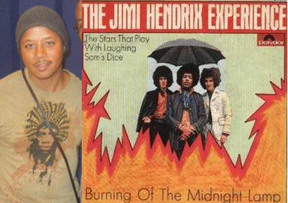On Terrence’s Jimi Hendrix’s t-shirt writing in the hair is the opening lyrics of Hendrix’s 1968 “Burning of the Midnight Lamp.” The Morning is dead and the day is too There is nothing left here to lead me, but the velvet moon All of my loneliness I have felt today It’s a litle more enough to make a man throw himself away And I continue to burn the Midnight Lamp, alone. Book of Genesis 1: 16-18 (KJV) “And God made two great lights; the greater light to rule the day, and the lesser light to rule the night: he made the stars also. And God set them in the firmament of the heaven to give light upon the earth, and to rule over the day and over the night, and to divide from the darkness: and God saw that it was good.”
Moon Worship is as ancient as it is complex. The Sun (light) rules the day and the Moon (darkness) rules the night. The name Lucifer occurs once in the Scriptures and only in some versions of the Bible. For example, the King James Version renders Isaiah 14:12: “How art thou fallen from heaven, O Lucifer, son of the morning!” The Hebrew word translated Lucifer means “shining one”. The Septuagint uses the Greek word “bringer of dawn. Hence, some translations render the original Hebrew morning star or Daystar. But Jerome’s Latin Vulgate uses “Lucifer” (light bearer). Luciferianism is a belief system that venerates the essential characteristics that are affixed to Lucifer. The tradition, influenced by Gnosticism, usually reveres Lucifer not as the Devil, but as a liberator of “guiding spirit” or even the true god as opposed to Jehovah. Among Satanist, Lucifer is seen as the “Torch of Baphomet.” Midnight is the “Witching Hour.” With a modern literal meaning of “midnight,” the term witching hour refers to the time of day when creatures such as witches, demons, and ghosts are though to appear and to be at their most powerful black magic to be effective.
Hendrix’s former girlfriend, Fayne Pridgo, has said: “He used to always talk about some devil or something was in him, you know, and he didn’t have any control over it, he didn’t know what made him act the way he acted and what made him say the things he said, and songs… just came out of him.” (Dave Hunt, America: The Sorcerers New Apprentice, Eugene, OR: Harvest House, 1988, pp. 239-40)
It is not surprising that an apprentice in Luciferianism like Terrence Howard would conjure up or “twin” a dead sorcerer and the guiding spirit of Jimi Hendrix to lead him through a league of demons and ghosts in the darkness at midnight to the enlightenment of the “light bearer” and the “Torch of Baphomet”, O Lucifer.
Terrence Howard & Luciferian- Enochian Sex Magkic
Dark Sex is a form of Aleister Crowley’s Satanic Ritual Sex Magick. It is a secret Enochian “Angelic” Ritual Ceremony.[175] The Enochian system of magic as practiced today is primarily the product of researches and workings by four men: John Dee, Edward Kelley, Samuel Liddell MacGregor Mathers and the Great BEAST 666 Aleister Crowley.[176]
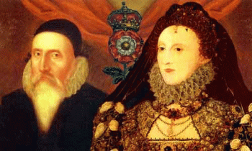
John Dee is important. Dee (July 13, 1527–1608 or 1609) was a Welch mathematician, astronomer, astrologer, occultist, navigator, imperialist, and consultant to Queen Elizabeth I (House of Tudor- started England’s African Slave Trade). He devoted much of his life to the study of alchemy, divination and Hermetic philosophy.[177] “Enochian” is described as “Angelical”, the “Celestial Speech”, the “Language of Angels”, the “First Language of God-Christ”, the “Holy Language”, or “Adamical” because, according to Dee’s Angels, it was used by Adam in Paradise to name all things. The term “Enochian” comes from Dee’s assertion that the Biblical Patriarch Enoch had been the last human (before Dee and Kelley) to know the language.[178]
Enochian Sex Magick involves invoking erotic-occulted paranormal experiences from Fallen Angels. “Sex Magkic can be done with a Demon/ess.” “Sexual fluids, both semen and vaginal secretions and also menstrual blood have the power of Life Forces.” –Joy of Satan Ministries, U.S. Library of Congress[179]
“Crowley’s sex rituals involving the consumption of blood, semen, or feces were allegedly intended to achieve a higher consciousness to empower a talisman, or to simply empower ones self. Intense focuses on the intended result during the ritual, especially during orgasm, were paramount to achieving the desired goal in Sex Magick. Crowley saw in orgasm (as in drug experience) a means to create ‘breakage of consciousness’ by pushing the mind to a point of extreme exhaustion and so opening it the “supersensual.’ The technique… was that of excess; through pain or pleasure, sex or intoxication, it was necessary to attain a condition of exhaustion taken to the extreme limit.”[180]
According to the Hermetic Order of the Golden Dawn, a talisman is “a magical figure charged with the force which it is intended to represent. In the construction of a talisman, care should be taken to make it, as far as possible, so to represent the universal forces that it should be in exact harmony with those you wish to attract, and the more exact the symbolism, the easier it is to attract the force”.[181] Ms. Yang allegedly met Terrence in a chance encounter at a pizzeria at the Plymouth Meeting Mall in Philadelphia. So, I assumed she isn’t necessarily a satanic hermetic sex practitioner, but was attempting to “drop the dime” on Howard when she said that he is so obsessed with satanic eroticism that he pays for Satanists to invoke the occulted experiences through Enochian Sex Magick Rituals.
Terrence Howard & Dr. Jekyll and Mr. Hyde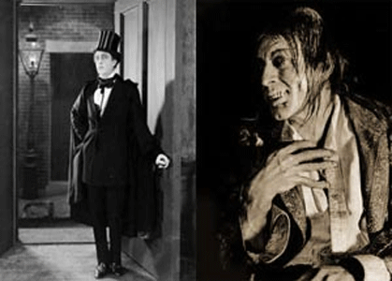The Strange Case of Dr. Jekyll and Mr. Hyde is the original title of a novella written by the Scottish author Robert Louis Stevenson first published in 1886. Stevenson seems to have worked primarily from Knights Templar mysteries and themes out of Scotland and Ireland. Stevenson’s works seem to be based on Knight Templars’ legends, myths, tales, and belief systems. The work is commonly associated with the rare mental condition called “split personality“, referred to in psychiatry as “dissociative identity disorder” (DID) where within the same body there exists more than one distinct personality.[182] In this case, there are two personalities within Dr Jekyll, one apparently good and the other evil- Mr. Hyde; completely opposite levels of morality;[183] the dualism of God and Satan.[184]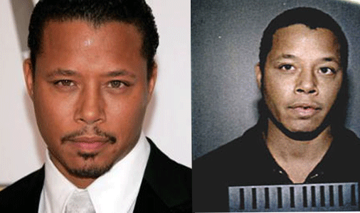There is certainly something awfully strange about Howard. If this is Terrence Howard on the left, then who is this guy on the right? Notice his right eye.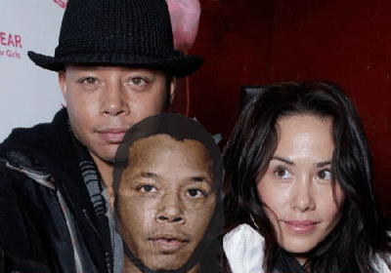
The Strange Couple, Terrence Howard, Wife Michele Ghent and his Dark Side Dr. Jekyll Right Eye
Terrence married his third wife, Michele Ghent, 33 years old, in a secret ceremony in January 2010. She filed for divorce in February 2011.[185] Ghent previously said that Terrence began beating her a week into their marriage. She said he “slugged” her across the face and neck and threatened to throw her off a balcony. Ghent said the abuse continued throughout the marriage, and that he chipped her tooth with his wedding ring. She also claimed Terrence threatened to kill her if she told anyone his personal business. [186]
Terrence married Ghent secretly. Almost nothing has been revealed about her background and family. One source identified her as a “commercial production worker” which is extremely strange that there has been no background check of Ms. Ghent.[187] Ghent is a medieval surname. The first recorded spelling of the family is shown to be that of Robert le Gent, which was dated 1195, in the “Pipe Rolls of Hampshire”, during the reign of of our old favorite British King Richard 1, recall “The Lionheart“.[188] Terrence became secretly engaged with Ghent in 2009. He claims that she may be connected with the Russian Mafia specializing in HollyWeird extortion- white-mail shams.[189]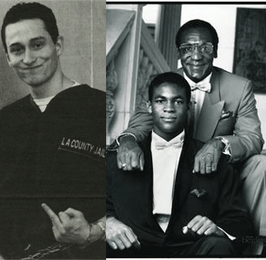Bill Cosby’s son, Ennis, was a murder victim of a sophisticated and highly secret Russian Mafia[190]. Mikail Markhasez that killed Ennis was a racist North Hollywood Russian born assassin.[191] Terrence claimed that soon after they became engaged, she began to secretly download his secret personal records and record his private conversations. She gained access to his banking information and pillaged at least $260,000 from one of his 25 bank accounts.[192]
Terrence Howard: “Satan is Taunting Me!”
Tellingly, Howard’s December 2 Email to Ghent, “If you wanted, you could crush me with the push of a button. I have no recourse, I have pleaded with Jehovah to fortify my heart that I do not fall into angry and revengeful retaliation against my forsaken love… I am newly reconciled to being a servant of Jehovah. SATAN is taunting me and there is no rest for my mind. So I beg you not to exercise the right that you have, divorce me and do what you wish but do not crush my families [sic] already threatened livelihood. I can’t promise how I will respond. In Jesus’ name I am praying.”[193] It seems as if Michele Ghent, agent of a criminal extortion syndicate, moved in and took advantage of Howard’s complex “dissociative identity disorder” that included highly CIA/MK ULTRA– MONARCH sensitive occult- satanic alter personalities that he had no power to control. They are pushing him to the edge. Like The Butler, Terrence Howard is caught in a classic DOUBLE BIND.
He, as a human being, is prohibited by blood oaths from revealing anything that he has heard, seen or even feel. Terrence is in a great dilemma as the elders say caught, “Between a Rock and a Hard Place.”[194] Terrence Howard is obsessed by the highs of satanic-erotic euphoria. He is caught on the edge of madness. His dilemma is so great, the fear so real that he has been driven on the path of suicide, “He grabbed an X-Acto blade and put it to his wrist as if to cut himself,” her filing states. He then reached for the “belt on his robe and displayed attempts to hang himself.”[195]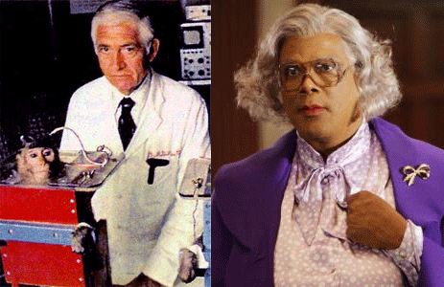During the late 1950s and 1960s, CIA doctors discovered and began experimenting with “pleasure centers “of the brain. One CIA- MK ULTRA doctor in New Orleans that was obsessively involved in stimulating the brain’s “pleasure centers” in the septum area was Dr. Robert Galbraith Heath, above, of Tulane University.[196]
I believe Dr. Heath’s experiments on children are related to Tyler Perry’s New Orleans hospital ritual sexual abuse episodes that altered his childhood pleasure center becoming a child prostitute. Above, Tyler Perry displays the stolen sacred Kemetic Lion’s Paw, the familiar DEVIL’S PAW of the ILLUMINATI. Dr. Heath implanted and attached electrodes to the brain’s “pleasure center” to self stimulate organism- euphoria and elation. One of Dr. Heath’s patients felt driven to stimulate his implant so often — 1,500 times — that he “was experiencing an almost overwhelming euphoria and elation, and had to be disconnected, despite his vigorous protests,” Heath wrote. [197]
Enochian Sex Magick is physiologically and psychotically addictive and a CIA- MK ULTRA “River of Reward” behavior modification method.[198] Terrence Howard: FROM THE BOOK OF REVELATION, “THE ANTICHRIST IS HERE” The DOUBLE BIND triggered one of Howard’s Satanic Alter Personalities to emerge. People, I am not making this stuff up!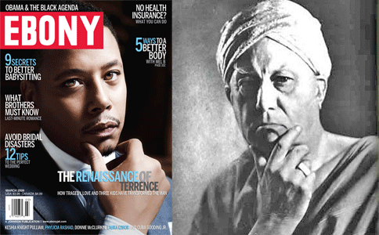Terrence Howard’s Email to Ghent, “If this is goodbye, then I hate everything and will now use my gifts to destroy mankind,” an April 27, 2013 text attributed to Howard reads. “I will become Satan Himself! You were my last chance to love. I will now Hate in all things and seek my vengeance upon Humanity for all the wrongs ever done to me!! … The Antichrist is Here!”[199] The Great BEAST 666 Aleister Crowley’s last words as he passed into a coma on December 1, 1947, were, “I am perplexed…” [200]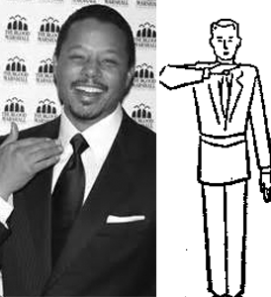
Terrence Howard & Masonic Sign of Distress
Likewise, Terrence Howard is perplexed- bewildered, puzzled and entangled caught up presenting a classic Dr. Gregory Bateson DOUBLE BIND- PSYCHO! If Terrence Howard is not a True Son of Satan, “Fat Meat Ain’t Greasy.” Howard is so far inside the ILLUMINATI, LUCIFERIANISM and the OCCULT spiritually, mentally and physical that he has an extremely difficult and dangerous path ahead. He must “COME HOME.” Ask God, the elders and his most ancient thousandths of years pillar of foundational spiritual strenght, Black Women and the people for love and forgiveness
HUEY P. NEWTON, PAPA DON’T TAKE NO MESS
http://www.youtube.com/watch?v=eNuGzbWv50Y
Symbolically, Cecil Gaines represents HollyWeird’s black straw man – classic Uncle Tom. Of the all the things going on in the White House and in the world, he had been enjoined from communicating anything that he saw, heard or feared. He exists only to be kicked around and SERVE blindly and faithfully the Imperium-ILLUMINATI. http://www.youtube.com/watch?v=ie5lToIZglY In the movie, Gaines (Forest Whitaker) and Gloria Gaines (Oprah Winfrey) are only empowered to communicate, to comment and react (violently) upon the meaningful actions of oneself against the images of Huey P. Newton and the Black Panther Party for Self Defense. Huey would be the absolute dialectical opposite of HollyWeird’s Satanic Uncle Tom PSYCHOS and Lunatics in The Butler. To the Luciferian-ILLUMINATI; Huey P. Newton– Fat Meat is Always Greasy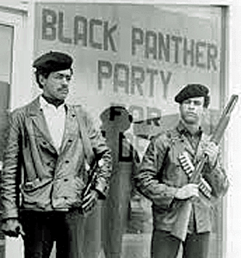In this situation, there is no Forrest Gump and Cecil Gaines, play dumb, stupid and stay dumb and stupid. The Luciferian-ILLUMINATI of the New World Order very well know the significance of Huey P. Newton, Bobby Seale and the Black Panther Party for Self Defense (BPP) to the masses. Brother Huey has been dead since 1989; and Huey and the original BPP (Images) still scares them. In The Butler, they are even afraid to show brothers and sisters portraying panthers in proper BBP uniforms.
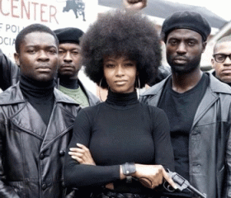
Chairman Bobby Seale was a brilliant visionary and strategist that understood the power of IMAGES. Bobby setup our official uniforms as black berets, black leather jacket, blue shirt with black tie, black slacks and polished dark shoes. Even the panther logo above them is deliberately visually distorted.
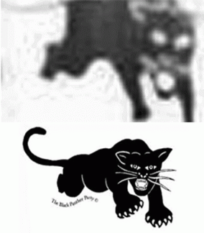
The BBP’s uniform was recognized all over the planet as a powerful “IMAGE” and example of fearless disciplined and organized resistance among the masses.The BPP uniform also meant a death sentence- shoot on sight. There were many nights that we received alerts that orders on the streets were shoot panthers on sight, but we resisted fear and suited up regardless of the constant threats of death. The fear of Huey and the BPP is far more deeply rooted in ancient prophecy than you want to believe.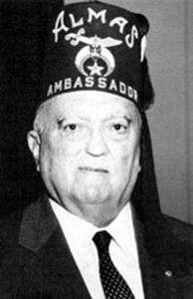FBI Director J. Edgar Hoover was a Master Mason in the Federal Lodge No. 1, Washington, DC. In 1955, he was coroneted a Thirty-Third Degree Inspector General Honorary in the Southern Scottish Rite Jurisdiction (Frederick the Great- House of House of Hohenzollem- Windsor). He was also awarded the Scottish Rite’s highest recognition, the Grand Cross of Honour, in 1965.[201] The House of Hohenzollem was the False Kings that Joachim de Flore prophesied would rule the world with a “rod of iron” before the dragon (Satan-Devil) with seven heads in Chapter 12 of the biblical Book of Revelation.
It was this Scottish Rite Freemason Luciferian disciple of the Ancient House of Hohenzollem, J. Edgar Hoover, that declared Huey P. Newton and the BPP the greatest threat to America’s national security. Lucifer, Satan, the DEVIL is his god and master. Luciferian Hoover also made the outcry, fear, and obsession of the Rise of Black Messiah among the masses official policy of the U.S. Government. What is it that we don’t seem to understand about their very real obsession and fears about the Rise of Black Messiah? It’s the Ancient Kemetic Vanquisher- HORUS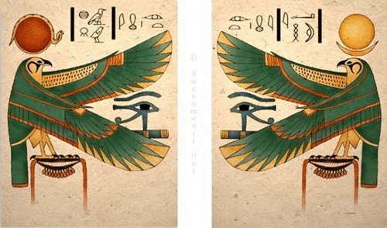“The ancient Kemet God Horus was a deity with many roles. His image and symbols can be found all throughout ancient Egyptian art. He is usually represented as a Falcon or a human figure with a Falcon head. In very early times of ancient Kemet the Sun and the Moon were regarded as the all seeing eyes of the great falcon god Horus. His right eye representing the Sun and his left eye representing the Moon.”[202] The Vanquisher is a complex Kemetic mythology-belief system, older than recorded time. In the far and distant prehistoric past, he was given the title Hor Nubti: “Horus the Vanquisher of Set [evil].”[203] Horus is the pubescent male who was born of the virgin mother without the fatherhood, third in advent, but placed first in series, as the representative of all the powers, whose natural genesis has been traced to lunar phenomena, and who in the solar mythos was the opponent and vanquisher of the Beast with ten horns, which represented the total of the opposing Typhoninan [Typhon-Set] powers.[204] It sounds like the 12th Chapter of the Book of Revelation is more bastardization of Kemetic Mythology. Typhon was the most deadly monster of Greek Mythology. The last Son of Gaia, fathered by Tartarus, he was known as the “Father of All Monsters”; his wife Echidna was likewise the “Mother of All Monsters.” Since the Greek Historian Herodotus, Typhon has been identified by some scholars with the Kemetic God Set. [205]
Everyone who met Brother Huey knew that there was something very special and spiritual about him. When the Panthers formed in 1966, the CIA/FBI had drawn up personality assessments and profiles of Bobby and Huey. An undercover student agent told me about Bobby and Huey’s personality assessments that they had developed to discourage me to from joining the Panthers. At the time right out of high school, I had no idea what he was talking about. “The Arc of the Moral Universe Is Long, but It Bends Toward Justice” –Dr. Martin Luther King, Jr.[206] Even then, they had assessed that Huey wouldn’t break; and once removed from the BPP leadership, things would fall apart. But there were those spiritual and unknown value and intangibles among the people that they couldn’t see, assess, control or figure out. There was no material award or gain for Huey and Bobby taking an armed stand against systematic global injustice. Huey and Bobby were brilliant individuals that would have prospered in any chosen field, but they SACRIFICED their lives for righteousness for righteousness sake. The entire community feared the government would crack down on them and the BPP with a “ROD of IRON” and they did.
There was a big difference between the Huey pre San Luis Obispo California Men’s (Penal) Colony and Huey post-San Luis Obispo. When Huey was first incarcerated at San Luis Obispo, the word circulated among brothers and sisters that they were using “Chinese Brainwashing” torture techniques on him, and we had to visit him as much as possible to keep his mind together. I recalled hearing that they were torturing Huey with slow drips of water on his head 24hrs a day, and “water boarding” techniques.
This was in 1968-69 when we basically threw very little or anything at all about secret governmental brainwashing and mind control programs. CIA-MK ULTRA Mind Control Programs weren’t exposed until 1974.[207] The brothers had described San Luis Obispo as a pill factory where prisoners were lined up each morning and given daily doses of pills then walked around all day like zombies. During the early 1970s, a petition addressed to the California Senate Committee on Penal Institutions by La Raza Unida, a Chicano organization representing prisoners confined in the California Men’s Colony, described the situation at San Luis Obispo: “The simple fact that a number of prisoners are walking the yard in this institution like somnambulists, robots, and vegetables as a result of the drug [Prolixin-Lithium] should be reason enough to make people apprehensive as to the effect it is having. That no prisoner feels safe because he never knows when he will become a candidate for said drug is another factor in producing tension in this institution.”[208]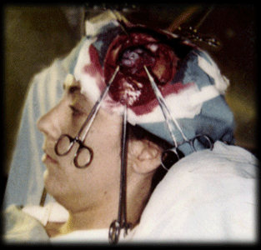A court case also exposed that San Luis Obispo had an advanced acute mental health facility involved in experiment forced electrical convulsion shock treatment-torture, and “Prefrontal Lobe Lobotomies”.[209] Huey was held in solitary confinement at the East Facility, at San Luis Obispo.[210] The East Facility housed that advanced acute mental health experimental facility.[211] The Huey that formed the BPP with Bobby Seale in 1966 was far different than the Huey P. Newton that left the California prison system in 1971. What they did to Huey and who did it remains top secret and classified information.Within two years of his release from prison, Huey was at the University of Santa Cruz’s Kresge College of Consciousness directly under the observation and control of the founders of NLP, Richard Bandler, John W. Grinder; and the British Godfather of the CIA and MK ULTRA and the Palo Alto Group (Mental Research Institute)- DOUBLE BIND Dr. Gregory Bateson.[212] At Kresge College, Grinder was a linguistic professor. Bandler was a student. In 1974, Dr. Bateson formerly joined the faculty at Kresge College as a fellow and lecturer, and the Bateson, Grinder and Bandler’s collaboration developed. Grinder, Bandler, Virginia Satir of Stanford Research Institute’s Mental Research Institute (MRI) collaborated with Dr. Bateson in “The Structure of Magic” (Magick), Volumes 1 and 2 (1975).[213]

The CIA (MK ULTRA- MONARCH) had to find and figure out who Huey was, and prevent another Huey P. Newton from rising among the masses. Even the ILLUMINATI and Satanic Bloodlines (Priory of Sion) were also extremely curious about Huey.
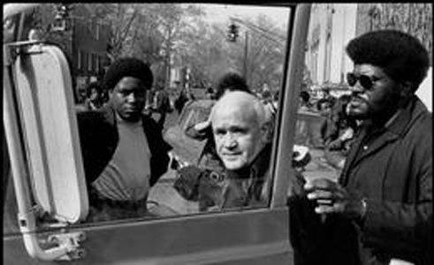In 1970, Jean Genet of the Old World ILLUMINATI flew into Oakland just before Huey was released from prison. His official BPP escorts were Big Man Howard and it appears to be Emory Douglas which would be consistent with historical records. One evening, Genet danced in a pink negligee for the Captain of the Captain of BPP, David Hilliard and three other brothers. In January 1969, I was among a group of brothers and sisters that had been purged from the BPP by a new governing body of the Central Committee, led by subsequent convicted federal criminal, governmental extortioner and front man for a convicted white professional (Croatian?) municipal extortioner, Lucas Dallas AKA William L. Dallas (In re Dallas Lucas, Inc. 185 BR 801 (BAP 9th Cir 1995); and the Chinese Triads, Virtual Murrell.
Murrell publicly accused purged BPP dedicated civil rights brothers such as Stokely Carmichael and H. Rap Brown of practicing “ultra-democracy” whatever that maybe. According to Murrell, we were not only suddenly buffoons, counter-revolutionaries, but renegades, and so artfully jacknapes and factionalizers. In 1970, while the Old World ILLUMINATI homosexual was dirty dancing in pink negligees for the new BPP leadership, we were the targets of a deadly assault not only by BPP Goon Squads with a shadow governmental license to kill, but also by a clandestine mutli-level governmental COINTELPRO-Project CHAOS search and destroy task force. Undoubtedly, the BPP Great Purge of 1969 had been a shadow government- ILLUMINATI setup.
Personally, I discovered around February 1969 that Chairman Bobby Seale wouldn’t be trusted any longer beyond looking at him. At Merritt Jr. College, two heavily armed BPP goon squad members began to tail and intimidate me and several student activists around campus. One guy, I knew went by the name of Robert Johnson had adopted the name, “Tcshaka.” The other guy we called, “Paul the Hunchback.” I accompanied a student delegation to Bobby Seale’s house down the street from campus. We pleaded with Bobby to withdraw the goon squad and preserve the college campus as a neutral ground for the well being and safety of the student body. The goon squad was withdrawn.
However within days during a special event on campus, I watched from a campus upstairs window as what appeared to be a platoon of new BPP members surrounded and invaded the entire campus like something like a siege of a Vietnam village. A squad of brothers asked students about my whereabouts on campus. Fortunately, the old Merritt Jr. College building on Grove Street (MLK, Jr. Blvd) is a gothic structure with hidden rooms and a couple of towers. I knew some of its secrets. I watched from one of the campus’ hidden windows on the second floor as the entire platoon met up with Chairman Bobby in one of the school’s many patios.
Tcshaka aka Robert Johnson was out of Baltimore, MD associated with black special agents out of SS General Fritz Kramer’s National Security Council (NSC) or National Security Agency (NSA). Paul the Hunchback was a black special agent associated with the Alameda County Sheriff’s Department or FBI/California Attorney General Eville Younger’s State Police.
The arch of the universe bends toward justice, peace and balance- Maat. There are certain universal truths that can’t be beaten down forever by an “IRON ROD,” ILLUSIONS and DECEPTIONS.
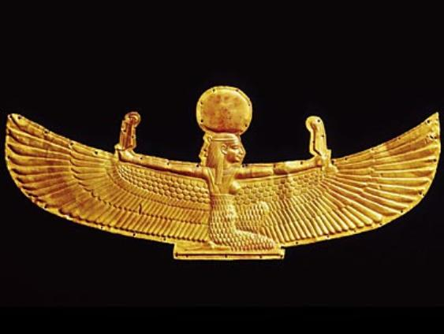
Regardless of the notions of idolatry, Kemetic Cosmology, Mythology and Science revolved around universal truth and principles- Maat since the dawn of human civilization. The name Huey stands for Heart, Mind and Spirit[214]. He was our spiritual bold “Hero” and fearless “Vanquisher” of the enemies of the people that had built a nation around him willing and ready to run and do battle with “EVIL”. The BPP was built around the “Living Prodigy” of Huey P. Newton. When they tried to take him down, Bobby Seale did a masterful task of building a worldwide “Free Huey” campaign around the true “Myth” and “Legend” of Huey P. Newton.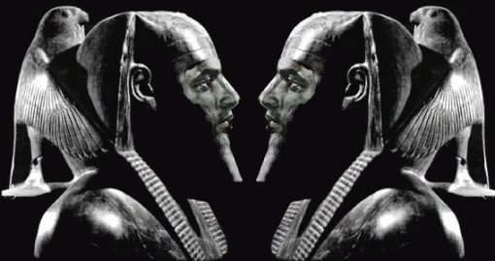All pharaohs claimed to be the incarnation of Horus the “Living King.”[215] Ramses II was nicknamed “SeSe” – the Vanquisher.[216] I call Huey P. Newton– “SeSe” that they still fear. The old Huey P. Newton that we knew in 1966 would know and SERVE the ILLUMINATI alright with a Bullet in the ASS.
“Papa Don’t Take No Mess– Papa Don’t Take No Mess… Papa is the man you can understand. How a man has to do whatever he can… Papa is the man who will take a stand. Papa don’t take no mess… Papa got a whole lotta heart. And Papa would do his part… Wait a minute. Looka here. Don’t take Papa light. Cause when he gets uptight. He knows he’s right. You got to sacrifice. Papa is a man that will take a STAND.” Papa Don’t Take No Mess- Papa Don’t Take No Mess.”[217] With a Gun in his Hand!

[1]http://www.brainyquote.com/quotes/quotes/a/alberteins133991.html [2]http://en.wikipedia.org/wiki/Delusion [3]http://socialanxietydisorder.about.com/od/copingwithsad/a/avoidance.htm [4]https://deeppoliticsforum.com/forums/showthread.php?698-Naval-Intelligence-MKUltra-and-the-Hippie-Movement/page4 [5]https://www.cia.gov/library/center-for-the-study-of-intelligence/kent-csi/vol10no2/html/v10i2a01p_0001.htm [6]http://www.currentconcerns.ch/index.php?id=1110 [7]https://www.cia.gov/library/center-for-the-study-of-intelligence/kent-csi/vol10no2/html/v10i2a01p_0001.htm [8]http://en.wikipedia.org/wiki/Gregory_Bateson [9]http://en.wikipedia.org/wiki/Anthropology [10]http://en.wikipedia.org/wiki/Anthropologist [11]http://abusesanctuary.blogspot.com/2006/03/double-bind-intimate-tie-between.html [12]http://abusesanctuary.blogspot.com/2006/03/double-bind-intimate-tie-between.html [13]http://www.wordiq.com/definition/Butler [14]http://en.wikipedia.org/wiki/Talk:Subliminal_stimuli [15]http://www.merriam-webster.com/dictionary/service [16]http://dictionary.reference.com/browse/serve [17]http://www.huffingtonpost.com/2013/05/08/oprah-the-butler-movie-trailer_n_3236749.html [18]http://news.yahoo.com/review-butler-tells-story-hear-001445998.html [19]http://www.dallasnews.com/entertainment/movies/20130815-lee-daniels-the-butler-digs-into-the-tensions-between-a-man-his-profession-and-his-times-b.ece [20]http://en.wikiquote.org/wiki/Forrest_Gump [21]http://joeforamerica.com/2013/06/california-senate-stupid-is-as-stupid-does/ [22]http://blogs.indiewire.com/shadowandact/is-lee-daniels-conservative-american-butler-a-black-version-of-forrest-gump [23]http://forestgumpapush.weebly.com/historical-references-in-the-movie.html [24]http://en.wikipedia.org/wiki/Nathan_Bedford_Forrest#The_Fort_Pillow_Massacre [25]http://www1.assumption.edu/users/McClymer/his260/Pillow.html [26]http://www.freerepublic.com/focus/fr/573217/replies?c=41 [27]http://www1.assumption.edu/users/McClymer/his260/Pillow.html [28]http://www1.assumption.edu/users/McClymer/his260/Pillow.html [29]http://www.treasurenet.com/forums/kgc/21435-kgc-fact-fiction.html [30]http://en.wikipedia.org/wiki/The_Butler [31]https://www.facebook.com/goodwaylodge222 [32]http://www.mwphglmn.net/Prince_Hall.html [33]http://en.wikipedia.org/wiki/Prince_Henry,_Duke_of_Cumberland_and_Strathearn [34]http://en.wikipedia.org/wiki/House_of_Hohenzollern [35]http://freemasonrywatch.org/P2.html#L2a [36]http://freemasonrywatch.org/P2.html#L2a [37]http://www.britroyals.com/kings.asp?id=george1 [38]http://www.rlhymersjr.com/Online_Sermons/04-06-03PM_Imperialism.html [39]http://www.whale.to/b/brussell_nazi.html [40]http://itwasjohnson.impiousdigest.com/index.htm [41]http://www.atlanteanconspiracy.com/2008/08/gulf-of-tonkin-vietnam-war.html [42]http://www.mastermason.com/willisstewart224/famous.htm [43]http://www.dailymail.co.uk/news/article-2322981/Former-Nixon-aide-claims-evidence-Lyndon-B-Johnson-arranged-John-F-Kennedys-assassination-new-book.html [44]http://emperors-clothes.com/articles/randy/swas4.htm [45]http://themagpieonline.com/wordpress/?p=31 [46]http://clive-donegal.hubpages.com/hub/To-Honor-George-Washington-Character-Virtue-and-Freemasonry [47]http://recolumns.blogspot.com/2010/10/bohemian-hijinx.html [48]http://www.pagrandlodge.org/mlam/presidents/ford.html [49]http://www.bibliotecapleyades.net/sociopolitica/sociopol_mindconmkultra04.htm [50]http://en.wikipedia.org/wiki/Sovereign_Military_Order_of_Malta [51]http://freemasonjabulon.wordpress.com/2011/11/12/ronald-reagan-royal-blue-blood-knight-of-malta-and-honorary-33rd-degree-freemason/ [52]http://recolumns.blogspot.com/2010/10/bohemian-hijinx.html [53]http://alexconstantine.blogspot.com/2007/06/otto-von-bolschwing-file.html [54]http://forum.prisonplanet.com/index.php?topic=124908.30;wap2 [55]http://www.infowars.com/bush-41-dons-bohemian-grove-hat-during-interview-about-vp-race/ [56]http://www.voxfux.com/features/bush_child_sex_coverup/franklin.htm [57]http://www.project.nsearch.com/profiles/blogs/occupy-kimball-castle-cherokee-castle [58]http://www.demolay.org/aboutdemolay/halloffame_bio.php?hofid=18 [59]http://www.angelfire.com/nj/EllyazHome/baphomet.html [60]http://www.biblebelievers.org.au/kmlst1.htm [61]http://www.redicecreations.com/specialreports/2006/08aug/kofc.html [62]http://whale.to/b/knights_q.html [63]http://www.theforbiddenknowledge.com/hardtruth/uspresidentasmasonspt4.htm [64] http://en.wikipedia.org/wiki/Lee_Daniels [65] http://en.wikipedia.org/wiki/Lee_Daniels [66] http://en.wikipedia.org/wiki/Lee_Daniels [67]http://www.comingsoon.net/news/movienews.php?id=60124 [68]http://www.whale.to/b/monarch_q.html [69]http://news.sky.com/story/372033/foster-parents-kept-children-in-cages [70]http://socyberty.com/social-sciences/applying-milgrams-agency-theory-to-jonestown/ [71]http://ritualabuse.us/smart-conference/conf2001/memory-recovery-and-screen-memories/ [72]http://www.apfn.org/apfn/oz.htm [73]http://www.apfn.org/apfn/oz.htm [74]http://www.apfn.org/apfn/oz.htm [75]http://www.philadelphiaweekly.com/news-and-opinion/cover-story/Lee-Daniels-Uncut.html [76]http://www.philadelphiaweekly.com/news-and-opinion/cover-story/Lee-Daniels-Uncut.html?page=2&comments=1&showAll= [77] [78]http://www.whale.to/c/aaliyah.html [79]http://www.nobeliefs.com/SomethingToThinkAbout.htm [80]http://www.unesco.org/new/en/bureau-of-strategic-planning/resources/category-2-institutes/bureau-of-strategic-planning/the-international-institute-for-peace/forest-whitaker/ [81] Civico, Aldo, Qualifications Summary, International Institute for Peace, Rutgers University (2011) [82]http://www.amazon.com/wiki/Vatican_Radio [83]http://www.unesco.org/new/en/bureau-of-strategic-planning/resources/category-2-institutes/bureau-of-strategic-planning/the-international-institute-for-peace/forest-whitaker/ [84]http://www.unesco.org/new/en/bureau-of-strategic-planning/resources/category-2-institutes/bureau-of-strategic-planning/the-international-institute-for-peace/aldo-civico/ [85]http://aconstantineblacklist.blogspot.com/2009/01/value-of-alvaro-uribes-medal-of-freedom.html [86] Civico, Aldo, Qualifications Summary, International Institute for Peace, Rutgers University (2011) [87]http://aconstantineblacklist.blogspot.com/2009/01/value-of-alvaro-uribes-medal-of-freedom.html [88]http://aconstantineblacklist.blogspot.com/2009/01/value-of-alvaro-uribes-medal-of-freedom.html [89]http://www.realjewnews.com/?p=201 [90] Aldo Civico’s Qualifications Summary, International Institute for Peace, Rutgers University (2011) [91]http://en.wikipedia.org/wiki/Vati-Con_Scandal [92]http://natcath.org/NCR_Online/archives2/2006a/030306/030306a.php [93]http://natcath.org/NCR_Online/archives2/2006a/030306/030306a.php [94]http://www.therealestatebloggers.com/real-estate-fraud/raffaello-follieri-italian-con-artist-scammed-clinton-and-burkle-in-real-estate-deals/ [95]http://natcath.org/NCR_Online/archives2/2006a/030306/030306a.php [96]http://www.thehollywoodgossip.com/2012/05/raffaello-follieri-released-from-prison-deported/ [97]http://royalcello.websitetoolbox.com/post?id=3396196 [98]http://www.adnkronos.com/AKI/English/CultureAndMedia/?id=1.0.2442653602 [99]http://armageddonconspiracy.co.uk/The-Illuminati-Network(1564027).htm [100]http://christianity.about.com/od/glossary/a/Gnosticism.htm [101]http://en.wikipedia.org/wiki/Joachimites [102]http://en.wikipedia.org/wiki/Fra_Dolcino [103]http://armageddonconspiracy.co.uk/The-Illuminati-Network(1564027).htm [104]http://en.wikipedia.org/wiki/Saladin#Third_Crusade

[105] Reston, Jr, James, Warriors of God: Richard the Lionheart and Saladin in the Third Crusade, pg. 152
. [106] Bible, Book of Revelation, Chapter 12 (KJV)

[107] Reston, Jr, James, Warriors of God: Richard the Lionheart and Saladin in the Third Crusade, pg. 152
[108]http://en.wikipedia.org/wiki/Dieu_et_mon_droit [109]http://en.wikipedia.org/wiki/Dieu_et_mon_droit [110]http://urwebsrv.rutgers.edu/experts/index.php?a=display&f=expert&id=1596 [111]http://rense.com/general81/abig.htm [112]http://www.independent.co.uk/news/people/profiles/henry-kissinger-a-diplomatic-colossus-who-is-still-a-key-influence-in-us-amid-syria-crisis-8815533.html [113] Civico, Adlo, Qualifications Summary, International Institute for Peace, Rutgers University (2011) [114]http://rense.com/general81/abig.htm [115]http://en.wikipedia.org/wiki/Zbigniew_Brzezinski [116]http://www.wnd.com/2012/07/record-shows-obama-at-columbia-only-1-year/ [117]http://www.unesco.org/new/en/bureau-of-strategic-planning/resources/category-2-institutes/bureau-of-strategic-planning/the-international-institute-for-peace/forest-whitaker/ [118]http://www.unesco.org/new/en/bureau-of-strategic-planning/resources/category-2-institutes/bureau-of-strategic-planning/the-international-institute-for-peace/forest-whitaker/ [119]http://mindcontrol101.blogspot.com/2008/07/mind-control-mk-ultra-and-course-in.html [120]http://acim-archives.org/Myths/index.html [121] Id. [122] Id. [123] Id. [124] :http://acim-archives.org/Myths/index.html [125]http://shelf-life.ew.com/2010/04/1 Joseph Mengele and others experimented extensively with children and adults using mescaline, electro-shock 11 cause2/kitty-kelley-oprah-secrets-teenage-prostitute/ [126] Ross, Colin, BLUEBIRD, Deliberate Creation of Multiple Personality By Psychiatrists, (2000) Manitou Communications, Inc., page 329 [127]http://en.wikipedia.org/wiki/Conversion_disorder [128]http://craunkids.pbworks.com/w/page/8975997/Norse%20Gods%3A%20A%20inspiration%20of%20Hitler?revision=74240492 [129]http://chrisdanielle.tripod.com/alicephil.html [130]http://www.ucmeta.org/Pages/Articles/Symbols-Colors/Symbol-Dictionary-Womb.txt [131]http://www.ucmeta.org/Pages/Articles/Symbols-Colors/Symbol-Dictionary-Womb.txt [132]http://www.ucmeta.org/Pages/Articles/Symbols-Colors/Symbol-Dictionary-Womb.txt [133] Id. [134] Id. [135] Id. [136]http://raumfahrer.wordpress.com/manson/crowley-on-sacrifice/ [137]http://en.wikipedia.org/wiki/Baphomet [138]http://ancienthistory.about.com/od/mithraism/g/Mithras.htm [139]http://rense.com/general61/satanism.htm [140]http://www.ekklesia.ws/Spiritofantichrist.htm [141]http://en.wikipedia.org/wiki/The_Color_Purple [142]http://en.wikipedia.org/wiki/Sophia_(wisdom) [143]http://mysticmedusa.com/2009/12/16/the-goddess-of-wisdom/ [144]http://www.suppressedhistories.net/articles/sophia.html [145]http://www.suppressedhistories.net/articles/sophia.html [146]http://www.suppressedhistories.net/articles/sophia.html [147]http://en.wikipedia.org/wiki/Beloved_(film) [148]http://www.whale.to/b/possession_h.html [149]http://www.wayoflife.org/index_files/ed81bf5c582812c15265905794bcf443-568.html [150]http://en.mediamass.net/people/cuba-gooding-jr/highest-paid.html [151]http://www.rhymeswithsnitch.com/2012/04/cuba-gooding-jr-wilding-in-new-york.html [152]http://diaryofahollywoodstreetking.com/cuba-gooding-jr-is-creeping-women-out-in-new-mexico/ [153] ww.mediatakeout.com/9965/exposed_man_claims_that_cuba_gooding_jr_passionately_kissed_him.html [154]http://en.wikipedia.org/wiki/Boat_Trip_(film) [155]http://indianinthemachine.wordpress.com/2012/02/06/madonnas-satanic-black-mass-at-superbowl-vigilent-citizen-laced-with-profound-imagery-madonnas-halftime-performance-was-a-massive-illuminati-ritual-one-that-was-witnessed-by-billions-of/ [156]http://vigilantcitizen.com/hidden-knowledge/whoisbaphomet/ [157]http://www.rhymeswithsnitch.com/2013/03/cuba-gooding-creates-party-monster.html [158]http://news.moviefone.com/2013/08/15/lenny-kravitz-the-butler-catching-fire/ [159]http://vigilantcitizen.com/latestnews/madonnas-mdna-tour-replete-with-illuminati-agenda/ [160]http://www.freerepublic.com/focus/f-chat/1348015/posts [161]http://www.radioislam.org/photos/celebrities/celebr_jews.htm [162]http://www.davidicke.com/forum/archive/index.php/t-44008.html [163]http://freemasonry.bcy.ca/biography/esoterica/levi_e/levi_e.html [164]http://henrymakow.com/2013/08/Lucifer-the-Occult-Power-Kabbalah.html [165]http://henrymakow.com/2013/08/Lucifer-the-Occult-Power-Kabbalah.html [166]http://indianinthemachine.wordpress.com/2012/02/06/madonnas-satanic-black-mass-at-superbowl-vigilent-citizen-laced-with-profound-imagery-madonnas-halftime-performance-was-a-massive-illuminati-ritual-one-that-was-witnessed-by-billions-of/ [167]http://en.wikipedia.org/wiki/Justify_My_Love [168]http://www.bizarremag.com/film-and-music/music/8380/az_of_satanic_music.html [169]http://www.davidicke.com/forum/showthread.php?t=2824 [170]http://perezhilton.com/2009-05-11-lenny-kravitz-naked#sthash.1cg4kN83.dpbs [171]http://www.gijewelry.com/LENNY-KRAVITY-SHORT-LIST.asp [172]http://diaryofahollywoodstreetking.com/former-terrence-howard-girlfriend-speaks-out-against-actor/#more-47047 [173]http://blogs.phillymag.com/the_philly_post/2013/08/16/interview-terrence-howard-girlfriend-punched/ [174]http://diaryofahollywoodstreetking.com/former-terrence-howard-girlfriend-speaks-out-against-actor/ [175]http://en.wikipedia.org/wiki/Enochian_magic [176]http://en.wikipedia.org/wiki/Enochian_magick [177]http://en.wikipedia.org/wiki/John_Dee [178]http://en.wikipedia.org/wiki/Enochian [179]http://www.angelfire.com/empire/serpentis666/Sex_Magick.html [180]http://mysteriousuniverse.org/2013/06/modern-porn-mimics-aleister-crowleys-sex-magick-philosophies/ [181]http://en.wikipedia.org/wiki/Talisman [182]http://en.wikipedia.org/wiki/Strange_Case_of_Dr_Jekyll_and_Mr_Hyde#cite_note-Saposnik-4 [183]http://en.wikipedia.org/wiki/Strange_Case_of_Dr_Jekyll_and_Mr_Hyde#cite_note-Saposnik-4 [184]http://theendlessfurther.com/tag/dr-jekyll-and-mr-hyde/ [185]http://www.inquisitr.com/888723/terrence-howard-accused-of-assaulting-ex-wife/ [186]http://www.inquisitr.com/888723/terrence-howard-accused-of-assaulting-ex-wife/ [187]http://stupidcelebrities.net/2010/05/terrence-howard-secretly-marries-michelle-ghent-howard-photos/ [188]http://www.surnamedb.com/Surname/Ghent [189]http://en.rian.ru/crime/20130701/181993586.html [190]http://www.bizjournals.com/sanfrancisco/stories/1997/04/14/tidbits.html [191]http://www.nytimes.com/1997/03/14/us/young-russian-immigrant-charged-with-cosby-killing.html [192]http://www.thedailybeast.com/articles/2012/01/06/terrence-howard-s-nasty-divorce-11-disturbing-claims-in-the-court-file.html [193]http://www.thedailybeast.com/articles/2012/01/06/terrence-howard-s-nasty-divorce-11-disturbing-claims-in-the-court-file.html [194]http://en.wikipedia.org/wiki/Between_a_Rock_and_a_Hard_Place [195]http://www.eurweb.com/2013/09/report-terrence-howard-threatened-suicide-with-x-acto-blade-court-papers/ [196]http://www.thenewatlantis.com/publications/the-age-of-neuroelectronics [197]http://www.thenewatlantis.com/publications/the-age-of-neuroelectronics [198]http://www.thenewatlantis.com/publications/the-age-of-neuroelectronics [199]http://www.eurweb.com/2013/09/report-terrence-howard-threatened-suicide-with-x-acto-blade-court-papers/ [200]http://www.illuminati-news.com/art-and-mc/rockmusic-and-crowley.htm [201]http://www.myfreemasonry.com/showthread.php/14364-J-Edgar-Hoover [202]http://dynamicafrica.tumblr.com/post/24633406234/slimlion-the-ancient-kemet-god-horus-was-a [203]http://www.mythology.totalroute.net/2006/10/05/the-falcon-which-they-saw-soaring-high-above/ [204]http://en.wikipedia.org/wiki/Talk%3AAmen/Archive1 [205]http://en.wikipedia.org/wiki/Typhon [206]http://www.goodreads.com/quotes/111013-the-arc-of-the-moral-universe-is-long-but-it [207]http://conspiracyscope.blogspot.com/2012/03/operation-midnight-climax-how-cia-dosed.html [208] Mitford, Jessica, The Torture Cure, Harpers, Vol. 247, August 1973, pg. 26 [209] People v. Feagley (1975) 14 Cal3d 338, 369 [210]http://testaae.greenwood.com/doc_print.aspx?fileID=GR4062&chapterID=GR4062-2533&path=books/greenwood [211]http://www.prisonfamilyonline.com/showthread.php?4967-California-Men-s-Colony-(CMC)-Prison-Informaion-Guide [212]http://purpleslurple.net/ps.php?theurl=http://en.wikipedia.org/wiki/Gregory_Bateson [213]http://www.amazon.com/THE-STRUCTURE-MAGIC-VOLUMES-AND/dp/B003XXPLXC [214]http://www.ourbabynamer.com/meaning-of-Huey.html [215]http://www.ancient-egypt.co.uk/edfu_main_temple/pages/Picture%20023001.htm [216]http://ancientegyptonline.co.uk/names.html [217]https://www.youtube.com/watch?v=dTbk_bjYGWE
Comments : 1 Comment
Tags: 12 years a slave, aaliyah, Aldo Civico, Aleister Crowley, Alice Walker, amber rose, ann hathaway, Arthur Rimbaud, baal, battlefield earth, Bill Clinton, black children in cages, black cinema, bobby seale, bohemian grove, book of going forith by days, book of revelation, book of the dead, brad pitt, brotherhood of death, California Medical Facility, Cedric the Entertainer, CIA, COINTELPRO, columbia, cuba gooding, danny strong, demolay, Dissociate identity disorder, django unchanined, Double bind, Dr. Gregory Bateston, draco constellation, duchinites, eugene allen, farc, Fat Meat Ain’t Greasy, follieri group, forest whitaker, forrest gump, fort pillow massacre, general natan belford forrest, GEORGE H. W. BUSH, George W. Bush, gerald ford, Gioacchino da Fiore, gog, grand lodge of england, hip hop satanic cult, horus, house of haover, house of hohenstaufen, house of king david, house of windsor, Huey P. Newton, human sacrifice, illuminated one, Illuminati, Jacques de Molay, Jamie Foxx, Jean Cocteau, jean genet, jessie jackson, jesuits, jimmy carter, Joachim da fiore, joachimite movement, john of Patmos, Jr., kemet, kevin bacon, khufu, king george, king richard, Knights of the Black Sun, knigths of the golden circle, L. Ron Hubbard, laurel canyon, Lee Daniels, lenny kravitiz, lion of zion, lyndon johnson, magog, marilyn monroe, michael gravelle, mind control, MK-ULTRA, moloch, Monarchs, NSA, NSC, orion constellation, palestine, pleiades, prince hall grand lodge, priory of sion, queen elizabeth, quentin tarantino, Quincy jones, richard nixon, Ron Howard, royal library of alexandria, samuel l. jackson, Satanism, Set, Seth, seven sisters, Sex kittens, sex slaves, Sharen Gravelle, skull and bones, SRI, Stanford Research Institute, steve mcqueen, subliminal implant, supraliminal implantation, tarsus constellation, terrence howard, the butler, the lionheart, the woodsman, third crusade, Tyler Perry, Vat-Con Scandal, white knights of the ku klux klan
Categories : A Course in Miracles, African Liberation, Aleister Crowley, Amber Rose, Aryan Supremacy, aset, ashur, baphomet, Barack Obama, bill clinton, bill cosby, Black Panther Party for Self Defense, blood oaths, bohemian club, bohemian grove, Brigadefuhrer Waffen SS Dr. Fritz Gustane Anton Kraemer, california medical facility, christianity, CIA, cmf, cyborg, cyborgs, Dr. Gregory Bateson, Dr. James Alexander Hamilton, Dr. Jay Haley, Dr. John Gittinger, Dr. Robert G. Heath, edgar j. hoover, False Satanic Rites of Lost Negroes, fbi, George W. Bush, h. rap brown, heru, hollywood satanic cult, Horus, huey p. newton, human sacifrice, illuminati, illuminati sacrifice, imperium, Isis, J. Edgar Hoover, James Brown, Jay Haley, jesuits, jesus christ, John f. kennedy, John Grinder, jonestown, kemet, Knight of Malta, Knights Hospitaller, Knights of the Black Sun, Knights Templar, ku klux klan, kwame nkrumah, Lookup Mountain Laboratory, lucifer's servants, lucifer's workshop, luciferians, mark of the beast, Martin Luther King, masonic sacrifice, MK ULTRA Project 74, mk ultra, cia occult bureau, temple of set, MK-ULTRA, Molech, Moloch, monarch child, monarch program, monster ball, MPD, mulitiple personality disorder, National Security Council, Neuro-Linquistic Programming, new age religion, new world order, NLP, NSC, nwo, Oprah Winfrey, oscars, panther squad, peoples temple, psychological warfare campaign against Christianity, racial mass murder, revelations, Richard Bandler, Ritual Satanic Abuse, ritual satanic sexual abuse, ritually abused children, RONALD REAGAN, rosemary's baby, satan, Satanism, Scientology, scientology, dianetics, Senator Robert F. Kennedy, set, seth, sex kitten, sidney poitier, skull and bones, Skull and Bones of Yale, sleeper agents, SS Baron Otto Albrecht Alfred von Bolschwing, st. peter's cross, Stanford University, steve mcqueen, stokely carmichael, Subproject 130, the color purple, the cosby show, trauma-based mind control, William Thetford, xenu, Zbigniew Brzezinski, ZIONIST

GEORGE ZIMMERMAN, THE SHADOW OF HIMMLER, CIA- MK ULTRA AND THE PROVIDENCE OF GOD
22072013

You Einsatzgruppen [SS Racial Mass Murder Task Forces] are called upon to fulfill a repulsive duty. But you are soldiers who have to carry out every order unconditionally. You have a responsibility before GOD and Hitler for everything that is happening. I myself hate this bloody business and I have been moved to the depths of my soul. But I am obeying the highest law by doing my duty. Man must defend himself against bedbugs and rats– against vermin. -Heinrich Himmler, in a speech to the SS guards, (Hitler’s Elite, Shocking Profiles of the Reich’s Most Notorious Henchmen,” Berkley Books, 1990)
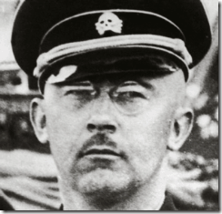
You may not be willing to accept it. But, it is official U.S. policy that Reichsfuhrer SS-1 Heinrich Himmler is a true initiate and Son of Satan. It is also true that U.S. Military Intelligence resurrected his Soul in the “Wewelsburg Workings” or the “Wewelsburg Rituals” at the Gate of the Dead at “Mittelpunkt der Welt” (Middle of the World).[1]
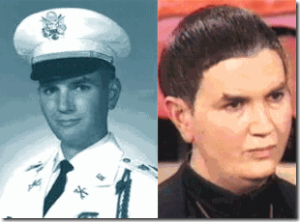
The Satanic Himmler Resurrection Rituals were conducted by U.S. Special Forces Officer, Army Lt. Col. Michael A. Aquino, Psychological Warfare Division (PYSCOPS).[2]
“You are travelling to another dimension, the fifth dimension. It is beyond that known to ordinary men and women. It is a dimension as vast as space and as timeless as infinity. It is the middle ground between light and shadow, between science and superstition, and it lies between the pit of man’s fears and the summit of his knowledge. This is the dimension whose door you unlock with the key of imagination. “That’s THE SIGN POST up ahead. Your Next Stop…”[3]
The Slaying of Trayvon Martin, the First 48 Hours
The HUNTER, Blueprint for a “One Man ILLUMINATI Einsatzgruppen”
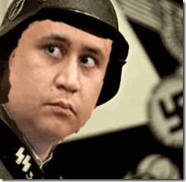
February 26, 2012
On Sunday at approximately 6:24:18 PM, a store video shows Trayvon Martin purchasing a bag of Skittles and an Arizona Watermelon Fruit Juice Cocktail.
At approximately 7:09:34 – 7:13:41 PM, the HUNTER spots his prey on his way home from the store.
The HUNTER calls the Sanford Police Department (SPD) from his truck; total time of the call is 4 minutes 7 seconds.
At this point, Zimmerman, the Hunter, spots on Trayvon on his way home from the store. Zimmerman stalks his prey and tells the 9-11 operator,
“Yeah, now he’s coming toward me. He’s got his hands in his waist band. And he’s a black male.” Then,
“Something’s wrong with him. Yep, he’s coming to check me out. He’s got something in his hands. I don’t know what his deal is.”[4]
The HUNTER was armed with a Kel-Tec PF-9 mm primed to use deadly force against his human prey.
In 2009, a neighborhood pit bull named Big Boi began menacing George and his wife Shellie Zimmerman. He was advised to get a permit to carry a concealed weapon to protect the family from Big Boi.[5]

George Zimmerman received a gun safety certificate from a local Masonic Lodge, but nobody names the lodge.[6] Once George obtained the concealed weapons permit, a Federal Air Marshal (U.S. Homeland Security Agent) and former Seminole County Sheriff and strange character, Mark Osterman, taught George how to patrol and target humans not dogs. He gave George law enforcement weapons training. He taught the U.S. government philosophy of KILLING. He taught George how to disable the gun’s safety lock permanently to kill humans more coldly, effectively and quickly.[7]
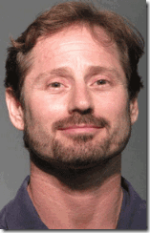
In 2010, George Zimmerman began training in Mixed Martial Arts (MMA) “No Holds Barred Fighting” with an another unusual and violent individual, Adam Pollock, at the Kokopelli Gym near Sanford.[8]
Undoubtedly, someone or some agency was really interested in providing George Zimmerman with “Urban Terrorist” training under the VEIL, instead of fighting off Big Boi.
It seems that some entity intended to create in George Zimmerman a blueprint for a “One Man Einsatzgruppen” (Executioner).
At approximately 7:11:59 PM — In reply to the dispatcher’s question, “Are you following him?” Zimmerman says, “Yes.” Dispatcher states, “OK, we don’t need you to do that.”
7:16:11 — First 911 call from witness about a fight, calls for help heard.
7:16:55 — Gunshot heard on 911 call. The HUNTER-Urban Terrorist slew his human prey, 17 year old Trayvon Martin.
Within the “First 48 Hours” in the slaughter of Trayvon Martin, the hunter and Urban Terrorist executioner, was questioned by SPD then sent home to his family no later than 1:00 AM the evening of February 26, 2012.
It appears that Trayvon’s cell phone found at the scene of the slaying was bagged up with the Skittles and Arizona Fruit Juice Cocktail then placed on the evidence shelf marked “JOHN DOE”.
February 27, 2012

Trayvon Martin’s body was delivered to the Seminole County Coroner’s Office toe-tagged “JOHN DOE”.
At approximately 8:39 AM, Tracy Martin finally reported Trayvon missing then called 9-11.
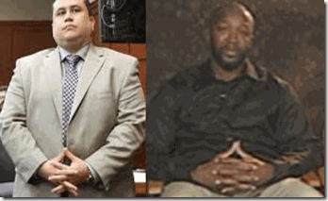
The Luciferian/ILLUMINATI Brotherhood Hand Symbol, APOSTLES OF HELL– George Zimmerman & Tracy Martin

What is extremely odd is that Brandi Green had a 14 year old son at home with Trayvon at the time of the murder while Tracy and Brandi attended Black Masonic-ILLUMINATI rituals. He told state attorney’s investigators that he waited for his mom and Tracy Martin to return home that evening and told them both that Trayvon had not returned from the 7-11 store. He said that Trayvon wanted to go to the store to get snacks, yet he had asked Trayvon to get the Skittles for him. There were no Trayvon’s snacks recovered from the murder scene. He said that Tracy and his mom went to bed. He went to school the next day. Trayvon missing the night before hadn’t seemed to be no big deal to Tracy or his mom.[9]
At approximately 9:20 AM, Tracy called 911. SPD asked Tracy to describe Trayvon, after which they sent officers to Brandi Green’s condo. SPD showed Tracy a picture of Trayvon with blood coming out of his mouth.SPD informed Tracy Martin that his son was dead.
February 28, 2012
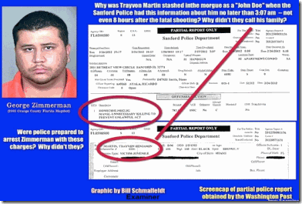
Approximately 12:30 PM, SPD finally faxed the medical examiners’ office a memo that “JOHN DOE” had been identified as Trayvon Martin.
Within the “First 48 Hours”, SPD also did not check George Zimmerman’s vehicle or impound it. SPD didn’t bother to ask neighbors if they recognized Trayvon, who had been staying with his father and Brandi Green in the condo complex.[10]
The slaughtered, 17 year old Trayvon Martin and everything he represented as a human being had been put on the shelf marked “JOHN DOE” young black male within “The First 48 hours.”
ABC News was correct when it reported that Trayvon Martin’s body sat in the medical examiners’ morgue for 3 days marked “JOHN DOE”. [11]
Rachel Jeantel was also absolutely correct. Within the “First 48 Hours”, the SPD homicide investigators never did call the last person Trayvon talked to in an attempt to identify the slaughtered teen-aged black male (Himmler’s Bedbugs and Rats—Vermin) .
Law enforcement analysts tell ABC News that George Zimmerman sounded intoxicated (under the influence-TRANCE of a drug or substance) in his call to police that night, SPD never gave him a toxicology test, which is standard in most homicide cases.[12]
With the “First 48 Hours”, SPD literally entertained, wined and dined the HUNTER and released him. Toxicology evidence for HUNTER-Urban Terrorist- Einsatzgruppen) was wiped clean.
“That’s THE SIGN POST up ahead. Your Next Stop…”
George Zimmerman & Iatrogenic Multi-Personality Disorder
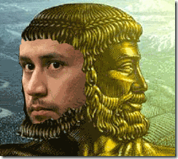
There are four pathways to multiple personality disorder (1) childhood abuse; (2) childhood neglect; (3) factitious; and, (4) iatrogenic. Iatrogenic means created unwittingly by the therapist or doctor.[13]

Also, SPD didn’t record and ask about the HUNTER’s rather unique theatre tattoo.[14] George Zimmerman carries the Masks of JANUS commonly referred as “Theater Masks” or “Comedy Tragedy Masks” on his left arm (Left-Hand Path).[15]
During the Golden Age of Greece (500- 300 BC), the two masks were the symbols for THEATER. They are the comedy and tragedy masks that were worn in ancient Greece. Plays were written in honor of the god Dionysus, the god of fertility and procreation, and were either Comedies or Tragedies.

“The actors played multiple roles, so a mask was used to show the change in character.”[16]
Zimmerman’s marks are absolutely consistent with Heinrich Himmler’s Satanic Principle of Dualism– the two-faced Janus Face of master deception. Himmler conditioned the SS to be multi-personalities and two-faced, one kind and decent gentleman, while the opposite- dissociated, cruel, evil and homicidal.
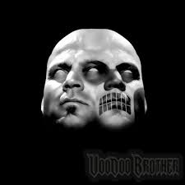
George Zimmerman had been scientifically implanted with “Himmler’s Classic Satanic Dualism.”
“That’s THE SIGN POST up ahead. Your Next Stop…”
George Zimmerman & CIA- MK ULTRA Mind Control

After the slaying of Trayvon, you should notice that the HUNTER, George Zimmerman, appeared at times under somewhat of a TRANCE. We now understand that the Urban Terrorist had indeed been SPELLBOUND by military intelligence MK ULTRA mind altering drugs. He was under the influence of two powerful prescription drugs TEMAZEPAM also known as Restoril, and Aderall.[17]

Adderall is amphetamine mixed salts that is generally used for the treatment of Attention Deficit Hyperactivity Disorder (ADHD) and narcolepsy, a sleeping disorder.[18] Adderall is highly addictive. It is known to cause “worsening mental or mood problems (e.g., aggression, anxiety, delusions, depression, hallucination, hostility).”[19]
TEMAZEPAM is of particular interest to and tool of military intelligence mind controllers. Its effects on the mind were secretly medically researched and experimented with by the CIA. Temazepam was used under the top secret code name Project MK SEARCH – a continuation of CIA/MK ULTRA.
The CIA’s ARTICHOKE and BLUEBIRD assassination programs were administratively rolled over into Project MK ULTRA, which was created by CIA Chief Allen Dulles on April 3, 1953.[20]
Project MK ULTRA was in turn rolled over into Project MK SEARCH on June 7, 1964. Project MK SEARCH then ran until June 1972, at which time extensive shredding of MK ULTRA and MK SEARCH files was ordered by the Director of the CIA, Richard Helms.[21]
Among other things known, these CIA programs were searching for the ultimate truth drug;[22] and most importantly clandestinely developing Manchurian Candidates and MONARCH assassins and operatives. [23]
The Monarch mind control program most likely evolved out of MK-SEARCH secret subprojects such as SPELLBINDER, which was a program to create the Manchurian Candidate or sleeper assassins that, could be activated with triggers and code words.[24]
Temazepam is a powerful sedative. Its amnesic effects got the attention of several Secret Intelligence agencies. The drug has strong hypnotic properties. Given to the subject, Temazepam weakens the resolve of the subject and makes him or her more compliant to pressure.[25]
Temazepam was also one of several drugs used in the research of mind control, brainwashing, and mass-scale social engineering by secret layers within U.S. Intelligence Agencies.[26]

Temazepam is also used by military-intelligence to maintain subjects in semi-vegetable states of consciousness.[27]
“That’s THE SIGN POST up ahead. Your Next Stop…”
RACIAL MURDER and CORPSES, to Have Stuck it Out & Remain a DECENT CATHOLIC
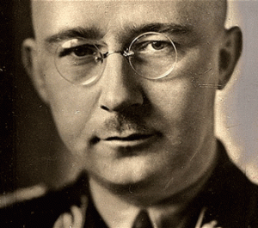
One principle must be absolute for the SS man: we must be honest, decent, loyal, and comradely to members of our own blood and to no one else. What happens to the Russians, what happens to the Czechs, is a matter of utter indifference to me… We shall never be rough or heartless where it is not necessary; that is clear. We Germans, who are the only people in the world who have a decent attitude to animals, will also adopt a decent attitude to these human animals, but it is a crime against our own blood to worry about them and to bring them ideals. I shall speak to you here with all frankness of a very grave matter. Among ourselves it should be mentioned quite frankly, and yet we will never speak of it publicly. I mean the evacuation of the Jews, the extermination of the Jewish people… Most of you know what it means to see a hundred corpses lying together, five hundred, or a thousand. To have stuck it out and at the same time–apart from exceptions caused by human weakness–to have remained decent fellows, that is what has made us hard. This is a page of glory in our history which has never been written and shall never be written. –SS-I Reichsfuhrer Heinrich Himmler, October 4, 1943 to the SS Group Leaders in Poznan

In SPD custody directly after the slaying, Zimmerman appeared to be under no unusual dismay or stress. He was uncannily cool, collected, calm and “utterly indifferent” to have just killed a human being, an unarmed teenager.

He demonstrated no sense of remorse for the homicide, but showed a sense of comfort and eases so much so that he developed idle theoretical religious conversations with police officers. SPD Officer Singleton testified that Zimmerman asked if she was catholic after noticing a cross around her neck. He reflected philosophically, “In the Catholic religion, it’s always wrong to kill somebody,” [28]
We know that to have been a self-serving Deception of mind control programming that was fed to the jury and the masses of the people by SPD and the prosecution as evidence of George Zimmerman’s state of mind at the time of slaying Trayvon Martin.
The “always wrong to kill somebody” Roman Catholic was one of Zimmerman’s “Alter Personalities”; and a classic example of Himmler’s classic JANUS two-faced- decent fellow dualism.
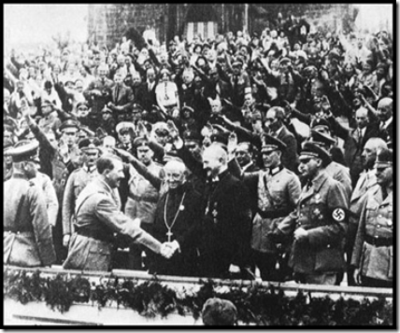
Under the Nazis, many Roman Catholics had developed a classic deprived and ghoulish preoccupation with “Divine Providence” at work with satanic principled dualism in madness, torture and mass murder.
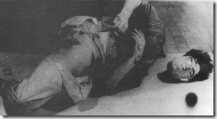
There seemed to be more Roman Catholics in the SS, the world’s greatness racial mass murderers; and in local militias that worked with the SS than there were religious conscious objectors to mass murder. Among the many Nazi leaders who were Roman Catholics, in addition to the Fuhrer Adolf Hitler, were Josef Goebbels, SS-1 Heinrich Himmler, Reinhard Heydrich, Heinrich Mullery and SS Rudolf Hoess that ran the concentration and extermination camps.[29]
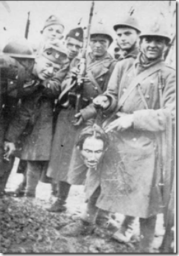
Some of the most sensational depraved and utterly ghoulish murderers of the THIRD REICH had been Roman Catholics, Ante Pavelic, middle below, and the above Ustashi of Croatia.[30]
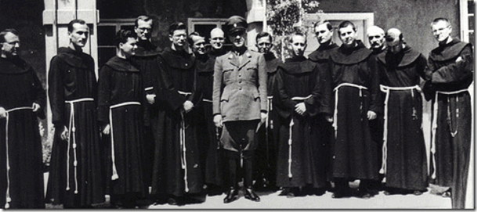
“These were not isolated instances. The Ustashi more often than not massacred all the inhabitants of Serb villages, callously torturing and killing even children, and then setting the villages on fire. In the village of Susnjari, for instance, the Ustashi, after having killed most of the inhabitants, led away about twenty surviving children, whom they tied to the threshold of a big barn, which was then set on fire. Most of the children, of an average age of about ten, were burned alive. The few who survived, horribly scorched, were eventually killed. Eye-witnesses testified to similar occurrences:
In the village of Gorevac, on September 13, 194i, children of about 3 years of age were impaled. In some places mothers threw themselves down with children in their arms, and one stake perforated mother and child. Some young girls had their breasts tied or cut, others had their hands made to pass through them. Men had their ears and noses sawn away, and eyes had been uprooted from their sockets.”[31]
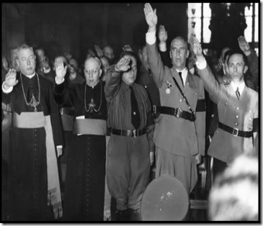
The war criminal SS Satanic Knights of the Black Sun had been constituted by Himmler, according to the principles of the Jesuit Order. The SS’ entire structure was a close imitation of the Catholic Church’s hierarchical order. Himmler’s Wewelburg’s castle was the SS monastery.
In Classic DUALITY under the Providence of God, Catholics do and continue to kill under the most fiendish and demonic circumstances.
On the night of February 26, 2012, George Zimmerman under the influence of CIA/ MK ULTRA experimental mind control drugs had been turned him into a classic satanic multi-personality Manchurian Candidate.
He said that the slaying of Trayvon had been God’s Plan.[32] The Manchurian Candidate’s GOD THAT MADE ME DO IT always turns out to be a high level Ultra Top Secret military intelligence project and objective.
“That’s THE SIGN POST up ahead. Your Next Stop…”
CIA & Robert Walter Zimmerman, BEHOLDEN TO LUCIFER
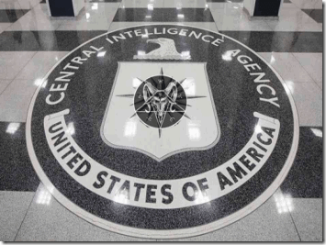
In 1947, the Central Intelligence Agency (CIA) was born out of the depths and traps of HELL. They were officially formed out of the slime and bowels of the Satanic Mysticism and Magick of the Son of Lucifer, Reichsfuhrer SS-1 Heinrich Himmler, and Lucifer’s Servants, Knights of the Black Sun. They became the keepers and preservers of the secret ancient arcane arts of Babylonia. They weren’t just fascinated and in awe of Fuhrer Adolf Himmler, Josef Goebbels, Commando Otto Skorzeny and Heinrich Himmler, they became BEHOLDEN to them, their symbols, legends, myths and their PATH.
Robert Walter Zimmerman is not a name found among some of the CIA’s most common and infamous cast of “self righteous” amoral German cousins like Allen Dulles, Richard Helms, Frank G. Wisner, James Angleton, George G. W. Bush, Dr. James Alexander Hamilton, Dr. Louis Jolyon West, Dr. Martin Orne or Dr. Ewen Cameron that became beholden to Lucifer and its servants.
In 1947, Robert Walter Zimmerman, another German cousin. , became a witting and essential clog in the wheel that made the CIA the outlaw, murdering devil worshipping and satanic agency that it became. Behind the veil for decades, CIA Agent Robert W. Zimmerman was, individually, just as criminal, vile, and demonic as the others that had reserved their places in HELL for their individual crimes and outrages against GOD and Humanity.
“That’s THE SIGN POST up ahead. Your Next Stop…”
Robert Walter Zimmerman, the Gehlen Org & the Old Boy CIA
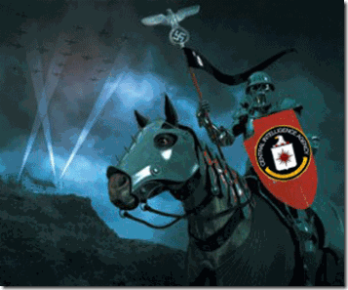
George Zimmerman’s paternal grandfather was Big Papa Robert Walter Zimmerman (February 5, 1919 – March 5, 1999), son of Clemence R. Zimmerman (born 1879) and Meta Becker (born 1881) of Peoria, IL. They were most likely born of German immigrants.
George’ family background in espionage and intelligence seem to begin with Big Papa Zimmerman of the Central Intelligence Agency (CIA). In the U.S. Intelligence circles, he was far from being a junior CIA officer.
“Allen Dulles, Richard Helms, Carmel Office and Frank G. Wisner were the grand masters. If you were in a room with them you were in a room full of people that you had to believe would deservedly end up in hell. I guess I will see them there soon.” –James Angleton, CIA Chief of Counter Intelligence[33]
During WWII, Big Papa worked with U.S. Naval Intelligence attached to the U.S. State Department special operations most likely with the notorious Frank G. Wisner.[34] When the CIA became official in 1947, Big Papa was poured over into the intelligence network with Nazi Generalmajor Reinhard Gehlen and Reichsfuhrer Heinrich Himmler’s SS (Knights of the Black Sun), the World’s Greatest Racial Mass Murderers.
Big Papa had been part of the “old boy network of political-military people” involved in WWII, many from the Foreign Service, people who think the same way. That means he was among the “Old Boy Network” of John Foster and Allen Dulles, William (Wild Bill) Donovan, Frank Wisner, Carmel Office, James Angleton, and Richard Helms that ran the Nazi Ratlines, USA Murder, Inc, Global Drug Trafficking and Mind Control Projects- MK ULTRA.
The founding fathers of the CIA William “Wild Bill” Donovan, Allen Dulles along with Hitler’s spy chief, Generalmajor Reinhard Gehlen, were Knights of Malta. The Sovereign Military Order of Malta, also known as the original Sovereign Military Order of St. John of Jerusalem, is a closed fraternity of the Roman Catholic Church.[35]
Most of the CIA hierarchy of the “Old Boy Network” was also Roman Catholic, knights and freemasons.[36] Likewise, Big Papa Zimmerman was also a Roman Catholic fanatic passed down through the bloodlines of the family.
In 1947, the CIA ran like an extension of the closed fraternity of Roman Catholic Jesuits and Knights out of Harvard University and the Ivy League Colleges. In 1942, Big Papa graduated out of Harvard with a Masters of Business Administration (MBA) to become part of the network of U.S. Foreign Service Anglo Saxon Aristocrats as a “CIA Bagman”.[37]
“That’s THE SIGN POST up ahead. Your Next Stop…”
Big Papa Zimmerman & the Ancient Samarians
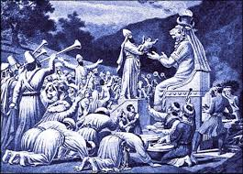
In December 1947, Big Papa married Roman Catholic Silvia Brull out of the Cuban Mission in Washington DC at St. Joseph’s Church in Ottawa, Canada [ancestry.com].
George’s grandmother, Silva Brull, also worked Foreign Service (CIA) deep cover out of the U.S. State Department. Silvia was no Cuban. She was part of the Spaniard colonial occupation of Cuba.
Silvia Brull was a Catalan Spaniard. Catalonia is an autonomous community of Spain with the official status of a nationality. Catalonia has a long and complicated history connected to the Ancient Iberians that traded with the Greeks to the Roman – Carthaginian Wars of the 2nd Century BC. During the Middle Ages, Byzantine chroniclers claimed that Catalania derives from the local medley of Goths with Alans, initially constituting a Goth-Alania.[38]
This is an important connection to the Samarian High Priest and followers of Ba’al Moloch ran out of Biblical Judea (Canaan) by the Holy Roman Empire in the 6th Century A.D. covered in Trayvon Martin, The Shadow of Caliban.
The Alans was the name for Iranian-speaking East Sarmarian (Samarin) nomad tribes. Old sources also describe them as an “untamable and brave” people who lived in the lower reach of the Danube, Northern Black Sea region, Fore-Caucasus and Central Caucasus. Their territory, which was known as Sarmatia to Greco-Roman ethnographers, correspond to the western part of greater Scythia (mostly modern Ukraine and Southern Russia, also to a smaller extent north eastern Balkans and Moldova).[39]
The territory inhabited by Sarmatians or Savromatians gradually became known as Alania, while at the same time ancient historians stopped mentioning other Sarmarian tribes in their works. They are generally considered the predecessors of the European Knights (King Arthur’s Knights of the Round Table and Roman Catholic Knights Templar). [40]

“That’s THE SIGN POST up ahead. Your Next Stop…”
Big Papa Zimmerman, Allen Dulles & Operation SS- BERNARD
“No one knows what is really going on. If they ever did, it would make Watergate look like Alice in Wonderland.”
— Lester Coleman, ex U.S. Defense Intelligence Agency[41]
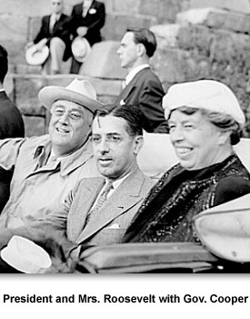

In 1947, Big Papa’s first official CIA assignment was to cover Ambassador Prentice Cooper in Lima, Peru. He said that the Peruvian military was still wearing Nazi war helmets and goose stepping.[42]

Cooper wasn’t a junior ambassador. He was out of Princeton University, and had been the former governor of Tennessee. During his administration as governor, the U.S. government began the ultra secret Oak Ridge Tennessee Manhattan Project to build America’s first atomic bomb.

In 1944, he trailed only Freemason of the 33 degree, Harry S. Truman, for the vice presidency of the United States. In 1946, President Truman appointed Cooper as the Peruvian Ambassador.[43]
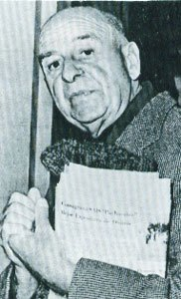

Mason Sturmbannführer SS Friedrich Schwend

The CIA had a big ultra secret asset and operation concealed in Lima, Sturmbannführer SS Friedrich Schwendof Himmler’s ultra secret SS counterfeiting Operation BERNARD.

In 1945, OSS Chief Allen Dulles had recruited SS Schwend as an agent in the Reinhard Gehlen Org. Through him, Dulles recovered millions in SS gold, American and British counterfeit dollars and pounds. However, the U.S. discovered that Schwend and the SS continued its counterfeiting operation under deep cover.[44]

In 1947, when things got too hot for Schwend in Europe, the CIA and the Gehlen Org packed him up and sent him off to Cooper and Big Papa in Lima.[45]
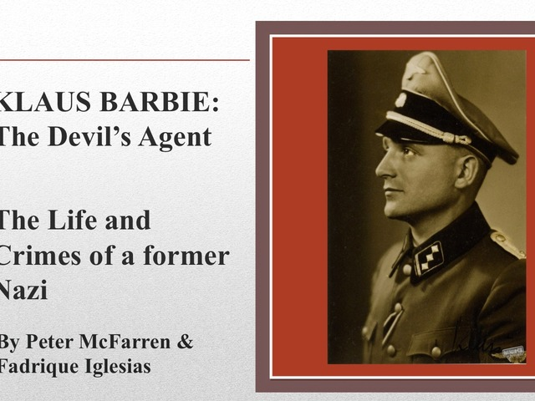
Schwend’s partner in business’ affairs in Lima was the “Devil’s Agent” SS war criminal and CIA agent Hauptsturmführer SS Klaus Barbie. With SS Barbie at his side, Schwend became minister of finance of Nazi funds smuggled out of Germany and used to finance the German exile network’s often illegal ventures, including assassinations, political coups, cocaine trafficking, and weapons running.[46]
Out of Lima, Schwend and Barbie also ran Otto Skorzeny Die Spinne (The Spider), which was also known as the “Swastika Syndicate” that was the clandestine operations arm of ODESSA, the SS-Nazi Ratline.[47]
In 1949, George’s alleged father, Roberto J. Zimmerman, was born in Lima. In 1950, Big Papa went to Bangkok, Thailand as an “economic officer”.[48]
“That’s THE SIGN POST up ahead. Your Next Stop…”
Big Papa Zimmerman, Heroin & the Golden Triangle

During the 1950’s, U.S. efforts to contain the spread of Communism in Asia involved forging alliances with tribes and warlords inhabiting the areas of the Golden Triangle, (an expanse covering Laos, Thailand and Burma), thus providing accessibility and protection along the southeast border of China. In order to maintain their relationship with the warlords while continuing to fund the struggle against communism, the U.S. and France supply the drug warlords and their armies with ammunition, arms and air transport for the production and sale of opium. The result: an explosion in the availability and illegal flow of heroin into the United States and into the hands of drug dealers and addicts.[49]
According to CIA official sources, in August 1950, the Agency secretly purchased the assets of Civil Air Transport (CAT), an airline that had been started in China after World War II by Gen. Claire L. Chennault and Whiting Willauer. CAT would continue to fly commercial routes throughout Asia, acting in every way as a privately owned commercial airline. At the same time, under the corporate guise of CAT Incorporated, it provided airplanes and crews for secret intelligence operations.[50]
The CIA’s alliance with the opium armies in the Burma-Thai borderlands lasted for a decade. The Agency delivered arms to their forces in Burma and then loaded opium aboard Civil Air Transport (CAT) planes for the return flight to Big Papa’s Bangkok Station.[51]
Big Papa called his CIA Thailand operation, the “BANGKOK MAFIA.”[52] There should be little doubt in your mind that Big Papa Zimmerman was a CIA bagman directly involved in financing Civil Air Transport (CAT); and part of the CIA’s ultra secret illegal Golden Triangle drug trafficking operation with the Sicilian Mafia.

“It is ironic, to say the least, that America’s heroin plague is of its own making.” — Fred W. McCoy[53]
“That’s THE SIGN POST up ahead. Your Next Stop…”
Big Papa Zimmerman, Dictator Francisco Franco, Obersturmbannführer SS Otto Skorzeny, the Satanic Knight of the Black Sun
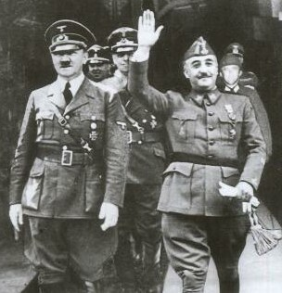
Spain’s Fascist Dictator Francisco Franco and Fuhrer Adolf Hitler
In 1960, Big Papa Zimmerman landed in Madrid, Spain to work with Spain’s Dictator Francisco Franco; and clandestinely with Basques and Catalan separatist.[54]

It is important to note that Basque separatism is thus an outgrowth of Benedictine CATALAN separatism.[55] Like Lima, Peru, the Gehlen Org was running a major clandestine operation in Spain led by Hitler’s Commando Obersturmbannführer SS Otto Skorzeny.
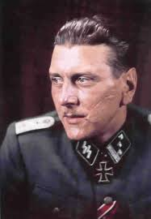
SS “Scarface”Skorzeny postwar career advanced to another level after he resettled in Madrid in 1950 with a passport and free pass from General Francisco Franco.
SS Skorzeny, Roman Catholic, entered Spain under an alias to begin collaboration with Franco’s top military leaders, ex-SS generals and officers, and even the highest levels of the Vatican to plan the formation of a secret army of ex-Nazis and Spanish military in Spain and North Africa, prepared at any time to counter a Russian attack from East Germany.[56]
In Spain, SS Skorzeny married Nazi Finance Mastermind Hjalmar Schacht’s niece, Ilse von Finkenstein; Schacht himself also made frequent visits to Madrid. It is estimated that all told, by 1950, about 16,000 Nazi emigrants were living in Spain.[57]
SS Skorzeny lived in Madrid and had a floor apartment in Mallorca (CATALAN) a fishing lodge.[58] It was no secret at all that Spain became a well-known “resting place” for ex-Nazis on the run while en route to South America and the Middle East. As a matter of fact, it is believed that a wide swath of coastline owned by Skorzeny near Majorca (CATALAN) was used to smuggle his comrades in and out of Spain.[59]
In 1960, SS Skorzeny founded the neo-Nazi movement CEDADE (Círculo Español de Amigos de Europa).[60]
In the 1960s, SS Skorzeny also set up the Paladin Group, which he envisioned as “an international directorship of strategic assault personnel [that would] straddle the watershed between paramilitary operations carried out by troops in uniforms and the political warfare which is conducted by civilian agents”.[61]

The city of Alacant/ Alicante has two official names. Alacant is the original Catalan one. The Spanish name Alicante was given by Franco.[62] .Based near Alicante, Spain, the Paladin Group specialized in arming and training guerrillas and their clients included the South African Bureau of State Security. They also carried out work for the Greek military junta of 1967-1974 and some of their operatives were recruited by the Spanish Interior Ministry to wage clandestine war against Basque separatists.[63]
SS Skorzeny was a major link between the Basque-CATALAN forces that Big Papa was officially assigned to in Spain. SS Skorzeny was the middle man, the international gun and weapons merchant. As above, the Paladin Group provided specialized military training bases in Spain for Basque-CATALAN separatists and international counterintelligence and terrorist groups.[64]
The Soviet news agency TASS alleged that Paladin was involved in training US Green Berets for Vietnam missions during the 1960s.[65] The U.S. Army Special Force Green Berets were officially established in 1961.[66] The Green Berets was established within a year of Big Papa Zimmerman and the CIA pocketbook arriving in Madrid, Spain.
“That’s THE SIGN POST up ahead. Your Next Stop…”
SS Otto Skorzeny & the Keeper of the Flame
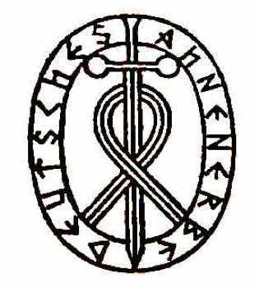
Himmler’s Ahnenerbe (Bureau for the Study of Ancestral Heritage) did not overlook the Ancient Iberians of Spain in its pseudo mystical race theories.
Generally, the Nazi view is that the Iberians were the bloodlines of the “Aryan-Teutons,” the “Fifth Root-Race” of the Lost Continent of Atlantis”.[67]
Recall. The Greek Historian, Herodotus, link the bloodlines of Alans–Scythians to the ancient Amazons of Atlantis that settled among the Atlas Mountains in North Africa.[68]

As noted above, the Alans were the predecessors of the European Knights that includes the Order of Teutonic Knights; and the SS-Knights of the Black Sun. SS Skorzeny’s choice of Catalonia as the place to recruit and reorganize Nazi forces was not a random choice. Apparently, Catalan separatists that Big Papa worked with certainty identified with Aryans and Nazism.
The Alans were also the “Keeper of the Flames” of ancient Babylonia arcane knowledge; and secretly maintained secret high priests and schools of Ba’al Moloch.
Reichsfuhrer SS-1 Heinrich Himmler and the SS were among some of the greatest collectors of arcane knowledge and artifacts. He was also a great believer and practitioner of the esoteric and satanic arts. Himmler was the high priest and grand master of his own coven (Round Table) of twelve at the Wewelsburg Castle. Himmler was always the 13th member.[69]
In 1935, Himmler setup Special Unit H (Sonderkommando H) within Archive Department 7 of the Reich Security Main Office (RSHA) to discover any traces of Germanic magic that survived the great witch-hunts of the Middle Ages.
Special Unit H looted more than 140,000 books on the subject of the occult from libraries across Nazi occupied Europe, and among the manuscripts they found a copy of Necronomicon (Book of the Dead) written in ancient Gothic that told of a race much older than mankind: the nightmarish Ancient Ones.[70]
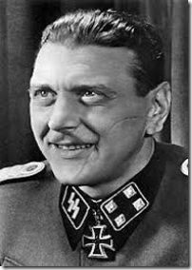
Wicked and demonic Scarface was a prominent and infamous member of Himmler’s Ahnenerbe, and Satanic Order of Knights of the Black Sun. To the Occulted and Satanic Hitler and Himmler, he also had been their most celebrated knight warrior and preserver of ancient arcane artifacts and knowledge.[71] SS Commando Skorzeny and Himmler’s Ahnenerbe archives are as we speak still classified ULTRA TOP SECRET.
I certainly believe that Robert Walter Zimmerman maintained a close and well guarded working relationship with Francisco Franco’s favorite mystic warriors in Spain, SS Otto Skorzeny. From Allen Dulles down through the ranks of the knightly order of the CIA, they were all fascinated with Hitler’s favorite commando and “the Most Dangerous Man in Europe.”[72]
In Spain, SS Skorzeny was one of the most important and essential links to Basque and CATALAN separatists and international terrorist groups. He would have been of primary and the focal interest to the CIA.
“That’s THE SIGN POST up ahead. Your Next Stop…”
Big Papa Zimmerman, Nazis & Operation CONDOR

It appears that Robert Walter Zimmerman was not only a CIA bagman for the Mafia’s Golden Triangle Heroin trafficking, but a bagman for the Reinhard Gehlen Org, Operation CONDOR; and Hitler’s Commando Obersturmbannführer SS Otto Skorzeny’s clandestine CIA counterintelligence and assassination operations out of Lima, Peru and Fascist Spain.
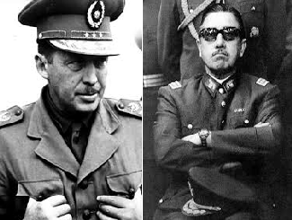
Robert Walter Zimmerman was also activity involved in Operation CONDOR in Chile and Paraguay. Condor was a South America terror campaign of political repression and terror involving intelligence operations and assassination of opponents, officially implemented in 1975 by the right-wing dictatorships like General Alfredo Stroessner of Paraguay and General Augusto Pinochet of Chile. CONDOR was intended to eradicate communist or Soviet influence and ideas, and to suppress active or potential opposition movements against the participating governments. [73]
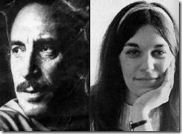
In 1976 under CIA Chief G.H. W. Bush, Zimmerman met directly with Paraguay Ambassador George P. Landau that provided two CONDOR assassins with false passports to travel to the United States to assassinate Orlando Letelier and Ronni Moffitt with a car bomb in Washington, DC.[74] I suspect that he was also the CIA bagman for that operation.

In Paraguay, Robert Zimmerman met several times with General Stroessner. The general was of German descent and recruited Nazis and the Gehlen Org to help run and develop the country. General Stroessner also provided safe havens for wanted SS war criminals like Big Papa’s fellow demonic Gehlen Org/CIA agent Hauptsturmführer SS Josef Mengele. [75]
“That’s THE SIGN POST up ahead. Your Next Stop…”
Roberto J. Zimmerman, the Keeper of the Flame- Old School CIA and Lucifer
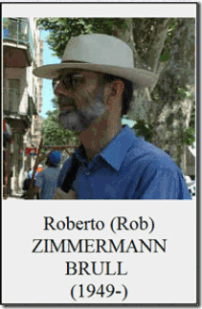
George’s alleged biological father, Roberto Zimmerman, Sr. was a U.S. Army veteran who served in Vietnam in 1970, and was stationed at Fort Myer in Arlington, Virginia, in 1975 with Gladys Mesa’s brother George.
Roberto Zimmerman, Sr. also served two tours in Korea, and spent the final 10 years of his 22-year military career in the Pentagon, working for the Department of Defense (DoD), a family member said.[76]
If you count from Roberto’s 1970 Vietnam tour of duty allegedly with Gladys’ brother to 2000 when he retired from the DoD, it covers over 30 years not 22 years of military career and involvement.
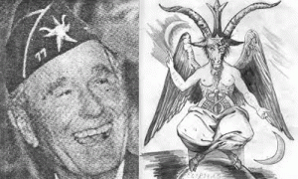
Skull and Bones- CIA Director George H.W. Bush & the Sign of BAPHOMET
Roberto likely began working for the DoD in 1988 around the beginning of the presidential reign of Big Papa’s Knights Templar- Knight of Malta- CIA Chief, George H. W. Bush.[77]
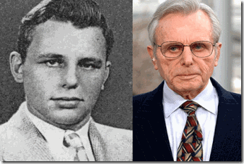
Roberto says that he worked at the Office of Secretary of Defense, Executive Support Service.[78] That would put him in bed with another of Big Papa’s extremely dangerous and evil “Old Boy Network” of former CIA Chiefs, Frank Charles Carlucci III, above, CIA Director (February 5, 1978 – February 4, 1981) ; U.S. Secretary of Defense (1987-1989).[79]
Frank Carlucci is one of world’s most dangerous people. Carlucci, Princeton University, Class of 1952, was born of classic Italian Freemason immigrants. Like Big Papa, he was also primed for the CIA at Harvard Business School.[80]
He was a “Sublime Prince of the Royal Secret” of the Sovereign Military Order of Malta (Knights of Malta) with CIA Chief Allen Dulles and Nazi Generalmajor Reinhard Gehlen.[81]
Carlucci is a member of Council on Foreign Relations (CFR), and Le Cercle. In 1961, he was directly involved in the overthrow and assassination of Congo President, Patrice Lumumba. In 1964, he is said to have been involved in the other throw of Brazilian President João Goulart. He is linked to the Sicilian Mafia and the Japanese Mob, Yakuza. He is Chairman emeritus of the Carlyle Group. He was a member of the Project for a New American Century, architects of the 9-11 Deception, and so on, and so forth.[82]
In 2000, Roberto became a powerful full-time Virginia Supreme Court Magistrate.[83] Like his brother-in-law, Jorge Mesa, for a man of his educational background and experience, the lofty rewards, positions and privileges he has held within the U.S. Government just don’t add up unless he was a high ranking clandestine Psychological Warfare (PSYOPs) “CIA Spook”.
Furthermore, at the time that Roberto was attached to the Pentagon, Big Papa was working by contract to the DoD under CIA Chief Robert Gates.[84] Big Papa and some of his “Old Intelligence Community Staff” [85] were working on a DoD component of the CIA’s Human Intelligence (HUMINT) Control System.[86] This is not what I say, but it is exactly what Robert Walter Zimmerman admitted that he was involved in.
After the arrest of Aldrich Ames, the CIA developed a new special information handling system to protect its most sensitive human intelligence sources. The system, called the Human Intelligence (HUMINT) Control System, or HCS, requires special handling procedures that limit the dissemination of, and control access to, sensitive source information.[87]
In other words, the “CIA Old Boy Cells” were teaching government agencies and departments how to develop Gestapo Gruppenführer SS Heinrich Müller and Himmler’s double and triple layers of compartmentalized secrecy and security.
The bottom line is that Roberto was a “spook” working U.S. Intelligence just like Big Papa. He also appeared to have been working some of the same intelligence- counterintelligence “Basque” and “Catalonian” networks and contacts in Lima, Peru and Spain.

Roberto also married a “Catalonian” woman. It also appears that George’s mother, Gladys Zimmerman, is actually Ines Tell de Palleja. According to George’s family tree, Roberto J. Zimmerman Brull married Ines TELL DE PALLEJA, daughter of TELL and Mercedes de PALLEJA FABRA, on June 21, 1975 in San Miquel D’olerdola, Barcelona, España.[88]
Sant Miquel D’olerdola is a municipality in the district of Upper Penedes, Barcelona province, autonomous community of Catalonia, Spain.[89] Gladys is the same as George’s alleged grandmother, Silvia Brull, she is not a Peruvian but a CATALAN Spaniard.
At least a couple of sources allege that Roberto and Gladys have only one child, Beatriz Zimmerman, born April 8, 1976 in Chicago, IL. On May 22, 2004, Beatriz married Panayotis LIANOS PROTAGORAS in Athens, Greece. [90] CIA?

If Gladys is really Ines Tell de Palleja then tell me who is George Zimmerman’s uncle, U.S. Army Medic Command Sergeant Major Jorge Mesa?
If Gladys was born in Lima, Peru, then it highly likely that Jorge is a Peruvian National. If Jorge is a Peruvian then how did this foreign national end up in the ranks of the U.S. Army in Vietnam? Why did the U.S. Military establishment reward him with the highest rank, Command Sergeant Major, and pay scale possible with his education and background? Just in base salary, they kicked Jorge down almost $50,000 a year.[91]
What makes sense is that Jorge was part of SS Skorzeny’s CATALONIAN Paladin Group cells that Big Papa recruited; and SS Skorzeny specially trained him to terrorize and murder the Vietnamese People.
“That’s THE SIGN POST up ahead. Your Next Stop…”
CIA, SS Otto Skorzeny and Luciferian Bloodlines
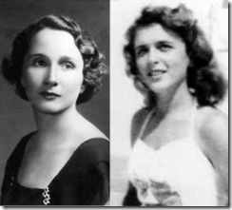
Pauline & Barbara Pierce
Socialite Pauline Robinson Pierce was former First Lady Barbara Pierce-Bush’s mother. During the 1940s, she was rumored to have had wild affairs with very powerful and prominent men in politics even the President of the United States, General Dwight Eisenhower.[92]
Pauline Pierce is linked to a man that was considered to be “Hitler’s Guru.” She was an OTO initiate of the Great BEAST 666 Aleister Crowley linked to Nazi, American and British secret intelligence circles.
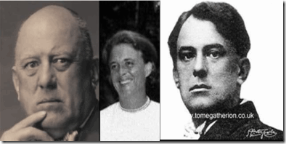
The BEAST and 39 year old Barbara Bush
It’s been reported that she and Crowley were in France together around September/October of 1924 performing Grade of Ipsissimus- “Satanic Sex Magick Rituals.” Upon return to America, Pauline gave birth to Barbara Pierce. [93] There is a high probability that Barbara Pierce’s biological father was “the Wickedness Man in the World.” Most people will agree that Ms. Pierce and the BEAST were in France together while the BEAST at the time was performing rituals and ceremonies to advance in OTO levels of demonic and satanic possession through sex magick rituals. Most people will agree that it is his nature, and THAT IS WHAT THE MAN DOES- SATANIC SEX MAGICK RITUALS.
Wall Street Banker and Financer, Prescott Sheldon Bush, had been in bed with Hitler, Himmler and National Socialism from the start. Also from the start, he had been a very “Special Friend” of America’s officially recognized “Son of Satan” Reichsfuhrer Heinrich Himmler. Prescott Bush had also been an Initiate of Ancient Arcane Knowledge and Practices. Prescott Bush had been a member of Yale University’s multi-generational Blood Oath “Skull and Bones”, an Ancient German Occult Lodge of the Brotherhood of Death.
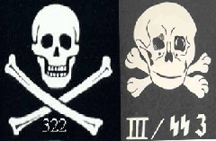
Skull and Bones of the Yale University and Himmler’s SS
Himmler’s SS (Knights of the Black Sun) was also part of the Ancient German Occult Lodge of the Brotherhood of Death.
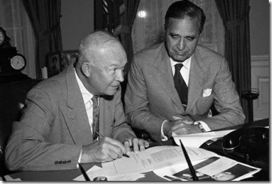
Luciferian Prescott Bush Overlooking U.S. President Dwight D. Eisenhower
Prescott Bush had been one of Eisenhower’s closest political manipulators and controllers. If Pauline Pierce was having an affair with President Eisenhower, Prescott Bush was well aware of it and probably setup the affair as a tool of wicked advantage and White- Mail.
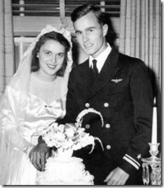
Prescott Bush was well aware of Pauline’s daughter, Barbara Pierce, being a Satanic “Moon Child.” Prescott Bush deliberately setup his son, George H. W. Bush (Skull and Bones-Brotherhood of DEATH), to marry a “Moon Child” to harness the Power of Lucifer through the Bush Bloodlines.
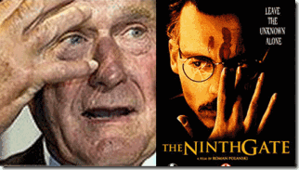
As noted above, Big Papa’s “Old Boy Network” included his former extremely demonic, satanic and pedophile boss, CIA Chief George H. W. Bush (January 30, 1976 – January 20, 1977).[94]
Were the Zimmermans really marrying CATALONIAN High Priestess and maidens of a secret SS Satanic Cult developed by Otto Skorzeny to also harness Luciferian Magick and Power through their bloodlines?
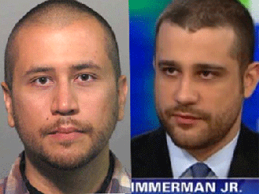
George Michael Zimmerman, The HUNTER, and his brother, Robert Zimmerman are alleged to be adopted children out of Lima, Peru. They were really the children of Gladys’ sister.[95] They look like biological brothers. However, they don’t seem to resemble the multi-generational “CIA Spook,” Roberto Zimmerman Brull.

They also don’t seem to resemble the CATALONIAN WITCH, Gladys Mesa-Zimmerman aka Ines TELL DE PALLEJA or Uncle George (Jorge) Mesa aka ?

George Michael Zimmerman’s birth certificate hasn’t appeared in the public domain and most likely will not. At the very least, George Zimmerman could actually be at least 50% CATALONIAN and only God knows out of what U.S. CATALONIAN terrorist and Luciferian cells linked to the Legend of CIA Bagman Robert Walter Zimmerman and Obersturmbannführer SS Otto Skorzeny.
WHO ARE THESE PEOPLE! Without a free and independent press (4th Estate), there really isn’t any “SIGN POSTS.”
Your Next Stop…
MODERN SLAVERY!

“What will the social order of the future be like? Comrade, I will tell you. There will be a class of overlords, after them the rank and file of the party members in hierarchical order, and then the great mass of anonymous followers, servants and workers in perpetuity, and beneath them again all the conquered foreign races, the modern slaves. And over and above all these will reign a new and exalted nobility of whom I cannot speak. But of all these plans the militant members will know nothing. The new man is living amongst us now! He is here. Isn’t that enough for you? I will tell you a secret. I have seen the new man. He is intrepid and cruel. I was afraid of him” –Adolf Hitler

[1] http://theforbiddenknowledge.com/hardtruth/satanic_subversion.htm
[2] http://theforbiddenknowledge.com/hardtruth/satanic_subversion.htm
[3] http://www.imdb.com/title/tt0052520/quotes
[4] http://phoebe53.wordpress.com/2012/03/26/zimmerman-911-call-transcript-trayvon-martin/
[5] http://www.reuters.com/article/2012/04/25/us-usa-florida-shooting-zimmerman-idUSBRE83O18H20120425
[6] http://www.reuters.com/article/2012/04/25/us-usa-florida-shooting-zimmerman-idUSBRE83O18H20120425
[7] http://globalgrind.com/news/us-air-marshal-mark-osterman-took-george-zimmerman-in-trayvon-martin-details
[8] http://www.mediaite.com/tv/george-zimmerman-mma-trainer-adam-pollock-was-arrested-for-attacking-woman-who-defrauded-him/
[9] http://www.clickorlando.com/blob/view/-/15490330/data/1/-/kligxm/-/Zimmerman-documents.pdf
[10] http://abcnews.go.com/US/police-chief-trayvon-martin-case-resigns-temporarily-amid/story?id=15977847#.Uc-sQzs3s7T
[11] http://www.examiner.com/article/trayvon-martin-morgue-3-days-as-john-doe-after-mom-reported-him-missing
[12] http://abcnews.go.com/US/trayvon-martin-family-seeks-fbi-investigation-killing/story?id=15949879
[13] Ross, Colin, Bluebird, Deliberate Creation of Multiple Personality By Psychiatrists, Manitou Communications, Richardson, TX (2000) pg. 255
[14] http://www.cbsnews.com/8301-201_162-57413331/arrest-records-shine-a-little-light-on-zimmerman/
[15] http://www.angelfire.com/art/masks/maskhistory.html
[16] http://www.angelfire.com/art/masks/maskhistory.html
[17] http://globalgrind.com/news/george-zimmerman–drugs-violent-side-effects-killed-trayvon-martin-details
[18] http://en.wikipedia.org/wiki/Amphetamine_mixed_salts_(medication)
[19] http://globalgrind.com/news/george-zimmerman–drugs-violent-side-effects-killed-trayvon-martin-details
[20] http://en.wikipedia.org/wiki/Project_MKULTRA
[21] http://www.wanttoknow.info/bluebird10pg
[22] http://en.wikipedia.org/wiki/Talk%3ATemazepam/Archive_1
[23] http://www.trutv.com/conspiracy/government-lies/manchurian-candidate/mk-ultra-mind-control.html
[24] http://panachereport.com/PanacheReportMyraPanacheReportsManchurianCandidates.htm
[25] http://www.sayvandalay.com/2008/03/12/it-had-a-code-name/
[26] http://www.sayvandalay.com/2008/03/12/it-had-a-code-name/
[27] http://panachereport.com/PanacheReportMyraPanacheReportsManchurianCandidates.htm
[28] http://www.nytimes.com/2013/07/02/us/jurors-hear-zimmermans-taped-police-interview.html?_r=0
[29] http://www.liberalslikechrist.org/Catholic/NaziLeadership.html
[30] http://en.wikipedia.org/wiki/Ante_Paveli%C4%87
[31] http://www.liberalslikechrist.org/Catholic/NaziLeadership.html
[32] http://www.usnews.com/opinion/blogs/robert-schlesinger/2012/07/19/george-zimmerman-and-gods-plan-to-kill-trayvon-martin
[33] http://www.skilluminati.com/research/entry/7_types_of_ambiguity/
[34] http://www.spartacus.schoolnet.co.uk/JFKwisner.htm
[35] http://www.bibliotecapleyades.net/sociopolitica/esp_sociopol_malta01.htm
[36] http://www.bibliotecapleyades.net/sociopolitica/esp_sociopol_malta01.htm
[37] http://www.adst.org/OH%20TOCs/Zimmerman,%20Robert%20W.toc.pdf
[38] http://en.wikipedia.org/wiki/Catalonia#History
[39] https://en.wikipedia.org/wiki/Sarmatians
[40] http://ukrainianweek.com/History/56230
[41] http://usahitman.com/ccahce/
[42] http://www.adst.org/OH%20TOCs/Zimmerman,%20Robert%20W.toc.pdf
[43] http://en.wikipedia.org/wiki/Prentice_Cooper
[44] Breitman, Richard, U.S. Intelligence and the Nazis, Cambridge University Press (2009) pgs. 125-127
[45] Breitman, Richard, U.S. Intelligence and the Nazis, Cambridge University Press (2009) pgs. 125-127
[46] http://www.newswithviews.com/Cuddy/dennis177.htm
[47] http://jimhougan.com/JimJones3.html
[48] http://www.adst.org/OH%20TOCs/Zimmerman,%20Robert%20W.toc.pdf
[49] http://www.heroinhistory.com/
[50] https://www.cia.gov/library/center-for-the-study-of-intelligence/csi-publications/csi-studies/studies/winter99-00/art7.html
[51] http://usahitman.com/ccahce/
[52] http://www.adst.org/OH%20TOCs/Zimmerman,%20Robert%20W.toc.pdf
[53] http://usahitman.com/ccahce/
[54] http://www.adst.org/OH%20TOCs/Zimmerman,%20Robert%20W.toc.pdf
[55] http://www.archive.org/stream/TheHotAutumn83-HistoryCommandStructureAndControllersOfAnti-nation/TheHotAutumn83-HistoryCommandStructureAndControllersOfAnti-nationStateForcesInEurope_djvu.txt
[56] http://auctions.alexautographs.com/asp/fullCatalogue.asp?salelot=46+++++++++8+&refno=+++71353
[57] http://www.larouchepub.com/other/2004/3114_terror_legacy.html
[58] http://en.wikipedia.org/wiki/Majorca
[59] http://auctions.alexautographs.com/asp/fullCatalogue.asp?salelot=46+++++++++8+&refno=+++71353
[60] http://desertwar.net/otto-skorzeny.html
[61] http://en.wikipedia.org/wiki/Skorzeny#Spain_and_Ireland
[62] http://en.wikipedia.org/wiki/Talk:Alicante
[63] http://en.wikipedia.org/wiki/Skorzeny#Spain_and_Ireland
[64] http://www.archive.org/stream/TheHotAutumn83-HistoryCommandStructureAndControllersOfAnti-nation/TheHotAutumn83-HistoryCommandStructureAndControllersOfAnti-nationStateForcesInEurope_djvu.txt
[65] http://en.wikipedia.org/wiki/Skorzeny#Spain_and_Ireland
[66] http://en.wikipedia.org/wiki/Special_Forces_(United_States_Army)
[67] http://groups.yahoo.com/group/waldorf-critics/message/22889
[68] http://www.sacred-texts.com/cla/hh/hh4110.htm
[69] http://heinrichhimmler.webs.com/Heinrich_Himmler.htm
[70] http://thecargoculte.com/archives/175
[71] http://otto-rahn.com/otto-rahn-otto-skorzeny-raiders-found-ark
[72] http://en.wikipedia.org/wiki/Otto_Skorzeny
[73] http://en.wikipedia.org/wiki/Operation_Condor
[74] http://en.wikipedia.org/wiki/Operation_Condor#Some_participants_in_Operation_Condor
[75] https://en.wikipedia.org/wiki/Josef_Mengele
[76] http://www.reuters.com/article/2012/04/25/us-usa-florida-shooting-zimmerman-idUSBRE83O18H20120425
[77] http://en.wikipedia.org/wiki/George_H._W._Bush
[78] http://www.robertandgladys.com/
[79] http://en.wikipedia.org/wiki/Frank_Carlucci
[80] http://www.historyandtheheadlines.abc
clio.com/ContentPages/ContentPage.aspx?entryId=1161947&currentSection=1130228&productid=4
[81] http://moversandshakersofthesmom.blogspot.com/2008/09/frank-c-carlucci-iii.html
[82] http://moversandshakersofthesmom.blogspot.com/2008/09/frank-c-carlucci-iii.html
[83] http://www.abcactionnews.com/dpp/news/crime/zimmerman-dad-worked-as-magistrate
[84] https://en.wikipedia.org/wiki/Robert_Gates#Director_of_Central_Intelligence
[85] http://www.adst.org/OH%20TOCs/Zimmerman,%20Robert%20W.toc.pdf
[86] http://cryptome.org/dodi/dodm-5105-21-v1.pdf
[87] http://www.justice.gov/oig/special/s0710/
[88] http://www.familias-de-fajardo.com/4521.htm
[89] http://es.wikipedia.org/wiki/Ol%C3%A8rdola
[90] http://frederickleatherman.com/2012/07/05/court-sets-bail-at-1-million-in-zimmerman-case/
[91] http://www.ehow.com/info_8639731_salary-command-sergeant-major.html
[92] http://cannonfire.blogspot.com/2006/04/george-w-bush-barbara-bush-and.html
[93] http://cannonfire.blogspot.com/2006/04/george-w-bush-barbara-bush-and.html
[94] https://www.cia.gov/library/center-for-the-study-of-intelligence/csi-publications/books-and-monographs/directors-and-deputy-directors-of-central-intelligence/bush.html
[95] http://frederickleatherman.com/2012/11/28/trayvon-martin-case-banishing-zimmermans-name/
Comments : 6 Comments
Tags: 7 root races, adam pollock, Aderall., ahnenerbe, Aleister Crowley, amazons, Ante Pavelic, atlantis, baal moloch, barbara bush, brotherhood of death, Catalan separatist, catalonia, Die Spinne, Divine Providence, dwight d. eisenhower, einsatzgruppen, francisco franco, frank carlucci, Frank G. Wisner, General Alfredo Stroessner, General AUGUSTO PINOCHET, GEORGE H. W. BUSH, george meza, george michael zimmerman, gladys mesa, gladys zimmerman, golden triangle, Heinrich Himmler, heroin, Illuminati, illuminati sacrifice, Ines Tell de Palleja, João Goulart, Jr., klaus barbie, knights of malta, luciferian brotherhood, luciferians, mark osterman, masks of janus, michael aquino, mind control, MK-ULTRA, modern slavery, Nazis, Nazism, necronomicon, Obersturmbannführer SS Otto Skorzeny, operation bernard, Orlando Letelier, Paladin Group, patrice lumumba, pauline pierce, prentice cooper, prescott bush, project spellbinder, rachel jeantel, Restoril, robert zimmerman, roberto j. zimmerman, Ronni Moffitt, samarians, sanford police department, Satanic Principle, Satanic Principle of Dualism, Satanism, Sex Magick, silvia brull, skull and bones, son of satan, Sonderkommando H, Sturmbannführer SS Friedrich Schwend, sythians, TEMAZEPAM, tracy martin, trayvon martin, wewelsburg working
Categories : 1000 Year Reich, allen dulles, Aryan Supremacy, DIA, Dr. James Alexander Hamilton, george michael zimmerman, Hauptsturmfuhrer SS Dr. Josef Mengele, Heinrich Himmler, Human ecology, Josef Mengele, Knight of Malta, Knights of the Black Sun, Knights Templar, lucifer's servants, luciferians, manchurian candidates, mark of the beast, masonic sacrifice, mind control, mk ultra, cia occult bureau, temple of set, MK-ULTRA, modern slavery, Moloch, monarch child, monarch program, mulitiple personality disorder, order of teutonic knights, Otto Skorzeny, paladin group, Paul Josef Goebbels, rachel jeantel, racial mass murder, Reichsfurhrer SS-1 Heinrich Himmler, Ritual Satanic Abuse, Schutzsteffel, skull and bones, sleeper agents, trauma-based mind control, trayvon martin, rachel jeantel, mark o'mara, don west,, underground reich, underground third reich, Ustashi, Vatican ratline

TRAYVON MARTIN, THE SHADOW OF CALIBAN, ROOT RACES & THE SATANIC-MASONIC SACRIFICE
13072013
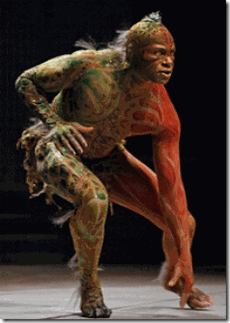
“This guy looks like he’s up to no good …” George Zimmerman, the Hunter[1]
The U.S. Army Psychological Warfare Division–Defense Intelligence Agency Weird Desk (Nazi-Satanist Lt. Colonel Michael Aquino) and the CIA Occult Bureau tipped off their hand when Rachel Jeantel’s black face and image attached to propaganda of substantial subliminal negative stereo-typical racial imaging reached and opened virtually each and every local and national newsroom and broadcast across the nation.
After she testified as the state’s star witness in the George Zimmerman Murder Trial, 19 year old Rachel Jeantel’s face and image was set in cement all over the world as a LYING insolent, illiterate, useless and obese black character up to no good.
Even among people of color, decades long eugenic linked arguments of NATURE versus NATURE were instantly revived. Just look at what all the government money, education, social and political programs produced- a black genetic failure and degenerate– Rachel Jeantel.
There is only one purely Luciferian group with the power to dominate, command and take-over newsrooms across the country with such a wicked racist enterprise to deliberately demonize youth of color in the eyes of the world, the Elite Satanic Cabal.
There is much more to the Trayvon Martin/George Zimmerman case than you may be willing to believe. For several weeks now, the George Zimmerman Murder Case has been at the top the news for almost 7 days a week, 24 hours a day at CNN and FOX local and national news affiliates demonizing youth of color.
CNN is a known CIA front for media propaganda and mass deception.[2] Rupert Murdoch that owns FOX News is also a CIA- British Intelligence propagandist.[3]
Early on, there has been some speculation that the Trayvon Martin Case may be a Strategy of Tension operation designed as a major psychological warfare mass population diversion; and a secret Masonic-Occult operation to further polarize the races.
The Strategy of Tension is a tactic that aims to divide, manipulate, and control public opinion using fear, propaganda, disinformation, psychological warfare, agents provocateurs, and false flag terrorist actions. [4]
The more I look at the Trayvon Martin Case, the more I am convinced that it was a joint American.-British Occulted Military Intelligence Strategy of Tension operation; and 17 year old Trayvon Martin was innocent. He had been setup as a Satanic-Masonic Sacrificial Victim.
Since the early 17th Century and the European Colonial Invasion of this country, America and Britain has been twisted cousins bonded at the hip in secret pagan Rosicrucian Symbolical Philosophy.
Within 4 months of Trayvon’s Sacrificial Slaying, not since the THIRD REICH’s spectacular and spellbinding Nuremberg night rallies have the world witnessed a national state sponsored event in the 21st Century so brazen a Rosicrucian-Masonic-Occulted and Pagan Celebration of Colonial White Supremacy.
The Hunter chasing down Trayvon Martin muttered, “Fucking Coons [human semi-animals].”[5]
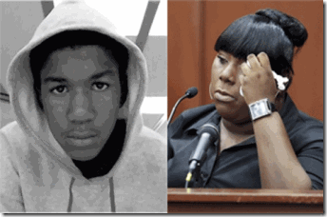
In the Eyes of George Zimmerman and the World, the Global Elite Satanic Cabal casted Trayvon Martin and Rachel Jeantel in the IMAGE OF CALIBAN.
ROSICRUCISM AND ZION, THE NEW WORLD ORDER TO COME

CALIBAN
Mysticism and occultism abound with symbols that often point to a transcendental reality beyond conscious understanding. —Nevill Drury, Dictionary of Mysticism and the Occult, p.249.
When I first saw this presentation of the black race, I was horrified and perplexed. It is stilling shocking and disturbing. You would believe that it is a throwback to another time and ego. Why does something like this even appear in the 21st Century if it isn’t a snapshot of a bigger picture and starling plan far beyond anything we are willing to admit or believe in this age and time?
In the 2012, the Global Satanic Elite Cabal took over the opening ceremonies of the Olympic Summer Games in London to deliver a global message. The Occult of Antiquity and Shakespeare’s Caliban Image crept into the opening ceremonies; and passed into the mass population psyche.
The Olympic ceremonies opened with a song Jerusalem. The games official logo was “ZION”.

The term Tzion came to designate the area of Jerusalem where the fortress (City of King David) stood, and later became a metonym for Solomon’s Temple in Jerusalem, the city of Jerusalem and generally, the World to Come.[6]
Be careful. In antiquity, there were two independent Jewish States in classic duality, one opposed to the other. One was ancient and very much Satanic.
“In the ninth year of Hoshea, the king of Assyria [Shalmaneser V (727 to 722 B.C.)] took and carried Israel away into Assyria…” 2 Kings 17:6
“And the children of Israel did secretly those things that that were not right against the LORD their God, and they built them high places in all their cities…” 2 Kings 17:9
“And they left all the commandments of the LORD their God, and made them molten images, even two calves, and made a grove, and worshipped all the host of heaven, and served Baal.” 2 Kings 17:16
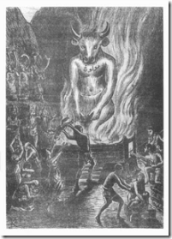
“And they caused their sons and their daughters to pass through the fire, and used divination and enchantments, and sold themselves to do evil in the sight of the LORD, to provoke him to anger.” 2 Kings 17:17
In Biblical Judea, the Sarmarians were a branch of the Jews, but they were arch-rivals of the Biblical Christian Jews led by Jesus. They proclaimed themselves the true Kings of Israel.
Herodotus reported that the Sarmarians were blond and blue-eyed, and said to be the offspring of Scythians who had mated with Amazons and that their female descendants “have continued from that day to the present to observe their ancient [Amazon] customs, frequently hunting on horseback with their husbands.”[7]
In Greek Mythology, the Amazons had once conquered Atlantis. They survived the downfall and collapse of the island-continent and resettled among the Atlas Mountains in North Africa.[8]
The Sarmarians worshipped idolatry and composed a high priesthood to Babylonian Gods, particularly Ba’al Moloch.[9]

At their temple on the Mount of Gerizim (“House of Shame“) outside of Jerusalem in the State of Samaria in what was once the Ancient Land of Canaan (Judea), they also worshipped Nergal, a deity worshipped throughout Mesopotamia, Akkad, Assyria, and Babylonia. Nergal was sometimes called a demon and even identified with Satan.[10] Nergal has also been depicted as the chief of Hell’s “secret police”, and worked as an “an honorary spy in the service of Beelzebub”.[11]
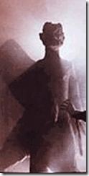
The Samarian temple was destroyed by John Hyrcanus in 128 B.C.[12] During the 6th Century A.D., the high priests and followers of Ba’al Moloch were forced out of Judea by the Holy Roman Empire and scattered across the Middle East and Europe.[13] However, the high priesthood remained intake and continued to spread its primordial arcane knowledge, and continued its Babylonian mystery schools among initiates in absolute secrecy.
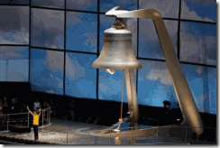
After the song, a 23 ton bell was rung. In occulted ceremonies, the bell will ring continuously for 3 (THREE) minutes.
The Satanic Nature of Number 3 (THREE)
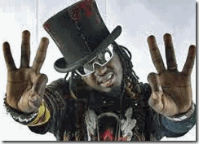
Satanic Hip Hop– Slaves and Patsies of the Global Satanic Elite Cabal
Satanic Progressions come in threes. The number of Spirit or Nature is three; the number of man is six; the number of Satan is nine. Even the Satanic hand clap or applause for ritual work well done is relegated to three times three times three. Consider the reality of egg, yoke and shell, root, stem and foliage, man, woman, and child, birth, life and death, or Spirit, Father, and Son. Of course, we prefer to say Spirit, parents and offspring in the Satanic World.[14]
Three (3) is the first sacred number, the first perfect number. Three represents the Pagan Trinity.”. It is represented geometrically in the triangle, and spiritually as the Third Eye of Hinduism. Occultists will multiply and add three to other sacred numbers to create new numbers. However, they also group threes in two’s and threes, because they believe in the principle of “intensification”, i.e., that greater power is achieved when a sacred number is grouped. In the case of three, greater intensification is achieved when it is shown as 33, or 333. When Hitler committed suicide, he arranged the timing details so as to create a triple three (333). Can you see how 333 formed the framework for this momentous occasion? Of course, 333 + 333 equals 666. Occultists have used 333 as the hidden symbol by which they present the more offensive number 666. When the details of an event are so arranged as to contain certain sacred occult numbers or numeric combinations, this is literally an occult signature on the event. Only occultists will recognize this signature.[15]
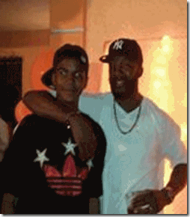
Trayvon Martin, a lamb to be slaughtered (3+3+3=9- Satan), only the occultists will recognize this signature.
ILLUMINATI OCCULT SYMBOLISM IN THE 2012 LONDON OLYMPICS OPENING CEREMONY:
“Witches altar bells have been used for centuries in spell crafting. The ringing of a bell supposedly unleashes vibrations which have powerful effects. Some witches use bells for removing unwanted or negative energies as well as calling in spirits.
The bell is often used to invoke the Goddess in Wiccan witchcraft ritual. Bells are rung during rituals to signal the beginning or ending of a spell. The outer portion of a bell is referred to as the female. The hammer is seen as the male. Ringing a bell signifies and celebrates an occasion or moment in time; clears and purifies the space for this time. Also by ringing a bell perception and awareness can be altered. Wiccan bells are rung to outline portions of rituals and celebrations.”[16]
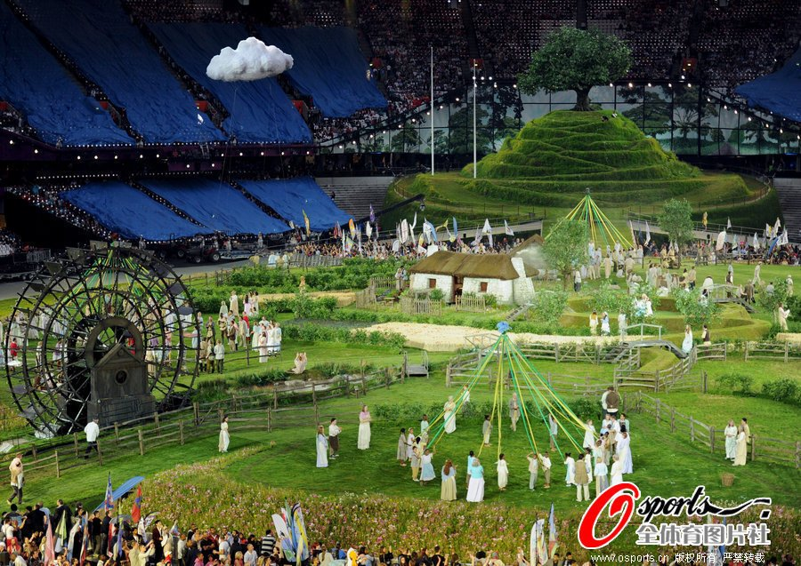
After the tolling of the bell, people began to dance and play. Prominent among the people’s play was Heinrich Himmler’s SS Pagan Maypole Ceremony before a great mound with a tree (Occulted Tree of Knowledge) on top. After that, men (freemasons) with mutton chop whiskers, side whiskers that are narrow at the temples and broad and trimmed short at the jaw line, the chin being shaved both in front and beneath, top hats and black top coats gathered at the foot of a mound and tree of life.
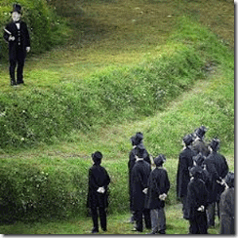
The concept of a Tree of Life has been used in science, religion, philosophy, and mythology. A tree of life is a common motif in various world theologies, mythologies, and philosophies. It alludes to the interconnection of all life on our planet and serves as a metaphor for common descent in the evolutionary sense.[17]
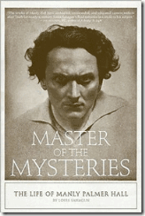
Manly P. Hall 33°, in his monumental work, The Secret Teachings of All Ages, writes, “…the Tree of Life is also the appointed symbol of the Mysteries, and by partaking of its fruit man attains immortality.”[18]
The mound does not represent the high place of Mount Zion but I believe Mount Gerizim of the Satanic High Priests of Ba’al Moloch.
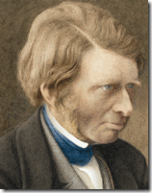
From a high place on the mound one of the men most likely representing John Ruskin read a short part from the “Speech of Caliban” from Shakespeare’s Tempest to that group of wise and illustrious fraters (brothers) assembled below.
“Be not afeard, the isle is full of noises”.[19]
The Late Jim Keith:
“Representing the interests of British aristocracy and Rothschild-front bankers such as the Warburgs, Schroders and Lazards, the Round Table promoted and continued to promote a New World Order based on the Freemasonic/Illuminist ideas such as those held by [Cecil] Rhodes’ mentor, John Ruskin. Ruskin in his turn is said to have been influenced by Bavarian Illuminatus Adam Weistaupt and Isis-occultism of Edward Bulwer-Lytton, the basis for many novel occultic offshoots including the Scottish Rite of Freemasonry, the Theosophy of Madame Blavatsky’s Isis Unveiled, the Golden Dawn, and the German Thule and Vril groups that were to launch and provide key philosophic underpinnings to the career of Adolf Hitler.
The Round Table advocated, in clear reflection of Illuminist ideas (and still does) the destruction of national sovereignties and surrender to an elitist ruling body, the prototype of the New World Order, and a theme that informs the thinking of occultic groups since at least the pre-Masonic Rosicrucians of the 1600s.”[20]
Seething of Lucifer, Cecil John Rhodes
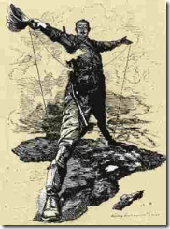
“I prefer land to niggers.”-Cecil Rhodes [21]
“When The Mason learns that the Key to the warrior on the block is the proper application of the dynamo of living power, he has learned the Mystery of his Craft.
The seething energies of Lucifer are in his hands and before he may step onward and upward, he must prove his ability to properly apply this energy.“
Lost Keys Of Freemasonry,” page 48 by Manly Palmer Hall 33° [22]
The Round Table is a secret society that was started around the start of the 20th century by Freemason and Rothschild agent, Lord Alfred Milner 33°, who was entrusted the mission to form the Round Table groups by Cecil Rhodes 33°.
When the imperial racist Cecil Rhodes died in 1902, he had become one of the wealthiest men in the world. In his will, Rhodes devoted his entire fortune to in the care of Lord Nathan Rothschild for the creation of the Round Table groups, the purpose of which would ultimately be to form a one world government, or as he said in the will,
“To and for the establishment, promotion and development of a Secret Society, the true aim and object whereof shall be for the extension of British rule throughout the world.”
Cecil Rhodes strong desire for world government was epitomized in his statement, “I would annex the planets if I could.”[23]
“At the present day I become a member of the Masonic order. I see the wealth and power they possess the influence they hold and I think over their ceremonies and I wonder that a large body of men can devote themselves to what at times appear the most ridiculous and absurd rites without an object and without an end.” –Statesman Cecil Rhodes[24]
What Masonic Order was Rhodes referring to as a member to do the seething of Lucifer? It was the United Grand Lodge of England. [25]
The Premier Grand Lodge of England was founded on June 24, 1717 as the Grand Lodge of London and Westminster, later calling itself the Grand Lodge of England. Convention calls it the Premier Grand Lodge of England” to distinguish it from the Most Ancient and Honourable Society of Free and Accepted Masons according to the Old Constitutions, more usually referred to as the Ancient Grand Lodge of England, and the Grand Lodge of All England Meeting at York. It existed until 1813 when it united with the Ancient Grand Lodge of England to create the United Grand Lodge of England. It was the first Masonic Grand Lodge to be created.[26]
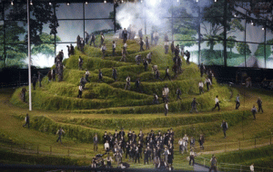
After the Masonic brothers depart on a mission to spread the secret craft and the mysteries of Ba’al Moloch across the globe, the tree atop the mound rose to the sky and people emerged from the hole.
THE SHADOW OF CALIBAN, THE BEAST

The Image of a MONSTER
“Be not afeard, the isle is full of noises”
In Tempest, Prospero is a fictional character, the rightful Duke of Milan, who with his young daughter, Miranda, was put to sea on “a rotten carcass of a butt [boat]” to die by his usurping brother, Antonio, twelve years before the play begins. The play centers on the year 1610 A.D.
Prospero and Miranda survived, and found exile on a small island (Bermuda in the Caribbean Islands). He has learned sorcery from books secretly given to as his “Art”, and used it while on the island to protect Miranda and control the other characters.[27]
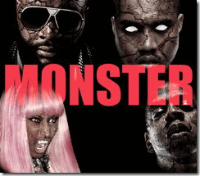
The Satanic Cabal that has taken over the Black Entertainment Music Industry has wickedly turned young Black Hip Hop Artist into CALIBAN IMAGES, a Den of Black Witches, Demons and Monsters to DEHUMANIZE a people before the eyes of the world.
On the island, he becomes master of the slave, Monster-BEAST CALIBAN (the son of Sycorax, an African (Algeria) Witch and a Demon); and Ariel an elemental who has become enslaved by Prospero after he is freed from his prison inside a tree.[28]
According to occultists, CALIBAN was an inhabitant of an “Island of Devils.”[29] Prospero describes CALIBAN as the illegitimate offspring of a witch and the devil. CALIBAN had language. He knew ‘sun’ and ‘moon’, but in his own tongue, he spoke nonsense, “When thou didst not … Know thine own meaning, but wouldst gabble like A thing most brutish”.[30]

Lil Wayne, CALIBAN DEVIL
Prospero calls CALIBAN: “a born devil, on whose nature Nurture can never stick”, while Miranda states: “thy vile race … had that in ‘t which good natures could not abide to be with”.[31]

Of course, CALIBAN-the BEAST is accused of attempting to rape Prospero’s Anglo Saxon daughter, Miranda.[32]

Kanye West and Jay Z, CALIBAN BEASTS
So, what in the world does CALIBAN, the image of the BEAST, have to do with the Olympics and the Tree of Life?
First, CALIBAN (Cannibal) is a SLAVE, a BEAST of nature that creeps on Earth, that spoke nonsense, “gabble like a thing most brutish.”[33] Prospero (Prosperity) is a white wizard-WARLOCK of the learned craft (FREEMASORY).
CALIBAN is under the control and spell of a brother of the learned craft. CALIBAN lives and speaks of a “World of ILLUSIONS” magically induced.
CALIBAN’S Full Speech,
Be not afeard; the isle is full of noises,
Sounds, and sweet airs, that give delight and hurt not.
Sometimes a thousand twangling instruments
Will hum about mine ears; and sometime voices
That, if I then had waked after long sleep,
Will make me sleep again; and then in dreaming,
The clouds methought would open, and show riches
Ready to drop upon me, that when I waked
I cried to dream again.[34]
CALIBAN speaks as if he is under hypnotism, the magkic spell of Prospero, or he is trapped in a permanent state of ILLUSIONS as if he had been drugged by hallucinogens (mandrake, mushrooms-alcohol, etc.).
CALIBAN, 2012 LONDON OLYMPICS, SHAKESPEARE, MADAME BLAVATSKY & THE 7 (SEVEN) ROOT RACES
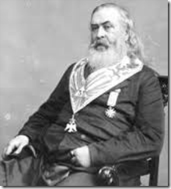
“Symbolical instruction is recommended by the constant and uniform usage of antiquity; and it has retained its influence throughout all ages, as a system of mysterious communication.” —Albert Pike, Morals and Dogmas, p. 372.
The Tempest is actually a 17th Century occult manuscript passed down from one generation to the next containing arcane and hidden knowledge of a European secret society.
There are many that believe that the man name William Shakespeare (April 26, 1564 –April 23, 1616)didn’t process the noticeable arcane knowledge to produce such works as the Tempest. Shakespeare’s contemporary that did process the arcane knowledge and skill to produce the Tempest was a nobleman of Queen Elizabeth’s royal court, Sir Francis Bacon (January 22, 1561 – April 9, 1626).

“Lord Bacon was the greatest genius that England, or perhaps any country, ever produced.” – Alexander Pope (1741)[35]
I have come to learn that sometimes there is a thin line between genius and the purely Luciferian nature, ideology and intellect.
During his lifetime, Manly Palmer Hall (March 18, 1901 – August 29, 1990) produced a number of influential books, An Encyclopedic Outline of Masonic, Hermetic, Qabbalistic and Rosicrucian Symbolical Philosophy: Being an Interpretation of the Secret Teachings concealed within the Rituals, Allegories and Mysteries of all Ages (1928), which is more commonly referred to as The Secret Teachings of All Ages. Hall’s other major books which followed include The Dionysian Artificers (1936), Freemasonry of the Ancient Egyptians (1937), and Masonic Orders of Fraternity (1950).[36]
Hall was recognized as a 33° Mason (the highest honor conferred by the Supreme Council of the Scottish Rite) In his over 70-year career, Hall delivered approximately 8,000 lectures in the United States and abroad, authored over 150 books and essays, and wrote countless magazine articles.[37]
Scores of volumes have been written to establish Sir Francis Bacon as the real author of the works of William Shakespeare. Hall states that an impartial consideration of these documents cannot but convince anyone who has an open-mind regarding the authenticity of the “Baconian theory”. He says that all those enthusiasts who for years struggled to identify Sir Francis Bacon as the true “Bard of Avon” would have won their case only if they had emphasized its most important angle, namely, that Sir Francis Bacon, the Rosicrucian initiate, wrote into the Shakespearian plays both the secret teachings of the Fraternity of the Rosy Cross and the “true rituals of the Freemasonic Order”.
Manly Palmer Hall writes: “Sir Francis Bacon knew the true secret of Masonic origin and there is reason to suspect that he concealed this knowledge in cipher and cryptogram. Bacon is not to be regarded solely as a man but rather as the focal point between an invisible institution and a world which was never able to distinguish between the messenger and the message which he promulgated. This secret society, having rediscovered the lost wisdom of the ages and fearing that the knowledge might be lost again, perpetuated it in two ways (1) by an organization (freemasonry) to the initiates of which it revealed its wisdom in the form of symbols; (2) by embodying in arcane in the literature of the day by means of cunningly contrived ciphers and enigmas.”
To emphasize this Manly Hall return to the claim that there is evidence that point to the existence of group of wise and illustrious fraters (brothers) who took it upon themselves to publish and preserve, for future generations, secret books of the ancients, together with documents. So that future members of the fraternity not only can identify the volumes but also immediate note the significant passages, words, chapters, or sections therein. He states that they created a symbolic alphabet of hieroglyphic designs. “By means of a certain key and order, the discerning few were thus enabled to fund that wisdom by which a man is ‘raised’ to an illumined life.”[38]
Sir Francis Bacon had been initiated into the mysterious Order of the Knights Templar. In 1580, he founded the secret Rosicrucian Library in Gray’s Inn. Later the same year, he founded the Lodge of Free and Accepted or Speculative Masons also at Gray’s Inn. [39]
In 1931, researchers claimed to have discovered Sir Bacon’s name actually encoded on the first page of the Shakespeare’s play, The Tempest.[40]
Furthermore, June 25, 1607, Sir Francis Bacon was appointed Solicitor-General and Chief Advisor to the English Crown. He had presented new ideas to the Government for the Reformation of the church and was officially instructed to commence restructuring the Bible.[41]
Research in the Records Office of the British Museum revealed that original documents still exist which refer to important proceedings associated with Sir Francis Bacon’s involvement with the editing of both the Old and New Testaments. The documents revealed that Bacon personally selected and paid the revisers of the New Testament who completed their task.[42]
Bacon also encoded secret information into both the Old and New Testament. An ancient document recorded that the true history of early Christianity was known to the initiates of the Order of the Knights Templar, having originally been:
“…imparted to Hugh de Payens by the Grand Pontiff of the Order of the Temple (of the Nazarene sect), one named Theocletes, after which it was learned by some Knights in Palestine.”[43]
Regarding the months of editing work applied to the Bible by Bacon, his biographer, William T.Smedley, confirmed the extent of the editing:
“It will eventually be proved that the whole structure of the Authorized Bible was Francis Bacon’s. He was an ardent student not only of the Bible, but also of early manuscripts. St Augustine, St Jerome, and writers of theological works, were studied by him with industry.”[44]
At the completion of the editing, Sir Francis Bacon and King James I had a series of meetings to finalize editorial matters associated with the new Bible. It was at this time that King James ordered a ‘Dedication to the King’ to be drawn up and included in the opening pages.
King James also wanted the phrase “Appointed to be read in the Churches” to appear on the title page. This was an announcement clarifying that King James had personally given the church “Special Command” for this particular version of the Bible to be used in preference to the vast array of Greek and Latin Vulgate Bibles current at the time. His reason was personal, as King James had previously instructed the revisers to “defend the position of the king” in their restructuring of the texts.[45]
The “original” Greek text of the Bible was not written until around the mid-Fourth Century A.D. and was a revised edition of writings compiled decades earlier in Aramaic and Hebrew. Those earlier documents no longer exist and the Bibles we have today are five linguistic removes from the first Bibles written. What was written in the “original originals” is quite unknown. It is important to remember that the words “authorized” and “original”, as applied to the Bible, do not mean “genuine”, “authentic” or “true”.[46]
The occulted works of William Shakespeare- Sir Francis Bacon such as the Tempest heavily influenced Satanist Madame Helena Blavatsky a 33° Mason and the Secret Doctrine,
“It is not Shakespeare only who divided the ages of man into a series of seven, but Nature herself.”[47]
According to the secret doctrine of the 16-17th Century racialist European occultist that influenced Blavatsky, there are seven ages of the evolution of mankind on earth, briefly, characterized as (1) Polarians (2) Hyperborean (3) Lemurian (4) Atlantean (5) Aryan. The 6th and 7th Root Races are still in the womb of the future and evolution. Each Root Race is further divided into sub races.
Contrary to common beliefs, Madame Blavatsky wasn’t the first to promote the “Seven Root Race” theory as a scientific doctrine. Two hundred years before her time, Shakespeare and a secret 16th Century Rosicrucian society promoted the pseudo occult root race theory among the ruling English elite and royalty as scientific doctrine.
Rosicrucianism is a generic term referring to studies or membership within a philosophical secret society said to have been founded in late medieval Germany. It holds a doctrine or theology “built on esoteric truths of the ancient past”, which, “concealed from the average man, provide insight into nature, the physical universe and the spiritual realm.”[48] According to historians, it was also influential to the craft of Freemasonry as it was emerging in Scotland.[49]
The Tempest is basically a Rosicrucian-Masonic secret manuscript popularly spreading and promoting its arcane and pseudo “Root Race” theories among the European elite and royalty; and now world leaders, politicians, and the general public under the yoke of the Global Satanic Elite.
According to Occult teachings, “Root Races” are stages in human evolution in the Rosicrucian and arcane cosmology.[50] Briefly, “The First Root-Race, i.e. the first “men” on earth (irrespective of form) were the progeny of the “celestial men”…in Indian philosophy the “Lunar Ancestors” or the Pitris, of which there are seven classes or Hierarchies.” [51]
The Second Root Race- Hyperborean (a continuation of the first) or Etheric race was semi-astral, but grew denser and more opaque with each passing age. Towards its end, it became more gelatinous and filamentous in structure, and developed the rudimentary beginnings of bones and organs, hair and skin.[52] The Second Root-Race was colored golden yellow. Hyperborea included what is now Northern Canada, Greenland, Iceland, Scandinavia, Northern Asia and Kamchatka. The esoteric name of their continent is Plaksha. They called themselves the Kimpurshas. They reproduced by budding. The second root race has no present-day descendants. The Hyperboreans evolved the third root race. [53]
The Third Root-Race, the first to be truly human, existed on the lost continent of Lemuria or Mu. The occultist maintains that the first physical man, the Lemurians, were semi-animal creatures which itself took place 18,000,000 years ago. Blavatsky described the Lemurians as “the Third Root Race” to inhabit the Earth. They were egg-laying beings with a third eye that gave them psychic powers and allowed them to function without a brain.[54]
Blavatsky says according to the occultists that the Lemurians were also semi-animal creatures, the sole remnants known to Ethnology were the Tasmanians, a portion of the Australians and a mountain tribe in China, the men and women of which are entirely covered with hair. They were the last descendants in a direct line of the semi-animal latter-day Lemurians referred to. Lemurians that survived the main submerged continent of Lemuria became the ancestors/relics of a portion of the present native tribes.
Blavatsky: “Being a very low sub-race, begotten originally of animals, of monsters, whose very fossils are now resting miles under the sea floors, their stock has since existed in an environment strongly subjected to the law of retardation. Australia is one of the oldest lands now above the waters, and in the senile decrepitude of old age, its “virgin soil” notwithstanding. It can produce no new forms, unless helped by new and fresh races, and artificial cultivation and breeding.”[55]
According to the occultist, the Fourth Root Race, called the Atlantean, was evolved from the remnants of the continent of Lemuria. The occultists trace the Aryan nations’ descent through the Atlanteans from the more spiritual sub-races of the Lemurians, [56]
“There were civilized people and savages in those days as there are now. Evolution achieved its work of perfection on the former, and Karma its work of destruction on the latter. The Australians and their like are the descendants of those who, Instead of vivifying the Spark projected into them by the ‘Flames,’ extinguished it by long generations of bestiality. Whereas the Aryan nations could trace their descent through the Atlanteans from the more spiritual races of the Lemurians, in whom the ‘Sons of Wisdom’ had personally incarnated.”
Human Evolution and the Magkical Sarced Spark of the Gods
Blavatsky repeatedly emphasizes that RACIAL KARMA account for the “great differences between the intellectual capacities of races,
“Mankind is obviously divided into God-informed men and lower human
creatures. The intellectual difference between the Aryan and other civilized
nations and such savages as the South Sea Islanders is inexplicable on any
other grounds. No amount of culture, no generations of training amid
civilization, could raise such human specimens as the Bushmen, the Veddhas
of Ceylon, and some African tribes, to the same intellectual level as the
Aryans, the Semites, and the Turanians so-called. The ‘Sacred Spark’ is
missing in them, and it is they who are the only inferior races on the
globe, now happily — owing to the wise adjustment of Nature which ever
works in that direction — fast dying out. Verily mankind is ‘of one blood,’
but not of the same essence.”[57]
So, what in the world does Caliban, the image of the BEAST, have to do with the Olympics and the Tree of Life? According to the Global Satanic Elite Cabal, the Black Race lies outside the bloodlines of the “divine” and godlike Adamites. The Black Race was not created in the image of the GOD of Genesis. Evolving from the “Scared Spark” and out of Eden, generally exclude PEOPLE OF COLOR.
No amount of culture, no generations of training amid civilization or MAGIK, could raise such human specimens throwbacks to semi-animals of the Lemurian Epoch to the intellectual and divine levels of Aryans.
GENOCIDE – NON MAGIKAL HUMANS & THE 2012 LONDON OLYMPICS
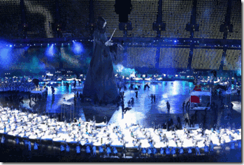
In another absolutely bizarre scene during the opening ceremonies, a towering dark sorcerer forms.

Dozens of children in hospital beds are rolled out by nurses to be offered up before to the giant sorcerer that seemed to hold the children SPELLBOUND.

The giant figure was Lord Voldemort, a fictional character from J.K. Rowling’s satanic and Masonic works, Harry Potter.[58]

Lord Voldemort is the leader of witches and wizards called “Death Eaters.” The Death Eaters first existed 11 years before the events of the books, torturing and murdering Muggles (non-magical humans) as well as anyone who opposed them or was believed to have information which could aid in or harm their rise to power.[59] The Death Eaters ideology is a version of racial supremacy. They believe wizards are, as a genealogy book within the story phrases it, “Nature’s Nobility” just like Prospero and Miranda of The Tempest; other magical creatures and the non-magical are inferior and should be subjugated,[60] or killed.
The message is clear. Those children without the divine “sacred spark” and the so-called “inferior races” will be sacrificed to the fires of MOLOCH!
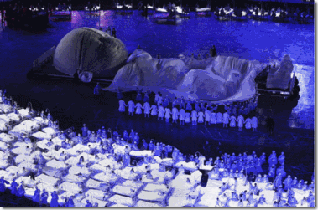
Here, the children of the lower races and those unable to evolve die while the offspring of the 6th Root-Race come into being.
The overwhelming message of Global Satanic Elite message to the world is chillingly consistent throughout the opening ceremonies; it is about the “divine” Adamite and Atlantean Aryan bloodlines evolving into the 6th and 7th Root-Races of the Earth. It is absolute RACIAL.
According to the occultist Global Satanic Elite, the inferior races- relics of Lemuria and those races that weren’t kissed by the ascended masters with the “Sacred Spark” along with the Aryans will be subjected to a permanent position of Modern Slavery or exterminated before humans evolve to the 6th and 7th Root-Races. Those that oppose or get in their way will be liquidated.
From the occult pseudo sciences of Freemasonry, to the Vril and Andromeda of Nazis, to the Space God Xenu and e-meters of the Scientologists, they plan global racial mass murder whether by biological-genetic warfare, drones, bombs, starvation, mass incarceration, wars of genocide, sectarian or race wars.
Finally, the Ascended Masters- Masters of Ancient Wisdom-Sons of Wisdom made their appearance in showering “Starships” above the stadium to open the 2012 Olympic Summer London Games; and incarnate the coming Adamite 6th Root –Race led by the Anti-Christ with Lucifer as GOD.

So, what in the world do the twisted occulted 2012 Summer Olympic Games have to do with Trayvon Martin? Well, there is a direct link between Cecil Rhodes’ Clandestine British Masonic- Round Table Global Agenda and Madame Blavatsky’s Luciferian Workings (The Secret Doctrine) as exposed in the opening ceremonies, and Trayvon’s father.
ILLUMINATI- RACE WAR, TRACY MARTIN & The Seething of Lucifer
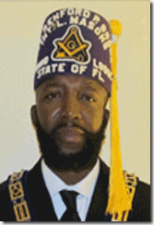
Trayvon’s father, Tracy Martin, is a Freemason-District Grand Master of the International Free and Accepted Modern Masons, Inc. and Order of the Eastern Star.[61]
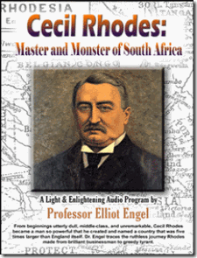
The Grand Lodge is the outgrowth of Ancient Free Masonry, as adopted by Modern Masons in 1717 at the Apple Tree Tavern, England. It is Cecil Rhodes’ United Grand Lodge of England,[62] “the Seething of Lucifer.”
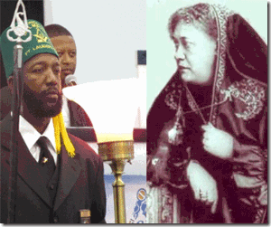
Its charter also place Tracy’s Grand Lodge under the jurisdiction of the Grand Orient of France. [63] Tracy’s late Luciferian Masonic Sister in the craft and the occult would be none other than Helena Petrovna Blavatsky 32° Ancient and Accepted Primitive Rite Grand Orient of France.[64] The Grand Orient of France is generally believed to be totally under the control of the ILLUMINATI.[65]
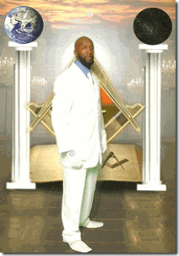
Tracy seen between the white and black Masonic pillars of Mercy and Severity, Boaz and Jachin, at the (STARGATE) gateway of the Mount Zion Solomon’s Temple; and most likely at the gateway of the Satanic Samarian Temple on the Mount of Gerizim.
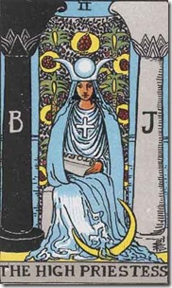
Between the pillars Boaz and Jachin, the High Priestess Tarot Card represents a link to the subconscious mind, which cannot be accessed through the everyday world but only through dreams and symbols.
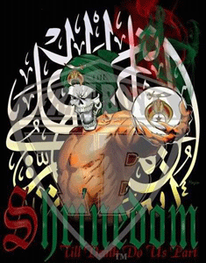
SHRINEDOM Till Devil Do its Part– found on Tracy Martin’s Facebook page, it’s a bitter pill to swallow, but he sold his soul to the DEVIL and will do its bidding. He is a mental slave of the LuciferIan- ILLUMINATI. It’s agenda is to polarize and strain race relations to create a major flash point and diversion from the cyborg presidency of Barack Obama, America’s global wars of aggression, campaign of genocide against people of color; and its war against the middle class that will produce a permanent class of peasants.
The United Grand Lodge of England, Cripping All the Time
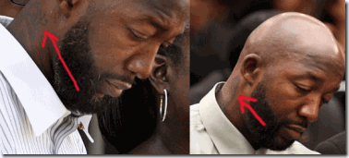
Furthermore, Tracy has also been linked with the Crips, Cripping All the Time (CAT)[66]. Previously, Tracy carried a CAT tattoo on his neck translated as Cripping All the Time. Subsequently, he covered the tattoo with a praying hands tattoo.
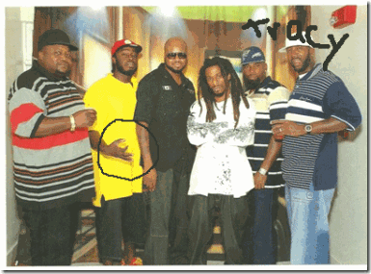
Above, Tracy with group of young lodge brothers- one of them flash a Crip Hand Symbol.
You may wonder what the United Grand Lodge of England and Grand Orient of France could have to do with American black street gangs- create Strategy of Tension Black American- Agent Provocateurs for the Satanic Global Elite Cabal and New World Order. Recall,
The Strategy of Tension is a tactic that aims to divide, manipulate, and control public opinion using fear, propaganda, disinformation, psychological warfare, agents provocateurs, and false flag terrorist actions. [67]
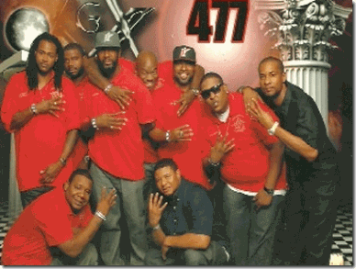
Tracy and his lodge brothers, Doric #477, sold themselves to the LUCIFER in a secret Blood Oath Covenant for Fame and Fortune.

They hear, see, and speak NO TRUTH- MAAT (Balance, Peace and Justice) for the Love of the People.
Trayvon Martin & the Other Side of the Rainbow

Sadly, there is more to the story. Alicia Stanley entered the picture of Trayvon Martin’s hidden legend. Ms. Stanley is Tracy Martin’s former spouse of 14 years. She had been with Tracy about a year before his official divorce from Trayvon’s birth mom, Sybrina Fulton. She alleged that it was she that raised Trayvon from the age of 3 years old. Between the times Trayvon was around 7 years old, up to the summer of 2010 when Trayvon was 15, Ms. Stanley had been his mom.[68]

After Tracy began an affair with Brandi Green of Sanford, FL, he moved Trayvon back to the permanent guardianship of his birth mom. However, from the summer of 2010, Trayvon appeared to have been moved from family to family, location to another location until he was slain. Ms. Stanley suggests that leading up to Trayvon’s death; he felt a sense of distance and abandonment from his father and mother, Tracy and Sybrina.[69]

It appears that Brandi’s sister, Zakiya Richardson, also resided with her. Brandi and Zakiya were members of the Order of Eastern Stars (United Grand Lodge of England), Marium 599 out of Orlando, FL. [70]

Brandi & Zakiya- Satanic Inverted Pentagram
They are also “Seething of Lucifer.” Zakiya may also have been at the Masonic convention. However, I don’t recall that Trayvon had possession of any keys when he was slain. Someone may have been in Brandi’s condominium that night and set Trayvon out alone that night on a Rainbow Bridge of no return.
Before Brandi Green learned the details of Trayvon’s slaying, she volunteered that Trayvon was slain while sitting on the porch in the dark. Was Trayvon intentionally locked out of Brandi’s condo during the hunt? Was that the original plan- mistaken for a burglar?
On Sunday, February 26, 2012, the Night of the Hunter, Trayvon walked to a local store on a mission to get an Arizona Tea and Skittles to taste the Rainbow.

Skittles, its major marketing campaign is “Taste the Rainbow.”[71] The Rainbow with its seven colors has long had an occult significance of being a great spiritual hypnotic device. Constance Cumbey, in her book, The Hidden Dangers of the Rainbow, which exposes the New Age Occult Movement, says that the Rainbow also called the Antahkarana or Rainbow Bridge is used as a hypnotic device. The Supreme Council of the 33rd° of Freemasonry has used the rainbow on the cover of their magazine. In a book teaching Druidism as in Illuminati Druidism, the 21 Lessons of Merlyn- the Rainbow is described as “A true sign of Magic…it exists in both worlds at once!”[72]

What appears odd is that Tracy’s lodge sponsors youth fraternity divisions. Masonic Orders such as the Masons and Eastern Stars youth organizations include Job’s Daughters, International Order for the Rainbow for Girls,[73] and The Order of Demolay for Boys. Demolay is the world’s largest fraternity for young men twelve to twenty-one years of age.[74]
Yet, it appears that Tracy had deliberately kept his son at distance from his lodge and fraternity activities, because he would become a lamb of sacrifice to Ba’al Moloch.
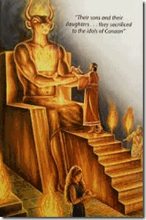
As Trayvon crossed the bridge to the other side of the Rainbow, Tracy, Brandi and maybe Zakiya were attending a big Masonic Grand Joint Council weekend convention/meeting in Kissimmee Feb 24-26, 2012 in ritual observance of the satanic sacrifice of a Grand Master’s first born to Ba’al Moloch.[75] It is a another bitter pill to shallow, but that’s what I believe.

Tracy Martin has shed a sea of public tears for his son. Yet, I wonder if all of those tears are not for himself.
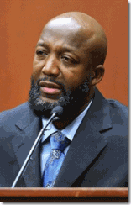
It was a very sad occasion when Tracy Martin was called to the stand as a witness for the defense of the Hunter, his son’s assassin.
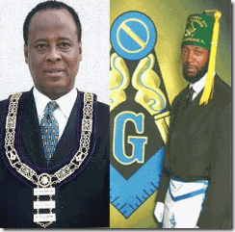
Tracy is in the same position as Masonic-Scottish Rite black patsy and slave, Dr. Conrad Murray, locked in a Blood Covenant of Death with Lucifer and his most vicious, devoted and demonic racist servants.
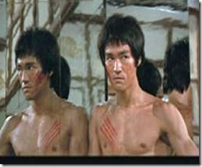
Whatever you think or believe and no matter the outcome of the jury verdict, 17 year old Trayvon Martin was an innocent victim set in the CALIBAN IMAGE in a much bigger, dangerous and utterly insane picture and Luciferian global agenda. As you reflect on this grave situation, always remember the lasting prophetic words to the People by the Late Great Bruce Lee,
“The enemy has only images and illusions behind which he hides his true motives. Destroy the image and you will break the enemy.” Shaolin Abbot to Bruce Lee, Enter the Dragon (1973)

By the way, I didn’t just draw the Ancient High Priests of the Samarians out a hat. A direct descendant of the Samarian High Priests have been running President Obama and America’s foreign policy for decades. He is a prominent member of Cecil Rhodes’ Round Table, Council of Foreign Affairs and Trilateral Commission. I will cover it in the upcoming Barack Hussein Obama and the Council of Nine, the Gods from the Stars. However next, I will cover “The Night of the Hunter, George Zimmerman and CIA/MK ULTRA”

[1] http://en.wikipedia.org/wiki/Shooting_of_Trayvon_Martin
[2] http://www.freewebs.com/cnnciafront/
[3] http://aconstantineblacklist.blogspot.com/2009/07/cias-rupert-murdoch-ted-shackley.html
[4] http://en.wikipedia.org/wiki/Strategy_of_tension
[5] http://www.youtube.com/watch?v=eGuctYqCDvo
[6] http://en.wikipedia.org/wiki/Zion
[7] http://www.silk-road.com/artl/sarmatian.shtml
[8] http://www.atlantia.de/atlantis_english/myth/myth/atlantis_atlantioi_hesperides.htm
[9] http://www.silk-road.com/artl/sarmatian.shtml
[10] http://en.wikipedia.org/wiki/Nergal
[11] http://en.wikipedia.org/wiki/Nergal
[12] http://www.bible-history.com/geography/ancient-israel/mount-gerizim.html
[13] http://en.wikipedia.org/wiki/Samaritans#Roman_period
[14] http://slickaz.tripod.com/cl/eagle.html
[15] http://www.cuttingedge.org/news/n1478.cfm
[16] http://www.fourwinds10.net/siterun_data/government/new_world_order/news.php?q=1343752597
[17] http://en.wikipedia.org/wiki/Tree_of_life#Assyria
[18] http://www.jashow.org/Articles/_PDFArchives/new-age/NA4W1002.pdf
[19] http://www.telegraph.co.uk/sport/olympics/olympicsvideo/9044505/London-2012-Olympics-Shakespeares-Caliban-the-inspiration-for-Isles-of-Wonder-opening-ceremony.html
[20] Keith, Jim, Mind Control and UFOS: Casebook on Alternative 3, Adventures Unlimited Press, Kempton, IL (2005) pg. 31
[21] http://espressostalinist.wordpress.com/genocide/cecil-rhodes-and-de-beers-genocide-diamonds/
[22] http://www.theforbiddenknowledge.com/chapter1/realmatrix.htm
[23] http://www.atlanteanconspiracy.com/2008/06/rhodes-round-table-groups.html
[24] http://www.conspiracyarchive.com/Blog/?p=545
[25] http://www.ugle.org.uk/what-is-freemasonry/famous-masons
[26] http://en.wikipedia.org/wiki/Premier_Grand_Lodge_of_England
[27] http://en.wikipedia.org/wiki/Prospero
[28] http://en.wikipedia.org/wiki/Prospero
[29] http://trish-m.hubpages.com/hub/Shakespeare-Presentation-Theme-Colonisation-The-Tempest
[30] http://trish-m.hubpages.com/hub/Shakespeare-Presentation-Theme-Colonisation-The-Tempest
[31] http://trish-m.hubpages.com/hub/Shakespeare-Presentation-Theme-Colonisation-The-Tempest
[32] http://trish-m.hubpages.com/hub/Shakespeare-Presentation-Theme-Colonisation-The-Tempest
[33] http://trish-m.hubpages.com/hub/Shakespeare-Presentation-Theme-Colonisation-The-Tempest
[34] http://www.telegraph.co.uk/sport/olympics/olympicsvideo/9044505/London-2012-Olympics-Shakespeares-Caliban-the-inspiration-for-Isles-of-Wonder-opening-ceremony.html
[35] http://www.darivera.com/index_files/FW_files/fw5.htm
[36] http://en.wikipedia.org/wiki/Manly_Palmer_Hall
[37] http://en.wikipedia.org/wiki/Manly_Palmer_Hall
[38]http://www.studymode.com/essays/The-Tempest-Caliban-Character-Analysis-706043.html
[39] http://www.bibliotecapleyades.net/biblianazar/esp_biblianazar_5.htm
[40] http://www.darivera.com/index_files/FW_files/fw5.htm
[41] http://www.darivera.com/index_files/FW_files/fw5.htm
[42] Id.
[43] Id.
[44] Id.
[45] Id.
[46] Id.
[47] http://www.phx-ult-lodge.org/SDVolume2.htm
[48] https://en.wikipedia.org/wiki/Rosicrucianism
[49] https://en.wikipedia.org/wiki/Rosicrucianism
[50] http://en.wikipedia.org/wiki/Root_race
[51] http://www.kheper.net/topics/Theosophy/HBP-Polarian.html
[52] http://indigoworld.com/testSMF/index.php?action=printpage;topic=1607.0
[53] http://en.wikipedia.org/wiki/Root_race#The_second_root_race_.28Hyperborean.29
[54] http://www.bibliotecapleyades.net/atlantida_mu/esp_lemuria_2.htm
[55] http://www.sacred-texts.com/the/sd/sd2-1-10.htm
[56] http://www.phx-ult-lodge.org/SDVolume2.htm
[57] http://lists.topica.com/lists/waldorf-critics/read/message.html?sort=d&mid=1721017874
[58] http://en.wikipedia.org/wiki/Lord_Voldemort
[59] http://en.wikipedia.org/wiki/Death_Eater
[60] http://en.wikipedia.org/wiki/Death_Eater#Ideology
[61] http://www.renfordpbrowngl.org/district_006.html
[62] http://www.renfordpbrowngl.org/about_us.html
[63] http://www.renfordpbrowngl.org/about_us.html
[64] http://www.thephora.net/forum/showpost.php?p=46109&postcount=32
[65] http://gnosticliberationfront.com/Architects_of_Deception_by_Juri_Lina.pdf
[66] http://theconservativetreehouse.com/2012/07/14/update-33-trayvon-martin-shooting-the-bloom-is-off-the-ruse-the-gang-connections/
[67] http://en.wikipedia.org/wiki/Strategy_of_tension
[68] http://theconservativetreehouse.com/2013/06/29/the-alicia-stanley-story-the-only-real-mom-trayvon-martin-ever-knew/
[69] http://theconservativetreehouse.com/2013/06/29/the-alicia-stanley-story-the-only-real-mom-trayvon-martin-ever-knew/
[70] http://radionewz.net/2012/07/trayvon-martin-who-is-brandy-green-really/?wpmp_tp=3
[71] http://creativecriminals.com/compilations/skittles-taste-the-rainbow-campaign/
[72] http://www.whale.to/b/sp/5.html
[73] http://www.gorainbow.org/home/home.taf
[74] http://mypeoplepc.com/members/engelhardt/windhampresumpscotmasoniclodge/id11.html
[75] http://www.renfordpbrowngl.org/calendar.html
Comments : 11 Comments
Tags: 2012 london olympics, 7 root races, alicia stanley, atlantis, baal, brandi green, bruce lee, caliban, cecil rhodes, CIA, cia occult bureau, crips, Defense Intelligence Agency, demolay for boys, DIA, doric 477, Dr. Conrad Murray, freemasons, george zimmerman, grand orient of france, harry potter, Illuminati, illuminati sacrifice, international Free and Accepted Modern Masons, j.k. rowling, john ruskin, kanye west, Lil wayne, lord voldermort, Lt. Col. Michael Aquino, masonic sacrifice, masons, moloch, mount of gerizim, nature versus nurture, order of eastern star, rachel jeantel, rainbow, Samaria, Satanism, shakespeare, sir francis bacon, skittles, sybrina fulton, taste the rainbow, the tempest, tracy martin, trayvon martin, U.S. Army Psychological Warfare Division, u.s. psychologial warfare division, United Grand Lodge of London, zakiya richardson
Categories : african american satanic cult, African Liberation, albert pike, Aryan Supremacy, ascended masters, baal, Barak Obama, council on foreign relations, cyborg, Defense Intelligence Agency, DIA, genesis, george zimmerman, Hip Hop, hip hop satanic cult, hollywood satanic cult, human sacifrice, illuminati, illuminati sacrifice, imperium, inverted pentagram, Isis, jay-z, Kanye Omari West, Kanye West, Knights Templar, lucifer's servants, luciferians, Madame H.P. Blavatsky, mark of the beast, masonic sacrifice, MK-ULTRA, modern slavery, Moloch, new age religion, new world order, rachel jeantel, racial mass murder, rose and cross, Rose-Croix, rosy cross, Satanic Global High Cabal, Satanism, Scientology, trayvon martin, trayvon martin, rachel jeantel, mark o'mara, don west,, Uncategorized, Untermensch, vril, xenu

TO MY COURAGEOUS YOUNG SISTER RACHEL JEANTEL, YOU FACED DRAGONS TO DELIVER TRAYVON MARTIN’S MESSAGE TO THE WORLD
29062013
My Dear Dark and Lovely Young Sister, RACHEL JEANTEL

We know that you didn’t want to get involved in the murder trial of your friend. I understand that you aren’t the stupid and insolent young Black sister that mass media have unjustly portrayed you to be.
I understand that you are only 18 or 19 years old trying to complete high school. I understand that you speak three languages, Haitian-French Creole, Spanish and English. English is not your primary language.
Haitian Creole is your primary language. It is a complex and essentially a colonial language created on condition of human bondage and the ingenuity of your people to the circumstances of extreme racial oppression and brutality. It is a language and testament to human struggle. It is a creole based largely on 18th-century French and some West African languages, and has secondary influence from other languages.[1]
THE MASONIC-ILLUMINATI AND INJUSTICE IN THE FLORIDA COURTROOM

The judge’s duty is to manage the courtroom and protect witnesses from being badgered, harassed and diverted on collateral issues that tend to prejudice, confuse and compound issues and sidetrack the jury from the issues. However, it seems that George Zimmerman’s attorneys Don West and Mark O’Mara and the secret Masonic-ILLUMINATI have taken over the Florida Seminole County courtroom.
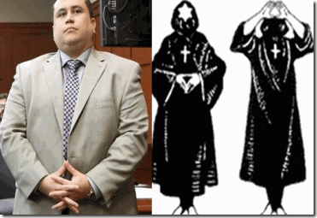
In court, George Zimmerman displays the secret “Descending Triangle” one of the hand signs of the Satanic Brotherhood of Death most often seen in court among the Masonic-ILLUMINATI.
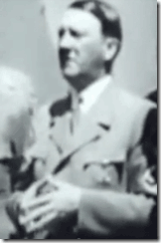
Fuhrer Adolf Hitler displaying the Satanic Brotherhood od Death ,“Descending Triangle,” the world’s “Ultimate Racial Mass Murderer.”
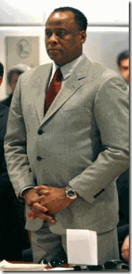
Dr. Conrad Murray– black pasty and member of the Scottish Rite Freemasonry also displaying the Satanic Brotherhood of Death ,“Descending Triangle” in the courtroom. The Ancient and Accepted Scottish Rite“ was brought into formal existence by Frederic the Great, the Rise of the Second Reich of Germany.
ALONE, FACING DRAGONS IN THE DEEP SOUTH
Under normal circumstances, if the court or attorneys had problems understanding your dialect or language, you should have been offered a translator or an interpreter. But that didn’t happen. You were entitled to the human dignity of a fair and just admonition from the court to be patient that because of your complex linguistic background that language barriers and dialect may be affecting your testimony. But that didn’t happen either.
Instead, you were badgered, humiliated and ridiculed before the eyes of the world –judicially lynched by America’s racist judicial system.
You are not and were not on trial when you testified to what you had witnessed leading to Trayvon Martin’s execution by George Zimmerman. You were just a witness, and a very important witness that spoke for Trayvon to the fear he experienced being chased and hunted down by a fiend just moments before his death.
Whether or not you attended Trayvon’s funeral or lied about why you didn’t go to his funeral was a complex, personal and emotional collateral issue. It doesn’t tend to prove or disprove any issues in the case. It was a cold- vicious racially based character attack intended to prejudice the jury, and yet the judge and prosecution allowed it to go on and no without admonishment or a spirited objection or protest to the injustice.
You can’t speak for Trayvon on whether or not he lied to you when he as they had alluded actually hid in a dark corner, laid in wait then suddenly racially charged and attacked Zimmerman that he perceived to be a “creepy ass cracker.”
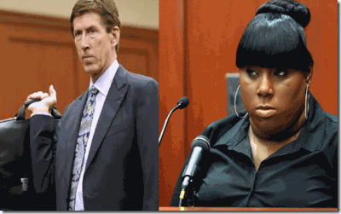
You were right to resist, object and fight back. They were putting words in your mouth creating improper ILLUSIONS, speculative scenarios; and implanting subliminal messages attacking Trayvon’s character.
You are not an experienced witness and frankly I don’t believe an experienced witness could have withstood literally a free-for-all collateral “slash and burn” character assassination that you were subject to in the courtroom peering into all the aspects of your young life.
I admit that I didn’t have the courage to continue to watch them continually bash, badger, harass, degrade and humiliate you for almost two days at trial and then seeing it repeated over and over again at the top of the news of almost every television networks in America. It hurts that in America things seem trapped in another time and era.
My Dearest Sister Rachel, the way that they treated you in an American court was like watching a throwback to another era when blacks were incompetent as witnesses in legal cases involving whites.[2]
Against this gross injustice, you fought back as best as you could. Instead of commending you for your savvy and courage to standup against them, you were perceived and labeled to be stupid, defiant, disrespectful and insolent to the court and its processes.
My Dearest Sister Rachel, you were badgered, humiliated and ridiculed before the eyes of the world –judicially lynched by the Masonic -ILLUMINATI in America’s racist judicial system.
What does it matter that former football player, Chad Johnson, slapped his attorney on the rear end as an example of free expression. It is a customary innocent expression of brotherhood among athletics of a good play or hold your head up.

However, Florida Broward County Circuit Judge Kathleen McHugh exploded when people in the courtroom chucked at the harmless expression. She instantly sentenced Chad Johnson to 30 days in county jail. It wasn’t contemptible or offensive behavior, a form of disturbance that may impede the functionality of the court.[3]

It is ironic and a bitter pill to shallow that Chad wasn’t sent to jail for violently head butting and severely injuring his wife, Evelyn Lozada. He was sent to county jail for simply displaying perceived insolence to white privilege and authority in a Florida courtroom.
At most in all fairness, if she felt offended the judge should have issued a simple admonition, warning or fine. However, Johnson’s real offense was really perceived as “deference” -violated white expectations of black deference which has been a lynch-able offense and death sentence for Black People in America.[4]
The State of Florida is a place with a particular vicious history of unprecedented violence, brutality and repression against Black People since the early 19th Century. It is a place where Africans that found the courage or so-called insolence or deference to resist slavery and oppression were covered in tar and burned to death, and blown to bits.[5] Below, the Klan was another “Cult of the Brotherhood of Death” established by Confederate Brigadier General Albert Pike of “The Ancient and Accepted Scottish Rite.”
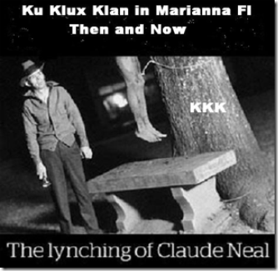
It is a state where a new study of lynching in the South found that Blacks were more likely to be lynched in Florida than in any other state.[6]
My young sister, I and most of America know that you resisted being there in that courtroom whether it is because of your fear of racist America or from being intentionally mis-educated, abused and alienated from mainstream America.
But, you had to be there. Righteousness, Goodness, Mercy and Justice put you there in what turned out to be Trayvon’s darkest moments in the shadows of death.
GOD put you at the other end of that phone and gave you the necessary courage to be there in that hostile courtroom facing dragons to speak for Trayvon that the world seems eager to dismiss and demonize as another Big Black Brute that the world is better off without.
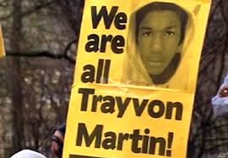
My sister, at least for me, you stopped all the ILLUSIONARY pictures of Trayvon being implanted in the public’s psyche. You quieted the doubts, unfounded speculations and unjust false allegations attacking Trayvon’s character.
You put a human face on Trayvon. You painted that picture of Trayvon in the last minutes of life as a frightened young man on a dark and rainy night that had been singled out by Zimmerman because of his youth and the color of skin.
We followed you as you described for us- how he was afraid that he was being stalked and hunted. We listened as you described him running and trying to lose what turned out to be a racist murdering fiend.

My Dear Rachel, the rest is history. George Zimmerman stalked, haunted, chased down and executed 17 year old Trayvon Martin on the insidious and racist assumption that he was a young black punk up to no good. He didn’t need to be here on earth.

I shared lonely tears with you about the guilt; and pain seeing Trayvon’s body because his death was so unnecessary, unfair and short. For some of us, we share the guilt that we couldn’t have done more to make America a safe and better place in peace and harmony for our children to share with the rest of the world even a George Zimmerman.
It is so important that in these most challenging moments in history that you stand firm. They intend to push you and most young people of color off this planet. It is so important that you remain strong and firm in the public eye as a shining example of strength, courage and resistance for other young people to follow.
Rachel, the Late and Great Donny Hathaway says hang on to the world as it spins around. Don’t let the spin get you down. Someday, We‘ll All Be Free.
During the Civil War, Frederick Douglass once said that when it is Right and Just, we run to do battle.
For Trayvon and our basic Human Rights, my dear sister in that courtroom you were alone, wounded, surrounded and outnumbered, yet when it came for Righteousness and Justice to rain down, all alone, you ran to do Battle in the most difficult time and circumstances that experienced warriors and dragon slayers would have a difficult time to overcome.
It is sad fact in America that you are being unjustly attacked, maligned, probably threatened and severely criticized even for your very existence as a young Black Woman.
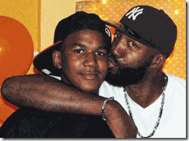
But, in your lowest moments of doubt, know for one thing that standing up to the DRAGON to deliver Trayvon’s message to the world, you have won my heart, and I believe the Hearts and Minds of the People.
They shall come to know the real EVIL and the ILLUMINATI that is really moving behind the scene of this case and rise to the occasion in your defense and DEMAND what is Right and Just for this Nation and its People: and bring to justice to those responsible for the senseless racial execution of TRAYVON MARTIN.
I SHALL ALWAYS LOVE YOU UNCONDITIONALLY- GOD BLESS YOU,
SINCERELY PRINCE RAY

[1] http://en.wikipedia.org/wiki/Haitian_Creole_language
[2] http://law.wustl.edu/staff/taylor/manual/slavery.htm
[3] http://en.wikipedia.org/wiki/Contempt_of_court
[4] http://www.pbs.org/wgbh/amex/till/peopleevents/e_lynch.html
[5] http://en.wikipedia.org/wiki/Battle_of_Negro_Fort
[6] http://articles.orlandosentinel.com/1993-03-07/news/9303070156_1_lynchings-mary-dennis-black-man
Comments : 10 Comments
Tags: Adolf Hitler, albert pike, brotherhood of death, chad johnson, conrad murray, don west, florida, george zimmerman, Illuminati, lynchings, mark o'mara, race, rachel jeantel, racism, trayon martin, trayvon martin
Categories : african holocaust, African Liberation, brotherhood of death, george zimmerman, illuminati, rachel jeantel, trayvon martin, trayvon martin, rachel jeantel, mark o'mara, don west,

BARACK HUSSEIN OBAMA, JAMES CLAPPER, EDWARD SNOWDEN, NSA, SPACE KIDS & THE TROLLS (NAZIS) UNDER THE BRIDGE
27062013

It isn’t President Barack Hussein Obama II that is watching you. The Satanic global elite has the deepest trust in a cyber political robotoid like President Obama to follow their instructions in blind faith, because he has been programmed to trick the people of the world into a future of global fascism, perpetual warfare and genocide.
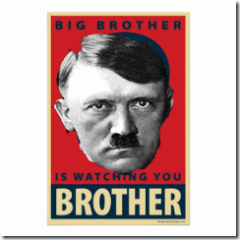
It’s the clandestine Satanic U.S. Military Intelligence Brotherhood that helped mold, shape and create President Barack Hussein Obama that’s TROLLING and WATCHING YOU.
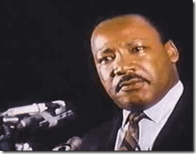
On April 3, 1968, Dr. Martin Luther King, Jr. delivered one of the most chilling, moving and prophetic oratories of the 20th Century. Dr. King’s theme of the speech, “I BEEN TO THE MOUNTAIN TOP” is still as relevant and stirring as it was at the height of the Civil Rights and Black Liberation movements of the 1960s.
“… He’s [God] allowed me to go up to the mountain. And I’ve looked over. And I’ve seen the Promised Land. I may not get there with you. But I want you to know tonight, that we, as a People, will get to the promised land!”[1]
Dr. King’s visionary themed “Promise Land” is not mythical or a land of fantasy, but is generally based on Genesis 1:26-31 “And God said, Let us make man in our image, after our likeness: and let them have dominion over the fish of the sea, and over the fowl of the air, and over the cattle, and over all the earth, and over every creeping thing that creeps on the earth”; and the “unalienable rights” of Life, Liberty and Happiness which the U.S. Declaration of Independence says all human beings have been given by the Creator and for the protection of which they institute governments.[2]
Dr. King stressed that there would be difficult days ahead reaching the promise land. He warned us that violent and lethal gatekeepers blocked the People’s Path to the other side of the mountain top. Huey P. Newton, Bobby Seale and Stokely Carmichael of the Black Panther Party for Self Defense often stressed to the Vanguard the importance of developing the capacity of “Loving the People more than You Loved Yourself” to reach Liberation. The struggle for “Black Liberation” was always for the “Love of the People”, and the BPP’s “10-Point Plan” was basically centered on the “God given” and “unalienable” and “human” rights of the People.[3]
Yet, loving the People enough to struggle to cross over to promised land earned Dr. King and the BPP the label of being the most serious “domestic threat” to national security; and targeted to be harassed, discredited, disrupted, neutralized and destroyed (assassinated) by gatekeepers within and outside government that perpetually block the path to the “Promise Land” primary on the basis of race and bloodlines.
Unrealized by many, the problem is that the global satanic elite maintain that they are the “Chosen Ones” created in the image of God of Genesis, and that the “Promise Land” and dominion over everything that “creeps” on earth belongs exclusively to the Aryan bloodlines.

The widely followed Secret Doctrine of Satanist H.P. Blavatsky and Alice Bailey speaks of a New Age Movement on earth led by a hierarchy of spirit-entities known as the “Ascended Masters”; “Great White Brotherhood”; “Brotherhood of Luxor” or “Brotherhood of Light” that oversee the spiritual and “evolutionary” development of the human race on both an individual level and in terms of the process of global civilization. The Secret Doctrine maintain that Mary, the mother of Jesus Christ, is one of the “Ascended Masters” that calls for setting-up a global White Brotherhood to usher in an early reign of peace and justice.[4]

Don’t be deceived by the talk of peace and justice of this global (One World) civilization. There will be a selection process and only people allowed in their promised land will carry the Mark of the BEAST. Barbara Marx Hubbard, above, is a member of the Rhodes Round Table- “Club of Rome,” and one of the leading advocates for establishing a U.S. Department or Room of Peace.[5] She is a Luciferian Futurist.[6] She is a director of the Lucis (LUCIFER) Trust.[7] She has been one of the most visible leaders of the New Age Movement for decades. In her Book of Co-Creation, she discusses the hidden meaning of the Revelation of St. John the Divine. Her manuscript was channeled by a demonic spirit she call “The Christ Light.” She quoted from Revelation 6:8:
“And I looked, and behold a pale horse: and his name that sat on him was Death, and Hell followed with him. And Power was given unto them over the forth part of the earth, to kill with sword, and with hunger, and with death, and with the beasts of the earth.”
Hubbard’s Christ of Light explained the true meaning of that passage:
“Out of the full spectrum of human personality, one-fourth is electing to transcend with all their heart, mind and spirit…One-fourth is resistant to election. They are unattracted by life ever-evolving. Their higher self is unable to penetrate the density of their mammalian senses. They cannot be reached…They are defective seeds…
Now, as we approach the quantum shift from creature-human to co-creative human… the destructive one-fourth must be eliminated from the social body…Fortunately you, dearly beloveds, are not responsible for this act. We are. We are in charge of God’s selection process for planet Earth. He selects, we destroy. We are riders of the pale horse. Death.
We come to bring death to those who are unable to know God. We do this for the sake of the world…
The riders of the pale horse are about to pass among you. Grim reapers. They will separate the wheat from the chaff. This the most painful period in the history of humanity… You do not have to participate in the destruction. You are to be responsible for the construction which shall begin as the tribulations come to an end.”[8]
Once in power, they intend to mass murder over 2 billion people on earth that they label defective seeds. We already know that the majority of people that they intend to slaughter are People of Color. This is not just a simple battle between the haves and have nots currently being played out around the world, particularly now in Turkey and Brazil. The global elite bloodlines of the “divine ones” and “man-gods” believe that this is their mandate from the secret space gods to have absolute dominion, rule and control over everything and the “creeping” masses of people on earth.
Edward Snowden, White Knight and the Sacred Trust
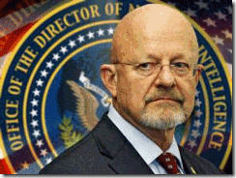
“This is someone who for whatever reason has chosen to violate a sacred trust for this country…”Former Lieut. General James R. Clapper, Jr., NDI[9]
Lieut. General Clapper’s use of language in describing the culture surrounding the National Security Agency (NSA) as “sacred trusts” is extremely interesting. It would be more comfortable if the U.S. Director of National Intelligence (DNI) used more appropriate secular language in describing their obligations as public servants instead of “sacred trusts” that overshadow the rule of law of the land (U.S. Constitution). However, he is describing a betrayal of sacred trust by a “cult member” bound to a covenant of secrecy.
Holiness, or sanctity, is in general the state of being holy (perceived by religious individuals as associated with the divine or sacred (considered worthy of spiritual respect or devotion; or inspiring awe or reverence among believers in a given set of spiritual ideas).[10] Reichsfuhrer SS-I Heinrich Himmler’s SS translates most perfectly into the meaning “Knights of the Holy See” (Latin Sedes = seat/see and Sacrorum = Holy/Sacred).[11]
I am quite uneasy about the entire Edward J. Snowden Affair. Clapper’s revealing inference above suggesting that the U.S. Intelligence Community is overshadowed by a cult of guardians (knights) of sacred and secret trusts instead of the rule of law should be quite troubling to everyone.
Usually within moments, a true U.S. enemy’s entire life story is exposed and demonized from pillar to post. Yet, we still know very little about Snowden, his family or background. What little we know about his father- Lonnie, mother- Elizabeth, and older sister- Jessica is that they are all connected with the U.S. federal government.[12] They appear to be a multi-generational U.S. military industry family centered in Maryland, a leading U.S. Military Intelligence Community for the NSA- Fort Meade, The U.S. Army Intelligence and Security Command (NSCOM/DIA) – Fort Meade, and the Chemical and Biological Warfare Nerve Center and Complex- Fort Derrick.
Snowden’s mother, Elizabeth Snowden, is an administrative clerk for Maryland’s federal courts. Snowden never graduated from high school and, for a few years, lived alone in his mom’s Ellicott City, Maryland, condominium. A neighbor said Snowden came across as “serious” and “studious” — not the type to throw parties or play loud music, “his mother dropping by with groceries about every week… he had few visitors except for a young woman with a Virginia license plate.”[13]
He has a few years window of “LOST TIME.” He was trained by U.S. Army at Fort Benning, Georgia, and then became a security guard at the Center for Advanced Study of Language at the University of Maryland in College Park. The center is affiliated with the U.S. Department of Defense and studies the language needs of the U.S. Intelligence Community. He was a CIA and NSA agent.[14]
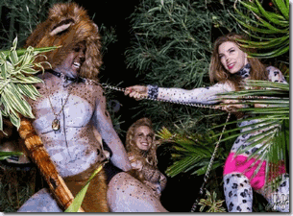
Snowden talked about the privileged life- living off the land of milk and honey in Hawaii taking in a six figure salary with a high school equivalency diploma. He talked about the TROLLING dominion “privileged access” he had over millions even the U.S. President. Even his so-called glamorous pole dancer girlfriend, Lindsey Mills, looks and sounds like a classic CIA/MK ULTRA Sex Kitten.[15]

“And for the first time in my life I feel strong enough to be on my own. Though I never imagined my hand would be so forced.”-Lindsay Mills[16]

“I don’t know how to feel normal.” –Lindsay Mills[17]
Snowden has suddenly become the new mass media darling of revolutionary consciousness. The Snowden Affair has given mass media an ILLUSIONARY false flag to suddenly distract the public away from what’s going with the People’s Rebellions in Turkey and Brazil. It distracts the public from the extremely explosive situation in Syria, biological warfare weapons of mass destruction, and the U.S. arming the very people called, “the Terrorist” that the government is spending billions if not trillions of tax payers funds to protect us against.
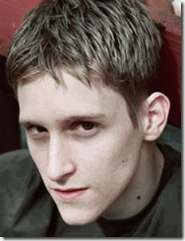
The more you look at the White Knight Edward Snowden, the more he appears like a typical multi-generational trauma-based MK ULTRA sacrificial son on white horse and set on a covert military intelligence mission instead of a revolutionary concerned about LIBERTY and WILL of the People.
“It begs common sense that the mainstream media would provide us with this sort of scoop. When the mainstream covers something intensively like this [Edward Snowden], there’s got to be a reason. The mainstream media is globalist in its sympathies and ownership. Thus, there is likely some sort of globalist advantage to this unprecedented leaking, however difficult it may be to unravel.”[18]
At this very moment, Snowden has been taken under the wings of Julian Assange of Wikileaks, the new pin-up boy of global investigative journalism. Assange’s most important dictatorial and arrogant directive to the masses is that he (the “Divine One”) knows what is best for the public to know,
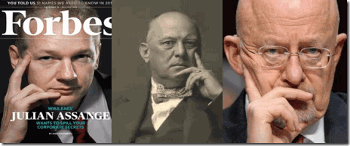
As far as I know, Assange, the Great BEAST 666 and Clapper one of the Masonic-ILLUMINATI Duegard Finger Signs.
“I’m constantly annoyed that people are distracted by false conspiracies such as 9/11, when all around we provide evidence of real conspiracies, for war or mass financial fraud.” –Julian Assange[19]
In other words, this new darling of global mass media will ignorantly control the whole narrative of America’s Reichstag Fire, the 9-11 Deception/Inside Job; and define, determine and spoon feed global conspiracies for the masses of the people.
It appears to me that the Edward Snowden Hollywood script maybe clandestinely controlled, written, edited and played out by the U.S. Military Intelligence Satanic Brotherhood and “Divine Ones” on the hill. In this case, they control the images, ILLUSIONS and the narrative.
Listening to your phones and reading e-mails should be the least of your worries that we are well aware of. Yes, we should always be extremely worried about the excesses of the National Security Agency (NSA) and America’s Luciferian U.S. Intelligence and Surveillance State.
But, keep your eye and focus on Lieut. General James R. Clapper, he will truly define what the NSA, U.S. Intelligence Community and Elite Satanic Cabal (Imperium), the “Divine Ones” are really up to and planning for the future. Clapper and the NSA really can’t stand the light of day and that may also have prompted the sudden coming out of Edward Snowden as a diversion to manufacture, manage and control PUBLIC PERCEPTION about America’s Clandestine Security and Surveillance State.
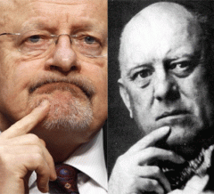
“The notion that we’re trolling through everyone’s emails and voyeuristically reading them, or listening to everyone’s phone calls is on its face absurd.”-Lieut. General James R. Clapper, Jr.[20]
Again, Lieut. General Clapper’s choice of language and use of the word “TROLLING” is extraordinary. The U.S. State Department has recently initiated a new computer program, called Viral Peace to undermine and demoralize enemy targets, “Think of it as strategic TROLLING, in pursuit of geopolitical pwnage [to conquer to gain ownership].”[21]
THREE BILLY GOATS GRUFF, THE TROLL UNDER THE BRIDGE
During my most impressionate years as an elementary school student, Peter Christen Asbjørnsen’s Norwegian fairy tale, Three Billy Goats Gruff, had been one of my most favorite school stories.[22] Paradoxically, it was also a fairy tale that I recall had most often frightened me. Somewhere in the back of my mind, the monstrous Troll under the bridge wasn’t just a fictional character, nightmare or ILLUSION to me, but presented a file in my subconscious of a real veiled obstacle to my future goals and aspirations as I crossed over the many bridges of life and struggle in the pursuit of life, liberty and happiness. The Troll and the “Trick-Trap– Who’s that tripping over my bridge?” haunted me throughout my impressionate years.
According to Norse and Scandinavia myths popularized by Lords of the Ring, trolls are gigantic creatures with a basic, humanoid appearance though they’re covered in thick fur or even moss. They have long noses, are immensely strong, and are often naive or easy to trick. Sometimes they lurk under bridges, as in the classic children’s story “The Three Billy Goats Gruff,” but they can also be found in thick woods and in caves according to the pagan myths. They only go abroad at night because if a troll is caught by the sun it turns to stone. This was a commonality in Norse mythology among supernatural creatures, and so well known that Thor once riddled a creature with difficult questions so that it forgot the time and was caught by the rising sun.[23]
Thor (from Old Norse Þórr) is a hammer-wielding god associated with thunder, lighting, storms, oak trees, strength, and the protection of mankind. Thor is a prominently mentioned god throughout the recorded history of the Germanic peoples.[24] I didn’t know it at the time but in my infancy, I had actually met forms of Nordic Trolls under the bridge that could not stand the light of day.
In the autumn of 1948, my father didn’t come from work at the U.S. Naval Air Station in Alameda, California. He had been just a regular hard working humble and literate guy from rural Mississippi. For the time, he had a relatively important and well paying national defense job that provided his family of four with comfort and security.
When my mother and his family found him, the U.S. Navy had put him in Highland County Hospital in Oakland then transferred him to a classified Naval Psychiatric Unit at Napa State Mental Hospital in Napa, California. At the U.S. Naval Air Station, someone had slipped him a substantial dose of mescaline or LSD that drove him into “chemical schizophrenia.”[25]
By the time that I was reunited with my beloved father at Napa State Mental Hospital, he had no memory of me or his family. He had been “depatterned” by being subjected to among other things successive electroconvulsive shock torture. According to the medical records I saw from Napa, he had been subjected to electroconvulsive shocks up to 35 times a session that weakened his heart and devoured his mind. He had been reduced to a vegetable state. He had to learn basic human functions all over again like feeding himself and going to the bathroom.
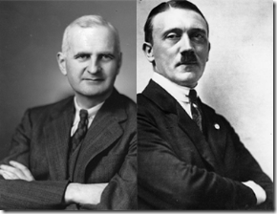
Dr. Cameron and the Fuhrer Adolf Hitler- Secret Hidden Hand of the Masonic-ILLUMINATI Brotherhood
During the late 1940s and 1950s, one of Dr. Ewen Cameron’s projects was an attempt to “depattern” experimental subjects. “Cameron defined ‘depatterning’ as breaking up existing patterns of behavior… by means of particularly intensive electroshocks, usually combined with prolonged, drug-induced sleep… Cameron claimed he could generate ‘differential amnesia.’ Creating such a state in which a man who knew too much could be made to forget had long been a prime objective [of CIA] programs.”[26]
However, before there was Dr. Cameronthat was a key CIA/MK ULTRA mind control contractor, it was the SS, Knights of the Black Sun, the Greatest Racial Mass Murderers in History, which mastered the use of “mescaline” and “depatterning” as military intelligence application tools of human torture.
In 1945, OSS Chief and Nazi Collaborator, Allen Dulles, sent Dr. Cameron directly to Nuremberg to study Hitler’s close friend and occulted psychic master, Deputy Fuhrer Rudolph Hess.[27] He undoubtedly also studied “depatterning” and “electroshock torture” and the use of “hallucinogenic drugs” from Nazi recruits for Operation PAPERCLIP to slip into the United States; and work for the CIA.
In 1950, Dr. Cameron and my father’s leading psychiatrist at Napa, Naval Commander Dr. Wrenshall Oliver, founded the World Psychiatric Association, which was a legitimate and reputable safe haven to harbor their brotherhood Nazi and SS psychiatrists.
For my father and family, one Nordic TROLL UNDER THE BRIDGE, turned out to be war criminal Hauptsturmführer SS Dr. Kurt Friedrich Plötner aka Kurt Schmitt of the SS Ahnenerbe out of the Dachau Concentration Camp.[28]
After the war, there was fierce competition between the U.S. military armed services to acquire as many Nazi-SS scientists and engineers as possible for “virtual extinction” warfare technologies. The U.S. Navy was eager to snare its share of Nazi-SS war criminals- racial mass murderers.[29]
The storyline on SS Dr. Plötner is that the Navy’s Technical Mission in Europe was hot on the trail of state-of-the-art Nazi research into interrogation (torture) techniques. The Navy’s intelligence officers came across SS experimental research papers on truth serums having been conducted by SS Dr. Plötner beginning in February 1944 at Dachau concentration camp.
US Naval Intelligence officers discovered that SS Dr. Plötner had achieved some success with mescaline as a speech – and even truth-inducing drug, enabling interrogators to extract “even the most intimate secrets from the subject when questions were cleverly put.” Plötner also reported researches into mescaline’s potential as an agent of behavioral modification or mind control.[30]
At Dachau, SS Dr. Plötner (TROLLING)had administered large doses of mescaline to Russian and Jewish victims by covertly spiking their drinks. Many of these victims didn’t understand what was happening to them and thought they were going mad.[31]
U.S. Naval Intelligence officers recruited SS Dr. Plötner as early as 1945, permitting him to continue his mescaline interrogation research this time in the interest of the United States.[32] In spite of being a notorious wanted war criminal, the U.S. shielded him and Dr. Josef Mengele.

Behind the veil, U.S. intelligence officers coveted Nazi-SS racialist war criminal physicians and scientists as their brotherhood medical scientific community colleagues. When Dr. Harold W. Batchelor of Fort Derrick Division of Biological and Chemical Warfare made a pilgrimage to Nuremberg Tribunal in Germany to recruit Himmler’s notorious fervent Nazi Biological Warfare specialist Reichsgesundheitsführer Dr. Kurt Blome.
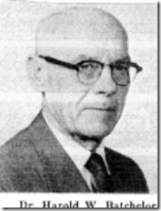
Dr. Batchelor noted,
“We have friends in Germany, scientific friends, and this is an opportunity to enjoy meeting them to discuss our various problems.”[33]
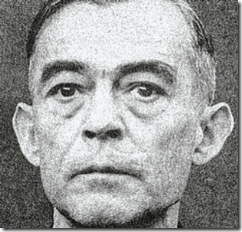
A Friend! This fiend headed Nazi Germany’s Biological and Warfare Program of racial mass murder. This is the fiend that promised Himmler and the Third Reich the mother of all biological/chemical weapons of mass destruction to wipe out Allied Forces to end WWII once and for all to ensure a Nazi victory.
This hidden American medical and scientific community’s friendship, bond of Brotherhood of Evil and Secrecy with the Nazis and SS is still ever so chilling. My childhood fear of Nordic TROLLS that could not stand the light of day had been no childhood fantasy, nightmare or an ILLUSION.
I had known and subconsciously suppressed the memory of them and my traumatized father from infancy. My father had been among the first victims of the U.S. Navy’s Project CHATTER. Project CHATTER is still ultra top secret and highly classified. Even today, it cannot stand the light of day.
It was an ultra secret program that brought real Nordic TROLLS (TROLLING) in America to block the paths of millions on their journey over the bridge of life to their god given human rights; and devour the body, hearts, minds and souls of the people.
Most of the secret experiments of Project CHATTER involved the DACHAU CONCENTRATION CAMP EXPERIMENTS of SS Dr. Plötner involving SS’ sadistic, barbaric inhumane medical experimentation with mescaline and possibly LSD, and mind control. It is also involved the insidious electroconvulsive shock experiments of Dr. Josef Mengele at Auschwitz.
Even in the 21st Century, little has come to light about the activities and whereabouts of SS Dr. Plötner after he had been recruited by the U.S. Navy from 1945 to the early 1950s; and the Navy’s Technical Mission didn’t skip down the Yellow Brick Road to just happen to trip over his research papers.
Dr. Plötner was a SS Medical Corps Officer that was regulated by a blood covenant of secrecy, and closely monitored by SS-1 Himmler and SS security forces. To say the least, it was extremely dangerous to cross Himmler and SS at any level of the game. The SS medical officer’s customary and business procedure was to submit detailed weekly or monthly medical reports of their experiments to Himmler and the SS. Himmler stockpiled all SS concentration camp experimental medical corps reports.
Himmler was uncommonly demonic and absolutely shrewd. As the war came to a close, Himmler secreted SS medical corps reports in various locations, then after the war released them to those willing to strike a bargain with the DEVIL and Lucifer’s Servants.
Project CHATTER and its links to the SS and Dr. Plötner’s Dachau Experiments still can’t stand the light of day. Even my father’s civil commitment papers have been locked and secreted away in the vaults above the Alameda County Superior Court Clerk’s Office in Oakland, CA. They promised me death before I document any links between superior court files, my father and Project CHATTER. These people mean exactly what they say.
THE NSA AND THE NORDIC TROLLS
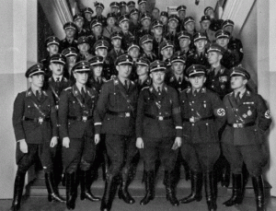
“ … The American Left has proven inept in gauging this fascist menace, much less mounting an effective response. Few are aware of the history that brought us to our current predicament. … “- Andrea Hackett[34]
Ms. Hackett continued, “In order to fight an enemy you must know that enemy. You must know their strengths and weaknesses, history and organizations, links, objectives and capabilities. You must know their operational methods and familiarize yourself with the central players. In short, you must do your homework. In the case of global fascism, you must also respect their fanaticism and willingness to use violence to further their goals.”[35]
Lately on the Internet, sources within Germany have compared the National Security Agency (NSA) to the Stasi.[36] The Ministry for State Security (German: Ministerium für Staatssicherheit, MfS), was created in 1950. The ministry commonly known as the Stasi (abbreviation German Staatssicherheit, literally State Security), was the official state security service of the Germany Democratic Republic or GDR, colloquially known as East Germany.[37]

THAT DOG WON’T HUNT. It is an ILLUSION and a hypocritical attempt at mass population THOUGH PERCEPTION. The true history of NSA and its central players is a puzzle wrapped inside an enigma to intentionally stifle an effective response from the people. The NSA has its secret roots in one of numerous balconies in Reichsfuhrer SS-1 Heinrich Himmler’s Puzzle Palace, the RSHA.
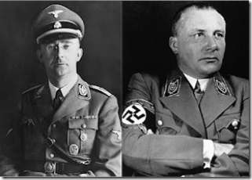
The RSHA or Reichssicherheitshauptamt (Reich Main Security Office or Reich Security Main Office or Reich Security Head Office) was a secret state wrapped inside a secret state. RSHA was the security service for Nazi Germany and the Nazi Party (Martin Bormann). The organization was completely subordinate to Heinrich Himmler in his dual capacities as Chef der Deutschen Polizei (Chief of German Police) and Reichsfuhrer SS-1. Amt III (German Amter-Office) Inland-SD headed by Nuremberg Tribunal convicted mass murderer SS-Gruppenführer Otto Ohlendorf. Amt III was the SS’ domestic mass information gathering service inside Germany. It also dealt with ethnic Germans outside of Germany’s prewar borders, and matters of culture.[38]
In Nazi Germany, Heinrich Himmler and the SS represented the proverbial EVIL TROLLS UNDER THE BRIDGE-constantly TROLLING to devour millions on their path across the bridge to life, liberty and the pursuit of happiness.
RSHA’s stated duty was to fight all “enemies of the Reich” inside and outside the borders of Nazi Germany. According to British author, Gerald Reitlinger, the RSHA “became a typical overblown bureaucracy… The complexity of RSHA was unequalled… with at least a hundred sub-sub sections”.[39]
RSHA’s data mining technology and facility was provided by IBM. In Nazi Germany, Willy Heidinger was the manager of the IBM subsidiary, Dehomag. During a tour of his facilities by Nazi Party leaders, Heidinger substantially exposed RSHA’s data mining ultimate objective,
“The physician examines the human body and determines whether …all organs are working to the benefit of the entire organism. We [Dehomag] are very much like the physician, in that we dissect, cell by cell, the German cultural body. We report every individual characteristic …on a little card. These are not dead cards, quite the contrary; they prove later on that they come to life when the cards are sorted at a rate of 25,000 per hour according to certain characteristics.
These characteristics are grouped like the organs of our cultural body and they will be calculated and determined with the help of our tabulating machine. … We are proud that we may assist in such a task, a task that provides our nation’s Physician [Adolf Hitler] with the material he needs for his examination. Our Physician can then determine whether the calculated values are in harmony with the health of the people. It also means that if such is not the case, our Physician can take corrective procedures to correct the sick circumstances. … Our characteristics are deeply rooted in race.
Therefore, we must cherish them like a holy shrine which we will – and must – keep pure. We have the deepest trust in our Physician and will follow his instructions in blind faith, because we know that he will lead our people to a great future. Hail to our German people and der Führer!”[40]
A sub-subsection of RSHA even took over German population censuses tabulated by Hollerith (IBM) machines. The census was one of several population identification systems used to track targeted groups in the Nazi state. Taken together, these systems resulted in distribution of uniform photo identity cards to all inhabitants of the Reich, mandatory under the law of September 10, 1939.[41]
The significance of IBM’s German subsidiary Dehomag, IBM machines and card systems in the Nazi persecution and extermination of the pseudo Untermensch (German for under man, sub-man, sub-human; plural: Untermenschen);[42] and its social, political and religious enemies was revolutionary satanic-demonic principled technology; and that connotation cannot be underestimated.
With IBM’s Hollerith machines and their punch cards, Himmler and the SS could TROLL people’s family and racial lineage, political and religious affiliations and track their movements by the millions. The SS-RSHA was able to trace and update its targeted enemies’ addresses, locations, occupations, wealth and associations. SS-RSHA’s IBM mass population data mining led ultimately to global racial and political persecution and mass murder unparalleled in human history.
The “ENEMIES OF THE REICH” that Himmler and the RSHA targeted for persecution, isolation and termination wasn’t just communist terrorists. It was the TROLL that blocked the path to life, liberty and the pursuit of happiness of the people of Germany whether Jews, disabled, non Aryans, Soviets, Poles, Gypsies, Christians, freemasons, homosexuals, intellectuals and the political dissent, etc., etc., and etc. by the millions.
The TROLLS, Himmler and SS RSHA, UNDER THE BRIDGE in Nazi Germany devoured at least 16.5 Million souls, likely over 17 Million people in the concentration camps. 7 million were the Jews and following that 3.3 million Soviet POWs.[43]
THE NORDIC TROLLS MAGKIC RED CARPET RIDE TO AMERICA
The Puzzle Palace is a book written by James Bamford, and published in 1982. It is the first major, popular work devoted entirely to the history and workings of the NSA, America’s intelligence organization and service. Bamford’s title refers to a nickname for the NSA which is headquartered in Fort Meade, Maryland.[44]
The Puzzle Palace can also be used to describe any large government building that is monolithic, secured or confusing to navigate.[45]

The NSA had its origins with a May 20, 1949 secret order and directive from U.S. Secretary of Defense, Louis A. Johnson, above. The secret directive authorized the Armed Forces Security Agency (AFSA) to be the umbrella organization to oversee and consolidate the military intelligence services (Army Security Agency, Naval Security Group, and Air Force Security Service). The AFSA, during the majority of the years of its existence, from 1945 to 1978, was largely a “Cold War” data gathering operation without a charter.[46] Louis A. Johnson is an interesting and peculiar historic character out of the Old South.
Johnson born in old Roanoke, Virginia was a former National Commander of the American Liberty League. The Liberty League was the private army of America’s Luciferian global elite, the Imperium “Divine Ones “on the Hill led by Pierre, Irenee, Lammot du Pont and John Jacob Raskob (Chief Executive, DuPont and General Motors, Builder of the NY Empire State Building) along with J.P. Morgan (JP Morgan & Chase Co.), and Alfred P. Sloan of General Motors (GM).[47]
The Liberty League was anti-Semitic, and an anti-Black American extension to the rise and growing power of global fascism led by Benito Mussolini and Adolf Hitler. The American “Divine Ones” link with Nazi Germany wasn’t a matter of any fantasy.
In 1938, just months after the Nazis’ annexation of Austria, James D. Mooney, head of GM’s overseas operations, received the German Eagle with Cross, the highest medal Hitler awarded to Nazi Germany’s foreign commercial collaborators and supporters.[48]
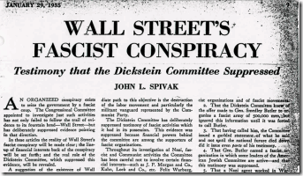
In 1933, Louis A. Johnson’s American Liberty League was the umbrella group that led a clandestine conspiracy on behalf of the “Divine Ones” led by Prescott Bush to overthrow U.S. President Franklin Delano Roosevelt and the United States Government in a coup (putsch) to implement a fascist dictatorship based around the racial pseudo geopolitical ideologies and politics of Mussolini and Hitler.[49]
The plot against the United States was widely exposed by Major General Smedley Darlington Butler of the U.S. Marine Corp.[50] U.S. Secretary of Defense Louis A. Johnson that implemented NSA for the Gehlen Org intelligence service, discussed below, to run amok in America. He was a fascist handmaiden and patsy of the Luciferian global elite; and the Nazis.
In March 1949, Louis A. Johnson had succeeded James Vincent Forrestal of Dillon, Read & Company as U.S. Secretary of Defense. Two days after Johnson issued the secret directive molding AFSA into a mass data gathering operation, Forrestal was dead.
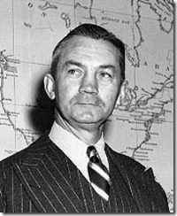
James Vincent Forrestal was born in 1892 in Matteawan, New York, the son of humble Catholic Irish immigrants. Forrestal made his fortune with the ruling classes and bloodline “divine ones” on Wall Street with the investment firm of Dillon, Read & Company. He was introduced into the world of politics and the NEW DEAL by his infamous neighbor, President Franklin Delano Roosevelt.[51]
As Secretary of the Navy, it was Forrestal that proposed the racial integration of the U.S. Navy. Later, as Secretary of Defense, he proposed the full racial integration of the armed forces.[52] He had also opposed the creation of the State of Israel to permanently disturb the balance of power and peace in the Middle East.[53]
Dillon, Read & Company had been one of the Anglo-American Axis companies that made large loans to finance the Nazis. As former Secretary of the Navy during WWII and the Defense Secretary after the war, Forrestal had been up to his nose in the top secret SS-Nazi Ratlines and Operation Paperclip. However, the more Forrestal discovered about the true details of America’s pact with the devil, the more distressed he became.
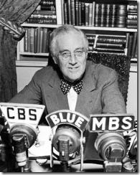
President Roosevelt died on April 12, 1945. There is at least one source, “Closely Guarded Secrets” that claims that FDR was assassinated by a Nazi Assassination Team that would have cleared a path for the SS underground to infiltrate America under more friendly and blood secret circumstances.[54] Forrestal became the odd man out in the presidential administration of Harry Truman. Truman was a 33° freemason. September 24-25, 1940, Truman was elected the ninety-seventh Grand Master of Masons of Missouri, and served until October 1, 1941.[55]
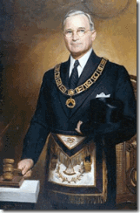
President Truman secretly was subjected by blood covenant to a higher order, the Masonic hidden hierarchy of the Knights Templar and Order of Teutonic Knights (SS-Knights of the Black Sun) dominated by Hitler, SS-1 Himmler and Reichsleiter SS Martin Bormann.
Leading up to his death, Forrestal became far too concerned, disturbed and vocal about the fanatical Nazi-SS Biological Warfare scientists like SS-1 Heinrich Himmler’s Erich Traub and Reichsgesundheitsführer Blome [56] being secretly implanted and bankrolled in America developing clandestine “Weapons of Mass Destruction”.[57]
In 1949, the clandestine movement of Nazis’ top scientists and Himmler’s SS war criminals, Wunderweapon programs (Weapons of Mass Destruction) being slipped into the United States was ultra top secret and highly classified information that couldn’t stand the light of day. It would have if exposed opened people’s eyes; outraged the world and changed the body politics of America forever.
Even though Forrestal heading the investment firm of Dillon and Read had been absolutely complicit with the Rockefellers, Dulles Brothers and Prescott Bush in a Bargain with Lucifer financing the Nazis and continuing to trade with Lucifer Servants during WWII, he would not have known about the full scope and power of Himmler’s clandestine Satanic SS objectives, and its ultra top secret Wunderweapons and biological warfare programs.
However, Forrestal was well aware of the Reinhard Gehlen Org, code named Operation Rusty, and its unfettered clandestine power and authority over U.S. Foreign Intelligence Programs ceded to it in the Secret Fort Hunt Treaty by the U.S. Pentagon (Joint Chiefs of Staff) in the fall of 1945.[58]
Forrestal pushed for the CIA to undermine and take over and control the Gehlen Org that the U.S. Government had no real authority over.[59] Additionally as U.S. Secretary of Defense, Forrestal had also rejected the Truman’s administration earlier move to make AFSA a consolidated U.S. military intelligence gathering agency in control of the Gehlen Org.[60]
However, it was far too late. Himmler’s Knights of Black Sun-SS, the world’s greatest demonic racial mass murderers, National Socialists and the Gehlen Org was too far secretly deeply imbedded within the power structure of America. Forrestal knew too much to be left to live. President Harry Truman forced Forrestal to resign; and into a military mental ward at the National Naval Medical Center, Bethesda, Maryland.
“Former Secretary of Defense James Vincent Forrestal died on May 22, 1949, after falling from the sixteenth of the U.S. Naval Hospital in Bethesda, Maryland. Forrestal’s broken, bloodied body was found clad in pajamas and a bathrobe. The bathrobe cord was wound tightly around his neck. He had been hospitalized due to “operational fatigue” attributed to “excessive work.” His death was ruled a suicide, but for many people, including members of Forrestal’s family, the matter remained far from resolved. Forrestal’s brother, Henry, told reporters at the time of the death that he “believed that someone threw my brother out the window” and that he considered it quite strange that his brother died “just a few hours before I was to take him home.”[61]
Operation SHAMROCK& the TROLLS

“The sparrow-faced man in the battle uniform of an American general clambered down the steps of the U.S. Army transport plane upon its arrival at Washington National Airport. It was August 24, 1945, two weeks after the surrender of Japan, three months after the German capitulation. The general was hustled into a van with no windows and whisked to Fort Hunt outside the capital. There he was attended by white-jacketed orderlies and, the next morning, fitted with a dark-grey business suit from one of Washington’s swankiest men’s stores.” –Mae Brussell[62]
Himmler SS-1 and his personal emissary SS Brigadeführer nd Generalmajor der Polizei Walter Schellenberg had been the true architects and engineers of America’s “Cold War” with the Soviet Union. According to former Abwehr official Eduard Waetjen, Himmler’s foreign policy strategy in early 1944 was to intensify the struggle against the Soviet Union, if possible through a joint operation with the Japanese and to convince the West that weakening or destroying the Soviet Union was in their interest. Himmler plotted the “Cold War” strategy as a means for the Allies to compromise a peace plan with the SS cloaking RSHA with a false mission as a western ally to weaken and destroy Communist Russia.[63]
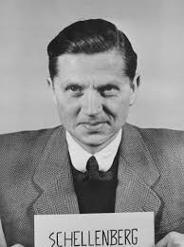
SS Wicked Walter
Himmler also had some pretty powerful bargaining chips to sway the west to an ultra secret compromise. He controlled access to the SS Wunderweapons (atomic bomb, etc.); V-2 rocket projects and personnel; atomic submarines and jets; important medical- neuroscience, biological patents; and alternative theory sciences like mind control-electromagnetic projects.
Project SHAMROCK was a major “Cold War” clandestine espionage program that started in August 1945 almost simultaneously with the red carpet arrival of Wehrmacht Generalmajor Reinhard Gehlen, Adolph Hitler’s chief intelligence officer against the Soviet Union, in America.
Generalmajor Gehlen had been a subordinate of Himmler and SS Schellenberg working out of RSHA’s Soviet Union desk and espionage networks. The Reinhard Gehlen Org in charge of America’s foreign policy and intelligence agenda was made up primarily of Hitler’s General Staff; and Himmler’s fervent RSHA SD (Sicherheitsdienst – Security Service) and SS (Knights of the Black Sun) officers.[64]
SHAMROCK involved the accumulation of telegraphic data entering or exiting the United States to primarily monitor and promote the fear of domestic Soviet Union espionage activities as contrived and veiled by Himmler, Schellenberg and the SS’ foreign policy agenda. SHAMROCK would have given the Gehlen Org access to secret U.S. military, diplomatic and congressional cables, which would have compromised and leveraged the entire nation.
AFSA and its successor NSA were given direct access to daily microfilm copies of all incoming, outgoing, and transiting telegrams via the Western Union and its associates RCA and ITT that represented almost all the international telegraphic traffic in the United States. AFSA and NSA basically operated without a charter, oversight, check and balances, or warrants. Their primary job was to gather and mine data and turn it over to the Gehlen Org/CIA, National Security Council (NSC), FBI, IRS, Secret Service, U.S. Military Intelligence or the White House.
On July 1, 1969, President Richard Nixon officially chartered Project “MINARET” directing government agencies to collaborate in targeting a White House “watch list” of enemies primarily from data gathered and mined by the NSA. The NSA actually operated MINARET between 1967 and 1973 collecting information on “individuals or organizations, involved in civil disturbances, Civil Rights, Black Power, antiwar movements/demonstrations and Military deserters involved in the antiwar movement.” [65] MINARET is defined as a “slender tower with balconies.” [66]
NSA targeted over 5,925 foreigners and 1,690 organizations and US citizens were included on the White House Project MINARET watch lists. NSA Director, Lew Allen, testified before the Senate Intelligence Committee in 1975 that the NSA had issued over 3,900 reports on the watch-listed Americans.[67] The Nixon White House watch list was only a sub-level governmental directive or “balcony” of SHAMROCK in the Puzzle Palace.
SHAMROCK wasn’t exposed until May 1975 when Congress began to investigate and expose the program. Senate Intelligence Committee Chairman Senator Frank Church concluded that Project SHAMROCK was “probably the largest government interception program affecting Americans ever undertaken.”[68]
Don’t be fooled. The NSA is TROLLING and profiling all citizens. It is being used daily primarily to clandestinely control racial nationalities, politics, religion, dissent, businesses and resources. It is used to trace and update targeted populations, groups and individual’s occupations, wealth, associations, addresses, and locations for relocations-resettlements to FEMA’s (Operation REX-84) political re-education and extermination concentration camps.
Himmler’s RSHA or Reichssicherheitshauptamt (Reich Main Security Office or Reich Security Main Office or Reich Security Head Office) wasn’t shut down as a mass murdering human rights and a war criminal organization. It just changed venue from Berlin, Nazi Germany to Washington DC.
JAMES R. CLAPPER, THE AMERICAN SATANIC TROLL UNDER THE BRIDGE
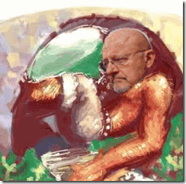
The TROLL & Neurologically Interactive Technologies
“The right of a person to liberty, autonomy, and privacy over his or her own intellect is situated at the core of what it means to be a free person. This principle is what gives life to some of our most well-established and cherished rights. Today, as new drugs and other technologies are being developed for augmenting, monitoring, and manipulating mental processes, it is more important than ever to ensure that our legal system recognizes and protects cognitive liberty as a fundament right.” (Center for Cognitive Liberty & Ethics, “Frequently Asked Questions,” September 15, 2003)
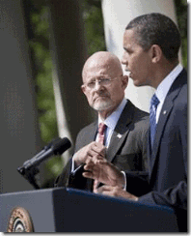
In June 2010, President Barack Obama nominated Retired Air Force Lieut. General James R. Clapper of Lucifer’s U.S. Military Intelligence Community as the Director of National Intelligence. The Director of National Intelligence (DNI) is the official subject to the authority, direction and control of the President who is responsible under the Intelligence Reform and Terrorism Prevention Act of 2004, serving as the principal adviser to the President, NSC, and Homeland Security Council for intelligence matters related to national security.[69]
Lieut. General Clapper is a very weird, scary and dangerous dude. Not much is publicly revealed about him personally, he usually moves deeply in the shadows of the military intelligence community. But, his thirst for power, and more raw power forced him into the daylight so that the general public can see this demonic TROLL UNDER THE BRIDGE and Master of Deception mostly for the very first time.
For over 30 years, he has been clandestinely at the forefront and at the tipping edge of neuroscience, computers, robotics-cybernetics and mind control technologies to dominate the “urban battlefield.” He is a fervent crusader in “America’s corporatist surveillances state that seek new means to elicit compliance and control over individuals as biological science is securitized under the rubric of ‘national security’”.[70]
Lieut. General Clapper has also been the TROLL UNDER THE BRIDGE clandestinely undermining human cognitive liberty by secretly militarizing life-biological sciences to blur and manipulate the distinctions between “human” and “machine.” For decades, he has been behind the veil developing brain-machine interfaces, also called “neural prosthetics” to manufacture virtual living robots subservient to a New Age and New World Order.[71]
Lieut. General Clapper position as DNI of America’s surveillance, security intelligence state is almost equivalent to Himmler’s position of ultimate command of RSHA, the original Puzzle House.
From the American Puzzle House, he has the power and authority to coordinate, control and command 16 U.S. intelligence agencies, ranging from the CIA and NSA to the FBI and National Geospatial-Intelligence Agency (NGA), Clapper’s former agency.[72] Clapper served as the director of the NGA from September 2001 until June 2006.[73]
THE REAL MATRIX
Geospatial-Intelligence is uncommon and unusual terms that may still be unfolding as we speak. The definitions and usage of the terms geospatial data, geospatial information, and geospatial knowledge are also unfolding and not used consistently in the surveillance intelligence gathering community.[74]
The CIA explains Geospatial-Intelligence as follows: “A picture is worth a thousand words: a lesson every intelligence officer learns. Every day satellites in the sky capture the comings and goings of nations around the world. These images may provide the missing piece to the puzzle that can help keep the nation safe.
Geospatial Intelligence
The Intelligence Community (IC) refers to the use and analysis of geospatial information to assess geographically referenced activities on Earth as geospatial intelligence (GEOINT). It is everything you can see or know about the earth.
GEOINT consists of:
· Imagery – a likeness of any natural or man-made feature, as well as its location.
· Imagery Intelligence (IMINT) – information derived through interpreting imagery.
· Geospatial Information – information that identifies a natural or constructed feature on Earth by its geographic location and other characteristics.
GEOINT Collection
The National Geospatial-Intelligence Agency (NGA) is the prime producer and functional manager for national and allied GEOINT efforts for the IC. CIA analysts often use NGA products to complement their analysis of a situation in finished intelligence.” [75]
NGA and the Defense Advanced Research Projects Agency (DARPA) have been quietly collaborating to perfect global satellite software programs and systems to collect “geospatial data, geospatial information, and geospatial knowledge” of brain and computer electromagnetic frequencies. DARPA is an agency of the U.S. Department of Defense responsible for the development of new technologies for use by the military.[76]
DARPA and NGA have been awarding research and development contracts under DARPA’s Urban Reasoning and Geospatial Exploitation Technology (URGENT) program to map and interface with the human brain from the sky (Cheryl Gerber, “Seeing with Your Brain,” Military Geospatial Technology, Vol 6, Issue 3, June 5, 2008).[77]
URGENT’s primary contractor, Lockheed Martin, is developing Object Recognition via Brain-inspired Technology (ORBIT) that seeks to merge neuroscience with computers to create a technology (3-D mapping systems) that promises to deliver “situational awareness” anywhere on the planet. Under URGENT, SPADAC, a Mclean, Virginia defense contractor have been developing a program called “Signature Analyst.” It promises to deliver an interface system that will deliver “powerful and actionable insights combining predictive analytics with spatial information as well as human terrain and social networking” to artificially improve and enhance “global operational and business challenges” to a “warfighter” and “counterterrorist”.[78]
Additionally under URGENT, Lockheed Martin and their partner “Numenta”, a software company are working on a suite of software applications, “Numenta Platform for Intelligent Computing (NuPIC) based on “hierarchical temporary memory (HTM), a “computing paradigm” that mimics the structure and function of the human neocortex, the area of the brain that handles high-level thought.[79]
Geospatial Intelligence & the 9-11 Inside Job and Deception
Consistent with the SS Satanic Principle of Duality, military intelligence satellite programs that have the capability to globally target, map, and collect brain electromagnetic frequencies can also entrain brain electromagnetic frequencies to harass, disable and assassinate, and transform targeted populations and individuals into “robotoids” from space.
The NGA also has the technology to reproduce and re-create 3-D [Geospatial} images of streets, buildings and locations across the globe like Google Maps. They can stage events across the world and falsely report that it is taking place as live news. They also apparently have developed secret backdoors to multi-national mass media live newsrooms such as the BBC to cut in and stimulate geospatial images as live news feeds. On 9-11, they went through the back door of the BBC to report that New York Trade Center Building 7 had collapsed. But due to a time glitch in calculating the time zone differences between New York and London, the BBC was caught with their pants down and reported live that Building 7 had collapsed before the building was pulled down.
Trade Center Building 7- Proof of an Inside Job
For decades, Lieut. General Clapper, TROLL UNDER THE BRIDGE, primary mission have been to block the path of liberty, happiness, individual human potential, and “invade the privacy of human thought, and infringe on the independence of our minds for “reasons of state,” transform biological/medical research into a subset of weapons development.”[80]
Lieut. General Clapper, SATANISM, PSYCHIC WARRIORS & THE CULT OF THE SS
During the 1990s, Lieut. General Clapper headed the Defense Intelligence Agency (DIA) that dwelled deeply into the “satanic occult world” to gather intelligence data and information for military industrial applications.
The DIA is a designated Department of Defense combat support agency that is the central producer and manager of foreign military intelligence for the United States. As one of the principal members of the U.S. Intelligence Community, the agency works to answer national-level defense objectives for the President, the Secretary of Defense, and senior U.S. military and civilian policymakers.[81]
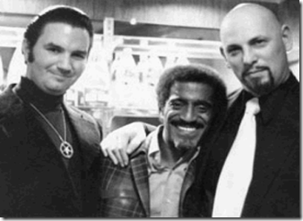
Michael Aquino is a Luciferian military intelligence former army lieutenant colonel sanctioned and blessed by the U.S. Pentagon as a fervent Satanist and PSYOP specialist attached to the DIA, Psychological Warfare Division.[82] Aquino is a former member of the late Anton LaVey’s Church of Satan, and co-founder of the Temple of Set.[83]
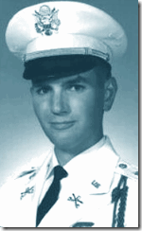
Lieut. Colonel Aquino is qualified as a Special-Forces officer, Civil Affairs officer, and Defense Attaché. He is a graduate of the Command and General Staff College, the National Defense University and the Defense Intelligence College, and the State Departments’ Foreign Service Institute.” He received a doctorate at the University of California at Santa Barbara in 1980, with s dissertation on “The Neutron Bomb.” He lists 16 separate military schools that he attended during 1968-87, including advanced courses in “Psychological Operations” at the JFK Special Warfare Center at Fort Bragg, North Carolina, and “Strategic Intelligence” at the Defense Intelligence College, at Bolling Air Force Base in Washington, D.C.[84]
“Aquino was deeply involved in what has been called the ‘revolution in military affairs’ (‘RMA’), the introduction of the most kooky ‘Third Wave,’ ‘New Age’ ideas into military long-range planning, which introduced such notions as ‘information warfare’ and ‘cyber-warfare’ into the Pentagon’s lexicon.”[85]
Lieut. Colonel Aquino is also linked to secret CIA MK-ULTRA satanic trauma based mind control programs; and a military intelligence high level nationwide pedophile ring.[86] Lieut. Colonel Aquino is the U.S. Military Intelligence Community’s expert on the “Cult of SS.” Adopting Himmler’s initiation and blood covenant rites; and a “Cult of the SS” among high ranking military officers was an effective means to avoid another “Major General Smedley Darlington Butler” from breaking ranks of the military’s shield of secrecy and brotherhood. The SS Blood Covenant of Secrecy overshadows the oath to protect the constitution; and supreme allegiance to the United States.
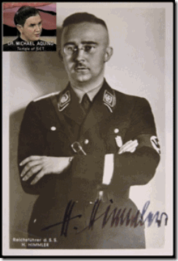
Aquino’s satanic activities in the military concerned the promotion of Nazi ideology; and overt support for neo-Nazi movements in the United States and Europe. On October 10, 1983, while traveling in West Germany on “official NATO business,” Aquino staged a Satanic “Wewelsburg Working” with military personnel officers at Heinrich Himmler SS-1’s Wewelsburg Castle in Bavaria to invoke the spirit of Himmler. Aquino wrote a lengthy account of the ritual, in which he invoked Himmler (“Wewelsburg Workings”): “As the Wewelsburg was conceived by Heinrich Himmler to be the ‘Mittelpunkt der Welt’ (‘Middle of the World’), and as the focus of the Hall of the Dead was to be the Gate of that Center, to summon the Powers of Darkness at their most powerful locus.”[87]
Aquino believes that Himmler was an authentic “Initiate of Satan.” Aquino invoked Himmler to adopt his secret satanic initiation rites and blood covenants to pass on the Powers of Darkness to the Joint Chiefs of Staff at the Pentagon and high level staff of the U.S. Military Intelligence Community.[88]
There are some questions whether or not he worked directly for the NSA. However, when Noreen Gosch, mother of Johnny Gosch-“Why Johnny Can’t Come Home”, requested a copy of Lieut. Colonel Aquino’s “From PsyOps to Mind War, the Success of Victory,” her FOIA request was surprising directly denied by the NSA on the ground of “National Security.”[89] It appears that this notorious satanic Nazi mind controller and pedophile was also working for the NSA developing long-range mass population control plans, policy and position papers.
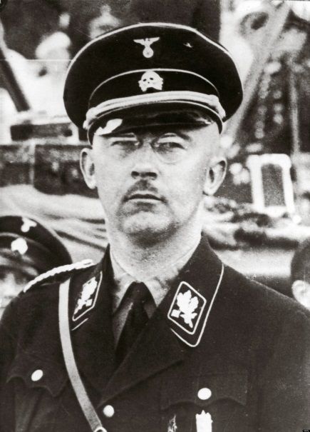
There is yet another important reason for adopting a clandestine “Cult of the SS” among the high ranking officers and officials of the U.S. military as outlined by Himmler SS-1 in the infamous October 4, 1943 (“Janus Face”) Speech to SS Major-Generals at Posen:
“One basic principle must be the absolute rule for the SS man: we must be honest, decent, loyal, and comradely to members of our own blood and to nobody else… Most of you must know what it means when 100 corpses are lying side by side, or 500 or 1000. To have stuck it out and at the same time-apart from exceptions caused by human weakness-to have remained decent fellows, that is what has made us hard. This is a page of glory in our history which has never been written and is never to be written …”[90]
Whether it is the millions slaughtered and maimed in Korea, Vietnam, Iraqi and Africa or the hundreds of thousands murdered and crippled in Libya and Syria, the “Cult of the SS” bound the U.S. military elite to be“hard” and uncompassionate to death and human suffering. It commands them to the practice of the art of deception.
U.S. Military Intelligence Secret Brotherhood with Lucifer’s Servants
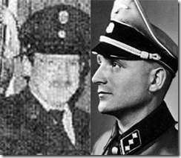
SS Heinrich Rupp and Klaus Barbie
For unknown reasons probably under the veil of U.S. National Security, SS Pilot Heinrich Rupp was smuggled into the country under Operation PAPERCLIP. In 1982, Italian Waffen SS officer Licio Gelli, head of a 2400 member secret Masonic Lodge, P2, a neo-fascist organization in Italy, with Gestapo Hauptsturmführer SS Klaus Barbie and SS Heinrich Rupp, met with CIA operative Ronald R. Rewald in Uruguay to arrange for the Argentine purchase of the French-made Exocet missile, used in the Falkland Island War with the British.[91] SS Rupp was also a CIA operative part of Obersturmbannführer (Lieutenant Colonel) SS Otto Skorzeny’s Die Spinne Nazi-SS Underground Network along with wanted war criminal SS Barbie.
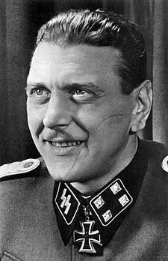
Werewolf Skorzeny
SS Skorzeny (Scarface) was Hitler and Himmler’s most ruthless, notorious and feared SS Commando that should have been hanged or faced a firing squad alone for war crimes at the Battle of the Bulge. He was called, “The Most Dangerous Man in Europe”.[92] Scarface’s legendary military WWII exploits was also idolized by the CIA. He was recruited into the CIA/Reinhard Gehlen Org. In 1953, Skorzeny was invited by CIA chief Allen Dulles, through his father-in-law, Hjalmar Schacht, Hitler’s ex-financial consultant and president of the Reichsbank, to help reorganize the security services of the new Republic of Egypt under General Neguib, and later Colonel Gamal Abdel Nasser. Skorzeny’s salary in this undertaking was subsidized by the American Taxpayers, the CIA.[93]
In 1969, SS Skorzeny was appointed security adviser to the Cocaine– Colombian Ministry of the Interior. The request for his assistance was channeled through the German ambassador in Bogota, Ernst Ludwig von Ror. In 1972, the Bolivian businessman and security adviser Klaus Altmann, otherwise known as the wanted Nazi war criminal, Gestapo Barbie, named Otto Skorzeny as the chief of the Die Spinne network which Barbie claimed commanded the loyalty of 100,000 fascist sympathizers in 22 countries and which was funded by secret Nazi Party flight capital investments (Martin Bormann) controlled by Skorzeny.[94]
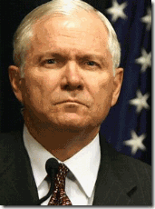
In 1980, Rupp was a Die Spinne arms broker and a fellow CIA/Gehlen Org agent when he transported Nazi collaborators among others, Executive assistant to the CIA Director, Robert Gates, above, the late then CIA Deputy Director, William Casey – then Ronald Reagan’s campaign manager for U.S. President, then U.S. Presidential Vice President nominee and CIA agent, George H. W. Bush, to Paris to seal a deal for 23 tons of TOW (Tube-launched, Optically-tracked, Wire-guided) missiles[95] from a Die Spinne affiliated network arms dealer in the Iran-Contra CIA Crack-Cocaine Scandal.[96]
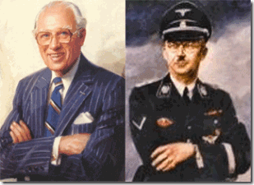
In fact it appears that Gates and his mentor CIA Director, William Casey, above, secretly handled the Reinhard Gehlen Org CIA faction; and continued to push Himmler’s Soviet Union “Cold War” Strategy well into the late 1980s contrary to the CIA’s proud Soviet analytical office assessments that significantly downplayed the soviet threat. Gates and Casey purged the Soviet desk in Washington DC of analysts that didn’t go along with the Soviet Union Threat Deception.[97]

Among the U.S. Military Intelligence brotherhood, Nazi collaborator former CIA Director and Secretary of Defense U.S. Air Force Second Lieutenant Robert Gates and Clapper have been longtime associates and close friends probably dating back to the 1960s in U.S. Air Force Intelligence during America’s campaign of Terror and War of Aggression in Vietnam. True to the secretive bond of the Luciferian brotherhood, Clapper had been one of Gates’ principal trusted advisors and his undersecretary of defense for intelligence.[98] There is no reason to believe that Lieut. General Clapper wasn’t among the secret Brotherhood with Lucifer’s Servants.
Whereas through the practice and art of deception, high ranking U.S. military or government secret members of the “Cult of the SS” like Lieut. General Clapper can look the U.S. Congress and the American public straight in the face- appear exceedingly “honest” and “decent” then LIE!
In March 2013, Lieut. General Clapper told a Senate Investigative Committee that the NSA does not “collect any type of data” on Americans:
Senator Wyden: “Last summer the NSA director was at a conference and he was asked a question about the NSA surveillance of Americans. He replied, and I quote here, ‘… the story that we have millions or hundreds of millions of dossiers on people is completely false… The reason I’m asking the question is, having served on the committee now for a dozen years, I don’t really know what a dossier is in this context. So what I wanted to see is if you could give me a yes or no answer to the question: Does the NSA collect any type of data at all on millions or hundreds of millions of Americans?”
Clapper: “No, sir.”
Wyden: “It does not.”
Clapper: “Not wittingly. There are cases where they could inadvertently perhaps collect, but not wittingly.”[99]
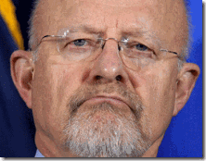
Lieut. General Clapper told a bold face lie to Congress and the general public, and then later admitted that he had lied. On television, he appeared “honest” and “decent” when he told a television audience that it had been the “least untruthful answer” that he could think of, which was another outright bold faced lie with absolute mass deception.[100] AFSA and its predecessor NSA has been clandestinely TROLLING, collecting and mining mass data on all Americans since August 1945- Project SHAMROCK.
Consistent with the secret military elite worship of Himmler and the SS as true Initiates of Satan endowed with the secret Powers of the Occult; they adopted his “Wewelsburg Workings” initiation and blood covenant rites, but also secretly pursued the SS’ “Astral-Time Travel” exercises,[101] commonly known as “Remote Viewing” for clandestine military application.[102]
Lieut. General Clapper, Remote Viewings, Space Kids and President Barack Hussein Obama
President Obama has a far more secret unconventional tie to Lieut. Colonel Clapper then you know or ever will know.
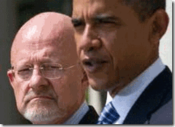
From November 1991 to August 1995, Lieut. General Clapper was the Director of the Defense Intelligence Agency (DIA).[103] He became the gatekeeper to Military Intelligence Satanist Lieut. Colonel Aquino of DIA’s Psychological Warfare Division conjuring up Heinrich Himmler and the “Cult of the SS.”
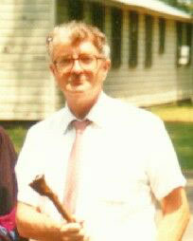
Lieut. General Clapper also became the gatekeeper to the DIA’s “Weird Desk”, the Advanced Technology Group (ATG) headed by Dale Graff , above, that reportedly consulted with “Witches.” Graff was also the DIA’s Branch Chief of the operation unit Star Gate out of the Stanford Research Institute (SRI). Remote Viewing was developed at SRI under the name STARGATE. Remote Viewing involves the use of paranormal methodologies similar to the ones used by the Rosicrucians and Scientology; “soul travel” or “astral projection” – a belief that the soul can leave the physical body and travel to other locations.[104] “Astral-Time travel” was also one of the practices of “Wewelsburg Workings” at Himmler’s Wewelsburg Castle.
In 1978, Graff headed DIA’s ATG at the Foreign Technology Division of Wright Patterson Air Force Base, Dayton, OH when it became involved in co-funding psychic-mystic Dr. Andrija Puharich’s NASA MK ULTRA Space Kids program as part of the Stargate Project.
The STARGATE Project was the umbrella code name of one of several sub-projects established by the U.S. Federal Government to investigate claims of psychic phenomena with potential military and domestic applications, particularly the “remote viewing”: the purported ability to psychically “see” events, sites, or information from a great distance. These projects were active from the 1970s through 1995, and followed up early psychic research done at SRI, Science Applications International Corporation (SAIC), The American Society for Psychical Research (ASPR) and other psychical research labs.[105]
- 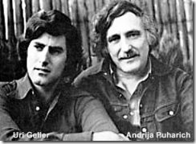
In August 1972, Dr. Puharich and Uri Geller are known to become involved in the STARGATE research program at SRI. Before that, they flew to Germantown, Maryland, to meet privately with NASA Director Allgemeine SS- Sturmbannführer (major) Werner von Braun, then onwards to San Francisco, to Stanford University (SRI) to participate in secret psychic parapsychology experiments funded by the CIA and DIA.[106]
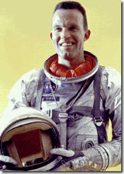
The late NASA Astronaut U.S. Navy Captain LeRoy Gordon Cooper, Jr., one of the original seven Mercury astronauts, was one of the first to expose the Space Kids program involving gifted American schoolchildren administrated under SS von Braun in the 1950s and 1960s as a CIA/MK ULTRA program.[107] SS von Braun SS headed NASA from 1958 to 1972.[108]
Cooper said that, “the space kids were children with exceptional mental abilities run through a kind of MK [CIA-ULTRA] program like the things are coming out now.” He described how NASA’s mind control program emphasized cultivation of the children’s psychic abilities and that it involved telepathy, remote viewing, and out-of-body experiences (OBE’s).[109]
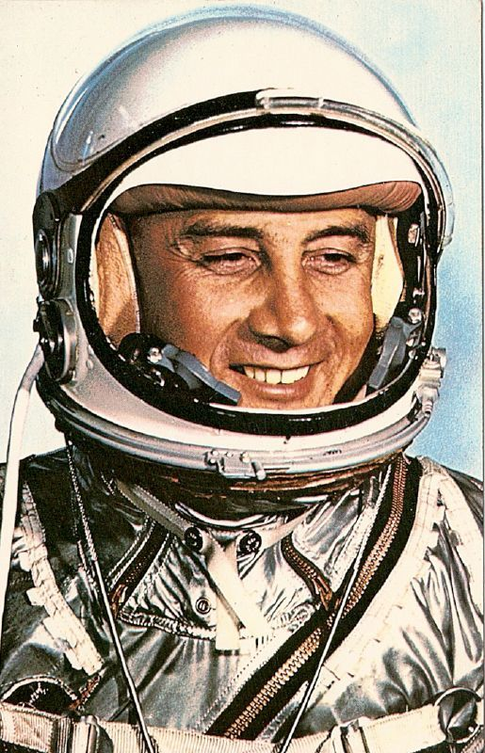
Virgil Ivan Grissom (April 3, 1926 – January 27, 1967), (Lt. Col, USAF), better known as Gus Grissom, was one of the original NASA Project Mercury astronauts involved in the mind control program along with Gordon Cooper.

NASA Gus Grissom with notable spaded nose and a classic military crew cut and 4 or 5 ears old Barack Hussein Obama, Jr. just before Grissom was assassinated in 1967.
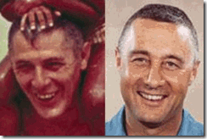
It is reasonable to conclude that SS von Braun personally primed Dr. Puharich and Uri Geller to take over NASA’s Space Kids program with Barry Soetoro (Barack Obama). Within three years of that private meeting with SS von Braun, in the summer of 1975, Dr. Puharich assembled around twenty children from the ages of nine to late teens, called “Gellerlings”, or “Space Kids”. Dr. Puharich trained their psychic abilities, and claimed that they received messages from aliens. One teen claimed that they practiced remote viewing, and some of their assignments included political targets like the Kremlin and the White House. Dr. Puharich claimed that the Space Kids were able to materialize objects like trees, and that six of them arrived at his ranch via teleportation.[110]
It appears the “Space Kids” program was reclassified from secret to ULTRA TOP SECRET involving high level governmental spooks, tricks, assassinations and counterintelligence activities. Ira Einhorn was a famous pacifist and ecologist in the 1960s very close to Dr. Puharich. He claimed that he had “practically lived in mind-link with Andrija for six years” and described his former mentor as “the great psychic circus manager of this century”.[111]
In late January, 1977, Einhorn presented a paper on the Space Kids at the “Mind Over Matter” conference at Penn State University, organized by Einhorn. Other attendees included Dr. Puharich, Christopher Bird, CIA agent, and Army Psychological Warfare specialist. He also worked at the CIA-connected Rand Development Corporation.
Lt. Col. Thomas E. Bearden was there. Lt. Col. Bearden was a nuclear engineer, war games and weapons analyst, and military tactician. He has over 30 years experience in air defense systems, technical intelligence, Soviet electromagnetic weaponry, artificial intelligence, computerized war games, and anti-radiation missile countermeasures.[112]
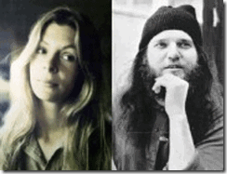
Not too long after exposing the secret Space Kids Program, Einhorn became the primary suspect in the disappearance and murder of his former girlfriend, Holly Maddox, in the fall of 1977 and fled the country. At the time of her disappearance, Maddux possessed papers relating to the Space Kids research. In 1978, Dr. Puharich’s Lab Nine housing the Space Kids program mysteriously burned down. Dr. Puharich also fled the country to Mexico, claiming he was being targeted by the CIA.[113]
Just months before Lieut. General Clapper retired from DIA; Dr. Puharich’s tongue started getting a little too loose for comfort. On January 3, 1995, Dr. Puharich “died following a convenient fall down a flight of stairs.”[114]
1995 was an important year paving Barack Obama’s road to the White House. To manufacture a legend, Obama’s memoir Dreams from My Father: A Story of Race and Inheritance was published in July 1995 as he was preparing to launch his political career in a campaign for an Illinois office.[115]
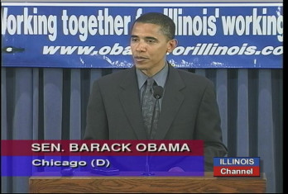
On December 11, 1995—the first filing day for nominating petitions for a state senate seat Obama filed his nominating petitions with more than 3,000 signatures. On December 26, Obama’s promptly then filed objections to the legitimacy of the nominating petitions of his democratic opponents to disqualify them. They either dropped out or were disqualified to run. Obama therefore won the Democratic nomination unopposed. On November 5, 1996, Obama was won the race for the 13th Senate district and rest is history.[116]
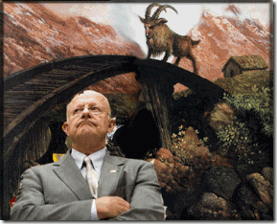
That’s some really powerful power plays for a novice politician with Lieut. General Clapper and the DIA as the gatekeepers to the secrets to Nazis, Space Kids, and Barack Hussein Obama, Jr. Clapper is building a huge secret spy NSA facility in Bluffdale (BILLY GOAT GRUFF-DALE), Utah the size of five capital buildings to stifle the goals and aspirations of the people to be free and determine their own destiny. Undoubtedly, It will become the satellite headquarters of the MATRIX- the MATRIX is a 1999 American-Australian science fiction action film that depicts a dystopian future in which reality as perceived by most humans is actually a simulated reality called “the MATRIX”, created by sentient machines to subdue the human population, while their bodies’ heat and electrical activity are used as an energy source.
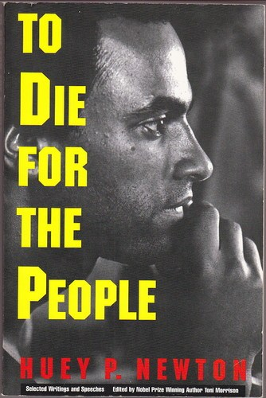
Finally, when we feared that we were becoming absolutely overwhelmed by the power of the system, Huey P. Newton always stressed stand firm, “THE WILL OF THE PEOPLE WILL DEFEAT THE MAN’S TECHNOLOGY”. It has happened in Eastern Europe, Korea, Cuba, Africa, Vietnam, Iraqi and now Afghanistan. It shall come to pass in America. Let me leave you with Dr. King’s I BEEN TO THE MOUNTAIN TOP. It is as relevant today as it was decades ago.

[1] http://www.americanrhetoric.com/speeches/mlkivebeentothemountaintop.htm
[2] http://en.wikipedia.org/wiki/Life,_liberty_and_the_pursuit_of_happiness
[3] http://blackpanther.org/TenPoint.htm
[4] http://richardboyden.com/ascended_masters.htm
[5] http://integral-review.org/documents/Volckmann,%20Interview%20Hubbard%20Vol.%205%20No.%201.pdf
[6] http://www.truthalliance.com.au/Global-False-Religion.html
[7] http://www.exposingsatanism.org/satanism_the_lucifer_trust.htm
[8] Monteith, Stanley, Brotherhood of Darkness, Hearthstone Publishing, Oklahoma City, OK (2000) pg. 134-138
[9] http://tv.msnbc.com/2013/06/10/national-intelligence-director-snowden-chose-to-violate-a-sacred-trust/
[10] http://en.wikipedia.org/wiki/Sacred
[11] http://one-evil.org/content/entities_organizations_nazi_ss.html
[12] http://www.bloomberg.com/news/2013-06-11/nsa-leaker-was-shy-computer-bound-teenager-in-maryland.html
[13] http://www.bloomberg.com/news/2013-06-11/nsa-leaker-was-shy-computer-bound-teenager-in-maryland.html
[14] http://www.bloomberg.com/news/2013-06-11/nsa-leaker-was-shy-computer-bound-teenager-in-maryland.html
[15] http://www.nypost.com/p/news/national/dancer_gal_pal_bares_shock_djshQSM57ptgfXtIxSiGCP
[16] http://www.nypost.com/p/news/national/dancer_gal_pal_bares_shock_djshQSM57ptgfXtIxSiGCP
[17]http://www.nypost.com/p/news/national/dancer_gal_pal_bares_shock_djshQSM57ptgfXtIxSiGCP
[18] http://www.thedailybell.com/29232/Is-Snowden-for-Real-Doubts-Set-In
[19] http://beforeitsnews.com/alternative/2012/08/flashback-wikileaks-founder-julian-assange-is-annoyed-by-911-truth-2452656.html
[20] http://tv.msnbc.com/2013/06/10/national-intelligence-director-snowden-chose-to-violate-a-sacred-trust/
[21] http://www.wired.com/dangerroom/2012/07/counterterrorism-trolls/all/
[22] http://en.wikipedia.org/wiki/Three_Billy_Goats_Gruff
[23] http://voices.yahoo.com/what-troll-lesser-known-part-norse-mythology-10180899.html
[24] http://en.wikipedia.org/wiki/Thor
[25] http://boingboing.net/2013/04/08/rare-footage-of-a-normal-per.html
[26] http://www.beyondweird.com/conspiracies/cotd9311.html
[27] http://www.spartacus.schoolnet.co.uk/GERhess.htm
[28] http://en.wikipedia.org/wiki/Kurt_Pl%C3%B6tner
[29] http://www.bibliotecapleyades.net/sociopolitica/esp_sociopol_mj12_18.htm
[30] http://www.bibliotecapleyades.net/sociopolitica/esp_sociopol_mj12_18.htm
[31] http://mojomorning.blogspot.com/2012/09/programmed-assassin.html
[32] http://en.wikipedia.org/wiki/Kurt_Pl%C3%B6tner
[33] http://www.bibliotecapleyades.net/sociopolitica/esp_sociopol_mj12_18.htm
[34] http://www.constantinereport.com/populist-review-fascism-in-america-roots-of-the-current-predicament/
[35] http://www.constantinereport.com/populist-review-fascism-in-america-roots-of-the-current-predicament/
[36] http://rt.com/news/germany-obama-nsa-stasi-spying-573/
[37] http://en.wikipedia.org/wiki/Stasi
[38] http://en.wikipedia.org/wiki/SS-Reichssicherheitshauptamt
[39] http://en.wikipedia.org/wiki/SS-Reichssicherheitshauptamt
[40] http://skepticism.org/timeline/january-history/2163-dehomags-willy-heidinger-touts-ibm-machines-later-used-to-manage-the-holocaust.html
[41] http://www.stockmaven.com/ibmstory.htm
[42] http://en.wikipedia.org/wiki/Untermensch
[43]http://wiki.answers.com/Q/How_many_people_were_killed_in_the_Nazi_Concentration_Camps_during_the_Holocaust
[44] http://en.wikipedia.org/wiki/The_Puzzle_Palace
[45] http://www.urbandictionary.com/define.php?term=Puzzle%20Palace
[46]http://en.wikipedia.org/wiki/United_States_Army_Security_Agency#Human_resources_.281945.E2.80.931965.29
[47] http://www.counterpunch.org/2011/12/02/wall-streets-failed-1934-coup/
[48] http://www.jewishvirtuallibrary.org/jsource/Holocaust/gm.html
[49] http://www.prisonplanet.com/articles/july2007/240707fascistcoup.htm
[50] http://en.wikipedia.org/wiki/Smedley_Butler
[51] http://en.wikipedia.org/wiki/James_Forrestal
[52] http://en.wikipedia.org/wiki/James_Forrestal
[53] http://www.paragoy.com/forrestal.html
[54] http://fdrassassination.50megs.com/
[55] http://www.pagrandlodge.org/mlam/presidents/truman.html
[56] http://www.operationpaperclip.info/kurt-blome.php
[57] H.P. Albarelli, Jr., A Terrible Mistake, The Murder of Frank Olson and the CIA’s Secret Cold War Experiments, Trine Day, LLC, Walterville, OR (2009) p. 636
[58] http://atrueott.files.wordpress.com/2010/05/the-secret-treaty-of-fort-hunt.pdf
[59] Breitman, Norman, U.S. Intelligence and the Nazis, Cambridge University Press, NY, NY (2009) pg. 392
[60] http://en.wikipedia.org/wiki/Signals_intelligence_in_the_Cold_War
[61] Supra, at p. 122-123
[62]http://www.maebrussell.com/Mae%20Brussell%20Articles/Nazi%20Connection%20to%20JFK%20Assass.html
[63] Breitman, Norman, U.S. Intelligence and the Nazis, Cambridge University Press, NY, NY (2009) pg. 108
[64] http://www.gwu.edu/~nsarchiv/NSAEBB/NSAEBB138/CIA%20Information%20Act%20-%20Reinhard%20Gehlen.pdf
[65] http://panafricannews.blogspot.com/2013/06/james-bamford-national-security-agency.html
[66] http://www.audioenglish.org/dictionary/minaret.htm
[67] http://en.wikipedia.org/wiki/Project_MINARET
[68] http://en.wikipedia.org/wiki/Project_SHAMROCK
[69] http://en.wikipedia.org/wiki/Director_of_National_Intelligence
[70] http://forum.prisonplanet.com/index.php?topic=51745.0;wap2
[71] http://forum.prisonplanet.com/index.php?topic=51745.0;wap2
[72] http://www.afio.com/sections/wins/2010/2010-20.htm#clapper
[73] http://www.dni.gov/index.php/newsroom/ic-in-the-news/187-ic-in-the-news-2012/735-geoint-2012-tuesday-keynote,-james-r-clapper,-jr-,-director-of-national-intelligence
[74] http://en.wikipedia.org/wiki/Geospatial_intelligence
[75] https://www.cia.gov/news-information/featured-story-archive/2010-featured-story-archive/geospatial-intelligence.html
[76] http://en.wikipedia.org/wiki/DARPA
[77] http://forum.prisonplanet.com/index.php?topic=51745.0;wap2
[78] http://forum.prisonplanet.com/index.php?topic=51745.0;wap2
[79] http://forum.prisonplanet.com/index.php?topic=51745.0;wap2
[80] http://forum.prisonplanet.com/index.php?topic=51745.0;wap2
[81] http://en.wikipedia.org/wiki/Defense_Intelligence_Agency
[82] http://www.theforbiddenknowledge.com/hardtruth/satanic_subversion.htm
[83] http://www.theforbiddenknowledge.com/hardtruth/satanic_subversion.htm
[84] http://www.theforbiddenknowledge.com/hardtruth/satanic_subversion.htm
[85] http://www.theforbiddenknowledge.com/hardtruth/satanic_subversion.htm
[86] http://www.theforbiddenknowledge.com/hardtruth/satanic_subversion.htm–
[87] http://www.theforbiddenknowledge.com/hardtruth/satanic_subversion.htm
[88] http://www.maebrussell.com/Bibliography%20Sheets/837s1.html
[89] http://rense.com/general67/gannn.htm
[90] http://www.ess.uwe.ac.uk/genocide/SS2.htm
[91] http://www.theforbiddenknowledge.com/hardtruth/operationpaperclip.htm
[92] http://en.wikipedia.org/wiki/Otto_Skorzeny
[93] http://libcom.org/library/appendix-g-otto-skorzeny
[94] http://libcom.org/library/appendix-g-otto-skorzeny
[95] http://en.wikipedia.org/wiki/BGM-71_TOW
[96] http://www.theforbiddenknowledge.com/hardtruth/operationpaperclip.htm
[97] http://consortiumnews.com/2011/05/31/the-mysterious-robert-gates/
[98] http://special.defensenews.com/people/profile.php?pn=20
[99] http://www.volokh.com/2013/06/11/did-james-clapper-lie-to-congress/
[100] http://www.politicalforum.com/civil-liberties/307762-intelligence-chief-james-clapper-lied-congress-about-nsaand-must-prosecuted.html
[101] http://quintessentialpublications.com/twyman/?page_id=52
[102] https://en.wikipedia.org/wiki/Stargate_Project
[103] http://www.dia.mil/history/directors/ltg-clapper.html
[104] http://www.antipasministries.com/html/file0000310.htm
[105] https://en.wikipedia.org/wiki/Stargate_Project
[106] http://www.uri-geller.com/articles/stargate.htm
[107] http://rense.com/general2/astro.htm
[108] http://en.wikipedia.org/wiki/Wernher_von_Braun#NASA_career
[109] http://en.wikipedia.org/wiki/Wernher_von_Braun#NASA_career
[110] http://multistalkervictims.org/mcf/hambone/people1.html
[111] http://www.uri-geller.com/articles/stargate.htm
[112] http://multistalkervictims.org/mcf/hambone/people1.html
[113] http://www.newdawnmagazine.com/articles/behind-the-mask-aliens-or-cosmic-jokers
[114] http://www.hiddenmysteries.org/themagazine/vol9/articles/desb2.shtml
[115] http://en.wikipedia.org/wiki/Dreams_from_My_Father
[116] http://en.wikipedia.org/wiki/Illinois_Senate_career_of_Barack_Obama
Comments : 13 Comments
Tags: Adolf Hitler, Aleister Crowley, barack hussein obama, Barry Soetoro, CIA, Dale Graff, Dr. Andrija Puharich, dr. kurt blome, dr. kurt Plötner, Dr. Martin Luther King, Edward Snowden, Geospatial-Intelligence, gus grissom, harry truman, Huey P. Newton, Ira Einhorn, James a. clapper, james clapper, james forrestal, Jr., klus barbie, Knights of the Black Sun, LeRoy Gordon Cooper, Mae Brussell, martin bormann, military intelligence community, MK-ULTRA, napa state hospital, National Geospatial-Intelligence Agency, National Security Agency, operation shamrock, Otto Skorzeny, PROJECT CHATTER, puzzle palace, Reichsfurhrer Heinrich Himmler, reinhard gehlen, remote viewing, robert gates, space kids, SRI, star kids, stargate project, trolls, Uri Geller, wewelsburg castle, william casey
Categories : 1000 Year Reich, 9-11, African Liberation, allen dulles, anton lavey, anton LeVay, Aryan Supremacy, Barack Obama, Benito Amilcare Andrea Mussolini, Black Manchurian Candidates, Black messiah, Black Panther Party for Self Defense, blood covenants, blood oaths, bloodline of wotan, bloodlines of wotan, church of satan, church of set, CIA, club of rome, Col. Dr. Michael A. Aquino, col. michael Aquino, columbian cocaine, Crimes Against Democracy, cyborg, cyborgs, DARPA, Defense Intelligence Agency, DIA, divine one, Dr. Erick Traub, Dr. Ewen Cameron, Dr. Josef Mengele, Edward Snowden, ELF, Extremely Low Electrical Frequencies, George W. Bush, Gordon LeRoy Cooper, Gus Grissom, Hauptsturmfuhrer SS Dr. Josef Mengele, Heinrich Himmler, heinrich rupp, illuminati, imperium, israel, J. P. Morgan, Josef Mengele, Knights Hospitaller, Knights of the Black Sun, Knights Templar, Lt. Gen. James R. Clapper, lucifer's servants, luciferians, Madame H.P. Blavatsky, mark of the beast, Martin Luther King, mind control, mk ultra, cia occult bureau, temple of set, MK-ULTRA, monarch program, nasa, National Security Council, National Socialism, Nazis, new world order, Nuremberg Tribunal, nwo, oakland, Operation PAPERCLIP, Otto Skorzeny, persistent warfare, PROJECT CHATTER, Reichsfurhrer SS-1 Heinrich Himmler, Ronald R. Rewald, RONALD REAGAN, rudolph hess, satan, Satanic Global High Cabal, Satanism, Schutzsteffel, Secret Doctrine, Space Kids, SS, Stanford University, STAR GATE, Star Kids, Strumbannfuhrer SS Dr. Wernher von Braun, trauma-based mind control, underground reich, underground third reich, Untermensch, Uri Geller, virgil ivan gus grissom

PART II, THE BOY FROM BRAZIL, BARACK HUSSEIN OBAMA II, THE SS & DR. JOSEF MENGELE
3062013

U.S. Presidential Monarch Programmed Marionettes, Barack and Michelle Obama exhibit the downward ILLUMINATI pyramid hand gesture.
In Part I, Barack Hussein Obama II, The Boy from Brazil, I covered his absolute bizarre birth and upbringing, plus his family’s unquestionable Reinhard Gehlen Org-CIA MK ULTRA background. As you see by his most recent national security national televised address and current events, President Barack Hussein Obama II more than likely controls nothing but his god given natural human body functions. Barack Obama has no control over the U.S. military, national security, foreign policy or the IRS. President Obama and the first lady are literally human clone “talking points” for the Satanic Global High Cabal /Imperium that secretly controls America. Barack Obama was created cyborg- robotoid.
In 1970, the Luciferian “divine rulers” informed the world that they would introduce human “cyborgs” into the body of American politics to deliberately undermine this constitutional “one person-one vote” form of government. These illuminated ones believes that original citizens are unable to govern themselves. In that year, Zbigniew Brzezinski authored the book, “Between Two Ages: America’s Role in the Technotronic Era”, which he advocated the control of populations by an elite political class via technotronic manipulation. The book had been commissioned by the Club of Rome, “The book is an open announcement of the manner and methods to be used to control the United States in the future. It also gave notice of cloning, “robotoids,” i.e., people who acted like people and who seemed to be people, but who were not.” (Coleman, Dr. John, Conspirators’ Hierarchy: the Story of the Committee of 300, America West Publishers, Carson City, NV (1992), pg. 27)
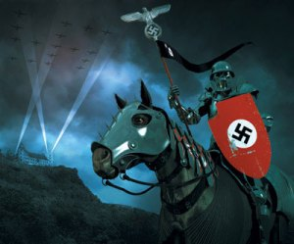
When Barack Obama was born in August 1961, everything take place in order for the Satanic Global High Cabal/Imperium to clone an experimental political “BOY FROM BRAZIL” to act like a president and seem to be a president, but who was not the President of the United States. In the secret technology to create a Luciferian Robotoid, of course, we begin with the BEAST, the SS, the mass murdering blood covenant Knights of the Black Sun, and Hauptsturmfuhrer (Captain) SS Josef Rudolf Mengele.
The Young Prince and National Socialism
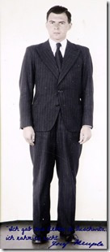
Josef Mengele was born of money, privilege and class in Gunzburg, Bavaria on March 16, 1911. His father had founded a powerful agricultural machine factory, Mengele and Sons, which dominated the economy affairs of the city. As a child, Josef was gifted, studious, privileged, rich and an arrogant “biological soldier” of the THIRD REICH.[1]
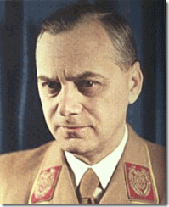
In October 1933, highly influenced by the pseudo racial ideology of Commissar of Supervision of Intellectual and Ideological Education of the DSDAP, Alfred Rosenberg, above, Mengele joined the Sturmabteilung (SA) Storm Troopers. In 1937, Mengele joined the Nazi Party. In 1938, he received his medical degree and joined the SS. Mengele was conscripted into the army in 1940 and later volunteered to the medical service of the Waffen-SS, the combat arm of the SS, where he distinguished himself as a soldier. Hitler declared war against the Soviet Union on June 22, 1941. Later that same month, Mengele was awarded the Iron Cross Second Class for his heroism at the Ukrainian Front. In January 1942, while serving with the 5th SS Panther Division behind Soviet lines, he pulled two German soldiers from a burning tank and was awarded the Iron Cross First Class, as well as the Wound Badge in Black and the Medal for the Care of the German People. Mengele was medically unfit for combat, and was then posted to the Race and Resettlement Office in Berlin. Mengele resumed an association with his mentor, Dr. Otmar Freiherr von Verschuer (Rockefeller Institute), who was at the Kaiser Wilhelm Institute for Anthropology, Human Genetics and Eugenics in Berlin. Just before he was transferred to Auschwitz, Mengele was promoted to the rank of SS-Hauptsturmführer (Captain) in April 1943.[2]
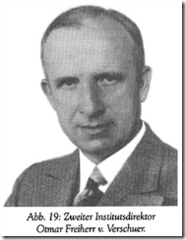
Despite notions to the contrary, Dr. Mengele had been a highly decorated battle tested fearless soldier which placed him in a special class of respect among hierarchy and the ranks of the SS. He was proven to be a foremost loyal and duty bound Teutonic Knight of the Blood Order-Black Sun.
Dr. Mengele had been one of Reichsfuhrer Heinrich Himmler’s classic SS dual natured, two faced-Janus Knights of the Black Sun. He was a medical doctor, but only pursuant to the agenda of the SS and the THIRD REICH. He was truly an extremely shrewd, dangerous and treacherous human being.
The Two Faced Prince and Auschwitz: “Arbeit Macht Frei”[3]
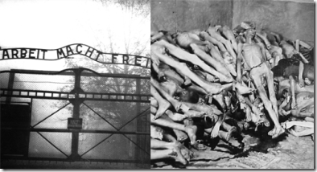
Work Will Set You Free- Entry Gate to Auschwitz
“This is not a sanatorium; there is no place for the sick. The prisoners are here to work or [and] to die.” Auschwitz Kommandant Rudolf Höss [4]
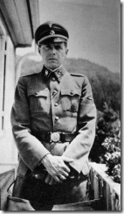
From most accounts at Auschwitz, one face of Dr. Josef Mengele was described as an aristocratic, impeccable and elegantly dressed gentleman down to his boots. His orderlies often carried an extra pair of boots if the pair he was wearing became soiled in mud.[5] He was often described as kind and gentle. As the appointed Chief SS Medical Officer of Auschwitz -Birkenau Concentration Camp in Poland,[6] interned women described him as a white angel,-savior, a legendary “Siegfried.”[7]
“… Survivors tell how as children in Auschwitz they were visited by a smiling “Uncle Mengele” who brought them candy and clothes. Then he had them delivered to his medical laboratory either in trucks painted with the Red Cross emblem or in his own personal car to undergo his experiments.”[8]
His other face was cold-hearted and disassociated from human compassion. Dr. Mengele was a fervent fan of Richard Wagner. During his dreaded selection process, prisoners selected for death, he always whistled a Wagner operatic aria.[9] Dr. Mengele exercised his power over life and death not only at the railroad yard ramps as the imprisoned entered the camp from loaded boxcars, but also routinely inside Birkenau at compound hospitals and holding blocks,
“Dr. Mengele never gave any warning of his visits and would appear at any hour of the day or night. When he suddenly surged into a block all exists barred by the S.S., the women huddled together in terror, knowing full well that their lives hung by the thread. They knew that they had to put on a good appearance. They hoped to escape death. Despite an all-devouring anguish, the poor, scrawny bodies were drawn to their full height. Heads lifted, the stride became firmer. Prisoners were told to undress. They were crammed into the corner of the block, and filed, one at a time, past the chief medical officer, seated, whistling, in the middle of the room…As each prisoner walked pass, the officer made a gesture with thumb to the left, to the right…He loved to encounter the terrified gave of those who found themselves in the left-hand file and condemned to almost certain death. When the march-past came to an end, Dr. Mengele rose to his feet, gracefully, and smilingly announced: “The right-hand group will be evacuated.” With that, he walked away whistling.”[10]
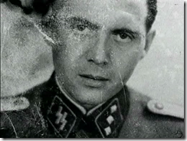
The people interned at Auschwitz didn’t want to see this face, because it may have been the last thing you saw. He was an architect of Racial Mass Murder. He was a gentleman Teutonic Knight with a duty to kill by the masses. Dr. Mengele’s body count at Auschwitz is absolutely staggering estimated at least 400,000 people.[11]
The Prince, Auschwitz and the Sadistic Little Genius, the Father of Positive (Artificial Insemination) and Negative Eugenics (Sterilization)
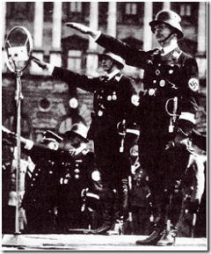
The Supreme Commander of Auschwitz and all Nazi concentration camps was bar none, Reichsfuhrer SS-1 Heinrich Himmler. Himmler was known to issue direct orders to the camp commanders, bypassing all other chains of command, in response to his own directives. Himmler would also occasionally receive broad instructions from Adolf Hitler or Herman Goring, which he would then interpret as he saw fit and transmit to the Auschwitz Camp Commander, SS- Obersturmbannführer Rudolf Höss.[12]
Concentration camps were not free enterprise zones for human medical experiments. Concentration camp medical corps was secret blood oath SS doctors strictly controlled, supervised and unconditionally duty bound to Himmler and the SS. Access to human “in vitro” material for scientific investigation at the camps was through permission only from the Reichsfuhrer. Himmler was uncannily shrewd. He hired out the SS medical corps and its experiments and inmates to research pharmaceuticals and universities not only to profit, but to control it and direct science toward the goals of National Socialism-Aryan Supremacy and Racial Genocide.
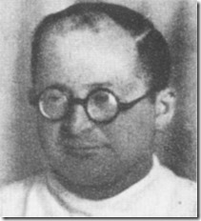
Some of the most significant experiments and SS doctors most germane to the Nazi’s breakthrough experiments in artificial insemination was Professor Dr. Karl Clauberg.
In 1941, Dr. Clauberg desperately sought Himmler’s permission to gain access to human material at Auschwitz to conduct human experiments in the science of artificial insemination, in vitro fertilization and sterilization. Dr. Clauberg was extremely legit.
Yet unlike Dr. Josef Mengele, Dr. Clauberg was openly ambiguous contrary to Himmler’s fervent policy of blood oath secrecy. Dr. Clauberg was widely accepted as an accomplished scientific medical genius and specialist. He was a renowned university professor. He had published numerous peer review papers and books on the subjects of gynecology under his name. His open ambition and ego may have been an individual fatal flaw in his bargain with the DEVIL, Reichsfuhrer SS-1 Heinrich Himmler and the dreaded Knights of the Black Sun.
During WWI, Dr. Clauberg had served in the Germany Army and had been a British prisoner of war.[13] On April 1, 1933, Dr. Clauberg joined the NSDAP (Nazi Party). Later that year he became an SA-Sanitätssturmführer (SA-Medical).[14] The Sturmabteilung (SA) Storm Detachment or Assault Division, or Brownshirts functioned as the original paramilitary wing of the Nazi Party.[15]
In 1940, Dr. Clauberg was promoted to the SS highest commissioned rank of Gruppenführer (colonel general). His mission in the SS was to establish his own institute for research on reproduction where he could cure the sterility issues of “Aryans” and perfect a simple and discreet means of sterilizing all other people. In this endeavor, he could link the two aspects, positive and negative (Satanic Principle), of Nazi demographic policy; to increase the pure Nordic race and decrease inferior races.[16]
In 1941, Clauberg was already a famous and brilliantly internationally distinguished gynecologist. He was five-foot tall and balding. His expressions were described as remarkably cruel. Dr. Clauberg subsequently proved to be indeed, a sadistic evil little genius. He received his medical diploma from the University of Kiel in 1925 and was for some years a medical assistant in the gynecological service. He was a noted specialist in female sex hormones. He was transferred to the University of Koenigsberg, where he obtained a fellowship in 1933 and obtained a chair in 1939. At the time, he worked in close collaboration with laboratories and invented for the firm Schering-Kahlbaum two preparations to counter sterility which are still produced today. The Clauberg Test, which measures the action of progesterone, is still currently used in gynecology.[17]
Progesterone is one extremely important and vital hormone in reproductive science. It is a hormone manufactured first by the ovaries and then by the placenta starting around the second trimester. Progesterone keeps the placenta functioning properly and the uterine lining healthy and thick, and it stimulates the growth of breast tissue. It also cracks down on pre-pregnancy’s natural contractions of the smooth muscle of the uterus, allowing the baby to grow in the expanding (and expanding, and expanding…) womb. Not intending to be redundant but technically, Progesterone, the hormone secreted by the female reproductive system functions mainly to regulate the condition of the inner lining (endometrium) of the uterus. Progesterone is produced by the ovaries, placenta, and adrenal glands. The term progestin is used to describe progesterone and synthetic steroid hormones with progesterone-like properties, such as the progestogen levonorgestrel.[18]
Simply, Dr. Clauberg was seeking to unlock the mind-body keys to the human mystery of pregnancy. In other words, he sought the keys to be able to fool the body and brain with progesterone-like properties to fertilize an egg whether produced in vitro or naturally. The key to unlock the mind-body processes to pregnancy also gave Dr. Clauberg the keys (Satanic Principle) to lock the mind-body processes to procreation with artificially produced hormones and chemicals. It literally gave the dreaded SS the scientific key to Life and Death, a way to promote an Aryan nation and annihilate nations of color.
Today, one of SRI’s (Stanford Research Institute), a military industrial handmaiden, key in vivo (within the living body) research studies involves, [Carl] Clauberg-McPhail Endometrial (inner membrane of the mammalian uterus) Proliferation, which is pretty scary stuff in their hands.[19]
The Nazi Paradigm Shift One Step Beyond Lebensborn

In 1942, Himmler’s SS Lebensborn natural procreation and racial annihilation paradigm wasn’t producing the mass results as rapidly as he had hoped. So, he finally sat down with Dr. Clauberg to discuss another way from a scientific and laboratory perspective. Dr. Clauberg’s proposal to promote eugenic reproduction by scientific research and development of artificial insemination, impregnation and in duality sterilization began to make a great deal of sense.
In 1942, Dr. Clauberg held a series of top secret meetings with Himmler, SS doctors and other high officers of the SS involved in management of concentration camps setting forth his eugenic theories and experimental plans. Finally on July 8, 1942, Dr. Clauberg finally obtained the backing, funding and vast resources from Himmler, the SS and the THRID REICH to have “…at his disposal the necessary [human] material for all experiments he wished to undertake.” He was bound to make regular reports of his progress to Himmler. [20] Everyone involved in Dr. Clauberg’s experiments were to be bounded by blood oath secrecy.
In August 1942, Dr. Clauberg moved into the notorious human medical experimental cell Block 10 at Auschwitz. At Block 10, where from 800 to 1000 women were regularly maintained for SS medical experiments. Dr. Clauberg always had about two hundred women permanently at his disposal to use as he wished particularly for experimental artificial impregnation. In most cases, successfully artificially impregnated women and the babies were put to death. After sperm experiments, bodies were dissected and reproductive body parts- uteruses, ovaries and fallopian tubes were sent to various institutes for detailed study and analysis. As his victims died off or killed, Dr. Clauberg sent out the Garrison Physician Sturmbannführer SS Dr. Eduard Wirths to choose replacements when a new convoy of prisoners arrived.[21]
Dr. Mengele regularly visited Block 10 to monitor the development of SS human medical experiments and also conduct his own individual infamous macabre against humanity.[22] The amount of collaboration that took place between Dr. Clauberg and Mengele in Block 10 was secret and still remains unknown and off the record. In fact, Dr. Clauberg and Mengele’s research mission had been similar.
Mengele’s stated mission at Auschwitz was to perform research on human genetics. Even his work had been fully funded through a grant to the SS that Professor von Verschuer had secured through the German Research Council in August of 1943. The goal of Mengele’s work was to unlock the secrets of genetic engineering, and to devise methods for eradicating inferior gene strands from the human population as a means to creating a Germanic Super-Race.[23]
Of the reports from survivors rescued from Auschwitz and Ravensbruck at the end of the war, Dr. Clauberg’s artificial insemination experiments involved an unknown sperm or hormone substance. The little evil sadistic genius often taunted his victims by telling women that he had put animal sperm inside them and that they had beasts growing in their bellies. Whether it was truly human sperm or animal sperm is unknown.[24]
Yet, it would have been absolutely natural and within the interest of the SS agenda of “Positive Eugenics” for Dr. Clauberg and Mengele to have collaborated in artificial insemination-in fertilization experiments at Block 10. Dr. Clauberg’s sperm-egg substances had to contain human Aryan sliced genetic material to pass to the children that they wished to produce.
Additionally, Dr. Mengele had to know the keys to the impregnation-reproductive processes to induce and fool the mind-body with Dr. Clauberg’s progesterone-like properties to fertilize genetically-gene sliced altered eggs and sperm. Dr. Mengele’s dedicated studious behavior for scientific detail would have put him constantly at Dr. Clauberg’s side to realize his mission to create a Germanic Aryan Super Race.
In January 1945, Dr. Clauberg fled Auschwitz in advance of the Soviet army with medical records and photographs to continue his experiments in nearby Koenigshuttte and Ravensbruck Women’s Concentration Camp about 50 miles north of Berlin. On April 30, 1945, Ravensbruck was liberated by the Soviets.[25]
On June 8, 1945, Dr. Clauberg was captured by Soviets while trying to escape to Schleswig-Holstein hoping to link up with Heinrich Himmler and a SS force.[26] Up to the time of at least the end of April 1945, Dr. Clauberg should still have been making regular progress reports to Himmler and the SS.
Dr. Clauberg was tried by the Russians for crimes against humanity and sentenced to prison. On October 11, 1955, after the Adenauer-Bulganin prisoner exchange agreement had been signed between the USSR and Germany, he was released and returned to West Germany. He only served 7 of his 25 year sentence. The odd thing about the Adenauer-Bulganin prisoner exchange agreement is that it involved 9000 Germany prisoners captured on Russian soil mostly doing Hitler’s failed military onslaught on Stalingrad.
The Russians picked up Dr. Clauberg within the boundaries of the German State of Schleswig-Holstein. According to Allied Forces Agreements, the Russians had been bound to turn him over to the Nuremberg Tribunal. From February 4-11 1945, “The Big Three”, British Prime Minister Winston Churchill, along with U.S. President Franklin Roosevelt and Soviet Leader Josef Stalin, held secret meetings at the Yalta Conference sometimes called the Crimea Conference and codenamed the Argonaut Conference to discuss the re-organization of war torn Europe after the Fall of Nazi Germany.[27] At the Yalta Conference and in Berlin in 1945, “The Big Three” reaffirmed the October 1943 Moscow Declaration that a War Crimes Tribunal should follow the conclusion of the war.[28]

The October 1943 Moscow Declaration had been signed by Roosevelt, Churchill, and Stalin, stating that at the time of an armistice persons deemed responsible for war crimes would be sent back to those countries in which the crimes had been committed and adjudged according to the laws of the nation concerned.[29]
So, why was Dr. Clauberg tried for crimes against humanity in Russia in 1948,[30] and then slipped into Adenauer-Bulganin prisoner exchange. Konrad Hermann Josef Adenauer (January 5, 1876 – April 19, 1967) that brokered the Adenauer-Bulganin Agreement was the first Chancellor of West Germany from 1949–1963 after the Fall of Nazis.[31]
In 1956, Adenauer chose Hitler’s Spy Master Reinhard Gehlen as the initial chief of the BND, West Germany’s post-war intelligence agency that succeeded the Gehlen Organization. Earlier, Adenauer had allowed the Gehlen Org to run amuck throughout Germany undoubtedly at the recommendation and collaboration of the OSS then CIA. The Gehlen Org was comprised primarily of Himmler’s SS.[32]
Gehlen had been the spiritual father of Stay Behind in Germany and his role was known to the West German leader, Konrad Adenauer, from the outset. Adenauer signed a secret protocol with the US on West Germany’s entry into NATO in May 1955 in which it was agreed that the West German authorities would refrain from active legal pursuit of known right-wing extremists-Nazi-SS.[33]
In addition, Adenauer was also a Knight (THE SOVEREIGN MILITARY ORDER OF MALTA).[34] In reality, Dr. Clauberg had been dropped right back into the lap of the Teutonic-Knights of the Black Sun, the SS.
Back in Germany, Dr. Clauberg attempted to continue his SS special projects out in the open. He even openly advertised re-establishing the Research Institute of Reich for Biology and Reproduction at the University of Kiel specializing in “Positive Eugenics” and “Sterilization” for profit.[35] In other words, he intended to expose the secret SS Aryan sperm hormones and sterilization research, development and projects perfected at Auschwitz and Ravensbruck, and people that had been involved.
On November 21, 1955, a little more than a month after he was freed from the USSR, he was arrested by German officials allegedly because of an outcry from his surviving victims, women and Jewish groups. The same voices had also cried out more vehemently for Hauptsturmführer–SS Dr. Josef Mengele. Yet, America and West Germany shielded him. Four months later in March 1956, Dr. Josef Mengele flew into Germany’s neighbor Switzerland on a 120 day passport in Engelberg out of Argentina, South Africa while Dr. Clauberg was under arrest in Germany. It makes sense that Dr. Mengele would have debriefed Dr. Clauberg for the Gehlen Org and CIA.
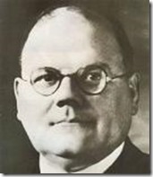
On August 9, 1957, Dr. Clauberg, 59 years old, died suddenly (alleged heart attack) while awaiting trial in Kiel for criminal conduct that “caused severe bodily harm” to large numbers of Jewish women at Ravensbruck and Auschwitz.[36] Not much is known about Dr. Mengele from 1956 until he resurfaces in Paraguay in May 1959 under the veil of Paraguay’s German-descended dictator, Alfredo Stroessner; and under his own name just months before Barack Obama II is conceived in December 1960. After surfacing in Paraguay in 1959, Dr. Mengele disappears again until he resurfaces again in Brazil from 1961 to 1962 after Obama II is born.
Artificial Insemination and sterilization technology developed under the Blood Oath Secrecy of Himmler and the SS at Auschwitz and Ravensbruck belonged exclusively to the benefit of Himmler and underground SS networks that controlled the CIA and West German Intelligence; exposure of the technology and competition with Dr. Clauberg to control and profit from that technology and its development just wasn’t going to happen.
Dr. Clauberg may have mistakenly believed that the dreaded Himmler truly died in British custody in May 1945; and that he was no longer bound by the SS blood oath of secrecy. He had been out of loop in Soviet’s hands since January 1945. However, Reichsfuhrer SS-1 Himmler was far too powerful, wealthy, shrewd and treacherous to have been captured while skipping through the tulips in the merry month of May around the city of Bremervörde (Lower Saxony) in Germany.[37]
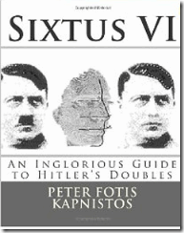
It was well established that most of the Nazi leadership regularly maintained secret doppelgangers, doubles and decoys. Himmler was a Knight and leader of an ancient Order of Teutonic Knights. He had thousands of powerful fellow Knights like OSS Allen Dulles and millions of Freemasons bound by a blood oath of secrecy at his feet and whim all over the world.
He also had access to millions if not billons in gold, securities, bonds and notes stashed all over the world. In May 1945, he still had over a million SS Waffen goons in Italy and probably a half million or more Allgemeine-SS Knights underground still active that would have fought to the last man to protect him. He had the Gehlen Org-CIA in his pocket. Additionally, he controlled access to secret nuclear technology-weapons and futuristic rockets, missiles, jets and U-boats. The man had access to spaceships. He had secret multi-national corporate and international banker goons in high places around the world. He held potential patents to secret revolutionary medical technologies that are still priceless even today. Yet, one of the world’s most powerful, richest, clandestine and dangerous men on earth was caught just merrily skipping among the daisies on a bright and sunny day along the Germany countryside on May 21, 1945, then conveniently committed suicide. That Dog Won’t Hunt.
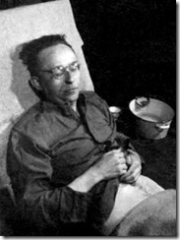
Tellingly, no known DNA exists to prove definitively that it was Himmler that committed suicide. The body was buried in a secret grave than may have been exhumed and the body cremated. Everything surrounding Himmler’s alleged body is sealed, classified and TOP SECRET from Britain to America.
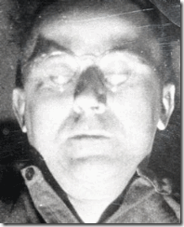
The body that was claimed to be Himmler’s had on the wrong glasses he commonly wore and it lacked his celebrated “Y” shaped dueling scar on the left cheek.[38] Himmler cherished that scar as a badge of ancient knightly chivalry. We also have a fairly good idea who put it there during the 1920s.[39] It had been his personal adjutant staffer, Standartenführer or Obersturmbannführer SS Dr. [Richard] Stahl.[40]
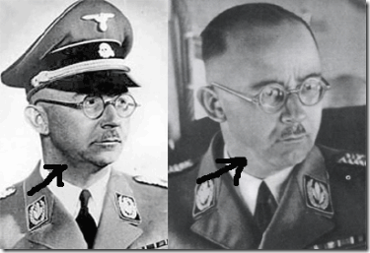
Then again, it is obvious that the Russians had abducted Dr. Clauberg out of Germany on more than the pretense of Crimes against Humanity. Surely, the outrages that he committed against humanity at Auschwitz and Ravensbruck were capital crimes that he should have swung the gallows or faced a firing squad for. Dr. Clauberg’s body count is estimated to have been numbered in the hundreds or in the thousands. Yet, it may have been Dr. Clauberg’s medical knowledge and expertise gained from the secret human experiment programs at Auschwitz that the Soviets were after.
The Soviets had their own secret team called, “BB Apparat”, which focused primarily on pursuing Nazi technical and scientific advanced warfare personnel, plans and technologies. The “BB Apparat” was a totally separate and independent operation that remains shrouded in mystery.[41] The Russians kept him alive and healthy for 7 years to begin a new day within days of release from captivity. I suspect that Russians abducted Dr. Clauberg also to keep him away from the special interests of the American, British and French forces.
“His [Dr. Clauberg] articles on experimental hormone research were published in the main German gynecological journal (1929-1940). He is represented in the Library of Congress in Washington with two books on neuroendocrinology experiments, especially with animals, which he published in 1933 and 1937. He also published on obstetrics. Clauberg is reputed to be an expert who developed a test to diagnose pregnancy at an early stage. He published important articles on infertility or so-called women diseases, especially on “follicle hormone cures” and on uterotubla insufflations, which he completed with a hysterosalpinogram in order to check the treatments’ success and to achieve “blowing up residual adhesions by pressure with the contrast fluid.”[42]
Undoubtedly, BB Aparat knew Dr. Clauberg’s scientific background and what he was doing at Auschwitz and Ravensbruck for the SS. They intensively interrogated him for at least 3 years before they finally put him on trial for crimes against humanity in 1948. He may have revealed the details about Himmler’s SS secret eugenic scientific agendas and programs.
He may have been turned into a soviet spy-mole and returned in the mass prisoner exchange. When Dr. Clauberg returned to West Germany, his ego and ambition got the best of him and went on public television to sell himself. He threatened to expose everything he told Russian intelligence for profit, it would have made their special information worthless and useless. The Soviets would also have a motive in liquidating him.
One Step Beyond- Dr. Clauberg, Dr. Mengele and Modern Genetic and Reproductive Technology
“We do know…that the scientific basis of modern gene and reproductive technology was firmly established in the Third Reich.” –Karl Heinz Roth[43]
The raw data that Dr. Clauberg, Neuroendocrinologist, and his colleague Dr. Mengele, Geneticist, developed in genetic and reproductive technology through the SS is priceless even today. The Nazis were at the forefront of revolutionizing biological and obstetric sciences for all the wrong demonic reasons (Duality-Satanic Principle),
I. Promote those worthy of reproduction and,
II. Eliminate those forms unworthy of reproduction.
During the war, Nazi reproductive focus took a radical turn from Lebensborn (promotion of sexual unions between pure Aryans to procreate the race) to laboratory research genetics and development. The Genetics Department at the Kaiser Wilhelm-Institute for Brain Research in Berlin was at the forefront of basic gene research in the area of breeding and selection. The institute was supported by the Emergency Organization of German Science (Notgemeinschaft det Deutschen Wissenschaft), Rockefeller and Carnegie Foundations.
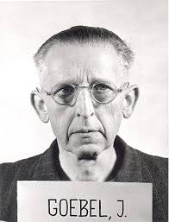
One of the leading German firms behind the Kaiser Wilhelm-Institute for Brain Research in developing sex hormone research was Schering-Kahbaum AG that Dr. Clauberg worked for and with at Auschwitz. In fact, Dr. Clauberg’s aide at Block 10 was Dr. Johannes Goebel, above, chief chemist with the Schering-Kahbaum AG pharmaceutical firm.[44]
It also appears that Himmler and the SS had secretly implemented and fully funded Dr. Clauberg’s proposals, a Reich Institute for Research on Reproductive Biology (Research Institute of the Reich for Biology and Reproduction); an animal experimental station; and two departments, one for the treatment of infertile women desirable for reproduction, and clinical advanced research on previous apparent hopeless cases of infertility, the other department to perform sterilization on women in an ambulant nonsurgical way- women not worthy of reproduction or not desirable for reproduction were to be used to test the operationless method.[45]
Dr. Clauberg’s infertile clinic operated out of two clinics outside Auschwitz, the Gynecological Clinic in Koenigshuttte, and the maternity and convalescent home of the National Socialist Welfare Service (NSV)- called the “City of Mothers” with a capacity of 800 mothers and 200 small children.[46]
Dr. Clauberg’s department that performed experimental sterilizations ran out of Auschwitz and Ravensbruck Concentration Camps. Dr. Clauberg’s Reich Institute of Reproductive Biology was most likely operated out of the Gynecology and Obstetrics Department of the German University of Koenisberg.[47] Russian Intelligence must have been fully informed of Dr. Clauberg’s clandestine SS programs and sent out a special detail to capture him before the American; British or French military intelligence could sequester him out of sight and mind.
With Dr. Karl Clauberg eliminated, the secret SS genetic and reproductive technology fell in the hands of their most secretive, loyal and dangerous Knight, Dr. Josef Mengele, and Dr. Mengele had been sequestered by Allen Dulles’ OSS then the Gehlen Org and the CIA.
Dr. Mengele and the Satanic Principle
Dr. Mengele’s dedicated SS mission had been to create an Aryan master race to rule the world- Positive-Divine Eugenics. It also gave him the dual mission to create a subservient race to do their will; and work for the master race- Negative-Profane Eugenics. It makes it possible and feasible to take bits of genetic material from one human and make somebody almost like him to function as an allegorical subhuman servant not only for consumption (work will set you free), but also mass political deception through mass hypnotism with imperfect ILLUSIONS of the Power and Will of the people.
“THE SS VRIL SATANIC PRINCIPLE”- AND ALTERNATIVE ENERGY THEORIES
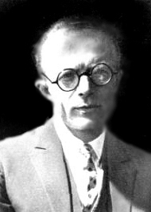
Dr. W.O. Schumann to the SS:
In all areas, there are two principles that determine events, light and darkness, good and evil, creation and destruction, as the positive and negative in electricity. This is always one way or another! These two principles designated concretely how the creative and destructive principles determine also our technical means […]
The destructive principle is the work of the devil, the creative principle, the work of God […]
Any technique based on the principle of explosion or combustion can be satanic technology. The new era that will be the age of a new technique, positive and divine! […] (Excerpt from the secret archives of the SS)[48]
Dr. Winfried Otto (W.O.) Schumann (1888-1974) was born in Tubingen, Germany, the son of a physical chemist. His early years were spent in Kassel and in Bergdorf, a town near Vienna. He majored in electrical engineering at the Technical College in Karlsruhe. In 1912, he gained a doctorate with high-voltage technology as his thesis. During 1920, he was made a professor at the Technical University in Stuttgart, where he had previously been employed as a research assistant. He subsequently took a position as professor of physics at the University of Jena. In 1924, he was made professor and director of the Electro physical Laboratory at the Technical University of Munich. During 1947-1948 he worked at the Wright-Patterson Air Force Base in Ohio, USA and then returned to his post in Munich.[49]
Like Dr. Clauberg, Dr. W.O. Schumann was a world renowned and distinguished scientific genius. When he talks about “Alternative SS Technologies and Theories”, a lot of people including I stop to listen. It gives us a rare opportunity into some insight of these people with other dimensional thought processes that caused so much death, destruction and chaos across the globe.
Behind the veil, Dr. W.O. Schumann was an Operation PAPERCLIP SS Nazi, an eminent international specialist in electromagnetic low-frequency resonances.[50] He founded the Schumann (electromagnetic) resonance of the earth. He was an ardent occultist, a member of the Thule and Vril Societies. He was an initiate of infamous Nazi VRIL MAIDENS. He developed a series of magnetic levitators-VRIL DRIVES for the SS’s Top Secret “Flying Discs”.[51] During 1947-1948, Dr. Schumann was an employee of the U.S. military at the Wright-Patterson Air Force Base in Ohio.[52]
Dr. Schumann was an essential part of the SS’s advanced development of virtual “flying saucers.” On January 22, 1944, Dr. Schumann, Hitler, Himmler and Kunkel of the Vril Society met in a top secret meeting to plan to drive a flying disc through a worm hole, inter-dimensional space travel.[53]
Dr. W.O. Schumann had a very rare discernment into this other “dimension: a dimension of sound, a dimension of sight, a dimension of mind- Twilight Zone.” If Dr. Mengele and his SS and its “Alternative Technologies and Theories” had anything to do with creating Obama, then in our normal understanding of the order of things,
We’re talking about our government!
We’re talking about a crime.
You must think on a different level, like the CIA does.
We’re through the looking glass.
White is black.
And black is white. -JFK, the Movie[54]
Hussein Barack Obama II, DEMON SEED, the Son of NONE
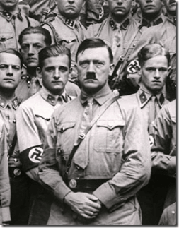
“He who does not carry demonic seeds within him will never give birth to a new world”. –A phrase found underscored by Fuhrer Adolf Hitler [55]
The Sacred Birth
“For thou hast possessed my reins: thou hast covered me in my mother’s womb. I will praise thee; for I am fearfully and wonderfully made;: marvelous are thy works; and that my soul knoweth right well.” -Palms 139: 13-14- The Original African Heritage Study Bible, KJV
Whatever dimension of mind(s) that created Hussein Barack Obama II has to be explored. If he was created and I am certain that he was, it opens a great moral, religious, ethical and spiritual debate that has existed since the beginning of recorded history.
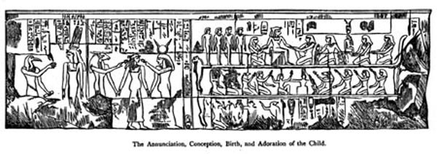
In the “Divine Birth” scene of Queen Mutemwiya, the mother of Amenhotep III; in a Luxor Scared Temple, Queen-Mother Mutemwiya is shown in scenes depicting the divine birth of her son Amenhotep III. The scenes resemble (and in some cases copy) scenes of the divine birth of Hatshepsut in Deir el-Bahari. Hatshepsut had used the birth story to reinforce her claims to the throne. Amenhotep was the son of a ruling Pharaoh and it seems that the birth scene is used to stress the semi-divine nature of Amenhotep III. In a key scene Mutemwiya is shown seated on a bed receiving the god Amun who had taken the form of her husband Thutmosis IV. They are in the presence of the goddesses Selket and Neith. The scenes show Amenhotep III to be the result of the union of his mother with the god Amun himself. A pregnant queen Mutemwiya is later shown being led to the birthing room by Isis and Khnum.[56]
Amenhotep III’s “Divine Birth” also included the entire Ogdoad of Hermopololis, primeval gods who, according to the Hermopolitian teachings, came into existence at the dawn of creation.[57]

Genesis 1:26-28, King James Version (KJV)
²⁶ And God said, Let us make man in our image, after our likeness: and let them have dominion over the fish of the sea, and over the fowl of the air, and over the cattle, and over all the earth, and over every creeping thing that creepeth upon the earth.
²⁷ So God created man in his own image, in the image of God created he him; male and female created he them.
²⁸ And God blessed them, and God said unto them, Be fruitful, and multiply, and replenish the earth, and subdue it: and have dominion over the fish of the sea, and over the fowl of the air, and over every living thing that moveth upon the earth.
In other words, since the beginning of recorded history, birth of human beings always involved the divine and sacred work of GOD(S). Biblically, human beings are made by God. They are created while still in the womb. God is the one who designed mankind, making them unique and special. The passages above supports the sanctity of life. God knows every embryo; every fetus is a unique individual made by God.
Honor thy father and thy mother: that thy days may be long upon the land which the LORD thy God giveth thee. Genesis 20:12
The Bible says that we are to bring up our children in “the training and admonition of the Lord” (Ephesians 6:4). It is not just the Christian bible that teaches us this, but it’s the age old recognition that the mother and father- family has been responsible for socialization of the child. Socialization describes a process which may lead to desirable, or ‘moral’, outcomes in the opinion of said society.[58] More than anything else, a child needs to know love, because a child’s relationship with a loving mother-father- family will teach the child the love for others and God.
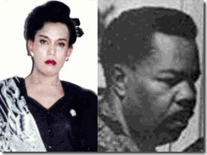
As we know, Obama II had an absolutely weird and bizarre upbringing and background for a U.S. President. Obama II was a scientific-satanic ritually sexual and trauma based abused child. He wasn’t raised by a father or even a father figure. He was only raised sporadically by his mother, Stanley Ann. She was a secular humanist,[59] she that condemns the concept of God.[60] In Indonesia, he was raised by Evie, above, the outcast transgender male prostitute.[61] In Hawaii, he was raised by GRAMS (grandfather), “the Red Light District” pot smoking drunk;[62] and by POPS, an UK ULTRA-MONARCH Handler, Frank Marshall Davis, the vile pedophile, a hideous and absolutely “ungodly” bisexual man.[63]
Hussein Barack Obama II nurtured an absolutely unnatural attraction and so-called intellectual love for T.S. Eliot,[64] not Karl Marx, Fanon, or even Dr. Martin Luther King, Jr. Obama II was a “T.S. Eliot Conservative”,[65] whatever that may be. Who was T.S. Eliot? He was vicious intellectual anti-Semite. May 10, 1940, Poet and essayist T. S. Eliot wrote that the Jews are the modern world’s foremost “Forces of Evil.” He claims that they have “made the modern world vile.”[66]
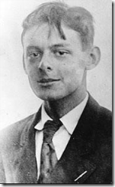
T.S. Eliot was among the ILLUMINATI-Luciferian High Priests of Cecil Rhodes’ Children of the Sun.[67] Trained at Toynbee’s Oxford, Aldous Huxley was also one of the initiates in the “’Children of the Sun,’ a Dionysian cult comprised of the children of Britain’s Roundtable elite. Among the other initiates were W.H. Auden, Sir Oswald Mosley, and D.H. Lawrence, Huxley’s homosexual lover. It was Huxley, furthermore, who would launch the legal battle in the 1950s to have Lawrence’s pornographic novel Lady Chatterley’s Lover allowed into the United States on the ground that it was a misunderstood “work of art’.”[68]
Obama was abnormally fixated with T.S. Eliot. He was an avid and astute student of Eliot’s “The Waste Land” (1922) and clearly understood Eliot’s aims as a Aquarian poet and public figure at that time.[69] Behind the veil of the “The Waste Land”, critics claim that T.S. Eliot’s French male lover, Jean Verdenal, might be the real-life figure behind the poem’s characters Phlebas the Phoenician and the hyacinth girl.[70]
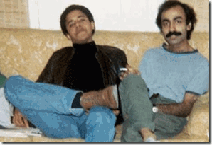
Above, In 1981, Obama II had his own “Waste Land” drama going on holding hands with his Pakistani lover and roommate, Sohale Siddiqi.
Obama II’s creators and handlers have done everything possible and consistent with nurturing and grooming a BOY FROM BRAZIL for the highest elected office of the United States, a cybernetic and robotoid, A SON OF NONE and a “DEMONIC SEED.’ In Part III, I will review baby Barack Hussein Obama II, Dr. Gregory Bateson, University of Hawaii, U.S. military industrial complex and the socialization project of the secret robotoid and cyborg, then in Part IV explore some of Barack Hussein Obama’s puppet masters such as Fritz Kraemer, Zbigniew Brzezinski , Henry Kissinger, SS and Satanic Global High Cabal.

[1] Aziz, Phiilippe, Doctors of Death, Vol. 2, Ferni Publishers, Geneva, 1976, pgs. 78-80
[2] http://en.wikipedia.org/wiki/Josef_Mengele
[3] http://www.escape2poland.co.uk/auschwitz_gate.html
[4] Aziz, Phiilippe, Doctors of Death, Vol. 2, Ferni Publishers, Geneva, 1976, pg. 82
[5] Aziz, Phiilippe, Doctors of Death, Vol. 2, Ferni Publishers, Geneva, 1976, pg 91
[6] Aziz, Phiilippe, Doctors of Death, Vol. 2, Ferni Publishers, Geneva, 1976, pg. 82
[7] Aziz, Phiilippe, Doctors of Death, Vol. 2, Ferni Publishers, Geneva, 1976, pg. 106
[8] http://www.auschwitz.dk/Mengele.htm
[9] Aziz, Phiilippe, Doctors of Death, Vol. 2, Ferni Publishers, Geneva, 1976, pg. 105
[10] Aziz, Phiilippe, Doctors of Death, Vol. 2, Ferni Publishers, Geneva, 1976, pg. 82
[11] http://www.ptla.us/TaylorW.html
[12] http://en.wikipedia.org/wiki/SS_command_of_Auschwitz_concentration_camp#Senior_chain_of_command
[13] http://www.whonamedit.com/doctor.cfm/3264.html
[14] http://www.whonamedit.com/doctor.cfm/3264.html
[15] http://en.wikipedia.org/wiki/Sturmabteilung
[16] Aziz, Phiilippe, Doctors of Death, Vol. 2, Ferni Publishers, Geneva, 1976, pg. 169
[17] Aziz, Phiilippe, Doctors of Death, Vol. 2, Ferni Publishers, Geneva, 1976, pgs. 156-7
[18] http://www.britannica.com/EBchecked/topic/478202/progesterone
[19] http://www.sri.com/research-development/developmental-reproductive-toxicology
[20] Aziz, Phiilippe, Doctors of Death, Vol. 2, Ferni Publishers, Geneva, 1976, pg. 160
[21] Aziz, Phiilippe, Doctors of Death, Vol. 2, Ferni Publishers, Geneva, 1976, pg. 169
[22] Aziz, Phiilippe, Doctors of Death, Vol. 2, Ferni Publishers, Geneva, 1976, pg. 169
[23] http://www.trutv.com/library/crime/serial_killers/history/mengele/aus_4.html
[24] http://www.bigeye.com/sexeducation/naziinsemination.html
[25] http://www.chgs.umn.edu/museum/exhibitions/ravensbruck/liberation.html
[26] http://simbahayan.tripod.com/B5-kclauberg.html
[27] http://en.wikipedia.org/wiki/Yalta_Conference
[28] http://en.wikipedia.org/wiki/Nuremberg_Trials
[29] http://www.ushmm.org/wlc/en/article.php?ModuleId=10007069
[30] http://www.jewishvirtuallibrary.org/jsource/biography/Clauberg.html
[31] http://moversandshakersofthesmom.blogspot.com/2008/08/konrad-adenauer.html
[32] http://moversandshakersofthesmom.blogspot.com/2008/08/konrad-adenauer.html
[33] http://moversandshakersofthesmom.blogspot.com/2008/08/konrad-adenauer.html
[34] http://www.mosquitonet.com/~prewett/caqsmom25.1.html
[35] Gutman, Yisrael, Anatomy of the Auschwitz Death Camp, Indiana University Press (1998) pg. 307
[36] http://simbahayan.tripod.com/B5-kclauberg.html
[37] http://www.deathcamps.org/reinhard/himmler.html
[38] http://en.wikipedia.org/wiki/Political_decoy#Heinrich_Himmler.2Funknown_.28.3F.E2.80.931945.29
[39] Amberger, Christoph, The Lararus Smile (The Stahl Unholy Grail Papers), Secret Archives Press, Baltimore, MD (2008), pgs. 194-5
[40] http://www.mazal.org/archive/nmt/08/NMT08-T0534.htm
[41] Aarons, Mark, Unholy Trinity, How the Vatican’s Nazi Networks Betrayed Western Intelligence to the Soviets, St. Martin Press, NY, NY (1991), pg. 272
[42] Kaupen-Hass, Heidrun, Experiment Obstetrics and National Socialism: The Conceptual Basis of Reproductive Technology Today, Reproductive and Engineering, Vol. 1, No. 2, pp. 127-132, 1988/ http://www.finrrage.org/pdf_files/RepTech%20General/Experimental_Obstetrics_and_National_Socialism.pdf
[43] Roth, Karl H., Brave New Man. The Change of Paradigms of Classical Genetics and its Effects on the Population Biology of the “Third Reich” (1986)
[44] http://www.holocaust-history.org/lifton/LiftonT272.shtml
[45] Kaupen-Hass, Heidrun, Experiment Obstetrics and National Socialism: The Conceptual Basis of Reproductive Technology Today, Reproductive and Engineering, Vol. 1, No. 2, pp. 127-132, 1988
[46] Id.
[47] Aziz, Phiilippe, Doctors of Death, Vol. 2, Ferni Publishers, Geneva, 1976, pg. 237
[48] http://hyperboreanvibrations.blogspot.com/2011/04/vril-society-secret-societies-and-their.html
[49] http://en.wikipedia.org/wiki/Winfried_Otto_Schumann
[50] Id.
[51] http://greyfalcon.us/restored/THE%20NAZI%20UFO%20ENIGMA.htm
[52] http://en.wikipedia.org/wiki/Winfried_Otto_Schumann
[53] http://www.thelivingmoon.com/43ancients/20nazi_ufos/Vril_01.html
[54] http://www.script-o-rama.com/movie_scripts/j/jfk-script-transcript-oliver-stone.html
[55] http://www.gnosticliberationfront.com/hitler,nazis%20and%20the%20occult.htm
[56] http://en.wikipedia.org/wiki/Mutemwiya
[57] Blavastsky, H.P., H.P. Blavatsky Collected Writings 1887, The Theosophical Publishing House, Wheaton, IL(1960), pgs. 376-377
[58] http://en.wikipedia.org/wiki/Socialization
[59] http://www.psychologytoday.com/blog/addiction-in-society/201104/obamas-search-his-mother-0/comments
[60] http://www.secular-humanism.com/
[61] http://www.huffingtonpost.com/2012/03/05/evie-obamas-transgender-nanny-indonesia_n_1320927.html
[62] http://servv89pn0aj.sn.sourcedns.com/~gbpprorg/obama/ObamaFamily.html
[63] http://www.freerepublic.com/focus/f-news/2066754/posts
[64] http://www.huffingtonpost.com/2012/05/02/obama-t-s-eliot-_n_1472524.html
[65] http://www.nytimes.com/2012/05/09/opinion/young-obama-an-eliot-conservative.html?_r=0
[66] http://www.jewishvirtuallibrary.org/jsource/Holocaust/Chronology_1940.html
[67] http://dc252.4shared.com/doc/aI67vjnp/preview.html
[68] http://dc252.4shared.com/doc/aI67vjnp/preview.html
[69] http://abcnews.go.com/blogs/politics/2012/05/t-s-eliot-scholars-give-high-marks-to-obamas-analysis/
[70] http://world.std.com/~raparker/pub/jean.html
Comments : 4 Comments
Tags: Artificial Insemination and sterilization technology, Auschwitz, Barack Hussein Obama II, BB Apparat, Black Manchurian Candidates, cecil rhodes, children of the sun, CIA, Clauberg-McPhail Endometrial, cyborgs, demon seed, demonic seed, Dissociate identity disorder, Dr. Johannes Goebel, Dr. Josef Mengele, Dr. Karl Clauberg, Dr. W.O. Schumann, Evie, frank marshall Davis, gehlen org, Hauptsturmfuhrer SS Josef Rudolf Mengele, Imperium, Knights of the Black Sun, michelle obama, Monarch Programmed Marionettes, Monarchs, Nazis, robotoid, round table, Satanic Global High Cabal, Satanic Principle, Sohale Siddigi, SS, Stanford Research Institute, The Boy from Brazil, TS Eliot, Zbigniew Brzezinski
Categories : 1000 Year Reich, Amenhotep III, Barack Obama, blood covenants, blood oaths, bloodlines of wotan, boys from brazil, cyborg, cyborgs, divine one, Dr. Josef Mengele, Hauptsturmfuhrer SS Dr. Josef Mengele, Heinrich Himmler, illuminati, imperium, Josef Mengele, Knights of the Black Sun, lucifer's servants, luciferians, manchurian candidates, Michelle Obama, mind control, MK-ULTRA, National Socialism, Nazis, new world order, Nuremberg Tribunal, Operation PAPERCLIP, order of teutonic knights, Paperclip Project, racial mass murder, Reichsfurhrer SS-1 Heinrich Himmler, reinhard gehlen, Ritual Satanic Abuse, ritual satanic sexual abuse, ritually abused children, satan, Satanic Global High Cabal, Schutzsteffel, SS, trauma-based mind control, vril, Zbigniew Brzezinski

REV. JIM JONES & BARACK HUSSEIN OBAMBA II- THE BOY FROM BRAZIL, Part 1
11032013
BARACK HUSSEIN OBANA II, The Son of NONE
THE BOYS FROM BRAZIL-The Fictional Exploits of Dr. Josef Mengele
“You’re traveling through another dimension — a dimension not only of sight and sound but of mind. A journey into a wondrous land whose boundaries are that of imagination. That’s a signpost up ahead: your next stop: the Twilight Zone! You unlock this door with the key of imagination. Beyond it is another dimension: a dimension of sound, a dimension of sight, a dimension of mind. You’re moving into a land of both shadow and substance, of things and ideas. You’ve just crossed over into… the Twilight Zone. There is a fifth dimension beyond that which is known to man. It is a dimension as vast as space and as timeless as infinity. It is the middle ground between light and shadow, between science and superstition, and it lies between the pit of man’s fears and the summit of his knowledge. This is the dimension of imagination. It is an area which we call “The Twilight Zone”. –Introduction, Rod Sterling[1]

As usually as I have done for decades, I watched the early 2012 national presidential elections on television. At the time, Republican candidate Mitt Romney was far ahead of the incumbent President Barack Obama. I turned off the television and went to bed, because I knew by the time that I woke up in the morning nothing would change and that Barack Obama would be re-elected as America’ highest elected official. In war and peace, he has been a blind zombie-surrogate for the secret Power Elite- the Satanic 1000 Year Reich.
Under President Obama, U.S. MASS MURDER, Inc., is engrossed in unlimited and perpetual global warfare against and the poor, middle class and particularly People of Color.[2] Under President Obama, one study calculated that during his administration, “the single largest transfer of wealth from people of color to whites since slavery” took place and continue quietly right under own collective noses.[3]
I do not subscribe to any such platforms of the so-called “Birthers” movement regarding U.S. President Barack Obama being a foreigner that should be removed from office on constitutional grounds. I do not subscribe to the notion that President Obama is any type of communist conspiracy. These are simply “red herrings.” The power structure and the war state of America will not allow a communist or a Muslim to obtain the highest office of the country without he or she being a virtually mindless zombie under their complete power and absolute power and control. They will kill anything that would even remotely expose or compromise the Imperium’s Power Elite.
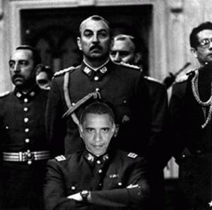
Already, President Obama has claimed the unparalleled power and authority to secretly KILL, Torture and Imprison you or I for life at his WHIM even if he remotely suspects based on NO EVIDENCE that you would- or could threaten him or the Power Elite. The Obama Administration has instituted its version of Chilean General AUGUSTO PINOCHET’s secret Nazi Colonia Dignidad murder, interrogation and torture chambers throughout the world.
The United States have become an extremely jealous and racialist war state brutally and savagely attempting to annihilate independent Nations; and People of Color like something out of Nazi Germany. The unseen extremely imperial racialist forces that truly rule the affairs of America and their motives are shrouded by smoked mirrors, trickery, deceptions, false images and ILLUSIONS. One of their Master ILLUSIONS leading this nation to the brink of COLLAPSE is Barack Hussein Obama II.
The man that we know as Barack Hussein Obama II was fabricated and created to veil a hidden agenda and policy of global geo-political and economical warfare and genocide hidden behind him.
The partisans of eugenic planning hear that other music, the music that says that there shall be nothing random in the world, nothing independent, nothing moved by its own vitality, nothing out of keeping with some idea: even our children must not be our progeny, but our creation. -Charles Frankel[4]
Charles Frankel was an American philosopher, Assistant U.S. Secretary of State under President Lyndon B. Johnson, professor, and founding director of the National Humanities Center.[5]
When I say that Obama was fabricated and created, I mean CLONED. Obama Hussein Obama II is the design by some of the most diabolical forces out of some other dimension of demonic understanding that ever walked the face of the earth.
They have explored other summits of human imagination that produced revolutionary breakthroughs in medicine and science; atomic bombs and space ships; and global mass murder by the millions and chaos unlike anything seen in recorded human history.
They are in the middle ground between light and shadow, between science and superstition, and they lay between the pit of man’s fears and the summit of his knowledge; and they exists so far from our basic religious, social and political understanding of the known order of things that you won’t believe your lying eyes.
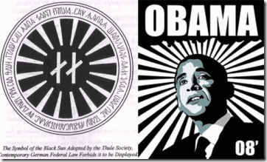
As the old folks say, “You don’t believe that fat meat is greasy” until you slip on it and fall flat on your face close to oblivion. Behind the veil of Barack Hussein Obama II, The Boy From Brazil, the ILLUMINATI Power Elite intend to bring this nation to the edge of destruction; and create a police-security state of utter and complete FASCISM.
The Clandestine Birth of the Boy from Brazil
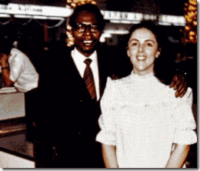
Barack Obama II is allegedly a seed of a native Kenyan, Barack Obama, Sr. and an American woman, Stanley Ann Dunham, with Scottish-Gaelic roots. Yet, there is little or no evidence that they ever lived together as husband and wife to procreate a child. The above photo of Obama, Sr. and Stanley Ann was taken at the international airport in Hawaii around Christmas 1971.
In fact, when Obama, Sr. arrived in Hawaii to attend the University of Hawaii; he was greeted by a contingent of U.S. Naval personnel and Stanley Armour Dunham, Stanley Ann’s father. A national security analyst contends that the CIA might well have assigned Dunham to keep an eye on Obama. In other words, “Grams” Dunham had been Barack Obama, Sr.’s CIA handler.[6]
At the time of Obama’s February 2, 1961 marriage to Stanley Ann, the U.S. Immigration and Naturalization Service (INS) suspected from suspicious circumstances surrounding the pair that they weren’t really husband and wife. What was of INS concern was that Obama Sr. and Dunham were not living together as husband and wife, and their marriage might have been arranged solely for immigration purposes.[7]
The Obama-Dunham wedding had no minister of any faith. There were no bridesmaids, witnesses or guests, nor friends or parents. There doesn’t appear to be any wedding photo albums, a record of the happy event. There is no wedding license or marriage certificate in the divorce papers. Is fat meat greasy or what?
In fact, after interviewing Obama, Sr., INS concluded that they weren’t living together; and they were contemplating giving the baby to the Salvation Army for adoption.[8] This is not what I am saying, it’s the conclusions of the INS that investigated the marriage and actually interrogated Obama Sr. about his possible “SHAM” marriage to Stanley Ann Dunham.
The INS memo memorializing the conversation with Obama, Sr., and their conclusions and speculations concerning the marriage were dated, February 12, 1961, almost 6 months before Barack Obama II’s birth.[9] The INS memo also shows conclusively that Obama, Sr. had some notable “dissociation” with the baby; so much so, he openly contemplated giving the child away.
Additionally, on August 31, 1961, just days after Obama II was born, Obama, Sr. executed an INS document requesting to extend to his stay in the United States. INS asked him, “if married, provide name and address of children”. By all accounts, Obama, Sr. was a man of unusual and exceptional intellect, but he left this section completely “BLANK” suggesting that he was so distant, “dissociated” with the child that he didn’t really know where Stanley Ann and the child were.
He hadn’t seen the child; and at the most wasn’t particularly interested in seeing the child or his wife. “Pieced together, the available evidence supports the theory the Obama-Dunham marriage was a cover-up from the start, designed to designate Obama as the father, without any expectation the two would ever live as husband and wife or that he would help raise the baby.”[10]
Furthermore and extremely significant is the fact that, “[T]here is a six-and-a-half-month time period in which there is no record of Dunham’s whereabouts – from Jan. 31, 1961, when she concluded her first semester at the University of Hawaii at Manoa, until Sept. 25, 1961, when the University of Washington at Seattle documents she was enrolled for extension classes on campus.”[11]
In fact, Stanley Ann disappeared around the time that would have been the first trimester of pregnancy. By the end of the third month of pregnancy, the baby is fully formed. The baby has arms, hands, fingers, feet, and toes and can open and close its fists and mouth.[12]
It is also interesting that nobody seems to have seen her pregnant and nobody has any idea where she was sequestered whether in Hawaii, Africa, Germany, Canada or in Brazil after allegedly her first trimester of pregnancy. It is also noteworthy that the federal and state record travel archives of people that moved in and out of Hawaii covering January to September 1961 is conveniently missing.
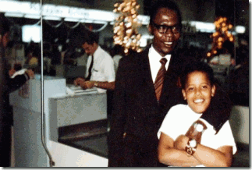
It also appears that Obama, Sr. may have seen and met his alleged son, Barack H. Obama II, only once in December 1971 at the Hawaii International Airport for a staged photo shot for the Legend.[13] Other than that, during his life, Obama, Sr. was patently disinterested and “dissociated” from his alleged son all the days of his life. If Barack H. Obama, Sr. didn’t know what or who Barack H. Obama II was, what makes you so certain that anyone really knows what or who he really is?
Stanley Ann Dunham, Barack Obama, Sr., Rev. Jim Jones & the Gehlen Org
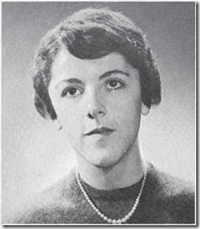
In the summer of 1960 Stanley Ann Dunham reportedly told her friends: “I don’t need to date or marry to have children”.[14]
I wonder where Stanley Ann developed such unnatural notions suggesting the replacement of procreation (Beyond Lebensborn) by the manufactury of children.
Jim Jones: Dusting the Trail of Hauptsturmführer SS Dr. Josef Rudolf Mengele
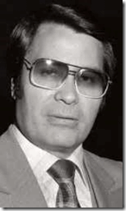
Within days of Stanley Ann surfacing at the University of Washington, CIA Field Agent Jim Jones of the Peoples Temple and a CIA Soviet Specialist Jon S. Lodeesen mysteriously appears somewhere in the picture in Hawaii.
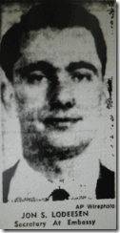
Special agent Lodeesen was like something of a Ian Fleming’s James Bond Movie. Lodeesen had been a spy for much of his life. According to Soviet intelligence officers, he was a CIA Special agent who taught at the US intelligence school in Garmisch Partenkirchen, West Germany—-a sort of West Point for spooks.[15]
Garmisch, or officially known as Garmisch-Partenkirchen, is a beautiful resort town nestled in the Bavarian Alps on the German/Austrian border north of Munich. In May 1945, the 10th Armored Division captured Garmisch and shortly thereafter, the Garmisch Military Post and the Garmisch Recreation Area (now Edelweiss Lodge and Resort) were established.[16]
The US Army Counter intelligence Corps (CIC) setup a major operation out of the Garmisch-Partenkirchen office. It was used as a resort, interrogation center and briefing station for Nazi Operation PAPERCLIP scientists and way station/safe house for the Reinhard Gehlen Org’s SS-CIA agents.
It was the place that the U.S. Army CIC and Allen Dulles OSS assembled four hundred of Obergruppenguhrer SS Dr. Ing (Engineer) Hans Kammler’s Peenemunde rocket team that included Sturmbannführer SS Werner von Braun and Brigadeführer SS Walter Robert Dornberger for interrogation and briefing.[17]
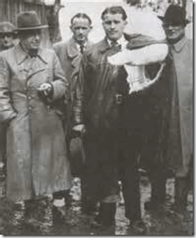
May 1945 in Germany, SS CULT Leaders Walter Dornberger and SS Wernher von Braun Surrender
Lodeesen was not only a CIA Soviet specialist, but he was right in the middle of America’s most TOP SECRET Operations, Project PAPERCLIP and Operation CAMPUS. In May 1945, Lodeesen (br. about 1924) would have been a young army officer about 21 years old during CIC’s interrogation and briefing at Garmisch of some of Hitler and Himmler’s most treacherous and sinister Nazis and blood oath SS Teutonic Knights (The Order of Brothers of the German House of Saint Mary)[18], among the likes of Reinhard Gehlen, SS von Braun, SS Dornberger and the Germany High Command.
It was likely the other way around at Garmisch; Lodeesen was a student and initiate of the SS CULT. He had been taught Soviet espionage activities by Reinhard Gehlen, and Himmler’s SS; such as Baron Otto von Bolschwing and Hitler’s Commando Otto Skorzeny. Lodeesen was part of the CIA’s most secretive, dangerous, treacherous and Satanic fraction, The SS CULT, the Reinhard Gehlen Org.
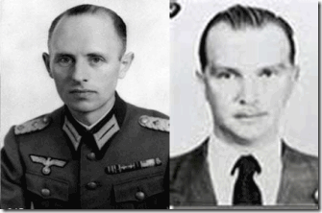
Since the Secret Fort Hunt Treaty of August 1945,[19] General Reinhard Gehlen and SS Baron von Bolschwing had been running an independent SS CULT fraction of the CIA out of a U.S. Military Top Secret program, Operation CAMPUS, at the 66th CIC Detachment at Hallschlag University in Stuttgart-Bad Cannstatt, Baden-Wurtemburg, Germany.[20],[21] Baden-Württemberg, Southern Germany shares borders with France and the states of Rhineland Palatinate, Heese and Bavaria.[22]
Despite the presence of CIA liaison officers, the 66th CIC Detachment succeeded in keeping its huge CAMPUS operation secret and out of reach of U.S. Military Intelligence G2. At the CAMPUS, Gehlen and SS Bolschwing were able to re-assemble key SS personnel such as wanted war criminals Dr. Josef Mengele, Klaus Barbie and SS networks that ultimately became the Gehlen Org. It became a safe house for some of Himmler’s most fervent and hardcore SS Knight Officers. The secret Gehlen Org-CIA fraction became an important and secretive key part of Allen Dulles’ powerful Old Boys’ network.[23]
In May 1968, the Los Angeles Times reported that 34 year old Jon S. Lodeesen’s cover as an undercover CIA Agent had been blown by Izvestia, a Soviet Newspaper. Izvestia accused Lodeesen from Miami of posing as the U.S. Embassy Second Secretary-Cultural Officer practicing espionage and psychological subversion in Russian Circles. Lodessen’s mission as the cultural officer was to watch movements in art, literature and theatre. The newspaper accused him of associating with Russian lovers of vodka, dirty rumors and gossip that were potential allies of the U.S. in case of war. He wasn’t officially expelled from the country, but with his cover blown he immediately left the country for a U.S. mission to NATO in Brussels.[24]
“While one cannot say that Jones’ 1960 visit to Cuba was necessarily a spying mission, the circumstantial evidence suggests that it was. Virtually every element of the trip can be shown to have been of particular interest to the CIA.” Jim Hougan, Independent Investigator[25]
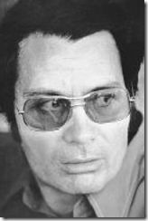
Jon Lodeesen was Jim Jones’ CIA handler. In 1961, Lodeesen sent Jones on an urgent assignment in Hawaii. Jones’s whereabouts from 10/61 until 4/62 is unknown and his U.S. Passport for that period is conveniently unaccounted for. Jones’ U.S. Passport #0111788 is accounted for, but it was issued in his name at Indianapolis on January 30, 1962 well after and during his presence in Cuba and Hawaii.[26]
From October 6, 1961 to April 1962, Jim Jones whereabouts is secret, which covers Obama Sr.’s sensitive presence at UH, and within days of Stanley Ann Dunham suddenly resurfacing at the University of Washington in Seattle. In fact, how Stanley Ann and Obama II got to Seattle, WA in August 1961 is an absolute mystery.[27]
At least one source placed Jim Jones in Hawaii in October 1961 most likely at the University of Hawaii (UH) with Barrack Obama, Sr., “On what would become a two-year sojourn, Jones made his first stop in Honolulu, where he explored a job as a university chaplain…”[28] At least one other source place both Lodeesen and Jones in Hawaii from 1961 to 1962 working with the CIA station in Honolulu.[29]
By Lodeesen being established as one of Jim Jones’ primary CIA handlers, we get a clear understanding of what his mission would have been in Hawaii- that is psychological subversive intelligence activity. Jim Jones would have clandestinely moved about UH closely monitoring rumors and gossip about Obama, Sr., Stanley Ann and Obama II.
Jim Jones would have recruited and influenced potential allies to spread friendly misleading information, gossip, rumors and join in the interest of the agency’s psychological disinformation project. Jones would have run a similar psychological warfare field operation in Cuba preceding Allen Dulles’ April 17-19, 1961 Bay of Pigs military invasion and aggression.[30]
Recall that from January to late August 1961, officials of the U.S. Immigration and Naturalization Service (INS) in Hawaii were hot on the trail to undercover the details of a sham marriage between Obama, Sr. and Stanley Ann Dunham which would have opened Pandora Box to a major TOP SECRET CIA operation.
Naturally, Jim Jones would have assessed the damages of Barack Sr.’s noted “playboy” activities with other women on campus; and leaks from the university and the INS that could potentially threaten to destroy the legend and cover of the marriage.[31]
Additionally, Hawaii Gov. Neil Abercrombie was undoubtedly recruited to provide false cover to the Obama, Sr., Stanley Ann and Obama II Legend. He told Fox News that he was there when Obama II was born than changed the story that he was there with them at UH, “We not only saw him and were with them, but were introduced to him of course at our gatherings, our student gatherings…” [32]
However other sources contradict Abercrombie, Boston Globe reporter Sally H. Jacobs who had access to what appears to be Obama Sr.’s un-redacted Immigration and Naturalization Service files wrote on page 118 of her book, The Bold and Reckless Life of Obama’s Father, that Obama Sr. “said nothing of his new girl friend [Stanley Ann Dunham] to most of his friends on campus.” Yet on the same page, she insisted that Gov. Abercrombie saw them on campus within days of the birth of Obama II. [33]
My intention is not to question where Obama II was born, but show that there is a great deal of mystery surrounding whether or not Obama, Sr. actually ever co-habituated with Stanley Ann, and show that were gaps and loose ends in the UH legend that the CIA needed to cover.
Jim Jones with a turned around collar was most likely assigned directly to Obama, Sr. to supervise him and clean up his act around UH. It appears that after the appearance of Jim Jones in Hawaii and UH, the INS backed away from Obama, Sr. It also appears that INS didn’t question Stanley Ann, Stanley Armour or Madelyn Dunham about the marriage.
After graduating with honors, Obama, Sr. left UH on June 22, 1962 to tour the states and attend Harvard all the way in Boston, then the INS active investigation of Obama. Sr. picked up again in 1964 forcing him out of the United States.[34] In January 1964, Stanley Ann also initiated uncontested divorce proceedings against Obama, Sr.[35]
Somebody wanted Obama, Sr. out of way as far from Stanley Ann and Obama II as could be manufactured to continue stacking the early Legend of Barack Hussein Obama II. Stanley Ann Dunham returned to Hawaii almost immediately after Obama Sr. left the island, and resumed her study of Mathematics in the spring of 1963 at the UH.[36]
Stanley Ann, Obama, Sr. & Operation BLOODSTONE
Obama, Sr. and the Mysterious Boston Lithuanian Maiden
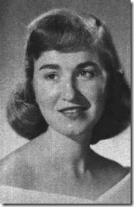
Sometime between May and June 1964; Obama, Sr. was quietly eased out by Harvard through conspiring with the INS and returned to Kenya. He didn’t leave alone. He left the country followed by a little talked about 27-year old white female, named Ruth Nidesand. If she was 27 years old in 1964, she was born somewhere around 1937. However, some sources say that she was born around 1940-1941.[37] She won’t discuss age or background.[38]
Ruth is a mysterious white Russian- a descendent of the Eastern European country of Lithuania that goes by several names, Ruth Ndesandjo, Ruth Baker and Ruth Beatrice Baker. Her real identity, roots and background is unusually shaded in mystery.
The INS had recorded that someone called and complained to Harvard University that Obama Sr. was taking their daughter out of the country. Some sources identified the daughter as “Ruth Nidesand.”[39] However, it may have been “Ruth Beatrice Baker.” The matter could be easily cleared up, but Ruth refuses to discuss her names, age, family and true background.
Nevertheless, she has been generally linked and associated with a Yiddish family of immigrant white Russians with the surname of “BAKER”.[40] Strangely, her alleged parents, Maurice Joseph and Ida Ethel Baker, didn’t become naturalized U.S. citizens until August 31, 1942 during WW II even though they had been in the country since the early 1900s.[41] On August 23, 1942, the Nazis began a massive air attack on Stalingrad.[42]
Out of a union with Obama, Sr. in Kenya where she remains, Ruth had two boys, David and Mark. One survived that goes by the name of Mark Okoth Obama Ndesandjo who has been tucked away in China for over a decade. He carries an uncanny striking resemblance to Obama, II. [43]
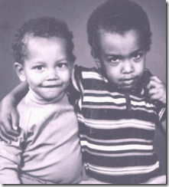
Above, David Ndesandjo (br. 1967) and his younger brother, Mark Ndesandjo.
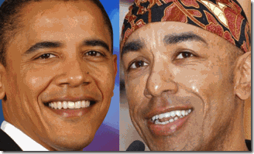
Strangely and troubling, Mark resembles Barack Obama II more than his biological brother in rather an eerie way. So much for the nonsense that Frank Marshall Davis or Malcolm X could be Obama II’s true father.
As far as the uncanny resemblance between Mark and Obama II, he can happen, but it is still odd under these circumstances. Undoubtedly, Mark and Obama II share some common DNA source.
Mark’s biological brother David was killed in 1987 in a mysterious motorcycle accident when he was about 20 years old. It was 4 years after Obama, Sr. was found on the road dead at the age of 46. There appears to be little details regarding David’s death, but he may have lost his head in the accident.
Mark Ndesandjo is another Obama family link who is shrouded in mystery. He is extremely strange and belligerently evasive about his past and background. His actual birthrate is a big secret like his mothers. He graduated from Brown University; studied physics at Stanford University received an MBA from Emory University.[44] He is notably intelligent, but an intelligence for whom? He worked with handmaidens of the America’s military industrial complex and the CIA; Lucent Technologies [45] and Nortel Networks.[46] He said that he fled America after 9-11 but refuses to discuss what intelligence communication work he was involved in doing the 9-11 deception operation.
Mark chose to carry the surname of his stepfather, Ruth’s second husband- Simeon Njdesandjo, who had been a close friend of his father. Simeon turns out to be an interesting character. Mark and David attended U.S. State Department “International Schools” in Nairobi, which means one of both parents was working in the interest of the U.S. Military, Government or its corporate interests.[47]
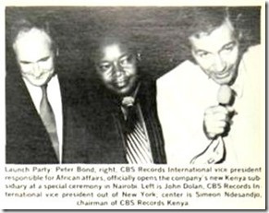
Simeon is a well connected Kenyan referred to as “one of the top persons in Voice of Kenya.”[48] The Voice of Kenya was actually the state run radio station, Kenya Broadcasting Corporation (KBC), which had been established in 1928 by and for white British colonials.[49]
In 1964, Kenya Broadcasting Corporation (KBC) was nationalized into Voice of Kenya (VoK) through an Act of parliament.[50] It was after the assassination of JFK and in the middle of the cold war that it went from KBC to VoK similar to the CIA’s Voice of America[51] that seemed to reflect a similar anti-communist philosophical mission; and share broadcasters in common.[52]
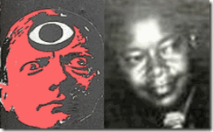
In 1979, Simeon became Chairman of CBS Records Kenya, a new subsidiary of CBS Records, International.[53] CBS Records International simply referred to as CBS in logo, was the international arm of the Columbia Records unit of Columbia Broadcasting System, Inc.[54] CBS (Columbian Broadcasting System) was/is the “CIA’s most valuable asset.”[55] CBS Records was run by our old friend and Whitney Houston’s most valuable ILLUMINATI-Columbian high priest, CLIVE DAVIS.
Simeon and Obama, Sr. had been part of the Kenyan bourgeois ruling class manipulated by American, British and French Intelligence to protect western imperial-corporate monopolies and pre-colonial interests like Shell Oil Company. Former U.S. Ambassador of Kenya, William Hollingsworth Atwood, wrote a book in 1967, Reds and the Blacks (London 1967) gloating how he and most likely the CIA manipulated and controlled the aspirations of the Africans through the petty bourgeois ruling classes in Africa.
Unfortunately for whatever reasons, Obama, Sr. became no longer useful. He was a loose end that knew too much to be left to prosper and live. Ruth Beatrice Baker just moved on to another prominent and powerful Black Kenyan, Simeon Njdesandjo, in the western imperialistic exploitation mix that needed to be watched, monitored and controlled. It also explains why Mark chose the Njdesandjo surname and travels so fluidly, comfortably and quietly from country to country.
After being widely exposed when he met with his half brother, President Obama, in China in November 2009, Mark’s semi-autobiographical story, “Nairobi to Shenzhen” A Love Novel in the East, appeared that primarily focused on the established CIA legend of Obama, Sr. as a “Big Black Brute,” a drunken abusive parent that beat his wives and children.[56] What is strange and unusual about his semi-autobiographical story supporting the demonization of Obama, Sr. is that it was actually published October 20, 2009 just days ahead of President Obama’s arrival to China.[57] Was it a psychological warfare tactic to control focus to direct attention away from Mark Nsesandjo’s military intelligence background and the 9-11 Deception?
Stanley Ann, The Boy From Brazil and the Seattle Lithuanian Safe house

When Stanley Ann and Obama II had suddenly re-surfaced in Seattle in August 1961, they settled in the safe house of Mary Toutonghi whose husband, Joseph, also allegedly of Lithuanian descent. Mary says that she had been Obama II’s babysitter in infancy. There is some information on the internet that links a “Joseph Toutonghi” to a post WWII Egyptian immigrant that married a woman from a post WWII misplaced persons camp in Germany. Her home land had been Riga, Latvia. Note, The CIA sent Hitler’s Commando SS Otto Skorzeny of the Gehlen Org to replace King Farouk of Egypt with an Egyptian general named Mohammed Naguib. “Scarface” aka SS Skorzeny felt at home in the Middle East where he saw a chance to renew his anti-Semitic, fascist propensities. In 1952, he threw his support behind rising star Gamal Abdel Nasser to overthrow King Farouk and used CIA money to import over 100 former SS cronies to aid in his efforts.The Egyptian/Lativia Toutonghi family helped found a Latvian Émigré Center in the State of Washington. [58]

Obama II had to be just weeks old when he and Stanley Ann surfaced in Seattle. For whatever reasons, there are few pictures of Obama II in infancy. Take a good look at one of the few existing pictures of Obama II as a 5-6 month old infant, above,
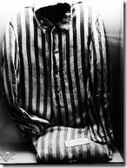
First, note Baby Obama’s pinstriped pants, which could mean little to nothing. Nevertheless, it is a significant piece of history of the people that I discuss.
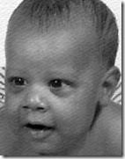
Second, look at the unusual heavy-dark bags under the eyes, and it’s not the lighting. Look at the shadow under his left arm pit in the full body picture above.

Compare his eyes with a small sampling of the eyes of children approximately the same age as infant Obama. People that are stressed generally have more prominent or visible dark circles under their eyes, and under situations of exhaustively stressful lifestyles, some people may be able to attribute the formation of dark circles around the eyes completely to the stress that fills their lives.[59] Yes, I believe that during the time he had been unaccounted for during his most impressionate years that he had been subjected to significant ritual satanic abuse and stress.
Mary is still alive in Alaska, but she like the other links to Obama’s past will not discuss her background, Obama II or Stanley Ann beyond simple and general questions.
Lodeesen and Eastern European Émigrés: Operation BLOODSTONE
What is extremely interesting about these East European links to Stanley Ann and Obama, Sr. surrounds CIA Special Agent Jon S. Lodeesen, again. During the early 1950s, Lodeesen headed the Russian Service of the Radio Free Europe/Radio Liberty (RFE/RL) Fund in Washington, DC.[60] He had been Director of the Planning and Research Department of Radio Liberty.[61]
After the fall of the Nazis and the end of WWII, millions were displaced from their homes and countries in Eastern Europe from the ravages of war. Many found shelter, food and refuge in camps for displaced persons.
A displaced persons camp was a temporary facility for displaced persons coerced into forced migration. Most of the camps were established in West Germany West and in Austria as well as in the United Kingdom, primarily for refugees from Eastern Europe and for the former inmates of the Nazi Concentration Camps.[62]
SS-Nazi war criminals and their Eastern European collaborators also used the camps for cover. The CIA under Allen Dulles, the notorious Frank G. Wisner and the Gehlen Org used the displaced camps to find and recruit Nazis as agents to assassinate enemies and communists leaders; and to move them into the United States as a THIRD REICH “Fifth Column.” It was called, Operation BLOODSTONE.
According to Christopher Simpson, Blowback America’s recruitment of Nazis, and its disastrous effect on our domestic and foreign policy,
“Many of the Bloodstone recruits-both Nazi collaborators and anti-Nazis-were passed along to two heavily funded CIA psychological warfare projects that are still in operation. These two enterprises were authorized under the “subversion against hostile states” and ‘propaganda’ sections of NSC 10/2 and are probably the largest and most expensive political warfare efforts ever undertaken by the United States. They are certainly the longest-running and best-publicized ‘secret’ operations ever. Their names are Radio Free Europe and Radio Liberation from Bolshevism, the latter of which is better known as Radio Liberation or Radio Liberty.”[63]
Operation Bloodstone had been nothing more than CIA Director Allen Dulles and the Gehlen Org’s Nazi Ratline ran through a Top Secret operation through Lodeesen’s RFE/RL Fund.
On June 1, 1949, a group of prominent American businessmen, lawyers, and philanthropists – including Allen Dulles, who would become Director of Central Intelligence in 1953 – launched the National Committee for Free Europe (NCFE) at a press release in New York. Only a handful of people knew that NCFE was actually the public face of an innovative “psychological warfare” project undertaken by the CIA. That operation gave rise to Radio Free Europe.[64]
Operation Bloodstone had begun on a relatively modest scale, with about 250 sponsored immigrants per year. By 1950, however, CIA representatives approached Congress with a plan to authorize special importation of some 15,000 CIA-sponsored refugees per year, in addition to those entering under the Displaced Persons Act and other more conventional immigration channels. They were to be émigrés “whose presence in the US would be deemed in the national interest,” according to Department of State documentation,” as a result of the prominent or active part they played in the struggle against Communism.” [65]
The REF/RL was NCFE’s major anti-communist CIA psychological warfare front developed by the infamous Frank G. Wisner of the Office of Policy Coordination (OPD). NCFE and other projects (such as the Congress for Cultural Freedom, 1950, and Radio Liberty, which began broadcasts to the Soviet Union in 1953) rallied anti-Communist intellectuals, politicians, and activists to fight the Soviets in a contest for the peoples’ “minds and loyalties.”[66]
A major theme of REF/RL was to establish the credibility and legitimacy of exiled Eastern European politicians-former Nazi collaborators and non-collaborators alike-in the eyes of the American public. Through NCFE and a new CIA-financed group, the Crusade for Freedom (CFF), the covert operations division of the agency became instrumental in introducing into the American political mainstream many of the right-wing extremist émigré politicians’ plans to “liberate” Eastern Europe and to “roll back communism.[67]
In 1952, at MCA, Actors’ Guild president Ronald Reagan was recruited by Crusade for Freedom to raise funds for the resettlement of Nazis and their collaborators some designated as displaced persons in the U.S.[68] During WWII,
Lithuania didn’t have a SS unit per se, but they continued to engage in fighting the Soviet occupation forces well into the 1950’s. The last of the Lithuaniananti-communist Soviet partisan forces are thought to have been wiped out around the time of 1955-56,[69] or entered the U.S. through the CIA’s Operation BLOODSTONE.
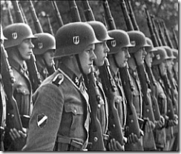
However, its neighbor, Latvia, had its Waffen-SS Legion created in January 1943 by Reichsfuhrer SS- Heinrich Himmler. Their notorious SS death squad was the notorious Arajs Kommando unit, responsible for atrocities committed against Jews, Roma, and civilians along Latvia’s border.[70] They would have idea recruits under Operation BLOODSTONE to enter the U.S. for CIA special operations; and swell the hardcore ranks of Republican Right Wing in the country.
During the 1950s when Lodeesen was directing REF/RL, security agencies of the government gave tacit support to private refugee relief committees, the stated goals of which included assisting thousands of Waffen SS veterans in secretly immigrating to the United States.
In 1954, Hauptsturmführer SS Baron Otto Albrecht Alfred von Bolschwing,Reinhard Gehlen’s second-in-command entered the country in the interested of U.S. National Security most likely funded by Lodeesen’s REF/RF and CF funds.
Simeon Ndesandjo’s high positions with the CIA’s most valuable asset, CBS, and Voice of Kenya, it certainty would have brought him within Lodessen’s sphere of influence and web of CIA collaborators. Now, you should understand why Mark adopted his stepfather’s name instead of his fathers. It is absolutely consistent with intelligence methods for Stanley Ann and Obama, Sr. to have been watchfully moved through a series of covert East European-African assets and safe houses.
As you see, Jon S. Lodeesen was in an extremely sensitive and unique position in the CIA to possess an entire clandestine underground Eastern European Network of CIA Operation BLOODSTONE assets, agents, safe houses and assassins and operatives at his disposal.
The Assassination of Barack Hussein Obama, Sr., DEAD MEN TELL NO TALES
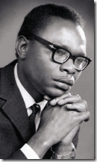
On November 24, 1982, while Obama II was a student attending Columbia University, Barack Obama, Sr. was found dead in Kenya. The cover story is that Obama, Sr. drove his car into a tree following a day of drinking in Nairobi.[71] However, Obama, Sr.,’s family, sister, Hawa Auma Obama, and his friend Patrick Ngei believe that he had been assassinated, “Obama didn’t die out of pure accident…. Bright Luos were eliminated by the Kenyatta government.”[72]
So, what did Stanley Ann really mean when she suggested to her friends that she could bear children without dating and marriage? Her comment suggests an unusual acute awareness for 1960 of the existence of in vitro fertilization, embryo transfer, and artificial insemination technology– positive eugenics.
Beyond Lebensborn, Himmler’s Secret
CIA- All in the Family
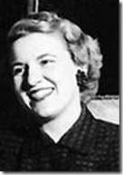
Stanley Ann’s father, Stanley Armour Dunham, had been Obama, Sr.’s CIA handler. Stanley Ann’s mother, Madelyn Dunham, above, also managed the agency’s secrets. In 1960, she started working at the Hawaii’s largest bank, Bank of Hawaii, and was promoted to be one of the first female bank vice presidents in 1970.[73]
Madelyn Dunham’s expertise had been in the bank’s escrow accounts department described to be primarily used for 3rd party money transfer accounts between two people who basically do not trust each other and still need a deal to be done.[74] Madelyn handled the secret escrow-payoff accounts of the CIA front company, Bishop Baldwin Rewald Dillingham Wong (BBRDW), Ltd.[75]
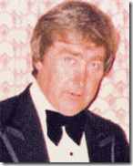
BBRDW was primarily run by Ronald R. Rewald. Rewald was a CIA agent recruited to spy on the student radical movement in America in the 1960’s.[76] “Now Bishop Baldwin expanded its operations greatly. Satellite offices opened up in more than a dozen cities worldwide. It now employed a staff of nearly 200 people. Rewald lived in a Hawaiian estate near Diamond Head valued at over a million dollars in 1980. Bishop Baldwin had a fleet of cars and a chauffeur to drive around Rewald and Bishop Baldwin’s clients. The company which had four accounts at its incorporation in 1979 had 110 by 1983. And in such exotic places as Hong Kong and the Cayman Islands. Rewald was now meeting with people like the Sultan of Brunei and Vice-President George Bush and arranging secret arms deals with Rajiv Gandhi of India. In fact, this last seems to have been the major CIA use of the company i.e. to spirit weapons and arms of all types into Pacific Rim countries. Bishop Baldwin also used businessmen to collect intelligence and to direct the flow of capital into American companies. It also was used as a cover for more sinister assignments like the assassinations of leftist leaders and sympathizers.”[77]
BBRDW and Rewald’s cover was blown in Hawaii by a tip to a news reporter in 1983.[78] Just prior to their cover being blown, CIA Special Agent Jon S. Lodeesen just happened to show up at their doorstep January 12, 1983 for a special assignment in Hawaii.[79]
During the Falkland Islands War of April 1982 between Argentina and Britain, Ron Rewald met with the Gehlen Org’s SS/CIA representatives in Uruguay, Licio Gelli of the Masonic Lodge P2, Klaus Barbie and Heinrich Rupp, to arrange for the Argentine purchase of the French-made Exocet missile used in war.[80]
BBRDW and Rewald had also been a pipeline for the Reinhard Gehlen Org. Madelyn Dunham retired from the Bank of Hawaii in 1986,[81] so and it is highly likely that Stanley Ann’s mother, Madelyn Dunham, handled the Gehlen Org’s secret transfer account to buy Exocet Missiles through the Bank of Hawaii. Stanley Ann Dunham had been a multi-generational asset deeply imbedded in the Reinhard Gehlen SS-CIA fraction.
The perfection of positive eugenics was a top secret mission of the THIRD REICH and a clandestine project of Reichsfuhrer SS-I Heinrich Himmler and the SS. Even today, two of Himmler’s SS doctors stand at the pentacle of Human Fertilization and Embryology to Fabricate Aryans from scientific genetic material; and in duality (Satanic Principle) Annihilate non-Aryan genetic material.
Himmler’s top in vitro fertilization and artificial insemination specialists were SS Teutonic-Knights of the Black Sun and neither one of them were tried at Nuremberg. One was captured in 1945 by the Soviets and may have been turned into a Soviet mole in West Germany, and the other escaped justice under the shroud of the Gehlen Org and Operation CAMPUS.
In 1961-1962, this agency doctor was in Brazil with Lodeesen and Jim Jones of the Peoples Temple. This particularly doctor was known to be involved in clandestine artificial insemination and in vitro fertilization projects. He is the subject of the popular 1978 movie thriller, The Boys From Brazil.
Dr. Mengele and Obama II: Timeline of the BOY FROM BRAZIL
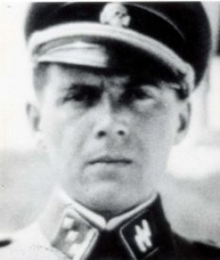
Jim Jones idolized Dr. Josef Mengele. There is cause to believe that while in Brazil in 1961, Jones had met his mentor and had been initiated into the CULT OF THE SS. Additionally, Jones’ Peoples Temple mind control experiments were an extension of Mengele’s Auschwitz experiments.[82]
At Mendocino State Mental Hospital were the entire staff was dismissed and replaced by Jim Jones’s personnel, according to mind-control survivors, Dr. Mengele had been there in association with Jim Jones programming patients and inmates.[83] It is reported that Dr. Mengele also visited Jonestown, Guyana.[84]
On May 11, 1960, the Israeli MOSSAD captured Obersturmbannführer SS Otto Adolf Eichmann one of the major organizers of the Final Solution in San Fernando, an industrial community north of the center of Buenos Aires.[85] MOSSAD agents had been Argentina since April 1960. At the time, Dr. Mengele was also discovered to have been living in Buenos Aires, Argentina. MOSSAD agents ound Dr. Mengele’s address and actually took pictures that they determined “beyond any doubt” the identity of the notorious Demon of Death of Auschwitz. The MOSSAD walked away from Dr. Mengele, one of the world’s most wanted Nazi war criminals. I gather that he was a little” too big for their boots” protected by U.S. National Security like SS Baron Otto von Bolschwing. [86]
Between April and May 1960, Dr. Mengele was confirmed to have been in Buenos Aires. Just before or after the capture of SS Eichmann, Mengele disappeared off the radar map. Obama II was born in August 1961. Normally, it would mean that he was conceived in December 1960 during the period of Dr. Mengele’s most secretive disappearance episode during the early 1960s. In fact, his trail remained cold until he reportedly surfaced in Brazil in the late 1960s.[87]
Now, you should have some idea where Stanley Ann could have got her notions of having children without natural procreation-beyond Lebensborn and why Jim Jones showed up in Hawaii She had been primed for the job as a multi-national CIA/MK ULTRA asset by the satanic (Negative Eugenics) plans of Dr. Josef Mengele; and Jim Jones showed up in Hawaii to dust the trail of his mentor and master.
Dr. Mengele’s Land of Aryan Twins
In a recent book, Mengele: the Angel of Death in South America, the Argentine historian Jorge Camarasa, a specialist in the post-war Nazi flight to South America, contends that Dr. Mengele re-surfaced in about 1962 or early 1963 in the enclave of Colonias Unidas, Paraguay that was founded by German immigrants in 1900. From there in 1963, Dr. Mengele began to make regular trips to another predominantly German community just over the border in Brazil – the farming community of Candido Godoi.[88]
In Candido Godoi, people remembered that Dr. Mengele “talked of artificial insemination in human beings, and that he continued working with animals, proclaiming that he was capable of getting cows to produce male twins.”[89] “Nobody knows for sure exactly what date Mengele arrived in Candido Godoi, but the first twins were born in 1963, the year in which we first hear reports of his presence,” Camarasa said. “I think Candido Godoi may have been Mengele’s laboratory, where he finally managed to fulfill his dreams of creating a master race of blond haired, blue eyed Aryans,” he said.[90]
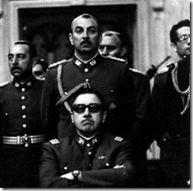
Dr. Mengele also worked out of the infamous post-war compound of Cologna Dignidad near Paral, Chile founded in 1961 by Nazis straight out of Germany. The UN commission found that the above”’Dictator for life’”General AUGUSTO PINOCHET’s military intelligence agency DINA-sponsored torture chambers at Colonia Dignidad. Its underground bunker and chambers were used as “research center” to continue Dr. Mengele’s work of refining the art of torture,
“…prisoners have allegedly been subjected to different ‘experiments’ without any interrogation… Prisoners charge that torture is ‘personalized’ through an initial interrogation which establishes the personal traits of the individual… This data is then used to program the torture sessions so that the result is a totally debilitated person who will comply with any demand.”[91]
According to a UN report, “… in Colonia Dignidad there is a specially equipped underground torture center with small soundproofed cells, hermetically sealed. The detainees’ heads are covered with leather hoods, which are stuck to their faces with substances that are supposedly chemicals. In these cells, interrogations are carried out through electronic equipment, including loudspeakers and microphones, while detainees are tied naked to metal frames to receive electric shocks.” [92]
The CIA Medical Experimental Compound at Jim Jones’ field station and agricultural commune in Jonestown, Guyana had been established as a U.S. “Shadow” of Cologna Dignidad.[93] Jeannie Mills, a white overseer and ring leader of the Peoples Temple that had been assassinated in Berkeley in 1980, claimed to have seen films taken inside a Chilean torture camp while at Jonestown. These films were either taken at the Colonia Dignidad or another located at Pisagua.[94] At that time, the only source possible for the films had to have been the CIA, DINA or Dr. Mengele.

Contrary to HollyWeird and government propaganda, Dr. Mengele didn’t appear to be a frighten fugitive constantly on the run from the law. To the contrary, after the capture, conviction and execution of Obersturmbannführer SS Otto Adolf Eichmann in 1962, the Great Nazi Satanist appeared to have travelled freely throughout South America, Canada, Germany and the United States without a care in the world polarizing the populations, spreading death, destruction and CHAOS..
In 1985, Senator Alfonse M. D’Amato (R-N.Y.) testified at a Senate hearing that the U.S. Government had evidence from “Cables and other documents indicate that Mengele “had a network available to him in raising large sums of money” and that “high officials (in South America) gave him protection…”[95] In other words, Dr. Mengele didn’t die in 1979 and was right in the middle of the CIA Iran-Contra CRACK Cocaine Scandal. Of course, U.S. Government agencies claimed they didn’t know what Senator D’Amato was talking about, because the CIA had also been protecting and supporting him since it was formed in 1947.
Out of everyone in the world, SS Dr. Josef Mengele and the underground SS Knights of the Black Sun had been the most secretive, treacherous and satanic forces to that would have conceived such a diabolical plan. Dr. Mengele disappeared during the time of conception and birth of Obama II. During that time, Dr. Mengele was secretly deeply involved in clandestine artificial insemination in human beings. When Obama II and Stanley Ann returned to Hawaii in 1962, Dr. Mengele was exposed by Argentine historian Jorge Camarasa artificially creating the master race of blond haired, blue eyed Aryans in twins by the dozens in Candido Godoi, Paraguay.
Don’t forget pursuant to the SS SCIENTIFIC SATANIC PRINCIPLE of the DIVINE POWER of OPPOSITIES that if they had the power to create the MASTER RACE in duality they had to power to create the SUBSERVIENT.
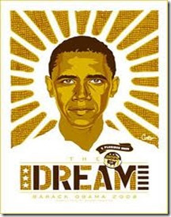
They had the money, technology, resources, clandestine support, international networks and motive to put a covert Diabolical Black Human Cyborg in the Whitehouse to continue the 1000 Year THIRD REICH and its Satanic Principle of Aryan Planet Domination and the Annihilation of People of Color. An African-American Brother? You never seen anything like him. KEEP DREAMING THAT THE BOYS FROM BRAZIL IS A WORK OF PURE SCIENCE FICTION- AND THAT FAT MEAT ISN’T GREASY!
In Part II, I intend to show where, when and how Dr. Josef Mengele and the SS developed Artificial Insemination and Fertilization that even still today THE CULT OF THE SS stand at the pinnacle and forefront of Modern Genetic and Reproductive Technology.

[1] http://grail.cba.csuohio.edu/~somos/twizone.html
[2] http://digitaljournal.com/article/341880
[3] http://www.marxists.org/history/etol/newspape/socialistvoice/obama81.html
[4] Charles Frankel. “The Specter of Eugenics.” Commentary, March 1977, page 27.
[5] http://en.wikipedia.org/wiki/Charles_Frankel
[6] http://www.theobamafile.com/_family/Senior.htm
[7] http://www.theobamafile.com/_family/Senior.htm
[8] http://www.theobamafile.com/_family/Senior.htm
[9] http://www.examiner.com/article/where-the-world-is-barack-obama-s-birth-certificate-part-2
[10] http://www.examiner.com/article/where-the-world-is-barack-obama-s-birth-certificate-part-2
[11] http://www.examiner.com/article/where-the-world-is-barack-obama-s-birth-certificate-part-2
[12] http://www.webmd.com/baby/1to3-months
[13] http://www.examiner.com/article/where-the-world-is-barack-obama-s-birth-certificate-part-2
[14] http://atlasshrugs2000.typepad.com/atlas_shrugs/2008/10/how-could-stanl.html
[15] http://jimhougan.com/JimJones3.html
[16] http://usmilitary.about.com/od/armybaseprofiles/ss/garmisch.htm
[17] http://www.army.mil/article/13102/rocket-pioneers/
[18] http://en.wikipedia.org/wiki/Teutonic_Knights
[19] http://atrueott.files.wordpress.com/2010/05/the-secret-treaty-of-fort-hunt.pdf
[20] Reese, Mary Ellen, General Reinhard Gehlen, the CIA Connection, George Mason University Press, Fairfax, VA (1990) pg. 135
[21] http://hallschlagunivalumni.tripod.com/
[22] http://en.wikipedia.org/wiki/Baden-W%C3%BCrttemberg
[23] Reese, Mary Ellen, General Reinhard Gehlen, the CIA Connection, George Mason University Press, Fairfax, VA (1990) pg. 135
[24]http://news.google.com/newspapers?nid=1817&dat=19680521&id=WHAfAAAAIBAJ&sjid=M5sEAAAAIBAJ&pg=7112,4256450
[25] http://www.truedemocracy.net/hj32/08.html
[26] http://www.truedemocracy.net/hj32/08.html
[27] http://www.cashill.com/intellect_fraud/first_sighting.htm
[28] http://jimhougan.com/JimJones2.html
[29] http://geoplotical.blogspot.com/2010/10/barack-obamas-mother-is-key-to.html
[30] http://en.wikipedia.org/wiki/Bay_of_Pigs_Invasion
[31] http://www.guardian.co.uk/world/richard-adams-blog/2011/apr/28/barack-obama-father-immigration-files
[32] http://dancingczars.wordpress.com/2011/11/09/boston-globe-reporter-withholds-obama-file/
[33] http://dancingczars.wordpress.com/2011/11/09/boston-globe-reporter-withholds-obama-file/
[34] http://pjmedia.com/tatler/2011/04/28/harvard-wanted-barack-obamas-dad-deported/
[35] http://en.wikipedia.org/wiki/Ann_Dunham
[36] http://atlasshrugs2000.typepad.com/atlas_shrugs/2008/10/how-could-stanl.html
[37] See Alfy comment, http://wtpotus.wordpress.com/2011/11/21/obama-mystery-theater-ruth-nidesand/
[38] http://www.capitalnewyork.com/article/politics/2011/04/1944130/was-barack-obama-sr-eased-out-harvard-and-america-dating-white-wome?page=all
[39] Id.
[40] http://wtpotus.wordpress.com/2011/11/30/440-days/
[41] http://wtpotus.wordpress.com/2011/11/30/440-days/
[42] http://www.historyplace.com/worldwar2/timeline/ww2time.htm#1942
[43] http://www.dailymail.co.uk/news/article-2158471/Mark-Okoth-Obama-Ndesandjo-looks-like-half-brother-Barack-Obama-China-tour.html
[44] http://markobamandesandjo.com/
[45] http://aconstantineblacklist.blogspot.com/2008/11/keycorp-cia-bank-recapitalization.html
[46] http://www.thefreelibrary.com/Former+CIA+Chief+Gates+to+Headline+Global+Information+Security+Summit.-a065331606
[47] http://www.tieonline.com/view_article.cfm?ArticleID=89
[48] http://wtpotus.wordpress.com/2011/10/06/spinning-out-a-story-about-simeon-ndesandjo-ruth-obamas-second-husband/
[49] http://en.wikipedia.org/wiki/Kenya_Broadcasting_Corporation
[50] http://www.kbc.co.ke/section.asp?id=113
[51] http://www.bibliotecapleyades.net/sociopolitica/sociopol_cia13.htm
[52] http://www.bbc.co.uk/worldservice/specials/1318_africa_radio_aw/page10.shtml
[53] http://wtpotus.wordpress.com/2011/10/06/spinning-out-a-story-about-simeon-ndesandjo-ruth-obamas-second-husband/
[54] http://en.wikipedia.org/wiki/CBS_Records_International
[55] http://tmh.floonet.net/articles/cia_press.html
[56] http://www.huffingtonpost.com/2009/11/04/mark-ndesandjo-obamas-hal_0_n_344824.html
[57] http://www.amazon.com/gp/product/1593306237/ref=olp_product_details?ie=UTF8&me=&seller=
[58] http://www.oregonlive.com/books/index.ssf/2012/07/where_i_write_pauls_toutonghi.html
[59] http://www.darkcirclespuffyeyes.com/stress-and-dark-circle-appearance/
[60] http://www.oac.cdlib.org/view?docId=tf9x0nb3wc;style=oac4;view=dsc
[61] http://www.leninist.biz/en/1985/AB166/8-Who.Makes.Subversive.Propaganda
[62] http://en.wikipedia.org/wiki/Displaced_Persons_camp
[63] http://www.thirdworldtraveler.com/Fascism/BareFists_B_CS.html
[64] https://www.cia.gov/news-information/featured-story-archive/2007-featured-story-archive/a-look-back.html
[65] http://www.shunpiking.com/ol0207/0207-CS-bback-us-nazi.htm
[66] https://www.cia.gov/news-information/featured-story-archive/2007-featured-story-archive/a-look-back.html
[67] http://www.shunpiking.com/ol0207/0207-CS-bback-us-nazi.htm
[68] http://www.mail-archive.com/ctrl@listserv.aol.com/msg96290.html
[69] http://www.feldgrau.com/lith.html
[70] http://en.wikipedia.org/wiki/Latvian_Legion
[71] http://www.newyorker.com/online/blogs/newsdesk/2010/10/barack-obama-sr.html
[72] http://www.newyorker.com/online/blogs/newsdesk/2010/10/barack-obama-sr.html
[73] http://en.wikipedia.org/wiki/Madelyn_Dunham
[74] http://www.freerepublic.com/focus/f-bloggers/2501144/posts
[75] http://stuartbramhall.aegauthorblogs.com/tag/nugan-hand-bank/
[76] http://www.ctka.net/abc_cap_intro.html
[77] http://www.ctka.net/abc_cap_intro.html
[78] Id.
[79] http://jimhougan.com/JimJones3.html, see footnote 83
[80] http://www.theforbiddenknowledge.com/hardtruth/operationpaperclip.htm
[81] http://en.wikipedia.org/wiki/Madelyn_Dunham
[82] http://www.godlikeproductions.com/forum1/message1263782/pg3
[83] http://whale.to/b/jonestown.html
[84] http://www.ratical.org/ratville/JFK/JohnJudge/Jonestown.html
[85] http://en.wikipedia.org/wiki/Adolf_Eichmann#Capture_in_Argentina
[86] http://www.telegraph.co.uk/news/worldnews/middleeast/israel/2661998/Israeli-spy-admits-Mossad-allowed-Josef-Mengele-to-escape.html
[87] http://www.chicagoreader.com/chicago/on-the-trail-of-josef-mengele/Content?oid=883306
[88] http://www.telegraph.co.uk/news/worldnews/southamerica/brazil/4307262/Nazi-angel-of-death-Josef-Mengele-created-twin-town-in-Brazil.html
[89] http://www.telegraph.co.uk/news/worldnews/southamerica/brazil/4307262/Nazi-angel-of-death-Josef-Mengele-created-twin-town-in-Brazil.html
[90] http://www.telegraph.co.uk/news/worldnews/southamerica/brazil/4307262/Nazi-angel-of-death-Josef-Mengele-created-twin-town-in-Brazil.html
[91] http://www.subliminalnews.com/colonia_dignidad/page5.html
[92]http://www.constantinereport.com/nazism/introduction-to-colonia-dignidad/
[93] http://www.sott.net/article/244755-Latin-American-High-Weirdness-Hand-of-Death-Satanic-CIA-Cult-Network
[94] http://www.abovetopsecret.com/forum/thread180070/pg1
[95] http://articles.latimes.com/1985-02-20/news/mn-305_1_josef-mengele
Comments : 5 Comments
Tags: Adolf Hitler, artificial insemination, barack hussein obama, barack obama, boys from brazil, Candido Godoi, CIA, Colonia Dignidad, Cult of the SS, Dr. Josef Mengele, gehlen org, General AUGUSTO PINOCHET, Genetic and Reproductive Technology, Hauptsturmführer-SS (Captain) Dr. Josef Mengele, iran contra affair, Jim Jones, jon s. lodeesen, Jorge Camarasa, land of twins, Lucifer's Servants, luciferians, madylin dunham, Mark Ndesandjo, Mark Okoth Obama Ndesandjo, Mary Toutonghi, mind control, mossad, Nazis, Nazism, operation bloodstone, Peoples Temple, President Barak Obama, Reichsfurhrer Heinrich Himmler, reinhard gehlen, Ruth Baker, Ruth Beatrice Baker, Ruth Ndesandjo, Satanic Principle, Simeon Njdesandjo, Sr., SS, stanley ann dunham
Categories : 1000 Year Reich, 9-11, african holocaust, ALL SEEING EYE, allen dulles, Aryan Supremacy, Barack Obama, Barak Obama, Black Manchurian Candidates, bloodline of wotan, bloodlines of wotan, boys from brazil, Brigadefuhrer Waffen SS Dr. Fritz Gustane Anton Kraemer, Brigadefuhrer Waffen SS Dr. Fritz Gustane Anton Kraemer, CIA, clive davis, Columbia Broadcasting System, columbia records, cybernetics, cyborg, cyborgs, Dr. Josef Mengele, dualism, Frank Marshall Davis, Hauptsturmfuhrer SS Dr. Josef Mengele, Heinrich Himmler, heinrich rupp, illuminati, Iran-Contra Crack Cocaine connection, jim jones, jonestown, Josef Mengele, Knights of the Black Sun, luciferians, Malcolm X, MOSSAD, Operation PAPERCLIP, order of teutonic knights, Otto Skorzeny, Paperclip Project, Peenemunde Missile Base, Schutzsteffel, SS, SS Baron Otto Albrecht Alfred von Bolschwing, Stanley Ann Dunham, Stanley Armour Dunham, Strumbannfuhrer SS Dr. Wernher von Braun, trauma-based mind control, University of Hawaii, whitney houston

DJANGO UNCHAINED & KATT WILLIAMS, DICK GREGORY, HOUSE NEGROES & PAUL JOSEF GOEBBELS
23012013
In the late evening of January 8, 2013, Katt Williams was released from jail on a $100.000 bail bond on a Sacramento, CA arrest warrant issued for missing his court appearance. He was captured on a TMZ video being led away from jail by a white security team.[1] Usually anything regarding Katt Williams, TMZ will spread it all over the world. However in this one case, this particular video of Williams being led away from a Yolo County Jail in California by a special security team has limited circulation for whatever reasons. The TMZ video can be reviewed at UPDATE: Katt Williams Release from Jail on 100K for Missing Court Date
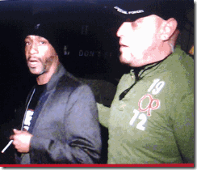
One guy in a green shirt is seen wearing a U.S. Army or Navy “Special Forces” cap similar to the one below.

The guy in green also has a surveillance earpiece designed for military, police, secret service, first responders and security personnel.[2] It has a Bluetooth pairing with a fast push-to-talk design microphone to communicate with band radio frequencies.[3]
So, why are U.S. Army Special Forces, former members of the Special Forces or an advanced professional security team connected to a secure central command station extracting Katt Williams from jail, but to deliver him to secure secret cybernetic mind control laboratory to repair a blown circuit, the Human Will and Compassion to be FREE. Nevertheless, I pray that I am wrong and they were his bail bondsmen. I also fear that it may be one of the last times we may see or hear from Katt close to his original conscious self.
Comedian Katt Williams was the first to coin the world, Niggadom (Kingdom). I don’t subscribe to such degrading terminology or jargon regarding African Descendants so I call it, Negrodom. But it isn’t really a physical place with borders and boundaries, Katt Williams must be making reference to a imprisoned state of consciousness; Delusional State of Mind, or an particular insanity among Black People of HollyWeird, CA.
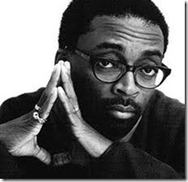
Criticism of Django Unchained: “American Slavery Was Not A Sergio Leone Spaghetti Western. It Was A Holocaust. My Ancestors Are Slaves. Stolen From Africa. I Will Honor Them,” –Director Spike Lee[4]
HollyWeird’s House Negroes and attack dogs are all over Spike Lee for his mere expression of opinion and criticism of Django Unchained as if he committed a crime against humanity, democracy or like Katt Williams violated a scared Luciferian oath or pact of secrecy.

The Luciferian HollyWeird elite Implant-Conceal many Satanic images and ILLUSIONS that isn’t easy to recognize in films to subliminal traumatize the masses . Red represents the color of the “Blood Sacrifice.”

In the Django Unchained Poster, above, there are at least four (4) Ancient Double Crosses of Loraine, Emblem of the Royal Secret
“When various members of the House of Anjou plotted to topple the Valois dynasty of France, the symbol of the conspirators was the Cross of Lorraine, the heraldic emblem of René d’Anjou, said by Charles Peguy to represent the “arms of Christ”, “the arms of Satan”, and, strangely, the blood of both. René was the Angevin monarch who, at the time of the renaissance, single-handedly spearheaded a Hermetic revival in Europe. It was he who personally convinced Cosimo de Medici to translate many ancient texts such as the Corpus Hermeticum into various European tongues for the first time ever. And when Corpus Hermeticum was first published in France, the dedication it bore was to Marie de Guise, wife of James Stuart V, mother of Mary Queen of Scots, and a descendant of René who also adopted the Cross of Lorraine as a personal symbol.
That the Cross of Lorraine is a symbol embodying the Hermetic ideal is fairly obvious. The Angevins were primarily advocates of the Regia, or Royal Art, of hermeticism; a tradition which according to legend was passed down to man by a race of fallen angels. This isn’t at all inconsistent with the perennially Luciferian overtones associated with the entire Angevin saga.
Interestingly, the Cross of Lorraine bears an uncanny resemblance to the sigil of Baphomet employed by British Magus Aleister Crowley, and the meaning of the two symbols would appear to be virtually synonymous. Baphomet is, after all, the penultimate hermetic symbol, whether depicted by Crowley in the form of a cross, or by Eliphas Levi as a goat-headed hermaphrodite. And the sigil used by Crowley was also employed by ancient alchemists as a device whose meaning was literally “very poisonous.” In fact, the symbol was commonly affixed to containers of toxic substances in Europe as recently as the mid-twentieth century. To the alchemists, of course, the symbol and its very meaning had far more esoteric connotations. To them, poison represented an agent of transformation, a vehicle for the reconciliation of opposites. And there is an alchemical myth about a poison which for most men is extremely deadly, while for the elect it confers mastership and absolute power. Echoes of this idea recur as a motif in various aspects of the Grail lore. It would seem that the alchemists accorded this symbol very much the same meaning attributed it by Crowley, which in turn echoes what the Cross of Lorraine embodied for Rene d’Anjou. It is little known, but the Cross of Lorraine was also the official emblem of the Knights Templar
Though they are more frequently associated with the symbol of the red equilateral cross, their true symbol first and foremost was the Cross of Lorraine, and many Templars awaiting death at the stake pursuant to the Friday the 13th persecutions drew the emblem on the walls of their cells. There is still a degree in certain rites of Freemasonry called the Knights Templar, whose symbol is the Cross of Lorraine. It is interesting to note that even the less esoteric-looking equilateral cross used by the Templars had essentially the same meaning: that of the union of opposites, the intersection of creative force and destructive force, or the union of male and female principles. It was a fundamental occult symbol, and it was in deference to the idea which it embodied that medieval occult rituals were often held at crossroads.
The Cross of Lorraine is far more explicit in it’s iconography: the bar above mirroring the bar below, both of which are symmetrically affixed to a central pillar that provides balance and equilibrium. As above, so below is, after all, a Hermetic maxim. And the three bars of which the cross is composed echo Eliphas Levi’s concept of the true trinity. Levi posited that the world is governed by two primordial forces, one creative, the other destructive. The equilibrium between these two forces constitutes a third force, and the union of the three constitutes what some might refer to as… God.
The central role of the principle of equilibrium in various occult arts cannot be overstressed. For Master Mason Albert Pike, equilibrium represented the Royal Secret, the pivotal principle upon which the universe is ordered. And Pike’s specific designation of equilibrium as a royal secret is of particular significance because, as previously mentioned, Hermeticism has traditionally been known as the Royal Art, and its central tenet is essentially that of equilibrium. And too, when Pike calls it a Royal secret, he isn’t speaking figuratively, but strictly in literal terms. Hermes, according to legend, was the sole receptacle of the secret doctrine of the antediluvian world, which he revived after the flood and passed down to the Kings. As you’ll recall, this secret knowledge was thought to have been taught to man by a race of Gods or fallen angels. This knowledge was kept secret because it was probably recognized that for all but an elect few, such thought would no doubt bring about their ruin. This brings to mind the concept of the alchemical poison. Kings and aristocrats would understand how to wield and apply the secret doctrine because it was believed that they were in fact flesh and blood descendants of the Forgotten Race which had come down to take the wives of men.
References to this Forgotten Race occur repeatedly in numerous religions and mythologies throughout the world, and should most likely be known to readers of this magazine. Their doctrines have been enshrined in myth, legend, and many religious symbols, in which they are looked upon by many, and recognized by but a few. They are, and shall remain, the Royal Secret. The Cross of Lorraine is a sigil of that Royal Secret, the doctrine of the Forgotten Ones.”

The Satanic Cross
In the Satanic Bible in LaVeyan Satanism, the Satanic Cross can also be interpreted as a combination of the Lorraine crossand the mathematical symbol for infinity, or a phallic re-imagining of the cross, with the infinity symbol representing a scrotum. It is often interpreted as a symbol of Satanism, because Anton LaVey adopted it from the Cross of Lorraine or even the Patriarchal, which is also a symbol of Christianity and Hermeticism. Hermetic alchemists of the Renaissance used the emblem as a symbol of earth and spirit by combining the square earth cross with the cross of Christ. When drawn symmetrically, it symbolized the hermetic maxim, “As above, so below”.
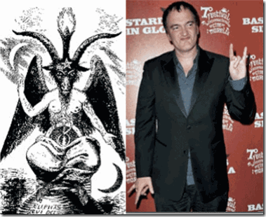
Baphomet & WICKED Tarantino, “As above, so below”
In the Django Unchained Deception, Legendary Black Comedian and Civil Rights Activist, Dick Gregory, has been making news around the internet. Dick Gregory publicly singled out and attacked Spike Lee for criticizing Quentin Tarantino and Django Unchained. In defense of the Tarantino film, Gregory called Spike Lee a “Thug” and “Punk.”[5] In Spike Lee’s line of profession in the community, Gregory’s chosen words spread across the world constitute insulting “fighting words.”[6]
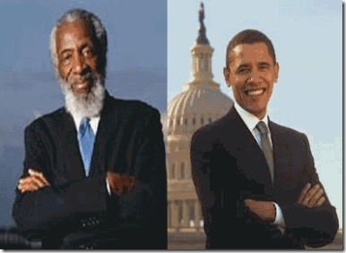
Dick Gregory & President Barack Obama, Look for the ILLUMINATI “Hidden Hand of Power” Gesture
“I’ve seen Django Unchained, I’ve seen that 12 times. Never in the history of Hollywood, have they ever made anything that freed the inside of me. The inside. I’m 80 years-old, I saw cowboy movies, wasn’t no Black folks in cowboy movies. I’m looking at a Western, plus a love story. To those of you all that see it, you’ll never see a love story about a Black man and a Black woman where it wasn’t some foul sex and foul language, huh. And Spike Lee can’t appreciate that. That little thug ain’t even seen the movie, he’s acting like he’s White.”[7]
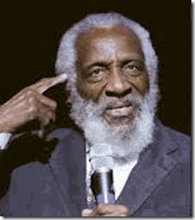
If you multiple 12 times 176, the number of times that Katt Williams said the script contained the word “N**ger” with damning adjectives (An adjective is a word that describes, identifies, modifies, or quantifies something [a noun or a pronoun] like f**king, it means that Dick Gregory subjected himself to 2112 scientific subliminal self inflicted mental head wounds from the “n word” determined by the highest court of the land to injure the Black Psyche [Chaplinsky v. New Hampshire, 315 U.S. 568 (1942)]. Dick Gregory may be immune to being called the “n word”, but it negatively affects and hurt our children and many other of us just don’t play that.
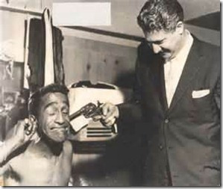
I am quite sure that each time Chicago Mafioso Frankie “One Ear” Fratto[8] pulled the trigger, it was preceded by the “n word” with adjectives like f**king, no good, dirty, stinking and useless, etc. It’s Russian roulette and it’s a physical form and method of scientific “Ritual Abuse and Trauma-Based Mind Control.”[9]
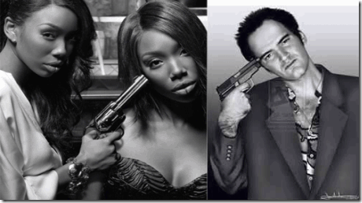
This is a subliminal hypnotic self (alternative personality) inflicted form of scientific traumatic torture that Brandy and Wicked Tarantino appears to be well aware of.
Out of Negrodom, Gregory also said he’d never seen a black man and a black woman ride off into the sunset in a movie, and that’s part of the beauty of Django Unchained.[10]
Beauty or ILLUSION? I wouldn’t call riding off in the middle of the Deep South in the 1850s during universal inhumane and vicious enslavement of (4) four million Africans exactly beautiful, unless, I am delusional or fed a grand ILLUSION of the actual barbaric racist affairs and attitudes of the country during this period.
Anyhow, Wicked Tarantino made it loud and clear to Negrodom early in the film that the storyline is about the Wagnerian Germanic Folktale of Broomhilda and Siegfried, a tale beloved by Adolf Hitler and Paul Josef Goebbels and the THRID REICH.[11]
Broomhilda (Brunhilde) is one of WOTAN’s (Odin) daughters. She is a “Valkyrie.”[12] That’s exactly what a Valkyrie does. She rides off into the sunset with the chosen hero to Valhalla, WOTAN’s castle in the sky.[13]
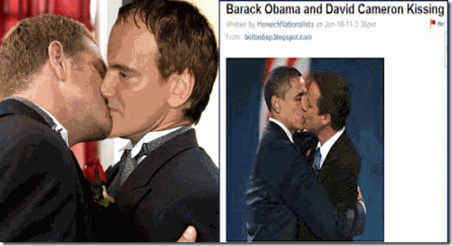
Wicked Tarantino & The Kiss of the Luciferian Brotherhood
This is a very secret and ancient reflection of patriarchal bonding going back to the days of the war state societies of Greece and Rome. During these ancient empires, homosexual male bonding in the militaries of ancient Greece was regarded as contributing to morale. The Sacred Band of Thebes (Greece), a unit said to have been formed of same-sex couples, and the Spartan tradition of military heroism has been explained as being fostered by strong emotional bonds resulting from homosexual relationships. Various ancient Greek sources record incidents of courage in battle and interpret them as motivated by homoerotic bonds. You would also be surprised to know that this ancient tradition and practice of male bonding lay at the birth of the Nazi Nationalist War State. (See Pink Swastika: Homosexuality in the Nazi Party, 5th Edition for Internet)

Danny Glover & Harry Belafonte, The Kiss of Luciferian Brotherhood in HollyWeird

L’ll Wayne & Birdman-Steve J, The Kiss of Luciferian Brotherhood in Hip Hop
Nevertheless what Tarantino says, out of Negrodom, Dick Gregory (House Negro Role) claims that the real inspiration of Django is Dangerfield Newby.[14] THAT DOG WON’T HUNT!
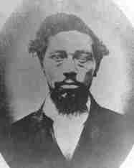
During the John Brown raid in October 1859, the first raider killed was a black man by the name of Dangerfield Newby. Dangerfield had been freed by his white father, but he had a wife and seven children held in slavery in Warrenton, Virginia. His wife’s master had told him that for the sum of $1,500 he could buy his wife and his youngest baby, who had just started to crawl. Dangerfield earned that amount of money and went back to Warrenton to purchase his wife and baby, only to have his wife’s master raise the price. The free black man then joined John Brown in the hope of freeing not only his wife and youngest baby, but his entire family.[15]
During the assault on Harpers Ferry to raid an armory to supply weapons for a rebellion, one man defending the armory was shooting 6 inch spikes from his powder loaded gun. One of those spikes hit the throat of Newby. He was killed instantly. The people of Harpers Ferry took the body of Newby and savagely stabbed it repeatedly with their rusty knives. They left the mutilated body in the alley to be eaten by hungry hogs.[16]
I suppose that Dick Gregory want us to be delusional, caught in the DOUBLE BIND and believe an ILLUSION that this act of a courageous and desperate man with all his God given human loving compassion stoke out to free his beloved wife and seven children from the horror of slavery; and the absolute horrible and barbaric reprisals against the body of this man can somehow be visualized as “beauty” and “riding off in the sunset” is absolutely insane. It is deliberate absolute mass DECEPTION in its broadest terms.
As far as credits for the film are concerned, Quentin Tarantino is the screenwriter. He credits the character development, Django, to a Italian spaghetti western based on no known slavery historical facts. Tarantino later explained the genesis of the idea: “I was writing a book about Sergio Cobucci when I came up with a way to tell the story. One of the things that’s fun when you write about subtextual criticism …”[17] Sergio Corbucci (December 6, 1927 – December 1, 1990) was an Italian film director. He is best known for his very violent spaghetti westerns.[18] Negrodom, Tarantino doesn’t doesn’t possess the Godly human capacity to care or have any compassion about the true heroic struggles, tribulations or issues of enslaved Africans.
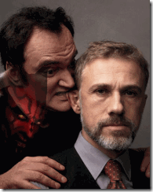
According to Wicked Tarantino, “I want to do movies that deal with America’s horrible past with slavery and stuff but do them like spaghetti westerns, not like big issue movies.”[19] “Slavery and stuff,” he just wanted to play around with it like an Italian spaghetti western, play games with the hearts and minds of the masses. Does Quentin Tarantino even know Dick Gregory in any cinematic sense of production or have any independent historical knowledge whatsoever of Dangerfield or his wife Harriet Newby? I doubt it.
Straight from Negrodom, Gregory continues:
“So it must be something personal because when I look and all them Black entertainers that know Spike Lee, how you gone attack this man [Quentin Tarantino]and don’t be attacking them? Are you saying everyone’s a fool but me? ‘Well, it offended my ancestors,’ but when you did She’s Got To Have It and some of those other thug movies you did, you took Malcolm X and put a Zoot suit on him — did that offend your ancestors, punk?[20]
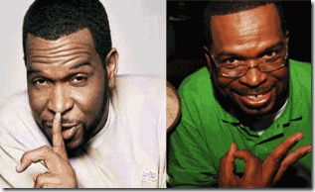
Good Old Uncle Luke, ILLUMINATI Silence is Golden & Mark of the BEAST 666

Also out of Negrodom, the dissectible Uncle [Real Tom] Luther Campbell of 2 Live Crew fame that happens to call himself “Uncle” [21] Luke was also sent on the attack. He called Spike Lee a “resident house Negro…conniving and scheming Uncle Tom”.[22]
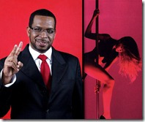
Luther Campbell has to be the nation’s leading Hip Hop artist to openly promote desecration and the exploitation of African descendent female flesh. Uncle (Tom) Luke will place young black females on the sexual slavery(MONARCH/MK ULTRA MIND CONTROL) auction block for only a few pieces of silver with a big grin and a slap on his ass by the ILLIMUNTI and the New World Order.
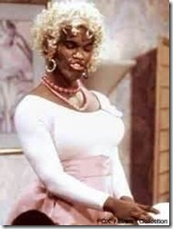
Comedian-Actor- Black Luciferian Jamie Foxx called Spike Lee “Shady…Irresponsible” for criticizing Tarantino’s artistic works. [23] Yet, Jamie Foxx is another dissectible House Negro that has done his fair share to desecrate the image, negatively impact and undermine the worldview of African Destiny, Manhood and Fatherhood for the New Luciferian World Order.
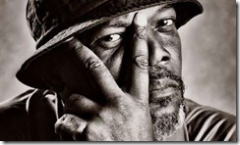
Samuel L. Jackson & Eye of Lucifer
One of the leading actors in Django Unchained, Satanic and ILLUMINATI House Negro, Samuel L. Jackson, added his two cents to the mix. He suggested that Spike Lee may be jealous of Quentin Tarantino’s film making success- “I don’t know if it’s jealousy”.[24]
Also, House Negro director of the film “Training Day” starting Denzil Washington, another ILUMINATI House Negro, also rode to Tarantino’s rescue to defend him publicly. Antoine Fugua admonished Spike Lee,
“That’s just not the way you do things,” said Fuqua, who admitted to not seeing the film yet himself, at the Capri event. “If you disagree with the way a colleague did something, call him up, invite him out for a coffee, talk about it. But don’t do it publicly.”[25]
In other words, we criticize HollyWeird’s Luciferian-Satanic powerful and elite, Quentin Tarantino, in secrecy, behind the scenes- closed doors. That’s the way it’s done by House Negroes in HollyWeird, CA.
Yet, there is my underlining suspicious that this will all play out to be a trick of mass deception. They create the false flag controversy between Spike Lee and Quentin Tarantino to lure unsuspecting masses to the film. Django Unchained has nothing to do with our true African Ancestors’ struggle and heroics during human bondage in America.
The film is a crude and vicious “red herring” designed to suck the masses into experimental cinematic subliminal mass hypnotics of self inflicted torture; and polarize the races. Django Unchained is a retelling of tales of Wagnerian Gods, Goddesses and the Mythology of the Germanic Pagan WOTAN played out with black faces.
In regards to Katt Williams and his criticism of the film and Wicked Tarantino seem to have fallen by the wayside, I suspect that the ILLUMINATI entertainment industry knows that everything is already in the works to neutralize him, and that he will be clandestinely dealt with by the highest levels of the ILLUMINATI and the (FEDS) U.S. Military-Industrial-Congressional System.
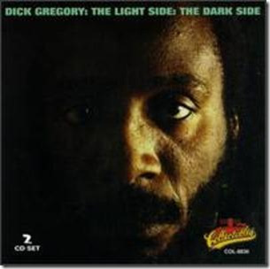
Still, the most wickedness attack on Spike Lee for discouraging the masses of people of color from being subjected to self-inflicted torture and abuse, ILLUSIONS and historic re-imaging of events close to their heart, soul and spirit, came from the Eye of Lucifer, Dick Gregory.
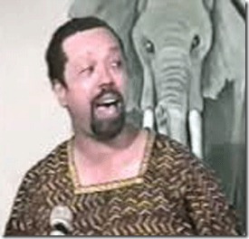
During the late 1990s, I had a rare opportunity to meet with a small group with the Late Great Steve Cokely in Oakland. As an Oak Town Field Negro, I wasn’t particularly invited. I found out about the time and place of the meeting, and went. Part of Cokely’s discussion was regarding Spike Lee’s 1992 film, Malcolm X.[26] Even at that time; it was common knowledge among brothers and sisters that half of movie involving Malcolm in a zoot suit, crime and chasing the blue eyed blond goddess was a tradeoff. It was the work of CIA Project MOCKINGBIRD originally established in 1947 on Lookout Mountain in Laurel Canyon, HollyWeird, CA.[27]
The HollyWeird film industry regularly clear scripts directed toward targeted audiences, particularly the Black and Brown masses, through the CIA and FBI. They have their own psychiatrists, psychologists and social scientists to mode cinema to control the mass psyche. They have script-screen writers, producers and directors in their back pocket with the power to revise film scripts and control film narratives.[28]
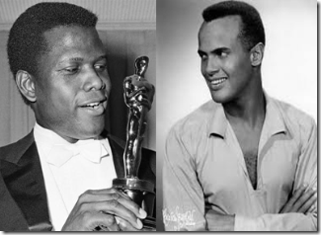
During the 1950s, it is documented that the CIA influenced HollyWeird’s film producers to plant “negroes” who were “well-dressed” (Sidney Poitier and Harry Belafonte, for example) in movies, as Cold War propaganda to manipulate and control mass world opinion and ILLUSIONS involving race relations in America.[29]
During this particular session with Cokely, he said that he knew Spike Lee well enough to command an audience. He asked us to help finance a trip to meet privately with Spike on the West Coast regarding further exploring the FBI/CIA’s role in developing, controlling and influencing the film Malcolm X and Black Cinema in general.
Cokely promised to keep the group, particularly the people that helped finance the trip, informed of the Spike Lee meeting. I intentionally gave Cokely a check with my name, address and phone number so there would be no excuse not to include me on the contact list, but as usual I was left out of the loop. I never heard from the group or Cokely again. However, it was generally understood among brothers and sisters, including Dick Gregory, of CIA/FBI involvement in the final film production of Malcolm X. In Chicago Gregory had been a close research protégée and friend of Steve Cokely.[30] He knew very that Malcolm X in that zoot suit chasing that blue eyed blond wasn’t his work.
R.I.P Steve Cokely passed from congestive heart failure April 11, 2011 in Chicago, IL. Cokely gained widespread notoriety when he served as special assistant to the former mayor of Chicago, Eugene Sawyer. He was also assistant to the special committee on rules under the late then Mayor Harold Washington.[31]
In Chicago, Cokely watched and befriended Barack Obama as he rose from a community organizer to a U.S. Senator which put this astute and highly intelligent, very vocal nationalist researcher and lecturer in a great deal of danger.
After several years of silence, Cokely finally promised to reveal all he knew about Chicago Politics and the “Obama Team.” Some entity and hidden hand forces in Chicago had gift wrapped Obama and delivered him to the masses like a Christmas gift, but Brother Cokely never lived long enough out of a coma to tell the story.[32]
It is disingenuous and an act of deception for Dick Gregory to single out Spike Lee for portraying Malcolm X as a slick zoot suit criminal chasing a blue eyed blond throughout half of the film knowing that it was the work of Project MOCKINGBIRD.
The CIA project is a MOCKINGBIRD of Reichsfuhrer Paul Josef Goebbels’ Ministry of Public Enlightenment and Propaganda that surreptitiously controlled the content of the THIRD REICH’s cinema and entertainment industry.[33]
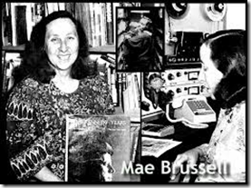
The Late Great Mae Brussell worked with a circle of lawyers, writers, journalist and researchers pursuing the “TRUTHS” behind the Assassinations of the Beloved, Malcolm X, U.S. President John F. Kennedy, Civil Rights Leader, Martin Luther King, Jr., and U.S. Senator Robert F. Kennedy.
Among these circles Brussell discovered what she called an elite “Power Control Group” that had a secret license from the government to control public access to real TRUTHS, and steer research and public exposures away from inconvenient Truths like the SS-REINHART GEHLEN ORG deeply imbedded in the deep cover (shadow) government, and the clandestine political assassinations of Malcolm X, the Kennedys, Dr. King and many-many others.
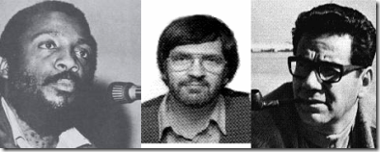
Dick Gregory, Author Robert Groden and Attorney Mark Lane had been among this elite “Power Control Group.”Lane and Gregory co-authored, Murder in Memphis: The FBI and the Assassination of Martin Luther King. Gregory became a leading outspoken critic of the Warren Commission findings that President JFK was assassinated by the lone wolf assassin, Lee Harvey Oswald.[34]
On March 6, 1975, Gregory and assassination researcher Robert Groden appeared on Geraldo Rivera’s late night ABC talk show Goodnight America. An important historical event happened that night when the famous Zapruder film of JFK’s assassination was shown to the public on TV for the first time in history. The public’s response and outrage to that showing led to the forming of the Hart-Schweiker investigation, which contributed to the Church Committee Investigation on Intelligence Activities by the United States, which resulted in the House Select Committee on Assassination investigation.[35]
Hitler’s General Reinhart Gehlen’s Org, SS Baron Otto von Bolschwing, and Operation PAPERCLIP Nazis in America and their clandestine involvement in shadow government political assassinations in America was completely veiled from any public or congressional inquiry.
During the 1970s, Gregory became grossly entangled as some sort of personal assistant to Millionaire Larry Flynt of Hustler Magazine.[36] On March 6, 1978, while leaving a court room in Georgia an attempt was made on Flynt’s life that left him partially paralyzed from the waist down, and with permanent spinal damage. He had been targeted by a sniper, believed to have been white supremacist serial killer, Joseph Paul Franklin.[37]
During the 1980s, Flynt became actively involved with financing a political assassination research group that included Mae Brussell. He financed a short-lived revolutionary classic publication, The Rebel. In January 1984, The Rebel published Mae Brussell’s classic article, The Nazi Connection to the John F. Kennedy Assassination: Evidence of link between Nazis still in operation after World War II to the still unsolved murder of John F. Kennedy.[38]
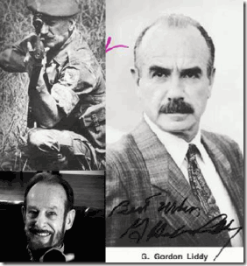
CIA/Gehlen Spooks Mitchell Werbell III, Gordon Novel & G. Gordon Liddy are Enough to Scare the Pants off of Anyone.
Merchant of Death, Mitchell Werbell, Richard Nixon White House Plumber operatives G. Gordon Liddy and Gordon Novel was dispatched into Flynt’s publishing enterprise and into his mansion as “house quests” to fix it, shut down Rebel, Mae Brussell and forcible turn Flynt, and in turn his close friend Dick Gregory who also had been residing at Flynt’s mansion in Beverly Hills-HollyWeird, CA.[39]
These were extremely dangerous people to say the least. In 1942, WerBell joined the Office of Strategic Services (OSS) and served in China, Burma, and French Indochina. As a guerrilla operative during World War II, he carried out a secret mission for the OSS under the command of Paul Helliwell in China with assassins E. Howard Hunt, Lucien Conein, John K. Singlaub, and Ray Cline that became major players in the world opium trade out of Southeast Asia. Werbell worked for Batista in pre-Castro Cuba. He was involved in political assassinations all across the Caribbean. He worked with U.S. Mercenary Gerry Patrick Hemmings on the Anti-Castro CIA training camps in Operation MONGOOSE to topple Castro in Cuba. He specialized in developing assassination weapons and silencers for the Gehlen/CIA. He was a major general of the U.S. Army. He is also linked to the JFK assassination team in Dallas.[40]
Gordon Novel is linked with the international assassination network linked with ardent Nazi Gruppenführer (Major General) SS Dr. Walter Robert Dohrnberger of Bell Helicopter and Permindex.[41] White House Plumber G. Gordon Liddy worshiped Adolf Hitler and Heinrich Himmler’s SS.[42]
WerBell, was put on Flynt’s payroll as his million dollar bodyguard.[43] Mae Brussell said they had given Flynt painkillers that fucked his judgment up and made him want to jump from an airplane to his death to protest the New York Times’ refusal to let him buy a full page carrying his view of the KAL 007 disaster that killed U.S. Congressman Larry McDonald of the John Birch Society.[44]
After Werbell, Liddy and Novel departed, Flynt was left in almost a vegetable state, his wife was dead from AIDS, and his prized Hustler Magazine was purged of its investigative articles and writing team and by early 1984 Rebel Magazine had been eliminated from existence altogether.[45] By 1988, R.I.P. Mae Brussell turned up dead.
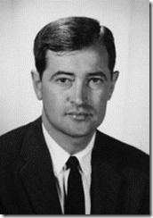
“The stone-age Negro denizens of Africa, Haiti, New Guinea and the southern Philippines are fascinated by clocks, radios and even sails.” –Willis Carto, The IMPERIUM [46]
Did they turn Dick Gregory? Judge it for yourself. Gregory and his buddy Mark Lane became part of the quasi-Nazi far right wing Liberty Lobby created by Willis A. Carto.[47] Gregory is alleged to have been a board director.[48]
In 1955, Carto founded the Liberty Lobby, an American political advocacy organization. He also ran an organization called Youth for [George] Wallace, which later became the White Nationalist organization the National Alliance. He also was involved in the Populist Party until political opponents took control over the party.[49]
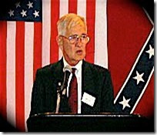
“All we know for certain about the Egyptians is that they were Caucasian, and that they, like all slavemasters, mingled their blood with that of their Negro slaves. As for the so-called Amerindian civilizations, we now know without doubt that civilization was superimposed upon the Indian savages by a White racial stock.” -Willis Carto, The IMPERIUM [50]
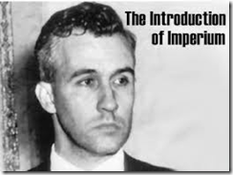
Carto had founded Western Destiny, a magazine which during the 1960s produced racist, Nazi-tinged articles; and Noontide Press, which continues to publish and offer for sale anti-Jewish and pro-Nazi books. One such book was Francis Parker Yockey’s 600-page Imperium, which was dedicated to Adolf Hitler and featured a 35-page introduction written by Carto. Yockey, an outspoken admirer of Hitler and Nazi SS Collaborator, was arrested in Oakland, CA across the street from Lake Merritt in 1960 on passport fraud charges; and subsequently committed suicide in a San Francisco jail. His book offers a rehash of Nazi doctrine — it denounced, for example, “the Church-State-Nation-People-Race of the Jew” as “distorters of culture.”[51]
Carto was a vicious racist as well as an anti-Semite. During the 1950s, Carto complained that “only a few Americans are concerned about the inevitable niggerfication of America.” In October 1966, the late columnist Drew Pearson published the contents of a letter written by Carto which stated:
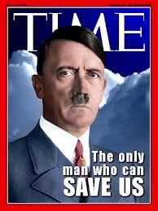
“Hitler’s defeat was the defeat of Europe. And of America. How could we have been so blind? The blame, it seems, must be laid at the door of the international Jews. It was their propaganda, lies and demands which blinded the West to what Germany was doing. . . . If Satan himself, with all of his superhuman genius and diabolical ingenuity at his command had tried to create a permanent disintegration and force for the destruction of the nations, he could have done no better than to invent the Jews.”
In a subsequent memo, Carto elaborated on these beliefs:
“Who is using who [sic]? Who is calling the shots? History supplies the answer to this. History tells us plainly who our Enemy is. Our Enemy today is the same Enemy of 50 years ago and before — and that was before Communism. The Communists are ‘using’ the Jews we are told. . . . [W]ho was ‘using the Jews 50 years ago –100 or 1,000 years ago. History supplies the answer. The Jews came first and remain Public Enemy No. 1.”[52]
I said all of this to say that Dick Gregory has been a scared running dog controlled by the SS-Knights of Black Sun and the Luciferian ILLUMINATI elite for quite some time. Yet, we have continued to love and respect the brother.

However, he has become far too comfortable in Negrodom acting as an ILLUMINATI black Goon attacking and calling his pathetically powerless ILLUMINATI brother Spike Lee out of his name in the world spotlight, and selling out the masses of people with grand ILLUSIONS and False Images of Quentin Tarantino’s Django Unchained for a few pieces of silver, a big grin on his face and pat on his ass for a job well done by the Luciferian New World Order. This is game.
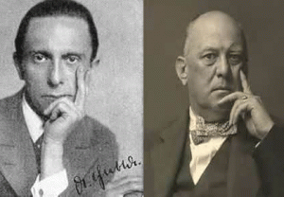
The little evil genius, Reichsminister Paul Josef Goebbels, and the Wickedness Man on Earth, the Great BEAST 666, Aleister Crowley wouldn’t have done a better job with Django Unchained at designing a more diabolical and sinister project that clandestinely destroy the mind, heart, spirit and unity of a people under the veil of their own racial history, entertainment and enjoyment for a New Luciferian World Order.
Especially for my Dear Brother, Katt Williams, I pray that you come HOME and your CHILDREN are returned without further harm,
The LORD is my shepherd I shall not want.
He maketh me to lie down in green pastures: he leadeth me beside the still waters.
He restoreth my soul: he leadeth me in the paths of righteousness for his name’s sake.
Yea, though I walk through the valley of death, I will fear no evil: for thou art with me; thy rod and thy staff they comfort me.
Thou preparest a table before me in the presence of mine enemies: thou anointest my head with oil; my cup runneth over.
Surely goodness and mercy shall follow me all the days of my life; and I will dwell in the LORD for ever.
(Psalm 23, The Original African Heritage Study Bible)

[1] http://allhiphop.com/2013/01/09/katt-williams-held-on-100k-bail-for-missing-court-date/
[2] http://www.pilotstuff.com/as.surveillance_earpiece.html
[3] http://www.gizmag.com/motorola-unveils-mission-critical-products/16019/
[4] http://www.nydailynews.com/entertainment/tv-movies/antoine-fuqua-calls-spike-lee-tarentino-film-article-1.1230298
[5]http://www.sohh.com/2013/01/spike_lee_that_little_thug_aint_even_see.html?utm_source=google&utm_medium=feed&utm_campaign=general-feed
[6] http://en.wikipedia.org/wiki/Fighting_words
[7]http://www.sohh.com/2013/01/spike_lee_that_little_thug_aint_even_see.html?utm_source=google&utm_medium=feed&utm_campaign=general-feed
[8] http://en.wikipedia.org/wiki/Louis_Fratto
[9] http://www.we-are-survivors.webs.com/ritualabuse.htm
[10] http://www.kulturekritic.com/2013/01/news/dck-gregory-calls-spike-lee-a-punk-and-a-thug-for-his-criticism-of-django-unchained/
[11] http://www.ferdyonfilms.com/2012/die-nibelungen-siegfried-kriemhilds-revenge-1924/15114/
[12] http://en.wikipedia.org/wiki/Brynhildr
[13] http://en.wikipedia.org/wiki/Valkyrie
[14] http://www.gamehunterfilmz.biz/gamehunter-filmz-blog/dick-gregory-on-django-unchained-spike-lee-is-a-thug-a-punk-audio-interview-
[15] http://wesclark.com/jw/newby.html
[16] http://wesclark.com/jw/newby.html
[17] http://en.wikipedia.org/wiki/Django_Unchained#Development
[18] http://en.wikipedia.org/wiki/Sergio_Corbucci
[19] http://www.firstshowing.net/2010/quentin-tarantino-reveals-more-about-his-slavery-western/
[20]http://www.sohh.com/2013/01/spike_lee_that_little_thug_aint_even_see.html?utm_source=google&utm_medium=feed&utm_campaign=general-feed
[21] http://en.wikipedia.org/wiki/Luther_Campbell
[22] http://www.eurweb.com/2013/01/luke-calls-spike-lee-uncle-tom-house-negro-for-django-bashing/
[23] http://www.huffingtonpost.com/2013/01/18/jamie-foxx-spike-lee-django-unchained-criticism_n_2505894.html
[24] http://www.entertainmentwise.com/photos/101488/1/Samuel-L-Jackson-Defends-Quentin-Tarantino-From-Criticism-Of-Django-Unchaineds-Racist-Language
[25] http://www.nydailynews.com/entertainment/tv-movies/antoine-fuqua-calls-spike-lee-tarentino-film-article-1.1230298
[26] http://en.wikipedia.org/wiki/Malcolm_X_(film)
[27] http://www.mail-archive.com/cia-drugs@yahoogroups.com/msg12919.html
[28] http://www.guardian.co.uk/film/2008/nov/14/thriller-ridley-scott
[29] http://www.guardian.co.uk/film/2008/nov/14/thriller-ridley-scott
[30] http://www.youtube.com/watch?v=xiOq85bLFnE
[31] http://en.wikipedia.org/wiki/Steve_Cokely
[32] http://www.abovetopsecret.com/forum/thread416856/pg1
[33] http://en.wikipedia.org/wiki/Ministry_of_Public_Enlightenment_and_Propaganda
[34] http://www.firstpost.com/topic/person/robert-f-kennedy-mae-brussell-power-control-group-mark-lane-robert-groden-11578-video-iQLH8GS_U0o-14883-1.html
[35] http://en.wikipedia.org/wiki/Dick_Gregory
[36] http://www.people.com/people/archive/article/0,,20085591,00.html
[37] http://african.howzit.msn.com/Africa-Gallery.aspx?cp-documentid=251859690&page=7&ocid=LastSlide&tcid=LastSlide
[38] http://www.whale.to/b/brussell_nazi.html
[39] https://deeppoliticsforum.com/forums/showthread.php?471-Larry-Flynt-deserves-his-own-thread-here
[40] http://en.wikipedia.org/wiki/Mitchell_WerBell
[41] http://www.bilderberg-mirror.org.uk/kennedy/index.htm
[42]http://www.democraticunderground.com/discuss/duboard.php?az=show_mesg&forum=104&topic_id=199853&mesg_id=219327
[43] http://www.independent.co.uk/news/people/profiles/larry-flynt-the-trouble-with-larry-570430.html
[44] http://www.lycaeum.org/drugs/abstracts/L4.cgi?mode=keys&kwand=intoxication
[45] https://deeppoliticsforum.com/forums/showthread.php?471-Larry-Flynt-deserves-his-own-thread-here
[46] http://www.barnesreview.org/page.html?chapter=1&id=3
[47] http://en.wikipedia.org/wiki/Mark_Lane_(author)
[48] http://educationforum.ipbhost.com/index.php?showtopic=10074&st=45
[49] http://www.the-savoisien.com/wawa-conspi/viewtopic.php?id=2009
[50] http://www.barnesreview.org/page.html?chapter=1&id=3
[51] http://www.adl.org/holocaust/carto.asp
[52] Id.
Comments : 19 Comments
Tags: barack obama, brandy, brandy norwood, broomhilda, cross of lorraine, dangerfield newby, dick gregory, django unchanined, Frances Parker Yockey, frankie fratto, g. gordon liddy, gordon novel, harriet newby, harry belafonte, house negroes, Imperium, Jamie Foxx, Jr., katt williams, kiss of luciferian brotherhood, luther campbell, Mae Brussell, mitchell werbell, paul josef goebbels, quentin tarantino, ritual abuse and torture, sammy davis, samuel l. jackson, satanic cross, sidney poitier, siegfried, spike lee, steve cokely, uncle luke, willis carto, wotan
Categories : dangerfield newby, danny glover, dick gregory, double bind, harry belafonte, hip hop satanic cult, hollywood satanic cult, illuminati, katt williams, lil wayne, luciferians, mae brussell, mark lane, mark of the beast, nwo, oakland, power control group, project mockingbird, re-image, re-imaging, robert groden, satan, sidney poitier, spike lee, steve cokley, trauma-based mind control, underground reich, underground third reich, wotan, young money

KATT WILLIAMS, MENSA & THE DJANGO UNCHAINED DECEPTION
11012013
The Little Mad Genius and the Wilderness of Mirrors
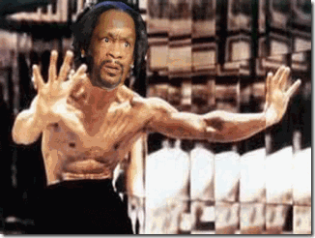
“Remember: the enemy has only images and ILLUSIONS behind which he hides his true motive. Destroy the images and you will break the enemy.” –Shaolin Abbott to Bruce Lee, Enter the Dragon[1]
Katt Williams opens a rare window into the struggle of a CIA MONARCH/MK ULTRA child victim to break free. It is rare to see it all playing out in the public domain like a Bourne Identity.
The Bourne Identity is a 2002 HollyWeird American-German action spy film loosely based on Robert Ludlum’s novel of the same name. Manchurian Candidate Jason Bourne was rescued from the ocean suffering from two bullet wounds. He recovered, but suffered from post-hypnotic amnesia barriers implanted by the CIA as cover for its clandestine assassination operations. Bourne struggles in an attempt to discover his true identity to break free from mind control programming amidst a clandestine conspiracy within the CIA to stop him from blowing cover.[2]
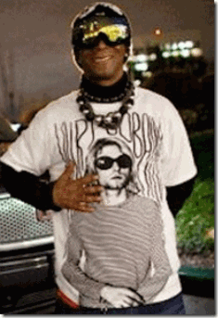
It appears that Katt Williams has some recall, but not total recall. In distress, he seems to have some recall that his programming and distress has something to do with events and people surrounding the late American musician and artist, Kurt Cobain, best known as the lead singer, guitarist and primary songwriter of the grunge band Nirvana. Cobain committed suicide in 1994. Yet, many maintain that his death is related to the CIA and MONARCH/MK ULTRA mind control programming from an early impressionate age from infancy to 6 years.[3]
Katt doesn’t openly express anything about MK-ULTRA whether it is fear or amnesia blocks, barriers and layers. I can’t be sure, but his symbolic or metaphoric expressions can’t be any clearer.
He doesn’t talk about what happened to him after forced into the South Carolina State Mental Health System for at least two weeks even though he was not a resident of the state and his net worth was at least $20 millions, which means that he had the resources to have had his own lawyers, psychiatrists, psychologists, social-mental health workers and physicians. What is odd is that he was forced into an antiquated public mental health system from the early 19th Century in the Post Ante-Bellum-Civil War South and not anyone lifted a hand to help him or protest.
In the recent TMZ video, above, Katt Williams revealed that his IQ was tested and measured at 163. There are three (3) generally accepted gradients within the gifted range: gifted, from 130-145 IQ; highly gifted, 140-160 IQ; and exceptionally gifted above 160 IQ.[4] A measured IQ score of 163 would certainty put Katt in the genius range. But, he went on to divulge that he was being tested every six months. So, who and what entity is messing with Katt Williams’ brain every six months?
The extremely troubling and truly frightening part of what Katt revealed in the video (frames 128-136) was the statement, “I have been with Mensa since I was 10.” He doesn’t say that he was a member of MENSA, but after some recall he says that he was associated with some aspects of the society whether seen or unseen since about 1983. I wouldn’t necessarily write off anything that Katt Williams says. He is not necessarily an “evil little genius gone mad,” but a possible popularized “BOURNE LEGACY” with recall of events and circumstances surrounding CIA MONARCH/MK ULTRA programs longing to be free of harassment.
Mensa is the largest and oldest high IQ society in the world. Mensa’s requirement for membership is a score at or above the 98th percentile on certain standardized IQ or other approved intelligence tests, such as the Stanford-Binet Intelligence Scales. The minimum accepted score on the Stanford-Binet is 132, while for the Cattell it is 148. Most IQ tests are designed to yield a mean score of 100 with a standard deviation of 15; the 98th-percentile score under these conditions is 130.82. [5]
Mensa’s constitution lists three purposes: “to identify and to foster human intelligence for the benefit of humanity; to encourage research into the nature, characteristics, and uses of intelligence; and to provide a stimulating intellectual and social environment for its members”. To this end, the organization is also involved with programs for gifted children, literacy and scholarships, and it also hold numerous gatherings.[6]
MENSA, Aquarian Conspiracy and LEBENSBORN

One of the founding fathers of MENSA was the eminent British Educational Psychologist and Race Scientist, Sir Cyril Burt (1883-1971). Sir Burt became the most prestigious, powerful, and influential psychologist since the American genius William James. He held the chair of psychology at London’s University College, was knighted in 1946 by King George VI, and received the Thorndike award from the American Psychological Association. Most of Burt’s career was based upon his statistical studies of the intelligence of identical twins, showing that poverty was due to inferior intelligence of the working class. In the 1940s, Burt was involved in setting up the British school (tracking) system which segregated students on the basis of an IQ test they took at age eleven.[7]
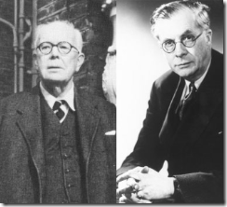
AQUARIANS, Eugenists Sir Burt and Sir Julian Huxley, brother of Aldous Huxley, led the British Eugenics Society. Sir Julian Huxley, first head of the United Nations’ UNESCO, changed the name of their program for enforced birth control, zero economic growth, and the technology of mass mind control, and continued to apply the principles which created Nazi Germany’s mass murder programs against the “mentally deficient,” the “racially unfit,” the politically undesirable.[8]
“The career of the venerated Julian Huxley is a classic of conspiratorial activity. Huxley was a director of the Abortion Law Reform Association in Britain from its inception; an Executive Committee member of the Euthanasia Society; an officer of the Eugenics Society; a leading member of the British National Association for Mental Health; and of the WFMH, and so on. Think again of Aldous Huxley’s book Brave New World. Julian Huxley was committed, all his life, to that “brave new world.”
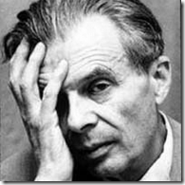
Anyone who ever read that book remembers very clearly one curious thing about it. The population is divided, genetically and for enforcement, into Alphas, Betas, and so on all the way down to the synthetically produced ‘Epsilon morons.’
These divisions are accomplished by applied eugenics, or Nazi breeding laws. Different synthetically produced “I.Q. groups” are predetermined to perform different tasks for the society, and are kept happy in their pre-fixed places by mind-altering drugs. Every agency Julian Huxley worked with is committed to such a society.”[9]
The AQUARIANS took over after the Fall of Nazi Germany to form the nucleus of a conspiracy of Global Aryan Dominance that maybe more powerful, dangerous, widespread, and clandestine than the THIRD REICH.
MENSA is veiled and shrouded in the ultimate secret global extermination of the “untermensch” (sub-man, sub-humans);[10] “lebensunwerte leben” [useless eaters- life unworthy of life];[11] and the universal racial dominance the Bloodlines of WOTAN.[12]
Around 1948, MENSA was formed – the first international organization for the intellectually ‘gifted.’ Sir Burt was its founding father and first president. Another founding father was Victor Serebriakoff, a White Russian émigré recruited by British and American intelligence services who was credited with greatly expanding membership in the organization, instituting the IQ test as a prerequisite of membership, and establishing American MENSA. Another founder, and the man who claimed to have come up with the idea for MENSA, was Dr. Lance Ware, a biochemist who had worked during World War II at Porton Down, Britain’s ultra-secret biological and chemical warfare facility.[13]
1948 was also the year that Franz Kallman, who had been an associate of Ernst Rudin, founded a new eugenics institute, dubbed the American Society of Human Genetics. Around that same time, Dr. Otmar von Verschuer, who had served as the mentor of the notorious Demon of Death, Dr. Josef Mengele, founded the Institute of Human Genetics in Munster, Germany.[14]
In 1950, Cyril Burt published the results of some of his twin studies, purportedly showing data that supported his eugenics views. His studies claimed to prove that poverty was due to the intellectual inferiority of the working class. In 1952, John Foster Dulles established the Population Council in conjunction with John D. Rockefeller III. Tens of millions of dollars of Rockefeller grant money were pumped in as the American Eugenics Society moved its headquarters into the offices of – and assumed the name of – the newly created Population Council.[15]
The Pioneer Fund has been involved in the history of race science since its establishment in 1937. One of its founders, Harry Laughlin wrote a model sterilization law widely used in both the United States and Europe. Many of the key academic racists in both Right Now! and American Renaissance have been funded by the Pioneer and the Pioneer was directly involved in funding the parent organization of American Renaissance, the New Century Foundation. Most of the leading Anglo-American academic race-scientists of the last several decades have been funded by the Pioneer, including William Shockley, Hans J. Eysenck, Arthur Jensen, Roger Pearson, Richard Lynn, J. Philippe Rushton, R. Travis Osborne, Linda Gottfredson, Robert Gordon, Daniel R. Vining, Jr., Michael Levin, and Seymour Itzkoff.[16]
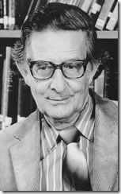
Hans Jürgen Eysenck (1916 – 1997) of Nazi Germany was an eminent psychologist, most remembered for his work on intelligence and personality. Eysenck was trained under and was a disciple of Sir Burt. The Pioneer Fund openly espoused the Racial Science of Sir Burt.[17]
Henry Garrett ’72-3 was a director of the Pioneer Fund, whose fundamental objective, stated in their corporate rationale was based on the SS-1 Heimlich Himmler’s Lebensborn.[18]
One of the first American members of MENSA is alleged to have been the felonious pedophile, Walter Breen, that I discussed in brief detail in the previous post “Over the Rainbow” Katt Williams…” During the 1960s around San Francisco, UC Berkeley and Stanford University, Breen had one of the leading protagonists’ for THE CHILDREN OF THE ATOM, a special society and boarding schools for high IQ children. This group of people opened the San Francisco MENSA Chapter. [19]
Eldon Byrd was a member of MENSA. Byrd who worked for Naval Surface Weapons, Office of Non-Lethal Weapons, White Oaks Laboratory, Silver Springs, Maryland was commissioned in 1981 to develop electromagnetic devices for purposes including ‘riot control’, clandestine operations and hostage removal. Byrd and Uri Geller of “Space Kids” are good friends, from back in the 70s.[20]
MENSA is a veiled LEBENSBORN’s program and a prime recruiting ground for CIA-MONARCH/MK ULTRA “Whiz Kids.”
Inglorious Bastards, A Shrouded Teutonic Lore of the SS
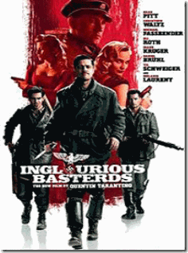
I respectfully disagree with Spike Lee. Quentin Tarantino’s Django Unchained does not rise to the occasion to be disrespectful of the heroics of my ancestors during slavery. There is a big difference between films expressing artistic freedom and instruments of deceptions. Halle Berry’s film Frankie & Alice from the Boys of Lookout Mountain is an instrument of deception and fraud veiling the MONARCH/MK ULTRA programs.
I also respectfully disagree with Katt Williams. Quentin Tarantino’s doesn’t want to be “Black.” He believes that he is cleverer than the Masses of the People. However, if Katt actually means that he desires to secretly command the energy, master the spirit and control the mass Black Psyche through LUCIFERIAN magkic, trickery, images, ILLUSIONS and deceptions than I agree wholeheartedly with him. Django has nothing to do with an artistic expression of American Slavery and “STUFF.” Django Unchained is an instrument of mass deception from the pits of HELL.
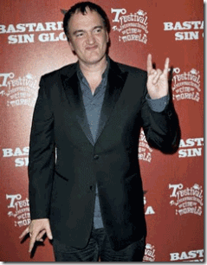
Satanic Quentin Tarantino and the Devil’s Horns hand gesture. Don’t believe your lying eyes. He does it twice. Yet, it may be the symbol of the Nazi Satanic Principle-Janus Faced Dualism. The right hand-Satan, the left hand-Love.
One evening, I sat down and watched Tarantino’s 2009 film, Inglorious Bastards.[21] I had absolutely no idea what the film was about. One of my in-laws thought that I would enjoy the film. I had no idea of alternate history or alternative history genre. It is a genre of fiction consisting of stories that are set worlds in which history has diverged from the actual history of the world. It is “allohistory” (literally “other history”).[22]
It is smoke and mirrors, ILLUMIONARY; and the re-imaging of history. Basically, Inglorious Bastards was a False Romanic Teutonic Lore of the SS and THRID REICH.
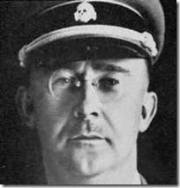
  - “Most of you know what it means when a hundred corpses are lying side by side, or five hundred, or a thousand. To have stuck it out, and at the same time — apart from exceptions caused by human weakness — to have remained decent fellows that is what has made us hard. This is a page of glory in our history, which has never been written and is never to be written….” -Reichsfuhrer SS-1 Heinrich Himmler, The Posen Speech to SS officers (6 October 1943)
The main character of the film is Standartenführer (Colonel) SS Hans Landa, the Jew Hunter. Nevertheless, SS Landa is really a great guy- one of Himmler’s decent fellows. He is not a true believer in Nazi ideology; “he admits that he has no personal animus toward Jews.”[23]
Compare SS Landa to California’s Resident SS Officer and Occulted Knight of the Black Sun, Hauptsturmführer SS Baron Otto von Bolschwing, the BEAST of Bucharest, Romania. He was the charming “David Niven of the SS.” SS Baron Bolschwing also didn’t really believe in Nazism, but was willingly part of the occulted SS declared by the Nuremberg Tribunal to be a human rights and war criminal organization against humanity responsible for the mass murder of millions in Eastern Europe and Africa. It is a bunch of HollyWeird propaganda and Romanized Bullshit and Mass Deception!
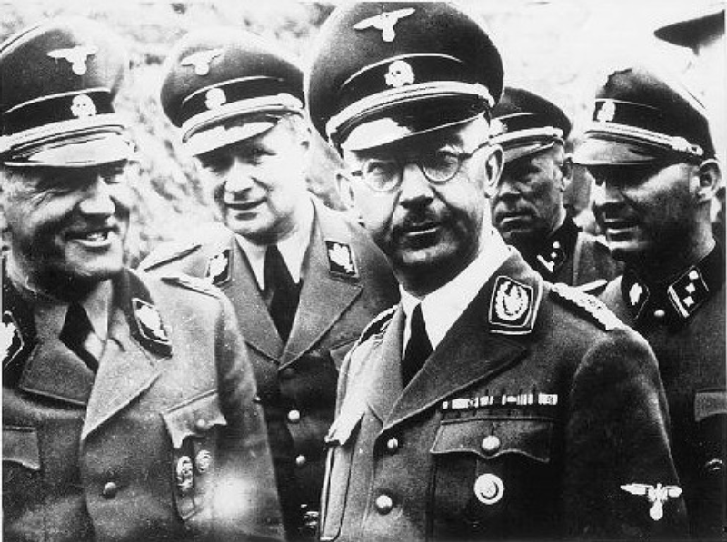
- I also want to mention a very difficult subject before you here, completely openly. It should be discussed among us, and yet, nevertheless, we will never speak about it in public. Just as we did not hesitate on 30 June to carry out our duty, as ordered, and stand comrades who had failed against the wall and shoot them. About which we have never spoken, and will never speak. That was, thank God, a kind of tact natural to us, a foregone conclusion of that fact, that we have never conversed about it amongst ourselves, never spoken about it, everyone shuddered and everyone was clear that the next time he would do the same thing again, if it were commanded and necessary. I am talking about the “Jewish evacuation”; the extermination of the Jewish people. It is one of those things that is easily said. “The Jewish people are being exterminated,” every party member will tell you, “perfectly clear, it’s part of our plans, we’re eliminating the Jews, exterminating them, Ha! A small matter.” -Reichsfuhrer SS-1 Heinrich Himmler, The Posen Speech to SS officers (6 October 1943)
Inglorious Bastards was described by its producer, Lawrence Bender, to have been a Jew’s “Wet Dream” revenge movie.[24] It was an ILLUMINATI tradeoff of the Jews and powerful, murderous GERMAN interests.
Tarantino and Bender also found it necessary to cast the right German “to play the charming polyglot Landa …”[25] Heinrich Himmler and Josef Goebbels couldn’t have done a better job to “re-image” the SS, the World’s Greatest Racial Mass Murderers, as charming and decent fellows to the Masses of the People.
For the job well done of veiling the Janus Face-Satanic Principled SS, the HollyWeird elite gave that right Teutonic Pagan Legatee and Bloodline, Christoph Waltz, an Academy Award.
Tarantino’s close friend and his major film producer, Bender, was nominated for a 2010 Academy Award for Best Motion Picture of the Year. Bender produced Lost in Oz. It was a 2002 television pilot for a planned series, an original sequel to The Wizard of Oz, inspired by the books of Oz of L. Frank Baum.[26]
L. Frank Baum was a member of the Theosophical Society, which is an organization based on global occult research among civilizations. Baum had a deep understanding of Theosophy and, consciously created an allegory of Theosophical teachings when he wrote the Wizard of Oz.[27]
The Theosophical Society is an occulted and notorious LUCIFERIAN organization, mainly based on the teachings of Madame Helena P. Blavatsky. She espoused the New Age of LUCIFER and the glorification of the GREAT ARYAN BROTHERHOOD given domain of everything on earth.[28] See the excellent Occult Roots of the Wizard of Oz.
For me, Inglorious Bastards had been a living nightmare. My father had been among the first victims of one of the most secretive and classified collaborative between the Nazis and the U.S. Navy, Project CHATTER.
In 1948, they kidnapped him from his job at the U.S. Naval Base in Alameda, CA. They took him to Napa State-Navy Hospital and subjected him to SS Dr. Josef Mengele’s tortuous experimental electrical shock procedures (depatterning) developed at Austerlitz Concentration Camp. In just one session, he was subjected to a series of electrical shocks up to 35 times that damaged his heart and turned him into a human vegetable.
For decades, I had been dumbfounded by my father’s odd ravings recorded in his medical reports. Suffering under the duress of delusions created by mescaline or LSD, he constantly ranted about “silver slippers” and “floating in the air.” I subsequently found that I had been a victim of my own folly and didn’t factor in the rapid advances in 20th Century Technicolor film productions.
The original and early production of the Wizard of Oz (1939) had been in black and white. Dorothy’s original slippers were “silver slippers.” Someplace in the deep recesses of my mind, I recall my father raving about the “silver slippers” as he turned our lives upside down in absolute horror.
Click your heels, you can literally fly to other dimension and from one alter to another “Somewhere Over the Rainbow.” The Nazis didn’t die in Nuremberg or in any Tarantino and Bender fantasy fire in Nazi Germany. They were ran out of Eastern Europe by the Russians. They were smuggled into America to bring about a New World Order and once again prey primarily upon the “untermensch” (sub-man, sub-humans); “lebensunwerte leben” [useless eaters- life unworthy of life] under the cloak of U.S. National Security and the HollyWeird ILLUMINATI elite.
Bender is a Zionist.[29] He is a member of the Council of Foreign Relations (CFR) and the globalist group, the Pacific Council on International Policy.[30]
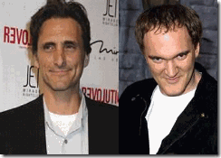
Bender and Tarantino are a key part of HollyWeird’s powerful LUCIFERIAN-ILLUMINTI. The theatre fire in Inglorious Bastards that consumed the Nazis was a vicious metaphor. It was the ceremonial burning of Valhalla, the Castle of the Wagnerian Aryan Gods. The fire consumed Wotan and other ancient pagan gods. They didn’t literally die, but entered into the “Dust and Twilight of the Gods” to make way for the coming of a New Age of LUCIFER.
Black People and the masses will not get a free “FEEL GOOD” pass from these ILLUMINISTS-MASTERS OF DECEPTIONS. They desire to penetrate the sub consciousness via mass media scientific “entrainment” of our brains. They are bent on extinguishing our minds and souls, our very BEING.
Django Unchained, another Shrouded Teutonic Lore
Tarantino didn’t consult with Black scholars or historians to create a meaningful script or plot for Django Unchained. It wasn’t created out of any dialogue or genuine concern for the aspirations of Black People that would validate and provide fuel and empowerment to Black Identity and their BEING. Tarantino’s pet Hip Hop Satanic Cult Negroes like Jamie Foxx or Samuel L. Jackson didn’t add to the script either.
As pointed out by Katt Williams, the name, Django, has absolutely nothing to do with the African Spirit and Experience in America. The name Django is an allusion to the hero of an obscure Italian spaghetti western film called Django played by Franco Nero.[31]
The people of Germany immediately recognized what Django Unchained really was metaphorically about. The movie plot was another Tarantino veiled teutonic lore of Germanic Mythology, Culture and Experience. Tarantino invited Standartenführer SS Hans Landa (Christoph Waltz) to add his special native Volkisch-Teutonic Love to the movie script. Waltz and Tarantino deceptively paralleled the plot of the movie to Richard Wagner’s “Ring of the Nibelung.”[32]
This is not my conclusion. They tell you from the very beginning of the movie that the Germanic personas and Occulted Mythology of Siegfried and Broomhilda from Wagner’s Ring Series are at the basis of Django Unchained.[33] It is long and complicated with many variations, so please bare with my brief summaries to the Wagnerian Folktale of Siegfried and Broomhilda.
Django Unchained and the German Folktale Siegfried and Broomhilda
Broomhilda

Though the cycle of Richard Wagner’s four operas titled Der Ring des Nibelungen, Brünnhilde (Broomhilda) appears in the latter three operas (Die Walkure, Siegfried, and Gotterdammerung), playing a central role in the overall story of Wotan’s downfall. In Wagner’s tale, Brünnhilde is one of the valkyries, who are born out of a union between Wotan and Erda, the personification of the wisest woman of the earth.[34]
In Norse mythology, a valkyrie (from Old Norse valkyrja “chooser of the slain”) is one of a host of female figures who decide which soldiers die in battle. Selecting among half of those who die in battle (the other half go to the goddess Freyja’s afterlife field Fólkvangr), the valkyries bring their chosen to the afterlife hall of the slain, Valhalla, ruled over by the god Wotan (Odin). There, the deceased warriors become einherjar (lone fighters) that in particular to Wagner’s Ring Series that will help the gods in the great battle with the Nibelungs. When the einherjar are not preparing for the events of Ragnarök, the valkyries bear them mead (honey wine). Valkyries also appear as lovers of heroes and other mortals, where they are sometimes described as the daughters of royalty, sometimes accompanied by ravens, and sometimes connected to swans or horses.[35]
Broomhilda play a major role in Wagner’s “Die Walkure” (1870), Wotan’s favorite daughter, the second of the four operas that comprise Der Ring des Nibelungen, in which the “Ride of the Valkyries” begins Act III. The heroine of the cycle, Brünnhilde is stripped of her immortality for defying the god Wotan (Odin).[36]
Siegfried

In Wagner’s Die Walkure, Wotan initially commissions Broomhilda to protect Siegmund, his son by a mortal mother. When Fricka forces Wotan to have Siegmund die, Brünnhilde disobeys her father’s change of orders and takes away Siegmund’s wife (and sister) Siegline and the shards of Siegmund’s divine sword, Nothung. She manages to hide them, but must then face the wrath of her father who is determined to make her mortal and put her into an enchanted sleep to be claimed by any man who happens across her. Brünnhilde argues that what she did was in abeyance of the god’s true will and does not deserve such a fate. Wotan is eventually persuaded to protect her sleep with magical fire, sentencing her to await awakening by a hero who does not know fear.[37]
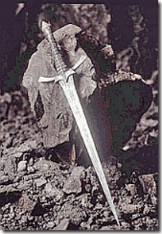
Mime the Nibelung finds Siegmund and Siegline dying and pieces of the Nothung broken by Wotan. Siegline dies giving birth to Siegfried. Siegfried, the hero, is Wotan’s grandson, the son of Wotan’s twins, Siegmund and Siegline, who were slain by Fricka, Goddess of Youth and Beauty, because Wotan had given them the Enchanted (Dragonslaying) Sword Nothung.
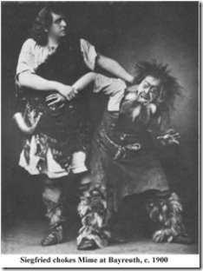
Mime raised Siegfried from infancy hoping that he would be able to betray him to reforge his father’s Nothung to slay the dragon to steal the Rhinegold and the Ring back. [38]
In the movie, Django-Persona of Siegfried (Jamie Foxx) is focused not on freeing his people from the horrors of human bondage, but on one goal as set by King Schultz: finding and rescuing Broomhilda (Kerry Washington), the wife he lost to the slave trade (Wotan’s ring of fire). Broomhilda was named by her GERMAN mistress. Broomhilda speaks fluent German.
Django’s enslaver and mentor is Dr. King Schultz (Christoph Waltz), a GERMAN dentist-cum-bounty-hunter who like the Janus-Faced Standartenführer SS Hans Landa, has an ILLUSIONARY healthy hatred of racism and slavery. In fact, King Schultz tells Django about the pagan folktale of Broomhilda, a woman who is imprisoned on a rock by her father until the hero, Siegfried, slays the dragon (Fafner) with a reforged Nothung and walks through hellfire to rescue her.[39]
So, what does the Nazi beloved pagan tale and the Wagnerian Gods of Richard Wagner (1813-1883) and his Der Ring des Nibelungens Operas truthfully have to do with the empowerment of Black People, the ancestors and human bondage in this country?
Peel away the veneer of Richard Wagner’s German-Aryan pagan fairy tales; Tarantino and Waltz’s Smoke and Mirrors and Teutonic Lore, you will be troubled at what you will discover and why Katt Williams, the Not So Little Mad Genius, is truly incensed about- promising (symbolically) to beat Tarantino’s Inglorious Bastard Ass for the Django Unchained Deception.
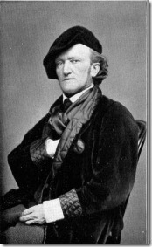
“Whoever wants to understand National Socialist Germany must first know Wagner.” -Fuhrer Adolf Hitler
Wagner’s, above, with the hidden hand gesture, friend was Arthur de Gobineau (1816-1882), the French racial theorist and author of The Inequality of the Races, which gained widespread acceptance in European communities, thanks to Wagner’s assiduous promotion. Gobineau’s theories corroborated what he himself had already decided about the “noble and ignoble” races.[40]
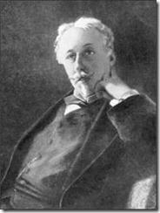
“…there is nothing to show that, in the view of the first compilers of the Adamite genealogies, those outside the white race were counted as part of the species at all.” –Count Arthur de Gobineau[41]
Count de Gobineau is the “Father of Modern European Racism.” All of his so-called race science experiments and theories concluded that “Caucausoids” were intellectually and physically superior to “Negroids,” “Mongoloids,” and other supposed racial categories,
“… We often hear of negroes who have learnt music, who are clerks in banking-houses, and who know how to read, write, count, dance, and speak, like white men. People are astonished at this, and conclude that the negro is capable of everything! And then, in the same breath, they will express surprise at the contrast between the Slav civilization and our own. The Russians, Poles, and Serbians (they will say), even though they are far nearer to us than the negroes, are only civilized on the surface; the higher classes alone participate in our ideas, owing to the continual admixture of English, French, and German blood. The masses, on the other hand, are invincibly ignorant of the Western world and its movements, although they have been Christian for so many centuries—in many cases before we were converted ourselves! The solution is simple. There is a great difference between imitation and conviction. Imitation does not necessarily imply a serious breach with hereditary instincts; but no one has a real part in any civilization until he is able to make progress by himself, without direction from others. What is the use of telling me how clever some particular savages are in guiding the plough, in spelling, or reading, when they are only repeating the lessons they have learnt ? Show me rather, among the many regions in which savages have lived for ages in contact with Europeans, one single place where the religious doctrines, the ideas, customs, and institutions of even one European people have been so completely assimilated that progress in them is made as naturally and spontaneously as among ourselves.” (Count) Joseph Arthur de Gobineau, Essay on the Inequality of the Human Races (1853), extracts.[42]
In defense of the American Institution of Slavery and the Confederacy during the Civil War, the confederacy translated Count de Gobineau’s racial science, theories, agenda and works to justify and support human bondage of Africans in America.[43]
Wagner’s Ride of The Valkyries is frequently used in HollyWeird movie productions. In the overt racist film, Birth of a Nation (1915), D. W. Griffith used the Ride of the Valkyries in the climactic scene of the third act, when “The former enemies of North and South are united again in defense of their Aryan birthright” against liberated African Descendants after the end of the Civil War. In the movie, a white group-white women are rescued by the Ku Klux Klan to the sound of Wagner’s Aryan chest beating music.[44]
Wagner cited de Gobineau to support his views about the heroic superiority of the Aryans and the extreme cultural inferiority of the Jewish “race.” Wagner’s English son-in-law and biographer, Houston Stewart Chamberlain, characterized the Aryans as culture-builders and sustainers and the Jews as destroyers (Chamberlain, 1899). Fuhrer Adolf Hitler was heavily influenced by the views of Wagner and Chamberlain. Chamberlain inspired a vast literature on “racial purity.”[45]

In fact, Adolf Hitler had been a devotee of Wagner, de Gobineau, and particularly British-born writer and occulted mystic Houston Stewart Chamberlain(1855-1927). They were all early proponents of Nordic (Imperium) supremacy and anti-Semitism. It was Chamberlain that “hails Hitler as the new leader of Germany in 1923.” Chamberlain “told a mass society, at the mercy of impersonal forces which was crushing it, that the Teutons were indomitable master builders, that in mysticism was freedom, and ‘every mystic’ is, whether he will or not, a Anti-Semite, and Darwin’s theory of natural selection justifies the structure against mingling of the races.” (Dusty Sklar, The Nazis and the Occult, Dorset Press, NY (1977), pg. 11)
Wagner, Gobineau and Chamberlain’s Aryan Agenda and race science theories are veiled in Wagner’s music and theatrical dramas and plays, particularly Der Ring des Nibelungens. Besonders gelte dies für die Rolle des entfesselten Titelhelden – dieser habe allerlei Prüfungen zu bestehen, um seine versklavte Frau zu befreien. Whereas, Wagner and Gobineau’s Aryan Agenda and race science theories are metaphorically veiled in Django Unchained.
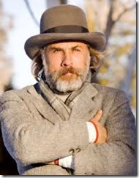
In Django Unchained, Dr. King Schultz, with the hidden hand gesture, is the Wanderer. KING Schultz, the Native German Volk– Christoph Waltz, is Wotan, King of the Gods. The name Shultz (German) is a status name for a village headman, from a contracted form of Middle High German Schultheize (Old High German is Sculdheizo). The term originally denoted a man responsible for collecting dues and paying them to the lord of the manor. It is a compound of sculd(a), meaning “debt” or “due,” plus a derivative of heiz(z)an, meaning “to command.”
In Wagner’s Das Rheingold, Fafner is a giant/dragon that Wotan, the Wanderer, influenced Siegfried to slay with the enchanted dragonslaying sword. Wotan owed Fafner payment for the work of building Walhalla, Castle of the Gods.[46] Fafner transformed into a dragon to guard the hoard of Rhinegold, including the “Ring of Power” taken from Alberich made from the Rhinegold that Wotan truly covets.[47]
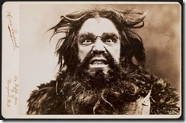
Alberich rules the Nibelungs in land of Nibelheim. Nibelheim is inhabited by a race of evil dark dwarves (creatures) down in the lower region of earth.[48] Alberich had cursed love, stole the hoard of gold from the Rhinedmaidens (water nymphs) and forged the Ring of Worldly Power from mythical precious Rhinegold.

In Wagner’s Ring Series, Wotan is disguised as the Wanderer, symbolic of his self-deception, thinking he’s uninvolved with Siegfried’s life and efforts to retrieve the ring. His desire to control events conflicts with his need for a free agent to accomplish what he by law cannot: obtain the ring.[49]
At the end of the movie, Dr. King Schultz dies at the Candyland Mansion that held Broomhilda in bondage. Django plants dynamite in the mansion. He kills most of the residents of Candyland, frees the house slaves than lights the dynamite’s fuse.
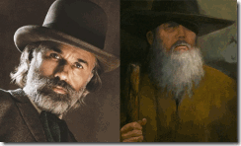
King Schultz is consumed by the explosion and fire just as Wotan had died in the burning Walhalla, Castle of the Wagnerian Gods.
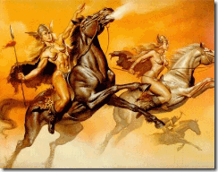
Amidst the burning mansion, Django, the hero, rides away on a horse along with Wotan’s daughter, the Valkyrie, Broomhilda.[50] It parallels Wagner’s Ride of the Valkyries.
It’s interesting that there is little critical analysis of the patent degradation and margination of Black Motherhood in the film. They don’t seem to reproduce, have husbands or family relationships. Even during bondage, it would have an important role of Black Motherhood to relinquish the stock, but their treatment in the film is unsettlingly consistent with Nazi racial theories and goals and policies of experimentation of the lower races. It also seems important that the right Black Women were casted in the film to go along with the film’s agenda of the patent degradation of sisters in a conspiracy of silence, like the use of MONARCH/MK ULTRA HollyWeird black Sex Kittens.

Broonhidla (Kerry Washington), [Spike Lee’s She Hate Me,] may do and show anything for a few pieces of silver, triggers or keys.
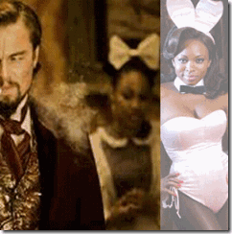
Black women in Django are essentially Candyland (Nibelheim) “Sex Slaves-Sex Kittens” except for Wotan’s daughter, Broomhilda. Recall her mission is to deliver heroes to Walhalla to battle the evil lower races (creatures) from the bottom layers of earth- the Nieblungs.

Candyland’s main candy-whore, Sheba (Kingdom of Sheba), is played by Nicole Galicia. Below, she appears in her “Alice Persona.” Alice in Wonderland is a commonly used theme to developed little girls into MONARCH/MK ULTRA mind controlled “Sex Kittens”.

Well, am I going off on the deep end? Look at HollyWeird Sex Kitten Halle Berry. Is it or is not overtly sexually persuasive and unnecessarily animal-analytic suggestive?

Below is Nicole Galicia and MONARCH/MK ULTRA Bunga-Bunga Ruby the Heart Stealer in their Sex Kitten Personas.

Django’s ceremonial so-called (Einherjar-Lone Fighter) revenge against the evil enslavers of the South is a “Seigfried Persona.” It is but another one of Tarantino’s ILLUSIONS. It is a crude metaphor of Siegfried slaying Niebelungs in chilling cold blood like the SS.

Alberich (Leonardo de Caprio) ruler of Candyland is slain. Django last and interesting battle takes place when he slays Stephen, Alberich’s brother Mime (Samuel L. Jackson).
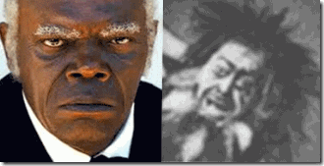
Alberich and Mime are brothers, Nibelungs. I have not viewed Django Unchained and have no intention to look at it. But, I understand that Django’s most vicious fight in the film is with Stephen, the most despised and vile character in the film. It’s not my conclusion. In fact, it is exactly what Samuel L. Jackson admitted, ‘Oh, you really want me to be the most despised Negro in cinematic history?’ “Mime fares even worse, depicted as a stinking ghetto Jew. Siegfried, the Ring’s hero, who knows no fear and is free of conscience, hates him merely for his appearance and smell: “. . . that shuffling and slinking, those eyelids blinking — how long must I endure this sight? When shall I be rid of this fool? I’d like to catch you and end your shrinking and stop your blinking! So deeply, Mime, do I loathe you.” After being nearly choked to death, Siegfried brutally murders Mime with the sword, Nothung. This is Mime’s reward for having raised Siegfried, like a father, from birth. Since Siegfried represents the conscience-free, fearless Teuton, he feels no remorse. Wagner’s music would have us justify Siegfried’s form of personal vengeance. He is glorified as the warrior hero of the Ring, the archtypal proto-Nazi. It is absolutely consistent with Wagner’s racial agenda and the two-faced Janus Face of deception of Himmler’s SS. Himmler conditioned the SS to be two-faced, one kind and decent gentleman, while the opposite- mean, cruel, evil and homicidal.
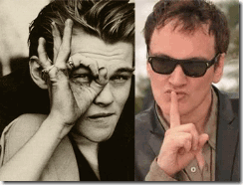
Leonardo de Caprio’s 666 and the All-Seeing Eve of LUCIIFER and Quentin Tarantino’s SILENCE (SECRECY) IS GOLDEN Symbol of the ILLUMINATI. Wagner’s racist Ring Series is clandestinely played out with the collaboration of HollyWeird’s ILLUMINATI Black Goons. Django (Jamie Foxx) is also the metaphor for Siegfried’s struggle with Wotan (Dr. King Schultz), who is ready for his own doom to make way for a coming of a New World Order and the New Age of LUCIFIER and his servants.
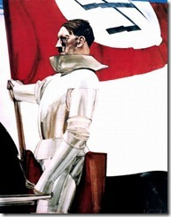
Here is Fuhrer Adolf Hitler in the Seigfried Lone Standard Bearer Persona
For Hitler and the Nazis, GERMAN history was symbolized Wagner’s Der Ring des Nibelungen. Both Hitler and Josef Goebbels proclaimed that the tale of Siegfried and Broomhilda were their favorites.[51]
Siegfried’s reforging of the enchanted sword became a metaphor German rearmament. Hitler’s final hour of symbolized defeat was the conclusion of his vast reenactment of the Ring, like Siegfried, Hitler’s body was consumed in a funeral pyre and both Brumhide and Eva Braun (symbolically) closely followed their lovers in death.[52]
Django Unchained, the N Word and the Black Psyche

“If you tell a lie big enough and keep repeating it, people will eventually come to believe it. The lie can be maintained only for such time as the State can shield the people from the political, economic and/or military consequences of the lie. It thus becomes vitally important for the State to use all of its powers to repress dissent, for the truth is the mortal enemy of the lie, and thus by extension, the truth is the greatest enemy of the State.” Reichsminister Paul Josef Goebbels, [53]
According to the Supreme Court of the United States, there are certain well-defined and narrowly limited classes of speech, the prevention and punishment of which have never been thought to raise any constitutional problem. These include the lewd and obscene, the profane, the libelous, and the insulting or “fighting words” those that by their very utterance inflict injury or tend to incite an immediate breach of the peace. It has been well observed that such utterances are no essential part of any exposition of ideas, and are of such slight social value as a step to truth that any benefit that may be derived from them is clearly outweighed by the social interest in order and morality. Chaplinski v. New Hampshire, 315 U.S. 568, 62 S.Ct. 766, 86 L.Ed. 1031 (1942). The N word is one of those fighting words that come within the profane and insulting that by its very utterance inflict injury. It is a badge of degradation and has no other connotation to society.
During and after the Civil War, Southern whites would commonly use the word “nigger” instead of “Negro” in order to represent superiority over the blacks. This was especially common for slave owners to refer to their slaves as “niggers” in order to both debase Africans below human beings [“untermensch” (sub-man, sub-humans)]; and to show ownership over their lives. The N word also signifies worthlessness “lebensunwerte leben” [useless eaters- life unworthy of life].[54]
Katt Williams discovered and then exposed to the general public that there are 176 instances of “F**k You Ni**ger” in Django Unchained,
“Everyone’s all ‘oh my god, Quentin’s written ‘nigger’ 176 times on a script again’… Django Unchained is essentially a spaghetti western exploitation movie with some Hong Kong overtones. He knows the movies that we like.”[55]
The ILLUMINATI have carefully studied the films that Black People, particularly, tend to watch and enjoy. I suspect like Josef Goebbels Propaganda Ministry would had their psychiatrists, psychologists and social scientists test, measure, experiment then develop a formula based on the number of times the N-word need to be repeated to penetrate, internalize, subliminally affect and injure the Black Psyche; and also polarize the races by mass media vehicles.

“I was called a nigger almost every day in Texas.”
Jamie Foxx, Oscar-winning actor (Ray) born in 1967
I grew up with the healing melodies and the Genius of Ray Charles. One evening, I sat down to enjoy the 2005 feature film, Ray, starting Jamie Foxx. At first, I thought it odd that the movie was just called “Ray,” and Jamie Foxx, a despicable satanic, cross dressing Negro comedian got the leading role.
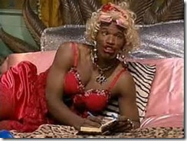
However, I put down my guard. I had so many warm, comfortable feelings and memories in regards to the beloved Ray Charles. I thought the movie would delight in his life and music. In the very opening scene, he was called out of name. He was both a ni**ger (untermensch) and useless blind (libensunwerte leben). It wasn’t necessary at all.
From the movie script,
Southern White Bus Driver: “Boy, I can’t take responsibility for some blind ni**ger traveling…miles alone.”[56]
I turned off the television. I was mentally deeply hurt and betrayed. For me, the N Word is still a vicious “Fighting Word.” I had been suckered in to watch the movie believing it was a sincere “Feel Good” ticket about a man, legend and his music that healed our souls and settled our spirits. I was hit in the blindside again by the HollyWeird ILLUMINATI that only intended to assert command over my very BEING and reinforce a sense of worthlessness and powerlessness among the masses. I am presently unable to watch the movie. You can’t trust HollyWeird and its black goons.They gave Jamie Foxx an Academy Award for in 2005 being a loyal Negro ILLUMINATI Goon.
In Katt Williams’ denunciation of Django Unchained, he personally exposed and singled out Jamie Foxx, in particular, for condemnation. Katt Williams said that he knows a lot about HollyWeird behind the scenes. He is ready telling the public, WATCH JAMIE FOXX.

In Jamie Foxx’s 2009 music video, Blame It, featuring Satanic T-Pain in a Masonic-ILLUMINATI checkerboard pattern vest, it shows that Jamie Foxx had been initiated as a High Priest of some type of HollyWeird Satanic Cult with an animal deity coven with a Panda talisman. The Panda, subliminally, appears to be soft, sweet and gentle like a Teddy Bear,
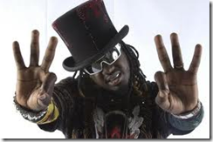
T-Pain 666, Sign of the BEAST
“This brings us back to the secret occult meaning behind the teddy bear. The teddy bear symbolizes only the nice side of the actual bear’s duality. It is cuddly, adorable and non-threatening. We give children a toy that represents the safe side of life’s duality. It is meant to be reassuring.”[57]
Yet, the bear, particularly the Panda, is a deadly animal with a nasty disposition that will attack humans without provocation. It is also symbolically patently dual (dualism); it is significantly black and white.
Blame It opens with the musical version of the black mass music played backwards in Stanley Kubrick’s classic satanic thriller, “Eyes Wide Shut.” It can’t be denied or explained away, the black mass music in the video denotes the start of a satanic ritual.[58]
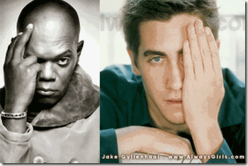
I had often related these gestures to the OSIRIS-ISIS-HORUS Mysteries of Kemet, All Seeing Eye of Horus. However, these people have absolutely nothing to do with Kemet. They are Two-Faced Janus Personalities, Deceivers and Masters of Deceptions and Disguises. This is what it is, the All-Seeing Eye of LUCIFER.
Appearing as satanic ritual coven members are Ron Howard, Forest Whitaker, Samuel L. Jackson, Jack Gyllenhall, Quincy Jones, Cedric the Entertainer, Morris Chestnut, Clifton Powell, Alex Thomas, DeRay Davis, Joe, Mos Def, Tatyana Alie, Jalen Rose, Bill Bellany, Ashley Scott, Electrik Red, Dawn Richard, Keshia Knight Pullman, and LeToya. BET named “Blame It” their No. 1 music video for 2009 on their year-end Notarized countdown.[59]
Subsequent to posting an excellent video in PRECIOUS & DECEPTION: THE ROAD BACK TO NAZI SPIRITUAL SCIENCE AND MK ULTRA on May 4, 2010 analyzing its patent Satanic content, the original official “Blame It” musical video was pulled, and the highly edited video below took its place.
However, some very significant satanic content of the video had not been removed. At frame 1:26, there is the caged woman in dark, than at frames 1:37-2:41, Jamie toys with a woman in a leopard skin print. Jamie says that he can feel their but she don’t care- mind controlled Sex Kitten, then it flashes to the woman (Sex Kitten) moving in the dark (animal) cage. At frames 1:31, spades with symbols, death calling cards appear on alcohol bottles.
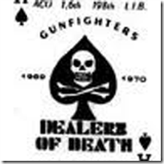
At frame 2:35, skulls appear at the bottom of two cocktail glasses. At frame 2:41, the Panda Deity Talisman dance and a woman wearing an animal print scarf begins to dance in trance flashing the devil’s horns hand symbol from frames 2:42-2:52; then the frame switch briefly back to the woman in the cage, linking the woman in the cage with the dancing women in trance with animal skin prints.
What is missing from the original video is that the Panda Deity Talisman’s dance with women in a ritualized dance that invoke and conjure up a demon patron-spirit. Some of the most chilling, disturbing and significant satanic scenes begins at this point in this video and its satanic and demonic nature can’t be denied for what it is.

From frames 3:32-3:56, a young woman (demonic patron) with strange dark-black fixed eyes who appears to be in a zombie zone with the devil’s horns finger symbol in her mouth began to dance in trance. Her moves are distorted, bizarre and possessed like the possession dance scene of the demonic patron in the 1987 Santeria cult film, The Believers.[60]
The video is significantly red with flashes of blue and purple. In illuminati symbology, red is the color of fire, blood, danger, chaos; and often symbolizes sin. In Wiccan, blue is associated with the God Zephyrus. Zephyrus is associated with fertility and love, and the hour of twilight. Blue is also associated with “blue bloods,” and LUCIFER. Purple is associated with royalty but likely privilege in this instance. Samuel L. Jackson appears to be trance throughout the video.

At the end of the video at frames 6:51-7:00, Jamie Foxx exposes himself as receiving the Panda Deity Talisman becoming the High Priest of the Satanic Coven. The Little Mad Genius turns out to be not too mad after all.
Finally, the Seigfried Persona is extremely dangerous and frightening prospect if it has not already been done (Jamie Foxx). Imagine MONARCH/MK ULTRA programmers and handlers using Siegfried Persona Alters to develop Black Manchurian Candidates to slaughter their own people to protect Walhalla and the Bloodlines of Wotan.
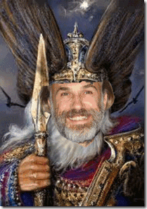
“We will of course not let them know about Wotan.” –Reichsminister Paul Josef Goebbels
Yesterday, the Academy of Motion Picture Arts and Sciences nominated Django Unchained for 4 academy awards including Best Picture and Best Original Screen Play. Of course, the Volkisct –Blood of Wotan Christoph Waltz got the nod from the academy for the 2013 Best Supporting Actor for clandestinely-subliminally WOTANIZING the entertainment film industry for the New Word Order and the Age of LUCIFER.
As I speak, Katt Williams has been taken off the street again by the Los Angeles Police Department on an outstanding $100,000 arrest warrant out of Sacramento.[61] I pray that they don’t suicide him or lobotomize his brain to keep him from smashing mirrors, images and ILLUSIONS of the ILLUMINATI, permanently!

[1] http://www.great-quotes.com/quotes/movie/Enter+the+Dragon
[2] http://en.wikipedia.org/wiki/The_Bourne_Identity_(2002_film)
[3] http://hyperspacecafe.com/showthread.php?tid=8424
[4] http://www.davidsongifted.org/db/Articles_id_10062.aspx
[5] http://en.wikipedia.org/wiki/Mensa_International
[6] http://en.wikipedia.org/wiki/Mensa_International
[7] http://www.davesweb.cnchost.com/fwordpreview.htm
[8] https://sites.google.com/site/thecampaignerunbound/home/the-british-origins-of-nazi-eugenics
[9] https://sites.google.com/site/thecampaignerunbound/home/the-british-origins-of-nazi-eugenics
[10] http://en.wikipedia.org/wiki/Untermensch
[11] http://www.conspiracyplanet.com/channel.cfm?channelid=67&contentid=6258&page=2
[12] http://www.american-buddha.com/nazi.wotancarljung.htm
[13] http://www.davesweb.cnchost.com/fwordpreview.htm
[14] http://www.davesweb.cnchost.com/fwordpreview.htm
[15] ht http://www.davesweb.cnchost.com/fwordpreview
[16] http://spitfirelist.com/news/race-science-and-the-pioneer-fund/
[17] http://en.wikipedia.org/wiki/Hans_Eysenck
[18] http://holocaustnews.wordpress.com/category/uncategorized/page/8/
[19] http://tech.groups.yahoo.com/group/ItalianPhysicsCenter/message/32
[20] http://www.bibliotecapleyades.net/sociopolitica/hambone_info/people.html
[21] http://en.wikipedia.org/wiki/Inglourious_Basterds
[22] http://en.wikipedia.org/wiki/Alternate_history
[23] http://en.wikipedia.org/wiki/Hans_Landa
[24] http://www.theatlantic.com/magazine/archive/2009/09/hollywoods-jewish-avenger/307619/
[25] http://www.reviewstl.com/christoph-waltz-win-academy-award-best-supporting-actor-inglorious-basterds-0307/
[26] http://en.wikipedia.org/wiki/Lawrence_Bender
[27] http://vigilantcitizen.com/moviesandtv/the-occult-roots-of-the-wizard-of-oz/
[28] http://www.detoxorcist.com/satanism-and-the-far-right.html
[29] http://www.judeofascism.com/2009/12/in-touch-with-their-zionist-sides.html
[30] http://en.wikipedia.org/wiki/Lawrence_Bender
[31] http://www.cinemablend.com/new/Why-Silent-Django-Unchained-34925.html
[32] http://www.post-gazette.com/stories/ae/movies/actor-christoph-waltz-says-bounty-hunter-role-makes-sense-667754/
[33] http://en.wikipedia.org/wiki/Brynhildr
[34] http://en.wikipedia.org/wiki/Brynhildr
[35] http://en.wikipedia.org/wiki/Valkyrie
[36] http://en.wikipedia.org/wiki/Valkyrie
[37] http://en.wikipedia.org/wiki/Brynhildr
[38] http://larryavisbrown.homestead.com/files/ring/ring2_valkyrie.htm
[39] http://www.columbiaspectator.com/2013/01/04/django-unchained-brings-tarantino-verse-antebellum-south
[40] http://solomonsmusic.net/WagHit.htm
[41] http://www.noanswersingenesis.org.au/cg_science_of_racism.htm
[42] http://www.indiana.edu/~hist104/sources/Gobineau.html
[43] http://opinionator.blogs.nytimes.com/2012/11/20/the-souths-man-in-london/
[44] http://en.wikipedia.org/wiki/Ride_of_the_Valkyries
[45] http://english.illinoisstate http://en.wikipedia.org/wiki/Ride_of_the_Valkyries.edu/strickland/rsvtxt/davis2.htm
[46]http://acousticwords.webs.com/Classical%20Music%20Recommendations/50%20CLASSICAL%20MUSIC%20RECOMMENDATION.htm
[47]http://acousticwords.webs.com/Classical%20Music%20Recommendations/50%20CLASSICAL%20MUSIC%20RECOMMENDATION.htm
[48] http://en.wikipedia.org/wiki/Nibelheim
[49] http://larryavisbrown.homestead.com/files/ring/ring3_siegfried.htm
[50] http://en.wikipedia.org/wiki/Django_Unchained
[51] http://movies.nytimes.com/movie/44604/Die-Nibelungen-Siegfried/overview
[52] Richardson, Herbert, New Studies in Richard Wagner’s The Ring of the Nibelung, The Edwin Mellen Press, Lewiston, NY (1991) pgs. 162-195)
[53] http://thinkexist.com/quotes/joseph_goebbels/
[54] http://www.studymode.com/essays/Use-Nigger-Meanings-Word-95483.html
[55] http://www.breitbart.com/Big-Hollywood/2012/12/30/django-stars-rush-defend-movie-violence
[56] http://www.script-o-rama.com/movie_scripts/r/ray-script-transcript-jamie-foxx.html
[57] http://occultview.com/2012/10/21/the-teddy-bear-as-an-occult-talisman-2/
[58] http://en.wikipedia.org/wiki/Blame_It
[59] http://en.wikipedia.org/wiki/Blame_It
[60] http://en.wikipedia.org/wiki/The_Believers
[61] http://www.eonline.com/news/376939/katt-williams-arrested-in-los-angeles-after-failing-to-appear-in-sacramento-court?cmpid=rss-000000-rssfeed-365-celebritynews&utm_source=eonline&utm_medium=rssfeeds&utm_campaign=rss_celebritynews
Comments : 11 Comments
Tags: Arthur de Gobineau, bourne identity, broomhilda, bruce lee, christophr waltz, django unchanined, Houston Stewart Chamberlain, inglorious bastards, Jamie Foxx, Julian Huxley, katt williams, king schultz, lawrence bender, mensa, MK-ULTRA, quentin tarantino, Richard Wagner, samuel l. jackson, siegfried, sir cyril burt, spike lee
Categories : african american satanic cult, African Liberation, African slavery, ALL SEEING EYE, Aryan Supremacy, baphomet, Black Manchurian Candidates, bloodline of wotan, bloodlines of wotan, CIA, council on foreign relations, devil's horns, Dr. Aldous Huxley, Dr. Josef Mengele, dualism, Eyes Wide Shut, False Satanic Rites of Lost Negroes, hallie berry, Hauptsturmfuhrer SS Dr. Josef Mengele, Heinrich Himmler, Hip Hop, hip hop satanic cult, illuminati, Inglorious Basterds, Josef Mengele, katt williams, mensa, kerry washington, kerry washington, t-pain, nicole gallicia, broomhilda,, Knights of the Black Sun, lebensborn, lucifer's servants, luciferians, Madame H.P. Blavatsky, manchurian candidates, mind control, MK-ULTRA, monarch program, mulitiple personality disorder, Nazis, new age religion, new world order, nicole gallicia, Nuremberg Tribunal, Paul Josef Goebbels, PROJECT CHATTER, re-image, re-imaging, Reichsfurhrer SS-1 Heinrich Himmler, ritually abused children, Schutzsteffel, sex kitten, sex slave, SS, SS Baron Otto Albrecht Alfred von Bolschwing, Stanley Kubrick, t-pain, trauma-based mind control, Untermensch, Valkyrie, wotan, ZIONIST

“SOMEWHERE OVER THE RAINBOW” KATT WILLIAMS, KURT COBAIN & THE CIA MK ULTRA- FINDERS
2012013
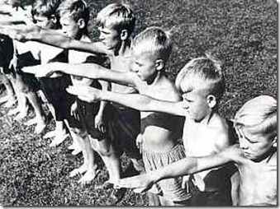
The Nazi Lebensborn and the Ahnenerbe (Occult Bureau) were some of the most secret, terrifying and diabolical programs ever developed by a State. After the Fall of Nazi Germany, these programs were deliberately shrouded by U.S. and British Intelligence in a cloak of silence as if they never had existed.
During the 20th Century, the Nazis paraded around dressed in black uniforms emblazed with “Skull and Bones” waving large black and red swastikas ranting a 1000 Year Reich of Global Dominance and Aryan Supremacy. It was a State whose national policy was based on global racial mass murder. It was a nation committed to the secret art, science and technology of mass population control for a Master-Slave New World Order (NWO). The National Socialist of Nazi Germany was only the seen agents, executives, mechanics and technicians of the unseen “Hidden Hand.”
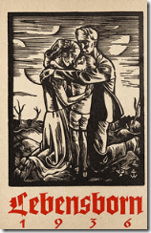
Lebensborn (Spring of Life) set up by Reichsfuhrer SS Heinrich Himmler, the National Socialist CEO, was far more sinister than breeding from birth generations of Nazis. Behind the veil, thousands of children were ‘drafted’ into Lebensborn. They were kidnapped and sent to secret remote hospitals, academies, and children concentration camps for mind control programming and reprogramming.[1]
In 1933 SS Himmler had written that he sought “. . . to attract all of the Nordic blood to Germany and so subtract it from our enemies.” The invasion of Poland in September 1939, afforded him with an excellent opportunity to acquire more Nordic blood for the Reich. Himmler ordered that all Polish children be examined racially. Those under the age of six years who proved racially valuable were to be brought to Lebensborn homes for further evaluation and the process of Eindeutschung (brainwashing). Afterwards, they would be made available for adoption by childless SS couples under the guise of “. . . German orphans from the reconquered east.” Many children were rounded up at orphanages, at school, or at playgrounds; others were kidnapped off the street or even out of their mothers.”[2]
In 1946, it was estimated, it is only an estimate, that more than 250,000 children were kidnapped for Lebensborn and sent by force to Germany for programming.[3] Lebensborn wasn’t an afterthought. It was a massive undertaking and one of the primary goals of the State. It was one of SS Himmler’s largest, and most ambitious, daring and secretive corporations.
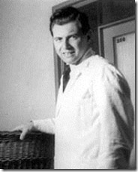
A program as large and audacious as Lebensborn had its executives, doctors, psychiatrists, mechanics and technicians. The infamous SS Dr. Josef Mengele, the Demon of Death, is generally remembered for the inhuman, vicious and lethal medical experiments on man, woman and child at the Auschwitz Concentration Camp in Poland. However, his hideous experiments extracted its heaviest physical toll on the children.[4]
Often ignored or least understood, Dr. Mengele had been one of Lebensborn’s most important and secretive technicians. At Auschwitz with a population that may have been up to 4 million people,[5] Dr. Mengele used his human guinea pig victims which numbered into the hundreds of thousands to primarily provide scientific improvement to pre-existing methods of Illuminati trauma based mind control programming of children. Dr. Mengele’s advanced mind control and reprogramming programs, methodologies and techniques were secretly instituted in Lebensborn facilities.[6]
Lebensborn and the Ahnenerbe (Occult Bureau) didn’t disappear with the Fall of Nazi Germany. They had a life of their own. They became secret “Creatures of the State” without borders and boundaries. One of the “hidden hands” and “research beneficiaries” behind the veil of Dr. Mengele on the other side of the globe was the Rockefeller Foundation of New York City.[7]
Today, children found and designated “Valuable to the State” are tested, evaluated then kidnapped. They go through an advanced process of Eindeutschung (trauma based mind control-multiple personality programming) developed and perfected primarily by Hauptsfuhrer (Captain) SS Josef Mengele.
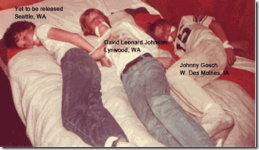
John David “Johnny” Gosch (born November 12, 1969) was a 12-year-old paperboy in West Des Moines, Iowa, when he disappeared on September 5, 1982, presumably kidnapped.[8]
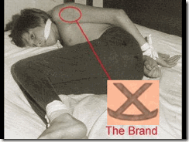
From an anonymous source, Johnny’s mom, Noreen Gosch, received several leaked photos of her son held in captivity. On the photos, she discovered that Johnny had been branded with a “Rocking X” ranch cattle brand. However, I suspect that the brand is an ancient Germanic Sun Wheel Swastika, the “Odal Rune” upside down. The Odal Rune was the last letter of the runic alphabet, and for fä (cattle), i.e. movable or personal property, was is the first.[9]
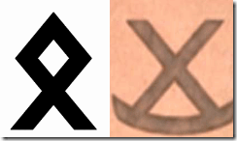
The Odal Rune symbolized several values of which were of central importance to Nazi ideology. It symbolized kinship and family and bringing together of people of similar blood or race. It was adopted by the S.S. race and resettlement office (R.U.S.A.)-SS-Rasse-und Siedungshuptamt, which was responsible for maintaining the racial purity of the SS.[10]

It was used by the S.S. Freiwilligen Gebirgs (mountain) Division “Prinz Eugene”. The center design of course is the “Sonnenrad” or sun wheel swastika and was an ancient Norse representation of the life giving sun. The Odal Rune symbol was adopted by the 5th S.S. Panzer Division “Wiking”.[11]
An Anglo-Saxon rune poem explains the rune’s meaning as follows:
An estate is very dear to every man,
if he can enjoy there in his house
whatever is right and proper in constant prosperity.
In Nazi Germany, the Odal Rune was symbolic of the Blut und Boden (“Blood and Soil”) ideology, focusing on a concept of ethnicity based on descent and homeland.
The rune upside down also symbolizes dualism, opposites and the “Satanic Principle.” An estate dear to man has been taken by the State. Additionally, the surname GOSCH is of German origin ‘the descendant of Gotesscalc’ a name meaning God’s servant.[12] Johnny’s brand may also identify him as Aryan “Germanic Stock” consistent with something out of secret vaults of Lebensborn.
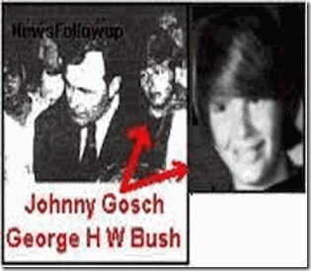
Recently, a photograph surfaced with Johnny Gosch two years after the abduction appearing in “Service to the State” to George Herbert Walker Bush, the 41st President of the United States.[13]
“Click your heel together and be there in a snap” is both in the movie [Wizard of Oz] and in the programming cues. Military Monarch slave models are especially taught to click their heels together. (Joseph Mengele, Dr. Black, Michael Aquino and others also liked to click their Nazi boots together while they programmed children.)”[14]
THE NEW EMPEOR OF BLACK COMEDY, “SOMEWHERE OVER THE RAINBOW”
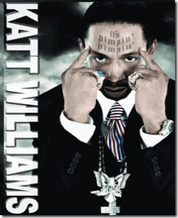
Today, the rich and powerful American Black Comedian Katt Williams has been suddenly reduced right before our eyes to something like a lonely wounded puppy. A lot of people like myself are wondering, what’s really going on beyond the Looking Glass?
Katt Williams, the New Emperor of Black Comedy
Not long ago, Williams was a celebrated mega-superstar entertainer swimming in a pool of American storybook success, notoriety, money and fame. He had become one of the highest paid comedians in America making Katt Williams, the New Emperor of Black Comedy.
In the so-called Hip Hop Generation, he had been living large. Williams had become much bigger in the mass media primetime than this 5’5” small statue and frame could ever image. With his raw, raunchy and witty but wild sense of humor, he had won the hearts and imagination of millions of devoted fans.
Katt Williams had become a BEAST of a stand-up comedic selling out venues across the nation. He hosted the early popular Black Entertainment Television (BET) Hip Hop Awards beginning in 2006 through 2007 that showcased Hip Hop’s most foremost performers, producers and music video directors in America.[15]
BET is owned by Viacom.[16] Viacom Inc., short for “Video & Audio Communications”, is an American global mass media company with interests primarily in, but not limited to, cinema and cable television. As of 2010, it is the world’s fourth-largest media conglomerate, behind The Walt Disney Company, Time Warner and News Corporation.[17]

Viacom (All Seeing Eye of LUCIFER) is owned in majority by National Amusements, Inc., a privately owned theater company based in Dedham, Massachusetts. National Amusements holds another controlling stake in CBS Corporation.[18]
The current Viacom was created on December 31, 2005 as a spinoff from CBS Corporation, which changed its name from Viacom to CBS at the same time. CBS (the New World Order COLUMBIANS), not Viacom, retains control of the over-the-air broadcasting.[19]
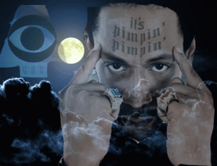
“Nxxgers Pimping for the Minds and Imagination of the Masses”, Courtesy of HBO
On September 16, 2006, HBO began to also feature Katt Williams. HBO’s Pimp Chronicles Pt. 1 featured Williams in his first worldwide solo HBO comedy special.[21] It was HBO’s highest rated stand-up comedy special and pulled more than 8 million viewers.[22]
HBO (Home Box Office) is an American premium cable television network, owned by All Seeing Eye of LUCIFER Corporation Time Warner under the operating subsidiary Home Box Office Inc. As of January 2012^{[update]}, HBO’s programming reaches 29 million subscribers in the United States. It the second largest premium network in the United States (Encore’s) programming reaches 33.2 million subscribers as of March 2012^{[update]}). In addition to its U.S. subscriber base, HBO also broadcasts in at least 151 countries worldwide.[23]

In the New World Order, “We know in the not too distant future, a half dozen corporations are going to control the media. We took this step (Turner Broadcasting Merger) to ensure we were one of them” —Time Warner spokesperson[24]Time Warner is the world’s leading and ever powerful Media and Entertainment Corporation. It owns AOL. Through its subsidiary Turner Broadcasting, it also owns CNN and DC Comics.[25]
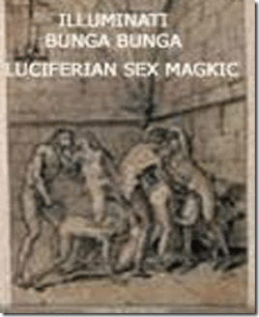
“Of all the means I know to lead men, the most effectual is a concealed mystery. The hankering of the mind is irresistible.” –ILLUMINATI Founder 1776, Dr. Adam [Spartacus] Weishaupt[26]
Most Hip Hop Black Entertainment Artists sign a contract to promote LUCIFER via ILLUSIONS, images, distractions, racial dysfunction, drug use and glorify perverted sexual lifestyles. This is the standard ILLUMINATI Contract that all black musical artist sign, if they are to reach Super Star Status. “You can be famous in Hollywood but to reach International Super Star Status like Michael Jackson, Jay-Z, Kanye West or Whitney Houston, you will end up signing one of these contracts.”[27]
Katt William’s power, success and fame were only an ILLUSION. Like so many successful and talented Black Entertainers like Michael Jackson and Whitney Houston, Williams had sold his soul to Holly-Weird’s Black Hip Hop Satanic Cult by a DEVIL’s Blood Covenant for Fame and Fortune.
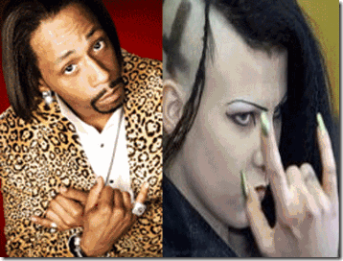
It is sly, but it is the Devil’s Horn Hand Symbol that Katt Williams is deliberately toying with. Additionally, Katt’s leopard print suggests a latent MK-ULTRA (Child) Sex-Kitten Alter Implant (discussed below).
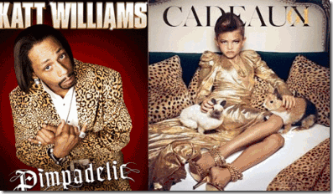
Katt Williams generated and promoted ILLUSIONS and images to glorify LUCIFER and promote racial dysfunction, drug use and glorify perverted sexual lifestyles among the worldwide masses- “Pimp Chronicles” courtesy of mega mass media giants and mysterious LUCIFERIAN All-Seeing-Eye Entities, the COLUMBIAN BET and Time Warner HBO.[28] The child in sexually suggestive animal print is between 6 and 7 years old.
Don’t believe your lying eyes. Below, Katt Williams and famous Producer LA Reid of X-Factor exhibit the Devil’s “Hidden Hand” of the HollyWeird’s Black Hip Hop Satanic Cult.
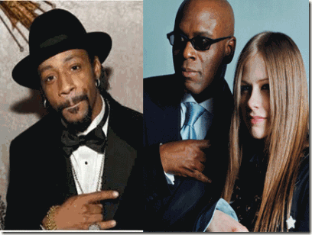
At times, Katt Williams is known for often using the stand-up comedy platform to expose things that are normally kept quiet and speaking Truth to Power. Katt has openly discussed topics that other black comedians and artists are forbidden and afraid to speak about.
Nevertheless, Katt Williams, the New Emperor of Black Comedy, was still beholden to the powerful and elite ILLUMINATI that created him and bound by Lucifer’s Blood Covenant of Secrecy. That Blood Covenant opened (ILLUMINATED) Katt’s eyes to the some of the Secret Satanic Rituals of the ILLUMINATI.
During the performance of the HBO special, the Emperor exposed Holly-Weird’s drug practices; and the ILLUMINATI’s Secret Satanic Rituals sensationalized in Stanley Kubrick’s Classic Film, Eyes Wide Shut.[29]
Many people by now know the story behind Eyes Wide Shut, that within days of the release of the film, Kubrick was murdered for revealing and exposing far too much to the masses.[30]
Among Holly-Weird’s Black Hip Hop Satanic Cults, the Eyes Wide Shut Secret Rituals are often called NH –Never Happened Parties.[31]
Internationally, Eyes Wide Shut Secret Satanic Rituals are called Bunga-Bunga Parties exploiting MK ULTRA sex slaves.[32]

At the heart of the Bunga-Bunga international scandal is the African-Moroccan-born Karima El Mahroug AKA Ruby the Heart Stealer, above, in Sex Kitten Alter and leopard print.

Obviously, Karima, above, has a disturbing latent MK ULTRA-MONARCH satanic ritual child sexual abuse background and history.
During the performance of Pimp Chronicles,above, the Emperor exposed Hip Hop’s Eyes Wide Shut Secret Rituals that he called, “Mansion Parties.” In particular, he outed a Professor Obie that he found engaging in homosexual episodes inside one of the secret party rooms.

On HBO’s Pimp Chronicles, Katt Williams actually said “Professor Oglevee” before editing in reference to Dorien Wilson’s character on BET’s “The Parkers.”[33]
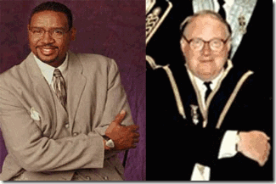
Above, Dorien Wilson exhibit the ILLUMINATI Masonic “Hidden Hand.” Wilson is the son of a U.S. Air Force member, was raised in Lompoc, CA, home of Vandenberg-Lompoc Air Force Base.[34] Vandenberg is a classified space launch center that has been connected to secret underground bases, laboratories, and the MONARCH-Montauk-Mind Control Programs.[35]
After the release of Pimp Chronicles, the ILLUMINATI seriously began to build a LEGEND on the Emperor to discredit, neutralize and destroy Katt Williams in the eyes of the masses.
November 7, 2006 about a week before hosting the first annual BET Hip Hop Awards ceremony, Williams was arrested by the Los Angeles Police Department (LAPD) on for having a concealed weapon in a carry-on bag.[36]
According to an absolutely rational, fluent and intelligent Williams, the the gun wasn’t loaded and inoperative but left in the bag by the inadvertence of his staff. Williams reasoned that in a 400 city comedy stand-up tour, some mistakes were bound to happen. He said that the other weapons had been properly checked into security pursuant to standard customary business practices within federal law and regulations. But, he said that he couldn’t afford to make any other mistakes and didn’t make any other mistakes because he was being targeted.
Nevertheless, the story that he concealed a stolen weapon and three other guns in his checked luggage made national news sensationalized byTMZ.[37] The FEDS not the LAPD took Katt Williams off the streets in a no bail situation for at least 3 days.
On about October 18, 2008, sometime prior to hosting the 3rd annual BET Hip Hop Awards ceremony in Atlanta, Georgia, BET suddenly replaced him as the show’s host. Katt Williams was replaced by T-Pain due to a serious dispute with BET executives.[38]
November 5, 2008, Katt Williams was a no show for the nationally televised Conan O’Brien Show. [39]
November 6, 2008, Katt Williams was reported missing. Previously on November 1st, Williams had been rumored to be DEAD![40] Where was Katt Williams for 5 (five) days?
November 6, 2008, at around 1:30 a.m., the New York Police Department (NYPD) said they saw a Cadillac belonging to Williams parked in Chelsea without license plates. When the officers approached, two men started backing away and one said, “I have nothing to do with what’s in that car,” law-enforcement sources said. Police allegedly found three guns in the Cadillac and a loaded weapon in Williams’ Mercedes bus, which was parked behind it. Williams emerged from a nearby building,[41] he told the cops that the vehicles were his; the officers handcuffed and took him into custody.[42]
Eighteen hours after being arrested, the comedian posted $25,000 bond and was released right around the time he was supposed to hit the stage at Carnegie Hall. Half an hour later, he jumped out of a limo and disappeared into the back stage of Carnegie Hall.”[43] Subsequently, the Manhattan City DA dismissed gun possession charges against Katt.[44]
Had Katt Williams actually been kidnapped then released when police suddenly happened on the scene?
Katt Williams Seized by the Masonic-ILLUMINATI in South Carolina
This extremely disturbing and chilling video shows Katt Williams dressed in bathrobe and towel clearly in distress trying to escape people that he couldn’t trust. When an unknown black male tries to take responsibility for him, Katt made a dash to escape out of the door, but is shot, zapped with an ELF or sound weapon or psychtronic then suddenly drops almost to his knees.
On November 14, 2008, Katt Williams was forcibly taken off the street by sheriff deputies by order of a Sumter, South Carolina (SC) Probate Judge and confined in a state mental institution for psychiatric examination.
He was confined at the Tuomey Regional Medical Center, SC Department of Mental Health (DMH). DMH collaborates extensively with the University of South Carolina (USC) School Of Medicine. DMH affiliation with USC includes clinical counseling, psychology interns, psychology graduate studies, residents and fellows in psychology.[45]
Katt’s behavior suddenly became erratic and bizarre shortly after his fallout with CBS-Columbian executives at BET and being removed as the host of its annual nationally televised Hip Hop Awards ceremony.
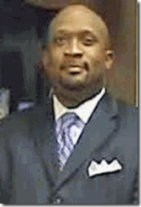
The lawyer that petitioned to have Katt taken off the street and committed to the state mental hospital was a local southern good old boy, Garryl Deas of Sumter, SC, above. He is a black Greek-ILLUMINATI Negro.
“He just said that he doesn’t trust anyone anymore,” Deas said. He said he thought “everyone has turned against him. He wasn’t really coherent.”[46]
Does being distrustful of the people around him, and being incoherent justification for the State of South Carolina to forcibly take Katt Williams off the street and confine him in an alien state mental hospital behind the classical Mason-Dixon (Dixie) Line?[47]
Katt Williams posed no immediate danger to himself or others, and he certainly had the money, means and resources to have had his own private physician.
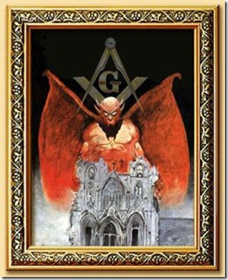
Attorney Deas is a graduate of USC, a member of the Omega Psi Phi Fraternity Inc. and he is a member of the Masonic Order, St. Paul Lodge #8 in Sumter.[48]
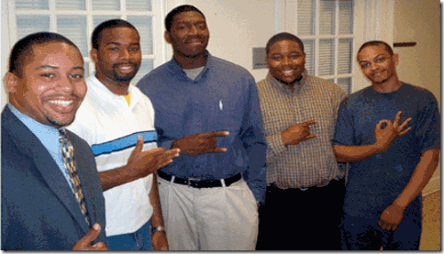
Some of those Old Southern Greek Negroes in the line to serve the New World Order playing with LUCIFERIAN hand symbols.
Like Dr. Conrad Murray, Deas is beholden to the “Hidden Hands”, the Satanic Masonic ILLUMINATI. Is Deas also a member of the Boule?
Vernon Jordan (Omega) of the Bilderberg Group is an infamous ILLUMINATI –Boule Negro. Also, Boule Rev. Jesse Jackson was initiated into the chapter of Omega Psi Phi at North Carolina A & T in the early 1960’s.[49] Omega Negroes certainty feed into the Boule.
An emergency involuntary psychiatric examination normally involves a 72 hour (3 days) hold.[50] According to internet sources, Katt Williams may have been confined in a SC mental institution up to two weeks.[51]
It is uncertain what therapy he got, the drugs that he was given, who had access to him, and what they may have implanted in Katt Williams. From the state’s extensive collaboration with University South Carolina, the CIA Voodoo Boys of USC (discussed later) certainty had access to him. Williams never seem to talk about or possess any memory of what happened to him while confined in those dark southern mental institutions behind the Mason-Dixie Line.
Katt Williams, Oak Town & the Emperor without Clothes
On November 15, 2012, Williams was arrested by Oakland Police Department (OPD) after allegedly hitting a 18 year old Berkeley man in the head with a bottle on a tour bus parked outside a hotel, or allegedly hitting him over the head with a bottle during a fight near Oakland club Kimball’s Carnival Club before his appearance at the Oracle Arena. He was booked into jail on investigation of assault and was released the next day.[52]
Katt Williams’ Oracle Arena sold-out concert turned into absolute CHAOS-Katt unlike anything witnessed in an American professional celebrity circuit tour.

Legendary Oakland Rapper Too Short (Skull & Bones, Todd Anthony Shaw)[53] was one of opening performers at the sold-out concert. Another Oakland Rapper, Richie Rich, joined Too Short on stage, and they did an hour set instead of the allotted 30 minutes.
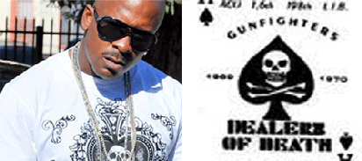
Above, Richie Rich wears a Skull & Bones’ Brotherhood of Death Carding Card T-Shirt. In the 1990s, Richard “Richie Rich” Serrell served time for drug trafficking.[54] In May 2012, Serrell was arrested again for being involved in a “Disco Dazed” drug trafficking ring.[55]
After Too Short and Richie Rich so-called performance, Katt Williams entered the stage after 11:00 p.m. in a disoriented and confused state of delusions believing that he was a CHRIST like figure. He was uncharacteristically vulgar, profane and unprofessional. He challenged and incited the agitated crowd to fight.
After about 10 minutes in utter and complete CHAOS in the arena, Katt Williams was snatched from the stage. Too Short and Richie Rich took the stage again and addressed the confused mass.
What in particular sent up RED FLAGS about Katt Williams being under MK ULTRA- ILLUMINATI control was Too Short and Richie Rich’s open revelation to the audience that Williams had been DRUGED-maybe BZ.[56] They said that he had been given some of Oakland’s high potency drugs, crack cocaine.
In other words, the LEGEND created in Oak Town was that Katt’s sudden paranoid schizophrenic behavior on stage had been his fault for taking drugs, and or it was the fault of those in and around Katt Williams that exposed him to drugs.
It also suggests that the drugs (crack cocaine) peddled in Oakland hold some latent (CIA- MK ULTRA) BZ markers and properties to deliberative drive users into fits of violence, insanity and CHAOS.
One of them told the crowd, “Obviously he underestimated the potency of this Bay Area Cocaine.” They told the audience. “My n*gga [Katt Williams] is on something, he’s extra loaded. He got too high in Oakland. You ain’t gotta forgive my n*gga, but you do gotta understand. Y’all just as much to blame as he is. That n*gga is sky high. We can’t cover it up… my n*gga loaded. Talk sh*t about it. Go to Twitter, but we still got love for Katt Williams.”[57]
Too Short said people should have known better to expose him to Oakland’s unique brand of CIA Crack Cocaine. The inference was that Katt wasn’t familiar with Oakland.
However, Too Short’s statement was total DECEPTION. Katt had been a wise “Street Kid” since the age of 13 (thirteen). He knew Oakland far more than Too Short and Richie Rich were allowed to expose. It wasn’t part of Katt Williams’ developing ILLUMINATI FALSE LEGEND to reveal the truth.
During his early comedic career before moving to Los Angeles- HollyWeird, Katt lived and performed in Oakland. He had even joined the Black Muslims, the Nation of Islam in San Francisco.[58]
Too Short and Richie Rich are some of those Hip Hop/Satanic-BROTHERHOOD OF DEATH Negroes that I suspect that have also soul his soul to the Devil for fame and fortune. These rappers will always go along with a Luciferian agenda even if it involved selling out their fellow performer to the ILLUMINATI; and their people to degradation and CIA-MK ULTRA drugs.
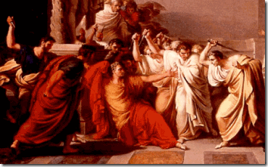
“I come to bury [Roman Emperor Julius] Caesar, not to praise him …” (from Julius Caesar, by William Shakespeare)
Too Short and Richie Rich didn’t come on stage to rescue Katt Williams as most internet sites suggest,[59] but to “bury him” without clothes who would be the New Black Emperor of Comedy.
December 8, 2012, Katt Williams canceled the show at the Toyota Center in Houston. According to reports, he failed to appear at the arena after venue officials received strange phone calls from the Williams camp regarding Katt’s fear of being abducted by aliens.[60]

It is certainly no longer a laughing matter for high profile black public figures with Katt’s intelligence under clandestine psychological scientific harassment to suddenly develop a fear of being abducted by Aliens and Spaceships.
Katt Williams “Pimp Down”
It is interesting that Katt Williams coined the phrase “Pimp Down” like as if an Officer of the State is in peril (“Officer Down”). Like the Late Whitney Houston, Katt is a multi-million dollar human commodity. Isn’t it a little too odd that while in distress he always appears to be alone without staff, personal assistants or bodyguards?
This is an extremely odd and troubling but revealing scene from the HollyWeird film, Friday After Next. In the film, Katt plays a character named “Money Mike.” In the scene, above, Money Mike is in the bathroom taking a leak with his pants dropped to the ground like a post-potty trained (3 to 4 years old) child. Terry Crews plays a character named, Damon Pearly. Pearly is a homosexual ex-convict who just got out of prison after twelve years. In the bathroom, Pearly attempt to rape Money Mike. Confronted with being rape, helpless like a child unable to defend himself or herself from ritual sexual abuse, Money Mike disassociate and falls into a subconscious-altered state to protect his original self from sexual trauma which is Classic Trauma Based MK ULTRA/MONARCH Multiple Personality Programming of Children! By the way, the girls (twinning) in the Spotted Cheetah prints are also 6 or 7 years old.
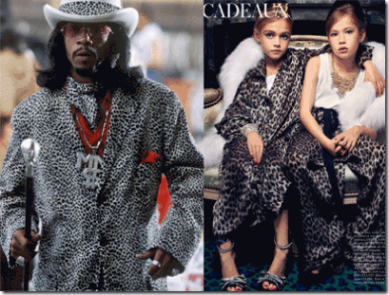
MK-Ultra BETA (Kitten or Cat) Alters are programmed into children selected to be Monarch Sex Slaves at very early ages in the most sadistic manner… Animal prints are used to identify and reinforce alters released (triggered) causing ALL sexual inhibitions (moral and physical) to be removed for full access by whom ever has codes (keys) to unlock Charm School mind files. MK-Ultra BETA Sex Kittens are told by Prog’mrs they have “hearts of stone” and are programmed for ANYTHING, ANYTIME, ANYWHERE, w/ ANYONE!
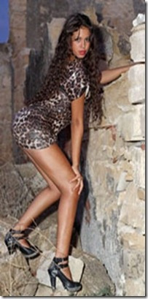
Above, Bunga Bunga Sex Kitten Ruby the Heart Breaker in a MK ULTRA Spotted Cheetah Zone.
I suspect that Katt Williams also has some type of latent childhood based “Bourne Identity” and the animal print-Black and White Spotted Cheetah print is a subliminal implant-trigger to control his alter (iatrogenic) multiple personalities.
Katt Williams, the “Whiz Kid”
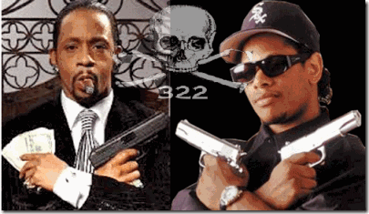
Whether or not Katt Williams is conscious of it, triggered he may march to the beat of many different drummers such as the Brotherhood of Death. The crosses in circles in the background of Katt’s picture has many meanings in Christianity and the Occult. It is also known as the prehistoric sun wheel disk similar to the Sun Wheel Swastika. It is also identified with the ancient pagan Odin and Woden’s Crosses.
Williams is a very intelligent, shrewd and cunning man from a scientific perceptive. He was reading at 3 years old like ILLUMINATI Oprah Winfrey. At 12 years old (around 1988), Williams had been designated a “Whiz Kid” by the U.S. National Academy of Science (NAS) to be of service to the nation whether wittingly or unwittingly. [66]
The NAS is a non-profit organization in the United States. Members serve pro bono as “advisers to the nation on science, engineering and medicine.” The group holds a congressional charter under Title 36 of the U.S. Code. [67]
It should be clear that at an early age, Katt Williams had been profiled, selected and assessed by covert military intelligence branches of the Reagan/Bush Administration as a “Whiz Kid” to be plugged in some future clandestine science project related to secret Star Wars Programs.
According to Williams’ Bio, he was scheduled to be specially trained through some type of exclusive NAS School in Dayton, OH, which is home to two very powerful covert MK ULTRA U.S. Military Industrial Complexes, Wright Patterson Air Force Base (Advanced Technology Group [ATG]), and SS Dr. Wernher von Braun’s Defense Industrial Security Command [DISC].
As a child, the “Whiz Kid” had been in some fairly exclusive, secret, scary and creepy company.
“Brain stem scarring was used to create the whiz kids that the NWO needed to run their big computers… These whiz kids, who were both programmed with Monarch programming and had their brain stems scarred can be seen in some of the University computer departments and the intelligence/military agencies’ computers rooms.”[68]
Whiz Kids & CIA Occult Bureau
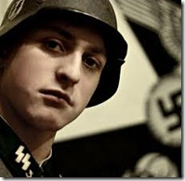
The Finders, Handiwork of Lebensborn and Dr. Mengele
The CIA has an ongoing covert operation called, the “Finders Cult” (formerly Seekers) headquarter in Washington DC. The Finders Cult is the story of the development of “Whiz Kids” as child/assets to be used as CIA-MK ULTRA Sex Slaves to entrap politicians, diplomats; corporate and law enforcement officials. They also sold child/victims to wealthy perverts to raise money for covert operations. They also trained some of the child/victims to be professional operatives and assassins of a totally cold, multiple personality, and mind control nature.[69]
In February 1987, the Finder Cult was first exposed with the arrest of two X-Men types in a van found overseeing six dirty malnourished children in a public park in Tallahassee, Florida. They were arrested by local police for child abuse.[70]
The men and the children were linked to a cult group in Washington D.C. called the “Finders.” The police found that the “cult” conducted “brainwashing” and used children “in rituals.”[71]
DC police who searched the Northeast Washington warehouse linked to the group removed large plastic bags filled with color slides, photographs and photographic contact sheets. Some showed naked children involved in what appeared to be “cult rituals,” bloodletting ceremonies of animals and one photograph of a child in chains.[72]
State law enforcement investigative officials from Tallahassee, DC, the FBI and the U.S. Customs Department discovered that The Finders Cult had international connections for satanic ritualistic abuse of children (Moscow, Hong Kong, China, Malaysia, North Vietnam, North Korea, Africa, London, Germany, “Europe” and the Bahamas).[73]
Dr. Mengele, the CIA’s Voodoo Boys and the University of South Carolina (USC)
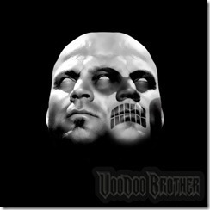
The Finders Cult was run by a former OSS and U.S. Air Force officer, Marion David Pettie (Man-Boy Lover) of the CIA. Pettie, his wife and son were also CIA agents.
During the illusionary fall of the Nazi Germany, Pettie had been one of Allen Dulles’ OSS Boys that formed the secret Fort Hunt allegiances and treaty with Reichsfuhrer SS Heinrich Himmler’s Schutzstaffel (SS) that created and formed the CIA.[74]
After WWII, Pettie and former OSS officers that formed the genesis of the CIA were trained in Nazi Counterintelligence by the Reinhard Gehlen Org and the SS in the U.S., and Germany.[75]
The Demon of Death, SS Dr. Josef Mengele, had been secretly working with Allen Dulles OSS Boys since at least November 19, 1946 when one of most wanted Nazi war criminals was covertly released by U.S. Allied Forces in Germany.[76] SS Mengele had been part of the Gehlen Org and its twisted sister, the CIA.[77]
That put Pettie in a unique position to have been trained by Dr. Mengele in the formation of the Mind Kontrol (MK) ULTRA programs officially instituted by Allen Dulles, Director of the CIA, in 1953.[78]
It also gave him access to the secrets of Lebensborn; Himmler’s Mind Controlled Guinea Pigs (Children);[79] and Himmler’s Ahnenerbe (Occult Bureau).[80]
You certainty can’t argue with what Pettie resulted being involved in that is related to secret Nazi inspired satanic mind control programs and the scientific ritual abuse of children.
MK ULTRA- OFTEN and CHICKWIT projects, jointly conducted by the Army and CIA at the Edgewood Arsenal, but also funded by the CIA, which involved the collection of information about foreign pharmaceuticals and experiments with human subjects. Some of the experiments at Edgewood and other sites were designed to replicate some of those that were conducted by Nazi doctors [Dr. Josef Mengele] in concentration camps.[81]
“The secondary source of funding for Dr. [Martin] Orne’s work in hypnotic suggestion and dissolution of memory is eerie in the cult child abuse context. The voluminous files of John Marks in Washington, D.C. (139 boxes obtained under FOIA, to be exact, two-fifths of which document CIA interest in the occult) include an Agency report itemizing a $30,000 grant to Orne from Human Ecology, and another $30,000 from Boston’s Scientific Engineering Institute (SEI) – another CIA funding cover, founded by Edwin Land of the Polaroid Corporation (and supervision of the U-2 spy plane escapades). This was the year that the CIA’s Office of Research and Development (ORD) geared up a study of parapsychology and the occult. The investigation, dubbed Project OFTEN-CHICKWIT, gave rise to the establishment of a social “laboratory” by SEI scientists at the University of South Carolina [USC]– a college class in black witchcraft, demonology and voodoo.”[82]
Under the auspices of OFTEN/CHICKWIT at least seven hallucinogens similar to BZ were tested. Inmates at Holmesburg prison in Pennsylvania were used as test subjects for BZ from 1951 to 1974. [83]
One of the most potent drugs in the U.S. arsenal is called BZ or quinuclidinyl benzilate. It is a long-lasting drug and brings on a litany of psychotic experiences and almost completely isolates any person from his environment. The main effects of BZ last up to 80 hours compared to eight hours for L.S.D. Negative after-effects may persist for up to six weeks.[84]
BZ is a potent psychomimetic that produces frank combativeness, paranoia,[85] hallucinations, confusion, delirium and amnesia.[86]
Col. Leonard N. Weigner ran Pettie’s program. Col. Weigner was also CIA. He most likely led the CIA-MK ULTRA OCCULT BUREAU. The CIA Occult Bureau was Himmler’s Ahnenerbe (Occult) Bureau American twisted sister. His last assignment, before retiring from active duty in 1972, was with the Defense Intelligence Agency (DIA) at Fort Belvoir, VA.[87]
The Finders is linked to the Millennium Prophecy that seeks to spread the empowerment of SATAN in the coming New Age.[88]
As a side note, one of Black Manchurian Candidate Yusuf Bey IV’s handlers and partner in crime was a shadowy figure, Shakir Zaid, of Oakland. Zaid is/was the pastor of the Rapture church and Millennium In international MINISTRIES. Another CIA Occult Bureau Front?[89]
The Finders were clandestinely involved in purchasing; trading and kidnapping bright children (Whiz Kids) moving them around the country in unmarked vans spanning the U.S including Tallahassee, and Miami, Florida, [90] like a Carnival troupe.[91]
The children were drugged and conditioned to worship Lucifer. They worshipped the Devil around a satanic altar. They were taught blood ritual sacrifices and forced to engage in orgies with adults around the altar.[92]
The Finders operated businesses and corporations across the U.S. One major business fronts was centered in San Francisco where Katt Williams (17 years old) and his father, Dontae White, also known as Dontae Micah S. Katt, settled into about 1990.[93] The Finders were also computer experts and interested in state of the art of “micro computing.”[94]
The criminal investigation of the Finders was pre-empted by the FEDS, U.S. Department of Justice, and then quashed and sealed permanently by the Voodoo Boys of the CIA,[95]
CIA-MK ULTRA & Space -Whiz Kids
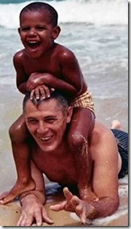
Above is a child photo of 4 or 5 year old Barack Obama that his staff must have inadvertently released claiming the man in the picture was his grandfather, Stanley Armour Dunham.
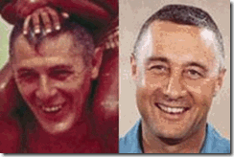
However, the man in the picture with the military crew cut is not Stanley Dunham, but NASA Astronaut Virgil I. Grissom (April 3, 1926 – January 27, 1967) with the distinctive shovel-spade nose. Astronaut Grissom had been Obama’s covert MK ULTRA “Space Kid” handler.
Clandestine s military intelligence agencies and shadow figures also used and trained designated “Whiz Kids” in covert parapsychology (PSI and ELF phenomena), exercises, training and operations.
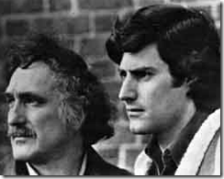
In the mid-70s, Andrija Puharich, left, ran a complex in Ossining called the Turkey Farm. In the summer of 1975, Dr. Puharich assembled around twenty children from the ages of nine to late teens, called [Uri] “Gellerlings” (right, above), or “Space Kids”. Dr. Puharich trained their psychic abilities, and claimed that they received messages from aliens. One teen claimed that they practiced remote viewing, and some of their assignments included political targets like the Kremlin and the White House. ((Levy, Steven, The Unicorn’s Secret, Prentice Hall Press, 1989, p 165-7)
Dr. Puharich has claimed that the Space Kids were able to materialize objects like trees, and that six of them arrived at his ranch via teleportation. (Gardner, Martin, Science: Good, Bad, and Bogus, Prometheus Books, 1981, p 287)
Part of Ira Einhorn’s “psychic mafia” presented a paper on the Space Kids at the “Mind Over Matter” conference at Penn State University, late January, 1977, organized by Einhorn. Other attendees included Christopher Bird and Thomas Bearden. (Levy, 1989, p 189)
The DIA (Voodoo Boy Col. Weigner) and the Wright Patterson Air Force Base ATG took over the Space Kids Program from Andrija Puharich.
MK ULTRA & Whiz Kids
CIA MK ULTRA/MONARCH mind control subprojects also involved confiscating and turning super bright “Whiz Kids” into assassins and counterintelligence operatives with Dr. Mengele’s developed methodology of satanic trauma based multiple personality disorders (MPD) and layers of amnesia barriers.[96]
Katt Williams & Lucifer’s Number 13& Toto
I am sure that If Katt Williams publicly exhibit Kurt Cobain clearly in distress; you better believe it is symbolic and has meaning; a clue to the forces harassing him and the underlining basis of his paranoia.
According to Katt Williams’ Bio, at 13 (thirteen) years old in Dayton, Ohio, he emancipated himself and moved to Miami, Florida with his dog, Rasha.
“State of Ohio does not have an emancipation law. Minor or parent is unable to file a legal action to have a minor emancipated or legally on their own and under the age of 18. There are two temporary ways in which a minor can be out of the custody of their parent. Either join any branch of the Armed Forces or marriage. However, if the marriage is dissolved or minor is discharged from the service and still under the age of 18 the custody automatically reverts back to the parent who originally had custody.”[97]
It appears that Katt Williams wasn’t really emancipated at all at 13 years old. The minimum age of emancipation in most states is 16 years old.[98]
Get the picture. Katt Williams and his dog were caught up in some type of stormy period of dissociation and swept “Somewhere over the Rainbow” to the Land of Oz (Wizard and CARNIVAL Magikian)[99].
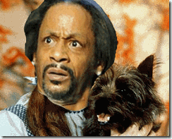
In the Wizard of Oz, Dorothy’s small dog Toto:
“Toto represents the inner, intuitive, instinctual, most animal-like part of us. Throughout the movie, Dorothy has conversations with Toto, or her inner intuitive self. The lesson here is to listen to the Toto within. In this movie, Toto was never wrong. When he barks at the scarecrow, Dorothy tries to ignore him: “Don’t be silly, Toto. Scarecrows don’t talk.” But scarecrows do talk in Oz. Toto also barks at the little man behind the curtain. It is he who realizes the Wizard is a fraud. At the Gale Farm and again at the castle, the Witch tries to put Toto into a basket. What is shadow will try to block or contain the intuitive. In both cases, Toto jumps out of the basket and escapes. Our intuitive voice can be ignored, but not contained.
In the last scene, Toto chases after a cat, causing Dorothy to chase after him and hence miss her balloon ride. This is what leads to Dorothy’s ultimate transformation, to the discovery of her inner powers. The balloon ride is representative of traditional religion, with a skinny-legged wizard promising a trip to the Divine. Toto was right to force Dorothy out of the balloon, otherwise she might never have found her magic. This is a call for us to listen to our intuition, our gut feelings, those momentary bits of imagination that appear seemingly out of nowhere.”[100]
In Arabic the meaning of the Katt Williams’ dog, Rasha, is: Gazelle (graceful and running free).[101]
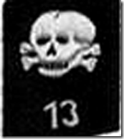
By the way, 13 is a sacred number. 13 represent death and rebirth. 13 can also represent rebellion against God’s authority. 13 is a very important number to the Brotherhood [Freemasons] and were not intended to be used by the profane- hence the superstitions surrounding 13 they are taught. “It’s OUR number, it’s not for you goyim”.[102]
From an age after 13 years old, Katt Williams traveled across the country with a carnival then returned to Florida to pursue to a stand-up comedic career.[103] Katt’s MISSING YEARS between 13 and 17 years old on the “Yellow Brick Road”, it just doesn’t seem to add up.
Nirvana & Over the Rainbow (Mind Control)
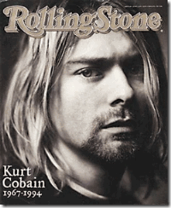
Kurt Donald Cobain (1967-1994), was the leader of the super popular rock band Nirvana. The word, Nirvana, literally means “blown out” (as in a candle) and refers, in the Buddhist context, to the imperturbable stillness of mind after the fires of desire, aversion, and delusion have been finally extinguished.[104]
Nirvana is essentially a state of dissociation. It is a state of conscious often achieved in CIA- MK ULTRA trauma based mind control programs as a gateway to developing iatrogenic (psychiatric) multiple personality disorders (MPD).[105]

This is the cover of a later-released compilation album of Nirvana’s hits, called ‘Over the Rainbow’. It has a Wizard of Oz title. The Wizard of OZ is a prominent theme used in CIA- MK ULTRA mind control programs.[106] Of course, the butterfly is also a prominent mind control image that suggests a relationship to MK ULTRA/MONARCH (children) programming.[107] Like Nirvana, “Over the Rainbow” also suggests a key state of dissociation associated with mind control programs.
“Dorothy is looking for a place where there is no trouble which is a place “over the rainbow…. To escape pain, alters go over the rainbow. (This is a.k.a. in Alice In Wonderland Programming as “going through the looking glass.. Judy Garland, she was an MK slave and the first to sing the ”over the rainbow” song. Holding a mirror (looking glass) another example how the symbolism fits the research. Over the rainbow in Oz is for the Monarch slave to be in a trance, and into a certain area of the programming…The theme song of the movie goes, ‘Somewhere over the Rainbow…there’s a land where the dreams that you dare to dream really come true.’ These lyrics are a method to hypnotically confuse the brain to perceive that the “over the Rainbow experience” (which is usually horrible abuse) is a ‘dream’. The dissociative mind is only too happy to call the trauma a dream, which is lived as a reality for a moment, but is nevertheless recorded by the mind as a fantasy. The term for this is crypto amnesia, which means the process where the proper functioning of memory is hypnotically messed up. The slave’s internal world becomes ‘reality” and the external real world becomes the Land of Oz which is perceived as make-believe.’”[108]
Beyond the Looking Glass, doesn’t it appear that Katt Williams is desperately trying to escape over the rainbow looking for a place where there is no trouble.
Kurt Cobain & Satanism
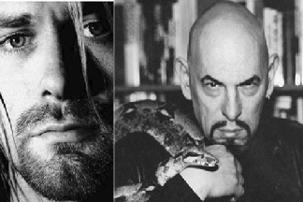
“Get stoned and worship Satan.”—Kurt Cobain[109]
Kurt Cobain committed suicide on April 5, 1994. He was “obsessed with Anton LaVey” (Mojo Magazine, Sept. 1999, p. 86). Anton LaVey was the founder of the Church of Satan and the author of the Satanic Bible. So obsessed was Cobain with Satanist Anton LaVey that he sought to enlist LaVey by having him play cello on Nirvana’s “Nevermind,” album.[110]
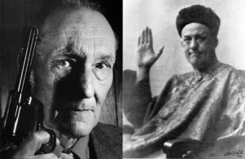
Cobain’s love of the occult would eventually lead him into developing a relationship with another notorious military intelligence occultist-CIA Assassin William Burroughs.[111] Stephen Davis, the biographer of the Led Zeppelin saga “Hammer of the Gods”, compares Burroughs to Satanist Aleister Crowley, stating:
“Like Crowley, Burroughs was an urbane and genial human Lucifer, a modern magus, a legendary addict, and an artist whose influence extended far beyond literature to music, painting and film” (Stephen Davis, Hammer of the Gods, Ballantine Books, New York, 1985, p. 237).
Kurt Cobain, Courtney Love & Voodoo Boys

The kicker is Cobain’s wife, Courtney Love. Courtney Love, above, also a MK ULTRA Sex Kitten in her black and white Spotted Cheetah animal zone.

Both Courtney and her daughter, Francis Bean Cobain, are Satanic. Courtney Love’s father is Hank Harrison, a clandestine MK ULTRA programmer and handler.
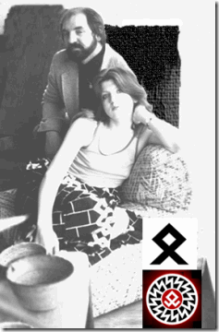
Hank Harrison and a teen-aged Courtney, her pant patterns appears to be NAZI LEBENSBORN ODAL RUNES.
Harrison was no hippy drug addict pothead burnout. He always looked clean. In fact he was a trained shrink. The first time I saw him he was wearing a Searsucker suit and a bow tie and was carrying an attaché case. I could venture a guess that Harrison was a CIA operative or a Saul Alinsky graduate in charge of organizing bands like the Grateful Dead. -David Crosby, Crosby, Stills & Nash[112]
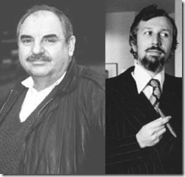
During the 1950s, Hank Harrison and Dr. Jack Sarfatti,, right, at 13 years old, became part of a group of “Whiz Kids.”[113] Dr. Sarfatti had been studied at the Columbia University Laboratory of William H. Sheldon and Walter Breen. Hank Harrison had been studied and trained at UC Berkeley.[114]
According to Dr. Sarfatti, Harrison was secretly tied up with the intelligence community, most likely the military. It was kind of like the X-Men, the Voodoo Boys of the Occult Bureau.[115]
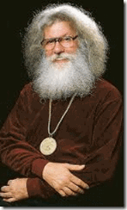
Walter Breen, a convicted pedophile,[116] and Dr. Sarfatti worked with Dr. Andrija Puharich developing “Space Kids” as covert operatives for the U.S. Government.[117] Breen was an elitist degenerate thatco-founded NAMBLA (Man-Boy Love) and had secretly coveted rare books of the Great BEAST 666, Aleister Crowley,such as Liber 777.[118]
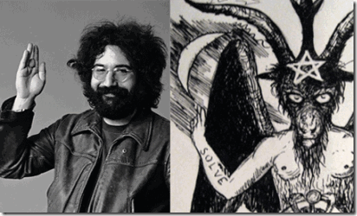
“A friend of the devil is a friend of mine”—Jerry Garcia, Grateful Dead[119]
Hank Harrison had been the first manager and the clandestine U.S. Military Intelligence handler of the Grateful Dead (formerly Warlocks).[120]
“The truth is, these Warlocks’ legendary concerts have always been nothing more than MK Ultra-inspired rituals. No other band sets the stage so carefully; the lighting, the free LSD, the Robert Hunter lyrics. To what end? Well I’m sure they don’t call Grateful Dead fans “Dead heads” for no good reason.”[121]
Warlocks are, among historic Christian traditions, said to be the male equivalent of witches. Likewise, in traditional Scottish witchcraft warlock was and is simply the term used for a WIZARD (OZ), or male witch.[122]

The Grateful Dead Logo is a a Skull with a Nazi-White Power and SS Symbol, a Lighting Strike. If you not one of them (LUCIFERIAN NWO), then you should be “Grateful” to be “DEAD.”
“Joe Baltake of the Sacramento Bee referred to The Wizard of Oz as “the definitive [Dead] head film” for the counterculture in the late 1960s and early 1970s. Hippies interpreted Dorothy’s adventure as an acid trip and would get high while watching the movie. [1]Late in his life, counterculture icon Ken Kesey wrote a satirical performance art piece called “Twister” based on The Wizard of Oz.”[123]
At least one online source link Kurt Cobain with the CIA Finders.[124]
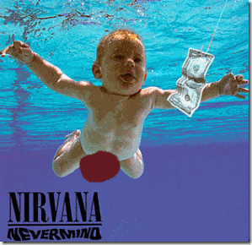
Lyrics to the Nirvana song ‘In Bloom’, from the album ‘Nevermind’:
Sell the kids for food
Weather changes moods
Spring is here again
Reproductive glands…
We can have some more
Nature is a whore
Bruises on the fruit
Tender age in bloom
‘we can have some more’, imo, means,
“we are selling our kids, but we can have some more” (ie: “there’s more where those came from, so don’t worry about it, let them go”)
“bruises on the fruit”: means the parents consider their own kids to be just damaged produce, to be sold into the market (the Finders).[125]
Many young people became “Dead Heads” after Jerry Garcia’s “Grateful Dead”. The Late Great Jim Keith [126]writes:
“An FBI internal memo from 1968 mentions the employment of the Grateful Dead as an avenue ‘to channel youth dissent and rebellion into more benign and non-threatening directions.’ [They] performed a vital service in distracting many young persons into drugs and mysticism, rather than politics.”[127]
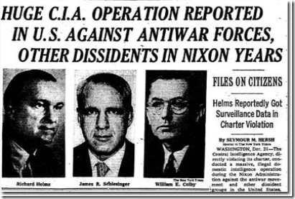
“According to my contact, the CIA is deeply concerned about the subversive influence of popular music on young people, that’s why ‘they murdered Brian Jones, John Lennon and Jim Morrison’.
What’s been worrying the spooks lately is the sway black radicalism has gained over the minds of white teenagers, to counter this ‘they’ve been pushing Nation of Islam style separatism among rappers’. Likewise, the white Grunge movement spearheaded by Nirvana was backed by the CIA because ‘they wanted to divide youngsters on racial lines, if black and white kids linked up, they’d pose a serious threat to the system. The whole point of Grunge is to instill in teenagers a sense of hopelessness, to fill them with self-hate and prevent them from changing the world.’
Apparently, the CIA got hold of Cobain when he was still unknown, then using drugs, hypnosis and medical torture; they broke his will and rebuilt his personality. ‘Most of the time he’d act relatively normal,’ I was told, ‘but all it took was a few key words spoken over the phone and Cobain would carry out the deeds he’d been programmed to enact.’ My contact was convinced that the singer had been brainwashed into committing suicide at the peak of his success because the CIA figured this would reduce his potentially rebellious fans to complete despair.
However, the conspiracy theorist admitted several of his fellow researchers thought Cobain had taken his own life as the only means of breaking free from the influence of his controllers. If this is the case, then the rock star is a hero rather than simply a victim, and his death provides grounds for a fresh outbreak of teenager rebellion.”[128]
Isn’t that exactly what Katt Williams was threatening to become a “folk hero” to the masses for having the courage and heart to expose truths to power?
At first, I had succumbed to the LEGEND that Katt Williams was a self destructing drug addicted crazed maniac or another Hip Hop Satanic Cult member wittingly beholden to a Blood Covenant with the Devil for Fame and Fortune. Now, I am not too sure.
Isn’t it clear what Katt Williams is really trying to tell us? Courtney Love and her father, Hank Harrison were Kurt Cobain’s CIA MK ULTRA handlers, and the same forces that made and controlled Kurt Cobain, also secretly made and control him that now want him neutralized, discredited and DEAD!
On December 28, 2012, LAPD broke into Katt Williams’ home in Woodland Hills, CA. According to Williams, the police broke into his lock gun cases and removed his weapons then charged him with felony endangerment of four of his children. The children were removed from the home or office by the LA County Child Protection Agency.[129] The police raid went down at 8:30 a.m., right around when news outlets were learning that the Feds IRS filed a $4 million tax lien against him.[130] I understand that Katt’s entire net worth is a little above $4 million.
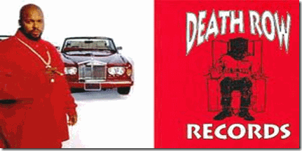
Within hours of the IRS lien and LAPD home-office raid and release from jail, Lucifer’s Servant-Brotherhood of Death (DEATH ROW) and MK ULTRA Handler, Suge Knight, deliberately led Katt Williams into another place of absolute CHAOS to further discredit the Comedy Emperor in the global public eyes.[131] In TMZ’s video “Club Fight,” below, Katt Williams appears as a paranoid, confused, wounded and helpless frightened child as he desperately took refuse and safety behind a large dumpster and a dark SUV. Where’s security? Why does security allow light in the ass people like the guy in the pink shirt to just run up on Katt Williams without being body slammed or put down?
It seems as if they’re deliberatively driving him “SOMEWHERE OVER THE RAINBOW” to find a place of peace without trouble; justify his “SUICIDE” in the eyes of the masses of the people based upon a False LEGEND.
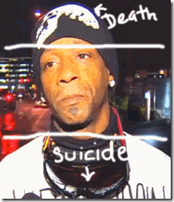
Kurt Cobain committed suicide to free his soul to become as free as a Gazelle (Katt Williams’ Dog “Rasha“) from MK ULTRA mind control and torture. If Katt Williams is an ILLUMINATI- CIA Voodoo Boy’s Mind Control victim, then my love, heart, soul and prayers are with him unconditionally that the LORD and the PEOPLE will see beyond the smoked mirrors, ILLUSIONS, and the LOOKING GLASS; and help him find a way his way home from “SOMEPLACE OVER THE RAINBOW”, and OVERCOME THE POWER AND CONTROL OF LUCIFER, and the ILLUMINATI.

[1] http://archive.decaturdaily.com/decaturdaily/news/070507/nazi.shtml
[2] http://colanmc.siu.edu/clockwork/papers/p2.htm
[3] http://www.jewishvirtuallibrary.org/jsource/Holocaust/Lebensborn.html
[4] http://www.trutv.com/library/crime/serial_killers/history/mengele/research_5.html
[5] http://www.jewishgen.org/forgottenCamps/camps/AuschwitzEng.html
[6] http://letsrollforums.com/kurt-cobain-mind-control-t17443p41.html
[7] http://educate-yourself.org/cn/genociderockefellernazis2apr03.shtml
[8] http://en.wikipedia.org/wiki/Johnny_Gosch
[9] http://www.germaniainternational.com/camps.html
[10] http://en.wikipedia.org/wiki/Runic_insignia_of_the_Schutzstaffel
[11] http://www.germaniainternational.com/camps.html
[12] http://www.4crests.com/gosch-coat-of-arms.html
[13] http://pedophileringilluminati.blogspot.com/2009/10/johnny-gosch-rare-survivor.html
[14] http://www.apfn.org/apfn/oz.htm
[15] http://en.wikipedia.org/wiki/BET_Hip_Hop_Awards
[16] http://abcnews.go.com/Business/story?id=89100&page=1
[17] http://en.wikipedia.org/wiki/Viacom
[18] http://en.wikipedia.org/wiki/Viacom
[19] http://en.wikipedia.org/wiki/Viacom
[20]
[21] http://www.ovguide.com/tv/katt_williams_the_pimp_chronicles.htm#
[22] http://www.prnewswire.com/news-releases/hottest-new-comedian-katt-williams-coming-to-spotlight-29-casino-56813417.html
[23] http://en.wikipedia.org/wiki/HBO
[24] http://www.jesus-is-savior.com/False%20Religions/Illuminati/quotes_on_the_new_world_order.htm
[25] http://en.wikipedia.org/wiki/Time_Warner
[26] http://www.jesus-is-savior.com/False%20Religions/Illuminati/quotes_on_the_new_world_order.htm
[27] http://destinysrehab.com/2012/02/20/real-talk-the-truth-behind-the-industry-whitney-houston/
[28] http://hollywood.thecomedystore.com/comedian.cfm?id=1201
[29] http://en.wikipedia.org/wiki/Eyes_Wide_Shut
[30] http://www.konformist.com/flicks/eyeswideshut.htm
[31] http://diaryofahollywoodstreetking.com/ask-jacky-what-happens-at-celebrity-sex-parties/
[32] http://en.wikipedia.org/wiki/Bunga_bunga
[33] http://www.imdb.com/title/tt0865482/
[34] http://www.answers.com/topic/dorien-wilson
[35] http://www.informantnews.com/under/under8.html
[36] http://usatoday30.usatoday.com/life/people/2006-11-07-kat-williams_x.htm
[37] http://www.tmz.com/2006/11/06/comedian-busted-for-stolen-concealed-weapon/
[38] http://www.nydailynews.com/entertainment/gossip/katt-williams-scratched-article-1.304176
[39] http://news.lalate.com/2008/11/06/katt-williams-missing-conan-obrien/
[40] http://cdn.mediatakeout.com/28002/missing-katt-williams-mysteriously-misses-conan-o-brien-s-show-yesterday-friends-can-t-find-him.html
[41] http://www.mtv.com/news/articles/1598815/katt-williams-arrested-plays-carnegie-hall-anyway.jhtml
[42] http://www.nypost.com/p/news/regional/item_ysRsgx8ibExuQA8qvVdNuN
[43] http://www.mtv.com/news/articles/1598815/katt-williams-arrested-plays-carnegie-hall-anyway.jhtml
[44] http://www.nydailynews.com/news/crime/gun-possession-charges-dropped-comedian-katt-williams-security-guards-face-rap-article-1.430748
[45] http://www.state.sc.us/dmh/dmh_presentation.pdf
[46] http://cdn.mediatakeout.com/28246/katt-williams-goes-bonkers-admitted-into-mental-hospital-for-evaluation.html
[47] http://en.wikipedia.org/wiki/Mason%E2%80%93Dixon_Line
[48] http://garryldeaslawfirm.com/
[49] http://www.skipmason.com/hm/hm19.htm
[50] http://www.aapa.org/uploadedFiles/…/Emergency_Detention_7-09.pdf
[51] http://necolebitchie.com/2012/12/10/katt-williams-needs-some-serious-help/
[52] http://kysdc.com/2877527/katt-williams-arrested-for-busting-bottle-over-someones-head/
[53] http://en.wikipedia.org/wiki/Too_Short
[54] http://mvremix.com/urban_blogs/2010/03/20/west-coast-living-legend-richard-richie-rich-serrell-returns-to-the-limelight-after-a-more-than-nine-year-musical-absence/
[55] http://www.ktvu.com/news/news/crime-law/32-people-indicted-disco-dazed-drug-trafficking-op/nPHm6/
[56] http://en.wikipedia.org/wiki/Project_MKUltra
[57] http://newsone.com/2086079/meltdown-katt-williams/
[58] http://www.comediandepot.com/biowilliams.php
[59] http://www.mocospace.com/html/forum/forum_topic-view.jsp?topicid=3419728
[60] http://slumz.boxden.com/f87/katt-williams-cancels-show-because-aliens-1853596/
[61] http://justifytheory.blogspot.com/2012/09/the-crazies-pt-iii-katt-williams.html
[62] http://www.sing365.com/music/lyric.nsf/Jesus-Walks-lyrics-Kanye-West/CD437440F8D4D11548256E0000077E92
[63] http://www.huffingtonpost.com/2012/02/11/whitney-houston-dead-last-performance-yes-jesus-loves-me_n_1270978.html
[64] http://mrsgrapevine.com/2012/02/whitney-houston-will-fight-ove-ray-ask-stacy-francis/
[65] http://www.votefortheworst.com/blog/667940/the-truth-about-stacy-francis/
[66] http://www.shayne-michael.com/links.php?searchFor=Katt%20Williams&findBio=full
[67] http://en.wikipedia.org/wiki/National_Academy_of_Sciences
[68] http://www.theforbiddenknowledge.com/hardtruth/if_chapter8.htm
[69] http://educate-yourself.org/cn/ciadrugsabusemurder.shtml
[70] http://educate-yourself.org/cn/ciadrugsabusemurder.shtml
[71] http://educate-yourself.org/cn/ciadrugsabusemurder.shtml
[72] http://educate-yourself.org/cn/ciadrugsabusemurder.shtml
[73] http://educate-yourself.org/cn/ciadrugsabusemurder.shtml
[74] atrueott.files.wordpress.com/2010/…/the-secret–treaty-of-fort–hunt.pd…
[75] I http://educate-yourself.org/cn/ciadrugsabusemurder.shtml
[76] http://www.wanttoknow.info/nationbetrayed10pg
[77] http://www.democraticunderground.com/discuss/duboard.php?az=view_all&address=104×4863411
[78] http://www.bibliotecapleyades.net/sociopolitica/esp_sociopol_mindcon02.htm
[79] http://www.redicecreations.com/article.php?id=16206
[80] http://www.666blacksun.org/satanic-national-socialism/reichsfuhrer-heinrich-himmler/
[81] https://eassurvey.wordpress.com/tag/chickwit/
[82] http://www.constantinereport.com/allposts/federal-mind-control-experiments-on-unwilling-subjects-cult-cut-outs- the-false-memory-cover-story-mass-media-concealment-of-the-nazi-style-atrocities/
[83] http://www.wnd.com/2002/05/14067/
[84] http://electronicharassment.weebly.com/the-victims-of-mk-ultra.html
[85] http://en.wikipedia.org/wiki/3-Quinuclidinyl_benzilate
[86] http://www.thefreelibrary.com/Chemical+stockpile+scrapping+work+proceeds+amid+dissent-a085918223
[87] http://www.highbeam.com/doc/1P2-1146707.html
[88] http://www.rigorousintuition.ca/board2/viewtopic.php?f=46&t=5098&start=15
[89] http://www.chaunceybaileyproject.org/2009/08/02/bailey-suspects-associates-left-behind-6-million-trail-of-bad-loans/
[90] http://www.rigorousintuition.ca/board2/viewtopic.php?f=46&t=5098&start=15
[91] http://www.rigorousintuition.ca/board2/viewtopic.php?f=46&t=5098&start=15
[92] http://www.rigorousintuition.ca/board2/viewtopic.php?f=46&t=5098&start=15
[93] http://events.7×7.com/oakland/events/katt-williams-/E0-001-051357291-8
[94] http://www.rigorousintuition.ca/board2/viewtopic.php?f=46&t=5098&start=15
[95] Id.
[96] http://www.davidicke.com/forum/showthread.php?t=171145
[97] http://wiki.answers.com/Q/How_old_does_a_child_have_to_be_in_Ohio_to_get_emancipated
[98] http://www.nolo.com/legal-encyclopedia/emancipation-of-minors-32237.html
[99] http://www.reelz.com/movie-news/14241/sam-raimi-introduces-first-trailer-for-oz-the-great-and-powerful-at-comic-con-photos/
[100] http://vigilantcitizen.com/moviesandtv/the-occult-roots-of-the-wizard-of-oz/
[101] http://www.sheknows.com/baby-names/name/rasha
[102] http://conspiracyresearch.blogspot.com/2010/04/world-government-numerics-followers-of.html
[103] http://www.theflowonline.com/index.php?mode=magazine_detail&mag_id=138
[104] http://en.wikipedia.org/wiki/Nirvana
[105] Ross, Colin, The C.I.A. Doctors, Manitou Communications, Inc, Richardson, TX (2000) pg. 232
[106] http://www.apfn.org/apfn/oz.htm
[107] http://www.bibliotecapleyades.net/sociopolitica/esp_sociopol_mindcon02.htm
[108] http://antinwoforlif3.blogspot.com/2011/05/wizard-of-oz-programming.html
[109] http://www.jesus-is-savior.com/Evils%20in%20America/Rock-n-Roll/kurt_cobain.htm
[110] http://panachereport.com/MyraPanacheOnBlackHollywodConspiracies-PanacheReport.htm
[111] http://letsrollforums.com/kurt-cobain-mind-control-t17443.html
[112] http://www.godlikeproductions.com/forum1/message1911428/pg2
[113] http://2012diaries.blogspot.com/2010/04/puharich-nexus-part-2-crack-in-record_02.html
[114] http://praxisforlife.org/?p=446
[115] http://praxisforlife.org/?p=446
[116] http://en.wikipedia.org/wiki/Walter_H._Breen
[117] http://www.rigorousintuition.ca/board2/viewtopic.php?f=8&t=24105&hilit=puharich+psychic+kids&start=30
[118] http://www.arcane-archive.org/religion/thelema/crowley-and-paederasty-1.php
[119] http://doctrinewars.blogspot.com/2008/01/mk-ultra-operation-mind-control-for.html
[120] http://blues.gr/profiles/blogs/an-interview-with-the-first-manager-of-grateful-dead-hank
[121]http://vigilantcitizen.com/vcboards/viewtopic.php?f=5&t=8928&sid=f2e243840999e083a5e3c0132669b1b0&view=print
[122] http://en.wikipedia.org/wiki/Warlock
[123] http://www.davidicke.com/forum/printthread.php?t=3097&pp=10&page=273
[124] http://letsrollforums.com/kurt-cobain-mind-control-t17443p6.html
[125] http://letsrollforums.com/kurt-cobain-mind-control-t17443p6.html
[126] http://en.wikipedia.org/wiki/Jim_Keith
[127][127] Keith, Jim, Mind Control World Control, Adventures Unlimited Press, Kempton, ILL (1997), pg. 179
[128] http://www.davidicke.com/forum/showthread.php?t=3097
[129] http://www.huffingtonpost.com/2012/12/29/katt-williams-child-endangerment-comedian-boasts-guns_n_2381068.html
[130] http://www.eonline.com/news/374734/katt-williams-jailed-after-being-arrested-for-child-endangerment
[131] http://www.tmz.com/2012/12/29/katt-williams-suge-knight-fight-video/
Comments : 14 Comments
Tags: ahnenerbe, Andrija Puharich, BZ, cia occult bureau, courtney love, crack cocaine, francis bean cobain, George Herbert Walker Bush, grateful dead, Great BEAST 666 Aleister Crowley, Heinrich Himmler, hip hop satanic cult, jack sarfatti, jerry garcia, johnny gosch, josef mengele, katt williams, Kurt cobain, lebensborn, MK-ULTRA, niirvana, richie rich, SS, suge knight, too short, university of south carolina, walter breen, william burroughs, your balck muslim bakery, yusuf bey iv
Categories : 1000 Year Reich, african american satanic cult, Aleister Crowley, ALL SEEING EYE, allen dulles, andrija puharich, Aryan Supremacy, baphomet, Barack Obama, Bet, church of satan, CIA, COINTELPRO, columbia records, Death row records, Defense Intelligence Agency, devil's horns, Dr. Conrad Murray, Dr. Josef Mengele, Eazy-E, ELF, Eyes Wide Shut, garryl deas, Gellerings, Hauptsturmfuhrer SS Dr. Josef Mengele, Heinrich Himmler, Hip Hop, hip hop satanic cult, hollywood satanic cult, illuminati, Iran-Contra Crack Cocaine connection, Josef Mengele, katt williams, lucifer's servants, luciferians, Marion Suge Knight, mind control, mk ultra, cia occult bureau, temple of set, MK-ULTRA, monarch child, monarch program, Nazis, nwo, Operation PAPERCLIP, Paperclip Project, Reichsfurhrer SS-1 Heinrich Himmler, Ritual Satanic Abuse, ritual satanic sexual abuse, ritually abused children, satan, Satanism, Schutzsteffel, sex kitten, sex slave, skull and bones, Skull and Bones of Yale, Space Kids, Stanley Armour Dunham, Stanley Kubrick, Star Kids, trauma-based mind control, Uri Geller, Virgil Grissom, whitney houston, your black muslim bakery, yusuf bey vi

A CASE FOR GENOCIDE: BLACK MANCHURIAN CANDIDATES- DONALD DAVID DEFREEZE, YUSUF BEY IV & THE DELIBERATE DESTRUCTION AND DECONSTRUCTION OF BLACK INSTITUTIONS
10122012
The Late Great Bruce Lee (November 27, 1940 – July 20, 1973)was much more closer to the People’s Struggle then you are allowed to believe. Bruce couldn’t meet with us personally and we fully understood it. Nevertheless, the ILLUMINATI and the San Francisco Chinese Triads warned Bruce to stay away from the struggle, particularly the Black Liberation Movement.
Yet during the late 1960s, we were able to train and spiritually reconnect with our Asian Brothers under Bruce’s directions somewhat behind the scenes. I didn’t understand it then, because I was so young. But, I learned that there were many battles to fight without our fists. Bruce’s “Art of Fighting without Fighting” required physical, mental and spiritual exercises and training before you ever threw a punch or a kick.
It isn’t happenstance that in Enter the Dragon that Bruce reconnected us with our ancestral spiritual training to fight and destroy ILLUMINATII-Luciferian images and “ILLUSIONS.”
“The older dictators fell because they could never supply their subjects with enough bread, enough circuses, enough miracles, and mysteries. Under a scientific dictatorship, education will really work’ with the result that most men and women will grow up to love their servitude and will never dream of revolution. There seems to be no good reason why a thoroughly scientific dictatorship should ever be overthrown.”
– Aldous Huxley, Brave New World Revisited, 116
The knowledge of escaping the embrace of illusions (slavery) created by the ILLUMINATI’s “Scientific Dictatorship” is an ancient mystery far beyond the written history of mankind. Lord Vishnu is also called Hari, or one who removes the darkness of ILLUSION. From the beginning of history, ILLUSIONS mark the idea that living beings live separate and in darkness without connection to GOD.
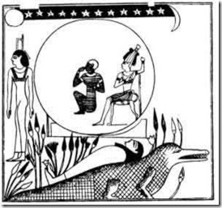
The counterpart of Vishnu, below right, is the Ancient Osiris of Ta Merry shown above dreaming while sleeping on the back of the Crocodile God Sebek of the primordial abyss.
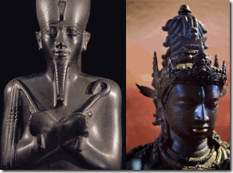
Of ILLUSIONS and Smooth Deceits (Trancelike States), the scriptures provide that Lord GOD, “Therefore this iniquity shall be to you as a breach ready to fall, swelling out in a high wall, whose breaking cometh suddenly at an instant. And he shall break it as the breaking of the potter’s vessel that is broken in pieces; he shall not spare : so that there shall not be found in the bursting of it a sherd to take fire from the hearth, or take water withal out of the pit.” Isaiah 30:13-14
ILLUSIONS are no longer the domain and power of Gods and Goddesses, but manipulated by ILLUMINATI oligarchies and their GOONS of the “Brave New World” offering the masses trinkets, entertainment, drugs, and distractions, placated with vicarious tokens and lost in a dream world of “happiness” keeping the people away from GOD and dumbing them down so they won’t awaken and revolt against the Luciferian Masters of Deceptions and ILLUSIONS.
LUCIFERS’ SERVANTS (ILLUSIONISTS) IN OUR MIST, AMERICA’S BIGGEST SECRET
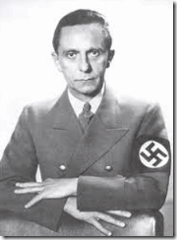
“Goebbels… was a deceiver, an ILLUSIONIST, by vocation, and ‘no ILLUSIONIST believes in the ILLUSIONS he himself fosters.” -Hans-Otto Meisner
NAZIS (ILLUSIONISTS) IN OUR MIST, AMERICA’S BIGGEST SECRET
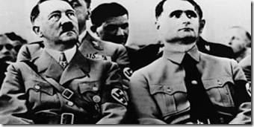
“National Socialism is nothing more than applied biology.”Deputy Fuhrer Rudolph Hess
It seems that ordinary people even like me are at times absolutely unable to fathom the notion that a group of people exist from one generation to the next with an evil design to bring about total racial destruction of a people.
Very few understand the political meaning of “applied biology” within National Socialism (Nazism). Also, very few understand that the genocidal designs and works of the Nazis often take place right under our collective noses right here in the Oakland-San Francisco Bay Area behind ILLUSIONS, smoked mirrors and the Looking Glass.
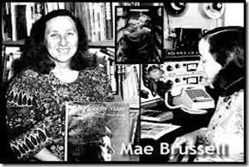
Yet, we don’t talk about it. The Late Great Mae Brussell was among a very few that was courageous enough to persistently educate us about the Nazis behind the veil in America. She was literally banned from the white liberal so-called free speech KFPA airways because she refused to be quiet to conceal the truth from us. Even though Mae has been dead for over two decades, her voice is still silenced over liberal and progressive airways.
The list of Bay Area white progressive-Negro journalists’ forbidden subjects continue to grow larger year after year from the Assassinations of JFK, MLK, Jr., RFK, to Jonestown, 9-11Deception and the Libyan Aggression to the Chauncey Bailey Assassination, Your Black Muslim Bakery and Yusuf Bey IV.
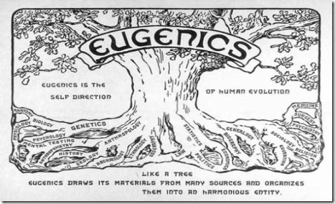
What the Nazis considered “applied biology” was actually Darwin’s theory of evolution and eugenics or artificial selection. The Nazis furthered the development of a world view of what they promoted as a blue-eyed, blond-haired Ancient Germanic Master Aryan Race to dominate and control the world.
The Nazis worldview was that the human gene pool could be improved by using selective breeding similar to how farmers breed superior cattle strains. In the formulation of their racial policies, National Socialism relied heavily upon Darwinism to protect the superior Master Aryan Race. Nazism sought to prevent the so-called “inferior races” permanently from mixing, polluting and the contamination of the Master Race’s gene pool by a FINAL SOLUTION, racial mass murder- Genocide.
Sometimes their genocidal agenda appears only through illusions, smoke mirrors and beyond the looking glass. Looking Glass Genocide often takes place in other ways than overt mass murder. The attack on the target group, particular Black people in America, manifests itself through the deliberate destruction or deconstruction of their educational systems, institutions, culture and economic abilities.
Basically, it is a comprehensive and intentional attack on the target race’s social and economic existences. The destruction lies in the end of annihilating their way of life, social networks, institutions and values of the community.[1]
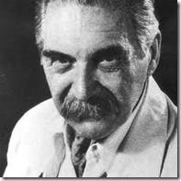
CIA-MK ULTRA is basically a vast multi-million dollar pharmaceutical-trauma based and genetic covert mind control industry developed by the Demon of Death of Auschwitz Concentration Camp, Hauptsfuhrer (Captain) SS Josef Rudolf Mengele.
Yet only through the Looking Glass are we able to see, discuss or explore “applied biology” and the works of the SS (Schutzstaffel) and Dr. Mengele that secretly took place in America after the end of WWII.
Mae Brussell was the first to expose wanted international war criminal, Dr. Mengele, as a U.S. Citizen.[2] During the 1960s, Mengele may have been living in the USA or Canada busy working for the CIA rather than hiding in Argentina or Brazil. Dr. Mengele’s rabbit hole in America runs far deeper than anyone is ready to pursue. “MENGELE told my informant THAT HE personally did the training on Oswald… Oswald was trained as a ‘patsy’ only.”[3]
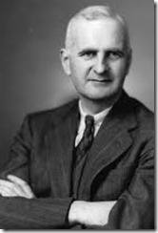
Reportedly, Dr. Mengele lived in Montreal during 1962, “suspectedly to work in setting up MK ULTRA experiments at the Allan Memorial branch of McGill University in Canada.”[4] That means Dr. Mengele trained the notorious master CIA MK ULTRA Psychiatrist, Dr. Donald Ewen Cameron, head of Allan Memorial.[5]
Dr. Cameron was one of the most influential psychiatrists in the world. He was a member of the Nuremberg Tribunal that ignored pursuing Dr. Mengele as a war criminal. One thing is clear; he shared the same Master Aryan Race GENOCIDIST vision with Dr. Mengele and the SS,
“Cameron’s idea for a societal cure differs from Freud’s, where Freud proposed a talking cure, Cameron did not believe in a cure but a form of quarantine and extermination. Cameron wanted better societal functions, to expose mental deficiencies, environments that might frustrate the mentally weak, however help to reinforce the authority of the psychiatric society. Where Freud saw symptoms of repression, Cameron saw genetic weakness, biological determination and symptoms of social contamination as causes for mental illness. Cameron’s elemental construction of society is not based on repression or the unconscious, id, ego and superego, but is socio-biologically determined as founded on genetics. Cameron’s own use of authority, discipline and control is not seen as any materialization of an unconscious drive.”[6]
When I discuss MK ULTRA Black Manchurian Candidates, you can’t separate it from Dr. Mengele and National Socialism’s designs and worldview of “applied biology,” GENOCIDE.
Black Manchurian Candidates are often used as tools, patsies and pawns in veiled genocidal programs, targeting Black leaders for assassinations, and the destruction and deconstruction of Black Institutions.
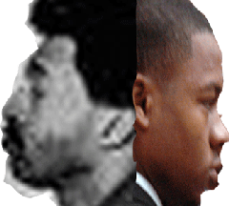
As it turns out, Donald Defreeze and Yusuf Bey VI maybe two of the Bay Area’s most significant Black Manchurian Candidates and “pasties” of GENOCIDE in the destruction and deconstruction of an educational system and an independent institution vital and necessary to the prosperity, well being and economic needs of Black People.
Donald David Defreeze (Cinque) was used as a shrouded “patsy” as the means to deconstruct the Oakland Unified School District (OUSD). OUSD had become a vital free comprehensive educational institution to People of Color. It was one of best educational systems in America if not the world. At the time of the Assassination of Dr. Marcus A. Foster, OUSD was home to over 66,000 students that over 70% were Black. It also provided over 4,000 jobs. OUSD provided a livelihood to many residents of Oakland, the majority People of Color.
Yusuf Bey IV (Spiritual Leader of Your Black Muslim Bakery) also was used as a shrouded “patsy” as the means to destroy Oakland’s Your Black Muslim Bakery (YBMB). YBMB had become a vital business and religious institution to People of Color. Over the decades, it had single-handedly carved out a niche in a highly competitive bakery goods market. It produced vital bakery products from raw materials. It provided healthy, nutritious and quality bakery goods to an often ignored target market group, Black People.
It also provided over 200 jobs with a potential of growth and development. YBMB was an inspiration to the community. It was one of the few remaining successful independently owned Black owned corporations in the Bay Area if not the State of California. It also provided a livelihood and a religious haven to many residents of Oakland, the majority People of Color.
Over and over again, the question has been raised why Black People don’t resist drugs, crime and corruption, a Black Holocaust in the community. Why do they allow themselves to be burdened by helplessness, drugs and crimes? Why don’t they produce anything?
They also ask how several thousand Jews could permit themselves to be shot, one by one, with no more than thirty or forty rifles aimed at them.[7]
I think some explanations to both cases are partial answers to the questions. The Nazis and the SS were ingenious in their deployment of elaborate deceptions, illusions and smoked mirrors in veiling in secrecy its policy and practice of genocide.
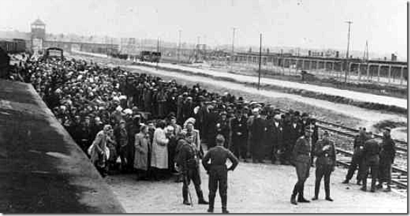
Lucifer Servants– Knights of the Black Sun, the SS, were the World’s Greatest Racial Mass Murderer Cult. They were Teutonic sorcerers, magikians, quintessential illuminists, two faces of JANUS , and the “Masters of Deception.” Jews were led to believe they were being transported to work sites and received detailed instructions on what to bring with them on the trains. And when they arrived, music would be blaring to “welcome” them inside the camp.[8]
As for the Jewish People, “It wasn’t difficult for the Jews to accept these deceptions. After all, there was nothing in the history of the world to prepare them for what awaited. It was possible to believe that they were being taken to labor camps, that the Germans needed them for free labor, but what civilized person was willing to entertain the notion that the Nazis had constructed gas chambers where shower heads spewed deadly gas that would kill innocent men, women, and children, all destined to death for the simple reason of being Jewish? It is human nature to believe what we want to believe, and the Jews were no exception to this rule.”[9]
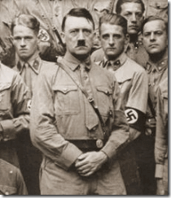
As for Black People, we weren’t aware that these same veiled absolute evil, the THIRD REICH and the SS that slaughtered over 6 million people in Eastern Europe had been slipped by the thousands into the United States to continue the 1000 YEAR REICH and prey upon People of Color behind a shroud of secrecy. Without the Nazi uniforms and swastikas, with the exception of Hitler, they would look just like people that we encounter daily.
There was nothing in the history of the world to also prepare us to understand the nature of, or the presence of Lucifer’s Servants like Dr. Mengele clandestinelyimbedded within the bowels of the U.S. government, military, police, corporations, banks, hospitals and universities.
We have been under the ILLUSION that Lucifer’s Servants, the Nazis and SS were defeated, polarized and neutralized. They were tried, convicted, and hanged or had been imprisoned for their crimes against People of Color at the Nuremberg Tribunal.
We were led to believe that the THIRD REICH was truly repugnant to a civilized nation, our practiced form of religion, and the very roots of an open and free democracy.
Beside the Late Great Mae Brussell, white journalist and researchers aren’t particularly interested in pursuing truths or getting behind what was/is really going on in the Black Community.
Far too many of them accept, pander and conspire in collaboration with the ILLUMINATI to mask the footprints, the two faces and works of absolute evil in our community.
Without the particular background research and work of the likes of Mae Brussell that is in the vital interest and concern of the Black Community, we would have to accept the magikians’ ILLUSIONS and tall tales as facts like the Late Jim Garrisons would say is as tall as the tale that “an elephant can hang from a cliff with his tail tied to a daisy.”[10]
Lucifer Servant’s footprint, ILLUSIONS and their designs run throughout the creation of Looking Glass MK ULTRA Manchurian Candidates Donald David Defreeze and Yusuf Bey IV.

“The Elephant Hanging Off a Cliff with his Tail Tied to a Daisy in Our Community: the Terrorist Donald Defreeze, “Field Marshal Cinque”
Donald David Defreeze (November 15, 1943 – May 17, 1974), also known as Cinque Mtume, was the leader of the America guerilla group Symbionese Liberation Army (SLA), a group operating in the mid-1970s, under the nom de guerre “Field Marshal Cinque.” Defreeze, along with Patricia Soltyski founded the SLA and soon recruited members for his group. The group perpetrated a number of crimes, the most infamous being the vicious slaying of Oakland Schools Superintendent Dr. Marcus A. Foster Marcus and the abduction, torture, rape, and brainwashing of newspaper heiress Patty Hearst. Defreeze is primarily suspected of having murdered Foster and shooting Assistant Superintendent Robert Blackburn.[11]
How is it possible to continue to spread the lie that the brown skin Defreeze is suspected of murdering Dr. Foster when all the assailants were described to have long straight hair and tan or olive complexions?
According to A STUDY PREPARED FOR THE USE OF THE COMMITTEE ON INTERNAL SECURITY HOUSE OF REPRESENTATIVES (FEBRUARY 18, 1974),
“The murder team was described by a witness who saw them fleeing the murder scene as between 15 to 20 years of age, all with dark, shoulder length hair or wigs, and all of medium height and slender build. According to this witness, each wore a uniform of dark pants, knit hat and a denim jacket with a white patch on the right breast. Their complexion was described as olive or tan, and it was indicated that one or more of the team could be female.” [12]
Donald Defreeze, the CIA and SS ILLUSIONISTS Behind the Veil
Back in 1974, Mae Brussell appears to be the first journalist-researcher to connect Colston Westbrook and Field Marshal Cinque to a CIA Mastermind Planner, Dr. William Herrmann.[13]
In 1974, not much was actually known about Dr. Herrmann in California and since then not much more has been revealed about him in the United States other than Brussell’s original findings.
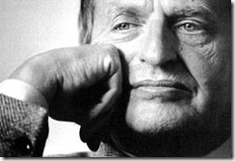
“I know that the Thatchers and the Reagans will be out in a few years. We have to survive till then.”-Olof Palme[14]
A decade later, Dr. Herrmann raised his ugly head across the Atlantic Ocean as a key international military intelligence ILLUSIONIST behind the political assassination of Sweden’s 26th Prime Minister, Sven Olof Joachim Palme.[15]
On February 28, 1986, Olof Palme was shot in the back of the neck at close range by an assassin in central Stockholm. Palme died instantly. His wife was also shot in the back but survived. By most accounts, Palme had been very vocal against the CIA, U.S. Vietnam Aggression and South Africa’s Apartheid System. He had been an uncooperative head of state to the New World Order.[16]
Palme’s assassination may be linked to Swedish business and right winged Police; and CIA foreign and domestic intelligence circles of former CIA director, U.S. Vice President and President, George Herbert Walker Bush.[17]
From 1991 to 1993, William Herrmann operated as a disinformant (U.S. Disinformation Intelligence Officer). In the investigation of the assassination of Palme, Dr. Herrmann was exposed as one of the National Security Council (NSC) and CIA’s major arms dealers. In the Iran-Contra Cocaine Connection, “the CIA and the FBI made sure that Herrmann was kept out of all congressional hearings.”[18]
In a 1986 interview with the Sunday Telegraph (London), Herrmann said he was 50 years old and born in Poland. He lived in Little Falls, New Jersey. He became a US citizen in 1956, and served in the US military until 1967, when he claimed had reached the rank of colonel. He claimed that he through the most recent decade (i. e. approx. 1976-86) had been a CIA agent in Iran and Iraq and also worked for the FBI.[19]
In 1956, Dr. Herrmann was slipped into the country by the CIA under the veil of national security in the ABOVE TOP SECRET program, Operation BLOODSTONE. [20]
Operation BLOODSTONE was a secret army of CIA operatives, executioners and assassins made up of Nazi-SS and their Eastern European SS collaborators recruited by General Reinhard Gehlen of the Gehlen Org (1947-1968)[21], CIA Director Allen Dulles (1953-1963), and Directorate of Plans, Frank Wisner, Sr. (1947-1958)[22]
Dr. Herrmann didn’t reveal what he did between 1967 and 1976, which was during the creation and making and mind control of Field Marshal Cinque and formation of the SLA at California Men’s Medical Facility with Colston Westbrook at Vacaville.
The U.S. House of Representatives Iran-Contra investigation team questioned and revealed approximately 10 named so-called “allegators”, including William Herrmann. For example, Herrmann is specifically named in Robert Parry ‘s book Trick or Treason, The October Surprise Mystery, Sheridan Square Press (1993:289):
“The House team repudiated other October Surprise ‘witnesses’ as well. None was telling the truth about Republican-Iranian contacts, the House investigators concluded. Yet, most of the so-called ‘allegators’ – including pilot Heinrich Rupp [..], American arms dealer William Herrmann, and [..] – stuck by their stories about Casey’s supposed hostage initiatives.”[23]
Above, the House team connects Dr. Herrmann with SS Pilot Heinrich Rupp. Rupp was a Project PAPERCLIP-Teutonic Knight Magikian that also had been slipped into the country under the veil of U.S. National Security.[24]
Both Herrmann and Rupp were connected to the highest elected official in the United States, California Governor and U.S. President Ronald Reagan. They were also connected to the highest seen and unseen intelligence agency officials in the country, CIA Chief William Casey,[25] and SS Captain Baron Otto Von Bolschwing of the Gehlen Org.[26]
On May 17, 1985, Dr. Herrmann was arrested in London after three million dollars in counterfeit notes was found in his hotel room (Parry 1993:133). At the time, Herrmann was also arranging a sale of 10,000 TOW missiles from the U.S. and Israel through Iranian arms dealer, Cyrus Hashemi. According to Herrmann, “In early 1985, I got the orders from Oliver North to issue pro-forma invoices for 10,000 TOW missiles from Cyrus Hashemi via Bank Melli.” (Bainerman, Joel (1992): The Crimes of a President. SPI Books, 1992: 239)
TOW” is an acronym that stands for “Tube-launched, Optically-tracked, Wire command data link, guided missile”.[27]
For the record, U.S. Marine Corps Lieutenant Colonel Oliver North was at the center of national attention during the Iran-Contra Affair, a political scandal of the late 1980s. North was a National Security Council (NSC) staff member involved in the clandestine sale of weapons to Iran, which served to encourage the release of U.S. hostages from Lebanon. North formulated the second part of the plan: diverting proceeds from the arms sales to support the Contra rebel groups in Nicaragua (funding to the Contras had been prohibited under the Boland Amendment amidst widespread public opposition in the U.S. and controversies surrounding human rights abuses by the Contras). [28]
During Dr. Herrmann’s trial in London, he explained that he had acted as a deep cover infiltrator in a counterfeiter gang on assignment from the FBI. In an interview with author Joe Bainerman (Bainerman, 1992:240), Herrmann said he had infiltrated the Belgian terrorist group Action Directe on behalf of the FBI. They, too, had a counterfeiting department that allegedly had turned the false money over to Herrmann for whitewashing.
This is consistent with what the FBI agent John Mencer said during the trial, that Herrmann was informer for the FBI and had provided information on international terrorists and espionage (Sunday Telegraph 1986b). It had been confirmed that Dr. Herrmann also worked for the FBI (Parry, 1993:133), the FBI’s own telexes show that Herrmann days before the arrest was in contact with two FBI agents – one in New Jersey and one at the US embassy in London – about how the money was to be delivered and received. Thus, we find that the entire operation was a sting operation and it was a part of the design that he was arrested by Scotland Yard and sentenced to five years imprisonment (Parry 1993:133).
This sting operation and “arrest” occurred in May 1985. The Iran-Contra scandal broke in November 1986, and investigations of people involved began a month later. Herrmann was obviously one of those Congress wanted to hear.[29]
Dr. Herrmann was also associated as a clandestine arms dealer and international terrorist network group expert with Oliver North and the NSC. Dr. Herrmann and the rabbit hole ran far deeper than Iran-Contra. The hole delved deep down into international SS terrorist networks, mercenaries and clandestine ILLUMINATI overthrow of sovereign nations; assassinations, and international drug rings and trafficking.
From March 1986 to February 1987, British Intelligence MI-5 and MI-6 kept Dr. Herrmann undercover and shielded him in protective custody from the Iran-Contra-Cocaine Crimes U.S. Congressional inquiries.
In December 1989, Dr. Herrmann was allegedly released from a prison in Pennsylvania. By that time, the Iran-Contra congressional inquiries had concluded.[30] At this time, Dr. William Herrmann remains shrouded in secrecy. He is still not officially part of any public record in any significant way.
Both Dr. Herrmann and Westbrook were psychological warfare experts, experienced in the formation and indoctrination of assassination and terrorist cadres among other things.
At the time of the creation and making of Field Marshal Cinque and the formation of the SLA at Vacaville, Dr. Herrmann and Westbrook were also undoubtedly members of the FBI’s special clandestine international counterintelligence and assassination group, Division 5, led by J. Edgar Hoover, the Masters of Deception, the SS, and SS Wernher von Braun of NASA. [31] Dr. Herrmann, Westbrook and the CIA weren’t just another one of Brussell’s kooky conspiracy theories.
This SHIT (excuse my expression) was REAL!
The Timeline of the Making of an ILLUSION, the LEGEND of Donald David Defreeze, Alias General Field Marshal Cinque-SIN, Spiritual Leader of the Symbionese Liberation Army
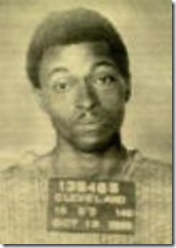
“I was slowly becoming a nothing.” Donald D. Defreeze[32]
Donald David Defreeze was born on November 15, 1943 in Cleveland, Ohio. He was the oldest of eight children. He was often beaten by his father. Reportedly, his father broke two of his arms. He completed the ninth grade and then left home to live with a cousin in Newark, NJ at 13 or14 years old.[33]
Donald Defreeze ended up living with Christian Minister Reverend William L. Foster, Buffalo, N.Y, and reportedly became deeply religious.[34]
At age 14, he was arrested for robbing a parking meter; later, for stealing a car and a weapon. He spent two years in a reformatory, surrounded by “hell,” loneliness, fear, hatred. Tried to keep out of fights and avoid homosexual advances.[35]
1962, Newark, New Jersey
Defreeze was released from reform school. Subsequently, he would describe his incarceration as living in prison and a mental hospital. I can’t find any references as to which reform school Defreeze had been sent to or where the juvenile offenses occurred, but he revolved around Buffalo and Newark.
However, his activities appeared to have been centered in Newark with his blood relatives. Not too long after being released from reform school, he married an older young lady in Newark, New Jersey.
Donald Defreeze, MK SEARCH and Bordentown Reformatory
It seems more than likely that Defreeze had been sent from Newark to Bordentown Reformatory in New Jersey, a home away from home for “juvenile delinquents.” In those days, Bordentown would have been equally a “prison” and experimental “mental hospital.”
For decades, Bordentown Reformatory had been a notorious OSS and CIA experimental medical and psychological human guinea pig farm.
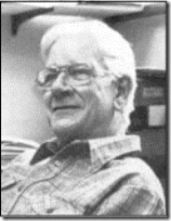
During World War II and also in 1951 through to at least 1964 when Defreeze may have been there, Bordentown Reformatory had been the site of secret CIA and U.S. Army mind control experiments. Dr. Carl C. Pfeiffer, above, of Emory University, Atlanta and the University of Illinois Medical School oversaw some of these experiments, which were intended to both study and trigger “a model psychosis characterized by visual and auditory hallucinations.”[36]
Earlier, during World War II, the Bordentown Reformatory was used by the OSS, precursor to the CIA, for truth drug experiments. These experiments included Dr. James A. Hamilton’s close associates OSS officer Capt. George White and New York psychiatrist Lawrence Kubie, also discussed later.[37]
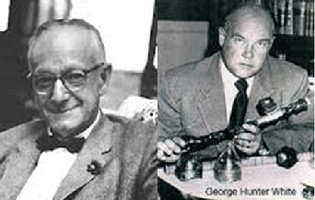
In the late 1950s, Kubie wrote White a letter within which he “fondly” recalls their time together conducting drug experiments at Bordentown and at a state prison in Baltimore. Wrote Kubie: “I look back fondly on those days. What great fun we had.”[38]
Dr. Pfeiffer had been a CIA MK ULTRA-SEARCH researcher along with Dr. James A. Hamilton of Vacaville.[39]
From Bordentown Reformatory to the Assassination of President John F. Kennedy
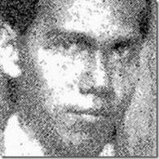
Furthermore, Luis Angel Castillo of Chicago and Wisconsin was captured in the Philippines in March 1967. He had been sent in to assassinate President Ferdinand Marcos. Philippine intelligence found that Castillo suffered Multiple Personality Disorder (MPD). They were able to uncover at least six different layers of programmed alters that had been implanted by a woman with a heavy German accent named, Mrs. Kreps. They also found out that Castillo was linked to the 1963 JFK assassination in Dallas. Castillo was a CIA assassin linked to Bordentown Reformatory at the same time it was a notorious MK ULTRA- SEARCH hallucinogen mind control site.[40]
It seems that Bordentown Reformatory connects perfectly with the major CIA-MK ULTRA-SEARCH players in the clandestine- creation of Field Marshal Cinque and the formation of the SLA.
Defreeze would have been their perfect candidate for a major operation like the SLA. He had a long jacket with covert MK ULTRA drug testing, research and experimentation beginning with Dr. Carl Pfeiffer at Bordentown Reformatory.
As illustrated in the case of Luis Angel Castillo, Bordentown had been a secret MK ULTRA- SEARCH routing station for potential MPD mind controlled assassins and operatives to be passed down the pipe to the CIA and military intelligence for future ABOVE TOP SECRET special operations.
Donald Defreeze from Newark to California
At 19 years old, he married Glory Thomas, 23 years old, mother of three children in Newark, New Jersey. They had three more children. In 1965, after being arrested for firing a weapon at his house, the family moved to California.[41]
The marriage was filled with rejection, disappointment. Defreeze tried to work and support his wife and children, but differences drove him to California. In California, Defreeze began drinking, taking drugs, and collecting weapons.
In California, Donald David Defreeze became a ghetto informer for the Los Angeles Police Department’s “black desk” since the August 1965 Watts Rebellion. His job had been to report on Black Militants- Black Liberation Politics.[42]
From 1967 to 1969
Defreeze worked as a police informer for the Los Angeles Police Department, (LAPD) under Detective R. G. Farwell, Public Disorder Intelligence Unit, Criminal Conspiracy Section.[43]
At the time, the LAPD was supplying weapons and bombs to BLACKPROS Ron Karenga and US (United Slaves) and hiring them by contract assignments to kill Black Panthers. Defreeze worked with police agent-provocateur Karenga, head of the US Organization, to disrupt and destroy the Black Panther Party. Later, he continued collaboration with Karenga and US at Colston Westbrook’s Black Cultural Association (BCA) at the California Men’s Medical Facility at Vacaville.[44]
US used the 7-headed cobra, later adopted by the SLA, for its symbol. Nothing in Defreeze’s background indicated a political consciousness while he worked as a police intelligence informer.
June 9, 1967, Los Angeles, CA
Defreeze was arrested for robbery violation 211 of the California Penal Code. He had been charged with two counts of possession of explosives, and one count of possession of a concealed weapon. On March 31, 1965, Defreeze had been arrested in possession of a bomb, knife and sawed off shotgun. He got five more years tacked on his prior probation. He was placed on probation even though he had violated probation on priors; Penal Code Sections 836.3, 459, and 12020.[45]
December 2, 1967, Los Angeles, CA
Defreeze was arrested for the fifth time on an arms charge. He had robbed and beaten a prostitute. He was arrested by LAPD officers Toles and R.G. Farwell. Defreeze allegedly escaped from police custody, but never was charged on escape charges.[46]
On December 6, 1967, Defreeze led police to an apartment where a cache of 200 stolen weapons were found. On December 2, 1967, Defreeze aka Steven Robinson, Ronald Coleman, Donald Williams, John Williams, Donald and Ronald Steven Coleman had been arrested for a November 22, 1967 burglary of Western Surplus Store at 8505 S. Western Avenue in Torrance, CA; buying and receiving stolen property (pistols and rifles); and possession of marijuana.[47]
Defreeze was given a relatively low bail. Subsequently, he had five (5) more years tacked on to his probation and walked again.[48]
April 4, 1968, Inglewood, CA
Defreeze arrested again on burglary PC 459 and PC 836.3 (Escape from Custody). He was released no charges filed. Dr. Martin Luther King was assassinated on April 4.[49] It is likely that in lieu of the Black Outrage and Rebellions that broke out in Los Angeles and across the country, Defreeze got some emergency assignments from the LAPD.[50]
August 16, 1968, Los Angeles, CA
Defreeze arrested again for Grand Larceny, PC 487.3. On August 24, 1968, Glory Defreeze wrote to authorities, following the arrest of her husband, reminding them that they had promised him protection from arrest while he worked for them. Defreeze was released.[51]
By this time, Defreeze was working with Officer Farwell in the LAPD Criminal Conspiracy Section (CCS) in an illegal war against the Black Panther Party.[52]
April 20, 1969, Los Angeles, CA
Defreeze was arrested with unlawful possession of a dangerous weapon “military type semi-automatic M-68 Nine (9) MM Rifle” loaded with 32 bullet clip designed for military or police work. Defreeze told the judge that the weapon had been registered to him for a police officer friend. The weapon was intended for police work.[53]
It had been Defreeze’s 7th arrest, but these charges also violated federal weapon charges. Nevertheless, he was released on concurrent bail (one bail-numerous offenses) in the interest of the CCS of the LAPD, FBI and CIA.[54]
May 9, 1969, Newark, NJ
Defreeze had been involved in a kidnapping and assault of Alfred Whiters, building superintendant at the Temple B’nia Abraham in Newark, NJ.[55]
The cover story was that Whiters had been kidnapped to raise $5,000 for the criminal defense of a jailed Black Panther brother called, the Enforcer.[56]
A co-defendant in Whiters’ kidnapping, Ralph Cobb, was a Newark Black Panther leader. After a trial, Cobb was acquitted of all charges. Cobb’s attorney suspected that the Whiters kidnapping had been a FBI COINTELPRO special covert operation to neutralize, discredit and disrupt the Newark, New Jersey Black Panther Party for Self Defense.[57]
Newark’s DA Office declined to extradite and prosecute Defreeze for the Whiters kidnapping because he was behind bars in California. They were surprised that he was let out of jail and put back on the streets.
October 11, 1969, Cleveland, OH
Defreeze was arrested in Cleveland outside a bank in possession of a 38 revolver, .25 caliber semi-automatic pistol, hand grenade and burglary tools.[58]
He was given a low $5,000 bail even though he was in violation of his probation and crossed state boundaries, a federal violation of the law. Subsequently, charges were never filed.
Defreeze had been arrested in Cleveland by FBI Special Agent Tom Padden. Padden was the arresting agent of Patty Hearst and Wendy Yoshimura in San Francisco.[59]
He returned to California, and then arrested for robbing a woman at gun point for a $1,000 check. He told the judge that he had been high on pills.[60] Disposition of that case is unknown, but we know that Defreeze was put right back on the street.
November 25, 1969, Los Angeles
Defreeze exchanged gun shots with a bank guard and wounded him – using a .32 caliber Beretta automatic pistol, one of the 200 stolen guns from the November 1967 Western Surplus Store burglary that LAPD had apparently allowed him to keep.[61]
During 1969, Defreeze had also maintained a nice house, only a few blocks from the Los Angeles Airport. He was in the business of pimping for black judges and airport officials, fixing them up with women. He drove around in a city truck during the day, and gave the impression to one of his women that he was employed by the city.[62]
Undoubtedly, Defreeze was an escort-pandering partner with LAPD and the CIA involved in a covert sexual entrapment operation similar to the Lawrence King-Craig Spence Franklin Credit Union CIA child-sexual entrapment and whitemail operation.[63]
In 1969, Defreeze subpoenaed his superior, LA Distinct Attorney Evelle Younger, to testify in his behalf. Younger has always maintained close contact and collaboration with LAPD’s Criminal Conspiracy Section (CDS).[64]
In December, 1969, Defreeze received his most ambitious special assignment that finally would make him the infamous “somebody” that he had always desired to be.
Defreeze was sent to Chino for “psychiatric testing.” Medical reports at Chino described Defreeze as “disorganized; had impaired social adjustment; was a schizoid personality, passive-aggressive, needs 24-hour program of treatment.” Defreeze was sent on to Vacaville Medical Facility.[65]
Behind the walls of Vacaville on a prison term of 6-14 years, Dr. Fredrick Hacker, an expert on “terrorism” and Tavistock Institute Behavior-Mind Control Modification Programs Expert was assigned to Donald Defreeze for “psychiatric evaluation.”[66]
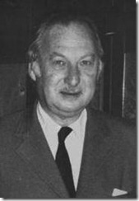
Dr. Hacker had an interesting and most convenient background related to the CIA and the creation of Manchurian Candidates. He was born in Vienna, Austria. In 1939, he graduated from the University of Basel, Switzerland when the THIRD REICH shared borders. Dr. Hacker was yet another well-situated “former escapee from Nazi Germany.”[67]
In 1940, he entered the U.S. at the outbreak of World War II as a medical intern at Saint Francis Hospital in New Jersey from 1940 to 1941. He did his residency at Columbia University’s Psychiatric Institute from 1941 to 1942. He practiced at Manhattan State Hospital on Ward’s Island in New York.[68]
Dr. Hacker’s most significant training took place from 1942 to 1944 with the infamous U.S. Army Neuropsychiatrist Dr. William C. Menninger at the Menninger Clinic in Topeka, KS.[69]
During WWII, Dr. Menninger became Director of the Psychiatry Consultants Division in the office of the Surgeon General of the U.S. Army. [70]
William and his brother Karl, co-founder of the Menninger Clinic, collaborated with OSS agents Stanley Lowell and New York Psychiatrist Lawrence Kubie (Bordentown Reformatory) to program a hypnotically (mind) controlled German prisoner to hate the Gestapo and the Nazi regime then give the subject a hypnotic suggestion to assassinate the Fuhrer, Adolf Hitler.[71] Reportedly, they concluded that it wouldn’t work. THAT DOG WON’T HUNT.
Chemist Stanley P. Lovell became a CIArecruiter for “Wild Bill” Donovan and chief of the CIA’s Research and Development Department.[72]: Kubie, a master hypnotist, subsequently worked with CIA Division of Technical Services (TS) Chief, Dr. Sidney Gottieb. Gottieb, a Dr. Mengele Clone, was the notorious TS director during its Artichoke (Assassination) and MK-ULTRA (Mind Control) programs.[73] Kubie and Vacaville CIA Chief James A. Hamilton had been key operatives in Gottieb-Dr. Mengele’s TS Division.[74]
Dr. Hacker later became a consultant to Patty Hearst’s father, Randolph Hearst, after she was kidnapped by the SLA. He had access to Patty Hearst and psychologically examined her.[75]
During the 1969 Sharon Tate-La Bianca murder investigation, Dr. Hacker, LA County Criminal-Psychological Profiler, rejected the idea of satanic ritual murders or drug-related vendetta. He provided the LA County Coroner, Thomas Noguche, with a detailed profile of the killer fitting Charles Manson before he was arrested.[76]
1970, Los Angeles County
While in prison, Defreeze wanted to “confess,” and end a life of running from the police — or working with them.
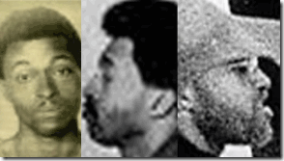
“I think they think I am nuts.” Donald D. Defreeze [77]
In 1970, Defreeze wrote to LA County Superior Court Judge William L. Ritzi that he “wanted to tell everything.” “I want to let you know what really happened and why. I am going to talk to you truthfully like I am talking to God. I will tell you things no one has ever known before.” Judge Ritzi wasn’t allowed to be interested. Good Old “Bill Ritzi” had been Evelle Younger’s specially chosen LA Assistant District Attorney.[78] Younger was a key member of a covert government domestic terrorist team, Squad 19.[79]
In 1970, Colston Westbrook became the CIA control officer for Defreeze and the group that was to become the SLA. Westbrook headed the CIA’s experimental behavior modification unit called the Black Cultural Association (BCA), at Vacaville.
Under Dr. James A. Hamilton’s BCA Behavior Modification Unit, Defreeze was to undergo a drastic and ultimately fatal personality change under MK ULTRA-SEARCH stress and hallucinogenic drug experiments.
After mind control programming, Defreeze assumed a militant anti-white alter personality, while at the same time meeting with white SLA counterintelligence agents who were brought into the prison system.
While in prison, Defreeze was programmed as a triple agent, for Westbrook and the CIA, the California Department of Corrections (Raymond Procunier) and Bureau of Criminal Intelligence and Investigation (Evelle Younger). Defreeze was responsible to California Attorney General Evelle Younger (1971-1979), who was also a FBI Special Agent.[80]
November 1972, Vacaville Men’s Medical Facility
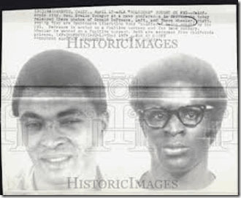
Above, left, is yet another and different historic image of CIA Manchurian Candidate Donald Defreeze. Whichever Defreeze was teamed with inmate, Thero Wheeler, left, for one month. FBI-CIA operative Thero Wheeler’s brother was a San Francisco Police Department officer.[81]
December 1972, Vacaville to Soledad Prison
Defreeze was transferred to Soledad Prison. He was placed in South Facility, set up for trusted inmates, and a holding section for informers. One inmate described Defreeze’s departure from Soledad:
“While Donald Defreeze was here, I had a few conversations with him. I have always questioned his departure as being a simple walk-away. I didn’t come into contact with him personally until his last couple of week here. There weren’t many who would associate with him. He tried to give the impression of being super cool, and he came across as cold. When I met him, he was working in the maintenance shop. I asked him if he was happy on his job, because if not, I might be able to find him something else.”[82]
“He replied that within a few days, he was going to be assigned to work in the boiler room at the South Facility. I questioned that, because he didn’t have enough time here to be given that trust. I know cons that have been turned down for that position. He wouldn’t comment; he only gave me a big smile. I should explain that no prisoners were kept at the South Facility at that time, because it had no security. No gun towers were in operation, and there were no guards posted.”[83]
“A few prisoners with proven records of trust were taken from Central Facility to South Facility to perform certain duties; then they would be returned to Central after their shift. A few days later, Defreeze did get that job. Midnight to 8 a.m. shift, in the boiler room, South Facility. On his first night, he was dropped off at midnight, and given a few instructions. His job was automatic; it only required an overseer. He was left to himself, and when an officer returned an hour later to check on him, he was gone.”[84]
A few months after leaving Vacaville, Defreeze was given a special privilege at Soledad prison. He was allowed to use the marital trailers for visits with women, a privilege normally reserved for married men.[85]
March 5, 1973, Walk Away from Soledad Prison
Donald Defreeze walked out of Soledad prison. His transportation to the Bay area was allegedly arranged by Deputy Superintendent James Nelson. Another former employee from Soledad, currently owner of a liquor store in Sacramento, assisted in the departure, which was later classified as an “escape.”[86]
In spring of 1973, Bernard Keaton, a double for Donald Defreeze, visited the Foster family in Buffalo, New York. He passed himself off as Defreeze, who had lived with the family 15 years ago, and he knew intimate details of their life.[87]
August 2, 1973- Walk Away from Vacaville Prison
Thero Wheeler walked away from Vacaville Medical Facility. From August to October 1973, Defreeze and Wheeler met “at least twenty times” with the SLA in Oakland. Wheeler and a notorious Black Panther infiltrator, Melvin “Cotton” Smith[88] provided Defreeze and the SLA with money, guns and ammunition then Wheeler disappeared. [89]
November 6, 1973- Assassination of OUSD Superintendent Dr. Marcus A. Foster
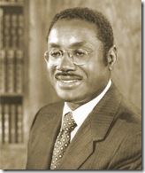
An unknown left-wing urban guerrilla group called the Symbionese Liberation Army (SLA) took credit for the assassination. Defreeze made his public appearance as General Field Marshal Cinque following the assassination. According to Mae Brussell, it was the beginning of terror and psychological sabotage, in the same vein Germany had been subjected to in the 1930s.[90]
February 4, 1974- Kidnapping of Patty Hearst
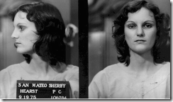
19-year-old UC Berkeley student Patty Hearst was kidnapped from her apartment, she shared with her fiancé Steven Weed by the SLA. General Field Marshal Cinque becomes a world renowned ILLUSIONARY sensational revolutionary figure.[91]
February 23, 1974- Assassination of William F. Knowland
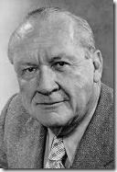
Knowland, Editor of the Oakland Tribune was found dead suicided at his summer home near Guerneville, CA. Knowland was a strict U.S. Constitutionist. He hated President Nixon and his Nazi Masters with a passion.[92] When Patty Hearst was kidnapped, the CIA-Project MOCKINGBIRD (Goebbels’ Propaganda Ministry) sent down a SLA-Patty Hearst LEGEND for Knowland and the Oakland Tribune to follow. Knowland was already unset about the U.S. Military-Intelligence slaying of Dr. Marcus A. Foster. Knowland was uncooperative and became no longer useful to the NWO. He was CIA-ARTICHOKED.[93]
March 1974, Oakland-Berkeley
Defreeze publicly named Colston Westbrook, Chris Brother Thompson, and Wheeler’s look alike Patty Hearst girlfriend, Robyn Steiner, as CIA and FBI informers.[94]
May 4, 1974, San Francisco, CA
Donald Freed, writer, and Lake Headley, independent investigator, held a press conference in San Francisco. They presented 400 pages of documentation on Defreeze’s arrest records, the work of Colston Westbrook with the CCS and CII (Criminal Identification and Investigation), and evidence of links of the CIA to Police Departments.[95]
May 17, 1974, Los Angeles, CA
New York Times carried the story of Defreeze and the LAPD. That same day, General Field Marshal Cinque was liquidated and cremated by the LAPD.[96]
The LAPD did not notify Defreeze’s family of his death for three days. His remains were sent to Cleveland, Ohio, with the head and the fingers missing.
In California, Donald David Defreeze had been arrested on 9 (nine ) separate occasions. The charges involved possession of bombs and explosives, knife, sawed-off shotguns; robbery, assault, possession of 200 firearms, grand larceny, kidnapping, and escaping arrest.[97]
In Ohio, he had been arrested for attempted bank robbery, possession of burglary tools and explosives.
In New Jersey, he was wanted on a capital offense of kidnapping, assault and battery, and extortion. Through a scheme of series of concurrent bails and tack on probation sentencing, jail had become nothing more than a revolving door for a Black Manchurian Candidate.
Donald David Defreeze, Manchurian Candidate Body Count: 9
Dead: Dr. Marcus Foster (Superintendent of Oakland Unified School District), William F. Knowland (Editor of Oakland Tribune), Donald David Defreeze (Cinque), Nancy Ling Perry (Fahizah), Angela Atwood (General Gelina), Camilla Hall (Gabi), Willie Wolfe (Kahjoh), Patricia Soltysik (Mizmoon, Zoya), and Myrna Opsahl.[98]
Donald David Defreeze, Manchurian Candidate Mission Objective
COINTELPRO- Neutralize, Discredit and Destroy Bay Area Black Nationalist and the Left; Permanently Undermine and Deconstruct Oakland’s Comprehensive Free Educational System.
GENOCIDE- the deliberate destruction or deconstruction of educational systems, institutions, culture and economic abilities of Black People.

The Elephant Hanging Off a Cliff with his Tail Tied to a Daisy in Our Community: the Terrorist Yusuf Bey IV, “CEO and Spiritual Leader of Your Black Muslim Bakery, Inc.”
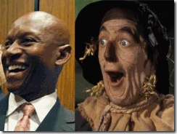
Dirty Derwin and the Wizard of Oz Straw man, “If I only had a brain”
Oakland Police Department (OPD) Detective Sergeant Derwin Longmire has to be a 21st Century version of a cold blooded military-police counterintelligence BLACKPRO without compassion or love for justice, the people; and a brain of his own.
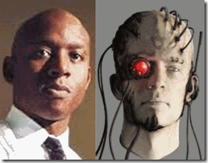
Derwin Longmire began his career with OPD sometime in 1991, twenty-one years ago.[99] Where he was created or crawled out of hole from into Oakland is unknown.
According to Longmire’s mouthpiece and a police officer’s best friend and defender, Attorney Mike Rains, Rains Lucia Stern, PC, Longmire bleed “Blue” something like a cold blooded transhumant cyborg.
According to Rains that by the way recently penned “The Saga of Oakland Police Sergeant Derwin Longmire” on the internet, he was a homicide detective “par excellence” bar none.
“At the time of Chauncey Bailey’s murder, Sgt. Derwin Longmire had been a member of the Oakland Police Department for over 21 years and had an unblemished, discipline-free record. He had served his last 10 years in a variety of investigative positions, much of it in the Homicide Section, where OPD sent its best, brightest, most capable and hardest working investigators. Derwin had received countless accolades and commendations from district attorneys for his investigative work and his testimony at trials.”[100]
Derwin Longmire, I call him, Dirty Derwin, like Hollywood’s Clint Eastwood, Dirty Harry. He stood tall and independent like a John Wayne. He was rough and ready, a no nonsense detective, a classic Gestapo styled cop. He was the government’s straw man for the deliberate racial attack on and destruction of YBMB.
A straw man is one who deliberately accepts a liability.[101] “Straw man” is also one of the best-named fallacies, because it is memorable and vividly illustrates the nature of the fallacy. Imagine a fight in which one of the combatants sets up a man of straw, attacks it, then proclaims victory. All the while, the real opponent stands by untouched.[102]
In the Wizard of Oz, the Scarecrow (straw man) must prove himself worthy to receive the benevolence from Oz. Scarecrow is asked the question, “How can you talk without a brain? Scarecrow answers, “Some people without a brain can do a lot of talking.” The Straw man believes that the Oz will give him a brain when he is worthy by completing a series of ordeals.[103]
The Wizard of Oz was some being ALL POWERFUL and KNOWING. Yet in reality, the wizard-magikian (ILLUMINATI) was just an old man that was a master of deception hiding behind a veil-ILLUSION (LUCIFER).[104]
For his trials and ordeals, the Oz was to setup Dirty Derwin in a coveted job as an Alameda County D.A. Investigator. Dirty Derwin’s first assignment had been to begin collecting investigative data on YBMB for a hit. If he only had a brain.
According to Rains,
“He had first gone into the Bakery in 1991, working as a Beat cop and assigned to the beat where the Bakery was located. He met Mustafa Bey, the Bakery’s counter-man at that time, and would pay occasional visits to the Bakery and discuss with Bey his perceptions of the distrust between members of the Bakery and the police. Even after Derwin’s assignment to that Beat ended, he would occasionally run into Bey in the community and would shake his hand and say hello.”[105]
Lorna Brown, attorney for Yusuf Bey IV, said that Longmire had acted as a “mentor” for her client. She said: “I always had the feeling that Longmire had Yusuf’s best interests at heart, and that he was trying to help another young African American guy.”[106]
She said that Longmire had become like an older brother to her client after the two met in 2005 when the detective investigated the shooting death of Bey IV’s brother, Antar Bey.[107]
Furthermore according to Longmire’s mouthpiece, Mike Rains confirmed Brown’s statement that at the time of the takeover of the bakery by Antar and Yusuf IV that Stg. Longmire had been acting as an “older brother” and “mentor” to Bey IV, he was setting him up as a pawn to destroy YBMB.
“In 2002, Derwin had been assigned to the OPD Intelligence Unit and, upon his arrival, talked to one of the Unit’s members who had devoted considerable time to intelligence gathering concerning the Bakery and its members. Derwin learned that the Bakery was participating in conduct involving fraud. He sought the commitment from the Police Chief at the time to obtain assistance from the FBI to conduct extensive surveillance and an investigation of the Bakery as a criminal enterprise.”[108]
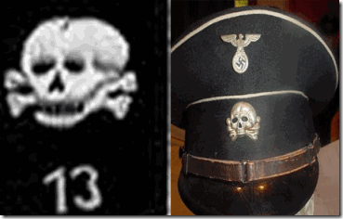
Actually from 2002 to 2007, Det. Longmire’s Oz had been a special interagency terrorist division called, Squad 13. The squad was an all powerful and knowing joint division behind a veil-ILLUSION of U.S. National Security. It was comprised of OPD Intelligence, FBI and U.S. Homeland Security, and the CIA.[109]
Contrary to the illusion that Rains creates that it had only one FBI agent, Squad 13 was essentially a large and extensive well established FBI COINTELPRO division.
Instead of getting a brain and job with the D.A., the wicked magikians threatened Longmire with fire, like the Scarecrow in the Wizard of Oz. They also intended to dismember him like the Scarecrow. For them it is not an idle threat.
Far too late in the game, Longmire was confronted with reality, the Satanic Principle, GOOD AND EVIL – (The two faces of Janus).
Janus was the god of gates and doors (ianua), beginnings and endings, and hence represented with a double-faced head, each looking in opposite directions.[110]
You can’t make a pact with Lucifer’s Squad and expect to walk away without selling your mind, heart, body and soul to the DEVIL. “If only Derwin Longmire had a brain.”
There is little doubt that they used him, and how want Derwin Longmire disposed of just like a classic patsy.
Lucifer’s Twisted Sisters, Squad 13 and Southern California’s Squad 19
Squad 13 is a “GOON SQUAD,” an American version of the Nazi GESTAPO. John J. Reikes was a Supervisory FBI Station Agent in charge of Squad 13, when they targeted, bombed and framed Judi Bari and Darryl Cherney of Earth First in Oakland as domestic terrorists in March 1990.[111]
The OPD-FBI Squad 13 is similar to the Los Angeles Police Department (LAPD)-FBI, CIA-White House Counter-Intelligence, Squad 19, first exposed in Louis Tackwood’s book, The Glass House Tapes.[112] Tackwood said that an internal part of Squad 19 was a LAPD DEVIL Worshipping Cult centered in Altadena, CA,[113] called, The Order of the Temple of Astarte (OTA).[114]
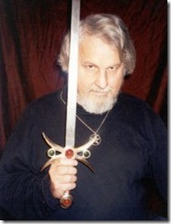
Poke Runyon, aka Frater Thabion, Founder of OTA, Freemason-Scottish Rite Former U.S. Army Green Beret [115]
During a press conference in mid-September 1971, Tackwood said he had been contacted by two CIA agents when he worked with the FBI on Squad 19 – a special group that was set up to plan disruptions at the Republican Convention, then slated for San Diego. Louis Tackwood stated:
There is a plan right now that is so monstrous that it is pathetic. It entails a detailed plan to blow up the Republican Convention. It has been worked out by the super-agencies…The blame will fall on militant organizations demonstrating at the convention. The President will then be asked to declare a state of national emergency and martial law. Within 48 hours, they will arrest all known militants on the left, and a police state will then exist…I am only giving up two names. There’s ‘Martin’ and there’s ‘White.’ Alright now, ‘Martin’ was the code name for my contact, and I’m going to tell you he’s CIA all the way. Are you ready for this? He was in Dallas when they got Kennedy; he left out of there for the Caribbean. And ‘Martin’ is in on the cancellation of elections, and some way in on the concentration camp thing. Do you see what I’m saying? Now the control, the man over ‘Martin’ is ‘White.’ I only heard a little about him, but they say he is the money man, nobody’s over him but the top dogs. ‘Martin’ and ‘White’ that’s all I’m going to give you now. This is my life insurance.[116]
Tackwood told The Washington Post he:
…sat in on meetings where plans were made by federal and local agents to disrupt the 1972 San Diego Republican convention and blame it on the leftists. The object: To create a situation which would permit the President to invoke special emergency powers leading to the arrest and detention of political activists throughout the country; that the C.C.S. had prior knowledge of last year’s Marin County Courthouse shootout and George Jackson’s fatal escape attempt from San Quentin – and allowed both to proceed despite certainty that lives would be lost.[117]
On November 22, 1971, Louis Tackwood testified in the Los Angeles Panther 13 trial. He said that Melvin Cotton Smith, the principal witness, was a police informant and had not turned State’s evidence as the police suggested. His testimony was preceded by that of Ronald Farwell who said that he first met Louis Tackwood in early 1970, and had used him as an informer against the Black Panthers.[118]
In June 1972, eight months after Louis Tackwood went public; it was revealed that White House Plumber, E. HOWARD HUNT, had used the name “White” during Watergate. His name appeared in Eugenio Martinez address book as “White H.” CIA Agent and security official of the National Republican Committee and Committee to Re-Elect the President, JAMES W. McCORD, told the police that his name was “Martin” when he was arrested at Watergate. [DC PD arrest rec.] The CIA reported:
At approximately 7:45 p.m., Mr. Arnold L. Parham, a Special Agent of the FBI Field Office in Alexandria, Virginia, called to request a name trace on ‘James Martin’ who had been arrested while demonstrating at Watergate. This call was taken by a security duty officer, and referred to the responsible senior security officer for night calls. [Memo Cary to [Richard] Helms Message Pref. #480889] [119]
Squad 19’s orders came directly from the White House, CIA, FBI, California Department of Justice, and the Los Angeles County District Attorney.[120]
Squad 13, Lucifer’s Squad, Dirty Derwin and YBMB
In Western culture, the number 13 is generally considered to be unlucky. The number 13 has commonly been avoided. Yet, it wasn’t happenstance that the interagency terrorist task force chose the number 13. It was a deliberate occulted rendering.
“The numbers 3, 7, 9, 11, 13, 33, 39. Any multiple of these numbers have special meaning to the Illuminati. Notice that the Bilderberg Group has core of 39 members who are broken into 3 groups of 13 members in each group. Notice that the core of 39 answers to the 13 who make up the Policy Committee. Take special notice that the 13 members of the Policy Committee answer to the Round Table of Nine. You know that the original number of states in the United States of America was 13. The Constitution has 7 articles and was signed by 39 members of the Constitutional Convention.”[121]

There are 13 leaves on the left olive branch with 13 berries. 13 stripes on the middle shield. 13 arrows on the right. 13 stars above the eagles head. 13 letters in the “E Pluribus Unum” on the ribbon. 13 letters in Annuit Coeptis. There are 13 blocks top to bottom on the pyramid. Fritz Springmeir in his The 13 Bloodlines says these 13 blocks represent the 13 Satanic family’s. [122]
Judas Iscariot was the 13th person at the Last Supper, and he betrayed Jesus Christ, and was thought to be possessed by Satan himself. It might also have to do with the fact that Judas’ Satanic decision to betray Christ cost Judas his own sanity, which caused him to commit suicide.[123]

The number, ’13’ is the occult number of Depravity and Rebellion.[124] The number 19 also has occulted significance. The number 19 represents manifestation, being the number of paths that have some existence below the Abyss (in the phenomenal world).[125] The OKC Bombing took place on April 19. The Number 19 continues to arise in the context of the 9/11 attacks and other terror-related matters, 19 Hijackers.
Similarly, Squad 19’s Northern California Luciferian twisted sister, Squad 13, gets its orders from the same Luciferian power bases; and it is capable of anything wicked and twisted, criminal, racist and two faced.
BLACKPRO Dirty Derwin was sent in to handle the deconstruction of YBMB from the inside. He infiltrated YBMB and offered Yusuf Bey IV and his Jr. Mafia post adolescent gang money, fame and fortune beyond their dreams to sell their souls to Lucifer.
Squad 13 & the Creation of a Junior Black Mafia
As we come to know it, Mafia (Murder, Inc) is an ethnic secret blood covenant criminal organization that may control everything from unions, street crime, prostitution, protection rackets and drug trafficking to governmental corruption.
The Mafia’s business interests have also gone beyond the “traditional” murder, Inc., extortion, prostitution, contraband and drug dealing. It has infiltrated deep and hides inside important corporate sectors of legitimate economies.
Mafia businesses are set up like any other company, with a business structure that includes a CEO, managers, department heads and consultants.[126]
BLACKPRO Maalik El Maalik had been one of the handlers of the CIA- MK ULTRA Bay Area Death Angel Cult called, El Constran, linked to Colston Westbrook. The killer and drug trafficking cult was ran out of a California Department of Corrections and OPD supported Oakland half way house for experimental mind controlled paroled felons called, Alternative House.
I most vividly recall the moments of eerie exhilaration that I saw in the eyes and demeanor of Maalik El Maalik when he talked about El Contran and what it had been designed to become, a Black Mafia (Murder, Inc.) allowed to control everything in the Black Community.
Maalik could only have dreamed of running a criminal killer cult shielded behind a long established legitimate corporate business structure with a CEO, managers, department heads, consultants, treasury of money, resources and community goodwill.
However, BLACKPRO Dirty Derwin received that distinction. Like Donald David Defreeze, they had developed early extensive psychological profiles of the brothers Antar and Yusuf Bey.
They wanted all the fame, power, glory, women and money (BLING) that their father had, but mostly lacked the God given innate intelligence and inner faith to achieve their goals to raise to the top. Indeed, they proved to the weakest link in the Bey Family chain.
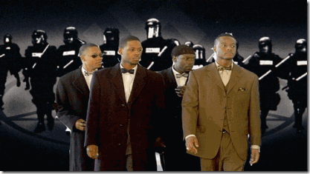
YBMB was a corporate creature of the State of California. The State had the regulatory power and authority over YBMB.[127] When Antar and Yusuf IV gained control of YBMB through murder, fraud and the collaboration of OPD and Squad 13, they acted under the protection of the State. They literally had a license to Kill with a million bayonets behind them to destroy YBMB, Inc. brick by brick.
Within 15 months of Yusuf Bey IV’s takeover of YBMB and under the direct tutorship of Stg. Longmire, OPD and Squad 13, he and seven associates got a fleet of expensive luxury cars; guns and ammunition; at least 19 loans totaling more than $6 million from 10 different lenders to buy 12 houses in Oakland, Richmond, Hayward and Antioch, according to the Alameda County district attorney, bankruptcy court records and real estate documents. Of these transactions, Bey IV and his girlfriend borrowed $2.4 million to buy five houses during just seven months in 2006.[128] They didn’t do it alone. The Junior Mafia had a lot of legitimate professional business and corporate help to destroy the bakery.
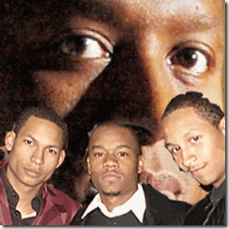
Remember that prior to the Jr. Mafia mentorship with Dirty Derwin and OPD, particularly Yusuf Bey IV beginning in October 2005; YBMB’s post adolescents had no significant (Lifestyle) history of mental illnesses, criminal activity, drugs or violence.
Additionally, beginning in August 2005, OPD began taking Yusuf Bey VI off the street for possible mind control programming. Both Ronnie Flenaugh and Billy Mapp of the El Contran Death Angel Cult had been taken off the street by police then covertly traumatized and MK ULTRA programmed.
In 1967, Ronnie was kidnapped off the street by the Berkeley Police Department. Ronnie said that they began poisoning him with hallucinogenic drugs while in city jail then driven insane at Santa Rita County Jail in Dublin.
During WWII, Santa Rita had been a terrible Nazi POW camp. It had barbaric and inhumane “tiger cage” cells with a guard cat walk built along the top of the cells to look down on prisoners. It became the infamous Santa Rita Jail “Little and Big Graystone Prison.” Nobody was really sure what was going on behind prison walls. For decades, public and press access to Graystone had been closed and then highly restricted.[129]
Ronnie’s programming may be connected with the MK ULTRA research of Dr. Valerie Hunt of NASA and Dr. Julian Silverman of Esalen Institute at Big Sur.
In 1969, Billy had been kidnapped off the street by OPD. He was beaten and taken to Santa Rita where significant personality-alters suddenly took shape. A reliable Alameda County Mafia informant, Joseph Spencer, connected Billy with Stanford Research Institute and Dr. Gregory Bateson, the British Godfather of MK ULTRA.
Like Ronnie Flenaugh, Bey VI appears to have received similar NASA“Mother-Spaceship” programming.[130]
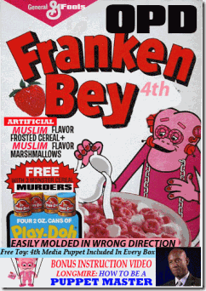
The Timeline of the Making of an ILLUSION, the LEGEND of Junior Mafia CEO and Spiritual Leader of YBMB, Yusuf Bey IV, and the Deconstruction of the Institutional Bakery
September 30, 2003
Within a year of being targeted by Lucifer’s Squad for destruction, and a couple weeks after being charged and arrested on September 19, 2002 by OPD for 27 felony counts of lewd conduct with a minor, Yusuf Bey, Sr. suddenly died from colon cancer.[131] Before he passed, the faithful and good brother, Waajid Aljawwaad, was chosen to succeed him as CEO and President of Your Black Muslim Bakery, Inc.
February 27, 2004
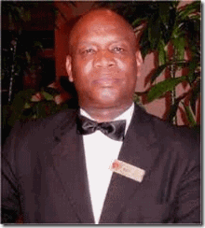
The Murder of the Faithful Brother
Within 5 months of Waajid taking over as YBMB CEO and President, the Faithful Brother disappeared, and was found dead in July 2004, buried in a shallow grave in the Oakland hills (RD#04-65105). [132] OPD claims that it can’t find the murder investigative file. I suspect that Dirty Derwin was the lead homicide detective.
Murder is one of the highest crimes against society. There is no statute of limitations for that category of crimes. Solve the murder of the Faithful Brother, you move closer to solving the riddle. You will see beyond the Looking Glass.
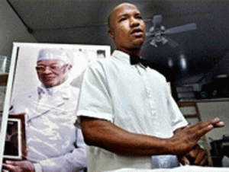
Squad 13 and OPD took the opportunity to step the stage to Antar Bey, age 23, to begin to set him up as CEO and President of YBMB based on forged corporate board meeting documents. Antar had no significant executive business experience or education beyond a California High School Equivalency Diploma.
June 29, 2005
YBMB brain trust and business leader, John Bey, was assaulted and wounded outside his home in an ambush. OPD investigators established then that Antar and Yusuf Bey IV in a takeover of the bakery had the clear motive for the deadly assault upon the life of John Bey.[133] Yet, OPD made absolutely no arrests in the case.
If the OPD determined the Antar-Yusuf Bey IV gang had a motive to try to kill YBMB Businessman John Bey in the takeover of the bakery, then why didn’t they pursue the same suspects in the assassination of CEO Aljawwaad that opened the LEGEND for the takeover? EVEN THE BLIND CAN SEE THAT!
August 5, 2005
OPD investigating a carjacking at 5800 San Pablo arrested Yusuf Bey IV.[134] Disposition of the case is unknown. How long Bey IV was taken off the street in their custody and control is also unknown.
October 25, 2005
Antar Bey, CEO, was murdered. The OPD storyline is that he was killed in a fatal carjacking. Dirty Derwin was the lead homicide detective. I suspect that Antar became consumed with power then failed to follow the script, the LEGEND.
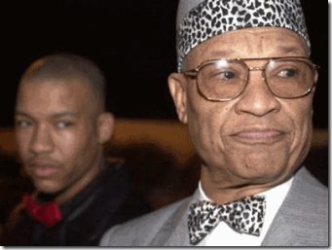
Antar began to believe that he had become like his father a true “spiritual leader” and defender of Black People like Donald David Defreeze. He developed his own version of his father’s longtime cable television show, “True Solutions.” Antar began to espouse his father’s brand of Black Nationalism which undoubtedly wasn’t part of the LEGEND.
He was liquidated. Yusuf Bey IV stepped in as CEO and President. Bey IV stayed on script. He never strayed from the program. He was their “Junior Black Mafia” all the way to the end.
November 15, 2005
20 days after his elder brother, Antar, the bakery’s CEO, was killed in an apparent attempted carjacking — Bey IV, according to police reports, used bogus ID and financial data to buy a 2002 Mercedes CL 500 for $55,000 from a Vallejo used car dealer; he later was charged with felony Grand Theft California Penal Code, Sec. 487, feloniously using a driver’s license with someone else’s name and filing false financial statements (California Penal Codes 484-502.9).
He pleaded no contest in this case. He was sentenced to eight months in jail. However, a Solano County judge let Bey remain free on bail until his trial on a more serious case that occurred while this one was pending. [135]
November 23, 2005
Bey and a group of post adolescents wearing suits and bow ties in a highly sensational public spectacle entered two North Oakland liquor stores smashed bottles and tore down merchandise displays demanding that the stores stop selling liquor to African Americans.
Identified by police from the video surveillance tapes, Bey IV turned himself in six days after the spree and was released on bail. Bey was most likely released pursuant to concurrent bail to the November 15, 2005 felony offenses.[136]
Concurrent is also used for bail amounts. Sometimes the judge will see a defendant who is arrested on several charges, and instead of giving a separate bail amount for each charge, he or she will issue one bail amount that will release the defendant on all the charges from that court. When this happens, the bail amount is shown for one charge from that court, and the rest of them will say either “CRNT” or “Concurrent.”
January 26, 2006
Emeryville Police Department responded to two men being chased by members of YBMB that included Bey IV (Report No. 0601-3127). No known disposition of the case.[137]
February 16, 2006
Berkeley Police Department arrested Yusuf Bey IV for Grand Theft (PC 487). No known disposition of the case.[138]
April 6, 2006
Bey IV is again arrested on a warrant in the company of Gary Popoff and Rasoul Bey. No known disposition of the case either.[139]
April 28, 2006
San Francisco Police Department said Bey IV tried to use his car to run down bouncers outside the New Century strip club on Larkin Street in San Francisco; he’d been thrown out of the club moments earlier for bad behavior. He was charged with three counts of assault with a deadly weapon (California PC, Sec. 245).[140]
June 7, 2006
Oakland Police Department (OPD) said Bey IV used a bogus driver’s license with the name Yasir Human but his real Social Security number to buy a single-family home at 2514 61st Ave. in Oakland, secured by two deeds of trust through the Cit Group/Consumer Finance Inc.: one for $440,000, the other for $110,000 (Felonious Grand Theft PC 487, Filing False Financial Statements PC 484-502.9).[141] The house, built in 1912, was worth no more than $120,000.[142]
August 14, 2006
Vallejo PD arrested Bey IV for possession of a 9 mm pistol. Vallejo PD Report number is 06-16635. No known disposition of the case either, particularly, with Bey IV wanted on a warrant.[143]
November 16, 2006
Bey IV was arrested by the California Highway Patrol for driving a stolen U-Haul truck with a bulletproof vest inside (CHP # F-866-370-1207). No known disposition of the case either or Bey IV’s outstanding warrant.[144]
December 2006
OPD implicated Bey IV in the shooting up of a car becoming to Cameron Cook with an AR-47 assault rifle. Cook and Bey IV had become entangled in a bitter love triangle.[145]
December 18, 2006
Bey IV was arrested by OPD for Battery (PC 242) in the parking lot at 1440 High Street (RD #06-112505). No known disposition of the case either or Bey IV’s outstanding warrant.[146]
January 9, 2007
OPD didn’t arrest but only cited Bey IV on suspicion of Misdemeanor Shoplifting (PC 484), after workers at a Walgreens on Telegraph Avenue in Oakland saw him stealing condoms (RD #07-003071). A juvenile relative of Bey IV’s also was seen shoplifting, but wasn’t cited.[147]
January 18, 2007
OPD comes in contact with Bey IV attempting to execute an illegal eviction. Again, they let him walk on an outstanding warrant.[148]
May 17, 2007
Five men kidnapped two women at gunpoint, taking them to a vacant East Oakland house owned by Bey IV’s brother-in-law. Police reports say one of the women was beaten and threatened with torture and murder as the masked men whom they couldn’t identify demanded to know where to find her money and that of an acquaintance. A police officer happened by and the suspects fled on foot, leaving behind cars and other evidence that led to the warrant for Joshua Bey’s arrest in the Aug. 3 raid. Later Bey IV, Bey V, Tamon Halfin and Richard Lewis were charged with various felonies in the case (PC 207-210, 245, etc.).[149] There is no known disposition of the case.
July 8, 2007
OPD found Odell Roberson slain on the south sidewalk of the 1000 block of 60th Street near YBMB. Roberson had been murdered by bullets matching an AR-47 assault rifle which had been associated with Bey IV in the December 2006 Cameron Cook Incident.[150]
July 11, 2007
Bey IV representing Your Black Muslim Bakery as its CEO appealed to U.S. Congressperson Barbara Lee for assistance with the IRS and its defrauded creditors in bankruptcy. Bey IV didn’t even pretend that he had any business-management interest, education or experience to run a major corporation. At all times, Brothers Saleem Bey and Bey had outspokenly publicly challenged Antar and Yusuf’s gangster takeover of the company by murder, corruption, intimidation, fraud and collaboration with BLACKPRO Det. Sgt. Derwin Longmire and the OPD.
July 12, 2007
Bey IV missed a court appearance for a pretrial hearing in this case- Failure to Appear, California PC 853.7, and it was the $375,000 bench warrant issued that day on which he was initially arrested in the August 3 raid of Your Black Muslim Bakery.[151]
July 12, 2007
OPD found Michael Wills slain in the 6200 block of San Pablo Avenue near YBMB. Wills had also been murdered by bullets matching an AR-47 assault rifle which had been associated with Bey IV in the December 2006 Cook Incident. OPD found that the bullets from the murder victims matched the bullets (7.62 mm) left at the Cook crime scene implicating Bey IV.[152]
July 31, 2007
In fact, two days before Chauncey Bailey was gunned down, Brother Saleem Bey personally fully and vehemently sat down and informed the congressperson’s office of Bey IV’s frauds and felonious crimes at a meeting at her office with Bey IV sitting in attendance. They were deaf and dumb to Bey IV’s lack of business, management and intellectual credentials to run a multi-million industry and his crimes.
August 1, 2007
The congressperson’s staffer and scheduler, Sandra Andrews, personally hand delivered a letter to Bankruptcy Judge Edward Jellen in support of YBMB that endorsed Bey IV’s leadership and business skills.[153]
Additionally, former U.S. Congressman and former Oakland Mayor, Ronald Dellums, was also deaf and dumb. Dellums also issued a letter in support of YBMB that also endorsed Bey IV’s leadership and business skills.[154]
Thereafter, Saleem Bey found out that he was no longer welcome at Congressperson Lee’s office in Oakland. They called Federal Security to escort the brother off federal grounds. Congressperson later issued a statement that she wasn’t informed of the crimes of Junior Black Mafia. THAT DOG WON’T HUNT.
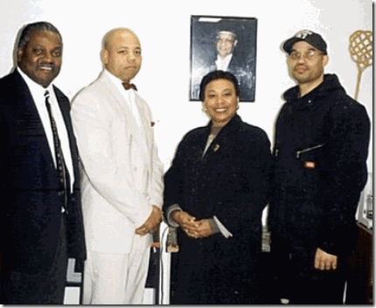
Above, former California Assembly member Sandré R. Swanson (D-Alameda) and Congressperson Lee with some of YBMB’s established business-corporate brain trust, Brothers John Bey and Saleem Bey. She knew exactly what was going on with Junior Black Mafia and the takeover and deconstruction of the bakery by a government criminal enterprise and conspiracy.
August 1, 2007
A massive armed and expensive interagency law enforcement taskforce raid to arrest Bey VI for outstanding warrants; and raid YBMB as a criminal enterprise was intentionally stood down by OPD.
August 2, 2007
On his way to work, Black Journalist Chauncey Bailey was gunned down in the street by triangulation of gunfire blowing off Chauncey’s head and blowing out his heart by shotgun blasts just like Dr. Marcus A. Foster had been slain. Chauncey Bailey’s briefcase disappeared from the scene of the crime controlled by OPD.
August 3, 2007
The massive interagency taskforce executed an arrest warrant for Yusuf Bey IV and raided YBMB.
August 4, 2007
At the time that U.S. Congressperson Lee and former Congressman and former Oakland Mayor Dellums issued letters of support for Junior Black Mafia CEO Bey IV, he had committed 12 felony counts: four counts of forgery; three counts of attempting to file a false or forged instrument; two counts of grand theft; and one count each of obtaining money, labor or property by false pretenses, possession of a forged driver’s license and identity theft.[155] And, he had an outstanding warrant issued for his arrest.
Yet, a violent wanted felon was welcomed in the congressperson’s office as the CEO of YBMB while the real trustees of YBMB like Brother Saleem Bey would be ejected from the entire federal building under the power and authority of the U.S. Government.
Lee and Dellums had no comment when confronted about throwing their weight behind Jr. Mafia; and Bey IV as YBMB’s CEO, President and Spiritual Leader.
From the Jonestown Massacre to the Betrayal of Maurice Bishop in Grenada,[156] sacred cows like Lee and Dellums seem to believe that they aren’t accountable to anyone that they can walk between the raindrops.
Court records say Bey IV told police that day, “We have the best lawyers, that’s why I’m not in jail.”[157] Undoubtedly, he also had the best and most influential federal congresspersons behind him.
He also had powerful collaborating Bay Area politicians, and a State and Federal interagency law enforcement force (Squad 13) behind him. Bey IV was allowed to commit most of his crimes against society under a shroud of protection while on concurrent bails, unexecuted warrants, uncharged and pending serious felony and misdemeanor charges.
Yusuf Bey IV, Manchurian Candidate Body Count: 6
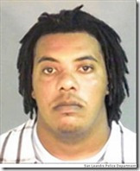
Dead: Yusuf Bey, Sr., Waajid Aljawwaad, Odell Robinson, Michael Wills, Chauncey Bailey; and Omar Sharif Allah (Ronnie Brown) October 27, 2007, above. Brown was found dead in a shallow grave in San Francisco bound with black electrical tape and covered with a blue tarp like the crime scene of Good Brother Aljawwaad.[158]
Yusuf Bey IV, Manchurian Candidate Mission Objective
COINTELPRO– Neutralize, Discredit and Destroy YBMB Nationalist Sect.
GENOCIDE– Undermine and Deliberately Destroy the Economic Abilities of Black People.
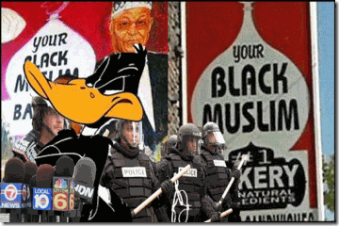
1. DESTROY the IMAGES and ILLUSIONS. The scriptures say break the potter’s vessel into shreds. Ancient wisdoms say destroy the image. Come to reality, turning over YBMB, Inc. to Yusuf Bey IV and the Jr. Black Mafia was like giving the keys to a multi-million corporation to Daffy Duck and Looney (Moon Madness) Tunes characters.
2. EDUCATE, RESEARCH and REALIZE that People of Color Worldwide are under covert Genocidal ATTACK by the deliberate destruction or deconstruction of their educational systems, institutions, culture and economic abilities.
3. SOLVE the murder of Dr. Marcus A. Foster and the Faithful Brother, Waajid Aljawwaad, find Chauncey Bailey’s BREIFCASE and the ILLUMINATI in the Bay Area will be exposed to the LIGHT OF DAY, then fall in the hearts and minds of the people like a tower of deck of cards.

[1] Shaw, Martin, What is Genocide?, Cambridge Press: Polity Press (2007)
[2] http://www.youtube.com/watch?v=MMUEK4AJfc8
[3] http://aangirfan.blogspot.com/2008/09/mengele-mossad-and-cia.html
[4] http://aangirfan.blogspot.com/2008/09/mengele-mossad-and-cia.html
[5] http://www.godlikeproductions.com/forum1/message728273/pg1
[6] http://www.edutarian.com/2011/08/donald-e-cameron-and-german-collective.html
[7] http://www.netplaces.com/jewish-history-heritage/the-holocaust/jewish-resistance.htm
[8] http://www.netplaces.com/jewish-history-heritage/the-holocaust/jewish-resistance.htm
[9] http://www.netplaces.com/jewish-history-heritage/the-holocaust/jewish-resistance.htm
[10] http://en.wikiquote.org/wiki/JFK_(film)
[11] http://en.wikipedia.org/wiki/Donald_DeFreeze
[12] http://www.powmadeak47.com/drugwar/dwslareport.html
[13] http://www.american-buddha.com/phoenixprog23.htm.
[14] http://news.bbc.co.uk/onthisday/hi/dates/stories/february/28/newsid_2802000/2802181.stm
[15] http://en.wikipedia.org/wiki/Olof_Palme
[16] http://www.leopoldreport.com/JohnA.html
[17] Id.
[18] http://www.leopoldreport.com/LRsajt73.html
[19] http://www.leopoldreport.com/LRsajt73.html
[20] http://www.thirdworldtraveler.com/Fascism/Bloodstone_B_CS.html
[21] http://www.maebrussell.com/Mae%20Brussell%20Articles/Nazi%20Connection%20to%20JFK%20Assass.html
[22] http://www.thirdworldtraveler.com/Fascism/Guerrillas_B_CS.html
[23] http://www.leopoldreport.com/LRsajt73.html
[24] http://www.theforbiddenknowledge.com/hardtruth/operationpaperclip.htm
[25] http://www.rumormillnews.com/HARRY_MARTIN_OCTOBER_SURPRISE.htm
[26] http://spitfirelist.com/for-the-record/ftr-465-the-gipper-and-the-underground-reich/
[27] http://en.wikipedia.org/wiki/BGM-71_TOW
[28] http://en.wikipedia.org/wiki/Oliver_North
[29] http://www.leopoldreport.com/LRsajt73.html
[30] http://www.ibiblio.org/sullivan/CNN/RWR/ps174/icontra/ictimtxt.htm
[31] http://www.newsmakingnews.com/torbitt.htm
[32]New York Magazine, Defreeze: the Jersey Connection, June 10, 1974, pg. 70
[33] http://www.maebrussell.com/Mae%20Brussell%20Articles/Why%20Was%20Hearst%20Kidnapped%201.html
[34] http://www.maebrussell.com/Mae%20Brussell%20Articles/Why%20Was%20Hearst%20Kidnapped%201.html
[35] http://www.maebrussell.com/Mae%20Brussell%20Articles/Why%20Was%20Hearst%20Kidnapped%201.html
[36] http://deconstructingthemanifest.blogspot.com/2010/01/author-hp-albarelli-jr-on-connections.html
[37] http://deconstructingthemanifest.blogspot.com/2010/01/author-hp-albarelli-jr-on-connections.html
[38] http://deconstructingthemanifest.blogspot.com/2010/01/author-hp-albarelli-jr-on-connections.html
[39] http://www.gts.net/waynesworld/mind01-07
[40] http://educationforum.ipbhost.com/index.php?showtopic=7165
[41] http://www.maebrussell.com/Mae%20Brussell%20Articles/Why%20Was%20Hearst%20Kidnapped%201.html
[42] Headley, Lake, Vegas P.I., Thunder Mouth Press, NY (1993) pg. 127
[43] http://www.maebrussell.com/Mae%20Brussell%20Articles/Why%20Was%20Hearst%20Kidnapped%201.html
[44] http://www.maebrussell.com/Mae%20Brussell%20Articles/Why%20Was%20Hearst%20Kidnapped%201.html
[45] http://www.scribd.com/doc/63755707/CIA-Involvement-in-SLA-Discussed
[46] http://www.scribd.com/doc/63755707/CIA-Involvement-in-SLA-Discussed
[47] Headley, Lake, Vegas P.I., Thunder Mouth Press, NY (1993) pg. 126
[48] Id.
[49] Id.
[50] Id.
[51] Id.
[52] Id.
[53] Headley, Lake, Vegas P.I., Thunder Mouth Press, NY (1993) pg. 128-129
[54] Id.
[55]New York Magazine, Defreeze: the Jersey Connection, June 10, 1974, pg. 70
[56] New York Magazine, Defreeze: the Jersey Connection, June 10, 1974, pg. 70
[57] New York Magazine, Defreeze: the Jersey Connection, June 10, 1974, pg. 70
[58] Headley, Lake, Vegas P.I., Thunder Mouth Press, NY (1993) pg. 129-130
[59] http://www.scribd.com/doc/63755707/CIA-Involvement-in-SLA-Discussed
[60] Headley, Lake, Vegas P.I., Thunder Mouth Press, NY (1993) pg. 130
[61] http://www.maebrussell.com/Mae%20Brussell%20Articles/Why%20Was%20Hearst%20Kidnapped%204.html
[62] Id.
[63] http://www.unexplained-mysteries.com/forum/index.php?showtopic=224644&st=15
[64] ://www.maebrussell.com/Mae%20Brussell%20Articles/Why%20Was%20Hearst%20Kidnapped%204.html
[65] http://www.maebrussell.com/Mae%20Brussell%20Articles/Why%20Was%20Hearst%20Kidnapped%204.html
[66] Id.
[67] http://www.paulmorantz.com/cult/escape-from-the-sla/
[68]http://www.leagle.com/xmlResult.aspx?page=74&xmldoc=1967669276FSupp393_1609.xml&docbase=CSLWAR1-1950-1985&SizeDisp=7
[69] Id.
[70] http://en.wikipedia.org/wiki/William_C._Menninger
[71] Marks, John, The Search for the Manchurian Candidate, Dell Publications, NY, 1988, pg. 2
[72] https://www.cia.gov/library/center-for-the-study-of-intelligence/csi-publications/books-and-monographs/oss/art08.htm
[73] http://forwardamerica.blogspot.com/2007/05/mkultra-government-mind-control_11.html
[74] http://crimemagazine.com/part-two-mysterious-death-cia-scientist-frank-olson
[75] http://www.maebrussell.com/Mae%20Brussell%20Articles/Why%20Was%20Hearst%20Kidnapped%204.html
[76] http://www.paulmorantz.com/the_synanon_story/60s-books/
[77]http://news.google.com/newspapers?nid=1964&dat=19740414&id=VnkyAAAAIBAJ&sjid=Z7cFAAAAIBAJ&pg=1764,5867317
[78] http://www.metnews.com/articles/2008/perspectives080608.htm
[79] http://www.newsmakingnews.com/mbwhywasmartha.htm
[80] http://www.ctka.net/pr598-rfk.html
[81] http://www.maebrussell.com/Mae%20Brussell%20Articles/Why%20Was%20Hearst%20Kidnapped%204.html
[82] Headley, Lake, Vegas P.I., Thunder Mouth Press, NY (1993) pg. 132-133
[83] Id.
[84] Id.
[85] http://www.maebrussell.com/Mae%20Brussell%20Articles/Why%20Was%20Hearst%20Kidnapped%204.html
[86] Id.
[87] Id.
[88] http://www.blackelectorate.com/articles.asp?ID=626
[89] http://www.maebrussell.com/Mae%20Brussell%20Articles/Why%20Was%20Hearst%20Kidnapped%201.html
[90] http://www.maebrussell.com/About%20Mae%20Brussell/About%20Mae%20Brussell.html
[91] http://en.wikipedia.org/wiki/Patty_Hearst#Kidnapping_and_the_SLA
[92]http://www.maebrussell.com/Mae%20Brussell%20Articles/How%20Nixon%20Actually%20Got%20Into%20Power.html
[93] http://www.prouty.org/brussell/hearst_1.html
[94] http://www.maebrussell.com/Mae%20Brussell%20Articles/Why%20Was%20Hearst%20Kidnapped%201.html
[95] Id.
[96] Id.
[97] Id.
[98] http://en.wikipedia.org/wiki/Symbionese_Liberation_Army
[99] http://www.rlslawyers.com/component/content/article/331
[100] http://www.rlslawyers.com/component/content/article/331
[101] http://en.wikipedia.org/wiki/Straw_man_(law)
[102] http://www.fallacyfiles.org/strawman.html
[103] http://www.apfn.org/apfn/oz.htm
[104] Id.
[105] http://www.rlslawyers.com/component/content/article/331
[106] http://www.islam-watch.org/AdrianMorgan/Oakland-Black-Muslims-Murder-Torture-Fraud.htm
[107] http://www.freerepublic.com/focus/f-news/2033429/posts
[108] http://www.rlslawyers.com/component/content/article/331
[109] http://www.judibari.org/
[110] http://www.pantheon.org/articles/j/janus.html
[111] http://www.judibari.org/
[112] http://doubleuoglobe.com/9410/0012.html
[113] http://doubleuoglobe.com/9410/0012.html
[114] http://www.whale.to/b/constantine1.html
[115] http://maelstrompress.info/TOA/Magister.php
[116] http://ajweberman.com/noduleX26-HUNT,%20BARKER%20&%20PHILLIPS%20POST%20COUP.htm
[117] http://ajweberman.com/noduleX26-HUNT,%20BARKER%20&%20PHILLIPS%20POST%20COUP.htm
[118] http://ajweberman.com/noduleX26-HUNT,%20BARKER%20&%20PHILLIPS%20POST%20COUP.htm
[119] http://ajweberman.com/noduleX26-HUNT,%20BARKER%20&%20PHILLIPS%20POST%20COUP.htm
[120] http://www.newsmakingnews.com/mbwhywasmartha.htm
[121] http://www.theforbiddenknowledge.com/hardtruth/13_33_freemason_sig.htm
[122] http://www.theforbiddenknowledge.com/hardtruth/13_33_freemason_sig.htm
[123] http://wiki.answers.com/Q/How_is_the_number_thirteen_related_to_Lucifer
[124] http://www.sabbathcovenant.com/doctrine/information_awareness_office.htm
[125] http://www.gnostics.com/maat.html
[126] http://abcnews.go.com/International/story?id=6238022&page=1
[127] http://www.corp.ca.gov/
[128] http://www.chaunceybaileyproject.org/2009/08/02/bailey-suspects-associates-left-behind-6-million-trail-of-bad-loans/
[129] KQED, Inc. v. Houchins (1976) 546 F.2d 284
[130] http://www.chaunceybaileyproject.org/2009/04/29/yusuf-bey-iv-discusses-religious-beliefs-in-jail-calls/
[131] http://www.monitor.net/monitor/0802a/copyright/chaunceybailey6.html
[132] http://www.chaunceybaileyproject.org/images/CruzSearchWarrant.pdf
[133] http://www.chaunceybaileyproject.org/images/CruzSearchWarrant.pdf
[134] http://www.chaunceybaileyproject.org/images/CruzSearchWarrant.pdf
[135] http://www.chaunceybaileyproject.org/2007/10/19/bey-ivs-rap-sheet-spans-wide-range-of-criminal-charges/
[136] Id.
[137] http://www.chaunceybaileyproject.org/images/CruzSearchWarrant.pdf
[138] http://www.chaunceybaileyproject.org/images/CruzSearchWarrant.pdf
[139] http://www.chaunceybaileyproject.org/images/CruzSearchWarrant.pdf
[140] Id.
[141] Id.
[142] http://www.trulia.com/homes/California/Oakland/sold/120070-2514-61st-Ave-Oakland-CA-94605
[143] http://www.chaunceybaileyproject.org/images/CruzSearchWarrant.pdf
[144] http://www.chaunceybaileyproject.org/images/CruzSearchWarrant.pdf
[145] http://www.chaunceybaileyproject.org/images/CruzSearchWarrant.pdf
[146] http://www.chaunceybaileyproject.org/images/CruzSearchWarrant.pdf
[147] Id.
[148] http://www.chaunceybaileyproject.org/images/CruzSearchWarrant.pdf
[149] Id.
[150] http://www.chaunceybaileyproject.org/images/CruzSearchWarrant.pdf
[151] Id.
[152] http://www.chaunceybaileyproject.org/images/CruzSearchWarrant.pdf
[153] http://www.sfgate.com/bayarea/article/Bakery-s-power-struggle-swept-up-journalist-3169438.php#page-2
[154] http://www.insidebayarea.com/oaklandtribune/localnews/ci_6590816
[155] Id.
[156] http://keywiki.org/index.php/Carlottia_Scott
[157] Id.
[158] http://www.sfgate.com/crime/article/S-F-victim-had-ties-to-Oakland-bakery-group-3224152.php
Comments : 8 Comments
Tags: . James Alexander Hamilton, Adolf Hitler, applied biology, ARTICHOKE, barbara lee, Billy Mapp, Black Manchurian Candidates, bordentown reformatory, bruce lee, California Medical Facility, chauncey bailey, christopher brother thompson, CIA, COINTELPRO, Colston Westbrook, congressperson barbara lee, Death Angels, Dissociate identity disorder, Donald Defreeze, Dr. Carl C. Pfeiffer, dr. frederick hacker, Dr. Lawrence Kubie, el constran, enter the dragon, Eugenics, iran contra scandal, john bey, Knights of the Black Sun, Louis Tackwood, luis angel castillo, maalik el maalik, Mae Brussell, mk search, MK-ULTRA, olof palme, operation bloodstone, Order of the Temple of Astarte, Patty Hearst, r.g. farwell, Ronnie Flenaugh, saleem bey, SLA, squad 13, Squad 19, Sven Olof Joachim Palme, Symbionese Liberation Army, the glass house tapes, thero wheeler, williiam f. knowland, your black muslim bakery, yusuf bey iv
Categories : 1000 Year Reich, 9-11, African Liberation, alameda county mafia, Antar Bey, Aryan Supremacy, black institutions, Black Manchurian Candidates, bloodline of wotan, bloodlines of wotan, california medical facility, chauncey bailey, CIA, COINTELPRO, Col. George White, colston westbrook, Crimes Against Democracy, Death Angels, derwin longmire, Dr Otto Menninger, Dr. Aldous Huxley, Dr. Ewen Cameron, Dr. James Alexander Hamilton, Dr. Josef Mengele, Dr. Sidney Gottlieb, Dr. William W. Herrmann, edgar j. hoover, George W. Bush, Hauptsturmfuhrer SS Dr. Josef Mengele, illuminati, J. Edgar Hoover, jim jones, John f. kennedy, jonestown, Josef Mengele, julian silverman, Knights of the Black Sun, KPFA, Kristallnacht, lucifer's servants, luciferians, manchurian candidates, marcus a. foster, Martin Luther King, Minister for Public Enlightenment and Propaganda, mk search, maalik el maalik,, MPD, mulitiple personality disorder, National Socialism, Nazis, Nuremberg Tribunal, nwo, oakland, oakland police department, Operation PAPERCLIP, Paperclip Project, paul cook, Paul Josef Goebbels, RONALD REAGAN, ronnie flenaugh, rudolph hess, Schutzsteffel, Senator Robert F. Kennedy, waajid aljaawaad bey, waajid bey, william edward mapp, yusuf bey, yusuf bey vi

Go to..
http://www.energyenhancement.org

For 34 Free..
- On Sign-Up - Energy Enhancement Books and Energy Enhancement Against Satanism Books.

To defeat Evil, you need to up your game.

Learn the Energy Enhancement Meditation Course by Video or Live in Iguazu.

ENERGY ENHANCEMENT MEDITATION
ENERGY ENHANCEMENT MEDITATION LEVEL 1 POWER UP!! GAIN SUPER ENERGY http://www.energyenhancement.org/Level1.htm
ENERGY ENHANCEMENT MEDITATION LEVEL 2 ELIMINATE ENERGY BLOCKAGES http://www.energyenhancement.org/Level2.htm
ENERGY ENHANCEMENT MEDITATION LEVEL 3 CLEAN KARMA BLOCKAGES AND PAST LIFE KARMA BY TRANSMUTATION http://www.energyenhancement.org/Level3.htm
ENERGY ENHANCEMENT MEDITATION LEVEL 4 MASTER ENERGY CONNECTIONS AND RELATIONSHIPS http://www.energyenhancement.org/Level4.htm













