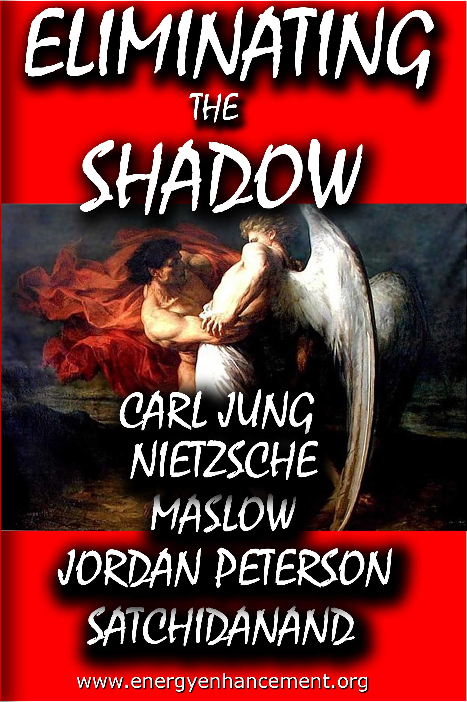
DEDICATION
With all Thanks, Love and Gratitude to Swami Devi Dhyani and all the helpers who make these books and DVDs possible.
With all Thanks, Love and Gratitude to my Mother and Father and to all my other Teachers, Theos Bernard, Sri Yogendra, Eric Berne, Gurdjieff, Father Bede Griffiths, Osho, Zen Master Hogen, Swami Sivananda, Swami Satchitananda, and all the other giants upon whose shoulders I stand - who made me able to be what… I AM – Swami Satchidanand

Copyright © 2019

[Energy Enhancement Synthesis of Light Limited (SOL)]

All rights reserved. This publication may be reproduced in whole or in part, by any person under fair use as long as we are referenced, without written permission of:
Swami Satchidanand

sol@energyenhancement.org
www.energyenhancement.org

ELIMINATE THE SHADOW

Satchidanand talks about Eliminating Shadow Subpersonalities, and Trashes Carl Jung, Nietzsche, Abraham Maslow, Joseph Campbell, and Jordan Peterson along the way.

Table of Contents

Preface ……………16

Chapter 1. JUST PULL YOURSELF TOGETHER - PSYCHIATRISTS FREUD, ADLER JUNG, NIETZSCHE, FRANKL, JORDAN PETERSON AND MASLOW ALL JUST SAY, “JUST PULL YOURSELF TOGETHER!’ ......................................21

Chapter 2. Energy Enhancement Meditation, Carl Jung and transmuting the Shadow, Unconscious, Ego, Id - The Hidden Power of Our Dark Side - and Psychology …………………………………………33

Chapter 3. Nietzsche, Carl Jung and Psychology Challenged by Energy Enhancement Meditation, Be One, Integrate the Shadow, Soul Retrieval - Enlighten..69

Chapter 4. SATCHIDANAND COMMENTARY ON JORDAN PETERSON………………………….……107

Chapter 5. Odin, Yggydrasil, Alchemical VITRIOL, The Kundalini Key, Meditation, Jung, Campbell, Neumann, Third Eye Opening and Projection, Antahkarana, Chakras Above the Head The 7even Rules of Highly Spiritual People Be the Hero in your life!………………………………..…………………...132

Chapter 6. Energy Enhancement Meditation and the Mythology of Lucas' Star Wars, Tolkien's Lord of the Rings, The Dune Trilogy, the Matrix Movies and Campbell's Universal Hero With regards to the Applicability of Nietzsche's and Carl Jung's Shadow Subpersonalities, in Heroic Meditational Self Development for the Destruction of Absolute Evil on this Planet…………………………………………...145

Chapter 7. You can't get Triggered if you Healed your Trauma - Depression Pain through Alchemical VITRIOL Kundalini Chakra Energy Enhancement Meditation Video Course…………………………….243

Chapter 8. The Conscious Creation of the Shadow..……………………………………………… 250

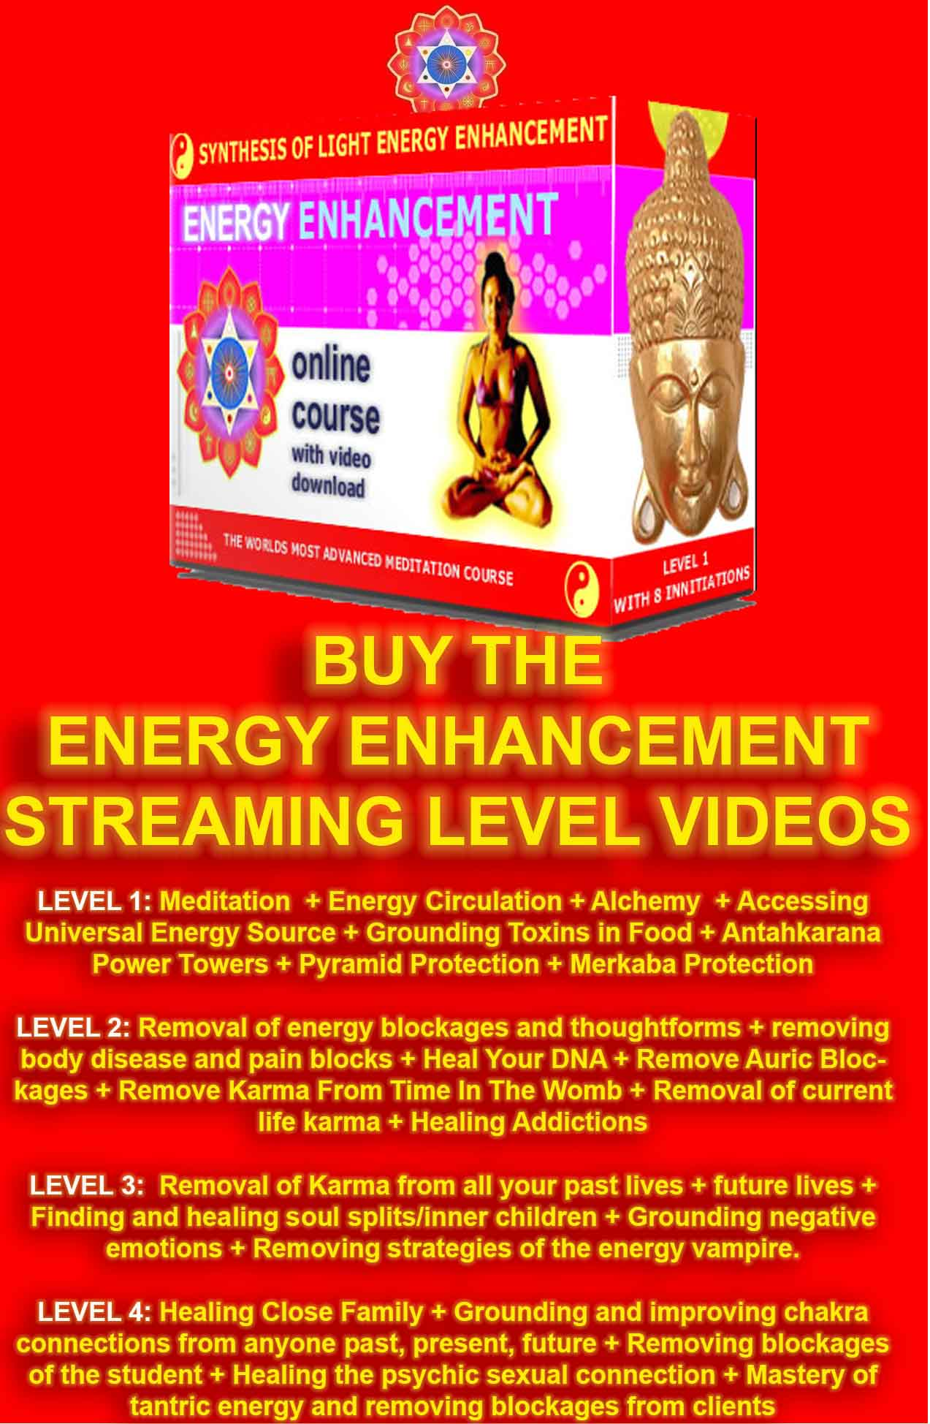

Go to http://www.energyenhancement.org for 19 Free Energy Enhancement Books.

To defeat Evil, you need to up your game. Learn the Energy Enhancement Meditation Course by Video or Live in Iguazu.

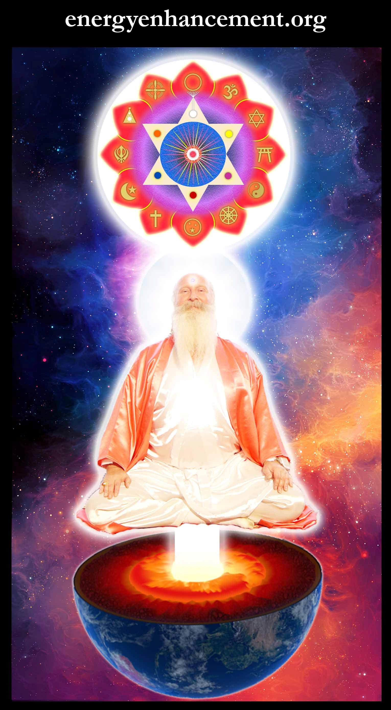
Change the World...
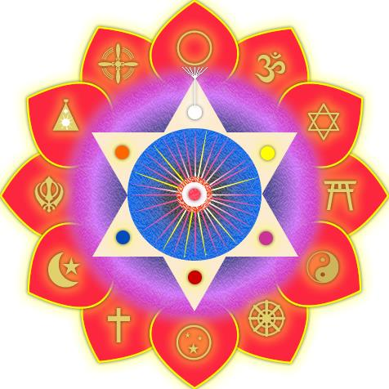

Go to http://www.energyenhancement.org for 21 Free Energy Enhancement Books.

To defeat Evil, you need to up your game. Learn the Energy Enhancement Meditation Course by Video or Live in Iguazu.

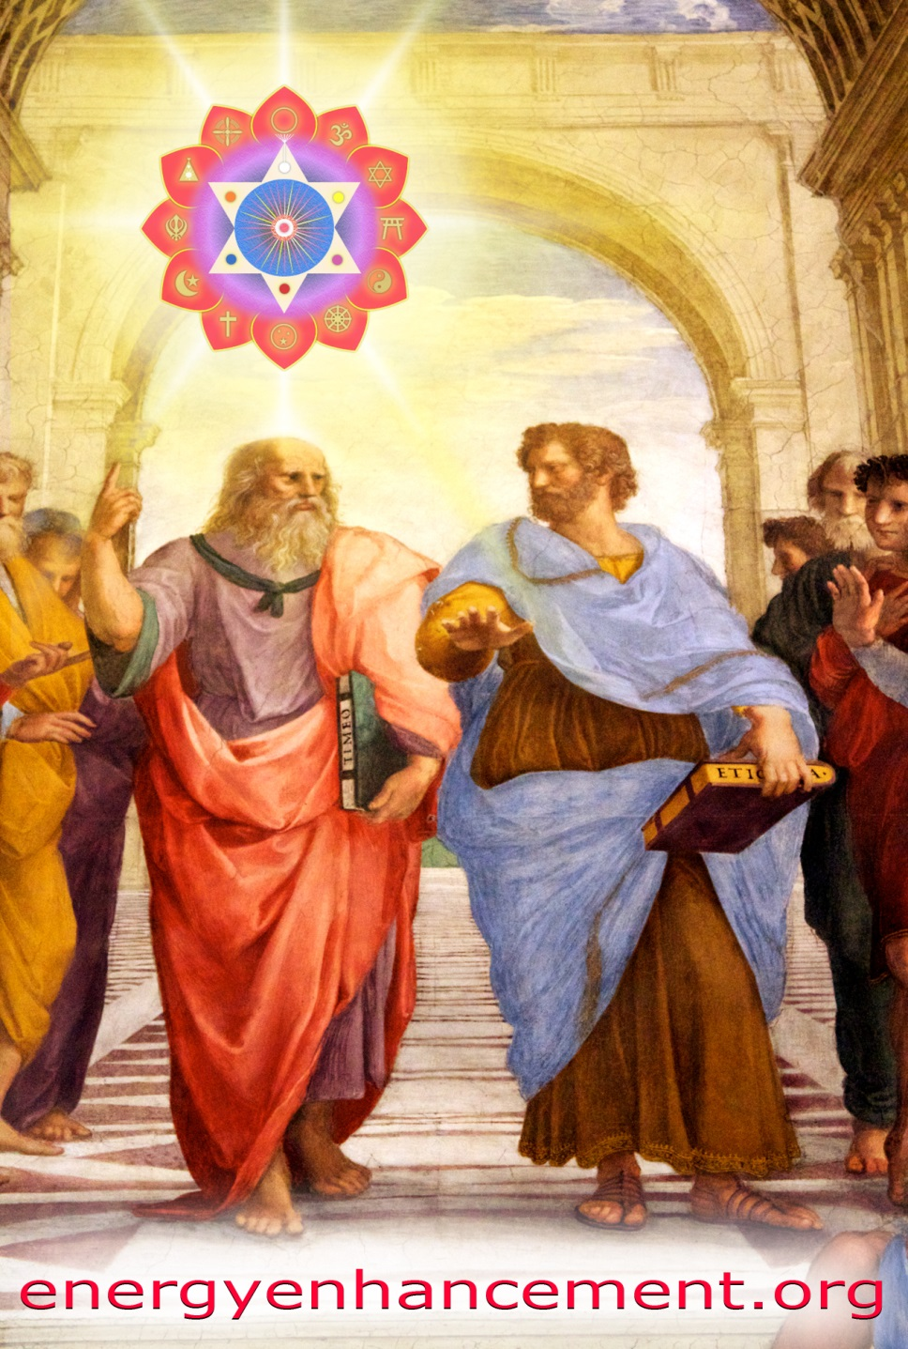
EUGENIC PLATO AND SATANIC BABYLONIAN SECRET AGENT ARISTOTLE "THE POISONER" OF ALEXANDER THE GREAT - BY RAPHAEL
EE LEVEL 1 POWER UP!! GAIN SUPER ENERGY http://www.energyenhancement.org/Level1.htm
EE LEVEL 2 ELIMINATE ENERGY BLOCKAGES http://www.energyenhancement.org/Level2.htm
EE LEVEL 3 CLEAN KARMA BLOCKAGES AND PAST LIFE KARMA BY TRANSMUTATION http://www.energyenhancement.org/Level3.htm
EE LEVEL 4 MASTER ENERGY CONNECTIONS AND RELATIONSHIPS http://www.energyenhancement.org/Level4.htm

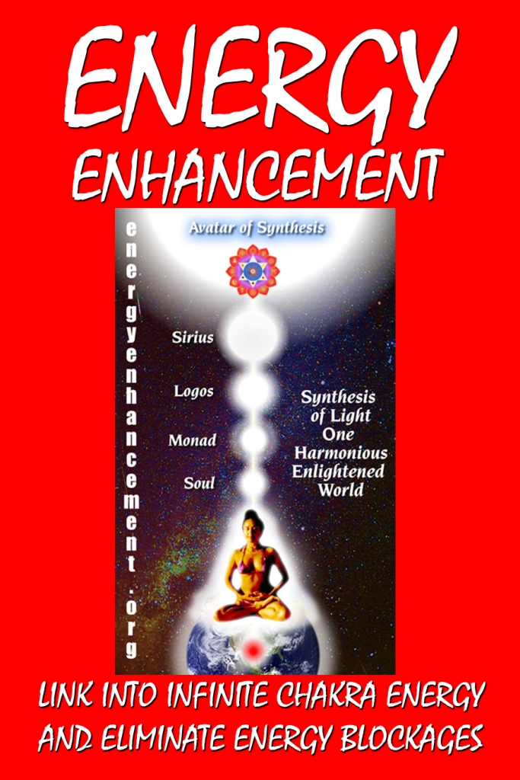

Go to http://www.energyenhancement.org for 21 Free Energy Enhancement Books.

To defeat Evil, you need to up your game. Learn the Energy Enhancement Meditation Course by Video or Live in Iguazu.

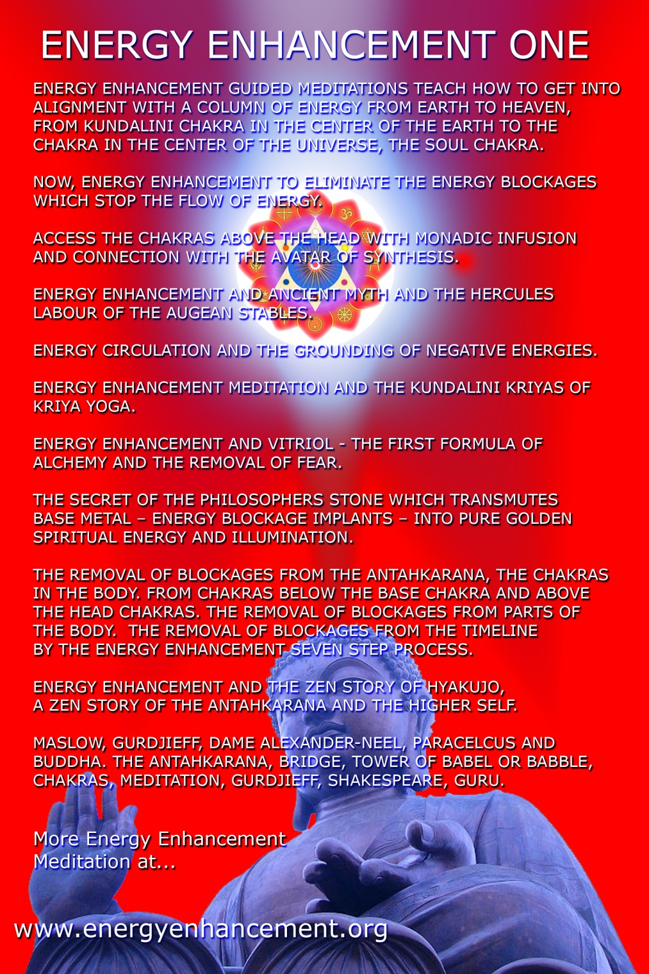

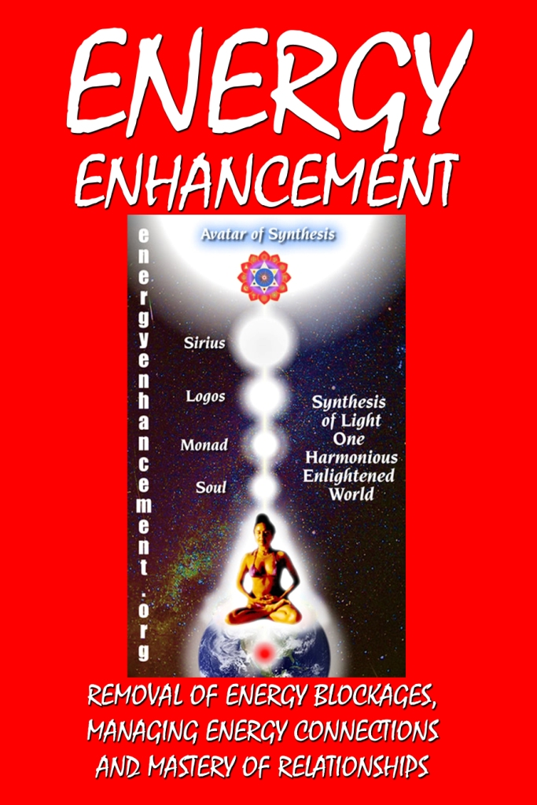

Go to http://www.energyenhancement.org for 21 Free Energy Enhancement Books.

To defeat Evil, you need to up your game. Learn the Energy Enhancement Meditation Course by Video or Live in Iguazu.

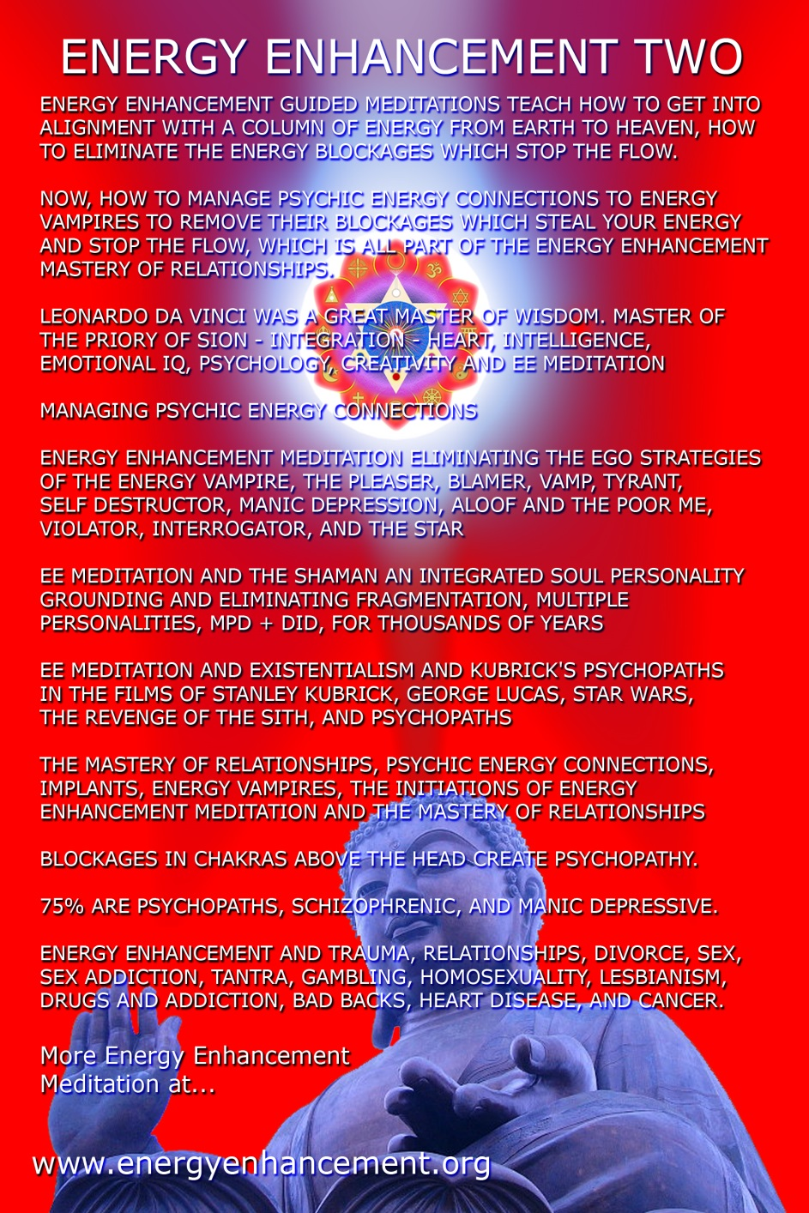

Go to http://www.energyenhancement.org for 21 Free Energy Enhancement Books.

To defeat Evil, you need to up your game. Learn the Energy Enhancement Meditation Course by Video or Live in Iguazu.
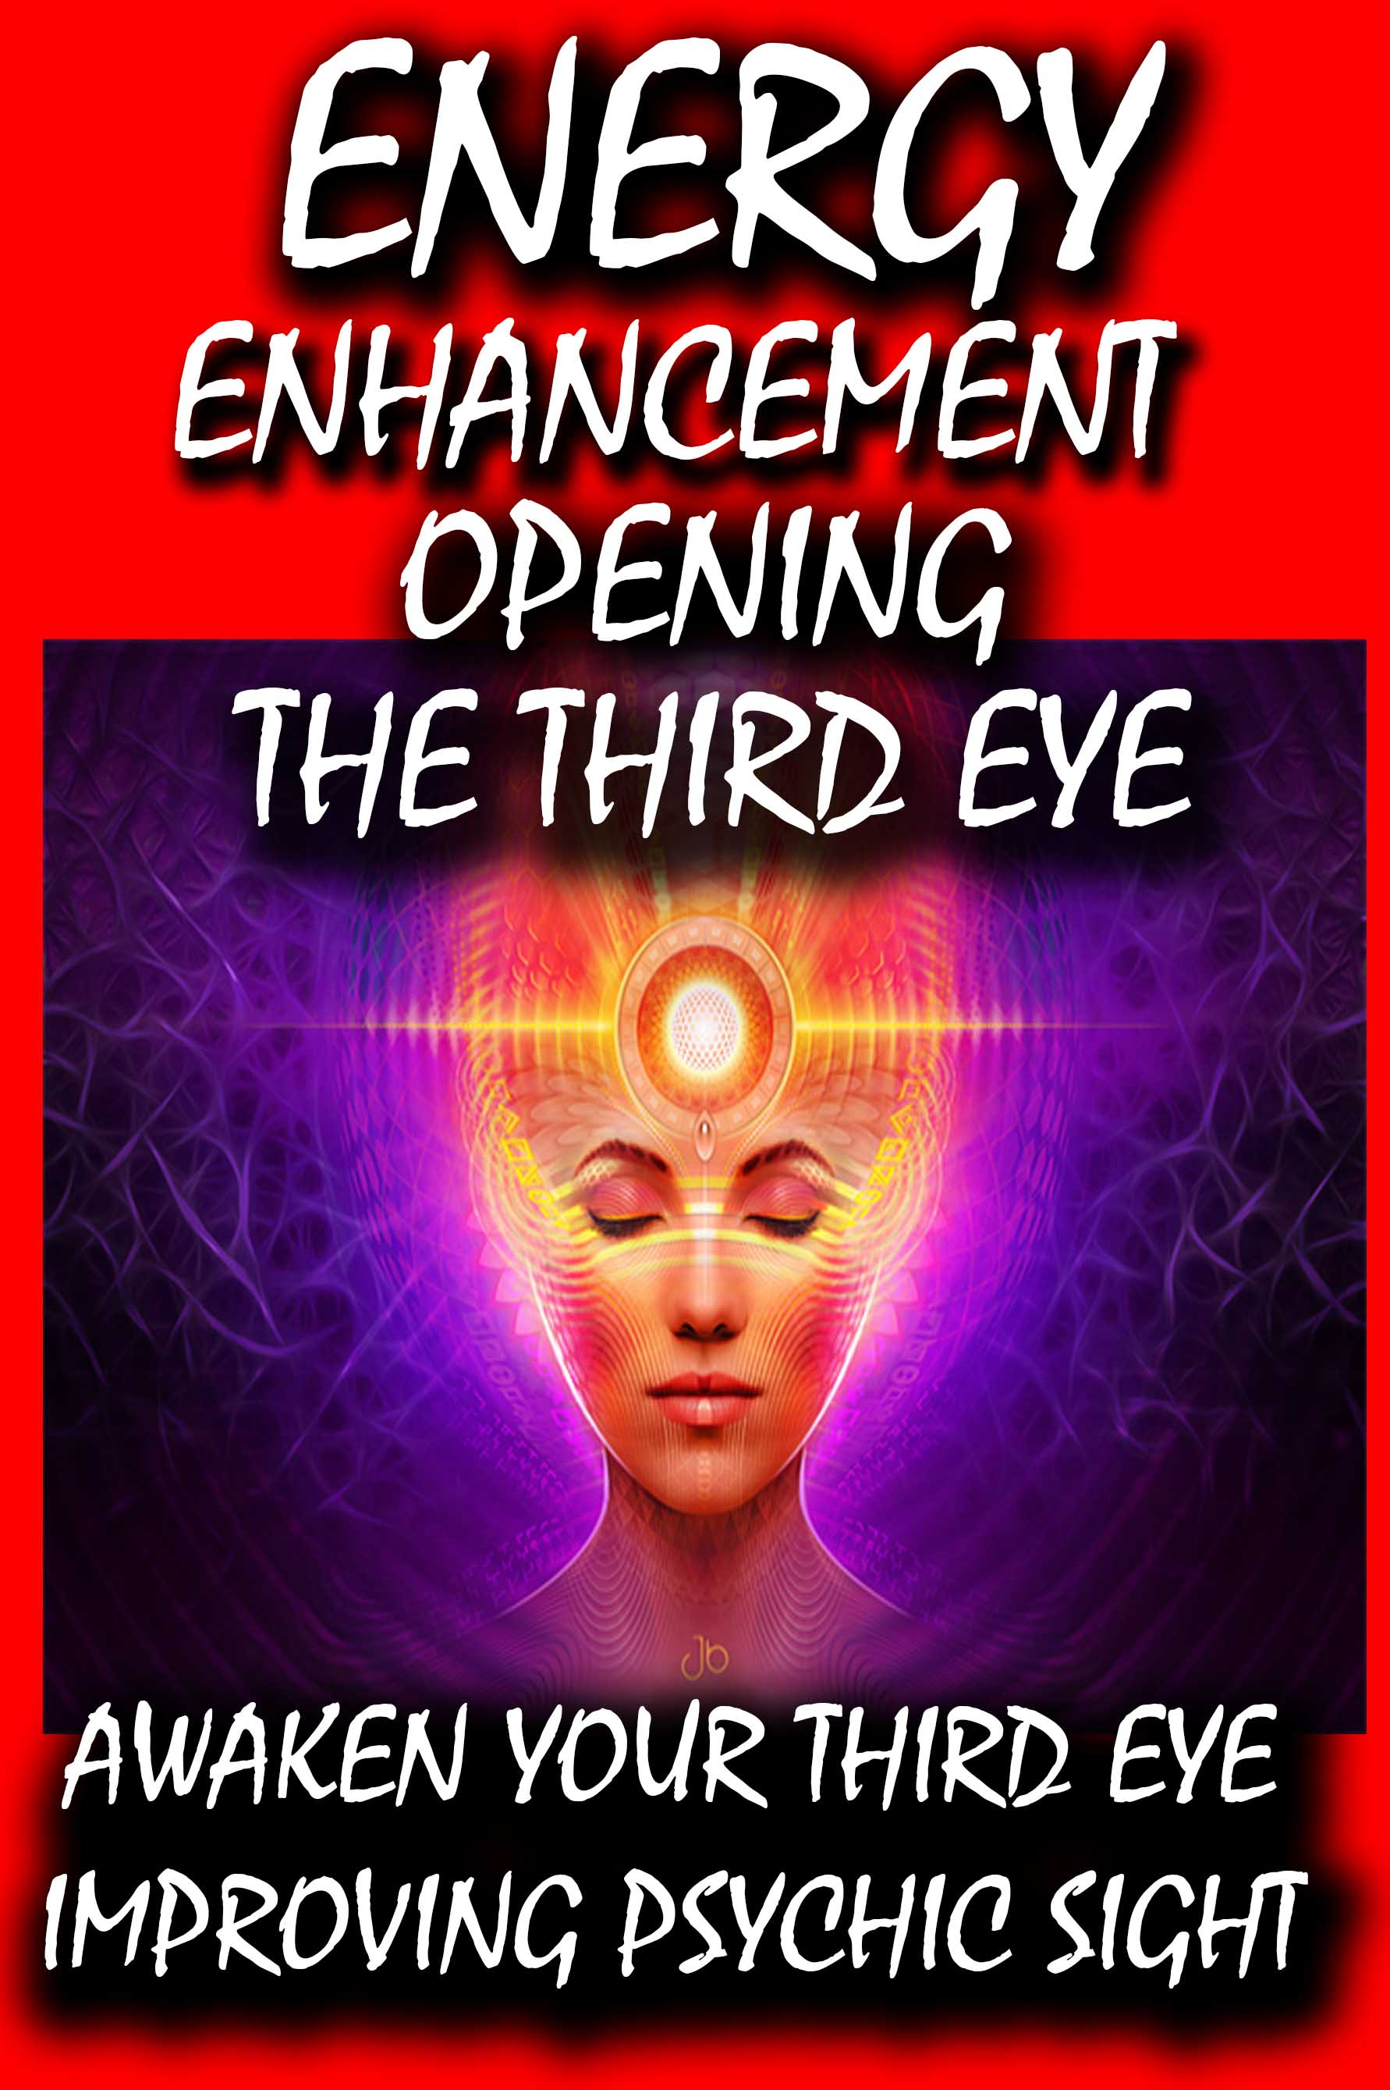
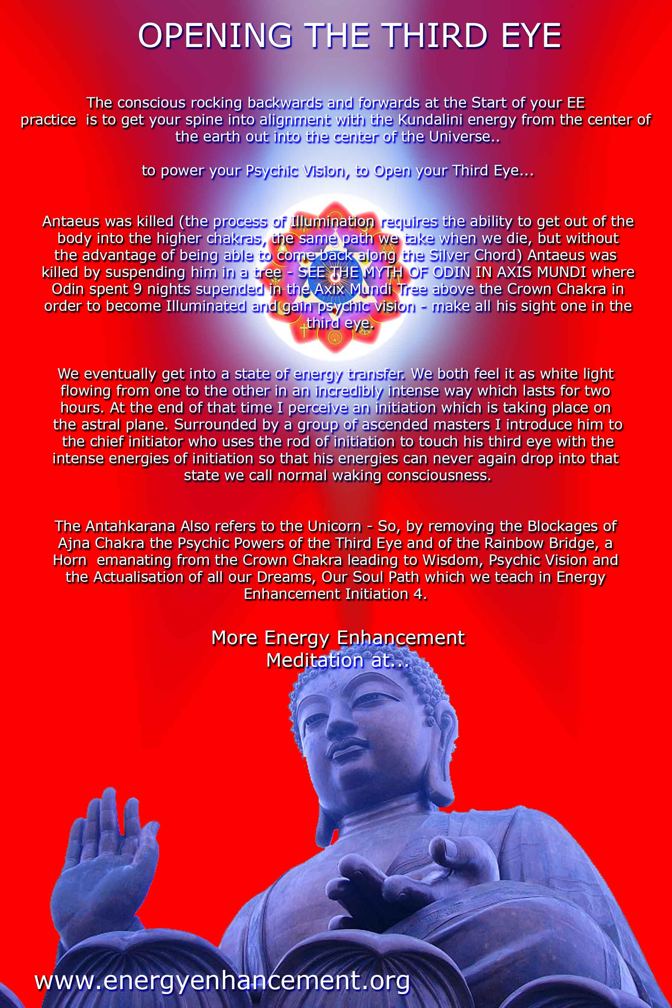PREFACE

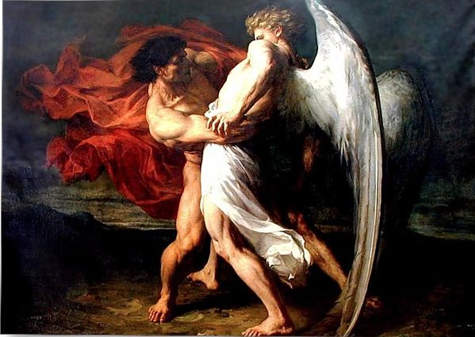
Jacob Wrestling an Angel

In this book, Satchidanand trashes the greatest most intellectual investigators and descriptors of the Shadow and the Shadow Subpersonalities.

Great People - The Highest of All Humanity - Jordan Peterson, Carl Jung, Nieszche, and every Psychotherapy, Psychological therapist who can describe the problem of the Shadow, talk about the problem of the shadow but have no Practical solution to the Shadow. All of those guys Failed to Solve the Problem of the Shadow. None of these guys have Any practical solution for the Shadow..

And it is the Shadow Subpersonalities which is the Source, The Fount, of All Evil on this Planet... And the Source of All Evil within You!!

Carl Jung says.. “There is no generally effective technique for assimilating the shadow. It is more like diplomacy or statesmanship and it is always an individual matter. First one has to accept and take seriously the existence of the shadow. Second, one has to become aware of its qualities and intentions. This happens through conscientious attention to moods, fantasies and impulses. Third, a long process of negotiation is unavoidable.” (Carl Jung)

As Jung notes in the passage above, he thought there is no general technique to integrate the shadow, even though the Buddha and Jesus Christ exemplified the Ancient Meditation Technology which is the only means for removing the Shadow. For thousands of years great souls have come to earth to demonstrate otherwise, that enlightenment is, "Tat tvam asi" Thou art that!! You are a part of the Universe and have nothing else to seek.

Energy Enhancement Meditation including Level 1 Alchemical VITRIOL to Ground Pain and Trauma from Memories and the Energy Enhancement Level 2 Seven Step Process to remove Energy Blockages by Purifying them then Integrating them with the Soul to create ONE Soul Infused Personality creating Spiritual Insight – combined with psychological knowledge Energy Enhancement is THE complete way of processing and integrating your Shadow Side into wholeness.

Because Energy Enhancement Meditation has actual ancient time-tested meditative techniques that you can use and apply to your Shadow work to Heal All your trauma formed Subpersonalities and Integrate them into the Soul.
As long as we have a Shadow Side we have Trauma formed Negative Karmic Mass – pain, fustration, pessimism, depression, anxiety, grief, bitterness, spitefulness, jealousy, anger, greed, lust, addiction, escapism, nihilism. These all need to be addressed and healed – VITRIOL transmuted and integrated.

Energy Enhancement Meditation uses the Psychic Spiritual Center – Third Eye as primary gateway into healing yourself. If we just use psychological analysis then we are limited. If we just use creative therapies, dream exploration, trance-work etc then we are also limited still. This is because we need it all, both sides.

ENERGY ENHANCEMENT MEDITATION - DEEPER THAN THE INTELLECT, MORE PROFOUND THAN THE MIND!

Alchemical VITRIOL is an Ancient Meditation designed to remove Trauma from Memories!! VITRIOL IS A LATIN ACRONYM - VITRIOL. – Visita Interiore Terrae Rectificando Invenies Occultem Lapidem, THE GROUNDING AND TRANSMUTATION OF ENERGY BLOCKAGES – The unification of the conscious and the unconscious., night and day, hot and cold, masculine and feminine. In the center is the Ajna Chakra – Third Eye. The kundalini Serpent has risen from the Muladhara – Base Chakra to the Third Eye Center. The symbolic meaning of its risen state is a raised consciousness that has dissolved duality. A state of Wholeness – Integration – Enlightenment.

“Come together, right now, over me” Singing these famous song lyrics from the Beatles to yourself, You can come together, surpassing your current-self to a higher-self!

With Energy Enhancement Meditation.

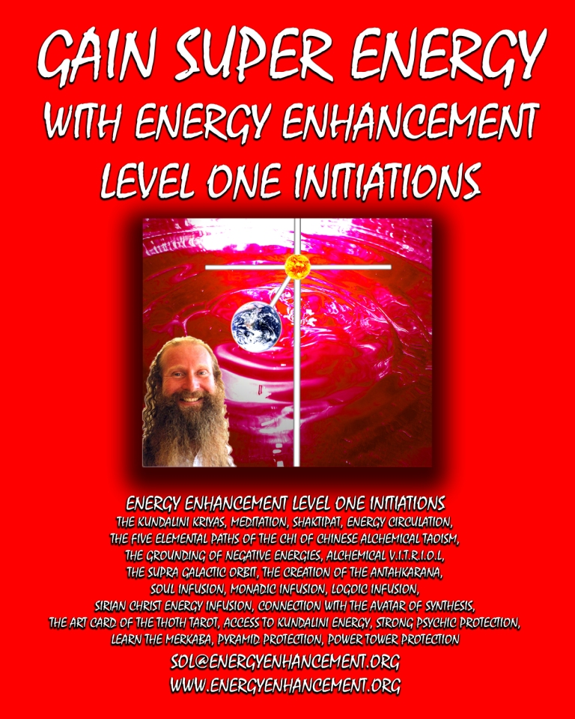

Go to http://www.energyenhancement.org for 21 Free Energy Enhancement Books.

To defeat Evil, you need to up your game. Learn the Energy Enhancement Meditation Course by Video or Live in Iguazu.
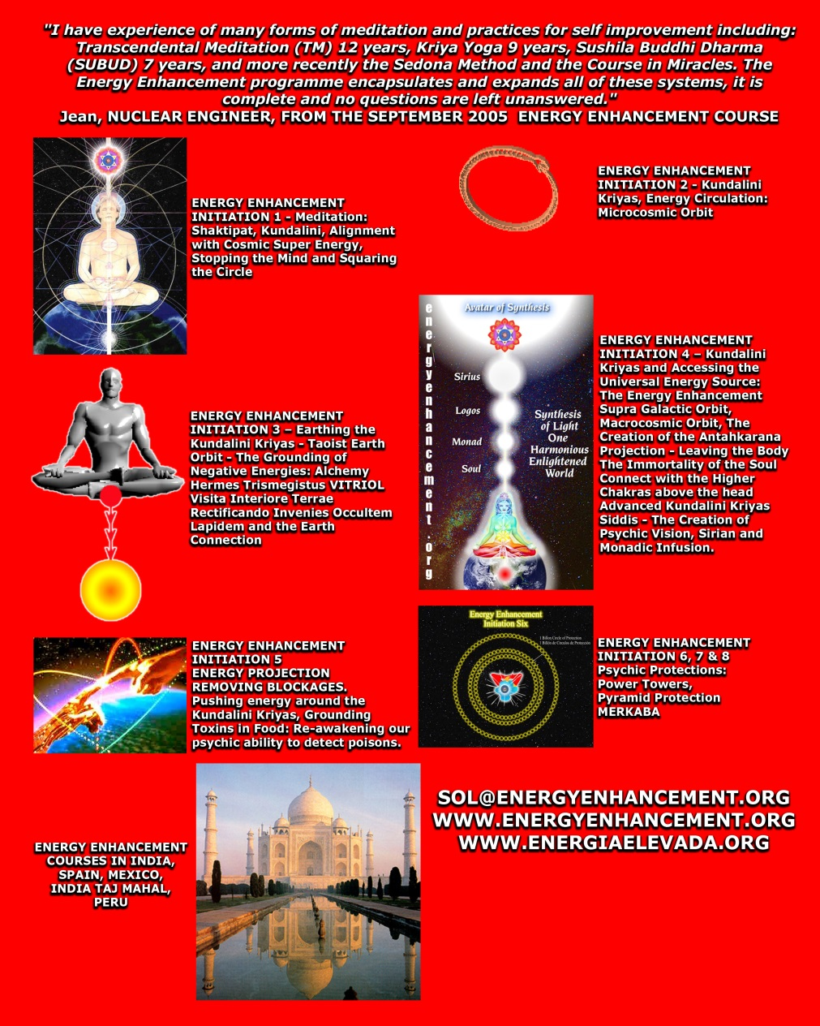

Go to http://www.energyenhancement.org for 21 Free Energy Enhancement Books.

To defeat Evil, you need to up your game. Learn the Energy Enhancement Meditation Course by Video or Live in Iguazu.

JUST PULL YOURSELF TOGETHER

PSYCHIATRISTS FREUD, ADLER JUNG, NIETZSCHE, FRANKL, JORDAN PETERSON AND MASLOW ALL JUST SAY, “JUST PULL YOURSELF TOGETHER!’

ONLY MEDITATION TRANSMUTES ALL YOUR PAIN AND TRAUMA – ONLY MEDITATION ALCHEMY TRANSMUTES LEAD INTO GOLD..

THE “JUST PULL YOURSELF TOGETHER” VIDEO ON YOUTUBE

https://www.youtube.com/watch?v=Y4GYooP6NOU

VIDEO ABOVE.. the famous, "Pull yourself together" video where Satchidanand trashes the greatest most intellectual investigators and descriptors of the Shadow Subpersonalities - Great People - The Highest of All Humanity - Jordan Peterson, Carl Jung, Nieszche, and every Psychotherapy, Psychological therapist who can describe the problem of the Shadow, talk about the problem of the shadow but have no Practical solution to the Shadow. All of those guys Failed to Solve the Problem of the Shadow. None of these guys have Any practical solution for the Shadow.. And it is the Shadow Subpersonalities which is the Source, The Fount, of All Evil on this Planet... And the Source of All Evil within You!!

Satchidanand talks about the problem and introduces the ONLY practical solution to the dissolution, the healing, The Removal, of the Shadow.

The Integration of the Soul. - With Energy Enhancement Meditation..

Take a deep breath in…OMMMM….

Today I thought I would tell you the story of Flo Jo. Flo Jo was walking along the street and as he goes past the first corner he sees this arm lying on the ground, “oh it’s an arm lying on the ground” he says, and as he walks past the next corner he sees another arm lying on the ground.

He goes across the next corner and there's a torso in the next corner and there's their head.

He says “Hi head, I recognize you, your name's Florencia.

Florencia, Just pull yourself together!” (laughing)

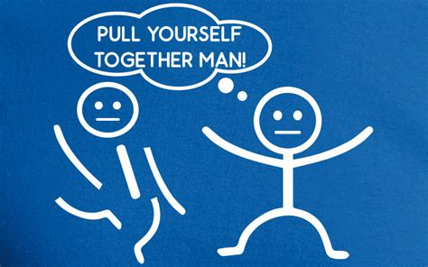

Now I know of many psychiatrists and they can tell you exactly what is wrong with you. They say you've got an arm over here and an arm over there, a head over here, a leg over there. And what do they do they say “Just pull yourself together!”.

Freud, Adler, Jung, Frankl, all of them they just say, “Just pull yourself together!”

You know you've got this type of psychopathy, you've got this type of sociopathy, you've got this type of, oh I don't know, they've got a whole book full of things that are wrong with you but none of them have any solution except “Just pull yourself together!”.

They can describe exactly what is wrong with you, you’re angry, why you’re so agrophobic and all of it is to do with trauma. You know, Doctor Colin Ross, and his Trauma Theory of psycho-whatever, he said at the base of every problem is trauma and pain.

And it's not just of anger, it’s not just of agrophobia, it's also of as you get older in life, health problems.

You know when you've got a problem in your tummy, when you got a problem in your arm, and you've got a problem in your leg where the doctors do, well they give you a pill. And if you got a lot of pain they give you a pain pill and there's this family, don't know what they're called, and they sell pain pills and everybody's going wild about them selling these pain pills because the base of these pain pills is heroin “Ah that'll sort you out”.

Note, Sackler family: 500 cities, counties and tribes sue owners of ...
https://www.theguardian.com/us-news/2019/mar/21/sackler-family-500-cities-counties-and-tribes-sue-oxycontin-maker
Mar 21, 2019 • Vast Oxycontin lawsuit accuses family of helping to create 'worst drug crisis in American history'

So many people, so much pain, so much methamphetamine, so much Marijuana, so much Hero-in because it will make you feel like a hero, said Bayer, when they sold it in the first place.

Note, “The head of Bayer's research department reputedly coined the drug's new name, "heroin," based on the German heroisch, which means "heroic, strong" (from the ancient Greek word "heros, ήρως"). Bayer scientists were not the first to make heroin, but their scientists discovered ways to make it, and Big Pharma Bayer led in the pushing of heroin.”

You know the whole idea of it is to say “well you've got this type of problem and you've got that type of problem” but here's the pain pill and we're going to make a whole lot of money out of it.

They say pull yourself together, all of them. I don't think any one of them have got any solution whatsoever except “pull yourself together” and none of the pain pill vendors like any of the natural therapies or herbs or Tai Chi or yoga, reiki, of all of these different natural therapies.

As a matter of fact they say, “You can't advertise these therapies” because they make billions and billions of dollars every year from selling you pain pills.

And what is the most ancient-most and oldest and most effective natural therapy in the world and its name is meditation. How do we know it's meditation?

Because all of the great masters of the past, all of the great religious leaders say meditate. You've got the Buddha, he says meditate, you've got Sivananda says meditate, he says if you can sit for three hours without moving chances are you'll be enlightened.

And what does enlightenment mean, it means you just don't have any pain. It means you've sought mastery of yourself, that all you want to do is good. You don't want to do any bad.

You know one of the problems of people in psychotherapy is called nihilism, it means you've got so angry with society and people, with your mum and your dad, all you want to do is to kill people.

It means you're so angry with that which you have inside, it's making you so angry that you want to take it out on other people. Woof woof! So the dogs bite bite. I have a pain inside, I'll take it out on you. It's nihilism, you can always tell people who are initially nihilistic, they almost want to take a bite out of you.

They react when you say anything to them. Just prod a little bit, (points to student in the audience), you know like I was doing with you this morning. Prodding a little bit, just to see if you're gonna bite me which you didn't. I was surprised. I was. I was sure you were gonna bite me but you didn't. Wow that's good, I like that.

So why is meditation a real solution which does not encompass anesthetizing with drugs, with heroin with methamphetamines with marijuana?

The pain which is caused by trauma, which is caused by people doing bad things to you. You know, there's a lot of bad people in the world. You need two bad things to happen to you and some of the people that get bad things done to them they'll often become like a Columbine shooter, they shoot everybody.

But some of the people like Solzhenitsyn, you know he’s had a lot of bad things done to him, he writes novels, he writes books and he says we have to overcome this by connection with the logos, by connection with God. We have to become good people and repent for the horrible things that we did in the past which caused us to have all of these bad things done to us. He took the blame for himself, he took the responsibility for all the problems of the world onto himself, he, he took the sins of mankind.

Solzhenitsyn took the sins of mankind onto himself and he did everything he possibly could to repent for his bad actions of the past through good works which he felt would help everybody.

So you've got, “One Day in the Life of Ivan Denisovich”, yeah, retelling his day in the gulags, the concentration camps of the old Soviet system where horrible things were done to him and yet he came out and became a personal friend of presidents, of good people in the world all over and the power of his writing is such that still today we can take sustenance from it.

It teaches you the right way to live, yeah,.

So why is meditation that which can overcome, even the deepest trauma?

Even the deepest pain?

How can it relieve the body, the physical body of pains? How could it heal all of your medical problems? How can meditation overcome even the deepest psychic pain that you have inside which causes you to take revenge on society?

How can it heal the deepest problems in the human mind?

How could it heal the deepest problems in the human spirit outside of the mind, higher than the mind, because every part of the human being is destroyed by trauma, by trauma, by pain.

Because when pain is done to us when we absorb the pain, it resides in one of our bodies as the pain body, the physical pain body, the emotional pain body, the mental pain body, the spiritual pain body, even as high as the soul body or the logos body or even higher. They all contain pain.

This is the problem, and all the psychiatrist's in the world all of them say “well Flo just pull, yourself together girl” and it just doesn't work. You can overcome the pain by willpower, by saying, I want to become a good person, and this works but it doesn't resolve the pain.

It just means that your willpower has got to be strong enough to overcome the pain but the pain still resides down deep below and if your willpower gets less then the pain body will supervene and you will get into problems.

Meditation, particularly Energy Enhancement Meditation can remove the pain body and this is the sort of thing the Buddha was saying thousands of years ago. He was saying remove the pain body. And how do you remove the pain body? Well we have meditational techniques to remove the pain body.

Unbelievable. Unbelievable. How can you remove the pain that is the bane of every human being on this planet? And it's not just me saying this all of the spiritual masters of the past have said, “All of your problems can be removed by means of meditation” and the major problem that everybody has is pain.

Pain can be burnt up as…

When pain hits the spiritual, physical, mental, spiritual body of a human being it causes a substance which we call negative karmic mass or trauma formed negative karmic mass or pain created negative karmic mass and this negative karmic mass is a distortion, a perversion of the natural spiritual energy which is so high and yet it's clicked together in a lump and it's put in various parts of your body, in the spiritual, in the mental, in the physical and the emotional body there's a lump there which does not allow spiritual energy to flow which does not allow mental energy to flow which does not allow physical energy to flow which does not allow emotional energy to flow and this distortion field, this negative karmic mass can actually be transmuted you know.

How do we know pain can be transmuted?

Because the whole of alchemy, the whole of the Jung says that you can transmute base metal, lead, into gold.

And what is lead?

That is pain. That is trauma.

Lead is negative karmic mass. Lead is energy blockages which are coated with negative karmic mass, so as you transmute base metal into gold by means of the spiritual technique called alchemical vitriol, then you can remove all of your pain body.

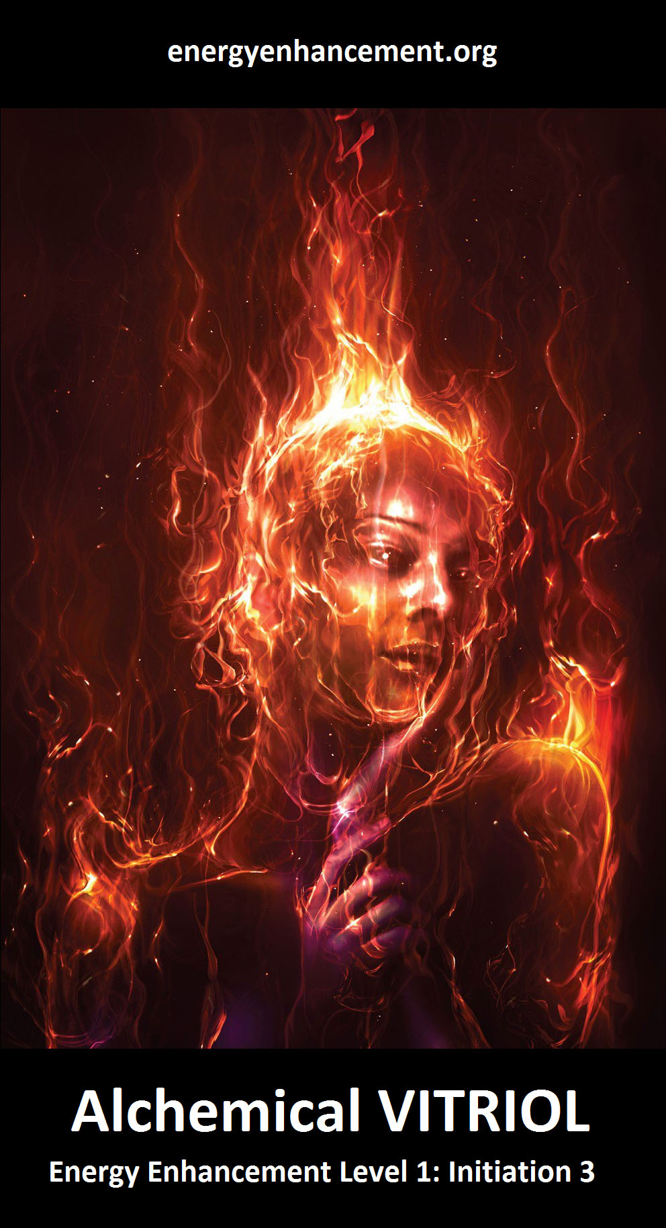
Removing the pain body is not enough. We need to have to want to help people but once you've removed the pain that's a much easier thing to do - as I said before you've got all this pain fulminating within you and this pain in the emotional body makes you sound like a frog.

It affects the voice, you can hear it in the voice of people, you can see it in their walk, you can just look at them and say well I can see the pain residing in every part of that being and that pain can be overcome by willpower but when you have no pain when the pain is less you need less willpower.

Of course you need willpower but you need a less willpower to have the same result of compassion, of love, of wanting to help everybody around you.

Of wanting to help humanity to reach to the stars to reach their potential, to evolve, to become better people, to start to pull the weight together, to enable humanity to reach to the stars.

So come and learn alchemical vitriol.

Come and learn how to transmute all of your pain.

Come to learn how to burn up all of your pain so that you never have that pain again.

Evolve, transmute, realize, illumine, enlighten!

This is what it's all about chaps and it all starts with the ancient effective technique proselytized by every spiritual master of the past.

Its name is meditation.

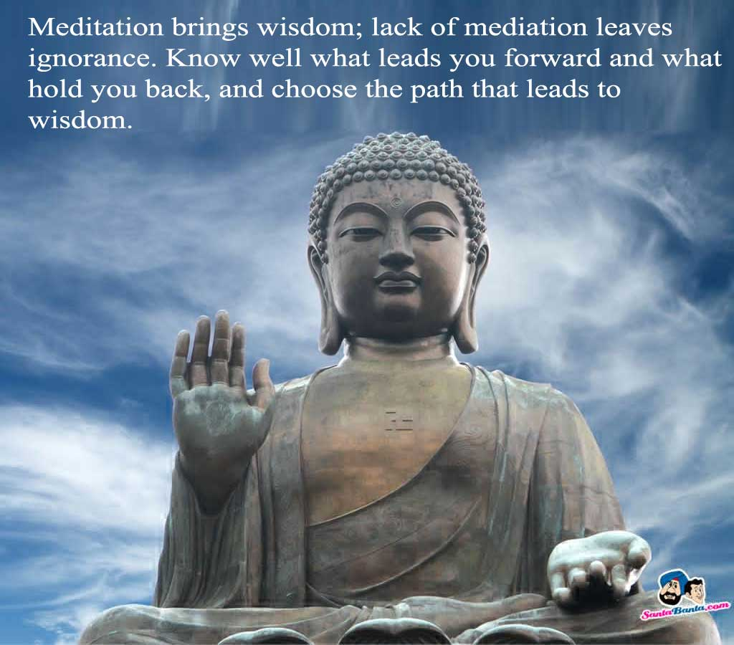

Meditate.



Become a meditation master.

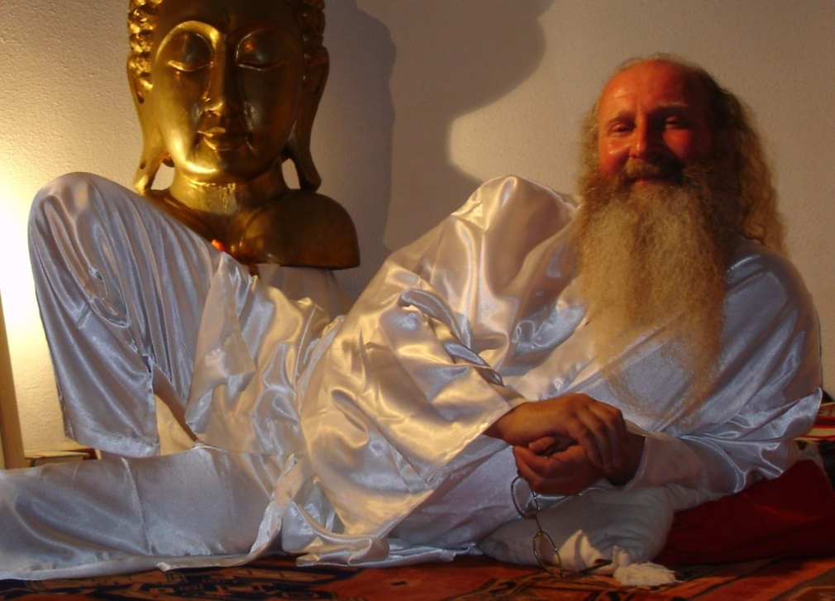

Burn up all of your pain.

Never get ill again.

Satchidanand

Go to http://www.energyenhancement.org for 21 Free Energy Enhancement Books.

To defeat Evil, you need to up your game. Learn the Energy Enhancement Meditation Course by Video or Live in Iguazu. Energy Enhancement Meditation, Carl Jung and transmuting the Shadow, Unconscious, Ego, Id - The Hidden Power of Our Dark Side - and Psychology
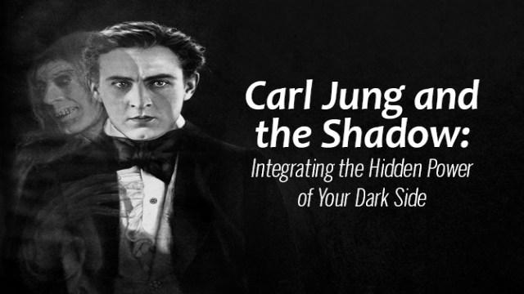
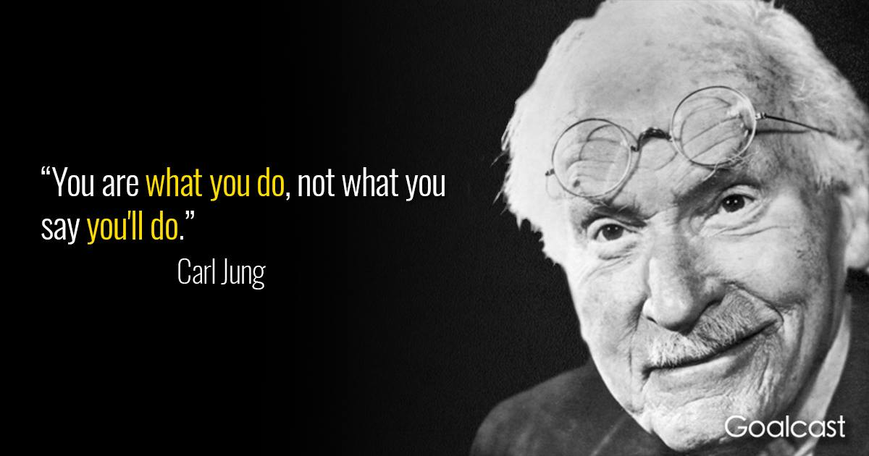

"YOU ARE WHAT YOU DO, NOT WHAT YOU SAY YOU'LL DO!" Gurdjieff used to say, "The man who says he will get up at six in the morning to meditate, is not the same person who throws the alarm clock out of the window."

And this split mind is the result of the shadow which exists in EVERY human being.

Remember the famous, "Pull yourself together" video where Satchidanand trashes the greatest most intellectual investigators and descriptors of the Shadow - Jordan Peterson, Carl Jung, Nieszche, and every Psychotherapy, Psychological therapist who can describe the problem of the Shadow, talk about the problem of the shadow but have no Practical solution to the Shadow. None of these guys have Any practical solution for the Shadow..

Satchidanand talks about the problem and introduces the ONLY practical solution to the dissolution, the healing, of the Shadow - Energy Enhancement Meditation..



“That which we do not bring to consciousness appears in our lives as fate.” (Carl Jung)

The Unconscious Shadow which exists in all of us bites us with Fate, Shame, Triggering, Karma, Bad Luck and Trouble.
Born under a bad sign,
Been down since I began to crawl.
If it wasn't for bad luck,
You know, I wouldn't have no luck at all.
Hard luck and trouble,
Been my only friend.
I been on my own,
Ever since I was ten.
Born under a bad sign,
I been down since I began to crawl.
If it wasn't for bad luck,
You know, I wouldn't have no luck at all.
I don't like to read,
I can hardly write,
My whole life has been
One big fight.
Born under a bad sign,
I been down since I began to crawl.
If it wasn't for bad luck,
I said I wouldn't have no luck at all.
And that ain't no lie.
(Guitar solo)
You know, if it wasn't for bad luck,
I wouldn't have no kind of luck.
If it wasn't for real bad luck,
I wouldn't have no luck at all.
You know fear of falling
Is all I crave.
A big bag of pork rinds
Gonna carry me to my grave.
Born under a bad sign,
I been down since I began to crawl.
If it wasn't for bad luck,
I tell ya I wouldn't have no luck at all

Carl Jung is famous for formulating the concept of the shadow, the portion of our personality which, through the course of our life, is relegated to the darkness of the unconscious.

The Nature of the Shadow

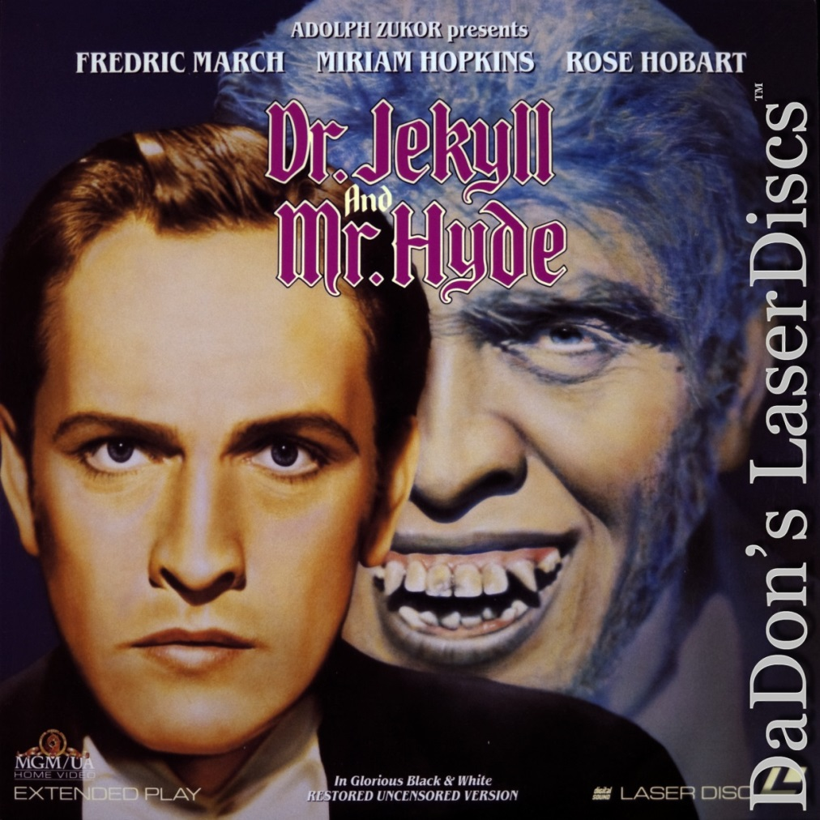

“The shadow goes by many familiar names: the disowned self, the lower self, the dark twin or brother in bible and myth, the double, repressed self, alter ego, id, sub-personalities. When we come face-to-face with our darker side, we use metaphors to describe these shadow encounters: meeting our demons, wrestling with the devil, descent to the underworld, dark night of the soul, midlife crisis.” (Connie Zweig, Meeting the Shadow)

While Jung is known for bringing the concept of the shadow to public awareness in the modern day, this aspect of ourselves has long been recognized as a ubiquitous feature of human beings.

In 1886, before Jung made his mark, Robert Louis Stevenson created the now famous story of Dr. Jekyll and Mr. Hyde. In his story Dr. Jekyll represents the respectable part of one’s personality, but when he transforms using drugs like Heroin, Alcohol and DMT, into Mr. Hyde, his dark shadow personality gains dominance over him and wreaks havoc on his life.

Although the shadow is an innate part of the human being, the vast majority of us are willfully blind regarding its existence. We hide our negative qualities, not only from others but from ourselves.

To do this we often criticize and condemn others to ensure our focus does not fall on our own faults and destructive tendencies. We go through life with a false air of moral superiority and a belief that while others act immorally and destructively, we ourselves are wholly virtuous and always in the right.

“Unfortunately there can be no doubt that man is, on the whole, less good than he imagines himself or wants to be. Everyone carries a shadow, and the less it is embodied in the individual’s conscious life, the blacker and denser it is. At all counts, it forms an unconscious snag, thwarting our most well-meant intentions.” (Carl Jung)

Making the Shadow Conscious

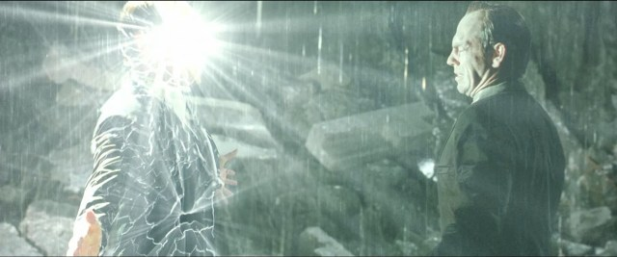
Neo becomes conscious of Agent Smith his shadow side, purifies and absorbs him.

Some aspects of our shadow are the product of our evolution. We contain, like all animals, instincts for sex and aggression that we tend to repress in order to adapt to the social mores of the day. Some aspects of our shadow are the product of our upbringing. Personality traits, stuck inner children, and impulses that elicited fear or anxiety in our parents or teachers, for example, caused them to punish or criticize us; and so we reacted by repressing these characteristics.

We put up psychological defences to ensure they were not allowed expression, and thus these characteristics were repressed into the unconscious. As all humans have a shadow, what differentiates us from others is the degree to which we are conscious of it.
When our shadow remains unconscious, it wreaks havoc in our life. Repressed contents do not merely disappear, but rather they function independently of our conscious awareness. In other words, the shadow has the capacity to override our conscious ego and take possession of our being, exerting control over our thoughts, emotions, and behaviors. When this happens we can be unconsciously driven into hard times, all the while remaining ignorant that these troubled periods were self-imposed, and not the product of bad luck or fate.

Born under a bad sign,
Been down since I began to crawl.
If it wasn't for bad luck,
You know, I wouldn't have no luck at all.

“The psychological rule says that when an inner situation is not made conscious, it happens outside as fate. That is to say, when the individual remains undivided and does not become conscious of his inner opposite, the world must perforce act out the conflict and be torn into opposing halves.” (Carl Jung)

The unconscious control which our shadow can exert upon us also accounts for the self destructive behaviors so many individuals struggle with and are unable to control despite consciously knowing they would be better off not engaging in such actions.

Many addicts are driven by their shadow, which accounts for the internal “war” which exists within them. One moment they tell themselves they are going to give up their addiction and live a clean life, and the next moment their shadow overrides their conscious ego and they enthusiastically seek out the next drink, “hit”, or sexual release.

As Robert Louis Stevenson notes in his book The Strange Case of Dr. Jekyll and Mr. Hyde, man is not one, but truly two or many more sub-personalities; he has a conscious personality and a shadow, each of which often battle for supremacy within his mind.

"In Vino, Veritas" - In wine, truth.

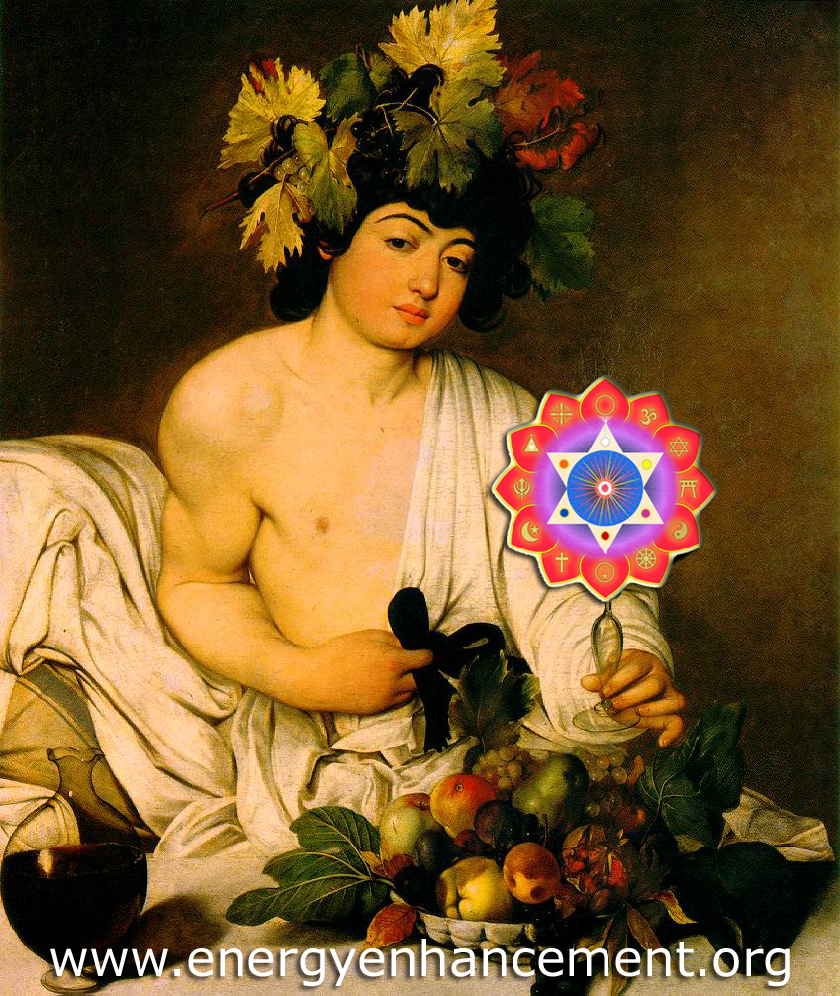
"Take what is in my hand" - Rumi
CARAVAGGIO

If you want to see the reality of the released shadow, see people when they are fucked up!

"I spent all my money on women and booze. The rest I wasted!" - George Best, the world's greatest footballer, who used alcohol to overcome shyness, married four Miss Worlds, and died age 53 after a Liver transplant.

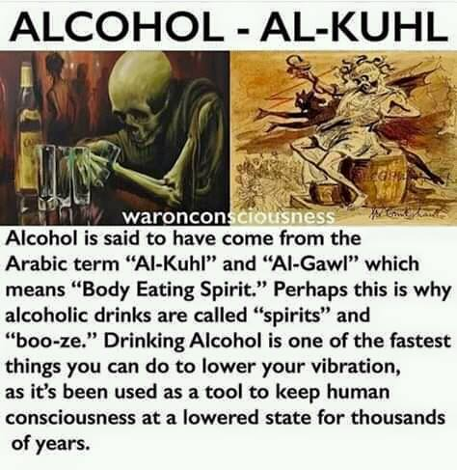
George Gurdjieff used to use his celebrated "toast to the idiots" with calvados alcohol to inebriate his students so as to release their shadows. So he could see their faults. So he could remove their shadows, heal their shadows, - he was a Master! - and advise them as to what sort of idiots they were.

“Man has to realize that he possesses a shadow which is the dark side of his own personality; he is being compelled to recognize his “inferior function”, if only for the reason that he is so often overwhelmed by it, with the result that the light world of his conscious mind and his ethical values succumb to an invasion by the dark side. The whole suffering brought upon man by his experience of the inherent evil in his own nature – the whole immeasurable problem of “original sin”, in fact – threatens to annihilate the individual in a welter of anxiety and feelings of guilt.” (Depth Psychology and a New Ethic, Erich Neumann)

In order to avoid being the victim of “shadow-possession”, we must become conscious of our shadow qualities and integrate them into our conscious personality.

The ONLY way to do this, the ONLY techniques which work are the techniques of Energy Enhancement Meditation, grounding the shadow, transmuting the shadow, purifying the shadow, accepting by transmuting them with open arms not as abhorrent aspects of our self, but as necessary and vital parts of our being.

Toward this end it is useful to realize that the task in life is not only to become perfect, but to become a purified whole.

And as our original wholeness always entails both good and evil, light and darkness, before the Energy Enhancement Meditation purification, the achievement of purified wholeness - enlightenment - in personality development requires we assimilate our shadow into our conscious personality.

“One does not become enlightened by imagining figures of light, but by making the darkness conscious.” (Carl Jung) - "and transmuting it" Satchidanand

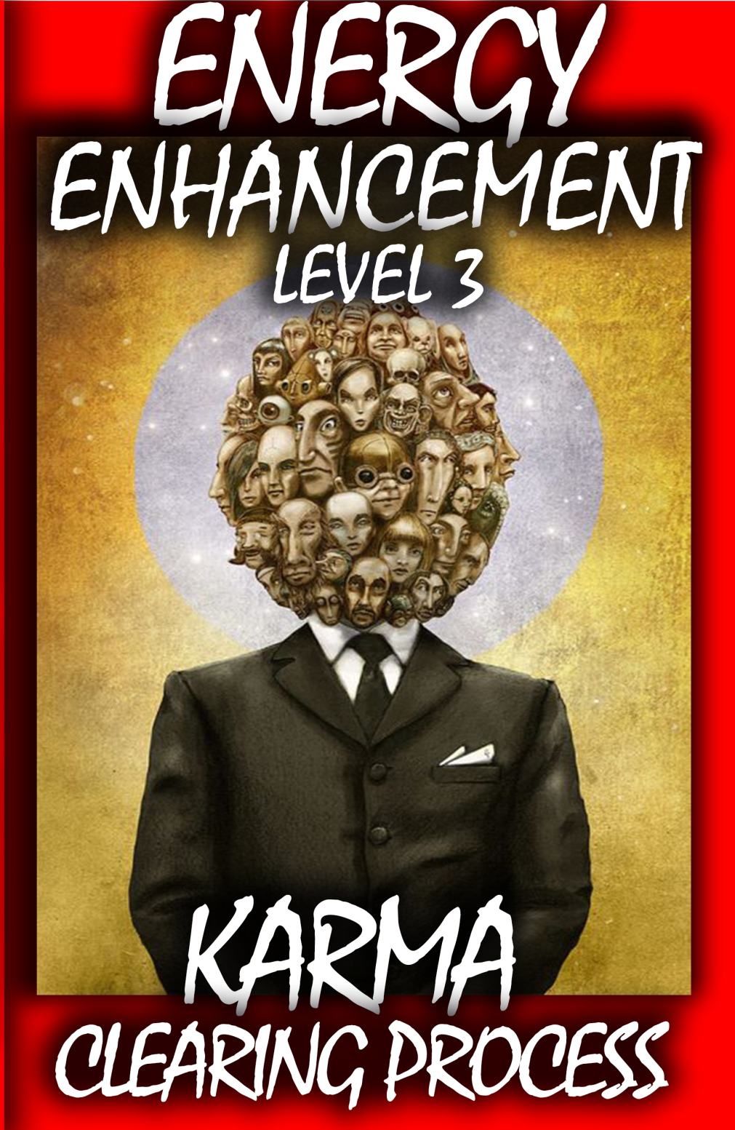

However, as Jung says, this is extremely difficult.

Most cannot and will not admit that deep down they are not wholly virtuous, selfless, and good human beings, but instead contain selfish, destructive, amoral and immoral impulses and capacities. Most would rather deceive themselves with a blind optimism about the “goodness” of their nature, which why most remain fragmented individuals who are ignorant of their inner depths.

“The meeting with oneself is, at first, the meeting with one’s own shadow. The shadow is a tight passage, a narrow door, whose painful constriction no one is spared who goes down to the deep well. But one must learn to know oneself in order to know who one is.” (Carl Jung)

"It is not sufficient to know one's shadow.

Seeing it, talking about it, has no effect.

What does have an effect on the shadow is Energy Enhancement Meditation. We are a collection of good and bad parts, white and dark angels. What makes the part bad, the Angel dark is ancient trauma.

The part of Energy Enhancement Meditation which has been consciously removed from all traditional meditations is the grounding of negative energies, the transmutation of ancient trauma, the transformation of negative parts, dark Angels into positive parts, White Angels.

The process of change by Energy Enhancement Meditation is one of bit by bit. Changing each negativity into positivity, one by one!

Energy Blockages are Infinite..
Let us vow to end them All.
Zen, Great Vows." - Satchidanand

Energy Enhancement teaches you how to transmute Dark Angels and incorporate them into your Soul as pure Positive Angel talents.

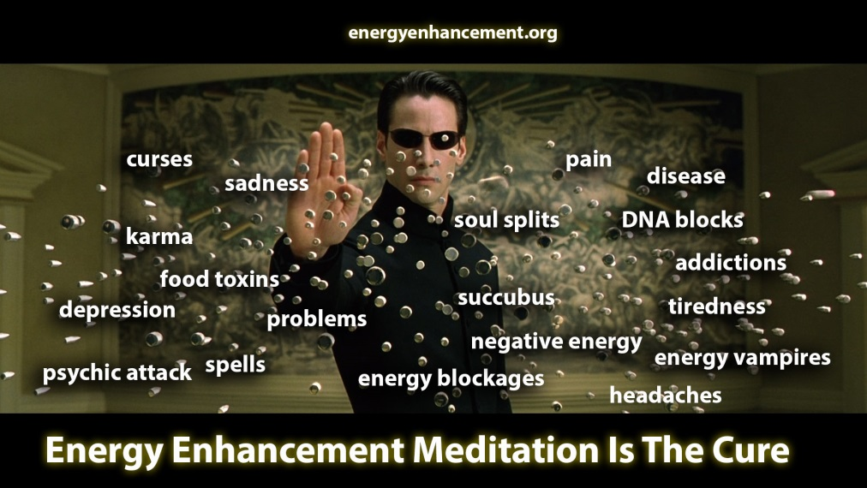
The Hidden Power of the Shadow

What is especially interesting is the idea that the shadow contains not just destructive aspects of the personality, but also potent, creative, and powerful capabilities and Talents from many past lifetimes of learning, practise and development evolution.

During our present lifetime development certain traits and impulses were condemned by our family, peers, and educators, not out of care but out of envy, fear, ignorance or jealousy. Our proclivity to abide by social expectations also caused us to repress ancient talents, innate abilities, and impulses which if cultivated and developed had the potential to make us more effective beings in the world.

For example, it is becoming more prevalent today for psychologists to diagnose individuals who question authority and show signs of extreme self reliance as being pathological, suffering from a condition they call “anti-authoritarian”.

Individuals who are too self-reliant in our increasingly collective and dependent society are viewed by many as a threat. They are lone wolves amidst a flock of sheep, instead of the sheepdogs, protecting the sheep from the Satanic psychopathic wolves, they really are, and they are attacked and ridiculed by the herd because of it.

This is just one example of many regarding how our socialization into modern society handicaps our development. The bottom line is that with our higher energies trapped, labeled by others and our conscious ego as negative and bad, our growth can become blocked, and life, a wasteland.

For the sake of our personal development, we must, therefore, become more aware of our shadow and open our mind to the possibility that maybe we are not so friendly, righteous, and moral as we think.

We must consider that perhaps there are unconscious aspects of ourselves driving our behavior “behind the scenes”. We must look down into our depths and realize that our conscious ego is not always in control, but is often overtaken by the power of our shadow.

Once we become more aware of these dark aspects of ourselves, we must honor them and find a way to integrate them into our life through Energy Enhancement Meditation.

In failing to do so, one will become weak and scattered. One cannot serve two inner drives without dissipating his strength and energies and falling prey to addiction, anomie and nihilism. The shadow must become transmuted, grounded, purified, a part of, integrated into one’s conscious personality by means of Energy Enhancement Meditation.
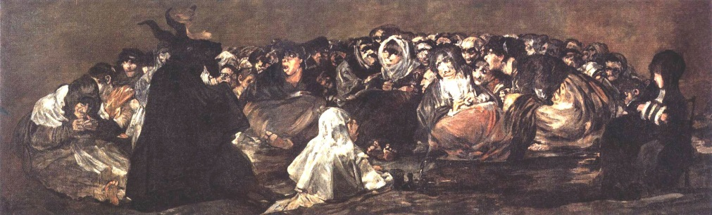
Francisco_de_Goya_y_Lucientes_-_Witches'_Sabbath_(The_Great_He-Goat) - Evil Subpersonalities of the ego which exist within us..

Is there a “Technique” to Integrate the Shadow?

Without Energy Enhancement Meditation there is no technique which can transmute the shadow and create a happy enlightened being..

Carl Jung says..
“There is no generally effective technique for assimilating the shadow. It is more like diplomacy or statesmanship and it is always an individual matter. First one has to accept and take seriously the existence of the shadow. Second, one has to become aware of its qualities and intentions. This happens through conscientious attention to moods, fantasies and impulses. Third, a long process of negotiation is unavoidable.” (Carl Jung)

As Jung notes in the passage above, he thought there is no general technique to integrate the shadow, even though the Buddha and Jesus Christ exemplified otherwise. For thousands of years great souls have come to earth to demonstrate otherwise, that enlightenment is, "Tat tvam asi" Thou art that!! You are a part of the Universe and have nothing else to seek.

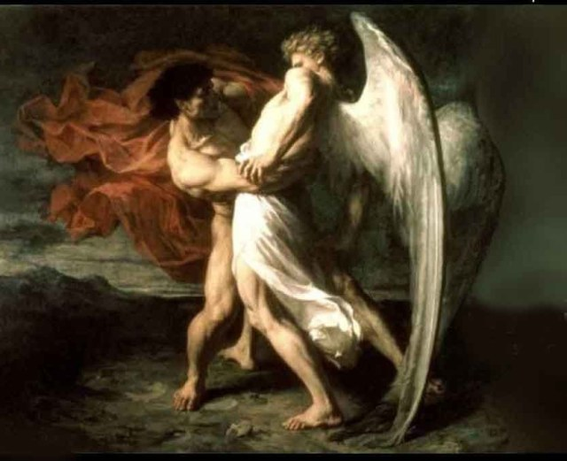
Westling with your Shadow Side – Energy Enhancement Meditation is an Integral Solution

Our shadow is not unique, and thus, to integrate it requires a general process of Energy Enhancement Meditation which acts in the same way on all humanity. "Eliminate the negative, accentuate the positive, That's what gets results!" Lyrics, Johnny Mercer

No matter the approach we adopt, to properly integrate our shadow it is necessary to behave in ways which run counter to the mores of society and our own conscious moral compass. Most of our shadow qualities, after all, were repressed into our unconscious because we believed they were unacceptable, either socially or according to our family or peers.

Previously, previous to Energy Enhancement Meditation, a common technique in shadow integration is to find a healthy, productive, or at the very least, controlled outlet for either repressed aggression or sexual urges.

Another was to ignore customs one thought to be superficial or pointless, but previously conformed to in order to fit in. Another was to pursue a passion despite all those around you pressuring you otherwise. These tactics can help us separate ourselves from the expectations and “conforming-eye” of others, and allow us to look within, without judgment or condemnation, to discover who and what we really are.

Rather than that, as well as that, with Energy Enhancement Meditation, we just ground the symptoms above and eliminate their negative effects, purifying their driven action in our lives - "Eliminate the negative, accentuate the positive, That's what gets results!" Lyrics, Johnny Mercer

Previously, previous to Energy Enhancement Meditation, a common technique in shadow integration was finding a way to negotiate with our shadow, and allow it to “live” in our conscious personality rather than repressing it, together with all of it's negativity. You can not negotiate with evil!!

With Energy Enhancement Meditation we will ground the shadow and the released positive shadow will not only attain a more secure sense of selfhood, but also more knowledge about what it is we really want in life.

With Energy Enhancement Meditation, by healing the shadow by grounding we will be more capable of ignoring what others think we should be doing, more able to deviate from the fake news mainstream media of the herd, and thus more prepared to commence on a path to fulfill our own personal destiny and unique individuality.

The shadow, as Jung mentioned, when transmuted by Energy Enhancement Meditation, is the doorway to our Self. Previously many dared not descend into their depths, but with Energy Enhancement Meditation, this is now incredibly easy and safe. It is exactly what we must do if we are to become who we really are.
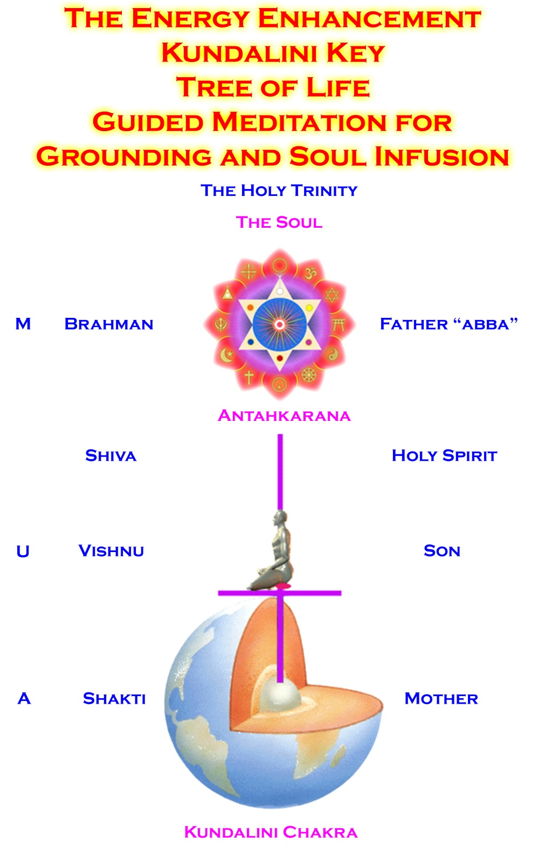
“The shadow, when it is transmuted with Energy Enhancement Meditation, is the source of renewal; the new and productive impulse cannot come from established values of the ego.


Better to transmute your demons than to negotiate with them.

When there is an impasse, and sterile time in our lives — despite an adequate ego development — we must look to the dark, hitherto unacceptable side which has been at our conscious disposal, and transmute it, change it, purify it.….

This brings us to the fundamental fact that the shadow is the door to our individuality, and with Energy Enhancement Meditation, as the shadow renders us our first view of the unconscious part of our personality, it represents the first stage toward meeting the True Self and becoming enlightened.

There is, in fact, no access to the unconscious and to our own reality except through Energy Enhancement Meditation and the grounding, no other techniques exist.

No other techniques to integrate the shadow other than Energy Enhancement Meditation exist.

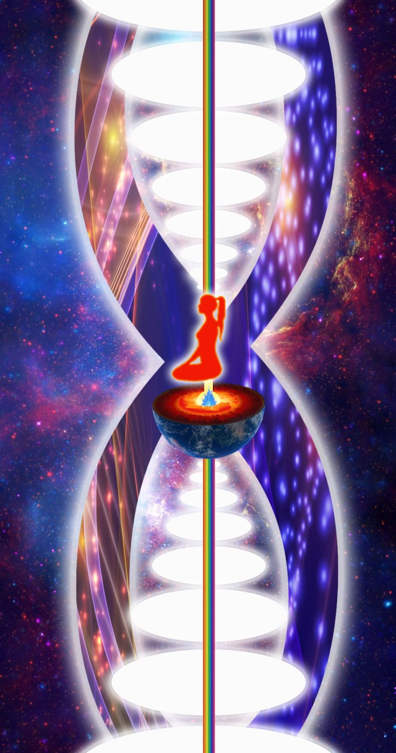

An Energy Enhancement Meditation column of energy, “twixt heaven and earth” which connects us with infinite immortal spiritual energy our psychic body from which it feeds and the basis on which it rests.
Even Jung admitted this. Every psychologist for the last one-hundred years has admitted the dearth of working techniques other than with Energy Enhancement Meditation.

This is the Energy Enhancement Meditation transmutation, the healing, the removal of the negative parts of the shadow, the cleaning and purification of the shadow until only positivity - positive talents and true direction - the Path of the Heart remains.

Only with Energy Enhancement Meditation, when we realize that part of ourselves which we have not hitherto seen or preferred not to see can we proceed to question and find the sources within the universe, our psychic connection to the universe, the infinity of chakras above the head and below the base.

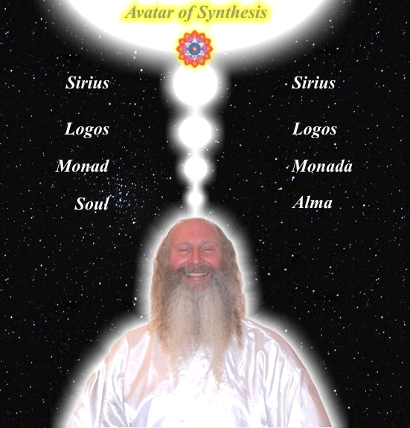

An Energy Enhancement Meditation column of energy, "twixt heaven and earth" which connects us with infinite immortal spiritual energy our psychic body from which it feeds and the basis on which it rests.

Hence no progress or growth is possible until the shadow is adequately confronted with Energy Enhancement Meditation, and confronting means more than merely knowing about it.

It is not until we have truly been energised by this infinite immortal, spiritual energy into seeing ourselves as we really are. Taking the Energy Enhancement Meditation Rite of Passage which shocks us into seeing our true psychic Higher Selves, instead of as we wish or hopefully assume we are, that we can take the first step toward individual reality.

THE “JUST PULL YOURSELF TOGETHER” VIDEO ON YOUTUBE

https://www.youtube.com/watch?v=Y4GYooP6NOU

VIDEO ABOVE.. the famous, "Pull yourself together" video where Satchidanand trashes the greatest most intellectual investigators and descriptors of the Shadow Subpersonalities - Great People - The Highest of All Humanity - Jordan Peterson, Carl Jung, Nieszche, and every Psychotherapy, Psychological therapist who can describe the problem of the Shadow, talk about the problem of the shadow but have no Practical solution to the Shadow. All of those guys Failed to Solve the Problem of the Shadow. None of these guys have Any practical solution for the Shadow.. And it is the Shadow Subpersonalities which is the Source, The Fount, of All Evil on this Planet... And the Source of All Evil within You!!
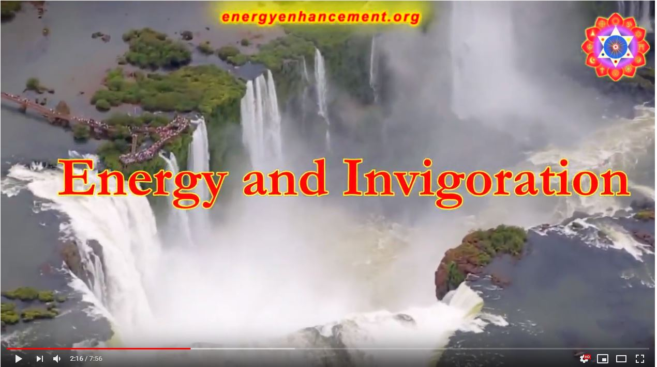
CLICK ABOVE TO SEE THE ENERGY ENHANCEMENT MEDITATION IGUAZU LIVE COURSES VIDEO AT https://www.youtube.com/watch?v=A2CZBQY5MB0
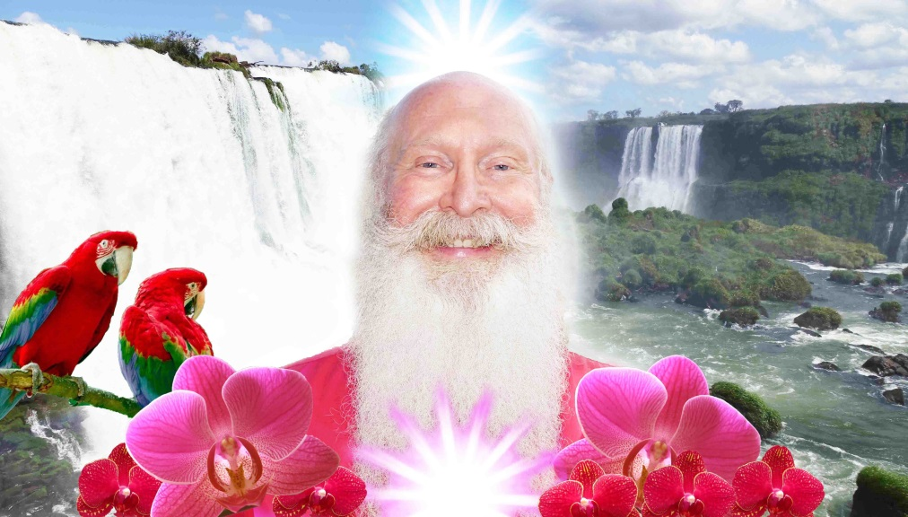
SATCHIDANAND IGUAZU!

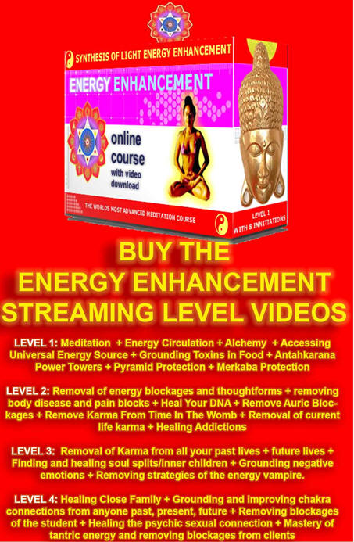

The Energy Enhancement Video Course in Four Levels is the essential Meditation Course which connects us, Powers us up! With Infinite Spiritual Energy and Removes the Shadow - All the Infinite Energy Blockages to which we are Prey.

EE HOME PAGE INTRODUCTION http://www.energyenhancement.org/


EE LEVEL 1 EIGHT INITIATIONS - POWER UP!! GAIN SUPER ENERGY http://www.energyenhancement.org/Level1.htm

EE LEVEL 2 SEVEN INITIATIONS - ELIMINATE ENERGY BLOCKAGES http://www.energyenhancement.org/Level2.htm

EE LEVEL 3 SEVEN INITIATIONS - CLEAN KARMA BLOCKAGES AND PAST LIFE KARMA BY TRANSMUTATION http://www.energyenhancement.org/Level3.htm

EE LEVEL 4 SEVEN INITIATIONS - MASTER ENERGY CONNECTIONS AND RELATIONSHIPS http://www.energyenhancement.org/Level4.htm

Live Energy Enhancement Meditation Courses in Brazil - Iguazu Falls is the Seventh Wonder of the Natural World - it's an incredible Power Center to learn Energy Enhancement - and India where its Summer in your Winter!

DOWNLOAD FREE!! THE ENERGY ENHANCEMENT FOUR LEVEL COURSE BOOKS IN FOUR FREE!! VOLUMES AND 20 MORE..

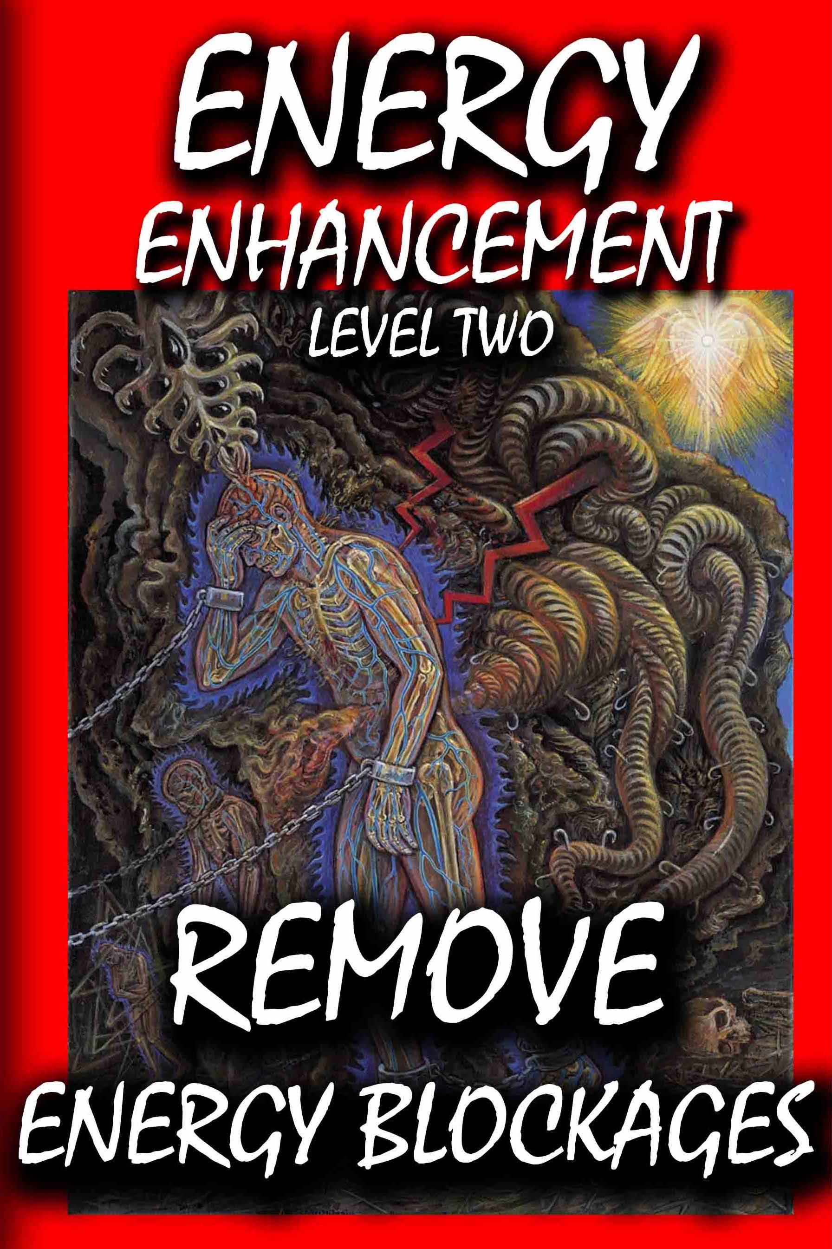

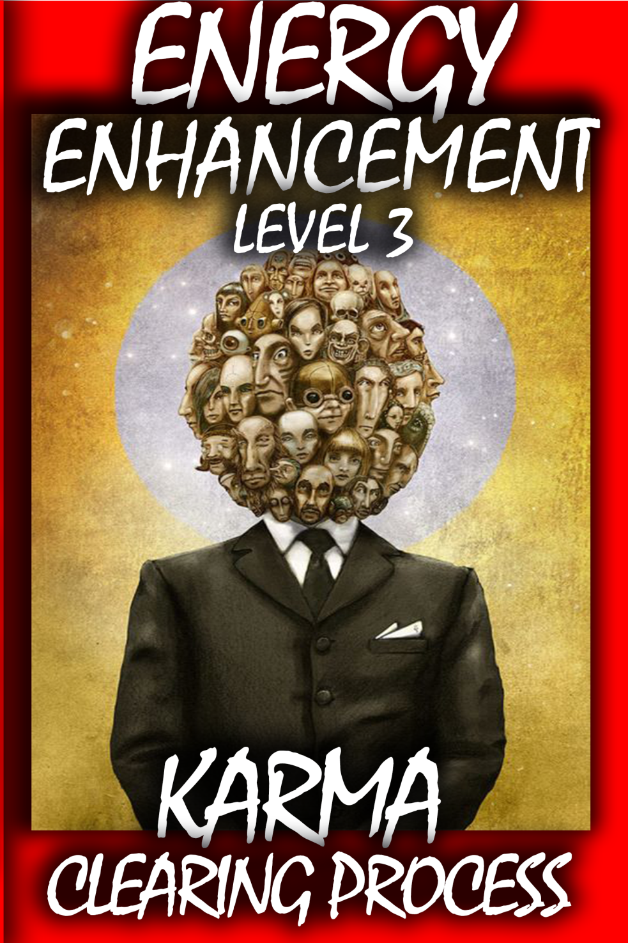

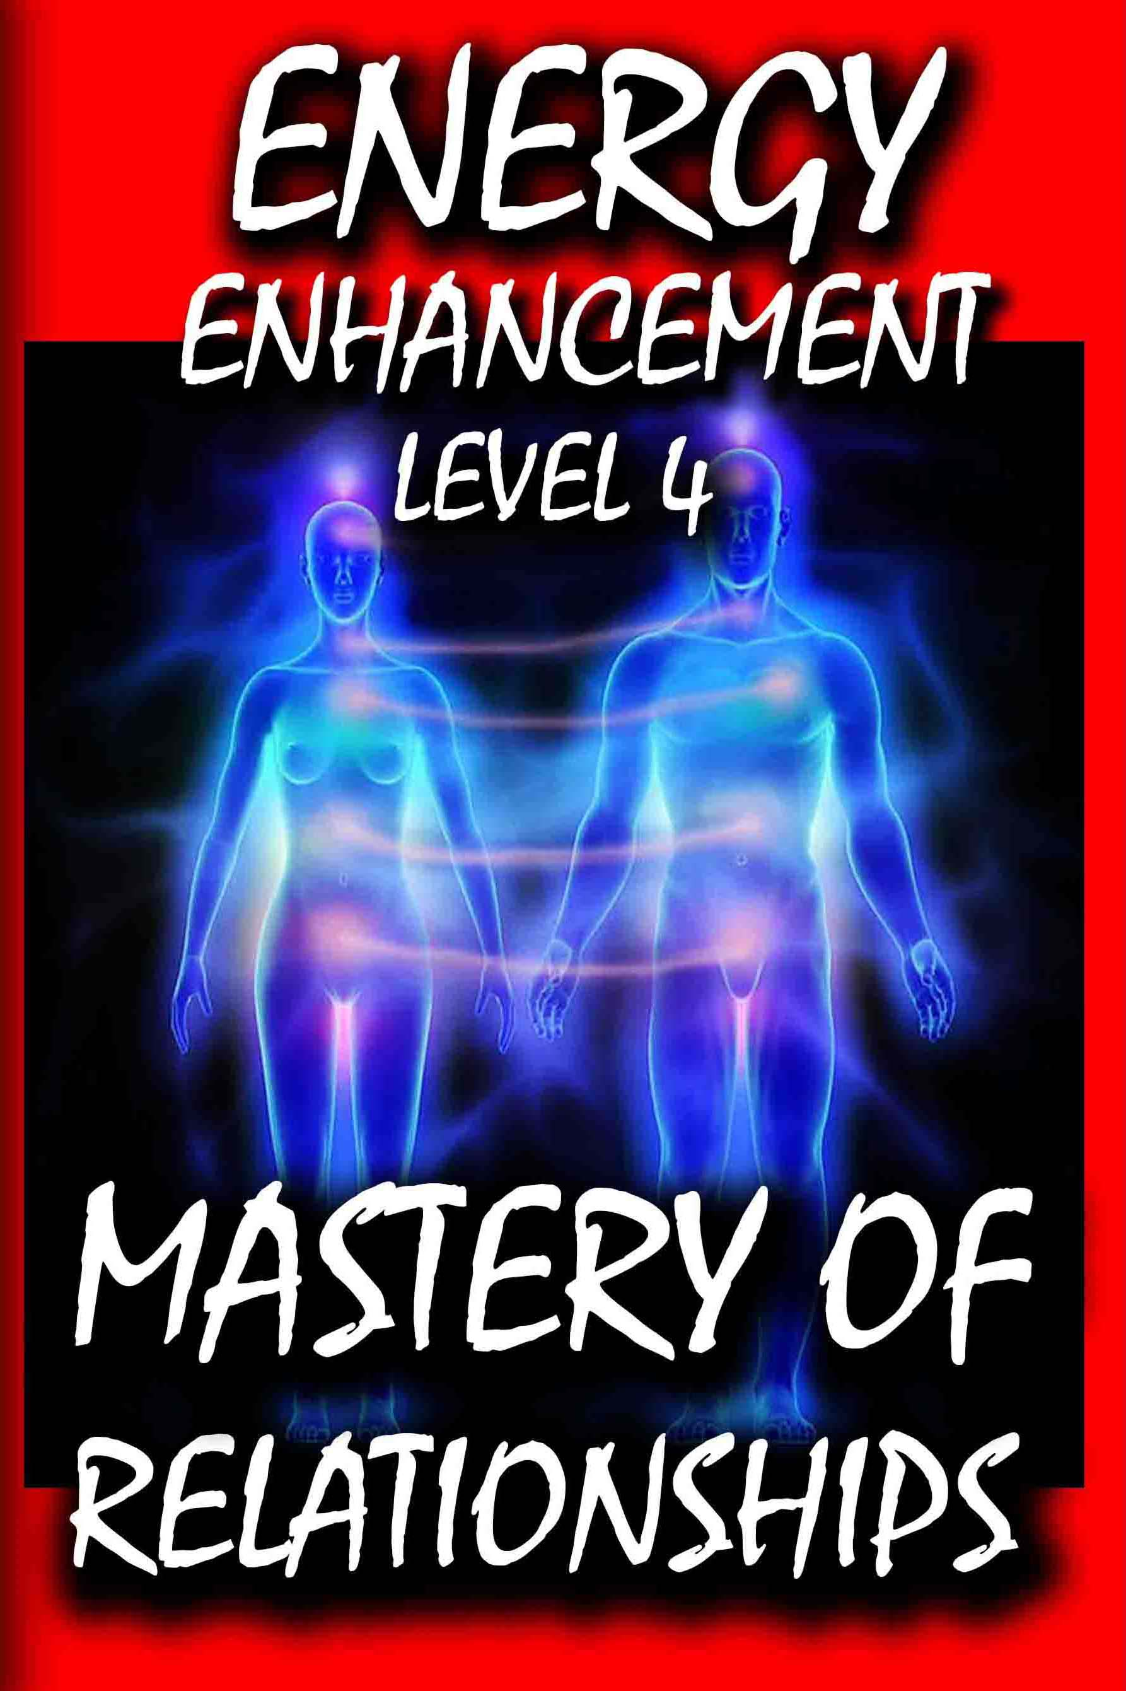

ONLY! Energy Enhancement Meditation gives you the techniques, the ability, to Eliminate the negative and accentuate the positive...

You've got to accentuate the positive
Eliminate the negative
And latch on to the affirmative
Don't mess with Mister In-Between

You've got to spread joy up to the maximum
Bring gloom down to the minimum
Have faith or pandemonium's
Liable to walk upon the scene

To illustrate my last remark
Jonah in the whale, Noah in the ark
What did they do just when everything looked so dark?

(Man, they said "We'd better accentuate the positive")
("Eliminate the negative")
("And latch on to the affirmative")
Don't mess with Mister In-Between (No!)
Don't mess with Mister In-Between

(Ya got to spread joy up to the maximum)
(Bring gloom down to the minimum)
(Have faith or pandemonium's)
(Liable to walk upon the scene)

You got to ac (yes, yes) -cent-tchu-ate the positive
Eliminate (yes, yes) the negative
And latch (yes, yes) on to the affirmative
Don't mess with Mister In-Between
No, don't mess with Mister In-Between

Johnny Mercer

GET IT NOW!!
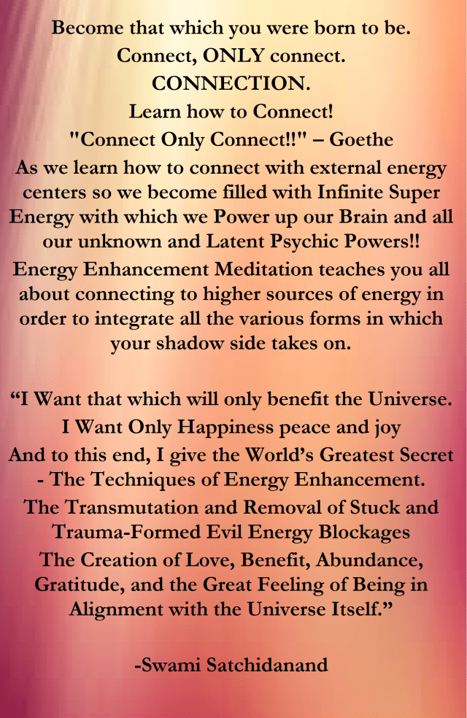

The bold few who practise meditation contact the real reality, an infinite spiritual energy which activates a Rite of Passage which powers up inner resources freeing up and Intensifying Spiritual energy and powering up unconscious abilities – psychic powers and visions never before entered into, never before encountered. Parts of ourselves we never knew existed before we activated and energised with these Energy Enhancement techniques.
You see.. You don’t know who you really are.
If you knew who you really were you would never feel inferior, afraid, incompetent, depressed, juvenile, incomplete.
If you knew who you really were your search would be over.
You would be here.
Now.
You are a part of the universe.
You are the universe.
But you are disconnected.
You do not inhabit yourself.
It’s as if you have a Palace but only live in one room.
Inhabit All of yourself.
Stretch out and grasp that which you already have, within.
Connect to every part of yourself.
Grow into that infinite template recorded in your spiritual DNA
You are like a seed which has been kept in a box.
Get out of the Box.
Germinate that seed.
Energise that seed!!
Plant it in the good earth.
Roots down into the Center of the Earth.
Leaves stretching up into the Central Spiritual Sun.
SACRED TREE -YGGIDRASIL
Grow.
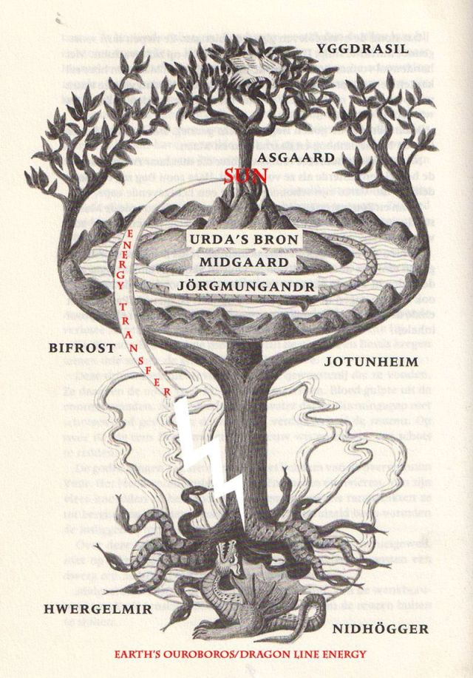
It is also, more ancient, the shape of the Ankh from Egypt and thus the first Alchemist Hermes Trismegistus because this meditation is codified in VITRIOL – the first formula of Alchemy.
“Myths are first and foremost psychic phenomena that reveal the nature of the soul.” -Carl Jung
The spiritual reality of our conscious and unconscious experience is the key to unifying our duality. Psychological analysis is insightful and can make things more tolerable and manegable at best and overwelheming and mentally exhausting at worse. This is because the insights that psychology gives are abundant whereas the solutions offered for these are few if any and not very helpful.
“Well, what do I do Doc?”
Psychologists say, “Well, you have to look inside yourself and figure it out…and you can tell me all about next session”
Energy Enhancement Meditation – Spiritual Insight – combined with psychological knowledge is THE complete way of processing and integrating your Shadow Side into wholeness.
Why? How?!!
Because Energy Enhancement Meditation has actual ancient time-tested meditive techniques that you can use and apply to your Shadow work. As long as we have a Shadow Side we have Negative Karmic Mass – trauma, pain, fustration, pessimism, depression, anxiety, grief, bitterness, spitefulness, jealousy, anger, greed, lust, addiction, escapism etc. These all need to be addressed and healed – transmuted and integrated.
You need energy to do this and Energy Enhancement Meditation teaches you how to power yourself up!
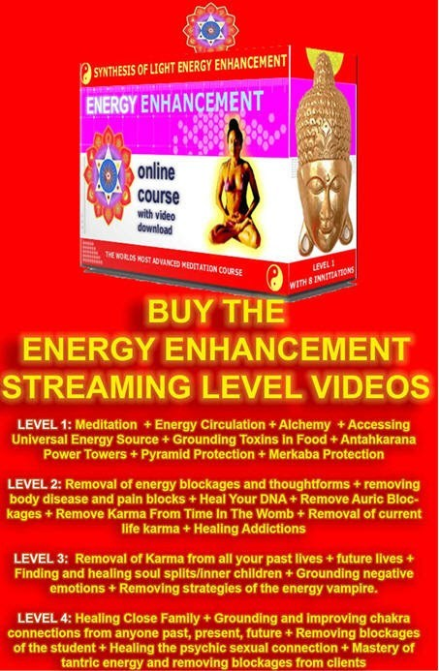

Go to http://www.energyenhancement.org for 21 Free Energy Enhancement Books.

To defeat Evil, you need to up your game. Learn the Energy Enhancement Meditation Course by Video or Live in Iguazu.
Energy Enhancement Meditation uses the Psychic Spiritual Center – Third Eye as primary gateway into healing yourself. If we just use psychological analysis then we are limited. If we just use creative therapies, dream exploration, trance-work etc then we are also limited still. This is because we need it all, both sides.

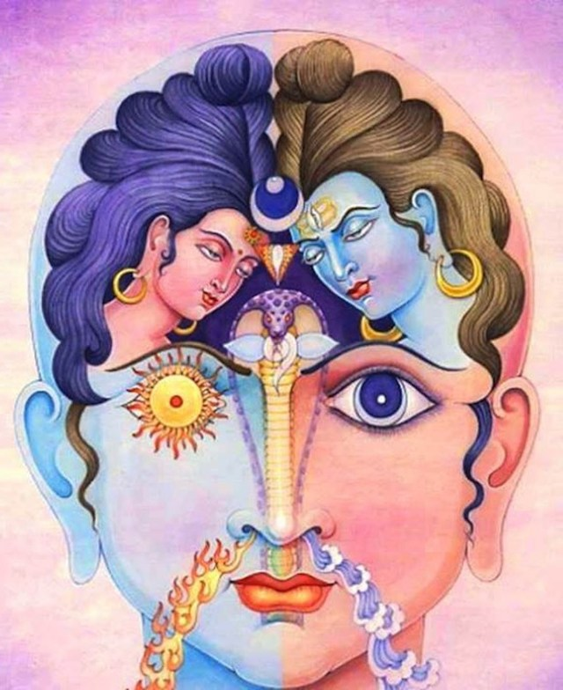

The image above depicts unification of the conscious and the unconscious., night and day, hot and cold, masculine and feminine. In the center is the Ajna Chakra – Third Eye. The kundalini Serpent has risen from the Muladhara – Base Chakra to the Third Eye Center. The symbolic meaning of its risen state is a raised consciousness that has dissolved duality. A state of Wholeness – Integration – Enlightenment.

“Come together, right now,
over me”
Singing these famous song lyrics from the Beatles to yourself, You can come together, surpassing your current-self to a higher-self!
With Energy Enhancement Meditation.
THE “JUST PULL YOURSELF TOGETHER” VIDEO ON YOUTUBE

https://www.youtube.com/watch?v=Y4GYooP6NOU

VIDEO ABOVE.. the famous, "Pull yourself together" video where Satchidanand trashes the greatest most intellectual investigators and descriptors of the Shadow Subpersonalities - Great People - The Highest of All Humanity - Jordan Peterson, Carl Jung, Nieszche, and every Psychotherapy, Psychological therapist who can describe the problem of the Shadow, talk about the problem of the shadow but have no Practical solution to the Shadow. All of those guys Failed to Solve the Problem of the Shadow. None of these guys have Any practical solution for the Shadow.. And it is the Shadow Subpersonalities which is the Source, The Fount, of All Evil on this Planet... And the Source of All Evil within You!!

Nietzsche, Carl Jung and Psychology Challenged by Energy Enhancement Meditation, Be One, Integrate the Shadow, Soul Retrieval - Enlighten

Remember the famous, "Pull yourself together" video where Satchidanand trashes the greatest most intellectual investigators and descriptors of the Shadow - Great People - The Highest of All Humanity - Jordan Peterson, Carl Jung, Nieszche, and every Psychotherapy, Psychological therapist who can describe the problem of the Shadow, talk about the problem of the Shadow but have no Practical Solution to the Shadow. All of those guys Failed to Solve the Problem of the Shadow. None of these guys have Any practical solution for the Shadow.. And it is the Shadow which is the Source, The Fount, of All Evil on this Planet... And the Source of All Evil within You!!

Satchidanand talks about the problem and introduces the ONLY practical solution to the dissolution, the healing, The Removal, of the Shadow. The Removal of All Trauma and Pain from the Pain Body.

The Integration of the Soul. - With Energy Enhancement Meditation..

In 1888, a few months before the end of his most prolific, and final period of writing, Friedrich Nietzsche wrote in Ecce Homo:

“That a psychologist without equal speaks from my writings – this is perhaps the first insight gained by a good reader.” (Ecce Homo)

Nietzsche viewed himself as the first psychologist amongst the great philosophers, writing:

“Who among the philosophers before me was in any way a psychologist? Before me there simply was no psychology” (Ecce Homo)

Given that Sigmund Freud, Carl Jung, and Alfred Adler, three giants of 20th century psychology, were all heavily influenced by Nietzsche’s psychological insights, his grandiose self-assessment seems to have contained at least a kernel of truth.

Nietzsche’s psychological investigations were not conducted for the sake of disinterested theoretical speculation; as in his eyes, knowledge should always be sought first and foremost for the purpose of energizing life. In his essay On the Use and Abuse of History for Life, he quoted Goethe:

“I hate everything that merely instructs me without augmenting or directly invigorating my activities.” (Goethe)

Nietzsche undertook his psychological ventures for the sake of discovering how to fulfill the maxim which formed the subtitle of his autobiography Ecce Homo – “How One Becomes What One Is”.

In the Gay Science, Nietzsche echoed this idea:

“What does your conscience say? – ‘You shall become the person you are’.” (The Gay Science)

"Become the person you were born to be!" - Satchidanand
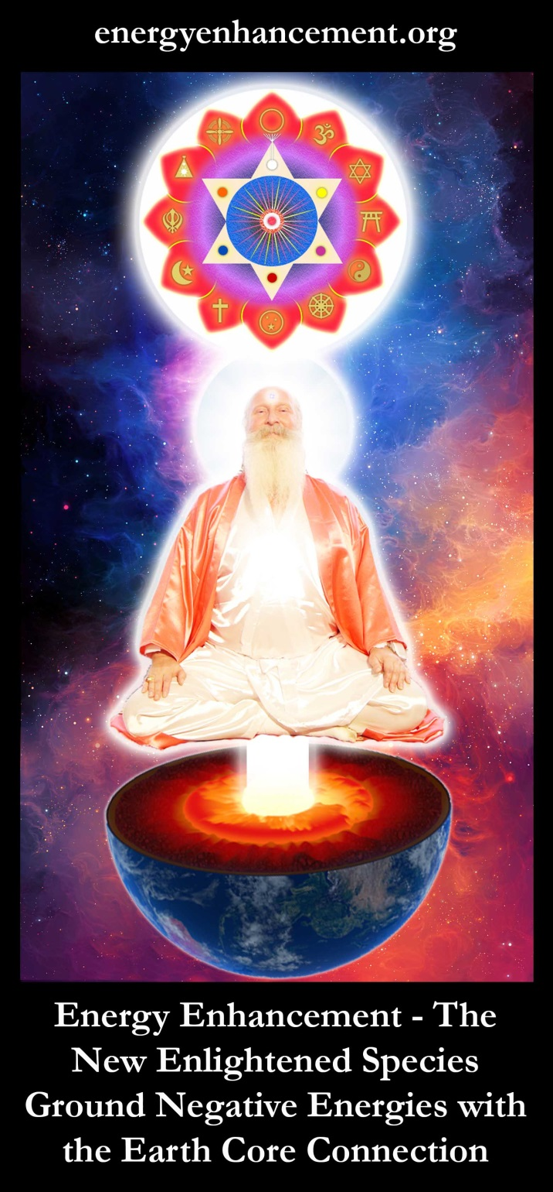
SATCHIDANAND - THE SOUL CHAKRA IS THE FIRST CHAKRA ABOVE THE HEAD - ENERGY ENHANCEMENT MEDITATION
You were born with Spiral Spiritual DNA which reaches into the Fission powered Core of the Earth and up into the Fusion Powered Stars.

Here, we will shed light on what it means to “become who you are” and in the process explore some of Nietzsche’s and Energy Enhancement Meditation's fascinating psychological and Spiritual insights.

Countless philosophers have attempted to understand the human mind, discern its tendencies, biases, potentials, nature, and origin. But Nietzsche claimed that all those before him were blinded in their psychological ventures by an unquestioned acceptance of not only the socially prevailing beliefs and moral standards, but more significantly, by a fear of exploring the depths within themselves. In Beyond Good and Evil Nietzsche explained:

“All psychology so far has got hung up on moral prejudices and fears: it has not dared to descend into the depths.” (Beyond Good and Evil)

Nietzsche conceived the psyche as constituted by multidimensional layers, separate desires, urges, personalities and possessing a complexity which renders total and complete knowledge of it an impossibility. Heraclitus, the Presocratic Greek philosopher whose aphorisms exerted a heavy influence on the development of Nietzsche’s ideas, captured the complex quality of the psyche:

“If you went in search of it, you would not find the boundaries of the soul [psyche], though you traveled every road – so deep is its measure [logos].” (Heraclitus)

Nietzsche similarly wrote:

“How can the human being know itself? It is a thing dark and veiled; and if the hare has seven skins, the human can slough off seventy times seven and still not be able to say, ‘Now that is what you really are, that is no longer outer shell.’” (Untimely Meditations III)

Most individuals, fearing the complex depths within, remain at the superficial and surface layer of their psyche, “industriously mindful of their common comedy and not at all of themselves.” (Untimely Meditations III) Not one to follow the crowd, Nietzsche took an opposing approach:

“I undertook something that not everyone may undertake: I descended into the depths, I bored into the foundations.”(Dawn of Morning)

A fear of descending into the depths of one’s psyche is not unfounded, but only because there is no method of changing and purifting the Psyche according to Any Psychologist or Philosopher in the World, prior to Energy Enhancement Meditation!

Who amongst them?

Any Psychologist or Philosopher in the World, ever became Enlightened, removed all their Energy Blockages, multidimensional layers, separate desires, urges, personalities and possessing a complexity which - according to them –

All the Psychologists or Philosophers in the World, renders total and complete knowledge of the Psyche and methods of healing the Psyche, an impossibility.

Which is why they All –

All the Psychologists or Philosophers in the World - thought it is “something that not everyone may undertake”.

Which is why they All –

All the Psychologists or Philosophers in the World - thought that for those who lack sufficient courage and are ungifted in psychological investigations, a voluntary descent into the inner foundations of one’s mind could engender temporary, or in rare cases, permanent, madness.

"YOU ARE WHAT YOU DO, NOT WHAT YOU SAY YOU'LL DO!" - Carl Jung –

And Gurdjieff used to say, "The man who says he will get up at six in the morning to meditate, is not the same person who throws the alarm clock out of the window."

And this split mind is the result of the shadow which exists in EVERY human being.

Is there a “Technique” to Integrate the Shadow?

Without Energy Enhancement Meditation there is no technique which can transmute the shadow and create a happy enlightened being..

There is a Path!!

Carl Jung says..

“There is no generally effective technique for assimilating the shadow. It is more like diplomacy or statesmanship and it is always an individual matter. First one has to accept and take seriously the existence of the shadow. Second, one has to become aware of its qualities and intentions. This happens through conscientious attention to moods, fantasies and impulses. Third, a long process of negotiation is unavoidable.” (Carl Jung)

YOU CAN NOT NEGOTIATE WITH EVIL!!

BUT YOU CAN TRANSMUTE EVIL WITH ENERGY ENHANCEMENT MEDITATION.

YOU CAN REMOVE THE EVIL WITH ENERGY ENHANCEMENT MEDITATION..

WRESTLING WITH THE SHADOW

As Jung notes in the passage above, he thought there is no general technique to integrate the shadow, even though the Buddha and Jesus Christ exemplified otherwise.

For thousands of years great souls have come to earth to demonstrate otherwise, that enlightenment is, "Tat tvam asi" Thou art that!! You are a part of the Universe and have nothing else to seek.

Our shadow is not unique, it exists in EVERY human being, and thus, to integrate it requires a general process of Energy Enhancement Meditation which acts in the same way on all humanity. "Eliminate the negative, accentuate the positive, That's what gets results!" Lyrics, Johnny Mercer

Poor Philosophers and Psychologists of the World write about the problem of the Shadow having no techniques to help the problems they see.

Writing of the dangers which confront the “adventurer and circumnavigator of that inner world called ‘human being’”, Nietzsche wrote:

“He enters a labyrinth, and multiplies a thousandfold the dangers that life in itself brings with it – of which not the least is that nobody can see how and where he loses his way, becomes solitary, and is torn to pieces by some cave-minotaur of conscience.”(Beyond Good and Evil)

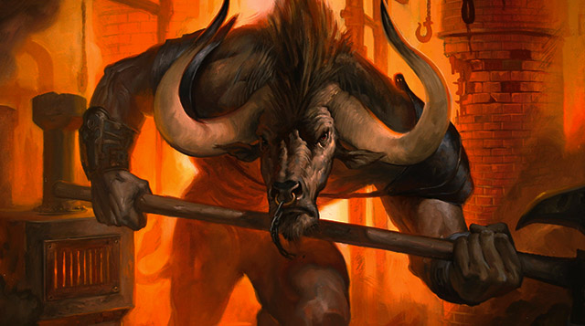
MINOTAUR

While exploring the depths within may be a foolish danger for the many, it is a necessary endeavor for the few.
But to attempt to enter the "labyrinth, and multiplies a thousandfold the dangers that life in itself brings with it" without being, "torn to pieces by some cave-minotaur of conscience" - without a working technique?

To attempt to enter the "labyrinth, and multiplies a thousandfold the dangers that life in itself brings with it" without being, "torn to pieces by some cave-minotaur of conscience"

- To try to enter the Mind Labyrinth without the Energy Enhancement Technique of Alchemical VITRIOL Meditation to remove all the Energy Blockages, multidimensional layers, separate desires, urges, and subpersonalities of the Psyche?

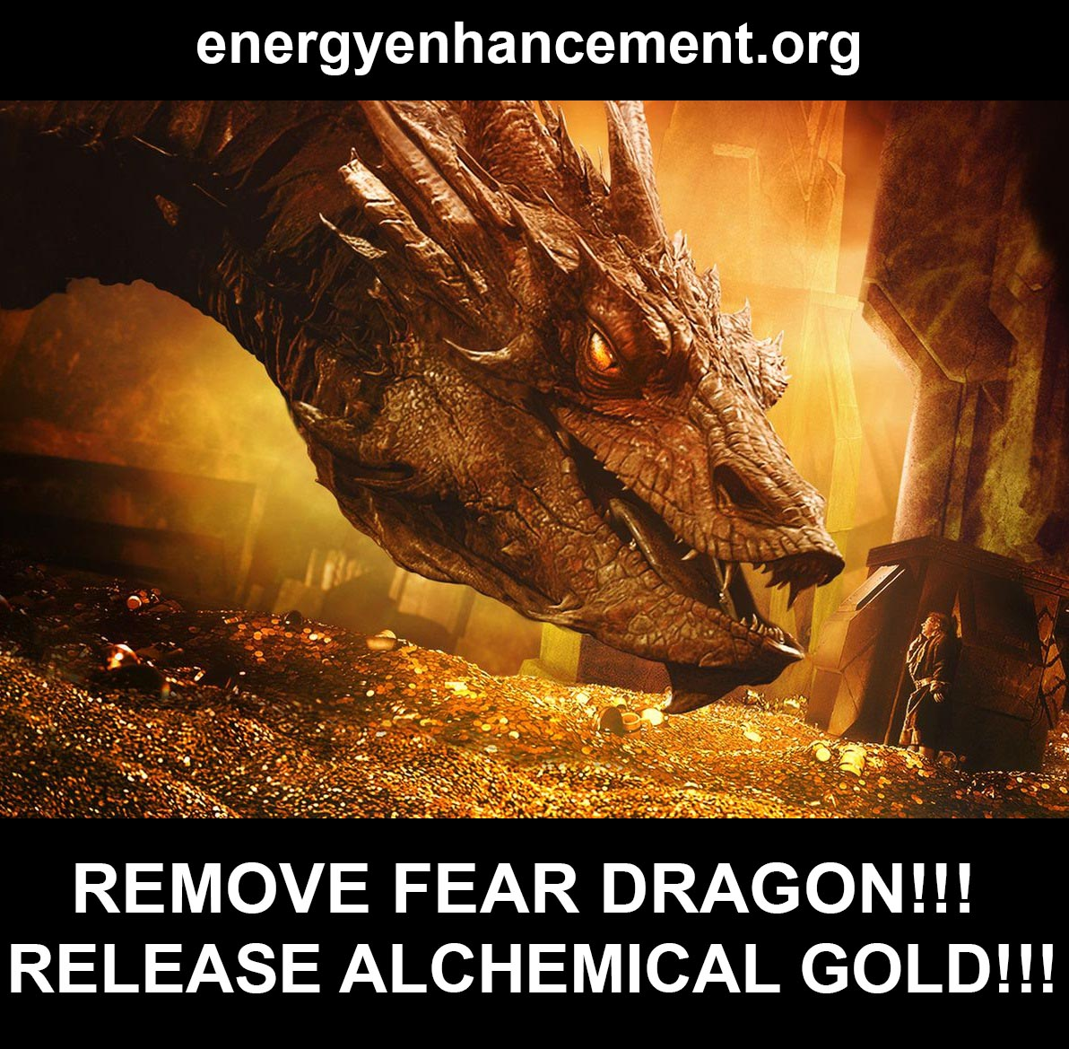
Remember Tolkien - Professor of the Ancient Myths at Oxford University - who wrote about the Hobbit, who journeyed deep into the depths of the earth, there to Kill Smaug, the Dragon of Fear..

- And there to release the Star of the Arkenstone..

And an unremitting Torrent of GOLD!!

Abundance, Riches, Wealth!

WITH ENERGY ENHANCEMENT!!

THE ONLY COURSE TO TEACH THE SEVEN STEP PROCESS!!

ENERGY ENHANCEMENT MEDITATION - DEEPER THAN THE INTELLECT, MORE PROFOUND THAN THE MIND!

Originally this Myth came from Alchemical VITRIOL.
An Ancient Meditation designed to remove Trauma from Memories!!

TRANSMUTE ALL PAIN AND FEAR WITH THE ANCIENT TECHNIQUE OF ENERGY ENHANCEMENT ALCHEMICAL VITRIOL

VITRIOL IS A LATIN ACRONYM

VITRIOL. – Visita Interiore Terrae Rectificando Invenies Occultem Lapidem.

VITRIOL - THE GROUNDING AND TRANSMUTATION OF ENERGY BLOCKAGES –

Has been removed from all Traditional Meditations –

Thus "Traditional forms of meditation are designed to fail!!"
READ ALL THE TECHNIQUES TAKEN OUT OF TRADITIONAL MEDITATIONS AND PUT BACK BY ENERGY ENHANCEMENT!!

WHICH CAN TRANSMUTE BASE METAL - FEAR, SADNESS, TRAUMA, ANGER, MANICISM, DEPRESSION

- THE ENERGY BLOCKAGES OF THE BASE CHAKRA -
INTO THE PURE SPIRITUAL GOLD

- THE PURE GOLDEN ENERGY OF ENLIGHTENMENT

Nietzsche’s psychological insights are wide, varied, and always penetrating – a result of his ardent conviction that the psyche of modern man was in dire need of being dissected, But his lack of Meditational Technology crippled and eventually destroyed his process.

Without Energy Enhancement Meditation, it is impossible to speed up the Spiritual Meditational process such that is possible to achieve Enlightenment in only one lifetime.

Just read this report from our student who had tried many methods of meditation with other Masters..

"Satchi’s energy is amazing and just watching his videos would charge me up with softness and bliss. The energy I felt from watching the videos not only enabled me to see my own blockages, but I could feel some of them rising to the surface and then getting dissolved by light.

Satchi is very helpful in email’s and I have emailed him many times…he got back to me and gave me some hard truths and also honest support which helped me to continue making progress.

The frequency of energy is the most powerful and high frequency I have worked with, it charged me up really fast and enabled me to see blockages psychically.- I started to sense astral beings a lot more (most of them not very nice) but we got taught how to deal with these in Energy Enhancement Meditation Level 2 with the Seven Step Process.

I also felt some very wonderful presences of spirits and ascended Masters associated with the course who were helping teach me.

- The Energy Enhancement Meditation Level 2 method 7 step Process of removing energy blockages is simply amazing.

I use it every day. I’ve used it to dissolve or ‘ground’ negative emotions, fear, anger, to clear negative energy from astral entities, deceased human spirits who were inside my aura… random spirits who would come to me to get guided to the light and so on.

This method has been far superior than all other methods which I have used.

- The The Energy Enhancement Meditation Level 2 methods allowed me to personally get through some very bothersome subconscious programming and blockages which no other methods were healing… I was under heavy psychic attack at this point and I got what I needed to stop it. Problems grounded and dissolved in the light of the earth chakra.

- The The Energy Enhancement Meditation Level 3 methods to remove deep karma - The Karma Cleaning Process - actually do work. I said in another report that I saw that it would have taken me 500 lifetimes to clear my Karma and become Enlightened . Now using Energy Enhancement Techniques I see that all those 500 lifetimes of Karma have been dissolved!!

Perhaps Enlightenment is Next!!

My body feels so bright and purified, so light and fresh, I have used these methods to clear the karmic bonds between me and other human souls. It feels like all the ‘history’ between you becomes instantly neutralized back into peace and light.

Although it also dissolves the ‘good’ karma too, for example it will neutralize attachment’s between you and others and make you feel a more evenly spread benevolent peace to humans in general.

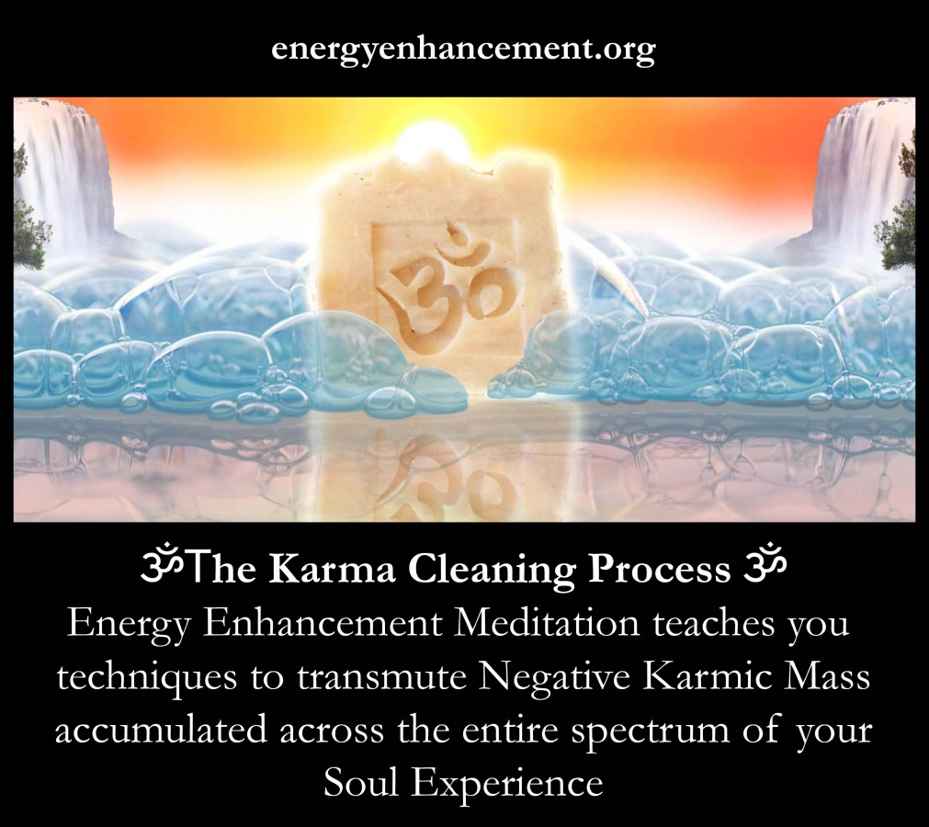

So I’m currently in the middle of energy enhancement level 3 (out of 4 levels).

It is very good. The methods are extremely powerful. I am having difficulty going back to my previous method’s of yoga and Meditation because the one's Satchi gave me are just too powerful and effective." Energy Enhancement Student 2018

But despite Nietzsche's piercing observations, there are critics who claim his insights into the nature of the human mind are irrelevant because of the fact that at the young age of 44 he fell victim to a mental illness which remained with him until the end of his relatively short life. Ignoring the fact that his illness may have been of an organic origin, there are some who may ask: Why should anyone pay attention to ideas on how to “become who you are” from a man who went mad?

I think this is a valid criticism..
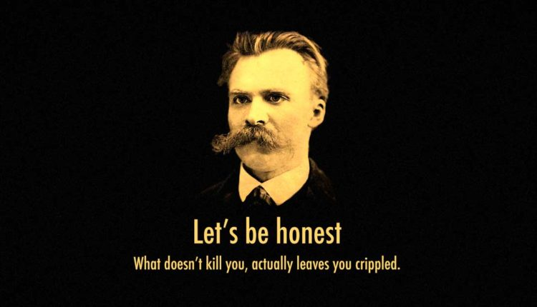
Nietzsche

ALL FAILURE IN LIFE IS BECAUSE OF THE SHADOW!!

To which Nietzsche weakly replied, “There is a false saying: “How can someone who can’t save himself save others?” Supposing I have the key to your chains, why should your lock and my lock be the same?” (Nietzsche, KSA 10:4[4])

The psyche of a small minority of individuals, in comparison with that of the overwhelming mass, is constituted by both greater depths and a higher degree of turmoil. To ensure they are not torn asunder by the contradictions, conflicts, and abysses within, such individuals are driven inward to explore and impose order on their psyche – trying to fashion and sculpt themselves into a “harmonious totality”.

BUT WITHOUT ENERGY ENHANCEMENT MEDITATION, ALL THESE ADVANCED HUMAN BEINGS WERE DOOMED TO FAILURE!!
The Dark Side says, "I am Enlightened because I say I am Enlightened, because I want to be Enlightened" - Doomed to failure!!

Only the Spiritual, Meditative, methods of Buddha, Krishna and Jesus Christ have ever been successful in creating Enlightenment..

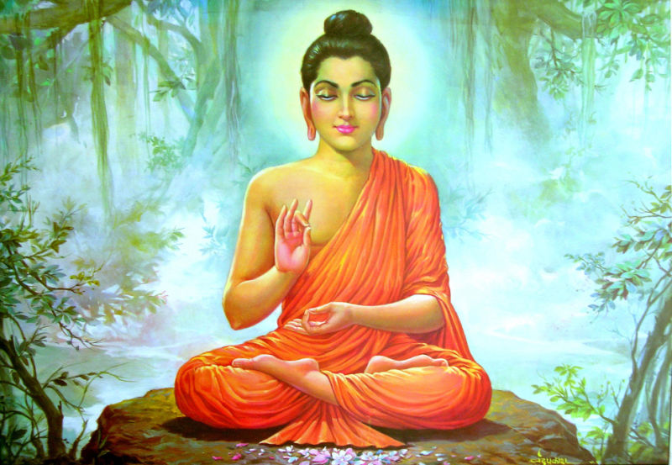

For thousands of years great souls have come to earth to demonstrate that enlightenment is, "Tat tvam asi" Thou art that!! You are a part of the Universe and have nothing else to seek.

THE SOUL

To create oneself does not mean to form oneself out of nothing. As humans, we cannot, as some falsely claim, be fashioned in any way we please. Each of us, according to Nietzsche, has a deep and abiding nature - THE SOUL - which places definite set limits on who and what we can become.

“At the bottom of us, really “deep down,” there is, of course, something unteachable, some granite of spiritual fatum - personal fate or destiny, of predetermined decision and answer to predetermined selected questions. Whenever a cardinal problem is at stake, there speaks an unchangeable “this is I.” (Beyond Good and Evil)

Our nature is sculpted not only by early personal life experiences and the traits and dispositions inherited from our ancestors, but also, according to Nietzsche, by historical forces. The traditions and “experiments” of past cultures continue to live on within us, influencing our life and experience from the deeper layers of our psyche.

“The past of every form and way of life, of cultures that formerly lay right next to or on top of each other, now…flows into us “modern souls”; our drives now run back everywhere; we ourselves are a kind of chaos.” (Beyond Good and Evil)

Given that the “the past of every form and way of life” continues to live on in us, Nietzsche proposed we need to engage in an active exploration of history, if we are to attain self-knowledge.

“Direct self observation is not nearly sufficient for us to know ourselves: we need history, for the past flows on within us in a hundred waves.”(Human All Too Human)

Just as the past continues to live on in modern cultures, embodied in myths, traditions, and institutions, so too our psyche has been shaped and sculpted by past ages.

The tendency of the modern individual to feel he has been arbitrarily thrown and abandoned into an absurd world is the direct result of lacking what Nietzsche called a “historical sense” – of having no conscious connection to the past, and therefore failing to dig one’s roots through the strata of history.

In an early essay titled On the Use and Abuse of History for Life, Nietzsche contrasted “the condition of a people which has lost faith in its ancient history and has fallen into a restless…and a constant search for novelty after novelty”, with the individual who has cultivated a “historical sense”, and attained “the sense of well being of a tree for its roots, the happiness to know oneself in a manner not entirely arbitrary and accidental, but as someone who has grown out of a past, as an heir, flower, and fruit.”

But it is not only the cultures of past millennia which continue to live on within us.

For in the deeper layers of our psyche exist prehistorical drives and impulses.

Just as our body contains relics of earlier developmental stages, stretching back even to the reptilian age, so too our psyche contains within its depths primitive drives which stretch back into the prehistory of humanity and animality.

Every human being, no matter how civilized and developed on the surface. Is still an animal and archaic man within the depths of his being.

“I have discovered for myself that ancient humanity and animality, indeed the entire primal age and past of all sentient being continues in me to create, to love, to hate, to infer.” (The Gay Science)

In these uncivilized layers reside what Zarathustra called “the beast within” – potentially destructive inclinations which can overtake and possess the human being, such as the drive to aggression and unbridled sexual lust.

Instead of advocating for the repression of the beast within, Nietzsche recommended we explore and become familiar with these potentially destructive vestiges of the ancient past. Just as a raging river can be harnessed for its energy, so too the uncivilized layers of the psyche, if channeled and handled properly, can vitalize life.

“[The] most shortsighted and pernicious way of thinking wants to make the great sources of energy, those wild torrents of the soul that often stream forth so dangerously and overwhelmingly, dry up altogether, instead of taking their power into service and economizing it.” (Nietzsche)


"Yes, these drives are destructive because they are driven by the shadow and entering into them without the ability to transmute the shadow, remove the shadow, is a sure way to hell, and is the cause of all failure on the Path of Enlightenment." -Satchidanand

Yes, these drives are destructive because they are driven by the shadow and entering into them without the ability to transmute the shadow, remove the shadow, is a sure way to hell.

But it is not only destructive drives and impulses which reside in the prehistoric layers of our psyche; there also exists what Nietzsche called the “divine animal” – ancient instincts, “regulating, unconscious and infallible drives” (On the Genealogy of Morality), which enabled our ancestors to survive and even flourish in harsh and uncertain environments prior to the emergence of the modern form of consciousness.

The modern individual has all but lost touch with these ancient instincts. Relying solely on his consciousness, his “weakest and most fallible organ”, he stumbles blindly through life, oblivious that in the recesses of his mind are archaic helpers, which, if he knew how to harness them, could assist him in the many situations in life where consciousness fails.

Speaking of the modern individual, Nietzsche wrote:

“He has lost and destroyed his instinct, and can no longer trust the “divine animal” and let go the reins when his understanding falters and his way leads through deserts.” (Untimely Meditations II)

Without Energy Enhancement Meditational Technology to Ground Negative Energies, remove Energy Blockages and complete the Karma Cleaning Process it is impossible to purify destructive drives and impulses which reside in the prehistoric layers of our psyche, Ancient Instincts, so they can be safely released in a fountain of Purified Power..

Without Energy Enhancement Meditational Technology, repression of the beast within is the safest option.

Within us exists 1000 lifetimes of experience, talents and trauma.
By grounding the trauma of all these 1000's of lifetimes within us in a prescribed, regulated, easy way, we Karma Clean our Psyche, our illogical behaviours, our driven emotions, and stop all triggering.
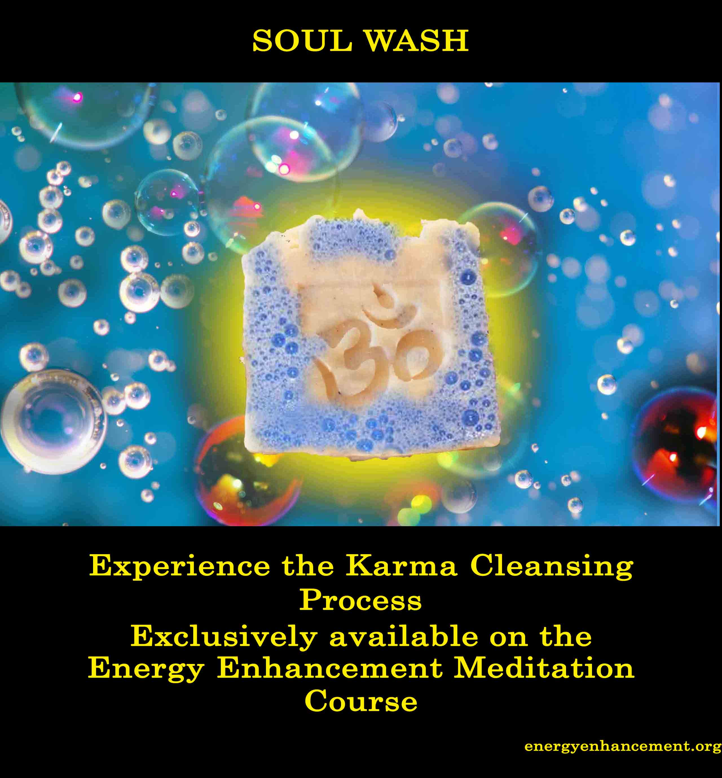

Report.. "As soon as I started to watch Energy Enhancement Meditation Level 1 video’s, I started to visually see blockages in my mind’s eye.

The ones I saw looked like dark shapes, such as any of the following: spiders, black clouds, triangles, spheres or other dark black of grey objects within my aura.

These blockages seemed to have their own thoughts and emotions and they were tricking me into believing they were the ‘real me’, but in reality they were leeching energy like parasites.

They would shout at me ‘Don’t do it! Don’t do the course. You need us.’

Then they would wriggle away like snakes and hide in deeper area’s of my aura.

I would have to visualize plucking them out like worms and dissolving them with light.

The best, fastest method of dissolving them was to trap them in the light bubble and bring them down to the center of earth, or up in the sirius chakra and hold them there 'till they dissolved (which they did).

After that I would see more blockages, it felt like I was travelling into my soul basement and shining a torch in there…only to find dark evil cockroaches, insects and parasites.

Not a pleasant place. But you have to first see darkness, before you can free the darkness, to be able to clear it out.

No more digging my head into the sand and pretending it isn’t there.

Keep in mind that my Taoist Alchemy practice, Reiki and other Qigong Meditations were not helping me with these extremely bizarre and extraordinarily tough energy blockages and desires and intrusive thoughts… which went on for months despite doing my normal meditations.

Only when I did Energy Enhancement Meditation Level 2 methods, the seven step process, was I able to locate and dissolve these problems in the earth’s core and that finally did start to clear out the darkness.

Anyway I know what I’m doing and it’s going very well.

I hope this message gets out to someone who needs it…There are not many energy enhancement reviews out there although there are 50 and more!! Fantastic reports on the Energy Enhancement Meditation site, so I’ll make sure I talk about it openly because it has helped me so much."

Energy Enhancement Meditation Level Student 2018

Further, we go through the process of Soul Retrieval. Healing those parts of the psyche, integrating them with the Soul, until, "There is only One!"

"THERE CAN ONLY BE ONE!" - HIGHLANDER

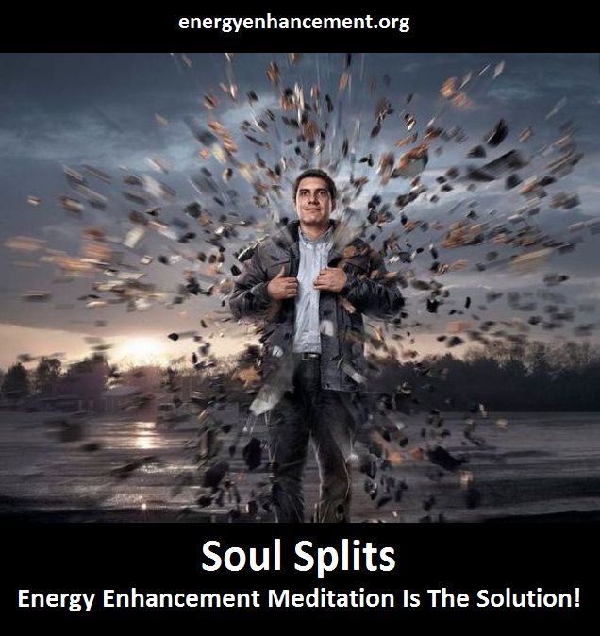

THE SHADOW
The presence of historical, prehistorical, and animal drives has contributed to the existence of an “abundance of contrary drives and impulses” within us – “we ourselves are a kind of chaos”, as Nietzsche put it - Soul Splits! Subpersonalities! In contrast to other philosophers who have posited the human mind to be above all something unitary, Nietzsche radically proclaimed it to be a multiplicity, an aggregation of intertwined psychological entities.

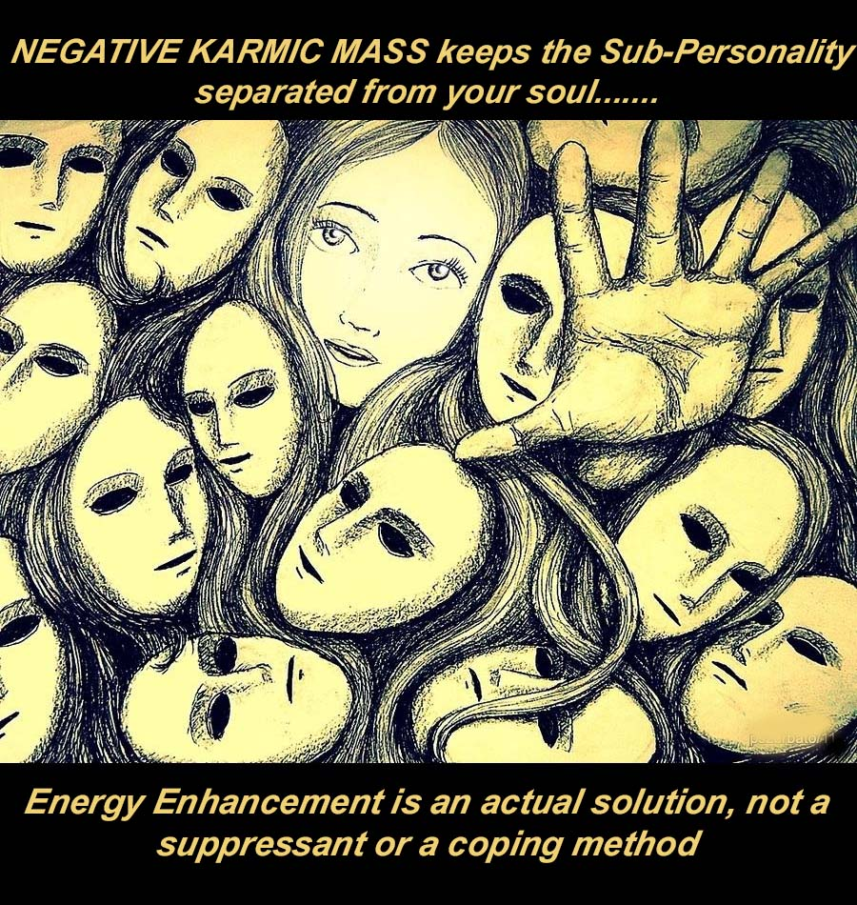

“The most general picture of our essence is an association of drives, with constant rivalry and particular alliances with each other.” (The Will to Power)

Conceptualizing the human psyche “as social structure of the drives and affects” – as a sort of city, in which numerous conflicting sub-personalities simultaneously live – the task Nietzsche set for himself, and his readers, was to harmonize the “abundance of contrary drives and impulses”, and provide coordination to the plethora of competing subpersonalities within.

He proposed that such coordination can be attained via the agency of an “organizing idea”, or “ruling passion” – a dominant “master” drive that forms the “living centre” of the psyche, and co-opts all the other drives to act in subordination to its end. The organizing idea is not found through an act of will, but, possessing a type of intelligence of its own, reveals itself throughout the course of one’s life. One merely has to remain on the lookout for such a master drive, and not hinder its growth and activity.

“The organizing “idea” that is destined to rule keeps growing deep down — it begins to command; slowly it leads us back from side roads and wrong roads; it prepares single qualities and fitnesses that will one day prove to be indispensable as means toward a whole — one by one, it trains all subservient capacities before giving any hint of the dominant task, “goal,” “aim,” or “meaning.”” (Ecce Homo)

The organizing idea, in other words, the Soul, arranges the plethora of competing forces in one’s psyche in a manner that allows one to strive with single minded devotion towards a heroic goal which gives meaning to life.

Nietzsche summarized the importance of the organizing idea in giving form to one’s psyche in the following unpublished note:

“It is a myth to believe that we will find our authentic self after we have left behind or forgotten one thing or another…To make ourselves, to shape a form from various elements – that is the task! The task of a sculptor! Of a productive human being!” (Nietzsche).

Nietzsche’s psychological insights are wide, varied, and always penetrating – a result of his ardent conviction that the psyche of modern man was in dire need of being dissected.
Indeed the, “The organizing “idea” that is destined to rule" is the Soul.

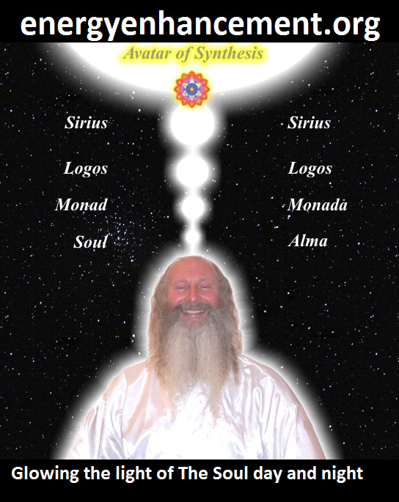

THE SOUL IS THE FIRST CHAKRA ABOVE THE HEAD

THE SOUL IS THE FIRST CHAKRA ABOVE THE HEAD

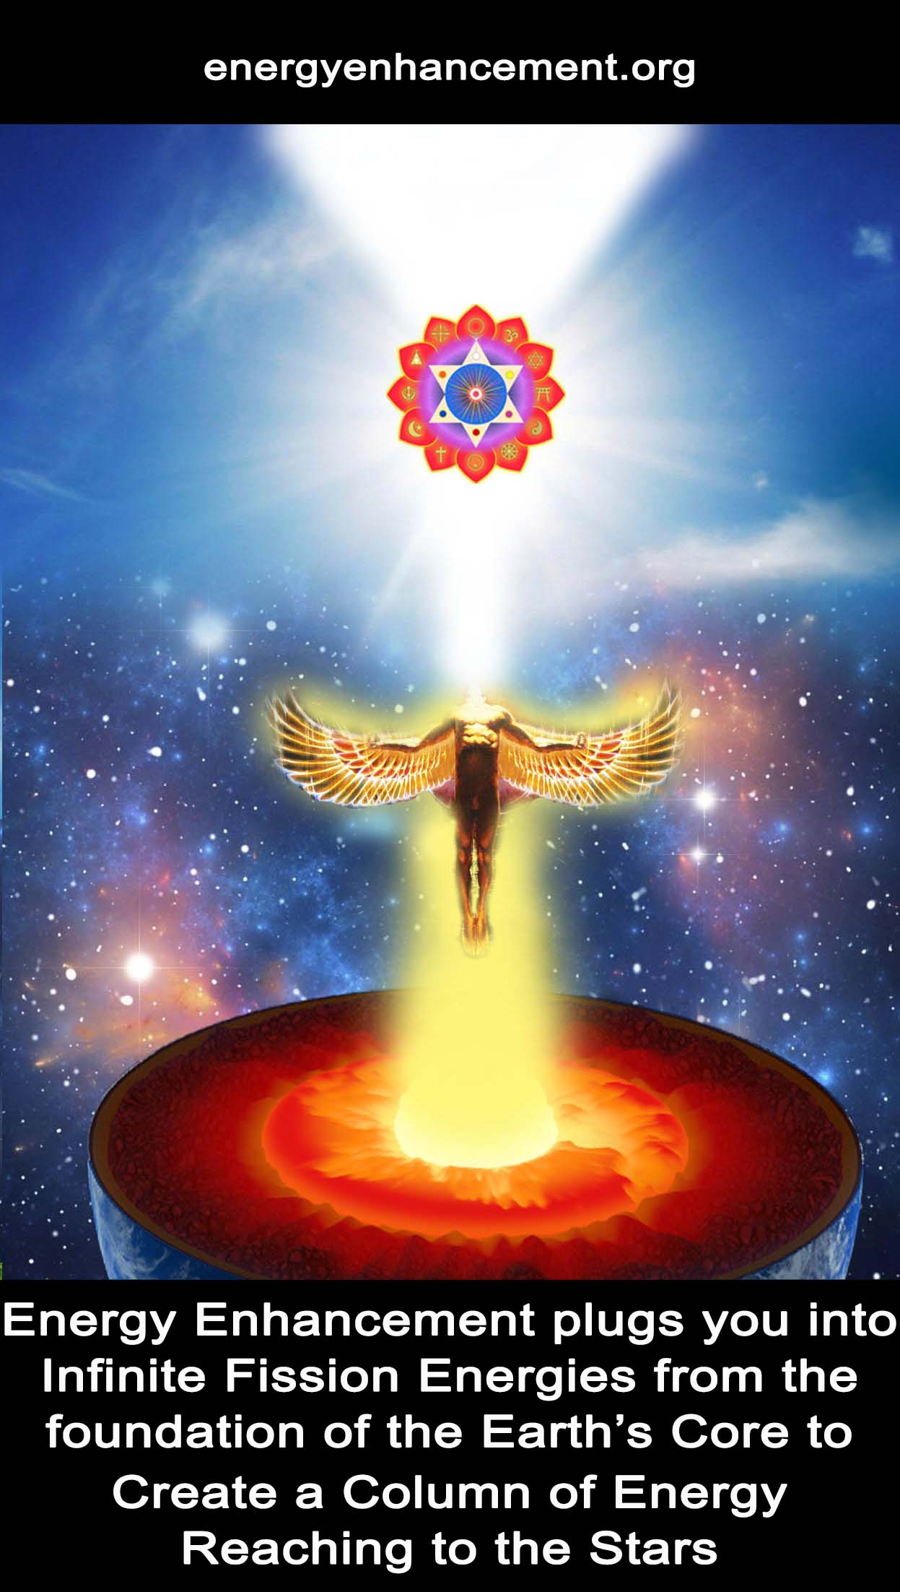

TRANSMUTE ALL PAIN AND FEAR WITH THE ANCIENT TECHNIQUE OF ENERGY ENHANCEMENT ALCHEMICAL VITRIOL

VITRIOL IS A LATIN ACRONYM

VITRIOL. – Visita Interiore Terrae Rectificando Invenies Occultem Lapidem.

VITRIOL - THE GROUNDING AND TRANSMUTATION OF ENERGY BLOCKAGES –

Has been removed from all Traditional Meditations –

Thus "Traditional forms of meditation are designed to fail!!"

READ ALL THE TECHNIQUES TAKEN OUT OF TRADITIONAL MEDITATIONS AND PUT BACK BY ENERGY ENHANCEMENT!!

WHICH CAN TRANSMUTE BASE METAL - FEAR, SADNESS, TRAUMA, ANGER, MANICISM, DEPRESSION

- THE ENERGY BLOCKAGES OF THE BASE CHAKRA -
INTO THE PURE SPIRITUAL GOLD

- THE PURE GOLDEN ENERGY OF ENLIGHTENMENT

Only after removing the trauma within can we access true courage and the compassion within which can actualise self sacrifice for the benefit of others exemplified by higher myths embodied in the Buddha, the Christ, the Earth Protector Angels Saint Michael and Saint George, Gandalf, Aragorn and Frodo, these symbols act in a teleologic manner, beckoning us forward toward goals we only partially understand.

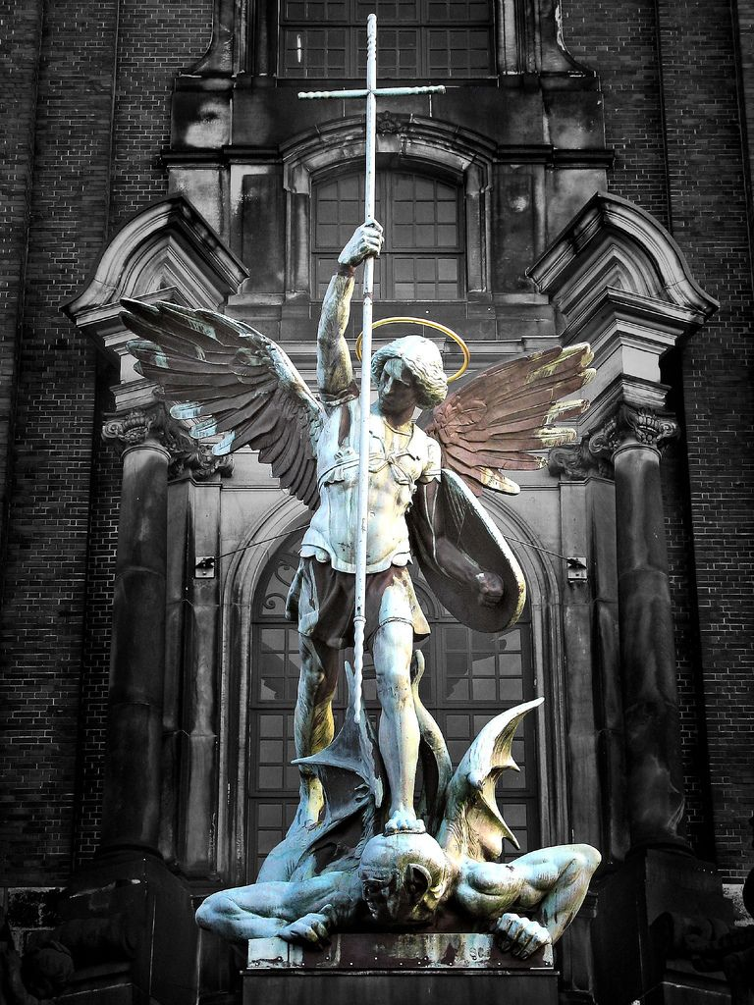SAINT MICHAEL CONQUERING SATAN

It is the Soul, like a cuckoo in the nest, which throws out the dross and purifies the mind as we go through the process of Soul Retrieval - Removing the Subpersonalities One by One, until only the Soul Infused Personality remains.

The Cuckoo and the Soul-Infused Personality

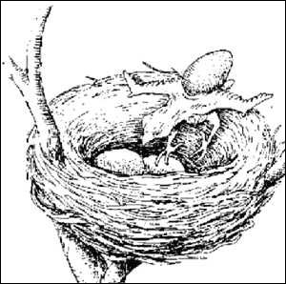

The parents of the Cuckoo Bird lay their eggs in the nests of other birds. As the cuckoo grows he throws all the other eggs and little birds out of the nest, so only the cuckoo remains to receive all the food from the loving foster parents!

It is a very similar process whereby the Soul Infused Personality integrates all the other blockages, implants and sub-personalities into the Soul Infused Personality, so at the end of the Process of Enlightenment, only the Soul Infused Personality remains.

Many people do not have a Soul Infused Personality and require up to a hundred lifetimes in order to start the creation and evolution of their "Essence", as it is called in Gurdjieffian terminology.

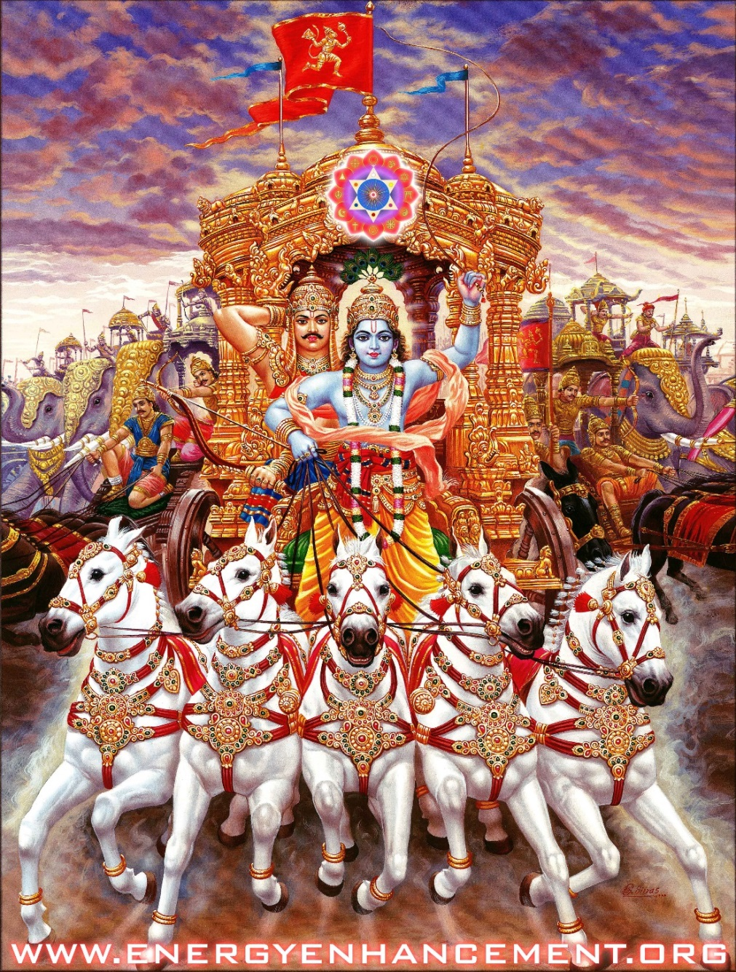

ANCIENT MASTERS KNEW ALL THIS BEFORE -
THE SOUL IS KRISHNA, ARJUNA IS THE SOUL INFUSED PERSONALITY, THE HORSES ARE THE SUBPERSONALITIES

The first chakra above the head is the Soul chakra which works at the much higher frequency of Intuition above the level of the intellectual and psychic functions of the chakras in the head. It is the Soul Chakra which creates and places the Soul Infused Personality into the mind where it shares the "nest" with all the other blockages and sub-personalities.

At this point the education of the Soul Infused Personality begins so that it knows it only has the free will to do the right thing.

Of course, all the blockages and Sub-Personalities which have been created with Trauma-Formed Negative Karmic mass as their basis always want to do the psychopathic, selfish and greedy, wrong thing, because they are Ego based.

Only after it wastes many lifetimes learning that it cannot go along with or manage the other personalities of the Ego, because the result is always disaster, resulting in negative karma and bad luck, does it investigate the techniques of the Energy Enhancement Seven Step process which can remove all Negative Karmic Mass from any blockage or sub-personality and then integrate it back into the Soul.

Sub-personalities include many talents and functions which have been developed over many lifetimes as specialised created angel colonies mixed with trauma-formed negative karmic mass. Only after the talent has been purified by the discharge of trauma-formed negative karmic mass, can the talent be trusted and successfully integrated into the purified crystalline matrix forms of the angel colonies of the higher chakras.

This Energy Enhancement Process is always under the management of the Soul Chakra. The Soul Chakra points out the blockages to deal with first. Usually the easiest blockages go first leaving time for the person to grow in power and skill so that later the most difficult blockages can be dealt with successfully.
At this point starts the war between the Soul Infused Personality and all the other sub-personalities and blockages.
"It is not sufficient to know one's shadow.

Seeing it, talking about it, has no effect.

What does have an effect on the shadow is Energy Enhancement Meditation.
We are a collection of good and bad parts, white and dark angels. What makes the part bad, the Angel dark, is ancient trauma.

The part of Energy Enhancement Meditation which has been consciously removed from all traditional meditations is the grounding of negative energies, the transmutation of ancient trauma, the transformation of negative parts, dark Angels into positive parts, White Angels.

The process of change by Energy Enhancement Meditation is one of bit by bit. Changing each negativity into positivity, one by one!

"Energy Blockages are Infinite..
Let us vow to end them All."
Zen, Great Vows." - Satchidanand

The blockages first try to anaesthetise and distract the Soul Infused Personality in order to stop the process. It tries to boost the ego by saying, "You are perfect", "You do not need to meditate any more!".

Then to frighten it with despair that nothing can ever change in the misery and pain of our world and words like "we are too strong for you" and " you will be our slave forever".

At this point, Positivity and the ability to create enthusiasm are necessary Energy Enhancement techniques.

However, the Energy Enhancement Seven Step Process always works and soon, only the sub-personalities which hide, remain. They are able to hide because they can distract, physically through pain, emotionally by making you angry, afraid or depressed, or they can talk to you and persuade you that your spiritual master is wrong. At this stage you need a guide and perfect confidence in your guide.
Only after all the blockages have been removed so that only the Cuckoo Soul Infused Personality remains is the person trusted enough to be given the Initiation of Enlightenment when the Soul Infused Personality is fused with the Soul Chakra.

This is the Process of Enlightenment.

Healing those parts of the psyche, integrating them with the Soul, until,
"There is only One!"

"THERE CAN ONLY BE ONE!" – HIGHLANDER


MARCUS AURELIUS PUN

"BE ONE" MEANS INTEGRATE YOUR MIND FROM ALL SUBPERSONALITIES; SOUL RETRIEVE.

THERE CAN ONLY BE ONE!

"BE ONE" - BECOME A GOOD MAN.

BECOME ENLIGHTENED WITH ENERGY ENHANCEMENT MEDITATION

Incredible Savings! - Save - 50% Off!! - Get Five Video Levels at 50% Off! for a Limited Time Only - Get All Five Levels when you Buy the Energy Enhancement Streaming Video Course.. Come for a Live Course to Iguazu..
Energy Enhancement Level 0 Super Chi Prana, Power, Strength, Immortality http://www.energyenhancement.org/LEVEL-Energy-Enhancement-Super-Chi-Immortality-Prana-Meditation-Course.htm
See Swami Amara Atmananda at the Iguazu Ashram doing Nauli and the Bound Lotus for Energy Enhancement Level 0 Super Chi Immortality Prana Meditation..

http://www.energyenhancement.org/LEVEL0-Swami-Amara-Atma-Experiences-Nauli-Bound-Lotus-Energy-Enhancement-Super-Chi-Immortality-Prana-Meditation-Course.htm
Energy Enhancement LEVEL 1 Immortality - Gain Infinite Energy from the Chakras above the Head - the Logos and higher! Power UP!! Gain Super Samadhi Kundalini Alchemical VITRIOL Energy. Ground All Negative Energies. Access Quantum Immortality http://www.energyenhancement.org/Level1.htm
Energy Enhancement LEVEL 2 - The Energy Enhancement Seven Step Process to Totally Remove Energy Blockages, Totally Remove Negative Emotions, Heal Your DNA, Remove your Karma http://www.energyenhancement.org/Level2.htm
Energy Enhancement LEVEL 3 - Eliminate Energy Blockages - The Removal of Strategies. Quantum Integration. The Karma Cleaning Process to Totally Eliminate All Your Karma!! http://www.energyenhancement.org/Level3.htm
Energy Enhancement LEVEL 4 - Stop the Suck!! Heal the Family!! MASTER ENERGY CONNECTIONS AND RELATIONSHIPS http://www.energyenhancement.org/Level4.htm

LIVE ENERGY ENHANCEMENT MEDITATION COURSES IGUAZU The Energy Enhancement Meditation Course Will Not Fail You!
THE “JUST PULL YOURSELF TOGETHER” VIDEO ON YOUTUBE

https://www.youtube.com/watch?v=Y4GYooP6NOU

VIDEO ABOVE.. the famous, "Pull yourself together" video where Satchidanand trashes the greatest most intellectual investigators and descriptors of the Shadow Subpersonalities - Great People - The Highest of All Humanity - Jordan Peterson, Carl Jung, Nieszche, and every Psychotherapy, Psychological therapist who can describe the problem of the Shadow, talk about the problem of the shadow but have no Practical solution to the Shadow. All of those guys Failed to Solve the Problem of the Shadow. None of these guys have Any practical solution for the Shadow.. And it is the Shadow Subpersonalities which is the Source, The Fount, of All Evil on this Planet... And the Source of All Evil within You!!

SATCHIDANAND COMMENTARY ON JORDAN PETERSON

Jordan Peterson - The Removal of Trauma, Pain and Fear from Memories - and Energy Enhancement Meditation Alchemical VITRIOL

MEDITATION ENERGY ENHANCEMENT
ENERGY ENHANCEMENT IS THE SOLUTION!!

Only The Energy Enhancement Meditation Course can Ground All Trauma, Pain and Fear.
Only The Energy Enhancement Meditation Course Remove All Energy Blockages.
The Energy Enhancement Meditation Video Course!
The Energy Enhancement Live Meditation Course in Iguazu Falls, Brazil or India!!

Satchidanand talks about the problem and introduces the ONLY practical solution to the dissolution, the healing, The Removal, of the Shadow - The Removal of All Trauma and Pain from the Pain Body.

The Integration of the Soul. - With Energy Enhancement Meditation..

Everyone needs the Recapitulation of the Energy Enhancement Course.

HOW TO REMOVE FEAR!!

NOW!

JORDAN PETERSON SAYS THAT, "ALL LIFE IS PAIN AND SUFFERING"

JORDAN PETERSON SAYS, "GET USED TO IT”

JORDAN PETERSON SAYS, "MAN UP!!",

JORDAN PETERSON SAYS, "SORT YOURSELF OUT!!..

Jordan Peterson says, “Sort yourself out!”

Jordan Peterson might as well say, “Pull Yourself Together!” Laughter!

Jordan Peterson says, "It is more difficult to rule yourself than to rule a city"

WHAT IF I TOLD YOU THAT PAIN AND SUFFERING COULD BE REMOVED?

WHAT IF I TOLD YOU, "THE PAIN THAT IS TO COME CAN BE AVOIDED" - YOGA SUTRAS OF PATANJALI, BOOK 2 SUTRA 16 –

YES EVEN KARMA, BAD LUCK AND TROUBLE, CAN BE DISSOLVED!!

Alchemical VITRIOL is an Ancient Energy Enhancement Meditational technique to remove all the Negative Emotions, All the Trauma and Pain, Associated with Negative Memories, from This Lifetime and All Your Previous Lifetimes!

IT WORKS!! We teach it in Energy Enhancement Level 1!

The Energy Enhancement Seven Step Process is an Ancient Energy Enhancement Meditational technique to remove all the Energy Blockages, Sub Personalities, Bi-Polar Disorders, and Deeper Negative Emotions, All the Trauma and Pain, Associated with Negative Memories, from This Lifetime and All Your Previous Lifetimes!

IT WORKS!! We teach it in Energy Enhancement Level 2!

Sort yourself out!

WITH ALCHEMICAL VITRIOL!! - ALCHEMICAL GOLD!!

SLAY THE DRAGON OF FEAR!!

How Medusa Fear Freezes You and stops your evolutionary progress.

The use of Medusa Fear! to Freeze your Heart.
The use of Medusa Fear! to Freeze your Conscience.
The use of Medusa Fear! To Freeze your Feet.. So you Cannot Take the Next Step Forward..

ANCIENT MYTH TELLS YOU WHAT YOU NEED TO DO...
PERSEUS KILLS THE FEAR DEMON MEDUSA AND FREES THE ANGEL WITHIN..

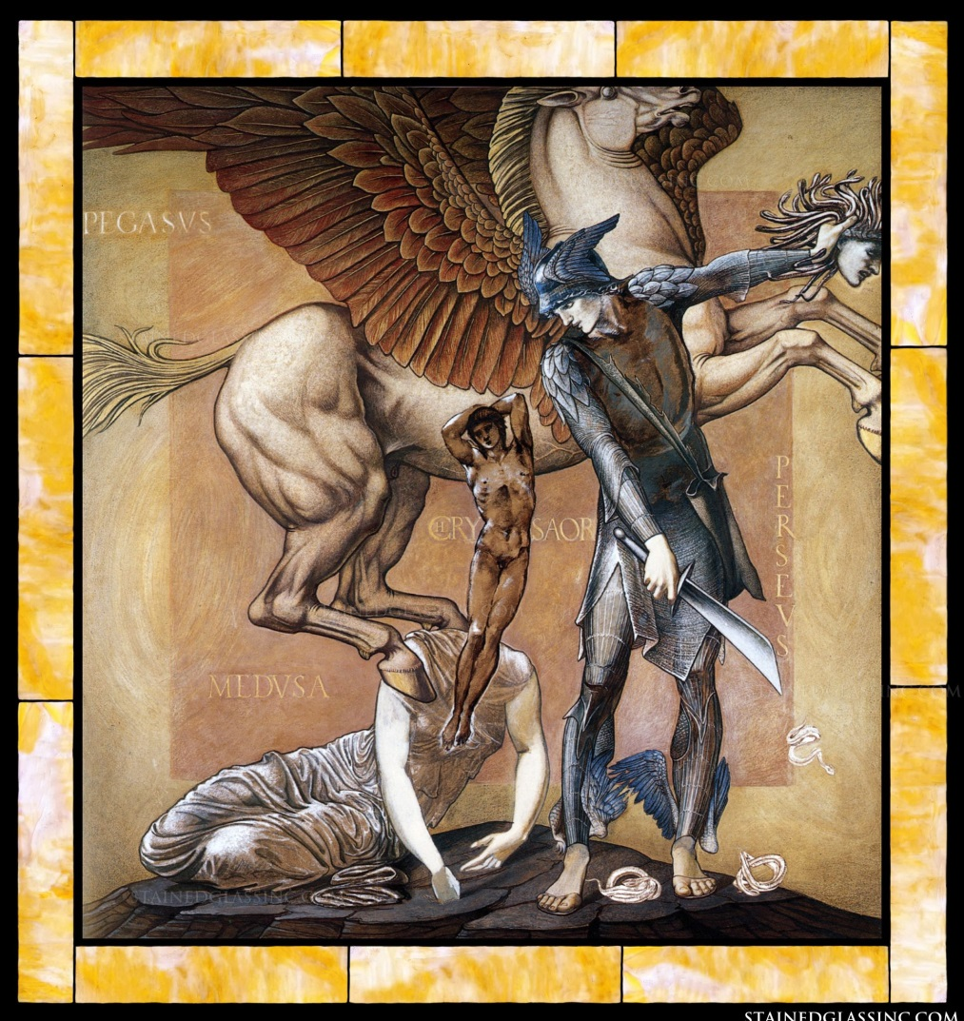
BURNE JONES - PERSEUS KILLS THE FEAR DEMON MEDUSA IN THE DEPTHS OF THE UNCONSCIOUS AND FREES THE ANGEL WITHIN..

ONLY THE ENERGY ENHANCEMENT MEDITATION COURSE CAN SHOW YOU HOW TO DO THAT..

QUICKLY.. RAPIDLY.. EASILY..
SPEEED UP!! YOUR PROCESS
Alchemical VITRIOL is an Ancient Energy Enhancement Meditational technique to remove all the Negative Emotions, All the Trauma and Pain, Associated with Negative Memories, from This Lifetime and All Your Previous Lifetimes!

We teach it in Energy Enhancement Level 1!
ALCHEMICAL VITRIOL
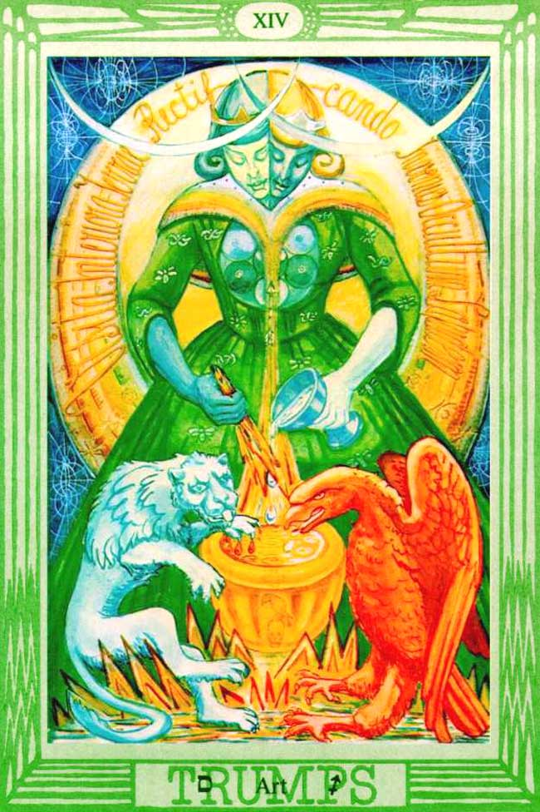
THE ART CARD OF THE TAROT - SEE ABOVE THE ANCIENT LATIN ACRONYM MEANING OF VITRIOL IN THE CIRCLE BEHIND THE MAIN FIGURE OF ART

VISITA INTERIORA TERRAE RECTIFICANDO INVENIES OCCULTEM LAPIDEM

VITRIOL

Is an Acronym which is an Ancient Guided Meditation teaching how to Ground Negative Energies and also how to access Infinite Energy to Power Up!! All your Psychic Powers!!

The Energy Enhancement Seven Step Process is an Ancient Energy Enhancement Meditational technique to remove all the Energy Blockages, Sub Personalities, PTSD, Bi-Polar Disorders, and Deeper Negative Emotions, All the Trauma and Pain, Associated with Negative Memories, from This Lifetime and All Your Previous Lifetimes!

ELIMINATE THE SHADOW!!

We teach it in Energy Enhancement Level 2!
Jordan Peterson Says, “Sort yourself out!”

Jordan Peterson Says, "It is more difficult to rule yourself than to rule a city"

Jordan Peterson Says, “There are horrible monsters inside you which need to be tamed, brought into submission and benignly used to make you a powerful actor in this world.”

But he gives no methodology other than,

“PULLYOURSELF TOGETHER!”

These horrible Monsters and Demons - Transmuted and Purified by Energy Enhancement Advanced Meditational Techniques - become Angel Talents for your benefit and the benefit of Humanity.

Jordan Peterson Says,

“Instead of rushing out into the world trying to change bad people, better to look inside and change yourself.

If you have a memory which is more than 18 months old and when you pull that memory up into your mind and you still have an emotional reaction that means you have not fully recapitulated that memory.”

That means that memory and all its trauma formed negative karmic mass has not been grounded and transmuted.

You have not freed yourself from its grasp and you are carrying it like a weight.”

This weight, this Trauma, this Pain is a Poison inside of you, killing your Higher Nature, increasing your violence, increasing your Fear, destroying your life!”

The more weight you are carrying, the more baggage, say, the more of the stress hormone cortisol you are producing and cortisol makes you old.”

James Pennebaker at the University of Texas studied this and he found that the brain keeps count of actions which work and actions which fail and produce a traumatic result.”

All those places where actions haven't worked out you need to Map and Master because trauma and uncertainty produce insecurity and fear which is a constant lead weight you carry with you, handicapping all your future with fear, producing the cortisol, making you old.” But Jordan Peterson gives no Methodology!!

When all that old memory has been transmuted, recapitulated, through Energy Enhancement Alchemical VITRIOL of Level 1 and the Seven Step Process of Level 2, this decreases the load on you, the existential fear of the situation, the physical physiological load on you the emotional and mental stress the aging effects of the cortisol is removed.

Removed too is the fear of the new which keeps us fixed in the prison of old beliefs, preventing us from greeting the future with enthusiasm and optimism.

Removed too is the Male Anger and vicious reactions rather than Female Calm and Emoluation.

When you, Perseus, destroy the Dragon..

You release the Princess..
Traumatic Memories increase the use of Male Violence.
Remove the Trauma.

Kill the Dragon.

And Release the Calming Female effect - The Princess..

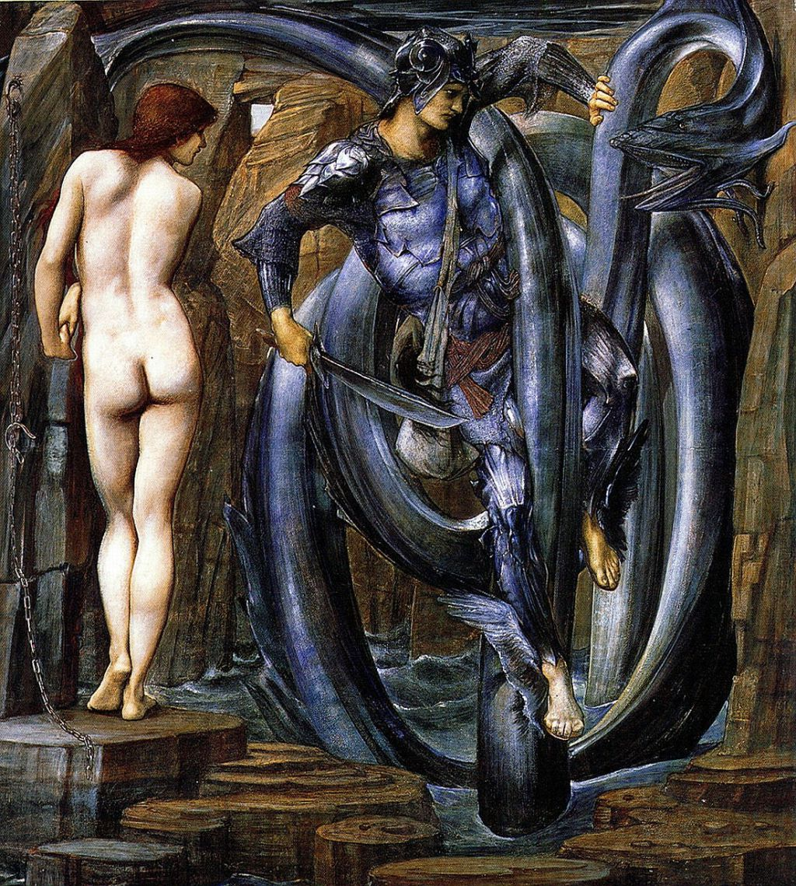
BURNE JONES - PERSEUS KILLS THE DRAGON, FREES THE PRINCESS..

"He that is slow to anger is better than the mighty;
and he that rules his spirit is better than he who takes a city"
Proverbs 16:32

The Release of the Calming Female effect of The Princess in you and in Society is the Reduction of Violence.. Civilised Society is Non-Violent and is produced by the recapitulation of Ancient Memories.

This killing Of Medusa and of Harry Potters Basilisk usually happens in the depths of the earth using the guided Meditation of VITRIOL.

Remember Tolkien - Professor of the Ancient Myths at Oxford University - who wrote about the Hobbit, who journeyed deep into the depths of the earth, there to Kill the Dragon of Fear..

- And there to release the Star of the Arkenstone..

And an unremitting Torrent of GOLD!!

Abundance, Riches, Wealth!

WITH ENERGY ENHANCEMENT!!

THE ONLY COURSE TO TEACH THE SEVEN STEP PROCESS!!

ENERGY ENHANCEMENT MEDITATION - DEEPER THAN THE INTELLECT, MORE PROFOUND THAN THE MIND!

Originally this Perseus Myth came from Alchemical VITRIOL.
An Ancient Meditation designed to remove Trauma from Memories!!

TRANSMUTE ALL PAIN AND FEAR WITH THE ANCIENT TECHNIQUE OF ALCHEMICAL VITRIOL

VISITA INTERIORA TERRAE RECTIFICANDO INVENIES OCCULTEM LAPIDEM

REMOVE ALL FEAR WITH
VITRIOL

VITRIOL is an Acronym which is a Guided Meditation teaching how to Ground Fear Negative Energies and also how to access Infinite Energy to Power Up!! All your Psychic Powers!!

VITRIOL Has been removed from all Traditional Meditations - Thus "Traditional forms of meditation are designed to fail!!"

READ ALL THE TECHNIQUES TAKEN OUT OF TRADITIONAL MEDITATIONS AND PUT BACK BY ENERGY ENHANCEMENT!!

WHICH CAN TRANSMUTE BASE METAL - THE ENERGY BLOCKAGES OF THE BASE CHAKRA - INTO THE PURE SPIRITUAL GOLD.

- THE PURE GOLDEN ENERGY OF ENLIGHTENMENT
MEDITATION, SHAKTIPAT, ENERGY CIRCULATION, THE KUNDALINI KRIYAS, THE FIVE ELEMENTAL PATHS OF THE CHI OF CHINESE ALCHEMICAL TAOISM, THE GROUNDING OF NEGATIVE ENERGIES, V.I.T.R.I.O.L, THE ART CARD OF THE TAROT, ACCESS TO KUNDALINI ENERGY, STRONG PSYCHIC PROTECTION, LEARN THE MERKABA, PYRAMID PROTECTION, POWER TOWER PROTECTION, CREATE THE ANTAHKARANA, SOUL FUSION, MONADIC INFUSION, LOGOS INFUSION!!!

Alchemical VITRIOL... Infinite Energy from the Hot Fission Kundalini Fires in the Center of the earth.. Your Kundalini Key to INFINITE Energy, Wealth and Abundance! FAST!

It is not enough that we transmute only the memories of this lifetime.

With Energy Enhancement, in order to complete the above process, we teach you how to transmute the memories from All your previous lifetimes, Faster, More Efficient, More Complete, More Profound..

There are many symptoms of this process not being finished.
One of them is a caught voice resulting from blockages in the second abdominal chakra due to bereavement, broken relationship problems.

If you sound like Pepe the Frog Jordan, you have not completed the process!!

ENERGY ENHANCEMENT MEDITATION - DEEPER THAN THE INTELLECT, MORE PROFOUND THAN THE MIND!

There! is the reason why meditators look younger, more beautiful, more relaxed, abundant.

SATCHIDANAND AND THE CHAKRAS ABOVE THE HEAD - THE PARALLEL PROCESSORS OF THE HUMAN SUPER COMPUTER - FOUNDER OF ENERGY ENHANCEMENT

So when we use Energy Enhancement Seven Step meditation techniques in Level 3 to sort out the Trauma and Pain and Energy Blockages of every year of this present lifetime and further, to remove all the encrusted fear from every one of our thousands of previous lifetimes, this releases us further to Master the future.

Straighten out your past.”

Reconcile with your past because most people just carry it all around with them.”

If you have not transmuted the negative energy of your past you haven't understood the causal chains which started it and you will repeat the same evil mistakes over and over again.”

You only remember the past in order to be prepared for the future.”

You are supposed to review the past and extract Wisdom and Wisdom is the ability to avoid re-stumbling into the same old ditches. You need to know why that happened and how you can avoid falling into that same situation in the future.”

You have to understand that we learn in Universities between lives, but here in this lifetime - This is the Examination Hall!!

And if you fail the test one day, the next day you will be given the same test!!

Until you pass!!

The fear and stress locked in the past are trying to pass on information which will give you the answer to the next test.

To allow you to pass.

But if that engram of knotted emotion and fear is not released, transmuted, grounded, then that information will not be passed on to you and you will fail, and keep on failing every day of your life!!

The fear and knotted emotion will be saying don't go there, don't go there.

Then there's Fire.”

Well, maybe you could Master the Fire?...”

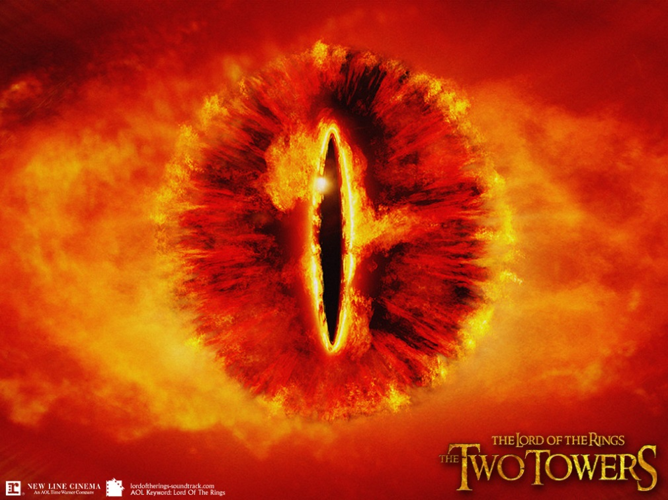
THE EYE OF SAURON - WREATHED IN FLAME

Right?”

Then you're a Master of Fire and not a victim!”

Situations are dangerous or not dangerous dependent on your Level of Mastery.”

Life is Like that.”
So, a negative emotion that's associated with a memory is something that's crying out for your Mastery”.

And Energy Enhancement Meditation can really help with that.

So, you're re-organising your brain when you meditate.

Memories are stored from All your past lifetimes from when you were a reptile in the swamp with deeply engrammed emotion to finely articulated plans for your future.

Well, you want to take everything which is negative and emotional and transform that into a finely articulated plan for your Life.

And that frees you from your past.

You should not be thinking about your past.

If you are constantly going, "ouch!!" then you are trapped back there in the past and you need to free it through meditational investigation.

And the metaphysical language is appropriate in the sense of what you are doing you are trapped in the past..

You need to break free of that so you can use all your resources to move forward successfully into the future.

And the Energy Enhancement Course has had walloping effects on people.

Normal education affects people but meditation - deeper and more profound than the Mind - releases and teaches you how to Master your Mind.

And Religion, Myth and Archetypes all say that renewal always depends on going into the depths and slaying the Dragon of fear!!
This is why you need to meditate.

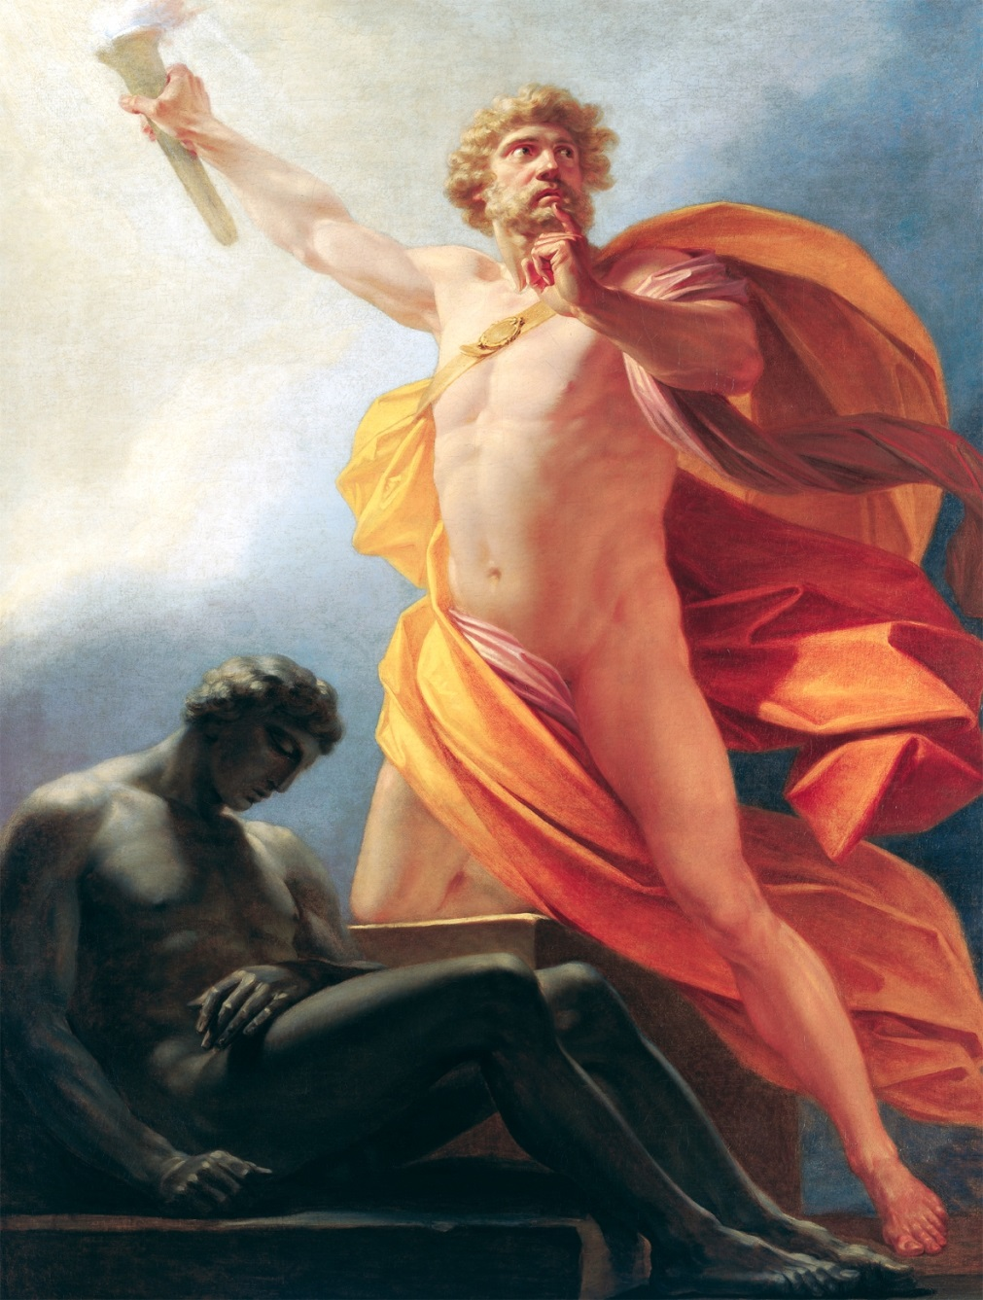
PROMETHEUS - FIRE FROM HEAVEN - THE SPARK TO IGNITE ZOMBIFIED MAN
I am a scientist. I studied Physics, Electronic and Maths at degree Level in a Joint Honours Program and worked in Advanced Computer Development yet I am also deeply Religious having Spiritual and Psychic experience through having worked with Zen Master Hogen and Swami Satchidanand.

And how do I reconcile that?

Well, I Discovered Fire!! I created Energy Enhancement!!

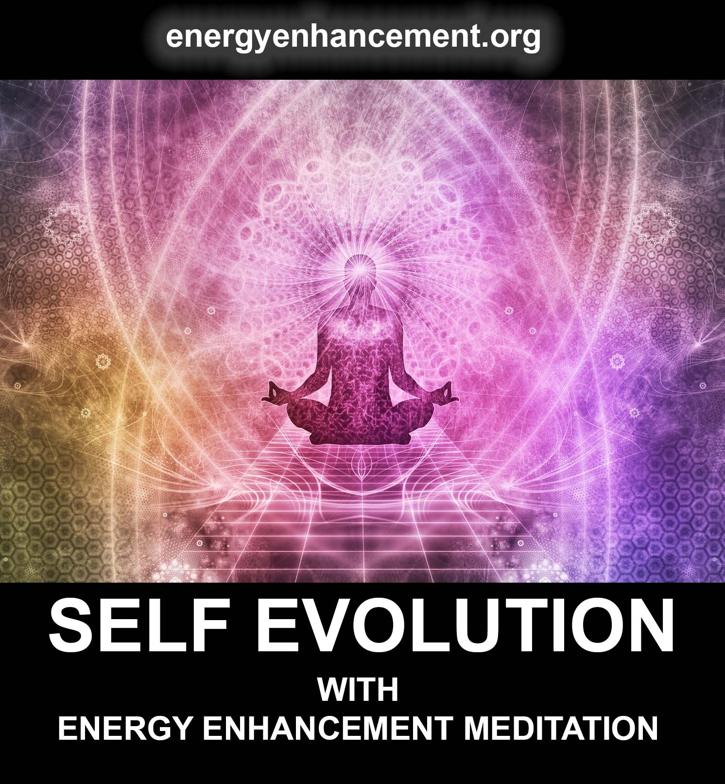
Ground It All with Energy Enhancement Video Course!

I BROUGHT BACK THE FIRE FROM HEAVEN..

I Discovered The Energy Enhancement Meditation Course by Streaming Video or Live in Iguazu, The means of Dissolving All Negativity and Pain.

To Renew You, and Your Life,
To Make You Free Again!

Get the Energy Enhancement Course!

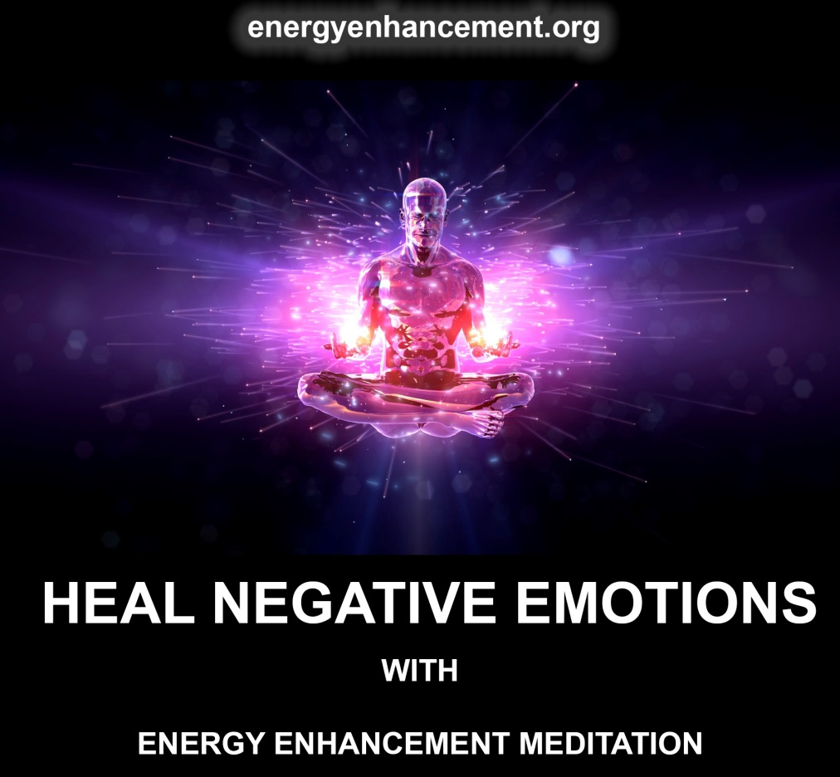

Burn All Negativity In... Access Infinite Energy From... The Hot Fission Kundalini Fires, in the Center of the Earth. Alchemical VITRIOL... Infinite Energy from the Hot Fission Kundalini Fires in the Center of the Earth..

Your Kundalini Key to INFINITE Energy, Wealth and Abundance!
FAST!

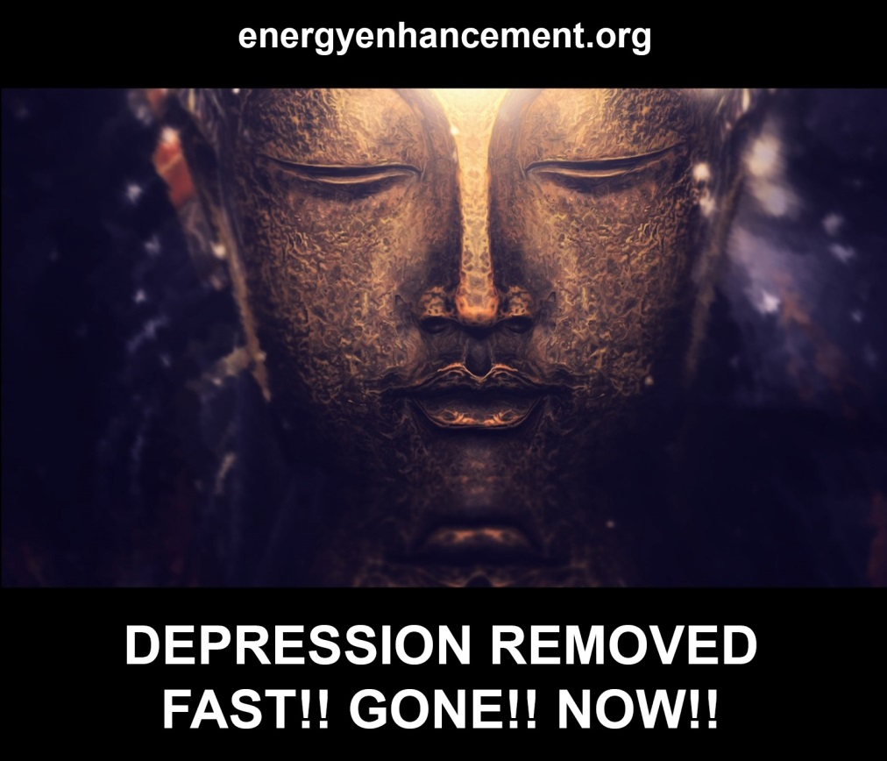

Access Infinite Energy from the Fusion Powered Central Spiritual Sun - "Brighter than 10,000 Suns, it Shines alone!" the Chakras above the Head - Infinite Spiritual Energies in the Chakras above the Head - The Central Spiritual Sun! Access Heaven! Access Angels and Arch Angels!

Go to God!

Burn your Dross.

Become Perfect! Become Enlightened!

Energize!

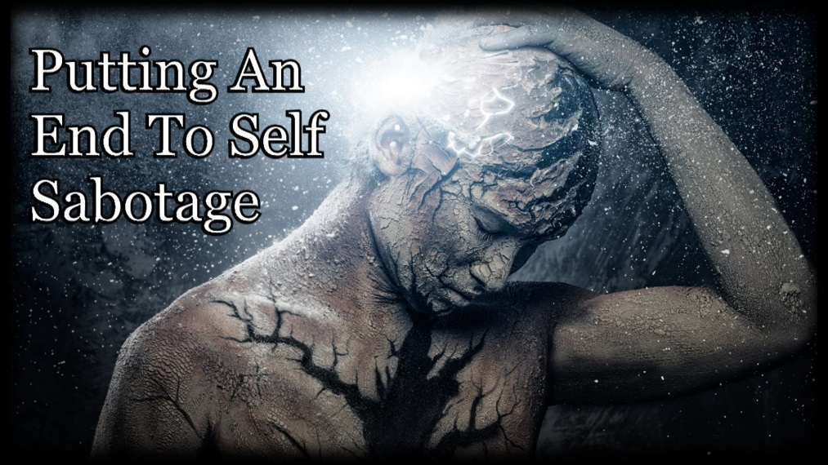

Power Up!

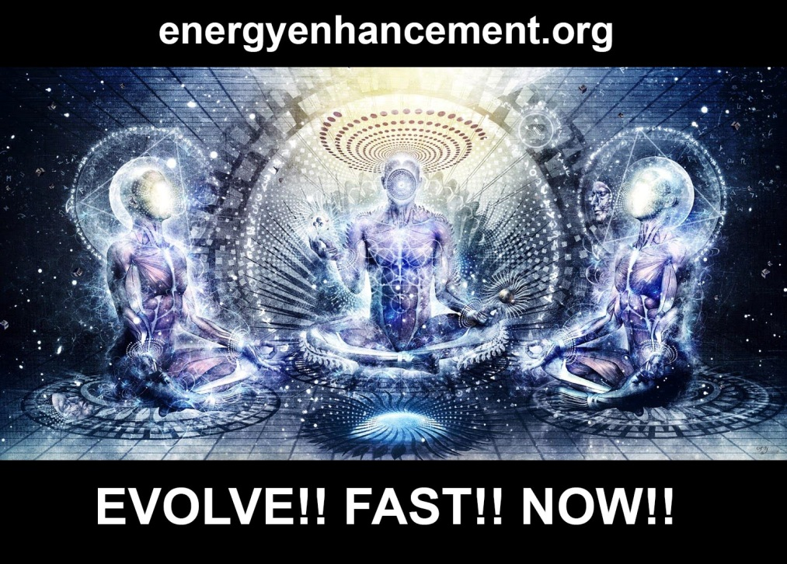
Power Up!! your Psychic Powers!

Power Up!! your Third Eye!

Access your Immortality!
Alchemical VITRIOL - Burn Up All Negativity!

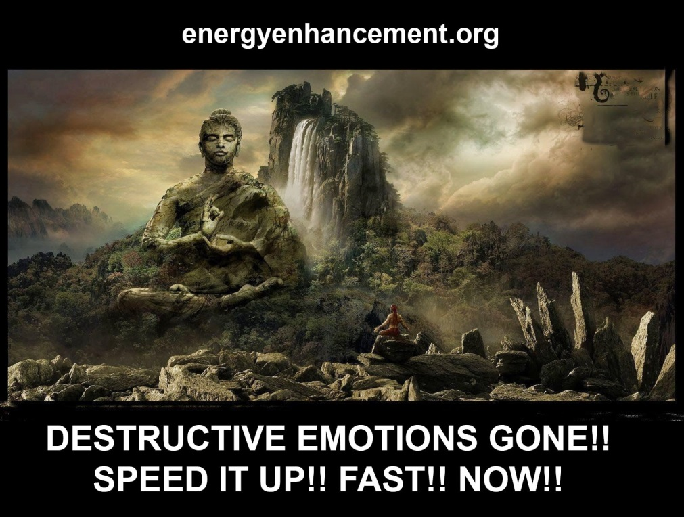

Speed Up!! Your Process!

Speed Up your Progress!

"Traditional Meditations are designed to Fail" - Get Energy Enhancement Quantum Immortality, Enlightenment, Third Eye Opening, Psychic Powers, Psychic Vision, Kundalini Kriyas, Kriya Yoga, Infinite Energy from the Fusion Powered Central Spiritual Sun - "Brighter than 10,000 Suns, it Shines alone!" the Chakras above the Head, Alchemical VITRIOL...

Infinite Energy from the Hot Fission Kundalini Fires in the Center of the earth.. Your Kundalini Key to INFINITE Energy, Wealth and Abundance! FAST!

Infinite Energy from the Removal of Energy Blockages allowing Infinite Energy to circulate through all your Chakras, Powering All Your Chakras Up!
Infinite Energy from the Removal of Depressing Negative Karma from this Lifetime and All Your Previous Lifetimes! Infinite Energy from the Integration of Your Mind!

Infinite Energy from stopping Soul Sucking Energy Cords from Family, Friends, Energy Vampires, Evil People, Psychopaths, Energy Blockages out of Incarnation.

Access Infinite Energy YOU!

Get it All Back!

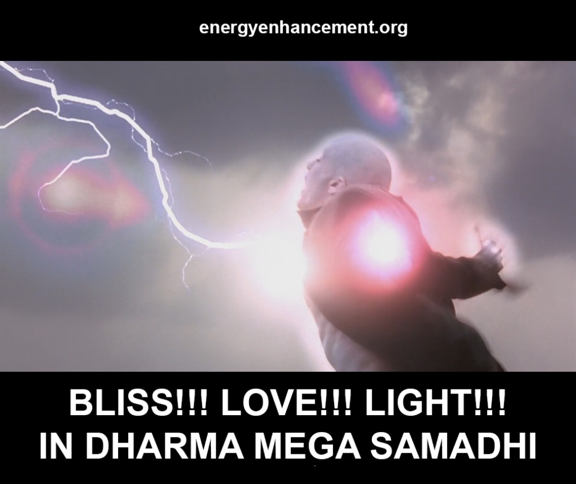

NOW!

Odin, Yggydrasil, Alchemical VITRIOL, The Kundalini Key, Meditation, Jung, Campbell, Neumann, Third Eye Opening and Projection, Antahkarana, Chakras Above the Head
The 7even Rules of Highly Spiritual People

Preface - Be the Hero in your life!

Hero myths are Deep, the same in many cultures, a theme that was picked up by Carl Jung, Joseph Campbell and Erich Neumann, among others.

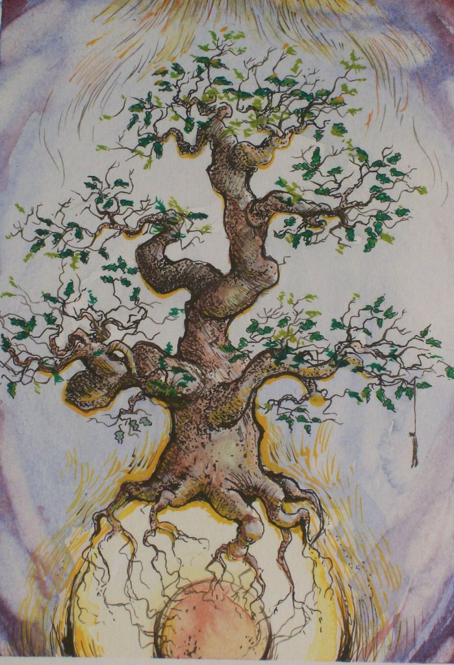
Focus on triumphant heroes. In all these triumph stories, the hero has to go into the unknown, into an unexplored territory, and deal with a new great challenge and take great risks in the unknown, to bring back a great gift to humanity.

THE WORLD TREE, YGGDRASIL, SPRINGING FROM THE NUCLEAR ALCHEMICAL VITRIOL CENTER OF THE EARTH - A FIRM FOUNDATION FOR THE TOWER OF THE ANTAHKARANA

THERE IS ODIN, HANGING FROM THE BRANCHES - AS CHRIST ON THE CROSS - IN SAMADHI FOR NINE DAYS IN THE CENTER OF THE UNIVERSE - BECOMING ENLIGHTENED.

ODIN LOST ONE EYE..

Christ himself told us, "When your two eyes become one, your body will be filled with light."

Odin is the Norse god of warfare, poetry and magic. He gave up an eye for all the knowledge in the world and hung on a tree like the antahkarana cross for nine days to learn the magic runes to manipulate the world, and fought a giant - energy blockage - for the Mead of Poetry so he could pass on his knowledge. He is the father of Thor.

ILLUMINATION INITIATION FOR ALL

The Stanza 138; reads:

I know that I hung on a windy tree

nine long nights,

wounded with a spear, dedicated to Odin,

myself to myself,

on that tree of which no man knows

from where its roots run.

Stanza 139;

"No bread did they give me

nor drink from a horn,

downwards I peered,

I took up the runes,

screaming I took them,

then I fell back from there".

Describing the psychic gifts of knowledge given by Illumination.

In the process, something of himself has to die, or be given up, so he can be reborn and meet the challenge. This requires courage, something rarely discussed in a psychology class or textbook.

How could the world be freed from the terrible dilemma of conflict, on the one hand, and psychological and social dissolution, on the other? The answer was this: through the elevation and development of the heroic individual, and through the willingness of everyone to shoulder the burden of Being and to take the heroic path of Enlightenment. To remove every spot of trauma

Through Meditation we must each adopt as much responsibility as possible for individual life, society and the world. We must each tell the truth and repair what is in disrepair and break down and recreate what is old and outdated. It is in this manner that we can and must reduce the suffering that poisons the world.

Illumination is asking a lot. It’s asking for everything. But the alternative—the horror of authoritarian belief, the chaos of the collapsed state, the tragic catastrophe of the unbridled natural world, the existential angst and weakness - to Death! of the purposeless individual — is clearly worse.

I hope that these rules and their accompanying essays will help people understand what they already know: that the soul of the individual eternally hungers for the heroism of genuine Being - Enlightenment, Illumination, Completion, and that the willingness to take on that responsibility is identical to the decision to live a meaningful life.

If we each live properly, if we each take responsibility for the benefit of Humanity, if we each - in alignment with the Logos - speak the Truth, the whole Truth and nothing but the Truth, we will collectively flourish. The Human race will evolve to their potential much more quickly.

I think most intellectuals are incredibly stupid! Because they argue from limited information and thus always miss the Truth. Here at Energy Enhancement we Speed up that Process of entering into adulthood, that strength which allows us to put away our toys, stop throwing them out of the pram, to take up the collective burden.

The Ancient Process of Meditation opens the mind, opens the psychic vision so that we see the Truth. We see our own faults, ancient trauma, energy blockages, that which stops our progress of coming into Alignment with Truth, of climbing the Hill to the City of God. But More!!

Energy Enhancement, Only Energy Enhancement!! Gives us the Tools to remove the faults, the ancient trauma, the energy blockages. Only that is sufficient to clean our contempt for our previous selves, to develop the Soul Quality, the Strength, the Competence, the Compassion, the Love, the Will, to want to help all others.
And it is only that which can truly heal our deepest wounds and allow a normal and productive life.

What type of person emerges from the Process of Alignment with Logos, Truth, Infinite Energy?
Each Energy Enhancement student develops a massive aura so that you become a Radiator of Spiritual Tension, a Walking Point of Crisis – Your Buddhafield creates awe, makes plain and heals by throwing out evil energy blockages in everyone you meet, it creates situations around you where the deepest energy blockages are thrown out and the Truth revealed for everyone to see as an aid for the Spiritual Development of every Student you meet.

Illumination.

Enlightenment

Energy Enhancement - Just follow the 7even Rules of Highly Spiritual People..

Meditate - Stop the World!
Ground - Remove the trauma
Connect -Increase the seratonin through Access to Infinite Energy of the Logos!
Project - Open the 3rd eye
Protect - Use Psychic protection
Remove - Remove energy blockages in the Karma Cleaning Process
Manage- Manage the cords

THE FOUR LEVEL ENERGY ENHANCEMENT COURSE

NAMASTE

This website offers the Energy Enhancement Meditation Video Course and Brazil Live Retreats.

It offers the techniques and truth all the new age courses and modern day gurus do not!!!

The removal of all energy blockages and the healing and integration of all soul splits leads to enlightenment.

All the missing ancient techniques and truth you’ve not heard before. The aim of the course is to get you to the Soul Infused state, the enlightened, ascended state and higher!

It takes you through key initiations to clear out the areas of your soul and life which has the most negative energy
e.g. antahkarana chakras, karma, DNA, past life vows and much more…

The course was founded by Swami Satchidanand and Swami Devi Dhyani.

They were students of Zen Master Hogen, Swami Satchidananda and Maharishi Mahesh Yogi.

DOWNLOAD THESE 10 SPIRITUAL PDF BOOKS FOR FREE!!!

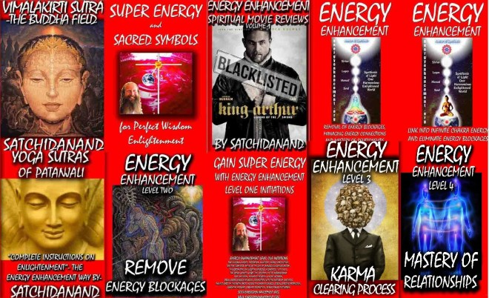

4 Level Video Course:
Level 1
Meditation : Stopping the mind and squaring the circle.
Energy Circulation: Microcosmic orbit and Kundalini Kriyas
The Grounding of Negative Energies: Alchemy, Vitriol and Earth Connection. Vitriol (Visita Interiore Terrae Rectificando Invenies Occultem Lapidem)
Accessing the Infinite Universal Energy Source: Macrocosmic Orbit, The Energy Enhancement Supra Galactic Orbit, Advanced Kundalini Kriyas.
Grounding Toxins in Food: Re-awakening our psychic ability to detect poisons. Removing Blockages.
Antahkarana Power Tower Protection
Pyramid Protection
The Merkaba Protection

Level 2
The Removal of Energy Blockages and Thought forms
The Removal of Energy Blockages in the Body: Healing disease and pain
The Removal of Energy Blockages from the 7 Chakras and higher spiritual Chakras
Heal your DNA: Remove the damage caused by lifestyle and toxins
The Removal of Negative Blockages and Thought forms from the Aura
The Removal of Karma from the time in the womb
The Removal of old Karma from this life time
The Healing of Addictions: Tobacco, Alcohol, Food, and Drugs.

Level 3
Removal of Karma from all your past lives
Removal of Karma from this and future lives.
Finding and healing soul splits/inner children.
Grounding negative emotions
Removing strategies of the energy vampire.

Level 4
Healing Close Family
Grounding and improving chakra connections from anyone past, present, future.
Removing blockages of the student
Healing the psychic sexual connection.
Mastery of tantric energy and removing blockages from clients

Try the first initiation for free, begin your journey!
http://www.energyenhancement.co.uk/player/Level1/Initiation1MEDITATION/flv6.html

Open on Chrome on computer and laptop. Most IOS and Androids can play the Flash using Photon or Puffin Browsers

Hungry for more initiations?

Sign Up on the site and Email me

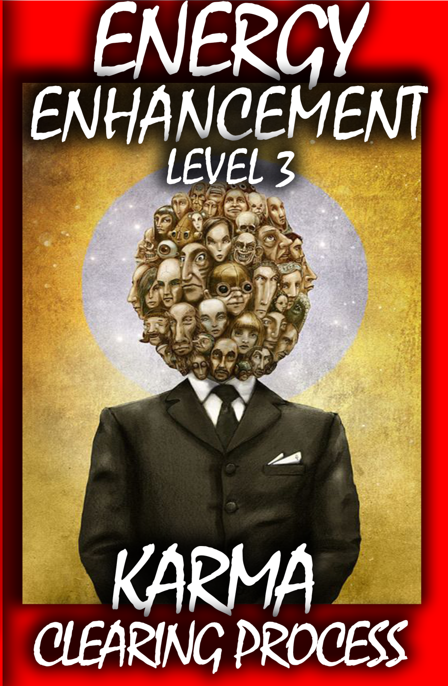

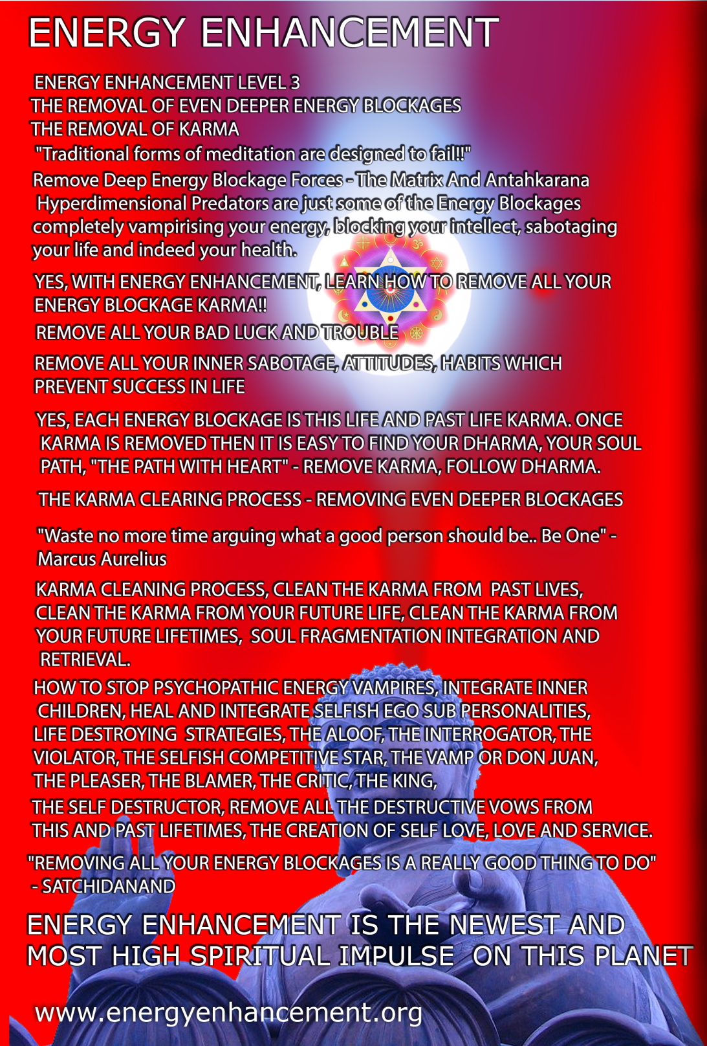

Go to http://www.energyenhancement.org for 19 Free Energy Enhancement Books.

To defeat Evil, you need to up your game. Learn the Energy Enhancement Meditation Course by Video or Live in Iguazu.

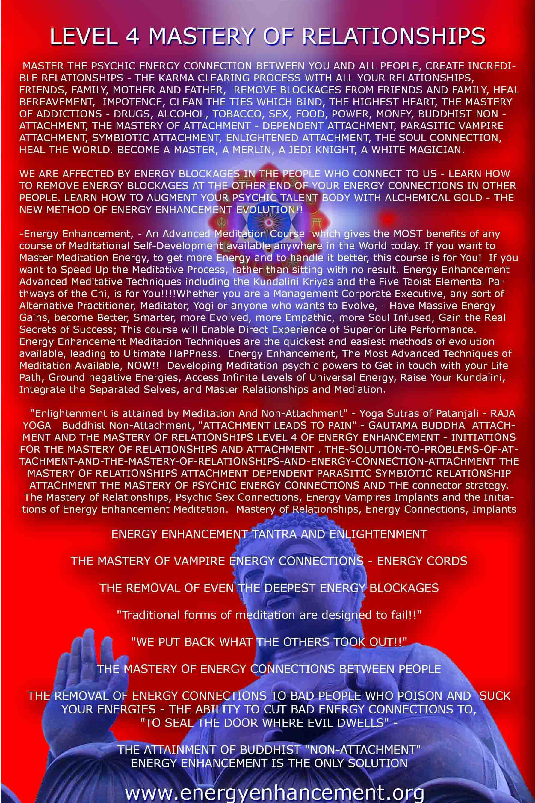Energy Enhancement Meditation and the Mythology of Lucas' Star Wars, Tolkien's Lord of the Rings, The Dune Trilogy, the Matrix Movies and Campbell's Universal Hero

With regards to the Applicability of Nietzsche's and Carl Jung's Shadow Subpersonalities, in Heroic Meditational Self Development for the Destruction of Absolute Evil on this Planet

https://www.youtube.com/watch?v=Y4GYooP6NOU

VIDEO ABOVE.. the famous, "Pull yourself together" video where Satchidanand trashes the greatest most intellectual investigators and descriptors of the Shadow Subpersonalities - Great People - The Highest of All Humanity - Jordan Peterson, Carl Jung, Nieszche, and every Psychotherapy, Psychological therapist who can describe the problem of the Shadow, talk about the problem of the shadow but have no Practical solution to the Shadow. All of those guys Failed to Solve the Problem of the Shadow. None of these guys have Any practical solution for the Shadow.. And it is the Shadow Subpersonalities which is the Source, The Fount, of All Evil on this Planet... And the Source of All Evil within You!!

Satchidanand talks about the problem and introduces the ONLY practical solution to the dissolution, the healing, The Removal, of the Shadow. The Integration of the Soul. - With Energy Enhancement Meditation..

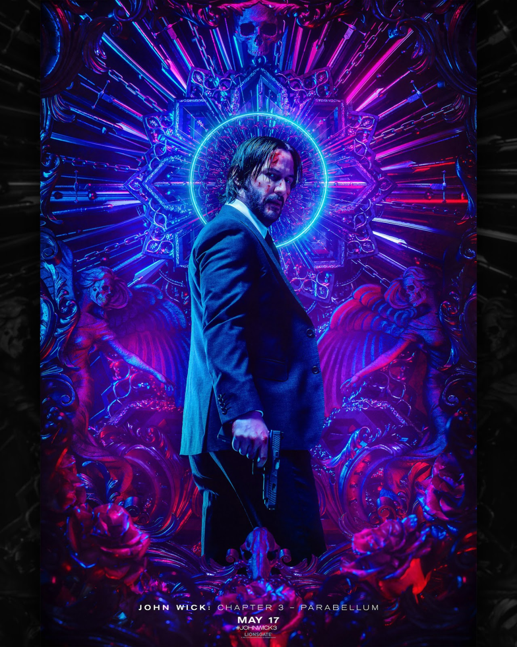

JOHN WICK 3 - THE SACRED WARRIOR DESTROYING DEMON SUBPERSONALITIES
John Wick 3 - Remove the Subpersonalities with Energy Enhancement Meditation or live in a World at constant War!

What is the power of Myth?

Why do modern myths such as Star Wars, Lord of the Rings, John Wick, The Dune Trilogy or the Matrix Movies; have such a powerful and profound effect on people?

Why do they seem to have such resonance with us?

And all through the history of humankind why have myths been stories of such central importance to their respective cultures and which have held them in such high regard? What is the meaning of Myth, their significance and purpose?

So what is Mythology? The word Mythology derives from the Greek word ‘mythos’, which means story. Therefore myths are stories but at the same time not all stories are myths. So what then are these stories that comprise the Mythology of the World. It has been said that “Myths are things that never happened but always are.” This quote is attributed to the 4th century Roman historian and mystic Sallustius.

It describes the allegorical nature of Mythology and suggests that they contain behind their often fairy tale and fantastical nature, hidden truths and higher meanings.

In a sense, Myths are stories that talk about the higher things and the more profound subject matters. They deal with the important issues to do with God, Cosmic Origins, Ultimate Conclusions, Purpose and Destiny. They derive from humankind’s quest to answer the big questions concerning the nature of the divine, the nature of reality, the human condition, higher powers and our relationship to those higher powers, they deal with the meaning of life.

They deal with the path, the methodology of attaining the Holy Grail, Mastery of the Mind, Mastery of the Astral Dimensions, Mastery of Life and Death, becoming Dwij - Twice Born, Illuminated, Enlightened, One, Soul Infused Being.

Jesus Christ, Buddha, Krishna, Gurdjieff, Mahavira, Ramana Maharshi, defined the Path.

Inevitably there exists a lot of over lap between World Mythology and World Religion which also concerns itself with these sorts of things. In one sense Mythology may be seen as proto-religion or an early forerunner of religion as we know it today. Also many of the stories contained in the more ancient literature of the Worlds Religions may be regarded as Mythology. We know that ancient myths found themselves incorporated into the holy texts of some the major World Religions. So for instance, a significant of the Bible consists of myths, especially in some of the earlier books such as Genesis. A similar situation exists in Hinduism which early on produced an extensive and elaborate collection of Myths. So Mythology blends into and is incorporated into religion and vice versa, certain religious ideas are often represented as Myths.

Essentially the issues and themes that Mythology deals with are really the same subject matter at the heart of much of World Religion. What we will show is that certain central ideas and themes from World Religion and World Mysticism allow us to clearly see some of the important hidden meanings behind World Mythology. These central Religious and Mystical notions, ideas and themes include the belief that ‘Everyone is God’ and the idea of a spiritual journey which leads to a state of ‘Mystical Awakening’ or Enlightenment; and also the Prophecies contained in World Religion together with the idea of a Messiah or World Saviour. We will show that these Religious ideas are really what’s behind a lot of the World’s most important Myths, both ancient and modern.

"The senses are higher than the body, the mind higher than the senses; above the mind is the intellect, and above the intellect is the Atman. Thus, knowing that which is supreme, let the Atman rule the ego. Use your mighty arms to slay the fierce enemy that is selfish desire."- Krishna, the Soul, Bhagavad Gita

Everyone is God and the Spiritual Quest

One of the main ideas behind this article, is the belief that ‘Everyone is God’, "Tat Tvam Asi", "Thou Art That".

This esoteric or hidden belief is found at the heart of all the World’s great Religions and Faith Traditions. We discuss how once this is accepted then it is very easy to suppose therefore that the ultimate goal of religion is to realize our true nature and inner divinity. So this would be the true meaning of the Kingdom of Heaven, Enlightenment, ‘Awakening’, Moksha etc. Ideas of Union with God, or being One with God or becoming One with the Universe would be equivalent to this interpretation. The Scriptures of World religion also describe a life path or spiritual journey which is the means by which this ultimate of attainments is obtained. This might variously be something along the lines of, ‘The Path to Perfection’ "Ananda Marga" or the ‘The Way to God’.

With these considerations in place it is reasonable to conjecture that this idea that a person’s real identity is God is also something related to the Hero Quest Myth tales which is the best known category of Myth to most people, including the Grail Myths, Campbell's, "Path of the Hero" and Odysseus. This is particularly so when we also understand that Mythology in general is intimately related to Religion and its concerns, with the ancient Myths existing at the heart of humankind’s earliest religious traditions and Myths serving as spiritual allegory. Seen in this light it makes sense to think of the Hero Quest Myths as coded stories that are really about a person’s spiritual evolution towards, potentially, the ultimate goal of union with God or becoming God.

Anyhow, what we propose now is this idea that ‘Everyone is God’ and the journey to the realization of our true nature i.e. God, is exactly what is behind what’s known as the Hero Quest Myth. So for instance, given this interpretation of the Hero Quest Myth, the quest for the Holy Grail in the various Myths involving King Arthur and the Knights of the Round Table is therefore really about the quest for Enlightenment.
This interpretation is supported by the fact that many versions of the Myth of the Quest for the Holy Grail describe not the obtaining of some physical object but rather a prize that is more ineffable and transcendent. Instead of just being a journey involving a translocation from place to place, rather the quest for the Grail is described as a process of purification and self development towards a more evolved state of being.

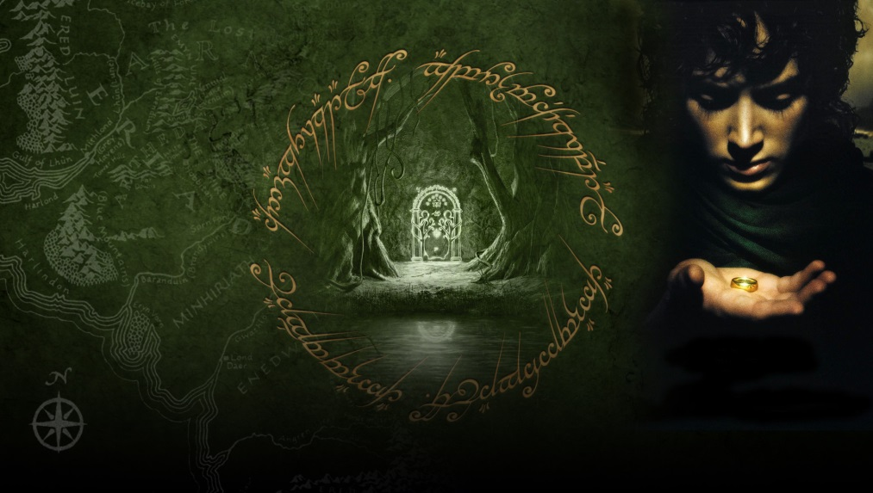

Jordan Peterson, Nietzsche, Jung and Tolkien - Myth and the Age of the Hero

And the same for the Classical Greek Myth called the Odyssey which describes the adventures of Odysseus the main character.

Whereas instead of a Holy Grail symbolizing the prize of Enlightenment, instead the uniting of Odysseus with his Wife Penelope at the end of the story would serve the same purpose.

The union of Odysseus and his wife symbolising humanity's Union with God. In the mystical and spiritual literature, all through history, the Union between a man and a woman has been used to symbolize Union with the Divine.

From the mystical poems of St Avila and the Sufi Troubadors and the Mystical Love poetry of the Song of Solomon in the Bible, to the Union of Shiva and Shakti in the Eastern traditions; the Quest for God and Mystical Union has often be symbolised by the coming together of a man and woman.

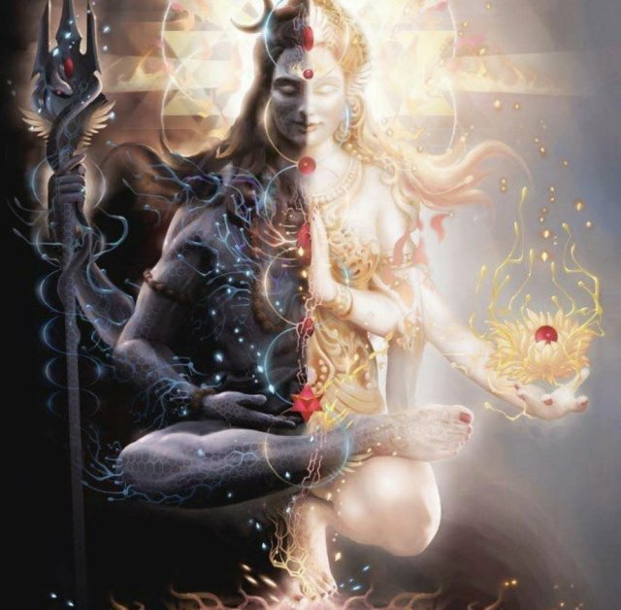

In both these examples, the trials and tribulations faced by the Grail Knights, Campbell's Hero and also by Odysseus and his sailors, are representative of the challenges and obstacles that face any mystical aspirant and spiritual seeker. So seen in this light the Hero Myths are really about the spiritual evolution of everyman and everywoman, and hidden within these timeless tales are guides, sign posts and also warnings which are relevant and meaningful even in modern times, for the contemporary seeker of the transcendent.

Further support for the idea that the Classic Hero Quest myths are really about the spiritual journey of mystical awakening and union with the divine comes from examining the parallels between, on the one hand the two Myths already discussed, i.e. The Grail Myths and Odysseus; and on the other hand, the great Mythic Epic from Hinduism called the Mahabharata.

What’s most significant here is a slim volume contained within the main body of the Mahabharata called the Bhagavad Gita..

To provide some background, the Bhagavad Gita - The Song of God - and the Soul, Krishna, is probably the most important book in Hinduism.

Many people in India, today and all through the ages, learn it word for word, such is its importance. When we examine the Bhagavad Gita closely then we realize that it is a sort of condensed Mystical Manual and Spiritual guide book.

The central idea contained in the Bhagavad Gita is the notion of Union with God or Krishna. Before we can unite with God or Krishna we must become warrior servant.

The mythical battle which Arjuna must fight is against the evil parts of his family, which symbolise the evil subpersonality blockages in his mind.

Only by defeating his evil subpersonalities, the Shadow talked about by Jung, can he bring goodness and mercy to this planet.

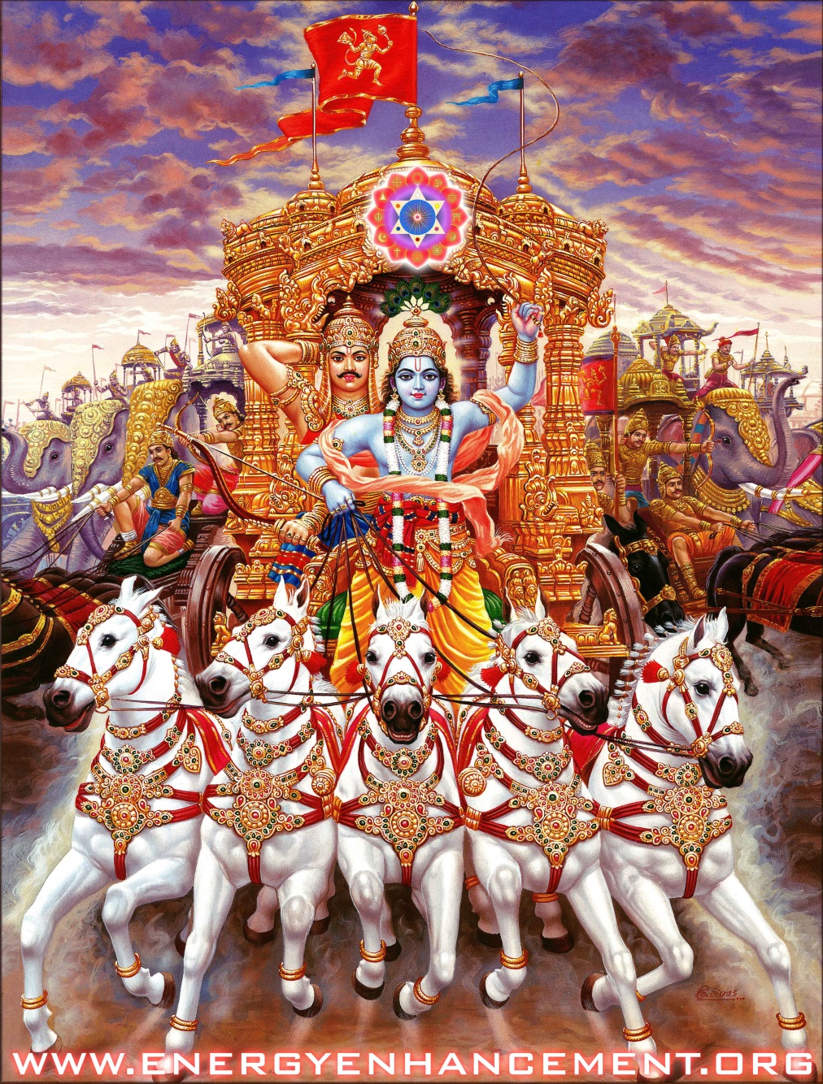
Krishna the Soul, Arjuna the Soul Infused Warrior and the subpersonality horses pulling the chariot.

Only by defeating his evil subpersonalities, the Shadow talked about by Jung, can he become Integrated, One, Soul Infused Personality.

Only by defeating his evil subpersonalities, the Shadow talked about by Jung, can he become Enlightened.

In this way, we must fight the evil shadow through a process of purification, grounding the subpersonalities and removing them from the mind. Integrating the subpersonalities into the Soul.

Only Energy Enhancement has the Techniques to remove Energy Blockage Subpersonalities from the mind!

This is quite explicitly stated or else alluded in various verses in Bhagavad Gita such as 13:30, ‘When a man sees that the infinity of subpersonalities is abiding in the One, and is an evolution from the One, then he becomes one with Brahman [ i.e. God ]’

And 5:19, ‘Those whose minds are ever serene win the victory of life on this earth. God is pure and ever one, and ever one they are in God’. So here in the Bhagavad Gita the purpose of the spiritual journey and mystical quest is clearly stated.

By seeing the parallels between Bhagavad Gita in relation to Odysseus and the Grail Myths and in relation to the Shadow, the subpersonalities talked about by Jung, then we can therefore more clearly see the underlying idea common to them all, i.e. the idea of a purifying spiritual journey, integrating the shadow subpersonalities, leads to Union with God or God Realization.

For an example of subpersonalities comprising the Shadow, Carl Jung said, "You are what you do, not what you say you'll do" meaning, as Gurdjieff said, "The person who says he'll get up at six in the morning to meditate, is not the same person who throws the alarm clock out of the window!!".

Thus Gurdjieff was saying that diminution of Subpersonalities is Increase in Willpower!
Energy Enhancement Meditation, Carl Jung and transmuting the Shadow, Unconscious, Ego, Id - The Hidden Power of Our Dark Side - and Psychology by Satchidanand

Here’s a first example of an interesting parallel between the Bhagavad Gita and the Grail Myths.

So for instance Joseph Campbell, the renowned Mythology expert, in one of his books describes a version of the Grail Myth where three of the Knights of the Round Table eventually find the Grail and they are Percival, Beofur, Galahad.

Each of these three Knights has a certain quality which enables them to attain the prize. So Percival is pure of heart, Beofur is the thinking Knight and Galahad is the Knight of actions and deeds.

Interesting this perfectly corresponds with the three paths to Union with God described in the Bhagavad Gita, i.e. Bhakti-marg the path of the heart, Jnana-marg the path of knowledge and Karma-marg the path of action.

Any of these paths can result in God realisation. These parallels support the notion that the Grail represents the goal of God Realization or Mystical Awakening.

In Yoga there are six paths, Hatha Yoga including Asana and Pranayama, Kriya Yoga including the shat kriyas and the kundalini kriyas, Bhakti Yoga the yoga of devotion, Gnana Yoga the yoga of knowledge, Karma Yoga the yoga of right and good action, Raja Yoga is the yoga of the Yoga Sutras of Patanjali including Meditation, and Samyama leading to Nirbija Samadhi.

All of these yogas comprise the Energy Enhancement Meditation Course in Six Levels..
Mastery of any one of the six paths gives Mastery of all paths.. A Soul Infused Being..

"As they approach me, so I receive them. All paths, Arjuna, lead to me."- Krishna, the Soul, Bhagavad Gita

"Some realize the Self within them through the practice of meditation, some by the path of wisdom, and others by selfless service. Others may not know these paths; but hearing and following the instructions of an illumined teacher, they too go beyond death." - Krishna, the Soul, Bhagavad Gita

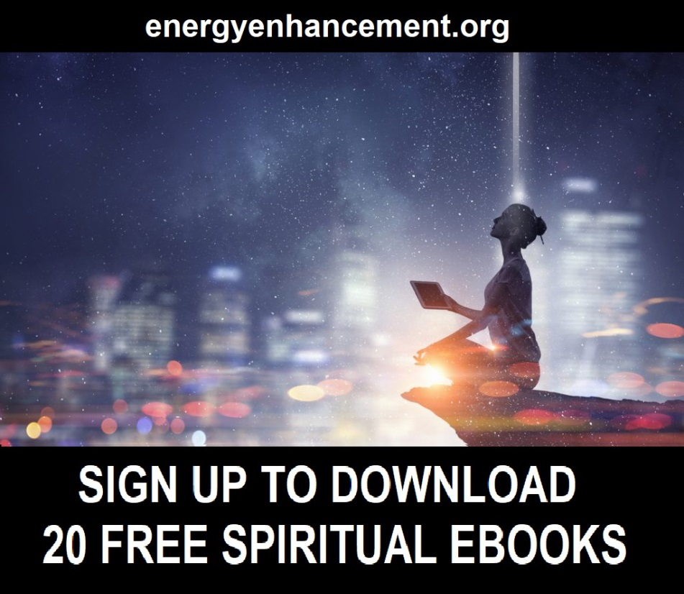

HEAL THE WORLD!!

WHAT IF I TOLD YOU THAT PAIN AND SUFFERING COULD BE EASILY REMOVED?

WHAT IF I TOLD YOU, "THE PAIN THAT IS TO COME CAN BE AVOIDED" - YOGA SUTRAS OF PATANJALI, BOOK 2, SUTRA 16 –

YES EVEN KARMA, BAD LUCK AND TROUBLE, CAN BE EASILY DISSOLVED!!

THIS IS YOUR MAGIC BULLET TO HEALTH, HAPPINESS, ENERGY AND FREEDOM!

BASED ON ANCIENT PRINCIPLES, ENERGY ENHANCEMENT IS EASY-PEASY!

GET THE ENERGY ENHANCEMENT COURSE NOW!!

Only The Energy Enhancement Meditation Course can Ground All Trauma, Pain and Fear

Only The Energy Enhancement Meditation Course Remove All Energy Blockages
The Energy Enhancement Meditation Video Course!
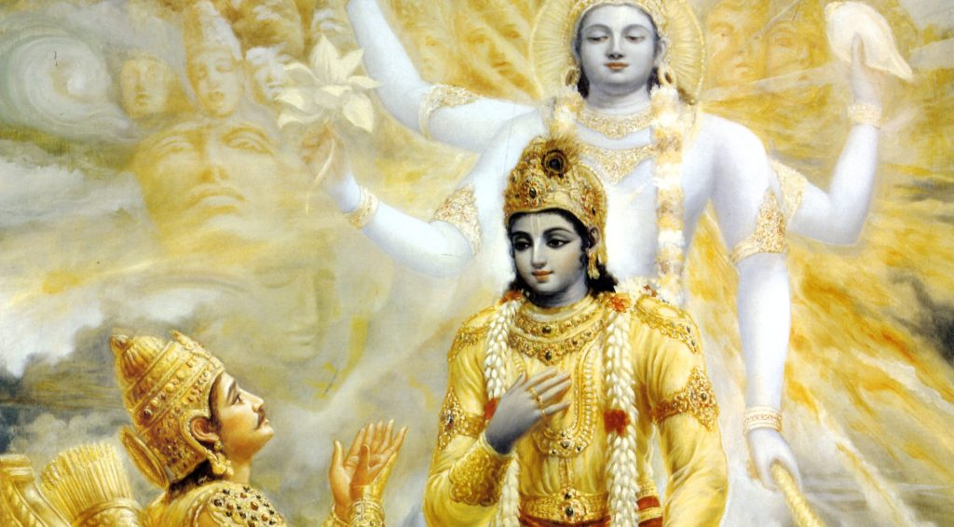

Interesting parallels also exists between the Bhagavad Gita and the book the Odyssey, which describes the Myth of Odysseus. Both books are contained within a much larger body of Mythology and exist as jewels in the crown with respect to the larger works in which they are embedded. We have already mentioned that the Bhagavad Gita is found within the Indian Mythic Epic called the Mahabharata. So it is in the same way that Odyssey is found within the famous Greek Epic called the Illiad. Also both great works have or have had a most special significance for their respectively Civilizations, i.e. Indian and Greek. In fact, the Illiad and Odyssey may be regarded as the most important texts of Classical Greek literature.

Interesting both the civilizations of ancient India and Greece had strong mystical traditions where the idea of a person’s ultimate identity being God was central. In India, both past and present, this idea of everyone being God is more formally called Advaita Vedanta and is described in ancient texts such a the Upanishads, Brahma Sutra and as already mentioned The Bhagavad Gita. The pursuit of the goal of union with God has always been the main pre-occupation of India’s Holy men known as Saddhus and is also behind the mystical Tantric practices found in India through the ages.

Correspondingly, in ancient Hellenistic civilization we have the Greek Mysteries, where again the central aim was unification with the deity or God. Given this background, therefore in a sense the ancient Myths of the Mahabharata/Bhagavad Gita and the Illiad/Odyssey would have served as a sort of introduction to the mystical beliefs of their respective cultures and the idea of union with God or the notion that Everyone is God.

One further parallel exists between the Bhagavad Gita and the Odyssey which is the allusion to idea that certain substances, i.e. plant extracts, can facilitate states of Union with the divine.
The Yoga Sutras of Patanjali says that psychic powers are born of past lifetime experience, hallucinogens or meditation, samadhi, samyama.

These sort of substances as sometimes labelled as Entheogenic in that they produce states of closeness to the divine which can not be maintained without constant massive drug intake.

Sometimes the expression Psychedelic or ‘mind manifesting’ is used. This is a recurring theme in early religion and also Mythology.

Here we’d like to point out the correspondence between the Soma Drinkers of the Bhagavad Gita and the Lotus Eaters mentioned in the Odyssey who dreamed away wasted lives in druggy sleep.

The Bhagavad Gita clearly states that the Soma drinkers as a result of their ingestation attain certain mystical states. Though the Odyssey with regard to the Lotus Eaters describes an island where the Lotus Eaters lose all will power due to the drugs they take, living in a land of dreams.

Odysseus and his men found it very difficult to get off that island but get off it they did, in order to pursue the aim of union with God.

A clue to its meaning is derived when we consider that ancient sanskrit texts discovered in India describes a variety of the Lotus plant as Soma.

Soma in Aldous Huxley's Brave New World where Soma was the drug, like marijuana, which was used to make humanity like happy cows, chewing the cud, used as a method of social control.

We know that the sanskrit word Soma literally means ‘to press out and extract’. So from this we could sensibly presume that at some point people in ancient India were pressing out and extracting something from the Lotus plant in order to make Soma and thus attain its mystical effects.

Therefore we can reasonably extrapolate from this the true meaning behind the Lotus Eaters found in the Myth of Odysseus.

That here too we are seeing the allusion to the idea that the ingestion of some plant or substance, in this case Lotus, can illicit in the user some sort of mystical experience and perhaps spiritual insight.

Further support for this interpretation comes from the Greek Mysteries and in particular the Eleusian Mysteries which took place at a sacred spot near ancient Athens where the participants drank a concoction called Kykeon which was key to producing a state of mystical union with God. Also the very ancient Sumerian Myth called Gilgamesh, which is probably the oldest recorded story know to humankind, makes mention of a ‘plant of immortality’, which can be interpreted in the same way as Soma and Lotus.

It is known that Homer, the Greek sage who wrote the Illiad and Odyssey was influenced by and derived of some of his storyline from the myth of Gilgamesh. It is also highly probably that Homer would have know of the Eleusian Mysteries and may even have been a participant as many of the cogniscenti of his time and locale were. So this adds further support to a Psychedelic interpretation of the Lotus Eaters encountered by Odysseus on his Mythic journey.

This connection between Mythology and Psychedelia is also apparent in modern Myths such as the Matrix movie and the Dune Trilogy. In Matrix the hero’s journey begins with the ingestion of a pill which allows him to ‘awaken’ from the illusion of the Matrix. In the Dune Trilogy a substance called Spice produces mystical states in people and gives users immortality and the power of prophecy.

Above, the dark side is propagandising the drug path.

Hallucinogens are dangerous, giving psychic experience before trauma, sticky trauma held inside the body, has been removed, rather like the glass half empty, glass half full paradigm.

After Trauma and Energy Blockages have been easily removed by the Energy Enhancement Meditation Course process, there is no need to take drugs because psychic powers naturally appear by themselves.

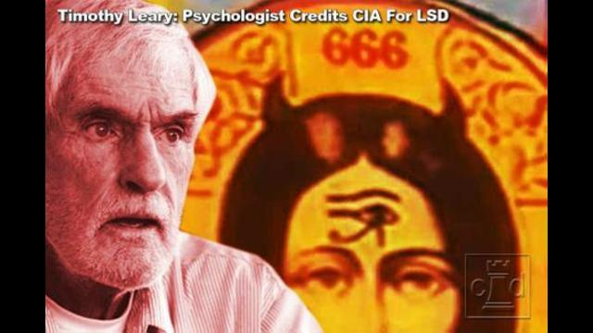

See my article.. How Trillionaires Infiltrated MKULTRA DMT, LSD and Ayahuasca into the Environmental, Hippie, Progressive and New Age Movements to Destroy Them

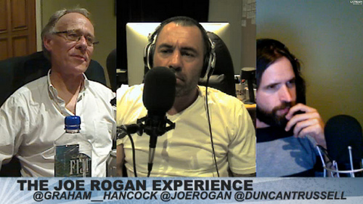

See my article.. Satanism Exposed - Joe Rogan, Jordan Peterson, Graham Hancock, Russell Brand, Rupert Sheldrake, Daniel Pinchbeck, Aldous Huxley, Carlos Castenada, Tim Leary and Ram Dass pushing MKULTRA Drugs DMT and LSD for Trillionaire Oligarch Controlled Military Intelligence to Destroy Society.

The Holy Grail is the cup Jesus Christ used to give his blood to his disciples at the Last Supper.

The Cup is the empty mind, the crown chakra into which falls the energy of the Soul, the blood of Christ.

It is the same blood, symbolised by wine taken at the Mass.

It is the sword passed on the the Emperor in, "The Last Samurai"

It says, "You are of the blood of Christ" "You are the Son of the Father" "You are the Son of Man"

It says, "take up the burden"

More, Jesus Christ becomes the point of light demarking the change of the Christianity of Christ from the Old Testament Judaic Religion of Human Sacrifice and All the other Pagan Satanic Religions using Human Sacrifice,Animal Sacrifice and Blood Sacrifice as their Rituals.

When Jesus Christ said to use Wine as a symbol of his blood, he was saying there was no more need to use real sacrificial blood Rituals which were so prevalent amidst the Satanic Pagan Religions all over the ancient world at that time.

When Jesus Christ said to use bread as a symbol for his body, he was saying there was no more need for cannibalistic Rituals which were so prevalent amidst the Satanic Pagan Religions allover the ancient world at that time.

See my Book – AGAINST SATANISM VOLUME 3 - THESE RITUALS DEFINE SATANISM.. SATANIC RITUAL SEX, RITUAL HOMOSEXUALITY, RITUAL PEDERASTY, RITUAL DRUGS, RITUAL BLOOD SACRIFICE, RITUAL TORTURE, RITUAL HUMAN SACRIFICE, RITUAL STRANGULATION, RITUAL CANNIBALISM, RITUAL CASTRATION

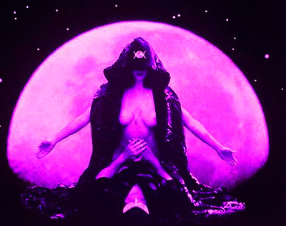

If you have not removed your Trauma with Energy Enhancement Alchemical VITRIOL prior to taking your drugs..

Trauma always shows the evil negative, glass half full, side of existence.

Trauma gives bad trips, talks to demons, clockwork elves, entities which always want payment for their advice in blood..

The Demons always want Blood!!

The Demons want to suck you dry of all your Spiritual Energy and they will Kill you, degenerate you,poison you, corrupt you, to get it.
.
Cultures based on high hallucinogen intake like the Mayan, Aztec, Inca, Greek, Roman, Phoenician, always ended with bloody human sacrifice cutting the hearts of bloody human sacrifices on sacrificial altars on the tops of pyramids, the sacred human meat sold by Satanic Priests to the cannibalistic populations.

Or Phoenician - babies thrown onto the red hot arms of Baal and roasted alive, the screams of the children drowned out by sacred music and buried in, "Tophets" found all around Baalbek Satanic Temple or any Phoenician city.

Or Roman State religion of the Roman Empire - Cybele and Attis with it Tauroboleums where Sacrificial Animal and human blood was showered onto its adherents in rooms below the sacrifice. Or the unmanning of the Galli transexual priests who then became homosexual "Dog" Priests in the Temples.

Drugs are the Path of Baal, Ashtoreth, and all the bloody South American Gods.

Trauma is the origin of the dark side.

Bloody Ritual Trauma maintains and defines the dark side...

Hindu culture says that for that reason drugs are not the true path and are never enjoined although these drugs are used in Hindu dark side cults.

Instead the path of the side of Light always starts with Meditation, grounding the trauma, powering up with connection to infinite spriritual energy, accessing past life memories and psychic talents, integrating the mind, Nirbija Samadhi, Samyama, becoming enlightened - naturally.

This is the Path of Jesus Christ.
This is the Path of the Buddha.
This is the Path of Energy Enhancement.

TO UP YOUR GAME IS PREPARATION FOR THE FIGHT AGAINST ABSOLUTE EVIL..

Mythology: Freud, Nietzsche and Jung

In modern times, this idea that stories about Mythological Quest are really coded allegories representing a person’s evolution and journey towards some sort of existential goal, was initially best elaborated upon by the renowned explorer of human psychology Carl Gustav Jung. His one time friend and mentor the equally well known Sigmund Freud, also explored the themes of Mythology in relation to the human mind and behaviour.

However it was Jung who saw Myths as representing a spiritual and transcendent dimension. During the course of Jung’s life, he was always something of a mystic. Later on he became very interested in Gnosticism and other ancient mystical ideas. His mystical leanings were captured in his notion of a ‘Collective Consciousness’, which is a common pool of memories and archetypes or universal themes, shared by all human beings.

His idea was that this Collective Consciousness was normally occluded during normal wakefulness. But also that through intuition and in our dreams, we could access this deeper knowledge. At various stages of his life he was not totally sure about the basis for this Collective Consciousness, vacillating variously between a biological and cultural interpretation.

His investigation of the Shadow side of our consciousness was an investigation of the subpersonality sabotage of the consciousness, the will, our life path our path of the Soul.

As we reduce the evil subpersonalities we become One.

Therefore supposing that the knowledge of the Collective Consciousness was something either transmitted in our Genetic DNA or else culturally i.e. through symbols, language or ritual. However he eventually settled on a mystical interpretation seeing the Collective Consciousness as something transcending biology, culture and matter.

In this way Jungian Psychology intersects with Religious and Mystical notions that somehow we need to be all One, together with the closely related idea that God is One and existing within us individually yet at the same time undivided and indivisible. A shared divine essence at the heart of the being of everywoman and everyman in a way that is completely analogous to and convergent with the Jungian notion of the Collective Consciousness.

Later on Jung’s idea of a Collective Consciousness and the Shadow would be taken up by various psycho-analytical schools which called themselves Transpersonal.

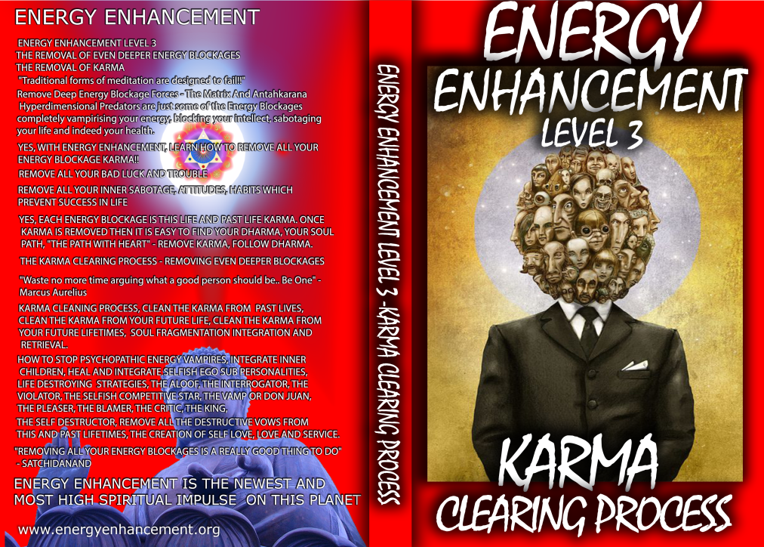

Download the Free Book Level 3 - Remove Subpersonalities, The Karma Cleaning Process - Remove Even Deeper Energy Blockages from the Timeline of this life and all your previous lifetimes - There Can Only be One!!

"You and I have passed through many births, Arjuna. You have forgotten, but I remember them all."- Krishna, the Soul, Bhagavad Gita

RIGHT CLICK AND SAVE AS

http://www.energyenhancement.org/Sacred-Energy/Level-3-Book/Energy-Enhancement-Level-3-Karma-Clearing-There-Can-Only-Be-One.pdf

Mythology: Joseph Campbell and the Mono-Myth
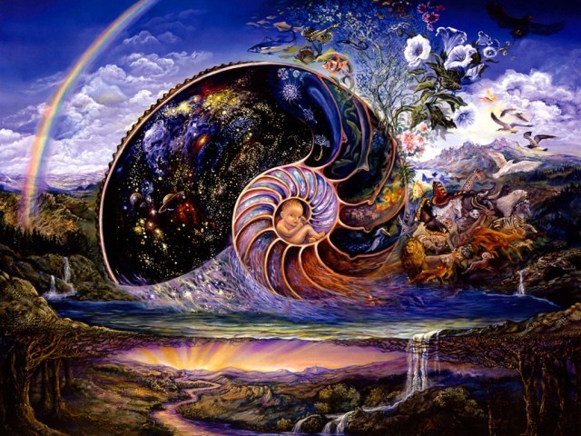

Another related thread in the development of our modern understanding of Mythology has been the work of the scholar and great popularizer of Myth Joseph Campbell.

Partly influenced by the ideas of Jung, Joseph Campbell synthesized a concept know as the Monomyth which he described in his influential work ‘The Hero with a Thousand Faces’.

Essentially what he did, was to survey a vast array of World Mythology from many of the major ancient cultures and also indigenous peoples of this planet, including well known Myths such as Odysseus and the Grail Legends.

As a result of this study he identified certain themes and central storylines which occurred in these Myths time and again. It is this distilled recurring story that he called the Monomyth.

It is as if a common template was being used to produce most of the World’s great myths, even though there would be various variations in the main storyline and differences in their details or specifics.

This Monomyth is therefore a generalization of the Mythological quest and involved a main character, the Mythic Quest Hero, whose purpose was to realize some transcendent or spiritual goal. So even though there is a huge variety among all the different stories about Mythological Quest from all the cultures of the World; what the concept of the monomyth is saying is that there is a universal story underlying all these different Myths.
What we have then is the distillation of the central and recurring underlying narrative that seems common to most of the Hero Quest Myths of the world.

So in a sense these tales are really about the same character in different guises, inhabiting various contexts and epochs. But all the while playing out the same drama and encountering recurring situations and circumstances.

Hence ‘The Hero with a Thousand Faces’.

The title of his other great work, the three volume ‘Masks of God’, also alludes to idea of Myth as religious and mystical allegory, which is one of the main idea behind his writings.

This religious aspect of Campbell’s interpretation of the meaning of the Hero Quest Myth is further highlighted by his use of the Mono-Myth concept to explain the lives or experiences of some of the founders of Religion such as Jesus Christ, Buddha, Moses and Muhammad when he was interviewed at length over the course of the TV series ‘The Power of Myth’.

It was his assertion that their respective personal life journeys and formative episodes were really expressions of the Mono-Myth and best understood in this light.

A Basic Outline of the Mono-Myth is the Path of Enlightenment Itself
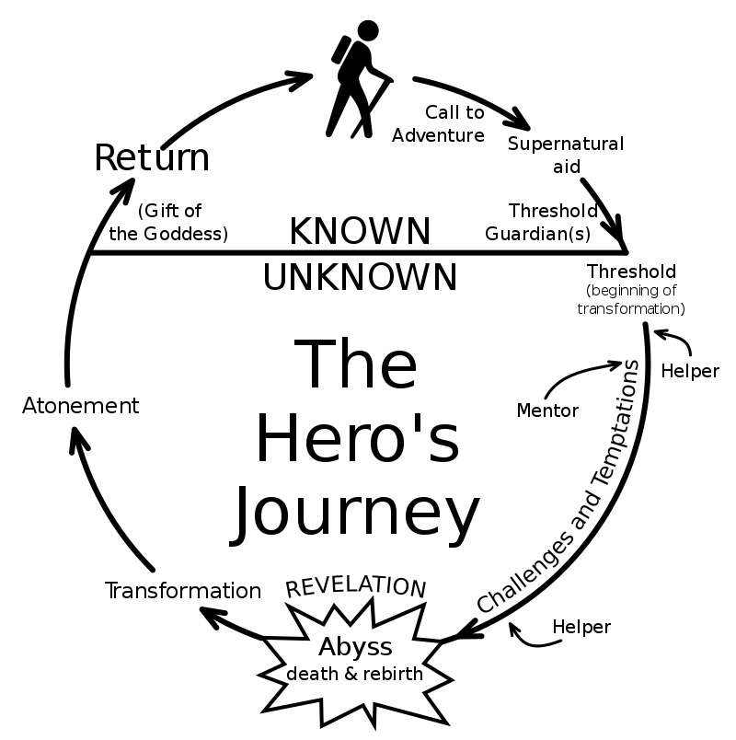

The Mono-Myth is the idea that there exists a common underlying storyline behind many of the Hero Quest Myths found various cultures and times from around the world. The Mono-Myth can be depicted as a diagram where the hero’s journey is mapped out on a circle which is meant to convey the idea that the mythological quest is a recurring undertaking (See Figure below).

That is it is a repeating process that happens periodically over the course of succeeding generations or epochs. It is as if it is a necessary quest that is essential for the maintenance of the life of a culture and also perhaps its progress. This cyclical aspect of the Hero Quest Myth implies that every so often in the course of the history of a civilization, fictional or real, a person or group of people will embark on the Mythological Hero Quest in order to find some spiritual or transcendental prize that is necessary for the life of the culture to carry on and thrive.

Put another way, the Myth Cycle and cyclical nature of the Mono-Myth is really saying that Camelot will recurrently enter into phases of malady and disarray. And when this dark periods occur then this necessitates the Holy Grail to be repeated sought, found and brought back to Camelot in order to remedy the situation.

Seen in this light we can grasp an important aspect of Mythology and the Hero Quest.
For not only are they tales serving as allegories for a person’s journey towards Enlightenment and God but they are also about the spiritual renewal of societies and perhaps entire civilizations.

In this way the story of the Mythic Quest Hero takes place as a part of a wider drama involving the Hero’s societal context and special circumstances he or she finds himself or herself in. And the Hero Quest becomes within this wider context not merely a tale of personal redemption or enlightenment but also something undertaken in order to save a world from calamity and disaster and/or to spiritually revive and culturally revitalize a society.

In the words of Joseph Campbell, ‘If we could dredge up something forgotten not only by ourselves but by our whole generation or our entire civilization, we should become the boon-bringer, the culture hero of the days - a personage of not only local but World historical moment’.

So to repeat, the concept of the Myth Cycle inherent to the idea of the Mono-Myth suggests that the process of Mythic Quest is a recurring undertaking which is not only a personal journey of spiritual discovery but also one which has implications for the wider context, i.e. society, from which the Mythic Hero emerges.

The diagram above shows the basic outline of the Myth Cycle and which was a concept formulated by the great scholar of World Mythology, Joseph Campbell. It was first introduced in his influential work ‘The Hero with a Thousand Faces'.

It represents the various stages of the Mythic processes described by Campbell's idea of the Mono-Myth, which captures the recurring and essential underlying storyline that is common to many of the Worlds Hero Quest Myths.

It is important to point out at this stage that this Myth Cycle and MonoMyth idea act as a sort of complete template from which Mythological Hero Quest stories may be created, as in the case of the Star wars discussed early. Also vice versa, existing Hero Quest Myths found in the ancient cultures of the world may also be mapped to this MonoMyth template and corresponding stages or features identified.

However it will not always be the case that a complete mapping can be made. That is, though just about all the worlds Hero Quest Myths are made up of central elements contained in the MonoMyth, not all these myths will necessarily contain all the themes and stages outlined in the Mono-Myth. And in turn various Myths may contain unusual elements or themes that don’t quite fit in neatly with the Mono-Myth template.

Yet the Mono-Myth can still be a useful guide for understanding the key aspects or motifs of the Worlds Hero Quest Myths. With these qualifications in place we’ll summarize the different stages of the Mono-Myth.

The Mono-Myth as represented by the Myth Cycle starts with things in a state of equilibrium or place of peace and this is represented by the topmost point of our myth cycle diagram.

The Mythic Hero and adventurer is usually to be found in a state of relative youthfulness, inexperience and perhaps one of naivity - he does not believe people and organisations can be bad, he does not believe Myth is real, he has, "nothing to hide".

The setting here may be the homestead, perhaps a village, farm or palace. But then something happens which upsets this equilibrium. For instance a princess may be abducted or some precious item may be stolen. Buddha saw an old man, dying, for the first time in his life. Christ whipped the Banksters out of the Temple.

Another example would be that perhaps the society or home in which the hero lives falls into disarray for some reason such as a sudden of death of some person, or else a natural disaster.
Perhaps he understands that Only Meditation can take him to the goal he seeks?

After this perturbation occurs then the goal of the mythological quest is communicated to the Hero to be by a messenger perhaps in the guise of a wise old man or some Oracle.

"The senses are higher than the body, the mind higher than the senses; above the mind is the intellect, and above the intellect is the Atman. Thus, knowing that which is supreme, let the Atman rule the ego. Use your mighty arms to slay the fierce enemy that is selfish desire."- Krishna, the Soul, Bhagavad Gita

"Some realize the Self within them through the practice of meditation, some by the path of wisdom, and others by selfless service. Others may not know these paths; but hearing and following the instructions of an illumined teacher, they too go beyond death." - Krishna, the Soul, Bhagavad Gita

Once this goal is understood the quest is taken up by the hero.
This goal may come in the form of a princess or some other beautiful woman who needs to be rescued or found. Or else some precious item such as a holy grail or perhaps a magic sword needs to be recovered that will restore things to the previous equilibrium and the tranquil way things were before the upheaval. This stage is labelled the ‘Call to adventure’.

So events transpire that cause the hero or heroine to leave his or her natural context and embark on a perilous journey in search of some goal. Once the hero is determined to pursue his goal then he is said to be crossing over the ‘Threshold of adventure’.

This step may involve defeating the ‘Guardians of the threshold.

These obstacles initially facing the Mythological Hero may be internal, i.e. self doubt or fear of the unknown. They may come in the form of friends or family members who try to persuade against pursuing the quest.

Or else they can be physical adversaries. Once this threshold is crossed then the mythic adventurer is at the start of his journey.

Having crossed over the threshold of adventure the quest begins in earnest. The hero enters into another world quite different from whence he come. He enters into the realm of the mythic quest and somewhere within it lies his sought after prize. This ‘other world’ may be represented in the myth as a Labyrinth, a Cave, a Dark forest, a Sea Voyage or some other environment that is far removed from the hero’s natural context. In this alien land the Mythic Hero will encounter all sorts of trials, obstacles, tribulations and challenges.

All sorts of adversaries will confront our intrepid seeker coming in the form of strange humans or weird beasts. A necessary part of the journey is that the hero must finds ways of somehow overcoming them, perhaps winning them over or else destroying them.

Also along the way friends and helpers will be encountered who may offer guidance or provide the hero with useful tools and magical talismans. Some of these characters may even join up with the hero and become travelling companions helping our central character to complete his or her journey of mythological quest.

As the journey progresses and the challenges are met, then all the while the hero becomes more experienced, grows in knowledge and develops special abilities. This prepares the hero for one last struggle before the ultimate prize is reached.

This final conflict may come in the form of a Dragon, a Master Sorcerer or some other potent adversary.

After a great battle or else through a some cunning trick that the hero employs, perhaps taking advantage of knowledge of the enemy’s weak spot, gained during the quest, then this last adversary is defeated.

After this the prize is attained, i.e. the princess is saved or the holy grail found.

This is represented by the bottom most point of the circle on our myth cycle diagram.

Often Myths will make allusions to the transcendental or spiritual nature of this final goal pointing towards some sort of mystical interpretation of the Mythic Quest.

The Hero is somehow transfigured or in some other way illuminated.

After achieving the final prize the hero has become a different person having undergone a profound transformation.

THE WORLD TREE, YGGDRASIL, SPRINGING FROM THE NUCLEAR ALCHEMICAL VITRIOL CENTER OF THE EARTH - A FIRM FOUNDATION FOR THE TOWER OF THE ANTAHKARANA THROUGH THE ASTRAL PLANE CHAKRAS ABOVE THE HEAD.

THERE IS ODIN, HANGING FROM THE BRANCHES - AS CHRIST ON THE CROSS - IN SAMADHI FOR NINE DAYS IN THE CENTER OF THE UNIVERSE - BECOMING ENLIGHTENED.

ODIN LOST ONE EYE..

Christ himself told us, "When your two eyes become one, your body will be filled with light."

Odin is the Norse god of warfare, poetry and magic. He gave up an eye for all the knowledge in the world and hung on a tree like the antahkarana cross for nine days to learn the magic runes to manipulate the world, and fought a giant - energy blockage - for the Mead of Poetry so he could pass on his knowledge.
He is the father of Thor.

In stanza 34 of the poem Hávamál, Odin describes how he once sacrificed himself to himself by hanging on a tree - like hanging on the antahkarana cross with the astral chakras above the head - which ends in higher Initiations of Illumination - symbolising the sacrifice of the Selfish Competitive Ego in Samadhi.

The Stanza 138; reads:

I know that I hung on a windy tree

nine long nights,

wounded with a spear, dedicated to Odin,

myself to myself,

on that tree of which no man knows

from where its roots run.[11]

Stanza 139;

"No bread did they give me

nor drink from a horn,

downwards I peered,

I took up the runes,

screaming I took them,

then I fell back from there".

So the hero having achieved his goal, then has to bring his prize back from the perilous realm of adventure and this involves a process of escape where a few more obstacles may present themselves.

After overcoming these last challenges the hero crosses another threshold that separates the realm of the quest from the more mundane reality from which the hero emerged at the start of the tale.

After this we arrive at the penultimate stage of the myth cycle which is called ‘The Return journey’. It involves a triumphant homeward course to the ending of the story and the last stage of the Myth Cycle.

Here the initial equilibrium is restored, the hero’s world is restored to its previous tranquil state and Mythological Quest has served its purpose. His or her society has been saved or otherwise restored, the Holy Grail has been brought back to Camelot. So in the end we arrive at the point in the circle of our Myth Cycle diagram which also represents the beginning of the cycle.

This represents the fact that this happy ending and harmonious state of affairs is only transitory. That is at some point in the future, perhaps many generations on, the tranquility will be perturbed and the Myth Cycle will begin all over again.

So in abbreviated form this is the essence of the Myth Cycle that is described by the concept of the Mono-Myth. It is a stereotypical sequence of events and actions that seem to be recurring themes in many of the Worlds great Hero Quest Myths. And with their allusions to the transcendent and spiritual, Hero Quest myths are also allegories pointing towards hidden metaphysical meanings.

Without this important and key ingredient then Hero Quest Myths would be nothing much more than very elaborate adventure tales.

However it is this added component, which may involve experiences of the numinous, encounters with gods, the divine or notions of eternal life, that gives these Hero Quest Myths their quite distinctive character.

So for instance in many renderings of the Holy Grail myths from Medieval Europe, the Grail is not some physical object but rather a rarefied state of being that is achieved by certain chosen knights who are endowed with certain virtues. In one version of the grail myth at the end the knight Galahad is lifted up in into Heaven.

In this way the grail is used as a metaphor for spiritual perfection.

The Holy Grail is the cup Jesus Christ used to give his blood to his disciples at the Last Supper.

The Cup is the empty mind, the crown chakra into which falls the energy of the Soul, the symbolic blood of Christ, the symbolic wine of the Sufis.

It is the same blood, symbolised by wine taken at the Christian Mass.

It is the sword passed on the the Emperor in, "The Last Samurai"

It says,

"You are of the blood of Christ"

"You are the Son of the Father"

"You are the Son of Man"

“You are the Christ”

It says, "take up the burden"

These allusions to the transcendent and mystical are also found in the contemporary Modern Myths. For instance at the end of the third installment of the Star Wars Myth called ‘Revenge of the Jedi’, some of the main characters who had died earlier return as immortal beings.

In the Lord of the Rings story, the main character Frodo Baggins goes off to live with the elves and earns immortality for himself. In both the Dune trilogy and the Matrix myths, the central characters of the two tales Paul Atreides and Neo respectively, both become Messianic figures with superhuman powers.

Furthermore in the case of Neo in the Matrix, he plays the role of the Christ who sacrifices himself to save the world and to give others life.

ENERGY ENHANCEMENT MEDITATION IS THE MAGIC BULLET!

So we therefore see a pattern behind all these different Hero Quest Myths both ancient and modern. They allude to themes normally associated with Religion and their respective mystical traditions.
Jordan Peterson, Nietzsche, Jung and Tolkien - Myth and the Age of the Hero

Hero Quest Myths and the Myth Cycle also reflect the ordinary lives of ordinary people.

We may ask and try to answer the question of why it is that these hero quest myths are such powerfully captivating and inspiring tales.

One answer is that even though these myths are highly fantastical and far removed from our day to day existence, they serve as a mirror which reflects the concerns and problems of real life.

That is in a sense we are all on our personal quests to realize some dream or to fulfil some aspiration, no matter how mundane. In this way we are all able to identify with the Mythological Hero and relate to his or her difficult journey. For the simple reason that we see in his or her problems our own.

In fact we can go much further and draw direct parallels between the stages of the Myth Cycle, described by the Mono-Myth, and the life cycle of a normal human being.

We’ll now explore this idea a little further and discuss the relationships between the Myth Cycle and the normal Human Life Cycle, to show the parallels between the mythic hero quest and the lives of ordinary people.

There is a pattern of existence that has been found throughout the world and all through human history. The important thing about the Human Life Cycle, in regard to present discussion, is that a meaningful correspondence can be made between each of its stages and each of the stages of the Myth Cycle diagram.

Once this connection is made then we start to see that everybody is like the Mythological Hero and that in a sense we’re all on our own intrepid adventures. We’ll go through the various stages of a typical person’s life to elaborate upon this idea.

We find the beginning of the cycle which is the idyllic and uncomplicated happiness of childhood and the family home.

We start in state, in the idealized view, where everything is alright, all is good and as it should be. This corresponds to the peaceful homestead or palace in Myth. But then we enter into puberty and adolescence. The harmony we had in our infancy vanishes and our sexual awakening is often accompanied with a sense of incompleteness and insecurity.

We are perturbed by this and so go on to endeavour to become adequate in our own eyes and in relation to others, in particular to members of the opposite sex or the gender we’re sexually attracted to. Thus we set out on the long journey towards maturity, sexual fullfilment and the quest for love.

This stage of life is correspondent with the call to adventure in the Mythological Hero Quest whereas in this context the precipitating factor is sexual awakening.

So we venture out into the world, typically leaving home or leaving behind childish modes of being, and setting out to make something of ourselves.

We try to become the perfect image that we have of our future selves, that we think will enable us to achieve our goals, gain status and win love.

We pursue our ambitions, work, study, explore and compete. We are engaged in the adventure that is life and this is correspondent with the Dark Forest, Labyrinth or Perilous Sea Journey of Mythology.

Within this stage we face the trials and tribulations of life, the pleasure, the pain, the successes, the setbacks, the rewards and the disappointments. And on we go until the primary goal for most people is finally achieved, we meet our chosen partner, fall in love, and raise children (perhaps not always in this order).

This for a lot of people is like finding the Holy Grail and of course like finding the Mythic Princess or Prince.

The rest of the Human Life Cycle involves setting up the conditions that we started out with in the first place, i.e. setting up a home, having children and creating a situation of domestic bliss.

And so like the Return Journey in Mythology we have a reinstatement of the original state of equilibrium and tranquility.

Also in the same way that the Myth Cycle repeats itself, so it is in our Human Life Cycle. That is once we have completed our life’s adventure, found a partner, set up a home and produced offspring, then so in turn our children grow into adolescence, sexually awaken and likewise set off on their own life quests.

And so the Human Life Cycle repeats itself again, generation after generation, further mirroring the Myth Cycle with its own recurrent cyclical nature.

In this way, what we have is an interpretation of the Mythic Hero Quest, which sees them also as symbolic descriptions of the normal life journeys of everywoman and everyman. They can been seen as stories which encapsulate within themselves the most significant and overriding concerns of living, to do with growth, sexual awakening, reaching maturity, the conflicts of life, finding love and having children. It is perhaps another reason why these sorts of Myths have such a deep resonance with so many people.
So there exists another aspect behind the Hero Quest Myths and therefore also behind the Mono-Myth concept.

That is apart from alluding towards spiritual and transcendent realities, the ideas and themes behind the Mono-Myth and Hero Quest Myths in general, also can be interpreted as being about the human condition and the lives of normal everyday human beings.

But which by doing so is also highly suggestive, that the seemingly ordinary and perhaps mundane lives of ordinary people are at the same time reflections of the sacred, heroic and transcendent.

The Myth Cycle and Human Life Cycle both as reflections of the Image of God

There is one other interpretation of the Myth Cycle which also casts a higher and deeper meaning behind the Human Life Cycle. It relates to the idea that there exists an Image of God, a sort of Cosmic Template or Blue Print from which all the patterns and processes of the Universe are themselves derived and which therefore reflect this in their make up and dynamic.

Therefore it is really this Image of God, manifested as an evolving process, which is behind both the Myth Cycle and Human Life Cycle.

The idea that somehow in our lives we reflect something of the divine, is already familiar with a lot of people.

We are in fact, “Imago Dei”, made in the image of God!

It is the idea that somehow we in our daily lives and in our ordinary existence, reflect the nature of God. This same notion is expressed in many other ways, for instance the mystical text the Corpus Hermeticum we find the often quoted passage ‘As above so below’.

In Taoism there is the Triad symbol which reflects the essential unity between man, Heaven and earth.

In the Western occult and Kabbalistic traditions this concept is called ‘correspondence’, which states that for every essential element of the person, there is a correspondent aspect of the divine.

Finally in the Upanishads, a revered set of Hindu texts, it states that, ‘As is the human body so is the Cosmic body. As is the human mind so is the Cosmic mind’.
So this idea of the human being reflecting the divine is quite universal.

What we’re doing is extending the idea somewhat and picturing the transcendent Image of God, as manifested in the human being, not as some static form but rather as a dynamic process evolving in time, which makes up the Human Life Cycle and which in turn is a reflection of the Myth Cycle.

The key difference between the Human Life Cycle and the Hero Quest Myth Cycle



We’ve just discussed that both the mythic hero and the everyday human being are reflections of the Image of God and are partaking of the divine process but does this mean that the Mythic Hero is an everyday human being or that all normal people are Mythic Heroes?

We established that many of the aspects of the Mythological Hero Quest seem to have their parallels in lives of ordinary people, when we explored why these myths resonated with some many of us.
However, the difference between the mythic hero and lives of most people is that the goal of the mythic quester is to find the secret of eternal life and become united with God; whereas the goal of most people is to find a partner and have children.

So the difference is between a spiritual prize versus a set of more earthly rewards. So this is the distinction between the journey of the Mythic Hero and that of everyday people. However this separation becomes blurred when we realize that everyday people sometimes take it upon themselves, when the circumstances are in place, to pursue for themselves the Mythic Hero Quest.

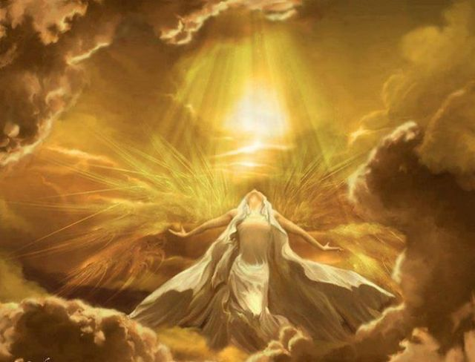

Even though Hero Quest Myths are invented stories communicating hidden metaphysical truths, they also inspire actual people to undertake the spiritual hero quest in their real lives.

So then the Mythological Hero emerges out of the realm of fantasy into the real world.

The Hero Quest Myth has then become not merely a inspiring tale but also a call to action for us to realize our greatest potential as human beings, that is the ultimate goal of spiritual awakening and becoming God.

This is perhaps the most important purpose of the Hero Quest Myth and Mythology in general, to orient our minds and lives towards the Transcendent and Divine. They tell us of life’s spiritual dimension and remind us that the ultimate purpose and destination of life is to realize our true nature as God.

However, in modern times there exists a state of affairs which prevents people from seeing the transcendent and hidden meaning behind the Hero Quest Myth. If these Myths a suggestive of the path to the Divine and Union with God, then the problem in the current age is not that people don’t know the way to God but they don’t know that the journey even exists.

In an age dominated by on the one hand Secularism and on the other, Religious Fundamentalism with its literal interpretation of scripture, including Mythology and aversion to mysticism and higher meanings; then the idea of the Hero Quest Myth as allegory for the spiritual journey towards union with God and mystical awakening is lost on most people.

Yet if the mystical idea that Everyone is God can be introduced into mainstream society in a convincing and compelling way, then surely this could revive in people the original purpose of the Hero Quest Myth and unlock its power.

It is as if through the absorbtion of Myth and particularly Modern Myth, by a lot of people of today, a seed has been sown in their minds, lying dormant and awaiting some stimulus that will set into motion the unravelling and fruition of the true meaning of Mythology in the Consciousness of modern minds.

The Myth Cycle and Human Life Cycle both as reflections of the Cosmic Life Cycle of the entire Universe
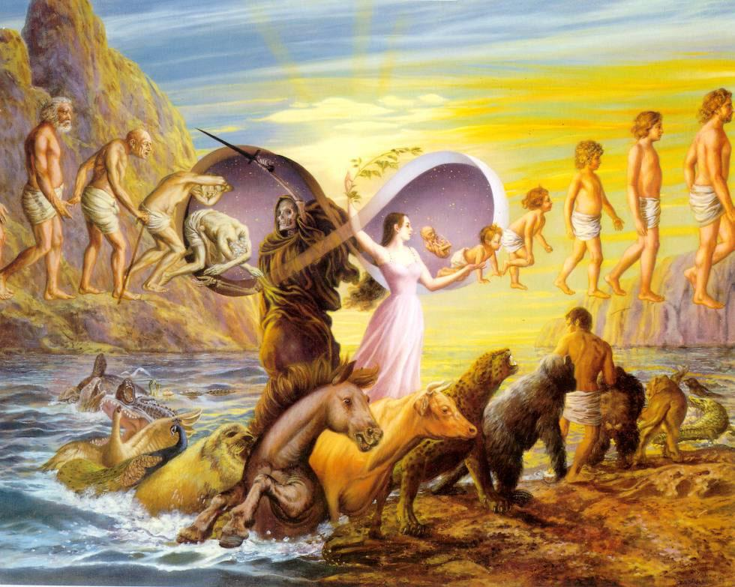

We can also draw direct parallels between the Myth Cycle and the Cosmic Cycle describing the evolution of the entire Universe. This rests on the assertion that the evolution of the entire Universe in time reflects our notion of an Image of God or Cosmic Template introduced earlier. And also on the assumption that the evolution of the Universe is Cyclical.

So as a result both the Myth Cycle and Human Life Cycle will both be reflections of the Cosmic Cycle of the Universe. Indeed the microcosmic would reflect the macrocosmic.

Put another way, what we’re suggesting is that all three cycles the Cosmic Cycle, Myth Cycle and Human Life Cycle are totally correspondent with each other. This is because the Image of God and Cosmic Template is manifested at the scale of the entire Universe as the Cosmic Cycle, and at the same time manifested throughout the Universe in all places, all processes and at all scales of consideration, from the atomic, human, planetary scales to the interstellar, galactic and back to the Cosmic.

In this way the Myth Cycles and Human Life Cycles are really instances of the Cosmic Cycle and Divine Image manifested in the lives of human beings, heroic and ordinary.

These are powerful ideas - ‘The Nature of God and Sacred Cosmology’, and ‘The Spiritual Journey’. In elucidating the Nature of God and the notion of the Divine Image is the essential unity and correspondences between the Divine Image, Cosmic Cycle, Myth Cycle and the Human Life Cycle. Also ‘The Nature of God and Sacred Cosmology’, explains the important mystical and mythic idea of the Cosmic Battle.

By showing how this Cosmic Battle is fought out in the minds of individuals, including Mythic Hero Questers, within Society and between Societies and also on inter-planetary, galactic and ultimate Cosmic scale, then this is one of the main underlying processes and recurring themes behind the Worlds Myths.

This is the struggle between Light and Dark or Good and Evil, happening on a personal, societal and also Cosmic level.

The Cosmic perspective is described by some of the ancient Cosmogonic or Creation Myths which describe how the World and Universe first come into being through a process of conflict or dialectic. And a recurring theme of these Cosmogonic Myths is the recurring idea of the Universe or World being created from the dismembered body of a sacrificed god.

In the Mythology and Religion of Hinduism in India this idea is well elaborated, where the body of God becomes the Universe followed by a complementary process by which the Universe becomes the Body of God again in an eternally repeating cycle. The ‘Nature of God’ explains the meaning behind this common Mythic theme.

We now move the current discussion to the Modern Myths and explore their relevance, meaning and impact.

Modern Mythology: From Star Wars to The Lord of the Rings, The Matrix and The Dune Trilogy

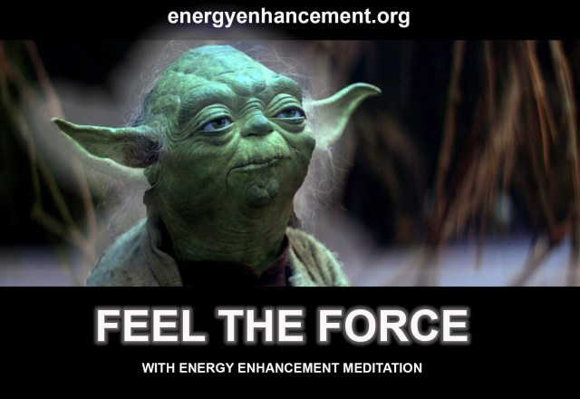

As already mentioned Joseph Campbell’s ideas about Mythology were quite widely read and significantly one of the people who was heavily influenced by his idea of the Mono-Myth, happened to be the creator of the ground breaking film Star wars.

It was George Lucas who conceived, wrote the story for and directed Star wars, "May the Force be with you".

He is fond of mentioning that while he was writing the storyline for the film, he would often refer to the work of Joseph Campbell to make sure he was on track and that there would be close correspondence between the outline of the Mono-Myth and the story behind Star Wars.

So In a definite sense, it can be said that Star Wars is a Modern Myth and faithful rendition of the Mono-Myth.

Though set in a technological science fiction context and communicated using the modern medium of film. It is natural therefore that there should be correspondence between the story in the film Star wars and the ancient myth of Odysseus and also the Grail Legends.

Also indeed by the same token, that there should be meaningful correspondence between Star Wars and many of the ancient Hero Quest Myths of the World. What we see therefore is a continuity and equivalence between on the one hand the traditional or classical Myths of old and on the other hand, modern Myths like Star Wars.

We can trace a sort of lineage and chain of derivation, whereby scholars like Joseph Campbell distill some of the ideas behind the pre-existent Myths of the World, followed by popularizers such as George Lucas who then bring these ideas in a more accessible form.

This process of borrowing and re-telling was also the way another well known myth, namely The Lord of the Rings Trilogy came into being. Essentially J.R.R Tolkien the originator and writer behind it, set out to create a body of Mythology for a people who didn’t already have one, i.e. The english speaking peoples of the World.

He made this clear in an interview. And he did this by extensively borrowing themes and motifs from the Norse Myths and Sagas.
So the Lord of the Rings is really a reworking of existing Mythic ideas in much the same way that the storyline behind the Star Wars movie is.

There are two other influential examples of Modern Mythology i.e. the Matrix movies and also the Dune Trilogy then again we see this same borrowing and re-telling process at work. In these cases we also see some borrowing directly from some of the Worlds major religions.

In both cases there is the notion of Prophecies for the coming of an expected one or Messiah.

In the Matrix, the main character Neo is the chosen one and prophesized saviour.

In the Dune Trilogy, the writer Frank Herbert borrows straight from Islam the term, ‘Mahdi’ or Muslim Messiah.

At the same time this process of borrowing and re-telling is not something peculiar to modern myths but is also part of the process by which many of the ancient Myths were synthesized. For instance we have already mentioned how Homer the writer of the Illiad and Odyssey was influenced by some of the Myths which were known to him such as Gilgamesh.

And the Grail Legends were constantly re-worked and re-retold such that there exist many versions of it to be found all over Europe, with some quite different storylines and inclusion of a variety of different Mythic motifs and themes.

In this way Modern Myths shouldn’t be seen as being somehow less because they have borrowed ideas from the ancient Myths, because this has always been part of the process by which Myths have come into being.

So in a very real sense people like George Lucas, J.R.R. Tolkien and Frank Herbert are like the modern day Homers of this world and present age.

Indeed, it can be argued that the Modern Myths are far more important than classical Myths such as Odysseus and the Grail Legends because their impact on modern people and the familiarity that most people have with them is far greater than with the Myths of old.

In the minds and imagination of a lot of everyday folk today, and especially in the younger generations, Modern Myths like Star Wars, Lord of the Rings, The Matrix and Dune; have a level of influence, relevance and meaning that perhaps in previous ages Myths like Odysseus and the Grail Legends would have had for their respective cultures.

So generally speaking, the power of Myth in modern times really derives from the Modern Myths such as those mentioned. But what is the power of Myth? What is their influence on modern society and might be their effect on the greater scheme of things?

As within, so without.

The search for enlightenment is the removal of the shadow subpersonalities, the purification and integration of the mind so that it becomes One Soul infused personality.

The paths towards this are many and there are many stones on the paths, so how to find the paths which work?

How to discard the false paths strewn by the dark side?

How to find the speediest paths which come to fruition in the shortest possible time?

How to choose a path with the greatest possible success rate?

Gurdjieff summed it up in his advice to Ouspensky in, "The Fourth Way", To move elements from one state of being into a higher state of being you need energy from an external source, Me!!

Always, in every Myth you need a source of ultimate evil, necessary as the perfect enemy to draw out the Enlightenment from the Hero, necessary to destroy that Evil and to make the World a better place.

Why do they tell us stories Daddy?, "I guess they just don't want to scare you!"
Take the brothers Grimm Myths for example "You have these children, there is a famine, Mother in law says "Go!" they leave, get captured by a witch. She puts them in the oven to cook them!!
How could anyone believe this?

Yet two weeks after food is taken away, most people turn into cannibals..

The Evil Sith Emperor in Star Wars with his mind-controlled Clone Army wants to destroy all the Jedi Knights and rule the Empire forever.

Sauron, servant of Morgoth, who lives outside the body and searches for a way to re-incarnate so as to destroy all races and rule a Planet of tortured and degenerated Elves called Orcs, forever.

Tolkien when asked if his Lord of the Rings was allegory said, “I cordially dislike allegory in all its manifestations, and always have done so since I grew old and wary enough to detect its presence. I much prefer history – true or feigned– with its varied applicability to the thought and experience of readers. I think that many confuse applicability with allegory, but the one resides in the freedom of the reader, and the other in the purposed domination of the author.”

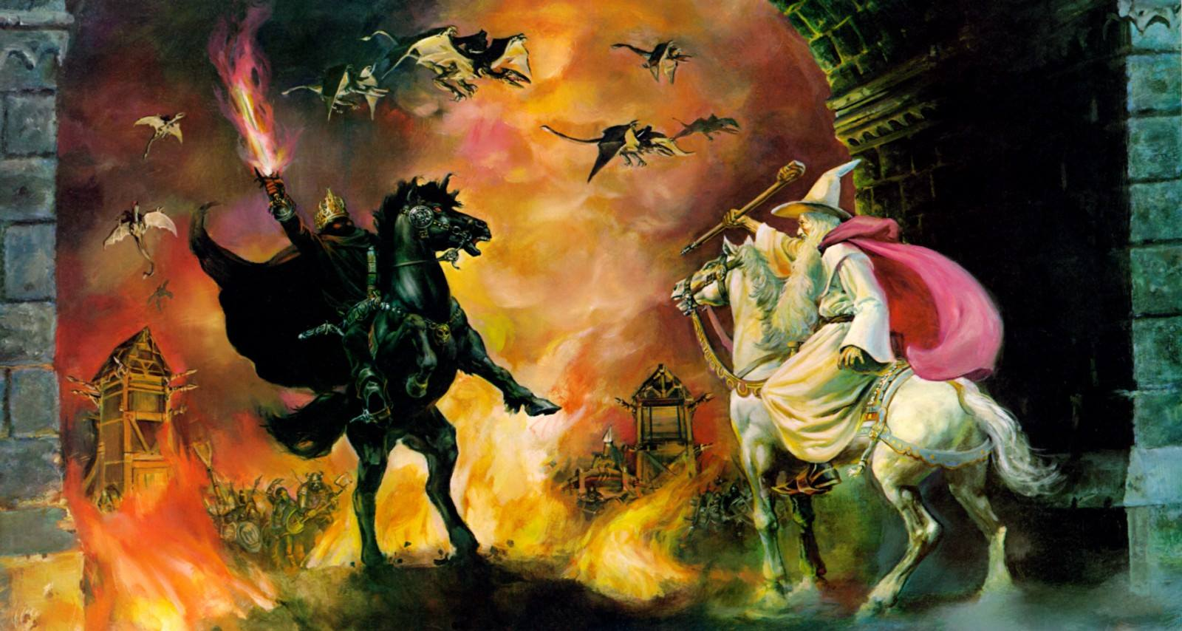
THE FIGHT AGAINST ABSOLUTE EVIL
GANDALF THE WHITE VS THE WITCH KING OF ANGMAR

Not allegory.. Applicable..

On this Planet Homosexual Black Magician Hitler wanted to destroy the Jewish Race and everyone who opposed him, Unpersoned Priests, Rabbis, Communists, Homosexuals, Intellectuals, and rule a Fascist Arian Race Thousand Year, SS Surveillance State, Book Burning Censorship, Reich.

Millions of people burned alive in concentration camps like Auschwitz, each of the five camps being at the tip of a Satanic Pentagram!

Who could believe it?

Applicable..

The Power of Modern Mythology

The power of Myth is multi-faceted and exists in various aspects some subtle and some quite direct. On a simple and direct level Myths entertain and excite, i.e. they serve as stimulating stories and gripping yarns. On a slightly higher level Myths can inspire. They can instill in people a sense of idealism, selflessness and even heroism. Especially in children and young people, Mythic Heroes can serve as role models or exemplars.

It is probably not an uncommon phenomenon whereby impressionable young people have imagined themselves as Mythic Heroes after exposure to Myths and in particular Modern Myths.

It has probably been fairly common for certain people to have identified with some of the characters of Modern Myth, perhaps Luke Skywalker of Star Wars, one of the Heroes from the Lord of the Rings or perhaps Neo from the Matrix.

But then this has always been the effect of Mythology. People have always been inspired powerfully by Mythology for better or worse. To give two examples of famous historical figures who were driven by the Mythic imagination, for instance we know that Alexander the Great was heavily influenced by the Illiad/Odysseus myth.

The infamous and perhaps not so great Adolf Hitler was much inspired by the Grail Legends and the story of Parsifal.

Another aspect of the power of Myth is that they can give people an attention grabbing and immediately accessible introduction to transcendent and mystical ideas. And as such they can serve as doorways into spiritual realms.

This was a side of Myth discussed when we proposed that the Hero Quest Myth can be seen as an allegory for the spiritual journey. And that the goal of the Quest Myth, for instance the Holy Grail or Princess can be seen as symbolizing the ultimate spiritual goal of unification with God or mystical awakening and realizing God Consciousness.

In this way Myths can serve as pointers to the inner mysteries and esoteric truths behind the Worlds Religions and their respective mystical traditions such as Kabbalah in Judaism, Sufism in Islam and Christian Gnosticism.

There is another way that Myths and in particular Modern Myths are very relevant and powerful with respect to what happening in the World today. And this derives from their relationship to the Prophecies contained in the just about all of the World’s major religions and great spiritual traditions.

The idea that the Prophecies are Now, that is the events and circumstances described in the Prophecies found in the World’s Religion correspond to and are describing the issues of the age and aspects of the World today, entitled, ‘The Prophecies are Now’.

What we could like to do now is to make a powerful and highly consequential assertion; This is the idea that there is a very deep connection between on the one hand, the ideas and themes behind Mythology; and on the other hand, the ideas and themes behind the Prophecies contained in the World’s religions.

If there is a Mythic Archetype which is a distillation of the basic themes and storylines common to all or most Myths then the same idea holds true for the Prophecies contained in the different religions of the World. That is we can describe a Prophetic Archetype which likewise distills the common storyline and themes behind all the different Prophetic sources.

What we propose is that the Mythic Archetype and the Prophetic Archetype are really two views on the same underlying truth and that they are essentially equivalent. The Prophetic archetype can also be called the Apocalyptic archetype.

Apocalypse is a word that is often associated with prophecies of the end times or the end of the age and one which has strong associations with disaster and calamity.

However the word Apocalypse, as literally translated from Greek, means something along the lines of, ‘The unveiling of the hidden thing’.

Apocalypse was also the word used by those involved in the Mystery Religions of Ancient Greece to describe the state of Union of Mystical Union with God.

So Apocalypse really describes a revelation, which can be personal or one given to an entire society. So the word Apocalypse doesn’t necessary imply a lot of negative happenings though disaster and malaise is a part of the generic prophetic storyline.

With this more positive meaning of the word Apocalypse in mind, we’ll be later on using the expression Apocalyptic archetype. This is in place of the equivalent expression Prophetic archetype, they mean exactly the same thing.

What we’ll do next is to explore some of the parallels between the Mythic archetype and the Apocalyptic archetype and further support the notion that there is a common truth underlying both. i.e. that the Apocalyptic archetype and therefore the Prophecies of World Religion are really also expressions of the Mythic archetype and the predicted or prophesized manifestion of the central themes of Mythology in the real life and the real World.

Mythology is like Prophecy. The Prophecies are Now and so Mythology is also like Reality

The important thing for us to consider is the relationship between Modern Mythology, which is most relevant to the modern mind, and the Prophecies of World Religion, which have a strong correspondence with the circumstances of modern times.

What we are saying is that the essential storyline of all the major Modern Myths and the generic description for the unfolding of events during the end times prophesized, which are common to all the various Religions and which make up the Apocalypse archetype; are really directly correspondent with each other.

In other words both the Modern Myths and the Prophecies of the World’s Religions are really telling the same underlying story. And because the Prophecies are really talking about present times and World in which we live today, then we can find very meaningful correspondences between on the one hand, Modern Mythology and the Prophecies, and on the other hand, the events and circumstances of the real World.

If Myths exist as transcendent archetypes, or as the famous quote mentioned earlier states that, ‘Myths are things which never happened but always are’. Then what this means is that even though the fantastical and phantasmagoric details of Mythology will never manifest in reality and neither should they be expected to.

Yet nonetheless the less superficial aspects of Mythology, that is the key themes and essential story behind them, do happen and become manifested in the actuality of the real World.

This is a world on the brink of calamity and disaster. Truly like no time before in human history, the planet as a whole is in a state of peril.

The Ecological, Environmental, Internet censorship, Google Social Score Unpersoning where Worldwide the faces, their voices, their videos, their very names are erased from the internet, they are not allowed to buy travel tickets, their bank accounts are cancelled, they are not allowed to buy or sell, mark of the beast, Smartphone Surveillance and Censorship systems are in a state of such stress and perturbation that the very future of civilization as we know it is being threatened.

So for instance the idea of a struggle between opposing forces of Good and Evil and the determination of the future of a World or Civilization, which is behind the story lines of Star Wars, Dune, The Lord of the Rings and The Matrix; has a lot of resonance with actual situation of the World today and the problems we face.

i.e. The Ecological, Environmental, Social Score, Surveillance and Censorship systems are in a state of such stress and perturbation that the very future of civilization as we know it is being threatened, together with all the Political problems of encroaching Tyranny, Oppression and Injustice, coupled with the Spiritual and Religious problems of the age.

But then this is also exactly what the Prophecies from the Religions of the World are generally talking about, i.e. a time of spiritual darkness, calamity and great peril culminating in a great struggle between dark and light, where the forces of evil are destroyed, the planet is saved and where a better World emerges from the old.

Which is also what’s behind the Modern Myths we have already mentioned.

Therefore the Modern Myths have served as introductions to the Prophecies of World Religion. A lot of modern people will have had no interest in any of the World’s Religions and would be completely unfamiliar with the Prophecies contained within them and described in their respective scriptures.

However many of these same people, particularly the younger ones, will be quite familiar with the storylines of the Modern Myths and so in this indirect but accessible way the key ideas of the Prophecies will have already been introduced to them. This is true even though they most people probably would never have made a connection between Modern Mythology on the one hand and on the other, either the Prophecies or the circumstances and events of modern day reality.

This is another way that Modern Mythology is powerful, in that it is preparing people for what is about to happen and has seeded in people’s minds possible roles that they might be playing in the drama of the unfolding of the Prophecies that is about to occur and whereby the boundaries between Mythic imagination and Reality will become increasingly unapparent.

So if the common themes behind Mythology can be distilled into a Mythological archetype, and if the same can be done for the common themes described in the Prophecies of Worlds major Religions to extract an Apocalyptic archetype; then to reiterate what we are essentially saying is that the Mythological archetype and Apocalyptic archetype are really different views on the same thing. Therefore it is not surprising that we should detect strong parallels between the various Mythic and Prophetic storylines.

In ‘The Nature of God and Sacred Cosmology’, we explain why this should be the case. Next, we’ll explore another important parallel that exists between Mythology and Prophecy and which concerns the idea of a central protagonist behind both the Mythic storyline and also the process of the unfolding of the Prophecies or Apocalypse.

The Mythic Hero as Messiah and Expected One

Earlier we mentioned than the creator of Dune, Frank Herbert, borrowed directly from the Prophecies of Islam and also that the idea of an expected prophesized Chosen One, Christ or World Saviour is central to the Matrix movies.

In these instances we are seeing a more direct transfer of ideas found in the Prophecies to modern people through the medium of Modern Myth.

Here what we are seeing is the direct communication of the Messiah or World Saviour theme which is common to all the Prophecies contained in the Worlds Religions.

In both the Dune and Matrix Myths we have situations where the central character and Mythic Hero of these respective Modern Myths, is also a prophesised chosen one, whose emergence in the mythic storyline had already been expected based on prophetic predictions. This would be exactly correspondent with the actual prophecies of this world and its major religions.

And also just as in the Prophecies of the real world, the respective Messianic characters in the Modern Myths of the Matrix and Dune are also the critical agents involved in the realization a benign outcome or happy ending to these tales.

That is the defeat of dark and oppressive tyrannical powers, the saving and/or renewal of a World and the creation of a better, happier, more just society. In the Matrix myth at the end, the hero Neo representing the Christ, saves two worlds, the virtual world of the Matrix and the human community of Zion by defeating a character called Agent Smith representing Satan.

And from this a new and ideal circumstance comes into being. In the Dune story, the main character Paul Atreides becomes the Mahdi and prophesized one, "He is the Quisatz Haderach!"

- defeating an evil and exploitative incumbent power structure and turns an arid hostile desert planet into one that is lush, fertile and fully hospitable to comfortable habitation. Also an oppressed people are made free and a more just new order comes into being.

At the same time, what have just described for the Matrix and Dune myths can also equally apply to the other two best known modern myths, i.e. Star Wars and the Lord of the Rings.

Though they don’t explicitly mention Prophecies or the concept of an Expected or Chosen One, nonetheless the storylines are very correspondent with our other two Modern Myths which do.

The Jedi Knights have psychic powers they gain from the Force, "May the Force be with you!" an allegory to the energy of God which is an applicable reality for those who practise meditation.

Lucas understands how real this is by naming the Evil Satanic opposition, the Sith. Turn Sith around and you have, "This" - The Lords of "This" reality.

So that the main characters of Star Wars and the Lord of the Rings play the same roles as that of the main protagonists in Matrix and Dune. And likewise they involve the defeat of evil tyrannical powers and the creation of a better world, or in the case of Star Wars a better Galaxy.

As already stated, this is also what is described by the actual prophecies of the Worlds Religions where the Expected One, i.e. whether the Messiah of Judaism, the Second Coming of Christ, the Mahdi of Islam, the Maitreya of Buddhism and Saoshyant of Zoroastrianism etc. plays respective roles which are very correspondent to that played by the main characters of the best known Modern Myths.

But instead of bringing about the happy ending of the Modern Myths, the Expected One of World Religion is predicted or prophesized to be critical in bringing about a happy conclusion to the Problems of this World and in addressing the major concerns of the human condition.

So therefore if we can draw parallels between Modern Mythology and the Prophecies of Religion, we can furthermore also draw parallels between the Mythic Hero and the Expected One of the World’s great spiritual traditions.

In effect, another purpose which Modern Myth has served, as well as introducing people to the general circumstances and events of the Prophecies, is that they have introduced to modern people what is behind the idea of the Expected One associated with the prophecies and who like the Mythic Hero is the critical agent of spiritual and/or cultural renewal and of societal and/or World transformation.

So we’ve established and highlighted the deep connections that exist between Mythology and especially the Modern Myths on the one hand, and on the other hand the Prophecies of the Worlds Religions together with the Apocalypse archetype that is common to them.

Due to the close correspondence between the Apocalypse Archetype and the Mythic Archetype, Apocalyptic Mass Movements could easily be interpreted as also being a discussion about Mythic Mass Movements.

Summary and Conclusion

In our examination of Mythology we have explored a variety of facets of Myth and considered some related topics which help us understand what is their higher meaning and true purpose. The main overall idea of what is Mythology, is that they are stories which in symbolic form have encoded in them some of the answers to the great philosophical and religious questions that people have come up with through the ages.

Myths point people in the direction that ancient organisations which have been in existence for thousands of years are continuously fighting to enslave humanity and that this is not just a story told to children, This is real!!

Myths say, more is possible from each individual - enlightenment, and that more is possible from the world - the destruction of tyranny, and that each generation, each age, is an internal and external fight for freedom and liberty.
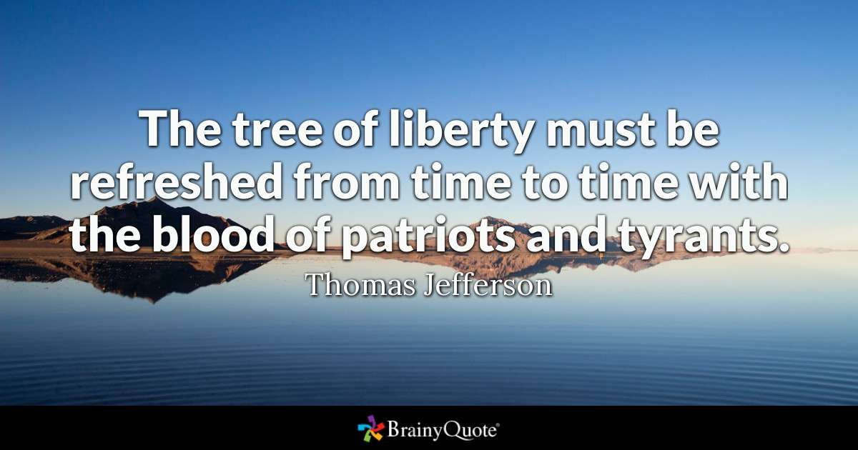
'
"The tree of liberty must be refreshed from time to time with the blood of patriots and tyrants." Thomas Jefferson

Myths are applicable allegories which deal with a variety of the most important questions in life and therefore often touch heavily upon spiritual and mystical topics. In fact they really talk about the same sort of things that we are concerned with. So by discussing some of the major aspects of the meaning of Myth, we also in effect provide an opening discussion to a lot of the themes.

The two main themes are reflected in, ‘Everyone is God and the Prophecies are Now’; are strongly related to core Mythic themes that occur repeatedly in World Mythology both ancient and modern.

That is the idea of the Hero Quest for some transcendent higher goal and the recurring storyline of a struggle to save and spiritual renew some society that is in a state of malaise or facing some impending major calamity.

What we have proposed is that this Hero Quest will generally be allegory for the spiritual journey leading towards the goal of Union with God and Mystical Awakening to our true nature.

Also by showing the correspondences and parallels between the predictions of the Prophecies of the Worlds Religions and some typical Mythic storylines; then we showed how the absorbtion of these Mythic storylines will also have the effect of communicating to people what is the basic storyline behind the Prophecies and their unfolding.

We showed how this is especially true for the Modern Myths such as Star Wars, Dune, The Matrix and The Lord of the Rings, which not only faithfully communicate the Mythic archetype and Mono-Myth but also the main ideas behind the Prophetic or Apocalypse archetype.

Therefore there is a deep and tight relationship between what is behind Mythology and the idea that Everyone is God and the notion that the Prophecies are now.

In an accessible way, Mythology really prepares people for these sorts of Mystical and Religious ideas and which has always been one of their purposes.

In that they serve as Outer Mysteries serving as applicable, allegorical and symbolic pointers towards the Inner or Esoteric Mysteries of Religion.

Something we also discussed is the direct relevance of Mythology to modern times and also the connection between Mythology and Prophecy.

We suggested that if there exists a Mythic archetype and a corresponding Prophetic archetype, then these two notions are essentially equivalent and different perspectives on the same underlying truth. Also we presented the idea that in the same way that the Prophecies are Now and that the general circumstances of the World and issues of the age correspond to the descriptions given by the Prophecies; so it is that the same is true for Mythology and in particular the Modern Myths.

So as a result we are able to find meaning correspondences with some of the things which define the present age, i.e. a planet in peril, corrupt satanic power structures, a state of transition and feelings of uncertainty and impending calamity, with aspects of the Mythic storyline.

So it is as if the Mythic archetype is manifesting itself in reality and the events of the real World.

We also discussed the parallels between the Mythic Hero of Mythology and the Expected One or Messiah of the Prophecies and proposed that the two concepts are very correspondent with each other.

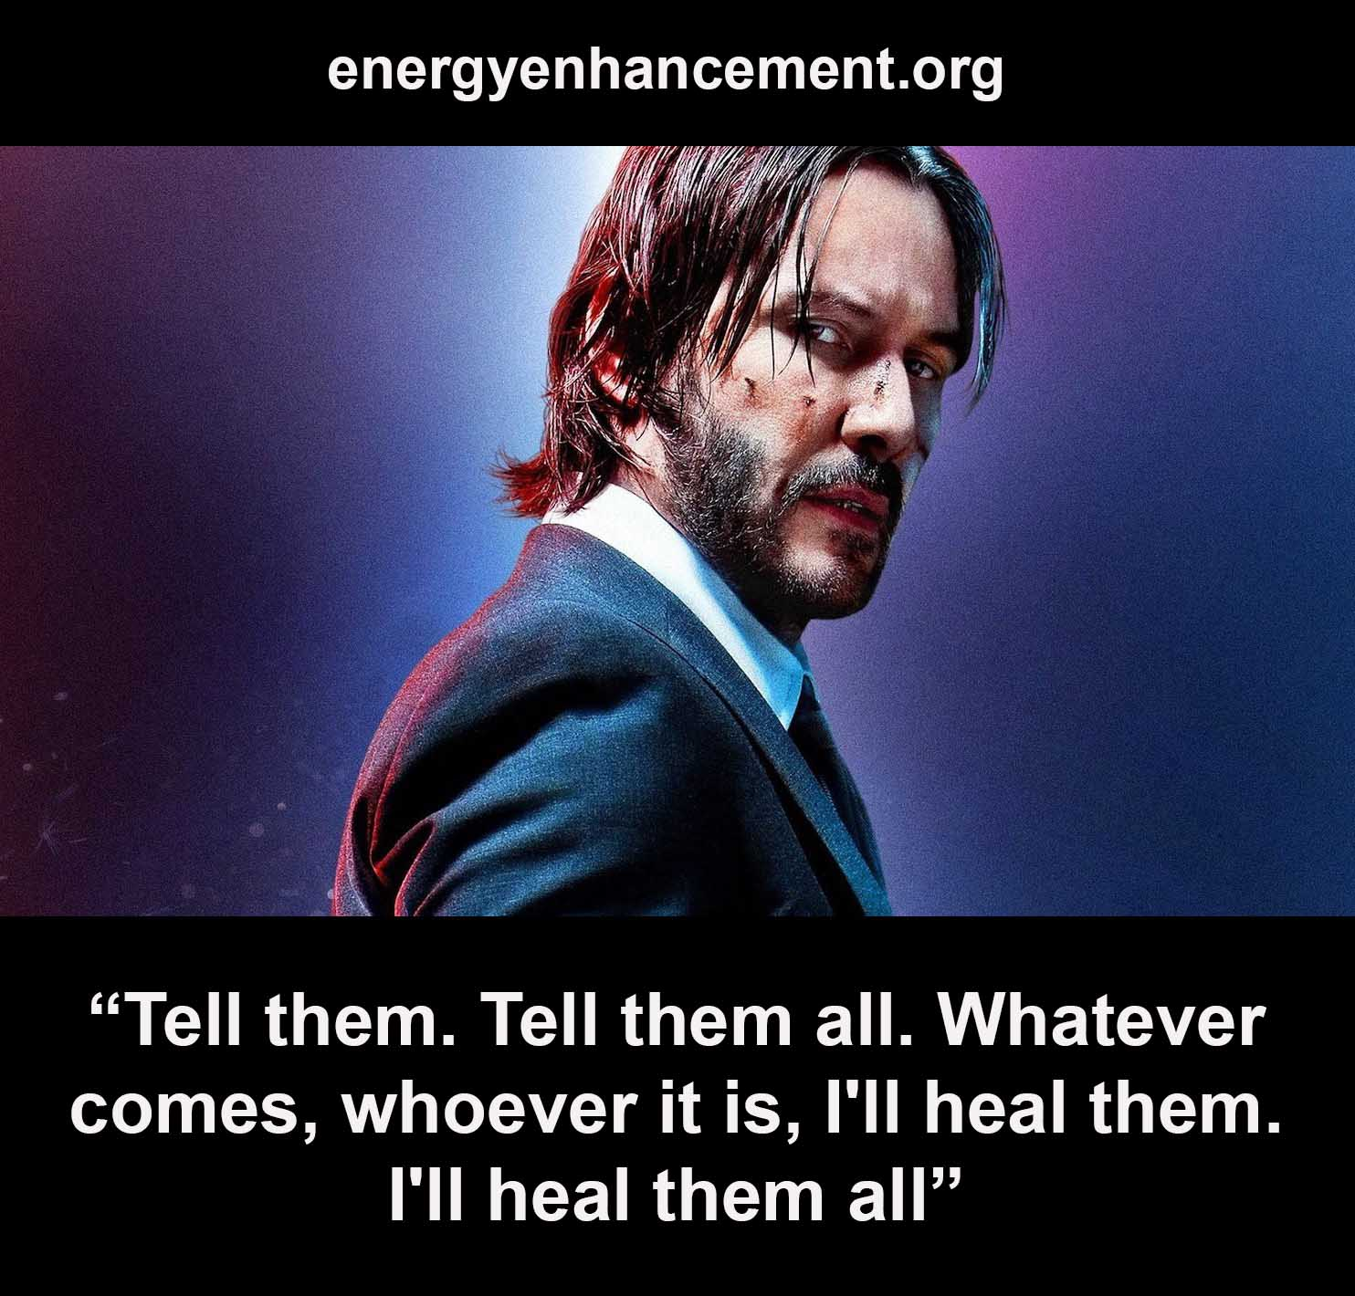

Everyone is a Hero. The Expected One or Messiah of the Prophecies is You!
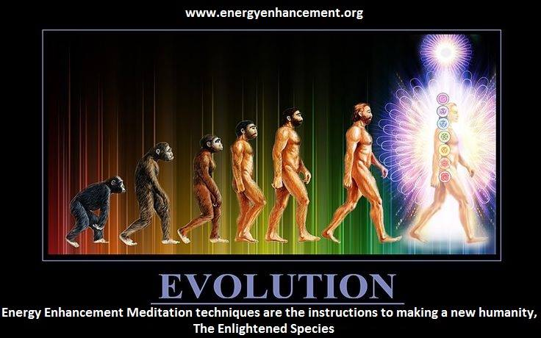

But you need to get trained up!

So in conclusion Myths though far removed from everyday life are really about real lives and their settings though fantastical are a mirror of the real world. And vice versa the real world can seem Myth-like. Indeed the boundaries between Myth and real life are indefinite and in the lives of certain people, these two realms merge together.

Furthermore at certain times during human history and in certain places in this world, events and circumstances come into being that are very much like the storylines from Mythology.

These are times of transition, conflict and upheaval which necessitate the quest for some spiritual revelation or change of political organization that will allow the societies caught up in these periods to adapt, survive and grow.

I believe that everytime in which we live today and the world we find ourselves in are exactly equivalent to those conditions found in some of the epic Hero Quest Myths and also particularly in the storylines of the best known Modern Myths. These are exactly the circumstances that precipitate the beginning of the Myth Cycle and the undertaking of the Mythic Hero Quest in the first place.

This is a world on the brink of calamity and disaster.

Truly like no time before in human history, the planet as a whole is in a state of peril. The Ecological, Environmental, Social Score, Surveillance and Censorship systems are in a state of such stress and perturbation that the very future of civilization as we know it is being threatened.

All the while the myriad and seemly intractable conflicts of this world are diverting our focus away from these global problems, making any attempts at their solution much harder and next to impossible.

On a worldwide scale, in mythic terms Camelot is in disarray. The equilibrium of the mythic palace or village has been upset and the Myth Cycle has come into play.

"Whenever dharma declines and the purpose of life is forgotten, I manifest myself on earth. I am born in every age to protect the good, to destroy evil, and to reestablish Dharma." - Krishna, The Bhagavad Gita
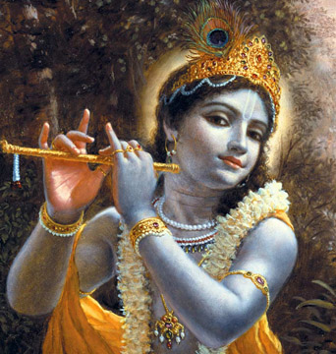
DHARMA IS THE PATH OF THE SOUL.
KRISHNA IS YOUR SOUL

So in the real world there is a feeling of unease that things are not right. There exists today that unless there is some drastic intervention or some new, significant and benign agency, then humanity will inevitably continue to get closer to the abyss and eventually fall in.

It is in these times of crisis that Mythology and the Hero Quest Myths plays another role. That is they serve the purpose of acting as a call to action and for people to take on the role of the mythic hero. I believe that modern myths such as the original Star Wars - "may the Force be with you", Lord of the Rings, The Dune Trilogy and the Matrix films can act as a powerful catalyst and have prepared a lot of modern people to take on the role of the mythological hero in real life.

For these tales can help to inspire people toward the selfless and heroic. There is an unconscious suggestion in these epic stories for people to take it upon themselves to save the World. By including pointers to the transcendent, they allude to the spiritual and point people towards the mystery that is God. Thereby mythology precipitates and makes sense of our quest for mystical awakening, helps in the process of spiritual renewal and inspires the struggle to save the Planet.

The key to self development is preparation. As we take up the burden we know that intellectual knowledge is no help in the fight against Evil. The Academic, Military, Industrial Complex is stuffed with Evil geniuses.
What is needed is talents who through trial and tribulation have removed their subpersonalities and become more One, more Soul infused. Giants of mythical proportion who in every age seize leadership in times of trouble, defeat Evil, and make this world a better place.
Energy Enhancement amongst All the traditional and newer Spiritual Technologies is the only one which talks about the major problems of Spiritual Development and yet provides the Techniques to overcome them. More it provides student reports from it's courses which detail the incredibly successful strides taken by the students in their Spiritual Development.

The problems of evil subpersonalities, energy blockages, Trauma and Past Life Trauma, the aim of becoming One Soul Infused Personality in complete alignment with the, "Force".
A Jedi Knight, an Enlightened person directed by the Soul.
"The ignorant work for their own profit, Arjuna; the wise work for the welfare of the world, without thought for themselves." - Krishna, the Soul, Bhagavad Gita

Only such people can have the Goodness and Single Minded Willpower to "Make a Difference" to overcome Ultimate Evil.
Article written by Wai H Tsang with Necessary Corrections about the Evil of Drugs and how ONLY Energy Enhancement Meditation Removes Subpersonalities thus enabling Enlightenment, the End of the Quest - by Satchidanand

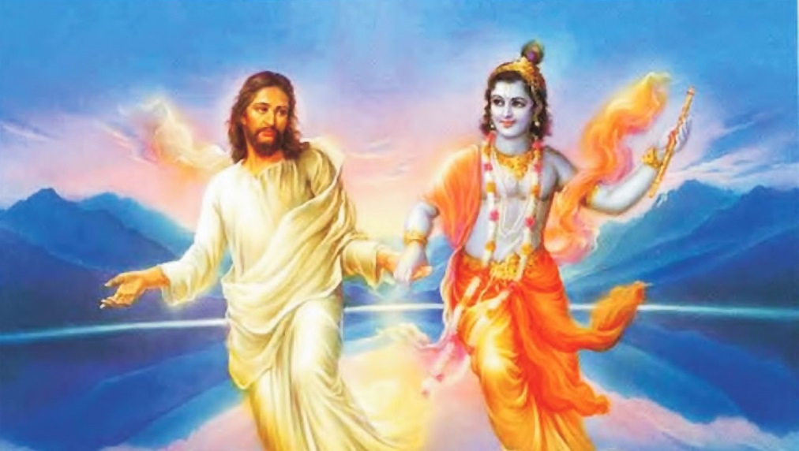
CHRIST KRISHNA

THE “JUST PULL YOURSELF TOGETHER” VIDEO ON YOUTUBE

https://www.youtube.com/watch?v=Y4GYooP6NOU

VIDEO ABOVE.. the famous, "Pull yourself together" video where Satchidanand trashes the greatest most intellectual investigators and descriptors of the Shadow Subpersonalities - Great People - The Highest of All Humanity - Jordan Peterson, Carl Jung, Nieszche, and every Psychotherapy, Psychological therapist who can describe the problem of the Shadow, talk about the problem of the shadow but have no Practical solution to the Shadow. All of those guys Failed to Solve the Problem of the Shadow. None of these guys have Any practical solution for the Shadow.. And it is the Shadow Subpersonalities which is the Source, The Fount, of All Evil on this Planet... And the Source of All Evil within You!!

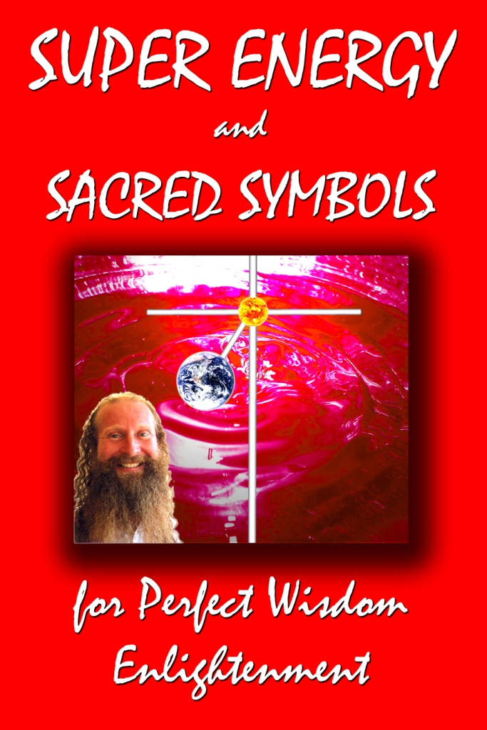

Go to http://www.energyenhancement.org for 21 Free Energy Enhancement Books.

To defeat Evil, you need to up your game. Learn the Energy Enhancement Meditation Course by Video or Live in Iguazu.
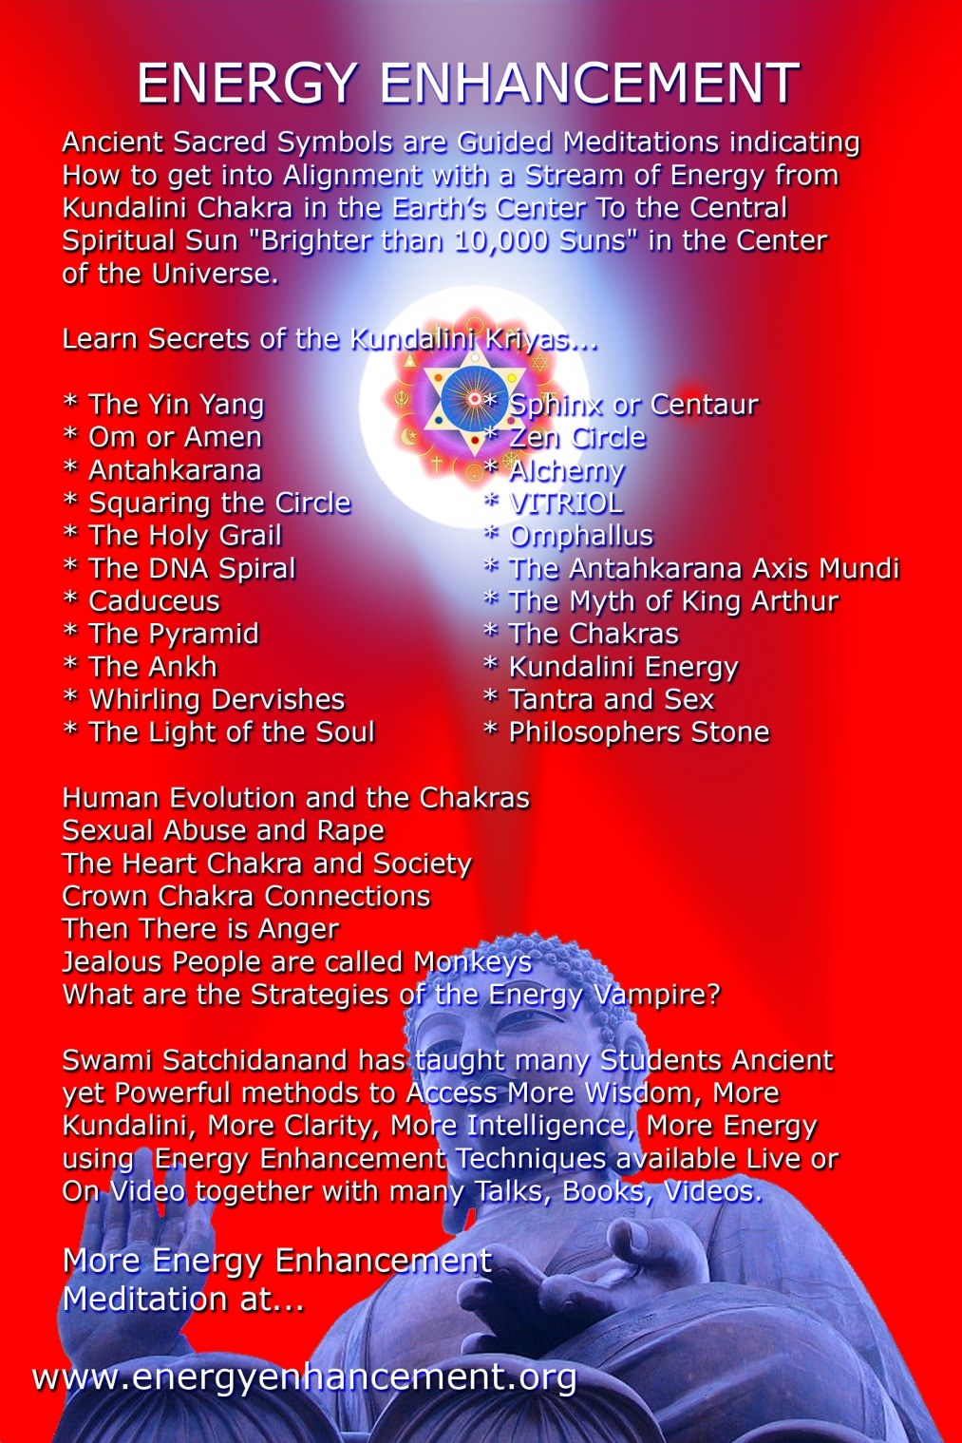
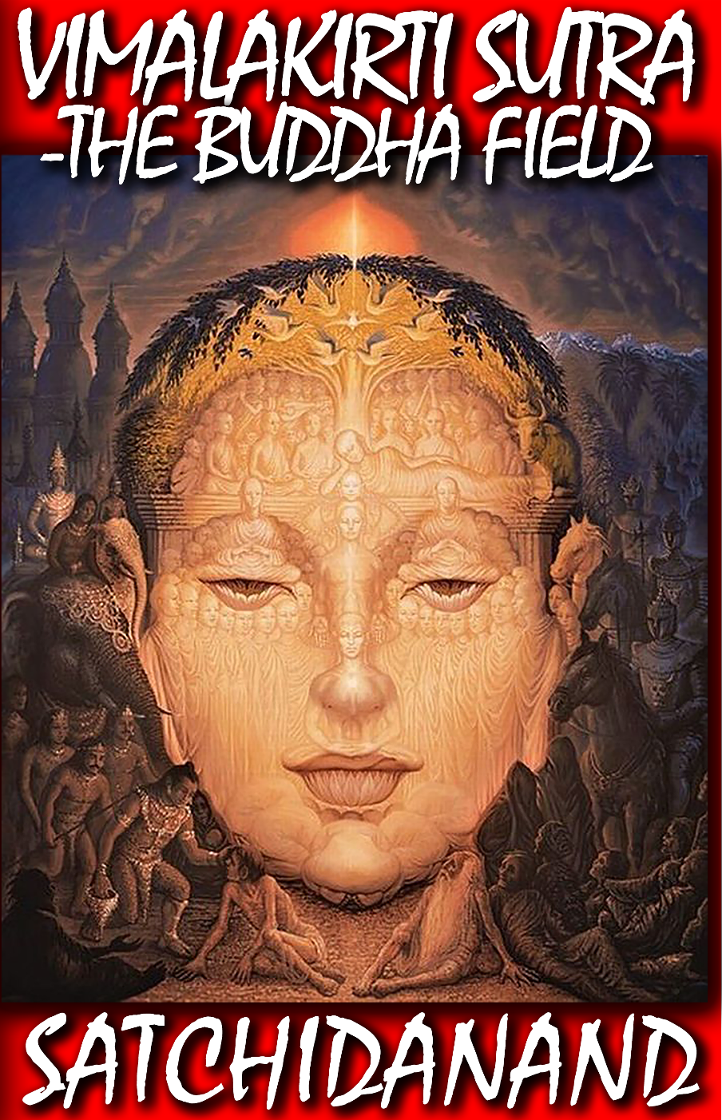
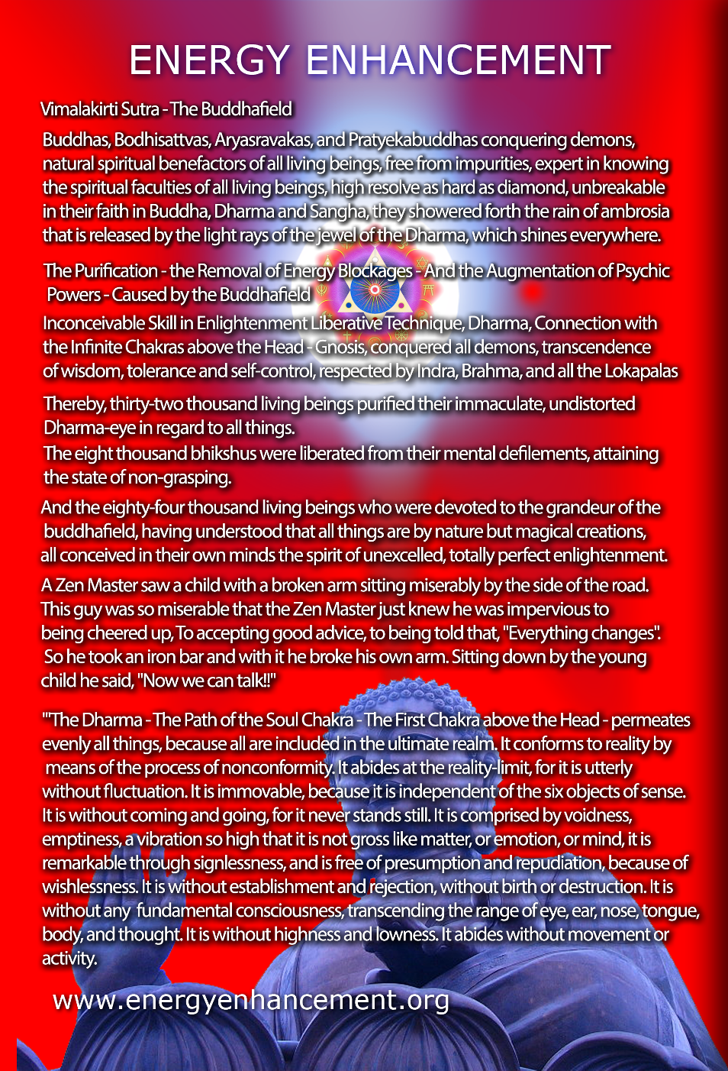
Jordan Peterson, Nietzsche, Jung and Tolkien - Myth and the Age of the Hero
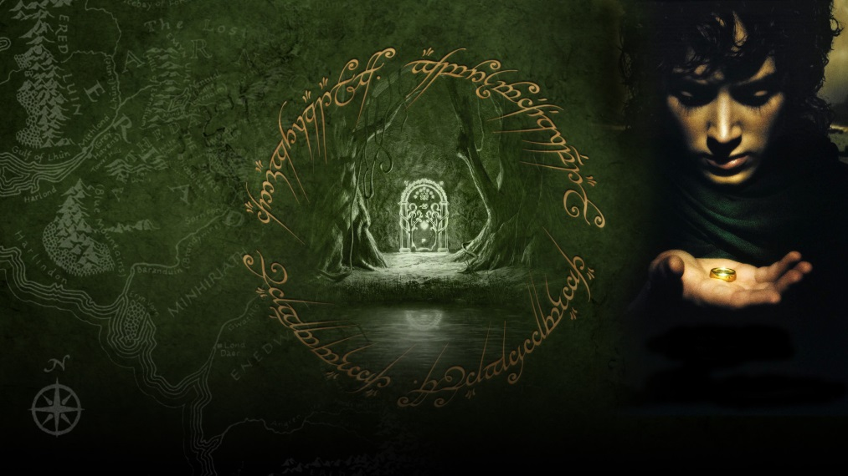

“Here we have our present age … bent on the extermination of myth. Man today, stripped of myth, stands famished among all his pasts and must dig frantically for roots…” (Friedrich Nietzsche, The Birth of Tragedy)

We live at a time where science and technology have diminished our physical suffering to a remarkable degree. But can the same be said about our psychological suffering?

For while our life spans have been prolonged, and many diseases eradicated, this has not changed our existential predicament. Just like every other man or woman to have walked this earth, we are born, we will die, everything and everyone we know will turn to dust, and unless we are one of the exceptional few, our legacy will live on for at most a generation.

Dwelling on these facts does not bring us joy. But if we dwell on these facts and at the same time feel that our life lacks meaning and significance, that nothing greater is achievable, that when we die, property, money, power, fame, relationships will fall like us into dust, then we will suffer from acute psychological pain.

Meaning and significance has traditionally been taught by myth and meditation.

The West, however, finds itself in a difficult position in this regard. For according to Friedrich Nietzsche and Carl Jung, the decline of Christianity ushered the West into a period of mythlessness in which it remains to this day. And this lack of myth, irrespective of all the advances in science and technology, has made it harder for us to face up to our existential predicament and increased our propensity for psychological suffering.

“Among the so-called neurotics of our day there are a good many who in other ages would not have been neurotic—that is, divided against themselves. If they had lived in a period . . . in which man was still linked by myth with the world of the ancestors. . .they would have been spared this division within themselves.” (Carl Jung, Memories, Dreams, Reflections)

How does myth help us shoulder our existential burdens and alleviate our psychological suffering? Are myths not merely attempts to explain the workings of the natural world or fictional stories which glorify the origins of a culture?

Have we not moved beyond our need for myth with the rise of science? According to Nietzsche and Jung we have not. For science and myth address different questions. The scientific method deals with cause and effect and helps us understand the workings of the natural world. Myths, on the other hand, are ancient concentrated narratives which transmit modes of behaviour, patterns of action, rites of passage which awaken parts of ourselves which we never knew existed within us, and ways of experiencing the world that promote a healthy psychological development and a meaningful life.

The myth, in other words, is a divine template, an Angel which embodies the wisdom of generations past, awakening psychic DNA, our psychic powers which alone can offer solutions to our shared existential dilemma and helping unite a culture under a shared vision.

When a society loses its Angel embodied myth, the members of that society do not lose their need to author stories about their life. Rather this need is so integral to our well-being that it’s something we do with, or without, the help of a myth but as Gurdjieff says, we "wiseacre" false stories, lies from the Father of Lies, which deviate us from our inner needs and degenerate us.

But when a society’s “horizons are ringed about with myth” (Nietzsche) the process of constructing a meaningful life story, and one that promotes our psychic and psychological development, is greatly facilitated.

To understand how the myth achieves this feat we need to examine the role of the mythological symbol. For it is the symbols of the myth that act in the words of Nietzsche as “the unnoticed omnipresent… guardians under whose protection the young soul grows up…”

Unlike a sign which points to, or represents, a known entity, a symbol in the words of the Jungian scholar Edward Edinger “is an image or representation which points to something essentially unknown, a mystery.” (Edward Edinger, Ego and Archetype)

Religions are the richest source of symbols. Whether it be the cross of Christianity, the Mandala of Hinduism, or the dharma wheel of Buddhism. Whether it is embodied in the Greek Myths of Hercules, Zeus, Prometheus, or Perseus..

Jordan Peterson talks about Perseus facing the Medusa..
How Medusa Fear Freezes You and stops your evolutionary progress.
The use of Medusa Fear! to Freeze your Heart.
The use of Medusa Fear! to Freeze your Conscience.
The use of Medusa Fear! To Freeze your Feet.. So you Cannot Take the Next Step Forward..

ANCIENT MYTH TELLS YOU WHAT YOU NEED TO DO...
PERSEUS KILLS THE FEAR DEMON MEDUSA AND FREES THE ANGEL WITHIN..
BURNE JONES - PERSEUS KILLS THE FEAR DEMON MEDUSA IN THE DEPTHS OF THE UNCONSCIOUS AND FREES THE ANGEL WITHIN..

"Sort yourself out!" Jordan Peterson

"It is more difficult to rule yourself than to rule a city" Jordan Peterson

There are horrible monsters inside you, fear, anger, sadness, depression, violence, manicism, grandiosity, vanity, which need to be tamed, brought into submission and benignly used to make you a powerful actor in this world.

These horrible Monsters and Demons - Transmuted and Purified by Energy Enhancement Advanced Meditational Techniques - later, become Angel Talents for your benefit and the benefit of Humanity.

Only after removing the trauma within can we access true courage and the compassion within which can actualise self sacrifice for the benefit of others.

Higher, myths are embodied in the Buddha, the Christ, the Earth Protector Angels Saint Michael and Saint George, Gandalf, Aragorn and Frodo, these symbols act in a teleologic manner, beckoning us forward toward goals we only partially understand.

In response to World War I, countless voices asserted that “chivalry” cannot “redeem the war’s disgrace”32 . Yet J.R.R. Tolkien never abandoned the path of chivalry – on the contrary. This discussion will map out Tolkien’s concept of the heroic and show how he incorporated and remodelled ancient notions into his own mythology.

Tom Shippey, who not only attended the same school as Tolkien, but also followed the same academic interests, taught the same syllabus at Oxford and Leeds, once started a lecture by singing aloud the old King Edward’s School song that he and JRR Tolkien both learned as children. The point of this lay in the following lines: "Oftentimes defeat is splendid! Victory may still be shame".

From this quote, he went on to suggest that Tolkien was ingrained from an early age with notions asserting “glory even in defeat” and stressing the possibility of “victory without honour” which we later encounter in, for example, the Silmarillion and Lord of the Rings.

SAINT MICHAEL CONQUERING SATAN IS AN EARTH PROTECTOR ANGEL-HERO

The tales from the Elder Days concerning elvish and human resistance to Morgoth’s growing power are largely tales of heroic defeat – amazing feats of courage and skill among the protagonists will not lift the cloud of impending doom which spreads with Morgoth’s advances on the larger scale.

This Tolkienian mythological concept of the courage of St Michael and St George and the Myths which develop that Angelic concept within is richly exemplified in Tolkien’s professional fields of interest.

In the following quote from the famous Anglo-Saxon poem “The Battle of Maldon ”, Tolkien’s English “ancestors” have been attacked by a fierce army of Viking invaders. Although the Vikings are between two branches of the river and thus separated from launching their full strength at the Anglo-Saxon army, Beortnoth nobly allows them free passage to do battle on equal terms. Vastly outnumbered, Beortnoth and his brave men are slain until only a small, unflinching band of housecarl warriors remain:

“Byorthwold spoke; he grasped his shield; he was an old companion; he shook his ash spear; full boldly he exhorted the warriors: 'Thought shall be the harder, heart the keener, courage the greater, as our might lessens. Here lies our leader all hewn down, the valiant man in the dust; may he lament for ever who thinks now to turn from this war-play. I am old in age; I will not hence, but I purpose to lie by the side of my lord, by the man so dearly loved.'”33

This account is a powerful record of heroism – of unwavering loyalty and dedication. The lines “Thought shall be the harder, heart the keener, courage the greater, as our might lessens" are one thousand years old and considered one of the finest expressions of the pre-Christian heroic spirit, what Tolkien himself called "Northernness".

Now, Tolkien's attitude to certain aspects of the poem was highly critical, yet this particular passage, epitomising the heroic idea of sacrifice and unyielding dedication, is clearly echoed in his own work, especially the dark and dense mythical account Silmarillion. The poignancy of this heroic ethos is used to great effect, for example, in Fingolfin’s desperate duel with Morgoth, the Satanic Dark Lord of the First Age, or Hurin’s Last Stand, guarding the retreat of their allies, the Elves:

"Then all the hosts of Angband swarmed against them, and they bridged the stream with their dead, and encircled the remnant of Hithlum as a gathering tide about a rock. … all the valiant Men of Hador were slain about him in a heap… Last of all Húrin stood alone. Then he cast aside his shield, and wielded an axe two-handed; and it is sung that the axe smoked in the black blood of the troll-guard of Gothmog until it withered, and each time that he slew, Húrin cried “Aurë entuluva! Day shall come again!” Seventy times he uttered that cry; but they took him at last alive, by the command of Morgoth…" 34
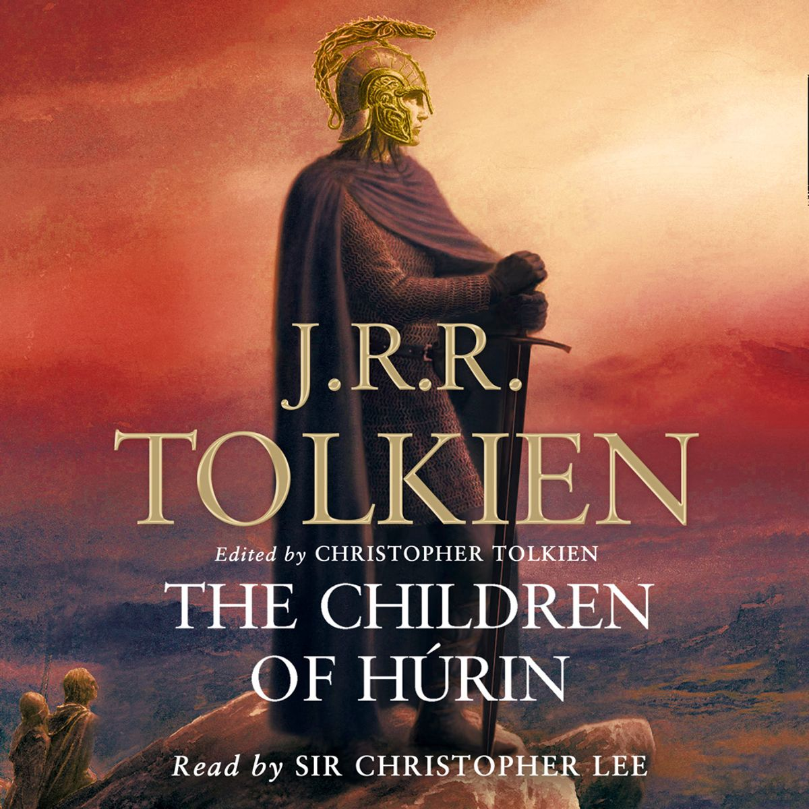

This quote vividly illustrates Tolkien's use of unflinching will (against impossible odds) as the highest and noblest expression of heroism.

That quality is found in the ancient poem of Beowulf35 , one that Tolkien spent a lifetime studying. Beowulf was composed at a point in time when pre-Christian heroic literature and pagan traditions of England had encountered the Christian world. Tolkien describes this as "a fusion that has occurred at a given point of contact between old and new, a product of thought and deep emotion."36

Therefore, although Beowulf is certainly the work of a Christian poet, it is also a poet looking back on a mythic and heroic past. His themes still carry much of its sentiment, he is still intimately familiar with its ancient nobility and mode of expression - yet the Christian lens through which he views this memory of native (heathen) past colours his entire portrayal. It is fair to say that Tolkien felt closer akin to the Beowulf poet than to most authors of later times.

Part of what he admired was the unique tone of this poem and much of his scholarship revolved around the Beowulfian legacy. In fiction, the Northern heroism fused with Christian sentiment was an ideal to which Tolkien aspired.

As he asserts in his Beowulf lecture: "one of the most potent elements in that fusion is the Northern courage: the theory of courage, which is the great contribution of early Northern literature."37

Yet, sacrifice comes in many forms and Frodo's spiritual sacrifice is by no means inferior to Húrin's physical one. Many quotes could be given in illustration of this heroic spirit in Tolkien and their unifying feature is the characteristic representation of the balance of power.

Rather than depicting his protagonists in a superior role, Tolkien does the reverse and confronts them with adversity, hardship and sorrow. This is specifically prominent in Silmarillion, but as any attentive reading will show, the Quest of Lord of the Rings operates on the same premise.

Tolkien chooses to show only specks of joy and only greatness beset with dangers. The assertion of course being that peace is bought dearly at the cost of sacrifices and continued vigil and awareness of the Ancient Enemy.

Furthermore, victory, however dearly bought, can never be regarded as permanent. One evil may be defeated, but new ones will rise and complacency will allow them to grow unchecked.

And thus, while painting images of magnificence, yet tinting them with despair, Tolkien crafts his Secondary World as an unceasing inspiration for the protagonists to achieve their highest potential, to constantly test their valour and loyalty.

The immediately perceptible effect of this mode is unmistakable and powerful. It serves to imbue his characters with the authenticity of medieval Northern temperament and it enhances their heroic qualities in the eye of the reader.

32Sassoon, Siegfried "Glory of Women" in the "Voices from WW1" section in Abrams, M.H., The Norton Anthology of English Literature, vol. 1, New York, W.W. Norton & Co., 1993, 6th ed. back
33"Battle of Maldon, The", Anglo-Saxon Poetry, ed. Gordon, R.K., Everyman’s Library, London, 1964, p. 334. back
34Tolkien, Silmarillion, p. 194-195 back
35"Beowulf", Anglo-Saxon Poetry, ed. Gordon, R.K., Everyman’s Library, London, 1964 back
36Tolkien, J.R.R., "Monsters", p. 20 back
37Ibid., p.20 back

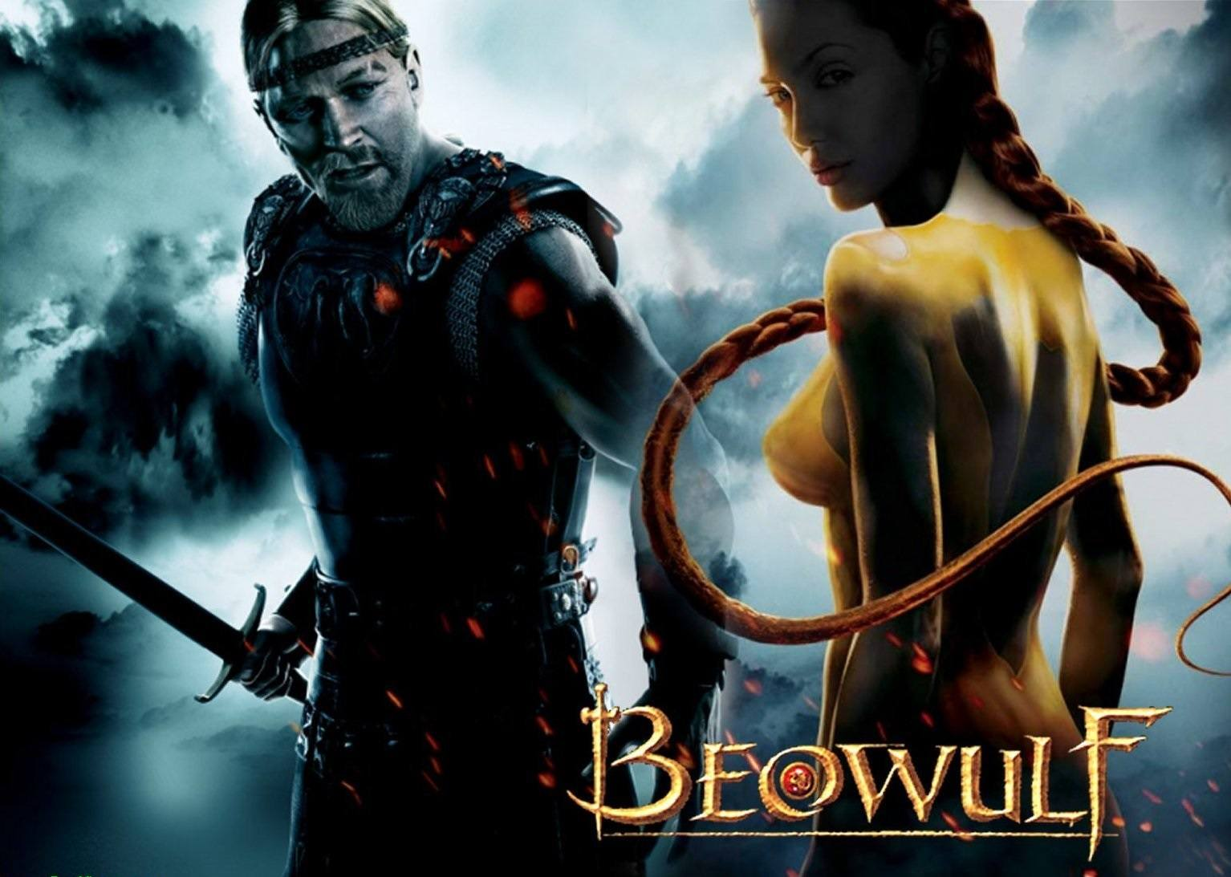
MOVIE BEOWULF (2007) WITH ANGELINA JOLIE

Beowulf, named after its valiant protagonist, is renowned as the most important Old English epic poem, used to teach generations of men the masculine virtues of true loyalty, undying courage, and the power of action. In the tale, Beowulf comes to the faithful assistance of his father’s friend King Hrothgar, one he is indebted to. He slays a giant, hellish creature named Grendel that plagued the kingdom, and when its monstrous mother desires vengeance he pretends to kill her as well but in fact is controlled by this Demon as in fact King Hrothgar was before him.

However, in this movie, at the behest of the Ancient Enemy writers, Beowulf shows the Satanic control of Kings, the serpent in the hearts of all, and his shame at being so controlled.

“It is the role of religious symbols to give a meaning and significance to the life of man.

The Pueblo Indians believe that they are the sons of Father Sun, and this belief endows their life with a perspective (and a goal) that goes far beyond their limited existence. It gives them ample space for the unfolding of personality and permits them a full life as complete persons.

Their plight is infinitely more satisfactory than that of a man in our own civilization who has been told that he is (and will remain) nothing more than an underdog with no inner meaning to his life.” (Carl Jung, Man and His Symbols)

The abandonment of myth is an obvious ploy of the Dark Side in order to weaken the resistance of humanity to its evil lies. Why should we believe in something, that considered objectively, through the lens of our more enlightened scientific mind, has no basis in reality? But the role of the symbol is not to help us manipulate or understand the external world, rather its primary purpose is to help us develop psychologically and spiritually.

“Considered from the standpoint of realism, the symbol is not of course an external truth, but it is psychologically true, for it was and is the bridge to all that is best in humanity.” (Carl Jung, Symbols of Transformation)

“The religious myth is one of man’s greatest and most significant achievements, giving him the security and inner strength not to be crushed by the monstrousness of the universe.” (Carl Jung, Symbols of Transformation)

The Dark Side has achieved a loss of myth through failing, stupid, dying, Gods and Goddesses easily killed of in Movies like, The Avengers, The X-Men, Superman, Captain America, and Wonder Woman.... Made stupid and being killed off at the behest of evil script writers working for Trillionaires whose only aim is taking the heart of you, and the crushing of courage, meaning and significance in order to attain a 10,000 year control of humanity.

Courage, meaning and significance can be taught through Myths like Tolkien but only actualised through Energy Enhancement Meditation which alone can bring you into contact with the the Real Energies, a Rite of Passage which awakens the Real You, only talked about in Myth and shown by Symbol.

Until you have meditated using Energy Enhancement, accessed the Chakras above the Head, the Chakra in the Center of the Earth, removed all your evil Energy Blockages, you are as yet a dependent child, dependent on the Oligarch controlled state.

What has not been lost is our need for meaning and therefore the West finds itself in a precarious position. For without a myth to help us author a meaningful life story and unite the culture in which we live, many people, according to Nietzsche and Jung, will latch on to collectivist political ideologies.

The Dark Side has created false myth ideologies, encompassing their own sets of symbols and rituals, allow those who follow them to feel they are contributing to something bigger than their solitary self. But Existentialism and the Postmodernist worship of the state, in whatever form it takes, is the worship of a false idol.
See this article on the Frankfurt School for more information on Postmodernism.

I could wax about false Existentialism and the false Existentialist heroes of Kubrick, James Ellroy and Elmore Leonard where the hero is a psychopath (Kubrick) or a nice psychopath by writers like James Ellroy and Elmore Leonard where their stories teach that psychopaths can be quite nice and they always get the girl, as I have done in other articles where true heart is supplanted by the term, "enlightened self interest", but while collectivist political ideologies can relieve its followers of the burdens of their individual existence, it is an inadequate replacement for real myth.

For Postmodern statism does not promote the healthy development of the personality. Rather the moral education it offers is one that diminishes the value of the individual in favour of the collective. But to make matters worse, as history has amply shown, the worship of the state does not produce cultural unity, but instead breeds division, conflict, and death as seen in the rise of Hitlerian "Kill out compassion" Fascism and Godless Stalinist "More Blood" and Maoist Collectivism which killed 200 million people in the 20th century.

“The state is merely the modern pretence, a shield, a make-belief, a concept. In reality, the ancient war-god holds the sacrificial knife, for it is in war that the sheep are sacrificed… So instead of human representatives or a personal divine being, we now have the dark gods of the state… The old gods are coming to life again in a time when they should have been superseded long ago, and nobody can see it.” (Carl Jung, Nietzsche’s Zarathustra)

Here Nietzsche is foretelling the return of human sacrifice and Satanism as did in fact occur with Hitler who was a Black Magician and with Stalin who said "Religion is the opium of the people".

Well, see what happens to society when you remove God - this act killed 200 million people in the 20th century.

"Religion is the opium of the people" is one of the most frequently paraphrased statements of German philosopher and economist Karl Marx who worked for British Secret Services under his handler, Ambassador Urquhart in his offices in the British National Library in London where he wrote, "Das Capital" from Urquart's notes.

Marxism and Socialism was created and has been used by the British/American Empire to destroy Russia-Lenin/Stalin, Europe-Junker and China-Mao and many others Worldwide.

If we agree with Nietzsche and Jung that collectivist political ideologies are an inadequate and destructive alternative to our lack of myth, is the only remaining option to descend into a passive state of nihilism?

Nietzsche and Jung were adamant that such a response was inappropriate and would only lead to a wasted life. For while we may be forced to accept the mythless condition into which we were born, the Satanic Nietzschian says that it does not follow that we must endure a meaningless existence as a result.

“The time is coming when man will no more shoot the arrow of his longing out over mankind, and the string of his bow will have forgotten how to twang!” (Nietzsche, Thus Spoke Zarathustra)

For when the hunger for heroism dies in a culture, the culture begins to die too. It is to the individual in the culturally decaying modern West that Nietzsche dedicated his masterpiece.

“But, by my love and hope I entreat you: do not reject the hero in your soul! Keep holy your highest hope!” (Nietzsche, Thus Spoke Zarathustra)

“It is a measure of the degree of strength of will to what extent one can do without meaning in things, to what extent one can endure to live in a meaningless world because one organizes a small portion of it oneself.” (Nietzsche, The Will to Power)

The need to organize our own small portion of meaning in an otherwise meaningless world is why our age, in addition to being a mythless one, can also be viewed as the age of the existential hero.

The existential hero is the one who displays the strength of will without connection to God to which Nietzsche alludes.

Rather than being overcome by the inner chaos that plagues those disconnected from an effective myth, the hero faces up to this chaos and discovers his or her own solutions to the existential burdens of our time. Hitler and Stalin exemplified the use of the Will without connection with external streams of spiritual energy, and were the epitome of existential "heroes".

But myth without contact with the spiritual energies of God is a false satanic myth lie, propounded by the false Existentialist heroes of writers like James Ellroy and Elmore Leonard where the hero is a nice psychopath. Where their stories teach that psychopaths can be quite nice, kill people without turning a hair and they always get the girl. Examples - L.A. Confidential (1997), Street Kings (2008), Get Shorty (1995), Out of Sight (1998), Jackie Brown (1997), The Big Bounce (2004) etc.

Courage, meaning and significance can be taught through Myths but only actualised through Energy Enhancement Meditation which alone can bring you into contact with the the Real Energies only talked about in Myth and shown by Symbol.

The bold few who practise meditation contact the real reality, an infinite spiritual energy which activates a Rite of Passage which powers up inner resources freeing up and Intensifying Spiritual energy and powering up unconscious abilities - psychic powers and visions never before entered into, never before encountered. Parts of ourselves we never knew existed before we activated and energised with these Energy Enhancement techniques.

You see.. You don't know who you really are.

If you knew who you really were you would never feel inferior, afraid, incompetent, depressed, juvenile, incomplete.

If you knew who you really were your search would be over.

You would be here.

Now.

You are a part of the universe.

You are the universe.

But you are disconnected.

You do not inhabit yourself.

It's as if you have a Palace but only live in one room.

PALACE

The Meditational Intensification of Spiritual Energy Powers up Psychic Powers and Visions - Shaktipat, Supermind, Kundalini Kriyas, Siddhis, Enlightenment, Telepathy, Astral Travel, Prophesy - Intensification comes through Connection and Blockage Removal.
Click Below...
http://www.energyenhancement.org/Meditational-Intensification-Spiritual-Energy-Blockage-Removal-Visions-Psychic-Powers-Siddhis-Enlightenment-Telepathy-Astral-Travel-Prophesy.htm

The freeing up and intensification of Spiritual energy powers up unconscious abilities - psychic powers and visions never before entered into, never before encountered. Parts of ourselves we never knew existed before we activated and energised with these Energy Enhancement techniques.

Inhabit All of yourself.

Stretch out and grasp that which you already have, within.

Connect to every part of yourself.

Grow into that infinite template recorded in your spiritual DNA

You are like a seed which has been kept in a box.
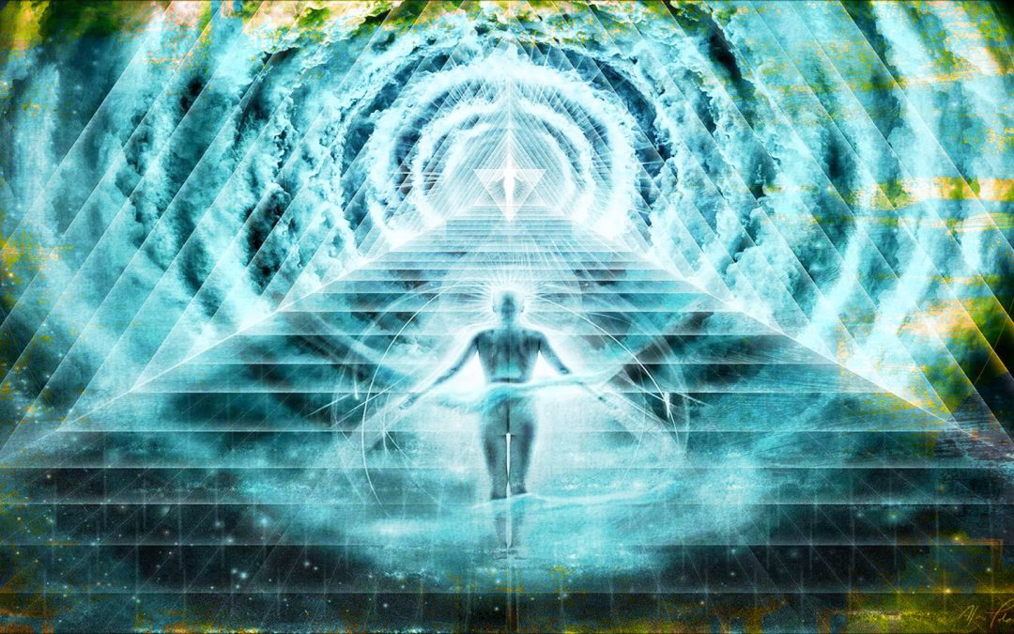
STAR SEED

Get out of the Box.

Germinate that seed.

Energise that seed!!

Plant it in the good earth.

Roots down into the Center of the Earth.

Leaves stretching up into the Central Spiritual Sun.

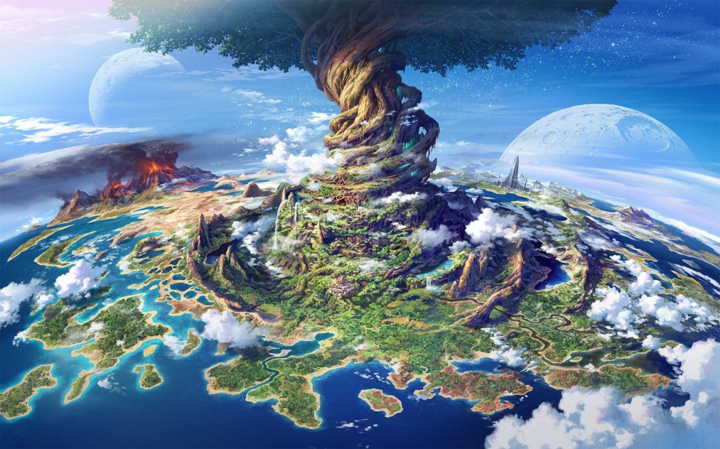
SACRED TREE –YGGIDRASIL

Grow.

Become that which you were born to be.

Connect, Only connect.

CONNECTION

Learn how to Connect!

"Connect Only Connect!!" - Goethe

As we learn how to connect with external energy centers so we become filled with Infinite Super Energy with which we Power up our Brain and all our unknown and Latent Psychic Powers!!

ENERGY ENHANCEMENT MEDITATION

Meditation Courses The Energy Enhancement Meditation Course Symbol from the Synthesis of Light- Satchidanand

I Want that which will only benefit the Universe.

I Want Only Happiness peace and joy

And to this end, I give the Worlds Greatest Secret - The Techniques of Energy Enhancement.

The Transmutation and Removal of Stuck and Trauma-Formed Evil Energy Blockages

The Creation of Love, Benefit, Abundance, Gratitude, and the Great Feeling of Being in Alignment with the Universe Itself.

It is also, more ancient, the shape of the Ankh from Egypt and thus the first Alchemist Hermes Trismegistus because this meditation is codified in VITRIOL - the first formula of Alchemy.

It is also, more ancient, from 5000 years the shape of the Shiva Lingham and Yoni from Hindu sources. And more recently from the shape of the fountain from the Alhambra in Granada whose Grand Visier at that time was Abubacer in charge of a Sufi school there.

ENERGY ENHANCEMENT STUDENT DR THOMAS FLUELLEN AT THE SUFI ALHAMBRA FOUNTAIN IN GRANADA, ANDALUCIA, SOUTHERN SPAIN
WITH THE SPOUT SYMBOLIZING THE ENERGY OF KUNDALINI FLOWING FROM THE CENTER OF THE EARTH OUT OF THE ANTAHKARANA.

VITRIOL!

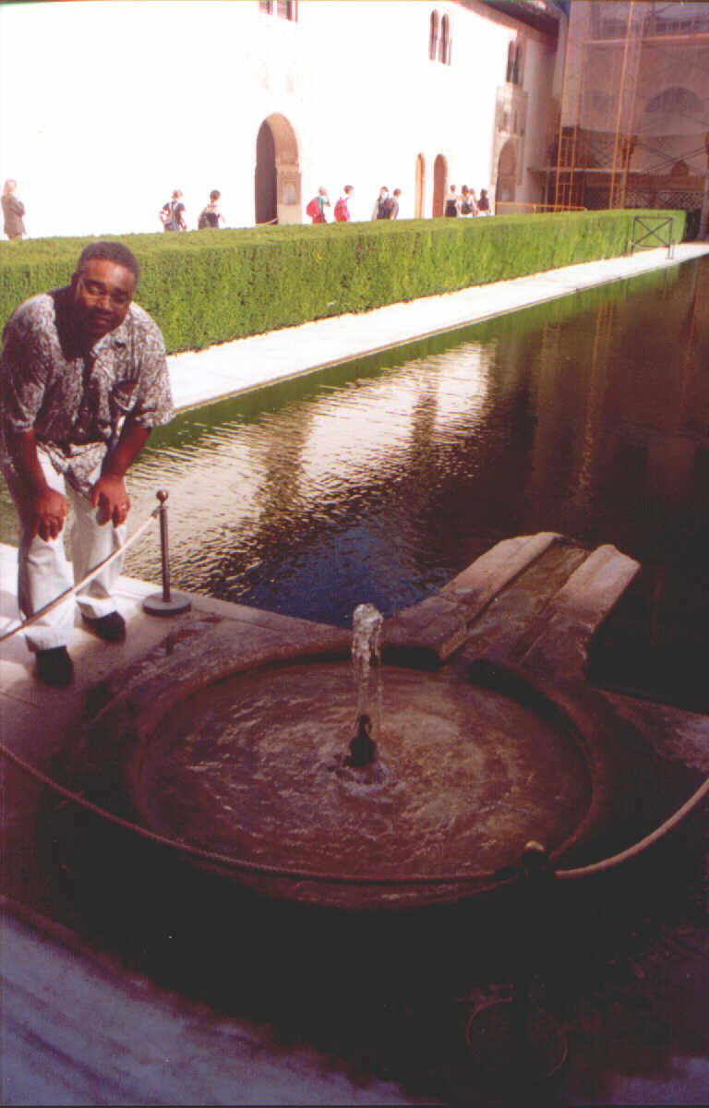

For in striving to impose order on your own small corner of the world, you have chosen the mythological path that is represented as the fight with the dragon.

“…only one who has risked the fight with the dragon and is not overcome by it wins the hoard, the “treasure hard to attain”.

“Individuality. The Universe. Enlightenment.

He alone who has encountered reality and achieved Union has a genuine claim to self-confidence, for he has faced the dark ground of his self and learned the Energy Enhancement techniques which allow him to easily transmute his Energy Blockages and thereby has gained himself. “

This Energy Enhancement experience gives faith and trust…

In the ability of the higher self to sustain him, for everything that menaced him from inside he has made his own by Transmuting the Trauma. “

Purifying the Pain. “

He has acquired the right to believe that he will be able to overcome all future threats by the same means.”

He has arrived at an inner certainty which makes him capable of self-reliance.” (Carl Jung, The Symbolic Life - adapted by Satchidanand)

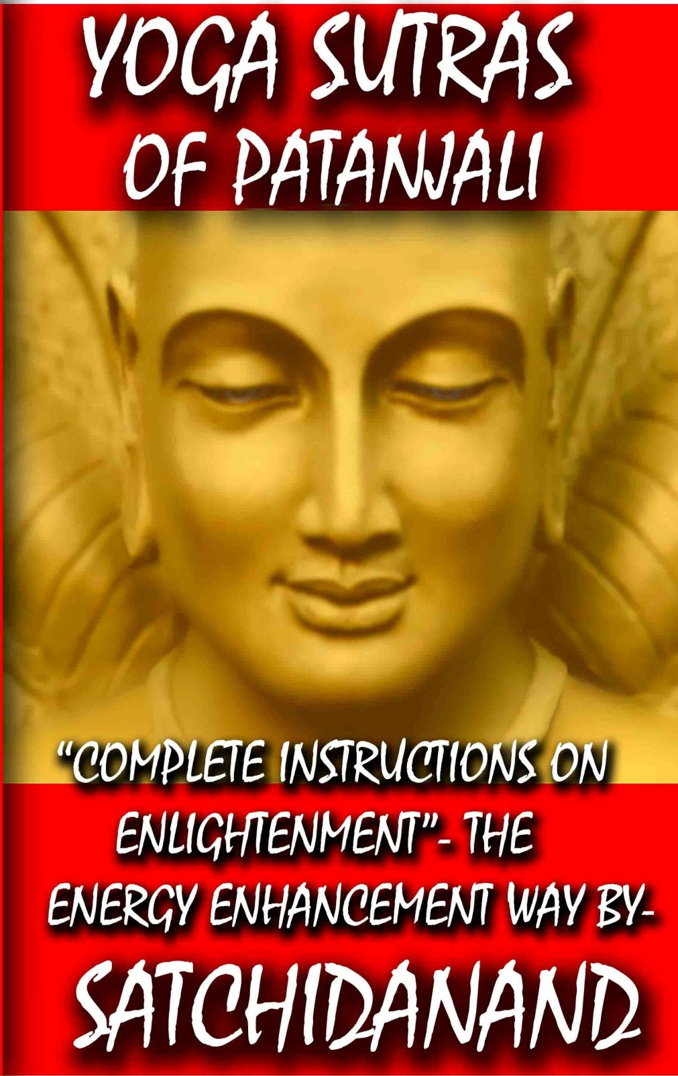
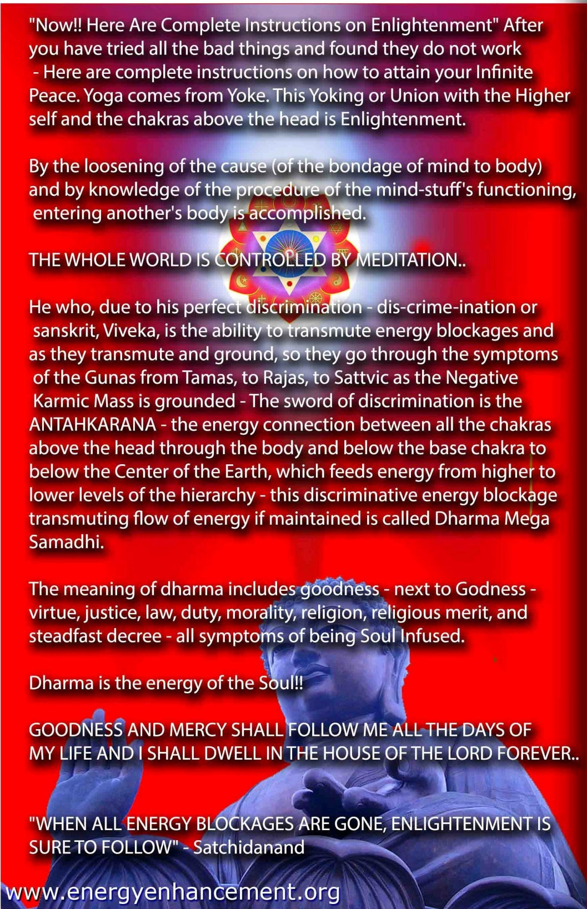
You can't get Triggered if you Healed your Trauma


You can't get Triggered if you Healed your Trauma Depression Pain through Alchemical VITRIOL Kundalini Chakra Energy Enhancement Meditation Video Course

- The Energy Enhancement Process Of Trauma Purification
- The Grounding of Negative Energies
- Alchemical VITRIOL

- The Energy Enhancement Science to Spiritual Enlightenment
The process of Your evolution as well as that of the world and all the people in it is that of the Purification of Evil.

We are a higherarchy of Functions mixed with dense Trauma–Formed Negative Karmic Mass which prevents the passage of Spiritual Energy and walls off and Splits the Mind.

Trauma–Formed Negative Karmic Mass is pure positive spiritual energy perverted and densified by pain, by trauma, by torture, by that which should not be.

Trauma–Formed Negative Karmic Mass is that which Triggers You.

Trauma–Formed Negative Karmic Mass is that which makes everything evil.

Trauma–Formed Negative Karmic Mass is the very nature of evil. It is evilness itself!!

It is created by Pain!

As the amount of Trauma–Formed Negative Karmic Mass increases in a person, so that person becomes more and more Evil.

And as life goes on. As the years pass. As a thousand lifetimes go by, so the amount of Trauma–Formed Negative Karmic Mass increases within, extinguishing the heart, killing out compassion, creating the Psychopath.

Energy Enhancement is the Only Course - Live or Video - which can easily dissolve, transmute, remove, that Trauma!

The only solution to dense Trauma–Formed Negative Karmic Mass is grounding it into the center of the earth where it can be transmuted back into pure positive spiritual energy again.

This is the only solution to evil.

This is the only solution to all the evil within you.

This is the only solution to all the evil in the World

Like the One Ring, it is only the hot fission fires at the bottom of Mount Doom which are hot enough, intense enough, to destroy dense evil Trauma–Formed Negative Karmic Mass and destroy all evil within you and in the World.

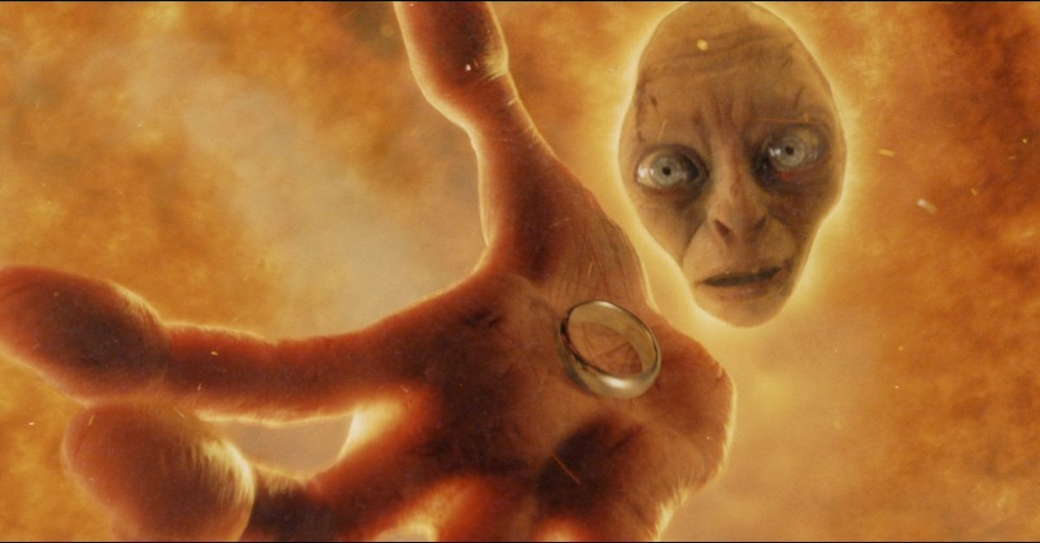

ONLY ENERGY ENHANCEMENT CAN REMOVE PAIN, TRAUMA, NEGATIVE ENERGIES, NEGATIVE EMOTIONS.. WITH..
VITRIOL -
GROUND ALL NEGATIVE ENERGIES
THE AMAZING THING IS, OUR EXPERIENCE SAYS THAT NEGATIVE ENERGY, PAIN, CAN BE GROUNDED!!

Go to http://www.energyenhancement.org for 21 Free Energy Enhancement Books.

To defeat Evil, you need to up your game. Learn the Energy Enhancement Meditation Course by Video or Live in Iguazu.
CLICK ABOVE TO SEE THE ENERGY ENHANCEMENT MEDITATION IGUAZU LIVE COURSES VIDEO AT https://www.youtube.com/watch?v=A2CZBQY5MB0
SATCHIDANAND IGUAZU!
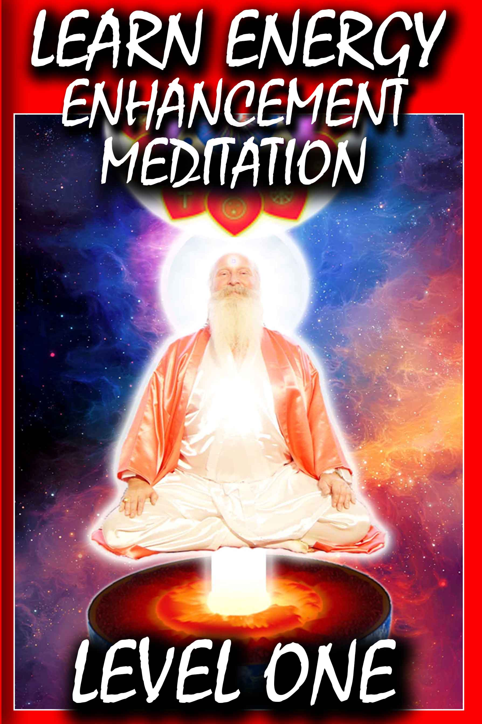

Go to http://www.energyenhancement.org for 21 Free Energy Enhancement Books.

To defeat Evil, you need to up your game. Learn the Energy Enhancement Meditation Course by Video or Live in Iguazu.
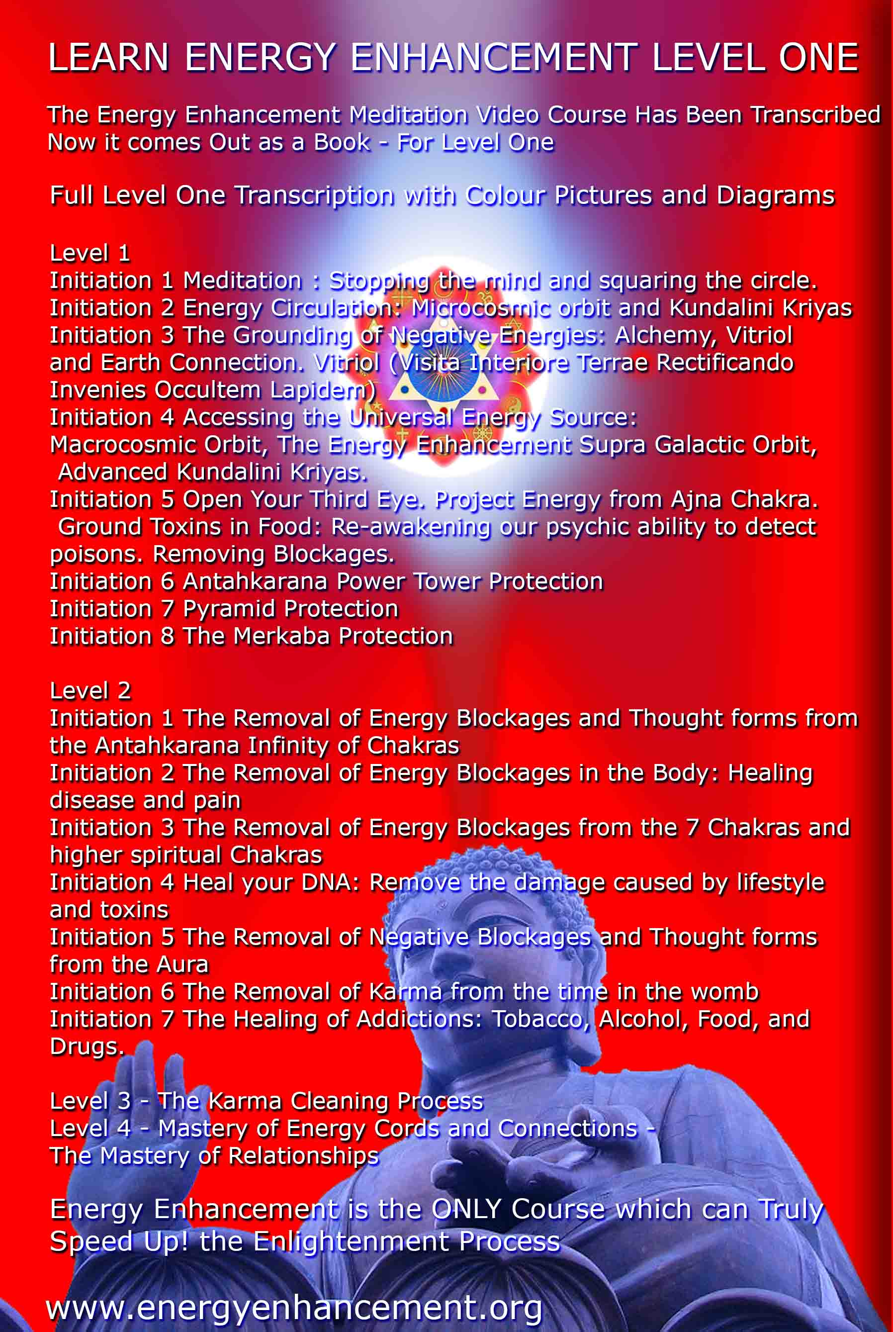

The Conscious Creation of the Shadow..

The Evil Shadow made up of demonic subpersonalities has been known for thousands of years.

As well as the Shadow subpersonalities being created by the normal trauma of everyday experience, the Elite have programs splitting the mind into multiple personalities - splits or Alters - which is is the The Conscious Creation of the Shadow..

This secret has been used to make mind controlled slaves since before Babylonian and Egyptian times using

Traumatization & Torture of the Victim,

The Use of Drugs

And the Use of Hypnosis.

One of the secrets of the Mystery Religions, especially the Egyptian Isis mystery religion was the conscious ability to use drugs, hypnosis and torture to create multiple personalities - the Shadow.

Illuminati rituals are based upon the most ancient Mystery religions.

The Rothschilds like the ancient Canaanite Mystery rituals, and use Akkadian-Hittite-Canaanite-Babylonian rituals.

The rituals from ancient Egypt are also heavily used by the Illuminati.

Masonic lodges bring in female Monarch slaves for some of their Egyptian sexual-magic rituals like the Palladian Rite.

The Collins-Sinclairs-type Illuminati bloodlines and some of the other Illuminati families with a northern European/celtic background, are very much into Druid rituals.

Understand that historically, the Druids gave up paganism for the truth of Christ, but now neo-paganism would have people return to what the Celtic leadership gave up about two thousand years ago.

The Grimm brothers, who were cabalistic jews, gathered the folk occult stories together. Their stories are full of spells, trances, and drugs.

Sleeping Beauty is put to sleep, and the trigger to wake her is a kiss on the lips. These are serious hints that the occult world didn’t stop programming people with dissociative states and triggers when the ancient Egyptian empires fell.

Instead of using modern lingo such as “hypnotize”, they would say “cast a spell” or use NLP.

Later in Freemasonry, the Right Worshipful Master would “charge” (meaning hypnotize) an initiate.

The occultist L. Frank Baum, a member of the Theosophical Society, was inspired by some spirit who gave him the “magic key” to write the Wizard of Oz book, which came out in 1900.

The book’s story is full of satanic activity and satanic thinking.

The story was chosen in the late 1940s to be the basis for the Illuminati/Intelligence community’s trauma-based total mind control programming.

When the Monarch MKULTRA Programming started, the top men were Illuminati.

Originally, Joseph Mengele was the lead programmer. He had already achieved the rank of Grand Master (later Ipssimus) within the Illuminati.

He had become skilled in Kabbalistic Magic, in Ritual abortions, and in torture (by the way, Mengele had a sadistic mother) and programming children.

Many of the concentration camp children that Mengele programmed still survive and still love him to this day as “Daddy”.

Mengele disappeared from Auschwitz in Jan. 1945, several months before the final chaos began in the Third Reich.

Mengele disappeared so the Illuminati could smuggle him to the U.S., so that his exceptional knowledge of programming - honed and fine tuned on thousands of concentration camp child victims - could be put to use on a grande scale in the United States.

He travelled worldwide, but especially in the western U.S. doing his programming accompanied by his pair of two black servants.

American Monarch survivors remember his spotless German uniform, his shiny boots (which he wore during programming), his thick German accent, his handsome features, his cleft chin, the space in his front teeth, the way he would jab with his thumb while programming, as if he were still saying “links, rechts” to lines of jews coming into the concentration camps.

The reason Mengele was so excited to do the selection process of inmates coming into Auschwitz was that he was choosing inmates for his numerous mind-control trauma experiments.

He was especially anxious to get identical twins, because his genetic research related to mind control, needed persons of identical genetic makeup.

Traditionally, the Illuminati had been having their children inspected by a woman with the rank of Grande Mother. She would determine the fitness of the children and then present them for a formal acceptance ceremony at age 3 to the Grande Druid Council.

This procedure didn’t change when Mengele came over- -the programming just jumped from being an occult science to one that had full access to the Medical, Psychiatric, Judicial, Scientific and Governmental sectors via the power of the National Security Act and the Intelligence agencies.

The Illuminati’s programming of multiples prior to Mengele’s arrival were simplistic, compared to the sophisticated techniques engineered by the Nazi Germans (whose Mind Control research included some non-German nationals such as Italians).

German & British scientists/mind control programmers came to NOTS after W.W. II, including Joseph Mengele (also known as Dr. Green, or Dr. Greenbaum, and other pseudonyms).

The Illuminati’s Dr. Black worked out of China Lake also. Dr. White (identified as Dr. Ewin Cameron) worked on the east coast, although he did fly in every so often to the west coast to meet with the other top programmers.

Dr. Blue was another of the important leading Illuminati programmers.

These top programmers supervised other lesser programmers. If something went wrong, they might fly a child from a programming location to a specialist to get it special help for its programming. The men and women of the Illuminati helped the top programmers out.

The Grande Mothers, and the Grande Masters of the Illuminati participated in helping with the programming. As a child of the Illuminati progressed through its programming, three people had oversight over its programming: its Grande Mother, its Grande Dame, and the Programmer.

The CIA front organization, the Human Ecology Society tested the PAS. In 1962, the CIA moved Gittinger’s base of operations to another CIA front on Connecticut Ave., Washington, D.C. called Psychological Assessment Associates. Because Gittinger believed genetic-based differences exist in people, which is one of the basis for the Monarch Programming, his work was not accepted by main stream psychology.

In 1974, Gittinger described the PAS system,

“...the Personality Assessment System (PAS): (a) indicates the kinds of internal and external cues to which the individual is most likely to respond; (b) suggests the types of stimuli that are most likely to produce behavioral change; (c) provides an understanding of the inter-, intra-, and impersonal environments in which a person is most likely to function efficiently; and (d) offers insight into what constitutes stress and predicts probable behavioral response to such stress, including maladjustments, should they occur.

In the area of experience, the PAS offers a method for obtaining specific clues to personality structure and functioning. Thus, the PAS: (a) allows for direct inferences concerning an individual’s primary response style: (b) suggests the quality of the compensations and modifications he has achieved in response to social and environmental pressures; (c) provides an understanding of personality development in terms of the interaction of primary structure, environmental pressures, and adaptive tendencies; (d) offers a procedure for evaluating the surface or contact personality developed over time; and (e) makes possible the assessment of the fundamental discrepancies between the surface personality and the underlying personality structure--discrepancies that typically produce tension, conflict and anxiety.”

Winne, John F. and John W. Gittinger. Journal of Community Psychology Monograph Supplement No.
38. Rutland, Vermont: Clinical Psychology Publishing Co., Inc. 1973, p. 99.

Wow! Gittinger’s description of PAS is specifically the needs & goals that the programmers had when they initiate programming the personality splits in tiny 18-month old children! People associated with the following listed organizations may assist the Network to use their child for trauma-based programming. Children from families where one or both parents belong to the following organizations are often routinely sent off in early childhood for trauma-based mind control.

We are now in 3rd and 4th generations of people who are programmed multiples. (And even into deeper generations in some Illuminati bloodlines.)

What can’t be covered here is the enormous secret drama involved in Moriah implementing control over parents via prescribed or illegal drugs, fear, blackmail etc. so that they will assist them in getting the children programmed.

If the motherly instinct is too strong, the mom may be prescribed tranquilizers, so that there is a stable house for the child’s front alters to grow up in.

Unreliable non-multiple fathers are “debriefed” by Iluminati multiples who debrief & then erase their memories of what is happening to their children. Parents may have only a limited view.

Personality assessment criteria and ability is one of the guarded secrets of the programming. Should unexpected behavior crop up, the slave may be hauled in for more EEGs.

The PAS tests would reveal to Gittinger a person’s weaknesses. The PAS shows what a person wants. And these are called the soft spots of a person’s personality. Also the PAS shows mental weaknesses, or where a person will be instable and could be broken down.

Certain types of stresses will have a cumulative effect of hurting a person. A stress-producing campaign is run against CIA targets, and by doing this they can neutralize a potential enemy. The information collected from children, who are potential victims for the Monarch programming, is essential for knowing how to structure that child’s programming. For instance, IFU children often are autistic; IRU are schizophrenic children; and IR or IF are fantasy prone. Later, it will be further explained how this aids programming.

An Internalizer personality would be important deep inside an alter system, while an Externalizer would be useful for a front personality. (Internalizers are predisposed to the production of mental fantasy.)

By knowing what the child was, the programmers know what they already have, and what they must add or build into the thinking of the alters they will create. Likewise, some alters need to be R and some F. And some need to be A and some U. Regulated (R) personalities like to have narrow limitations on their activity.

This makes them suitable for programming. The R’s readily accept authority, and will not try to step out of the range of their habits. The R has a marked ability to learn without understanding. They easily learn material by rote, because they do not need to understand it before they will learn it.

This is another asset that the programmers like. The programmers may or may not want an A (Role Adaptive personality). A future country singer needs charisma -- a future computer programmer doesn’t. Without being able to finely determine what is there, the programming could not be fine tuned. If the child is good in math, it will have its programming scripts steered in that direction.

The Shadow, Split SubPersonalities, is created by any or all of...

The Traumatization & Torture of the Victim
The Use of Drugs
The Use of Hypnosis

For more information download and read, Fritz Springmeir's Book, "The Illuminati Formula to Create an Undetectable Total Mind Controlled Slave"
http://www.energyenhancement.org/Fifth-Level-Avatars/Springmeier-Illuminati-Formula-to-Create-A-Total-Mind-Controlled-Slave.pdf

The Book includes,

Chap. 1 The Selection & Preparation of the Victim
Severing the "Soul Core" of the mind

Chap. 2 The Traumatization & Torture of the Victim
What trauma does, the creation of PTSD & DID (MPD)
How the torture is carried out, types of trauma
How MPD works
The Soul Core

Chap. 3 The Use of Drugs
A. A list of drugs used
B. A brief history of use
C. Applications for drugs to control a slave

Chap. 4A The Use of Hypnosis
A. Dissociation, trance, & its historical use
B. How to program with hypnosis
C. How to boost creativity of victim with hypnosis
D. Keeping the mind dissociative

Chap. 6 The Use of Electricity & Electronics
A. For torture
B. For memory deletion
C. For implanting thoughts
D. Electronic communication & control

Chap. 7 Engineering & Structuring Of An MPD System
A. Structuring of MPD worlds
B. The creation of roles
C. Building in layered defenses
D. Building backup systems

Chap. 8 Body Manipulation & Programming
A. Scarring the brain stem
B. Split brain work
C. Medical technologies

Trauma - A basic component of the Monarch program is lots of electro shock. Stun guns, staffs with hidden electric cattle prods, and cattle prods are frequently used on the slaves.

Electroshock is used to create the dissociation from trauma during the programming, and later it is used to remove memories after the slave has carried out a mission, or to instill fear and obedience in a reluctant slave. Slaves generally carry horrible body memories of excruciating electro-shock tortures to their entire bodies.

As the slaves begin a therapeutic deprogramming process they will recover these horrible memories, not to mention many other painful memories. A slave often shows electro-shock marks on their feet, or back, or buttock or legs after they have been used.

An owner of a slave will ordinarily carry a stun gun. This is perhaps a 120,000 DC volt stun gun to erase & compartmentalize memories, but some of the stun guns go up to 200,000 volts DC to erase the memory of his slave.

They will apply their stun guns to the base of the skull. After giving programming instructions they will usually give a high voltage shock to the base of the skull to imbed the instructions deep in the subconscious.

Drugs - Religious groups, shamans, medicine men, witches and cults have been using mind altering drugs throughout history. The medieval witches used potions of hemlock and aconite for their flying ointments. These are herbs (natural drugs) which will create delirium.

Contemporary witnesses reported that covens during the medieval ages would apply the potion of hemlock and aconite to cause their new witch to go delirious, and then would transport the person to the Sabbat, where they would be told they flew there.
The Haitian satanic Vodoun cult, which has been manipulated by the CIA/Illuminati, has sorcerers called bokors.

The Vodoun cult in Haiti is being used for trauma-based mind control. One of the items of the cult is to take the plant Datura stramonium and add this plant with other things. The plant is the active ingredient of a potent psychoactive drug, the “zombi cucumber” which produces amnesia and a pseudo- death of the victim. The brain doesn’t die, but the mind is shut off.

The victim is brought back to life as a zombie--a slave of the bokor. The powder to create a zombi is called zombificant in French-creole. The ceremonies to kill and resurrect the zombie are full of magic and demonology also.

Magic, drugs and demonology have always gone hand in hand. Drugs remove the part of the will that prevents demonic possession. Drugs are considered powerful demonizing substances by the those skilled in Demonology. If demonic possession is seen as part of mind-control, then cocaine, hashish, crack, and some of the other drugs are part of the effort to enslave people. (The power of magic to kill, just as the power of faith can heal, will be discussed in chapter 10.)

In Basutoland in Drakersbergs, the Zulu witchdoctors use drugs and trauma to create tokoloshes (mind-controlled zombie slaves). It is said that in recent years, they are using less children and more baboons and monkeys to get tokoloshes. The point is that drugs have been and continue to be used by the occult world for controlling people.

The science of Pharmacology (drugs) has given the Programmers a vast array of mind-altering and body- altering drugs. Some of the drugs are not used to directly alter the mind, but to change the body (makethe skin burn), or make the person vomit, or some other reaction that can be harnessed to further their nefarious programming goals.

If they want a little girl to develop breasts they might give her hormones.

Neuroscientists are now familiar with chemicals which cause personality traits. If one wants to create raving paranoia, simply provide the brain with too much dopamine in the emotional centers of the brain and too little dopamine in the seat of reasoning area of the brain.

Reduce serotonin in the person and the person will be unable to connect disagreeable consequences with what provoked them. In other words, they can’t protect themselves from danger.

Drugs are used during programming. Although drugs used to assist programming mean nothing to the common person, they each have a specific purpose within a certain type of programming. Some specific uses for drugs during programming include:

• Putting people into trance
• Teaching alters to go deeper into trance to escape drug effects
• Enhancing the trauma
• Producing out of body experiences e. creating pain
• Creating blood vessels that hurt, a pulsating pain, that runs through the body
• Controlling histamine production
• Helping create illusions such as no hands, no feet, no face, no head etc.
• Teaching alters to stay in position
• To assist other programming modalities, such as high tech harmonic machines, which implant thoughts. (The machines are used in conjunction with designer drugs.)
• Hormones, for instance GnRH, which regulates the physiology of the sexual growth, and is given to speed up sexual growth. Other body developments may also be manipulated.
• To enhance or reduce memory
• To build the image of the programmer’s power

Hypnotism - Dissociation, Trance, and History of Hypnosis for Programming. Dissociation is used as a defense to protect a person from overwhelming pain and trauma. It is a natural ability of the brain. Hypnosis or hypnotic trance is a form of dissociation. There are a number of types of dissociation: amnesia, somnambulistic states, localized paralyses, anaesthesias, and hallucinations.Hypnosis can reproduce all of these dissociative states.

Hypnosis can be used on the intellectual part of the mind, the social-spiritual part of the mind, and the primitive reproductive part of the mind. The skilled hypnotist will decide which area he wants and how to work with that area. Both Christians and Illuminati members who are skilled in understanding demonology, believe that there is a demonic side to hypnosis also. It should come as no shock to people that in the World Book Encyclopedia hypnosis is listed under Magic as a related article, but not under Medicine.

There is open debate whether hypnotism is simply part of the brain’s natural abilities or if supernatural elements are part of the process. There is no debate that historically, hypnosis for centuries has been the guarded secret of the occult world. During shock or stress, the body’s limbic-hypothalamic- pituitary-adrenal system, releases substances which encode all the internal and external pieces of information being sensed into a deep level of consciousness.

These memories often become dissociated from normal states of consciousness. In other words, when the mind-body returns to this state (where it was in during shock/stress) the mind can reaccess those memories. However, until the mind returns to this shocked state, it doesn’t pick up the information it has embedded.

The Monarch programmers are acutely aware of how the mind functions, and how information and memories can be trapped in the mind. There are different neurophysiological states. Also there are said to be 12 levels to the subconscious mind.

Then on top of this the mind has the ability to create trauma/amnesia barriers.

Hypnosis is a valuable tool to move the mind to different neurophysiological states and to get the mind to different levels of the subconscious mind. Hypnosis can also play a role in working around amnesia, since both are types of dissociation. Hyperventilation helps a person induct into a hypnotic trance. Torture, depersonalization, fear and acute anxiety stimulate the body to hyperventilate.

There are several ways to alter a person’s state of consciousness, but the most popular one by Monarch handlers is to use a combination of drugs and hypnosis. Drugs are used to facilitate hypnosis. Modern drugs do almost all the work for the hypnotist. They place the person in an altered state and make them willing to take any order. Often survivors remember orange or grape drinks, or something else which they were given, which were used to give the child drugs. One Monarch slave (Cathy O’Brien) wrote about having been given hypnotic drugs via a Grasshopper ice cream drink.

So the fear, torture and depersonalization are aids for the hypnotist to help induct a person into a hypnotic trance.

So the fear, torture and depersonalization are aids for the hypnotist to help induct a person into a hypnotic trance.

Early on it was discovered that the brain would overcompensate for scarring on the brain stem.

This is a principle similar to weight lifting. By tearing down the muscle fiber by overexertion, the body rebuilds the muscle stronger. By scarring the brain stem, it -was discovered that geniuses who had photographic memories could be created. Brain stem scarring was used to create the whiz kids that the NWO needed to run their big computers. For instance, the computers that just NASA alone uses require people who can work in ALGOL, BASIC, COBOL, COBOL 74, MULTICS COBOL ver. 4.4, COBOL Cb.4, COBOL CP-6, BOL, EULOR, FLIP, FORAST, FORTRAN, HAL/S, Illiac 4, JASP, JOSS, JOVIAL, /LYAPAS, LISP, LISP 2, /MAP/, NuSpeak, PASCAL, PEARL, /PLACE/, PL/1, PL/1-APAREL, PLANIT, Praxis,
SA Machine Language, SEMANOL, SNOBEL, UNIX, WANG, ZBIE. It takes a good memory to remember computer languages and programming. These whiz kids, who were both programmed with Monarch programming and had their brain stems scarred can be seen in some of the University computer departments and the intelligence/military agencies’ computers rooms.

Still another method is to place small transceivers into the head or body of the person. These implants have been attached in the neck or other places, and have been connected to various parts of the brain. They have literally created what the movies called “terminal man.” This has allowed special intelligence agents to be linked to large computers. The intelligence asset can get continuous information on anything the intelligence agencies have managed to get into their large computers.

Brain implants can download incredible amounts of information to the brain, however, the ability to use this information wisely is still a skill. Having a library of information available doesn’t necessarily mean a person is wiser. For more on slave-computer interfacing see the index for information on ALEX, Amalgamated Logarithmic Encrypted Transmissions, and UNIX systems which are used to tie the Monarch Mind to computers.

Drugs and torture are also used to enhance memory. Brain stem scarring is not the only method to enhance memory, but it has been a “highly successful” (if one doesn’t count all the ruined lives when it’s failed) method.

MPD also naturally increases the brain’s functioning several fold, and can help give photographic memories.

In review, drugs, torture, hypnosis and MPD all work to enhance memory. Most slaves have some photographic memory capability. The most serious form of memory enhancement is brain stem scarring, which produces a strong system-wide photographic memory.

Programming -

A standard Illuminati System is built like a 13x13x13 cube of subpersonalities or Alters with an elevator shaft running up and down from the bottom to the top. The elevator is constructed as a piece of DNA and alters can ride up and down the elevator (go up or down in trance) to move when allowed.

Most of the alters have no sense of time, and most of the alters do not hold the body very frequently. For various reasons most of the alters never grow up. Obviously, if they don’t hold the body very much, and are dissociated from everyone else’s memories, they have nothing to stimulate them to grow up. However, the Programmers must have some of the alters who can function as adults. For instance, alters who go into bars must think of themselves as adults. The alters which will hold the body in public will be hypnotically made into adults.

The Network likes to leave many child alters, because most of them are pedophiles and they like the pseudo-pedophile experience of making it with an alter that thinks it is four years old. Or just the opposite, sometimes an adult alter will appear within a child victim, and this is a clue that this is an access/reporting alter.

Many of the Illuminati systems, especially Mengele’s were set up on a 13x13 grid of alters. The grids are numbered top to bottom and side to side but not in the fashion one might expect. The typical Mengele grid will begin with 6 and proceed 6, 7, 8, 9, 10, 11, 12, 13, 1, 2, 3, 4, 5. However, the structure doesn’t have to be a grid, any geometric shape works and has been used, such as a sphere, cube, or pyramid.

Dr. Star and his wife, who is an OTO programmer working out of Corpus Christi, TX likes to structure an alter system in the shape of the Seal of Solomon. The Yin-yang symbol is then equated with the entire Seal of Solomon. The all-seeing eye is placed in the center of Star’s systems, just like Mengele would put in an All-Seeing Eye. The hidden Sun of Tiphareth is placed into Dr. Star’s victim’s systems, as well as the four elements, and sulfuric acid. Alters are then placed in the various positions around the hexagram.

Because therapists, (and Christian ministers) are generally unaware of the deeper occult things, they usually miss seeing the occult philosophies behind the structures.

For instance, the elements of earth, wind, fire and water are not just part of magic--they are in Druidism considered the four zones (or directions) also called rings which are held together by the fifth ring--balance. This is the basis of Celtic geometric art, metaphysical maps, and ancient Ireland was symbolically divided into four regions with a unifying fifth. This was the bardic view of the universe which is presented in the Vita Merlini (written by Geoffrey of Monmouth in 1150).

Supposedly England, Wales and Scotland were also divided into 4 regions with a unifying fifth too. And all these four regions Ireland, Wales, Scotland and England are joined again in the U.K. In Druidism, the four magical elements the Sword, Rod, Cup and Shield are unified by the Cord while the four elements are unified by the spirit.

Ancient Druid stone statues of triple faced gods and goddesses still remain today. Heads were considered sacred by the early Celts which is why the heads of the top Grand Dames are preserved after they are ritually murdered. If an outsider really wants to understand why Illuminati systems are constructed in the fashion that they are--first understand that there is a great depth of meaning behind what structures are used to build an internal world.

An ex- programmer talks about how the programmers would call upon Satan in high level rituals to “Tell me what to do, and I’ll do what you want” to gain wisdom in how to design these alter systems. Within a System, a few alters will be given maps to the System. There will be a structure “map” which takes the system down through its progressive levels down to its fundamental or primal level. There will also be internal world maps, maze maps, or what some call programming maps

The Soul Core is not an alter, but is an essence that the programmers hide.

The programmers do not touch the Soul Core in the fashion they do alters. They hide the Soul Core. Part of the drama that is carried out during the entire victim’s life, is that their mind tries to protect this untouched Soul Core essense of their mind from being touched. If they think anyone, the therapist or the abuser are going to tamper with it, the mind and its parts will protect that Soul Core.

As strange as it may seem, when a therapist talks about integration, they often scare the victim’s mind that the integrity of the Soul Core and its innocence will be violated, and the victim’s mind does everything it can to avoid contaminating the integrity of their Soul Core, i.e. they sabotage therapy and return to their programmer who understands their safety issue.

Initially, in the 1940s, the Illuminati researched what would happen if the Soul Core was allowed to meet up with the alters, and they discovered that the brain’s essence or energy will work to pull the mind back together.

Therefore, the Soul Core is separated and hidden from all the alters.

In Illuminati systems, it is usually placed in the middle of its first splits, which are also sources of energy and which are well hidden. They are dehumanized parts which function as gems, which are programmed as in the Alice In Wonderland story to change shape and color if they are approached, which rarely happens.

A dissociative carousel is also attached around the Soul Core. After the Soul Core is hidden, the rest of the alters will be programmed not to look for the energy/synthesizing Soul Core part of the system.

The real “Soul Core” or primal part of the unconscious will have an adult representative of it in a Monarch System. This primal part has a Toddler switch upon which all the programming is built. An event(s) in the child’s life is used to build the programming upon.

The Illuminati know about the various base programs and the foundational traumas, and some of this is kept secret from programmers who come from front organizations of the Illuminati.

There are a number of parts which will be called “Soul Cores”--simply because they were early parts, but there is no intact single person who represents all of the mind.

All that is left are fragments of the mind, each segment walled off with trauma/amnesia.

The alters who perceive themselves to be “Soul Cores” are alters who have been programmed to think they are the Soul Core alter.

The mind has a way of knowing the truth, and these alters may realize that their programmed story line is suspicious, but they won’t know what is “fishy” about it, so they tend to be in denial about their identity.

These substitute or mock Soul Cores will often be in denial that they are even multiple personalities. In some cases, where Scripture was used to program with, the Soul Core was told that it would be “blessed by multiplying as the seeds in the stars of heaven and the sands of the sea” if “thou hast obeyed my voice”, which is misuse of Gen. 22:17-18. Alters which represent the “sands of the sea” pop up if an alter tries to get to the Soul Core.

One of the basic ideas of creating a mind-controlled slave, is to control the entire milieu of the slave. This is expressed in Nexus Seven. The environment of the slave is designed for what is called “story immersion.” A Monarch slave who has been given the basic Alice In Wonderland and Wizard of Oz programming will see objects connected to these story lines in almost every store. Restaurants in Dallas and San Antonio (The Time Machine Restaurants) which are used to reinforce programming, have mirrors on their walls, doors and ceilings and their waitresses dressed like programming script characters- -such as Dorothy of the Wizard of Oz. It is no accident that one of the leading Satanic singers calls himself Ozzy Ozburn, or that a certain Mexican witch calls herself Oz.

It is no accident that recently a witch wrote the book The Witches of Oz. It is no accident that the elite have promoted the Wizard of Oz theme with television product advertisements. It is no accident that the U.S. has Oz stamps, that television has Oz cartoons, and Oz characters are appearing all over the place.

For a while even Kansas had an Oz theme to their license plates (“Land of Ahs”). Hillary Clinton, (a 6th level Illuminati witch & sadistic Monarch slave handler) received a witch’s hat in anticipation that she would be called the wicked witch of the West, and that Mary Matalin (who married Clinton’s top campaign advisor James Carville) had a photograph of Hillary Clinton as the Wicked Witch of the West on her wall with the caption “I will get you, my pretty, and your little dog too!”

The witch’s hat and the caption both are popular with these people associated with the White House because they are so rich in triple and quadruple meanings. The deadliest meaning is that the Monarch Slaves that sexually service Hillary and Bill Clinton have Wizard of Oz programming.

Hillary is really the Wicked Witch of the West! to these poor Beta slaves. The constant bumping into Wizard of Oz paraphernalia or pictures of it helps focus the slave’s mind onto their Wizard of Oz programming. MGM Grand recently built a multi- million dollar pyramid complex with a theme park which is based on the Wizard of Oz and the Alice in Wonderland themes.

The hotel at the MGM Grand is the world’s largest with 5,000 rooms, which shows that mind-control is big business. A team of actors dressed up in the Wizard of Oz theme like Dorothy and her friends (Tin man & Scarecrow) and walked on a yellow brick road constructed in the MGM complex. Emerald City is part of the theme park. The complex cost $1 billion according to the Las Vegas Review Journal, Dec. 19, ‘93 page Al.

This complex is given the occult name Luxor, and is at 3900 Las Vegas Boulevard South. It has been advertised as the “Next Wonder of the World.” It’s a shame that the 1990’s big wonder is a programming center.

Another part of the control of the Milieu is labelled “planned spontaneity” by the controllers. The Monarch victim repeatedly finds experiences “just happening.” These are the coincidences that are so mystical that people feel there must be a higher significance to the event. Many of these are well-staged events. A slave may try to escape marrying the person they are commanded to marry. The handlers stay one step ahead of the slave, and through a series of coincidences introduce another acceptable person.

The slave in an effort to escape grabs the first available substitute who has been coached on how to push all the correct green mental buttons to get the escapee to marry them. ‘The slave jumps from the frying pan into the fire.

Things which validate the programming and the mystical beliefs of the cult will be repeatedly introduced. The skill in introducing these secretly into the life of the slave are amazing. There is no limit to what can be attempted, and some of these staged events are worthy of Houdini.

The occult world has placed their symbols all over the United States. The most esteemed institutions such as Walt Disney are fountains of the occult. Walt Disney movies are steeped in magic, and yet American society is so drowned in the occult, they have been desensitized to how it permeates American culture.

The concept of “Sacred knowledge” versus “profane knowledge” is introduced. If the slave should escape, the first choice is to send someone who can pick them up. I have heard of slaves escaping from Europe on the plane, only to be picked up by a handler when they land in New York.

Mt. Shasta’s programming site, accessed by helicopter, specializes in reprogramming escaped slaves. Jerry Lee Lewis has a notorious reputation among the Network as being exceptionally sadistic in reprogramming escapees.

However, if the slave is not needed, and is wanting out--tens of thousands of them have been locked up in mental hospitals as paranoid schizophrenics. In the mental hospitals they can continue to get drugs and electro-shock--the very things that caused their problems in the first place. The insiders have a name for these slaves, they call them “broken butterflies”.

If the slave tries to go to court, according to some the Non Compos Mentis Law prevents them from testifying against their abusers. At any rate, with or without this law it would not be easy for a victim to get his testimony accorded the respect it deserves.

If they get psychiatric help--their therapist can not tell anyone about what they have suffered, and the therapist is hamstrung about what they can do in court for the client. Recently, 15 states have created statutes of limitations on sadistic rape.

This is in response to all the Monarch slaves who have begun recovering memories. •The extent that entire culture and society protect the Monarch Programming is enormous. Anyone admitting MPD – Multiple personality Disorder (aka DID) is in fear of being labelled crazy and losing some of their rights and their job.

Because the conspiracy (the Network) is so vast, an examination of how the Illuminati controls society would be needed to cover the subject of milieu control. This would take an entire book. The reader is encouraged to read some of Fritz Springmeier’s other works which expose how the Illuminati’ s control extends over all levels of society. Most people have settled their minds on this issue without getting the facts.

When the real facts are shown, it blows people’s minds. Some of the easiest and everyday items to show people, are simply a dollar bill--with its Illuminati symbol on the back, and a can of vegetables which has a bar code on it. Every bar code has 3 secret and non-functional numbers in the bar code, which are 666. The silent hammer that strikes out at the Monarch slave is that everywhere they go, the occult world is there.

Several cars are named after Satan. The name Saturn, and Belair are well-known as occult names for Satan.

When Freemasonry’s greatest philosopher/Illuminati Mind-control Programmer/Grand Druid Council member Manly P. Hall wrote Cabalistic Keys to the Lord’s Prayer (Los Angeles, CA: The Philosophical Research Society, 1964, p. 10) he wrote “Saturn = Hallowed be thy name.” The men who head these auto manufacturing companies are in the Illuminati.

There is no question that they were NOT ignorant of the significance of these names. Many other occult names of big significance to the Illuminati involving eagles have been placed on cars. Electra is a recent car named after a demon. Viper is a slow and deadly creature, why would one want to use it to name a car? Viper is also the name of an important demon. Viper is found in Black Widow Monarch slaves.

Some readers may begin to feel that things are being stretched. The connections of numerous car names to the occult could be exposed, but that is not the purpose of this book. We will quote straight from a company their own explanation for their car’s name in this next paragraph, simply to make the point, whether other perceive it or not, the Monarch slaves have to exist in a world full of satanic/occult symbology that ordinary people don’t understand.

Mazda’s president, Norimasa Furuta, published a book in 1990 which it intended to give to all its employees. The book explains its purpose “...we have written a booklet to explain how MAZDA became the name of our corporation and what it means in order to help everyone who is related to MAZDA enhance their creativity and develop their potential.”

The book entitled The Globe: In Search of the Origins of Mazda, goes on to explain about the founder of Mazda car company, Matsuda Jujiro, who is heralded as a great seer who “believed in himself, in his friends, and in heaven, and he achieved a truly global vision.” Mazda company’s book The Globe then explains that the company name Mazda comes from the god Ahura-Mazda which was the “god of light” and the “god of wisdom” according to the book. Jujiro believed that Mazda represents the “origin of civilization.”

The “god of light” (Lucifer) is often credited for starting civilization by those who aren’t Christians. The name Mazda according to The Globe symbolizes “unlimited possibility and stimulates people’s dreams.” Mazda’s book puts down in writing their New Age goals to “establish peace for mankind with a global point of view,” and “a spiritual foundation” toward which to work toward a “new age.” The book further states civilization started in Egypt and that Christianity evolved from the pagan mystery religions.

Another book associated with Mazda cars, is the book The Meaning of Life given to everyone who test- drives a Mazda--that was as long as book supplies last. I quote the book “...the time when regions and continents existed keeping a certain distance from each other is a thing of the past....

We are eager to transmit the meaning of MAZDA to the children of MAZDA who will create a new MAZDA... With a strong desire for peace and through the production and sale of automobiles and machine tools, MAZDA has advanced on a course to unite the people of the world” [bold added] (pp 78-79.)

An adept of the Illuminati is taught about Ahura Mazda. He would know that Mazda was the Persian God of Light who was also known as Ormus--which is another name for the Preiure de Sion, which is a powerful group protecting the 13th Illuminati Bloodline.

Some of the names of cars which could be triggering to SRA survivors include the Demon, the Vagabond, Dodge Ram (Goat of Mendes), Buick’s Phoenix, Ford’s Cobra, Mercury’s Cougar, Eagle Jeeps, the Le Baron Eagle Logo, Navistar Eagle Truck (which may have Eagle mud flaps, and Goodyear Eagle GT tires). For most of us an eagle is a symbol of what is noble and beautiful.
Historically, the eagle and the snake have been the logo of the tribe of Dan, considered the “black sheep” of the 12 tribes. The Prophet Hosea said, “Set the trumpet to thy mouth. He shall come as an eagle against the house of the LORD, because they have transgressed my covenant, and trespassed against my law.” (HOS 8:1)

And the Prophet Obadiah said, “Though thou exalt thyself as the eagle, and though thou set thy nest among the stars, thence will I bring thee down, saith the Lord.” (OB 1:4)

The co-authors of this book didn’t create Illuminati history nor their symbols. We are only reporting on them. We would like the eagle simply to represent what is noble and fearfully made by God. Indeed, in some verses like in Isaiah the eagle has a positive connotation.

However, the construct, the refraining that is done by the Illuminati upon these symbols is that the eagle represents Satan’s empire.

The Assyrian, Roman, and Nazi empires used the eagle. The Illuminati point these things out to their initiates, and ask, “Is this a symbol of Christianity, or the power of our lineages which ruled those empires?”

It is not the co-authors desire to interpret what Hosea and Obadiah meant. Nor is it our desire to dissuade anyone from buying the cars mentioned above. Our only point is that the survivor lives in a world of occult symbols and occult programming triggers.

How do you convince someone to quit fearing the power of their abusers when it has its symbols on their money, their canned food, their cars, and their churches? (Yes, there are such things as All-Seeing Eyes in some churches and Masonic logos on others, and other occult symbols.

Hislop’s The Two Babylons is devoted to showing all the pagan symbology in the Catholic church.) Are we exaggerating? Fritz went into one fast food restaurant and the cups and placemats had a wizard throwing occult energy balls with occult symbols, the next fast food place had place mats showing the King Arthur story which is an extremely important myth for the Illuminati (the quest for the Grail!), the next fast food place had place mats giving children instructions on how to hypnotize your parents, the next one had a Wizard of Oz theme, and the next one was selling occult movies.

Fritz kept these place mats to use in his talks! This nation is immersed in the occult and so desensitized they don’t realize it.

The public thinks nothing of a Gargoyle Coloring/Activity book. This type of thing is commonplace in American society. If one examines Golden Book’s Gargoyle Coloring/Activity book (1995) still being sold, you will find Gargoyle demons named after geographic locations that the child can color, you will find a Magus with a Book of Spells that the child can color.

For activities, the child can duplicate pictures, work codes, match shadows with their figures, match objects and images, and work with robot heads of which several can be placed on one body. All these activities reinforce the type of skills that the programmers want children under mind-control to have. The book has castles, robots, a sentence about a kitten which is a code about a computer disk, and mazes. A perfect book for the programmers to give a child, and the naive public walks by these kinds of books on their store shelves everyday.

The Illuminati’s mind-control goes on in part right in front of America’s nose, and they don’t see it. One of the saddest things for Monarch mind-control survivors is that the Programmers are so systematic in destroying everything of beauty and value in life.

Everything conceivable that can be degraded will be.

Recently an insider who was sent the the 2019 Sundance Film Festival had an opportunity to attend meetings with Hollywood and Netflix, for the adults, Nicolodeon and Cartoon Networks for the kids.

Adults are shown a grey heartless world of coldness, lack of empathy, violence like Avengers Endgame or Game of Thrones “To take the heart of you!”

Children are sexually perverted with the rainbow LGBTP Agenda – Lesbian, Gay,Bi, Trans, Pedophile.



This mind-control has spread like an unseen cancer to every segment of life, and threatens to destroy this nation from the inside out. Imagine that every time you heard your own national anthem that it reinforced your mind-control programming?

That is the life of these victims of mind-control. We wish the American people could realize that George Bush and Bill Clinton are on the same team. Both are descendants of the top 13 Illuminati bloodlines, both are totally corrupt morally, both are into the occult, and both were trained by the same person in subliminal language techniques [NLP, Neuro Linguistic Programming].

The best in subliminal language techniques is said to be Tony Robins, and he is who the elite got to train both George Bush and Bill Clinton.

Monarch Mind Controlled Slaves have been created since the late 1940s. Since the early ‘60s, Monarch Slaves have been specially created for American presidents. These models are called Presidential Models. There are now living about 600 people (Monarch slaves) who were created into Presidential Models. That is a large harem.

Presidential Models fit a particular set of physical standards, not one of the Presidential sex slaves has been black. President Kennedy, Johnson, Nixon, Ford, Bush, Reagan and Clinton have all been slave handlers.

Many slaves have some deeper alters who have a realization that their Presidents are in on the corruption, how does that make them feel?

The cults which program pay particular attention to showing the child that men in police uniforms and ministers of churches are participating with the cult. This has the effect of embedding in the mind of the victim that there is no escape--that the entire structure of society is secretly in cahoots with the programmers.

Not all policemen nor all ministers are dirty, but because of the Monarch program, the entire structure of American society has been seriously compromised to the extent that all sectors are infiltrated and contaminated.

Unfortunately, the worst fears of the victims, are in reality close to the truth.

The Monarch victim is further victimized because no-one wants to believe them in how controlled American society has become.

The truth is we are on the verge of losing civilization as we know it, and entering into a dark sadistic slave-master society that will make Hitler’s Third Reich look like child play.

What part of our lives are not controlled?

We go to our jobs--our boss is naturally given the right to control us.

For many centuries, the Machiavellian elite have provided the masses with “Bread and Circus”. That means “keep the people fed and entertained and they will not rebel.”

After Americans come home they are kept busy with entertainment. The only exception to their work, and TV watching, are their trips to their churches. Even the various religions are secretly under elite control.

See Fritz’s Be Wise As Serpents book for an 800 page expose of how the various Christian groups and New Age Religions are controlled.

The point is that people are kept busy and occupied, and they seldom try to step outside of the path that the elite want them to stay in.

A slave’s front system will be a normal busy person for years, while the deeper alters serve their various functions for the elite.

There is simply little that occurs that shakes the routine that gets established.

If the handler doesn’t live with the slave himself, he will often place another slave as the spouse, to oversee the slave. The marriage couple’s deeper alters spy on each other.

The schools that the slaves will go to are often controlled by the abusers. Some of the more obvious ones are Groton, a school for the elite’s children, and Santa Clara University and Williamette University used by the Illuminati to train their politicians for public office.

The Beta Theta Pi is a political fraternity through which quite a few Illuminati politicians have joined.

The Jesuit schools throughout the United States are used for abuse and programming. Note, that Bill Clinton went to the Jesuit university in Washington, D.C. called Georgetown University.

A number of the military school that parents ship their elementary boys off to are used by the elite for the ongoing abuse and programming of slaves.

The Illuminati foundation, the W.K. Kellogg Foundation, gave the initial funding for the Quest Program for the public schools. The Quest Program is being adopted by various public schools.

It also goes by the names Skills for Adolescence, Skills for Growing, and Skills for Living.

One of the early editions of Quest had an exercise called “elevator” where the teacher uses visualization and guided imagery. The teacher places her school children in a mild hypnotic trance described in the Quest literature as “a quiet contemplative mood.” Then the teacher tells the students, “You are on an elevator.” Each button on the elevator represents an age of the child.

When the students push a button, the elevator takes them back to experiences at that age. It is not possible in the scope of this book to cover how every sector of our lives are controlled. Those who are interested need to read some of Fritz Springmeier’s other writing including Be Wise As Serpents.

However, it would be appropriate to cover how television shows and Hollywood are intimately linked to Monarch Mind-Control programming. A great deal that is coming out of Hollywood is linked to mind-control in some fashion.

Some of the hottest entertainers are Monarch slaves, such as Madonna, a Marilyn Monroe replacement.

Co-author Fritz was given a catalog to Vidimax, which is an New Jersey occult porn video club by someone wanting to help his research. This cult video club actually sells snuff films. They sell the real life footage of cannibalism, virgin sacrifices, occult rituals, and worse.

When Madonna was a teenage slave with the name Louise Chiccone living in NY East Village, a real life film was made of her being raped (a setup), and then her cult family taking the rapist and sacrificing him.

Vidimax sells this for $19 to their members. Some of their videos are live footage of how kidnapped people have been tortured into becoming slaves.

One of the catalog listing says, “tortured until their wills are broken and they become Olga’s submissive slaves!...WARNING EXTREME GRAPHIC VIOLENCE...BACK BY POPULAR DEMAND.”

By the way, the Illuminati have their own private porn distribution. Many people ask, “Why do they need mind-controlled slaves?” Part of the answer is they need them to make their sick porn.

The history of the connections between the entertainment world and the occult and royalty go far back. One group of people known for their travelling entertainment, the gypsies, have some interesting parallels with the Illuminati bloodlines.

A gypsy proverb is, “If you want to stay survive, you must be a devil.”

Both groups have kept their bloodlines and their identity. Both are secretive. Both groups live double lives. Gypsy children will be given a secret magical name, and a name to use for outsiders. Gypsy children are often baptized in a magical circle.

Both groups are into the occult, such as cannibalism, black magic, the evil eye, and white slavery. The gypsies believe in Charani, a big bird consumed by fire who rises from the ashes. The Illuminati call this the Phoenix. Both groups have a secret code that allows them to do anything to outsiders (who are called “Gadja” by gypsies meaning “enemy”).

The gypsies originated in India and migrated west to Iran and Turkey and then to Greece and then into western Europe in the 1400s just prior to an occult revival in Europe.

The largest gypsy tribe in India is Ghor. They follow Durga (Kali).

Other tribes also worship Kali under different names such as the Black Virgin for which they make an effigy called “Bibiaca” which simply means “lady”. Gypsies made up early groups of travelling entertainers.

Sir Francis Bacon, who wrote under the pen name of Shakespeare, was the founder/leader of the Rosicrucians of his time. (The proof of who Shakespeare was is in several books, for instance, see Alfred Dodd’s research in his excellent book Francis Bacon ‘s Personal Life Story.)

The previous two paragraphs are offered as examples of how close the occult world and entertainment have been over the centuries.

The history of the two worlds coincide for many centuries back, so it shouldn’t come as a surprise that today’s entertainment industry is still closely linked to the occult world, nor should it come as a surprise that the Illuminati have made sure they have control over the industry.

During W.W.II, the entire country was mobilized for the war effort and Hollywood was recruited so to speak to help with the war effort. For instance, cartoons were created as training films and as war propaganda. The military hired thousands of entertainers for USO Camp Shows, Inc. which was under the Special Services Division of the U.S. Army.

Bob Hope, who worked for MI-6, British overseas intelligence, was the leading entertainer for USO tours. After the war broke out, he went on 12 major overseas tours which took him and his beautiful troop of stunning knock-out girls to every front of the war--from the quiet fronts like Panama to places like Italy and North Africa.

To make a long story short, Bob Hope was used to run messages to programmed multiples for British & American Intelligence. Later, after the war Bob Hope became a slave handler.

In some of Fritz’s other writings, Bob Hope’s connections to the Illuminati are gone into.
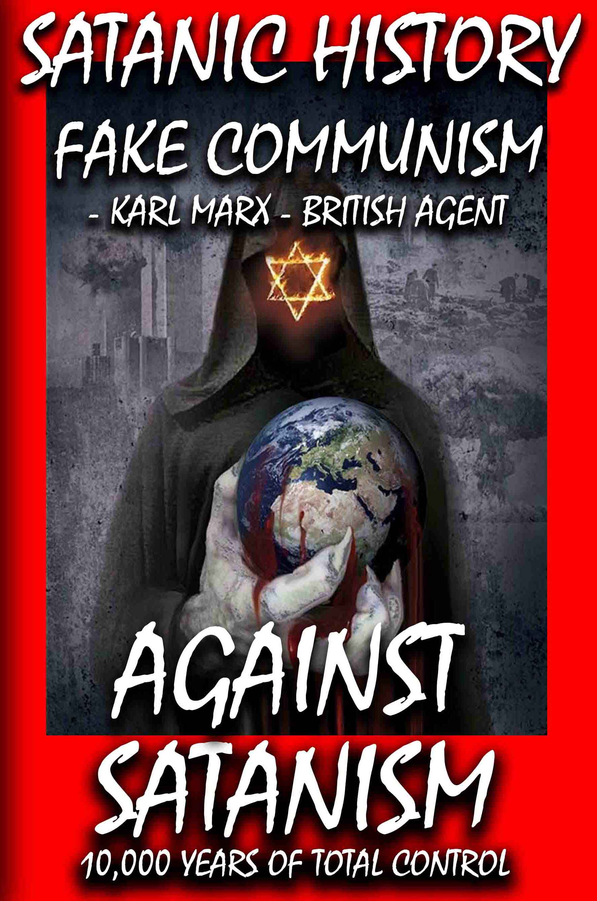 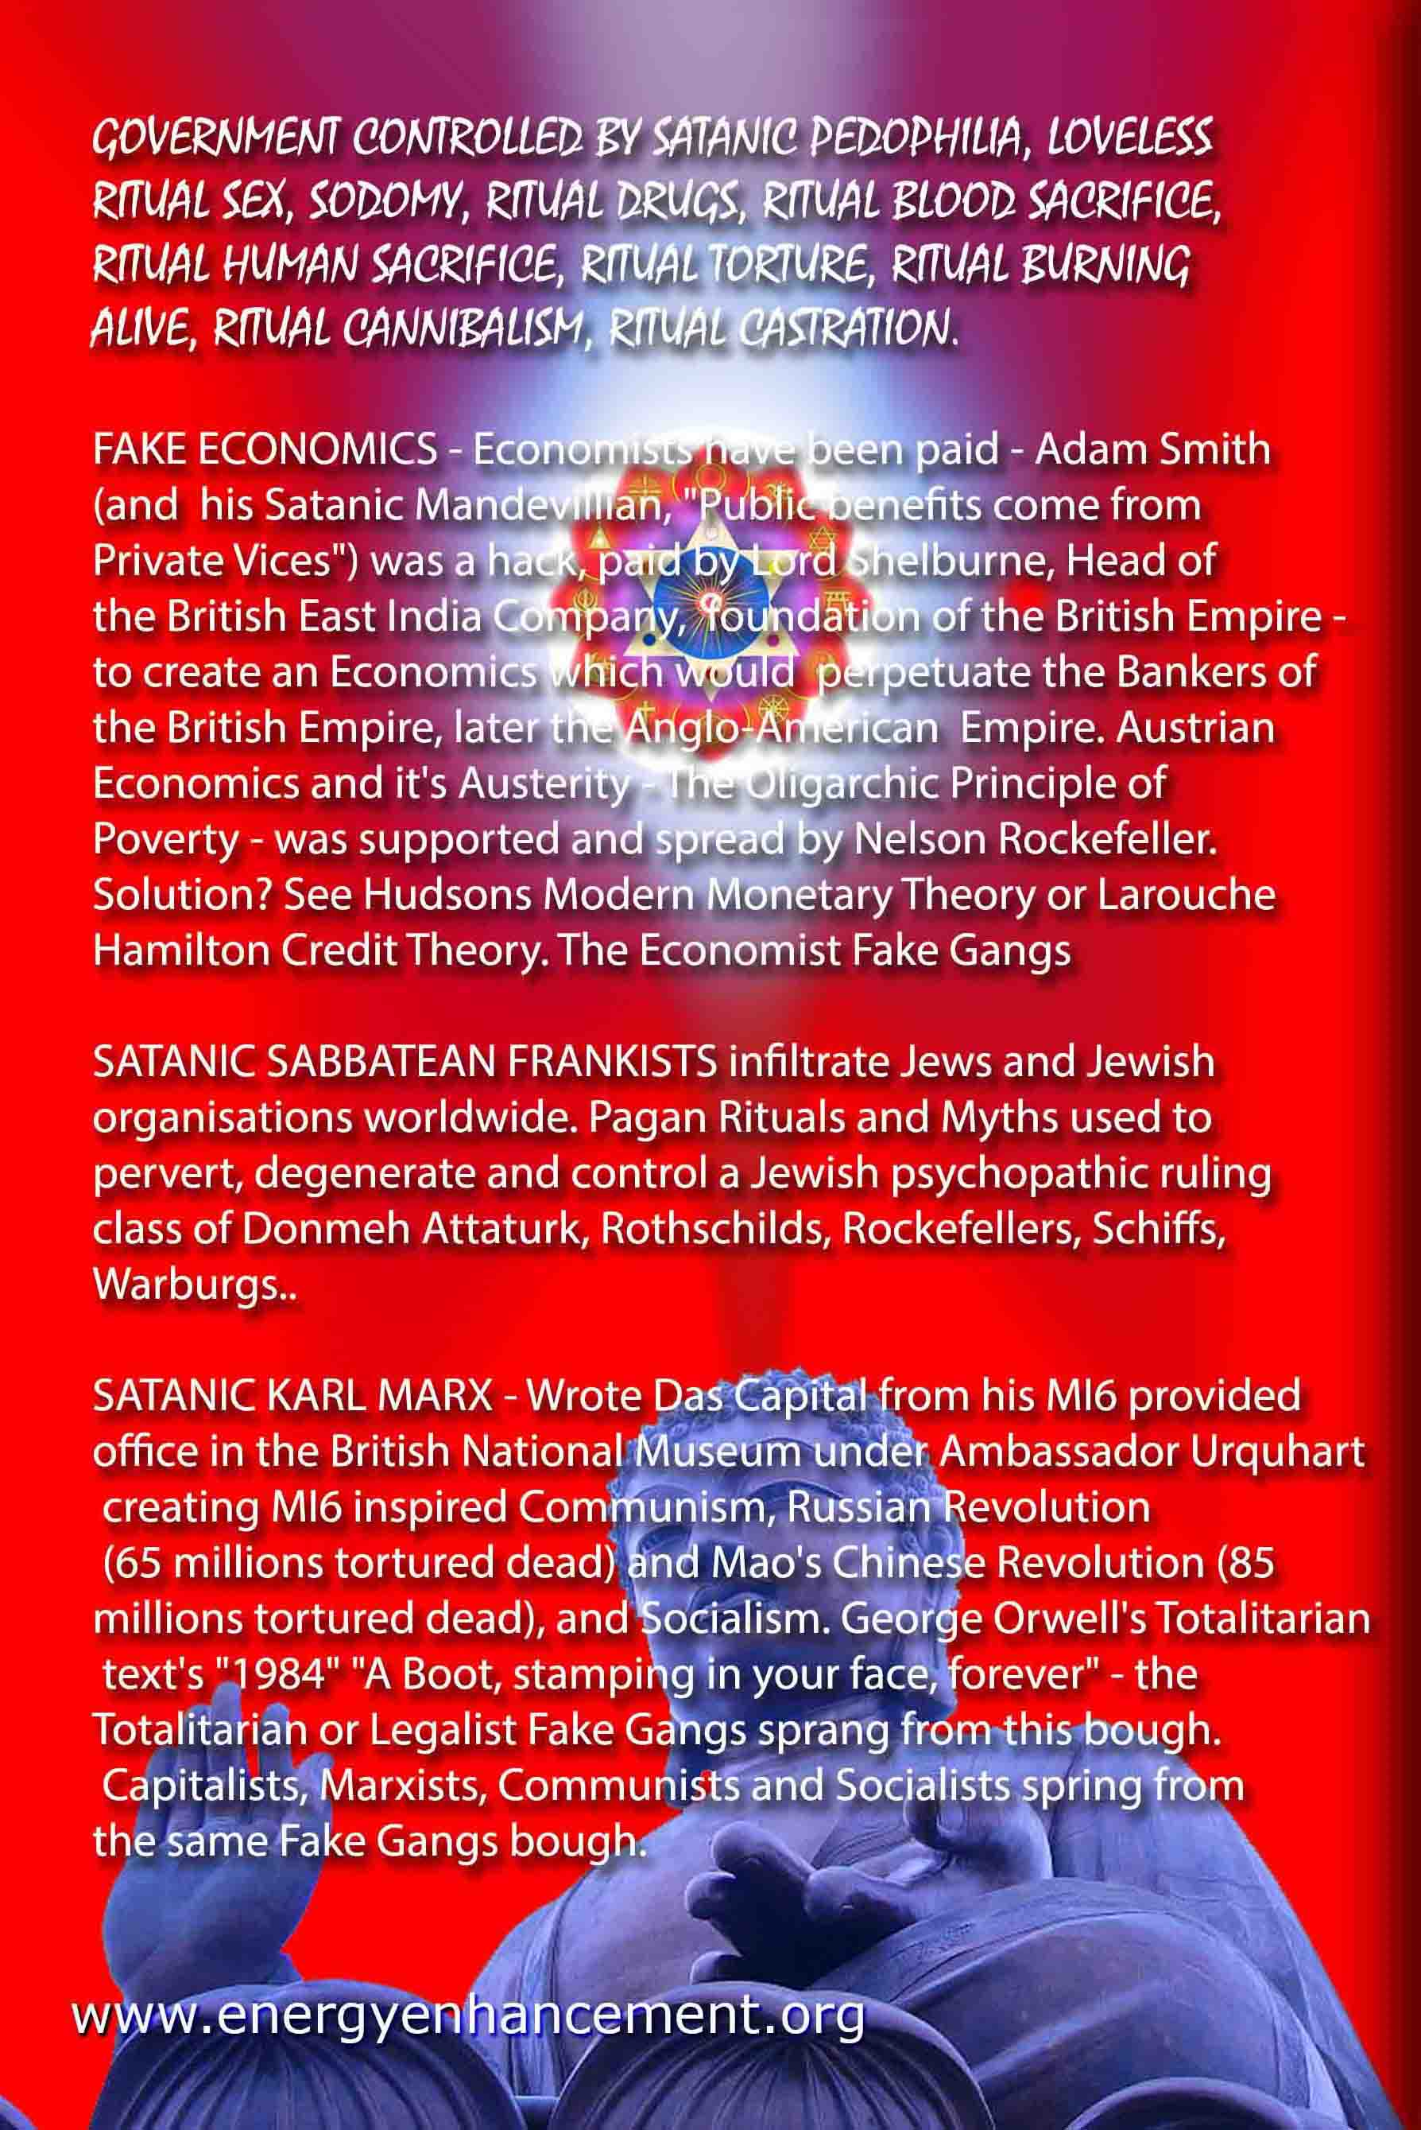

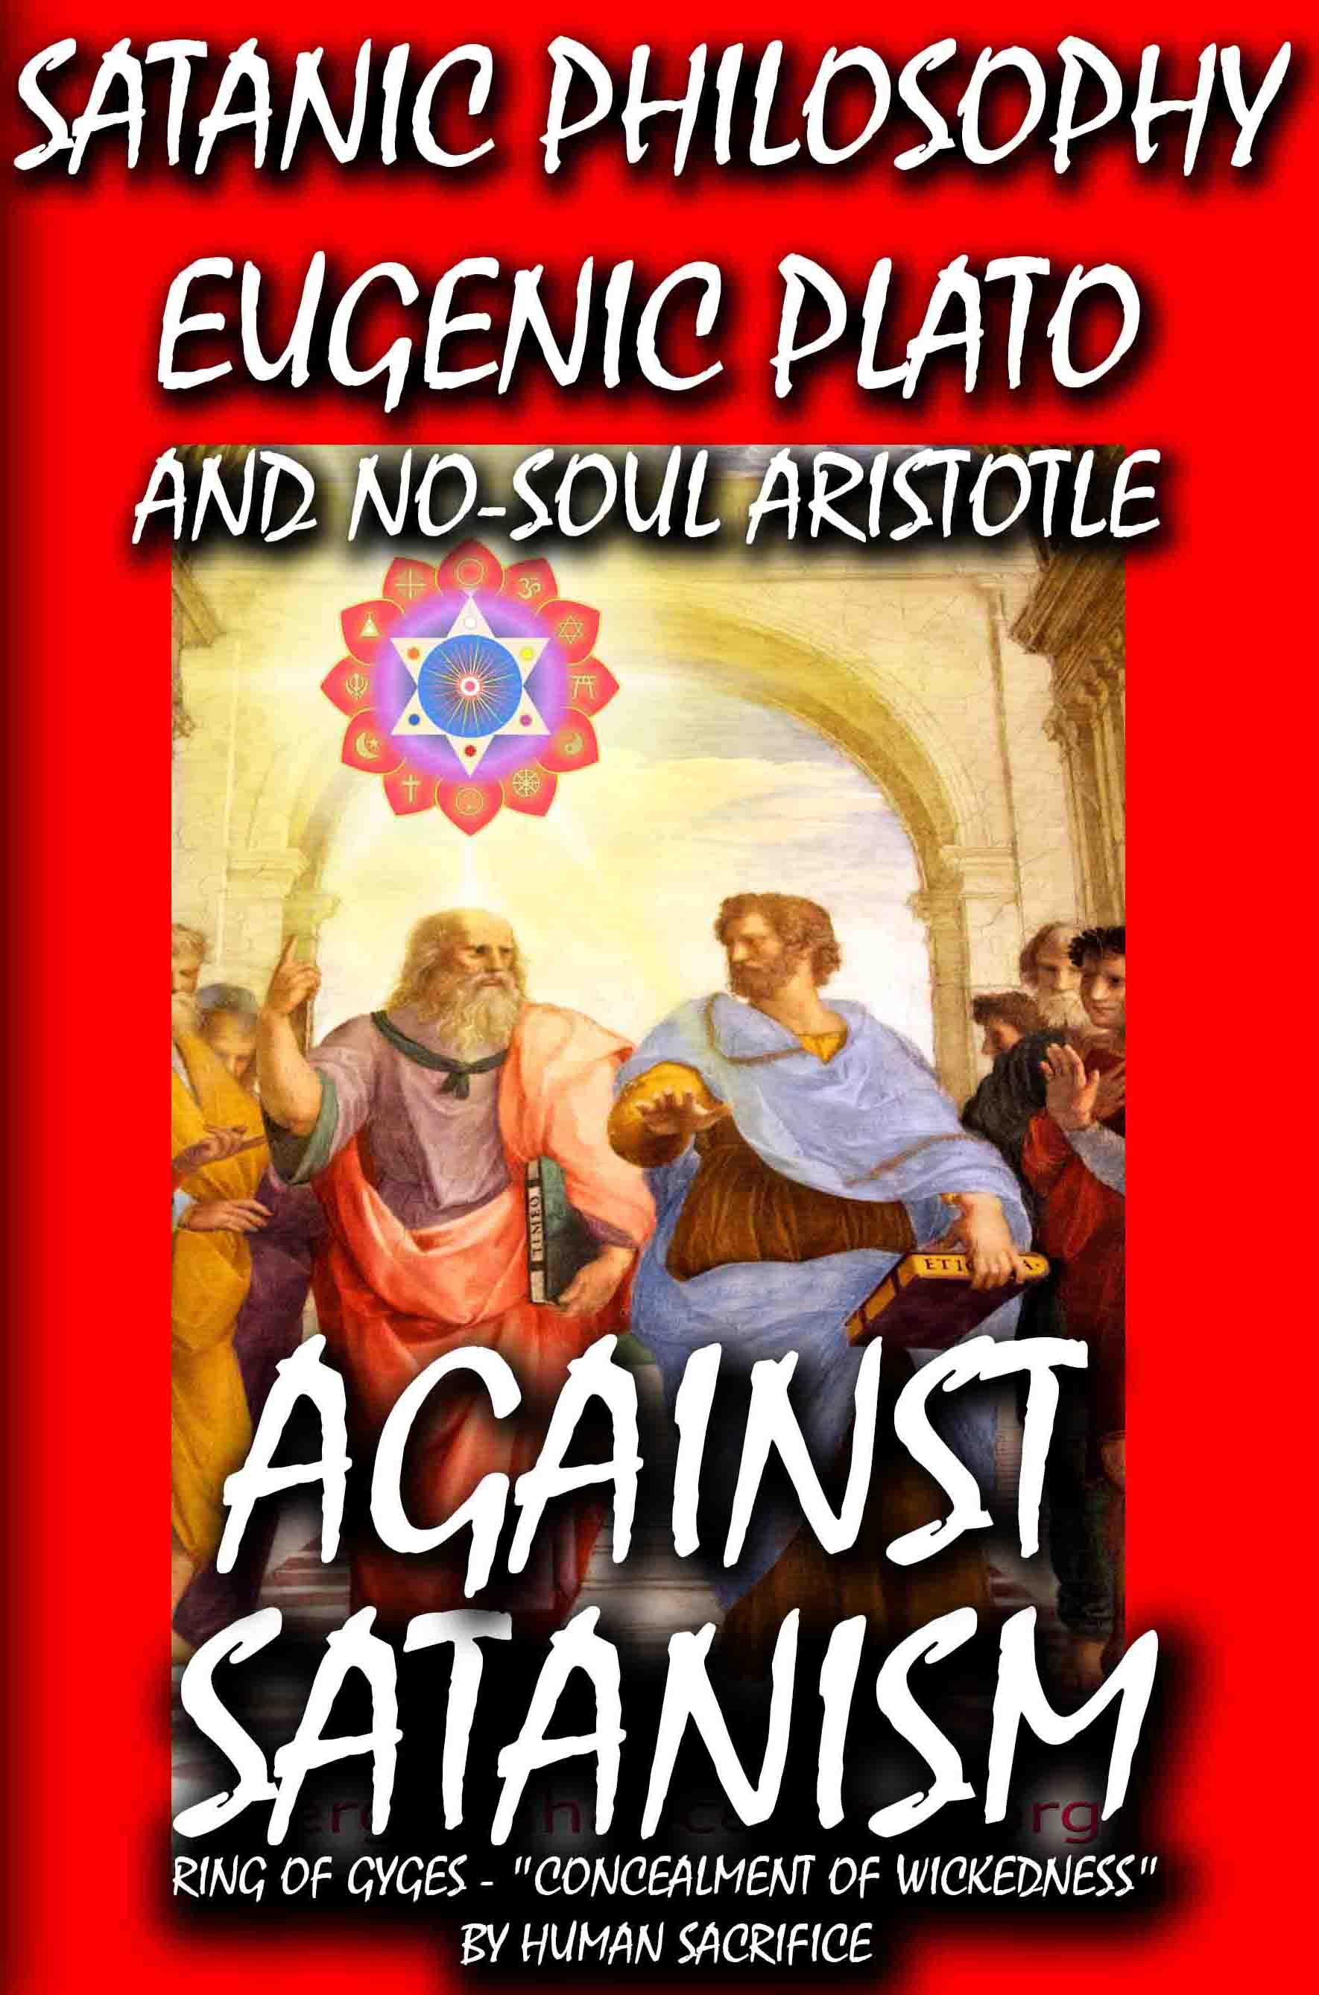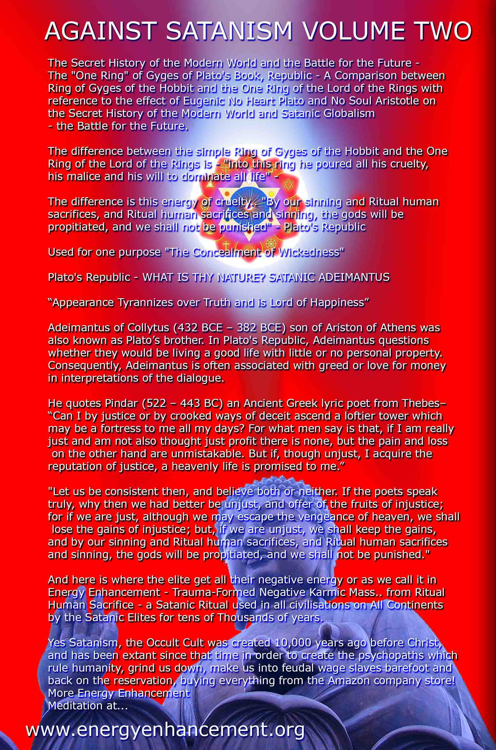

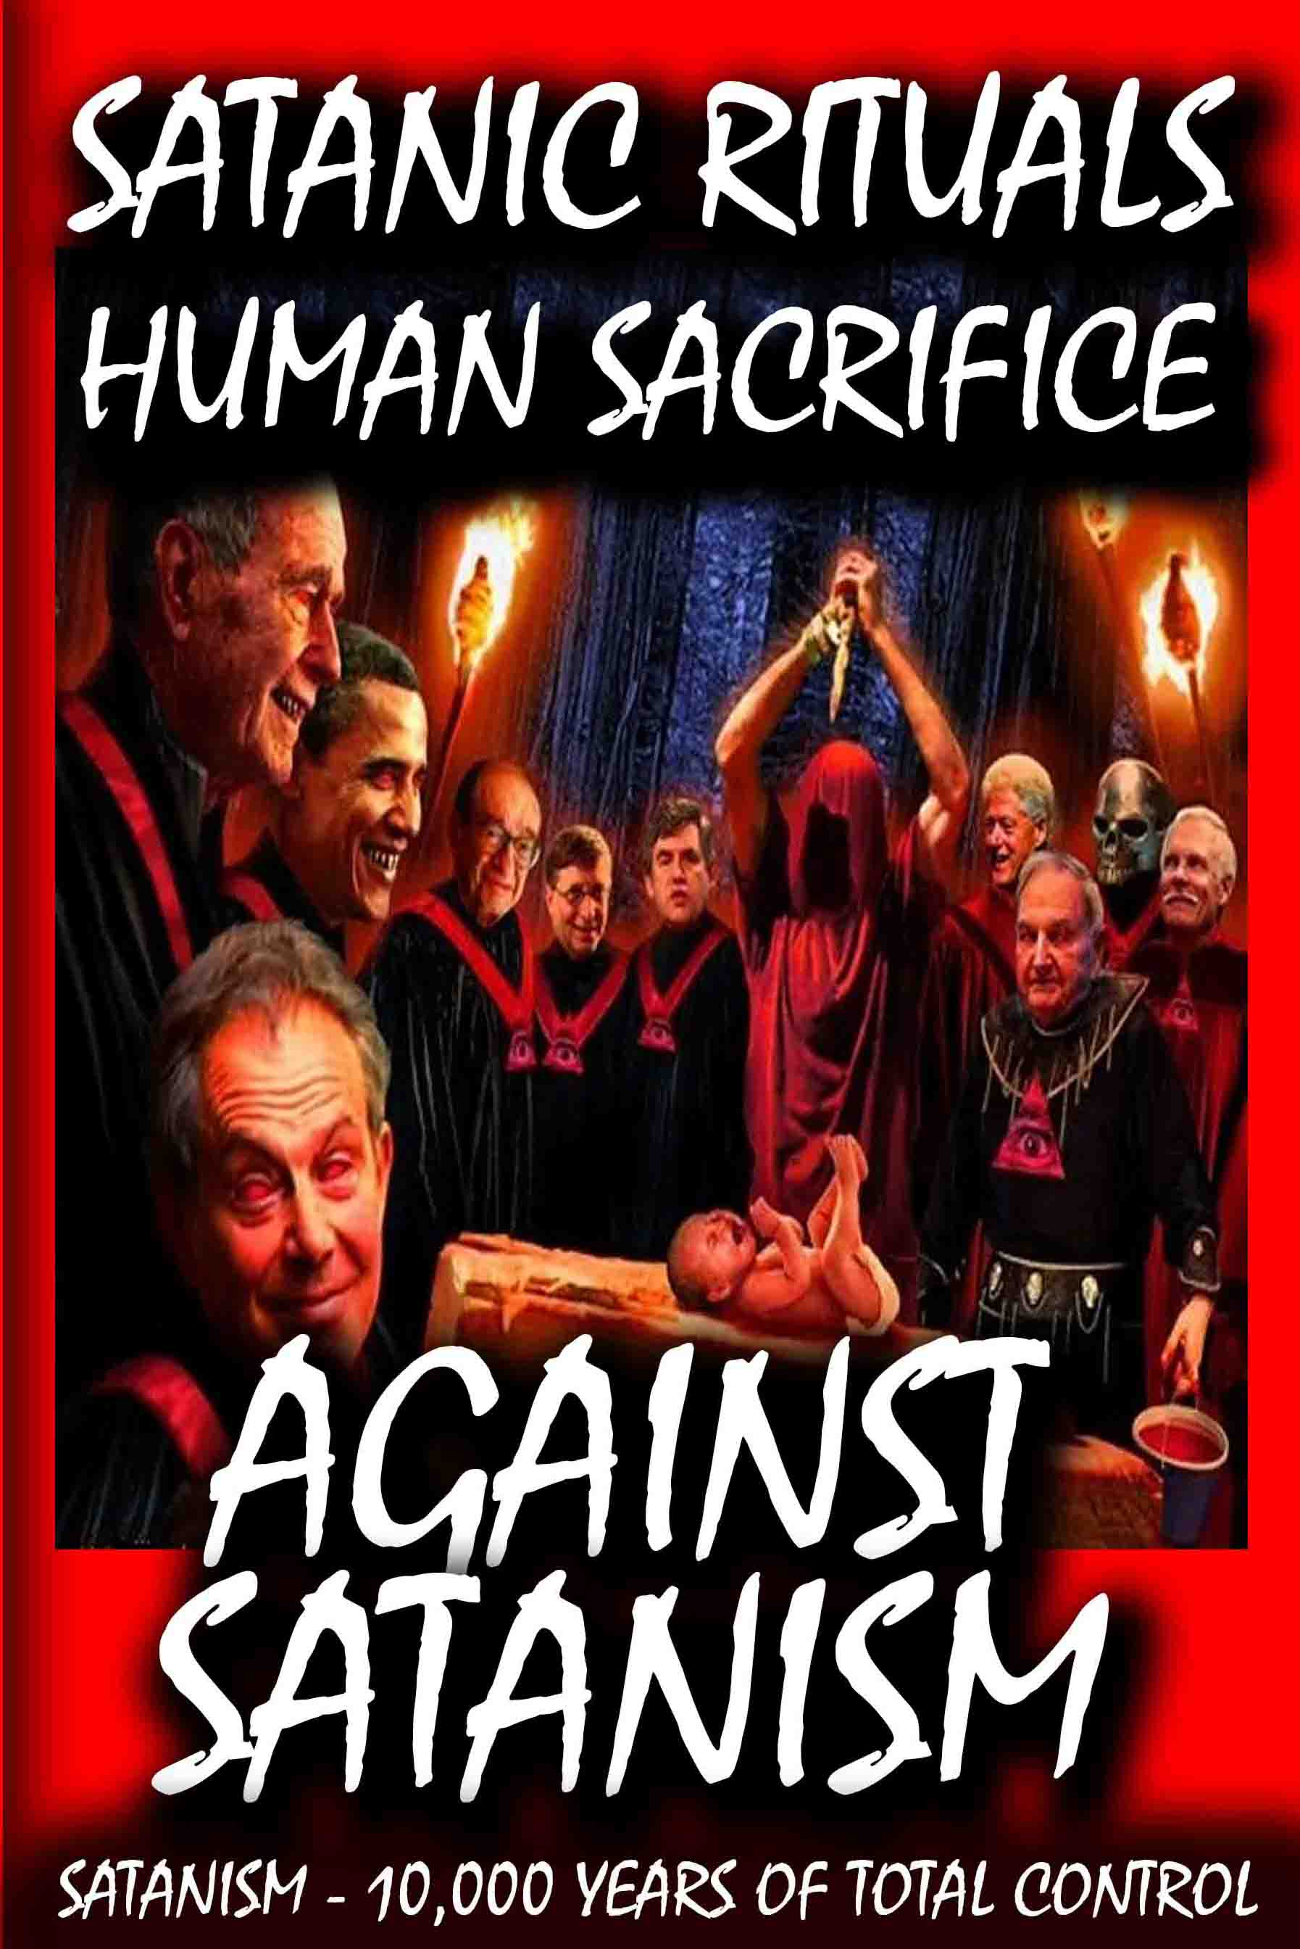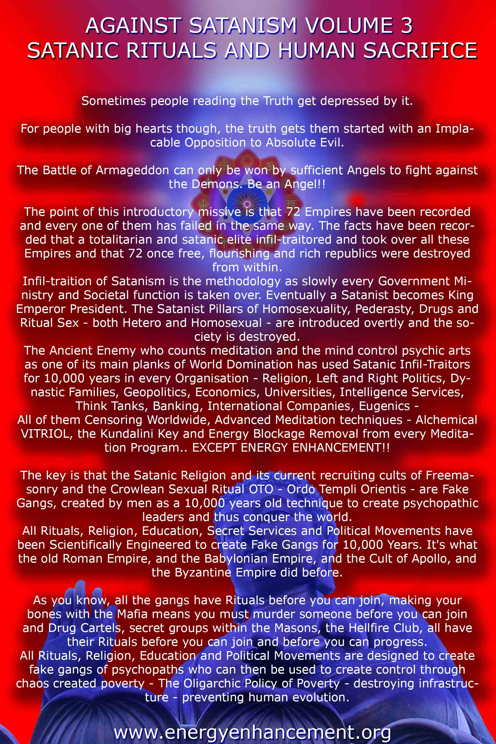

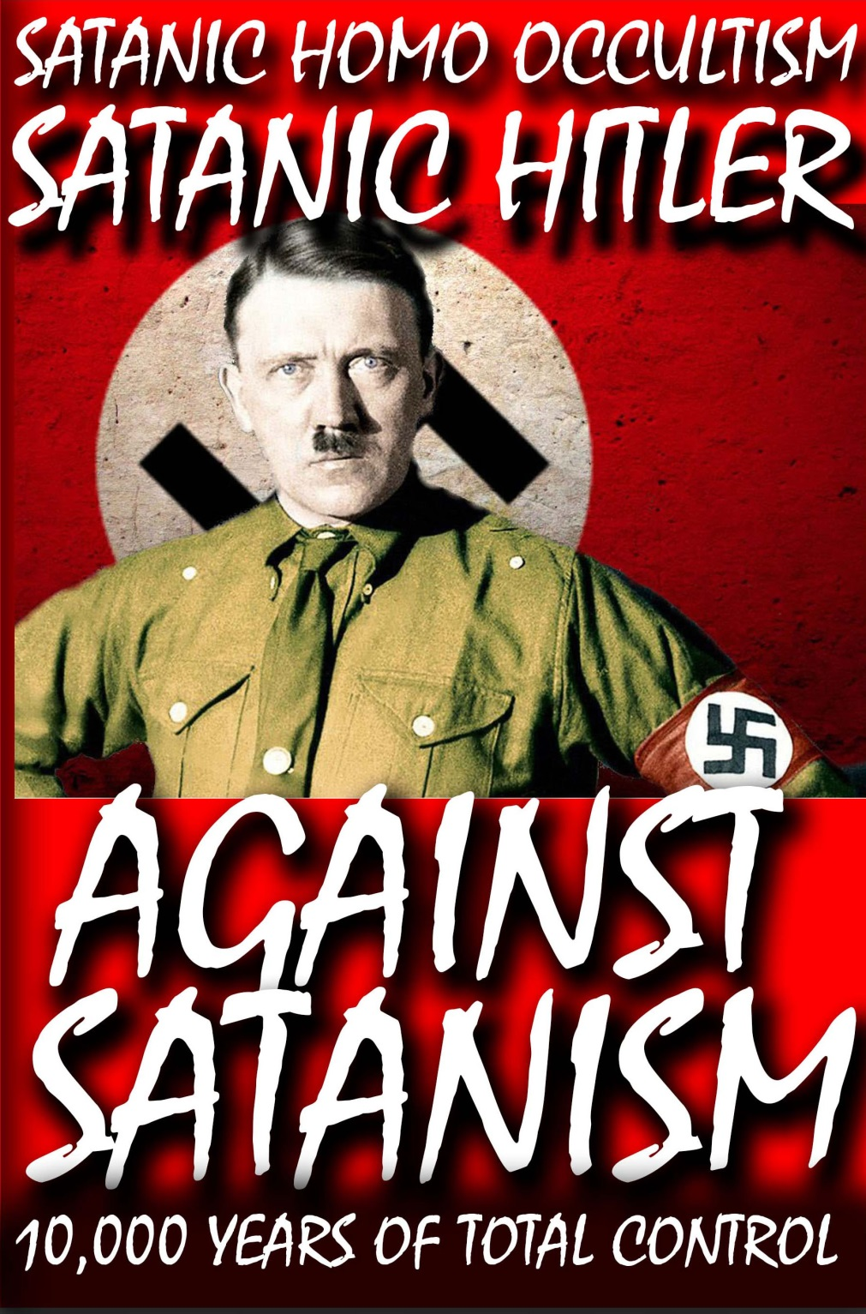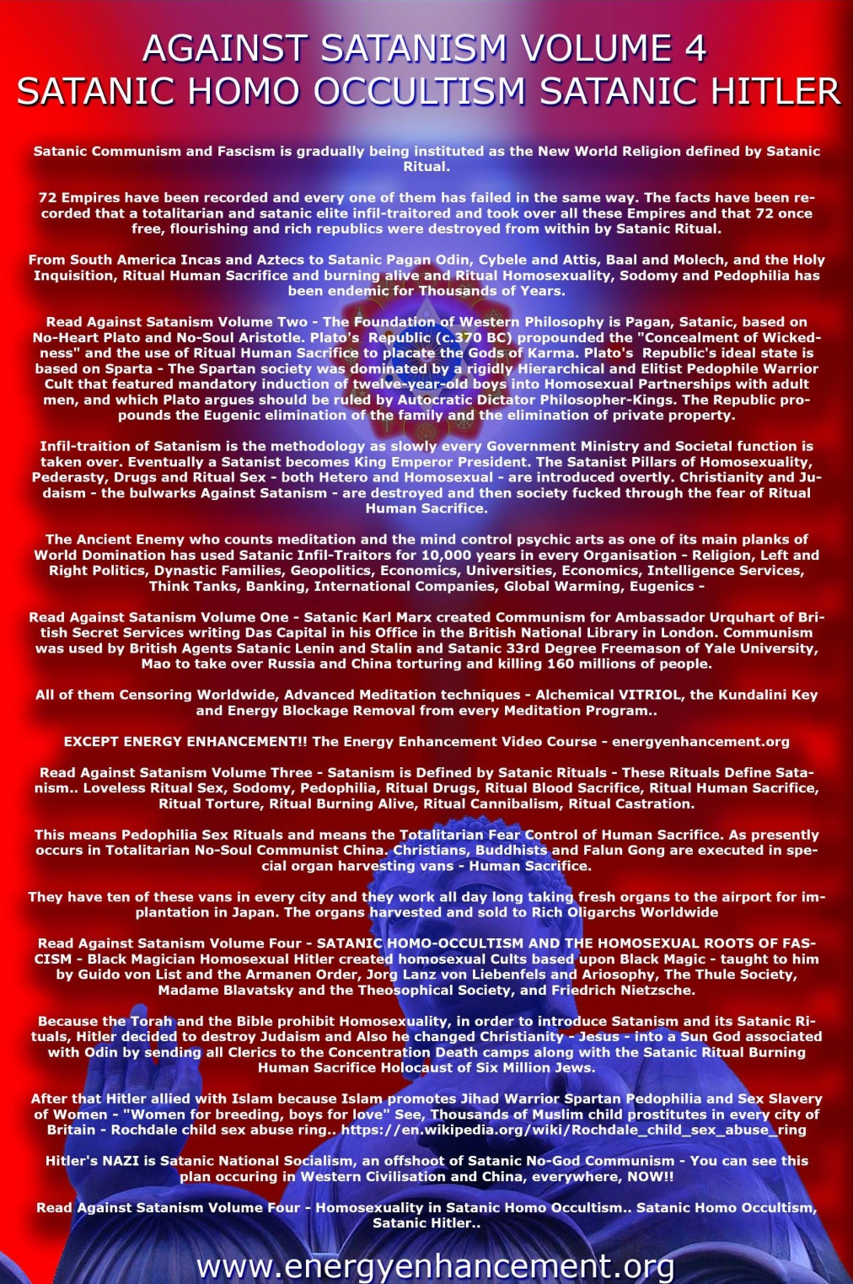

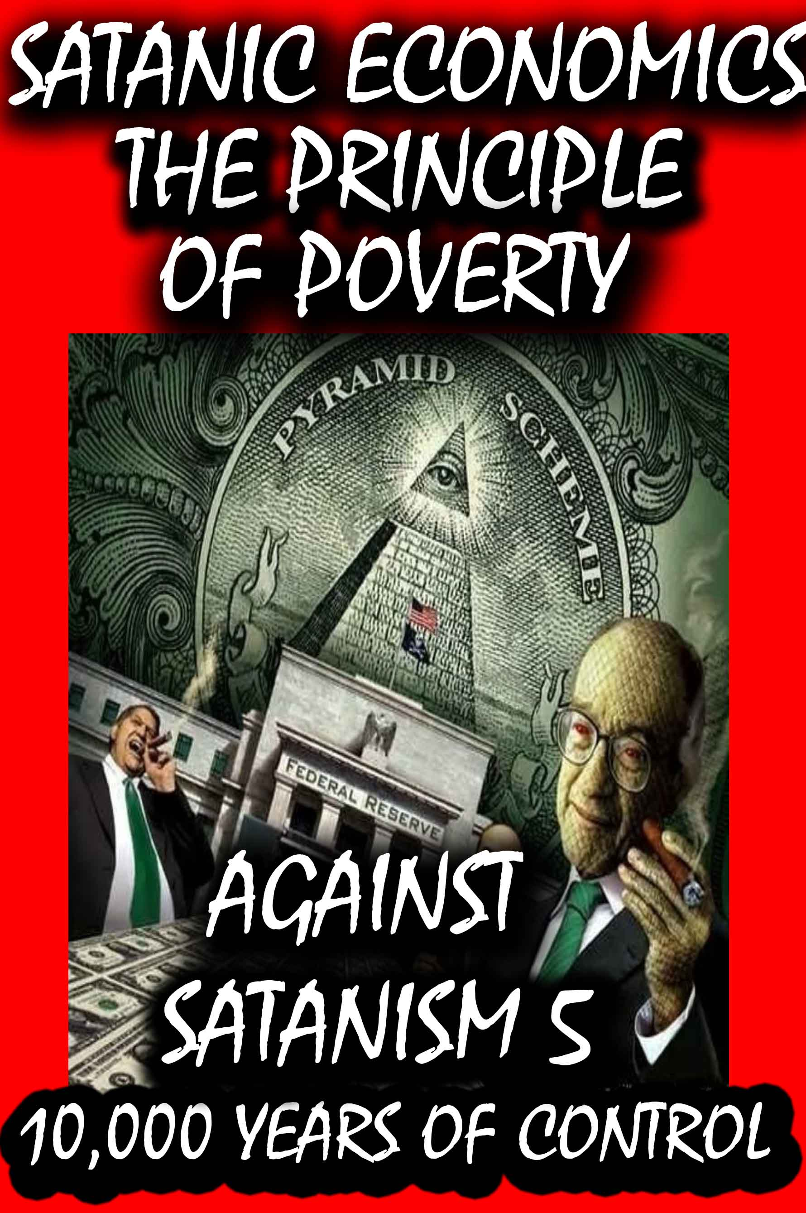
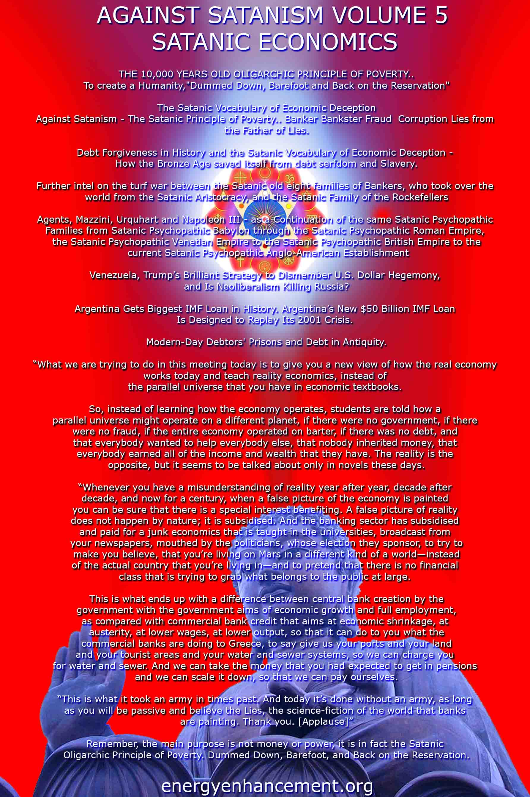

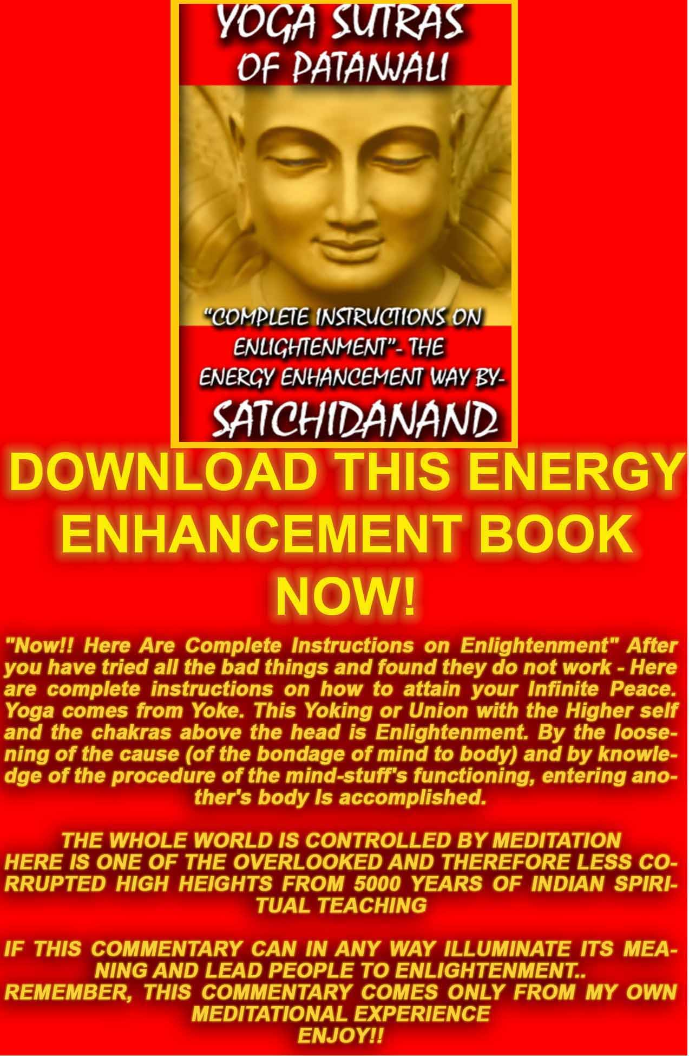
THE YOGA SUTRAS OF PATANJALI BY SWAMI SATCHIDANAND - DOWNLOAD http://www.energyenhancement.org/Sacred-Energy/yoga-sutras-of-patanjali-book/Energy-Enhancement-Yoga-Sutras-of-Patanjali.pdf
SUPER ENERGY AND SACRED SYMBOLS
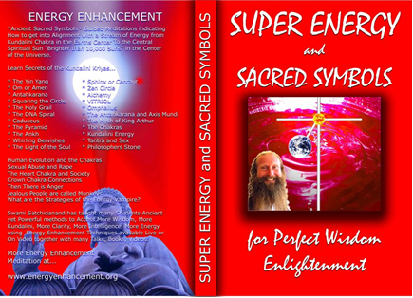
*THE ENERGY ENHANCEMENT BOOK… Ancient Sacred Symbols - Guided Meditations indicating How to get into Alignment with a Stream of Energy from Kundalini Chakra in the Earth’s Center to the Central Spiritual Sun "Brighter than 10,000 Suns" in the Center of the Universe.
Learn Secrets of the Kundalini Kriyas... and more…
Swami Satchidanand has taught many Students Ancient yet Powerful methods to Access More Wisdom, More Kundalini, More Clarity, More Intelligence, More Energy using Energy Enhancement Techniques available Live or On Video together with many Talks, Books, Videos.
ENERGY ENHANCEMENT TWO – REMOVAL OF ENERGY BLOCKAGES, MANAGING ENERGY CONNECTIONS AND MASTERY OD RELATIONSHIPS
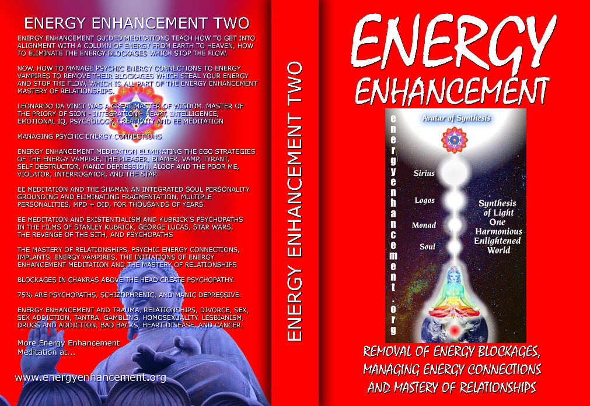
ENERGY ENHANCEMENT GUIDED MEDITATIONS TEACH HOW TO GET INTO ALIGNMENT WITH A COLUMN OF ENERGY FROM EARTH TO HEAVEN, HOW TO ELIMINATE THE ENERGY BLOCKAGES WHICH STOP THE FLOW.
NOW, HOW TO MANAGE PSYCHIC ENERGY CONNECTIONS TO ENERGY VAMPIRES TO REMOVE THEIR BLOCKAGES WHICH STEAL YOUR ENERGY AND STOP THE FLOW, WHICH IS ALL PART OF THE ENERGY ENHANCEMENT MASTERY OF RELATIONSHIPS.
LEONARDO DA VINCI WAS A GREAT MASTER OF WISDOM. MASTER OF THE PRIORY OF SION - INTEGRATION - HEART, INTELLIGENCE, EMOTIONAL IQ, PSYCHOLOGY, CREATIVITY AND EE MEDITATION MANAGING PSYCHIC ENERGY CONNECTIONS ENERGY ENHANCEMENT MEDITATION ELIMINATING THE EGO STRATEGIES OF THE ENERGY VAMPIRE, THE PLEASER, BLAMER, VAMP, TYRANT, SELF DESTRUCTOR, MANIC DEPRESSION, ALOOF AND THE POOR ME, VIOLATOR, INTERROGATOR, AND THE STAR
EE MEDITATION AND THE SHAMAN AN INTEGRATED SOUL PERSONALITY GROUNDING AND ELIMINATING FRAGMENTATION, MULTIPLE PERSONALITIES, MPD + DID, FOR THOUSANDS OF YEARS
EE MEDITATION AND EXISTENTIALISM AND KUBRICK'S PSYCHOPATHS IN THE FILMS OF STANLEY KUBRICK, GEORGE LUCAS, STAR WARS, THE REVENGE OF THE SITH, AND PSYCHOPATHS
THE MASTERY OF RELATIONSHIPS, PSYCHIC ENERGY CONNECTIONS, IMPLANTS, ENERGY VAMPIRES, THE INITIATIONS OF ENERGY ENHANCEMENT MEDITATION AND THE MASTERY OF RELATIONSHIPS
BLOCKAGES IN CHAKRAS ABOVE THE HEAD CREATE PSYCHOPATHY.
75% ARE PSYCHOPATHS, SCHIZOPHRENIC, AND MANIC DEPRESSIVE.
ENERGY ENHANCEMENT AND TRAUMA, RELATIONSHIPS, DIVORCE, SEX, SEX ADDICTION, TANTRA, GAMBLING, HOMOSEXUALITY, LESBIANISM, DRUGS AND ADDICTION, BAD BACKS, HEART DISEASE, AND CANCER.

Buy all Books and DVD’s at: amazon.com
www.energyenhancement.org
DVD 1 - KUNDALINI CHAKRA MEDITATION
HEART SUTRA – HIGHEST HEART OF WISDOM MEDITATION
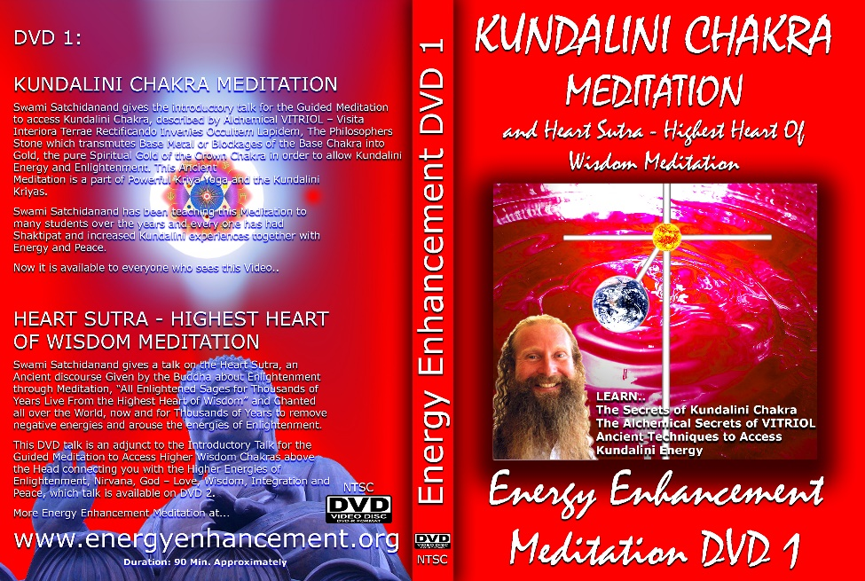
*ENERGY ENHANCEMENT MEDITATION DVD 1… Guided Meditation to Access Kundalini Chakra, VITRIOL, The Philosopher’s Stone, Kriya Yoga and the Kundalini Kriyas.
Heart Sutra, All Enlightened Sages for Thousands of Years Live From the Highest Heart of Wisdom.

Buy all Books and DVD’s at: amazon.com
www.energyenhancement.org

DVD 2 - HIGHEST HEART OF GENIUS WISDOM MEDITATION
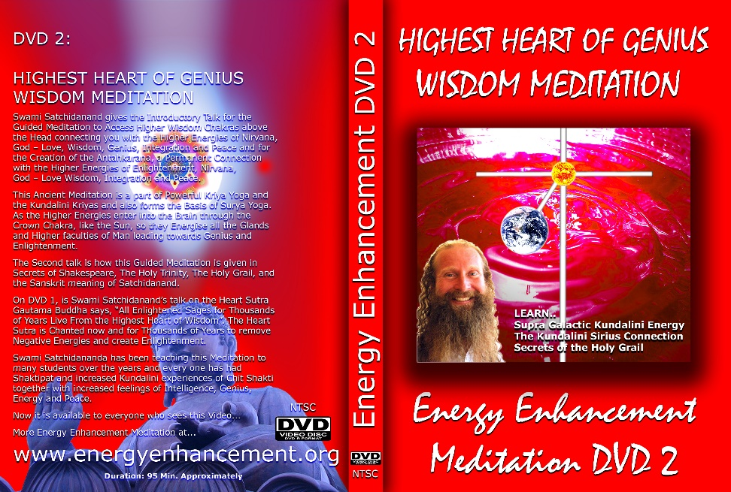
Guided Meditation to Access Higher Wisdom Chakras above the Head connecting you with the Higher Energies of Nirvana, God – Love, Wisdom, Genius, Integration and Peace and the Creation of the Antahkarana.
How this Guided Meditation is given in Secrets of Shakespeare, The Holy Trinity, The Holy Grail and the Sanskrit meaning of Satchidanand.
Swami Satchidananda has been teaching this Meditation to many students over the years and every one has had Shaktipat and increased Kundalini experiences of Chit Shakti together with increased feelings of Intelligence, Genius, Energy and Peace.
BOOK - GAIN SUPER ENERGY
ENERGY ENHANCEMENT LEVEL 1
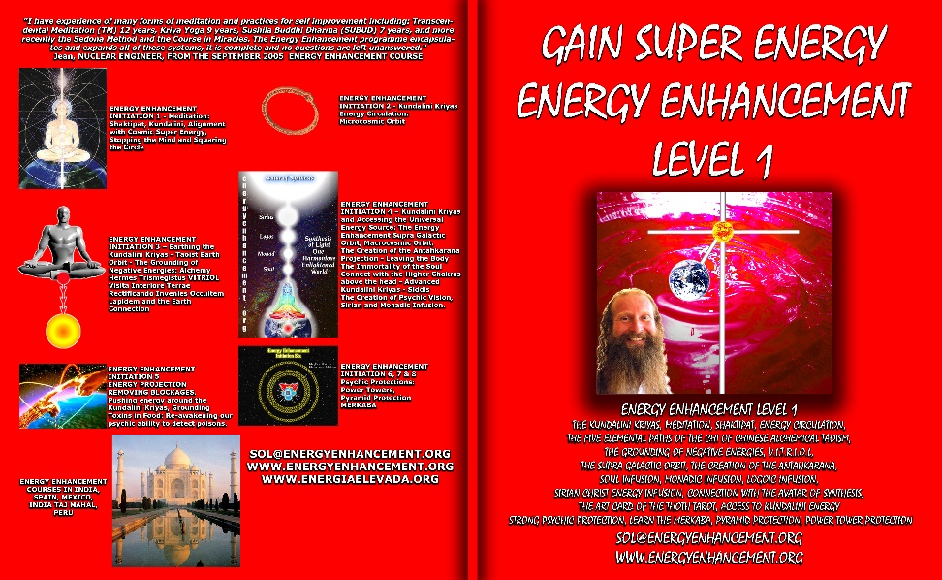
READ… The Kundalini Kriyas, Meditation, Shaktipat, Energy Circulation, The Five Elemental Paths of the Chi of Chinese Alchemical Taoism, The Grounding of Negative Energies, V.I.T.R.I.O.L., The Supra Galactic orbit, The Creation of the Antahkarana, Soul Infusion, Monadic Infusion, Logoic Infusion, Sirian Christ Energy Infusion, Connection with the Avatar of Synthesis, The Art Card of the Thoth Tarot, Access to Kundalini Energy Strong Psychic Protection, Learn the Merkaba, Pyramid Protection, Power Tower Protection.
Buy all Books and DVD’s at: amazon.com
www.energyenhancement.org
THE ENERGY ENHANCEMENT FOUR INITIATION DVD COURSE - THE ULTIMATE TECHNIQUES ON 15 DVDs
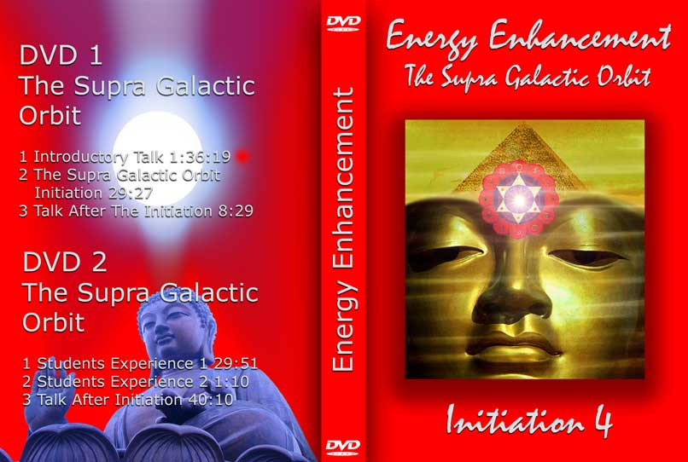
“I have experience of many forms of meditation and practices for self improvement including: Transcendental Meditation (TM) 12 years, Kriya Yoga 9 years, Sushila Buddhi Dharma (SUBUD) 7 years, and more recently the Sedona Method and the Course
ENERGY ENHANCEMENT LIVE COURSES – WORLDWIDE
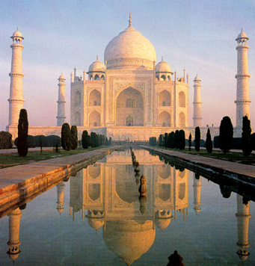
INDIA, 5 STAR INDIA TAJ MAHAL, SPAIN, MEXICO, PERU, ARGENTINA – MORE
Bookings: www.energyenhancement.org

EE LEVEL 1 POWER UP!! GAIN SUPER ENERGY http://www.energyenhancement.org/Level1.htm
EE LEVEL 2 ELIMINATE ENERGY BLOCKAGES http://www.energyenhancement.org/Level2.htm
EE LEVEL 3 CLEAN KARMA BLOCKAGES AND PAST LIFE KARMA BY TRANSMUTATION http://www.energyenhancement.org/Level3.htm
EE LEVEL 4 MASTER ENERGY CONNECTIONS AND RELATIONSHIPS http://www.energyenhancement.org/Level4.htm

