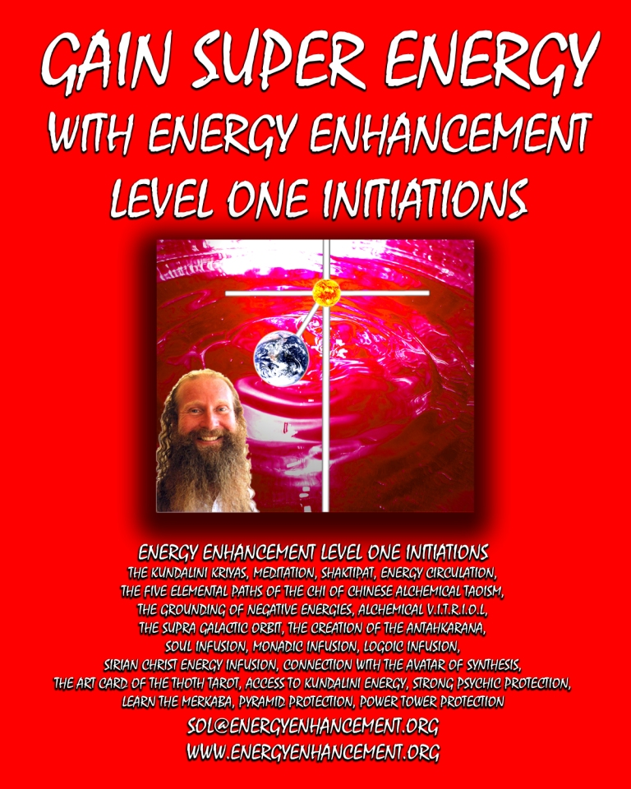

DEDICATION

**With all Thanks, Love and Gratitude to my Mother and Father and to all my other Teachers, Theos Bernard, Sri Yogendra, Eric Berne, Gurdjieff, Father Bede Griffiths, Osho, Zen**

**Master Hogen, Sivananda, Swami Satchidananda, and all the other giants upon whose shoulders I stand - who made me able to be what… I AM Copyright © 2008 [Energy**

**Enhancement Synthesis of Light Limited (SOL)]**

**All rights reserved. This publication may not be reproduced in whole or in part, by any person, without written permission of:**

**Swami Satchidanand**

[**sol@energyenhancement.org**](mailto:sol@energyenhancement.org)[**www.energyenhancement.org**](http://www.energyenhancement.org/) **ISBN: 1438248059**

**ENERGY ENHANCEMENT LEVEL ONE**

**THE KUNDALINI KRIYAS AND KUNDALINI CHAKRA**

**THE TAOIST MICROCOSMIC, MACROCOSMIC AND SUPRA GALACTIC ORBITS**

**HEART OF WISDOM CHAKRA - SURYA YOGA AND THE ANTAHKARANANA**

**PSYCHIC PROTECTIONS, PYRAMID PROTECTION AND THE MERKABA**

**GAINING MORE ENERGY.**

**The Antahkarana or Axis Mundi is the Psychic Tower of Connection between Heaven and Earth along which are strung all the Infinity of Chakras which end in God, of which you contain seven within your body. By connection with Chakras outside the body we connect with Infinite Pure Spiritual Energies which create Health, Wealth, Abundance, Super Intelligence and Genius.**

**YOU GET ALL THIS TO GAIN ENERGY IN LEVEL ONE OF ENERGY ENHANCEMENT...**

**MEDITATION, SHAKTIPAT, ENERGY CIRCULATION, THE KUNDALINI KRIYAS, THE FIVE ELEMENTAL PATHS OF THE CHI OF CHINESE ALCHEMICAL TAOISM, THE GROUNDING OF NEGATIVE ENERGIES, V.I.T.R.I.O.L, THE SUPRA GALACTIC ORBIT, THE CREATION OF THE ANTAHKARANA, SOUL INFUSION, MONADIC INFUSION, LOGOIC INFUSION, SIRIAN CHRIST ENERGY INFUSION, CONNECTION WITH THE AVATAR OF SYNTHESIS, THE ART CARD OF THE THOTH TAROT, ACCESS TO KUNDALINI ENERGY, STRONG PSYCHIC PROTECTION, LEARN THE MERKABA, PYRAMID PROTECTION, POWER TOWER PROTECTION AND MORE…**

# 

**INITIATIONS 1 TO 8 OF LEVEL 1 - GAINING ENERGY**

**THE TAOIST MICROCOSMIC, MACROCOSMIC AND SUPRA GALACTIC ORBITS**

**HEART OF WISDOM CHAKRA - SURYA YOGA**

**PSYCHIC PROTECTIONS PYRAMID PROTECTION MERKABA**

**GAINING MORE ENERGY.**

**YOU GET ALL THIS TO GAIN ENERGY IN LEVEL ONE OF ENERGY ENHANCEMENT...**

**MEDITATION, SHAKTIPAT, ENERGY CIRCULATION, THE KUNDALINI KRIYAS, THE FIVE ELEMENTAL PATHS OF THE CHI OF CHINESE ALCHEMICAL TAOISM, THE GROUNDING OF NEGATIVE ENERGIES, V.I.T.R.I.O.L, THE SUPRA GALACTIC ORBIT, THE CREATION OF THE ANTAHKARANA, SOUL INFUSION, MONADIC INFUSION, LOGOIC INFUSION, SIRIAN CHRIST ENERGY INFUSION, CONNECTION WITH THE AVATAR OF SYNTHESIS, THE ART CARD OF THE THOTH TAROT, ACCESS TO KUNDALINI ENERGY, STRONG PSYCHIC PROTECTION, LEARN THE MERKABA, PYRAMID PROTECTION, POWER TOWER PROTECTION,**

***"I have experience of many forms of meditation and practices for self improvement including: Transcendental meditation (TM) 12 years, Kriya Yoga 9***

***years, Sushila Buddhi Dharma (SUBUD) 7 years, and more recently the Sedona Method and the Course in Miracles. The Energy Enhancement programme encapsulates and expands all of these systems, it is complete and no questions are left unanswered."***

***Jean, NUCLEAR ENGINEER, FROM THE SEPTEMBER 2005***

***ENERGY ENHANCEMENT COURSE***

**ENERGY ENHANCEMENT IS THE NEWEST AND MOST HIGH SPIRITUAL IMPULSE ON THIS PLANET**

**INITIATION 1 - Meditation:**

* Shaktipat.
* Kundalini.
* Stopping the Mind and Squaring the

Circle.

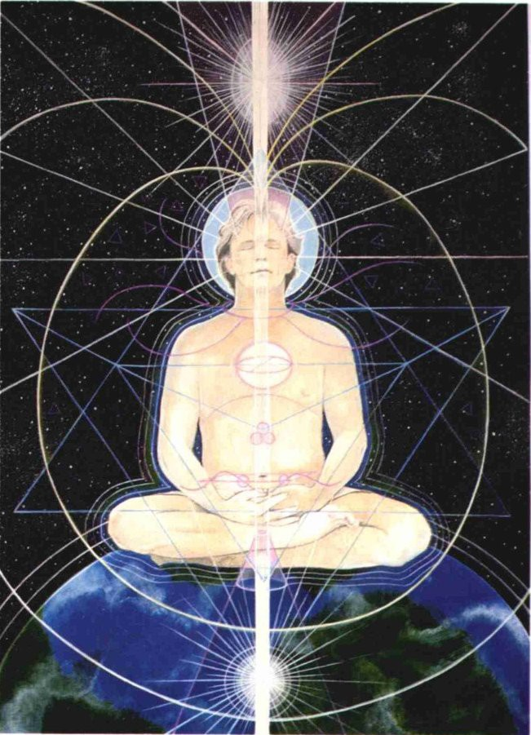

**ENERGY ENHANCEMENT INITIATION 1 -**

**Meditation: Shaktipat, Kundalini, Stopping the Mind and Squaring the Circle**

**INITIATION 2 Energy Circulation:**

* Microcosmic Orbit.

**\* Kundalini Kriyas.**



**ENERGY ENHANCEMENT INITIATION 2 - Energy**

**Circulation: Microcosmic Orbit, Kundalini Kriyas**

**INITIATION 3 - Taoist Earth Orbit - The Grounding of Negative Energies:**

* Alchemy. Hermes Trismegistus
* VITRIOL Visita Interiore Terrae Rectificando Invenies Occultem Lapidem.
* Earth Connection.

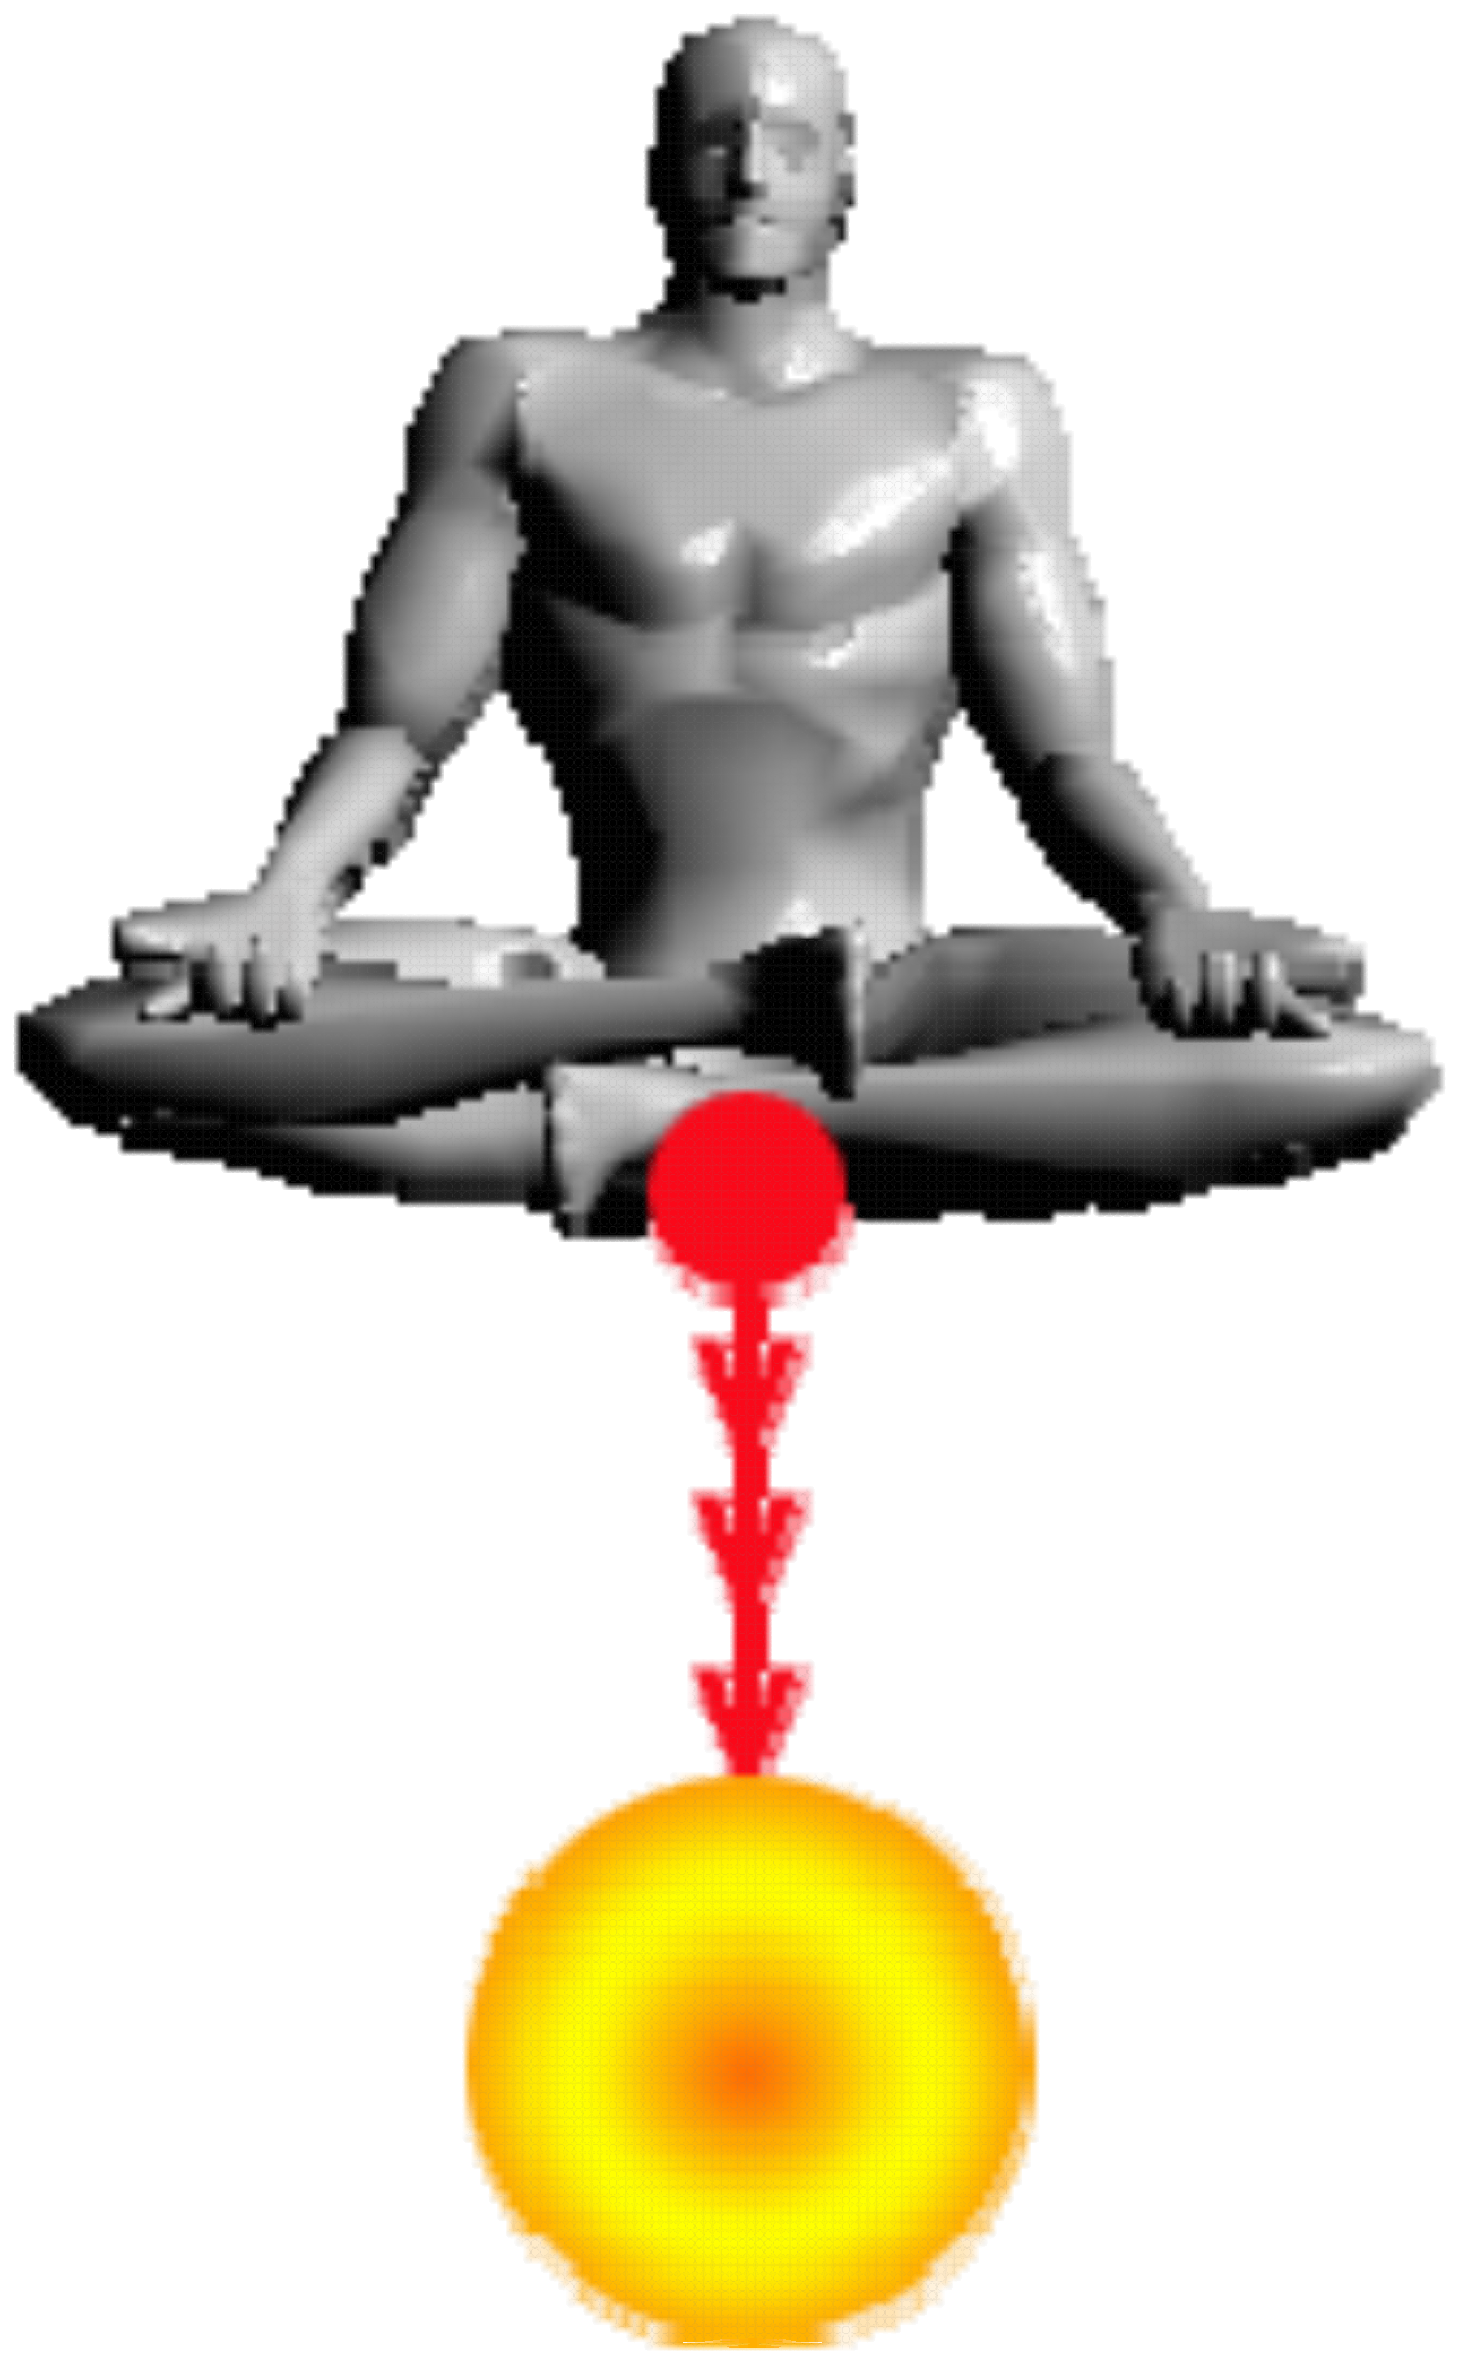

**ENERGY ENHANCEMENT INITIATION 3 - Taoist**

**Earth Orbit - The Grounding of Negative Energies: Alchemy, Hermes Trismegistus VITRIOL Visita**

**Interiore Terrae Rectificando Invenies Occultem Lapidem and Earth Connection**

**INITIATION 4 –**

**Accessing the Universal Energy Source:**

* Macrocosmic Orbit.
* The Energy Enhancement Supra Galactic Orbit.
* The Creation of the Antahkarana.
* Projection.
* Leaving the Body.

*The Immortality of the Soul.

* Connect with the Higher Chakras above the head.
* Advanced Kundalini Kriyas.
* Siddis
* The Creation of Psychic Vision.

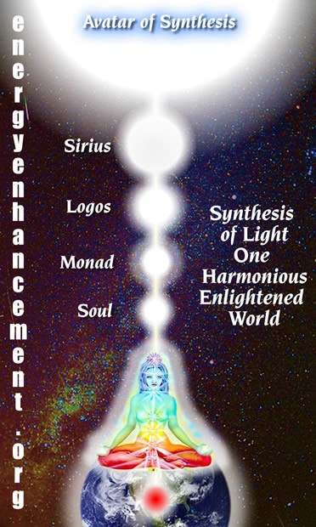

***ENERGY ENHANCEMENT INITIATION 4 - Accessing***

***the Universal Energy Source: Macrocosmic Orbit, The Energy Enhancement Supra Galactic Orbit,***

***The Creation of the Antahkarana - Projection - Leaving the Body - the Immortality of the Soul - Connect with the Higher Chakras above the head - Advanced Kundalini Kriyas - Siddis - The Creation of Psychic Vision***

**INITIATION 5 - ENERGY PROJECTION -**

**Grounding Toxins in Food:**

* Re-awakening our psychic ability to detect poisons.
* REMOVING BLOCKAGES.

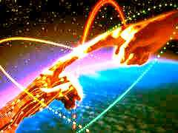

**ENERGY ENHANCEMENT INITIATION 5 - ENERGY**

**PROJECTION - Grounding Toxins in Food: Re- awakening our psychic ability to detect poisons.**

**REMOVING BLOCKAGES.**

**INITIATION 6 - Psychic Protections: Power Towers**

* Creating and Using External Antahkaranas. Exponentially Increasing your Spiritual Energy.
* Creating the Flow from Heaven to Earth.
* Astral Travel and Projection.

***ENERGY ENHANCEMENT INITIATION 6 - Psychic***

***Protections: Power Towers - Creating and Using External Antahkaranas - Exponentially Increasing your Spiritual Energy - Creating the Flow from Heaven to Earth***

**INITIATION 7 - Psychic Protections: Pyramid Protection**

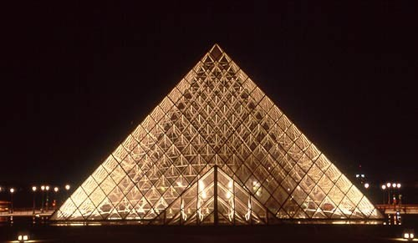

**ENERGY ENHANCEMENT INITIATION 7 - Psychic**

**Protections: Pyramid Protection**

**INITIATION 8 - Psychic Protections: How to Use THE MERKABA**

* Astral Travel and Projection.

* **Advantages of the Siddhis of Becoming Bigger and Smaller**

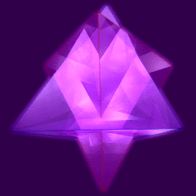

***ENERGY ENHANCEMENT INITIATION 8 - Psychic***

***Protections: How to Use THE MERKABA - Astral Travel and Projection - Advantages of the Siddhis***

**THE SECRET OF THE CIRCULATION OF THE ENERGIES, THE KUNDALINI KRIYAS, THE FIVE ELEMENTAL CIRCULATIONS OF THE QI, THEN VITRIOL THE ANTAHKARANA AND THE CHAKRAS ABOVE THE HEAD**

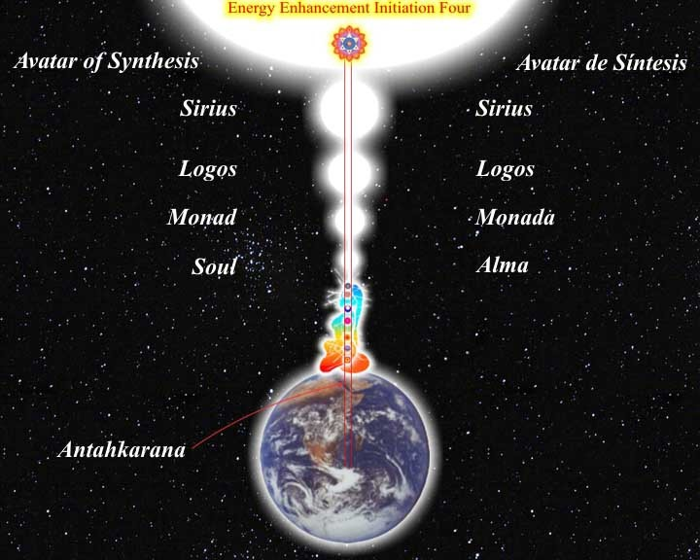

**The secret of the Sacred Circular Symbols** is that of Golden Bio - Energy flowing in the Central and Governing Meridians and mapped for 4000 years by Acupuncture.

**The Central Meridian** flows down the front of the body from Forehead to Throat to Center of the Chest to Belly to Genitals to Perineum to Anus.

**The Governing Meridian** flows from Anus to Coccyx up every bone of the Spine to the Neck, Base of the Skull, over the top of the Head to the Forehead.

In reality there are not two Meridians, only one. And the Energy flows naturally in a circuit, circle, around the body.

**If we can maximise the flow through Energy Enhancement techniques we can maximise our**

**energy** and eventually become Enlightened, Illuminated.

**Table of the Synthesis of Religions with great respect to Benedictine Monk, Father Bede Griffiths known also as Swami Dayananda who enunciated the Synthesis of The Holy Trinity and Satchidananda to me on his death – bed at the age of 96 at his Ashram, Satchidananda Ashram on the Banks of the River Cauvery in Tamil Nadu, South India, “Tell them! Tell Them!” he said. So now you are told.**

|  |  |  |  |
| --- | --- | --- | --- |
| **EE Table of the Synthesis of Religions** | Central Spiritual Sun  - Gurdjieff | Surface - Center of the Earth – VITRIOL -  Alchemy | Connecting Column of Energy - Axis Mundi or the Antahkarana |
| Holy Trinity | Father | Christ/Son – Mother Mary | Holy Spirit – Blood of Christ |
| Satchidananda | Sat – The Truth | Chid, Chitta – Holy Grail/Chalice of the Purified Mind | Ananda – Bliss flow of Energy  - SangReal |
| Hindu Gods – Tri Murthi – the three faces of God | Brahma | Krishna/Vishnu  – Shakti Kundalini | Shiva |

The flow of Energy in this Meridian is stopped by Energy Blockages. By meditating on the flow with Energy Enhancement techniques we can push the Energy faster around the body. This helps to remove Energy Blockages and also speeds up the natural flow.

By meditating on the Energy Blockages with Energy Enhancement techniques we can remove the Energy Blockages and thus speed up the flow all the way to health, wealth, intelligence and Wisdom, Enlightenment, Illumination.

**We can further increase the Energy by connecting this natural Circuit to the infinite energy sources of Chakras outside the body**, - female Kundalini Chakra in the Center of the Earth – VITRIOL, Which connects with the male Central Spiritual Sun Chakras in the Center of the Universe – The Soul, Monad, Logos, Sirius and Avatar of Synthesis, **then an infinity of chakras to God.** female polarities

The male and female polarities are connected by means of a column of Energy called Axis Mundi or the Antahkarana which includes the upward flow with its associated spiral, as magnetic energies spiral around flows of light, in parallel with the downward flow with its associated spiral, an energy Circle within the same Antahkarana Column of Energy.

The Antahkarana links in with the human energy meridian flows down the front of the body and the flow up the spine and thus The Masonic Two Towers.

In Energy Enhancement we differentiate into two parts..

* 1. The male surface of the Earth – You, Christ the Son, Vishnu/Krishna.
  2. The female Center of the earth – Shakti and Mother Mary in the female Kundalini Center.

In Energy Enhancement the lost energies of the Gaia female Earth Kundalini Shakti are integrated into the patriarchal myth.

**Energy Enhancement Teaches that Infinite Spiritual Energies flow between these two polarities. . The Center of the Earth and the Center of the Universe. “Connect, Only Connect” - Goethe. All we need to do is to Learn How to Connect!! - With Energy Enhancement.**

**ENERGY ENHANCEMENT**

**Initiation 1**

***Meditation***

*"The first day Satchi taught me how to sit. By moving the position of my posture slightly I could feel the flow of energy from the center of the earth into the center of the universe. Satchi explained that what I was feeling was Kundalini Energy. If I followed it, he said, It would lead me to Enlightenment."*

From the testimonial of Energy Enhancement Student Carla, Jan 2004

*Siva Samhitã, iii, 10-19: "Now I shall tell you how easily to attain success in Yoga, by knowing which the Yogis never fail in the practice of Yoga. Only the knowledge imparted by a Competent Teacher through his lips is powerful and useful; otherwise it becomes fruitless, weak and very painful.*

And this is why - by coming into the Buddhafield of Energy surrounding Energy Enhancement Satchidanand obtained through many years of meditation with many enlightened masters, you obtain Shaktipat- an infusion of energy to help you get into a permanent state of meditation.

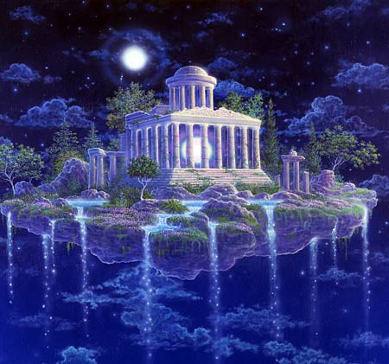

**The Ultimate in the Control of your own Mind**

Most people find it easy to have many thoughts, but you only have control over something when you have the power to stop it.

Our mind is so full of thoughts that it is necessary to learn how to press the stop button, so that one thought can have maximum power when you want it. To learn how to access Wisdom and intuition. To access the Unconscious, the Alpha, Beta and Delta levels of our own mind.

Meditation is a fast for the thoughts of the mind. All our painful memories are thoughts filled will negative emotion. As we learn how to stop giving energy to a thought, so it gets smaller, less powerful. It eventually disappears.

The true control over our minds, as known for many thousands of years, comes when we have the power to stop all our thoughts. When this occurs then we gain the Energy to access our intuition and Soul life path. When we can do this then any thought we have becomes so much more powerful. We begin to have the ability to make things happen. The power of doing. The clarity to hold and accomplish anything we set our minds to.

To control something, one must be capable of stopping it, said Karl Popper the famous philosopher who wrote, "The Open Society and its Enemies" and Frank Herbert who wrote the DUNE series of Science fiction.

STOP THE MIND

Energy Enhancement Meditation taught here is based upon ancient Zen Techniques in a Synthesis of many advanced methods from Hindu Masters as well as practical hints and tips from several Masters of Meditation from many traditions, some of which have never been taught previously, giving the most advanced practical techniques on how to enter into the state of meditation and including the Buddhafield of Energy to get there.

To Square the Circle To Stop the Mind

Meditation is a prerequisite to the further advanced

states of Energy Enhancement and just this Energy Enhancement Meditation is enough to gradually lead you towards your Ultimate Clarity, your Ultimate peace.

ENERGY ENHANCEMENT

**Initiation 1**

***Meditation***

THE TWELVE LABOURS OF HERCULES -- THE HYDRA

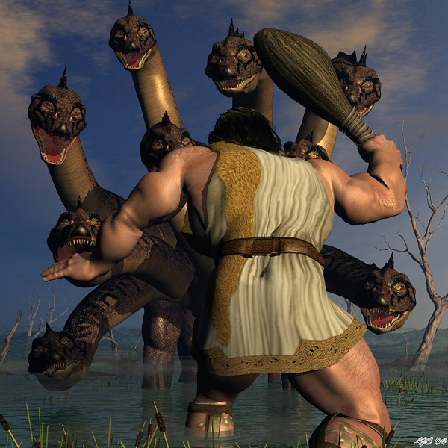

**THE TWELVE LABOURS OF HERCULES OR HERACLES SYMBOLISES THAT WHICH IS NECCESSARY ON THE PATH OF ENLIGHTENMENT**

Remember the Labour of Hercules involving the Hydra. As Hercules chopped off one head with his sword another 3 grew back in its place.

As Hercules chopped off the head, he cauterised it with the Sacred Fire, and thus the heads grew no more. This is the secret of meditation taught in Energy Enhancement, but for the fire, you have to wait a few Initiations!

The Hydra symbolises the mind. Its heads the many thoughts we have which need to be dissipated through Energy Enhancement Initiation One, meditation.

**TO STOP THE MIND, WE MUST DEFEAT THE HYDRA. ENERGY ENHANCEMENT KNOWS THE FAST AND SPEEDY WAY TO ENLIGHTENMENT!**

***MIND IS A DISEASE WHOSE CURE IS ENLIGHTENMENT***



The human mind is filled with wandering thoughts and desires like a mad monkey it leaps from tree to branch and distracts the mind from the higher energies from chakras above the head.

**Yet, this is not mind.**

**Mind is merely a container.**

And what the mind contains is madness. The mind contains thoughtforms, programs and sub-personalities which have been created by the person and also absorbed from the surroundings.

These blockage thoughtform program sub-personalities are fixed, obsessed, filled with desire which become stale and poisonous. They Kill!! - Only the Purified Empty mind can truly Live.

These mind created thoughtforms are the ones which cause the endless Chitta Chatter (Chitta is Sanskrit meaning, Mind) and distraction from Purpose.

These thoughtform Energy blockages cause all the negative emotions of Anger, Fear, Sadness, Despair, Depression, and Manicism.

These thoughtform Energy blockages create and maintain connections which drain energy and strength from the lower chakras.

So, when we say mind is the disease, we mean that the full and sick desire filled mind is the disease.

An empty mind is a perceptive instrument and meditation is a fast for the mind because it drives out all the blockages and creates enlightenment.

The purpose of the empty mind faculty is to contain the psychic powers of perception and to listen to the energies of the higher chakras above the head which work at a higher and faster frequency, To listen to the quantum shift in energy from the chakras above the head.

The chakras above the head eventually at their highest point connect with Atman, God, Allah, Nirvana - any of the 10,000 names of the one Highest Energy.

Even Buddha when asked about God said Nirvana - Nothing - Emptiness. When you create an empty mind then automatically you get in touch with the Mind of God!!

This is why the Zen Masters say the Zen Joke, " I know Nothing!" Which really means, "I know God!"

Only an empty mind can contact the energies of God!

And, when all the blockages are removed, then you can become a candidate for Enlightenment!

And Energy Enhancement Techniques through many ancient and effective techniques like the Kundalini Kriyas and the Supra Galactic Orbit of Chinese Alchemical Taoism and the Emerald Tablet of Hermes Trismegistus, VITRIOL, The Seven Step Process for the removal of all blockages, The Karma Clearing Process, can Speed up the Process of Enlightenment.

ENERGY ENHANCEMENT

**Initiation 1**

Meditation

THE REMOVAL OF STRESS, TRAUMA AND NEGATIVE EMOTION

Energy Enhancement easily transmutes all negative energy without going anywhere near the emotions and memory!! The techniques of Energy Enhancement show you how to **QUICKLY AND EASILY TRANSMUTE YOUR STRESS** because it works at the level of Energy which underlies **AND IS THE BASIS** of all problems.

*THE START OF THE ENERGY ENHANCEMENT ENERGIES*

The Buddhafield of energy, in which evolutionary progress can quickly be made, and Kundalini Energy are absolutely necessary to any course of Meditation.

Energy Enhancement Advanced Techniques allow PAINLESS progress above and beyond any other course.

Energy Enhancement Advanced Techniques only use ENERGY which underlies all other human functions.

With Energy Enhancement it is not necessary to go anywhere near painful memory, negative emotions and catharsis which are the foundations of other courses.

**ENERGY ENHANCEMENT PAINLESS TRANSMUTATION IS EASY AND QUICK.**

**IT SPEEDS UP THE PROCESS OF ENLIGHTENMENT!!**

It teaches TOTAL Transformation and Transmutation.

ENERGY ENHANCEMENT

**Initiation 1 Meditation**

THE PRINCESS OF SWORDS OF THE THOTH TAROT

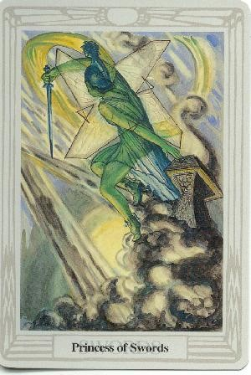

The inflow of Spiritual Energy or Kundalini Energy is well known in all Spiritual Circles as being expected in all genuine Courses with teachers who have advanced experience with Enlightened Masters yet some people just cannot get their heads around it and they do not

trust it as this concept destroys their idea of a "Normal" world. They start to fear the unknown!!

*"EASY AND SMOOTH ENERGY ENHANCEMENT SPEEDS UP THE PROCESS OF ENLIGHTENMENT"*

Energy Enhancement easily transmutes all negative energy without going anywhere near the emotions and memory!! The wind of Kundalini blowing through you usually leaves smoke and ashes in its wake. Normally, when Kundalini energy starts to flow through the interiorly held negativities it starts to destroy and release the Trauma and trauma within. Fear CAN be the result with all OTHER courses. The techniques of Energy Enhancement show you how to TOTALLY CLEAR yourself from moods and disturbing thoughts because it works at the level of Energy which underlies all the problems.

*"ENERGY ENHANCEMENT IS A PROBLEM FREE METHOD OF AWAKENING CREATIVE INTELLIGENCE!!"*

The powerful techniques of Energy Enhancement **REMOVE** the traumatic nature of all this Energy Release by using the new ALCHEMICAL concept of "Transmutation" - there remains non of the problems associated with all other courses.

Energy Enhancement does not work at the level of memory. You do not have to remember anything as we work at the level of energy which underlies all of the painful memories, yet the performance of Energy Enhancement techniques can easily and totally remove all the ENERGY BLOCKAGES, in a non-painful way!!

The student of Energy Enhancement knows how necessary is the transmutation of all the old energies on the path of evolution, progress and inner freedom.

The Energy transmutation of Energy Enhancement produces inner peace, clarity, openness and truth. The Energy Enhancement student's "NO" to all the past negative energy held inside springs from an unequivocal "YES" to themselves and to their life!

The necessity for positive and easy change is comparable to the drastic move by Jesus Christ when he drove the moneylenders out of the Temple, and to the work of Hercules when he drove the River Styx through the Augean Stables, thus easily cleaning out thousands of years of horse shit in one day!

ENERGY ENHANCEMENT

**Initiation 1**

Meditation

THE PRINCESS OF DISCS OF THE THOTH TAROT

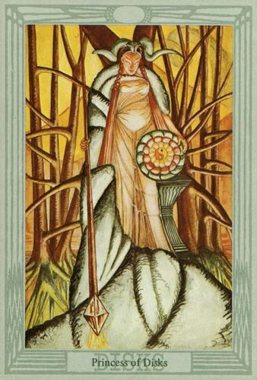

The wand of the Princess of discs stretches from heaven to earth and symbolises the Antakarana, an ancient symbol of Kundalini Yoga, which represents the tower, rainbow bridge of energy which flows through all your chakras from heaven to earth, when all energy

blockages preventing that flow have been transmuted through the techniques of Energy Enhancement.

By learning how to bring the Spiritual Energies of the Center of the Universe, the highest and purest form of light, into this Earth which is the darkest and most negative of all elements, it becomes possible to raise the energy level of the Energy Enhancement student and the Earth itself. This advance into new territory has the ability to unify to integrate the mother, the father and all the internal children into one energetic, soul infused and peaceful being.

***"THERE CAN ONLY BE ONE!!"***

Thus bringing together spirit and matter. The removal of energy blockages has created something new which can channel the light onto the Earth and cosmic idea- impulses, thoughtforms, become visible to everyone and permeate everything with their divine quality.

***THE TRUE HEALING OF YOU, AND THE EARTH ITSELF!!***

**ENERGY ENHANCEMENT**

**Initiation 2 KUNDALINI KRIYAS**

**Energy Circulation**

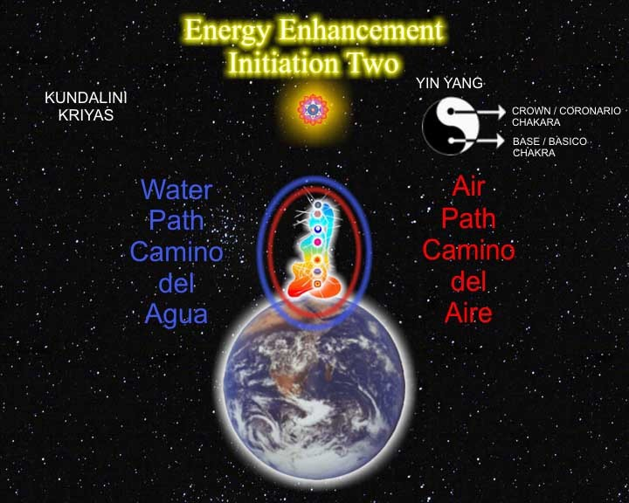

**THE KUNDALINI KRIYAS OF KRIYA YOGA**

*"EASY AND SMOOTH ENERGY ENHANCEMENT PUTS YOU IN CONTACT WITH KUNDALINI ENERGY WHICH SPEEDS UP THE PROCESS OF ENLIGHTENMENT AND INTELLIGENCE"*

**THE 5 ELEMENTARY CIRCULATIONS OF THE KI OF TAOISM** ARE THE SAME MEDITATIONS AS TAUGHT IN THIS INITIATION OF ENERGY ENHANCEMENT

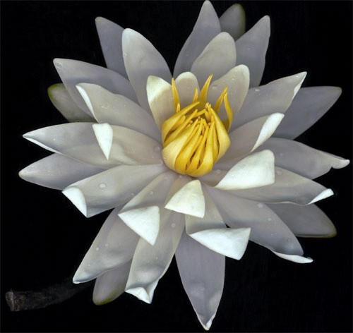

**Masters... and the flowers showered, the energy of existence flows**

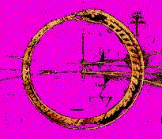The Same Guided Meditation as this ADVANCED TECHNIQUE of Energy Enhancement has been symbolised in many cultures. All the SYMBOLS below mean the same CIRCULAR GUIDED MEDITATION.

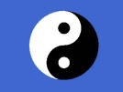

The Circular Yin Yang Symbol of Chinese Alchemical Taoism makes sense once you understand that the black dot represents the alchemical lead of the dirty Base chakra and the white dot represents the pure crown chakra. The circle represents the powerful Central and Governing Meridians of Acupuncture which was SEEN PSYCHICALLY by Taoist masters in their meditations. These Meridians, energy flows, circulate down the front of the body and up the spine through all the major Chakras.

This is the "Microcosmic Orbit" of Energy Enhancement.

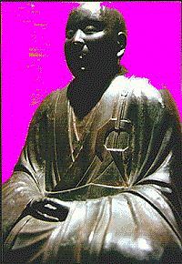

The Circular Broach in the costume of the Zen Master on the left. Zen is the Hybrid of Buddhism and Taoism. Hogen, the name of my Master, Zen Master Hogen means, "Master of the Tao" It represents the "Microcosmic Orbit" of Energy Enhancement.

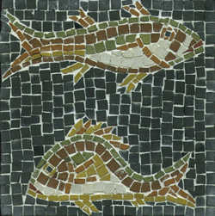

The Christian Fishes

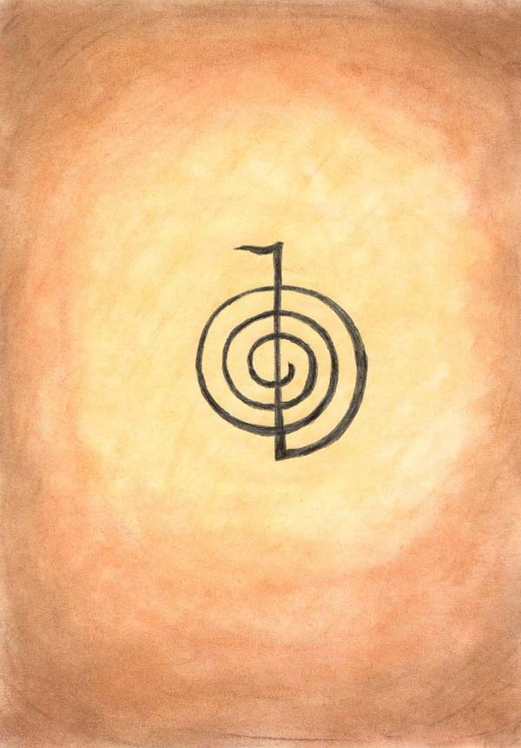

The Reiki "Choku Rei Symbol" This represents the Antahkarana flow of energy between heaven and earth

- the upright line, and the spiral of spiritual energy which surrounds it as magnetism spirals around a ray of light in the direction of the "right hand rule" of physics. It represents the "Microcosmic Orbit" of Energy Enhancement.

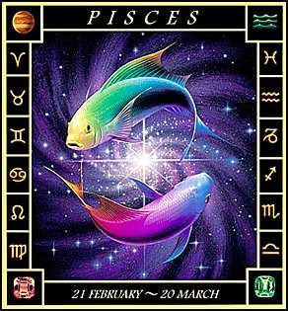 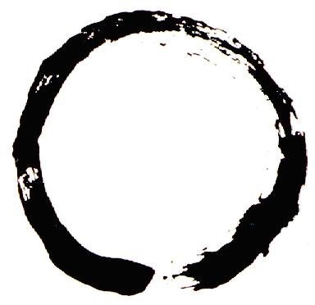

The Astrological Sign of Pisces

The Zen Circle

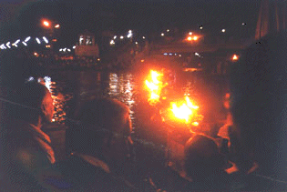

The Circular movement of the Sacred Flame in Hindu Arati

This picture is of the evening Arati Ceremony at the Sacred City of Haridwar taken by the Directors of Energy Enhancement on one of their India Tours.

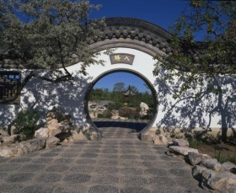The Chinese Taoist, Circular Doorways

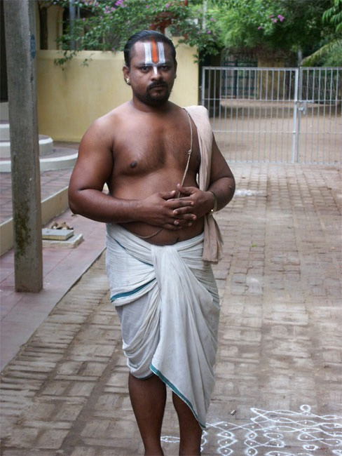

The Circular Sacred Thread traditionally worn around the body, over the shoulder and around the genitals, by the Hindu Brahmins who are Brahmacharya, celibate and working under the tutelage of a Guru

When the circulation of the energies, the Microcosmic Orbit, the Macrocosmic Orbit, The Energy Enhancement Supra Galactic Orbit, starts to function then the higher attachment of the Soul and higher starts to control all lower attachments.

The Hindu Swastika, Anti-Clockwise and clockwise Like the Choku Rei Symbol and the Prayer Wheel the

swastika represents the spiral flows of energy around a

central stem. Anti-Clockwise or as they say in Magic, "Widdershins" represents energy going away from you.

Devi Dhyani, "A Simple teacher of Dance" - Quote by Gurdjieff, like Jalaluddin Rumi and his whirling dervishes utilises this spiritual truth by turning

anticlockwise to send all negative energy into the center of the earth and clean the base chakra.

It represents the Kundalini Kriyas "Microcosmic Orbit" of Energy Enhancement.

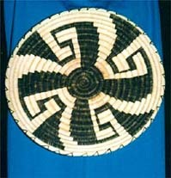

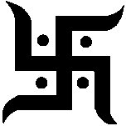The Hindu Swastika

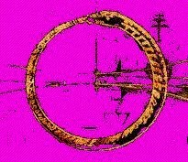

The Worm (Kundalini Dragon, Salamander) Orobouros which encircles the World of Norse Culture

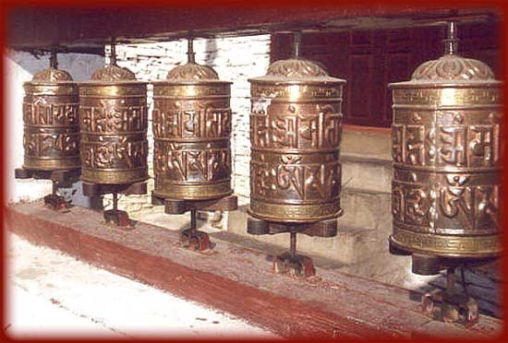

The Tibetan Buddhist Prayer Wheel shows movement in a circle and also represents the Antahkarana - see EE Initiation 4 - like the Reiki Choku Rei. The outside of the wheel represents the spiral flows of energy around the axis of the wheel which represents a flow of energy between heaven and earth - the Antahkarana. It represents the "Microcosmic Orbit" of Energy Enhancement.

All the symbols ABOVE are the same **GUIDED MEDITATION** of...

**ENERGY ENHANCEMENT Initiation 2 - THE CIRCULATION OF THE ENERGIES - ENERGY ENHANCEMENT APPRENTICE LEVEL 1**

**Initiation 2.**

And are Ancient symbols which show the Energy Enhancement Guided Meditation of Energy Circulation.

These are the Kundalini Kriyas and The Five Elemental paths of the Chi of the Taoist masters, comprising Initiations 1-4 of Energy Enhancement.

This gives the Hidden Taoist Secrets of the Microcosmic AND the Macrocosmic Orbit and The Energy Enhancement Supra Galactic Orbit.

*“The problem is that over the years we lose our inner energy due to bad experiences that happen to us in life. Negative thoughts forms are also responsible for its lack. The solution to all these problems is learning Energy Enhancement! So I had to go onto the course!!!*

*I am now finishing the Energy Enhancement Level 3 of the Energy Enhancement Course. I have learned so much in this course that there is no way that I could sum it up in few lines!*

*However I can tell you about an experience that I had during my first week. This proved me and may be to you as well, that meditation is very active process using the energy of the earth and those from the universe. I was sitting in the lotus position, applying some of the basic Energy Enhancement techniques, and suddenly I felt my whole body getting warmer and warmer. My hands started to shake a little bit and I was feeling slightly dizzy.*

*As I was still concentrating on the technique a heat from within started to make my whole body sweat. Although it was a cool September day I was getting so warm that I could feel the drops of sweat coming down the back of my spine, from my head onto the my neck. Once the meditation over I had to get change and have a shower because even my clothes were all damp. I can guarantee to you that I am not a person to get very warm even in the hottest summer day in Spain!*

*This was a very interesting experience for me and it*

*proved to me another time the effectiveness of Energy Enhancement Meditation”.* SOPHIA FROM EE MEDITATION COURSE 2004

This technique cleans all the Chakras. Helping all parts of the mind including the Unconscious, to become more calm and still.

To remove the stones in the path of the watercourse. To remove blockages to the flow of your energy.

It teaches how to cleanse the psychic body so that our psyche becomes sensitive and our energy more powerful.

It strengthens the psychic circuits and decreases the resistance to the flow of Energy. It helps to build the psychic body, as Gurdjieff called it, "The Body Kesdjian".

ENERGY ENHANCEMENT

**Initiation 2 KUNDALINI KRIYAS**

**Energy Circulation**

The Fifth labour of Hercules

This technique of Energy Circulation (EE Initiation 2) and Grounding (EE Initiation Three) is referred to in the 12 Labours of Hercules. Ancient teachings in the form of stories which enable "**The Son** (Hercules) **of God** (Zeus)" to get married to the daughter of the king of the underworld.

To integrate the Crown Chakra with the Base Chakra or how to become Enlightened.

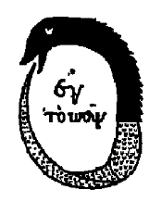

**All ancient myths refer to hidden levels of meditation.**

Throughout history, simple stories and symbols containing many levels of meaning have usually not been destroyed by the prevalent Religion as have been the competing religions temples and texts. In particular The Herculean Labour of the cleaning of the Augean stables refers to the cleaning of the Base Chakra with a River of Energy.

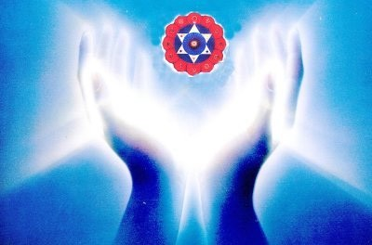In the past, psychologists have only worked on one painful experience at a time by providing a meaningful theory by Freud or Jung and then examining the problem. Through understanding the problem, it is released and the client adjusted back into society in his proper place. He may still be neurotic because only one problem has been solved.

The same with ancient lives. We may travel back to, see and fix one life problem in one of our past lives, but what about the other thousands of life-times, each with their own traumas, deaths and problems.

Energy Enhancement Techniques teaches how to remove All of the traumas, deaths and problems as simple negative energy. You do not have to see the problems. They are simply grounded as Negative energy. Learn how to simply, "Ground the last dregs of your VITRIOL!"

There is an ancient Greek myth about Hercules, (a Son of God, Zeus), wanting to marry Persephone the Daughter of the King of the underworld. The Crown Chakra wanting to combine with the Base Chakra. Shiva combining with Shakti. A Human Being becoming Enlightened.

He needed to ask her father's permission. When he did, her father was pleased to marry his daughter to the son of Zeus, but first he must perform 12 tasks. The 12 labours of Hercules. The fifth task was to clean out the Kings stables - The Augean stables. Hercules said, "No Problem," but when he saw the stables, he realised what a mountainous task he had taken on. There were thousands of horses and they had been creating manure for hundreds of years. Just like we, ourselves, create and absorb Trauma and Karma over thousands of lifetimes.

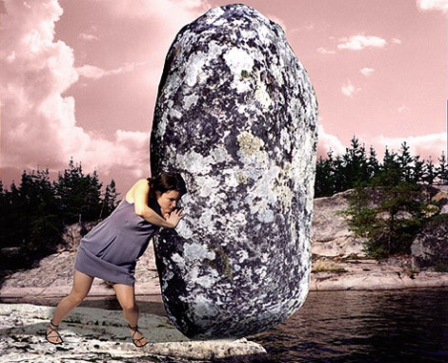At first, he tried to dig the manure, examining every turd. Just like the psychologists and past life therapists of today. But after one month he had got nowhere. He had only cleared a small hole in a mountain of shit.

After much thought, he then projected to change the course of the river Styx, the river we cross when we die, through the stables. When he did this, the stables were quickly cleaned as the river washed all the manure away.

THIS IS THE CONCEPT OF ENERGY CIRCULATION, THE KUNDALINI KRIYAS, THE TAOIST MICROCOSMIC AND MACROCOSMIC ORBITS - DEEP RIVERS OF ENERGY WASHING AWAY ALL THE SHIT.

WITH THE TECHNIQUES OF ENERGY ENHANCEMENT RIVERS OF ENERGY WILL DISSOLVE AND SWEEP AWAY ALL YOUR NEGATIVE ENERGIES - FAST!!

Deep Rivers of Energy lie hidden deep within us. As we learn to access and then to use them. So, All our History. All our TRAUMA can be dissipated and washed away

In the same manner, our first APPRENTICE LEVEL of Energy Enhancement teaches basic methods whereby the mountains of manure within us can be removed, painlessly, without examining every turd.

The whole mountain can gradually be moved and our History painting which has been painted brushful by brushful, day by day, can be returned to the clean white sheet we were when we were born.

We are full of a lot of "History" not only from this life, but also from previous lives. Our Energy Enhancement can truly remove this Personal History so that all painful memories can be dissipated and our energies can then start to flow in their natural courses, once again.

AND ITS A PAINLESS PROCESS BECAUSE WE WORK AT THE LEVEL OF ENERGY.

It is not enough to pick up one piece of shit and examine it and say "Ah yes, this was the Trauma I absorbed when my father died. Or in that lifetime when I continued on such a stupid path."

**We need to be able to transmute it all!**

**ENERGY ENHANCEMENT**

**Initiation 2 KUNDALINI KRIYAS**

**Energy Circulation**

***THESEUS AND THE MINOTAUR, ENERGY CIRCULATION, THE GOLDEN THREAD AND OPENING THE HEART***

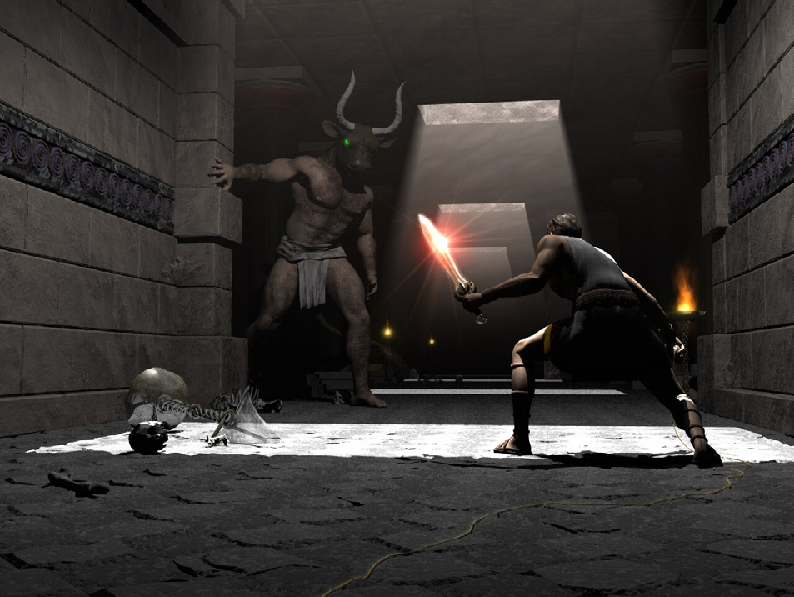

Again the ancient Greek Myths give the Secrets of Energy Enhancement meditation.

The Labyrinth, is cut into the stone floor of Chartres Cathedral. There was a plate in the middle of the Labyrinth there before the French revolution showing The myth of Theseus and the Minotaur.

The Minotaur like the Sphinx and the Centaur shows the dual Nature of man. It represents the man without a heart, the savage animal red in tooth and claw. The Law of the Jungle. Kill or be killed. The person only interested in himself to the detriment of everyone

around him. The psychopathic personality who only wants for himself and who will do anything, even kill, those who stand against him.

Many people admire Julius Caesar yet when Julius Caesar came to France it contained six million people. After taking it over he had killed one million and one million had been sold off into slavery.

Similarly with Pol Pot of Cambodia, who killed 2 million people. Stalin of the Soviet Union who killed 65 millions of people, 25 million alone during the Second World War, and sent everyone else to the concentration camps, the Gulags. Mao Tse Tung of China killed off 35 millions during the cultural revolution in the name of holding onto power, and so for many other similar psychopaths.

In order to open the heart we need to heal the Minotaur within all of us. It is called Energy Enhancement Opening of the Heart. Removing the Blockages of the heart and this is the function of the Second Initiation of Energy Enhancement.

Part of the Initiation is explaining the function of the Golden thread which allowed Theseus to find his way safely out of the Labyrinth created by Daedelus a genius of a man whose mind was made of metal and wheels.

Follow the golden thread, it will lead you to safety. The Golden thread is the Golden Circulation of the Energy..... THE SECRET OF THE GOLDEN FLOWER....

***THE PARAMAHAMSA***

An enlightened being is sometimes given the title Paramahamsa. This refers to an ancient Hindu myth of when the world was young, the whole of the surface was covered with water. The mischievous Gods mixed milk and poison in the water and stirred it all together. Paramahamsa was the name meaning the Great White Swan.

This enormous Swan, is said to have had the ability to put its beak deep down into the water and draw out pure milk. It had the capacity to discriminate and draw in only the milk, which is the reason it remained white, and reject the poison water. Not only that, a Paramahamsa, an enlightened being, has the capacity of changing water into wine, poison into milk, Yin into Yang, black into white.

Aham also means the self. Para means higher. A Paramahamsa is one who is in constant contact with the higher self and this is only possible when the lower self is being constantly cleaned through transmutation of the negative energies of the body… aches and pains, emotional body… anger, depression and fear, and the mental body.. wrong thoughts like selfish desire, ignorance of the soul and selfish attachment.

He can only do this by learning the psychic powers of the digestion, the transmutation of energy. As Gurdjieff, one of the greatest Sufi Masters who ever came to the west, said… “First Mastic, Then Mystic!!”

THE YIN YANG SYMBOL



This Yin Yang drawing symbolises the process whereby we too can do the same. It shows how to keep free of negative influences and energies by transmuting them (The secret of the Philosophers Stone is given in Energy Enhancement Initiation Three) within our energy systems.

*Energy Enhancement Initiation Two - The Circulation of the Energy, is an Indispensable tool for those wishing to evolve.*

Also the Labour of Hercules involving the Hydra. As Hercules chopped off one head with his sword another

2 grew back in its place. The Hydra symbolises the mind. Its heads the many thoughts we have which need to be dissipated.



**The Dragon always Symbolises Kundalini Energy**

The method of Energy Circulation is an ancient and hidden technique preserved in Taoism and Hindu Kundalini Kriyas.

It is the most gentle and effective tool for all those who want to increase their energy, their evolution, their genius.

**“With this technique, your evolution will increase with every energy revolution to create a revolution in your evolution” – PARAMAHAMSA YOGANANDA**

**ENERGY ENHANCEMENT**

**Initiation 3**

**ADVANCED KUNDALINI KRIYAS**

***The Grounding of Negative Energies***

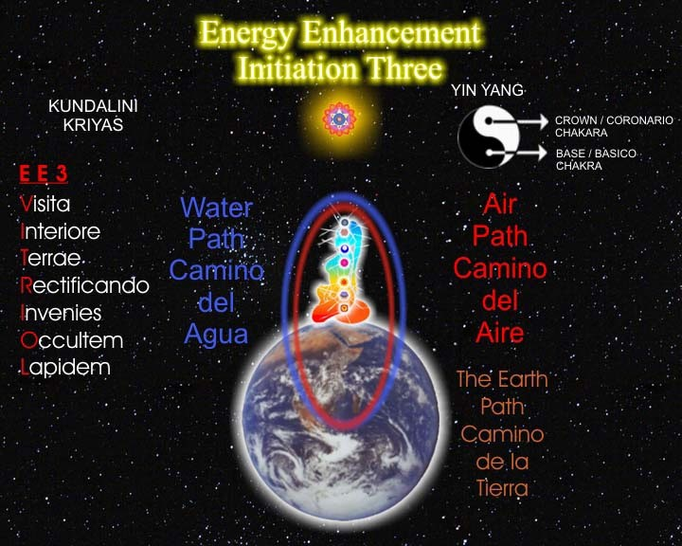

**THE EARTH PATH OF CHINESE ALCHEMICAL TAOISM**

We have a very ancient saying, "The more God, the more Devil. The more Flesh the more Worms.

The more property, the more anxiety.

The more control of negative energies, the more negative energies that need control."

**The Abbods of Amel**

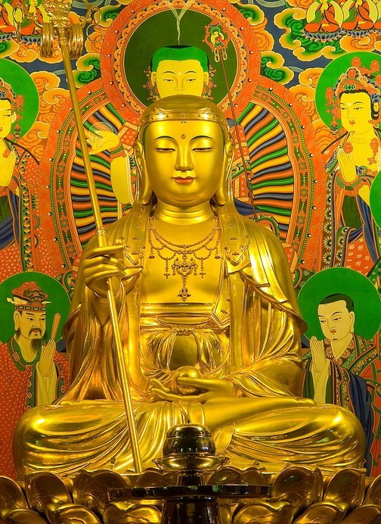

**ENERGY ENHANCEMENT**

**JUST GROUND IT!!**

**ENERGY ENHANCEMENT**

**Initiation 3**

**ADVANCED KUNDALINI KRIYAS**

***The Grounding of Negative Energies***

**THE EARTH PATH OF CHINESE ALCHEMICAL TAOISM**

**AND CONTACT WITH KUNDALINI CHAKRA IN THE CENTER OF THE EARTH**

**CORNUCOPIA ABUNDANCE**

The Base Chakra, Contact with the fiery Energy of Kundalini Chakra which exists in the Center of the Earth.

The Base Chakra blockages are those of Money so, by using the Techniques of Energy Enhancement to remove the blockages of the Base Chakra, we are removing blockages to having Money, Abundance, a Cornucopia of Wealth, Energy, Happiness and Life Energy!!

“That's why you are suffering. That's why you are poor

-- because you have forgotten how to live on this earth! Nobody has taught you how to live on this earth, how to love this earth. They have all taught you that this earth is ugly, that it is a punishment that you have been sent here, that you are not supposed to enjoy. If you enjoy, you will be sent again. You are supposed to be very sad, detached. You have to renounce all the joys of the earth so next time you don't have to be born, and then you will enjoy heavenly pleasures.

Because these people have been talking too much about the "other world", they have destroyed this world. I teach you this earth.

This very earth, the paradise. This very body the Buddha - OSHO

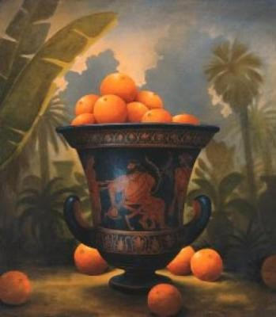

Cornucopia - the Downward pointing Horn of Plenty - of the Base Kundalini Chakra

CORNUCOPIA

Cornucopia is one of the horns of Amaltheia, the goat- nymph who nursed Zeus. She gave it to Zeus who presented it to Adrasteia and Io, two other nymphs: it became the horn of plenty (*Latin: cornus=horn, copia=abundance*), which is always filled with whatever food or drink its owner may desire. A very common decoration theme, cornucopia is often shown in a very standardized way (see the cornucopias in Porta del Popolo in Rome). An exception is the long cornucopia held by the River Tiber in a colossal statue now in Piazza del Campidoglio in Rome.... here it is...

**The Myth of the Virgin and the Unicorn**

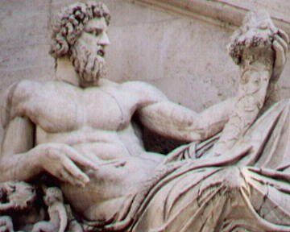

ENERGY ENHANCEMENT

This Cornucopia "Around the Horn" also refers to the powers of Generation, of Sex - also the traditional Powers of Kundalini and the Base Chakra

The Antahkarana Also refers to the Unicorn - So, by removing the Blockages of Ajna Chakra the Psychic Powers of the Third Eye and of the Rainbow Bridge, a Horn emanating from the Crown Chakra leading to Wisdom, Psychic Vision and the Actualisation of all our Dreams, Our Soul Path.

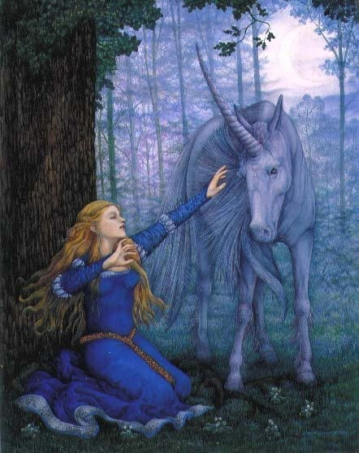

**Initiation 3**

ADVANCED KUNDALINI KRIYAS

***The Grounding of Negative Energies***

The Myth of the Virgin and the Unicorn - The Female Virgin, earth, the Male Unicorn, heaven, and the Horn, the Holy Spirit, The Antahkaran, Axis Mundi

represents the Holy Trinity, Father Son and Holy Spirit

- Sat Chid Ananda the Union of Heaven and Earth, Shiva and Shakti.

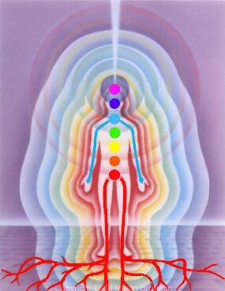

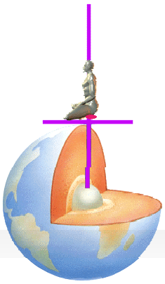**Energy Enhancement Initiation Three is a Practical Guided Meditation which will put you in touch with your own earth energy connection.**

The Fulcrum point, the evolutionary Initiation we are learning about here is **the Earth Connection.**

That of when the child was in the Womb up till the age of Four Months at this time the baby is learning to integrate the interior and exterior of its body. Sometimes this integration is faulty due to a painful abusive shock to the psyche. Yoga, dance, massage and other Pre - Energy Enhancement Techniques can help with this Initiation. Even fairly well integrated, everyone needs to improve **this Earth connection.**

"As within" said Hermes Trismegistus "So Without". The baby, so used to the soul connection and not understanding its new role of learning how to raise the Energy Vibration of the Earth, needs to **learn to integrate the Earth connection.**

**If there is a problem with this Initiation of earth integration** in the Base Chakra then it is indicated that from an early age the child and then the adult will feel fear, have problems with its food, money and with its security and with just not wanting to be here, sometimes even hiding from reality.

**FEAR IS THE BLOCKAGE OF THE BASE CHAKRA**

**ENERGY ENHANCEMENT**

**Initiation 3**

**ADVANCED KUNDALINI KRIYAS**

***The Grounding of Negative Energies***

**ABUNDANCE**

RELEASE YOUR BASE CHAKRA ABUNDANCE! - EVER WONDER WHY ABUNDANCE ISNT FOR YOU? WELL, BASE CHAKRA BLOCKAGES FOLLOWED BY MAKING A VOW OF POVERTY IN THE PAST ARE PRIMARY REASONS.

WE NEED THE CONCURRANCE OF THE INTERNAL AND THE EXTERNAL. THE BODY AND SPIRIT HAVE BEEN APART FOR TOO LONG AND NEED TO COME TOGETHER IN HARMAONIOUS UNION. THE MORE CENTERED AND DDPLY FOUNDED WE ARE IN OUR BODIES, THE MORE EASILY THINGS UNFOLD BEFORE US. THE DEEPER OUR ROOTS WILL GROW INTO THE EARTH, THE HIGHER OUR SPIRITS WILL SOAR. MAN SHOULD LEAD A RICH INNER AND OUTER EXISTANCE. IT IS NOT NECCESSARY TO CHOOSE. THE INSIDE IS NOT IN CONFLICT WITH THE OUTSIDE. YOU DO NOT NEED TO BE POOR ON THE OUTSIDE TO ACHEIVE INNER WEALTH. BE EXTERNALLY RICH THROUGH SCIENCE AND BE INTERNALLY RICH THROUGH MEDITATION. THIS WILL MAKE YOU ORGANICALLY INTO COMPLETE INDIVIDUALS.

DESIRE FOR WEALTH AND AVERSION TO WEALTH ARE BLOCKAGES IN THE BASE CHAKRA.

WITH DESIRE FOR WEALTH YOU DO NOT LIKE TO SPEND IT!

WITH AVERSION TO WEALTH YOU HAVE NO WEALTH TO SPEND AND YOU WANT EVERYTHING FOR FREE AND YOU HATE PEOPLE WHO TALK ABOUT MONEY, PARTICULARLY IF YOU CAN NOT AFFORD IT.

**REMOVE ALL BLOCKAGES IN YOUR BASE CHAKRA.**

The fear blockages of having nothing. The fear of death, even when this is not likely to happen, can cause you to take the stupid slave-like path in life. As Jesus Christ said -"Look at all the lillies in the field. They toil not, neither do they spin, yet Solomon in all his Glory was not arrayed as such as these...."

**REMOVE ALL ENERGY BLOCKAGES**

THE PAINLESS Integration of the Earth connection, the removal of blockages in the base chakra, will remove all fear, it will help us to be practical, to help give us the capacity to "DO", to help us make our vision a practical reality.

HAVE A FEAR FREE LIFE!!

We also need to learn how to remove Blockages below the base chakra which have reduced our energy and make it probable we would depend on others, be a slave, do what we are told.

**KUNDALINI ENERGY BURNS OUT ALL ENERGY BLOCKAGES**

The Earth Connection helps the baby to know that it will return to the Soul whether it is successful with its integration with the Earth or not. Helps it to learn to Master the physical environs of this planet. Sometimes this Initiation will make problems with this Earth connection but this integration needs to start to happen before for progress to be made.

Even with no major evolutionary "Fulcrum Point" problems, every student needs to strengthen this earth connection through these Energy Enhancement techniques because it is your base and foundation upon which can be built the Temple of Solomon.

Symbolising Evolutionary Integration. Symbolising all your levels of the Auric Body which need to be fed and created, so that we can function at our full capacity.

The PAINLESS Grounding of Negative Energies is an Ancient, further and more advanced technique going on from Energy Circulation. It is the Earth Circulation of the Five Elemental Taoist Circulations- Paths of the Chi.

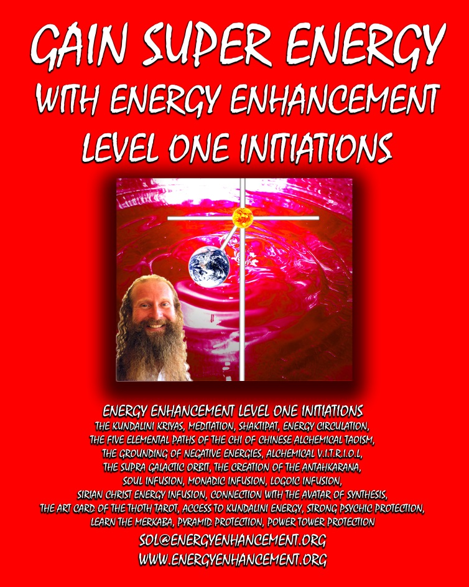

FULL BOOK

GAIN SUPER ENERGY LEVEL ONE

**Level One - Access Infinite Spiritual Energy!! CLICK BELOW!!**

[**http://www.energyenhancement.org/Free-Book-Level-One-Meditation-Access-Infinite-Spiritual-Energy-Kundalini-Key-Antahkarana-Alchemical-VITRIOL-Chakras-Above-Head-Kundalini-Chakra.htm**](http://www.energyenhancement.org/Free-Book-Level-One-Meditation-Access-Infinite-Spiritual-Energy-Kundalini-Key-Antahkarana-Alchemical-VITRIOL-Chakras-Above-Head-Kundalini-Chakra.htm)

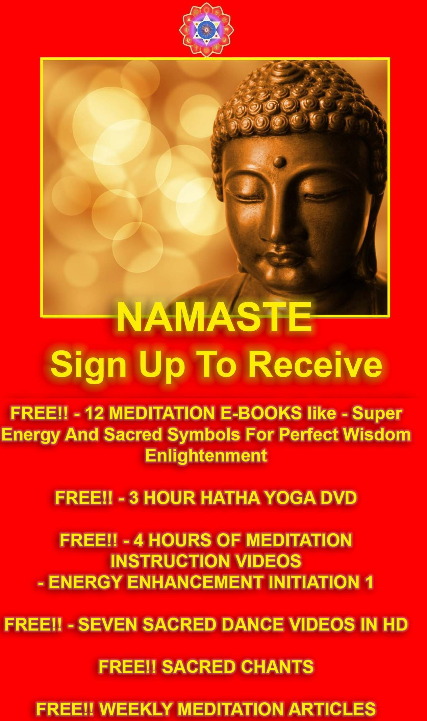

**SIGN UP!!**

**CLICK BELOW!!**

[**http://www.energyenhancement.org**](http://www.energyenhancement.org)

