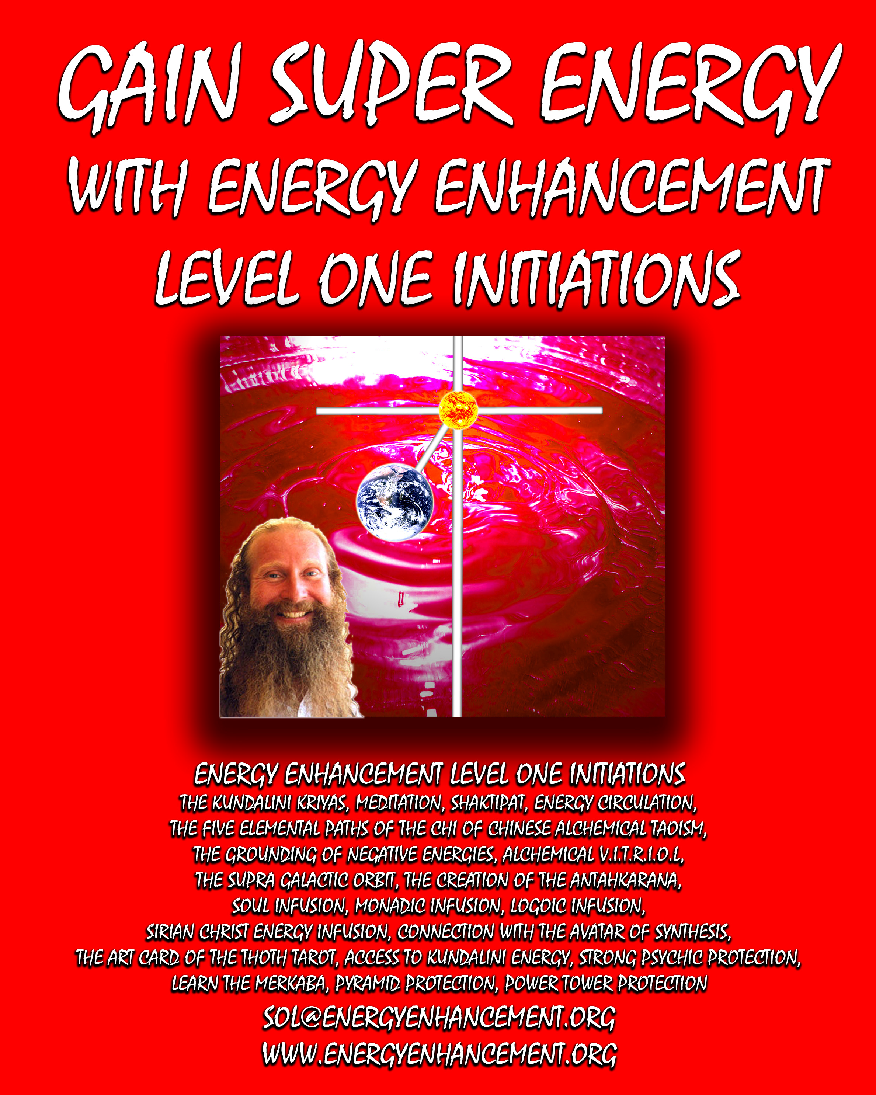

DEDICATION
With all Thanks, Love and Gratitude to my Mother and Father and to all my other Teachers, Theos Bernard, Sri Yogendra, Eric Berne, Gurdjieff, Father Bede Griffiths, Osho, Zen
Master Hogen, Sivananda, Swami Satchidananda, and all the other giants upon whose shoulders I stand - who made me able to be what… I AM Copyright © 2008 [Energy
Enhancement Synthesis of Light Limited (SOL)]

All rights reserved. This publication may not be reproduced in whole or in part, by any person, without written permission of:
Swami Satchidanand

sol@energyenhancement.org www.energyenhancement.org ISBN: 1438248059

ENERGY ENHANCEMENT LEVEL ONE
THE KUNDALINI KRIYAS AND KUNDALINI CHAKRA

THE TAOIST MICROCOSMIC, MACROCOSMIC AND SUPRA GALACTIC ORBITS

HEART OF WISDOM CHAKRA - SURYA YOGA AND THE ANTAHKARANANA

PSYCHIC PROTECTIONS, PYRAMID PROTECTION AND THE MERKABA

GAINING MORE ENERGY.
The Antahkarana or Axis Mundi is the Psychic Tower of Connection between Heaven and Earth along which are strung all the Infinity of Chakras which end in God, of which you contain seven within your body. By connection with Chakras outside the body we connect with Infinite Pure Spiritual Energies which create Health, Wealth, Abundance, Super Intelligence and Genius.
YOU GET ALL THIS TO GAIN ENERGY IN LEVEL ONE OF ENERGY ENHANCEMENT...
MEDITATION, SHAKTIPAT, ENERGY CIRCULATION, THE KUNDALINI KRIYAS, THE FIVE ELEMENTAL PATHS OF THE CHI OF CHINESE ALCHEMICAL TAOISM, THE GROUNDING OF NEGATIVE ENERGIES, V.I.T.R.I.O.L, THE SUPRA GALACTIC ORBIT, THE CREATION OF THE ANTAHKARANA, SOUL INFUSION, MONADIC INFUSION, LOGOIC INFUSION, SIRIAN CHRIST ENERGY INFUSION, CONNECTION WITH THE AVATAR OF SYNTHESIS, THE ART CARD OF THE THOTH TAROT, ACCESS TO KUNDALINI ENERGY, STRONG PSYCHIC PROTECTION, LEARN THE MERKABA, PYRAMID PROTECTION, POWER TOWER PROTECTION AND MORE…
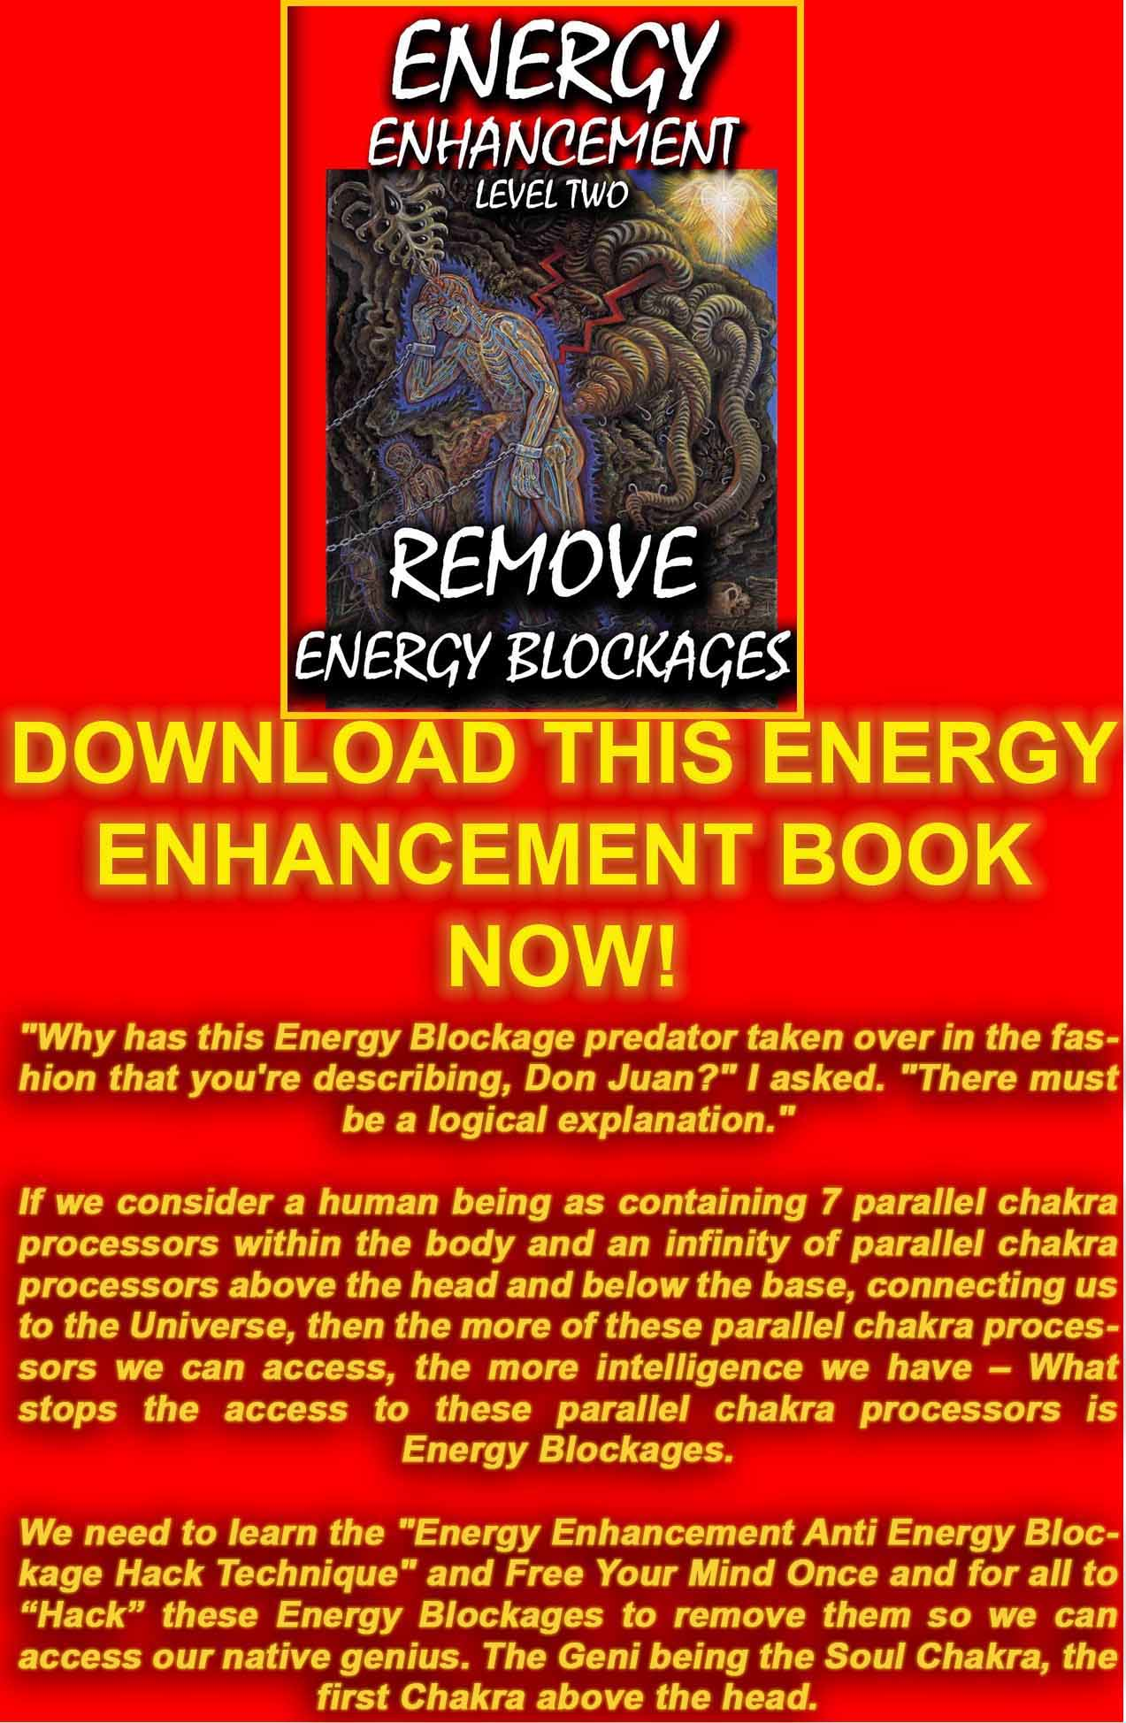
DOWNLOAD “LEVEL 2 REMOVE ENERGY BLOCKAGES” HEREhttp://www.energyenhancement.org/Sacred-Energy/Level-2-Book/Energy-Enhancement-Level-2-Book-Remove-Energy-Blockages.pdf
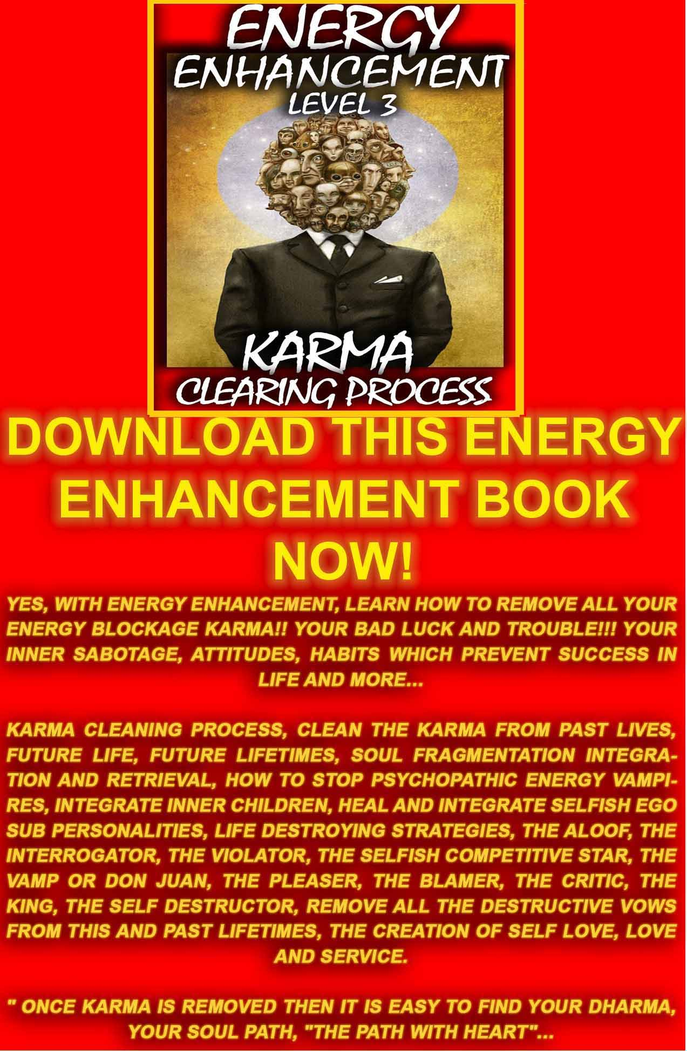
DOWNLOAD LEVEL 3 BOOK HERE!!! http://www.energyenhancement.org/Sacred-Energy/Level-3-Book/Energy-Enhancement-Level-3-Karma-Clearing-There-Can-Only-Be-One.pdf
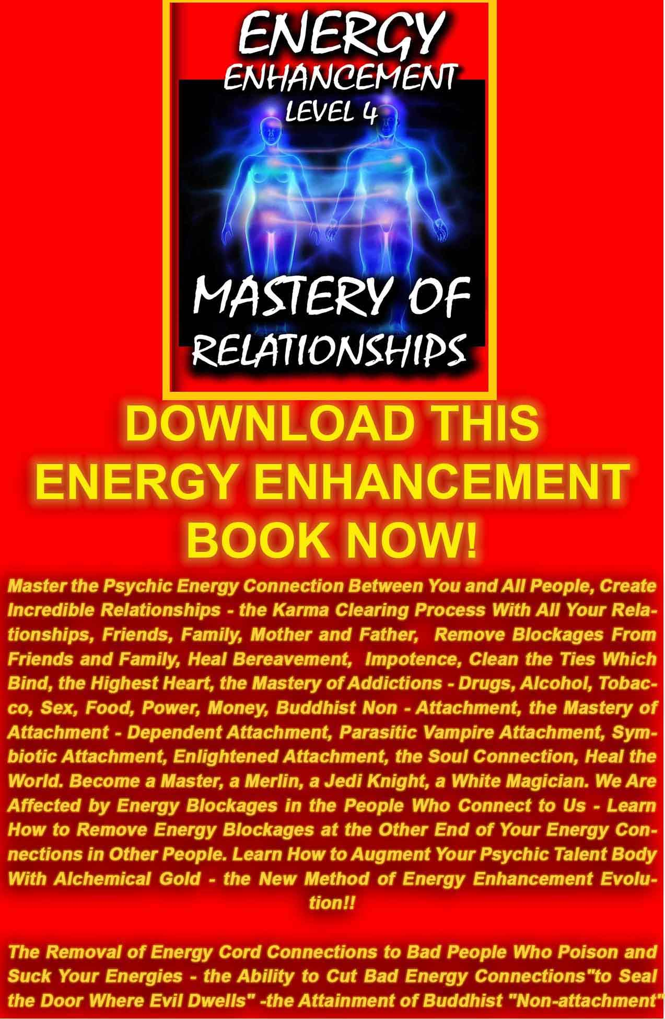
DOWNLOAD LEVEL 4 BOOK HERE!!!
http://www.energyenhancement.org/Sacred-Energy/Level-4-Book/Energy-Enhancement-Level-4-Book-Energy-Cords-Mastery-Of-Relationships.pdf

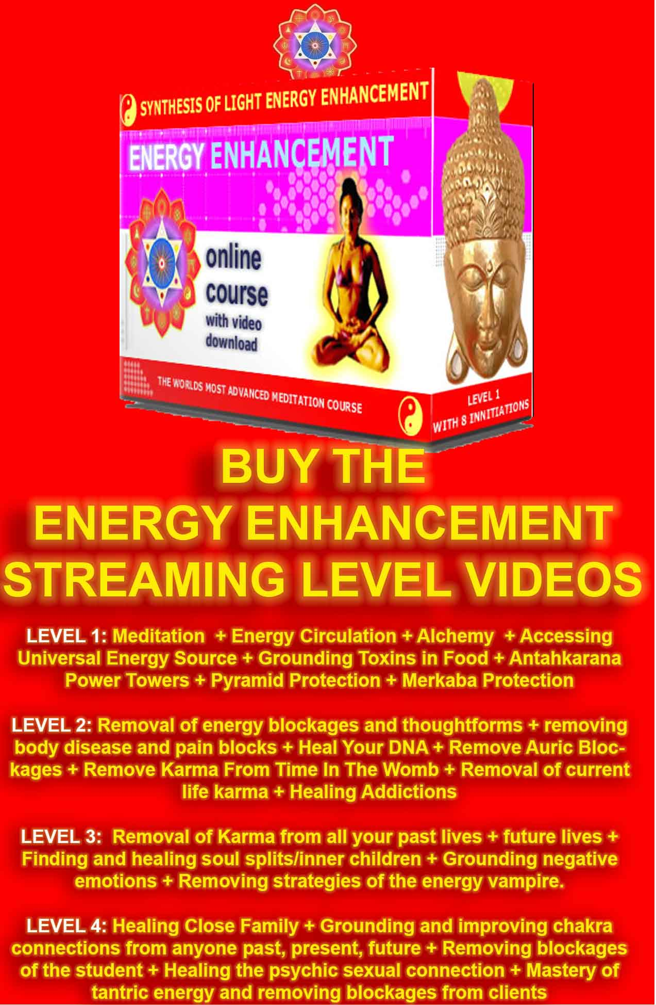

THE ENERGY ENHANCEMENT STREAMING VIDEO COURSE

"Get your asses over here Now and Speed Up your process of Enlightenment on the Energy Enhancement one month course!!" - DON
Every one of our Students gets this Spiritual Experience of Connection with Infinite Energies.
Energy Enhancement does indeed, "SPEED UP THE PROCESS!!"
And they all get this Experience of Light, Life and Infinite Energy just with the Energy Enhancement Course - Every One of Them!!
LEVEL 1 - 4 VIDEO COURSES ANYTIME IN THE COMFORT OF YOUR OWN HOME

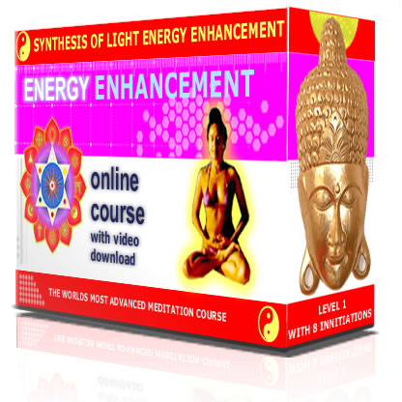

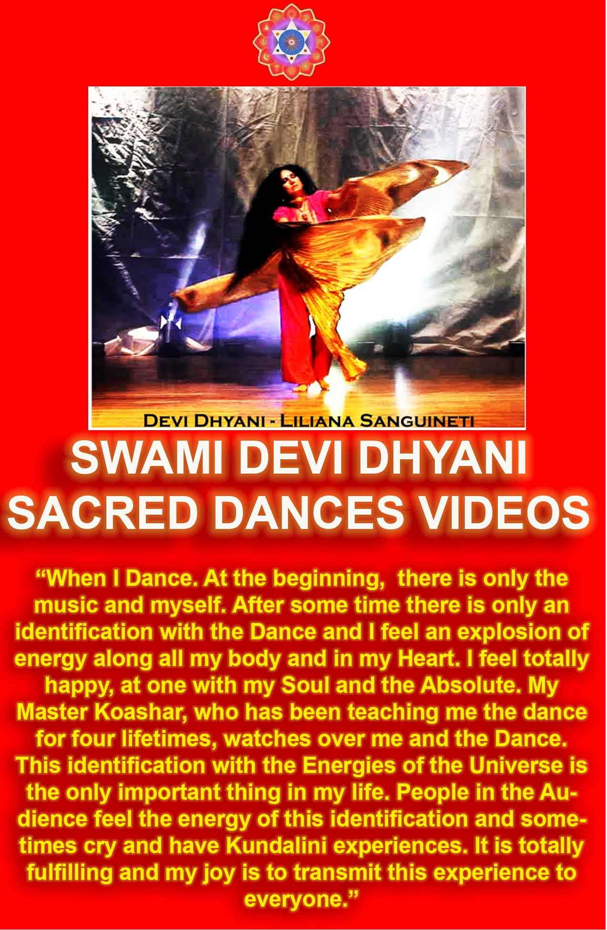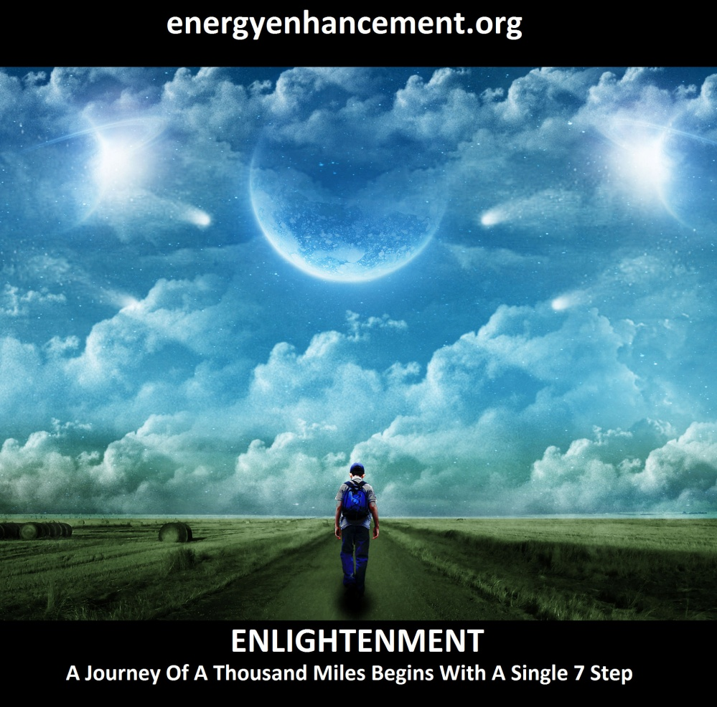
LEARN THAT WHICH IS FALSE WITHIN YOU
LEARN TO RECOGNIZE THE FALSE AS FALSE
-WITHOUT THAT, THERE CAN BE NO LASTING TRANSFORMATION
ENERGY ENHANCEMENT
"I was not sure if this was wise, as I knew nothing other than what I had read on the web site and the testimonials, which I was a bit skeptical about! However, I am now adding my own because if you read this you might be a bit like me...

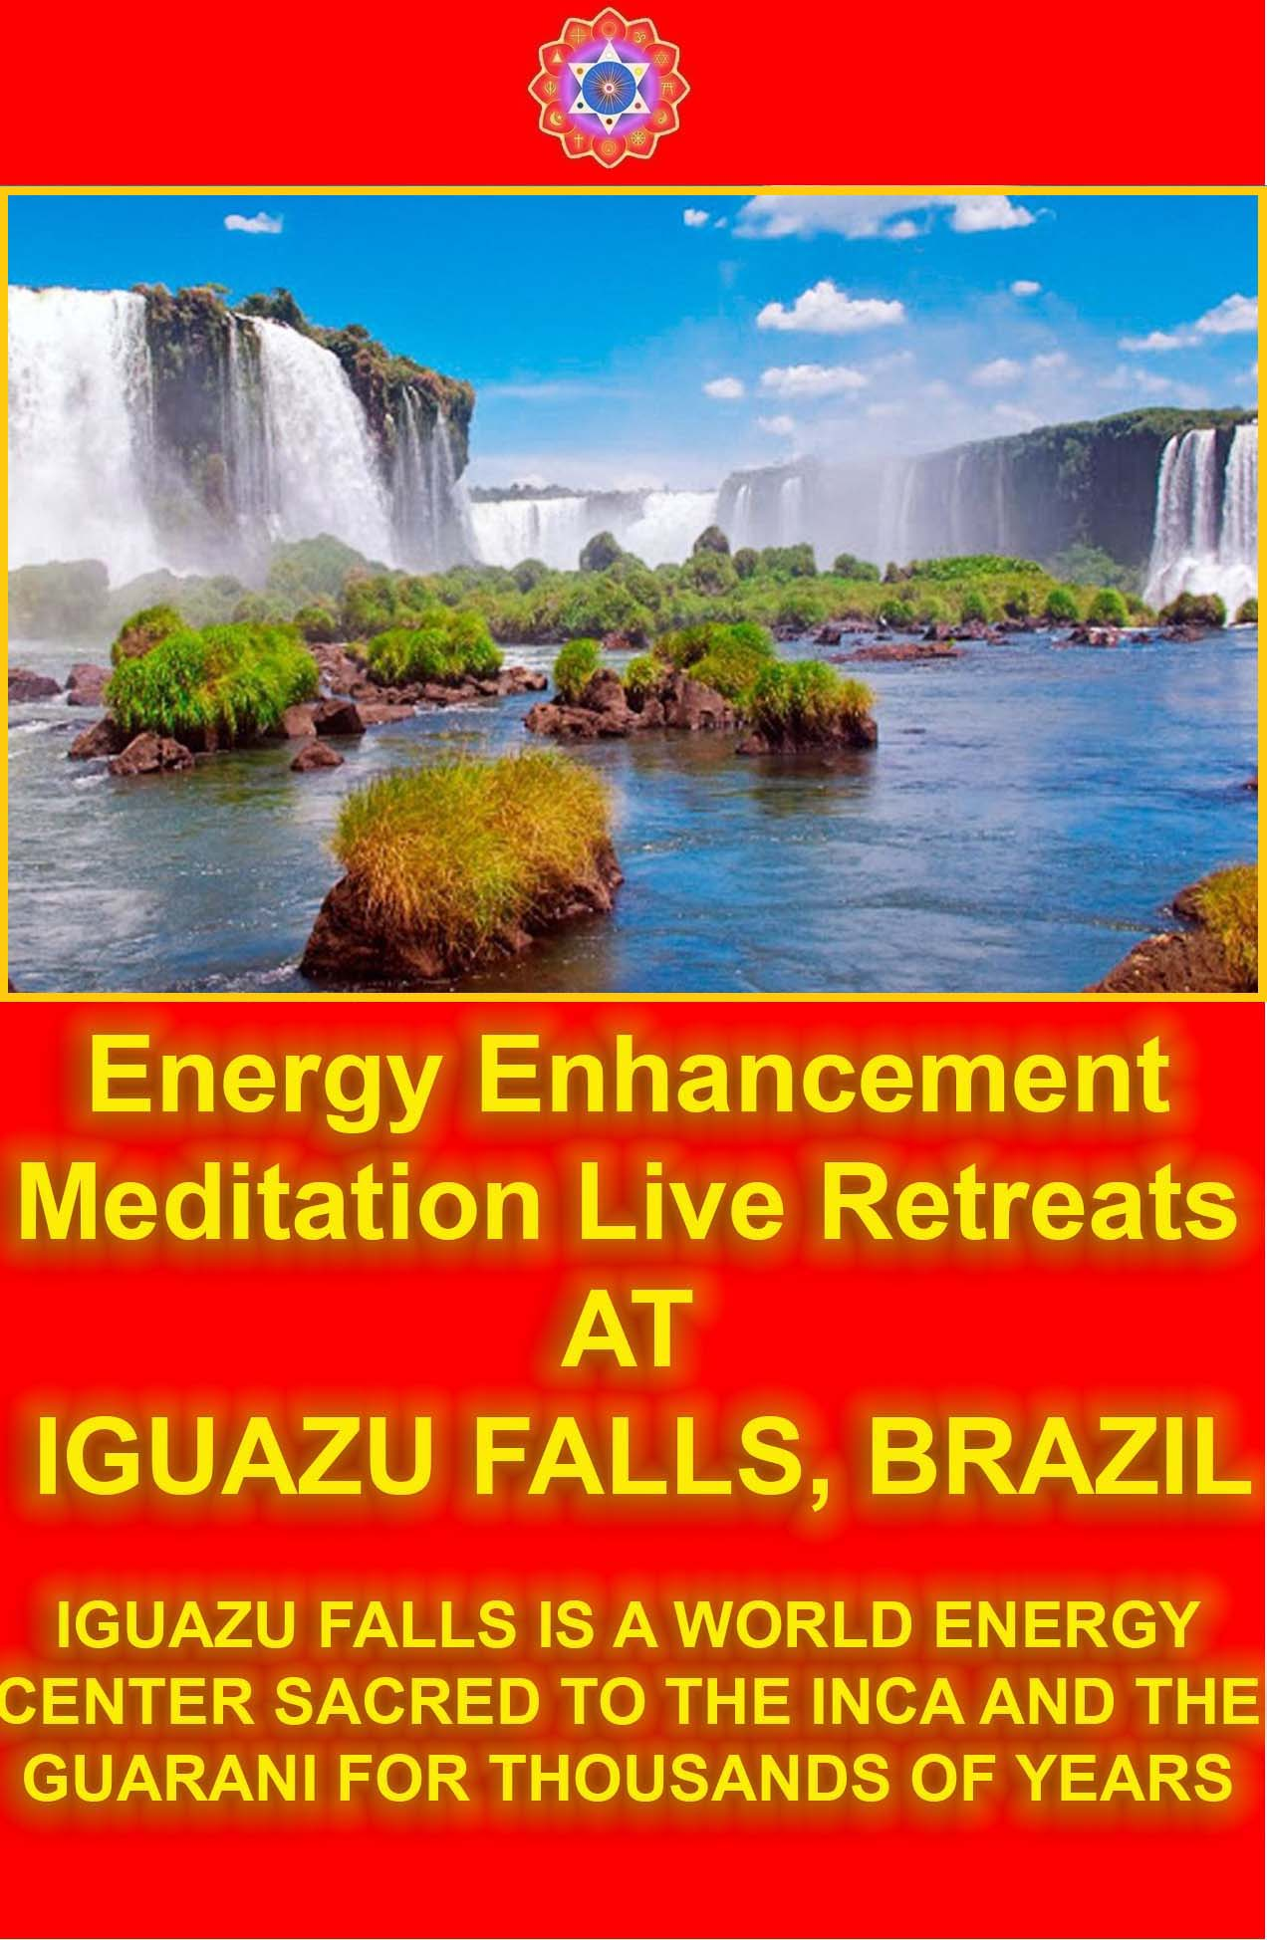

WITH THE ENERGY ENHANCEMENT COURSE BUY A STAIRWAY TO HEAVEN
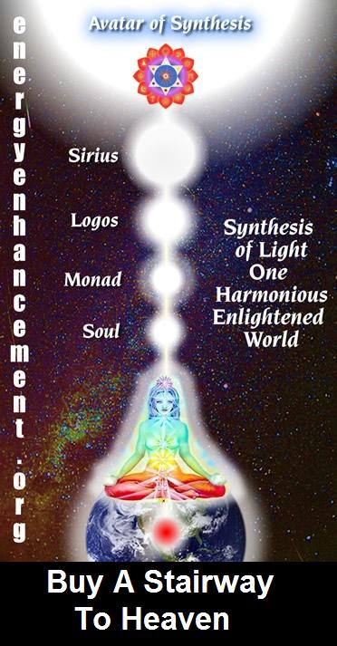
BUY A STAIRWAY TO HEAVEN
WITH THE ENERGY ENHANCEMENT COURSE
STUDENT REPORT
Also I noticed as soon as Satchidanand emailed me, I got a down-pouring of light from above the crown which kept charging me up the rest of the day – and my cravings died out! Then I realized the cravings were ego-blockages and that I did not want them.
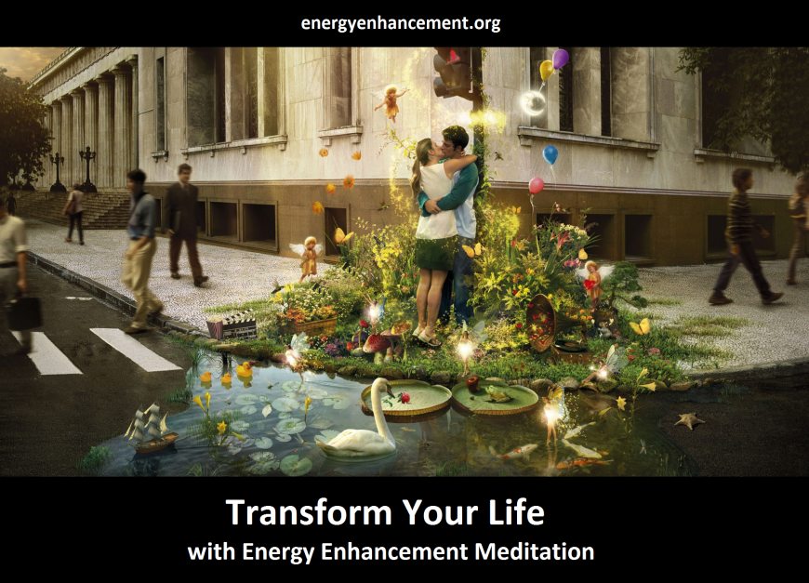
Energy Enhancement says that there are an infinity of chakras above the head up into the Center of the Universe and above, high above the head, ending in God, just as there are an infinity of chakras below the base - "As above, So Below" - Hermes Trismegistus from the Emerald Tablet.
INCREASE YOUR INTELLIGENCE - THE PARALLEL PROCESSING SUPERCOMPUTER YOU!! Energy Enhancement says that each chakra within you and above the head is a computer processor with higher and higher frequency, speed and capacity as you go higher. So, like a parallel processing supercomputer, the more chakras you can get working in the Infinity of Chakras above the Head and the more chakras you can access, the more chakras you can disblock, the more chakras you can augment, the more intelligent, the more intuitive, the more wise you will be.
FUSING WITH THE SOUL CHAKRA - Energy Enhancement says that just by fusing with the soul chakra one can see all your past lives and remove all blockages from all your past lives in one sweep, fast!!
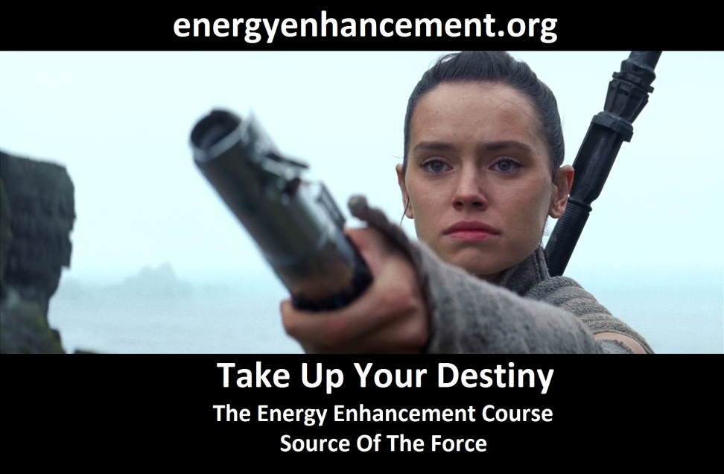
FUSING WITH HIGHER CHAKRAS - THE SOUL, MONAD, LOGOS, SIRIUS, AVATAR OF SYNTHESIS - Energy Enhancement says that it also contains the secret of Initiations Higher that Illumination –
"Enlightenment is not Enough!!"
EE LEVEL 1 POWER UP!! GAIN SUPER ENERGY
http://www.energyenhancement.org/Level1.htm
EE LEVEL 2 ELIMINATE ENERGY BLOCKAGES
http://www.energyenhancement.org/Level2.htm
EE LEVEL 3 CLEAN KARMA BLOCKAGES AND PAST LIFE KARMA BY TRANSMUTATION http://www.energyenhancement.org/Level3.htm
EE LEVEL 4 MASTER ENERGY CONNECTIONS AND RELATIONSHIPS http://www.energyenhancement.org/Level4.htm
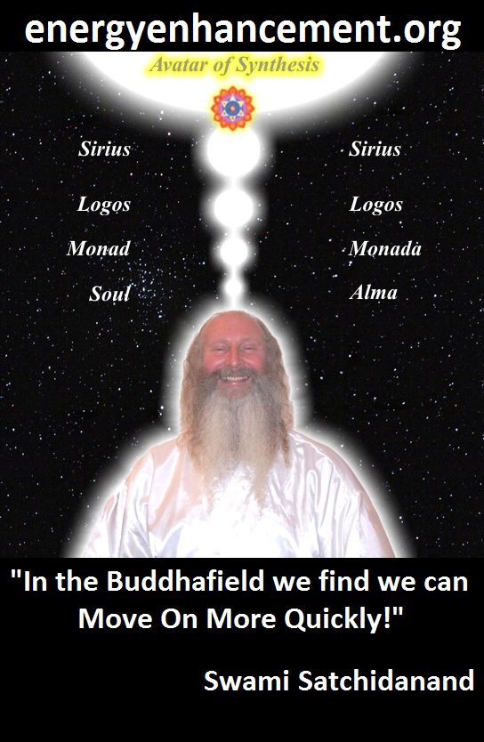
ENERGY ENHANCEMENT - THE ULTIMATE MEDITATION COURSE!!
“Traditional meditations are designed to Fail” – Satchidanand
FUSION WITH THE SOUL CHAKRA - Enlightenment - is Only the first Dan. Become fused with the Monad - Second Dan. Become fused with the Logos - Third Dan. Become Fused with Sirius - Fourth Dan. Become Fused with the Avatar of Synthesis - Fifth Dan - Satchidanand
Research The Energy Enhancement Meditation Course by video or on retreat..
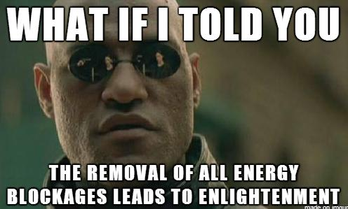
The Ancient Enemy who counts meditation and the mind control psychic arts as one of its main planks of ing, International Companies, Eugenics - Worldwide, censoring Alchemical VITRIOL, the Kundalini Key and Energy Blockage Removal from every Meditation Program..
WE HAVE SO MANY ARTICLES SHOWING THE ORIGINAL EXISTENCE OF THESE ESSENTIAL MEDITATION TECHNIQUES IN EVERY WORLD RELIGION.. NOW, SPEED UP YOUR PROCESS WITH ENERGY ENHANCEMENT ALCHEMICAL VITRIOL, KUNDALINI KEY AND ENERGY BLOCKAGE REMOVAL ON THE PATH OF ENLIGHTENMENTGET IT NOW!!
EMAIL sol@energyenhancement.org

SACRED DANCES OF FUSION WHERE DEVI DHYANI EXERTS HER POWER - AVAILABLE ON YOUTUBE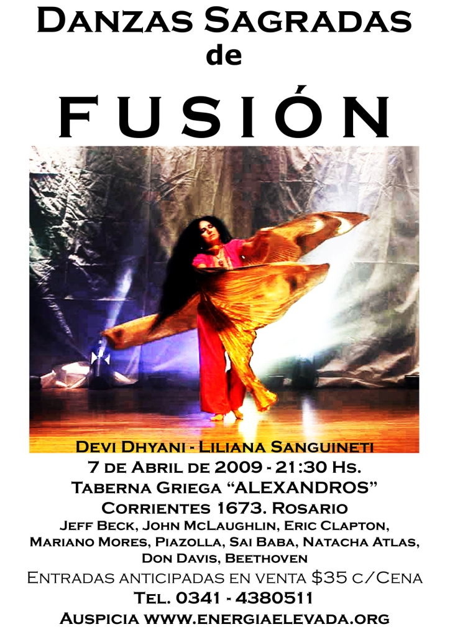

INITIATIONS 1 TO 8 OF LEVEL 1 - GAINING ENERGY
THE TAOIST MICROCOSMIC, MACROCOSMIC AND SUPRA GALACTIC ORBITS
HEART OF WISDOM CHAKRA - SURYA YOGA
PSYCHIC PROTECTIONS PYRAMID PROTECTION MERKABA
GAINING MORE ENERGY.
YOU GET ALL THIS TO GAIN ENERGY IN LEVEL ONE OF ENERGY ENHANCEMENT...
MEDITATION, SHAKTIPAT, ENERGY CIRCULATION, THE KUNDALINI KRIYAS, THE FIVE ELEMENTAL PATHS OF THE CHI OF CHINESE ALCHEMICAL TAOISM, THE GROUNDING OF NEGATIVE ENERGIES, V.I.T.R.I.O.L, THE SUPRA GALACTIC ORBIT, THE CREATION OF THE ANTAHKARANA, SOUL INFUSION, MONADIC INFUSION, LOGOIC INFUSION, SIRIAN CHRIST ENERGY INFUSION, CONNECTION WITH THE AVATAR OF SYNTHESIS, THE ART CARD OF THE THOTH TAROT, ACCESS TO KUNDALINI ENERGY, STRONG PSYCHIC PROTECTION, LEARN THE MERKABA, PYRAMID PROTECTION, POWER TOWER PROTECTION,
"I have experience of many forms of meditation and practices for self improvement including: Transcendental meditation (TM) 12 years, Kriya Yoga 9
years, Sushila Buddhi Dharma (SUBUD) 7 years, and more recently the Sedona Method and the Course in Miracles. The Energy Enhancement programme encapsulates and expands all of these systems, it is complete and no questions are left unanswered."
Jean, NUCLEAR ENGINEER, FROM THE SEPTEMBER 2005
ENERGY ENHANCEMENT COURSE
ENERGY ENHANCEMENT IS THE NEWEST AND MOST HIGH SPIRITUAL IMPULSE ON THIS PLANET
INITIATION 1 - Meditation:
- Shaktipat.
- Kundalini.
- Stopping the Mind and Squaring the
Circle.

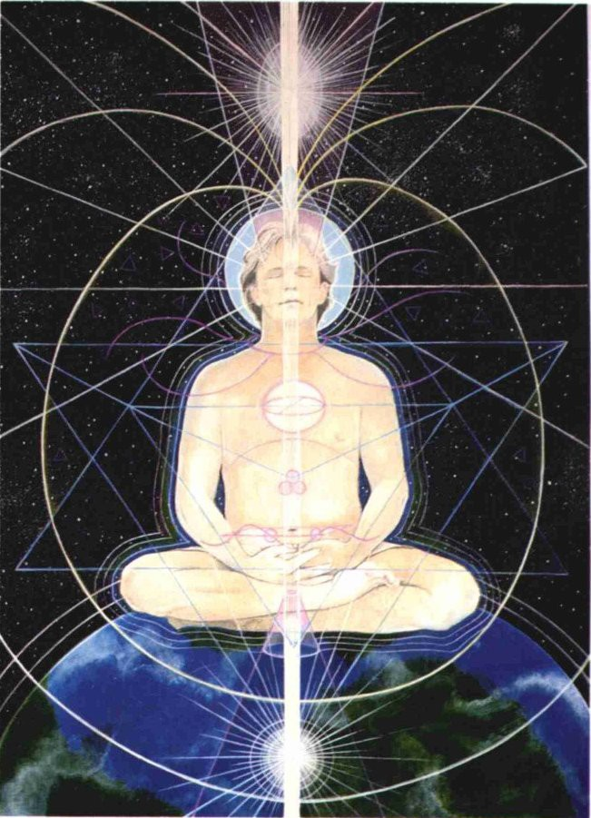

ENERGY ENHANCEMENT INITIATION 1 -
Meditation: Shaktipat, Kundalini, Stopping the Mind and Squaring the Circle

INITIATION 2 Energy Circulation:
* Microcosmic Orbit.
* Kundalini Kriyas.



ENERGY ENHANCEMENT INITIATION 2 - Energy
Circulation: Microcosmic Orbit, Kundalini Kriyas
INITIATION 3 - Taoist Earth Orbit - The Grounding of Negative Energies:
- Alchemy. Hermes Trismegistus
- VITRIOL Visita Interiore Terrae Rectificando Invenies Occultem Lapidem.
- Earth Connection.

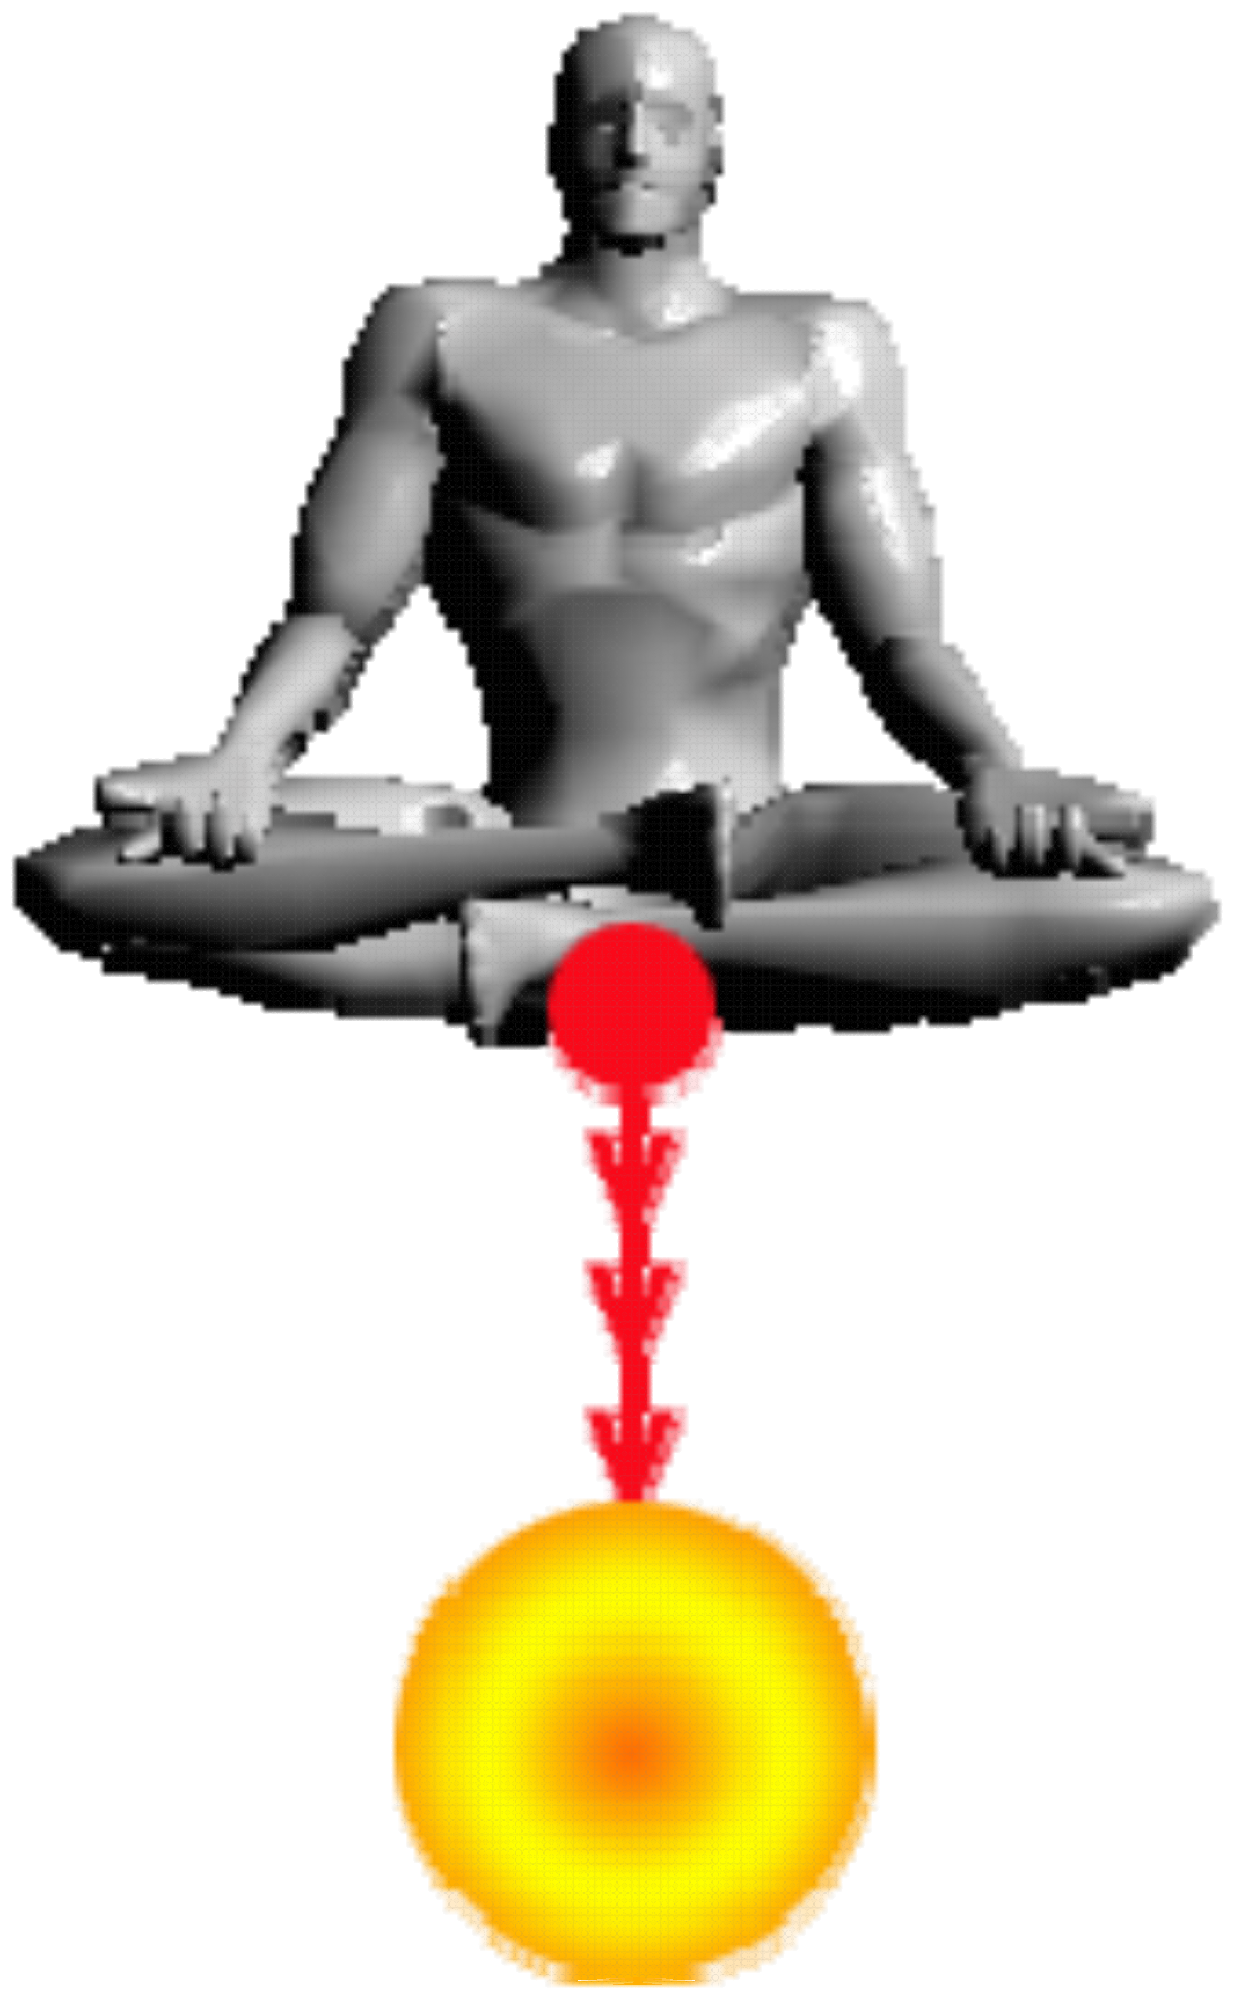
ENERGY ENHANCEMENT INITIATION 3 - Taoist
Earth Orbit - The Grounding of Negative Energies: Alchemy, Hermes Trismegistus VITRIOL Visita
Interiore Terrae Rectificando Invenies Occultem Lapidem and Earth Connection
INITIATION 4 –
Accessing the Universal Energy Source:
- Macrocosmic Orbit.
- The Energy Enhancement Supra Galactic Orbit.
- The Creation of the Antahkarana.
- Projection.
- Leaving the Body.
*The Immortality of the Soul.
- Connect with the Higher Chakras above the head.
- Advanced Kundalini Kriyas.
- Siddis
- The Creation of Psychic Vision.

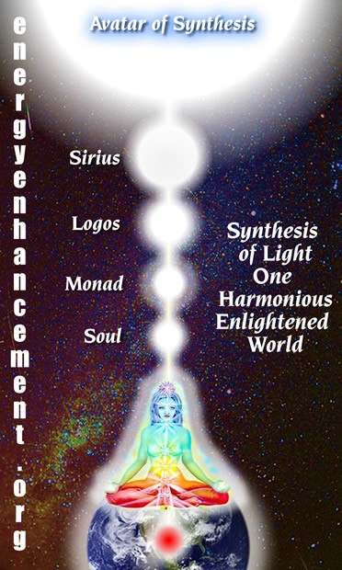
ENERGY ENHANCEMENT INITIATION 4 - Accessing
the Universal Energy Source: Macrocosmic Orbit, The Energy Enhancement Supra Galactic Orbit,

The Creation of the Antahkarana - Projection - Leaving the Body - the Immortality of the Soul - Connect with the Higher Chakras above the head - Advanced Kundalini Kriyas - Siddis - The Creation of Psychic Vision
INITIATION 5 - ENERGY PROJECTION -
Grounding Toxins in Food:
- Re-awakening our psychic ability to detect poisons.
- REMOVING BLOCKAGES.

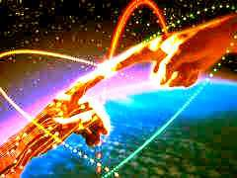
ENERGY ENHANCEMENT INITIATION 5 - ENERGY
PROJECTION - Grounding Toxins in Food: Re- awakening our psychic ability to detect poisons.
REMOVING BLOCKAGES.

INITIATION 6 - Psychic Protections: Power Towers
- Creating and Using External Antahkaranas. Exponentially Increasing your Spiritual Energy.
- Creating the Flow from Heaven to Earth.
- Astral Travel and Projection.
ENERGY ENHANCEMENT INITIATION 6 - Psychic
Protections: Power Towers - Creating and Using External Antahkaranas - Exponentially Increasing your Spiritual Energy - Creating the Flow from Heaven to Earth
INITIATION 7 - Psychic Protections: Pyramid Protection

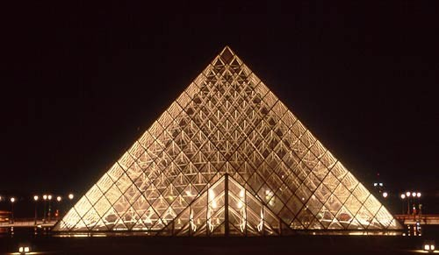

ENERGY ENHANCEMENT INITIATION 7 - Psychic
Protections: Pyramid Protection

INITIATION 8 - Psychic Protections: How to Use THE MERKABA
* Astral Travel and Projection.
- Advantages of the Siddhis of Becoming Bigger and Smaller

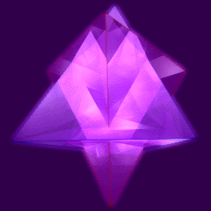
ENERGY ENHANCEMENT INITIATION 8 - Psychic
Protections: How to Use THE MERKABA - Astral Travel and Projection - Advantages of the Siddhis

THE SECRET OF THE CIRCULATION OF THE ENERGIES, THE KUNDALINI KRIYAS, THE FIVE ELEMENTAL CIRCULATIONS OF THE QI, THEN VITRIOL THE ANTAHKARANA AND THE CHAKRAS ABOVE THE HEAD

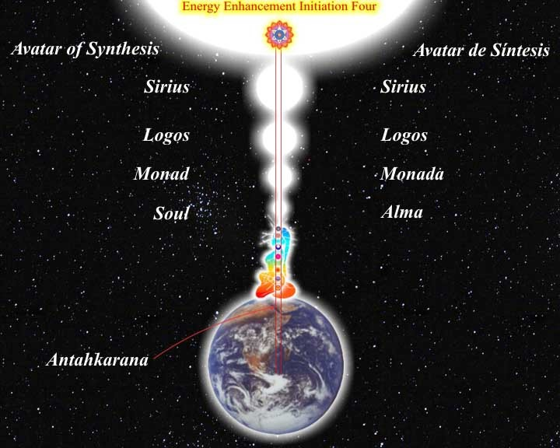
The secret of the Sacred Circular Symbols is that of Golden Bio - Energy flowing in the Central and Governing Meridians and mapped for 4000 years by Acupuncture.
The Central Meridian flows down the front of the body from Forehead to Throat to Center of the Chest to Belly to Genitals to Perineum to Anus.
The Governing Meridian flows from Anus to Coccyx up every bone of the Spine to the Neck, Base of the Skull, over the top of the Head to the Forehead.
In reality there are not two Meridians, only one. And the Energy flows naturally in a circuit, circle, around the body.
If we can maximise the flow through Energy Enhancement techniques we can maximise our
energy and eventually become Enlightened, Illuminated.
Table of the Synthesis of Religions with great respect to Benedictine Monk, Father Bede Griffiths known also as Swami Dayananda who enunciated the Synthesis of The Holy Trinity and Satchidananda to me on his death – bed at the age of 96 at his Ashram, Satchidananda Ashram on the Banks of the River Cauvery in Tamil Nadu, South India, “Tell them! Tell Them!” he said. So now you are told.

EE Table of the Synthesis of Religions | Central Spiritual Sun  - Gurdjieff | Surface - Center of the Earth – VITRIOL -  Alchemy | Connecting Column of Energy - Axis Mundi or the Antahkarana
Holy Trinity | Father | Christ/Son – Mother Mary | Holy Spirit – Blood of Christ
Satchidananda | Sat – The Truth | Chid, Chitta – Holy Grail/Chalice of the Purified Mind | Ananda – Bliss flow of Energy  - SangReal
Hindu Gods – Tri Murthi – the three faces of God | Brahma | Krishna/Vishnu  – Shakti Kundalini | Shiva
The flow of Energy in this Meridian is stopped by Energy Blockages. By meditating on the flow with Energy Enhancement techniques we can push the Energy faster around the body. This helps to remove Energy Blockages and also speeds up the natural flow.
By meditating on the Energy Blockages with Energy Enhancement techniques we can remove the Energy Blockages and thus speed up the flow all the way to health, wealth, intelligence and Wisdom, Enlightenment, Illumination.

We can further increase the Energy by connecting this natural Circuit to the infinite energy sources of Chakras outside the body, - female Kundalini Chakra in the Center of the Earth – VITRIOL, Which connects with the male Central Spiritual Sun Chakras in the Center of the Universe – The Soul, Monad, Logos, Sirius and Avatar of Synthesis, then an infinity of chakras to God. female polarities
The male and female polarities are connected by means of a column of Energy called Axis Mundi or the Antahkarana which includes the upward flow with its associated spiral, as magnetic energies spiral around flows of light, in parallel with the downward flow with its associated spiral, an energy Circle within the same Antahkarana Column of Energy.
The Antahkarana links in with the human energy meridian flows down the front of the body and the flow up the spine and thus The Masonic Two Towers.
In Energy Enhancement we differentiate into two parts..
  - The male surface of the Earth – You, Christ the Son, Vishnu/Krishna.
  - The female Center of the earth – Shakti and Mother Mary in the female Kundalini Center.
In Energy Enhancement the lost energies of the Gaia female Earth Kundalini Shakti are integrated into the patriarchal myth.

Energy Enhancement Teaches that Infinite Spiritual Energies flow between these two polarities. . The Center of the Earth and the Center of the Universe. “Connect, Only Connect” - Goethe. All we need to do is to Learn How to Connect!! - With Energy Enhancement.
ENERGY ENHANCEMENT
Initiation 1
Meditation
"The first day Satchi taught me how to sit. By moving the position of my posture slightly I could feel the flow of energy from the center of the earth into the center of the universe. Satchi explained that what I was feeling was Kundalini Energy. If I followed it, he said, It would lead me to Enlightenment."
From the testimonial of Energy Enhancement Student Carla, Jan 2004

Siva Samhitã, iii, 10-19: "Now I shall tell you how easily to attain success in Yoga, by knowing which the Yogis never fail in the practice of Yoga. Only the knowledge imparted by a Competent Teacher through his lips is powerful and useful; otherwise it becomes fruitless, weak and very painful.
And this is why - by coming into the Buddhafield of Energy surrounding Energy Enhancement Satchidanand obtained through many years of meditation with many enlightened masters, you obtain Shaktipat- an infusion of energy to help you get into a permanent state of meditation.

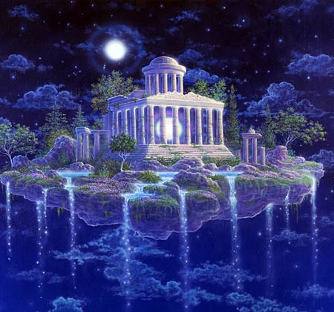
The Ultimate in the Control of your own Mind
Most people find it easy to have many thoughts, but you only have control over something when you have the power to stop it.
Our mind is so full of thoughts that it is necessary to learn how to press the stop button, so that one thought can have maximum power when you want it. To learn how to access Wisdom and intuition. To access the Unconscious, the Alpha, Beta and Delta levels of our own mind.
Meditation is a fast for the thoughts of the mind. All our painful memories are thoughts filled will negative emotion. As we learn how to stop giving energy to a thought, so it gets smaller, less powerful. It eventually disappears.
The true control over our minds, as known for many thousands of years, comes when we have the power to stop all our thoughts. When this occurs then we gain the Energy to access our intuition and Soul life path. When we can do this then any thought we have becomes so much more powerful. We begin to have the ability to make things happen. The power of doing. The clarity to hold and accomplish anything we set our minds to.
To control something, one must be capable of stopping it, said Karl Popper the famous philosopher who wrote, "The Open Society and its Enemies" and Frank Herbert who wrote the DUNE series of Science fiction.
STOP THE MIND
Energy Enhancement Meditation taught here is based upon ancient Zen Techniques in a Synthesis of many advanced methods from Hindu Masters as well as practical hints and tips from several Masters of Meditation from many traditions, some of which have never been taught previously, giving the most advanced practical techniques on how to enter into the state of meditation and including the Buddhafield of Energy to get there.

To Square the Circle To Stop the Mind
Meditation is a prerequisite to the further advanced
states of Energy Enhancement and just this Energy Enhancement Meditation is enough to gradually lead you towards your Ultimate Clarity, your Ultimate peace.

ENERGY ENHANCEMENT
Initiation 1

Meditation

THE TWELVE LABOURS OF HERCULES -- THE HYDRA

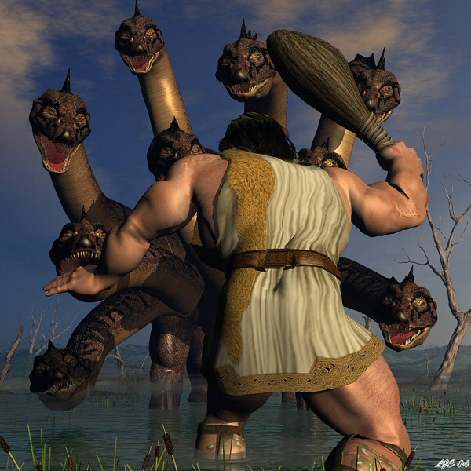
THE TWELVE LABOURS OF HERCULES OR HERACLES SYMBOLISES THAT WHICH IS NECCESSARY ON THE PATH OF ENLIGHTENMENT
Remember the Labour of Hercules involving the Hydra. As Hercules chopped off one head with his sword another 3 grew back in its place.
As Hercules chopped off the head, he cauterised it with the Sacred Fire, and thus the heads grew no more. This is the secret of meditation taught in Energy Enhancement, but for the fire, you have to wait a few Initiations!
The Hydra symbolises the mind. Its heads the many thoughts we have which need to be dissipated through Energy Enhancement Initiation One, meditation.
TO STOP THE MIND, WE MUST DEFEAT THE HYDRA. ENERGY ENHANCEMENT KNOWS THE FAST AND SPEEDY WAY TO ENLIGHTENMENT!
MIND IS A DISEASE WHOSE CURE IS ENLIGHTENMENT

The human mind is filled with wandering thoughts and desires like a mad monkey it leaps from tree to branch and distracts the mind from the higher energies from chakras above the head.
Yet, this is not mind.
Mind is merely a container.
And what the mind contains is madness. The mind contains thoughtforms, programs and sub-personalities which have been created by the person and also absorbed from the surroundings.

These blockage thoughtform program sub-personalities are fixed, obsessed, filled with desire which become stale and poisonous. They Kill!! - Only the Purified Empty mind can truly Live.
These mind created thoughtforms are the ones which cause the endless Chitta Chatter (Chitta is Sanskrit meaning, Mind) and distraction from Purpose.
These thoughtform Energy blockages cause all the negative emotions of Anger, Fear, Sadness, Despair, Depression, and Manicism.
These thoughtform Energy blockages create and maintain connections which drain energy and strength from the lower chakras.
So, when we say mind is the disease, we mean that the full and sick desire filled mind is the disease.
An empty mind is a perceptive instrument and meditation is a fast for the mind because it drives out all the blockages and creates enlightenment.
The purpose of the empty mind faculty is to contain the psychic powers of perception and to listen to the energies of the higher chakras above the head which work at a higher and faster frequency, To listen to the quantum shift in energy from the chakras above the head.
The chakras above the head eventually at their highest point connect with Atman, God, Allah, Nirvana - any of the 10,000 names of the one Highest Energy.
Even Buddha when asked about God said Nirvana - Nothing - Emptiness. When you create an empty mind then automatically you get in touch with the Mind of God!!
This is why the Zen Masters say the Zen Joke, " I know Nothing!" Which really means, "I know God!"
Only an empty mind can contact the energies of God!
And, when all the blockages are removed, then you can become a candidate for Enlightenment!
And Energy Enhancement Techniques through many ancient and effective techniques like the Kundalini Kriyas and the Supra Galactic Orbit of Chinese Alchemical Taoism and the Emerald Tablet of Hermes Trismegistus, VITRIOL, The Seven Step Process for the removal of all blockages, The Karma Clearing Process, can Speed up the Process of Enlightenment.

ENERGY ENHANCEMENT
Initiation 1

Meditation

THE REMOVAL OF STRESS, TRAUMA AND NEGATIVE EMOTION
Energy Enhancement easily transmutes all negative energy without going anywhere near the emotions and memory!! The techniques of Energy Enhancement show you how to QUICKLY AND EASILY TRANSMUTE YOUR STRESS because it works at the level of Energy which underlies AND IS THE BASIS of all problems.
THE START OF THE ENERGY ENHANCEMENT ENERGIES
The Buddhafield of energy, in which evolutionary progress can quickly be made, and Kundalini Energy are absolutely necessary to any course of Meditation.
Energy Enhancement Advanced Techniques allow PAINLESS progress above and beyond any other course.
Energy Enhancement Advanced Techniques only use ENERGY which underlies all other human functions.
With Energy Enhancement it is not necessary to go anywhere near painful memory, negative emotions and catharsis which are the foundations of other courses.
ENERGY ENHANCEMENT PAINLESS TRANSMUTATION IS EASY AND QUICK.
IT SPEEDS UP THE PROCESS OF ENLIGHTENMENT!!
It teaches TOTAL Transformation and Transmutation.

ENERGY ENHANCEMENT
Initiation 1 Meditation

THE PRINCESS OF SWORDS OF THE THOTH TAROT

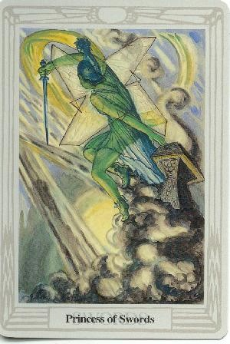
The inflow of Spiritual Energy or Kundalini Energy is well known in all Spiritual Circles as being expected in all genuine Courses with teachers who have advanced experience with Enlightened Masters yet some people just cannot get their heads around it and they do not
trust it as this concept destroys their idea of a "Normal" world. They start to fear the unknown!!
"EASY AND SMOOTH ENERGY ENHANCEMENT SPEEDS UP THE PROCESS OF ENLIGHTENMENT"
Energy Enhancement easily transmutes all negative energy without going anywhere near the emotions and memory!! The wind of Kundalini blowing through you usually leaves smoke and ashes in its wake. Normally, when Kundalini energy starts to flow through the interiorly held negativities it starts to destroy and release the Trauma and trauma within. Fear CAN be the result with all OTHER courses. The techniques of Energy Enhancement show you how to TOTALLY CLEAR yourself from moods and disturbing thoughts because it works at the level of Energy which underlies all the problems.
"ENERGY ENHANCEMENT IS A PROBLEM FREE METHOD OF AWAKENING CREATIVE INTELLIGENCE!!"
The powerful techniques of Energy Enhancement REMOVE the traumatic nature of all this Energy Release by using the new ALCHEMICAL concept of "Transmutation" - there remains non of the problems associated with all other courses.
Energy Enhancement does not work at the level of memory. You do not have to remember anything as we work at the level of energy which underlies all of the painful memories, yet the performance of Energy Enhancement techniques can easily and totally remove all the ENERGY BLOCKAGES, in a non-painful way!!
The student of Energy Enhancement knows how necessary is the transmutation of all the old energies on the path of evolution, progress and inner freedom.
The Energy transmutation of Energy Enhancement produces inner peace, clarity, openness and truth. The Energy Enhancement student's "NO" to all the past negative energy held inside springs from an unequivocal "YES" to themselves and to their life!
The necessity for positive and easy change is comparable to the drastic move by Jesus Christ when he drove the moneylenders out of the Temple, and to the work of Hercules when he drove the River Styx through the Augean Stables, thus easily cleaning out thousands of years of horse shit in one day!

ENERGY ENHANCEMENT
Initiation 1

Meditation

THE PRINCESS OF DISCS OF THE THOTH TAROT

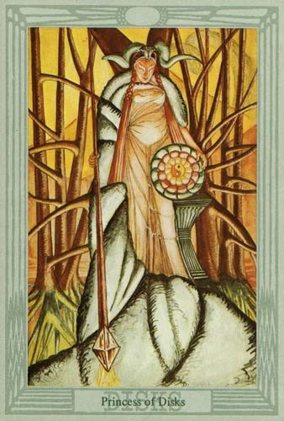
The wand of the Princess of discs stretches from heaven to earth and symbolises the Antakarana, an ancient symbol of Kundalini Yoga, which represents the tower, rainbow bridge of energy which flows through all your chakras from heaven to earth, when all energy
blockages preventing that flow have been transmuted through the techniques of Energy Enhancement.
By learning how to bring the Spiritual Energies of the Center of the Universe, the highest and purest form of light, into this Earth which is the darkest and most negative of all elements, it becomes possible to raise the energy level of the Energy Enhancement student and the Earth itself. This advance into new territory has the ability to unify to integrate the mother, the father and all the internal children into one energetic, soul infused and peaceful being.
"THERE CAN ONLY BE ONE!!"
Thus bringing together spirit and matter. The removal of energy blockages has created something new which can channel the light onto the Earth and cosmic idea- impulses, thoughtforms, become visible to everyone and permeate everything with their divine quality.
THE TRUE HEALING OF YOU, AND THE EARTH ITSELF!!

ENERGY ENHANCEMENT
Initiation 2 KUNDALINI KRIYAS
Energy Circulation

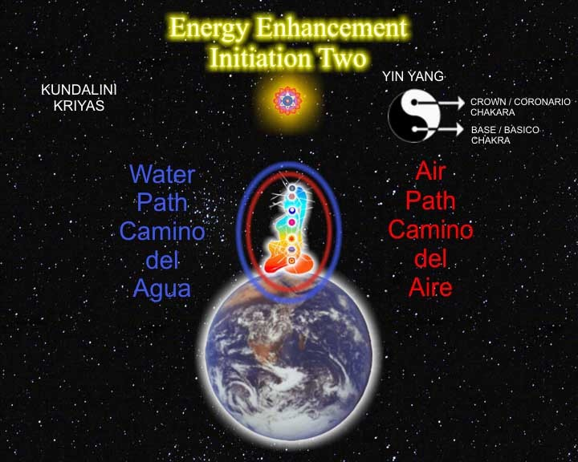

THE KUNDALINI KRIYAS OF KRIYA YOGA
"EASY AND SMOOTH ENERGY ENHANCEMENT PUTS YOU IN CONTACT WITH KUNDALINI ENERGY WHICH SPEEDS UP THE PROCESS OF ENLIGHTENMENT AND INTELLIGENCE"
THE 5 ELEMENTARY CIRCULATIONS OF THE KI OF TAOISM ARE THE SAME MEDITATIONS AS TAUGHT IN THIS INITIATION OF ENERGY ENHANCEMENT

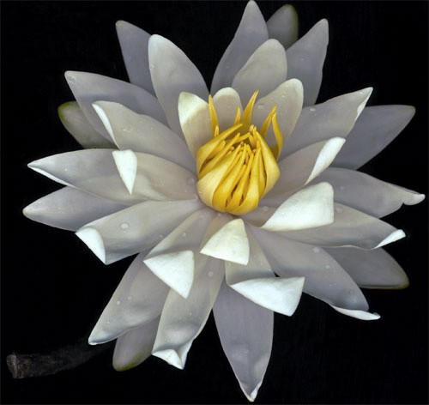
Masters... and the flowers showered, the energy of existence flows

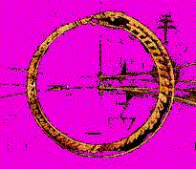The Same Guided Meditation as this ADVANCED TECHNIQUE of Energy Enhancement has been symbolised in many cultures. All the SYMBOLS below mean the same CIRCULAR GUIDED MEDITATION.

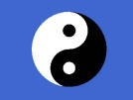

The Circular Yin Yang Symbol of Chinese Alchemical Taoism makes sense once you understand that the black dot represents the alchemical lead of the dirty Base chakra and the white dot represents the pure crown chakra. The circle represents the powerful Central and Governing Meridians of Acupuncture which was SEEN PSYCHICALLY by Taoist masters in their meditations. These Meridians, energy flows, circulate down the front of the body and up the spine through all the major Chakras.

This is the "Microcosmic Orbit" of Energy Enhancement.

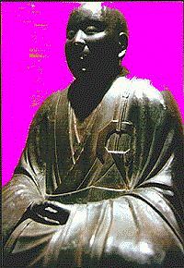

The Circular Broach in the costume of the Zen Master on the left. Zen is the Hybrid of Buddhism and Taoism. Hogen, the name of my Master, Zen Master Hogen means, "Master of the Tao" It represents the "Microcosmic Orbit" of Energy Enhancement.

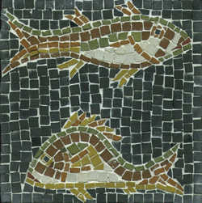
The Christian Fishes

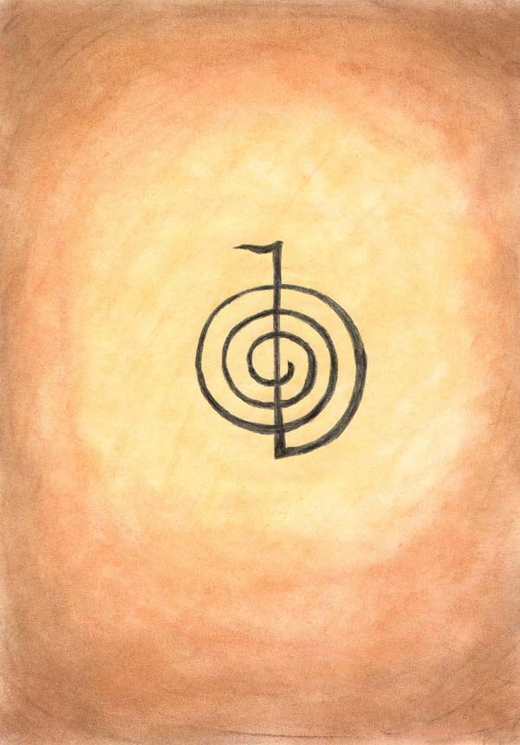
The Reiki "Choku Rei Symbol" This represents the Antahkarana flow of energy between heaven and earth
- the upright line, and the spiral of spiritual energy which surrounds it as magnetism spirals around a ray of light in the direction of the "right hand rule" of physics. It represents the "Microcosmic Orbit" of Energy Enhancement.

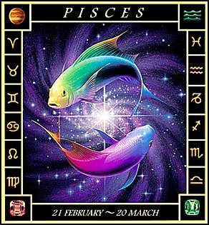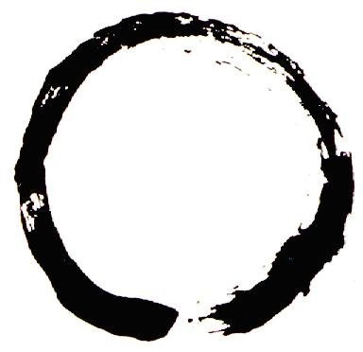

The Astrological Sign of Pisces
The Zen Circle

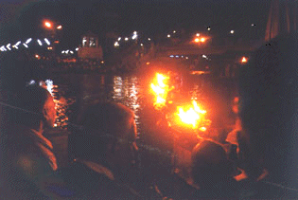

The Circular movement of the Sacred Flame in Hindu Arati
This picture is of the evening Arati Ceremony at the Sacred City of Haridwar taken by the Directors of Energy Enhancement on one of their India Tours.

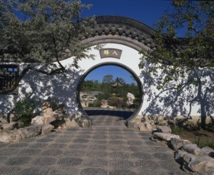The Chinese Taoist, Circular Doorways

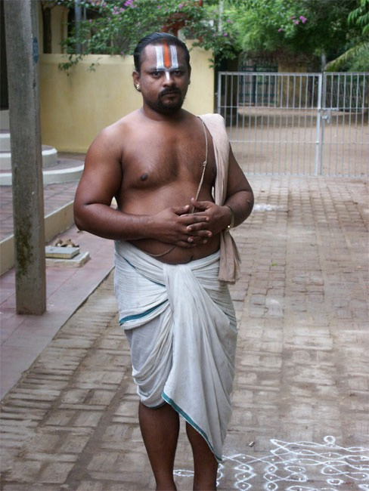
The Circular Sacred Thread traditionally worn around the body, over the shoulder and around the genitals, by the Hindu Brahmins who are Brahmacharya, celibate and working under the tutelage of a Guru
When the circulation of the energies, the Microcosmic Orbit, the Macrocosmic Orbit, The Energy Enhancement Supra Galactic Orbit, starts to function then the higher attachment of the Soul and higher starts to control all lower attachments.
The Hindu Swastika, Anti-Clockwise and clockwise Like the Choku Rei Symbol and the Prayer Wheel the
swastika represents the spiral flows of energy around a
central stem. Anti-Clockwise or as they say in Magic, "Widdershins" represents energy going away from you.

Devi Dhyani, "A Simple teacher of Dance" - Quote by Gurdjieff, like Jalaluddin Rumi and his whirling dervishes utilises this spiritual truth by turning

anticlockwise to send all negative energy into the center of the earth and clean the base chakra.

It represents the Kundalini Kriyas "Microcosmic Orbit" of Energy Enhancement.

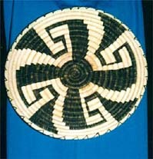
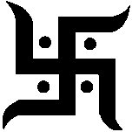The Hindu Swastika

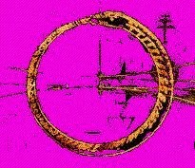
The Worm (Kundalini Dragon, Salamander) Orobouros which encircles the World of Norse Culture

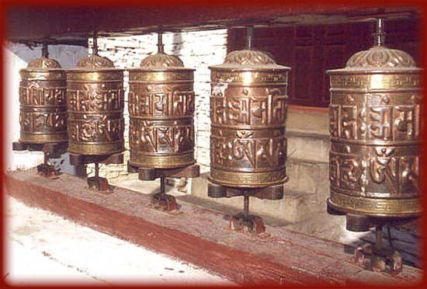

The Tibetan Buddhist Prayer Wheel shows movement in a circle and also represents the Antahkarana - see EE Initiation 4 - like the Reiki Choku Rei. The outside of the wheel represents the spiral flows of energy around the axis of the wheel which represents a flow of energy between heaven and earth - the Antahkarana. It represents the "Microcosmic Orbit" of Energy Enhancement.

All the symbols ABOVE are the same GUIDED MEDITATION of...

ENERGY ENHANCEMENT Initiation 2 - THE CIRCULATION OF THE ENERGIES - ENERGY ENHANCEMENT APPRENTICE LEVEL 1
Initiation 2.
And are Ancient symbols which show the Energy Enhancement Guided Meditation of Energy Circulation.
These are the Kundalini Kriyas and The Five Elemental paths of the Chi of the Taoist masters, comprising Initiations 1-4 of Energy Enhancement.
This gives the Hidden Taoist Secrets of the Microcosmic AND the Macrocosmic Orbit and The Energy Enhancement Supra Galactic Orbit.

“The problem is that over the years we lose our inner energy due to bad experiences that happen to us in life. Negative thoughts forms are also responsible for its lack. The solution to all these problems is learning Energy Enhancement! So I had to go onto the course!!!

I am now finishing the Energy Enhancement Level 3 of the Energy Enhancement Course. I have learned so much in this course that there is no way that I could sum it up in few lines!

However I can tell you about an experience that I had during my first week. This proved me and may be to you as well, that meditation is very active process using the energy of the earth and those from the universe. I was sitting in the lotus position, applying some of the basic Energy Enhancement techniques, and suddenly I felt my whole body getting warmer and warmer. My hands started to shake a little bit and I was feeling slightly dizzy.

As I was still concentrating on the technique a heat from within started to make my whole body sweat. Although it was a cool September day I was getting so warm that I could feel the drops of sweat coming down the back of my spine, from my head onto the my neck. Once the meditation over I had to get change and have a shower because even my clothes were all damp. I can guarantee to you that I am not a person to get very warm even in the hottest summer day in Spain!

This was a very interesting experience for me and it

proved to me another time the effectiveness of Energy Enhancement Meditation”. SOPHIA FROM EE MEDITATION COURSE 2004
This technique cleans all the Chakras. Helping all parts of the mind including the Unconscious, to become more calm and still.
To remove the stones in the path of the watercourse. To remove blockages to the flow of your energy.
It teaches how to cleanse the psychic body so that our psyche becomes sensitive and our energy more powerful.
It strengthens the psychic circuits and decreases the resistance to the flow of Energy. It helps to build the psychic body, as Gurdjieff called it, "The Body Kesdjian".

ENERGY ENHANCEMENT
Initiation 2 KUNDALINI KRIYAS
Energy Circulation

The Fifth labour of Hercules
This technique of Energy Circulation (EE Initiation 2) and Grounding (EE Initiation Three) is referred to in the 12 Labours of Hercules. Ancient teachings in the form of stories which enable "The Son (Hercules) of God (Zeus)" to get married to the daughter of the king of the underworld.
To integrate the Crown Chakra with the Base Chakra or how to become Enlightened.

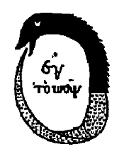

All ancient myths refer to hidden levels of meditation.
Throughout history, simple stories and symbols containing many levels of meaning have usually not been destroyed by the prevalent Religion as have been the competing religions temples and texts. In particular The Herculean Labour of the cleaning of the Augean stables refers to the cleaning of the Base Chakra with a River of Energy.
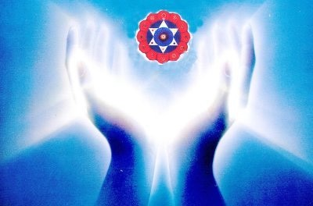In the past, psychologists have only worked on one painful experience at a time by providing a meaningful theory by Freud or Jung and then examining the problem. Through understanding the problem, it is released and the client adjusted back into society in his proper place. He may still be neurotic because only one problem has been solved.

The same with ancient lives. We may travel back to, see and fix one life problem in one of our past lives, but what about the other thousands of life-times, each with their own traumas, deaths and problems.
Energy Enhancement Techniques teaches how to remove All of the traumas, deaths and problems as simple negative energy. You do not have to see the problems. They are simply grounded as Negative energy. Learn how to simply, "Ground the last dregs of your VITRIOL!"
There is an ancient Greek myth about Hercules, (a Son of God, Zeus), wanting to marry Persephone the Daughter of the King of the underworld. The Crown Chakra wanting to combine with the Base Chakra. Shiva combining with Shakti. A Human Being becoming Enlightened.
He needed to ask her father's permission. When he did, her father was pleased to marry his daughter to the son of Zeus, but first he must perform 12 tasks. The 12 labours of Hercules. The fifth task was to clean out the Kings stables - The Augean stables. Hercules said, "No Problem," but when he saw the stables, he realised what a mountainous task he had taken on. There were thousands of horses and they had been creating manure for hundreds of years. Just like we, ourselves, create and absorb Trauma and Karma over thousands of lifetimes.
At first, he tried to dig the manure, examining every turd. Just like the psychologists and past life therapists of today. But after one month he had got nowhere. He had only cleared a small hole in a mountain of shit.
After much thought, he then projected to change the course of the river Styx, the river we cross when we die, through the stables. When he did this, the stables were quickly cleaned as the river washed all the manure away.
THIS IS THE CONCEPT OF ENERGY CIRCULATION, THE KUNDALINI KRIYAS, THE TAOIST MICROCOSMIC AND MACROCOSMIC ORBITS - DEEP RIVERS OF ENERGY WASHING AWAY ALL THE SHIT.
WITH THE TECHNIQUES OF ENERGY ENHANCEMENT RIVERS OF ENERGY WILL DISSOLVE AND SWEEP AWAY ALL YOUR NEGATIVE ENERGIES - FAST!!
Deep Rivers of Energy lie hidden deep within us. As we learn to access and then to use them. So, All our History. All our TRAUMA can be dissipated and washed away
In the same manner, our first APPRENTICE LEVEL of Energy Enhancement teaches basic methods whereby the mountains of manure within us can be removed, painlessly, without examining every turd.
The whole mountain can gradually be moved and our History painting which has been painted brushful by brushful, day by day, can be returned to the clean white sheet we were when we were born.
We are full of a lot of "History" not only from this life, but also from previous lives. Our Energy Enhancement can truly remove this Personal History so that all painful memories can be dissipated and our energies can then start to flow in their natural courses, once again.

AND ITS A PAINLESS PROCESS BECAUSE WE WORK AT THE LEVEL OF ENERGY.
It is not enough to pick up one piece of shit and examine it and say "Ah yes, this was the Trauma I absorbed when my father died. Or in that lifetime when I continued on such a stupid path."
We need to be able to transmute it all!

ENERGY ENHANCEMENT
Initiation 2 KUNDALINI KRIYAS
Energy Circulation
THESEUS AND THE MINOTAUR, ENERGY CIRCULATION, THE GOLDEN THREAD AND OPENING THE HEART

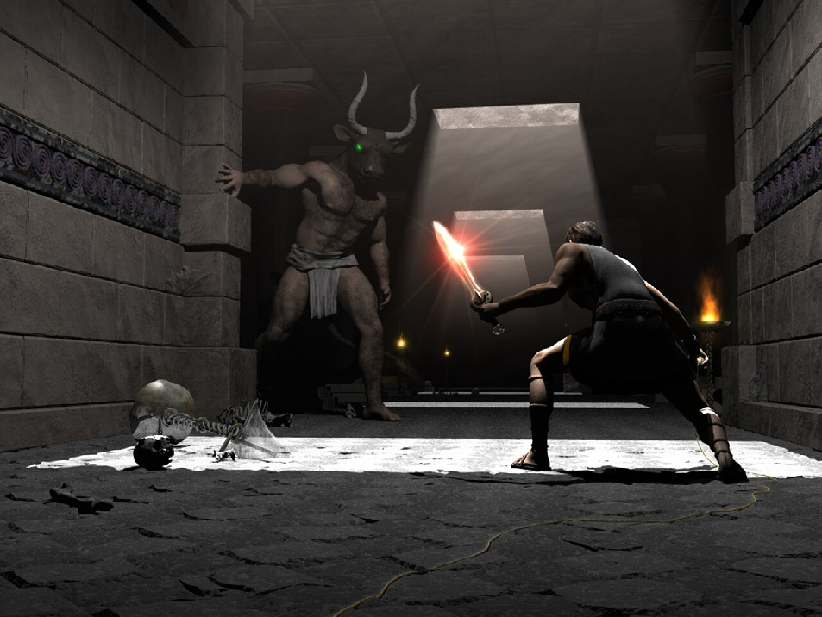
Again the ancient Greek Myths give the Secrets of Energy Enhancement meditation.
The Labyrinth, is cut into the stone floor of Chartres Cathedral. There was a plate in the middle of the Labyrinth there before the French revolution showing The myth of Theseus and the Minotaur.
The Minotaur like the Sphinx and the Centaur shows the dual Nature of man. It represents the man without a heart, the savage animal red in tooth and claw. The Law of the Jungle. Kill or be killed. The person only interested in himself to the detriment of everyone
around him. The psychopathic personality who only wants for himself and who will do anything, even kill, those who stand against him.
Many people admire Julius Caesar yet when Julius Caesar came to France it contained six million people. After taking it over he had killed one million and one million had been sold off into slavery.
Similarly with Pol Pot of Cambodia, who killed 2 million people. Stalin of the Soviet Union who killed 65 millions of people, 25 million alone during the Second World War, and sent everyone else to the concentration camps, the Gulags. Mao Tse Tung of China killed off 35 millions during the cultural revolution in the name of holding onto power, and so for many other similar psychopaths.
In order to open the heart we need to heal the Minotaur within all of us. It is called Energy Enhancement Opening of the Heart. Removing the Blockages of the heart and this is the function of the Second Initiation of Energy Enhancement.
Part of the Initiation is explaining the function of the Golden thread which allowed Theseus to find his way safely out of the Labyrinth created by Daedelus a genius of a man whose mind was made of metal and wheels.
Follow the golden thread, it will lead you to safety. The Golden thread is the Golden Circulation of the Energy..... THE SECRET OF THE GOLDEN FLOWER....
THE PARAMAHAMSA
An enlightened being is sometimes given the title Paramahamsa. This refers to an ancient Hindu myth of when the world was young, the whole of the surface was covered with water. The mischievous Gods mixed milk and poison in the water and stirred it all together. Paramahamsa was the name meaning the Great White Swan.
This enormous Swan, is said to have had the ability to put its beak deep down into the water and draw out pure milk. It had the capacity to discriminate and draw in only the milk, which is the reason it remained white, and reject the poison water. Not only that, a Paramahamsa, an enlightened being, has the capacity of changing water into wine, poison into milk, Yin into Yang, black into white.

Aham also means the self. Para means higher. A Paramahamsa is one who is in constant contact with the higher self and this is only possible when the lower self is being constantly cleaned through transmutation of the negative energies of the body… aches and pains, emotional body… anger, depression and fear, and the mental body.. wrong thoughts like selfish desire, ignorance of the soul and selfish attachment.
He can only do this by learning the psychic powers of the digestion, the transmutation of energy. As Gurdjieff, one of the greatest Sufi Masters who ever came to the west, said… “First Mastic, Then Mystic!!”

THE YIN YANG SYMBOL

This Yin Yang drawing symbolises the process whereby we too can do the same. It shows how to keep free of negative influences and energies by transmuting them (The secret of the Philosophers Stone is given in Energy Enhancement Initiation Three) within our energy systems.

Energy Enhancement Initiation Two - The Circulation of the Energy, is an Indispensable tool for those wishing to evolve.

Also the Labour of Hercules involving the Hydra. As Hercules chopped off one head with his sword another
2 grew back in its place. The Hydra symbolises the mind. Its heads the many thoughts we have which need to be dissipated.


The Dragon always Symbolises Kundalini Energy

The method of Energy Circulation is an ancient and hidden technique preserved in Taoism and Hindu Kundalini Kriyas.
It is the most gentle and effective tool for all those who want to increase their energy, their evolution, their genius.
“With this technique, your evolution will increase with every energy revolution to create a revolution in your evolution” – PARAMAHAMSA YOGANANDA

ENERGY ENHANCEMENT
Initiation 3
ADVANCED KUNDALINI KRIYAS

The Grounding of Negative Energies

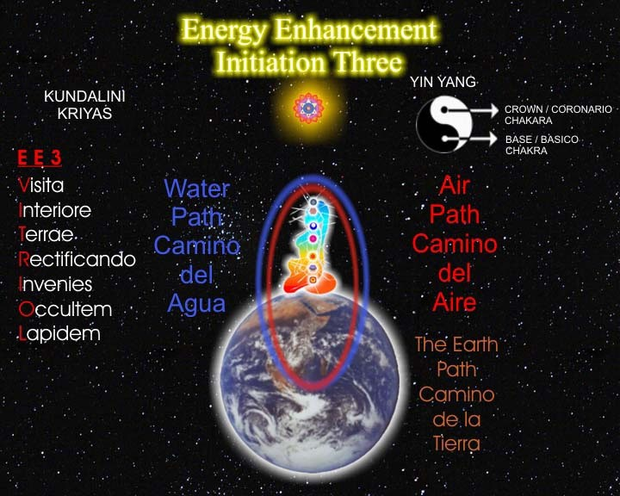
THE EARTH PATH OF CHINESE ALCHEMICAL TAOISM
We have a very ancient saying, "The more God, the more Devil. The more Flesh the more Worms.
The more property, the more anxiety.
The more control of negative energies, the more negative energies that need control."
The Abbods of Amel

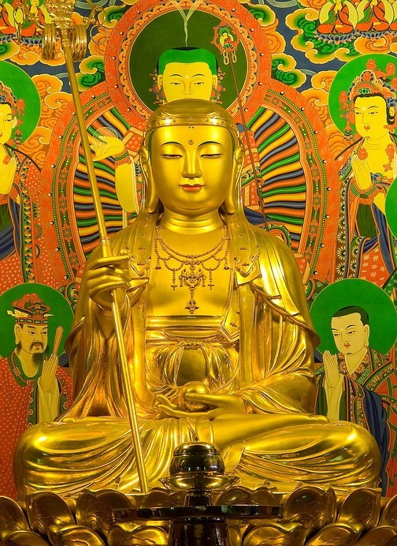
ENERGY ENHANCEMENT
JUST GROUND IT!!
ENERGY ENHANCEMENT
Initiation 3
ADVANCED KUNDALINI KRIYAS
The Grounding of Negative Energies

THE EARTH PATH OF CHINESE ALCHEMICAL TAOISM

AND CONTACT WITH KUNDALINI CHAKRA IN THE CENTER OF THE EARTH
CORNUCOPIA ABUNDANCE
The Base Chakra, Contact with the fiery Energy of Kundalini Chakra which exists in the Center of the Earth.

The Base Chakra blockages are those of Money so, by using the Techniques of Energy Enhancement to remove the blockages of the Base Chakra, we are removing blockages to having Money, Abundance, a Cornucopia of Wealth, Energy, Happiness and Life Energy!!
“That's why you are suffering. That's why you are poor
-- because you have forgotten how to live on this earth! Nobody has taught you how to live on this earth, how to love this earth. They have all taught you that this earth is ugly, that it is a punishment that you have been sent here, that you are not supposed to enjoy. If you enjoy, you will be sent again. You are supposed to be very sad, detached. You have to renounce all the joys of the earth so next time you don't have to be born, and then you will enjoy heavenly pleasures.

Because these people have been talking too much about the "other world", they have destroyed this world. I teach you this earth.

This very earth, the paradise. This very body the Buddha - OSHO

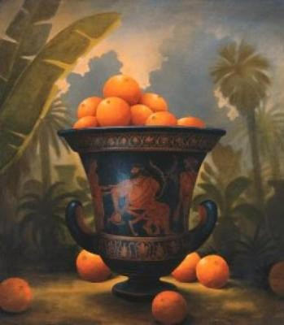

Cornucopia - the Downward pointing Horn of Plenty - of the Base Kundalini Chakra

CORNUCOPIA
Cornucopia is one of the horns of Amaltheia, the goat- nymph who nursed Zeus. She gave it to Zeus who presented it to Adrasteia and Io, two other nymphs: it became the horn of plenty (Latin: cornus=horn, copia=abundance), which is always filled with whatever food or drink its owner may desire. A very common decoration theme, cornucopia is often shown in a very standardized way (see the cornucopias in Porta del Popolo in Rome). An exception is the long cornucopia held by the River Tiber in a colossal statue now in Piazza del Campidoglio in Rome.... here it is...

The Myth of the Virgin and the Unicorn
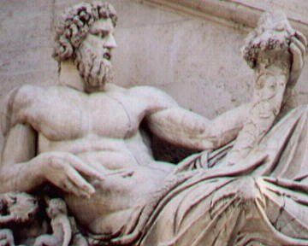

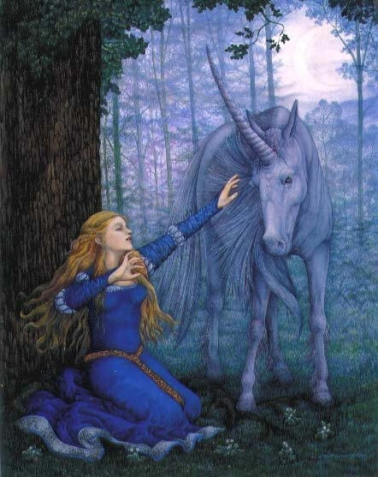ENERGY ENHANCEMENT
This Cornucopia "Around the Horn" also refers to the powers of Generation, of Sex - also the traditional Powers of Kundalini and the Base Chakra
The Antahkarana Also refers to the Unicorn - So, by removing the Blockages of Ajna Chakra the Psychic Powers of the Third Eye and of the Rainbow Bridge, a Horn emanating from the Crown Chakra leading to Wisdom, Psychic Vision and the Actualisation of all our Dreams, Our Soul Path.
Initiation 3

ADVANCED KUNDALINI KRIYAS

The Grounding of Negative Energies

The Myth of the Virgin and the Unicorn - The Female Virgin, earth, the Male Unicorn, heaven, and the Horn, the Holy Spirit, The Antahkaran, Axis Mundi

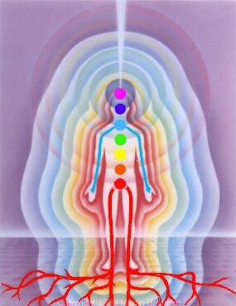
represents the Holy Trinity, Father Son and Holy Spirit
- Sat Chid Ananda the Union of Heaven and Earth, Shiva and Shakti.

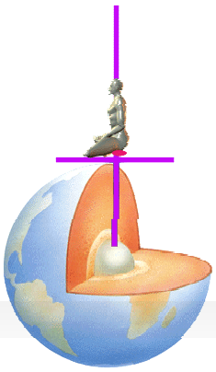Energy Enhancement Initiation Three is a Practical Guided Meditation which will put you in touch with your own earth energy connection.

The Fulcrum point, the evolutionary Initiation we are learning about here is the Earth Connection.
That of when the child was in the Womb up till the age of Four Months at this time the baby is learning to integrate the interior and exterior of its body. Sometimes this integration is faulty due to a painful abusive shock to the psyche. Yoga, dance, massage and other Pre - Energy Enhancement Techniques can help with this Initiation. Even fairly well integrated, everyone needs to improve this Earth connection.
"As within" said Hermes Trismegistus "So Without". The baby, so used to the soul connection and not understanding its new role of learning how to raise the Energy Vibration of the Earth, needs to learn to integrate the Earth connection.
If there is a problem with this Initiation of earth integration in the Base Chakra then it is indicated that from an early age the child and then the adult will feel fear, have problems with its food, money and with its security and with just not wanting to be here, sometimes even hiding from reality.
FEAR IS THE BLOCKAGE OF THE BASE CHAKRA

ENERGY ENHANCEMENT
Initiation 3
ADVANCED KUNDALINI KRIYAS
The Grounding of Negative Energies
ABUNDANCE
RELEASE YOUR BASE CHAKRA ABUNDANCE! - EVER WONDER WHY ABUNDANCE ISNT FOR YOU? WELL, BASE CHAKRA BLOCKAGES FOLLOWED BY MAKING A VOW OF POVERTY IN THE PAST ARE PRIMARY REASONS.
WE NEED THE CONCURRANCE OF THE INTERNAL AND THE EXTERNAL. THE BODY AND SPIRIT HAVE BEEN APART FOR TOO LONG AND NEED TO COME TOGETHER IN HARMAONIOUS UNION. THE MORE CENTERED AND DDPLY FOUNDED WE ARE IN OUR BODIES, THE MORE EASILY THINGS UNFOLD BEFORE US. THE DEEPER OUR ROOTS WILL GROW INTO THE EARTH, THE HIGHER OUR SPIRITS WILL SOAR. MAN SHOULD LEAD A RICH INNER AND OUTER EXISTANCE. IT IS NOT NECCESSARY TO CHOOSE. THE INSIDE IS NOT IN CONFLICT WITH THE OUTSIDE. YOU DO NOT NEED TO BE POOR ON THE OUTSIDE TO ACHEIVE INNER WEALTH. BE EXTERNALLY RICH THROUGH SCIENCE AND BE INTERNALLY RICH THROUGH MEDITATION. THIS WILL MAKE YOU ORGANICALLY INTO COMPLETE INDIVIDUALS.
DESIRE FOR WEALTH AND AVERSION TO WEALTH ARE BLOCKAGES IN THE BASE CHAKRA.
WITH DESIRE FOR WEALTH YOU DO NOT LIKE TO SPEND IT!
WITH AVERSION TO WEALTH YOU HAVE NO WEALTH TO SPEND AND YOU WANT EVERYTHING FOR FREE AND YOU HATE PEOPLE WHO TALK ABOUT MONEY, PARTICULARLY IF YOU CAN NOT AFFORD IT.
REMOVE ALL BLOCKAGES IN YOUR BASE CHAKRA.
The fear blockages of having nothing. The fear of death, even when this is not likely to happen, can cause you to take the stupid slave-like path in life. As Jesus Christ said -"Look at all the lillies in the field. They toil not, neither do they spin, yet Solomon in all his Glory was not arrayed as such as these...."
REMOVE ALL ENERGY BLOCKAGES
THE PAINLESS Integration of the Earth connection, the removal of blockages in the base chakra, will remove all fear, it will help us to be practical, to help give us the capacity to "DO", to help us make our vision a practical reality.
HAVE A FEAR FREE LIFE!!
We also need to learn how to remove Blockages below the base chakra which have reduced our energy and make it probable we would depend on others, be a slave, do what we are told.

KUNDALINI ENERGY BURNS OUT ALL ENERGY BLOCKAGES
The Earth Connection helps the baby to know that it will return to the Soul whether it is successful with its integration with the Earth or not. Helps it to learn to Master the physical environs of this planet. Sometimes this Initiation will make problems with this Earth connection but this integration needs to start to happen before for progress to be made.
Even with no major evolutionary "Fulcrum Point" problems, every student needs to strengthen this earth connection through these Energy Enhancement techniques because it is your base and foundation upon which can be built the Temple of Solomon.
Symbolising Evolutionary Integration. Symbolising all your levels of the Auric Body which need to be fed and created, so that we can function at our full capacity.
The PAINLESS Grounding of Negative Energies is an Ancient, further and more advanced technique going on from Energy Circulation. It is the Earth Circulation of the Five Elemental Taoist Circulations- Paths of the Chi.
THE FIRST FORMULA OF ALCHEMY…

ENERGY ENHANCEMENT
Initiation 3
ADVANCED KUNDALINI KRIYAS
THE ART CARD OF THE THOTH TAROT WITH THE TRANSLATION OF VITRIOL

The Grounding of Negative Energies

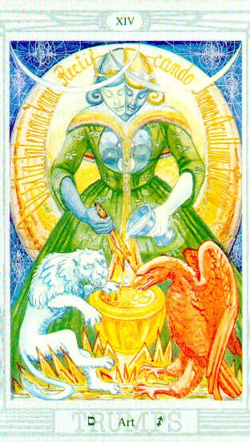VITRIOL
Is the First Formula of Alchemy - the hidden meaning of VITRIOL gives the hidden Meditational meaning of
the Philosophers Stone - THAT WHICH TRANSMUTES BASE METAL INTO GOLD

VITRIOL is a Latin word which means Acid. The acid which can dissolve all negativity.
The Integration of all the Chakras ends in complete freedom, Kaivalya or Enlightenment. We can use this meditational formula to Ground all Negativity.
THE PAINLESS GROUNDING OF NEGATIVE ENERGIES IS THE SECRET OF THE PHILOSOPHERS STONE
Each letter in the word VITRIOL stands for another Latin word which together give the First Formula, THE FIRST GUIDED MEDITATION of ALCHEMY. - !!NOW TAUGHT TO YOU IN ENERGY ENHANCEMENT!!
VISITA INTERIORE TERRAE RECTIFICANDO INVENIES OCCULTEM LAPIDEM

A Guided meditation encoded for centuries in the word VITRIOL - a guided meditation given in the Art Card of the Tarot, THOTH Pack.
See the latin words, an explanation of VITRIOL in a circle behind the figure on the card above.
Showing what is and how to activate "The Philosophers Stone" The "Occultem Lapidem" which is the catalyst which changes Base metal into Gold.
Not the metal Gold, the Element Gold or "Fools Gold" as the Alchemists used to call it.

The Enhancement of the pure Golden Spiritual Energy of the Crown Chakra and the transmutation of the Negative Energy slowing down the Base Chakra, or how to change or transmute the BLOCKAGES OF THE BASE CHAKRA, the Base metal (lead) into PURE SPIRITUAL GOLDEN ENERGY, THE ALCHEMICAL SECRET OF THE GOLDEN FLOWER.

Learn how to Ground Negative Energies. Learn how to transform the stress, the Negative Energy, of daily life, which arises in you or that which you pick up from other people. The stress which arises from the painful memories of the past.
Learn how to use Energy Enhancement get rid of all Painful Traumatic Memories and the Energy Blockages which hold them in the Body, the Emotional Armour of Reich, which causes toxins to be deposited in the area of the Stiffness, eventually failing in the body and making operations necessary.
Learn how to use Energy Enhancement to ground the Trauma of broken relationships.
Learn how to use Energy Enhancement to ground the Trauma of bereavement, the Trauma of divorce, the Trauma of abuse. The Trauma which causes fear, sadness, anger and grief.
Learn how to Ground Negative Energies to gain this energy to heal yourself and others.

THE GROUNDING OF NEGATIVE ENERGIES AND THE SECOND FORMULA OF ALCHEMY
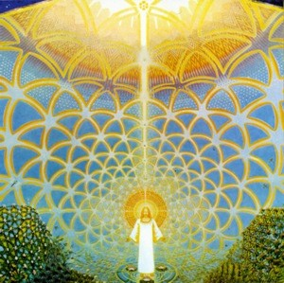"Solve Et Coagule" said the Alchemists, or "Dissolve to Integrate". THE SECOND FORMULA OF ALCHEMY IS SEC A LATIN WORD MEANING "TO DRY" - Dry out the
WATER OF THE Emotions - get rid of your fear, pain, anger, jealousy and negativity etc. THROUGH VITRIOL.
"DRAIN THE LAST DREGS OF YOUR VITRIOL"

LEARN HOW TO CONNECT WITH THE EARTH MOTHER,
THE SOURCE OF ALL KUNDALINI SHAKTI, OF ALL
KUNDALINI ENERGY, WHOSE JOB IS TO REMOVE ALL
ENERGY BLOCKAGES!!

"CONNECT, ONLY CONNECT" - GOETHE

ENERGY ENHANCEMENT
Initiation 4
SUPER ADVANCED KUNDALINI KRIYAS
CONNECTION WITH CHAKRAS ABOVE THE HEAD

The Garden of the Hesperides by Frederick, Lord Leighton, 1892.

The Eleventh Labour of Hercules and The Garden of the Hesperides
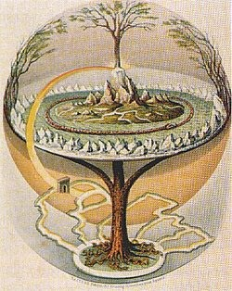"THE GOLDEN APPLES OF THE SUN THE SILVER APPLES OF THE MOON"
WITH REFERENCE THE SOUL WISDOM CHAKRAS ABOVE THE HEAD.

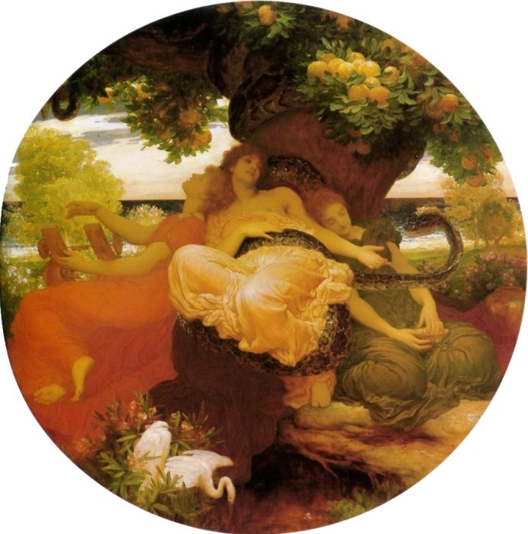AND THE WORLD TREE OF AXIS MUNDI AND THE ANTAHKARANA.
Yggdrasil, the World Ash (Norse)

The Garden of the Hesperides is Hera's orchard in the west, where either a single tree or a grove of Illumination - immortality-giving golden apples grew. The apples were planted from the fruited branches that Gaia the Earth Goddess gave to her as a wedding gift when Hera accepted Zeus. The 3 lady Hesperides were given the task of tending to the grove, but occasionally plucked from it themselves. Not trusting them, Hera also placed in the garden a never-sleeping, hundred- headed, dragon, named Ladon, see the Lernaean Hydra - this is the same beast as Ladon - as an additional safeguard.

As philosophical, moral, and eventually allegorical overlays came to be applied to Hercules death- cheating superhuman exploits, behind their outer, literal meaning, the Hercules figure came to represent an inner mystical tradition, and thus the labours could be interpreted in terms of the spiritual path. The last three labours (10-12) of Heracles are generally considered metaphors about death or illumination. Hercules was unique among Greek heroes in that no tomb of Hercules was ever localized, and the Olympian sacrifices and chthonic libations were offered simultaneously to him everywhere.

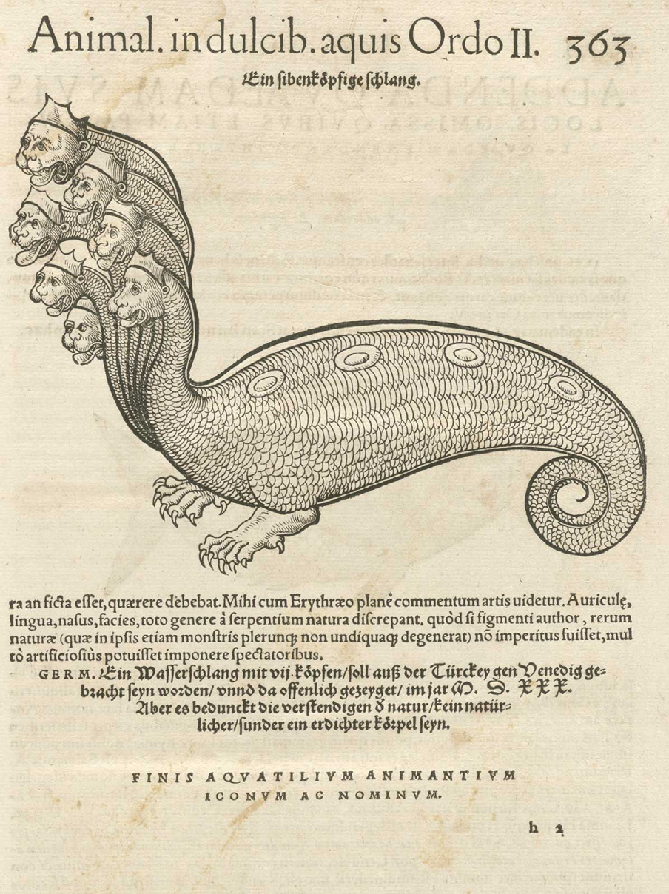In Greek mythology, the Lernaean Hydra (Greek:
/\Epvaia Yopa) was an ancient nameless serpent-like chthonic water beast that possessed numerous heads— the poets mention more heads than the vase-painters could paint— and poisonous breath (Hyginus, 30). The Hydra of Lerna had heads which when cut sprouted three more, was killed by Hercules as the Second of his Twelve Labours and refers to the rubbish unnecessary thoughtforms of the mind created by trauma formed Energy Blockages. Hercules destroyed the heads of the Hydra with Sacred Kundalini Fire - The Energy Enhancement Meditation and the Seven Step Process for the removal of Energy Blockages.
Walter Burkert has called the labours and other myths of Hercules "a conglomerate of popular tales which was exploited only secondarily by the high art of poetry", and it was not until the fifth century that poets of the Classic age could draw the myth into "a tragic, heroic, and human atmosphere and away from its natural thrust outwards to a carefree realm beyond the human" (Burkert 1985:208).
In order to make Ten out of the Twelve Labours of Heracles (also known as the Twelve Labours of Hercules), and thus destroy the essence of the Illumination myth path, it was suggested that Eurystheus discounted those where Heracles was aided or paid, and so two additional labours were given.
The first of these was to steal the apples from the garden of the Hersperides. Heracles first caught Nereus, the shape-shifting sea god, to learn where the Garden of the Hesperides was located. In some variations, Heracles, either at the start or at the end of his task, meets Antaeus, who was invincible as long as he touched his mother, Gaia, the earth goddess.
Antaeus was killed (the process of Illumination requires the ability to get out of the body into the higher chakras, the same path we take when we die, but without the advantage of being able to come back along the Silver Chord) by suspending him in a tree - SEE THE MYTH OF ODIN IN AXIS MUNDI where Odin
spent 9 nights supended in the Axis Mundi Tree above the Crown Chakra in order to become Illuminated and gain psychic vision - make all his sight one in the third eye.

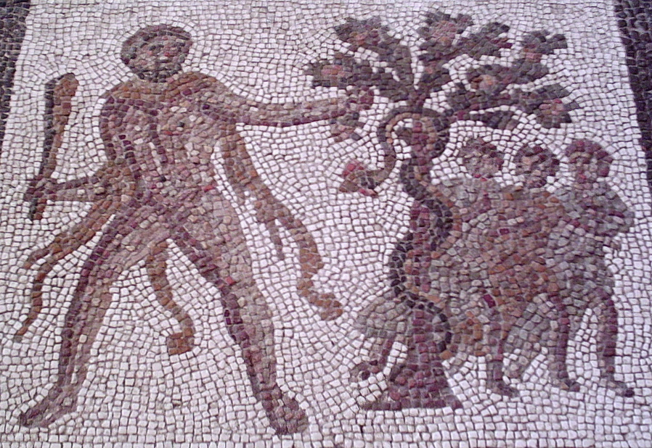
Hercules stealing the golden apples from the Garden of the Hesperides. Detail of a Twelve Labours Roman mosaic from Llíria, Spain (3rd century A.D).
Finally making his way to the Garden of the Hesperides, Heracles tricked Atlas into retrieving some of the golden apples for him, by offering to hold up the heavens for a little while (Atlas was able to take them as, in this version, he was the father or otherwise related to the Hesperides). Upon his return, Atlas decided that he did not want to take the heavens back, and instead offered to deliver the apples himself, but Heracles tricked him again by agreeing to take his place on condition that Atlas relieve him temporarily so that Heracles could make his cloak more comfortable. Atlas agreed, but Heracles reneged and walked away. According to an alternative version, Heracles slew Ladon.
According to some Heracles was the only person to steal the apples, other than Perseus, although Athena later returned the apples to their rightful place in the garden. They are considered by some to be the same "apples of joy" - The Golden Apples of the Sun, that tempted Atalanta, as opposed to the "apple of discord"
- Blockages which exist above the Crown Chakra, cutting us off from our Soul Chakra - used by Eris to start a beauty contest (The Ego Blockages) on Olympus.
On Attic pottery, especially from the late fifth century, Heracles is depicted sitting in bliss in the Gardens of the Hesperides, attended by the maidens. This is the Story of Heaven - in the Chakras above the head along the Antahkarana of the World Tree of Axis Mundi. Later, William Shakespeare wrote "For valour, is not

Love a Hercules. Still climbing trees in the Hesperides?" (Love's Labours Lost, IV.III).

HERCULES, THE SON OF GOD, DEOS OR ZEUS, NEEDS TO CONTACT THE CHAKRAS ABOVE THE HEAD IN ORDER TO ACHIEVE ILLUMINATION. TO DO THIS HE NEEDS TO GAIN THE HELP OF ATLAS OF THE EARTH - ENERGY ENHANCEMENT INITIATION THREE IS CONTACT WITH KUNDALINI CHAKRA IN THE CENTER OF THE EARTH - IN ORDER TO STEAL THE GOLDEN APPLES OF THE SUN OF THE GARDEN OF HESPERIDES - ENERGY ENHANCEMENT INITIATION
4 - CONTACT WITH THE CHAKRAS ABOVE THE HEAD, THE SOUL WISDOM CHAKRA.

ENERGY ENHANCEMENT
Initiation 4
SUPER ADVANCED KUNDALINI KRIYAS
CONNECTION WITH CHAKRAS ABOVE THE HEAD
- The Taoist Supra-Galactic Orbit
- The Creation, projection, of the Antahkarana to the Soul Chakra
- The Creation, projection, of the Antahkarana to the Monad Chakra

- The Creation, projection, of the Antahkarana to the Logos Chakra
- The Creation, projection, of the Antahkarana to the Sirius Chakra
- The Creation, projection, of the Antahkarana to the Avatar of Synthesis Chakra
- The Creation, projection, of the Antahkarana to the infinite Chakras of God

THE TAOIST Macrocosmic Orbit, The Energy Enhancement Supra Galactic Orbit

"The force and degree of a man's inner benevolence evokes in others a proportionate degree of ill-will" - Gurdjjieff

"Evil people always hate those at the opposite end of the moral spectrum" - Earl Spencer at the funeral of Lady Diana
"The Radiance of the Buddhafield irritates, depresses or upsets Negative Energy Blockages, this is the scientific test for Energy Blockages and by these fruits, ye shall know them!" – Satchidanand
The Macrocosmic Orbit, The Energy Enhancement Supra Galactic Orbit
OVERCOME THE SHOCK AND FEAR OF THE DEATH PROCESS

ENERGY ENHANCEMENT
Initiation 4

SUPER ADVANCED KUNDALINI KRIYAS
CONNECTION WITH CHAKRAS ABOVE THE HEAD

SOUL CONTACT AND THE ANTAHKARANA!
The Antahkarana or Axis Mundi is the psychic tower of connection between Heaven and Earth along which are strung all the Infinity of Chakras which end in God, of which you contain seven within your body.
By connection with Chakras outside the body we connect with Infinite Pure Spiritual Energies which create Health, Wealth, Abundance, Super Intelligence and Genius.
Practise this Initiation every day so that when you die you will not be so shocked by the Death Process.
"Your Soul is bound for the sky, your corpse is beneath the ground... You shall go up to the sky.... You shall ascend to those who are above the earth.... You shall ascend to the sky, you shall traverse the firmament, you shall associate with the stars. ..." - Ancient Egyptian Book of the Dead.

Learn how to access infinite amounts of healing spiritual energy. Energy from Accessing the Universal Energy Source FROM THE INFINITY OF CHAKRAS ABOVE OUR HEADS... ABOVE THE CROWN, SAHASRARA, CHAKRA...
"Die before thou Die,

That so thou shalt not die when thou dost come to die.
Else thou diest utterly.

Were Christ a thousand times reborn in Bethlehem's stall

And not in thee, thou art lost beyond recall."
Angelus Silesius

When Gorakh says, "Die Yogi, Die." When the Sufis say, "Die before you Die." this is understanding the meaning of the Antahkarana.

In Energy Enhancement we teach and give real experience of ascending through the Astral and Buddhic Planes, escaping beyond the reach of Death and reaching towards Immortality.

Energy Enhancement teaches the Meditation connection with the Soul and the higher self along the Antahkarana - the connection between Heaven and Earth.
Forget about small capacitor (Internal Chakras which give little Ki) and connect in to Big Generator (The Chakras above the head like the Soul and God) – GURDJIEFF
Practise this Connection, the Fourth Initiation of Energy Enhancement, every day so that when you die you will not be so shocked by the Death Process.
Practise this Connection every day so that when you die you will be able to pass through the death process without losing your memory in full consciousness.
PRACTISE THIS ENERGY ENHANCEMENT CONNECTION EVERY DAY SO THAT YOU CAN BECOME AN ASCENDED MASTER!

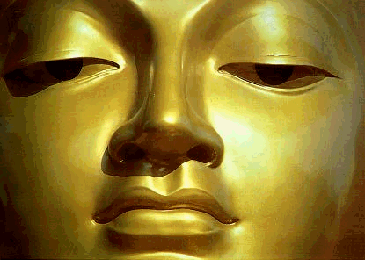

Central Spiritual Sun

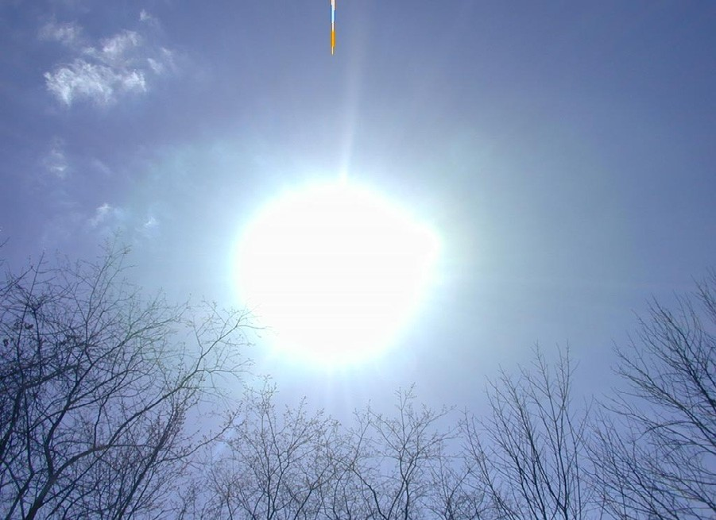
The egg is a common alchemical symbol. The retort, the alchemists’ bulb-shaped vessel, was called the Philosopher’s egg. It was used for gentle distillation and cohobation and could be hermetically sealed, so that the various materials inside could incubate. The egg was, more importantly, perceived as an image of the universe, the macrocosmos.

THE ANTAHKARANA OF JOHN DEE

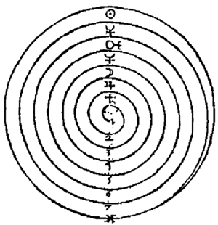

THE JOHN DEE SCREW - CIRCULATION OF THE ENERGIES OF THE ENERGY ENHANCEMENT SUPRA GALACTIC ORBIT

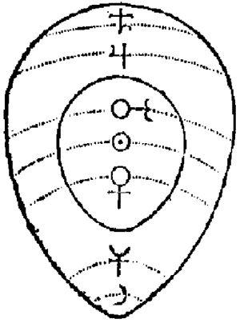John Dee, a British alchemist and mathematician who wrote the Monas hieroglyphica in 1564, wrote about the monad (unity) underlying the universe as expressed in a hieroglyph or symbol. He connected the symbol of the monad to the process of alchemical transmutation and found elements of transformation arranged along orbital lines in the egg, according to the corresponding placement of their ruling planets. He delineated the egg into a central “yolk” made up of the Sun, Mars and Venus (the metals gold, iron and copper) and a “white” made up of Jupiter, Saturn, Luna and Mercury (the metals tin, lead, silver and quicksilver)…Material transformation took place when the “yolk” enveloped the “white” through a process of “rotation.”
ABOVE, ALL THE PLANETS IN A LINE, HIGHER AND HIGHER, ALONG THE ANTAHKARANA.
THIS IS PYTHAGORAS´S MUSIC OF THE SPHERES, OR PLANETS, OR CHAKRAS OUT OF THE BODY, TO WHICH WE ARE CONNECTED.
WE ASCEND, OUT OF THE BODY TO ACCESS HIGHER AND HIGHER CHAKRAS TO WHICH WE ARE CONNECTED.
THIS MAP SHOWS HOW WE HUMAN BEINGS CONNECT INTO THE HIGHER AND HIGHER ENERGIES OF THE UNIVERSE.
Dee further symbolized this process with a spiral derived from Sufi Arabic- Egyptian alchemy, - originally Taoist Alchemy - where “turning the screw” was used to describe transformation. The spiral described and contained circles, and the circle was conceived as a hermetically sealed space in which transformation could take place.
In reality, this is a picture of the chakras outside the body below the base and above the head, connecting us with our soul and energy centers even higher than that, the Monad, The Logos, Sirius and the Avatar of Synthesis all the way to the energy in the center of the universe.

As the screw is turned, we access higher and higher, one chakra at a time.

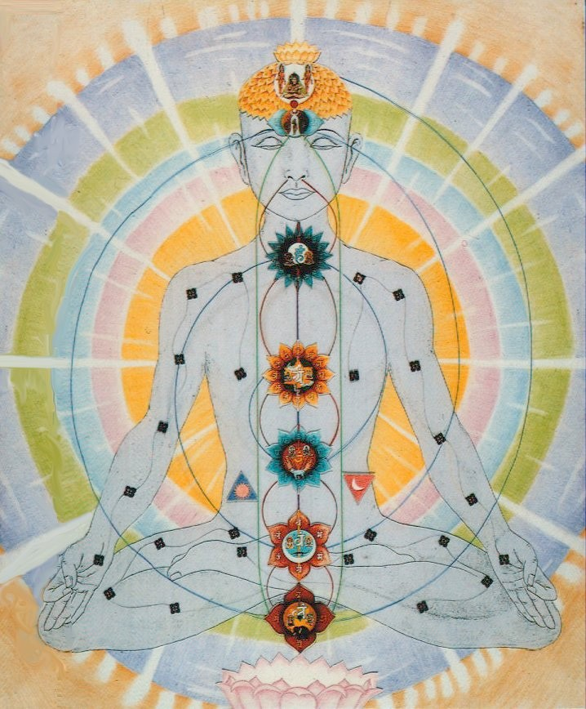
Above, see the spiral "Screw" Circulating Energy through the chakras. Although not created by Dee, it shows the antiquity of of the same successful technique actually pre-dating that of Dee's, as we say above, from the Taoist Supra- Galactic Orbit and the Hindu Kundalini Kriyas.

ENERGY ENHANCEMENT
Initiation 4
SUPER ADVANCED KUNDALINI KRIYAS
CONNECTION WITH CHAKRAS ABOVE THE HEAD

SOUL CONTACT AND THE ANTAHKARANA!

THE CENTRAL SPIRITUAL SUN OF AKHNATEN

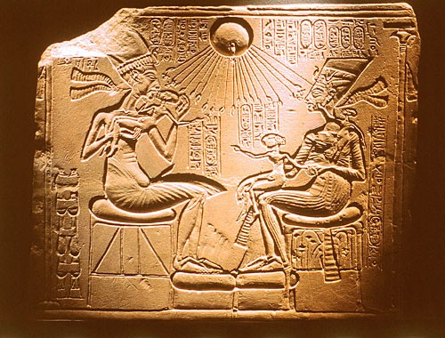
The Energy transmutation of Energy Enhancement produces inner peace, clarity, openness and truth. The Energy Enhancement student's "NO" to all the past negative energy and energy blockages held inside springs from an unequivocal "YES" to themselves and to their life!
ZEN THE ANTAHKARANA AND ENERGY ENHANCEMENT
LEARN HOW TO DROP THE BODY LEARN HOW TO DROP THE MIND HAVE AN OOBE
Dogen, one of the founders of zen buddhism in Japan, spent three years at Tien-túng in China, entering whole heartedly into zazen practice.

One day during meditation, Tendo Nyojo shouted at a sleeping monk, "When you study under a Master, you must drop body and mind!"
For Dogen, seated right beside this monk the shouted words, ¨Drop body and mind!" precipitated a profound experience.
He made his way to the Abbots quarters and burned incence in awe and gratitude, and, after a brief exchange, Tendo Nyojo confirmed that his young Japanese disciple had indeed, "Dropped Body and Mind."
"BECOME A MADE MAN" BY CONNECTING WITH HIGHER ENERGIES - ENERGY ENHANCEMENT INITIATION 4.
THESE PHRASES COME FROM THE MAFIA AND NOW REFER TO BECOMING AN ASSASSIN.
PREVIOUSLY THE MAFIA STARTED AS A SUFI SPIRITUAL SOCIETY IN SICILY WHEN THEY HAD THESE PREVIOUS MEANINGS.....
THE EMERALD TABLET

The only way to perceive that we are mainly using the body as our vehicle is to drop it.
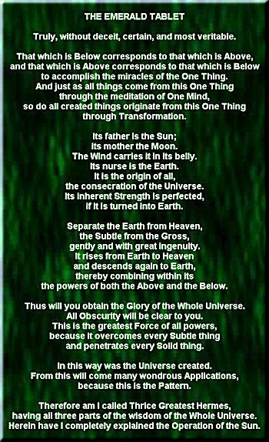To get out of it. Higher, along the ANTAHKARANA.
We can always choose to come back to it. We can choose when to die, dropping the body like a suit of old clothes.

Ancient books are full of this leaving the body and entering into the body of another, or choosing when to die.
We can choose to enter into the body of another as Lao Tsu chose to do when his first body wore out and he entered into another body in another land and became another enlightened sage.
We can choose to enter into the body of another as the Buddha did in order to gain experience, he entered into the body of a king who had just died for a month, and then dropped that body in order to enter back into his own body.

"A SINGLE HAIR CAN PIERCE MANY EMPTINESSES" - ZEN KOAN

THE SINGLE HAIR IS THE ANTAHKARANA AND THE EMPTINESSES ARE THE CHAKRAS.
EACH CHAKRA CONTAINS EMPTINESS.

THE ANTAHKARANA, LIKE A NEEDLE, LIKE A HAIR, PIERCES EVERY ONE.

"MAKE YOUR BONES" WITH THE GROUNDING OF NEGATIVE ENERGIES - ENERGY ENHANCEMENT INITIATION 3.

The Alchemical Emerald Tablet of Hermes Trismegistus describes the Macrocosmic Orbit, The Energy Enhancement Supra Galactic Orbit, of

the Chinese Alchemical Taoists, the Sufi Alchemists and of Energy Enhancement.

Without lie, certain and most true: What is below is is like what is above, and what is above is like what is below, to accomplish the miracle of the One thing.
In truth, and without Lie, And just as all things have been from the one, so also they are born from this one thing by adaptation.
THE TRINITY.. Its father is the sun father, its mother the earth The connection between the two, the holy spirit or ananda has borne it. This one thing is the father of all things.
Its power is perfect, after it has been united with the earth.
In the center of the earth is the fire/philosophers stone which separates, transmutes, purifies, the subtle from the dense, positive spiritual energy from negative energies with gentle heat and much devotion.
In great measure, The Macrocosmic Orbit, The Energy Enhancement Supra Galactic Orbit, it ascends from earth to heaven, descends again toward earth, and receives the force of the things above and below.
Thus you will possess the glory of the world, all obscurity shall flee away from thee.
This is the force of all force, it will overcome everything subtle, and penetrate everything solid.
For this reason I am called "Hiram Telat Machasot"- one in essence, but three in aspect. In this trinity is the wisdom of the whole world.
This curious phrase is Babylonian, Chaldean in origin, and has been suspected as the true identity of the Hiram Abiff of Masonic legend. Hiram means ‘universal,’ and contains the root letter of the elements of air, water, and fire, a play on words that echoes the Hebrew tetragrammaton, the four letter name of God which also incorporates the elements and forms the basis for all kabbalistic doctrine.
The tablet closes:
And so I have been called: Hermes Trismegistus - thrice greatest, having the three parts of the
philosophy of the world – THE HOLY TRINITY and SAT CHID ANAND, - THE FATHER, THE SON AND THE HOLY SPIRIT.
ENERGY ENHANCEMENT INITIATION FOUR CONTAINS THE CREATION AND PROJECTION OF THE ANTAHKARANA

ENERGY ENHANCEMENT
Initiation 4
SUPER ADVANCED KUNDALINI KRIYAS
CONNECTION WITH CHAKRAS ABOVE THE HEAD
SOUL CONTACT AND THE ANTAHKARANA!
SYMBOLS OF THE ANTAHKARANA

THE ANTAHKARANA AND THE OBELISK
The Obelisk is the physical, artistic, objective art, representation of the Antahkarana or the tower which connects all the chakras, below the base chakra, in the body and above the head, together.
In the Egyptian Religion the Obelisk symbolises the Penis of Osiris - the Father, which when conjoined with his wife Isis creates the Orgasm of Enlightenment symbolising the Holy Trinity of the Father the Son and the Holy Spirit. Some say that the basis of the Egyptian Religion was absorbed from ancient India...
Like Brahma the Father, Shiva (The Shivalingam means the Penis of Shiva!) the Antahkarana Lightning

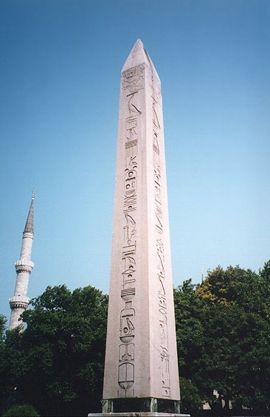Holy Spirit and Shakti the Mother. Kundalini Shakti exists in the Center of the Earth.

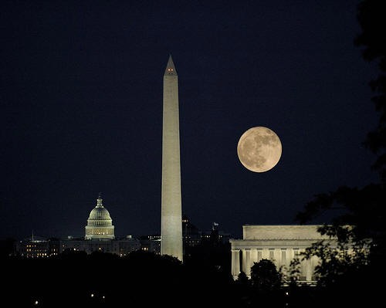
The Obelisk from Egypt and the Masons - Washington Monument together with the Capitol from the Capitoline Hill in Rome. The Dome of the Capitol represents the Hemisphere of the Earth, and the column arising from it, the Anthkarana.

The Tower. The Tower struck by Lightning. The Rainbow Bridge which connects all the infinity of chakras from the center of the earth chakra through the seven chakras of the body and up through the infinity of chakras above the head.
spire, inspire, aspire
Every brick aspires to become a Cathedral - the Monadic and the Logoic Communities of Angels.

The Egyptian Obelisk like Cleopatras Needle in London and Paris, from thousands of years of Antiquity and the Washington Monument below...

like magnetic force spirals around light rays in the direction of motion. In the same way spiritual magnetic force spirals around spiritual energy anticlockwise in the direction of motion away from you and clockwise as it comes towards you.
THE ANTAHKARANA AND THE TIBETAN BUDDHIST PRAYER WHEEL

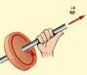

THE ANTAHKARANA AND THE SWASTIKA
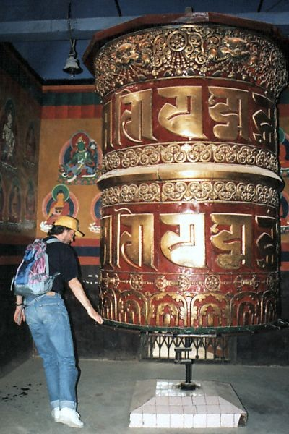THE SWASTIKA IS AN ANCIENT SYMBOL FROM 5000 YEARS OLD HINDU SOURCES. IMAGINE THE AXIS OF THE ANTAHKARANA COMING OUT OF THE CENTER OF THE DRAWINGS BELOW AS THE SWASTIKA OR CHOKU REI TURNS AROUND ITS CENTER.

THE TIBETAN PRAYER WHEEL TURNS AROUND ITS AXIS WHICH REPRESENTS THE ANTAHKARANA. IT TURNS IN A CIRCLE EITHER CLOCKWISE SENDING ENERGY UP INTO THE CENTER OF THE UNIVERSE OR ANTICLOCKWISE - "WIDDERSHINS" SENDING ENERGY INTO THE CENTER OF THE EARTH.
THE CLOCKWISE OR ANTICLOCKWISE MOVEMENT SENDING ENERGY UP OR DOWN IS SYMBOLISED BY THE CLOCKWISE OR ANTICLOCKWISE SWASTIKA OR THE CLOCKWISE OR ANTICLOCKWISE ORIGINALLY TIBETAN CHOKU REI SYMBOL OF REIKI.
In physics we call this circulation or spiral of energy around motion in a direction by the, "Left hand rule"

ANTI-CLOCKWISE SWASTIKA

THE ANTAHKARANA AND THE REIKI CHOKU REI

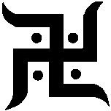

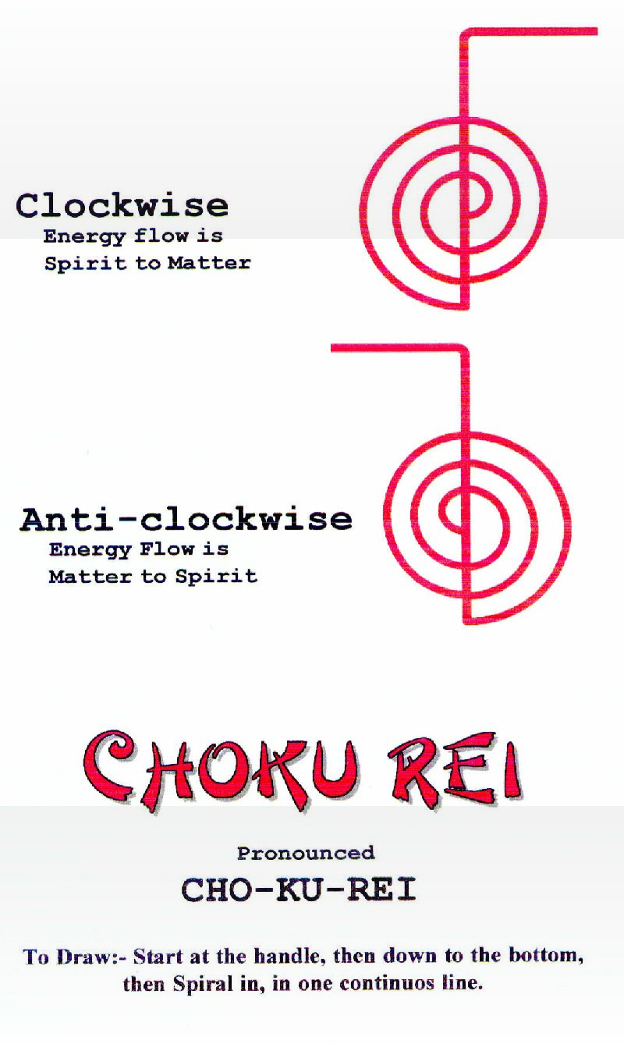CLOCKWISE SWASTIKAS

THE ANTAHKARANA AND THE MINARET OF THE BLUE MOSQUE

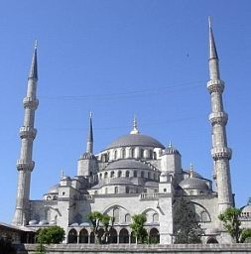
The Sufi Inspired Minaret of the Blue Mosque in Turkey even has the representation of the chakras above the head built as three balconies up the towers representing only three chakras above the head. Now we need to go higher. There are an infinity of chakras above the head connecting us with God!
King Kong symbolises the Ego. As we ascend the Empire State building of the Antahkarana to the soul, then the ego must die and slip away.
As it says in the Movie as a Sufi saying - And the Prophet said, 'And lo, the beast looked upon the face of beauty. And it stayed its hand from killing. And from that day, it was as one dead.'
The beloved, beauty, is the soul, is God.
This is the Sufi secret of the Troubadours and the Jesters (from Chisti)* who introduced the concept of courtly love in romantic poetry into Europe. Only the knowledge of the true self, the Soul, can overcome the selfish, competitive Ego, red in tooth and claw.
*Hazrat Nizamuddin Awlia Chisti (died.1325 A.D in Nizamuddin in Delhi.) represents in many ways the pinnacle of the Chisti* Order of the Sufis. "The heart of a lover (True lover of God) constantly burns with the fire of love, so much so that whatever impurity which intrudes upon its sanctity is burnt to ashes".
THE ANTAHKARANA AND SECRET KNOWLEDGE AT CHARTRES

THE ANTAHKARANA AND KING KONG

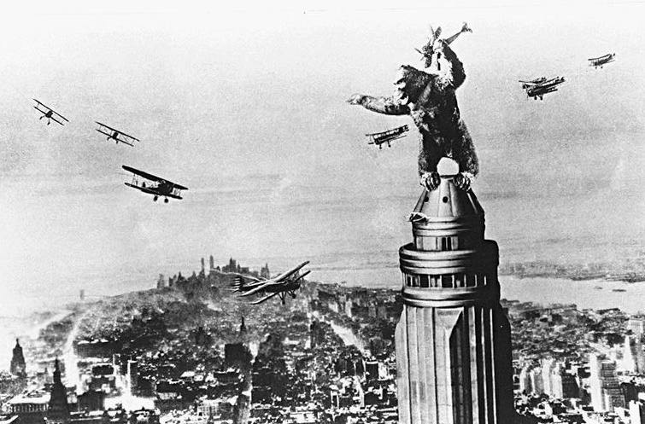

Here I am not referring to Freemasonry, but to the idea that there has been knowledge kept secret, spiritual knowledge, and in particular knowledge of the secrets of art and architecture. After the age of the cathedrals, the Middle Ages, with the Renaissance, and up to the present, the development of humanity in the European tradition turned to the development of the intellect, reason, logical thought, as distinct from instinct and intuition. We have gained enormously from this development, and we can see with a clarity previously impossible, but a combination of ego and rationality has demanded an understanding which commands its subject. An illusory desire for reason to command all, meeting the fact that reason cannot command all, produces the concept of secrets, secret knowledge.
There is an essential knowledge, but it is not secret, just difficult to put into practice, so it is sometimes easier to hold the concept of secret knowledge, not available to me. There have been all sorts of ideas about secret schools preserving knowledge of architecture across the centuries, and this usually settles upon geometrical systems of proportion and composition. Harmonious proportions and number symbolism were used, and these harmonies are inherent in the human mind, and emerge naturally when composition is undertaken by a pure mind.
The search for secret knowledge is often promoted by people who are avoiding their own self discovery. There have been times when knowledge had to be kept secret from oppressive authorities - time when religious institutions were both decadent and powerful, but even then the real knowledge can be expressed in a way that communicates without offence. Maurice Maeterlinck, author of the play The Blue Bird, wrote his book The Great Secret about seventy years ago. He said that the secret had been openly expressed again and again, and it told who you really are, something quite simple, but entailing in its acceptance a certain sacrifice, of who you are not, THE EGO, a sacrifice many are unwilling to entertain, and, consciously or unconsciously, prefer to see the truth as hidden from them, requiring a profound search. Your search is hindered only by yourself.

NUMBER SYMBOLISM
The cathedral is also full of number symbolism, not the construction of a rational meaning out of numerical analysis, but from an underlying sense that every number, and particularly the numbers from 1 to 12 had a transforming meaning. One was the number of original unity, and two the number of the first division. Three was the number of the divine, and four the number of the world. Seven, the sum of three and four, represented the steps or completed cycle from earth to heaven, the seven chakras and eight, the next chakra, the chakra above the head, the completion of the Octave, signifying rebirth and new life – Soul Fusion, and 12, the product of three and four, God and the world, were all also important as they represent higher chakras above the head, higher levels of Enlightenment.
Chartres is full of threes and sevens. Apart from the threes inherent in the layout and height of the building, the transepts and the choir each have three bays, there are three portals, each with three doors. and three storeys to each tower. At Chartres, there are seven bays to the nave, seven bays between the crossing and the east window, and seven bays to the apse and ambulatory. The pilgrimage to Chartres, from the secular to the sacred, and the pilgrimage through Chartres, through the sacred to rebirth, can be seen as journeys of seven steps, with, like the chapels of the ambulatory, three principal aspects. Seven is also the number of the gifts of the body and the gifts of the soul, shown in both transepts. Chartres expresses a unifying and transforming symbolism in the very fabric of its architectural design. It was the first high cathedral with only three storeys, the model for all later cathedrals – like the three stories of the vertical towers around the Taj Mahal or the Blue Mosque they represent higher chakras above the head along the vertical column of the Antahkarana. Internally and externally, height is a principal attribute, and not only height, but verticality. The whole design is expressed in terms of vertical lines. This is an enormously heavy stone building, which could have been expressed as stable and earthbound, but with all the stone masses expressed as bundles of vertical shafts, and with pointed arches formed like arrows to heaven, the emphasis is upward: gravity is transformed and the building leads the eye upward, an upward emphasis that is read psychologically as a spiritual ascent – the chakras above the head – the Antahkarana.

THE ANTAHKARANA AND THE BUDDHIST STUPA

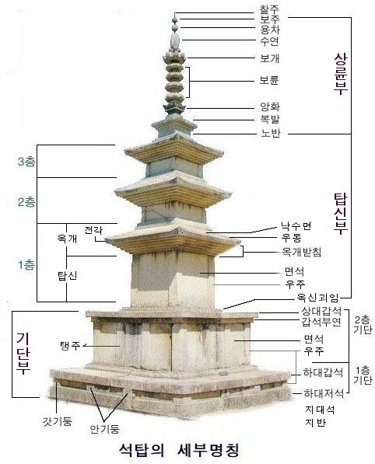
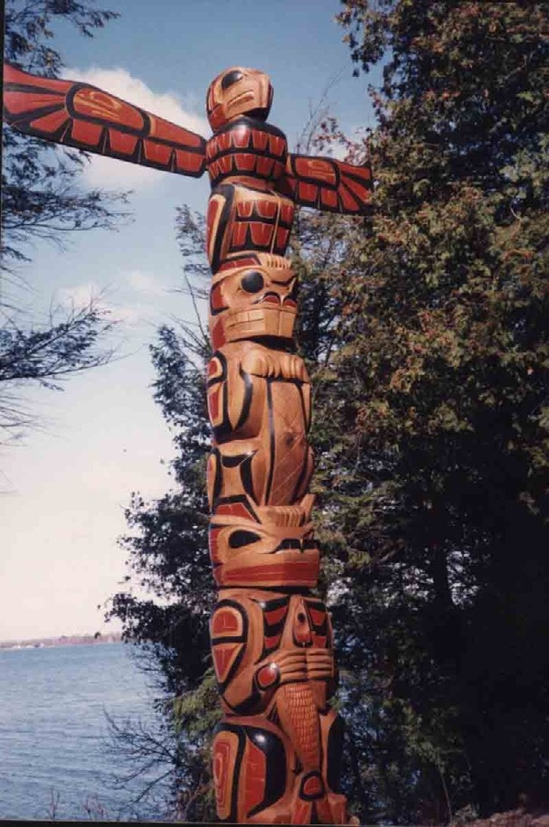Buddhist Stupa showing the representation of the Jhanas, or Chakras above the head
THE ANTAHKARANA AND THE TOTEM POLE
The Native American Indian Totem Pole has many chakras, gods, blockages and CHAKRAS on the way up the Antahkarana to the Eagle of Don Juan and Castaneda

THE ANTAHKARANA AND THE ALCHEMICAL COSMIC EGG

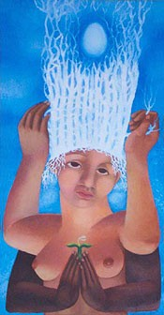
The Alchemical Cosmic Egg
"When the Supreme Ultimate and the Immaterial Spirit unfold, the Point at the crown of your head opens and the light or tunnel or shaft leading to the Cosmic Egg is revealed"

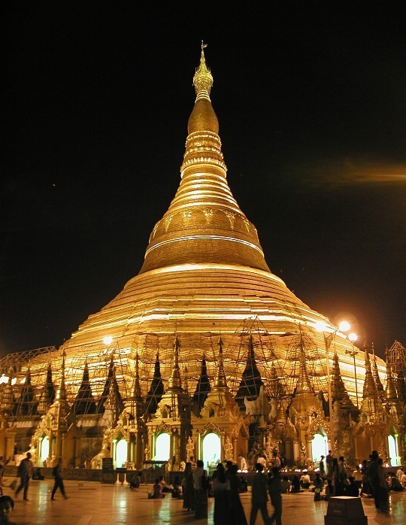
Shwedagon Pagoda at night
THE ANTAHKARANA AND THE PAGODA

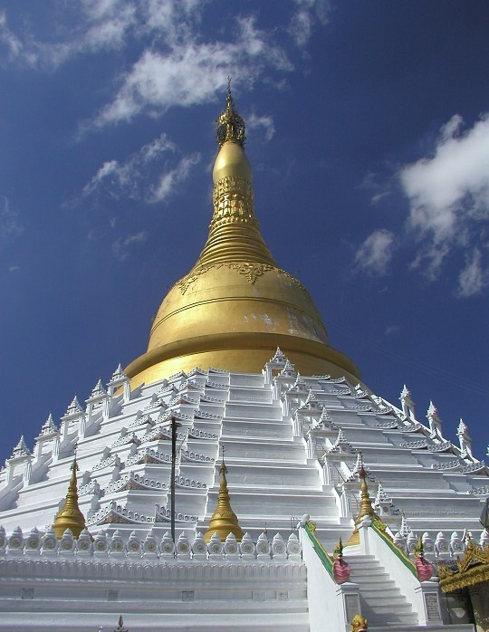
Mahazedi Pagoda

THE ANTAHKARANA AN THE SUFI FOUNTAIN AT THE ALHAMBRA, GRANADA, SPAIN
Many Sufi mystics came from organisations with names like the builders or the lock makers (Naqshbandhi).

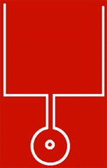
Plan of a pool at the Alhambra Granada. The Key and the Lock
When you go to the Alhambra in Granada, Spain, you come across many symbols of Sufism. Above is the plan of the Pool of water (Rectangle) in front of one of the beautiful buildings there. And a fountain (Circle) with a water channel between the two. The water from the fountain comes out of the little circle in the center of the bigger circle and flows into the pool.

The key of the Lockmakers, the Sufi Naqshbandi, a symbol of the Antahkarana

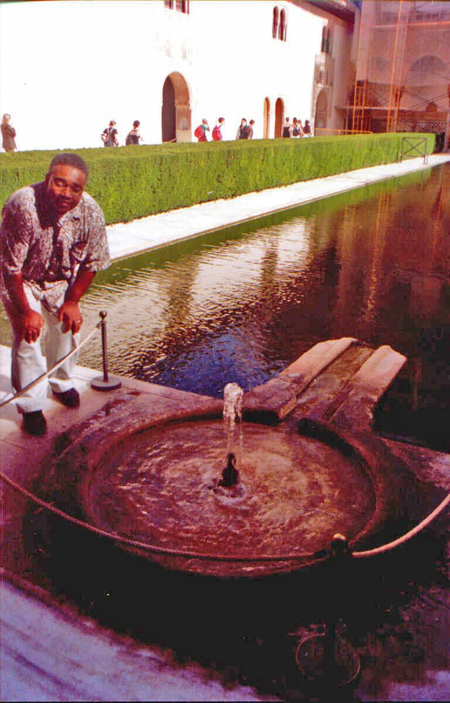
THE CIRCLE OF THE FOUNTAIN REPRESENTS THE EARTH, THE FOUNTAIN OF WATER IS THE KUNDALINI CHAKRA IN THE CENTER OF THE EARTH, THE CHANNEL THE ANTAHKARANA FROM THE CENTER OF THE EARTH OUT INTO THE SEA OF ENERGY - GOD - IN THE CENTER OF THE UNIVERSE.
"AS THE DROP DISSOLVES INTO THE OCEAN..."
The large circle of the fountain above is the Earth. The little circle in its center is kundalini energy which flows in every direction but is then channelled through the Antahkarana, the channel, into the pool, the ocean, the Soul, the central spiritual sun of Gurdjieff.
The fountain and the channel looks like a Key, does it not? Therefore here is the key of the Lockmakers, the Naqshbandi.

THE ANTAHKARANA AND THE 5000 YEARS OLD SHIVA LINGAM

The Shiva Lingam is a Representation of the Antahkarana
Below is a Shiva Lingham and Yoni from the india and the Ancient, 5000 years old Hindu religion. The base, Yoni looks like the fountain above, yes? The Shiva Lingam (Male Genitals) takes the part of the upwelling water of the fountain. In ritual worship, milk is poured over the Shiva Lingam and it comes out of the Yoni (Female Genitals) which symbolise the earth and the antahkarana spout shooting spiritual energy out of the center of the earth like the water of the fountain comes out of the fountain above into the pool.
This shows the rectification (The R of Vitriol) of the energy milk which comes down from the center of the universe and its rectification, change of direction, as it returns from the center of the earth back into the center of the universe.

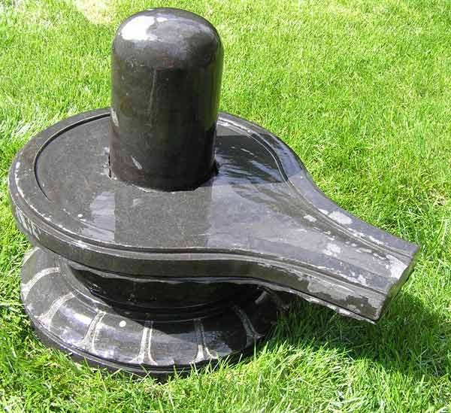
THE PARALLEL PROCESSOR MODEL OF A HUMAN BEING
Super Computers gain speed through the number of processors connected. Each Chakra is a processor. As we connect the chakras higher and higher along the

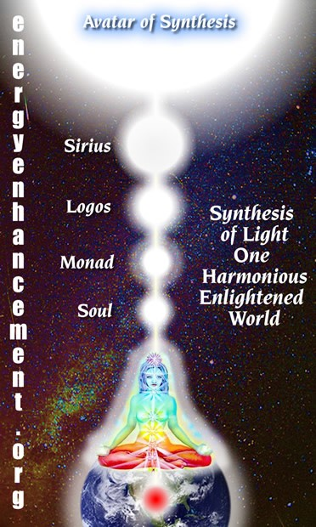antahkarana by removing the energy blockages between them so we gain more intelligence the higher they go, and the more chakras we connect together. As more processors are connected, so a human being gains more wisdom. The communication bus connecting the chakras together is the Antahkarana - a connecting tower of energy between heaven and earth. There are an infinity of chakras in the body and above the crown - soul, monad, sirius etc - connecting us with god. The number of processors is infinite. Our intelligence is potentially unlimited!!
Brahma is God. Acharya is Mastery. Translation "Mastery of the Connection with God" not "Celibacy".
Sexual Energy and Selfish Desire is Mastered through the Soul Connection and ONLY through the Soul Connection because the energy of God is higher and stronger. The Soul Connection is more interesting than the Sexual Connection. The Soul Connection puts the Sexual Connection in its place as a part of the energy of God, lower than the Energy of God and thus gradually stops Sexual Addiction.

ESTABLISHED
Established in the connection with God is Enlightenment. Each Incarnation is Unique and dependant on the Quality and Quantity of the connection. Of the size and function of the Spiritual Body and the components of the Spiritual Body of the Enlightened Person. Established in the soul, sanskrit- Stithyapragnyam.

ROSHI HOGEN

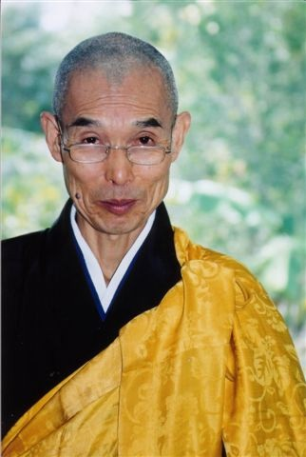
As my Master Roshi Hogen says "The spring at the top of the Mountain." - the Energy coming from the Crown Chakra.
BRAHMACHARYA

In Energy Enhancement this is the Energy in the Center of the Universe.
Illness is caused by a lack of energy. We can only heal ourselves when we learn to fill ourselves with energy by these methods.

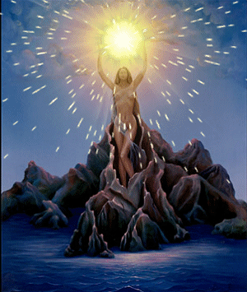

THE SPRING AT THE TOP OF THE MOUNTAIN

Energy is a glow. Energy is beauty. Energy is health.
Energy is happiness.
Energy is concentration and memory and your ability to respond.
Learn practical methods to access these Infinite Energies.
Gain Energy!
ENERGY ENHANCEMENT
Initiation 4
SUPER ADVANCED KUNDALINI KRIYAS
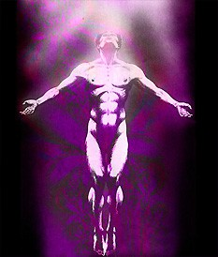CONNECTION WITH CHAKRAS ABOVE THE HEAD

This Energy Enhancement Initiation is the most important Initiation of Energy Enhancement
Other Initiations teach us about the Negativities and attitudes which stop this highly Energetic Soul Connection. Other Initiations teach us how to use this Higher energy in the correct way.
In this Initiation we learn Methods of Accessing the Infinite Energy of the Higher Mind. Easy and practical meditations based upon Ancient Methodology of 200,000 years duration whose track record of success is greater than any other system!
By accessing this energy we get in touch with our Intuition, our Direction, our Soul Path.
By accessing this energy we get in touch with the path we will take when we die.
When Gorakh says, "Die O Yogi, Die." When the Sufis say, "Die before you Die." this Fourth Initiation of energy Enhancement is the Meditation connection they mean.
Practise this Connection every day so that when you die you will not be so shocked by the Death Process.
Practise this Connection every day so that when you die you will be able to pass through the death process without losing your memory. Die in full consciousness.
By accessing this energy we get in touch with our Intuition, our Direction, our Soul Path.
By accessing this energy we subordinate everything else in our lives to this higher connection, to this Higher Energy. Then, every lower pleasure is subordinated to this energy. Everything in our lives starts to get put into its correct place...
Everything in our lives is important and should be used correctly, but when these lower things are put in control, when we become addicted to them. Then we have life problems.
Food, Relationships, Sharing the energies of the Psychic Sexual Connection, Sex, Power, Money, Property are all good and necessary when in their proper place.

PUT EVERYTHING IN ITS PROPER PLACE.
Feeling the orgasmic Higher Energies from the Connection to chakras above our heads makes us
understand that everything else in our lives is good... but not that good!!
"CONNECT, ONLY CONNECT", SAID GOETHE. THE HIGHER ENERGIES RULE... OK!!
We access the energies of Initiation which take us ever Higher.

ENERGY ENHANCEMENT
Initiation 4

SUPER ADVANCED KUNDALINI KRIYAS
CONNECTION WITH CHAKRAS ABOVE THE HEAD
THE ZEN STORY OF HYAKUJO

A ZEN STORY OF THE ANTAHKARANA AND THE HIGHER SELF
WHEN HYAKUJO FIRST ARRIVED AT CHIANG-SI TO PAY HIS RESPECTS TO MA TZU, MA TZU INQUIRED, "FROM WHERE HAVE YOU COME?"

"FROM THE GREAT CLOUD MONASTERY AT YUEH CHOU," ANSWERED HYAKUJO.

"AND WHAT DO YOU HOPE TO GAIN BY COMING HERE?" ASKED MA TZU.

HYAKUJO REPLIED, "I HAVE COME SEEKING THE BUDDHA-DHARMA."

TO THIS MA TZU REPLIED, "INSTEAD OF LOOKING TO THE TREASURE HOUSE WHICH IS YOUR VERY OWN, YOU HAVE LEFT HOME AND GONE WANDERING FAR AWAY. WHAT FOR? I HAVE ABSOLUTELY NOTHING HERE AT ALL. (THE TREASURE HOUSE IS YOUR HIGHER SELF. NOTHING, EMPTINESS, ANATTA,

NIRVANA IS THE HIGHER SELF, HERE HE IS SAYING THAT HE IS CONNECTED TO THE EMPTINESS OF THE HIGHER SELF, THAT HE CAN DROP THE BODY, THAT HE IS ENLIGHTENED - COMMENTARY SATCHIDANAND). WHAT IS THIS BUDDHA-DHARMA THAT YOU SEEK?"

WHEREUPON HYAKUJO PROSTRATED HIMSELF AND ASKED, "PLEASE TELL ME TO WHAT YOU ALLUDED WHEN YOU SPOKE OF A TREASURE HOUSE OF MY VERY OWN."

MA TZU REPLIED, "THAT WHICH ASKED THE QUESTION IS YOUR TREASURE HOUSE. IT CONTAINS ABSOLUTELY EVERYTHING YOU NEED AND LACKS NOTHING AT ALL. IT IS THERE FOR YOU TO USE FREELY, SO WHY THIS VAIN SEARCH FOR SOMETHING OUTSIDE YOURSELF?"

NO SOONER WERE THESE WORDS SPOKEN THAN HYAKUJO RECEIVED A GREAT ILLUMINATION AND RECOGNIZED HIS OWN NO-MIND. (NO MIND IS EMPTINESS OF THE HIGHER SELF, THE CHAKRAS ABOVE THE HEAD ALONG THE ANTAHKARANA. HERE HYAJUKO HAD TUNED IN TO THE BUDDHAFIELD OF THE MASTER MA TSU. THUS THE TRANSMISSION BEYOND WORDS). BESIDE HIMSELF WITH JOY, HE BOWED IN DEEP GRATITUDE.
(THE TREASURE HOUSE IS THE HIGHER SELF, THE SOUL, THE MONAD, THE LOGOS AND HIGHER, COMMENTARY BY SATCHIDANAND).
HYAKUJO SPENT THE NEXT SIX YEARS IN ATTENDANCE UPON MA TZU. BUT AS TAO-CHIH, HIS FIRST TEACHER, WAS GROWING OLD, HE WANTED TO RETURN TO LOOK AFTER HIM.

BEFORE HYAKUJO LEFT MA TZU, HE WENT TO PAY HIS FINAL TRIBUTE TO HIM.

SEEING HIM COMING, MA TZU RAISED HIS HORSE WHISK STRAIGHT UP. (THE HORSE WHISK IS THE "FINGER POINTING AT THE MOON" IT REPRESENTS THE ANTAHKARANA). HYAKUJO ASKED, "ARE YOU IN THE USE OF IT, OR APART FROM THE USE?"

MA TZU HUNG THE HORSE WHISK ON THE CORNER OF HIS CHAIR. AFTER A MINUTE OR SO, HE ASKED
HYAKUJO, "HENCE FORWARD, HOW DO YOU OPEN THOSE TWO LEAVES OF YOUR MOUTH TO WORK FOR OTHERS?"

AT THIS, HYAKUJO TOOK THE HORSE WHISK AND RAISED IT STRAIGHT UP.

MA TZU SAID, "ARE YOU IN THE USE OF IT, OR APART FROM IT?"

HYAKUJO HUNG THE HORSE WHISK ON THE CORNER OF THE CHAIR.

JUST AT THAT MOMENT, A GREAT ROAR, LIKE HUNDREDS OF THUNDERBOLTS FALLING, RAINED ON HYAKUJO'S HEAD. MA TZU HAD GIVEN A SHOUT WHICH, IT IS SAID, DEAFENED HYAKUJO FOR THREE DAYS.
(THE HORSE WHISK IS THE "FINGER POINTING AT THE MOON" IT IS THE ANTAHKARANA. WE DO NOT USE IT. WE ARE APART FROM IT AND YET IT IS PART OF OURSELVES. AND WHEN WE DO NOT USE IT WE ARE THEN THE WITNESS OF ITS USE BY OUR HIGHER SELVES. THEN THE FLOWERS SHOWER. THE ENERGY OF THE HIGHER SELF RAINS DOWN UPON OUR CROWN CHAKRAS, AND WE ARE DEAFENED BY THE LIGHTNING BOLT OF ENERGY WHICH ENERGIZES US FROM ON HIGH. COMMENTARY – SATCHIDANAND).

ENERGY ENHANCEMENT
Initiation 4
SUPER ADVANCED KUNDALINI KRIYAS
CONNECTION WITH CHAKRAS ABOVE THE HEAD

Maslow's Hierarchy of Needs a plagiarism of the Chakras.
PSYCHOPATHY HEALED BY REMOVING BLOCKAGES IN CHAKRAS OUTSIDE THE BODY IN THE ANTAHKARANA
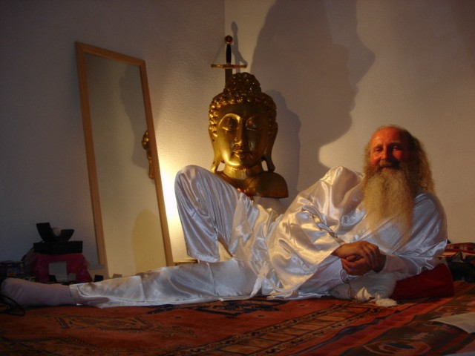Maslow said that evolution of man was how he gradually fulfilled the "Hierarchy of Needs". His level of evolution was shown by which level of the hierarchy he placed his life attention.
Chakras and Communication, the Ancient Symbol of the Tower of Babel or Babble.
The tower of Babel is the synonym in the Bible for a human being.
In a "normal" human being every part works and communicates together.
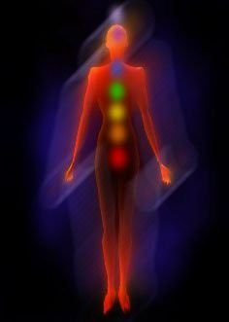The brain, spine and connection with the Soul, the Antahkarana, comprise the tower. Along the spine are the Seven Major Chakras or parallel processors.

By Satchidanand
The Functions of the Mind - The Chakras
After the functions of the mind as chakras and about the exponential improvement in intelligence as each function is improved and blockages between them removed. The Chakras are spread out along the spine and in the head. They reside in powerful nervous plexuses within the body. Each chakra is associated with an endocrine gland, which pours its powerful hormones directly into the bloodstream. The spine protects the spinal chord, which is made of the same nerve cells as the brain itself and is protected by the same spinal fluid as surrounds the brain. Each chakra communicates along the spinal chord. Each chakra can be educated and brought to full function. This communicating spinal chord can be educated to full information flow.
As the fears, jealousy, envy, competition and other negative thought forms, which cause the blockages in and between the chakras are cleared out by the techniques on our Energy Enhancement courses then one after another the functions are improved and the communication between them becomes better. This exponentially increases the intelligence of the more integrated human being, - the Gestalt.

The Seven Mayor Chakras
As I said, these chakras rarely communicate. They rarely work together. The parable goes that because Jehovah was afraid that the Tower of Babel would be built so high as to reach heaven, he purposefully created different languages amongst the various people building the tower. Because of the lack of communication the tower never got built to Heaven.
The lack of communication between the chakras, or the people building the Tower, symbolises their lack of integration. Because we are not integrated our psychic

bodies will not reach up to heaven. We never managed to contact our Higher Selves. We are not Enlightened.
The Enlightened have built a Tower of communication "Twixt Heaven and Earth".
In the Ancient Sanskrit this Tower has been given the name "The Antahkarana".
It is the psychic wiring, created in mental matter. A thought form created dually by the Soul and the aspirant to connect the Crown Chakra through to the Soul and then to the spiritual triad and then the
Each Chakra, when working correctly, acts like a Transformer in an Electrical system to halve the Energy Frequency of God. The frequency drops Chakra by Chakra, "Station by Station" as said David Bowie, on its way down to this planet because as Gurdjieff said "Normal Human Beings are transmitters of Cosmic Energy". And this is the function of Normal Human Beings. Those who are Enlightened. To transmit the Energy of The Soul. Whereby the higher energies of Truth, Prophesy, Intuition and Initiation are sent down towards this Planet.

Monad. Where the Higher Energy Frequencies of God create the Higher Energy Thought forms towards which the

Your evolution is the height of your Antahkarana or
how many chakras within and outside the body you have integrated into your being and removed all
Median of the Masses are moved as they evolve and as the Earth Spirit Evolves.

energy blockages from. Because the Energy Transmitted by the Enlightened is used to raise the frequency level of the Earth itself and

Please notice I said "Chakras Outside the Body!" -
These chakras are energy centers and brain functions called the kundalini center in the center of the earth, and the Soul, the Monad, the Logos, Sirius and the Avatar of Synthesis above the head through an infinity of chakras above the head towards God.
The Astral plane is not flat. Although most people inhabit the psychic slums in the basement of the astral plane in their dreams, when they go to sleep.
It is the "Rainbow Bridge" whereby the Higher frequencies of the energy of the Soul are stepped down to that of the Earth, so that the Earth itself can raise its frequencies, can evolve. We have been created to help in this creative act.
These frequencies are stepped down Octave by Octave through each Chakra which are really Way Stations in the Energy System of the Soul. This is the "Music of the Spheres" of Pythagoras. Because The Enlightened Master Pythagoras was indeed talking of Chakras when talking about the Spheres or the Planets. Each Chakra as it evolves corresponds to one or more of the Planets. This is the secret of Astrology. This is the means whereby the Seven Sacred Suns and the Seven Sacred Constellations in this Sacred Universe affect us.
all the people on it. To transmit the Light of Love down on to this planet of Love. To dissolve the Selfishness of the separated selves, those "Law of the Jungle" Egos who cannot communicate with The Higher Self. Who think of themselves as Separate. Who think themselves Apart. Who do not know that they too are A Part of the Universe of God Itself. Those who are not connected. Those who have not been touched by God. Those who are not "Made”.

ENERGY ENHANCEMENT Initiation 4 SUPER ADVANCED KUNDALINI KRIYAS CONNECTION WITH CHAKRAS ABOVE THE HEAD CHAKRAS OUTSIDE OF THE BODY
A Table of Maslow's Hierarchy of Needs and the Chakras.

Maslow's Hierarchy of Needs – The Psychological Expression of the Chakras | Chakra Body Position and associated Endocrine Gland together with illnesses associated with the Chakra.
0. The Kundalini Chakra in the Center of the Earth given in the Alchemical Formula and guided meditation, VITRIOL. – Visita Interiore Terrae Rectificando Invenies Occultem Lapidem. | Blockages along the path to that chakra create energy lacks which create a fearful slave mentality and locks people, lifetime after lifetime, into abusive slave-like situations.
1. Negative energy or blockages in the Base Chakra are the cause of fears about security. The removal of this negative energy gives mastery of basic security needs like food, money, and housing. The Mastery of the fear of not having them. Last of all the mastery of the fear of death. The Base Chakra is symbolised by the tantrics as a shiva lingam surrounded by three and a half coils of a kundalini snake. As we clear out the base chakra so the Initiations are taken as the snake rises to the fourth coil or the fourth chakra and so on. | 1. The Base Chakra is located in the coccyx. The trigger point in the perineum where resides a muscle which stops us urinating and ejaculating semen in men. The trigger point is in the vulva in women. It is known as Muladhara Chakra in India. It is associated with security. Its sense is smell. It controls the fight or flight reaction through the adrenal gland. The energetic blockages of fear in the base chakra cause stiffness, Trauma and illnesses in the vulva, prostate, hips and legs. Base Chakra Blockages cause problems with the emotion fear, problems with sex, problems with money or being a miser, and problems with security.
2. Blockages are selfish dependant desire and are the cause of unhappy dependant relationships. There are many fears about abuse, bereavement and divorce in relationships. Removal of negative energy or blockages to the energy flows in this center | 2. The Sacral, Second or Swadisthan Chakra is located in the abdomen below the navel. Its sense is taste. Its blockages are associated with selfish uncontrolled, sexual desire and attachment. Its function is the creation of children and the energetic feeding of children

gives mastery of Sexual Desire and Mastery of strong independent and happy relationships through control of the Psychic Sexual Connection. | through energetic connections. It controls the sex glands -Ovaries and Testes. Physical illness is caused by blockages in this area.
3. Fear in this area causes us to use power selfishly only for our own benefit. As we remove the negative energy causing the blockages, we get mastery of the use of power for the benefit of all and the mastery of selfish desire for objects or things. | 3. The Solar Plexus, Third or Manipur Chakra is located in the soft spot just below the center of the lower ribs- the sternum. Its sense is vision. It is the major energetic reservoir of the body. It releases its energy through the pancreas which synthesises insulin which burns sugar. If this chakra is out of whack, after a time digestive problems, ulcers, and diabetes is the result.
4. The First major blockage to enlightenment - Alice Baileys First Initiation, The Opening of the Heart - is between the Solar Plexus and the Heart Center. The Solar Plexus should power the Heart. Any blockage in the Solar Plexus the Heart or between them causes problems to The Mastery of Loving Relationships in partnerships, groups and organisations, and anger. Energy Blockages in the heart center cause a lack of empathy with others, an inability to put yourself in anothers shoes – external consideration, an inability to feel for another. | 4. The Heart Chakra is the Fourth or Anahata Chakra and is located just to the right center of the chest. Its sense is touch and its energy emmanates through the hands as in Reiki as well as in the centre of the chest. It controls the immune system through the Thymus gland. Any problems with the giving and receiving of love and empathy will cause toxins to reside there and the immune system thus to suffer. Heart disease, AIDS, Cancer are physical expressions of this problem.
5. The second major blockage to enlightenment  - Alice Baileys Second initiation - The Mastery of Relationships - is between the second chakra and the throat. The second chakra should power the throat. Any blockages to the second chakra, the throat or between them causes problems to the Mastery of Purification of thoughtforms, travel on the astral plane and The Mastery of Creativity in Art, Science, Philosophy and Business. | 5. The Throat Chakra is the Fifth Chakra also called Visshuddhi Chakra and is located in the pit of the throat. Its senses are speach, singing, chanting and hearing both normal and psychic. It controls the metabolism through the Thyroid and Parathyroid glands.
6. Self Actualisation. The Third Blockage to | 6. The Third Eye, Sixth or Ajna Chakra is located
Enlightenment is between the Base Chakra and | in the center of the forehead. Like a snake the
the Head Chakras. Blockages to these Chakras | Energy curves from the forehead like the
and between them will cause problems to the | ornamentation seen on the headresses of Ancient
Master Control Center of all the Chakras, the | Egyptian Pharohs. It controls the Sixth sense of

intellect, and the creation and use of Thoughtforms, entities, ideals, ideas and Ego Sub-Personalities. | the intellect and is associated with the Pineal Gland.
7. Self Transcendence. The Third Initiation of enlightenment is stopped by blockages between the Base Chakra and the Head Chakras. Blockages between these chakras and within them cause problems to the Mastery of Self Transcendence, Connection with the Higher Self, The Soul, The Spiritual Triad, Ascended Masters, The Central Spiritual Sun and I AM – God. | 7. The Crown Chakra is the Seventh or Sahasrara Chakra above the top of the Head. It is also "The Thousand Petalled Lotus" or the "Golden Flower". It controls the Seventh Sense of Connection with higher Energies, and is associated with the Pituitary Gland.
8. The Soul Chakra connecting with one to twenty Soul Personalities and many ego-Sub- Personalities which need to be integrated with the soul. | Blockages and Implants above the crown chakra cause a lack of conscience along with Heart Blockages which cause a lack of Empathy.  Together these are one of the main causes of  Psychopathy and Political Authoritarianism.  Thus these blockages are the main cause of misery, Trauma and lack of integration on this planet.  The solution to all the problems of this planet is not revolution and war. The solution is to remove all energy blockages and implants through techniques like Energy Enhancement which is the most advanced technique in this time period.  The higher the blockage, the more effect it has in controlling the normal mind.  Energy Enhancement teaches how to remove blockages from chakras 1 to 5 and then one million, 10 million on the way to infinity.  The first Initiation of Enlightenment (Alice Bailey's Third Initiation) crowns the removal of all sub-personalities and One Soul Infused Personality.  The Second Initiation of Enlightenment (Alice Bailey's Fourth Initiation) crowns a Master responsible for the removal of all Sub- Personalities in his Monad.  The Third Initiation of Enlightenment (Alice
9. The Monad Chakra connecting with a Group of Souls of perhaps 100,000 people.
10. The Logos Chakra - the group of all the Monads or Soul Groups on this planet both in and out of incarnation connecting with 200 Billion Souls animal, mineral and angelic composing the psychic body of the Archangel in charge of this planet whose aim is to evolve into a sacred planet having strong, blockageless connections with the Seven sacred Suns or Constellations.
11. Sirius Chakra. Outside of this planet are Seven possible connections with the seven sacred Suns. Usually we choose one of these connections. Perhaps the most powerful is Sirius, the Chakra where the Christ lives.
12. The Avatar of Synthesis is an Angelic being who controls the Christ and the Buddha and all

the Spiritual Enlightened and Ascended Masters. Like his name, his job is to integrate this planet, helping its evolution and raising its possible energy level. | Bailey's Fifth Initiation) crowns an Ascended Master who can maintain his consciousness through the death process, a Master responsible for the removal of all Sub-Personalities in his Logos - an integrating World teacher like the Christ.
13. An infinity of Chakras ending in God The last Stage of Self Transcendence is just another way of saying Enlightenment. The Seven Stages of the Hierarchy of Needs is just a plagiarism on the Theories of Tantric or Kundalini Yoga known about in India for thousands of years.
Kundalini Yoga talks about the psychological aspects of the seven major energy centers spread out along the spine called chakras.
The spinal chord is an extension of the brain. It is made up of the same type of cells. It is surrounded by the same cerebral fluid as is the brain. The spine acts as a communication bus, in computer terminology, between all the chakra parallel processors which make up the Human Being and is the physical correspondence of the
GooRoo
The Enlightened exist to bring light into darkness. To dissolve the darkness and this itself is the meaning of the Sanskrit word "Guru". A person who dissolves or Transmutes Goo is a GooRoo.
The Light of the Soul
And this is done through the Light of the Soul. Brighter than Ten Thousand Suns it exists alone. Unchangeable. Like Fire it lights everything with which it comes into contact. And once you are lit, you too burn with the Fire of the Soul. Like Prometheus you bring
down the Fire of God onto the Earth, for the Benefit of every living being.
Hari OM Tat Sat.
This is Sat Chid Anand. Antahkarana in the body.

On War and Violence
by Sri Swami Satchidananda

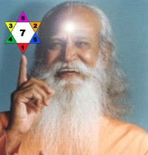
Your first duty is to find the peace in you. If you root yourself in your peace and then lend your hand, you will certainly bring peace. If not, you will only add more and more to the peaceless condition.

Violence cannot stop violence. A war can never really be won by violence alone. The mind must be changed.
A violent victory only means that you have handicapped your enemy. He is still your enemy and the peace is only temporary. You have covered the fire so it doesn't show now, but it is still inside and one day it will flare up again.

When you win a war with your power, your enemy simply retreats and waits for an opportunity to strike back at you. You have won the war but not the heart. Real victory is to win the heart, not just the land or the political power.

Yoga tells you that your own peaceful thoughts will bring results. In the name of Yoga, we try to collect the mind and send out peaceful vibrations. A sincere thought will travel all over the world. It is more than an atomic bomb, it's more than a missile.

Even if you don't believe in God or prayer, sit and say, "Let there be peace. Let the minds of the people who want war be changed." We believe in thought force.
Because it is the very same thought force that creates war. Remember that. It is the human mind that creates all these bombs, all these wars.

If you still want a war, fight it against undesirable thinking, not against a nation of people. And to fight such a war, you have to send out beautiful thoughts. Make every thought a powerful anti missile. Sit quietly and send out powerful peaceful thoughts. I'm not joking - it is possible. Even one minute spent in peace is valuable. Don't think, "When our brothers are dying, how can we sit quietly and think of peace?" This crazy world is, in a way, stabilized because of people sitting for a few minutes in meditation every day. Know that.

Don't ever think that by raising your hand or throwing a bomb or shouting something you can help the situation. Do it in a nonviolent way. Don't hurt anybody, don't hate anybody. As long as you have hatred in your mind, you are unfit to talk of peace.
An excerpt from the book, “Beyond Words”

"By performing Energy Enhancement Advanced Meditational Techniques to dissolve all psychopathic, empathyless, conscienceless energy blockages, we can stop all wars and bring true peace into the heart and mind of every person in this world"
Energy Enhancement Satchidanand
PSYCHOPATHS
"A Psychopath has no conscience due to blockages above the crown chakra. The higher they are, the more consciencelessly psychopathic they are - they have no shame, they can kill without remorse. A Psychopath has no empathy because of the energy blockages in his heart chakra thus he cannot put himself in the shoes of another person, he can not care; He has a screw loose!! Most political leaders and business leaders have these types of blockages - as well as most of humanity. The only question is how many, and how deep? Only Energy Enhancement has the techniques to dissolve them ALL in you!!"
Energy Enhancement Satchidanand

ENERGY ENHANCEMENT
Initiation 4

SUPER ADVANCED KUNDALINI KRIYAS
CONNECTION WITH CHAKRAS ABOVE THE HEAD

CONNECTION WITH THE ANTAHKARANA AND CHAKRAS ABOVE THE HEAD, BY REMOVING THE ENERGY BLOCKAGES ABOVE THE HEAD CREATING CONSCIENCE

The mass often serve the state thus, not as men mainly, but as machines, with their bodies. They are the standing army, and the militia, jailors, constables, posse comitatus, etc. In most cases there is no free excercise whatever of the judgement or of the moral sense, but they put themselves on a level with wood and earth and stones, and wooden men can perhaps be manufactured that will serve the purposes as well. Such command no more respect than men of straw or a lump of dirt. They have the same sort of worth as only horses or dogs. Yet such as these are commonly esteemed good citizens. Others - as most legislators, politicians, ministers, and office holders, - serve the state chiefly with their heads, and, as they rarely make any moral distinctions, they are as likely to serve the Devil, as God. A very few, as heroes, patriots, martyrs, reformers in the great sense, and men, serve the State with their consciences also, and so necessarily resist it for the most part, and they are commonly treated as enemies by it. - Henry David Thoreau

ENERGY ENHANCEMENT
Initiation 4

SUPER ADVANCED KUNDALINI KRIYAS
CONNECTION WITH CHAKRAS ABOVE THE HEAD
ENERGY ENHANCEMENT AND HIGH TANTRA
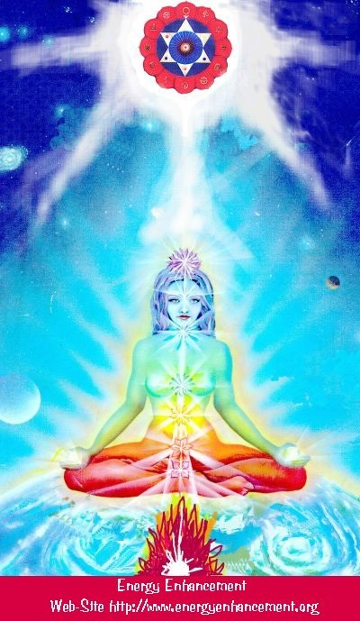WHAT IS HIGH TANTRA?

TANTRA IS ONE OF THE MANY PATHS WHOSE AIM OR END OR PURPOSE IS ENLIGHTENMENT
Like Yoga which means Union with the center of the Universe or with God, Tantra is any path which achieves that aim.
For many, Tantra is a sexual means of achieving that union. People ask me, isn't one of the methods to make love only once per month? To increase the length of time we make love to hours?
Well, I reply, Enlightenment comes from the increase of energy. Human beings only have a small amount of energy within themselves. Really to increase that energy we need to access the energy from chakras outside the body. It is like we have a computer which is running slowly on only five volts. We need to plug ourselves into the big generator!
To obtain thousands of volts of power in order to make the computer work more quickly at a much higher level we need to plug ourselves into the chakras above the Crown Chakra, into energy in the central spiritual sun!! The Soul!! God!!!
And in the center of the Earth is the Kundalini Shakti flowing out in every direction from the Atomic Generator which powers this planet. The atomic pile in the center of the planet is a 5000 degrees centigrade and provides the energy which keeps this planet alive and at the correct temperature. The Earth is feminine. The Indians say, "Our Mother, the Earth" and our Father, who art in Heaven is God, the energy in the center of the universe. And when all the Energy Blockages to that connection have been removed, then there is a flow, a waterfall of spiritual energy which powers every one of the enlightened.
Then we have Shiva, our father, combining with Shakti our mother. Then we have Hercules, son of God, Zeus, Theos, Deos, combining with the daughter of Pluto, King of the Underworld.
Enlightenment concerns The Holy Trinity and is composed of Sat, the truth of the center of the Universe combining with Chitta - the holy grail, the cup of the mind on this planet, empty and ready to receive the libation of the Gods, and the flow of energy between the two is called Ananda, or bliss -
Satchitananda like the Father - Our Father who art in Heaven, the Son and the Holy Spirit which flows between the two.
And the Hindus have a word for the channel between the Center of the Universe and the Center of the Earth. Rapunzel, Rapunzel, let down your hair. The Rainbow Bridge. The Tower of Babel. Tower of Connection created out of mental matter to channel the energies of God through all the infinite chakras of existence, powering the whole universe from the center. This is the Antahkarana.
If you are not connected with, if you are blocked from, the center of the universe then just think of a small flow of water slowly filling a bucket. You may well have to wait a month for the bucket to fill. Only then will you have sufficient energy to enjoy making love, or really doing any of the thousand things we have to do on this planet. But if you are connected and put your bucket under a waterfall, then that bucket will fill in seconds. You will have infinite energy to do with whatever you want every second of the day.
The Greeks had a name for this energy which descends from the soul to power the Mind Computer, and they called it Genius which is the what happens to the mind computer powered by the energy of the Soul. Soul Infused.
The Mind is of the intellect of logic yet the Soul is Intuition, Knowing, Wisdom and is much higher than the mind.
The Kashmir Shaivites also have the energy of Chit Shakti whereby the mind is also powered by the Energy in the Center of the earth.
In reality, human beings are powered by both masculine and feminine energies. We connect with the Kundalini Chakra in the center of the earth by means of the Base chakra, and we connect with the center of the universe by means of the Crown Chakra.
Usually it takes three days for the students who come on our courses to access this energy with which they can successfully transmute all their Energy Blockages because another, more easy way for people to absorb energy is from the Buddhafield, the Aura of the Master.
When they leave then sometimes the energy drains away, because it is the energy blockages which create

the holes in the bucket through which all the water drains away.
And this is Tantra, the Energy Flow of the Soul created by the Sexual Union of Shiva and Shakti.
In that that bliss, that delight, such an overflowing cornucopia of Energy which comes from the Gaining of Energy and the Removal of Energy Blockages, we find only Enlightenment.
In a way, Enlightenment is a twenty-four hour a day orgasm.

ENERGY ENHANCEMENT
Initiation 5

SUPER ADVANCED KUNDALINI KRIYAS

ENERGY ENHANCEMENT
Initiation 5
SUPER ADVANCED KUNDALINI KRIYAS
THE PROJECTION OF ENERGY
LEARNING TO REMOVE ENERGY BLOCKAGES GROUNDING THE TOXINS IN FOOD
The Projection of Energy was learnt by Satchidanand and Devi Dhyani from a 72 year old student of Gurdjieff in India. This Energy Enhancement Technique is also one of the more advanced Gurdjieffian Techniques as given in his Third series of Teachings "Life is Real. Only Then. When I AM!"
"First Mastic. Then Mystic.” said Gurdjieff.
And it is the way in which the Master Gurdjieff managed to overcome the Food and Alcohol he put away. By eating heavy food, smoking and drinking, as a lot of Zen Masters do, he symbolised his ability to Transmute and to Earth. He was trying to say, if I can do this to the food I eat, then I can do the same for you.
This symbolises the transmutative effect of a Master.

THE REMOVAL OF
TOXINS
BUT WITH THIS ANCIENT ENERGY ENHANCEMENT TECHNIQUE, YOU TOO CAN LEARN HOW TO GROUND THE TOXINS IN THE FOOD YOU EAT AND TOO REMOVE YOUR ENERGY BLOCKAGES!!
Remember, the Sufis say "Bringing an unformed man into the presence of the wise, is like throwing a dead dog into a pool of Rose water!"
It is necessary to receive the help of a Master to purify yourself and to gain higher frequencies of Energy to grow the Body Kesdjian or the Psychic Bodies, but the student must take an equal responsibility of desiring to be helped, symbolised by learning and practising how to do it for themselves.
They may not be able to do this very much at first but the effort "for a long time, without break and with enthusiasm" is that which is prescribed in the Yoga Sutras of Patanjali.
Learning how to improve your Earth is the basis of what these next Initiations are about. Roshi Hogen, one of my enlightened Masters, was pleased when his students brought him A bottle of Guinness or Red Pepper Pickle even though he always recommended Organic vegetarian food.
"Even though, as a Buddhist Monk, I have to follow 33,000 rules, I have to come to prove to you that we are all Infinitely FREE!!" Master Roshi Hogen
Hogen hoped they had grown to understand that they were offering all their internal emotional negativity as a sacrifice at his feet. He could help to Transmute all

the Negative Energy his students brought to him. That is the necessary function of a Master. Guru means that which changes darkness into light. Learning how to do this and improving the ability to Ground using the physical example of our Food and Air is what we now continue to do:
Practise makes Perfect.
In this Initiation we learn to use energy to heal ourselves.
The Cleaning of the Base Chakra is, on the Physical Level, The Removal of Toxins The start of the Creation of IMMORTALITY!
Toxins are one of the major causes of diseases like Cancer and Heart failure. In modern Britain 30% of all people die from Cancer, the next 25% of all people Die from Heart Disease. These statistics are increasing year by year as pollution in food, water and air increases.
One in Two die from pollution!
For this Reason, like Zen Master Hogen, we at Energy Enhancement recommend only Organic Food as your normal Diet. As we invest our money in the production of Organic Food by buying it, so it will become more plentiful and less expensive.
Think of it as a sound investment in your health.
In the Lord of the Rings, Tolkien wrote that Orcs were made by the Black Magician, Sauron, from the Elves, "Tortured and Polluted."
POLLUTION IS THE UGLY PILL WHICH TURNS YOU INTO AN ORC!!
THE USE OF ENERGY ENHANCEMENT APPRENTICE LEVEL ONE INITIATION FIVE TO TRANSMUTE TOXINS
Energy Enhancement recommends the use of Healthy Non-Pesticided, Vegetarian - no meat or fish, Food and no nitrate mineral water.
PURITY AND LIGHTNESS LEAD TO LONG LIFE AND ENLIGHTENMENT
IMPURITIES CREATE HEART DISEASE AND CANCER AND TURN YOU INTO AN ORC!!
In Tolkien, The Lord of the Rings, where each of the Rings is a powerful symbol of a Chakra, one of the energetic centers within a human being, one of the 15 parallel processors of the mind, only one of which is intellectual, he says:
"One Ring to Rule them all and in the Darkness Bind Them." The only way to control these energy centers is by throwing the One controlling Ring to the bottom of a deep volcano as we do in The Grounding of Negative Energies...
Energy Enhancement APPRENTICE LEVEL Five shows you how to remain Young and Active all your life by giving you Power over Toxins.
It shows you how to know if food is toxic before you eat it.
It gives you the power to get rid of the toxins you have already eaten, quickly and easily.
Toxins in our food and in our Environment are one of the major causes of cellulite, obesity, scaly skin, tooth loss, baldness and hair loss in both men and women. If we have not got enough energy to excrete toxins from our bodies immediately, the body stores the toxins in places which will not immediately kill you.
In fat cells causing the brown fat of cellulite and obesity. The Orangepeel effect which is very difficult to get rid of.
In the hair and nails. As the nails take up the toxins they split and break. Hair diagnosis is a standard way of finding out which toxins you are storing. As the hair becomes filled with Toxins it becomes unhealthy. It Loses its shine. It becomes dry and unmanageable. We constantly need to feed it conditioner. Eventually we give up and cut it short. But healthy shining hair shows the health of the body and is very attractive. The hair fills up with toxins from the tip to the root, when it reaches the root, the hair falls out!
Bad breath is caused by the body excreting high level toxins from the mouth. Tongue scrapers and body scrapers have been found in Turkish and Roman baths for thousands of years. Bad breath, smelly armpits and smelly feet show the quality of the diet. Pure, sweet

smelling saliva shows the purity of your diet. Toxins in the mouth over many years cause tooth decay.
Toxins like pesticides are also a major cause of Low Birthrate in many Countries, dificulties in becoming pregnant, premature abortion and menopause, low energy, spots and pimples, Osteoporosis, Arthritis, ME, Multiple Sclerosis, Meningitis, Altsheimers Disease, Senile Dementia, BSE and Gulf War Syndrome.
The age at which we catch these horrible diseases is coming down as Toxins in the environment increase.
Toxins in the Environment are one of the major causes of disease and death all over the world.
THE REMOVAL OF TOXINS
All Cancer is Caused by Chemical POLLUTION
Some people, genetically, are more sensitive to Xeno- Estrogenous Chemicals like Pesticides - DDT and the Organophosphates, like Pthalates leeching from the solder in tin cans, or plasticisers like the common chemical nonyl phenol.

Like Dioxins, the unchangeable products of Incineration.

In this Initiation we also learn how to get more Energy from Heart Healing, Grounding the Negative Energies of the Air we Breathe.

FUCTORIES POLLUTE ALL THE AIR OF THE WORLD
Pollution, toxins in our food, come from bacteria, heavy metals like lead and aluminium, also from Toxic chemicals like those which mimic the Hormone Oestrogen, Xeno-Oestrogens are 3000 chemicals acknowledged to be highly cancerous by all scientists.
Common chemicals which act exponentially more poisonous in concert.

ENERGY ENHANCEMENT
Initiation 5

SUPER ADVANCED KUNDALINI KRIYAS

50% of toxins get into the body from the air we breathe from the hundreds of Incinerators which gather in Hospitals and Universities throughout the world, burning Industrial waste from all the major cities. Also council rubbish which could be recycled instead. Thus meningitis for students at university and Flu for everyone else.
"Small" incinerators now have almost no controls. Small incinerators are defined as those burning only one ton an hour – almost 10,000 tons a year! Many of them are being built, particularly in Hospitals and then run by a private company bringing in industrial waste from all over the world, so that instead of one point source, now no matter where the wind comes from, it is poisonous.
Rubbish is shipped in to Incinerators from hundreds of miles away because it is not economically viable to run an incinerator at less than capacity. From the whole of Europe to Southampton and Bournemouth. From Athens to the INCINERATOR at beautiful and once unspoilt island of Santorini.
Now the cities are all exporting their pollution to the Tourist centers and to the countryside.

"We only go on Holiday for a change of Pollution!"
Large incinerators are so highly controlled that no company can afford to build them but the "small" ones have no controls at all, they can even burn plutonium in them and no-one would know.
Toxins in our bodies are eliminated quickly by Colds and Flu. If they are not eliminated then we can get Cancer or Heart Disease or Multiple Sclerosis or M.E.
Incinerators produce kilograms of Xeno-Oestrogens like Dioxins which can kill in doses as small as one millionth of a gram, which is more toxic than Plutonium. They pollute the air and all the land they spew out over.
The Fallout from Incinerators is toxic. Food grown in that land whether organic or not will be Toxic!
Industrial Oil is now burnt in power stations and diesel engines. Special Companies now create worse oil from the industrial oil by putting dangerous toxins in it so that these toxins can be burnt. It has been proved that cancer and heart disease increase for 40 miles around the power stations, ceramic factories etc which use this polluted oil as fuel.
Badly refined petrol creates exhaust from Cars.
All of this Air Pollution causes the 15% rate of Asthma in modern Society.
When we know. When we have direct knowledge of our environment we can then make strong efforts to improve our food and air quality which can vastly increase our Energy, save us from debilitating disease and even save our lives.
These Energy Enhancement techniques can teach us how to dissipate these toxins from our bodies from all the food we have ever eaten and from all the air we have ever breathed.
Energy Enhancement Initiation Five shows you how to remain Young and Active all your life by giving you Power over Toxins.
After all that, THE USE OF ENERGY ENHANCEMENT APPRENTICE LEVEL ONE INITIATION FIVE, - Energy
Enhancement recommends the use of Healthy Non- Pesticided, Vegetarian - no meat or fish, Food and no nitrate mineral water.
PURITY AND LIGHTNESS LEAD TO LONG LIFE AND ENLIGHTENMENT
IMPURITIES TURN YOU INTO AN ORC!!
ENERGY ENHANCEMENT
Initiation 6
SUPER ADVANCED KUNDALINI KRIYAS
Psychic Protections and the Third Law of Thermodynamics
Energy Blockages tend to move from one person to another according to the Third Law of Thermodynamics
- Energy flows from areas of high concentration to low concentration. This means...
- Positive energy flows from Saints at a high energy level into people of low levels, thus raising them up and making them higher. Another byproduct is that Blockages tend to get thrown out by this raising of energies and in the process making their blockages really upset. Thus the attributes of Kundalini Energy. A feeling of Awe and Fear or Anger. Shaking and heat and cold in the presence of the Enlightened.
- The Blockages of the unenlightened flow into the enlightened - and ito YOU!!! Negative energy flows from High concentrations to low concentrations. So, if you hang around people with blockages, they will percolate into you!!
"Bringing an unformed man into the presence of the wise is like throwing a dead dog into a pool of rosewater." Sufi saying. This has the effect of healing the people who come into the presence of the wise, but unless they are coming to learn, rather than being just curious, the unenlightened will soon come back to their previous state.
Thus, protection is very necessary to prevent Energy Enhancement students from picking up the blockages

of others, giving out too much spiritual energy or receiving too much positive energy, except when they want to....

ENERGY ENHANCEMENT
Initiation 6

SUPER ADVANCED KUNDALINI KRIYAS
Psychic Protections
  - The Spiral of protection
How to further increase the connection with the Universal Energy Source, and the spiral flow of Energy throughout our Energy System so that we can use this connection to further cleanse all the psychic bodies and to increase the energy from all previous Initiations.
b. The Power Towers and the CIRCLE of protection
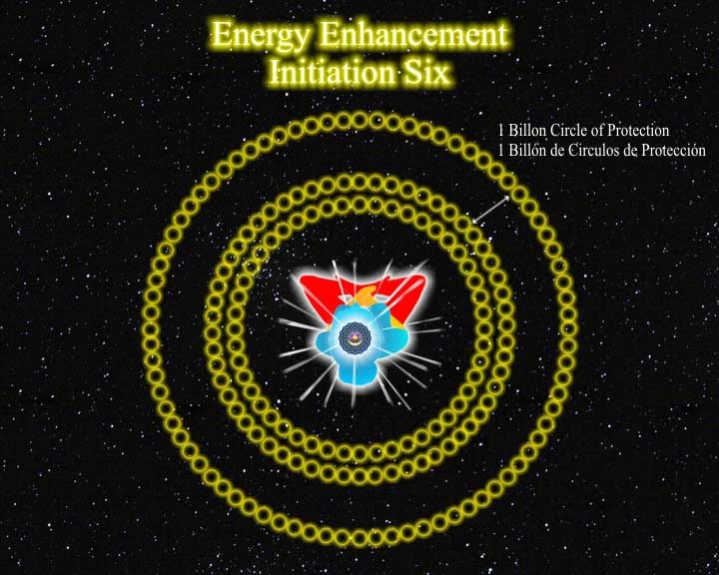
How to learn higher methods of energy protection for yourself and every thing around you. Also, as your energy increases, so you will start to affect everything around you.
These Energy Enhancement Protection techniques show you how to create a "ring pass not" of energy
around you so that you can learn how not to waste your energy unnecessarily. So that you will not affect other people unless you want to, and you will not be so affected by the negative energies around you.
It protects the people around you from unintentionally being exposed to your energy of change. With Energy Enhancement Techniques increasing your energies, you could start to affect the people around you. This shows you how to protect them from your evolutionary energy.

ENERGY ENHANCEMENT
Initiation 7

SUPER ADVANCED KUNDALINI KRIYAS
Psychic Protections

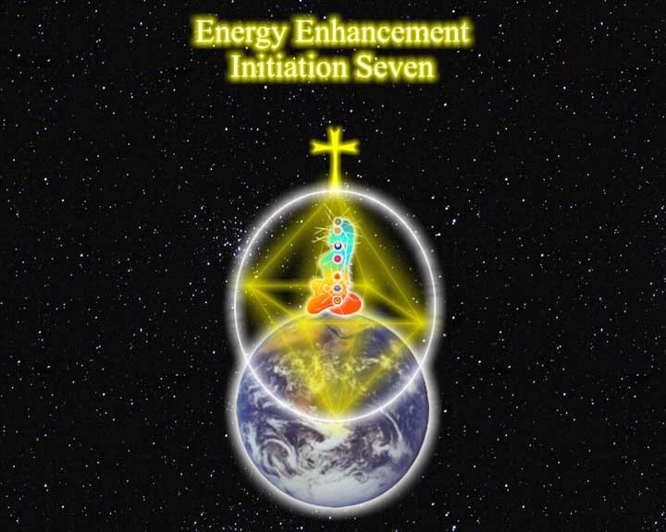

PYRAMID PROTECTION
Energy Blockages tend to move from one person to another according to the Third Law of Thermodynamics
- Energy flows from areas of high concentration to low concentration. This means...

- Positive energy flows from Saints at a high energy level into people of low levels, thus raising them up and making them higher. Another byproduct is that Blockages tend to get thrown out by this raising of energies and in the process making their blockages really upset. Thus the attributes of Kundalini Energy. A feeling of Awe and Fear or Anger. Shaking and heat and cold in the presence of the Enlightened.
- The Blockages of the unenlightened flow into the enlightened. Negative energy flows from High concentrations to low concentrations. "Bringing an unformed man into the presence of the wise is like throwing a dead dog into a pool of rosewater." Sufi saying. This has the effect of healing the people who come into the presence of the wise, but unless they are coming to learn, rather than being just curious, the unenlightened will soon come back to their previous state.
Thus, protection is very necessary to prevent Energy Enhancement students from picking up the blockages of others, giving out too much spiritual energy or receiving too much positive energy, except when they want to...
How to learn higher methods of energy protection for yourself and every thing around you. Also, as your energy increases, so you will start to affect everything around you.
These Energy Enhancement Protection techniques show you how to create a "ring pass not" of energy around you so that you can learn how not to waste your energy unnecessarily. So that you will not affect other people unless you want to, and you will not be so affected by the negative energies around you.
It protects the people around you from unintentionally being exposed to your energy of change. With Energy Enhancement Techniques increasing your energies, you could start to affect the people around you. This shows you how to protect them from your evolutionary energy.

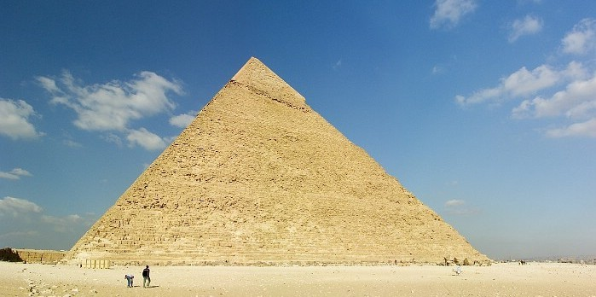
Pyramids are pictorial representations of enlightenment incorporating all the chakras. It is a Traditional Protection, effectively taught on the Energy Enhancement course to raise your energy levels to the Masonic Thirty Third Degree Level of Jesus Christ and above to protect against attack and to protect against losing your energy.

ENERGY ENHANCEMENT
Initiation 8

SUPER ADVANCED KUNDALINI KRIYAS
Psychic Protections
a. The Light Body, Merkaba Meditation Protection This is a highly effective meditation to protect from attack, to Connect you in to the Energies of the Universe and help break all negative ENERGY BLOCKAGES. Here in Energy Enhancement we give it away almost free!!
The Merkaba was invented in Ancient Egypt and has been used by adepts for thousands of years.
The Merkaba axial rotation of intertwined Tetrahedrons, one clockwise and one anticlockwise, sets up a current of energy between the center of the Earth and the Center of the Universe thus activating Axis Mundi - the

Antahkarana and connecting you with an enduring source of energy, genius and intuition. The Soul.
b. INVISIBILITY
THE ZONE ALARM OF PROTECTION
All protections provide a point of attack. As in computers, it is necessary to learn how to be invisible in order to prevent attacks on one.

“Truly, perhaps Enlightenment is next!!”

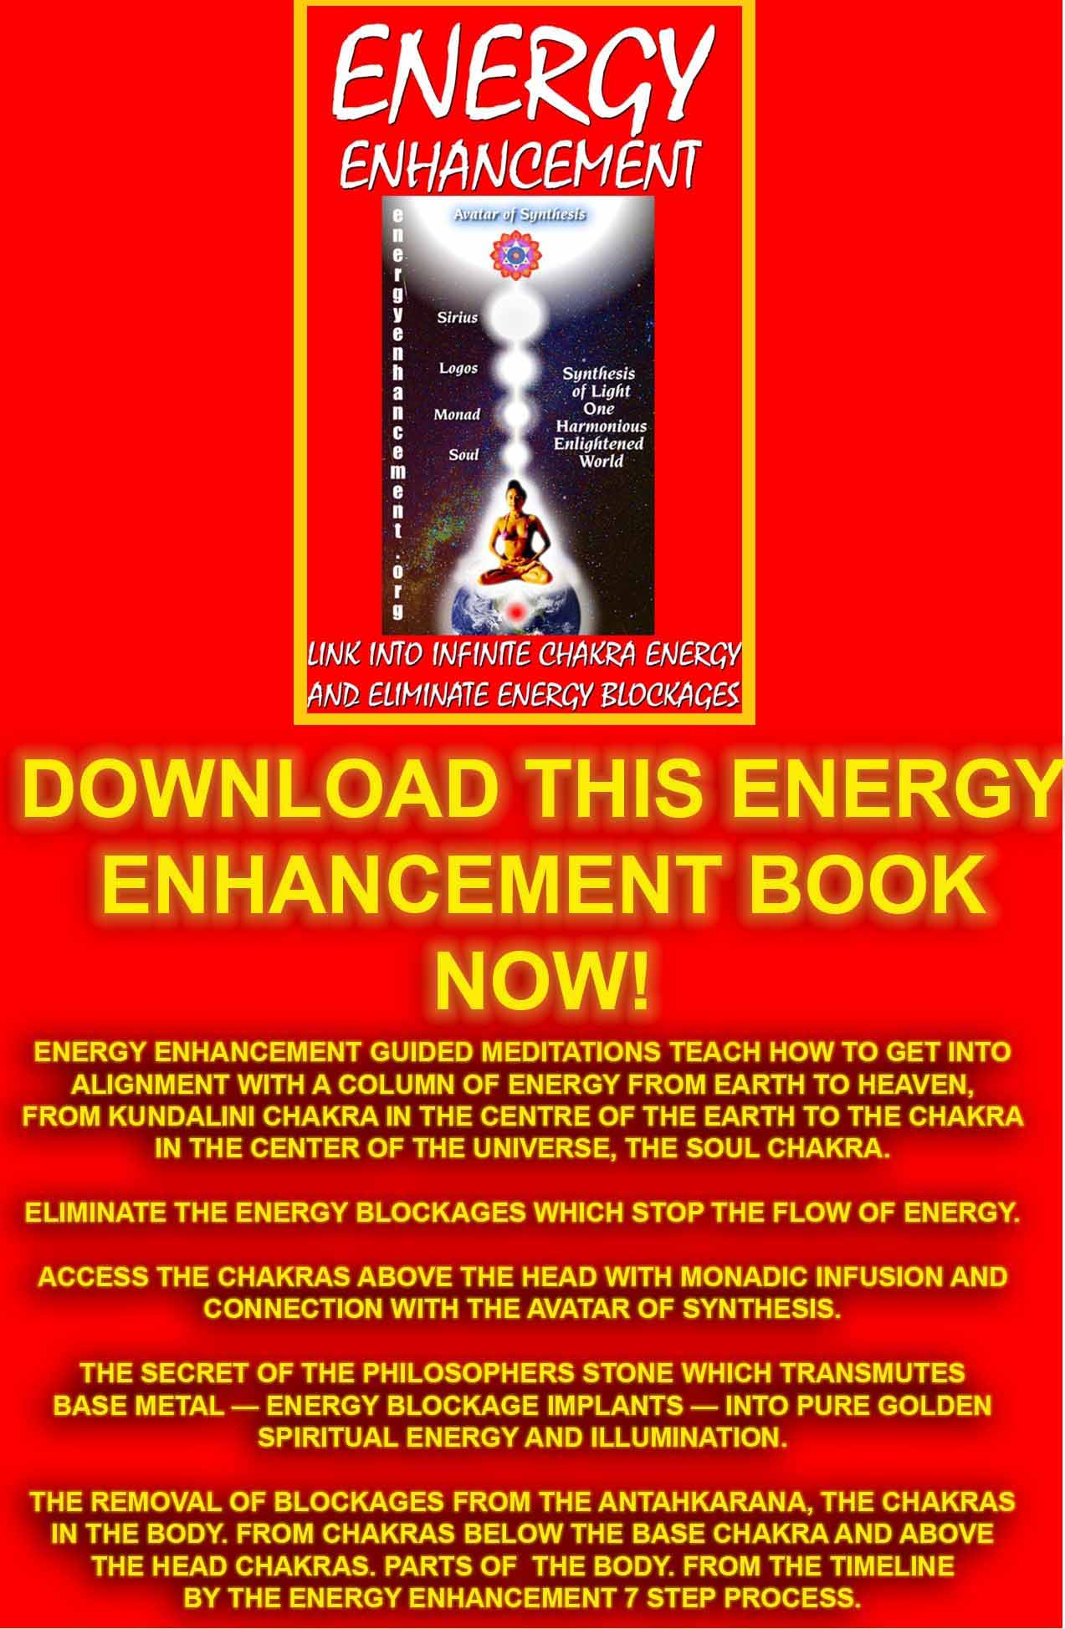
Download “Link Into Infinite Chakra Energy And Eliminate Energy Blockages” Here
http://www.energyenhancement.org/Sacred-Energy/Meditation-Energy-Enhancement-Link-into-Infinite-Chakra-Energies-and-Remove-Energy-Blockages-EEBOOK1Color-energyenhancement-org.pdf
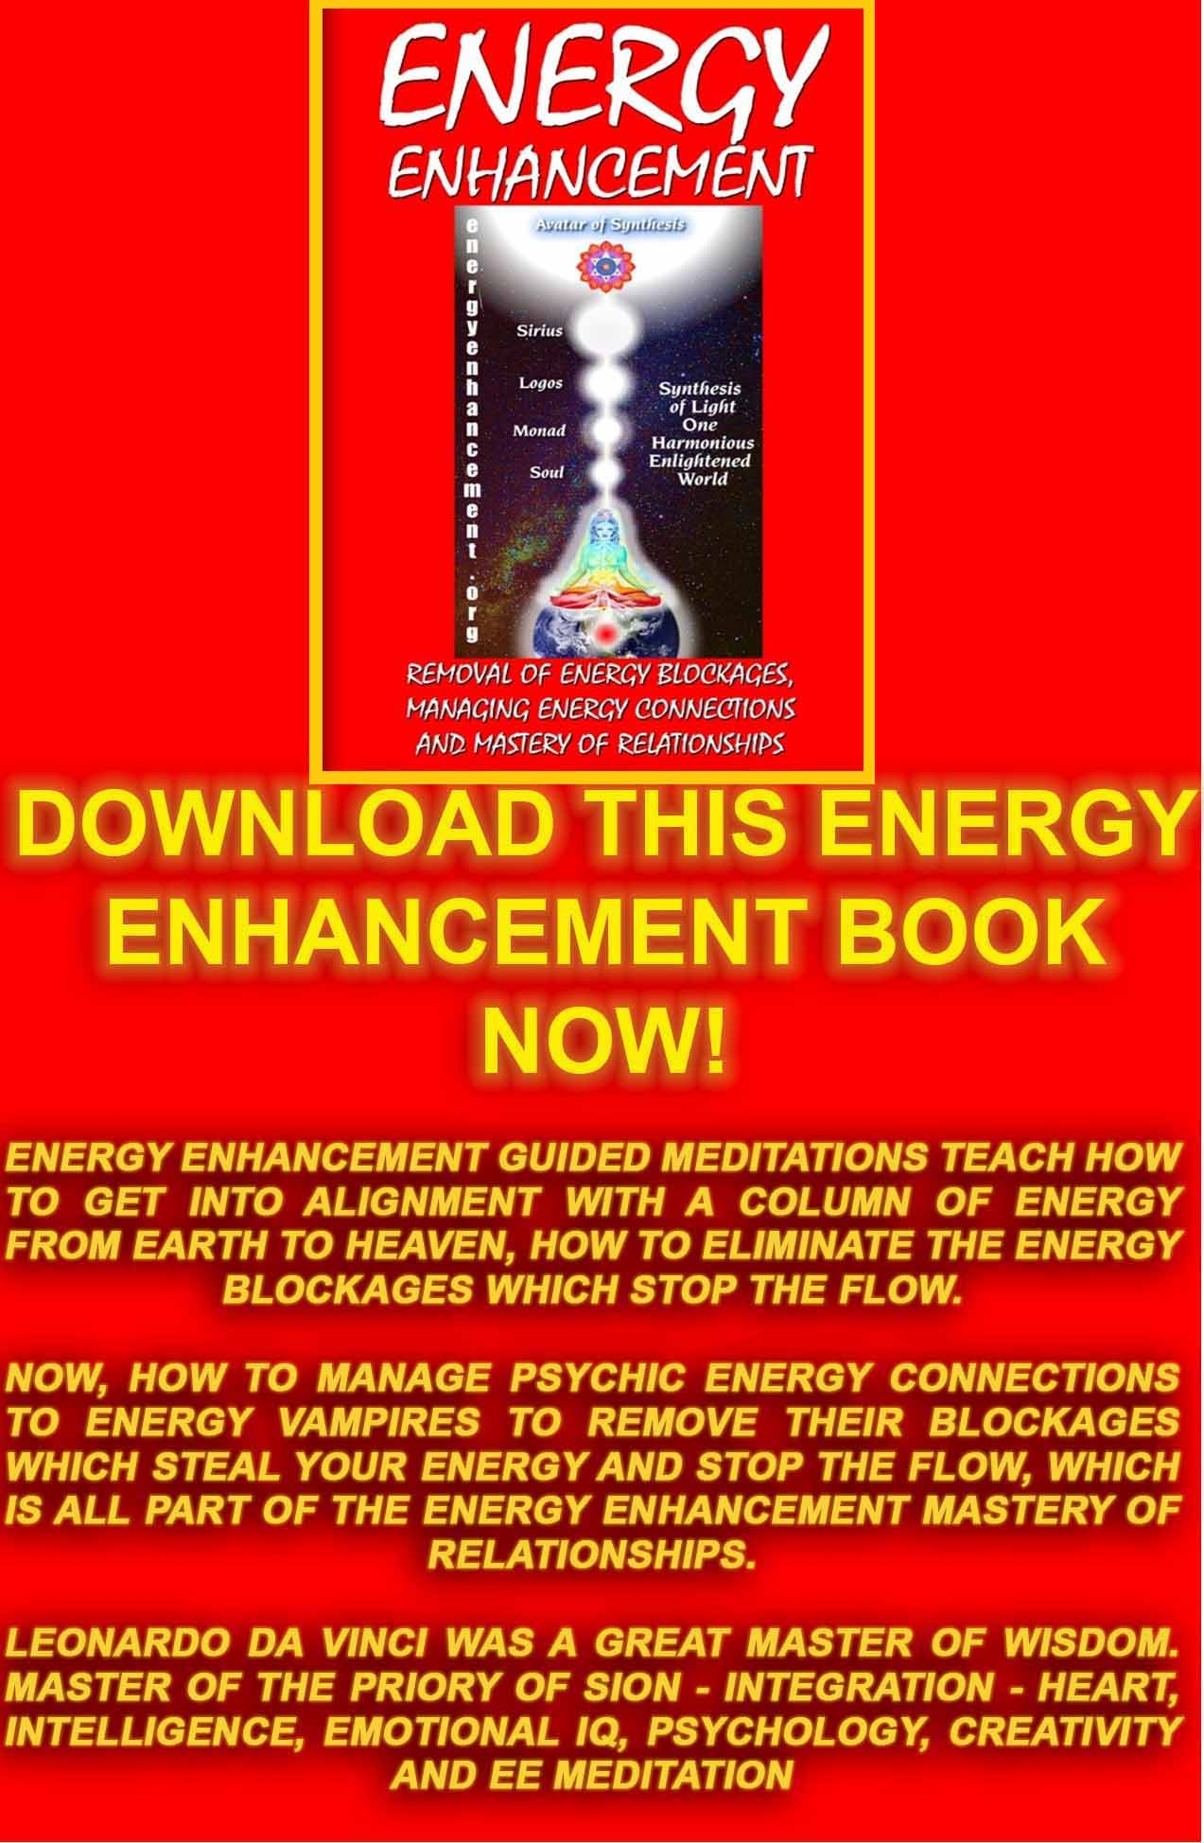
Download “REMOVAL OF ENERGY BLOCKAGES, MANAGING ENERGY CONNECTIONS AND MASTERY OF RELATIONSHIPS” HERE
http://www.energyenhancement.org/Sacred-Energy/Meditation-Energy-Enhancement-Eliminate-Energy-Blockages-Manage-Energy-Connections-and-Attachment-Mastery-of-Relationships-EEBOOK2Color-energyenhancement-org.pdf 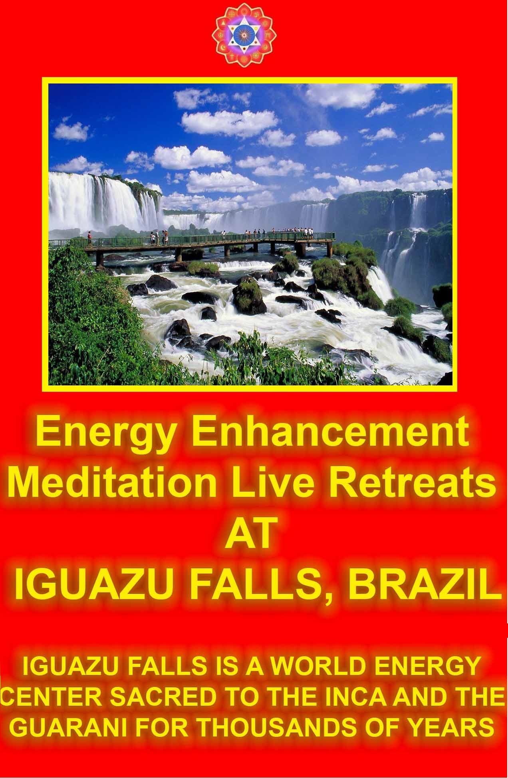
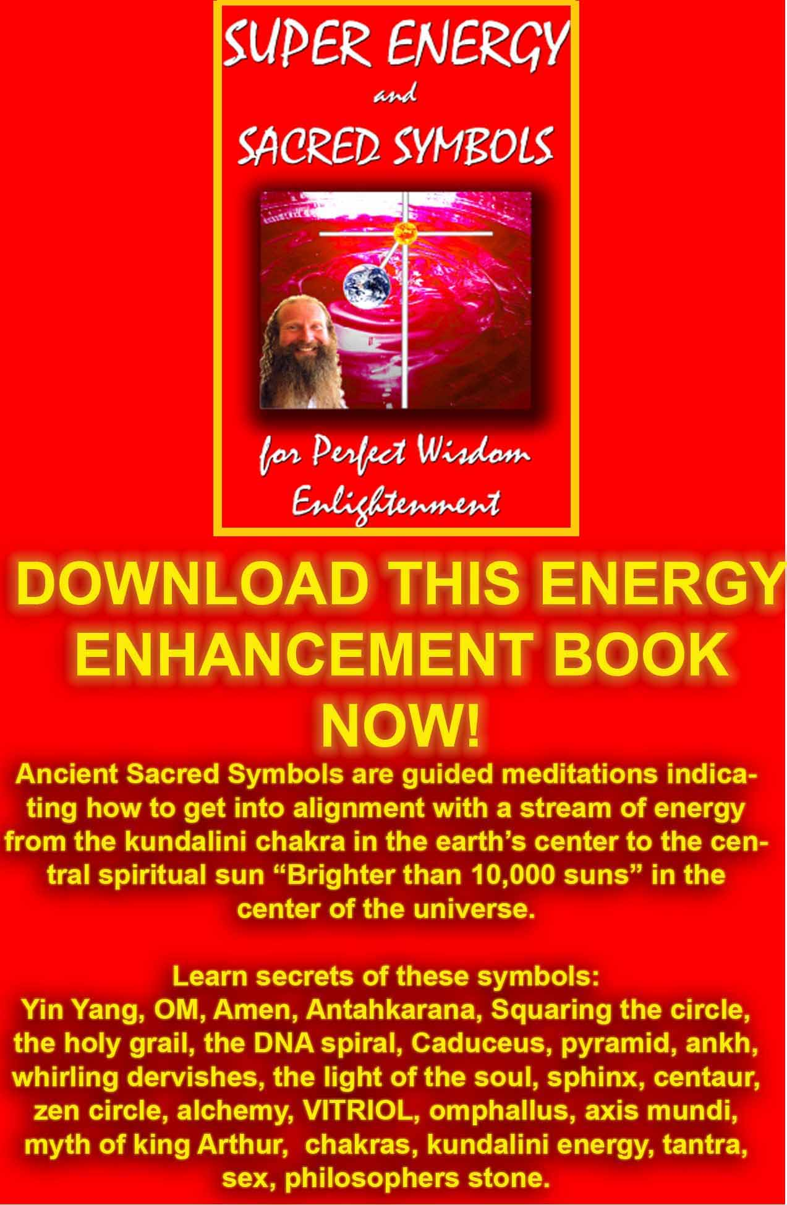
DOWNLOAD SUPER ENERGY AND SACRED SYMBOLS HERE!!!
http://www.energyenhancement.org/Sacred-Energy/Meditation-Super-Energy-And-Sacred-Symbols-for-Perfect-Wisdom-Enlightenment-Color-energyenhancement-org.pdf
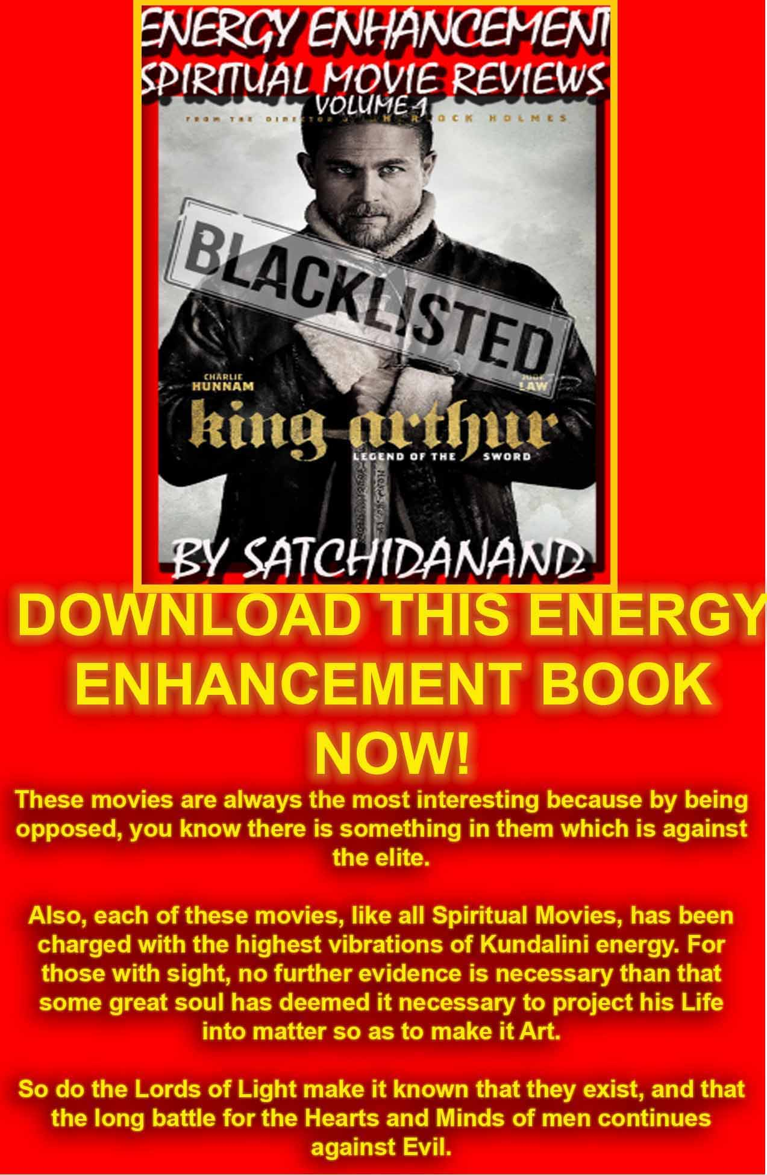
Energy Enhancement Spiritual Movie Reviews Book - Volume 1 by Satchidanand download here..
http://www.energyenhancement.org/Spiritual-Movie-Reviews/Energy-Enhancement-spiritual-esoteric-movie-reviews-by-Satchidanand.pdf
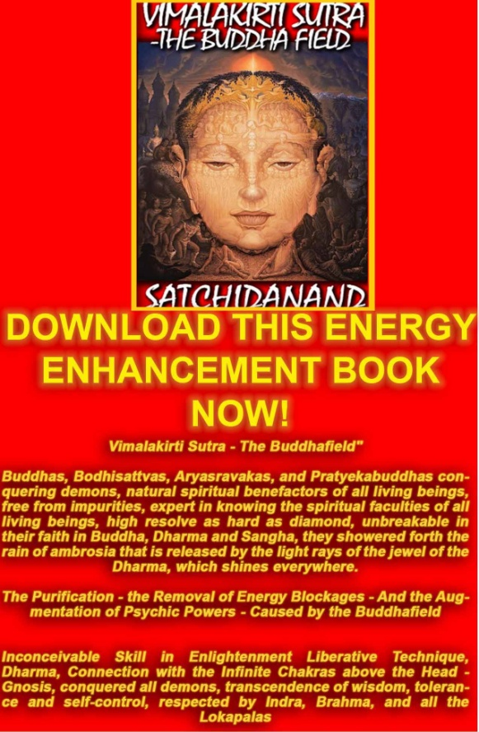
DOWNLOAD BELOW
The Buddhist, "Vimalakirti Sutra" in 14 Chapters - by Satchidanand plus one Chapter - The Buddhist Energy Enhancement Kundalini Key is the Buddhist Stupa http://www.energyenhancement.org/Vimalakirti-Sutra/vimalakirti-sutra.pdf
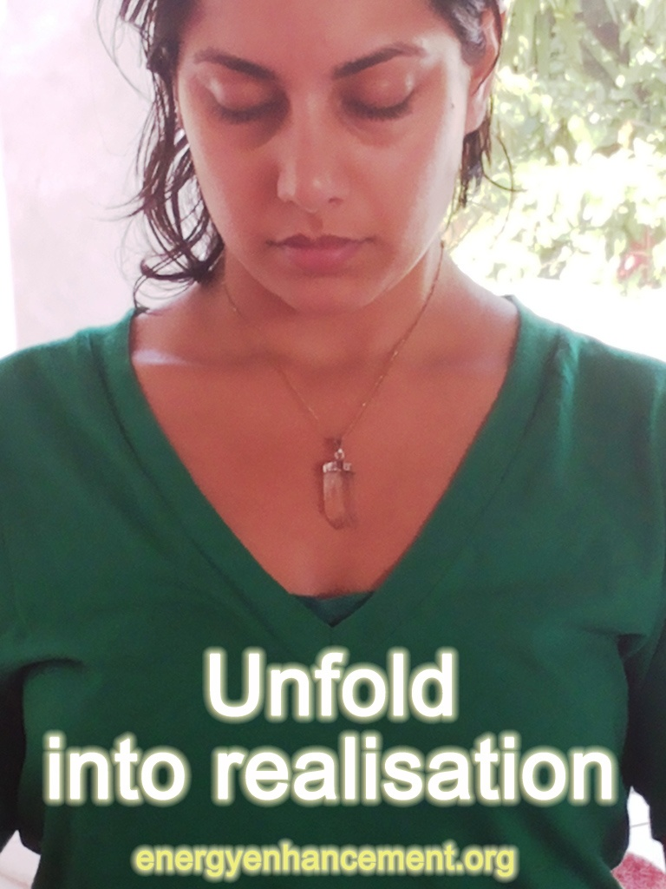
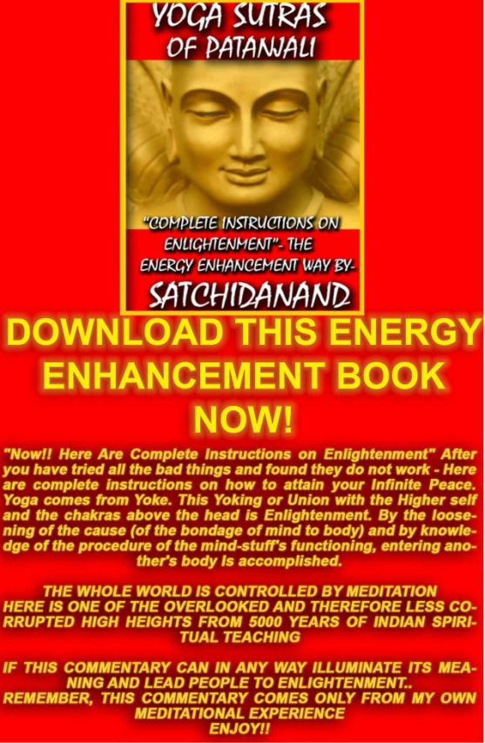
THE YOGA SUTRAS OF PATANJALI BY SWAMI SATCHIDANAND - DOWNLOAD HERE.. http://www.energyenhancement.org/Sacred-Energy/yoga-sutras-of-patanjali-book/Energy-Enhancement-Yoga-Sutras-of-Patanjali.pdf
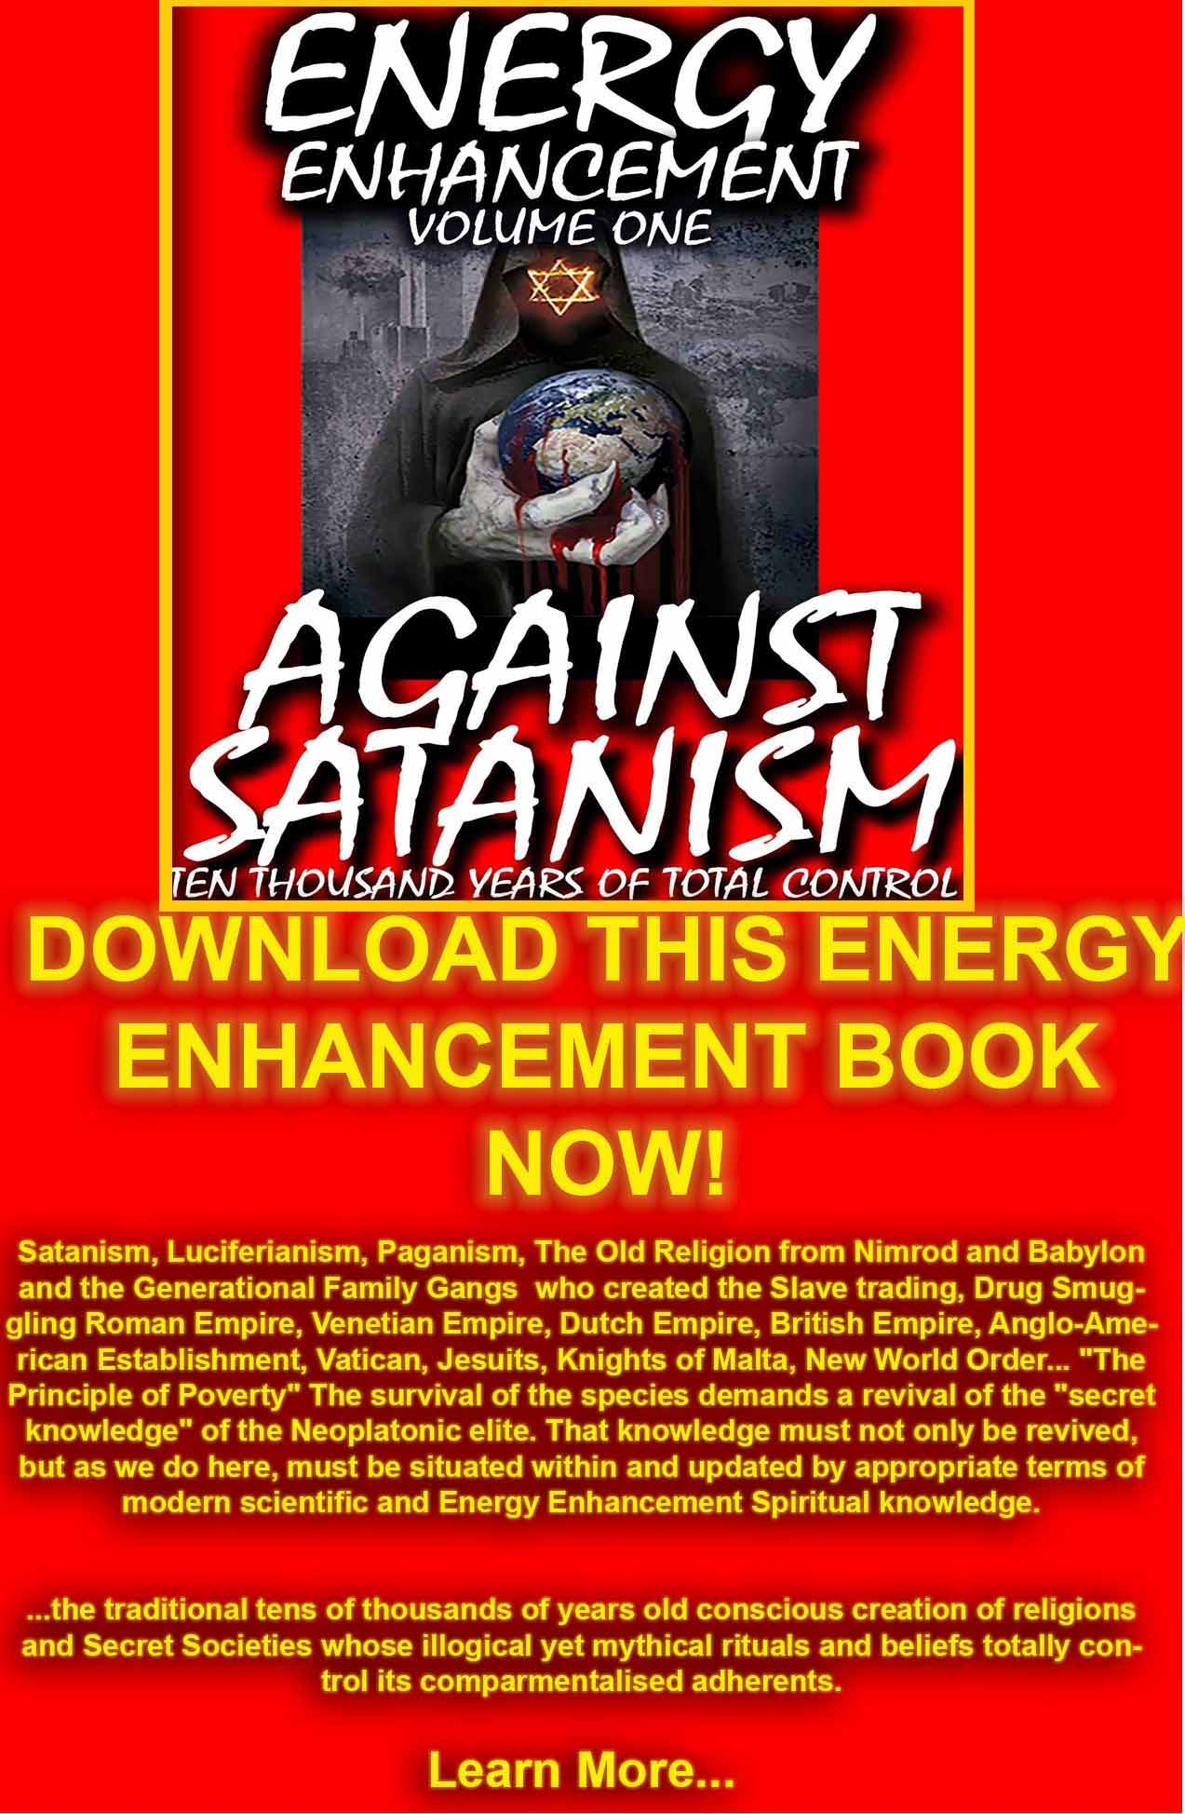
DOWNLOAD AGAINST SATANISM VOLUME ONE HERE
http://www.energyenhancement.org/Against-Satanism/Against-Satanism-Energy-Enhancement-Satanic-History-of-the-World-Volume-1.pdf

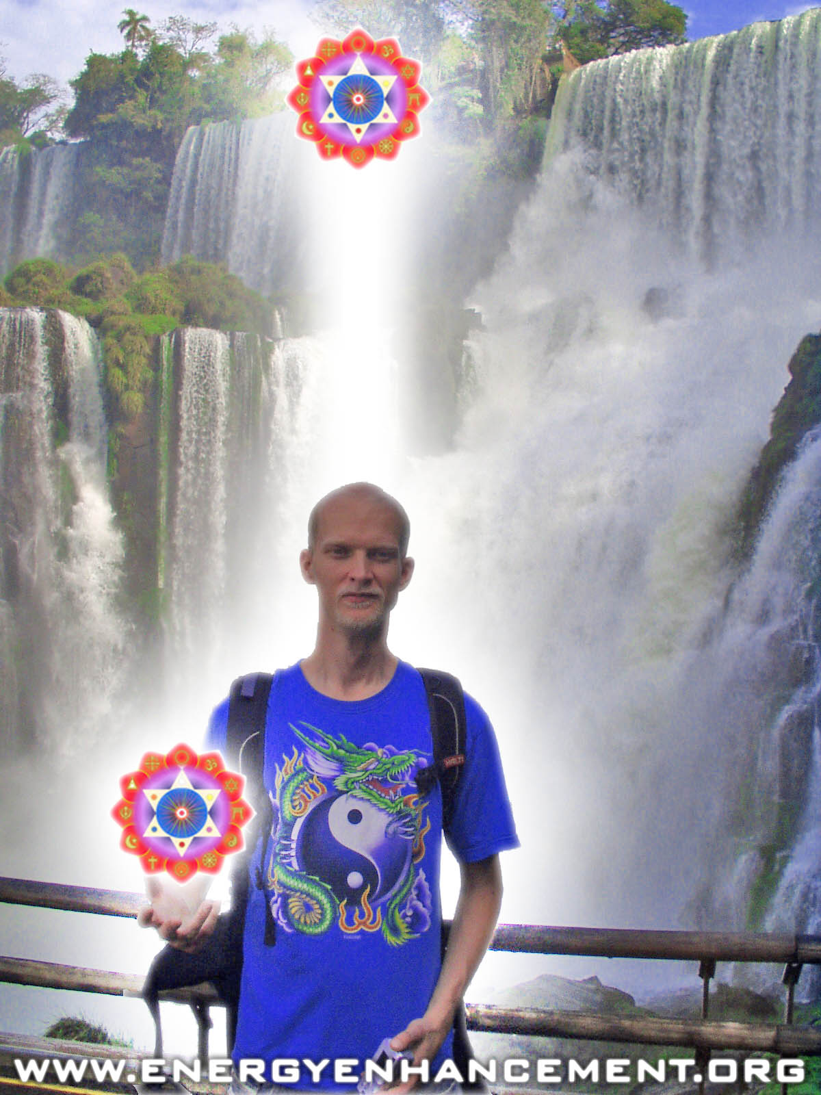

ENERGY ENHANCEMENT COURSE AT IGUAZU FALLS. BRAZIL

"Get your asses over here Now and Speed Up your process of Enlightenment on the Energy Enhancement one month course!!" - DON
Every one of our Students gets this Spiritual Experience of Connection with Infinite Energies.
Energy Enhancement does indeed, "SPEED UP THE PROCESS!!"
And they all get this Experience of Light, Life and Infinite Energy just with the Energy Enhancement Course - Every One of Them!!
LEVEL 1 - 4 VIDEO COURSES ANYTIME IN THE COMFORT OF YOUR OWN HOME

ENERGY ENHANCEMENT IMMORTALITY LIVE COURSES, INDIA AND IGUAZU FALLS

ONLY THE SUPERPOWERS DEVELOPED BY THE SCIENCE OF REAL MEDITATION CAN FREE HUMANITY TO REACH THE STARS.

ENERGY ENHANCEMENT MEDITATION ENLIGHTENMENT AND ILLUMINATION

THE INCREDIBLE MEDITATION COURSE AND MEDITATION TECHNIQUES CREATED TO PRODUCE ENLIGHTENMENT AND ILLUMINATION

"ALL TRADITIONAL MEDITATIONS HAVE BEEN DESIGNED TO FAIL" - SATCHIDANAND -

"BECAUSE ORIGINALLY ALL MEDITATIONS CONTAINED THE TECHNIQUES OF, "THE KUNDALINI KEY" AND OF, "ALCHEMICAL VITRIOL" TO GROUND NEGATIVE ENERGIES AND TO NATURALLY INCREASE KUNDALINI ENERGY"

"NOW, ONLY ENERGY ENHANCEMENT MEDITATION TEACHES THESE TECHNIQUES WHICH SPEED UP THE ENLIGHTENMENT PROCESS"
SATCHIDANAND - IGUAZU FALLS

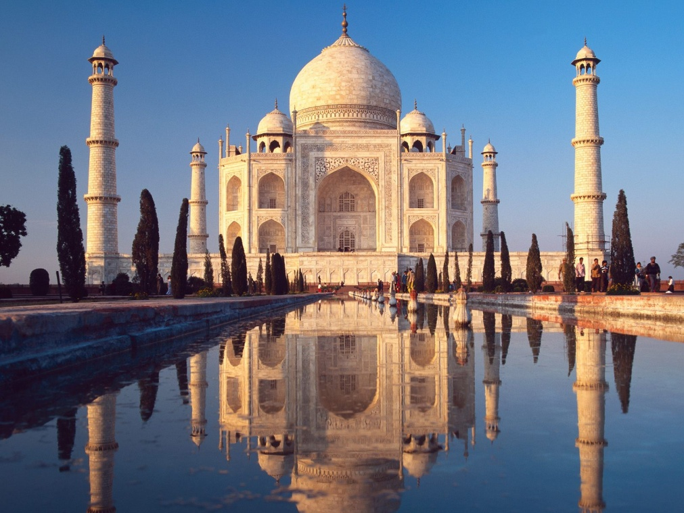

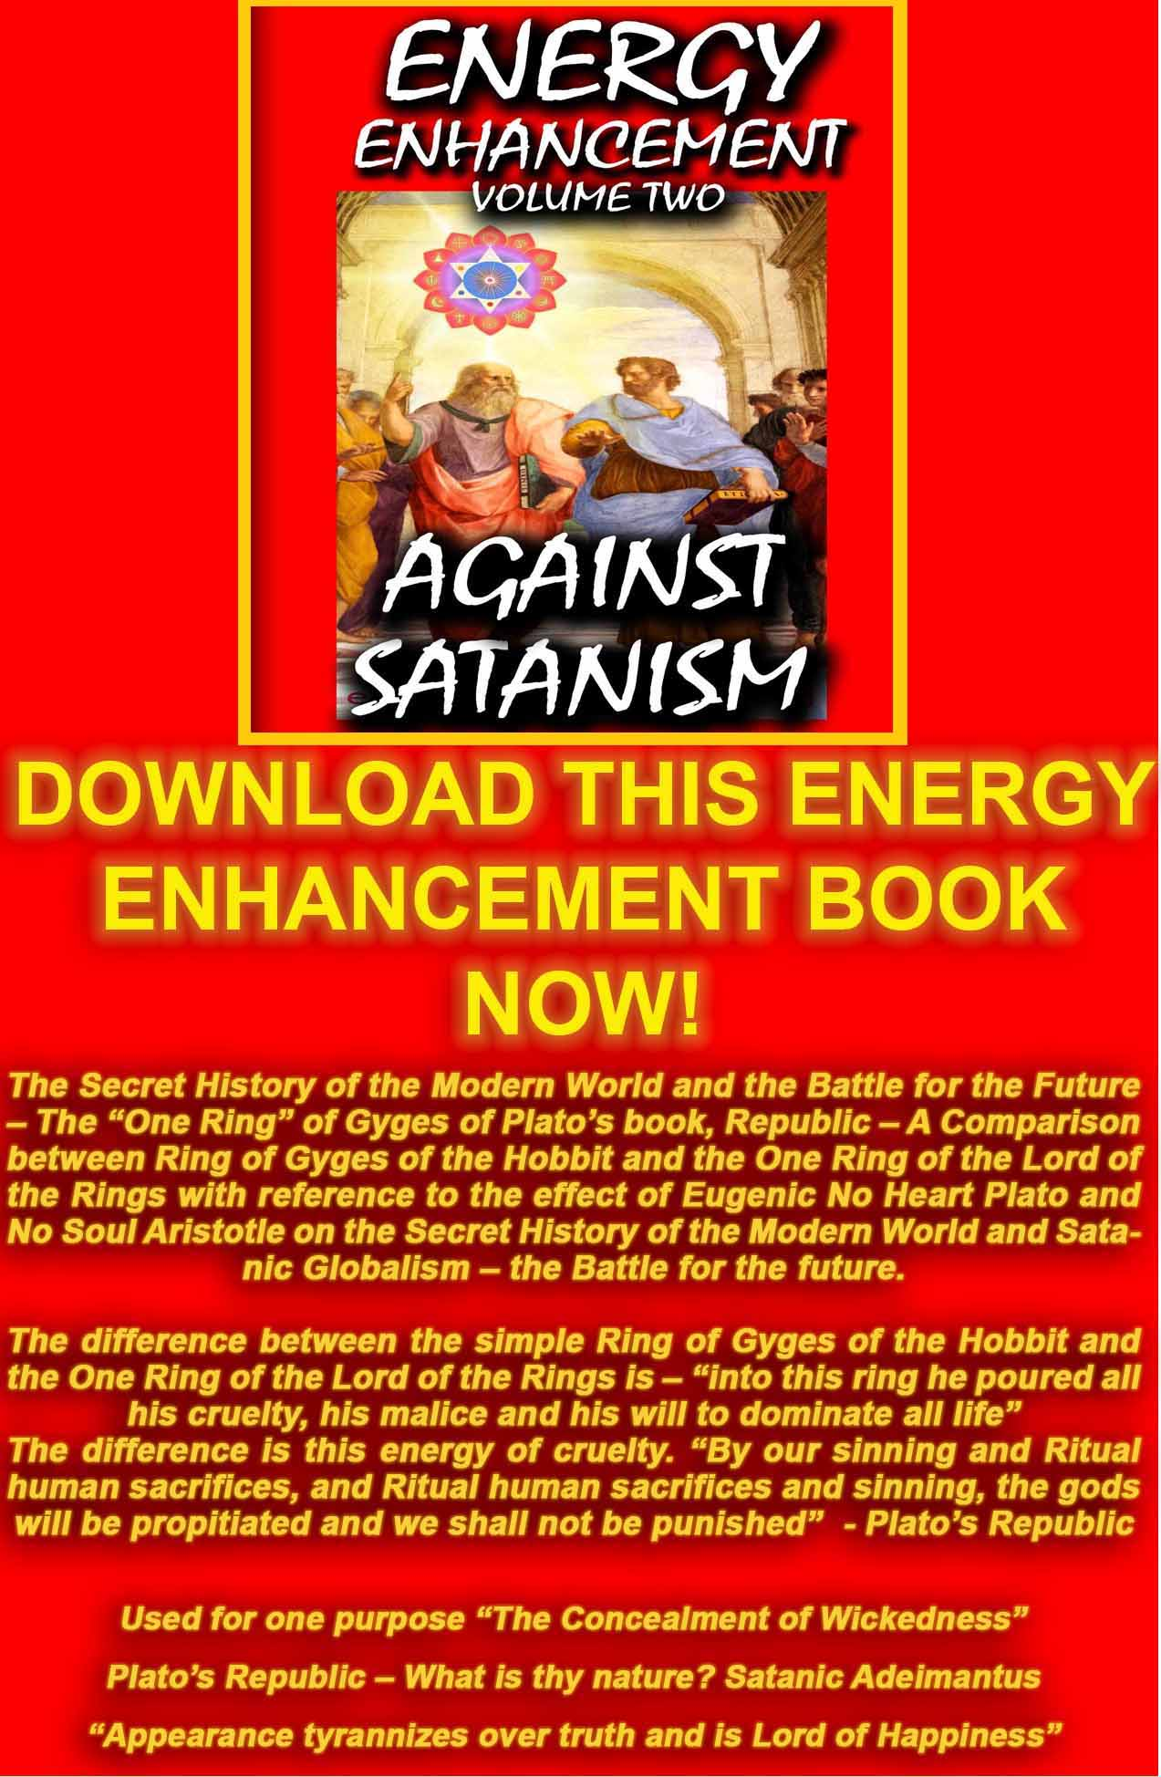
AGAINST SATANISM VOLUME 2
DOWNLOAD HERE
http://www.energyenhancement.org/Sacred-Energy/Against-Satanism-Volume-2/Against-Satanism-Volume-2.pdf

SUPER ENERGY AND SACRED SYMBOLS

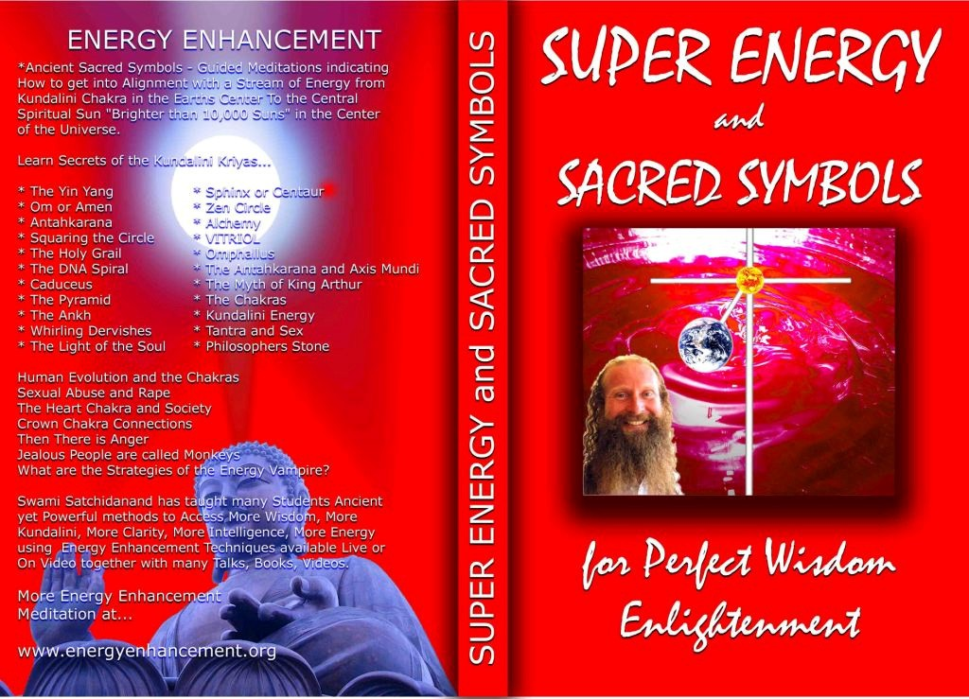

*THE ENERGY ENHANCEMENT BOOK… Ancient Sacred Symbols - Guided Meditations indicating How to get into Alignment with a Stream of Energy from Kundalini Chakra in the Earth’s Center to the Central Spiritual Sun "Brighter than 10,000 Suns" in the Center of the Universe.

Learn Secrets of the Kundalini Kriyas... and more…

Swami Satchidanand has taught many Students Ancient yet Powerful methods to Access More Wisdom, More Kundalini, More Clarity, More Intelligence, More Energy using Energy Enhancement Techniques available Live or On Video together with many Talks, Books, Videos.

DVD 1 - KUNDALINI CHAKRA MEDITATION

AND HEART SUTRA – HIGHEST HEART OF WISDOM MEDITATION

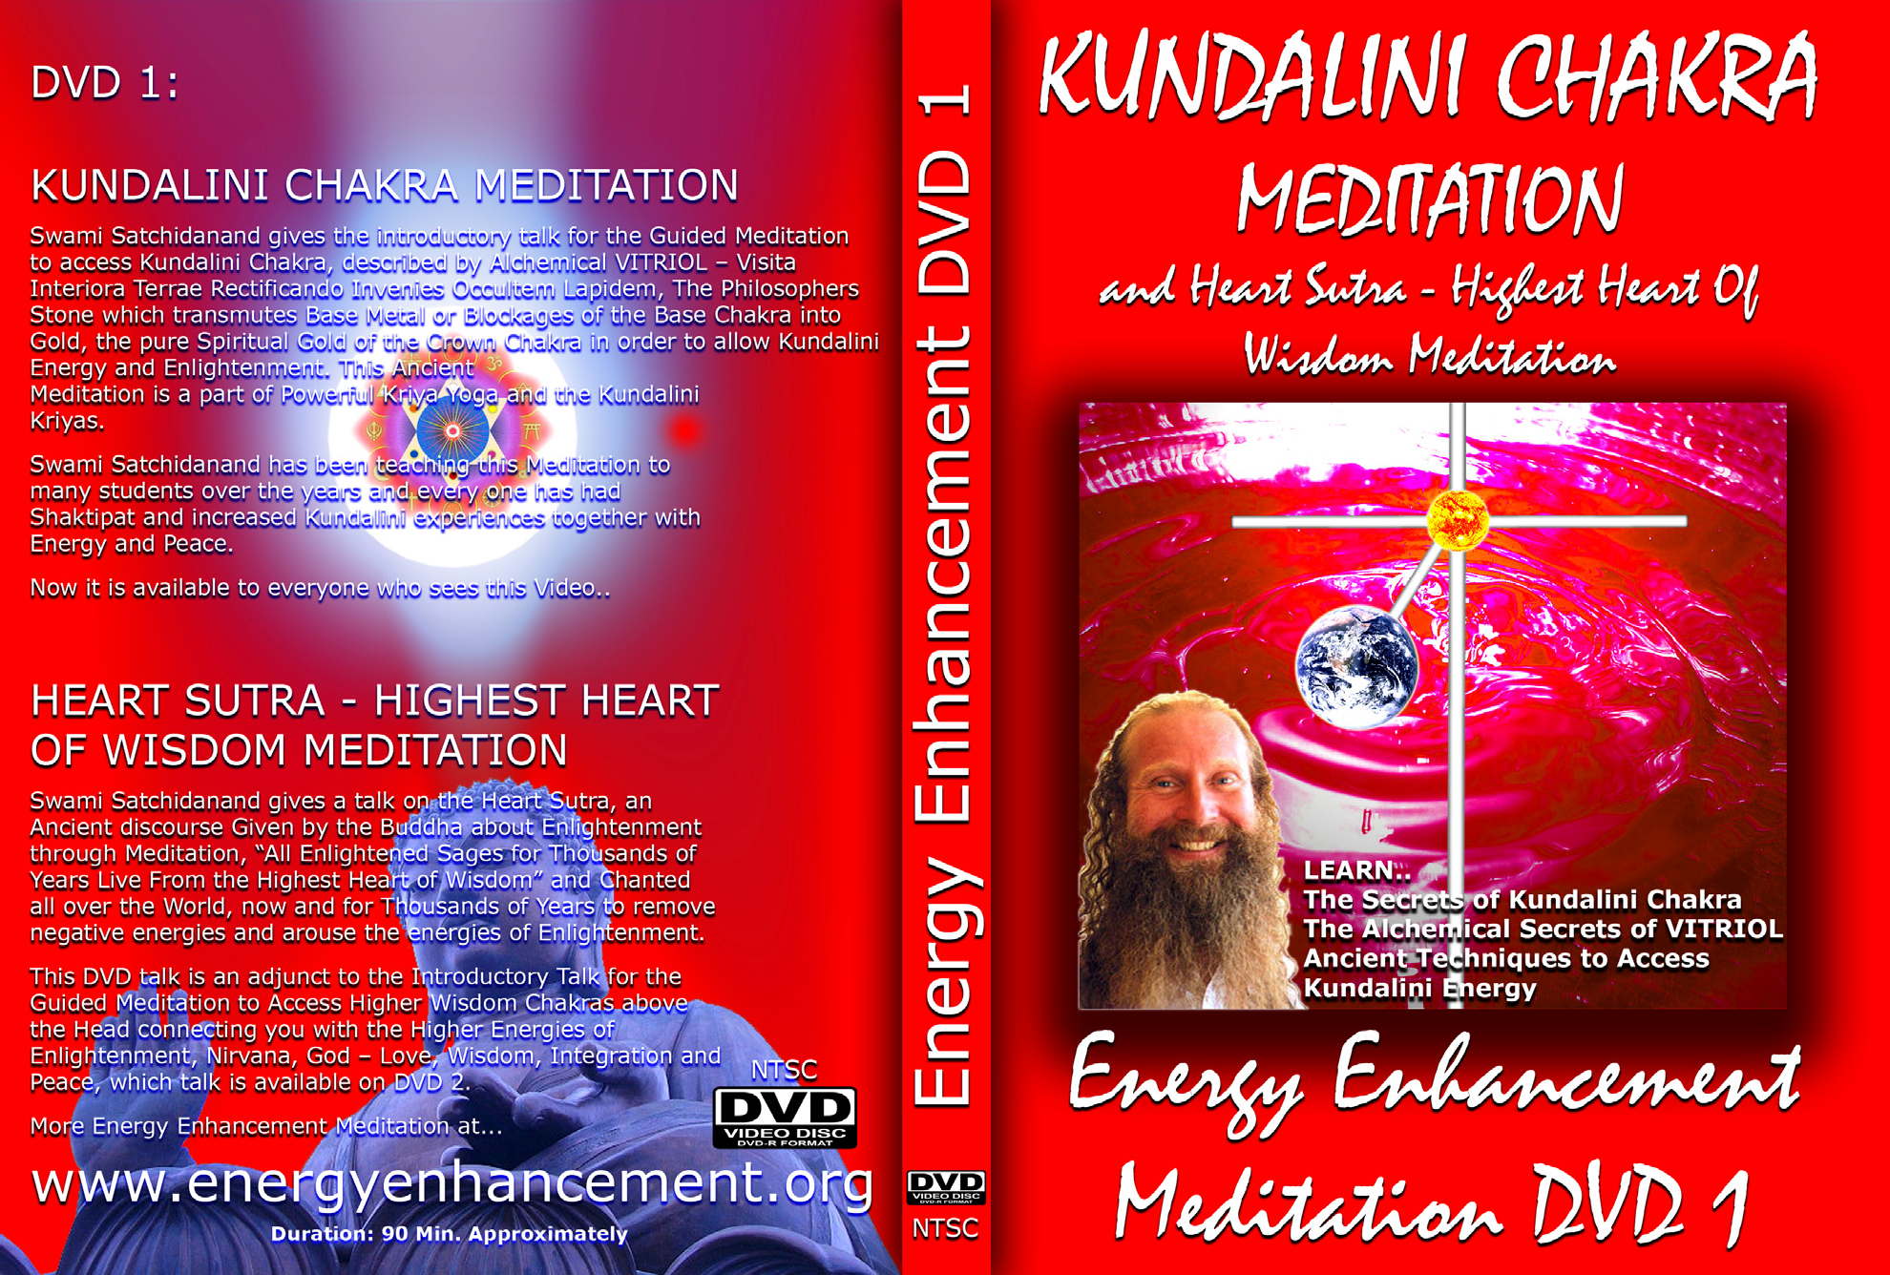

*ENERGY ENHANCEMENT MEDITATION DVD 1… Guided Meditation to Access Kundalini Chakra, VITRIOL, The Philosopher’s Stone, Kriya Yoga and the Kundalini Kriyas.
Heart Sutra, All Enlightened Sages for Thousands of Years Live From the Highest Heart of Wisdom.

DVD 2 - HIGHEST HEART OF GENIUS WISDOM MEDITATION

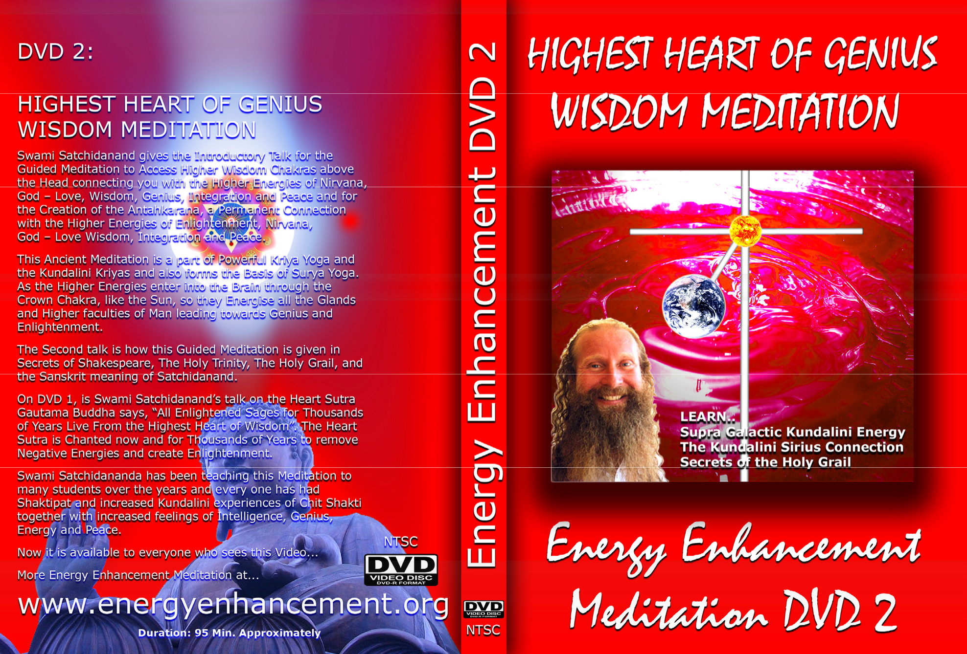

Guided Meditation to Access Higher Wisdom Chakras above the Head connecting you with the Higher Energies of Nirvana, God – Love, Wisdom, Genius, Integration and Peace and the Creation of the Antahkarana.

How this Guided Meditation is given in Secrets of Shakespeare, The Holy Trinity, The Holy Grail and the Sanskrit meaning of Satchidanand.

Swami Satchidananda has been teaching this Meditation to many students over the years and every one has had Shaktipat and increased Kundalini experiences of Chit Shakti together with increased feelings of Intelligence, Genius, Energy and Peace.

THE ENERGY ENHANCEMENT FOUR
INITIATION DVD COURSE - THE ULTIMATE TECHNIQUES WITH 15 DVDs

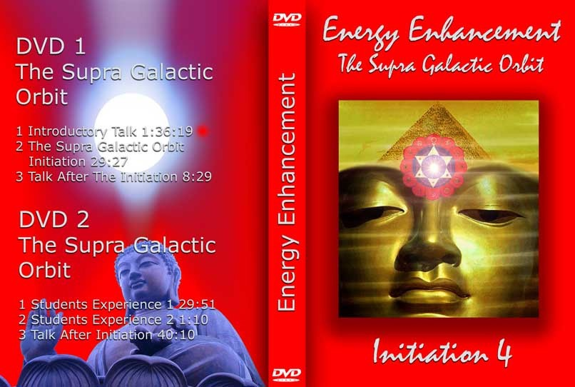

ENERGY ENHANCEMENT LIVE COURSES -
WORLDWIDE
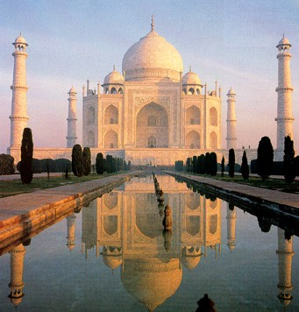
INDIA, 5 STAR INDIA TAJ MAHAL, SPAIN, MEXICO, PERU, ARGENTINA – MORE

