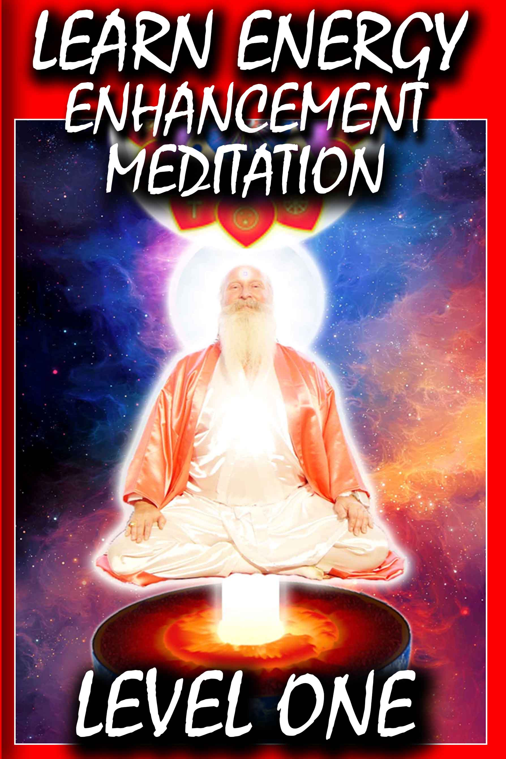
DEDICATION
With all Thanks, Love and Gratitude to Swami Devi Dhyani and all the helpers like Swami Ganesha Bhavananda who transcribed all these Level 1 videos and who make these books and Videos possible.
With all Thanks, Love and Gratitude to my Mother and Father and to all my other Teachers, Theos Bernard, Sri Yogendra, Eric Berne, Gurdjieff, Father Bede Griffiths, Osho, Zen Master Hogen, Swami Sivananda, Swami Satchitananda, and all the other giants upon whose shoulders I stand - who made me able to be what… I AM – Swami Satchidanand

Copyright © 2019 Energy Enhancement Synthesis of Light Limited (SOL)
All rights reserved. This publication may not be reproduced in whole or in part, by any person, without written permission of:
Swami Satchidanand
sol@energyenhancement.org
www.energyenhancement.org
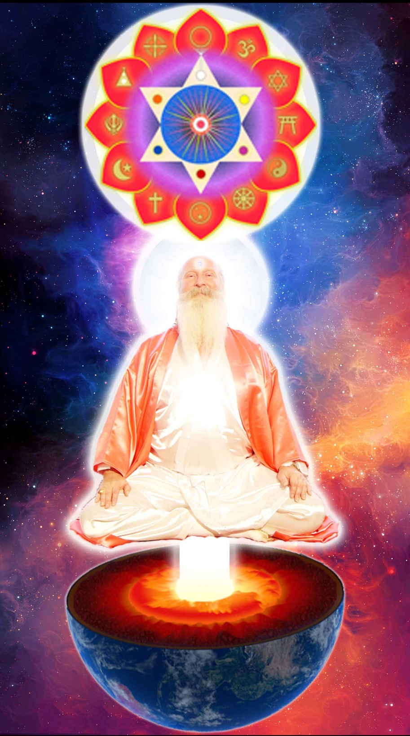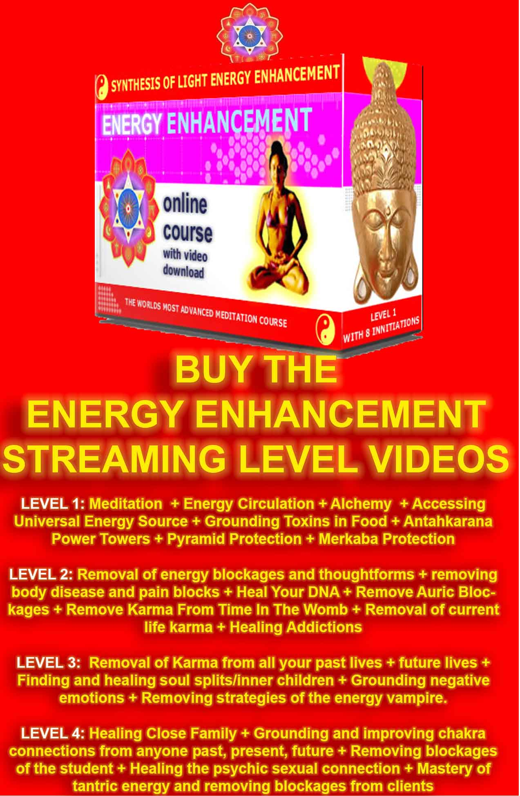
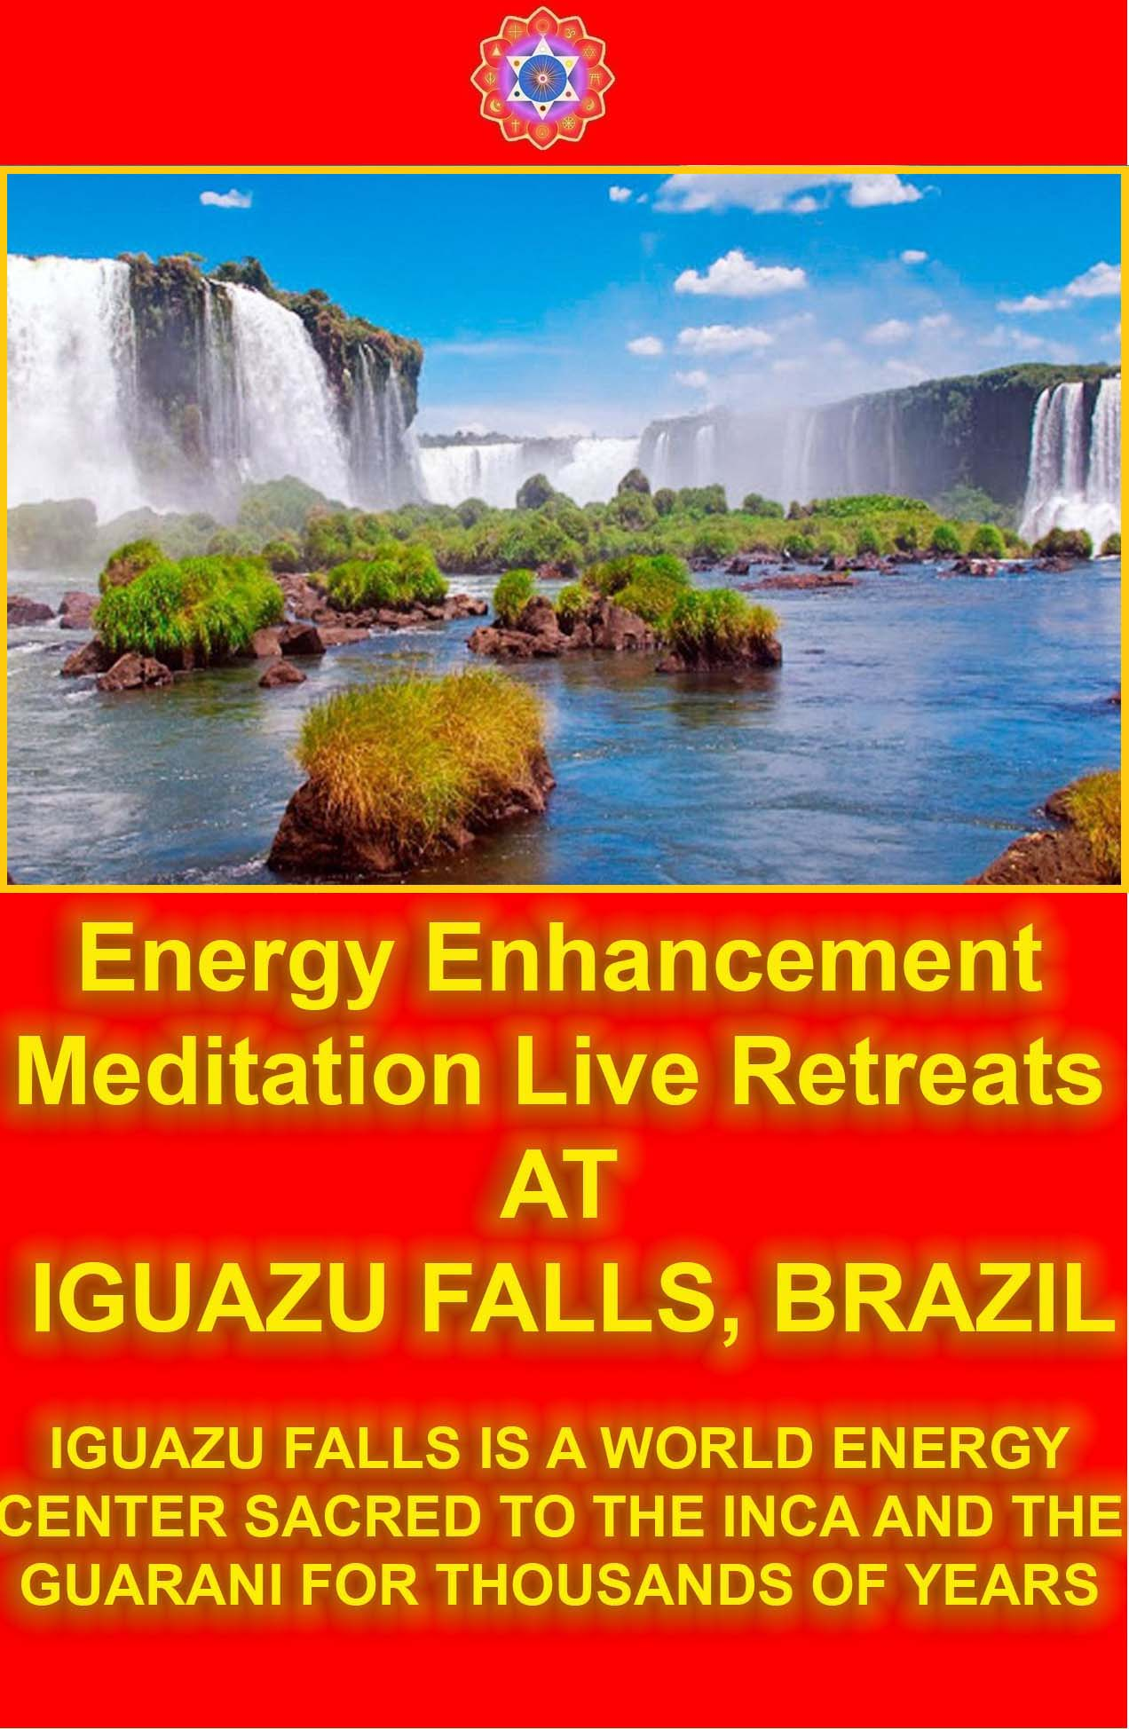
ENERGY ENHANCEMENT LEVEL ONE
Contents

Initiation 1: Meditation …….8

Initiation 2: Energy Circulation ……………………………131

Initiation 3 The Grounding of Negative Energies ………..222

Initiation 4 – The Macrocosmic Orbit ……………………..249

Initiation 5 Projecting Energy ……………………………343
Initiation 6 Psychic Protections Power Towers ……………421

Initiation 7 Pyramid Protection ……………………………462

Intiation 8 The Merkaba …485

ENERGY ENHANCEMENT LEVEL ONE

Energy Enhancement Level 1 Transcribed from the Energy Enhancement Streaming Videos - Level 1 20 hours 56 mins 17 secs
Initiation 1 : Meditation
4 hours 9 mins 38 secs
Introductory talk
58:08 mins
Satchidanand: So, humanity now has the possibility of changing it's environment. We've had houses for many thousands of years and the Romans invented the hypocaust for heating the house, for putting hot air around the house, the fire travels around the house, the hot air.
At this moment, we have central heating and in England at the moment and it's the end of December there is snow and it's -5 degrees but my mother has central heating and they send hot water around the house and everything is warm.
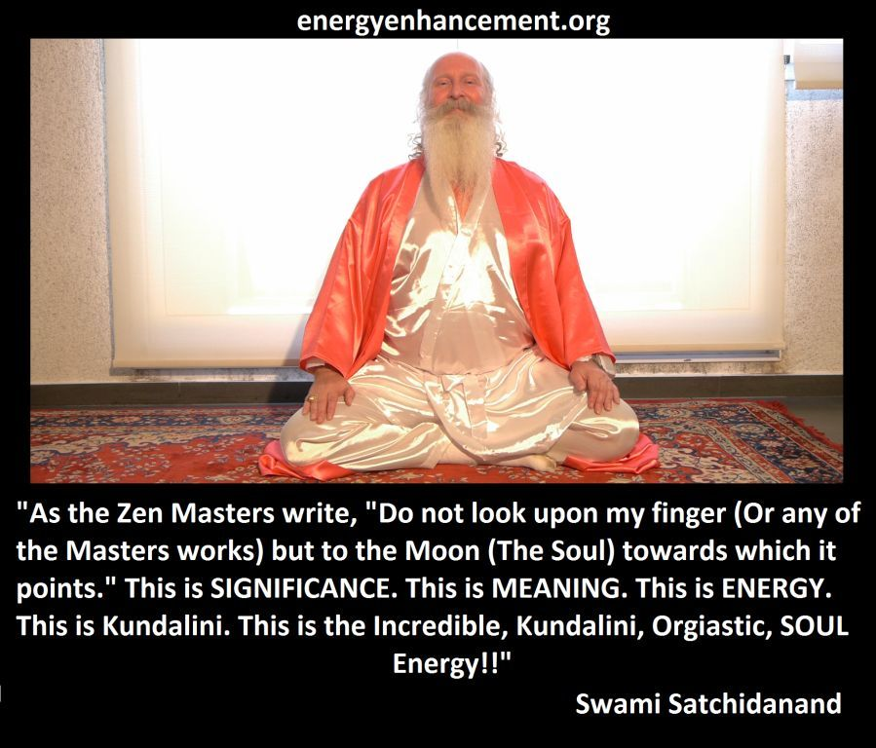
Here in Argentina it's very hot and we have air conditioning to keep us cool because the sun burns everything.
Back in the ancient days, yogis said it was good to meditate at the beginning of summer, when it wasn't too hot and when it wasn't too cold. This is the best season for meditation. Not when the rainy season comes.
The Buddha went to a place in India, there were so many mosquitoes. He said “Pah we must be strong against these mosquito's”.
Non attachment, to the body, so they withstood, they didn't kill any mosquitoes. So they just allowed them to come.
But the Buddha never went back to that place (laughs).
And now if the mosquito comes into the house, what can we do? We spray Raid on them. We swat them. But perhaps we should leave them outside. We should have mosquito nets at every window. Yea?
This is a much better solution to killing everything. We just separate the bad from the good, like a paramahansa separates the poison from the milk.
Even in this world we have bad people. We call these people matatodo, mata - kill, Todo - All – Kill All!!
Like Torquemada the top guy in the Spanish Inquisition Torquemada means Tor - Torture and Quema - burn Torture and Burn!!
There are people on this planet who murder, rape and kill and burn and they live in every country. And they live in every city. And what are we going to do with these people.
Well if we walk down the street at night without a bodyguard they'll come at us with knives and guns. Yea?
So what do we do, we stay in our houses. And the mosquitoes stay outside.
We have cars, with air conditioning so we don't have to go out in the street.
We separate the bad from the good.
We only have friends who are good people. Yea?
Because we get rid of the bad ones, we never go near them again.
We separate. Because, the good energy will only allow the good energies to come. – the bad from the good.
The bad energies will feel uncomfortable in the presence of the good energies.
The concentration of the good.
Because every human being is made up of the good angels and the bad angels, and they are whispering into the ears and the bad angel is talking and the good angel is talking.
Which one do we listen to? Our friend was saying that while she was meditating this little bad angel was whispering into her ear “This meditation is a waste of time”. And you know, she knew it was the bad angel.
This is very evolved to know that.
How to separate the bad angels talking from the good angels talking.
It's a process of intellect also.
We know that meditation has been used for 5,000 years to increase our evolution. We know that. So when the bad angels whisper into the ear and says “This is a waste of time, this meditation”. You know that bad angels exist and I'm telling you, bad angels exist.
We cannot get to the bottom of how many different ways they will try to prevent the process of enlightenment. The ways are infinite. And they will concentrate on your weaknesses. And the really bad ones they will concentrate on breaking your strengths.
Always the bad guys focus on those areas where you think you are strong. There was Michael Jackson , he was saying “Heal the world”. He was saying, “Earth Song”. “Don't cut down the trees, don't change the environment”.
And all the bad guys were saying, “It's not good for the people to hear these things. They might start to do something about it!”
So what was Michael Jackson's strongest point? Helping the children, he had 400 million dollars, a contract with Pepsi Cola. All the people were dying in Africa of starvation and he hired a jumbo jet out of his own money and he sent all the food in this jumbo jet to the children in Africa.
And what did the bad guys do? The external evil blockage people. They said Michael Jackson perverts children. And they kept on saying it. And they hired people to take it him to court and they destroyed his reputation.
They focussed him on other things. And they stopped Michael Jackson from speaking.
Now you are not so famous. I am not so famous. To be famous is very dangerous. (laughs).
But I am telling you that the evil blockages that are inside you are already searching out your strong points and they are already searching out your weaknesses, and they will be starting to test you.
The blockages will say, how can we stop, this lady, getting rid of us. Yea? Cos she is our house, we live in her body, and we've done this for many lifetimes, and in this time we have been successful in perverting this lady into the paths of many addictions.
We have distracted her, successfully for thousands of years and because of this she's learnt a little bit.
She's learnt the first sutra from the Yoga Sutra's of Patanjali, “after all that, here are the complete instructions on enlightenment”.
Yea we've taken her through all of that. So perhaps now she knows.
But I think she doesn't. The blockages are saying, no, we know the ways to pervert her. We still have lots of strength left. She thinks she's so good as a yoga teacher. Helping all the pensioners.
She thinks she's soo good. But we know the way to get her. Now, who is in charge? Who is in charge?
Because, the good angel is always talking. And you must listen to the good angel.
And if you hear a bad angel, you know it's a blockage.
Use the techniques of Energy Enhancement – The Seven Step Process of the Energy Enhancement Meditation Course Level 2 - to destroy every blockage which raises it's head. If you don't, they will pervert you and they will stop your progress.
To raise your energy with Kundalini energy, to give you more strength, to destroy blockages and more strength to find even more deep and dangerous blockages.
Bien?...okay question (Student asks question)
Satchidanand: This is the resting state, when you are doing both the air path and the water path at the same time. You can gain a lot of energy from this. But, for getting blockages, you need to do one path carefully at a time.
Devi's translation of Alexandria: It was easy for her to go down. She felt the fire was filling through her being easy. (inaudible) . And she was dancing in the flame. Sometimes she was going up without wanting to. She was going down. After she made the flame go up, without thinking without desire the flame was going up over the top of her head and going down. She wanted the fire to go down, for the chakra, but didn't go down from the top of her. (inaudible) It was going up to centre of her head. She was trying to make the fire go down to the center of the earth.
Devi: Really good...She was feeling some pain in her shoulder and spine.
Satchidanand: So in the future you need to work on these pains. Bien. Very good. So I want to say something now.
Satchidanand: I have my microphone...well it's almost there...Okay...I think Alexandria had a very good experience and as she well knows herself, this is just the start.
We use the energy, we use the excess of light. We use the light that we receive from the centre of the earth, like a searchlight.
We can see more, because before you can remove a blockage, first you must perceive it. And it works on the physical plane with the pains, works on the emotional pain with the negative emotions.
In the end, it works on the level of the mind.
On the level of the ego. And the ego, has so many forms. You know, competition is one of the forms. You might have noticed Dhiren. I started saying a few little things about Dhiren so Dhiren had to prove his superiority by telling us that he knew everything about blockages.
Yet, not one of the people who came on this January 2005 course has continued with their Energy Enhancement. They came, they did all 28 initiations of Energy Enhancement. You will see over the next few days all of their fantastic experiences of removing some of their blockages.
They removed many blockages, but in one month, even in such an intense month is not possible to remove all of the ego. You can have a very good start, you can learn techniques which can remove the deepest of blockage, but unless you continue on a daily basis it's not possible to remove all of the blockages.
And as I said, I'm warning you now. Because I have seen so many students have so much success in removing their blockages, and yet, not continue.
All of the gurus, for all time, for thousands of years have said the same thing, to every one of their students.
You must continue, Swami Satchidananda said “You have been practising your yoga everyday for years and you have been working working working everyday, and I think some of you must get a little bit sick of this continuous work, but I am here to say to you that in the end, all of the blockages will go”, they will be finished. But, you must continue til the end, it is not finished until it is finished.
And I know precisely which blockages remain in every student.
Every student that came to me, were stopped, by one particular thing. And I pointed that out to people by email after the course – this is the problem, this is the problem, this is the problem – and yet, the blockages were too strong.
They did not do their homework.
They did not continue.
This is my warning to you.
Once you have started on the path of meditation, it is necessary to continue on a daily basis.
I have never heard of anybody becoming enlightened in less than 3 years.
Normally, if you come to stay with a guru in India you have to serve your guru for 12 years minimum.
With Energy Enhancement, it can happen so much more quickly.
But, in the end, the blockages are personal.
I am giving you general blockages to remove on the Energy Enhancement course and we move so quickly through these general blockages that sometimes, we miss one or two.
It is necessary to do the exercises I give you, many times, to get the juice out of the fruit.
The work is simple. It is not rocket science. In the end, all that is needed is perseverance.
Energy Enhancement is the ONLY meditation course which gives the techniques – removed from All Traditional Courses - to ground negative energies, contact and channel infinite energies from the chakras above the head, remove energy blockages with the seven step process, remove soul splits, remove the strategies of the vampire, remove ancient vows, clean all your karma from this life and all your previous lifetimes and clean and manage energy connections, energy cords, apron strings and thus harmonise all your relationships
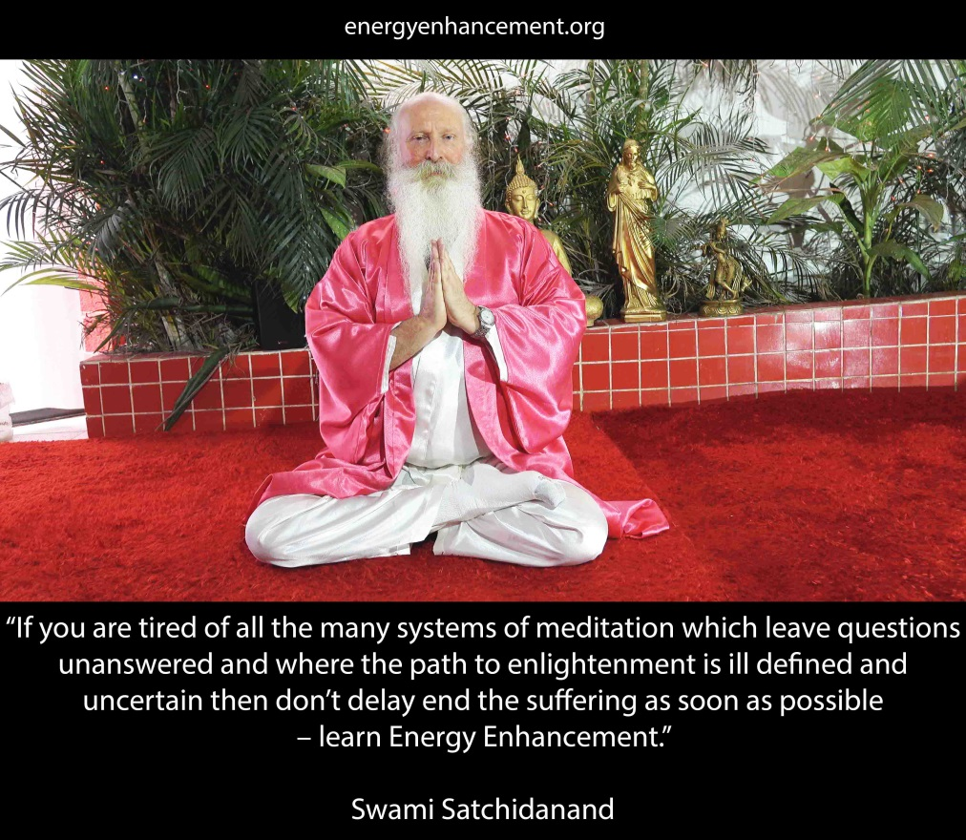
As the Buddha said, Energy Enhancement is for those people who believe in enlightenment, the necessity for enlightenment, and who understand the urgency of the situation because the blockages will procrastinate, they will say next lifetime.
They will say, I am interested, I am interested in my life.
My spiritual life can wait.
There was a guru in (?) who was 96 years old, and he said to his congregation of students, “Everyday for 60 years I have been telling you about enlightenment. And you have been listening to me and now I have some great news, today is the day that I die.
Today is the day I have my mahasamadhi.
This is the day that I pass on into infinity.
This is the day that I go to God.
And, I can take one person with me.
Who wants to come with me?” ..silence...
Until one guy put up his hand, “well it's a very nice offer, but I think I have to wait, my daughter is going for her confirmation. And my sons are going to university and I have so many things to do, I cannot take up your offer”.
The ego will say, I have a wonderful business to run and I am enjoying playing this game with my business, making more and more money.
Takes a great deal of creativity to do this, I'm really enjoying it. People say I have this job to do, people say that job to do. And all of these jobs, are to do with you.
Not, I am doing this work for the benefit of all the people around me,…. I am enjoying this work.
This is the difference.
The enlightened only do their work for a purpose. That purpose is for the benefit of everybody around them.
So...take heed of what I am saying.
Continue..for a long time with constancy and with enthusiasm, words from the Yoga Sutras of Patanjali, for a long time, constantly and with enthusiasm. This is necessary.
Okay.. I have finished now.
We have been listening and listening to hours and hours of talking, from the video.
While I was talking on the video, my main job was to transfer intellectual information, but the more high job, is to transmit the energy of the soul and when this energy goes into the bodies of the students, the rays of the light of the soul allows to see blockages.
The energy goes into the body of the student and it released the blockages that need to be released.
So when these blockages come in front of me with a large group I usually say it's time to chant the heart sutra, which is a very ancient technique to release blockages to release blockages to get rid of them, and this what we need to do now before the initiation.
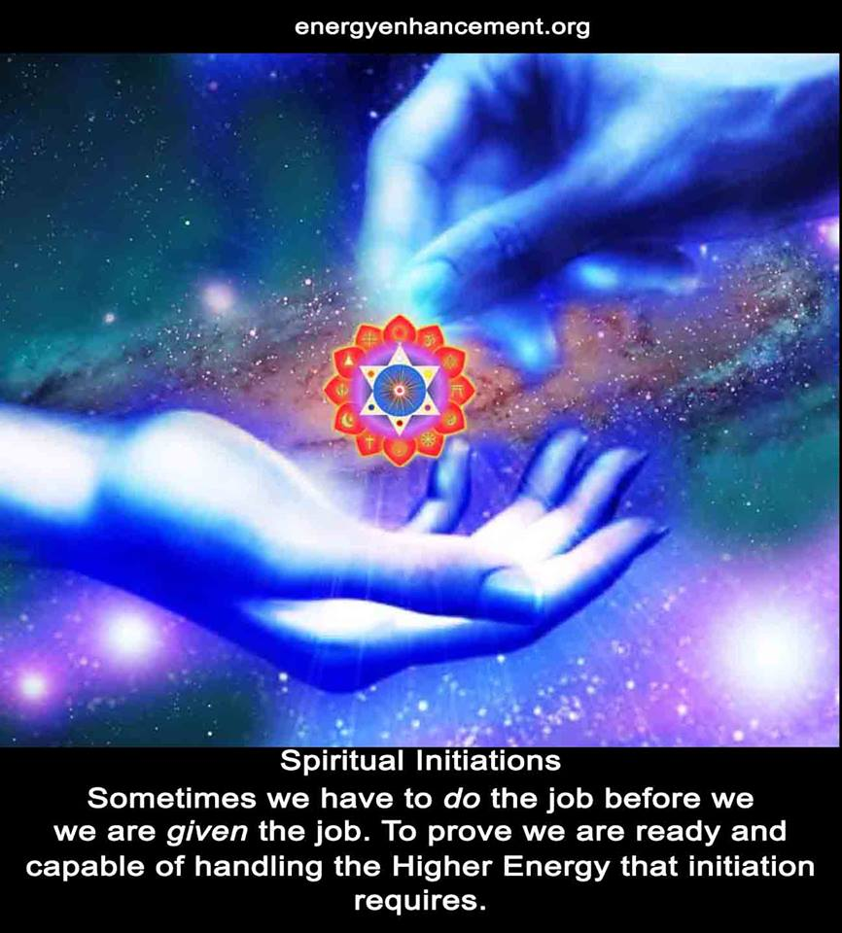
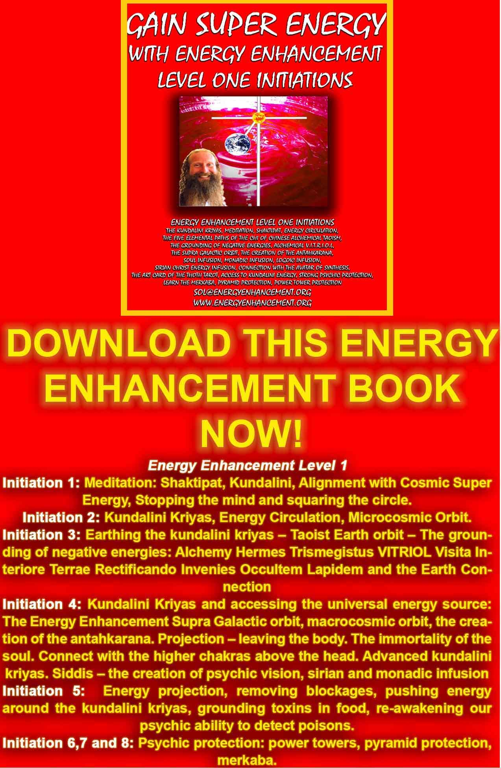
DOWNLOAD FREE! “GAIN SUPER ENERGY WITH ENERGY ENHANCEMENT LEVEL ONE INITIATIONS HERE!!!
http://www.energyenhancement.org/Sacred-Energy/Gain-Super-Energy-Energy-Enhancement-Level1-Initiations-Kundalini-Kriyas-Meditation-Shaktipat-Circulation-Taoist-Orbits-Alchemy-VITRIOL-Grounding-Psychic-Protection-Pyramid-Merkaba-energyenhancement-org.pdf
Initiation 1 : Meditation
4 hours 9 mins 38 secs
Introductory Talk Part Two
You know...today we will be learning the first initiation of Energy Enhancement and this is meditation.
Now what is meditation, don't answer that all at once, it was a rhetorical question (laughs).
I'm going to answer it! Meditation is first the ability to still the mind, to still the mind...
I was talking about that, the necessity to get rid of all the negative thoughts of the mind.
To be able to stop the mind at will, as Don Juan says “To stop the world”.
Now in the Yoga Sutras of Patanjali he says “yogas chitta vittri nirodhah”. You know that Natwaral don't you?
This is Sanskrit, and this is coming from Maharishi Patanjali from 5000 years ago. And I'll give you the translation for that, Yogas, well you know what yoga means don't you?
Well yoga comes from the word Yuj, which means yoke, the yoke, you know Krishna's riding in his chariot, and Arjuna is just sitting there very quietly.
He's supposed to represent you.
And he's sitting there quietly without any thoughts in the mind. And Krishna's is there with the reigns in his hand and he is driving everything, just like this guy here (points to Buddha) and what is driving the chariot forwards? Are the horses.
And around their necks is the yoke. And the yoke signifies union. Union is this case with the higher self so in reality yoga 5000 years ago meant enlightenment.
Now, they do all these strange contortions and they call it yoga (laughs) Oh I am doing yoga...OM....
But really yoga means enlightenment and the first stage of enlightenment is “chitta vittri nirodhah”. Chitta is the mind space, vittri is all the bad thoughts, all the Energy Blockages. Nirodhah means to bring those mind waves down to zero, stop them. - thank you Guillermo.
Guillermo is about 6ft 4 and he's a reiki master. And he's a Tibetan Buddhist and when he was doing his Energy Enhancement back in 1998 – are you translating here Devi? (laughs)
When he was doing his course of Energy Enhancement the last time. He was getting all these visions of Jesus Christ coming down to touch him.
And he came to see me, and he said“I'm a Tibetan Buddhist and I'm getting this Jesus coming down to touch me and I'm getting Mary as well , I'm a Tibetan Buddhist. What does this mean?
And I said to him. “Look who chooses? Does the student choose the master or does the master choose the student”
He said “The master chooses the student.”
Personally I think Jesus is a Tibetan Buddhist.
I think Jesus is an Ascended Master.
And that means he contains within him all religions, because these Ascended Masters are the source of all religions.
And every master on this planet functions through them.
I once heard of a guru, and he said there are many masters in the high Himalayas and they never speak, all they do is meditate all day long, and they are directing energy to all of humanity and they said personally I wish I was there with them because down here on this planet spreading this energy from the masters in the Himalayas is a much more difficult job, I feel like I'm a worker in the factory, the guys up there are the managers.
But personally I even believe the ascended masters are much more powerful than those, I think they are the CEOs. So I was talking about meditation and Guillermo has had all of this before but he is not here just for intellectual knowledge.
Because he's heard all of this before. It's very simple this stuff, what he is here for is to learn how to get rid of his energy blockages.
Because when “Chitta Vittri Nirodhah”
When the mind is stopped, then you get into a psychic state where all of your Energy Blockages become apparent.
And when you can see them, you can free them.
When you feel them, you can heal them.
Meditation is in 3 parts, and it has to be because all of these bad thoughts that you have in the mind are symptoms of the energy blockages that levels beneath the mind, they come from the levels of the unconscious subconscious, they come from the levels of the physical body of the emotional body.
When I go to India I see many people with beautiful hearts but they are totally thick.
They don't have any intellect at all.
Because they don't understand their hearts are constantly being hit by disappointment, because they have blockages in the mind.
And then here in the West, you have people with minds the size of planets, they have such brilliant minds, yet they have no hearts and this is because they have blockages in the heart.
I remember Forest Gump and he's a total idiot, born that way and yet he has the most precious heart.
And he knows he's not very intelligent and he thinks of this lacks of intelligence as a sort of infirmity, that he was born that way, he said, “I might be very stupid but I can still love.”
And what unifies the heart and the mind is purpose.
Alice Bailey talks about the 7 rays of the initiations. The 1st ray which brings everything together, is will or purpose. 2nd ray is love. 3rd ray is intelligence.
And you see how the 2 rays underneath hierarchically are unified by the purpose. If you have no purpose you will never unify the two.
Well what is a good purpose? Well, what is a good purpose? Why are we here?
Because..who is the happiest person, the happiest person is the one who makes everyone around them happy.
Now this is a very good purpose. How to make everybody happy?
Well this comes down to the 4 levels of charity. The first level is food, you can give food to people. And you can make them very happy but then you've got to keep feeding them, everyday.
The second level of charity is money, you can give money to people every month, but every month they come back for more.
The third level is education, you put people into university, they can go and do a job, and they get all the food and money from the job.
But they are not happy.
They are not happy.
So this comes to the fourth level of charity. Spiritual teachings, meditation, yoga, chanting, all of the spiritual techniques, reading the spiritual works, noticing when your mind is not quiet, noticing when your emotions are upset and being humble enough to know when you are 99% perfect but to know from your own observations of yourself that 1% needs to be improved.
Just to know that and then to know, I need to do this, in order to improve.
Because, if you are intelligent and evolved, then you know the solutions to everybody else's problems, you can point the finger at somebody and say you are not perfect because you've passed that test, but 3 fingers are pointing back at you.
If you see something bad in someone else, the same thing is wrong with you inside.
One of the secrets of enlightenment is to see, to be able to see enlightenment in one other person at least.
If you see enlightenment in one other person then you have the seeds of that enlightenment yourself.
So what is meditation, well, I was taught by my master, Zen Master Hogen from Japan, in one of the most powerful types of meditation in the world.
Because the Zen, they don't do yoga, they don't do anything else except sit.
For 1,000 years they have been sitting in meditation and they have developed the techniques of sitting to the highest point available in this world at the moment.
The yogi's teach everything in India, but there are very few yogi's who teach just meditation so the technology of Zen meditation, and having investigated many meditations, this is the most powerful.
Zen Master Hogen said, “meditation is in 3 parts, like a pyramid, the base of the pyramid is the physical, this is Hatha Yoga.
And what does it say is yoga in the Yoga Sutras of Patanjali, what is asana, remember it's Arse- ana.
Ass-ana – calls everyone in America this.
And in the Yoga Sutras of Patanjali, asana is defined as steady comfortable sitting position.
Swami Sivananda of Rishikesh said if you can sit for 3 hours without moving, the chances are you are enlightened.
This is the base of Zen Meditation.
Because where are the blockages, they're in the body, how do you know where the blockages are, what do the blockages produce in the body, they produce pain.
If you have a pain in the body, that is where your blockages are.
And those blockages don't just act on the physical, they move, they affected your emotions making you negative.
And then they start coming up from the emotions into the mind and they start producing all sorts of negative thoughts.
This is how you know you are not perfect, and what is the process of removing those blockages, well meditation is just sitting.
No pain no gain, oh Swami Swami, how long should I sit for?
10,000 years...(laughs)
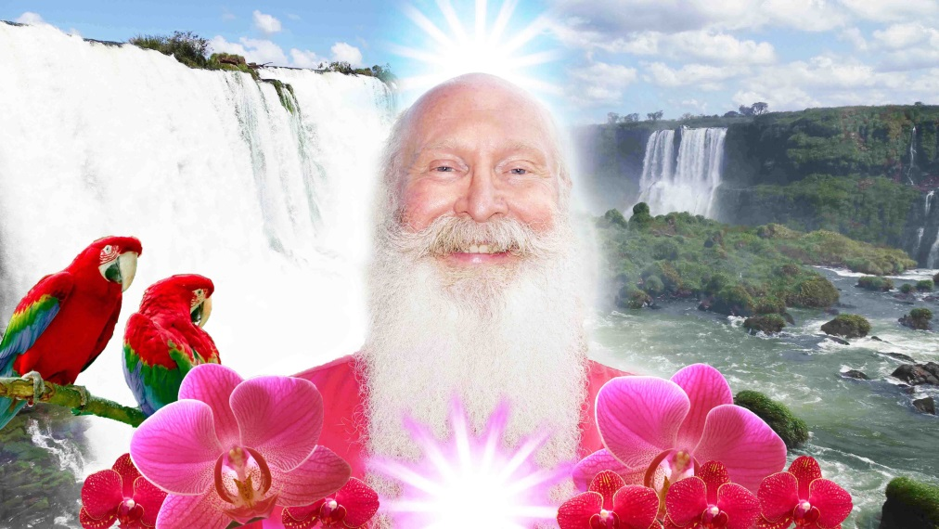
But, as William Blake said, “If you can see heaven in a grain of sand and eternity in an hour”...
I was talking about how the process of enlightenment is in 2 parts.
Now before I met Swami Satchidananda I had been meditating everyday for 5 years. And I had been practising with a Zen Master from Japan for 5 years.
And every time I sat, he used to throw me out of bed every morning at 6 o clock and he used to say “Sit”
..and he was in Japan, he was 10,000 miles away
“Can you feel my breeze blowing, even from 10,000 miles?” - Hogen
He used to throw me out of bed every morning, and as I was sitting I could feel him polishing my base chakra, I could feel it clearing out all the blockages, and after 5 years, I was enabled to meet up with Swami Satchidananda,
Swami Satchidananda never taught me nothing but what he did, was he gave me energy and he gave me psychic experience.
Seeing him in light coming to me in meditation, telepathy, all of the things they talk about in the books, they came with Swami Satchidananda.
Everybody who came to Swami Satchidananda used to get his energy, but in order to really feel the energies of Swami Satchidananda was necessary to practise because the more empty you become the more the cup can be filled.
If your cup is filled with bad things, it's not possible to fill it with good things.
Only by removing the negative energies, comes the possibility of initiation.
And initiation is a fact
…..but only for those people who are prepared to practise.
Satchidanand's Movie Reviews
DOWNLOAD BELOW
http://www.energyenhancement.org/Spiritual-Movie-Reviews/Energy-Enhancement-spiritual-esoteric-movie-reviews-by-Satchidanand.pdf

http://www.energyenhancement.org/Spiritual-Movie-Reviews-Satchidanand/Index.html
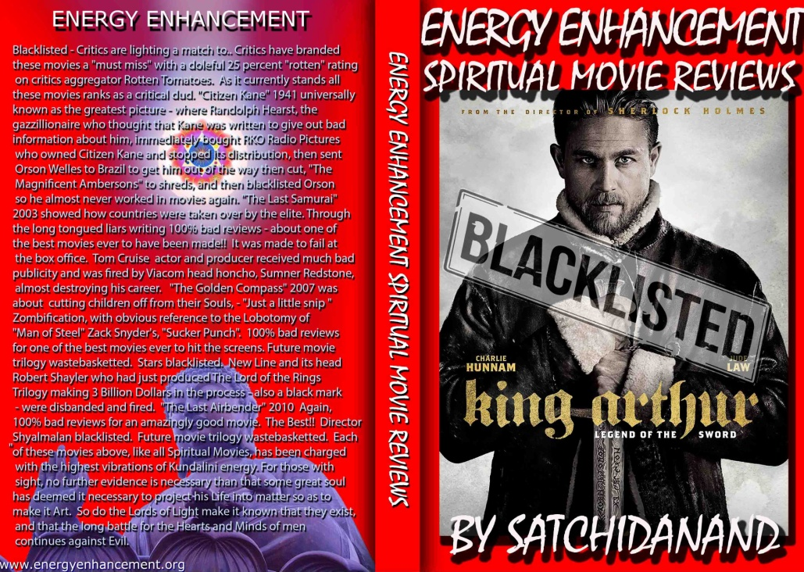
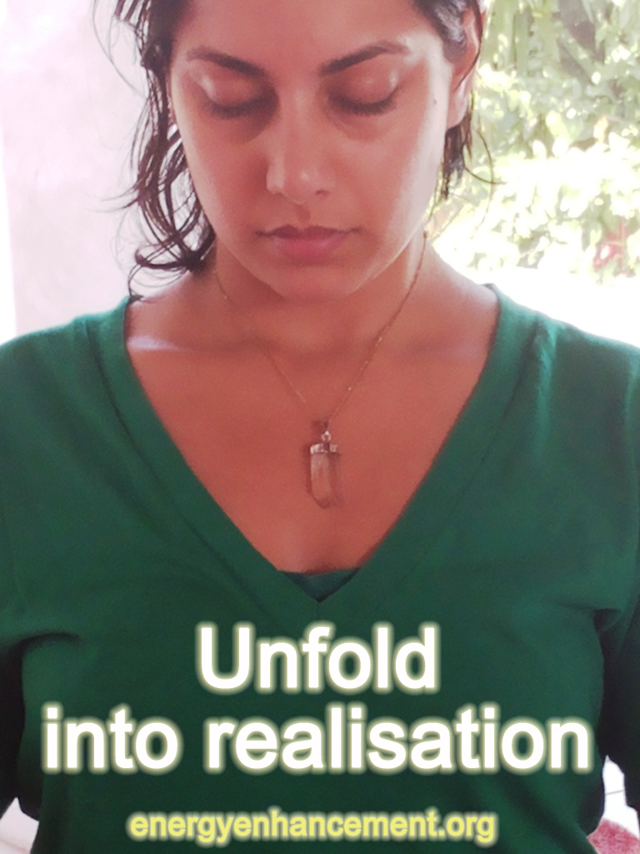

Initiation 1 : Meditation
4 hours 9 mins 38 secs
Introductory Talk Part Three, Energy Blockages
56.23mins
Satchidanand: Well, sometimes in our lives we need gurus.
Some of us go to India to meet gurus, and in my time I have met many gurus.
And I started doing yoga when I was 16.
And, when I started to learn meditation I did it all by myself but after reading about it in books and learning a little bit about what is meditation I decided I needed to have a guru. Because you can only learn so much from books.
Really, to learn meditation correctly, like anything in life you need to go to somebody who knows meditation.
You know, if you want to learn the piano you can learn it from a book but most people choose to go to a piano guru. A guru of piano.
But you can't learn everything from a guru of the piano. You come for a lesson for an hour and then you go home and practise every night. And you learn the tune and then you come back and do another hour. And in this way, you gradually become a concert pianist.
Because, is meditation just this? No, this is not meditation. This is practising to get into a state of meditation. Because meditation is 24 hours a day.
You are playing the piano 24 hours a day and you are making sweet music in the world. Because if you read the Yoga Sutras of Patanjali which is the textbook for 5,000 years of everybody that wanted to learn meditation, it leads you gently through the stages of practise.
It says to become a master of meditation you need to start off with sitting and then you need to learn a bit about breathing and pranayama because you need a lot of energy to meditate and on this base of the pyramid of meditation, Sitting. Then the middle of the pyramid, Breathing correctly. Then we have the peak of the pyramid, Meditation.
If the sitting is no good, the meditation is no good, if the breathing is no good how can you have the energy to meditate correctly.
But the peak of the pyramid is meditation.
But, this is only the first book of the 4 books of the Yoga Sutra of Patanjali.
Patanjali was an enlightened master 5000 years ago in India, and everyone who has learnt meditation since, takes note of what this Indian master had to say.
And the first book teaches you about meditation but in book 2, book 3, book 4, he says this is what you use meditation for.
What is the use of meditation? (Indian accent) Oh...I want to peaceful...Ohh I want to be happy in the world...
Satchidanand: I was talking about computer programmes and in some programs, in this computer which is your mind, you are the world's experts.
And there are many different programmes which I will go into, but why you are here is because your mind is capable of more.
Now what are the problems with computers. What happens if you put too many programs on your computer. You get a lack of memory, and the computer gets stressed.
And finally it stops.
Now, I'm saying there's a parallel between the computer and a human being.
Where can you get more RAM? How can you stop the computer that you have, how can you reduce the number of programs? Yea?
Now you can either have a bigger computer which meditation will give you or you can reduce the number of programs which meditation will give you, yea?
You are going to learn how to run your computer at the optimum and you're going to learn how to make your computer become bigger. This is what meditation is for.
And it's to make the program you want to run, run to it's potential.
Now that's the minimum that your computer can do. Because, you have been to school, and you have played in games to make the body good, to breathe correctly, you've got to be able to do that to run a marathon.
And you have been to school to learn how to read and write, you've learnt Microsoft Word. And you've learnt to read lots of lots of books, and learn ….well how to do what...manage life..and some of you have been to university and learnt big programs, like the law...or like me like computers, mathematics physics, electronics etc. there are many themes that you have to go university for yea?
And you have proved that you can pump all of this information in and you can write it out on examination papers and then you can use it to help people with their problems.
But like all good human beings, you know the difficulties with your profession and if you are a good human being, you will try to add to your profession to make it better, and this is where the next level of university comes from. Meditation.
Because meditation, not only gives you a bigger computer, it not only helps you to run the program without stress, also meditation enables you to go beyond the intellect
And this is where I wanted to talk to you about parallel processing computers, what are the fastest computers on this planet? (student points to brain off-screen) I agree I agree.
But what is the fastest computer on this planet, what is a supercomputer, how do you make a supercomputer? Well a supercomputer, is one with many processors, yea?
You go to IBM Big Blue, and it's not like this one here with only one chip, the IBM, Big Blue, not only has a thousand processors, it has many thousands of processors, and it's called a parallel processing computer.
Because not only does it take one thing into one processor at one time, it takes a thousand things at one time in each processor and thus is a thousand times faster, and not only that computers are heirachical, they have a base of a thousand processors to do the general work, but above that they have 10 chips which manage all that work, and above that one chip to manage the managers.
In a way it's like human society. It's a hierarchy, you have Hitler at the top, yea? And he tells everybody to go into the concentration camps and then he has thousands of camp commanders, millions of torturers and all the people underneath are being tortured, it's like a normal society.
But I'm here to tell you, that the intellect, is only in the middle of the hierarchy, if you want to increase the size of your computer you need to go to the next level which is called intuition which is called goodness.
And also, people say above the intellect there is something call love, and above that is another level called the will of God.
And people feel ashamed, and they get stressed out when they cannot follow the will of God.
If you can get yourself in alignment with the will of God, of goodness, of love, going through in your life, goodness when you don't need to feel ashamed, then, you'll be working at a higher level, these are the type of people who want to improve their profession, these are the people who want to improve society, these are the people who want to relieve people of all the pain.
Now the profession I have chosen to do this, is meditation.
But meditation is a tool, which can help every other profession on this planet, and it can also help every human being on this planet, but it does need practise, it doesn't just come by itself.
If you want to learn how read and write you have to practise, if you want to learn how to play the piano, you have to practise, if you want to learn meditation, you have to practise.
Now, all the things I am talking about in meditation, come to you as symptoms that the meditation is working. What happens when you sit and you have pain, well, I want to introduce you to the concept of energy blockages.
Energy blockages stop the computer, they create stress, they are stress and they exist in every part of the body, they exist in every part of your emotions, they exist in every part of your intellect, and they exist higher stopping you having conscience, empathy, and connecting with the higher levels of your computer.
As a matter of fact they stop goodness.
Energy blockages are totally bad and the higher levels of meditation teach you how to remove energy blockages.
But that's higher...but I wanted to talk about energy blockages because Maria (inaudible) asked me a very interesting question, she said “Us people in the west..”
You know everybody has energy blockages, as you work with meditation, you have less.
This means that a person of meditation will live longer, with more energy and less pain, because at the lower level of the computer we have the physical body, yea?
And if this physical body has blockages, then eventually you will have a disease and you will have to go to the doctor, to have it cut out, and then you will die.
So really the higher levels of meditation teach you how to live, yea?
Cos you could be an expert in your profession but are you an expert in health.
The doctors are an expert in disease.
But they never see people who are fit and healthy all the time, all they see is disease.
I know many people who have never seen a doctor all their lives. I don't think I've been to the doctor all my life.
Why?
If you are well, why do you need to go see a doctor.
And it's the same with the psychologists, everybody is mad. Because all they ever see are mad people.
And they write books about all these mad people but 99% of the people have never seen a psychologist but this is a profession.
Then there are all the people who have never seen a lawyer, you know the people who never have to go to a
profession, these are the lucky people.
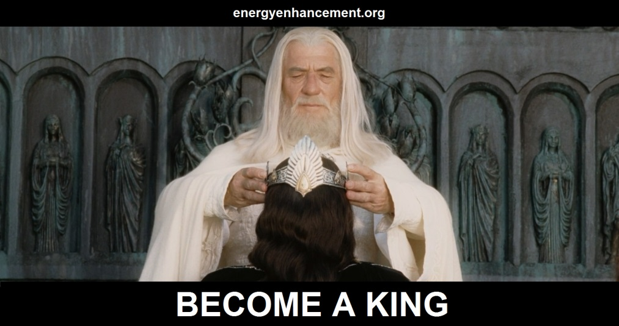
But, Nitendo Surgimus, we rise by striving.
The Romans had to be good for something.
And I am saying to you that after you have trained the intellect at university, after you have put your intellect at the service of humanity, then it's time to learn to increase the size of the computer.
At the bottom of the computer is the body, and what are the symptoms of meditation is that every pain of the body disappears and you don't need to see a doctor ever again.
So as you meditate all of those pains are going to disappear. And in one year, you are going to be able to sit like this (gets into lotus position) for 3 hours without moving and if you practise this will happen because it's very scientific.
It's been used for 5000 years.
If you go to India and China, and 99% of the people there, if you ask them to sit, they'll be sitting like this (pointing to student in cross legged/kneeling)...or like this or like this... but the few people who are learning meditation they'll be sitting in the lotus posture, for 3 hours without moving, and they will never get arthritis, because the start of arthritis is the locked in pain.
Does it make sense?
No I am a professional, you can come and practise with any doctor and he will charge you 100 peso's an hour.
If you want to talk to a lawyer for free he will laugh at you.
Now what happens when you go to the weight training place, what happens when you go weight training, you go to the weight training place and they say that you use our machines and your body will become very strong.
And it's true, if you go there everyday then you will become very strong.
And if you want to run the marathon of 50km and the people say if you run the marathon you'll be very strong and your body will become very powerful.
And what happens if you have never practised with weights before and you try to lift the biggest weight?
Your body will break.
And what happens if you are training for the marathon and you have never run before and you go out and run 50km for the first time?
Yea? Meditation is the same as weight training.
Devi: Maria came and came to the class with me with an original blockage.
She had a blockage in the knee, and in the class, I helped her to remove the blockage, and she doesn't have any more pain in the knee.
Satchidanand: OK where did I get to, where did I get to, I was saying, the bottom level of the computer is the body, yea? And it's possible with training to strengthen the body, yea, this is the purpose with asana and also with breathing properly, it's possible to have more energy and this is the base of meditation for 5000 years.
Patanjali gave the 8 limbs of yoga, Yama, Niyama, they're like the 10 commandments.
And the first commandment is ahimsa.
Ahimsa means don't give any pain to any person by word, by thought, or by deed.
And if you go against the will of God, you will get the return which is Karma, you will have pain also. So don't give yourself pain, this is the main spiritual commandment.
And if you just follow that one, you will be enlightened.
And then he says if you can sit for 3 hours without moving, having no pain in the body, you know most people move around if they have a pain.
They are always moving.
You see these people sitting and their legs are moving like that (motions shaking in the leg) because if you move you don't feel the pain but the pain exists as an energy blockage.
And as you sit you will start to feel your energy blockages, more and more because to heal them, you gotta be able to feel them. Yea?
Most people don't know where the energy blockages are.
And if they know where they are, they distract themselves from the symptoms.
And the Tibetan masters say if you can enter into an energy blockage with spiritual energy the energy blockage will dissolve.
So do not distract yourself but allow the spiritual energy to flow into the energy blockage and this will start to dissolve it.
Yea. By being still, we feel the energy blockages in the body.
We dissolve them.
In the end we learn to transmute them by using the Seven Step Process of Energy Enhancement Meditation Course Level 2.
We feel the energy blockages in the emotions, negative emotions and we dissolve them.
We feel the negative energy blockages in the mind as negative desires, things that if we do them, we will be ashamed, we will be going against the will of god.
Most people have these thoughts and people with a consciousness will not follow these desires, these are the first stage of control of desires by the intellect.
But with meditation we can dissolve these desires.
The strongest desires come out first in meditation as we dissolve them so we can sit for longer.
As we quieten the mind, which includes the body, the emotions, the mind, and the higher levels of the hierarchy so the blockages which are hiding, appear in front of you.
And this is why when you start to meditate you are so disturbed.
And the process of releasing all of this madness is the process of meditation.
The process of just sitting and allowing things to arise.
The Chinese have a beautiful symbol of dirty water, yea, you can't see through it, it's completely dark.
They say if you put that in a glass beaker, and wait, all the heavy particles will go to the bottom first and then the medium particles will go to the bottom but the water will still be dirty, but after many days everything goes to the bottom and the water becomes absolutely pure and at the bottom you have the dirt.
The process is one of separating the bad from the good.
Pain in the body, negative emotions, thoughts which will make you ashamed, and pure spiritual energy which will give you a direction in life, which will create pure goodness in your profession and on this planet because there are levels above the intellect
And by allowing the mind to purify, you open it up to these higher levels of the hierarchy of your computer.
You remove the blockages to this very high spiritual energy and as you follow that energy, then you become happy against all the problems you encounter because you are not ashamed because you are following your Soul path.
Yea, and everybody is an individual, everybody has their path, and if you like your mission on this planet in this lifetime, and as you follow your mission, which is not there in your intellect, it comes from higher...then whether you fail or whether you succeed, you never are 100% successful in whatever you do, but if you only get 50% you will be incredibly happy.
And I am saying to you, meditation is the tool which can help you to do this.
But as with the body in weight training.
As with the body in marathons.
Same with the body in Meditation.
Train your body slowly to become more strong, stronger and strongest.
Soon you will lift great weights.
Soon you will run the marathon.
Soon you will sit, motionless in Samadhi for 3 hours.
But train slowly, do not push TOO much.
Push a little though.
So the next thing I want to talk about, a concept which is called negative karmic mass.
As you know the lower levels of the computer are more dense.
The body is more dense than the emotions. And the emotions are more dense then the mind. And the mind is more dense than the higher levels of the hierarchy.
Now the negative karmic mass, is energy which is very dense and it is caused by trauma.
When a person is hurt, when a person is hit, when a person sees something which is against the will of God, then this pain causes them to create within their system something which is called negative karmic mass, it is an energy which can be dissolved by the higher levels of spiritual energy.
If we are talking about energy blockages, every energy blockage, is coated by something which is called negative karmic mass, it is the result of perversion.
It is the result of anything which is against the will of god, it is caused by pain, it is caused by shame.
Wherever you are ashamed, wherever you have done something against the will of god. Whenever something has been done to you which is against the will of god, then this negative karmic mass is the result and it exists in energy blockages in your body and it exists in your aura as a darkness.
Now, and you don't have to believe me, I call it karmic. Yea, because if someone in your family does something very bad to you, then within you recorded at that time will be a blockage of negative karmic mass which will cause you to take revenge on that person, on that person when you get the opportunity.
Negative karmic mass causes you to want to take revenge. As you dissolve your energy blockages, then you will want to take less revenge.
And what causes the blockages to dissolve is a higher spiritual energy called love, and higher than that, is another energy which is called will, but we can just call it spiritual energy.
Now there are many people, there are many movies, there are many books and they are all about revenge.
It is a normal condition of the psychopath but the saints for thousands of years have said, “Forgive them Lord, they know not what they do”.
Yea, now what is the difference between a saint and a normal person?
The amount of negative karmic mass.
And what causes the negative karmic mass to disappear?
By removing the blockages which stop the love, the spiritual energy, coming into you from chakras above the head and dissolving all of your blockages.
The blockages stop the light coming in, they are the darkness, they are the Dark Side.
And when you have removed all of your blockages then the light streams in.
We can call this light love, will, but you can also call it pardon, forgiveness.
Yea, because human beings are like that, they don't know what they're doing.
Every human being has blockages.
Some human beings have more blockages than others.
Some people are worse than others.
But no matter who you are, if you are on this planet then you have blockages.
And as you meditate, this energy of forgiveness comes in and dissolves all of your negative karmic mass so you don't want to take so much revenge.
You know, you've got various political movements on this planet, I think Hitler liked fascism, Stalin liked totalitarianism, George Bush likes democracy and Mao Zedong, err, what does he like Authoritarianism? Killing 100 million people?
Yea., but if the people running whichever system it is, if they have blockages, then whatever system it is, will run badly.
If you have saints running fascism, it will run perfectly.
Any system will work well if it is run by good people.
But the people with many energy blockages, they can be very energetic but they have revenge, they have competitiveness, they want to be at the top.
Genghis Khan said, “It is not enough that I succeed, everyone else must fail”.
That means that if he had any opposition, secretly he used to send secret agents in to make them fail.
Yea, whereas a saint says “Everybody is perfect and everybody should be as perfect as me” and they try to help people to make people better and they say we can do this by removing the energy blockages.
We can help you by removing the energy blockages in your body, to make you more healthy, we can remove the energy blockages in the emotions, to make you happy, to remove the revenge, to remove the competition, to remove the jealousy, to remove the fear, to remove the sadness, to remove the depression, to remove the anger.
Yea, all the negative emotions, are caused by energy blockages, which are caused by trauma, and the only solution to this problem is forgiveness.
To allow the energy of god, to act, on your energy blockages, and dissolve them, to forget everything, every bad thing, that ever happened to you, and this is the purpose of meditation.
At the level of the intellect, all of those things that you want to do that you know will make you ashamed, these blockages also need to go, at the level of the mind you want to take revenge, you want to be competitive with that person, so you say bad things about them, at the level of the mind, with the sex, oh we should all have thousands of men and women at our beck and call, we should all have thousands of men and women to do what we want with them, and then same with the men and women, and they should be naked too...
Now...it is whatever makes you ashamed, and by removing the blockages, we can enjoy life and not be ashamed.
Because some things are good and some things are bad, and if you do things that cause pain to other people then you should be ashamed.
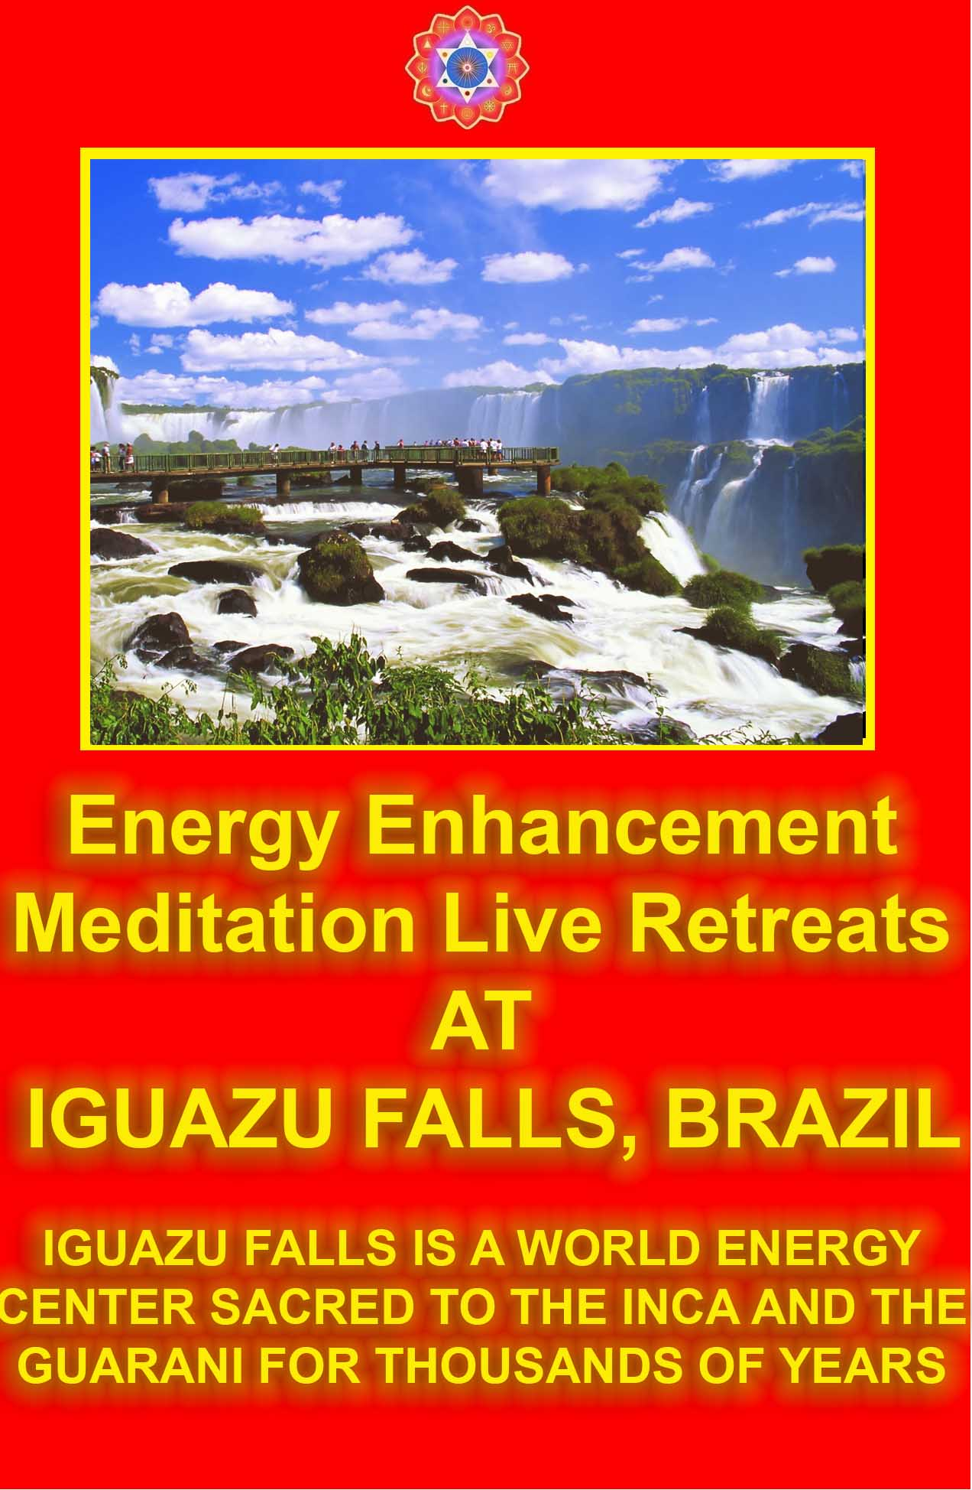

ENERGY ENHANCEMENT IMMORTALITY LIVE COURSES, INDIA AND IGUAZU FALLS

ONLY THE SUPERPOWERS DEVELOPED BY THE SCIENCE OF REAL MEDITATION CAN FREE HUMANITY TO REACH THE STARS.

ENERGY ENHANCEMENT MEDITATION ENLIGHTENMENT AND ILLUMINATION

THE INCREDIBLE MEDITATION COURSE AND MEDITATION TECHNIQUES CREATED TO PRODUCE ENLIGHTENMENT AND ILLUMINATION

"ALL TRADITIONAL MEDITATIONS HAVE BEEN DESIGNED TO FAIL" - SATCHIDANAND -

"BECAUSE ORIGINALLY ALL MEDITATIONS CONTAINED THE TECHNIQUES OF, "THE KUNDALINI KEY" AND OF, "ALCHEMICAL VITRIOL" TO GROUND NEGATIVE ENERGIES AND TO NATURALLY INCREASE KUNDALINI ENERGY"

"NOW, ONLY ENERGY ENHANCEMENT MEDITATION TEACHES THESE TECHNIQUES WHICH SPEED UP THE ENLIGHTENMENT PROCESS"
SATCHIDANAND - IGUAZU FALLS
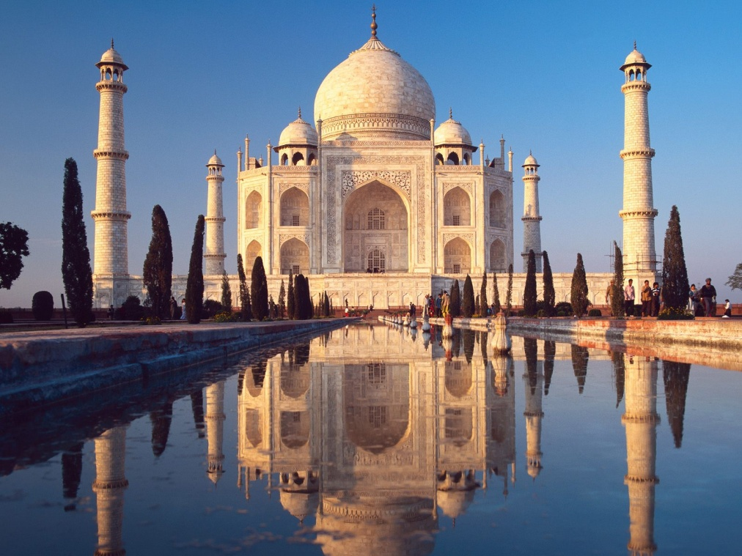
Initiation 1 : Meditation
4 hours 9 mins 38 secs
Introductory Talk Part Three
The Heart Sutra
Satchidanand: This is a very good time for us all to learn the heart sutra, the sutra of the heart and it was a lecture that was given by the Buddha, thousands of years ago and it contains the essence of enlightenment.
If you understand what the Buddha says in this sutra you will become enlightened.
Now on the back of this paper (holds up paper) you have a translation in English, of what it means, and what it means is this, “Avoleskitesvara bodhissatva doing deep prajnaparamita clearly saw the mu of the five conditions”.
Now, everybody understands that don't they?
It's all in English.
It's alright, this is total nonsense, it means nothing.
Yea, it's such a bad translation, can you understand it Honey? No.
Can you understand it Dhiren? No.
The translation that they have given was given by an unenlightened person and all the texts are like this, total nonsense.
LEVEL 1 - 4 VIDEO COURSES ANYTIME IN THE COMFORT OF YOUR OWN HOME

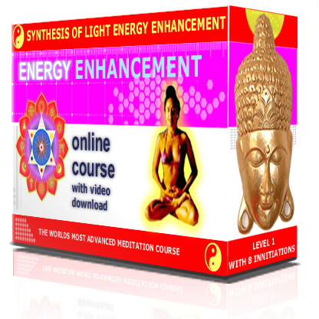
And you go, “oh holy heart sutra take me up to heaven”, and you're going “Avoleskitesvara bodhisattva – deeply saw – mu – five conditions” – and what do you get out of that? Nothing.
And as Father Bede Griffiths said to me, it's all in the explanation.
So without more a do, I will tell you about Avoleskitesvara Bodhisattva.
When the Bodhisattva Avalokitesvara was engaged in the practice of the deep Prajnaparamita, he perceived that there are the five Skandhas (conditions) and these he saw in their self-nature to be Mu or emptiness.
"O Sariputra, form is emptiness, emptiness is form; form is no other than emptiness, emptiness is no other than form; that which is form is emptiness, that which is emptiness is form. The same can be said of sensation, thought, confection, and consciousness.
"O Sariputra, all things here are characterized with emptiness: they are not born, they are not annihilated; they are not tainted, they are not immaculate; they do not increase, they do not decrease.
Therefore, O Sariputra, in emptiness there is no form, no sensation, no thought, no confection, no consciousness; no eye, ear, nose, tongue, body, mind; no form, sound, colour, taste, touch, objects; no Dhatu of vision, till we come to no Dhatu of consciousness; there is no knowledge, no ignorance.
Till we come to there is no old age and death, no extinction of old age and death; there is no suffering, no accumulation, no annihilation, no path; there is no knowledge, no attainment, and no realization,
Because there is no attainment. In the mind of the Bodhisattva who dwells depending on the Prajnaparamita there are no obstacles; and, going beyond the perverted energy blockages, he reaches final Nirvana.
All the Buddhas of the past, present, and future, depending on the Prajnaparamita, attain to the highest perfect enlightenment.
"Therefore, one ought to know that the Prajnaparamita is the great Mantram, the Mantram of great wisdom, the highest Mantram, the peerless Mantram, which is capable of allaying all pain; it is truth, it is not a Lie: this is the Mantram proclaimed in the Praynaparamita.
It runs: 'Gate, gate, Paragate, parasamgate, bodhi, svaha!' (O Bodhi, gone, gone, gone to the other shore, landed at the other shore , Svaha!)"
Now Avoleskitesvara is a Buddha, he is a bodhisattva. Guillermo, he knows what bodhisattvas are, what is a bodhisattva, tell us what a bodhisattva is Guillermo...
Guillermo: errr
Satchidanand: (laughs)
Guillermo: (translated by Devi) he is the one who is doing the meditation to save everybody. The world is waiting for the nirvana state for everybody to become enlightened, and everybody is becoming enlightened.
He will go last.
Satchidanand: So it's all in the explanation (laughs). So it's all in the explanation, so a Bodhisattva is a person who has become enlightened and instead of going up to heaven, through the goodness of his heart he waits here to help every other person on this planet to achieve enlightenment.
What a good chap.
Bodhisattva who's heart is so big that he wants to help everybody who he comes across.
There is a story about the Buddha and the Buddha became enlightened under a Bodhi tree, Bo, it's a Bodhi-ssatva tree, no it's a bodhi tree, in the original (inaudible) it is Bo.
And after 5 years of torturing himself, austerities, tapas, fasting, doing all the Hatha Yoga he came to the conclusion that this was all totally useless and he sat down beneath the bo tree and magically a beautiful young girl appeared and gave him something to drink.
And he sat there and he ate down all the beautiful food for the first time in 5 years and reminds me of my donkey.
I was teaching my donkey how to remain without food and he was getting along really well and then all of a sudden he died.
So there was this guy and he was living for a long time with no food, very much like the fact meditation is a fast for the mind – no food for the mind - so there he is under this bo tree and he is totally relaxed after his food and that night his energy blockage created thoughts die and he becomes enlightened.
And they say if you can remain without thoughts then one day your ego will die.
Because, “the ego is a mass of Energy Blockages” - Swami Satchitananda
One day the thoughts in your mind will die. Just like my donkey, this donkey gets everywhere by the way.
I can tell you the story of donkey-hotay.
(laughs - Don Quixote is pronounced Donkey-hotay in Spanish and Donkey-hotay was the Man of La Mancha and Mancha in Spanish is a spot, a stain, so Donkey-hotay was a very flawed man, a Donkey. And his servant was Sancho Panza, panza in Spanish meaning belly - a person who lives for food and sex, whereas Donkey-hotay lived, "deep in mistaken fantasy, perverted views"- heart sutra, a Donkey)..
No it's a terrible joke...
And the Buddha, thought to himself if I start expounding the truth, nobody will understand me, they will take it the wrong way and it will not do any good at all, anything I say will end up like this translation of the heart sutra, so what's the point of me staying here.
I might as well go to heaven because I can do no good here.
But all the Gods and Goddesses saw the Buddha's dilemma. And they decided to come down and persuade him to stay.
And they said you know there's one person in a million just on the point of enlightenment and If you say something to that person they will immediately become enlightened.
So that's when the Buddha decided to stay.
“Avoleskitesvara bodhissatva”, well avoleskitesvara is a very special Buddha, I have seen the beautiful tantric paintings of avoleskitesvara and it's a Buddha of 1000 arms.
And every one of them is there to help all the people in the world. It is the bodhissatva of compassion.
“Avoleskitesvara bodhissatva was doing deep prajnaparamita.”
Now, in Zen, prajna means the heart, that's why it's called the heart sutra, and he was doing prajnaparamita, paramita means the highest heart.
Oh, you say, I thought there was only one heart, and it's here in the centre of my chest, but the Buddha mysteriously says, the highest heart, now what does he mean, well, I'll get round to that, he was doing deep prajnaparamita –
Well an ordinary explanation for this, he was meditating on prajnaparamita, deep, highest heart meditation,
“clearly saw the mu”, is this a cow? Mooo.
“Clearly saw the mu of all 5 conditions”, what is this...it's different from the mind, different from my donkey,
We've got a moo cow there now.
What is this moo?
Well, hmm we'll get round to that later as well. It's complicated this you know, it's not easy, I can understand the difficulty this person had in translating.
“Thus redeeming misfortune and pain.” Takes away, misfortune, bad luck.
So whatever he was doing, it was really good.
And he says “oh Sariputra”, what is this Sariputra, is it like a puta?
No, it's Sariputra.
Sariputra, was the closest disciple to the Buddha. So by stating Sariputra's name within this sutra he is saying this lecture only for the highest most evolved people.
So you can all go. (laughs).
“Oh Sariputra form is no other than mu”, we've got that cow back again, he's there, he's got back into the story again, he's even more horrible than my burro.
“Form is no other than mu. And mu is exactly form”.
So form means mu. Yea?
Now you know Shakespeare said, “this story is a story full of sound and fury signifying nothing”.
Now this is a story without a heart.
Now this is the heart sutra, so there is a tremendous significance within this story.
Now, I didn't know what this translation meant 20 years ago, when I read it for the first time and yet when I read it for the first time, and I got to this point, when form is no other than emptiness, mu or emptiness is no other than form I started to cry.
I started to have little tears, tears coming down from my eyes as I was reading it and I didn't know what it meant, my intellect didn't know what it meant.
But something inside said this is significant, it's important, it means something, so I had to find out what it meant.
My intellect has to be satisfied even though my intuition said this is significant, this has heart, this is going to teach me something of real significance.
So, there are chakras above the head, we have 7 chakras inside and we connect to the universe by means of the base chakra to the center of the earth and the crown chakra has connect to these higher levels of energy above the head, the infinity of chakras above the head.
We connect with our soul, we connect with our group soul, we connect with the highest energies of the universe.
Now what is the higher heart?
It's not here, this is the lowest heart. (pointing to the center of the chest)
And further more.. here it says, “feeling. thought, discrimination and perception are also like this”, they are all mu.
Discrimination, perception, they all come from the energy of mu.
Form comes from the energy of mu.
“Oh Sariputra all such things are the form of mu, they come from mu, they are not born, mu is not born and it is not destroyed. It is not stained, mu is not pure and without loss and without gain”.
So all things are supplied by the energy of mu.
But if form and feeling go, mu is not affected by it.
Because all things come by mu.
“So in mu there is no form or feeling. There is no eye, no ear, nose, tongue, body, mind” and yet all these things come from mu.
And if they disappear mu is not affected.
“There is no colour, voice, smell, taste, touch or thing, there is no world of sight, there is no world of consciousness, there is no ignorance or end to ignorance”
Mu exists alone and is not affected by anything on this planet and yet all things on this planet are supplied by the energy of mu.
And then comes the important fact, “the bodhissatva lives by prajnaparamita”.
He lives in prajnaparamita.
He doesn't live in this body, he doesn't live in his mind.
He doesn't live in his donkey.
Did you ever hear of Saint Francis of Assisi he said one day, “my donkey is tired I think I need to get off”, and the next day he died.
He was saying that your body is a donkey, you are riding on your donkey, and the donkey wants to eat all the pizzas In the world.
But who's holding the reigns?
Who is in charge?
The donkey likes to make love to all the pretty women.
But who's in charge?
Who's in charge of the donkey?
Well, I always like the feeling that Krishna – the soul, the first chakra above the head - is in charge of my donkey, he is the one holding the reigns, Arjuna which is me is just sitting there watching.
So the bodhissatva lives in the highest heart -- in the chakras above the head.
“And with no hindrance in the mind”, remember we were talking about the mind this morning, we were saying enlightenment is the ability to bring all the thoughts in the mind down to zero, to remove all the Energy Blockages – Yogas citta vritti nirodha is the second sutra of the Yoga Sutras of Patanjali....
So all the hindrances means all of the thoughts in the mind, all the Energy blockages in the mind, yea?
No thoughts in the mind.
It's good that Buddha is agreeing with Patanjali, but he needs one more thing, because it's not just the thoughts in the mind, he is talking about energy blockages, in the mind, with no hindrances, there is no fear.
And in acupuncture they say if you have a blockage on the water meridian you will have fear, so no blockages, no fear.
Far beyond mistaken fantasy, at last there is nirvana.
Have you ever heard the Zen masters say, “I know nothing”?
I know nothing.
Well, here's the nothing. Nir means nothing.
At last there is nir-vana, I think there's a cow there as well, it's going moo. (laughs) (Davids speaks off screen)
Devi: He asks why does a master say (inaudible) objective
Satchidanand: Well Zen master Hogen, he say (laughs), there is no such thing as a choice, there is no such thing as an objective, but what we have is a choice-less choice, and this means, the mind is not deciding.
Everything is coming from intuition.
Everything is coming from the highest heart.
Eeverything is coming from nirvana.
Everything is coming from the cow in the sky, you know the cow jumped over the moon, flying cow, Mu.
“All past present and future buddhas, live in prajnaparamita”.
They don't live here.
They know they exist in the soul and the highest chakras above the head.
The Highest Heart.
Prajna Paramita..
“And therefore get the highest and most perfect enlightenment”.
Once you understand that then you understand the essence of Energy Enhancement.
Because now you understand it, now we're going to do it, because of all of you need to become enlightened in this lifetime.
And with the techniques of Energy Enhancement it's going to speed up this process, because what we need to do is access the highest heart.
And the height of your connection is the height of your evolution.
“So therefore know, that the prajnaparamita sutra”, that comes from highest knowledge, “is the great mantra”.
It's the greatest knowledge, “the vivid knowledge, the best knowledge, the incomparable knowledge, it completely clears all pain, this is the truth, it is not a lie”.
Isn't that a wonderful line, “this is the truth, it is not a lie”?
“So, chant”, - tell people what it means, “the great highest heart knowledge. Set forth this knowledge and say lets go, lets go, go to the other shore, bodhissatva prajnaparamita sutra”.
They get really excited about it when they're chanting this sutra. They say lets go, lets go, go to the other shore.
I was talking to you last night about the river Styx you know the place you pass when you die, the river Styx?
Charon the boatman, you give him the coins out of your eyes and he takes you to the other shore, and the Sufis all say, “die before you die”. (Devi translates)
Honey: So normally, we believe in our Indian thing as well, but I think what you do you take the coins out to give
Satchidanand: to the boatman
Honey: to the boatman
Satchidanand: to take you across the..
So what is the other shore. Yea?
What is the highest heart?
Well, it is your Soul, the first chakras above the Head..
It is not your mind.
It is not the intellect.
It is the first chakra above the Head, the Soul!!
It is something higher than the intellect, and only when your mind can be still can you perceive the intelligence of the soul.
This is what you need to do to become enlightened, you need to become a soul infused human being.
You don't have to stay in the mind, you don't have to be sabotaged by the energy blockages.
You need to cross the Abyss to the other shore, to the other side of the rainbow bridge, you need to climb the antahkarana of the Chakras above the Head.
An infinity of chakras above the Head is God, or Mu!!
And we are all dependent on the Energy of Good, or God.
And he is in no way dependent upon us!!
You need to die before you die.
This is what the Sufis say.
You need to practice now, because this is the same passage that you'll take when you die, and this is the highest heart.
You come from there when you are born, and you return there when you die.
And we need to practise this, so it's not such a shock when the real thing happens.
Good this Buddha eh?
My mate, my mate, he's a good chap (points to Buddha head behind him)
He knew what he was talking about.
Remember, everything on this planet comes from God, Mu.
Everything comes from God and God is not diminished if he takes it back.
Remember, Father Bede Griffiths knew this.
This is the secret of Sat Chid Ananda.
And on his death bed at the age of ninety – six he said to me, “Tell them!!” “Tell Them!!”
So now you are told...
So keep this in mind, when you chant the heart sutra.
HEART SUTRA
Satchidanand
MA KA HAN NYA HA RA MI TA SHIN GYO
All
KAN JI ZAI BO SA(TSU) GYO JIN HAN NYA
HA RA MI TA JI SHO KEN GO ON KAI KU DO
IS SAI KU YAKU SHA RI SHI SHIKI FU I KU
KU FU I SHIKI SHIKI SOKU ZE KU KU SOKU
ZE SHIKI JU SO GYO SHIKI YAKU BU NYO ZE
SHA RI SHI ZE SHO HO KU SO FU SHO FU
METSU FU KU FU JO FU ZO FU GEN ZE KO
KU CHU MU SHIKI MU JU SO GYO SHIKI MU
GEN NI BI ZES SHIN NI MU SHIKI SHO KO MI
SOKU HO MU GEN KAI NAI SHI MU I SHIKI
KAI MU MU MYO YAKU MU MU MYO JIN
NAI SHI MU RO SHI YAKU MU RO SHI JIN MU
KU SHU METSU DO MU CHI YAKU MU TOKU
I MU SHO TOK(U) KO BO DAI SAT TA E HAN

NYA HA RA MI TA KO SHIN MU KE GE MU
KE GE KO MU U KU FU ON RI IS SAI TEN
DO MU SO KU GYO NE HAN SAN ZE SHO
BUTSU E HAN NYA HA RA MI TA KO TOKU
A NOKU TA RA SAM MYAKU SAM BO DAI
KO CHI HAN NYA HA RA MI TA ZE DAI JIN
SHU ZE DAI MYO SHU ZE MU JO SHU ZE MU
TO TO SHU NO JO IS SAI KU SHIN JITSU FU
KO KO SETSU HAN NYA HA RA MI TA SHU
SOKU SETSU SHU WATSU GYA TEl GYA TEI
HA RA GYA TEl HARA SO GYA TEI BO JI
SOWA KA HAN NYA SHIN GYO.
E KO
Dedication

JI HO SAN SHI I SHI FU
SHI SON BU SA MO KO SA
MO KO HO JA HO RO MI

SHIGUSEIGAN
Great Vows for All

SHU JO MU HEN SEI GAN DO
BO NO MU JIN SEI GAN DAN
HO MON MU RYO SEI GAN GAKU
BUTSU DO MU JO SEI GAN JO
Chanting the Heart Sutra
But Zen Master Hogen says, it is Zen pranayama, and it's a practise for getting into a state of meditation.
When you chant the heart sutra, you need to remember the rules, the 3 L's… Low, Loud and Long..
Low – from here (deep voice from the abdomen).
You got to practise the lowest possible note you can get, and you need to need to make that note vibrate in your base chakra, and beneath the base chakra, from the very center of the earth.
From here, ouch, ouch, from here, because the antahkarana, the rainbow bridge, the passage between life and death, starts from kundalini energy in the base chakra and the more low you can go with your voice, the more you practise going low with your voice the more control you have over the higher notes.
Opera singers chant the heart sutra to improve their voice, it is very good practise for all singers, it clears negative energy and produces enlightenment.
Everybody should chant it everyday. Twice, before breakfast and twice before you go to bed at night.
It's a superb practise.
Low, remember it's gotta vibrate deep down, you got it?
Remember, it's not low, no it's not low.
Did you know that every voice stretches between heaven and earth.
Every note.
There is not just one frequency in the note.
Each note is composed of every frequency.
And remember that a note of many frequencies is a Shiva lingham which is stretched out between heaven and earth.
Within your voice there should be the lowest note and the highest note at the same time.
This is a good voice, this is a voice with power.
So although we're concentrating on the lower notes we're simply creating a foundation, where we can touch God with every syllable of the heart sutra.. low, loud and long.
Remember when you breathe in, you need to breathe in fully, but you're aiming to do it in one syllable.
And after that breathe out as many syllable as you can, 10, 20, 40 on one out breath.
And when you become enlightened, you never stop breathing out.
That's how you know that you're enlightened, it's one of the tests of enlightenment. Okay?
And what else Devi do I need to say, what have I forgotten, there's always something, ah yes, the other side is one breathe per line, (inaudible) go through the heart sutra 3 times.
And when we go through it once, I'm going to (dings the bowl) and we start at the beginning again, and then on the final time, I'm going to hit it a few times through the chant (2 dings) and at the end, one breathe per line.
Remember the breathing. Breathe in fully, and as many syllables as you can on the way out.
And it's the heart sutra, so this is the mudra for the heart centre (prayer position) so we're using the heart sutra and the heart mudra to awaken the heart, and I'm gonna chant
“Maka hannya haramita shingyo...”
And then we're all going to start...”Kan-ji zai bo-satsu gyo jin han-nya ha-ra-mi-ta”
And then we're gonna breathe in, breathe when you want you don't have to breathe with me, it's your own breathing,
OK, I've had people religiously copy my breathing patterns.
It's terrible, you breathe when you need to mate, an enlightened person never stops breathing out, OK ready.
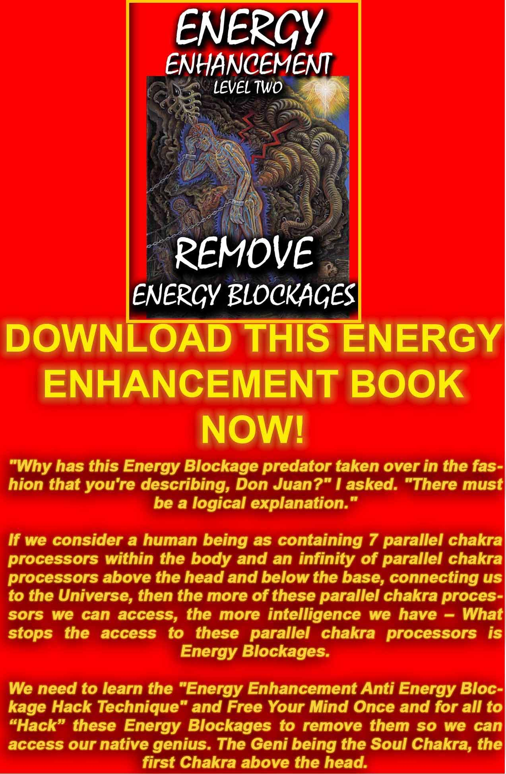
DOWNLOAD FREE! “LEVEL 2 REMOVE ENERGY BLOCKAGES” HERE
http://www.energyenhancement.org/Sacred-Energy/Level-2-Book/Energy-Enhancement-Level-2-Book-Remove-Energy-Blockages.pdf
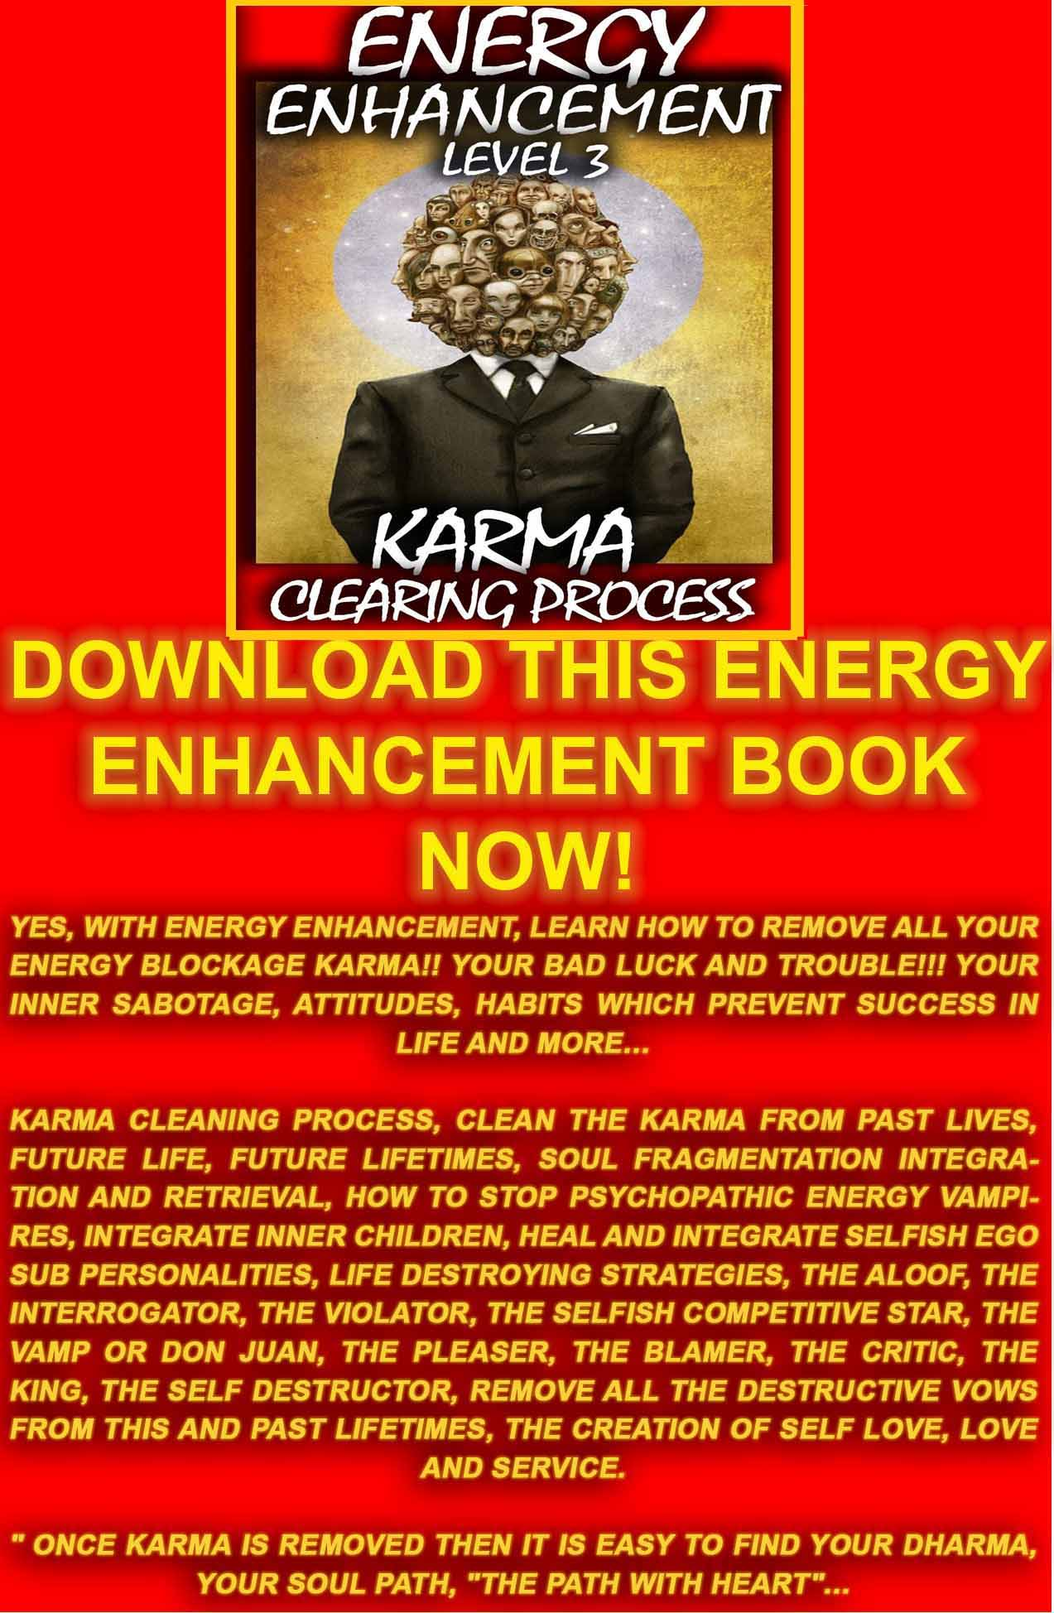
DOWNLOAD FREE! LEVEL 3 BOOK HERE!!!
http://www.energyenhancement.org/Sacred-Energy/Level-3-Book/Energy-Enhancement-Level-3-Karma-Clearing-There-Can-Only-Be-One.pdf
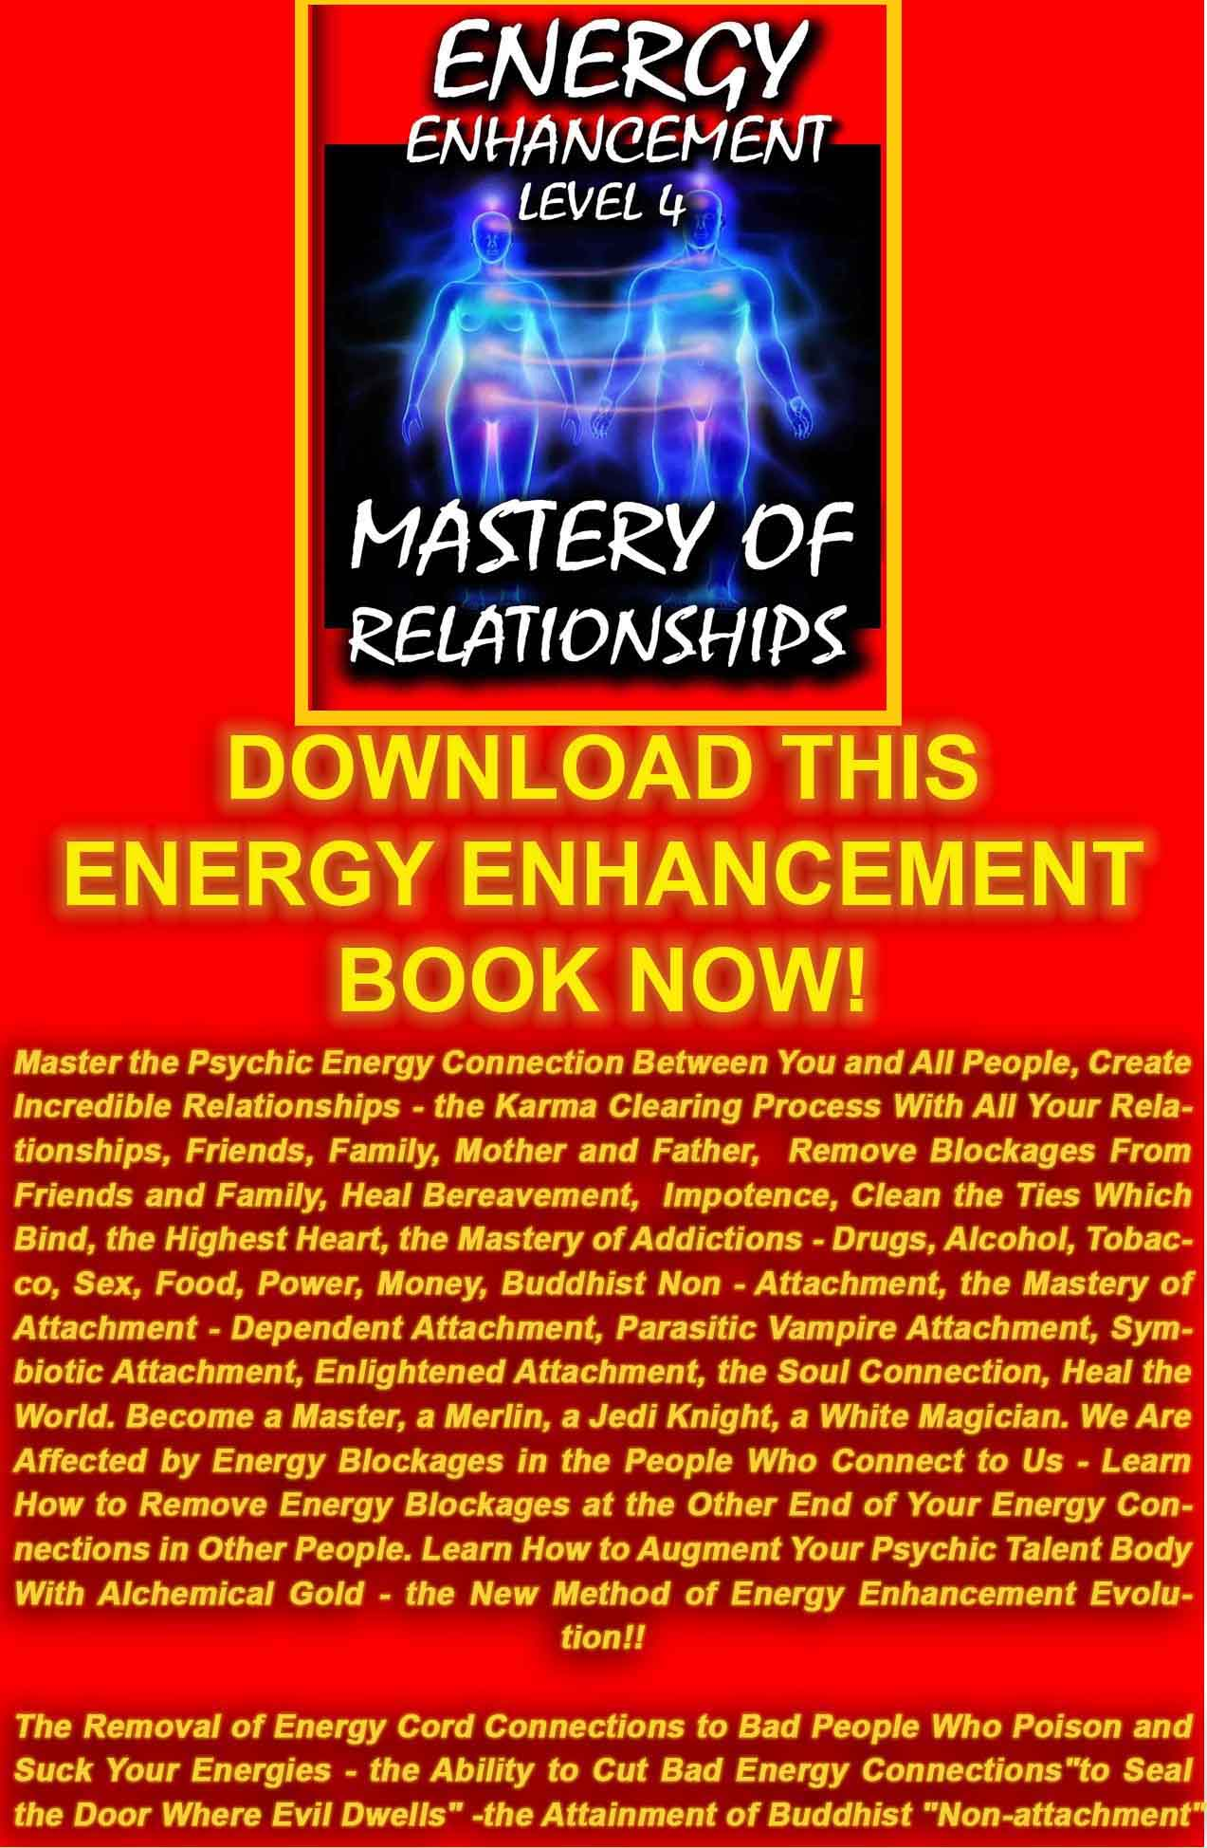
DOWNLOAD FREE! LEVEL 4 BOOK HERE!!!
http://www.energyenhancement.org/Sacred-Energy/Level-4-Book/Energy-Enhancement-Level-4-Book-Energy-Cords-Mastery-Of-Relationships.pdf
The Initiation, Sitting Position 42.20mins
Satchidanand (whilst physically altering someone's posture): And could you take off your shawls, so sit up straight.
Now, what I want to show here, is the necessity for having a curved spine, so come forwards a little bit, come forward a little bit, a little bit, put your hands on the floor like that, yep come forward, straighten the back as you come up.
Now keep the spine in this position. And come up into position with your hands in front of you. Shoulders back.
Like that, big chest, big chest. See.
Come forwards. Put your hands in your lap. Like that. And now keeping in this direction, come back up. Big chest. Shoulders back. Lift up. That's it. Okay. Very good.
Devi: She asks why this curve in the spine in the movement.
Satchidanand: I'll answer that later...
Now...there is an energy in the centre of the earth called kundalini energy.
And it comes up like a snake from the centre of the earth.
And this is why your spine comes in a curve from the base, goes back over the shoulders, goes forward over the neck, goes back over the back of the head, and goes forwards over the top of the head. Yea?
This is the way in which the spine is naturally curved.
Now you must be aware of trying to open the heart so bring your shoulders back, open the heart centre. This is the heart centre. Lift up.
Now this is what you're trying to do, is to stretch up from the base of the spine through the heart centre so you're trying to lift up that heart, stretch it upwards towards God. Lift up the chest.
And also you're trying to stretch up from the spine, through the back of the head, so we're trying to stretch in both of those directions.
We're trying to stretch up through the heart centre, from here, shoulders back, stretching up from this point. Very good.
And we're trying to stretch up, through the back of the head.
Now there is this energy which is flowing from the centre of the earth and it's flowing through your heart centre and it's flowing through the back of the head.
And I want you to sway 2cm forwards and backwards..and I want to feel that point where is the energy.
Can you feel that?
Try it for yourself.
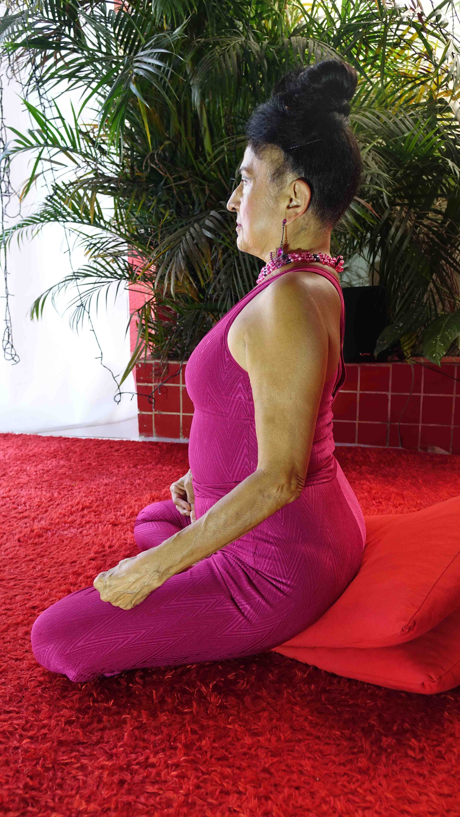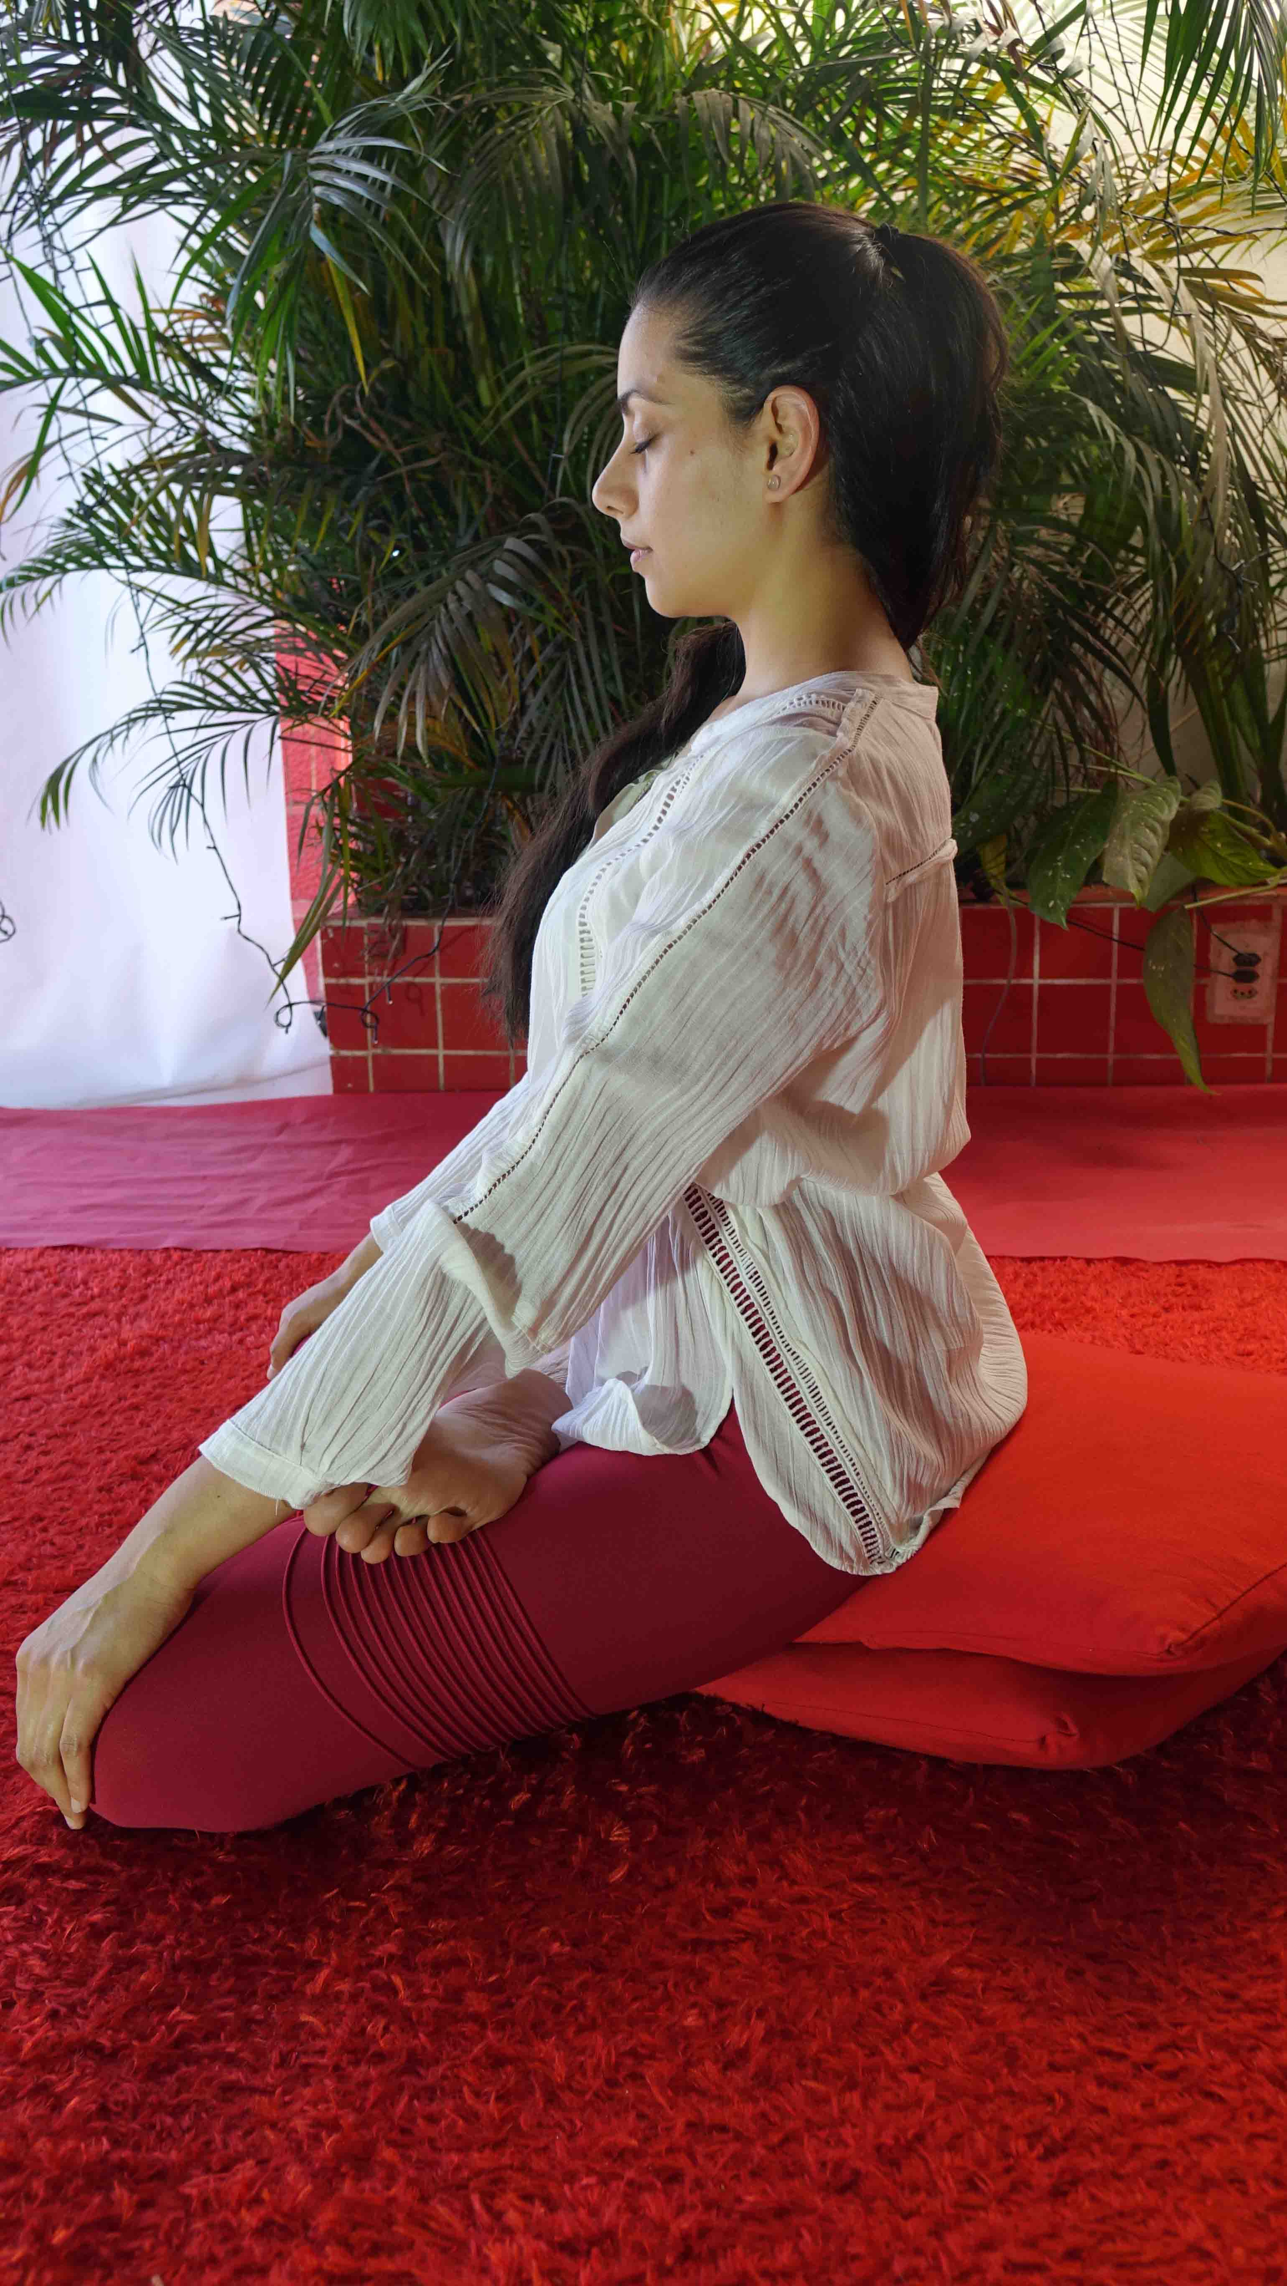Find the point.
Stop at the point.
And notice how you're breathing strongly when you hit that point.
It affects your breathing.
As the kundalini comes up through the body it hits all the blockages.
And the bad things in your body don't want you to feel the energy.
And that's why you need to go back.
There, you were too far forwards.
Can you feel it?
You need to be in the middle of that energy.
And you need to start to breathe from your belly.
This will control the energy.
Lets try again.
There are 3 points.
One in the middle, one at the front and one at the back.
You need to hit the middle one.
There is the maximum energy.
And you need to work on staying in that energy field.
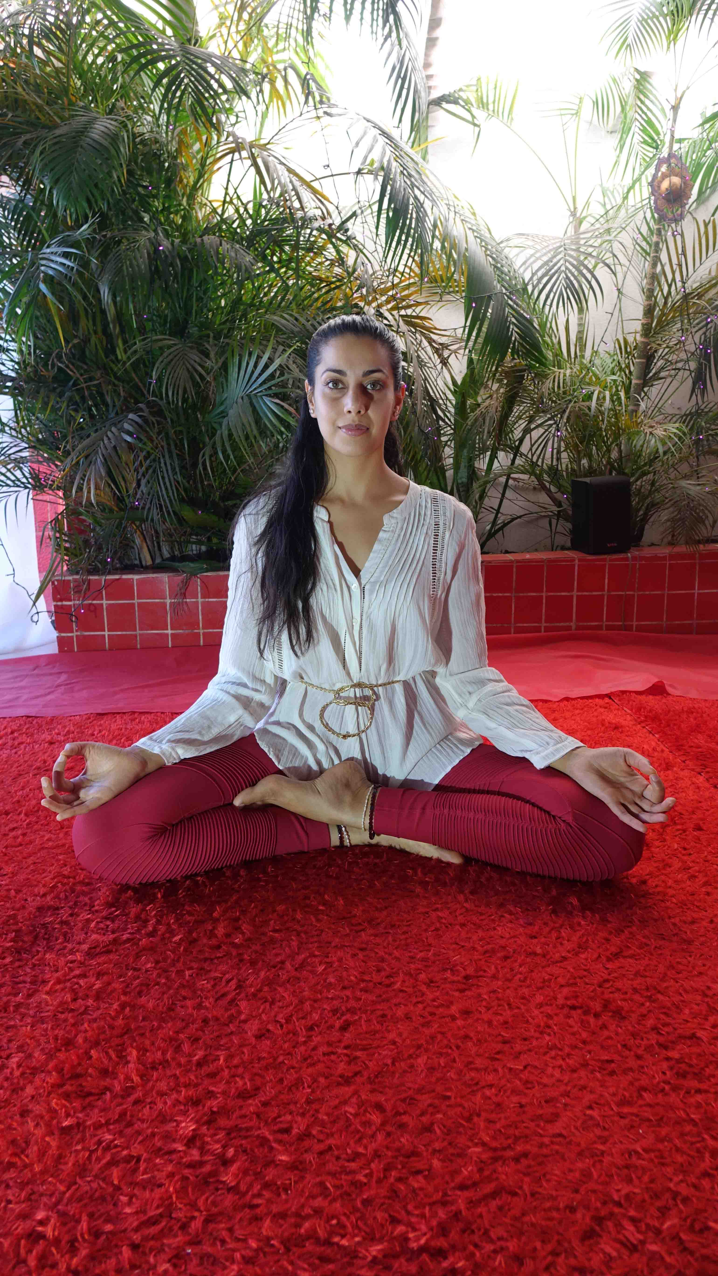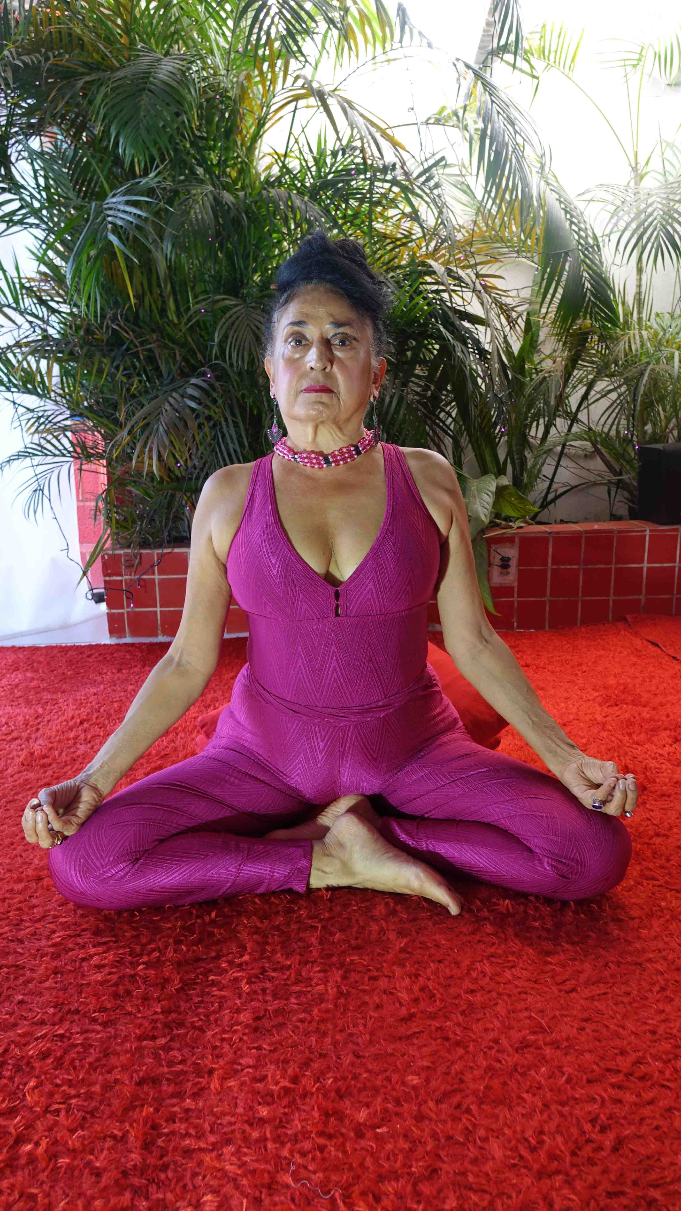Let's do it with you. (to cameraman)
Okay are you alright there?
The main thing is to get the chest, the shoulders and my hands.
So sway.
You need more here (poking spine).
You see more of a curve here.
Lifting up the chest more, really stretching up, shoulders back.
Lifting up. (physically swaying the lady).
Can you feel that?
Now slowly. Slowly.
There's the back, there's the middle, there's the front.
Lift here (chest).
Okay sway and find for your self.
There you go.
More forwards.
There.
Try and find for yourself.
Can you feel the breathing change?
Breathe from here (Abdomen).
Lifting here (Heart Center).
Can you sway and find the point.
Feel your breathing change on the point.
That's exactly it.
A little forwards.
There.
Breathe from the abdomen.
50% of the meditation is from consciousness of this energy which is flowing through the body.
And your job is to get closer and closer to the centre of this energy.
And this means millimetres, movements of millimetres to get closer to the centre.
It means stretching up more and more.
Through the heart and through the back of the head.
Stretching up from the base of the spine and then swaying a little bit to get closer to the centre.
Nice. Okay.
Breathe into the abdomen.
Stretch up from the base of the spine, through the heart centre.
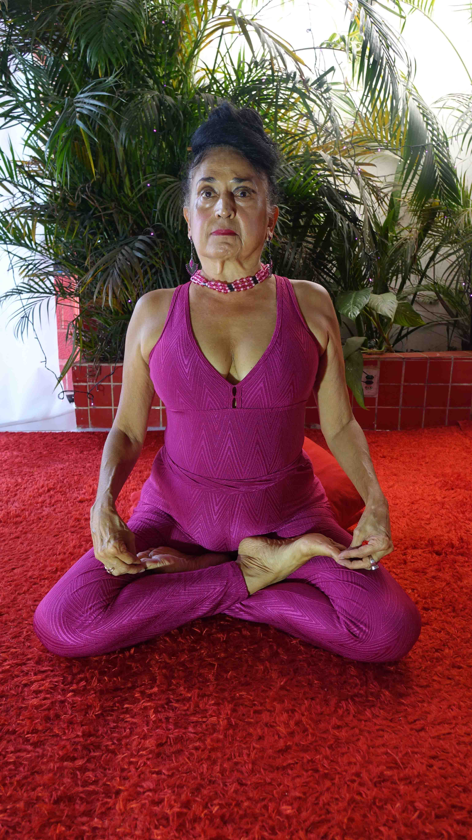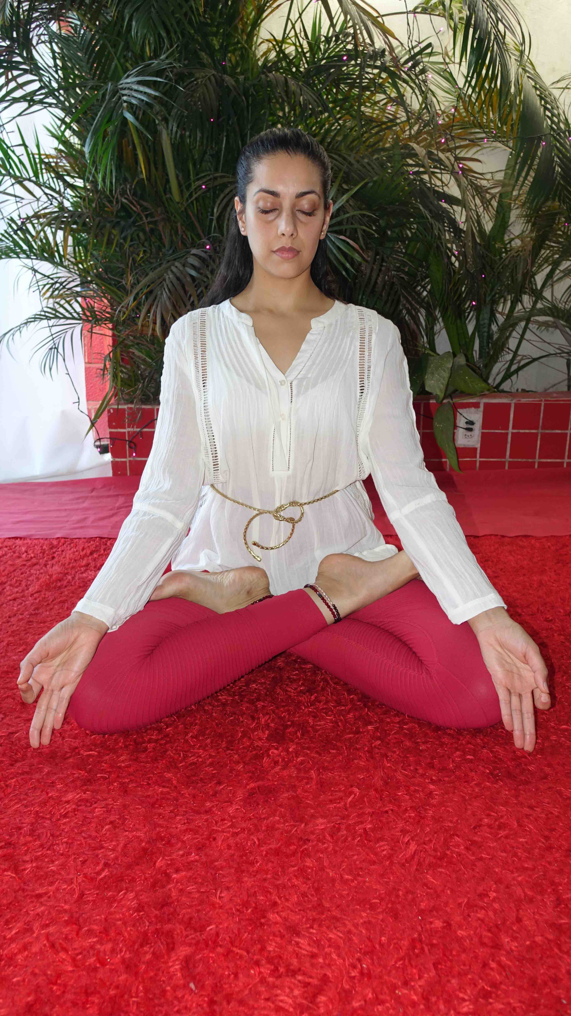Through the back of the head.
Stretching up getting closer and closer to the centre of the energy.
Breathing into the abdomen.
Feel the change in the breathing getting closer to the centre
And exploring the centre of this energy is what meditation is all about.
Because this energy is the energy of love.
This energy is the energy of will and high purpose.
For the benefit of all human beings.
And anything which is getting in the way of this.
Any blockage is going to come out in front of you now.
As pain in the knees.
As pains anywhere in the body.
As negative emotions.
And as painful thoughts in the mind, painful memories.
After sitting a while, due to a lack of blood, then you should stretch your legs out in front of you like this. (to cameraman)
Focus on my legs.
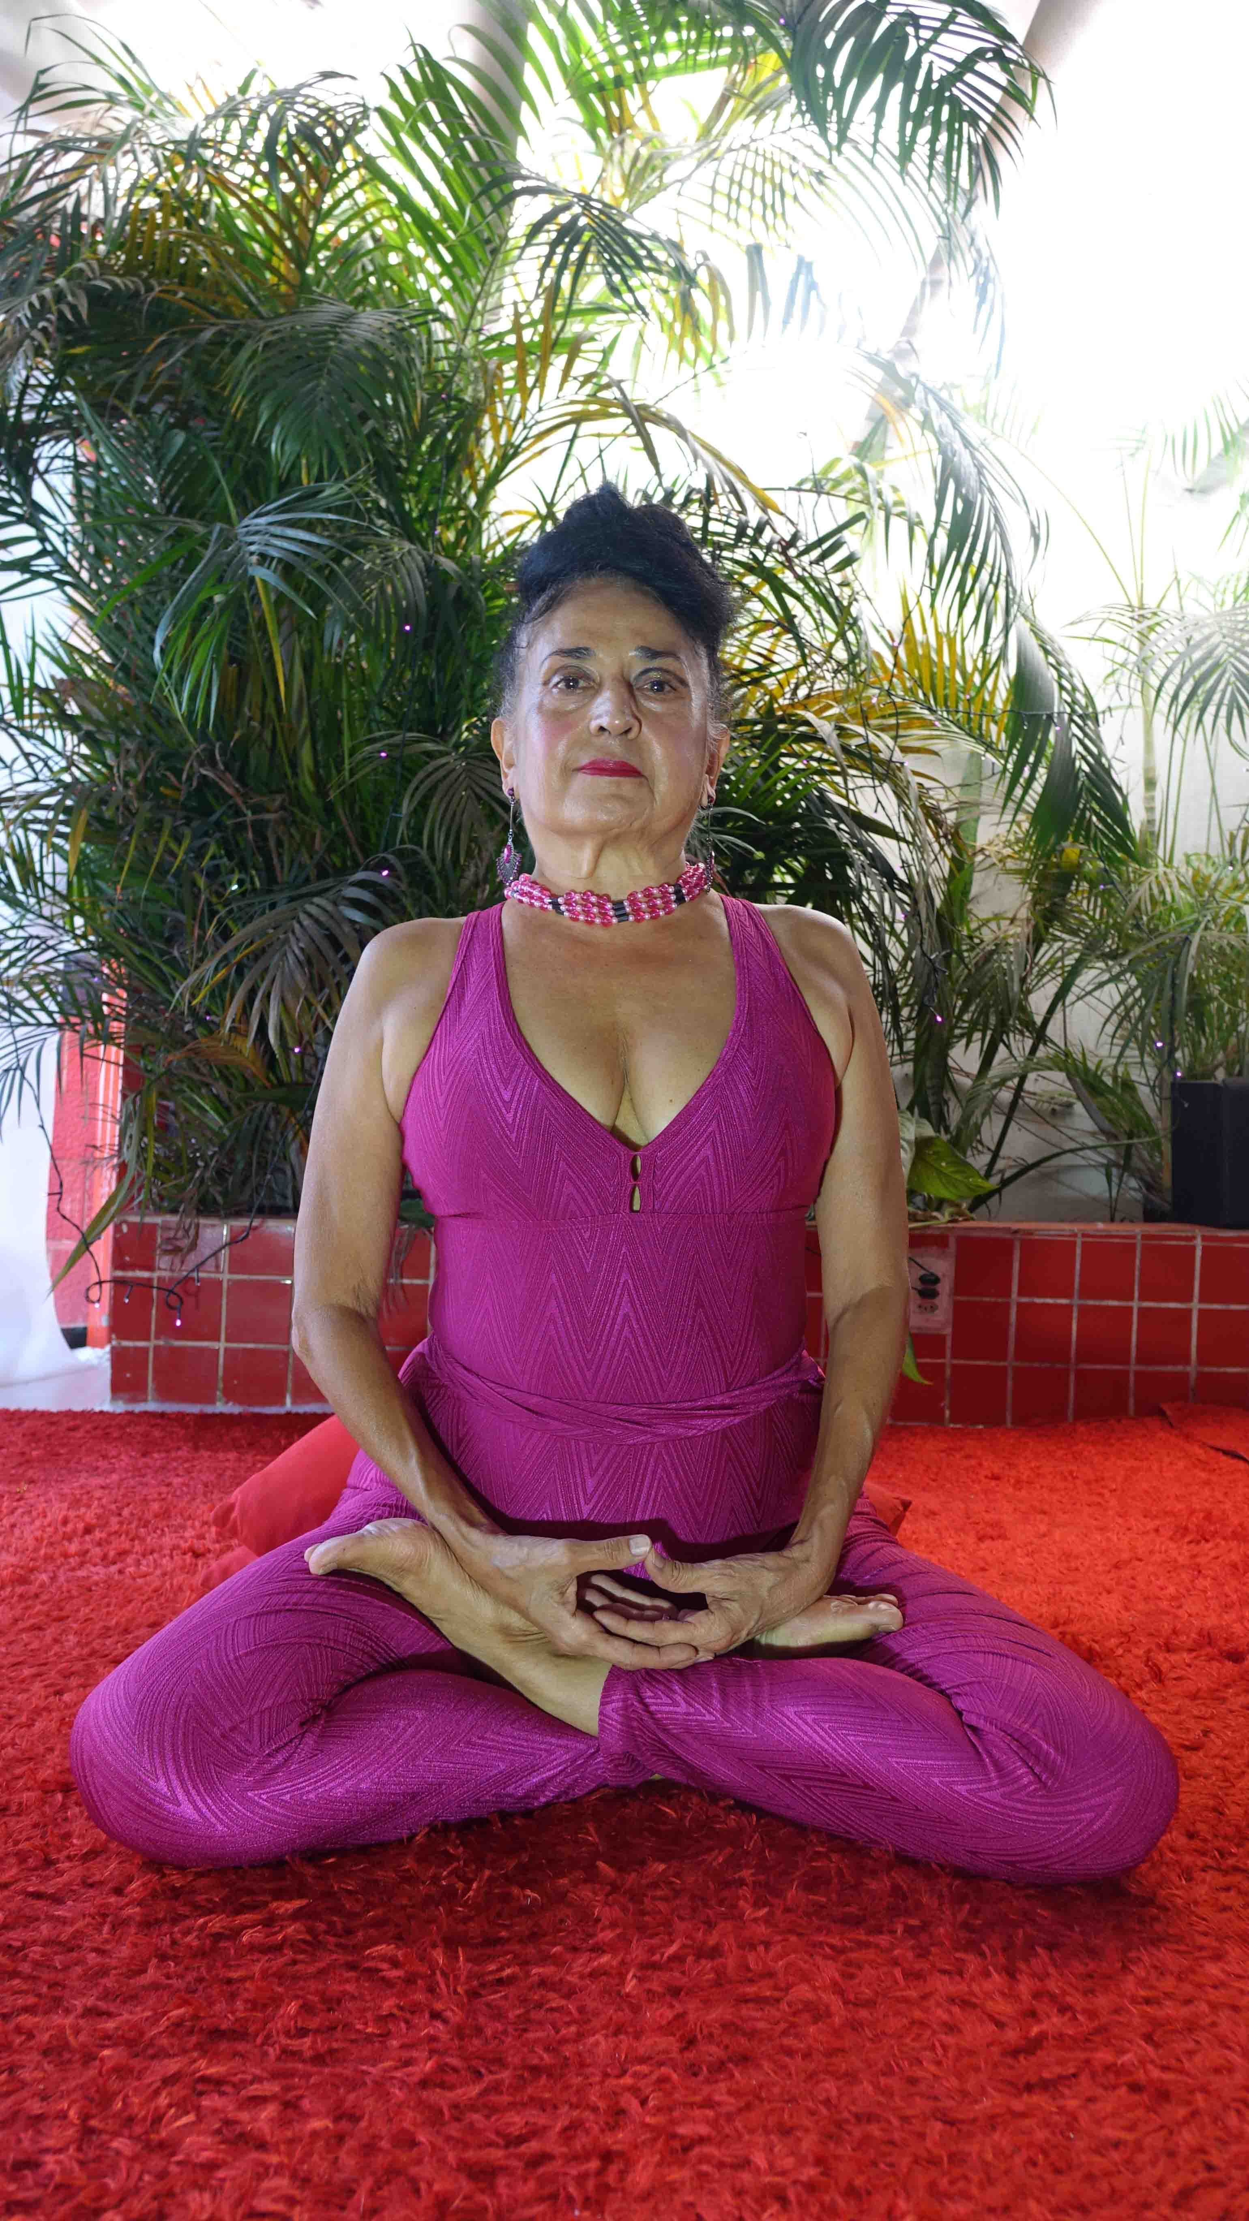Very slowly and don't point them at anybody because all the bad angels come out through the feet, point them at the wall.
Don't point them at computers.
Because bad angels like to live in computers.
They live in silicon, they live in the crystals don't they Devi? (laughs)
And you allow the blood to flow.
Don't move your feet because you will create an oxygen debt.
And when the blood is flowing for a little while, your legs have been given the energy of oxygen, then you can walk.
And this is good advice because many times during our practise of meditation your legs will become numb.
Parts of the strengthening process of your legs is to stretch out the legs, allow the blood to flow and then move the legs back again.
It's part of strengthening the legs.
The legs need to become strong.
Focus on my hands.
And my knees.
So we've got the knees on the ground.
We've got the feet in alignment.
And then we place the hand and the other hand on top of it.
And we put the 2nd knuckle against the 2nd knuckle in front of you with your thumbs against the belly.
Chest up, shoulders back, elbows wide and just to get used to this.
Push hands together.
Feel the muscles in your chest.
Lift up and then relax. Okay?
Sway spine...Get into alignment.
Sway your head. Get your neck in alignment with the energies of your spine.
Remember...(Spanish terms)....in alignment of the spine, in alignment with the neck, this is the position of the body, it's like a yoga posture, it's not natural but this posture will strengthen the body.
This is the natural position of the body, it's very proud.
Most people like to go around like that (hunched) so they don't get noticed, but in meditation we are training our body into a very young posture.
Because what happens when someone gets older (hunch posture).
This is a very young posture.
You need to have strong muscles.
You need to have strong bones, in order to have this natural young position and as you stretch into this position everyday...then your body will become stronger.
And it will become more easy and more easy to hold this position for 3 hours without moving (laughs).
Bien. But...as a beginner, you will need to practise and change your position and strengthen up your body into order to maintain this position.
Meditation is like weight training.
You go to a weight training gym and you get some weights and you do repetitions, reps.
This is the stretching up, it's a very strong pose.
And you need to develop this strong and young body.
And what is going to power this development of your body it's the energy in the centre of the earth.
It's going to energise you.
This is the physical body.
Your tongue is against the top of your pallet.
In position you're looking naturally at a position one meter in front of you.
Your eyes are closed.
There is no focus in your vision.
You are what the martial artists call ten directions vision.
So you're not focussing on anything, your vision is wide, it notices any movement but your eyes are closed..there is no focus.
Meditation – Initiations – Alternative methods of sitting – Kneeling and Chair.
Satchidanand: But kneeling, okay if you get up and kneel in this direction as well. (lady alters into kneeling posture).
Bien, sitting up, stretching, shoulders back, stretching up through the heart centre and through the back of the head, and there are 2 lines of energy, the sutrama is through the heart and the antahkarana is through the head.
So sitting up again.
Stretching up. Stretching up.
Close the eyes.
Keeping into alignment with the back and the head.
Move the head
And then in the chair..(lady in chair)...go right on the front of the chair.
Then stretch up.
Sway. (inaudible). Yea you can always do your best.
From the hips to the head.
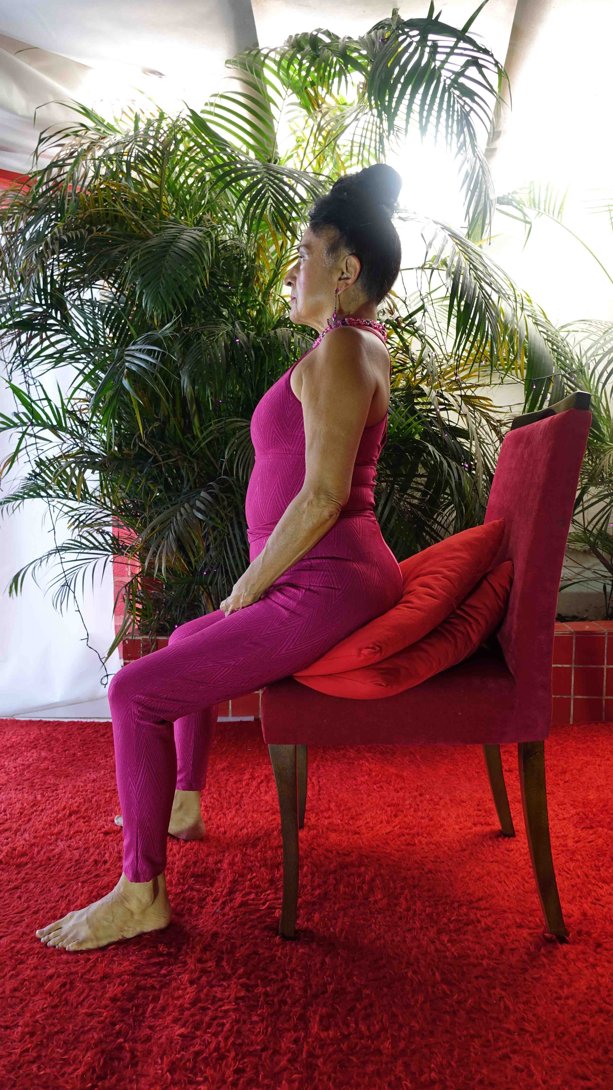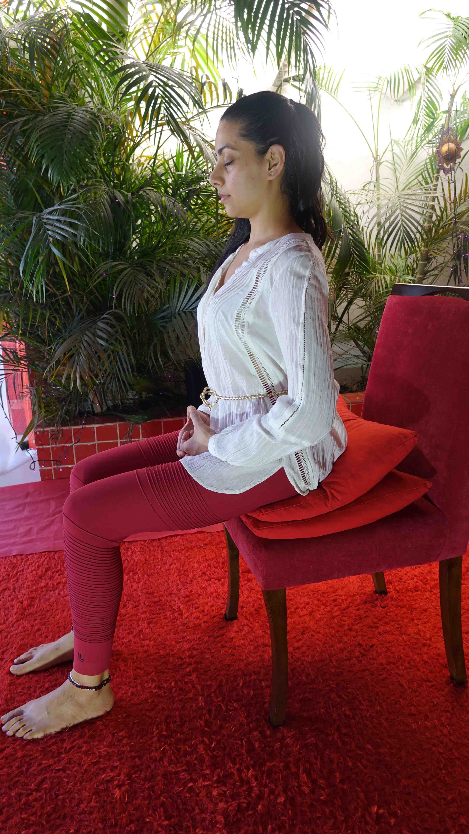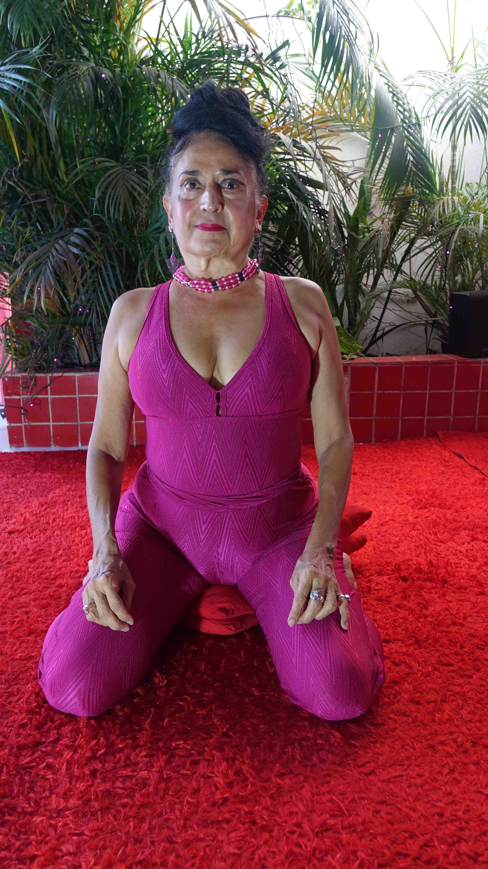Close your eyes.
Sway.
Lift up your chest.
Shoulders back.
And what I'd like you to do Devi is show them the knees are lower than the hips...and if you could go and touch them with your hands.
Devi, touch them, show the people, see, and the shoulders are back and the chest is high.
And then if you want to move back - Devi out of the way.
And what I wanted to show was the swaying of the back.
There is perfect.
And then the head.
Sway the head. Forwards and backwards.
Fall back, fall back. Lift up the chin. There. There.
More, sway, sway the head. Go back and forwards.
Lift up the chin.
Where's the centre, go down, there.
This is perfect.
Of course in this position. You don't get the benefit of upsetting the base chakra to remove all of these blockages.
It's a lot easier like this. (Spanish terms).
Gracias.
Shall we have a break Devi. Cup of tea. A nice cup of tea.
Meditation – Initiation –
After Sitting Comes Breathing.
Satchidanand: And after that, we're going to train the breath.
In yoga we learn about the 3 part yogic breath. Breathing into the abdomen, filling up into the centre of the chest. Filling up...and then into the top chest.
100% of the big breath, so breathe that in.
Have a big chest. In meditation have a big chest.
But then you don't move.
In meditation all you need to breathe into is the abdomen. So you breathe in the abdomen.
And you squeeze the abdomen back into the spine. You squeeze your anus and that pumps the energy up the spine.
So when you breathe out you squeeze all the muscles of the abdomen and tighten them up. You tense up your anus.
And then you breathe in again.
And you breathe out.
And now I'm going to teach you the 2nd part of meditation which is called breathing.
Which works on the abdomen.
Which is the place in which all the negative emotions reside.
As I breathe in I lift my hands as I breathe out I'll be moving my hands down.
You don't move your hands you keep them like this.
But I want you to get into tune with my respiration.
Okay so breathing in and breathing out.
It's very good at this point if you can use Ujayi pranayama.
It's like this, take a deep breath in, and when you breath out (demonstrates the breathing in and then out with a HAAA motion)...
And that's part, of pranayama, the psychic breath, the one that brings about psychic powers.
The real Ujayi pranayama,is where you close off the back of the throat, as we've been doing, but we breathe out through the nose, so we get a noise a very subtle gentle noise, which is very steady, of constant speed.
Not a rush at the beginning and nothing at the end.
It's going very slowly, so when I go like that (palms slowly coming down)...
So breathing in (raises palms)
And slowly down exhaling.
Up for inhale.
Slowly down for exhale...
As the thoughts come into your mind..take your mind to the breathing..
Open on your eyes.
Devi, focus on the translation...
Focus on the out breath and on the breathing...
Focus on the Ujayi noise that you are making on the out breath.
This Ujayi is a technique to take your mind away from the thoughts.
If at this particular moment you don't have a lot of thoughts in the mind you don't need to focus on the breathing.
Focus on stretching the body.
Getting your spine in alignment.
Neck in alignment.
This energy as you get closer and closer to the centre is the energy of kundalini which can become samadhi which is an experience of energy, orgasmic energy which can get very strong.
But as soon as the negative thoughts get into the mind again, focus on the breathing...
If the thoughts become very strong.
If they're really upsetting, then you can start to count the breath.
Using the Ujayi pranayama, you need to count the out-breath in your mind.
Like this....one....keep that One going all the way out on the out breath.
Breatheout....two...three...four...five....six...seven...eight...
No thoughts in the mind
Satchidanand: As the thoughts come, let them come don't' push them away.
And as the thoughts go let them go...don't hold onto them.
And try to retain an image in your mind of a mountain, be like a mountain with your roots deep into the centre of the earth...and your head right up into the centre of the universe...
And as the clouds of the thoughts come into the face of the mountain the mountain is absolutely unmoved
And as the clouds of thought are blowing past the face of the mountain, the mountain is completely unmoved.
The mountain is absolutely unmoved.
Heart Sutra 14.53 mins
Satchidanand: Okay...(Satchidanand and students do heart sutra)

Open your Heart using the Bound Lotus

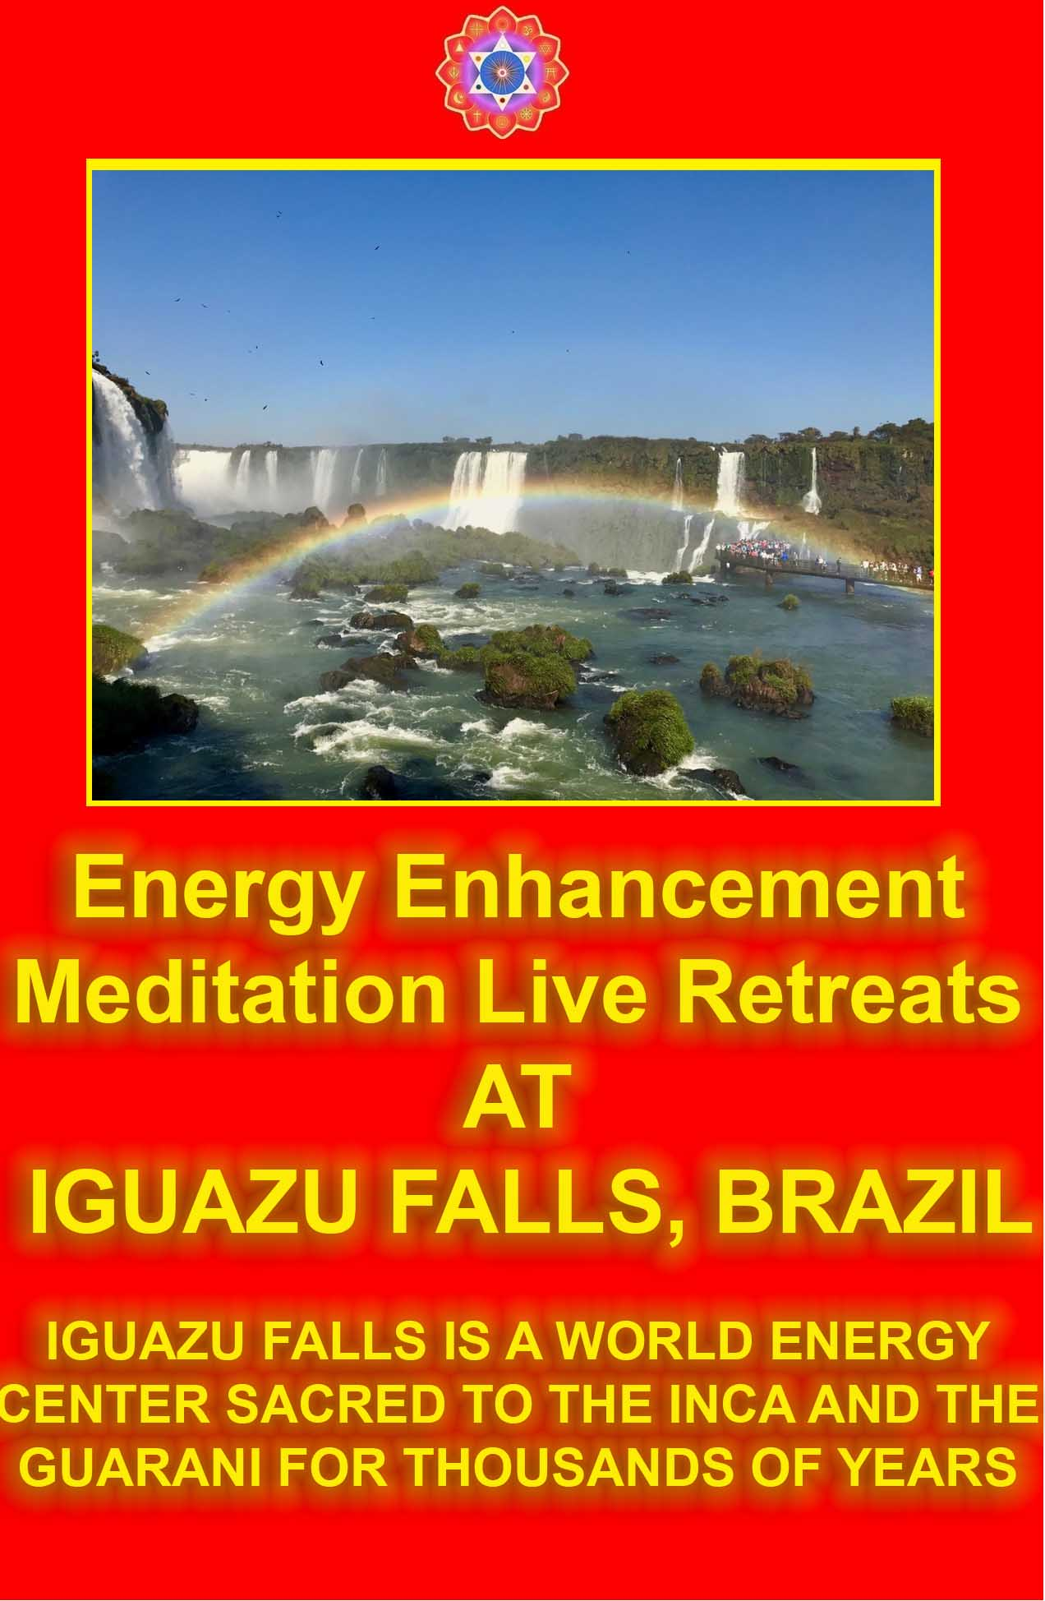
Extra Talk on The Secret, OM Mantra, Karma Yoga 25.41 mins
Satchidanand: (chants ooo with students)...
So last night we were watching the movie called The Secret, and because I put it on as part of the course I thought it would be really nice to comment upon it for your edification and delight and because it's nice to hear a point of view, a different point of view.
Now we should always trust tradition, you know when we have the sacred books, you can trust what is written down in the sacred books.
So when we're talking about the Yoga Sutras of Patanjali, after all that...says the first sutra of the yoga sutras of patanjali, after all that here are complete instructions on enlightenment.
Seems pretty good, doesn't it, and always in everything you get a current in life which is against the ancient traditions.
You can see this fight which is against the dark side and the light side.
In Star Wars for example, and you have the emperor and he's trying to draw Luke Skywalker to the dark side and he says to Luke, feel your power, be angry, use your anger as a power...bad person...
And Luke who has been trained by Zen master Yoda, he knows he's meant to be in the moment, he's meant to be pure, be perfect and he knows if he gives into his anger he's moving over onto the dark side.
And you know, in the movie, The Secret, last night, whatever you put your positive energy towards, you will attract towards you,
They say in your mind, it's very simple, it can deal with simple images, if you put this simple image, of a woman, of money, of a big house, of a swimming pool, of a Rolls Royce in front of your mind.
And you put your positive energy towards it then you will attract this image toward you, and it is the truth it is not a lie.
They say as well as vision and image you can use feeling to bring this image toward you, so for example if you want a car imagine you are sitting in the car, and you are playing with it and having a good time, and the mind is very simple images to focus upon in order to get what you want.
But there is a Hindu saying, “Lord have mercy on those who get what you want.”
In the Bible it says “Seek thee first the kingdom of god, and all else will be added unto thee”.
And in the Yoga Sutras of Patanjali it says “after all that..”well after all that means...after you have tried to be happy after searching after money, after you after you have tried to be happy after searching for a Rolls Royce, after you have tried to be happy after searching for a man or a woman, after you have tried to be happy by getting a yacht, after you have tried to be happy by going on holiday to India, Japan or China to see the great wall,
After you have found out that none of these things will give you happiness…
Here are complete instructions on enlightenment.
It's part of what is in the Bible, “Seek ye first the kingdom of god and all else will be added unto thee”.
Because the strategy to get what you want works.
Whatever you want.
And if you go searching after money then you'll have to deal with the Mafia.
And if you go searching after a man you will have to put up with the demon.
And if you go searching after holidays then you find everybody rips you off.
You will never be happy going after these low level things.
You will never be happy and the lord have mercy those who get what the ego wants, good eh?
Because you will always get what you want...
How it says, “seek ye first the kingdom of God and all else will be added unto thee...”
So if you need to have a Rolls Royce to do your job, if you need to have money to do your job, if you need to have a beautiful wife or husband to do your job to help you then you will get the beautiful wife or husband.
It comes naturally, without you having to ask for it.
And yet in Buddhism in Hinduism is says only the ego wants.
If you are wanting the kingdom of god is this not a sin, is this not a bad thing to want.
Because logically this is correct.
And yet the Hindu scriptures say that yes it is a bad thing to want the kingdom of god but it is necessary in order to eventually get to that stage of everything just happening naturally and automatically so that you get what you need.
It is not what you want, it is what you need to do your job.
You know if you want to create a book you will need a computer to write it, it needs to come.
Form is Emptiness.
Emptiness is Form.
Form follows the function.
So for example you have a cloth and it is dirty now this dirty cloth is you, you are a dirty cloth, you have been used and abused and the white cloth that was you when you were born has absorbed all the dirt of the world.
You have got this dirty thing within you, you have got that dirty thing within you, and it is there and it needs to be washed and how do you wash this dirty cloth, well you get another piece of dirt, we can call it soap
And we can put it in the water and mix it in, and we put the cloth in the water, and all the dirt in the cloth well it goes off to play with it's friend in the water, the dirty soap.
And when you take the cloth out of the water it is clean
You have a clean cloth so you need a little bit of dirt in order to clean the cloth and that bit of dirt is the want to be enlightened.
And when you are enlightened you don't have that want...because you are enlightened, it is the thing that is needed.
And you must have this want in order to become enlightened.
So...what is a good image to use as a set-up in your Energy Enhancement programme to gain the positivity that you need to wash the cloth further.
And when you're sitting there you can have an image of enlightenment.
And one of the images that the yoga techniques give is the guided meditation of OM.
Which is the guided meditation of enlightenment
And it says OM is composed of 3 syllables, AUM, aahhh ooo and M..
Because OM is enlightenment.
Once it has been activated once the guided meditation has become normal, it functions automatically without you even thinking about it then you are enlightened.
It says A - aahh is the base chakra down into the centre of the earth.
U - OOOo is the heart centre.
MM is the head chakras all the way up into the centre of the universe.
And as you chant AUM...you create the antahkarana of connection through all the infinity of chakras to god and that is enlightenment.
And this is a good image to hold and it's a simple image for the mind to understand and so it said use OM as a yoga to get you to enlightenment.
And then they have karma yoga first we have the mantra yoga of OM, and then we have karma yoga and karma yoga is the yoga of work.
And in the garden of Eden, Adam and Eve were told to take the fruit of the tree of knowledge by the black serpent.
And what did god say to Adam and Eve?
Don't take the fruit...
Don't take the fruit of your actions.
This is karma yoga.
Work, know you are working in the right way and whatever happens don't take the fruit of your actions.
Because if you're working toward enlightenment then 50% of the people will like it and they will say “oh you are a very good person”.
And the ego inside of you will be going “oh I am a very good person and I am sitting here I am doing the good work.
And 50% of the people are telling me that I am enlightened and I am a perfect human being and so I must be and I am very happy” - very egotistical.
50% of the people no matter what you do will say that is crap, that is a terrible thing, what are you doing, doing these terrible things...
And so you are sitting there saying oh so I must be a really bad person.
I am sitting here and I am doing the things for the work for all the good things and they are telling me I am terrible.
I will go into my hole and die. (students laugh).
And it says karma yoga, don't take the fruit of your actions.
Please be certain that whatever you do is a good thing, then whatever happens know you did it for a good reason.
Don't listen to what other people say about you outside.
Know you are doing it for a good reason, you are a good person and whatever happens, happens.
Don't take the fruit of your actions.
You know, what did Satan offer to Jesus Christ on the mountain?
He said to Jesus Christ, follow me and I will give you the money.
Follow me and I will give you the hundreds of beautiful women.
Follow me and I will give you the gold and the gold cups, the jewels.
And he even said to Jesus Christ follow me and I will give you a Rolls Royce.
He was ahead of his time this Satan wasn't he?
He said follow me and I will give you the big house with a swimming pool worth 4 and a half million pounds that I put as an image on my wall.
And what did Jesus Christ do, he said all these images that went pop pop pop in front of him, he said “Get thee behind me Satan.
“Seek thee first the kingdom of god, and all of those things will be added unto thee”.
You will just get them as part of the process, because everybody needs these things, why shouldn't everyone have them.
There is enough abundance for all of these things but get your mind right first.
If you are searching for these things and think they are going to give you happiness think again.
Enlightened sages have been proving for thousands of years that they can be happy doing anything, they are sitting there on the mountainside and they have no clothes and they are completely naked and they are sitting out in the thunderstorms with a big smile on their face going OM OM OM...
And everybody is coming by saying Look at that guy, he doesn't have any gold, he doesn't have a Rolls Royce, he doesn't have beautiful women, he doesn't have all of those jewels, how can he be happy?
And he's saying..
But I am enlightened.
I am connected with God.
What more do I need?
And you get these guys and they're just sitting there, going oh I am so happy, and what they're doing is they are providing an example of happiness to you saying you don't need anything else.
Because you know you cannot take it with you.
You cannot take the Rolls Royce with you.
You can not take the beautiful women with you.
You cannot take the gold, the frankincense and the myrrh with you.
But one thing you can take with you is your evolution, and your enlightenment, your ability to live through the death process, without losing your consciousness to become an ascended master.
What are you wanting with all this money and things, they are only burdens..
They are only problems...
Responsibility.
And once you are enlightened and you are sitting you will say “oh I take on that responsibility for the benefit of humanity.
I will take on all of this money because I need it to do my job.
It is a great burden having to look after all this to pay the taxes, getting involved in society, it's terrible.
You get a house the first you've got to do is to maintain it, if you get a swimming pool you've got to the liquids in here and the liquids in there, you need a pool boy then the pool boy rips you off and robs you, everything is a burden.
And the enlightened are saying some of them, look at me, I don't have any burdens whatsoever, all you people with your money are in hell.
I am happy, if I want the food people give it to me.
If I want to be protected against the wind, I have my skin.
I am happy.
I am sitting here with the happiness.
I am connected with God.
I am pure,
I don't need any of this stuff.
With Sai Baba you don’t get the interview, you get the inner view.
As he was talking on the stage in front of thousands of people he looked at me, jumped off the stage and walked right in front of me.
I remember Sathya Sai Baba coming to me one day and he stood in front of me, and he said well what can I do for you.
And I said well I want to come to the end of my meditation.
I want to become enlightened, and of all a sudden these images appeared in front of me, pop...a Rolls Royce, pop a million beautiful women, maybe there was a just a hundred there, but they were naked, pop a pile of gold, pop a big house 4 and a half million dollars at least with a swimming pool, and as these things were going pop pop pop.
And Sai Baba was looking at me I put my hands up and I went (moves images down) I moved the images behind me. Get behind me Satan!!
“Oh “ said Sathya Sai Baba, I “will see what I can do (laughs)
And he turned round and walked back (sighs) such is life.
And then I woke up and Sathya sai Baba was on the Stage and he was talking..
It is such a bother having to set up all these microphones, they are such a burden, it's such a bother having to set up all these videos and this and that and the other, such a burden.
I have computers here and people there and it's all such a burden and the only thing that makes it bearable is enlightenment.
The connection with god, working for non egotistical purposes.
Because it is in alignment with the will of god...and it is what makes you happy, nothing else.
OM an image.
And what other images do they give you well you can try the other mantras, coca cola coca cola coca cola and then somebody comes to you with a great big drink full of bubbles and all sorts of shit.
So if you have a mantra that is given to you by a guru then you need to have something that Is spiritual with an image of god within it, coca cola will not do, you will need to have something like Buddha.
And the essence of mantra is that it is in tune with the breath, just like all good Hatha Yoga, you have to be in tune with the breath.
Because Hatha Yoga is not only asana it is also pranayama so if you bend forwards you breath out, if you bend backwards you breathe in, and you are always conscious of your breathing while you are doing the asanas.
And in your asanas you are sitting on your bottom and this is why it's called an arse-ana.
So if you have a mantra, it's the same thing, you have a mantra called pra, on the in breath, na on the out-breath
You usually have..or hari-om tat sat..
Hari om as you breathe in and tat sat as you breathe out...this opens the heart.
There are many mantras, they need to have a spiritual meaning behind them, not coca cola, coca cola is no good.
You can try money if you want...money...but then you will be in hell..you will get all the bubbles and the crap and all that...
Breathe in ...gold....beautiful women...(laughs) you will be in hell..
No...you need to have something like krish...naaa...braahmm mmaaa....shiv...vvaaa....you need to be involved in the connection between heaven and the earth, you need to be in alignment with the energy of god.
Anything that brings you into that alignment is good, (inaudible) yoga- knowledge of god, Hatha Yoga – knowledge of the internal energies of the body – ha - the sun – tha - the moon...ida the moon, pingala the sun, sunshumna the balance between the two that is brought by alternate nostril breathing.
All low level stuff but very necessary for the balance of the emotions of the body, all of the yogas, giving images, simple images to meditate upon that will bring you to enlightenment.
The image of the Buddha, a young chap sitting in the lotus posture in gold, well the image is that of enlightenment.
The image of Jesus Christ with his big heart of love.
The image of Krishna giving you honey and butter, playing his little games and strategies, having fun consciously.
You need to use a simple image, and choose it and use it for a time and by the law of attraction that will come to you, and you need to do it with great positivity, that is the secret.
Everything else is the dark side of the force.
After all that here are complete instructions on enlightenment.
Got it?
Good.

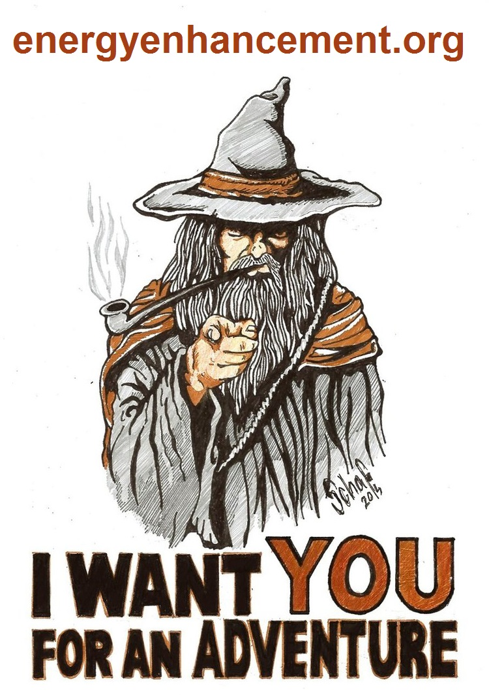

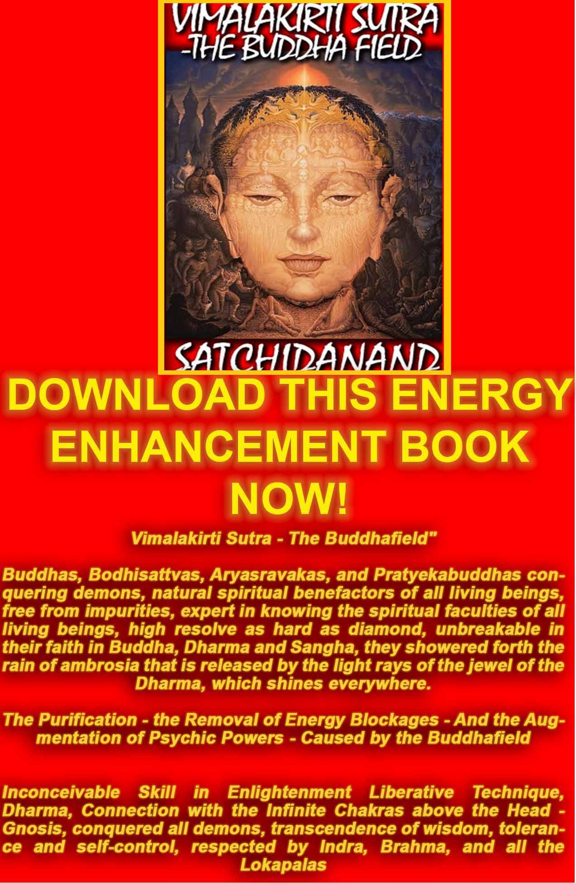
http://www.energyenhancement.org/Vimalakirti-Sutra/vimalakirti-sutra.pdf
Initiation 2: Energy Circulation 3 hours 23 mins 3 secs
Introductory Talk 62 mins 27 seconds
Satchidanand: (laughs) It's very simple, I read in a book once, that there are some masters that are so high, that they live in the planes of the Himalayas, and they never meet anybody because their energy is so strong that if a normal person met them, they would explode. (laughs).
They only meet up with their very closest disciples who can take the energy that they can give.
And all I was saying to Nipun, is something very normal that when you raise your spiritual energy your level of spiritual energy sometimes it becomes so strong, that some of your friends cannot take the energy and they drop away from you and your energy rises so much that people with more energy enter into your life.
This is how you change your life, it's just about the levels of energy. I don't know whether Nipun wants to live in a cave all alone, because if everyone saw him they would explode, but I don't think there's much chance of that. Laughs.
Which is just as well. Because Nipun's job is going to be to teach many many people. Because he will be a very good teacher. Yep. He has a very good heart. (smiles). (students cheer). (claps and laughs). Okay..what are we doing today. What is it? At this very moment.
Devi: The 2nd stage of Energy Enhancement
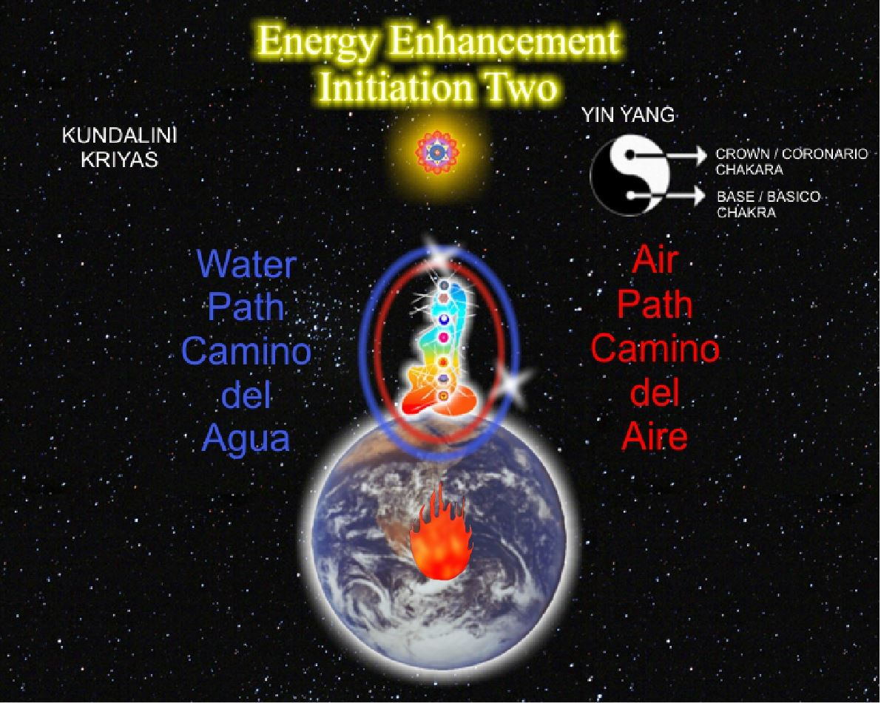
Satchidanand: No, it's a rhetorical question. I know exactly what we are doing.
Voice off-screen: I have a question for you.
Satchidanand: Ah yes a question.
Student: (inaudible and Devi translates)
Satchidanand: Shall I give a short reply or the long reply? Devi translates. It might be a bit too early in the course for the long reply. (inaudible) energy vampires.
The question of energy vampires is very normal, some people are energy vampires. Some people are energy vampires. And they exist whatever your energy level, the more energy you have the more energy vampires there are.
Some of them don't know that they are energy vampires because they have blockages.
Each chakra there is a side which gives, the right side, and the side that receives the left side.
And if those people have a blockage on their right side, they will not be able to give energy to you, the energy will not flow between you on that chakra level. You will not be able to communicate on that chakra level. But as you learn Energy Enhancement so your very presence will dissolve their blockages and enable correct communication between you and them, you will heal, they will no longer be energy vampires.
And then, there are the other energy vampires, shall we call them students. (laughs with students).
And many years ago, one of my favourite saints, Jallaludin Rumi, who wrote many of the most beautiful poetries in the world. They call him the Persian Shakespeare. And the spiritual wisdom which is encapsulated and encrypted in those poems has been basic reading material for every spiritual student who wants to grow and he always used to talk about the perfect thief. And I just love this story because every student needs to learn to be the perfect thief to take the energy from the master.
But then..erm...every master must learn to be the perfect thief, in order to take the energy blockages from the student.
Once upon a time, there was the most perfect thief in the world. Everybody wanted to have their goods stolen by him.
He was a really famous, thief but he had one thing wrong in his life. And it was his son, you know he was just lying in bed all day. He was not interested. You know. What can you do?
But then one day he was overjoyed, his son came to him and he said, father father I've been thinking and I really want to follow in your profession, I want to become the most perfect thief. And he was overjoyed, oh my son my son. I'll take you out tonight. I'll show you the ropes. I'll tell you everything about the profession, and that night when the moon was shining they went out into the city and they came to a big house. And as they were crossing the yard, they saw this big well. As they were crossing, the master said, careful you can fall down there.
And they went up to the house. And the master thief took out one by one, all the bricks in the wall and he made a big hole and they both entered into the house and the father said ssshhh...they are asleep upstairs and as they went into the house they came to a big cupboard and the master thief opened up the door and he said right son you go in there and then he slammed the door and then he turned the key and high tailed it out of there.
And the son was in the cupboard.. he goes (screams)...because upstairs everybody was getting up and they were saying The thieves the thieves... and the guy in the cupboard, he's going (worrying scream) and so they came into the room and put on all the lights and as they were passing by the cupboard, the son said...meow meow...and they said Oh, there's a cat in the cupboard and they opened the door and the son came out like that (running motion) and he went across the room, and he went through the hole in the wall and he went into the garden and as he was passing the well he got hold of a big stone and he threw it down the well and it went splosh and he went on out of it.
And all the people in the house, they heard this splosh, and they said the thief has fallen down the well, tell you what we'll leave it. If he drowns it's his bad luck. And if he's alive in the morning we'll take him to the magistrates. So they went to bed.
And so the son was going home and he was terribly angry. But when he got home he found his father asleep in bed. With a sweet smile on his face. And he said father father, what happened, why did you leave me in this situation , in the cupboard, with all the people coming down.
Well my son he said, I was wondering, whether you had the same genes as me. I know I gave you the Levi's (laughs).
Devi: What is the Levi's?
Satchidanand: They're a type of blue jeans, trousers...you're giving away the joke (laughs)...
I was wondering whether you were really my son. And now you have managed to escape from this situation. I know that you are my son. And you are going to be the most perfect thief. Just like me.
Oh dear..so what is the meaning of this story. So Jallaludin Rumi, he wouldn't write just about a joke, he would write a real current of meaning. Yea? What is the significance of this joke. It's very deep you know. Just like the well. Yea? Has anybody got any ideas?
Well the perfect thief is a spiritual master. As I said the perfect thief takes all of the negativities from all of his students. He helps them to grow.
Now..the son...just like the son of God. Gets sent down to earth to do his work. And every one of us has been sent down to earth, we are all the sons of God, even Honey. I know we have the wrong sort of..
Satchidanand and Honey: Gender
Satchidanand: about it...but even so she is the son of god as well. There we go I'll make a special case just for you.
Honey: My mum and dad always say I'm the son and daughter of the family (laughs)
Satchidanand: The son of God, and my experience has been that before we can take up our real work after we have laid about in bed for so long. After we have removed many of our energy blockages then we become fit to take up our real work which is to become a spiritual master.
Now I don't know how long you gotta lie around in bed. The Buddha used to say the house is burning down around you but you are still lying in bed. He said...this work this Energy Enhancement because the Buddha used to teach Energy Enhancement as well. (laughs)
He was very good as enhancing people's energy (laughs) He used to say, this work is for those who believe in enlightenment. And understand the urgency of the situation.
So...after you have taken up the gauntlet.
Devi: What?
Satchidanand: After you have taken up the gauntlet.
Devi: What is gauntlet?
Satchidanand: It was in the Lord of the Rings. You must have seen Lord of the Rings. No the gauntlet, the gauntlet is a glove. Now remember when Boromir dies.
Aragorn, who until that moment...had never really believed he could be king, but when Boromir dies, he says I would have followed you my captain, my king. And Aragorn is very touched by this. And as he leaves he takes Boromir's gauntlet, and he puts it on.
And this signifies that he has taken up his destiny and he has decided he has made a decision that he is going to try to become king
So when you lot get out of bed...and take up your proper destiny, then the next stage is to get shut in the cupboard (laughs)...just to see if you can get out of it.
Honey: So how can that happen in real life normally. Is it like challenges?
Satchidanand: Sure it just means when you take up your destiny, you know you have a job to do, but you don't exactly know how you're going to do it. You know you got the energy but then you have to think of a new way of manifesting this because it's going to be different every time. And once you've got the idea then you got to put many years of hard work into it. In order to make certain that it works.
I suppose it's like any business. You gotta have everything in place in order to make certain that it works and then after 30 years of hard work you can be an overnight success. (laughs).
That's my idea about it. You can have your own ideas about it also. But that's the way I see the story.
Honey: Shortcut formulas I always come out with creative ideas.
Devi: Guillermo say, the idea is to have a chain of supermarkets
Satchidanand: Well I always have been one for believing in franchises. And I think that one of the best thing in the world has been to copy accurately things like the Mona Lisa, you can churn them out by the million.
Everyone can have the Mona Lisa. It's the same as Gutenberg when he made the Bible millions of time and everyone can read it and take from it. And when you make a DVD about how to dance properly (laughs) then you can distribute it to all the countries of the world and everybody can see exactly the same thing as what was on that the original video, isn't science wonderful? Yea? So I'm a great admirer of that kind of thing. Very good, okay...
Well that was the short answer (laughs)...there is much more I can say on this subject but I think it's fun to I don't know, just to play, it's good. Alright, so...now...now is the time, we're going to have the initiation of errm Initiation 2 called the circulation of the energies, it's the start of the Kundalini Kriyas and it's the start of learning Daoist meditation.
Daoism grew up on one side of the Himalayas in China. And on the other side of the Himalayas the gurus were teaching the Kundalini Kriyas. And it's exactly the same technique, because the real people who taught this lived on top of Mount Everest. They could see on both sides.
There was a friend who came in yesterday. He says why are you here in Rosario. And I said but I'm not here in Rosario, I'm here on the planet Earth. (laughs). And because the Daoists know about the competition in religions, because in every organisation has bad people in it. As well as every organisation has really wonderful people Saints in it. But the bad people sometimes due to competition they want to take over the other religions. You know the temples change their name. You got the Temple of Zeus and then you get the Temples of Deos, you get the Temple of Diana and she changes into another name of another Goddess Aphrodite, yea?
And all the symbols are neutral – they work equally for the Dark Side as well as for the Light.
And so it goes on. And they know all the religious texts get burnt. So instead of writing things down and providing more translations to argue about they made a beautiful symbol. Its very pretty and yet all the knowledge of the Daoists is within that symbol, and it's this symbol, it's the yin yang. Yea?
Now many people put it the wrong way up, they have it like that with the dots on the side. But it's not meant to be like that, it's meant to be like that.. with the dots vertical one above the other - because once you understand that each of these dots is a chakra... and the top dot is the crown chakra and the bottom dot is the base chakra then you know that you are talking about circulating energies between chakras.
Now for 4000 years the Daoist students who created acupuncture have mapped the channels of energy called meridians on the surface of the body. And these maps have not changed for 4000 years. There are 12 major meridians and they come out of all of the fingers and they come out of the arms and they come down the legs and they come out of each toe. And these are the meridians that the acupuncturists put their needles in to remove energy blockages to allow the energy to flow properly in order to create health in the body.
But they very rarely touch the meridians from which all of those 12 flow. The most important meridians in the body are the ones which flow through the chakras and they flow from the top of the head down the nose and down the front of the body through all the chakras to the genitals to the perineum to the anus to the coccyx of the base of the spine and this meridian down the front of the body is the central meridian and the one that flows up the spine from the coccyx of each of the spinal processors to the back of the heart to the back of the head over the top of the head to here (third eye) is called the governing meridian. And in reality there are not 2 meridians there is only one. It flows in a circle and it flows in both directions in the same time. And it is this circle of energy that we are going to use in order to increase our natural bio energies.
We are going to imagine a journey along these meridians and we are going to go and try to see a golden cord out of our heart centre and we are going to try and move that golden cord down the front of the body and around all of these meridians..now...as we do this...we might start to see reality because everything starts with imagination and then we see reality. These meridians are real. And as we do this we might start to see energy blockages which are stopping the flow of the energy around our body. Now how do we know where 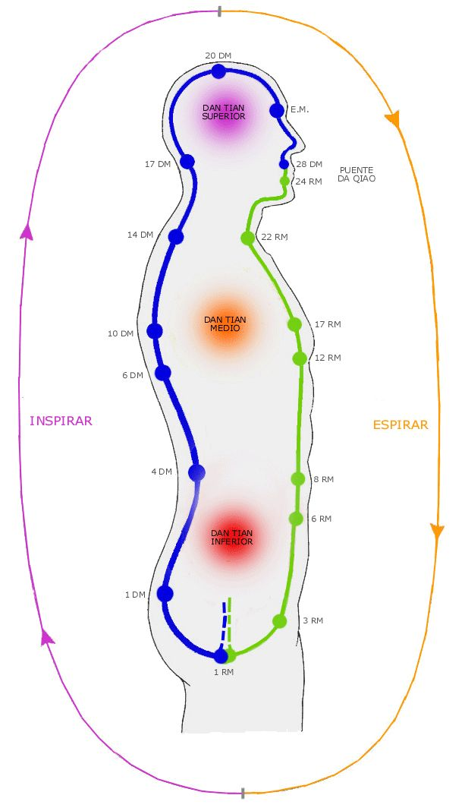there is an energy blockage. Well where you cannot imagine the golden light, that is where there is an energy blockage.
Your job is to really push with your out breath, remember, we were learning about the out breath in the heart sutra. You can learn how to push energy with your out breath and where you find an energy blockage, as you push the golden light through it, you can dissolve it and then everything is made into gold.
When you can see a blockage, you might have so much psychic power you can see the blockage. When you can feel the blockage. Seeing is a function of manipura chakra. But feeling is a function of the heart chakra. Every one of the chakras has a sense and depending upon which is your most developed chakra then psychically you will get visions depending upon your capacity.
You will also know that there is a blockage when you get distracted. There you are in the middle of your meditations and you are breathing the golden light around your body and all of a sudden you’re in the middle of last week talking to your friend, you have been distracted, and at this point you know there is an energy blockage there that doe not want to be seen “oh don't look at me, I'm not doing any harm here at all” right you bugger I've got you (laughs) right we'll soon sort him out...err..where you get pain..sometimes when you're breathing the golden energy through a blockage you'll feel a little pain in that region.
And as we continue to breathe that golden light through it...then the blockage will dissolve. Another thing is as you're doing this and you're breathing the golden light you might suddenly feel oh I wanna go to sleep, another blockage...yea? Wake up!
As you're breathing the golden light through a blockage you might get a lot of thoughts, there's a blockage there. When you feel some negative emotions....that's where there is a blockage.
Sometimes as you're breathing the golden light you sometimes get a little kink in the golden cord...a kink...it means it just moves out of the way...there is a disturbance in the force...(laughs)...and I'm taking that from Star Wars...”my lord there has been a disturbance in the force”.. that's where you know there's a blockage..
The technique that we are going to use at this time is to breathe the golden cord through the blockage because we are learning to deal with energy.
Honey: It's a golden cord..
Satchidanand: String..cord...erm...flow of energy
Honey: liquid
Satchidanand: Or liquid yea..really there is no set way of doing these things, everybody is different, everybody has had many many different lifetimes of meditating in different traditions. The Buddha said, they asked the Buddha, what is the truth...and the Buddha said That which works. (laughs). I don't care what you do. The only thing I require is that you get rid of the energy blockages. That's the only thing that counts. They must go. Okay? But if you want to ask me any more questions, that's fine. Okay.
Now...you know these techniques have been known for a long long long long long long time. There's a guy in Crete who's name was Daedalus and he created something called the Labyrinth. Underneath the palace of the king of at Knossos. And this labyrinth was a sequence of passageways and when you entered into it it was very easy to get lost and very difficult to find the centre and they made the labyrinth because they wanted to hide the Minotaur. And he was half man...and half beast, just like the sphinx just like the centaur...and in a way he's very much like the description that Sathya Sai Baba guy gave about a normal person...you know a normal person..he says is made up of the beast...personally I prefer to call him a donkey...this burro gets everywhere and not far behind him is the cow...moo... and that's the other side...we're also made up out of God, and in the middle you've got the normal guy, did you ever explain it to Nipun about the cow...he was asking me this question yesterday, he said what is this cow.. what is this cow..yea well the cow goes moo...and in the heart sutra...there is this word called mu..yea?
It is part of the heart sutra, and what is mu? Is god. But they just call it by a different name to confuse people like you and me and everybody else. Because God is that energy with 10,000 names and yet he is only one.
So why not make up another one and call it a cow...moo...(laughs) (Guillermo speaks off-screen)
Devi: Guillermo says there is a (inaudible)..somebody asks to him what is the face of Buddha..(inaudible)
Satchidanand: There is another Koan does a dog have Buddha nature? Master replies...Moooo...
Who founded Zen Buddhism, el Buddha, who wrote the heart sutra..the Buddha, where did Mu come from? He came from a cow. (laughs) So we are going to have our first experience with blockages. With Dhiren's side 2, the second yea. Everybody wants to go to sleep.
Well this is quite normal that everybody wants to go to sleep when I talk. (laughs). And it's not because I'm not an interesting speaker. Because I do give my all into this. I do give my all, everything..but when I speak... I am radiating the energy of the masters and this energy is radiating out and it's going into the people and all of their blockages are starting to melt.
How do you know when there is a blockage, when you want to go to sleep. Who wants to go sleep. (laughs) But none of them are admitting to it.
Honey: A little bit.
Satchidanand: You egotistical bastards you all want to go to sleep, come on admit to it.
(laughter)
Devi: What happened we are up to 8 o clock today. We dance a lot.
Honey: That's true
Devi: We did a lot.
Santhan: 6.30. That's why I had coffee.
Honey: 6.30
Santhan: I had a cup of coffee
Devi: Ah Santhan had a big cup of coffee.
Satchidanand: This is why Santhan does not want to go to sleep.
Honey: We'll find another way.
Devi: A blockage
Dhiren: All these impurities in the coffee you know.
Devi: What...oh impurities.
Satchidanand: Dhiren, don't give coffee a bad name. Because I am a coffee fan. Have been for many years and I know if you drink too much coffee too much caffeine it's very bad for you and I know if you drink coffee which has been contaminated with pesticides...(inaudible) what's going on here eh? (laughs) .You don't know what you're going on about..Now who's going to sleep now eh? Devi translates
Satchidanand: So if you want to get coffee you've got to have good coffee. And we ourselves we are the espresso company. Hot, short and strong. This is what my friend Jose Maria Mena used to say... I like it short, hot and strong and you know he wasn't talking about coffee....oh you know Jose... Jose is not a made up guy... Jose is the guy who said I have been to bed with 3000 women...(laughs)
Devi: Guillermo said what a big bed!
Dhiren: It's a different frame isn't it.
Laughter
Satchidanand: But poor old Jose, I think he gave too much. And he died at the very young age of 56, poor him.
Dhiren: I'm not surprised.
Satchidanand: But my friend, Jose (inaudible)
Devi: She asks me how did he die?
Satchidanand: He did not die from making love to 3000 women. No, because he practised tantra. He knew, that semen
Devi: Florencia doesn't believe
Satchidanand: Oh you know him!?
Off-screen: inaudible.
Devi: Ah Jose wrote a poem to her
Satchidanand: Oh I think he liked you.
Off-screen: Yes (inaudible) 3000..
Devi: She learnt that Jose has been with 3000 women.
Off-screen: (inaudible) (cheers) Devi translates.
Satchidanand: Now I'm getting confused. Devi translates. (cheers). Now...
Honey: You mentioned he didn't die from sleeping with 3000 women.
Satchidanand: Jose Maria Menna did not die from sleeping with 3000 women because he knew tantra. It is true that it is possible not to waste your semen. Swami Satchidananda said, he say, that one drop of semen contains as much energy as one litre of blood. You let loose this semen, you lose a lot of energy.
So...tantra..one of the aspects of tantra, one of the aspects of sexual tantra is the ability to retain your semen, to split in a way, the orgasm and the ejaculation.
So Jose he told me, be quiet, be quiet I know you don't believe him...(laughs) he could retain his semen and therefore he didn't lose his energy and he could make love for 4 hours without becoming tired, why he died was because he was addicted to sex. Yea?
There are many addictions in life. There's nothing wrong with sex, it's a perfectly natural thing. It is one of the ways of entering into enlightenment. It's a very strong energy. You know there was a story about the Buddha and one day a woman came to him and she was the most beautiful woman in the world and she was also a sexual tantric master. She was initiating young men in kundalini energy by means of this method and she says to Buddha I have come here to challenge you, I challenge you to a bout of sexual congress and we will see who wins.
And the Buddha said, you must come back in 1 month, I accept your challenge. And the Buddha he knew bugger all about this. He had never been trained in it. So he went into meditation and he left his body and he looked around and he found a king who had just died and just as he died he entered into his body and took control of it. And he looked around and he saw he had a harem of 300 of the most beautiful nubile women on this planet and one of them was very special, she was the king's wife, well versed in all of the tantric techniques and as he spent time in the pleasure gardens, this wife taught him everything about tantra and in one month he knew everything. At the end of the month the woman said to the king, my lord you were not as you were before. I have noticed that instead of treating me with harsh words, now you are most gentle with me. So much so, that I have fallen in love with you again. And the Buddha said, tomorrow I will die. I will leave this body, but if you want to search for me, you must come to the purple grove.
Devi: What is that?
Satchidanand: It's errm a lot of trees and purple flowers...and there you will find the Buddha and there you will find me.
So...it happened just that way. The Buddha left that body and re-entered into his body and he won the challenge with the female tantric master and one month later the Queen came with all of her people with all of her riches, and she came to the Buddha and when she conversed with the Buddha she says you are the exactly same person as my king and she reached down and touched his feet and she said I wish to take the orange robes and the Buddha says yes, you must be a monk because you have a great destiny in front of you.
Honey: I didn't understand the ending.
Satchidanand: She became a monk with the Buddha, she stayed with him forever and ever.
Devi: She came to visit the Buddha and become a monk
Honey: And it was a challenge
Satchidanand: Oh he won the challenge with the sexual tantric master.
Honey: Okay and at that time she came along
Satchidanand: And then a month later the queen came along
Honey: Oh I see OK so it is 2 separate things..yea okay..and she became a monk
Satchidanand: and then she became a monk, and she stayed with the Buddha because she was in love with him..
Honey: Oh lovely
Satchidanand: isn't that nice? So when you are making love with 3000 women sometimes these women are very dirty, they have many energy blockages they have picked up because when you are close to another human being it is very easy for a lot of healing to go along.
And Jose picked up some energy blockages that he was not able to resolve and after many years that took hold in his brain and he died of a brain aneurysm, cancer in the head. Not from a lack of energy but from a lack of ability to dissolve energy blockages.
Bringing us back to energy blockages. Yes..
Dhiren: You said I have 2.
Satchidanand: No what I meant was for many people this would be the first experience with energy blockages but for you it will be the second.
No no for the first time Devi she removed your blockage and now you are going to get the opportunity to dissolve the energy blockage for yourself.
There is a difference, the energy blockages need to go. If somebody else always has to do it for you then you then you become dependant upon that person and you come back and say I have another blockage and the doctor says, Doctor Satchidanand says, okay 1000 pounds, healing the energy blockage.
And you come back another time, and you become dependant upon these bloody doctors, these acupuncturists, these massagists, these doctors who give you the pharma pill, ayurvedics, you become dependant, on something external to yourself, far better to do this to learn how to do this for yourself, so...I am going to take a break..
Student's Questions 20 mins 31 seconds
Satchidanand: What is the question Nipun?
Devi translating: The circulation of the Energy he's not having a circulation of energy..
Satchidanand: Tell me again Devi
Devi: he asks in the alternate nostril breathing there is no circulation of energy...
Satchidanand: Well it's a very simple question to answer. Nipun was asking, when you do alternate nostril breathing, which is a form of pranayama, how this affects the circulation. Well..your left nostril is connected to the channel of energy which flows down the left side of the spine, on the left side of the spine there is a energy channel called Ida. And here I am giving the Hindu knowledge, the Chinese knowledge talks about meridians, but in India they talk about Nadis and on the left channel on the left side of the spine, is called Ida. And it's connected to the female energy and it's connected to the part of the nervous system, which is called the parasympathetic nervous system. It's the side of the nervous system which when stimulated will calm you down.
When the left energy channel Ida is stimulated, there is an energy which flows in the vagus nerve into the heart...which slows down the heart...in Hinduism they call this tamas...yea? It's always called a very bad energy they do not like it because they think it makes you lazy and you lie in bed all day.
But in reality there needs to be a balance. And this energy of nadis slows you down when you need to be slowed down. And you know the opposite side the right side is called pingala and it's of the sun, it's a masculine energy the sympathetic nervous system, and when this is stimulated, adrenaline is made and you get the fight or flight reaction.
Devi: Fight or flight
Satchidanand: You know these business leaders..
Devi: Fight..
Satchidanand: These business - Fight or flight
Devi: Fight or fright?
Satchidanand: And flight means to go away quickly, you're afraid. There are some business leaders who say we like to work hard and play hard. They're always in a state of manicism. They're always working working working working. Stimulating stimulating stimulating stimulating. They know how to activate pingala. And yet if you do not have this balance between pingala and ida then you will burn yourself out very quickly and you will die of a heart attack when you are 40.
You need to be able to balance out these particular energies. Because this pingala is rajas. It's energy which is going in all directions but it is not one pointed. However you cannot get to enlightenment from tamas. You have to pass from tamas to rajas in order to achieve satvas which is the energy of enlightenment itself.
Only when ida and pingala are balanced, not stuck on the right, not stuck on the left, like a jelly, but in the middle, in satvas, and in satvas, you are one pointed, you have just as much energy as rajas and yet it is calm, it is unattached, it is not excited. In a way, it's a little bit like a top, which goes round and round and round and round, you know you have these little whips and you hit the top and it goes round and round and it stands up and it going around at 10,000 revolutions a minute, like a gyroscope... and when you look at it it doesn't seems as if it's moving, and yet there is a tremendous amount of kinetic energy which is invested in that movement and it looks quite still and yet you go to that top and touch it and it jumps off in a direction in a minute it's so calm until it needs to move, but when it needs to move, it moves so quickly. This is satvas. This is a state of enlightenment.
So much energy contained within and yet it is calm. And inside the central channel, which is called shushumna...embodying satvas, you have a very fine energy channel called chittrini the finest of a hair, and here is where you get kundalini energy flowing, right in the marrow of the spine.
Alternate nostril breathing, is useful for those people who are stuck either in tamas or in rajas in order to harmonize into satvas.
Another technique is called meditation, this has exactly the same effect but alternate nostril breathing is more strong physically, and it's what the Buddha said, that which works for you. And the question was about the moving of the side to side of the energy, how does that affect the circulation..
Devi: No no it wasn't the circulation (inaudible) kind of circulation
Satchidanand: In not the same way that it circulates, it affects the energy, more like a spiral, more like a spiral
Devi: He asks is it deep the breathing.. .the circulation.. and I said it's more deep the the circulation the element we do than the circulation (inaudible)
Satchidanand: Yea so the alternate nostril breathing is more physical and what we're doing is more subtle. But sometimes people who are really stuck physically on one side or the other, like a person who has an energy blockage on the heart meridian of acupuncture, manic.
These people will be stuck on the right side, and you need to remove that energy blockage by any means in order to bring those people back to stability in the centre and if you have a blockage on the metal meridian, those people will be stuck on the depressed side, they will have tamas, in order to bring them back to the centre you need to remove that energy blockage and bi-polar disorder...
Because it's very true that energy blockages create negative emotions they are symptoms..these negative emotions are symptoms of an energy blockage. If you have any negative emotion then you are sick (laughs). Get cured.
Get rid of the energy blockages. So I think it's a good time now, it's getting a bit late, 2 freckles past a hair, we need to do this initiation because although I love to talk we have work to do.
So before we start there we have a picture of a guy sitting on the ground and the energy is circulating down the front of the body and up the spine. Over the next few days we are going to be teaching about the 5 elementary pathways of the ki, in this particular initiation we are teaching you 2 of them.
And when you go back to do your homework tonight before you go to bed, a little bit of meditation, I want you to practise this particular meditation, and the first path is the path of the air, it's down the front of the body and up the spine. And this has the effect of heating up the process of evolution and of kundalini.
The next path is called the path of water, and the energy flows up the front of the body and down the spine. And this has the effect of cooling down the process, the water path.
And you need to master both of these pathways. Because each of the pathways will reveal to you different energy blockages and you need to practise pushing the golden cords through the energy blockages in order to remove them. And you will have many experiences as you do them. Do not expect that you can remove every energy blockage. But you'll be able to remove many of them. And the ones you cannot remove must wait for higher techniques of the Energy Enhancement Seven Step Process of Level 2.
Oh..I was telling you about the Minotaur I didn't finish that one. Now Is the time to tell it. Have you heard of the story of Theseus and the Minotaur and the Greek myth? I don't know, we should be talking about Greek mister and not Greek myth. Because the Greek mister is the mister Theseus
Devi: Ah mister, mister Theseus
Satchidanand: Theseus...Ah very good, you keep her right...Theseus..was a Greek prince, and he had the task of killing the Minotaur very much like Hercules, of the 12 labours of Hercules, in order to become enlightened.
Well Theseus was similar to Hercules Son of God, or son of the king. And as he was going to Crete in his ship. There was a nice young lady – Circe -who gave him a ball of golden thread. And she said you take this thread Theseus and you leave one part outside the labyrinth and as you go into the centre you unravel it behind you so when you have killed the Minotaur you can find your way out.
Now I want to tell you that this Minotaur is an energy blockage, it's a monster. It's a very nasty thing. Yea..half man half beast and I don't think this one was a donkey. I think it was worse.
So Theseus went along his golden thread and he found the Minotaur in the centre of the labyrinth and he took his vorpal sword in hand and as quick as that the jabbowock was dead and this was the technique of level 2 of energy enhancement but we're just going to blow at it... I'm sure that will kill it. And then we're going to take the golden thread - this golden thread is the circulation of the energies in golden light, down the front of the body and up the spine and the minotaur is the energy blockages we find along the route - and we're going to find our way out of the labyrinth because when we're talking about the labyrinth we're talking about the deep unconscious, and what is the deep unconscious, it is anything below the level of ajna chakra. The problem is that people do not know how to use their chakras and they call the other chakras -

EE LEVEL 1 POWER UP!! GAIN SUPER ENERGY http://www.energyenhancement.org/Level1.htm
EE LEVEL 2 ELIMINATE ENERGY BLOCKAGES http://www.energyenhancement.org/Level2.htm
EE LEVEL 3 CLEAN KARMA BLOCKAGES AND PAST LIFE KARMA BY TRANSMUTATION http://www.energyenhancement.org/Level3.htm
EE LEVEL 4 MASTER ENERGY CONNECTIONS AND RELATIONSHIPS http://www.energyenhancement.org/Level4.htm
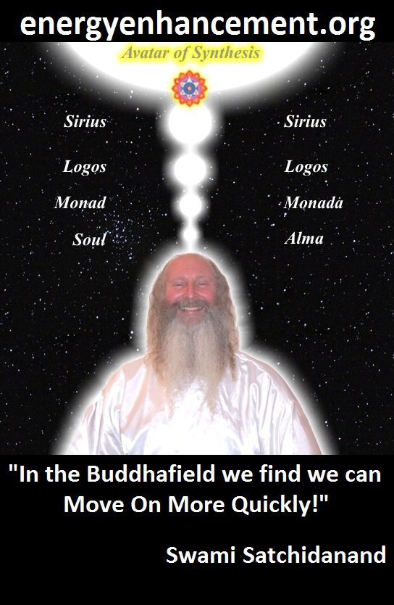
ENERGY ENHANCEMENT - THE ULTIMATE MEDITATION COURSE!!
“Traditional meditations are designed to Fail” – Satchidanand
FUSION WITH THE SOUL CHAKRA - Enlightenment - is Only the first Dan. Become fused with the Monad - Second Dan. Become fused with the Logos - Third Dan. Become Fused with Sirius - Fourth Dan. Become Fused with the Avatar of Synthesis - Fifth Dan - Satchidanand
Research The Energy Enhancement Meditation Course by video or on retreat..
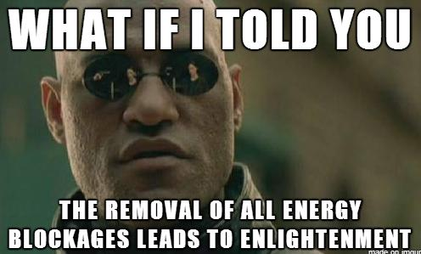
The Ancient Enemy who counts meditation and the mind control psychic arts as one of its main planks of ing, International Companies, Eugenics - Worldwide, censoring Alchemical VITRIOL, the Kundalini Key and Energy Blockage Removal from every Meditation Program..
WE HAVE SO MANY ARTICLES SHOWING THE ORIGINAL EXISTENCE OF THESE ESSENTIAL MEDITATION TECHNIQUES IN EVERY WORLD RELIGION..
NOW, SPEED UP YOUR PROCESS WITH ENERGY ENHANCEMENT ALCHEMICAL VITRIOL, KUNDALINI KEY AND ENERGY BLOCKAGE REMOVAL ON THE PATH OF ENLIGHTENMENT
GET IT NOW!!
EMAIL sol@energyenhancement.org

Level 1 Initiation 2 Energy Circulation Part 1.
21 mins 03 seconds
Satchidanand: A little bit of chanting. Very carefully going around the circuit searching for blockages, when you find it breathe through it, there's another way of using this, just to go round very fast, just imagine it's going around at the speed of light. And with this speed you can increase your energy. Two ways of doing it, but we're just going to use the first method this time, okay? Yes Santhan?
Santhan: If we can't slow it down and it's just going fast on it's own, then have to try and slow it down?
Satchidanand: Who is in charge? Eh? Of course it's going round at the speed of light at all times. But you can go round as slowly as you want. Who's in charge?. You're in charge. You must be in charge. It's necessary that you must be in charge of your own bodies.
Okay...Sit up straight everybody. Take a deep breath in. OMMM SHANTI chant..(students join in). Hold on a bit folks...When we do this, you can only hear my voice. You are only doing this internally with a very low voice. Otherwise you'll be doing it totally wrong. If you listen to the guy next door, he doesn't know what he's doing. Listen to me. Take a deep breath in. OOMM SHANTI chant.
Okay imagine from above your head is golden light and it's flowing down from above your head. And it's flowing down from around your body to the depth of six inches, 15cm, it's flowing around your body. Around your head front back and sides. Body front back and sides. Around the legs front back and sides. And into the centre of the earth.
The aura comes from the word aurum, in Latin, gold Ore, Aura. It's the same. And as you imagine this golden light flowing around you.
I want you to start breathing in this golden light. And I want you to imagine that the golden light is flowing into your lungs, it's flowing into your chest, as you breathe it in it's flowing into your neck and head, as you breathe it in it's flowing into your arms and fingers, as you breathe in the golden light, it's flowing into your hips and legs, it's flowing into your feet and toes.
And as you breathe in more of the golden light, I want you to feel it densely packing, all of the body, so it starts to glow like the sun.
Now I want to imagine that the golden light is flowing on the out-breath out of your heart centre, and it's flowing down the front of the body and I want you to see that golden light, it's flowing in a golden stream, from the heart centre to the solar plexus, and from the solar plexus down to swadithan chakra in the abdomen, and from the swadisthan chakra in the abdomen down to the genitals. And from the genitals down to the perineum and the anus, and start to use the breath, on the out breath to push the golden string.
And you're pushing it up your spine from the coccyx, it's flowing up each of the vertebrae, at the back of the abdomen, at the back of the heart centre, the back of the neck, over the back of the head, to the forehead, and at the forehead it goes inside to the tongue, to the tip of the tongue, which is pushing against the upper palate, no space in the mouth, and it flows down the tongue to the throat and it flows out of the throat to the outside of the body to the heart centre and just circulate the energy and break your blockages.
A long slow out breath. Ooom chant.
Student's Experiences 40 mins 30 seconds
Satchidanand: Yea?
Honey: Satchidanand is looking at me so I think it's sharing time.
Satchidanand: What happened?
Honey: Well you know when I went into my meditation, I don't know why but my legs and my thighs started spasming as if it's like “noises”, like going – yea...I don't know why but the body just reflects..
Satchidanand: What does it say on this list, you have blockages when you get pain.
Honey: (laughs) Yea, I think there is some kind of blockage there. But it's some kind of spasm which just started by itself, I was being able to concentrate properly. But then I thought right I'm going to fight this off, so I going to do, you know go for it
Satchidanand: Go for it, that's what you need, that's the attitude.
Honey: As I saw, and it went really good the golden, I thought, the golden liquid, I worked with a liquid...by my heart chakra, there was blockages there, little black bits, yea...and then as it moved down, I feel I've got like a blockage like a U shape all the way down here to the top (Satchidanand turns camera on honey) ..and I've been trying, trying to still clear it, cleared a little bit, and I think there seems to be some kind of blockage, down here, all the way down and back up again, I think...and then the golden light just flew up again all the way round and up the spine, but there was no point, this cleared up while I was clearing it, but I was finding it very difficult to clear this part of the knee, hmm, yea, so I don't know what that means (laughs)
Satchidanand: well, (inaudible mumbles as brings camera back) ah very good I'm back again, hello everybody
Honey: I should have (inaudible) right side better
Satchidanand: What Honey was saying was she's got a very clear crown and higher chakras, But the base chakra, the 2nd chakra were a little bit filled with negativity and she was very upset that she didn't clear it all in 5 minutes (laughs).
Honey: (laughs) You know what I'm like.
Satchidanand: Honey, you need to take this home as homework.
Honey: Okay
Honey: I will do
Satchidanand: Yea
Honey: I'll slaughter it.
Satchidanand: Good for you. Now this experience of being able to see your energy blockages means that you've gone one step on the path of being able to remove them totally. If you can see them you can free them. Yea?
Honey: Right
Satchidanand: They cannot escape. And by seeing them you have feedback of your true state. This leads to humility. Yea? We know we are 99% perfect, and now you have been given the opportunity of seeing the other 1%. Yea? And the problems of the base chakra, all to do with fear. And as you release that fear you will find yourself will be able to take more steps forward, bigger steps, 7 league boots.
Devi: What is league boots.
Satchidanand: 7 leagues is 7 miles. It means that you can, these are magic boots, magic shoes. So if you put them on. Every step is 7 kilometres. And this is what we need to do. Yea? It's all we need to do. We just need a bit of spit and polish and everything will be gold. We'll bring the gold out of gold. Very good.
Honey: That's interesting. I thought I would have more blockages around here. Whereas it's less so. And we went through., it wasn't a problem. And I was finding it very difficult to clear.
Satchidanand: Okay, would anybody else like to share what they got on this first experience.
Honey's dad: I think I didn't see the gold was there at all.(laughs) I don't know what that means (laughs)
Satchidanand: Let me, let me put this (camera) on the man himself (laughs). Let me see, okay there we go.
Honey's dad: I was just saying this is I just couldn't see anything anywhere, I don't know what that means. Maybe it's full of negative negativity?
Satchidanand: I don't know either. Perhaps it's all one big blockage. (laughs). Now how was it when you started to imagine the golden light above your head?
Honey's Dad: I could not keep the thoughts in one place, that was the problem.
Satchidanand: Many thoughts.
Honey's dad: Yea they just go in different places.
Satchidanand: Oh right so you are at the first stage of energy enhancement initiation one, meditation. Now what do you do with the thoughts. Yea what do you do with the thoughts.
Satchidanand: You concentrate on counting the breath. You're still at the first stage.
Honey's dad: Yea
Satchidanand: Now what did I say on my list. You have blockages when you get a lot of thoughts in the mind. OK That's on my list that is.
Honey's dad: Yea yea
Satchidanand: Yea, so there you go. Now as you focus on your breath when you meditate you will find all of these thoughts go, then you need to imagine the golden light. And then when you get a lot of thoughts you need to focus on?
Honey's dad: The breathing again.
Satchidanand: The breathing again. And then when the thoughts are gone, you need to focus on the golden light. And in this way , just by sitting a little bit. You'll be able to do this. It needs a little bit of application.
Honeys dad: So at the moment I need to concentrate on breathing.
Satchidanand: Concentrate on breathing but when the thoughts go.. go forwards right?
Honeys dad: Okay
Satchidanand: Okay. Fine. (laughs). Very good, I like that. And I promise you the thoughts will go, yea? But it does need a little bit of application at the start,
Honeys dad: it takes time
Satchidanand: It takes time. Yes, so do not worry, everything is good.
Honey: Dad, concentrate on the breathing.
Satchidanand: Yes concentrate on the breathing
Honey: So when he's meditating just breathe so we can work on that dad..
Honeys dad: Hmm
Honey: just breathing in and breathing out, concentrating on one thing..
Satchidanand: Yes
Honey: .and just slowly not worrying about the breathing
Satchidanand: The thing to do is not to worry, you know, because everything is happening as it should, yea, cos everything is happening as it should, but by the symptoms, by what happens we can tell exactly what the state is and what is necessary to do.
This meditation will clear everything.
Anybody else, anybody else Santhan, how did you get along? How did you get along Santhan? (camera on Santhan)
Santhan: The technique was effective, the visualisation of the golden energy flowing around my body was very clear. At some point though my body started to tremble and I had problems with the breath.
Satchidanand: Aahh
Santhan: The thread going through the chakras was clear.
Satchidanand: Yes
Santhan: But I had a problem with my breathing. My out breath shook and it caused my body to vibrate.
Satchidanand: At which point what the golden light at this time?
Santhan: I think it was when from the throat to the heart chakra through the stomach chakra, (inaudible)
Satchidanand: Right right
Santhan: That's when the breathing, there was a blockage there?
Satchidanand: Definitely
Santhan: The breathing, out breath started there. Interestingly when I started there it a strong vibe on the left side. Erm (inaudible) which gradually went away and from the list, from the list that Satchidanand mentioned earlier I started ticking them off one by one (laughs).
Satchidanand: Oh this list by no means complete, when you hear a wind in the left ear, when there is a trembling in the breath, this is where there is an energy blockage. (laughs). Very good Santhan. As you clear the energy blockages, then like the layers of an onion you will find even more and more dense and more difficult blockages because they get worse as they go along. Yea? This is good. Because the easy ones are first and then as we get better at it they get more difficult. Now isn't that good eh? Ah not bad at all
Honey: By that time we're experts at getting rid of them right? (laughs)
Satchidanand: (camera on Satchidanand) Okay, so I think that's enough experiences. Did everybody see an..did you see an energy blockage David? Did you see them Dhiren?
Dhiren: (off-screen to on camera) I did err (inaudible) it coincided with the reiki treatment, the reiki initiation that we did. It started yesterday and today, and er seeing this golden light coming through it's so strange because it's exactly the same chakras, my heart, all that was clear. The first instance that I noticed was I disappeared when we say the golden light was coming up, and covering the whole body. And it would up to the throat and to the heart and I would lose totally just lose sight of the whole thing covering my body.
Satchidanand: yes
Dhiren: So I said that's one and twice and the third time I said no I'm not going to lose sight of it and so eventually it covered my whole body (inaudible – Devi translates) No I could the see golden energy coming up through my throat and my heart..this is on the outside yea? And then after that I would lose sight. So I tried that once and twice and then I realised so I realised and then I said no the third I have to see it through, yes, so I saw the entire body covered in the golden light and then I started breathing in, yea and yes...breathing in..yes so I saw the golden light going into my lungs, a and my heart, my heart was shining
Satchidanand: Oh very good
Dhiren: Golden golden light, and it came out through the heart. (tape change). And it was crazy and dizzy, my head was going all over the place. I couldn't stand but at one point I felt very vomiting, and I couldn't stand, I came out in sweat, I started, it reminded me of when I used to do weight training and I didn't eat anything all day and I would kind of be at a point where I was dehydrated and I was gonna faint.
Devi: Hmm
Dhiren: That kinda feeling you know. So that's why I rushed off to
Devi: The toilet.
Dhiren: the bathroom thinking I was gonna vomit. But it didn't happen. It didn't happen..What is that to do.
Devi: It's a blockage, when you circulated the light is working in this blockage, and its very good to lie down like that...
Dhiren: Like this
Devi: And I say to people, lie down like that, (inaudible) and nobody did it
Dhiren: Oh
Devi: Nobody did it today.
Dhiren: No we, nobody, we didn't..
Devi: no no finish and remind Dhiren was so concentrated in the meditation I couldn't tell people lets do that. But it's very important if you want to practise this again, do this when you finish, because it will help you to dis-block the blockage. And also the technique, it is necessary to attack the blockage for the different ..yea..because like that it's more more quick.
Dhiren: so as Satchidanand was saying
Satchidanand: Oh please, do it again Dhiren, do it again, tell us all (Indian accent) about this bolt of lightening
Dhiren: well as I was, as you asked us to breathe in the golden light, I breathe in the golden light and it went to my lungs and my heart. And from there I lost sight of the light. Erm, and I went through that once and twice and the third time I decided that I wasn't going to take this..
Satchidanand: Anymore! (laughs)
Dhiren: So as you said earlier Satchidanand, think of the Shiva, think of the bolt of lightning, so I smashed it and it went straight through both the chakras, it just shattered everything and it ended up in 2 gold rings where it made it easier to.. and then it went through right here and it stopped just above the coccyx and you said it was the same area and what I realised was that, that I had lost touch with my breath, I wasn't breathing out, so every now and then you would hear me (exaggerated breathing in) (inaudible) it's coming, wait for it, and then I pushed it up, and it would just go, up the vertebrae and (inaudible) and straight through here (back of head) and straight through here (third eye) round the tongue and straight through the heart but although I cleared the chakras every time I came back I would find something different along the way (inaudible)
Devi: aaahh
(laughs)
Dhiren: So at that time (laughs) at that time I realised that this is an ongoing thing, this is not something that smash it once and it’s gone.
Satchidanand: no
Dhiren: So of course I had the bolt of lightening and every time I came through it and I smashed it, smashed it came round and again it was there (laughter)
Satchidanand: This is very interesting. (camera on Satchidanand). Because we had exactly the same experience when we were doing this meditation many years ago. They always came back. And we had to wait to be given the technique to teach in the 2nd level of Energy Enhancement Meditation Course – The Seven Step Process. And in order to destroy these particular little devils totally so do the whole circuit.
Dhiren: Yes
Satchidanand: Remember the ones that do not go, and we'll pick them up the 2nd time round we'll get them.
Dhiren: The other thing you said was pain.
Satchidanand: Yes
Dhiren (camera on Dhiren): There were 2 points in the back that I felt pain when I had that same pain from that time ago. That was just behind my left shoulder. Erm right in line with the heart, and some psychic had told me that its to do with some pain that I'm carrying in the heart
Satchidanand: mm
Dhiren: So...(laughter) and so I went through the back with the golden light coming up and I said to myself what are you doing there still and wiped it off, and it was amazing because one second the pain was there and In a split second it was gone
Satchidanand: Where did it go to?
Dhiren: Well it wasn't there...it just gone..
Satchidanand: Where did it go to?
Dhiren: Disappeared. Got wiped out.
Satchidanand: It's interesting. This is true.
Dhiren: Yea it just disappeared There was no pain anymore. And there isn't pain anymore.
Devi: How long was this pain.
Dhiren: How long?
Devi: Yea.
Dhiren: Well the first time I went round, I felt it very strongly over here (on upper back).
Devi: But how long do you suffer this pain? Did you suffer (inaudible).
Dhiren: Oh with this pain that I had before?
Devi: How long? 3, for a year, for 5.
Dhiren: ummm
Devi: You went to see a psychic about this pain, no?
Dhiren: No this psychic err had sent a message with someone else.
Devi: Ah
Dhiren: Someone said to me and that was a message.
Satchidanand: When?
Dhiren: Uh, I only heard about the message recently. About 3 months ago. But umm this pain was..going back years now, years and years back.
Devi: Very interestingly
Dhiren: '93.
Devi: hmm
Dhiren: 93..and I had a pain that was 2 years ago when my father passed away, these were the 2 pains,
Satchidanand and Devi: hmm
(laughter)
Honey: Hmmm (laughs)
Satchidanand: Hmm..(laughs)
Honeys dad: Getting all the pains here..
Dhiren: but I'm fairly clear with the pains, but not one cent worried about the pain. My focus is on those two chakras that I need to deal with so all I can say is give me the information (laughs)
Satchidanand: Well..Dhiren...step...by...step by step..this is what we need,we need step by step..yea? Sure...
Dhiren: I'm ready
Satchidanand: Sure. I know you are. And I think you did extremely well with the bolts of right lightning too. You know when the going gets tough.
Honey: The tough get going.
Satchidanand: The tough get going. Yes, there is much information that I can give about these various blockages. I tend to not speak more about energy blockages on the site because there are many different kinds of energy blockages, there are many different evolutions of energy blockages, from the most dense, to the most err evolutionary high.
But wherever you get an energy blockage it's got to go. And I will be giving more information about these energy blockages later, but now is not the time, The main thing you've got to know is they've got to go. Yea?
They've got to go! And I want you to do some homework and you need to work hard at this. Because what are we doing at the moment, we're getting used to working with the breath, we're getting used to working with the golden light, and we're getting used to working with these energy blockages, we're getting our experiences, our own personal experiences and I want you to have these experiences before we go onto the next and more strong methods of removing these blockages and so we'll progress because this is an experiential course, it's not an intellectual course.
Energy Enhancement is the simplest thing in this world, it's not complicated, but what is complicated is getting rid of the energy blockages (laughs) and this involves practise, because practise makes perfect. Okay? Good.
Tape cut
Satchidanand: We're recording now, you're on.
Ramiro: Am I speaking in Spanish or English. (inaudible)
Satchidanand: Well for me..err..this is difficult because the translator is not here (laughter)..wait..wait..
Satchidanand: Okay you can start. (and now Devi translates)
Ramiro: When he arrived in Rosario 2 days ago he was feeling okay. When he arrived to Rosario and met us he started to feel pain in his stomach, the solar plexus. The sacral chakra. He can remember when he went to Spain he felt the same kind of pain. When he started the technique today it was more difficult to see the golden thread. It was..he couldn't see anything, he was seeing everything black, he did was he made the thread big and there was light from the ball, light from the ball, big, gross, and he started to wrap that around his body and this helped to clean his energies, and after he did this the (inaudible) felt very happy,
Satchidanand: Excellent
Ramiro (Devi translating) very peaceful and happy with himself.
Devi: Very good. Yay, Ramiro
Satchidanand: So there was Ramiro, he lost the most beautiful woman in the world.
He came on an Energy Enhancement course and asked me if he should get married to his girlfriend because he was not sure of her fidelity having done tantra and having a new girl every day of the week and two on Sunday. I said wait. You will see.
So he went home. Went into his house and found his girlfriend in bed with his best friend!
And after that he didn't look at another woman for another year and a half. All he did was go down the gym for 2 hours, 3 times a week for a year. And he didn't do any Energy Enhancement whatsoever. (laughs).
(camera on Satchidanand)
Satchidanand: Yes..And one thing I want to say to you. Is that we have many pains in our lives..all of us..there isn't one person here that hasn't had a lot of pain. (emphasised)
There is not one person here that hasn't had a lot of pain. And this pain makes makes us act in extreme ways for either good or evil. It makes us act extremely in fact it is this pain which is called divine discontent. It means that something is wrong with you. It means that this pain makes it known to you that you have a problem. And it is this pain that provides the impetus to never have that pain ever again. Yea?
And I believe, when I created Energy enhancement I created it for the purpose of solving all of the pain in the world, and yet pain is necessary. You know, I always think of it that if we stick to the right path, if we follow our proper path then we get no pain whatsoever. But..it's like we're in the motor car.. a motor car... that's on a motorway. And you're driving between two brick walls, and as you drive along in your motorcar you might make a little diversion from the straight path. We might scrape the wall on one side, bounce off onto the other, bounce off onto the other side, but if you continue to keep turning to the left, eventually you'll hit a brick wall.
We get warnings, before the real bad things happen, and we need to notice, we need to be sensitive enough to be noticed, when things start to scrape the wall, before you hit it, and solve the problem before it gets really bad.
Now this is why Energy Enhancement is here, we have a lot of shit to clear up. And we need to clear this shit up before we can learn the lessons and never create shit ever again. You are not allowed to go to the toilet, okay? (laughs) It is not allowed.
I remember once asking Zen Master Hogen what did you do in previous lifetimes, he said I was a Guinness maker.
And every time a student came to Zen Master Hogen, they gave him a pint of Guinness And this Guinness means all the karma he created in previous lifetimes. In a way it's shit. Sorry Guinness! And Hogen used to take this shit from his students and drink it all down. Symbolising, that a master has to eat all the shit. He was symbolising that a master can digest anything.
Sathya Sai Baba says, I am the greatest guru in the world, because of this I can remove the deepest karma, and that is why only the worst people come to see me. (laughter)
Dhiren: Well I haven't been there quite some time ago. (laughs). Lets change the frame of it. (inaudible).
Satchidanand: And as Swami Satchidananda used to say, here we are the in-patients. All of the other people outside they are the out-patients for the operation of the egodectomy.
Because what are all of these blockages, in total as a mass, altogether they are a mass of selfish desires, and together they make up the ego. Humility needed here folks, we are not perfect...
Devi: (inaudible)
Satchidanand: where did that come from eh?
Dhiren: I was just going to ask the same thing.
Satchidanand: And where did all the pain go to? (laughs)
Devi: (inaudible)
Satchidanand: OK, I think that's enough for today. I think we- I haven't got my watch with me, I don't know what time it is.
Devi: It's 10 o clock
Satchidanand: Oh my God, how long have we been sitting here?
Devi: 10 o clock
Dhiren: Quite some time.
Satchidanand: When did we start?
Devi: About 6.30
Dhiren: 6.30
Honey: (inaudible) We're supposed to finish at 12 and we stopped at 1.30. (inaudible). Really, really went on.
Dhiren: (inaudible) I said, I said, didn't I say, I said I could do a belly dance now.
Satchidanand: No, not that.
Honey: Please, that what we said. We held him back
Dhiren: I'm enjoying, this throat chakra being cleared, you know..speaking..
Honey's Dad: When will you start singing.
Dhiren: When you want.
Satchidanand: Always remember Dhiren that the chakras go in pairs, if you have a blockage in the throat chakra you have a matching blockage in the second chakra,
Dhiren: Right which is?
Satchidanand: The solar, not the solar plexus, the abdominal chakra.
Dhiren: Right
Satchidanand: The second chakra, the abdominal one, just 2cm below the belly button.
Devi: (inaudible)
Dhiren: Yea yea yea... (inaudible) it's groovy...

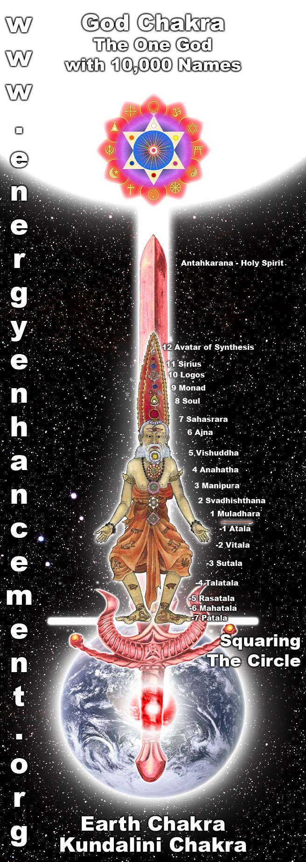
UNION WITH THE CHAKRAS ABOVE THE HEAD AND KUNDALINI CHAKRA IN THE CENTER OF THE EARTH
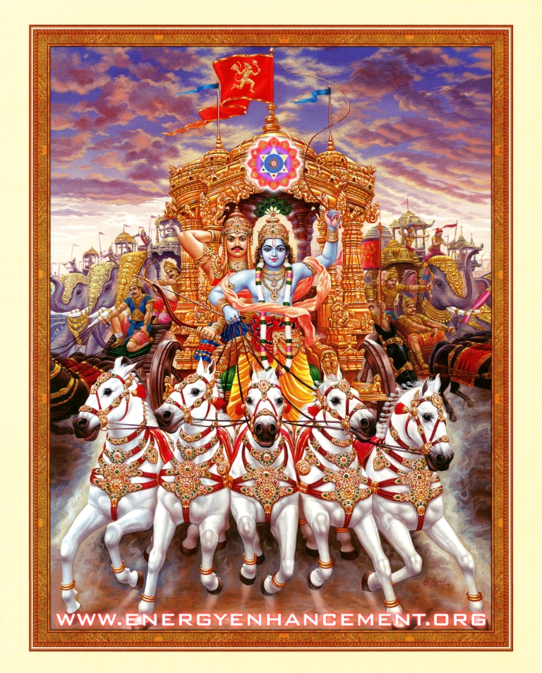FROM THOUSANDS OF YEARS AGO... THE BHAGAVAD GITA, KRISHNA THE SOUL AND ARJUNA THE SOUL INFUSED PERSONALITY AND THE CHARIOT ALL YOKED TOGETHER WITH THE HORSES OF THE EMOTIONS - SYMBOLISING UNION WITH THE CHAKRAS ABOVE THE HEAD.
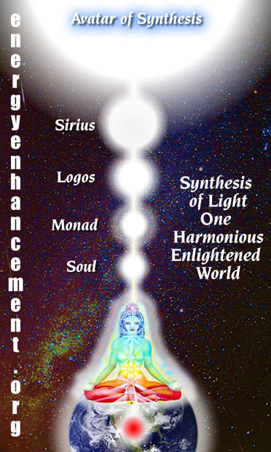Level 1 Initiation 2 Energy Circulation Part 2.
4 mins 41 seconds
Satchidanand: Surrounding our body with the golden light, breathing in the golden light, every part of our body, increasing the intensity of the golden light, burning out all the impurities so that they impurities fall out of our bottoms, like ash burnt up into the centre of the earth, when we're finally packed with golden light, finally we breathe a golden stream from our heart centre and we breathe it down the front of our bodies, from our heart centre down to our solar plexus, from our solar plexus down to the abdomen, from the abdomen down to the genitals, from the genitals to the perineum or the vulva, from the vulva down to the anus, and from the anus around to the coccyx and up the spine.
Vertebrae by vertebrae on the outside of the body to the back of the abdomen...at the back of the heart centre, the back of the neck, the base of the skull, all over the back of the head to the crown chakra, to anja chakra the centre of the forehead, and then inside anja chakra to the top of the tongue, which is pressing against the upper palate forming a switch allowing the energy to flow down the tongue to the throat and then on the outside of the body to the next chakra on the outside of the body to the heart centre, and I want you to explore that path, find your energy blockages and try to breathe the golden light through them...5 minutes...
Student's Experience Part 2 80 mins 47 seconds
Satchidanand: So what happened with our people? This time. What happened David with your meditation, did you find an energy blockage? (To Devi) If you could translate in English that would be great...Oh wait I'm going, I'm going to do the thing here now.(camera on David).here we are. ho ho ho ho..it's David..yes here we go..haha.
David: When he did the path for the first time, he noticed some places in the path some blockages. Especially in the head.
Satchidanand: In the back of the head. Yea
David: All the time he felt when he passing there, he felt cold.
Satchidanand: Ah...cold?
David: He worked on this blockage. He felt the sense in the (inaudible) in the relation of people of distract. And after that he found a small blockage. Some were (inaudible) when he was passing through. And another he wasn't sure.
Satchidanand: Where were they?
David: One was between the tongue and upper palate. One was in front of his heart.
Satchidanand: This is a strong one in the heart centre. And why do you think it was important?
David: He thought it was something he couldn't understand.
Satchidanand: Ah. And what happened when you tried to push the golden light through this blockage of the heart centre?
David: He didn't have enough strength.
Satchidanand: You've got to learn how to push with your breath. Sometimes if you meditate get in alignment with your energy..you can gain enough energy to push through the blockage. Meditate to gain energy and then use it to push through the blockage with all of your force, with all of your strength.
David: Where is possible to get the energy.
Satchidanand: Well you'll get it from the alignment. This kundalini stream is possible to gain much energy. But as we go through the initiations we are going to learn ways of getting even more energy. This is necessary in order to destroy dissolve this blockages.
But what you are doing at the moment you are gaining the experience to gain energy and to push with the out breath through the blockage. Yea, push with the exhalations, when you exhale. The first time when I did this meditation myself, the meditation proceeded automatically without my permission for 24 hours even when I was asleep and in that time I removed 3 big energy blockages sort of like automatically it just happened whatever I was doing.
And you need to gain your own experience, but don't worry if you cannot remove an energy blockage. This is what Carlos Castenada called the perfect enemy, in order to grow, you need to have the perfect enemy. It's the grain of sand which in the oyster produces the pearl. You are going to learn so much from these energy blockages. Anymore?
David: When he want to move the energy in this kind of energies, or direction of energy, which direction is inside or outside he ask..
Satchidanand: Outside, but when you go inside, this is the fire circulation which is much more powerful. But if you want to..
David: He asks when is going, when the energy is going inside.
Satchidanand: When you want it to.
Devi: no no no, for (inaudible) connection (inaudible)
Satchidanand: Coming out of the throat... But it was good that you found this very important blockage. Because all of the most evolved human beings have blockages in the heart centre and by removing that blockage you are making another step forward, now you have your problem and all evolution starts with a problem, (laughs) because otherwise you would be contented. Like a cow chewing the grass, happy with the world, absolutely no, er, no energy for evolution. There's no reason for evolution. No reason, no reason for evolution. Problems are the cause of evolution. And I am pointing out the most important problems. For evolution. Energy blockages. When you find them, you are on the path to remove them. Push...Yea?
(camera on Ramiro)
Satchidanand:: Okay Ramiro, what was your experience during the meditation.
Ramiro: He say he chew like a cow. (Satchidanand laughs) .. He couldn't feel any blockage. And were feeling sleepy.
Satchidanand: Now remember what I said Ramiro, when you go to sleep, you have hit an energy blockage. When you cannot see the golden light that is where there is an energy blockage. So where could you not see the golden light?
Ramiro: He was meditating and in the light he could not do the path, he was not distract, no, he was, he couldn't concentrate in his body
Satchidanand: This is what is distraction, when you cannot concentrate on something you want to do..you have been distracted..and this means that you have many energy blockages (laughs) and this is why you need to practise this technique because even when you are going to sleep the negative energy is coming off the system like a gas and sometimes when you want to go sleep, it's good to use a mantra or some chanting to dissolve this negative energy so as you practise this little by little you are going to remove the negative energy of the energy blockages and when you have removed a little bit of this energy you will be able to see the energy blockages more (inaudible) and then you'll have the opportunity of breathing through them.
Ramiro: He said he was in meditating in the light and he was feeling his body was relaxed, was in my opinion he wants to ascend, but it's true he couldn't concentrate in circulation and he was going to another plane
Satchidanand: You were in the stage there of gaining energy, this is a very good thing to do, and you need to gain a lot of energy and then apply the energy to the places where you want to go to sleep or are distracted. So you need to do 2 things, gain energy and apply it to the blockages. This is learning how to work with energy.
Ramiro: He didn't think. So he was only observing the light and he was absorbed.
Satchidanand: Now this is very good, because in order to practise Energy Enhancement you must transcend the meditation, you must get to the stage of samadhi, when you have no thoughts in the mind, because this point is so much more powerful than the simple meditation. Samyama Energy Enhancement comes from concentration, meditation and samadhi altogether and applied to the energy blockages. This is a very much more powerful state and you can do so much more with this energy.
Devi: I think it's a newer energy for him, he needs to have the habit to know that.
Satchidanand: I think you need to practice Samadhi and then samyama and with this everything will go very quickly. You will have more experiences with energy blockages and if you have any problems or you want to ask some questions just get us on the telephone and we will try to help with this but I think it will be very interesting for you. Bien.
Okay folks. (camera on Satchidanand). So...I think this completes the initiation of Energy Enhancement initiation 2 the circulation of the energies, the only thing we did not practise was the water circulation. And I'll leave you to do that because you need to practise both direction, water direction is up the front of the body and down the spine and with this you will find different and more blockages. (David and Devi converse in Spanish)
Satchidanand: Devi, you need to explain for the video camera in English
Devi: Okay, there are different blockage, from, you could removed from the different, different (inaudible) connections.
David: And the ways are the same, different (inaudible)
Satchidanand: The energy is flowing in both directions at the same time. You need to utilise those 2 directions in order to remove as many blockages as possible. You need to utilise those two directions to remove as many blockages as possible...Any questions Ramiro?
Ramiro: Which kind of blockages are water and which kind blockages are air.
Satchidanand: But what you find is blockage blockages. (laughs) It is true, that some blockages are more easy than others and I tell you the deep blockages are very difficult to remove without the techniques of level 2 of Energy Enhancement. You are going to do the best you can with the techniques that you have and this will be a process of learning and of strengthening your ability to work with energy. (David comments)
David: He says how long (inaudible) to sleep.
Satchidanand: Well I remember Devi Dhyani telling me, that she learnt transcendental meditation because she wanted to pass her examinations to be a lawyer and to do that she thought she needed to sleep less and study more but what happened was that when she started meditating she started sleeping for 10 hours a day yet she passed her examinations of 4 years, normally took 4 years, in one and a half years because the importance of study is not the amount of time but the intensity in which you do it.
And sometimes we force ourselves to work without sleep with the force of our minds even though our bodies are really tired. As we meditate, we take the amount of sleep we need in order to heal our bodies and minds. Enlightened people never go to sleep but if you force this you will make yourself ill. And you can do many things with your mind. Because the mind is more powerful than the body yet if you go against nature you will make yourself ill.
David: What time do you recommend to..
Devi: Let your body tell you..how long you need to sleep
Satchidanand: I think it's good to lie in bed from time to time, I think it's good to rest from time to time but sometimes when I am doing a course and I am transmitting a lot of energy..erm..
Swami Satchidananda says that when you transmit energy you always get a little bit as well so when I am doing my work sometimes I only need to sleep for 4 hours. (Devi and David talk in Spanish). But when I am not doing my work sometimes I will sleep for 8 or 10 hours...
David: He said its good to check the time when you're asleep and to keep the time fixed of your sleeping
Satchidanand: I don't think so...no..I believe in going with nature. Life tends to go in cycles. And sometimes you need to work hard and sometimes you need to recuperate and so there should be no fixed rule. In England they used to believe in 4 square meals a day and the square meant you had to have meat, potatoes, vegetables and salad. 4 times a day, regularly and the people used to die from too much food, sometimes it's necessary to eat nothing.
To get rid of all of your toxins and sometimes it's necessary to eat strong food to build up the bones in the body but most of the time it's good to eat little light food but when you are ill or you hit a lot of pollution you need to eat strong food to recuperate the body. So you need to know what to eat and when through sensitivity.
David: How many meals per day?
Satchidanand: My Master Satchitananda said a yogi eats once per day. He ate something little, the size of a burger.
Personally I like to eat twice per day, I like to have a nice breakfast, and then I like to have a nice meal at 5 o clock in the afternoon and then nothing for the rest of the evening so a slight fast and then I have a break fast haha...this is the name ...a break-fast...(inaudible) breakfast, no not good to eat things at night, they say that food is gold in the morning, and silver in the afternoon, but in the evening it's poison. Silver in the afternoon and poison in the evening. The time of the stomach is between 7 and 9 in the morning and the time opposite to the stomach, time when it is not good to eat between 7 and 9 in the evening, this is when the energy of the stomach is at it's minimum, you eat at this time, you die.
David: Fasting he said how long is good to do fasting, how often.
Satchidanand: Well we have the Well, they say, it's good to do one day of fast for as many years as you have. Per year. It's good to have at least one fast per year. Because of the toxins, you need to give the body time to recuperate because as we eat the food we eat it with
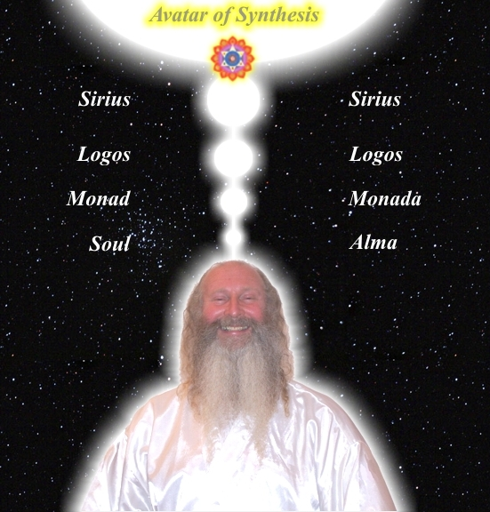
SATCHIDANAND LINEAGE - CHRIST, HINDU AND ZEN BUDDHIST

SATCHIDANAND
The Energy Enhancement Streaming Video Course is Chanelled by Satchidanand - Student of Swami Satchidananda, Guru of the Woodstock Festival and Tamil Siddar in the Lineage of Bogar of Palani Hill Temple Tamil Nadu who lived for 15,000 years, and Bogar's Student, Tamil Siddar Patanjali who wrote the Yoga Sutras of Patanjali, and Tamil Siddar Babaji who has has taught Kundalini Kriyas in the Himalayas for 2000 years to people like Paramahamsa Yogananda who wrote, "Autobiography of a Yogi" also Tamil Siddar, Thiruvalluvar.
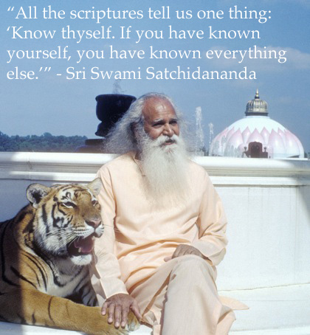
toxins, we eat it at times where we cannot digest everything and all of the toxins get thrown into the body as fat and in the fat is cellulite and cellulite is pure toxins. Every year it's good to have a fast where you get rid of all that bad fat and toxins.
David: How long
Satchidanand: Well, if you are 20 years old, you should have a fast for 20 days a year. You need less food when you're older and you have less energy to get rid of the toxins. But I am going further, I know that I need to have a fast every year of at least one month and it's really good to practise fasting.
First, you should try a fast of raw vegetables, nothing cooked or manufactured no oil, no salt, no bread, and you should do that for a week or two. After that you should try a fast of fruit for 2 or 3 days, but after that you should try a fast with just water and you will be amazed at how many toxins come out.
The purpose of having a vegetable fast first is to slow down the removal of toxins, because if the toxins come out too quickly, it's dangerous, they come out as spots on the body, they come out as bad breathe, they come out as pains in the head, and these are normal if you go onto a water fast too quickly.
It's good to avoid the toxins coming out too quickly. One week is good for vegetables to start with and I think you must do it this way...and in this way on a water fast for 20 30 days there is no diminishing in energy, it's possible to do your work and it's possible to forget about food and your body just naturally normalises itself without any spots or pains in the head and it's necessary for me to do this once per year minimum, probably twice per year might be even better.
Only water..orange juice is nice...orange juice at the beginning of the fast, but if ever you feel hungry it's good to take a spoonful of honey, good quality honey. But after about ten days you don't feel as though you need anything. Ramiro was telling me he observes Ekadasi 11 days before the full moon and 11 days after the full moon - one day of fasting each day.
But personally it goes deeper and it's more easy actually to do one month but only after you've been through the process of vegetables and fruit until you've got rid of the difficult toxins in the body the easy toxins, the more toxins, you need to purify before you can go on a fast like that.
But you should not be hard about yourself, ah that's another thing, the end of the fast is very important, because it's like you have a car, with an engine and it's just gone to the factory for being rebored and in this state you have to run the car for a thousand miles at a low speed and it's like that with your new body wherever I come off the fast I have mashed potato. But without any oil, no oil, and Devi likes to have cream of oats. And this for a few days We should take about 3 or 4 or 5 days before you come back to oil, I say this very strong, so you can have boiled vegetables and a little bit of fruit and salad later but you should take your time to come back to a normal diet.
(skip to different talk)
But, a good star wants to support everybody around him to be a star, this is a good star. Bien. (laughs) And what is another negative emotion you can have Devi? I've forgotten
Devi: Anger
Satchidanand: No I've said that one. No I know what it is. It is an excess of joy. It is manicism. Manicism, an excess of joy. So these are negative emotions. If you have any of these negative emotions this is something that can be removed by meditation and Energy Enhancement.
Every enlightened person has knowledge about the physical body and the pains caused by blockages. Every enlightened person has knowledge of these negative emotions and the knowledge of how to remove them.
Every enlightened person has knowledge about the bad thoughts that come into the mind and knows how to remove them because you could be perfect sitting by yourself but when you're in contact with the world you are absorbing negative energies from everybody around you from the world itself and then you are transmuting them.
So..meditation, sitting, for 3 hours without any movement whatsoever, breathing, perfectly and the final point of the pyramid is called no thoughts in the mind meditation. Yea? No thoughts in the mind. When you are just sitting in a state of just ecstasy.
Now what does ecstasy mean? Well from Greek, it means the ability to get out of the body.
Because you have to practise, to die before you die. Otherwise, when you die it's gonna be a big shock (laughs). It's gonna be a big shock. Oh..(laughs) so you need to practise this..you should be in a state of ecstasy,
I first found this out when I was with master Hogen, because we used to sit for 6 hours a day, he was a real bastard this guy, he had no compassion for us at all, and when you go to India, the first thing they say, do no show your feet to your guru, you know they've had seats for 10,000 years but the bastards in these ashrams they don't have any seats whatsoever. I've been to pyramids in Egypt, 10,000 years old and all the gods and goddesses are sitting on seats. These bastards in the ashrams, they don't have no seats whatsoever. They have no compassion.
And you can't even move your feet to show your feet to the guru. Bastards (laughs).
There is a symbol in India for the base chakra, in that symbol there is a Shiva lingham, this means the penis of Shiva, sex comes into somewhere I'm sure it does. Now this, this penis is so big, it stretches from earth and heaven. Can you imagine it? (laughs). It is the rainbow bridge that stretches from earth and heaven.
It connects the 2 poles of the battery between earth and heaven, between the female earth and god who is living in heaven. And around this Shiva lingham every altar in India they have an oval stone which represents the Shiva lingham and in the symbol they have a snake and it circles the Shiva lingham 3 and a half times...no why..now don't answer Honey...why...why 3 and a half times...(laughs)
Well..there are 7 chakras, base chakra down there, then you've got the swadisthan chakra, the abdominal chakra, the sexual chakra, then you've got the solar plexus chakra where your power centre is, (deep voice) from here, from here...and then you've got the heart center.
Now base chakra is no.1, swadisthan chakra is no.2, solar plexus is no.3, and the heart chakra in no.4 and the head of the snake is mid way between the solar plexus and the heart because most people have no heart.
It takes one hundred lifetimes to open the heart. So most people are psychopaths.
And in that state of having a closed heart, relationships are no problem because you do not care about anyone else. Only after you have opened your heart does relationship become a problem, because only then do you care about the other.
And the first station on the path of kundalini is the heart centre as the kundalini snake becomes straight it pierces the heart centre, you start to worry about the benefit of other people, you know internally that your benefit is intimately connected with the benefit of everybody around you, you know that, this is the heart, this is why this guy up here wears his heart on his chest.
Jesus Christ symbolises the love of the heart, yea? The benefit of everybody around you in the world, to know that if you benefit one other person, you will get 10 times more back for yourself which you can then use to benefit 10 more people because it grows exponentially
This is the meaning of the heart. And this is the first initiation.
Second initiation, the mastery of relationships, how do you know if your next initiation is the mastery of relationships because you have been hurt by any relationship in this lifetime...as they come..let them come..as they go...let them go, don't try to hold onto them, to do this without pain and disappointment is the mastery of relationships.
To know that if anybody leaves you, it is like you're a mother and you love your son and your son must go to university in another city, and you don't say to your son, please stay with me son I love you soo much...no you say, you have many more things to learn in the world, go with my love.
Love does not stop just because a person is not there, instead it grows stronger because you have the ability to give that teaching to the other person, so if you have ever been hurt any relationship in this life...you need to take the initiation of the mastery of relationships.
And what is the third initiation, the third initiation is enlightenment itself. You've passed the opening of the heart initiation, you've passed the mastery of relationships initiation, and then you are almost enlightened.
The energy flows from the base chakra where all the pains come from in the legs, and it goes into all the head chakras, and it goes higher into the energy of the soul, and then it goes higher into the energy of the group soul, and then it goes higher into the energy of god and it needs to go even higher, there are an infinity of levels, each with higher and higher energies and when you've passed those initiations even before you've passed them you can have this experience of connecting to higher levels of energy in meditation but when you've passed the previous two initiations, then you need the third initiation to be touched by god, so you can never fall from that enlightenment state, it confirms you with an open heart, the ability to master relationships and you can never fall from that higher state except for a few seconds, because as you absorb the negative energies from around you depending upon the density of the energies, it takes time to transmute them, but if you are enlightened you know you are in the process of transmuting those negative energies, and the symptoms which I told you about, pains in the body, upset emotions, negative thoughts, come to bother you, but you just know it's part of the process, 24 hours a day you are sitting like a mountain, sitting like a Shiva lingham (laughs), you are sitting like a big penis, and your energy is connected between earth and heaven and heaven and earth, you cannot be moved.
And as the clouds of thought come across the face of the mountain, the mountain is absolutely unmoved. And as the clouds of thought are blown past the face of the mountain, the mountain is absolutely unmoved.
This is meditation. So..all we have to do is this and I am here to teach you. So..sitting up boys..in order to sit correctly you need to have your knees on the ground, you need to have your bottoms on your cushions, what I always say is that the size of these cushions of the student is the size of his ego. – (cut to new clip of student)
Satchidanand: Gratious, okay what do you want to say?
Student: It was easy for her to go down, she felt the fire was filling through her being easy, and was like (inaudible) and she was dancing in the flame. Sometimes she was going up, she was going up without wanting, and she was going down. After she felt she was make the flame going up. Without thinking without desire the flame was going up, to her, to the top of her head and going down, she was wanting to make down the fire, the flame, for the channel, but didn't go down from the channel, (inaudible) brain from the top of her head, and was going down to the centre of the earth. She was trying to make the fire going down and in the channel of the golden stream but they didn't pay any attention and was going out (inaudible) down and later she wanted to push anything and left the thing happening...
Satchidanand: naturalmente
Devi: very good..
Student: She was feeling some pain in her legs in her shoulder blade and in the spine
Satchidanand: So in the future, you need to work on these pains. Yea...very good. Okay, so I want to say something now. (camera on Satchidanand). I have my microphone...need a bit more light on me..well it's almost there...that's maximum very good..okay I think that Alexandria had a very good experience, and as she well knows herself, this is just the start we use the energy, we use the excess of light we use the light that we receive from the centre of the earth..like a search light, we can see more...because before you can remove a blockage first you must perceive it and it works on the physical planes with the pains, it works on the emotional planes with the negative emotions, and in the end, it works on the level of the mind on the level of the ego and the ego has so many forms, you know.
Competition is one of the forms, you might have noticed Dhiren, you know I started saying a few little things about Dhiren so Dhiren had to prove his superiority by telling us that he knew everything about blockages yet not one of the people who came on this January 2005 course has continued with their Energy Enhancement, they came, they did all 28 initiations of Energy Enhancement and you will see over the next few days all of their fantastic experiences of removing some of their blockages. They removed many blockages but in one month, even such an intense month, is not possible to remove all of the ego...you can have a very good start you can learn techniques which remove the deepest blockage, but unless you continue on a daily basis, it's not possible to remove all of the blockages. And as I said, I am warning you now, because I have seen so many students have so much success in removing their blockages and yet not continue...all of the gurus, for all time for thousands of years, have said the same thing to everyone of their students, you must continue Swami Satchidananda said you have been practising your yoga everyday for years and you have been working working working everyday and I think some of you must get a little bit sick of this continuous work, but I am here to say to you that in the end, all of the blockages will go, they will be finished. But, you must continue til the end, it is not finished until it is finished.
And I know precisely which blockages remain in every student. Every student that came to me, were stopped, by one particular thing. And I pointed that out to people by email after the course – this is the problem, this is the problem, this is the problem – and yet, the blockages were too strong. They did not do their homework. They did not continue. This is my warning to you. Once you have started on the path of meditation, it is necessary to continue on a daily basis. I have never heard of anybody becoming enlightened in less than 3 years. Normally, if you come to stay with a guru in India you have to serve your guru for 12 years minimum. With Energy Enhancement, it can happen so much more quickly.
But, in the end, the blockages are personal. I am giving you general blockages to remove on the Energy Enhancement course and we move so quickly through these general blockages that sometimes, we miss one or two. It is necessary to do the exercises I give you, many times, to get the juice out of the fruit. The work is simple. It is not rocket science. In the end, all that is needed is perseverance. As the Buddha said, Energy
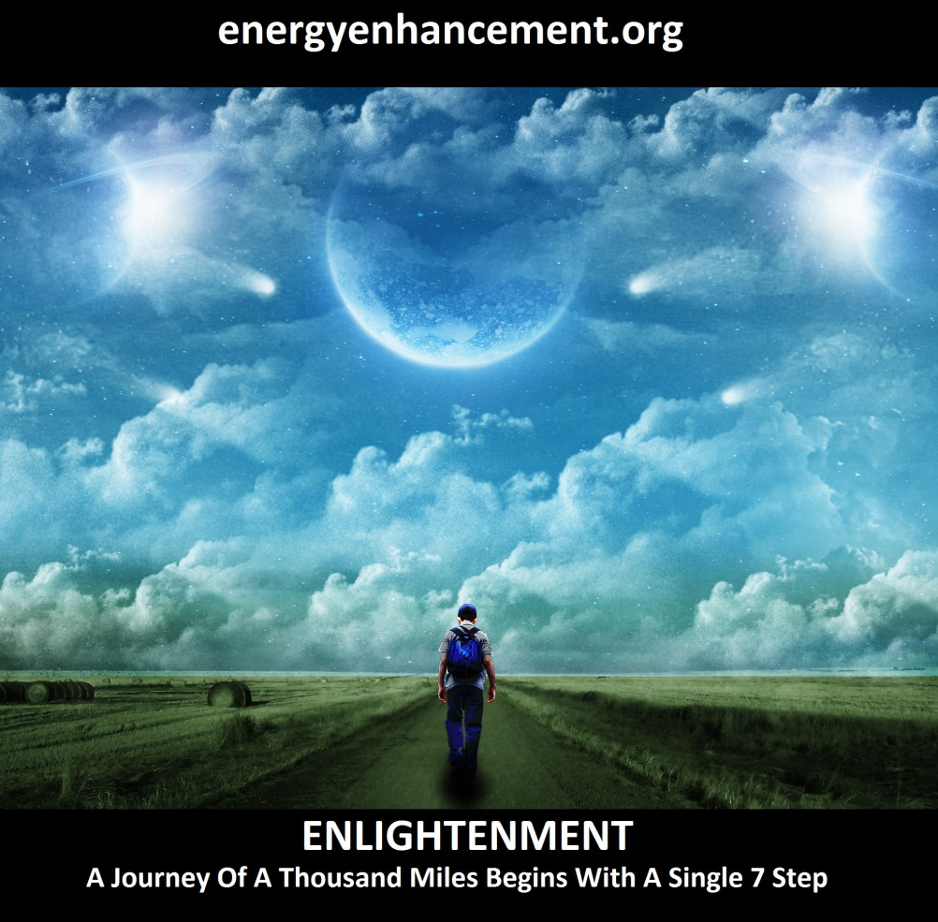
LEARN THAT WHICH IS FALSE WITHIN YOU
LEARN TO RECOGNIZE THE FALSE AS FALSE
-WITHOUT THAT, THERE CAN BE NO LASTING TRANSFORMATION
ENERGY ENHANCEMENT
"I was not sure if this was wise, as I knew nothing other than what I had read on the web site and the testimonials, which I was a bit skeptical about! However, I am now adding my own because if you read this you might be a bit like me...
Don't hesitate - go for it!"
MS (Ireland) Human Resources Director, Europe/Asia, of a Fortune 500 US Multinational Company
Honey Kalaria

" Once on the course, my exciting adventurous journey began! In my life I have done hundreds of courses but the Energy Enhancement Course I found to be completely different. Firstly, the contents and the teachings seem to be inspired by higher forces and had a deep base in spirituality..." Honey Kalaria (UK) Bollywood Actress/Owner of Diva Entertainment
ENERGY ENHANCEMENT
"I was not sure if this was wise, as I knew nothing other than what I had read on the web site and the testimonials, which I was a bit skeptical about! However, I am now adding my own because if you read this you might be a bit like me...
Don't hesitate - go for it!"
MS (Ireland) Human Resources Director, Europe/Asia, of a Fortune 500 US Multinational Company

GAIN SUPER ENERGY

ENERGY ENHANCEMENT MEDITATION
Enhancement is for those people who believe in enlightenment, the necessity for enlightenment, and who understand the urgency of the situation because the blockages will procrastinate, they will say next lifetime. I am interested, I am interested in my life. My spiritual life can wait.
There was a guru in Celon who was 96 years old, and he said to his congregation of students, everyday for 60 years I have been telling you about enlightenment. And you have been listening to me and now I have some great news, today is the day that I die. Today is the day I have my mahasamadhi. This is the day that I pass on into infinity. This is the day that I go to God. And, I can take one person with me, who wants to come with me? ..silence...Until one guy put up his hand, “well it's a very nice offer, but I think I have to wait, my daughter is going for her confirmation. And my sons are going to university and I have so many things to do, I cannot take up your offer”.
The ego will say, I have a wonderful business to run and I am enjoying playing this game with my business, making more and more money. Takes a great deal of creativity to do this, I'm really enjoying it. People say I have this job to do, people say that job to do. And all of these jobs, are to do with you.
Not, I am doing this work for the benefit of all the people around me, I am enjoying this work. This is the difference. The enlightened only do their work for a purpose. That purpose is for the benefit of everybody around them. So...take heed of what I am saying.
Continue..for a long time with constancy and with enthusiasm, words from the Yoga Sutras of Patanjali, for a long time, constantly and with enthusiasm. This is necessary. Okay.. I have finished now.
We have been listening and listening to hours and hours of talking, from the video. While I was talking on the video, my main job was to transfer intellectual information, but the more high job, is to transmit the energy of the soul.
And when this energy goes into the bodies of the students, the rays of the light of the soul allows to see blockages. The energy goes into the body of the student and it releases the blockages that need to be released. So when these blockages come in front of me with a large group I usually say it's time to chant the heart sutra, which is a very ancient technique to release blockages to release blockages to get rid of them, and this what we need to do now before the initiation. Bien. And what I want to do now because we don't have the heart sutra sheets in front of us is to do a little bit of chanting, is do a little bit of chanting, and then we'll do some meditation and we'll get rid of this blockage and what I want Alexandria to do when we meditate is to just do the circulation down into the centre of the earth just what we've been taught and to use the blow torch to use the heart centre to use the brow centre and to use the out-breathe to push energy through the blockage which you also can feel.
I have been working on this blockage for the past 20 minutes while we have been watching the video but I think it needs a little bit more work because we've reached the point now where we need to do the initiation for the 4th initiation, and I think to complete the work of the energy we need to remove this blockage before we go further, so take a deep breathe...oooo chant take a deep breath in again ooooo..oooo...so we worked on this blockage and we reduced it an awful lot and the blockage was moving on my left side from the area of the 2nd chakra to the area of the 3rd chakra up into the heart up into the throat and down again, we reduced the negative karmic mass of the blockage by quite a lot, we took parts of it up to heaven but still some parts remain down below..but it's a lot better than it was..Spanish please Devi...2nd chakra...3rd chakra..solar plexus...heart chakra...into the throat and then down again..
Devi: Alexandria (inaudible) coccyx
Satchidanand: And in Spanish...(in Spanish – terrible blockage eh)...camera on Alexandria...
Alexandria: She felt in her throat and in the coccyx
Satchidanand: This was one blockage, (camera on Satchidanand) this was one blockage or an accumulation of blockages in one place which moved around, this is the worst type of blockage, they don't stay in one place..they move around in the body..so like I said I think we reduced it a lot but there's still something left in it, I can still feel it, but I think we've reduced it enough to do a little bit more work so the question is – cuts out
Extra Talk on Blockages and Strategies 26 mins 56 seconds
Satchidanand: So today I thought I would give you a very amusing lecture because I thought it was time for you guys to be told something real about your lives. I was talking with Johannes the other day about oh how it is that every human being works through sub personalities. You know, Gurdjieff said, he's one of my favourite gurus, he said, the guy that says he will wake up at 4 o clock in the morning to meditate, he is not the same guy that throws the alarm clock out of the window...
Gurdjieff worked on the higher aspects of the personality and of the ego..he didn't bother with the physical problems that blockages produce, he mentioned the emotional problems that blockages produce, you know, every pain you have in your body is because a blockage is living there, you remove the blockage, pain gone, you remove the blockage, illness gone, all the negative emotions are created by the blockages, when the blockages are not there, positive emotions of happiness, positive emotions of love of the heart, positive emotions of the will, the ability to get things done and not stop half way through and say oh I'll start something else (laughs)...
What is it Sathya Sai Baba says, water 30ft down, start hole, get sick of hole 15ft down, start another hole, get 16ft down get sick, start another hole, (Devi laughs) you've got all this land and hundreds of holes and you have not yet found water. (laughs). You've got to laugh, if you didn't laugh you'd have to cry...
You know you'd have to start singing... Isn't it a pity, isn't it a shame, how we break each other hearts, and cause each other pain, how we take each others love without giving any more (Satchidanand sings) All the beauty that surrounds you, well isn't it a pity..well some things take so long..so how do I explain...(returns to talking)
Well I'm gonna try...(laughs) I was explaining to Johannes the other day, the necessity for all of my students to know the intellectual theory about strategy blockages which are different, higher and much harder than the normal little blockage that lives in the body and causes you to have all ze negative emotions like the fear, the sadness, the anger, the wanting to kill, harming, terrible things they are, these little blockages, the worst blockages, the ones that are the most difficult to heal, which we'll get into in Energy Enhancement level 3,
No different from any other blockage and concept, all we do is to ground all the negative karmic mass out of them, chase them back to the incident where the blockage was formed, the strategy was formed, heal the inner child that got hurt at that particular time of all its pain, and blockage gone, pain gone, strategy gone, simple, but until you can do that kind of thing, then I'd like to teach you the knowledge of Gurdjieff who was talking about these things at the turn of the century, the person who says he will get up at 4 o clock in the morning is not the same person who throws the alarm clock out of the window...
This is a higher type of blockage...theory very important because the first step in removing these blockages which will entirely destroy your life if you use them unconsciously is the intellectual knowledge of them..and I am saying that every human being has these blockages so don't feel important because you've got one (laughs) oh I've got this blockage...oh oh oh I'm better than you, your blockage is different from mine, mine is the best.
No everybody has these blockages in different amounts and from different causes but the blockages are archetypes, the strategies are archetypes which everybody uses because they are neutral as the same way as the knife is neutral, you can use a knife to cut out the disease of the body which a surgeon does and throw away the disease, heal a person with that knife, and if you want to you can plunge it into another persons heart and you can kill them and the difference of the good aspect of the strategies is that it is used consciously and the bad aspect of a blockage is where it is used unconsciously and we are all using these strategies unconsciously and Gurdjieff was saying the intellectual knowledge that you have one of these blockages and that these particular blockages exist the intellectual knowledge is the first step of toward you getting rid of the blockage.
Prior to me teaching the Seven Step Process of the Energy Enhancement Meditation Course Level 2 to remove these very deep blockages I want you to search yourselves for the blockages that I mention, and if the cap fits wear it and use that knowledge to say oh I've got a blockage, (laughs) oh I need to get rid of this, perhaps if I catch the unconscious action of this blockage in advance I can actually stop it happening this time, and when you catch yourself looking back at what happened and say oh a blockage was acting in me, you can say oh perhaps I wont let that happen next time, not to get upset about it, because the blockages love you to get upset, distraction, away from the point, but the blockages need to be known.
So how do we know. Well I was talking to Jay, the other day about how everybody has the three main blockages, there are thousands of them, things people play, and the major one is called the star, all dancers are stars, and again if you are consciously a star, if you are a good star, then this is the best thing you can be, it is good to be a star, you must know that you are a star and by your star-ness you are benefiting the whole of humanity, but when it is unconscious then it is used to get attention, look at me daddy I can play the piano, oh yes little girl you are good girl you are playing the piano, look at me daddy I got 10/10 out of maths at school, oh you are a good little girl you got 10/10 at school for the maths (laughs) attention attention, attention is natural, but if you want the attention, if the ego craves the attention, and attention seeking is one of the major aspects of the ego, the star, the violator, the poor me all do these strategies in order to gain attention because there is a little child inside that doesn't have enough love, and it wants to have the love and the attention of the mother of the father of the people around it just to show that it is loved.
Now this is a little bit stupid, this is the basis of the blockage, and yet we are not talking about an adult, we are talking about a little child who lives within you and who doesn't have any intellect and all it wants is the love and the attention.
You cannot explain anything to this child, I can talk to you about attention, ego, blockages, til the cows cows come home and the adult will know everything but this little child will not be affected so don't think that me explaining this to you will stop these actions and unconscious actions of these blockages in anyway, but I'm saying the first step toward removing these blockages is to know about them, intellectually, and Gurdjieff used to work with his students but the toast to the idiots, he used to have a big bottle of Armagnac, a big bottle of brandy, a big bottle of vodka on the table for 20 people, and he used to do a toast each time to each one of his students, and he used to say, oh lets do a toast (drinking shot motion) wallop, with liqueur..he used to take the wine, and he used to say, you are this particular type of idiot...you are using this strategy and if you focus intellectually on this strategy eventually the strategy will go because it works it just takes a long time.
Whereas with the Seven Step Process of the Energy Enhancement Meditation Course Level 2 you just focus on the blockage and you ground it and perhaps in ten minutes the whole thing has gone, this is the difference, it's an accelerated process to remove blockages, but before you can remove the blockage you need to know it's there, you must feel it before you can heal it, you must see it before you can free it. Intellectual knowledge that these things exist, are the first steps on the way to removing them, so when I say the star, I am saying that all dancers are bad stars, they are so competitive, I am the best star, all these people here they are rubbish dancers, they cannot dance like me, I am the best. They have knives, they stick them one by one, in the backs of all their competitors, oh this person here, this person here is rubbish, she is bad, she learnt from a bad teacher, she has bad models, she goes to bed with 1000 men, she is a prostitute, this is a bad star.
The good star is one who knows that she is a star, that she is a high priestess that she is channelling the soul, and she knows that she is a star, and she knows that she is good, and she knows that all of her students are also stars and potential stars and she says I want all my students to be stars like me, I want all my students to be better stars than me, my student is the best, this is a good star. So do not speak bad of your rivals, I love all gurus says Swami Satchidananda, I love all cults, I love all people who are making a difference for the light on this planet, you know, a lot of those people were bad people but he said that I love them all...and this is the way...not to be critical of everything around you but to accept that is the way it is, and to try to help everybody else to be a good star.
Next comes the poor me...No..next does not come the poor me, there is another one I forgot to mention...well perhaps I could mention the violator first, it reminds me of an old joke by Peter Cook and he's going to the football match with Dudley Moore, and he says well Pete what happened to you at the football today, that's Dudley Moore talking to Peter Cook Pete, and he says well my friend, this man came up to me and he said oops. I said you say oops to me. What did you do then Pete? Well I hit him didn't I? Wallop, right in the mouth... What did he do then Pete? He said eek. You say eek to me, what did you do then Pete? Well I kicked him in the balls didn't I? (laughs) What did he do then Pete? Well he sort of crumpled over a little bit and said ooo...You say oo to me? (laughs)..
And the violator gets his or her attention by bad words by physical bad actions..and it is an inner child who wants to get attention by violence, and it's very strange how usually the poor me and the violator flip from one to the other, if the poor me is a person who gets his attention by being sick...oh today I am feeling so tired, I think I will go to bed, oh today I lost my credit card...poor me..poor me..oh they are not noticing I am so sad and tired I will drink ten bottles of beer, that'll show them, that'll show them, ahh they drank the beer with me I know what I will do I will chop off my arm that will make them sorry then you'll know ha ha..poor me..and you know all the poor me's get together in the doctors surgery and the sort of competing for who has the worst illness, (laughs) oh I've got a pain in the stomach..pain in the stomach well that's nothing, you should hear what I've got..
And my little dog...sore paw..sore paw..and fell over and hit it's paw...and ever afterwards even when the paw was healed it used to want attention and it used to go (holding up paw) oh sore paw little thing, and then you get sick of it, that bloody dogs going like that again, hmm doesn't work, I know what I'll do throw myself off a cliff and hit my head (shakes head), little dogs going (shakes head) brains hanging out on one side, blood everywhere, aww (inaudible) oh good it worked. Because the strategy, the inner child, only wants attention and the strategy is living in your body and it does not care one jot about your body, it does not care about you, the strategy does not care about your well being, it doesn't care about your food, it does not care about your health, it will kill itself to get attention, and if you allow yourself to do this unconsciously then you are allowing the self destructor to run riot, and everybody has these strategies to different degrees, not everyone goes out to commit suicide, to show them! Now they'll care...when they see me dead and dying on the ground then they'll be sorry!
And of course no-one gives a fuck. (Devi laughs) Because you are loved. Every one of you is loved. The sun and the love it droppeth as the gentle rain from heaven upon it's place beneath and it is twice blessed first as he who gives and then as he who receives.
Would you like some green chilli. Jallaludin Rumi, take what is in my hand. On the way towards being a poor me, there is a nice game which is called the aloof, the aloof. We've had many students practised to be the aloof. You know little Johhny is in the chair, he's 5 years old and he's sort of like that (hunched) he's aloof, and his mother comes by and she pats little Johhny on the head, she says little Johnny little Johhny what's the matter, are you alright? And the strategy inside little Johhny says success, I got attention by being aloof. And so the scene is set for the aloof to come into play all of the life, because when little johnny goes out into the world of business and he's sitting at his desk behind the computer and he's like that (hunched) the boss comes in and says to the chief guy in charge, oh he's always like that, get rid of him, he's useless and so your life it totally destroyed by the use of the aloof in your life.
Many children like to use the aloof. We had a student by the name of, oh well I won't give the name, that would be terrible wouldn't it. But you know you try to put people right and when they've got the aloof it's nice to say it to them. Because this student who came from America, she used to have all of these food fads and she used to sort of eat all of this strange food, the food was never good enough for her, she always used to cook her own food, and she used to go to the other side of the table and she used to eat in silence. She wasn't doing it because the food was any better it was because she was aloof and we knew that because time to time to get attention she used to go on trips away from her family, away from her husband she used to go on a yacht around the world so she could be alone. She was being aloof.
And many children play the same game, you know they're sort of a little bit faddy about their food and they play the game of saying no I don't like that food, no I don't like that food, and then daddy comes over and says right we're going to Macdonalds and the little child oh wonderful we're going to Macdonalds tonight, I have got the attention of my father and my mother (laughs).
Is it true, is it false, perhaps. We need to look, we need to see the action of these things in our life. So..we are saying that the aloof does this to get the attention and love from the people around it and in general it works to put people away from them and then they wonder why I am alone? Why does nobody love me.
You see because there is another game that is further on from the aloof, there is another game called the frigid women, this is a very hard game, the woman is aloof from her husband and doesn't make love with him, and then after 6 months she sort of says oh come to bed with me and then she says all men are the same all they want is sex. And then (inaudible) right you bastard, we're going to have a divorce, and the whole house is broken up because of the frigid woman and sometimes the husband then starts to go off with another woman, he leaves and he goes and the end result is that he leaves with another woman and the wife is left there saying what went on..what happened?
All because little Johnny was wanting the love of his mother saying hmm notice me notice me..that's how it starts off. And it grows, and it grows, like topsy. And it goes through the stages of the aloof to you know with the food, with the going away from people going through the stages of the frigid woman but the next stage of the aloof is even worse that is when it goes into the poor me, that is when you start to feel really sad and you start to damage yourself just to get the love, and I explained all that about the guy with the sore paw. Well the next step is alcoholism, the next step is drug abuse, just to say, I'll show them, nobody loves me, nobody cares...and the strategy if it's unconscious takes that form in the life of a human being.
Personally I like George Best, I spent all of my money, no sorry he said I spent 95% of my money on women and booze, the rest I wasted (laughs). Because when you have your inhibitions taken away from you, then you become a star.
Now never mind that's another thing. We'll go into that later. So, remember, everybody has these blockages within them and they start off very small but if they're allowed to continue they can get worse and worse and worse..and you can destroy your life with them, but once you recognise that they are there you can catch them intellectually before you move into them and with the Seven Step Process of the Energy Enhancement Meditation Course Level 2 you can totally get rid of them, to be a natural normal human being if there is such a thing. And I'm not just speaking at the top of my head here, you can see these games in the books that I mention – The Games People Play by Eric Berne and Transactional Analysis.
You can read these books by the very high members of the psychological association, they are extant, there's a lot of research being done on these particular strategies and how they come out in therapy and things like that but the first stage in all the therapies is to mention that these games exist. And if they are used unconsciously they will destroy your life, catch them and you can be a better person and have a better life, remember everybody loves you, I love you. I just don't like the games.

Energy Enhancement Level One Initiation 3 Grounding of Negative Energies
1 hour 41 mins 10 secs
Introductory Talk 37 mins 39 seconds
Laughter
Satchidanand: Good, okay folk. Is everybody ready? Good. Today we are going to do Energy Enhancement Initiation 3: The grounding of negative energies and what we are going to do..and what we are going to do, we are going to increase the energies which we were using yesterday by connecting to an external source of energy.
It's a very ancient technique it is the earth path of the elemental paths of the ki. Back in ancient times, when Europe was in the dark ages there was no spiritual light entering into these countries at all, when to be anything other than Christian meant you were burnt at the stake and tortured mercilessly before that happened. The enlightened people of those times, wanted to send a ray of light into this darkness. And in those days the lingua franca was Latin and so they taught alchemy. But in reality they were talking enlightenment.
Alchemy was talked about in scientific terms. They were talking about base metal or lead, and they were talking about gold, the aura. They were talking about salt and mercury and all of these chemical substances had a spiritual, they were similes for spiritual substances. So the Latin word we are going to talk about today is vitriol. And vitriol means acid which can dissolve even the deepest blockages. Each of the letters of vitriol stands for another Latin word which together make the first formula of alchemy, the first guided meditation of alchemy which can destroy even the deepest of blockages,
Visita Interiore Terrae Rectificando Invenies Occultem Lapidem. You got that err Honey? There you go.
Honey: I was like, completely lost right?
Satchidanand: Read that, it's all there.
Honey: Oh my god. (inaudible) what is stands for.
Devi: Vitriol
Honey: Vitriol..aaahh
Satchidanand: aaah
Visita Interiore Terrae means go into the centre of the earth.
Invenies – there you will find...
Occultem lapidem – the philosophers stone, the hidden stone which transmutes all base metal into gold. Base metal is thought to mean lead. But instead, base metal means the blockages in the base chakra. To transform the blockages in the base chakra into gold.
Rectificando - the secret of enlightenment is to change the direction of the energy coming from god, turn it round in the center of the earth in the opposite direction and send it back to god. To rectify the energy to send it at right angles. If you have the centre of a circle, you send a straight line from that centre in any direction and you will find it will go out of the circumference of the circle absolutely at right angles. You put a tangent to the circumference of the circle at exactly that point and it will make an exact right angle between the energy of the centre of the circle and the tangent. This is how you square the circle.
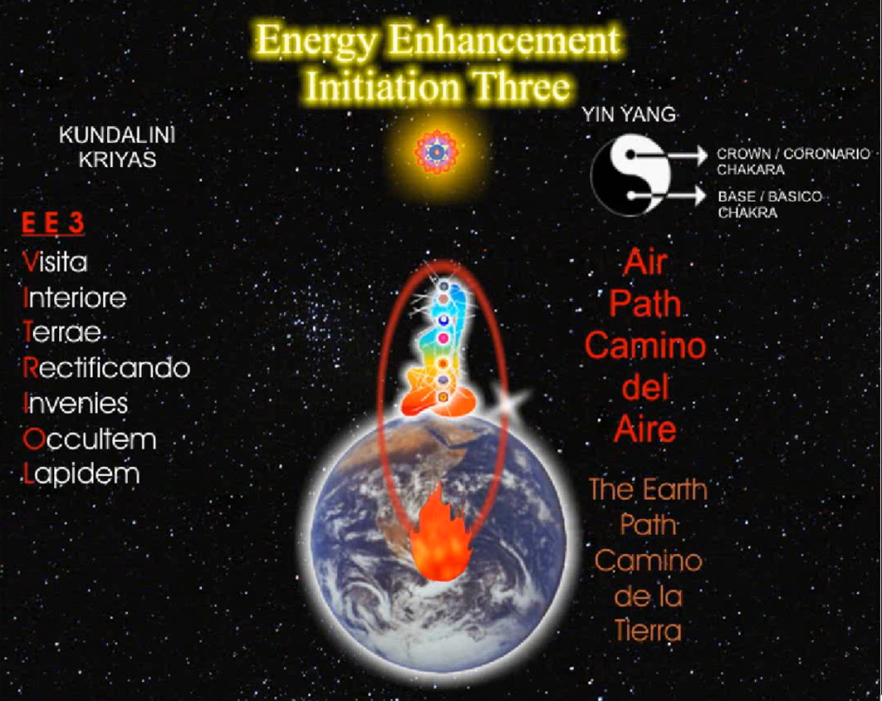
In masonic terms when they give the ritual of the master mason, who built the pyramids? Cry the masons, it was the masons! They have many secrets. And they say to the master mason, what is the point from which a man can not err..make a mistake...and the answer is the centre of the earth. They're saying the secret of meditation is to contact the centre of the earth.
In the centre of the earth, there is a burning fire. This earth is 10,000 miles down to the centre The crust of the earth is 100 miles thick. 9,900 miles is all molten lava. This earth is like an egg and the thickness of the eggshell...is the crust of the earth.
This earth has been around for 4 billion years and all the scientists say if there was no atomic pile, atomic engine in the centre of the earth, the earth would be as dead as the moon. All of the rocks would be congealed even by simple radiation ,the earth would have cooled down in that time. The earth is so dense, that half of the weight of the earth is made up of iron, the magnetic field of the earth is so strong that the earth is made up out of iron, it's not just rock.
And in the very centre of the earth there is an atomic flame, the same temperature of the sun, 5000'C. And this atomic flame can burn up even the deepest of karma and what we are going to do, we are going to make a journey to the centre of the earth, just like Jules Verne, but we are not going to get a special machine with a screw top to it to do that, we are going to journey in our astral bodies.
There is another book, Aisha, she who must be obeyed, written by H Rider Haggard which I read when I was a little boy. There was this priestess in Egypt and her favourite man, another priest, died and so she stepped into the sacred flame, the flame of immortality and she lived for 2000 years whilst she waited for him to be reborn.
This flame in the centre of the earth, is the sacred flame of immortality by which we can burn away our deepest energy blockages by connecting to this sacred flame we can increase tremendously the kundalini energy which flows as a golden cord around our central and governing meridians. The philosophers stone, that which transmutes base metals into gold. So...shall we do that? (laughs).
Now the one thing I want from this initiation, is for you to feel that contact with the centre of the earth because you have got an awful lot of black gold inside of you.
Can you remember The Clampetts, the Beverly Hillbillies and they were going on about this oil that they found underneath their land and they were calling it black gold, Texas Tea. (sings) Now I'm gonna tell you about a man named Jedd, a poor mountaineer who barely kept his family fed, and then one day he was shooting up some food, and up from the ground came some bubbling crude, black gold, Texas Tea.
And you've got an awful lot of this black gold within you, and I think on other days we've got it manure (laughs). I'm not going to mention the obvious (inaudible) otherwise I would scandalise all of you I know, but this black gold is the fuel for your enlightenment. Yea, there are lots of bad people on this planet and they like to create a lot of this black gold in everybody around them so that they can steal it because these bad people they have a very good connection with the centre of the earth. They are well grounded. They use this power source to gain their energy.
But! We are going to use our own black gold and when we send the black gold into this flame in the centre of the earth it's like putting petrol into a fire and the fire boosts up, it flares up and the energy shoots up to the base of the spine and it goes right up and down into the centre of the earth and this extra power, and this extra power takes away all of the negativity and sends it down into the centre of the earth.
So we are going to make this journey to the centre of the earth and just before we enter it, with our imagination, we are going to imagine what happens when we go down into the atomic flame with all this black gold.
Picture to yourself when you go into it there's flare up of fire energy right into the base of your spine. And you can use this flare of energy to remove all of your blockages.
The important thing is your connection, Goetha said, a very famous Rosicrucian Connect, only connect. And I want you to feel this connection anytime you put your mind on it. I want you to feel this connection 24 hours a day, 365 days a year. Once you are connected you are a made man. You have made your bones. You might have heard this from the Mafia. The Mafia in ancient times were called the Carbonari, a very spiritual organisation started by the Sufis. The carbonari, the coal men, we've upgraded it to black oil these days, Texas Tea, and this is why on New Years Eve it's good luck, for a man with a black face to come into the house and bless everybody, the coal man, the Carbonari and this is why you've got loads of black virgins around.
And if you come Escala, I will take you to Monsaarat, which is a beautiful series of mountains just outside of Barcelona and for a thousand years this monastery has been a haven for the alchemists. If you look at the pictures inside there, it's all alchemy. And the most sacred emblem of Monsarrat, is the black virgin, an outshoot of the Sufi's, the Sufi's came from Islam. But in reality they are much older than that, and the rays of their light entered into Europe through Spain. Alchemy came from the Sufi's but originally it came from the Taoists in China so these streams of knowledge have been passed around the world for thousands of years in different guises in different religions, the religion does not matter but the people that teach this information exist in all religions as well as a lot of bad guys in every religion.
So we're going to make this journey down to the centre of the earth, through the crust, through the molten rock and as you go deeper the rock is going to change colour, from red hot to orange hot to yellow hot to white hot. You come to the interface then between the rock and the molten iron. The molten iron is white hot and it's got streams of blue lightning flashing through it.
In the centre of the earth there is a sacred flame, an atomic flame, the same colour and temperature as an acetylene flame. Acetylene flame. And the flame is on the altar of sacrifice because we are going to sacrifice all of our sins, all of our blockages on the sacred flame on the altar of sacrifice very much like Agni Hotra which is a symbol for this actual meditation. The Indians in India have a sacred ceremony called Agni Hotra where they make a sacred fire made out of camphor and sandalwood and they get pieces of paper in which they put their sins and they throw it into the flame to burn up.
The North American Indians do similarly, they have a sacred fire and they take pine cones and they throw these pine cones as their sins into the flame to burn up and now we're going to do it for real. We are going to strengthen our internal energies by connection to the sacred energies of the universe. The function of the base chakra is to connect with these other energies. The function of the crown chakra is to connect with other energies which we will learn about in Initiation 4. The energies of God, even more powerful than the centre of the earth but one step at a time.
You may find blockages existing between the base chakra and the centre of the earth stopping your connection, if you find one, in any of the ways I've described previously then in the same way you need to push through it and make that connection this is your task, this is your mission (laughs). Okay?
And if you get a lot of problems we can help you with it, because you must connect, it's essential, any problems at the end of this, get back to me and Devi. Okay sit up straight everybody, once you've connected with the centre of the earth, it's wonderful to dance naked in the flames in the centre Free! (laughs) Burn away everything because only the bad things can be burnt, you can not be burnt at all because you are at a higher energy.

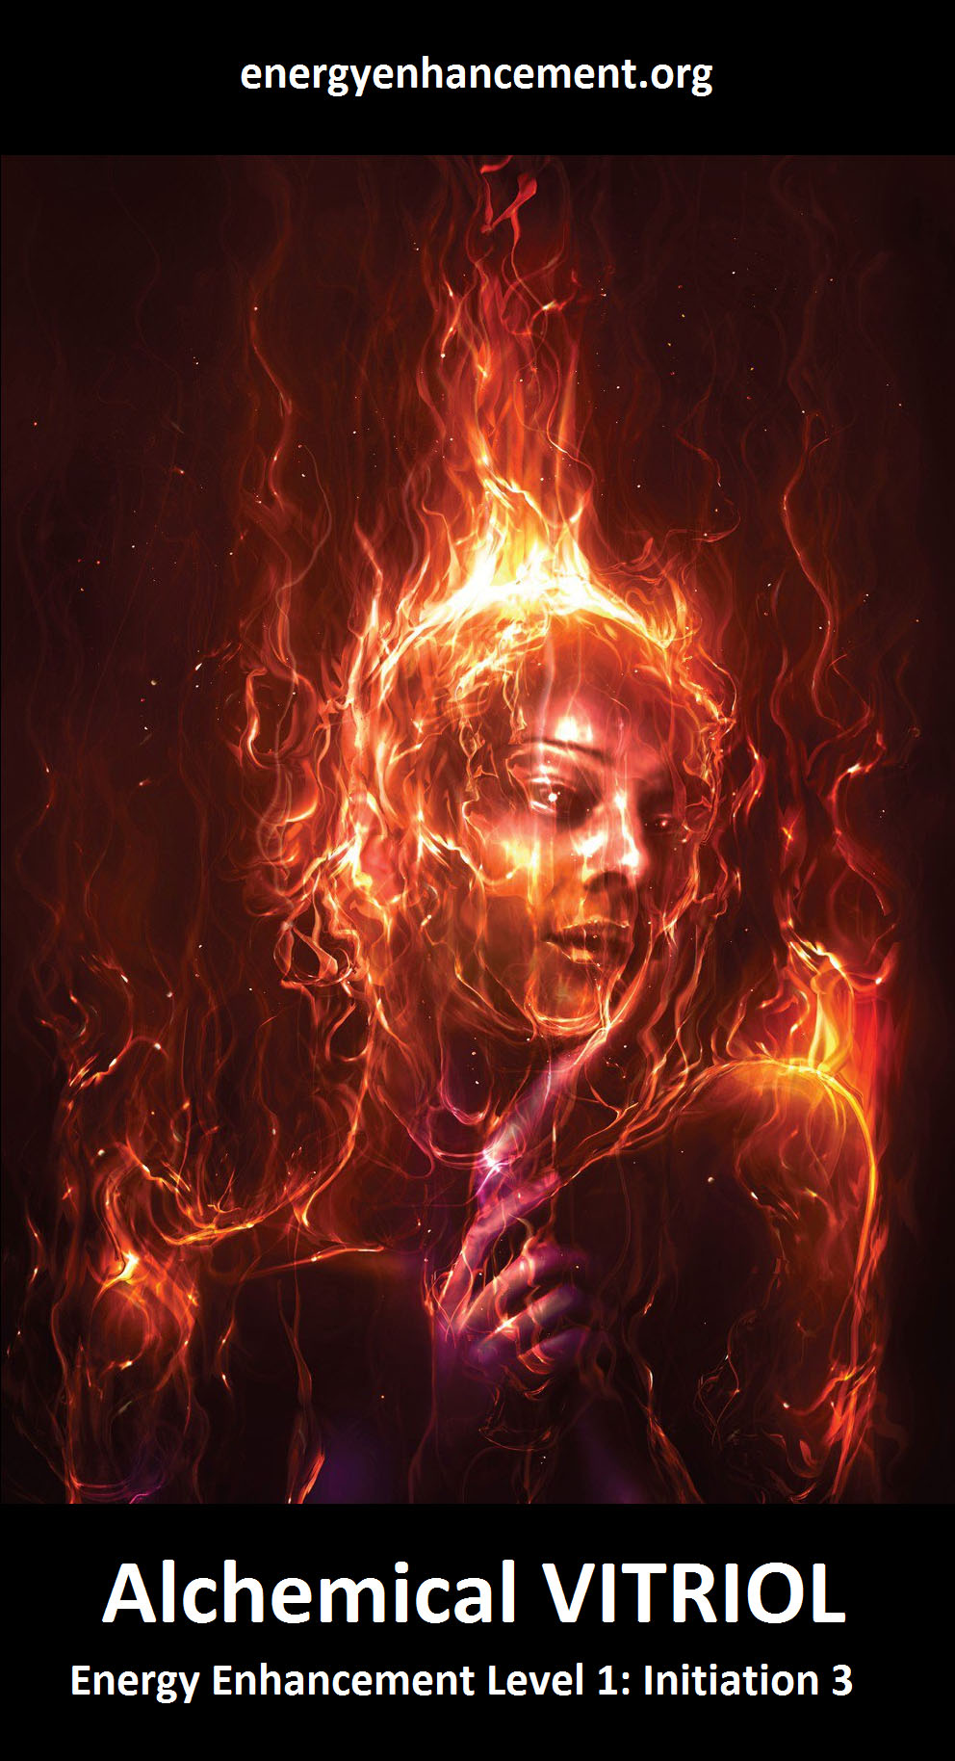
Energy Enhancement Meditation Course Level One Initiation 3 – The Grounding of Negative Energies
The Initiation 29 mins 33 seconds
Satchidanand: So I'll say it again, before you meditate, normally in future, then you make this a part of your meditation, sway, get in contact with the energies from the centre of the earth and then you connect down into the very centre of the flame in the centre of the earth.
And you contact the female energies of the earth, the shakti. The source of kundalini energy, and this is why you may get hot when you do this because what happens when you put the coal on the fire? It heats up, as you put your blockages into the flame it's possible that you can get really hot. And what happens when Shiva unites with Shakti? Well you get enlightenment dont you.
You know there's a beautiful story about Shakti...and she was having beautiful bath in her goats milk, to make herself beautiful and she said to her son, Ganesha, stop anybody coming through that door I want a bath in peace and Shiva came back from the wars and he was really hot and passionate and he wanted to get to his wife, Shakti and he came in through the door of the house, and he approached the door of the bathroom and little Ganesha he was only about 5 years old, he said, you shall not pass, so he chopped his head off did Shiva and went in and when he came out again, Shakti said, you killed our son, bring him back to life again ya devil, so he went outside and looked for a head, and in the only one he could find was one of an elephant..so he came back in again and he plonked it on the top of little Ganesha and that's why Ganesha has an elephants head, symbolising strength, symbolising the base chakra because in order to become enlightened the last blockages to go are those of the base chakra.
To change base metal into gold. You see its in all religions, it's everywhere...you just have to be able to pick up the signals about this, alchemy, Daoism have been taught for thousands of years and this is the way the energy works, this is the reality of how energy works...you just get yourself in alignment with these thoughts and with these energies...and you can become enlightened. Very quickly. And why do you want to become enlightened? So you can better serve everybody on this planet, the secret of enlightenment is not to want anything selfishly for yourself. Yea? You do not want to have this sacred powers so that you can become a millionaire, you want to become a millionaire so you can use that money to serve. Because you can't take it with you...all you can do is use it for a sacred trust. Trust...Honey was telling me about her friend last night, Doctor...
Honey: Marlek
Satchidanand: Doctor Marlek, if you're there Doctor Marlek...hello (laughs). We were very impressed that you were spending all of your money on a yoga magazine to bring the energy of God subtly into humanity...we want to think people like JRR Tolkien who brought the energy of God to humanity very subtly by means of a beautiful story. Yea and this is the way it happens. People need to have these little hints. As stories, as fairy stories, that we learnt at our mothers knees so as we become older we can drink the real thing...coke (laughs)...from the carbonari..from the coal men. Okay I think I have to wait again....(tape change) I don't know everybody is getting really cold, and I'm getting hotter and hotter. And I think It must be because I'm wearing a red kurta today in honour of the centre of the earth. There you see, it's all red, red (inaudible).
Okay folks sit up straight, sway a little bit, get your spines in alignment with the energy from the centre of the earth out into the centre of the universe, forwards and backwards, side to side, and then just nod your heads a little bit and get your necks into alignment with the energy from the centre of the earth out into the centre of the universe.
And once you get yourself connected fill yourself with the golden light from the centre of the universe, breathe it in, pack yourself with the light, breath it out through the heart centre and circulate it around the body, down the front of the body, up the spine, over the top of the head, and down the front of the body again but this time, as we send the golden thread down the front of the body, we're gonna send it down into the crust of the earth, we're gonna send it down into all of the layers of sedimentary rock, we're gonna send it down through all of the sandstones which is yellow, the limestone which is white, the coal which is black, the ironstone which is red, layer after layer, of the bones of the dead animals, the bones of dead bacteria, the vegetables of the trees which have fallen down, for millions of year dying and creating rock, we're going to send down our golden energy through all of these layers of sedimentary rock down down down until we reach the volcanic rock base, the black balsatic schist.
And as we send our golden stream down into the sedimentary rock and into the volcanic rock we're getting hotter and hotter until we reach the interface between the volcanic rock and the molten lava beneath. We're sitting on the surface of the earth, circulating the energy, sending the golden stream down through the crust of the earth, down through the molten rock, down towards the centre of the earth, down through the red hot lava, down through the orange hot lava, deeper and deeper, hotter and hotter, down through the white hot rock, to the interface between the rock and the molten metal beneath.
Golden streams of energy down the front of your body, breathe it down through the crust of the earth, breathe it down through the molten rock beneath...and into the molten iron, white hot with streams of lightning, flashing through it, corruscating hotness, sending your golden stream down down down, through the molten metal until at last you see the sacred flame.
You're not going to enter into it yet, you're going to see it, you're going to see how white hot it is, on an altar of sacrifice in the centre of the earth, you're going to imagine as you send down your negativity, it's going to burn up, it's going to flare up very quickly to the base of your spine over the top of your head, down the front of your body and into the centre of the earth, perpetual motion caused by the heat of the flame in the centre of the earth.
So when you feel ready, breathe down the golden stream into the flame in the centre of the earth, make the connection. Take all of your blockages down into the centre of the earth and there burn them up, in the centre of the earth, with your blockages, you can take your hot plasma, which is just the flames at 5000'C, and you can use it like a blow torch, to blast your blockages and gradually wear them away, get every last bit, burn them up. Use the powerful golden stream which flares up from the centre of the earth up your spine down the front of your body to gather up all the blockages, use that golden stream, like a blow torch, to burn away all the blockages in the body, eventually take yourself down into the centre of the flame, and dance there, free, happy, blockageless.
Rectificando, the right leading of the transmuted energy along the path of the soul, remember if there is any blockage between you and the centre of the earth, any disturbance in the force, stopping that strong connection than this blockage must be removed...
If the energies from the centre of the earth, flare up to the base of the spine and there's a blockage at the base of the spine, there may be a little pain there, if this happens change the flow of the energy to up the front of the body and down the spine and as you go down the base of the spine from above send the negative energy from that blockage at the base of the spine down into the centre of the earth and burn it up. This is less painful. Ooom chant
Pain is where there is a blockage. When you can sit for 3 hours without moving chances you are you will be enlightened. The pain is a great teacher where you have pain, search for the gold that is the black gold of the blockage and breathe that negative energy down into the centre of the earth and the pain will go. And where will it go to. Well where did it come from?
Student's Experiences 33 mins 58 seconds
Satchidanand: And Devi is going to..
Devi: Translate (camera on David)
David: At this time he wanted to go down to the centre of the earth he found some blockages..small and he could dissolve easy...he went to reach the flame he felt this pressure, he came down and when he was down he visualised the flame and he went inside the flame and burnt all the impurities. He was weak, and again the same pressure, (inaudible) but he went down to the (inaudible) he kneel in the flame, in front of the flame, he was giving to the flame all of his blockages and there was a lot of pressure, but he was maintaining the act of giving his blockages, a long time, and later it was difficult for him to go up...he would be the same (inaudible) again and he was feeling was too strong, he was having pain in his leg, he was feeling a strange feeling, he went up again, and he had enough strength to go down again and this time he was feeling a little bit upset, little bit of will to go with it, and later he was feeling better
Satchidanand: Anybody else? (laughs) Gracias David, gracias
(camera on Honey)
Honey: I have to say mine was slightly different, this particular meditation. And I felt I connected very quickly to the earth and the blockages that I had before I did what Satchi said, and that was with the blow torch, full of fire, that kind of concept I used so that when I came up and took all the energy from the earth, and where I saw myself on top of the earth, I just brought all the energy and it went round that circle of energy around me and very quickly blasted everything away, and then I was just sitting there doing nothing so I thought there must be more so what I did this time I brought up loads of energy to my whole body and I grounded my whole body with golden light and heat, and suddenly I started feeling a few blockages here and there in my body, so I pushed it like from the top right all the way down and squeezed it all the way across, yea..some went away..and I still felt a few bits here and there in my arms and my legs so I repeated the whole process until I felt all golden, my whole body was gold, and again I was sitting around, and then I started generating this energy around me, and all I felt were these rays coming out of my body, and I was sitting in an altar in the earth and there was me and earth as well, and both parts were generating energy and I was thanking mother earth, to take away..thank you so much for taking this away, and it was a different experience, you know, it felt very good, it happened very quickly.
Satchidanand: Yea
Honey: Yea, I was trying to find more things (laughs) it can't be as easy as this there must be more to it
Satchidanand: Energy Enhancement is incredibly simple, it's very simple
Honey: It was just so simple. It's very nice
Satchidanand: And after that we will be going blockage hunting
Honey: Yea
Satchidanand: Because there are more...
Honey: There must be lots more..
Satchidanand: There are more
Honey: Because even when the golden energy was going through my body I thought maybe all my blockages were being drowned so I cant see them and hiding somewhere so that's why I kept on going back I couldn't find them.
Satchidanand: In order to find your blockages, you must gradually increase the intensity and amount of energy flowing around the system and it is this which can cause the blockages to reveal themselves. Because they're hiding. “oh don't look at me” (laughs) But eventually they have to reveal themselves. So this is going to be a future task. Anyone else? Yea Dhiren...take the microphones
(camera on Dhiren)
Satchidanand: Where is Dhiren...There is Dhiren, he is here, oh now we have got him. There we go. You can see yourself now. Is that okay.
Dhiren: Not really. With this kind of a shawl I look silly you know. This is coming off.
Satchidanand: This is what the revealing nature of the video does.
Dhiren: No actually, I'm hot.
Satchidanand: Oh now you're hot.
Dhiren: Oh...yea it's initially I went down, I sent the energy through my heart down to the chakras through the earth and went to the yellow fire before we're coming to the white, the white light, I went there and started using that to clear my energy. More similar to the golden energy that we had so I reflected toward the gold energy and the cold fire, the yellow fire. Golden fire. Yea...And every time I brought it up my back and my spine, I could actually feel it come up, up my head and into my third eye and every time I plunge it down I end up with that yellow golden fire. My 2 chakras I made sure that I was just going through, they were aligned and everything was just going through them. And every time I went through that, I saw the black section diminishing slowly. And then I realised I was just focussing on those two and I was missing one, another section, my throat...and so I said 'oohh' you are showing up again, here you are again saying hello, and why that happened Is I was feeling some irritation, just a little bit of irritation, and dry. So then I thought, I remembered what you said about the white fire, the white energy, so I thought, sat in the golden fire, I was actually there, why am I working on this surface, whatever happened with the white energy which is a stronger one.
So then I remembered the blowtorch so I connected that, and brought the little pipe up there with my blowtorch and climbed up my back, I was actually climbing up my own backside can you imagine (laughs) and I went there and first was this stop...to see whether that blockage was still there and there was little patches of black which I burnt them off stepped up again and worked on this side. Which is diagonally opposite to my heart which I shared about yesterday because I felt a little bit of irritation over there so I said...you are off, burn off and I actually sat there for quite some time with a blowtorch burning it down, melting it down, yea and I took all that black gold, black liquid took it through and came towards my throat chakra..and I melted that and I was getting a lot of black gold, you know black liquid, really dark black liquid, so I made it into a little ball, because otherwise it would have flowed all over the place, so I made it into a little ball, melted it, took it down with me, it felt so strange, because I was inside myself, so I went through, I went straight through the 2 chakras, and by this time it was nearer to the end because I was working too slowly and I said I'm wasting time over here. And just nearer the end, 3 times I went round, and before that I took the energy, it was funny, it was so fast, it was actually golden and there was kind of fires of red, and...the energy that was flowing through it was a bit like..those firework spirals you get and it went round and suddenly I remembered what Santhan said, maybe you need to slow it down, because if I think about it now I'm shaking now, because I got scared of that energy so fast that I might burn myself out
Devi: (laughs) no
Satchidanand: No..you cannot be burnt. Only bad things can be burnt.
Dhiren: yea yea...yea but was I was realised it was not me that I was scared of, it was the blockages didn't want to burn
Satchidanand: Ahh, they were talking to you pretending to be you.
Dhiren: Yes, that's right. They were scared that, basically what I was getting was not slow it down because you're burning yourself but it wasn't me who was burning...
Satchidanand: Ah very interesting. This is the truth.
Dhiren: So then I came up and went in through my third eye and went down, and when I got over here I thought that's it enough is enough. And I plunged in so fast down into the white energy I went inside and I was sitting with my hands and my whole body shook, I was shaking, actually shivering but not out of cold, heat, I feeling very hot, my hands started sweating, and because I dived into that heat, but at the end, I knew that I was being, I knew me as a soul I was fine, so the heat was just burning, so that heat wasn't burning me it didn't feel burning, and I went 3 times over so fast, just like plunging right down and then coming up, then going right down then coming up, then coming up and coming down again and suddenly I calmed down I was still shaking and hot and then I heard the OM.
Satchidanand: OM
Dhiren: So that was my experience.
Satchidanand: Very good, very good.
Dhiren: Shaking.
Satchidanand: Anymore for anymore? Florencia. Uno momento ..(inaudible) (camera on Florencia)
Florencia: She didn't have any problem to go down but if she thought that Satchi was saying ..the colours confused Florence....
Dhiren: Start again because you'll (inaudible)
Satchidanand: Shall we wait...shall we wait...Come on in Honey...we're waiting for you..
Honey (inaudible)
Dhiren: (inaudible)
Florencia: Florence, she went very quick to the centre of the earth, afterwards she started to go very slowly, step by step, she was feeling a lot of heat, and a lot of discomfort in her body more than the sea she was feeling, more than sea...she was very very hot, she was having a lot of pain in her knee, and she tried to have like a lot of
Satchidanand: a twist
Florencia: and she was having to have a twist, and she was saying this is real hell...she says she needed to go through (inaudible) because she will have a lot of pain and she felt this is heavy. She enjoyed. The blockage didn't like it.
Satchidanand: No the blockages don't like it up them
Florencia: This feeling was so painful and so strong she needed to go up because she could not support (inaudible) go down...later she (inaudible) She need to work a lot. You have a lot of work to burn her blockages. This is what she thought when she finished the meditation. But this is the work.
Satchidanand: It is the truth, it is the light. (cam very close on Satchi) A little bit closer eh I need to go away. Err can I have the microphone back please. Pass it round this way, very good thank you. I was very interested in what both Florencia and Dhiren had to say because it is true these blockages have a sort of sentience. In the Yoga Sutras of Patanjali in Hinduism they say all bad things come from ignorance. And what they mean by ignorance doesn't mean that we're all stupid, although we are it means that we are ignorant of our true selves.
The ego pretends to be ourself. Remember what I said, these blockages in total, these masks of little bit of blackness inside, they comprise the ego and this ego, lives within you as a parasite, it is a vampire on the energies of the soul, because you are that soul, and they do not want to go and they will do everything to prevent you doing your duty which is to get rid of them which is to heal them.
To heal them of all their pain and to re-join them with god. They are the ignorant parts and they think that they are you because they are riding your donkey just like you. Your negative karmic mass has too much weight. Your donkey...your donkey-hote (the Don Quixote ego).
Do you need change your disc there Dhiren?
Dhiren: No I'm going to have to get a new disc.
Satchidanand: How many hours can you put on those discs Dhiren?
Dhiren: Oh erm a normal CD is about what 70 minute, 80 minute (inaudible) I can put 4 in.
Satchidanand: However I will get back to where I was, because these blockages they want to hide, and they want to distract you, and they want to stop you doing this process, remember what I say they will do everything to make you stop this process. I have had students who in the middle of the course after paying all their money, decide tomorrow I am going home and we say why? And they say I don't know (laughs) I'm going home...And these little blockages, these evil little pieces of blackness they affect your physical body, they can give you pain, they can affect your emotions, they can give you anyone of the negative emotions, you might not realise it, but they actually talk to you, Dhiren gave an example, he understood in the end, it was the blockages that were thinking for him...oh don't burn me up...
Dhiren: Don't go there
Satchidanand: Don't go there (laughs)
Dhiren: You'll burn yourself
Satchidanand: Because you'll burn yourself, no, you will not burn yourself you will only burn the blockages...So..be aware over these next few days, you will have to prove, who is in charge, yea? Who is in charge...it is only the soul infused being... which must be in charge...and your soul is of such a high energy...that it cannot be affected by any of these lower energies...only that which is lower can be burnt, only that which is lower can feel pain? Yea? So when you are peaceful and when you are easeful then all your blockages will be gone. This is the aim. This Is Energy Enhancement.
Dhiren: I'd like to share something here. (camera to Dhiren).
Satchidanand: One momento Dhiren
Dhiren: I'm not a keen person with the camera, I don't think about that.
Satchidanand: Well you've got 4 minutes so hurry up.
Dhiren: You see the only way I can define me as not being my blockages was something that I've always paid attention to in my life and whatever situation that I'm going through I see the entire thing from a point of triangle. Being 3 points of this triangle. The triangle is called you. Now point A, you in the physical form. A is you in the body form. Point B is you as the blockages. And at point C is you as the true self as the soul. So when I was going through and when the blockages was saying don't go there. They were the point B talking to me as point A. And what's if you can manage yourself to stand at point C, then you see the reaction between point B and point A and so then you identify the physical self with the blockage, yourself. Yes. And that helps you deal with the blockages as (inaudible).
Satchidanand: Bien. Gracias. (camera on Satchi). In the end, in the end, it all comes down to who is in charge? Yea? We are realising by experience, we have always known intellectually that your ego is something that lives inside you as a parasite, it is a virus programme, which is living inside your computer and what we are doing we are getting Energy Enhancement anti-virus programme to remove these virus'.
Notice, these blockages think in your mind, they are talking to you and it is up to you to be the soul and assert that you are in charge. It must be that way. In the end it is a force of will which comes from God itself which can free you from these virus'. Yea, anything which sabotages you in your life, you know you can even notice these things intellectually, I am acting very strangely, some people can point out, you are acting very strangely, it is a blockage, which is doing this. With the further techniques of Energy Enhancement, when somebody tells you something, you can go on a blockage hunt, they cannot escape.

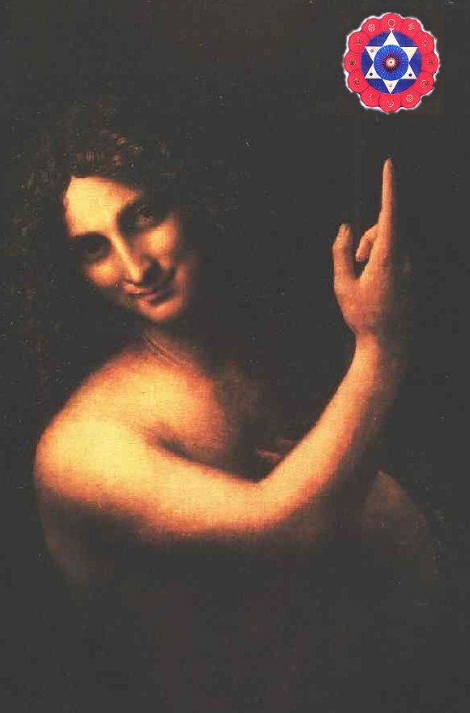
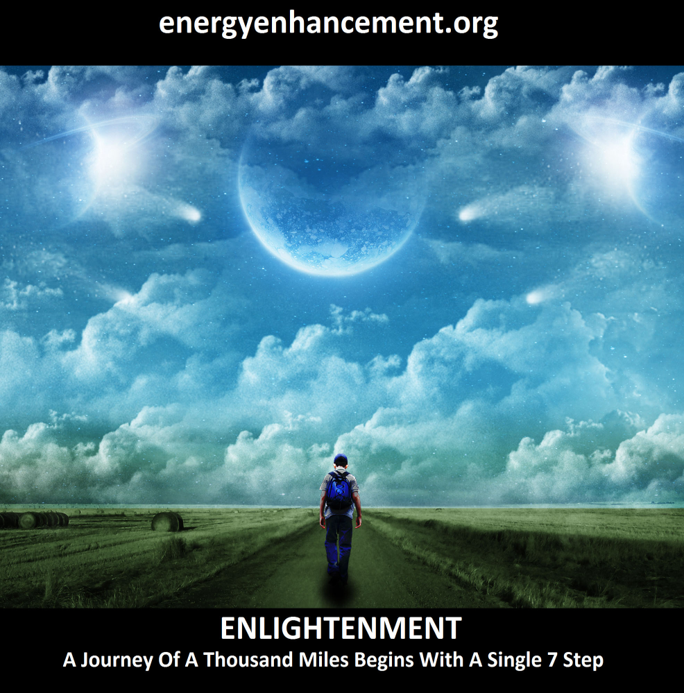
Truly, perhaps Enlightenment is next!!

THE ENERGY ENHANCEMENT PATH OF PLEASURE, SAMADHI, SAMYAMA, ENLIGHTENMENT

Energy Enhancement Meditation Course Level One Initiation 4 – The Macrocosmic Orbit
4 hours 17 mins 11 secs
Introductory Talk 96 mins 19 seconds
Satchidanand: We're going to learn the next initiation of Energy Enhancement. In the previous session we found out about extra chakra, beneath our base chakra. We found out about the centre of the earth which is an atomic flame. It's going to be a fire in your bottom. It's going to burn your ego.
Now in this particular initiation we're going to learn about the other chakras outside of the human body from which we can accept energy. Base chakra is made to accept energy from the centre of the earth. The crown chakra has been made to accept energy from God but God works in hierarchies. And like a human being is apart of that hierarchy, there are chakras above human beings to which we are connected which we are a part of, which are higher than human beings and these chakras are far more powerful than the centre of the earth.
I'm talking about the first chakra above the crown chakra, is the soul. The chakra above the soul is called the monad and this is the group of souls. The chakra above the monad is called the logos and this is the archangel who is in charge of the whole planet, within his psychic body is contained the earth itself and all of the mechanisms which he has created to help him accept energy from the universe because this archangel is evolving and as he evolves he needs to be initiated.
He needs to accept energy from higher beings than himself. Beings higher in the hierarchy. I always wondered why they call it a higher-archy, that's because it's higher! (laughs). Well it works in English.. (laughs).
So...for millions of years, the archangel who is in charge of this planet accepted energy into his being by means of trees. The trees stretched their arms up to the sky, like aerials, and they accepted the energy of God and brought it down into the centre of the earth. The roots of the trees put down all of the energy into the centre of the earth and you know trees very much mirror the vitriolic affect of the centre of the earth. I mean, you get a pile of shit and you put it as an offering with great reverence at the root of a tree and the tree goes “yum yum yum yea food” (slurping noises) and then you get all of these beautiful peaches that you pick and then you eat them? What are you eating? You're eating transmuted...(laughs)
Honey: transmuted energy (inaudible)
Satchidanand: But, but, as the planet, as the archangel who is in charge of this planet evolved, he needed to get more energy from the universe because the amount of energy he needed increases exponentially, with time, as it approaches it's next initiation, so after a while, even with trees all over the planet, he still couldn't get enough energy.
He had to plan ahead, he thought to himself, I need another mechanism whereby I can bring in more energy into myself, so I can evolve and he invented human beings. And the other planets gave him a few souls high enough to be able to manage them. And he told them, “oh well if you stick with me mate, I'll give you a good job, good contract, next 10,000 years you'll be finished, lots of food, all the money you can want and evolution very quickly, because you need it on this job mate” it's called a terra forming crew, you know, we came from other planets,
Devi: What is that
Satchidanand: The terra forming
Devi: What is it
Satchidanand: tierra forme..
Devi: aahh...tierra forme..
Satchidanand: terror forming
Devi: (laughs)
Satchidanand: So we're the sort of rough and ready guys that come in at the beginning of any organisation. We're rough and ready, ready to do anything for the job just to get it done you know, We're the sort of Irish that come in and drink the Guinness and eat the bacon and get things done. That's what we're here for.
Devi: Who, us?
Satchidanand: Oui. Yes.
Devi: (laughs)
Satchidanand: We're very lonely evolved people.
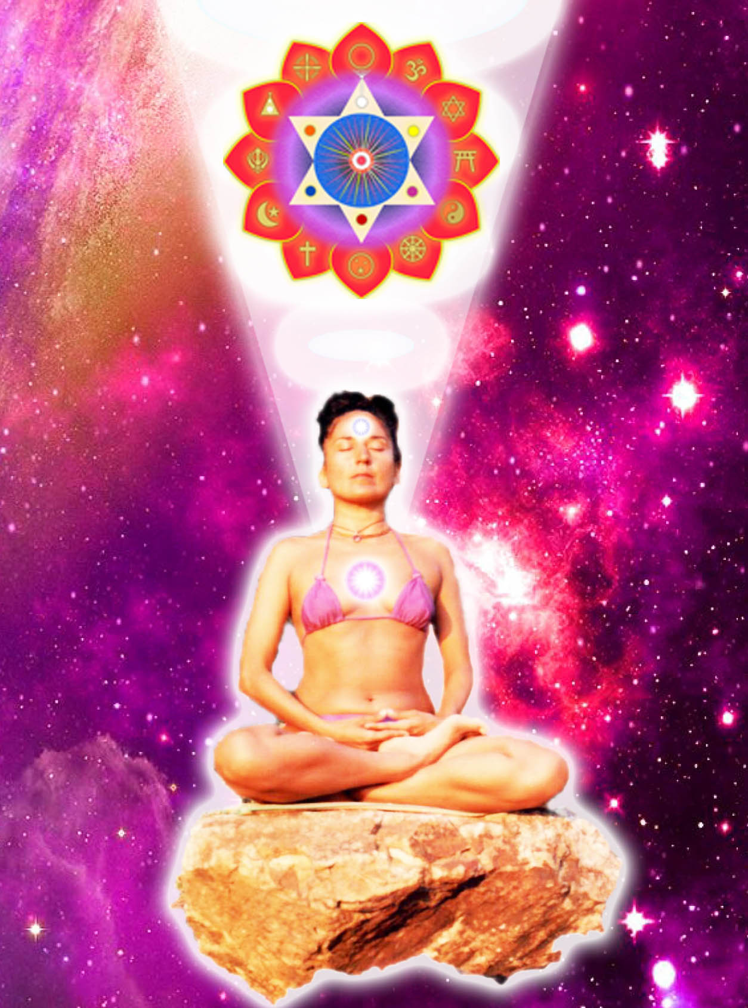
Devi: (laughs)
Satchidanand: But, as we come into ourselves then we evolve higher and higher. Now at the moment there are 6 billion people on this planet and only the enlightened beings, only the beings without any blockages can bring down the full amount of energy which a human being is capable of channelling.
You know, most of humanity are not enlightened. As a matter of fact they only have one problem, they are not enlightened. And this creates all the problems in humanity. As a matter of fact this planet, is a factory for the production of enlightened beings.
You know, we'll put all of these sort of raw human beings through this grinder with a few hammers thrown in, and we'll pound them into shape, we'll pound them into shape and eventually we'll produce some enlightened beings because this earth, although it needs exponentially more energy year by year, it does not need, it does not need all of these 6 billion beings to be enlightened at this moment. But it's planning ahead. It's a good planner. It knows how much energy it needs in each particular year. And if there isn't sufficient energy from the enlightened beings it creates mad cow disease and by the death of 6 million animals it makes up the deficit and if it needs a few more watts of energy it creates a war here, a tsunami here or an earthquake there and takes the energy from the deaths of all of these people.
So enlightened beings are absolutely necessary to prevent all of these natural accidents that befall this planet. So for thousands of years there have always been schools to train up the necessary enlightened beings. So although there are teachers the main work of an enlightened being
Devi: what?
Satchidanand: The main work of an enlightened being, is the channelling of the energy from the universe into the earth itself and in the Himalayas there are guys who sit there and meditate all day. And they send energy to humanity and into the earth. They channel a lot more energy then we are capable because they are higher beings and like the managers of factories they don't talk with the normal workers, they leave that to the workers.
They have managers here and there that do all the work with what's going on (laughs). And when the masters die on this planet they are able to maintain their consciousness through the death process and they rise higher into the astral and mental and there they have the possibility of channelling much more energy down to the people of the earth so we are here to help the earth and as we help the earth so we ourselves evolve.
Above the logos there are many stars, there are many sacred stars who have energy cords, sort of like beams of energy directed at the earth because they have to feed the earth up in order to make the earth a sacred planet. And once you've got out of the aura of this great being, who is the CEO of the earth, the top manager of the earth then you get into the real interplanetary organisations.
We're not really interested in international organisations anymore. Somebody said to me yesterday, what are you doing in Rosario. I said I'm not in Rosario, I am sitting on this planet.
And the whole universe is criss crossed by energy beams, holding the evolution of the universe supporting it. Just the way it is. And the whole universe, is increasing in evolutionary ...evolutionary...highness (laughs).
So once you get out of the aura of this planet, then you have a choice of which organisation you want to join once you've left the planetary organisation. You know you can join the Sirius organisation, you can join the draconis organisation, you can join the Orion organisation. Just depends on which stream of energy takes your fancy. So I don't like to prescribe where you should go after you go higher than the logos, but higher you must in order to get the energy you need for your evolution. Personally I am a Sirius guy, I'm in the Sirius organisation.
Devi: (laughs with and translates inaudible David)
Satchidanand: Well it's something that I know, but I don't think it's very useful. After we've been a few days more together I'll give you the information you seek but it won't mean a lot to you because it's not intellectual that you're talking about, it's actually talking about energy and feeling and intuition. Yea?
The thing is that this hierarchy of chakras that goes higher and higher and higher ends up finally in infinity with the highest possible energy of this universe. The one god with 10,000 names. The one god, with 10,000 names.
Guillermo is scratching his head, why is he scratching his head Devi? Si, moo..that cow gets everywhere. Si, bien.
Devi: He said yes, moo.
Satchidanand: The one cow with 10,000 names.
Devi: He asks what is the point where we need to go, absolute, farther, God, and I say, (inaudible) maybe there is more
Honey: Oh you mean further than God?
Devi: further than absolute. Because the absolute is containing all the manifestations, contain God, contain everything,
Honey: Yea
Devi: Maybe we can go more further (inaudible)
Honey: We don't need to go any further than that (inaudible)
Satchidanand: We need to go 2 times higher than infinity.
Devi: (laughs)
Satchidanand: There was once a Zen master and he had a student, and he said to the student I just built this greasy pole. 100 meters high, climb to the top. So he sat at the bottom in meditation and the student he was climbing up 3 and slipping down 2 and he was trying trying trying to get to the top and after one hour he got to the top and he stood on top of this 100 meter pole, high high in the air, the wind was blowing, and the pole was swaying and he was standing on top and as he's swaying he's shouting to the master below, master master what do I do now?
The master is sitting in meditation, and he goes take one step higher. (laughs). From millions of years of evolution you have finally reached the top of your 100 meter pole, this is the level of your evolution and now I'm going to teach you how to go one step higher.
Dhiren: One step beyond
Satchidanand: (after student speaks). No this is next..I haven't got there yet. Wait, everything in it's time. Don't push too much. Now remember yesterday I was talking about the heart sutra for 1 hour. And what did it say in the heart sutra? It said let's go, let's go, let's go to the other shore. Bodhisvaha!!
And where is the other shore? It is prajnaparamita, the highest heart, not this heart,(holds chest) not this heart (holds crown), not the soul, not the logos, not Sirius, all enlightened sages for thousands of years have lived in the highest heart, the highest chakra, they do not live in this chakra, they do not live in this brow chakra, they do not live in the crown chakra, they do not live in the soul chakra, they do not live in the monad chakra, they do not live in the logos chakra, they take one step higher, limitless, infinity, moo. (laughs)
And they look down upon their bodies sitting on this planet and they say good grief, why have I got to be here. Why have I got to be there? Why have I got to be there? It's so much better up here. And Sanat Kumara, the archangel who runs this planet immediately runs up there with the contract that we signed 10,000 years ago in which he promised all the Guinness and bacon you could eat, in return for being part of the terra forming crew, he says you signed on the dotted line, you gotta be here and do your work. Yea?
Until you become enlightened, it is not possible for you to leave my aura, because I too signed the contract that I would make you enlightened. Before the other organisations will accept you you need to have your doctorate before you can join the other organisations.
This is a very low organisation. And before you can go into another job, you need to get trained up. Yea. So, how do we get from A to B. You know. All that we need is books.
Honey: inaudible
Satchidanand: All the religious books they give instructions for how to become an enlightened being and most of the people they take these holy books and they put them on the holy altar, and they say oh holy book, oh holy book please take me up to heaven and god's laughing up there, he says you've got to do what the instructions say.
Who buys a swimming pool and doesn't read the instructions? (laughs). We've got a swimming pool up on the roof and I gave the job to Nipun and Florencia to put it together and they say What's this, what's that, where does it go. Well of course I read the instructions. So I just say, it goes there, there, there and there, no problem, what's the problem here.
So one of the things that we are going to do, is that we're going to make this journey to the other shore, step by step because it's very important to bring these higher vibrations of energy into your life. Yea? If you want to maybe have contact with Krishna, you've got to climb the tree. Krishna is always at the top of the tree, he's got his flute there, and he's got his feet, and his feet are going like this and you've got to climb the tree to get there. Yea, now what are going to climb? Well, there's a ladder. Oh holy ladder, please take me up to heaven. (laughs). Oh, I've heard of a guy once, I think he came from Ireland, and he had these boots and he's got these shoelaces in the boots and he was pulling on his shoelaces, pulling on his shoelaces, for hours pulling on his shoelaces, and people came up and said what are you doing Jack, why are you doing this sort of thing and he said I'm pulling myself up to heaven.
And have you ever heard of the phrase, by his own boot straps, it's a very common phrase in England. For those people who have read a lot of books.
Devi: What is the information?
Satchidanand: By his own boot straps. Boot straps are shoelaces.
Devi: ahah..and by...
Satchidanand: And actually, pulling yourself up to heaven by your own boot straps, is exactly the same as standing on the top of a 100ft pole and taking one step higher. Now I always believe in the power of imagination because imagination leads to reality so you have to imagine your rainbow bridge. You've got to imagine your antahkarana, have you ever heard of the antahkarana before? have you heard of the antahkarana? What do you know of the antahkarana Nipun?
Nipun: It's a bridge.
Satchidanand: Excellent. Nipun knows about it. Nipun knows about it. Why don't you know about it? Why don't you know about it?
Honey: You see, it's my 1%. It's within the 1%.
Satchidanand: Nipun knows about it. But you don't know about it. Ah dear dear dear dear...There's a beautiful tale which I've forgotten. (laughs) And it goes something like this.
Once upon a time there was the family of Krishna, and this guru who was a very bad guru but who had the ability to always to tell the truth and the future came to their house and he said it is the antahkarana of Krishna which will kill him.
So the sons of Krishna, oh we better do something about this antahkarana, because it's going to kill Krishna. So what they did they went out into the forest looking for the antahkarana of Krishna. But as they were passing, they saw Krishna's feet in the leaves of the tree and they were sort of going like that. Yea? Because Krishna's feet are always vibrating like that, creating a, “disturbance in the force”. That's how you can tell where Krishna is, it is a disturbance in the force.
That was his feet, just like that. And they thought it was a dove or a bird. So they got out a bow and arrow, and they went whoosh and Krishna went aargh dead. And they thought, no, we've killed Krishna. It was his antahkarana what did it.
And they ground it up. They ground up the Antahkarana. And they had made all this Antahkarana powder which they distributed all over. And it's this powder from Krishna's antahkarana that had caused all the problems on this planet because unconnected Antahkarana dust is simply Trillions of Energy Blockages!!
And it is our job to recreate the antahkarana of Krishna because although this guru always said exactly what was going to happen, always the information can be taken in the wrong way. Krishna is the antahkarana, Krishna is the rainbow bridge which connects all of the chakras.
You know it's like a computer. And each of the chakra is like a processor, what connects all of these processors together? It is the antahkarana. The antahkarana is like a tall tower. You could even say it's like a greasy pole which connects the centre of the earth and the highest possible point you can get. Along it's length, lie all the chakras. And all of the chakras together including the antahkarana tower is God himself. Because God, we are a part of God.
We have 7 of those chakras within us. And as we grow we get one more in the centre of the earth. And as we grow we get more and more and more chakras – the chakras above the head - as part of our psychic body, this is the way that we grow and how shall I become enlightened? Take one step higher (laughs).
Now we are going to learn the Daoist macrocosmic orbit. Already we have learnt how to circulate the energy down the front of the body and up the spine. Already we have learnt how to extend that microcosmic orbit down into the centre of the earth and now from the centre of the earth we are going to extend this microcosmic orbit into the macrocosmic orbit and connect up to the soul.
And what connects all of these chakras? It is a tower called the antahkarana. A N T A H K A R A N A...karana antah – karana..this is the Sanskrit name. For many many lifetimes we have been creating our own antahkarana through our meditation, through our many visits to spiritual masters, we have been creating this Antahkarana. However many people's antahkaranas are in a state of dilapidation. Devi is in a state of destruction, she always chooses a better word than me. I've got too many words to choose that's my problem.
For many lifetimes you have been learning your towers and you know every student who I have ever asked, what does your antahkarana look like, has given me a totally different reply, they all look different. mine is a marble round tower, white marble, and it's got little red jewels all over it, quite a nice decorative pattern but Devi's Is far nicer. It's made out of etheric matter, it's like glass, not hard but just a higher vibration.
I've had many people who's antahkarana's look like a pyramid, yea they've come from ancient Egyptian times these people. And I've had one person who had it made out of spiral ivy with flowers going all the way up.
Devi: Another one was a tree.
Satchidanand: Another one was a tree...So when we look you'll have to come back and tell me what your antahkarana looks like. And what we're going to do, is we're going to make the journey to the centre of the universe a place suitably high but this is only the soul. It's still a part of this planet. And although I'm saying the centre of the universe because it's suitably high it really is within the aura of the guy who's planet this is, it isn't the real centre of the universe it's just high, it's your soul, okay?
Honey: What's the name of the archangel (inaudible)
Satchidanand: Sanat Kumara, S A N A T K U M A R A
Honey: The archangel
Satchidanand: The archangel
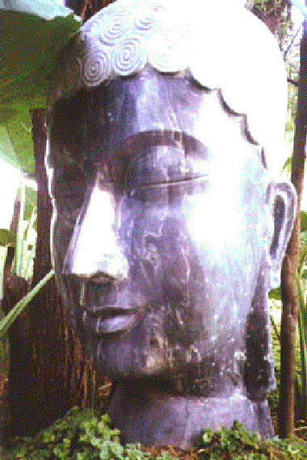
Honey: Looking after the earth
Satchidanand: Yea, he got promoted, he was the CEO in charge of Venus, and then he came to the earth, so I'll have to train all these people up you know.
David: In Spanish...what...
Satchidanand: Apparently coffee comes from Venus. Yea, many of these psychotropic substances coming into humanity to help them grow their energy beings, problem is many of them are poisonous, cut with different substances so you can't take full advantage of the psychotropic substances
Honey: Psychotropic means?
Satchidanand: Psychotropic means like er coffee.
Devi: Cocoa, sacred herb
Honey: So you mean sacred beans or sacred things like that.
Satchidanand: Yes.
Honey: Are from different planets to grow these (inaudible) okay
Devi: Cocoa, chocolate
Satchidanand: Chocolate (laughs), tea, Texas T, black gold
Devi: Rice, they brought from Venus to earth.
Honey: So are there beings in Venus?
Satchidanand: Yes but they've ascended so high they don't have physical bodies.
Devi: I was saying to Ramiro there is a passage in the bible, they were describing there the angels were making love with the women from here from earth to improve the race, and they took it off from the bible because they couldn't understand how the angels were making love with you, couldn't understand (inaudible)
Honey: What do these angels look like?
Devi: I don't know.
(inaudible discussion)
Satchidanand: (inaudible)
Devi: they were most suited for that reason (inaudible) they were more subtle
Satchidanand: Subtle
Honey: Subtle
Satchidanand: Subtle...so subtle.
Honey: So Mary, Jesus was born to Mary.
Devi: No this is another (inaudible) this was from old testament.
Satchidanand: So without getting into controversies about Mary and Jesus and angels what they bleeding look like, they look like bleeding angels don't they. Bloody hell. You know what an angel looks like. Good grief.
What we are about is raising our energy levels by accessing these higher chakras. By getting in touch with the centre of the earth we have been able to burn up a lot of karma by going higher into the soul we are going to access another furnace of energy like a sun, a sun is very hot yea? The Sun is a Fusion Power Generator. It's got a lot of very high vibrations. You bring your karma up to that sun mate, you've got an even hotter furnace - hotter mate, even hotter, there you can burn up even deeper karmas and the higher you go, the hotter and more forceful the energy is and in order to get rid of some of the deepest karmas, you need to go higher than the logos itself okay?
On the way, you will have access to your past lifetimes, you will have access to ascended masters, it usually goes in the form of finding a sort of council of 7 or 5 ascended masters who you talk to and then they're normally there to test you before they allow you to pass onto higher beings where you get even more advice, yea? So as we go higher we are going to have the opportunity of meeting even higher and higher beings, you might even find, the guy who employs you.
And you have to test these beings because some of them are bad!! Using Initiation 5 of Energy Enhancement.
Well you've got to sign at the dotted line with somebody aint ya? You don't sign on the dotted line with Sanat Kumara do you? He gives you one of his lower managers. Who are you working for mate? Oh I've got lots of Guinness for him.
Student: (inaudible)
Satchidanand: And the question was, erm, what does the logos look like? Yea so I always remember Monty Python, and they're there at the amphitheatre and they're selling all these strange things like rabbit gonads, in a packet, all nicely salted..
Devi: Rabbit what?
Satchidanand: Rabbit gonads
Devi: What is gonads?
Satchidanand: I don't know it's something horrible. And he says, he goes albatross on a stick, albatross on a stick...and he says what flavour is it? And he says, it's bleeding sea bird flavour innit.
So if somebody asked me what does the logos look like? I can say, it looks like a logos doesn't it.
And it will look.. because it's not physical, it will look the way you want it to look. It will look the way that your programming makes it look to you. They usually take very traditional forms because of all your previous lifetimes and meditation in temples etc they tend to take the forms of temples with sacred flames etc It doesn't really matter because you will see that which makes sacred sense to you. Because these places are sacred they are the places where you will receive initiation. As Nipun said they are archetypes.
Devi: Can I say something?
Satchidanand: Please
Devi: They say the Native American Indians, when they go to, when they die, they see (inaudible), they see green (inaudible),(camera on Devi) they see a fort, they see buffalo, they see the thing for them that makes them happy, the American Indian, the Indian from the east, they see maybe Krishna or Shiva. The Christian or the Catholic, maybe they can see the vision Mary or Jesus Christ, depends. But it depends which tradition you are coming from, and also if you are more and more high maybe you will see an ethereal, (inaudible), perceive or you can see energy, you can see..my antahkarana doesn't have any shape, it's energy purely.
Florencia: (inaudible)
Devi: Florence say, if you are near to one tradition or you chant a mantra which is connected with some tradition, appears some symbol or something can be connected with this tradition there is more chance if your mantra, and appear the David star into her vision, it depend what kind of activity you do, you have different symbol and vision.
David: I have a question, (camera on Satchidanand) what is the group of souls?
Satchidanand: What is the group of souls? What is the group of souls? Well, you have your soul and your soul might have 20 different reflections living down on this planet all gathering experience for the soul.
Now higher than the soul is the monad which is the group of souls, and if you can imagine there is about 50,000 souls connected directly to this monad and you've got another monad over here on the left and there's another 50,000 souls connected to that monad and then both of these monads are connected higher into the logos so the logos might have round about 100,000 monads beneath it and each of those monads might have 50,000 souls connected to it. And that's how you get 6 billion people on this planet. All connected to the monad and all connected to the logos.
Now what is an enlightened being, it is a person who is soul infused. The connection with the soul is perfect. There is no ego, no blockage, which is stopping the connection. This is the third initiation with those I was telling you about. The 1st one is opening the heart, the 2nd one is the mastery of relationships, the third one is enlightenment itself, soul infused being and yet there is a 4th initiation even higher than that and then as the ego is dissolved so the soul itself is dissolved. And all that is left is a monad infused being.
A person that is in charge of 50,000 people. And then there is a 5th initiation, where you take full control of the monad. Where you become in charge of the enlightenment of 50,000 people. If there are any bad people there, your job is to absorb them into your monadic being. That is the monad.
David: He said people are in the monad, can be know each other, which connection (inaudible)
Satchidanand: They are part of your soul group.
David: (inaudible)
Devi: If you could perceive, I perceive many people connected with the soul of Satchi, I perceive many people connected with my soul, and I perceive many people with different group solar group,
Satchidanand: And most of the people here will be part of my monad group. My job is to help you attain enlightenment because as you get enlightened so I become more integrated.
Devi: Ah Satchi, do you want to mention about the matrix (inaudible) absorption
Satchidanand: Perhaps you could tell them.
Devi: No no no
Satchidanand: Which absorption is that Devi?
Devi: The absorption is between Neo, you could see that there is absorbing (inaudible) matrix, you could see that there is absorbing (inaudible) matrix, because Neo entered into Agent Smith.
Satchidanand: True, yea Devi mentioned about The Matrix, which is what we call one of our spiritual films there to enlighten and give information to a lot of people. Although the first matrix was most popular, spiritually the third matrix film contains a lot of information about what I've been telling you.
For example Agent Smith represents the ego. He keeps going, me me me me me me me as he changes everybody on this planet into people like himself. And how does Neo the monadic infused being manage to get rid of all of those ego's on this planet. He channels the energy of the logos, a super computer in the sky which dissolves all of the ego's beneath it. And so the world is cleaned of this bad guy called Agent Smith. …
Devi: (inaudible)
Satchidanand: ah perhaps you better explain it Devi...and Devi said and the absorption of the oracle by agent smith
(new clip)
Satchidanand: Some questions are not useful and therefore he would not answer them...I just don't know...the answer to many of these questions, I just know from experience the way things seem to work out, some things I know...and some things I don't and some of these questions are not useful.
You have to ask for the answer to these questions by yourself. The people in the soul group will have an evolutionary centre of gravity. Higher or lower depending upon how many enlightened people there are in the group, as soon as one person becomes enlightened, the group really starts moving and it's very quick for all those 50,000 people to all become enlightened.
However the numbers drop off severely as they all join together in the monad. Remember, as your guru gets in contact with more and more of his monadic group he becomes more powerful. I just added the monadic group in, that's the only extra bit yea? But it's the same. Yea?
Honey: (inaudible) what do they say about Sat gurus? The Sat guru turns their disciples into gurus.
Satchidanand: Exactly and they're all connected by means of the monadic group.
Honey: They turn their disciples into gurus.
Satchidanand: But within the monadic group there can be many Sat gurus for you. Because they're all part of the same monadic group. There can be many sat gurus for you, depending upon the evolutionary centre of gravity of the group, there can be more or less enlightened people within the group and if there are a lot you can have many sat gurus. But if there's only one, you can only have one. Oh yea I got so much help from so many different gurus, so I think I'm in a group with a lot of enlightened people in.
Devi: What did you say at the end?
Satchidanand: About?
Devi: I don't know
Satchidanand: Why?
Devi: Because I was doing the translation.
Satchidanand: You were translating what I was saying.
Devi: No I got to whichever people (inaudible) there were many Sat gurus in your group, many enlightened beings in your group
Satchidanand: Yea
Devi: I told them also..
Satchidanand: So this is a group...Ssshhh....now we are going to do the meditation. Now this is far better than blabbering on about sat gurus and gurus. This is intellectual clap trap. In a way, it doesn't matter what idiocy the guru talks about, they could be talking complete load of rubbish.
The important thing about a guru is the energy. I was always one of these respectful students, I was always one of these respectful students, I was tremendously respectful to the people that I met (inaudible), respectful, as a matter of fact whenever I met them, I don't know why, but I never asked any questions and I was just entirely quiet with them and they always started talking to me and they used to be telling me all sort of things and my mind was going, I was respectful I didn't have any thought in my mind but I was saying why is he telling me all this rubbish and then I found out he just wanted to form a connection to give me energy.
You know philosophy all of these books about Hinduism and Tibetan Buddhism and all of these different religions. They are just a big advertisement to get you to go and see the guru.
There was once a student who came to a Zen master and he said you know I've got a library filled with 6000 books and the guru said all useless, he said they must be useful for something, yes they brought you to me.
You know advertising is very useful. It's good stuff, it's completely necessary. Everything spiritual that is produced on this planet is simply an advert which eventually ends up with you going to see somebody that can give you the energy to rise high. This is all you need and then you know for yourself.
Swami Satchidananda used to say to me, once you grow higher evolutionary, you can read any spiritual book and you will know exactly what it means because you have already gone that path. As Father Bede Griffiths told me it is all in the explanation. Now you read the other day, the heart sutra, the translation of the heart sutra. This is the state of all spiritual books. It is a fact that the unenlightened always defeat the enlightened – until they don’t. Now here am I telling you the way to become enlightened, and you're asking me if all of the people in the monadic group have a similar astrological chart do you understand how the blockages within you are trying to stop the process, this is just not useful. Focus Trinity.
Shall we do the meditation. Now, I am going to describe where we're going. I'm going to take you on a journey, we're going to go down into the centre of the earth and make contact, we're going circulate the energy and then I'm going to take you on a journey and the journey is only useful to get you there, a ladder to take you up to the soul, once you've got to the soul you can throw the ladder away.
You will not need it anymore. It is a spiritual truth, once you have been somewhere you can always get back to the same place, you don't need the ladder to get there because you know where it is. So I'm giving you a guided meditation which is a ladder but once you have gone up to the soul, you won't need to do this journey ever again. You can just go (clicks fingers), there. You might have to travel up the golden cord. You might find it useful to go up your antahkarana but you can go there very quickly. You don't have to bother about the journey. It's all part of going one step higher.
So the journey I'm going to take you on, after we've been down to the centre of the earth and we've taken the golden energy higher, we're going to take it through the clouds, we're going to take it out the atmosphere of the earth and then we're going to take it up to the level of the moon. At the moon we're find those class of people who like angels who get enfolded in the arms of the angel and taken higher at the speed of light out of this solar system higher and higher to the centre of the universe above your head, is a star which is brighter than 10,000 suns. This is how it's described in the Hindu Upanishads. Brighter than 10,000 suns.
And we're going to make this trip, out of the solar system, out of the galaxy, past all the millions of galaxies to this sun, which is the largest sun in the
ENERGY ENHANCEMENT LIVE COURSES – WORLDWIDE
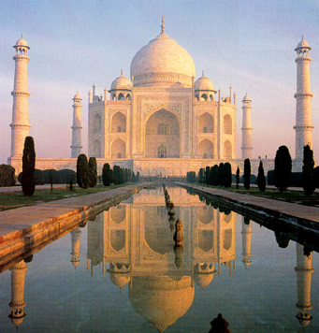
INDIA, 5 STAR INDIA TAJ MAHAL, SPAIN, MEXICO, PERU, ARGENTINA – MORE
Bookings: www.energyenhancement.org
whole universe which exists in the centre of the universe.
As we go higher we are going to feel the light and the heat of this sun above our heads and as we feel that, we're going to take that energy and circulate it down the front of our body into the centre of the earth and get that boost from the centre of the earth to send the golden light higher towards the centre of the universe.
As we go higher, we're going to enter into the atmosphere of this central spiritual sun and in this atmosphere we're getting to a very hot temperature. The surface of the sun is 5000 degrees centigrade. But this sun is so bright it's even hotter than that. And as we go through the atmosphere of the sun into the very centre of the sun it's just going to get so bright and so white around us it's going to be indescribable.
Now I want you to exist in the centre of this sun. And I want you to send down the golden cord, vast amounts of energy into the crown chakra, down the golden cord down the front of your body into the centre of the earth. And I want you to use that vast amount of energy to further find out more blockages and transmute them.
In the centre of the central spiritual sun is a blue door. As you open the blue door you enter into a blue tube and you go higher and higher through this blue tube many thousands of light years and you reach this top of this blue tube, you enter into a blue sun, this is the monad it is at a very much higher frequency than the central spiritual sun, the soul, and from the monad you will send down vast amount of energy to your crown chakra, you'll circulate it down to the centre of the earth and you will use this energy to further find blockages and transmute them.
You can even take the blockages up into the centre of the monad and in the sacred flame in the centre of the monad you can blow this flame into the blockage by using a blow torch, a very hot plasma to gradually wear away even the most dense and terrible blockages.
If you want to take a blockage higher trap it in a crucible, made up of 2 hemispheres which you trap around the blockage so it cannot escape and you can take it right up into the monad and you can destroy even the deepest blockage.
As you go into the centre of the monad, you will find a black door as you open the black door, (squeaky hinge noise) you enter into a black universe with one white star, very brilliant high above your head, this white star will send down a ray of light and you will ascend the ray of light into the centre of this star. This star is called the logos. And in the centre of the logos, you will find the hottest flame on this planet. Even so, there are some blockages which are not possible to destroy even by the flame in the logos, for this you will have to go one step higher.
And you need to go to a higher sun, called Sirius, but other people can choose which sun they go to, it depends upon your path, and it that centre of that sun Sirius is a flame which can destroy even the deepest blockage. People of the 6th initiation managed to go higher than the logos, to have a perfect communication with the suns higher than the logos, all we're trying to do is to get a little bit of communication and we can use that energy to make that communication even better.
As you go higher many of you will find blockages, between these various chakras, these blockages must be transmuted. As you go higher there is a possibility of seeing your past lifetimes, ascended masters advice. Some of these ascended masters might be blockages, do not take advice so easily.
Take them into the centre of the monad or the logos, put them in the centre of the flame, use the blow torch on them, and if they are entirely untouched, trust them. Test them.
When we finally go as the logos we are going to rebuild our antahkarana. We are going to have a look at the top of our heads and see this building that you have built over many lifetimes that comes from the centre of the earth and is built up and it will be a form of destruction. All you need to do is to rebuild it. You might decide that it's too far gone and a new building is needed. Well you might like your old building and decide to renovate it. Build you tower right up into the centre of logos, right up into the centre of Sirius. And make certain that it is built out of the finest materials with no breaks.
Honey: When I went to my guru I heard his talk and it was very very interesting and I went up to him and I said to him, all this teaching of yours is so brilliant that I want to pass this onto my students. I said to him I want to help you spread your word and he said, he smiled at me and he said work on yourself first. I said, no no no gurugee I don't think you understand, I'm going to put my time and effort and I want to go and teach people about this. And he just looked at me again, smiled, and said work on yourself first.
So I went back home, in my car, and I thought to myself, I don't think he understood, I'm here trying to help him, and suddenly something just went *whoof on my face. And I thought who am I to go and teach other people, who am I. I mean how could I see myself above everybody else. And I have so much things that I need to work on myself and here I am thinking I am going to make everybody else better people. Haha.
And that was my first step on my spiritual path. So what I understood that spiritual masters are so important that one thing that they could say so few words have transformed my life, yea. And later on when I said that to my guru he said once you've worked on yourself you won't have to look for anybody else.
The right people will come to you and what you wish to do you'll be able to do without any effort. It just happens. So yea those few words were so profound and important, yea, so I just thought I'd share that with you, it's quite interesting.
Student: Thank you
Honey: Thank you, (camera on Satchi). Living in the way I live I just realised what a big ego I had, and still have.
Satchidanand: Well, even though Honey was evolved enough to perform any useful function for her guru at that time, Swami Satchidananda, he say, (laughs) there are many people wanting to put out the fires on this planet, but instead of carrying buckets of cool water they are carrying buckets of petrol.
But the only way to get rid of that petrol within yourself, black gold, Texas Tea. Is to have the desire to get rid of that petroleum within yourself. Just by having that wish is the first step on spirituality. Don't worry, it will all happen at the correct time to people who have such a wish. (new clip).
I'll say that again, we're going to find those people with blockages above their heads, it's very normal to find
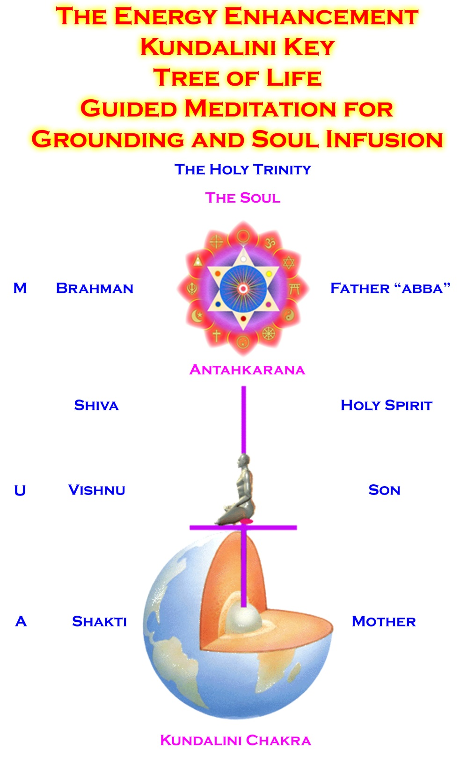these blockages and if you do find them it is absolutely essential to get rid of them. You can find them between the crown chakra and the centre of the universe. You can find them from the centre of the universe right up into the monad. You can find them from the monad up into the logos. And you can find them on the way to Sirius as well, they exist everywhere. And you need to remove them by any means possible.
And we be going more into that and further initiations, removing all blockages to an infinity of chakras above and below the base chakra..
In the mean time, working with blockages is very good experience. Yea? Just to even know they exist gives rise to the question how do we get rid of them. And once you've got that question you will find the answer. Because you must. Yea? You've got to get rid of them. They've got to go.
These blockages these are the sorts of things that turn up in every astrological chart. These kinds of blockages are the kinds of things that turn up in every astrological chart. As you remove the blockages, so the charts become more integrated. You know the difference between an integrated chart and one which is all over the place.
Satchidanand: An integrated chart is one which has good angles between all of the planets and less of the bad angles. Even though you need to have those bad angels to provide some sort of fire in the chart it's that that supplies the evolution. You will find that a person with a lot of integration will have a better chance of moving onto the spiritual path. The possibility of doing more. The ability, the talent to do more. Yea am I right? It's true. That's the way it is.
Student: (inaudible) push from the chart, some sort of (inaudible) some angles are a stress for the angles (inaudible) they have to give you some push (inaudible)
Satchidanand: Exactly. You've got to have that push. It supplies the necessary evolution. Yea? The only problem is it going to be evolution or is it going to be evil-lution.
Honey: (laughs)
Satchidanand: I said the only problem is it going to provide evolution or evil-lution. evil Is the opposite of live. All the bad guys reverse everything.

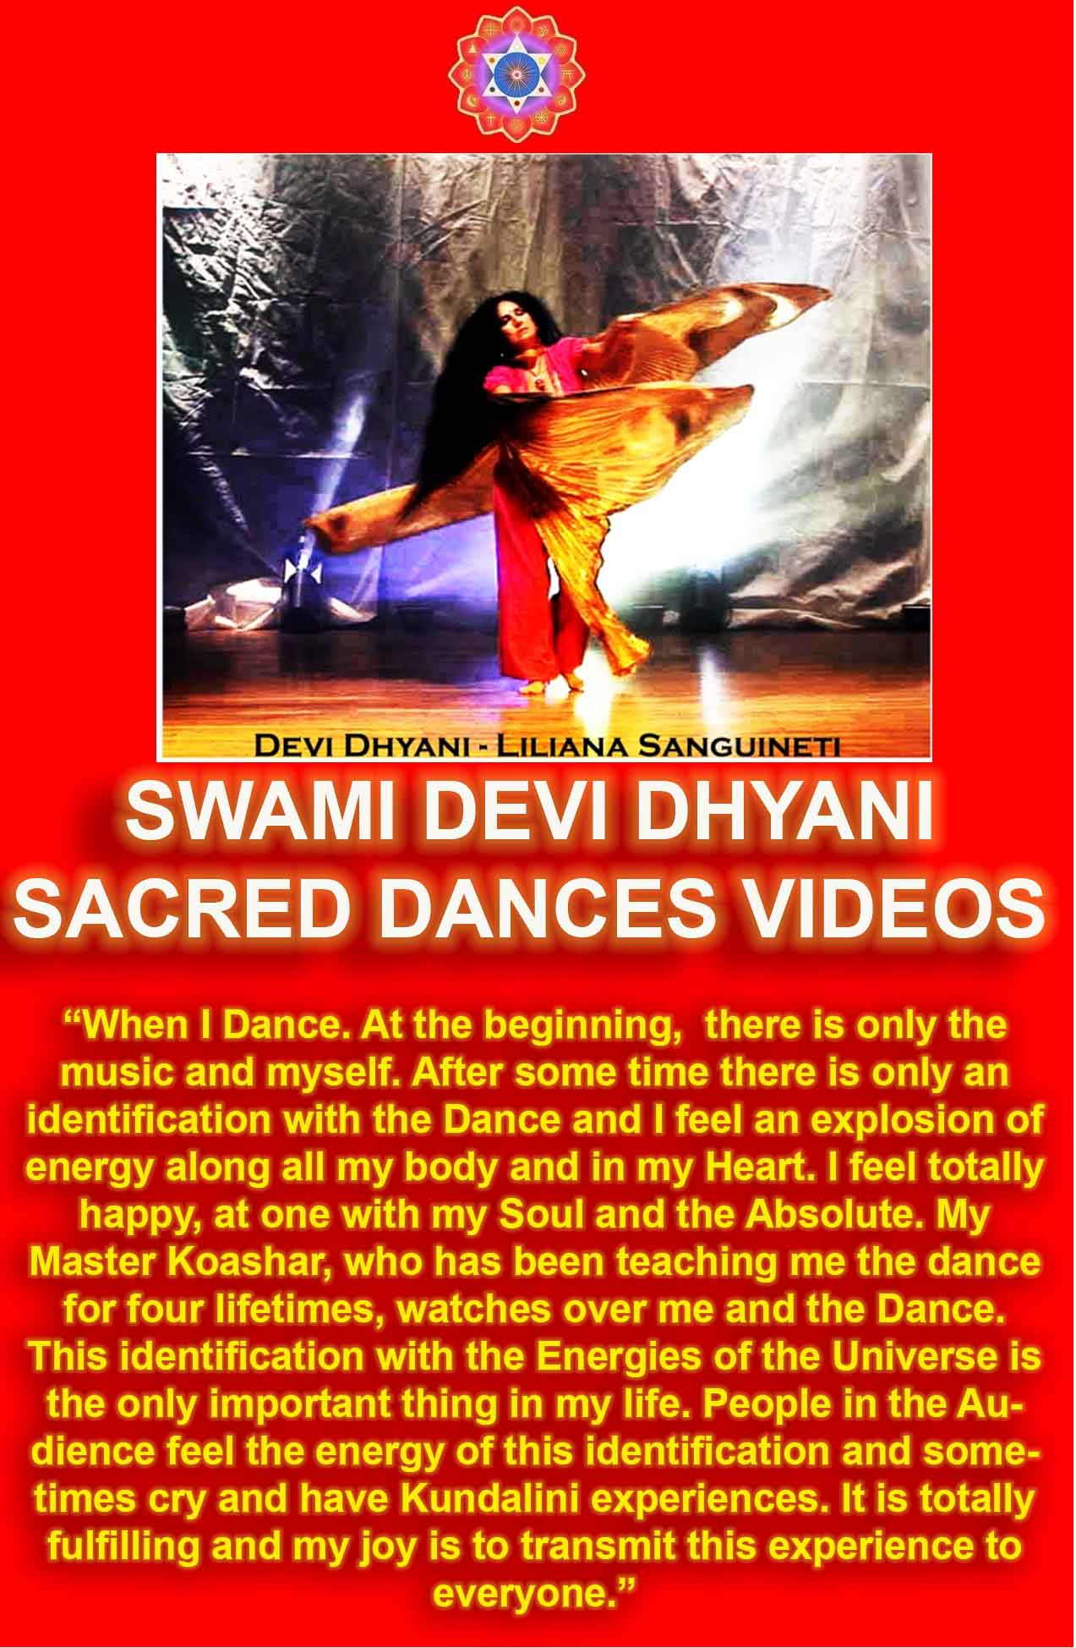
DOWNLOAD LEVEL 4 BOOK HERE!!!
http://www.energyenhancement.org/Sacred-Energy/Level-4-Book/Energy-Enhancement-Level-4-Book-Energy-Cords-Mastery-Of-Relationships.pdf
Energy Enhancement Meditation Course Level One Initiation 4 – The Macrocosmic Orbit
The Initiation
29 mins 28 seconds
Satchidanand: Chanting, meditation, going higher, take one step higher, sit up straight. Sway, get your spine in alignment with the energies of the universe, get your neck in alignment, with the energies of the universe, calm your breathing, contact the centre of the earth. Every hour ask yourself, am I in contact with the centre of the earth until you know that you are in contact with the centre of the earth, 24 hours a day. If you want to build a big building, something like a very tall tower then you need a very deep and firm foundation. And if you want to have a rocket to go right up into the centre of the universe you need a lot of fuel, black gold, Texas Tea. Take a deep breath in.
OM SHANTI chant.
Satchidanand: Connect with the centre of the earth, take your golden cord up your spine, up out of the back of your head and upwards past the clouds, out of the atmosphere up to the level of the moon and some people might like to be caught by an angel and taken higher and some people might like to board the starship enterprise and on the view screen on the captains cabin, you can navigate your way out of the solar system going into towards the sun past Venus, past mercury, past the sun and then away from the sun, past Mars, past Jupiter, past Uranus, past Saturn, past Pluto and out of the solar system away from the sun.
But you are still sitting on the earth and you are still connected with the centre of the earth, breathing energy down the front of your body into the centre of the earth, up and away up the spine out of the solar system and then faster and fast, warp factor ten, travelling through this galaxy the milky way, out of the galaxy, and then faster and faster higher and higher, way above your heads, breathing the golden cord, out of the galaxy, and then past all the other galaxies toward the central spiritual sun, the sun brighter than 10,000 stars.
And as you go towards it, higher and higher, you can feel, heat and light above your head, and you can feel this heat and light flowing down the front of your body into the centre of the earth. Higher and higher up your spine, away towards the centre of the universe. As you approach the atmosphere of the central spiritual sun, high above your head, feel the heat of the light white hot plasma at 5,000'C.
Now this heat and this light is flowing down the front of your body into the centre of the earth. Up your spine, high up into the centre of the universe going through the atmosphere of the sun through all the white light, brighter and brighter in toward the centre of the central spiritual sun, the Soul. The centre of the central spiritual sun. From the centre of the central spiritual sun, channel energy, heat and light down to your crown chakra, breathe it down into the centre of the earth, feel
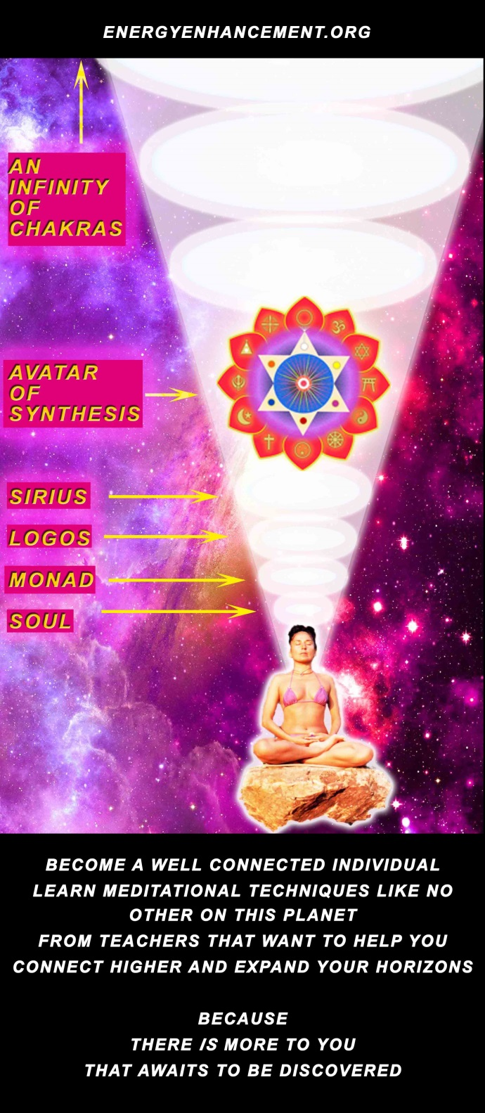
the return of energy from the centre of the earth, coming up towards you in the central spiritual sun.
Circulate this energy in the macrocosmic orbit. And you can use this energy to further transmute any blockages in your system. But we're not going to do that at the moment.
We're going to find a blue door in the centre of the central spiritual sun. We're going to open that door, enter into a blue tube taking you higher very very high above you thousands of light years, higher and higher through the blue tube, until we begin to feel the heat and the light of the blue sun above you, more intense, more bright, more hot, than the central spiritual sun, higher and higher into the atmosphere of the monad, brilliant blue sun. Into the very centre in the centre of the monad there is a sacred flame, which can burn up even the deepest karma.
Circulate the energy from the monad very strong, down to your crown chakra, down to the centre of the earth, feel the explosion of energy flowing up your spine, and coming towards you in the centre of the monad. The energy is circulating at the speed of light, and that's not very fast, it needs to be faster. It needs to circulate at the speed of thought.
Again destroying all the blockages. But we're going even higher to the black door in the centre of the monad. We're going to open that door, enter into a black universe with one white star high above your head, and it's going to send down a ray of light to your crown chakra. And you're gonna travel up that ray of light, higher and higher to this bright white star. Feel the heat and the light of the logos above your heads. Feel the heat of the light from the atmosphere of the logos as you travel into it. Into the centre of the logos. Sacred flame. A temple. Circulate the energy from the centre of the logos down to your crown chakra, down to the centre of the earth an explosion of energy, shooting the energy up your spine into the centre of the logos. Circulating at the speed of thought with the even higher frequency of energy from the logos. Transmute all blockages, take them up into the centre of the flame in the centre of the logos. Transmute them.
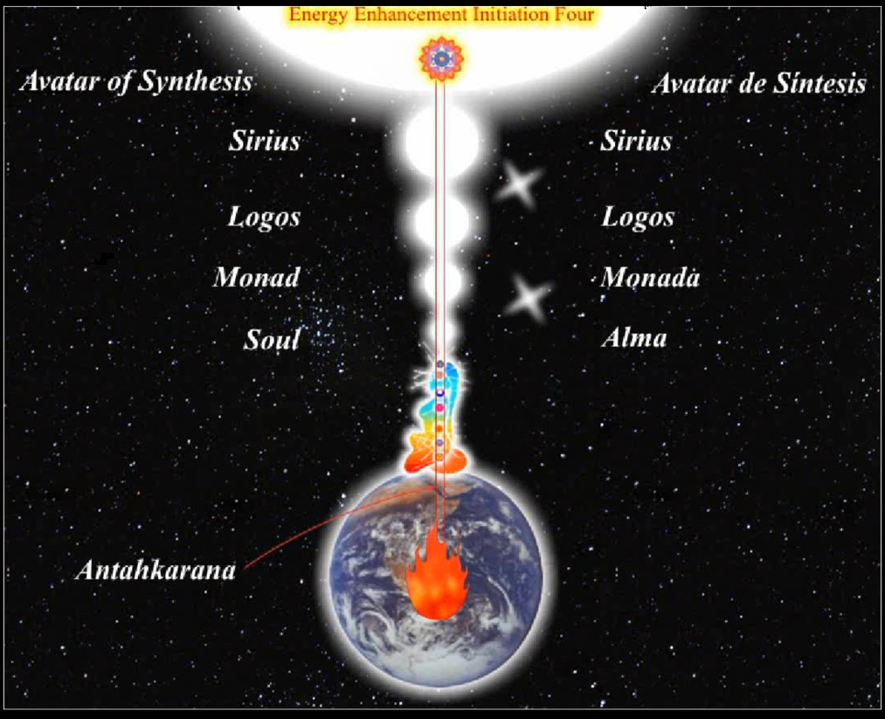
And as you go higher than the logos you travel upwards higher and higher towards a sun called Sirius. An even brighter white than all the suns beneath. Travel into the atmosphere of the sun. Feel the heat and the light flowing down to your crown chakra into the centre of the earth Feel the heat and the light flowing from the centre of the earth up into the centre of Sirius travelling through the atmosphere of Sirius into the centre of Sirius.
Higher than Sirius, 5th level, 6th level, 7th level, 8th level, 10th level, feeling the heat and the light of the 10th level flowing down into the centre of the earth and returning up to the 10th level. 20th level, a 1000th level. A millionth level to an infinity of levels with an indescribable amount of light and energy. Circulating, into the centre of the earth and circulating up into the centre of god.
Now, build your antahkarana tower. Energy is circulating automatically, take your tower and build it, into the centre of the universe, the soul. Take your time over it, you don't have to do it as quickly as this. Do it thoroughly, with the best quality mental matter. With the finest quality of jewels, however it is. Make it perfect. Take your time over building the antahkarana properly. Take it up into the central spiritual sun. Take it up into the monad. Take it up into the logos. Take it up into Sirius. Take it to the 5th level, take it to the millionth level. Take it up into infinity. Build it without any breaks, any destruction, perfectly.
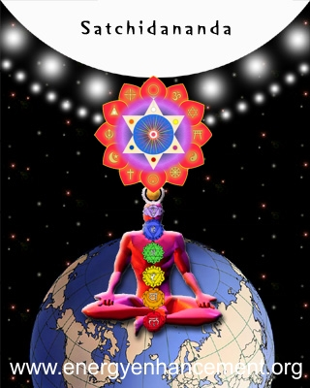

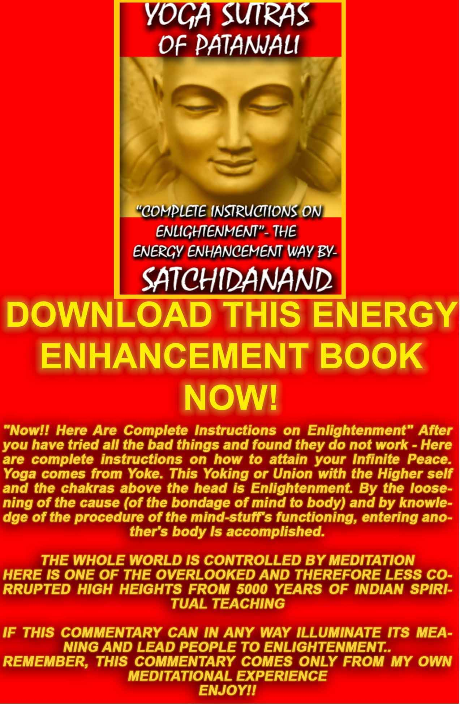
THE YOGA SUTRAS OF PATANJALI BY SWAMI SATCHIDANAND - CLICK HERE..
http://www.energyenhancement.org/Sacred-Energy/yoga-sutras-of-patanjali-book/Energy-Enhancement-Yoga-Sutras-of-Patanjali.pdf
Energy Enhancement Meditation Course Level One Initiation 4 – The Macrocosmic Orbit
Talk after the initiation
8 mins 30 seconds
Satchidanand: The quality of mercy is not strained, not constrained, it droppeth as the gentle dew from heaven upon it's place beneath, it is twice blessed, first by he who gives, and then by he who receives. Shakespeare, another enlightened master.
Satchidanand...what is the meaning of this name. What is Sat. Comes from the Sanskrit word Sathya which means truth but what is true? What is it that never changes on this planet as everything is worn away, everything gets old, broken, worn away, and dies.
There's only one thing that is constant in this universe and that is mu. Highest energy that we can reach even though everything beneath it drops away. The truth can never change, Sat chid- comes from the Sanskrit word chitta. We've heard about this before in the Yoga Sutras of Patanjali. Yogas, chitta, vritti, nirodhah. Yoga for enlightenment is when the mind, the chitta, reduces all of it's disturbances, all of it's energy blockages to zero.
Chitta is the mind space. In this case chitta means a mind without thought. One day a student who was the governor of the province came to see the master, a Zen master and he said, what about this...what about that...isn't the sun shining beautiful, and all little lambs jumping in the forest and the Zen master said, stop, shall we have a cup of tea.
The students of the master came into the room with a teapot and 2 cups of tea, the master picked up the pot of tea and he started to pour it into the governor's cup and he poured and he poured until all the tea came over the top of the cup and it spilled onto the table beneath and he kept on pouring and the governor said stop stop what are you doing. The tea is going all over the table and all over my lap. And it's hot.
And the master said, this cup represents your mind. It is too full of cows..and donkeys...and lambs...dancing in the forest..come back when your cup is empty. And what is this empty cup. It is the sacred chalice. The Holy Grail. The Sang Real. The cup which Jesus shared with his disciples on the night before he was taken before crucifixion.
What fills the cup? It is the blood of Christ. The empty cup is on top of your head, it is your empty mind. And as the energy of Sathya falls into the empty cup it is filled with the energy of bliss of ananada which is the blood of Christ.
The Father Sathya, the Son Chitta and the Holy Spirit Ananada, the blood of Christ.
It is twice blessed, first by he who gives Sathya, and then by he who receives chitta. This is you. You are an empty cup. You are the sacred chalice. You are the sangrial.
Then you are enlightened.
Experiences of student Honey 16 mins 6 seconds
Satchidanand: Now what did people find on the journey to the centre of the universe? What did you find? I always look at Honey because she's always, oh yes oh yes, me me me, okay. (camera on Honey) Wait, take that.
Honey: Oh yes
Satchidanand: Give that to the Honey. Lets have a look at this. Sort you out. Okay Honey. What happened.
Honey: Right, now don't laugh okay. (laughs). Now I wasn't very sure if I was doing this meditation right. All I saw myself was whizzing from one place to another. And when we finally went and built the actual tower kind of thing which is linked,
Satchidanand: the antahkarana.
Honey: antahkarana. Suddenly I thought, oh dear, I should have asked Satchidanand what exactly am I supposed to build. So, I wasn't quite, completely clear so then I thought let me ask myself within. So I understood maybe what I need to do is a connection right from where we are right up to where we went. So I thought right, so I can build anything I want. So I came up with this futuristic kind of a cage thing so I just stepped in there and it just whizzes me straight to where I want to go through this big white tunnel. And the reason I did that, is because this particular like a Doctor Who, I don't know if any of you know that, it's like this round shape thing, it's like a cage thing, like an arch. You go in there with seats all the way so if I want to face this way I can, if I want to face that way I can, that way or that way. But the thing is as I travel I made sure that my wall around the cage, round tube, was white because I thought let me pre plan. Just in case I have to find any of my blockages which are dark and black then I'll be able to see them better in the white. And it was brilliant, because as I thought let me try this one more time by myself. Practise in this, and I just press the button and the door opens and I sat in there, pressed this button, it went zzzhh, and I press the button and it went whhoosh straight, and I passed everything, I went whhoaa there goes that monad thing, oo there goes the sun, there goes there, and I just passed it all with the stars and I reached where I was supposed to reach, yea, and that's all I saw, and I wasn't sure whether I was supposed to see anything more. So finally I thought am I supposed to build something at the end of it. So I felt I'll start the work but I think I may come back here again after a redesign of my, what I want at the top. Erm, I'll go back at another time because I want to redesign my place on the top if I'm supposed to do something
Satchidanand: The penthouse suite.
Honey: I just have to tell my friends here, this family members here, that I'm an Aquarian, I always think many years ahead so my plan was very futuristic as well. That's what I call my futuristic tower to get there.
Satchidanand: And Honey you didn't find any difficulty with any blockages at all, (inaudible) it was just dead easy all the way up
Honey: I just went whooff all the way there and I came back and I thought let me try one more time.
Satchidanand: All the way there, to where?
Honey: Well, I went...
Satchidanand: Where did you go?
Honey: That's the thing...so where I went was I whizzed past everything that you spoke about, I saw the galaxies, I went through that monad thing, the blue door, big white tube
Satchidanand: Blue tube
Honey: Oh it was blue, yea?
Satchidanand: Blue sun
Honey: My'n was kind of bright whitey blue. Okay, so I'll make it more blue next time.
Satchidanand: OK, no no, it's okay, whitey blue is good.
Honey: Okay so I went all the way through, and then of course I went to that lo lunar thing, wherever
Satchidanand: (inaudible) the logos.
Honey: the black, logos yes. So I went to the logos. And then through there I went through the door, the black door and everything and I went through this little thing, it was really fast though, I was travelling through it, and then I saw the big star and it went bbzzzz and it had lots of energy (inaudible)
Satchidanand: (inaudible)
Honey: Went through again, and then I started going through these steps thinking now where am I supposed to exactly go, starts looking around, and then all I saw was this big line, with lots of, like an underground map, like a train thing, with platforms, wherever I want to go I can go, so it was zzzz all the way, so if I want to take here if I want to take there and I want to take another one. Yea, so many, like a train platform thing. And it just went on and on and on. Until I came to this round shape, where I think..just just emptiness. And I thought is this where I'm supposed to build something? So I wasn't sure what to do after then. So I came back enjoying myself, (going down) weee, my pressing buttons
Satchidanand: Yea but do you know nothing
Honey: I don't know anything from this, I just had fun going up and down, I don't know what this whole meditation was about for me. But I just went zooming up and down, it was fun.
Satchidanand: The main thing is to gain energy. The higher you go the more energy you can channel down to your soul, through your crown chakra. And if you can sit (camera on Satchi) and if you can sit, in the centre of nothingness the highest possible energy that you can obtain, if you can live there 24 hours a day and be channelling energy down to yourself on this planet, then you are living as an enlightened sage who for thousands of years have lived in prajnaparamita, the highest heart, the spring at the top of the mountain. It is the water from this spring, that must fill this bucket. Slowly slowly, it must replace all of the petrol. It must remove all of your blockages.
Honey: I have just one question I wanted to ask Satchi.
Satchidanand: Yea
Honey: So the idea was for me to use these, this way of moving from the earth, mother earth right up to where I was, where I ended up, and you're saying use this to find the blockages on the way etc...
Satchidanand: First of all you must remove all of the blockages on the way but secondly you must use the energy in the centre of the universe to transmute all of the other blockages in that circuit around your body.
Honey: (inaudible) bad student (inaudible). I'm still not clear in terms of I'm supposed to use this energy from – I'm so -
Satchidanand: From God
Honey: Because I go so extra energetic going up and down I (inaudible) this energy I was using whizzing up and down
Devi: It is the same energy you collect in earth but more powerful than the earth energy
Satchidanand: As you breathe the energy down into the centre of the earth, you bring that energy back up to the base of your spine and circulate it around your body to find blockages and get rid of them. It's just the same but the other end
Honey: Oh I see...so I can, I go even higher up
Satchidanand: You go even higher up but from that point, you circulate the energy down the front of your body to the centre of the earth, feel the return from the centre of the earth up your spine into the centre of wherever you are. And the purpose of the antahkarana is a permanent connection tower so that this connection is there, there is no part of it which is broken, it forms a cable of connection, all the way from the centre of the earth right up as high as you can go up to God. So you don't have to think about it anymore, the connection is there, by means of that connection, you can travel in an instant to any place along that tower. To any level of energy which is necessary to use while you are doing your job on this planet. Okay?
Honey: That is brilliant yea, now it all makes sense to me. Thank you.
Satchidanand: Good, you need to practise it again Honey (inaudible) and use it like that. Very good.
Honey: Yes, now I understand it.
Santhan: Satchi, can you repeat what you said about sharing, what you receive you share, you receive twice.
Satchidanand: Ah this is Shakespeare from the Merchant of Venice, it's Portia's speech. She says the quality of mercy is not strained, not constrained, it droppeth from the gentle dew from heaven upon it's place beneath. It is twice blessed first by he who gives and then by he who receives. Is that okay Santhan? Good, you can write it down now.
Davids: He asks if it is similar (inaudible) the soul, the centre of the monad, and the centre of the – he want to know if there is a difference between the centre of the universe and the soul
Satchidanand: No they are the same thing.
Davids: The same thing.
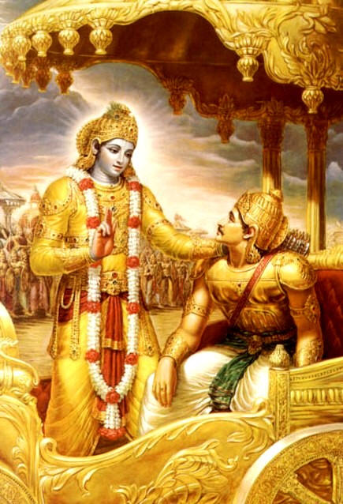
KRISHNA, THE SOUL, ENERGISING THE SOUL INFUSED PERSONALITY OF ARJUNA
Satchidanand: Yes, I'm using it as a synonym.
Experiences of Dhiren 13 mins 46 seconds
Satchidanand: Now has anybody else got any experiences that they would like to share?
Dhiren: I didn't think my'n was any interest, I didn't think I got any Swami: Ah
Dhiren: But after her sharing I realised what had happened.
Devi: What happened?
Satchidanand: What happened, wait wait wait. Let's put this onto Dhiren.
Dhiren: The dreaded camera.
Satchidanand: The dreaded camera. You're on candid camera.
Devi: Pass the microphone.
Satchidanand: Oh yes pass the microphone to Dhiren.
Dhiren: Thanks for the close up. Haha, no after this afternoon session it was very calming for me. Erm, and as Ramiro pointed out, a little too calm.
Devi: Ramiro told you something and you understood what was going on.
Dhiren: Yea he said, no he was asking me a question. He said “Why are you quiet? Why are you calm? What are you quiet?”. And I said I'm being with this afternoon's thing, the experience. And then when we went through this exercise I thought, Now what? And I said there and listened to Satchi say “Go from this point and touch the centre of the earth” .So earlier I just shot down.
Satchidanand: You don't go with it, you breathe the cord.
Dhiren: But I was just there, I was up on the earth and I was there as well. And then I took the cord with me out and went straight up. And when you said “By a means of a spaceship or
Satchidanand: Or an angel
Dhiren: Yea. Before you mentioned that I had met up with my *inaudible guardian angel. My *inaudible guardian angel, I told you about that. And I was just for a short instant, then you said transport yourself from here to there, and it was gone..and at that point I didn't need anything, I didn't need a vehicle, I didn't need a space ship, neither did I need the hand of a guardian angel. And you said from this point to this point and I didn't see any distance. At one point I was in the clouds and you said out of the clouds, out of the atmosphere and so I was there. And then you said, past Saturn so I saw everything whiz by, I was still standing in the same place.
Devi: Past what?
Dhiren: Past all the planets. But I wasn't moving I was just there. And then you said the sun, so I was there. And every time that you said travel, yea the blue tunnel. So for me there was no tunnel. I went straight into the blue sun. It was like I didn't have to open the door. And in that time I thought to myself it can't be this easy. You know, it's so easy. Like I'm taking a step and I'm there. I went to the blue sun. But in the inside I saw a lot of white light. But there was a blue sun. And I started burning up a house there, something living, no particular structure. But it was made out of glass, totally transparent. And I couldn't feel the physicalness of it but I could see everything. And the star that was the blue planet, the blue sun right. And what I saw was just like a laser light shot down straight on the top of my head. And the next one I saw was the white light and the red heat straight from here (third eye) straight to the core of the earth..
Devi: From?
Dhiren: From the top of my head straight to the centre of the earth and that was a continuous connection.
Satchidanand: So that is your antahkarana.
Dhiren: Right. And then from the blue planet, blue sun, there was a glasshouse, a transparent house, I could see myself sitting on earth, but it wasn't as if it was that far. I could see myself sitting there yet I knew I was so far though I wasn't so far. And I could see the blockages *inaudible.
Devi: *inaudible blockage
Dhiren: No they were all like little bits here there and everywhere. I didn't particularly see
any one point. But all I concentrated on was the light coming from the star to my head and the white and the red flame going through to the centre of the earth. And I could be at the centre of the earth or on the Avatar of Synthesis and at the same instance I can travel across. And I thought, it can't be this easy. I don't know what that means. I don't know whether that's an experience.
Satchidanand: Well Dhiren...pass me the microphone back please. Dhiren it is that easy. You inhabit all points along that antahkarana at the same time just by placing your attention on one part of that you can be there. But one interesting question came of this. What happened to the logos?
Dhiren: I don't know.
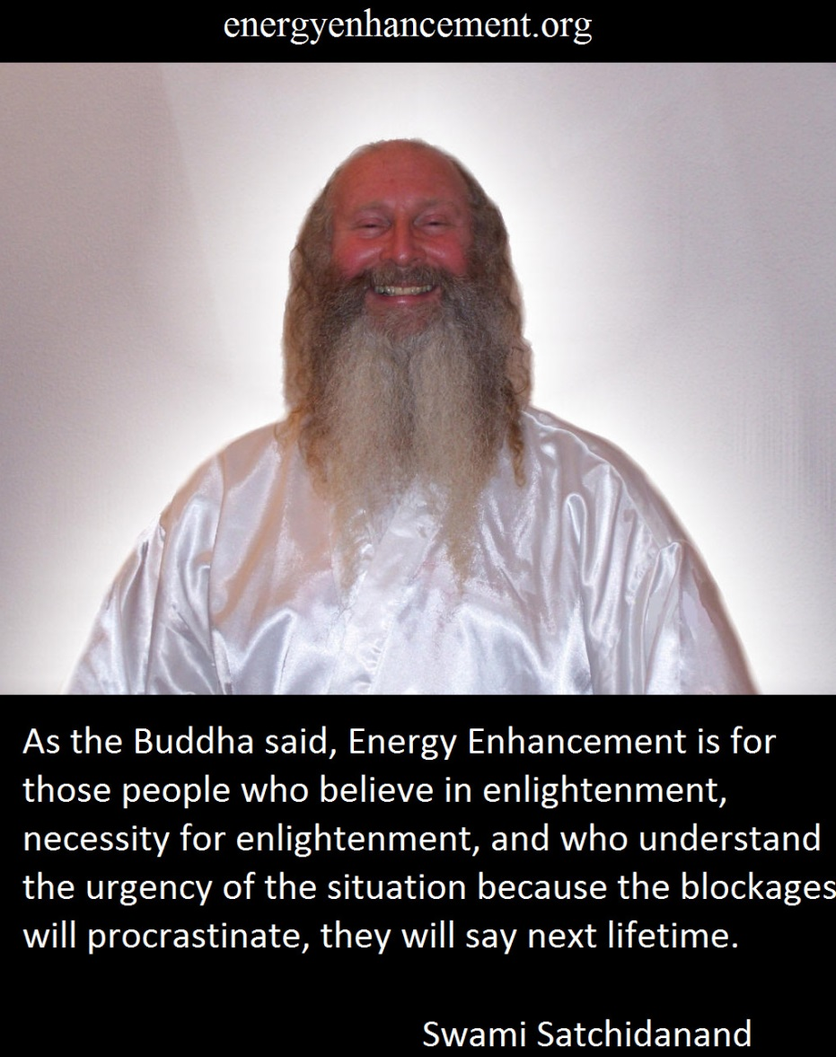

Satchidanand: Go one step higher haha.
Dhiren: I went straight to the blue sun you said right?
Satchidanand: This is the monad...and then? What comes after the monad Honey?
Honey: The logos
Satchidanand: And what comes after the logos Honey?
Honey: Erm that's when you get to that star through the black door.
Satchidanand: Sirius
Devi: He got the star eh?
Dhiren: That's when I shone that laser light onto my head. So what I felt was I, because it felt as if there was no distance and I didn't need to go through of all this or I didn't see it to go through it or important enough I just straight into a point.
Satchidanand: Erm, well the point I'm trying to make at the moment is that it is that easy but if you allow yourself to become distracted by how easy it is. If you travel from where you are now into the centre of the universe, the central spiritual sun, and then you enter into a blue door, into a blue tube and then travel up to a blue sun with a white interior and there you build a house then you have missed the black door on the interior of the blue sun which is the monad, the group soul, and you have missed out on going higher. You have become distracted and what distracts you? A blockage between the monad and the logos. Because it is that easy unless there is a blockage there. And when there is a blockage there, the higher it is, the more control it has over you and the more difficult it is to remove. So this is your next journey. I suspect a blockage. But whatever happens you need to go higher, to logos, to Sirius and then to infinity. Yea? Because it is that easy Dhiren. There is nothing difficult, nothing wrong with what happened to you there it was perfect.
Dhiren: I wasn't so much distracted in fact I was disturbed that it was so easy and so I kind of got lost in that space thinking it can't be this easy. It's not. Because anything in my life, anything that I've gone through has been a struggle. So for me to think about this whole experience is just stepping into a space I want to be in, wasn't any difficult to *inaudible.
Satchidanand: Again, we will practise this again. And I will be very interested to find out what Dhiren finds out next. Remember the higher these blockages are the more difficult they become. And it's really necessary for you to go to the logos to go to Sirius and then to build your antahkarana, whatever it is, beam of light or whatever, as high as you can. I just suspect, I'm not certain it might be as easy to go to the logos and higher as you've already done but you need to do that. Got it?
Dhiren: So where was I at that point?
Satchidanand: You were in the monad. You were in the monad. You were in the monad. But you didn't get any higher. And I suspect a blockage between the monad and the logos because of the distraction. They distract you in all kinds of ways Dhiren. But then again, I might be wrong. It doesn't matter. The main thing is you go higher, no problems. No problems. That was a very good experience. Yea?
Dhiren: Yea. Still I'm not sure.
Satchidanand: No, but what does it matter.
Dhiren: No, it doesn't matter.
Satchidanand It doesn't matter, it was good.
Experiences of Guillermo 14 mins 32 seconds
Satchidanand: Okay, anybody else? Who else?
Dhiren: Federico wants to do a question.
Federico: It is possible to repeat the travel of the antahkarana anywhere any time? It is possible?
Big Spanish discussion.
Devi: He asks if he did the *inaudible and the antahkarana is gold with some stones. He said he can change the antahkarana?
Satchidanand: Yes you can change the antahkarana if you wish. You modernize it, it's an old design but its pretty good. Its stood the test of time.
Devi: Guillermo wants to...
Satchidanand: Wait wait wait Guillermo. I'm gonna turn this onto you. We're gonna see the real Guillermo. There we go there's Guillermo. There you go Guillermo.
Devi: Guillermo wants to say many things which are significant. First...
Guillermo: First, he remembered that the antahkarana when he did the exercise with us years ago. Was feeling of strong. Like a medieval castle. And it changed into the ray of light. This was, he remembered, because he forgot about his antahkarana. Because he doesn't remember what he *inaudible. I (Devi) always say to him he's a bad student. Haha. The second thing interesting was, he didn't find blockage in his column but after he find a blockage in his throat. Satchi was saying visualise the blue sun and he was there before. There were a number of blockage between the monad and the logos. And also the experience was strong, interesting and he felt more relaxed. Because a lot of *inaudible was going down down down down. *inaudible buffaloes and animals.
Satchidanand: Was there a cow?
Guilllermo: No, buffaloes.
Satchidanand: haha buffaloes all the way.
Guillermo: Buffaloes. This was very strong for him. When Satchi was said going higher. He was fed up. He said, ah this guy, he's pushing. He got angry. I didn't want to go anymore higher.
Dhiren: Distraction
Guillermo: Why is this guy pushing me. Too much to me. He was angry.
Satchidanand: Ah so this guy got angry.
Guillermo: He said I'm not going up. I'm not going. I don't want to go. His *inaudible was very bright light, and was giving him a lot of light. *inaudible. Devi and Guilllermo talk in Spanish.
Satchidanand: Can I answer now, finished. Okay give me that microphone back. Okay Ramira. As I said. How do you know when there is a blockage? When you get distracted. When you get angry. And I'd like to say something about Guilllermo's experience. Why do we have blockages above the monad. Why do we have blockages above the central spiritual sun. And I want to refer back to many lifetimes ago. How does a soul evolve? You know we enter into so many bad experiences.
Sometimes we get attracted by the dark side of the force. And this is the thing that I saw first in Guilllermo which is why I did not want to teach him 5 years ago because I saw that he had been a black magician in a previous lifetime.
He's a very good chap now mind you. Hahah. And I want to say that for Energy Enhancement this is very normal. How does a person evolve? How does he gain psychic powers?
He doesn't come first to the light. Black Magic is there to train up future white magicians. It's all serving the part of God. What is a black magician? A black magician is somebody who has cut himself off from God. How do they cut themselves off from God? A black magician has the ability to make an implant of negative karmic mass. This is a blockage. They make these blockages in rituals. And in rituals for new black magicians they put these blockages in the crown chakra and then when you become a really bad black magician they place the blockages above the monad and when they become a really bad black magician then it goes even higher.
In order for you to get your connection back again, to receive the light it's necessary to destroy all of those before us. Every blockage on that path between the monad and the logos must be destroyed, must be transmuted by the methods of Energy Enhancement Level 2 which we're gonna get to in 5 or 6 days time. You already know these techniques so in your next meditations your work is to get rid of all those blockages every one of them. Because even though you can reach to the white light.
Devi: He burned the blockage.
Satchidanand: Ah good. Did you do it by the methods of
Devi: He felt paralysed when he was burning ..he went to the centre of the earth..
Satchidanand: And then when you have destroyed all of those blockages. It's necessary for you to go higher which is what you were resistant to. Why is Satchi pushing me so much? Because unless you can go higher you cannot become enlightened. (Winks)
Dhiren: What did he say?
Guilllermo: When do I get to become enlightened?
Devi: *inaudible
Guillermo: What happens after enlightenment?
Devi: Happiness
Satchidanand: When you become enlightened you get a permanent blissful energetic connection with God. If you have blockages on the path to God, it reduces the amount of energy you receive and it gives you a tremendous amount of bad luck like I know one guy he lost all of his guitars...on the dock of Dubai...why did this happen? That was Dhiren, that guy over there, the one's who asking me all these stupid questions...yes...
Experiences of Ramiro 17 mins 4 seconds
Satchidanand: Now does anybody else have anything to say about their experience this time around? Anybody else? Anymore for anymore.
Ramiro: I want to ask a question
Satchidanand: Ah okay, shall I turn it onto you
Ramiro: Okay
Satchidanand: OK. He doesn't mind this guy he's happy with everything. I like that. It's Ramiro. There you go, Ramiro. Yes! It's the man himself. There you go.
Ramiro: Okay. When I made the exercise I try to follow it step by step all the course that Satchi says . I imagine all the stars and logos and Sirius. But this time when I did the exercise I had an image of
a crash helicopter appear but was very rare.
Devi: He say when he was doing the exercise, appear an accident of a helicopter. Very clear, like he saw it on TV.
Ramiro: And I think maybe its a blockage that disturbed my...and I try to do the exercise again and after I got another image of a medieval castle. Very vivid. But also whilst I was doing the exercise I had many nonsense image appear to me.
Satchidanand: Nonsense
Ramiro: Nonsense because I...laughs with students...I've never been there before? People who I don't know...Devi laughs.
Satchidanand: Which people appeared?
Ramiro: An old man was going up to a library.. When I imaged I was in a castle and she was (Honey) walking down
Satchidanand: She was there? She was there.
Ramiro: Passing through..a lot of people I imagine.
Satchidanand: Was she wearing the purple uniform?
Ramiro: Yes a purple uniform.
Dhiren: This must be when she was just *inaudible
Satchidanand: Ramiro where were you at the time, which point.
Ramiro: Between the monad and the logos.
Satchidanand: Between the monad and the logos is the place. Wait wait wait wait. Let me get this back on . Give me that microphone.
Honey: This is getting exciting.
Satchidanand: Oh I was there...Well, Ramiro had a very exciting adventure between the monad and the logos. He had an accident in a helicopter. (Students Laugh). He saw a castle....Ramiro saw an accident in a helicopter. He saw an ancient castle and he saw a crowd of people including Honey. Which is very amazing isn't it out of a crowd of people. And you were wondering what is this? What is this? Whereas I was wondering, why didn't you go higher?
Ramiro: After that I go.
Satchidanand: Ah after that you went higher. And there was no problem with that? The thing was seeing these between the monad and the logos
Ramiro: very clearly
Satchidanand: Very clearly. Well between the monad and the logos is the place where you see all of your past lives and if you died or had a very strong experience this will create a sort of a hangover blockage which needs to be grounded. You know?
And as you know second level techniques. I expect you to go back there, imagine the helicopter and ground it. I expect you to go to the castle, circle it in white light and ground it. And the reason why Honey was there is because you've known her in past lives.
She was there for a purpose. And if you went more into that scene you might find out more about your lifetime together. It's information about one of those karmic relationships that you and Honey have but if anything turns up like that ground it. Because these bad ways of dying can leave traces of fear in this life time.
Ramiro: When I saw the helicopter *inaudible
Devi: Sorry, he's talking in English.
Satchidanand: No he wasn't he was talking in Spanish.
Devi: He was saying the accident *inaudible.
Satchidanand: Oh I heard it in Spanish. Say it again please Ramiro.
Ramiro: When I saw the helicopter coming
Satchidanand: Yes
Ramiro: The crash
Satchidanand: Yes
Ramiro: I had a feeling or I've always felt, told me there will occur
Satchidanand: Will be?
Devi: In the future
Satchidanand: Oh will occur. Will happen in the future. Ohh.
Ramiro: Maybe not me.
Satchidanand: Maybe somebody you know.
Ramiro: I don't know.
Devi: Who is usually going in a helicopter? You know somebody?
Ramiro: Never. Nobody
Satchidanand: Well it seems Ramiro has seen the future. And what happens when a helicopter crashes. Somebody dies. And what happens with the mastery of relationships? One of the things you have to pass is that when people go, you don't hold onto them and when people come you don't push them away. You can be satisfied with the fact that if you know somebody who dies you do not get destroyed by the death...
Cuts to...
Satchidanand: Right, Natwahul was asking the question, what happens when if this guy is really gonna blow your head off?
And this is the question of a normal person. A person who is under the laws of karma. But I hope you understand just what we are doing here in Energy Enhancement. Have you heard me refer to blockages as negative karmic mass? This means, blockages are bad luck. Blockages are negative karma. Blockages are karma.
If you have blockages, you're gonna get your head blown off. But if you don't have blockages you don't have any bad karma, you don't have any negative karmic mass. You will never get your head blown off. Never. You will never die in a coma. Never. Nothing bad will ever happen to you.
Natwalhul: So in the first place that person (inaudible
In the first place, you just would never had that problem happening and this is the reply of Don Juan. You will follow your path, you will choose your path, you will choose exactly what happens to you and if you are Jesus Christ, you will choose to go the cross, because that is your path, not because of bad luck, not because of somebody with a telescope and rifle shooting your head off, you will say yes, that is my path, I will follow it. So do you know why you need to work hard at your Energy Enhancement exercises? Do you know why you have to work hard at your meditation? Do you understand that? Do you understand how important it is?
Honey: He's speaking like he's in *inaudible yeeessss
Satchidanand: You will meditate 24 hours a day. And you will never have any bad luck. And you will live in peace and happiness to the end of your days but first you have to dissolve all of the bad experiences that have happened to you in your lifetime.
And what are the symptoms of these bad experiences that you had when you were very young, lots of thoughts in the mind. This is the first stage, getting rid of those thoughts means you are dissolving those bad things that the negative impressions, emotional impressions, that were left by what happened to you.
This you must do. And this is what meditation does, it removes those negative impressions, it gives you the ability to start to work with blockages and once you can start to work with blockages you can get rid of all your negative karma, you can follow the path of light and you can become enlightened and become a great benefit to the whole of humanity.
Natwalhul: How do you get rid of all the blockages?
Satchidanand: And how do you get rid of all these negative impressions Natwalhul? How do you do that? You have to meditate more. Aaahh yes. This is what you have to do. So how much are you going to meditate tomorrow?
Natwalhul: As much as possible.
Satchidanand: Ah good, that's what I wanted to hear.
Natwalhul : You are right.
Satchidanand: I am right. Yea good. Well...it is 10.54. haha
Honey: Oh dear. We love our lectures don't we. Such good students we don't want to go. We'll just sit here *inaudible
Satchidanand: I was wanting to ask how Florencia and Nipun are getting on with this. I was wanting to ask how Federico is getting on with this. I was wanting ask how Santhan is getting on with this? Is everything okay folks? Yea you did everything? You didn't find any blockages and went right the way up? Everything's okay. It's very powerful. It is a powerful technique. It's good you know it and I'm interested in if there's anything I can help with.
Experiences of Federica, Nipun, Florencia 22 mins 43 seconds
Devi: Federico wants to say what happened with him.
Satchidanand: Yea, Federico wants to talk. Wait wait wait wait wait
Federico: He felt when he was doing the *inaudible and when he arrived to the blue sun he opened the door, and an angel brought him, the angel left him, and he said to the angel come with me, he left the angel alone, and when he opened the door, and he went to the blue tube, he went to the monad, he felt a vibration of light and heat from the crown chakra, he got the light and he made the light go up his body. He said he was moving at the speed of light and he was losing consciousness because he was going so quick. When he passed the black door reaching the logos, he saw the stars *inaudible there was a lot of energy in the crown chakra. He remained there.
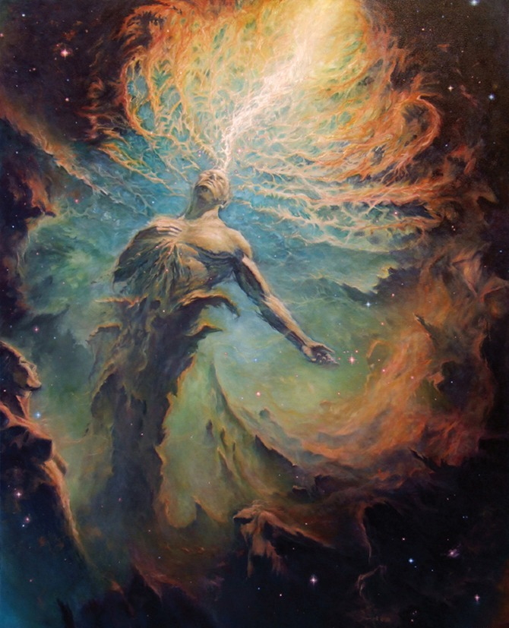Satchidanand: Ah that's perfect. Perfecto. Well done I like that. That's just perfect. Good
Devi: Perfecto.
Satchidanand: Perfecto. Would anybody else like to say something similar.
Nipun: Nipun did all the process. And he realised everything was made of light. After, he went to the monad, he touched the light, and he maintained the light. His head couldn't support this light.
Satchidanand: And what happens when you feel pain Devi?
Nipun: A blockage....he was feeling very light. And last year he was very very heavy, his body, he felt he was burning his bone *inaudible.
Satchidanand: Very tough eh?

Nipun: The deeper *inaudible he felt the pain was here. *inaudible. He reaches a very high bright light.
Satchidanand: Which point?
Nipun: Between the Logos and...
Satchidanand: And the Sirius and even higher than Sirius. Everyone's a black magician here! But you were a very high one, the worst I've ever come across. (everyone laughs). So Nipun what do you do with blockages?
Nipun: He could not *inaudible. He could not do anything, he had pain in all his body, he did nothing.
Devi: Next time. Next time.
Satchidanand: Hello again.
Devi: Federico even now feel the crown chakra *inaudible
Satchidanand: Well I'd like to say to Federico that there doesn't seem to be any blockages up there but what you're feeling in the crown chakra is that it's a little weak and you need to have many experiences with these very high levels of energy so when you go there you can channel this energy easily. You need to grow your crown chakra so it can handle this energy with no problems at all so you need to practise this everyday. Yea? So there's no problems with this it all. And you might have more better experiences, the more you go into this light.
Federico: Before, I did this meditation for 20 minutes. He said he meditated before he came here and the channels were more clear. He could perceive all the movement of the energy and *inaudible. He could perceive all the cleansing of the path.
Satchidanand: Well this is the experience that we want to hear in Energy Enhancement. We want a person who has no blockages whatsoever. We want to have a person who needs to grow. But what is the difference between a person who wants to grow and a person who has blockages. Because we need to grow in getting rid of our blockages also.
We are here as young sprogs, haha, and we are here to grasp this opportunity to grow as much as we can during this retreat. And you have a very good chance.
And as for Nipun who got knocked down by this blockage, you have to visit this point again with more protection, do you remember your protection Nipun? You need to have more protection. What protection do you need to protect you against this? Merkaba. Pyramids, golden pyramids. You need to get yourself very strongly protected before you approach this blockage. This is the most terrible blockage I've ever heard about in my life. And you're gonna have a lot of fun grounding it all. And it is this that you need to do.
Because there is no failure, there is only feedback. There is only feedback. And what this feedback is telling you, is that if you want to reach the highest energy in this universe then you need to go through this blockage. Who is standing in the way and is saying You shall not pass.
You gotta pass, you gotta go there and you haven't gotta let anybody stand in the way. You got it? Go for it baby!
Satchidanand: What happened with you Florencia. Would you like to say something. Wait, I'm going to put the camera on you. Wait wait wait wait wait. Yep, go ahead.
Florencia: She concentrate on the centre of the earth and she went up. The blockage didn't see, she forgot.
Satchidanand: Say it again.
Florencia: She forgot to ground the blockages.
Satchidanand: She forgot to ground the blockages?
Florencia She didn't see or they were not there.
Swami: Okay that's cool, you can do this again.
Florencia: And then she *inaudible different step of the...she was...
Satchidanand: When you want to go sleep, it's a blockage.
Florencia: Yea
Satchidanand: Good you found a blockage.
Florencia: Yea
Satchidanand: Excellent.
Florencia: She was fighting against the sleep. She found her antahkarana was light.
Satchidanand: Just pure light
Florencia: Yes
Satchidanand: And where was the blockage exactly?
Florencia: Multiple blockages
Satchidanand: Ah so many blockages. *inaudible. Another black magician, you're well matched you too!
Florencia: Between the moon and the sun she doesn't remember. where *inaudible. Satchi, where the moon was. She was coming to a spaceship. ..Dhiren..
Satchidanand: Dhiren!
Florencia: She saw you and she said, What are you doing here? Later Nipun came. Somebody told her, Dhiren will pilot in the ship. And Nipun the co-pilot. After that the image disappeared and she was alone. She *inaudible spaceship, with the light of the initiation and was okay.
Satchidanand: Good psychic powers eh? Yea. Where did she get that from? From being a black magician.
Natwalhul: Everybody is travelling in the spaceship.
Honey: I had my angel.
Dhiren: I didn't have a spaceship *inaudible.
Honey: Alright we're listening to someone else right now.
Florencia: *inaudible make her body move or *inaudible. She forgot about the blockage.
Satchidanand: Ah so, all of Florencia's stuff was perfect. You now have you mission in life to get rid of all of these blockages and you will feel a lot better.
Now about the mastery of relationships. Now there was once a young man who went to, ah can you give me the microphone please, gracias. There was once a young man, who went to see the famous American seer and psychic Edgar Cayce. And he said to Edgar Cayce I have found the woman of my dreams, but its so important, I'm only 21, is she the girl for me? And Edgar Cayce went up into the astral plane, he went into a trance, he examined all the akashic records and when he came back he said, This young lady is one of 35 young ladies of marriageable age with whom you have had previous karma. She's one of them so she'll do.
And what he was meaning by that was we have been with many many human beings in all of our previous lives and in those previous lifetimes we have done very bad things to each other. You've killed them and they've killed you. And in any relationship we need to forgive each other. So if you saw Nipun there, and you saw Dhiren there it means you've been together in previous lifetimes. Nipun is one so he'll do. This Dhiren's been around a lot hasn't he?
Honey: Yea
Dhiren: Excuse me? Change the frame.
Satchidanand: And Honey is laughing away and yet she was in the dream of Ramiro. She gets around a bit as well doesn't she. She does. She gets around a bit.
Honey: It's karmic relationship isn't that right Ramiro.
Satchidanand: Okay I'm gonna call it a day.
Talk after Initiation 4 - Blockages - 9 mins 27 seconds
Satchidanand: Last night, we had experiences with blockages. We saw our blockages. We had experiences with blockages. And I told you at that time. That these blockages didn't want to go. Yea?
And sometimes without meaning too I put my finger, into some pain. Without any desire to do this the words that I say hurt you. But what I am trying to say is that it is only the ego that gets hurt by them. If I say something and it makes you feel bad or angry...depressed, it is only the ego which is being hurt.
Because sticks and stones can break my bones but only the ego gets hurt by words. Remember that. Because what is the ego, its all your blockages and they will use any excuse to stop you removing them.
I wonder if you can remember last night and I was talking to Guilllermo. You know that big guy, 6ft 4, muscles on his muscles. And we were talking about all the blockages that he saw, as he went up beyond the monad to the logos. And there was just blockage after blockage up there. And I said Oh that's the place where you see the blockages that were placed there by the black magicians in order to stop you reaching God. I said you're a black magician in a past life. And what did Guilllermo say this morning, I've got to go. I cannot stay here anymore. And whether it was the fact that I pointed out that he was a black magician in a past life or whether it was this comment that he made...you're trying to push me to go higher and I'm very happy being here.
Remember these blockages will make any excuse to stop the process. And I want to use this now to warn all of you that this is the effect of the course. You have made a decision to be here and your will power should hold you to the course. Who's in charge?
Because Gurdjieff said, the guy that made a promise to get up to go to the Energy Enhancement course at 5 o clock in the morning is not the same guy who throws the alarm clock out of the window.
Gurdjieff says you are not warned...now what does yoga do for you. They all say, integration, and what does integration mean. Well when you are doing your meditation and you're following your breath, Hogen recommends one, OOONNNNEEE (exhaling). OOONNNEEE. OONNNNEEE it's a very good mantra.
As they say in Highlander, there can only be one. And this is the case. Yea? Gurdjieff says that there is a stream of personalities running through your head. And the person you are talking to is not the same person you were talking to 5 minutes ago because the blockages, the blockage personalities come in and go out. And as they come let them come, don't push them away, and as they go let them go, don't hold onto them. Okay folks?
Yea? You have to be like a mountain with your roots deep into the earth. And your head right up into the centre of the universe into your soul. And as the clouds of the sub personalities come across the face of the mountain the mountain is absolutely unmoved. And as the clouds of the sub personalities are blown past the face of the mountain the mountain is absolutely unmoved.
What was I saying to you that was enlightenment? Enlightenment is when you have no thoughts in the mind. These thoughts are sub personalities. There can only be one personality, the soul infused personality. As a matter of fact it is not a sub personality, it is the personality. So who's in charge? Haha But Guilllermo thought he was exercising his free will,.he said I have changed my mind. I went down to Woolworths, and I bought a new one for 2 and 6. He bought a new mind at Woolworths. He changed it.
Honey: Oh okay.. derrr..
Experiences of David 11 mins 55 seconds
Satchidanand: So today, we're going to do Initiation 5 of Energy Enhancement. I was wanting to do another practise of Initiation 4 this morning but I think everybody has been doing their homework. Now did you do another meditation last night or this morning David? And what happened when you did your Energy Enhancement Initiation 4 again going right up into the centre of the Logos. And Dhiren could I ask you to use the camera to point it at David whilst he's answering these questions because I know you just love to do these things, now you just turn the screen around
Dhiren: thank you
Satchidanand: in the opposite direction you point it at David and capture every nuance of his answer. So David what happened when you went up into the centre of the universe?
David: Everyday I practise my meditation at Stage 1 for 40 minutes.
Satchidanand: Very good.
David: The meditation with connection on the centre of the universe I did today and was very strong. The centre of the earth was fine, and I went more far from the logos. He doesn't know what star, he doesn't know the name. He felt was very strong, like a ball, or like concentrate fire. And before when he was in the logos, something was bothering him a lot, and was a doubt.
This moment it happened to him, very regular experience. He couldn't take off from his third chakra a black serpent, and was the doubt. And at the logos, they inform him he needs to burn the serpent more high. He went to this star, put the serpent in this fire and he was meditate outside. Was difficult for him to go inside because it was too strong. And finally he put his whole body in this fire and he meditated there. And he was meditate there.
Devi: Very good.
David: And later he went back.
Honey: Spiritual knowledge
Satchidanand: You'll get enlightened soon.
Dhiren: I've got you on tape for that.
Satchidanand: Okay, now this is something everybody can learn from here. Remember I said that the very deepest blockages were very very dense. The negative karmic mass is very dense and in order to deal with these very dense blockages you need to take them to the highest and the most strong fire that you can find ya know. You need to go to the centre of the universe, the soul, you need to go to the monad, the group of souls, you need to go to the logos, the archangel in charge of this planet.
But what David had to do today and they told him this in the logos, this is something else you have to notice, the student must learn how to ask. Now I am telling you things here, that I have learned up there and you all can have this same access.
I can tell you many things but up there they know a lot more than me. This is true, this is the truth, it is not a lie. You need to get your own connection but if you want to become enlightened. This is the communication channel that you can trust, and yet up there, these blockages talked to Guilllermo and told him not to stay on this course so you must test every communication that you get and you test it by doing the, on the voice, on the item the thing which is talking to you, you must treat it like a blockage and if it grounds don't trust it.
Now I don't have any problems with what was told to David, in this communication because this matches in with my experience. But please remember what I say, test, everything that gets told to you. Use Energy Enhancement Initiation 5 on every communication that you get. Use Energy Enhancement Level 2 Initiation 1 on every communication that you get.
Test them out. But remember, you want to have these communications, they are available. You don't just think I'm sitting here talking out of my head do you? I am talking from higher and this is what you all need to learn how to do. And the way that you do it, is by going as high as you possibly can and staying there in the light, you need to live from Prajnaparamita the highest heart and this is exactly what David was doing, and he needs to do it more but he's made a good start.
Well done David. Bien de bien. Tabien. And the other thing was he got rid of this snake, this blockage he found in the third chakra and there will be more. Yea?
But step by step we are going to clean our psychic bodies of all these bad things. Because in order to be enlightened we have to get rid of all of these things. As a matter of fact its not necessary to get rid of all of them, I don't know how they make the decisions on these things. But these blockages seem to come in and out of my psychic body. But what they do say is, when you've reached a certain stage they can come in but they can't stay there they go out very quickly. Yea?
And this is what is meant by the initiation of enlightenment. The energy that you get from this initiation makes it more difficult for the blockages to stay, okay folks?
Now anybody else would like to say about their experience and there Ramiro he's got his hand in the air. Dhiren Dhiren Dhiren, that's another minute off how long its going to be before you get enlightened, he's going to be enlightened in 5 minutes. Haha tomorrow.
Experiences, more from Ramiro 5 mins 4 seconds
Ramiro: I speak in Spanish sorry for... Yesterday he got an experience with the helicopter. Satchi told him to discharge. Today in the morning he connected with the higher self with the centre of the earth and Sirius. He put again this image he got before. He visualised again the same vision.
Satchidanand: I said you could do it.
Ramiro: Yea. I trust you. With this imagine he asked, what is it, what is happening here.
Satchidanand: The student must learn how to ask.
Ramiro: And the voice told him its an accident that will happen in the future. But inside him, something was not right. He took the imagine and the voice and he move it up to Sirius. And in this time the image was *inaudible and there was no voice.
Satchidanand: Ah this was really serious
Devi: Haha Sirius serious, Sirius serious.
Satchidanand: Remember, if something talks to you, test it out.
Devi: Don't believe it.
Satchidanand: Don't believe. Very good. Do you have something more to say Ramiro?
Ramiro: He next imagined the castle. He tested to see if it was a blockage. It was not a blockage but he was feeling he got *inaudible he asked what is it? It was place where he was meditate before. He then imagined the guy he didn't know. He put it up and asked what is it? It was not a voice but he had a feeling it was himself in past life.
He last imagined Honey appearing in his meditation. He put it up to Sirius and asked what is it. He had no reply but his feeling, he felt she was in his spiritual past.
Satchidanand: In the same lifetime at the castle?
Ramiro: I don't know I don't ask questions.
Satchidanand: Okay. Bien.
Experiences of honey and Florencia 12 mins 17 seconds
Honey: So as I was saying, what I did was, what I didn't realise was how difficult these blockages are to clear up and *inaudible. But when I went back up after cleaning up lots of them, that's when I, I asked what do I have to do to clear up these blockages. And I remember what Satchi said, you've got to ask the right questions. Yea, so I asked what do I need to do and I was given an answer. I was told 5 things that I have to work on. Love, compassion, understanding, wisdom and knowledge.
And I wasn't sure whether that will give me the energy to fight everything I need to fight. Which is the logos and lower down which I'm not seeing anything at the moment. Meaning there could be blockages but I'm not seeing any of them, I just whiz up straight to my empty space. So for me it was just to understand maybe it was to clear this lower chakra which seems to be so hard to get rid of or is it to fight with the rest. Any other blockages above. And finally I asked a few times is there anything else I need to do. And kept on coming back to these 5 words. So, yea...
Satchidanand: Can I answer?
Honey: Please, yea
Satchidanand: Well I think the 2 words I can help with are knowledge and understanding. I always feel that the first 4 initiations are essential to raise the energy of the student and they always get experience with seeing their blockages. They get many experiences, and these experiences are necessary to teach you that these are real. It's not just imagination. But the next few initiations, the next 5 or 6 are absolutely necessary to complete your knowledge of how to remove these blockages.
Don't think you know enough at the moment. It's simple but I need to go through it with you. I can say that what David did this morning, what I also said, is that the highest energy is sometimes necessary to destroy these blockages. But even more is necessary and this is what I need to teach you so don't be worried if you feel that you can't get these blockages yet.
We are to teach you more. So don't worry Honey, everybody's doing absolutely fantastic. Really, I'm so happy with everybody on the course. But you need to know a little bit more and then we can start the fight.
Honey: And you said knowledge and understanding. What's the bit about the understanding.
Satchidanand: Well you need to understand the way the universe works. Yea? So knowledge by itself is not enough. You need to experience it to have understanding. And then you get wisdom. You just need to know a bit more but that's nothing.
Now, I'm really happy with what everybody's been saying. Would anybody else like say something about what happened to them this morning. I was wanting Florencia to say something. Can you point it at Florence. It doesn't need to be very much Florence but they need to know this it's very important.
Florencia: Today she was talking with Satchi. She noticed two important things from the time she started the course. One was the change of the colour of her skin and another is the colour of her hair. And today in the morning, after the reiki initiation she went back to her house, and she lie down and the sensation was going up. And she noticed she could go more far away now. Before she couldn't pass the monad and now she could go up. When she reached the monad she felt *inaudible. She *inaudible. This was a mistake. She came out from there and she went to the logos. At the logos, *inaudible.
And there she was inaudible...Satchi...inaudible. She see at first you see one blockage and then you see more. Before she was fighting blockages and now she's fighting more blockages.
Satchidanand: Florence was telling me that these blockages up high gave her many many different problems. And she realised that she had to fight very hard in order to get rid of them because they were creating all of her problems and this is the truth. You know I was saying that these blockages are your karma.
They are your bad luck. They are sabotaging your lives and in total they make up the ego. And again, ego. So again, summon up the blood. Ego go.
But Ramiro has to go by 9 o clock tonight so I want to complete these initiations before 9 o clock. Okay. Right, so we have to finish the initiations by that time, so I haven't got anymore time for anyone else at the moment but later we can.

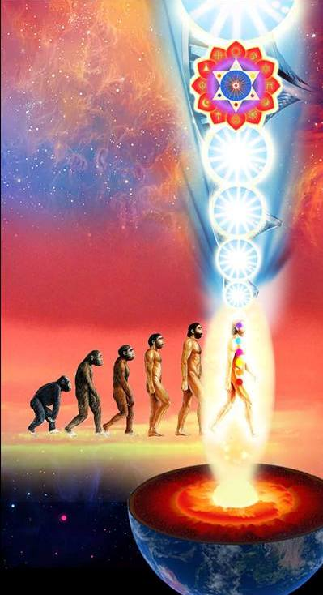
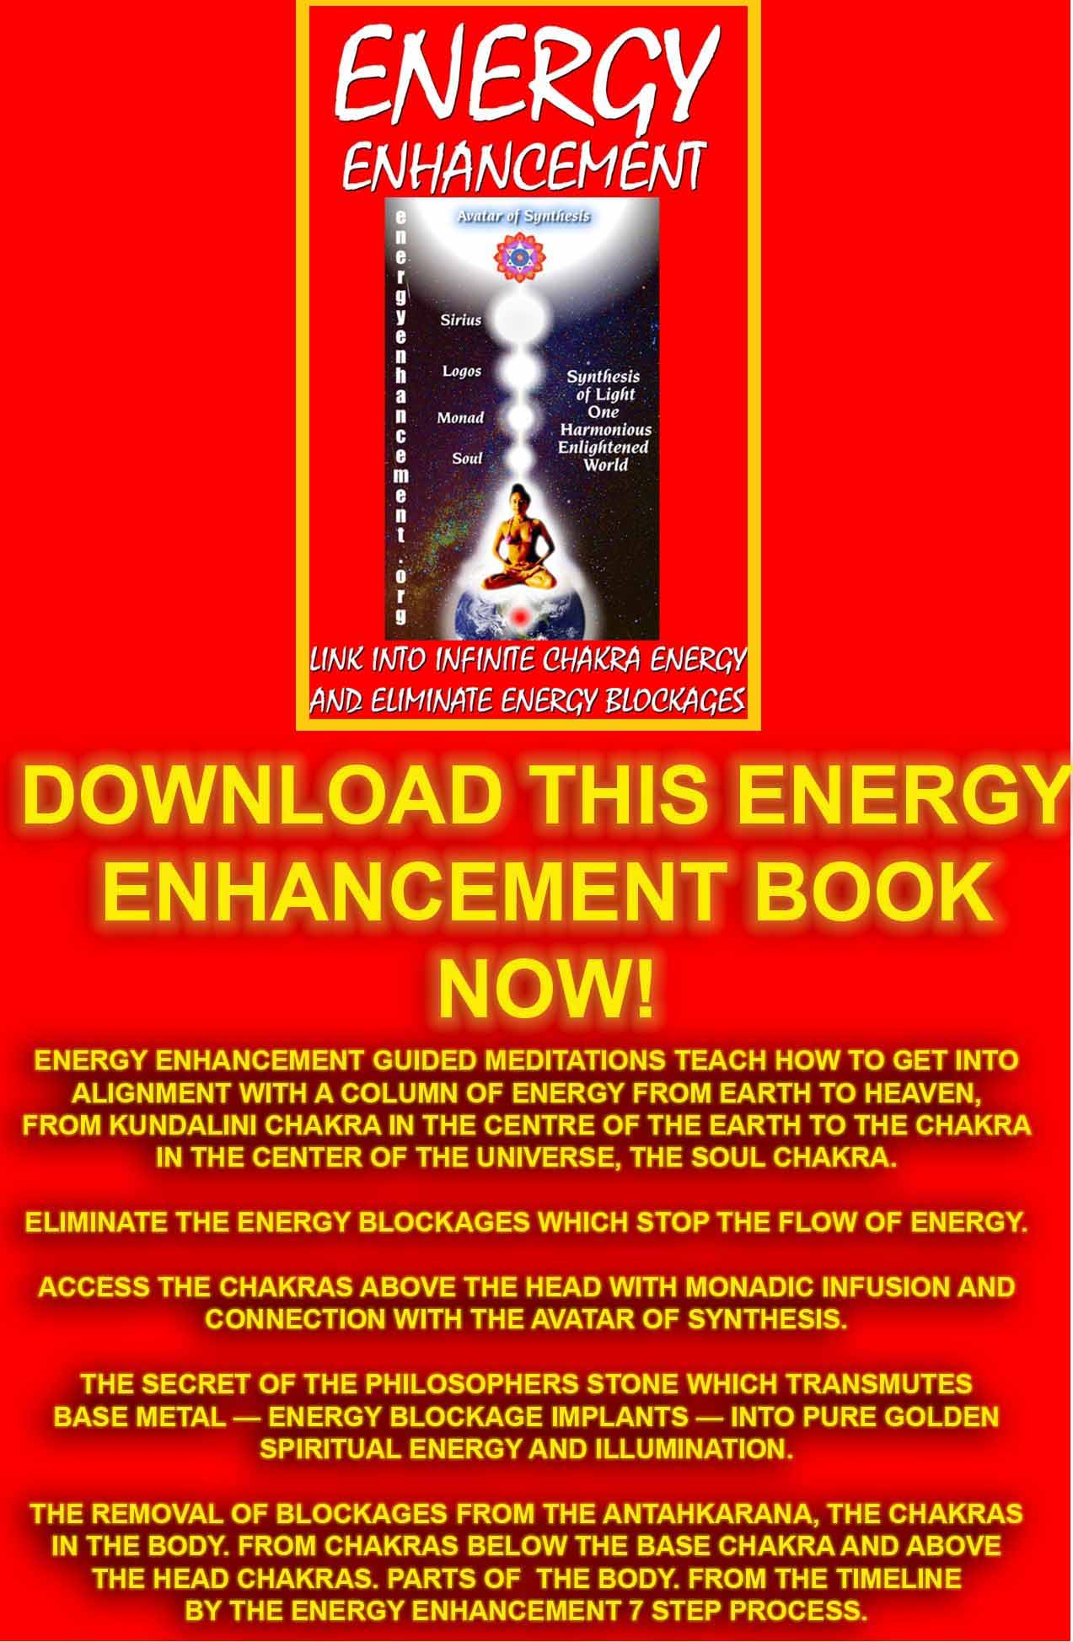
Download “Link Into Infinite Chakra Energy And Eliminate Energy Blockages” Here
http://www.energyenhancement.org/Sacred-Energy/Meditation-Energy-Enhancement-Link-into-Infinite-Chakra-Energies-and-Remove-Energy-Blockages-EEBOOK1Color-energyenhancement-org.pdf
Initiation 5 Projecting Energy
3 hours 11 mins 40 secs
Introductory Talk 33mins 12 secs
Satchidanand: Okay folks, here we are back again. Now, this is a diagram. This is the diagram and as you can see you have the connection down into the centre of the earth, you've got the connection up into the centre of the universe. But whilst we are in this state, connected, what we are going to do, we are going to send the energy out of our heart, and we're going send energy out from our third eye to towards anything that we place in front of us.
Now for example we're in the supermarket and we say “Oh, that olive oil looks really nice” (Honey laughs) but first I will test it out. So you either look at it or you either imagine or you hold it in your hands in front of it and you send the energy of your heart and third eye to it and then you see what happens to the energy of the food. Yea?
It has 3 choices, the energy can go to the food and it can go down. Now if it goes down, it's filled with pesticides it's horrible, its rotten it grounds.
And if you are thinking about some food, that you ate many years ago that gave you the most horrible reaction, and you got really ill with that food. You can even imagine that food, and even now, you can find traces of those toxins in your system as you send
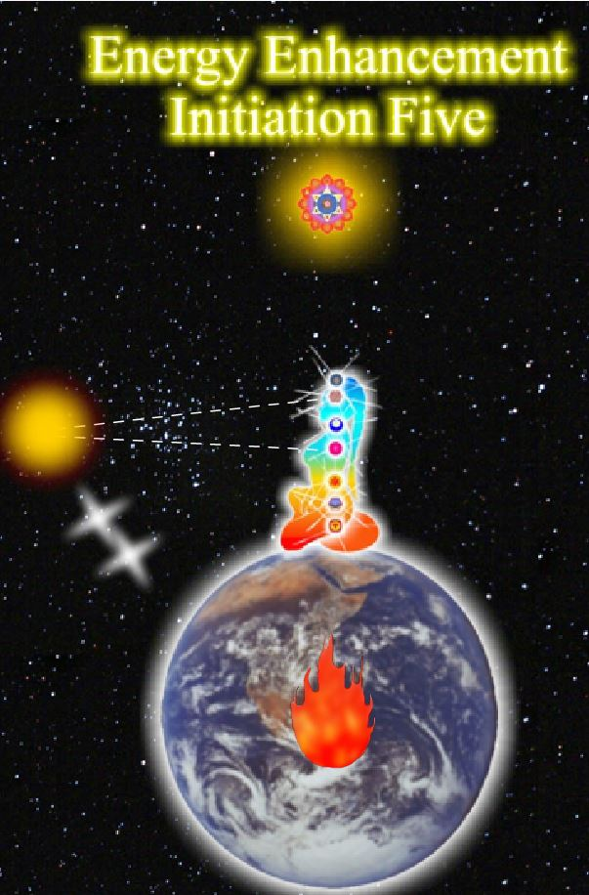
energy to that food that you've eaten many years ago you can have strange feelings all over your body as the toxins leave it.
Now I found out about this technique when I went to Goa and I met up with an ex student of Gurdjieff, a fine looking chap, with white hair, a white beard and he was English and he used to like to drink beer and go out with pretty women and we drank the beer of Goa, which is the worst beer in the world, he used to spend a few minutes afterwards grounding the beer that he had just drunk. This meant he could drink a lot of beer and it made him very happy haha.
But we are not so stupid. You can spend the whole of your life grounding horrible food that you eat. One day we were in London, and we were passing this Indian restaurant, with all these big bowls of bubbling curry in the window. And I said, “Oh look at that Devi, that food looks really nice, lets go and have some” But Devi is far more wise about food than I am, she doesn't need these techniques to know that that food was absolute crap.
And she said “Well why don't you test it out using the technique of that chap in Goa”. I said “Oh what a good idea” and I looked at the food and it grounded really horribly. And I said, “Oh I see what you mean, lets not waste our time on that”.
Because this technique gives you the choice, are you going to eat really good food or are you going to eat, food which is not so good. It gives you that choice. But you know Gurdjieff, he used to do dinner parties and they used to eat all sorts of things. And as I told you he used to drink all sorts of toasts to the idiots and at that time many people used to leave Gurdjieff.
He used to tell them what type of idiot they were. And as I said it's only the ego that gets hurt. When a master says something really hard to you its possible he is testing your ego.
Now, this morning I had a cup of Fig coffee. And what is this coffee called in Spanish, Cafe de Higo (Ego). So be aware. If you want to eat crap, it is only your ego that wants it.
Now, it can go down. And If it is very badly down, sometimes it can go back towards you and try get into your body. And if it gets into your body, you might feel so sick, that you feel you want to throw up, its that violent. Because it makes the body want to get rid of all the toxins very quickly.
So when we do the exercise, on any horrible food we've ever eaten, be aware, that you need to make that energy go down. You need to channel it into the centre of the earth without allowing it to come back towards you. And one of the ways we channel energy is by using golden pyramids.
Can you see them there? These are golden pyramids and they are upside down and you put a golden pyramid underneath the image of the food with a red tip at the bottom. Remember its an upside pyramid so at the bottom you have a red capstone matching the base chakra.
Then all the negative energy in that food gets sucked into the base of the pyramid and concentrated down through the tip instead of coming back towards you.
Now if you put a million pyramids one underneath the other you make sort of like a tube which takes the negative energy down into the centre of the earth and stops it coming back towards you.
Now this energy can stay where it is. It can stay where it is instead of going down. And if it does, the food doesn't have any high energies it sort of like mashed potato. I love mashed potato myself. Tamasic food, neutral food. It's not got anything really good in it but it's okay. It's not gonna do any harm but its a bit...
Or the food can go right up to heaven and this food is the best food it's got lots and lots of sattvic energy and its gonna give you the best and most nutritious meals.
Now the worst thing is where you get this fantastic kind of food with all the energy and beauty in it and yet its been sprayed with pesticides. And then, it will go both up and down at the same time. And if it goes down like that, no matter how good that food is, it's still poison and you must not touch it. Very good.
Honey: You can feel the energy going up and down?
Satchidanand: Yes, you see it or you feel it.
Honey: So you're just looking at a product..
Satchidanand: Yea you breathe out the energy from your heart and third eye towards it and you just perceive where the energy is going, down or up. If it goes up its fine, if it goes down it's bad. If it goes both ways that's really bad.
Devi: Not really
Satchidanand: It's just bad, you don't touch it. Because they've sprayed the food.
Honey: Oh I see, so you've got the good food but you've got pesticides in it.
Satchidanand: That's it.
Honey: So you can't.
Satchidanand: It's still gonna poison you,
Honey: Yea
Satchidanand: it's really sad when that happens.
Honey: Yea
Devi: Ramiro wants to do a question
Ramiro: *inaudible
Florencia: *inaudible
Satchidanand: Devi I really feel if you do a question in Spanish, you need to translate it in English.
Devi: Ah, sorry, she asks if there is a way to heal some kind of food, the bad food?
Satchidanand: Yea there are ways to heal the bad food, some of the pesticides just stay on the skin so you can wash it off with certain chemicals – vinegar - or you can peel the vegetable or whatever it is. But there are some kinds of pesticides like organophospates which it is impossible to heal in this way. They go right into the heart of the vegetable. So what you can do is you can try to heal it and test it again to see if it worked but personally if it goes down in the shop I look for something else because life's too short.
Student talks in Spanish to Devi
Florencia: Nipun *inaudible is taking a long time to go down. He like the cabbage. Even when its off he's eating it the same. She say when the cabbage is off, he's eating. And she asks, because he said, it took a long time and a lot of effort to grow this plant and its not right to *inaudible.
Satchidanand: Well Swami Satchidananda always used to say people throw out vegetables long before they should not eat them. He says a few little leaves that have gone off are nothing. He said the earth took a long time to grow these vegetables and we should not waste the food the earth gives to us.
Devi: Can I say something else. If it is rotting then it's organic.
Satchidanand: And what Devi means by that is, if it rots, there's no pesticides in it. That's one of the tests of knowing if the vegetables are okay. You know, once we had a tomato, and I bought this in the supermarket and it was absolutely glowing with health and I put it on top of the fridge and it glowed there for a week. And then I left it there for another week and it was still glowing and after a month it was glowing even more. And you know they irradiate food. And this tomato never went off.
They take all the vegetables in great big packing cases and they put it in a great big room and there's a little hole in the floor and there's a big sort of hole comes out. The door's locked, everybody's out, there's a lead line surrounding all around the room and then they sort of open up the radiation source. And then they leave it there for 15 minutes whilst this very powerful nuclear radiation irradiates everything in the room and it precooks everything. It takes away all of the nutrients, the essential higher nutrients of that food. It takes away all of the bio energy of that food. If you ate that food all of the time, things would start to go wrong with your organs.
And they do it because the potatoes go green in the shops. They do it to stop all the insects and parasites on the vegetables travelling abroad with the planes.
For example with lentils and beans I love chick peas and hummus. And what you do with chick peas is that you put them in water for a couple of hours and they start to germinate and they sort of go all juicy and sweet before you boil them, it pre-softens them.
You put in the irradiated chick peas and in 2 hours they putrefy and they do not go sweet. And when you cook them, they go hard. And although part of the value is there the higher elements of the food have been cooked out of it by the nuclear radiation.
Most of the potatoes here in Argentina have been irradiated and God knows what else. Strawberries, it's not only pesticides with strawberries. You put a strawberry on top of the fridge it'll stay there for a month glowing. So what you want, are fruit which is ripe. And food that rots, you know this is okay.
Devi talking to Nipun in Spanish
Satchidanand: This is not for the video Devi, this is just a side thing. Because we are not learning from it.
Devi: Can I reply and then translate in English.
Satchidanand: Oh I thought you were just talking in Spanish.
Devi: No I was talking and then I'll translate it into English. We were talking about the fact that if you eat things that are not from the place, then this is not good, it is good to eat things local. From the local cultivation, because it is fresh and it is not *inaudible and it's from the season.
Satchidanand: I think this means it's got more chance to be like that.
Honey: So buying fruit and vegetables from local farms and local..
Devi: Cultivated here *inaudible.
Satchidanand: Now as well as sending energy towards food which is one of the exercises we are going to do. It's a nice treat to start sending this energy towards your blockages also. Because I want to tell you about blockages a little bit more. Blockages contain a lot of negative karmic mass which must be grounded. A lot of these blockages contain angels or human souls which when grounded are then free to go up to heaven.
Remember its the negative karmic mass which perverts, which degenerates, so you get a nice human being, and all sorts of disappointing things happen to it and it starts to feel really disappointed and its life is destroyed and this happens because it has gathered a lot of negative karmic mass.
A person in this state when he dies is very heavy. He cannot rise to heaven, sometimes he travels down a line of connection into another human being and arrives as a blockage. Now this is usually the close family and when a blockage arrives inside a member of the close family its usually the family member with the highest evolution which gets the blockage. These are called the black sheep of the family. When you receive a blockage like that, you get the same negative karmic mass that that person had. It is an example of attachment in the Buddhic sense.
Attachment leads to pain. You get an energy blockage. You get a lot of pain. So it's entirely necessary to heal that energy blockage, take out its soul, and take it up to heaven. Because that is it's natural place.
You take away the heavy negative karmic mass, it becomes light, you take it in your arms, you take it up towards the centre of the universe, you take it up towards the monad, you take it up towards the logos, and up there at the evolutionary level of the person you are taking up, you will find a hospital. It's a nice thing to imagine isn't it. And there is an angel who is the gatekeeper of the hospital and you hand over the soul to the angel and you say look after that please for me. And he says “Right on sir, no problem”. And he takes the soul and he bungs it into the hospital and he goes in for rehabilitation before he gets reborn.
It's a nice thing to do for the world because these energy blockages cause an awful lot of problems all over the planet and they always go to the person with the brightest energy with more evolution because they need to have an energy source to stay on this plane. So they want to take your energy, they become parasites on your energy field. Always looking for the brightest energy, and the person that loves them the most in the family.
So its very simple, you send your energy of your brow centre and your heart centre towards the blockage, you ground all the negative karmic mass within the blockage. And then you send it up to heaven. And the Sufis say “Die a little everyday” and it's a really good thing, to go upwards towards heaven everyday and pass these souls over to the angels in charge of the hospital.
By doing this you gain a lot of experience. And when you die, you will not be surprised to meet the angel in charge of the hospital. Sometimes these souls, these angels, because also angels can be in charge of energy blockages, the higher the evolution of the angel, the more negative karmic mass it can contain.
The really deep energy blockages are run by angels. It's the same process, you send energy towards the blockage and ground it and you take the angel up to the hospital. Now these perverted angels have been healed but sometimes they don't stay in the hospital. You stay at the hospital for a minute or two to make certain that they don't come out again. And if they do, you put them back in again, make certain they stay there.
Devi: They didn't understand the perverted angels..
Satchidanand: In the same way that you have human beings who take on awful lot of negative karmic mass sometimes the bad people in this world, trap an angel, and give it a lot of negative karmic mass in a ritual.
And they create an energy blockage.
But at the heart of this energy blockage, is an angel who has been perverted.
I think the essential thing that comes out of this, is that there is nothing really bad although we feel as though we're beating up all of these energy blockages. At the heart of the energy blockage is one of God's creations who has been perverted.
Our aim, although we have to be strong with these blockages is essentially to heal them, take them to hospital and rehabilitate them.
You've got to have that attitude of getting them, but at it's heart is the wish to heal. I know many people who go around ancient battlefields and they take the souls that have been killed and they take them up to heaven.
My mother and father's house was built on top of a mine, a coal mine, in which many hundreds of people died in an accident. Sleeping there we had to take all of these souls into heaven. And it was quite heavy work haha.
David History to His Grandmother 7 mins 37 secs
David: When he was small, 6 years old, his grandmother died, and he was feeling his grandmother was having a lot of sadness. He asked to her you can be with me. He felt very heavy presence and very difficult to carry for one week. And after that she went.
Satchidanand: And it is through experiences like this, that happen in our lives, that we learn about the spirit, the same things used to happen to me. And by means of these things, questions arise that have to be answered. And my answer is Energy Enhancement. I'm sure there's a lot more to know and there is. But this is what I know it's enough. Okay, more...
Devi: Satchi, Ramiro wants to ask a question
Satchidanand: Ah okay
Ramiro: You talk about 3 option when you send energy to the food, he would like you to repeat it again.
Satchidanand: One option is that the energy goes down, in which case it's bad. In one case it stays where it is in the food and its average food, tamasic. The third option is that the energy in the food goes up, in which case the food is very very very good. And the fourth option of the three, haha, is that the energy of the food goes up and down which means the food is a very good food, except it has been sprayed by pesticide in which case its poisonous. And you should not touch it. (holds up a diagram) So this is the next piece of information.
Now I told you the way to ground energy in a blockage or food. It's very useful to have a tube to take the negative energy down to the centre of the earth. It stops it spreading it out and getting lost. I told you about the upside golden pyramids with a red capstone. Which keeps all the energy together and takes it down to the centre of the earth, it sucks it down. But once you have completed this process with your energy blockage and you want to take it up to heaven.
Then you can use a golden tube above the blockage with a golden pyramid right side up this time with a white capstone on top which matches in with the chakras if you understand. Crown chakra this time, takes it right up to heaven and this acts like a hoover and it sucks it up as high as it needs to go. You take it up to its level of evolution. Give it to the hospital. Give it to the angel in charge of the hospital. And then wait just to make certain it does not escape. Sometimes its hard to make the soul or angel move. In which case you put a diamond, a diamond shape, a classic diamond shape like this, underneath the blockage, it makes the blockage shake, and makes it want to go up. So if you have any trouble use a diamond. A process of grounding all the negative karmic mass, healing the blockage, and then taking its soul up to heaven.
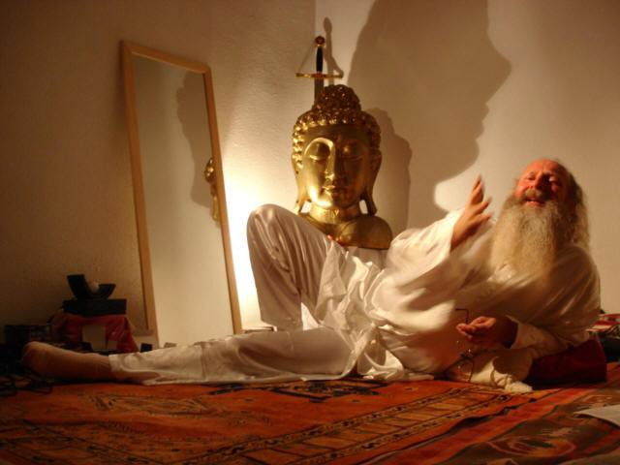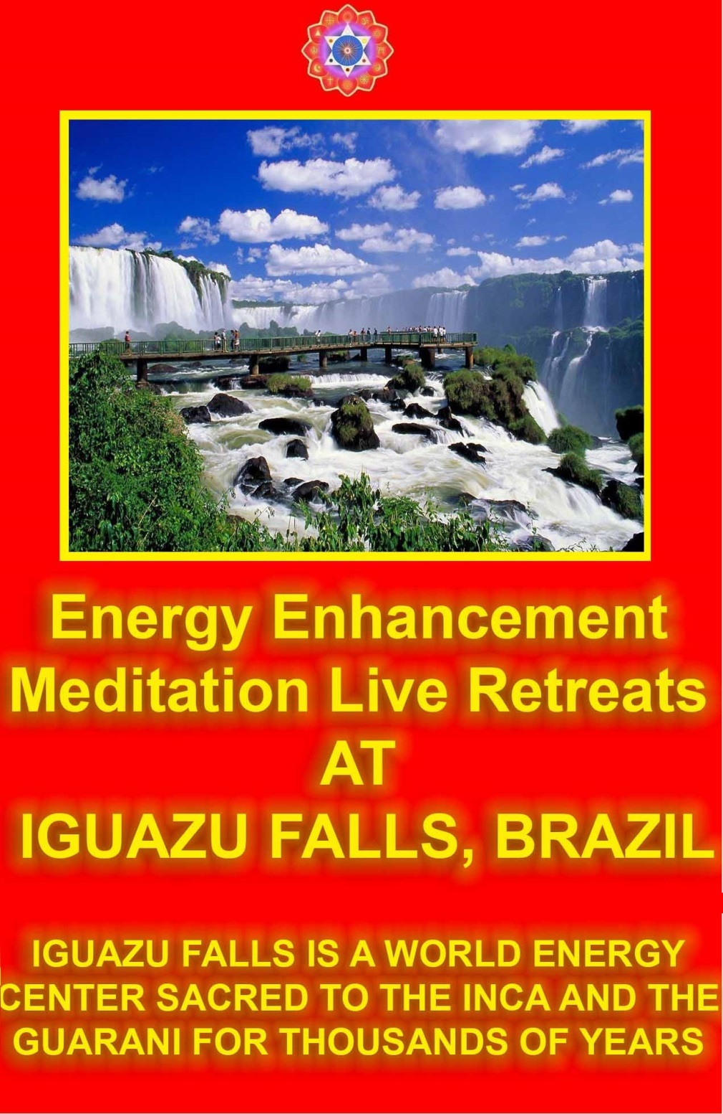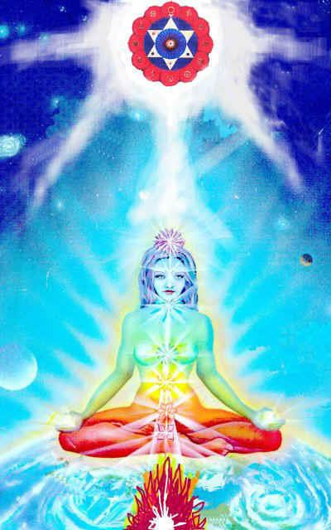

The Fifth Initiation Part 1: Sending Energy to God
8 mins 51 secs
Satchidanand: Okay, shall we have our experience? Bien.
Cuts to
Satchidanand: So the question was, how do we get these souls to go up to heaven? And the way you do it is at a distance you can create these tube and upright pyramid shapes with the white capstones above them and that like a hoover sucks them up to the hospital or you can go and hold them in your arms and you can say to them something spiritual to make them feel calm like in the name of the father, the sun and the holy spirit I'm taking you up to heaven, don't struggle You can talk to them, interesting eh? Or if they are of another religion, you can say something in that religion. You can say the gayatri mantra to them.
Florencia: She asks if it is possible to treat alive people in the same way we treat the dead people because there are alive people that block you.
Satchidanand: Well this is one of the methods of healing. Which we'll be going into in level 2 of Energy Enhancement. We're going into these techniques step by step, one thing at a time....another question!
David: This technique is only useful for blockage coming from the dead person or for everyone *inaudible.
Satchidanand: Well I did mention angels could be at the heart of blockages. So that's another type of blockage isn't it?
David: Also for the people who die who don't have any blockage.
Satchidanand: For people who die who don't have any blockages you find they go up to heaven a lot more easily and they never create any problems like this.
David: I wanted to mention the people who didn't make any problem know they didn't have any problem.
Satchidanand: Sometimes you find saints who don't know they are saints, they are very humble people. You don't always find the bumptious ones like me. So shall we get onto our experiences?
What I would like to do is to give you an exercise. I would like you to imagine a picture of your most favourite deity. Buddha, Jesus Christ, Krishna, whoever is your favourite, I would like you to imagine that person in front of you and I would like you to send energy from your brow centre and your heart towards that deity and just see what happens.
So sit up straight, get your spine in alignment with the energy from the centre of the earth into the centre of the universe. Connect with the centre of the earth, connect with the centre of the logos. Circulate the energy. Get yourself connected first before you try anything. Imagine the deity in front of you and see what happens when you send the energy to it.
Follow the energy and see where it takes you. Have your experience fully. (om chant)
Time to call you back from heaven. Now I would like to focus with the camera on various people's experiences. So if anybody has an experience they would like to share with us about what happened with this particular exercise then raise your hand.
Sending Energy to God Natwaral Experience 1 min 37 secs
Natwaral: You said send your energy to one of the deities. So I sent my energy to Krishna and as soon as he looked at me and when he saw me he just raised his hand and blessed me. This is what I saw. Nothing else.
Satchidanand: This is very beautiful Natwaral.
Devi: Very nice
Natwaral: Yep.
Student: How do you feel?
Natwaral: I feel better because you know I was happy to be blessed by him and just went on.
Satchidanand: Straight on haha...no this is why I gave you this exercise Natwaral it's so beautiful.
Natwaral: Thank you
Satchidanand: There are many good things in the universe as well as all the bad things. This is the important thing.
Sending Energy to God Honey 7 mins 27 secs
Honey: I needed to share this with you because I think it's quite interesting. Before I started meditation I used to go and visit a few Gods and in my own little place and I used to do my prayers and then get answers.
Sometimes it used to be cheeky, naughty, childish, like you're my father you're the one looking after me, tell me. So I have a wonderful relationship with this group of Gods. So the main person in the middle was Lord Shiva so this time round I went to visit Lord Shiva. All the other Gods were there I just did my namaste and they went away and I went straight to Lord Shiva to speak to him. And Lord Shiva said you haven't visited me for quite some time. And Lord Shiva said you haven't visited me for quite some time. And I said but Guru told me that I should focus on my spiritual path and not share my concentration with too many Gods. So I can just focus on my spiritual path.
And he goes, no problem, so I'm glad you're back here anyway. He said to me I'm very happy with you for doing this special ceremony that you did. For Lord *inaudible which was an astrologer told me to do a *inaudible a special religious thing. I just did, not really believing in it, but I just did it. And later on I found out Lord *inaudible is Lord Shiva's son which I didn't know about.
But anyway, he said to me, you asked for 2 things. Right, haha, I'm gonna have to share this, first thing was I asked for spiritual growth, and the second thing I asked for was the right marriage partner.
So he goes, that on the spiritual path you should evolve much more than you have at the moment. But I'm so happy with your efforts, with the lifestyle that you *inaudible.
And then I asked, I didn't want to ask about any other situation, and I asked you have sent me here to Satchi, what is it for? What am I supposed to gain from here?
And Satchi went OOOMMM haha And I went nooo, please let me just know this. Haha. Lord Shiva was just telling me.
Satchidanand: You don't have to come back..*inaudible for another ten minutes.
Honey: I know, I went uh oh I'll have to come out again so but thats how my journey happened.
Devi: You can go back again.
Honey: I'd like to.
Satchidanand: But I want to know what happened when you sent the energy of your heart and the energy of your brow centre towards Lord Shiva.
Honey: You see Lord Shiva straight away through my brow chakra.
Satchidanand: You sent energy to him, what happened to the energy?
Honey: I forgot about the energy. I *inaudible from travelling to Lord Shiva where's the energy. I went like this (hand at brow) buzzzz and I saw this Lord Shiva come up straight away in my third eye and with my heart I went more with humility, just to say thanks.
Satchidanand: I think you had a good experience.
Honey: But I forgot the love part and the energy part.
Satchidanand: It's an exercise.
Honey: Oh dear I better start working on that one, but anyway, that's the thing there
Cuts to:
Satchidanand: The exercise I'd like you to do next Ramiro, when you go home tonight, I would like you to imagine some really bad food that you have eaten.
I would like you to imagine it in front of you. Doesn't matter when it was, 10, 20, 5 years ago, send the energy of your brow and heart centre towards it.
Remember you can expect this to ground. Before you do send it, put the golden pyramids underneath, upside golden pyramids with the red capstone ready and prepared and then send the energy towards it.
Don't allow the energy to come back towards you, push it away, keep it inside the golden pyramids, send the energy down into the centre of the earth, keep the energy going until all the energy is discharged, okay? Bien.
Devi: *inaudible
Satchidanand: Of course
Sending Energy to God Ramiro 6mins 11 secs
Ramiro: The only thing that he asked was Krishna manifests and he put his concentration on that. And appear a dark image, like it was the night. Fire, with light of fire. There were people in the wood meditating. When he went near this image, he saw a big fire, and he imaged Krishna, and he was sitting in this position (palm up and a crossed leg) and he saw, he imagined *inaudible, and he realised he manifested himself. And a lot of people were searching for him. *inaudible. And later he saw in the wood like a sunset, and path of fire on the way, he didn't understand what it was.
And he was walking over that without burning himself. The path was continuous but he was walking quick and he arrived to a cliff. He saw the ocean and the bright sun and again Krishna in the mudra position. Again after that, he saw many strange *inaudible like movement of the clouds, the dark, and see very turbulent.
He tried to understand that. He thought maybe was his blockages and after that he start Satchi start to sing the OMM. That's all.
Satchidanand: Well Ramiro saw Krishna and he saw all the various people sitting around Krishna. And he saw the world, and all of the various densities of negative karmic mass. All of the fires, all of the various things that are happening here and wherever he went he saw Krishna. With a hand down and a hand up. He is everywhere.
Honey: I didn't quite understand the exercise.
Satchidanand: Well the exercise was to send energy from the brow centre and from the heart centre towards an image of your favourite deity and your guru and just to see what happens. The idea was to use the brow centre and the heart centre instead of the talking centre just to see what happens as an exercise.
But I think you should go back and ask Shiva another little question but go to your guru as well and send him the energy from your heart and your brow centre and see what happens.
Honey: I would like to
Satchidanand: Yea? When you have some time.
Honey: I'll find some time don't you worry.
Sending Energy God Federico 5mins 5 seconds
Federico: He thinks its very important to share with you what happened with him. He felt with a lot of noticeable effort, he imagined very clear, the energies coming from his third eye and solar plexus.
He noticed when he saw Jesus in sitting position he was sending energy from his heart. And his heart was all full of...spine burn in the spine. And one moment he sent back the energy. And he sent *inaudible to his solar plexus and he felt a vibration very strong and he had to stop.
Devi: Very good
Federico: And he is shaking and sweating.
Satchidanand: This is one of the reasons why I wanted to give you this particular exercise. We think we are grounding grounding grounding all the time. But we are grounding grounding grounding so we can have experiences like this.
We can charge ourselves up with the energies of the logos and Sirius. But also at these levels are great Saints like Jesus Christ and they can charge us too.
And more than that, they can give us energy initiations from which we cannot drop. Okay Federico, nice experience eh? Because talking talking talking gives us knowledge. But that which gives us wisdom is energy.
Federico: He said he didn't talk at all between Jesus and him, the only thing was energy communication. He sent a lot of energy to Jesus Christ and Jesus Christ sent to him very short energy but very very intense, more more intense than the energy he could send to Jesus Christ.
Satchidanand: Of course. Jesus does things like that. And I noticed that you said the solar plexus rather than the heart Federico. (Federico replies in Spanish). But why did you not send the energy to him from the heart?
Federico: He tried to send from his heart but he could not. The energy came from the solar plexus. He tried but he couldn't.
Satchidanand: This is again what I've said before. You do not choose what happens to you with the guru, the guru chooses what happens to you.
And obviously you needed these energies. And it was sort of an initiation. Bien. We need these experiences and we're all going to get them.
Sending Energy God Santhan 2 mins 44 secs
Santhan: For me yesterday, the sensation that carried on to todays meditation was the tingling at the back of the head when I made the connection. And that tingling came through today as soon as I made the connection to infinity.
Satchidanand: Which tingling?
Santhan: It was a very distinct tingling at the back of my head. Yea exactly as yesterday when we did Initiation 4. Was a very powerful experience. Except today it wasn't the tingling at the low of my spine, at the base of my spine, yesterday was the tingling at the base of my spine and at the back of my head.
Devi: And today?
Santhan: Only the head yea, only the head. And the Indian deities have always been very interesting and fascinating for me, the Indian deities. Lord Shiva is my favourite. I've always been fascinated by his form and his face, picture of all those arms and snake around his.. so today I visualised Shiva and initially the picture of Shiva and when I focussed my, (touches brow) this chakra here, and my heart chakra I used the Ramira mantra in my head to pull up the energy and I focussed on Shiva's visualisation and Shiva's picture and it went up in flames and the form of Shiva was what I saw behind that and Shiva smiled and he picked one leg up and you know he does that Yoga posture like this yaya know.
Honey: The nataraja position.
Satchidanand: Natajara. He did the nataraja position. The dancer, yea? And then?
Santhan: And then the OMM came along
Satchidanand: *inaudible
Sending Energy God Dhiren 19 mins 29 secs
Dhiren: My experience was very quick. Erm, I have 3 favourite deities. And a little bit of the Shiva, the first deity that I always admire is the Ganesh. That comes first to my mind. So I saw the form of Ganesh, and I sent the energy from my brow chakra and my heart. And it went straight to him and in return he sent his energy back in the form of a laddu
Satchidanand: A laddu, an Indian sweet
Dhiren: He kind of picked it up with the trunk and threw it at me.
Satchidanand: Just like Krishna, in the painting outside, holding a laddu.
Honey: Yea
Dhiren: And the next thing he did was he just raised his hand and blessed us. And next I went to my
childhood hero, and that's Ram. Yea and I approached and he was just standing there and he was looking absolutely majestic.
Now I went to him and put my hands together sending the energy at the same time. And what I got, all I got from him was a big hearty smile and the energy coming out from his hand, he raised his hand and passed me his energy and then the playful Krishna.
Now as I was going to Krishna I saw Shiva flash. And all I saw, the image that I saw of Shiva is a picture that I always, every time I think of Shiva I see him in one form only. And he's sitting at some high mountain sitting on a grey rock. And he's got this erm tiger
Satchidanand: skin
Dhiren: Yes, where he's sitting on top of it and around him. And with the snake, he's sitting there with the spear. And that's the image that flashed across.
I was on my way to Krishna. So then I saw him and as I was approaching him. He was sitting there playfully, messing about and playing his flute. This one I was very concerned and a little humbled and embarrassed to approach him because my connection with this deity is very special.
Being a musician. And the one thing I say to everybody is that I'm the persona of Krishna. And I always say he plays the flute and I play the saxophone. So having this in mind I was so scared, I mean I could feel it now
Devi: haha
Dhiren: well, I'm in for a ticking over here. Haha And I approached him slowly making sure my energy was right out there. And as I approached him he put his flute down and turned around and instead of me approaching him, he came towards me, he immediately gave me a big hug, very warm hug, very very warm. And it felt as if what I was saying was okay. Ya know. He acknowledged it. Whatever I said. Because I wasn't saying it from any erm
Devi: egotistical
Dhiren: yea, I was saying it because that's how I saw myself.
Satchidanand: It's a good ambition.
Dhiren: It's good to have good ambitions like that.
Satchidanand: This is correct. This is what makes you right.
Dhiren: And it was so profound, so so warm. So from Ganesh with his exciting throw of his laddu, and a very warm smile of Ram and Shiva flashing and then this was...and I said this happened very quickly, and I sat there, I just sat there, and I feel
Devi: Your aura is beautiful.
Dhiren: Sorry?
Devi: Your aura is very bright.
Dhiren: And then the OMM
Satchidanand: Can I ask you one more question Dhiren, you were telling me about your meditation this morning with Initiation 4 of Energy Enhancement and going higher, can you give me that experience now please.
Dhiren: Haha. Sure. It was quite different this morning in comparison to yesterday. Yesterday I thought I had got to the stages I wanted to get to. And Satchi pointed out that I was stuck in the blue sun, the monad, and yet at that time I thought I had reached the star, Sirius.
At that time I was sitting there with this glasshouse and I had imagined like this laser beam going on top of my head. This morning however when I started meditating and plus the exercises I went through and Satchi pointed out that this is where I was stuck.
I was very determined as Ramiro pointed out yesterday I was kind of quiet and keeping to myself. I was a little dejected, a little disappointed with myself being a perfectionist that I had not been able to do this. It was the ego, I have to get the e to go you know.
Anyway, this morning as I meditated I went straight to that place but before I went to that place I prepared myself.
Devi: What?
Dhiren: I prepared myself.
Satchidanand: Which place?
Dhiren: The monad.
Satchidanand: Oh the monad.
Dhiren: Because I knew I had to cross across the blockages to go to the logos.
Satchidanand: Yes
Dhiren: So then I was expecting something strong over there and so I prepared myself, I went through the entire cycle of sending the white energy and the red fire, yea, from my head down to my base chakra and also dealing with
Satchidanand: And the centre of the earth
Dhiren: Yes, while going down I was made sure I was dealing with the 2 chakras that I was always dealing with. The solar energy. But if I'm going that way then I might as well deal with these 2. I ploughed through that and I made sure I left 2 rings with static energy going inside. Yes, static energy inside the rings. Going from outside into inside. So anything that materializes over there will immediately get burned up. And I wasn't sure about the colours but I spoke with Honey and I shared this with her because I wasn't sure if the colours related to those chakras. And the solar chakras I saw a kind of a murrish colour.
Devi: What is murrish?
Satchidanand: reddish colour
Honey: He saw it as red.
Satchidanand: Burgundy
Devi: What is murrish?
Satchidanand: Osho, Osho colour
Honey: It's like red.
Satchidanand: Osho colour.
Devi: Osho, aahh like maroon, brown, maroon.
Students: Maroon.
Dhiren: Yea maroonish. And in the lower one I saw orange. And so when I shared this because I wasn't sure about the colours she says those are the colours for those 2 chakras.
Honey: Red, orange and maybe then a browny colour isn't before it goes to green.
Satchidanand: Erm maybe orange and yellow
Honey: Yellow, I thought it was yellow, that was I said
Satchidanand: Gold
Honey: that's what I said to you didn't I thought that it was yellow
Dhiren: Yea
Satchidanand: golden yellow
Honey: Then I said maybe it was brown
Satchidanand: Like the sun
Dhiren: Right, so anyway I went through that, I went to the centre of the earth, turned around immediately, picking up energy, I went through the rings...(Devi translates) went to the centre of the earth, made a quick U turn, and made sure I had enough speed in me.
Taking the energy from the centre of the earth and from that point what I visualised was straight out my head, straight out of the back of the head, I visualised myself straight into the monad. So I was now confident that I was going to be tackling whatever I have to tackle.
I went through the back door of the monad. And I tried looking for logos and I couldn't see anything. What I could see is a black mist, like a cloud, like a fog. And remembering what I said, it could relate to some power that stopped me going from there.
I wasn't prepared to waste time to get to logos. So I stood there and shut my eyes and just wiped it out. Realised that it was there, it was showing itself but it wasn't real. And when I opened my eyes I could see the logos right in front of me. It was like I took a step straight into logos. I saw some souls but I didn't recognise any.
Devi: What did you see?
Honey: Souls
Devi: ahh
Dhiren: I shot straight through Logos, I saw Sirius star and I went straight through and straight out of the back. And I couldn't believe I had picked up that much energy from the centre of the earth and I just shot through it. Now the next thing that happened I wasn't expecting.
The light that I had imagined that was coming from the monad going into my head. It wasn't coming from there. Neither was it coming from Sirius. Because when I saw, and I was looking at Sirius and the rest of the Logos and the monad and all the planets, I was looking at myself sitting on the earth but the light was coming from behind me.
So I turned around to see where this light was coming from. And initially I saw an image, an image of, I thought it was Shirdi Sai Baba.
He was standing with his hand, and the light coming from his hand. The energy coming through. But the image was hazy. So I went close to it and I realised that it wasn't the clothes that Shirdi Sai Baba wears but it was a similar image.
Now I just met a guru where I had been initiated. Yea, and that was *inaudible. Now, why I realised that that was the image because I had gone to a retreat and I had taken some photos. And realised that the outfit that he was wearing was one of the photos that I had taken. So I sat there questioning is this my imagination or am I remembering the photo or is it what it is?
Yea, so instead of thinking about things, I asked a question, I asked a few questions. I asked a few questions, but one I'd like to share, and I asked him, I asked him, I said are you Shirdi Sai Baba or are you *inaudible. So I got a question against a question.
He said So what do you see? So I said, I think it's *inaudible. So then there was silence. And then he said, so be it. And that was it. So the message that I got, although he said, so be it, in such a short form, what I understood from that is that I have no image. I will be what you want me to be. Yea. You can see me as you want to see me. And that's what I appear to you. So anyway I crossed across.
Satchidanand: Well thank you Dhiren for sharing your wonderful experiences with us. When you meet up with your satguru, now remember, that this sometimes can be an ascended master who you do not know at all.
Once you know them, they can come to you through any master. The clouds that you saw, still exist, and they can sabotage your spiritual progress until they are removed. Even though you can go as high as you want to go.
They act as mines or bombs which can affect your spiritual progress. So do not worry about that now, because I want to prepare you more for their removal. I'm going to do a little bit more teaching but we move toward getting rid of them, and that's all I wanted to say.

VIMALAKIRTI SUTRA
DOWNLOAD BELOW
The Buddhist, "Vimalakirti Sutra" in 14 Chapters - by Satchidanand plus one Chapter - The Buddhist Energy Enhancement Kundalini Key is the Buddhist Stupa
http://www.energyenhancement.org/Vimalakirti-Sutra/vimalakirti-sutra.pdf
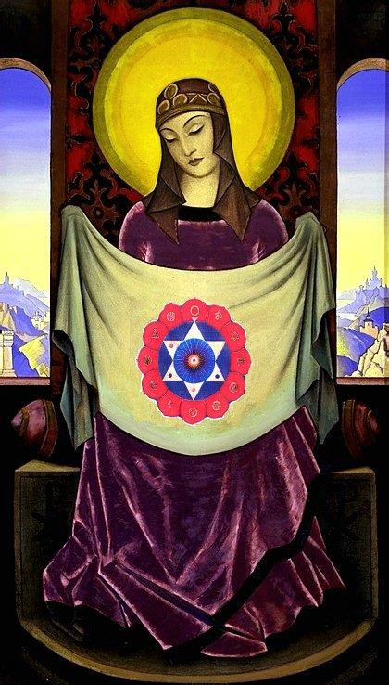
INITIATION 5 Introductory Talk, Choosing the right food
1 min 55 sec
Satchidanand; I was wanting say that what we are going to do next is to chant the heart sutra and then we have 8 products. And we are going to meditate down to the centre of the earth, we're going to meditate up into the centre of the universe and get ourselves filled with the power of the soul and then we are going to project that power from our brow centre and from our heart to each one of these products in front of us.
We have a beautiful apple, a piece of cake, we have hing or asafoetida spice, we have some grains of quinoa the grain of the Incas. We have a beautiful tomato. We have some of Honey's Cumin, oh no it's not Cumin, its err
Honey: Turmeric
Satchidanand: Turmeric, cacooma which it is in...
Honey: Hurdur we call it *inaudible.
Satchidanand: What do you call it?
Honey: Hurdur
Satchidanand: *inaudible
Honey: *Hurdur. H.U.R.D.U.R. Or *inaudible we use in India.
Satchidanand: *inaudible Which language is hurdur.
Honey: Hurdur is *inaudible language.
Satchidanand:*inaudible aahh
Honey: And haldi we use the Indian.
Satchidanand: Ah bien. And then we have some beautiful lentils and some beautiful flower. Okay? So I think we can do without the heart sutra on tape cos we've got one of those. And I'll just switch you off and I'll bring you back when we've done the exercise, how's that?
Initiation Part 2: Sending Energy to bad food 1 min 36 secs
Satchidanand: So the next exercise is to imagine the most horrible food you've ever eaten in your life thats made you ill. Be very careful with it. Prepare you golden upside pyramids underneath the food and then send your energy from your brow centre and from your heart centre towards the food, it will ground and keep on grounding it until all the negative energy has gone.
Okay folks? Mission Impossible haha. Remember, go as high as you can and down into the centre of the earth. Prepare the food. Prepare the upside pyramids and send the energy. Remember don't allow that energy to come back towards you, don't allow it to touch you. Push it into the centre of the earth, ground all of it. Fine.
Sending Energy to bad food Florencia 3min 51 secs
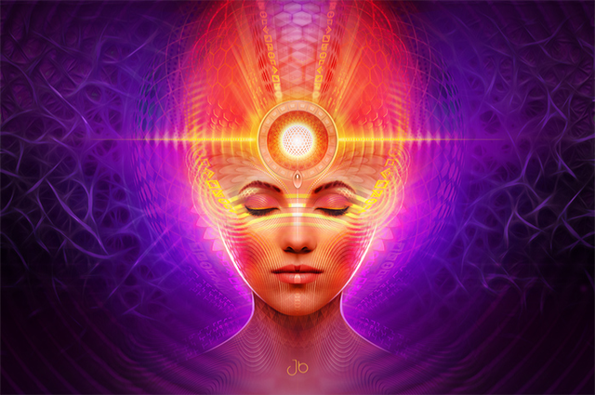
Satchidanand: It's all yours
Florencia: She say the meditation she enjoy more because she thought never had she ate something bad and she let image come to herself. Her dad is a hunter. From when they were young, they only get to eat the animal he was hunting. She always resist to eat this meat. Sometimes they were lying to her. Her curiosity was, she can imagine to herself, she was discharging with a *inaudible to the centre of the earth and she was floating. *inaudible the animal was alive.
She said very good, means I can make a life with meat I ate. Here in Argentina people eat a lot of meat. It's different than , *inaudible.
Where she was 15 years old, practically she doesn't eat more. When she got pregnant she got the will to eat meat. And in 2 occasions they invite them to eat fish. And she ate because she liked. And on 2 occasion she *inaudible eat it.
The first thing she perceived, the baby didn't like and from that time she didn't eat anymore fish. And after she passed from this experience of meat.
Also I can put on the alcohol I drank and water *inaudible transmute alcohol. And water like waterfall came. She's very happy.
Sending Energy to bad food Santhan 4mins 19 secs
Santhan: A long long time ago, a group of friends and myself went camping up this mountain. Was about a week and half long trip so...and ermm the mountain was very high. It was about 3700 meters above sea level. On the way we stopped at the village. And it was somebody's idea to buy this goat. And in those days I used to eat a lot of meat. So one of the guys in the group had this very strange idea to let this goat loose on the mountain and hunt the goat down.
So when we bought the creature I was against the idea in the first place, and on the way to the mountain we had a little van. And I was sitting in the back with some people with the goat and I couldn't bear the idea of the guys hunting the goat down.
So the goat was next to me and I held the goat's head with my hands and sort of broke it's neck. (students gasp) So it died quickly. And in this meditation I visualised the negative energy of the goat and focus the chakras points on the goat, grounded the energy to the centre of the earth, grounded the energy, the karma the blackness, to the centre of the earth. Burnt it up in the flames, the white hot flames and hugged the white spirit that remained and took it up to the logos where the tingling began at the back of my head again.
Yea that's where the tingling begins at the lagos. As soon as I reach the archangel, at the point of lagos,
Satchidanand: Logos
Santhan: yea, and released the spirit at the hospital. I cleansed quite a few other things that I ate also haha like little ghost crabs that we used to have when we used to go fishing.
We would go for these holidays on the ocean, and there were little crabs that used to run around the beach. And we used to catch them and make a nice sort of curry out of them.
But the way of killing them is very bad. You put in them in a bath tub. Like a tub yea. And you put boiling water in with them to kill them, and the little creatures are tap-dancing and it's not nice. Yea, so I healed all of that.
Sending Energy to bad food David 6 min 22 secs
David: In short the experience that he wanted to say, more than the *inaudible of the food, was that something happened later. The food was alright. Something passed out and he ground without any problems. Because he was having a good time, he tried to work with the connection with his higher self because he was working in this time, he was having some blockages.
And he think appears just now, they are real. Searching for these blockages, observe, he noticed one, he imagined Satchi. But when he saw better, it start to laugh. It started to change to red like a devil. And after that he wanted to go escape. It was nearly to convince him he couldn't catch him but he did effort and he remembered the crystal Satchi mentioned...
Satchidanand: The crucible. This is another technique I need to come into.
David: And he catches it in the crucible, he move it up to his higher self to burn it out. And because that was not enough, so he brought it up to Sirius to the star. He put it inside the star, he got the same feeling before it was happening before, it was very hot. Like he was very, had a lot of power now to this star. After that he could come inside the star, meditate inside the star. The same another time Satchi *inaudible and this time he felt pain all over his body. But he felt is good.
Satchidanand: I just wanted to remind people of the technique I told you about. You know if you have a very deep and dense blockage, you can channel energy down into it from Sirius or Logos and use a blowtorch to burn it up.
But as well, you can take a crucible, 2 hemispheres which do not get burnt up by anything to trap the blockage so it cannot escape. Some of them try to escape and you can trap it in there and bring it up to a very hot star. You can bring it up to the Logos or Sirius or even higher and there you can use the hot plasma of that star to burn up the blockage.
Remember each blockage has an angel inside, it's a really good thing to bring that angel to a hospital once you have entirely grounded that negative karmic mass.
And when you sit in a very high place like Sirius, meditating, in the hot fires, of immortality, you will find that if you have any blockages or toxins in the body, they will appear or they will burn up. With the appearance of some sort of pain or something like that. It just means that you're being purified. Bien eh? Because it's very good to sit there in this samadhi for 3 hours a day gaining energy, burning away all that is not you.
Sending Energy to bad food Honey 15mins 53 secs
Honey: Okay, well my'ns a quick one here.
Satchidanand: It's a quickie.
Honey: It's a, it's a quickie right haha, well this one, what I wanted to explain here was of course, I thought I may found it difficult to visualise how to, I thought the exercise we were doing was to kill that toxins off, and the thing right? I keep worrying that I'm doing different exercises to the rest of the group. But here what I did was I took out energy... oh no at first I imagined my dosa
Satchidanand: Dosa
Honey: Dosa, right which is an Indian food, it's got lentils in it, potatoes in it, and curry.
Satchidanand: Because you always know Honey, it's a dosa this, a dosa that and dosa the other.
Students laugh
Honey: Absolutely, it's too much of a dose. Yea, but I had this dosa in India and I got real bad runs, diarrhoea which I never get my stomach is strong, I can eat whatever I want. Which I never get, my stomach is strong I can eat whatever I want to eat. So anyway so this time I thought I'm going to kill that little dosa.
Revenge. Yea, so here I had a plate of dosa that I imagine. I took out energy from my third eye and of course my heart, I said thank you for feeding me dear god you know, but my third eye needs to get rid of that because its got toxins in it. And what I did was, well it was hard to crumble it, I sort of melted it and crumbled it.
Devi: It's real or no?
Satchidanand: Made it go into little bits.
Honey: Yea and it dropped into one of those triangles
Satchidanand: Or pyramids.
Honey: The pyramids, yea I call, yea the pyramid that goes down. As soon as it reaches there my pyramid were the kind, as soon as something touches it, it goes down further further further, into the next pyramid, next pyramid, next pyramid, and it becomes heavy. Suddenly the heaviness just pulled it all down to earth so it has no chance to escape.
And I then I threw into the altar thing, the fire thing and it just burned. And then I went yayayay like that. But then, now what do I do? Because I've killed it off. So I thought, let me go and practise again, so I did it about 3 or 4 times. But what I realised was that each time I was getting really strong. Because I had learned to concentrate, before I was finding it difficult to concentrate with the eye and the heart, this time I was getting easy because I was going buzzzzzzz …burn it.. push..down and I was enjoying it because it was quick.
Then afterwards just to end the whole thing because I was still waiting, I was thinking, I'm sure someone's going to say OMM in a minute right? Haha But it didn't come, so I wanted to utilize my time effectively and efficiently so I went around my body to find toxins. I even saw some at the back of my neck here, and I was going through the body, then I thought oh let me start going through my, what would you say, scanning my body.
I'm not very good at imagination completely. I'm just practising at the moment, yea know for this particular exercise. And I started seeing little patches, like bluey, bluey gooey patches. Yea, so that's what I saw. And I was just about to start clearing those when of course, you were finishing the...but I found this exercise to be very powerful and I really thought that was, although it looks so simple to kill off this food thing haha I found it so much fun and I could do it.
Satchidanand: But Honey was it only one Dosa that you've ever eaten that was bad for you?
Honey: I've hardly ever had any problems with foods I have been able to eat, well yea, the things I do know I keep away from, some wheat products.
Satchidanand: Yes
Honey: I tend not to eat, I know this sounds terrible, but if somebody ate something, I don't eat from that. I don't know why but from a very young age I've had this habit not to share food etc with people, or spoons and things and I don't know why but ever since I was young 2 or 3 years old, I wouldn't touch anything if somebody else ate it and I just wouldn't eat it. I would have my own plates and things. But that's just a habit that I've got for many, even when my dad drinks from a bottle of water I say, dad you know I wont drink it now,
Natwaral: Habit
Honey: I don't know what it is, but even when I was a child I wouldn't eat from something if something else at something I wouldn't touch that food. Maybe you could explain Satchi, I don't know why, I was just born like that.
Satchidanand: Instead of it being software, it's hard-wired in from other lifetimes.
Cuts to
Satchidanand: Everything's on a chip, its not actually in software. When you're enlightened and this is the way it's got to be. The only way you grow is through experience. You have to experience everything bad on this planet, so you will know, not in software but in hardware that lasts from lifetime to lifetime, then you'll know,with your singing and your dancing and your dirty women, they'll come the day, will be a wailing and a nashing of teeth, then you'll know haha
Dhiren: You've got the job....I like this software and hard-wire computer lifetimes
Satchidanand: I'm a computer expert, who knows nothing about computers.
Honey: So hardware is something that's been there for many lifetimes, its just there.
Satchidanand: It's just there it's part of you. You know it but it's nothing to do with the intellect.
Honey: And software is.
Satchidanand: The software is just is a program that runs in the computer but when you stop the computer the program goes but all the hardware remains, the hardware where all the chips and the hard-drives and everything that's on there.
Honey: Is that the good bits?
Satchidanand: Those are the bits that stay with you from lifetime to lifetime. The programs go, the personality is gone, the ego goes.
Honey: Is it good to keep the hardware there or is it supposed to..
Satchidanand: Well all of your experiences tell you that which works. And really you only have one choice in this life...so I went on to explain that a cow, moooo,
Dhiren: Back again!
Satchidanand: He's back again does not have any free will. He's entirely in enlightenment with the will of God.
Now an enlightened person is learning to get even more in alignment with the will of God. Now you all have free will. You can do anything you want to do. But, if you make the wrong decision, the result will be pain. If you do the will of God, the result will be sweetness, you have been sent onto this planet to find out, hard-wired in, it does not compute (about Devi)...can you help her...Hard-wired into the system, what is good to do?
You've done everything and you know that some things give you a lot of pain for example a little baby, oh nice fire...ouch! And after a while the baby doesn't do that again.
You've been given the free will to only do the right thing. You can only do one thing, you can only do the right thing. And you have to learn that.
Not just as an intellectual concept, but something which is absolutely ground in, interiorly, hard-wired in.
You just have to know. You have been given the free will to only do that which is right, you have been given the free will, to only align yourself with gods will, everything else, is pain.
Swami Satchidananda said, do anything you want to do, and find out that which gives you pain and that's fine.
You have to discover these things by yourself, but he said if you do it again, you're really stupid.
Everything in life is like that. From not opening the heart, to not mastering relationships, to not getting in contact with your soul, anything else is pain, so you're only allowed to follow your heart, only allowed to act correctly in relationships, only allowed to be a soul infused being.
And if you're not a soul infused being. You are a blockage infused being. You are following the direction of the ego inside. And the ego is that which is cut off from God.
The ego is a parasite which drains your energy and uses you like a battery. It likes to play aimlessly in so called “pleasure”. But which all the time, ends up in pain.
Sending Energy to good and bad food Apple 2 mins 50 secs
Satchidanand: Okay folks, shall we have a look at all these beautiful foods and you tell me what you think of them, right we're going to do the apple first. What do you think of the apple.
David: He saw *inaudible first he saw the apple was vibrating and later it was going a little bit down.
Honey: I saw the apple go down straight away, I don't know.
Satchidanand: Ohh good.
Honey: It just went straight whhoompp!
Satchidanand: Dhiren
Dhiren: I actually felt vibrations rather than see it go down or up
Satchidanand: Yea it doesn't matter how you see it, its just a matter of whether is it bad or is it good?
Dhiren: It's bad
Satchidanand: It's bad.
Dhiren: I just saw the energy and it was bad.
Satchidanand: Very good. Natwaral
Natwaral: I think its bad because I think its been sprayed with pesticides, it's so shiny.
Satchidanand: Ah there you are using the intellect Natwaral.
Natwaral: That's what I thought anyway.
Satchidanand: Okay, fair enough.
Devi: Santhan
Satchidanand: Santhan
Santhan: Straight away good.
Satchidanand: You got it good straight away.
Ramiro: 75% is good, and 25% is bad.
Nipun: Apple good.
Florencia: For Florence it's not good and not bad.
Satchidanand: Not good and not bad. And what did you think Devi?
Devi: For me bad.
Satchidanand: And what I wanted to say, was with this testing of food, it's slightly individual, some people can take poisons that other people cannot. And this is a very confusing apple isn't it? Some people are seeing that it's really good, and some people are seeing that it's really bad and some people are seeing its 75% good and 25% bad.
Sending Energy to bad food students 15 mins 5 secs
Satchidanand: So shall we try the hing how do you do there David.
David: eh very good, good good.
Satchidanand: The hing he gets it very good. Okay moving along to Honey
Honey: Okay, my, that hing turned out to be neutral.
Satchidanand: Neutral.
Honey: Yea it wasn't good, it wasn't bad it just came out neutral.
Satchidanand: Neutral. Fair enough, can we move onto Dhiren? Wait Dhiren, I'll get on you first (camera) there we go I got you.
Dhiren: I got neutral, 50 51%
Natwaral: I think it's very good.
Satchidanand: It's good. Santhan
Santhan: Tomasic with a bit of pesticide on it.
Satchidanand: You think it's got a bit of pesticide there.
Ramiro: For me it's neutral.
Satchidanand: For you its neutral.
Nipun: It's mal.
Satchidanand: And Florencia?
Florencia: Bad.
Devi: We didn't ask Florencia about the cake and apple
Florencia: For me it's bad.
Satchidanand: Well this hing, can you pass it to me please?
Devi: The hing
Satchidanand: The hing, the *inaudible, this is the pot of hing, for me it goes down like a stone haha.
And everybody was saying it was good, well they weren't actually, they were saying it's 50 50. You know, a real spice, has got so much energy inside of it, that it leaps up towards heaven, *inaudible, real *inaudible without any pesticide inside has got so much energy that it goes up to God. This is what spices do, they are medicines for our bodies, they are so good for us. If a spice is good, it's very very good, and this spice has got so much energy inside of it, it fooled you all.
If you get a spice that looks 50 50 throw it in in the bin. You are fooled by the goodness of the spice, this is pesticide.
Cuts to
Satchidanand: Okay David, how did you get on with the quinoa?
David: The quinoa, is for David, 40% 60% bad.
Satchidanand: We're talking about, Natwaral about these grains here, its called Quinoa and it comes from the Incas.
Natawaral: Oh I thought it was sesame seeds.
Satchidanand: No it's quinoa, but doesn't matter really, now I tell you
Honey: Okay, for me, the seeds came out good.
Satchidanand: 100% good?
Honey: No they were just floating up, so they were floating up...so what I did was, certain things I didn't realise we have to write percentages, so I just whatever went down went down, whatever came up, I just said good, bad, neutral, but there were certain food that were floating up slightly. It wasn't, weren't going all the way up.
Satchidanand: Remember, the difficult ones was where you've got a beautiful food, which has been pesticided just like that *inaudible, you know these are difficult to know. You've got to look at both sides and see the bad, and it's the bad that's going to poison you.
Honey: Okay, when it's fighting up and down.
Satchidanand: This is what I want you to see.
Honey: Yea I understand.
Satchidanand: Okay, this is where we are gong to have to practise a bit more.
Dhiren: The seeds, I got neutral.
Satchidanand: You got neutral.
Dhiren: Yea
Satchidanand: Nothing bad in them. Natwaral.
Natwaral: I feel the seeds are quite good.
Satchidanand: Okay, Santhan.
Santhan: The first time around I got neutral, the second time around I got good.
Satchidanand: Excellent
Ramiro: For me it's good
Satchidanand: For you its good..no no no...wait wait wait, okay now you can say it
Nipun: 50% good, 50% bad
Satchidanand: And Florencia?
Florencia: 80% good.
Satchidanand: Do you mean 20% is bad. Goes down?
Now remember all the time on this, you've got to listen to yourselves, you are the one who's got to choose, but I got this grain as being good. There was nothing wrong with it for me that I could see. But again you've got to learn to listen to yourselves. And if it's bad for you, its bad, bien. And now we're going to get along to the very beautifully red tomato.
David: Bad
Satchidanand: Say it again
David: Bad
Satchidanand: It's bad haha..its bad. Okay.
Honey: This tomato was the one I with which I was having problems with. Because it floated it, came down, it floated up came down. It just kept on bouncing up and down in the middle so I wasn't sure if it was neutral, good or bad. Because it just kept going up and down. So I you know it's between the good and the neutral but I felt there was something I couldn't understand. So I found that one difficult to work out.
Satchidanand: Right, difficult, would you eat it?
Honey: Erm, it's between the good and the neutral so I just put that I would because my stomach is pretty strong. Haha. But I had some doubts about it, it just went up and down quite a lot. You know
Satchidanand: Okay
Honey: Yea, I was finding it difficult.
Satchidanand: That was the difficult one.
Honey: For me.
Devi: How much percentage was it.
Honey: Well it just kept going up and down, up and down so I wasn't sure. It was slightly more up so I chose it as, between neutral and good.
Satchidanand: So again, what I wanted to say to you here Honey, what I wanted to say to you Honey, was that if you have got a perfectly good tomato, with a lot of really beautiful energy in it, then you really feel as if you want to eat it, because it's got a lot of vitamins, its red, it's beautiful, you want to eat something, its time for lunch haha and you think that's a good tomato, but also you see in it the pesticides, and what you are having difficulty in with the tomato and with the hing, is that you're seeing the good side and the bad side altogether, and putting it as neutral.
And It's sort of going up and down. You need to separate these 2 sides out in your brain and see the good side as good and see the bad side as bad cos that's a bad tomato, you do not eat that tomato,
Honey: Yea cos my intellect.
Satchidanand: Have another look at it. See if you can you can see the bad side now. That's a really bad tomato you don't want it.
Honey: Yea, I think intellectually I felt the nourishment would be good. The thing kept coming down again, I tried to push it back up but it went back down again. So that's why I think I got a bit confused.
Satchidanand: Okay, so this is where you're getting confused.
Dhiren: Confused myself, because I judged it as good, between 60 and 80% but when you asked Honey the question whether she would eat it, my immediate answer was no.
Satchidanand: This is the question you've got to ask.
Devi: This is, I'm not having up or down or percent, I eat it or not eat it.
Dhiren: 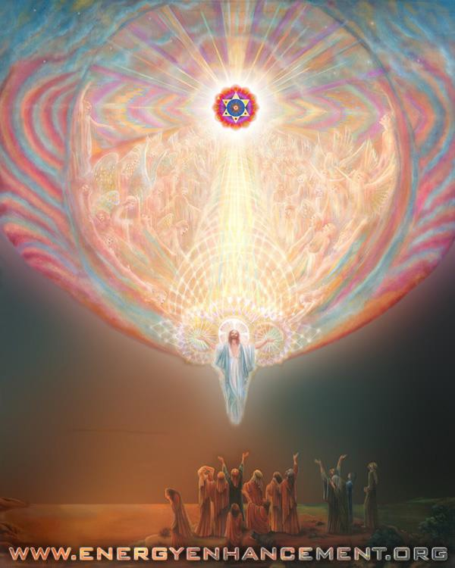
Yea
Satchidanand: Yea. This is the way you've got to look at it. Engineers say percentages or not percentages. But we say is, do you want to eat it or not. And what we're trying to do is to give you our experience here so you can gain from it...Natwaral what did you think of this tomato.
Natwaral: I think it's a very good tomato. It looks like an organic tomato and I would eat it myself. Because to me it looks alright.
Satchidanand: But Natwaral you're here on the Energy Enhancement course,
Natwaral: Yea
Satchidanand: Now, here we're talking about energy
Natwaral: My energy says also
Satchidanand: We're not looking at things with our eyes.
What I was wanting to say to Natwaral, is that we're here on the Energy Enhancement course, and we're trying not to look at things with our eyes, we're trying to look at things from our brow centre and our heart centre and judge what happens to the energy.
Because there was Nipun and his eyes were looking at the cake. And he's got this little child inside, you know you've got this little Krishna there and he's offering you this laddu and what are you going to do. Oh I take laddu I eat it.
And we're trying to get away from that. We're trying to see deeply. We're trying to see deeply into this laddu. Haha. We're trying to see deeply into this sweetie. We're trying to see deeply into this tomato. To see if it's going to poison us. And this is what you need to do. More meditation Natwaral. I sentence you to meditation.
Cuts to
Santhan: Bad, bad bad bad bad bad bad, straight down, bad.
Satchidanand: Like a stone.
Santhan: Like a stone.
Satchidanand: Okay. How did you get on Ramiro?
Ramiro: It also was bad *inaudible
Satchidanand: Bad, bad, bad, you wouldn't eat it...and Nipun?
Nipun: The tomato he can eat it, but it got something..
Satchidanand: Well..wait wait, lets have a look at Florencia...
Florencia: For me it's bad.
Satchidanand: Florencia, you don't think it's going to be very good for your babies?
Florencia: No
Satchidanand: Haha I just love the answers of Nipun. It's got something bad about it, but I will eat it! Haha
Dhiren: A man who likes his food.
Satchidanand: Nipun you're going to have to do better.
I want you to be a sannyasin who lives for many years to give his beautiful heart to all of humanity and your problem is addiction to food. I name a food idiot!
There's no doubt about it in my mind. You have to do something about this. You have to choose to eat good food, this is the first stage. And then after that, I sentence you to a lot of fasting, to get rid of all the toxins in your body.
Krishna wants you to do his work, and to do his work, you need to improve on food. It's got something bad in it, but I will eat it! Haha No...
Devi: He said he knows its something bad but he will eat it because he doesn't *inaudible
Satchidanand: haha
Honey: Yea, it wont do anything
Satchidanand: This is not true Nipun, this tomato will kill you slowly, it will crucify you.
Choose good food 4 mins 7 secs
Satchidanand: If you are going to listen to me Nipun, you then have a choice, between choosing the good food or choosing the bad food.
If you choose the bad food, then you will kill yourself, you will dig your grave with your teeth.
Remember Nipun that you always have a choice, if you go down to the supermarket, there are several brands down there. There are many cakes in the supermarket, now if you walk down and look at each one of them, eventually you will find one which is good, I promise, not all the products are bad.
Now if you go into the supermarket, which one are you going to choose? The best one. Because, food is an addiction. And I know about it well.
Honey: Me too!
Satchidanand: But, it is only my donkey, that likes to eat the bad food.
And I must remember that I am riding my donkey, and I am in charge of my donkey.
I can choose, and if my donkey wants to eat the cake, then its very convenient to say, not that cake donkey, this cake is much better for you. And the donkey goes, oohh, okay, I eat the good cake huh?
In this way, we train our donkey. You know, a bad habit, is very easy to start off, but a good habit, is very difficult at the beginning but at the end this good habit gets sweeter and sweeter. But a bad habit starts off really good, it feels fantastic, oh yes, give me the bad cake. Oh yea, give me the bad cake! But you know, if you keep on eating that bad cake, it ends up in a very bad place, the same as every bad habit. It gets harder and harder.
Honey's Morning Experience 11 mins 39 secs
Satchidanand: So I was just talking to Honey and I was asking her what she did this morning...and she replied...
Honey: I did my reiki exercise this morning, and it was really really good. Because I could start visualising blockages and toxins in my body. And the way I worked around my body, was when I was touching each part of my body. I would ask the universal energy, to heal me, and to fill me with positive energy.
So wherever there were blockages, I would see black liquid coming out, all melting. So I quickly made a black container, a round circular container and I was collecting this black liquid everywhere throughout my body. When I came to my right side which I mentioned yesterday, that there was some kind of toxin that I saw in the right side of my back.
Suddenly all this liquid went *noise came out, you know like in this bubble, liquid came out. Same thing happened with my legs. And just kept on, lots of liquid kept coming out in that bowl, I just expanded my black circular bowl.
Satchidanand: Your crucibowl
Honey: Exactly, probably, yea that's where I'm, crucible, my crucibowl...yea...so I thought no problems I don't have much time so I'll come back again to continue clearing it. Yea, so at the end of the exercise I picked up that bowl, went to mother earth and threw it in the altar, the fire alter that I had there and as always celebrated and went yeeaa haha and came back up again.
Celebration for me is really important because it just gives me extra energy to feel that I'm gonna go back and sort out more. Yea, and that's it and we finished off the exercise. But it was a fantastic and a beautiful exercise because I didn't realise that again I could go through my body and find these kind of blockages, I felt I needed to go through years and years of training but you know the technique that you showed, that this is how you go through the body was very very useful and very powerful
Satchidanand: The Energy Enhancement technique.
Honey: Absolutely the Energy Enhancement technique haha was very very useful, definitely. Yea, because it works and that's the important thing.
Because you could go through lots and lots of techniques, and at the end of the day, they don't give you that kind of results. I'm only on my 4th or 5th day and I'm managing to clear up so much. Yea, I'm really looking forward to it as we progress how we're going to do it. Yea
Satchidanand: Well, I was wanting to comment on what Honey said and she said she was doing reiki but at the same time as doing reiki with her hands she was using the techniques of Energy Enhancement to see inside of her body. What she saw was all of this black liquid haha and you know, there are some very special people in this world called Medical Sensitives.
And they're very very rare these people, because they can see inside people's bodies, and they can see exactly what is wrong with them.
And Honey, has been here for 3 or 4 days and I think she could take up another job. Because this is exactly what a Medical Sensitive does. And you can spend thousands and thousands of dollars going to see a medical sensitive.
You can spend thousands and thousands of dollars going to see acupuncturists. You can spend thousands and thousands of dollars going to see a doctor.
You can spend many many thousands of dollars getting surgery from a doctor. But by the time you've gone to the surgery, it's too late.
What Energy Enhancement allows you to do is to deal with the problems, by yourself, and stop any problems, before they occur. Because this black liquid, that you're finding inside after 20 or 30 years, can turn into a medical or surgical problem, like arthritis.
Honey: Okay, what I wanted to say was, that it's very interesting that you mentioned about this black liquid thing because I see it very clearly. I even see some places with just a few drops coming out and some places with a bit more and some places lots of liquid comes through and some days just nothing at all.
Yea. So I found it very interesting. And now that you've mentioned this, I didn't realise, because I really do see it very clearly. And I've never thought I could imagine things like that.
Yea. I really felt that I would have to go through years and years of training as I mentioned before I could start seeing this. And yea, and I don't know if it's the reiki or is it okay to mix the two together because whilst I'm feeling the energy through reiki doing the exercise where I feel the tingles, I'm also visualising at the same time is it okay for me to combine the two together. Because I found it very useful.
Satchidanand: Well what we find is that Medical Sensitives like Caroline Myss have been doing this work for many many thousands of years and what we're trying to tell all of you, is that you are here on this course and you have been doing the spiritual things also for thousands and thousands of years.
Energy Enhancement improves everything it touches. If you do reiki, with the techniques of Energy Enhancement it applies the reiki, same with acupuncture, same with homeopathy, same with anything you can mention.
It applies everything in your life. Because what we are doing with Energy Enhancement is we are entering into our psychic powers in order to clean ourselves and when ourselves are clean you will have the same power to help everybody else you meet.
And as we move into Level 4 of Energy Enhancement we want to recommend groups of people getting together, using Energy Enhancement techniques as a group to transmute the very dense and horrible energies which are affecting this earth.
So it spreads out from one to all of your friends and then to all of the earth. The same techniques are applicable and they are used by all spiritual masters.
David's morning experience 22 mins 17 secs
David: He would like to comment about his experience with the meditation this morning. First he tried to do the Energy Enhancement stage 1. After he noticed it was good to do the same meditation in the higher star and sitting there and doing the meditation, he did it. And was a very beautiful and strong experience. He *inaudible throat chakra and heart, how they were heating up, a very strange feeling. And when he went down, the feeling stop and he was feeling very happy.
Satchidanand: So I just wanted to ask a question of David. This was with the technique of Initiation 4 of Energy Enhancement yes?
David: Yes
Satchidanand: And this initiation of Energy Enhancement is very essential for everybody to practise as religiously as their reiki as a prelude to any spiritual work that you undertake.
It's necessary to gain energy. As you gain energy, you can see more. So bathe in the energies of the higher self. Bathe in the energies of the monad. Energise in the energies of the logos. Bathe in the energies of the higher stars.
And as you feel this energy flowing down into your chakras, then you charge yourself up, with the charge of the soul by singing the body electric. With my armies I engirth thee. Yea, it's the thing between arms and armies. It's a poem. Armies, yes, with all the people in the world, I engirth thee. And charge thee full with the charge of the soul. Walt Whitman, Leaves of Grass.
It's a poem. Because it always starts off with one. And then it spreads, just like the tsunami. There's been a very vast earthquake just off the coast of Sumatra.
And you see the pictures on the television. There is an epicentre and from that epicentre the waves spread out all over the planet. And as the waves travel over thousands of miles in circles from the epicentre the waves get bigger and bigger so when they get to the coast of *inaudible in India, they are 30 meters high.
And this is the way it works. There is a spiritual impulse of Energy Enhancement entering into the planet and from this epicentre the waves of spiritual energy spread out to the whole of humanity.
Gurdjieff, when he wrote Beelzebub's Tales to his Grandson in 3 volumes, said, that he was an alien and over 5000 years he had visited this planet 5 times.
And each time he came down to the planet he saw what was wrong with humanity and he described exactly what these things were that he saw in humanity and he remedied the defects by bringing something into humanity that would cure the problem.
Now one great seer looked at me once and he said you've been on this planet for 28000 years and over that time, you've come down to this planet 28 times. And it seems whenever you come down to the planet, you see exactly what is wrong with humanity, where people are.
And I think the thing that I saw when I came down this time was the pain in the whole of humanity. You know, this is why I talk about the levels of charity. Food, you teach people how to farm, money, you give people enough money to live with, social security, but better than is education, and thousands of years ago we started off all these schools intellectually how to make money.
But the problem with the people with education is that they're just not happy. They don't know how to manage disappointment.
And this is the main reason for Energy Enhancement, yea? To get rid of the pain from the body. To get rid of the pain from the emotional body. To get rid of the pain of the conflicting sub personalities with the soul. And then to teach how to never get those pains again.
Two things, transmute the pain, and teach the causes of the pain. And then it's your choice.
Okay, anymore for anymore? Oh I was going to say one more thing that was really interesting. That I was talking to Honey previously about how to make the things you do successful. Well, I think at that time I said you have got to learn how to surf. Because when there is an epicentre of a spiritual explosion, when this starts to sweep over the earth, if you can learn how to balance on the wave and use the power of that wave, then you can rise as quickly as the spread of this energy over the whole world.
The spiritual impulse of J.R.R Tolkien came into the world in 1952, the year I was born and since that time, the energy that he started off with the book The Lord of the Rings took 50 years to reach the peak of it's popularity with the 3 movies, The Lord of the Rings, which has not gone to every part of the planet and has become the most successful movie that has ever been.
I was explaining how if a movie, a music, a book is spiritual, it is teaching something essential to the archetypal mind of humanity then this elements gets touched by God. And in order to be successful, this product needs to have the energy of the heart.
There are so many people who's heart is not open. 50% has a heart which only thinks of itself, which is totally selfish which has a mind of metal and wheels. And these people are the critics, and they don't care if the product has the energy of the heart, they will judge all movies and products equally.
But only 50% of the people will stand a chance of liking a product which has no heart. To reach the other 50% of the people, with open hearts, these 50% have open hearts, they will not go to see the movie that has no heart. They will not listen to music that has no heart, in order to be truly popular, you need to include that heart energy in your product and the way that you do it, is by embodying in your product, to put into your product, some element which God wants to spread on the planet.
As you do that, the energy of God flows and you can ride that wave. From a very small beginning in Japan at the beginning of the century, Professor Usui, the founder of reiki lived in a Zen monastery for 21 years.
For 21 years he meditated everyday with his master with one thing in his mind, how to heal like Jesus Christ. With his search and research, he found the symbols of reiki.
And when his master told him after 21 years to go to the top of a sacred mountain and there fast for 21 days and meditate with Zen for 21 days at the end of that time Professor Usui became enlightened.
The enlightened ascended masters came to him, they initiated him an enlightened being and then they gave him his task, his mission, they said here are the symbols of reiki. And they gave them to him, in golden energy. They painted them in front of him in golden energy and they said take these symbols and teach people how to use them to purify, to transmute, and to heal. And from that very small beginning at the beginning of the century in only 100 years this epicentre has spread throughout the whole world and so now everybody knows about reiki and uses it...
Cuts to
Satchidanand: Well you know there are many different personality types in the earth and if you have a hand which is very small, then you tend to have very big ideas but very little attention to detail and those people who have very big hands, then they tend to have very few big ideas, but those big hands can take apart a watch wheel by wheel and put it all back together again very quickly.
And you know you can't do a project without big ideas and attention to detail and these 2 things is very rare to have embodied in one human being but you need both.

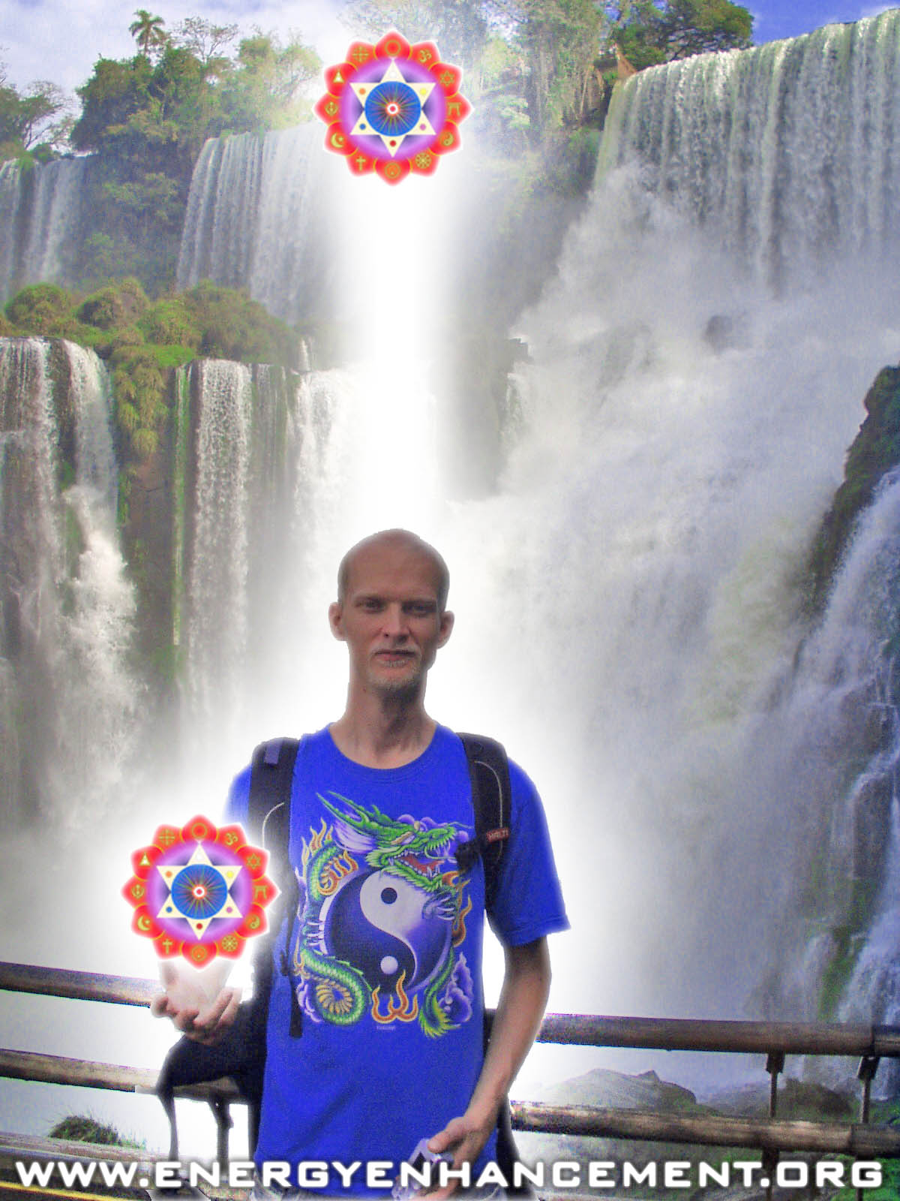

ENERGY ENHANCEMENT COURSE AT IGUAZU FALLS. BRAZIL

"Get your asses over here Now and Speed Up your process of Enlightenment on the Energy Enhancement one month course!!" - DON

And this is why you need to have 2 people at least to finish off any project.
Cuts to
om chant.
Extra Talk on The Symptoms of Blockages 9 mins 33 secs
Satchidanand: When I was at the ashram of Swami Satchidananda, he said that as we evolve, he said eventually we come to the knowledge that we need some help with our spiritual development.
It's possible to do many spiritual exercises by yourself. You can do the yoga, you can do the pranayama, you can do the meditation, you can do the Energy Enhancement at a distance but in the end you understand what Gurdjieff was saying, that in order to move from one octave to the next octave you need to receive some spiritual energy to leven the bread, to give it a little bit of bubbles, the wine of spirituality.
You need to have that energy given to you from outside, to make the leap. And once you make the leap you don't need it anymore. So he said that when people..he said I have many students, I've got thousands of students, and he says what I do I call all of those people who are outside the ashram the out patients, and he says the ones that are inside the ashram I call the in patients, and they have all come here for the operation of the egodectomy.
He said when I come in, I have to work on them very hard. Haha. Any emotion that comes into the psychic body of the student which is less than pure spiritual calmness is how the ego comes out because you've got to see it, before you can free it.
So all of those people that come here, he said many of them get very emotional and indeed some of them who come to the ashram get physically sick because the ego is attached to the body.
There is an interplay between the two and as my pure spiritual energy casts out all the demons into the pigs around so they can fall over a cliff, there are some symptoms of the way in which they come out.
And this is very much like I was talking yesterday, the symptoms of how you know you have a blockage. Any of those symptoms, means that you have a blockage which is coming out which you can see which is like a pimple which is ready to pop. What are those symptoms, well I've got a full list of them here.
When you are meditating, when you are meditating in the presence then the first symptom is like *inaudible, boff! You go to sleep. In the presence of pure positive spiritual energy if you have a lot of negative karmic mass, if you have a lot of resistance to the mass, you will nod off.
Second, pain in the spiritual body, pain in the physical body, whilst you're sitting there for 3 and a half hours in the lotus posture without moving, a little bit of pain comes into the body. As you are sitting there circulating the light of the Taoist orbits in very short time perhaps the light will pass through an area of the body where this is a blockage and you will get a pain in that area.
And that's one of the ways in which you will know that you have a blockage in that area. Where you cannot see the golden light, you are pushing the golden light around your Taoist orbits and it gets to the area of your body where there is a blockage and for some reason you cannot see the golden light. You try to imagine it there. You try to push it in there with your breathe but no matter how much you try you cannot visualise the golden light. There also is a blockage.
One of the major ways in which blockages avoid being thrown out of the body is through distraction. I don't know if anybody's ever seen Monty Python? Erm, they've got this beautiful movie called The Meaning of Life. I think we can see it perhaps in one of our off times. But they say one of the major reasons why people do not become enlightened is because they get distracted and so one of the guys said, we were talking before about hats and how they sort of majorly effect humanity and what do you mean by distraction and at that moment the pirates come in through the window with sabres and you never hear anything more about how distraction takes you away from enlightenment.
But we know don't we, we've been sitting 3 and half hours in the lotus posture, all of you working on a blockage, you're circulating the light, and the next thing you know, you're sort of moved to Bermuda wearing a swimsuit surrounded by bikini clad naked ladies. And all of a sudden you come to, what was I doing, why am I in Bermuda, surrounded by all these naked ladies, aahh haha I was trying to circulate the light around my body. But I became distracted.
You get distracted by negative emotions. You get distracted by thoughts coming into your head, like this technique is totally useless and that Satchidanand is a clown. All normal stuff.
The blockages do no want to go. The blockages do not want to move. And they will make you angry, they will make you upset, they will get upset at any point. And you look at it later and think well why did I get upset?
But at that time you're upset by it and it distracts you from what you are trying to do. And what you are really trying to do is to work on the blockages and so all sorts of emotions come up all the negative emotions and one of the things you have to do intellectually is to know the way in which the blockages will try to distract you from doing your work and you have to be strong enough and quick enough to catch it and to develop the positive emotions of love, of stick to it ness, of the ability to complete a process, of will power.
Because that's what will power means, the ability to continue in the face of distraction and blockages. Same thing in an ashram, you are coming there to remove the blockage of the ego. The ego is a collective of all of the blockages which you have inside your body and as you come into the light, so you will go through a process of the removal of the egodectomy.
Now the way in which we have improved upon this process here is that here we are giving you advanced techniques for the removal of all blockages. So that you can do it much more quickly. But then the reaction to those techniques is much more violent than it is in an ashram.
Even though in many ashrams, you get many people who leave, they're crying, they're very emotional, they say I can't stay here anymore. I've been in the presence of those people but when you start to work on the blockages in Energy Enhancement, it's very quick, but it's also very intense.
So you have to do develop that ability to know who is in charge? You have to be able to say, this is a blockage, it does not want to move, who is in charge?
Is the blockage in charge or are you in charge? Are you in charge? No, you only become in charge when you become enlightened.
But by saying I must be in charge then you can help the process of the removal of the blockages. You can help the process of enlightenment. Because all of these things I am talking about now is so that you can be forewarned and thus be forearmed
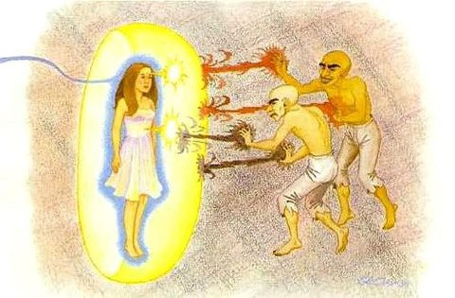
THE YOGA SUTRAS OF PATANJALI BY SWAMI SATCHIDANAND – FREE! DOWNLOAD HERE..
http://www.energyenhancement.org/Sacred-Energy/yoga-sutras-of-patanjali-book/Energy-Enhancement-Yoga-Sutras-of-Patanjali.pdf
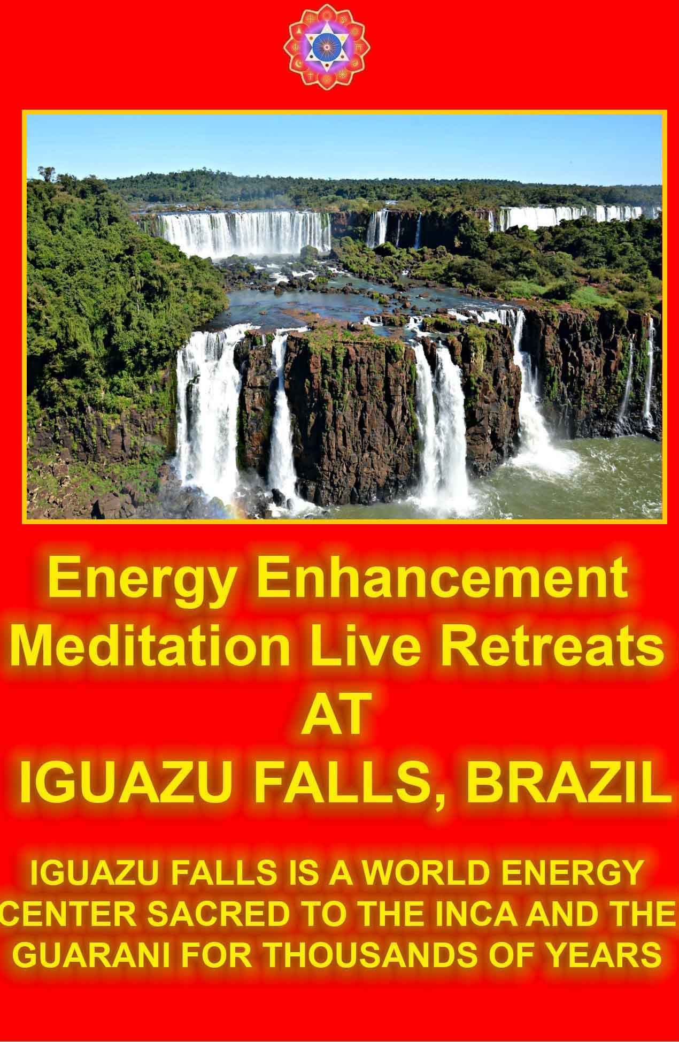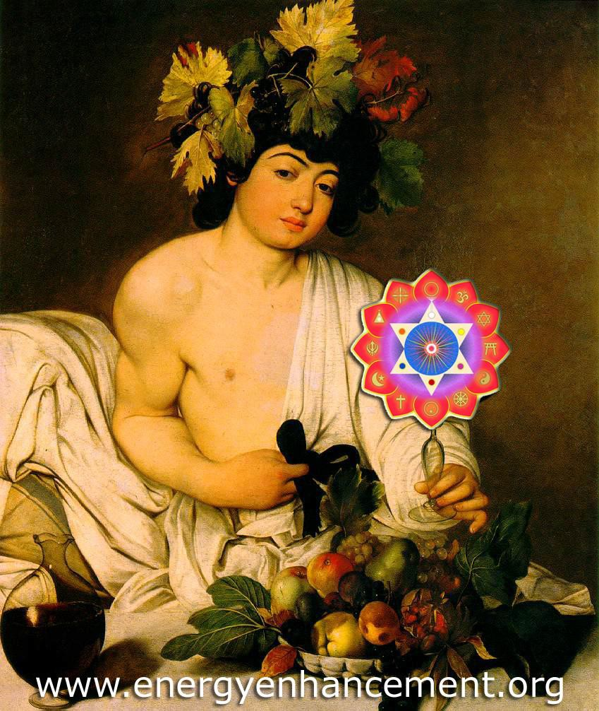
BACCHUS BY CARAVAGGIO

DRUNK ON THE "WINE" OF THE SUFIS FLOWING IN FROM THE VINE LEAF CHAKRAS ABOVE THE HEAD

AS THE WINE SPIRITUAL KUNDALINI ENERGY BECOMES MATURE...

JALALUDDIN RUMI - TAKE WHAT IS IN MY HAND...
Energy Enhancement Level 1, Initiation 6 Psychic Protections
2hours 2 mins 11 secs
Introductory Talk 5mins 21 secs
Satchidanand: Love droppeth as the gentle dew from heaven on its place to beneath. It is twice blessed. First by he who gives. And then by he who receives.
Love is the energy of change. Love is the energy of evolution. It takes that which is perfect and makes it even more perfect.
Energy flows from levels of high energy to levels of low energy so high levels of spiritual energy flow to low levels of spiritual energy until the energy is equalised, until the student is at the same level as the master.
There are also levels of negative energy, as you reduce your levels of negative energy you will find that people with high levels of negativity will flow into you until all the energy is equalised.
When my friend goes to the ashram of Sathya Sai Baba she talks about the liquidiser effect. Because as this energy flows. There is a sort of battle. Depending upon how high the energy is. Depending upon how low the energy is. Depending upon the difference in the energies.
The energy will flow very fast if there's a big difference, but if there's a small difference the energy will flow very slowly.
Which levels of energy are manageable for you.
Struck by lightning. Struck by lightning said Bilbo Baggins in Lord of the Rings. Struck by lightning.
When Shiva takes his lightning and throws it at you from on high what sort of a change does this produce.
Towers struck by lightning. Image of the tarot. The test of Jobe. No, not job, Jobe from the Bible. Jobe. I said to
Honey, best you meditate in the centre of the highest possible energy in the highest heart for 3 hours a day. She said if you ask me to, I will do it.
Difference between Angels and Archangels 2 mins 19 secs
Satchidanand: The difference between angels and archangels, is the difference between a normal human being and an enlightened human being.
Evolution, if you think of it as a computer processor, a little angel is a computer chip. It can do very simple things.
An archangel, is something like Big Blue, this is the computer that was created by IBM, which was 10,000 computers connected together, each like a column. A multi processor computer.
And it's just much more quick and it can do more things. The guy in charge of this planet, is a very high archangel. Yea. We're living inside a computer haha. Just like The Matrix haha. Focus Trinity.
Power Towers 30mins 44 secs
Satchidanand: But today I was wanting to teach you something which is very necessary to the destruction of blockages.
You know that these blockages are very dense. They have a lot of negative energy. And before we start to destroy them with the strongest possible means. We need to learn about protection.
In very traditional ways, traditionally psychic protections have been taught to student from time immemorial...and we need these protections but the best form of defence is attack.
Protection is not effective. Protection can always be breached. But what it does do, is give it time, to attack.
That's the kind of guy I am. It's the difference between love and will. I'm not coming from the point of view of love, I'm coming from the point of view of beating them up to heal them haha.
Dhiren: Ouch
Devi: Shiva
Satchidanand: Shiva. It seems to be that way. In reality all these energies are one. But we have to experience each different kind of energy in order to truly appreciate each different type. Yea?
I am a lover. I am the biggest lover in the world. Because I love everybody that comes to me. The only thing that I am looking for in my lovers is a response.
That is all that is needed for the energy to flow. It is my duty, it is my joy. Haha There is nothing finer in the whole world, than doing one's work in the world. There is nothing more orgasmic then energy flows. You know people get stuck in the physical. But the higher the level of energy the more pleasure there is in using it.
Protection, this is what we are doing today, with all these little side comments. I have to thank Dhiren for giving me the most beautiful poem about love. Every time I see something he just brings something in response. The best kind of student is the one who asks questions and the best kind of students draw forth the best kind of reply. They draw forth, they bring from you the best kind of response. And the best kind of student who asks questions without words simply the energy draws forth that which is necessary.
Well it makes me happy anyway. It's like when I make a meal, I know there's a least one person who's going to enjoy it, me. And I'm here enjoying myself and I'm so grateful that you allow me to be here. Perhaps we are all enjoying ourselves.
Dhiren: Absolutely
Satchidanand: Protection, very necessary, very good to practise, but know its limitations. Protection like the walls of a castle can always be destroyed but it takes time to do it. The more power you put into your protection, the more time its going to take to get through, this gives you the time to make your response and that response must be strong.
Strength haha. Flexibility. When I was younger, I used to walk around in big cities and feel I was sucked dry by the energies around me. I used to feel very tired *inaudible out in the world but once I had learnt this protection, I was not effected by the cities anymore.
This form of protection, one of the 3 that I'm going to teach you is for normal daily use. It's not for use in meditation although its very good to be there. Because it is a leaking protection. It allows thing in, and it allows things out. But it takes the badness out of that which comes in but the important thing is, it allows all the good energy to come out.
It's a little bit like a diving suit, the one with the helmet on and the rubber suit and it's got this little pipe on top of the head that stretches right up into the centre of Sirius, you know, all the oxygen comes down through the pipe, you're breathing down here, and you're surrounded by low levels of energy but you're atmosphere is of the highest purest kind of energy.
It allows you to walk around at your energy level without effecting anything around you. You find if you walk around without your suit, the levels of energy that you have inside you, when you're connected high up, act like the lightning of Shiva with everyone you meet.
And the worst the person you meet, the more it accelerates their karma so inside of bringing good luck to everybody, you make them go through their bad karma very quickly.
And you really don't want to have this effect it's not necessary. What you want, is to give the right amount of energy, to everybody that you meet, to a good student who asks the right questions, you want to give them that which is drawn from you. You don't want to affect the ordinary man in the street because it's too painful for them to go through their karma so quickly.
Really, you want a student who wants to learn how to dissolve their karma, instead of going through it physically.
This is the way to get out of your karma. So what I'm talking about here is a sort of protection, that protects everybody else from you.
It allows you to walk around with a very high energy level and it protects the world from you, this is protection haha.
It enables you to be at a very high energy level without affecting the people around you. And it protects you from absorbing too much negative energy from the very bad people that are out there. Yea?
It's not necessary to heal so many people, best retain it for your students. This is the most efficient use of spiritual energy. This is my favourite kind of protection.
I very rarely worry about the other forms of protection but you need to learn, because by practising they then become automatic. Yea?
When you get attacked, you need to be able to put up the shutters, very quickly.
When you are dealing with some of these really bad blockages, you need the other kinds of protection.
The ones that I call, useful in your meditations. Meditative protections, to protect your meditation.
But today we're going to learn my favourite kind of protection. And this kind of protection also has the virtue of raising your spiritual energy permanently.
In the same way that connecting up into the centre of the universe does. How can these bad energy blockages live in such a high spiritual energy field.
They get cast out. It helps with the elimination of your energy blockages so after this everybody is going to have an aura of light.
First I have to talk about theory. We were talking the other day about gyration, the reason gyration works is because it follows the laws of physics. And the law is, when spiritual energy goes away from you or perverted negative spiritual energy flows away from you, for example into the centre of the earth as you breathe it down into the centre of the earth, works the same with the golden thread or with the negative energy when it goes down to the centre of the earth.
There are lines of force that flow spirally around that energy and they flow anticlockwise in the direction of the flow. Yea?
But the strange thing, just imagine it, that you are below this energy which is being sent to you from above. As the energy comes towards you, that same spiral anticlockwise flow, from underneath, looks as though it is clockwise, this is relativity.
Just think about it, its going around in this direction as it goes down, now you just think what its like when it looks above, and its going clockwise, its just that way, I don't know why it is. But just try it for yourself, yea as it comes towards you it's going clockwise and as its going away from you its going anticlockwise.
In physics they call it the right hand rule. You put your fingers like this, this is the direction of the flow, and as it goes away it goes like that, its difficult to make it go the other way but it goes like that, anticlockwise, the right hand rule. So as it goes away from you, its the right hand rule, and as it comes toward you its the left hand rule. Yea, they teach you this in physics, the laws of radiation. The electrons flow and magnetism goes anticlockwise or clockwise depending on whether its the left hand rule or the right hand rule. Whether its going away from you or coming towards you. Like that, or like that. It's dead good this physics isn't it? Its dead good this physics.
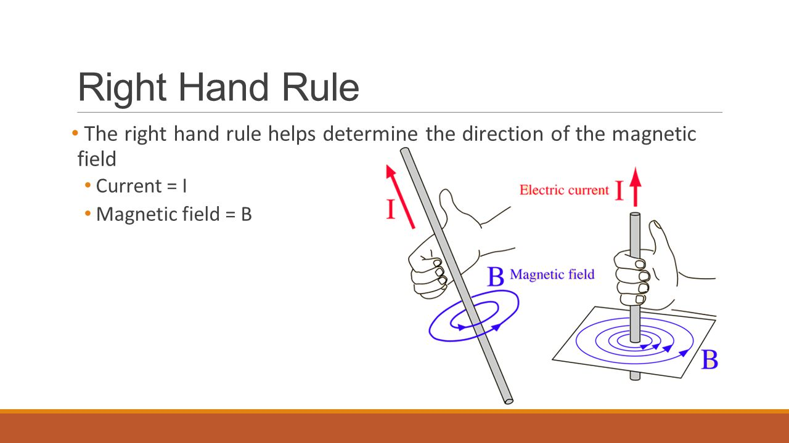
Dhiren: Dead good. Is it good dead, or is it dead good.
Satchidanand: It's so good, its just ..
Dhiren: dead haha
Satchidanand: It's just in the smallest portion of time, which means you get the maximum energy in the shortest portion of time, its just intense. That what I mean by dead good, intense.
Dhiren: So intense that it doesn't seem to exist, that's how intense it is, and yet it exists.
Satchidanand: haha...So, just imagine that this energy that's flowing down into the centre of the earth down the front of your body, the energy is flowing on the golden cord, and the lines of force going spirally around it are going anticlockwise but you're going to move that line of energy from you to a position one meter in front of you.
It's flowing down one meter in front of you into the centre of the earth, and it's coming down from the centre of the universe in front of you down into the centre of the earth. You've formed a line of energy, in front of you 1 meter in front of you, flowing down from the centre of the universe down in the centre of the earth, and the lines are flowing anticlockwise around it, that line can be very thin but the lines of energy are going to be flowing at a diameter of 15cm. You have formed a column of protection.
Just imagine something comes toward that column, the lines of energy are going around like that, gets deflected, cant get through, whoomph! Taken away. (ricochet noise) It gets deflected off sideways.
And then imagine that next to that line of energy, that cord of golden energy flowing down from above into the centre of the earth just next to it you've got another line of energy that comes up from the centre of the earth into the centre of the universe. And they're very close together.
Now, the lines of energy going around that are going clockwise, and the anticlockwise lines intertwine with the clockwise spirals. I'm taking you through it a step at a time. It's very physical this, yea? Yea, the spirals of
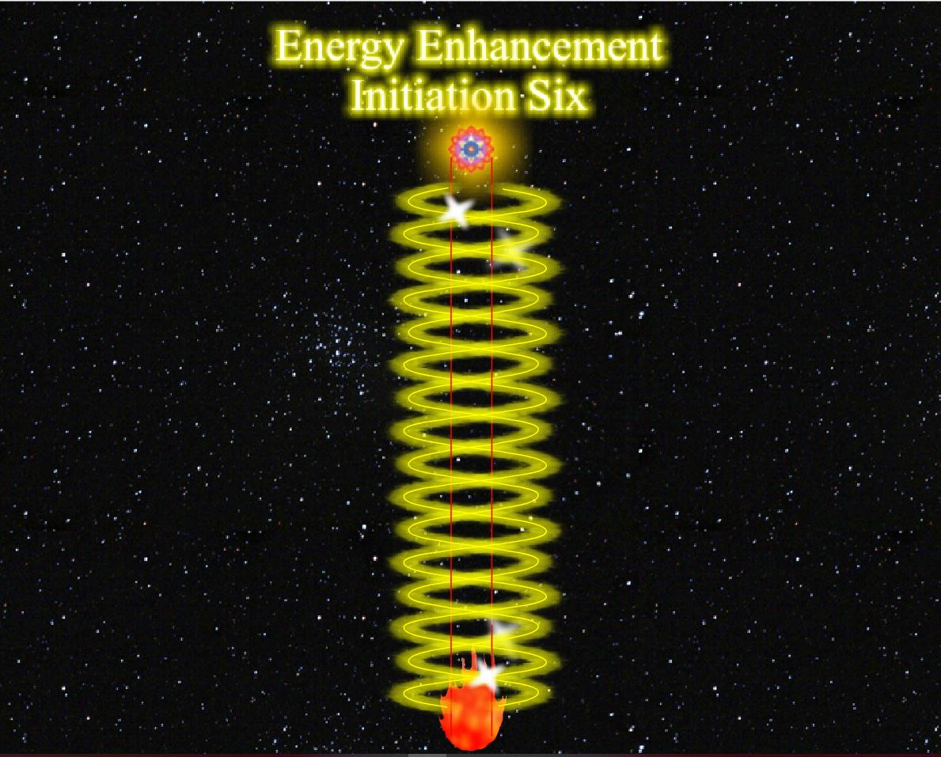
energy intertwine, one is going clockwise and is going anticlockwise.
Honey: From the top is anticlockwise
Satchidanand: Yes
Honey: and from the bottom is clockwise.
Satchidanand: That's right
Honey: So this one goes this way
Satchidanand: Yes
Honey: And this will come..
Satchidanand: That way..and they intertwine together and they form an even more strong column of protection in front of you. One meter in front of you.
Honey: So anything that comes this way can go that way
Satchidanand: (ricochet noises)
Honey: And if it goes that way it still gets, goes back
Satchidanand:It gets deflected, nothing can get through it because this is very strong the more strong the lines of energy flow from top to bottom and from bottom to top the stronger your column of protection. Would you like to that translate Devi?
Devi: We were talking, she asks me something.
Satchidanand: If somebody asks a question, it needs to come here, I give the reply in English, and you give the reply in Spanish, and then everybody can hear. Because otherwise its impolite.
Devi: Satchi, *inaudible teaching, she is going more fast...wait..what did you say...
Satchidanand: I said, the more powerful the flows that come from above to below and from below to above than the more strong your column of protection.
Now imagine we're going to create that column in front of us and we're going to create another one behind us, one meter away. And we're going to create one to our left and one to our right, so we're got 4 columns of protection and we're going to connect them up into the centre of the universe above and we're going to connect down into the centre of the earth below so that they form a structure which is very powerful and strong.
Here is something I prepared before, there you go (holds up a picture) can you see that. Now this is you, this is you in the centre, you're looking down from above, this is the column in front of you, this is the column behind you, this is the one to the left, and this is the one to the right, and they're going down, connecting into the bottom of the earth, and connecting up just like this. Yea you see the structure. Yea? Very good.
So what we're going to do is we're going to ask a little angel to come and take charge of each column and we're going to ask an archangel to look after the whole structure. Are we going to fast?
Devi: No.
Satchidanand: Bien
Devi: Wait
Santhan: Satchi are there 4 columns?
Satchidanand: Yes, that's right 4 columns.
Santhan: And around each column there are 2 spirals of energy,
Satchidanand: Yes
Santhan: One coming up, one going down. One going down is going anticlockwise.
Satchidanand: The one going down is anticlockwise
Santhan: And the one coming up is going clockwise
Satchidanand: is going clockwise, and the 2 spirals intertwine. The interesting thing is about the mind, is
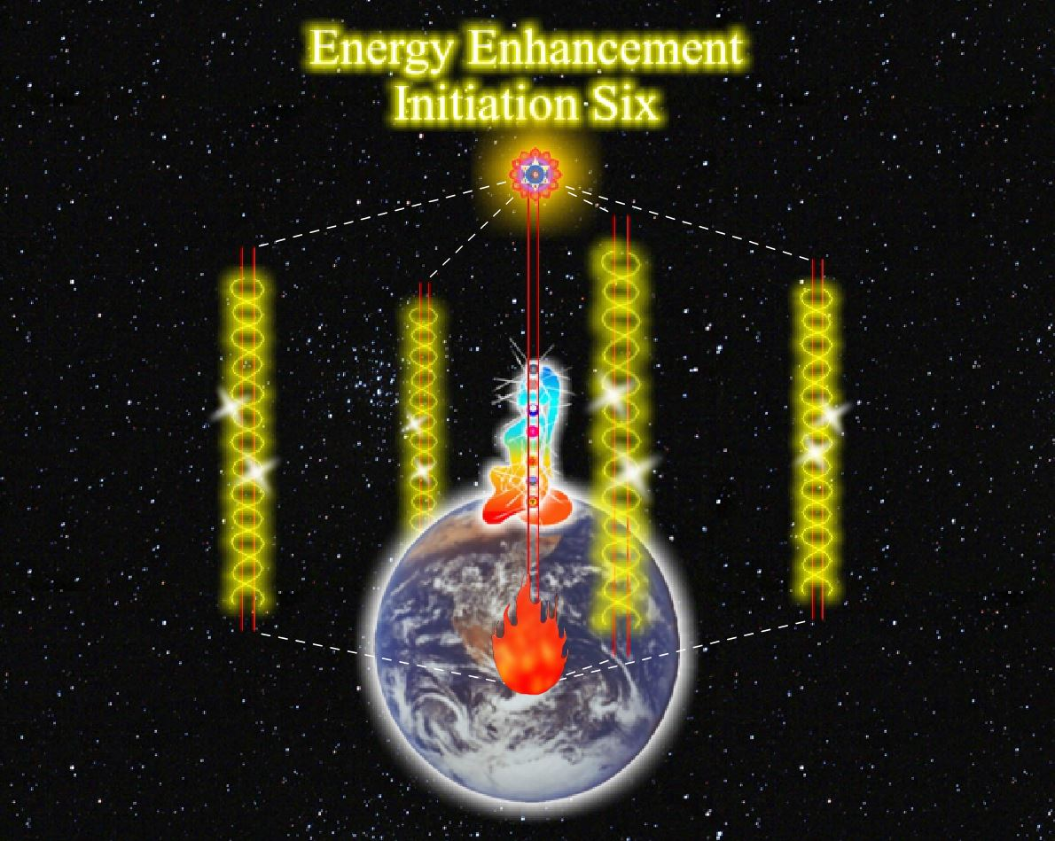
that once you have visualised one thing correctly, it is possible to tell the mind to replicate exactly the same thing.
You tell it to do that, and it will do it. So we've got 4 columns of protection in this structure.
Now, between the one in front and the one to the left. We're going to create 90 columns of protection, replicate. 90 columns of protection.
And then from our left to behind us we're going to create another 90 columns of protection and then from behind us to our right, we're going to create another 90 columns of protection, and then to our right to in front us we're going to create another 90 columns of protection so 4 multiplied by 90 is 360 columns of protection in our circle of protection.
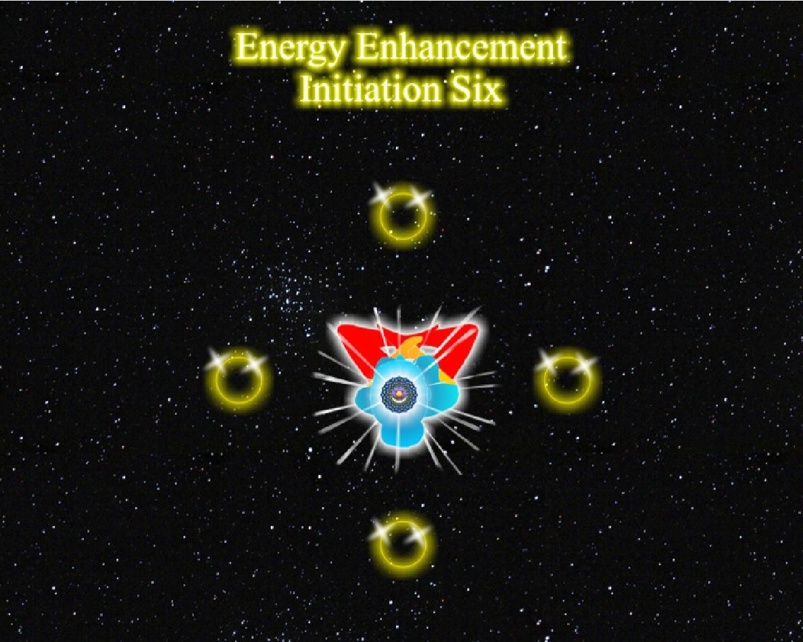
We are creating our circle of protection around us with 360 columns plus the original 4, 364 columns of protection. One for each day of the year. 360 degrees in a circle.
All of these columns are connecting upwards into the centre of the universe and then we're going to take them higher, we're going to connect them into the monad, and we're going to take them even higher, we're going to connect them into the logos, and we're going to take them even higher, we're going to connect them into Sirius, and we're going to connect the bottom of these columns into the centre of the earth.
We're going to plug them into the hot fires and because we are connecting very high levels of energy to very low levels of energy, we are going to create a tremendous flow of energy which flow down the columns and then we're going to create one column in the centre of this structure which goes down through the crown chakra, out of our base chakra and into the centre of the earth and you will find that as you create this structure, then more energy will flow from the centre of the universe through your crown chakra and into the centre of the earth. You are going to get much more energy when this is all connected.
This is a circle of protection, 360 columns, an angel in charge of each column and an archangel in charge of the whole, one circle of protection.
Circle of Protection 7 mins 17 secs
Satchidanand: So again there are 2 golden cords very close together in the centre of each column. In one golden cord the energy is flowing down, and in one golden cord the energy is flowing up. This creates 2

spirals of energy around them which form the circumference of the column, of spiral energies, 2 spirals intertwined, one clockwise and one anticlockwise and we're creating 360 of these columns in a circle around us.
With one column that goes down the the centre of this structure through us. Now, replication, once you can create one, you can create many. We've created 360 to make one circle of protection. I'm not bothered about the details, 360, 364, a thousand, it doesn't matter, it's the concept that's important.
So we've created one circle of protection around us, now just outside that circle, we are going to create another
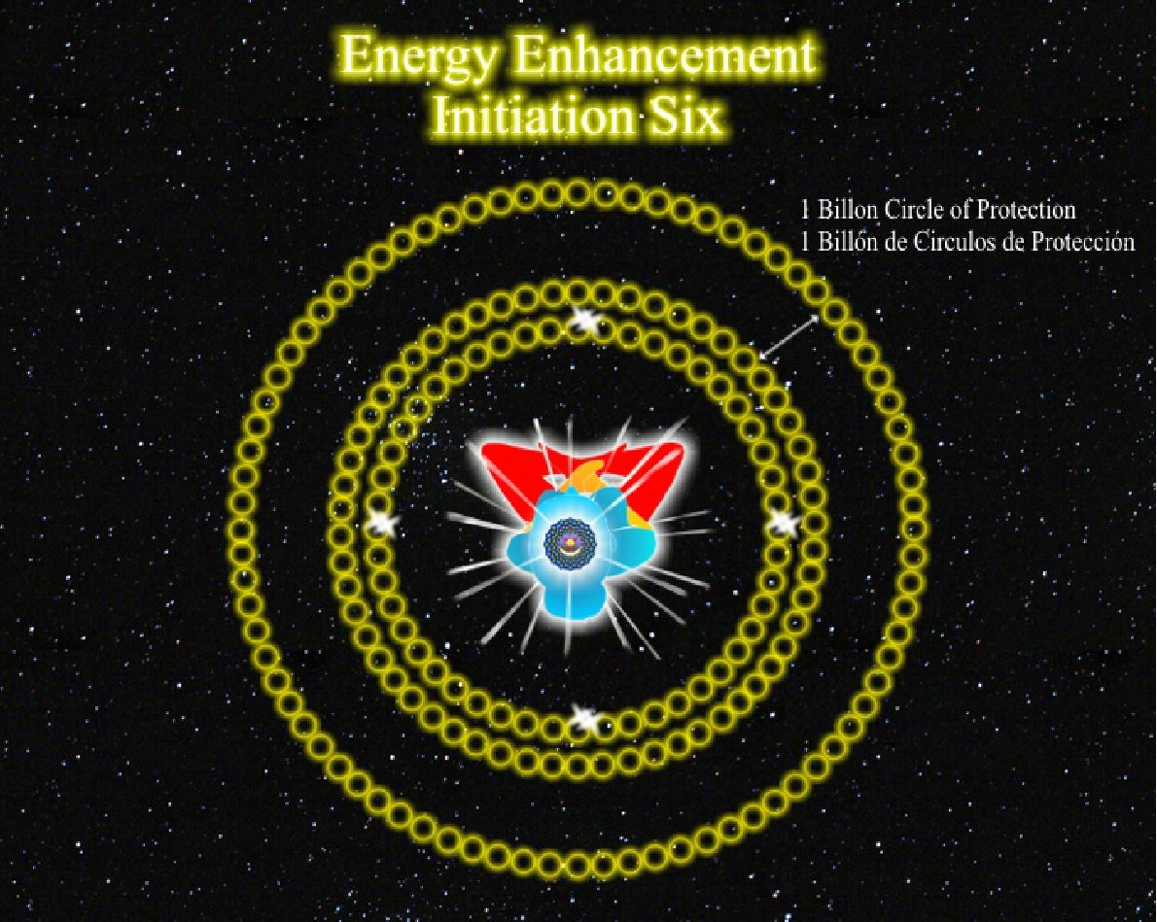
circle of protection just outside of it and this other circle has got 360 columns just like the other one and its even more powerful and strong and I'm gonna say, 4 circles of protection, 6 circles of protection, 8 circles of protection, 10 circles of protection each with 360 columns and we can increase the power flowing down the central column.
An angel in charge of each column, and an archangel in charge of the whole structure. We're just telling the archangel, I have increased the number of columns, I have increased the number of circles. The energy flows more. 20 circles of protection, 40 circles of protection, 60 circles of protection, 80 circles of protection, 100 circles of protection.
Now don't worry about them getting too far away, because we are going to compress them and we're going to make them...how many angels can dance on the head of a pin? An infinity. So its not very far away from this, it's very compressed. It is very energy dense.
David: One archangel for all the structure.
Satchidanand: Yes, one archangel for all the structure. (student talks in Spanish) Devi the correct manner.
Devi: He asks if it is possible to have a meter of distance.
Satchidanand: Well the meter of distance is between you and the circle. It doesn't have to be a meter, it can be half a meter. But those 100 circles we're compressing into 10cm of thickness. Very energy dense, very difficult for somebody to break through. Although it is always possible by a person of energy to get through anything but it slows them down, particularly if you create these things in advance and you maintain them regularly.
David: How regularly?
Satchidanand: At the beginning, once per day. But after that, once you've created it, when you need to. When you're going to meet some people. When you're going to meet a great crowd of people. When you're going to do something, you will find this energy protection is incredibly useful to you. 200 circles of protection, 400 circles of protection, 600 circles of protection, 1000 circles of protection.
Increase the number of angels, tell the archangel, increase the energy through the central column. And we eventually are going to get 10,000, 100,000, 1 million, 10 million, 100 million, 1 billion circles of protection each with 360 angels and the archangel looking after the whole.
Is Important to create the 4 columns? 3mins 48 secs
Honey: When you're building the 4 columns, and the little columns in between and then you start replicating, so is it important to build those 4 columns really well first? And then you replicate or just one.
Satchidanand: Can you say this in Spanish Devi?
Devi: Say it again
Honey: You know about replication, do we do the 4 columns really strong first and then replicate or one then...
Satchidanand: The important thing is the creation of the first column accurately. The important thing is the creation of one golden cord of energy. And the first one you create is the one that flows down the front of your body and up your spine and once you understand a golden cord of energy then you know that it flows down from the centre of the universe into the centre of the earth and it flows from the centre of the earth into the centre of the universe, I'm just moving it one meter in front of me. And it creates a column of protection, all you have to do is visualise the spirals.
Once you made one, you can replicate 4, once you've made 4, you can replicate 360. Once you've made one circle of protection, you can replicate another and once you've created 2, you can create a billion.
It's quite simple. The brain is a computer. You tell it to replicate, (clicks finger) it's magic. Who's in charge? And its very interesting that I'm introducing you to the partnership that exists between human beings and angels.
This is how we can start to create a partnership between yourself and the angels which is necessary to work in this world. When I went to see Santana, not this Santana here, but the musician Santana in Barcelona, he said I could not do my work without the angels.
The 4 Columns 25mins 4 secs
Satchidanand: Okay sit up straight everybody....So shall we sit up straight. Shall we put our hands together. Shall we sway to get our spine in our alignment.
I want you to imagine your golden cord flowing down the front of your body, flowing down into the centre of the earth. And it goes into the centre of the earth and the golden cord flows up from the centre of the earth to the base of our spine up the spine, and up into the centre of the universe.
And it flows down from the centre of the universe down the front of our body, into the centre of the universe, 2 cords of golden energy, one flowing down, and one flowing up.
And just like that we are going to create 2 more golden cords of energy and in front of you, and I want you to imagine the spirals of force which flow around those cords, creating 1 column in front of you. And I want you to connect that column in front of you down into the centre of the earth upwards into the centre of the universe higher into the monad, higher into the logos, higher into Sirius, and higher to infinity.
One column in front of you and the energy is flowing really strongly in it, up and down. Creating very strong spirals of force through which nothing can penetrate and just like that we're going to create another column behind us, connecting down to the centre of the earth and connecting up through the soul, through the monad, through the logos, through Sirius, higher to infinity.
And create another column to our right, create another column to our left and we connect them up into the centre of the highest point and down in the centre of the earth and as we do that, we create a central column which flows down through the top of our head, and down into the centre of the earth.
We're going to put one angel in charge of each column, and put an archangel in charge of the whole.
Now I want you to create 90 more columns. For the quarter in front of you to your left hand side connect them up into centre of the universe, and down into the centre of the earth, and from your left to behind you another 90 columns, and from behind you to your right another 90 columns. From your right to in front of you another 90 columns. Connect them as higher as you can and down into the centre of the earth. Feel the increase in energy throughout the central column. Put an angel in charge of each column and put an archangel in charge of the whole.
You've created one circle of protection around you through replication, create 2. Connect them up into the centre of the universe and down into the centre of the earth. Increase the energy through the central column, put an angel in charge of each column and put the archangel in charge of the whole.
Lets increase the number of circles, 4, 6, 8, 10. Connect them up into the centre of the universe, connect them down into the centre of the earth. Increase the energy through the central column, put an angel in charge of each column, and put the archangel in charge of the whole. Be the columns with your energy, create them.
20 circles, 40, 60, 80. 100 circles of protection, connect them up into the centre of the universe down into the centre of the earth, increase the energy through the central column, put an angel in charge of each column and an archangel in charge of the whole.
200 circles, 400 circles, 600 circles, 800, one thousand circles of protection around us, compress them so they're more close to you, compress the circle so they're more close to you, make them more dense, make them more difficult to get through. Connect them up into the centre of the universe, connect them down into the centre of the earth, increase the energy through the central column. Put an angel in charge of each column, put an archangel in charge of the whole.
2,000, 4,000 , 6,000, 8,000, 10,000 circles of protection. Connect them up into the centre of the universe, down into the centre of the earth, increase the energy through the central column, put an angel in charge of each column, put an archangel in charge of the whole.
20 thousand, 60 thousand, 100 thousand circles of protection. Increase the energy through the central column. Put an angel in charge of each column, an archangel in charge of the whole. Make certain of the top of each column is connected really high. Soul, higher in the monad, higher than the logos, higher than Sirius, connect them right up at high as you can and connect them in the centre.
200 thousand, 400 thousand, 600 thousand, 800 thousand, 1 million circles of protection around you. Increase the energy through the central column, take them up into the centre of the universe, down into the centre of the earth, angel in charge of each column, archangel in charge of the whole, feed the columns. And if this exercise is too much Federico, do a little bit more later at home. It's a lot of energy.
2 million, 4 million, 6 million, 8 million, 10 million circles of protection. Increase the energy through the central column, connect them high into the centre of the universe into the centre of the earth, angel in charge of each column, archangel in charge of the whole.
20 million, 40 million, 60 million, 80 million, 100 million circles of protection. Connect them up into the centre of the universe, down into the centre of the earth, increase the energy through the central column, archangel in charge of the whole, angel in charge of each column, feed the energy.
200 million, 400 million, 600 million, 800 million, 1000 million circles of protection around you. Connect them up into the centre of the universe, down into the centre of the earth, increase the energy through the central column, make certain all the columns connect them as high as you can, plug them into the soul, the monad, the logos, higher to Sirius, higher as high as you can reach, plug them in the centre, increase the energy through the central column. Angel in charge of each column, archangel in charge of the whole.
Om chant.
Creating Circles of Protection 5mins52 secs
Satchidanand: What we are going to do now, is we're going to meditate, and we are going to create this protection, which takes a lot of energy to make it, and as we create each section of rings of protection, then we might find it'll take a while to give energy to all of those circles of protection.
You need to give it the time for the energy to flow and fill up all of the circles. And you need to go away and your homework for the next week is to spend some time creating this protection, one time per day and you'll find once it's been created and a lot of energy has been put into it you'll just have to go “shields up” “flame on” haha
Dhiren: Warp speed
Satchidanand: Warp factor 10. And it will be very simple to maintain your protection but the beginning is where you have to create it accurately and spend time on it to get it right.
But once it gets created its very simple to maintain.
You can even do this around your whole house, one column in each corner of the house or you can do it for your plot of land, one column in each corner of the plot.
And you'll find the whole area has a much higher energy level. It'll keep away all of your friends at a lower energy level and it'll only allow your higher energy friends to come in.
It'll keep away all the people with a lot of negativity inside them. And only allow those people with less negativity to come in.
You've got to be very careful in spiritual life, to choose friends who are very good. This protection aids that process. Eliminate the negative and accentuate the positive, protection does that for you, it's an anti-virus protection. It keeps Agent Smith out.
So we're going to sit up straight and I'm going to take you through this protection and I might go through it too quickly. But you know the principles now and when you practise this, spend a bit of time on it, the first time or two. But after that you can do it much more quickly.
You need to feed the circles of protection. You need to feed them with your energy and you might feel that as you create this protection.
David: One question quickly, who created this technique?
Satchidanand: Me. It is my own. And is a response to the difficulties of living in a low energy world. But I was given various hints on its creation. Particularly like to thank Victor Van Kooten and Angela Farmer who are great Yogi's, disciples of BKS Iyengar and I spent 2 weeks with them in Greece, learning their yoga and this was part of the course but I adapted the seeds that I learnt on that course in order to create this particular protection and all I can say is that it works and I use it all the time.
Types of Students 3 mins 37 secs
Satchidanand: I was thinking of what the Buddha said. He said there are 3 types of student. He said there are those students you have to beat up to get them to do anything. I rather like doing that haha.
These students will take 20 years to reach enlightenment. And there are those students you have to teach, who are quite assiduous, they work quite hard. These students will take 10 years to reach enlightenment. The ones you say, meditate for 3 hours a day and they'll say, oh yea, okay, fine.
He said but the best student is like with the horse, some horses you have to beat to get them to do anything, some horses you have to just move the reins. He said but the best horse are those you just have to show the shadow of the whip. These students will take 3 years to reach enlightenment. What kind of student are you?
The quality of mercy is not constrained. The energy is there for everybody. All you have to do is say yes. This energy, enlightenment can be called Love. But it can also be called the energy of Will. This is more Shiva energy. This is stronger, more quick form of energy.
By destroying that which is outmoded, obsolete, you create space for something completely new, this is the destruction of Shiva. Whereas the maintenance of Krishna is also necessary until it has passed it's time. This type of student takes 10 years haha
Student's Experience 18mins 42 secs
Satchidanand: And can I ask Federico how he got on with all of that?
Federico: He felt a lot of energy. He felt he had a very strong feeling. He did the first column connecting with *inaudible logos, the centre of the earth. He *inaudible connection. He could see the archangel and angel very clear and easy. *inaudible like a column. The *inaudible energy was passing through. His found his crown chakra was open very strong. His base chakra open inside. He said he couldn't continue because it was too strong.
Devi: Very impressed with the heat.
Satchidanand: Well Federico needs to get used to the energy. He needs to stay in that until it's all manageable.
Federico: He felt very *inaudible in this space. He felt very happy there and he didn't feel any bad energy. He say one of the best feeling he could feel in his life.
Satchidanand: Anybody else have an experience they would like to share? I think you need to do this Dhiren. *inaudible
Honey: That was really nice to hear, you know about your experience. Because I felt the crown chakra really really energised. And as I built up my columns, I felt so much energy coming. I found it a bit difficult to ground it though, to go lower down. But my top half of my columns were so bright and full of energy. And I was trying to send the energy more to the earth. Yea. Which at first I was finding a bit difficult but at the end, I just gave it, one big, that's it, I need all the energy I can get. To make the foundation stronger. And my columns built up throughout the universe.
Because as we multiplied like 10,000, 20,000, 2 million, 20 million I made them grow out of the galaxy, pulled them all back in around me. The next time we multiplied I went even further out. Built up the energy everywhere around me and then condensed it again. But it's like by the time I'm finished, it was like such a huge column, a little me and then a huge column around me. And then I went *noise try to bring it back in.
And every time I saw my little angels. When they arrived I saw a light bulb come out in each corner so I knew they arrived until they wouldn't arrive, I'd keep saying, come on come down come down come down. I want enough energy. So by the time I finished it was like a fun fare, like Christmas lights, so many angels everywhere. Then I went with the whirlwind thing, with the energy, I made them disappear, the lights, I made the lights disappear in the energy. And then suddenly by the time we finished the meditation my energy was so bright. Its glowing everywhere. Again like I said last minute, to ground it, to keep that energy, I think that's the bit I'm gonna have to work on.
But its very interesting, and what I found the most amazing was how much the crown chakra was buzzing, it was like buuzzzzzzzz, haha it was really, but I was enjoying it, I wanted more you know, I wanted more, I was really enjoying that, but anyway, that was my, I didn't see anything more out of it. But that was a really good meditation.
Satchidanand: I'd like to say to Honey, that, its really good, that she noticed she had blockages in the base chakra, below the base chakra preventing connection with the centre of the earth. And not to worry too much at the moment but when we get into Level 2, the first thing she should do is remove all of those blockages below the base chakra, and we should be getting there within 1 or 2 days. Who would like to say something more? Ramiro?
Federico: This exercise makes him feel so good, *inaudible.
Satchidanand: This is good, as I said, it can have the effect of increasing your energy. In the same way, more so than going up into the centre of the universe with one column but whatever makes you feel good, do more of it, 3 hours per day. Very good. Ah we have Ramiro, can you give that to Ramiro please (microphone).
Ramiro: The experience of meditation is very good because before I had the feeling of sleeping but couldn't *inaudible. At the end he was *inaudible and wanting to be there *inaudible. He was feeling really good.
Something new come into experience he'd like to share with us. He put an angel above. When Satchi said go more high, he went more high than Sirius. Ramiro didn't know what to do. He asked for some help please and appear a very bright light. He told him I am the protector, the light and he will take care of all his problems. His energy was expanding all over the meditation. He was going down. And the protector going up and appear another light and he's called a super protector. I feel very happy. His central energy was covering all his body.
Santhan: What is very interesting, the previous technique, initiation number 4, was very very powerful for me. And that sort of prepared me for this technique because in this technique the power of the sensation was so much more. The sensation at the back of my head was even more distinct with a bit more power flowing through us. Loads of power.
And as I increased the number of circles and the central column, the power, energy flowing through the central column also increased. An interesting observation that I made was, was with my pulse afterwards, my pulse was very distinct and slowed down to about 59 58 per minute. *inaudible Where as it's normally 65 64 but very even *inaudible.
Satchidanand: One of the comments I'd like to make on Ramiro, ask and it shall be given unto yee, seek and you shall find. Remember them. But when you ask, remember to ask unselfishly. If you ask egotistically, selfishly, the Chinese have a curse, God have mercy on those who get what they want and I'm not saying that to Ramiro I'm commenting on selfish wanting.
Ramiro asked for a higher angel and he got exactly what he needed. And here we can see the various degrees of evolution of angels and archangels and its to do with how high you can go. Yea?
So when I say take one step higher I'm saying this is one way of increasing your evolution and if everybody is satisfied then we can finish but we seem to have one more question...
Extra Talk in Columns of Protection 19 mins 27 secs
Satchidanand: Now today I would like to start of a little bit of external antahkaranas. You know when we are circling the hips and we are moving the hips in an anticlockwise direction we imagine that we have a clock face on the ground beneath our feet and as we move our hips with Devi Dhyani in an anticlockwise direction, we are making all the negative energy flow down into the centre of the earth.
This is very much like light, when light is travelling in a certain direction, then there are magnetic spirals of force that surround the light wave, which flow anticlockwise. When the light is flowing away from you, this is called the right hand rule of physics and it is exactly the same in spirituality.
When we are talking about negative bioenergy, when we are talking about negative karmic mass, when we are talking about golden light of the soul.
When that energy is flowing away from you, the spirals of force flow around that energy in spirals that are anticlockwise. So Hiromi, I am pointing my right hand at you and this is the direction in which the spiritual light is going, its going towards you. So as I'm doing that (pointing and turning hand), as I'm doing that, yea? Then which direction is my thumb going, is it going anticlockwise?
Hiromi: For me clockwise, but for you anticlockwise.
Satchidanand: Now that's very interesting, because when I am doing that, to me this looks as though it is going anticlockwise and in the video also it looks as though it is going anticlockwise because its reversed, but when I'm doing that towards you, you can see me moving my thumb clockwise but to me its anticlockwise,how is this?
How is that? It is something to do with spherical geometry, it is something to do with relativity of Einstein but when I do that the energy is flowing from me to you and the spirals of force are going anticlockwise.
But when the energy is flowing towards you, then the energy is flowing clockwise, it changes direction with the direction with which its flowing. I say that when the energy is coming towards you then the energy is going clockwise, this is the left hand rule of physics. It's going clockwise but to you it looks like it is going anticlockwise. But when the energy is going away from you the energy is going anticlockwise. When the energy is coming towards you it looks as though it's going clockwise.
Try it. Which direction is that going for you. Yea? It's anticlockwise. Sorry it's clockwise for me, because this is the left hand rule but for you it looks as though its going anticlockwise.
You can even try it on a sheet of paper, you can draw arrows on a piece of paper clockwise, turn the paper over and they're going in a clockwise direction. You're looking confused Johannes haha.
It's true to me this looks, this hand looks as though it is going anticlockwise. Yea, this thumb now, anticlockwise. But to you its going clockwise. Think about it. Try it yourself. Do that movement and say which direction is this going. I guarantee you it's the opposite from my point of view. Yea? It's magic. But its true.
You have to start to think in terms of relativity, in terms of spherical geometry. Do you get that? Looks at this? (turns pointing hand) Yea anticlockwise to me, clockwise to you. So when its coming towards you it looks as though its going clockwise. And when its going away from you the spirals of force are anticlockwise.
Therefore energy into the centre of the earth, move the hips in an anticlockwise direction, you are in tune with the spirals of force and when they're coming down to you from the centre of the universe they look as though they're anticlockwise and it really changes at the level of the eyes.
It's coming down anticlockwise and when it reaches the eyes you're moving the same and then it looks as though its clockwise. Try it. Here its coming anticlockwise and then when it gets to the level of the eyes it changes into clockwise, and you haven't changed the spiral, its just where you are looking from.
It is where you are looking from that makes it different, you see try it. That's right isn't it? This is exactly as it is.
So this is the force.
Now when we are talking about making columns of protection, we are talking about making external antahkaranas.
We know we have an antahkarana that flows along our spine. It goes out of the top of our head into the centre of the universe. It goes out of the base chakra down into the centre of the earth. And the 2 polarities of the centre of the earth, and the centre of the universe are what power, the 2 polarities power the antahkarana.
A connection between heaven and earth, now a genuine antahkarana, due to the reciprocal maintenance of Gurdjieff, has energy flowing down from the centre of the universe into the centre of the earth but its also, when the negative energy hits the centre of the earth, it burns up and there's a flow of energy started from the centre of the earth up into the centre of the universe, we 're getting sort of like a circulation of energy, but because the 2 paths are so far apart the centre of the earth light years, trillions of miles, away from the centre of the universe.
This circulation then becomes 2 parallel lines that join into the centre of the earth and join in the centre of the universe. One line is coming down the other line is coming up, one line is coming down, and the other line is coming up, and around each one of these lines, there is a spiral of energy , so the energy is going down, beneath your eyes, and its going down anticlockwise and then its coming up from the centre of the earth and its going clockwise. So you have 2 intertwined spirals of energy. One which is anticlockwise intertwined with the one coming up, the clockwise spiral, and together, these 2 spirals of energy like a gene, like RNA, Ribo Nucleic Acid, which is part of the DNA, 2 spirals of energy,
and they intertwine.
They are actually 180 degrees out of phase, to allow the intertwining but, all I'm talking about is how we create a column of energy. An external antahkarana.
What is it made from? How is it created? How does it function? You don't really need to go into all the science of it.
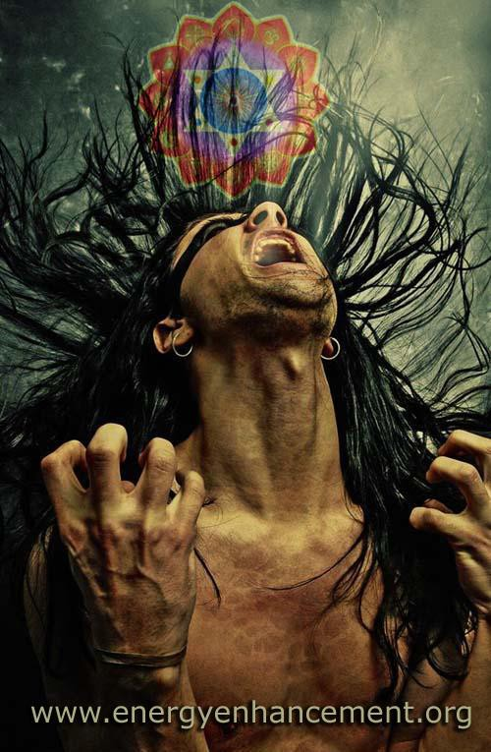
But I sort of get interested in that kind of thing. And there is an external antahkarana (holds up picture). Two spirals of energy, 2 lines of energy going from the centre of the universe down into the centre of the earth and back again creating the spirals around it creating a column of protection.
That is how you create one column of protection, you say, in front of me, one meter in front of me, I am going to create a connection between heaven and earth, 2 lines of energy, one going up, one going down, creating the 2 spirals, creating a column, which is impenetrable, nothing can come through it, and then you say, I will make one behind me, and I will make one to my right, and I will make one to my left, and I will join them up in the centre of the universe, and I will join them up, in the centre of the earth, and I will have one central column that comes up through me, joining up into the centre of the universe down into the centre of the earth, and this creates a structure, which can channel more spiritual energy.
So as well as providing protection around you, as well as providing a diving suit. Do you know what is a diving suit Hiromi? A diving suit is what you wear with this big copper helmet on the top, yea, and you go (bubbling noises) down into the centre of the earth in the ocean, and what do you have coming out of the top of the suit, you have an airline, you have an airline, and you have this pure positive oxygen spiritual energy coming down and its flowing around all of your body and its contained by the suit.
And around you you've got all this dirty water. But around you you've got this oxygen spiritual energy, and it goes down, and there you are touching the centre of the earth. This is protection, it is the way to maintain a positive spiritual energy around you whilst everything else is dirty.
The whole world is dirty and filled with horrible dirty energy and what you are doing you are protecting all of these horrible dirty people from your pure positive spiritual energy because if your positive spiritual energy oxygen hits them they will ignite and burn up poor things.
All of their karma will come into play in that moment and it will be like they are struck by lightning, struck by lightning, and you don't want to do that to anybody else except your students do you? haha Struck by lightning bof. Struck by lightning bof. Struck by lightning bof.
That's what Bilbo Baggins said in Lord of the Rings, struck by lightning, struck by lightning. You've been hit by the lightning of Zeus.
But because you are at a higher energy level, you can channel, that lightning strike, because you have less negative karmic mass resistance, to that flow of energy whereas in normal people, who are very dirty, haha, they have more resistance, so that when they get this super positive powerful spiritual energy hitting them, they cannot take it, its too much for them.
It’s very much like the story of Layla. I was telling Hiromi, her spiritual name is Layla. And I said I know the story of Layla. It’s very much like the song by Eric Clapton. Layla. And I said one day there were these tribes in Arabia, and Layla, a very beautiful young lady, so beautiful and so spiritual she was a saint, and in the other tribe there was this young man called Michaeledes and he heard about Layla and he wanted to marry her.
He thought, I am a beautiful boy and I want to join in marriage with this lady. He was very proper about it, he didn’t steal into the tribe and whisk her away or the rest of it. He thought, I will do this proper, the way it is meant to be done. And he went to the leader of the tribe which is the leader of Layla’s tribe, and he said to the leader, I have heard a lot about Layla and I am a rich young man, I am the Prince of my tribe and I would like to join our two tribes together by this marriage.
I would like to marry Layla. I’ve got a thousand camels, I am willing to give for this beautiful lady.
The leader of the tribe said well this is all very good he said, this is a very beautiful idea, to join our two tribes together like this. But somehow I don’t think you are ready for this.
What do you mean, he said, I am the prince of my tribe, I have one thousand camels, what can possibly be wrong with that.
So he said well come, we’ll go to see Layla. So they went through the encampment and they came to the tent of Layla. He said just open the tent and have a look. So Michaeledes went to the tent and he opened it up just a gap and he took one look at the bottom level of the skirt of Layla and he fell over in a faint. Pof!
On the ground, out like a light. And the meaning of the story is that in the presence of pure positive spiritual energy those who are not prepared will not be able to gaze upon the light of the beauty of Layla.
You have to prepare yourself. It is not enough to have a thousand camels. It is not enough to have a thousand camels.
Jesus Christ was talking to a rich young man, he said, you have as much chance of going to heaven, as a rich man to pass through the eye of a needle. Because you have too much negative karmic mass. You have too much negativity in your soul and in your being. The only way you can come into the presence of Layla, is by taking a course of Energy Enhancement (laughs).
Yoga, meditation, pranayama, any of the thousand techniques that aspirants take on the path toward God.
He fell over in a faint, he just could not take the energy.
And so this is why I am talking to you about the necessity for protection, spiritual psychic protection, not for your protection, but to protect everybody from your Layla spiritual energy. Because when you leave here I hope you will be saints, I hope you will be radiating the light of the soul. And you have to be careful when you go back, after you have been to the ashram and you have partaken a little bit of the energy of Shivananda then everybody that you come into contact with will be irradiated by that light.
And if they have a little bit of negativity within them they will feel uneasy. It will make them angry. They will fall over in a faint. They will perhaps become angry in your presence or other people with that type of psychic body might become depressed or sad in your presence, they will become emotional in the presence of the light.
As we know ourselves when we start to meditate sometimes we go to sleep, we nod off, because we can’t take the light. Some people will become afraid in your presence. And so in order to not bother other people, we have to protect them from your radiance and the means of doing that is the columns of protection.
Please practise them everyday so you don’t bother people when you go back.
Put the diving suit around you, surround yourself with the pure radiance of the pure spiritual oxygen, remain in that atmosphere but please don’t try to breathe water anymore. You are not a fish, you have evolved, you have come out of the ocean and you have moved onto the land of the enlightened. You’re not touching the earth, you have moved into the land above the physical land.
You have moved into the land of enlightenment. Higher, more energy, more effect.
And please only share this energy with people of like mind, do not waste it on those who do not want to accept it.

LIVE COURSES, INDIA AND BRAZIL - IGUAZU FALLS

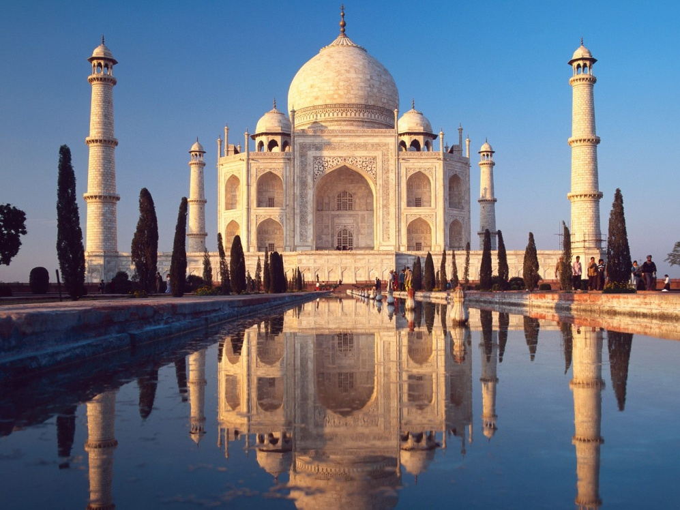
GET MEDITATIONAL SUPERPOWERS WITH ENERGY ENHANCEMENT, LIGHT YEARS AHEAD OF EVERY OTHER COURSE
THE ULTIMATE ADVANCED MEDITATION COURSE
MEDITATION ENERGY ENHANCEMENT
THE CORE ENERGY TECHNIQUES!!
THE MOST ADVANCED MEDITATION TECHNIQUES ON THIS PLANET, IN 28 INITIATIONS!!
ANCIENT EFFECTIVE ENERGY ENHANCEMENT SECRETS -
SUCCESSFUL
TIME TESTED
TRUE
Initiation 7 Pyramid Protection
54 mins 23 secs
Initiation 7 Pyramid Protection
Introductory Talk
38mins 55 secs
Satchidanand: This morning we are going to learn another protection. This is energy enhancement initiation 7, and it's to do with a protection that you would use in meditation when you need that protection against the very difficult energies that you will be dealing with. Total *inaudible protection.
And of course, any protection can be breached. And this is a protection that you would not use all the time, because if you did you would come across very cold. Because the energy could not come from you to the other person. Yea? It would keep you in a box. It wouldn't allow you to feel what's going on, which is of course is what we need to do.
Personally I don't believe in protection, but it is useful from time to time. I always feel, if you've got enough energy, why do you need protection.
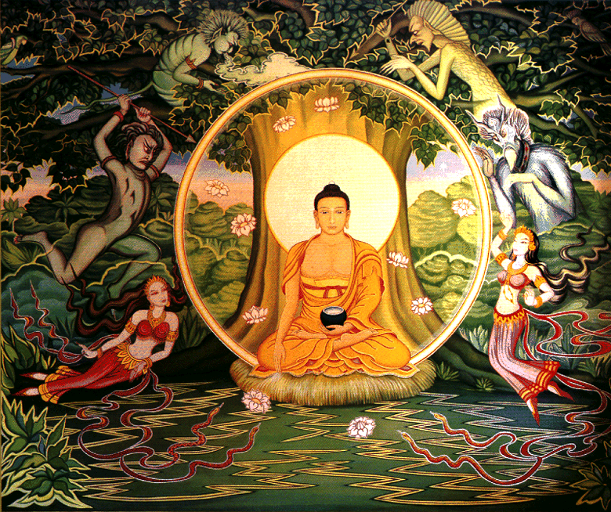
Energy is protection in itself. But having said that, we need protection. But what I want to talk about this morning, is about the music of the spheres.
How many notes in an octave Dhiren?
Dhiren: 7 and the octave 1
Satchidanand: How many notes in an octave Dhiren?
Dhiren: 22
Satchidanand: How many notes in an octave Dhiren?
Dhiren: Infinity
Satchidanand: No 7. There are 7 notes in an octave.
And why are there 7 notes in an octave, because the whole system is created by enlightened mystics. The whole idea of going beyond the octave to the next octave is the idea of initiation. It's the idea of going beyond the beyond. Yea?
So some people have said that you have 7 chakras.
How many chakras do you have Dhiren?
Satchidanand: No you have infinity chakras, wrong again! Haha You can't win can you?
Dhiren: I have no doubt...I am with you all the way, you can say whatever you want.
Satchidanand: It's only because you're having fun
Dhiren: Me too
Satchidanand: And what I want to say, the idea of Octaves, came from Pythagoras the music of the spheres and was informed by a very mystical brain. The idea of going out of the box, thinking out of the box.
Completing the Octave.
Completing the Octave is when you leave the seven chakras of the body and enter into the 8th chakra of the Soul.
You know that is when you go from 7 notes, to the 8 notes, from doe to doe, yea this is completing the octave.
Dhiren: Doe to doe
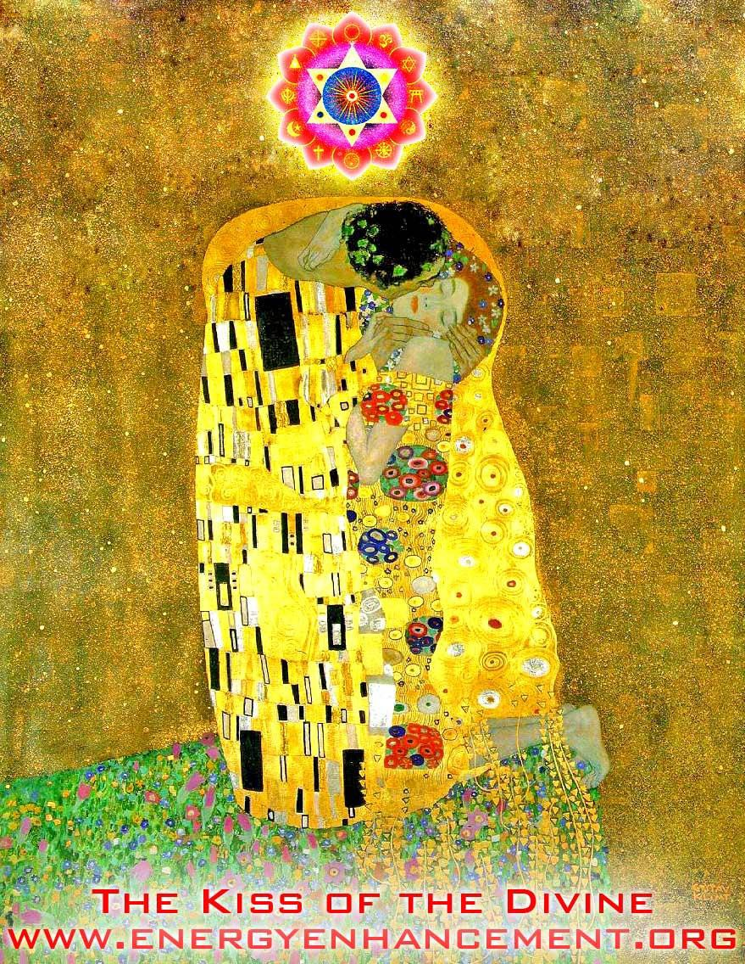
Satchidanand: Thank you Dhiren. Haha. Doe a deer, a female deer, ray a drop of golden sun, me a name I call myself, far a long long way to go, T, sow a needle pulling thread, far a long long way to go, see...tea I drink with bread and jam, and it all goes back to doe.
Haha...And what we're talking about here is the idea that we have more than 7 chakras, well most people don't even know you have 7 chakras. Most people don't know that we have 7 parallel processors within our minds.
But the concept we're bringing in here, with the completion of the octave, is that you have a soul.
You know, you can say this intellectually, you have 8 chakras, you have a soul, but these masons, these Rosicrucians, they sort of want to pass the information on in ways that are puzzling to make you curious, so would you like to learn to complete the octave? Haha
The guys going what? But it sounds good, doesn't it. Yea, it sounds ancient, it comes from ancient times.
Devi: Satchi, Federico asks, 8 octaves, one chakra?
Satchidanand: Haha. Federico asks, 8 octaves, one chakra? Haha. No one octave...
Cut to..
Satchidanand: Sometimes these blockages just don't want to go. You know they give you a really good experience of asking god for a sign, and then these damn blockages make you forget it. And they will, that's their function. And I'm just warning you, that this is what the blockages do.
That is their function, to make you forget. To send you to sleep. Until you can be awakened by the kiss of a beautiful princess, your soul.
Oh where did I get to on the previous tape before it ran out. I was talking about a 33rd degree Freemason. Now one of the ideas behind the 33 degree Freemason, is this is the number of years that Christ lived on this planet, before he attained the 6th initiation.
But, if you think about it in terms of all these chakras, it also means the level of initiation of Christ. So, if you count up from the centre of the earth, 7 chakras, count through you 7 chakras, count up to the soul, 7 chakras, that's 21 chakras, count up to the monad 28 chakras, and then 33 is another 5 chakras up from the monad, between the monad and the logos.
On the other hand I might have it wrong. It might be from the base of your spine, so he might be halfway between the logos and Sirius So I think you've got to go there and find out for yourself.
But that's the idea of it anyway. I don't know. They have all this (deep voice) 33rd degree Freemason, all this encoded information put into it.
Dhiren: It's one thing whether the, my 5 *inaudible experiences, I think its to do with 5, its so strange that you mentioned 5 chakras and then I saw 5 spirits.
Satchidanand: Well perhaps, you'll have to go and ask them.
Dhiren: I'll do that
Satchidanand: You should go and ask a lot of questions and then come back to me with the replies.
Dhiren: Sure
Satchidanand But first, test them out.
David: The centre of the universe and the monad is a chakra?
Satchidanand: Yes.
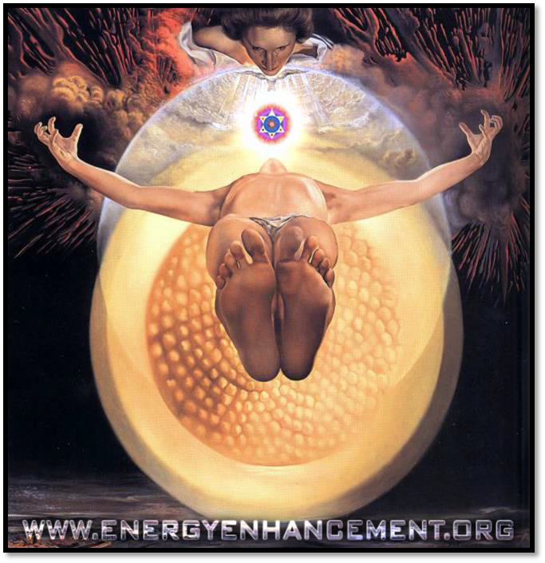
David: *inaudible
Satchidanand: Because you have an infinity of chakras.
All of these things haha are chakras. (Devi translates) They are all chakras. Everything is chakras. Chakras chakras all the way...
So this is a part of your protection, I haven't been wasting your time with all these tales. When you are in a group of people, you can count up the energies by means of these chakras, as long as everybody knows what it means then you're going to be like the guy that went to jail.
And he was very surprised, because there were all the guys in the cell, and they were just saying numbers, they were going 7, and everybody burst into laughter, oh oh that was a good one.
He says what's all this, what's all this he says. He said, oh we've been here for so many years, that we know all the jokes and we've given them all a number. So if somebody says 7, we all know the joke, and we all laugh, we think its wonderful.
He says that's fantastic, 512, and everybody in the cell, bursts into laughter, and they laugh for an hour, he's never seen so much laughter in all of his life, he said why did you laugh so long as my joke?
They said, oh, we've never heard that one before... haha...so remember if someone is counting out.
Devi: I have to translate haha I need to translate.
Satchidanand: So this counting up through the chakras, counting up through the energies in groups, is great providing everybody knows the joke. Otherwise everybody gets totally confused. What are you saying Devi?
Devi: Up, down, down.
Satchidanand: (confused face)
Honey: I still don't understand the group thing. When you're in a group of people you can count up with energy.
Satchidanand: Yes
Honey: What energy, like what do you..
Satchidanand: Well when we talk about different energies of evolution we're talking about going up from you to the soul, and you can say, 7 and you're in the soul, or you can say 14 and you're in the soul, yea from the base of your spine going up
Honey: OK
Satchidanand: So as long as you know that 14 means the soul then you can go up there. So this is how you work in groups.
Honey: So you tell a person in another group?
Satchidanand: If we're together in a group
Honey: Yea
Satchidanand: And we want to do a group meditation
Honey: Yea yea
Satchidanand: To go up through the chakras then we can just say, we're going to count up through the chakras
Honey: Oh I see so everybody understands you.
Satchidanand: Yea
Honey: We've been there so now as a group we meditate together
Satchidanand: You can meditate together
Honey: To reach that level.
Satchidanand: (clicks fingers) Yea It's traditional.
Honey: It creates more energy together.
Satchidanand: Yea you if you meditates together it keeps everybody in tune. Yea? It keeps everybody in tune.
You know the idea of everybody being in tune, everybody being on the same note, is very much like when you're in the army. And your marching along together in step, yea?
You're going (step noises) 1,000 men. And when they walk across a bridge, they found out, that these men, could break the bridge because they were all on the same note.
So when they go across bridges now they have to break step, so they don't break the bridge.
Dhiren: Really?
Satchidanand: Really. Yea, its the power of doing everything at the same moment. So if you can get a few human beings in step, this is the reason behind group ritual. Yea?
If you can get 10,000 people together, and you say 512 haha everybody bursts into laughter, there's a big explosion of energy.
Okay, this is a traditional protection that's been taught for many years for the same purpose. It's a pyramid, its a golden pyramid.
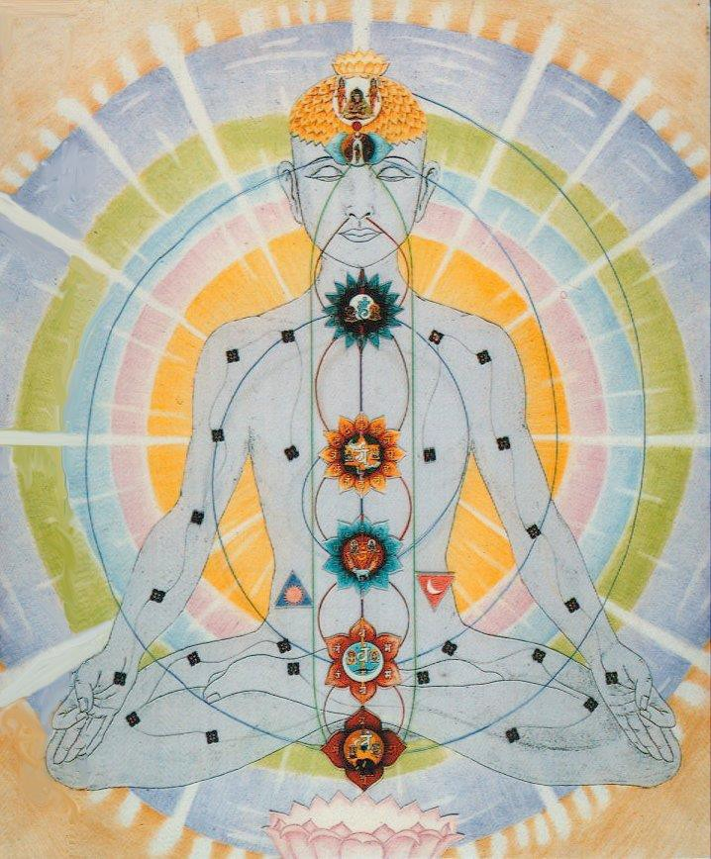
Now you've got to imagine, you've got this golden pyramid around you, you're sitting in meditation, and you've got this square base around you on the floor, and from the vertices, from the corners, the vertices come up and meet above your head so you're sitting in a golden pyramid.
And below you, you have another upside pyramid, yea? You've got the same base to it on the floor, but down below you, the pyramid goes down to a point beneath you.
And this is something I prepared earlier (holds up picture). There you go, there's the guy. Yea, can you see? I'll pass it around so you can all have a look at it.
Yea? So you're sitting inside the pyramid with the pyramid beneath you. And then you're going to imagine that you're going to coat all the sides of each pyramid with gold. Because gold keeps everything out. You know they use lead and gold to protect against radiation, nothing can get through it.
So then we're going to put another coat of gold on, especially around the corners and the edges. Yea? And then we're going to put a golden sphere around that and then on top of that because it's traditional, we're going to put the Christian Cross, but if you're Hindu, I'll let you put the OM sign how's that? Haha. Okay?
You happy, its good because anything that tries to come through that, can't get in. And while you are protected in your pyramid and circle, you can work without any interference.
So it's very traditional when you're meditating, against strong negative energies, like blockages for example, you protect yourself in something like this. It's traditional.
Warning is, do not walk around in a pyramid, it'll stop you feeling existence. I think its far better to feel. Did you know that each chakra had a sense. And what is the chakra which is the sense of touch. It's the heart. The heart comes out through the arms and touches people.

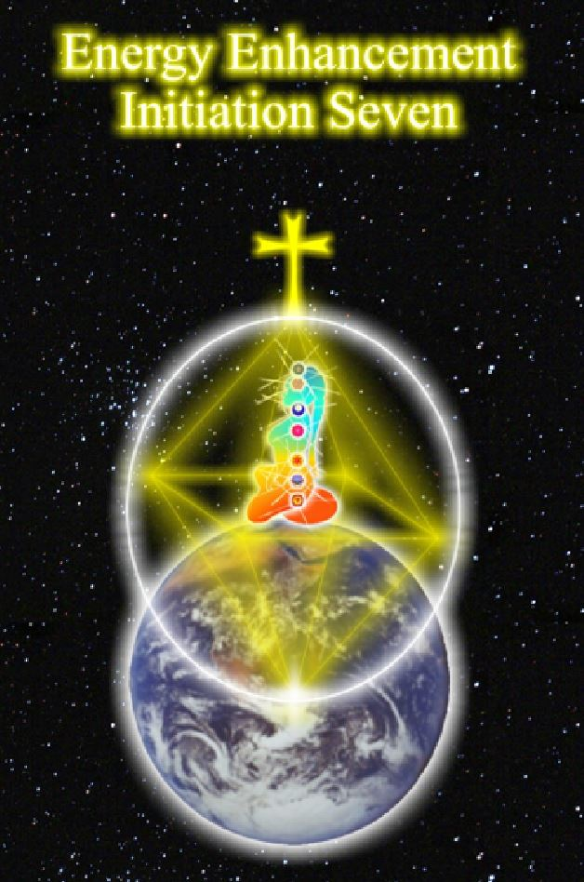
And it touches people psychically at a distance too. And while we are building our pyramids, before we coat them all with gold, we are going to fill the interior of those pyramids with the energy of the highest place that we can go to.
We're going to feel the fizzing energy of the logos or higher, coming into the pyramid, to protect you again.
And we do this by counting up the octaves, now don't laugh all at once.
So I'm going to be counting from the centre of the earth to the base of the spine, 7, from the base of the spine to the top of the head 14, I'm gonna count up from the top of the head to the soul, 21, I'm going to count up from the centre of the soul to the centre of the monad, 28, from the centre of the monad to the centre of the logos, 35, from the centre of the logos to the centre of the Sirius, 42, and then 50, 100, one thousand, ten thousand, 100 thousand, a million, sufficiente? Infinity!
Tune into Canal infinito. Canal Infinito is one of the television stations they have here in South America, and on it they put all of the spiritual things. It's just like that its tuning in your television set to the higher energies, yea its what we do.
Because we can place our mind anywhere we want along the antahkarana,we can channel as much energy from the high levels of the antahkarana to wherever we want to.
Gurdjieff used to say, that a chakra can hold a certain amount of energy, like a capacitor, he said but we want to get out of this small capacitor, and so contact big generator. (whoosh noises). Haha.
And Dhiren had his experience of that this morning. In touch with big generator. God said you take as much as you want, we have plenty here. You take what you want. Don't even have to ask about it we've got plenty. So all you have to do is contact big generator and fill your pyramid with all of of this energy and we're going to coat the pyramid then with the gold a couple of times.
We're going to put the golden sphere around the 2 pyramids, and then we are going to be protected.
Then an infinity of Spheres.
You can even use this construct like a crucible by putting it around blockages.
The construct even causes blockages to ground,to discharge, automatically.
Now, again, you have to put a lot of energy into this the first time you do it. The second time you do it, with these you need to practise them, every time you start to meditate, and if you meet a bad guy, in normal life, you need to be able to put up the shutters, just like that, this is practise, yea because sometimes you meet some bad people who want to vampirise your energies, (sucking noises) with people like these what are you going to do, you are going to put up your pyramids eh?
And then they can't get you. However, you might find that your power towers, the columns of protection...Devi translating. These Spanish, they keep adding in these extra words, they just don't have the umph that the English do, you know, Power Towers...Yes! It's much better. Power towers, yea? This is what we need.
Thank you Honey. Good names. That's going in the book. You might find that your power towers, your columns of protection, your circles of protection are sufficient in these situations, just the simple vampires, this is sufficient but for really bad people you need a pyramid, with infinite spheres, and remember if you use it all the time it will not have a good effect.
You will appear cold and harsh and not be warm with people. But of course you want to be warm don't you? Because when you are dead you are cold and when if you are alive you are warm, and you want to be warm don't you?
Federico: He say he will look like an English.
Satchidanand: Exactly! Haha This is the English. Cold, hard. They come from a cold country. And they have cold hearts. Well that's what they think about you here folks, but its not true is it? No, you're not like that are you? You are very warm.
David: I have a question
Satchidanand: You have a question?
David: *inaudible (Spanish)
Satchidanand: This comes in the next initiation of Energy Enhancement.
Devi: He asks, how do you work with this protection and this blockage. He talk in Spanish and you talk in English. Haha
Satchidanand: Now, there's both of us here thinking in Spanish.
Devi: I can become not here. David asks, how can we work with blockages with this protection.
Satchidanand: And what did I say?
Devi: And Satchi told him we will do that in the 2nd level of Energy Enhancement. Next teaching.
Satchidanand: Okay, so I think we'll have a little bit of a rest and then we will do this meditation shall we? Okay
Cuts to
The Initiation 15 mins 28 secs
Satchidanand: And so concentrate on Energy Enhancement meditation, this time we're not going after blockages, unless they come across you. We're just going to meditate, so take a deep breathe in
(OMM Shanti OMM and OOOO chant)
Satchidanand: Sit up straight, sway a little, get yourself in contact with the centre of the universe, centre of the earth, take a deep breathe in. Take a deep breathe in.
(OMM shanti OMM chant)
Satchidanand: One of the things you can do, you can go up into the centre of the universe, and gain lots and lots of energy, or you can use that energy, the energy of love, or the energy of Shiva, to heal all of the blockages in you, in your friends or in the world. And when you want to work with blockages, and bad negative energies, its good to have some sort of protection. And this pyramid protection, is a protection for your meditation. So shall we sit up? Sitting up straight.
We are going to imagine a pyramid with its square base around our legs on the floor. And from each corner of the pyramid, a line goes up to a point above your head. And beneath you, a line goes down to a point from each corner, so you've got a pyramid above, and you've got a pyramid below. Now, we are going to fill up these 2 pyramids, with the light of the soul. With the highest energy, that we can possibly bring down and the way we do it, is we're going to count, from the centre of the earth from the base of our spine, 7, to the top of our head 14, from the top of our head to the centre of the universe our soul, 21, from the soul to the monad, 28, from the monad to the logos, 35, from the logos to Sirius, 42, 50, 100, 1,000, 100,000, a million, infinity.
Bring down the energy of infinity, Canal Infinito. Bring it around your pyramid, and then holding the energy inside your pyramid, coat the outside of your pyramid with gold. Each of the sides of the top pyramid, each of the sides of the lower pyramid, and then coat all the sides again with gold, this time paying special attention, to the corners and the vertices. Then we create a golden sphere and put it around the golden pyramid and then we put a nice religious symbol on top, like the cross or an ohm sign. And in this pyramid you can then do your meditation.

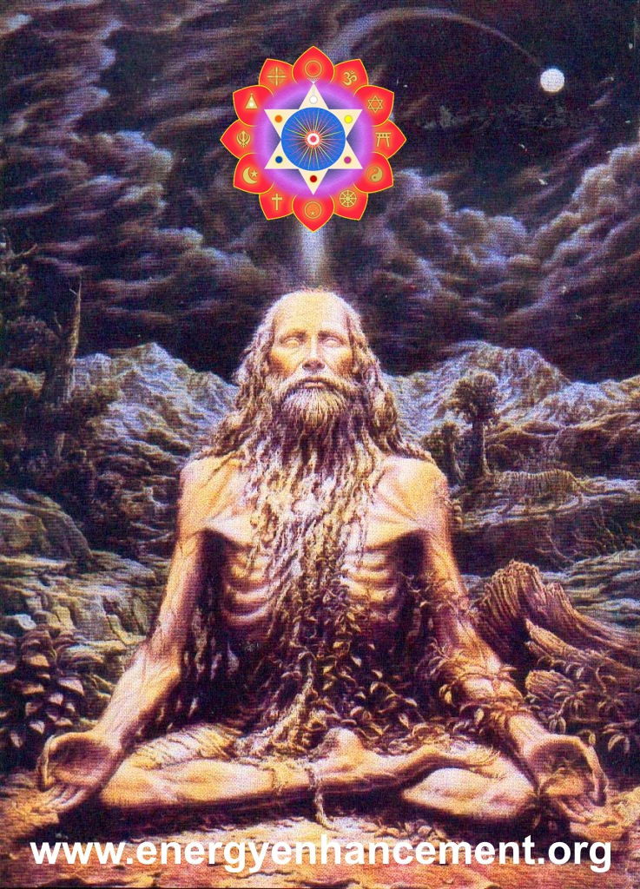
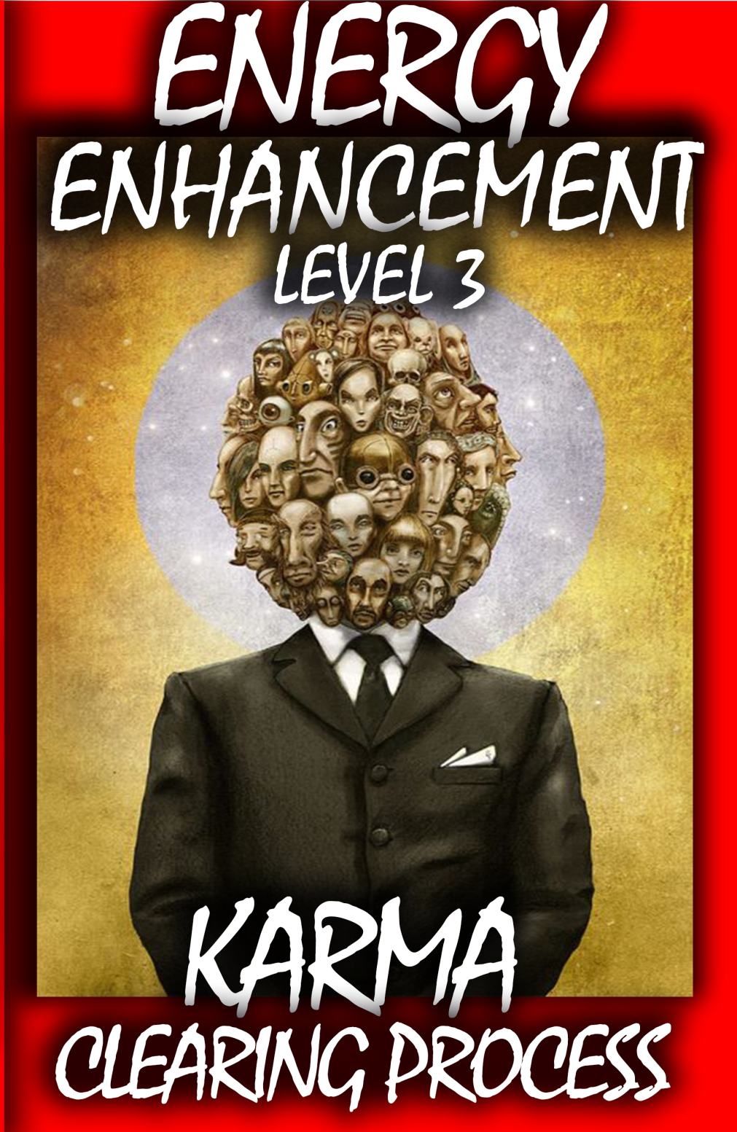
THE YOGA SUTRAS OF PATANJALI BY SWAMI SATCHIDANAND - CLICK HERE..
http://www.energyenhancement.org/Sacred-Energy/yoga-sutras-of-patanjali-book/Energy-Enhancement-Yoga-Sutras-of-Patanjali.pdf
Intiation 8 The Merkaba
1 hour 17 mins 1 secs
Introductory Talk
45min 54 secs
Satchidanand: Well tonight I'm going to teach you the 8 initiations, of the 7 initiations of Level 1 of Energy Enhancement haha. You get this one for free.
And this one is called the merkaba and has anybody heard of the merkaba before? It's very current at the moment, it came from Egyptian times and it's also called the Light Body Protection. And it's spelt M.E.R.K.A.B.A.
And like all techniques, it's very simple. But its very effective. And with the additions that have been invented by Devi Dhyani it's impregnable.
I call this the zone alarm of protection. There's a firewall product in the computers and it's called Zone Alarm. And what it does, is it stops the other computers being able to see you so that they don't know that you are there. Because a protection, if you put enough pressure on it, you can always get through it.

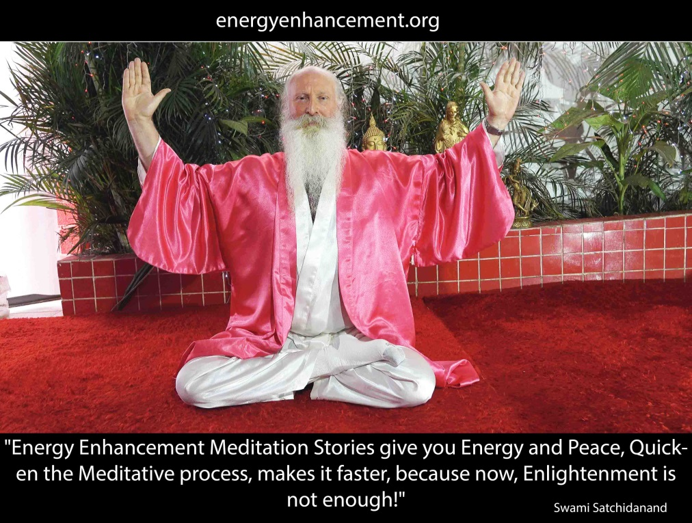
But with this one, they don't know where you are. Good eh? Ah wow, that's what I thought as well. Now, had anybody ever heard of a tetrahedron. It's a pyramid with a triangular base, which means it isn't a pyramid its a tetrahedron. Tetrahedron. (Ramiro comes in to the room).
I'll just say for Ramiro again, that what we're doing tonight is the light body protection and its made up of a tetrahedron. Which is a pyramid with a triangular base. And what we are going to do, is to visualise a tetrahedron and we're going to put 2 of them around us, one pointing up, one pointing down..
And it's like this. (holds up a picture) There you go. And if you look at it in 2D from the side it looks like the Seal of Solomon. So it fits inside a circle perfectly. Yea?
So there you go. Pass that around. Now, you're sitting on the base of the tetrahedron, that's the one that's the right side up. And this tetrahedron is made out of gold. The sides are made of gold. Everything is made out of gold. And it's just like the other pyramid protection really.
But instead this time the upside pointing tetrahedron doesn't fit on the bottom of the other tetrahedron, its base is above the base of the other tetrahedron. And it comes somewhere in the chest, yea?
And now the interesting thing about these tetrahedrons is that they are rotating. Now the one with the point pointing downwards, the lower tetrahedron is rotating anti clockwise.
And what happens when something rotates anticlockwise? It forms a connection with the centre of the earth. All of the negative energy inside that tetrahedron is pushed into the centre of the earth. It forms its own connection by its own rotation.
And the upper tetrahedron, the one that you are sitting on, that rotates clockwise. The base rotates clockwise.
And what happens when something rotates clockwise? It forms a connection with the centre of the universe.
So we have something..and can you imagine its rotating at the speed of light this thing and if anything comes towards it, it deflects it.
And in a way, its a little like an astral spaceship, you set this thing up around you and then in your astral body you can go in meditation and you can go anywhere.
Good eh? Good for when you're looking at blockages.
Now, the extra little bit, is that Devi Dhyani added on because she's a genius is if you compress all of this and you compress it and you compress it and you compress it to the size of a golf ball.
If you compress it to the size of an atom. And you compress it even further than that it forms a black hole and pops out of existence.
But your point of view is still there, you can still see. But they can't see you. What about that then eh? Phroar, Devi Dhyani is a genius. I think she's been here before. Well done Devi Dhyani. This is really good this, I tried it myself a few times, works a treat.
Florencia: Florence got a dream when she went to sleep.
Satchidanand: Oh wait wait wait is this a commentary...would you like to give her a microphone
Devi: she got a dream last night.
Satchidanand: I had a dream! (MLK)
Florencia: *inaudible. In a dark place, and she was very small. And he was saying to her, continue your dream and he will go through a black tube. She was feeling in all her body, she was going through this dark tube. She was becoming dizzy even when she was lying down. And she thought she was *inaudible disappear. And there she was a lot of fear.
Satchidanand: Is Nipun on the roof? *inaudible I locked the roof because it was open. And then?
Florencia: She was with a lot of fear.
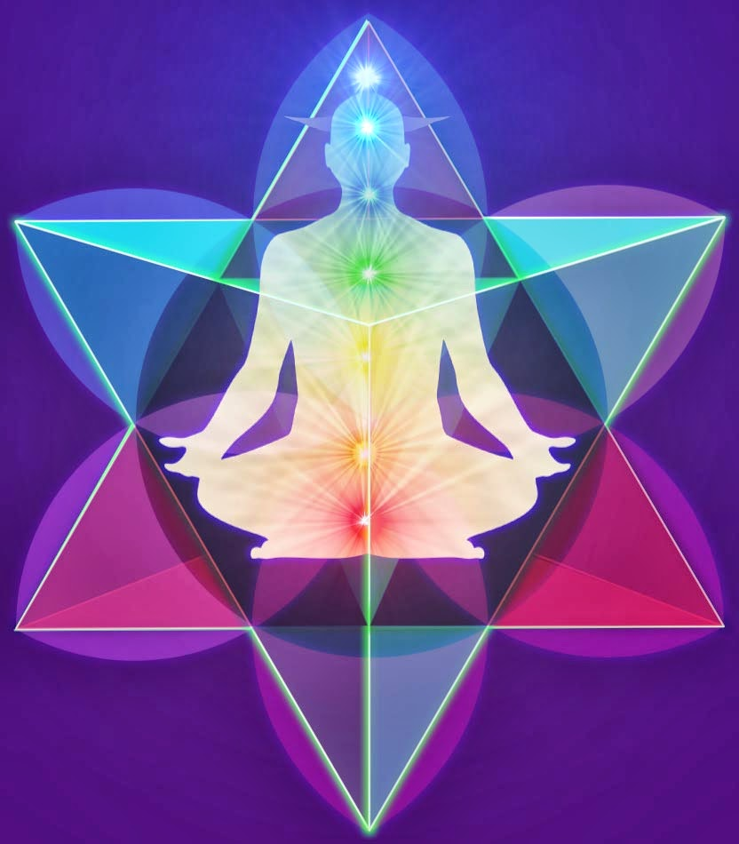
Satchidanand: Well, well. So this experience is exactly the experience that these protections are meant to protect you against. Yea? Because when you get a bad guy like that, and that was not me, it was somebody pretending to be me.
Florencia: She perceived it wasn't you.
Satchidanand: No, this was a blockage, pretending to be me, wanting to frighten you, away from learning something really good for yourself. They wanted you to leave the course. So what do you do with a guy like that.
You put up your protections that's what you do. You practise your protections. Everyday you practise them, so eventually you just go BOOMPH, just like that, you just, tight, one second, protection is there.
And then when you know your second level techniques of Energy Enhancement, safe in your protection, you ground it. You take it down to the centre of the earth, you just get rid of it totally. Because there is no reason to be afraid of anything. Because you can handle everything with these techniques. So the least you can do is your protection, next time. Okay?
Florencia: She couldn't sleep all the night long, it was that bad. She couldn't go to sleep all the night long, she got up.
Satchidanand: So you got really afraid by that. And you know when a blockage contains lots of very deep, dark, dense, negative energy, they can radiate that density too and it make you afraid and then they gather that fear from you which is newly created negative energy and they use it for their fuel. In a way, its like that film, Monsters, did anybody ever see Monsters the film.
David: Monsters
Satchidanand: Monsters, its a cartoon for kids.
Honey: Yea with the factory thing.
Satchidanand: Yea the factory thing.
Honey: Yea yea
Satchidanand: Well what they do there is they go in and scare all the kids don't they, just like Florencia was scared. And then they take their energy from them. And use it for their fuel.
David: haha we is a factory
Satchidanand: Well there are many factories on the astral plane. And that's their job. That's how they gain their fuel.
Honey: If they make you scared...the energy
Satchidanand: Well you give off that negative energy...where's the water Devi...
Honey: I didn't know that about the dreams. People used to get surprised, why don't you dream?
I said I really don't know. I close my eyes, go to sleep and then I wake up this morning and I never..
Satchidanand: That's because you go OM/home every night.
Honey: Probably, I never realised I did the Oms like that
Satchidanand: Do you always wake up with lots of energy in the morning?
Honey: Most of the times. But I would sleep very less normally because I work quite long hours. So I fell asleep at 3.30 sometimes...yea...and I wake up so sometimes...and it goes on 7 days a week so...
Satchidanand: And when you wake up?
Honey: Probably around 9.30, so I do wake up sometimes at 10 because sometimes I'm completely..
Satchidanand: Completely..
Honey: But when I wake up and it goes on again til 2 or 3 in the morning.
ENERGY ENHANCEMENT IMMORTALITY LIVE COURSES, INDIA AND IGUAZU FALLS
ONLY THE SUPERPOWERS DEVELOPED BY THE SCIENCE OF REAL MEDITATION CAN FREE HUMANITY TO REACH THE STARS.

ENERGY ENHANCEMENT MEDITATION ENLIGHTENMENT AND ILLUMINATION

THE INCREDIBLE MEDITATION COURSE AND MEDITATION TECHNIQUES CREATED TO PRODUCE ENLIGHTENMENT AND ILLUMINATION

"ALL TRADITIONAL MEDITATIONS HAVE BEEN DESIGNED TO FAIL" - SATCHIDANAND -

"BECAUSE ORIGINALLY ALL MEDITATIONS CONTAINED THE TECHNIQUES OF, "THE KUNDALINI KEY" AND OF, "ALCHEMICAL VITRIOL" TO GROUND NEGATIVE ENERGIES AND TO NATURALLY INCREASE KUNDALINI ENERGY"

"NOW, ONLY ENERGY ENHANCEMENT MEDITATION TEACHES THESE TECHNIQUES WHICH SPEED UP THE ENLIGHTENMENT PROCESS"

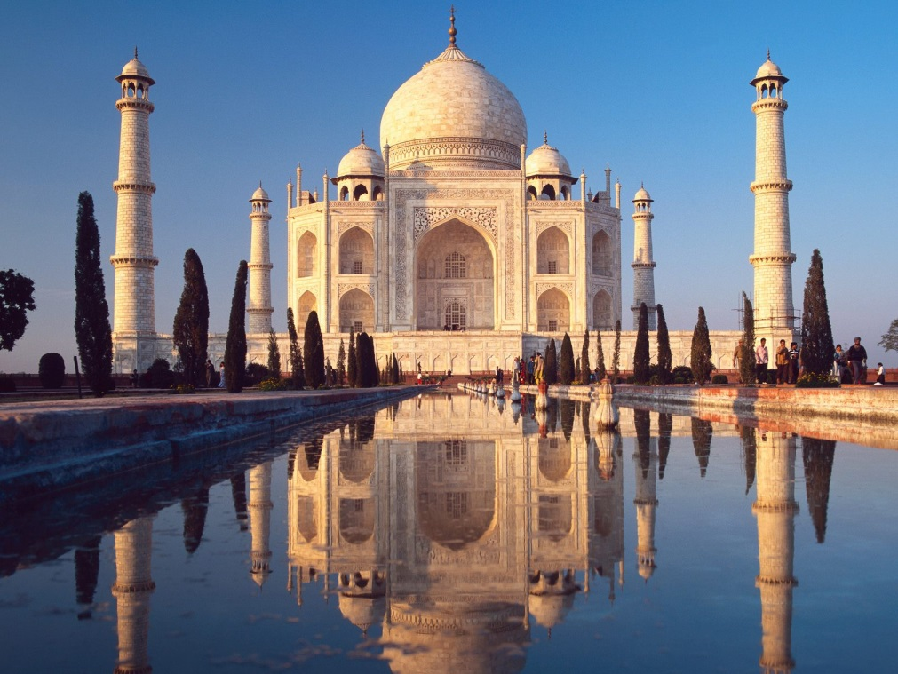

Reincarnation, Immortality and the Removal of Karma
Energy Enhancement Meditation Energy Blockages and Soul Splits, Clean Past Life Karma, Master Relationships

Devi: Honey, you always was like that ever since you were small?
Honey: Yea since I was 17, 18. Even when I was school I was still studying, Saturday, Sunday I would fly to New York and Spain and places like that, to do my shows.
Devi: When you were studying?
Honey: When I was studying, when I was 13 14 years old, I used to
Devi: Ooohh so young.
Honey: Yea..so that's why I never thought there was anything different. It was only when I got older, I must have shared that with people and they would say huh you were at school when you were 13 14, erm you were at school when you were 13 or 14 years old and you know in the weekends you're flying to New York, Spain, Greece, places like that.
Devi: Beautiful
Honey: To do my shows..
Devi: When you were studying 14 years old you were flying to do your shows.
Honey: Yea, and then when I was 16 17, I was doing choreography for big concerts, and everything, I was like little, and there was all these big stars, Bollywood stars and celebrities, who I was working with. And 2 or 3 years before I worked with these Bollywood stars I would say to my mum, one day I will be working with these people, and my mum would laugh at me, and she would..oh sorry..(Devi translates).
Oh God, those were fantastic translations, I would have never been able to do that. But erm, yea so that's how I used to know 2 years in advance what I'm going to be doing, and I used to think about it, and it would always happen. Yea and the reason I was just sharing this, because although with my busy lifestyle, when I go to sleep I never have dreams,I just wake up in the morning. So its very rare that I dream, very rare, but I do dream, but very rare.
Satchidanand: So how long do you sleep for normally Honey:
Honey: Erm, I do need 7-8 hours sleep, but I normally get about 6 hours.
Satchidanand: That's the same with me. I get 5 or 6 quite well.
Honey: Yea and I work 7 days a week. And during the day I'm very energetic. So there you go. I just thought I was telling you...but its a different kind of lifestyle which I realised that I was living from a very young age, but what it taught me was how to deal with people, how to work with people from different countries, how to communicate.
And finally it just helped to expand my way of understanding things, I looked at things in a bigger way, instead of straight. Because I had the chance and the opportunity to see that, things, people from differently, people look at things differently, you know, so I expanded my way of thinking as well with them.
Ramiro: Do you have dreams?
Honey: Very rare, when I used to say that to people they'd say, oh there's something wrong with you. haha So I would try to have dreams.
Satchidanand: hahaha
Honey: So each time I put my head on the pillow, I'm literally sleeping, and then I wake up and its morning, every time
Ramiro: What is the meaning of that?
Devi: Did you dream before you do the practises of meditation?
Ramiro: What is the meaning of ...did you dream before you meditate Satchi or..?
Satchidanand: Before I started to meditate I used to dream but when I started to meditate, little by little the dreams went away and now I only dream of other people.
For example when I travel on Indian trains, we all sleep together, and I find myself on everybody else's dreams, I call it Coronation Street. It's a telly novella...And its a very low place. It's the basement of the astral plane. It's not very nice at all, its very boring. I much prefer to be in the light.
Natwaral: But this dream state, that's not in your hand, they come and go, I mean, you cant say you want to dream but you don't want to dream, they come or they will not to come, how will you know about the dreams.
Satchidanand: Well Ramana Maharshi, when he was a young boy before he became enlightened he used to dream...
Devi: Wait because I need to translate Natwaral.
Satchidanand: Okay...When he was a young boy before he became enlightened, he used to dream, sorry, he used to sleep very deeply, so deeply in fact, that nobody could wake him up, and he never dreamed, and people used to take their revenge on him at night. Because no matter how much they beat him, he wouldn't wake up. This sleeping is a very strange thing. Buddha used to say, I never go to sleep. I just place my body in one place and it stays there, quite relaxed. Yea, but I never go to sleep. I once asked Zen Master Hogen, er what time he went to sleep. He said about 12 o clock. I said what time do you get up to meditate, he said about 1 haha.
Honey: Oh dear
Satchidanand: Honey was saying that she goes to sleep and she does not dream. The same as me. And the same as Devi.
After we started to meditate, we found we did not dream anymore. As a matter of fact, every night we go OM which is the same as home.
Because Honey is almost enlightened. If she does not fail she will become enlightened. Its a matter of removing a few blockages. There's a few things like disappointment that need to be overcome. Oh yea, you lot have got a lot more. But that doesn't matter, because its always the last blockage that is the worst. So screw yourself up here Honey, you're gonna need all your strength.
Honey;Hahaha oh dear me......Shall I go grab some more water quickly.
Cuts to
Satchidanand: There we go.
David: David says sometimes he goes signify dreams, but he thinks its important to dream like that.
Satchidanand: Erm well I normally get them when I'm awake, what else do you think I'm doing here, at this very moment. I am getting messages. I'm channelling.
You don't think I know all this do you? No, the aim is not to get all your messages when you are asleep. This is a very inefficient way of doing things. You know there are people who channel other people. Have you ever been to one of the seances where there's a guy and he sort of goes to sleep, and then all of a sudden he wakes up and goes Oh look at me I'm another person etc No?
Well I prefer to channel myself. Yea? Which is a little bit higher than my normal state. It knows a lot more this thing above me. Err and its a way to really think big I think. You know? Yea, because this guy up here he knows an awful lot more, he's got the big vision. He's in charge.
I think many people have said it's very dangerous to channel other people. I'm not so sure if that's the case.
But definitely I feel myself, although my mother was a medium, and I have that sort of propensity I think I've never wanted to go that path. I've always felt as though I've wanted to channel myself. Yea?
How else is real intuition going to come down. Mind you, many a time I go to bed with a problem, and when I wake up in the morning I know the answer. So I always like to go sleep on it.
Gurdjieff used to describe this process very beautifully. I really recommend you to read Beelzebub's Tales to his Grandson. And in that process he talks about, all the various processes inside, coming together.
He says my common presence he calls it, my common presence. And he says he's got all these things inside that just work on it all in parallel.
He was describing a parallel processor, yea and the answer just pops out and the answer is 42. What is 6 x 9? They ask the planet. And they waited 10 billion years for the answer and when it came out, it was 42. Situation normal.
Devi: I don't understand.
Satchidanand: You mean, you never saw The Hitchhikers Guide to the Galaxy Devi?
Devi: No
Satchidanand: OK, well there you go then. Okay, satisfied?
David: Yes but..
Satchidanand: Haha, no I'm not satisfied. You see this is English culture. It's something like onion culture (Kulcha) That's Indian culture also. What do you have to say David?
David: No, I understand you.
Satchidanand: Yes. Because you can train yourself, never to go to sleep. When you put your head down to the pillow, you can inhabit the astral plane. About 25 years ago I read a book called Journeys Out of the Body by Robert A Munroe.
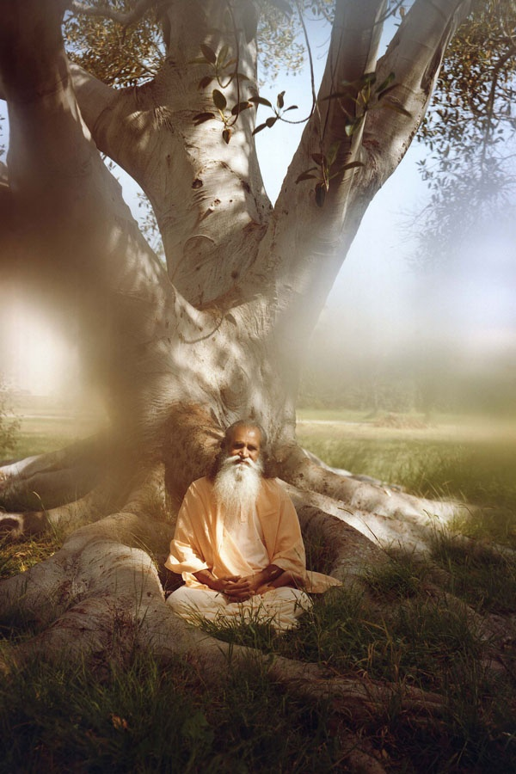
SATCHITANANDA

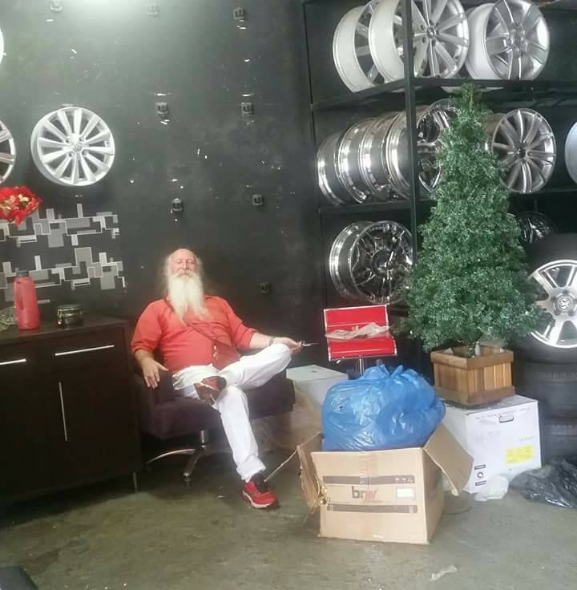
SATCHIDANAND "PAPA NOEL" AND THE CHRISTMAS TREE
Who founded later the Munroe Institute in the United States. And this guy was a very talented guy he could go out of his body very easily and you talk about seeing the aura, when he was outside of the body he could see everything. And he was interested in training people to do the same. And I think its a very interesting training I'm sure its very good. I heard of people going to the Munroe Institute and although Robert Munroe is now dead, they all report that they meet him during the training on the astral plane. Seems like he was successful at being an Ascended Master. I prefer to teach people to do exactly the same thing in meditation while you're awake rather than going to sleep to do it. Okay folks.
Devi: Another question...Ramiro want to do a question..
Ramiro: He asks because he would like to understand correctly. He got another *inaudible into the dream. When you go to sleep your soul comes out from your body. For the body the rest, and you have another experience in another dimension.
Satchidanand: Yea this is very possible.
Ramiro: And this is defined as a dream? And he can not understand it is possible without dream. He say he would like to understand how its possible not to dream. He would like to know what is your reply connected with the dream, because he got this information from another master, they say to dream is good, because you can go out to another plane and learn to see. He would like to learn about the concept of dream.
Satchidanand: I think what both Honey and I are saying is that when we go to sleep we go so high we go to God. This is what I meant by OM. And when you go to God, you get some very high teachings indeed. You get lots of energy too. Whereas normal dreams half the people who don't quite go so high, yea, so they learn things at that level also. But you might not know it but on the Energy Enhancement course, we are teaching you to do the same things whilst waking. Eventually we will integrate our right and left sides. Our concious and unconscious sides. Shall we do the meditation? Does everybody understand the concept?
Honey: Just one question, about the, you know we talked about the anticlockwise pyramid...
Satchidanand: Erm not a pyramid..
Honey: Hydra erm..yea that..tetra
Satchidanand: Tetra means 4. Its 4 sided.
Honey: 1,2,3,4 is like a pyramid right?
Satchidanand: No, its got 1, 2, 3 and the bottom is the 4th.
Devi: You want to do the picture.
Honey: Oh. Ah yea I see. Oh I see, 1. But then, okay the triangle we'll be sitting in as well. It's trying to, oh its not a square OK
Satchidanand: Yes that's right.
Honey: I'm seeing a square
Satchidanand: Aaah, well its...ooh dear (Student knocked glass of water over) I think we need to get a cloth... erm Ramiro, could you go to the – (student gets up) Yea..Dhiren will go to the kitchen.
Honey: Ah something has to stop me going for his haha
Satchidanand: No, they stand no chance.
Honey: Is it like a triangle of a pyramid.
Satchidanand: The base is a triangle of the tetrahedron. The base of the tetrahedron is a triangle and not a square.
Honey: The base is a triangle and it goes up like this.
Satchidanand: Yes
Honey: And there's another one that comes up like that from the top. One goes this way, one goes that way.
Satchidanand: Well not like that, its actually in that direction.
Honey: Ahh now I understand.
Satchidanand: Yea. Yea
Honey: It's like the, the bottom of,
Satchidanand: Like a top, yea that's right. You can do that with both hands? You're a genius.
Honey: Even through my meditation I was making my spirals with my hands. Yea, so that's how you do it. So that's all it is. It's nothing more.
Satchidanand: It's simple. Everything in Energy Enhancement is just very simple. Nothing complicated.
Honey: The circle around it is for what?
Satchidanand: The circle is just to show you, that if you look at it from the side it looks like the Seal of Solomon, the Jewish Symbol, that hexagon. You look at it from the side it looks like a hexagon. Have a look, does it look like a hexagon.
Honey: Lets see
Satchidanand: It looks like a hexagon. 6 points. A 6 pointed star.
Honey: Ah this is what you mean, a 6 pointed star...
Satchidanand: That's what I mean, a 6 pointed star.
Honey: Okay yea yea.
Satchidanand: Yes. Oh good a 6 pointed star.
Honey: Lets try this. I can see properly now.
Satchidanand: Yea good. Its very important to get the visualization of this correct. Yea? So does everybody know what I mean? Bien. Because this is a dead good protection. I think its even better than the pyramid protection personally. But the pyramid protection is something you can do in a group meditation counting them up etc whereas your merkaba is very individual.
Devi: (Yawns)
Satchidanand: Aww Okay,
Initiation 14min 22 secs
Satchidanand: Okay sit up straight everybody, sit up straight, sit up straight. Lets do the meditation. (Victorian English accent) I say shall we do the meditation this time.
Dhiren: Jolly good old chap
Satchidanand: I say old chap.
Dhiren: Yes?
Satchidanand: Shall we do the merkaba eh?
Dhiren: Why not? ...Sharp sharp pain here
Satchidanand: A blockage probably lad.
Dhiren: I was breathing deeper and saying the OM thing.
Satchidanand: Ahh, oh dear, don't do anything, rest it. Don't do it so much in future.
Honey: Too much energy.
Satchidanand: Yea
Dhiren: No I like to keep the OM going as long as you would do it.
Satchidanand: Yea?
Honey: Oh that's what happened you were trying to -
Satchidanand: Well you've got to practise the heart sutra everyday for 20 years.
Dhiren: I think what happened was, when I took a dip, right this spring came up.
Satchidanand: Oh it was the alien.
Honey: Oh I've seen loads of those in my *inaudible at the moment.
Satchidanand: Okay sitting up straight lads.
Devi: Florence is going to the toilet.
Satchidanand: Okay, we'll wait for Florencia
Cuts to
Satchidanand: Sitting up straight. Spine absolutely straight. Swaying your head. I want you to visualise that you are sitting on a triangular base. And from each corner of the triangle, bring a line up to above your head where they meet, at the tip of the tetrahedron, and then create another triangular base at about the level of your heart centre and move the lines down to beneath you from each corner of that triangle to the tip which is beneath you.
Two intertwined tetrahedrons. And the tetrahedron which is upside down with the point below you, I want you to make that rotate, I want you to make the base rotate, anticlockwise.
And as you make that rotate anticlockwise, as it moves very fast, I want you to feel the negative energy is being pushed down through the tip into the centre of the earth.
The mind is a computer. You set up the visualization to work and it keeps on working. And then the tetrahedron who's base you are sitting upon which its tip above your head, make that base rotate clockwise. And make it rotate very fast.
And as you do that, feel that it is creating a connection to the centre of the universe above you.
Feel that the 2 opposing rotations are connecting you up and down. And as you increase the speed of the rotations, to the speed of light, which is very fast, feel that you have created a rotating protection around you.
If somebody sends energy towards you and the rotating pyramids deflect whatever is sent towards you. And sitting there in meditation in your merkaba, you can float off around the universe on the astral plane. And now I'd like you to compress, the merkaba with you inside of it to the size of a golf ball.
And then compress yourself even further to the size of an atom. And as you compress yourself further, you wink out of existence but your point of view remains.
You can still see, but they cant see you because you've moved into another dimension. This is the zone alarm of protection.
Satchidanand and students sit.
Cuts to
Satchidanand: Pass to Ramiro (mic) Okay folks. Erm, how are we doing with our meditations...would anybody like to comment on when they were meditating on the merkaba? Ah Federico-
Student Merkaba Experiences 16mins 45 secs
Satchidanand: Yea, bien, uno momento Federico
Federico: First of all the initiation was very good with the 2 tetrahedrons. I felt like the last exercise, a lot of connection and energy, and *inaudible.
Satchidanand: Bien, okay.
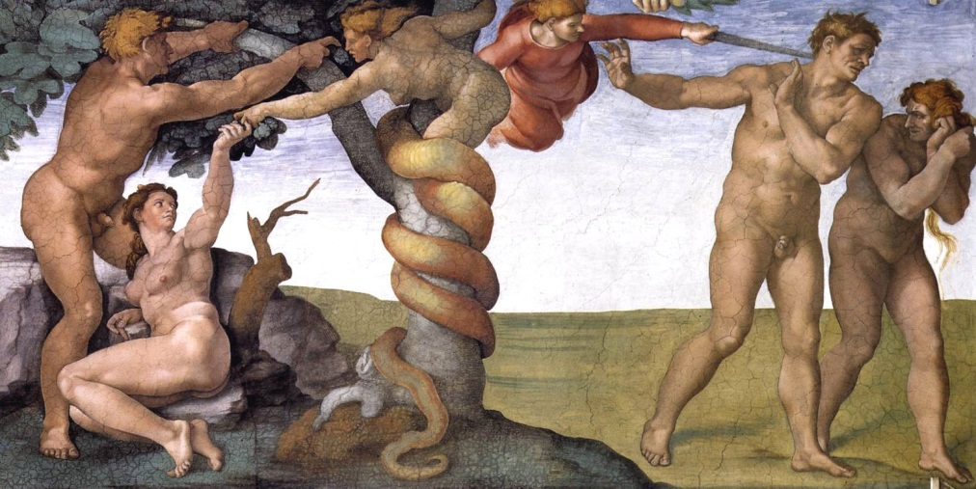
Honey: That was very interesting as always. I made my spaceship kind of a tetra triangle thing.
Satchidanand: Haha tetra triangle thing.
Honey: There was so much energy that came down from the heavens above to give the strength *inaudible. And I created a special little whirlwind when we did the anticlockwise like a tornado to go down to the mother earth.
Satchidanand: The lower tetrahedron does that for you, it pulls you down.
Honey: Yea so its like I can visualise anything that gonna come its gonna get sucked back down again. And then of course I compressed it until I was nothing, from a golf ball to nothing. And then I happily went to have a little a little journey around the plane.
Satchidanand: Inside your merkaba, spaceship.
Honey: Yes, nobody could see me, nobody could see me. I saw lots of souls, lots of little souls, moving around, hanging around by themselves. Don't know what that was. So I thought I don't really wanna be in this place. I don't think I wanna be here.
Satchidanand: It's not very high.
Honey: Yea. So I moved up even further to monad and there I saw hiding behind these groups of people like little beings, angel kind of beings, my group soul people, the group soul, behind lots of little people, hiding behind them a stack of clouds. Hiding behind them was a stack of black clouds, one after the other, all stacked up, hiding in the back. Because I could see them behind hiding so I went aha so I went above them with my little vibration tornado thing. Just went whoosh! Pushed them down. Straight to the earth.
Ramiro: All the clouds back to the earth?
Honey: Yea, they just went in a pile. Because they were hiding on top of each other. And just went straight down and got burnt off.
So I thought right let me go a bit higher now, let me go and see somewhere else. So I went up to logos...I'm getting the Spanish and English mixed up haha.
Now when I was above the..I saw the nothing there, but I went a little bit above the logos and suddenly I saw all these battleships hiding from me. And there was a whole load on this side and a whole load on that side.
And I spoke to my spiritual masters saying uh oh there's loads of these around me. I'm not sure what to do exactly. (repeats for Ramiro) The spiritual masters say don't worry, get the energy and we'll get rid of them right now.
So I got all these energies back through my head erm and the way I saw it was, there was me in my empty space, and there was 7 spiritual masters, whoever they are, and on top of that there was like a tree, with lots of branches, so all the energy was coming from all the branches, through to me and my 7 spiritual masters. And I was also connected to the tree kind of thing, with lots of energy, and erm the 7 spiritual masters were doing this to me (palm healing) and so I was getting lots of energy as well.
Yea so the energy came down to Sirius, came down further down between logos and Sirius, where the battleships were.
Ramiro Between Sirius and logos
Honey: Yea, and then I got so much energy, so I went right in one go, they didn't even know I was there you see.
Satchidanand: Because you were hidden in your merkaba.
Honey:Yea they were waiting for me. They were thinking she was gonna be here anytime now. So in one go I went whhoosh. And what happened was all these nets came out in one go from where I was, grabbed every single one in one go (SFX noises) all of them, all around and one
Dhiren: Like a fishing net
Honey: And it turned into like a metal thing so it became hard so they cant go anywhere. And there was one little ship that started escaping. So I said oh my god, oh my god, its going it going its going its gonna come and get me. Haha.
So the spiritual masters kept don't worry go on just push it go go go go put the netting even further. And I did the net one more time, and it just pulled it back again and it got that last one.
Yea so anyway, and then I took them altogether, it was so heavy to take them all in one go, so I brought them all down, and I thought which hospital do I have to take them to, I wasn't sure. And I was told that I need to take them between the monad and the logos, to the hospital between those two. So I brought them back down, took them to the hospital and there was sooo many of them. Oh my god.
Satchidanand: Devi said people forget to discharge.
Honey: Ah because for me I just took them to the hospital, I was thinking, do I get them down and then I thought then I'm supposed to look after these, erm beings, or give them lots of love, and take them to the hospital, because I was going to send them down, a whole load of them, but I thought, because I'm up there, am I supposed to take them to the hospital...
Devi: *inaudible
Honey: Aaah so that's what I, maybe it was difficult haha
Satchidanand: Difficult...difficult
Honey: There was so many of them. There was like, oh gosh, there were so many of them, like piles of them and so I asked the archangel to please help me, and the archangel came and took them, bit by bit, in the hospital. And he said well done to me haha Thank you so much. And even the archangel said to me, I cant see you but I speak to you through (touches temples), I can understand you, I know what you're saying
Satchidanand: He couldn't see you even.
Honey: No
Satchidanand: This merkaba is really good eh?
Honey: Yea,
Satchidanand: Yea
Honey: He couldn't see me. We were speaking telepathically you know just like through mind. And then there was 2 questions I asked whilst I was there because once I killed them off I was hanging around doing nothing, so I asked who these 7 spiritual masters are.
I said is it my Guruji and Yogi Bhajan? And they said no, Yogi Bhajan is somewhere between logos and Sirius He's helping me there. And Swamiji my Guruji he's around the Sirius area. But he's going to grow and grow and grow and he'll be one of my guides on the top. So he's still growing. That's what they said to me.
Then I asked about the 7 spiritual masters and I was getting a little bit tired, a little bit, I was feeling so much here (crown), I was feeling too much of the energy when I was talking directly so I quickly got told one Egyptian, one Buddhist, one Indian, Christ, and there's 3 more, and they said come back later on and we will, we're still stronger but there's still more energy and we will talk further.
So I couldn't, because I was feeling (SFX buzz) when I was talking I was getting quick ideas, but I like feeling all this (buzzing) too much, I felt too much of the energy there so I thought I'd come back down again.
Satchidanand: Very good.
Honey: Yea, so I did wonder, maybe explain to me, about the, what I have to do to these hundreds and thousands of baddies
Satchidanand: Absolutely, that's what we're here for.
Honey: And they're like...they're like aliens. They were quite horrible looking. And even earlier today, I went to a planet where they said come here, in my pyramid and I said no I think I better go back. Yea, and again they were like those alien kinda of looking..yea
Satchidanand: Blockages.
Honey: Very bad blockages. And these were like thous- hundreds,there were just piles of people coming through the spaceships through the hospitals
Satchidanand: haha
Honey: There were so many. And I was going, aah come on quick now. Haha Too many. Getting tired watching them. But no, that was my experience.
Satchidanand: Haha. Woo. Excellent. Yea. Well done Honey (students clap) *inaudible
Honey: I think I've been watching too many Star War movies.
Satchidanand: Haha, well, I think as a commentary to what I could say to Honey, with regard to what Devi was saying Discharge them first! Discharge them first!
That in Energy Enhancement there is only one truth, that which works. And if the archangels gonna say well done, what am I gonna say? Eh? Haha.
But, our experience says that it is very difficult to manage even just one spaceship if you don't ground it first.
Yea, this negative karmic mass that the bad guys have a lot of, is very heavy. It's no good at all. And in order to get them to the hospital sometimes you know because very heavy these guys, you usually got to ground them to make them lighter. Yea?
Now if you're really strong like these little girls around here who's got no muscles on the muscles at all but spiritually she seems to have a little bit of strength, what is this? Haha
She pulled all these thousands of millions of spaceships into the hospitals, asked for help and all these guys just threw them in. Boomph. Boomph. Boomph. Yea?
So there are no rules. It's that which works. Yea? And the main thing is. Get rid of all the blockages. Yea?
This is what you need to do in your system. And the higher the blockage the more dense it is. The more dangerous it is.
Now we move on to Energy Enhancement Level 2 – the Seven StepProcess for the removal of Energy Blockages from all the Infinity of Chakras in the Antahkarana – the column of energy between heaven and earth, the Aura, the DNA, and your timeline of Karma, the star of the Karma Cleaning Process of Energy Enhancement Level 3.



WITH THE ENERGY ENHANCEMENT COURSE BUY A STAIRWAY TO HEAVEN

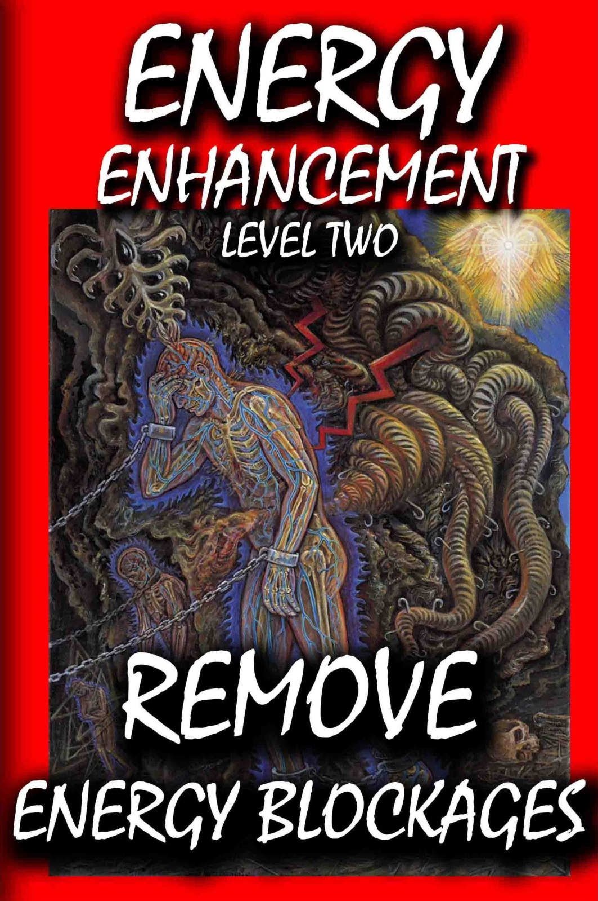
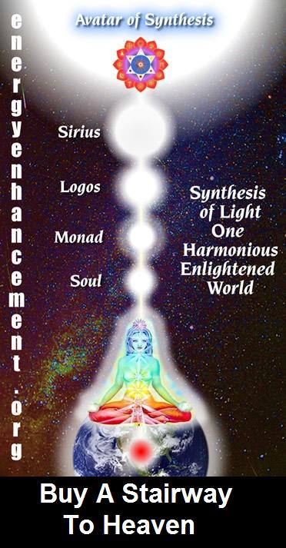
BUY A STAIRWAY TO HEAVEN
WITH THE ENERGY ENHANCEMENT COURSE
STUDENT REPORT
Also I noticed as soon as Satchidanand emailed me, I got a down-pouring of light from above the crown which kept charging me up the rest of the day – and my cravings died out! Then I realized the cravings were ego-blockages and that I did not want them.
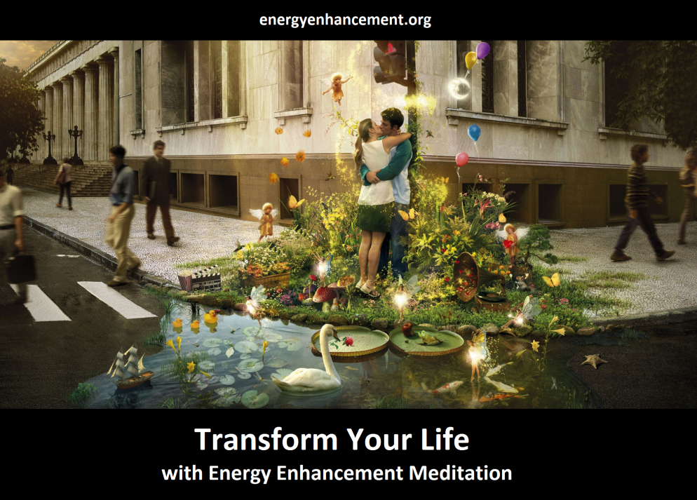
Energy Enhancement says that there are an infinity of chakras above the head up into the Center of the Universe and above, high above the head, ending in God, just as there are an infinity of chakras below the base - "As above, So Below" - Hermes Trismegistus from the Emerald Tablet.
INCREASE YOUR INTELLIGENCE - THE PARALLEL PROCESSING SUPERCOMPUTER YOU!! Energy Enhancement says that each chakra within you and above the head is a computer processor with higher and higher frequency, speed and capacity as you go higher. So, like a parallel processing supercomputer, the more chakras you can get working in the Infinity of Chakras above the Head and the more chakras you can access, the more chakras you can disblock, the more chakras you can augment, the more intelligent, the more intuitive, the more wise you will be.
FUSING WITH THE SOUL CHAKRA - Energy Enhancement says that just by fusing with the soul chakra one can see all your past lives and remove all blockages from all your past lives in one sweep, fast!!
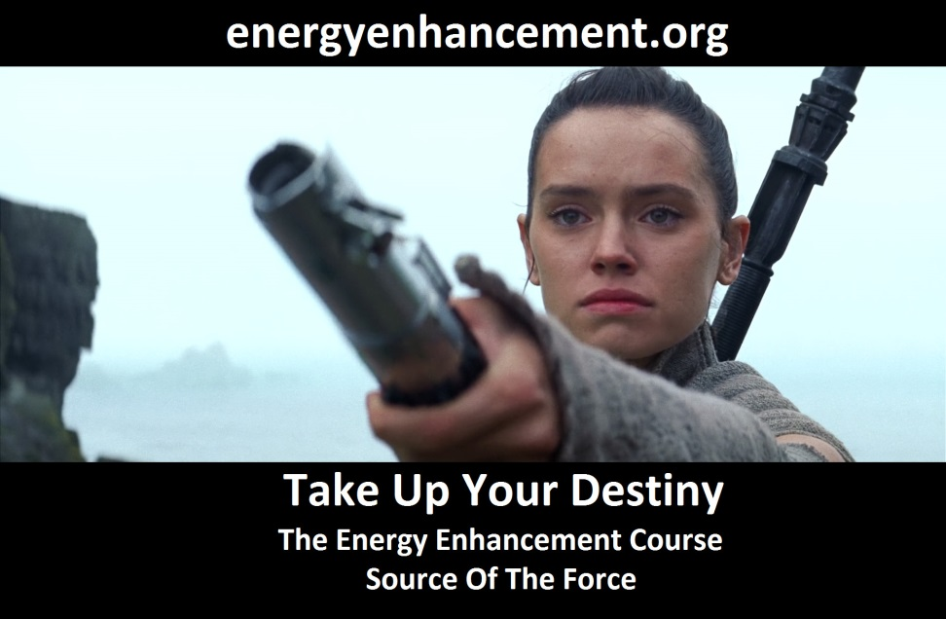
FUSING WITH HIGHER CHAKRAS - THE SOUL, MONAD, LOGOS, SIRIUS, AVATAR OF SYNTHESIS - Energy Enhancement says that it also contains the secret of Initiations Higher that Illumination - "Enlightenment is not Enough!!"
EE LEVEL 1 POWER UP!! GAIN SUPER ENERGY http://www.energyenhancement.org/Level1.htm
EE LEVEL 2 ELIMINATE ENERGY BLOCKAGES http://www.energyenhancement.org/Level2.htm
EE LEVEL 3 CLEAN KARMA BLOCKAGES AND PAST LIFE KARMA BY TRANSMUTATION http://www.energyenhancement.org/Level3.htm
EE LEVEL 4 MASTER ENERGY CONNECTIONS AND RELATIONSHIPS http://www.energyenhancement.org/Level4.htm
ENERGY ENHANCEMENT - THE ULTIMATE MEDITATION COURSE!!
“Traditional meditations are designed to Fail” – Satchidanand
FUSION WITH THE SOUL CHAKRA - Enlightenment - is Only the first Dan. Become fused with the Monad - Second Dan. Become fused with the Logos - Third Dan. Become Fused with Sirius - Fourth Dan. Become Fused with the Avatar of Synthesis - Fifth Dan - Satchidanand
Research The Energy Enhancement Meditation Course by video or on retreat..
The Ancient Enemy who counts meditation and the mind control psychic arts as one of its main planks of ing, International Companies, Eugenics - Worldwide, censoring Alchemical VITRIOL, the Kundalini Key and Energy Blockage Removal from every Meditation Program..
WE HAVE SO MANY ARTICLES SHOWING THE ORIGINAL EXISTENCE OF THESE ESSENTIAL MEDITATION TECHNIQUES IN EVERY WORLD RELIGION..
NOW, SPEED UP YOUR PROCESS WITH ENERGY ENHANCEMENT ALCHEMICAL VITRIOL, KUNDALINI KEY AND ENERGY BLOCKAGE REMOVAL ON THE PATH OF ENLIGHTENMENT
GET IT NOW!!
EMAIL sol@energyenhancement.org
LIVE COURSES, INDIA AND BRAZIL - IGUAZU FALLS

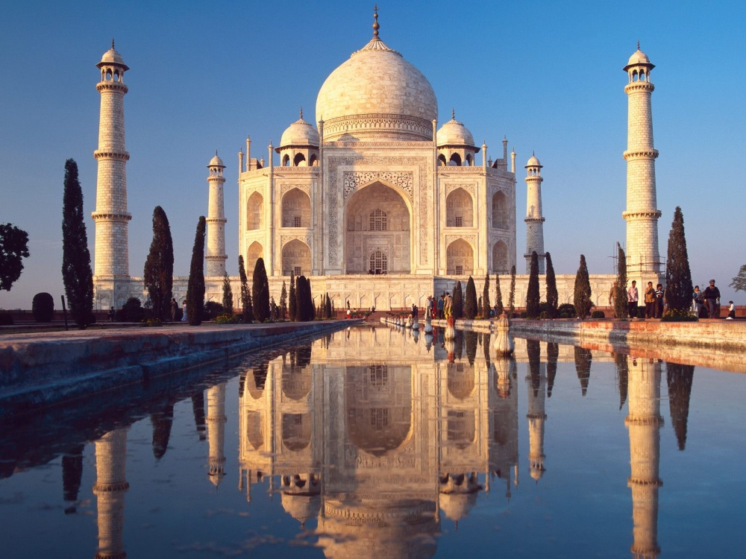
GET MEDITATIONAL SUPERPOWERS WITH ENERGY ENHANCEMENT, LIGHT YEARS AHEAD OF EVERY OTHER COURSE
THE ULTIMATE ADVANCED MEDITATION COURSE
MEDITATION ENERGY ENHANCEMENT
THE CORE ENERGY TECHNIQUES!!
THE MOST ADVANCED MEDITATION TECHNIQUES ON THIS PLANET, IN 28 INITIATIONS!!
ANCIENT EFFECTIVE ENERGY ENHANCEMENT SECRETS -
SUCCESSFUL
TIME TESTED
TRUE
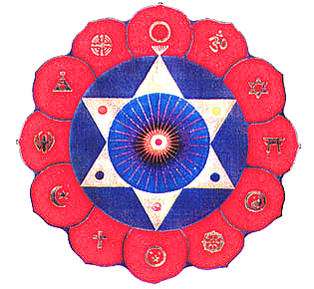
Bookings: www.energyenhancement.org
