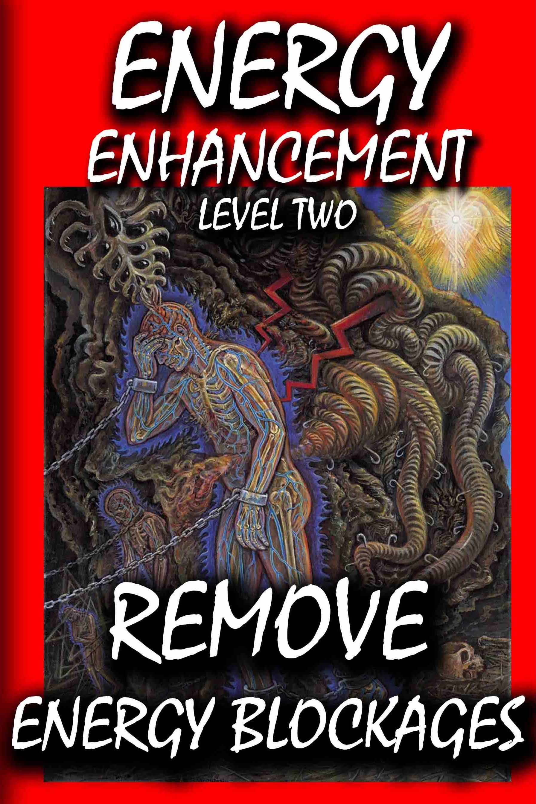

DEDICATION

With all Thanks, Love and Gratitude to Swami Devi Dhyani and the Energy Enhancement Book Editor Prema PraShakti who makes these books possible.
With all Thanks, Love and Gratitude to my Mother and Father and to all my other Teachers, Theos Bernard, Sri Yogendra, Eric Berne, Gurdjieff, Father Bede Griffiths, Osho, Zen Master Hogen, Swami Sivananda, Swami Satchitananda, and all the other giants upon whose shoulders I stand - who made me able to be what… I AM – Swami Satchidanand

Copyright © 2018

[Energy Enhancement Synthesis of Light Limited (SOL)]

All rights reserved. This publication may be reproduced in whole or in part, by any person under fair use as long as we are referenced, without written permission of:
Swami Satchidanand

sol@energyenhancement.org

www.energyenhancement.org

sol@energyenhancement.org www.energyenhancement.org

THE ENERGY ENHANCEMENT MEDITATION COURSE - LEVEL TWO

THE REMOVAL OF ENERGY BLOCKAGES WITH THE ENERGY ENHANCEMENT SEVEN STEP PROCESS

ILLUMINATION, ENLIGHTENMENT - INCREASE THE ACTION OF THE LAW OF ATTRACTION - IN YOUR LIFE - NOW!!
INCREASE YOUR EXTERNAL AND INTERNAL WEALTH - WITH ENERGY ENHANCEMENT

"ALL TRADITIONAL MEDITATIONS HAVE BEEN DESIGNED TO FAIL" - SATCHIDANAND -

FIND ALL THE INCREDIBLE TECHNIQUES REMOVED FROM TRADITIONAL MEDITATIONS -

DESIGNED TO FAIL - AND TAUGHT IN ENERGY ENHANCEMENT

"WE PUT BACK WHAT THE OTHERS TOOK OUT!!"

THE REMOVAL OF ENERGY BLOCKAGES TO INCREASE THE LAW OF ATTRACTION - REMOVE ENTITIES AND IMPLANTS WITH ADVANCED ENERGY BLOCKAGE BUSTING TECHNIQUES –

THE ENERGY ENHANCEMENT SEVEN STEP PROCESS

“When Qi flows freely along the meridians, people are free from illness; If the Qi is blocked, the pain follows.” Ancient Chinese Saying

"You Know, Removing all your Energy Blockages is a Really Good Thing" - Satchidanand

THE ENERGY ENHANCEMENT SEVEN STEP PROCESS IS AN UNFAILING TECHNIQUE WHICH CAN REMOVE ANY ENERGY BLOCKAGE
LEARN IT NOW!!

COME ON A MEDITATION ENERGY ENHANCEMENT APPRENTICE LEVEL 1 and 2 COURSE!!

COME AND GET EXPERIENCED!

CLICK HERE!! FOR WHAT WE ARE DOING

EMAIL
sol@energyenhancement.org

FOR DETAILS
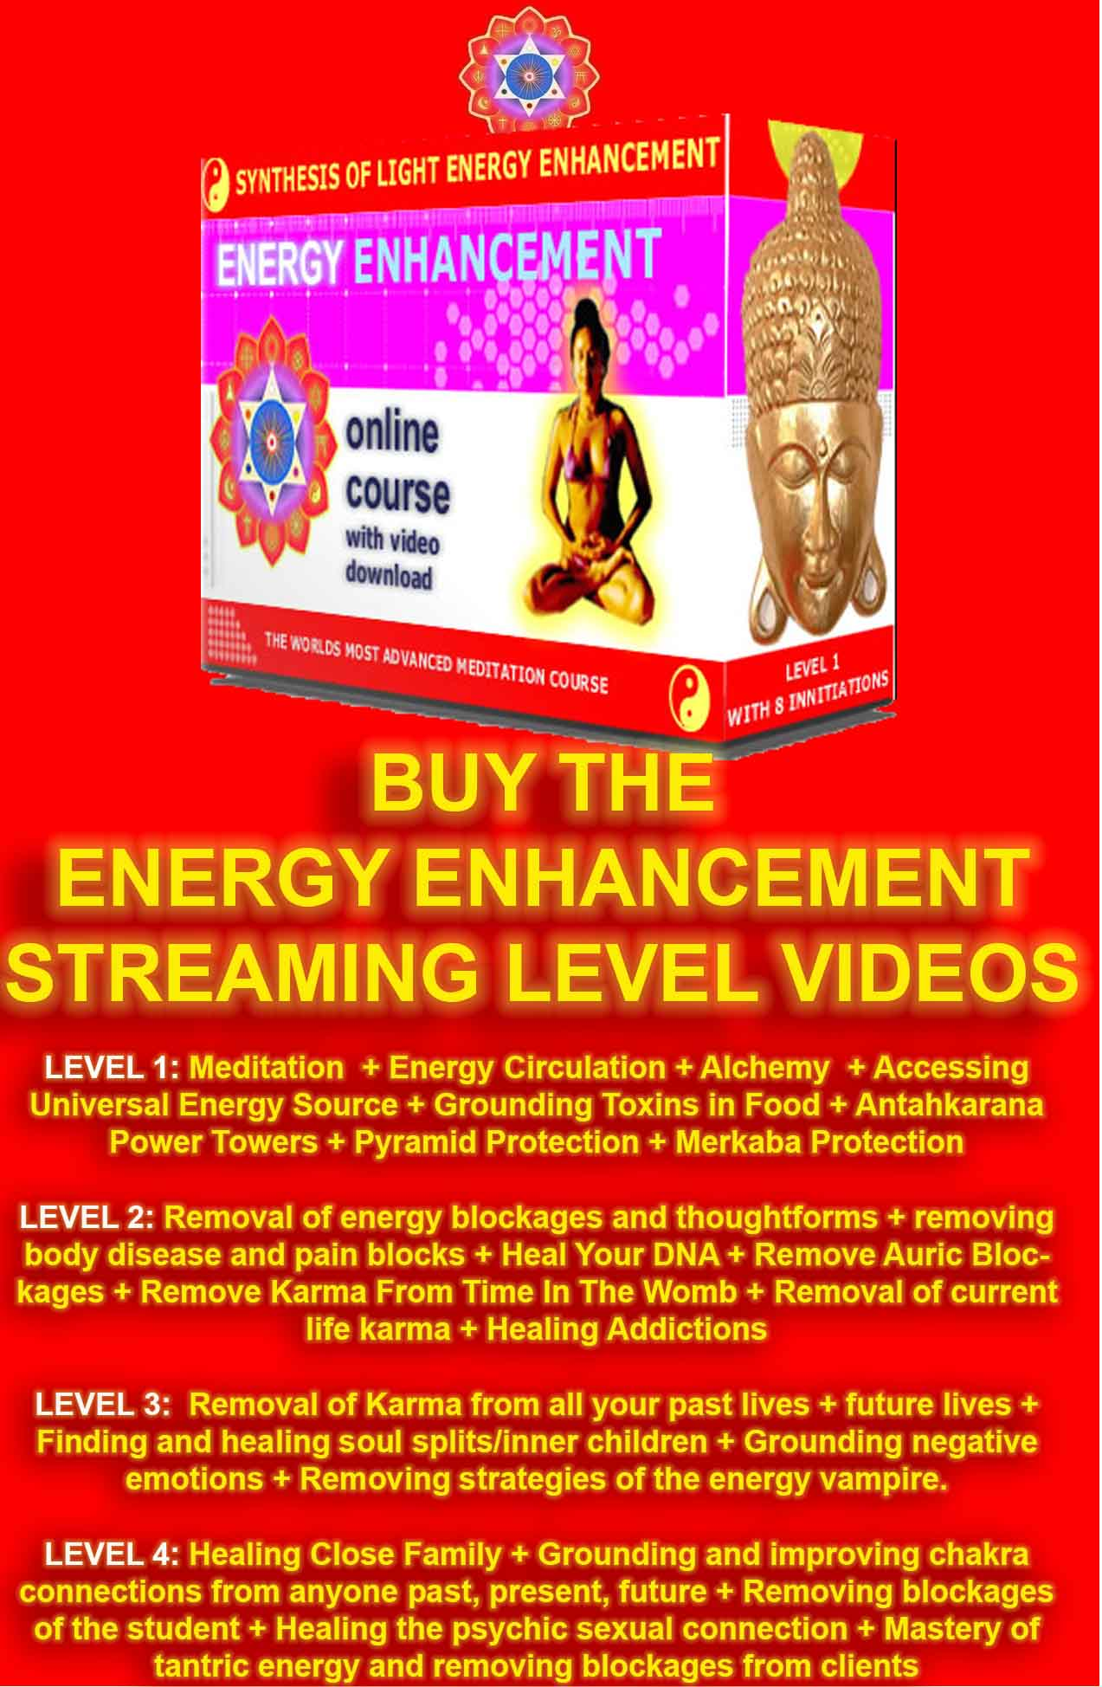

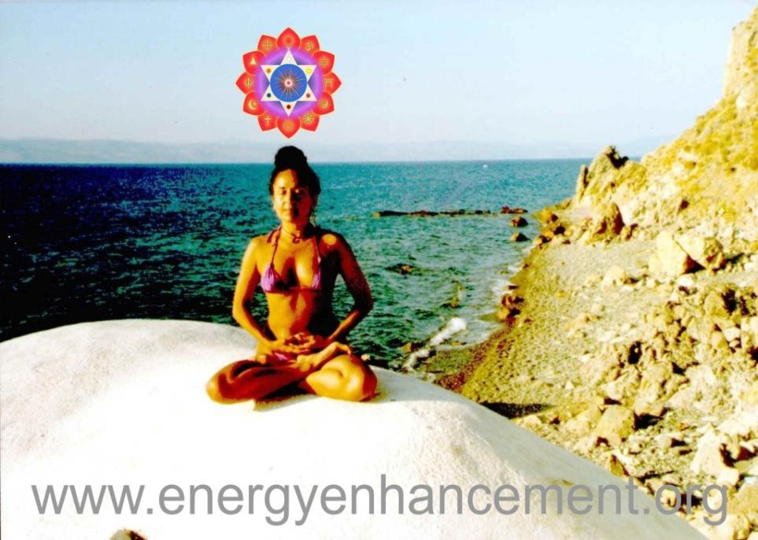
ENERGY ENHANCEMENT DEVI DHYANI

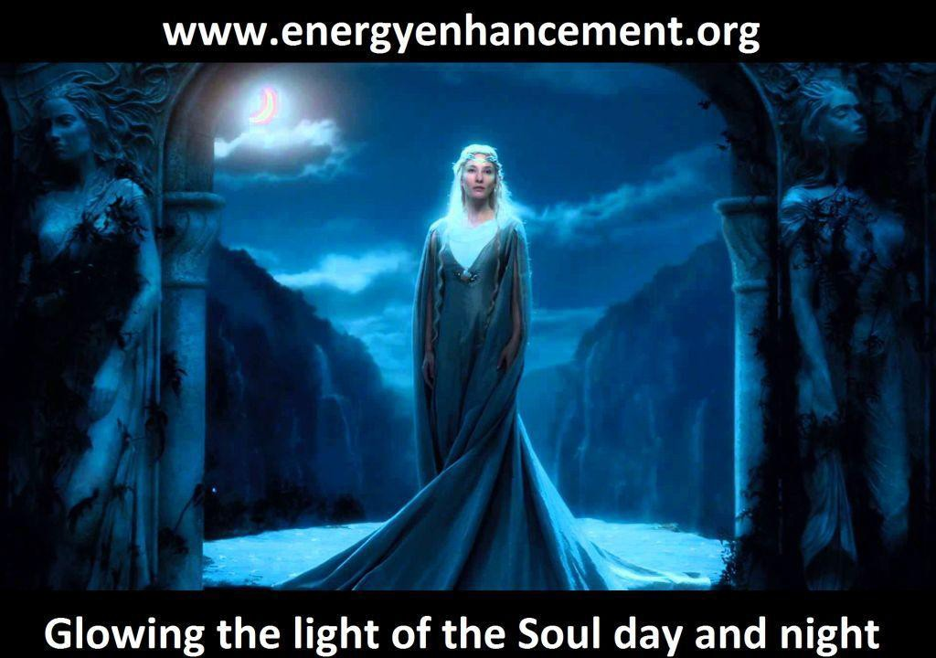

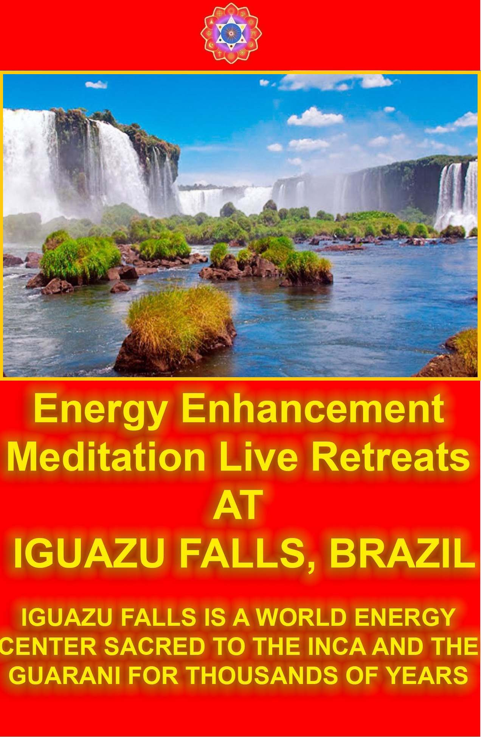

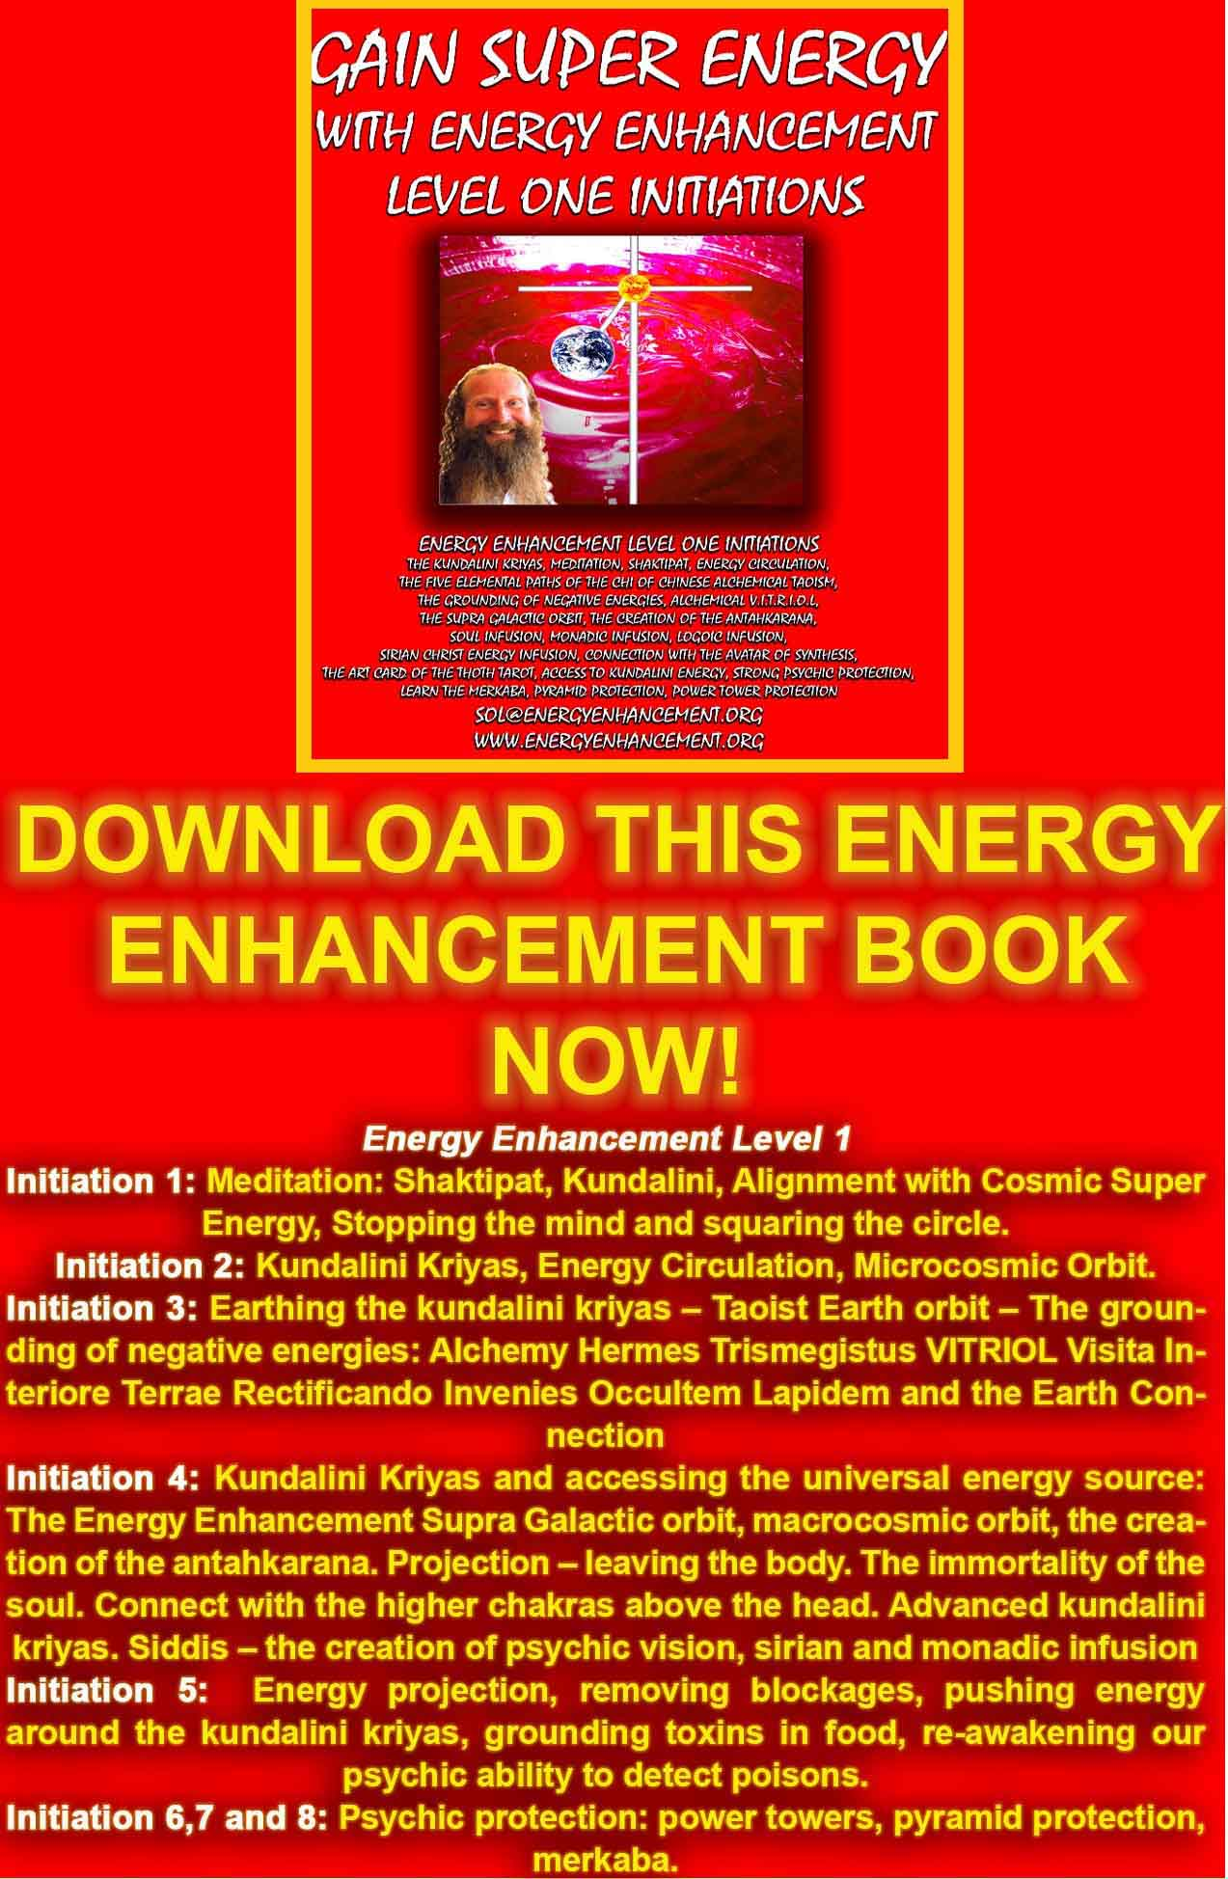
DOWNLOAD “GAIN SUPER ENERGY WITH ENERGY ENHANCEMENT LEVEL ONE INITIATIONS HERE!!!
http://www.energyenhancement.org/Sacred-Energy/Gain-Super-Energy-Energy-Enhancement-Level1-Initiations-Kundalini-Kriyas-Meditation-Shaktipat-Circulation-Taoist-Orbits-Alchemy-VITRIOL-Grounding-Psychic-Protection-Pyramid-Merkaba-energyenhancement-org.pdf

HACK YOUR MIND
Learn the Anti Energy Blockage Hack Technique to Remove Energy Blockages and Escape From the Matrix

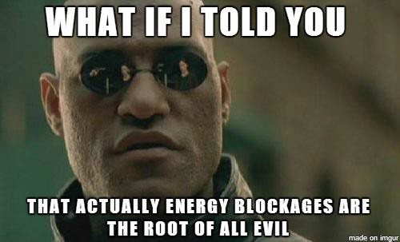
Learn the "Energy Enhancement Anti Energy Blockage Hack Technique" and Free Your Mind Once and for All.

If we consider a human being as containing seven parallel chakra processors within the body and an infinity of parallel chakra processors above the head and below the base, connecting us to the Universe, then the more of these parallel chakra processors we can access, the more intelligence we have.

What stops the access to these parallel chakra processors is Energy Blockages.

We need to learn how to "Hack" these Energy Blockages to remove them so we can access our native genius. The Geni being the Soul Chakra, the first Chakra above the head.

Yet as we remove more of the energy blockages and access many more chakras, even more intelligence is possible!!

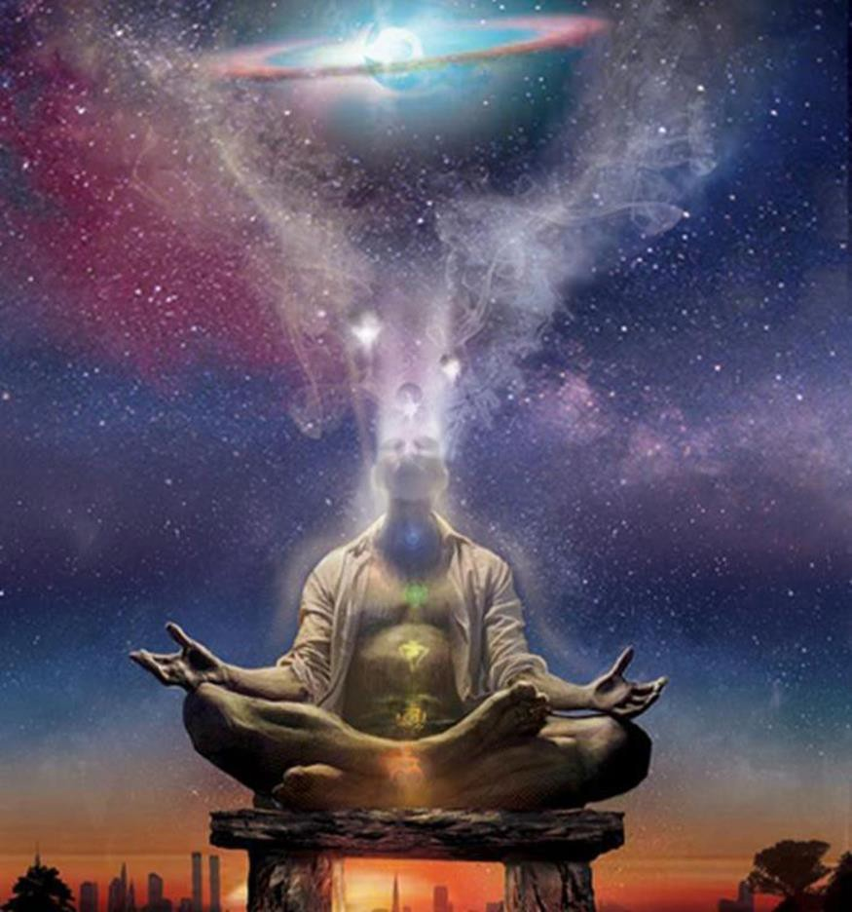
ACCESSING THE INFINITE CHAKRAS ABOVE THE HEAD - CONNECT WITH THE INFINITE ENERGY OF THE UNIVERSE

How aware are you of these energy blockages beings each stealing the limelight from awareness?

We all desire stillness and control within our minds, and prefer our inner domains to be free from disruptive thoughts that cause us to react.

Reacting in this context means thinking more thoughts resulting from energy blockages that were primarily implanted by the Luciferian Archons (The ego) that know you better than you know yourself!

These entity energy blockages live by thought alone and use thought to manipulate this reality by implanting thoughts into all of humanity.
We direly need to be free from all energy blockages. An energy blockage is a thought that has been
energized to the point of gaining it’s own life and
dominion within the psyche of the captive’s mind. It literally is a created entity that lives within a person that wants its own way.

An energy blockage can be compared to a stuck tape — its patterns and reasoning are repetitious and serve to keep you in frozen malfunction, or an unconscious existence.

You become like a computer trying to function with an energy blockages virus; everything is a struggle and your frequency is slower than it should be.

Energy blockages become ingrained into your mind and rule your life while you are unconscious.

Many of us have become slaves to the consequences of being a victim to the Luciferian egregore group of

thinking entity energy blockages, that gain more access to our minds through matrix-based information constructs, such as words, numbers, shapes, colors and sounds.

The sad fact is that the more thought-based illusory knowledge and information you have uploaded, that has arisen out of this 3-dimensional experience, the easier it is for you to become a victim from the very data that you have absorbed.

Once you start considering this holographic realm of energy blockages to be real and science or religion guiding beacons to the truth, then you become imprisoned into the Matrix.

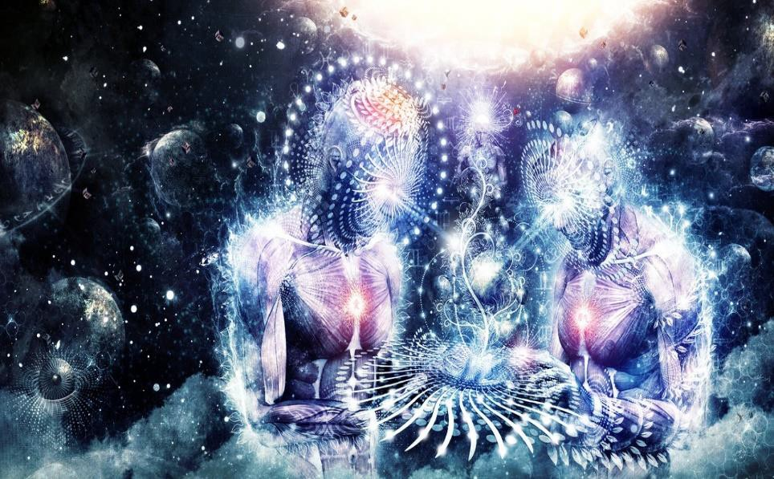
Disconnected from the Universe you become imprisoned into the Matrix, in THINGS!!.

The longer you live by the Logic-Based, Thought-Based, Laws the harder it becomes to regain your conscious mind from within the holographic reality.

Remember that words originate from thoughts, and that thoughts create light. Thoughts are a frequency because they have an energetic vibration; vibration is energy and energy glows as light.

Although this light cannot be perceived with our limited sight, it is real and it is what creates this light-based reality that conjures matter.

We learn the alphabet and the number system in school so that we may curse ourselves and render ourselves spellbound by all those letters and numbers that quantify our eternal, omnipresent nature.

We all have energy blockages uploaded into our consciousness, otherwise we could not manifest in this reality. At the very least, you believe you are real. That thought will, by all means, keep you around on the face of the Earth.

Gravity is an energy blockage, energy is a energy blockage, and even time is an energy blockage.

None of these written thought-based laws are real, but they are made very real by us, by the beliefs we absorb from the mainframe thinking construct that permeates its frequencies through our minds, which are programmed to receive from this false light, which is the great deceiver, father of lies.

Everything of the light is broadcasted from all knowledge-based institutions that insist reality is only what we are able to perceive with the five (very limited!) senses.

The senses are open to thought-form suggestions

All the senses are receivers that are tuned to tune into the third dimensional matrix experience.

They only serve to experience the illusion. The belief that they, alone, experience reality, creates the limited world of a physical third dimensional existence.

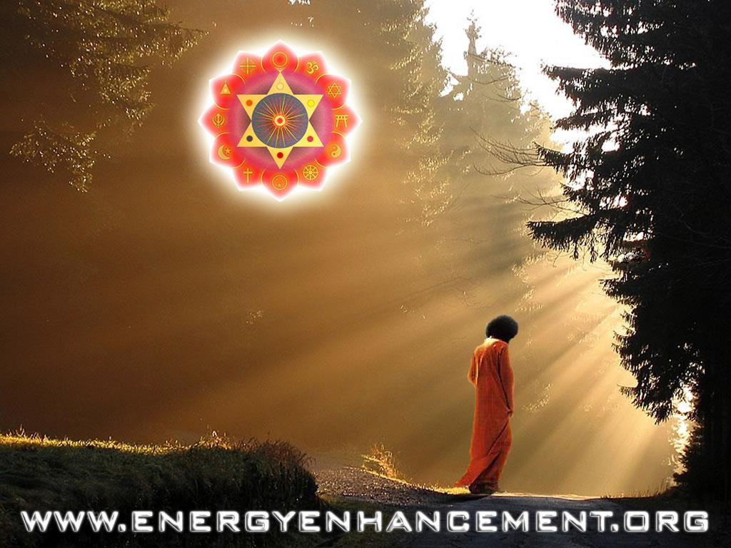

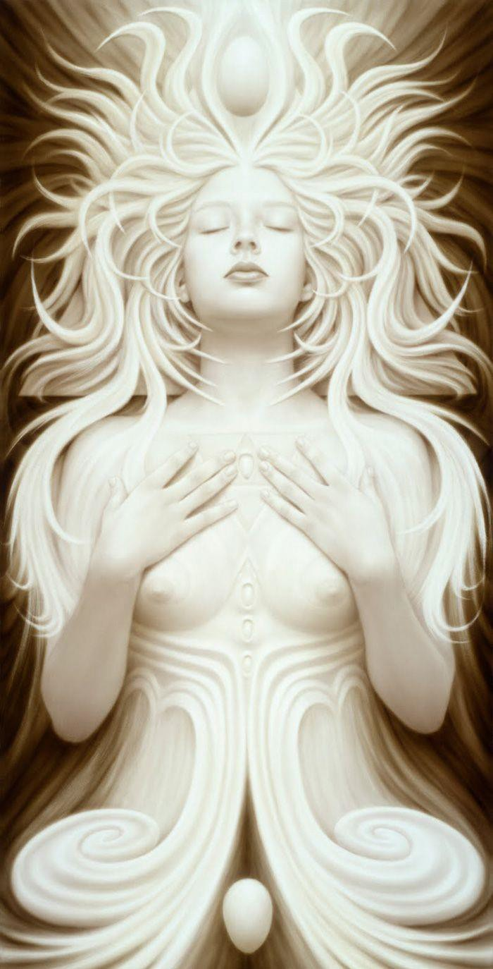

THE SOUL IS THE FIRST CHAKRA ABOVE THE HEAD

Once you believe that all the input you receive through them is real, then you subconsciously give yourself away to this light-show going on around you.

Believing this is all there is to it, you use this light-show every time you have a chance for addictive pleasure that your senses find gratifying (not you!), and if you are anyhow religious, you then feel guilty, for most of the pleasures are considered to be sins. And guilt manifests a whole lot of remorse, regrets and fear.

If a human being experiences fear in any form, then it is like a bleeding seal in shark infested waters.

Fear opens you wide open to the destructive thoughts that lead to all sorts of devastating effects.

Those that experience the most fear, exhibit the highest degree of dysfunction in their realities. The further you sink into fear manifesting from guilt, the deeper you sink into the vortex of negative imagery and destructive thought patterns, which you cannot yield in any way.

You may term this is “demonic possession” if you like. Possession is much more common than most people believe. Most people are indeed possessed today by all sorts of thought-entities living inside them. Understand that thought gave birth to your demonic components.

"I think, therefore I am" — René Descartes

Descartes was half right, but, it is not you and never was you that thinks, it was the energy blockages, although if you understand that the word “I” actually insinuates EYE, the all seeing eye, representing Satan/Thoth (i.e.
Thought), which conjures up reality, then Descartes was right on cue!

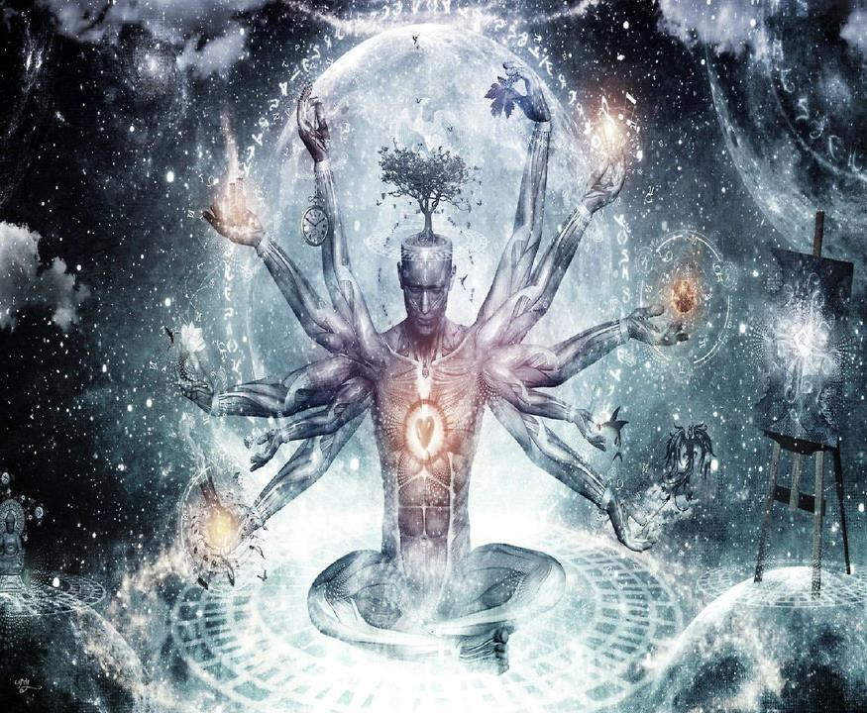
CONNECT WITH THE INFINITE CHAKRAS ABOVE THE HEAD

The deeper the consciousness resides in duality, the more thoughts may be implanted to freak out about and react to, triggering you into bouts of unconscious feeding the illusion, that is mostly conjured by negative streaming.

That’s why religions are all fear and duality based. What a clever plan by the secret societies, such as the Freemasons, to erect a platform and a foundation for the reality construct of this world!

It is very important to remove yourself out of duality so that you may not feed two different sides of the same illusion with thoughts. Once duality is deprogrammed, you have much more space available to you, where before you had conflicting thoughts between good and bad.

Life and death is also duality based.

The two conjured notions are only made real by the existence of each other, and if you remove one, then the whole paradigm seizes to be.

The unnecessary fear of the bad one (i.e. death) would have never originated. The ancients were never afraid of death; they knew that dying here meant “waking up” somewhere else.

What if there was only life? What if there was only death?

Its all thought-based deceit, meant to confuse us. The real you is eternal and now you are only in a third- dimensional illusion prison that has thought itself into something, that you believe to be real. It is time to come out of the box and play!

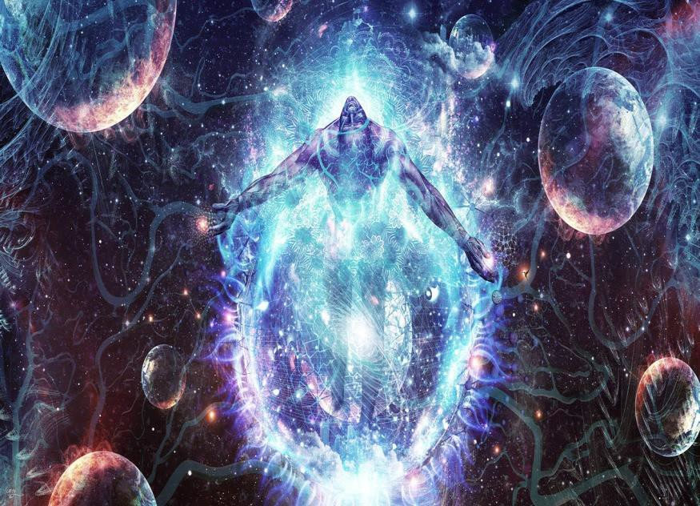
It is time to come out of the box and play!

It is time to access the infinite energy of the chakras outside the body

It is time to learn how to alchemize, to remove, an energy blockage.

Have you ever had an incredible amount of energy and you had been forced to sit in a room and do nothing? Your brain must have probably exploded, as you thought yourself into a short circuit.

Your mind needs a disc cleanup every now and then. There are viruses in the form of energy blockages running the show and you need to do something about them!

Once you can identify them, you can alchemize, remove, them.

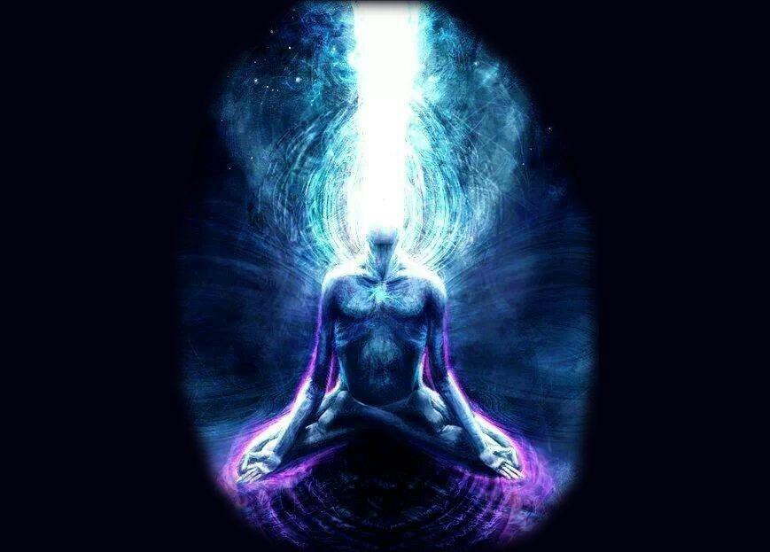
CONNECT WITH INFINITE LIGHT!!

It may be a difficult emotional process because you will be in a battle with your demons that do not want to leave, as they only live because of you.

Once you identify the energy blockages pattern, agenda and its origin point (why you gave birth to it), you can then forgive and love it, which will allow you to release it, and breathe a sigh of relief…

Whenever you are confronted with a problem thought in the mind and body (DNA related to ancestors and parents), then you can use the information to release the energy blockages.

Thoughts, energy blockages, are information technology (from the matrix programmed reality) that are implanted into your mind, which is also information technology, although YOU are NOT information technology, the mind and the program. You are Eternal. You are the Lord of your Computer!!

Labeling the problem in the psyche correctly, you shift the problem where that space was and you take that space where the problem is.

If the problem is what it is said to be, it will alchemize immediately and you will no longer have a problem. It will serve to overcome energy blockages and bring you back to empty space and stillness, where there is only now.

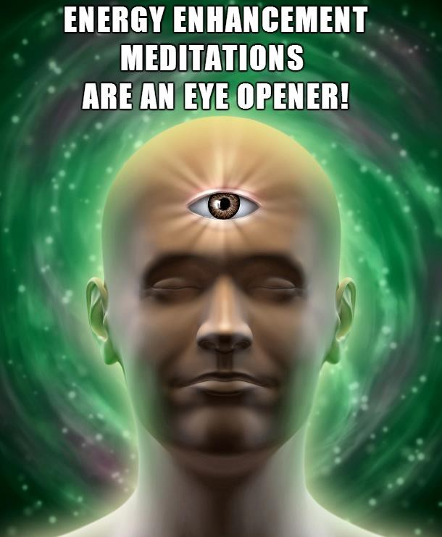

Find your Deep Peace and Infinite Energy.

Get the Energy Enhancement Streaming Videos..

Come to Incredible Iguazu Falls.

Learn how to connect with the infinite Energies of the chakras above the head.

Learn how to remove energy blockages with the Energy Enhancement Seven Step Process.

Realise!!

Illuminate!!

EnLighten!!

Sign up for the Mailing List and Find Out More!!

Find your Deep Peace and Infinite Energy.

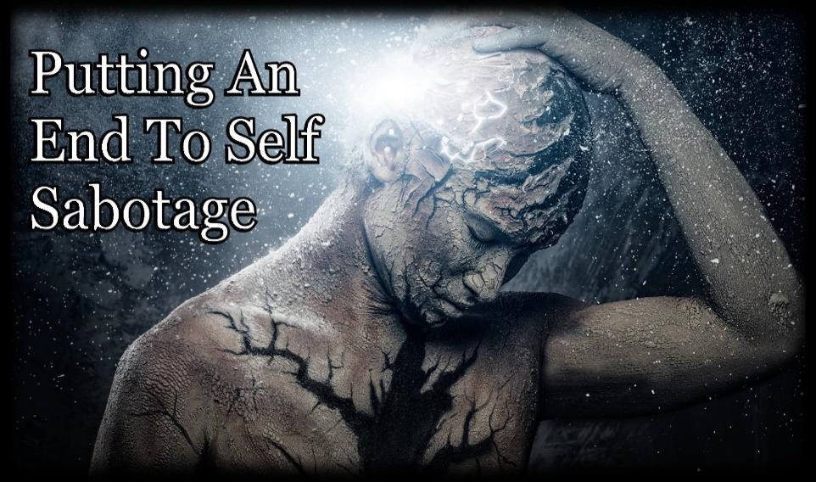

Connection and Blockage Removal
Remove All Self Sabotage with The
Energy Enhancement Streaming
Video Course in Four Levels of Soul

EE Level 3 - Ground All Your Karma
- Ground All your Bad Luck and trouble

Ever Wonder Why Things go Wrong?

Stop the Sabotage!!

Get the Energy Enhancement Streaming Videos..

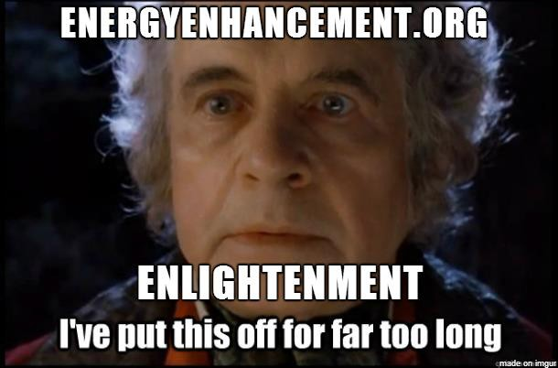

"My energies are naturally far higher than when I arrived on the Energy Enhancement course just two weeks ago. I am experiencing the fruits of meditation which normally arrive, if they do, after twenty years of meditation and it has only taken me two weeks.
This is the first meditation course I have been on. I have an injured knee from a few months ago in a motor cycle accident, yet the knee is now healed of its blockages and of its pain here on the Energy Enhancement Course and I am sitting in meditation for more than three hours a day, on the ground in the easy meditation posture, here in the light and working on more of my deep internal blockages.

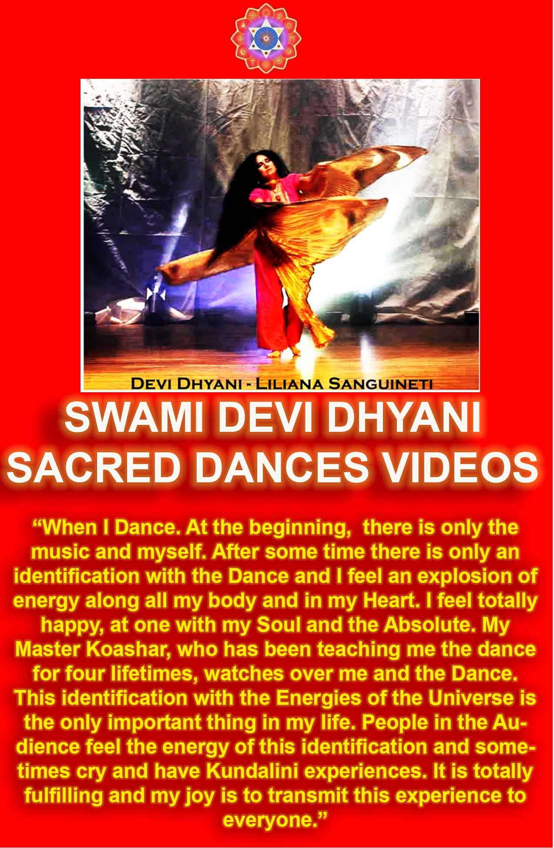

Truly, perhaps Enlightenment is next!!"

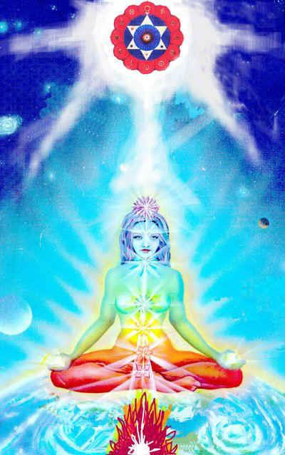
Satchidanand's Movie Reviews
DOWNLOAD BELOW
http://www.energyenhancement.org/Spiritual-Movie-Reviews-Satchidanand/Index.html
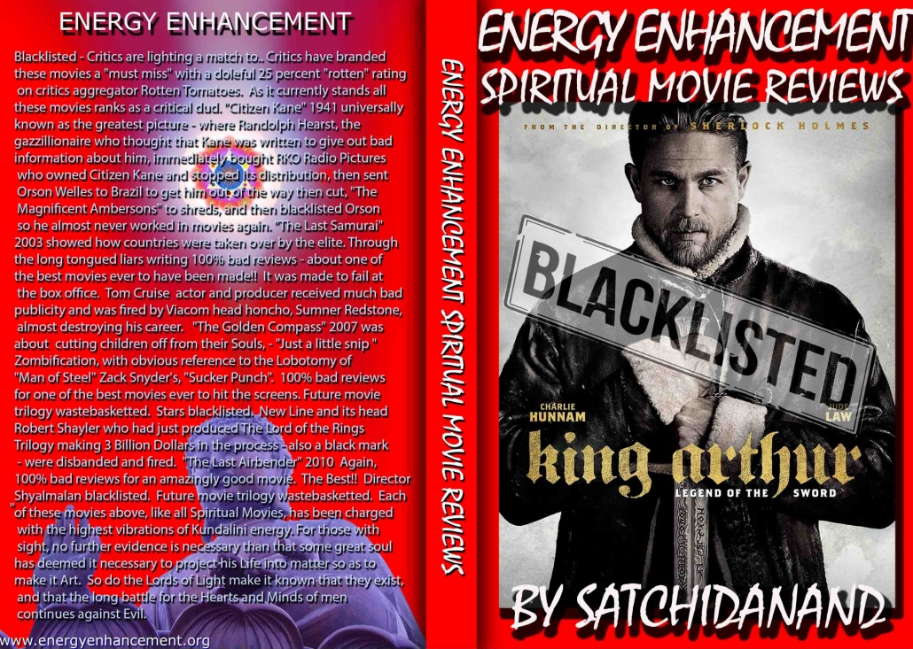
Energy Enhancement Spiritual Movie Reviews Book - Volume 1 by Satchidanand Immortalises the Kundalini Energy which Radiates from Satanically Blacklisted by the Dark Side - Movies like..
King Arthur - Legend of the Sword The Story of Enlightenment - by Guy Ritchie - a Movie Review by Satchidanand
Karma and Anti-Satanism in the Spiritual Actor, Keanu Reeves movies, "John Wick (2014)" also "Man of Tai Chi (2013)"
John Wick Ch 2 - Is Donald Trump and Alex Jones of Infowars - The Spiritual Warrior - Finger of God - Removes Satanic Demons, Deletes the Elite, Cleans the Swamp - Move Witch, Get out the Way!
Doctor Strange - Psychic Warrior Earth Protector..
Logan - "Beware Of the Light" Esoteric Movie Review by Satchidanand
And Much Much More..
Energy Enhancement Spiritual Movie Reviews Book - Volume 1 by Satchidanand - right click and save as..
http://www.energyenhancement.org/Spiritual-Movie-Reviews/Energy-Enhancement-spiritual-esoteric-movie-reviews-by-Satchidanand.pdf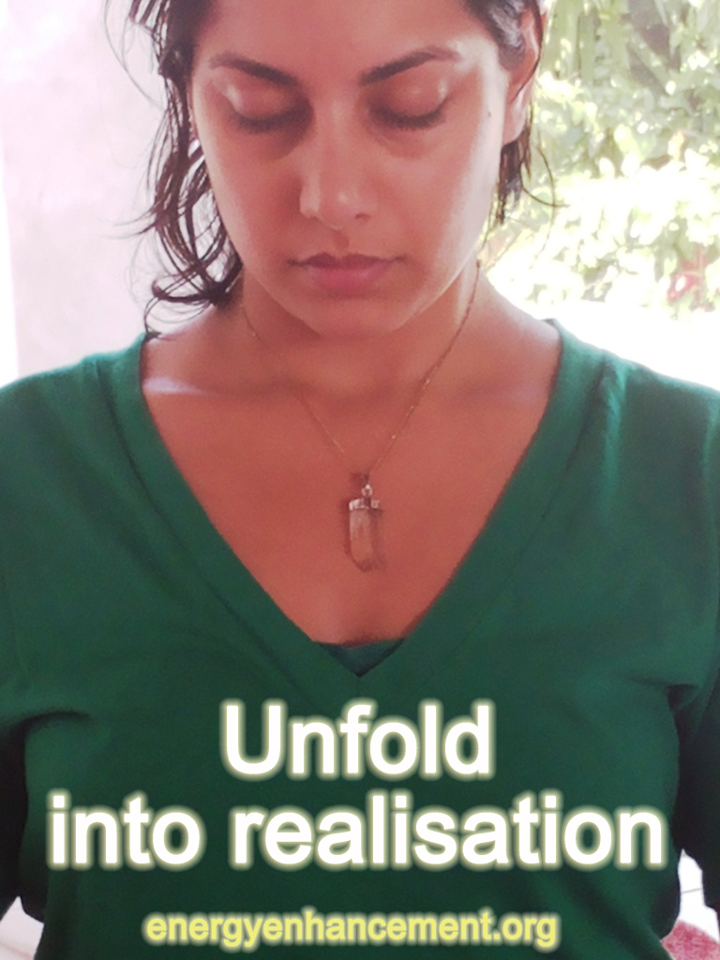

LEVEL TWO OF ENERGY ENHANCEMENT AND THE REMOVAL OF BLOCKAGES -

ENERGY BLOCKAGES, ENTITIES, IMPLANTS AND NAFS - WHAT ARE THEY, WHY ARE THEY FORMED, AND HOW TO REMOVE ENERGY BLOCKAGES AND IMPLANTS BY THE ENERGY ENHANCEMENT SEVEN STEP PROCESS



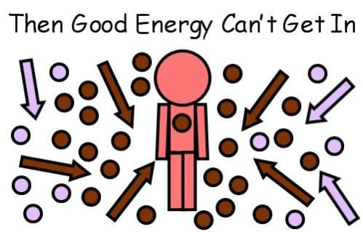

ENERGY BLOCKAGES, ENTITIES, NAFS, and ADDICTION
IMPLANT BLOCKAGES are composed of these parts..

- Negative Karmic Mass and Energy Blockages

- Blockage Protection

- The Blockage Living Core

- The Blockage Power Source which comes from outside.

- The Blockage Programming

- MULTI - CORED BLOCKAGES
- ADDICTION IMPLANT BLOCKAGES - HOW THEY STEAL YOUR SPIRITUAL ENERGY -
- ENERGY BLOCKAGE NAFS

1. NEGATIVE KARMIC MASS (NKM) AND ENERGY BLOCKAGES

Negative Karmic Mass is pure spiritual energy which has become TRAUMATISED by what we believe to be, "anything which should not be" When something should not be, it is because it is against the will of God. When we do something which is against the will of God then we feel Shame which usually creates Guilt.

Negative Karmic Mass is created by Traumatic happenings which we know should not be. So, Trauma and Stress on the physical, emotional, mental or spiritual levels create Negative Karmic Mass.

Physical Trauma comes from accidents or deliberate torture.

Emotional Trauma comes from bad actions by people we trust or through fear of those bad actions.

Mental Trauma is like a joke whose purpose is to release this NKM in laughter or tears. Mental Trauma is where usually there is a disconnect, a paradox, two mutually cancelling statements like, "I Love You" and "I Love You Not", the traditional statements whilst pulling the petals from daisies. A Koan like, "What is the sound of one hand clapping?" or, "What was your face before you were born?" are similar and work in the same way.

The mind cannot compute these seemingly opposite statements which can only be understood in terms of wisdom and intuition, seeing the problem from a higher level with more information.

Mental trauma comes from the contemplation of "That which should not be" - in this case - through not

understanding the test through a lack of wisdom, understanding, intuition and thus creating a problem, trauma, Negative karmic mass in the mind. The Negative Karmic Mass walls off the problem into a blockage or "Inner child" and prevents its resolution or evolution by the higher parts of the mind, the chakras above the head, the parts of your super- computer which, "Know"

Negative Karmic Mass can only be created by moral people who know the difference between right and wrong, good and bad, that which is better and that which is worse. That morality is created by a relative lack of blockages above the head allowing a clear connection to the higher chakras of the Soul and the Monad etc. As the blows of life rain down, so blockages are created which tend to reduce morality and in the creation of Negative Karmic Mass we lose the ability to change and evolve.
We can use Negative Karmic Mass as a power source independent of the energy of God. As we burn the NKM in the Center of the Earth by using the Ancient Taoist and Alchemical Formula in Latin, VITRIOL - VISITA INTERIORE TERRAE RECTIFICANDO INVENIES OCCULTEM
LAPIDEM - Visit the Center of the earth, there you will find the hidden stone, the Philosophers Stone which Transmutes Base metal (Blockages) into pure Spiritual Gold.

We teach this process in Energy Enhancement Initiation Three, The Grounding of Negative Energy, in order to remove some energy blockages which are not powerful or have heavy protections. We use the Energy Enhancement Level 2 Seven Step Process to further enter Blockage protections, cut them off from their power source and put, resurrect, the living core in its proper place in the chakras above the head.

NKM is also used by Bad people who have many blockages above the head and in the Heart, which is the definition of a psychopath, and who are thus cut off from the energy of God and who have no empathy for others. These types of people can go on training courses to learn how to create and use NKM, how to create and program blockages etc.

These bad types of people like to create this Negative Karmic Mass in all people so they can take it and use it to power their beings independent of the energy of God. They can do this on an individual basis by all types of Trauma or on a countrywide basis by creating fear. They also like to create it so that they can use it to create Blockage Implants which they place in people to create and leach off Negative Karmic Mass and spiritual energy from their chakras from other people for these purposes of independent power.

"As above so below" says Hermes Trismegistus - if the energy of God is like sunlight which is infinite and free, the sun constantly showering energy on this planet, then NKM is like petroleum oil which needs to be thoroughly burnt to create energy. Incomplete burning creates pollution. The use of NKM to make people independent from God is like the scientific and political discussion as to where humanity should get its energy from. From monopoly controlled oil or from infinite free sunlight?
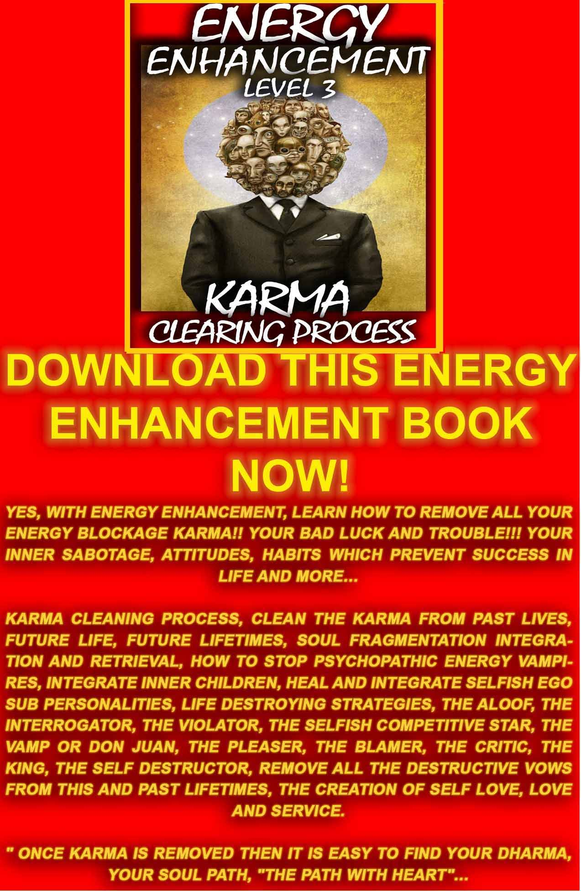
DOWNLOAD LEVEL 3 BOOK HERE!!!
http://www.energyenhancement.org/Sacred-Energy/Level-3-Book/Energy-Enhancement-Level-3-Karma-Clearing-There-Can-Only-Be-One.pdf

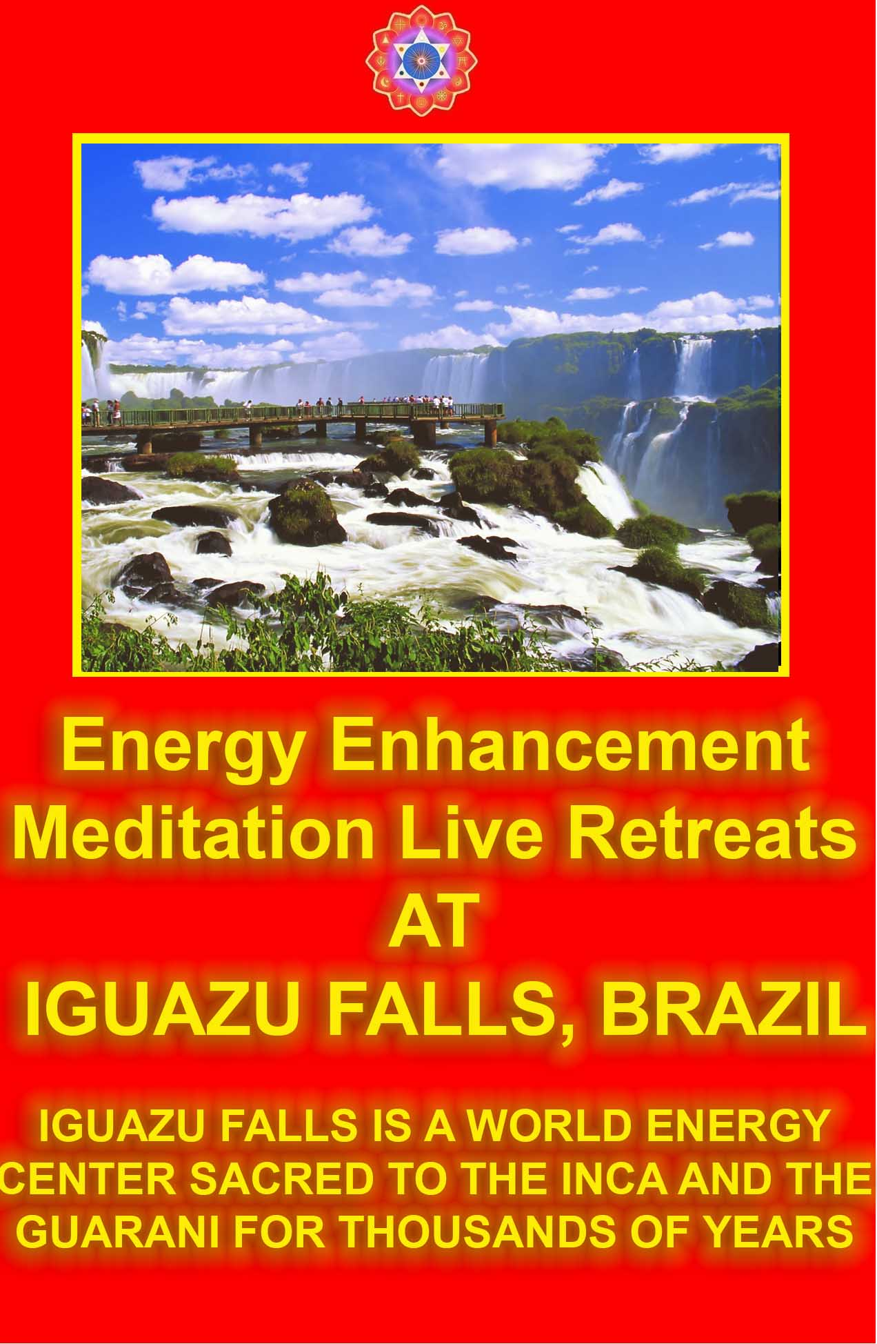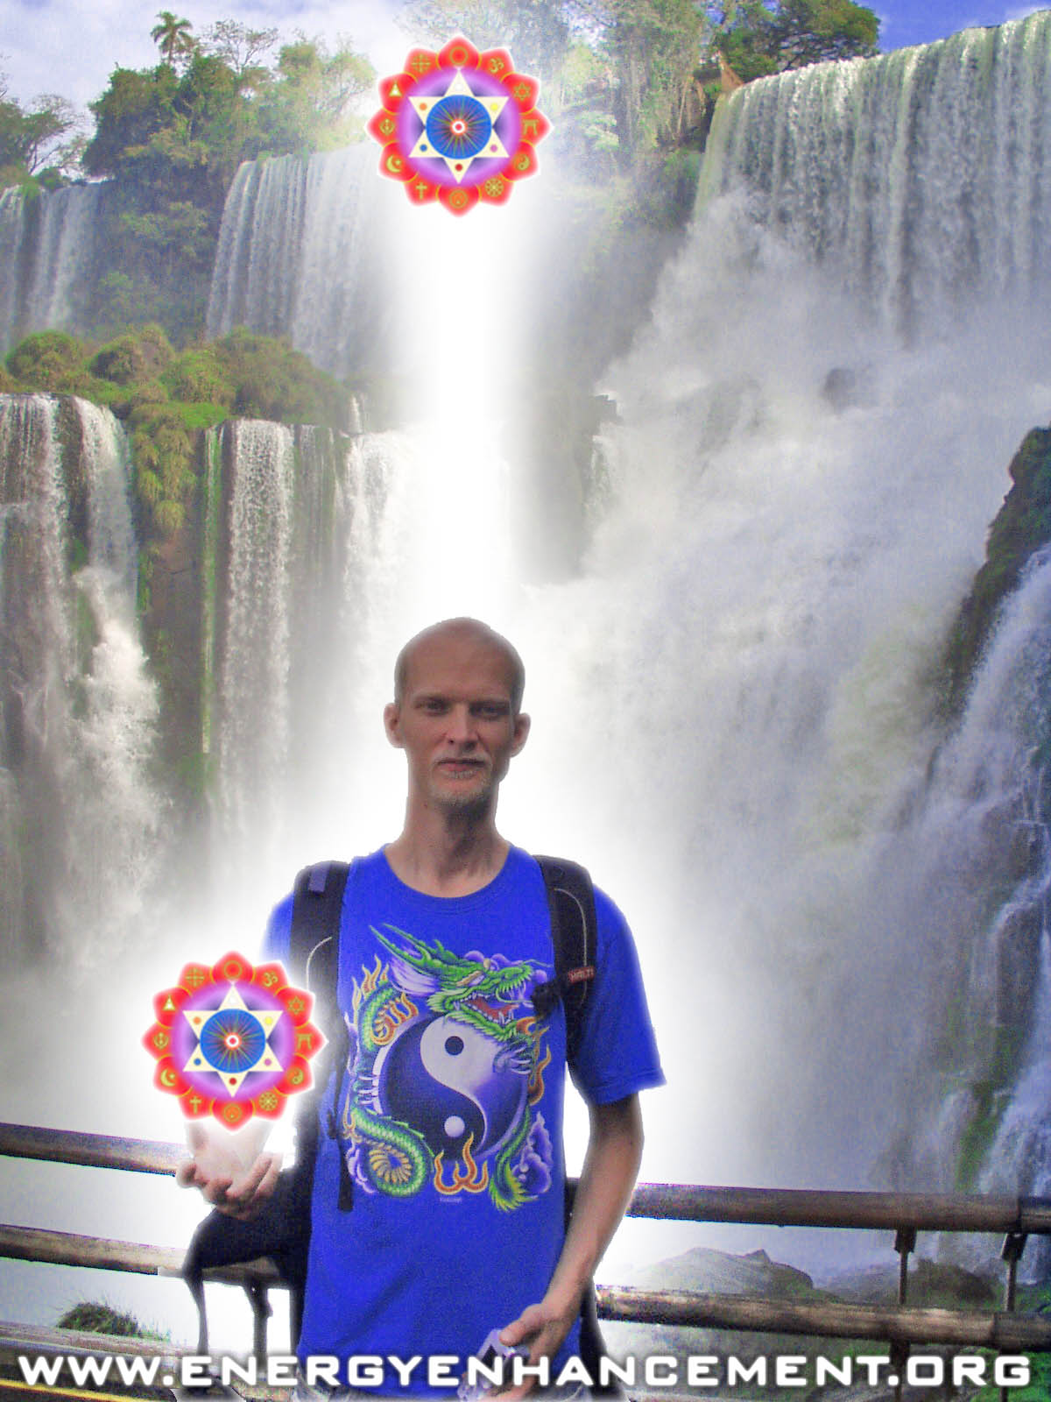

ENERGY ENHANCEMENT COURSE AT IGUAZU FALLS. BRAZIL

"Get your asses over here Now and Speed Up your process of Enlightenment on the Energy Enhancement one month course!!" - DON
Every one of our Students gets this Spiritual Experience of Connection with Infinite Energies.
Energy Enhancement does indeed, "SPEED UP THE PROCESS!!"
And they all get this Experience of Light, Life and Infinite Energy just with the Energy Enhancement Course - Every One of Them!!

BLOCKAGE PROTECTION

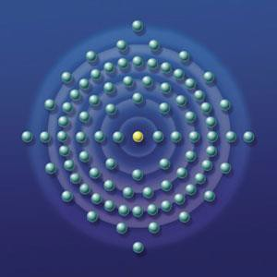
Blockages like the core of an atom have protections which are like electrons moving at the speed of light around the blockage core in up to an infinity of orbits called shells. In order to ground the Negative karmic mass in the core we need to penetrate this protection. Energy Enhancement has developed techniques to penetrate through to any core or any number of cores simultaneously in Multi-Cored Blockages thus releasing the blockage.

THE BLOCKAGE LIVING CORE

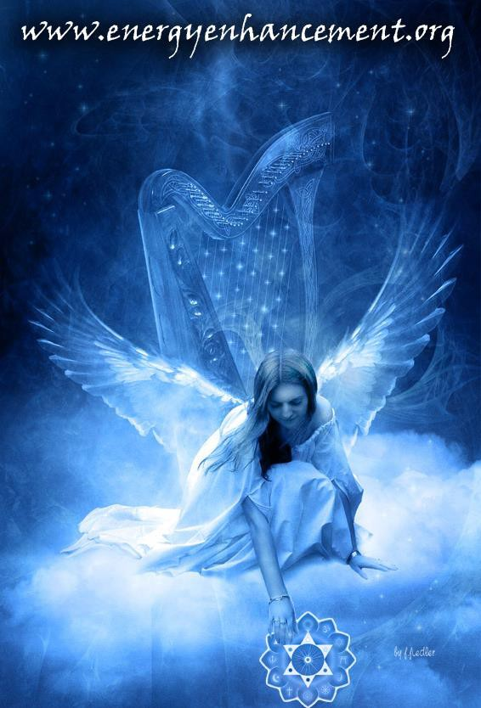

The human matrix exists as chakras which step down the energies of the source in discrete levels and functions, all parts of the multi - processor human super
- computer model. Human beings and their chakras are composed of other species of existence called angels. These angels come in all levels of evolution from the parts of chakras to the Archangel who supervises the existence of planets and suns. Like cells who make up the organs of the human body and the human body itself, angels make up the parts of the human super- computer and in matrices make up higher and more highly evolved parts of existence.

Everything is created from communities and matrices of angels. As evolution proceeds, these communities become larger and more highly organised. Indeed, human beings are made up of angels and as we start to access more and more of our chakras above the head, so we develop in wisdom, grace and enlightenment.

When a human being dies, if he suffered a lot and does not know how to ground his negative karmic mass, then he will be heavy and may not have enough energy to go higher, to heaven, to the soul and thus his lower bodies may separate off and float around. This is an Entity.
Everything needs a power source and usually they travel towards the greatest source of energy amongst their family and the people that they know. They parasitise their loved ones in order to exist either consciously or unconsciously like in a coma.

For example I had a little girl of four years brought to me by her grandfather. Her mother had died that year and since then she had been behaving strangely. So I felt something within her and asked silently, inside, "Who are you?" and the reply came back that this was her mother! So I said well, perhaps you should go to heaven because you have with you some negative

energies and these were adversely affecting her little girl. "But my daughter needs me" - this came to me emphatically with a lot of emotion, so I mentioned that it was possible for her to go to heaven, get all of her pain taken away and then come back as her daughters guardian angel. "Can I do that?" and I said, "Yes!" so she went. And within five seconds she was back, all healed and ready to look after her daughter. Well, the little daughter was fine after that.

As long as the angel is connected to the source of all existence - God, there is harmony. When the angel at the heart of the blockage has become blocked off from this connection by the Negative Karmic mass and by the protection then it becomes separated and subject to other negative and evil programming. It becomes a cancer on the spiritual level and given time will become a cancer or other disease on the physical level.

When the protections have been breeched and all of the Negative Karmic Mass grounded and burnt up then the angel core of the blockage has been healed, resurrected and connected with the source again. It then becomes free to become part of your psychic body to increase your complexity, function and ability to handle energy. To help in your evolution.

Blockages and Tapas

This removal and healing of blockages is the Raja Yoga "Tapas" or austerity as it is normally translated enjoined by the Yoga Sutras of Patanjali as part of a spiritual persons evolution. Tapas refers to the heat involved in burning up negative karmic mass. Raja Yoga involves the enlightenment processes of yama, niyama, asana, pranayama, pratyahara, dharana, dhyana samdhi and samyama which we teach in energy enhancement. Tapas is a part of "the five things to do" - yama and also is connected to "the five things not to do" - niyama, making up the yogic ten commandments. It also refers to other disciplines like yoga, meditation and fasting as part of the blockage busting process.

Blockages and Gurdjieffs Conscious suffering
Gurdjieffian "Conscious suffering" which Gurdjieff said was the only way of evolution is the same process in which Gurdjieff precribed taking upon yourself as many blockages as possible and in that way you will complete your psychic body to the level of ascended master very quickly. Gurdjieff described a process in which you deliberately went out of your way to take on problems, making your life as difficult as possible, receiving as many "shocks" as possible in order to evolve quickly.
This is the same as the energy enhancement process where we acknowledge the necessity of removing our own blockages as part of our own enlightenment process, but also acknowledge that our evolution also involves our interaction with humanity. As we evolve we also have the possibility of removing the blockages in

others, thus helping their evolution and also evolving our own psychic body. Gurdjieff says as you help other people, so you help yourself.

Blockages and Alice Baileys Resurrection

Then we come to the concept of "resurrection" given out in the Alice Bailey teachings in, "The Rays and the Initiations" as something which can take us into the realm of becoming an Ascended Master of the fifth Initiation.

Chakras are functions created by teams of angels working together in a group. As we increase the number and evolution of the angels working there, so we can evolve the chakra function and handle more energy.

Resurrection is the healing of the angels at the core of blockages and then the process of moving them up the Antahkarana, resurrecting them into place as members of your higher chakras as part of your angel team there thus increasing the size, function and ability to handle energy of your psychic body.

"COATING THE HIGHER BEING BODIES" - GURDJIEFF
Energy Enhancement uses scientifically proven and conscious techniques to speed up Tapas - The Burning Out of Energy Blockages with focussed Kundalini Energy.

The evolution of the "Conscious suffering" is made quick and easy as we learn how to automatically transmute energy blockages and negative energies in the people

around us and Resurrection of blockages to add functionality to all your chakras to create an Ascended Masters of yourself is just part of the job.

Healing of blockages is one way to find angel partners in your evolution. There are all evolutionary levels of angels inside blockages. By incorporating the healed angels we become greater more complex and more evolved.

As Above, So Below. All levels are analogous, as we purify our spiritual bodies of blockages and become more complex and evolved, so the earth evolves in a similar way by purging all of its Negative Karmic Mass and stuck blockages.

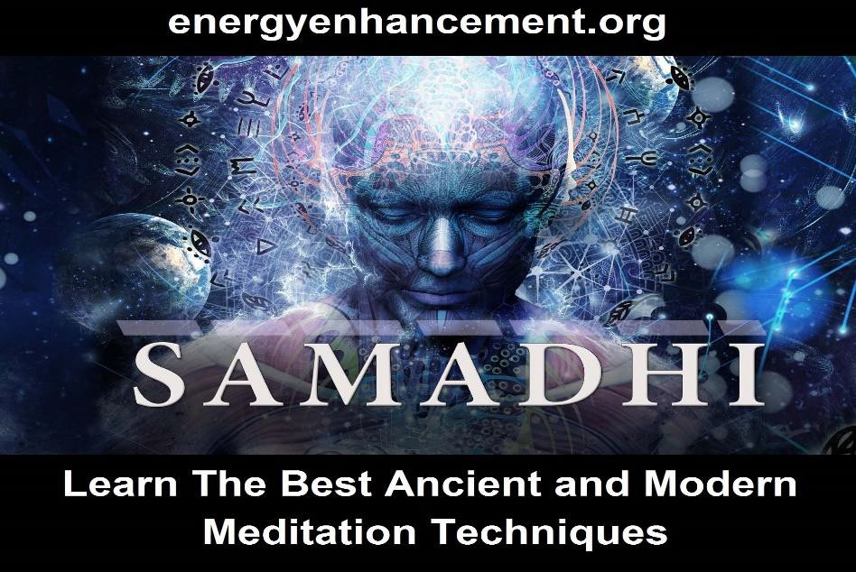

THE BLOCKAGE POWER SOURCE.

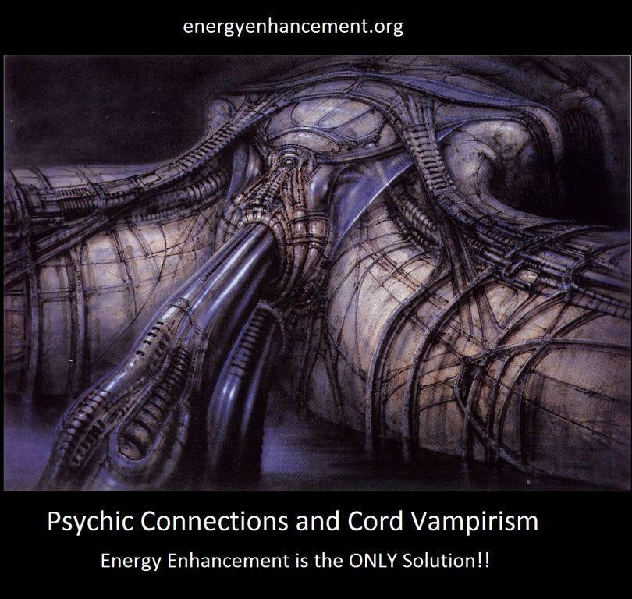
VAMPIRE CORDS CONNECT TO IMPLANT ENERGY BLOCKAGES
Angels and Enlightened human beings should be totally powered by the source which is infinite. The infinite source steps down its energy through chakras until it reaches our crown chakra. If we are cut off from the source by energy blockages then in order to live, we must parasitise other forms of life on this planet for our food. See the Strategies of the Vampire - in Energy Enhancement Level 3

INNER CHILDREN BLOCKAGES
Traumatic blows of existence create inner children which are powered by split off parts of the soul chakra. They are created in this lifetime and in all of our previous lifetimes and pass on from body to body, until they are healed and dissolved by Energy Enhancement Meditation techniques.

Inner children exist in droves inside the normal human mind. They are talents, self - programmed points of view or simple childish emotion limited by their trauma and fear created Negative Karmic Mass.

For example if we are beaten or raped then a very sad or angry inner child may be formed. The inner child might lock off the memory of this through amnesia to protect the rest of the mind.

You may have been bereaved or been dumped in this lifetime and certainly so in many other lifetimes and the pain of this always comes through the violent breaking of connections from your chakras to the chakras of your family or marriage partners. Inner children will have been formed long ago from these constant blows and be in charge of your psychic connections. In order to Master your Relationships and be in charge of who you connect to, from which chakra and for which purpose you will need to heal these inner children and take control of these processes for yourself. This problem, located in the lower chakras is also a prime area for sexual implants to create sexual addiction and adultery. By healing these types of blockages you will gain control over the talent and remove the addiction.

You may also have been immensely successful in previous lifetimes in business, money, property and have developed the talent to deal with these things. If

the talent forms part of a blockage then you will be addicted to these things as well as having a talent with them and thus this will prevent your evolution into higher things. By healing these types of blockages you will gain control over the talent and remove the addiction.

If you try to work on one of these blockages to ground all the NKM surrounding this event then the inner child will try to prevent this because it is afraid of being integrated into the soul, afraid of the traumatic memory, and might even want to protect you from the memory.
Thus when using meditation to integrate and heal It will try to distract you. It will create diversions outside. It will try to rubbish the meditative technique. And it is then you must prove who is in charge, "Focus Trinity", use the rapid and effective energy enhancement technique of the Seven Step Process and move on to remove the inner child and integrate your mind.

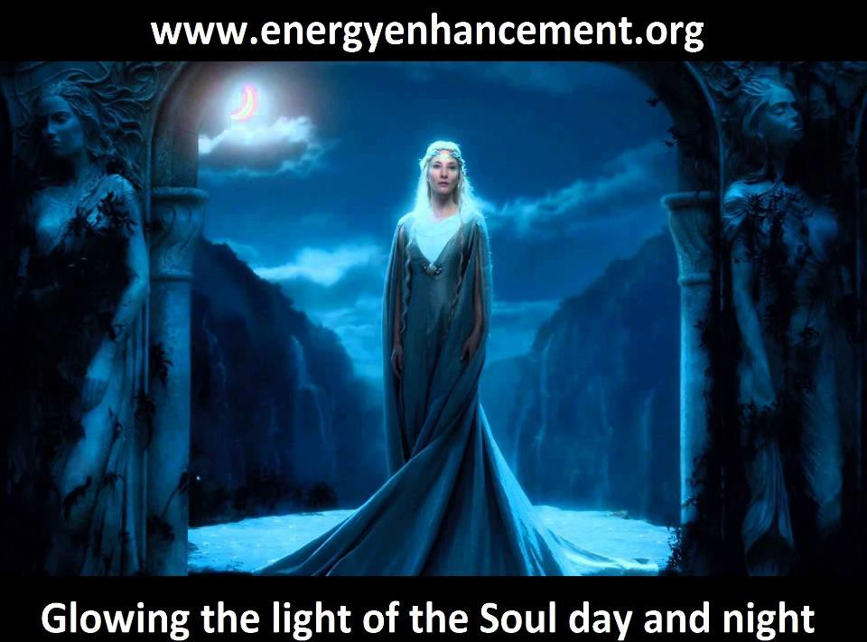

We, ourselves, create blockages and it is we ourselves who must integrate them. We must create one, integrated soul - infused mind, - the soul because the higher chakras must always rule. Only when the lower rules - and the blockages always rule the lower - do we have all the warlike selfish problems of life for ourselves and for all others on the planet.

Until we can heal these inner child blockages and integrate them back into the Soul - together with all their talents and psychic powers, we cannot become enlightened.

IMPLANT VAMPIRE BLOCKAGES AND IMPLANT CONTROL BLOCKAGES

Blockages and implants are created for various purposes but all involve a link back to their creator who powers the blockage and holds it in place in the victim for lifetime after lifetime, until it can be removed by energy enhancement techniques.

Blockages and blocked human beings are powered by links to bad energies and people. Any attempt to de - power and heal a blockage must involve cutting off its links to its perverted power source and indeed healing all these sources too. Blockages exist at all levels of existence and the higher blockages power the lower blockages.

Without an infinite source of energy there is always a perceived energy shortage and thus much competition for energy therefore bad people feed on the energies of their own kind as well as their human energy food.
Competition is a symptom of blockages. Indeed to survive, the bad people who are cut off from the source

must be vampires, feeding off the energy of innocent human victims and their evil contemporaries, lifetime after lifetime.

By implanting blockages which they create into other people they can cut a person off from the source by putting blockages in above the head or into the heart chakra, thus creating an accomplice. They can put blockages between the base chakra and the center of the earth thus creating someone to feed off, a slave. They can also program the blockages to send the energy back to them, thus becoming an energy vampire.

They can program addiction and other types of control blockages.

The energy of one addicted is greater - like burning the candle at both ends - and easily taken. People burning the candle quickly usually die young but as well as energy received each day from God, the soul is given a supply of energy at birth, thus for a vampire to get more energy it is good that there are many short bright lives. Thus drugs, sex and gambling blockages are tools to concentrate energy back to the blockage implant creator.

Distraction Implant Control Blockages are very high level alter-Egos whose job is to distract the victim with the Normal Hollywood dreams of Power, Money, Car, House, Fame, Harem. They also do it through addiction to Food, Drugs, Sex. They also do it by perverting the power of Emotion creating fear, anger, sadness, slave and psychopath as part of their control. They also are behind and above the use of Ego-Strategies like the
Poor-Me, Violator and Selfish Competitive Star. They do this by forming these stupid alter-ego distraction desires in people

We see these bad people who create implants with psychic vision connected by streams of energy to their victims. Some have thousands of connections like a telephone exchange connecting to thousands of implant blockages put into their human energy food. And these implant blockages exist in people lifetime after lifetime, until the techniques of energy enhancement can remove the implant. The whole world is in the state that it is, perverted, because of the creation of these brainwash implant blockages.

IMPLANT VAMPIRE BLOCKAGES are programmed blockages created by an evil person to implant into other people, usually to siphon energy back to the evil person - the Ultimate Energy Vampire.

Gurdjieff used to tell a parable to explain how the world is run by elite families controlled by a few bad people.... There was a magician who was also a shepherd. He had thousands of sheep to look after and he was a very miserly man so he didn't want many servants and he didn't want many watchmen. He did not want to pay anybody and he did not want his sheep to be lost or taken by the wolves. But it was very difficult for him to take care of all the sheep alone. He was very rich and he had many sheep.

So he played a trick on the sheep. He hypnotised them and implanted them with control blockages -- he was a magician. He hypnotised them and told every sheep, 'You are not a sheep. Don't be afraid.' To some he said, like in Animal Farm by George Orwell, 'You are a lion.' To some he said, 'You are tigers.' To some he even said, 'You are men. Nobody is going to kill you. Don't be afraid and don't try to escape from here.'

The sheep started believing in his controls. Every day he would butcher a few sheep but the others would think,

'We are not sheep. He is butchering only sheep. We are lions, we are tigers, we are wolves, we are French, we are Russians, we are Chinese, we are this and that...' even that they were men. Some were even told that they were magicians -- and they believed it. It was always some sheep which was to be butchered. They remained aloof, distant. They were not worried. And by and by they were all butchered.

'This is the situation,' Gurdjieff used to say.

Implant Blockages are removed in exactly the same way as all the other blockages, quite easily through the Energy Enhancement Seven Step Process of Energy Enhancement Level 2.

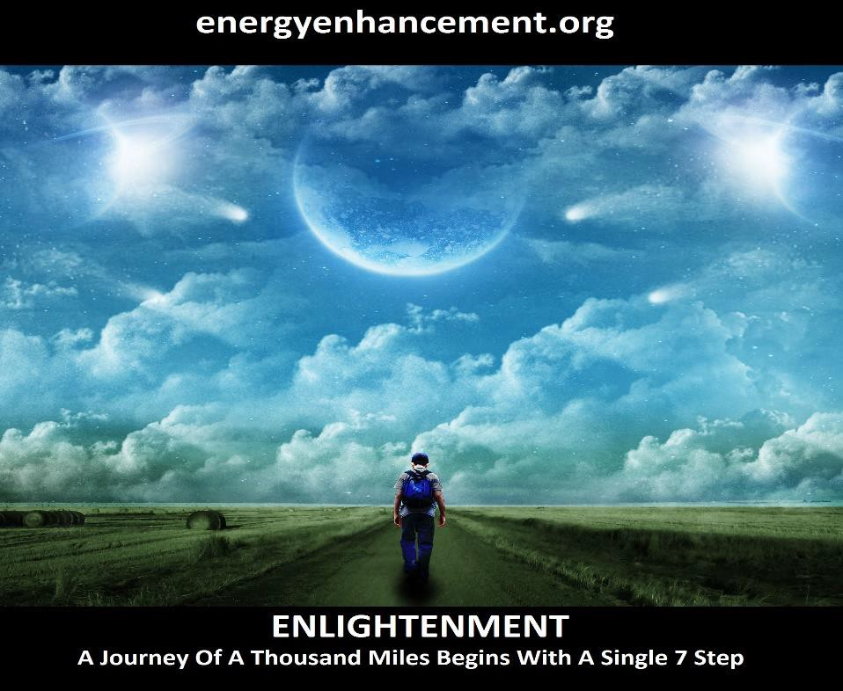
Implant Blockages usually connect to the evil person or their accomplice worker or emmissary who in general

are completely oblivious that they are working for someone else through Energy Connections from the Implant Blockage, although sometimes they are! These energy connections are from person to person or horizontal - the image is that of a circle with a horizontal line in the center thus the person only takes energy from others and is cut off from the higher self.

What I mean by that is that the normal personality is completely oblivious that one of the Control Implant Blockage is conscious of the connection and in fact is in charge of it. This is the connector and it thinks that it is saving the normal personality by taking energy from others, allowing it to live longer and with more energy by becoming a sucker.
We work on Ego Energy Blockages like the Connector and Control Implant and Vampire Blockages in Energy Enhancement Level 3 and also with Attention Seeking Strategy Energy Blockages and Inner Children.
We work on these Energy Connections, as part of the Mastery of Relationships in Energy Enhancement Level 4.
Only by connecting with the energies of the universe as we Gain Energy in Energy Enhancement Level 1 can we drop the necessity of absorbing the energies of others.

In this way an Enlightened Person only gives 100% of his energy because he is connected to infinite sources of Eternal Energy from the Soul and other chakras above the head. The image is that of a circle with a vertical line in the center - symbolising the connection with the soul.

When we do this we then become able to purify the Connector Personality so that the Soul can regain the psychic power of connection in order to give energy in the Healing of others or the giving of Kundalini Energy to help with the Enlightenment of Students - an Energy Enhancement Teacher and here the symbol is that of a

circle with a cross in the center of it, the vertical line taking energy from the soul and the horizontal line giving 100% of its energy to others - the Meaning of the Christian Cross.

The upgrade of this symbol of course is that of the pure circle - here this symbolises the Ascended Master where we take energy vertically from the Soul and distribute it downwards to any pure person who needs it. The circle, like the columns of protection, an external antahkarana, of Energy Enhancement Initiation 6 of Level 1 has become extended into a vertical line containing the upwards flow of Energy and the downwards flow of Energy of Gurdjieff's Reciprocal Maintenance and the Yin Yang Symbol, signifying the antahkarana of an ascended Master whose duty is to distribute the energy of God.

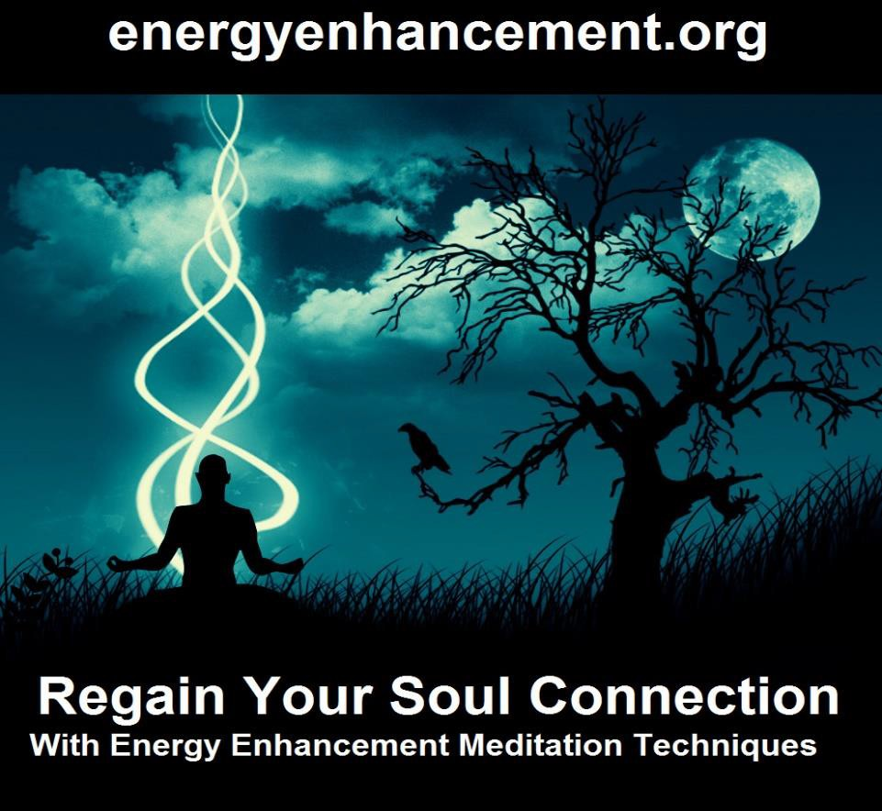

THE BLOCKAGE PROGRAMMING
Because these angels at the center of blockages are cut off from connection with the source and the good instructions from the source, they no longer know what to do. They are perverted by the Negative Karmic Mass which surrounds them. Thus they are easily programmed with instructions from other sources which can be followed like a program for thousands of years.
They can no longer evolve.

As above, so below. Human beings are in exactly the same problems as angels. As blockages cut them off from the source, so they lose their essential humanity and move into the direction of the dark side, they listen to the messages of the dark side through their blockages and their media interests and become programmed by it. They develop cynicism, lack of conscience, lack of empathy. Meaningless, purposeless, addicted lives without any significance. They can no longer evolve.

"After all that" is part of the first Sutra of the Yoga Sutras of Patanjali written 5000 years ago. It seems that we need many immersions into the dark side before we understand that it always ends up in a bad way. We need these experiences and indeed are sent to this planet to receive them.

This planet is a factory for the production of enlightened beings. Bad experiences are part of the process which we have designed. The way of the world is to purify gold ore by heating it up to a thousand degrees, putting it on the anvil, and then beating the crap out of it.

Enlightened beings say a softer process is more effective and more desirable. Energy Enhancement is that softer and more effective process.

As Human beings and blockages lose their Negative Karmic Mass and as Humans lose their blockages so they get back on track on their soul path and on the path of their evolution. They become ascended masters.

MULTI - CORED BLOCKAGES
When viewing blockages psychically, often times we see that they have many parts, some thicker and more dense from having more Negative Karmic Mass, some having more layers or shells of protection. Groups or teams of blockages join together to perform their function. Any strategy to remove blockages must take these multi-cored blockages into account. Energy Enhancement techniques remove multi-cored blockages.

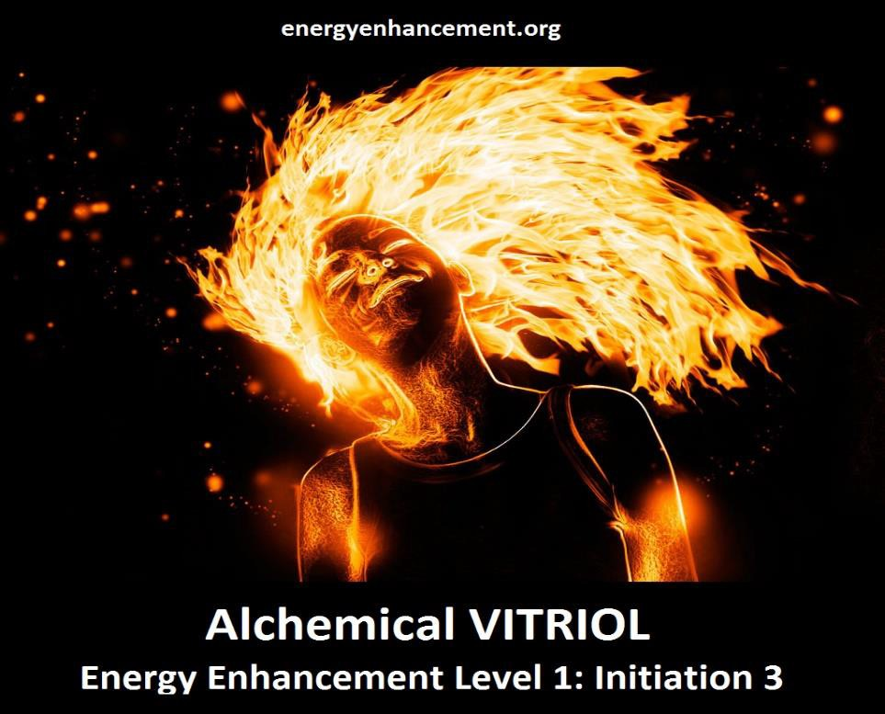

7. HOW THEY STEAL YOUR SPIRITUAL ENERGY - VAMPIRE
ADDICTION IMPLANT BLOCKAGES VAMPIRE SEXUAL ADDICTION IMPLANT BLOCKAGES VAMPIRE DRUG ADDICTION IMPLANT BLOCKAGES VAMPIRE FOOD ADDICTION IMPLANT BLOCKAGES

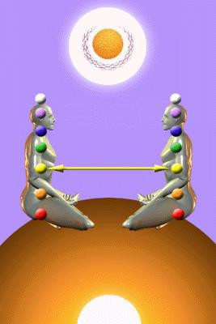

ENERGY CONNECTIONS BETWEEN PEOPLE AND THEIR CHAKRAS IS DEALT WITH IN ENERGY ENHANCEMENT MEDITATION COURSE LEVEL 4

Implant Blockages are programmed to use Energy Connections between people which are naturally formed between every human being in order to drain their energies back to the person who implanted them, either in this lifetime or in any previous lifetime, no matter how far they are away.

We have seen in meditation that the implanters have thousands of energy connections coming to them from the thousands of people whom they vampirise, rather like a telephone exchange.

They manage to get so many connections by implanting people who act as their helpers, their collaborators, their fellow Initiates, to implant people they meet. Any energetic psychic connection between the victim helper and the victim - the sacrifice - is channeled back to the original implanter.

Usually implant is implanted upon implant as many people have already been implanted in previous lifetimes. These people already addicted and are easier to recognise by the helper/collaborator and to implant over the original implant.

There are many young ladies and young men who act as the helper/collaborator of the implanter. These many evolved helpers unconsciously even implant and vampirise their own children, the mothers and fathers sending the energy of their own children back to the original implanter.

The field of the dark side is sex, drugs and rock and roll. Sex and drugs, to addict people to things which will burn their energy more quickly as they send their energy back to the implanter so they can burn out and be discarded early.

Initiates involved in Sexual ritual can steal energy from their ritual partners but because no matter how high their degree if they do not know about Implant Addiction Energy Blockages, How to Create them, How to spread them about, How to gain energy from the victims - then they themselves are the victims!!

These so called high and mighty, "Initiates" are the victims of Drugs, Sex, food and unnecessary excercise implant addiction blockages.

These so called high and mighty, "Initiates" are Initiates because they are implanted with Drugs, Sex, food and unnecessary excercise implant addiction blockages.

These so called high and mighty, "Initiates" are victims of higher Initiates who are draining them of their life energy, vampirising them like normal humanity because higher Initiates think of these lower Initiates in the same way that they think of normal humanity... as if they were livestock or a slave.

If you have not been informed about implant addiction blockages then you too are a slave.
..a sacrificial slave whose death is the ultimate sacrifice to Satan.

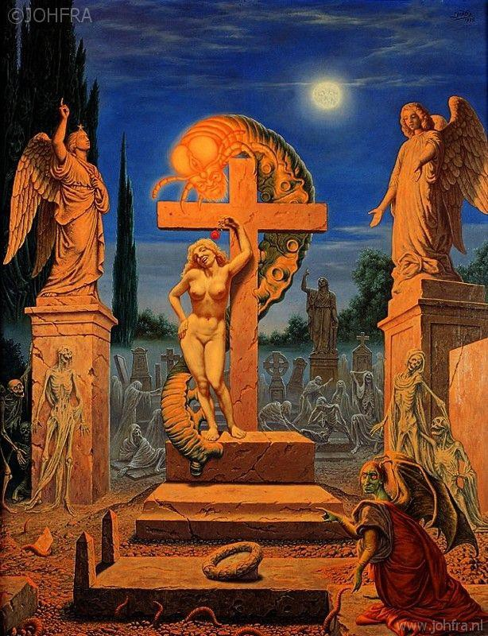

The only way in which a slave can free herself or himself is to first recognize one's bondage.

In general everyone is the victim of these Implant Addiction Energy Blockages.

Every member of humanity has been already implanted from our childhood and youth in the company of the evil in every gathering place, through pornography, traumatic sexual experiences, rapes, school, hospital, university, rituals and also from previous lifetimes by all manner of blockages including Implant Addiction Blockages - Drugs, Sex, food and unnecessary excercise etc - This means YOU!
See.. VAMPIRE ADDICTION IMPLANT BLOCKAGES VAMPIRE SEXUAL ADDICTION IMPLANT BLOCKAGES VAMPIRE DRUG ADDICTION IMPLANT BLOCKAGES VAMPIRE FOOD ADDICTION IMPLANT BLOCKAGES

Everyone instinctively knows about Drugs, Sex, food and unnecessary excercise implant addiction blockages and the necessity to resist them, in order to have a long, unblackmailed and productive life. Everyone knows of the downward path, the descent into perversion, corruption, disease and an early death.

Now, as well as knowing about this instinctive resistance to addiction desire, Energy Enhancement teaches WHY!!
- about the drainage of your life energy by anyone who gives in to an implant addiction energy blockage desire and addiction through the vampiric drainage if the aroused life energy energy back to the implanter.
See.. LIMITLESS - THE MOVIE OF ILLUMINATION

As I say in my review of the Movie, "Limitless" - All arousal of the system into ravaging its own internal energies in Sex, Drugs, Food or unnecessary Excercise, sending that energy on to an energy vampire via an implant energy blockage is the path of death - instead use Energy Enhancement Level One to connect to an infinite stream of free energy from the Chakras above the head ending with God.

All arousal of the system into ravaging its own internal energies in Sex, Drugs, Food or unnecessary Excercise will result in the, "Burnout of the Binge" as your life energy is sent back to the vampire implanter and you the implanted are stoned, burnt out, anaesthetised, recuperating, ill, cold, influenza, ME, medical intervention, surgical intervention, ghosted, on the verge of death, Dead before your natural time...

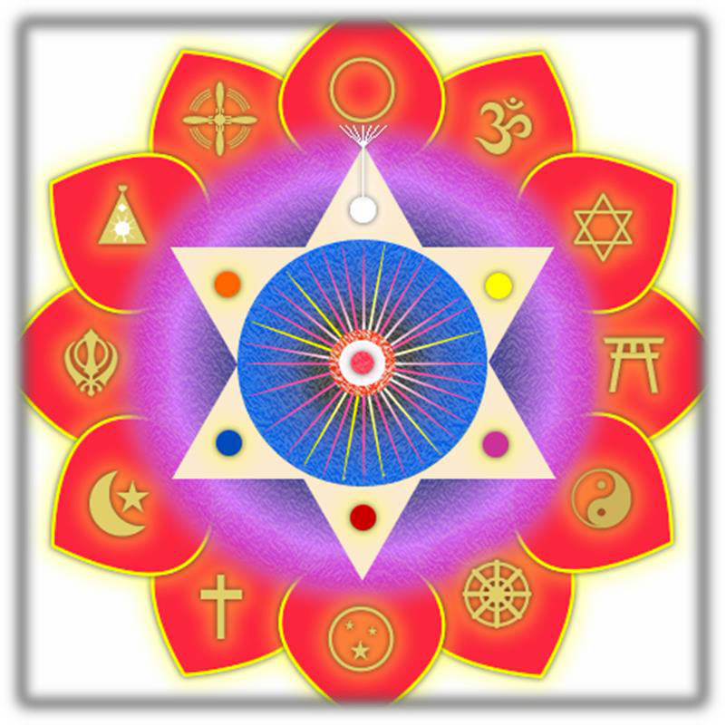

By Surrounding all these blockages in Energy Enhancement Protection, Pyramid Protection or Merkaba Protection, taught in the ENERGY ENHANCEMENT MEDITATION COURSE LEVEL ONE it will cut off that energy blockage from its support, from the people who are draining your energy along energetic connections from the energy blockage back to them.
So Psychic Protection stops the vampiric drainage even though the Implant Blockages still remain.

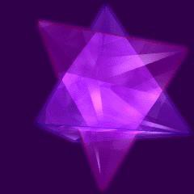
THE MERKABA - ENERGY ENHANCEMENT MEDITATION COURSE LEVEL ONE

Stopping the vampiric drainage and energetic support of the blockage through the use of Energy Enhancement Psychic Protection which can even help in removing the blockage is a necessary preliminary to the Seven Step Process of Energy Enhancement Level Two - Remove Energy Blockages.

FOR MORE INFORMATION ON ADDICTION IMPLANT ENERGY BLOCKAGES - CLICK BELOW..
ALEISTER CROWLEY - ILLUMINATI INITIATE, SEX TANTRA ADDICT, DRUG ADDICT, VICTIM OF VAMPIRE IMPLANT ADDICTION BLOCKAGES

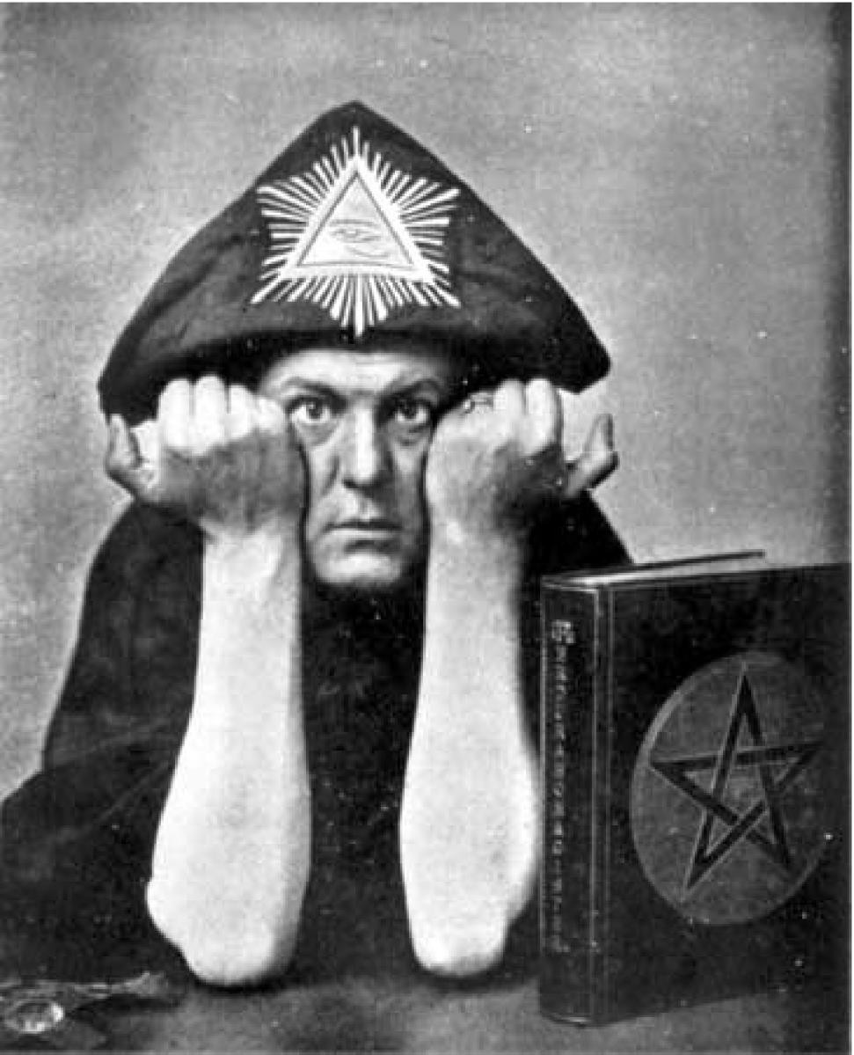

8. ENERGY BLOCKAGE EGO NAFS

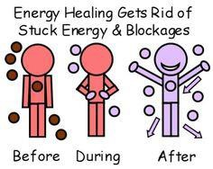

In the Sufi terminology, NAFS or Breaths or Energy Blockages represent the degrees of in the transmutation of the consciousness which we go through in the Levels of Energy Enhancement starting at the Second level.

First we deal with the lower types of NAFS and later with more refined parts of the EGO. Although more refined, all NAFS are part of the Ego structure and all of them, one by one must be found and purified as their Trauma- Formed Negative Karmic Mass is transmuted and then the core of the blockage is integrated with the Soul Personality where it can finally be safely used as a purified function or purified talent or so called psychic power.

THE SEVEN MEN THE NAFS, ENERGY BLOCKAGES, IMPURE TALENTS AND THEIR PURIFICATION AND INTEGRATION INTO THE SOUL OR HIGHER SELF

- Nafs-i-ammara - the depraved or commanding Nafs

- Nafs-i-lawwama - the accusing Nafs

- Nafs-i-mulhama - the inspired Nafs

- Nafs-i-mutmainna - the serene Nafs

- Nafs-i-radiyya - the fulfilled Nafs

- Nafs-i-mardiyya - The fulfilling Nafs
- Nafs-i-safiyya - The purified and complete Nafs The creation of the Sufi (from Sophia or Wisdom
showing the Greek Platonic origins of Sufism) process of creating the "Golden Head" through the purification of the mind and integration into the Soul. Sun symbolises Soul, so as the shadows of the mind are purified to make them transparent and open, so the Soul Sun, the first chakra above the head, "Brighter than 10,000 Suns" illuminates the intellect and emotions in EnLightenment. The Aura of the Buddhafield becomes Golden, "The Secret of the Golden Flower", the Chinese Alchemical Taoist Golden Elixir which confers immortal life.

These Seven types of Nafs or Energy Blockages are formed so that you can see how they start as part of the ego, the separated split off parts of the mind as depraved or commanding or Accusing Nafs and then are evolved through the Energy Enhancement Seven step process by purifying the Trauma Formed Negative Karmic Mass through VITRIOL and then integrating the

purified and complete Nafs into the Soul Chakra, on the path of Illumination.

Nafs are Energy Blockages which when purified of all trauma then become compliant fulfilled parts - the talents - of an integrated mind.

The Nafs pass through the Energy Enhancement Seven Step Process which can be termed "Death and Rebirth". The death or removal of the Trauma-Formed Negative Karmic Mass and the Recapitulation of the events and traumas which formed the Blockage and the Rebirth, the Transfiguration and Resurrection (Alice Bailey - The Rays and the Initiations) as the purified function or talent is absorbed or integrated with the Soul or Higher Chakras so that it can be safely used by the Soul infused Personality.

As the Nafs become purified then we become open to the still small voice of the conscience - accusing and then serene and fulfilling etc as we find our Soul Path and the purified talents and functions become useful to the individual and society.

Most individuals are out of control. They believe themselves to be coherent personalities but with Energy Enhancement they start to see their multiple and changing personalities. "The man that swears to get up at four o' clock in the morning is not the same personality who throws the alarm clock out of the window!" - GURDJIEFF

They use the energy enhancement seven step process on programmed, automatic and negative thoughts and thus start to understand that these negative thoughts are simply symptoms of the energy blockages. As these blockages are reduced, so the mind becomes capable of operating at a higher level.

There is a process of removing, eliminating, the energy blockages which exhibit Attention seeking behaviour, through the Energy Enhancement Process. This is the process of Integrating the mind under the aegis of the Soul, the Higher Self, and by purifying the Nafs, the Talents, the Energy Blockages in Energy Enhancement Level 2 - Eliminate Energy Blockages, and Energy Enhancement Level 3 - Eliminate the Attention Seeking Strategies of the Vampire

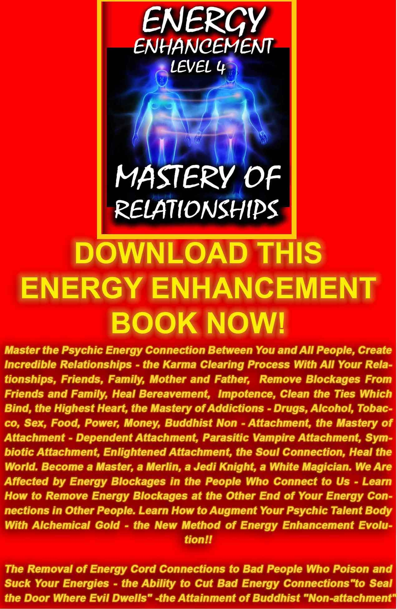
DOWNLOAD LEVEL 4 BOOK HERE!!!
http://www.energyenhancement.org/Sacred-Energy/Level-4-Book/Energy-Enhancement-Level-4-Book-Energy-Cords-Mastery-Of-Relationships.pdf

With an Astral Device - The Energy Enhancement Seven Step Process

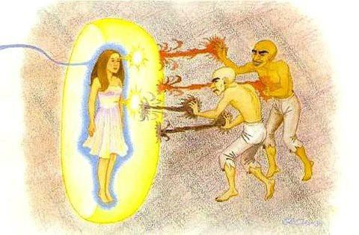
As the task of reconstitution and Resurrection is completed, then enlightenment, the capacity for teaching and the capacity for intuitive understanding become normal.“Like the sharp edge of a razor, the sages say, is the path. Narrow it is, and difficult to tread!” Immediately we think of Jesus words: “Enter ye in at the strait gate: for wide is the gate, and broad is the way, that leadeth to destruction, and many there be

which go in thereat: because strait is the gate, and narrow is the way, which leadeth unto life, and few there be that find it” (Matthew 7:13, 14)

Satchi, I will give you an update!

Okay so first I finished off the level 1 initiations...during those...your shaktipat energy brought up 5 blockages! They were very ugly, various shades of dark with some hate and fear trapped inside, so I had to dissolve them. They dissolved quite easily.

Then I haven't got very far into your level 2 yet because I started work and was tired...(insert blockage based excuse) but I do enter samadhi and gain a lot of energy, so I do it most days.

I managed to try your methods of dissolving the blockages in: level 2 course, 1st initiation and part 3....Where you talk about making an energy nuke, lazer and cutting off the top, bottom and then draining the dark energy into the core of the earth...

This does indeed work, because I had to do this for some more blockages (2 or 3 of them), one nasty one which had tentacles...and was inside me.

All it takes now is for me to think 'where are my blockages?' and my mind looks inside and can see swarms of them...like crawling black maggots hiding in this deep place.

Then my mind zoomed in on this blockage, which I used these methods to dissolve.

What I found happened with this...was that the blockage looked almost like it was made from rock/stone or like it was a golem or ...a device which had been

programmed with a set agenda (without it's own consciousness...as if an astral electrical technology device, controlled by a conscious demon).

To try to explain it some more...like most of my blockages have their own personality...they mostly have fear and hate and they 'talk' to me...in my mind like they tell me:

'Don't do this, don't do that!' or 'Do this do that.'

I have experienced a lot of fear, hesitation and the blockages attempt to make me put off doing your level 2 course.

They give me a lot of fear.

So what I found from the most recent blockages when I use your extra methods to dissolve them is that after some dark energy comes off...what is left is ...more of an 'astral device' than a demon, does it make sense? For example, it appears like an electrical device, or bug, square shaped objects...little rocks...with bugs on it and they have connections going up to darker beings (who have consciousness like a demon) who are controlling the devices...switching it on or off, etc. This is being used and switched on sometimes which acts to 'mind control' me, it influences my thoughts and emotions.

I found I could very quickly drain off the dark energy and 'cut' the connections to these higher dark beings, but dissolving the entire core of the blockage was difficult, it felt as if little useless bits of rock or stone were left...or like a ruined/broken bugging device.

So I at least got the impression that I had 'disabled' and 'broken' and 'disconnected...' the device. But not fully destroyed it.

I see all of this in my mind's eye.

So I am noticing more blockages and removing some more. When I have more time especially...I will watch more of your videos to learn more about it.

Like I said, I feel the biggest problem is the high levels of 'fear' which the blockages give out...when I try to focus on your videos. The transmissions of energy are very powerful. It digs up my blockages and also makes them find excuses to give to me why I should turn off the video. I am consciously aware of this happening.

'You should do x instead, don't listen to it, this teaching is bad...you don't need it...turn it off now. You should go do something else...'

Thanks very much for these videos. I want to spend some Months on learning the way to remove blockages and dig deeper to remove a lot of them!

Okay, for now I will go off. But I've given some explanation ...it is the least I can do right now.

OH, and also I sometimes find myself 'conscious' during sleep, and dream.

You appeared in one of my dreams some nights ago...what was special about this is that you had your aura.

So most people in my dreams are illusions, images but without 'aura's. Sometimes I meet a very wonderful spirit being in my dreams who radiates compassion. I believe that this is when sometimes a 'real spirit' enters my dream world and meets me while I am dreaming.

I saw someone who looked like you in my dream and they had a huge aura, very bright, very soft aura! Just like yours.

I remember myself in the dream apologizing to you for not doing the level 2 course enough, because I've only just started and I think I felt guilty for not doing it every day because I got distracted by the fear of blockages....and busy with everyday life.

Given time...It will be worked on! Thanks, this is my update.
Today I sat in a chair and listened to the heart chant initiation 1 Streaming Video for the first time.

I was focusing on aligning my shoulders and spine forward and backward between the two lines of power from the center of the earth. And picturing the immovable mountain. Focusing on my breathing, closing the anus. I stayed in for the first four minutes. Then I got tired and openned my eyes, for about 7 or 8 seconds. Then I was so drowsy I had to close my eyes again. Then after about another four minutes I was tired again. Then the same thing but this time I focused on nothing but the energy from the earth entering the base of my spine and coming into my heart. Right from the beginning of the meditation I felt my energy all over my whole chest, even now.

But at the last when I focused on it coming from the earth, I immediately felt very, very powerful energy and I didn't move to find it. My back straightenned up automatically to the alignment and I was kind of "stuck" in that position with the power flowing.

From there it was hard for me to stop meditating when the chants were over. Very powerful. Even without magnets. My question is about my focusing. Is it wrong to "imagine" the power or the alignment or the energy? or should we imagine until we feel it? Or both? Am I focusing on the right things?

I am very grateful for your teachings. Thank you for your generosity.

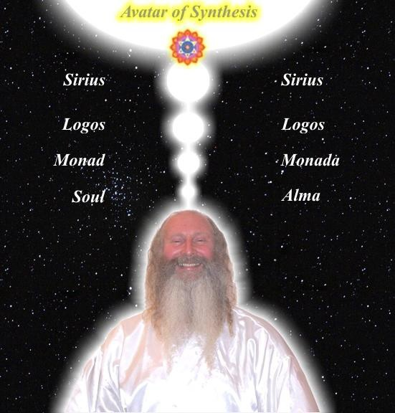

Student Report.. SPEEED UP THE PROCESS!!

Also I noticed as soon as satchi emailed me, I got a down-pouring of light from above the crown which kept charging me up the rest of the day – and my cravings died out! Then I realized they were ego-blockages and that I did not want them.

This Energy Enhancement Level One Initiation Three - ALCHEMICAL VITRIOL is great! I've done it some more and it's incredibly powerful. I don't know why it isn't more well known or taught? It's really bringing up little blockages which are complaining while being pushed down into the earth's core to get purified.

The hot fire energy has gotten much stronger in my body while doing the practice, mostly the base of the spine heats up, but also the middle of the spine. There are lots of little blockages being noticed. But I'm pushing them out.

Energy Enhancement Meditation Course Level 1 Initiation 4: Accessing the Universal Energy Source: Soul Fusion - INFINITE ENERGY!! for You!! via the Antahkarana, Macrocosmic Orbit, The Energy Enhancement Supra Galactic Orbit, Chakras above the Head, Advanced Kundalini Kriyas, Siddis, The Creation of Psychic Vision.

http://www.energyenhancement.org/EE-Meditation- Level-1-Initiation-4-Macrocosmic-Orbit-EE-Supra-Galactic- Orbit-Antahkarana-Chakras-Above-the-Head-Advance- Kundalini-Kriyas-Siddis.html

LEVEL 1 - 4 VIDEO COURSES ANYTIME IN THE COMFORT OF YOUR OWN HOME

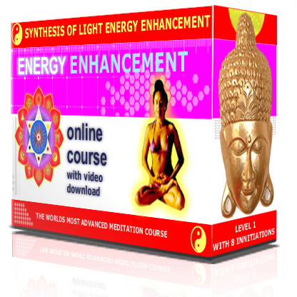

THE MEDITATION ENERGY ENHANCEMENT APPRENTICE LEVEL 1 and 2 COURSE!!

GET THE VIDEO COURSE!!

COME ON A LIVE COURSE!! - BRAZIL, INDIA, SPAIN



Sign up for the Mailing List and Find Out More!!
Find your Deep Peace and Infinite Energy.
@ www.energyenhancement.org

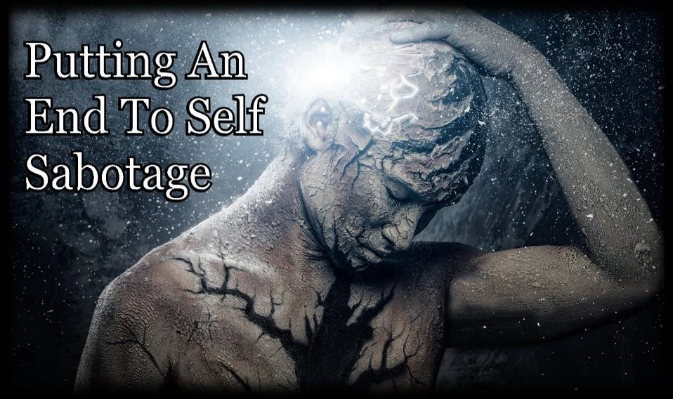

Connection and Blockage Removal
Remove All Self Sabotage with The
Energy Enhancement Streaming
Video Course in Four Levels of Soul

EE Level 3 - Ground All Your Karma
- Ground All your Bad Luck and trouble
Ever Wonder Why Things go Wrong?
Stop the Sabotage!!

Get the Energy Enhancement Streaming Videos..



LEVEL 1 - 4 VIDEO COURSES ANYTIME IN THE COMFORT OF YOUR OWN HOME

Free!!, with Two Levels of Energy Enhancement Streaming Videos you can start to Practise..

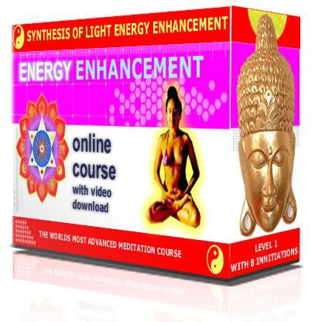

FREE!! Energy Enhancement Infinite Wealth Home Training Program WITH TWO LEVELS OR MORE OF ENERGY ENHANCEMENT
STREAMING VIDEOS!! Ride the wave of awakening and break free from the 26 Wealth Blocks holding you back with the Energy Enhancement Infinite Wealth home training program.

email sol@energyenhancement.org for details

COME TO IGUAZU FALLS FOR YOUR LIVE COURSE!!

Sign up for the Mailing List and Find Out More!!

The FREE!! - With Two Levels -
Energy Enhancement Infinite
Wealth Home Training Program

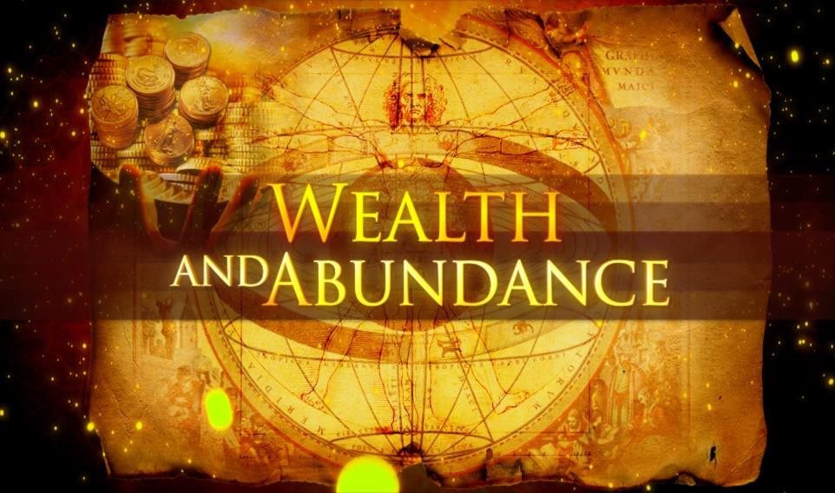WITH TWO LEVELS OR MORE OF ENERGY ENHANCEMENT
STREAMING VIDEOS!! Ride the wave of awakening and break free from the 26 Wealth Blocks holding you back with the Energy Enhancement Infinite Wealth home training program.
Do you believe your Infinite Wealth is directly related to your state of mind and consciousness?

If yes, what if there was a process to enhance your state of mind and consciousness, so from this moment onwards you could improve your ability to attract wealth? Would this interest you?

And if you knew this process only took a few sessions of practice, but would benefit you for the rest of your life… would you make the time for it?

If you said YES to all these questions, I have an invitation for you.

Previously, an intimate group joined me on a One Month Energy Enhancement Course including All Four Levels of Energy Enhancement including the Seven Step Process for Transmuting and Removing Energy Blockages.

The Free Energy Enhancement Infinite Wealth Program.

During the Month, I used my gifts to work with every participant’s energetic frequency. I dived deep into their minds, and removed hidden subconscious barriers – or as I call them, Energy Blockages including Wealth Energy Blocks – that were silently sabotaging their ability to attract wealth.

Blocks like “I don’t really deserve to be rich“, or “Wealthy people are bad“ (I’ll show you a full list of these Blocks further down below, and some of them will surprise you!).

The results of this program were life-changing — but it was only available for a small group which is why now, for the first time ever, I’ve decided to make this content public.

I’ll tell you more Sivananda of Rishikesh. He exudes the Buddhafield in which all change is Infinitely possible connecting to the Energy Enhancement Infinite realmeople's lives.. Satchidanand has worked with many Students including Directors of Fortune 500 Companies. He gives Retreats and Seminars from five days to one month to five months in his Ashram at Iguazu Falls in Brazil and also in India, Spain, Italy and Greece.

“It is just as difficult and dangerous to try to free a people that wants to remain servile as it is to enslave a people that wants to remain free.”

Niccolò Macchiavelli

The geopolitical tragicomedy is certainly fun to watch, sort of like watching icebergs capsize, but since there is not a lot any of us can do about it, it's something of a time-waster; whereas fixing an actual problem, and making many people's lives better as a result, seems like a worthwhile pursuit—at least it does to me.

Minimum Viable Action (MVA). This is a tremendously powerful concept, because it shows how you can do pretty much whatever you want. You just have to do enough different things, and each one with sufficient lack of success, so that none of them runs the danger of making a Significant Contribution to Society (SCS) (joke), and getting noticed and potentially struck down by those who jealously guard their prerogatives to create Poverty as a matter of Policy. All you have to do is not be sufficiently successful, not so much in the public eye, and you should be safe.

Therefore the maximal change you can make for Yourself and for the World comes from Energy Enhancement Meditation.

When you eliminate your Energy Blockages, you will… Out of the blue start feeling newfound passion which only occurs when you do that thing you were Born To Do..

- Only when you access your Soul Path.

Only when you remove all the Energy Blockage Chains standing between you and your Soul...
How can you be successful doing that which you are not meant, not Born, to do?

Energy Enhancement Transmutes and Removes Energy Blockages allowing you access to the Destiny of your Soul!!

Only this will give you the motivation to excel in your Soul Path career, and enthusiastically jump on the opportunities surrounding you.

Imagine waking up every morning with that tingly excited feeling to try out a fresh idea at work or explore a new business opportunity.

It only happens when you do, that which you were born to do.

By Removing All the Blockages between you and your Immortal Soul, Magically the Chains Fall Away and you end up Doing that thing which excites you, and Inspires you!!

Only Soul Path Access will allow you to Experience sudden rushes of creative ideas and even dreams that lead to Real Wealth, like suddenly realizing a way to reach out to more customers, finding a way to better manage your debt, or discovering a no-brainer

investment opportunity that’s been under your nose all this time.

Only Soul Path Access will allow you to find yourself living in a state of optimal work-life balance, where you know exactly how much time and energy to invest in your career to make it successful, and when to clock out so your family, friends and hobbies get the attention they deserve.

Only Soul Path Access will allow you to Discover that your attitude towards money has transformed for the better. You’re no longer worried about the bills and the mortgage, you’re not held back by the “I don’t have enough” mentality, and you’re never afraid to spoil yourself and your loved ones with good food, nice things and exotic holidays.

Only Soul Path Access will allow you to Start experiencing serendipitous moments in your everyday life like never before, like finding a surprise cheque in the mail, meeting your future business partner at a bus stop, or stumbling on a book that turns your life around.

Only Soul Path Access will allow you to Transform yourself into a catalyst for positive change for the planet by inspiring others with your success and Wealth, and having the financial means to support your favourite charities and spark social movements in your community.

Best of all, all these Soul Access mind shifts, coincidences and opportunities get more and more profound as you continue working on your Wealth Blocks—until eventually, perhaps just months from now, you’re enjoying the kind of Infinite Wealth

you once thought impossible.

Now it’s important that you realize there are 26 Wealth Blocks in existence, and your unique life circumstances will determine exactly which ones are affecting you.
However…

Even having just ONE Wealth Block is enough to completely derail your life.

For example what if you had an Wealth Block that causes you to believe hard work equals success? If you hate doing it You might become the kind of person who works 60, 70, even 80 hours a week without any success at All. You might come home late every night, and miss countless precious moments with your family and friends. You might even over-exert yourself, and end up in hospital or worse.

Not Connecting with your Soul gives you a Life without Meaning, Full of Sound and Fury, Signifying Nothing!!

You see when left unchecked, even this One Single Wealth Block can ruin your life—and what I’ve found is that most of us have at least half a dozen Wealth Blocks affecting us to varying degrees.

And if just one Wealth Block can do so much damage, think about how a multitude of them could be sabotaging your career, your finances and your life as a whole. Picture how they could be holding you back from your true potential, and the Infinite Wealth

you deserve.

How do I know so much about all this? Well…

I am an intuitive healer. Ever since I was a child, I knew I had a special gift. I’ve always experienced inexplicable bursts of intuition, and have an uncanny ability to see and influence people’s energy fields.

Only by Training and Refining that Intuitive Function in the Buddhafield's of my Teachers - Incredible people from Ancient Lineages and Great Soul Force - using the Techniques of Energy Enhancement, Meditation, Samadhi, and Energy Blockage removing Samyama have I been able to bring that innate intuitive Soul Path Force to Incomparable Fruition!!

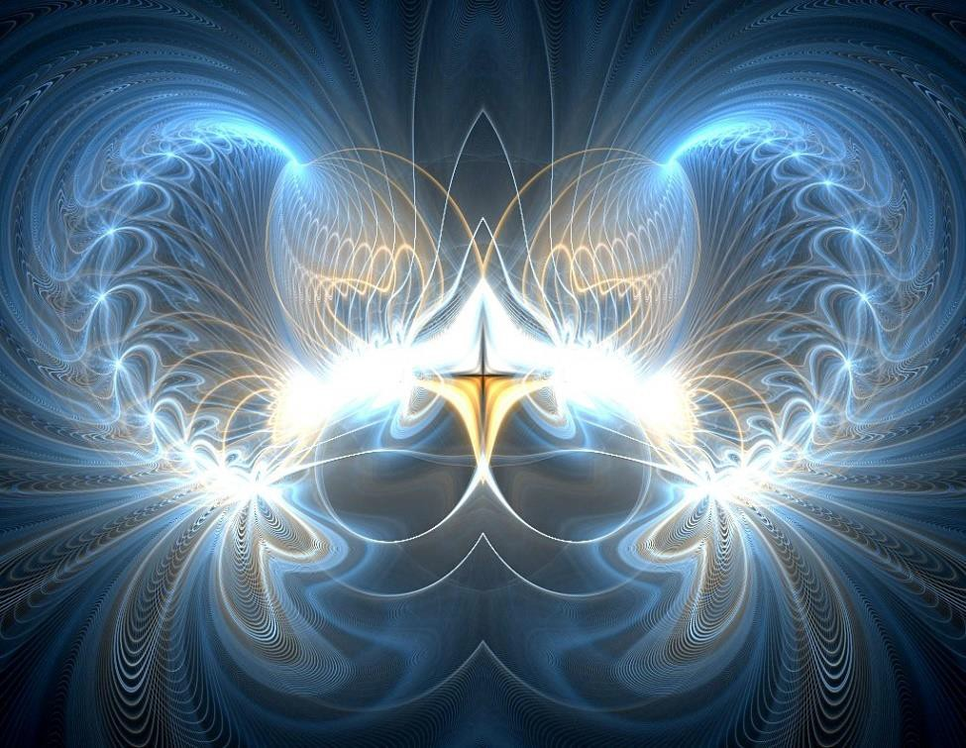
You can do that Too.. GREAT SOUL!!
Great Soul, You have nothing to lose but your Energy Blockage Chains!!

The Ruler of the Universe is that Intense Explosive Silence an Infinity of Chakras above the Head.

When Energy Enhancement teaches you, gives you direct experience of contacting the Energies of the Center of the Universe, Beyond the Center of the Universe into the Absolute.. and then Chanelling those energies down onto this Earth to Power Your Soul Path..

DHARMAMEGA SAMADHI!!

Then you too become a Ruler of the Universe!!

In this time I’ve also used my gifts to follow my Soul
Path which is to bring this Ancient Meditative Knowledge to Humanity to eliminate my own Wealth Blocks and Speed Up Your Process!!

Once upon a time I had barely a dollar to my name and slaved in the Company Store. I retired at age 37 and Now I live a lifestyle most people dream of in the Tropical Beauty Iguazu Falls in Brazil having taught Energy Enhancement in some of the Worlds most beautiful locations, Southern Spain, Italy, Greece, Brazil and India, to some of the World's most Incredible people!!

And I’m committed to using my position of privilege to
help the world manifest their ideal realities too.

I tell you all this not to brag, but to show you just how transformational overcoming your Soul and Wealth Blocks can be. No matter who you are and what your background is, you CAN do exactly what I’ve done for myself and thousands of others.

How to permanently remove your Wealth Blocks.

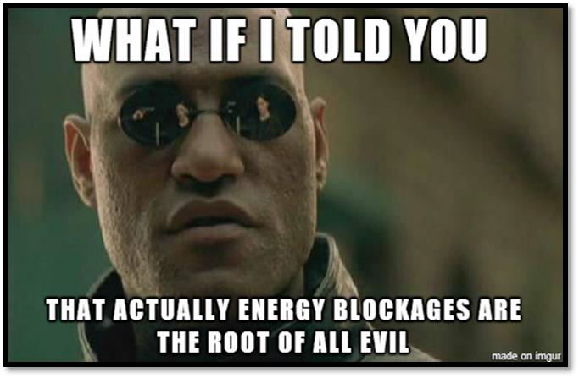

Removing your Wealth Blocks is not something you can normally do alone, without training. Because even if you know exactly what they are, and even if you make a conscious intellectual decision to break free from them… Energy Blockages are not Intellectual!!

Just by saying it, you do not have the Training to make it So!!

Your existing energetic frequency and subconscious Energy Blockage thought patterns will always, always pull you back to them. Back to square one, back to the same limiting beliefs and behaviours.

That’s why the key to liberating yourself from them is to
go to the source of All Energy, The Absolute!!

In Energy Enhancement Meditation we will give you Direct Experience of Infinite Energy from outside your body, from the Universe itself. "Brighter than 10,000 Suns it Shines Alone!!" — the part of your personal energetic field known as an Infinity of Chakras above

the Head, source of Samadhi, liberator of ALL Energy Blockages, every Self Limiting Belief, Liberator of Your Internal and External, Eternal Wealth.

In the Buddhafield, with a little help from your Soul, you will learn to connect with the external Chakras connecting you with the Universe and its Energy Enhancement Infinite Energy. Using the eternal techniques of Meditation, using the 5000 years Old Sutras of Tamil Siddar Patanjali you will access Samadhi and the Energy Blockage Transmuting Energies of Samyama.

Unique techniques for accessing your Wealth Frequency and systematically removing all the blockages that are holding it down.

Energy Enhancement is a liberating, exhilarating and life-changing process as you Access your Soul.

We now need to Supplement your Soul Path with Intellect because Taking ACTION Speeeds Up the Process!!

One that you will experience firsthand when you join me
in…


The Energy Enhancement FREE Energy Enhancement Infinite Wealth Home Training Program

A step-by-step guide for Accessing your Soul and eliminating your 26 Wealth Blocks

Available exclusively on this site, the Energy Enhancement Energy Enhancement Infinite Wealth Home Training Program is a course for eliminating each of your Wealth Blocks, one after the other, FREE, as part of.. Energy Enhancement Level One - Gain Energy Enhancement Infinite Energy by connecting to the Universal Source.

Energy Enhancement Level Two - Transmute and Employ all self limiting Energy Blockages

Plus Later, Levels Three and Four..

What you get is a complete collection of Streaming Video recordings from each of the Energy Enhancing sessions from the original Energy Enhancement Program. In each session, you’ll experience a powerful and immersive process that increases your energetic frequency, protects you from negative energies, accesses your subconscious mind, and liberates you from Energy Blockages.

The program is designed to give you the same transformational energy clearing results as experienced by participants of the original Energy Enhancement Course — but at a fraction of the price, and without being tied to a preset schedule.

In Addition here Are The 26 Wealth Blocks Which Are Holding Back 99% of Entire Population

Here’s an explanation for each one:

One by One, go through and 7step each blockage.

Circle the word, circle the concept, circle the idea in white light and 7 step!!

Wealth Block 1 : Energy Enhancement Seven Step your, "Resistance"

How your surroundings silently influence you.

Wealth Blocks could come from anywhere — your parents, your mentors, your friends, the media and the government.

For example…

As a child, did you ever hear your parents complaining about “greedy” and “unethical” rich people, and how the government always sides with them instead of the masses?

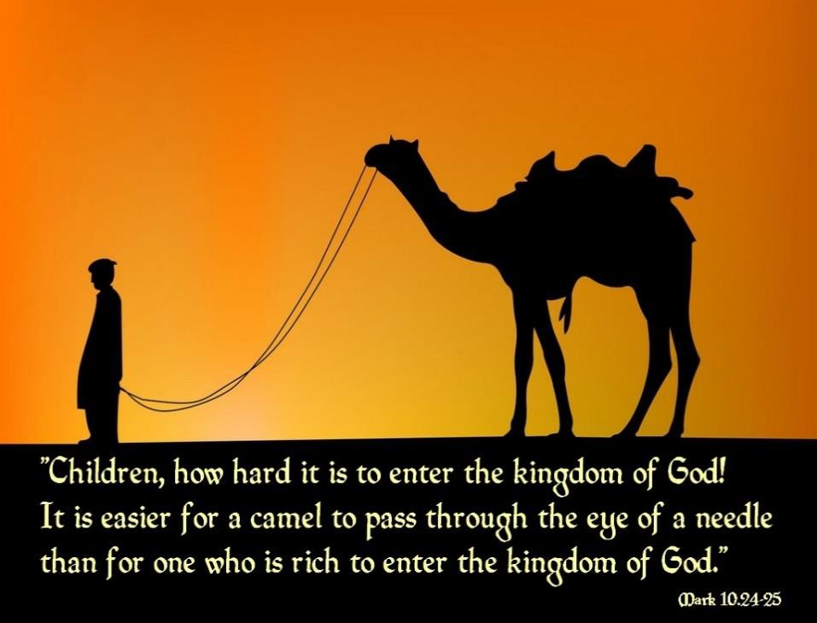

Did you ever hear that line from the Bible saying it’s harder for a rich man to enter heaven than for a camel to pass through the eye of a needle?

Have you ever heard the Pope extolling the virtues of, "The Principle of Poverty"?
Have you ever heard politicians bigging Austerity? Have you ever watched a movie, listened to a song or
read an article that calls money “the root of all evil”?

In high school or college, were you ever told that working hard is the only key to success?

Silently, sneakily, these influences latch onto your subconscious mind, and form Wealth Blocks in you.

And the result is in plain sight. Many of us are saddled with a subconscious fear towards money, because somewhere deep down inside, we relate it to greed and evil. Some of us spend way too much time at work, thinking back-breaking work is the only path to success. We overlook opportunities, we’re often too afraid to invest, we always second-guess ourselves… the list goes on and on.

In fact statistics show that Wealth Blocks hold us back even further when left unchecked. In 1990, researcher John Zogby found that 14% of adults were actually making less than what they earned in their previous jobs. Since March 2011, that figure has since increased to a staggering 35%.

Now look at your personal financial circumstances. How much do you think Wealth Blocks are holding you back right now?

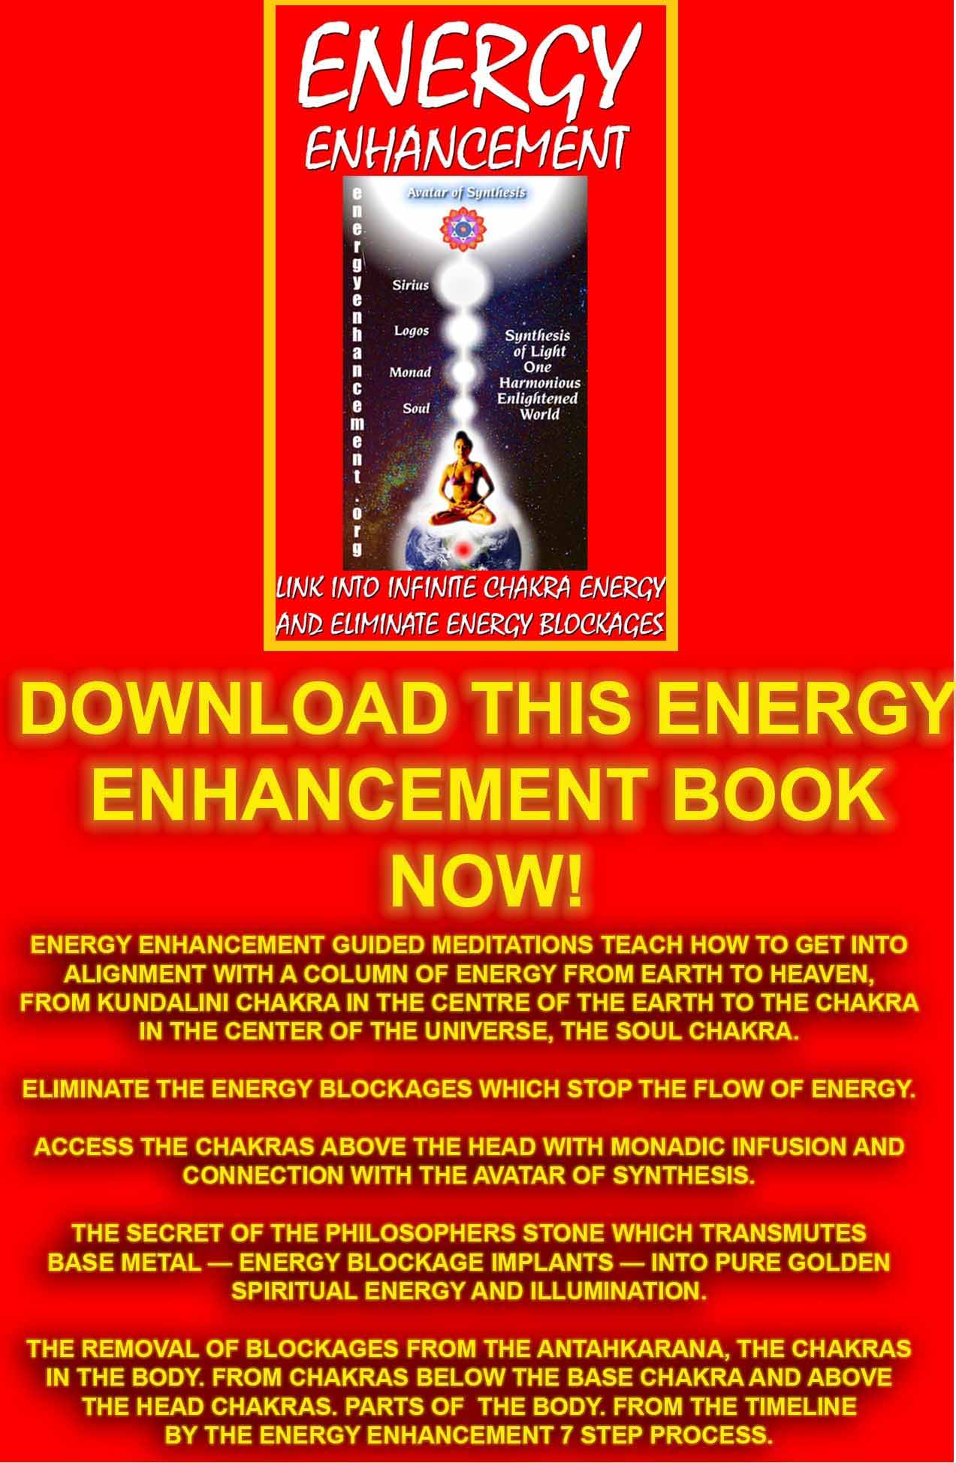
Download “Link Into Infinite Chakra Energy And Eliminate Energy Blockages” Here
http://www.energyenhancement.org/Sacred-Energy/Meditation-Energy-Enhancement-Link-into-Infinite-Chakra-Energies-and-Remove-Energy-Blockages-EEBOOK1Color-energyenhancement-org.pdf

With Energy Enhancement you can drain the negativity out of all these and other concepts within your psyche leaving the truth..
Rich people can be evil vampires, but those vowing to use that money on their soul path to help yourself, to help your family, to help the evolution of every soul, all humanity, get a pass - you can't take it with you. Decide to Use your money in the Service of Goodness.

Jesus did extol Poverty, but he was talking about the Poverty of the mind, free from evil thoughts, the ability to remove all evil from your mind in order to contact the thoughts and energies of the highest and best Good God, the one with 10,000 names.

And the concept of - it’s harder for a rich man to enter heaven than for a camel to pass through the eye of a needle? - Again this is the Evil Ego of wanting money for its own sake, being a Miser, which needs to be grounded, Rather than planning how you are going to use All that money you will receive for the benefit of yourself and of Humanity.

Are you growing by 10 percent each year, as all optimistic countries should be growing at 10% per year?

It’s common knowledge that to be considered financially healthy, your income should increase by at least 10 percent each year—both to combat inflation, and to reward you with a progressively better standard of living.

Why? Because think about it. The longer you spend in a career, the better you should become at it. If you work in sales, for example, you should only get better at

persuading customers and closing deals. You should be getting more creative ideas and inspiration to grow your customer base. And on the side, your investments should be growing too.

So the big question is, are you achieving this? Or are your Wealth Blocks holding you back?

It’s common knowledge that to be considered Soul healthy, you should be cleaving to your Soul Path preparing for a quantum leap - increasing by at least 10 percent each year — both to combat despair, and to reward you with a progressively better standard of living which is only possible when you are in alignment with your Soul and moving towards that perfection of Quantum Leap Soul Work Alignment too.

Jump start your journey into Wealth with a Four step system to open your energy fields, contact the Energy Enhancement Infinite External Chakra Energies, Access your Soul and begin the Energy Enhancement Blockage clearing process.

Energy 101 – wondering what exactly is energy? Learn what it is by Energy Enhancement Direct Experience.
Alignment with your Soul, Connection with Kundalini Chakra, Samdahi an Infinity of Chakras above the Head, Free Up, Remove All Energy Blockages on the Path of Your soul!!

Autopilot Breakdown – identify the ‘lies’ you have learned in life about money and Wealth, so you can start breaking down the subconscious patterns towards wealth that are holding you back.

Remove Vows of Poverty from previous Lifetimes.

Wealth Block 2 : Energy Enhancement Seven Step your doubt and fear....
Read More or contact Energy Enhancement for your Energy Enhancement Streaming Video Course in Four Levels - With this the The Energy Enhancement Infinite Wealth Home Training Program is Free!!!

And 22 Blocks more....
INFINITE WEALTH STUDENT REPORT..

Satchi ! Some good updates. Filled with a tonne of energy right now...

I am getting a lot more sensitive to my soul path, as well as my integration with what I call the 'unity field', aka , god.

So after Getting an email from you about the abundance/wealth blocks... I knew that I had some, so I went hunting.

I got about 5 or 6 blocks relating to fear of money/abundance... dark grey or black blobs.

I also grounded a fear which looked like a pitch black energy slug.

I can feel my soul energy is strong in my heart, and pure light.

...I really want to get out of my current job and find something more aligned with my soul purpose though.

Got to keep working on this.

So I've found the best, most simple ways to find blockages are this:

- samadhi

- your energy from video

- searching for 'resistance to', 'fear of', and so on

The blocks primarily feel 'resistance to what is right'.
J

Thank you so much. This is so great. This past weekend I created a 60 day transformation plan in which I called forth the transmutation of my health, finances, karate, relationships book (done and published) and home, car and office in the next 60 days. I am living in it so there is no doing and instead of working on one area in my life I am asking for it all.

Your help in making me aware of the person(s) that are stealing my life force energy as well as releasing and blessing those people and then drawing up the power already inside of me is fantastic. The awareness that I truly have the power to manifest anything is amazing! Thank you!

Don’t Decide Now… Take All The Time You Need And Try “Energy Enhancement Infinite Wealth

Energy Enhancement Infinite Wealth comes with a triple guarantee and peace of mind
- Quality.

You’ll notice the highest level of quality in every aspect of this program, from the detailed and structured way each technique and lesson is delivered, to the highly personalized email attention directly with Satchidanand and the Buddhafield, right down to the audio clarity of the Streaming Video. Everything you’re about to learn has been researched, practiced and perfected over 25 years, with many people.

- Results.

Upon beginning the Energy Enhancement Infinite Wealth Program, you’ll notice profound changes that will only get better in the coming days, weeks and months. Your attitude will change. You’ll be more inspired at work.
Serendipitous coincidences will manifest. And out of
thin air you’ll get new creative ideas.

- Impact on your life.

With the Energy Enhancement Infinite Wealth Program your Wealth is Infinitely growing, even if it’s been stagnant for years. Your debts will shrink. You’ll be happier and more productive at work. And you’ll have the financial ability to spark positive change in your community and the world.

The path to your abundant life starts with a decision.
Now that this opportunity has been made public, will you seize it?

Will you liberate yourself from all your Energy Blockages and Wealth Blocks, and reward yourself and your loved ones with a life of affluence, freedom and contribution?

Or will you miss the boat and choose a life of financial mediocrity, where money and self-sabotage is a constant worry, financial mistakes keep getting in the way of success, and your full potential is never realized?

If you’re ready to make a commitment, I’m ready to help you through every step of the way. Let’s make this moment right now your Wealth turning point.

Satchidanand



WEALTH, ABUNDANCE, RICHNESS AND MONEY - THE NEW HUMAN RIGHT

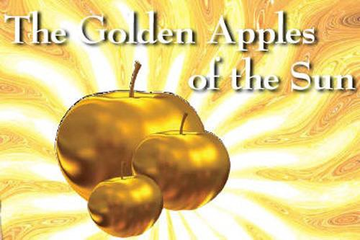
WEALTH AND ABUNDANCE - THE NEW HUMAN RIGHT - EXTERNAL AND INTERNAL

Satchidanand and "The Secret" by Rhonda Byrne - Meditation, Removal of Negativity, Painergy, Energy Blockages for Self Help and Wealth

Sign up for the Mailing List and Find Out More!!

Come to Incredible Iguazu Falls.

Learn how to connect with the infinite Energies of the chakras above the head.
Learn how to remove energy blockages with the Energy Enhancement Seven Step Process.

Realise!!
Illuminate!!

EnLighten!!

THE ENERGY ENHANCEMENT MEDITATION COURSE - LEVEL TWO

ILLUMINATION, ENLIGHTENMENT

"ALL TRADITIONAL MEDITATIONS HAVE BEEN DESIGNED TO FAIL" - SATCHIDANAND -

FIND ALL THE INCREDIBLE TECHNIQUES REMOVED FROM TRADITIONAL MEDITATIONS - DESIGNED TO FAIL - AND TAUGHT IN ENERGY ENHANCEMENT

WE PUT BACK WHAT THE OTHERS TOOK OUT!!"
THE REMOVAL OF ENERGY BLOCKAGES - REMOVE ENTITIES AND IMPLANTS WITH ADVANCED ENERGY BLOCKAGE BUSTING TECHNIQUES -

THE ENERGY ENHANCEMENT SEVEN STEP PROCESS

“When Qi flows freely along the meridians, people are free from illness; If the Qi is blocked, the pain follows.” Ancient Chinese Saying

"You Know, Removing all your Energy Blockages is a Really Good Thing" – Satchidanand

THE ENERGY ENHANCEMENT SEVEN STEP PROCESS IS AN UNFAILING TECHNIQUE WHICH CAN REMOVE ANY ENERGY BLOCKAGE

LEARN IT NOW!!

COME ON A MEDITATION ENERGY ENHANCEMENT APPRENTICE LEVEL 1 and 2 COURSE!!

COME AND GET EXPERIENCED!

CLICK HERE!! FOR WHAT WE ARE DOING

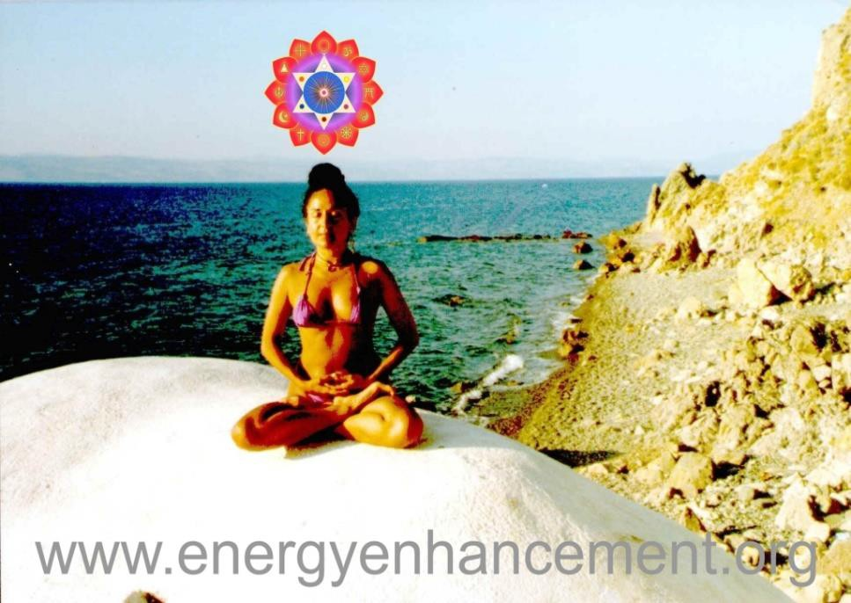EMAIL sol@energyenhancement.org FOR DETAILS

ENERGY ENHANCEMENT DEVI DHYANI

Sign up for the Mailing List and Find Out More!!

ENERGY ENHANCEMENT PROMETHEUS INFUSING LIFE ENERGY INTO ZOMBIFIED MAN

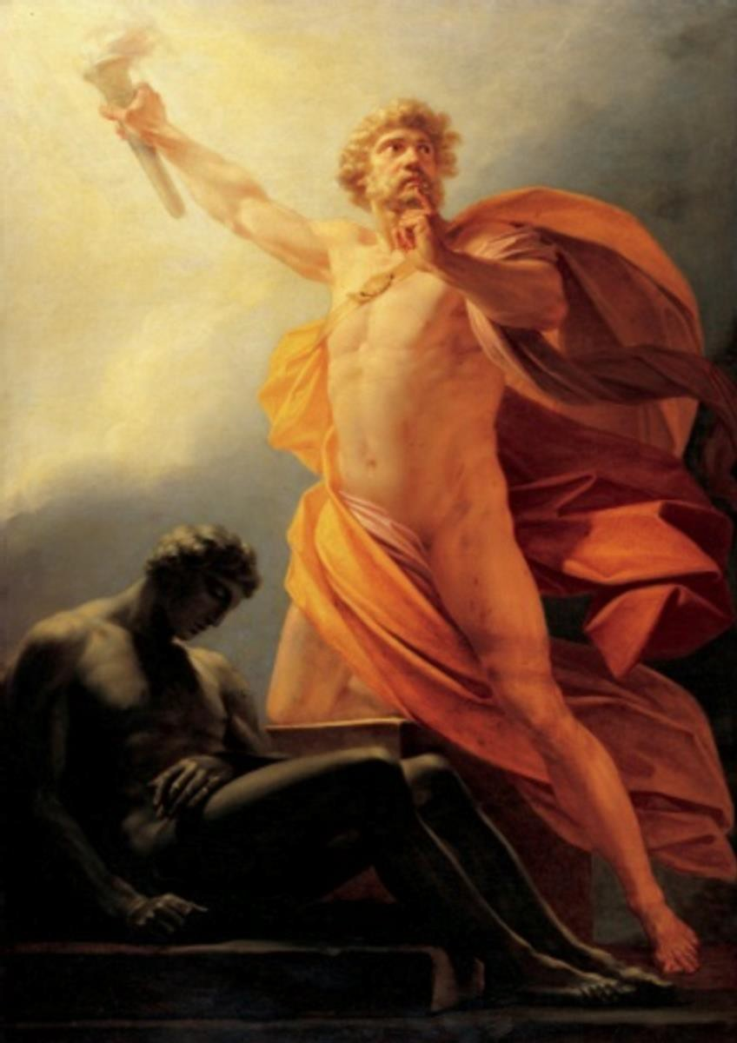

"WAKE UP!!"

STUDENT REPORT September 2013
- The Energy Enhancement Course Level One, Initiation Three, Streaming Video..

KUNDALINI PURIFICATION..

Further notes:

Also I noticed as soon as Satchidanand emailed me, I got a down-pouring of light from above the crown which kept charging me up the rest of the day – and my cravings died out! Then I realized the cravings were ego- blockages and that I did not want them.

This meditation 3 - The Energy Enhancement Course Level One, Initiation Three Streaming Video... is great! I've done it some more and it's incredibly powerful. I don't know why it isn't more well known or taught?

This meditation 3 - The Energy Enhancement Course Level One, Initiation Three

"BECAUSE TRADITIONAL MEDITATIONS ARE DESIGNED TO FAIL!!"

It's really bringing up little blockages which are complaining while being pushed down into the earth's core to get purified. The hot fire energy has gotten much stronger in my body while doing the practice, mostly the base of the spine heats up, but also the middle of the spine. There are lots of little blockages being noticed. But I'm pushing them out.

I think this is my new favorite meditation practice! It's far more powerful than the normal orbit practice.

Have practiced it some more – my body gets very hot during the practice – just like the video says.

"JUST LIKE IT SAYS ON THE TIN!!"

"DRAIN THE LAST DREGS OF YOUR, "VITRIOL""

My mother came into the room and told me she 'couldn't be near me' because I was giving off too much heat – like a radiator! After this I noticed that by thinking about certain areas of my body I could send the intense heat to that area!

So now this meditation is definitely the most powerful one I have got. Very impressive. I do an in breath/out breath orbit and then hold for a moment at the earth- core. Then I bring up the energy again.

I've had another experience today, which is light surrounding a part of my selfish ego, and my ego submitted. The light has won for this issue. It is no longer possible to tolerate some of my selfish behaviours.

Now I feel very peaceful. ILLUMINATION, ENLIGHTENMENT..
THE TOTAL MASS OF ENERGY BLOCKAGES IS WHAT MAKES UP THE EGO

ENERGY ENHANCEMENT DHARMA MEGA SAMADHI REMOVES THE ENERGY BLOCKAGES OF THE SELFISH COMPETITIVE PSYCHOPATHIC EGO ONE BY ONE, KNOT BY KNOT UNTIL, "THERE CAN ONLY BE ONE" ONLY ONE SOUL INFUSED PERSONALITY REMAINS.

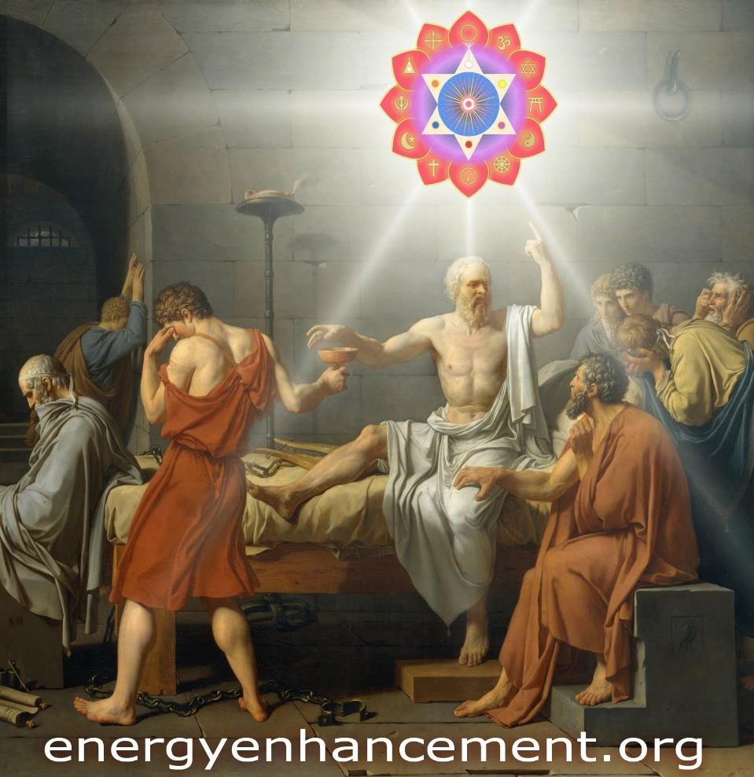
THE LIGHT OF THE SOUL IS THE SILVER LINING "DO NOT LOOK UPON MY FINGER, INSTEAD LOOK
TOWARDS THE SOUL TO WHICH IT POINTS" - BUDDHA THE DEATH OF SOCRATES BY DAVID

Thanks! I want to update you. I underwent a profound change in my energy last night after my main ego blockage submitted.

However today I noticed with more light in my system, that there are more, smaller ego blockages which are there and which talk to me. I look forward to resolving them. I'll now paste what I wrote last night.

Now I write here what I experienced between my last comment and reading her reply, written just below:

I had to lay down to do some meditation just now, and I felt like there were ‘two me’s, the first me was this little black smudge of an ego, the ‘I’, the selfish ego, or the part which basically functions for it’s own agenda. This guy basically pleasure-seeks and avoids pain/responsibility and is good at justifying it’s reasons and making excuses.

The second ‘me’, was this overwhelmingly peaceful, white light. It was so powerful it was literally drowning my little dark ego. So my ego had this light just drowning it from all directions. Imagine a war scene where the dark side is just a little blob of dark and there is hundreds or thousands of times as much light surrounding it from all angles.

Then also during this process, I had to see through the ‘light’s eyes to take a look at me…and I saw all these faults. I saw this creeping little dark ego who was so unaware of everything, it just kept making excuses for it’s actions ‘but’ this, and ‘but’ that. It just kept wanting pleasurable things and to run away from responsibility. I had to take a long good look at this guy, this type of me.

So my little dark ego, the ‘I’, just …well, just gave up. He just said ‘Okay!! Okay…I give up! I give up!
Surrender!’ So then I started to feel like I was going to cry. All this light just smothered me, my ego and gave it a lot of love and peace. Then I felt this vortex of white light form in my heart – it felt quite small, maybe an inch or so big.

Then I felt all this peaceful energy throughout my whole body – it felt like cosmic/space/universe energy.
Something like a peaceful energy from space (as if I had a whole entire universe inside my chest and body with the heart at the center). After that happened, I was getting light flood my body and I just felt like crying and surrendering. I suddenly felt this rush of what felt like crystalline white light flood into my body and fill my arms and legs and whole body. So I had a new ‘layer’ of energy body or something like this.

I think it’s a point of no-return now! I can only surrender now. What seems to be filling my body is this type of energy which is peace and light, it only seems to want what’s right for everyone. I hope it remains. I don’t
know how much of my ego I let go off…I wish all of it
will go now.

I honestly don’t believe I will go back to being how I used to, because too much of my consciousness or awareness feels grounded into ‘light’, so if I can keep seeing from the light’s viewpoint, I can quickly pick out faults which I might otherwise do.

Phew, what an intense evening. But I feel so peaceful! I seem quite satisfied to just drown myself in this light.

I want to give an update on this today. I’m pleased to say that the energy of soft love and peace which flooded my body last night, has remained with me today. I feel

like a completely different person. There has been a loss of desire, an increase in peace.

I threw out some supplements and felt like that type of thing has now become redundant.

Today I noticed that small ego blockages were in my aura. They are much weaker than the one which submitted to the light last night, they are more deeply buried.

I hope to continue to resolve and integrate these fragments of ego energy blockages in future.

Peace, Starlight

Why Energy Enhancement Personal Development is the Best Investment You'll Ever Make

I'm a strong believer that personal development is the best investment you could ever make. The reason is really simple. Improving yourself proactively, working on your awareness, improving your skills and knowledge about how you can get to the edge of your potential, all of that is an investment into the greatest asset you'll always have: Yourself.

I know from my own experience that this is true. And I know it from the fact that almost every Spiritually successful person started out low and became high!!

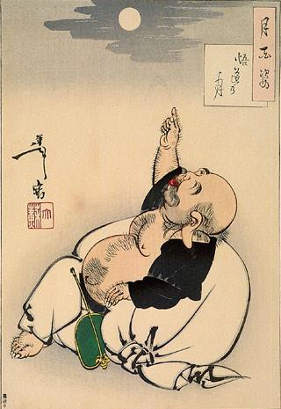
HOTEI POINTING AT THE MOON

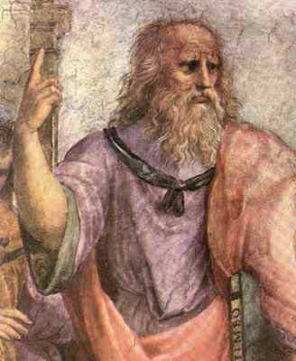
PLATO POINTING TOWARDS THE SOUL BECOME A SOUL INFUSED BEING!!

"Since that time I am always connected to and able to source the white light from above my head. Many times during this process I just forget to breathe as though my breathing is just naturally suspended. I am now living in the Light!!"



"My energies are naturally far higher than when I arrived on the Energy Enhancement course just two weeks ago. I am experiencing the fruits of meditation which normally arrive, if they do, after twenty years of meditation and it has only taken me two weeks.

This is the first meditation course I have been on. I have an injured knee from a few months ago in a motor cycle accident, yet the knee is now healed of its blockages and of its pain here on the Energy Enhancement Course and I am sitting in meditation for more than three hours a day, on the ground in the easy meditation posture, here in the light and working on more of my deep internal blockages.

Truly, perhaps Enlightenment is next!!"

ENERGY ENHANCEMENT MEDITATION ENLIGHTENMENT AND ILLUMINATION
AND THE REMOVAL OF ENERGY BLOCKAGES

THE INCREDIBLE MEDITATION COURSE AND MEDITATION TECHNIQUES CREATED TO PRODUCE ENLIGHTENMENT AND ILLUMINATION

"ALL TRADITIONAL MEDITATIONS HAVE BEEN DESIGNED TO FAIL" - SATCHIDANAND

"BECAUSE ORIGINALLY ALL MEDITATIONS CONTAINED THE TECHNIQUES OF, "THE REMOVAL OF ENERGY BLOCKAGES", "THE KUNDALINI KEY" AND OF, "ALCHEMICAL VITRIOL" TO GROUND NEGATIVE ENERGIES AND TO NATURALLY INCREASE KUNDALINI ENERGY"

"NOW, ONLY ENERGY ENHANCEMENT MEDITATION TEACHES THESE TECHNIQUES WHICH SPEED UP THE ENLIGHTENMENT PROCESS"
CLICK HERE FOR..

YGGDRASIL IS THE KUNDALINI KEY

AND

VITRIOL - Visita Interiora Terrae
Rectificando Invenies Occultem
Lapidem

Translation of VITRIOL.. "Visit the Center of the Earth there you will find the Philosophers Stone, Kundalini Chakra, which transmutes all Negative Energy, All Pain, All Negative Karmic Mass, into Pure Positive Spiritual Energy. By changing the direction of that Energy along the Path of the Soul, Soul Chakra, Central Spiritual Sun, First Chakra Above the Head you will receive Enlightenment"

\

"IF YOUR TRADITIONAL MEDITATION DOES NOT TEACH YOU ABOUT THE REMOVAL OF ENERGY BLOCKAGES, THE KUNDALINI KEY AND ALCHEMICAL VITRIOL, THEN IT HAS BEEN DESIGNED TO FAIL"

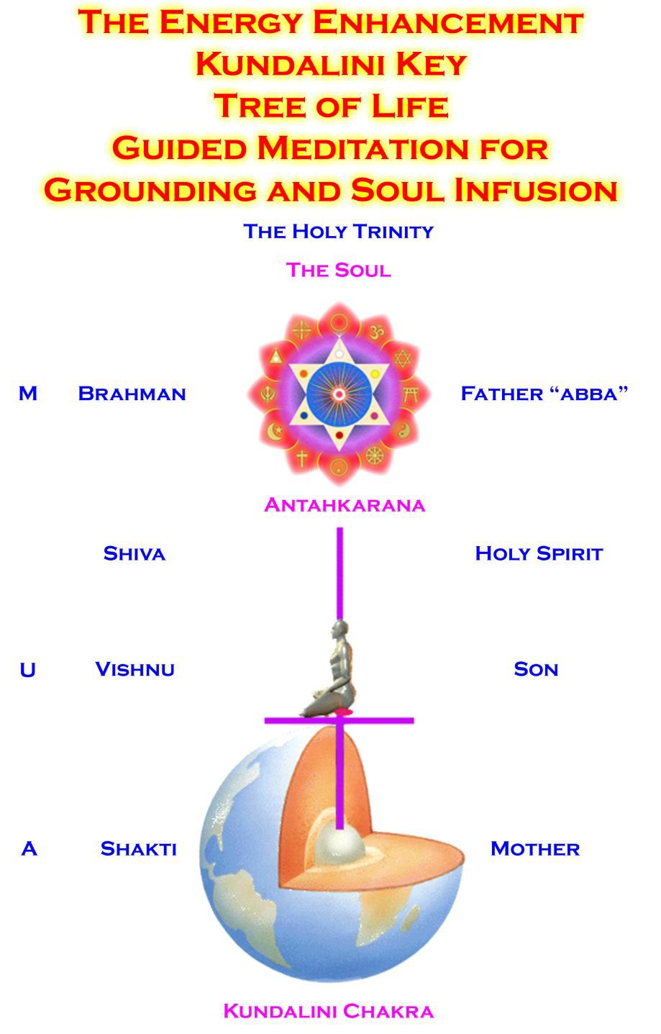
ENERGY ENHANCEMENT IMMORTALITY LIVE COURSES, INDIA AND IGUAZU FALLS

ONLY THE SUPERPOWERS DEVELOPED BY THE SCIENCE OF REAL MEDITATION CAN FREE HUMANITY TO REACH THE STARS.

ENERGY ENHANCEMENT MEDITATION ENLIGHTENMENT AND ILLUMINATION

THE INCREDIBLE MEDITATION COURSE AND MEDITATION TECHNIQUES CREATED TO PRODUCE ENLIGHTENMENT AND ILLUMINATION

"ALL TRADITIONAL MEDITATIONS HAVE BEEN DESIGNED TO FAIL" - SATCHIDANAND -

"BECAUSE ORIGINALLY ALL MEDITATIONS CONTAINED THE TECHNIQUES OF, "THE KUNDALINI KEY" AND OF, "ALCHEMICAL VITRIOL" TO GROUND NEGATIVE ENERGIES AND TO NATURALLY INCREASE KUNDALINI ENERGY"

"NOW, ONLY ENERGY ENHANCEMENT MEDITATION TEACHES THESE TECHNIQUES WHICH SPEED UP THE ENLIGHTENMENT PROCESS"

SATCHIDANAND - IGUAZU FALLS



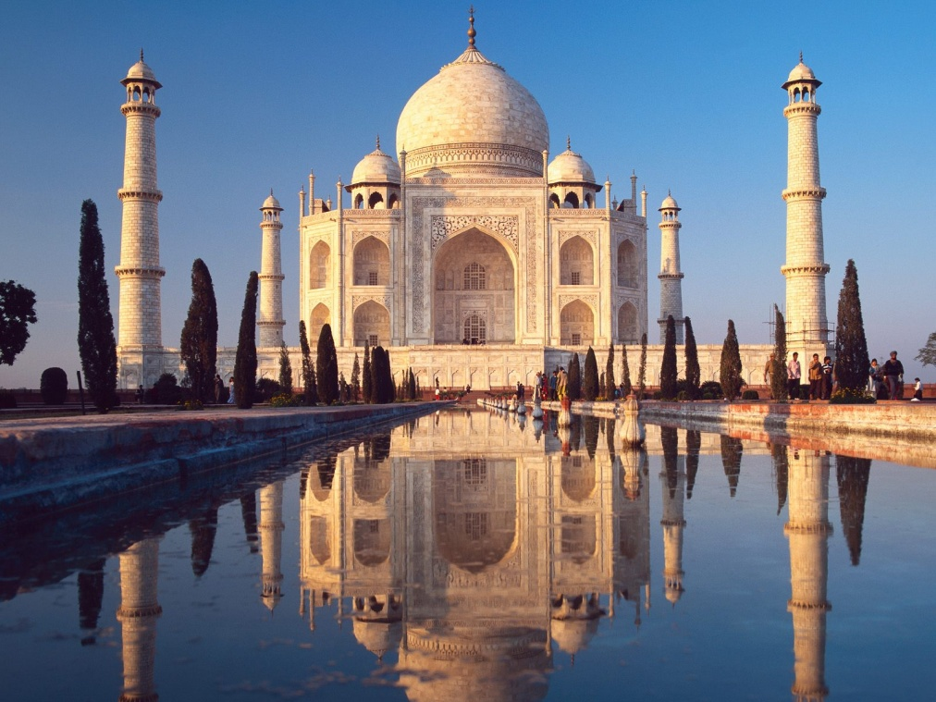

FIND ALL THE INCREDIBLE MEDITATION TECHNIQUES AND MEDITATION PRACTISES REMOVED FROM TRADITIONAL MEDITATIONS AND TAUGHT IN THE ENERGY ENHANCEMENT STREAMING VIDEO MEDITATION COURSE AND LIVE MEDITATION RETREATS IN BRAZIL AND INDIA

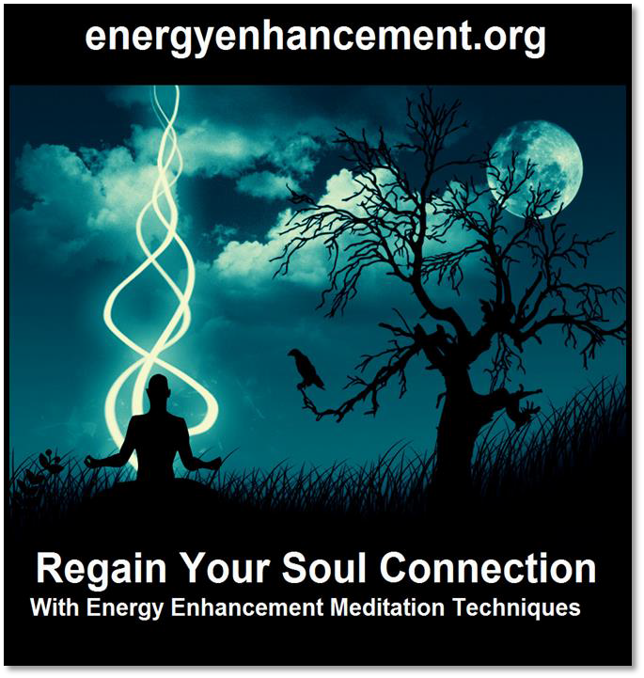

THE ENERGY ENHANCEMENT VIDEO MEDITATION COURSE

ENERGY ENHANCEMENT - THE ULTIMATE MEDITATION COURSE!!
ANCIENT EFFECTIVE ENERGY ENHANCEMENT MEDITATION SECRETS
ALL THE MEDITATION TECHNIQUES!!
SUCCESSFUL
SPEED UP YOUR PROCESS!!
PROVEN TIME TESTED TRUE

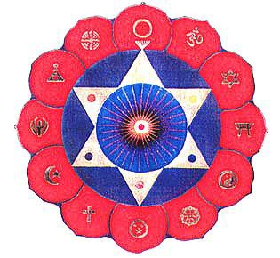

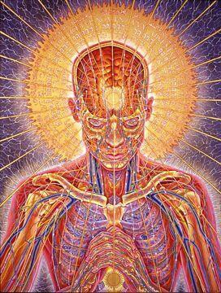

THE MOST ADVANCED MEDITATION COURSE, MEDITATION TECHNIQUES AND MEDITATION PRACTICES ON THIS PLANET, INCLUDING THE KUNDALINI KEY, THE KUNDALINI KRIYAS, ALCHEMICAL VITRIOL AND KUNDALINI YOGA IN 28 INITIATIONS!!

SPEED UP THE PROCESS!!
"I have experience of many forms of meditation and practices for self improvement including: Transcendental meditation (TM) 12 years, Kriya Yoga 9 years, Sushila Buddhi Dharma (SUBUD) 7 years, and more recently the Sedona Method and the Course in Miracles.

The Energy Enhancement programme encapsulates and expands all of these systems, it is complete and no questions are left unanswered."

JEAN - NUCLEAR ENGINEER

WHY JUST SIT? - YOU NEED REAL SPIRITUAL EXPERIENCE - FAST!!

READ BELOW ALL THE TECHNIQUES TAKEN OUT OF TRADITIONAL MEDITATIONS AND PUT BACK BY THE ENERGY ENHANCEMENT MEDITATION COURSE!!

- RESTORING THE ENERGY ENHANCEMENT KUNDALINI KEY

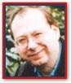Phillip Chester

Phillip Chester - Change manager working directly to the Managing Directors of several fortune 500 companies.

"I feel that I have been given some secret knowledge, which was only given to the initiated, or hidden among a lot of unnecessary sub techniques in other disciplines."

"The energy techniques given in Energy Enhancement have never been explained to me in Aikido (even Ki Aikido), Yoga or Ashtanga Yoga or on any meditation course that I have been on like Transcendental Meditation, and have only been partly taught to me previously by Taoist Master Mantak Chia and on Tantra Courses. Mantak Chia I found particularly confusing; Chi Gung I found awkward"

"ENERGY ENHANCEMENT GOES MUCH FURTHER THAN ALL THE ABOVE, IN A MORE EFFECTIVE WAY THAT ANY OF THE OTHERS I HAVE EXPERIENCED..."

One effect of Energy Enhancement is that I can no longer look at other disciplines like Ashtanga Yoga, Transcendental Meditation, NLP, Aikido and Ki Aikido and Mantak Chia and his Chi Gung, in the same light, because they do not contain this learning.

MEDITATION ENERGY ENHANCEMENT - THE CORE ENERGY TECHNIQUES!!

THE MOST ADVANCED MEDITATION TECHNIQUES ON THIS PLANET, IN 28 INITIATIONS!!

ANCIENT EFFECTIVE ENERGY ENHANCEMENT SECRETS -

SUCCESSFUL PROVEN TIME TESTED TRUE

SRI RAMANA MAHARSHI, GURU, ENLIGHTENED ILLUMINATED SPIRITUAL ASCENDED MASTER

BHOGAR - Tamil Siddar - Kundalini
Yoga, Siddha Bhoganāthar: An
Oceanic Life Story

The Teachings of Don Juan by
Carlos Castaneda - A Separate
Reality

The Teachings of Don Juan by Carlos Castaneda

CARLOS CASTANEDA AND DON
JUAN - ILLUMINATED AND
ASCENDED MASTER

REMBRANDT - ILLUMINATED SAINT

Don Juan, Carlos Castaneda, Petty
Tyrants, Self Importance,
Impeccability

FINDING THE GURU - MILAREPA AND MARPA

SRI RAMANA MAHARSHI, GURU,
ENLIGHTENED ILLUMINATED
SPIRITUAL MASTER

ENERGY ENHANCEMENT
SATCHIDANAND AND DEVI DHYANI
BIO


"Jnana is given neither from outside nor from another person. It can be realised by each and everyone in his own Heart. The jnana Guru of everyone is only the Supreme Self that is always revealing its own truth in every Heart through the being-conciousness 'I am, I am.' The granting of true knowledge by him is initiation into jnana. The grace of the Guru is only that Self-awareness that is one's own true nature. It is the inner conciousness by which he is unceasingly revealing his existence. This divine upadesa is always going on naturally in everyone."
- Sri Ramana Maharshi

"Knowledge of the Supreme Self is Simple. We attain it in Level 1 of Energy Enhancement. What must follow is the removal of all energy blockages. Higher Initiations caused by the purification which must follow Illumination. Higher energies. Higher Initiations than Enlightenment!!"

- Satchidanand

Devi Dhyani and Satchidanand have visited the Ashram of Ramana Maharshi on their India Tours many times alone and with students. Ramana Maharshi still exists at the Ashram as an Ascended Master. The white light of his Presence still radiates in the old meditation room at 4am. One of Satchidanand's students, Susan, had the experience of seeing and speaking to Ramana Maharshi in his Cave on Arunachala in a vision.

GET IN TOUCH NOW FOR YOUR INDIA TOUR WITH SATCHIDANAND AND DEVI DHYANI

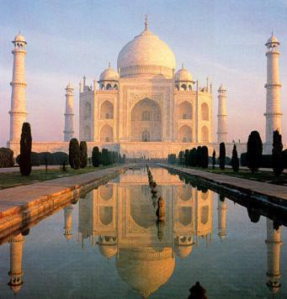

"Sri Ramana maintained that the purest form of his teachings was the powerful silence - the Presence which radiated from him and quieted the minds of those attuned to it. He gave verbal teachings only for the benefit of those who could not understand his silence"

"A few days ago Satchidanand was glowing such that Anna could not look at him. She said she needed sunglasses. She had to leave the Presence. The growing pains produced by the spiritual radiation were intense." QUOTE FROM PSYCHIC POWERS, PSYCHIC VISION, SIDDHIS, AND INCREDIBLE SPIRITUAL EXPERIENCES WITH THE TRIANGLE OF CHAKRAS IN THE HEAD - ANNA'S ENERGY ENHANCEMENT COURSE STUDENT REPORT - WITH SATCHIDANAND AND DEVI DHYANI - JAN 22ND TO FEBRUARY 25TH 2011 - CLICK HERE

Energy Enhancement is at a much higher energy level than any other ashram on this planet. From the Ascended masters from the highest chakras above the Head. Using the most advanced techniques from the Yoga Sutras of Patanjali. Thus the methodology of Energy Blockage removal is much quicker than Samadhi 24 Hrs per day as enjoined by Milarepa and Ramana Maharshi.

Read the History of Milarepa so that you might read the 24Hrs per Day Samadhi necessary in the past to achieve Illumination.

"Ramana Maharshi said that he had been able to deal with all the negative energies and energy blockages from everyone he met, but the Energy Blockages he had taken from his mother when she died in order to make her enlightened he had not been able to remove, thus the cancer.."

Energy Enhancement Samyama is much faster. Energy Enhancement is the practise designed for the Illuminated who seek more Illumination. Energy Enhancement needs to be learned Now by each Guru in order to improve their ability to remove energy blockages.

Speed up your path to the Bliss of Enlightenment NOW!! by Video Course or Live with Satchidanand and Devi Dhyani.
Meditation Course Testimonial by Susan Wade - Nurse - Ramana Maharshi Experiences on the 1997 Southern India Tour
Click Here for Energy Enhancement India Tours
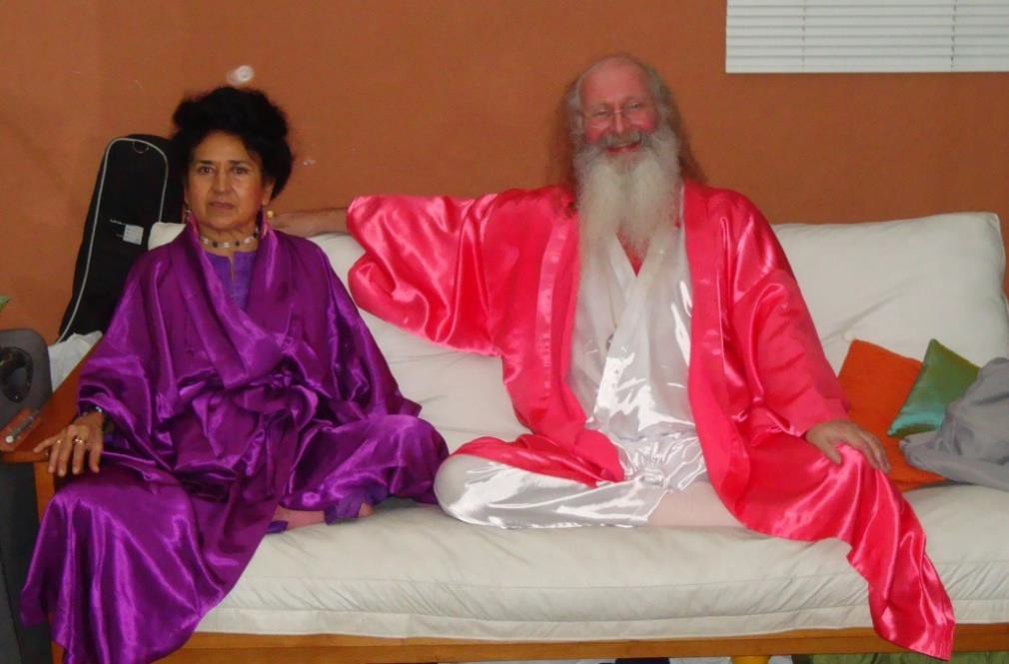
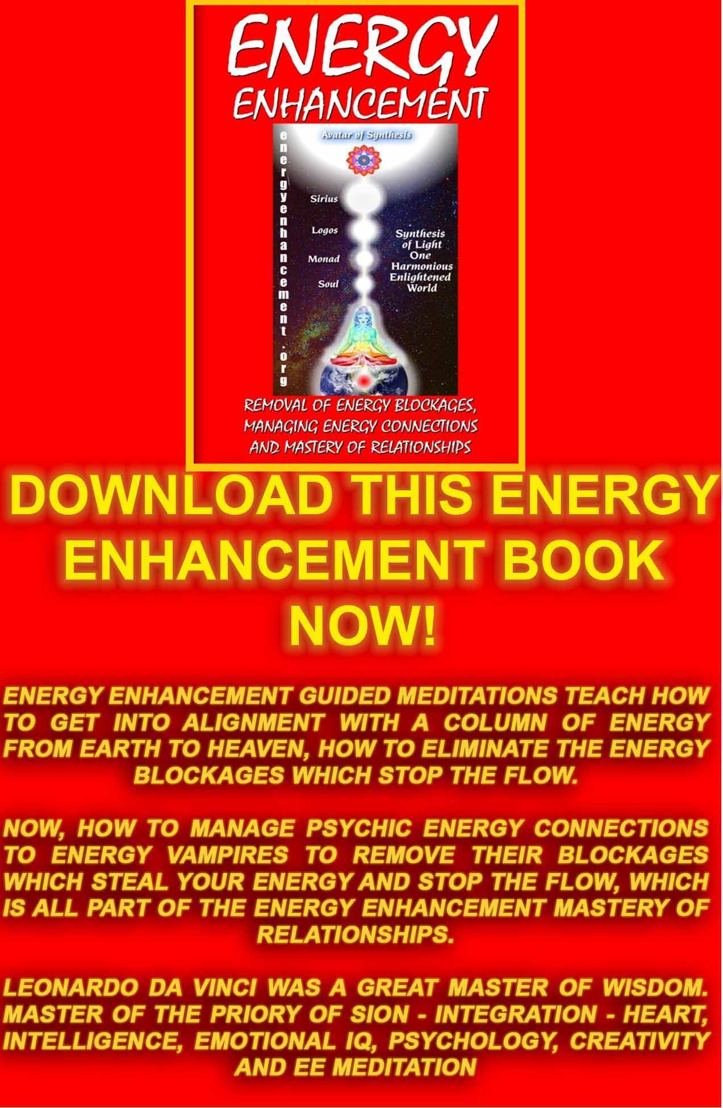
Download “REMOVAL OF ENERGY BLOCKAGES, MANAGING ENERGY CONNECTIONS AND MASTERY OF RELATIONSHIPS” HERE
http://www.energyenhancement.org/Sacred-Energy/Meditation-Energy-Enhancement-Eliminate-Energy-Blockages-Manage-Energy-Connections-and-Attachment-Mastery-of-Relationships-EEBOOK2Color-energyenhancement-org.pdf
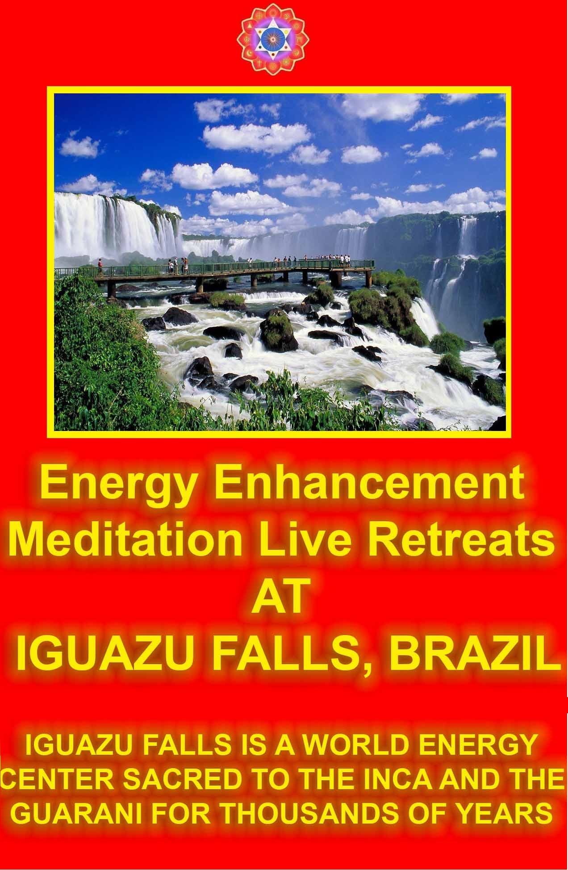
From Devi and Sat I have gained Support, friendship, healing and guidance in contacting our source of inner wisdom through the release of old patterns of behaviour
- daily practice of meditation and Energy Work.

From the Energy Enhancement Work I got the importance of daily routine of meditation - time to be alone and get in contact with my higher self, also tune into my thought system and experience how I really feel about issues affecting my life eg. Trust - I find it hard to form close friendships through lack of trust, opening myself up may result in pain. Learning to take risks, trust in guidance from my higher self. If I do experience pain in any relationship - what lessons can I learn from this pain - see it as a teaching/growth experience rather than negative experience which reconfirms to my darker side Just can't trust anybody - told you so!

Hatha yoga - gentle form of yoga which allows you to proceed at your own pace - awareness of stiffness/pain of body joints. Correct breathing into the pain allows the body to relax and the pain to leave - allowing you to master the pain with awareness rather than give up. The chanting was good. I have felt a fire in the heart and heat in the spine after chanting with Devi and Sat in Sai Babas Ashram.

The Ashram of Sri Ramana Maharshi embraced me with love, gentleness and feeling of inner peace. On walking up the steps into the cave of Ramana Maharshi I was embraced by strong energy - a welcome energy. During meditating in his room (in the cave) I had a strong vision of him entering my forehead. He (Ramana Maharshi) told me it was time to go home. The vision has reappeared to bring me support during periods of deep inner pain experienced throughout the tour.

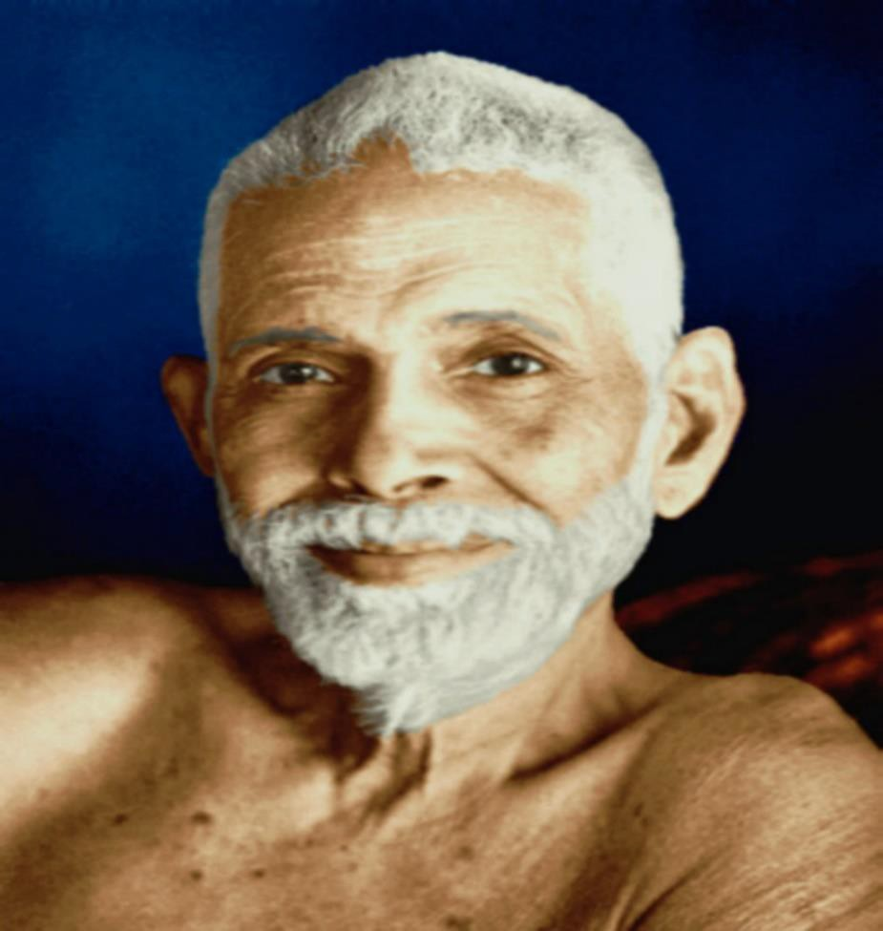
RAMANA MAHARSHI

In the Ashram of Father Bede Griffiths I felt strong presence of spiritual energy. The lectures from brother Martin about looking at life and teachings of Christs message through love and not fear, as man likes to believe, has allowed me, as a Catholic, to respect Christs teaching and see him as a teacher of love and wisdom.
Happiness is here to obtain in this life, not the next.

Ashram of Sai Baba - Opening of my heart Chakra. During a healing session with Devi and Satchidanand, a person who wronged me, raped me, 22 years ago, leaving me with pain and guilt, came through

Satchidanand in a healing session to say he was sorry for the grief he had caused. This has helped me to release a lot of pent up tension, anger guilt, pain. To be asked for forgiveness awakens the part of you that would like to be forgiven for the times I have wronged people - to look at the areas in my life I need to resolve before I get a true picture of my inner qualities, strengths, accepting guidance within.

The power of forgiveness and to forgive is a very strong quality to possess, a wonderful friend to have.

(Since the course Susan has left UK where she has been working as a nurse for many years having been almost exiled there by the parochial consciousness of New Zealand after her rape 22 years ago. She is dealing with the Mastery of Relationships Initiation. She has now returned home to New Zealand after her spiritual vision in the cave at Arunachala - Ramana Maharshi "It is time to go Home" Love and Light, Satchidanand)

Click here for SRI RAMANA MAHARSHI, GURU, ENLIGHTENED ILLUMINATED SPIRITUAL MASTER

SEE THE INCREDIBLE ENERGY ENHANCEMENT COURSE REPORTS..

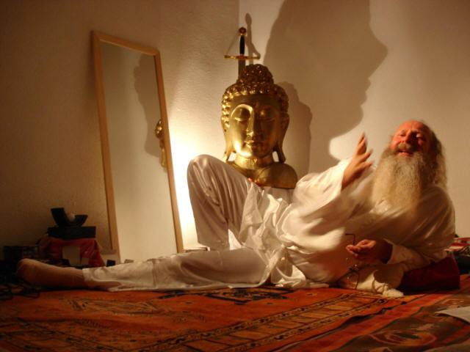

SINCE 1993 - YEARS OF FANTASTIC COURSE REPORTS COURSE REPORTS
LATER COURSE REPORTS REPORTS FROM SOUTH AMERICA
GRAHAM SMITH COURSE REPORT RISHIKESH AND GOA INDIA

COURSE REPORTS WITH BHAKTI GANESHA DEVANANDA

HONEY KALARIA'S 2005 COURSE REPORT

ENERGETIC BLOCKAGES, GRAHAM AND HIS ENERGY ENHANCEMENT COURSE OF MEDITATION ENERGY ENHANCEMENT 2004

PSYCHIC POWERS, PSYCHIC VISION, SIDDHIS, AND INCREDIBLE SPIRITUAL EXPERIENCES WITH THE TRIANGLE OF CHAKRAS IN THE HEAD - ANNA'S ENERGY ENHANCEMENT COURSE STUDENT REPORT - JAN 22ND TO FEBRUARY 25TH 2011

HONEY KALARIA EMAILS SATCHIDANAND JANUARY 2011 HONEY KALARIA'S 2005 COURSE REPORT
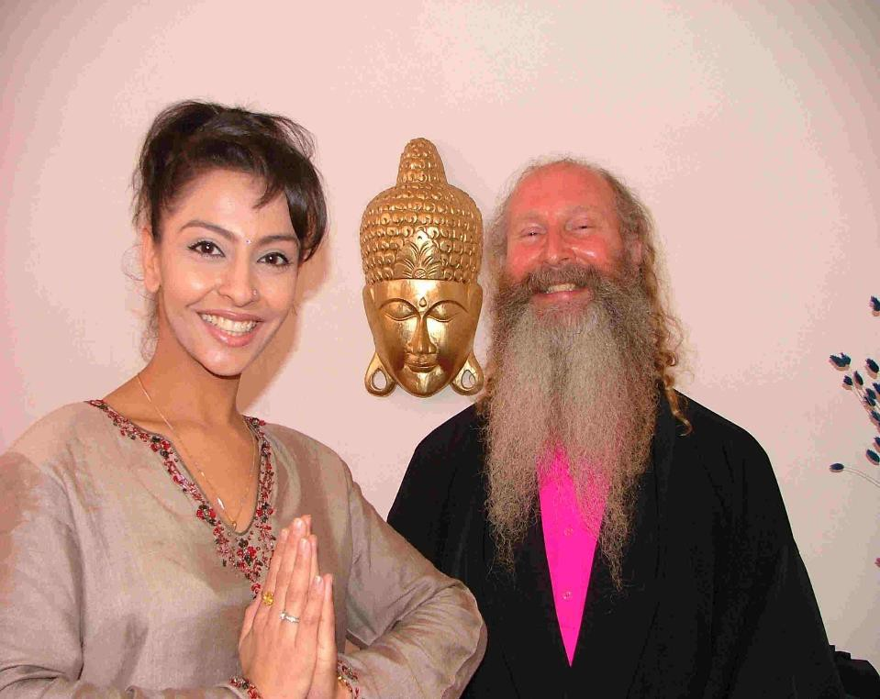
Dear Satchidanandji and Devi Thank you for the birthday wishes.
How are you? I am so glad to hear about the Iguazu ashram project and wanted to wish you luck with the venture. I hope all is going well. I have just launched my new website - (www.honeykalaria.com) and will shortly be launching The Honey Kalaria Foundation to help

various causes. I am also raising funds for an International Meditation Centre here in the UK.

Wishing you love and light Honey Kalaria



Dear Honey,

How am I? Very well and working hard to make Our Energy Enhancement Foundation the Center of Excellence it already is.

A Five Star Retreat at the World Heritage Site of Iguazu Falls with High Flux Densities of Spiritual Energy in the Buddhafield, Air Conditioning, Upgraded Fixtures, Swimming Pool, Sauna, Incredible Vegetarian Food,

As you know, Energy Enhancement really works - and much better than most of the expensive courses taught by the so called, "famous" teachers.

I told you I had taken away your Energy Blockage in the Second, abdominal chakra, during your course with us and you said your menstrual problem had improved.

I often think that the seven step process could have helped Ramana Maharshi from succumbing to the Energy Blockage which gave him Cancer!!

Yes, Energy Enhancement is a much higher Revelation, meant to help the Enlightened take more, higher, Initiations!!

In your Course Report you said you wanted to know about your relationships and you had lifetime after lifetime of feedback about this, explaining how you came to be as you are now. The problem started with the loss of Your husband in a Turkish past life and you even met up with this guy, Ramiya, YOUR HUSBAND FROM TURKEY REBORN! on the Course!!

The problem is one of loss, if you like, bereavement and fear of bereavement. To lose the person we are attached to. And the problem of attachment to the Prince and the problems this brought in its wake.

And the solution - a movement to being successful at other things which do not give that same problem. As when you were looking after the business matters of the Princess, with great success.

Yet every success is always followed by failure. In the end it is all taken away as we die, and all of our success, all of our empire cannot follow us into the grave.

Our only legacy is that which we pass on to the people of the future.

Our only legacy is our own evolution, which can only come from the very highest teachings and the highest aspiration.

It is the reduction of attachment which is the key...

Yoga Sutras of Patanjali - "Enlightenment comes through practise and non attachment"

It is the attachment of the Energy Blockages of the ego which needs to be dissolved.

And it is here that Energy Enhancement holds the key!!.

My aim in this lifetime, which cannot fail!! as it is the will of the Higher Masters that this be so, that Energy Enhancement become the new Meditation Technique, which influences all the World Meditations, improving them and thus improving the evolution of all Humanity. This must be so because there is no course in the world which teaches more than Energy Enhancement. It is the Source of all meditational excellence.

Personally, I do not care about name or fame.

It is sufficient that Energy Enhancement fulfils its purpose.

Thus I offer Energy Enhancement..

1 Further Levels to remove even more blockages.

2. Energy Enhancement Teacher Training and Certification.

All at the best lowest prices in order to support the movement of Energy Enhancement into World Centers like London.

This must be my aim, my purpose, my life!! Yours in Love and Light,
Satchidanand

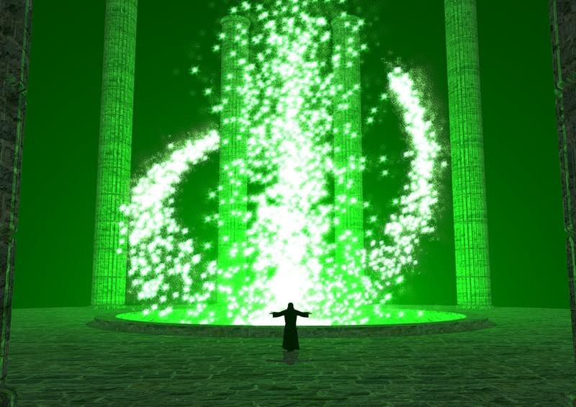

COME AND GET EXPERIENCED!

CLICK HERE!! FOR WHAT WE ARE DOING
http://www.energyenhancement.org/Prices.htm

EMAIL sol@energyenhancement.org FOR DETAILS
IT IS SO EASY!!

ENERGY BLOCKAGES, ENTITIES, IMPLANT CONTROL BLOCKAGES AND IMPLANT VAMPIRE BLOCKAGES AND NAFS - WHAT ARE THEY, WHY ARE THEY FORMED, AND HOW TO REMOVE ENERGY BLOCKAGES AND IMPLANTS BY THE ENERGY ENHANCEMENT SEVEN STEP PROCESS OF ENERGY ENHANCEMENT LEVEL 2 AND 3

ENERGY ENHANCEMENT BLOCKAGE DIRECTORY

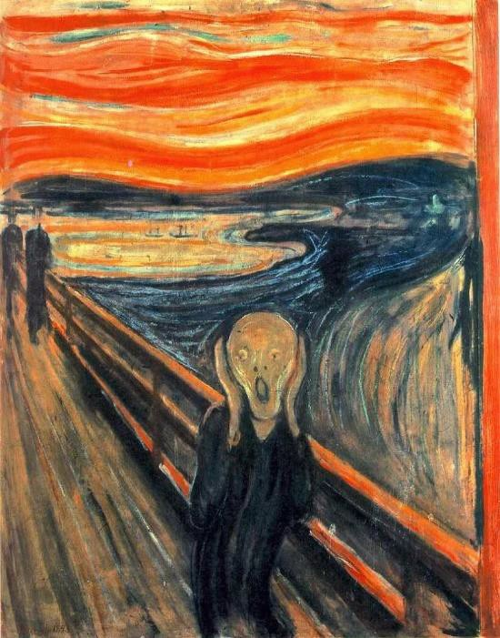

Blockages are surrounded by Trauma-Formed negative karmic mass - The Scream - Munch

BLOCKAGE ELIMINATION AND WORLD CHANGE - THE REMOVAL OF ENERGY BLOCKAGES ENTITIES AND IMPLANTS WITH ADVANCED ENERGY BLOCKAGE BUSTING TECHNIQUES

ENERGY CONNECTIONS BETWEEN PEOPLE, BETWEEN THEIR CHAKRAS AND ENERGY BLOCKAGES. ENERGY CONNECTIONS BETWEEN PEOPLE, BETWEEN THEIR CHAKRAS AND CONTROL IMPLANT BLOCKAGES,
VAMPIRE IMPLANT BLOCKAGES, Student experience of sexual Implants, THE OPENING OF PSYCHIC VISION

BLOCKAGE KARMA ENTITIES FROM THE LORD OF THE RINGS AND PATANJALI WITH ENERGY ENHANCEMENT

Chakras above Sahasrara Chakra and Below Muladhara Chakra

THE PSYCHOPATH, HERVEY CLECKLEY, THE MASK OF SANITY

PARACELSUS AND BLOCKAGES - CLICK HERE

GURDJIEFF AND BLOCKAGES - CLICK HERE

DAME ALEXANDRA DAVID NEEL - THOUGHT-FORMS IN TIBET - CLICK HERE

HUBBARD, SCIENTOLOGY AND BLOCKAGES

SLAVE DISTRACTION CONTROL BLOCKAGES ARE CAUSED BY ENERGY BLOCKAGES BELOW THE BASE CHAKRA

PSYCHOPATH DISTRACTION CONTROL BLOCKAGES ARE CAUSED BY ENERGY BLOCKAGES ABOVE THE CROWN CHAKRA AND IN THE HEART CHAKRA

ENERGY ENHANCEMENT GAIN SUPER ENERGY SOUL FUSION

ENERGY ENHANCEMENT BLOCKAGE REMOVAL

ENERGY ENHANCEMENT KARMA CLEARING PROCESS -
Remove Ego Energy Blockages like the Connector Strategy, the Distraction Implant Control Blockages and Implant Vampire Blockages Attention Seeking Strategy Energy Blockages and Inner Children in Energy Enhancement Level 3

Chakras and Ida, Pingala, Sushumna and the Caduceus

Chakras and the Initiations of Enlightenment

CHAKRAS

PSYCHOPATHY HEALED BY REMOVING BLOCKAGES IN CHAKRAS OUTSIDE THE BODY IN THE ANTAHKARANA

MEDITATION - ENERGY BLOCKAGES ARE THE CAUSE OF THE PSYCHOPATH, THE SCHIZOPHRENIC, AND MANIC DEPRESSION. WITH EXAMPLES STALIN, HITLER, ENRON AND MAO

MEDITATION - Existentialism and Kubrick's Psychopaths in the Films of Stanley Kubrick.

George Lucas, Star Wars, the Revenge of the Sith, and Psychopaths

LILITH-Succubus-Psychopath-Implanter-Energy-Blockage- Scarlet-Woman

MEDITATION ENERGY ENHANCEMENT AND Trauma, Pain,
Relationships, Divorce, Piercings, Tattoos, BDSM, Sex, Sex Addiction, Tantra, Gambling, Homosexuality,

Lesbianism, Drugs and Addiction, Bad backs, Heart Disease, and Cancer.

ENERGY ENHANCEMENT MASTERY OF RELATIONSHIPS

THE PURIFICATION PROCESS AND ENERGY BLOCKAGES

BLOCKAGE ELIMINATION AND WORLD CHANGE - THE REMOVAL OF ENERGY BLOCKAGES ENTITIES AND IMPLANTS WITH ADVANCED ENERGY BLOCKAGE BUSTING TECHNIQUES

The Buddhist Five Hindrances of Meditation, Bijas, your blockage seeds And Energy Enhancement Advanced Meditation Techniques

The Omphalos and the Om Phallus stone from Delphi, and the sexual energy blockage implant in the form of a sexual exitation container of black squirming snakes trapped in a snake basket

CARLOS CASTANEDA, DON JUAN, GNOSTICISM AND ENERGY BLOCKAGE IMPLANTS

The psychopath and the Buddhist icchantika

KRISHNA - THE BHAGAVAD GITA AND THE DEMON QUALITIES OF THE SELFISH COMPETITIVE PSYCHOPATHIC EGO

THE PURPOSE AND THE PSYCHOPATHIC PERVERSION OF THE PURPOSE

ANCIENT THAILAND TRIBAL PSYCHIC PROTECTION AGAINST PSYCHIC CONNECTION AND PSYCHIC ENERGY BLOCKAGE IMPLANTS

Ahimsa or Harmlessness - The Greatest Spiritual Law to Remove Negative Karmic Mass and Energy Blockages

THE NATURE OF ALL EVIL IN THE WORLD - PAIN IS THE PROBLEM, ENERGY ENHANCEMENT IS THE SOLUTION

The Twelve Labours of Hercules The Nemean Lion and Energy Blockages

EE Meditation, Shaman + Integrated Soul Personality, Energy Blockage Fragmentation, MPD + DID, Psychology; Pt 1 of 3

EE Meditation, Shaman + Integrated Soul
Personality, Energy Blockage Fragmentation, MPD + DID, Psychology; Pt 2 of 3

EE Meditation, Shaman + Integrated Soul
Personality, Energy Blockage Fragmentation, MPD + DID, Psychology; Pt 3 of 3

ENERGETIC BLOCKAGES, GRAHAM AND HIS ENERGY ENHANCEMENT COURSE OF MEDITATION ENERGY ENHANCEMENT 2004

ENERGY BLOCKAGES, ENTITIES, IMPLANT CONTROL BLOCKAGES AND IMPLANT VAMPIRE BLOCKAGES AND NAFS - WHAT ARE THEY, WHY ARE THEY FORMED, AND HOW TO REMOVE ENERGY BLOCKAGES AND IMPLANTS BY THE ENERGY ENHANCEMENT SEVEN STEP PROCESS OF ENERGY ENHANCEMENT LEVEL 2 AND 3

ENERGY ENHANCEMENT ARTICLES

ENERGY ENHANCEMENT MEDITATION SAMYAMA ENLIGHTENMENT!!!

NOT ONLY MASSIVE ENERGY - LEVEL 1

NOT ONLY ENERGY BLOCKAGE ELIMINATION - LEVEL 2

NOT ONLY KARMA CLEANING - LEVEL 3

AND MASTERY OF RELATIONSHIPS - LEVEL 4
BUT ENLIGHTENMENT!! "FOR THOSE WHO BELIEVE IN
ENLIGHTENMENT AND UNDERSTAND THE URGENCY OF THE SITUATION" - GAUTAMA BUDDHA

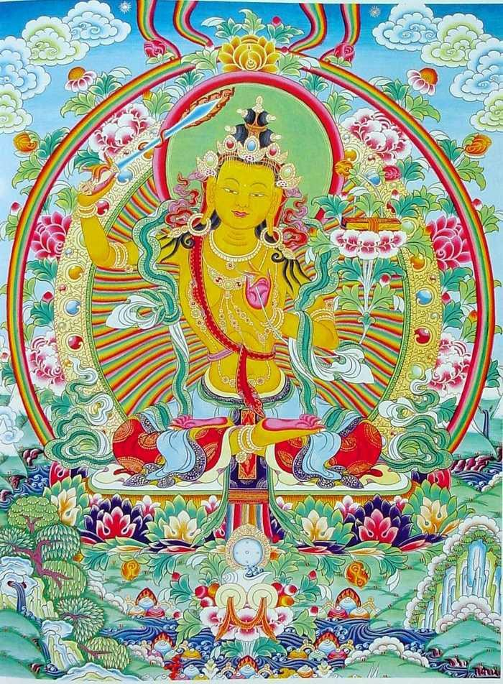
BUDDHAS DISCIPLE, MANJUSRI AND HIS SWORD OF VIVEKA OR DISCRIMINATION, SYMBOLISES THE ENERGY ENHANCEMENT SEVEN STEP PROCESS

WE CAN CHANGE YES WE CAN
FOR THOSE WHO TELL US THAT WE CAN'T

YES WE CAN ENDURING HOPE YES WE CAN
AND THE LIGHT OF OUR IDEALS SHINES BRIGHTLY

YES WE CAN

WE SHALL OVERCOME YES WE CAN!!
ENLIGHTENMENT YES WE CAN!!

SACRED DANCES OF FUSION WHERE DEVI DHYANI EXERTS HER POWER - AVAILABLE ON YOUTUBE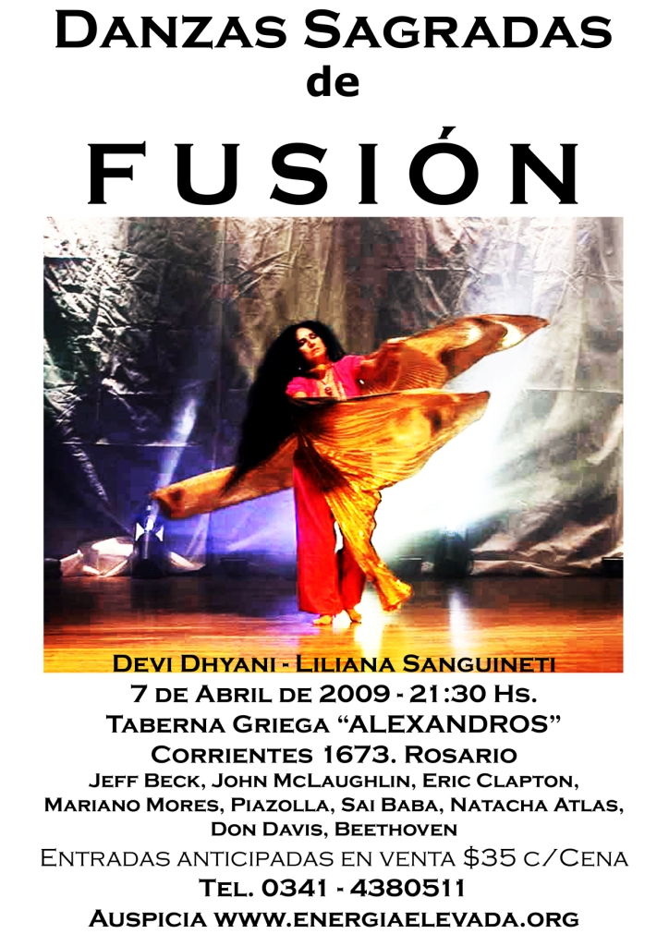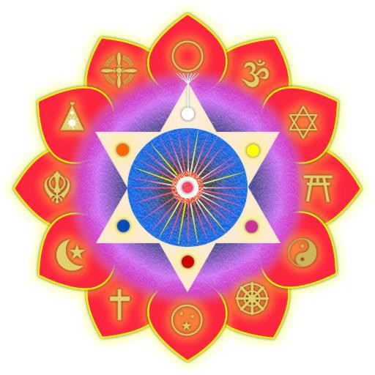
ENERGY ENHANCEMENTMeditation EE Symbol LEVEL 2

THE REMOVAL OF BLOCKAGES AND THE KARMA CLEARING PROCESS

LEARN TO FREE UP THE ENERGY BLOCKAGES OF THE BODY WHICH SLOW DOWN THE ENERGY, CREATE ALL ACHES AND PAINS, AND IN WHICH TOXINS ARE DEPOSITED IN THAT PLACE IN THE BODY, EVENTUALLY CAUSING CANCER, HEART DISEASE AND ORGAN FAILURE.

THE MEDITATIONS FOR THE REMOVAL OF ENERGY BLOCKAGES, ENTITIES, IMPLANTS AND NEGATIVE EMOTIONS.

IN THIS ADVANCED INITIATORY APPRENTICE LEVEL WE LEARN HOW TO CHANNEL THE ENERGY OF THE SOUL IN ORDER TO DISSOLVE ALL NEGATIVITY - EVERYTHING BAD!!

THIS HAS THE EFFECT OF DISSOLVING EVERYTHING NEGATIVE FROM THIS LIFE AND THOSE BEFORE.

ENERGY ENHANCEMENT APPRENTICE LEVEL 2 SHOWS ADVANCED ANCIENT TECHNIQUES TO REMOVE ALL ANCIENT THOUGHTFORMS AND BLOCKAGES AND TO CLEAR ALL KARMA!!!!!

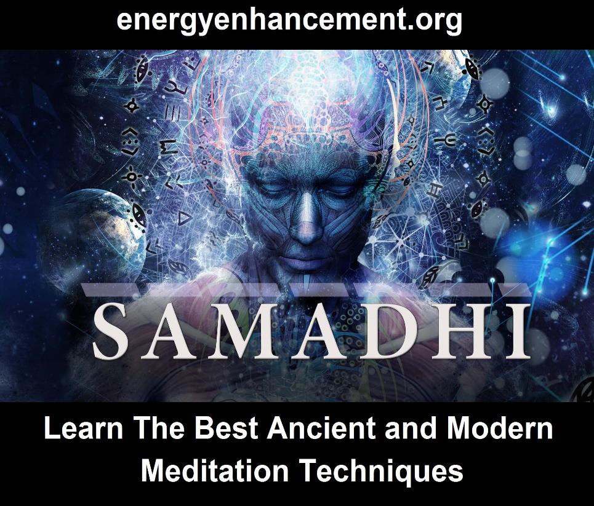

THE KARMA CLEARING PROCESS
This Second APPRENTICE LEVEL of Meditation Energy Enhancement starts to put it all together. The gradual, safe advance in Energy continues, bringing with it a new responsibility.

This powerful Initiation of Meditation Energy Enhancement completes the purification process, showing that in the end there is no difference between your energy of purification and the purification of every thing around you.

There is no difference.

As your energy is raised so the energy of the whole world and everything in it is raised. We learn that we affect everything and everyone around us. Our Initiation brings about the Evolution of the whole planet and every Group and Person in it.

You can make a difference!

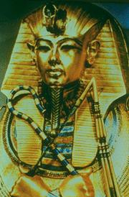Energy Enhancement Meditation Courses Meditation Course - Egyptian Learn the higher levels of healing beyond Reiki. How to de-power Blockages and to calm them so that their Energy can be sent on more easily. Also how to develop the strength to do this with Excellence.

This Initiation of Energy Enhancement also completes the Teaching on how to

prevent a fall, which can happen now or at any time, with or without the Energy Enhancement teachings.

Thus, Energy Enhancement completes the teaching on one of the most powerful methods of protection known.:-
As you get brighter and your Heart opens so you can attract the attention of people who want to steal your energy. To pervert your evolution by wanting to teach you methods of getting what you want, selfishness and the misuse of power, the opposite of the Open Heart.

Those on the selfish left-hand path will never teach you the way of fully opening the Heart or the Crown chakra.

Since those on the left-hand path can never exist in the full presence of the Heart or the Soul, this is one method of telling black from white MAGICIANS.

Also, as Earl Spencer said about Princess Diana "Those who are truly good are threatening to those at the opposite end of the moral spectrum." You can expect AS YOU EVOLVE, as Don Juan said in the book by Carlos Castaneda, "the most perfect enemies."

Inner strength is found, given and created. As Baudelaire said- "That which does not kill me makes me strong." The method of use of the vibration of Soul Energy and of the Monad and of the Logos, taught in Energy Enhancement, can be higher than that used by those on the left-hand path, usually the level of the mind. So gradually one is taken higher and higher.

It is said that a Human picks up Blockages and implants like a dog picks up Fleas!!

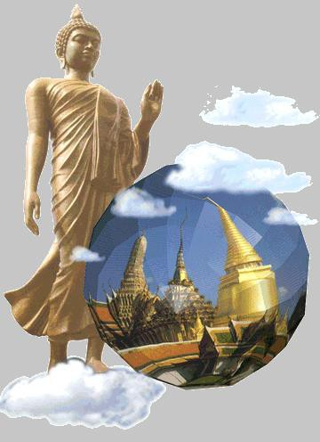

APPRENTICE LEVEL two of Energy Enhancement, built upon the firm foundation of the other Initiations is a powerful system of protection from Blockages and Blockage implant absorbtion, in dealing with all methods of attack, through using the healing energy of the Soul. These negative energies can affect us even now, with or without the teachings of Energy Enhancement.

With these highly advanced techniques you also have the opportunity of freeing yourself from negative Blockages and implants in our Auras.

These thoughtforms which can lead to Energy Blockages which cause mood swings, negativity, cynicism and the downward spiral to depression and physical disease, as well as the positive thoughtforms of psychic powers.

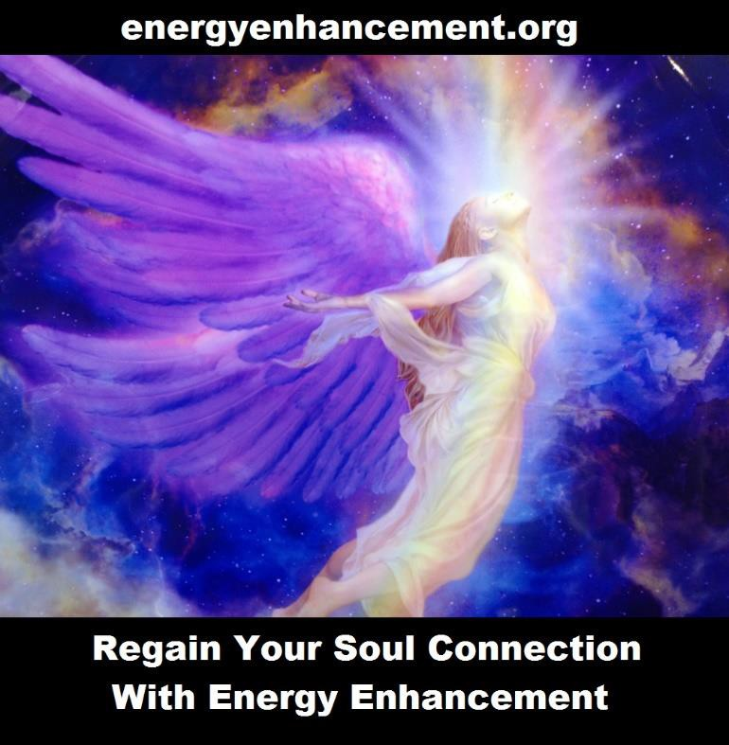

THE KARMA CLEARING PROCESS AND ACUPUNCTURE
“When Qi flows freely along the meridians, people are free from illness; If the Qi is blocked, the pain follows.” Ancient Chinese Saying

According to Chinese Acupuncture, blockages on any of the Energy Meridians will cause negative emotions, cancer, heart disease as symptoms. As you remove the Energy Blockages so radiant health, the ability never to need to see a doctor again, resistance to any sort of disease.
ALL THROUGH THE ABILITY TO REMOVE ENERGY BLOCKAGES

Acupuncture has been used successfully for 4000 years!!, All disease is caused by Energetic Blockages in the body. Acupuncturists cure people by removing these blockages by sticking needles into minor chakras, acupuncture points, on the energy Meridians or Nadis which have been mapped on the body for 4000 years in China and India.

Yet the deeper Blockages can only be removed by Higher Techniques Like ENERGY ENHANCEMENT

Experientially, the electrical resistance of the body is much higher on the acupuncture points!! Energetic blockages attract toxins to the part of the physical body where the blockage is, causing stiffness, pain and eventually disfunction and failure of the organ affected. Remove the energetic blockage and the physical toxins will eventually be flushed away!!

According to the Shen Flow of traditional chinese Acupuncture, negative emotions are created by energic

blockages in the energy pathways in the body called Meridians or Nadis:-

A Wood Blockage will cause - Anger A Fire Blockage will cause - Manicism
An Earth Blockage will cause - Wanting Sympathy and attention
An Metal Blockage will cause - Depression or sadness A Water Blockage will cause- Fear.

Negative Emotions are diseases caused by energetic blockages.

Remove the energetic blockage through Energy Enhancement techniques and the negative emotion disappears. With the Energy Enhancement Karma Clearing Process Only Positive Emotions remain.

Love and the power of the true will which comes from the higher energy levels of the Soul.

Energy Enhancement teaches Ancient Meditational Techniques to remove these Blockages more deeply than any other system!!

It is easy to see how if you have two meridians blocked you can get mood swings like manic depression or any combination of the above.

One of our clients was cured of manic depression. One of our clients now has no epilepsy.
Energy Blockages eventually degenerate the body causing organ failure.

With three blockages on three different meridians I have been told by my acupuncture teacher, Professor Worsley, that one will die within six months.

Positive thoughtforms or psychic powers are fine when we do not desire them for our separated selves, are OK when they come to us when we need them.

Only with these Energy Enhancement techniques can you develop Psychic Vision, can you free yourself from the psychic drainage of these Blockages, attachments, psychic implants, and negative thoughtforms, which have accumulated in our Aura from our past lives.
Thoughtforms connected to various people, Groups and Organisations. We teach how to deal with all these energies in turn.

Usually we find these energies blocking the Heart and Crown chakras, but all chakras and the aura suffer from negative programs and energy blocks.

With these techniques we can learn how to access spiritual vision so that we can heal the energy bodies of our students at a distance or with a glance.

It is also a training in the Creation and dissolution of Thoughtforms on this Earth plane, anywhere or in anybody or in any organisation in the world, the major use of the energy released when the Base Chakra powers the Triangle of Chakras in the Head.

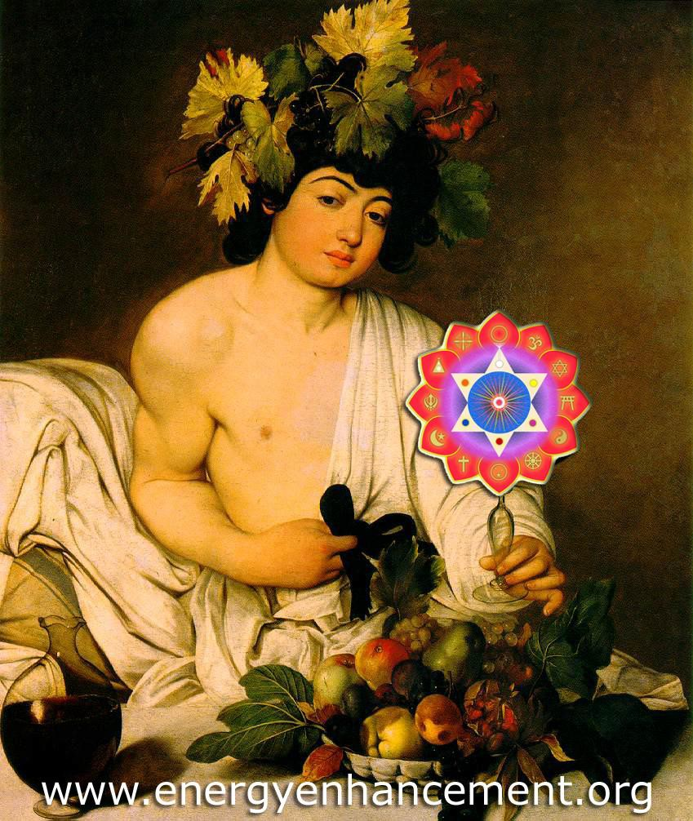
"TAKE WHAT IS IN MINE HAND.." SATCHIDANAND

As above, so below.

As you free yourself from negative programming, implanted in you by many organisations, over many lifetimes, so you become capable of healing all those who come into contact with you. As this occurs so the

waves of Universal Love, the Energy of Change, spread out towards all groups, all individuals you contact.

With these techniques we start the healing process of the World.

Perfect Love is Perfect Freedom from all lower energy attachments - the Energy of Change.

As we gain Energy we become more fulfilled spiritually. Energy Enhancement shows us the way.

COME ON A MEDITATION ENERGY ENHANCEMENT APPRENTICE LEVEL 1 and 2 COURSE!!

COME AND GET EXPERIENCED!

CLICK HERE!! FOR WHAT WE ARE DOING

EMAIL sol@energyenhancement.org

FOR DETAILS

IT IS SO EASY!!
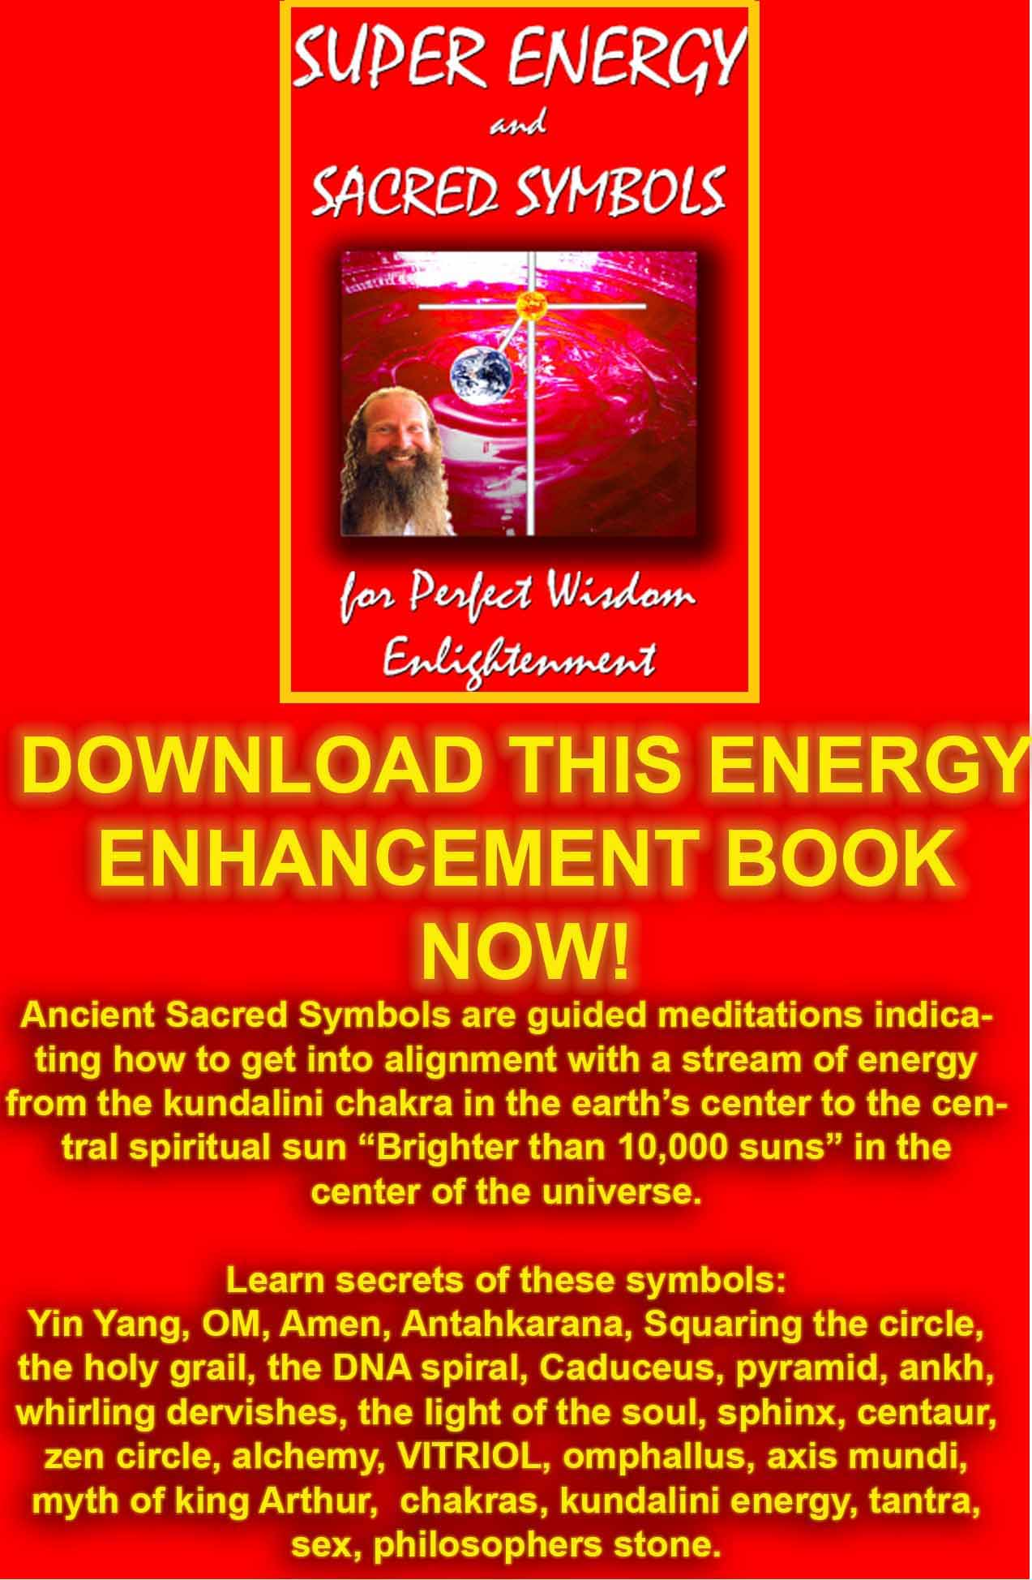
DOWNLOAD SUPER ENERGY AND SACRED SYMBOLS HERE!!!
http://www.energyenhancement.org/Sacred-Energy/Meditation-Super-Energy-And-Sacred-Symbols-for-Perfect-Wisdom-Enlightenment-Color-energyenhancement-org.pdf

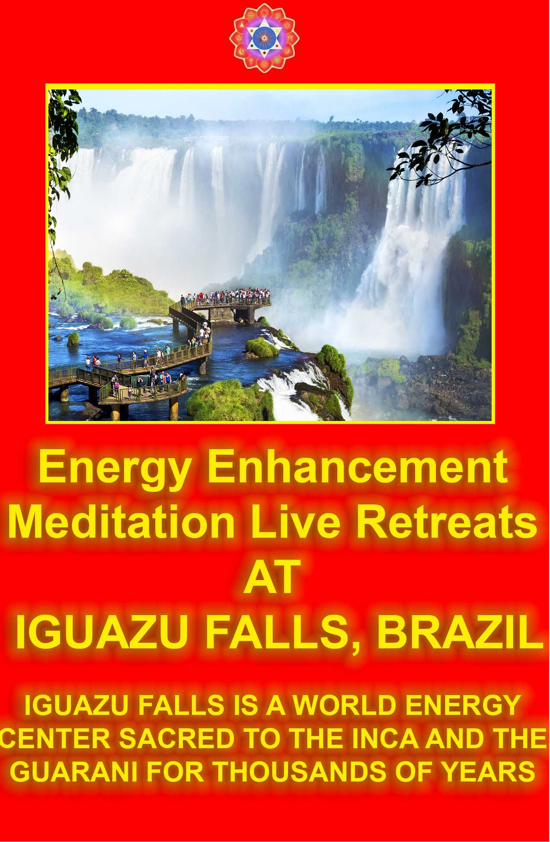
MEDITATION ENERGY ENHANCEMENT APPRENTICE LEVEL 1 WILL DRAMATICALLY DECREASE YOUR NEGATIVE AND INCREASE YOUR POSITIVE ENERGIES

"The Miracle of the Removal of Energy Blockages.. Miracles, Miracles and yet more Miracles!!"

- Graham Smith on his Energy Enhancement Course in India November 2009

"DO IT!" M.S. - HR Director PepsiCo Europe/Asia

Energy Enhancement MEDITATION LEVEL 2.

Initiation 1 of 7 - THE SEVEN STEP PROCESS

THE REMOVAL OF ENERGY BLOCKAGES AND IMPLANTS WITH ADVANCED ENERGY BLOCKAGE BUSTING TECHNIQUES

This Initiation Shows you Advanced, Effective, Powerful yet Traditional Techniques to Remove Thoughtforms, Implants or Energy Blockages.

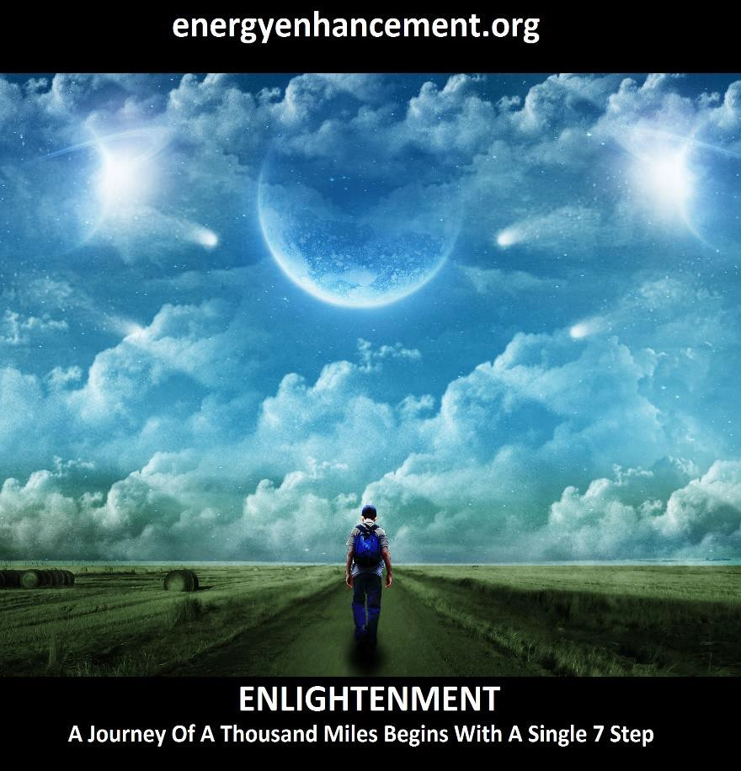

ALCHEMY AND THE REMOVAL OF BLOCKAGES

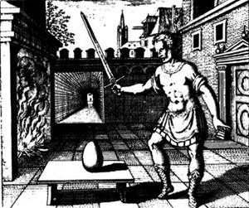
Michael Maier’s, a German alchemist, wrote in his Scrutinium Chymicum of 1687: “Learn about the egg and cut it with a flaming sword. In our world there is a bird more sublime than all others. To search for his egg be thy only concern. The egg of alchemy is a symbol for magical realization.”

These BLOCKAGE Thoughtforms which stop the energy flow and create illness and disease have been called many names.... Implants, psychic entities, Dark Forces and Blockages on the First three Levels using traditional and highly effective techniques taught for thousands of years and then on the infinite Levels.

The removal of negative energy from Thoughtforms. The penetration of their protections. The putting of them in their proper place. The creation of psychic powers. The increase in psychic visualisation. The increase in energy onwards towards enlightenment. Contemplation...

SAMYAMA!!
"ONLY WHEN ALL THE BLOCKAGES ARE GONE DO WE
BECOME ENLIGHTENED" -Satchidanand

The Healing of Thoughtforms and the Removal of negative Thoughtform Blockages.

FROM DON MINIHANES COURSE REPORT

"I first contacted Satchi just over one year ago and hit him immediately with a big question that I knew would either get a real answer or a load of waffle or bullshit like all my previous attempts over the years or no reply at all as they dived for cover. I had by now got most of the bullshit answers you could possibly get so I became expert in smelling shit at every corner and knew exactly what to ask to eliminate the idiots and charlatans of this world. At this point I was expecting more of the same.

Satchi wrote back to me and the answer he gave me was the first real and tangible result I got in over 35 years of searching.

I was so shocked that it took me a long time to assimilate the answer as the implications were so profound it shook me to the very foundations of my existence and I knew for the first time in my life that what I was experiencing was real as he described in detail what I knew, citing his own experiences as

example. It would appear that I had found someone who really knew what they were talking about.

Over the following months I tested him again with yet more of my questions and got a proper answer every time, answers that you instinctively know to be true and correct.

Bit by bit my life began to make sense and the reasons for my rather unique experiences became clear to me. I began to understand this life of mine and resolved to go and see this man and his amazing wife Devi to undergo the Energy Enhancement course that you are looking at so I flew half way around the world to spend a month in the home of these very special people who welcomed me with open arms and much warmth even though I arrived at their door at 3am in the morning"

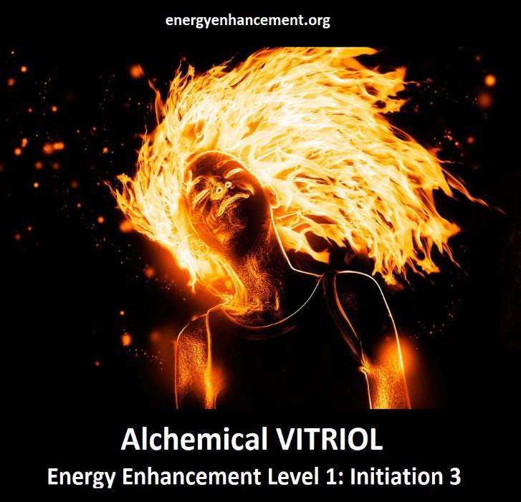

MANJUSHRI, SYMBOL OF BLOCKAGE REMOVAL, AND HIS SWORD OF DISCRIMINATION

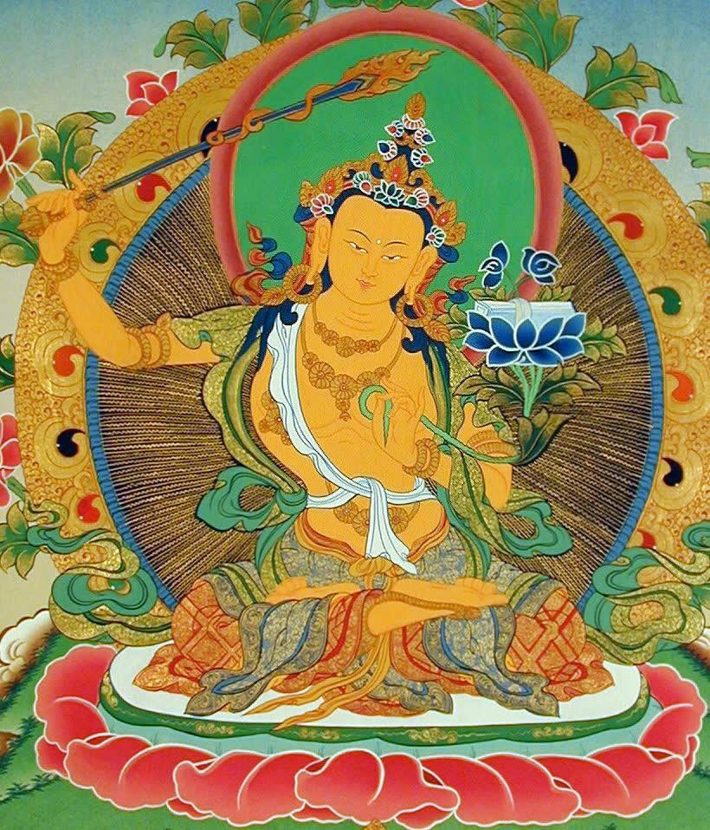

THE TWELVE LABOURS OF HERCULES ENCODE ANCIENT TECHNIQUES USED BY ALL MASTERS TO ENLIGHTEN THEIR STUDENTS
EE LEVEL2 - THE REMOVAL OF BLOCKAGES - AND THE TWELVE LABOURS OF HERCULES -- THE HYDRA



THE TWELVE LABOURS OF HERCULES OR HERACLES SYMBOLISES THAT WHICH IS NECCESSARY ON THE PATH OF ENLIGHTENMENT

Remember the Labour of Hercules involving the Hydra. As Hercules chopped off one head with his sword another 3 grew back in its place.

As Hercules chopped off the head using his magical sword - See the Sword of Discrimination of Manjusri above! - he cauterised it with the Sacred Fire, and thus the heads grew no more. This is the secret of meditation taught in Energy Enhancement, here, in this Initiation of Level 2 we teach about the use of Sacred Fire!

The Hydra symbolises the mind. Its heads the many energy blockages whose symptoms are the thoughts we have which need to be dissipated through Energy Enhancement Level 2, Initiation One, THE REMOVAL OF ENERGY BLOCKAGES.

TO STOP THE MIND, WE MUST DEFEAT THE HYDRA. ENERGY ENHANCEMENT KNOWS THE FAST AND SPEEDY WAY TO ENLIGHTENMENT!

AHIMSA OR HARMLESSNESS REMOVES THE PAIN BODY OR NEGATIVE KARMIC MASS

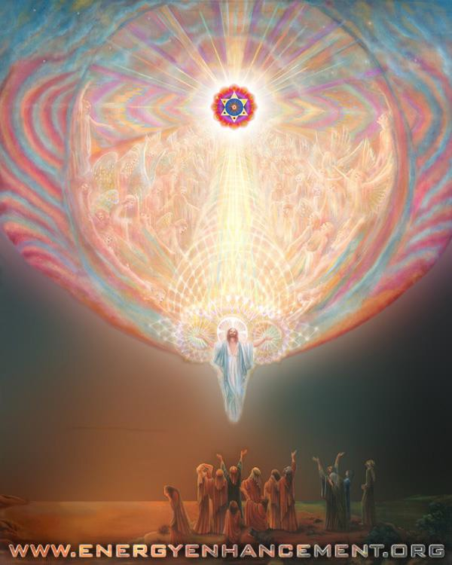

IN SPAIN, ELEGANT 5Star INDIA TAJ MAHAL, INDIA TOUR, ARGENTINA AND IGUAZU FALLS MEXICO, PERU SATCHIDANAND'S ARTICLES ON ENERGY ENHANCEMENT

The Yoga Sutras of Patanjali Ahimsa or Harmlessness - The Greatest Spiritual Law to Remove The pain Body and Negative Karmic Mass

Ahimsa, the greatest spiritual law, is one of the Yamas, one of the things to do, from the Second Book of the Yoga Sutras of Patanjali. It means Harmlessness…

“Harmlessness - Give no pain, by word, thought or deed”

Why?

Because pain creates a dense form of energy called Negative Karmic Mass - The Pain Body, which does not allow entry of the subtle energies of Existence.

Negative Karmic Mass - The Pain Body, becomes locked into the body as Energy Blockages which create Pain in the Body as one of its Symptoms which eventually cause cancer and heart disease.

Further, it is the means whereby this Planet and all the people on it can take higher Initiations, and this Planet become a Sacred Planet at a higher level of Energy, Radiating strongly the Energy of Love.

Energy Enhancement is the Solution to All the Problems in this Universe.

Come on the Energy Enhancement Course Now!!

The Synthesis of Light Symbol

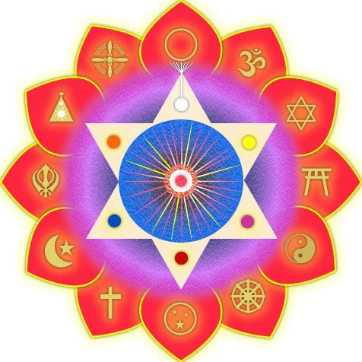

The Energy Enhancement Meditation Course APPRENTICE LEVEL TWO

THE REMOVAL OF ENERGY BLOCKAGES AND IMPLANTS BY THE ENERGY ENHANCEMENT SEVEN STEP PROCESS

ENERGY BLOCKAGES, ENTITIES, NAFS, and IMPLANT
BLOCKAGES are composed of seven parts.

- Negative Karmic Mass

- Blockage Protection

- The Blockage Living Core

- The Blockage Power Source which comes from outside.

- The Blockage Programming

- MULTI - CORED BLOCKAGES

- ENERGY BLOCKAGE OR NAFS

FROM DON MINIHANES COURSE REPORT - LAST WEEK OF ENERGY ENHANCEMENT REIKI MASTERY OPTION

"I am now in the last week of the course and I feel like a totally different person. I have regained myself and have been given from nothing having no psychic vision at all at the start of the energy enhancement course, a clarity of psychic vision that is breathtaking."

"As we practiced on each other we came very quickly to realise this. I could literally feel the energy moving inside each chakra as the other person worked within me from several meters away and when I worked on the other person I could see me projecting energy to them and could see where the blockages were within their chakras.

I could force the energy from my centres into their centres and clean their centre bringing the energy full circle back to me. You could tell the state of their chakras by the amount of energy returning to your own centre and this was achieved by mind power only.

Before I came here Satchi said he would teach me to do it in this way and I was sceptical about this claim. I could never envision me having psychic vision, but I have now, I can now do astonishingly powerful Reiki sessions on people without going any where near them and distance healing over any distance is a piece of cake, incredible stuff."

"I am totally de-stressed and have expanded in every way. I feel stronger and fitter and much more mentally agile than I have ever felt in my life. The fog and confusion of life has gone and I feel that I have just received the inside information on everything. I am ready for anything and am wide awake. I am full of the most incredible energy imaginable and have Energy Enhancement Reiki that is so powerful it staggers me. I know a thing or two about Reiki and had a very strong Reiki connection before I got here, now I have a connection that is beyond description and I have yet to undergo the second initiation this week and then the masters. I have opted to take this as an extra and for anyone who is interested, I believe this is beyond anything you will ever experienced anywhere."

I am now equipped with life tools and healing tools that one only dreams of and there is nothing out there in the world that will ever faze me again. I am absolutely delighted that I decided to come here, because this experience has changed me, for the good of me and for all those that I will touch when I leave here. I am so excited and can’t wait to start exploring my new found talents"

MORE ON ENERGY ENHANCEMENT REIKI

BLOCKAGES, THE PAIN BODY, AND THE YOGA SUTRAS OF PATANJALI BY SATCHIDANAND

"All my life I have been guided by an inner sense of that which is significant. That way you don't waste time on the insignificant which allows you to accomplish more. For example on hearing the words, " The Yoga Sutras of Patanjali" I knew that this was significant and I vowed at that moment to learn everything I could about it." Satchidanand - "Raja Yoga is Energy Enhancement - Now, Complete Instructions on Enlightenment"

As Father Bede Griffiths once said to me, "Its all in the explanation" and reading through this text book - which is one of the set books on the Energy Enhancement Course - all about on Enlightenment, I thought it would be nice to comment. I did not get very far, this time, but more will surely follow. So, read on for The Yoga Sutras of Patanjali with its Citta, Vrittis, Vasanas, Energy Blockages, Dharana, Dhyana and Samadhi - Samyama, on the path of Enlightenment.. There is the rest of it if you follow this Link.. - Swami Satchidanand

YOU CAN BUY Integral Yoga Hatha - The Yoga Sutras of Patanjali (with full commentary, Sanskrit and Index) by Sri Swami Satchidananda FROM AMAZON, AND THIS TRANSLATION COMES FROM THAT BOOK - THE COMMENTARY BY MY MASTER IS IMPERDIBILE.

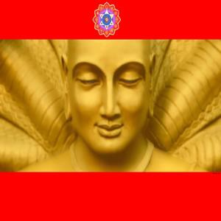
Picture of the Enlightened Sage Patanjali

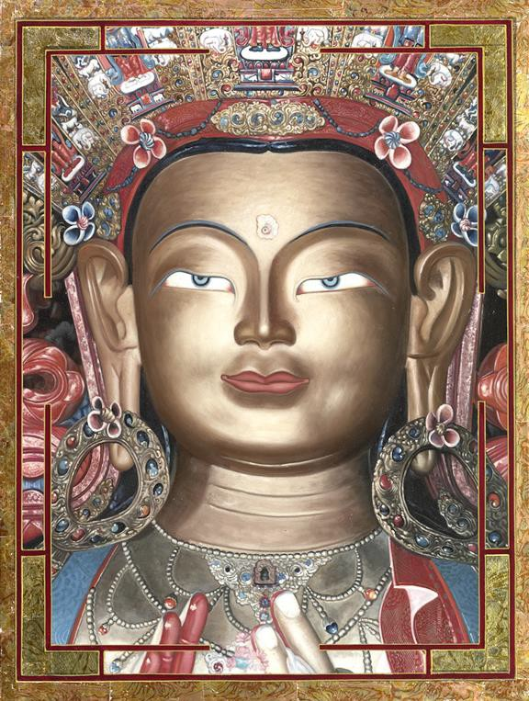
"An example of one of the different types of Energy Blockage is that they are sometimes created when we do not get what we expect, or we get what we do not want. They are caused by the pain of disappointment.
Like when our Mother or Father or Son or Daughter dies. Like when a Lover leaves us.

This trauma, this pain is so strong that at that moment the mind can not look at it, so it gets locked away within the body as a Blockage until we get strong enough to process it.

Then amnesia. We forget the pain fulminating in our bodies. We forget the poison until, after a while, disease is the result."

Satchidanand

TRAUMA-FORMED NEGATIVE KARMIC MASS
Is created by the influence of pain on pure spiritual energy which changes it in the way that sunlight is turned into Coal or Petroleum, Oil, Black Gold, Texas Tea.

Trauma-Formed Negative Karmic Mass is pure, concentrated pain which creates all the hard knots of pain and discomfort in the body which eventually, if left, turn into disease and surgical intervention.

By removal of these Physical Energy Blockages we can create Health, Strength and Energy and Long Life in Energy Human Being who uses the Energy Enhancement Techniques.

Trauma-Formed Negative Karmic Mass is pure concentrated pain which creates the symptoms of Manicism, Depression, Worry, Anger, and Fear in every human being.

By removal of these Emotional Energy Blockages we can Remove all Negative Emotions and create the Positive

Emotions of Optimism, and the Love, Energy and Will to get things done.

Trauma-Formed Negative Karmic Mass is pure concentrated pain which creates a lack of Conscience and Heartlessness which are the symptoms of Psychopathy.

By removal of these Spiritual Energy Blockages we can Remove psychopathy, one of the greatest diseases of humanity, which through War, Torture Chambers, Labour Camps, Re-Education Camps, Concentration Camps, Gulags and Pogrom destroyed and tortured 200 Millions of people in every country in the World throughout the 20th Century.

Trauma-Formed Negative Karmic Mass is pure concentrated pain which creates a lack of Conscience and Heartlessness, Corruption and Greed which are the further symptoms of Psychopathy.

By removal of these Spiritual Energy Blockages we can Remove the Corruption and Greed which caused all the Financial Bubbles where Pension Plans, Real Assets and Wealth are stolen to feed the endless Desires of the Robbers and Thieves.

"We've Stolen All Your Money!!" More?.. Click Below..
THE NATURE OF ALL EVIL IN THE WORLD - PAIN IS THE PROBLEM, ENERGY ENHANCEMENT IS THE SOLUTION

THE GROUNDING OF NEGATIVE ENERGIES REMOVES ALL NEGATIVE KARMIC MASS

ARE YOU READY TO RECEIVE!
SPIDERMAN THREE AND NEGATIVE KARMIC MASS - VENOM!!


IN THIS MOVIE - SPIDERMAN THREE, SPIDERMAN GETS COATED IN A SUIT OF VENOM - TRAUMA - FORMED NEGATIVE KARMIC MASS - VENOM!! THIS CAUSES HIM TO BECOME EGOTISTICAL AND ACT IN A BAD WAY...


SPIDERMAN GETS COATED IN A SUIT OF VENOM - NEGATIVE KARMIC MASS - VENOM!! BUT THE VENOM COMES INTO ITS OWN WHEN IT COATS A PSYCHOPATH.

THE THEME OF SPIDERMAN THREE IS THAT THROUGH THE REMOVAL OF VENOM FORMED NEGATIVE KARMIC MASS WE CAN COME TO A STATE OF FORGIVENESS - A TRUE OPENING OF THE HEART... THE THEME OF THIS MOVIE IS FORGIVENESS..

SEE THE MOVIE!!



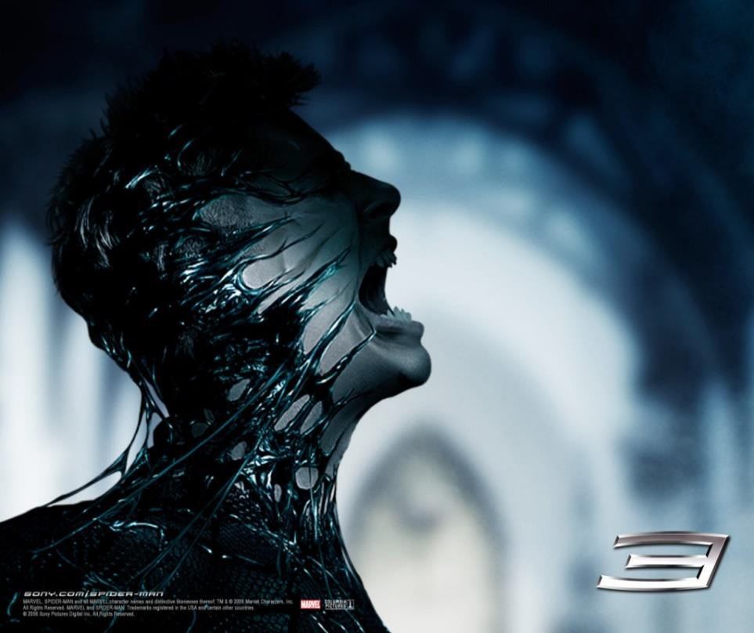

THE GROUNDING OF NEGATIVE ENERGIES REMOVES ALL NEGATIVE KARMIC MASS

HERE IS AN INTRODUCTION TO ENERGY ENHANCEMENT, IF YOU HAVE READ IT BEFORE, JUST SCROLL PAST IT TO LEVEL 2 OF ENERGY ENHANCEMENT... the KARMA CLEANING PROCESS..

"I have experience of many forms of meditation and practices for self improvement including: Transcendental meditation (TM) 12 years, Kriya Yoga 9 years, Sushila Buddhi Dharma (SUBUD) 7 years, and more recently the Sedona Method and the Course in

Miracles. The Energy Enhancement programme encapsulates and expands all of these systems, it is complete and no questions are left unanswered."

Jean, NUCLEAR ENGINEER, FROM THE SEPTEMBER 2005

GOLDEN LIGHT SURGES INTO MY BRAIN...

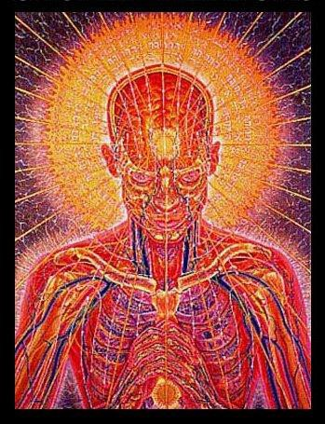

"A POINT OF LIGHT EXPLODES, it opens and golden light surges in to my brain from the center of my head. Like liquid light it fills me up and at the same time the

universe is born, the light expands forming energies that divide and merge forming particles eventually forming atoms, molecules wich form stardust stars solar systems galaxies, planets and the they form life, living cells that connect to form a physical brain, manifestation of the cosmic mind and consciousness, eventually reaching my cortex and I open my eyes and remember my self.

My center is the center of the universe, the circle is complete! I am absolutely everything. All time is curved around me, all galactic systems are me, all life is me and I am through this small body I am complete. My personal mind goes in to absolute shock, into hysterical laughter that I cannot stop. I am overflowing billion times billion. Infinite amount of information fills me in a timeless time, my consciousness is flowing from the beginningless beginning of all reaching the final destination of all.

The grand cycle is complete and I encounter all the infinite forms of existence as well as the formless forms of enlightenment beings, the future. I am, one with my self from the future! From the times of conscious creation. There is only space, all of my meridians are ONE! Stretching through all the creation. Then I leave my body and I am guided through many things that I cannot explain or remember in my current state."

As we were talking well into the night at the end of our Energy Enhancement Course together.

After he has removed many energy blockages over the last four weeks. Blockages above the crown chakra in the Antahkarana which were preventing him from re- connecting with the Source of all Life. He described one of the blockages between one million and Infinity of chakras above the head as a dense translucent crystal

which was incredibly difficult to remove, different from the other blockages which he had found below it which were dense and covered with a black tarry substance or blood and which were more easy to transmute and dissolve.

We eventually get into a state of energy transfer. We both feel it as white light flowing from one to the other in an incredibly intense way which lasts for two hours. At the end of that time I perceive an initiation which is taking place on the astral plane. Surrounded by a group of ascended masters I introduce him to the chief initiator who uses the rod of initiation to touch his third eye with the intense energies of initiation so that his energies can never again drop into that state we call normal waking consciousness.

Never to lose the Light of Enlightenment, ever again.

Get your asses over here Now and Speed Up your process of Enlightenment on the Energy Enhancement one month course!!

SATCHIDANAND

THE ENERGY BLOCKAGE REMOVAL PROCESS LEVEL2

THE REMOVAL OF THOUGHTFORMS, IMPLANTS, ENTITIES, AURIC EGG BLOCKAGES, SHAME, GUILT, DISAPPOINTMENT, BEREAVEMENT, NEGATIVE EMOTIONS
- ANGER, FEAR, WANTING SYMPATHY, MANIC, SADNESS, DEPRESSION, CHRONIC DEPRESSION, ENVY, JEALOUSY, THE DESIRE TO DO HARM, EMOTIONAL IQ, CLEAR CANCER FROM THE DNA, CHAKRAS, CHAKRAS BELOW THE BASE, CHAKRAS ABOVE THE HEAD, PARTS OF THE BODY, THE AURA, THE TIMELINE, THE KARMA CLEANING PROCESS, THE WOMB, THE PRIMAL SCREAM, CLEAN THE

KARMA FROM ALL THE YEARS OF YOUR LIFE, CREATE GOOD LUCK, AND GOOD HEALTH.

If you are serious about self-improvement, growth, change, enlightenment! Then the Energy Enhancement Course is for you.

JEAN, EE STUDENT

KUNDALINI KRIYAS, MASSIVE ENERGY GAINS, GROUND NEGATIVE ENERGIES, KARMA CLEANING, MASTER ENERGY CONNECTIONS AND RELATIONSHIPS ILLUMINATION
THE ANCIENT SECRETS WHICH WILL ENABLE YOU TO BECOME MORE ENERGETIC, MORE POSITIVE, MORE PURE, MORE SOUL INFUSED IN YOUR ALL YOUR LIFE AND FUTURE LIFETIMES - THE REAL SECRETS OF SUCCESS

 , - An Advanced Meditation Course which gives the MOST benefits of any course of Meditational
Self-Development available anywhere in the World today.

If you want to Master Meditation Energy, to get more Energy and to handle it better, this course is for You!

If you want to Speed Up the Meditative Process, rather than sitting with no result

Energy Enhancement Advanced Meditative Techniques including the Kundalini Kriyas and the Five Taoist Elemental Pathways of the Chi, is for You!!!!

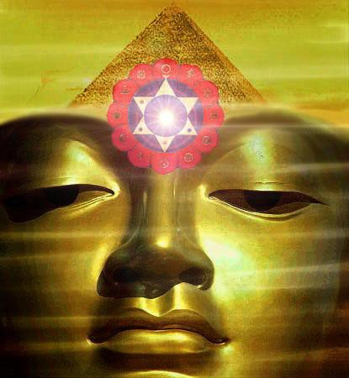

Whether you are a Management Corporate Executive, any sort of Alternative Practitioner, Meditator, Yogi or anyone who wants to Evolve, - Have Massive Energy Gains, become Better, Smarter, more Evolved, more Empathic, more Soul Infused, Gain the Real Secrets of Success; This course will Enable Direct Experience of Superior Life Performance.

Energy Enhancement Meditation Techniques are the quickest and easiest methods of evolution available, leading to Ultimate Happiness.

Energy Enhancement, The Most Advanced Techniques of Meditation Available, NOW!!

Developing Meditation psychic powers to Get in touch with your Life Path, Ground negative Energies, Access Infinite Levels of Universal Energy, Raise Your Kundalini, Integrate the Separated Selves, and Master Relationships and Mediation.

Meditation Energy Enhancement Enables FOUR Levels towards your Ultimate Freedom - Illumination, Nirvana, Emptiness, - Enlightenment.

Energy Enhancement is a unique system to exponentially increase your energy by mastering the Mind, accessing inner peace, improving health, Mastering Relationships , creating synchronicity and luck, and improving your success.

Energy Enhancement is a Course of selfless, highly advanced, meditation techniques which can Quickly!! Increase the Speed of the normal Mind.

Energy Enhancement Synthesises, brings together ALL these gifts for the first time in one Course.-

To Enable Your Evolution!!

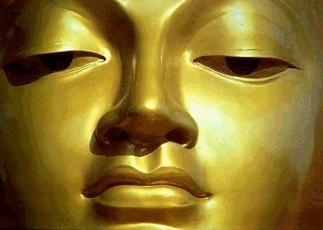

ENERGY ENHANCEMENT ILLUMINATION

THOMAS BLAIR'S ENERGY EXPERIENCES!!!

"Next, I came across a particularly stubborn blockage to remove, and knew that I would have to prepare myself well during meditation. I consciously sourced as much energy from above to flow through my body, and in doing so, rather than my body being filled with golden light, I had somehow tapped into an immense source of white light above the head. As well as feeling this increased energy stream through my body, I realised I had involuntarily suspended breathing somewhere near the top of an in breath. My body felt like a beacon of light, with more than enough energy to direct toward a blockage and watch it dissolve in an instant.

Since that time I am always connected to and able to source the white light from above my head. Many times during this process I just forget to breathe as though my breathing is just naturally suspended. I am now living in the Light!!

My energies are naturally far higher than when I arrived on the Energy Enhancement course just two weeks ago.

I am experiencing Energy, the fruits of meditation which normally arrive, if they do, after twenty years of meditation and it has only taken me two weeks."

- Thomas Blair September 2005 Course in Spain

TO ENQUIRE ABOUT ENERGY ENHANCEMENT COURSES PLEASE SIGN ON TO OUR MAILING LIST AND THEN EMAIL US DIRECT FROM THE EMAIL ADDRESS WE SEND YOU FROM OUR MAILING LIST
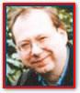
Philip Chester Course Report

"SATCHI PROVED THIS TO ME IN THE FIRST FIVE MINUTES OF OUR FIRST MEDITATION, BY PUTTING MY BACK AND TOP OF THE HEAD IN THE RIGHT POSTURE. I IMMEDIATELY FELT A FLOW OF ENERGY GOING UP MY SPINE."

"Once this stage was reached I had tremendous energy!" Philip Chester, Change Manager reporting to the Managing Directors of several Fortune 500 Companies.

THE SOUL SYMBOL

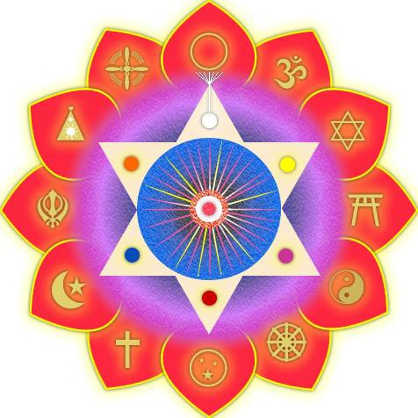

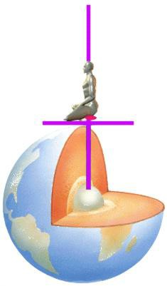

THE DIAGRAM ABOVE IS AN ENERGY ENHANCEMENT GUIDED MEDITATION TO PUT YOU IN TOUCH WITH THE SOURCE OF KUNDALINI ENERGY TO ACCELERATE YOUR EVOLUTION - THE CENTER OF THE EARTH - KUNDALINI CHAKRA.

THIS CONNECTS THROUGH THE SEVEN CHAKRAS IN YOUR BODY - OUT INTO THE SOUL CHAKRA, ALL THE WAY TO THE CENTER OF THE UNIVERSE AND THE ONE GOD WITH 10,000 NAMES.

THIS SYMBOL ABOVE IS THE SOURCE SHAPE OF ANCIENT SACRED SYMBOLS - GREEK - AXIS MUNDI, OMPHALLOS, THE TAU, EGYPTIAN - THE ANKH, MASONIC - SQUARING THE CIRCLE, CHRISTIAN - THE CROSS, TROUBADOURS MYTH OF ARTHUR - THE SWORD IN THE STONE, THE

SWORD OF SAINT MICHAEL, HINDU - THE YONI SHIVALINGAM, SUFI - THE FOUNTAINS AT THE ALHAMBRA, THE MOORISH ARCH, THE KEYHOLE, THE CATHARTIC CATHARS - SUFI - THE LUTE (TROUBADOUR - ABJAD ROOT TRB - MEANS LUTE IN ARABIC) AND THE SUFI NAQSBANDHI KUNDALINI KEY -

FROM 5000 YEARS OF SUCCESSFUL SPIRITUAL TECHNOLOGY - SIMULTANEOUSLY THE SOURCE OF EGYPTIAN, MASONIC, TAOISM, SUFI, HINDUISM AND CHRISTIANITY - ENERGY ENHANCEMENT IS THE SYNTHESIS OF ALL RELIGION - READ THE ENERGY ENHANCEMENT BOOK - BUY IT NOW

- "SUPER ENERGY AND SACRED SYMBOLS"

THIS BOOK GIVES THE HISTORICAL BASIS OF ONE GUIDED MEDITATION SAMYAMA WHICH IS THE BASIS OF ALL THE MAJOR WORLD RELIGIONS - EGYPTIAN, TAOIST, HINDU, CHRISTIAN - AS TAUGHT IN ENERGY ENHANCEMENT

ENERGY ENHANCEMENT IS THE SYNTHESIS OF ALL RELIGION

THIS IS THE ONE BOOK WHICH CAN TOTALLY CHANGE THE WORLD!!

GAIN SUPER ENERGY - ELIMINATE ENERGY BLOCKAGES

THE ENERGY ENHANCEMENT BOOK
SUPER ENERGY AND SACRED
SYMBOLS - CLICK HERE | !!

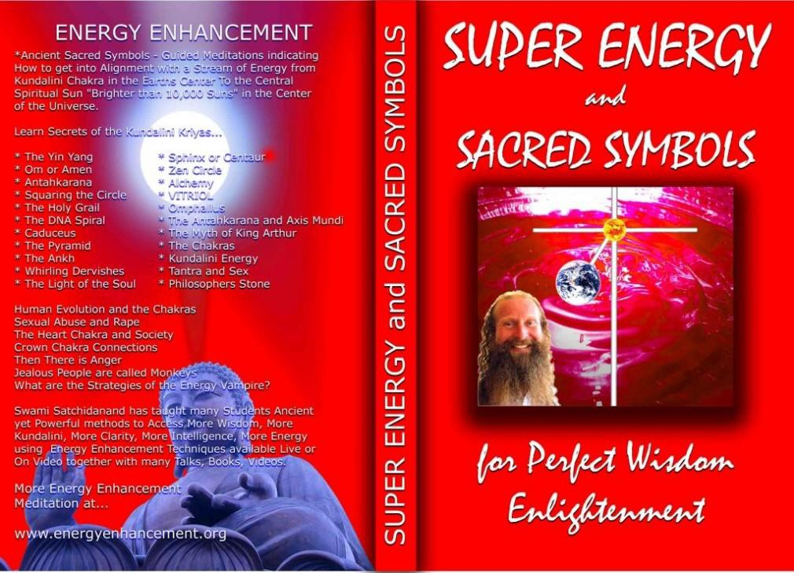

THE ENERGY ENHANCEMENT BOOK SUPER ENERGY AND SACRED SYMBOLS COLOUR PDF DOWNLOAD, NOW!! - CLICK HERE!!

Energy Enhancement Meditation Course Level 2

EE-Meditation-The-Removal-of- Energy-Blockages-From-Body- Chakras-DNA-Auras-The-Seven- Step-Process-The-Karma-Claning- Process-Old-Karma-Time-in-Womb- of-Your-Mother-and-This-Lifetime

Energy Enhancement Meditation Course

Level 2

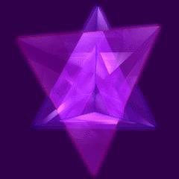
Energy Enhancement Meditation Course Level 2 - The Seven Step process - The removal of energy blockages and implants by the Energy Enhancement Busting Techniques - The Removal of Old Karma from the time in the womb of your mother and from this time

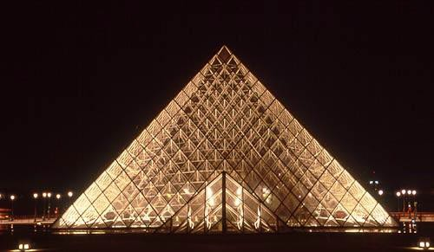
Energy Enhancement Meditation Course Level 2 Initiation 1: The removal energy blockages and implants by the Energy Enhancement Seven Step Process.

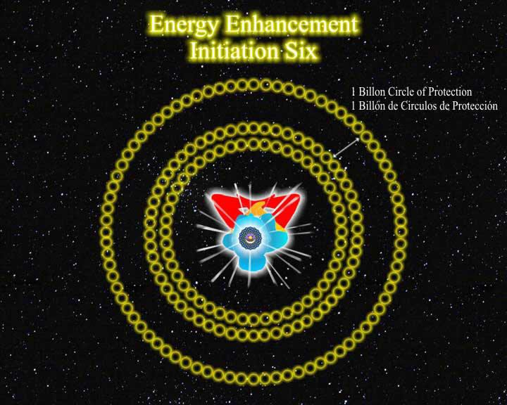

Energy Enhancement Meditation Course Level 2 Initiation 2: How to Heal the Energy Blockages in the body.

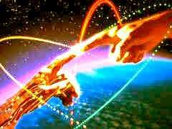

Energy Enhancement Meditation Course Level 2 Initiation 3: The removal of Energy Blockages thoughtforms from the chakras. From the seven chakras inside the body and then all the external spiritual chakras to which we are connected the Soul Chakra, the Monad Chakra, the Logos Chakra, the Sirius chakra, the Avatar of Synthesis Chakra.

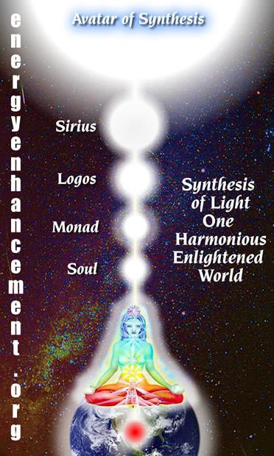
Energy Enhancement Meditation Course Level 2 Initiation 4: The removal of Energy Blockages thoughtforms from the DNA. Heal your DNA.

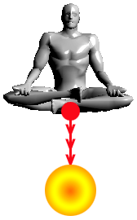Energy Enhancement Meditation Course Level 2 Initiation 5: The removal of Energy Blockages thoughtforms from the Auras.
Heal the Physical Aura, Heal the Emotional Aura, Heal the Mental Aura, Heal the Buddhic Aura.

Energy Enhancement Meditation Course Level 2 Initiation 6: The removal of old karma from the time in the womb of your mother. The karma cleaning process.

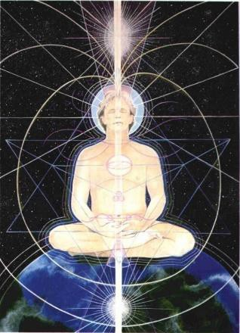Energy Enhancement Meditation Course Level 2 Initiation 7: The removal of old karma from this lifetime. The karma clearing process.

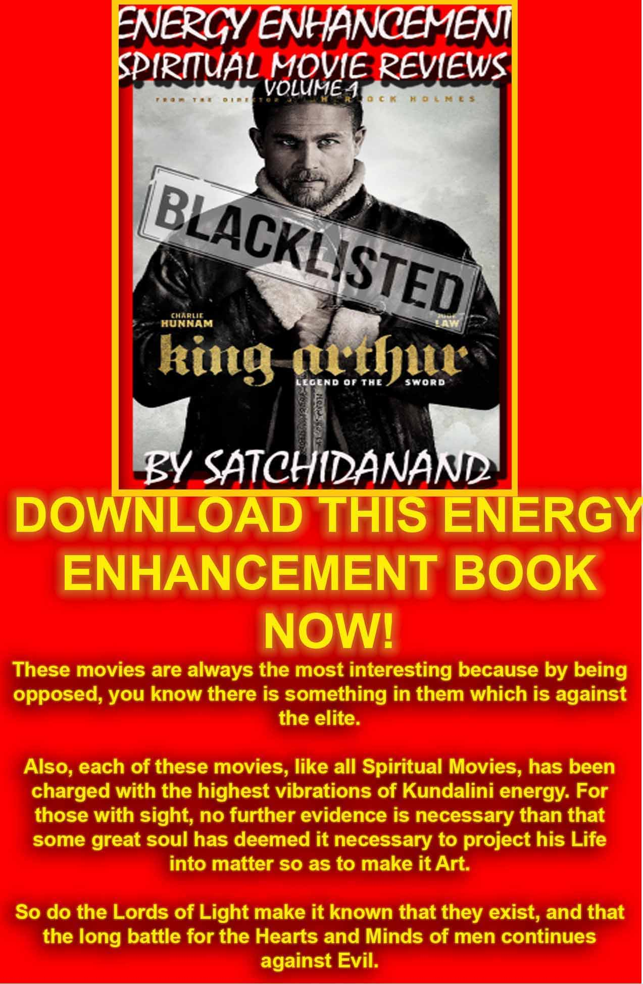
Energy Enhancement Spiritual Movie Reviews Book - Volume 1 by Satchidanand download here..
http://www.energyenhancement.org/Spiritual-Movie-Reviews/Energy-Enhancement-spiritual-esoteric-movie-reviews-by-Satchidanand.pdf

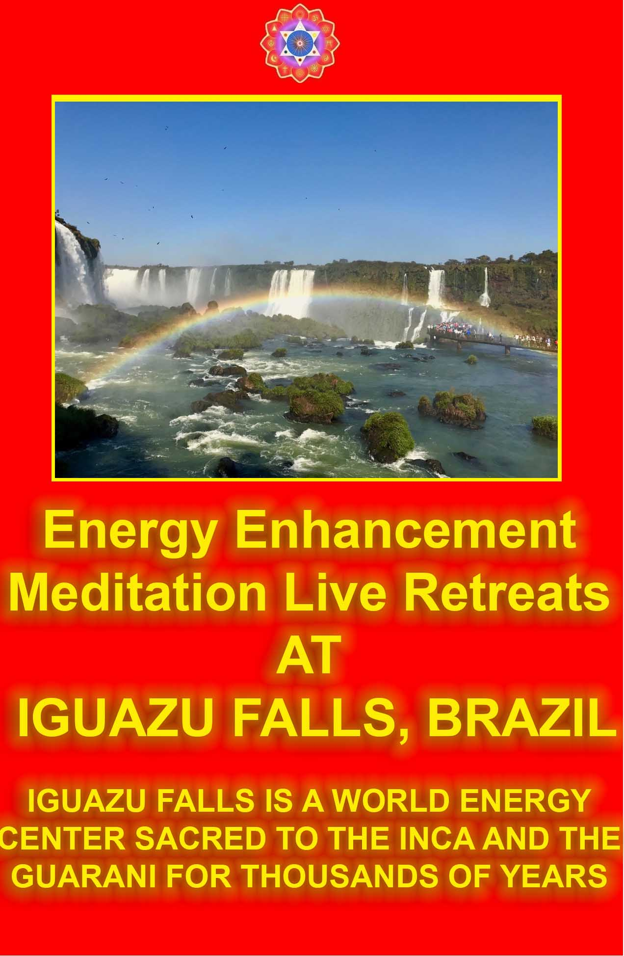

ENERGY ENHANCEMENT COURSE REPORT FROM JEAN
"I have experience of many forms of meditation and practices for self improvement including: Transcendental meditation (TM) 12 years, Kriya Yoga 9 years, Sushila Buddhi Dharma (SUBUD) 7 years, and more recently the Sedona Method and the Course in Miracles. The Energy Enhancement programme encapsulates and expands all of these systems, it is complete and no questions are left unanswered."

Jean, NUCLEAR ENGINEER, FROM THE SEPTEMBER 2005 ENERGY ENHANCEMENT COURSE

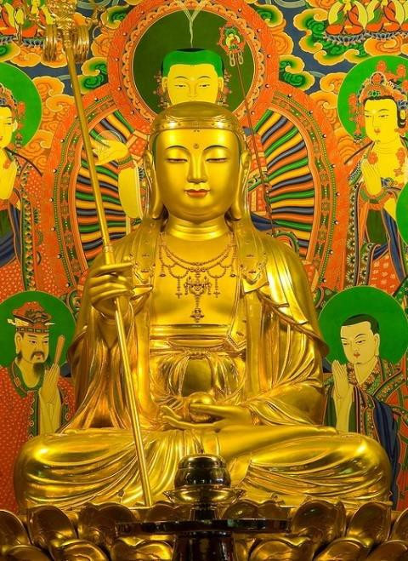
"I have experience of many forms of meditation and practices for self improvement including: Transcendental meditation (TM) 12 years, Kriya Yoga 9 years, Sushila Buddhi Dharma (SUBUD) 7 years, and more recently the Sedona Method and the Course in

Miracles. The Energy Enhancement programme encapsulates and expands all of these systems, it is complete and no questions are left unanswered."

Jean, NUCLEAR ENGINEER, FROM THE SEPTEMBER 2005
ENERGY ENHANCEMENT COURSE

ENERGY ENHANCEMENT IS THE NEWEST AND MOST HIGH SPIRITUAL IMPULSE ON THIS PLANET

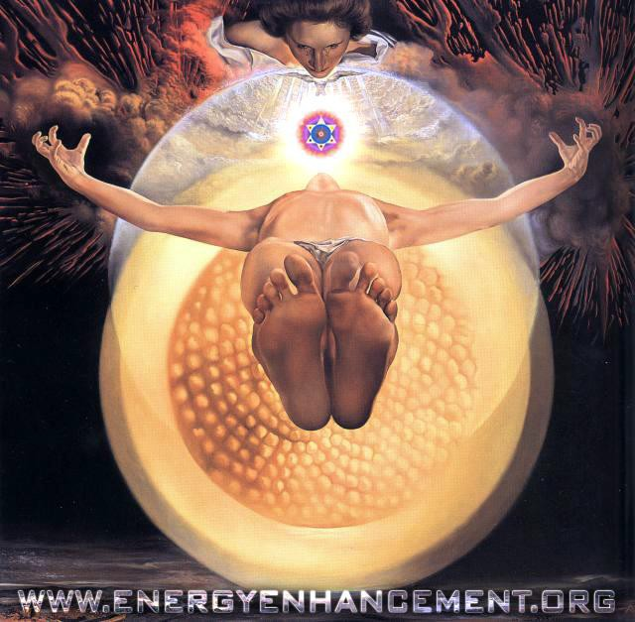



ENERGY ENHANCEMENT SYLLABUS
WHAT IS ENERGY ENHANCEMENT?

THE ENERGY ENHANCEMENT SYLLABUS CAN BE FOUND HERE - THE HOME PAGE IS WHERE YOU SHOULD START OFF BUT FOR MORE DETAIL - LEVEL 1 GAIN MASSIVE ENERGY, LEVEL 2 - CLEAR ENERGY BLOCKAGES, LEVEL 3 - CLEAR ANCIENT KARMA, LEVEL 4 - MASTER RELATIONSHIPS, LEVEL 5 - HEAL THE WORLD

THE EE STUDENTS

THE ENERGY ENHANCEMENT STUDENTS HAVE BEEN GIVING THEIR REPORTS - STUDENTS ONE, EXPERIENCES STUDENTS TWO AND JULY 2008 ARGENTINA COURSE THEY REPORT WHAT HAPPENED TO THEM - EXPERIENCE OF THE ENERGY ENHANCEMENT COURSE - CLICK BELOW!!

http://www.energyenhancement.org/player/Elsie- Testimonial-Spain-2007/flv6.html

THE TEACHING
Just with the Kundalini Kriyas you can start to move forward strongly to Remove All Your Negative Energies, all Negative Karmic Mass in order to Create Intelligence, Positivity, Energy and Confidence.

WHAT IS ENERGY ENHANCEMENT?

THE HOME PAGE IS WHERE YOU SHOULD START OFF BUT FOR MORE DETAIL - LEVEL 1 GAIN MASSIVE ENERGY, LEVEL 2 - ELIMINATE ENERGY BLOCKAGES AND TRAUMA, LEVEL 3 - CLEAR ANCIENT KARMA, LEVEL 4 - MASTER RELATIONSHIPS, LEVEL 5 - HEAL THE WORLD

ENERGY ENHANCEMENT MEDITATION SAMYAMA

DVD COURSES

PLUS 7 FREE DVDS

PLUS FREE VIDEO ON DEMAND
AS GIVEN IN THE HOME STUDY COURSE, ONLINE BY STREAMING VIDEO (YOU MUST HAVE A GOOD BROADBAND CONNECTION TO RECEIVE THIS) PASSWORDS TO THE ONLINE VIDEO ADDRESS PLUS WITH ALL THE SAME EXTRAS, SATCHIDANAND AUDIO TALKS, DOWNLOADABLE YOGA, PRANAYAMA, SACRED SYMBOLS BOOKS GIVEN BY EMAIL ...

THE ENERGY ENHANCEMENT BOOK SUPER ENERGY AND SACRED SYMBOLS COLOUR PDF DOWNLOAD - CLICK HERE!!

ENERGY ENHANCEMENT MEDITATION SAMYAMA ENLIGHTENMENT!!!

NOT ONLY MASSIVE ENERGY - LEVEL 1

NOT ONLY ENERGY BLOCKAGE ELIMINATION - LEVEL 2

NOT ONLY KARMA CLEANING - LEVEL 3

AND MASTERY OF RELATIONSHIPS - LEVEL 4

BUT ENLIGHTENMENT!!

"FOR THOSE WHO BELIEVE IN ENLIGHTENMENT AND UNDERSTAND THE URGENCY OF THE SITUATION" - GAUTAMA BUDDHA

WE CAN CHANGE

YES WE CAN

FOR THOSE WHO TELL US THAT WE CAN'T

YES WE CAN ENDURING HOPE YES WE CAN
AND THE LIGHT OF OUR IDEALS SHINES BRIGHTLY

YES WE CAN

WE SHALL OVERCOME YES WE CAN!!
ENLIGHTENMENT

YES WE CAN!!
THE ANCIENT EFFECTIVE SECRETS OF ENERGY ENHANCEMENT WILL ENABLE YOU TO BECOME MORE ENERGETIC, MORE PEACEFUL, MORE POSITIVE, MORE PURE, MORE SOUL INFUSED IN YOUR ALL YOUR LIFE AND FUTURE LIFETIMES - THE REAL SECRETS OF SUCCESS

COME FOR A LIVE, MONTH LONG, TWO LEVEL COURSE WORLDWIDE

Energy Enhancement recommends that you start with any DVD Course - 2 Initiation DVD Course, or 4 Initiation DVD Course or One Level DVD - practise THE KUNDALINI KRIYAS and take advantage of asking questions of Satchidanand by email.

Get the DVDs

THE HOME PAGE IS WHERE YOU SHOULD START OFF BUT FOR MORE DETAIL - LEVEL 1 GAIN MASSIVE ENERGY, LEVEL 2 - ELIMINATE ENERGY BLOCKAGES AND TRAUMA, LEVEL 3 - CLEAR ANCIENT KARMA, LEVEL 4 - MASTER RELATIONSHIPS, LEVEL 5 - HEAL THE WORLD

Or just come on the Live Course Straight away.. LIVE COURSES...


IN ARGENTINA AND IGUAZU FALLS , SPAIN, ELEGANT 5Star INDIA TAJ MAHAL, INDIA TOUR , MEXICO, PERU

INDIA TOUR - CLICK HERE FOR WEB PAGES

SEE THE VIDEO TOUR OF INDIA BELOW

https://youtu.be/KVbVm6B8t28

THE VIDEO TOUR OF INDIA

The Energy Enhancement Meditation Course - www.energyenhancement.org in India introduced by Swami Satchidanand and Swami Devi Dhyani. We see...

The Taj Mahal in Agra and The Red Fort. Then there is an interview with Swami Shantananda of Vashishta Gufa in the Himalayas above Rishikesh.
We see Haridwar and the Hindu arati ceremony there at dusk on the banks of the River Ganges where crowds of thousands view the sacred flame and chant the songs of enlightenment. Enlightened sages descend from their caves in the high Himalayas to give experiences of energy to the assambled people - a shower of flowers.
We see the temple of Hare Krishna in Vrindaban and the special ceremony of the display of the Murthys, the statues of Krishna together with the chanting of the monks and the dance of the whirling dervishes by Swami Devi Dhyani.

COME AND GET EXPERIENCED!
CLICK HERE!! FOR WHAT WE ARE DOING

EMAIL sol@energyenhancement.org

FOR DETAILS
PREPARATION FOR ENERGY ENHANCEMENT

Usually the students practice some of the initiations before they come on the course so that when the Buddhafield hits them they can remove more Energy Blockages whilst they are on the Course.

We recommend you start NOW!! with any DVD COURSE. A regular Spiritual Practise with Energy Enhancement in advance of any Live Course will give you Massive Energy, and Remove All Energy Blockages.

REPORT FROM JAPAN ON THE DVD COURSE

Hi, I want to tell you about my recent feeling, It came spring in Japan suddenly, I felt like my blockage began to melt and I felt negative feeling. I took a herbal face massage about 1.5 hours yesterday night, it dozed me .

End of that it came up to my mind that you were shining in white space. next Devi, Danisa, Sebaschan, me, and my partner I have never seen. You and Danisa's halo was more clear.

After that, I could feel that inside my body and my every cells swimming in lighting for a while. And when I did Level1 initiation2 by DVD, with your shining image, I could feel filled white light was in my body, And I could

feel energy circulate my body include my Hurt center where my blockage is.

I could breath strongly and through my blockage, I felt - Is it good?
It may be good season for meditation, as you said. Thanks a lot .
with love,
DVD Student Japan MARCH 2008

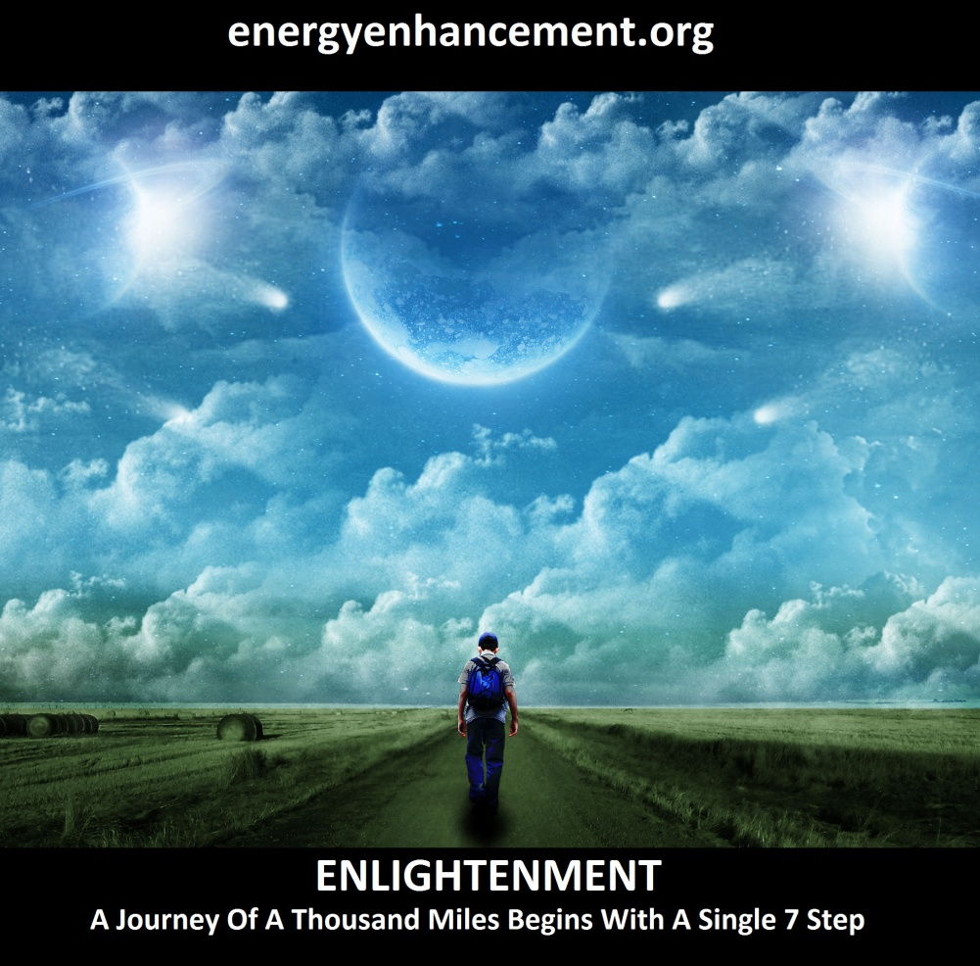
LEARN THAT WHICH IS FALSE WITHIN YOU
LEARN TO RECOGNIZE THE FALSE AS FALSE
-WITHOUT THAT, THERE CAN BE NO LASTING TRANSFORMATION
ENERGY ENHANCEMENT
"I was not sure if this was wise, as I knew nothing other than what I had read on the web site and the testimonials, which I was a bit skeptical about! However, I am now adding my own because if you read this you might be a bit like me...
Don't hesitate - go for it!"
MS (Ireland) Human Resources Director, Europe/Asia, of a Fortune 500 US Multinational Company
Honey Kalaria

" Once on the course, my exciting adventurous journey began! In my life I have done hundreds of courses but the Energy Enhancement Course I found to be completely different. Firstly, the contents and the teachings seem to be inspired by higher forces and had a deep base in spirituality..." Honey Kalaria (UK) Bollywood Actress/Owner of Diva Entertainment
ENERGY ENHANCEMENT
"I was not sure if this was wise, as I knew nothing other than what I had read on the web site and the testimonials, which I was a bit skeptical about! However, I am now adding my own because if you read this you might be a bit like me...
Don't hesitate - go for it!"
MS (Ireland) Human Resources Director, Europe/Asia, of a Fortune 500 US Multinational Company

GAIN SUPER ENERGY

ENERGY ENHANCEMENT MEDITATION

Here is our Client, Peter and his Testimonial
Hi, my name is Peter; I am an electrical engineer for my local power company in the UK.

Previous to attending the Energy Enhancement Course I had been initiated to Level 3 Reiki. I have also been suffering over a few years, sensitivity to certain foods, pollutants and pesticides, giving me low-grade health.

We started at 7.30am on day one and Satch and Devi taught us Yogic Breathing, which is quite different from normal breathing. One breathes in through the nose first to the abdomen, then the chest and finally the upper chest, holding for a few seconds. Finally the out breath should be twice the length of the in breath.

Once this technique of breathing was practiced enough, we were taken through various Yoga positions, during the resting period between some of the positions I felt my whole body tingling with energy.

I felt very emotional and started to shake and cry as the waves of negative energy released through my body down to my feet and then to 'ground'. This reaction completely surprised me as I thought Yoga was all about stretching the muscles, developing agility and finally achieving calm.

After the morning session we went down to the beautiful Calla Montgo beach nearby to our Villa. This is not to be missed, golden sand and wonderful warm, clear water. We swam and caught some rays. Yeah!


cala montgo, montego bay, SPAIN

On the evening of day one we assumed the cross-legged 'easy position', which I never thought, was possible for me. I maintained this position for one hour!

We started Yoga breathing and got into alignment with the earth energy, at first it was difficult to feel the connection. Satch then came over to me and aligned my body correctly, I then immediately felt the energy flow.

This flow became stronger as time elapsed until again I felt strong emotion, first I cried and then I laughed, the energy flow was much stronger and was continually flowing without any effort. I actually felt as if I didn't want to break the connection, although there was a delicious pesticide free meal on the table!

Day two a.m. was even more dramatic, once in meditation I was continually clearing negative emotions, although what they were I do not know, I was shaking and crying.

We also learnt the Hatha Yoga 'master position'; I only thought gymnasts would be able do this one! Negative energy again started clearing but this time during and after the position. I didn't know I had so much dross on board.

The advantage of Energy Enhancement is that you do not have to experience every single negative experience you ever had, it is swept away as a "job lot" so you feel it going, but it is not unpleasant! This is really good, who wants to experience all the bad things again!!

We are off to Roses this afternoon for a sauna and a meal. I am really looking forward to this evening's meditation and Energy Enhancement!

Day 3, a.m., we received a Reiki initiation today, although this was the second time for me it was completely different from the first time back home.

I felt lots of energy flowing while Devi's hands were on my shoulder, I also got a vision of a sword, apparently this could mean breaking of some energy connections, which may have been of a negative nature.

We then continued meditation with the Fire Ceremony. This consists of sending your negative energy down an energy tube for purifying by the 'Atomic Flame' at the center of the earth. The energy is then returned as 'pure gold' to the body's energy field and this starts an energy circulation, which can then be used to burn through energy blockages.

During this burning I released again waves of negative energy and started shaking and laughing.

Day 3, p.m., connecting to the God energy. Started with meditation pose and circulating energy as in the Fire Ceremony, we then sent our connection out through the earth's atmosphere and out the galaxy and universe by imagining we were in the starship enterprise at warp 10, beam me up Scotty!

We then went on to the Spiritual Sun (soul) and went to its centre. From there through a door and onto the Monad (in charge of many souls) and from the centre of the Monad upwards to God.

One may encounter blockages of negative energy on the way up and have to 'breathe' our energy through them.

I found a very powerful one just before the white light of the God energy, it consisted of a black goo.

I was finding it impossible to fight through, my legs were hurting, my back was hurting from the meditation pose and I was on the verge of defeat. I told Satch and he said that it was probably time to come down again, as soon as he said that it made me want to do the opposite!

I broke through and contacted the God energy. Well what an energy flow took place then! It felt unlike any of

the other flows and my negative energy starting clearing good style. I was shaking, crying and then finally laughing. This lasted for a few minutes and then finally subsided.

This energy flow started from myself, to the God energy, from the God energy and back to me and then down to the atomic flame, negative energies purified and sent back up through the body and up again. This is known as the 'Macrocosmic Orbit, The Energy Enhancement Supra Galactic Orbit' of energy.

Day 4, a.m., feeling quite whacked out today, no energy, found it difficult to maintain yoga poses and was aching all over. We had 3rd Reiki initiation with Devi, felt a lot of energy flow through shoulders. Had breakfast and went for some z's to recover.

Day 4 p.m., did further clearing of negative energies, but this time much more powerful, I had a blockage in the chest and the energy was so intense I felt as if I was having a heart failure! This sensation passes quickly and even after breaking the pose I could feel the energy flow and I broke out into laughter.

Day 5, a.m., talk by Satch about grounding the effects of any food that we have eaten in the past, or are about to eat and have just eaten (stage 5 of Energy Enhancement). Unfortunately lots of meals I had eaten were bad! Lots of grounding to do!

Also more importantly how to ground negative energy blockages within the body. One can with the right technique use the God energy and beams of energy from the third eye and the heart to zap these out of the way. This additional technique is very powerful and level of clearing is much more intense again.

How much more powerful can we go?!

THE ENERGY ENHANCEMENT STREAMING VIDEO COURSE

"Get your asses over here Now and Speed Up your process of Enlightenment on the Energy Enhancement one month course!!" - DON
Every one of our Students gets this Spiritual Experience of Connection with Infinite Energies.
Energy Enhancement does indeed, "SPEED UP THE PROCESS!!"
And they all get this Experience of Light, Life and Infinite Energy just with the Energy Enhancement Course - Every One of Them!!
LEVEL 1 - 4 VIDEO COURSES ANYTIME IN THE COMFORT OF YOUR OWN HOME

IGUAZU

BIG WATER!!

When you receive energy correctly

And not everyone does because they get the symptoms of energy blockages instead - Going to sleep, shaking, pain, heat, cold, negative emotions, - all the common so called symptoms of Kundalini Energy. But when you get taught to receive energy correctly on the Energy

Enhancement Course - "When the energy is flowing correctly, there is no movement" - Saadi of Shiraz.

And this is the Energy Enhancement Experience.. "We eventually get into a state of energy transfer. We both feel it as white light flowing from one to the other in an incredibly intense way which lasts for two hours. At the end of that time I perceive an initiation which is taking place on the astral plane. Surrounded by a group of ascended masters I introduce him to the chief initiator who uses the rod of initiation to touch his third eye with the intense energies of initiation so that his energies can never again drop into that state we call normal waking consciousness."

If you can receive energy then the chances are that you can give energy. Only the people who can receive energy correctly can go on to become enlightened, can go on to become Initiators of men, Gurus and Spiritual Masters.

If you only get the symptoms of Energy Blockages in the fire of the Buddhafield which is the intense aura of energy which surrounds every Spiritual Master then you need to remove the Energy Blockages which produce the symptoms. The Energy Enhancement Level Two Seven Step Process is the unfailing technique which can remove any Energy Blockage.

When we become a stream enterer, we tap into the Energies of the Earth and of Heaven and of the Buddhafield and through energising our faculties, we start to have spiritual experiences beyond the norm. We start to feel and see energy to start with, which always comes to every student.

It happens with all of our students... INNER PEACE

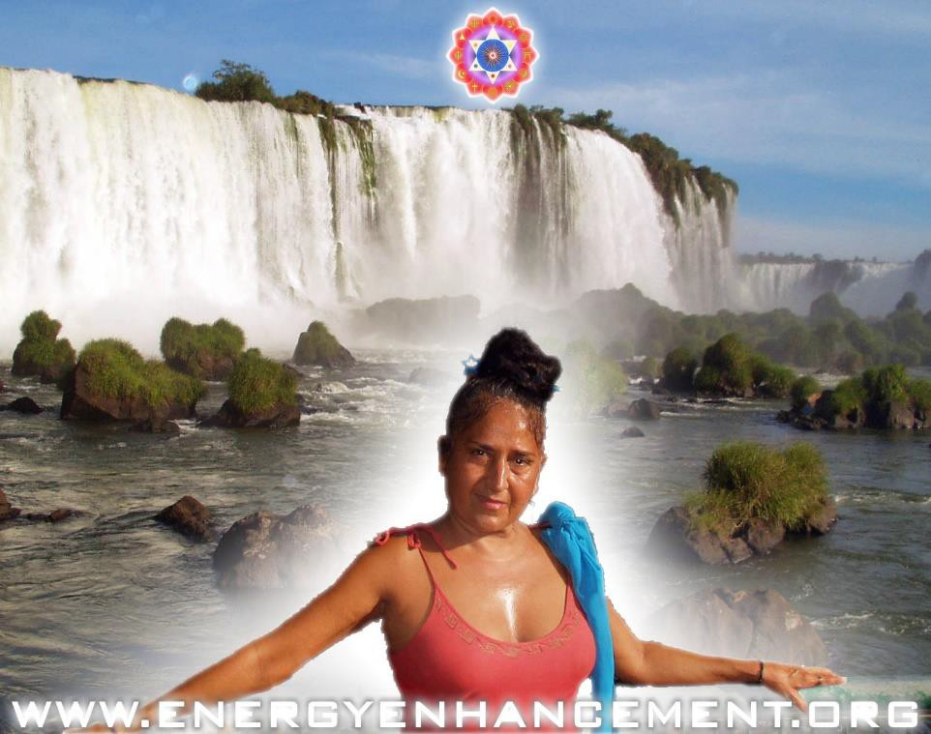
MATAJI DEVI DHYANI - VISIT TO IGUAZU AFTER THE JULY 2008 COURSE

Reports of our Students

ARGENTINA

VISIT TO IGUASU FALLS AFTER THE EE COURSE

THE PRESENCE
The Presence is a Personal Spiritual Experience and Initiation into Energy Enhancement Techniques without Words - View it on Youtube Now, A Transfer of Energy which awakens the Soul, Enlivens the Brain, Stops the Mind, Brings you into This Moment of Peace and of Joy. Feel the Effects of Spiritual Energy Vibrations, Launch into Enlightenment - High Quality versions available on DVD.

SEE THE PRESENCE NOW ON YOUTUBE - CLICK HERE

THE CLEARING

Using Energy Enhancement, "The Clearing" Play it now, you can clear your room and Yourself of Negative Energies - Negative Karmic Mass. View it now on Youtube - High Quality Versions available on DVD

SEE THE CLEARING DANCE NOW ON YOUTUBE OR ON THE EE SITE - CLICK HERE

ENERGY ENHANCEMENT teaches TOTAL Transmutation of ALL ENERGY BLOCKAGES

The inflow of Spiritual Energy or Kundalini Energy is well known in all Spiritual Circles as being expected in all genuine Courses with teachers who have advanced experience with Enlightened Masters. Yet some people just cannot get their heads around Kundalini Energy which is talked about even in the Vedas which are a sacred spiritual resource thousands of years old. Even though Swami Sivananda of Rishikesh said that all meditation and Yoga was based upon Kundalini Energy.

If you are not experiencing spiritual energy in your Yoga or Meditation practise then What is UP??!!

"EASY AND SMOOTH ENERGY ENHANCEMENT PUTS YOU IN CONTACT WITH KUNDALINI ENERGY WHICH SPEEDS UP THE PROCESS OF ENLIGHTENMENT AND INTELLIGENCE"

COME AND JOIN IN THE SEARCH FOR YOUR EVOLUTION

"I have experience of many forms of meditation and practices for self improvement including: Transcendental meditation (TM) 12 years, Kriya Yoga 9

years, Sushila Buddhi Dharma (SUBUD) 7 years, and more recently the Sedona Method and the Course in Miracles. The Energy Enhancement programme encapsulates and expands all of these systems, it is complete and no questions are left unanswered."

Jean, NUCLEAR ENGINEER, FROM THE SEPTEMBER 2005 ENERGY ENHANCEMENT COURSE

THE ENERGY ENHANCEMENT APPRENTICE LEVEL TWO COURSE

THE KARMA CLEARING PROCESS

- THE REMOVAL OF ENERGY BLOCKAGES MORE ADVANCED THAN MEDITATION!! FASTER THAN MEDITATION
ABOVE AND BEYOND MEDITATION

"I have experience of many forms of meditation and practices for self improvement including: Transcendental meditation (TM) 12 years, Kriya Yoga 9 years, Sushila Buddhi Dharma (SUBUD) 7 years, and more recently the Sedona Method and the Course in Miracles. The Energy Enhancement programme encapsulates and expands all of these systems, it is complete and no questions are left unanswered."

Jean, NUCLEAR ENGINEER, FROM THE SEPTEMBER 2005
ENERGY ENHANCEMENT COURSE

COME AND GET EXPERIENCED!

CLICK HERE!! FOR WHAT WE ARE DOING
EMAIL sol@energyenhancement.org FOR DETAILS

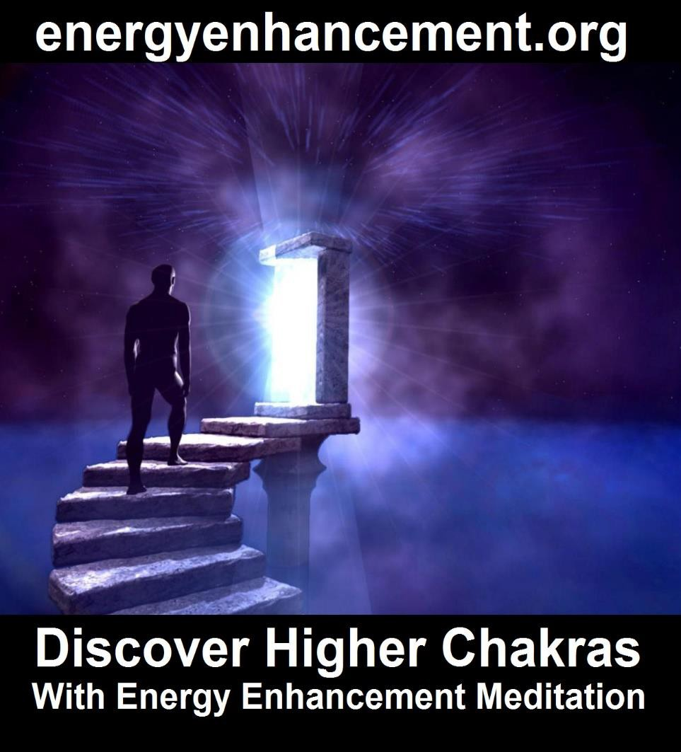

THE ENERGY ENHANCEMENT PATH OF PLEASURE, SAMADHI, SAMYAMA, ENLIGHTENMENT



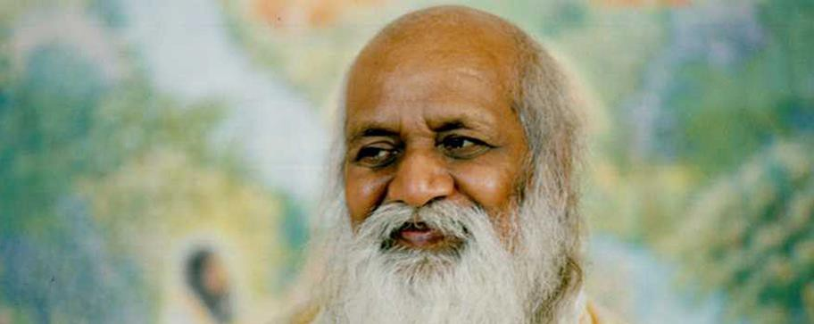
MAHARISHI MAHESH YOGI

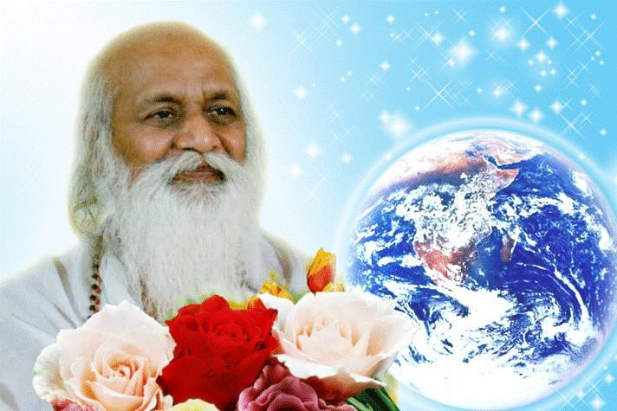

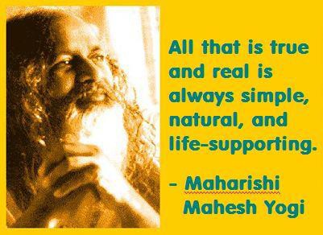

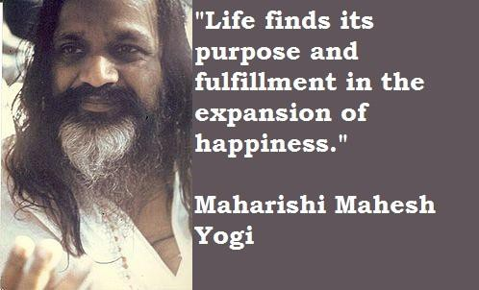

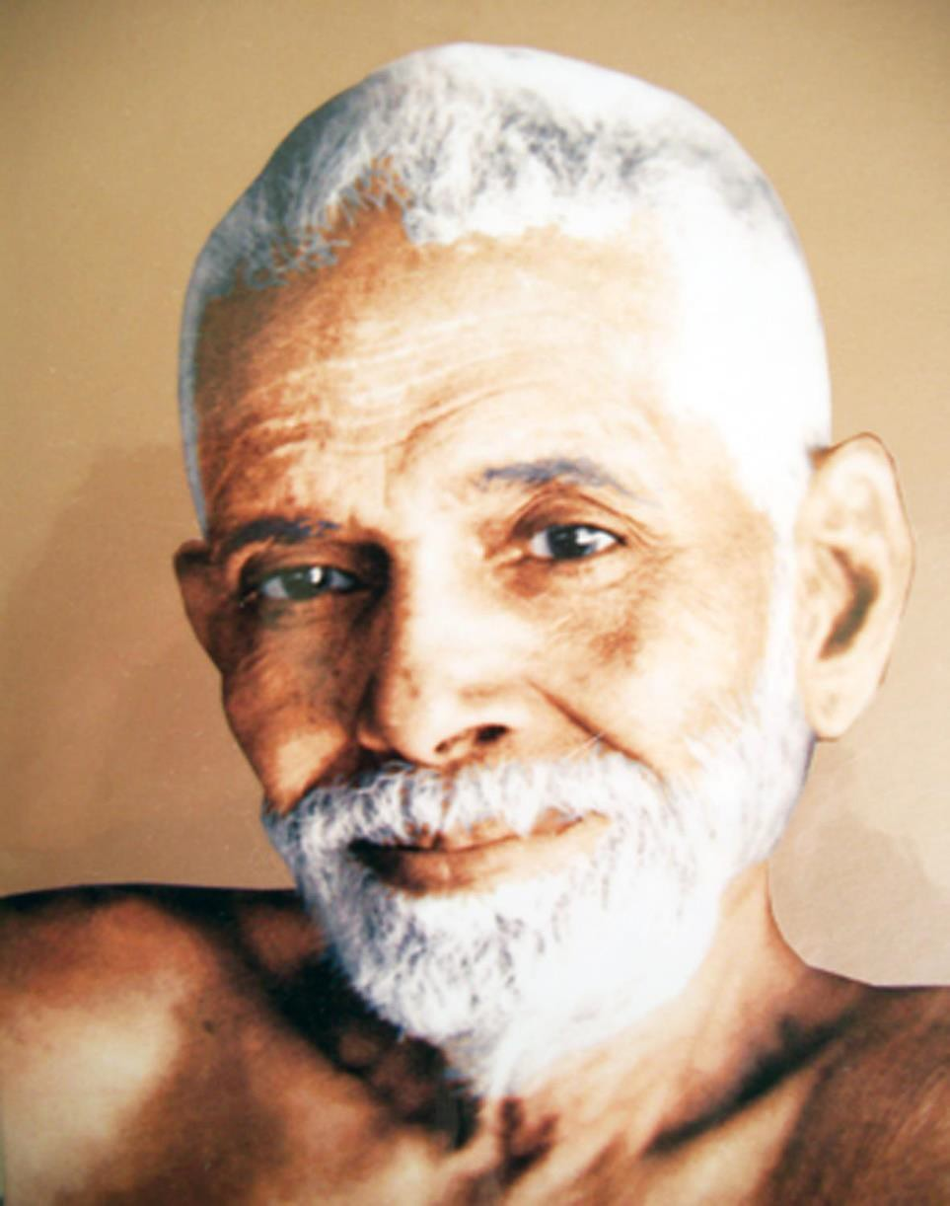

SRI RAMANA MAHARSHI, "I AM THAT"
To Tamil Siddar Ramana Maharshi and his Ashram in Tamil Nadu, South India.

TAMIL SIDDAR SRI RAMANA MAHARSHI, GURU, ENLIGHTENED ILLUMINATED SPIRITUAL MASTER

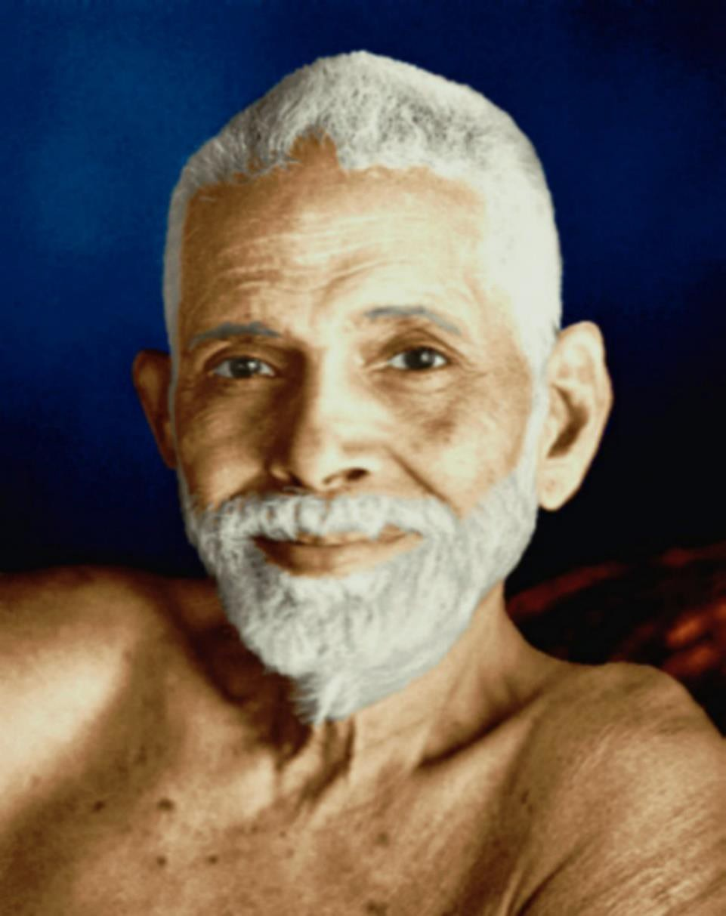

Tamil Siddar SRI RAMANA MAHARSHI, GURU QUOTES, ENLIGHTENED ILLUMINATED SPIRITUAL MASTER

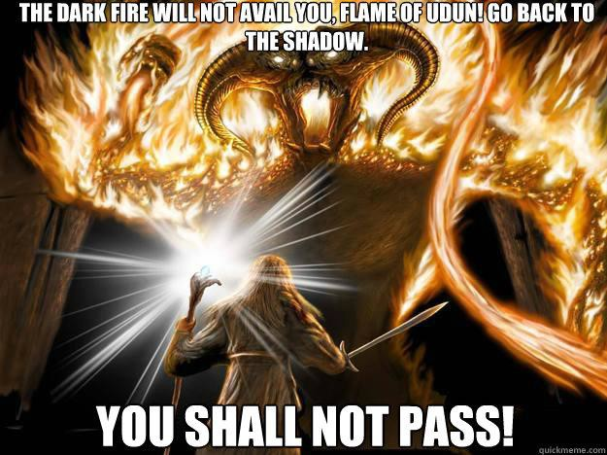
TOLKIEN CREATED THE LORD OF THE RINGS TO OPPOSE THE WAGNERIAN RING CYCLE THOUGHTFORM

Tolkien wrote the following about the idea behind the One Ring: "I should say that it was a mythical way of representing the truth that potency (or perhaps potentiality) if it is to be exercised, and produce results, has to be externalized and so as it were passes, to a greater or lesser degree, out of one's direct control." (Letter #211, 1958).

Tolkien always strongly held that The Lord of the Rings was not allegorical, particularly in reference to political events of his time such as World War II or the Cold War. At the same time he conceded "applicability" as being within the "freedom" of the reader, and indeed many people have been inclined to view the One Ring as a symbol or metaphor. The notion of an evil power too great for humans to safely possess is an evocative one, and already in the 1930s there were technologies

available to suggest the idea. By the time the work was published, though not when most of it was written, the existence of nuclear power and nuclear weapons were common knowledge, and the Ring was often taken as symbolic of them. The effect of the Ring and its physical and spiritual after-effects on Bilbo and Frodo are obsessions that have been compared with drug addiction; actor Andy Serkis who played Gollum in the film trilogy cited drug addiction as an inspiration for his performance.

Parallels have been drawn between the literary device of Tolkien's Cursed Ring and the titular ring in Richard Wagner's Der Ring des Nibelungen. Tolkien dismissed critics' direct comparisons to Wagner, telling his publisher, "Both rings were round, and there the resemblance ceases." According to Humphrey Carpenter's biography of Tolkien, the author held Wagner's interpretation of the relevant Germanic myths in contempt.

Tom Shippey and Gloriana St. Clair, attribute the resemblances to the fact that Tolkien and Wagner have created homologue works based in the same sources. However, Shippey and other researchers have written on an intermediary position, stating that both the authors, indeed, used the same source materials but that Tolkien was, in fact, indebted to some of the original developments, insights and artistic uses made upon those sources that first appeared in Wagner, and sought to improve upon them.

Indeed Tolkien sought to change to Good the the evil Wagnerian thoughtform which emphasises the use of the Will to, "Get what you Want". Wagner echoes OTO Crowley and Reuss. Hitler himself said that to understand the unfinished Caliban character, you had to understand Wagner.

Tolkien sought to increase the Thoughtform of Implacable opposition to Evil

"YOU SHALL NOT PASS!!"
As Karma proceeds so the psychic structure and the Soul reach out for Union with each other.

Quite naturally and through discipline - as we learn Energy Enhancement Meditation - we learn to project in meditation into the chakras above the head and thus we access higher and more intense spiritual energies which light up, illuminate, and thus Power Up!! the mind all the talents and all the psychic powers. Thus a Human Being starts to, "Wake Up"

Quite naturally and through the discipline of Energy Enhancement 28 Initiation on the Path of EnLightenment we learn to Ground all the negative energies striated through all the Psychic Body and through every God created talent. This purification of all the talents, of all the energy blockages, of all the Trauma-Formed Negative Karmic Mass, leads to correct action in the World - Only doing the Right thing - which gives satisfaction and a sense of rightness, of being in tune with the Universe as all connection with the dark Side is rejected, "To seal the door where evil dwells", "Stay away from evil" - Jesus Christ

At the Enlightenment Initiation the Chela, purified of all Energy Blockages, fuses with his Soul and all his psychic Body is heated in the Crucible and cools down, crystallised - Unchangeably good, efficient, faster, - unable to be perverted by energy blockages within the new crystalline body.

EnLightenment is Only the First Dan.

After this Initiation there is a period where karma is speeded up as the new Master increases the size of his Psychic Body. Not through serendipity and the action of Karma but by Grounding Negative energies from the World around him, from his students, from all the people around him, from the World.

This grounding of Energy Blockages purifies their psychic mechanism and afterwards he incorporates these newly purified psychic mechanisms into his psychic body.

This work does not take the 100 lifetimes of serendipity to complete. We can enhance our psychic bodies with new talents amazingly quickly to achieve further Initiations and Ascended Mastery within only one Lifetime!!

"AS ABOVE, SO BELOW AS WITHIN, SO WITHOUT"
- Hermes Trismegistus

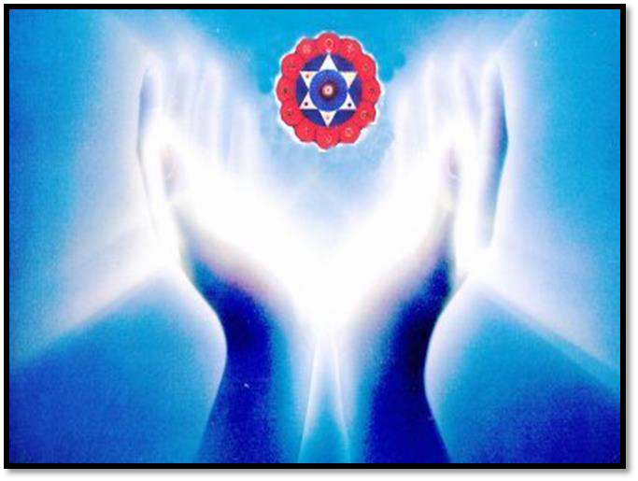

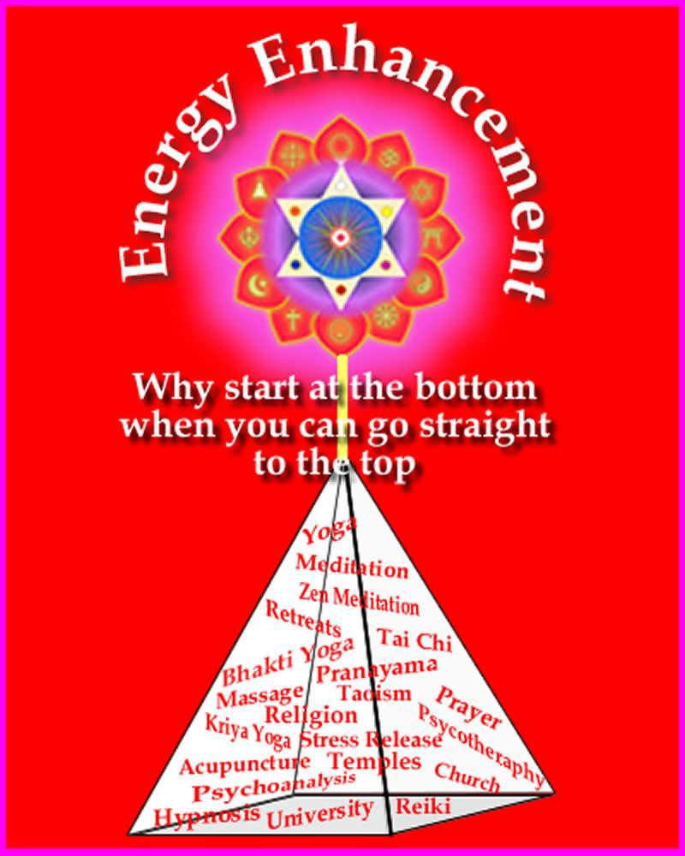

This Isn't a Game!!

Energy Enhancement is Meditation on Steroids..

Meditation with Cojones!!

Meditation which Really Works...

As you remove ALL Your Blockages with Energy Enhancement Satchidanand so Everything Changes.

Achieve Your Deep Peace..

EE Level 1 - Incredible Energy - Affecting Your Aura, Your Health, Your Attractivity.

EE Level 2 - All your Blocks - Remove and Release Your Beast!!

EE Level 3 - All Your Karma - Ever Wonder Why Things go Wrong?
Stop the Sabotage!!

EE Level 4 - All Your Relationships - How to Stop Your Divorce or your Lover’s Rejection..

It Goes On and On - Free Up Your Time - Have Fun - Access Infinite Wealth..

TEN FREE DOWNLOADS...
FREE EE YOGA INSTRUCTION VIDEO
DVD With Satchidanand and Amy Zantras who went into Samadhi for 2 hours whilst making the Video!!
See her Experience.. http://www.energyenhancement.or g/eeyoga.htm

FREE SACRED DANCE VIDEO DVDS FREE FOUR EE BOOKS - As sold on
Amazon!!

FREE With Two Levels, the Energy Enhancement Infinite Wealth Home Training Program

Bye-Bye Boss - Do you like your job or do you dream of saying, "Bye- Bye Boss"

Do you believe your Infinite Wealth is directly related to your state of mind and consciousness?

If yes, what if there was a process to enhance your state of mind and consciousness, so from this moment onwards you could improve your ability to attract wealth? Follow your Soul Path, the work you were Born to Do? Would this interest you?

And if you knew this process only took a few sessions of practice, but would benefit you for the rest of your life… would you make the time for it?

If you said YES to all these questions, I have an invitation for you.

The FREE!! Energy Enhancement
Infinite Wealth Home Training
Program

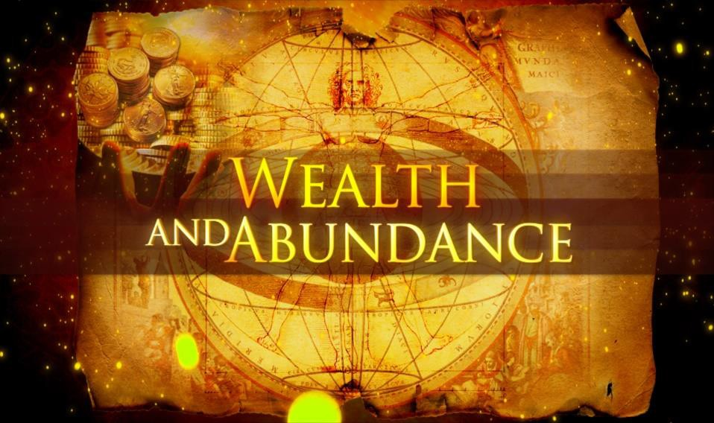

Only in the Video Buddhafield with at least Two Levels of the EE Streaming Video Course with Satchidanand

We are maintaining the 50% off Incredible Streaming Video Levels!!

http://www.energyenhancement.org/HomeStudyMeditat ionCourseSpecialOffer.htm

http://www.energyenhancement.org/FREE-Energy- Enhancement-Infinite-Wealth-Home-Training-Program- with-Energy-Enhancement-Streaming-Video-Course.htm

Free, as Sold on Amazon - Download these 4 Free Incredible Energy Enhancement Evolutionary Books, Now!!

Click below and right click and "save as" on each book to download

https://archive.org/search.php?query=meditation%20sat chidanand

Through this stochastic, statistical, karmic yet very slow principle, every human being turns out different, unique, with different talents, different interests, different capacities on the path of unique sovereignty, of Heart, of Illumination.

The psychic body and its talents, its intelligence, its energy is increased slowly at the behest of necessity, interest, and opportunity on its path to union with the Soul.

Incorporated, Hard wired in is the experience of the Laws of Karma which give an understanding that, "We are only allowed to do the right thing"

"This Planet is a factory for the production of Enlightened beings" Satchidananda

At first this planetary action is that of Karma necessitating all the bad and good things of life.
Over time, as well as psychic structures, infrastructure called Talent, also there becomes striated through the Psychic Infrastructure, Energy Blockages and Trauma- Formed Negative Karmic Mass which perverts the system and causes this world, just the way that it is - giving all the Karmic experiences needed by every Monadic Group to every individual at every level of evolution.

As we need more Psychic Infrastructure within, so we need more Physical Infrastructure without.. In order to Speed Up the evolution of Humanity in a more Humane way.

In alignment with the Hierarchy of needs by Maslow we need the firm base of Abundance upon which to base higher evolution. After all, when our lower needs are met, surely all that is left to conquer are the higher needs.

THE ENERGY ENHANCEMENT COURSE

IGUAZU FALLS IS A WORLD ENERGY CENTER SACRED TO THE INCA AND THE GUARANI FOR THOUSANDS OF YEARS
IN SPAIN, ELEGANT 5Star INDIA TAJ MAHAL, INDIA TOUR, SACRED IGUASSU FALLS, MEXICO, PERU
SIGN UP TO THE MAILING LIST FOR MORE DETAILS
EMAIL sol@energyenhancement.org
for details

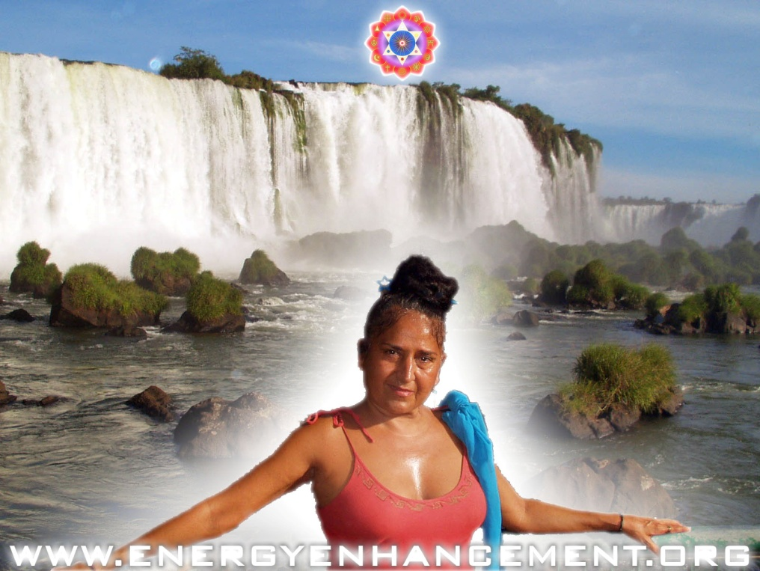

Today I sat in a chair and listened to the heart chant initiation 1 for the first time.

I was focusing on aligning my shoulders and spine forward and backward between the two lines of power from the center of the earth. And picturing the immovable mountain. Focusing on my breathing, closing the anus. I stayed in for the first four minutes. Then I got tired and openned my eyes, for about 7 or 8 seconds. Then I was so drowsy I had to close my eyes again. Then after about another four minutes I was tired again. Then the same thing but this time I focused on nothing but the energy from the earth entering the base of my spine and coming into my heart. Right from the beginning of the meditation I felt my energy all over my whole chest, even now.

But at the last when I focused on it coming from the earth, I immediately felt very, very powerful energy and I didn't move to find it. My back straightenned up automatically to the alignment and I was kind of "stuck" in that position with the power flowing.

From there it was hard for me to stop meditating when the chants were over. Very powerful. Even without magnets. My question is about my focusing. Is it wrong to "imagine" the power or the alignment or the energy? or should we imagine until we feel it? Or both? Am I focusing on the right things?

I am very grateful for your teachings. Thank you for your generosity.

Student Report.. SPEEED UP THE PROCESS!!

Also I noticed as soon as satchi emailed me, I got a down-pouring of light from above the crown which kept charging me up the rest of the day – and my cravings died out! Then I realized they were ego-blockages and that I did not want them.

This Energy Enhancement Level One Initiation Three - ALCHEMICAL VITRIOL is great! I've done it some more and it's incredibly powerful. I don't know why it isn't more well known or taught? It's really bringing up little

blockages which are complaining while being pushed down into the earth's core to get purified.

The hot fire energy has gotten much stronger in my body while doing the practice, mostly the base of the spine heats up, but also the middle of the spine. There are lots of little blockages being noticed. But I'm pushing them out.

Energy Enhancement Meditation Course Level 1 Initiation 4: Accessing the Universal Energy Source: Soul Fusion - INFINITE ENERGY!! for You!! via the Antahkarana, Macrocosmic Orbit, The Energy Enhancement Supra Galactic Orbit, Chakras above the Head, Advanced Kundalini Kriyas, Siddis, The Creation of Psychic Vision.

http://www.energyenhancement.org/EE-Meditation- Level-1-Initiation-4-Macrocosmic-Orbit-EE-Supra-Galactic- Orbit-Antahkarana-Chakras-Above-the-Head-Advance- Kundalini-Kriyas-Siddis.html

GAIN ENERGY - POWER UP!!
ENERGY ENHANCEMENT LEVEL 1
THE ENERGY BLOCKAGE REMOVAL PROCESS
LEVEL2
THE KARMA CLEARING PROCESS LEVEL3

MASTERY OF ENERGY CHORDS AND CONNECTIONS –

THE MASTERY OF RELATIONSHIPS LEVEL4

ENERGY ENHANCEMENT LEVEL 5 - IMMORTALITY WITH ENERGY ENHANCEMENT - CREATING THE IMMORTAL VAJRA DIAMOND BODY

ENERGY ENHANCEMENT MEDITATION ENLIGHTENMENT AND ILLUMINATION

ENERGY ENHANCEMENT SPEEEDS UP!! YOUR PROCESS

FIND ALL THE INCREDIBLE MEDITATION TECHNIQUES AND MEDITATION PRACTISES REMOVED FROM TRADITIONAL MEDITATIONS AND TAUGHT IN THE ENERGY ENHANCEMENT STREAMING VIDEO MEDITATION COURSE AND LIVE

MEDITATION RETREATS IN BRAZIL AND INDIA

THE MOST ADVANCED MEDITATION COURSE, MEDITATION TECHNIQUES AND MEDITATION PRACTICES ON THIS PLANET, INCLUDING THE KUNDALINI KEY, THE KUNDALINI KRIYAS, ALCHEMICAL VITRIOL AND

KUNDALINI YOGA IN 28 INITIATIONS!!

SPEED UP THE PROCESS!!

REMOVE EXTERNAL WORLD ENERGY BLOCKAGES WITH ENERGY ENHANCEMENT MEDITATION

WITH THE ENERGY ENHANCEMENT COURSE BUY A STAIRWAY TO HEAVEN
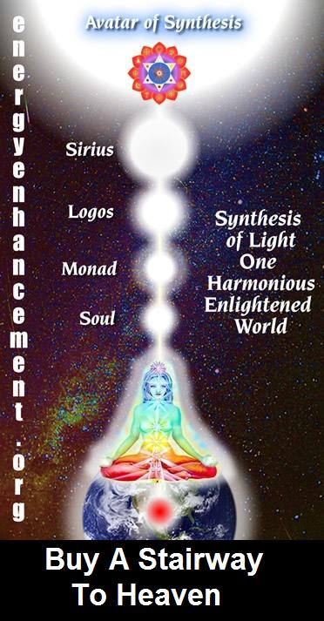
BUY A STAIRWAY TO HEAVEN
WITH THE ENERGY ENHANCEMENT COURSE
STUDENT REPORT
Also I noticed as soon as Satchidanand emailed me, I got a down-pouring of light from above the crown which kept charging me up the rest of the day – and my cravings died out! Then I realized the cravings were ego-blockages and that I did not want them.
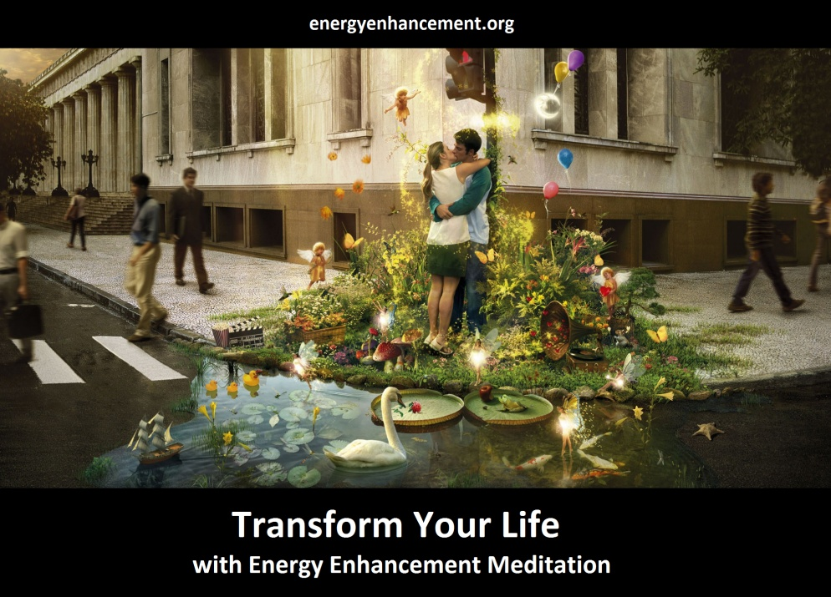
Energy Enhancement says that there are an infinity of chakras above the head up into the Center of the Universe and above, high above the head, ending in God, just as there are an infinity of chakras below the base - "As above, So Below" - Hermes Trismegistus from the Emerald Tablet.
INCREASE YOUR INTELLIGENCE - THE PARALLEL PROCESSING SUPERCOMPUTER YOU!! Energy Enhancement says that each chakra within you and above the head is a computer processor with higher and higher frequency, speed and capacity as you go higher. So, like a parallel processing supercomputer, the more chakras you can get working in the Infinity of Chakras above the Head and the more chakras you can access, the more chakras you can disblock, the more chakras you can augment, the more intelligent, the more intuitive, the more wise you will be.
FUSING WITH THE SOUL CHAKRA - Energy Enhancement says that just by fusing with the soul chakra one can see all your past lives and remove all blockages from all your past lives in one sweep, fast!!
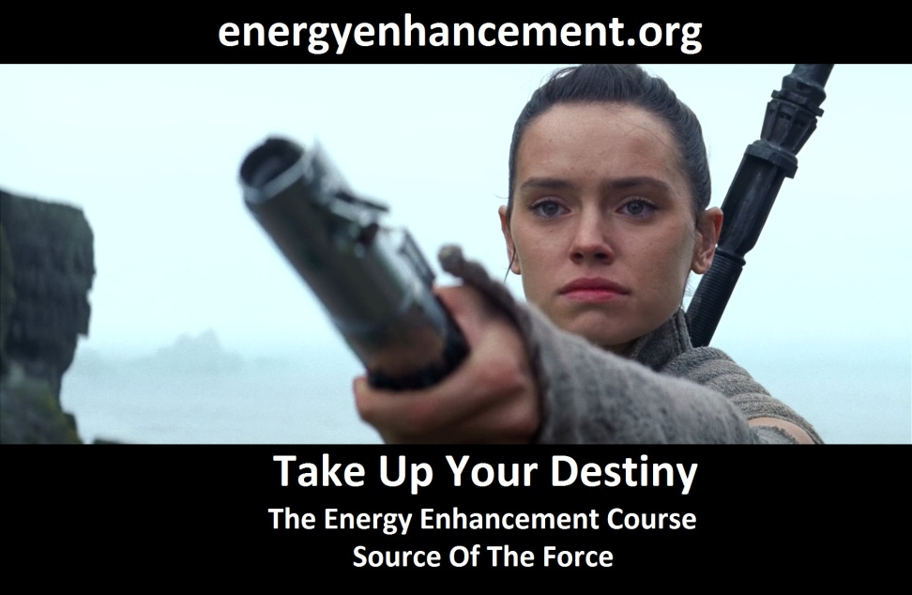
FUSING WITH HIGHER CHAKRAS - THE SOUL, MONAD, LOGOS, SIRIUS, AVATAR OF SYNTHESIS - Energy Enhancement says that it also contains the secret of Initiations Higher that Illumination - "Enlightenment is not Enough!!"

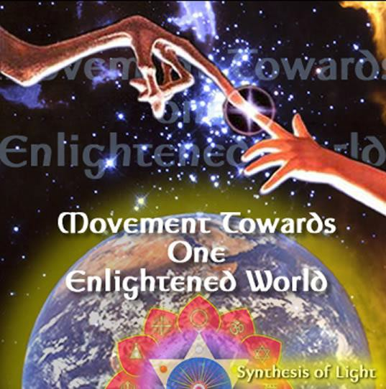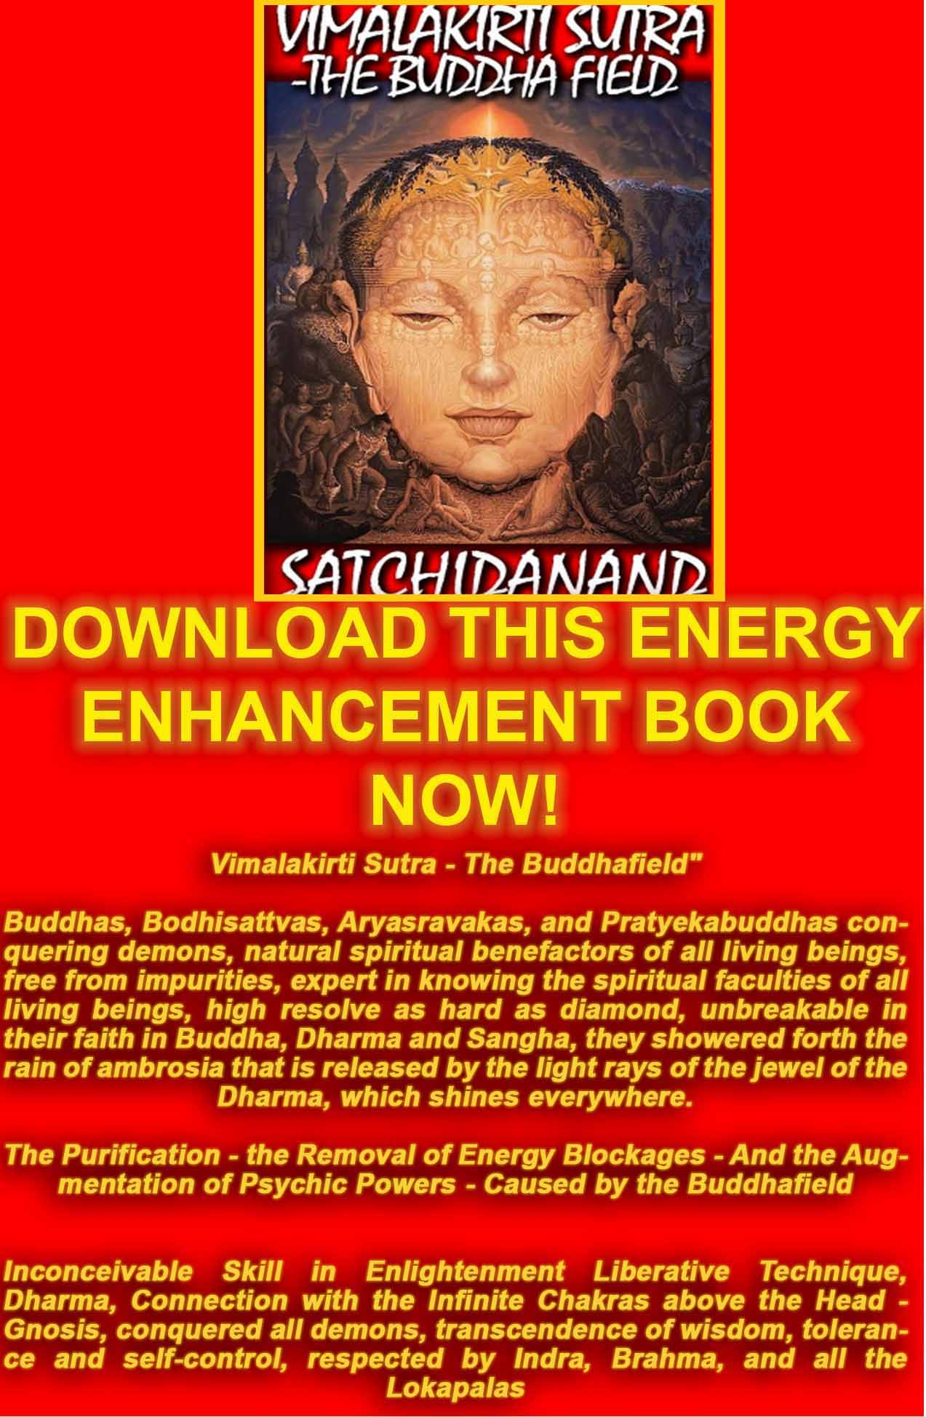
VIMALAKIRTI SUTRA
DOWNLOAD BELOW
The Buddhist, "Vimalakirti Sutra" in 14 Chapters - by Satchidanand plus one Chapter - The Buddhist Energy Enhancement Kundalini Key is the Buddhist Stupa
http://www.energyenhancement.org/Vimalakirti-Sutra/vimalakirti-sutra.pdf

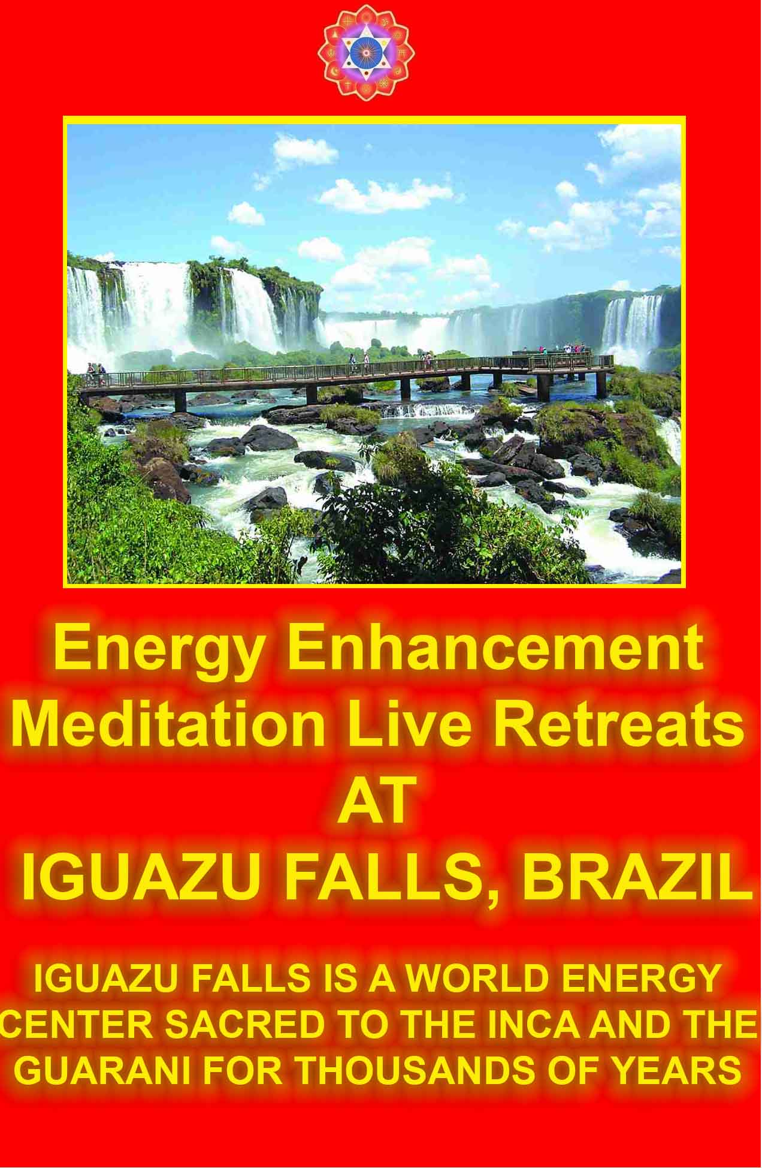

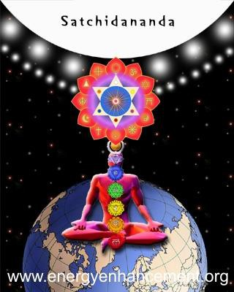

MEDITATION WITH COJONES

JOIN IN OUR ENERGY ENHANCEMENT VISION OF ONE ENLIGHTENED HARMONIOUS WORLD.

EMBASSIES OF ENLIGHTENMENT IN EVERY MAJOR WORLD CITY.

RETREAT CENTERS IN THE ANDES AND DRAKENSBERG MOUNTAINS.

IF YOU WANT TO CHANGE THE WORLD, CHANGE YOURSELF FIRST.

IF YOU WANT TO MAKE THE WORLD ENLIGHTENED, MAKE YOURSELF ENLIGHTENED FIRST.

JOIN US BY USING THE ENERGY ENHANCEMENT KARMA CLEARING TECHNIQUES REMOVING ALL TRAUMA AND NEGATIVE EMOTIONS.... ON THE PATH OF ENLIGHTENMENT.

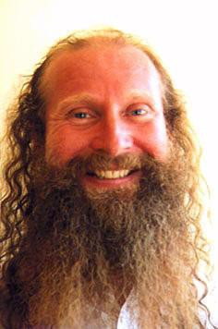

Energy Enhancement is the fastest way to Enlightenment..

Yoga is good but Pranayama is 10 times faster at releasing Energy Blockages whiMeditation Courses The Energy Enhancement Meditation Course Symbol from the Synthesis of Light- Satchidanandch stop the Enlightenment process.

Pranayama is good but Meditation is 10 times faster than even that at releasing Energy Blockages which stop the Enlightenment process.

Meditation is good but Samyama is 10 times faster than even that at releasing Energy Blockages which stop the Enlightenment process.

Yoga, Pranayama, Meditation and Samyama are part of the Eight Limbs of Yoga in the Yoga Sutras of Patanjali and Samyama is talked about from over 5000 years ago in the THIRD AND FOURTH Chapter of The Yoga Sutras of Patanjali.

And Samyama IS Energy Enhancement, 1000 times faster on the Path of Enlightenment.

You cannot afford NOT to try it!! Love and Light,
Satchidanand

ENERGY ENHANCEMENT CONNECT WITH ALL THE CHAKRAS - INTERNAL AND EXTERNAL - SOUL, MONAD, LOGOS SIRIUS...AND THE ANTAHKARANA

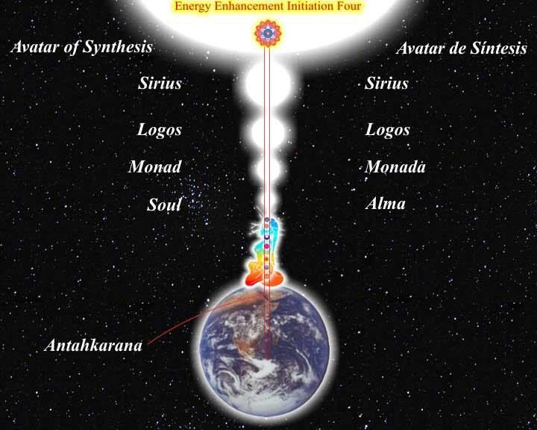

ENERGY ENHANCEMENT IS THE NEW, SAFE, SMOOTH AND FAST WAY OF LOSING ALL INTERNAL NEGATIVE ENERGY AND PAIN BECAUSE IT WORKS ONLY AT THE ENERGY LEVEL, THEREFORE SPEEDING UP THE PATH OF ENLIGHTENMENT.

ENERGY ENHANCEMENT HAS HELPED MANY PEOPLE ON THIS PATH FROM THOSE WITH THE BIGGEST ENERGY

BLOCKAGES TO THOSE WHOSE ASPIRATION IS TO HELP THE WORLD AND ALL THE PEOPLE IN IT.



ENERGY ENHANCEMENT CAN HELP YOU!!

Part of Satchidanand's Web Blog - "I was meeting a nice girl of 28 this morning here at our center in Rosario. She is a Psychologist but has fallen out of love with Psychology because although it explains things intellectually it gives no TECHNIQUES apart from talking to change anything internally, particularly in herself.
You can see how effective Psychology is by looking at Woody Allen.

I connected with her base chakra and her inner child showed me all her chakras and blockages one by one. A

very interesting experience. First the Base chakra, one fear and security blockage which I removed very quickly. Then the second, a pain filled relationship blockage which I also removed. Then all the chakras solar plexus, heart etc, feeling the general dirtyness of the psychic body usually cleaned with The Grounding of Negative Energies but no major blockages. Then the head, two blockages, one a person who had just died, very deep and negative. I removed the first blockage but the other one was more difficult and stayed with me, absorbed by my psychic body, for a day before I sent it on.

She felt the movement of energy blockages in the head and in the body as my mind and energy was working on her and told me that she normally got a lot of headaches. She was interested in my exposition of Energy Enhancement as all the while I was working on these blockages I was also talking to her. Such openings show an educated psychic body, one with talent. Not everyone who comes to the Guru has similar experiences. Some also get more. She and I felt that with training she also might be able to help her clients in a similar way. So, she is coming back tomorrow to try out the process, to get her first Initiation in Energy Enhancement.

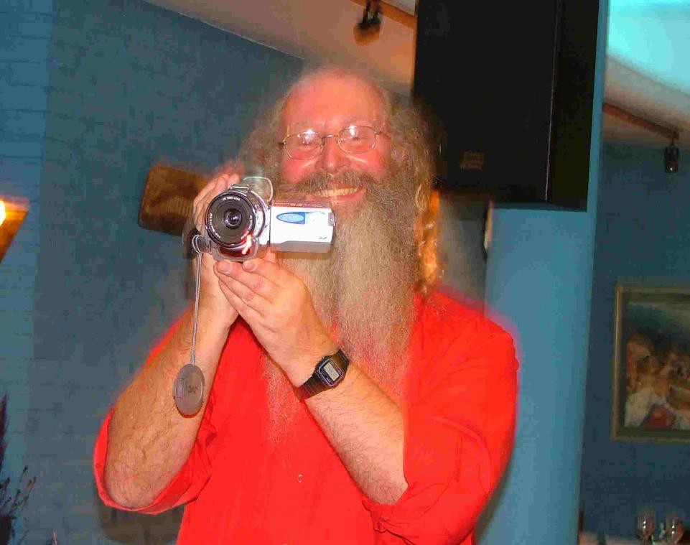

ARTICLE ON ENERGY ENHANCEMENT FROM THE YOGA MAGAZINE OF GREAT BRITAIN - FIND OUT WHAT THEY SAY!!

Energy Enhancement does exactly what it says on the Tin!

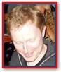
James Ellerbeck, Yoga Magazine of Great Britain.

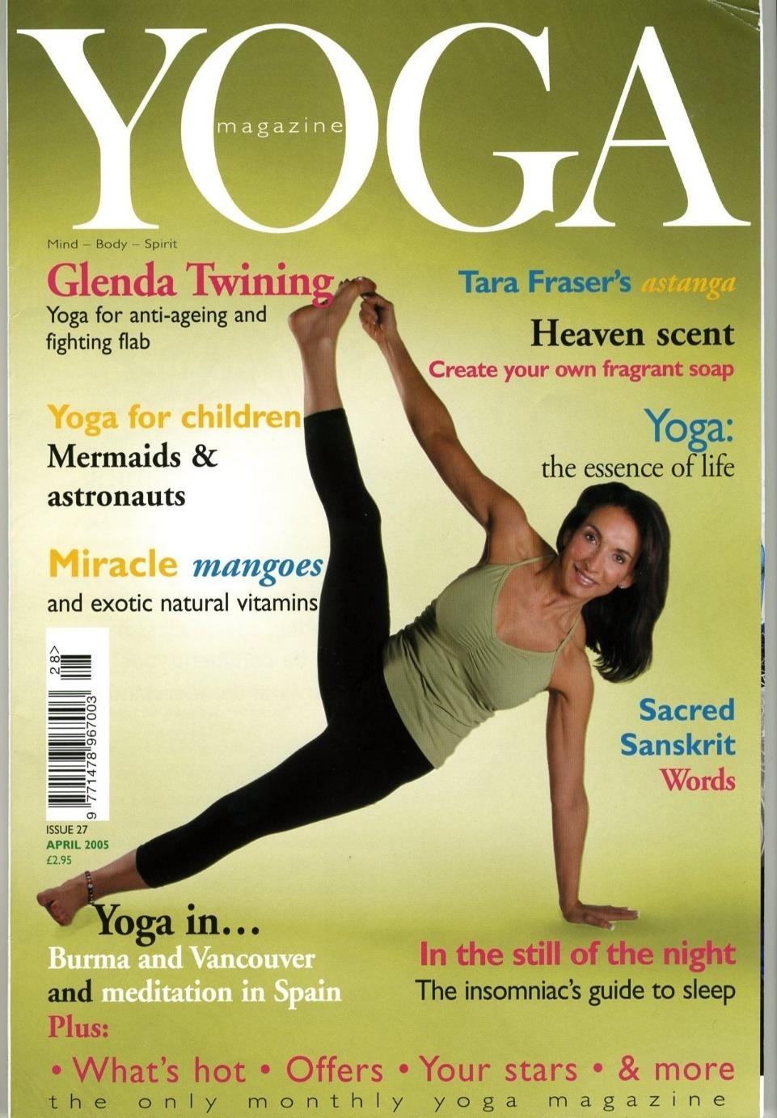

Here I am today, sitting down, putting pen down on paper whilst gathering my thoughts on the amazing Energy Enhancement Course that I am currently on. Where do I begin? Firstly, I felt it would be great to share my experiences of the Energy Enhancement course with other like-minded people. The following information is for those interested in growing spiritually, and wanting this world to become a better
place - starting from improving themselves!

Honey Kalaria, Bollywood Star and Owner of Diva Entertainments

What we feel...
I am a brother of yours, who has traveled a little longer upon the Path than has the normal student, and has therefore incurred greater responsibilities. I am one who has wrestled and fought his way into a greater measure of light than has the aspirant who will read this webpage, and I must therefore act as a transmitter of the light, no matter what the cost.

I am not an old man, as age counts among the teachers, yet I am not young or inexperienced. My work is to teach and spread the knowledge of the Ageless Wisdom wherever I can find a response, and I have been doing this for many years.

I seek also to help the ascended Masters whenever opportunity offers, for I have been long connected with

Them and with Their work. In all the above, I have told you much; yet at the same time I have told you nothing which would lead you to offer me that blind obedience and the foolish devotion which the emotional aspirant offers to the Guru and Master Whom he is as yet unable to contact. Nor will he make that desired contact until he has transmuted emotional devotion into unselfish service to humanity - not to the Master.

The words that I have written are sent out with no claim for their acceptance. They may, or may not, be correct, true and useful. It is for you to ascertain their truth by right practice and by the exercise of the intuition. I am not interested in having them acclaimed as inspired writings, or in having anyone speak of them (with bated breath) as being the work of one of the Masters.

If they present truth in such a way that it follows sequentially upon that already offered in the world teachings, if the information given raises the aspiration and the will-to-serve from the plane of the emotions to that of the mind then they will have served their purpose.

If the teaching conveyed calls forth a response from the illumined mind of the student worker in the world, and brings a flashing forth of his intuition, then let that teaching be accepted. But not otherwise.

If the statements meet with eventual corroboration, or are deemed true under the test of the Law of Correspondences, then that is well and good. But should this not be so, let not the student accept what is said.

Djwan Khul - Tibetan lama

Our Deepest Fear
Our deepest fear is not that we are inadequate.

Our deepest fear is that we are powerful beyond measure. It is our light, not our darkness that most frightens us.

We ask ourselves, Who am I to be brilliant, gorgeous, talented, fabulous?

Actually, who are you not to be? You are a child of God. Your playing small does not serve the world.

There is nothing enlightened about shrinking so that other people won't feel insecure around you. We are all meant to shine, as children do.

We were born to make manifest the glory of God that is within us. It is not just in some of us; it is in everyone. And as we let our own light shine, we unconsciously give other people permission to do the same.

As we are liberated from our own fear, our presence automatically liberates others.

by Marianne Williamson from A Return To Love: Reflections on the Principles of A Course in Miracles

(Note: This is often found on the Internet incorrectly stated as a quote by Nelson Mandela from the Inauguration Speech, 1994.)

NEW!! REFLECTIONS ON HOW TO DO WHAT YOU LOVE BY PAUL GRAHAM

CLICK HERE FOR SATCHIDANAND ARTICLE ON THE EE INCREDIBLY SUCCESSFUL AND PROFITABLE MOVIE LIST - AMERICAN BEAUTY

CLICK HERE FOR FREE SPIRITUAL DATABASE

CLICK HERE FOR FREE YOGA BOOKS

CLICK HERE FOR FREE SPIRITUAL MP3 TALKS

FREE GIFTS FOR NEWSLETTER SIGNUP

ENERGY ENHANCEMENT

THE MOST ADVANCED ENERGY COURSE OF MEDITATION ON THIS PLANET

INCREASE INTELLIGENCE

DISSOLVE ENCAPSULATED TRAUMA

SPEED UP THE PROCESS OF ENLIGHTENMENT

FREE!! - NINE FREE ENERGY ENHANCEMENT MEDITATION GIFTS

Weekly Email Service of Right On Spiritual Texts and Pointed, Pungent and Humorous Stories.

YOGA, Energy Enhancement and Meditation.

SIGN UP NOW FOR THE "ENERGIES" NEWSLETTER BELOW

YOU GET NINE FREE ENERGY ENHANCEMENT MEDITATION GIFTS
- FREE DOWNLOADS AND SPECIAL OFFERS!!

SPECIAL OFFER - ENERGY ENHANCEMENT INITIATION ONE VIDEO FOR ONLY 10 US DOLLARS!!

SPECIAL OFFER - SACRED DANCE DVD SPECIAL OFFERS!!

FREE SACRED DANCE DOWNLOADS FROM EMULE!!

FREE REPORTS - WHAT THE OTHER MEDITATION COURSES WILL NEVER TELL YOU

HOW TO HEAL TRAUMA AND CLEANSE YOUR KARMA.

FREE ONLINE ENERGY ENHANCEMENT E-Book

FREE ENERGY ENHANCEMENT VIDEO - YOGA SUTRAS BY
SATCHIDANAND Download size 426mb

FREE!! 90 MINUTE TALK - ENLIGHTENMENT BY
SATCHIDANAND Download size 11MB

FREE MEDITATION ENERGY ENHANCEMENT DATABASE ACCESS ONLINE 200MB

FREE Weekly Email Service of Right On Spiritual Texts and Pointed, Pungent and Humorous Stories.

SPECIAL OFFER - SACRED DANCE DVD SPECIAL OFFERS!!

Sign up Here

THE CORE ENERGY TECHNIQUES

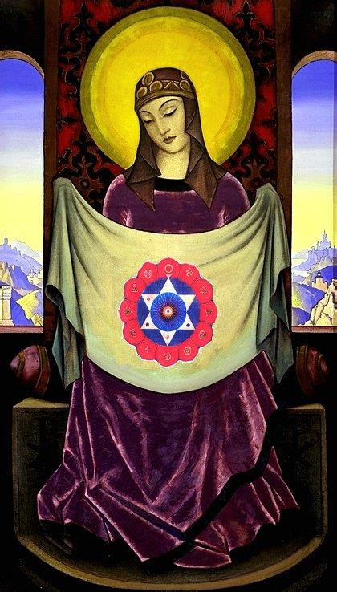

ENERGY ENHANCEMENT MEDITATION

"An example of one of the different types of Energy Blockage is that they are sometimes created when we do not get what we expect, or we get what we do not want. They are caused by the pain of disappointment.

Like when our Mother or Father or Son or Daughter dies. Like when a Lover leaves us.

This trauma, this pain is so strong that at that moment the mind can not look at it, so it gets locked away within

the body as a Blockage until we get strong enough to process it.

Then amnesia. We forget the pain fulminating in our bodies. We forget the poison until, after a while, disease is the result."

Satchidanand

EE LEVEL 1 POWER UP!! GAIN SUPER ENERGY http://www.energyenhancement.org/Level1.htm
EE LEVEL 2 ELIMINATE ENERGY BLOCKAGES http://www.energyenhancement.org/Level2.htm
EE LEVEL 3 CLEAN KARMA BLOCKAGES AND PAST LIFE KARMA BY TRANSMUTATION http://www.energyenhancement.org/Level3.htm
EE LEVEL 4 MASTER ENERGY CONNECTIONS AND RELATIONSHIPS http://www.energyenhancement.org/Level4.htm
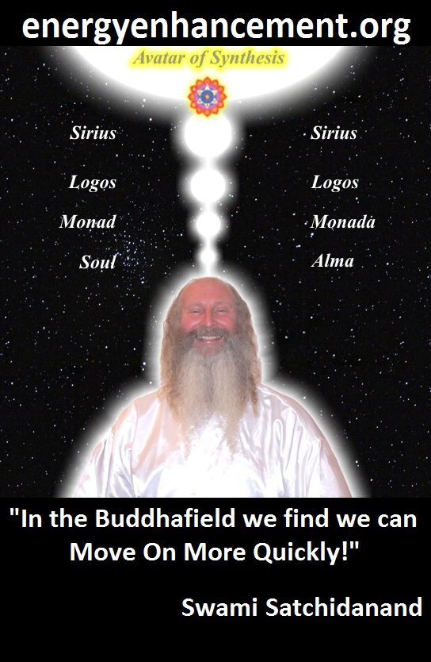
ENERGY ENHANCEMENT - THE ULTIMATE MEDITATION COURSE!!
“Traditional meditations are designed to Fail” – Satchidanand
FUSION WITH THE SOUL CHAKRA - Enlightenment - is Only the first Dan. Become fused with the Monad - Second Dan. Become fused with the Logos - Third Dan. Become Fused with Sirius - Fourth Dan. Become Fused with the Avatar of Synthesis - Fifth Dan - Satchidanand
Research The Energy Enhancement Meditation Course by video or on retreat..
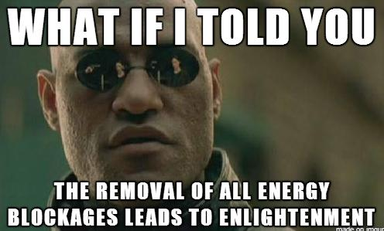
The Ancient Enemy who counts meditation and the mind control psychic arts as one of its main planks of ing, International Companies, Eugenics - Worldwide, censoring Alchemical VITRIOL, the Kundalini Key and Energy Blockage Removal from every Meditation Program..
WE HAVE SO MANY ARTICLES SHOWING THE ORIGINAL EXISTENCE OF THESE ESSENTIAL MEDITATION TECHNIQUES IN EVERY WORLD RELIGION..
NOW, SPEED UP YOUR PROCESS WITH ENERGY ENHANCEMENT ALCHEMICAL VITRIOL, KUNDALINI KEY AND ENERGY BLOCKAGE REMOVAL ON THE PATH OF ENLIGHTENMENT
GET IT NOW!!
EMAIL sol@energyenhancement.org

WHAT DON MINIHANE SAYS OF HIS MEDITATIONAL EXPERIENCES ON THE JANUARY 2007 COURSE

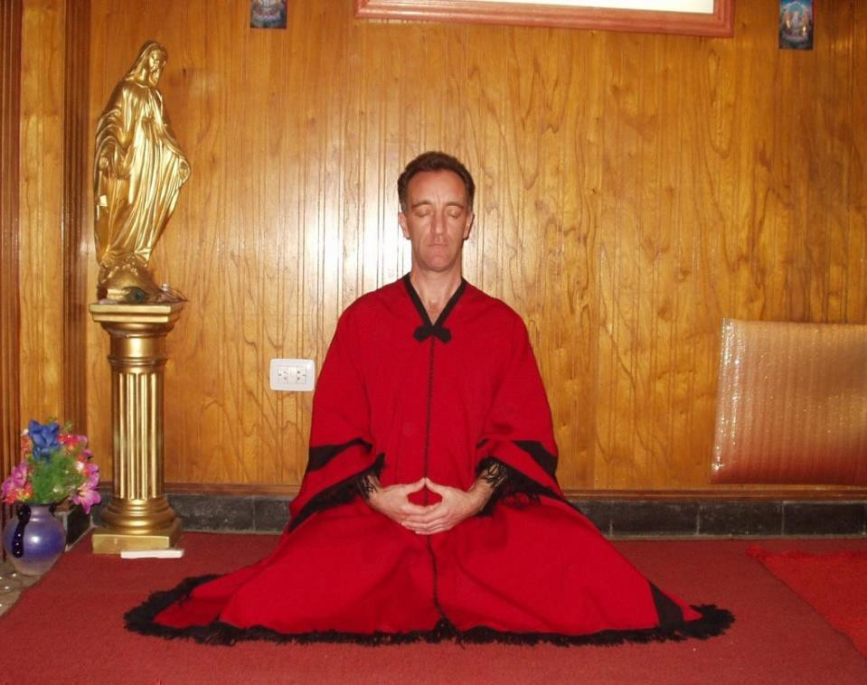
DON MEDITATING AFTER A FEW DAYS ON THE COURSE -

"To expand, I was sitting in meditation the other night and was happily destroying blockages in me using the Seven Step Process of Energy Enhancement taught by

Satchi and Devi when I was staggered by something new. I watched as negative energy transmuted into white light and travelled down to the centre of the earth then returned up my spinal column and carried on into outer space to the centre of the universe and then returned back to me through the crown chakra and down the front of my body through the throat centre then the heart centre and the solar plexus, on to the genitals and in to the perineum, through to the centre of the earth and returned back up my spine and so began this new orbit of energy.

The effect was something else; it shot through me at incredible speed. This carried on and got denser and more powerful as I discharged more of the negative energy within me. This energy took the form of bands of light that followed each other in waves travelling at equal distance apart and as I discharged and transmuted more negative energy the bands got closer together and I found that I could control the speed at which they travelled through the body. Satchi calls this orbit the Supra Galactic Orbit which travels up the ANTAHKARANA into the centre of the universe and down through the centre of the earth passing through the front of the body on the downward sweep and returning up the spine on the outward sweep. I was complete."

TOTAL RESPECT TO SATCHIDANAND AND DEVI DHYANI

"Satchi, please accept my total respect and gratitude for everything you have imparted to me over the short four weeks I have been here. You are a huge light in this world and long may you shine. For everyone reading this, get your asses over to see these people, your lives will be changed forever and we don’t get many chances

in this world to be able to achieve that and there are defiantly not many people in this world like Satchi and Devi who can do the business like this"

MORE DON MINIHANE

Energy Enhancement is the process of clearing all the bad things which have ever happened to you from your psychic body, freeing up the internal essence to attain clarity and enlightenment on your true life path.

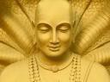

ENERGY ENHANCEMENT IS THE NEWEST AND HIGHEST SPIRITUAL IMPULSE ON THIS PLANET.

Energy Enhancement contains Ancient Successful Techniques which Create a Quantum Leap in the Power of any other technique they touch.

Yoga, Acupuncture, Reiki, Healing, Meditation, Tantra and all through The Taoist Supra Galactic Orbit, The Removal of Blockages, The Removal of Encapsulated Trauma, The Karma Cleaning Process, The Mastery of Relationships and the Total Healing of the World.

AFTER ALL THAT, HERE ARE COMPLETE INSTRUCTIONS ON ENLIGHTENMENT - YOGA SUTRAS OF PATANJALI

YES, ENERGY ENHANCEMENT LEADS TO ENLIGHTENMENT

COME FOR YOUR ENERGY
ENHANCEMENT COURSE OR DVD
TODAY!!

MEDITATION ENERGY ENHANCEMENT WHAT IS IT?

SIGN UP NOW FOR THE "ENERGIES" NEWSLETTER

SPECIAL OFFER - SACRED DANCE DVD SPECIAL OFFERS!!

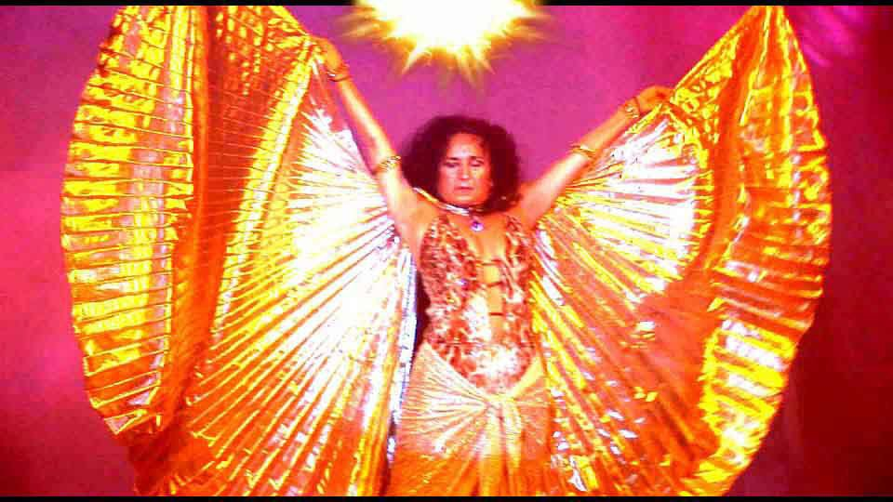SACRED PINK FLOYD MOVIE - 2.5 HOURS IN STEREO AND 5.1 SURROUND SOUND - ENTERED INTO FILM FESTIVALS WORLDWIDE!!

FREE GIFTS FOR NEWSLETTER SIGNUP

THE MOST ADVANCED ENERGY COURSE OF MEDITATION ON THIS PLANET

INCREASE INTELLIGENCE

DISSOLVE ENCAPSULATED TRAUMA

SPEED UP THE PROCESS OF ENLIGHTENMENT

FREE!! - NINE FREE ENERGY ENHANCEMENT MEDITATION GIFTS

Weekly Email Service of Right On Spiritual Texts and Pointed, Pungent and Humorous Stories.

YOGA, Energy Enhancement and Meditation.



SIGN UP NOW FOR THE "ENERGIES" NEWSLETTER BELOW

YOU GET NINE FREE ENERGY ENHANCEMENT MEDITATION GIFTS
- FREE DOWNLOADS AND SPECIAL OFFERS!!

SPECIAL OFFER - ENERGY ENHANCEMENT INITIATION ONE VIDEO FOR ONLY 10 US DOLLARS!!

SPECIAL OFFER - SACRED DANCE DVD SPECIAL OFFERS!!

FREE SACRED DANCE DOWNLOADS FROM EMULE!!

FREE REPORTS - WHAT THE OTHER MEDITATION COURSES WILL NEVER TELL YOU

HOW TO HEAL TRAUMA AND CLEANSE YOUR KARMA.

FREE ONLINE ENERGY ENHANCEMENT E-Book

FREE ENERGY ENHANCEMENT VIDEO - YOGA SUTRAS BY
SATCHIDANAND Download size 426mb

FREE!! 90 MINUTE TALK - ENLIGHTENMENT BY
SATCHIDANAND Download size 11MB

FREE MEDITATION ENERGY ENHANCEMENT DATABASE ACCESS ONLINE 200MB

FREE Weekly Email Service of Right On Spiritual Texts and Pointed, Pungent and Humorous Stories.

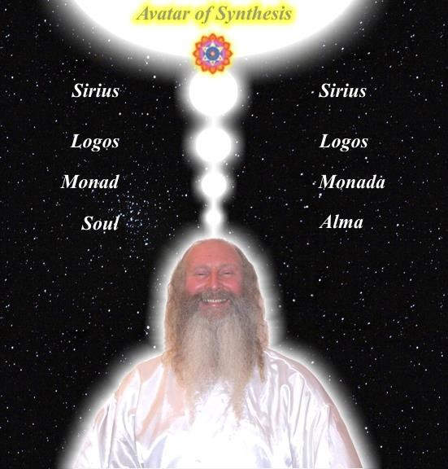
ENERGY ENHANCEMENT IS THE NEWEST AND HIGHEST SPIRITUAL IMPULSE ON THIS PLANET.



IN INDIA, SPAIN, MEXICO, 5Star
India Taj Mahal, PERU



DANISA FROM THE SPAIN 2003 MEDITATION COURSE


DANISA WENT TO THAILAND AFTER THE COURSE AND NOW, 2006, IS IN JAPAN TEACHING AND PRACTICING BELLY DANCING!
I've been in La Escala with Satchy and Devi for a week now, Its the longest time I've here!! and I noticed that every day I am going deeply inside of me.

When I arrived here, was very hard for me, but luckily Satchy and Devi helped me a lot and removed many of my blockages so that I can really think with my head! The first 2 days I was feeling very strange and uncomfortable inside of me. Half of myself wanted to improve and half wanted to stay like that, in a low energy level state, didn't want to grow neither change.

During these days I realized how the strategies control people and how they were controlling myself.
Sometimes you are confused, sometimes happy, sometimes angry, and these don't have to be like that !!! but nobody knows! I didnt know.

Energy Enhancement Level 2 teaches you how to manage your emotions, it gives you a strong emotinonal IQ.

I feel so happy to meet Satchy and Devi, they are high spiritual teachers that can see deeply inside you, behind the mask that everybody has. They can see your soul, your real self!! If you need help you'll get it from them.

I've been working with my lower chakras and after I learned how to remove a blockage from my base chakra I immediately felt the energy of Kundalini flowing from down in my base chakra to up, to the head and above.

I was sitting in my meditation position and for the first time I got the sensation and feeling that my body was lifting off the ground. I was just enjoying the experience feeling the circulation of the energy, a hot and smooth sensation. My mind at that moment was free and happy.

Every day I feel a little more steady and comfortable. I am getting in touch with my deepest blockages and fears from my lower chakras, With energy enhancement level 2 I am learning how to deal with this energy and how to remove them totally. My fear is disappearing, my sadness and worries, too. Things that already existed in me and are coming out with the use of these techniques.

To sum up I think that everybody should come to do this course and learn energy enhancement techniques to improve their lives and help other people, heal

themselves and their relationships to make this world a better place and to start really enjoying life

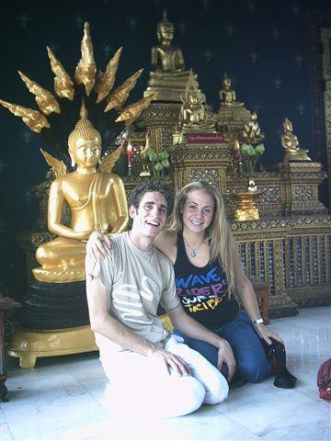
DANISA, EE MEDITATION COURSE 2003
Danisa de Paul. 12/08/2003.

DANISA

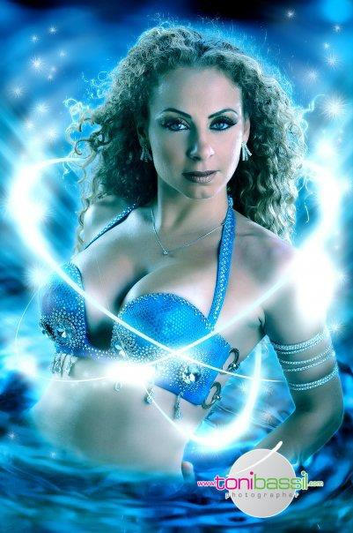
DANISA WENT TO JAPAN AND THAILAND AFTER HER ENERGY ENHANCEMENT COURSE AND IS NOW A TEACHER OF SACRED DANCE

MEDITATION ENERGY ENHANCEMENT APPRENTICE LEVEL 2

The Total Removal of Energy Blockages!!!

The Total Removal of all Karma!!! The Total Removal of Strategies!!!
The Total Removal of Disappointment!!!

The Mastery of Emotional IQ!!!

The Mastery of the Will!!!

The Healing of Addictions AND Dependency on Tobacco, Alcohol, Food, and Drugs.

COME ON AN ENERGY ENHANCEMENT COURSE!!

THE DOWNLOADABLE ONLINE COURSE

THE VIDEO COURSE IN 9DVDS

THE ONLINE/VIDEO COURSE COMBINATION

SUMMER COURSES ON THE COSTA BRAVA IN SPAIN

WINTER COURSES IN MACHU PICHU, BRAZIL, ARGENTINA AND INDIA!!!

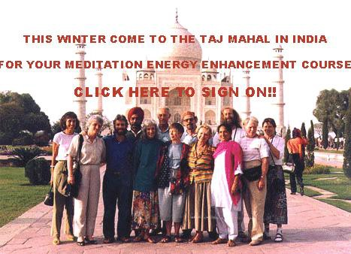

TO ENQUIRE ABOUT ENERGY ENHANCEMENT COURSES PLEASE SIGN ON TO OUR MAILING LIST AND THEN EMAIL US DIRECT FROM THE EMAIL ADDRESS WE SEND YOU FROM OUR MAILING LIST

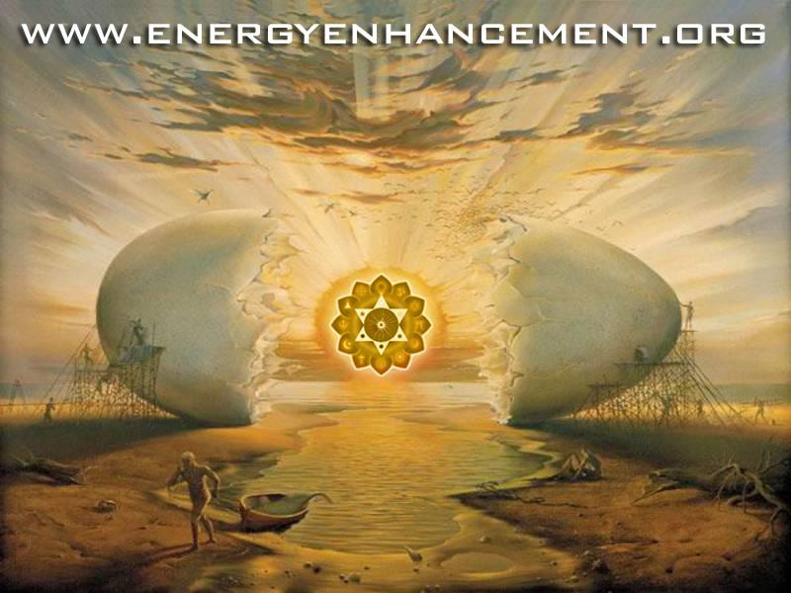

The KARMA CLEARING PROCESS
- Mastery of Protection and the Mastery of Thoughtforms. The mastery of Blockages between the Base and Crown Chakras. The Mastery of the creation and dissolution of Blockages and Thoughtforms through the Advanced techniques of Taoism, Buddhist Meta, the Western Mystery Tradition and Merlin. The Jedi Knights. The White Magicians.MEDITATION HEAD

There are Four APPRENTICE LEVELs of Energy Enhancement Teaching, each APPRENTICE LEVEL is a Meditation Course having Seven Meditational Initiations which can be taken in a Week-Long Course.

Also one REIKI Initiation is AVAILABLE with each APPRENTICE LEVEL. You can become a Reiki Master with Energy Enhancement Meditation.

Each APPRENTICE LEVEL is entirely independent of the others and complete in itself. You do not have to take every APPRENTICE LEVEL, but the APPRENTICE LEVELs
must be taken in the order of One, Two, Three and Four.

THE PAINLESS REMOVAL OF STRESS, TRAUMA AND NEGATIVE EMOTION

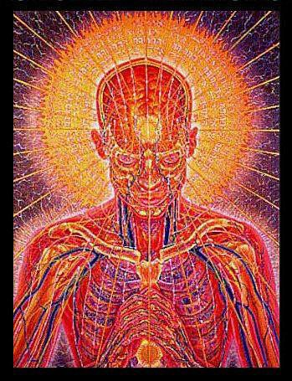

HONEY KALARIA SAYS

I was told that each of our 7 chakras within our bodies should be seen as a separate mind/brain like one of the processors in a parallel processing computer. All the Super Computers these days are parallel processing computers. We use only 1 brain or processor and the idea is to activate the other 6 brains or processors to build your creativity, intellect, wisdom and genius abilities. This would lead you to become happier and healthier, enjoy being a more emotionally and mentally balanced person and become a more blockage free (free

of negative emotions) human being. The idea is to have a purpose in life to make this world a better, more peaceful and spiritual place, starting from working on yourself as mentioned before.

As I realized how wonderful and life transforming this course is, I got inspired to make this course available to others.

Both Satchiji and Devi are beautiful and inspiring souls, passionately committed to helping people grow spiritually and accelerating each students progress towards enlightenment. They allow the students to grow at their own pace, whilst passing on profound knowledge and techniques in a light hearted and joyful manner. Both of them have extensive knowledge, possess strong perceptive powers and bathe people around them in the strong Buddhafield of energy that surrounds them. They have both made my stay in Argentina in Jan 2005 a delightful and a memorable one.

Honey Kalaria, Diva, Choreographer, Bollywood Film Star. Honey Kalaria Full MEDITATION Testimonial Click Here!

Energy Enhancement easily transmutes all negative energy without going anywhere near the emotions and memory!! The techniques of Energy Enhancement show you how to QUICKLY AND EASILY TRANSMUTE YOUR
STRESS because it works at the level of Energy which underlies AND IS THE BASIS of all problems.

THE PAINLESS REMOVAL OF STRESS, TRAUMA AND NEGATIVE EMOTION
Energy Enhancement easily transmutes all negative energy without going anywhere near the emotions and memory!! The techniques of Energy Enhancement show you how to QUICKLY AND EASILY TRANSMUTE YOUR
STRESS because it works at the level of Energy which underlies AND IS THE BASIS of all problems.

THE START OF THE ENERGY ENHANCEMENT ENERGIES

The Buddhafield of energy, in which evolutionary progress can quickly be made, and Kundalini Energy are absolutely necessary to any course of Meditation.

Energy Enhancement Advanced Techniques allow PAINLESS progress above and beyond any other course.

Energy Enhancement Advanced Techniques only use ENERGY which underlies all other human functions.

With Energy Enhancement it is not necessary to go anywhere near painful memory, negative emotions and catharsis which are the foundations of other courses.

ENERGY ENHANCEMENT PAINLESS TRANSMUTATION IS EASY AND QUICK.

IT SPEEDS UP THE PROCESS OF ENLIGHTENMENT!!

It teaches TOTAL Transformation and Transmutation THE PRINCESS OF SWORDS OF THE THOTH TAROT
The inflow of Spiritual Energy or Kundalini Energy is well known in all Spiritual Circles as being expected in all

genuine Courses with teachers who have advanced experience with Enlightened Masters yet some people just cannot get their heads around it and they do not trust it as this concept destroys their idea of a "Normal" world. They start to fear the unknown!!

"EASY AND SMOOTH ENERGY ENHANCEMENT SPEEDS UP THE PROCESS OF ENLIGHTENMENT"

Energy Enhancement easily transmutes all negative energy without going anywhere near the emotions and memory!! The wind of Kundalini blowing through you usually leaves smoke and ashes in its wake. Normally, when Kundalini energy starts to flow through the interiorly held negativities it starts to destroy and release the pain and trauma within. Fear CAN be the result with all OTHER courses. The techniques of Energy Enhancement show you how to TOTALLY CLEAR yourself from moods and disturbing thoughts because it works at the level of Energy which underlies all the problems.

"ENERGY ENHANCEMENT IS A PROBLEM FREE METHOD OF AWAKENING CREATIVE INTELLIGENCE!!"
The powerful techniques of Energy Enhancement REMOVE the traumatic nature of all this Energy Release by using the new ALCHEMICAL concept of "Transmutation" - there remains non of the problems associated with all other courses.

Energy Enhancement does not work at the level of memory. You do not have to remember anything as we work at the level of energy which underlies all of the painful memories, yet the performance of Energy Enhancement techniques can easily and totally remove all the ENERGY BLOCKAGES, in a non-painful way!!

The student of Energy Enhancement knows how necessary is the transmutation of all the old energies on the path of evolution, progress and inner freedom.

The Energy transmutation of Energy Enhancement produces inner peace, clarity, openness and truth. The Energy Enhancement student's "NO" to all the past negative energy held inside springs from an unequivocal "YES" to themselves and to their life!

The necessity for positive and easy change is comparable to the drastic move by Jesus Christ when he drove the moneylenders out of the Temple, and to the work of Hercules when he drove the River Styx through the Augean Stables, thus easily cleaning out thousands of years of horse shit in one day!

THE RESULT OF THE ENERGY ENHANCEMENT ENERGIES

THE PRINCESS OF DISCS OF THE THOTH TAROT
The wand of the Princess of discs stretches from heaven to earth and symbolises the Antakarana, an ancient symbol of Kundalini Yoga, which represents the tower, rainbow bridge of energy which flows through all your chakras from heaven to earth, when all energy

blockages preventing that flow have been transmuted through the techniques of Energy Enhancement.

By learning how to bring the Spiritual Energies of the Center of the Universe, the highest and purest form of light, into this Earth which is the darkest and most negative of all elements, it becomes possible to raise the energy level of the Energy Enhancement student and the Earth itself. This advance into new territory has the ability to unify to integrate the mother, the father and all the internal children into one energetic, soul infused and peaceful being.

"THERE CAN ONLY BE ONE!!"
Thus bringing together spirit and matter. The removal of energy blockages has created something new which can channel the light onto the Earth and cosmic idea- impulses, thoughtforms, become visible to everyone and permeate everything with their divine quality.

THE TRUE HEALING OF YOU, AND THE EARTH ITSELF!!

Here's another testimonial,....
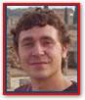Thomas Kline

Hello! My name is Thomas Kline and I am 21 years of age. For 8 years now I have been studying a “Collective Martial Art” consisting of mostly Hung Gar Kung Fu and
Ninjitsu under my very experienced and excellent teacher Bill Bruley who is a 5th degree black belt in his art

I am now at my 3rd degree black belt, and I knew that I needed to add on to my art, looking mainly towards the Spiritual aspect.

When I first arrived in L’Escala in Spain, from America, I didn’t really know what to expect, except for what I had read about on their website. I must say I really got what I had bargained for!

I had tried practicing meditation and yoga here and there before, but never knew what was really out there to experience.

After learning just the first stage of Energy Enhancement, I immediately felt the energy rushing through me!

It truly was quite an experience! I could’ve spent months upon months to get to where I am after only 1 week with Satchi and Devi!

The feeling of bringing up blockages and grounding them was another life changing experience I had out here!

I never knew that the pains that I was physically and emotionally feeling were caused by these energies (blockages) keeping me from being just who I’m made to be! My blockages were mainly around the 2nd and 5th chakras. When they were removed one by one, I could sense that I felt more at ease and pains were actually going away revealing more and more blockages to be sorted out!

Also, being initiated into Reiki 1 by Devi and learning her unique exercises really helped in the process of bringing up blockages and removing them!

During one of my meditations, I really could feel that I was completely in line with the energies of the universe, which gave me such a feeling of ecstasy! Then I knew that I could never turn back on my practices! I am definitely going to stick with the techniques I have learned out here!

There really are no words I could use to make you completely understand what I experienced, except that you should come and find out for yourselves what it’s like to learn how to completely better yourself and the world around you!

I hope my words could at least inspire one of you to take the first step in Energy Enhancement by coming out to stay with Satchi and Devi and learning something you can take with you FOREVER!! Wishing you ALL the best in life,

Tommy From the Energy Enhancement Meditation Course 2003

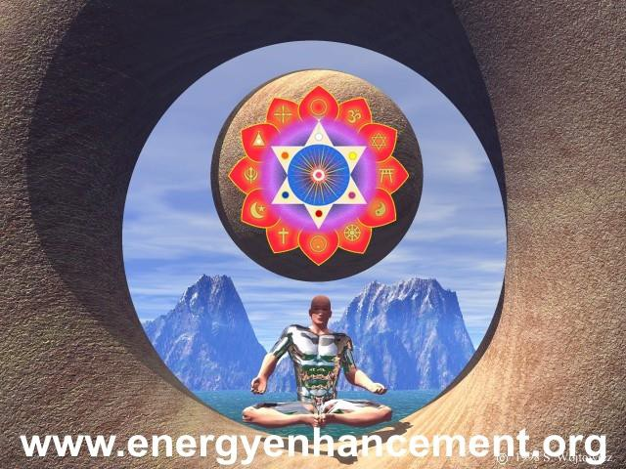
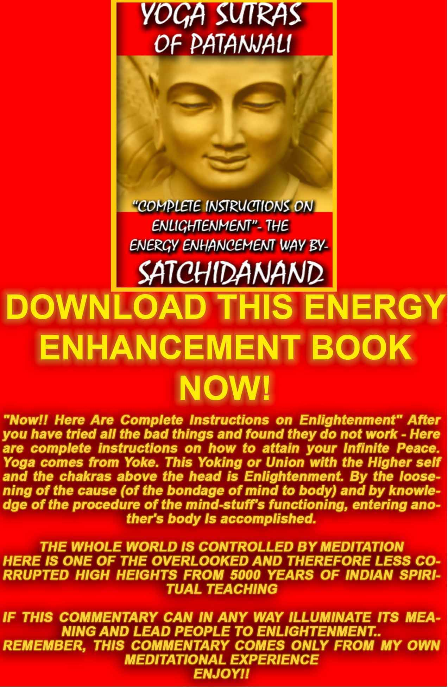
THE YOGA SUTRAS OF PATANJALI BY SWAMI SATCHIDANAND - DOWNLOAD HERE..
http://www.energyenhancement.org/Sacred-Energy/yoga-sutras-of-patanjali-book/Energy-Enhancement-Yoga-Sutras-of-Patanjali.pdf

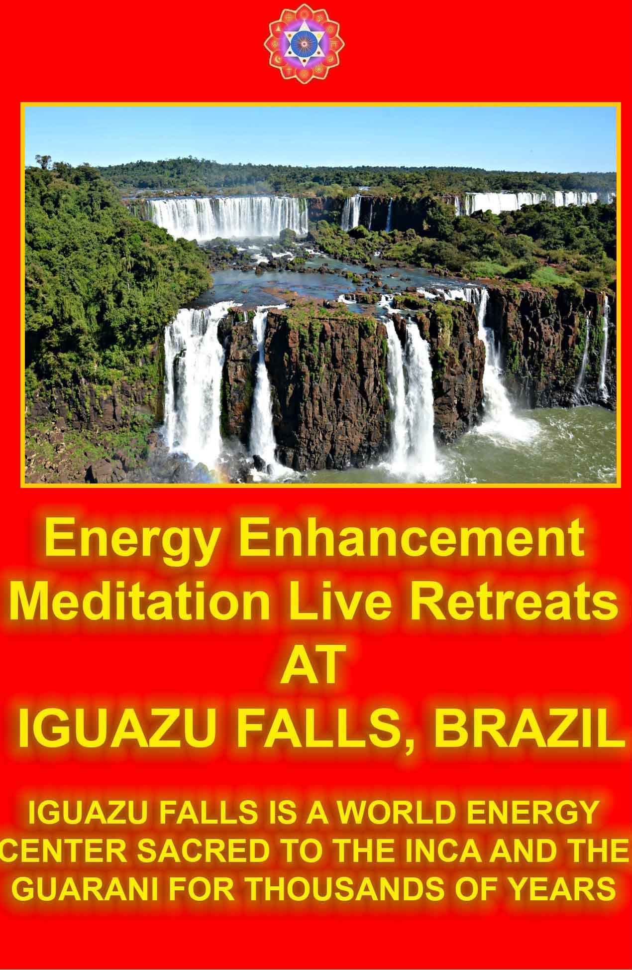

The Karma Clearing Process of Energy Enhancement Meditation Starts with the Seven Step Processes of Level Two including the Kundalini Kriyas + Alchemy

Author: Swami Satchidanand

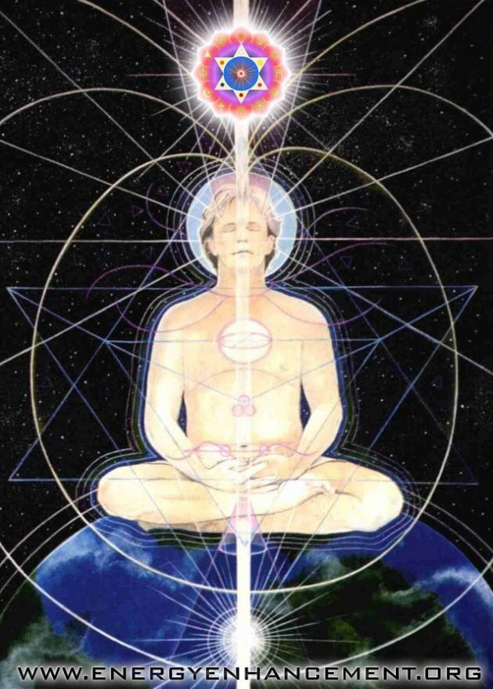
The Karma Clearing Process begins with the removal of all Energy Blockages from the energetic system of a human being. Wilhelm Reich called it the Emotional Armor. These are the little stiffnesses which cause us so much pain in massage. Energy Blockages exist in the

mental, emotional and physical bodies... Even in the spiritual bodies.

Energy Blockages split us so as we remove them through the advanced and effective meditation techniques of the Seven Step Process so we become more integrated, more solid.

Removing energy blockages from our spiritual bodies will allow us to access our hearts and our conscience, it will allow us to access our soul, our soul path in life, without which life has no meaning.

Removing energy blockages from the mind, the mental body, allows more energy to flow, we become more brilliant. Our minds become clear, our IQ increases and more.. We obtain the power of persistence which enables us to accomplish anything!

Removing energy blockages from the emotions allows more energy to flow, we become more stable. Our emotions become clear, our emotional IQ increases and more.. We obtain the power of having only positive emotions which enables us to radiate love, the energy of change and to access the will!

Removing energy blockages from the body allows more energy to flow, we become more energetic. Our bodies become clear of disease and pain, our energy increases and more.. We obtain the power of flexibility and strength which enables us to live longer and with more pleasure, more quality of life!


BACCHUS BY CARAVAGGIO

DRUNK ON THE "WINE" OF THE SUFIS FLOWING IN FROM THE VINE LEAF CHAKRAS ABOVE THE HEAD

AS THE WINE SPIRITUAL KUNDALINI ENERGY BECOMES MATURE...

JALALUDDIN RUMI - TAKE WHAT IS IN MY HAND...

And what is that uneasiness within? Just what is that tension which we find inside?

It is pure spiritual energy which has somehow become perverted by painful traumatic experience. It is energy which has been transmuted by some painful experience into pain, that encapsulated pain which we hold inside us or absorb from people and places on this planet. It is energy blockages which makes us feel uneasy and tense.

All the pain caused negative energy blockages which we hold inside are called the selfish competitive ego.

And because we all have been painfully perverting this pure spiritual energy into encapsulated negative energy or energy blockages for thousands of years, this world is filled with that perverted negative energy as energy blockages which we absorb from everything and everyone around us.

It is that pain and tension inside, those energy blockages which causes us to do all the bad things in this world. It is that pain and tension inside, those energy blockages which causes all the bad things in this world to happen to us, we call the bad things, all the bad luck to us. We are accidents waiting to happen. This is karma.

Body stiffness, niggles and pain cause Illness and disease.

Negative emotions, mood swings, wrong thinking, jealousy, prejudice, hatred, anger, fear are all caused perverted spiritual energy encapsulated as energy blockages. The "Mind filled manacles of fear" as said Blake.

Splitnesses in the mind, blocked minds, unclear and plain wrong thinking. Heartless mind solutions caused by selfishly wanting to gain something to the detriment of someone else, the "final solution" of Hitler for example. If we have a lot of these negative energy blockages within ourselves it will cause us to give up easily, a lack of energy, a lack of goodness and heart and soul.

It will cause us to lose our trust and our faith in the essential goodness of people and our teachers. We will project all our negativity onto them and begin to see them through the dark glasses of our negative experiences. Through the darkness of the negative energy which we hold inside.

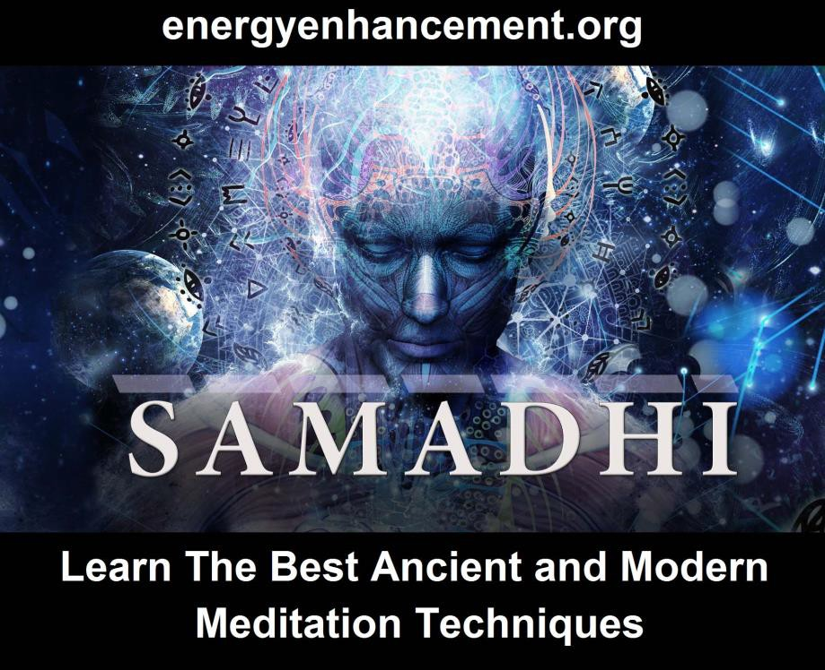

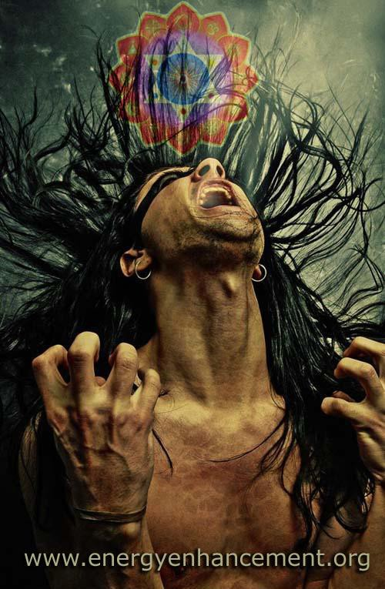

We create this negative energy inside. And as we evolve we gain the ability to absorb more of this negativity from the people around us and from our surroundings. We gain the power to hold on to more of this negativity without being affected by it. However, the straw that broke the camels back always comes. At this point we become open to wanting to know how to remove and transmute energy blockages. How to change negative energy into pure positive spiritual energy again.

When we enter into the Buddhafield of Energy which surrounds the enlightened we start to feel and lose this Negative energy from inside us. These are the symptoms of Kundalini energy usually.

Because an enlightened master has the ability radiate pure positive spiritual energy as well as to absorb and transmute this negative energy back into pure spiritual energy, a spiral of transmutation, a column of pure transmutation, the Buddhafield, surrounds him and enters into his surroundings.

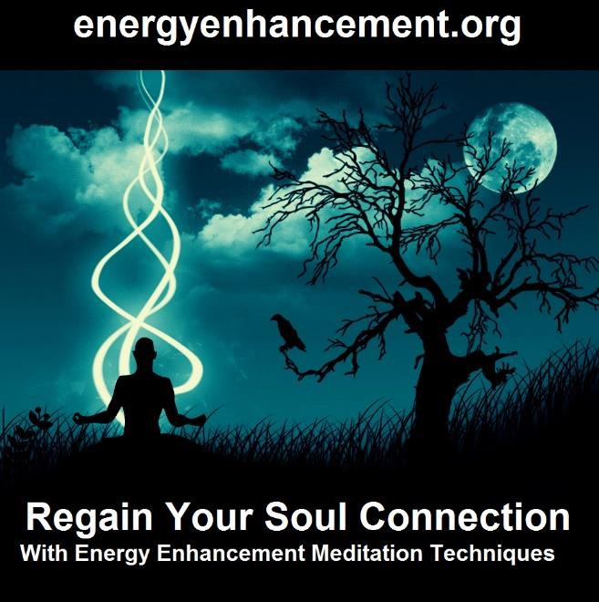



As you people upon the verge of enlightenment walk around, as well as creating your own negative energy, you absorb likewise the negative energies of people and places. The symptoms of this are your illnesses, your negative emotions of anger and fear, your mood swings and your feelings of negativity.

The only difference between you people on the verge of enlightenment and a master is that a master knows how to transmute the energy he absorbs. And thus he is

surrounded by peace and harmony instead of more and more pain and negativity..

He does not curse the darkness. Instead he lights a candle.

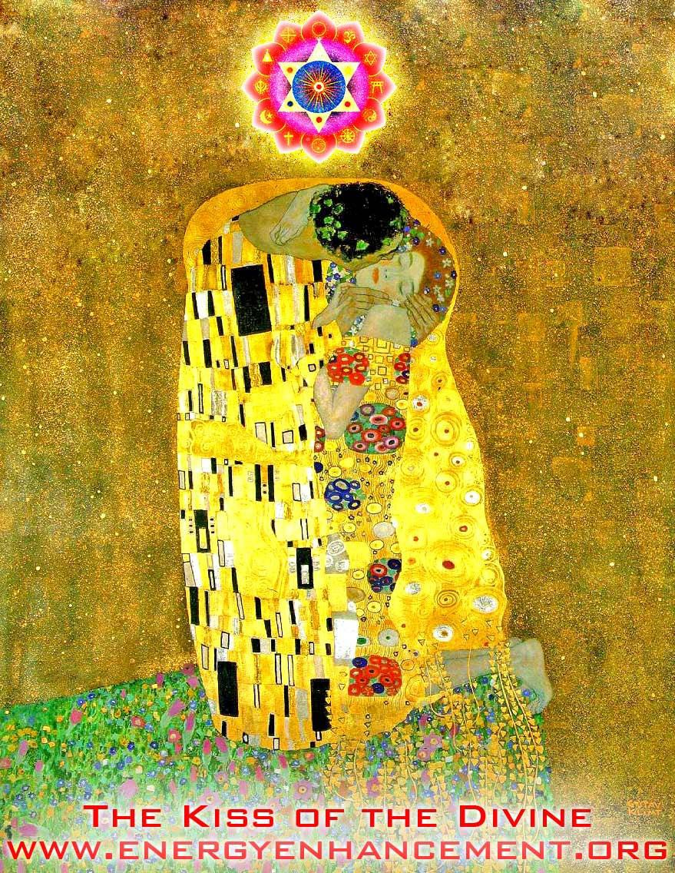
The only difference between you and a master is that a master knows how to teach you how to transmute this negative energy into harmonious spiritual energy, and

thus place you on the path of peace and harmony, the path of enlightenment itself.

He only needs to teach you how to look at the negative energy. He only needs to teach you how to see it and deal with it. Because anything else is painful. And will cause you to do more painful things. Because this negative energy is Karma itself.

THUS THE KARMA CLEARING PROCESS, THE SOURCE OF ALL TRUE FORGIVENESS.

Spiritual masters are not affected by Karma and indeed have no Karma. Because they have the psychic ability to transmute all karma into pure spiritual energy. And this pure spiritual energy builds up in them and is added to by their masters when they die. So that they are rich because they have a large bank balance of Pure positive spiritual energy to spend on their students. This is called Positive karma.

Because the first stage is the access to purity by transmuting all the pain, which travels with us from lifetime to lifetime and grows more and more each lifetime because like calls to like, inside. To he that has, more will be given, said the Christ.

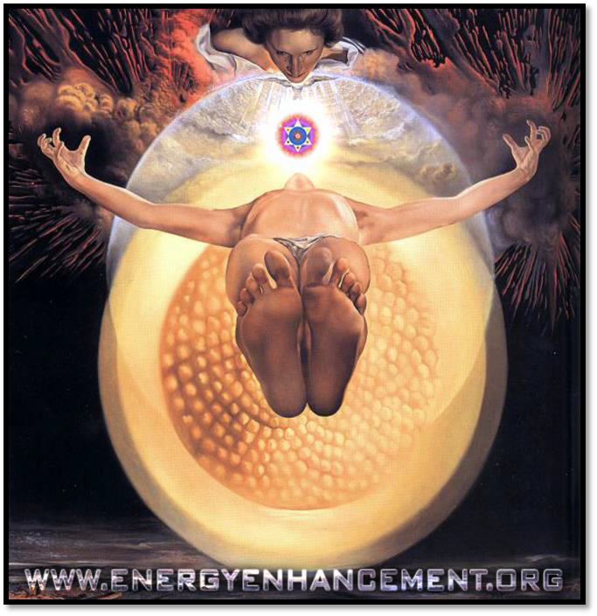
So we need to learn how to go against this law of the gaining of karma and negative energy and energy blockages by understanding and using the grounding of negative energies, the Third Initiation of Energy Enhancement.

And then the second part comes. Once we have transmuted this negativity inside to a certain degree, it then becomes possible to absorb more positive spiritual energy from the masters bank balance.

The Master can send it to you with a glance. We absorb energy from the Master. The Hindus call it the Uppadesa

or the Initiation of the Master, and it is said to come by glance, by touch, or in silence.

Until we learn how to do it for ourselves from the Universe.

And once you start transmuting negative energy by using the Seven Step Process techniques of Energy Enhancement every day. Once you start to access your inner purity… To he that has not, it will all be taken away, said the Christ. Yes, all the negativity will be taken away.

And this is the Real Initiation or in the Zen Phrase, Satori. And after many Satoris, you then eventually become in the Hindu Phrase, Twice Born, in the Sufi Phrase, a Made Man, You have made your Bones.

PEACEFUL. HARMONIOUS. ENLIGHTENED.

All with a glance.
All with learning how to open our eyes. All with the gaining of Psychic Vision.

You are the people who have no other choice but to absorb negativity and die, or learn how to transmute it and learn how to Live. Because this knowledge is more important than life and death. It is for those of you who want to attain a Soul.

Start your Karma Cleaning Process by learning how to meditate and then speed it up with the advanced techniques of Energy Enhancement - The Seven Step Process - based upon ancient effective techniques of Taoism, The Kundalini Kriyas, The five elemental circulations of the Qi of Chinese Alchemical Taoism, The

Guided Meditation of the Emerald tablet of Hermes Trismegistus encapsulated in VITRIOL and more..

Satchidanand, Director of Energy Enhancement, is one of the leading teachers of Meditation.! He helps people worldwide reach further than they EVER thought possible, FASTER!!!

www.energyenhancement.org

PEACEFUL. HARMONIOUS. ENLIGHTENED.

All with a glance.
All with learning how to open our eyes.
All with the gaining of Psychic Vision.
All with Energy Enhancement.

In 14 Initiations over 4 weeks
In FOUR APPRENTICE LEVELs over 8
weeks.

We search for those of you on the verge of Enlightenment to Brave the Course of Energy Enhancement.

You know who you are because already you are going through the processes described above.

You are the people who have no other choice but to absorb negativity and die, or learn how to transmute it and learn how to Live.
Because this knowledge is more important than life and death.

It is for those of you who want to attain a Soul.

Love and Light,

SATCHIDANAND

I have been working for over 12 years with many well known techniques including Transcendental meditation and Kriya Yoga, Subud, A Course in Mircles and the Sedona Method.

Although I have made good progress with these techniques I now consider these to have been preliminary techniques to prepare me for Energy Enhancement.

These methods that I have tried before simply don’t provide for the systematic identification of Energy Blockages or contain the Advanced Techniques for the removal of the energy blockages to enlightenment that Energy Enhancement does.

If you are serious about self-improvement, growth, change, enlightenment! Then the Energy Enhancement course is for you.

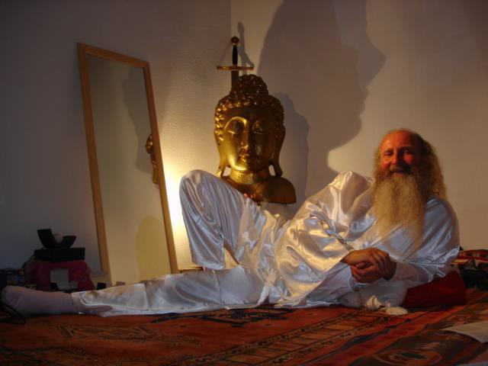

If you are tired of all the many systems of meditation which leave questions unanswered and where the path to enlightenment is ill defined and uncertain then don’t delay end the suffering as soon as possible – learn Energy Enhancement.

Jean, FROM THE SEPTEMBER 2005 ENERGY ENHANCEMENT COURSE

WHAT JEAN SAYS - FROM THE SEPTEMBER 2006 COURSE IN SPAIN
"There is little more I can say about the efficacy of Energy Enhancement that I haven’t already said before so I will recount a wonderful experience I had whilst on the course.

The rest of the class were sat in a circle on the floor meditating with Master Satchidanand. It was my turn to receive an initiation from Devi so I was sat on a chair at the back of the meditation room with my eyes closed and hands together in a prayer like fashion.

"As I became absorbed in the experience of the initiation it was as if my eyes opened to the scene before me.
However this was not the scene to which I closed my eyes.

Satchi and the students had transformed into beings of intense white light. I think that I was being given a glimpse of their true nature, a peek at the world the way the enlightened see it.

The meditation room had opened and expanded. I felt we were outdoors in a place of great space, holiness and energetic purity maybe a forest or mountain top.

Then I became aware of the presence of others. A group of beings approached from my right and turned to face me one by one.

I felt immense happiness and peace at their presence, they had an aura of intense holiness and purity - great Saints and Sages.

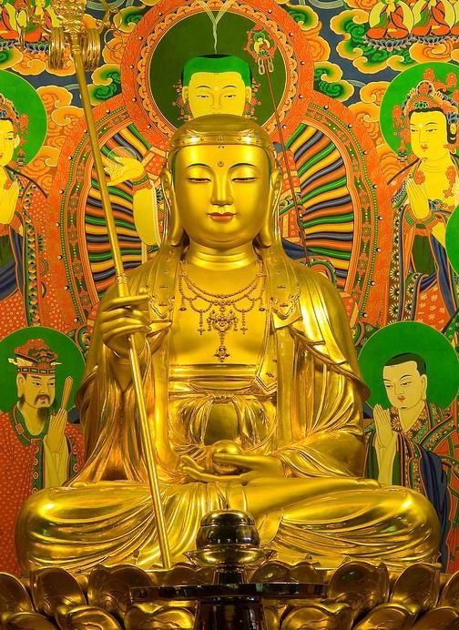

DEVI DHYANI BY YUKO SATO
As they faced me and bowed one by one I felt a feeling of unworthiness but the thought came immediately "worthiness is not necessary, by the grace of God infinite love and light is offered to each of us every moment all we need do is accept it".

I felt that they were very pleased with my practice and had appeared to me to let me know. I think it is important to say that I was in no way unique.

Most of the other students this year and last year had experiences of meeting beings of light, ascended masters and angels - EE has that effect!

Come and experience it for yourself you won't be disappointed."


DEVI DHYANI BY YUKO SATO

Jean, NUCLEAR ENGINEER, FROM THE SEPTEMBER 2005
ENERGY ENHANCEMENT COURSE

MORE FROM JEAN..

Energy Enhancement

APPRENTICE LEVEL 2 Initiation 2 - THE KARMA CLEANING PROCESS -

How to Heal the Energy Blockages in the body.

In this Energy Enhancement Initiation we investigate all our aches and pains as being symptoms of Energy Blockages.

We investigate the negative Energies within - The Trauma and Shame caused Negative Karmic mass which coats every Energy Blockage - with our psychic vision in order to find and remove all negative Thoughtforms which if not found now will eventually culminate in Disease like Heart Disease or Cancer.

We investigate the negative Energies within with our psychic vision in order to find and remove all negative Thoughtforms which if not found now will eventually culminate in some physical Infirmity necessitating surgical Intervention or an Operation.

As the Buddha said, "Old Age, Disease and Death, This is the lot of man"

Yet people of the Chi, Enlightened Masters seem to have some immunity to this general rule above. I remember my Master, Swami Satchidananda living until 89 with no diminution of Health or Strength or Energy. Constantly gave energy to others, raising them up, removing blockages and spiritualising their lives.

HE NEVER HAD A DISEASE IN HIS LIFE!!

WHY?
The answer is that like most Masters he had the ability to clear and banish negative thoughtforms from his own body and the bodies of others.

It is this which we teach in easy steps in THIS Energy Enhancement Initiation using Ancient Techniques from over 5000 years of Successful Spiritual Technology.

Energy Enhancement Meditation Course Level 2 Initiation 1: The removal energy blockages and implants by the Energy Enhancement Seven Step Process.
Energy Enhancement Meditation Course Level 2 Initiation 2: How to Heal the Energy Blockages in the body.

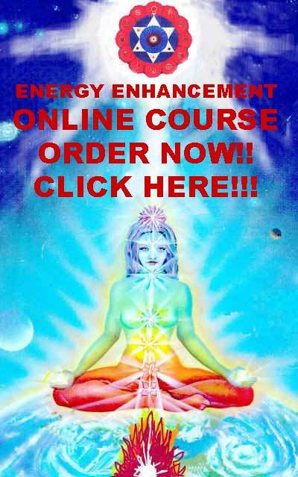

The Nemean Lion and Energy Blockages
Initially, Hercules was required to complete ten labors, not twelve. King Eurystheus decided Hercules' first task would be to bring him the skin of an invulnerable lion which terrorized the hills around Nemea.

All the labours of Hercules refer to the process of Enlightenment For example the reward for the labours is the marriage between Hercules, the son of God, Zeus, Deos, Theos and the Daughter of the God of the Underworld, the Center of the Earth. The internal Marriage of Crown Chakra Heaven and Base Chakra Earth is Enlightenment.

The Nemean lion represents an Energy Blockage. It is invulnerable because it is protected by psychic protection.
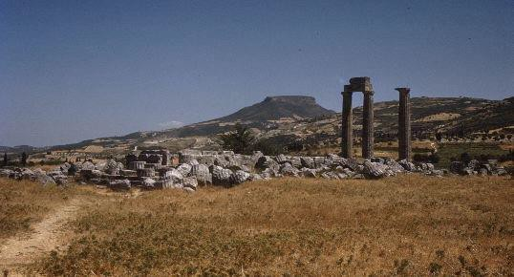
Nemea, Temple of Zeus and landscape Overall view from SW
Photograph courtesy of the Department of Archaeology, Boston University, Saul S. Weinberg Collection

Setting out on such a seemingly impossible labor, Hercules came to a town called Cleonae, where he stayed at the house of a poor workman-for-hire, Molorchus. When his host offered to sacrifice an animal to pray for a safe lion hunt, Hercules asked him to wait 30 days. If the hero returned with the lion's skin, they would sacrifice to Zeus, king of the gods. If Hercules died trying to kill the lion, Molorchus agreed to sacrifice instead to Hercules, as a hero.

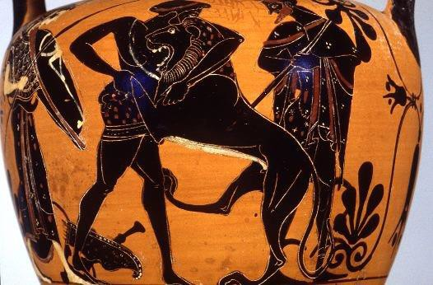
Hercules wrestling the Nemean Lion Philadelphia L-64-185, Attic red figure stamnos, ca. 490
B.C.
Photograph by Maria Daniels, courtesy of the University of Pennsylvania Museum

When Hercules got to Nemea and began tracking the terrible lion, he soon discovered his arrows were useless against the beast because its skin was invulnerable to them.

Hercules picked up his club and went after the lion. Following it to a cave which had two entrances, Hercules blocked one of the doorways, then approached the fierce lion through the other.

This means that Hercules put his Nemean Lion Energy Blockage into a Psychic Prison called a Crucible or the Alembic so that the Energy Blockage was trapped and could not move, and therefore he could focus all his energy on it.

Grasping the lion in his mighty arms, and ignoring its powerful claws, he held it tightly until he'd choked it to death.

Usually the psychic protection, the lion skin, around a blockage prevents us accessing the Negative Karmic Mass inside it. Until we can put on the lion skin - put up our own psychic protection, the claws of the lion can hurt us. Once Hercules had learnt how to wear the lion skin at all times he was invulnerable.

This means that Hercules used one of the most effective methods of transmuting Energy Blockages, that of compression.

Usually Energy connections to the implant blockage from those who made it support the energies of the blockage and thus need special processes, the Seven Step Process to free it from those connections. As we compress the blockage it goes through physical stages of Gas to Liquid, to solid, to black hole, to the removal of Negative karmic Mass in the form of Light from each of the poles of the Black Hole.

At each stage in the physical compression of a blockage it is possible to Ground, send negative karmic mass into the center of the Earth to be Burnt, purified, transmuted.

However, usually the internal construction of the blockage and their psychic protection strength makes it necessary to complete the compression process in order to complete the transmutation.

The last stage of Light has the unfortunate side effect of completely destroying the internal structure of the blockage. We can imagine that after God has spent so much effort to make the internal structures of the Blockage - usually many lifetimes of evolution - he wants to re-use that which he has made. . Thus we only use it to remove the will which is holding the blockage together.

Once we can ground we complete the process of purification. Usually the blockage structure once purified can be re-used as part of the White Magicians internal structure and the purified structure is usually sent up to become part of the Higher Being Bodies. Thus the White Magician can evolve much more quickly by using already made parts and no longer has to go through the normal processes of Evolution.

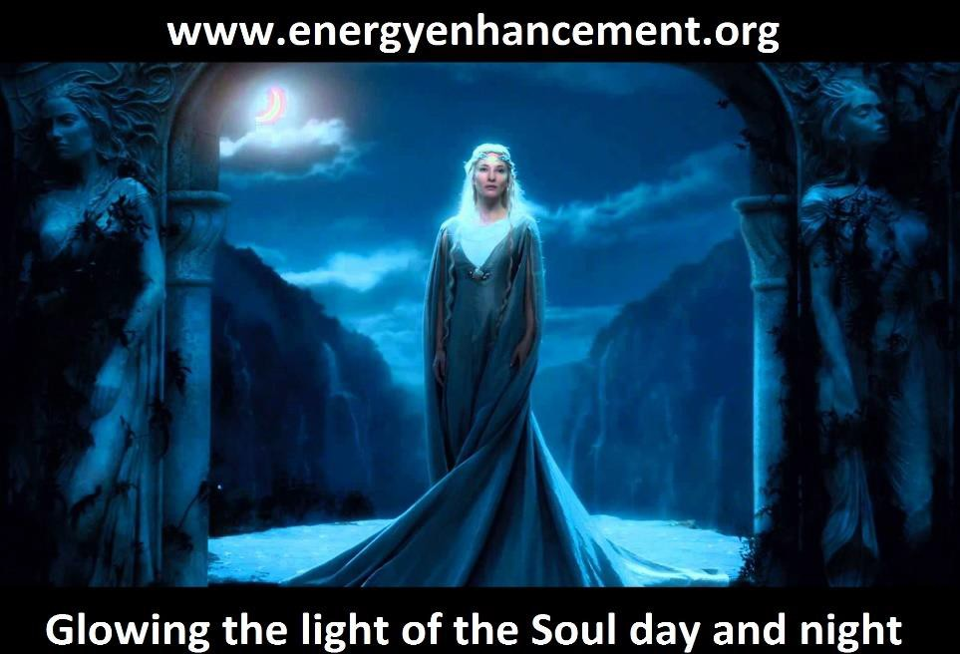

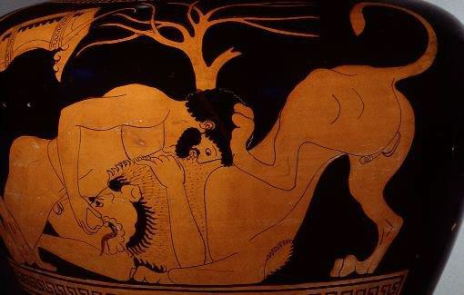
Hercules wrestling the Nemean lion Mississippi 1977.3.62, Attic black figure neck amphora,
ca. 510-500 B.C.
Photograph by Maria Daniels, courtesy of the University Museums, University of Mississippi

Hercules returned to Cleonae, carrying the dead lion, and found Molorchus on the 30th day after he'd left for the hunt. Instead of sacrificing to Hercules as a dead man, Molorchus and Hercules were able to sacrifice together, to Zeus. The sacrifice is always that of Negative Karmic Mass being burnt up in the center of the earth in the process of Alchemical VITRIOL.

The real Agni Hotra and not the Ritual which symbolises the real thing. As the NKM is burnt so the released purified spiritual energy rises higher up to God as part of the Supra-Galactic Orbit of the Kundalini Kriyas. An enlightened master is a tornado of energy in constant circulation and thus is constantly sacrificing to God in a sort of constant "conscious suffering of Gurdjieff" who used it to, "coat the higher being bodies"

When Hercules made it back to Mycenae, Eurystheus was amazed that the hero had managed such an impossible task. The king became afraid of Hercules, and forbade him from entering through the gates of the city.
Furthermore, Eurystheus had a large bronze jar made and buried partway in the earth, - his psychic protection like the Golden Pyramid Protection of Energy Enhancement Level 1 - where he could hide from Hercules if need be. After that, Eurystheus sent his commands to Hercules through a herald, refusing to see the powerful hero face to face.

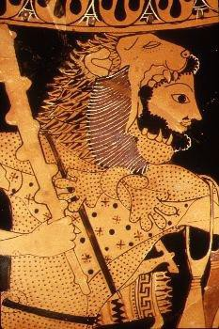

Hercules wearing the lion skin
Boston 99.538, Attic bilingual amphora, ca. 525-500 B.C.
Photograph courtesy,Museum of Fine Arts, Boston. H. L. Pierce Fund

Many times we can identify Hercules in ancient Greek vase paintings or sculptures simply because he is depicted wearing a lion skin. Ancient writers disagreed as to whether the skin Hercules wore was that of the Nemean lion, or one from a different lion, which Hercules was said to have killed when he was 18 years old. The playwright Euripides wrote that Hercules' lion skin came from the grove of Zeus, the sanctuary at Nemea:

First he cleared the grove of Zeus - which symbolises the chakras above the head - of a lion "energy blockage", and put its "psychic protection" skin upon his back, hiding his yellow hair - the Sun God - in its fearful tawny gaping jaws. Euripides, Hercules, 359 which is what we do in APPRENTICE LEVEL 2 Initiation 3 - THE REMOVAL OF ENERGY BLOCKAGE THOUGHTFORMS FROM THE CHAKRAS

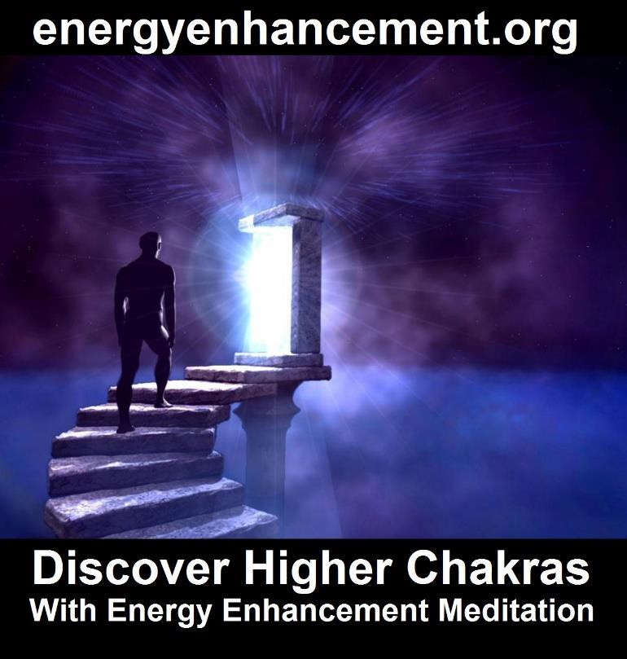

LIVE COURSES, INDIA AND BRAZIL - IGUAZU FALLS

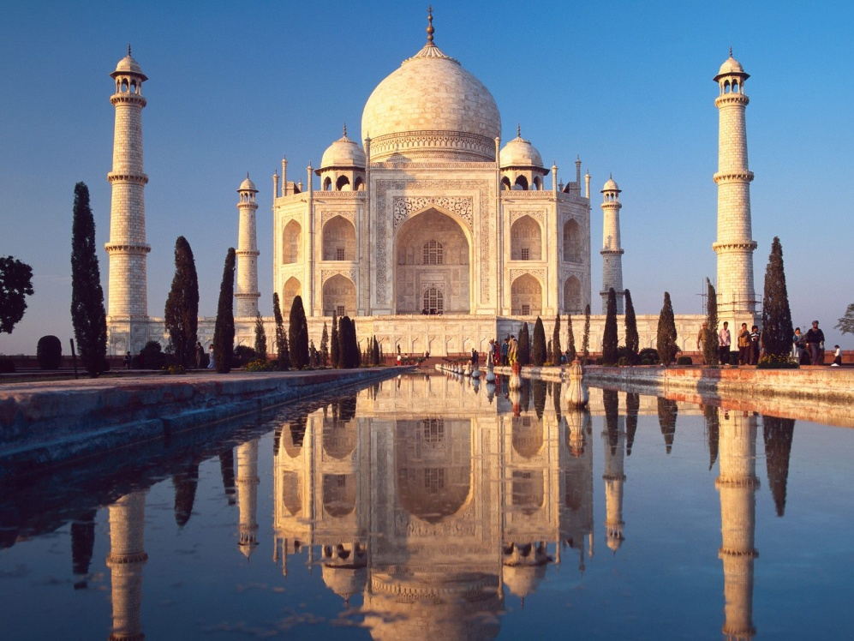
GET MEDITATIONAL SUPERPOWERS WITH ENERGY ENHANCEMENT, LIGHT YEARS AHEAD OF EVERY OTHER COURSE
THE ULTIMATE ADVANCED MEDITATION COURSE
MEDITATION ENERGY ENHANCEMENT
THE CORE ENERGY TECHNIQUES!!
THE MOST ADVANCED MEDITATION TECHNIQUES ON THIS PLANET, IN 28 INITIATIONS!!
ANCIENT EFFECTIVE ENERGY ENHANCEMENT SECRETS -
SUCCESSFUL
TIME TESTED
TRUE


Bookings: www.energyenhancement.org

Energy Enhancement

APPRENTICE LEVEL 2 Initiation 3

HE REMOVAL OF ENERGY BLOCKAGE THOUGHTFORMS FROM THE CHAKRAS

FROM THE SEVEN CHAKRAS INSIDE THE BODY AND THEN ALL THE EXTERNAL SPIRITUAL CHAKRAS TO WHICH WE ARE CONNECTED

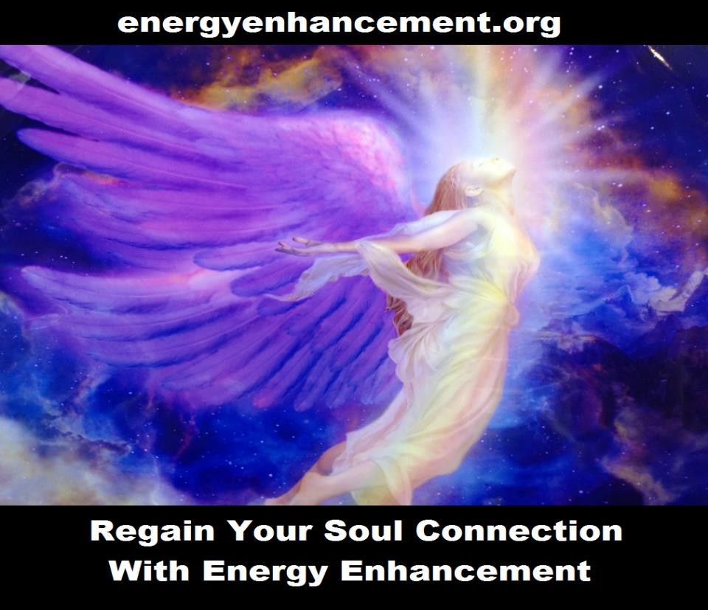

In this Initiation we investigate and remove negative thoughtforms from all the chakras.

- The Base Chakra or Shakti

1a. The Infinity of Chakras below the Base Chakra or Para Shakti which is the source of all Kundalini Energy - The Kundalini Chakra.

- The Relationship Chakra

- The Power Chakra

- The Heart Chakra

- The Throat Chakra

- The Master Control Chakra

- The Crown Chakra

- The Soul Chakra.

- The Group Soul or Monad Chakra

- The Logos Chakra

- The STAR Sirius, etc Chakras

- The Avatar of Synthesis

- The Infinity of Chakras above the Head on the way towards the One God, the Energy in the Center of the Universe.

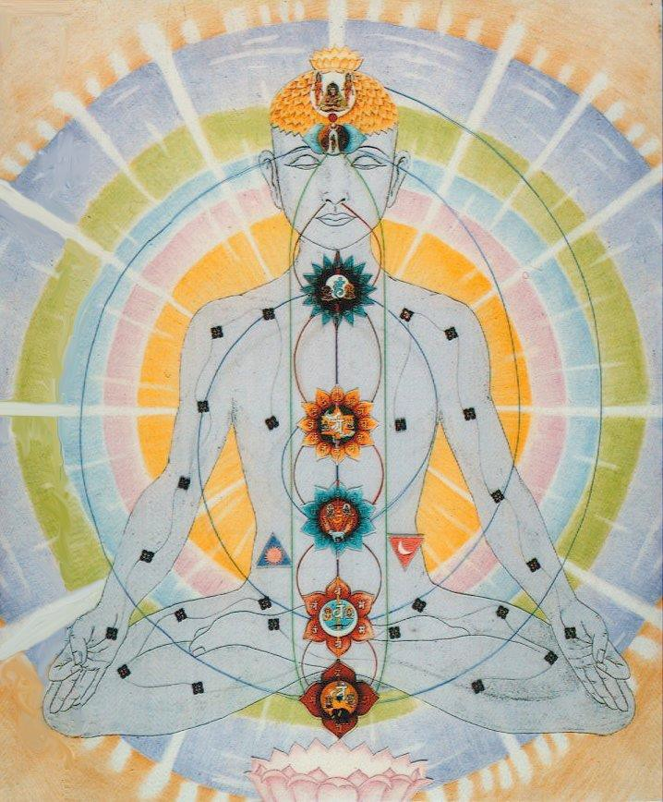

THE CHAKRAS OF THE BODY AND THE CHAKRAS OUTSIDE THE BODY - STRUNG ALONG THE TOWER OF THE ANTAHKARANA, TWIXT HEAVEN - THE CENTER OF THE UNIVERSE AND THE KUNDALINI CHAKRA IN THE CENTER OF THE EARTH. AS WE CLEAR THE ENERGY BLOCKAGES IN AND BETWEEN THE CHAKRAS, ENLIGHTENMENT IS SURE TO FOLLOW...

Although we can feel or see with our psychic vision the chakras and the spaces between chakras to see if Implant Blockages exist there, the application of the Seven Step Process can bring out the blockages so that
they can not hide from us. Implant Blockages have been distorting and perverting our vision of reality from the time, many lifetimes ago, when they were implanted. As we remove them they are very difficult to replace with blockages of the same grade of difficulty. Therefore every blockage we remove is a step on the path of our own Illumination, Enlightenment.

Also we investigate and remove negative Thoughtforms from the connections between the chakras, thus cleaning the Antahkarana or the Rainbow Bridge which connects us to our Higher Self, thus allowing a free flow of intense intelligent energy which can reformulate our lives in good directions.

Energy Enhancement Meditation Course Level 2 Initiation 3: The removal of Energy Blockages thoughtforms from the chakras. From the seven chakras inside the body and then all the external spiritual chakras to which we are connected the Soul Chakra, the Monad Chakra, the Logos Chakra, the Sirius chakra, the Avatar of Synthesis Chakra.

Energy Enhancement

APPRENTICE LEVEL 2 Initiation 4

THE REMOVAL OF ENERGY BLOCKAGE THOUGHTFORMS FROM THE DNA

HEAL YOUR DNA

All the cells in your body are under attack from toxins from pesticides, incinerators and dirty fuctories. As we get older many of the cells become perverted and their DNA becomes old and cannot replicate perfectly.

This perverted DNA becomes the source of all cancer WHICH WILDLY REPLICATES ITS PERVERTED DNA SELF THROUGHOUT YOUR BODY!!!

In this Initiation we show you how to heal all your DNA

Energy Enhancement Meditation Course Level 2 Initiation 4: The removal of Energy Blockages thoughtforms from the DNA. Heal your DNA.

Energy Enhancement

APPRENTICE LEVEL 2 Initiation 5

THE REMOVAL OF NEGATIVE THOUGHTFORMS - ENERGY BLOCKAGES - FROM THE AURAS

Heal the Physical Aura Heal the Emotional Aura Heal the Mental Aura Heal the Buddhic Aura
Many Blockages exist in the space outside the magnetic sheathe where blockages try to gain entry or affect the body inside the magnetic sheathe.

Energy Enhancement Meditation Course Level 2 Initiation 5: The removal of Energy Blockages thoughtforms from the Auras. Heal the Physical Aura, Heal the Emotional Aura, Heal the Mental Aura, Heal the Buddhic Aura.

More Essential Information is available in the Energy Enhancement E-Book available NOW on this site....

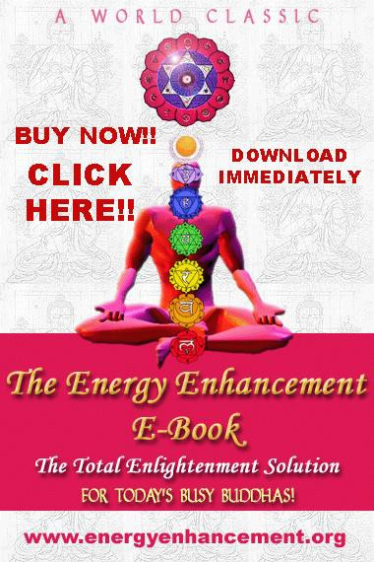
Click Here for the Online Energy Enhancement E-Book - www.energyenhancement.org/shau.htm

Energy Enhancement APPRENTICE LEVEL 2. Initiation 6

THE OPENING OF THE HEART

THE REMOVAL OF ENERGY BLOCKAGE THOUGHTFORMS FROM YOUR HEART

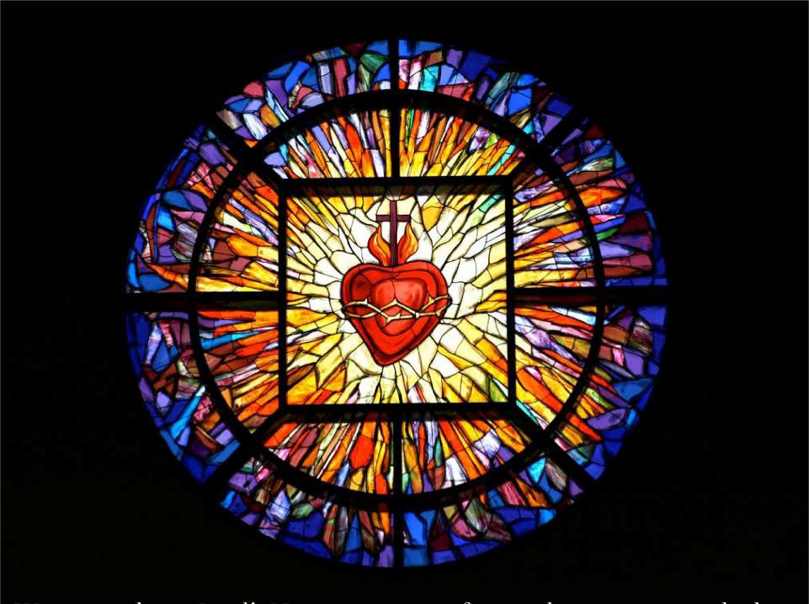
Good qualities: gratitude and devotion and loyalty and dignity - not being ashamed of anything you have done - being non-egotistically proud of the things you have done for yourself and for others, empathy and the ability of putting yourself in the shoes of the others, doing everything for others, being a servant to

humanity, being the hands of god on this planet to positive qualities
creation, nourishment, compassion, pure love, complete sense of security, confidence, joy of spirit, empathy, understanding, harmony, peace, love, bliss, bhakti, unity, kindness, forgiveness, clarity, self acceptance, charity, appreciation for beauty, selflessness, truth, grace.

Blocked qualities:
revenge, betrayal, traitorism, getting joy out of hurting, corrupting, degenerating good people, taking an evil life path simply for the money and security, taking joy in the pain of others, insecurity, motherhood/fatherhood problems, fear, atheism, not connected to the energy of God, no seeking, inconsiderate, critical/intolerant, no compassion, feeling unloved, low self worth, jealousy, overconfident, stingy behaviour, extreme anger outbursts, victim mentality, self concious, low self esteem, blaming others, afraid of rejection, emotionally cold, paranoid, indecisive, poor communication, desire, sadness, despair, codependancy, poor boundaries, matryr, pleaser, antisocial/withdrawn, lonely, fear of intimacy, lack of empathy, possessive, hatred/seek to destroy or punish those who resist their possession/control

Seven Step all words.

7step the heart word, the heart chakra position, the heart of christ the infinity of heart qualities

THE INITIATION OF THE OPENING OF THE HEART

There is a story about the guy who comes for initiation to the ashram.

Go to the hut at the bottom of the garden and meditate 6 hours a day for 6 months - then initiation.

Finally the guy is ready for Initiation, washed, clean clothes, hair combed.

As he passes the cow shed the cow boy is cleaning the cows and he shovels a huge load of shit over the guy.

The guy is horrified and chases the cow boy around the ashram!!

Back to the hut, 6 months, 12 hours per day!!

Next time the Master says to the cow boy, when he comes, get him good!!

As he passes the cow shed the cow boy shovels a huge load of shit over the guy.

The guy is amazed and chases the cow boy around the ashram again!!

Back to the hut, 6 months, 18 hours per day!!

Again Master says to the cow boy, when he comes for initiation, get him good, again!!

As he passes the cow shed the cow boy shovels a huge load of shit over the guy.

This time the initiate goes to his knees and begs forgiveness from the cow boy and the Master.

Master says no need for initiation, you are already initiated!!

This is the Zen Koan, "What is the sound of one hand clapping?"

This is the sound of God's hand hitting your face. Jesus said when this happens, "Turn the other cheek" This means forgiveness.
Forgiveness in the moment. Otherwise it means a closed heart. A Lack of forgiveness.
Revenge!!

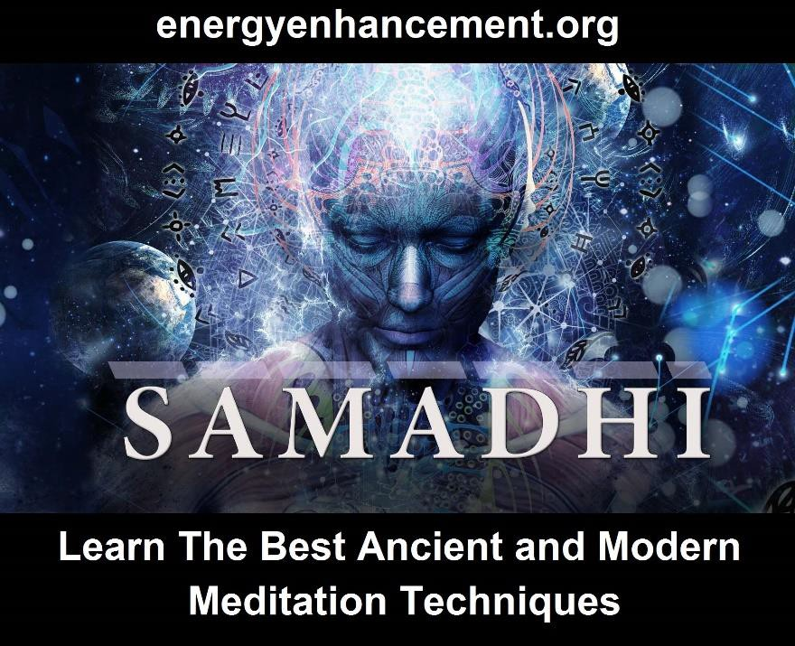

Energy Enhancement APPRENTICE LEVEL 2. Initiation 7.

THE KARMA CLEANING PROCESS

THE REMOVAL OF ENERGY BLOCKAGE THOUGHTFORMS FROM YOUR KARMA

THE REMOVAL OF OLD KARMA

FROM THE TIME IN THE WOMB OF YOUR MOTHER

Remove the blockages from your 9 Months in the Womb of your Mother to the Primal Scream of Birth.

This is what they mean when they say a Master is not under the Laws of Karma.
He has dissolved all the negativity from all his past lives. He has used his SOUL, MONAD, LOGOS AND HIGHER
ENERGIES to dissolve all the negativity, to FORGIVE all
the bad actions that he has done, and have been done to him.

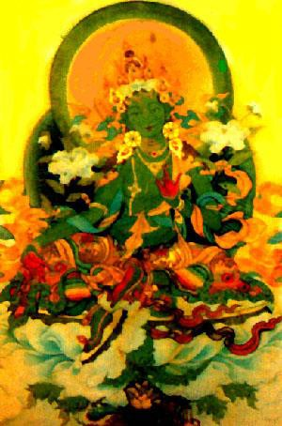

Create a Clean white sheet again from your Messy Dark History Painting which you have created brushful by brushful, every day of your life.

Learn How to easily and quickly Heal, remove all the negative trauma energy from all your Personal History, Your Life until now, of all of its painful memories and blockages which act as filters to our vision.

Learn How to easily and quickly Heal, remove all the negative trauma energy from all your Past Lifetimes,

Your Lives until now, of all of their painful memories and blockages.

Learn How to easily and quickly Heal, remove all the negative trauma energy from this Future Life of all of its painful memories and blockages.

Learn How to easily and quickly Heal, remove all the negative trauma energy from all your Future Lifetimes, Your Future Lifetimes of all of their painful memories and blockages which act as filters to our vision.

One of our Students age 37, the director of an Internet Business in Bolivia, started to clean his future of this lifetime by mistake, before he had cleaned all of his past lifetimes and this life. He saw himself at the age of 56 with two children in his arms and no wife and then.... all became blank. He then cleaned this lifetime and all previous lifetimes of all their Negative Energy blockages, Energies and bad Karma. When he came to clean the future of this life he saw himself entering into the light, becoming a spiritual teacher in his fifties, onwards towards AGE 80!!!

One of my Teachers, Zen Master Hogen said, We are all History Paintings. We start with a clean white sheet and then every day we apply paint. Usually our History Paintings become very messy!!! "I am a clean white sheet which is washed constantly. Everytime we meet, it is as if there is no emotional holdover from the past.
Everytime, I see you clearly, as if for the first time!" Zen Master Hogen.

Energy Enhancement Meditation Course Level 2 Initiation 6: The removal of old karma from the time in the womb of your mother. The karma cleaning process.

Energy Enhancement APPRENTICE LEVEL 2. Initiation 8

THE KARMA CLEANING PROCESS

THE REMOVAL OF ENERGY BLOCKAGE THOUGHTFORMS FROM YOUR KARMA

THE REMOVAL OF OLD KARMA

FROM THIS LIFETIME

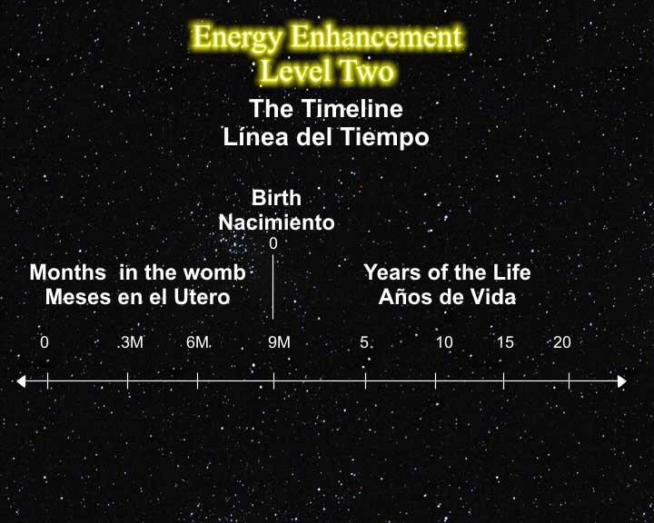

Remove the blockages from all the years of your life

Remove all the Blockages from all your previous lifetimes

Remove the blockages from all the future years of this lifetime

Remove the blockages from all your future lifetimes

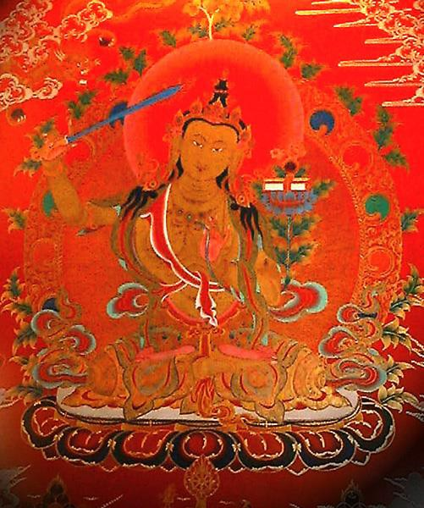

This is what they mean when they say a Master is not under the Laws of Karma.

He has dissolved all the negativity from all his past lives.

He has used his SOUL ENERGY to dissolve all the negativity, to FORGIVE all the bad actions that he has done, and have been done to him.

Create a Clean white sheet again from your Messy Dark History Painting which you have created brushful by brushful, every day of your life.

Learn How to easily and quickly Heal, remove all the negative trauma energy from all your Personal History, Your Life until now, of all of its painful memories and blockages which act as filters to our vision.

Learn How to easily and quickly Heal, remove all the negative trauma energy from all your Past Lifetimes, Your Lives until now, of all of their painful memories and blockages.

Learn How to easily and quickly Heal, remove all the negative trauma energy from this Future Life of all of its painful memories and blockages.

Learn How to easily and quickly Heal, remove all the negative trauma energy from all your Future Lifetimes, Your Future Lifetimes of all of their painful memories and blockages which act as filters to our vision.
One of our Students age 37, the director of an Internet Business in Bolivia, started to clean his future of this lifetime by mistake, before he had cleaned all of his past lifetimes and this life. He saw himself at the age of 56 with two children in his arms and no wife and then.... all became blank. He then cleaned this lifetime and all
previous lifetimes of all their Negative Energy blockages, Energies and bad Karma. When he came to clean the future of this life he saw himself entering into the light, becoming a spiritual teacher in his fifties, onwards towards AGE 80!!!

One of my Teachers, Zen Master Hogen said, We are all History Paintings. We start with a clean white sheet and then every day we apply paint. Usually our History Paintings become very messy!!! "I am a clean white sheet which is washed constantly. Everytime we meet, it is as if there is no emotional holdover from the past.
Everytime, I see you clearly, as if for the first time!" Zen Master Hogen.

Truly, perhaps Enlightenment is next!!

Energy Enhancement Meditation Course Level 2 Initiation 7: The removal of old karma from this lifetime. The karma clearing process.
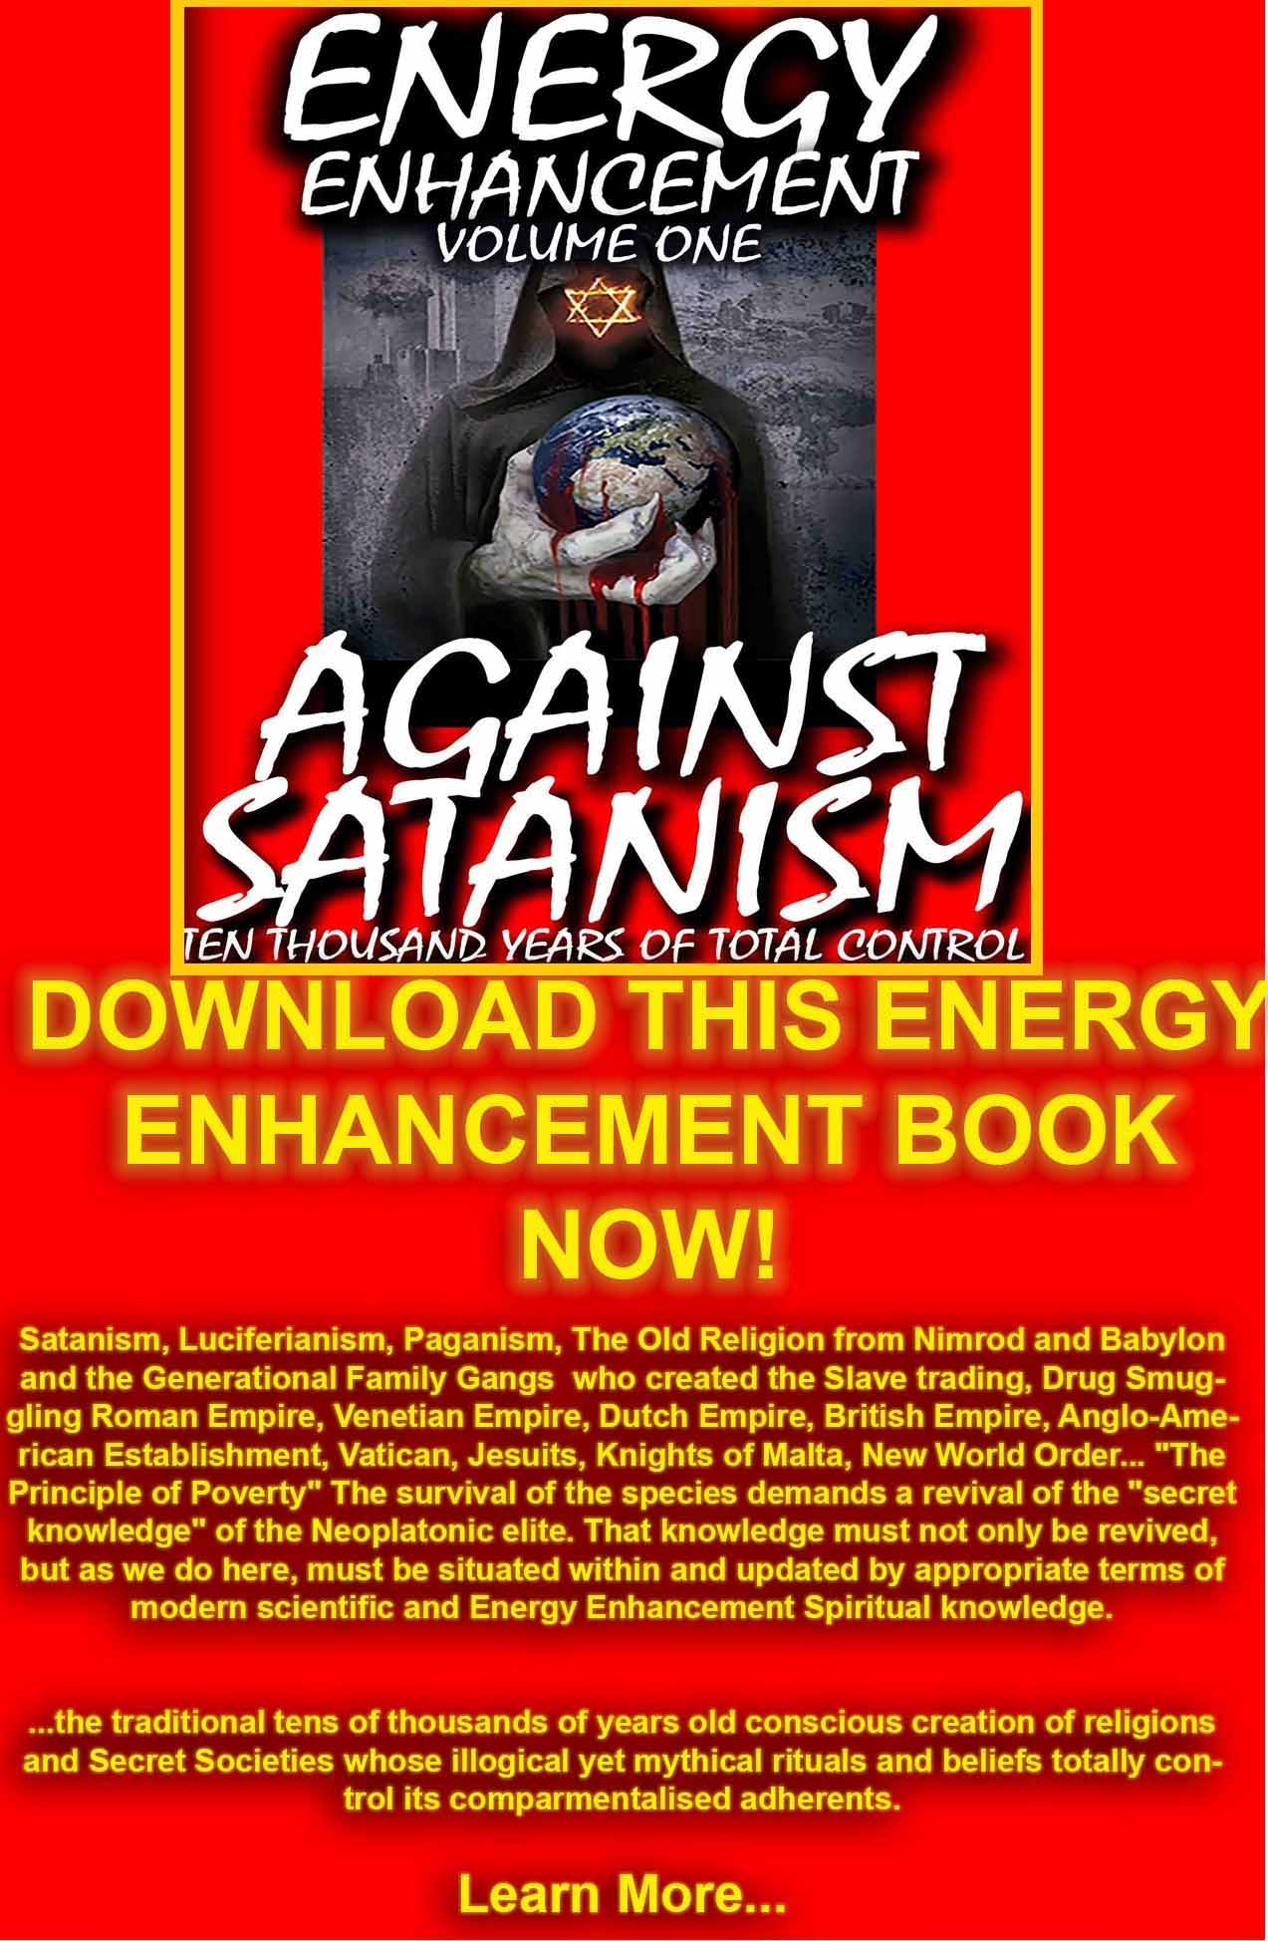
DOWNLOAD AGAINST SATANISM VOLUME ONE HERE
http://www.energyenhancement.org/Against-Satanism/Against-Satanism-Energy-Enhancement-Satanic-History-of-the-World-Volume-1.pdf

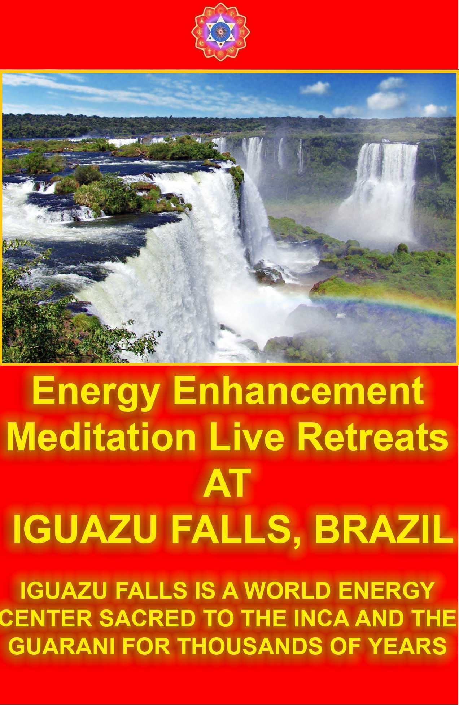

THIS WORLD NEEDS TO CHANGE

ENERGY ENHANCEMENT AND WORLD CHANGE
There is Something Ancient, Atavistic and Evil which Exists in the Hearts of All Living People which leads to Their Unhappiness, Poverty, Shame and Guilt.

Trauma Caused Energy Blockages are the Cause of Evil People with No Heart - Psychopaths like Hitler, Stalin and Pol Pot who use Torture, Fear, Poverty, Gulag Labour Camps, Killing and War to pursue their Selfish and Evil Ends.

Only People of the Heart, with No Energy Blockages in the Heart talk about Environmental Purity, Pure Food and Water for Everyone, Human Rights, Children's Rights, Education for All, Housing, Free Time to Follow Happiness and Freedom and Self-Evolution, Liberty,


Economic Freedom, and Free Speech in their Country and in all the Counties in the World.

Because people of the Heart, Good People know that Their Happiness and the Happiness of Everyone around them depends on these Freedoms which are all Self- Evident and True for All Time.

ENERGY ENHANCEMENT - SUCCESSFUL ENERGY OF CHANGE FOR ALL PEOPLE
Energy Enhancement is the Only Course in the World which can Remove Energy Blockages producing in all their Client's Lives a Goodness and Purity which Gives Energy, Health, Freedom, Liberation, Personal and World Evolution, Choice, Meaning, Significance and Purpose - TOTAL HAPPINESS!!

NORMAL TRAINING FAILS

For All Human History, Normal Training for people of Abstract Thought, whose Family, Sat Scores and IQ has allowed them to go to University, has produced the Few People who Control the World.

It has produced the Vocational Training for the Workers who Run the World.

Success in Training Intellect and Talent. And this is enough for Society.

But Some Clever, Talented People are Morally Ambiguous, Evil, Psychopathic and this has been the case with most totalitarian leaders and bosses who have taken the Ring for All Time.

Where All Normal Training Fails is that it does not deal with Man's Energy Blockage Propensity for Egotistical, Selfishness and Competitiveness.

An Evil in the Hearts of All Men which leads to Unhappiness for them and Everyone Around them!!

ENERGY BLOCKAGES OF THE HEART

"EVIL IS" - TOLKIEN

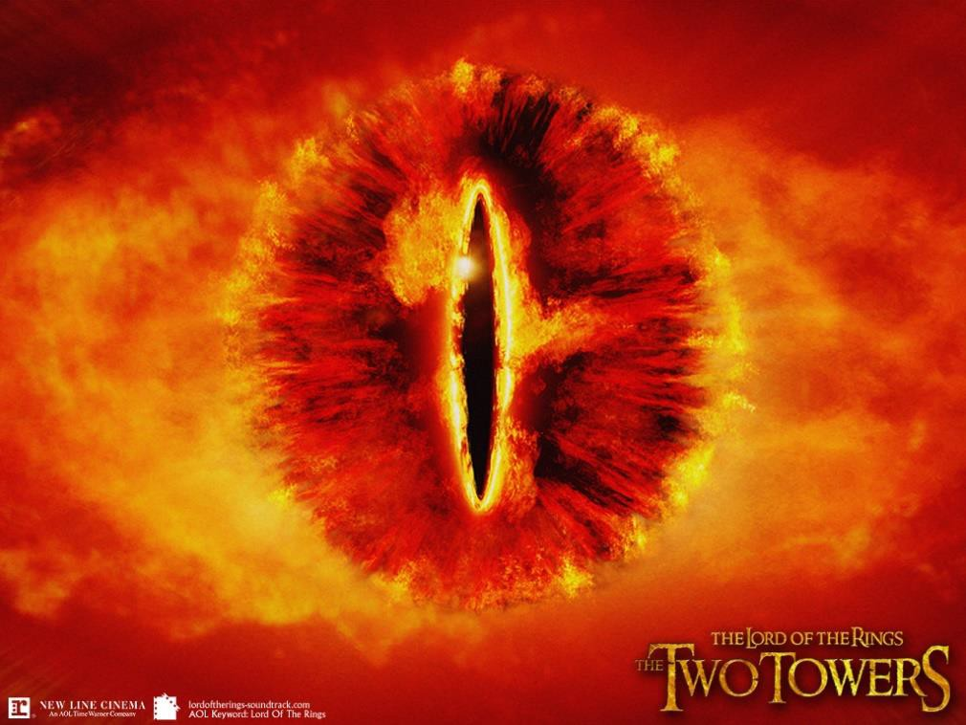

It is Energy Blockages which Allow and Persuade People to Do Evil!!

It is Energy Blockages which Create the Symptoms of Aches and Pains in the Body which Grow into Medical Operations, Heart Disease, Cancer and Death if not Dealt With.

Energy Blockages also Create the Unhappiness of Depression, Manicism, Anger, Fear, Hatred, Jealousy and Selfish Desire.

Energy Blockages Decrease Intelligence, IQ, Create Unwanted and Distracting Thoughts, Thoughts of Egotistical and Selfish Gain, Evil Thoughts.

Energy Blockages Create a Lack of Empathy and Conscience.

Energy Blockages Create Unhappiness in You and Everyone Around You!!

THE PEOPLE OF THE WORLD NEED CHANGE
Where all Normal Training Fails is the Inbuilt Energy Blockage Propensity for Egotistical Selfishness, Competitiveness and Evil in the Hearts of All Men.

It is the Evil which Men Do which makes their Lives and the Lives of Everyone Around them Painful, Shameful, Guilty, Poor, Undeserving - UNHAPPY!!

ENERGY ENHANCEMENT - CHANGE YOU CAN BELIEVE IN
Energy Enhancement is the Only Recognized and Institutional Training which Guarantees Energy, Goodness, Heart and Mercy and thus Guarantees a Life of Happiness, Peace and Joy for You and for All the People around You.



WHO IS THE HAPPIEST PERSON? - THE PERSON WHO CREATES HAPPINESS IN EVERYONE AROUND THEM!!

Energy Enhancement teaches Successful and Ancient Techniques which Increase Energy, remove Energy Blockages, Cleans the Shame and Guilt of Ancient Karma and Improves all Relationships.

Further, they Increase Goodness and Mercy in the Hearts of all People thus producing a Good Life of Happiness and Peace for them and all the People around them.

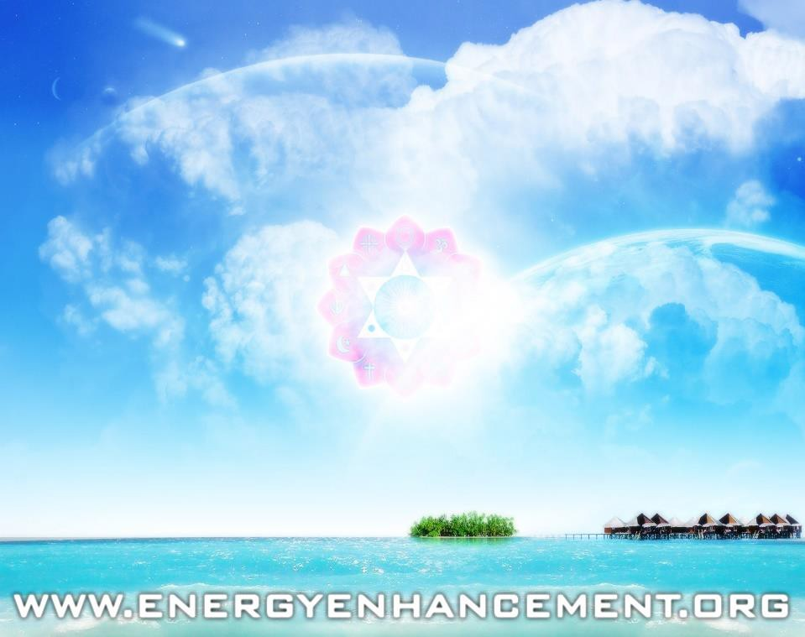

THE TRAUMA CREATION OF ENERGY BLOCKAGES
"An example of one of the different types of Energy Blockage is that they are sometimes created when we do not get what we expect, or we get what we do not want. They are caused by the Trauma of Disappointment.

Like when our Mother or Father or Son or Daughter dies. Like when a Lover leaves us.

This trauma, this pain is so strong that at that moment the mind can not look at it, so it gets locked away within the body until we get strong enough to process it.

Then amnesia. We forget the pain fulminating in our bodies. We forget the poison until, after a while, disease is the result."

Satchidanand



ENERGY ENHANCEMENT LEVEL TWO THE REMOVAL OF SOCIOPATHIC TRAITS AND THE OPENING OF THE HEART!!

PSYCHOPATHS

"A Psychopath has no conscience due to blockages above the crown chakra. The higher they are, the more consciencelessly psychopathic they are - they have no shame, they can kill without remorse. A Psychopath has no empathy because of the energy blockages in his heart chakra thus he cannot put himself in the shoes of another person, he can not care; He has a screw loose!! Most political leaders and business leaders have these types of blockages - as well as most of humanity. The only question is how many, and how deep? Only Energy Enhancement has the techniques to dissolve them ALL in you!!"

- Energy Enhancement Satchidanand RELATED ARTICLES
NEW!! MEDITATION - ENERGY BLOCKAGES ARE THE CAUSE OF THE PSYCHOPATH, THE SCHIZOPHRENIC, AND MANIC DEPRESSION. WITH EXAMPLES STALIN, HITLER, ENRON AND MAO

NEW!! MEDITATION - Existentialism and Kubrick's Psychopaths in the Films of Stanley Kubrick.

NEW!! PSYCHOPATHS, CHAKRAS OUTSIDE THE BODY AND THE ANTAHKARANA

NEW!! George Lucas, Star Wars, the Revenge of the Sith, and Psychopaths

NEW!! MEDITATION ENERGY ENHANCEMENT AND
Trauma, Pain, Relationships, Divorce, Piercings, Tattoos, BDSM, Sex, Sex Addiction, Tantra, Gambling, Homosexuality, Lesbianism, Drugs and Addiction, Bad backs, Heart Disease, and Cancer.

THE PSYCHOPATH, HERVEY CLECKLEY, THE MASK OF SANITY



CONNECTION WITH THE ANTAHKARANA AND CHAKRAS ABOVE THE HEAD, BY REMOVING THE ENERGY BLOCKAGES ABOVE THE HEAD CREATING CONSCIENCE.

"The mass often serve the state thus, not as men mainly, but as machines, with their bodies. They are the standing army, and the militia, jailors, constables, posse comitatus, etc. In most cases there is no free excercise whatever of the judgement or of the moral sense, but they put themselves on a level with wood and earth and stones, and wooden men can perhaps be manufactured that will serve the purposes as well. Such command no more respect than men of straw or a lump of dirt. They have the same sort of worth as only horses or dogs. Yet such as these are commonly esteemed good citizens.

Others - as most legislators, politicians, ministers, and office holders, - serve the state chiefly with their heads, and, as they rarely make any moral distinctions, they are as likely to serve the Devil, as God.

A very few, as heroes, patriots, martyrs, reformers in the great sense, and men, serve the State with their consciences also, and so necessarily resist it for the most part, and they are commonly treated as enemies by it."

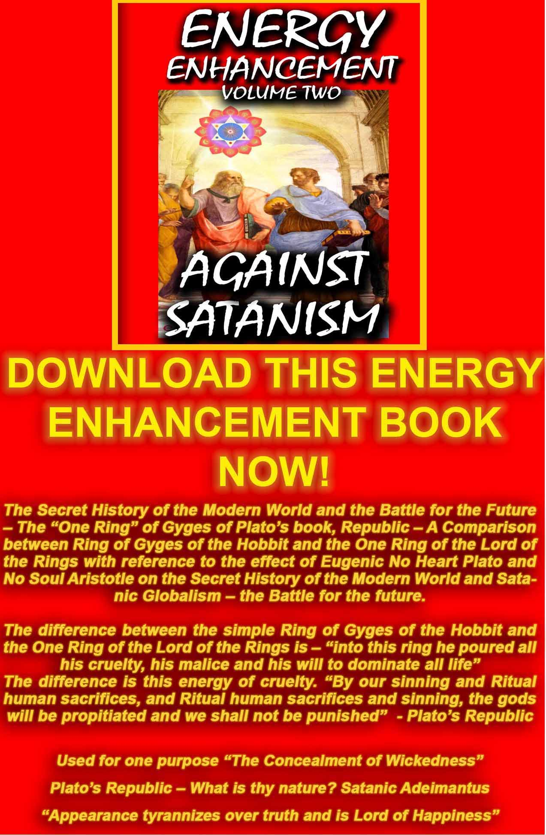
AGAINST SATANISM VOLUME 2
DOWNLOAD HERE
http://www.energyenhancement.org/Sacred-Energy/Against-Satanism-Volume-2/Against-Satanism-Volume-2.pdf

BLOCKAGES AND ENERGY ENHANCEMENT

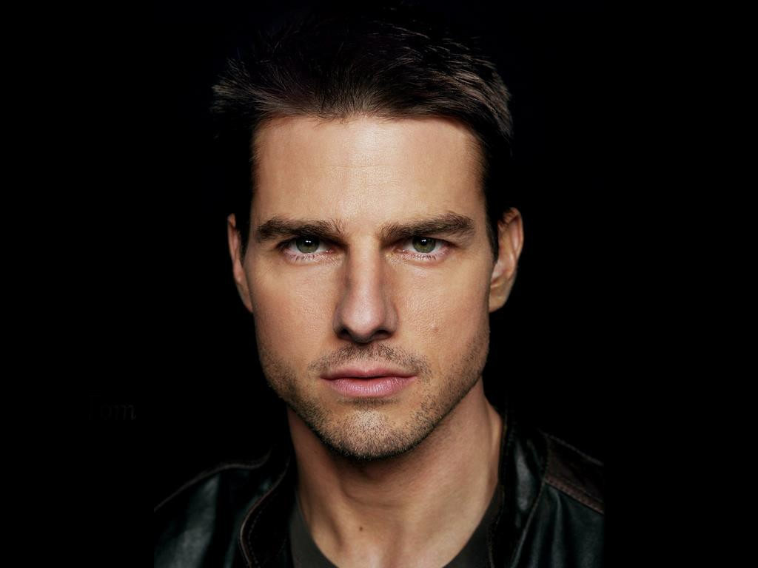
Are You Haunted?

"I got into Energy Enhancement because I was inhibited. Turns out I was inhabited!" - Anonymous, L.A. newspaper ad.

Over the past few decades some highly dramatic stories illustrating the phenomenon of "multiple personalities" have become quite well known.

Some psychiatrists and psychologists, and, in fictional accounts, novelists and scriptwriters, have given considerable attention to extreme cases where another distinctly different "personality" appears to take control over an individual for prolonged periods of time.

Less attention, however, has been given to less dramatic but, perhaps, related occurrences.

Most people have days when they are "not quite themselves." One hears comments like, "It just wasn't like Fred. He was like some kind of madman!" or "She was like a woman possessed!" or "He's a different person when he drinks," or "I don't know what came over me, " or "What got into me?" What's happening? There is no scarcity of theories. This and the following paragraphs examines this area, and offers various explanations concerning it.

Currently, the entirety of Scientology's super-secret "upper levels" deal with this type of "phenomena." but are only able to remove the easy blockages because Scientology does not have the Ancient techniques of the Old Religions of removing Energy Blockages like, for example, the Energy Enhancement Seven Step process. Inner Children and the Strategies of the Vampire seem to be beyond them especially regarding Hubbard's many times reported temper tantrums (violator) and his inability to have other stars around him because a selfish competitive star can only have yes - men around him. He will try to destroy (fair game) all other stars.

But Hubbard was onto energy blockages. Even in 1950 Hubbard was preoccupied by this sort of thing. In Dianetics, the Evolution of a Science-published in 1950 and aired at a broad science fiction audience (consisting of scientifically oriented readers)-Hubbard wrote:
...it was necessary to hark back to the techniques of the Kayan Shaman of Borneo, among others. Their theory is crude; they exorcise demons....Provisionally, let's try to postulate that Man is good.... And we suppose something such as the Borneo Shaman's Toh has entered into him which directs him to do evil things.

Man has believed longer that demons inhabit men than Man has believed they did not. We assume demons. We look for some demons, one way or another. And we find some!

This was a discovery almost as mad as some of the patients on hand. But the thing to do was try to measure and classify demons. Strange work for an engineer and a mathematician! But it was found that the "demons" could be classified. There were several "demons" in each patient, but there were only a few classes of "demons."

There were audio demons...visio demons, interior demons, exterior demons, ordering demons, directing demons, critical demons, apathetic demons, angry demons, bored demons and certain demons who merely blocked things. The last seemed to be most common.
Looking into a few minds established soon that it was difficult to find anyone who didn't have some of these demons....

Hubbard then discusses the analogy between the human mind and an electronic computer. Finally he concludes:

There are no demons. No ghosts or ghouls or Tohs. But there are aberrative circuits.

Hubbard doesn't explain how it is that these "circuits" existed structurally. But "structure" was not his concern; his concern was function. He wrote:

...it was not necessary to show how it is done in terms of physical mechanism if we can show that it IS done.

In 1950, a circuit was defined by Hubbard as:
A part of the individual's bank [reactive mind] that behaves as though it were someone or something

separate from him and that either talks to him or goes into action of its own accord, and may even, if severe enough, take control of him while it operates.

The jingle heard on the radio that sticks in one's mind, playing over and over; the actor who after many appearances on stage, portraying a particular character, takes a vacation and finds, to his discomfort, that he still at times possesses the qualities of that character; the obsession that grips a person causing him to do things he knows he will later regret-the materialistic viewpoint might simply say, "That's simply something the brain does."

The spiritual viewpoint on the other hand traditionally divides a human being into "body, mind, and spirit," with the spirit being the basic individual and the mind being the recordings of one's past experiences, ideas, conclusions, etc. These recordings are not necessarily considered as a part of the brain, but rather a function of the spirit.

Quoting from Joseph Krutch's More Lives Than One:
The physiologists are very fond of comparing the network of our cerebral nerves with a telephone system but they overlook the significant fact that a telephone system does not function until someone talks over it.
The brain does not create thought (Sir Julian Huxley has recently pointed out this fact); it is an instrument which thought finds useful.

PARACELSUS

Paracelsus von Hohenheim (1490-1541) was the outstanding medical therapist of his time and, perhaps, the greatest mystic in the history of Western medicine. He devoted his life to research in the healing arts.

Paracelsus visited Constantinople to acquaint himself with the secret practices of the Dervishes and the Sufis.

The following is an excerpt from Paracelsus - His Mystical and Medical Philosophy, by Manly P. Hall, published by the Philosophical Research Society:

[According to Paracelsus]...the elementary is an artificial being, created in the invisible worlds by man himself. In harmony with more recent findings, Paracelsus noted that most elementaries seem to be of an evil or destructive nature. They are generated from the excesses of human thought and emotion, the corruption of character, or the degeneration of faculties and powers which should be used in other,more constructive ways....
Man is therefore a creator, not merely in terms of the perpetuation of the species, but especially in terms of the imagination. Man is creative in the arts, sciences, and philosophies, but his creative powers are not only external, but also internal. Because he lives, man bestows life, and he can generate creatures from his thoughts and emotions....The power to create is the power of vibration, by which anything is set into a peculiar motion....The invisible progeny of man include thought-forms and emotion-forms. These are like infants or inner children, especially in their beginnings, for they depend upon their creator for their nutrition and survival.
Later,however, if the forces which generate continue to operate, these thought and emotion-forms gain strength, finally attaining a kind of independence....Having thus become even stronger than their creator, these thought and emotion-forms will turn upon the one who fashioned them, often causing in him a terrible habit or addiction and destroying his health and happiness.

We know that the human psyche can become ridden with pressure centers or pressure-patterns which we call fixations, complexes, phobias, and the like. We know that these negative psychic formations are nourished by the continued repetition of the attitudes which caused them. We say that negative attitudes become habitual, by degrees taking over and destroying the mental and emotional integrity of the individual.

A fixation, well nourished by attitudes suitable for its perpetuation, intensifies, becoming actually avaricious and resolved to dominate or possess the entire life of its unhappy victim....

Modern thinking therefore, sheds light upon the concept of elementaries, extending beyond the basic research of Paracelsus...[He] used the term obsession to signify possession by an entity. Today the term is used to signify possession by an abnormal attitude....Is it possible that the abnormal attitude has gradually become an entity?

...Many persons under psychological obsession resist treatment, as though some foreign creature were fighting for its survival in them....

Out of his philosophy of elementaries, Paracelsus came to the conclusion that a very large part of what we consider to be disease, results from psychic parasites generated by wrong thoughts and emotion.

GURDJIEFF

From the book The Mystic Path to Cosmic Power, by Vernon Howard:
Gurdjieff was probably born in Alexandropal, in Asia Minor, about 1872. This remarkable and often

controversial man spent a dozen years roaming about the East in search of esoteric teachings. He returned with a tremendous wealth of wisdom for the Western world.

Gurdjieff summarized the problem: Mankind is asleep but doesn't know it. So deep is his hypnotic slumber that he does his daily walking and talking and legislating and marrying in a state of unconsciousness.

Actually, the acts are the mechanical acts of hypnotized people. And that, Gurdjieff declares, is the simple reason why the world goes from one disaster to another: "Would", he asks, "a conscious human being destroy himself' through war, and crime, and quarrels No, man simply knows not what he does to himself."

One of the basic principles explains the many and varied I's in a man. The unawakened man is not a unified person. He has dozens of selves within him, each falsely calling itself. Many philosophers, including George Santayana and David Hume, have also observed how a person switches constantly from one I to another.

The many I's within a man explains many mysteries about human nature. For example, a man decides to give up an undesirable habit, but the next day he repeats it again. Why? Because another entity has taken over, an energy blockage that likes the habit and has no intention of giving it up.
Or perhaps a woman decides to quit fooling around with her life; she determines to find her real self. She reads a book or two and goes to a few lectures. Then, suddenly, she loses all interest and goes back to her self-defeating behavior. What happened? An entirely different I, entity, energy blockage that doesn't want her to wake up, took charge.

Gurdjieff provides a simple solution to this contradictory condition: Become aware of the many I's. Watch how one takes over and then another. Also, see that they do not represent the true you, but consist of borrowed opinions and imitated viewpoints. Such self-observation weakens their grip; you eventually find your real I.

LOATHSOME LARVAE

From Mouni Sadhu's The Tarot, A Contemporary Course of the Quintessence of Hermetic Occultism:

Let us imagine that a man has a common evil desire, he makes no attempt to realize it on the physical plane. He only draws a dark desire on the astral plane, and so creates a kind of "entity."...This artificial "being" does not possess a physical body....Such a being can...act and influence only in direction as intended by its unwise creator, man, who is usually unaware of his foolishness.

Now, on whom will the influence of such a demon be exerted Yes, firstly on the father of it himself...who created the astral picture of the evil deed. We call this type of ominous artificial entity a larva. Such a larva will watch it's "father' in order to prevent him from forgetting his evil intention and desire, and to fortify the larva's life by new meditations about the same theme.
But it can also attach itself to another man, who has a certain astral and mental affinity with the first one.

THOUGHT-FORMS IN TIBET

Besides the idea that "thought forms" may be inadvertently created, there is also the viewpoint that they can be deliberately brought into being.
The following excerpt is from the book The Yoga of Sex by Omar Garrison:

According to secret lore, man can develop such concentration of mind that he is able to generate psycho-mental energy (called "risal" in Tibet) and to use it for bringing about results that to the uninitiated appear to be supernatural.

It has been because the Tantric* techniques employ these secret methods of concentration that Tantrism has been called the most elaborate system of auto- suggestion in the world.

While such an evaluation may serve to explain the more seductive visions of the sadhaka [adept], it is hardly adequate to account for phenomena witnessed by persons other than the creator of them.

For example, Tantric adepts (especially in Tibet) possess methods for projecting thought forms (called tulpas) which are materialized so completely that they are often mistaken for physical entities.

Moreover, these phantoms are sometimes visualized and given a kind of autonomy, so that they may act and seemingly think without the consent or even knowledge of their creator. In this connection, Madame Alexandra David-Neel, a Frenchwoman who spent many years among the lamas of Tibet, recounts an intriguing personal experience in the creation of a tulpa.
Having a sceptical turn of mind, Madame David-Neel suspected that many stories she had heard concerning such materializations might be gross exaggerations.
The most common kind of Tulpa-making in Tibet is that of forming and animating the counterparts of Tibetan deities. So to avoid coming under the influence of this kind of mental suggestion - so prevalent around her - she chose for her thought-child the figure of a fat, jolly monk.

After a few months of performing the prescribed disciplines for ritual projection of thought image, Madame David-Neel relates that the form and character of her phantom monk took on the appearance of real life. He shared her apartment like a guest and, when she departed for a journey, he accompanied her entourage. At first, the monk put in an appearance only when his creator thought of him. But after a time, he began to behave in a very independent manner and to perform various actions not directed by his maker. So real did he become in time, that on one occasion, when a herdsman came to the Frenchwoman's encampment to bring her some butter, he mistook the chimerical monk for a live lama.

Even more alarming to the phantom's begetter, his character began to undergo a subtle change. He grew leaner and his face gradually took on a sly malevolent look. He daily grew more importunate and bold. "In brief," says Madame David-Neel," he escaped my control."

Clearly, the time had come to purge herself of the unwanted companion whom she had brought to life, but who, by her own admission, had turned her existence into a day-nightmare. It required six months of difficult practice and ritual to magically dissolve the monstrous prodigy.

"My mind-creature was tenacious in life," she declared.

How are we to explain such phenomena? Western psychology has only begun to investigate the secret and profound life of the mind. Many of their answers so far are far from adequate to account for occurrences such as that just cited.

Be that as it may, in the case of the deliberately created phantom, such as Madame David-Neel's monk, the independence and individuality of the prodigy ought to give us considerable pause....

Getting back to Hubbard, during the 1952 Philadelphia Doctorate Course, Hubbard said of what used to be called, in Dianetics, "demon circuits":

Each one of these things can be a thinking entity. It thinks it's alive. It can think it's a being as long as energy is fed to it.
He had also mentioned in this lecture series that someone can deliberately "mock up" (i.e., vividly imagine) something and give it a life of its own. Thus these blockage implants can be created by people with vivid imaginations and implanted into people to vampirise their energy and send it back to the Implant creator.

There is the idea of "thought forms" created by the individual himself is the viewpoint that asserts that, while thought forms do exist, real "demons" also exist. But not only "demons"; also many types of "disembodied beings," human and non-human, some big some small, some good, some indifferent, some unconscious,
some insane.

There are many variations of this theme. The movie The Exorcist illustrates one version. A powerful demonic being completely takes over a little girl.

One can also pose a less dramatic scenario. As well one powerful "demon," a person, theoretically, might be infested with many little "demons."

To quote again from Garrison,

"Tantric texts assert that the universe all about us is teeming with thought forms and with beings good and bad-deities, demons, nature spirits, discarnate human egos, phantoms, monsters. The sadhaka is not only made aware that they exist, he is taught disciplines that bring them under his control and enable him to communicate freely to them. The tantric Yogis are not alone in their view, or the claim of ability to communicate and control this, supposed, class of beings. In fact, in various degrees of sophistication, it can be found to be part of the spiritual tradition of Man on all five continents. The witchdoctor, the magi, the medicine man, and many a modern psychic have as a commonality the view that such things exist."

As an aside I find it of interest that Thomas Edison wrote the following in "The Diary and Sundry observations," although it is not in the category of "unwanted psychical or spiritual influences" in one's body or "aura":

Take our own bodies. I believe they are composed of myriads and myriads of infinitesimally small individuals, each in itself a unit of life, and that these units work in squads - or swarms, as I prefer to call them - and these infinitesimally small units live forever. When we "die" these swarms of units, like a swarm of bees, so to speak, betake themselves elsewhere, and go on functioning in some other form or environment.

Edison not only believed in the immortality of the human spirit, but also in the immortality of that which he believed enlivens the physical body - the immortality of each cell.
In 1978 L. Ron Hubbard, felled by his second major heart attack, lay barely conscious and helpless in bed. At the time Dr. Gene Denk and "Case Supervisor

International" David Mayo began working with him on his health in 1978, Hubbard conceived of himself as surrounded by a swarm of confused, unconscious, or semi-conscious entities: burnt-out human souls. He had discovered Energy Blockages in the Aura for the first time!

"There are no demons," he had written in 1950. A couple of years later, he spoke of self-generated "thinking entities." Then, a quarter of a century later, he was party to the development of procedures or guided meditations with which any medicine man or witch doctor would probably feel at home. These procedures dealt with the eviction of swarms of non-self-generated parasitic beings.

Now, any decent witch doctor "servicing a client" does his thing and a few hours later goes on his way, goat, chicken or pig in hand, in exchange for his services. In the varied literature regarding "exorcism" and the like- whether such things are considered self-generated or not - one sees a regular reference to a relatively small number of "influences,'" "thought forms," "obsessions," or whatever, in need of "handling."

Hubbard operated on a much grander scale. From his hypnotic pedestal of "ultimate authority," he stated to his followers that everyone was engulfed in thousands upon thousands of degraded beings.

"A man has blockages like a dog has fleas!"

Hubbard says, "You're the effect of all these body Thetans!" (beings attached to the body)
Hubbard's theory and procedure of how to "handle" the entity "phenomenon" is highly secret. This level of auditing brings in probably a million dollars a week

internationally for the Church of Scientology The high prices charged depend upon these guided meditations and information being kept tantalizingly mysterious and secret.

"Mystery is the glue that sticks Thetans or Energy Blockages to things," Hubbard once said. He proceeded to use this principle in marketing his Operating Thetan or Blockage Free levels. The secrecy and mystery surrounding these levels pulled people in, bringing in also their wallets and check-books; a major part of it...just to discover the answer to the mystery.

The wealthy Scientologists are sold a lot of auditing with authorised auditors for the eradication of their Energy Blockage "fleas."

Such auditing costs over $400 per hour. It is quite usual for Scientologists to spend well over $100,000 for this level of removing Energy Blockages from the body alone. One man, a geologist, engineer and entrepreneur, spent $450,000.

According to Hubbard, "Nots handles" are those beings or entities, energy blockages or "body thetans" ("BTs") that are located in the body or around the body. The auditing procedure of Nots can locate those body entities, and send them off, no longer infesting the individual or his body.

The entities are inhabiting various things, like a body part (a bone, arm, cell, whatever) or they are a particular condition, such as "TV watcher," or "fear," or "worker," or "solitary angry man," and so on.

According to this line of thought, people get confused as to who they are and who they are not. A person hears

these voices or feels desires, and so on, and thinks he is the source of them.

Yet, the theory goes, you are not necessarily the originator of these thoughts or impulses. Another may be. So, by identifying who is the being (who is the source of these vocalizations or impulses) and spotting where it is located, you are freed to think for yourself.

So an auditor has you (the main guy in control) ask each BT, "What are you?" and "Who are you?"

The Body Thetans or Energy Blockages will then separate out and realize that they are in fact themselves; that they are not some body part or whatever. At the same time, you realize that the Energy Blockages or BTs are different from you; that their mental pictures, ideas, and degraded impulses do not originate from you. According to Hubbard, these beings are very easily overwhelmable and hypnotic. Because of this, they tend to take on the personality of whatever (or whoever) comes along that gets their attention.

Hubbard says,
"You have to actually put some life into them to activate them. They're like pebbles on a beach....But listen, you're living in a universe which is crawling with this type of stuff. And planet Earth was a dumping ground to end all dumping grounds....As NED for OTs is run these cats wake up and get handled This relieves the entity infested guy of a lot of phenomena which puzzles him and can hold him down.

As you go along doing the guided meditation many times on each energy blockage (running it) you will find that the Energy Blockages seldom consider themselves live beings. They think they are MEST (Matter, Energy,

Space and Time), body parts, significances, conditions- anything but live beings."

No, such energy blockage "beings" are the victims of what Hubbard calls the "dwindling spiral." According to him, any spiritual being in the physical universe is inevitably subject to deterioration and degradation.

Beings who are not removing Energy Blockages are not evolving spiritually, but rather are devolving-heading downward towards "Hubbardian Hell."

In "Ron's Journal 30" Hubbard explains: "But there was one discovery in 1978 that I haven't said very much about and am really not likely to since it is a sad thing. It is what really happens to a thetan or Energy Blockage who is not salvaged or processed and goes on down the chute. Man, when I saw that and knew it to be true I actually felt sorry for these guys or Energy Blockages that try to hit at us. Poor devils. Some religious talk about hell. It's an understatement of what really happens."

In 1967, on the Canary Island of Las Palmas, Hubbard made what he claimed was the most important spiritual breakthrough in the history of the human race. He had unearthed, in his solo-auditing, a super traumatic ancient incident that had killed anyone else who had ever come close to uncovering it.

The resolution of, and safe passage through, this incident was "boldly explored and mapped" by him. This "map" was put into the form of his longhand writings for the highly confidential level of "Operating Thetan Level Three" (OT III) which only deals with Energy Blockages in the Body.

The revelation of OT III was that virtually everyone on this planet - indeed, in "this sector of the Galaxy" - was totally overwhelmed by the effects of an incident that occurred 75 million years ago. And that underlying this cataclysmic event was another more basic cause of "human contamination": everyone without exception had been zapped and zombified by an incident that occurred four quadrillion years ago.

Human beings, he said, "do not respond to reason, they respond only to `R6* symbols.' The designation R6 derives from the OTIII guided Meditation or process or "routine" ("R"), in this case the 6th in a series "0" to...(however many processes or guided meditations he would go through till he found the one that he felt did the trick).

He first "discovered" this "bank" (storage of damaging mental image pictures in the "reactive mind") during the early sixties. and, later in 1967, "discovered" the full incident of which these pictures were but a part. He promoted the incident as the "Wall of Fire." " The "R6 memory bank," is a part of any person's unconscious mind, according to Hubbard. This "bank" was deliberately created by mass implanting which occurred 75 Million years ago. This implanting was a highly "scientific" form of brainwashing, using huge movie screens as part of a program of mass hypnosis.
According to Hubbard, there was no point in reasoning with normal human beings as they were all controlled by implants and Energy Blockages. Instead of reasoning with these people he spoke of reaching into the public and "driving them through your orgs by using the original programming - "R6 bank symbols" (in the form of certain words, and pictures such as, for example, volcanoes) "key in" (in other words reconnect) people to these implants.

The result is that they become attracted to the organisation.

In 1967 all Scientology books suddenly presented a collection of images upon their covers: an exploding volcano; a woman in a monkey suit, eating what appeared to be a turkey leg; the frontal view of a speeding train; an odd-looking old man with a beard; a fellow dressed in a white spacesuit carrying a box (of "packaged beings") into a spaceship. These were R6 bank symbols.

A special "Book Mission" was sent out to promote these books, now empowered and made irresistible by the addition of these overwhelming symbols or images.

Organization staff were assured that if they simply held up one of the books, revealing its cover, that any bookstore owner would immediately order crateloads of them. A customs officer, seeing any of the book covers in one's luggage, would immediately pass one on through.

These images seem to work as Scientology now is one of the richest and fastest growing religions in the world!

The symbols of the Hubbard Sea Org, which include the uniforms worn by Sea Org officers, were designed to fit Hubbard's descriptions of symbols of "R6", and were thus guaranteed to win instant respect and obedience for the person wearing them.
Hubbard had made it plain that he, and only he, had discovered and risen above the "R6 bank." Human existence is controlled utterly by it. He emphasized that, to those who had not completed the lower pre-requisite levels of Scientology, to remove the easy Energy Blockages, reading the materials of OT III was deadly.

The confidential class 8 course with Hubbard's twenty lectures taped on the Apollo in Corfu, Greece gives Hubbard's opinion of Christianity: Somebody on this planet, about 600 B.C. found some pieces of "R6. " I don't know how they found it; either by watching madmen or something. But since that time they have used it. And it became what is known as Christianity. The man on the cross. There was no Christ! The Roman Catholic Church, through watching the dramatizations of people picked up some little fragments of R6. In a bulletin of that period he states: "Also the Christian Church used (and uses) implanting - "They took over the Nicene Creed just before the year zero, invented Christ (who comes from the `crucifixion' in R6, 75 million years ago) and implanted their way to power."
He made it plain that the traumatic effects of the events of 75 million years ago had been the ultimate barrier to the attainment of "full removal of all blockages" Despite the mortal dangers, however, he had braved the "Wall of Fire" and survived. He had then "taped the route" for all Mankind to follow.

Of course getting the blocked people of planet Earth from zombiedom to godhood was going to be no easy task. Yet it must be done. And with the threat of nuclear war looming ever overhead, it must be done fast!

Because of this, to be in the Sea Org - or for that matter to be on staff at any Scientology org - is to be a participant in a never-ending "condensed time emergency. " One never has time to pause and think about what is going on. Besides, doing so would be a form of "self auditing" which is strictly forbidden by Hubbard.

Hubbard said it is impossible for people to free themselves from their own Energy Blockages and thus

only authorised auditors are allowed to remove blockages from their clients. And indeed, the job is so difficult that for thousands of years, Gurus are the only people to have successfully made people enlightened.

The Energy Blockages of the more difficult fourth level control a persons mind so completely that they can never have enough energy to overcome them by themselves. And this is true.

In light of all this Hubbard explained: "Anyone is entitled to have opinions and ideas and cognitions - so long as these do not bar the route out..." The road to "Total Freedom," is only available to people who can continue to use the help of the Guru, continue to remove blockages.

Any newly initiated, "good Scientologist" would tell himself: "I have a reactive energy blocked mind! My opinion is irrelevant, especially when compared to that of this guy who has broken free and who will eventually free me also."

Before 1967 Scientologists regarded themselves as the elite of earth. While the materials of OT III in some ways served to further enhance that feeling, and many Sea Org members, for instance, were said to have been the "loyal officers," i.e., the good guys who opposed the mass implanting, when all this happened, these materials served also to greatly increase their feeling of Gratefulness to their Founder Guru, - Hubbard.

And whereas Hubbard was able to help in removing easy Energy Blockages of creativity, communication and the Body, when it comes to Body Implants from external Energy Vampires through energy cords and internal Inner Children and their Strategies of the Vampire, Hubbard failed!!

It has been reported many times that Hubbard was a shouting and angry man.

Perhaps he had had reached his limit in dealing with the more difficult Energy Blockages which Only Energy Enhancement can Remove!!

The resistance of the Blockages to their removal makes martyrs of all the saints as the blockage controlled people cry, "Nail them up!". Yet his effort to mechanise the process of Blockage Removal and his success in using it on so many people was and is a great try.

It needs the Twenty Eight Initiations of Energy Enhancement and a lot of intuitive and psychic help in order to remove all Energy Blockages, even the most powerful and reach enlightenment. Energy Enhancement has the key to the removal of ALL energy blockages!!

Energy Enhancement Levels - The removal of Energy Blockages and the Removal of Energy Blockages from Past Lifetimes is the solution for all those people interested in Happiness and Bliss!!

GET THE 5 LEVEL STREAMING VIDEOS OR COME FOR A LIVE COURSE!!

NOW!!

TOM CRUISE, ENERGY CORDS AND RELATIONSHIPS

Tom Cruise has been described as a "serial monogamist" with three wives, so far.

It would seem that Scientology, whilst having very powerful effects on his psyche, has not been able to help him with his Relationships.

His mother is a powerful influence in his life.

Like many people, he has not been able to untie the apron strings or energy cords with his mother.

As a normal heterosexual guy, Tom makes strong connections with his wives but the Energy Connections into the second chakra, Swadisthan Chakra are originally

created by the Mother. The umbilical cord is cut, but into the same location follow the energy connections from the Mother which feed energetically and keep the baby alive.

When the baby is weaned, naturally the Energy Cords are cut, freeing up the person for sexual relationships and marriage.

However, if there is a strong bond between mother and child, sometimes the child can not get free of the Mother connection, in order to become free to have other relationships.

The result is homosexuality and feeble relationships with the opposite sex.

As the female connections are used up by the Mother, only the male connections remain for relationships.

As the strong energy connections between man and woman recede, so the connections with the mother return.

His wives all felt the return of the Mother connection into Tom's abdomen as a lack of sexual interest.

Only a new relationship could revive the interest in sex, which again subsides with the return of the Mother connection.

Thus three wives, and Tom is not alone in this.

Many people are serial monogamists and worse because of an inability to control the "Ties that Bind"; the parental connection into the second chakra of the child.

The lack of ability to control the "Psychic Sexual Connection" is the main cause of sexual problems and sexual perversions on this planet.

Energy Enhancement Level Four - The Mastery of Energy Connections and The Mastery of Relationships, the removal of the Mother Connection and its more appropriate energy connection within the psychic body and the removal of other energy blockages in order to normalise the sexual relationship problem is the solution for all those people interested in Relationship Happiness and Bliss!!



GET THE LEVEL FOUR STREAMING VIDEOS OR COME FOR A LIVE COURSE!!

NOW!!

STREAMING VIDEO
PLEASE CHECK OUT THE DEMONSTRATIONS AND SEE IF IT WORKS FOR YOU. A BROADBAND CONNECTION IS NECESSARY TO RECEIVE THE STREAMING VIDEO COURSES OVER THE INTERNET.

To receive streaming videos, you must have a broadband connection which stays faster than 250K all the time. A lot of ADSL providers do not guarantee the lower rate, only the 1M or 8Megabyte per second higher rate.

So you must be one of those people whose service provider is giving a good connection,

STREAMING VIDEO OF
SATCHIDANAND, PATANJALI AND
THE YOGA SUTRAS

VIDEOS!! CLICK BELOW!!

STREAMING VIDEO OF SATCHIDANAND AND THE CONNECTION OF HATHA YOGA WITH RAJA YOGA AND MEDITATION

VIDEOS!! CLICK BELOW!!

STREAMING VIDEO OF SATCHIDANAND INTERPRETING THE HEART SUTRA - ALL ENLIGHTENED MASTERS FOR THOUSANDS OF YEARS HAVE LIVED IN THE HIGHEST HEART, PRAJNA PARAMITA - ALONG THE ANTAHKARANA IN THE CENTER OF THE UNIVERSE IN THE HIGHEST CHAKRAS ABOVE THE HEAD

VIDEOS!! INDIA - CLICK BELOW!!

Energy-Enhancement-Video-India-
Taj-Mahal-Haridwar-Ganges-Arati-
Vrindaban-Hare-Krishna-
Celebration-Murthy-Swami-
Shantananda-Satchidanand-Devi-
Dhyani-Sacred-Dance-
Dervishes.html

ENERGY ENHANCEMENT COMBINES, SYNTHESISES ALL THESE TECHNIQUES AND MORE!!

TO SPEED UP!! THE PROCESS OF YOUR EVOLUTION.

MEDITATION ENERGY ENHANCEMENT COURSES

Each of the FOUR Parts of the Energy Enhancement Course, takes ONE WEEK to teach at our Centers in Spain on the Costa Brava near Barcelona, in Argentina or India at the Taj Mahal or anywhere in the world

THE ENERGY ENHANCEMENT COURSE

1. Energy Enhancement APPRENTICE LEVEL I, II or III or Energy Enhancement Teacher

Training Levels I, II, III over One Week

2. COME FOR FOUR MEDITATION ENERGY ENHANCEMENT
APPRENTICE LEVELS OVER FOUR WEEKS AND GET A 16.5% REDUCTION!!

3. COME FOR FOUR MEDITATION ENERGY ENHANCEMENT
APPRENTICE LEVELS AND GET A 16.5% REDUCTION!! AND AN 80% DISCOUNT ON ENERGY ENHANCEMENT YOGA TEACHER TRAINING, CERTIFICATION, AND FREE REIKI MASTERY OVER FOUR WEEKS!!

ENQUIRIES, JOIN SOL MAILING LIST CLICK HERE!!

For Bookings Email

sol@energyenhancement.org

The Truth is One the Paths are Many.

Energy Enhancement Synthesis Of Light Ltd

A Non-Profit Organization, dedicated to raising the World's Evolutionary Energy.

