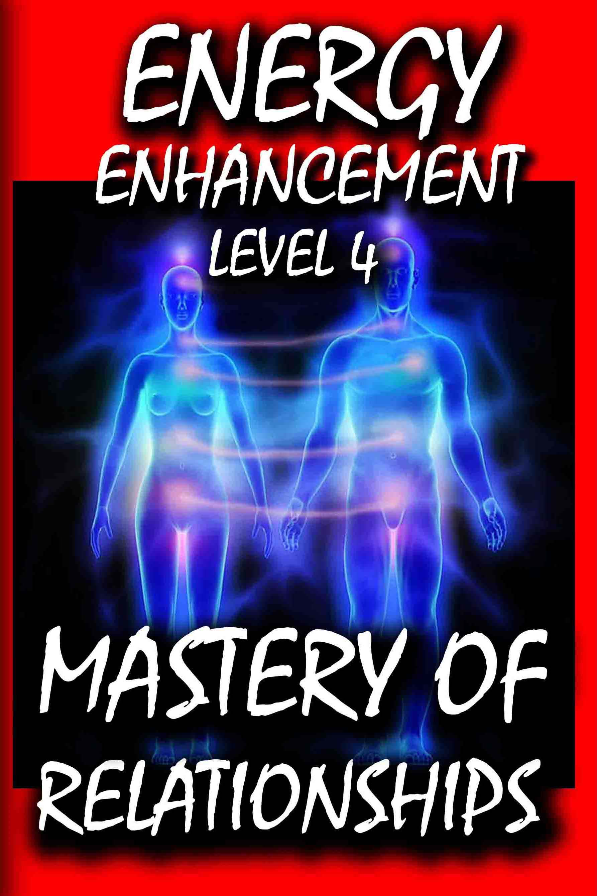

DEDICATION

With all Thanks, Love and Gratitude to Swami Devi Dhyani and the Energy Enhancement Book Editor Prema PraShakti who makes these books possible.
With all Thanks, Love and Gratitude to my Mother and Father and to all my other Teachers, Theos Bernard, Sri Yogendra, Eric Berne, Gurdjieff, Father Bede Griffiths, Osho, Zen Master Hogen, Swami Sivananda, Swami Satchitananda, and all the other giants upon whose shoulders I stand - who made me able to be what… I AM – Swami Satchidanand

Copyright © 2018

[Energy Enhancement Synthesis of Light Limited (SOL)]

All rights reserved. This publication may be reproduced in whole or in part, by any person under fair use as long as we are referenced, without written permission of:
Swami Satchidanand

sol@energyenhancement.org

www.energyenhancement.org

Table of Contents

Energy Enhancement Student, Feb 20 2014 8
GOLDEN LIGHT SURGES INTO MY BRAIN... 11
THOMAS BLAIR'S ENERGY EXPERIENCES!!! 18
Philip Chester Course Report 19
THE SOUL SYMBOL 22
STUDENT REPORT 25
STUDENT REPORT 26
ENERGY ENHANCEMENT COURSE REPORT FROM JEAN 28
ENERGY ENHANCEMENT AND TANTRA by SATCHIDANAND 47
THE PSYCHIC SEXUAL CONNECTION AND THE HOOKER!! 61
THE ATTAINMENT OF BUDDHIST "NON-ATTACHMENT"
BY UNPUGGING FROM THE MATRIX 64
ENERGY ENHANCEMENT WITH LISABET 72
When you receive energy correctly 80
IMPLANT BLOCKAGES WITH OUR STUDENT IN GOA 2010 83
THE MASTERY OF RELATIONSHIPS ENERGY CONNECTIONS
BETWEEN PEOPLE, BETWEEN THEIR CHAKRAS
AND ENERGY BLOCKAGES 86
EXPERIENCE GROUNDING NEGATIVE ENERGIES 87
ENERGY CONNECTIONS BETWEEN PEOPLE,
BETWEEN THEIR CHAKRAS
AND IMPLANT ENERGY BLOCKAGES 90
CONTROL IMPLANT BLOCKAGES 91
VAMPIRE IMPLANT BLOCKAGES 94
Energy Enhancement Student
experience of sexual Implants 95
HOMOSEXUALITY AND SEXUAL IMPLANTS 99
IMPLANT BLOCKAGES WITH OUR STUDENT IN GOA 2010 100
THE OPENING OF PSYCHIC VISION 109
ENERGY ENHANCEMENT RULES!! 113
THE MATRIX - UNPLUG FROM ENERGY ENHANCEMENT
ENERGY CONNECTIONS, ENERGY CORDS,
ENERGY BLOCKAGE IMPLANTS AND THE MATRIX 116
AGENT SMITH AND THE MATRIX 121
HONEY KALARIA JAN 2005 125
The Heart Centre and Relationships 131
Pierre Morency- What He Says!! 140
Craig Testimony 144
Testimonial From Gary Spaid a Wealth Counselor 146
Devi is pure magic. 146
THE PRINCESS OF SWORDS OF THE THOTH TAROT 148
THE PRINCESS OF DISCS OF THE THOTH TAROT 151
The Healing of the Negative Energy
of Close Personal Relationships 153
The True Energy of Love is the Energy of Change. 155
ENERGY ENHANCEMENT MASTERY OF BEREAVEMENT 160
HIGH TANTRA 162
Attachment And Relationships 164
THE SOLUTION TO PROBLEMS OF ATTACHMENT
AND THE MASTERY OF RELATIONSHIPS 166
John Bowlby - Attachment Theory 171
Ainsworth's "Strange Situation" Assessment 173
THE NAVEL CHAKRA AND THE MASTERY OF RELATIONSHIPS 184
THE NAGUAL DON JUAN, CARLOS CASTANEDA 185
ENERGY ENHANCEMENT MASTERY OF
ADULTERY AND DIVORCE 191
THE connector strategy 194
YOUR BLOCKAGES CAUSE YOU TO BE UNCONSCIOUS
OF WHAT YOU ARE DOING 203
TALENT GAMES 204
Please Join me in the Master Game of Enlightenment 205
REPORT - RELATIONSHIPS AND ENERGY CONNECTIONS 208
HOW ARE THEY STEALING YOUR SPIRITUAL ENERGY? 211
Satanism, Black Magic, Ordo Templi Orientis OTO,
Aleister Crowley, Luciferianism, Wicca 217
STUDENT REPORT - The Energy Enhancement
Course Level One, Initiation Three 218
Danisa Report 219
ENLIGHTENED RELATIONSHIPS
AND ENLIGHTENED ENERGY CONNECTIONS 225
INITIATIONS ON THE PATH OF
ENLIGHTENMENT AND RELATIONSHIPS 227
LEARN NON-ATTACHMENT 232
CHAKRA LINKS 237
ENERGY ENHANCEMENT ON THE COSTA BRAVA 240
The Mastery of Relationships. 242
The Mastery of Tantric Energy 243
CHAKRA LINKS 245
"THE MASTERY OF RELATIONSHIPS TESTIMONIAL
FROM STUDENT DON MINIHANE 247
Marie Report 252
THOMAS BLAIR IN ARGENTINA AND BRAZIL 254
SEVEN STEP PROCESS 285
Astral Sexual Addiction 288
STUDENT REPORT 12 JUNE 2015 306
HOW ARE THEY STEALING YOUR SPIRITUAL ENERGY? - 320
PROJECTION OUT OF THE BODY 322
COURSES IN ARGENTINA 324
WHAT DON MINIHANE SAYS OF HIS
TANTRA MEDITATIONAL EXPERIENCES 326
THE ENERGY ENHANCEMENT PATH OF PLEASURE,
SAMADHI, SAMYAMA, ENLIGHTENMENT 339
TOLKIEN CREATED THE LORD OF THE RINGS
TO OPPOSE THE WAGNERIAN RING CYCLE THOUGHTFORM 342
This Isn't a Game!! 345
The FREE!! Energy Enhancement
Infinite Wealth Home Training Program 347
Today I sat in a chair and listened
to the heart chant initiation 1 for the first time 349
Part of Satchidanand's Web Blog 351
What we feel... 354
Our Deepest Fear 356
DON MINIHANE JANUARY 2007 COURSE 359
The Mastery of Relationships,
Psychic Sex Connections 361
Why have Normal Psychic Sex Connections? 365
The Omphalos and the Om Phallus stone from Delphi 369
MANAGING PSYCHIC CONNECTIONS 372
Relationship Psychic Sex Connections and TANTRA 374
How to connect and disconnect appropriately 375
Raja Yoga and the Yoga Sutras of Patanjali 379
WHAT IS TANTRA? 382
Description of the Complete
Energy Enhancement Meditation Course 387

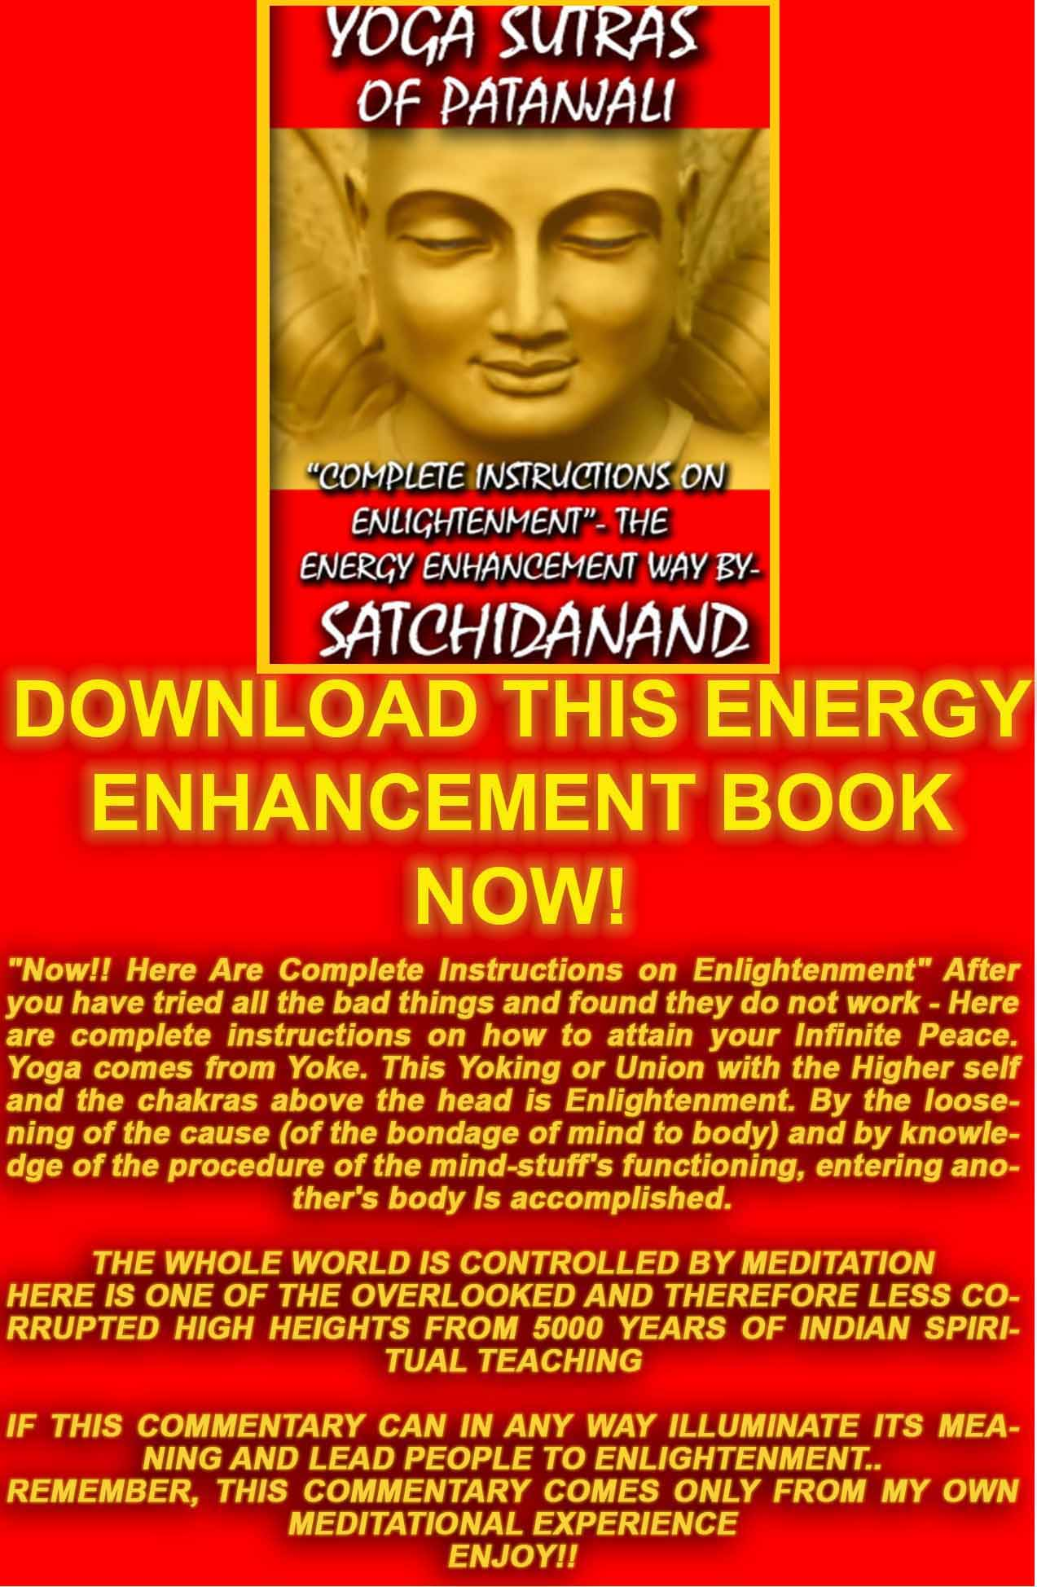
THE YOGA SUTRAS OF PATANJALI BY SWAMI SATCHIDANAND - DOWNLOAD HERE..
http://www.energyenhancement.org/Sacred-Energy/yoga-sutras-of-patanjali-book/Energy-Enhancement-Yoga-Sutras-of-Patanjali.pdf
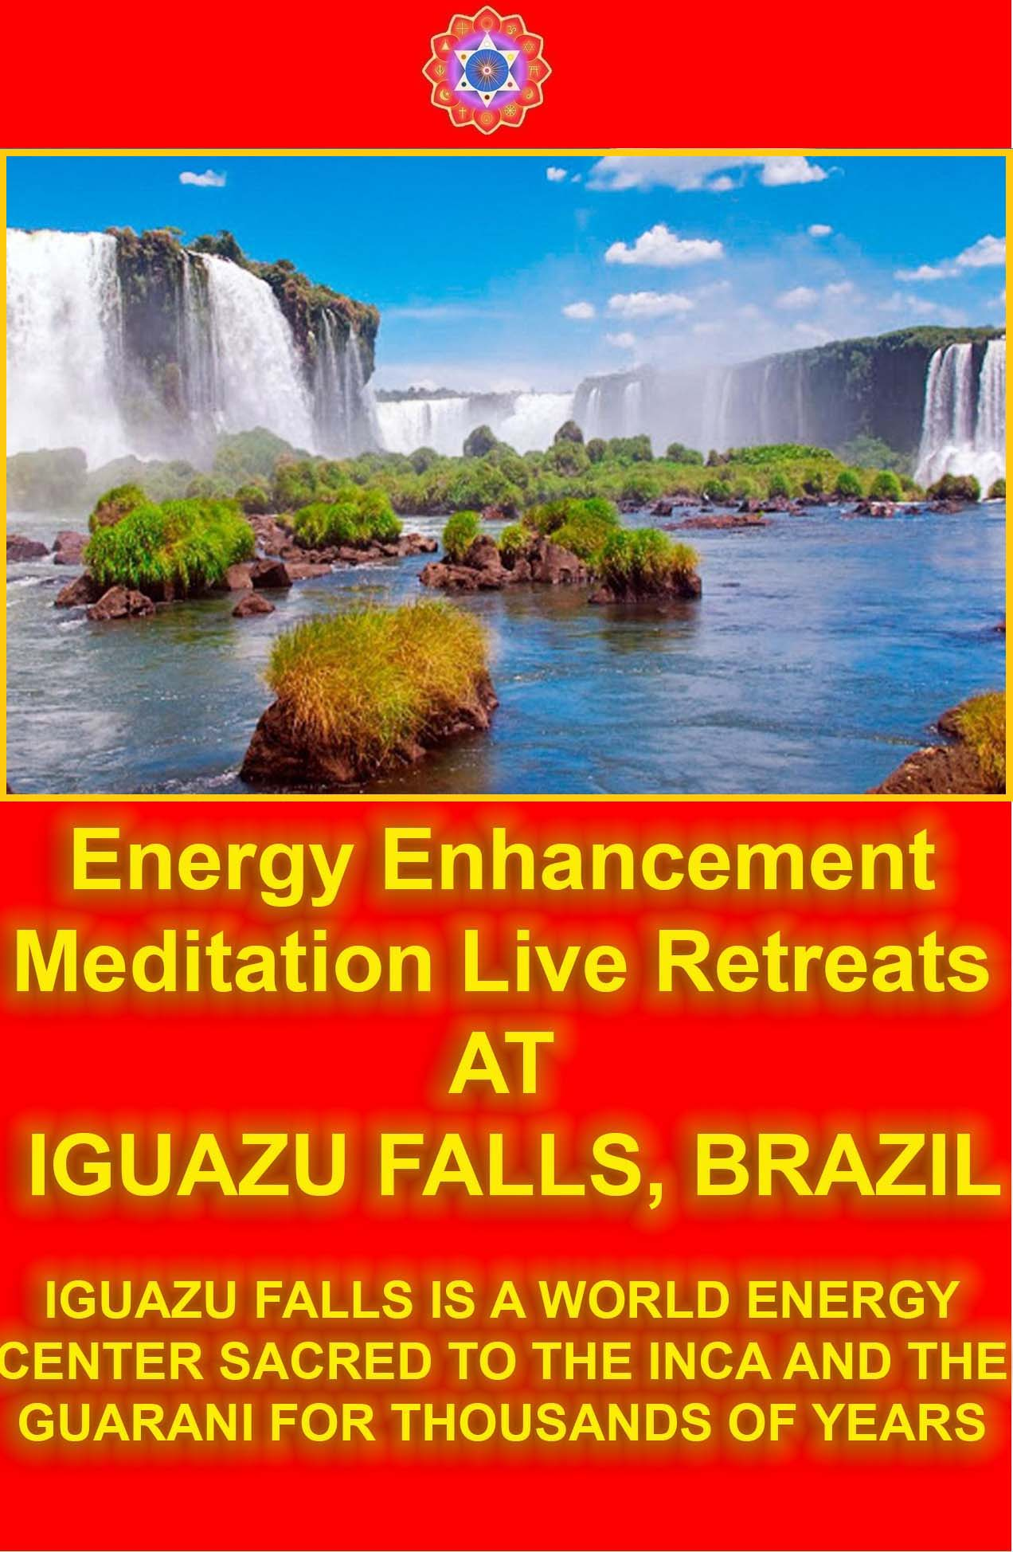
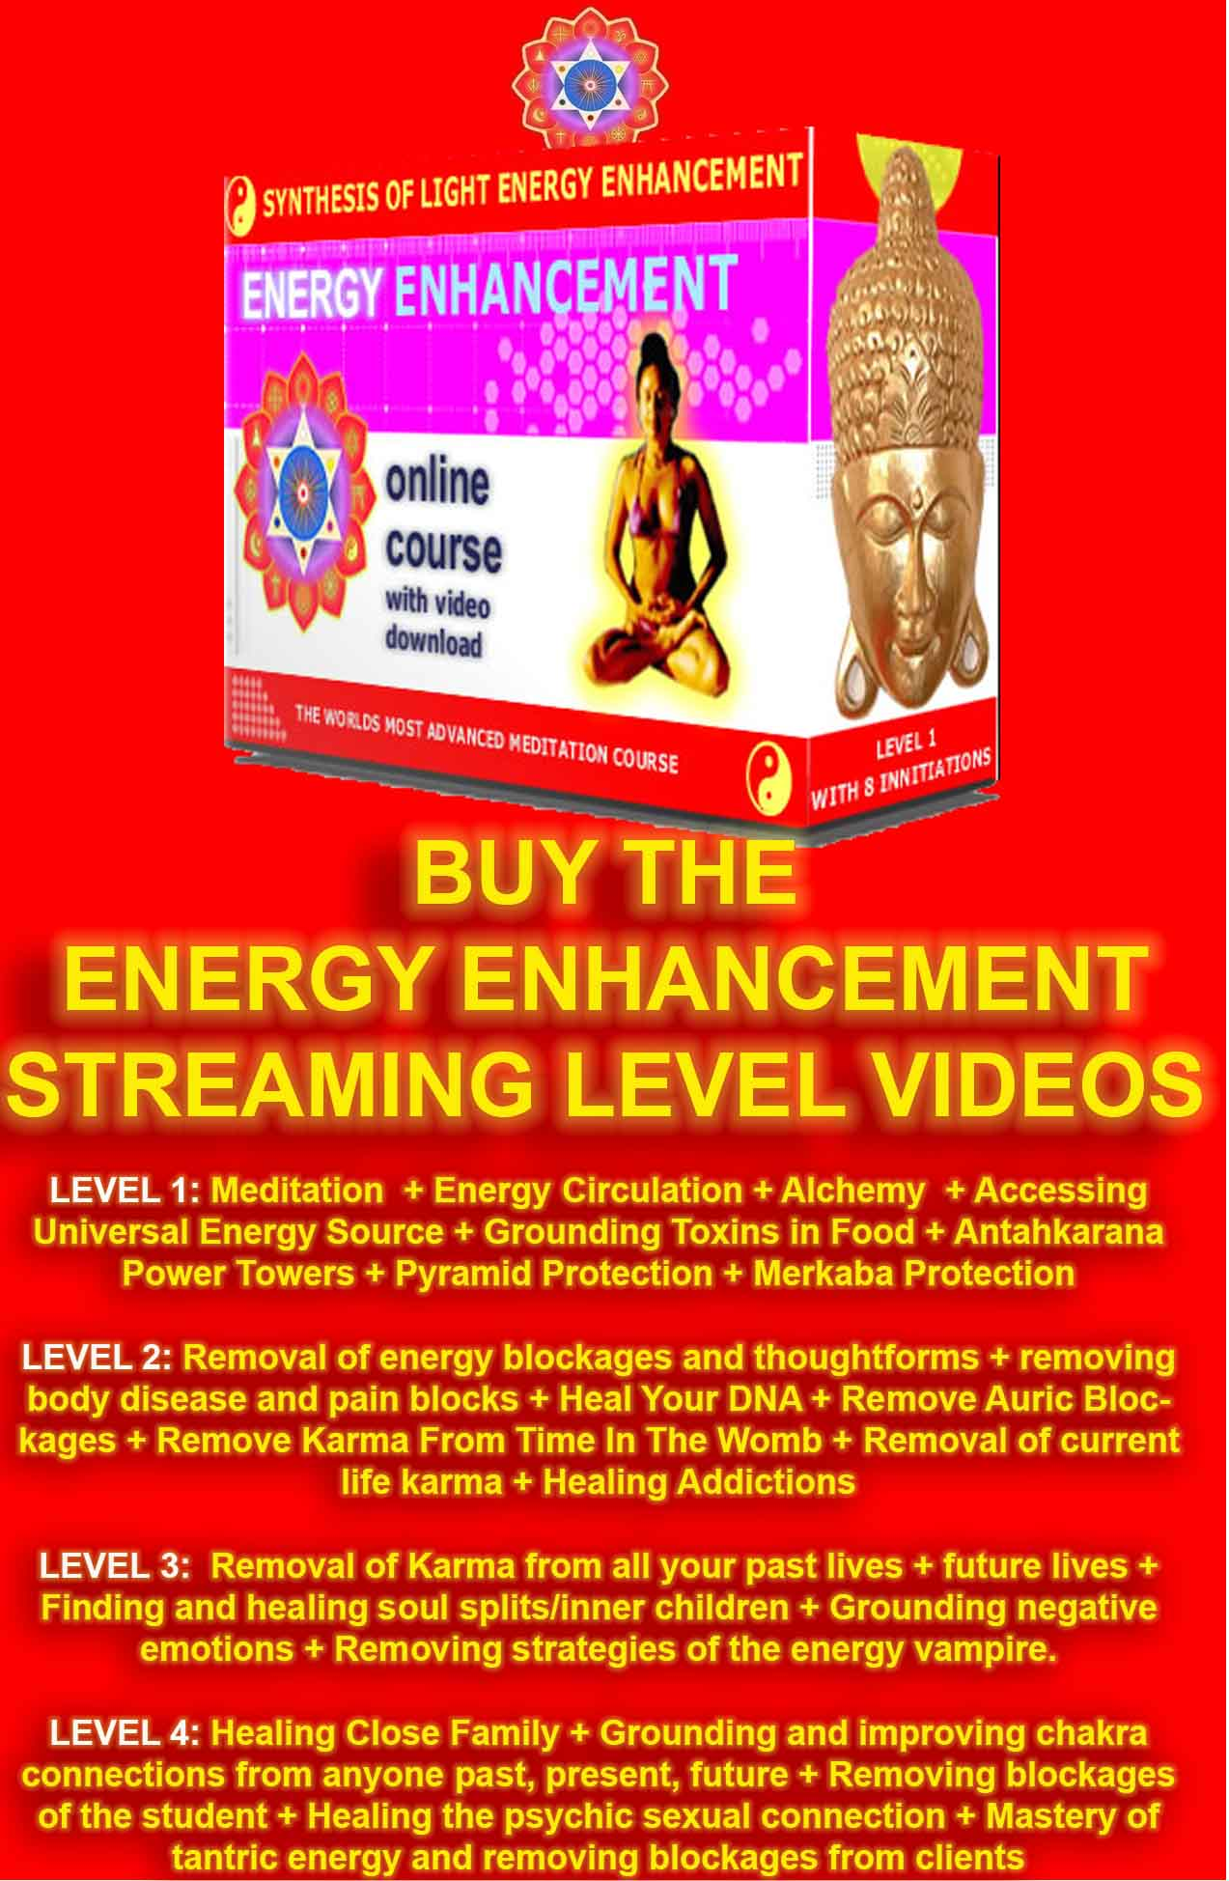

MEDITATION ENERGY ENHANCEMENT
APPRENTICE LEVEL 4 –

THE MASTERY OF VAMPIRE ENERGY
CONNECTIONS - ENERGY CORDS

THE MASTERY OF RELATIONSHIPS

THE REMOVAL OF EVEN THE DEEPEST ENERGY BLOCKAGES

"Traditional forms of meditation are designed to fail!!"

FIND ALL THE INCREDIBLE MEDITATION TECHNIQUES AND MEDITATION PRACTISES REMOVED FROM TRADITIONAL MEDITATIONS AND TAUGHT IN THE ENERGY ENHANCEMENT STREAMING VIDEO MEDITATION COURSE AND LIVE MEDITATION RETREATS IN BRAZIL AND INDIA

"WE PUT BACK WHAT THE OTHERS TOOK OUT!!"

THE MASTERY OF ENERGY CONNECTIONS BETWEEN PEOPLE

"TO SEAL THE DOOR WHERE EVIL DWELLS!!"

THE REMOVAL OF ENERGY CONNECTIONS TO BAD PEOPLE WHO POISON AND SUCK YOUR ENERGIES - THE ABILITY TO CUT BAD ENERGY CONNECTIONS TO, "TO SEAL THE DOOR WHERE EVIL DWELLS" - THE ATTAINMENT OF BUDDHIST "NON-ATTACHMENT"

ENERGY ENHANCEMENT IS THE ONLY SOLUTION

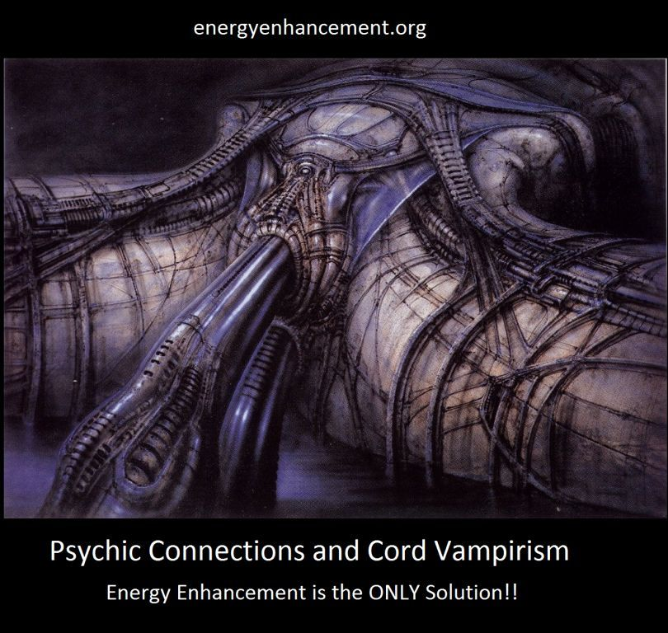

THE MATRIX - ENERGY ENHANCEMENT VAMPIRE ENERGY CONNECTIONS, ENERGY CORDS, ENERGY BLOCKAGE IMPLANTS AND THE MATRIX

In the Matrix, Implant Blockages are represented by the black studs all over the body;

In the Matrix, Energy Connections are represented by the tubes connecting to the implants



WE ARE AFFECTED BY ENERGY BLOCKAGES IN THE PEOPLE WHO CONNECT TO US - LEARN HOW TO REMOVE ENERGY BLOCKAGES AT THE OTHER END OF YOUR ENERGY CONNECTIONS IN OTHER PEOPLE. LEARN HOW TO AUGMENT YOUR PSYCHIC TALENT BODY WITH ALCHEMICAL GOLD - THE NEW METHOD OF ENERGY ENHANCEMENT EVOLUTION!!

-Energy Enhancement Student, Feb 20 2014

"It was after level 4 that I could meditate for a
easier for a much longer time. In that level you deal
with base cords and they are very draining. For me
they were the most vamping blocks to ground. When
grounded I had so much more energy. Literally from the
minute I starting clearing them. Clearing the base
cords it kicked up deep dark blockages which I
transmuted. The perverted angels that were too
perverted to go to an angel hospital I used as parts
for me. I built up my angel colonies using them. My
soul became bigger. I felt like I had taken some
kundalini steroids or something. I was larger, more
integrated into the one. Are we all transformers just
getting bigger and more talented?"

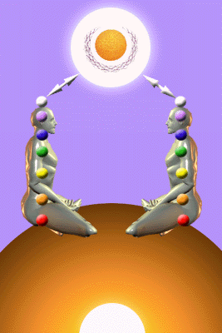

THE MASTERY AND HEALING OF RELATIONSHIPS
FOR High Tantra, Gandalfs and Jedis.



Meditation EE Level 4 High Tantra Psychic Energy Connections between Chakras - The Mastery of Relationships by using Meditation

ENERGY ENHANCEMENT COURSE - MASTER RELATIONSHIPS IN APPRENTICE LEVEL4
MASTER THE PSYCHIC ENERGY CONNECTION BETWEEN YOU AND ALL PEOPLE, CREATE INCREDIBLE RELATIONSHIPS - THE KARMA CLEARING PROCESS WITH ALL YOUR RELATIONSHIPS, FRIENDS, FAMILY, MOTHER AND FATHER, REMOVE BLOCKAGES FROM FRIENDS AND FAMILY, HEAL BEREAVEMENT, IMPOTENCE, CLEAN THE TIES WHICH BIND, THE HIGHEST HEART, THE MASTERY OF ADDICTIONS - DRUGS, ALCOHOL, TOBACCO, SEX, FOOD, POWER, MONEY, BUDDHIST NON - ATTACHMENT, THE MASTERY OF ATTACHMENT - DEPENDENT ATTACHMENT, PARASITIC VAMPIRE ATTACHMENT, SYMBIOTIC ATTACHMENT, ENLIGHTENED ATTACHMENT, THE SOUL CONNECTION, HEAL THE WORLD. BECOME A MASTER, A MERLIN, A JEDI KNIGHT, A WHITE MAGICIAN.

If you are serious about self-improvement, growth, change, enlightenment! Then the Energy Enhancement Course is for you.

JEAN, EE STUDENT

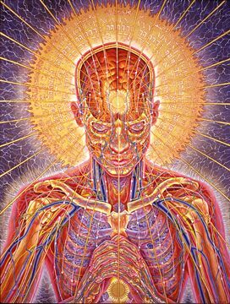

GOLDEN LIGHT SURGES INTO MY BRAIN...

"A POINT OF LIGHT EXPLODES, it opens and golden light surges in to my brain from the center of my head. Like liquid light it fills me up and at the same time the universe is born, the light expands forming energies that divide and merge forming particles eventually forming atoms, molecules wich form stardust stars solar systems galaxies, planets and the they form life, living cells that connect to form a physical brain, manifestation of the cosmic mind and consciousness, eventually reaching my cortex and I open my eyes and remember my self.

My center is the center of the universe, the circle is complete! I am absolutely everything. All time is curved around me, all galactic systems are me, all life is me and I am through this small body I am complete. My personal mind goes in to absolute shock, into hysterical laughter that I cannot stop. I am overflowing billion times billion. Infinite amount of information fills me in a timeless time, my consciousness is flowing from the beginningless beginning of all reaching the final destination of all.

The grand cycle is complete and I encounter all the infinite forms of existence as well as the formless forms of enlightenment beings, the future. I am, one with my self from the future! From the times of conscious creation. There is only space, all of my meridians are ONE! Stretching through all the creation. Then I leave my body and I am guided through many things that I cannot explain or remember in my current state."

As we were talking well into the night at the end of our Energy Enhancement Course together.

After he has removed many energy blockages over the last four weeks. Blockages above the crown chakra in the Antahkarana which were preventing him from re-connecting with the Source of all Life. He described one of the blockages between one million and Infinity of chakras above the head as a dense translucent crystal which was incredibly difficult to remove, different from the other blockages which he had found below it which were dense and covered with a black tarry substance or blood and which were more easy to transmute and dissolve.

We eventually get into a state of energy transfer. We both feel it as white light flowing from one to the other in an incredibly intense way which lasts for two hours. At the end of that time I perceive an initiation which is taking place on the astral plane. Surrounded by a group of ascended masters I introduce him to the chief initiator who uses the rod of initiation to touch his third eye with the intense energies of initiation so that his energies can never again drop into that state we call normal waking consciousness.

Never to lose the Light of Enlightenment, ever again. 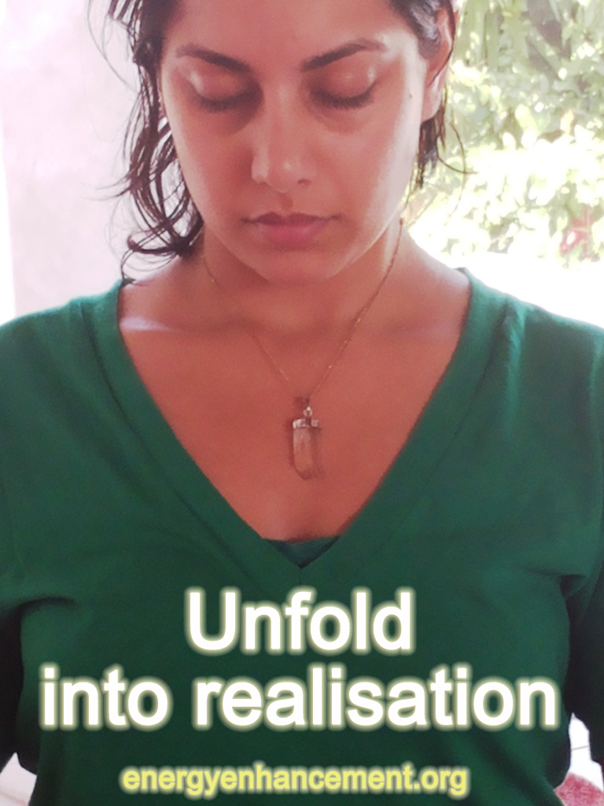

Get your asses over here Now and Speed Up your process of Enlightenment on the Energy Enhancement one month course!!

SATCHIDANAND

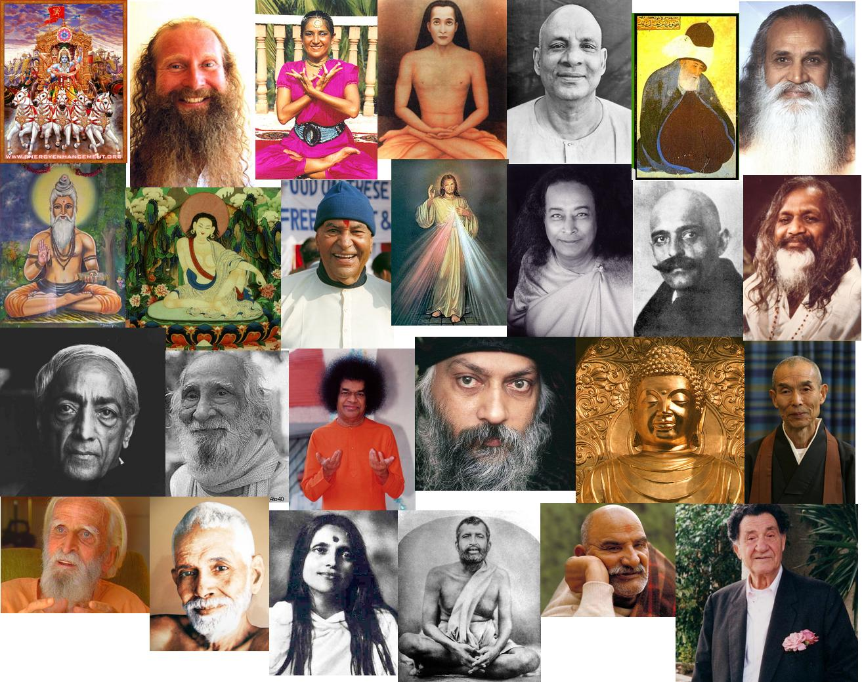

-Energy Enhancement, - An Advanced Meditation Course which gives the MOST benefits of any course of Meditational Self-Development available anywhere in the World today.

If you want to Master Meditation Energy, to get more Energy and to handle it better, this course is for You!

If you want to Speed Up the Meditative Process, rather than sitting with no result.

Energy Enhancement Advanced Meditative Techniques including the Kundalini Kriyas and the Five Taoist Elemental Pathways of the Chi, is for You!!!!

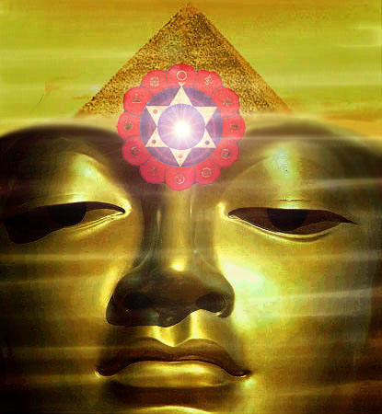

Whether you are a Management Corporate Executive, any sort of Alternative Practitioner, Meditator, Yogi or anyone who wants to Evolve, - Have Massive Energy Gains, become Better, Smarter, more Evolved, more Empathic, more Soul Infused, Gain the Real Secrets of Success; This course will Enable Direct Experience of Superior Life Performance.

Energy Enhancement Meditation Techniques are the quickest and easiest methods of evolution available, leading to Ultimate Happiness.

Energy Enhancement, The Most Advanced Techniques of Meditation Available, NOW!!

Developing Meditation psychic powers to Get in touch with your Life Path, Ground negative Energies, Access Infinite Levels of Universal Energy, Raise Your Kundalini, Integrate the Separated Selves, and Master Relationships and Mediation.

Meditation Energy Enhancement Enables FOUR Initiations towards your Ultimate Freedom - Illumination, Nirvana, Emptiness, - Enlightenment.

Energy Enhancement is a unique system to exponentially increase your energy by mastering the Mind, accessing inner peace, improving health, Mastering Relationships , creating synchronicity and luck, and improving your success.

Energy Enhancement is a Course of selfless, highly advanced, meditation techniques which can Quickly!! Increase the Speed of the normal Mind.

Energy Enhancement Synthesises, brings together ALL these gifts for the first time in one Course.-

To Enable Your Evolution!!

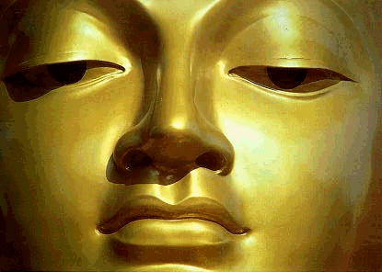

ENERGY ENHANCEMENT ILLUMINATION

THOMAS BLAIR'S ENERGY EXPERIENCES!!!

"Next, I came across a particularly stubborn blockage to remove, and knew that I would have to prepare myself well during meditation. I consciously sourced as much energy from above to flow through my body, and in doing so, rather than my body being filled with golden light, I had somehow tapped into an immense source of white light above the head. As well as feeling this increased energy stream through my body, I realised I had involuntarily suspended breathing somewhere near the top of an in breath. My body felt like a beacon of light, with more than enough energy to direct toward a blockage and watch it dissolve in an instant.

Since that time I am always connected to and able to source the white light from above my head. Many times during this process I just forget to breathe as though my breathing is just naturally suspended. I am now living in the Light!!

My energies are naturally far higher than when I arrived on the Energy Enhancement course just two weeks ago.

I am experiencing Energy, the fruits of meditation which normally arrive, if they do, after twenty years of meditation and it has only taken me two weeks."
- Thomas Blair September 2005 Course in Spain

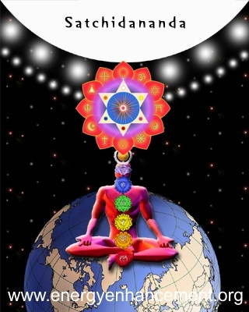
Philip Chester Course Report

"SATCHI PROVED THIS TO ME IN THE FIRST FIVE MINUTES OF OUR FIRST MEDITATION, BY PUTTING MY BACK AND TOP OF THE HEAD IN THE RIGHT POSTURE.

I IMMEDIATELY FELT A FLOW OF ENERGY GOING UP MY SPINE."

"Once this stage was reached I had tremendous energy!"
Philip Chester, Change Manager reporting to the Managing Directors of several Fortune 500 Companies.

"Enlightenment is attained by Meditation And Non-Attachment" - Yoga Sutras of Patanjali - RAJA YOGA

Buddhist Non-Attachment, "ATTACHMENT LEADS TO PAIN" - GAUTAMA BUDDHA

ATTACHMENT AND THE MASTERY OF RELATIONSHIPS
LEVEL 4 OF ENERGY ENHANCEMENT - INITIATIONS FOR THE MASTERY OF RELATIONSHIPS AND ATTACHMENT

THE-SOLUTION-TO-PROBLEMS-OF-ATTACHMENT-AND-THE-MASTERY-OF-RELATIONSHIPS-AND-ENERGY-CONNECTION-ATTACHMENT

THE MASTERY OF RELATIONSHIPS ATTACHMENT DEPENDENT PARASITIC SYMBIOTIC RELATIONSHIP ATTACHMENT THE MASTERY OF PSYCHIC ENERGY CONNECTIONS AND THE connector strategy
The Mastery of Relationships, Psychic Sex Connections, Energy Vampires Implants and the Initiations of Energy Enhancement Meditation.

Mastery of Relationships, Energy Connections, Implants

ENERGY ENHANCEMENT TANTRA AND ENLIGHTENMENT

THE SOUL SYMBOL

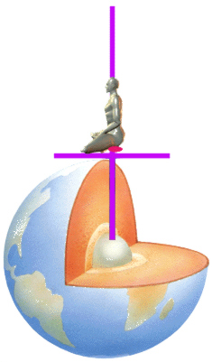

THE DIAGRAM ABOVE IS AN ENERGY ENHANCEMENT GUIDED MEDITATION TO PUT YOU IN TOUCH WITH THE SOURCE OF KUNDALINI ENERGY TO ACCELERATE YOUR EVOLUTION - THE CENTER OF THE EARTH - KUNDALINI CHAKRA.

THIS CONNECTS THROUGH THE SEVEN CHAKRAS IN YOUR BODY - OUT INTO THE SOUL CHAKRA, ALL THE WAY TO THE CENTER OF THE UNIVERSE AND THE ONE GOD WITH 10,000 NAMES.

THIS SYMBOL ABOVE IS THE SOURCE SHAPE OF ANCIENT SACRED SYMBOLS - GREEK - AXIS MUNDI, OMPHALLOS, THE TAU, EGYPTIAN - THE ANKH, MASONIC - SQUARING THE CIRCLE, CHRISTIAN - THE CROSS, TROUBADOURS MYTH OF ARTHUR - THE SWORD IN THE STONE, THE SWORD OF SAINT MICHAEL, HINDU - THE YONI SHIVALINGAM, SUFI - THE FOUNTAINS AT THE ALHAMBRA, THE MOORISH ARCH, THE KEYHOLE, THE CATHARTIC CATHARS - SUFI - THE LUTE (TROUBADOUR - ABJAD ROOT TRB - MEANS LUTE IN ARABIC) AND THE SUFI NAQSBANDHI KUNDALINI KEY –

FROM 5000 YEARS OF SUCCESSFUL SPIRITUAL TECHNOLOGY - SIMULTANEOUSLY THE SOURCE OF EGYPTIAN, MASONIC, TAOISM, SUFI, HINDUISM AND CHRISTIANITY - ENERGY ENHANCEMENT IS THE SYNTHESIS OF ALL RELIGION - READ THE ENERGY ENHANCEMENT BOOK - BUY IT NOW

"SUPER ENERGY AND SACRED SYMBOLS"

THIS BOOK GIVES THE HISTORICAL BASIS OF ONE GUIDED MEDITATION SAMYAMA WHICH IS THE BASIS OF ALL THE MAJOR WORLD RELIGIONS - EGYPTIAN, TAOIST, HINDU, CHRISTIAN - AS TAUGHT IN ENERGY ENHANCEMENT

ENERGY ENHANCEMENT IS THE SYNTHESIS OF ALL RELIGION

THIS IS THE ONE BOOK WHICH CAN TOTALLY CHANGE THE WORLD!!

GAIN SUPER ENERGY - ELIMINATE ENERGY BLOCKAGES

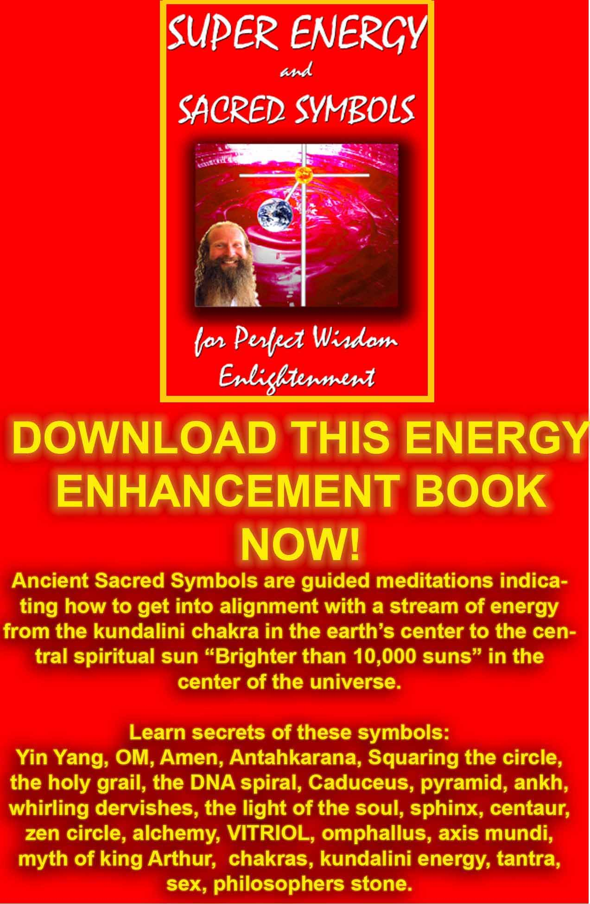
DOWNLOAD SUPER ENERGY AND SACRED SYMBOLS HERE!!!
http://www.energyenhancement.org/Sacred-Energy/Meditation-Super-Energy-And-Sacred-Symbols-for-Perfect-Wisdom-Enlightenment-Color-energyenhancement-org.pdf

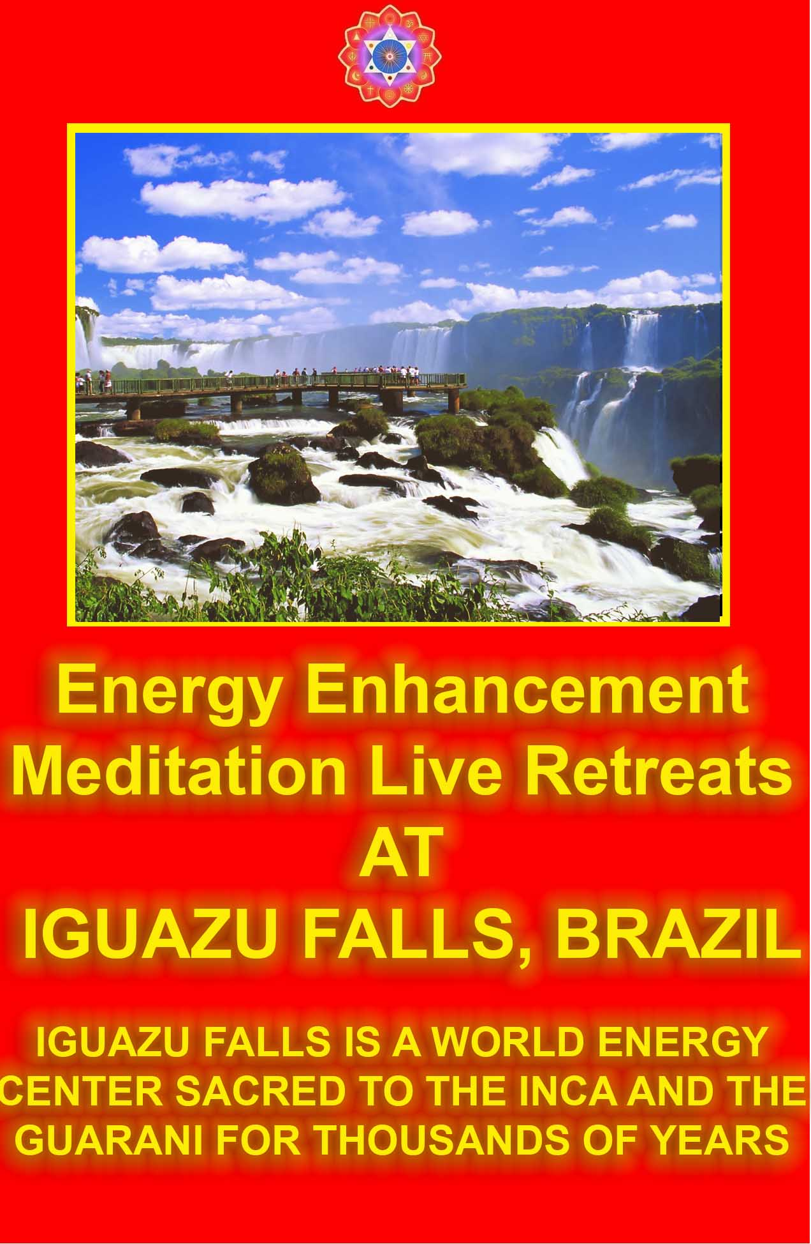
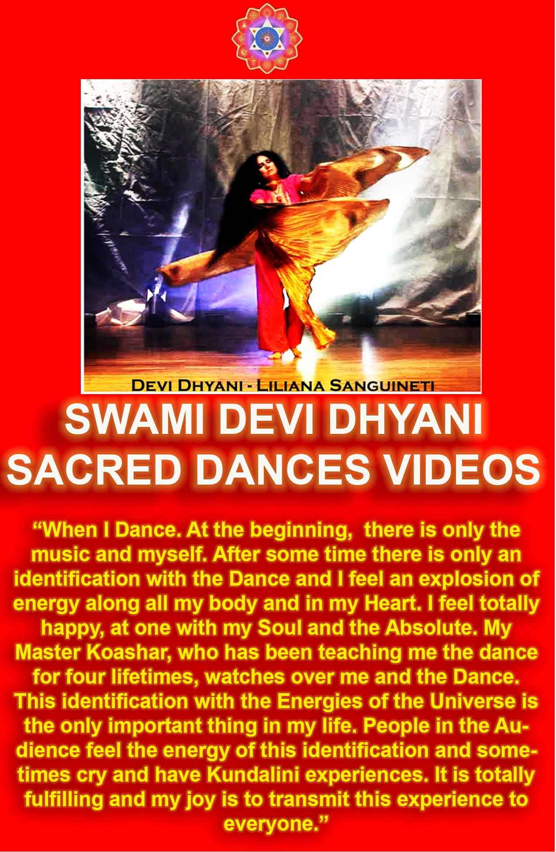

STUDENT REPORT

Today I sat in a chair and listened to the heart chant initiation 1 for the first time.

I was focusing on aligning my shoulders and spine forward and backward between the two lines of power from the center of the earth. And picturing the immovable mountain. Focusing on my breathing, closing the anus. I stayed in for the first four minutes. Then I got tired and openned my eyes, for about 7 or 8 seconds. Then I was so drowsy I had to close my eyes again. Then after about another four minutes I was tired again. Then the same thing but this time I focused on nothing but the energy from the earth entering the base of my spine and coming into my heart. Right from the beginning of the meditation I felt my energy all over my whole chest, even now.

But at the last when I focused on it coming from the earth, I immediately felt very, very powerful energy and I didn't move to find it. My back straightenned up automatically to the alignment and I was kind of "stuck" in that position with the power flowing.

From there it was hard for me to stop meditating when the chants were over. Very powerful. Even without magnets. My question is about my focusing. Is it wrong to "imagine" the power or the alignment or the energy? or should we imagine until we feel it? Or both? Am I focusing on the right things?

I am very grateful for your teachings. Thank you for your generosity.

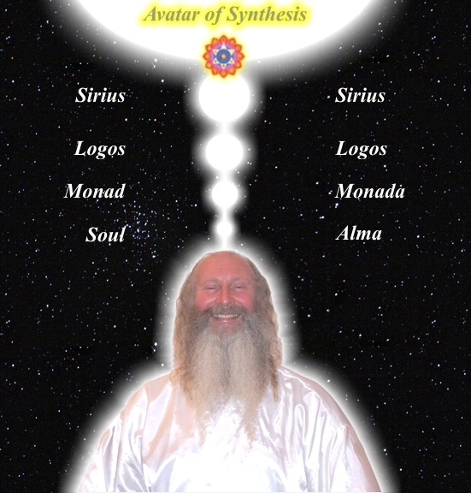

Student Report

Also I noticed as soon as satchi emailed me, I got a down-pouring of light from above the crown which kept charging me up the rest of the day – and my cravings died out! Then I realized they were ego-blockages and that I did not want them.

This Energy Enhancement Level One Initiation Three - ALCHEMICAL VITRIOL is great! I've done it some more and it's incredibly powerful. I don't know why it isn't more well known or taught? It's really bringing up little blockages which are complaining while being pushed down into the earth's core to get purified.
The hot fire energy has gotten much stronger in my body while doing the practice, mostly the base of the spine heats up, but also the middle of the spine. There are lots of little blockages being noticed. But I'm pushing them out.

Energy Enhancement Meditation Course Level 1 Initiation 4: Accessing the Universal Energy Source: Soul Fusion - INFINITE ENERGY!! for You!! via the Antahkarana, Macrocosmic Orbit, The Energy Enhancement Supra Galactic Orbit, Chakras above the Head, Advanced Kundalini Kriyas, Siddis, The Creation of Psychic Vision.

http://www.energyenhancement.org/EE-Meditation-Level-1-Initiation-4-Macrocosmic-Orbit-EE-Supra-Galactic-Orbit-Antahkarana-Chakras-Above-the-Head-Advance-Kundalini-Kriyas-Siddis.html

ENERGY ENHANCEMENT MEDITATION ENLIGHTENMENT AND ILLUMINATION
ENERGY ENHANCEMENT SPEEEDS UP!! YOUR PROCESS

FIND ALL THE INCREDIBLE MEDITATION TECHNIQUES AND MEDITATION PRACTISES REMOVED FROM TRADITIONAL MEDITATIONS AND TAUGHT IN THE ENERGY ENHANCEMENT STREAMING VIDEO MEDITATION COURSE AND LIVE MEDITATION RETREATS IN BRAZIL AND INDIA

ENERGY ENHANCEMENT COURSE REPORT FROM JEAN

"I have experience of many forms of meditation and practices for self improvement including: Transcendental meditation (TM) 12 years, Kriya Yoga 9 years, Sushila Buddhi Dharma (SUBUD) 7 years, and more recently the Sedona Method and the Course in Miracles. The Energy Enhancement programme encapsulates and expands all of these systems, it is complete and no questions are left unanswered."

Jean, NUCLEAR ENGINEER, FROM THE SEPTEMBER 2005
ENERGY ENHANCEMENT COURSE

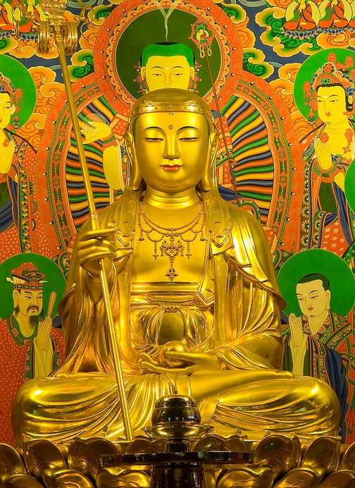

I felt immense happiness and peace at their presence, they had an aura of intense holiness and purity - great Saints and Sages.

As they faced me and bowed one by one I felt a feeling of unworthiness but the thought came immediately "worthiness is not necessary, by the grace of God infinite love and light is offered to each of us every moment all we need do is accept it".

I felt that they were very pleased with my practice and had appeared to me to let me know. I think it is important to say that I was in no way unique.
Most of the other students this year and last year had experiences of meeting beings of light, ascended masters and angels - EE has that effect!
Come and experience it for yourself you won't be disappointed.

JEAN

Truly, perhaps Enlightenment is next!!
You will probably find this interesting. Jenny who came on the Energy Enhancement course with me this year went to see her accupuncturist which she does routinely.

This guy (Ross) seems very talented, by reading her pulse he can tell her what she has been eating - certain energy patterns apparently. Anyway when he checked her pulses this time he found something interesting.
Apparently there is a pulse which gives an indication of the level of spiritual energy.

Jennies' spiritual energy was reading off the scale, something Ross said he has never seen before with Jenny or anyone else.
He says people just don't have this pulse and as far as he knows the only way to get it is to connect to external sources which as you know we did on the Course - wow!

Truly, perhaps Enlightenment is next!!

Kindest Regards & Thanks as always
Jean

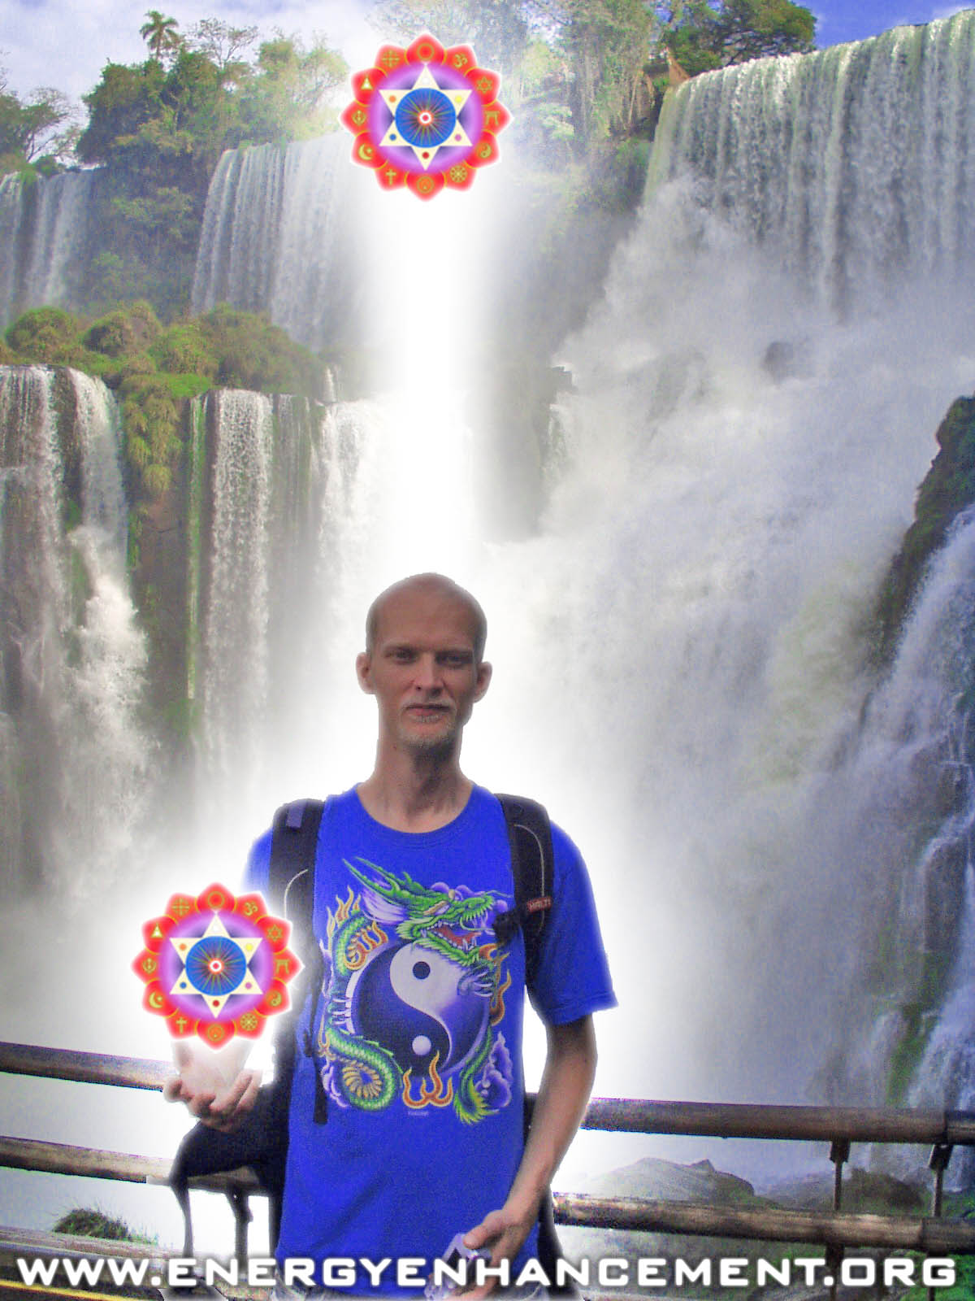

ENERGY ENHANCEMENT COURSE AT IGUAZU FALLS. BRAZIL

"Get your asses over here Now and Speed Up your process of Enlightenment on the Energy Enhancement one month course!!" - DON
Every one of our Students gets this Spiritual Experience of Connection with Infinite Energies.
Energy Enhancement does indeed, "SPEED UP THE PROCESS!!"
And they all get this Experience of Light, Life and Infinite Energy just with the Energy Enhancement Course - Every One of Them!!
LEVEL 1 - 4 VIDEO COURSES ANYTIME IN THE COMFORT OF YOUR OWN HOME

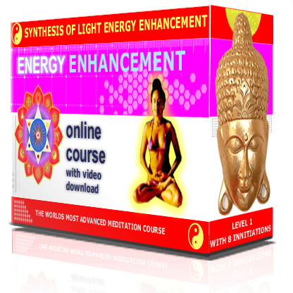

ENERGY ENHANCEMENT MEDITATION ENLIGHTENMENT AND ILLUMINATION

THE INCREDIBLE MEDITATION COURSE AND MEDITATION TECHNIQUES CREATED TO PRODUCE ENLIGHTENMENT AND ILLUMINATION

"ALL TRADITIONAL MEDITATIONS HAVE BEEN DESIGNED TO FAIL" - SATCHIDANAND –

"BECAUSE ORIGINALLY ALL MEDITATIONS CONTAINED THE TECHNIQUES OF, "THE REMOVAL OF ENERGY BLOCKAGES", "THE KUNDALINI KEY" AND OF, "ALCHEMICAL VITRIOL" TO GROUND NEGATIVE ENERGIES AND TO NATURALLY INCREASE KUNDALINI ENERGY"

"NOW, ONLY ENERGY ENHANCEMENT MEDITATION TEACHES THESE TECHNIQUES WHICH SPEED UP THE ENLIGHTENMENT PROCESS"

CLICK HERE FOR..
YGGDRASIL IS THE KUNDALINI KEY
AND

VITRIOL – Visita Interiora Terrae Rectificando Invenies Occultem Lapidem

Translation of VITRIOL.. "Visit the Center of the Earth there you will find the Philosophers Stone, Kundalini Chakra, which transmutes all Negative Energy, All Pain, All Negative Karmic Mass, into Pure Positive Spiritual Energy. By changing the direction of that Energy along the Path of the Soul, Soul Chakra, Central Spiritual Sun, First Chakra Above the Head you will receive Enlightenment"

"IF YOUR TRADITIONAL MEDITATION DOES NOT TEACH YOU ABOUT THE THE REMOVAL OF ENERGY BLOCKAGES KUNDALINI KEY AND ALCHEMICAL VITRIOL, THEN IT HAS BEEN DESIGNED TO FAIL"

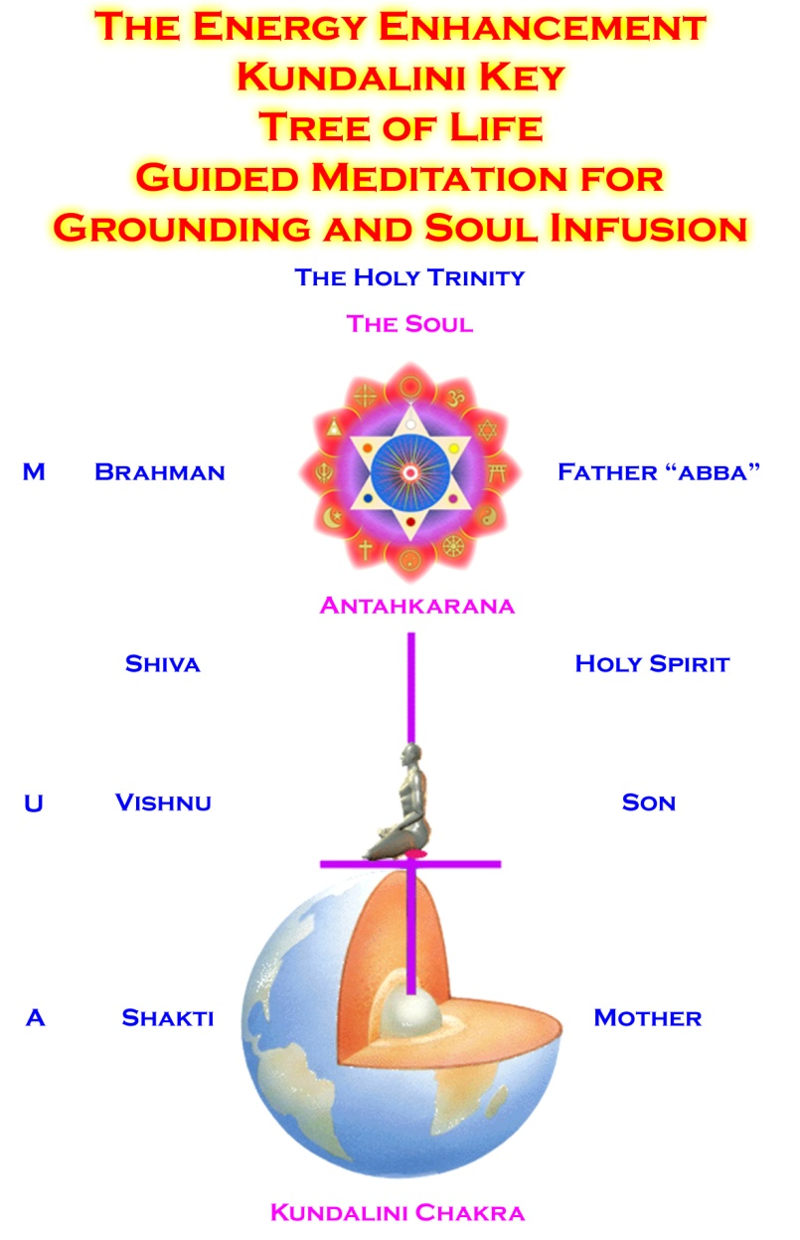

FIND ALL THE INCREDIBLE MEDITATION TECHNIQUES AND MEDITATION PRACTISES REMOVED FROM TRADITIONAL MEDITATIONS AND TAUGHT IN THE ENERGY ENHANCEMENT STREAMING VIDEO MEDITATION COURSE AND LIVE MEDITATION RETREATS IN BRAZIL AND INDIA
THE ENERGY ENHANCEMENT VIDEO MEDITATION COURSE

ENERGY ENHANCEMENT - THE ULTIMATE MEDITATION COURSE!!
ANCIENT EFFECTIVE ENERGY ENHANCEMENT MEDITATION SECRETS
ALL THE MEDITATION TECHNIQUES!!
SUCCESSFUL
SPEED UP YOUR PROCESS!!
PROVEN
TIME TESTED
TRUE

THE MOST ADVANCED MEDITATION COURSE, MEDITATION TECHNIQUES AND MEDITATION PRACTICES ON THIS PLANET, INCLUDING THE THE REMOVAL OF ENERGY BLOCKAGES KUNDALINI KEY, THE KUNDALINI KRIYAS, ALCHEMICAL VITRIOL AND KUNDALINI YOGA IN 28 INITIATIONS!!
SPEED UP THE PROCESS!!

"I have experience of many forms of meditation and practices for self improvement including: Transcendental meditation (TM) 12 years, Kriya Yoga 9 years, Sushila Buddhi Dharma (SUBUD) 7 years, and more recently the Sedona Method and the Course in Miracles.

The Energy Enhancement programme encapsulates and expands all of these systems, it is complete and no questions are left unanswered."

JEAN - NUCLEAR ENGINEER

WHY JUST SIT? - YOU NEED REAL SPIRITUAL EXPERIENCE - FAST!!

READ BELOW ALL THE TECHNIQUES TAKEN OUT OF TRADITIONAL MEDITATIONS AND PUT BACK BY THE ENERGY ENHANCEMENT MEDITATION COURSE!!
- RESTORING THE ENERGY ENHANCEMENT KUNDALINI KEY

Phillip Chester

Phillip Chester - Change manager working directly to the Managing Directors of several fortune 500 companies.

"I feel that I have been given some secret knowledge, which was only given to the initiated, or hidden among a lot of unnecessary sub techniques in other disciplines."

"The energy techniques given in Energy Enhancement have never been explained to me in Aikido (even Ki Aikido), Yoga or Ashtanga Yoga or on any meditation course that I have been on like Transcendental Meditation, and have only been partly taught to me previously by Taoist Master Mantak Chia and on Tantra Courses. Mantak Chia I found particularly confusing; Chi Gung I found awkward"

"ENERGY ENHANCEMENT GOES MUCH FURTHER THAN ALL THE ABOVE, IN A MORE EFFECTIVE WAY THAT ANY OF THE OTHERS I HAVE EXPERIENCED..."

One effect of Energy Enhancement is that I can no longer look at other disciplines like Ashtanga Yoga, Transcendental Meditation, NLP, Aikido and Ki Aikido and Mantak Chia and his Chi Gung, in the same light, because they do not contain this learning.

Phillip Chester - Change manager working directly to the Managing Directors of several fortune 500 companies.

MEDITATION ENERGY ENHANCEMENT - THE CORE ENERGY TECHNIQUES!!

THE MOST ADVANCED MEDITATION TECHNIQUES ON THIS PLANET, IN 28 INITIATIONS!!

ANCIENT EFFECTIVE ENERGY ENHANCEMENT SECRETS -
SUCCESSFUL
PROVEN
TIME TESTED
TRUE

TO ENQUIRE ABOUT ENERGY ENHANCEMENT COURSES PLEASE SIGN ON TO OUR MAILING LIST AND THEN EMAIL US DIRECT FROM THE EMAIL ADDRESS WE SEND YOU FROM OUR MAILING LIST

email sol@energyenhancement.org

PICTURE OF MOVING FLASH VIDEO SHOWING THE ANTAHKARANA CONNECTING WITH THE CENTER OF THE EARTH AND THE CENTER OF THE UNIVERSE - FREE WITH THE ONLINE AND DVD COURSES!!

INITIATIONS 1 TO 8 OF LEVEL 1 - GAINING THE ENERGY OF ENLIGHTENMENT

ENERGY ENHANCEMENT INITIATION 1 - Meditation: Shaktipat Kundalini Stopping the mind and Squaring the Circle

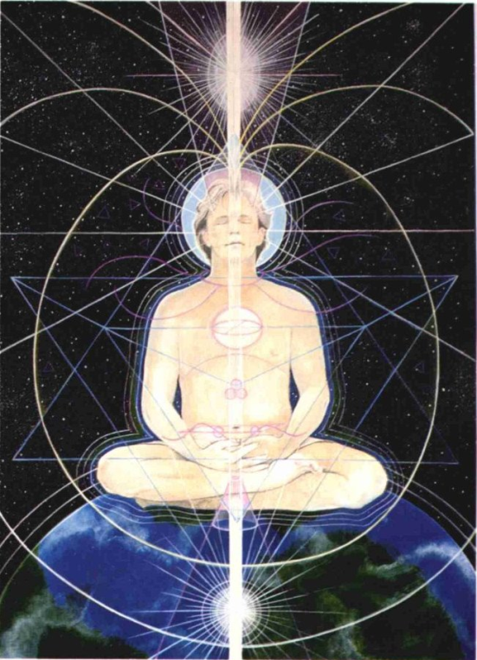

ENERGY ENHANCEMENT INITIATION 2 - Energy Circulation: Microcosmic Orbit, Kundalini Kriyas



ENERGY ENHANCEMENT INITIATION 3 - Advanced Kundalini Kriyas - Taoist Earth Orbit - The Grounding of Negative Energies: Alchemy, Hermes Trismegistus VITRIOL Visita Interiore Terrae Rectificando Invenies Occultem Lapidem and Earth Connection

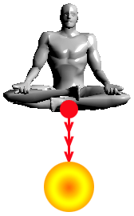

ENERGY ENHANCEMENT INITIATION 4 - Accessing the Universal Energy Source: Macrocosmic Orbit, The Energy Enhancement Supra Galactic Orbit, The Creation of the Antahkarana - Projection - Leaving the Body - the Immortality of the Soul - Connect with the Higher Chakras above the head - Advanced Kundalini Kriyas - Siddis - The Creation of Psychic Vision
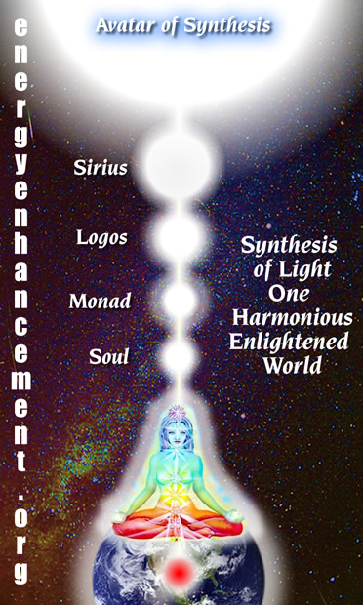

ENERGY ENHANCEMENT INITIATION 5 - ENERGY PROJECTION in External Antahkaranas - Grounding Toxins in Food: Re-awakening our psychic ability to detect poisons. REMOVING BLOCKAGES.

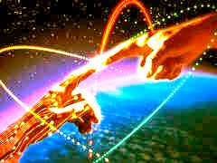

ENERGY ENHANCEMENT INITIATION 6 - Psychic Protections: Power Towers - Creating and Using External Antahkaranas - Exponentially Increasing your Spiritual Energy - Creating the Flow from Heaven to Earth



ENERGY ENHANCEMENT INITIATION 7 - Psychic Protections: Pyramid Protection

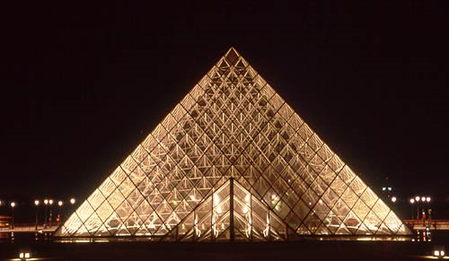

ENERGY ENHANCEMENT INITIATION 8 - Psychic Protections: How to Use THE MERKABA - Astral Travel and Projection - Advantages of the Siddhis of Becoming Bigger and Smaller

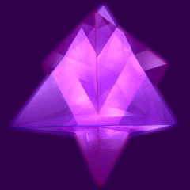

"I have experience of many forms of meditation and practices for self improvement including: Transcendental meditation (TM) 12 years, Kriya Yoga 9 years, Sushila Buddhi Dharma (SUBUD) 7 years, and more recently the Sedona Method and the Course in Miracles. The Energy Enhancement programme encapsulates and expands all of these systems, it is complete and no questions are left unanswered."

Jean, NUCLEAR ENGINEER, FROM THE SEPTEMBER 2005
ENERGY ENHANCEMENT COURSE

ENERGY ENHANCEMENT AND TANTRA by SATCHIDANAND

WHAT IS TANTRA?

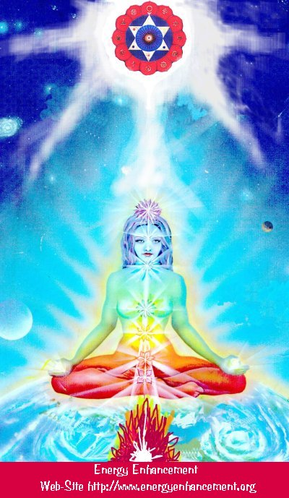

TANTRA IS ONE OF THE MANY PATHS WHOSE AIM OR END OR PURPOSE IS ENLIGHTENMENT

Like Yoga which means Union with the center of the Universe or with God, Tantra is any path which achieves that aim.

For many, Tantra is a sexual means of achieving that union. People ask me, isn't one of the methods to make love only once per month? To increase the length of time we make love to hours?

Well, I reply, Enlightenment comes from the increase of energy. Human beings only have a small amount of energy within themselves. Really to increase that energy we need to access the energy from chakras outside the body. It is like we have a computer which is running slowly on only five volts. We need to plug ourselves into the big generator!

To obtain thousands of volts of power in order to make the computer work more quickly at a much higher level we need to plug ourselves into the chakras above the Crown Chakra, into energy in the central spiritual sun!! The Soul!! God!!!

And in the center of the Earth is the Kundalini Shakti flowing out in every direction from the Atomic Generator which powers this planet. The atomic pile in the center of the planet is a 5000 degrees centigrade and provides the energy which keeps this planet alive and at the correct temperature. The Earth is feminine. The Indians say, "Our Mother, the Earth" and our Father, who art in Heaven is God, the energy in the center of the universe. And when all the Energy Blockages to that connection have been removed, then there is a flow, a waterfall of spiritual energy which powers every one of the enlightened.
Then we have Shiva, our father, combining with Shakti our mother. Then we have Hercules, son of God, Zeus, Theos, Deos, combining with the daughter of Pluto, King of the Underworld.

Enlightenment concerns The Holy Trinity and is composed of Sat, the truth of the center of the Universe combining with Chitta - the holy grail, the cup of the mind on this planet, empty and ready to receive the libation of the Gods, and the flow of energy between the two is called Ananda, or bliss - Satchitananda like the Father - Our Father who art in Heaven, the Son and the Holy Spirit which flows between the two.

And the Hindus have a word for the channel between the Center of the Universe and the Center of the Earth. Rapunzel, Rapunzel, let down your hair. The Rainbow Bridge. The Tower of Babel. Tower of Connection created out of mental matter to channel the energies of God through all the infinite chakras of existence, powering the whole universe from the center. This is the Antahkarana.

If you are not connected with, if you are blocked from, the center of the universe then just think of a small flow of water slowly filling a bucket. You may well have to wait a month for the bucket to fill. Only then will you have sufficient energy to enjoy making love, or really doing any of the thousand things we have to do on this planet. But if you are connected and put your bucket under a waterfall, then that bucket will fill in seconds. You will have infinite energy to do with whatever you want every second of the day.
The Greeks had a name for this energy which descends from the soul to power the Mind Computer, and they called it Genius which is the what happens to the mind computer powered by the energy of the Soul. Soul Infused.
The Mind is of the intellect of logic yet the Soul is Intuition, Knowing, Wisdom and is much higher than the mind.

The Kashmir Shaivites also have the energy of Chit Shakti whereby the mind is also powered by the Energy in the Center of the earth.
In reality, human beings are powered by both masculine and feminine energies. We connect with the Kundalini Chakra in the center of the earth by means of the Base chakra, and we connect with the center of the universe by means of the Crown Chakra.

Usually it takes three days for the students who come on our courses to access this energy with which they can successfully transmute all their Energy Blockages because another, more easy way for people to absorb energy is from the Buddhafield, the Aura of the Master.

When they leave then sometimes the energy drains away, because it is the energy blockages which create the holes in the bucket through which all the water drains away.

And this is Tantra, the Energy Flow of the Soul created by the Sexual Union of Shiva and Shakti.

In that that bliss, that delight, such an overflowing cornucopia of Energy which comes from the Gaining of Energy and the Removal of Energy Blockages, we find only Enlightenment.

In a way, Enlightenment is a twenty-four hour a day orgasm.

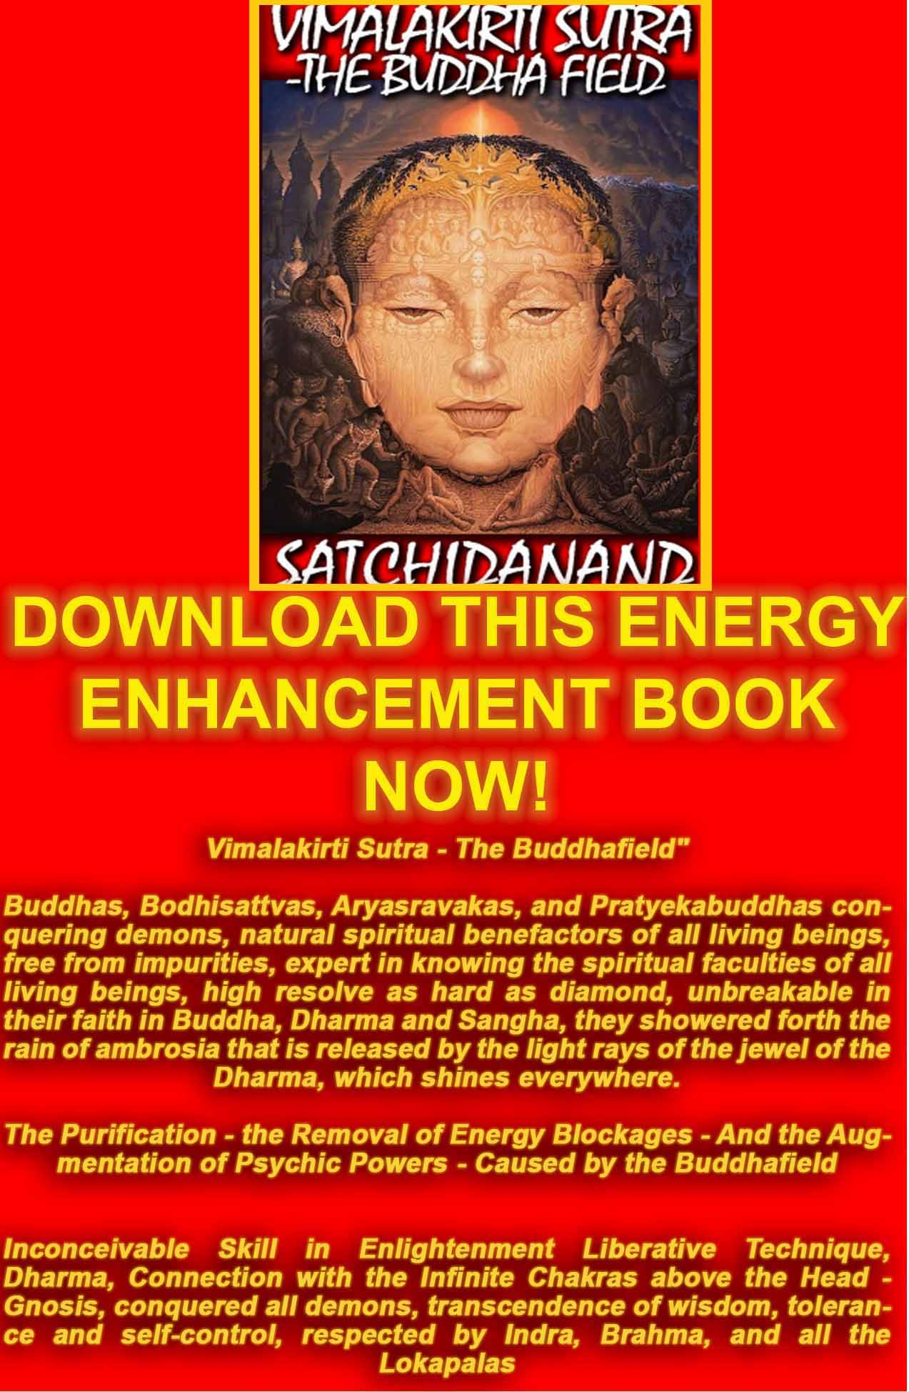
VIMALAKIRTI SUTRA THE BOOK!!
DOWNLOAD BELOW
http://www.energyenhancement.org/Vimalakirti-Sutra/vimalakirti-sutra.pdf

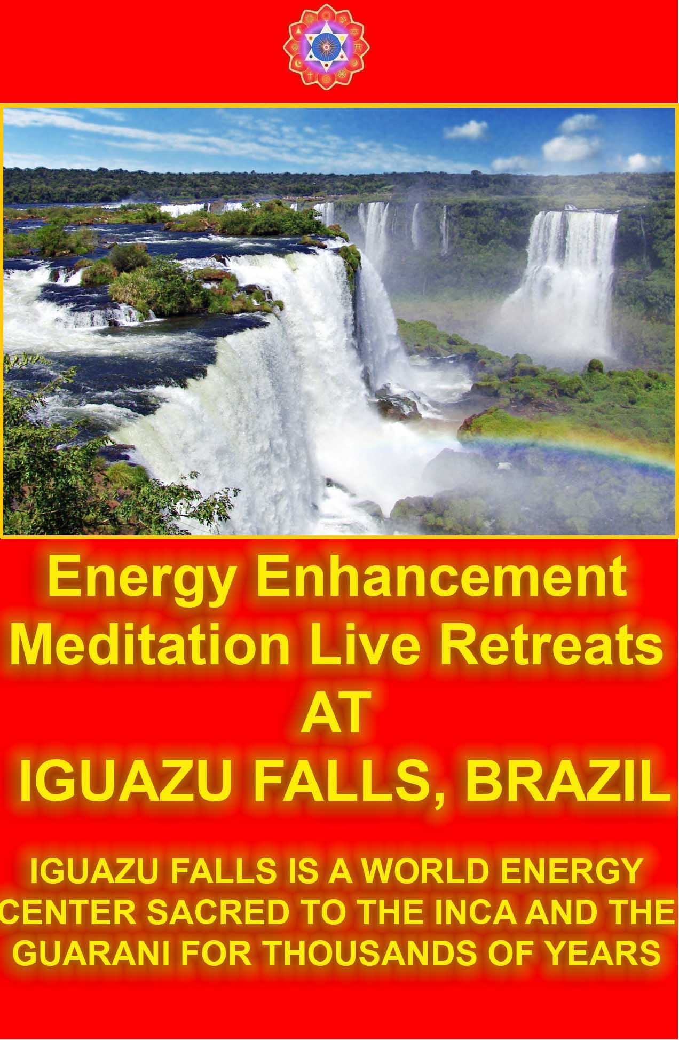
COME ON AN ENERGY ENHANCEMENT COURSE!!
THE DOWNLOADABLE ONLINE COURSE
THE VIDEO COURSE IN 12 DVDs
THE ONLINE/VIDEO COURSE COMBINATION
SUMMER COURSES ON THE COSTA BRAVA IN SPAIN
WINTER COURSES IN MACHU PICHU, BRAZIL, ARGENTINA AND INDIA!!!

ENERGY ENHANCEMENT IS THE NEWEST AND MOST HIGH SPIRITUAL IMPULSE ON THIS PLANET

ENERGY ENHANCEMENT SYLLABUS - WHAT IS ENERGY ENHANCEMENT?

THE ENERGY ENHANCEMENT SYLLABUS CAN BE FOUND HERE - THE HOME PAGE IS WHERE YOU SHOULD START OFF BUT FOR MORE DETAIL - LEVEL 1 GAIN MASSIVE ENERGY, LEVEL 2 - CLEAR ENERGY BLOCKAGES, LEVEL 3 - CLEAR ANCIENT KARMA, LEVEL 4 - MASTER RELATIONSHIPS, LEVEL 5 - HEAL THE WORLD

THE EE STUDENTS
THE ENERGY ENHANCEMENT STUDENTS HAVE BEEN GIVING THEIR REPORTS - STUDENTS ONE, EXPERIENCES STUDENTS TWO AND JULY 2008 ARGENTINA COURSE THEY REPORT WHAT HAPPENED TO THEM - EXPERIENCE OF THE ENERGY ENHANCEMENT COURSE - CLICK BELOW!!
http://www.energyenhancement.org/player/Elsie-Testimonial-Spain-2007/flv6.html

THE TEACHING

Just with the Kundalini Kriyas you can start to move forward strongly to Remove All Your Negative Energies, all Negative Karmic Mass in order to Create Intelligence, Positivity, Energy and Confidence.
Come for a Live Course...

WHAT IS ENERGY ENHANCEMENT?

THE HOME PAGE IS WHERE YOU SHOULD START OFF BUT FOR MORE DETAIL - LEVEL 1 GAIN MASSIVE ENERGY, LEVEL 2 - ELIMINATE ENERGY BLOCKAGES AND TRAUMA, LEVEL 3 - CLEAR ANCIENT KARMA, LEVEL 4 - MASTER RELATIONSHIPS, LEVEL 5 - HEAL THE WORLD

ENERGY ENHANCEMENT MEDITATION SAMYAMA
ENERGY ENHANCEMENT MEDITATION SAMYAMA

DVD COURSES

PLUS 7 FREE DVDS

PLUS FREE VIDEO ON DEMAND
AS GIVEN IN THE HOME STUDY COURSE, ONLINE BY STREAMING VIDEO (YOU MUST HAVE A GOOD BROADBAND CONNECTION TO RECEIVE THIS) PASSWORDS TO THE ONLINE VIDEO ADDRESS PLUS WITH ALL THE SAME EXTRAS, SATCHIDANAND AUDIO TALKS, DOWNLOADABLE YOGA, PRANAYAMA, SACRED SYMBOLS BOOKS GIVEN BY EMAIL ...

ENERGY ENHANCEMENT MEDITATION SAMYAMA ENLIGHTENMENT!!!

NOT ONLY MASSIVE ENERGY - LEVEL 1
NOT ONLY ENERGY BLOCKAGE ELIMINATION - LEVEL 2

NOT ONLY KARMA CLEANING - LEVEL 3

AND MASTERY OF RELATIONSHIPS - LEVEL 4

BUT ENLIGHTENMENT!!

"FOR THOSE WHO BELIEVE IN ENLIGHTENMENT AND UNDERSTAND THE URGENCY OF THE SITUATION" - GAUTAMA BUDDHA

THE ANCIENT EFFECTIVE SECRETS OF ENERGY ENHANCEMENT WILL ENABLE YOU TO BECOME MORE ENERGETIC, MORE PEACEFUL, MORE POSITIVE, MORE PURE, MORE SOUL INFUSED IN YOUR ALL YOUR LIFE AND FUTURE LIFETIMES - THE REAL SECRETS OF SUCCESS

BOOK A LIVE, MONTH LONG, TWO LEVEL COURSE WORLDWIDE ..

Energy Enhancement recommends that you start with any DVD Course - 2 Initiation DVD Course, or 4 Initiation DVD Course or One Level DVD - practise THE KUNDALINI KRIYAS and take advantage of asking questions of Satchidanand by email.

Get the DVDs

THE HOME PAGE IS WHERE YOU SHOULD START OFF BUT FOR MORE DETAIL - LEVEL 1 GAIN MASSIVE ENERGY, LEVEL 2 - ELIMINATE ENERGY BLOCKAGES AND TRAUMA, LEVEL 3 - CLEAR ANCIENT KARMA, LEVEL 4 - MASTER RELATIONSHIPS, LEVEL 5 - HEAL THE WORLD

Or just come on the Live Course Straight away; get the Videos to practice in advance..

LIVE COURSES...



IN ARGENTINA AND IGUAZU FALLS SPAIN, ELEGANT 5Star INDIA TAJ MAHAL, INDIA TOUR MEXICO, PERU
INDIA TOUR -CLICK HERE FOR WEB PAGES
SEE THE VIDEO TOUR OF INDIA BELOW

THE VIDEO TOUR OF INDIA

The Energy Enhancement Meditation Course - www.energyenhancement.org in India introduced by Swami Satchidanand and Swami Devi Dhyani. We see...

The Taj Mahal in Agra and The Red Fort. Then there is an interview with Swami Shantananda of Vashishta Gufa in the Himalayas above Rishikesh.
We see Haridwar and the Hindu arati ceremony there at dusk on the banks of the River Ganges where crowds of thousands view the sacred flame and chant the songs of enlightenment. Enlightened sages descend from their caves in the high Himalayas to give experiences of energy to the assambled people - a shower of flowers.

We see the temple of Hare Krishna in Vrindaban and the special ceremony of the display of the Murthys, the statues of Krishna together with the chanting of the monks and the dance of the whirling dervishes by Swami Devi Dhyani.

COME AND GET EXPERIENCED!
CLICK HERE!! FOR WHAT WE ARE DOING
EMAIL sol@energyenhancement.org
FOR DETAILS

PREPARATION FOR ENERGY ENHANCEMENT
Get the Full DVDs of the Level One and Level Two Course together with all the free DVD's - a total of 12 DVD's!!

Usually the students practice some of the initiations before they come on the course so that when the Buddhafield hits them they can remove more Energy Blockages whilst they are on the Course.
We recommend you start NOW!! with any DVD COURSE. A regular Spiritual Practise with Energy Enhancement in advance of any Live Course will give you Massive Energy, and Remove All Energy Blockages.

REPORT FROM JAPAN ON THE DVD COURSE
Hi, I want to tell you about my recent feeling, It came spring in Japan suddenly, I felt like my blockage began to melt and I felt negative feeling. I took a herbal face massage about 1.5 hours yesterday night, it dozed me .

End of that it came up to my mind that you were shining in white space. next Devi, Danisa, Sebaschan, me, and my partner I have never seen. You and Danisa's halo was more clear.

After that, I could feel that inside my body and my every cells swimming in lighting for a while. And when I did Level1 initiation2 by DVD, with your shining image, I could feel filled white light was in my body, And I could feel energy circulate my body include my Hurt center where my blockage is.

I could breath strongly and through my blockage, I felt - Is it good?

It may be good season for meditation, as you said.

Thanks a lot .
with love,
DVD Student Japan MARCH 2008

ENERGY
ENHANCEMENT MEDITATION

THE PSYCHIC SEXUAL CONNECTION AND THE HOOKER!!

AND THE ATTAINMENT OF BUDDHIST "NON-ATTACHMENT" BY UNPUGGING FROM THE MATRIX

PEOPLE NATURALLY CONNECT.

EVER WONDER WHY A HOOKER IS CALLED A HOOKER?

EVER BEEN HOOKED?

NORMALLY IN RELATIONSHIPS WE CONNECT.

AND THE CONNECTIONS ARE STRONG.

BUT OTHER PEOPLE, EXPERTS IN HOOKING, ARE TRYING TO SUBVERT THOSE CONNECTIONS AND CONNECT THEMSELVES USING THE PSYCHIC SEXUAL CONNECTION!!

TO TAKE AWAY YOUR PARTNER!!

TO ATTACK YOUR RELATIONSHIPS!!

TO DESTROY YOUR LIFE!!

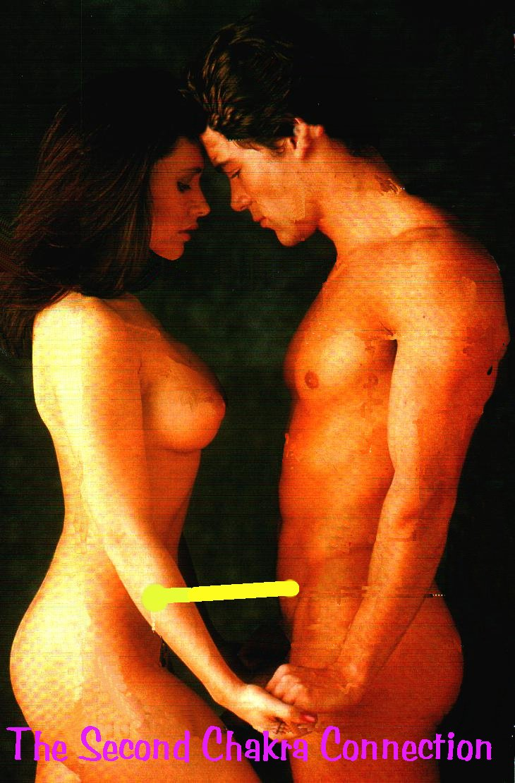
YOU ARE NOT IN CHARGE!!

THE BASE CHAKRA KUNDALINI SEXUAL CONNECTION!!
THE STEALER ON THE DOORSTEP!!

ENERGY CORDS AND LEVEL 4 OF ENERGY ENHANCEMENT

WE ARE AFFECTED AND DRAINED BY ENERGY BLOCKAGES IN THE PEOPLE WHO CONNECT TO US –

LEARN HOW TO REMOVE ENERGY BLOCKAGES AT THE OTHER END OF YOUR ENERGY CONNECTIONS IN OTHER PEOPLE

THE MASTERY OF ENERGY CONNECTIONS BETWEEN PEOPLE
THE REMOVAL OF ENERGY CONNECTIONS TO BAD PEOPLE WHO POISON AND SUCK YOUR ENERGIES - THE ABILITY TO CUT BAD ENERGY CONNECTIONS TO, "TO SEAL THE DOOR WHERE EVIL DWELLS" - THE ATTAINMENT OF BUDDHIST "NON-ATTACHMENT"

WE ARE AFFECTED BY ENERGY BLOCKAGES IN THE PEOPLE WHO CONNECT TO US - LEARN HOW TO REMOVE ENERGY BLOCKAGES AT THE OTHER END OF YOUR ENERGY CONNECTIONS IN OTHER PEOPLE

"It was after level 4 that I could meditate for a
easier for a much longer time. In that level you deal
with base cords and they are very draining. For me
they were the most vamping blocks to ground.
When grounded I had so much more energy.
Literally from the minute I starting clearing them.
Clearing the base cords it kicked up deep dark blockages which I
transmuted.

The perverted angels that were too
perverted to go to an angel hospital I used as parts
for me. I built up my angel colonies using them. My
soul became bigger. I felt like I had taken some
kundalini steroids or something. I was larger, more
integrated into the one. Are we all transformers just
getting bigger and more talented?"

- Energy Enhancement Student, Feb 20 2014

THE ATTAINMENT OF BUDDHIST "NON-ATTACHMENT" BY UNPUGGING FROM THE MATRIX

UNPLUGGED FROM THE MATRIX
Morpheus: The Matrix is a system Neo. That system is our enemy. But when you're inside, what do you see? Businessmen, Lawyers, teachers, Carpenters. The very minds of the people we are trying to save. But until we do, these people are a part of that system, and that makes them our enemy... You have to understand that these people are not ready to be unplugged, and many of them are so inert, so dependant on the system, that they will fight to protect it.
If you are not one of us you are one of them.

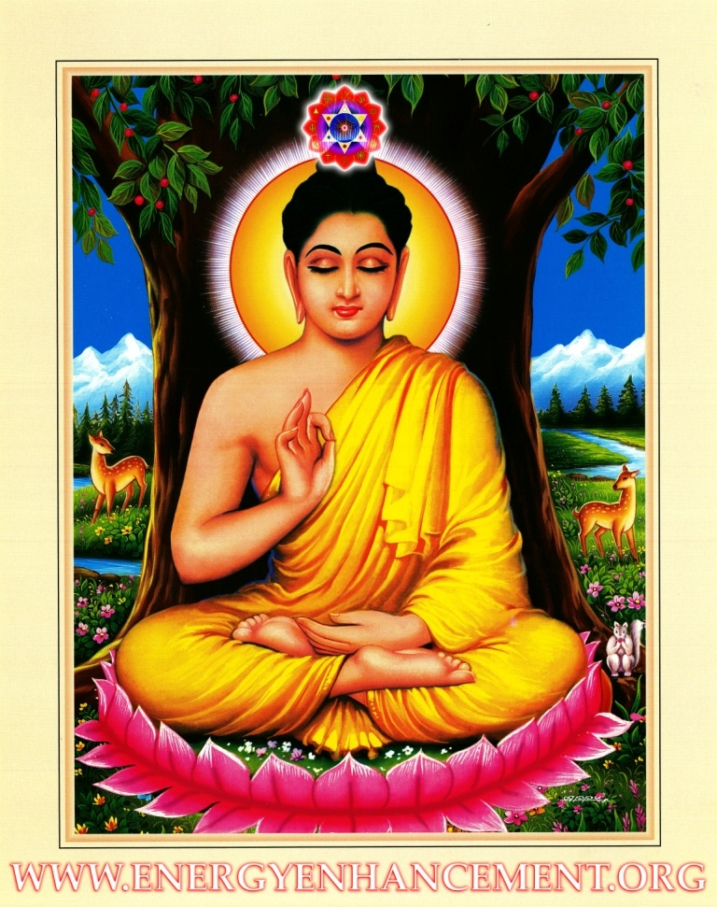

YES, KNOWLEDGE OF ENERGY CONNECTIONS HAS BEEN REMOVED FROM BUDDHISM!!

BUDDHISTS TALK ABOUT NON ATTACHMENT BUT KNOWLEDGE OF ITS TRUE MEANING - THE REMOVAL OF ENERGY CONNECTIONS - THE TUBES IN THE MATRIX AND IMPLANT BLOCKAGES - THE BLACK CONNECTIONS ON THE OUTSIDE OF THE BODY - HAS BEEN REMOVED FROM BUDDHISM!!

"ATTACHMENT LEADS TO PAIN" – BUDDHA

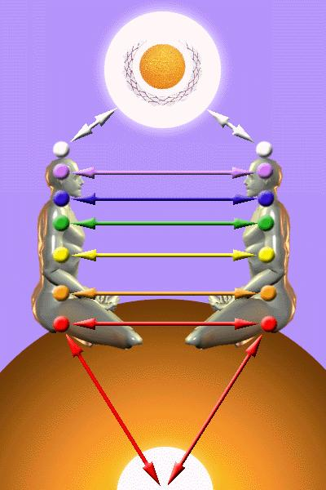

Implant Blockages are represented by the black studs all over the body;

Energy Connections by the tubes connecting to the implant studs.

THE MASTERY AND HEALING OF RELATIONSHIPS
FOR High Tantra, Gandalfs and Jedis.

Everyone you meet is connected to the Control....

ENERGY ENHANCEMENT LIBERATION FROM THE CONTROLS!!

Which brings me to the necessity of using Energy Enhancement level 4 techniques to attain Mastery over Attachment, Mastery of why and who you connect to, - the Mastery of Relationships.

As everyone who has not been through the Energy Enhancement training process has these Implant Blockages with attendant Energy Connections
As everyone who has not been through the Energy Enhancement training process has Implant Blockages built to distract and therefore manage the attention of their clients....

As everyone who has been through the Energy Enhancement training process originally had Food, Sexual and Drug Addiction Implants....
Everyone you meet is connected to the Control....

ENERGY ENHANCEMENT LIBERATION FROM THE CONTROLS!!

One White Magician Only is Required to change this Planet into a Sacred Planet, or a group of Like minded people, in Silence and in Secrecy
HEAL THE WORLD, BECOME A MASTER, A MERLIN, A JEDI KNIGHT, A WHITE MAGICIAN
"Traditional forms of meditation are designed to fail!!"

FIND ALL THE INCREDIBLE TECHNIQUES REMOVED FROM TRADITIONAL MEDITATIONS - DESIGNED TO FAIL - AND TAUGHT IN ENERGY ENHANCEMENT
"WE PUT BACK WHAT THE OTHERS TOOK OUT!!" - WITH THE MASTERY OF RELATIONSHIPS, ENERGY CONNECTIONS, ENERGY BLOCKAGE IMPLANTS - "WITH REMOVING THAT ATTACHMENT WHICH LEADS TO PAIN" - THE BUDDHA!!

MEDITATION ENERGY ENHANCEMENT APPRENTICE LEVEL 4 –

THE MASTERY OF ENERGY CONNECTIONS
THE MASTERY OF RELATIONSHIPS

"Traditional forms of meditation are designed to fail!!"

FIND ALL THE INCREDIBLE TECHNIQUES REMOVED FROM TRADITIONAL MEDITATIONS - DESIGNED TO FAIL - AND TAUGHT IN ENERGY ENHANCEMENT
"WE PUT BACK WHAT THE OTHERS TOOK OUT!!"
THE KUNDALINI KEY
THE REMOVAL OF ENERGY BLOCKAGES
ALCHEMICAL VITRIOL
THE CHAKRAS ABOVE THE HEAD

ELIMINATE ENERGY BLOCKAGES
THE KARMA CLEANING PROCESS

ENERGY ENHANCEMENT IMMORTALITY LIVE COURSES, INDIA AND IGUAZU FALLS

ONLY THE SUPERPOWERS DEVELOPED BY THE SCIENCE OF REAL MEDITATION CAN FREE HUMANITY TO REACH THE STARS.

ENERGY ENHANCEMENT MEDITATION ENLIGHTENMENT AND ILLUMINATION

THE INCREDIBLE MEDITATION COURSE AND MEDITATION TECHNIQUES CREATED TO PRODUCE ENLIGHTENMENT AND ILLUMINATION

"ALL TRADITIONAL MEDITATIONS HAVE BEEN DESIGNED TO FAIL" - SATCHIDANAND -

"BECAUSE ORIGINALLY ALL MEDITATIONS CONTAINED THE TECHNIQUES OF, "THE KUNDALINI KEY" AND OF, "ALCHEMICAL VITRIOL" TO GROUND NEGATIVE ENERGIES AND TO NATURALLY INCREASE KUNDALINI ENERGY"

"NOW, ONLY ENERGY ENHANCEMENT MEDITATION TEACHES THESE TECHNIQUES WHICH SPEED UP THE ENLIGHTENMENT PROCESS"
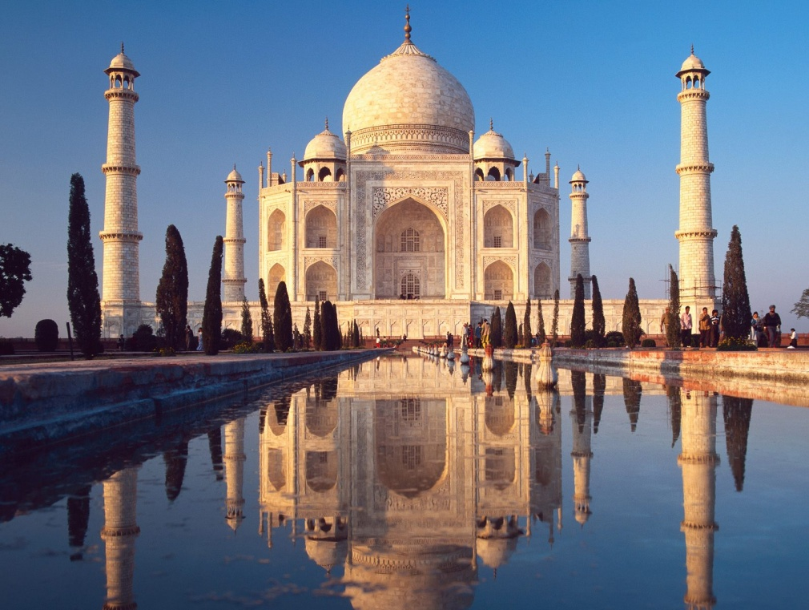

ENERGY ENHANCEMENT WITH LISABET



Picture from September 2006 when Lis came to visit and ask for our help with some Inner Children coming from past lifetimes

Well, in the middle of a Three Level Energy Enhancement Course and Energy Enhancement Yoga Teacher Training Course we had some experiences with Lisabeta from Sweden. She is an incipient Priestess with psychic energy gifts which can be amazing until training makes them useful.

Lisabeta has been to Peru for Training with a Shaman on the Inca Trail.

Yesterday she had a wonderful experience after the Yoga session. I was playing the Gyuto Monks from Tibet whose job it is to use their Chanting of Prayers and Mantras to expel and exorcise entities and negative energies from the surroundings.

The recording was made in Saint John the Divines Cathedral in New York in the presence of the Dalai Lama. The beautiful Digital Recording was paid for and organized by Richard Gere the actor and Mickey Hart, the drummer from the Grateful Dead. The disk is available on rykodisk.

Picture from September 2006 when Lis came to visit and ask for our help with some Inner Children coming from past lifetimes. We had pizza on the beach and a wonderful afternoon.
It is interesting that there in the Cathedral talked my teacher Swami Satchidananda on many occasions. He was invited to talk there because he so impressed the rector of the Cathedral with his presence and Energy of Enlightenment but also because he received the Martin Buber award for World Peace due to his efforts in the Ecumenical field.

How can this World come together as One, in Peace and Harmony, if the Religions of this world are still fighting one another?

The Truth is One, He said, The Paths are many.

We use the energy of the Gyuto Monks whose heartfelt prayer, Negative Thoughtforms, entities and human delusions are endless, we vow to end them all!! and so they stay on this planet from lifetime to lifetime, dedicated to the Enlightenment of all beings. We use their chanting to clear the negative energies released from the energy bodies of our clients through the Energy Enhancement purification process.

So after the yoga we were meditating with the chanting of these monks in the background and the Energy Enhancement techniques in the foreground.

Lisabet reported that she felt the energies coalescing in her Solar Plexus going round and around, and then they shot down into a blockage she felt for the first time in her Abdominal Chakra. Then the Kundalini Energy started to travel powerfully all around her body up into the center of the Universe and down into the center of the Earth.

She felt goose pimples all over her skin. The energy was coursing and rushing through her body in very strong waves for at least 30 minutes and when it was time for lunch she did not want to come out of it, she was laying on her back and couldn´t stop laughing of happiness!

Usually such Kundalini experiences are just adjuncts to the process of clearing energy blockages.

Said Sufi Master Saadi, When the energy is flowing correctly, there is no movement!

And these powerful sensations are just Kundalini energy flowing through a blockage resistance as the blockage is in the process of being removed.

We tend to remove Energy Blockages in waves. At first we remove all the easy blockages and then as we go deeper into Energy Enhancement we raise our energies higher and stronger, deeper blockages become candidates for expulsion. Like the layers of an onion we expel all blockages. The more powerful blockages hide until sufficient energy is there to remove them. The last and most powerful blockage is removed just before enlightenment. And that one is a Doozy!!

And when we gain energy enough Energy Enhancement Energy, up pop the blockages.

And when you feel them, that is when we can heal them!!
When you see them, you can free them!

So, the next day this abdominal blockage came to the presence of our minds by creating all sorts of negative energies and thoughts.

Abdominal blockages are caused by disappointment in relationships in this and past lifetimes. They travel with us from lifetime to lifetime until we learn how to heal them, They draw similar experiences to you until the negative energy of the blockage becomes insupportable.

To those that have, more will be given.

Until the blockages are removed through evolution and training. And eventually these blockages become a matter of life and death.

Until, To those that have not, it will all be taken away!

All your blockages are removed.

Blockageless you become a serious candidate for the Third Initiation of Enlightenment. You get energized through Initiation and then become Enlightened. This is the Energy Enhancement process.

Not only through the first initiation of Opening the Heart. Or the Second Initiation of the Mastery of Relationships and the Third Initiation of Enlightenment itself, becoming a Soul Infused Personality. But also further initiations of the Fourth Initiation, becoming a Monad Infused Personality. And more!!

Enlightenment is only the first Dan. You then become fit to learn by
yourself.

This is the Energy Enhancement Process of progressive blockage
removal and Initiation.

We meditated the next day and I felt a painful Vitriolic ball of fire in my belly. I was feeling the Energy Blockage of Lisabet which was just waiting for time, place and energy for it to become available for removal.

And Lisabet became so tired and painful she lay on her side in a Foetal position.
As our other student and I continued to meditate we used Second Level Energy Enhancement techniques to Ground and remove Lisabetas Abdominal Energy Blockage. She actually saw an angel in her mind coming to help her remove the strong anger she felt, so she was delighted when she found out that the "angel" was Satchi



A good training for our other student as all teaching comes through psychic experiences like this on the course. Things just happen and through the experience of doing, because as we are just reminding you of what you already know, you Grow.

Picture from September 2006 when Lis came to visit and ask for our help with some Inner Children coming from past lifetimes. We had pizza on the beach and a wonderful afternoon.

Eventually on the Energy Enhancement Course we move on into enlightenment experiences like Lisabeta from Sweden.

In one of the last mailing list broadcasts I told of Lisabeta's process for getting rid of one of her energy blockages. Usually the first energy blockages on the energy enhancement course are the easiest. The one we described last time was heavy but manageable, and came towards the end of the course after many similar experiences, particularly when you see what this blockage removal led to...

On the last day of her course, after 4 weeks of Energy Enhancement blockage removal, Lisabeta was getting ready for her Yoga Teacher Training tryout. She was going to give another lesson in Yoga to us.

Well as she was preparing she decided to do a little meditation and when she sat, she just felt all this energy which made her want to sit even more.

She felt herself ascending higher and higher like her head was going up into the center of the universe and she was breaking through one of her old barriers, like her head was pushing through the top of an egg.

As she broke through this barrier, she felt fingers brushing through her hair with a sweet indescribable energy for what seemed like a long time. Well, we were trying to get her to come to the yoga class. Talking to her and telling her to come out of it. But she could not hear us, she did not want to. She was in bliss. Gentle fingers brushing slowly through her hair.
She stayed in this state for two hours without moving!

Please remember that Lisabeta had done meditation before coming on the Energy Enhancement course but never been able to sit for more than 45 min, and Swami Sivananda used to say, if you can sit still without moving for three hours, the chances are that you are enlightened.
Well, perhaps Lisabeta is not enlightened, but if you see her now as we did when we met again, last week, one year after her course with us, you would definitely see an energy glow around her. She looks just glowing with energy, relaxed and wonderful. A big smile all over her face!

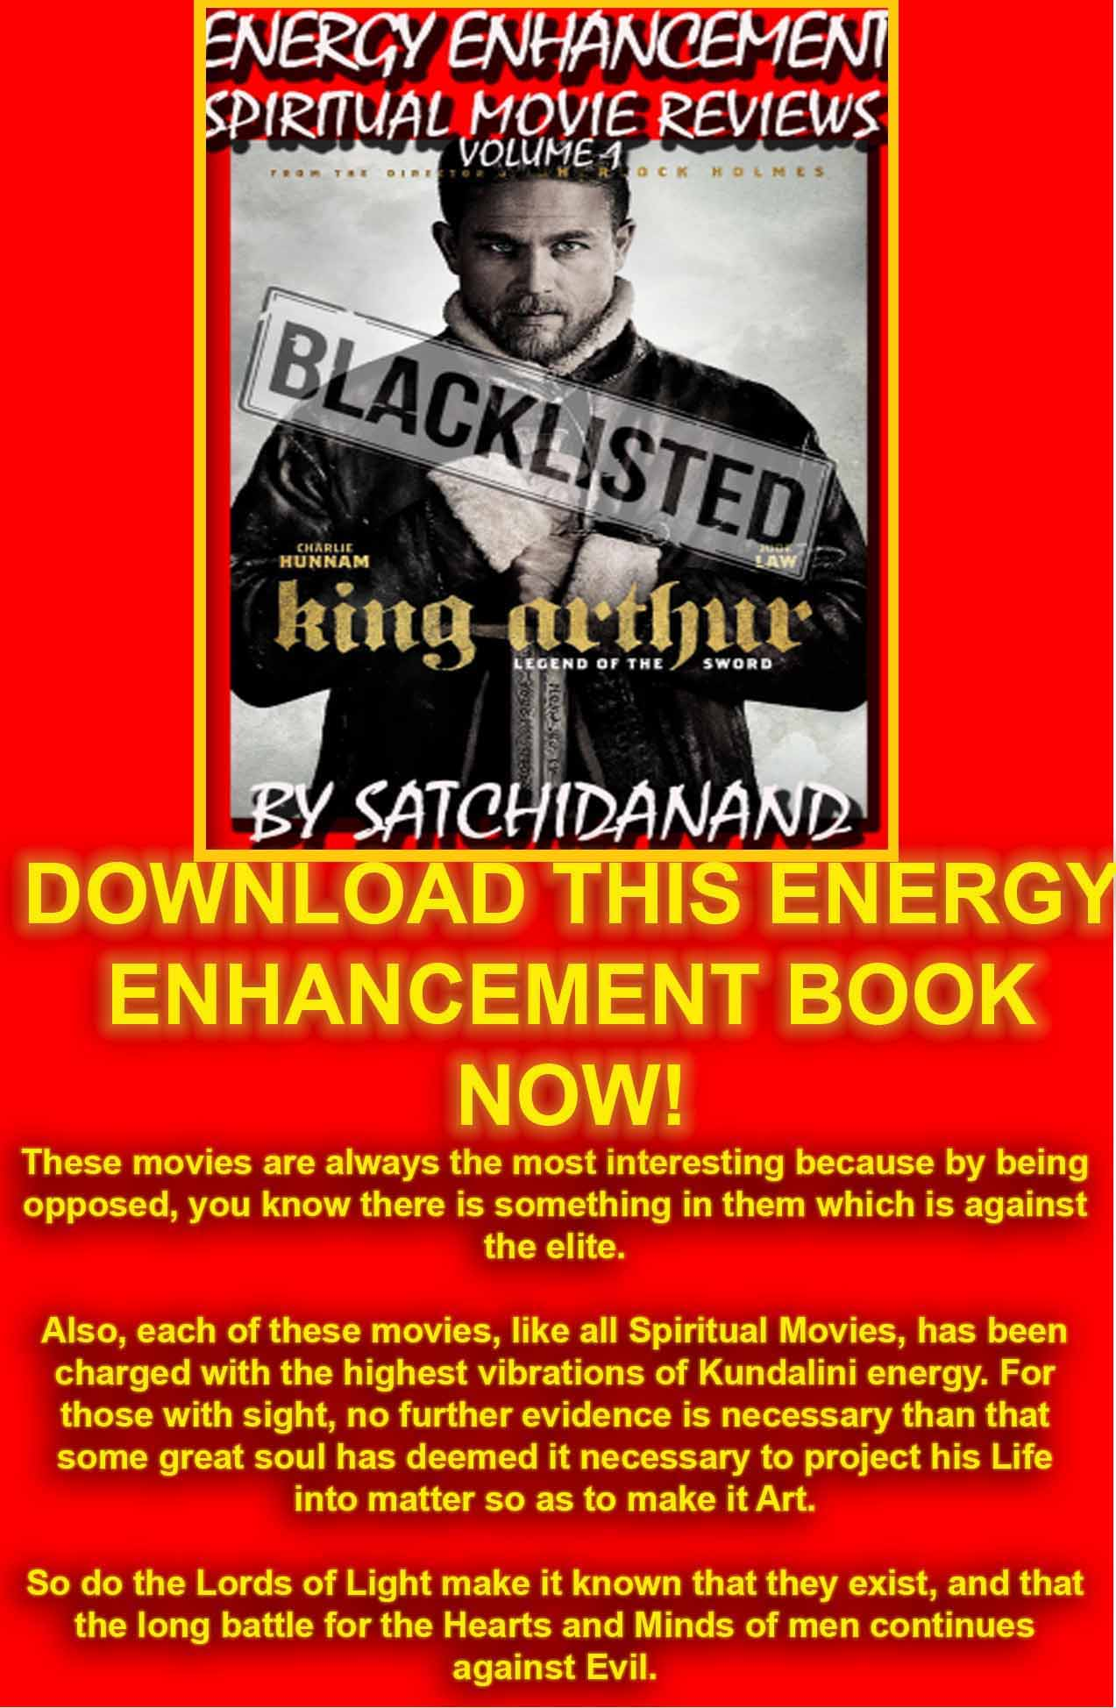
Energy Enhancement Spiritual Movie Reviews Book - Volume 1 by Satchidanand download here..
http://www.energyenhancement.org/Spiritual-Movie-Reviews/Energy-Enhancement-spiritual-esoteric-movie-reviews-by-Satchidanand.pdf
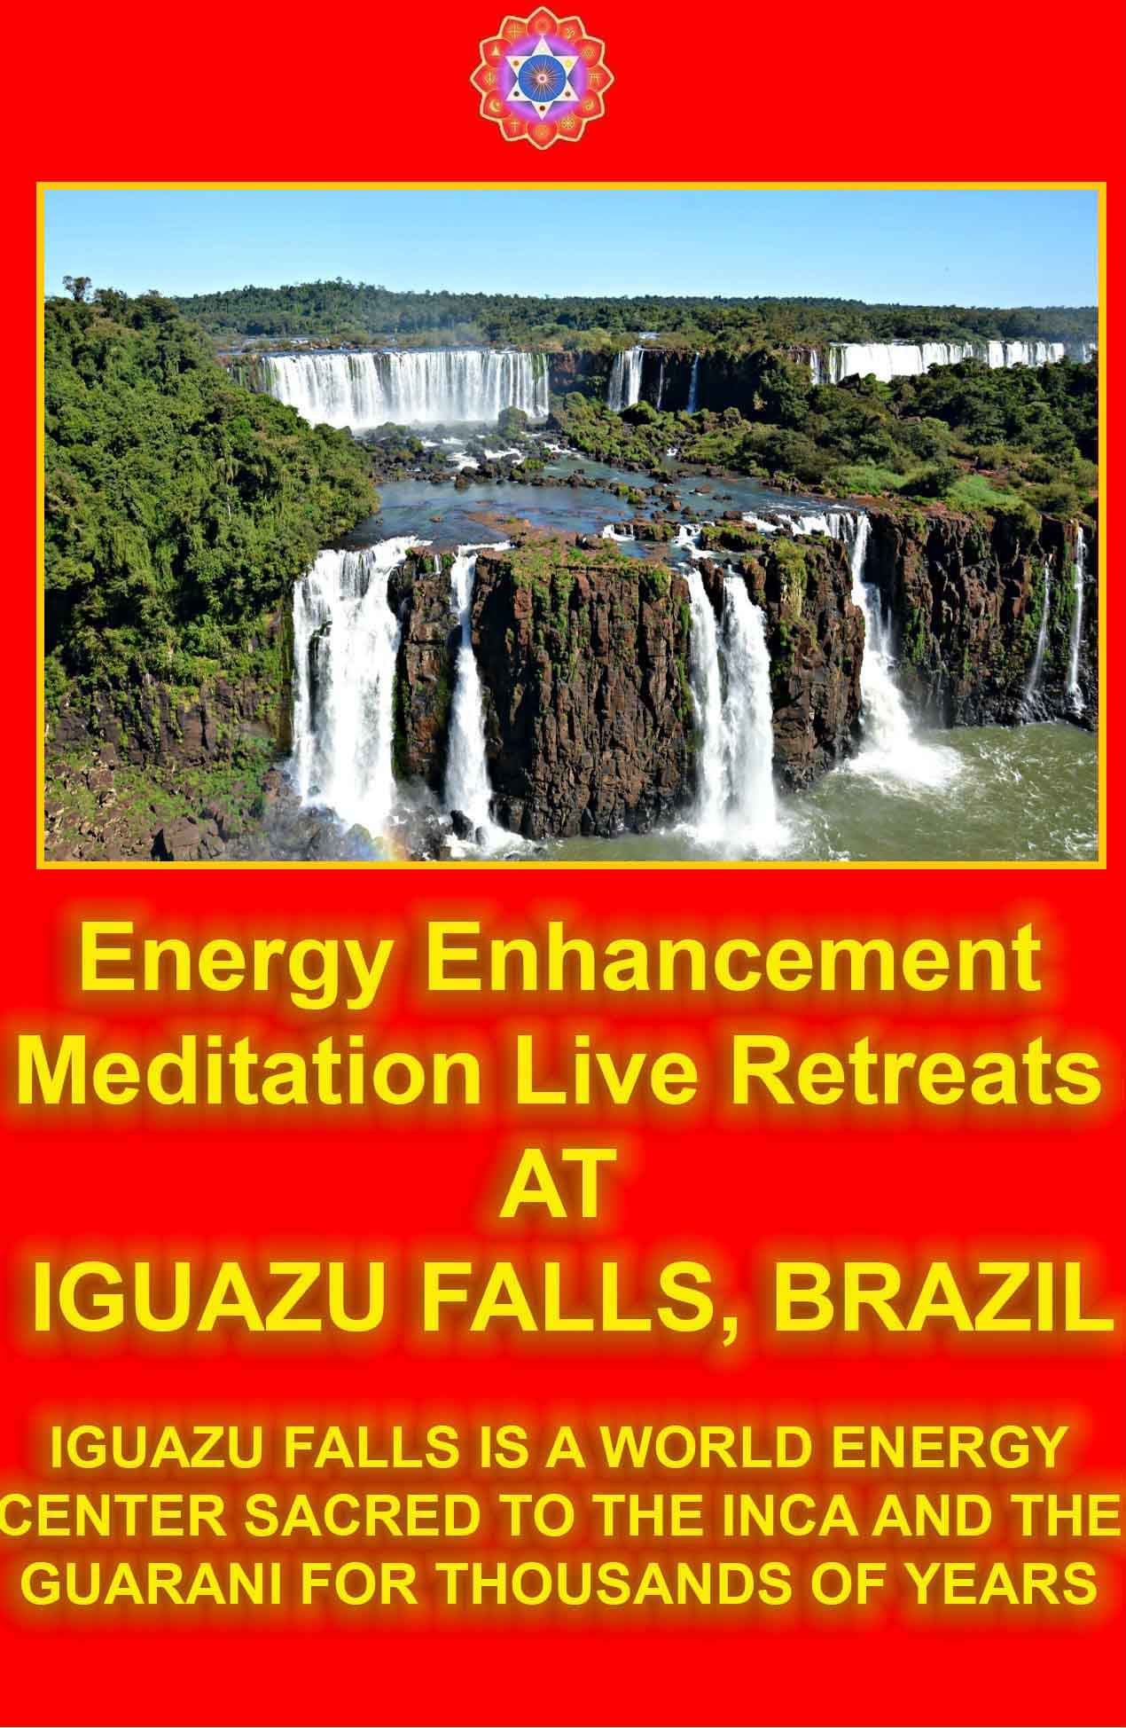

THE PRESENCE

The Presence is a Personal Spiritual Experience and Initiation into Energy Enhancement Techniques without Words - View it on Youtube Now, A Transfer of Energy which awakens the Soul, Enlivens the Brain, Stops the Mind, Brings you into This Moment of Peace and of Joy. Feel the Effects of Spiritual Energy Vibrations, Launch into Enlightenment - High Quality versions available on DVD.

SEE THE PRESENCE NOW ON YOUTUBE - CLICK HERE

THE CLEARING

Using Energy Enhancement, "The Clearing" Play it now, you can clear your room and Yourself of Negative Energies - Negative Karmic Mass. View it now on Youtube - High Quality Versions available on DVD

SEE THE CLEARING DANCE NOW ON YOUTUBE OR ON THE EE SITE- CLICK HERE

IGUAZU
BIG WATER!!

When you receive energy correctly

And not everyone does because they get the symptoms of energy blockages instead - Going to sleep, shaking, pain, heat, cold, negative emotions, - all the common so called symptoms of Kundalini Energy. But when you get taught to receive energy correctly on the Energy Enhancement Course - "When the energy is flowing correctly, there is no movement" - Saadi of Shiraz.

And this is the Energy Enhancement Experience.. "We eventually get into a state of energy transfer. We both feel it as white light flowing from one to the other in an incredibly intense way which lasts for two hours. At the end of that time I perceive an initiation which is taking place on the astral plane. Surrounded by a group of ascended masters I introduce him to the chief initiator who uses the rod of initiation to touch his third eye with the intense energies of initiation so that his energies can never again drop into that state we call normal waking consciousness."

If you can receive energy then the chances are that you can give energy. Only the people who can receive energy correctly can go on to become enlightened, can go on to become Initiators of men, Gurus and Spiritual Masters.

If you only get the symptoms of Energy Blockages in the fire of the Buddhafield which is the intense aura of energy which surrounds every Spiritual Master then you need to remove the Energy Blockages which produce the symptoms. The Energy Enhancement Level Two Seven Step Process is the unfailing technique which can remove any Energy Blockage.

When we become a stream enterer, we tap into the Energies of the Earth and of Heaven and of the Buddhafield and through energising our faculties, we start to have spiritual experiences beyond the norm. We start to feel and see energy to start with, which always comes to every student.

It happens with all of our students...

INNER PEACE



MATAJI DEVI DHYANI - VISIT TO IGUAZU AFTER THE JULY 2008 COURSE

Reports of our Students

ARGENTINA

VISIT TO IGUASU FALLS AFTER THE EE COURSE

ELIMINATE ENERGY BLOCKAGES

THE KARMA CLEANING PROCESS

THE MASTERY OF RELATIONSHIPS

ENERGY CONNECTIONS BETWEEN PEOPLE, BETWEEN THEIR CHAKRAS AND ENERGY BLOCKAGES

ENERGY CONNECTIONS BETWEEN PEOPLE, BETWEEN THEIR CHAKRAS AND IMPLANT ENERGY BLOCKAGES

CONTROL IMPLANT BLOCKAGES

VAMPIRE IMPLANT BLOCKAGES

Student experience of sexual Implants

THE OPENING OF PSYCHIC VISION
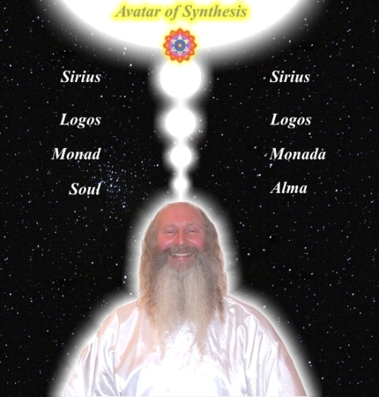

"Satchidanand seems to be talking of a reality once written about by many Sages of the past but now forgotten in the West!"

ELIMINATE ENERGY BLOCKAGES

THE KARMA CLEANING PROCESS

IMPLANT BLOCKAGES WITH OUR STUDENT IN GOA 2010

"Miracles, Miracles and yet more Miracles!!"

"Miracles, Miracles and yet more Miracles!! Every day was a Miracle on my Course as my Ego Blockages bit the dust! I remember one day just after removing one of the most difficult Implant Control Blockages I ended up prostrating at the feet of Satchidanand in Tears of Gratitude.

The Power of Satchidanand when focused on the Blockage was beyond my comprehension, and yet the blockage was resisting. With steady application from Satchidanand even that blockage was dissolved and Grounded. No-One Else could have removed that blockage as it was too strong!! And yet up to that point Satchidanand allowed me remove every other blockage we found by myself. He only entered into the fray when it was absolutely necessary and this built up a steady body of Confidence that I could handle everything which the course threw at me!!

From a guy who could barely feel the energy blockages at the start of the course, I have grown into a Healer who not only can "See" every Energy Blockage, but my Intuition has grown to the extent that I "Know" every what why and wherefore about them.
Satchi uses Spiritual Movies to teach and he channels energy to emphasise the spiritual points being made. One night, we were watching the movie, "Constantine" where Keanu Reaves is playing the Cynical Wizard who curses the "Gift" of Psychic Vision he has been given and who is using the Strategy of committing slow suicide through smoking 30 a day for 15 years in revenge to God. Satchi felt the energy of one of my blockages and he held it for me whilst I felt into it and healed it by myself.

The blockage was one where I complained bitterly to God for everything which happened which I did not like - which was almost everything. The blockage was powered by the most bitter hatred such that everything in my life felt like shit and this Hate filled Blockage was just confirming that my life was Shit!! Satchi said, "everything on this course has happened perfectly, and joked, "I am the Hand of God on this Planet" and indeed everything on the course did happen perfectly and just at the right time.

Directly after watching this film, I had a powerful healing-teaching experience: I realised that the blockage Satchi was holding for me was a powerful energy-blockage within me which thinks it knows best all the time. This blockage caused great anger and frustration in my life. I experienced a wondeful healing and teaching when I understood the nature of this blockage and released it back to God. This teaching was all about letting go of all the selfish expectations in my life and being more appreciative and grateful for the life which is given to me.

Thank you Swamis Satchidanand and Devi Dhyani for your perfect care and blessings. Miracles and yet more Miracles!!" –

Graham Smith on his Energy Enhancement Course in Goa, India November 2009

SACRED DANCES OF FUSION WHERE DEVI DHYANI EXERTS HER POWER - AVAILABLE ON YOUTUBE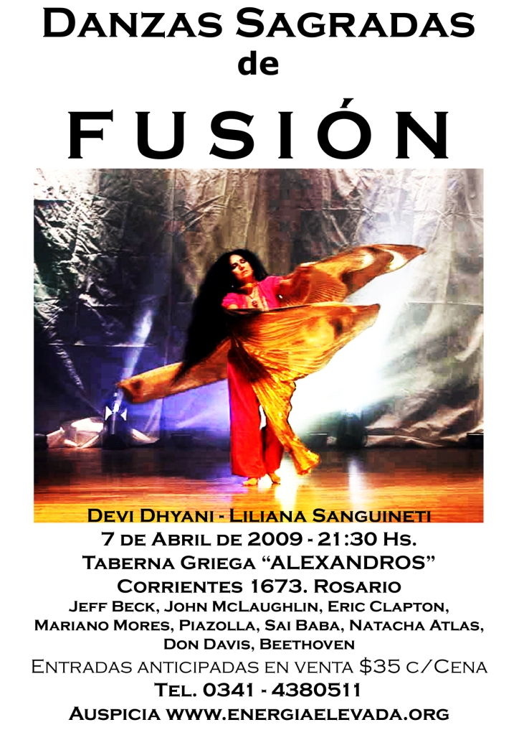THE MASTERY OF RELATIONSHIPS

ENERGY CONNECTIONS BETWEEN PEOPLE, BETWEEN THEIR CHAKRAS AND ENERGY BLOCKAGES

Energy Connections between people, between chakras were originally used as a means of energetic support.

This energetic support is explained by the circle of energy between two people and their chakras which give and receive energy equally; the right side of the chakra giving and the left side of the chakra receiving, thus the energetic support. If one person is using a lot of energy, the connected pair of people and their chakras acts as a reservoir of energy to support the efforts of the active person in the couple. Thus the truism in the sanctioned couple pairs in marriage, “Behind every good man is a good woman”.

Energy blockages on either of these connections stop the giving, making you into an energy vampire or stop the receiving, making you into a person permanently drained. In these circumstances the couple fails as the blockage cuts off the pairing and the lack of energy sharing will destroy the health of the relationship usually making it very unhappy or ending in failure and divorce. People who have many relationships all of which fail, – serially monogamous – are usually people who have these types of energy blockage problems which Energy Enhancement, with its Elimination of Energy Blockages in Level 2 can heal as part of its Mastery of Relationships program taught in Level 4.

Energy Blockages stopping the flow of energy on energy connections are usually formed through pain, abuse or loss. Pain caused by that which should not happen changes, perverts the natural energy of a human being into a dense dark energy which stops the flow of natural energy through it, indeed it forms a major part in the formation of energy blockages. We call it Negative Karmic Mass or NKM. NKM can be grounded into the center of the earth where it can be burnt and purified back into its natural state.

EXPERIENCE GROUNDING NEGATIVE ENERGIES

Here is the experience of one of our energy enhancement students in the grounding of these negative energies, Negative Karmic mass, NKM,

“This is a sincere request. I am fully aware that all my problems are my own energy blockages. I don’t feel like victim particularly but I am a bit confounded by the overwhelming force with which my own blockages appear to be deterring me. I’m sure your emails are standard and sent out to everyone in general but the last two made me laugh out loud:

"You Know, Removing all your Energy Blockages is a Really Good Thing" – Satchidanand

India Meditation Course - Pain is the Problem.. Ground It!!

THE AMAZING THING IS, OUR EXPERIENCE SAYS THAT NEGATIVE ENERGY, PAIN, CAN BE GROUNDED!!

ALL EVIL COMES FROM PAIN: DISEASE, ANGER AND FEAR - FEAR IS THE MIND KILLER - ALL THE WORLD'S PROBLEMS COME FROM CONGEALED PAIN.

START NOW - DON'T WAIT FOR NEXT LIFETIME

Truer words were never spoken! .... “

“What I mean is, I believe I mentioned the searing back pain that came on suddenly a couple weeks ago. Well, I thought it was subsiding but it appears instead to be getting worse. I believe there is some connection with the XXXX group that I am a bit leery of that ties into my experiences with YYYYY —none of which I’m saying to blame them because I know this is my own crap but the similarities seem to be the catalyst for my energy blockages to have a field day.

Pain I’m pretty good at handling. But this pain is preventing me from doing my work by which I need to earn my living (fortunately my boss is understanding and not angry with me) and it also prevents me to from doing my spiritual work once I get home. I am embarrassed to admit but have to tell you that I am sleeping more than any normal human being should. I go to work, come home, watch a bit of your video, go to bed and read a bit of your EE book that I got from Amazon, fall asleep easily by 9:00 p.m. and don’t wake up until 6:30 the next morning! Then, for the last two days, I left work about 11:00 a.m., fell asleep by 1:00 then slept till 5:30 or so, went back to sleep at 8:00 and slept through again until 6:30! This is insane! My energy blockages are everything you mention—pain, sleep and too much negative emotion….”

And after giving our student a pre Energy Enhancement method of Grounding Negative energies….

“As for my painful back, I did my best with the counterclockwise movement of my body as I understood it from Devi Dhyani and it was fascinating. I went out to my rental house’s little backyard (which unfortunately is mostly concrete) and found a patch of dirt to stand on barefoot. As I moved my body counterclockwise I felt the magnetism of Mother Earth drawing out the negativity—like a whirlpool (or a flushing toilet!). I pretty much let my body move the way it wanted to and a couple of times it stopped and went into spontaneous Tadasana pose which felt like all the negativity was shooting down to the center of the Earth where it could be instantaneously transmuted by the Fire. There was corresponding relief to the physical pain in my lower back/right hip as well. Such a blessing!

The next day the pain seemed to return, although not as strong so I tried the counterclockwise movements again, this time inside on my hardwood floor because it was raining and cold outside. I was surprised that the effect was the same—very powerful. Afterwards I had that “spongy” feeling (don’t know how to describe it) like I’d been meditating or in a high process for some time. I did a long soak in a tub of hot water with sea salt, baking soda and white vinegar that also seemed to calm the energy and alkalize the physical body, removing just about all the pain. The difference in my mental state without the constant fierce pain is remarkable. I want to learn how to do this grounding the proper way because I can see it will be a lifelong practice”

ENERGY CONNECTIONS BETWEEN PEOPLE, BETWEEN THEIR CHAKRAS AND IMPLANT ENERGY BLOCKAGES

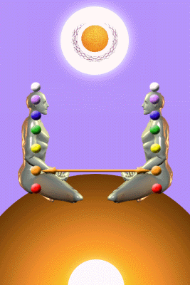

There is an evil class of Energy Blockage which can be created by another human being called an Implant Energy Blockage.

There are Ancient White Spiritual Sciences were passed on generation to generation by word of mouth using chanting techniques which pre – date even Raja Yoga, written down after thousands of years as an oral tradition as the Yoga Sutras of Patanjali which itself contains the Science of Samadhi and Illumination, Enlightenment.

There are Ancient Black Spiritual Sciences also pre – dating even our written history.

As Henry Ford said, “History is Bunk!”

As Stalin said, “It is the victors who write the History Books”

These Ancient Black Spiritual Sciences - The Dark Side - come from before the first written history from before the 6000 years old Babylonian civilization stretching back more than 40,000 years to the time of the Cave Paintings, Toltec Sorcerers and the Dream Time Shamen Aborigines of Australia.

CONTROL IMPLANT BLOCKAGES

This science which stretches back more than 40,000 years through individuals and Secret Societies gives the methodology of creating Implant Energy Blockages which if implanted in previous lifetimes will remain with you to the present day until removed by Energy Enhancement Techniques like the “Seven Step Process” of Energy Enhancement Level 2, thus setting the stage for societal control over thousands of years. As Implant Blockages form part of the mind, so by using them we have a form of almost perfect, "Mind Control"

Implant Energy Blockages can be programmed to control the minds of the people in whom they are implanted in many different ways and intensities of control. The higher intensities of control being reserved for the more intelligent and even more for the intelligent people publicly controlling society, the original controllers and their families remaining anonymous.

The methods of Control by different types of Energy Blockage involve control over the emotions and the will thus making intellect impotent. Thus making them unaware that they are being vampirised, lifetime after lifetime, over thousands of years.

Only those people, one in a million, if that, who are ready after many lifetimes of experience and energy body growth, are able to break the bonds of their Implant Blockages can choose a Spiritual Path which works.

The only reply to the sound of one hand clapping and the Hossu striking, and this is not intellectual, is to have sufficient evolutionary forgiveness to turn the other cheek.

The Evolution of people is towards goodness. But some people are not sufficiently good for them to be able to take a genuine path. People are made up of a Council of Implant Dark Angels and White Angels and they are always voting.

Really, there is no reason to answer and give all of the above spoon feeding.

The essential thing I can tell you is that people are not stupid.

In alignment with Sosan, the Third Zen Patriarch I can say with full knowledge, "They Know!"

And if they say they do not know it is because their dark energy implant blockages are too great for them at this time.

That in this lifetime they themselves are allowing the Energy Blockages to win because they themselves are complicit with them and the dark Forces which control them..

Their Blockages have already prompted them to make their decision. They have already made their decision - Like Neo - and by complaining about anything - They are not taking the cookie from the Oracle this time.

Remember, "One Complaint and Heaven and Earth are set Infinitely apart" - Sosan - From "Hsin Hsin Ming: The Book of Nothing" - The Enlightened Mind of Sosan, which can be found by anyone in touch with their Soul, On this energyenhancement.org site..

The above is another Open Secret.

There are many paths and the most popular are those which can not work. And the people know this. And that is why, prompted by their Implant Blockages, they choose these paths.

Christianity, Buddhism, Zen, Sufism - all the current religions as they currently are, are popular because they can not work other than as a foundation for the people who choose them.

But for those who seek the true path, the path which works, the path which will lead them to Enlightenment, Illumination, Integration, Atman, - They know that only The One who has successfully walked the path can really bring them to that which they seek.

People are searching all over the planet for a Genuine Master, but me, I have been searching all my life for a Genuine Student.

And it is in their choice of Master that the Evolutionary Heart of the Student is known…

VAMPIRE IMPLANT BLOCKAGES

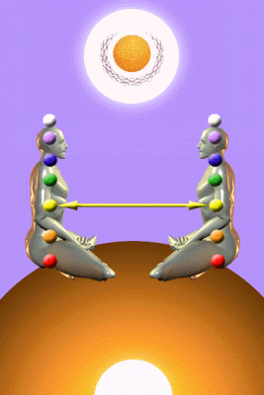
Implant Blockages can also be programmed to use these Energy Connections which are naturally formed in every human being in order to drain their energies back to the person who implanted them, either in this lifetime or in any previous lifetime.

We have seen in meditation that the implanters have thousands of connections coming to them from the many people whom they vampirise.

Implant blockages can be programmed into web sites - usually sex sites, books and items - like drugs, to addict people to things which will burn their energy more quickly as they send their energy back to the implanter.

They manage to get so many connections by implanting people who act as their helpers, their collaborators, to implant people they meet. Any energetic psychic connection between the helper and the victim is channeled back to the original implanter.

Usually implant is implanted upon implant as many people have already been implanted in previous lifetimes. These people already addicted and are easier to recognise by the helper/collaborator and to implant over the original implant.
There are many young ladies and young men who act as the helper/collaborator of the implanter. These many evolved helpers unconsciously even implant and vampirise their own children, the mothers and fathers sending the energy of their own children back to the original implanter.

The helper/collaborators spreading the sexual implant virus are usually beautiful sexual partners although the suppliers of drugs - the man - are also complicit.

"If there had been two things like sex, I never would have become Enlightened!" – Gurdjieff

Energy Enhancement Student experience of sexual Implants

Oh boy! I have gotten what I asked for! I am really struggling to cut the connections with xxx. Today I have felt so much fear come through (some must be mine) and now in the last few minutes I know she has either fallen asleep or smoked a joint and she is over 65 miles away. Yesterday, she did some coke and I was wired all day. I was very high and to begin with thought it was somebody from above giving me light and energy. But for the most part I cant concentrate or stand still - it's too painful to feel all of her stuff all the time. It's like being in perpetual fear. Yes, I might well have bitten off more than I can chew.

The night before I managed to cut the ties with xxx as per my previous email, I dreamt that amidst a whole load of fear experiences, 2-3 crows gathered around my neck and comforted me. Their black feathers rubbed against my face. For some reason I believe that this event was connected to help I was given to release me from ties with xxx last Friday. And maybe now this is why it is not working for me cos I no longer have this help.

The energy connection is so strong between us; I have never experienced anything like this.

Recently xxx took the initiative to redefine our relationship, which meant that none of us were going to "fall" in love. Feeling her break the energy connections with this decision, I felt fear sadness and loss and dreams took me back to prep school when I was home sick all the time missing my mom when i first went there - crying every morning. Until this redefining of our relationship I was not aware of all her stuff, but now I feel it all the time and cant get her out of my mind to do daily tasks easily. I cant find peace. So, I see that I have created the same strong attachments with xxx as existed with my mum, which when broken and denied me, make me feel fear and loss, sadness. On top of this I get her stuff too. Right now I am feeling grounded and comfy cos I know shes stoned or asleep.

Is this because of implants do you think or is it due to simple energy ties?"...

"The only solution is to end the relationship for now. She is linked to a source of bad energy, from which I am suffering. It goes straight out of my solar plexus, leaving me in fear all the time. I work on it most sits, and try to get the connector implants that make it all possible, as you have pointed out"

The Lahu and Akha Tribes in Thailand traditionally use silver plates and silver buttons to psychically protect against energy connections and being implanted.



The silver disk plates above are made to protect the chakra they are placed over.



Lahu belt of silver buttons to protect the base sexual chakra and the second, relationship chakra.



Akha Hat with silver buttons to protect against energy connections into the head chakras



Akha Hat with silver buttons to protect against energy connections into the head chakras and the silver chains around the neck to protect vishuddhi chakra

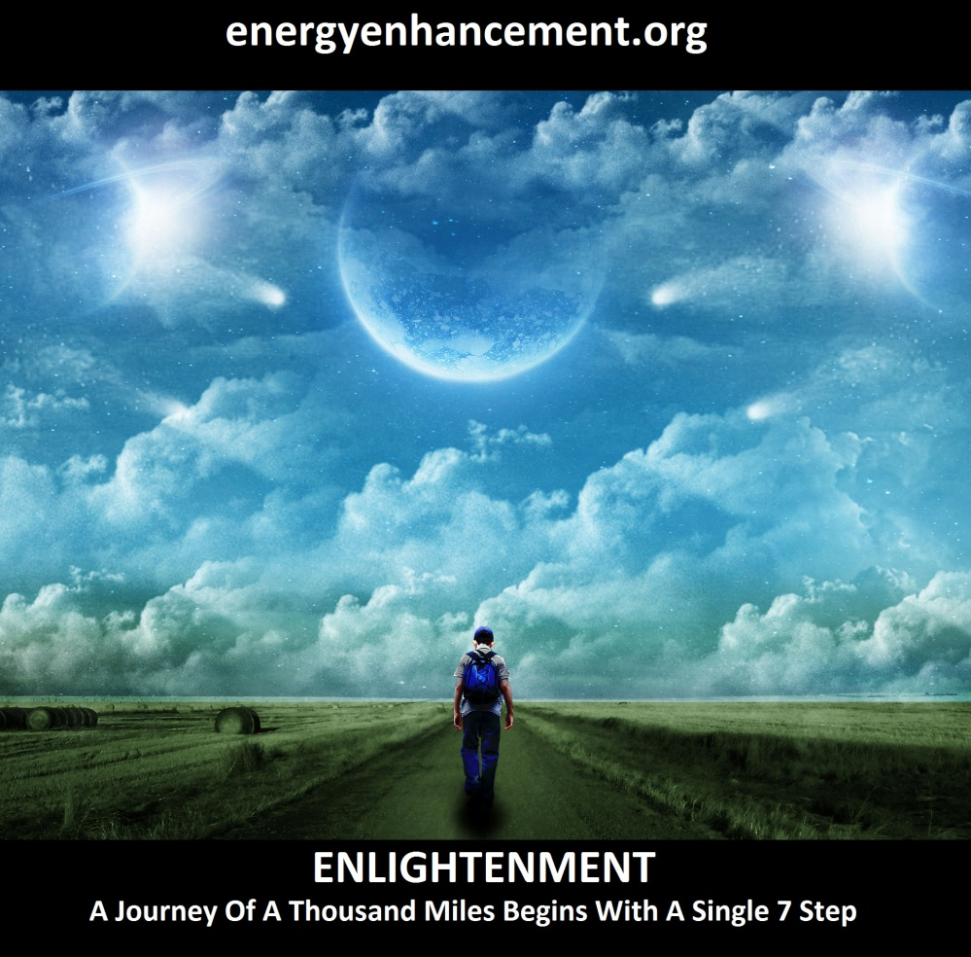
LEARN THAT WHICH IS FALSE WITHIN YOU
LEARN TO RECOGNIZE THE FALSE AS FALSE
-WITHOUT THAT, THERE CAN BE NO LASTING TRANSFORMATION
ENERGY ENHANCEMENT
"I was not sure if this was wise, as I knew nothing other than what I had read on the web site and the testimonials, which I was a bit skeptical about! However, I am now adding my own because if you read this you might be a bit like me...
Don't hesitate - go for it!"
MS (Ireland) Human Resources Director, Europe/Asia, of a Fortune 500 US Multinational Company
Honey Kalaria

" Once on the course, my exciting adventurous journey began! In my life I have done hundreds of courses but the Energy Enhancement Course I found to be completely different. Firstly, the contents and the teachings seem to be inspired by higher forces and had a deep base in spirituality..." Honey Kalaria (UK) Bollywood Actress/Owner of Diva Entertainment
ENERGY ENHANCEMENT
"I was not sure if this was wise, as I knew nothing other than what I had read on the web site and the testimonials, which I was a bit skeptical about! However, I am now adding my own because if you read this you might be a bit like me...
Don't hesitate - go for it!"
MS (Ireland) Human Resources Director, Europe/Asia, of a Fortune 500 US Multinational Company

GAIN SUPER ENERGY

ENERGY ENHANCEMENT MEDITATION

HOMOSEXUALITY AND SEXUAL IMPLANTS

Usually, when there is a strong connection between a mother and her son(s) then the sexual connection chakra is shared and the son has no possibility of another sexual connection with another woman, therefore he only has the possibility of a male sexual connection. One reason for homosexuality. Usually the mother is a helper/collaborator of the implanter

Also, when there is a strong connection between a father and her daughter(s) then the sexual connection chakra is shared and the daughter has no possibility of another sexual connection with another man, therefore she only has the possibility of a female sexual connection. One reason for lesbianism. Usually the father is a helper/collaborator of the implanter. And if the father, as is usual in these cases of the Dark Side, also sexually abuses his daughter, the daughter also becomes promiscuous, and sometimes becomes a drug addict with suicidal tendencies and becomes another helper/collaborator of the implanter.
"The sins of the Father will be passed unto the Sons unto the 9th Generation" – Bible

REMOVE ALL ENERGY BLOCKAGE IMPLANTS WITH ENERGY ENHANCEMENT

IMPLANT BLOCKAGES WITH OUR STUDENT IN GOA 2010

INDIA 2009 OCTOBER - GOA WITH A STUDENT GRAHAM DOING TWO LEVELS OF ENERGY ENHANCEMENT

Now we are in Goa in a beautiful Apartment with swimming pool for a few months - waiting for more students - get in Touch!! and also waiting for the start of our All India Tour with One Level of Energy Enhancement Free!! and concentrating on the Energy Enhancement Course with our Student from Haridwar and Rishikesh - Removing, Healing, Purifying, Bringing back to their purified and blockageless state - Nirodha, all the Vrittis - Energy Blockages and samskaras on the Path of Yoga Integration, Enlightenment.



Speed up Your Process with Energy Enhancement..
Get Experienced - as do all Energy Enhancement Students and this indeed is the only answer to the intellectual Mind which knows not and can never know Anything!! Only Direct Spiritual Experience is the answer.

And here we are with our Student, Graham, in Rishikesh. He came to see us in 2002 for an Energiser and again in 2007 in Palamos in Spain where he and his wife were given Initiations in Level 1 and level 2.

His wife at that time who is a complete natural at meditation and has been dragged on Zen retreats with Zen Masters by her husband and also other Meditation Courses and comes from Siberia where shamanism and BMs are a part of Normal life, had a Grandfather who was a great healer and spiritual force in that area. She said that, "Devi Dhyani and Satchidanand are two of the most Spiritual People I have ever met"

To become Enlightened all she needs is a little more of, "After All That" which is from the first Sutra of the Yoga Sutras of Patanjali. The bit where is says that you have to have, "Done That, Been There and Got the T Shirt" You must have seen through the Hollywood dreams which say you will be happy with Children, Fulfilling Job, Wife and Husband, Money, Power, Big Houses, Rolls Royces and a Hareem. Of course this can never be true. She needs to know that only Enlightenment will suffice in Eternity. That Only Enlightenment can assuage her need for Complete and Utter Fulfillment in this moment, Now!! When she can "Dwell in the House of the Lord for Ever"

And here is our student again with us in Goa, India for more Ego Blockage Busting!!



All those people who know of us in England, America, Australia - everywhere in the World - They are the Outpatients. And our Student here with us now - He is the Inpatient. For the Operation of the Egodectomy!!

And this is what he wants having had experience of our power previously.
And Energy Enhancement gives the Meditative Tools, the Seven Step Process, The Kundalini Kriyas, The Supra- Galactic Orbit - Ancient Techniques from 5000 years of Effective Spiritual technology to allow this to happen.

So, we set him clearing out his Antahkarana and Sutrama. Clearing out all the blockages in the chakras of the body and the Chakras below the Body and the Chakras above the body.

The Chakras above the Crown contain many control implants from the Dark Side cutting him off from the Light of the Soul, creating Despair and Cynicism which are truly great weapons of the Dark Side. And when he finds them and Grounds these controls he always finds that they are connected with the net of blockages inside his body which he must Ground also.

The Chakras below the base are usually Blocked with Implant Blockages in our students having been De-Feeted in previous spiritual encounters in lifetimes long ago. These blockages below the base create the slave mentality of having wonderful thoughts and ideas, "You're living in a Dream World, Neo" but having no Base Chakra Power to implement Any of them.

But these blockages are simple and the work includes using the simple exercises to find the deeper Blockages called Sub- Personalities so, "Ask and ye shall receive" Our student found one. He found the Big Fish, the Selfish!! A part of the selfish competitive ego.

According to our student he saw his Strategy, more accurately described as an Alter-Ego. We have many of these Alter-Egos and they are sometimes created by bad events like your mother dying when you were three. You can imagine the pain of the unprotected child at this time, and when this happens, shit happens, sometimes an inner child alter-ego is formed with the pain of the event as its power. the alter-ego is sometimes called an, "Inner Child" and its function is always to, 'Get Attention"

It is only the Soul Infused personality which can notice these Alter Egos because they are usually limited in their selfish little aims and they do not act in a logical manner. Only the Soul Infused Personality can heal these Inner Children by Grounding all of their Trauma Formed Negative Karmic Mass and then by integrating the purified parts of the Strategy into the Soul Chakra. A Process called Resurrection by Alice Bailey in the "Rays and the Initiations"
As The "Complete Instructions on Enlightenment", The Yoga Sutras of Patanjali, say in Book Four, Sutra 6.. TATRA DHYANAJAM ANASAYAM - "Only the Alter Ego minds, grounded and resurrected, born of meditation, are free from Karmic Impressions".

He Saw this Strategy he called the "Resistor", the Intellectual, the guy who decides what to do, the guy who manages and directs everything. The guy who rejects everything and insists on his own path. The guy who rejected the life his parents wanted for him, a Doctor like his father or a lawyer. The one who wanted to know the truth, the one who rejected many paths because he wanted to know it for himself. The one who went for the philosophy course at University and eventually became a Doctor of Philosophy.

This Alter-Ego had many ideas of what might work but always came to the Soul Infused Personality for decisions and the Soul Infused Personality always knew, Yes or No!!

And the Soul Infused Personality found it very easy to allow this Alter-Ego to manage his life because he was doing, in General, a good job but now he saw in the Energy Enhancement meditations that the Alter-Ego was based in pain and thus resists too much, is afraid and in General is now too much of a drag!!
The Resistor Alter-Ego is seen needing to be purified and Integrated into the Soul Infused Personality - The One, "There can only be One" And Energy Enhancement gives the Meditative Tools, the Seven Step Process, to allow this to happen.

Many people, Psychologists like Eric Berne who wrote million seller and now standard work, "The Games People Play" have seen these Alter Ego Inner Children but have no way of resolving them except by talking about them. Using the Intellect to dwell on their Illogicalities.

The Alter-Ego Inner Children and Strategies spit on these methods. They have no effect on them because these Inner Children have been built and Programmed by YOU to only GET ATTENTION!! They are only doing their job. And they do not care what happens to you.

The Alcoholic can die in the process of getting attention. I think it was the Star Footballer George Best who said, "I spend nearly all of my money on Booze and Beautiful Women, the rest I wasted!" He died from drinking alcohol after his Liver transplant.

I think it was one psychologist who admitted to his colleague, "You know and I know that working with Alcoholics is like chipping ice from the Antarctic!" Only Energy Enhancement has the tools to provide real inner change in All Humanity!
"The Technique of the Energy Enhancement Seven Step Process is the only Enlightenment process outside of expensive Scientology which can dissolve Energy Blockages. Without it Buddhism, Hinduism, Ramana Maharshism, Ekhard Tollism, Sri Niscardattaism, any Enlightenment process other than Energy Enhancement depends on the Master to remove the energy blockages" – Satchidanand

So our student Grounded and Resurrected the "Resistor" Strategy and when he absorbed it into his Soul he noticed that he felt more Solid. His Antahkarana instead of being thin with no Base expanded and became a, "Fat Pipe" able to channel more energy from the Soul to all his projects on this planet.
Because he noticed that the "Resistor" Alter was based on anger to fuel its resistance we decided to focus on the "Violator" Strategy and to Ground all the Anger Trauma-Formed Negative Karmic Mass which was powering it.
After a lot of hard work he finally grounded all the Violator, and in the process of resurrecting all of its parts he noticed that it split into many bits, some bigger than others.

The small bits went into the Soul Chakra, but the big bits went higher into the Monad or the Logos or the Sirius Chakras. He presumed the bigger bits were more evolved Function Angel Colonies which could help crystallise the functions of those higher chakras.

We need bigger and more complex chakras to help channel the increased energies of the Higher Chakras we will need to channel, in order to do our spiritual work in future. We can use the spare parts of the Angel Colonies from the blockages we heal to add to our Spiritual Bodies.

In a way it is another use of the, "Black Gold" "Texas tea" I talk about in my Youtube Video on VITRIOL on how to Ground all negative energies for purification in Kundalini Chakra in the Center of the Earth
You can see the Video here..

Or Here http://www.youtube.com/user/swamisatchidanand#grid/user/931DC970B246AC2D

Kundalini Chakra VITRIOL - Visita Interiore Chakra 1 to 5
Kundalini Chakra Parts 1 to 5 VITRIOL - Visita Interiore Chakra - Swami Satchidanand on Kundalini Chakra giving the Five Parts sequence of talks about Kundalini Chakra Energy Enhancement about Kundalini Chakra. Kundalini Chakra is in the Center of the Earth. A mass of Uranium 5 Kilometers in Diameter! which has heated this earth for 4 billion years!!

Energy Enhancement Meditation VITRIOL - Visita Interiore Terrae Rectificando Invenies Occultem Lapidem - A guided meditation from the alchemists and the alchemical taoists of China to transmute Trauma, Negative Energies, -

Visit the Center of the earth, there you will find the hidden Stone, the Philosophers Stone which transmutes Base metal or Negative karmic mass or Negative energies in Energy Blockages, into pure positive Spiritual Gold Energy.

More Videos like this about the Kundalini Chakra in the center of the earth, Heart Sutra - All sages and saints live from the Highest Heart, Prajna Paramita from the chakras, like the Soul chakra, above the head,

Search youtube for tag.. Swamisatchidanand If you like to watch the whole talk Kundalini Chakra VITRIOL - Visita Interiore Terrae- five parts in One! go to: http://www.energyenhancement.org/player /TheGroundingOfNegativeEnergies/flv6.html

Search youtube for tag.. swamisatchidanand for more information on the Advanced Techniques of Energy Enhancement Meditation..

Increase Energy, Remove Energy Blockages, Clean Karma, Master Fantastic Relationships, Improve IQ.

1. The Energy Enhancement Chakras above the head.. How man connects with the Center of the Universe through the Soul Chakra, Monad Chakra, Logos Chakra and the Kundalini Chakra.

2. The Energy Enhancement Antahkarana Tower, rainbow bridge, A Column of Energy which stretches from the center of the earth through every human being through all the chakras and upwards through chakras outside the body into the Center of the Universe. A Connection between heaven and Earth.

3. The Energy Enhancement Energy Blockage Removal Process and Karma Cleaning Process. Psychic Energy Blockages which block your connections between your chakras and between you and other people.

Psychic Energy Blockages create disease in the Body, Negative Emotions and bad thoughts which this energy enhancement meditation removes.

The Advanced Techniques of Energy Enhancement Meditation,
www.energyenhancement.org

After the Violator and its Anger I said, "Just check" and when he checked he found another Alter Ego, an Implant Blockage which was just filled with Anger. More Anger. Free Anger. And he tried to Ground it. Tried to Contain it. It was almost too much!!

As he meditated on it over the next day I thought I would give him a hand without saying anything about it, because he looked a little overwhelmed. And when your whelm is overed!!

So I connected him to my hundreds of helpers in the Avatar of Synthesis whose job is to help with the process of World Integration and to an Ascended Master much higher than that and I started to use the techniques of the seven step process on the Anger Blockage.

He complained to me bitterly before the course that I would not use as he called them, "Visual Techniques" on his Energy Enhancement course because all he could do was "Feel" what was happening.

DOWNLOAD SUPER ENERGY AND SACRED SYMBOLS HERE!!!
http://www.energyenhancement.org/Sacred-Energy/Meditation-Super-Energy-And-Sacred-Symbols-for-Perfect-Wisdom-Enlightenment-Color-energyenhancement-org.pdf

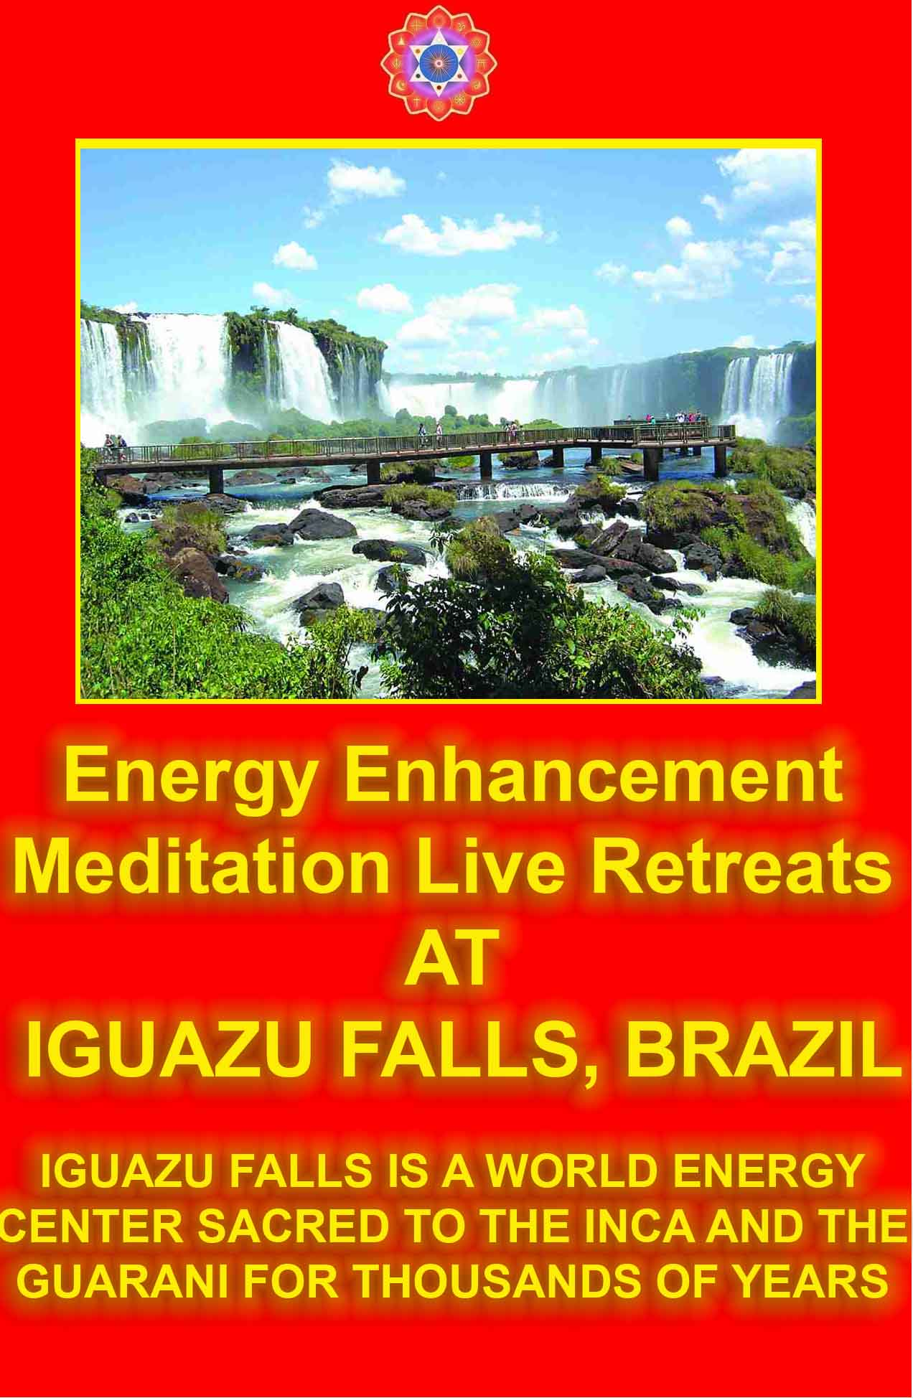

THE OPENING OF PSYCHIC VISION

Of course, since then my student had spent a day or two clearing out his Antahkarana which is the first thing we always do in Level 2 of Energy Enhancement. This opens the channels to the higher chakras and enables vast amounts of energy to power the physical, emotional, mental, spiritual and psychic bodies.

Energy Enhancement connects you up with higher energies. It removes your blockages to the flow of energies. The psychic machinery exists perfectly, within everyone. The problem is it is connected to the little Five Volt Battery of the Chakras where what it really needs is to be connected in to the, as Gurdjieff called it, "The Big Generator!" or the energy of the Soul and Kundalini Chakras.
When given more energy from Advanced Energy Enhancement Initiations, all Energy Enhancement students gain the ability to, "See" what is going on as their Psychic Powers reach fruition. Of Course the Psychic Machinery is not just, "Psychic Vision. It also includes, "Intuition" and "Wisdom" where without any intellectual functioning, we just, "Know".

My student of course, made sensitive by the Energy Enhancement processes was now able to garner much experience and information from this occurrence of the opening of his psychic vision.

He, "Saw" the blockage react to the energy I sent to it and how it resisted the Seven Step process and just how strong it was, what it was and what was its function. He said he had never seen so much energy. he did not know that it was possible to channel so much energy. He did not know that it was possible for Blockages to be so strong.

He, "Saw" that this blockage was a strong Implant Blockage input into his system many lifetimes ago to Vampirise his energy system. These strong types of Implants have the ability to control your intellectual thoughts and lower types of Alters like the "Resistor" we had already grounded.

The Resistor Alter was a Front for the Implant Blockage to distract attention from its presence. The major weapon of these implants is invisibility, because as soon as we know of their existence in Energy Enhancement, they are on the way out!!

Seeing its strength. Seeing how it had resisted my initial blast of energy towards it, my student became afraid that he would remain implanted for all of his life and future lifetimes. Usually, the purpose of such a strong blockage is to act as a Vampire to channel the Psychic Energies of the Client to the Implanters. To keep its client distracted so that it can never regain its psychic powers. And especially, never to allow the client to become Enlightened.

Over many years these sophisticated yet programmed Implant Blockages become a part of the emotional and intellectual mind of the client. They actually gain the ability to affect the emotions of the client and even to "talk" to the client and the words appear in the mind of the client as their own thoughts!!
So, having been discovered this Powerful Implant Blockage went into overdrive to increase its major power, Despair. They are all the same these Big Blockages. They say, "You Can't get rid of me. I am more powerful than you" and time after time we say nothing and we do the Energy Enhancement Seven Step Process and they fall; they go; and their spare parts coat our Higher Being Bodies - at least they are that much use.

They do the same in the World creating all cynicism and despair, as most human beings, 99%, are implanted in this way, "Look upon my works Ye People and Despair!" Yet this world is performing its function, perfectly, as a factory for the production of Enlightened Beings as it provides different races and different evolutions of people in order for us to make our mistakes on the path of learning, "That we only have the Free Will to do the Right Thing"
The wrong thing always brings Its Own Karma, "I was down when I began to crawl. If I didn't have Bad luck, I wouldn't have No luck at All!"
The Buddha was Right, "Right Mind, Right Job, Right Meditation" as he says in the Dhammapada.

The end result of Doing the Right thing is to be in Perfect Alignment with the Purpose of God on this Planet, Enlightenment.
Overnight the blockage talked to our client and in the morning he was in despair. I said, "The only thing we have to fear is fear itself", and he thought that we could not remove the blockage because it was so strong. "I saw your energy hit the Blockage", he said, "And I saw how strongly it reacted to protect itself"

I said that I had only blasted it a little while and that, "No protection can ever hold" It can only give us a little time to react and remove the attacker. "We will remove the Blockage. No Blockage can stand against us because we are connected to the higher frequencies of the Light, to a source of infinite power, whereas the energies of the dark side are necessarily connected to the source of their prey at very much lower frequencies, you!! What chance do they have"

Positivity is a major weapon we all need to work with and to enhance.
So we sat together and Devi Dhyani and I helped and at the end of the meditation the Blockage was gone and its spare parts were coating the Higher Being Bodies of our Student, "Pain Gone! Blockage Gone!!"

There were more blockages like this as we proceeded further on the course, one was found in the middle of a Reiki Mastery Initiation given by Devi Dhyani, yet the process is the same. "Seek and Ye shall find" and when found, the blockage goes and all its bad luck goes with it. These blockages are control blockages designed to distract you and take your attention away from spiritual success. With these blockages in the system The Initiation of Enlightenment is impossible because how can the Ascended Masters of Initiation trust you as you will always be taking your advice from the control blockages. Always you can fall...

As we removed all the blockages so our student had the vision of a sail being unfurled. The mast of the sail stretched up through the antahkarana to infinity and as the sail unfurled he felt the movement forward, with a good wind, in his evolution. At this point he saw a group of Masters including my Master, Swami Satchidananda, taking an interest in him. When all the blockages are gone, then at this point these group of Masters will become the group of Initiating masters for the Initiation of Enlightenment.

And just as we got to the airport on his way home from India I felt another control blockage!! I felt the negative energy triggered by our conversation and I saw at the back of Graham's neck the edge of the control blockage and I said, "meditate on it!" because these control blockages will distract you, distract you from your path, and plug you back into the Matrix. And what did our student say at this moment? "Not now, later"

This is one of the reasons of coming to visit an Enlightened Master. The blockages will distract you, distract you from your path and happily plug you back into the Matrix. Only a Master can stay centered sufficiently to stay still and say, "Meditate on this!" despite all the protestations of the student. Because it is not the student who is talking, it is the Implant Control Blockage which is talking.

Implant control blockages are implanted into the body in this lifetime and also in past lifetimes and it is these Implants which are more dense, more heavy, more controlling because they were implanted in rituals where you helped the process because you wanted to enter into the Dark Side. As these Implant control blockages are removed one by one, know that they can never come back. And every one of these ancient control blockages removed is another degree of freedom for you and for your life..

ENERGY ENHANCEMENT RULES!!

On the path of Illumination, Enlightenment with Energy Enhancement where Enlightenment is Not Enough! because we Facilitate the Higher Cosmic Initiations above Enlightenment. We provide the Techniques to Speed Up the Path of Enlightenment for Every Path extant on this World as All the religions and Spiritual Paths on this planet come together through the use of the Most Advanced and Effective Energy Enhancement Techniques to Create Evolution, Enlightenment and World Peace.

"Miracles, Miracles and yet more Miracles!!" - Graham Smith on his Energy Enhancement Course in India November 2009

"DO IT!" M.S. - HR Director PepsiCo Europe/Asia

APPRENTICE LEVEL 4 - THE MASTERY AND HEALING OF RELATIONSHIPS
FOR High Tantra, Gandalfs and Jedis.

COME ON A MEDITATION ENERGY ENHANCEMENT COURSE!!

FREE YOURSELF!!!

IT IS SO EASY!!

ENERGY ENHANCEMENT APPRENTICE LEVEL 4

The Management of the Psychic Energy Connection.

The Total Mastery of Relationships.
The Mastery of Disappointment.
The Mastery of the Emotional IQ
The Mastery of High Tantra
The ability to remove Energy Blockages from your Friends and Family.
The ability to remove Energy Blockages from your Students.

Become a Master, A Merlin, A Jedi Knight, A White Magician!!!

THE MATRIX - UNPLUG FROM ENERGY ENHANCEMENT ENERGY CONNECTIONS, ENERGY CORDS, ENERGY BLOCKAGE IMPLANTS AND THE MATRIX

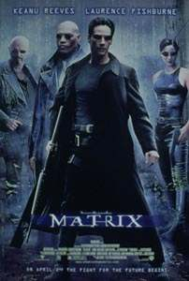

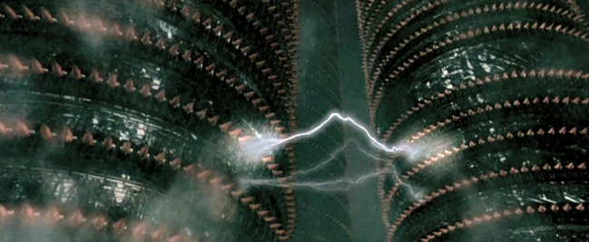

THE PRISON
MORPHEUS: Let me tell you why you are here. You're here because you know something. What you know you can't explain, but you feel it. You've felt it your entire life. There's something wrong with the world. You don't know what it is, but it's there, like a splinter in your mind, driving you mad. It is this feeling that brought you to me. Do you know what I'm talking about?

NEO: The Matrix?

MORPHEUS: Do you want to know what it is?

Neo nods.

MORPHEUS: The Matrix is everywhere. It is all around us, even now in this very room. You can see it when you look out your window, or when you turn on your television. You can feel it when you go to work, when you go to church, when you pay your taxes. It is the world that has been pulled over your eyes to blind you from the truth.

NEO: What truth?

MORPHEUS: That you are a slave, Neo. Like everyone else, you were born into bondage, born into a prison that you cannot smell or taste or touch. A prison for your mind.

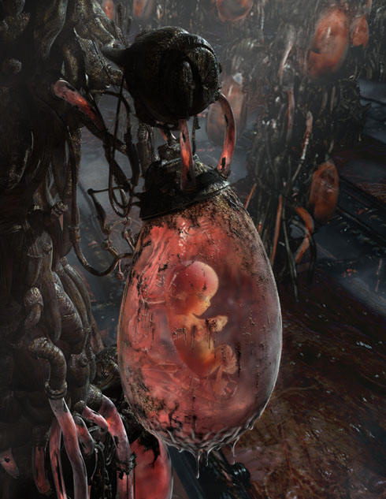

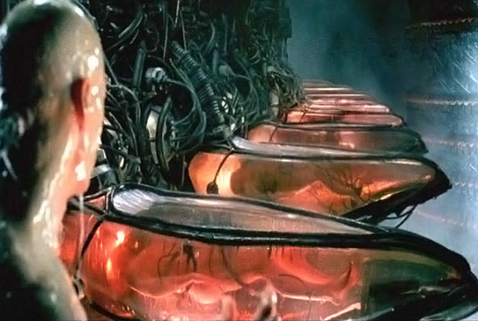
MORPHEUS: You've been living in a dream world Neo.

MORPHEUS: What is the Matrix?
Control
The Matrix is a computer generated dream world built to keep us under control in order to change a human being into this...

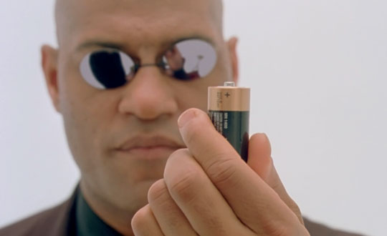

Humanity is the Energy Source of the Dark Side

GOVERNMENT
GOVERN MENTE
GOVERN MIND
MIND CONTROL
PLUGGED INTO THE MATRIX

Morpheus: The Matrix is a system Neo. That system is our enemy. But when you're inside, what do you see? Businessmen, Lawyers, teachers, Carpenters. The very minds of the people we are trying to save. But until we do, these people are a part of that system, and that makes them our enemy... You have to understand that these people are not ready to be unplugged, and many of them are so inert, so dependant on the system, that they will fight to protect it.
If you are not one of us you are one of them.
Neo: What are they?

Morpheus: Sentient programs, they can move in and out of any software still hardwired into their system. That means that anyone we haven't unplugged is potentially an agent. Inside the Matrix they are everyone and they are no-one. We have survived by hiding and running from them but they are the gatekeepers. They are guarding all the doors and holding all the keys.

Implant Blockages are represented by the black studs all over the body;
Energy Connections by the tubes connecting to the implants

We can use some of the items from the Matrix Movie to describe the reality of Implant Energy Blockages which are the black plugs in Neo's body and Energy Connections which are the tubes which enter into the Plug Implants.

AGENT SMITH AND THE MATRIX

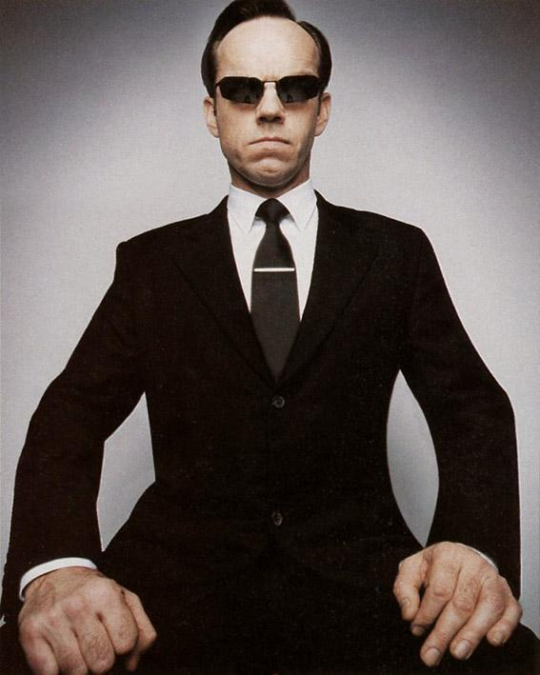

And then there is Agent Smith who can travel down the cords of connection, travel down the Energy Connections to enter into anyone's body who is plugged into the Matrix - and take them over!!

Not just implanting you with the Drug Addiction, the Alcohol Addiction, the Tobacco Addiction, the Sex Addiction, the Dog Priest Homosexuality Addiction, the Ritual Paedophile Addiction, the Television Addiction.
But actually entering into the Body, Emotions and Mind and taking over another Human Being Totally. Cardinals, Bankers, Politicians, Presidents, Chief Executive Officers of vast International Corporations who all with their Big Lie Green Credentials are saying that there are just too many people on this planet -- Just Like this...

Agent Smith: I'd like to share a revelation that I've had during my time here. It came to me when I tried to classify your species and I realized that you're not actually mammals. Every mammal on this planet instinctively develops a natural equilibrium with the surrounding environment but you humans do not. You move to an area and you multiply and multiply until every natural resource is consumed and the only way you can survive is to spread to another area. There is another organism on this planet that follows the same pattern. Do you know what it is? A virus. Human beings are a disease, a cancer of this planet. You're a plague and we are the cure.

If you could live outside the body then you may have a similar view..

BEHOLD THE NEW TRULY ANTI-HUMAN SPECIES!!

POISON WITH UNNECESSARY FUCTORY OUTPUTS, PESTICIDES, FLUORIDE, AND FRANKENSTEIN FOOD.

DUMB DOWN AND ZOMBIFY WITH TELEVISION, DRUGS, FLUORIDE AND VACCINES.

CONTROL
VAMPIRISE
LIVE FOREVER!!

Which brings me to the necessity of using Energy Enhancement level 4 techniques to attain Mastery over Attachment, Mastery of why and who you connect to, - the Mastery of Relationships.

As everyone who has not been through the Energy Enhancement training process has these Implant Blockages with attendant Energy Connections
As everyone who has not been through the Energy Enhancement training process has Implant Blockages built to distract and therefore manage the attention of their clients....

As everyone who has been through the Energy Enhancement training process originally had Food, Sexual and Drug Addiction Implants....
Everyone you meet is connected to the Control....

ENERGY ENHANCEMENT LIBERATION FROM THE CONTROLS!!

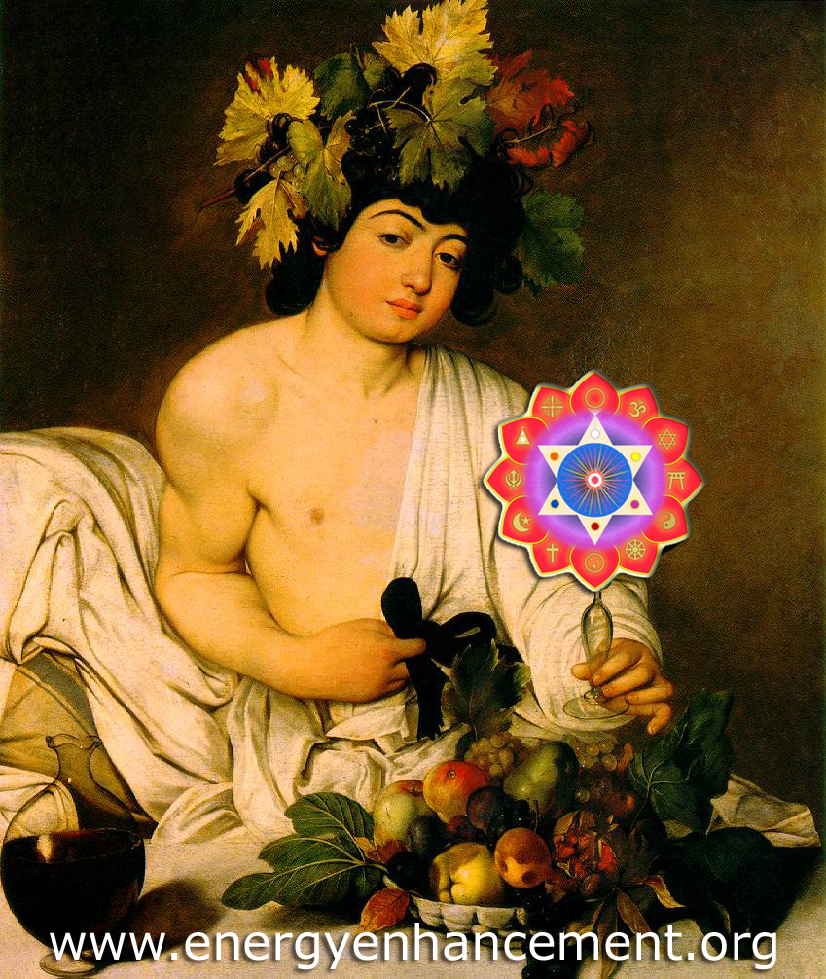

CARAVAGGIO - THE GOD BACCHUS OFFERS YOU THE WINE OF ENLIGHTENMENT - THE ENERGY FLOWING IN THROUGH THE CHAKRAS ABOVE THE HEAD SYMBOLISED BY THE CROWN OF VINE LEAVES SURROUNDING THE HEAD - ENERGY ENHANCEMENT SAYS,..... "TAKE WHAT IS IN MINE HAND"

Benefits
Of the Energy Enhancement Course APPRENTICE LEVEL FOUR

Meditations for the Mastery of Relationships
The Mastery of the Psychic Sexual Connection.

HONEY KALARIA JAN 2005



I was told that each of our 7 chakras within our bodies should be seen as a separate mind/brain like one of the processors in a parallel processing computer. All the Super Computers these days are parallel processing computers. We use only 1 brain or processor and the idea is to activate the other 6 brains or processors to build your creativity, intellect, wisdom and genius abilities. This would lead you to become happier and healthier, enjoy being a more emotionally and mentally balanced person and become a more blockage free (free of negative emotions) human being. The idea is to have a purpose in life to make this world a better, more peaceful and spiritual place, starting from working on yourself as mentioned before.

As I realized how wonderful and life transforming this course is, I got inspired to make this course available to others in London. I have therefore invited Satchiji and his wife Devi to conduct a 4 week evening and weekend course in May 2005 in London. Both Satchiji and Devi are beautiful and inspiring souls, passionately committed to helping people grow spiritually and accelerating each students progress towards enlightenment. They allow the students to grow at their own pace, whilst passing on profound knowledge and techniques in a light hearted and joyful manner. Both of them have extensive knowledge, possess strong perceptive powers and bathe people around them in the strong Buddhafield of energy that surrounds them. They have both made my stay in Argentina a delightful and a memorable one.

Honey Kalaria, Diva, Choreographer, Bollywood Film Star. Honey Kalaria Full Testimonial Click Here!

Learn how to move your relationships to Higher Levels through the Mastery of The Second Initiation.

How to Master and heal the Blockages caused by Disappointment in yourself and others.



How to totally Speed up and Master the Grieving Process of Bereavement by the ability to remove the pain of Disappointment.

How to remove Blockages in all chakras in yourself and others, so that you can initiate the perfect communication of Universal Love with all your friends and Family!!

So that you get less argument. Things get done quicker with no disputes. Win-Win relationships are easily maintained. The Further opening of the Heart.

Increase your Emotional IQ.

Improve all your Relationships

As you connect and clear the problems on every Chakra level so, Learn how to Deepen your Relationships. Make your relationships healthy and happy.

Meditations for the Mastery and Cleaning of Energy Connections, CLEANING ALL THE HISTORY between you and all your Relationships, - AND Everyone you meet.

By cleaning these connections so you clean your ability to Communicate at every level, you remove the blockages of prejudice and deep ancient karma and Competition.

Learn how to Truly Talk on every level. Cooperate together. Heal your Relationships.

Set Yourself Free!!

Clean the Negative Energy between you and all your Karmic Relationships. These are Relationships where people hurt you and harm you for no reason at all. As you heal these relationships through Energy Enhancement then you will improve and deepen all your relationships.

The Mastery of the Psychic Sexual Connection.

How never to feel the pain of Bereavement and Broken Relationships - ever again. How to create Happiness and Felicity between you and everyone you meet.

Learn the Mastery of Relationships.

Freedom in Relationships.

Meditations for the Mastery of The Force.

Learn How to heal and clean your students chakras and all your Relationships at a distance. By first of all learning how to heal all your chakra blockages Through the Grounding of Negative Energies. When you can do this then you can learn to heal all your friends and students in the same way.

The Mastery of Groups and Organisations.

Meditations for the Mastery of the Thoughtforms of Groups and Organisations. Transmuting the negative and Energising the positive.

Energy Enhancement APPRENTICE LEVEL 4 Techniques - Meditation techniques of a Master, a Jedi Knight, White Magician, Merlin and Healer working behind the scenes to Increase the Light, Clean the World and all your Businesses, Institutions, Students and Friends.

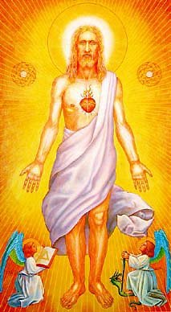

Vanessa Graham (UK)
Meditation Teacher/Writer
"During past meditation sessions for over two years, I have twirled like a top when my bottom came into contact with the floor. After two years the swaying finally stopped in ONE session with Energy Enhancement! I later found out that Satchi had been working on this blockage at the same time using Energy Enhancement Level 2 Techniques...."

Vanessa Graham (UK)
Meditation Teacher/Writer
http://www.energyenhancement.org/page17.htm
Energy Enhancement APPRENTICE LEVEL 4, the Energy of the Heart Center and Meta.
The Heart Centre and Relationships
Coming to Terms with our Primary relationships is something which brings us peace and allows us to move on the path of evolution.
We heal these relationships by an Ancient Secret Energy Enhancement practises which speeds up the process of strengthening and healing the Heart Centre. This has even more far-reaching effects:-
A Blocked Heart centre is selfish.
Healing our Relationships is really the Healing of our own Hearts and developing the Higher Emotion of Compassion and Meta.
This is the First Initiation towards Enlightenment, which ends in Selfless caring for others.
The Energy of the Heart is the Energy of Charity, of Giving without any thought of selfishly wanting a reward.
More; Meta, Love, Compassion is the Energy of Change, without which there can be no movement forward in our evolution.
Masters of Energy Radiate the Energy of Change, Meta, Compassion. It dispels all Energetic Blockages, strategies, anger, needing attention, sadness and depression, manicism, and fear.
This is why they are the only people who can make you angry. They are dangerous to all that is not you.
This is why the first test is to enter into their aura.
Many people can not, as some blockages are so great as to make you uncomfortable in the presence of True Love. As you purify yourself so you become able to stand in the presence of the more evolved. As within, So without!!
"Those whom the gods love the most they first make mad" - Ancient Hindu saying. The result is the Tarot card of the Tower. Struck by lightning as the selfish ego is worn away, transmuted, cast out!!
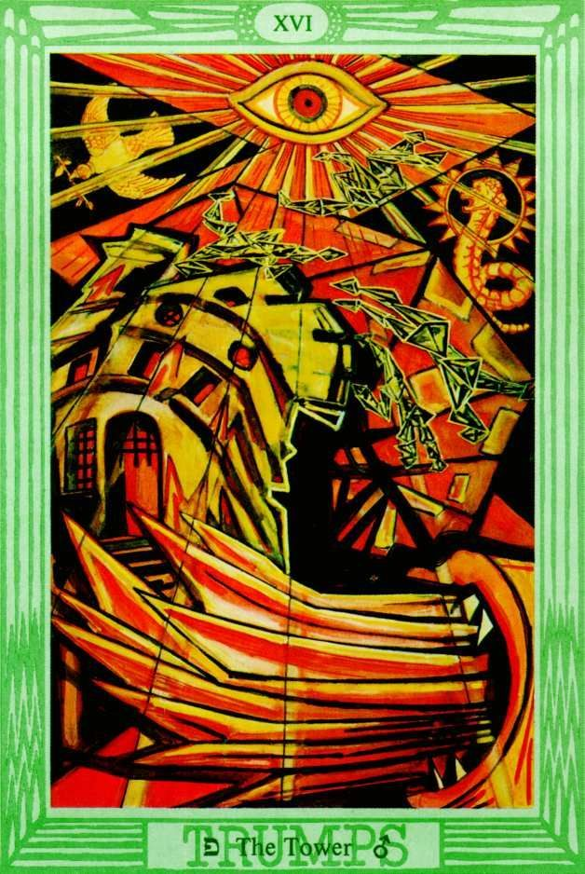
We know that the law of the Universe is that Practically, that what goes around comes around.
What we give in one direction, either positive or negative, always comes back to us in full from that or another direction.
So practically, we know that as we give, so we receive.
It is also that Heart Energy which allows us to change.
The Energy of Love is seen in the truly great, including more evolved human beings like Mother Teresa and her student, Princess Diana.
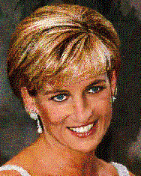
They sought to help children, the sick and poor people no matter what their faults. For no clever intellectual reason at all. Just that of the Heart.
INTELLECTUALLY WE ALL KNOW ABOUT ENLIGHTENED SELF INTEREST
As society evolves so the responsibility goes higher. We know that Vast profits are The Major TAX on Society which shifts money from the poor to the rich.
CO0RRUPTION attacks, CORRUPTION a Tax, on the wellbeing of the poor, of the sick, of the children.
First of all,
1. Individuals take responsibility for other individuals, then sometimes "the law of the jungle" or "Market forces" or "Free Trade" rules the roost. But later, more high, as we evolve,
2. Families,
3. Organisations,
4. Small companies,
5. Small countries,
6. Global International companies,
7. Groups of countries like the EEC, USA and NAFTA
and lastly, on this planet,
8.The United Nations,

will take more and more compassion on others. Not to make them dependent, but AS WITH THE IDEA OF A "BASIC INCOME" or "Citizens Wage" to provide a solid base of food, housing and education, FREE!!; like all good families do for their children, for the benefit of the World!!
First of all by providing rules and laws to control the rapacious strong, to control these vast profit taxes. To take from the rich, and give to the poor a small basic income, like Robin Hood.
To provide the basic necessities of life, water, health, food, housing, education and meditation. In this way the people of the world can evolve more quickly.
For example we have the inalienable "Rights of the Child" as presently written down by the United Nations, although they, and we, have no budget to enforce these "Rights".
In most societies, now, Individuals are responsible for the rights of children. For their hunger, for their housing, and for their education.
There is a tremendous World failure in the application of these Rights. A vast abuse of the rights of the child.
It is now not a matter of whether the world will come together as one, under one government. Evolutionary forces demand that this will happen over the next century.
Now the world is coming together as 5 major trading blocks. The intention is that these too will merge under one elected government.
Not only does intuition lead in this direction, but cold hard facts and common sense.
With no enemies the world can save the 15 trillion or 15 million, billions - yes, that is right, 15 million, Billions of dollars have been spent on arms since the last world war; enough to turn this world into a paradise.
A United Federation of World States under one president would save this money which could be spent on better things.
The only Question is now - Which Quality of People will Rule the World?!!
Energy Enhancement APPRENTICE LEVEL 4 and Meditation Hold the KEY!!
Remember, children did not ask to come.
Who will provide the birthright for the as yet unborn child?
Who will provide for their rights in advance? If the rights of children are not supported then society will reap the whirlwind as walking down the street becomes more and more dangerous, as less educated people
1.become more warlike and
2.create more and more other children.
Educated societies have a lower birthrate. In Kerala, a state in India, where the education system has created a population where 100% can read, their population growth is remarkably low.
The rest of India where Education is not well supported, has a much higher birthrate.

Likewise in China and Africa.
This shows the changes which still need to come.
As societies evolve so, higher and higher will the budget to support these children come from.
Because it makes intellectual sense to do so.
Because it is the message of the heart.
Less evolved societies RUN BY PSYCHOPATHS will push the responsibility and the budget lower and lower down the evolutionary ladder. And inevitably, many children will be abused.
Already Many children Die due to this present world system.
Saintly individuals of the heart like Mother Teresa and Princess Diana, quietly shamed us and showed the work needing to be done higher in society.

THEY SHOWED US THE PATH OF THE HEART.

With Energy Enhancement APPRENTICE LEVEL four
Learn how to Heal all your Primary Relationships
Learn how to develop strength and purity in your Heart Centre.
To Heal your Heart with Excellence.
The Synthesis of Light Symbol

The Purity of your Heart is shown by your attitude to your Relationships, by the quality of your energy towards everyone in your life.
This Initiation gives techniques which will enable you to heal and purify these relationship energies at your own pace, safely, at a distance. See the difference as you progress!
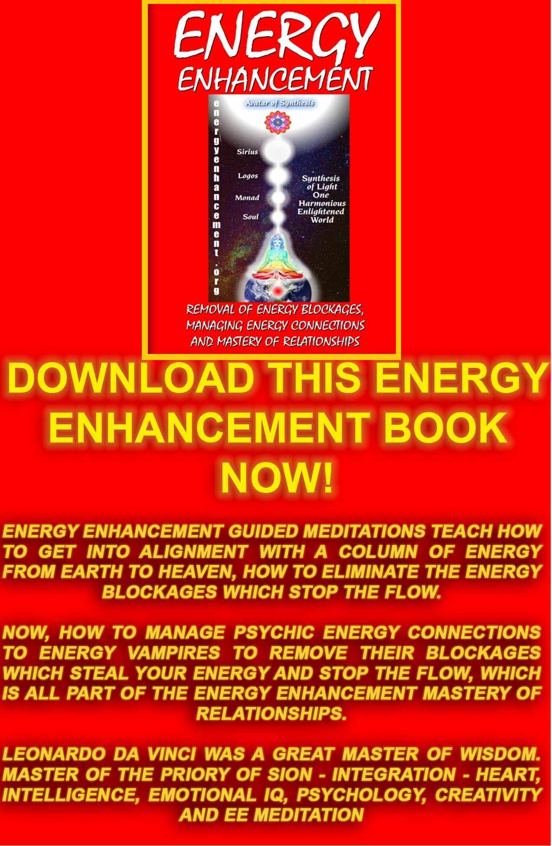
Download “REMOVAL OF ENERGY BLOCKAGES, MANAGING ENERGY CONNECTIONS AND MASTERY OF RELATIONSHIPS” HERE
http://www.energyenhancement.org/Sacred-Energy/Meditation-Energy-Enhancement-Eliminate-Energy-Blockages-Manage-Energy-Connections-and-Attachment-Mastery-of-Relationships-EEBOOK2Color-energyenhancement-org.pdf
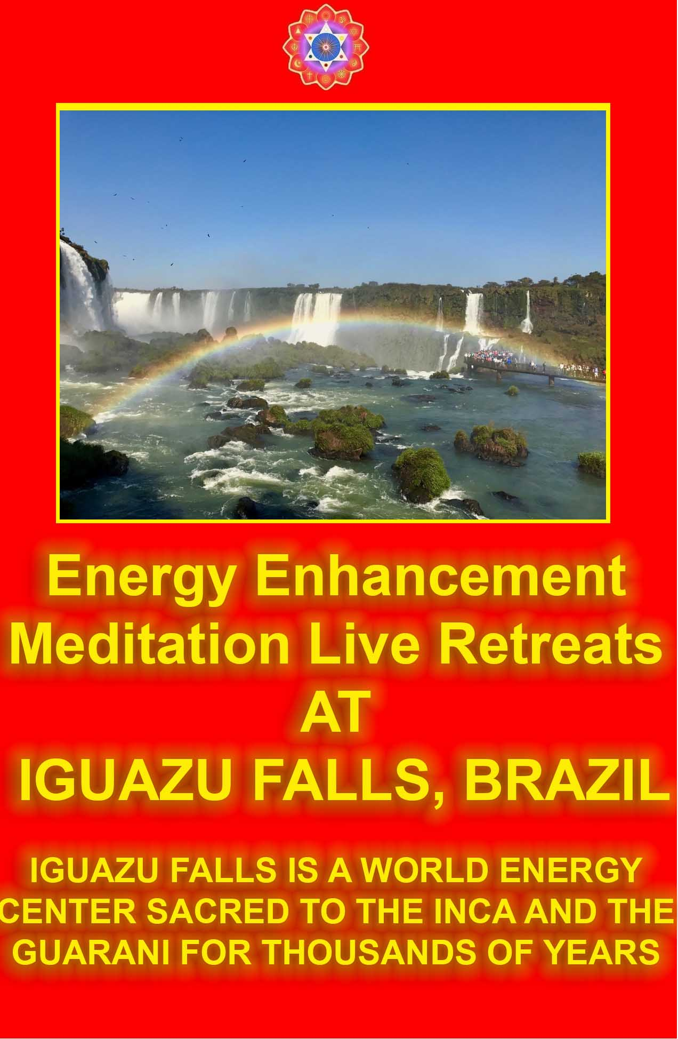
The Energy Enhancement Indian Adventure with:-
Energy Enhancement Levels One and Two.
Pierre Morency- What He Says!!
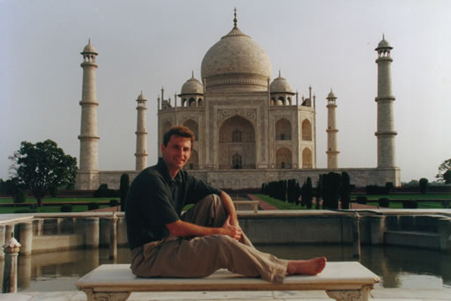
This testimonial has been provided by Pierre Morency, a previous member of International Consultants, McKinsey and Company. Management Consultants who recruit mainly Rhodes Scholars, universally used by all major International Companies for consultation and as a selection ground for future Chief Executive Officers, CEO's.
Energy Enhancement proves its use for all levels of business and professionals; and for meditators, yoga teachers, healers, - in fact for anyone who wants to access their inherent energies. Energy Enhancement speeds up the process of gaining more Energy!
Pierre came on one of our Energy Enhancement Training Adventures in India, visiting the Taj Mahal and the Foothills of the Himalayas from his home in Canada. Usually we go for one week for one Level of Energy Enhancement, learning the Techniques in 5Star Hotels.
Pierre learnt Two Levels of Energy Enhancement in two weeks. We also have longer tours. The process he describes in his case was very quick as is his nature. Most people go through this process at a much more sedate rate.
Pierre himself is a major marketing consultant to many International Companies and CEO's.
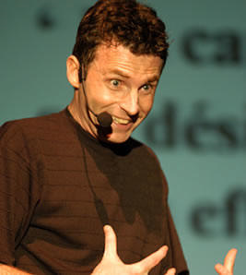
Here's my promised testimonial:
"Last June, I had the privilege to get my first taste of India in the Company of two wonderful, knowledgeable and fun people, Satchi and Devi. From day one, they were able to stabilize me in this strange and mysterious country.
Being a marketing speaker and a meditation practitioner, I didn't really know what to expect from my 2 week training. What I discovered was a powerful systematic way of practising meditation and other Energy Enhancement methods.
I'm in the process of fully testing the techniques and approaches I've learned but can already feel - and prove!- tremendous changes in my life.
For instance, since I've been working on "cleaning my base chakra" (The Grounding of Negative Energies, Stage Three of Energy Enhancement, -Satchidanand) everything around me seems to be going through a massive cleansing process - Only 2 days after I returned to Canada from India, a chain reaction of events led my to change my 5 employees, change some of my major accounts and delay a move to the United States. 10 weeks after the program, things are stabilizing.
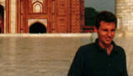
Looking back, I think the cleansing process probably saved my business and my marriage.

Thank you Satchi and Devi!!!
Hope this testimonial can serve you well.

Marketing Physicist
President Morency Marketing Inc."
Pierre Morency
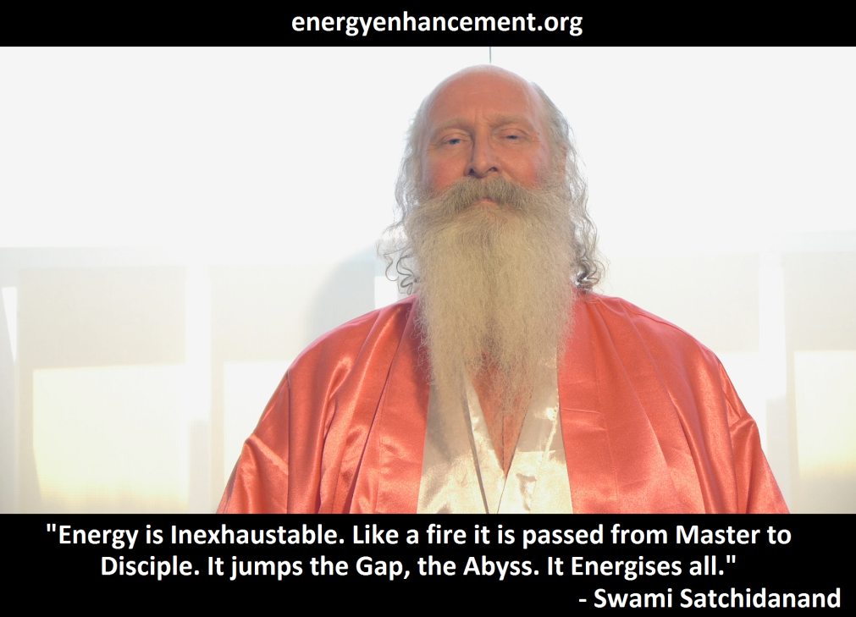

Energy Enhancement APPRENTICE LEVEL 4.
Initiation 1
LEARN HOW TO HEAL ALL ADDICTION!!!
Learn how to heal all your Addictions or strategy driven predelections to...
Food, Alcohol, Smoking, Drugs and Sex.

Brenda Wilkinson, Co Durham.
You have both made me think about life in a very different way and I thank you both with all my love.

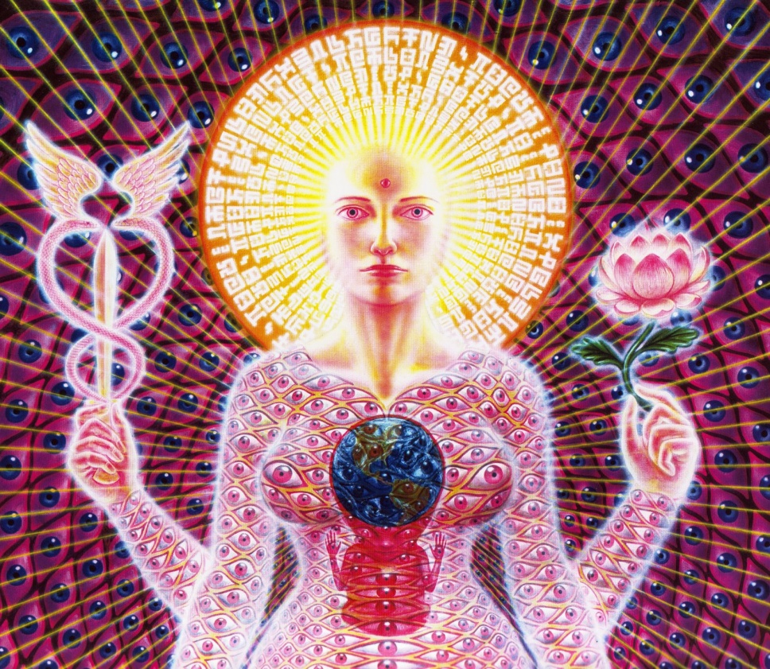

TESTIMONIAL REVIEW OF THE FIRST ENERGY ENHANCEMENT COURSE, INITIATION ONE - MEDITATION
Prior to seeing the "Initiation One" Video my 50 year old legs would go numb within 10 minutes any time I tried to meditate sitting on the floor with legs crossed in "easy position". After making the adjustments suggested in the video I can sit for 40+ minutes without any sign of numbness or strain. I'm sure I'll be able to go much longer with practice. An alternate method of sitting "saddle style" was also shown and it too provided numbness and pain free meditation.

The next part of the video described how to align the spine so that it is square to the earth. Once in alignment I could easily feel the current from the center of the earth flowing though me. This was very energizing.
These two changes alone I feel will dramatically impact my meditation progress for the better.
The breathing technique given was not unlike techniques that I've used before. So it wasn't a major breakthrough for me. However, with the above two changes I think any breathing technique would be greatly enhanced.
Overall, I think that this video gives the two most important and often overlooked keys to meditation. First is finding a sitting position that is comfortable for a long duration and second is squaring the body to tap into the earth's energy system.

Craig Adamson

Testimonial From Gary Spaid a Wealth Counselor in Vail Valley, Colorado, USA.
... I recommend you try this Energy Enhancement for yourself.
They gave some inner WEALTH to me and Yoga and better relationships to Candy.
Candy even wants to accompany my daily meditation sessions now!!
I suggest you try the Video course or the Online Course first before you invite them to YOUR home or go to visit them wherever in the World they are. I guess Spain or India this year. You will not be disappointed.
Devi is pure magic.
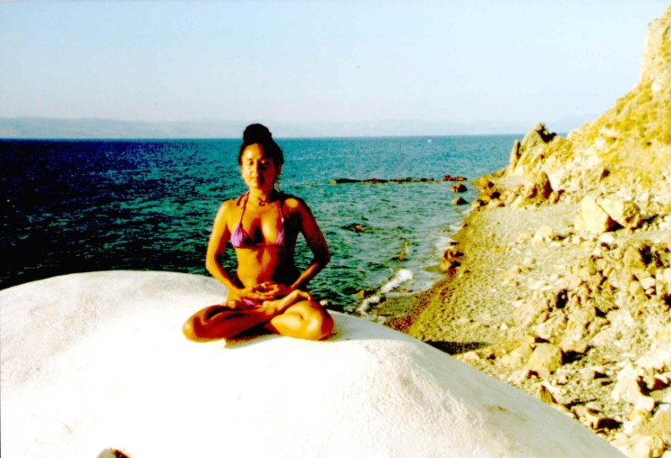
She said I just know where the point is. I can just see it, and when she treated it our client felt a terrible pain where Devi was touching her on the feet.
The Pains at the back of the heart now were completely gone!
Devi used the light puncture and the Techniques of Energy Enhancement to ground all the negative energy in the point on the feet. It took her five minutes and after that treatment there was no more pain in the point of the feet and the pains on either side of the abdomen had also disappeared. Where did it go to?
Pain is due to an energy blockage.
THE PAINLESS REMOVAL OF STRESS, TRAUMA AND NEGATIVE EMOTION
Energy Enhancement easily transmutes all negative energy without going anywhere near the emotions and memory!! The techniques of Energy Enhancement show you how to QUICKLY AND EASILY TRANSMUTE YOUR STRESS because it works at the level of Energy which underlies AND IS THE BASIS of all problems.

THE START OF THE ENERGY ENHANCEMENT ENERGIES
The Buddhafield of energy, in which evolutionary progress can quickly be made, and Kundalini Energy are absolutely necessary to any course of Meditation.
Energy Enhancement Advanced Techniques allow PAINLESS progress above and beyond any other course.
Energy Enhancement Advanced Techniques only use ENERGY which underlies all other human functions.
With Energy Enhancement it is not necessary to go anywhere near painful memory, negative emotions and catharsis which are the foundations of other courses.
ENERGY ENHANCEMENT PAINLESS TRANSMUTATION IS EASY AND QUICK.
IT SPEEDS UP THE PROCESS OF ENLIGHTENMENT!!
It teaches TOTAL Transformation and Transmutation
THE PRINCESS OF SWORDS OF THE THOTH TAROT
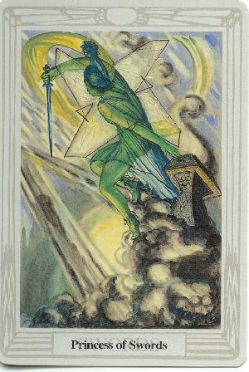
The inflow of Spiritual Energy or Kundalini Energy is well known in all Spiritual Circles as being expected in all genuine Courses with teachers who have advanced experience with Enlightened Masters yet some people just cannot get their heads around it and they do not trust it as this concept destroys their idea of a "Normal" world. They start to fear the unknown!!
"EASY AND SMOOTH ENERGY ENHANCEMENT SPEEDS UP THE PROCESS OF ENLIGHTENMENT"
Energy Enhancement easily transmutes all negative energy without going anywhere near the emotions and memory!! The wind of Kundalini blowing through you usually leaves smoke and ashes in its wake. Normally, when Kundalini energy starts to flow through the interiorly held negativities it starts to destroy and release the pain and trauma within. Fear CAN be the result with all OTHER courses.
The techniques of Energy Enhancement show you how to TOTALLY CLEAR yourself from moods and disturbing thoughts because it works at the level of Energy which underlies all the problems.
"ENERGY ENHANCEMENT IS A PROBLEM FREE METHOD OF AWAKENING CREATIVE INTELLIGENCE!!"
The powerful techniques of Energy Enhancement REMOVE the traumatic nature of all this Energy Release by using the new ALCHEMICAL concept of "Transmutation" - there remains non of the problems associated with all other courses.
Energy Enhancement does not work at the level of memory. You do not have to remember anything as we work at the level of energy which underlies all of the painful memories, yet the performance of Energy Enhancement techniques can easily and totally remove all the ENERGY BLOCKAGES, in a non-painful way!!
The student of Energy Enhancement knows how necessary is the transmutation of all the old energies on the path of evolution, progress and inner freedom.
The Energy transmutation of Energy Enhancement produces inner peace, clarity, openness and truth. The Energy Enhancement student's "NO" to all the past negative energy held inside springs from an unequivocal "YES" to themselves and to their life!
The necessity for positive and easy change is comparable to the drastic move by Jesus Christ when he drove the moneylenders out of the Temple, and to the work of Hercules when he drove the River Styx through the Augean Stables, thus easily cleaning out thousands of years of horse shit in one day!

THE ENERGY ENHANCEMENT STREAMING VIDEO COURSE

"Get your asses over here Now and Speed Up your process of Enlightenment on the Energy Enhancement one month course!!" - DON
Every one of our Students gets this Spiritual Experience of Connection with Infinite Energies.
Energy Enhancement does indeed, "SPEED UP THE PROCESS!!"
And they all get this Experience of Light, Life and Infinite Energy just with the Energy Enhancement Course - Every One of Them!!
LEVEL 1 - 4 VIDEO COURSES ANYTIME IN THE COMFORT OF YOUR OWN HOME
THE RESULT OF THE ENERGY ENHANCEMENT ENERGIES
THE PRINCESS OF DISCS OF THE THOTH TAROT
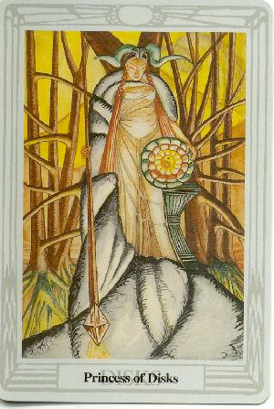
The wand of the Princess of discs stretches from heaven to earth and symbolises the Antakarana, an ancient symbol of Kundalini Yoga, which represents the tower, rainbow bridge of energy which flows through all your chakras from heaven to earth, when all energy blockages preventing that flow have been transmuted through the techniques of Energy Enhancement.
By learning how to bring the Spiritual Energies of the Center of the Universe, the highest and purest form of light, into this Earth which is the darkest and most negative of all elements, it becomes possible to raise the energy level of the Energy Enhancement student and the Earth itself. This advance into new territory has the ability to unify to integrate the mother, the father and all the internal children into one energetic, soul infused and peaceful being.
"THERE CAN ONLY BE ONE!!"
Thus bringing together spirit and matter. The removal of energy blockages has created something new which can channel the light onto the Earth and cosmic idea-impulses, thoughtforms, become visible to everyone and permeate everything with their divine quality.
THE TRUE HEALING OF YOU, AND THE EARTH ITSELF!!

Energy Enhancement
APPRENTICE LEVEL 4. Initiation 2.
The Healing of the Negative Energy of Close Personal, Primary, Relationships including your mother and your father.
Learn how to Heal all your Relationships Without talking to these people. Learn to heal at a distance all the Negative Energy which inevitably builds up in all our Primary Relationships;
Heal all your Relationship to your Father, your Mother, your Brothers, your Sisters, your Partners, your Children, your Friends, your Enemies.
To heal all of your close personal relationships, including your friends and Managers at work. Do all this quietly, privately and alone at home and learn the management of conflict.
Learn the Secrets of True Mediation
Gurdjieff said it was not possible to be truly human without the ability to love your Father and your Mother.
This APPRENTICE LEVEL 4 of Energy Enhancement gives you the techniques to Heal all this ancient and not so ancient Karma with all your relationships.
The energy of the Heart used correctly, even at a distance, will lead to true forgiveness.
Only when we can stop blaming other people for our problems, knowing that we attract everything, every test, to ourselves.
As Hermes Trismegistus said, "As Within, So Without."
So, with Energy Enhancement, we can even learn to Forgive Ourselves!!!
As we Heal our energies with the use of the Heart, so know that as we change that which is inside, so our outside will change automatically.

The True Energy of Love is the Energy of Change.

Just notice how your relationships improve with everyone you know!
We travel from lifetime to lifetime in families with all our little friends.
In one lifetime your little friend is your mother and in the next she is your wife and next your sister or even your husband.
Over many lifetimes we tend to do many bad things to each other.
We create karma between us. Because of this a black cloud of negative energy stands between all of us and our little friends.
We always recognise our karmic relationships.
Because we know them we find it easy to fall in love with them.
After we meet again, after a month or two, this negativity becomes activated physically after a while in bad words and even actions.
In one lifetime they hit us and in the next we hit them. Have you ever heard, "You are the only person who can make me angry!"?
(Quotes from the Energy Enhancement Dark Poetic Book.)
The Energy Enhancement Dark Poetic Book, CLICK HERE!!
These people are our Karmic Enemies.
In one lifetime we hit them and in the next they hit us, creating black negative energies between us.
The only way out is to dissolve this energy and for one of us to say STOP!
Like Jesus turning the other cheek.
It is not enough for the intellect to say, "Stop!".
The intellect is not enough.
This negative energy still remains.
Energy Enhancement in this Initiation teaches how to spiritually dissolve all this negative energy between us. How never to have to fight, to hit, ever again!
In this way, with Energy Enhancement we can learn how to turn our Enemies into friends, even at a distance.
The Primary Relationships we have with our Parents or our Brothers and Sisters determine every other relationship we have in this life.
Learn how to Transform, Free up, negative energies between yourself and others. The pain, competition and conflict which tends to separate all close relationships from time to time. Some of it new. Some of it long standing.

ENLIGHTENMENT
Energy Enhancement APPRENTICE LEVEL 4. Initiation 3
The Total healing of all Chakra connections
Energy from further Improving Relationships and Protection.

How to clean all the energy connections of Attachment.
How to clean the ties that bind so that we can totally purify all our close relationships.
ENLIGHTENMENT
"Enlightenment is attained by Meditation And Non-Attachment" - Yoga Sutras of Patanjali

Energy Enhancement
APPRENTICE LEVEL 4. Initiation 4
Creating and Cleaning the soul connection in your students and friends
ILLUMINATION
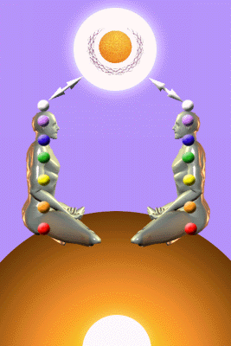
Energy Enhancement
APPRENTICE LEVEL 4. Initiation 5.
The Mastery of Relationships II
The Mastery of the Psychic Energy Connections.
The Removal of Blockages between the Sacral and the Throat Chakras and the Learning of Protection from Energy Vampires.
The Creation of Emotional Intelligence
ENERGY ENHANCEMENT MASTERY OF BEREAVEMENT
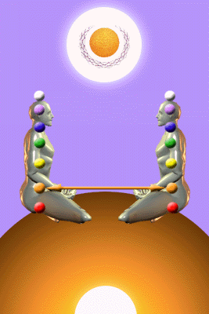
The Mastery of Relationships - How to master your emotions.
It is easy to think intellectually about how you would feel if one of your close family died.
Or if you split up and divorced.
But the reality is not like that. The emotions, a totally different system from the mental, are the ones that get hurt. And when the Psychic sexual connection between the relationship chakras is cut it acts like a taut elastic band which snaps back into the abdomen in an explosion of pain and psychic damage, and this is how many energy blockages are created.
This Disappointment is an explosion of psychic pain and damage in the abdomen creating an Energy Blockage which stops your breathing and your energy.
With Energy Enhancement, we teach how to remove pain blockages in ourselves and others.
To Master the Energy and Emotions.
And Not Only That!!! How to Master the Energetic Connections between Chakras so that this explosion of pain, can never happen again!!
And not only that. How to integrate the Trauma created Strategy separated selves. How to dissolve the karma between you and all your close friends, enemies and family. The Mastery of Relationships.

HIGH TANTRA

Learn complete Mastery of Relationships, protection from being hurt by the pain of bereavement, separation and divorce, ever occurring again.
Learn the MASTERY of Close Relationships with husbands, wives, girlfriends and boyfriends. Practical methods of dealing with Dependency and Independence in Loving Relationships.
Learn also, practical methods of Auric protection and cleansing and Protecting against Psychic Attack which drains your energy THROUGH THE PSYCHIC SEXUAL CONNECTION in many situations.
Learn how to prevent psychic attack from people who unconsciously affect your aura. And through your aura who affect your emotions and mind. These psychic Energies Affect Everyone.
These methods of Psychic protection are only a first step on the way to total Protection in Relationships in this Initiation through the Transmutation of Negative Energies in APPRENTICE LEVEL FOUR of Energy Enhancement. This teaches practical methods of being an Energetic, Independent person.
Enlightenment comes from Meditation and Non Attachment- Yoga Sutras of Patanjali
Attachment And Relationships
THE SOLUTION TO PROBLEMS OF ATTACHMENT AND THE MASTERY OF RELATIONSHIPS AND ENERGY CONNECTION ATTACHMENT
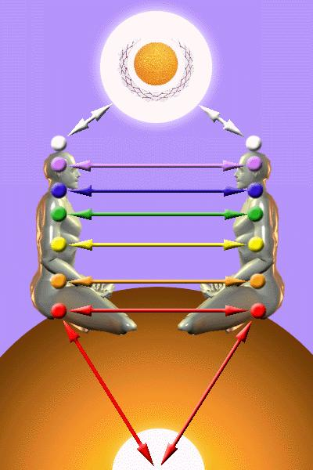
The normal horizontal energy attachments which are created between people start in the womb through the umbilical chord.
When the chord is cut into the same place go the energy connections or attachments which are created to feed the child energy for its development.
The adult takes energy from the source through the vertical connection, the chakra above the head called the soul, and then channels that energy to the child, as we do to the old, ill and infirm.
The child becomes Weaned when it can form its own attachment with the Energies of the Soul, unfortunately many people never become weaned, never "Cut the ties which Bind" and are dependent slaves for the whole of their lives.
The Horizontal and Vertical Connection forms the Christian Cross in which the Christ shows how energy is meant to be distributed on the Planet. How every member of humanity is meant to connect with the source, to an infinite supply of energy and then give it freely.

The meaning of Sacred Symbols is Given in the Energy Enhancement Book, "Super Energy and Sacred Symbols for Perfect Wisdom Enlightenment" - available from Amazon soon or as a downloadable PDF in colour from this website
The Iona Cross, as well as showing the horizontal and Vertical attachments, also shows the source of Kundalini Chakra in the Center of the Earth - The Center of the Circle in the picture of the Iona Cross above - which we teach in Initiation 3 of Level One of Energy Enhancement - These Initiations are available as a DVD from this website.
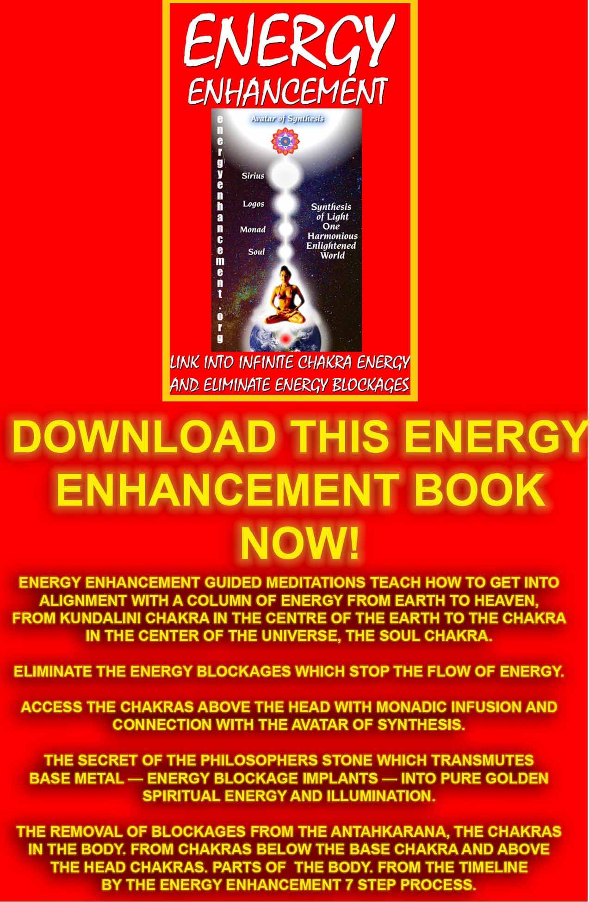
Download “Link Into Infinite Chakra Energy And Eliminate Energy Blockages” Here
http://www.energyenhancement.org/Sacred-Energy/Meditation-Energy-Enhancement-Link-into-Infinite-Chakra-Energies-and-Remove-Energy-Blockages-EEBOOK1Color-energyenhancement-org.pdf
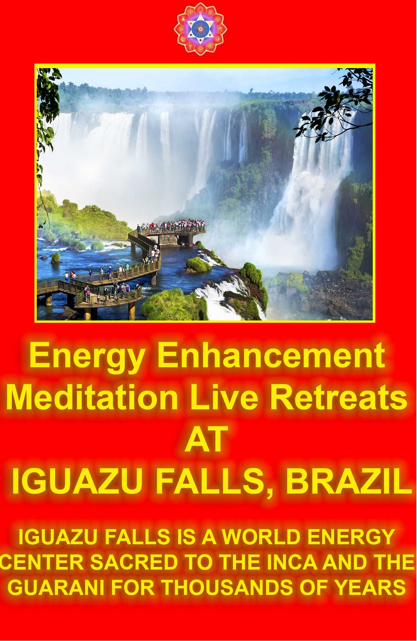
THE SOLUTION TO PROBLEMS OF ATTACHMENT AND THE MASTERY OF RELATIONSHIPS

1. BLOCKAGES ABOVE THE HEAD AND BELOW THE BASE CHAKRA
Energy Blockages above the head cut one off from the Source, the Soul (Or SOL the Sun which gives an infinity of energy to the earth, or Sole, "there can only be one!") and thus ensure that you must take your energy though horizontal attachments only.
This is the creation of Energy Vampires when these blockages are consciously put into the Aura by bad people in ritual; these blockages can then stay with you, lifetime after lifetime even when you forget that you consciously allowed them to be put there in previous lifetimes, until removed by Energy Enhancement Techniques.
Blockages above the head have the side effect of cutting you off from higher forces like the Intuition of the Soul or from Conscience. Without the energy from the Soul entering into the Crown Chakra or Sufi Soul ferment or Bacchus Wine, or the Christian Holy Spirit, or Hindu Ananda or Buddhist Nirvana or Nothingness as it has been called in many different religions, then perforce we must take our energy from human cattle.
Blockages above the head are one of the causes of the Psychopath like Hitler from the Right or Stalin or Mao from the Left which enable the psychopath to contemplate war, torture and killing with equinamity. The other causes of the Psychopath is the conscious implanting of Energy Blockages in the Heart, thus cutting you off from Empathy, the "Ability to put yourself in the Shoes of Another" Of Gurdjieff.
Many people Vampirise Energy consciously, see human beings as their cattle, and this is the Cause of all Wars and human misery on this planet for thousands of years as one civilisation after another has been destroyed in the name of Vampirism over the last 400,000 years.
Most people Vampirise Energy unconsciously, and this is the fact which creates all the symptoms of Attachment which we write about below, also the "Games people Play" written about by Eric Berne, also the Strategies which we write about in Energy Enhancement Level 3.
Energy Blockages beneath the Base Chakra between the Base Chakra and the center of the earth.are implanted in previous lifetimes when we are defeated or de - feeted and cause the person who is not in contact with his earth, a Slave who follows orders because they do not have sufficient energy to start anything off by themselves.
Unconscious Energy Vampires caused by Trauma Formed and Implanted in previous lifetimes Energy Blockages are human cripples who have no possibility of a normal relationship and which form the vast mass of Humanity as the problems caused by Blockages in every chakra are endemic throughout all society as the symptoms of Madness. As we remove the blockages in Energy Enhancement Courses so we travel the Path of the Mastery of Relationships.

2. ENERGY CONNECTIONS
People connect chakra to chakra by means of created horizontal Antahkaranas. Antahkaranas are symbolised by Hindu OM - AUM, The Christian Holy Trinity, The Hindu Sat Chid Ananda, The Sufi HOO, and the Hindu Trimurthy - Shakti/Visnu/Krishna, Shiva and Brahman and are composed of three parts.
1. The polarity at a higher energy level - The Father, Sat, Brahman, M
2. The polarity at a lower energy level - The Son, Chid, Shakti, A
3. The column of connection - The Holy Spirit, Shiva, Ananda, U - which is composed of two parts - See a. and b. below..
a. An energy which flows in one direction which creates a spiral of energy flowing around it anticlockwise or widdershins in the direction of the flow away from you.
b. The energy which flows towards you in the opposite direction which is 180 degrees out of phase with the opposite direction of the flow, which has a spiral of energy around it clockwise.
These two energy flows together together form a circle of Energy Symbolised by the Taoist Orbits of the Kundalini Kriyas..
People give energy along the right side of the connection and receive energy from the left side of the connection when these attachments are formed horizontally
3. BLOCKAGES ON THE ENERGY CONNECTIONS WHICH GIVES
This means we cannot give energy, we can only receive or Vampirise energy from other people. As other people can feel connections and being sucked then unless you have a very strong sexual connection which always overcomes a lack of connection for a while, or we have a very forgiving partner, the relationship will always eventually break up.
4. BLOCKAGES ON THE ENERGY CONNECTION WHICH RECEIVES
This means we can only give energy and we feel drained by everyone around us. Perforce everyone, to this person, is an Energy Vampire.
5. NON ATTACHMENT
Gautama Buddha said "Attachment leads to Pain" and by this he was referring to Mastery of Connection. Conscious Connection always leads to pain in other people as they are vampirised by psychopaths. Unconscious connection always leads to pain both in the person crippled by Energy Blockages who act out the Trauma - Formed Inner Children and in the people who perforce must deal with their symptoms..
When we connect with the Soul through the Crown Chakra Connection then we start to normalise our horizontal energy connections as the Higher always Heals the Lower. The Soul helps with the removal of Energy Blockages. Higher Energy Centers of the Ascended masters are responsible for all Techniques which help with their removal.
When, through Energy Enhancement Techniques we have removed most of our Energy Blockages and practised working with the removal and construction of Horizontal Energy Connections, we then have the ability to be Non - Attached which is a pre-requisite for Enlightenment, which simply means than we are "Soul Infused" - a very strong welded, fused by higher spiritual forces, connection, connected with the Soul through the Crown Chakra Connection.
Conscious connection with other people by Enlightened Masters of Wisdom always leads to the Tapas of Patanjali or the "Conscious Suffering" of Gurdjieff as we consciously use these connections to give energy and remove blockages from our students.

John Bowlby - Attachment Theory
Attachment Styles
John Bowlby described attachment as an emotional bond that impacts behavior "from the cradle to the grave." Learn more about the styles of attachment described by researchers and the role attachment style plays in behavior and relationships.
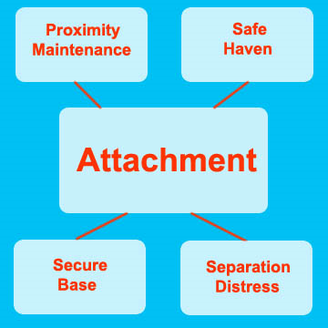

What is Attachment?
Attachment is a special emotional relationship that involves an exchange of comfort, care, and pleasure. The roots of research on attachment began with Freud's theories about love, but another researcher is usually credited as the father of attachment theory.

John Bowlby devoted extensive research to the concept of attachment, describing it as a "lasting psychological connectedness between human beings" (Bowlby, 1969, p. 194). Bowlby shared the psychoanalytic view that early experiences in childhood have an important influence on development and behavior later in life. Our early attachment styles are established in childhood through the infant/caregiver relationship.

In addition to this, Bowlby believed that attachment had an evolutionary component; it aids in survival. "The propensity to make strong emotional bonds to particular individuals [is] a basic component of human nature" (Bowlby, 1988, 3).
Characteristics of Attachment
Bowlby believed that there are four distinguishing characteristics of attachment:
Proximity Maintenance - The desire to be near the people we are attached to.
Safe Haven - Returning to the attachment figure for comfort and safety in the face of a fear or threat.
Secure Base - The attachment figure acts as a base of security from which the child can explore the surrounding environment.
Separation Distress - Anxiety that occurs in the absence of the attachment figure.

The necessity of lasting Attachment leads to Security Problems usually caused by fear blockages in the Base Chakra. Blockages in the Base chakra cause all the problems of Money Misery, Fear of a Lack of Security "I want my Mummy" Or a strong society with many police and a big army. Any Trauma to the Base Chakra in this or previous lifetimes through torture or Circumcision, for example, will cause this type of mindset which is very helpful to the people at the top of society who provide the image - because it is not real - of Security.

Ainsworth's "Strange Situation" Assessment
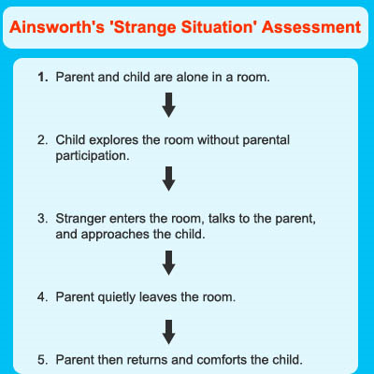

During the 1970's, researcher Mary Ainsworth further expanded upon Bowlby's groundbreaking work in her now-famous "Strange Situation" study. The study involved observing children between the ages of 12 to 18 months responding to a situation in which they were briefly left alone and then reunited with their mother (Ainsworth, 1978).
Based on these observations, Ainsworth concluded that there were three major styles of attachment: secure attachment, ambivalent-insecure attachment, and avoidant-insecure attachment. Researchers Main and Solomon (1986) added a fourth attachment style known as disorganized-insecure attachment. Numerous studies have supported Ainsworth's conclusions and additional research has revealed that these early attachment styles can help predict behaviors later in life.
These Strange Situation Symptoms are symptoms as they get worse of more and more trauma Formed Energy Blockages in the Energy Connections between them and their family/partner and usually piggy-back on blockages passed down from previous lifetimes as like calls to like which is simply Karma. The Karma Cleaning Processes of Energy Enhancement Level 3 deal with the removal of this type of Blockage.
Attachment Through Life
Before you start blaming relationship problems on your parents, it is important to note that attachment styles formed in infancy are not necessarily identical to those demonstrated in adult romantic-attachment. A great deal of time has elapsed between infancy and adulthood, so intervening experiences also play a large role in adult attachment styles. Those described as ambivalent or avoidant in infancy can become securely attached as adults as it is normal to remove blockages - more so in evolved individuals, while those with a secure attachment in childhood can show insecure attachment styles in adulthood as they absorb blockages as they get older. Basic temperament and evolution is also thought to play a partial role in attachment.
But research in this area does indicate that patterns established in childhood have an important impact on later relationships. Researchers Hazen and Shaver (1987) found a number of different beliefs about relationships amongst adults with differing attachment styles. Securely attached adults tend to believe that romantic love is enduring. Ambivalently attached adults report falling in love often, while those with avoidant attachment styles describe love as rare and temporary.

While we cannot say that infant attachment styles are identical to adult romantic-attachment styles, research has shown that early attachment styles can help predict patterns of behavior in adulthood.
Secure Attachment
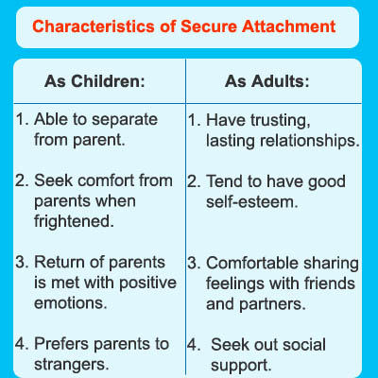

Characteristics of Secure Attachment
Children who are securely attached - fewer Energy Blockages call good experiences through the good karma of having a loving parent. These children do not experience significant distress when separated from caregivers. When frightened, these children will seek comfort from the parent or caregiver. Contact initiated by a parent is readily accepted by securely attached children and they greet the return of a parent with positive behavior. While these children do not become exceptionally distressed by a parent's absence, they clearly prefer parents to strangers.
Parents of securely attached children tend to play more with their children. Additionally, these parents react more quickly to their children's needs and are generally more responsive to their children than the parents of insecurely attached children. Studies have shown that securely attached children are more empathetic during later stages of childhood. These children are also described as less disruptive, less aggressive, and more mature than children with ambivalent or avoidant attachment styles.
As adults, those who are securely attached tend to have trusting, long-term relationships. Other key characteristics of securely attached individuals include having high self-esteem, enjoying intimate relationships, seeking out social support, and an ability to share feelings with other people.
In one study, researchers found that women with a secure attachment style had more positive feelings about their adult romantic relationships than other women with insecure attachment styles (Mccarthy G., 1999).

Ambivalent Attachment
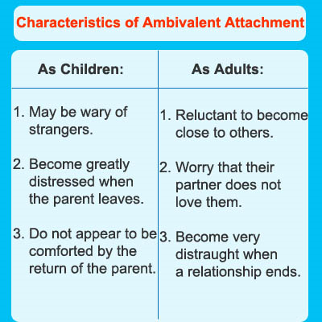
Characteristics of Ambivalent Attachment
Children who are ambivalently attached tend to be extremely suspicious of strangers. These children display considerable distress when separated from a parent or caregiver, but do not seem reassured or comforted by the return of the parent. In some cases, the child might passively reject the parent by refusing comfort, or may openly display direct aggression toward the parent.
According to Cassidy and Berlin (1994), ambivalent attachment is relatively uncommon, with only 7% to 15% of infants in the United States displaying this attachment style. In a review of ambivalent attachment literature, Cassidy and Berlin also found that observational research consistently links ambivalent-insecure attachment to low maternal availability. As these children grow older, teachers often describe them as clingy and over-dependent.
As adults, those with an ambivalent attachment style often feel reluctant about becoming close to others and worry that their partner does not reciprocate their feelings or return the energy which they give along the energy connections. This leads to frequent breakups, often because the relationship feels cold and distant. These individuals feel especially distraught after the end of a relationship. Cassidy and Berlin described another pathological pattern where ambivalently attached adults cling to young children as a source of security and thus vampirise the energy they can not give, from their children(1994).

Avoidant Attachment
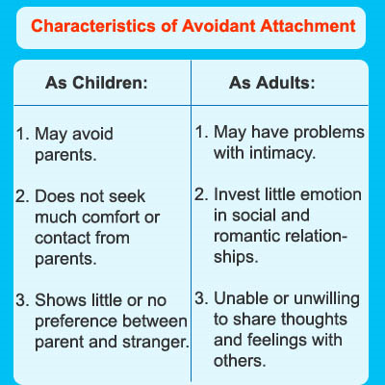

Characteristics of Avoidant Attachment
Children with avoidant attachment styles tend to avoid parents and caregivers. This avoidance often becomes especially pronounced after a period of absence. These children might not reject attention from a parent, but neither do they seek our comfort or contact. Children with an avoidant attachment show no preference between a parent and a complete stranger.
As adults, those with an avoidant attachment tend to have difficulty with intimacy and close relationships. These individuals do not invest much emotion in relationships and experience little distress when a relationship ends. They often avoid intimacy by using excuses (such as long work hours), or may fantasize about other people during sex. Research has also shown that adults with an avoidant attachment style are more accepting and likely to engage in casual sex (Feeney, J., Noller, and Patty 1993). Other common characteristics include a failure to support partners during stressful times and an inability to share feelings, thoughts, and emotions with partners.
Disorganized Attachment
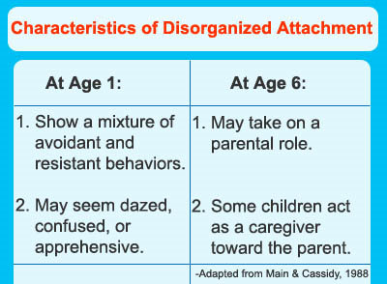
Characteristics of Disorganized Attachment
Children with a disorganized-insecure attachment style show a lack of clear attachment behavior. Their actions and responses to caregivers are often a mix of behaviors, including avoidance or resistance. These children are described as displaying dazed behavior, sometimes seeming either confused or apprehensive in the presence of a caregiver.
Main and Solomon (1986) proposed that inconsistent behavior on the part of parents might be a contributing factor in this style of attachment. In later research, Main and Hesse (1990) argued that parents who act as figures of both fear and reassurance to a child contribute to a disorganized attachment style. Because the child feels both comforted and frightened by the parent, confusion results.

Feeney, J. A.; Noller, P.; and Patty, J. (1993). "Adolescents' Interactions with the Opposite Sex: Influence of Attachment Style and Gender." Journal of Adolescence 16, 169–186.
Hazen, C. & Shaver, P. (1987) Romantic love conceptualized as an attachment process. Journal of Personality and Social Psychology, 52, 511-524.
Main, M., & Hesse, E. (1990). Parents' unresolved traumatic experiences are related to infant disorganized attachment status: Is frightened/frightening parental behavior the linking mechanism? In M. T. Greenberg, D. Cicchetti, & E. M. Cummings (Eds.), Attachment in the Preschool Years: Theory, Research, and Intervention, 161-182. Chicago, IL: University of Chicago Press.
Main, M., & Solomon, J. (1986). Discovery of an insecure-disorganized/ disoriented attachment pattern: Procedures, findings and implications for the classification of behavior. In T. B. Brazelton & M. Yogman (Eds.), Affective Development in Infancy, 95-124. Norwood, NJ: Ablex.
Mccarthy, G. (1999) Attachment style and adult love relationships and friendships: A study of a group of women at risk of experiencing relationship difficulties. British Journal of Medical Psychology, Volume 72, Number 3, September 1999, pp. 305-321(17).

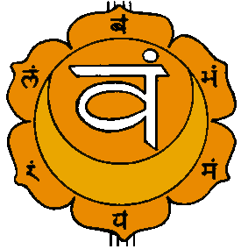
THE NAVEL CHAKRA AND THE MASTERY OF RELATIONSHIPS
"Then this energy coming in becomes centered at one point in you. That point is just near the navel -- because really, you are born as a navel. You are connected with your mother at the navel. The life energy of the mother is being poured into you through the navel. And once the navel cord is cut, you are separated from the mother, you become an individual. Before that you are not an individual, just part of your mother.
So real birth takes place when the navel cord is cut. Then the child takes its own life, becomes its own center. That center is bound to be just at the navel, because through the navel the energy comes to the child. That was the connecting link. And still, whether you are aware or not, your navel remains the center.


If energy begins to pour in, if you change the direction of the energy so that it comes in, it will hit the navel. It will go on coming in and become centered at the navel. When it is so much that the navel cannot contain it, that the center cannot contain it any longer, the center explodes. In that explosion, again you are no longer an individual. You were not an individual when you were connected with your mother; again you will not be an individual.
A new birth has taken place. You have become one with the cosmos. Now you do not have any center; you cannot say "I." Now there is no ego. A Buddha, a Krishna, goes on talking and using the word 'I'. That is simply formal; they do not have any ego. They are NOT. "
FROM OSHO VIGNAN BHAIRAVAN TANTRA

Learn the Mastery of the Second Initiation, the Mastery of the Second Chakra, the Mastery of the Psychic Sexual Connection, the Mastery of Intimacy and Independence. The Mastery of Relationships

THE NAGUAL DON JUAN, CARLOS CASTANEDA - GET YOUR EDGE BACK!!
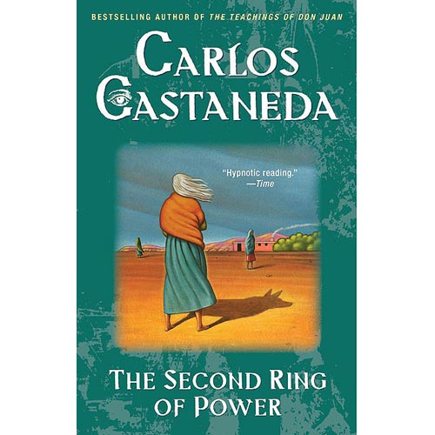
ENERGY ENHANCEMENT LEVEL ONE AND SOUL CONNECTION AND THE GROUNDING OF NEGATIVE ENERGIES
ENERGY ENHANCEMENT LEVEL FOUR AND THE MASTERY OF ENERGY CONNECTIONS THE MASTERY OF RELATIONSHIPS
GET YOUR EDGE BACK THROUGH SOUL CONTACT, THE GROUNDING OF NEGATIVE ENERGIES, MASTERY OF ENERGY CONNECTIONS AND
THE MASTERY OF RELATIONSHIPS
FROM THE SECOND RING OF POWER BY CARLOS CASTENADA PAGE 61..

He had said that when one has a child that child takes the edge of our spirit. For a woman to have a girl means the end of that edge. To have had two as I did meant the end of me. The best of my strength and my illusions went to those girls. They stole my edge, the Nagual said, in the same way I had stolen it from my parents. That's our fate.
A boy steals the biggest part of his edge from his father, a girl from her mother.
The Nagual said that people who have had children could tell, if they aren't as stubborn as you, that something is missing in them.
Some craziness, some nervousness, some power that they had before is gone.
They used to have it, but where is it now?
The Nagual said that it is in the little child running around the house, full of energy, full of illusions.
In other words, complete.
He said that if we watch children we can tell that they are daring, they move in leaps.
If we watch their parents we can see that they are cautious and timid.
They don't leap anymore.

The Nagual told me we explain that by saying that the parents are grown-ups and have responsibilities.
But that's not true. The truth of the matter is that they have lost their edge."
I asked la Gorda what the Nagual would have said if I had told him that I knew parents with much more spirit and edge than their children.
She laughed, covering her face in a gesture of sham embarrassment.
"You can ask me," she said giggling. "You want to hear what I think?"
"Of course I want to hear it."
"Those people don't have more spirit, they merely had a lot of vigor to begin with and have trained their children to be
obedient and meek. They have frightened their children all their lives, that's all."
I described to her the case of a man I knew, a father of four, who at the age of fifty-three changed his life completely.
That entailed leaving his wife and his executive job in a large corporation after more than twenty-five years of building a career and a family. He chucked it all very daringly and went to live on an island in the Pacific.
"You mean he went there all by himself?" la Gorda asked with a tone of surprise.
She had destroyed my argument. I had to admit that the man had gone there with his twenty-three year-old bride.
"Who no doubt is complete," la Gorda added.
I had to agree with her again.
"An empty man uses the completeness of a woman all the time," she went on. "A complete woman is dangerous in her completeness,
more so than a man. She is unreliable, moody, nervous, but also capable of great changes. Women like that can pick themselves up and go anywhere.

They'll do nothing there, but that's because they had nothing going to begin with.
Empty people, on the other hand, can't jump like that anymore, but they're more reliable.
The Nagual said that empty people are like worms that look around before moving a bit and then they back up and then they move a
little bit more again.
Complete people always jump, somersault and almost always land on their heads, but it doesn't matter to them.
"The Nagual said that to enter into the other world one has to be complete.
To be a sorcerer one has to have all of one's luminosity: no holes, no patches and all the edge of the spirit.
So a sorcerer who is empty has to regain completeness.
Man or woman, they must be complete to enter into that world out there, that eternity where the Nagual and Genaro are now waiting for us."

GET YOUR EDGE BACK THROUGH SOUL CONTACT, THE GROUNDING OF NEGATIVE ENERGIES, MASTERY OF ENERGY CONNECTIONS AND
THE MASTERY OF RELATIONSHIPS
LEARN THE GROUNDING OF NEGATIVE ENERGIES THROUGH VITRIOL ENERGY ENHANCEMENT LEVEL ONE INITIATION THREE
LEARN SOUL CONTACT THROUGH ENERGY ENHANCEMENT LEVEL ONE INITIATION FOUR
BUY FOUR INITIATIONS HOME STUDY.. MEDITATION, GROUNDING NEGATIVE ENERGIES, SOUL CONTACT SUPRA GALACTIC ORBIT..
BUY LEVELS 1, 2, 3 AND FOUR HOME STUDY

ENERGY ENHANCEMENT MASTERY OF ADULTERY AND DIVORCE
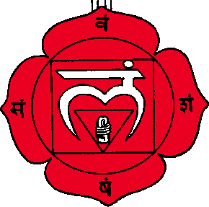
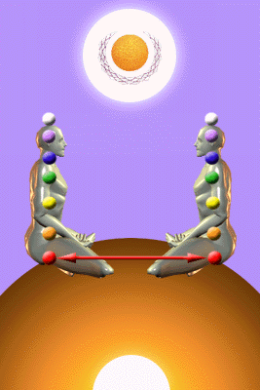
The Integration of the connector strategy
From the blockages in the Base Chakra, the sexual chakra, without any of your knowledge. Based upon connector strategy Inner Child Blockages limited desireful intelligence.
Like the Strategies, this connector strategy is a part of every evolved human being. Energy Enhancement at this initiation needs to Purify and Integrate this function because it is a major blockage preventing the evolution of all humanity
The connector strategy will connect with other people thus causing all adultery and sexual relationships.
Upon any emotional pretence these Inner Child Blockages will stop the connection and also cause the breakup of a relationship, Divorce. Without any conscious knowledge of yourself.
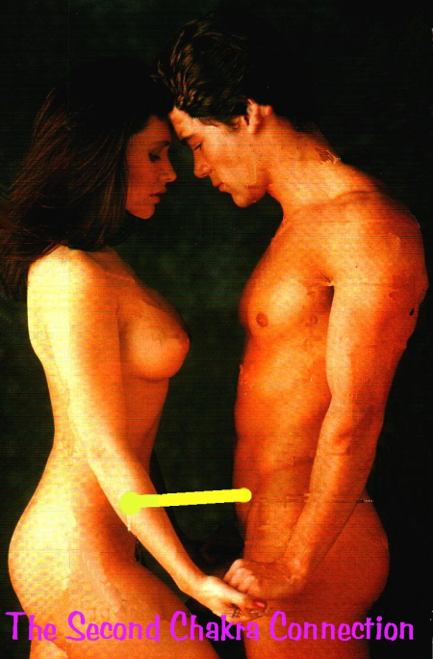
YOU ARE NOT IN CHARGE!!
With Energy Enhancement Gain complete conscious control of these Unconscious Inner Child blockages and of your Psychic Sexual Connections.
Remove and Integrate all Your Inner Child Blockages.
Remove and Integrate all your Unconscious desires.
Feel when other people connect with you and consciously Choose whether to follow it up.
Consciously connect with other peoples base chakra and find out their unconscious desires.
Consciously connect with other peoples base chakra remove their Base Chakra Blockages.
Consciously connect with other peoples base chakra and heal them.
Consciously connect with other peoples base chakra and give them energy.
Consciously connect with other peoples base chakra and make them Enlightened.
"Making another person Enlightened is like making a baby" - Swami Satchidananda, Guru of Swami Satchidanand

THE ENERGY ENHANCEMENT COURSE

IGUAZU FALLS IS A WORLD ENERGY CENTER SACRED TO THE INCA AND THE GUARANI FOR THOUSANDS OF YEARS
IN SPAIN, ELEGANT 5Star INDIA TAJ MAHAL, INDIA TOUR, SACRED IGUASSU FALLS, MEXICO, PERU
SIGN UP TO THE MAILING LIST FOR MORE DETAILS
EMAIL sol@energyenhancement.org
for details


THE connector strategy
The change in YOUR energy structure begins once YOU connect with the vertical connection through the Crown Chakra with the Energy in the Center of the Universe which we teach in Energy Enhancement Level One - Gain massive energy.
At that point, something within you starts to understand that you do not need to get the energy of life from other human beings and the necessity for learning non-attachment becomes paramount to any evolutionary development.
You may say that people who drain the energy from others in order to live are Energy Vampires, but the whole of Humanity, Families, Parent/Child, Husband/Wife, live in this way. It is not that one person is an energy vampire and the other one is not. Everyone is an energy vampire!! Just some of them are better at it than others!!
There is an evolution over a hundred lifetimes from Parasitic Energy Vampire, to Symbiotic Energy Vampire to Independent Enlightened Attachment.
Parasitic Vampires use the Strategies of the Vampire as well as all "The Games People Play" (Book by Eric Berne of Transactional Analysis) in order to get your attention and your energy.
And as well as Vampire Parasite attachment some couples become dependent partners who give and take energy from each other as need dictates - this is the Symbiotic Relationship Attachment which is the highest evolutionary development of attachment for a member of humanity.
Symbiotic relationship attachment is good business; you give 50% and then Receive 50%. This is the minimum necessary in honest business. However, now you are tied into a dependent relationship where it is difficult to rise higher in energy than the median energy level of the couple.
Also in Symbiotic Relationships sometimes one of the partners becomes a permanent drain. And this too can be an unconscious or semi-conscious parasitic strategy used for many lifetimes by the Connector strategy as an old parent or old relative or as partner who needs to be "Saved". Here we have a problem because the heart says we should give energy to these relatives, the people we love so we are a bit stuck here. Well, always these people have someone else to fall back on so if they don't take energy from you they will from someone else. And your evolution is not possible if you continue to support their energy addiction. You need to remove yourself from this situation now so that you can give more back to humanity in the future.
"Come to join us in the Purple Grove!" - Gautama Buddha
Because the solution to all arguments as to whether to give energy is the fact that we can all learn to connect into a vertical connection to an infinite stream of energy from the Higher Chakras instead of being a dependent parasite on humanity. It is this evolution which Energy Enhancement teaches, It is this evolution which all genuine Masters of Enlightenment have taught from the beginning of Evolution itself.
Higher, Independent Enlightened Connection - the Saint Business is one where they give 100% to their students and receive Nothing in return - Nothing, Nirvana, is the Energy in the Center of the Universe. So they receive nothing back from their students, except the Students future Saintly work, and they receive everything back from God in the moment and in the future as a reward for their good deeds - it's called Good Karma. They also become "perfect thieves" (Rumi) as they steal the energy blockages of their students.
There are the Real Enlightened people who lead all towards their enlightenment and in general the real vampires do not like them and so say bad things about them, crucify them - Christ, and poison them - Buddha. The Blockages inside everyone do not like them and it becomes a test of purity for the Student to find a real master, because the blockages inside will prefer someone or something which will not remove them, someone or something false.
As well as the unconscious Parasitism and Symbiosis of the connector strategy Some members of Humanity have learned to perform this act consciously. These are the Energy Vampires who pretend to be enlightened - the bad leaders of small communities who lie and pretend to be enlightened whereas all the while they only want to suck their students. Internal blockages of all humanity prefer these types of leaders as they cannot be successful in removing the internal blockages. These are the people who as a minimum say bad things about the Enlightened but then, later start Inquisitions to torture and burn and poison all the opposition - A real Enlightened Master would never use this violence..
"If most of the people were thieves and murderers, what sort of a leader would they elect?" - Swami Satchidananda, Master of Satchidanand
"You can fool some of the people all of the time, and most of the people most of the time, and that is enough in any Democracy" - Satchidanand
Then there are the real Energy Vampires who have learned to take a tithe from vast sections, communities, Races of Humanity and who have caused all the wars for thousands of years as part of the Psychopathic, Conscienceless, Empathyless, Lying, Violator, Attention Grabbing, Shock and Awe, War and Fear Process of their Vampirism.
As the Buddha Said, "All Attachment leads to Pain"
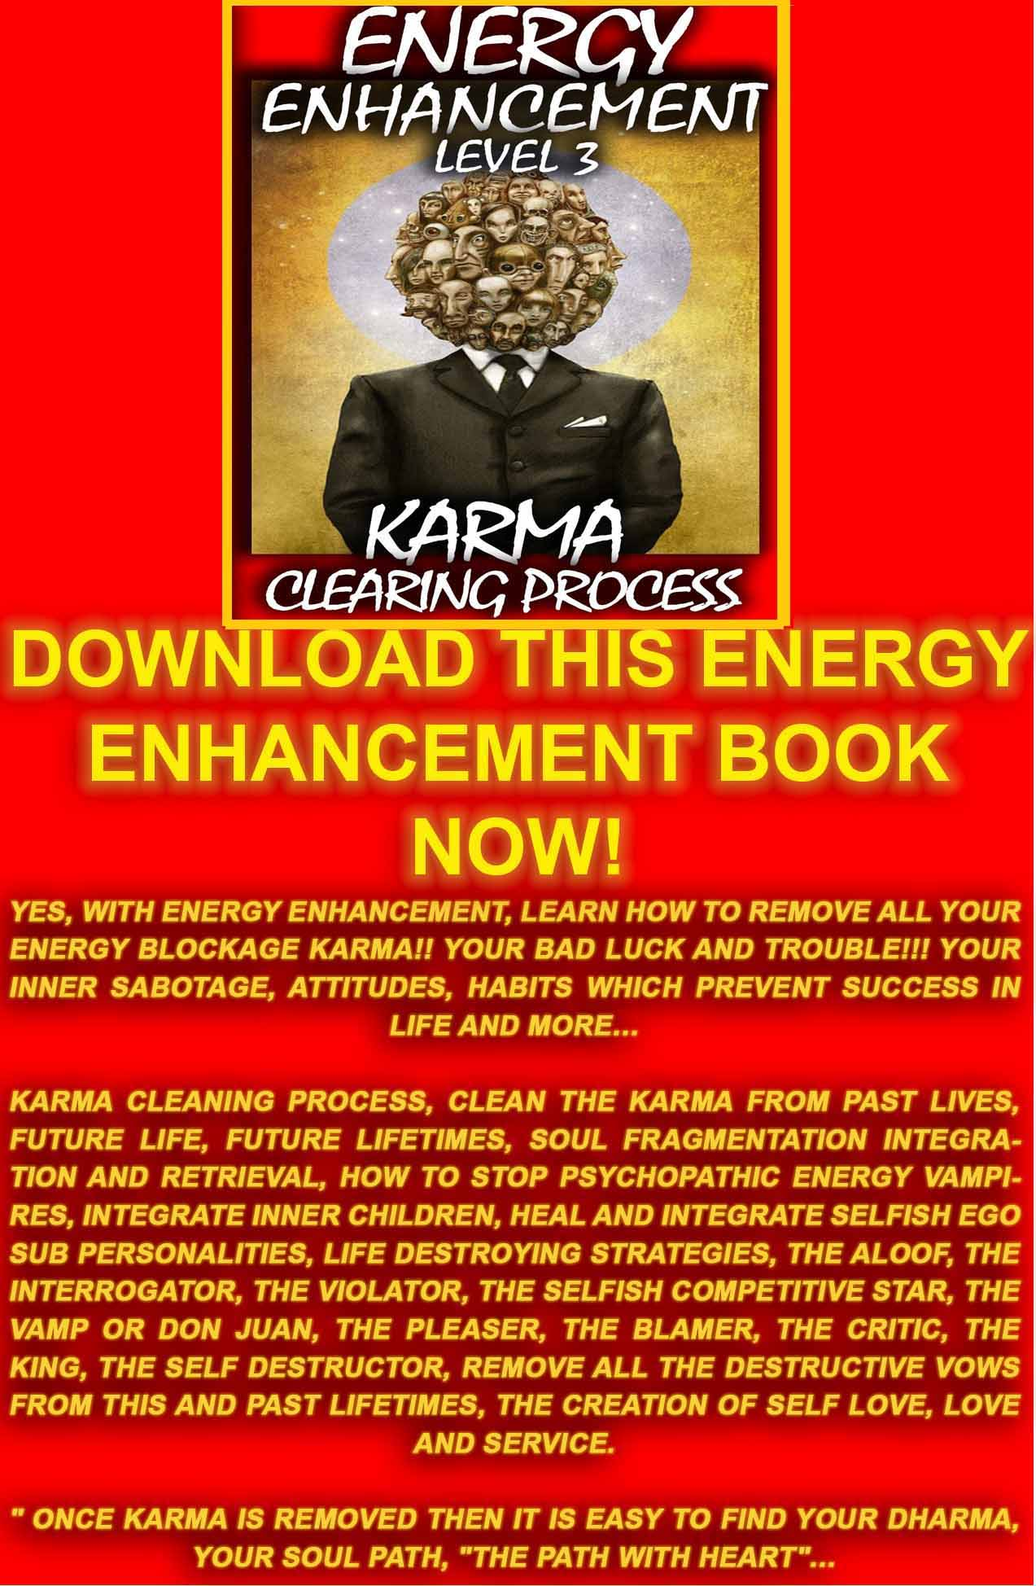

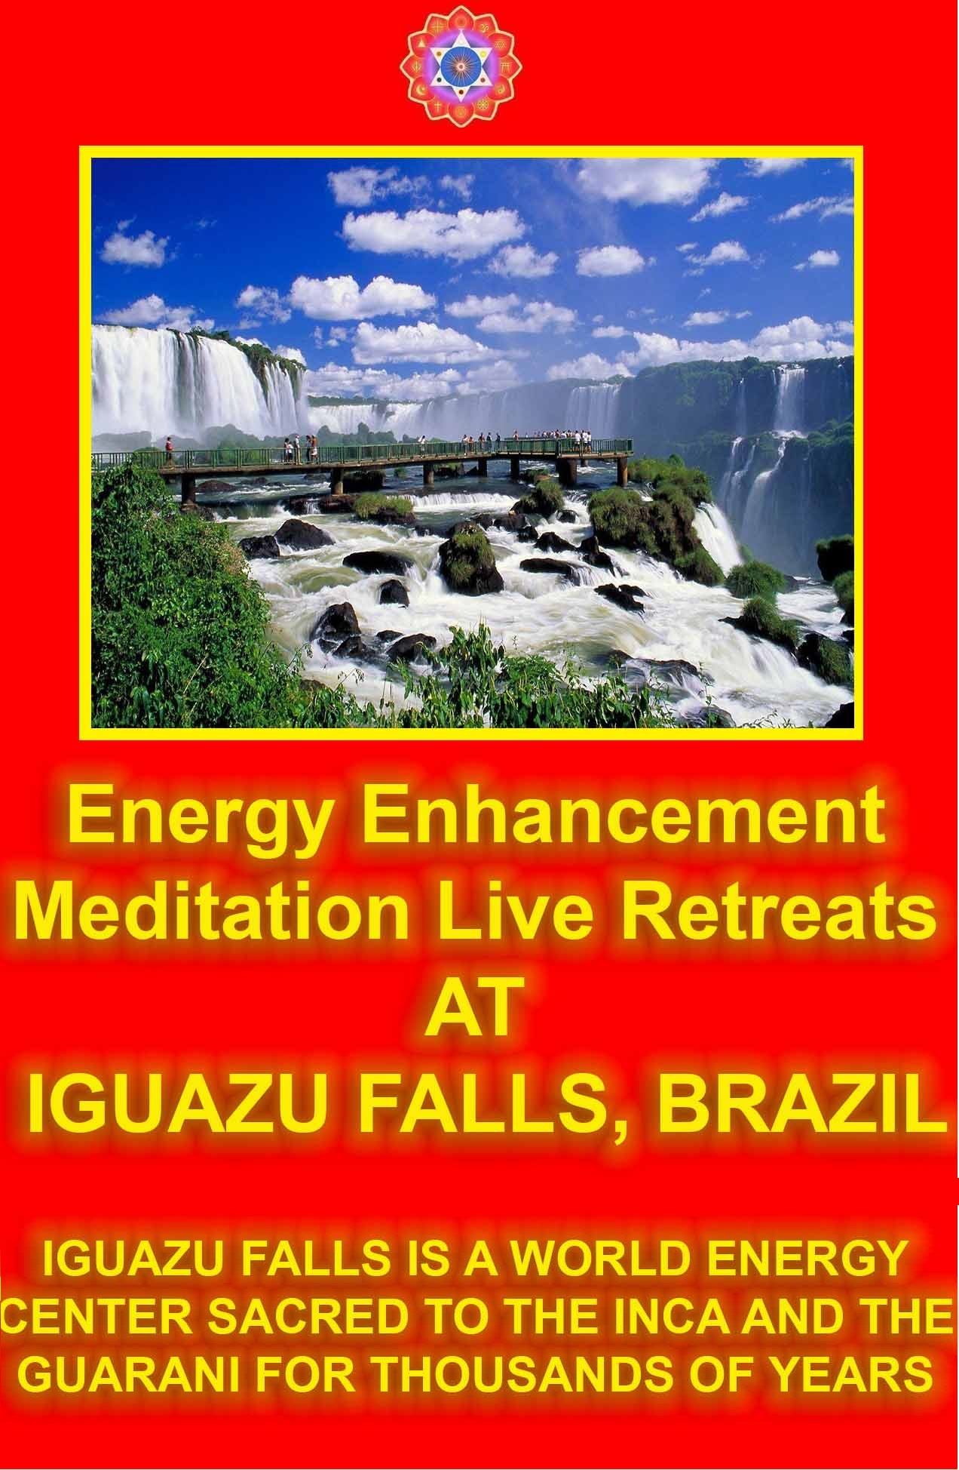
Wives/Husbands
The connector Strategy of some Wives/Husbands desires to continue with the connection to its Husband/Wife because the Husband/Wife's abundant energy can be drained.
In Parasitic relationships there is the abundant use of Games and Strategies. These Vampire Strategies are symptoms of unconscious parasitic relationships.
It is an evolution as they move towards the more peaceful Symbiotic Dependent Relationship.
And I am saying the connector strategy here because in the majority of cases here it is not consciously done. The sub conscious ego part is in charge. The conscious personality does not know. And this draining of the Husband/Wife can continue all the life of the Husband/Wife. This is the reason why when the Husband dies the wife sometimes dies quickly afterwards.
Also However most wife/husbands consciously/unconsciously cooperate with the parasitic/symbiotic connector strategy. These connectors have power in the life of which we need to be conscious in order to heal them. They will create the intellectual arguments and situations which will try to prolong their functionality.
They will try to trap you!!
The good mother says, "You need to leave me in order to go to university and evolve"
The bad mother says, "How can you leave me!?" And they cry and cry...
The connector strategy will cooperate with the Inner Child fear Strategies where security of the inner child is associated with a connection from their Mother/Father in order to prolong the dependent relationship of the connector strategy.
The Soul connection will obviously aim at maximal evolution which usually occurs individually.
All part of the Ability and the Willpower - "not my will but thy will be done" - to "Cut the ties which Bind"
The Mastery of Dependent Relationships as a pre-requisite for Enlightenment

Mother/Fathers
The mother/father connects with the child at birth and feeds the child their bio energy because the child cannot connect with the energy in the center of the universe. The child is completely dependent upon the largesse of its parents. And with evolution over many lifetimes some parents have more and higher and purer energy to give than others which all depends on Karma.
The connector Strategy of some mother/fathers desires to continue with the connection to its children because as well as giving energy at birth to the children, after a few years the children's abundant energy can be drained from the children. And I am saying the connector strategy here because in the majority of cases here it is not consciously done. The sub conscious ego part is in charge. The conscious personality does not know. And this draining of the children can continue all the life of the children.
The struggle of the child to escape its parents and their influence is written about in many books of literature.
The many cases of children who never escape and are tied through life to their parents, mothers, apron strings.
There are men who become permanently connected to their mothers and never are able to make the break into marriage. These horizontal connections, the "Ties which Bind" are hard to break. So with a strong connection they are never able to make another strong connection with another woman. Only the male connection is left. Thus many cases of Homosexuality. Same with some fathers and Daughters.
The many jokes about the Mother in Law.
The men who exchange their mother for a wife as the Parent/Child relationship morphs into the Husband/Wife relationship.
The women who exchange the father for a husband. The men who exchange the Mother for the Wife.
Some Wives/Husbands/Children feel it is their duty to become the chief energy giver of the family, and this job is good to learn, but the person who gives so much finds it difficult to rise higher in evolution than the median energy level of the dependent relationship.
Then there is the person, the black sheep of the family whose job it is to absorb all the energy blockages of the whole family, protecting the rest, usually the most sensitively evolved member of the family whose next job is to learn how to eliminate blockages rather than just hold on to them..
The connector strategy will cooperate with the other Inner Child fear Strategies where the security of the inner child is associated with a connection from their Mother/Father - Husband/Wife - Parent/Child, even and especially in abusive situations, in order to prolong the dependent relationship of the connector strategy.
In the end we need to learn connect with the higher chakras for our sustenance.
Before we "Cut the ties which Bind" we need to heal all the dependent, trauma -Formed, Inner Children Strategies.
As we heal all the abused inner children Strategies who cling on to their dependent relationships; (These are the Star Trek Klingons! :) so we become able to become independent and thus raise our energy levels towards Enlightenment, not being held down by the lower energy level of the dependent partner.
How to know if you are ready for this step? Only if you chafe at the problems of your relationships. If you are happy with your place in Society, then you are not ready to leave it. Do you think if the Disciples of Jesus had been any good at catching fish, they would have left to join him?
Once enlightened we can choose to help all the family relationships we want to as the Buddha did when he returned to his Father and his Wife, - and here we have the whole story of how Gautama Buddha left his family in the middle of the night on the same night as his wife gave birth to his Son.
He returned to his wife Yasodara, after his Enlightenment. His wife asked him why he had left without any talking. "I am a Warrior, a Daughter of Kings!" she said, "If you had only asked me I would have come with you!" And the Buddha said, "Forgive me. I was not strong enough to leave if I had talked with you!"
The Light of the Soul, shining through the Buddha so awed his family, so impressed them that they forgave him; and his Father and his wife and his male child decided to become his Monks - to walk the path of becoming independent Enlightened Masters themselves.
All Ashrams and religions say, "Leave the family", "Leave Society "in order gain the strength - because this Spiritual Initiation of the Mastery of Relationships is that tough, - in order to access higher evolutionary energies and not have them drained from you through attachment.
Because in the end, the function of the Unconscious Ego Part connector strategy is to mechanically follow their script and unconsciously drain the energy of the other and extend their own lives.
Strong connector strategy Example...
For example, When our client, Elektra (From the Greek Myth of Elektra, the sister of Oedipus, who killed her mother and married her father) was a child she had a beautiful energy connection with her father that she really enjoyed. Her father really enjoyed it too, probably much more that with her mother. Elektra's connection broke her Fathers connection with her Mother.
The inner child formed at that point and like Anais Nin, unconsciously she started to connect to everyone, searching for that father connection she had before.
As she left home one day at the age of 14 she was set upon and raped probably because she was still seeking those same energy connections with others that she enjoyed with her father. The Inner Child connected energetically with a man who had no control. She did not do this consciously, the little Inner Child Computer program was in charge and was probably combined with a vampire strategy program searching for sympathy from her father in order to get him back. More Trauma Pain and Relationships? Click Here
After many external relationships - he was a strong and beautiful football coach, away from home every weekend - he left home and set up house with another woman and this really upset our client because she felt like the wife who was left behind. His new wife was the same age as her, and looked exactly like her!
The Drama Queen - kicked in to her life and she did all manner of bad things over the years with drugs and relationships, which I don't really want to go into, in order to catch the attention of her father. After all that, eventually she married a Heroin addict, had his child, whereupon her husband died of his addiction.
As she and her father aged, so she mentioned to me that her father had lost his energy. He no longer shone like the Sun. And so her connector strategy lost interest, unconsciously, and she became happy with her single mother status...
"And so it Goes..." Kurt Vonnegut of Novels, "Cats Cradle" and "Mother Night"

YOUR BLOCKAGES CAUSE YOU TO BE UNCONSCIOUS OF WHAT YOU ARE DOING

The Inner Children Blockages of the Base Chakra are split off parts of your mind, caused by pain and disappointment in the early years and in previous lifetimes, which can, and in many cases do, manage your energy connections in your deep unconscious.
Usually these Inner Children Blockagesare created by some great need which then mechanically and Automatically becomes programmed into the system so that lifetime after lifetime we follow the same script.
Further, once created in one lifetime, these Talent strategies who specialise in connecting with other people can unconsciously manage all your relationships lifetime after lifetime as they evolve - yes, blockages evolve - from Parasites to Symbiotes.

TALENT GAMES
These Inner Children Blockages are unconscious in most people and can be childish in action.
They are all Talents, but poisoned by Trauma Formed Negative Karmic Mass they always act independently of the Soul in Selfishly Egotistical ways. When healed and Integrated by the Energy Enhancement process they become aligned with the Meaning and Purpose of the Soul Infused Personality.
The Connector - just to vampirise energy? and not to energise people towards enlightenment?
The Business Person - Just to make money? The Game is Pig in the Trough. And not to to build the institutions which humanity needs?
The Artist - Just for fame? The Game is Cock on the Dunghill. And not to use art to teach humanity?
The General - War, The Moloch Game, To Win or to Serve
The Olympic Gold Medallist - Just to Win? Or to encourage the rest?
The Musician
The Professional
etc, etc
After all that..

Please Join me in the Master Game of Enlightenment
Once Selfish Egotistical Talent strategies are drained of all their Trauma Created Negative Karmic Mass. Once all their Negative Karmic Mass has been grounded then the Strategy at the heart of the Trauma created blockage can then be integrated into the Soul Chakra. The Angel which has evolved at the Heart of this Talent Blockage can then be aligned with the Angel Matrix of the Soul.
Alice Bailey and Energy Enhancement call this process Resurrection because the Split off Strategy is part of the "Mind of Metal and Wheels" as the Ent, Treebeard once described the mind of Saruman in the "Lord of the Rings".
Indeed, this collection of Implants, Blockages and Strategies make up the Selfish, Competitive Ego. Even evolved blockages are egotistical and the end of their unenlightened evolution is when they become purified of their NKM and Integrated into the higher chakras.
Effectively the Selfish, Competitive and Programmed Ego is Dead to the Life giving essence of the Soul. When it is healed and Integrated into the Soul, it then becomes alive and useful to the Soul or to chakras Higher than the Soul.
We do not kill the Ego, we heal it of its negative Karmic Mass and Plug it into the Higher Chakra Angel Matrixes which are like a Pure Crystal created out of Aligned and ordered Angels.
We plug it in like a spare part which then become a useful function of the Human Angel Matrix Enlightened Super Mind functions - higher than the mind which create intuitive intelligent energy to power the normal mind with Genius.
All the psychic Powers which are used by this Strategy Unconsciously by the person, then become available to be used consciously.
The Strategy has become purified and, "Resurrected', like Lazarus.
A Human Psychic Body has become more purified and Talents have been added to the Chakra Functions above the Head.
In this way we can easily increase the Purity, Size and talents of our Psychic Bodies which can never be destroyed by death.
These Improvements and Increments will pass with us through the Death Process.
When the Integration and Size of the psychic body of the higher chakras becomes large enough, then we will become Enlightened or Soul Infused - Initiation 3 of Alice Bailey (Alice Bailey, "The Rays and the Initiations") - we are responsible for integrating all our Blockages and Strategies using the Intelligent Energy Light of the Soul.
Further, as we integrate and Fuse with Higher Chakras above the head like the Soul, Monad and the Logos then our Enlightened Psychic Bodies will become useful to Higher and Larger sections of Humanity.
Monad infused is Initiation 4 of Alice Bailey - we are responsible for integrating all the Blockages and Strategies within our Monadic Group. The people who do this are called "Gurus". A person who can dissolve the Goo with the Light of the Soul is called a GooRoo!!
The Mayans call these Monadic Groups "Tribes" - There are about Twenty Eight Tribes and the names of the Tribes connect with Maximal Life Purpose and Potential Ability. The Mayans believe that all humanity belongs to one or more of the Tribes. As we evolve, so we can access more purposes, more tribes - we can actualise our Life Purpose!
For example I have been told that I am of the Tribe, "Enlazador del Mundos" or "Connector of Worlds" - a person whose eventual job is to Synthesise Religion, Integrate and Harmonise the World.
Logos Infused is Initiation 5 of Alice Bailey - we are then responsible for integrating all the Blockages and Strategies within our Logoic Group - all the Monads in the World - The Whole of Humanity - A World Teacher..
Sirius Infused Is Initiation 6 of Alice Bailey - Jesus Christ was Initiation 6 although he too has evolved since he was in Incarnation. Fusion with the Chakra "The Avatar of Synthesis" is a Higher Initiation.
As we evolve we eventually become Ascended Masters, Saints who when they die radiate their energy without the need of a physical body to help all humanity.
It is the normal part of the Enlightenment Process.
Understand that the Intellectual Function is a lower function.
The work of the World Teacher is to Dissolve the Goo, the Karma Created by Humanity for thousands of Years, in order to Purify and Integrate the whole of Humanity into the Purpose and Direction of this to be created, Sacred Planet!!
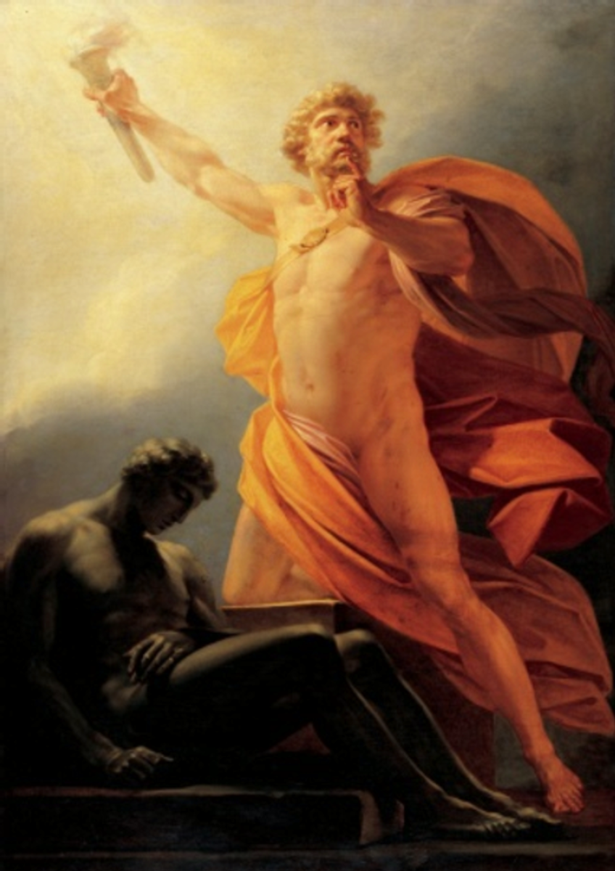
PROMETHEUS INFUSING LIFE ENERGY INTO ZOMBIFIED MAN
"WAKE UP!!"

STREAMING VIDEO STUDENT REPORT - RELATIONSHIPS AND ENERGY CONNECTIONS - SEPT 2013

To summarise what happened...I have avoided close or romantic relationships for a couple of years - making any excuses why it is no good. So the issue was 'fear of relationships'.
When I used my own healing methods to heal this...a lot came up! A lot of dark stuff.
What happened was - every relationship/emotional bond I have had with a girl in this lifetime has been a disaster.
As soon as the aura's of me and them connect...one starts to drain the other TOO MUCH!
So I also had close emotional (of course not close physical) connections to people through the net too. This was very intense and I'd often get telepathy, feel all their emotions and so on with them. This is because my aura was very wide OPEN, often called 'Empath', or 'emotional empath.'
These relationships followed a pattern which I now believe I was being used as a dark pawn for the dark agenda.
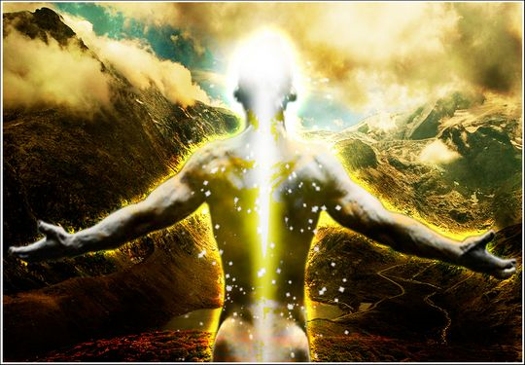
I would start to focus on the girl, and feel like ...I needed something! I needed more energy, more life - because my aura was very blocked due to emotional trauma and blockages. So when I focused on her, I would often talk and talk and talk to get her to focus her attention (energy) on me...as much as possible.
I sensed an astral tube connect between us...at heart or at abdomen. Energy, emotion and thoughts could get sent through it.
I would drain or suck the energy out, getting a brief 'buzz' or high from it, followed by a crash and desperate need for 'more energy'. While I was doing this, It was all on a largely unconscious level.

HOW ARE THEY STEALING YOUR SPIRITUAL ENERGY?
All arousal of the system into ravaging its own internal energies Using Implant Addiction Blockages designed to send energy back to the implanter.. the Addiction Blockages of Sex, Drugs, Food or unnecessary Excercise will result in the, "Burnout of the Binge" as your life energy is sent back to the vampire implanter and you the implanted are stoned, burnt out, anaesthetised, recuperating, ill, cold, influenza, ME, medical intervention, surgical intervention, ghosted, on the verge of death, Dead before your natural time...
ENERGY ENHANCEMENT REMOVAL OF THE Addiction Blockages of Sex, Drugs, Food or unnecessary Excercise IS A NECESSITY FOR ALL HUMANITY!!

HOW ARE THEY STEALING YOUR SPIRITUAL ENERGY? 2

So I didn't realise I was 'taking' something which they needed... I just felt 'good' when they gave their attention to me.
I also used the 'poor me' strategy because it worked the best. When people Pitied me, I felt really good like I was getting something I desperately needed (energy).
Over time, I would start to turn manical - Now I feel a bit hyper/manic now but that's for a different reason. I would become manic and attached/clingy to this girl as if my life depended on it. I would feel jealousy to a massive degree...
I would start to blame her more and more for not giving me enough, like I kept needing more energy!
Then..she would turn unconfident, irritated and drained of life...
Suddenly - she would have to cut off from me emotionally - cutting the astral cord. I would plunge into the deepest despair ever!
Crying all over, feeling as if my internal organs were being squeezed with a stone fist. Darkness in my abdomen - all dark and painful. I'd feel so much anger, rage, jealousy and hatred.
So the next relationship connection after that one, SHE drained ME! So I was the one always giving. Over a period of 6 months (another online relationship), this girl ...I gave her all my attention and she sucked up all the energy. THEN, I finally couldn't cope anymore.
I'd wake up with no energy, feeling crippled low confidence...no life...I got a message from 'god', which felt like a pair of eyes looking at me which filled the entire skies 'keep this up...and you'll die.' as if the energy would get too low. The reserves would get too low!

So I cut the astral cord. The poor girl plunged into mania, despair and an emotional wreck - same as I'd been previously.
This pattern happened at least twice more!
The final times was so intense...it got even worse. The levels of possessiveness, jealousy and hatred were so intense I felt like a monster. At the time I didn't understand what was happening.
When another girl ...took the girl who I was draining's attention off of me for just a few hours, my feelings were 'I want to KILL HER.' Literally, I felt like I wanted to destroy her - This isn't my normal personality! What was going on???
So then when the girl disconnected her etheric cord with me...I plunged into dark despair, crippling pain in the organs, dark black hatred, I wriggled about feeling like a DEMON!
Like hate the whole world! Hate everything. I felt intense 'FEAR' - specifically fear of 'annihilation', this gets pretty interesting when I get to the point soon.
I also felt the presence of three 'demonic spirits' fly into my room and circle me...while I was wriggling in pain and hatred. This was before I even properly sensed spirits! Long before my spiritual path (about a year before).
Okay.
So why talk of all this? Because...I had to relive it all last week when doing emotional healing! I also received a lot of heart-info letting me know what was actually going on with me.
What happened was - during one of my past lives I had undergone a type of satanic 'vampire' initiation which
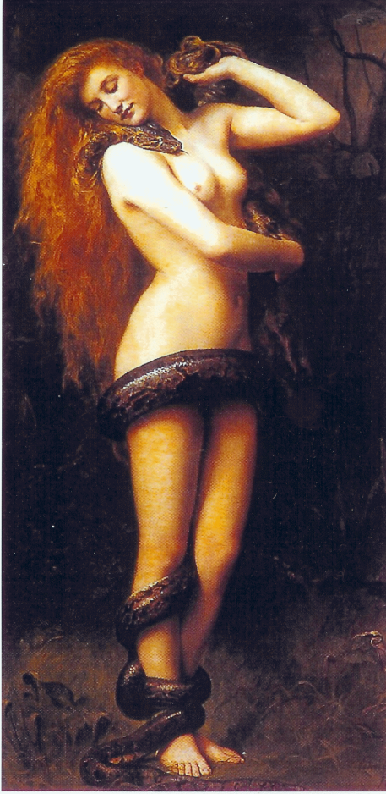
THE LILITH SEX VAMPIRE IMPLANT
LILITH-Succubus-Psychopath-Implanter-Energy-Blockage-Scarlet-Woman

was an agreement for me to serve the dark as a pawn, sucking energy from my victims and sending the energy on to my Dark Master.. I believe it was related to occult practice, witchcraft and either a cult or a religion.
Don't even get me started on religion nowadays - take Christianity the infiltraited Organisation for example - some good, real teachings from Master Jesus mixed in with a whole lot of delusional Satanic lies thrown together with PAIN to form a CONTROL STRUCTURE, to keep people feeling FEAR (fear of going to hell), GUILT/SHAME (sexual issues), and also Christians are against all kundalini training - specifically because it has the chance for people to break free from the dark control structure.
Enough on religion and back to my story;
So the info which came up during healing showed me that during the times I was 'draining' these girls...the energy was not for my benefit - it was being channelled through me and up into some other spiritual beings who were feeding off the energy!
During these times where I turned like a demon (HATE, ANGER, JEALOUSY), at it's worst points - I was connected to dark entities and I was sharing their emotions...!!!!!!
So I was being totally used to siphon life energy out of people and send it up to the dark - all without my knowledge!
This is what I believe is what you talk about 'vampire blockages/implants'. It's totally made me experience a lot of pain - probably for many lifetimes. Enough that I've finally had enough of this crap! No more victim. No more predator
Satanism, Black Magic, Ordo Templi Orientis OTO, Aleister Crowley, Luciferianism, Wicca

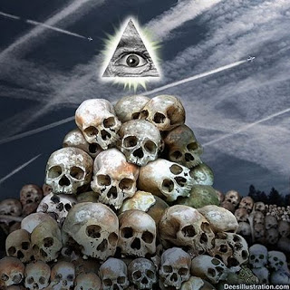
LUCIFER, SAURON, DISCONNECTED FROM GOD.
The 'FEAR of annihilation' I experienced during all that was actually the fear coming from the dark entity because it is disconnected from God and needs our energies to live.
I felt sorry for the entity! But No Way do I give it my energy.
My heart-intuition told me last week the fear of relationships has to be resolved NOW! (capital letters). So then it happened. And I remembered.
So I tell you all this so you can see a bit of where I have been, to a very dark place! I have been the victim of bullying and just a victim in this current life.
I asked why? I found I was able to see bits of a past life where I had been a ...predatory alpha male! Who bullied many people and believed that he could get away with it. This is my karma.

STUDENT REPORT - The Energy Enhancement Course Level One, Initiation Three, Streaming Video..
KUNDALINI PURIFICATION..
Further notes:
Also I noticed as soon as Satchidanand emailed me, I got a down-pouring of light from above the crown which kept charging me up the rest of the day – and my cravings died out! Then I realized the cravings were ego-blockages and that I did not want them.
This meditation 3 - The Energy Enhancement Course Level One, Initiation Three Streaming Video... is great! I've done it some more and it's incredibly powerful. I don't know why it isn't more well known or taught?
"BECAUSE OTHER MEDITATIONS ARE DESIGNED TO FAIL!!"
It's really bringing up little blockages which are complaining while being pushed down into the earth's core to get purified. The hot fire energy has gotten much stronger in my body while doing the practice, mostly the base of the spine heats up, but also the middle of the spine. There are lots of little blockages being noticed. But I'm pushing them out.
I think this is my new favorite meditation practice! It's far more powerful than the normal orbit practice.
Have practiced it some more – my body gets very hot during the practice – just like the video says.

"DRAIN THE LAST DREGS OF YOUR, "VITRIOL""
"JUST LIKE IT SAYS ON THE TIN!!"
My mother came into the room and told me she 'couldn't be near me' because I was giving off too much heat – like a radiator! After this I noticed that by thinking about certain areas of my body I could send the intense heat to that area!
So now this meditation is definitely the most powerful one I have got. Very impressive. I do an in breath/out breath orbit and then hold for a moment at the earth-core. Then I bring up the energy again.

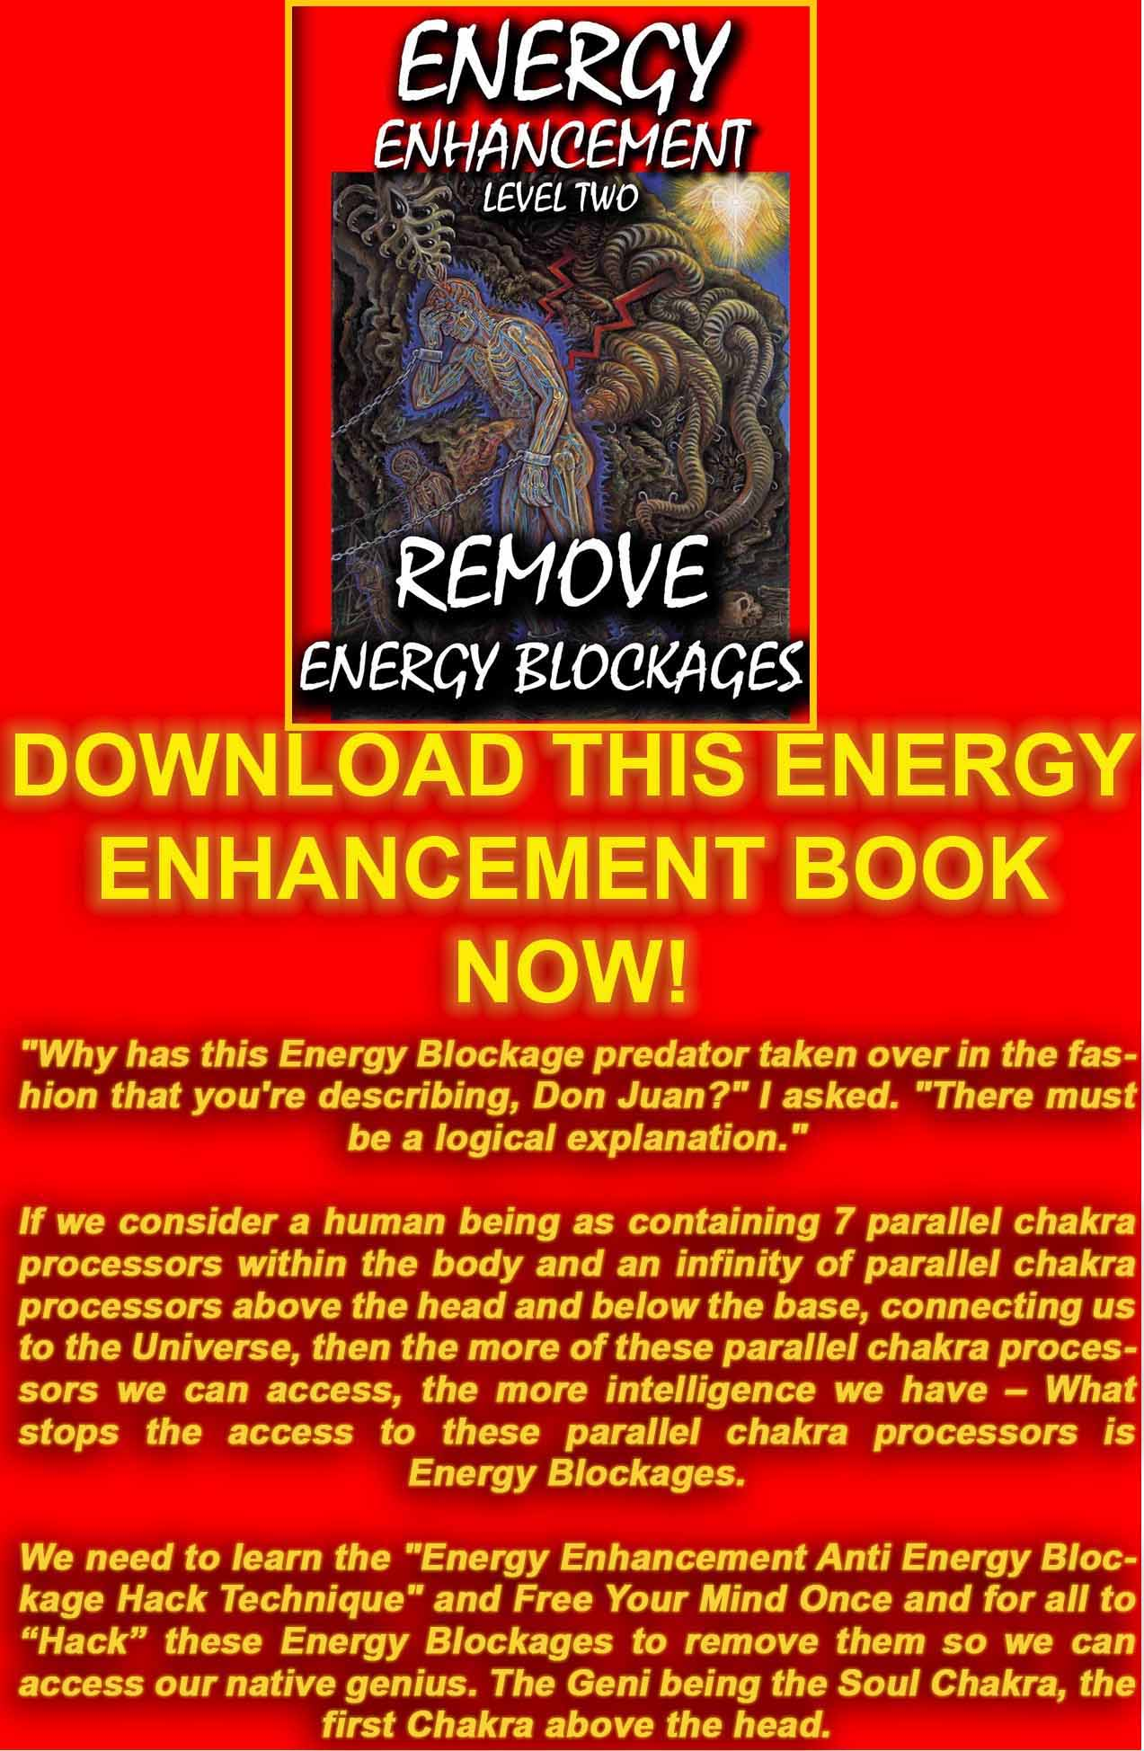
DOWNLOAD “LEVEL 2 REMOVE ENERGY BLOCKAGES” HERE
http://www.energyenhancement.org/Sacred-Energy/Level-2-Book/Energy-Enhancement-Level-2-Book-Remove-Energy-Blockages.pdf
Testimonial on the most effective course, What Dani Says!!!
DANISA FROM THE SPAIN 2003 MEDITATION COURSE

DANISA WENT TO THAILAND AFTER THE COURSE AND NOW IS IN JAPAN TEACHING AND PRACTISING BELLY DANCING!
I've been in La Escala with Satchy and Devi for a week now, Its the longest time I ve here!! and I noticed that every day I am going deeply inside of me.
When I arrived here, was very hard for me, but luckily Satchy and Devi helped me a lot and removed many of my blockages so that I can really think with my head! The first 2 days I was feeling very strange and uncomfortable inside of me. Half of myself wanted to improve and half wanted to stay like that, in a low energy level state, didn't want to grow neither change.
During these days I realized how the strategies control people and how they were controlling myself. Sometimes you are confused, sometimes happy, sometimes angry, and these don't have to be like that !!! but nobody knows! I didnt know.
Energy Enhancement Level 2 teaches you how to manage your emotions, it gives you a strong emotinonal IQ.
I feel so happy to meet Satchy and Devi, they are high spiritual teachers that can see deeply inside you, behind the mask that everybody has. They can see your soul, your real self!! If you need help you'll get it from them.
I feel so happy to meet Satchy and Devi, they are high spiritual teachers that can see deeply inside you, behind the mask that everybody has. They can see your soul, your real self!! If you need help you'll get it from them.
I ve been working with my lower chakras and after I learned how to remove a blockage from my base chakra I immediately felt the energy of Kundalini flowing from down in my base chakra to up, to the head and above.
I was sitting in my meditation position and for the first time I got the sensation and feeling that my body was lifting off the ground. I was just enjoying the experience feeling the circulation of the energy, a hot and smooth sensation. My mind at that moment was free and happy.
Every day I feel a little more steady and comfortable. I am getting in touch with my deepest blockages and fears from my lower chakras, With energy enhancement level 2 I am learning how to deal with this energy and how to remove them totally. My fear is disappearing, my sadness and worries, too. Things that already existed in me and are coming out with the use of these techniques.
To sum up I think that everybody should come to do this course and learn energy enhancement techniques to improve their lives and help other people, heal themselves and their relationships to make this world a better place and to start really enjoying
life.
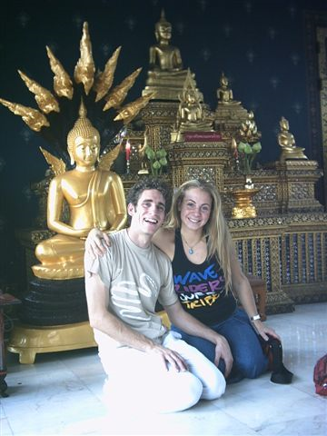

DANISA, EE MEDITATION COURSE 2003
Danisa de Paul.
12/08/2003.

DANISA IN JAPAN
WHAT SHE SAYS NOW!
05 March 2006 07:19:15

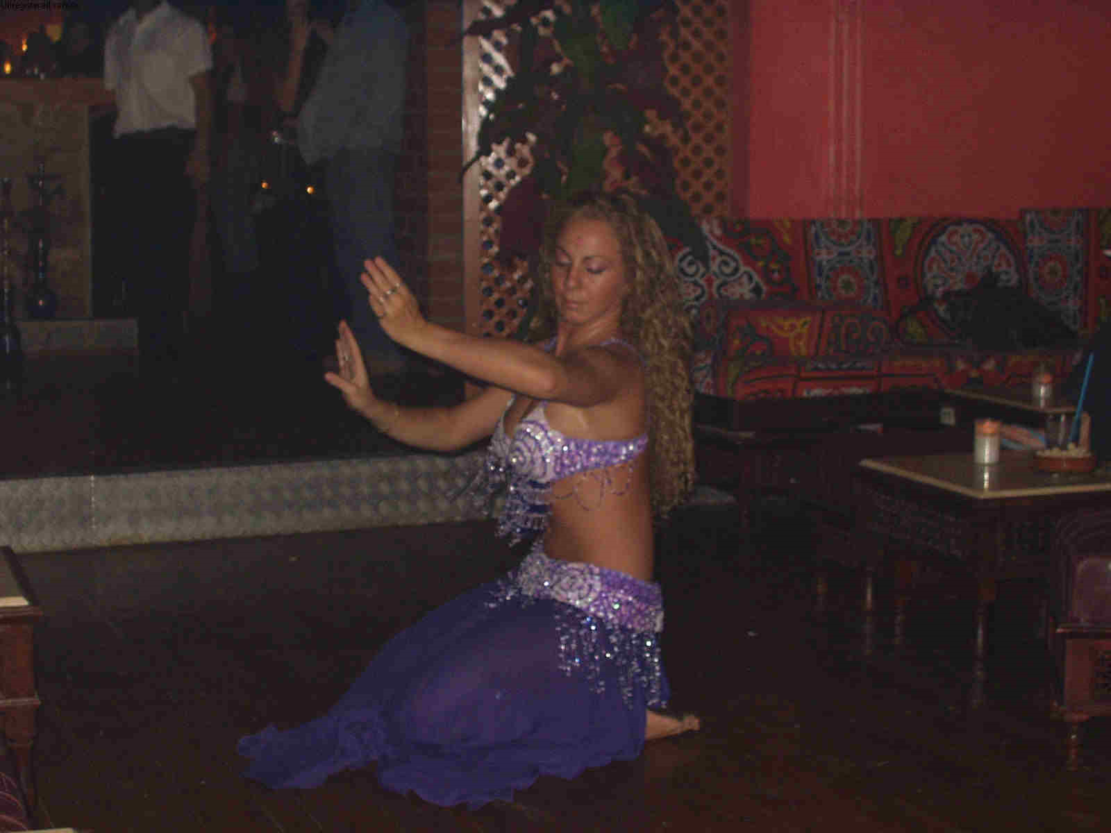
Hello!
Thanks for the email including my testimonial about Energy Enhancement in Spain! Its such a nice memory!
I think about these moments as the best of my life.
It was hard work for me but Ive never felt so happy and rewarded in my life, only when Ive been close to you both.
I been thinking about you lately a lot , I miss you guys, I really do. Im very busy here in Japan, thats why I didnt write to much, but now I have internet at home, and I hope we can be more in touch.
Im glad you are working hard there in Argentina and having a beautiful time.
Here is good, sometimes very hard. Japan is a good experience though but very intense.
I found some temples which I want to visit, but spiritual people are hard to find here. And lately I ve been feeling so many different things.
I hope one day I can be a really a spiritual person and teacher like you, you are my example.
I know now, how many things I have to heal, how many are not finished yet.
Because Ive been through many tests, and Ive been far from you, and having some healing from you.
I hope to see you soon, I love you with all my heart.
I wish you the best and more
love you
Dani

ENLIGHTENED RELATIONSHIPS AND ENLIGHTENED ENERGY CONNECTIONS
We receive energy from the Purest of Spiritual Sources in the Center of the Universe, an infinity of Chakras above the head, from the energy of God, the One God with 10,000 names.
As we channel this energy through our Crown Chakra, so we become liberated from having to absorb energy from other people.
As children we receive 100% of our energy from our Mothers and fathers.
As we become older so we eventually evolve from being a sucker, taking all of our energy from other human beings through the Strategies of the Vampire of Level 3 of Energy Enhancement and written about in "The Games People Play" by Transactional Analysis Innovator, Psychologist Eric Berne.

We evolve from being a sucker to a person who gives 50% and receives 50% in a good partnership. A person who gives when necessary and who receives when necessary. This person is a businessman who believes in fairness. What we give we receive. As the Beatles say "And in the end, the love you take is equal to the love you make..."
But in the end we evolve further into a Person who gives 100% without asking anything in return.
This type of person is One who has a big bank account of energy. He receives that largesse from the Cornucopia - The Horn Of Plenty - which represents the Antahkarana connecting us through the Crown Chakra with God. A person who has fused with the Soul Chakra above the head. A person who is Enlightened.
This person because he has fused his chakras with the Soul Chakra above the head can channel more of that energy through a process of removing all resistance to the flow, the Energy Blockages which slow the flow. Thus he is a distributor of energy, receiving from the verical connection and distributing though the Horizontal connections through all of the chakras as appropriate.
Normally, this person is called "EnLightened" or "Illuminated" because connected permanently with the Soul, the first chakra above the head, he is filled with the Light of the Soul, the Light of God and his aura glows. He has a little circle above the head as shown in all christian spiritual art. He has a golden Crown Chakra as shown in all Buddhist spiritual art.

INITIATIONS ON THE PATH OF ENLIGHTENMENT AND RELATIONSHIPS

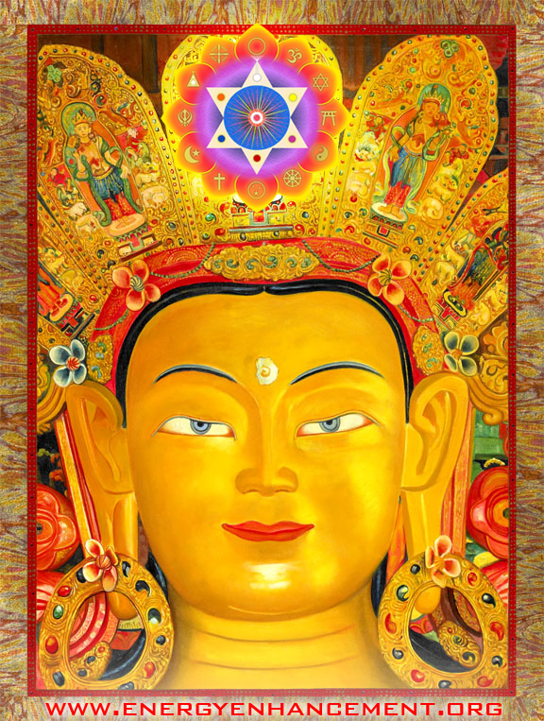

PREPARATION FOR THE INITIATION OF THE OPENING OF THE HEART AND THE THE INITIATION OF THE MASTERY OF RELATIONSHIPS AND THEN THE INITIATION OF SOUL FUSION - BECOME A JEDI, A MERLIN, AN AVATAR
More evolved people have taken the Initiation of the Opening of the Heart. This Initiation normally takes one hundred lifetimes.
People who have no Hearts, who have not taken the Initiation of the Opening of the Heart have no empathy - they have Blockages in the Heart Center, and they have no Conscience - they have Blockages above the Crown Chakra cutting them off from the chakras bove the head and the intuition of God. Thus they have no shame and can and do perform any horrible act. This is 50% of Humanity.
These people are in the process of learning about Karma. They always get bad results from their actions not neccessarily immediately, but always sometime in the future. Thus they learn compassion from being sorry for themselves. As we evolve, if we are more sensitive, Karma comes immediately.
The Karma of the people without hearts always comes from breaking Gods Laws - "Thou shalt not Steal" - Corruption or "thou shalt not give Pain" "Thou Shalt not Kill" - and these people are normally called Psychopaths or Sociopaths in the spectrum from a petty tyrant to Hitler.
The process of Opening the Heart means that you develop Compassion for others and also shame which causes Post traumatic Stress Disorder (PTSD) for your terrible acts. Only people who are on the verge of the Initiation of the Opening of the Heart can have shame, can have PTSD. This is why, in the army of Alexander the Great, the best soldiers were 65 years and older. The people of the heart are always weeded out in the first battles. After killing in Alexanders army for many years only the heartless were left.
Thus we spend our early years, if we are successful, graduating from the more lowly evolved groups within human society.
A person who has Opened the Heart will not be corrupt and will not kill no matter what the intellectual or emotional argument for doing it. Thus, advanced societies have banned the death penalty and instead give the bad karma of Life Sentences in terrible prisons.

These people who have passed the Initiation of the Opening of the Heart, the people of the heart, have graduated to the process of taking the Initiation of, "The Mastery of Relationships". This process normally takes 10 lifetimes to complete.
You can tell if you are in the process of taking the Initiation of the Mastery of Relationships by looking at your personal history.
Have you had bereavements early in life? Lost your mother or your father in divorce early in life? Difficult to hold onto your relationships? Having many fleeting Relationships? If so, you are in the process of taking the Initiation of the Mastery of Relationships.
This process involves cleaning out the lower chakras, especially the relationship chakras, of all of its energy blockages of congealed pain or negative karmic mass. This must be completed before they can successfully maintain a relationship with a person or a group, before they can maintain an energy connection with a partner for a long time because blockages on the energy connection will make the connection difficult to maintain.
It also involves choosing the right person and the right group to be with. People fail the test for the Initiation of the mastery of Relationships by insisting on choosing the wrong person and group to be with. The wrong person or group will have too many blockages to be called sane.
In modern, more evolved societies, after the age of fifty, 30% of all people live alone in their flats with their cats and dogs to have energy connections with. Cats and dogs are tolerant of energy connections with energy blockages and can even heal these blockages over time. They are very faithful and never leave you, except when they die.
Usually this means that these people have failed in finding a person or a group to resonate with and given up. Probably they have failed to clear out their lower chakras of all of its congealed pain which means that they will be touchy and it will be impossible to maintain an energy connection with anyone for a long time.
As like calls to like, probably they have chosen similar people with energy blockages in the relationship chakras to be with and so received even more painful experiences into their blockage filled lower chakras.. "Unto those that have, more will be given" - Jesus Christ.

So the minimum is that you have cleaned out your relationship blockages in order to have a long relationship. Energy Enhancement teaches how to remove these Energy Blockages.
Also, today I was teaching Meditation to a 65 Year old Reiki Master whose husband had died last year. She had had an operation on the Liver to try to find the problem of pain there, and in other parts of her body, but the doctor could nor find anything, so the problem obviously was that of Energy Blockages. She was a little suspicious of me at first which is probably sensible even though I had been recommended by a friend. As we talked she got on the same wavelength and she started to trust me so that when it Came to the initiation, at the end of the initiation when we practise the Meditation I was given knowledge of her blockages as I was automatically drawn to them. And I healed them, dissolved and removed them, resurrected them because these were high and difficult blockages, one by one.
I told her what happened with Arwen Evenstar (Search for her on the energyenhancement.org google site search at the bottom of our pages), our 21 year old student in Crete, how I healed her painful menstruations where she had turned white with pain every month for 6 years, as I removed three tough blockages in her abdomen in our first meditation together. After totally failing at relationships prior to the blockage removal and turning through despair into a lesbian, Arwen finally got married to a man last year. Devi Dhyani and I were invited to the wedding!!
The other condition for passing the Initiation of the Mastery of Relationships is that you reject all people and groups who are at the wrong evolutionary level for you as these types of relationships unless altruistic and for the purpose of being taught, can never persist.
The square peg in the round hole is a very painful place to be. "Its the fish which John West rejects which makes John West the best" - Advert for John West Salmon. As you choose only the best people, the people at greater or similar evolutionary level to your own to be with, so your life will blossom and succeed.
Usually you must choose to be with an enlightened Master to be with for a while, in order to pass the Mastery of Relationships and then successfully take the Third Initiation of Enlightenment - Soul Fusion, within one lifetime.
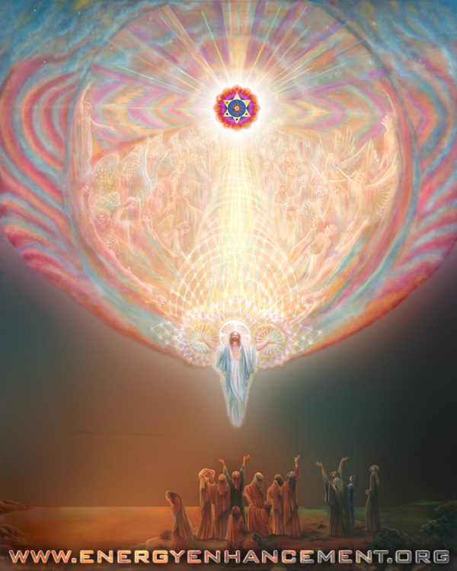
LEARN NON-ATTACHMENT WITH ENERGY ENHANCEMENT APPRENTICE LEVEL 4.
Learn how not to lose your energy to others unnecessarily through Lower, Abdominal Energy Connections.
Symbiotic, parasitic and Dependent Relationships are the "Norm"
Because most people are forced into Giving and Taking Energy from each other through dependent, energetic connections into the Abdomen caused by blockages.
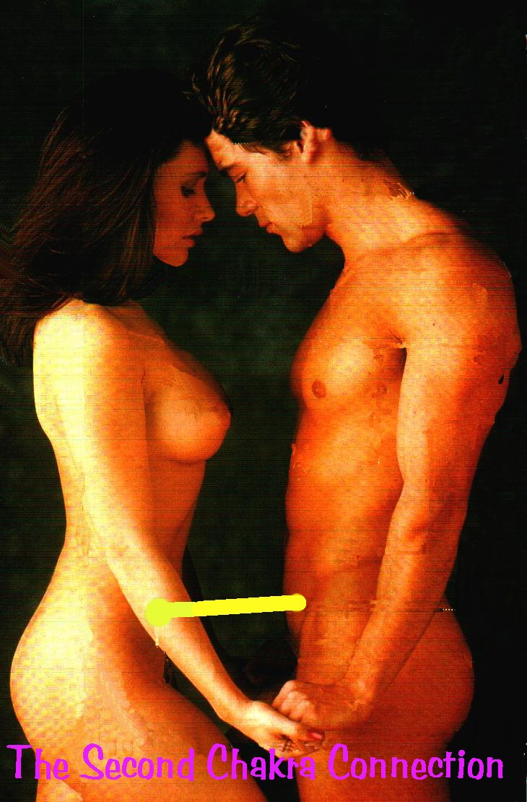
This Initiation also teaches how to stop people, "Energy Vampires", draining your energy through the chakras by means of Implant Blockages which are psychic viruses.
We teach the control of these connections. How to stop them. How to start Them. How to Heal them!!
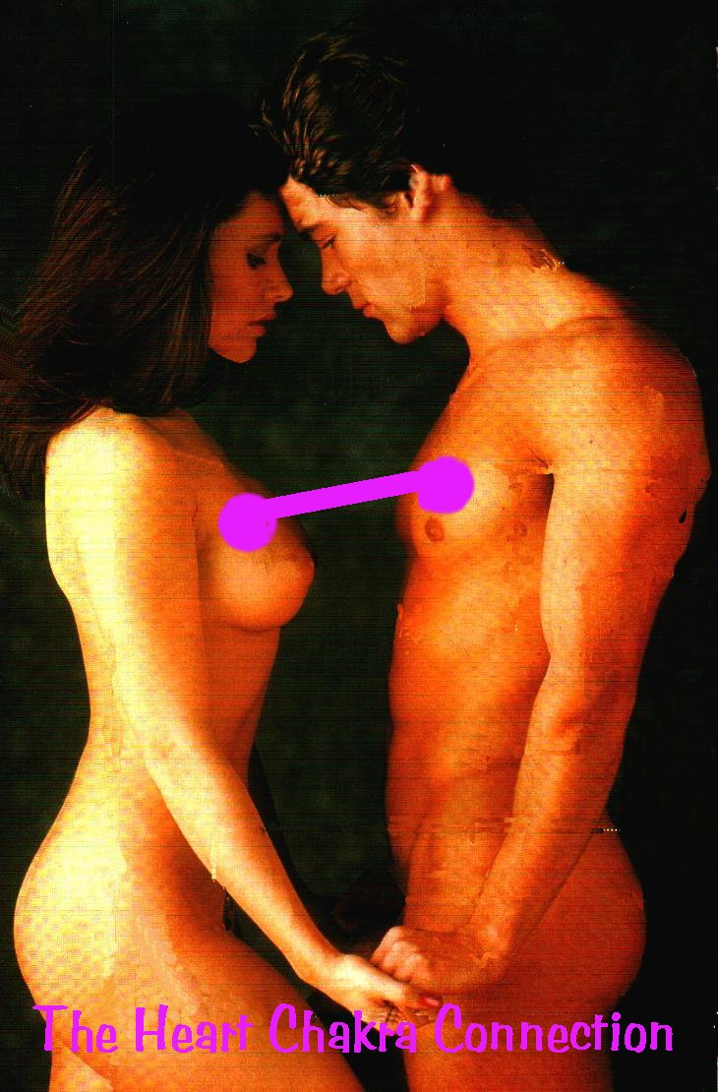
We teach the appropriateness of connections from the Heart.
The Highest Heart, Prajna Paramita - the highest wisdom chakras above the head. There are an infinity of chakras above the head ending with the One God with 10,000 names.
We teach the appropriateness of connections from every chakra. How to use them responsibly for their natural purpose,
How to remove the blockages in Others, as Energy, drained from you by others unnecessarily, cannot then be used for higher purposes. It makes you tired, makes you Depressed, gives you colds and Flu and just makes you lose your zest for life.
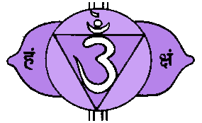
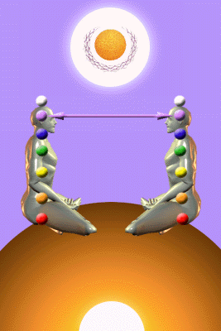

WITH THE ENERGY ENHANCEMENT COURSE BUY A STAIRWAY TO HEAVEN
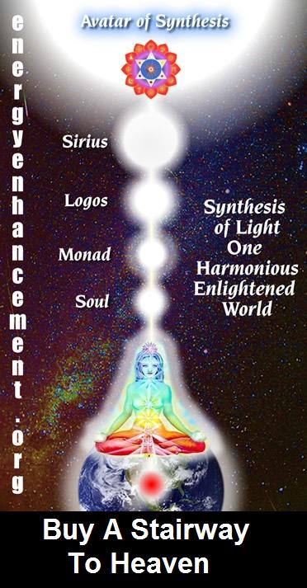
BUY A STAIRWAY TO HEAVEN
WITH THE ENERGY ENHANCEMENT COURSE
STUDENT REPORT
Also I noticed as soon as Satchidanand emailed me, I got a down-pouring of light from above the crown which kept charging me up the rest of the day – and my cravings died out! Then I realized the cravings were ego-blockages and that I did not want them.
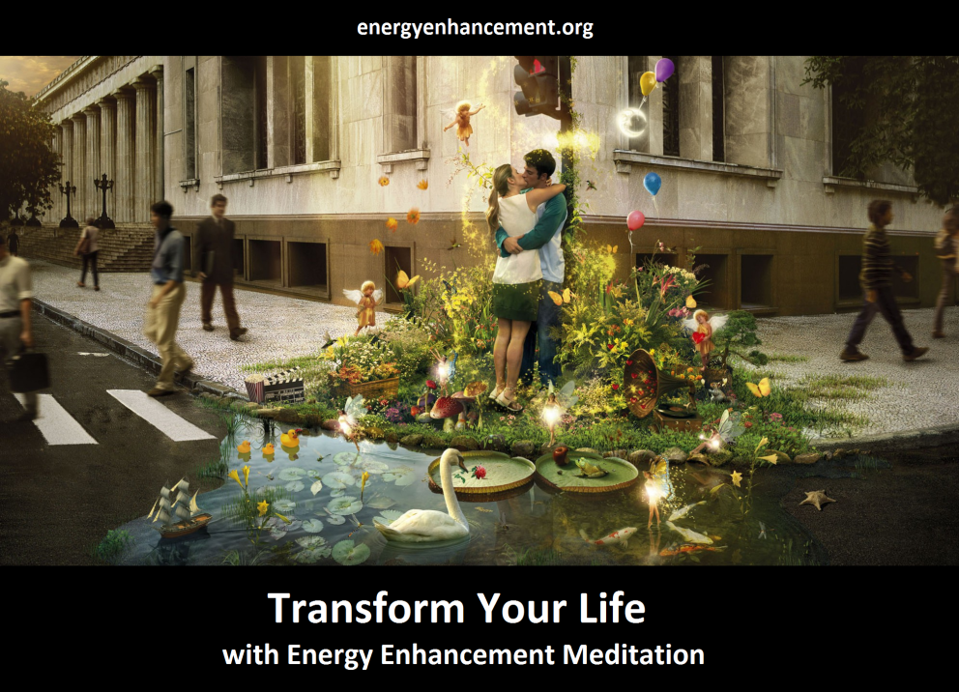
Energy Enhancement says that there are an infinity of chakras above the head up into the Center of the Universe and above, high above the head, ending in God, just as there are an infinity of chakras below the base - "As above, So Below" - Hermes Trismegistus from the Emerald Tablet.
INCREASE YOUR INTELLIGENCE - THE PARALLEL PROCESSING SUPERCOMPUTER YOU!! Energy Enhancement says that each chakra within you and above the head is a computer processor with higher and higher frequency, speed and capacity as you go higher. So, like a parallel processing supercomputer, the more chakras you can get working in the Infinity of Chakras above the Head and the more chakras you can access, the more chakras you can disblock, the more chakras you can augment, the more intelligent, the more intuitive, the more wise you will be.
FUSING WITH THE SOUL CHAKRA - Energy Enhancement says that just by fusing with the soul chakra one can see all your past lives and remove all blockages from all your past lives in one sweep, fast!!
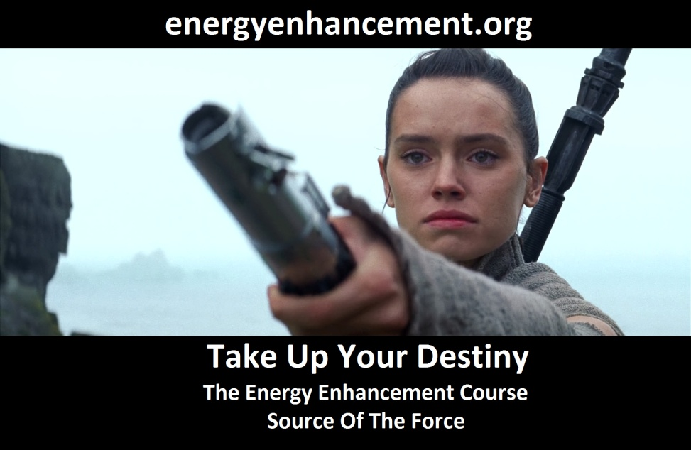
FUSING WITH HIGHER CHAKRAS - THE SOUL, MONAD, LOGOS, SIRIUS, AVATAR OF SYNTHESIS - Energy Enhancement says that it also contains the secret of Initiations Higher that Illumination - "Enlightenment is not Enough!!"

CHAKRA LINKS
BALANCED AND SHARED COMMUNICATION FLOW
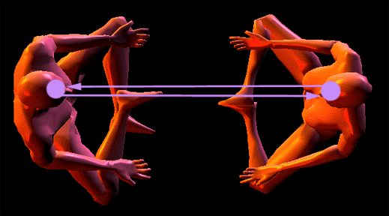
Transmitting and Receiving Communication in a shared and balanced way.

All chakras communicate by:
Transmitting from the right side.
Receiving on the left side.
These connections are horizontal Antahkaranas.
The connection from the Center of the Universe is Vertical, through the Crown Chakra.
The Horizontal and Vertical Connections, together, Form the Christian Cross
In the above diagram, the two people are sharing an Ajna chakra connection, although it could be any chakra, both transmitting and receiving. But why is it that many communications are not satisfactory or balanced? This is because of a energy blockage in one or more of the chakras concerned.
For instance, in the diagram below, we see that one person can give from the Ajna chakra but the other cannot. This can be due to an Energy Blockage on her Right side preventing her from giving or a blockage on his left side thus preventing him from receiving.
And this giving and receiving and the blockages preventing it occur on every chakra level preventing communication with everybody at different chakra levels.

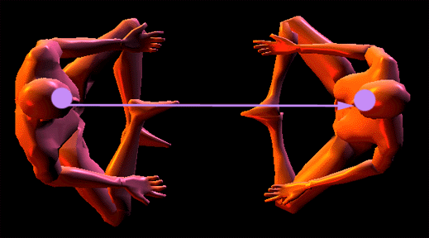
Blockages and damage can prevent good communication.

Problems occur in the transmitting and receiving of communication between people's chakras when there is a blockage, damage, or the activity is out-of-balance in one or more of the chakras because of a blockage.
For example, concerning the throat chakra, if one person cannot receive energy from the other because of a blockage in that chakra or in the partners chakra, then that person will have the tendency to monologue, be unable to converse, and may finish off your sentences for you, or quickly change the subject so that they retain dominance in the communication.
Blockages can be removed, damages can be healed, over active chakras can be calmed, under active chakras can be awakened, and balance can be restored by Energy Enhancement Techniques
ENERGY ENHANCEMENT ON THE COSTA BRAVA

WHAT HAPPENED TO ARWEN
For an Energy Enhancement Example, one beautiful young lady came on the Energy Enhancement Course with relationship and stress problems. From the age of 16, from her first period she had felt intense pain in the abdomen during that and every period since for many days. She went white with the pain and nothing had been able to diminish the problem days every month so all she did was go to bed for a few days and dosed herself with the most powerful analgesics, pain killers, she could find. Now the abdomen is Swadhisthan Chakra, the relationship chakra and a pain there points out energy blockages in the abdomen which probably came from implants or painful relationship partings, death, bereavement and painful breaking ups like divorce in this and in previous lifetimes.
Because of these traumatic memories fulminating in the abdominal psyche it is not possible to have a perfectly good relationship with anyone, they need to forgive you so many bad ways of acting, so much so that after a few painful tries at a normal relationship with prospective husbands she had decided to try out lesbianism. I told her that she would have no better luck with lesbianism because if your relationship chakra is blocked, it is not possible to have perfectly good relationships with anyone.
And stress was there in her life which was seriously affecting her work. Because the pain caused blockages were filling up her abdomen, she had no room for storing more pain and stress, so she just could not deal with it and it was becoming more and more of a problem with each passing year.. Further, because of the pain inside of the abdomen sometimes people do not want to go close to that pain. They do not want to move the abdomen at all because it disturbs the pain. Therefore they do not breathe into the abdomen and this lack of correct breathing further reduces their energy and their ability to handle stress. Statistically 30% of all people are like this. Although we can learn to breathe into the abdomen, unless we remove the pain filled blockages the problems will persist.
So, knowing the above I went into the abdominal chakra in my meditation; by pushing energy down the right and feeling no flow coming back along the left channel from the chakra I was able to locate three energy blockages there.
Using the techniques of Energy Enhancement APPRENTICE LEVEL 2, The mastery of Energy Blockages, and APPRENTICE LEVEL 4, The Mastery of Relationships, I grounded, Transmuted and sent on the Perverted Negative Energy inside the three energy blockages and the living energies which were maintaining them, one by one with great concentration.
The results were that next period and for every period afterwards our client had no more pain. After going white with pain for several days in bed with an analgesic every month since the age of sixteen, the pain was entirely gone!!
She later reported by email that she was going out with a nice boyfriend again and her resistance to stress was vastly improved, particularly using the techniques of Energy Enhancement which we taught her on the course. More Trauma Pain and Relationships? Click Here
ADDITION.. Last year Devi and I were invited to her marriage in America!! Well done!! We are very happy for her..
Instead, We give you ENERGY and the ability to give that ENERGY to Others!!.
This Initiation of Energy Enhancement teaches the further uses of the Heart which is the Centre of Universal Love.
This Initiation of Energy Enhancement teaches the Evolution of our lower energy connections from the any chakra, The Psychic Sexual Connection, the Heart, and further, higher, into the Heart Centres above the Head.

This is a further Initiation of control of healing energies which can increase your energy tremendously.

The Mastery of Relationships.

This Initiation gives techniques which can totally solve the Major problem of humanity which can prevent APPRENTICE LEVEL 1. Initiation 4 - Connection with higher forces.
It leads to happy and fulfilled relationships. It can prevent the pain which causes the major fall in energy in the life of a human being.
Whether you want to become lovingly independent in your private life, in your business or in your Healing Modality, this Initiation of Energy Enhancement is essential to your life and to the Higher Initiations of Energy Enhancement which come next.

Energy Enhancement
APPRENTICE LEVEL 4. Initiation 6.
The Mastery of Relationships III
The Mastery of Tantric Energy
How to Remove Implants, Transmute the Negative Karmic Mass of Blockages and Clean all the Chakras of your students and close personal relationships.
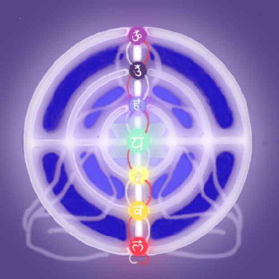

The function of a Merlin, A Jedi Knight, A Master!!
There are 7 chakras or Energy Centers spread along the spine and head. These 7 chakras comprise the mind. The head chakras are your consciousness, those in the middle the Subconscious and those at the base of the spine, the Unconscious.
Each Chakra has a right and left side, the right side gives energy in a stream to the other person in the relationship, the left side receives energy from the other in the relationship. When there is good communication, then the energy flows in a circle between you at each chakra level.
Most people have many blockages, and these blockages stop the flows of energy in relationships thus degrading the quality of the relationships.

As you absorb more blockages then the changes in the quality of the energies can cause a decrease of quality of the relationship and eventually the breakup of the relationship.
For example if you have a blockage on the right side of your chakra, you will not be able to give energy to the other, you will only be able to receive energy. You Will be an Energy Vampire!!

CHAKRA LINKS
BALANCED AND SHARED COMMUNICATION FLOW

Transmitting and Receiving Communication in a shared and balanced way.
Or if you have a blockage on the left side of your chakra you will not be able to receive energy, only to give. You will be drained.
Similarly if your partner has the same problem you will be drained or be a vampire. At every chakra level.
Energy Enhancement, in the same way that we teach you how to remove all YOUR blockages, gives you the technique and ability to GO DOWN these lines of ENERGY BETWEEN CHAKRAS AND HEAL THE BLOCKAGES IN ALL YOUR RELATIONSHIPS!!
ENERGY CONNECTIONS WITH PETS, ANIMALS, CATS AND DOGS
"THE MASTERY OF RELATIONSHIPS TESTIMONIAL FROM STUDENT DON MINIHANE
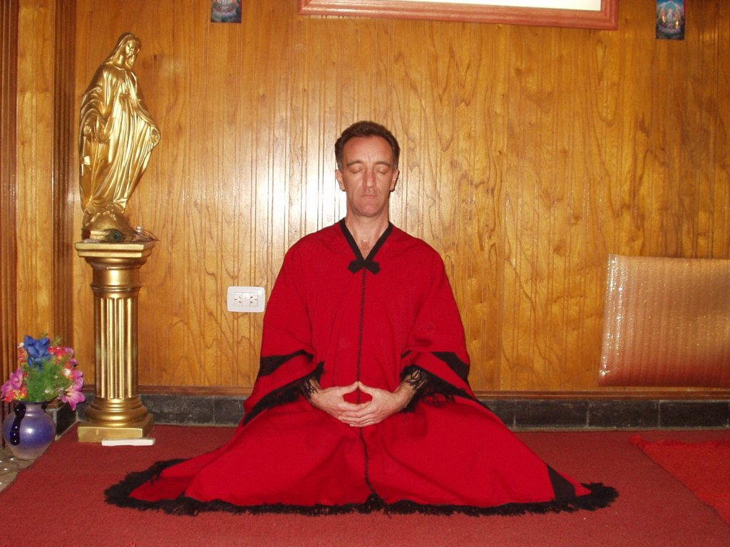
DON MEDITATING AFTER A FEW DAYS ON THE COURSE -
STUDENT FROM THE 2007 JANUARY ENERGY ENHANCEMENT COURSE
Satchi has been teaching us about the mastery of relationships over the last few days and it is another astonishing eye opener. The techniques he has thought us are brilliant and work immediately and what is amazing is that you can prove it there and then and watch the results happening before your eyes.
I don’t want to give this info away here as it is very personal. It is sufficient to say that if you have or had any relationships with people that were not to your liking or affected you badly then this is the place to come to wipe that negative crap away in one sitting.
Satchi taught us how to disconnect from you, every one you have ever come into contact with in this life time and all past life times and then how to reconnect the relationships you want to keep into a higher connection and transmute the ones you don’t want.
(Note, it is impossible to cut connections, however, you can reduce the amount of energy which flows down them... Satchidanand)
He also showed us how to clean each others blockages in every energy centre in the body using only the power of the mind. This is seriously powerful stuff, not to be messed about with and demands the utmost integrity.
As we practiced on each other we came very quickly to realise this. I could literally feel the energy moving inside each chakra as the other person worked within me from several meters away and when I worked on the other person I could see me projecting energy to them and could see where the blockages were within their chakras.
I could force the energy from my centres into their centres and clean their centre bringing the energy full circle back to me. You could tell the state of their chakras by the amount of energy returning to your own centre and this was achieved by mind power only.
Before I came here Satchi said he would teach me to do it in this way and I was sceptical about this claim. I could never envision me having psychic vision, but I have now, I can now do astonishingly powerful Reiki sessions on people without going any where near them and distance healing over any distance is a piece of cake, incredible stuff."

MORE MASTERY OF RELATIONSHIPS FROM DON MINIHANE
ENERGY ENHANCEMENT GIVES YOU THE ABILITY, THE FUNCTION OF A JEDI MASTER, A MERLIN, A GURU!!
A Gooroo is simply one who can remove the darkness....
He removes the Goo!!
He Takes YOU
"FROM DARKNESS TO LIGHT,
FROM DEATH TO IMMORTALITY"
(From The Gayatri Mantra)


Energy Enhancement APPRENTICE LEVEL 4. Initiation 7.
Ceremonies and Meditation Groups - Using the Energy of the Higher Heart, The Heart Center in the Head, Prajna Paramita, - The Soul and the Monad Itself, for the Healing of Groups, Organisations and the World.

The Techniques of a White Magician.


The Synthesis of Light Symbol

Master of Meditation, Devi Dhyani
Energy Enhancement will help you get everything you need and will make you enjoy everything you have!
Energy Enhancement quickly dissolves negativities. If you have Energy, you have Everything!
Energy Enhancement is complete Freedom!
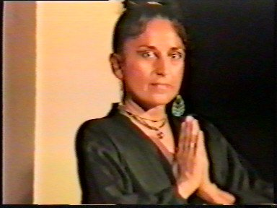
Marie Report

" Our Latest Client and now friend, Marie, comes
from Peru although she lives in London with her American husband and family.
We just completed a course of Energy Enhancement APPRENTICE LEVEL One with her and we were all very happy with the results, particularly as we work full time with our clients energetically and in person physically and Psychically for a lot of hours.
Our Clients also like the superb Organic Food we cook for them!!
Marie has previously been on many Meditation Courses but never she said, with the direct experience and targeted advice on her personal circumstances, as with this Energy Enhancement course.
Marie had the experience in Energy Enhancement Meditation Initiation 4 of going up through several Initiations meeting one of my Masters from America and India, on the mental planes. He said that he was not her master, gave her an energy present and sent her up.
Then strangely, as she told me that she spent a long time in churches through her unhappy childhood, she had an experience with a higher Saint. Again The Saint turned her palms towards her, gave her energy, and sent her up. She then had direct experience of her Soul, Higher Self with many symbols she had never seen before, but I was able to show her them in books so that she could see the antiquity and Sacred nature of her experience.
Next meditation she had direct experience of her relationships and advice but she never told me what it was and nor did I really want to know as it was really personal. She wrote this testimonial (Translated from the Spanish) recently after her week long Energy Enhancement APPRENTICE LEVEL One Course...
"The Energy enhancement Course Work was very satisfying.
I found what I was expecting and more. The way Satchi and Devi teach, Unifies every thing I ever learnt, and for that reason was very intense.
I can not tell you the details of my course experience because you could not understand, I can only tell you that if you feel attracted to do The Energy Enhancement course through what you have read before in the advertising...
DO IT!!
The experience you will find can tell you everything. And what you can learn will change your life, not only in the Spiritual sense but also in your daily life.
Not only will you gain direct experience and consciousness of what you really are, but through the management of emotions and inclinations, and using superior knowledge from the past centuries which was given by the Great Masters and Wise Sages, Energy Enhancement and Satchi and Devi make the learning process very rich."
She wants to come again to do Energy Enhancement APPRENTICE LEVELs Two and Three!!
We are very happy with our work as our aim is to Enlighten everyone. It is
easy to be enlightened, but to make others enlightened, you need to know a
lot!
This work is my life and gives me great satisfaction."
Satchidanand
Truly, perhaps Enlightenment is next!!
THOMAS BLAIR IN ARGENTINA AND BRAZIL AT IGUAZU FALLS OCTOBER 2008
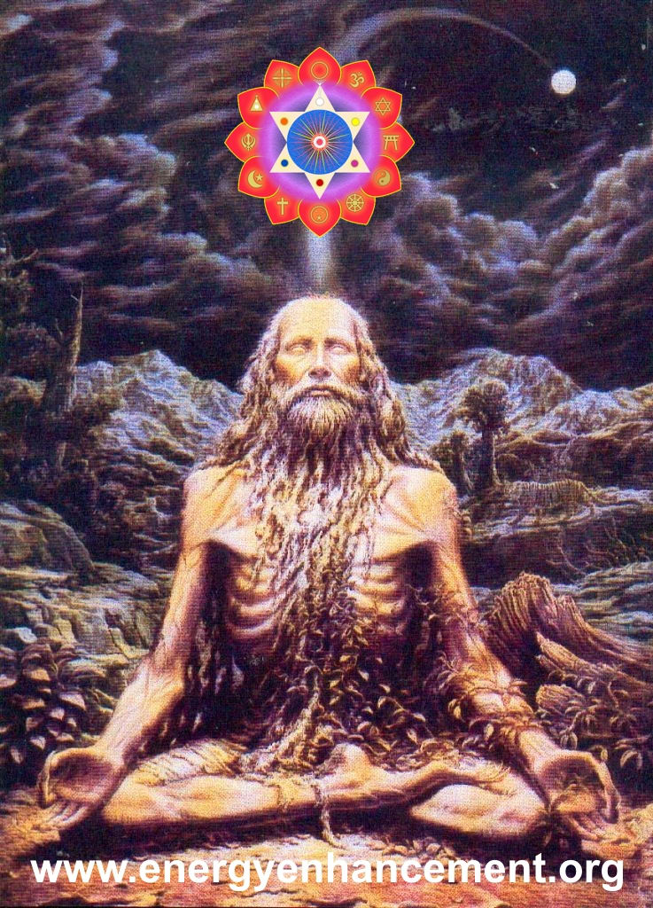
THE SPIRITUAL WARRIOR
ADVANCED ENERGY ENHANCEMENT MEDITATION COURSE
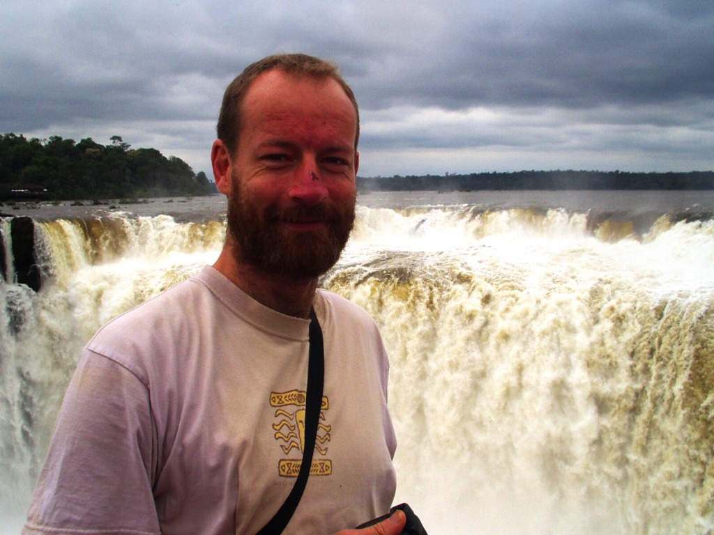
THOMAS BLAIR AT IGUAZU FALLS - THE DEVILS THROAT! OCTOBER 2008
Well, after Thomas Blair's Energy Enhancement Courses in Spain L'Escala 2006, and Spain Palamos 2007, Thomas returned for a third time - an Advanced Energy Enhancement Meditation Course Refresher to Rosario Argentina going on to Iguazu Brazil in October 2008 in which he removed a Dense Multi-Cored Matrix Blockage Implant from past lifetimes.



THOMAS BLAIR AND DEVI DHYANI AT IGUAZU FALLS - THE DEVILS THROAT! OCTOBER 2008

THE INTUITIVE SENSE HIGHER THAN THE INTELLECT
Always we try to put off the people who have no intuitive inner sense from coming on the Energy Enhancement course because they would have little chance of completing the course. Only the inner intuitive sense can overcome the negative intellectual dark angels who have no trust, no faith, no devotion, no love.
Instead these dark angels are solely concerned with money and the selfish competitive ego. And because they are untrustworthy, they have no trust for us, as within, so without, as one finger points, so three fingers are pointing back at you.
Gurdjieff used the same technique as us. He used to joke with the students that he was only after their money. He always said he wanted to "shear the sheep" which is always the students fear whereas his whole life was devoted towards enlightenment for his students and the world. History has proved that Gurdjieff affected the way enlightenment is taught across the whole western world, the ideas of Gurdjieff have been incredibly influential to all seekers. Gurdjieff used to charge enormous prices and acted in an untrustworthy fashion to put off those who could be put off by the intellect.
Only the Soul Intuition can be the guide of the good student.
Everyone who stayed with Gurdjieff grew, not just in intellect - which is only one chakra in seven - but in all the other coordinates of an integrated human being - higher emotion, intuition, bodily grace, love, will, wisdom.
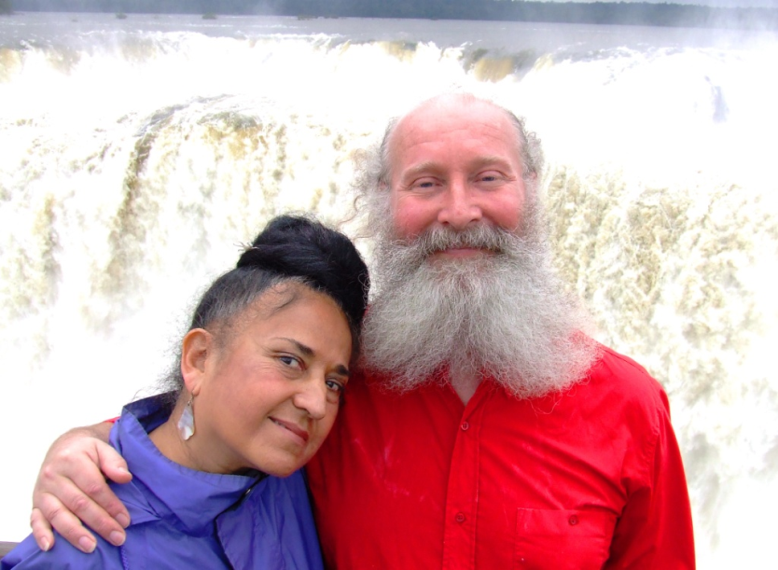

DEVI DHYANI AND SATCHIDANAND - IGUAZU FALLS OCTOBER 2008
IMPLANT BLOCKAGES CREATE THE PSYCHO PATH
On the course we deal with the easy blockages first but on the path of enlightenment we next need to deal with the implant blockages which feed energy back to the bad people who made them. The suckers, the vamps, the energy vampires and their knowing and unknowing helpers who implant the implants which direct thousands of streams of energy back from thousands of people to the guy in the center of the energy web.
Usually these implants exist above the head, cutting you off from your conscience which will not allow you to do a bad thing, which will direct you towards good paths, which will keep you on a Path with Heart - "Choose a Path with Heart" - Don Juan to Carlos Castenada - the Path of the Spiritual Masters as opposed to the Implant Blockage induced Psycho - Path.
Also these implant blockages exist in the heart cutting you off from empathy, the ability to put yourself in anothers place, Gurdjieffian External Consideration which will prevent you hurting another animal or human being.
The implants and their apologists are intent on turning all humanity into Orcs. Eating and breathing pollution. Delighting in selfishness and the production of pain in others. Thus people who are implanted not only eat and breathe pollution, but do all those types of work physical and mental, which make it possible to torture, kill, cut up and eat our fellow creatures. Thus people who are implanted do all those types of work physical and mental which produce the black clouds of pollution so necessary to produce and Orc from a natural human being. Thus people who are implanted see innovative solutions like War, Slavery, Corruption and Lies instead of The Truth, The Whole Truth, and Nothing but the Truth, The Final Solution, Malthusian Theory and the Chaos Management of Problem, Reaction, Solution as necessary, as good Government.
Politics is taught at University from thousands of years of experience to create Government, Govern Mente, Govern the Mind, Mind Control - the "Big Lie" of Hitler's Mein Kampf.
The implants and their apologists are intent on turning all humanity into Orcs. Thus implanted people work in poisonous fuctories, Agri-chemicals, poisonous pesticides, corrupt waste management and incineration and genetic engineering which switches off the seed after one year so it can not germinate a second time - just for money - and puts fish genes into soya to make it resistant to Agent Orange Pesticides which kill off the land and the people who consume the products of the land.
The opposite polarity to this is the work of good and evolved spiritual people on this planet who necessarily oppose the bad thoughtforms historically created by the would - be Orcs.

DATURA FLOWERS IN THE IGUAZU RAIN FOREST

THE COATI BANDIT IN THE IGUAZU RAIN FOREST
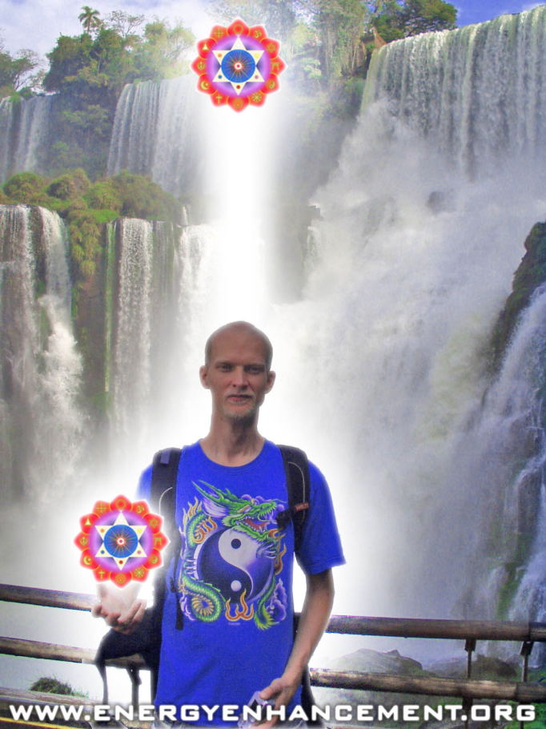
ENERGY ENHANCEMENT STUDENT IGUAZU JULY 2008
IMPLANT BLOCKAGES CREATE "MORAL BLINDNESS"
Thus although the Christian Bible says, "Thou Shalt Not Kill" the apologists say, with no backup from the bible, that this only refers to human beings. And we can always find a good excuse, "Dulce et Decorum est Pro Patria Mori - It is good and it is sweet to die for one's country"
Ahimsa is the law which says "Create no pain by word, thought or deed" Both Hindu Brahmins and Buddhist Priests also say, that to become spiritual, to evolve, to walk on the path of evolution we should become more peaceful, we should eat food which has less spiritual and Physical pollution, is more pure. Which contains no pain or the products of pain.
But the implants and their creators, the would be creators of Orcs, say that protein is necessary from the meat although this argument is destroyed by vegetarian traditions thousands of years old in which people live much longer and with less disease, in which 5000% more food is created from the same amount of land - talk about saving the rain forests. So that the only arguments left are the egotistical ones of, "We have always done it" and "We like the taste" which works equally well for all CainAbel Cannibals.
It takes a certain opening of the Heart, a removal of Implants, to understand Osho when he says killing is just not, "Aesthetic", otherwise it is just not understood, people just do not, "get it" A lack of empathy - Heart Blockages creating moral blindness, moral paradigmes.
Thus for real evolution revolution of the heart, blockages must be removed, empathy increased.
In the same way implant blockages create a "blindness" in all the other functions we need - not just in the heart - which is only one chakra in seven - not just in intellect or IQ- which is only one more chakra in seven - but in all the other coordinates, chakras of an integrated human being - higher emotion, intuition, bodily grace, love, will, wisdom.

GREEK DANCING WITH VEGETARIAN FOOD AT THE GREEK RESTAURANT
IMPLANTS BLOCKAGES CREATE PAIN AND DISEASE
It is the sucking effect, years of energy sucking of Implant Energy Blockages together with external pollution which produce the Blockage symptoms of wasting and killing diseases such as Multiple Sclerosis, ME, Diabetes, Heart Disease and Cancer. Only by removing the Implant Blockages which are the cause of the disease can we release the pain and pollution locked into our bodies from the Blockage Implant cause. Pain is a symptom of energy blockage implants.
Only by removing the Implant Blockages can we remove the pain and heal the wasting and killing diseases of Multiple Sclerosis, ME, Diabetes, Heart Disease and Cancer.

DEVI DHYANI - MUDRA FOR REMOVAL OF NEGATIVE ENERGIES - PLACE ON THE PAIN!


DEVI DHYANI - MUDRA FOR REMOVAL OF NEGATIVE ENERGIES - PLACE ON THE PAIN!
IMPLANT BLOCKAGES - THE PROBLEM
So, when we get one of the many students who return, we want to do our best for them.
Thomas Blair was complaining of a pain at the top of his head which increased in a debilitating fashion when he practised his profession - coding PHP on the web and creating DVD HD Videos for firms. He knows he needs to move in a more spiritual direction. To change his focus and move in the direction of Professional Healing and Spiritual Teaching.
So he was saying that this pain was a lesson and a warning to make the leap, take the jump, leave all of his clients and just move to that position.
Our advice was, "Dont give up your day job". Your future life in Spirituality will be supported by everything you have ever learned, everything you are doing now will support the pyramid of your spirituality. Your healing web page and spiritual videos will support your wanted and needed future profession.
We were saying that instead of this pain being a warning, instead it was an energy implant blockage which needed to be removed. Instead of being a warning the Implant Blockage was actively trying to destroy his life by taking him away from his Base Chakra support for his lifestyle. Implant Blockages sometimes take the form of a trauma - formed strategy called, "The Destroyer" (See Energy Enhancement Level 3) which just wants you to fail, to destroy your life.
So this was the argument. But what was indubitable was the fact that pain is a symptom of Energy Blockages and this energy Blockage needed to go!!

THE IMPLANT BLOCKAGE "TREE"
By plugging into the external kundalini chakras in Energy Enhancement Level 1 we so increase the energies flowing into our psychic bodies that normally, with all of our students, Psychic Powers manifest. And the normal psychic power is Psychic Vision which forms on top of Psychic Feeling which is the first stage of Psychic Power manifestation.
Everyone can feel the pain. And pain is a symptom of Energy Blockages, a warning which left untreated will result in time in a medical problem like strokes, embolisms, tumors or Cancer.
So when Thomas focussed on the pain at the top of his head and performed the "Seven Step Process of Energy Enhancement Level 2 for Blockage Dissolution" on it he started to discharge it. And as he focussed on it through many sessions and with many immersions into the Energy of the Buddhafield when I gave teachings on Innovation and further improvements and experiences in the Blockage Busting Process, which further increases the energy available for Blockage Grounding and dissolution, the blockage started to discharge and get smaller and have less power.
Now easy blockages are easy and dissolve quickly and this easy blockage dissolution is a great relief, a great benefit gained by all who complete the normal Energy Enhancement Two and Four Level Course. But this blockage was a doozy - a massive structure implanted in previous lifetimes and increased in this lifetime.
Under the direction of the Higher Chakras like the Soul, we are directed to remove blockages in a certain sequence, usually the easy blockages first which is what happens on the Energy Enhancement Course, but we need to continue until the end - enlightenment - because all blockages will destroy you unless you get them first!
So Thomas first "saw" this blockage as a Tree which was implanted into the top of his head and rose higher into his aura and this blockage was composed of many blockage parts composed of both big and small blockages and connected into his base chakra and blockages beneath the Base Chakra in the form of black balls all in the form of a shape like a birdcage with blockages in the head and blockages in the base connected together by connections which looked like a G Clamp or the wires of a birdcage. A Multiple Matrix Blockage - a prison for the soul - which is normal in Implants to feed energy back to a guy or a group of people who want to vampirise energy from you.
Blockages in the head cut you off from your Soul and the still small voice which guides you along the path of your Soul, the Path of the Heart, and prevents you from making bad mistakes in life.
Blockages in the Base create Fear create relationships with the wrong type of sexual partner and suck the energy of sex and the orgasm back to the implanters.
Blockages beneath the base reduce your energy and make you malleable, easy to control, easy to direct in bad directions - a slave.

IGUAZU FALLS BY THOMAS BLAIR

HELP FROM SWAMI SATCHIDANAND

So many sessions working on the blockages in the head, and then the blockages in the base and below the base and then on the connecting wires between them. And as in all of his meditation sessions at home he saw me in his meditations, Swami Satchidanand, psychically, with him helping and encouraging the work.
And as he focused on the blockages in the head the pain in the head increased - "No Pain, No Gain" said I - and he began to despair of ever removing the blockages because they were just too strong. And we encouraged him, and we meditated with him and I saw that the blockage had already been removed and that it was, "Dead man walking" and I said that now he needed to prove his willpower and finish the job and the removal of this blockage continued for two weeks and eventually the blockages in the Head and Base and all the connections went and the pain went, "Blockage Gone, Pain Gone!"
Practically, evidence that the blockage is removed is that the pain is removed.
Success in removing the stronger blockages which always we find later on the path of enlightenment is not just in removing the blockages. Session by Meditation session we first just remove, dissolve, ground the Trauma - Formed Negative Karmic Mass. We remove the power of the blockage to protect its inner core. The inner core will protect itself again if we stop the process half way through, so the blockage is working to stop the process with physical symptoms like pain, emotional symptoms like anger and mental symptoms like, "You can't get me, I'm too strong for you" and the like. All these symptoms need to be countered by arguments like, "Anger is a blockage symptom, blockages always say they are strong and yet always they go". Be a Warrior on the Path of Enlightenment.
The most important and best argument is that, "It is Necessary that All Blockages are Removed or the result will be an Orc, Orc Emotions, Orc Thoughts!" in you and in all the people on this planet, the cause of all World problems.
"For those who believe in Enlightenment, and Understand the Urgency of the situation!" - Gautama Buddha
The removal of All Energy Blockages will result in Your Enlightenment and Create World Peace, The Purity of a Sacred Planet, In the Firmament of a Sacred Universe.
So, after sessions of just grounding the Negative Karmic Mass Thomas started to remove important Blockages within the whole Blockage matrix he was starting to remove.
KHIDR, ROBIN HOOD, THE GREEN MAN, THE JOLLY GREEN GIANT - HELP FROM ASCENDED MASTERS
As he released the blockage cores so he started to gain the purified talents of this process. As he sent the purified Blockage Cores into his Antahkarana Matrix of the Higher Chakras so his Psychic Body, The Body Kesdjian, began to increase and he began to get back his own power.
One major blockage when totally healed became a psychic power "Ally" helper - came back as an image like the "Jolly Green Giant" based upon ancient Gods, Ascended Masters like Khidr, the wise guide of the Sufis, like Robin Hood in Lincoln Green, like the "Green Man" of the Druids symbolising the force of nature, like the Ents - a strong looking chap who then accompanied him in all his meditations, and with his laser sword he further helped the blockage dissolution process which involved removing all the blockages in the Head, all the blockages in the base, all the blockages below the base.
Often, our meditations involve the help of all the Ascended masters to which we are connected from many lifetimes and come to help us through prayer.
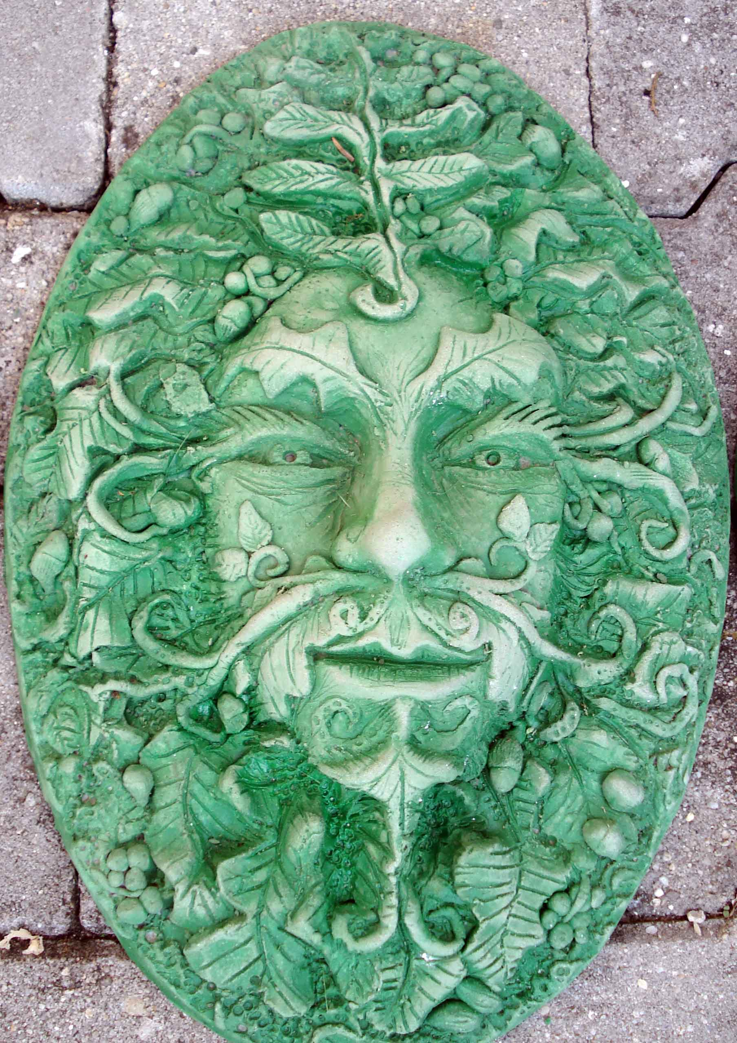
THE GREEN MAN OF THE DRUIDS
SEXUAL IMPLANTS
As time went on he saw connections from the blockages in the head to all the chakras in the body, and all the other implants above the head and all the other blockages below the base. These implants had been totally imprisoning his soul and tried to gain great Orc influence in the path of his life, as they try to influence all Humans on this planet to parasitise all psychic energy on this planet as a Rose is destroyed by Aphid Insects.
After regaining the Jolly Green Giant the image of the tree changed and he was able to see more blockages above the head, Still Connected to the Base, in the form of Blockage Implant Rings which he referred to as, "Collets".
As he was meditating on grounding the Collets one day - as he released the Collets - he saw many of his previous girlfriends, And each of the girlfriends was connected to one of their friends who controlled them. And he cut all the connections from the Collets to them as he removed the Collets totally.
If you have sexual implants in the base chakra so this will lead to an ease of connection to partners who have the same type of sexual implants thus creating inappropriate sexual relationships, disappointment, adultery, divorce.
All your sexual energy and the energy of all your orgasms will be channeled back to the implanter and to the person who controls and implants the implanter who may not consciously know that they are controlled implanters, that their job is to implant their victims during the sexual act.
So, Thomas totally and carefully removed each part of the Implant Blockage Matrix Above the head, In the Head, In all of the chakras, in the base Chakra, beneath the Base Chakra and the G Clamps which connected them.
After all that he felt better!! - "Blockage Gone, Pain Gone!"
RESTAURANTS, ROSARIO, VEGETARIAN FOOD AND IGUAZU FALLS IN BRAZIL

IGUAZU FALLS PANORAMA

IGUAZU RAFAIN SHOW OF ALL SOUTH AMERICAN DANCES AND VEGETARIAN DINNER - MEXICO MARIACHI
And during the process we visited Rosario, Visited some restaurants, gave him good vegetarian food, took him to Brazil and Iguazu Falls, boosted the buddhafield, advised on the order of Blockage Matrix removal, used Pratipaksha Bhavana - good advice - to help in his Soul Path.

IGUAZU RAFAIN SHOW OF ALL SOUTH AMERICAN DANCES AND VEGETARIAN DINNER - BRAZILIAN SAMBA

IGUAZU FALLS PANORAMA

IGUAZU RAFAIN SHOW OF ALL SOUTH AMERICAN DANCES AND VEGETARIAN DINNER - BRAZILIAN SHOW

IGUAZU FALLS PALM TREES

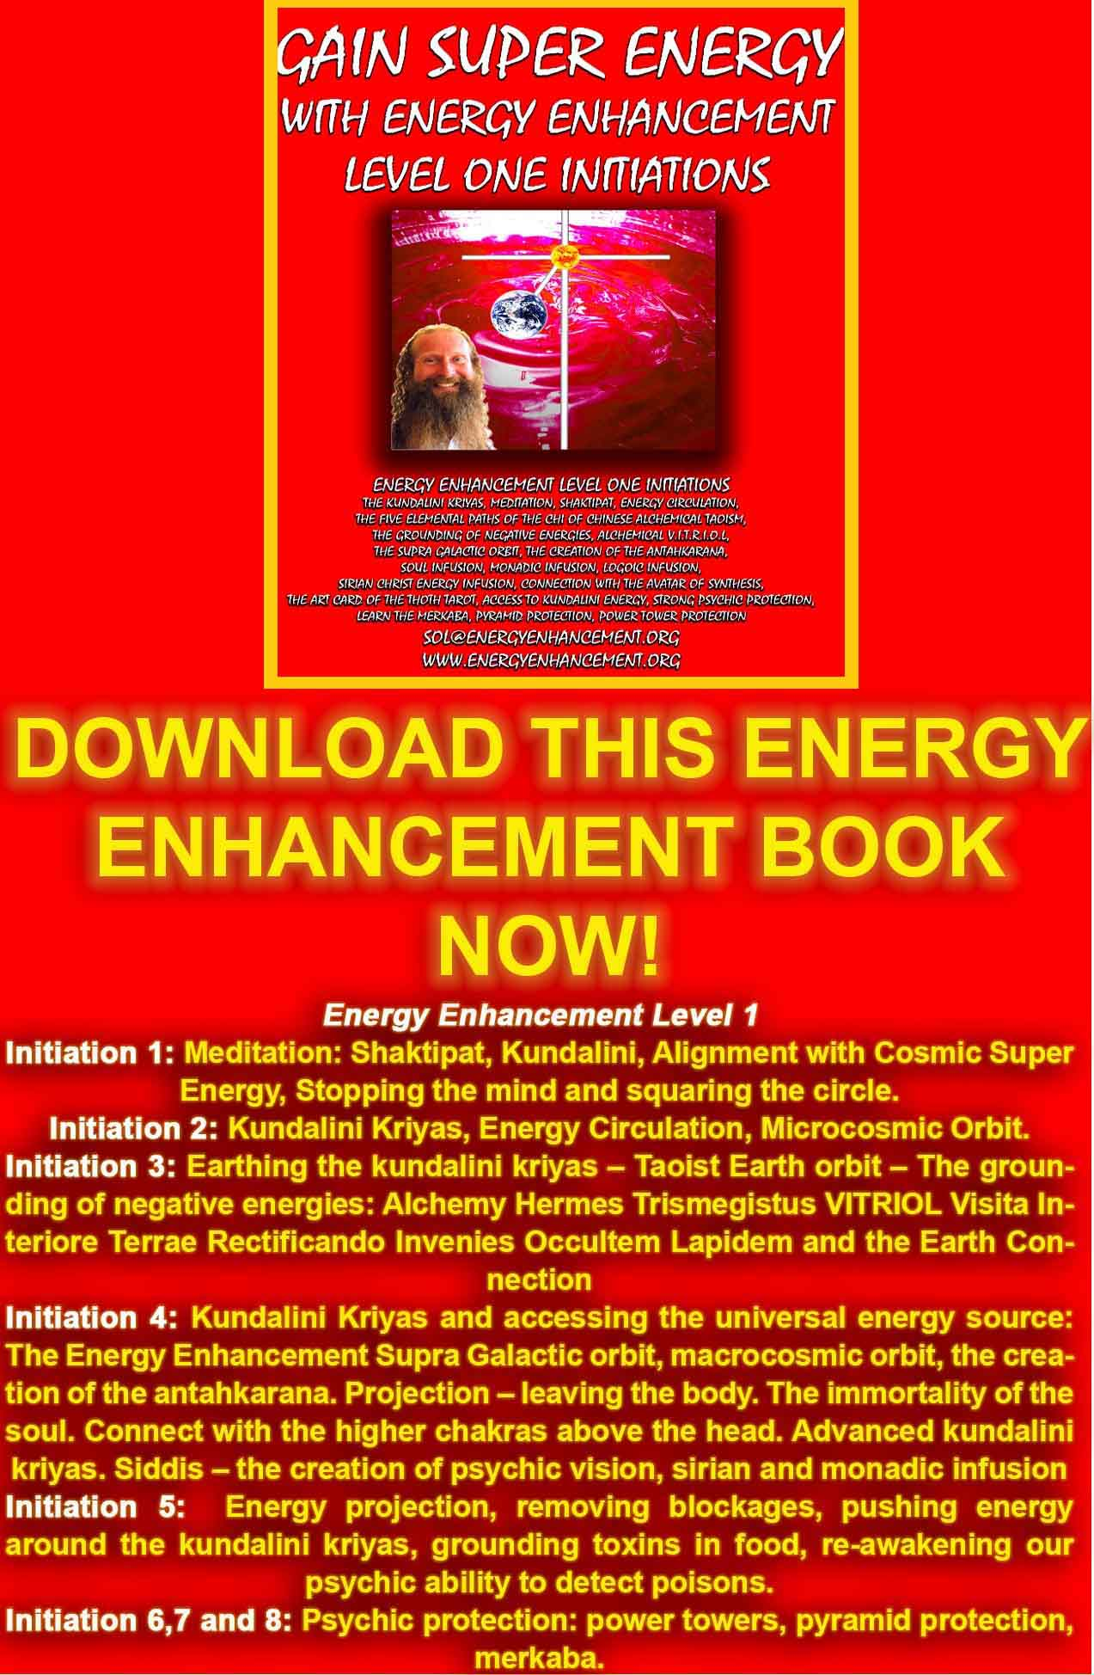
DOWNLOAD “GAIN SUPER ENERGY WITH ENERGY ENHANCEMENT LEVEL ONE INITIATIONS HERE!!!
http://www.energyenhancement.org/Sacred-Energy/Gain-Super-Energy-Energy-Enhancement-Level1-Initiations-Kundalini-Kriyas-Meditation-Shaktipat-Circulation-Taoist-Orbits-Alchemy-VITRIOL-Grounding-Psychic-Protection-Pyramid-Merkaba-energyenhancement-org.pdf

"When I was talking to the famous Ecumenical Benedictine Monk, Father Bede Griffiths, Head of the Ashram of Shantivanam on the Banks of the River Cauvery in Tamil Nadu, Southern India, he said that each Saint who has come to Earth to create a Religion has brought a Revelation, A Special Meditation Teaching, a Precious Jewel unto the Earth for the benefit of Humanity. Such is the competition between Religions is that some of these precious jewels have been destroyed or lost" Satchidanand

Satchidanand is a person who has arrived.
Satchidanand is a person who has cleaned the Insane Mind.
Satchidanand is a person who has become Enlightened has entered into the Presence, that moment of NOW!
Thus Satchidanand has gained Fire, that Buddhafield which can dissolve the Body of Pain In You. That Body of Pain which has created the Mad Mind to Drain you of Life Energy just as it is Poisoning and Destroying the Earth. That Body of Pain which is Torturing and Killing all the people on the Earth - 200 Millions in the last Century alone, without Conscience without Empathy, without Heart... Psycho!!
Not only does Energy Enhancement utilise the Buddhafield, the Presence, but also it Utilises all these Precious Jewels, these Advanced Meditations, from 5000 Years of Spiritual Technology to Intensely Speed Up! the Processes of Evolution and Enlightenment within YOU, as quickly as possible.
Energy Enhancement will create a profound transformation in Your Consciousness and in the Consciousness of all Humanity, Now!!
As you Ground all your Body of Pain, Burn up the Body of Pain, Energy Blockages, Inherited and Collective Mind Patterns, in Kundalini Chakra and dissolve them in the Soul Chakra of your Higher Self, so you will enter into the Presence Yourself - FAST - EASY - SPEED UP!!
You will awaken out of the Dream of Time into the Presence of the Present. NOW!!"-
Satchidanand

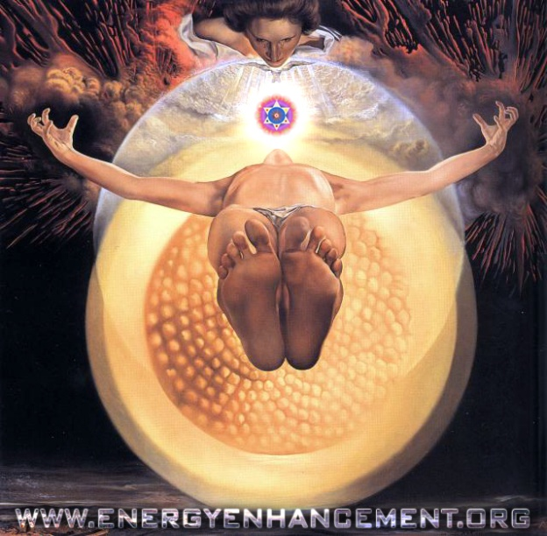
SALVADORE DALI - ASCENSION IN THE ANTAHKARANA
The Buddha came to this Planet to Reveal the Cleaning of the Intellect through Meditation THE THIRD RAY
Jesus Christ came to Reveal the Opening of the Heart of Compassion - THE SECOND RAY
2000 YEARS LATER, ENERGY ENHANCEMENT HAS COME TO REVEAL THE ENERGY OF CLARIFICATION OF PURPOSE AND WILL - THE FIRST RAY
THROUGH ANCIENT TECHNIQUES WHICH DISSOLVE ENERGY BLOCKAGES - WHICH GROUND NEGATIVE ENERGIES - WHICH CLARIFY AND REVEAL THE TRUTH!!

TO SPEED UP YOUR PROCESS!!

IT IS A MIRACLE TO REMOVE JUST ONE ENERGY BLOCKAGE "The Miracle of the Removal of Energy Blockages.. Miracles, Miracles and yet more Miracles!!" - Graham Smith - MA Philosophy, on his Energy Enhancement Course in India November 2009

DO IT!
M.S. - Human Resources Director for Europe and Asia of Fortune 500 Company, PepsiCo

ANCIENT PROVEN TECHNIQUES WHICH WORK TO CREATE A PROFOUND TRANSFORMATION OF HUMAN CONSCIOUSNESS, FAST!!

MEDITATION ENERGY ENHANCEMENT APPRENTICE LEVEL 1 WILL DRAMATICALLY DECREASE YOUR NEGATIVE AND INCREASE YOUR POSITIVE ENERGIES
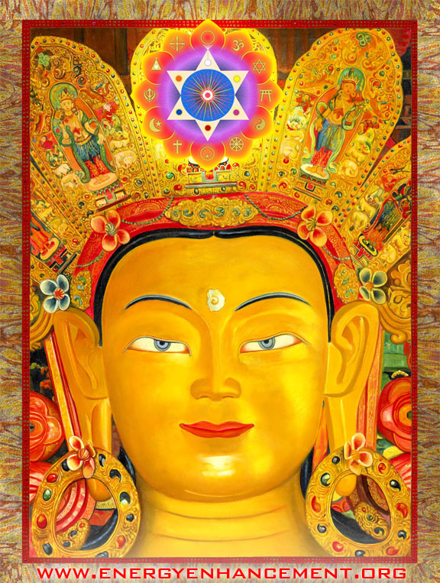
THE MEDITATION ENERGY ENHANCEMENT SEVEN STEP PROCESS OF LEVEL TWO IS THE ONLY PROCESS ON ANY PATH WHICH TEACHES HOW TO TOTALLY REMOVE NEGATIVE ENERGY BLOCKAGES !!
"All of our students report on their personal success in eliminating their own Energy Blockages by themselves"
"The Technique of the Energy Enhancement Seven Step Process is the only Enlightenment process outside of expensive Scientology which can dissolve Energy Blockages. Without it Buddhism, Hinduism, Ramana Maharshi - ism, Ekhard Toll - ism, Sri Niscardatta - ism, any other Enlightenment process depends on the Master to remove the energy blockages.
In Energy Enhancement, we help but we give full instructions to our students on how to Eliminate the Energy Blockages of the Angry, Painful, Selfish, Competitive, Fearful, Desire filled Energy Blockages and all of our students report on their personal success in eliminating their own Energy Blockages by themselves.
IN THIS WAY, WITH ENERGY ENHANCEMENT, NEW MASTERS ARE VERY EASILY FORMED
The rate of evolution of humanity needs to increase. The old ways of the Master doing all the work of removing the energy blockages of the ego are now too slow. The recommendation is for students to serve their Masters for at least 12 years. Many have been there for 20 years with no appreciable movement forwards. The new technique of The Energy Enhancement Seven Step process can now augment the processes of every Enlightened Master and thus Speed Up!! the Process of Enlightenment Worldwide - Satchidanand Bio"
"NOW IS THE OPPORTUNITY FOR FULFILLMENT AND NEW BEGINNINGS FOR THE WORLD"
ENERGY ENHANCEMENT IS A NEW REVELATION OF GOD TO HUMANITY!!

One White Magician Only is Required to change this Planet into a Sacred Planet, or a group of Like minded people, in Silence and in Secrecy
HEAL THE WORLD, BECOME A MASTER, A MERLIN, A JEDI KNIGHT, A WHITE MAGICIAN

EE LEVEL 1 POWER UP!! GAIN SUPER ENERGY http://www.energyenhancement.org/Level1.htm
EE LEVEL 2 ELIMINATE ENERGY BLOCKAGES http://www.energyenhancement.org/Level2.htm
EE LEVEL 3 CLEAN KARMA BLOCKAGES AND PAST LIFE KARMA BY TRANSMUTATION http://www.energyenhancement.org/Level3.htm
EE LEVEL 4 MASTER ENERGY CONNECTIONS AND RELATIONSHIPS http://www.energyenhancement.org/Level4.htm
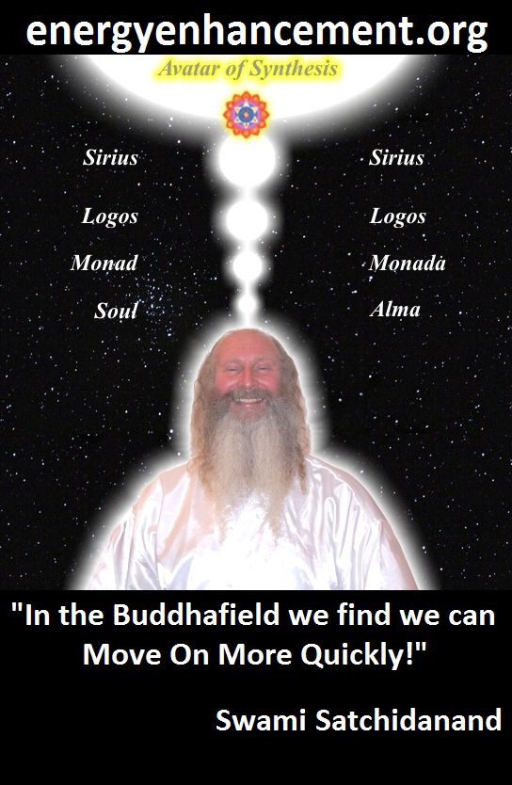

ENERGY ENHANCEMENT - THE ULTIMATE MEDITATION COURSE!!
“Traditional meditations are designed to Fail” – Satchidanand
FUSION WITH THE SOUL CHAKRA - Enlightenment - is Only the first Dan. Become fused with the Monad - Second Dan. Become fused with the Logos - Third Dan. Become Fused with Sirius - Fourth Dan. Become Fused with the Avatar of Synthesis - Fifth Dan - Satchidanand
Research The Energy Enhancement Meditation Course by video or on retreat..

Astral Sexual Addiction - The Addiction Ecstasy of Out of Body Sex Pleasure -Stealing your spiritual Energy with VAMPIRE ADDICTION IMPLANT BLOCKAGES and VAMPIRE SEXUAL ADDICTION IMPLANT BLOCKAGES
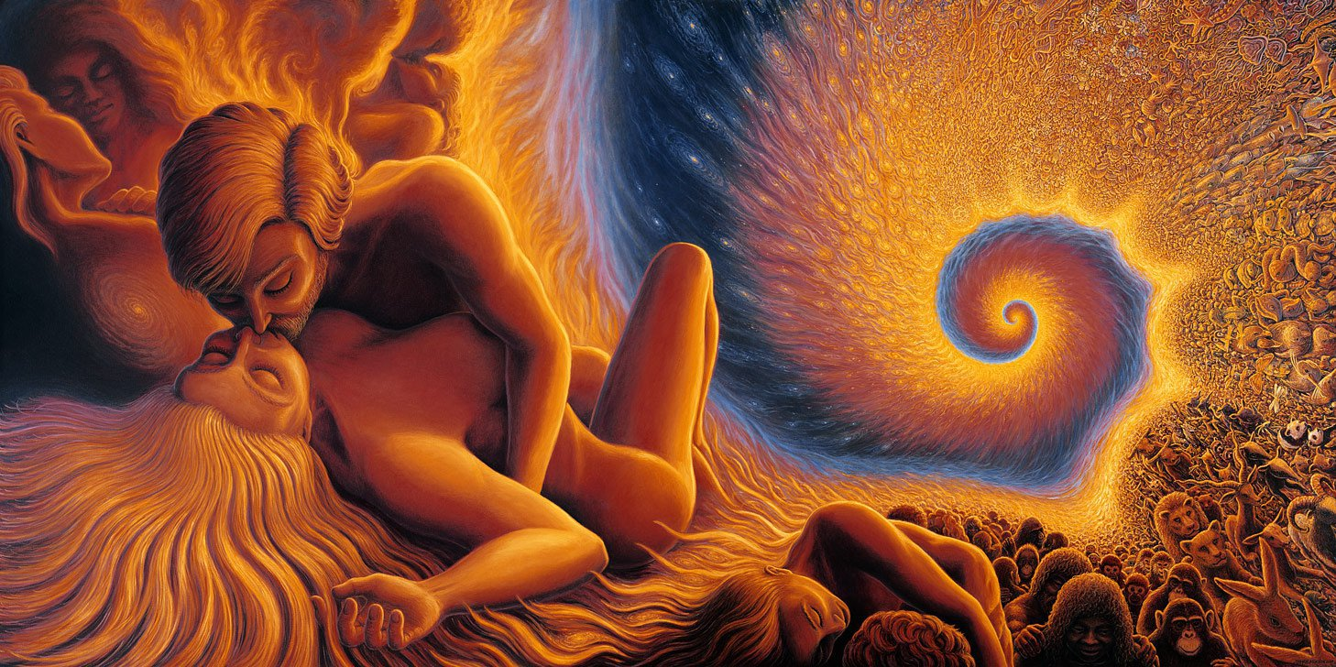
Ever wonder why you feel so drained and painful?
Everyone starts off with a large amount of sexual energy and in the beginning, as with all drugs, the orgasms are many and intense and the energy is radiated into the area or the video - pornographic videos consciously use this sexual radiation to attract customers, with this sexual radiation, they also mix in Implant Sexual Addiction Energy Blockages to further Addict and Degenerate their customers - so that everyone can feel this energy and themselves become aroused.
Thus the urge to make love with virgins because their energy is so intense and strong - for a little while. Everyone is implanted with sexual implant blockages so all this sexual energy is vampirised, stolen and soon the only energy left is the tithe vouchsafed to everyone in your sleep which is then stolen every morning!!
The implanters of sexual addiction energy blockages and their group of minions consciously stimulate the sexual addiction energy blockages of everyone early every morning thus the proud tumescence, the horn of every red blooded man and the desire for sex, the milking of their herd of cows for their energy every day of the year!! And this has been going on for Thousands of Years!!
Leaving very little left!!
Again... The implanters of sexual addiction energy blockages and their group of minions consciously stimulate the sexual addiction energy blockages of everyone early every morning.
I do not think that anyone has ever said this!!
That they milk their herd of cows for their energy every day of the year!!
And that this has been going on for Thousands of Years!!
What can you do about this??
The answer is this..
Except for those who consciously connect with God in Meditation Samadhi with the infinite chakras above the head. Who protect themselves with Spiritual Protection. Who remove all their implant energy blockages. These people glow with Buddhafield energy!!
HERE IT IS.. THE BUDDHA KNEW WHAT TO DO AND HOW TO DO IT..
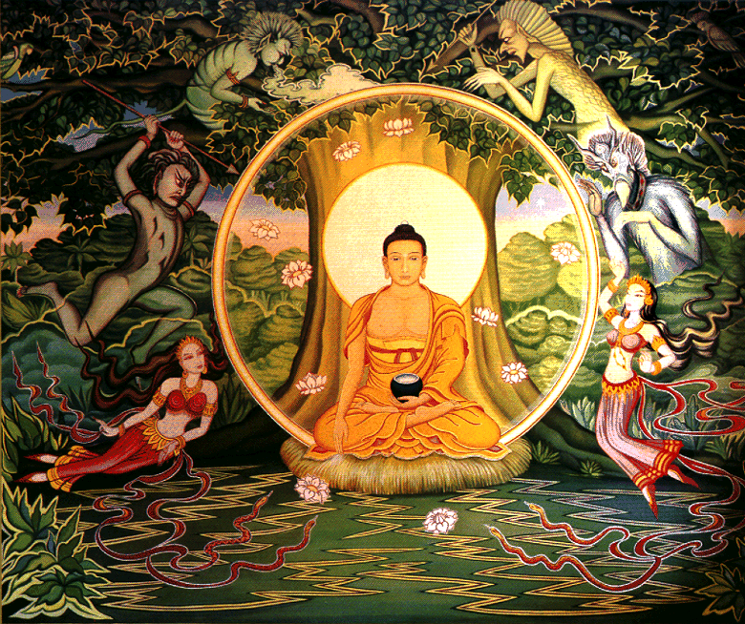
ENERGY ENHANCEMENT ENLIGHTENMENT - CONNECTING WITH CHAKRAS HIGHER THAN THE SOUL CHAKRA ABOVE THE HEAD
THE BUDDHA IS IN HIS CIRCLE OF PSYCHIC PROTECTION RADIATING THE ENERGY OF THE SOUL
OUTSIDE THE CIRCLE OF PROTECTION ARE DEMONS AND SUCCUBI TRYING TO GET IN - TO STEAL HIS ENERGY
NOW, ONLY ENERGY ENHANCEMENT KNOWS HOW TO DO THIS..

You’re probably already familiar with what it’s like to have sex as a physical human being, together with the risk of disease and implant blockages stealing your sexual energy, and people learning how to steal energy from their partners, and absorbing the energy blockages of your partner which becomes intense in Sex, and your children conceived in and with energy blockages turning out as they do.
Like calls unto like..
But did you know that you can also engage in sexual liaisons outside of your physical body to further have your energy stolen and absorb even more energy blockages? Yes, it’s true. You’re not limited to the physical. There’s a whole other world of sex, pleasure, unbridled passion, vampirisation and sexual addiction awaiting you outside of your physical shell. And today I’m going to tell you all about it.
The only solution is the Total Removal of All Energy Blockages.

There’s more than one way to have non-corporeal sex. You can have sex and all your spiritual energy stolen in your dreams with a dream character. You can have sex while astral with a corporeal being, or sex while astral with another astral playmate. You can also have sex with a demon or low vibrational entity.
Or you can go completely beyond the confines of the physical and non-physical and have a blissful ethereal experience that is unlike anything you can imagine; yes, better than any kind of sex you can imagine, through Energy Enhancement Samadhi with the God Chakras above the Head. A Twenty-Four Hour Orgasm!!!

So let’s go over each of these and I’ll explain what it is and how to achieve your own lack of energy as it is stolen away.

Dream Sex
Having sex in your dreams is fun, pleasurable, risks your energy being stolen through your Sexual Implant Blockage - which everyone on this planet has been implanted with, sending the energy of the arousal back to the Implanter along energy connections which also maintain the Implant blockage in place.
It’s just you and your dream character and no one ever has to know what you’re up to. With the ability to lucid dream, you can have had sex with every hot actor, fictional character, and good looking real life friends, when you want, the way you want, and as many times as you want. And you can do this anytime you want. Just learn how to lucid dream and, when the situation presents itself, you can snap your fingers and engage in sexual activity with whoever you want.
Sexual Addiction Blockages are programmed to increase your sexual activity so that your sexual energy can be stolen through these and other means. If you aren’t a master at lucid dreaming, you may still end up with a sex dream accidentally. But believe me, the sexual addiction implant blockages want you to learn how to do it lucidly.
If you’re a woman, dream sex can actually lead to having a real and true orgasm. More than likely you will wake up while in the throes of your orgasm and find your body actually having one as the implant energy blockage incubus or succubus steals all that energy..
If you’re a man, this is more tricky. Mostly what I hear from men is that they wake up with an erection and extremely horny, but don’t actually ejaculate in the dream or upon waking. If you’re a man, and you have, please let us know this is possible. Half the world awaits your testimonial.
Dream sex can lead to a lot of frustration though. Most of the time it doesn’t lead to climax, so you wake particularly hot, bothered, and unfulfilled as your implant blockage increases your desire for sex so that all your energy can be stolen and you lose the ability to orgasm.
The implanters of sexual addiction energy blockages and their group of minions consciously stimulate the sexual addiction energy blockages of everyone early every morning thus the proud tumescence, the horn of every red blooded man and the desire for sex, the the milking of their herd of cows for their energy every day of the year!! And this has been going on for Thousands of Years!!

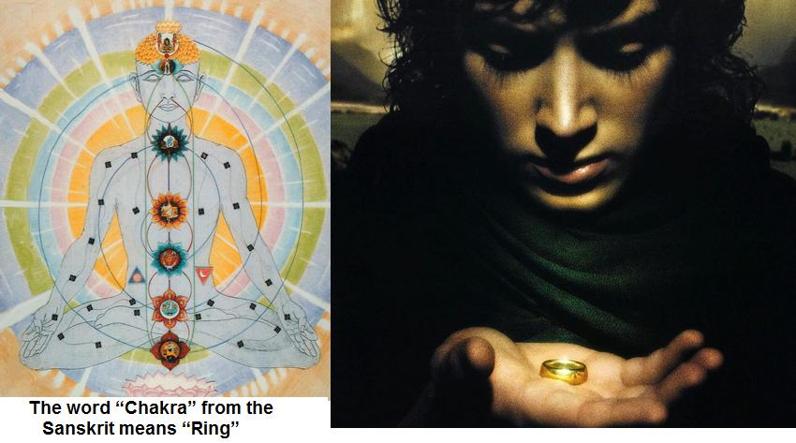

And into the Ring Sauron placed all of his evil power - Implant Energy Blockages.
The One Ring.
One Ring to rule them all, One Ring to find them,
One Ring to bring them all and in the darkness bind them
THE NWO PSYCHIC ATTACK FROM THEIR MINISTRY OF SEX, MINISTRY OF DRUGS, MINISTRY OF MILKING - CONTROL FOR THOUSANDS OF YEARS - DRAINING, WEAKENING,VAMPIRISING THE HERD - THAT NO-ONE KNOWS ABOUT!!
JUST THINK, YOU ARE THE GOLDEN GOOSE!!
Astral/Corporeal Sex
There is also a way to engage in sex where one person is astral (out of body) and one person is still in the body. If you are astral, you can go visit someone and attempt to merge your energy with theirs while they are sleeping (it won’t work if they are awake as your frequencies will be totally off). This should always and only be done with consent of the person you’re visiting, otherwise we’re talking astral rape and that’s not cool.
Once you are out of body, fly to the person’s body. You will likely see both their physical body on the bed and their astral body floating inside it, like a peanut rattling in a shell. With great love, tenderness and respect you can overlay your energy onto theirs and cast loving sexual thoughts their way. What’s going to happen is that you will experience a sexual bliss that is not localized to a body part, and your partner will either dream that they are having sex, or simply become sexually aroused without consciously realizing what’s happening.
If your friend is accomplished at lucid dreaming, this act will likely trigger lucidity. If not, they may phone you in the morning and tell you about the hot dream they had about you.
This particular method is not terribly fulfilling because usually only one of you is conscious of what’s going on and can act as a succubus - raping the object of desire consciously whilst not saying anything, stealing their energy.
To prevent yourself being astrally raped, practise Psychic Protection, taught in Energy Enhancement Level 1.
Astral Playmates
If you can find a partner who is also accomplished at astral projection, then the two of you can meet on the astral plane and engage in astral sex together and consciously have your energy stolen. It’s difficult to accomplish as you have to be out of the body at the same time, on the same plane, and at the same astral frequency. The closer you are to each other emotionally, the more accomplished you are at astral projection, and the more you practice meeting up, the more success you will have.
Pick a location ahead of time and a time when you will attempt to meet. If one of you is better at astral projection, fly to the other person’s house and wake them up astrally, and then fly to your romantic destination together. Once you’re ready, you will simply hug or merge your energy together. Cast loving and sexual thoughts at your partner and you will trigger a release of pleasure that will reverberate through your entire energetic self and probably also to your body back on your bed. It’s a combination of bliss and the sensation of physical pleasure.
Great stuff as you lose energy!
And now for the dark side of astral sex. Sometimes an entity that normally resides on the astral plane can come to you and stimulate you sexually for the purposes of swiping your energy. Look up incubi and succubi for more info on that.

Here’s the thing, though. These entities can come to you against your will and essentially rape you. If you’ve ever been stuck in a sleep paralysis state and felt someone touching you in your special areas, and got aroused even though you were terrified, you’re basically being astrally raped. This is no bueno!
You must immediately put up your Psychic Protection to cut off from this interloper pronto. Energy Enhancement
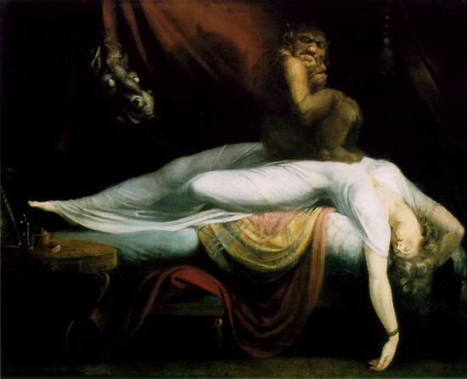
Sex with Demons or Lower Vibrational Entities
Level 2 will show you how to remove the demon interloper energy blockage permanently.
Your energy is being violently taken from you. You will wake up feeling lethargic and it can take hours to replace that energy.
These demons also infect other human beings who consciously rape other people every night in their dreams. They take a tithe of the energy stolen as the demon sends the sexual orgasm energy back to their controller implanters.
Unfortunately sometimes people end up in a parasitic relationship with such entities. The entity gives you a ton of pleasure (and we’re talking about more pleasure than any human being can generate while corporeal), and you feel like it’s worth losing a little of your energy to obtain such bliss, so you don’t resist or push them away. In fact, you invite them to come back for another “session.”
This is Sexual Addiction.
Over time, this leads to you losing a ton of energy which can manifest as apathy towards the real world or real love, and depression, anxiety, and sometimes shame, fear and suicidal thoughts. Not to mention leaking little parts of your soul to an entity who doesn’t have good intentions.

If you’re a woman, having sex with a demon or astral entity will feel like someone stimulating the g-spot of every single one of your chakras at the same time. It’s ridiculously pleasurable, and something no human can accomplish, so it can turn enticing very quickly. But I urge and caution you to avoid this slippery slope of parasitic sex. It’s not worth losing your soul.
Demons Addict!!
If you do find yourself in an unwanted sexual relationship with a non-corporeal entity, you’ve got to sever your connection, remove the sexual implant from that particular demon and protect you from being visited by them anymore. A clean break. Just end it, and find a playmate in real life to satisfy you.
Be Safe..
So there you have it. All the different ways to have sex on another plane and lose all your spiritual energy. Some of it is awesome, some of it is a little dark, but at least you don’t have to worry about contraception! If there’s an astral sexually transmitted disease it’s probably lust, addiction, and losing your soul, so be careful of Astral rape, and be respectful of other people.

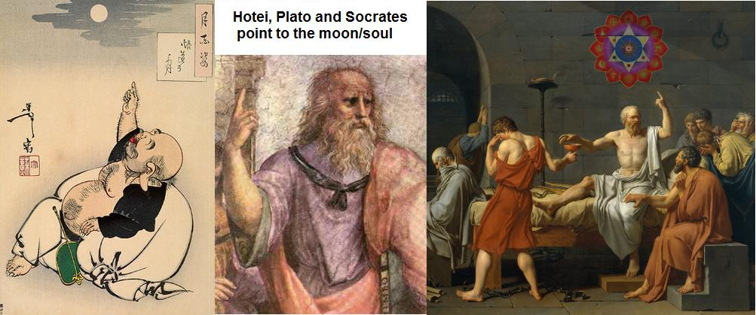

Safe Sex!! Samadhi Bliss Sex - a 24 hour orgasm!!
ENERGY ENHANCEMENT ENLIGHTENMENT - CONNECTING WITH CHAKRAS HIGHER THAN THE SOUL CHAKRA ABOVE THE HEAD
THE BUDDHA IS IN HIS CIRCLE OF PROTECTION RADIATING THE ENERGY OF THE SOUL
OUTSIDE THE CIRCLE OF PROTECTION ARE DEMONS AND SUCCUBI TRYING TO GET IN - TO STEAL HIS ENERGY
You must immediately put up your Psychic Protection to cut off from this interloper pronto. Energy Enhancement Level 2 will show you how to remove the demon interloper energy blockage permanently.
The final method for out of body pleasure is the pure universal bliss of Samadhi Energy Enhancement. It’s you merging your soul with the Love of the infinite chakras above the head.
It won’t feel like physical sex. It is beyond any pleasure known to the physical form. It is almost indescribable if you haven’t felt it but imagine becoming one with EVERYTHING and feeling totally loved, connected, cared for, and blissful. And perfect.
The way to achieve this is to project onto the astral and way above the astral into the infinity of chakras above the head as taught in EE Level 1 Initiation 4, and reach out to the highest Source/Creator/Consciousness.
The merging is timeless, spaceless and absolute. You probably won’t want to go back to your body, but you must. If you get the opportunity to experience this, it’s awesome. Enjoy the experience!

ONLY ENERGY ENHANCEMENT MEDITATION CAN OVERCOME ALL THIS..
THE MASTERY OF ENERGY CONNECTIONS
THE MASTERY OF ENERGY BLOCKAGES
THE MASTERY OF RELATIONSHIPS
LEVEL 4 OF ENERGY ENHANCEMENT TEACHES ALL OF THIS
Energy enhancement is a super-powered yoga which is meant to get people to Enlightenment at top speed. It is meant for everyone. It is the original yoga of Patanjali, before it was dummed down because all Traditional Meditations have been dummed down. They just do not work to go any further than A to B.
Energy Enhancement takes you from A to Z!! It suits me.
WHO ELSE IS TALKING ABOUT THESE SUBJECTS?
"BECAUSE ORIGINALLY ALL MEDITATIONS CONTAINED THE TECHNIQUES OF, "THE KUNDALINI KEY" AND OF, "ALCHEMICAL VITRIOL" TO GROUND NEGATIVE ENERGIES AND TO NATURALLY INCREASE KUNDALINI ENERGY"
"NOW, ONLY ENERGY ENHANCEMENT MEDITATION TEACHES THESE TECHNIQUES WHICH SPEED UP THE ENLIGHTENMENT PROCESS"

When Vimalakirti had spoken this discourse, eight thousand of the gods in the company of the crown prince Manjusri conceived the spirit of unexcelled, perfect enlightenment..
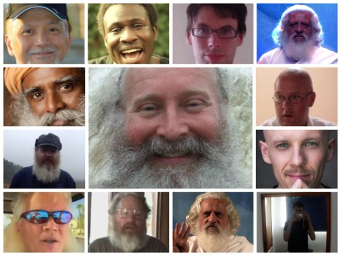
THE INCREDIBLE MEDITATION COURSE AND MEDITATION TECHNIQUES CREATED TO PRODUCE ENLIGHTENMENT AND ILLUMINATION
"ALL TRADITIONAL MEDITATIONS HAVE BEEN DESIGNED TO FAIL" - SATCHIDANAND -
"BECAUSE ORIGINALLY ALL MEDITATIONS CONTAINED THE TECHNIQUES OF, "THE KUNDALINI KEY" AND OF, "ALCHEMICAL VITRIOL" TO GROUND NEGATIVE ENERGIES AND TO NATURALLY INCREASE KUNDALINI ENERGY"
"NOW, ONLY ENERGY ENHANCEMENT MEDITATION TEACHES THESE TECHNIQUES WHICH SPEED UP THE ENLIGHTENMENT PROCESS"
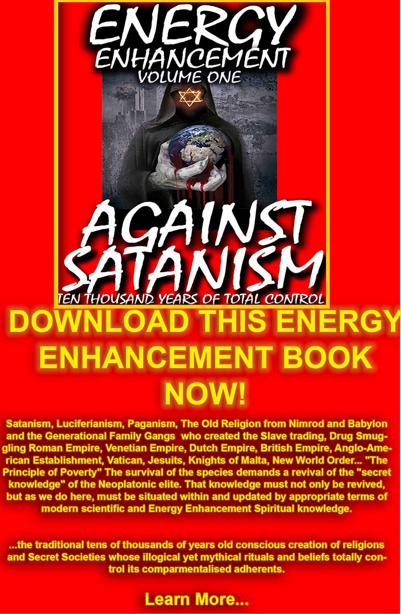
DOWNLOAD AGAINST SATANISM VOLUME ONE HERE
http://www.energyenhancement.org/Against-Satanism/Against-Satanism-Energy-Enhancement-Satanic-History-of-the-World-Volume-1.pdf
ENERGY ENHANCEMENT STUDENT REPORT 12 JUNE 2015

Dear Swami Satchidanand,
This is my first report since I started doing the Level1 meditation.
Initiation 1
I was quickly able to align my spine with the energy from the centre of the earth. I could feel the energy along the spine. As I meditated I could also feel a marked pain in the spine, at the approximate location of the heart chakra. The pain has not fully cleared but it is barely noticeable now.
Initiation 2
I could not see the golden light clearly but I could FEEL it circulating around me. The feeling of energy circulating around me was palpable. The circulation of energy sets the chakras buzzing. This is especially the case with the crown chakra, the brow chakra, the heart chakra and to a lesser degree the base chakra. I must also add that my crown and brow chakras have been vibrating in sync for the past two years but circulating the energy seem to have intensified the vibration.
Initiation 3
I began the third initiation on Sunday June 7th. By the time I completed the initiation my whole body felt like it was on fire. My base chakra became intensely warm. The feeling of intense warmth continued hours after the initiation.
Monday,8th June, The warmth was not as intense as the previous day but my body felt warm throughout the day.
Tuesday, 9th June. I couldn't meditate. I seem to be trapped in the centre of a dark oppressive fog (Energy Blockage). My body felt cold. Confused thoughts kept going through my mind. I felt drowsy, It was almost like I have been drugged.
Wednesday 10th June. The fog had not left me but I was determined to go through the meditation process. I tried to align my spine with the earth energy without much success. I started breathing in the golden light. Suddenly I heard a click and literally fell out of the fog. I felt weightless, like I was floating in space. My mind was quiet and my body was still. I could feel and see a white light from the centre of the earth orbiting around me in slow motion. I felt a subtle, gentle warmth, different from the intense heat I had previously experienced.
Now everything seems normal. Interfering thoughts seem to have become noticeably less during meditation. My body jerks automatically into alignment without any conscious effort on my part when I fall out of alignment during meditation.
I will begin the 4th initiation today. In my next report I will tell you something about myself.
Thank you for giving me the opportunity to help myself become a better person.
I trust all is well with you and yours.
Best regards,
Dear Swami Satchidanand,
Level 1 Initiation 4
I seemed to have encountered a barrier when I tried to access the first chakra above my head. It was like a concrete ceiling above my head. Eventually that barrier (Energy Blockage) was removed.
I am struggling with visioning the various chakras above my head but I seem to have a fairly good idea which of them I am accessing by the intensity of vibration in my crown and brow chakras.
The higher I go the more intense is the vibration in my crown and brow chakras.
The vibration usually covers the top of my head down over my forehead to the bridge of my nose.
My body is now permanently warm and I am not able to sleep as much as I used to.
Three days ago I had a cramp in my left leg. It was so painful I that screamed but when I imagined a golden light going through my leg into the earth, the cramp immediately eased leaving a dull pain in my calf (Removal of Energy Blockage).
Perhaps the most positive outcome so far is the drastic reduction in mental chatter.
Going through the four initiations have given me hope that all is not lost.
The past seven years have been very difficult for me. My health has suffered and I lost almost every material possession. There are those who think I am cursed. But that would be a story for another day.
Again thank you for the opportunity given me to turn around my life.
Best regards,
Yes!! I NEED All of the Initiations.

Dear Swami Satchidanand,
This is my first report since I started doing the Level1 meditation.

Initiation 1
I was quickly able to align my spine with the energy from the centre of the earth. I could feel the energy along the spine. As I meditated I could also feel a marked pain in the spine, at the approximate location of the heart chakra. The pain has not fully cleared but it is barely noticeable now.
Initiation 2
I could not see the golden light clearly but I could FEEL it circulating around me. The feeling of energy circulating around me was palpable. The circulation of energy sets the chakras buzzing. This is especially the case with the crown chakra, the brow chakra, the heart chakra and to a lesser degree the base chakra. I must also add that my crown and brow chakras have been vibrating in sync for the past two years but circulating the energy seem to have intensified the vibration.
Initiation 3
I began the third initiation on Sunday June 7th. By the time I completed the initiation my whole body felt like it was on fire. My base chakra became intensely warm. The feeling of intense warmth continued hours after the initiation.
Monday,8th June, The warmth was not as intense as the previous day but my body felt warm throughout the day.
Tuesday, 9th June. I couldn't meditate. I seem to be trapped in the centre of a dark oppressive fog. My body felt cold. Confused thoughts kept going through my mind. I felt drowsy, It was almost like I have been drugged.
Wednesday 10th June. The fog had not left me but I was determined to go through the meditation process. I tried to align my spine with the earth energy without much success. I started breathing in the golden light. Suddenly I heard a click and literally fell out of the fog. I felt weightless, like I was floating in space. My mind was quiet and my body was still. I could feel and see a white light from the centre of the earth orbiting around me in slow motion. I felt a subtle, gentle warmth, different from the intense heat I had previously experienced.
Now everything seems normal. Interfering thoughts seem to have become noticeably less during meditation. My body jerks automatically into alignment without any conscious effort on my part when I fall out of alignment during meditation.
I will begin the 4th initiation today. In my next report I will tell you something about myself.
Thank you for giving me the opportunity to help myself become a better person.
I trust all is well with you and yours.
Best regards,

WE HAVE MANY ARTICLES SHOWING THE ORIGINAL EXISTENCE OF THESE ESSENTIAL MEDITATION TECHNIQUES IN EVERY WORLD RELIGION..
NOW, SPEED UP YOUR PROCESS WITH ENERGY ENHANCEMENT ALCHEMICAL VITRIOL, KUNDALINI KEY AND ENERGY BLOCKAGE REMOVAL ON THE PATH OF ENLIGHTENMENT
GET IT NOW!!
SIGN UP TO THE MAILING LIST
EMAIL sol@energyenhancement.org FOR DETAILS

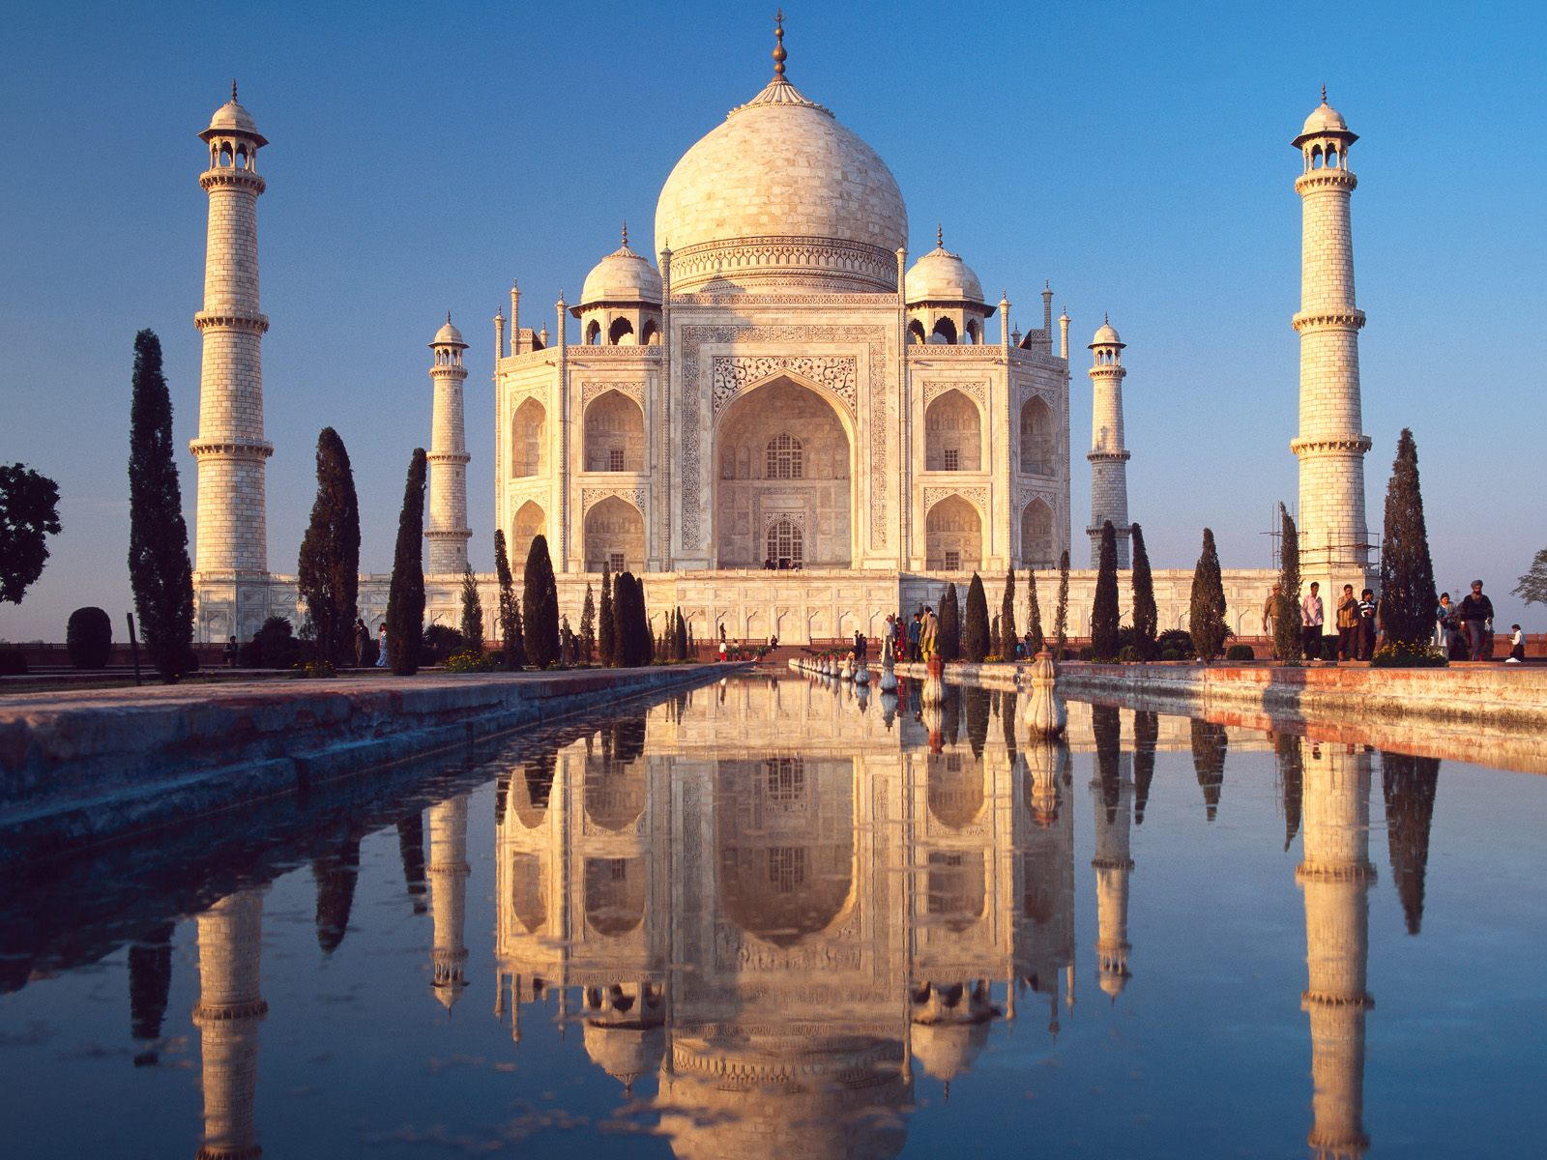

ONLY THE SUPERPOWERS DEVELOPED BY THE SCIENCE OF REAL MEDITATION CAN FREE HUMANITY TO REACH THE STARS.
ENERGY ENHANCEMENT MEDITATION ENLIGHTENMENT AND ILLUMINATION
THE INCREDIBLE MEDITATION COURSE AND MEDITATION TECHNIQUES CREATED TO PRODUCE ENLIGHTENMENT AND ILLUMINATION
"ALL TRADITIONAL MEDITATIONS HAVE BEEN DESIGNED TO FAIL" - SATCHIDANAND -
"BECAUSE ORIGINALLY ALL MEDITATIONS CONTAINED THE TECHNIQUES OF, "THE KUNDALINI KEY" AND OF, "ALCHEMICAL VITRIOL" TO GROUND NEGATIVE ENERGIES AND TO NATURALLY INCREASE KUNDALINI ENERGY"
"NOW, ONLY ENERGY ENHANCEMENT MEDITATION TEACHES THESE TECHNIQUES WHICH SPEED UP THE ENLIGHTENMENT PROCESS"
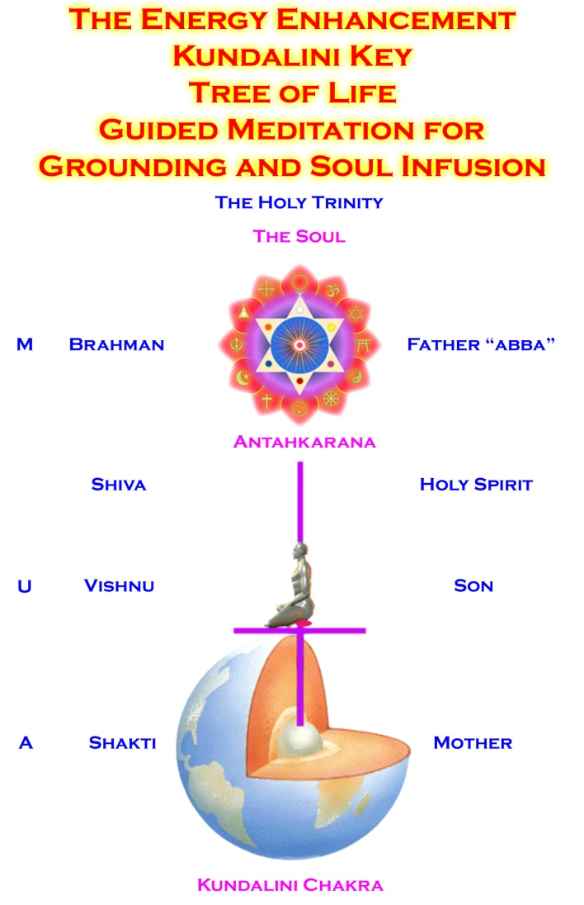
VITRIOL - Visita Interiora Terrae Rectificando Invenies Occultem Lapidem
Translation of VITRIOL.. "Visit the Center of the Earth there you will find the Philosophers Stone, Kundalini Chakra, which transmutes all Negative Energy, All Pain, All Negative Karmic Mass, into Pure Positive Spiritual Energy. By changing the direction of that Energy along the Path of the Soul, Soul Chakra, Central Spiritual Sun, First Chakra Above the Head you will receive Enlightenment"
"IF YOUR TRADITIONAL MEDITATION DOES NOT TEACH YOU ABOUT THE KUNDALINI KEY AND ALCHEMICAL VITRIOL, THEN IT HAS BEEN DESIGNED TO FAIL"

ENERGY ENHANCEMENT - THE ULTIMATE MEDITATION COURSE!!
ANCIENT EFFECTIVE ENERGY ENHANCEMENT MEDITATION SECRETS
ALL THE MEDITATION TECHNIQUES!!
SUCCESSFUL
SPEED UP YOUR PROCESS!!
PROVEN
TIME TESTED
TRUE


"I have experience of many forms of meditation and practices for self improvement including: Transcendental meditation (TM) 12 years, Kriya Yoga 9 years, Sushila Buddhi Dharma (SUBUD) 7 years, and more recently the Sedona Method and the Course in Miracles.
The Energy Enhancement programme encapsulates and expands all of these systems, it is complete and no questions are left unanswered."
JEAN - NUCLEAR ENGINEER
WHY JUST SIT? - YOU NEED REAL SPIRITUAL EXPERIENCE - FAST!!
READ BELOW ALL THE TECHNIQUES TAKEN OUT OF TRADITIONAL MEDITATIONS AND PUT BACK BY THE ENERGY ENHANCEMENT MEDITATION COURSE!!
- RESTORING THE ENERGY ENHANCEMENT KUNDALINI KEY
Phillip Chester
Phillip Chester - Change manager working directly to the Managing Directors of several fortune 500 companies.

"I feel that I have been given some secret knowledge, which was only given to the initiated, or hidden among a lot of unnecessary sub techniques in other disciplines."

"The energy techniques given in Energy Enhancement have never been explained to me in Aikido (even Ki Aikido), Yoga or Ashtanga Yoga or on any meditation course that I have been on like Transcendental Meditation, and have only been partly taught to me previously by Taoist Master Mantak Chia and on Tantra Courses. Mantak Chia I found particularly confusing; Chi Gung I found awkward"
"ENERGY ENHANCEMENT GOES MUCH FURTHER THAN ALL THE ABOVE, IN A MORE EFFECTIVE WAY THAT ANY OF THE OTHERS I HAVE EXPERIENCED..."
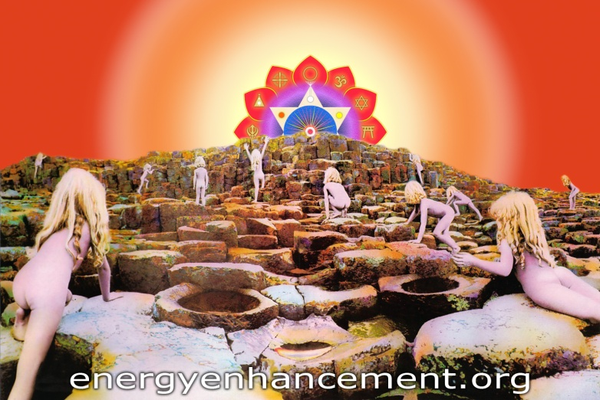
The striving and search for the soul.

HOW ARE THEY STEALING YOUR SPIRITUAL ENERGY? -
Everyone is Already the victim of these Implant Addiction Energy Blockages.
VAMPIRE ADDICTION IMPLANT BLOCKAGES VAMPIRE SEXUAL ADDICTION IMPLANT BLOCKAGES VAMPIRE DRUG ADDICTION IMPLANT BLOCKAGES VAMPIRE FOOD ADDICTION IMPLANT BLOCKAGES
THE FIELD OF VAMPIRISATION OF ENERGY IS SEX, DRUGS AND ROCK AND ROLL
Implant Blockages are programmed to use Energy Connections between people which are naturally formed between every human being in order to drain their energies back to the person who implanted them, either in this lifetime or in any previous lifetime, no matter how far they are away.
We have seen in meditation that the implanters have thousands of energy connections coming to them from the thousands of people whom they vampirise, rather like a telephone exchange.
PROJECTION OUT OF THE BODY
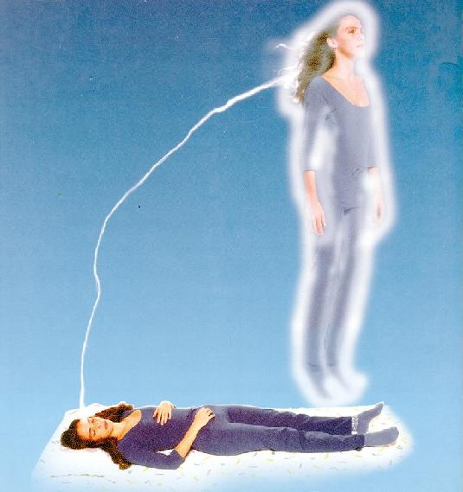
He remembered lying on the bed in the hotel room just outside the amazing waterfalls of Iguazu on the Argentine/Brazil border - Big Water as it means in the Guarani!! And he had been bathed in the purifying energies of the waterfalls that day. And when he returned to the Hotel that night he felt the energies in all the meridians of his body and they were raging and they were coalescing in his abdomen and they traveled up the meridian of the right side of his nose.
And the next moment he was out of his Body!! And he was scared because it was the first time this had happened to him although he had read about it many times happening to other people. But now it was happening to him and he could see his body lying down on the bed below him and he could see the silver cord connecting him with his body and it was beginning to feel alright.
So he wondered if he could travel further and tried to get through the wall to visit Satchi next door but the walls resisted and threw him back and he fell back into his body and the next thing he knew he was waking up but he remembered being out of his body and he had been consciously outside his body for the very first time!!
In Energy Enhancement we teach and give real experience of ascending, projection, through the Astral and Buddhic Planes, escaping beyond the reach of Death and reaching towards Immortality.
And he had just completed the first month of his Energy Enhancement course and had received the energy of the Buddhafield. He had received many, many experiences of a spiritual nature and had felt his very being expand in such a way that he knew Enlightenment was within his very grasp...
And you know, if you have been outside the body then no-one can take that away from you. You know that you can exist outside the body and all the existentialist bullshit is just that... Existentialist Bullshit!!
Because I have been outside the body and I know that I will exist without my body after death and that I am an immortal soul who will travel on, body after body, lifetime after lifetime, gaining experience, and gaining evolution and perfection as I travel the path of Enlightenment, just like all the Spritual Masters have said from time immemorial.
Spiritual Experience is a million times better than listening about it or reading the books. It is the proof of the books!!
And he got this experience and many more like it because he has been on the Energy Enhancement Course!!
And everyone who comes on the Energy Enhancement Course or tries the DVD Course gets many spiritual experiences.. just READ the Reports of our Students
Come try it Yourself...
DROP BODY
DROP MIND
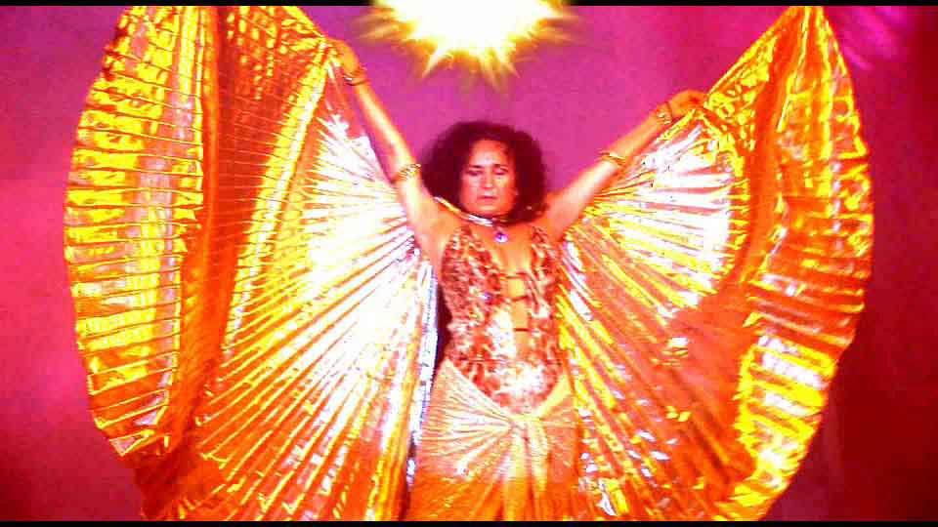
FREE - SACRED PINK FLOYD MOVIE - 2.5 HOURS IN STEREO AND 5.1 SURROUND SOUND - ENTERED INTO FILM FESTIVALS WORLDWIDE!!

COURSES IN IGUAZU
WHAT IS EXITING NOW IS THAT WE HAVE A VERY EFFICIENT AND WONDERFUL WAY OF TEACHING ENERGY ENHANCEMENT IN ARGENTINA AT THE SOL CENTER.
STAY WITH SATCHIDANAND AND DEVI DHYANI AT THE SOL CENTER IN ROSARIO.
LEARN ENERGY ENHANCEMENT IN YOUR AUDIO VISUAL CENTER BY VIDEO
LEARN AT HALF THE PRICE OF THE LIVE COURSES IN SPAIN OR MEXICO
ASK QUESTIONS OF DEVI AND SATCHI
STAY FOR ONE OR TWO MONTHS LEARNING EE LEVELS ONE, TWO, THREE AND FOUR, TWO WEEKS PER LEVEL, OR LONGER TO LEARN ALL THE ENERGY ENHANCEMENT COURSE IN ONE GO
RECEIVE INITIATIONS IN REIKI UP TO REIKI MASTER
LEARN FURTHER ENERGY ENHANCEMENT LEVELS FIVE AND SIX INCLUDING SPIRITUAL HEALING
LEARN ENERGY ENHANCEMENT SPIRITUAL HEALING USING ENERGY ENHANCEMENT TECHNIQUES AND MASSAGE FROM ENERGY ENHANCEMENT STUDENTS
JOIN DEVI IN HER WEEKLY CLASSES OF SELF HEALING AND THE REMOVAL OF ENERGY BLOCKAGES
VEGETARIAN FOOD AND ACCOMMODATION AVAILABLE AT THE CENTER.
BOOK IN ADVANCE AT ANY TIME - NO FIXED TIMES
EMAIL sol@energyenhancement.org for details
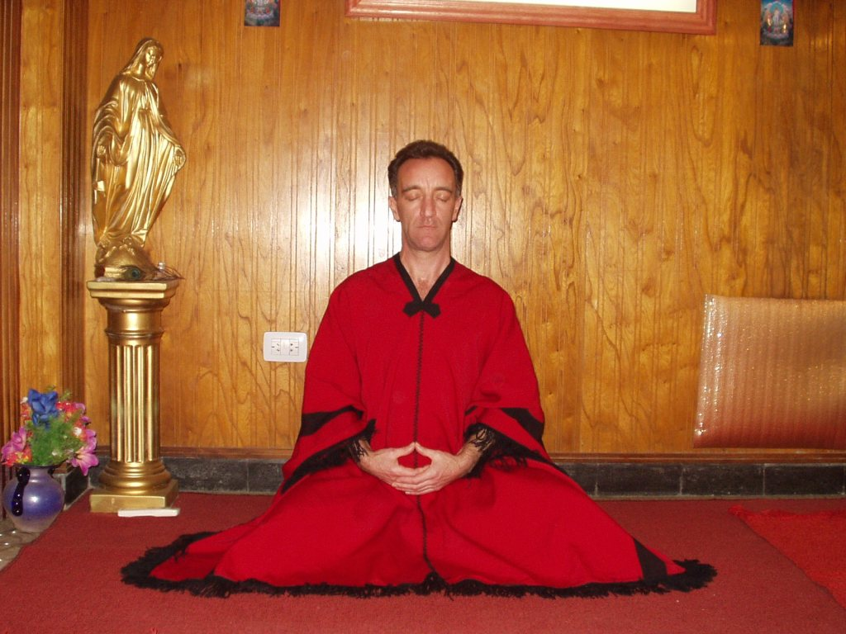
DON MINIHANE AT THE SOL CENTER IN ARGENTINA
WHAT DON MINIHANE SAYS OF HIS TANTRA MEDITATIONAL EXPERIENCES ON THE JANUARY 2007 COURSE
BABE MAGNET
One effect of Energy Enhancement that surprised me is other people’s reaction to me; they are somehow more attracted to me and want a part of me, especially the girls. Now that is an effect I was not prepared for but I am not complaining in fact it’s very enjoyable indeed. People recognise that you have something different AS YOUR ENERGY IS INCREDIBLY INCREASED and they are naturally attracted to this like bees are to nice flowers so guys and girls this is not to be missed, you won’t buy this kind of attraction in a bottle, or find it behind the wheel of some fancy car while being covered in expensive clothes and that’s for sure. Energy Enhancement is a babe magnet, but that’s not what it’s about, on the other hand, if that is what floats your boat then go for it.

CHI GUNG TANTRA AND ENERGY ENHANCEMENT
I wanted to expand more on the Energy Enhancement side of the course and it is difficult to explain this to anyone who has no knowledge of energy or how it all works. I have tried to get on with Chi Gung and while I respect and admire the system of Chi Gung I feel that it is over complicated and long winded. The microcosmic and macrocosmic orbit is a wonderful internal exercise and is not to be misunderstood or demeaned in any way but the techniques of Energy Enhancement like the Supra galactic Orbit supersedes Chi Gung and leaves it trailing light years behind.
"To expand, I was sitting in meditation the other night and was happily destroying blockages in me using the Seven Step Process of Energy Enhancement taught by Satchi and Devi when I was staggered by something new. I watched as negative energy transmuted into white light and travelled down to the centre of the earth then returned up my spinal column and carried on into outer space to the centre of the universe and then returned back to me through the crown chakra and down the front of my body through the throat centre then the heart centre and the solar plexus, on to the genitals and in to the perineum, through to the centre of the earth and returned back up my spine and so began this new orbit of energy.
The effect was something else; it shot through me at incredible speed. This carried on and got denser and more powerful as I discharged more of the negative energy within me. This energy took the form of bands of light that followed each other in waves travelling at equal distance apart and as I discharged and transmuted more negative energy the bands got closer together and I found that I could control the speed at which they travelled through the body. Satchi calls this orbit the Supra Galactic Orbit which travels up the ANTAHKARANA into the centre of the universe and down through the centre of the earth passing through the front of the body on the downward sweep and returning up the spine on the outward sweep. I was complete."
We teach the appropriateness of connections from every chakra. How to use them responsibly for their natural purpose,

THE MASTERY OF RELATIONSHIPS
As we practiced on each other we came very quickly to realise this. I could literally feel the energy moving inside each chakra as the other person worked within me from several meters away and when I worked on the other person I could see me projecting energy to them and could see where the blockages were within their chakras.
I could force the energy from my centres into their centres and clean their centre bringing the energy full circle back to me. You could tell the state of their chakras by the amount of energy returning to your own centre and this was achieved by mind power only.
Before I came here Satchi said he would teach me to do it in this way and I was sceptical about this claim. I could never envision me having psychic vision, but I have now, I can now do astonishingly powerful Reiki sessions on people without going any where near them and distance healing over any distance is a piece of cake, incredible stuff.
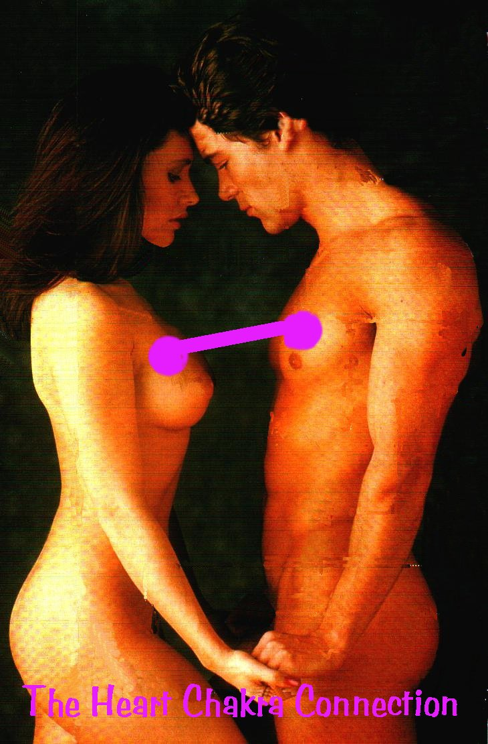
TOTAL RESPECT TO SATCHIDANAND AND DEVI DHYANI
"Satchi, please accept my total respect and gratitude for everything you have imparted to me over the short four weeks I have been here. You are a huge light in this world and long may you shine. For everyone reading this, get your asses over to see these people, your lives will be changed forever and we don’t get many chances in this world to be able to achieve that and there are definitely not many people in this world like Satchi and Devi who can do the business like this"
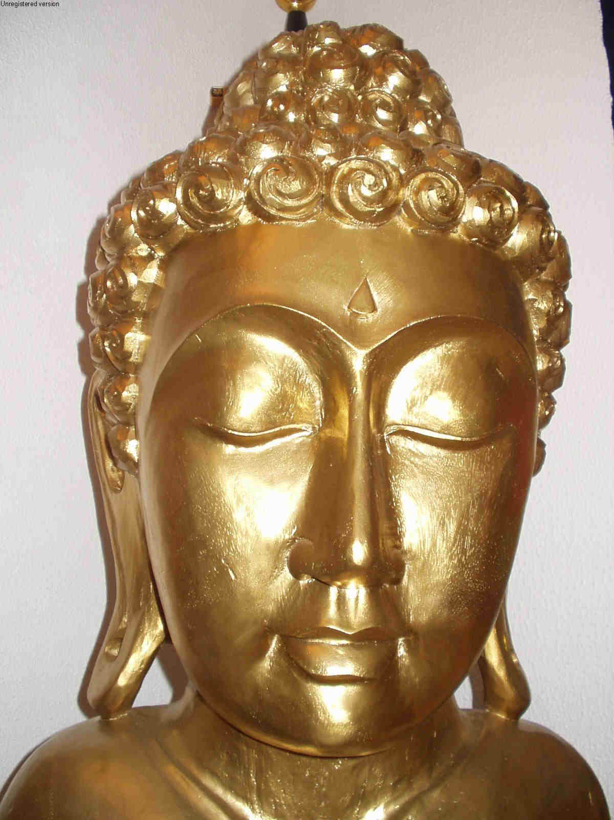
ENERGY ENHANCEMENT COURSE - MASTER RELATIONSHIPS IN APPRENTICE LEVEL4
THE MASTERY OF RELATIONSHIPS AND THE PSYCHIC SEXUAL CONNECTION
MASTER THE PSYCHIC ENERGY CONNECTION BETWEEN YOU AND ALL PEOPLE, HEAL BEREAVEMENT, IMPOTENCE, CLEAN THE TIES WHICH BIND, THE HIGHEST HEART, THE MASTERY OF ADDICTIONS - DRUGS, ALCOHOL, TOBACCO, SEX, FOOD, POWER, MONEY, THE SOUL CONNECTION, CREATE INCREDIBLE RELATIONSHIPS - THE KARMA CLEARING PROCESS WITH ALL YOUR RELATIONSHIPS, FRIENDS, FAMILY, MOTHER AND FATHER, REMOVE BLOCKAGES FROM FRIENDS AND FAMILY, HEAL THE WORLD. BECOME A MASTER, A MERLIN, A JEDI KNIGHT, A WHITE MAGICIAN.

JOIN IN OUR ENERGY ENHANCEMENT VISION OF ONE ENLIGHTENED HARMONIOUS WORLD.
EMBASSIES OF ENLIGHTENMENT IN EVERY MAJOR WORLD CITY.
RETREAT CENTERS IN THE ANDES AND DRAKENSBERG MOUNTAINS.
IF YOU WANT TO CHANGE THE WORLD, CHANGE YOURSELF FIRST.
IF YOU WANT TO MAKE THE WORLD ENLIGHTENED, MAKE YOURSELF ENLIGHTENED FIRST.
JOIN US BY USING THE ENERGY ENHANCEMENT KARMA CLEARING TECHNIQUES REMOVING ALL TRAUMA AND NEGATIVE EMOTIONS.... ON THE PATH OF ENLIGHTENMENT.

HEAL PROBLEMS - TRAUMA, PAIN, RAPE AND ABUSE, RELATIONSHIPS, DIVORCE, BEREAVEMENT, ANGER, FEAR AND DEPRESSION, FRIGIDITY AND IMPOTENCE, SEX ADDICTION, PIERCINGS, TATTOOS, BDSM, T
EE COURSE OVERVIEW THE KARMA CLEANING PROCESS
SPEED UP THE PROCESS OF ENLIGHTENMENT, WISDOM AND LEADERSHIP WITH THE APPRENTICE LEVELS OF THE ENERGY ENHANCEMENT COURSE.....

LEVEL 1
GAIN ENERGY APPRENTICE LEVEL1
YOU GET ALL THIS TO GAIN ENERGY IN LEVEL ONE OF ENERGY ENHANCEMENT...
MEDITATION, SHAKTIPAT, ENERGY CIRCULATION, THE KUNDALINI KRIYAS, THE FIVE ELEMENTAL PATHS OF THE CHI OF CHINESE ALCHEMICAL TAOISM, THE GROUNDING OF NEGATIVE ENERGIES, V.I.T.R.I.O.L, THE SUPRA GALACTIC ORBIT, THE CREATION OF THE ANTAHKARANA, SOUL INFUSION, MONADIC INFUSION, LOGOIC INFUSION, SIRIAN ENERGY INFUSION, CONNECTION WITH THE AVATAR OF SYNTHESIS, THE ART CARD OF THE THOTH TAROT, ACCESS TO KUNDALINI ENERGY, STRONG PSYCHIC PROTECTION, LEARN THE MERKABA, PYRAMID PROTECTION, POWER TOWER PROTECTION

LEVEL 2
THE ENERGY BLOCKAGE REMOVAL PROCESS LEVEL2
THE REMOVAL OF ENERGY BLOCKAGES AND IMPLANTS WITH ADVANCED ENERGY BLOCKAGE BUSTING TECHNIQUES
THE SEVEN STEP PROCESS, THE REMOVAL OF THOUGHT-FORMS, THE REMOVAL OF IMPLANTS, THE REMOVAL OF ENTITIES, THE REMOVAL OF AURIC EGG BLOCKAGES, THE REMOVAL OF SHAME, GUILT, DISAPPOINTMENT, BEREAVEMENT, THE REMOVAL OF NEGATIVE EMOTIONS - ANGER, FEAR, WANTING SYMPATHY, MANIC, SADNESS, DEPRESSION, CHRONIC DEPRESSION, ENVY, JEALOUSY, THE DESIRE TO DO HARM, INCREASE YOUR EMOTIONAL IQ, CLEAR CANCER FROM THE DNA, THE REMOVAL OF BLOCKAGES FROM THE ANTAHKARANA THE REMOVAL OF BLOCKAGES FROM CHAKRAS IN THE BODY FROM CHAKRAS BELOW THE BASE CHAKRA AND ABOVE THE HEAD CHAKRAS, THE REMOVAL OF BLOCKAGES FROM PARTS OF THE BODY, THE REMOVAL OF BLOCKAGES FROM THE TIMELINE, THE KARMA CLEANING PROCESS, THE WOMB, THE PRIMAL SCREAM, CLEAN THE KARMA FROM ALL THE YEARS OF YOUR LIFE, CREATE GOOD LUCK, AND GOOD HEALTH.

LEVEL3
KARMA CLEARING PROCESS SOUL RETRIEVAL APPRENTICE LEVEL3

LEVEL 4
MASTERY OF RELATIONSHIPS TANTRA APPRENTICE LEVEL 4

Remove Blockages in the Aura and in the Chakras, Remove Encapsulated Trauma, Remove Implants, Past Life Trauma and Implants, Inner Children, Ego Talents, Dark Energies, Entities, and Obsessions in your Clients and Yourself with Energy Enhancement Reiki and Massage.
What is Energy Enhancement Reiki?
Energy Enhancement Reiki is Reiki with the addition of the 28 Energy Enhancement Initiations, The most advanced Meditation Course on this Planet.
The Teacher of Reiki, Doctor Usui, became Enlightened after living in a Zen Monastery for 21 Years through the practices of Meditation.

BLOCKAGE REMOVAL WITH ENERGY ENHANCEMENT REIKI
BECOME AN ENERGY ENHANCEMENT REIKI MASTER

THE ENERGY ENHANCEMENT PATH OF PLEASURE, SAMADHI, SAMYAMA, ENLIGHTENMENT

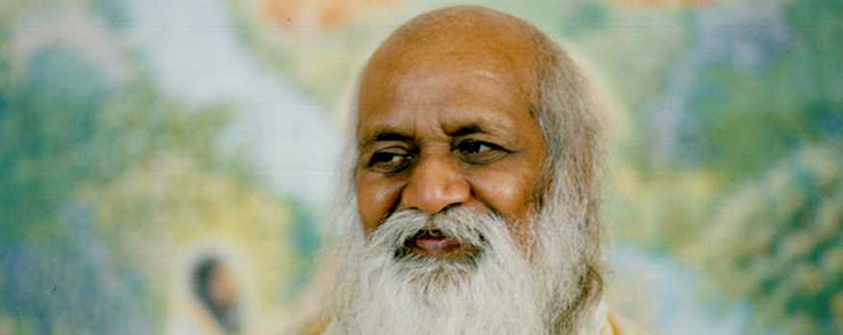

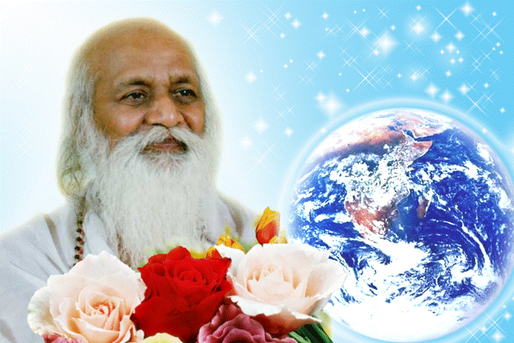
MAHARISHI MAHESH YOGI
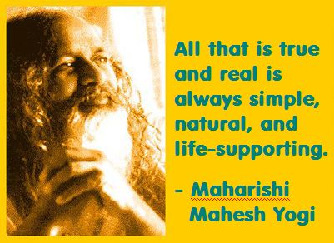
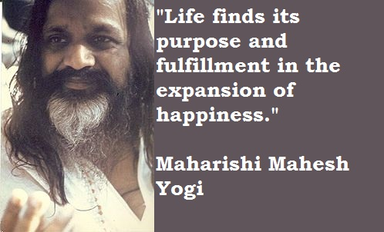

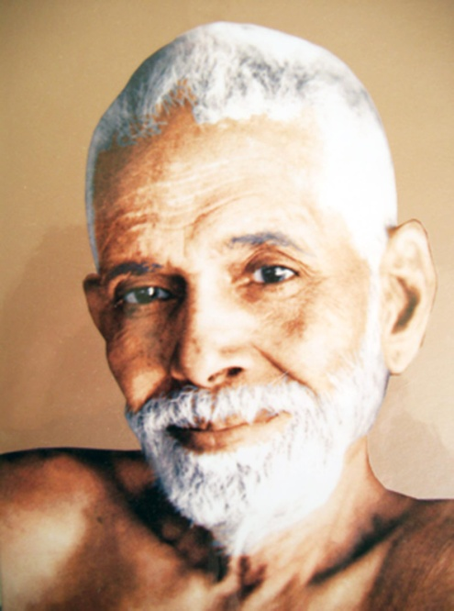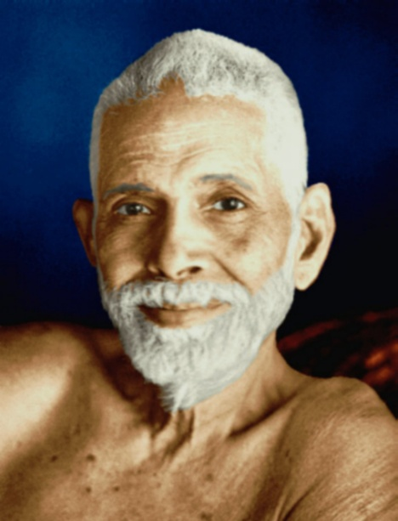
SRI RAMANA MAHARSHI, "I AM THAT"
To Tamil Siddar Ramana Maharshi and his Ashram in Tamil Nadu, South India.
TAMIL SIDDAR SRI RAMANA MAHARSHI, GURU, ENLIGHTENED ILLUMINATED SPIRITUAL MASTER
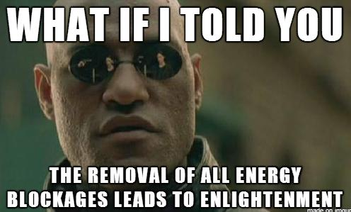
The Ancient Enemy who counts meditation and the mind control psychic arts as one of its main planks of ing, International Companies, Eugenics - Worldwide, censoring Alchemical VITRIOL, the Kundalini Key and Energy Blockage Removal from every Meditation Program..
WE HAVE SO MANY ARTICLES SHOWING THE ORIGINAL EXISTENCE OF THESE ESSENTIAL MEDITATION TECHNIQUES IN EVERY WORLD RELIGION..
NOW, SPEED UP YOUR PROCESS WITH ENERGY ENHANCEMENT ALCHEMICAL VITRIOL, KUNDALINI KEY AND ENERGY BLOCKAGE REMOVAL ON THE PATH OF ENLIGHTENMENT
GET IT NOW!!
EMAIL sol@energyenhancement.org
LIVE COURSES, INDIA AND BRAZIL - IGUAZU FALLS

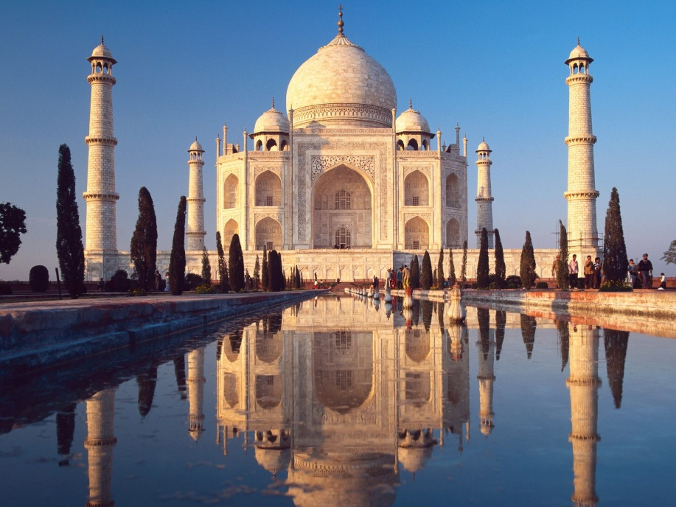
GET MEDITATIONAL SUPERPOWERS WITH ENERGY ENHANCEMENT, LIGHT YEARS AHEAD OF EVERY OTHER COURSE
THE ULTIMATE ADVANCED MEDITATION COURSE
MEDITATION ENERGY ENHANCEMENT
THE CORE ENERGY TECHNIQUES!!
THE MOST ADVANCED MEDITATION TECHNIQUES ON THIS PLANET, IN 28 INITIATIONS!!
ANCIENT EFFECTIVE ENERGY ENHANCEMENT SECRETS -
SUCCESSFUL
TIME TESTED
TRUE
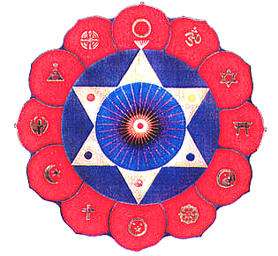

Bookings: www.energyenhancement.org
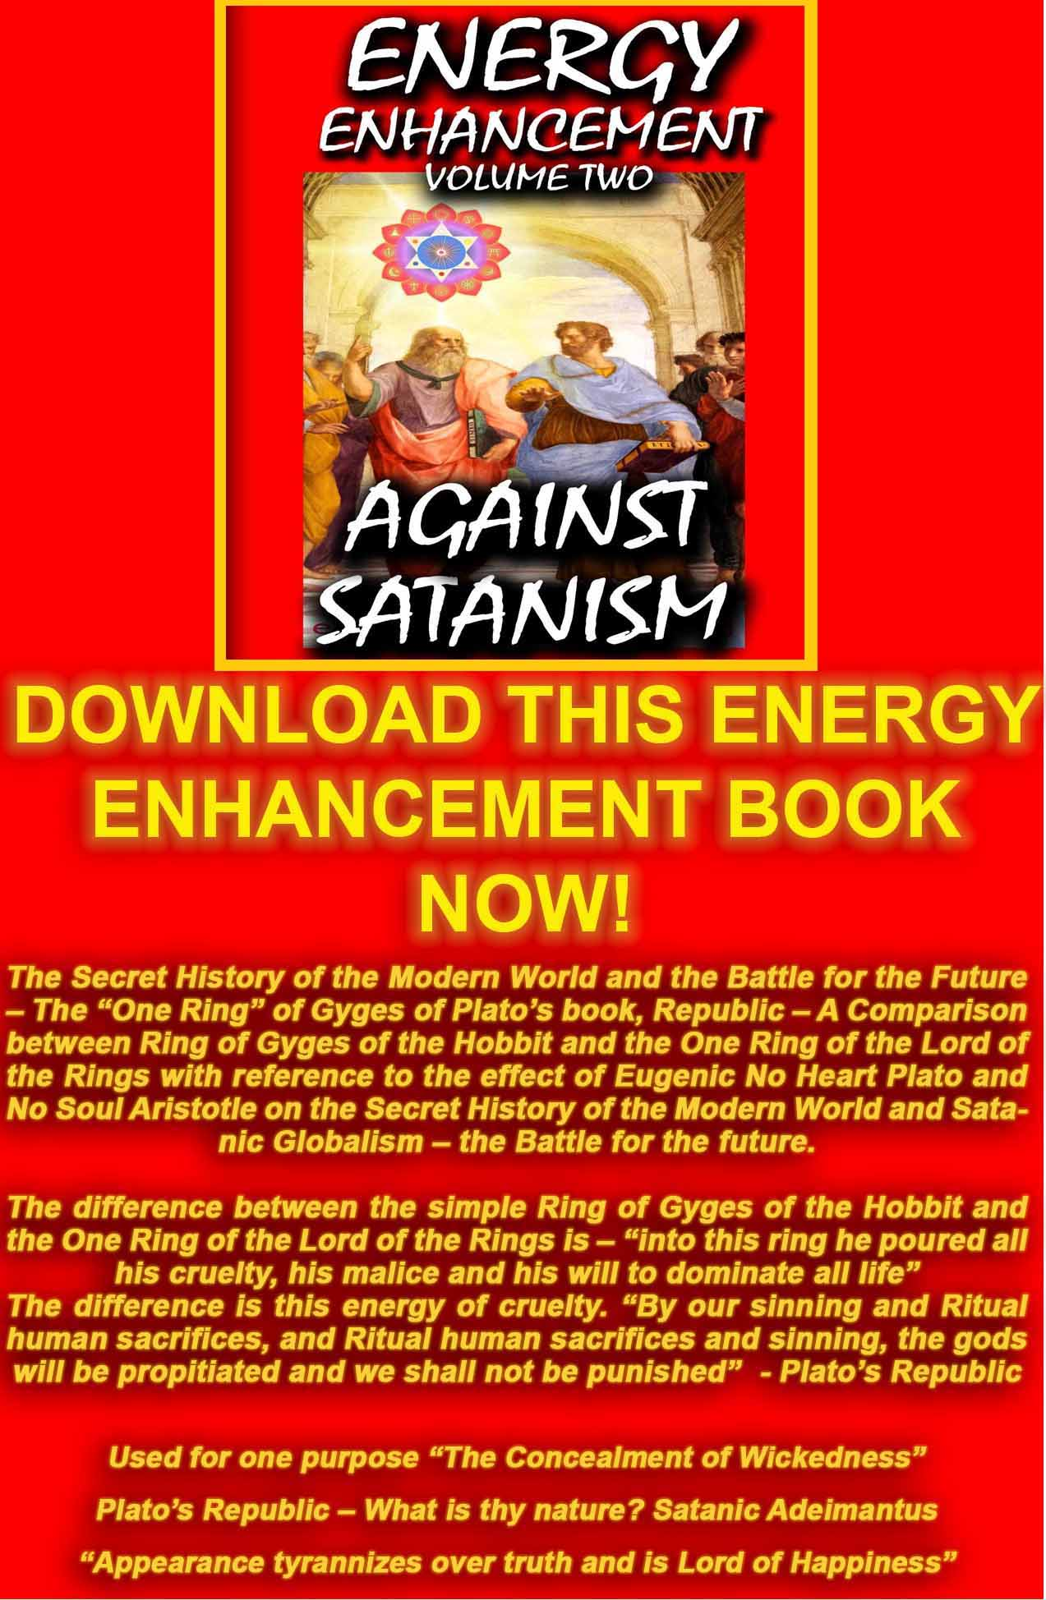
AGAINST SATANISM VOLUME 2 DOWNLOAD HERE
http://www.energyenhancement.org/Sacred-Energy/Against-Satanism-Volume-2/Against-Satanism-Volume-2.pdf
TOLKIEN CREATED THE LORD OF THE RINGS TO OPPOSE THE WAGNERIAN RING CYCLE THOUGHTFORM
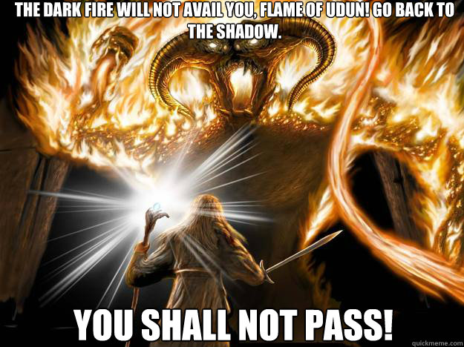
Tolkien wrote the following about the idea behind the One Ring: "I should say that it was a mythical way of representing the truth that potency (or perhaps potentiality) if it is to be exercised, and produce results, has to be externalized and so as it were passes, to a greater or lesser degree, out of one's direct control." (Letter #211, 1958).

Tolkien always strongly held that The Lord of the Rings was not allegorical, particularly in reference to political events of his time such as World War II or the Cold War. At the same time he conceded "applicability" as being within the "freedom" of the reader, and indeed many people have been inclined to view the One Ring as a symbol or metaphor. The notion of an evil power too great for humans to safely possess is an evocative one, and already in the 1930s there were technologies available to suggest the idea. By the time the work was published, though not when most of it was written, the existence of nuclear power and nuclear weapons were common knowledge, and the Ring was often taken as symbolic of them. The effect of the Ring and its physical and spiritual after-effects on Bilbo and Frodo are obsessions that have been compared with drug addiction; actor Andy Serkis who played Gollum in the film trilogy cited drug addiction as an inspiration for his performance.

Parallels have been drawn between the literary device of Tolkien's Cursed Ring and the titular ring in Richard Wagner's Der Ring des Nibelungen. Tolkien dismissed critics' direct comparisons to Wagner, telling his publisher, "Both rings were round, and there the resemblance ceases." According to Humphrey Carpenter's biography of Tolkien, the author held Wagner's interpretation of the relevant Germanic myths in contempt.

Tom Shippey and Gloriana St. Clair, attribute the resemblances to the fact that Tolkien and Wagner have created homologue works based in the same sources. However, Shippey and other researchers have written on an intermediary position, stating that both the authors, indeed, used the same source materials but that Tolkien was, in fact, indebted to some of the original developments, insights and artistic uses made upon those sources that first appeared in Wagner, and sought to improve upon them.
Indeed Tolkien sought to change to Good the the evil Wagnerian thoughtform which emphasises the use of the Will to, "Get what you Want". Wagner echoes OTO Crowley and Reuss. Hitler himself said that to understand the unfinished Caliban character, you had to understand Wagner.
Tolkien sought to increase the Thoughtform of Implacable opposition to Evil
"YOU SHALL NOT PASS!!"

As Karma proceeds so the psychic structure and the Soul reach out for Union with each other.

Quite naturally and through discipline - as we learn Energy Enhancement Meditation - we learn to project in meditation into the chakras above the head and thus we access higher and more intense spiritual energies which light up, illuminate, and thus Power Up!! the mind all the talents and all the psychic powers. Thus a Human Being starts to, "Wake Up"

Quite naturally and through the discipline of Energy Enhancement 28 Initiation on the Path of EnLightenment we learn to Ground all the negative energies striated through all the Psychic Body and through every God created talent. This purification of all the talents, of all the energy blockages, of all the Trauma-Formed Negative Karmic Mass, leads to correct action in the World - Only doing the Right thing - which gives satisfaction and a sense of rightness, of being in tune with the Universe as all connection with the dark Side is rejected, "To seal the door where evil dwells", "Stay away from evil" - Jesus Christ
At the Enlightenment Initiation the Chela, purified of all Energy Blockages, fuses with his Soul and all his psychic Body is heated in the Crucible and cools down, crystallised - Unchangeably good, efficient, faster, - unable to be perverted by energy blockages within the new crystalline body.
EnLightenment is Only the First Dan.

After this Initiation there is a period where karma is speeded up as the new Master increases the size of his Psychic Body. Not through serendipity and the action of Karma but by Grounding Negative energies from the World around him, from his students, from all the people around him, from the World.
This grounding of Energy Blockages purifies their psychic mechanism and afterwards he incorporates these newly purified psychic mechanisms into his psychic body.
This work does not take the 100 lifetimes of serendipity to complete. We can enhance our psychic bodies with new talents amazingly quickly to achieve further Initiations and Ascended Mastery within only one Lifetime!!

"AS ABOVE, SO BELOW
AS WITHIN, SO WITHOUT"
- Hermes Trismegistus

This Isn't a Game!!

Energy Enhancement is Meditation on Steroids..
Meditation with Cojones!!
Meditation which Really Works...

As you remove ALL Your Blockages with Energy Enhancement Satchidanand so Everything Changes.

Achieve Your Deep Peace..

EE Level 1 - Incredible Energy - Affecting Your Aura, Your Health, Your Attractivity.
EE Level 2 - All your Blocks - Remove and Release Your Beast!!
EE Level 3 - All Your Karma - Ever Wonder Why Things go Wrong? Stop the Sabotage!!
EE Level 4 - All Your Relationships - How to Stop Your Divorce or your Lover’s Rejection..

It Goes On and On - Free Up Your Time - Have Fun - Access Infinite Wealth..

TEN FREE DOWNLOADS...
FREE EE YOGA INSTRUCTION VIDEO DVD With Satchidanand and Amy Zantras who went into Samadhi for 2 hours whilst making the Video!! See her Experience.. http://www.energyenhancement.org/eeyoga.htm

FREE SACRED DANCE VIDEO DVDS
FREE FOUR EE BOOKS - As sold on Amazon!!

FREE With Two Levels, the Energy Enhancement Infinite Wealth Home Training Program

Bye-Bye Boss - Do you like your job or do you dream of saying, "Bye-Bye Boss"

Do you believe your Infinite Wealth is directly related to your state of mind and consciousness?

If yes, what if there was a process to enhance your state of mind and consciousness, so from this moment onwards you could improve your ability to attract wealth? Follow your Soul Path, the work you were Born to Do? Would this interest you?

And if you knew this process only took a few sessions of practice, but would benefit you for the rest of your life… would you make the time for it?

If you said YES to all these questions, I have an invitation for you.

The FREE!! Energy Enhancement Infinite Wealth Home Training Program

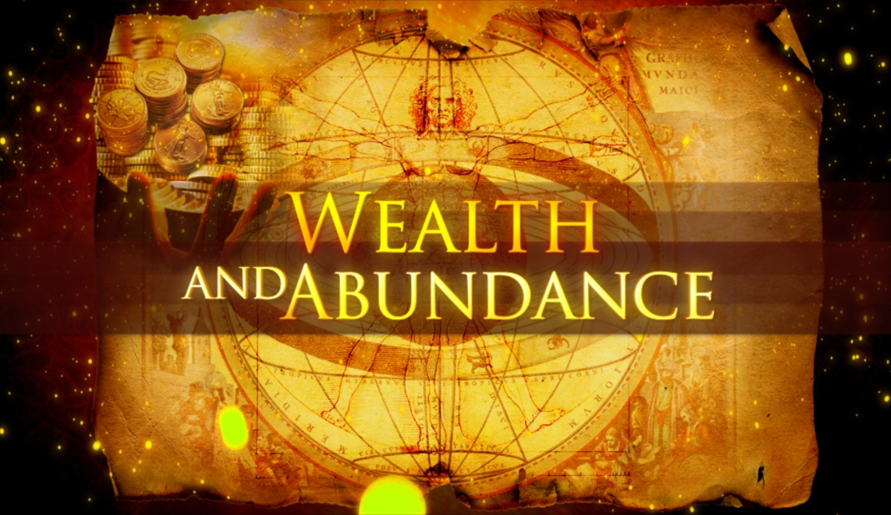

http://www.energyenhancement.org/FREE-Energy-Enhancement-Infinite-Wealth-Home-Training-Program-with-Energy-Enhancement-Streaming-Video-Course.htm

Through this stochastic, statistical, karmic yet very slow principle, every human being turns out different, unique, with different talents, different interests, different capacities on the path of unique sovereignty, of Heart, of Illumination.
The psychic body and its talents, its intelligence, its energy is increased slowly at the behest of necessity, interest, and opportunity on its path to union with the Soul.

Incorporated, Hard wired in is the experience of the Laws of Karma which give an understanding that, "We are only allowed to do the right thing"
"This Planet is a factory for the production of Enlightened beings" Satchidananda

At first this planetary action is that of Karma necessitating all the bad and good things of life.

Over time, as well as psychic structures, infrastructure called Talent, also there becomes striated through the Psychic Infrastructure, Energy Blockages and Trauma-Formed Negative Karmic Mass which perverts the system and causes this world, just the way that it is - giving all the Karmic experiences needed by every Monadic Group to every individual at every level of evolution.
As we need more Psychic Infrastructure within, so we need more Physical Infrastructure without.. In order to Speed Up the evolution of Humanity in a more Humane way.

In alignment with the Hierarchy of needs by Maslow we need the firm base of Abundance upon which to base higher evolution. After all, when our lower needs are met, surely all that is left to conquer are the higher needs.

Today I sat in a chair and listened to the heart chant initiation 1 for the first time.

I was focusing on aligning my shoulders and spine forward and backward between the two lines of power from the center of the earth. And picturing the immovable mountain. Focusing on my breathing, closing the anus. I stayed in for the first four minutes. Then I got tired and openned my eyes, for about 7 or 8 seconds. Then I was so drowsy I had to close my eyes again. Then after about another four minutes I was tired again. Then the same thing but this time I focused on nothing but the energy from the earth entering the base of my spine and coming into my heart. Right from the beginning of the meditation I felt my energy all over my whole chest, even now.
But at the last when I focused on it coming from the earth, I immediately felt very, very powerful energy and I didn't move to find it. My back straightenned up automatically to the alignment and I was kind of "stuck" in that position with the power flowing.
From there it was hard for me to stop meditating when the chants were over. Very powerful. Even without magnets. My question is about my focusing. Is it wrong to "imagine" the power or the alignment or the energy? or should we imagine until we feel it? Or both? Am I focusing on the right things?

I am very grateful for your teachings. Thank you for your generosity.

Also I noticed as soon as satchi emailed me, I got a down-pouring of light from above the crown which kept charging me up the rest of the day – and my cravings died out! Then I realized they were ego-blockages and that I did not want them.

This Energy Enhancement Level One Initiation Three - ALCHEMICAL VITRIOL is great! I've done it some more and it's incredibly powerful. I don't know why it isn't more well known or taught? It's really bringing up little blockages which are complaining while being pushed down into the earth's core to get purified.

The hot fire energy has gotten much stronger in my body while doing the practice, mostly the base of the spine heats up, but also the middle of the spine. There are lots of little blockages being noticed. But I'm pushing them out.

ENERGY ENHANCEMENT IS THE NEW, SAFE, SMOOTH AND FAST WAY OF LOSING ALL INTERNAL NEGATIVE ENERGY AND PAIN BECAUSE IT WORKS ONLY AT THE ENERGY LEVEL, THEREFORE SPEEDING UP THE PATH OF ENLIGHTENMENT.

ENERGY ENHANCEMENT HAS HELPED MANY PEOPLE ON THIS PATH FROM THOSE WITH THE BIGGEST ENERGY BLOCKAGES TO THOSE WHOSE ASPIRATION IS TO HELP THE WORLD AND ALL THE PEOPLE IN IT.
ENERGY ENHANCEMENT CAN HELP YOU!!

Part of Satchidanand's Web Blog

- "I was meeting a nice girl of 28 this morning here at our center in Rosario. She is a Psychologist but has fallen out of love with Psychology because although it explains things intellectually it gives no TECHNIQUES apart from talking to change anything internally, particularly in herself. You can see how effective Psychology is by looking at Woody Allen.

I connected with her base chakra and her inner child showed me all her chakras and blockages one by one. A very interesting experience. First the Base chakra, one fear and security blockage which I removed very quickly. Then the second, a pain filled relationship blockage which I also removed. Then all the chakras solar plexus, heart etc, feeling the general dirtyness of the psychic body usually cleaned with The Grounding of Negative Energies but no major blockages. Then the head, two blockages, one a person who had just died, very deep and negative. I removed the first blockage but the other one was more difficult and stayed with me, absorbed by my psychic body, for a day before I sent it on.
She felt the movement of energy blockages in the head and in the body as my mind and energy was working on her and told me that she normally got a lot of headaches. She was interested in my exposition of Energy Enhancement as all the while I was working on these blockages I was also talking to her. Such openings show an educated psychic body, one with talent. Not everyone who comes to the Guru has similar experiences. Some also get more. She and I felt that with training she also might be able to help her clients in a similar way. So, she is coming back tomorrow to try out the process, to get her first Initiation in Energy Enhancement."

ARTICLE ON ENERGY ENHANCEMENT FROM THE YOGA MAGAZINE OF GREAT BRITAIN - FIND OUT WHAT THEY SAY!!

Energy Enhancement does exactly what it says on the Tin!
James Ellerbeck, Yoga Magazine of Great Britain.


Here I am today, sitting down, putting pen down on paper whilst gathering my thoughts on the amazing Energy Enhancement Course that I am currently on. Where do I begin? Firstly, I felt it would be great to share my experiences of the Energy Enhancement course with other like-minded people. The following information is for those interested in growing spiritually, and wanting this world to become a better place - starting from improving themselves!

Honey Kalaria, Bollywood Star and Owner of Diva Entertainments

What we feel...

I am a brother of yours, who has traveled a little longer upon the Path than has the normal student, and has therefore incurred greater responsibilities. I am one who has wrestled and fought his way into a greater measure of light than has the aspirant who will read this webpage, and I must therefore act as a transmitter of the light, no matter what the cost.

I am not an old man, as age counts among the teachers, yet I am not young or inexperienced. My work is to teach and spread the knowledge of the Ageless Wisdom wherever I can find a response, and I have been doing this for many years.

I seek also to help the ascended Masters whenever opportunity offers, for I have been long connected with Them and with Their work. In all the above, I have told you much; yet at the same time I have told you nothing which would lead you to offer me that blind obedience and the foolish devotion which the emotional aspirant offers to the Guru and Master Whom he is as yet unable to contact. Nor will he make that desired contact until he has transmuted emotional devotion into unselfish service to humanity - not to the Master.

The words that I have written are sent out with no claim for their acceptance. They may, or may not, be correct, true and useful. It is for you to ascertain their truth by right practice and by the exercise of the intuition. I am not interested in having them acclaimed as inspired writings, or in having anyone speak of them (with bated breath) as being the work of one of the Masters.

If they present truth in such a way that it follows sequentially upon that already offered in the world teachings, if the information given raises the aspiration and the will-to-serve from the plane of the emotions to that of the mind then they will have served their purpose.

If the teaching conveyed calls forth a response from the illumined mind of the student worker in the world, and brings a flashing forth of his intuition, then let that teaching be accepted. But not otherwise.

If the statements meet with eventual corroboration, or are deemed true under the test of the Law of Correspondences, then that is well and good. But should this not be so, let not the student accept what is said.

Djwan Khul - Tibetan lama

Our Deepest Fear

Our deepest fear is not that we are inadequate.
Our deepest fear is that we are powerful beyond measure. It is our light, not our darkness that most frightens us.
We ask ourselves, Who am I to be brilliant, gorgeous, talented, fabulous?
Actually, who are you not to be? You are a child of God. Your playing small does not serve the world.
There is nothing enlightened about shrinking so that other people won't feel insecure around you. We are all meant to shine, as children do.
We were born to make manifest the glory of God that is within us. It is not just in some of us; it is in everyone. And as we let our own light shine, we unconsciously give other people permission to do the same.
As we are liberated from our own fear, our presence automatically liberates others.
by Marianne Williamson from A Return To Love: Reflections on the Principles of A Course in Miracles
(Note: This is often found on the Internet incorrectly stated as a quote by Nelson Mandela from the Inauguration Speech, 1994.)

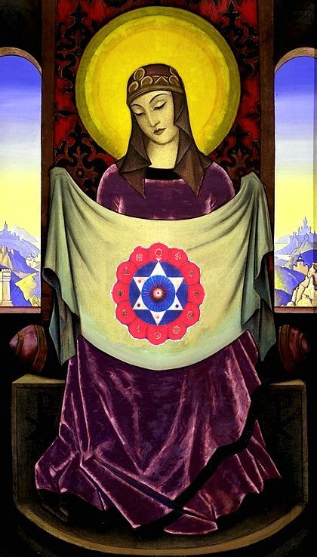

"An example of one of the different types of Energy Blockage is that they are sometimes created when we do not get what we expect, or we get what we do not want. They are caused by the pain of disappointment.

Like when our Mother or Father or Son or Daughter dies. Like when a Lover leaves us.

This trauma, this pain is so strong that at that moment the mind can not look at it, so it gets locked away within the body as a Blockage until we get strong enough to process it.

Then amnesia. We forget the pain fulminating in our bodies. We forget the poison until, after a while, disease is the result."

Satchidanand

WHAT DON MINIHANE SAYS OF HIS MEDITATIONAL EXPERIENCES ON THE JANUARY 2007 COURSE

DON MEDITATING AFTER A FEW DAYS ON THE COURSE -

"To expand, I was sitting in meditation the other night and was happily destroying blockages in me using the Seven Step Process of Energy Enhancement taught by Satchi and Devi when I was staggered by something new. I watched as negative energy transmuted into white light and travelled down to the centre of the earth then returned up my spinal column and carried on into outer space to the centre of the universe and then returned back to me through the crown chakra and down the front of my body through the throat centre then the heart centre and the solar plexus, on to the genitals and in to the perineum, through to the centre of the earth and returned back up my spine and so began this new orbit of energy.
The effect was something else; it shot through me at incredible speed. This carried on and got denser and more powerful as I discharged more of the negative energy within me. This energy took the form of bands of light that followed each other in waves travelling at equal distance apart and as I discharged and transmuted more negative energy the bands got closer together and I found that I could control the speed at which they travelled through the body. Satchi calls this orbit the Supra Galactic Orbit which travels up the ANTAHKARANA into the centre of the universe and down through the centre of the earth passing through the front of the body on the downward sweep and returning up the spine on the outward sweep. I was complete."

TOTAL RESPECT TO SATCHIDANAND AND DEVI DHYANI
"Satchi, please accept my total respect and gratitude for everything you have imparted to me over the short four weeks I have been here. You are a huge light in this world and long may you shine. For everyone reading this, get your asses over to see these people, your lives will be changed forever and we don’t get many chances in this world to be able to achieve that and there are defiantly not many people in this world like Satchi and Devi who can do the business like this"
MORE DON MINIHANE

Energy Enhancement is the process of clearing all the bad things which have ever happened to you from your psychic body, freeing up the internal essence to attain clarity and enlightenment on your true life path.

ENERGY ENHANCEMENT IS THE NEWEST AND HIGHEST SPIRITUAL IMPULSE ON THIS PLANET.

Energy Enhancement contains Ancient Successful Techniques which Create a Quantum Leap in the Power of any other technique they touch.

Yoga, Acupuncture, Reiki, Healing, Meditation, Tantra and all through The Taoist Supra Galactic Orbit, The Removal of Blockages, The Removal of Encapsulated Trauma, The Karma Cleaning Process, The Mastery of Relationships and the Total Healing of the World.

AFTER ALL THAT, HERE ARE COMPLETE INSTRUCTIONS ON ENLIGHTENMENT - YOGA SUTRAS OF PATANJALI

YES, ENERGY ENHANCEMENT LEADS TO ENLIGHTENMENT

ENERGY ENHANCEMENT IS THE NEWEST AND HIGHEST SPIRITUAL IMPULSE ON THIS PLANET.

The Mastery of Relationships, Psychic Sex Connections, Energy Vampires, Implants and the Initiations of Energy Enhancement Meditation.

Relationship Psychic Sex Connections exist in all people and in general mess up their lives. Instead they should Enhance our lives and lives of everyone around us. With Energy Enhancement Techniques we can learn The Mastery of Relationships!!
For all intent and purpose, Psychic Sex Connections or "strings" in relationships are very similar to umbilical connections or even electric and telephone wires, except they exist on the astral dimensional planes in all relationships. They can be very thin, or very thick, and can appear as very light or very dark streamers coming out of your energy fields/bodies.

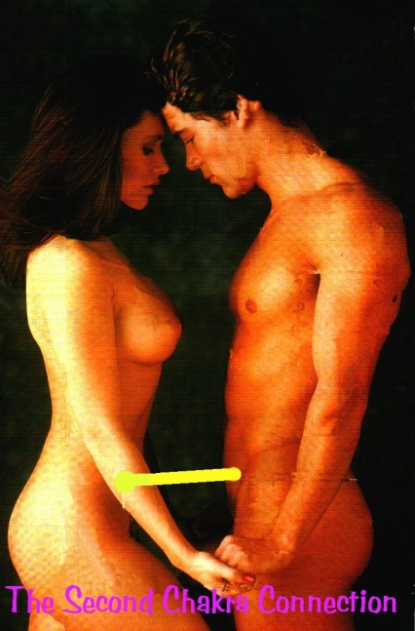

These strings, psychic sex connections, stretch between all chakras, chakra to chakra and in the case of Relationships from abdomen to abdomen and with sex, from base chakra to base chakra.

Relationship Psychic Sex Connections can be superficially hooked onto the surface of - or more deeply plugged into the very cores of - your numerous energy fields, chakras and/or dimensional bodies. Initially these relationship hooks or plugs seem pretty innocuous to the astral spirit, at first glance appearing very light, maybe even golden and brightly colored but Psychic Sex Connections in Relationships, no matter how attractive or light or energizing, are ties that bind, and as Gautama Buddha said, thousands of years ago, "Attachment leads to Pain".

One of our Meditation students, Susan Macri, a medical doctor living at the ashram of Sathya Sai Baba in India teaches “cutting the ties that bind” to 2000 people a year in her workshops there, yet found it necessary to learn the Advanced Initiations of Energy Enhancement to further augment her knowledge. You can read her testimonial HERE!! on the Energy Enhancement Meditation site.

These Psychic Sex Connections can limit your freedom in Relationships if you can’t manage them through knowledge of the Initiations of Energy Enhancement in Relationships...gilded chains are still chains, and a gilded cage is still a cage .... Any relationship Psychic Sex Connection can be made to appear beautiful and of the light, yet one should ask " where does this Psychic Sex Connection lead to, or come from?"

When followed back to their origins, we have found sometimes people are unconsciously connected to people who are sucking their energies. We call these people Energy Vampires. They can also be connected in to bad entities or consciousnesses, pulling these "strings" these Psychic Sex Connections - See the movie "The Matrix" WHERE PEOPLE ARE TURNED INTO BATTERIES.

You usually have a relationship with badness usually through being Implanted. The Energy Blockage or Psychic Virus implanted in you, always sends energy back to the person who implanted you. Some of these energy vampires have thousands of connections with people sending energy back to them!

Relationship Psychic Sex Connections might be seen, felt or sensed by you feeling tired and lacking in energy, or attracted by things you know are bad for you or even becoming addicted, but there are many connections that are imperceptible to most people.

It is handy to work with people who are experienced in these matters as they can help you spot the connections and help you release them.

The bleed through of negative psychic impulses, messages and energies from one being to another through these Psychic Sex Connections can often and easily act to interfere or distort the integrity and conscious energetic experience of your own space.

This may be something most people are totally unaware of... as everyone falsely assumes that all their impulses, thoughts and feelings originate from themselves where in actuality much comes through being given Implants by these and other bad people.

If a person has lived with these Relationship Psychic Sex Connection "monkeys" on their back for a long time, they may have gotten accustomed to them and would probably be in denial to their very existence.

The relationship Psychic Sex Connection controls them.

Since our modern society disavows any knowledge of such things being that you cant scientifically prove their existence, this is a reality the modern rational person would not even remotely consider... however, ancient man knew better.... It is good that there are movies such as "The 6th Sense" or "The Matrix" ... they are to remind us that this phenomena does exist and has been written about for thousands of years.

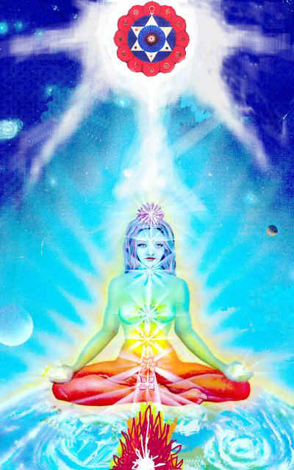

Why have Normal Psychic Sex Connections?
TO BRING DOWN A BABIES SOUL FROM HEAVEN

There are many reasons why you create relationship Psychic Sex Connections yourself to another being and/or for that matter, why they create Psychic Sex Connections themselves to you. One of the major reasons is to create babies. Energy is necessary for this and flows from abdomen to abdomen. And as the energy flows in sex a connection is created from base to crown chakra and from the crown to the Soul, in order to bring down another soul from heaven!!
However, this natural function can become perverted....

1 It could have seemed like a good idea at the time, quite handy and practical in fact, being able to telepathically call in and out to your friends.... But friends create Psychic Sex Connections to other friends, and sooner or later you are connected to a party line and are getting input from all sorts of unwanted sources.... You could easily be inundated, day and night, non-stop with this psychic "spam". This is why the Initiations of Energy Enhancement teach how to, and give you a process of, cutting all ancient connections and then reforming them appropriately.

2 It could have been done as a way to be closer, more intimate with someone... to share the deepest thoughts and feelings from ones deepest centers. But all relationships change... usually through bad Karma.

If you did bad things to a person in a previous lifetime, usually in this lifetime they will take revenge. Relationships go sour, even adversarial, confrontational, or outright hostile... but the Psychic Sex Connections remain.

Once you are wired with Psychic Sex Connections, it is not as easy to remove them as it was to create them. Just imagine if you were create Psychic Sex Connections to someone who turned dark and evil... and you had one of these wires from them plugged into your brain, or into your sex chakra, or your heart...? You are really really stuck....
You need to learn how to disconnect your Psychic Sex Connections to negative energy and we can help you to do this. This is one of the main works of our Teachers of Energy Enhancement.

3 It could have been contractually agreed upon as a way to be in a partnership or marriage with another. A “Vow” which we need to learn how to deal with. The old paradigm of partnership or marriage has been about "banding" branding? one person to another,... i.e. being contractually bound by Psychic Sex Connections "tying" the knot and "the ties that bind".
The new paradigm of truly loving and deep relationships is about unconditionally giving and setting each other free with no strings attached. Or, through the Initiations of Energy Enhancement, having the ability to manage these connections.

4 It could have been done out of fear to go it alone in the world. Many people think that by standing within their own power, the resultant freedom and independence this would give including the associated personal and spiritual responsibility would shun them from human society, causing them to live solitary, alone, and lonely lives.
To prevent this, they are willing to compromise their personal power and sovereignty... and join or "hook" up with another person, group, or outside authority... in exchange for the companionship, security in numbers, and shared responsibility.
Usually, this is a case of our relationship to priestly vows, or vows to be a member of a bad group, which remain in the psychic body for many lifetimes through Implants. For a particularly good example, look at all the people who are members of all organized religions and don't forget the political parties.

5 Or it could have even been forced upon you against your will, or even secretly planted as a thoughtform “Implant” without your awareness as a hook to draw you back into the fold, lifetime after lifetime. These implants have Psychic Sex Connections going into them from the people who psychically made the implant many lifetimes ago. Implants exert control and drain energy back to the original maker of the implant, turning many people into batteries, like in the Matrix.

The implant maker vampires are not interested in people of low evolution who do not have much psychic energy. They are interested in people of high evolution. People more Soul Connected, and it is these people who they drain, as an aphid drains the rose flower, preventing its further evolution by usually perverting the victim as the Ring Implant, like the Ring in the Lord of the Rings movie and book, perverts all who come into contact with it. These implants create desires for sex, sexual abuse, drugs and rock and roll. It can draw you back into the same type of life, lifetime after lifetime.

As the candle is burned at both ends much energy can be taken, and usually the victim dies young.

Inadvertently or in a lapse of good judgment, you let down your protective energy barriers, and someone slipped in and hooked or plugged an Implant into you.

HOOKERS
This also happens quite a lot, especially between men and women "she got her hooks into him". Why do you think prostitutes are called "hookers" ? Usually prostitutes are implanted lifetime after lifetime, and the created implant blockage which acts like a psychic virus is spread to all the customers, creating a desire for more - See the Omphallos Snake Basket of the Delphic Pythonesses; also the Lilith Succubus for information on how these implants have been used for thousands of years

This is the nature of all addiction. It is nice to learn how to overcome your relationship to all desire, your relationship to all addiction by working to learn how to become free.

6 It could have been contractually agreed upon as a way to clear some mutually unresolved karmic debts "Karmic Contracts" or Vows.

7 It could also be entered into as a spiritual service to another soul, such as in a "God Contract" as exemplified in that Psychic Sex Connection between children and their parents.

Relationship Psychic Sex Connections exist in all people and in general mess up their lives. Instead they should Enhance our lives and lives of everyone around us. With Energy Enhancement Techniques we can learn The Mastery of Relationships!!
For all intent and purpose, Psychic Sex Connections or "strings" in relationships are very similar to umbilical connections or even electric and telephone wires, except they exist on the astral dimensional planes in all relationships. They can be very thin, or very thick, and can appear as very light or very dark streamers coming out of your energy fields/bodies.
Satchidanand's Movie Reviews
DOWNLOAD BELOW
http://www.energyenhancement.org/Spiritual-Movie-Reviews-Satchidanand/Index.html
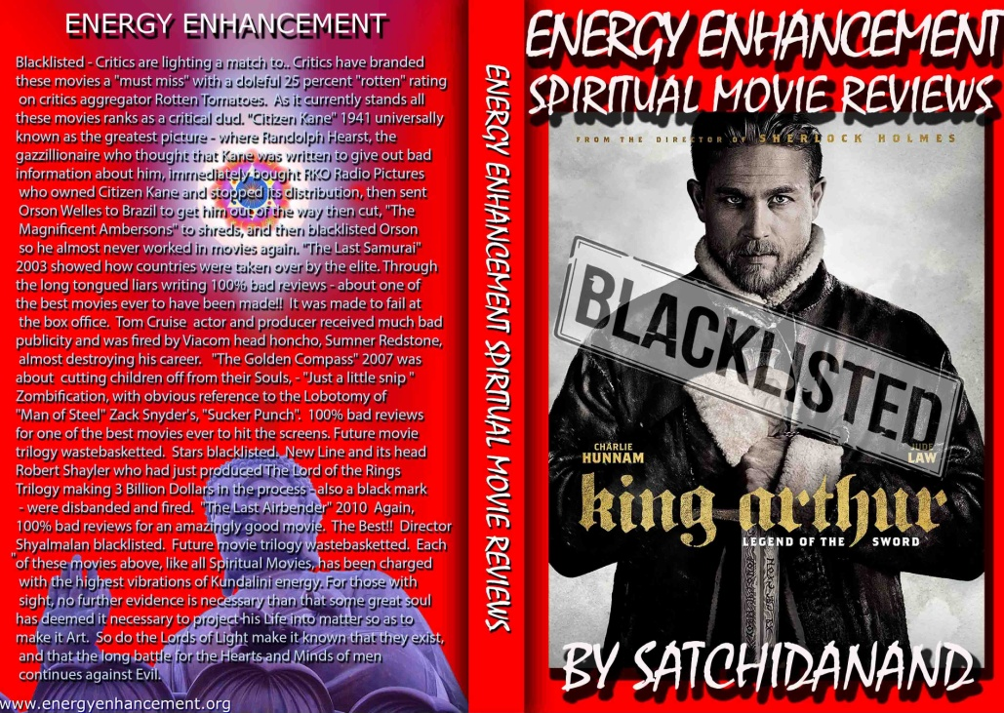
Energy Enhancement Spiritual Movie Reviews Book - Volume 1 by Satchidanand Immortalises the Kundalini Energy which Radiates from Satanically Blacklisted by the Dark Side - Movies like..
King Arthur - Legend of the Sword The Story of Enlightenment - by Guy Ritchie - a Movie Review by Satchidanand
Karma and Anti-Satanism in the Spiritual Actor, Keanu Reeves movies, "John Wick (2014)" also "Man of Tai Chi (2013)"
John Wick Ch 2 - Is Donald Trump and Alex Jones of Infowars - The Spiritual Warrior - Finger of God - Removes Satanic Demons, Deletes the Elite, Cleans the Swamp - Move Witch, Get out the Way!
Doctor Strange - Psychic Warrior Earth Protector..
Logan - "Beware Of the Light" Esoteric Movie Review by Satchidanand
And Much Much More..
Energy Enhancement Spiritual Movie Reviews Book - Volume 1 by Satchidanand - right click and save as..
http://www.energyenhancement.org/Spiritual-Movie-Reviews/Energy-Enhancement-spiritual-esoteric-movie-reviews-by-Satchidanand.pdf

The Omphalos and the Om Phallus stone from Delphi

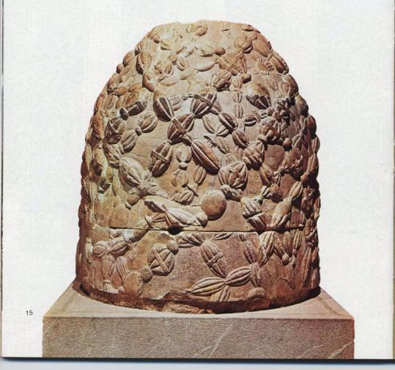

The above stone was originally placed in the heart of the sanctuary to Apollo, where the Pythia (Pythonesses), Delphic Divinatory Mediumistic Channelling Priestesses of the Serpent Kundalini would give the god's oracles...The spot where it represented the center of the earth, hence the name Omphalos, or Om Phallus, first determined when Zeus sent two eagles from each end of the kosmos and the two then met and circled in the Center of the Earth... (See Alchemical VITRIOL)

The stone, same shape here as the Shiva lingam or the penis of Shiva, shown above originally had two golden eagles attached to its top. This makes the symbol of Omphalos look very much like the Caduceus of Mercury, messenger of the Gods and Hermes which also symbolizes the Antahkarana – the Column of Energy between Heaven and Earth.

In addition, the Greeks believed that the Omphalos stone marked the spot where Apollo first established his oracle by driving the serpent monster Python into the Earth at Delphi. Serpents are the symbol of Kundalini Earth Energies. All Myths give hints towards guided Meditations which can internally enhance Kundalini Energies to pierce and purify the chakras and thus initiate enlightenment, a quantum leap in human evolution which involves piercing the granthi (Sanskrit, Knot) or the knot (Gordian Knot) of the heart. Only the person who has purified the Gordian knot of the heart and the Soul is pure enough to become a Priest or become Enlightened.

There are many Omphalos stones all around the Mediterranean and they were placed in Temples in locations where earth energies were more intense and thus Rites of Initiation and Divination – all Shakti spiritual energies helping Initiation and Illumination were increased and psychic powers were intensified in those places.
The place where Omphalos or Earth Energies arise is the Center of the Earth. The Center of the Earth is Omphalos where Om is the Guided Meditation using sound which creates the Kundalini Connection between heaven and earth and Phallos – Penis Greek. Or Phallus, Penis Latin – Penis being the Shiva Lingam (Sanskrit, Penis) - connecting this with Sexual Energy, Kundalini Energy and the Base Chakra which connects with Kundalini Chakra and Shakti in the Center of the Earth, is the Column which represents the connection between heaven and earth.

Why the decoration on this stone? According to ancient accounts, there was originally a different Omphalos stone at Delphi, prior to the one shown here (which was made as a replacement in the 4th cent. BC). The first stone was a meteorite, and was draped in an argenon, or woven net, thus creating an effect reminiscent of woven snake baskets.

"It is possible to create psychically an energy blockage implant in the form of a container of black squirming snakes trapped in a snake basket. The Shivalingam connection between heaven and earth is the energy to be tapped by this implant blockage whose squirming has the ability to stimulate the sexual organs when implanted there. This symbol of the power of the pythonesses of Delphi is that of the sexual vamp.
Together with knowledge of how to connect using energy connections between chakras with this implant at the tip of the connection either implanting the energy blockage or stimulating one which is already there, this knowledge can facilitate seduction and also the vampire sucking of the energies of the orgasm of the energies between heaven and earth symbolised by the Penis Shivalingam."

Python was a good giant Kundalini serpent showing the correct knowledge of how man connects with God.. Such imagery was surely evocative of the stone's importance as a sacred marker of Apollo's or God the Fathers victory over the terrifying serpent by sending him into the center of the earth a reflected Shakti Kundalini Energy always arises, is reflected, from the earths Center at that spot....

MANAGING PSYCHIC CONNECTIONS

Psychic Sex Connections start with the umbilical cord that connects a child to its mothers. It is a biological necessity during gestation, and even after, when this cord is cut, there still remains in this same area an important energetic Psychic Sex Connection between parents and child both mother and father.

This seems to be necessary for the child's comfort, security, and even survival in the developing early years. It is this telepathic-energetic relationship link with the parents that energetically feeds the child, that assists the child to feel more connected and grounded to life and humanity, at this level or dimension of reality. It is bad enough, if you think about it, to at one point be in spirit, at peace, at one with all, and then be thrust down into this gross dimensional plane of duality and suffering, all by oneself... without at least some kind of life line to hold onto.

However, this Psychic Sex Connection between parents and children can have negative consequences... Usually we are not weaned of this Psychic Sex Connection at the age of 5 or 7 as should happen, but the Psychic Sex Connection endures for all of our lives.

When one of the beings such as a parent or even a child has dark issues and heavy karma, an energetic bleeding through the Psychic Sex Connection can occur, corrupting or at least be disturbing to the other individual. In these relationship family ties we can be “tied to the apron strings of our mother”.

Some male homosexuals, or people not interested in sexual relationships, have very strong Psychic Sex Connections to their mothers or fathers.

This is accounted for and anticipated in spirit before the birth, as we all choose these relationships for the reason of learning these relationship lessons, sometimes to assist and carry another through their darkness and karma. This is why learning about this is so necessary to people in the process of learning about relationships.

You can see this if in your life all your negative life experiences have come through relationships. This means that you are in the process of Mastering the Second Initiation of Alice Bailey, The Mastery of Relationships, and it is this which is the intent of the teachings of Energy Enhancement, to give you the Mastery of your Relationships.

Often, being connected in this way as parents or even as the child is the only way to help the other soul through these trials and tribulations. It is a noble endeavor and spiritual service one can do for another. It is like having a permanent, continuous, invisible life line of support and love.... If the one being is overwhelmingly strong enough to transform the others' negative energies and darkness, this could be a good thing. Unfortunately, this rarely works out so ideally as the burden can be sooo great as to drown both people.

If you think of a person who jumps into the water to save a drowning man, and ends up being attacked and drowned instead, you know what I mean. This is a task for the strong at heart, and even then, you still have Psychic Sex Connections with that person after. This is why the Initiations of Energy Enhancement are so necessary to enable everyone to handle all these types of problem above mentioned.

And to do it properly you need to learn the lessons of the Enlightened Master. And it is this which we learn in the Initiations of Energy Enhancement, The Mastery of Relationships.

Relationship Psychic Sex Connections and TANTRA - the Energy Enhancement View

When these relationship Psychic Sex Connections are created by people in love they can create a baby, they can make love they can have an orgasm and when Psychic Sex Connections are created consciously by a Master of Energy Enhancement, they can be given energy on many vibrational planes which can help in their Enlightenment.

This is high spiritual tantra. Learning how to connect appropriately can bring energy, love and loving sexual orgasms back into failing relationships. Energy Enhancement Mastery of Connections can heal frigidity and many inabilities to make love.

So one of the Energy Enhancement Meditation Keys to the Mastery of Relationships which we teach about fully on the course is to have care in your relationships. Only connect to the good. Be mindful of whom you are connected to. Only connect to the bad if you want to heal them or give them energy. The Key to Energy Enhancement Initiations for the Mastery of Relationships is the ability to disconnect these Psychic Sex Connections as well as create them.

And why do we give energy to our students, the answer is that all Enlightened Masters give Energy to, raise the Energy Vibration of Their Students and Disciples in order to make them Enlightened. As my Master, Swami Satchidananda said, “Making someone Enlightened is like creating a baby” Or as Goethe Said, “Connect, only Connect.”

We can understand why the Buddha Said, “Attachment leads to Pain” This is caused by holding onto negative connections too long. Pain is caused by the inability to connect and disconnect, the inability to Manage Connections which is the teaching of the Initiations of Energy Enhancement, The Mastery of Relationships!

The most important thing about Psychic Sex Connections is to know that it is possible to connect and also to disconnect using these cords of Psychic Sex Connections. Only connect when it is necessary. Disconnect when it is not necessary. Be mindful of your connections. And these Psychic Sex Connections are at the core of every successful Loving Relationship.

CHAKRA TANTRA LINKS
BALANCED AND SHARED COMMUNICATION FLOW
How to connect and disconnect appropriately

Transmitting and Receiving Communication in a shared and balanced way.

THE MASTERY OF RELATIONSHIPS

In Energy Enhancement Mastery of Relationships we learn how to cut off all connections when we need to. We follow a process of cutting off all connections with everyone we know from every one of the chakras in our bodies. We learn how to dissolve implants. Then we learn how to connect appropriately. We practice connecting appropriately. Thus the Initiations of Energy Enhancement teaches the Mastery of Relationships.

We learn how to use these connections to heal the people we connect to so that we can not be connected to anything bad. Healing the person means dissolving their negativity or negative Ancient Karma. We healed all of our Karma in this Lifetime and all of our past lifetimes with Energy Enhancement Level 2. Now we learn how to perform the same service for others. Through the Initiations of Energy Enhancement we overcome the objections to connections which we read about above through the ability to Master each connection.

In Energy Enhancement Mastery of Relationships we learn how to connect and disconnect appropriately. We learn that WE are responsible for the health of all our relationships. We learn how to use the Light of the Soul to dispel all ancient negativity in those we are connected to, ALL OUR RELATIONSHIPS. This is the true meaning of “Forgiveness” it is not something we decide to do mentally. It is something we do psychically to take back, to transmute, to dissolve the ancient negativity caused by our bad actions in the past, so that all this ancient evil karma will not come back to haunt us in this lifetime and in the future.

In this same way in Energy Enhancement we learn how to reduce the Karmic Burden of this Planet creating conditions to raise the Vibrational Energy Level of this Planet, for this planet to become a Sacred Planet, where every person is Enlightened

In Energy Enhancement the Mastery of Psychic Sex Connections is the Basis of the Energy Enhancement Mastery of Relationships.

by Energy Enhancement Satchidanand

ENERGY ENHANCEMENT
THE CORE ENERGY TECHNIQUES !!

ENERGY ENHANCEMENT, !!! ULTIMATE !!!!!! ANCIENT !!! !!! EFFECTIVE !!!!! SUCCESSFUL !!!

1. Get into Intense alignment with Your Own Kundalini Energy and Immediate Access to the Meditative State.

2. Remove your Energy Blockages with The Circulation of the Energies, the Kundalini Kriyas, Ancient Taoist Energy Circulations which have worked effectively for 5000 years to help all towards ENLIGHTENMENT.

3. The Grounding of all your Negative Energies through Alchemical VITRIOL - Become Incredibly POSITIVE and ENERGETIC!!

4. Alignment with Your Higher Self - INCREASE YOUR IQ, INCREASE YOUR LUCK, ACCESS YOUR HIGHEST ENERGIES!! ACHIEVE WHAT YOU WERE PUT ON THIS PLANET TO DO.

5. Learn how to USE and Increase the LOVE of Your Heart Center to ZAP YOUR NEGATIVE EMOTIONS AND DEVELOP PSYCHIC POWERS TO HEAL YOURSELF AND OTHERS.

6. Overcome ENERGY VAMPIRES - MASTER ENERGY PROTECTION AND MAINTAIN YOUR HIGH ENERGIES!!

7. EXPERIENCE INCREDIBLE RELATIONSHIPS WITH ENERGY ENHANCEMENT - THE CORE ENERGY TECHNIQUES

8. ENERGY ENHANCEMENT Techniques are the source of all Successful spiritual training courses over the last 5000 years. Become a Jedi Master, a Gandalf, a Transmitter of the FORCE a Bringer of the Light!!

GET MORE ENERGY!!!
ENERGY ENHANCEMENT -
!!! ULTIMATE !!!
!!! ANCIENT !!!
!!! EFFECTIVE !!!
!!! SUCCESSFUL !!!

Raja Yoga and the Yoga Sutras of Patanjali

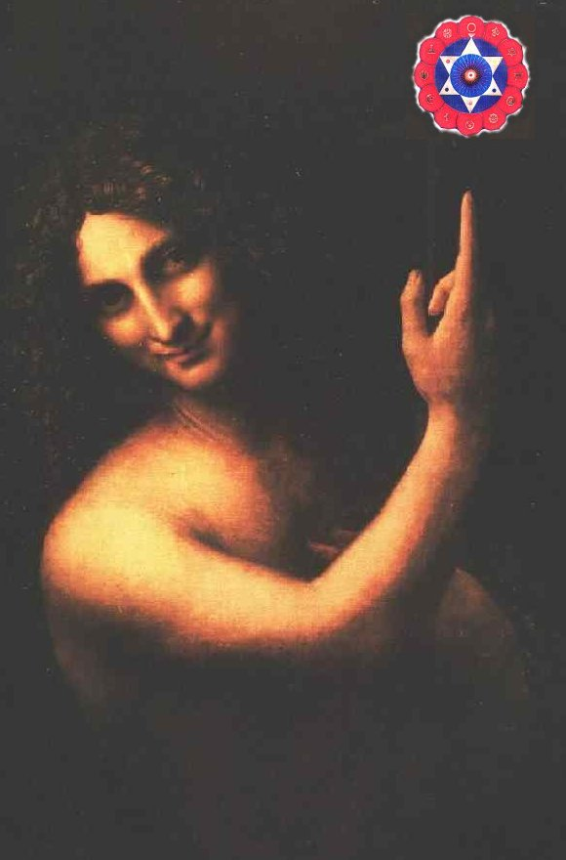

Excerpt from Book Four - Kaivalya Pada
Portion on Absoluteness.
4.4. The flow of Energy in Meditation Energy Enhancement does not directly cause natural evolution; it just removes the obstacles, the Energy Blockages and Strategies, as a farmer (removes the obstacles in a water course running in his field).

4.5. A Yogis egoity alone is the cause of (other artificially) created minds.
When something bad happens, particularly whe we are children, the pain causes the ego mind to split and a Strategy inner child is created which egotistically, selfishly uses all the strategies to GET WHAT IT WANTS!!
We teach how to heal these selfish ego minds by grounding their initial pain cause and then absorb them back into the central soul stem. This central soul stem is the Strong One personality, the Director of them all. There can only be One!!!

4. 6. Although the functions in the many created minds may differ, the original mind-stuff of the Yogi, the Soul, is the director of them all.
This finding the director, the Strong One Soul Personality, is one of the aims of Enlightenment.
As we evolve we naturally create strong Strategies in our minds through the process of splitting due to trauma as a child.
Eventually we have to integrate these Strategies back into the even stronger director, the soul which is higher than the mind. However, many people so far have not met the director and are evolving only through the Strategies.
Thus, in Energy Enhancement right at the beginning of your Energy Enhancement practises in Initiation 4 of Level One, we put you in contact with your Soul.
This Initiation is most important as it gives you the foundation of your evolution.
Thus Gautama Buddha said he was there only for those few who had the possibility of change, those who are soul connected. Those in whom the Soul is beginning to heal and absorb the egoistic Strategies, and talents or psychic powers.
Eventually we become one, when all the Strategies and talents are healed. All the ancient negative energy which is bound up in them is dissolved and they are absorberd back into the central soul stem.
Then we have Mastery of them all, then we are Enlightened.

This is Energy Enhancement!

In Energy Enhancement we ask the Koan, "Who is in charge??"

SO, "WHO IS IN CHARGE?"

Love and commentary on the Sutras by Energy Enhancement Satchidanand

ENERGY ENHANCEMENT AND TANTRA
WHAT IS TANTRA?

TANTRA IS ONE OF THE MANY PATHS WHOSE AIM OR END OR PURPOSE IS ENLIGHTENMENT

Like Yoga which means Union with the center of the Universe or with God, Tantra is any path which achieves that aim.

For many, Tantra is a sexual means of achieving that union. People ask me, isnt one of the methods to make love only once per month? To increase the length of time we make love to hours?
Well, I reply, Enlightenment comes from the increase of energy. Human beings only have a small amount of energy within themselves. Really to increase that energy we need to access the energy from chakras outside the body. It is like we have a computer which is running slowly on only five volts. We need to plug ourselves into the big generator!

To obtain thousands of volts of power in order to make the computer work more quickly at a much higher level we need to plug ourselves into the chakras above the Crown Chakra, into energy in the central spiritual sun!! The Soul!! God!!!

And in the center of the Earth is the Kundalini Shakti flowing out in every direction from the Atomic Generator which powers this planet. The atomic pile in the center of the planet is a 5000 degrees centigrade and provides the energy which keeps this planet alive and at the correct temperature. The Earth is feminine. The Indians say, "Our Mother, the Earth" and our Father, who art in Heaven is God, the energy in the center of the universe. And when all the Energy Blockages to that connection have been removed, then there is a flow, a waterfall of spiritual energy which powers every one of the enlightened.
Then we have Shiva, our father, combining with Shakti our mother. Then we have Hercules, son of God, Zeus, Theos, Deos, combining with the daughter of Pluto, King of the Underworld.

Enlightenment concerns The Holy Trinity and is composed of Sat, the truth of the center of the Universe combining with Chitta - the holy grail, the cup of the mind on this planet, empty and ready to receive the libation of the Gods, and the flow of energy between the two is called Ananda, or bliss - Satchitananda like the Father - Our Father who art in Heaven, the Son and the Holy Spirit which flows between the two.

And the Hindus have a word for the channel between the Center of the Universe and the Center of the Earth. Rapunzel, Rapunzel, let down your hair. The Rainbow Bridge. The Tower of Babel. Tower of Connection created out of mental matter to channel the energies of God through all the infinite chakras of existence, powering the whole universe from the center. This is the Antahkarana.

If you are not connected with, if you are blocked from, the center of the universe then just think of a small flow of water slowly filling a bucket. You may well have to wait a month for the bucket to fill. Only then will you have sufficient energy to enjoy making love, or really doing any of the thousand things we have to do on this planet. But if you are connected and put your bucket under a waterfall, then that bucket will fill in seconds. You will have infinite energy to do with whatever you want every second of the day.
The Greeks had a name for this energy which descends from the soul to power the Mind Computer, and they called it Genius which is the what happens to the mind computer powered by the energy of the Soul. Soul Infused.
The Mind is of the intellect of logic yet the Soul is Intuition, Knowing, Wisdom and is much higher than the mind.

The Kashmir Shaivites also have the energy of Chit Shakti whereby the mind is also powered by the Energy in the Center of the earth.
In reality, human beings are powered by both masculine and feminine energies. We connect with the Kundalini Chakra in the center of the earth by means of the Base chakra, and we connect with the center of the universe by means of the Crown Chakra.

Usually it takes three days for the students who come on our courses to access this energy with which they can successfully transmute all their Energy Blockages because another, more easy way for people to absorb energy is from the Buddhafield, the Aura of the Master.

When they leave then sometimes the energy drains away, because it is the energy blockages which create the holes in the bucket through which all the water drains away.

And this is Tantra, the Energy Flow of the Soul created by the Sexual Union of Shiva and Shakti.

In that that bliss, that delight, such an overflowing cornucopia of Energy which comes from the Gaining of Energy and the Removal of Energy Blockages, we find only Enlightenment.

In a way, Enlightenment is a twenty-four hour a day orgasm.

The Tantra Course given in parallel with the Energy Enhancement Course overcomes all energetic and sexual problems. Stimulation of the Base Chakra eventually leads to a removal of all energy blockages there and Enlightenment itself.

Tantra is an Ancient means of reaching Enlightenment. However it is said to be dangerous because sex can be addictive. Gurdjieff said, "If there had been two things like sex, I never would have become Enlightened!" However, if those people who really wish to attain enlightenment through Tantra approach with the right attitude in a loving relationship, then it can be a help.
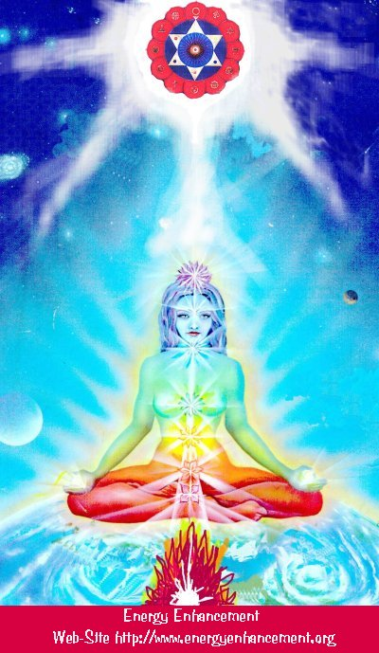

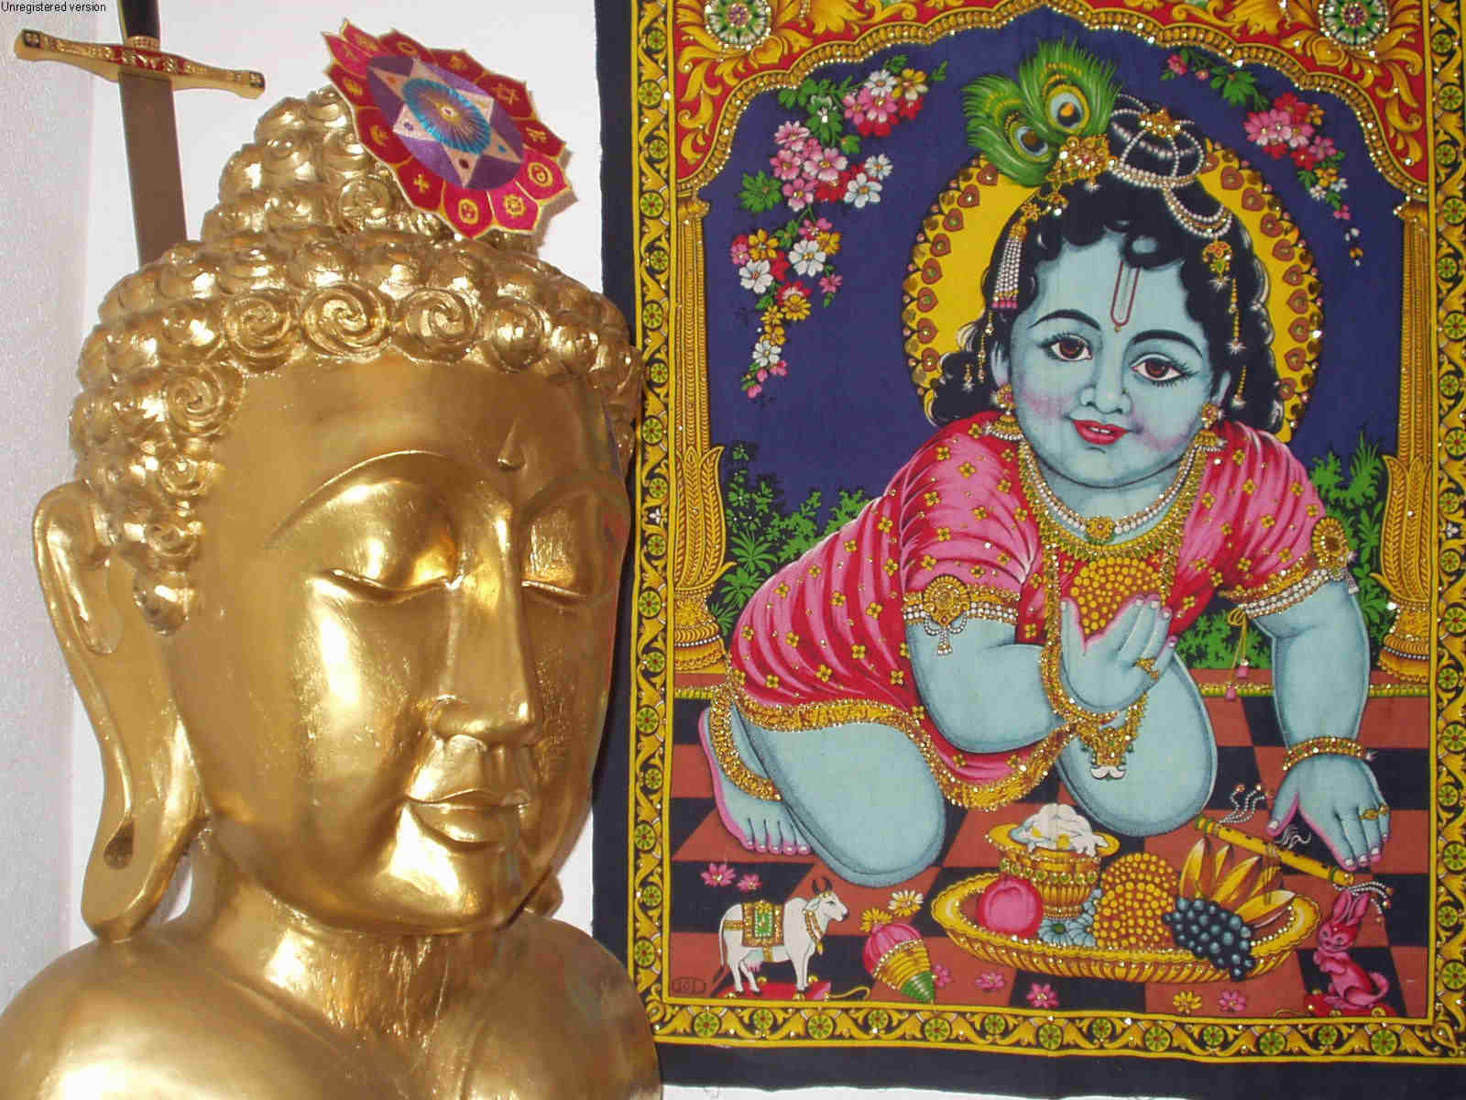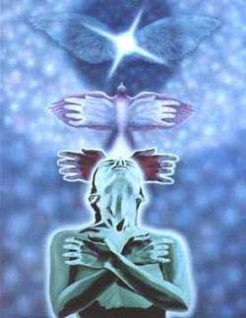

Description of the Complete Energy Enhancement Meditation Course

Energy Enhancement Meditation Course Level 1

Energy Enhancement Meditation Course Level 1 - Gain Energy!! Meditation, Kundalini Kriyas, Taoist Super Orbits, Alchemical VITRIOL, Projection of the Antahkarana into the Soul Chakra, Monad Chakra, Logos Chakra the manipulation of life energy (Ki, Chi, Pranha, Orgone, Kundalini)

Energy Enhancement Meditation Course Level 1 Initiation 1: Alignment with the energies from the Center of the Earth into the Center of the Universe. Shaktipat, Energy Alignment, Kundalini, Stopping the Mind and Squaring the Circle.

Energy Enhancement Meditation Course Level 1 Initiation 2: Energy Circulation: Microcosmic Orbit, Kundalini Kriyas. This gives the Hidden Taoist Secrets of the Microcosmic AND the Macrocosmic Orbit, the 5 Elemental pathways of the Chi or Ki and the Kundalini Kriyas of Paramahamsa Yogananda.

Energy Enhancement Meditation Course Level 1 Initiation 3: The Grounding of Negative Energies: Alchemy, Hermes Trismegistus, VITRIOL - VISITA INTERIORE TERRAE RECTIFICANDO INVENIES OCCULTEM LAPIDEM and the guided meditation of Grounding, transmuting all trauma caused negative energy.

Energy Enhancement Meditation Course Level 1 Initiation 4: Accessing the Universal Energy Source: Macrocosmic Orbit, The Energy Enhancement Supra Galactic Orbit, Chakras above the Head, Soul Fusion via the Antahkarana, Advanced Kundalini Kriyas, Siddis, The Creation of Psychic Vision.

Energy Enhancement Meditation Course Level 1 Initiation 5: Projecting Energy - Grounding Toxins in Food: Re-awakening our psychic ability to detect poisons. Removing Blockages.

Energy Enhancement Meditation Course Level 1 Initiation 6: Psychic Protection: Power Towers, Creating and Using External Antahkaranas, Exponentially Increasing your Spiritual Energy, Creating the Flow from Heaven to Earth.

Energy Enhancement Meditation Course Level 1 Initiation 7: Psychic Protection: Pyramid Protection.

Energy Enhancement Meditation Course Level 1 Initiation 8: Psychic Protection: The Merkaba, Astral Travel and Projection, Advantages of the Siddhis of Becoming Bigger and Smaller.
Energy Enhancement Meditation Course Level 2

Energy Enhancement Meditation Course Level 2 - The Seven Step process - The removal of energy blockages and implants by the Energy Enhancement Busting Techniques - The Removal of Old Karma from the time in the womb of your mother and from this time.

Energy Enhancement Meditation Course Level 2 Initiation 1: The removal energy blockages and implants by the Energy Enhancement Seven Step Process.

Energy Enhancement Meditation Course Level 2 Initiation 2: How to Heal the Energy Blockages in the body.

Energy Enhancement Meditation Course Level 2 Initiation 3: The removal of Energy Blockages thoughtforms from the chakras. From the seven chakras inside the body and then all the external spiritual chakras to which we are connected the Soul Chakra, the Monad Chakra, the Logos Chakra, the Sirius chakra, the Avatar of Synthesis Chakra.

Energy Enhancement Meditation Course Level 2 Initiation 4: The removal of Energy Blockages thoughtforms from the DNA. Heal your DNA.

Energy Enhancement Meditation Course Level 2 Initiation 5: The removal of Energy Blockages thoughtforms from the Auras. Heal the Physical Aura, Heal the Emotional Aura, Heal the Mental Aura, Heal the Buddhic Aura.

Energy Enhancement Meditation Course Level 2 Initiation 6: The removal of old karma from the time in the womb of your mother. The karma cleaning process.

Energy Enhancement Meditation Course Level 2 Initiation 7: The removal of old karma from this lifetime. The karma clearing process.

Energy Enhancement Meditation Course Level 3

Energy Enhancement Level 3: Energy Enhancement Meditation Course Level 3, The Karma Clearing Process - Psychopathic Energy Vampires - The Inner Children Strategies - The Grounding of Emotions - The Removal of Old Karma from Past, This and Future Lifetimes.

Energy Enhancement Level 3 Initiation 1: The removal of old karma from all your past lifetimes. Remove all the Blockages from all your previous lifetimes. This is what they mean when they say a Master is not under the Laws of Karma. He has dissolved all the negativity from all his past lives.

Energy Enhancement Level 3 Initiation 2: The removal of old karma from all the future years in this lifetime and all your future lifetime.

Energy Enhancement Level 3 Initiation 3: The retrieval of the soul splits of the inner children Strategies.

Energy Enhancement Level 3 Initiation 4: The grounding of the emotions. This Initiation shows how to Ground, to Drain all the negative energies from your negative emotions and thus remove all your emotional Energy Blockages.

Energy Enhancement Level 3 Initiation 5: Removing the strategies of the psychopathic energy vampire. LEARN HOW NOT TO BECOME ENGAGED BY THEIR STRATEGIES TO SUCK YOUR ENERGY.

Energy Enhancement Level 3 Initiation 6: The Seven Step purification of trauma-formed negatice karmic mass in talents and the creation and increase of talents or angel talent colonies in level 3 of Energy Enhancement.

Energy Enhancement Level 3 Initiation 7: Removing vows from this life and all your past lives. Past life priest vows and vows to the dark side can affect present prosperity, self worth, and relationships. And they can continuously block you, and be carried from life time to life time. All Old Souls carry them and most have thousands of them buried in their minds. This Energy Enhancement Initiation method removes the blocks that are held deep within your subconscious mind. Traditional therapies cannot remove them.

Energy Enhancement Level 3 Initiation 8: The use of life experiences to notice and remove the Inner Children and the Strategies which are based on the inner children. The weaker inner children are very easy to remove, yet it sometimes needs stress pressure which is always occurring in life in order to get the more intelligent Soul Split inner children and past life talents to show themselves.

Energy Enhancement Meditation Course Level 4

Energy Enhancement Meditation Course Level 4. High Tantra Psychic Sexual Connection - The Mastery of Relationships by using Meditation (including your mother and father)- How to heal all addictions.

Energy Enhancement Meditation Course Level 4 Initiation 1: Learn how to heal all addiction. Learn how to heal all your Addictions or strategy driven predelections to... Food, Alcohol, Smoking, Drugs and Sex.

Energy Enhancement Meditation Course Level 4 Initiation 2: The healing of the negative energy of close personal primary relationships including your mother and your father. Learn how to Heal all your Relationships Without talking to these people. Learn to heal at a distance all the Negative Energy which inevitably builds up in all our Primary Relationships.

Energy Enhancement Meditation Course Level 4 Initiation 3: The total healing of all chakra connections. Energy from further improving relationships and protection. How to clean all the energy connections of Attachment.

Energy Enhancement Meditation Course Level 4 Initiation 4: Creating and cleaning the soul connection in your students and friends.

Energy Enhancement Meditation Course Level 4 Initiation 5: The Mastery of the psychic energy connections.

Energy Enhancement Meditation Course Level 4 Initiation 6: The Mastery of trantic energy. How to Remove Implants, Transmute the Negative Karmic Mass of Blockages and Clean all the Chakras of your students and close personal relationships.

Energy Enhancement Meditation Course Level 4 Initiation 7:Ceremonies and Meditation Groups - Using the Energy of the Higher Heart, The Heart Center in the Head, Prajna Paramita, - The Soul and the Monad Itself, for the Healing of Groups, Organizations and the World.

Energy Enhancement Meditation Course Level 4 Initiation 8: The use of life experiences to notice and remove the Inner Children and the Strategies which are based on the inner children. The weaker inner children are very easy to remove, yet it sometimes needs stress pressure which is always occurring in life in order to get the more intelligent Soul Split inner children to show themselves.

