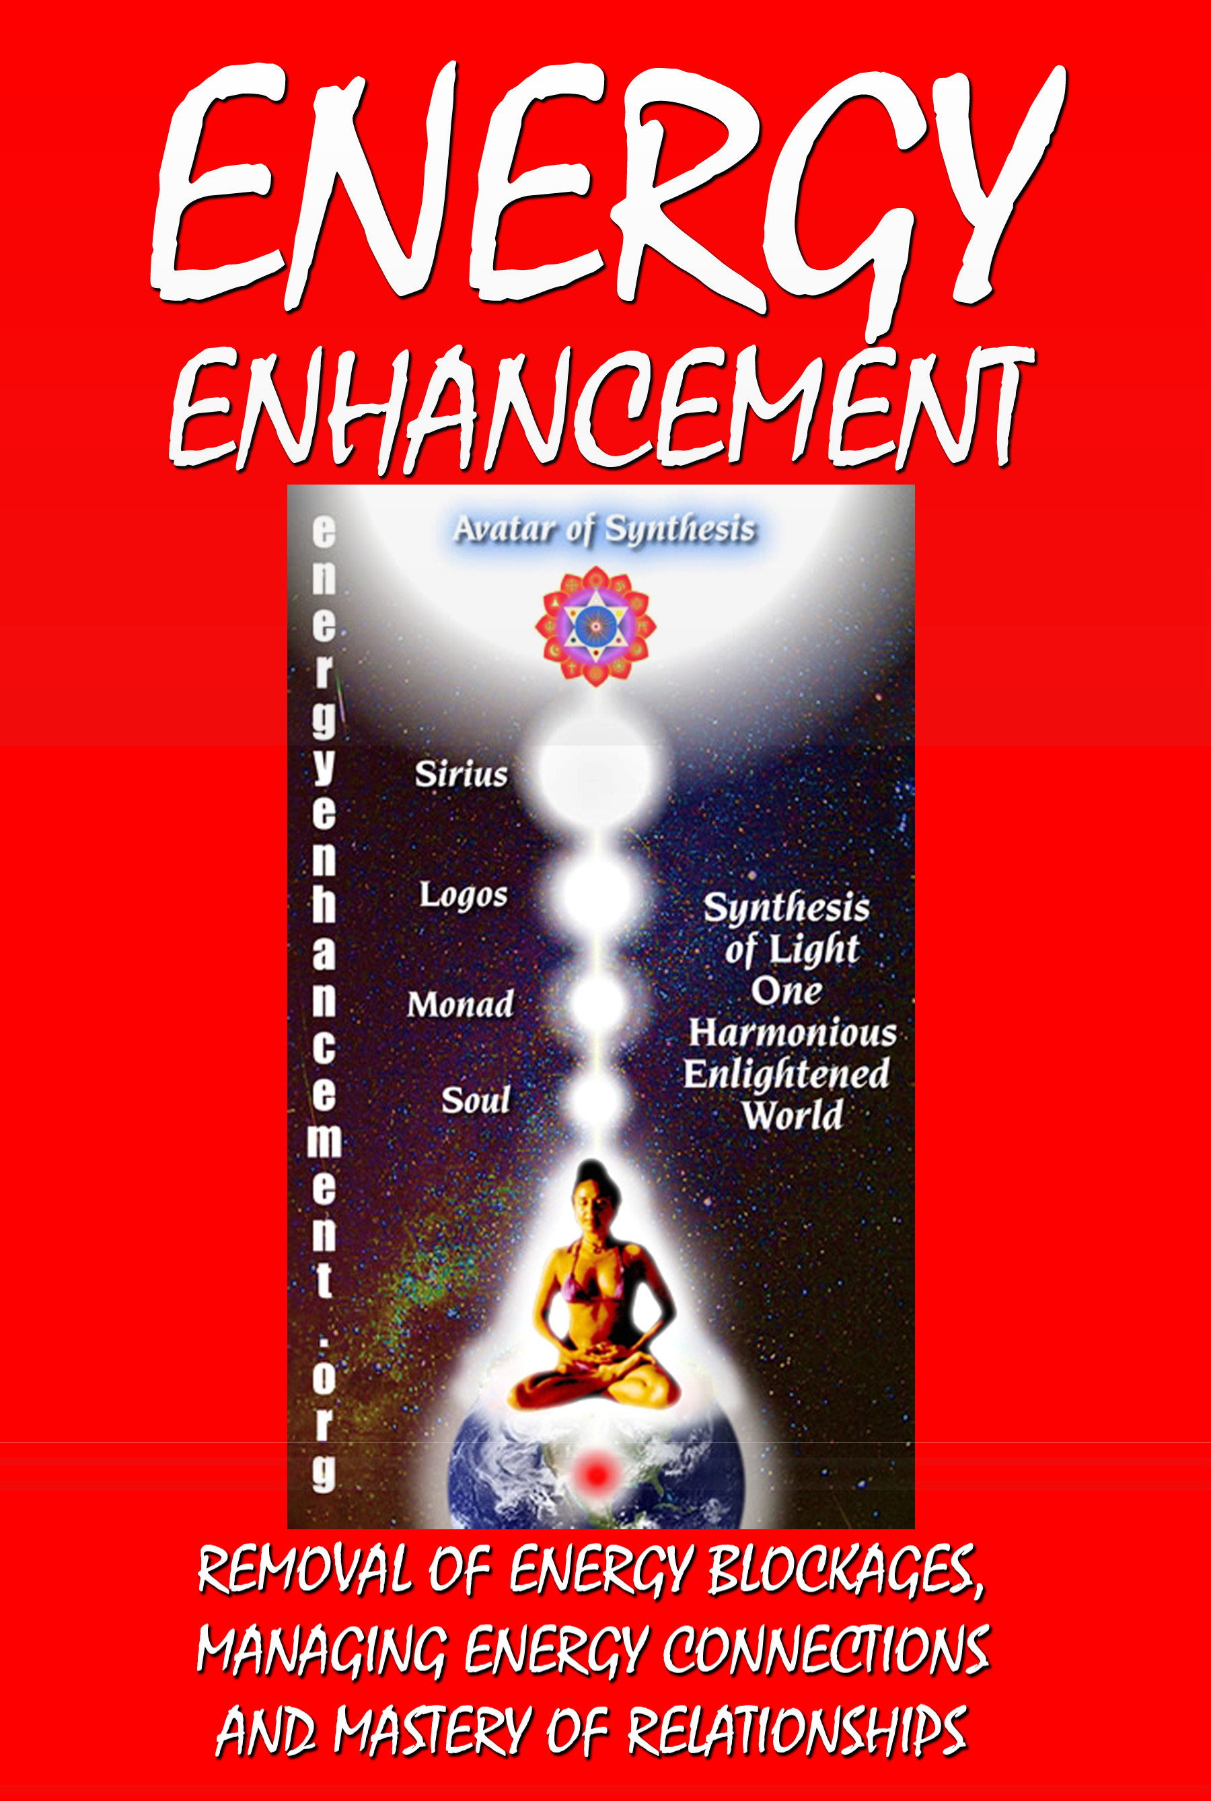

DEDICATION

With all Thanks, Love and Gratitude to Swami Devi Dhyani and all the helpers who make these books and DVDs possible. With all Thanks, Love and Gratitude to my Mother and Father and to all my other Teachers, Theos Bernard, Sri Yogendra, Eric Berne, Gurdjieff, Father Bede Griffiths, Osho, Zen Master Hogen, Swami Sivananda, Swami Satchitananda, and all the other giants upon whose shoulders I stand – who made me able to be what…
I AM - Satchidanand

Copyright © 2008

[Energy Enhancement Synthesis of Light Limited (SOL)] All rights reserved. This publication may not be reproduced in whole or in part, by any person,
without written permission of: Swami Satchidanand
sol@energyenhancement.org www.energyenhancement.org Printed by Amazon
ISBN: 1441414339

CONTENTS

THE STRATEGIES OF THE ENERGY VAMPIRE AND THE SPLIT MIND - MPD AND DID
………………………………..Page 9
Integration - Heart, Intelligence, Emotional IQ, Psychology, Creativity and EE Meditation.
Energy Enhancement and Emotional IQ.
Energy Enhancement Meditation and the Ego Strategies of the Vampire - Violator, Interrogator, and the Star.
Energy Enhancement Meditation and the Psychology of Ego Strategies of the Aloof and the Poor Me.
Energy Enhancement Meditation, the Pleaser, Blamer, Vamp, Tyrant, Self Destructor Manic Depression.
Energy Enhancement and the Use of Life Experience and Stress to Remove Bad Behaviors.
EE Meditation, Shaman + Integrated Soul Personality, Fragmentation, MPD + DID, Psychology; Pt 1 of 3
EE Meditation, Shaman + Integrated Soul Personality, Fragmentation, MPD + DID, Psychology; Pt 2 of 3
EE Meditation, Shaman + Integrated Soul Personality, Fragmentation, MPD + DID, Psychology; Pt 3 of 3
EE Meditation and the Kundalini Kriyas grounding Multiple Personalities, DID + MPD

PSYCHOPATHS ………… Page 40
An Old Sufi Story of Meditation Caste System: Spiritual King, General, Businessmen and Helpers.
Existentialism and Kubrick's Psychopaths, Society and Human Nature in the Films, Movies of Stanley Kubrick.

GEORGE LUCAS, STAR WARS AND THE REVENGE OF THE LORDS OF THE SITH.
TRAUMA, PAIN, RAPE AND ABUSE, RELATIONSHIPS, DIVORCE, BEREAVEMENT, ANGER, FEAR AND DEPRESSION, FRIGIDITY AND IMPOTENCE, SEX ADDICTION, PIERCINGS, TATTOOS, BDSM, TANTRA, HOMOSEXUALITY, LESBIANISM, MULTISEXUAL PROBLEMS, DRUG ADDICTION AND CRAVING, GAMBLING, BAD BACKS, HEART DISEASE, CANCER.
75% are PSYCHOPATHS, Thieves, Murderers, Torturers and their Accomplices!
ENERGY CONNECTIONS ENERGY VAMPIRES AND THE MASTERY OF
RELATIONSHIPS, Psychic Energy Connections, Implants and the Initiations of Energy Enhancement Meditation 1.
The Mastery of Relationships, Energy Connections, Implants and the Initiations of Energy Enhancement Meditation 2.
Mastery of Relationships, Psychic Energy Connections, Energy Vampires, Implants and Meditation.
Energy Enhancement Psychic Energy Connection and The Mastery Of Relationships.
Energy Enhancement Meditation, Relationships, Sex, Adultery - Should You Forgive Infidelity p1.
Energy Enhancement Meditation, Relationships, Sex, Adultery, Should You Forgive Infidelity p2.
Energy Enhancement Meditation, Relationships, Sex, Adultery and Keeping Your Promises.

THE GURU …………… Page 256
THE TRUTH IS ONE, THE PATHS ARE MANY - The Energy
Enhancement Symbol
ENERGY ENHANCEMENT AND WORLD CHANGE
Olympia Panza
SATCHIDANAND MEETS SWAMI SATCHIDANANDA FOR THE FIRST TIME
Kundalini Energy and Satchidanand
Energy Enhancement with a very nice young lady who is a Database Administrator with a BSc in Computer Science

Yoga Magazine writer James Ellerbeck came on the EE meditation and yoga course for 2 weeks
Pierre Morency, an established corporate marketing physicist loved Meditation Energy Enhancement
Dr. Thomas Fluellen had some wonderful words to say about Satchidanand and Devi Dhyani
Why Energy Enhancement is the best thing since Sliced Bread after a six week Energy Enhancement Course just after I finished my Degree.
ENERGY ENHANCEMENT AND THE MASTERY OF THE WILL!!
Testimonial of Julia Herrera December 22nd 2003 SEPTEMBER COURSE FIRST SCRIBBLINGS By Thomas Blair from
Sheffield, UK White Light
ENERGY ENHANCEMENT AND THE HEALING OF DESTRUCTIVE SUB PERSONALITIES
Dream Food For Meditation
THE TEACHERS OF SATCHIDANAND
Satchidanand’s ENERGY ENHANCEMENT Stories ROSHI HOGEN
KUNDALINI TANTRA AND THE TRANSMISSION OF ENERGY FROM MASTER TO DISCIPLE
Sri Yogendra of Bombay OSHO
Father Bede Griffiths Swami Satchidananda Swami Sivananda
THE CHAKRAS ABOVE THE HEAD - CONNECTING YOU WITH THE UNIVERSE
THE BUDDHAFIELD AND KUNDALINI
ENERGY ENHANCEMENT - ARE YOU EXPERIENCED?
Testimonial From Gary Spaid a Wealth Counselor in Vail Valley, Colorado, USA.
KUNDALINI ENERGY

ENERGY ENHANCEMENT QUICKLY TRANSMUTES ALL PROBLEMS
What Laura Steiman found with Kundalini in her Energy Enhancement Course.
Leonardo Da Vinci was a Great Master of Wisdom. Master of the Priory of Sion.
SATCHIDANAND IN PARANA
Satchidanand’s ENERGY ENHANCEMENT Stories
ENERGY ENHANCEMENT ADVANCED TECHNIQUES TO INCREASE YOUR SPIRITUAL ENERGY AND SPEED YOUR EVOLUTION TOWARDS YOUR ULTIMATE PEACE AND HAPPINESS!!
Energy is All - Testimonial by Arwen Evenstar Does Enlightenment exist?
Energy Enhancement Director Devi Dhyani
ON THE LORDS PRAYER - THE RULES OF BEING WITH ANY GURU FROM THE HINDU SCRIPTURES FOR THOUSANDS OF YEARS - THE GURU STUDENT RELATIONSHIP
Only Dead Sat Gurus and Dead Spiritual Gurus are Nice THE GURU STRATEGY - OR THE PATH OF BLAME, ONE THE GURU STRATEGY - OR THE PATH OF BLAME, TWO THE GURU STRATEGY - OR THE PATH OF BLAME, THREE
MEDITATION ENERGY ENHANCEMENT AND THE SELFISH COMPETITIVE EGO
LIZABETA’S RETURN - SHE CAME TO VISIT US FOR AN AFTERNOON AND ASKED FOR ADVICE
ENERGY ENHANCEMENT WITH LISABET FROM THE 2003 SEPTEMBER COURSE
SATCHIDANAND AND INNER CHILDREN HONEY KALARIA IN ARGENTINA
WHAT DON MINIHANE SAYS OF HIS MEDITATIONAL EXPERIENCES ON THE JANUARY 2007 COURSE
NEW FROM DON AFTER ARGENTINA - BACK TO THE UK
MORE FROM DON AFTER HIS ENERGY ENHANCEMENT COURSE WHEN HE STARTS TO WORK ON THE ASTRAL PLANE - 15th March 2007
AND THE REPLY OF SATCHIDANAND WHERE HE TALKS TO DON OF PRIDE, THE EGO AND THE PROCESS OF ENLIGHTENMENT

MORE FROM DON AFTER HIS ENERGY ENHANCEMENT COURSE WHEN HE HEALS EIGHT LEY LINES CONVERGING ON CANTERBURY CATHEDRAL - 22nd March 2007
THOMAS BLAIR IN ARGENTINA AND BRAZIL AT IGUAZU FALLS OCTOBER 2008 ADVANCED ENERGY ENHANCEMENT MEDITATION COURSE
IMPLANT BLOCKAGES CREATE THE PSYCHO PATH
SAMADHI WITH WHITE LIGHT AND THE INTENSITY OF THE MUSIC AND THE KUNDALINI ENERGY
KARMA AND FORGIVENESS
The Mastery of Relationships, Psychic Energy Connections, Energy Vampires Implants and the Initiations of Energy Enhancement Meditation
MANAGING PSYCHIC CONNECTIONS
Relationship Psychic Energy Connections and TANTRA - the Energy Enhancement View
CHAKRA TANTRA LINKS, BALANCED AND SHARED COMMUNICATION
FLOW - How to connect and disconnect appropriately THE MASTERY OF RELATIONSHIPS
ENERGY ENHANCEMENT AND TANTRA - WHAT IS TANTRA?
TRAUMA, PAIN, RAPE AND ABUSE, RELATIONSHIPS, DIVORCE, BEREAVEMENT, ANGER, FEAR AND DEPRESSION, FRIGIDITY AND IMPOTENCE, SEX ADDICTION, PIERCINGS, TATTOOS, BDSM, TANTRA, HOMOSEXUALITY, LESBIANISM, MULTISEXUAL PROBLEMS, DRUG ADDICTION AND CRAVING, GAMBLING, BAD BACKS, HEART DISEASE, CANCER
THE QUALITIES OF THE SELFISH COMPETITIVE PSYCHOPATHIC EGO....

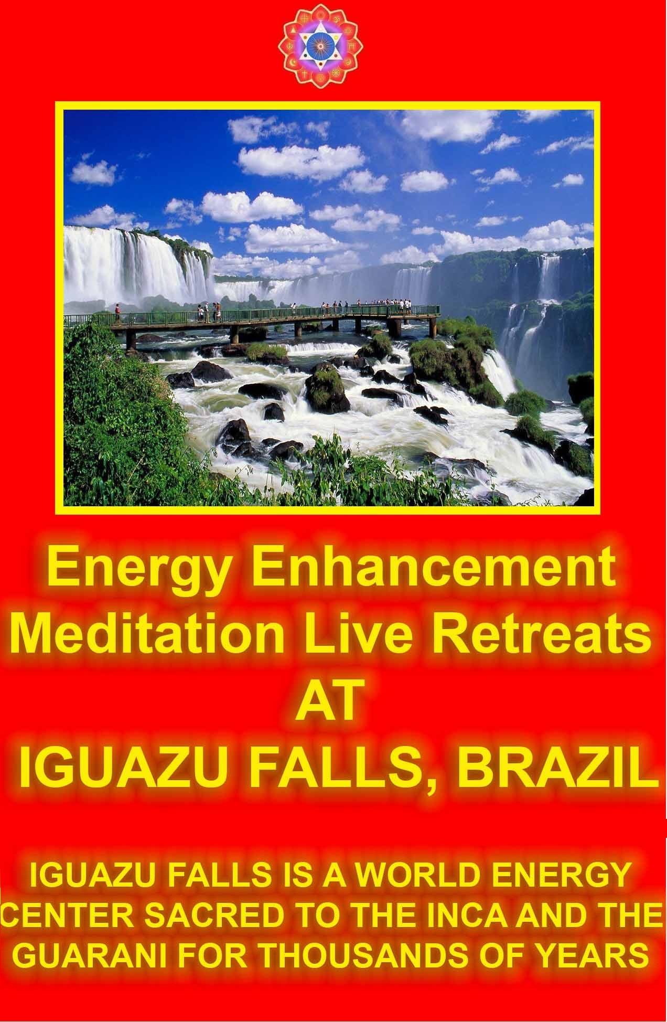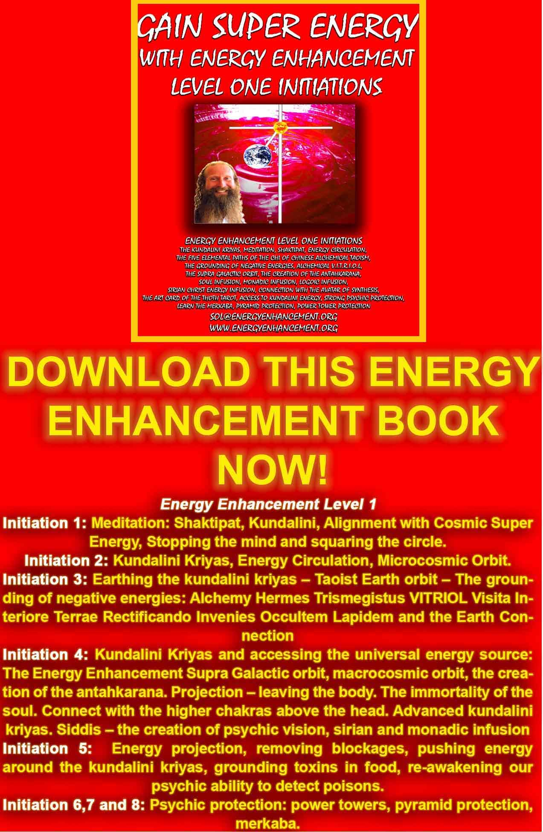
DOWNLOAD “GAIN SUPER ENERGY WITH ENERGY ENHANCEMENT LEVEL ONE INITIATIONS HERE!!!
http://www.energyenhancement.org/Sacred-Energy/Gain-Super-Energy-Energy-Enhancement-Level1-Initiations-Kundalini-Kriyas-Meditation-Shaktipat-Circulation-Taoist-Orbits-Alchemy-VITRIOL-Grounding-Psychic-Protection-Pyramid-Merkaba-energyenhancement-org.pdf
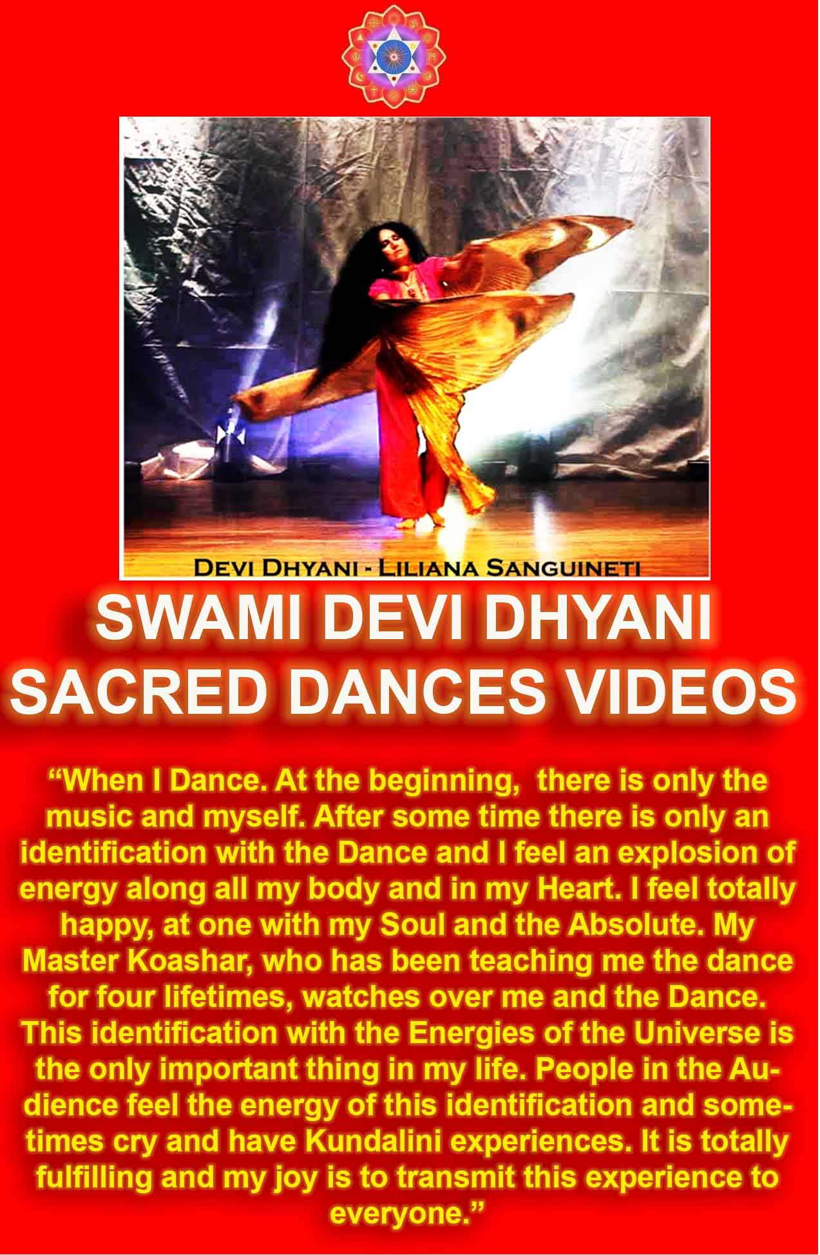THE SYNTHESIS OF LIGHT (SOL) BY SATCHIDANAND

ENERGY ENHANCEMENT COURSE
This work has been written with the aim of introducing the Techniques of Energy Enhancement to the world.

This New Course of Energy Enhancement is an Integration and improvement on Ancient Techniques over 5000 years old with the best track record of success in producing an acceleration in the Evolution of those partaking of them.

SPEED UP THE PROCESS OF EVOLUTION!

- Energy Enhancement Speeds UP the Process of Enlightenment.

- Stop the Trauma… Energy Enhancement teaches how to dissolve old trauma, the congealed painful energies called Negative Karmic Mass.

- More Energy - Less Sleep, More Vigour, More ability to do, speeding up of the Normal mind, connection with the source.

- The Grounding of Negative Energies and the Removal of Pain - No bodily Aches and Pains, No bad Memories, Stable Emotions, Full Breathing, A quiet Mind.

- Soul Fusion, Access to your Genius.- The Ability to Channel Information, Genius, Intuition and Infinite Energy more Creatively in your chosen field or Effort, the Path of your Life.

- The Mastery of Thoughtforms - The Removal of Energy Blockages Mastery of Bad and Good Habits.. The healing of all painful Inner Children. The ability to deal with all your Childish Strategies. The Channelling and Creation of Teaching Tools for the benefit of Humanity. The ability to Dissolve old Outmoded Thoughtforms.

- The Mastery of Energy Connections Between People.

- The Mastery of Relationships.- At peace with all your Relationships, through the removal of Energy Blockages and Shaktipat. Appreciation of the Good and Bad qualities of all, The Mastery of leaving and being left, the Mastery of Bereavement, The ability to come and Go, Complete Freedom.

COME LEARN THE ADVANCED TECHNIQUES OF ENERGY ENHANCEMENT, NOW!!

GAIN ENERGY APPRENTICE LEVEL1
YOU GET ALL THIS TO GAIN ENERGY IN LEVEL ONE OF ENERGY ENHANCEMENT...
MEDITATION, SHAKTIPAT, ENERGY CIRCULATION, THE KUNDALINI KRIYAS, THE FIVE ELEMENTAL PATHS OF THE CHI OF CHINESE ALCHEMICAL TAOISM, THE GROUNDING OF NEGATIVE ENERGIES,
ALCHEMICAL V.I.T.R.I.O.L, Visita Interiora Terrae Rectificando Invenies Occultem Lapidem – THE SECRET OF THE PHILOSOPHERS STONE WHICH TRANSMUTES BASE METAL – ENERGY BLOCKAGES – INTO PURE GOLDEN SPIRITUAL ENERGY AND ILLUMINATION. THE SUPRA GALACTIC ORBIT, THE CREATION OF THE ANTAHKARANA, THE ENERGY COLUMN OF CONNECTION BETWEEN HEAVEN AND EARTH. ACCESS THE CHAKRAS ABOVE THE HEAD WITH SOUL INFUSION, MONADIC INFUSION, LOGOIC INFUSION, SIRIAN ENERGY INFUSION, CONNECTION WITH THE AVATAR OF SYNTHESIS, THE ART CARD OF THE THOTH TAROT, ACCESS TO KUNDALINI ENERGY, STRONG PSYCHIC PROTECTION, LEARN THE MERKABA, PYRAMID PROTECTION, POWER TOWER PROTECTION.

THE ENERGY BLOCKAGE REMOVAL PROCESS LEVEL2
THE ELIMINATION OF ENERGY BLOCKAGES AND IMPLANTS WITH ADVANCED ENERGY BLOCKAGE BUSTING TECHNIQUES
THE SEVEN STEP PROCESS, THE REMOVAL OF THOUGHT-FORMS, THE REMOVAL OF IMPLANTS, THE REMOVAL OF ENTITIES, THE REMOVAL OF AURIC EGG BLOCKAGES, THE REMOVAL OF SHAME, GUILT, DISAPPOINTMENT, BEREAVEMENT, NEGATIVE EMOTIONS - ANGER, FEAR, WANTING SYMPATHY, MANIC, SADNESS, DEPRESSION, CHRONIC DEPRESSION, ENVY, JEALOUSY, THE DESIRE TO DO HARM. INCREASE YOUR EMOTIONAL IQ, CLEAR CANCER FROM THE DNA, THE REMOVAL OF BLOCKAGES FROM THE ANTAHKARANA, THE CHAKRAS IN THE BODY FROM CHAKRAS BELOW THE BASE CHAKRA AND ABOVE THE HEAD CHAKRAS, THE REMOVAL OF BLOCKAGES FROM PARTS OF THE BODY, THE REMOVAL OF BLOCKAGES FROM THE TIMELINE, THE KARMA CLEANING PROCESS, THE WOMB, THE PRIMAL SCREAM, CLEAN THE KARMA FROM ALL THE YEARS OF YOUR LIFE, CREATE GOOD LUCK, AND GOOD HEALTH.

ENERGY ENHANCEMENT COURSE SOUL SPLIT RETRIEVAL APPRENTICE LEVEL3

KARMA CLEANING PROCESS, CLEAN THE KARMA FROM PAST LIVES, FUTURE LIFE, FUTURE LIFETIMES, SOUL FRAGMENTATION AND RETRIEVAL, HOW TO STOP PSYCHOPATHIC ENERGY VAMPIRES, INNER CHILDREN, SELFISH EGO SUB PERSONALITIES, LIFE DESTROYING STRATEGIES, THE ALOOF, THE INTERROGATOR, THE VIOLATOR, THE SELFISH COMPETITIVE STAR, THE VAMP OR DON JUAN, THE PLEASER, THE BLAMER, THE CRITIC, THE KING, THE SELF DESTRUCTOR, REMOVE ALL THE DESTRUCTIVE VOWS FROM THIS AND PAST LIFETIMES, THE CREATION OF SELF LOVE, LOVE AND SERVICE.

ENERGY ENHANCEMENT COURSE – MASTER RELATIONSHIPS IN APPRENTICE LEVEL4

MASTER THE PSYCHIC ENERGY CONNECTION BETWEEN YOU AND ALL PEOPLE, THE SOUL CONNECTION, CREATE INCREDIBLE RELATIONSHIPS - THE KARMA CLEARING PROCESS WITH ALL YOUR RELATIONSHIPS, FRIENDS, FAMILY, MOTHER AND FATHER, REMOVE BLOCKAGES FROM FRIENDS AND FAMILY, GIVE ENERGY, HEAL BEREAVEMENT, IMPOTENCE, CLEAN THE TIES WHICH BIND, THE HIGHEST HEART, THE MASTERY OF ADDICTIONS - DRUGS, ALCOHOL, TOBACCO, SEX, FOOD, POWER, MONEY, HEAL THE WORLD, BECOME A MASTER, A MERLIN, A JEDI KNIGHT, A WHITE MAGICIAN.

THE STRATEGIES OF THE ENERGY VAMPIRE AND THE SPLIT MIND - MPD AND DID
Integration - Heart, Intelligence, Emotional IQ, Psychology, Creativity and EE Meditation
For thousands of years Yogis and Masters of Meditation have been talking about integration.
With integration comes all the benefits of a one pointed and focused mind, leading to higher ability and achievement, Higher Intelligence, Intellect, Emotional IQ, Communication, Creativity and Will Power.
As well as the integration of the energy centers of the body, the chakras through the removal of energy blockages, there is also an incredible integration of the separated selves, both of which come about through meditation.
Yogic theory says that your mind is like a distributed or parallel processing computer with many energy blockages, ego programs and sub-personalities wandering around in it. Ghosts in the Machine!
This is the reason why people are inconsistent, they tend to change their minds!
Now this is interesting, the idea, the theory that we are a collection of sub-personalities and in this work of integration, we are aiming to make one of the sub-personalities the strongest by absorbing and integrating all the lesser sub-personalities into it.
One strong integrated personality is more decisive and more successful than a hundred weak and aimless sub-personalities.
The first step in the process of integration is simply to examine the theory and literature on sub-personalities and then start to spot and notice the effects of sub-personalities in the people around you.
- First we have the literature on Sub-personalities. As well as the psychological books detailing abnormal multiple personalitied people, we also have literature on the softer and more normal symptoms of the pervasive nature of sub-personalities in everyone.

  - Paracelsus von Hohenheim (1490-1541) was the outstanding medical therapist of his time and, perhaps, the greatest mystic in the history of Western medicine. He devoted his life to research in the healing arts. Paracelsus visited Constantinople to acquaint himself with the secret practices of the Dervishes and the Sufis.
The invisible progeny of man include thought-forms and emotion- forms. These are like infants or inner children, especially in their beginnings, for they depend upon their creator for their nutrition and survival. Paracelsus noted that most elementaries or sub- personalities seem to be of an evil or destructive nature. They are generated from the excesses of human thought and emotion, the corruption of character, or the degeneration of faculties and powers which should be used in other, more constructive ways....
  - Gurdjieff "The person who says he will get up at 5 in the morning, is not the same person who throws the alarm clock out of the window!" Addictive and negative sub-personalities were part of the Gurdjieffian teaching, The Work, and indeed Gurdjieff cured many people of their most distressing symptoms.
"One of the basic principles explains the many and varied I's in a man. The unawakened man is not a unified person. He has dozens of selves within him, each falsely calling itself "me". The many I's within a man explains many mysteries about human nature. For example, a man decides to give up an undesirable habit, but the next day he repeats it again. Why? Because another entitiy sub personality, I, has taken over, an energy blockage that likes the habit and has no intention of giving it up."
  - Eric Berne of Transactional Analysis, and his book, "The Games People Play". Forty years ago, Games People Play revolutionized our understanding of what really goes on during our most basic social interactions. More than five million copies later, Dr. Eric Bernes classic is as astonishingand revealingas it was on the day it was first published.
  - Jung, and his Archetypal sub-personalities.
  - Dame Alexandra-Neel worked with sub-personalities and Thought-Forms in Tibet and reported on her experiences in her autobiography.
  - Hubbard - those beings or entities, energy blockages or "body thetans" ("BTs") that are located in the body or around the body are inhabiting various things, like a body part - a bone, arm, cell, or they are a particular sub-personality, or condition, such as "TV watcher," or "fear," or "worker," or "solitary angry man," and so on.

"People get confused as to who they are and who they are not. A person hears these voices or feels desires, and so on, and thinks he is the source of them. Yet, you are not necessarily the originator of these thoughts or impulses. So, by identifying who is the source of these vocalizations or impulses and spotting where it is located and removing it, you are freed to think for yourself."
  - Many philosophers, including George Santayana and David Hume, have also observed how a person switches constantly from one I to another.
- Sub-personalities in people are created to make them weaker. The younger we are, the more we are affected by physical and emotional shocks to the system, traumas which create negative emotions, anger and sadness are caused by energy blockages. These traumas split off the ego programs into Inner Children Sub- Personalities who sabotage your life thereafter.
- Then we have the symptoms of sub-personalities in all people. The inner child archetypes of the attention seeking energy vampires, - the poor me, the violator, the selfish competitive star, the seducer, the tyrant, the pleaser, the critic and many more games that people play, which have been written about in many articles.
- Then we have the advanced meditational technology to integrate the sub-personalities and become more creative and successful. And even meditation is not enough, now we need real Meditative Progress, a Speeding up of the Process of Meditation through Advanced Meditational Techniques.
The Kundalini Kriyas, the Grounding of Negative Energies, Opening the Heart Center, Soul Fusion and the Seven Step Process will integrate you and give real results of Integration - evolution, coherence, alignment and progress in our lives and in the lives of everyone in the World, FAST!!
Meditation and Energy Enhancement which teaches Twenty Seven Ancient and Effective techniques Beyond Simple Meditation to Speed Up the Meditative Process will progressively increase Energy, Intelligence and Will.
Satchidanand, Director of Energy Enhancement, is one of the leading teachers of Meditation.!

Energy Enhancement and Emotional IQ
You can heal all inner sub-personalities, split personalities and remove the destructive strategies from your life by absorbing them back into the central soul personality.
The Correct use of the Strategies
Once, through the use of an Ancient Advanced Synthesis of Effective Techniques, the Energy Blockages of the sub-personalities or strategies like the poor me and the violator or the selfish competitive star within the body have been removed, it is possible to consciously choose to use the Strategies to teach, to test, or just to get things done for a good cause.
I remember seeing my spiritual master, Swami Satchidananda test out a Yogi one day. He came asking him to sign a piece of paper saying that he personally knew him as a good Yogi. At this Swami became very angry, "You want Me to sign this?!!!" and he started on a very long diatribe. At the time I was trying to deal with my Violator. And this Anger was making me feel very uncomfortable.
As within, So without. We only get upset at that which we also have inside. Otherwise, why get upset? If one finger points, there are always three fingers pointing backwards!!
IT IS ONLY THE EGO WHICH GETS HURT!!
So I interposed myself. I asked a question of Swami in mid flow of his anger. He calmly turned towards me and answered my question with great sweet patience as you would to a child. "Are you satisfied with my answer?" "Yes Swami." He then turned to the Yogi and laid into him verbally, again.
It is through experiences like this, that we see what it is possible to do with a large emotional IQ. And what is necessary to do.
We do not get angry with children, and yet it is necessary sometimes to act angriness, so that we can appropriately exercise them in a strong NO!! Better that a parent gently give a child boundaries. Stop them becoming a spoiled brat. Than the Universe say NO!!, to them when they are older, when they can become completely crushed by some hard thing, - bereavement or their girlfriend leaving them, perhaps. (an Ancient Advanced Synthesis of Effective Techniques gives techniques to totally stop the pain of bereavement)
We need to develop a strong emotional IQ.

An Ancient Advanced Synthesis of Effective Techniques will Remove Strategies and Negative Emotions, and the creation of a strong Emotional IQ!!
We see people working out in the Gym to get very big muscles, to get very strong. And yet, If you say anything bad about these people, they will get uncontrollably angry and chase you around the Gym. Or they will swear undying vengeance and become your mortal enemy.
They are not mentally or emotionally strong.
The removal of the Energy Blockages of the Strategies and the Negative Emotions can give you this mental and emotional strength.
An Ancient Advanced Synthesis of Effective Techniques Will Give You A Large, Stronger Emotional IQ
It needs an Ancient Advanced Synthesis of Effective Techniques for Gaining More Energy - Meditation, Shaktipat, Energy Circulation, The Kundalini Kriyas, The Five Elemental Paths Of The Chi Of Chinese Alchemical Taoism, The Grounding Of Negative Energies, V.I.T.R.I.O.L, The Art Card Of The Thoth Tarot, Access To Kundalini Energy, Strong Psychic Protection, Learn The Merkaba, Pyramid Protection, Power Tower Protection, Create The Antahkarana, Soul Fusion, Monadic Infusion, Logos Infusion. The Painless Removal Of Stress, Trauma And Negative Emotion
Leading onto the more advanced Techniques of The Karma Clearing Process. Karma Cleaning Process, Learning how to clean The Karma From Past Lives, Future Life, Future Lifetimes, Integrating Soul Fragmentation And Retrieval of Inner Children, Selfish Ego Sub Personalites, Life Destroying Strategies, The Aloof, The Interrogator, The Violator, The Selfish Competitive Star, The Vamp Or Don Juan, The Pleaser, The Blamer, The Critic, The King, The Self Destructor, All The Destructive Vows From This And Past Lifetimes,.
Which results in The Creation Of Self Love, Love And Service.
Please do not just accept what is said above. This is our experience, but you will need to look more deeply into it for yourself.
Ponder on it
Director Satchidanand, is one of the leading teachers of Meditation.
He helps people worldwide reach further than they EVER thought possible, FASTER!!!

Satchidanand's Movie Reviews
DOWNLOAD BELOW
http://www.energyenhancement.org/Spiritual-Movie-Reviews/Energy-Enhancement-spiritual-esoteric-movie-reviews-by-Satchidanand.pdf

http://www.energyenhancement.org/Spiritual-Movie-Reviews-Satchidanand/Index.html

Energy Enhancement Spiritual Movie Reviews Book - Volume 1 by Satchidanand Immortalises the Kundalini Energy which Radiates from Satanically Blacklisted by the Dark Side - Movies like..
King Arthur - Legend of the Sword The Story of Enlightenment - by Guy Ritchie - a Movie Review by Satchidanand
Karma and Anti-Satanism in the Spiritual Actor, Keanu Reeves movies, "John Wick (2014)" also "Man of Tai Chi (2013)"
John Wick Ch 2 - Is Donald Trump and Alex Jones of Infowars - The Spiritual Warrior - Finger of God - Removes Satanic Demons, Deletes the Elite, Cleans the Swamp - Move Witch, Get out the Way!
Doctor Strange - Psychic Warrior Earth Protector..
Logan - "Beware Of the Light" Esoteric Movie Review by Satchidanand
And Much Much More..
Energy Enhancement Spiritual Movie Reviews Book - Volume 1 by Satchidanand

Energy Enhancement Meditation and the Ego Strategies of the Violator, Interrogator, and the Star
These Strategies are where separate intelligences are split off from the central stem of your Soul and are Archetypes created and used by the Hurt Inner Children.
Hurt Inner Children split off from the Central Soul personality when the person gets traumatised by the painful and corrupt actions of life.
These Hurt Inner Children flow in and out of your consciousness and it is these split personalities which use the Strategies like the Violator, the Poor Me and the Selfish Competitive Star in order to get the attention and the Love of everyone around them.
The problem is that these ego strategies always hurt the people around them. Eventually they stop working and the people around them throw them out. With ego strategies, if you are rich everyone puts up with them, their job depends on it, but no-one likes them.
Without someone pointing out the discrepancies in your behaviour, you probably will not notice them..
As Gurdjieff said, "The person that says I will get up early in the morning is not the same personality who throws the alarm clock out of the window!!."
As the False Negative Emotions of Anger, Manicism, Seeking Sympathy and Attention, Depression and Fear are Eliminated, Emotional Integration with the Intelligence results in Willpower and the Power of Doing.
This higher functionality is the result of healing these Strategies! The Interrogator Strategy
This one is always asking questions to get your attention. It is the forerunner of the Violator Strategy because it is so invasive. The Interrogator does not want the answer, all it wants is your attention and your energy.
The Violator Strategy
Further than the interrogator and the star, this person uses powerful hurtful means to get your attention and energy. Verbal

abuse, Physical abuse. Rape. A Violator needs the acquiescence of a Poor Me in order to create the energy sucking polarity he craves.
A good violator will use this technique to break blockages and generally test out your emotional state
One of my favourite Strategy Jokes... Masochist, "Beat me, Beat me!" Sadist, "NO!!!!"
Remember the Vampiric Strategy Sub-Personality does not care one jot about its host, YOU!!
The SELFISH COMPETITIVE STAR STRATEGY.
By asking questions or telling jokes. "Daddy, look, I got ten out of ten at school today!" There are many ways to be a star. But ask yourself why they are doing it? If all they want is attention. If they have no selfless inner purpose. Then this is just another selfish strategy, developed when they were a child, to gain your attention.
Further, in extremis the star becomes a jealous and vindictive tyrant. They try to destroy all competition.
As Gengis Khan said,- "It is not enough that I succeed, everyone else must fail." These stars become surrounded by many poor me's who need help so that the Star can be seen to be "Generous" and people who say "Yes". These people will confirm you as a Star. They are no Competition, No Threat.
However if a Bad Star sees someone as competition, then they will try to destroy that person by saying bad things about them.
Destroying their reputation and in extremis, killing them.
Stalin was said to be always asking if the people around him were geniuses. If he thought they were a genius, a threat to his ego and his power, then they would "disappear" and end up dead in a concentration camp, a Gulag in Siberia.
Stars always want to teach and never to learn. They are not good students, not respectful of the teacher or the teachings, always competing and thus never learning or just being.
Once the Star has been healed of all its negative energy on the Meditation Energy Enhancement Course, then it can become a Good Star!!
A Good Star encourages all people to become stars. It does not see anyone as competition because it understands that this world to evolve, it needs everyone to become a strong personality, evolved and creative.
Every Man and Woman is a STAR!!

All the inner child and its strategy cares about is to perform its robotic programmed function of gaining attention and love and energy from everyone around them. The Strategies of the Vampire.
However, to remove these sub-personalities completely, the more Advanced techniques of a Synthesis of Ancient Meditational Techniques are absolutely necessary:-
It needs an Ancient Advanced Synthesis of Effective Techniques for Gaining More Energy - Meditation, Shaktipat, Energy Circulation, The Kundalini Kriyas, The Five Elemental Paths Of The Chi Of Chinese Alchemical Taoism, The Grounding Of Negative Energies, V.I.T.R.I.O.L, The Art Card Of The Thoth Tarot, Access To Kundalini Energy, Strong Psychic Protection, Learn The Merkaba, Pyramid Protection, Power Tower Protection, Create The Antahkarana, Soul Fusion, Monadic Infusion, Logos Infusion. The Painless Removal Of Stress, Trauma And Negative Emotion
Leading onto the more advanced Techniques of The Karma Clearing Process. Karma Cleaning Process, Learning how to clean The Karma From Past Lives, Future Life, Future Lifetimes, Integrating Soul Fragmentation And Retrieval of Inner Children, Selfish Ego Sub Personalites, Life Destroying Strategies, The Aloof, The Interrogator, The Violator, The Selfish Competitive Star, The Vamp Or Don Juan, The Pleaser, The Blamer, The Critic, The King, The Self Destructor, All The Destructive Vows From This And Past Lifetimes,.
Which results in The Creation Of Self Love, Love And Service. Ponder on this
Director Satchidanand, is one of the leading teachers of Meditation.
He helps people worldwide reach further than they EVER thought possible, FASTER!!!



Energy Enhancement Meditation and the Psychology of Ego Strategies of the Aloof and the Poor Me
These psychological ego Strategies arise where separate intelligences are split off from the central stem of your Soul and are Archetypes created and used by the Hurt Inner Children
Hurt Inner Children split off from the Central Soul personality when the person gets traumatised by the painful and corrupt actions of life.
These Hurt Inner Children flow in and out of your consciousness and it is these split personalities which use the Strategies like the Violator, the Poor Me and the Selfish Competitive Star in order to get the attention and the Love of everyone around them.
The problem is that these psychology ego strategies always hurt the people around them. Eventually they stop working and the people around them throw them out.
With ego strategies, if you are rich everyone puts up with them, their job depends on it, but no-one likes them.
Without someone pointing out the discrepancies in your behaviour, you probably will not notice them...
As Gurdjieff said, "The personality that says I will get up early in the morning is not the same personality who throws the alarm clock out of the window!!"
This is the psychology of the split personality!
As the False Negative Emotions of Anger, Manicism, Seeking Sympathy and Attention, Depression and Fear are Eliminated, Emotional Integration with the Intelligence results in Willpower and the Power of Doing.
This higher functionality is the result of healing these Strategies! The Aloof Strategy
When we remain quiet as a child, then our mothers often ask if there is a problem. The psychological strategy has worked! We have caught the attention, the energy, the love of our mothers. Because of this people remain quiet and show no love at inappropriate times, simply because this strategy worked once.
The aloof use this psychological strategy to gain attention. Once we had a client who used to constantly travel around the world in order to remain aloof from his family and create food for themselves and eat it separately. It certainly got their attention!!
Also the aloof psychology can work in combination with the Star. Once we had a client who preferred to eat alone rather than eat with others. The star made wonderful food which it used in order to remain aloof.
The Poor me Strategy

Further than the aloof strategy the Poor Me gains energy by being sad or sick and by moaning and complaining.
Many people say that doctors surgeries are places where people compete for who had the worse things that happened to them. The combination of the Poor me and the Star.
They have some investment in always remaining sick, and that is because it gets the attention of all the people around them.
As people get sick of their constant moaning the poor me strategy begins to fail to get attention, as all of these strategies eventually fail. Then something stronger is needed in order to gain the attention and the POOR ME becomes an amputee, Alcoholic or a Drug Addict.
They are so sad that one feels guilty to be happy in their presence. Needless to say, this childish personality will do anything, hurt or even kill themselves to gain your attention and your Energy!
And if that does not work the Poor Me always flips into the Violator Strategy in order to get attention. Ignore them and they get Very Very Angry!!! This is the origin of many Bi-polar Disorders.
Remember the Vampiric Strategy Sub-Personality does not care one jot about its host, YOU!!
All it cares about is to perform its robotic programmed function of gaining attention and love and energy from everyone around them. The Strategies of the Vampire.
However, to remove these sub-personalities completely, the more Advanced techniques of a Synthesis of Ancient Meditational Techniques are absolutely necessary:-
It needs an Ancient Advanced Synthesis of Effective Techniques for Gaining More Energy - Meditation, Shaktipat, Energy Circulation, The Kundalini Kriyas, The Five Elemental Paths Of The Chi Of Chinese Alchemical Taoism, The Grounding Of Negative Energies, V.I.T.R.I.O.L, The Art Card Of The Thoth Tarot, Access To Kundalini Energy, Strong Psychic Protection, Learn The Merkaba, Pyramid Protection, Power Tower Protection, Create The Antahkarana, Soul Fusion, Monadic Infusion, Logos Infusion. The Painless Removal Of Stress, Trauma And Negative Emotion
Leading onto the more advanced Techniques of The Karma Clearing Process. Karma Cleaning Process, Learning how to clean The Karma From Past Lives, Future Life, Future Lifetimes, Integrating Soul Fragmentation And Retrieval of Inner Children, Selfish Ego Sub Personalites, Life Destroying Strategies, The Aloof, The Interrogator, The Violator, The Selfish Competitive Star, The Vamp

Or Don Juan, The Pleaser, The Blamer, The Critic, The King, The Self Destructor, All The Destructive Vows From This And Past Lifetimes,.
Which results in The Creation Of Self Love, Love And Service. Ponder on this..
Director Satchidanand, is one of the leading teachers of Meditation.
He helps people worldwide reach further than they EVER thought possible, FASTER!!!

Energy Enhancement Meditation, the Pleaser, Blamer, Vamp, Tyrant, Self Destructor Manic Depression
These Strategies are where separate intelligences are split off from the central stem of your Soul and are Archetypes created and used by the Hurt Inner Children.
Hurt Inner Children split off from the Central Soul personality when the person gets traumatised by the painful and corrupt actions of life.
These Hurt Inner Children flow in and out of your consciousness and it is these split personalities which use the Strategies like the Violator, the Poor Me and the Selfish Competitive Star in order to get the attention and the Love of everyone around them.
The problem is that these ego strategies always hurt the people around them. Eventually they stop working and the people around them throw them out. With ego strategies, if you are rich everyone puts up with them, their job depends on it, but no-one likes them.
Without someone pointing out the discrepancies in your behaviour, you probably will not notice them...
As Gurdjieff said, "The person that says I will get up early in the morning is not the same personality who throws the alarm clock out of the window!!"
As the False Negative Emotions of Anger, Manicism, Seeking Sympathy and Attention, Depression and Fear are Eliminated, Emotional Integration with the Intelligence results in Willpower and the Power of Doing.

This higher functionality is the result of healing these Strategies!
The Don Juan or Vamp Strategy
We have all heard of the town bicycle who is ridden by everyone. Well, because of this need for Love and Attention. Because we are afraid of people leaving us so that we leave them first. Because of the very strong Psychic Energyual connection and the energy flows it can create - it takes very strong energies to draw a soul down from heaven. This strategy is a wonderful egotistical method for both men and women to vampirise the energies of people they meet.
Pleaser Strategy
Because they want your love, they will put aside their wants and even their justifiable needs, and try to please you. They will have no personality of their own except that which wants to please. They will be happy or sad depending upon whether you have been pleased.
However, they will make you dependant upon them. they will engage your attention more and more. They become inescapable. They mutate into a Tyrant!
The Blamer Strategy
It’s all your fault. There are only two of us here and it can't be me who is wrong. It must be you!!!
The Critic Strategy
Like the interrogator this intellectual strategy gets off on criticising everything to get your energy and attention. Yet the critic even criticises himself.
The Tyrant Strategy
All of the strategies in the end are tyrants who want, need and even demand your attention.
All they want is your attention. They will get your attention in many destructive and self destructive ways
The Self Destructor Strategy
This one is the Big Daddy of them all. The Controlling Archetype of all of the Strategies. All of them lead to self destruction because they are the major part of the Desire-filled, wanting, vampire ego.

Manic Depression
The Poor Me and the Violator usually flip from one to the other and back again within one body. If you have one Strategy, then soon you will flip to the other side.
We see many Poor Me's. All of them are capable of becoming the violator in a trice.
However, to remove these sub-personalities completely, the more Advanced techniques of a Synthesis of Ancient Meditational Techniques are absolutely necessary:-
It needs an Ancient Advanced Synthesis of Effective Techniques for Gaining More Energy - Meditation, Shaktipat, Energy Circulation, The Kundalini Kriyas, The Five Elemental Paths Of The Chi Of Chinese Alchemical Taoism, The Grounding Of Negative Energies, V.I.T.R.I.O.L, The Art Card Of The Thoth Tarot, Access To Kundalini Energy, Strong Psychic Protection, Learn The Merkaba, Pyramid Protection, Power Tower Protection, Create The Antahkarana, Soul Fusion, Monadic Infusion, Logos Infusion. The Painless Removal Of Stress, Trauma And Negative Emotion
Leading onto the more advanced Techniques of The Karma Clearing Process. Karma Cleaning Process, Learning how to clean The Karma From Past Lives, Future Life, Future Lifetimes, Integrating Soul Fragmentation And Retrieval of Inner Children, Selfish Ego Sub Personalites, Life Destroying Strategies, The Aloof, The Interrogator, The Violator, The Selfish Competitive Star, The Vamp Or Don Juan, The Pleaser, The Blamer, The Critic, The King, The Self Destructor, All The Destructive Vows From This And Past Lifetimes,.
Which results in The Creation Of Self Love, Love And Service. Ponder on this
Satchidanand, Director of Energy Enhancement, is one of the leading teachers of Meditation.!

He helps people worldwide reach further than they EVER thought possible, FASTER!!!

Energy Enhancement and the Use of Life Experience and Stress to Remove Bad Behaviours
The use of life experiences to notice and remove the bad behaviours caused by hurt Inner Children and the ego Strategies which are based on the inner children
Hurt Inner Children caused by childhood pain and Traumatic experiences flow in and out of your consciousness and it is these split personalities which use the Strategies like the Violator, the Poor Me and the Selfish Competitive Star in order to get the attention and the Love of everyone around them.
The problem is that these ego strategies always hurt the people around them. Eventually they stop working and the people around them throw them out. With ego strategies, if you are rich everyone puts up with them, their job depends on it, but no-one likes them.
Without someone pointing out the discrepancies in your behaviour, you probably will not notice them..
As Gurdjieff said, "The person that says I will get up early in the morning is not the same personality who throws the alarm clock out of the window!!."
As the False Negative Emotions of Anger, Manicism, Seeking Sympathy and Attention, Depression and Fear are Eliminated, Emotional Integration with the Intelligence results in Willpower and the Power of Doing.
This higher functionality is the result of healing these Strategies!
The Strategies are the Poor Me, The Violator, The Selfish Competitive Star, The Aloof, The Interrogator, The Don Juan or the Vamp, The Pleaser, Blamer, Critic, Tyrant and Last but not least, the Self Destructor!
The weaker inner children sub-personalities are very easy to remove, yet it sometimes needs stress pressure which is always occurring in life in order to get the more intelligent Soul Split inner children to show themselves.
Thus the Master Gurdjieff using alcohol as toasts at his table in order to see deeply into the Inner Children of his students... In Vino Veritas, which means, In Wine the Truth comes out. However, once

noticed then it is extremely easy to remove all the inner children using the Advanced Techniques of Energy Enhancement.
What this means is that during therapy sometimes one or two blockages escape. Also, it is a fact that we absorb blockages from our surroundings, quite normally. So, we need to take responsibility for that.
We need to notice when we become emotional and over the top. When we have negative emotions because these are the symptoms which tell us when we need to use the Ancient Advanced Synthesis of Effective Meditation Techniques to remain blockage free.
In Extremis, these fractures or splits are one of the reasons for Manic depression and schizophrenia, but most people are bothered by them to a smaller extent.
As you remove these inner children, One by One, you gain even more energy because you free up the energy which was repressed by holding in all of their painful memories.
As you do this so you overcome anything which can stop the natural flow of your energy. Your energy flows on, never to be stopped. It becomes a Cornucopia, an ever overflowing cup of energy which can never be emptied.
"My cup is full and runneth over."
It needs an Ancient Advanced Synthesis of Effective meditation Techniques for Gaining More Energy - Meditation, Shaktipat, Energy Circulation, The Kundalini Kriyas, The Five Elemental Paths Of The Chi Of Chinese Alchemical Taoism, The Grounding Of Negative Energies, V.I.T.R.I.O.L, The Art Card Of The Thoth Tarot, Access To Kundalini Energy, Strong Psychic Protection, Learn The Merkaba, Pyramid Protection, Power Tower Protection, Create The Antahkarana, Soul Fusion, Monadic Infusion, Logos Infusion. The Painless Removal Of Stress, Trauma And Negative Emotion
Leading onto the more advanced Techniques of The Karma Clearing Process. Karma Cleaning Process, Learning how to clean The Karma From Past Lives, Future Life, Future Lifetimes, Integrating Soul Fragmentation And Retrieval of Inner Children, Selfish Ego Sub Personalites, Life Destroying Strategies, The Aloof, The Interrogator, The Violator, The Selfish Competitive Star, The Vamp Or Don Juan, The Pleaser, The Blamer, The Critic, The King, The Self Destructor, All The Destructive Vows From This And Past Lifetimes,.
Which results in The Creation Of Self Love, Love And Service.
Please do not just accept what is said above. This is our experience, but you will need to look more deeply into it for yourself.

Ponder on it
Director Satchidanand, is one of the leading teachers of Meditation.
He helps people worldwide reach further than they EVER thought possible, FASTER!!!

EE Meditation, Shaman + Integrated Soul Personality, Fragmentation, MPD + DID, Psychology; Pt 1 of 3
There is in every person the possibility of an integrated Soul Personality. However, normally the average person is split to a greater or lesser degree, dependent upon the amount of pain, trauma and undigested stress in their lives and dependent upon the amount of work they have done to integrate their personalities by means of therapy and meditation.
Therapy and psychology allow intellectual appreciation of the problem in ourselves and others. It takes meditation to heal the splits and integrate the separated selves.
Charles Tart and others have used the symbology of the very nature of cyberspace as acting as a sort of "universal solvent" to break up our long cherished notions, myths that everyone is a monolithic self.
The ease with which we can take on new Split Personalities and new connectivities in the virtual domain implies an average self which is multivalent, fluid and de-centered-- a self which often operates in parallel, in different modalities and different capacities.
I propose that a model for the average unintegrated person, this new, postmodern, postrationalist, cyberspatial self can be found in the cluster of psychological manifestations currently known as Splitting - or Dissociative Identity Disorder (DID), and formerly and more popularly as Multiple Personality Disorder (MPD).
But I also propose that Shamen and Enlightened Saints have provided a higher model of Personality integration in the concept of the Soul Infused Personality and integration with the Higher Self.
The average person lives in a more or less completely self- constituted world, where fragments of personality are imbedded in

a matrix of delusional projections. It is a world where inner-driven states are substituted for any kind of consensual reality, and a world where it is almost meaningless to talk about having "personality" at all.
The task of Deleuze and Guattari's happy schizophrenic is to harness this condition of non-referentiality to the use of forging a new kind of self, in an essentially linguistic transformation, free of the moral and psychological despotism of Modernism.
Schizophrenia is very different from normal and average Splitting only in degree.
The concept of dissociation
The concept of Multiple Personalities has evolved over not just centuries, but millennia, and throughout cultures as varied as nomadic hunter gatherers of the sub-arctic to contemporary industrial societies. At its core, this concept involves the inherent capacity of the human psyche to dissociate or split.
Colin Ross defines dissociation quite simply: "Dissociation is the opposite of association...For definitional purposes the psyche may be reduced to a collection of elements in complex relationships with each other. Psychic elements include thoughts, memories, feelings, motor commands, impulses, sensations, and all the other constituents of psychic life. Any two psychic elements may be more associated ... or relatively isolated and separate, which is to be dissociated." (Ross, 1997, p 116).
Dissociation is an important factor in normal psychological functioning, allowing for a degree of mutability and adaptability which would be impossible without it. In the absence of healing the painful event causing the split personality it is true that the only option of the average person is to have amnesia of the causing event which again causes all these symptoms.
It is probably best to think of dissociation on a steadily worsening continuum of split personality symptoms, from ordinary daydreaming, through such phenomena as forgetting where one is going on the freeway, to the particularly florid manifestations of dissociation which are commonly labeled as Multiple Personality. Although the phenomenon is usually thought of as purely psychological in nature, it can actually be either biologically or psychosociologically driven, as given by Ross (Ross, 1997, p 116):
Symptoms of the Split Personality 1.Normal biological dissociation-- Forgetting that you got up in the night to go to the bathroom.
2.Normal psychosocial dissociation-- Daydreaming during a boring lecture. 3.Abnormal psychosocial dissociation-- Amnesia for incest.

4. Abnormal biological dissociation-- Amnesia following a concussion.
An integrated soul personality is always there, solid, not lost or daydreaming.
These biological aspects of dissociation reinforce the notion that it is an entirely normal process in the average person.
Dissociation due to encapsulated pain is the only resort of the psyche which does not have the ability, through meditation to ground and heal that encapsulated pain or energy blockage.
Grounding the encapsulated trauma and pain centered in an energy blockage will obviate the necessity for the split and indeed heal any split which has occurred.
Shamen and the Guru as trained Healers. The earliest known references to dissociative phenomena are to be found in Neolithic cave paintings, in which Shamen can be seen entering into dissociated parts of their clients symbolised as animals and spirits. Jung used a similar methodology.
In fact, throughout the long march of what we call pre-history, such integrated psychic power abilities had great survival value, by enabling a connection with the interior worlds of spirits and animals, with which split humans coexisted. Persons adept at such entering the psyche of the split client for the purposes of integration were given positions of considerable power and respect in "primitive" societies.
Shamen and the enlightened, though, always had the ability to enter, heal and then come back. Split Personalities are lost, they are still searching for the road home, searching for Integration and healing.
The shamanistic tradition has survived almost to the present day in the circumpolar regions of Asia and North America, and study of these cultures provides our best view of how shamanism operated over tens of thousands of years so it is illustrative to examine this incredibly ancient and successful tradition.
Most shamen, as near as can be determined, seemed to be healthy and not suffering from mental disorders. They were integral members of their societies and often went through long periods of training to become adept, all of which argue against any sort of pathological component to their craft. The Shamen of the far north rarely, if ever, used hallucinogenic plants, relying instead exclusively on self-hypnosis and meditation. They were, in effect, rigorously trained professional psychics, priests who functioned

variously as weather forecasters, doctors and conveyors of the oral tradition.
An example of the training given to Shamen is available in a 5000 years old text called, "The Yoga Sutras of Patanjali." In there a meditational methodology for integration with the soul has been extant for millennia. However, always the Guru Shaman who has walked the path was considered essential to the process of soul integration.
The healer, Shaman, Enlightened through much training, always have the ability to come back to themselves, to re-integrate after helping the integration of a client.
However, the cure for split personality for everyone is integration of the splits by grounding all the negative energy created by traumatic experiences which sustains the splits. As we ground all the negative energy through meditation, so the splits disappear and one integrated soul personality becomes in charge..
Start your integrative Process by learning how to meditate and then speed it up with the advanced techniques of Energy Enhancement based upon the thousands of years old ancient effective techniques of Taoism, The Kundalini Kriyas, The five elemental circulations of the Qi of Chinese Alchemical Taoism, The Guided Meditation of the Emerald tablet of Hermes Trismegistus encapsulated in VITRIOL and The Yoga Sutras of Patanjali.
Satchidanand, Director of Energy Enhancement, is one of the leading teachers of Meditation!

EE Meditation, Shaman + Integrated Soul Personality, Fragmentation, MPD + DID, Psychology; Pt 2 of 3
There is in every person the possibility of an integrated Soul Personality. However, normally the average person is split to a greater or lesser degree, dependent upon the amount of pain, trauma and undigested stress in their lives and dependent upon the amount of work they have done to integrate their personalities by means of therapy and meditation.

Therapy and psychology allow intellectual appreciation of the problem in ourselves and others. It takes meditation to heal the splits and integrate the separated selves.
Colin Ross (Ross, 1997) lists 11 dissociative features of the Shamen work, and relates each to Dissociative Identity Disorder or Splitting. These parallelisms are worth mentioning here, as they further ground the experiences of Split patients in a milieu that is pathological by reference to the abilities of Shamen which are integrated and real:
Structured, Meaningful Hallucinations-- Shamen deliberately induced special states of being, in which they could communicate with other realms of being, such as the spirit and animal worlds, symbols of the split off parts of the client, the subconscious and the Unconscious. The Shamen induced these states so that they could access the split off parts of the client and heal them, thus also giving the client the ability to access unconscious parts other processes cannot reach.
Trance States-- Trance states through meditation were essential prerequisites for communication with the split parts of their clients, out of body experiences, possession, etc. Split patients frequently enter trance. One of the major diagnostic criteria for Splitting is ease of hypnotizability. As people evolve, they get more ability to easily enter meditative states which precede integration of the split parts. However, although they find it easy to enter these states, integrated Shamen always have the ability to return, unlike their unintegrated split patients who are lost.
Hypnotic Anesthesia-- Such Shamanic super abilities as walking naked in the arctic winter, holding hot objects, and self-piercing indicate hypnotic anesthesia. Split patients often report anesthesia and amnesia for the pain of abuse, or self-inflicted pain.
Symbolic Dreams-- Shamen' dreams and meditations were often lucid and directed at finding and conveying information about the clients split parts to the real world of the client. Once buried information is acknowledged it becomes available for being grounded and healed. Jung accessed the split parts of his clients using this method so that he could integrate them. The psyche of the Split patient usually tries to spontaneously heal itself through dreams which often involve conveying information about past abuse which has been forgotten through amnesia. Once acknowledged by the waking personality it helps to organize the personality system or leads onto accessing other buried information for the waking personality.

Ritual Dismemberment-- Often initiation as a shaman involved ritual dismemberment analogous to death, as a symbol of spiritual fragmentation of the many split personalities within. The Shaman must have the ability to split and then integrate himself before attempting to integrate other people. Normally Shamen were trained by other Shamen although spontaneous Integration also occurred. Only when the apprentice Shaman had Integrated and healed all his splits into the Integrated Soul personality was he strong enough to attempt to heal others. It takes a strong sense of the Higher Soul Infused Personality to be able to enter into the various unintegrated parts of the personality and then return as it is easy to get lost. Split patients have, by definition, undergone dismemberment of the self as a strategy for survival, essentially they are lost.
An example of the training given to Shamen is available in a 5000 years old text called, "The Yoga Sutras of Patanjali." In there a meditational methodology for integration with the soul has been extant for millennia. However, always the Guru Shaman who has walked the path was considered essential to the process of soul integration.
As can be seen from this list of correspondences, there is much commonality between the "professionally" achieved and culturally approved meditative states of the sub-arctic shaman, and the dissociative states of the split patient. Split patients are usually more highly evolved than the average person as their amnesia is starting to slip. They have more psychic ability, more meditative ability, more hypnotizability.
Normal people do not have the ability to know that they are split, they think they are perfect. The symptoms of splitness need to be pointed out to normal average people before they can overcome the paradigm of not understanding that they are not yet integrated, they are split too…
This is an Introduction to Split Personality from many works of Psychology and the Shaman as Trained Healer and personality Integrator… Later I hope to complete the work in 1. The concept of universal dissociation. 2. Multiple personalities, MPD. 3. The Integrated Soul Personality and Energy Enhancement Meditation.
The healer, Shaman, Enlightened through much training, always have the ability to come back to themselves, to re-integrate after helping the integration of a client.
However, the cure for split personality for everyone is integration of the splits by grounding all the negative energy created by traumatic experiences which sustains the splits. As we ground all the negative

energy through meditation, so the splits disappear and one integrated soul personality becomes in charge...
Start your integrative Process by learning how to meditate and then speed it up with the advanced techniques of Energy Enhancement based upon the thousands of years old ancient effective techniques of Taoism, The Kundalini Kriyas, The five elemental circulations of the Qi of Chinese Alchemical Taoism, The Guided Meditation of the Emerald tablet of Hermes Trismegistus encapsulated in VITRIOL and The Yoga Sutras of Patanjali.
Satchidanand, Director of Energy Enhancement, is one of the leading teachers of Meditation!

EE Meditation, Shaman + Integrated Soul Personality, Fragmentation, MPD + DID Psychology; Pt. 3 of 3
There is in every person the possibility of an integrated Soul Personality. However, normally the average person is split to a greater or lesser degree, dependent upon the amount of pain, trauma and undigested stress in their lives and dependent upon the amount of work they have done to integrate their personalities by means of therapy and meditation.
Therapy and psychology allow intellectual appreciation of the problem in ourselves and others. It takes meditation to heal the splits and integrate the separated selves.
Colin Ross (Ross, 1997) lists 11 dissociative features of the Shamen work, and relates each to Dissociative Identity Disorder or Splitting. These parallelisms are worth mentioning here, as they further ground the experiences of Split patients in a milieu that is pathological by reference to the abilities of Shamen which are integrated and real:
Possession by the Souls of Ancestors-- In trance states, Shamen would often deliberately become possessed by the souls of dead ancestors, who would impart advice and wisdom. Again, it takes a strong sense of the Higher Soul Infused Personality to be able to enter into the various unintegrated parts of the personality and then return as it is easy to get lost.

For thousands of years it was common knowledge that Personalities migrated from body to body, lifetime after lifetime. Only a Soul Integrated personality can remember their past lifetimes, for example Buddha often talked about this. It is fairly common for Split patients to have at least one alter who claims to be a dead ancestor and their access to this information shows that these people are in the process of integration; their amnesia is starting to slip.
So called normal people have no access or experience of this reality through deep amnesia and they are fearful of the tales of ghosts and ancestors because of their not wanting to face up to their painful memories which are the real cause of their amnesia.
However, there is no need for this fear. The real experiences we cannot face up to as children, once accessed in energy enhancement meditation are easily and painlessly digested and integrated by the adult.
Possession by Helping Spirits-- These "familiars" were often invoked by Shamen during trance states as helpers and guides. Split patients almost always have helper personalities, some of whom claim to be from other dimensions or to be spirits.
Exhaustion Following Strenuous Trance Work-- Intense trance events often left Shamen tired for a period of days. Spiritual work for the Integration of the split off parts of the Client takes energy. Intense psychological Split treatment sessions have a similar effect.
Stimulating Dissociation through Intoxication-- As mentioned, it was rare for Shamen of old to use intoxicants, except, rarely, hallucinogenic mushrooms. Split patients, on the other hand, frequently resort to chemical paths to dissociation, and often manifest substance-abusing alters.
Why do you drink? Because I want to forget. What do you want to forget? I don't know, I've forgotten! Split patients always resort to amnesia in order to handle painful events and amnesia is the symptom of a Split personality. So called normal people have split from their subconscious and Unconscious minds and this also is a symptom of a Split personality, whereas the Shamen and the enlightened have complete or better access to their shadow sides.
Out-of-Body Experiences-- A common technique for Shamen was astral projection, or out-of -body travel, where they would project themselves into the spirit or real world to accomplish integration of their clients. This happens spontaneously in meditation which is a training in Integration. There have been many books over the past few thousands of years where the ability to move your consciousness into the body of another as a means of immortality

has been presented. Indeed many people have chosen this means of living. Usually they are the heads of their family. And the family is very rich. For this reason the law of Primogeniture has been made, whereby the eldest son inherits everything upon the death of his father. Usually the father takes over the body of his son, and goes on to inherit everything, time after time, after time, for thousands of years.
Unfortunately these people exist in a state of fear and fear drives their lives. The fear of accident. The fear of another family going to war against their country and killing them as happened with the Russian Czars. The fear of the happy cows, normal people who are tapped with the addictions of alcohol, drugs, sex and rock and roll which burn energy quickly and assist implants and energy connections to feed all their energy to the elite – these are the geese who create the golden eggs – the loyal citizenry, getting enough power to take everything away from the elite. For this reason has been created the Armies to protect them. The strong police forces to repress. Pogroms, Wars, Genocide, the Fall of the Roman Empire, Torture, Concentration camps. Gulags. Television, Movies, Literature, Philosophy, Art - to serve elite interests.
For this reason the British Parliaments serve organic food in their Restaurants. For this reason there is a government department in China which creates organic food for the elite of China, originally created to prevent the poisoning of Mao. For this reason they need a vast store of Harvested Organs from the Chinese Labour camps to prevent accidental deaths, and for these people medical care is very much higher than believed possible for the majority.
Everything which has a Beginning has an End.
And this is the problem of these people. They are afraid of something which inevitably will come to pass – accidents and being put to death. The way of enlightenment is to learn how to evolve and how to die. How to exist in full consciousness without a body yet connected to the soul and the higher chakras leading to the one God. To ask correctly if you want to be a walk-in. To be born as a child in full consciousness. The die in full consciousness so that we can pass in full consciousness through the death process. Don’t be afraid. Everything is alright. Forgive them Lord, they know not what they do.
For thousands of years Shamen and the Enlightened have helped their clients in the field of healing and Personality Integration. Many Split patients have had out-of-body experiences, often at the time of childhood abuse, as a means of psychic escape but also as the first stage of attempting to heal the personality split. Sometimes

they spontaneously succeed in healing themselves but often further help and training is needed. Chiron the wounded healer is the symbol of this process. Usually it is only the wounded healer who has been healed, who knows the process to heal others.
Transformation of Identity-- During the possession state of trance, the shaman became reciprocally identified with the possessing spirit in a manner analogous to alter switching in Split patients, but Shamen always returned consciously to their main, Soul Personality. They have this ability not to get lost by having already integrated their Personalities which have then become stronger than the average personality. Split people are always lost.
An example of the training given to Shamen is available in a 5000 years old text called, "The Yoga Sutras of Patanjali." In there a meditational methodology for integration with the soul has been extant for millennia. However, always the Guru Shaman who has walked the path was considered essential to the process of soul integration.
As can be seen from this list of correspondences, there is much commonality between the "professionally" achieved and culturally approved meditative states of the sub-arctic shaman, and the dissociative states of the split patient. Split patients are usually more highly evolved than the average person as their amnesia is starting to slip. They have more psychic ability, more meditative ability, more hypnotizability. Normal people do not have the ability to know that they are split, they think they are perfect. The symptoms of splitness need to be pointed out to normal average people before they can overcome the paradigm of not understanding that they are not yet integrated, they are split too..
This is an Introduction to Split Personality from many works of Psychology and the Shaman as Trained Healer and personality Integrator.. Later I hope to complete the work in 1. The concept of universal dissociation. 2. Multiple personalities, MPD. 3. The Integrated Soul Personality and Energy Enhancement Meditation.
The healer, Shaman, Enlightened through much training, always have the ability to come back to themselves, to re-integrate after helping the integration of a client.
However, the cure for split personality for everyone is integration of the splits by grounding all the negative energy created by traumatic experiences which sustains the splits. As we ground all the negative energy through meditation, so the splits disappear and one integrated soul personality becomes in charge..

Start your integrative Process by learning how to meditate and then speed it up with the advanced techniques of Energy Enhancement based upon the thousands of years old ancient effective techniques of Taoism, The Kundalini Kriyas, The five elemental circulations of the Qi of Chinese Alchemical Taoism, The Guided Meditation of the Emerald tablet of Hermes Trismegistus encapsulated in VITRIOL and The Yoga Sutras of Patanjali.
Satchidanand, Director of Energy Enhancement, is one of the leading teachers of Meditation!





DOWNLOAD AGAINST SATANISM VOLUME ONE HERE
http://www.energyenhancement.org/Against-Satanism/Against-Satanism-Energy-Enhancement-Satanic-History-of-the-World-Volume-1.pdf

EE Meditation and the Kundalini Kriyas grounding Multiple Personalities, DID + MPD
This is the second article after an Introduction on Split Personality using Shamen to illustrate the concept as well as a few works in the Psychological sphere.
Later I hope to complete the work in the concept of Dissociation, Multiple personalities, Causes of Dissociative Identity Disorder and The Soul Personality.
This is a description of Multiple Personalities, DID + MPD as the cause of all suffering in the world, how to spot them and the neccessity for their cure through EE meditation.
Most people are split personalities. However the symptoms of this splitness differ depending upon the severity of the painful traumatic experiences which split the person and the degree of evolution of the person which increasingly helps the person to manage more trauma and more splits without giving the game away to others.
Splitness, DID and MPD as a cause of the selfish competitive ego is an explanation for the world as it is and the suffering of everyone in society. Integration of the splitness is the cure for the world as it is and the end of suffering of everyone in society.
However, severely damaged people and evolved people on the verge of integration have been studied by psychologists
The splits are sometimes called alter personalities which have types which are common across Split people. Putnam has created a set of such types from many years of experience of therapy (Putnam 1986)

The Host Personality-- Usually defined as the alter who has executive control of the body most of the time. This personality is typically depressed, compulsively good, conscience-stricken, and feels overwhelmed by circumstances.
A normal person in other words, however the strength of the symptoms of splitness differ so that only those with strong symptoms get caught, anaesthetised with drugs by psychiatrists or put into therapy by psychologists.
The normal person exhibits symptoms of splitness which can be spotted in others and then in ourselves.
Quite often, the host personality is completely unaware of the existence of other alters until presented with them during meditation. Hosts may sometimes be facades put up by a group of cooperating alters.
Inner Children Personalities-- These are found in every Split person. They are frozen in time and do not age. Such personalities often serve the function of holding traumatic memories of childhood abuse or other painful memories; they are frequently counterbalanced by other child alters who embody pure childhood innocence.
Inner children always want and compete for attention, sympathy, love, energy from everyone around them. They develop talents, personalities, alters and strategies to get this. This is the selfish competitive ego, red in tooth and claw, the cause of all suffering in the world.
The Star Personality Symptoms.. these develop talents in order to compete for power, money, attention and love from everyone around them. Typically they try to destroy the livelihoods and reputations of every competing star. They surround themselves with "yes men" who provide no competition to them, are extremely loyal and thus will do anything they are told to do, who confirm the star in their place by massaging their egos, and to whom they are extremely generous in wages and bonuses.
Persecutor Personalities The Self Destructor. These personalities will try to sabotage the person's life and even inflict bodily harm on the host. They are sometimes responsible for "suicide" attempts which are really cases of "internal homicide", where a persecutor personality attempts to kill the host, like "cutting off the nose to spite the face".
The Violator Personality is professionally angry with everyone around them as a means of gaining attention and energy from them.

Suicidal Personalities -- As distinct from above, these are personalities driven to kill themselves, as opposed to other alters. They may be unaware of the existence of the host, or other alters.
The Poor Me Personality moans complains and even hurts itself through accidents, substance abuse and suicide attempts simply to gain sympathy and energy from everyone around them. They tend to flip into Violators when the Poor Me ceases to work.
Protector and Helper Personalities-- These personalities serve as a counterbalance to the destructive and suicidal alters. They come in a number of forms, depending on what the multiple requires protection from. In female multiples, they are often male alters of great physical strength.
The Internal Self-HelperA relatively emotionless personality, who provides information about the internal workings of the personality system. Very useful allies for therapy as you can talk sensibly to them.
Memory Trace Personality-- A passive personality who usually has a more or less complete memory of the Split person's life. Most alters have access to only a severely limited range of memories.
Cross-Gender Personalities-- It is very common for multiples to have alters of opposite sex. In females, male alters tend to serve in such masculine roles as physical protection and operation of machinery. In some male Split persons, female personalities are older "good- mother" figures who provide counsel, and tend to be active in the person's internal dynamics more than manifesting outwardly.
Promiscuous Personalities-- The Don Juan strategy. These alters exist to express forbidden impulses, often sexual in nature and to gain attention and love from others.
Administrators and Obsessive-Compulsive Personalities-- These personalities frequently emerge in the workplace, where they may be quite competent professionally, although seen by fellow workers as distant and authoritarian. They may also function to manage the internal organization of the Split person's fragmented personality.
Substance Abusers-- Drug abuse in Split persons is frequently limited to one alter, and this alter may be the only one to suffer withdrawal symptoms as a means of gaining sympathy.
Autistic and Handicapped Personalities-- Autistic personalities are often sent "out" during periods when no other alter is interested in executive control, or especially during situations of confinement or control.

Personalities with Special Talents or Skills-- Alters displaying great skill in work-related, artistic or athletic fields are common, and often tend to be more like fragments than complete alter personalities.
Anesthetic or Analgesic Personalities-- These alters seem to be formed during initial episodes of abuse, and deny feelings of pain. They are activated when the body is injured by self or others.
Imitators and Impostors-- Some multiples have alters who imitate the functions of other alters. In some instances, the impostor will handle situations the personality they are mimicking cannot.
Demons and Spirits-- These alters sometimes manifest, especially in persons from rural areas or with fundamentalist religious beliefs.
Spirit alters are the same as Internal Self-Helpers and demon alters are the same as Persecutors.
The Original Core Personality-- Many multiples have a "core" personality from which the others are derived. Typically this alter is not active, and is described by others in the system of alters as having been "put to sleep" to protect it from remembering traumatic experiences. The negative karmic mass created by such experiences is that which creates and sustains the split alters. Only by grounding that pain, can the person become integrated.
The Soul Infused Personality This personality only starts to appear when there has been a period of grounding of negative energies and integration of the alters. We say that the normal person is split and in various stages and states of splitness. Gurdjieff said that normal people only had the possibility of a Soul Infused Personality, which could only be accessed through meditative work. It is typically pure, strong, solid and integrated. It contains no splits. It is the personality of the trained Shaman and Guru, Chiron, the Wounded Healer who through healing himself has the ability to integrate the split personalities of others.
As can be seen from the above list, alter personalities tend to help a traumatized person assume some sort of functional role, either in the external life of the multiple, or in the complex internal dynamics of the system of alters. Such diversification according to functionality will be very useful in developing a model of distributed agency in the cyberspace domain for the average, unintegrated "normal" person.
The discussion of the ubiquity of the Split Personality or Dissociative Identity Disorder or DID as related to non-pathological functioning is important, as it will serve to ground our perceptions of this phenomenon while we tread the increasingly exotic terrain

covered by the manifestation of Splits usually called Multiple Personalities. The DSM-IV (Diagnostic and Statistical Manual, Fourth Edition, of the American Psychiatric Association) category of Splitting or DID was in fact called Multiple Personality Disorder (MPD) in the DSM-III, and so quotes from some materials will refer to the syndrome by that name.
According to Putnam, "The core feature of MPD (Splitting - auth) is the existence of alter personalities who exchange control over an individual's behavior. it is important to state from the outset that whatever an alter personality is, it is not a separate person." (Putnam, 1986, p 103, italics the author's).
Putnam goes on to quote the definition of an alter personality given by Braun and Kluft as "an entity with a firm, persistent, and well- founded sense of self and a characteristic and consistent pattern of behavior and feelings in response to given stimuli. It must have a range of functions, a range of emotional responses, and a significant life history (of its own existence)." (Kluft 1984, p 23).
Usually these alters seamlessly takeover the outer personality as external circumstances need their different talents. As Gurdjieff said, "The alter who says he will get up at 5 in the morning to meditate, is not the same alter who throws the alarm clock out of the window. Or shall we say that he just, "Changed his mind."
The sense of a seamless self maintained by alter personalities is solid enough that even though they are very different, physically, emotionally and psychologically, they often claim vociferously to be the same independent person, in the face of all evidence to the contrary. This is the normal and average person.
But as the degree trauma increases and the degree of splitness pathologically increases, one alter might insist that another's clothes are not just in bad taste, but are of the wrong size, or even appropriate for the wrong sex. Sometimes alters even see other alters as being differently located physically, as sitting in a different chair or being in a different room. In really extreme cases, one alter might wish to kill another, adamantly denying any connection whatsoever with that alter.
In addition to such well formed alter personalities, it is typical to find a number of personality fragments-- smaller units of personality of limited scope and ability. Typically a personality fragment will be limited to one symptom of splitness, such as anger, depression or manicism, or one functionality, such as driving a car or absorbing pain. This sort of fracturing can yield fragments so specific that it is ultimately useless to consider them as personalities, just talents.

Alter personalities can be thought of as units of functionality which enable the Split person to function in the external world, or cope with the complex demands of the inner world such people inhabit. External duties include holding a job, managing relationships with other people, taking care of bodily needs, etc. Internal duties include such activities as managing which alter is "out" (in control of the physical body) at any time, holding and managing traumatic memories, and settling internal squabbles between alters. A complicated set of personalities often arises to accomplish these tasks; frequently numbering a few tens or scores of distinct alters.
However, the cure to all the above is integration of the splits by grounding all the negative energy created by traumatic experiences which sustains the splits. As we ground all the negative energy through meditation, so the splits disappear..
Start your integrative Process by learning how to meditate and then speed it up with the advanced techniques of Energy Enhancement based upon the thousands of years old ancient effective techniques of Taoism, The Kundalini Kriyas, The five elemental circulations of the Qi of Chinese Alchemical Taoism, The Guided Meditation of the Emerald tablet of Hermes Trismegistus encapsulated in VITRIOL and The Yoga Sutras of Patanjali.
Satchidanand, Director of Energy Enhancement, is one of the leading teachers of Meditation!

He helps people worldwide reach further than they EVER thought possible, FASTER!!!



PSYCHOPATHS
An Old Sufi Story of Meditation Caste System: Spiritual King, General, Businessmen and Helpers
Many hundreds of years ago there was a Mother who had Four children. She was alone and needed help. She prayed for help and asked an enlightened Sufi Master for advice.
He came and pronounced the work for all of the Children. One he said to become his servant. The other to join the army. The other to become a shopkeeper and the last to help all the others.
Over the years the boy who joined the army progressed, became heroic, won many battles and became a General under the King. The Boy who became a shopkeeper became very successful, bought many large shops and became very rich. He was supported by his brother who helped him manage the businesses and left him free to start many other businesses.
Everyone in the family was so happy with the Sufi master that they gave him a place in the family, gave him many gifts and consulted him regularly.
At last the boy who was the servant to the Sufi Master became Enlightened. He asked him how he knew which occupation to give to himself and his brothers.
The Master said it was easy. He looked into their past lives and saw that the one who joined the army had a predisposition to becoming a murderer. The one who became a businessman shopkeeper had a past life predisposition to being a thief. And the one who helped the Business brother had no soul, would only do what he was told and so for many lifetimes had been the other brothers Accomplice in their murdering and thievery. He liked following orders.
Any other occupation and they would all have been put in jail and executed.
The Sufi Master said that the boy who was his servant had the best chance of Enlightenment because he was an older soul, had much experience in the occupations of the others in past lifetimes and

because of that had seen deeply that these occupations always failed.
Always there were people competing for the same things. Ultimately the General was defeated and the Businessman became bankrupt. Ultimately, even if able to hold onto your gains, "You can't take it with you", Death came along and took everything. Life after Life!!!
For this reason the Servant of the MASTER was the only one who stood the chance of enlightenment.
And even with that predisposition, with bad teaching he would never reach his goal. Unless humble and able to find a Master, normally he would become an unenlightened Priest and become One of the Blind, leading the Blind, another accomplice of the murderers and the thieves.
That is why he needed the help of the Sufi Master and that is why he had kept him close, within his Buddhafield and removed many of his blockages to enable him to become Enlightened.
The Blind, the Businessman, the General and the Accomplice
This story comes from a Sufi Tale many thousands of years old when Manu created the caste system. It tells the truth about you and humanity. It tells the truth about the Law of Manu and the caste System of India and the Four Castes
The Bhagavad Gita says this about the varnas:
The works of Brahmins, Kshatriyas, Vaishyas, and Shudras are different, in harmony with the three powers of their born nature.
- The works of a good Brahmin are enlightenment; peace, self- harmony, austerity, and purity; loving-forgiveness and righteousness; vision and wisdom and faith. A bad Brahmin, the person interested in Enlightenment which in this world has come to mean the Unenlightened Priest who are blind to the light of the soul and accomplices to the totalitarian state.
- These are the works of a good Kshatriya: protectors of the weak, a heroic mind, inner fire, constancy, resourcefulness, courage in battle, generosity and noble leadership. Kshatriya, the Warrior, charged with protecting the state. The King, the General, the Samurai. The bad Kshatriya, the General, is usually the Totalitarian Murderer and the torturer.
- Trade, Business, agriculture and the rearing of cattle is the work of a good Vaishya. The bad Vaishya, the businessman is the thief who uses the general and the accomplices to attain his monetary

end through the control of armaments, petroleum, and pharmaceuticals.
- And the work of the Shudra is service to all the above, the Laborer in this world. He likes following orders! The bad Shudra is the Accomplice helping the thief and the murderer and the torturer
- a person who has taken the Ring.
My Master, Swami Satchidananda knew all of this. They asked him about the Rulers of the World. "You are a famous man, you have shaken the hands of all these leaders and Prime Ministers. Just what do you think of them?"
First of all he said that it was very dangerous to speak of these people or even mention their names because although we are assured that James Bond does not exist, it is amazing the number of accidents and suicides in the world.
For this reason he said he would tell a story.
If you had an election for the leader of the council in a town and seventy-five percent of the people in this town were thieves, murderers and their accomplices, just what sort of a person would they elect?
But let us not miss the point; the meaning and significance of this history. The ancient stories point to a trauma disappointment formed splitness in the personalities of all humanity as being the cause of all evil on this planet for thousands of years.
They also teach of Enlightenment; the Integrating techniques of Love, Meditation, Energy Enhancement and the underlying techniques of the Kundalini Kriyas, The Five Element Circulations of the Qi or Chi or Kundalini Energy, the Alchemical Meditational Formulas or Guided Meditations of Hermes Trismegistus as a means of overcoming this trauma formed splitness which is the cause of psychopaths, Universal DID (Dissociative Identity Disorder) and MPD (Multiple Personality Disorder).
Meditation and the higher techniques of Meditation are the cure of that splitness.
Satchidanand, Director of Energy Enhancement, is one of the leading teachers of Fast Meditation Results!

Existentialism and Kubrick's Psychopaths, Society and Human Nature in the Films, Movies of Stanley Kubrick

Introduction - Existentialism and Kubrick's Psychopaths
To my mind, no-one has brought up the similarity between existentialists and Psychopaths. An existentialist is a person cut off from their soul conscience and from their heart sympathy, living in a flat, intellectual drab wasteland devoid of meaning. And it is only the heart and the soul which give life meaning and significance, not the intellect.

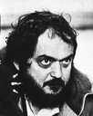

Why are there psychopaths? And the answer is contained in the chakra multi-processor model of the human being together with the concept of Energy Blockages which block and cut off some chakra functions like soul conscience which conquers selfish desire and heart sympathy which allows you to imagine yourself in another persons place, Gurdjieffian external consideration, whilst sometimes leaving courage and the intellect intact.

Sometimes courage and the intellect are also blocked and this covers the great differences in human psychological disease potentiality.

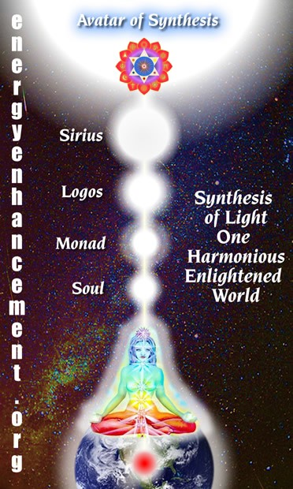

Existentialists admire most those traits which are psychopathic.
The psychopath Don Juan has found his defenders in our time. The Existentialist philosopher Camus finds in Don Juan something of an existentialist hero, a natural (or absurd) man: He says, "This life gratifies his every wish, and nothing is worse than losing it. This

madman is a great wise man. . . . Why should he give himself a problem in morality? . . . How easy it is to understand why the men of God call down punishment on his head. He achieves a knowledge without illusions which negates everything they profess. Loving and possessing, conquering and consuming--that is his way of knowing."
An existentialist is a person cut off from their soul and from their heart, living in a flat, intellectual drab wasteland devoid of meaning. And it is only the heart and the soul conscience and meaning which give life significance, not the intellect.
Because to an existentialist, there is no meaning to anything, Camus said, "The only thing we have to decide is how to commit suicide!"
They believe in enlightened self interest because this is a rule they can understand and follow, not because it is right.
A existentialist psychopath cannot understand words like the soul conscience and the heart sympathy, it is another paradigm because in Energy Enhancement terminology, in them the soul is cut off by energy blockages and the heart center is blocked. It is impossible for them to understand the soul and the heart. Like a psychopath they can only pretend and fake it.
Energy Enhancement teaches that human beings have seven chakras or energy centers in their bodies which act as processors in the human parallel processing super computer, and in that computer only one processor, the brow chakra is intellectual. Other processors handle the emotions and the conscience and if those are cut off or blocked, then psychopaths, schizophrenics and manic depressives are the result.
To make you less of a psychopath, Energy Enhancement gives advanced techniques for removing energy blockages in the heart and above the head, thus connecting you with your heart and your soul!!
This battle between the intellect and the heart and soul is the story of Ridley Scotts The Gladiator where Commodus the Emperor is a psychopath with no connection with his heart or soul, versus Maximus, the Gladiator who has both heart and soul, who knows his duty to god.
And no-one has brought up the fact that it is only those films with BOTH Intellect, heart and soul which make a lot of money.
Also no-one has brought up the fact that psychopaths vary in the lengths to which they feel able to go. They vary from those who kill

millions to those who destroy the lives of those around them to those who follow the rules of enlightened self interest and are fairly good chaps but cannot understand why.
Kubricks films in general did not make so much money even though they were loved by the mildly psycho film critics, whereas Star Wars (May the Force be with You!) series and Lord of the Rings Trilogy (Because there is some good in the World Mr Frodo, and its worth fighting for!!) have heart too and thus, even though were hated by all the mildly psychopathic critics who could not understand them and therefore were against them, those movies could still make Loads of Money!!!
Some other Examples of great films not understood by the mildly psychopathic movie critics;- The Sixth Sense, The Shawshank Redemption, Gladiator, Brubaker, Ghost, Godfather Trilogy, ET, Forrest Gump, The Last Samurai, Constantine, The Matrix Trilogy, Raiders of the Lost Ark, Ghostbusters, Fallen, Groundhog Day, American Beauty, Jerry Maguire, The Green Mile.
Lesson, if you want a movie with heart know that the psychopathic movie critics will not understand it, the movie will have bad reviews, - the evidence is the Star Wars franchise whose movies have run the gauntlet of hate from every movie critic who still cannot understand why they are so popular, it's because most critics just have no heart or soul.
Most directors and film critics are intellectual existentialists without heart, merely pretending to have heart, merely going through the motions, like all psychopaths - this is one of the definitions of a psychopath. An example is Big Fish and Life Aquatic but these films are the majority.
Pschopaths do not care whether a film has heart or soul or meaning or significance. They cannot see it, they do not understand it, as this requires a paradigm shift for them to see Heart and Soul!!
These people only make up 50% of the population.
Those people with a heart require intellectual ability but also heart and soul. These people make up the other 50% of the people. Thus to satisfy more viewers and be popular AND Profitable, a film needs to contain Intellect, Heart, Soul and significance.
Films "Full of sound and fury, signifying Nothing" quote from Shakespeare, make little money. And Shakespeare should know because his plays have run and been popular for more time than any others!

Yet the films of Kubrick are good teachings about those people who are existentialist psychopaths. For that reason they are good teaching tools for Energy Enhancement techniques.
Energy Enhancement gives advanced techniques for removing energy blockages in the heart and above the head, thus connecting you with your heart and the soul!!
To the creator of films as well as other forms of literature, the dark side of human nature has often proved more rich and interesting than the bright. Films and books on the lives of saints have not been as popular as murder mysteries and works of horror. While we may have no desire to experience them in our own lives, terrible deeds and evil people exert their perverse attraction on our psyches. We who consider ourselves moral and upright are often fascinated by the behavior of the pitiless, merciless, and guiltless psychopath. Like a magnificent black panther: powerful, dangerous, and alien, the psychopathic character can have a dark, perfect beauty that simultaneously attracts and repels us. We will explore the use of such characters in the films of Stanley Kubrick, the 20th century film auteur as it relates to his view of the nature of both individuals and human institutions. But first, we will review the clinical view of psychopathy as assembled by students of brain and behavior over the centuries
While it was not until the nineteenth century that doctors began to elucidate the nature of that disturbing category of human beings that we now call psychopaths, history and literature show that they have always been with us. Scientific study of the psychopath is difficult because of the skewed view we obtain from those psychopaths available for study: prison populations. The psychopath recognizes no flaw in his psyche, no need for change. Those who are successful in avoiding brushes with the law do not present themselves for treatment or study. While some psychopaths undoubtedly correspond to the popular view of the brutal killer, criminal, or rapist, many, if not most, do not. Often this entity is referred to by the term sociopathy or antisocial personality, emphasizing their chaotic relationships with other people and society, but while this aspect of these personalities is most readily apparent, there are many other features of this character disorder having nothing to do with other people which also show considerable deviation from normal behavior. For this reason, I prefer the older term psychopath. In recent years, there has been a growing realization that there are many psychopaths who successfully avoid trouble with the law, and estimates of the percentage of psychopaths in the population have been revised upward.

As is common in medicine, and especially in psychiatry, where there is often no "litmus" test which can be applied, diagnosis is a matter of nosology and categorization. This is bound to lead to disagreements between various authorities as to which manifestations warrant inclusion or exclusion of an individual from a given diagnosis. Naturally, this has led to various schools of thought on the subject of psychopathy.
You should know however, that the psychopaths which get caught are in the minority. These are the mad kettle of fish psychopaths. The rest are amongst you now....
Historical Overview Existentialism and Kubrick's Psychopaths
The first writings by doctors on the subject seem to originate around the beginning of the 19th century[1,2], but the earliest formal description of what he called "moral insanity" is given by Prichard[3] in 1835. The 19th century physicians recognized that there were some walking among other men who were of sound reason and intellect, but when it came to the moral realm were "deranged". They described individuals who had no sense of right and wrong, no feelings of guilt or shame for wrongdoing, and had a marked propensity to lie, cheat, and engage in other activities which normal society considered reprehensible. During the last 40 years, psychopaths have been more intensively studied and recent research seems to indicate that they actually represent a variant of human beings with abnormal brain function.
Demographics Existentialism and Kubrick's Psychopaths
Demographic studies of psychopaths are somewhat suspect because they rely so heavily on the institutionalized segment of the population of psychopaths, but they show that males outnumber females by at least 5:1, and that they almost always come from severely disturbed families[4] The deviant behavior is manifest even as young children. The period from adolescence to mid-thirties is marked by the most severe deviance. As they age, many psychopaths seem to "mellow", at least in their more aggressive antisocial behavior.
Clinical Features Existentialism and Kubrick's Psychopaths
In describing the clinical features of psychopaths, I will rely heavily on the most complete description in the literature, the monograph which constituted the life-work of psychiatrist and neurologist Hervey Cleckley entitled The Mask of Sanity.[5]

Guiltlessness Existentialism and Kubrick's Psychopaths
While the psychopath often recognizes that other people have a "conscience", and will feign remorse to avoid punishment, as Cleckley explains, "he shows almost no sense of shame. His career is always full of exploits, any one of which would wither even the more callous representatives of the ordinary man. Yet he does not, despite his able protestations, show the slightest evidence of major humiliation or regret. This is true of matters pertaining to his personal and selfish pride and to esthetic standards that he avows as well as to moral or humanitarian matters."[6]
Lack of insight and judgement Existentialism and Kubrick's Psychopaths
It is in this realm that the psychopath comes closest to the psychotic. While seemingly in full possession of his reasoning ability, by all the means of clinical psychology to test and assess them, the psychopath demonstrates an inability to comprehend the meaning and significance of his behavior for other people, and to judge their probable reactions to his behavior. He is often astounded to find that people are upset by his exploits. Although he knows intellectually what punishment is decreed for certain crimes, when caught, he puts up elaborate rationalizations and defenses, and seems surprised when he is actually punished. Mark Hofmann, an ingenious forger of rare documents and murderer, included among the victims of his: many scholars, the Library of Congress, the U.S. mint, the Mormon Church, private collectors, and several forgery experts. His career began as a child with the alteration of mint-marks on coins. He recently revealed his thinking on the subject of his forgeries: "It's not so much what is genuine and what isn't as what people believe is genuine. When I forged a document and sold it, I was not cheating the person that I was selling it to because the document would never be detected as being a fraud. Obviously if I would have known they would some day be detected, I wouldn't have done it. I didn't feel like I was cheating them.[7]" This statement shows not only a lack of guilt and remorse, but a semantic lack of understanding of the concept of authenticity. Psychopaths can be thought of not as being hypocrites, but as actually not understanding or using language in the same way other people do.
Lovelessness and lack of empathy Existentialism and Kubrick's Psychopaths
While the psychopath has likes and dislikes and fondness for the pleasures that human company can bring, analysis shows that he is completely egocentric, valuing others only for their enhancement of

his own pleasure or status. While he gives no real love, he is quite capable of inspiring love of sometimes fanatical degree in others. He is generally superficially charming and often makes a striking impression as possessed of the noblest of human qualities. He makes friends easily, and is very manipulative, using his ability with words to talk his way out of trouble. Many psychopaths love to be admired and bask in the adulation of others. With the lack of love, there is also a lack of empathy. The psychopath is unable to feel sorry for others in unfortunate situations or put himself in another's place, whether or not they have been harmed by him.
Disordered interpersonal relationships Existentialism and Kubrick's Psychopaths
While psychopaths are notably sexually promiscuous, their inability to love or to show any but the most superficial kindness to others prevents them from forming meaningful relationships with others, including parents and spouses. The promiscuity seems more related to their lack of restraint than to an exaggerated sexual drive. Bizarre and indecent liaisons are common. Dominance and power are recurring themes in the social relations of psychopaths. They enjoy being in a position of power over others, especially women. The psychopath often plays jokes and tricks on others to humiliate them or to assert dominance. Psychopaths are often found in positions of imposture. They are attracted to certain vocations having great opportunity for exerting power such as politics, the law, or medicine.
Fearlessness Existentialism and Kubrick's Psychopaths
The psychopath is remarkably free of both the psychological and physiological manifestations of anxiety[8]. They often pass lie detector tests (as did Mark Hofmann), and are well known for their valor in war, risking their own lives, and often recklessly endangering their entire units and disobeying orders in the process. It is said that the decision often comes whether to award a man the Medal of Honor or to court-martial him, and the "Rambo" stories of former war heros in trouble with the law have basis in reality. The famous psychopath, Aaron Burr, directly disobeyed the orders of his superior in winning a battle and fame during the American revolution.[9] It is this "bravery" that often helps the psychopath win the affection of followers and accord him a respected place in society, which is later disillusioned by his subsequent exploits. Another aspect of the fearlessness, is the obliviousness of the psychopath to punishment. Not only does the threat of future punishment have no power to deter him, but actual punishment does not reform him. Most psychiatrists consider psychopaths untreatable.

Irresponsibility, Insincerity, and Unreliability Existentialism and Kubrick's Psychopaths
While the psychopath is charming and makes friends easily, those who come to rely upon him soon painfully find out that he has no sense of responsibility. Continually promises are made and broken without regard for the gravity of the consequences, for which the psychopath will then deny responsibility. He can solemnly lie while looking the victim in the eye, showing no anxiety whatever.
Impulsiveness Existentialism and Kubrick's Psychopaths
The inability to restrain his impulses is what often leads to the downfall of the psychopath. While he theoretically knows what is considered proper behavior, and can even provide sage advice, it is in carrying out the actual process of living that the psychopath runs into trouble. There is a tendency toward continual excitement and stimulation. This impulsiveness may lead to a scandal or to the commission of a theft, rape, or other crime. It is this obliviousness to the consequences of risk taking that often leads to the uncovering of a "successful" psychopath who was previously well esconced as a doctor, lawyer, teacher, politician, or some other respected person in the community.
Etiology
Prior to the past 30 years, psychiatry operated largely apart from the tools of modern biological investigation, and most theories of abnormal behavior were based on moral and later psychoanalytic notions, which largely were grounded in the belief that the individual was shaped by the environment. When it comes to explaining the psychopath, psychoanalytic theory has been speculative and not very credible[10,11], and recent investigators have turned to studies in genetics, electrophysiology, and language in an attempt to explain why such a constellation of character defects crops up so frequently and consistently. Opinion now seems to favor a defect in the function of the brain, probably involving the non-dominant hemisphere which may well be innate.[12] Studies of very young children have revealed that contrary to the theories of Piaget, empathy appears at a very early age and is probably an innate characteristic.
The Psychopath in Film
That the psychopathic character often finds his way into films (as well as other forms of literature) is not surprising. The ambiguous mixture of strong emotions that are aroused in "normal" persons while examining such characters make them strange and fascinating subjects. We are charmed by their craftiness and allow

ourselves to be inveigled by their manipulativeness from the safety of our theater seats. We secretly admire their disrespect for convention and guiltless flaunting of rules and laws in a manner that we find almost impossible to do. We enjoy their brave exploits and fearlessness. While we fear their predatory nature, yet we find in them a mixture of beauty and danger.[13]

The criminal psychopath is probably the most common form to appear in films. Often, the characters are based on actual psychopaths such as James Wood's character in The Onion Field, Gary Gilmore in The Executioner's Song, Peter Lorre's character in M, and Charles Starkweather (the basis for Kit, played by Martin Sheen in Badlands). Notable examples of fictional criminal psychopaths in films are Michael Corleone in the Godfather films, Scarface in the De Palma version of that gangster film, and Dennis Hopper's character in Blue Velvet. Psychopaths may occur in a film with a moral heart to serve as a contrast to the upright protagonist (Richard Rich vs. Sir Thomas More in A Man for All Seasons) and appear in other films as an evil double or antagonist to the main character (Harvey Keitel's character in The Duellists, Bruno Anthony in Strangers on a Train). As in reality, film female psychopaths are rare, and when they are used, they often serve as scheming manipulators whose main weapons are sexual (Matty in Body Heat, Scarlet O'Hara in Gone with the Wind, Jessica Walter's character in Play Misty for Me, Glenn Close's character in Dangerous Liaisons).
Other interesting psychopathic portrayals in film are that of Robert Mitchum as "Preacher" in Night of the Hunter, that of Eric Roberts as Paul Snider (Dorothy Stratton's husband) in Star 80, Keith Carradine's character in Nashville, and Robert Duvall's Bull Meecham in The Great Santini.
Kubrick's Psychopath
The most obvious psychopath in a Kubrick film is Alex (played by Malcolm McDowell) in A Clockwork Orange. In Clockwork, we find ourselves listening to Alex's narration as he tells the story of his career. In Alex, Kubrick has created a character who is simultaneously attractive and repellant. He is bright, witty, handsome, self-confident, brave (plays "chicken" in motorcars), adventurous, splendidly fashionable in dress, lover of Beethoven, and has a highly developed esthetic sense which is demonstrated in the following narration describing the sensations of driving in the country at night:

The Durango 95 purred away real horrorshow; a nice warm vibraty feeling all through your gutty-wuts. And soon it was trees and dark, my brothers, with real country dark.


But at the same time, Alex is totally devoid of any empathy for other human beings. He has no moral scruples or conscience. He is sadistic, narcissistic, sexually promiscuous, a liar and deceiver, and is driven by fantasies of power and dominance. He and his hoodlum droogs prowl nightly beating up drunks, fighting with rivals, and looking for opportunities to rob, rape, and pummel their victims.
Alex sees his crimes almost as a peculiar form of artistic expression. The victims are usually chosen randomly (those unfortunates who happen to be driving the other way when they play "kings of the road", or the writer and his wife). Alex and his droogs are masked and the violence is theatrical, accompanied by strange touches such as Gene Kelly song and dance numbers ("Singing in the Rain"). When Alex returns from his depredations, during which we have observed him rape a woman in her home and

kick her husband until he is left paraplegic, we see him deposit a watch and cash taken from his victims into his nightstand drawer, which contains hundreds of other watches, indicating the length of time over which this kind of behavior has been occurring. He then remarks:
It had been a wonderful evening and what I needed now to give it a perfect ending was a bit of the old Ludwig Van (Beethoven).
Whereupon he proceeds to masturbate to the music of Beethoven's 9th Symphony while entertaining fantasies of rape and violence.
Alex is well satisfied with this life and has no plans to change it, unlike Droog Georgie, who aspires to a more conventional criminal career going for the "big, big, money". He tells Georgie:
And what will you do with the big, big, big, money?" Have you not everything you need? If you need a motorcar, you pluck it from the trees. If you need pretty Polly, you take it.
Alex's home environment is a dreary contrast to his exciting night life. He lives in "municipal flat block 18A linear north", a drab concrete housing project with non-functional elevators and graffiti- defaced wall murals painted in the style of "socialist-realism."[14] His parents embody all of the bad stereotypes of the British working class: stupid, gullible, unambitious, all leisure time spent watching the tele and reading sensational newspapers, with garish taste in decor and personal attire. In contrast to the decor in the rest of the cramped flat, Alex's room is very mod and artistically appointed.
Manipulation is another tool of the psychopath often used by Alex. He lies to his parents and to his truant officer in order to manipulate them. When Alex is caught and charged with murder, he typically tries to shift blame to his droogs and to deny responsibility. Once he is imprisoned, he adopts the role of model prisoner, "sucking up" to the chaplain by pretending to study the Bible (secretly finding more material for his sadist and sexual fantasies therein). During his conditioning he attempts to manipulate the scientists. Once in a position of dominance, his manipulation takes on a bullying tone, as exemplified by his behavior following the suicide attempt when, despite having lost the use of all four limbs, simply by opening his mouth, and demanding food as if he were a baby bird, he asserts his dominance over the government minister as the minister feeds Alex.
As might be expected, the choice of such a protagonist for an important film by such a well known director as Kubrick resulted in a storm of critical controversy. Kubrick was accused of pandering to

violent behavior if not outrightly promoting it. In an interview in the New York Times, Kubrick explained that although he is fascinated by violence, he is not advocating it (or anything else) in the film, but merely portraying it: "Part of the artistic challenge of the character is to present the violence as he sees it, not with the disapproving eye of the moralist, but subjectively, as Alex experiences it."[15] From this standpoint, in my view, Kubrick has succeeded masterfully in letting us see into the mind of a psychopathic personality. But Kubrick goes further in the interview in explaining his reasons for his fascination with Alex: "I'm interested in the brutal and violent nature of man because it's a true picture of him. And any attempt to create social institutions on a false view of the nature of man is probably doomed to failure....
The idea that social restraints are all bad is based on a utopian and unrealistic vision of man."
Kubrick is expressing an idea here that accords with Sowell's[16] description of the "constrained" view of human nature which posits that it is flawed and largely fixed, and that efforts to build utopias will invariably founder on the rocks of human failings and will reflect the imperfections of their builders. Variations on this view have been held by such historical figures as Adam Smith, Alexander Hamilton, Edmund Burke, Thomas Hobbes, Oliver Wendell Holmes, Friedrich Hayek, and Milton Friedman. The opposing view, that man is (at least somewhat) perfectible, or that the evil in the world is mainly the result of bad social institutions has been the view of Godwin, Rousseau, John Stuart Mill, Thomas Paine, Jefferson, Voltaire, Ronald Dworkin, and John Kenneth Galbraith. The constrained vision has been characterized as cynical, conservative, pessimistic, as opposed to the romantic, liberal, optimistic, idealistic unconstrained vision of man. Sowell points out that the person's view of human nature often serves as a litmus test that can predict which side of a given controversy the person will come down on, with holders of the constrained vision opposing holders of the unconstrained view across a spectrum of religious, social, and political issues. Often, people at opposite poles have great difficulty communicating with and understanding each other, since their basic premises are so different.
Kubrick expands on his view of the man's futile hope of salvation through social institutions in Clockwork by showing the natural man (psychopath Alex) in his encounters with characters representing other archetypes.
The liberal is represented by the writer Frank Alexander. Alex and his droogs gull him into opening the door to them by playing on his compassion with a sob story about an accident on the road,

whereupon they brutally rape the wife and beat Frank so severely he is left a paraplegic invalid. Significantly, Alex vandalizes Frank's study, sweeping his writings and his typewriter onto the floor, and pulling down the shelves scattering asunder the books representing man's accumulated wisdom and knowledge. When Alex has come full-circle, and once again encounters Frank, he now is in Frank's power. How does the liberal deal with him? He drugs him and submits him to torture, gleefully enjoying his screams, thus demonstrating that at the heart of the liberal lurks the same primitive brutality that motivates Alex.
The moralist is represented by the prison chaplain. Alex fools the chaplain into thinking he has a true love for the Bible in order to gain privileges. The chaplain, significantly, recognizes the hypocrisy of the conditioning, and that it has made no moral change in Alex. But he is told by the minister of the interior (another type of psychopath):
Padre, these are subtleties. We're not concerned with motives, with the higher ethics, we're concerned only with cutting down crime and with relieving the ghastly congestion in our prisons. He will be your true Christian...
Cynical characters in the film who appear to share Kubrick's gestalt are the prison guard and warden who see through Alex's manipulation, but have not sufficient power to prevent the minister and the scientists from using Alex for his own ends.
Kubrick's view of societal institutions is shown by his general portrayal of the drab conditions of the future England as well as through the psychopathic characters of the representatives of state authority shown in the film. The truant officer, Mr. Deltoid, is hardly concerned for Alex's well being. He barely can conceal his joy that finally Alex has killed someone and now can be punished severely. The psychopathic police interrogator enjoys torturing Alex. The government minister is also a psychopath, having no true concern for the welfare of either the prisoners or the society. The minister sees the Ludovico technique[17] as a tool for accomplishing his political ends, and Alex as a perfect candidate: "He's enterprising, aggressive, outgoing, young, bold, vicious--he'll do". And besides, "Soon we may need all our prison space for political offenders." He and Alex understand each other well and the last scene shows them scheming to place the blame for Alex's "misfortune" on the scientists and the minister's political opponents:
We tried to help you. We followed recommendations which were made to us that turned out to be wrong. An inquiry will place the responsibility where it belongs.... We never wished you harm, but

there are some who did and do.... There is also a certain man...a writer of subversive literature, who has been howling for your blood...but you're safe from him now...we've put him away. He was a menace--we put him away for his own protection and also for yours.
At the end, Alex is "cured" of his conditioning under government auspices and begins a new career in government service ("we always help our friends, don't we"). It is clear from his power and sex fantasies which close the film that he is not cured of his psychopathy, and that he will now continue his exploits from a position of even greater power than before. The final fantasy of him reveling in a sexual orgy while being applauded by many figures in Victorian garb may be symbolic of the forthcoming social sanctioning of his libertine behavior.
In Clockwork, government, technology, and other social institutions are seen as only worsening the problem of man's barbaric nature rather than helping. It is small wonder that liberal critics decried Kubrick's vision, as this also runs counter to their notions. Malcolm McDowell said in an interview, "Liberals, they hate Clockwork because they're dreamers, and if someone shows them realities-- cringe, don't they, when faced with the bloody truth."[18]
Kubrick's view that the psychopath is an apt model for the natural man is one of the more bleak and cynical castings of the constrained vision. His casting of society as basically sharing the psychopathic bestiality of the natural man makes it no surprise that he has been vehemently attacked by some critics. It is interesting that many of those critics generally failed to perceive Kubrick's fundamental antagonism to their own views until the release of Clockwork. We will now examine the earlier Kubrick films to see how his use of psychopathic individuals and societies developed.
In Kubrick's earliest work we encounter psychopaths only as villains or peripheral characters, in the persons of the dance hall manager in Killer's Kiss, and Val in The Killing, although all of the main characters in the latter film are criminals. Kubrick's first use of full psychopaths as major characters comes in the form of the scheming generals Broulard and Mireau in Paths of Glory. Here we find them as pitted against hero Kirk Douglas, a liberal officer.
Douglas' Colonel Dax character was the last use of an unambiguously liberal protagonist in a Kubrick film,[19] and it can be argued that the producer, James B. Harris, and/or Douglas may have had some influence on his interpretation of this character.
Kubrick probably delivered a jolt to the world view of the average film viewer in 1957 with his portrayal of the Generals. In those

days, many were fond of thinking of the leaders of countries (especially allies) as being intelligent, competent, and even humanistic, and they were usually so portrayed in film. General Mireau, despite his feigned concern for his troops (sparring with Gen. Broulard and trying to avoid a difficult assignment) orders his gunnery officer to murder them by impetuously turning his own artillery on them after they fail to carry out his impossible orders. He is incapable of accepting blame for his mistakes, and remorselessly sacrifices three of his own troops to deflect attention from his failure. General Broulard even more clearly exemplifies psychopathic amorality. He uses Dax against General Mireau and seeks to reward him with the latter's command after Mireau's final downfall, assuming Dax to be a man like themselves who was playing his cards for his own benefit and not for that of his men.
When Dax responds indignantly, General Broulard is surprised at this "naïvete" and tells him he is "wallowing in sentimentality".
Because the self-serving psychopath does not think as other men and has no feelings of guilt, shame, remorse, empathy or conscience, his ability to wreak chaos upon the rest of mankind is immense as he executes his power schemes without regard to who
gets hurt.
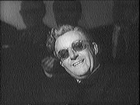General Mireau's indignation at ultimately being held accountable for his battlefield behavior illustrates another interesting facet of psychopathic behavior: their peculiar sense of justice. Being deficient in empathy and thus failing to recognize his own behavior as immoral, Mireau can see his fate only as the result
of the scheming of brother officers, both superior (Broulard) and subordinate (Dax), in the power game. He was at least half right with respect to Broulard, whose moves also were governed by psychopathic logic.[20] In the end, Kubrick's dark vision prevailed in this film, as the liberal Dax is incapable of either saving his men or changing the rules of the game in which he is enmeshed. Liberal film critics could acclaim Paths of Glory because the psychopaths were militarists and the film was seen as anti-war, with a liberal hero, Dax.
The Roman senators in Spartacus play power games, and Imperial Rome is portrayed as a corrupt and scheming society, but the

central character, Spartacus (played by Kirk Douglas), is a somewhat liberal man of scruples.. Spartacus ultimately fails (as did the real Spartacus, who has in modern days become somewhat of a ideal of the left). In Lolita, Clare Quilty has some aspects of psychopathy (he is as much a pedophile as Humbert Humbert, a trickster, but brave in the teeth of death), but his character is not well enough developed to make any definitive statements. Likewise, in Dr. Strangelove, we get glimpses of characters who seem to be rather devoid of morality (Strangelove, General Buck Turgidson), but their personas are not explored in detail. Again, it is deranged human systems and institutions that seem more Kubrick's target in this film. Strangelove was perhaps the favorite film of liberal critics as they saw it as indicting one of the great evils of the cold war: the arms race. What they may have failed to perceive was Kubrick's cynical attitude toward the efficacy of liberal politics, as he portrayed the impotent president Muffley as an Adlai Stevenson clone. In 2001, A Space Odessey, the central character, HAL, is a computer. While he does some terrible deeds, killing the human members of the crew, he does it out of dedication to his mission and self-preservation instinct. HAL also apparently becomes mad because of conflicting instructions given to him by his human programs, and thus does not qualify as a psychopathic intelligence. It was at this point that some of the critics began to become uneasy with Kubrick, for he portrayed man as violent and bestial by nature, incapable of solving their problems on their own and with their only hope of salvation being intervention by god-like extraterrestrial intelligences. Because they could see it as primarily an indictment of technological solutions, many of the Luddites among them could still approve.
Kubrick's work following Clockwork Orange has continued to display the pessimism and even misanthropy of that film. Barry Lyndon depicts a society bound up in formality and ritual which people used to pretend to civilization while basically totally corrupt, decadent, and immoral. The central character is a picaresque rogue. Apart from the fact that he seems to be capable of love (at least in the case of his friend, Captain Jack Grogan, and son Brian), Barry seems to fit the picture of a manipulative, although not murderous (if one ignores duelling) psychopath. As his career progresses, he becomes more skilled at lying and cheating under the tutelage of a phony marquis. His major goal is to lead the life of an aristocrat and he attempts to attain his goals by marrying a rich woman he does not love and then bribing his way into a title. With each film, Kubrick's settings seem to cycle from present to future to past, but all of his visions show humans as base and loathsome.

Jack Torrance in The Shining has many psychopathic features. He is a bully to his wife, a child abuser, and has a history of alcoholism. He has difficulty keeping a job. He shows little love for his family, but he is quite capable of being charming and manipulative when it suits his purposes. Psychosis plays more a part in his final downfall than does psychopathy. Again, characters representing the more liberal side of man (the pediatrician and Dick Halloran) are impotent to ameliorate the situation when push comes to shove.
In some ways, Full Metal Jacket can be seen as complementary and inverse to A Clockwork Orange. In Clockwork, Alex wreaks havoc because of his love of violence and sex and his lack of empathy for his victims. Society tries to change him by aversive conditioning against the sex and violence (leaving the lack of empathy untouched, however). In Full Metal Jacket, the system takes young men and puts them through a conditioning program to attempt to extirpate any feelings of empathy that they might naturally have, leaving them in the end, psychopaths, suitable for animalistic warfare. It does so first by stripping them of the characteristics they use to identify themselves and order their lives. They are shaved bald, removing any individual hair styles. Their names are taken away from them and denigrating nicknames applied. Their home regions and towns are ridiculed. Their physical characteristics (shortness, obesity) are used to mock them and tease them. Their manhood is denied. Any morality that they learned at their mother's knee (don't fight, don't say bad words, don't have promiscuous sex, etc.) is deliberately inverted and aggression, sexual prowess, and profanity become the valued qualities. Any empathy the soldiers might have for one weaker or less fortunate is mercilessly driven out of them. The fat Pvt. Leonard "Gomer Pyle" Lawrence is continually harassed and ridiculed by the DI. Some of the more sympathetic men, such as Joker, attempt to help him get through basic training by showing him how to do things and keeping him out of trouble. The real purpose of making Pyle the goat, however, becomes clear when the DI begins to punish the men for Leonard's mistakes. Then they begin to hate him. In the incident when they pummel him with bars of soap slung in their towels, even Joker takes part, showing that the breaking down of sympathy and empathy has succeeded, and the men are ready to be killers. Thus, Kubrick demonstrates that, as in Clockwork, the society gives lip service to law and order, but when it gets down to the nitty-gritty, it is psychopathic and will use whatever system of values (or lack of them) that it needs to in order to accomplish its purposes.
Once in Viet Nam, the men put into practice the psychopathy they learned in their training. They swagger, curse, kill, and screw, and do little else. On the helicopter trip to the front, Joker and Rafter

Man observe the psychopathic door gunner as he machine guns peasants at work in their rice fields while laughing and joking, asking them to write a news story on him. The Vietnamese are also corrupt, or have become corrupted by the contact. Whores walk the streets with their pimps auctioning them off. Youths on motor scooters steal using hit-and-run tactics. Respect for authority is almost non-existent. Cowboy, although he is technically in command, can not enforce his orders, and the men do pretty much as they please.


Eyes Wide Shut
The protagonist in this film is Joker. The psychopathic conditioning is not fully successful on Joker's personality. He retains some empathy, although becoming hard and cynical. Although he participates in pummelling Pyle when egged on by his peers (with a vengeance), he cringes to hear Pyle's cries and weeping afterward. He tries to prevent Pyle's suicide. In Viet Nam, he wears a peace button to symbolize his ambiguous feelings about the endeavor he is engaged in. His opposite number is Animal Mother ("You talk the talk but do you walk the walk"), in whom the conditioning has produced a perfect specimen. Animal Mother carries a huge Browning Automatic Rifle and joyously screams war cries as he kills. His reaction on viewing the bodies of dead comrades is "better you than me." Finally, Joker's empathy forces him to put the wounded female Viet Cong sniper out of her misery, when Animal Mother and the others oppose it and want to see her suffer.
Certainly Full Metal Jacket can be seen as an anti-war film (as was Strangelove and Paths of Glory). Since war is the human institution which most highlights the brutality of man's animalistic nature, it is

natural that a pessimist such as Kubrick would return to it again and again.
Eyes Wide Shut shows the unbelievable picture of a hidden world of sado masochistic ritual and psychopathy behind the doors of normality.
Conclusion
One of the questions asked of Kubrick in the aforementioned interview was "how did a nice Jewish boy from the Bronx acquire such a dark view of humanity?" His answer was "From observation, knowing what has happened in the world, seeing the people around me." He specifically denied that it was because of being Jewish (and the holocaust), and said that such a view was historically primarily Christian, anyhow.[21]
Does this mean Kubrick is a fascist, as some have suggested? Kubrick does state that there should be social constraints on behavior, and believers in the constrained vision have often been politically conservative, believing that authority is necessary to check the propensity of individuals to do evil. At least in his films, Kubrick puts forth no vision of a social order (as Fascism is) as a solution to the evil he portrays. He seems to equally indict all attempts to impose order as futile. His main interest, it appears, is to portray the dark side of human nature and institutions without offering solutions (if one ignores the deus ex machina solution of the monoliths in 2001). While Kubrick disclaims advocating violence, he probably would not be surprised (or disturbed) to learn that many viewers vicariously enjoyed the violence portrayed in his films. This would simply accord with his views of the nature of man.
Is Kubrick correct in his pessimistic view of the natural man as a psychopath? I think most psychologists and psychiatrists would agree with him. There is ample evidence that while the common garden-variety man is no angel, and empathy is a fundamental human characteristic. While most persons do have consciences, and feel guilty when they violate their own moral standards, although specific moral rules vary from culture to culture. However, business and war cultures exalt and promote and elevate those people with the psychopathic ideal. Cultures that exalt psychopathic ideals are said to be rare,[22] but even in our own society, there are subcultures which espouse frankly psychopathic ideals. Examples are the fringe right-wing groups such as "The Order", skinheads, left-wing terrorist groups, "Soldier of Fortune" devotees of Ramboiana, and the urban street gangs of tough young males.
While all of these groups may contain idealistic individuals who are merely following a different morality, and are not true psychopaths,

these subcultures attract psychopathic leaders who often see the group as an opportunity for adventure and power.
If the majority of individuals are psychopaths to some degree or other, what about governments and societal institutions and their leaders? To give my answer to that, I must first indulge in some speculation and try to answer the question, why are there psychopaths? And the answer is contained in the chakra multi- processor model of the human being together with Energy Blockages which block and cut off some chakra functions like soul conscience which conquers selfish desire and heart sympathy whilst sometimes leaving courage and the intellect intact.
Sometimes courage and the intellect are also blocked and this covers the great differences in human potentiality
While we are a social species, the engine of evolution is variation. The psychopath is common enough, with uniform enough characteristics, that he might be thought of as a variant upon normal. Variants that survive and are genetically passed on must carry some advantage for at least a significant portion of the variant organisms. While many, if not most, psychopaths seem to be misfits, spending much of their lives incarcerated in penal institutions, it has been recognized that many are clever enough or restrained enough, to avoid being "unmasked." It is easy to think of fields of endeavor (politics, business, even science) where a lack of ethics might present a decided advantage, provided the unethical behavior can be shrouded from the scrutiny of associates and society. Even when the misdeeds are uncovered (often through the psychopath's poor judgement), the psychopath may succeed in maintaining the respect and admiration through his charisma, talents, and abilities. (Does the world in general respect Nixon or Carter more?) Many of the "greatest" politicians and businessmen have made their fame and fortunes living according to their own rules and full-speed-ahead-damn-the-torpedos, with their own agendas. Those who succeed, have their faults forgotten. Perhaps the psychopaths then, even serve a social purpose in our species.
The negative side to all this, however, is that when psychopaths govern, their policies can lead to a great deal of inhumane behavior, such as intrigues, "dirty tricks", arms races, assassinations, and wars. 200 millions of people were murdered in the 20th century at the hands of psychopaths including Stalin, Mao and Hitler. Thus I agree with Kubrick's severe view of individual human nature, and I somewhat agree that humans acting collectively under leaders tend to act with less conscience than individual persons would. In part this might be explained by the gravitation of bright psychopaths into high government positions.

Although we can describe the psychopath, we do not understand him. What we do know, for me at least, does not reduce but expands the wonder at the beautiful complexity of brain and behavior. One of the values of literature (of which film is a part) is vicarious experience. We can experience persons and situations that we would never meet in the flesh. We can absorb some of the wisdom of dead men and vanished cultures. Films such as Kubrick's, which seek to portray man and his experience, even in some of its darker aspects, are sometimes superior to those which tend to deliver an obvious "message" or to preach or moralize. One can never definitively explain a work of literature or art. Because such explanation would not only embody every thought put into it by its creator, but every thought which will be evoked in every reader, even those not yet born, every work is infinite.
[1]Pinel, P. Traité médico-phiosophique sur l'aliénation metale, 2nd edn., Paris: J. Ant. Brosson, 1809.
[2]Rush, B..Medical Inquiries and Observations upon the Diseases of the Mind. New York: Hafner, 1962.
[3]Pritchard, J. C. A Treatise on Insanity and Other Disorders Affecting the Mind. London: Sherwood, Gilbert, and Piper, 1835.
[4]Goodwin, D. W. and Guze, S. B. Psychiatric Diagnosis. New York: Oxford Univ. Press, 1979.
[5]Cleckley, H. The Mask of Sanity. St. Louis: Mosby, 1976. [6]Cleckley, p.343.
[7]Excerpts from the Mark Hofmann Interviews. Sunstone 11: 40- 41. 1987.
[8]Hare, R.D. Psychopathy: Theory and Research. New York: J. Wiley, 1970. Chap.4 "Autonomic Correlates of Psychopathy".
[9] Burr also demonstrated the psychopath's typical lack of judgement and obliviousness to consequences in pursuing his duel of honor with Alexander Hamilton. Burr was vice-president of the United States at the time of the duel. He was planning to run for president with the support of the Federalists when he shot and killed Hamilton, a beloved founding-father of the Federalist Party. Almost immediately he became a pariah and was forced to flee the country.
[10]Cleckley, pp. 395ff.
[11] Grünbaum, A. Foundations of Psychoanalysis. Berkeley, Univ of Calif, 1985.

[12]Hare, R.D. ""Twenty years experience with the Cleckley psychopath." In Unmasking the Psychopath, Reid, et al, eds. New York: W.W. Norton, 1986.
[13] The most famous "psychos" in films are not psychopaths, but psychotics. Well known examples of these are found in the films Psycho (Norman Bates), Taxi Driver (Travis Bickel), and Halloween (Michael). These characters are in varying ways disconnected from reality and suffer from delusional ideation.
[14]We imagine such a world to be the failed socialism of the future Britain toward which policies of the 1960s Labor Party were leading.
[15]McGregor, C. Interview with Stanley Kubrick. New York Times, January 30, 1972.
[16]Sowell, T. A Conflict of Visions: Ideological Origins of Political Struggles. New York: WIlliam Morrow, 1987.
[17]Whereby criminals undergo operant conditioning to extinguish violent behavior and sexual behavior.
[18]New York Times, January 30, 1972.
[19]Kubrick did not have artistic control of Spartacus. Joker in Full Metal Jacket did display some ambiguity and there are some parallels to Dax.
[20]A similar real-life example can be found in the failure of Richard Nixon to this day to understand the moral significance of the Watergate affair, and his continual insistence that it was all blown out of proportion by his enemies.
[21]Indeed, there is a strong current of Christian thought that emphasizes original sin, the depravity of man. It has been more prominent, however, since the holocaust, and usually is considered a feature of neo-orthodoxy.
[22]Nazi Germany is the most oft cited example. While studies of Hitler have shown that he probably was not a psychopath but a fanatical eccentric, the Nazi party attracted numerous psychopaths into leadership roles at all levels.

GEORGE LUCAS, STAR WARS AND THE REVENGE OF THE LORDS OF THE SITH
THE LORDS OF THE SITH THE LORDS OF THIS
(turn sith around and you get this) THE LORDS OF THIS PLANET
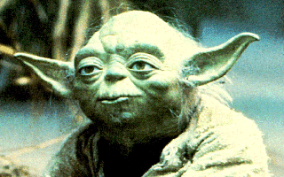
When George Lucas put pen to paper 30 odd years ago to write Star Wars he wrote from the roots of the past using Myth and mythical story from thousands of years of mystical literature which is far higher than the contemporary novels and stories which spring from the common psychopathic existential intellectual mind set.
Why is it higher? Because it cries, "May the Force be with you!!"
To those of you with, "Ears to Hear" It is because it talks of an energy higher than the mind called the Intuition or the Soul. It brings the higher mind or the Soul full frontal back into society after centuries of darkness. Because it brings the Light of the Soul (Lucas means Light Bringer) back into these times which we can call the "Dark Ages"

Shakespeare, another mystical master, knew of this perversion called common contemporary novels and movies. He called them, "Full of sound and fury, signifying Nothing!" Whereas the best of literature from Jallaluddhin Rumi to Shakespeare, to Tolkien to Lucas is nothing but Meaning and Significance.
On television we have significance and meaning? with weekly programs based on the police in order to inculcate trust in the police, that they are not corrupt. We have weekly programs about lawyers so that we know that they are good and interested in truth and justice. We even had shows about Oilmen like the Beverly hill billies the Clampets and Dallas to make us warm to the families owning the oil. There is even one about "The Love Boat" which advertises the cruise business to get people to go on cruises. I saw one last week about Las Vegas with Stallone and Caan whose purpose was to get more people to go there and show casino owners as warm hearted. Then many popular shows about daily life so that messages can be given, order created, population controlled, their reason for creation from the radio days over 60 years ago, and some of them have been going for that long.
Rather than that, the best of literature points out universal truths which can be "applied" in the Tolkienian sense to Your life and to this world. Here and Now! This is meaning and significance, words which are not talked about by critics or commentators presently on any movie in the IMDB database (The Internet Movie Database at imdb.com) thus partly proving my assertion in the first paragraph above, that meaning and significance are things which are not commonly understood by the psychopathic Sith Lords and their clone accomplices.



So, the main themes in the Revenge of the Sith are..
- Pointing out the qualities and actions and mind set of the psychopathic Sith Lords like The Emperor and Darth Vader from Star Wars or Sauron the Black Magician, The Witch King of Angmar or Saruman the bad wizard from The Lord of the Rings and their minions or accomplices whether they be called Orcs from the Lord of the Rings or Clones from Lucas's Clone Army or "Dracula" from Francis Ford Copola's Movie or Salieri From the Movie "Amadeus". How these people are cut off from their higher mind or Soul, consciously cut themselves off from their higher mind or do not know of and disparage the Souls existence, and thus with no empathy or conscience Sith Lords can order the murder of 6 millions of Jews, in all, 200 millions of people murdered and tortured by Stalin, Hitler and Mao this last century.
These people are the Sith Lords. Turning the letters of Sith around you get "This" and its meaning and significance are that these are the Lords, like Stalin, Mao and Hitler, who rule THIS Planet, NOW!
In terms of Star Wars a Sith Lord uses negative emotions like Anger to access the perverted Dark side of the force whereas a Jedi Knight, like all enlightened beings, has trained himself to lose and transmute all negative emotions like anger, depression, manicism, wanting sympathy and attention, and fear into positive emotions like compassion, non attachment, willpower and universal love.
This is the training we give on the Energy Enhancement course.
Sith Lords Lie. The Emperor said the Jedi are traitors and must be destroyed. "Fair is Foul and Foul is Fair. Hover through the Fog and Filthy air!" Said Shakespeare. According to common understanding, carbon dioxide which plants use as food is pollution whereas poisonous Dioxins, PCBs and Pthalates are allowed from fuctories and incinerators and more and more are built.
In terms of Star Wars a Sith Lord uses terms of Absolutes like black and white to say, "If you are not with me then you are my enemy."
They have no loyalty, the Emperor destroyed his allies in the trade federation as soon as they became unnecessary, just like the Jewish leaders of the ghettos in Germany during the second world war were told they would be saved if they helped to send the rest of the Jews to the gas ovens. They themselves were then sent to the gas ovens in the last train.
The Emperor told of how he assassinated his master to become leader. Just like when Lenin died, was assassinated, Stalin became leader.

- How these Sith psychopaths come into being. What causes them to become psychopathic? Why do they take the Ring?


And you movie lovers can see the nature of the Psychopath from this dissertation on Stanley Kubric and the Clockwork Orange (Saruman has a "mind of metal and wheels" quote from the lord of the Rings) in this Link here Annakin becomes a psychopathic Sith Lord because he wants to save his wife in the way that he could not save his mother. He was so DISAPPOINTED by the Death of his mother that he would do anything to prevent the death of his wife. He is so attached to his mother and to his wife that he would do anything, even become a psychopathic Sith Lord, to save them. He was told lies that he would be taught how to give his wife eternal

life. When he took the Ring in the Tolkienian sense then that Ring perverted him.
When we join in something bad then the psychopathic Sith Lords always want proof of your badness otherwise they will destroy you. So they ask you to do some little thing and this action so perverts you that you will continue, you cannot go back, you think, and eventually it leads on worse and worse to kill or destroy someone. In this way we are all tested in this life.
The psychopathic Ring takers are sucked into power and riches if they do this little thing. And as they continue, that little thing they have to do gets worse and worse, until they become a Lord of the Sith, a psychopathic leader. In a psychopathic Sith organisation the people who will not do this little bad thing are demoted and lose
power and prestige, this is how you know the difference between which organisation is psychopathically bad and which is good.
Annakin was told to go to the Jedi Temple and to murder all the little Jedi children. This he did.
Another example of this is when they asked the Chief torturer from the time of the Generals in the 1960's in Greece, how he had found his accomplices to do his torturing. He said it
was easy, "We just took 10 likely candidates from the army every week and gave them some mild torturing tasks. Those who did well we promoted and kept. Those who did badly we demoted and sent back to the army!"
When Annakin became a psychopathic Sith Lord he tried to kill his wife because she was against him. The Emperor laughed when he told Darth Vader that his anger had destroyed her. He had proved himself a psychopathic Sith. Anger is always destructive.



And in "Amadeus" Salieri became so DISAPPOINTED in God after he had offered his chastity and his industry to God so that he could create wonderful music. Everyone liked his music. The King liked his music. He liked himself. But when he heard the music of Mozart he knew that Mozart's music was directly from God, and this unchaste, lewd, rude, punk of a musician was creating music far higher than he could ever create. He was so DISAPPOINTED that he swore undying hatred of God and threw his cross on the fire. And
he swore undying hatred to his creation, Mozart. And so, cutting himself off from his soul, he slowly did worse and worse things,

eventually murder, to destroy Gods creation, Mozart. He eventually become patron saint of all mediocrity, "full of sound and fury, signifying Nothing!", on this planet. And that is This.
And in "Dracula" from Ford Coppola, Dracula was so DISAPPOINTED by the suicide death of his wife that he became angry with God. "How could God allow this to happen!" he cried and so swore undying enmity to God and all creation. He cut himself off from his Soul and became one of the undead. "The Blood is the Life!!" - he cannot take his energy from the Soul, from God, instead he must parasithise everyone for Blood, he becomes a bloodsucker. Like Darth Vader who repented, Dracula also repented and in the end made his peace with God. Anyone can come back from the psychopathic Sith!
But the real route is attachment, disappointment, pain, anger, revenge. And it goes on, round and round like a Wheel. The Buddhist Wheel of the Law, of The buddhist Wheel of Karma, OF THE LORDS OF THE SITH. And that, is This...
THE ROUTE TO BECOMING A SITH LORD
  - ATTACHMENT
  - DISAPPOINTMENT AND PAIN-
  - ANGER -
  - CUTTING OFF FROM THE SOUL -
  - A BAD PERVERTED ACT, REPEATED AND REPEATED-
  - NOW YOU ARE A SITH LORD

TRAUMA, PAIN, RAPE AND ABUSE, RELATIONSHIPS, DIVORCE, BEREAVEMENT, ANGER, FEAR AND DEPRESSION, FRIGIDITY AND IMPOTENCE, SEX ADDICTION, PIERCINGS, TATTOOS, BDSM, TANTRA, HOMOSEXUALITY, LESBIANISM, MULTISEXUAL PROBLEMS, DRUG ADDICTION AND CRAVING, GAMBLING, BAD BACKS, HEART DISEASE, CANCER.



Energy Enhancement Transmutes and Dissolves all Negative Energy. Energy Enhancement Advanced Ancient and Successful Techniques will teach you how to Transmute and Dissolve all Negative Energy underlying the Trauma or extremely distressing experience that causes severe emotional shock. This act of dissolving the negative energy at the core of the trauma will produce Acceptance in you and will allow you to Forgive yourself which is neccessary before you can begin to Forgive all those who have trespassed against you.
From experience with our past clients we have had to work with people who are suffering from..

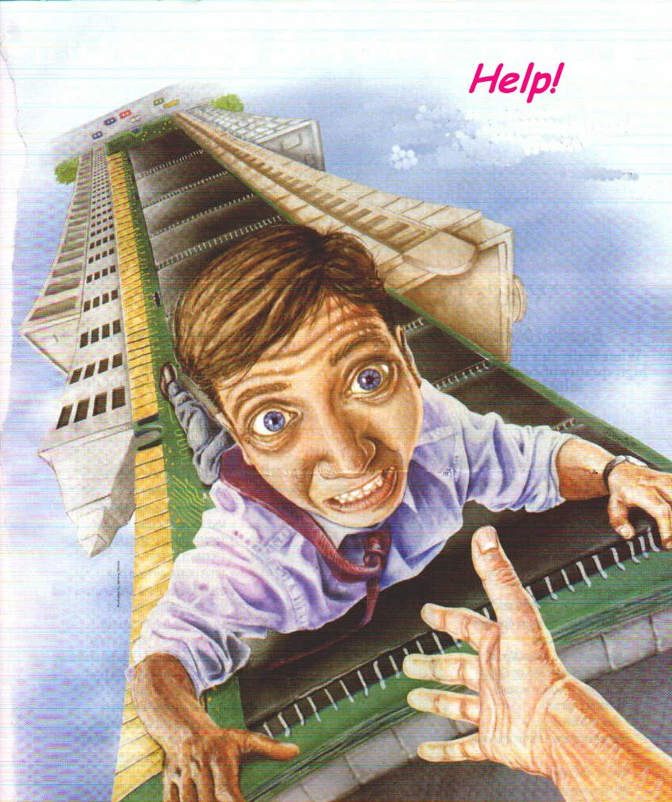
Traumas, distress, damage, suffering, ordeal, upset, shock, extremely distressing experiences that causes severe emotional

shock and may have long-lasting psychological effects and many difficult and painful problems. Energy Enhancement teaches how to dissolve the negative energy from all memories.
Divorce, Bereavement, Relationships and Accidents. separation, split-up, break up, annulment, separate, break up, Grief sadness mourning unhappiness regret, distress, many difficult and painful problems. Learn the Energy Enhancement Mastery of Relationships. Energy Enhancement teaches how to how to dissolve the negative energy from all memories.
Rape and Abuse violent, destructive, or abusive treatment. Being a sort of slave for the benefit of others. Controlled by the people around you who suck and vampirise your energies. Energy Enhancement teaches how to how to dissolve the blockages and negative energy from all karma and bad memories.
Anger, Fear and Depression. Energy Enhancement teaches how to how to dissolve all negative emotions.
Sex, Frigidity and Impotence, unable or unwilling to respond sexually, to enjoy sexual intercourse, or to have orgasm during intercourse and the inability of a male to perform sexual intercourse, usually because erection of the penis cannot be achieved or sustained. Energy Enhancement teaches the Mastery of Relationships and how to how to remove all blockages from the sexual chakra.
Multisexual problems, Lesbianism, Homosexuality Energy Enhancement teaches the Mastery of Relationships and how to how to remove all blockages from the sexual chakra.
Sex Addiction and sexual intercourse. Energy Enhancement teaches the Mastery of Relationships and how to how to remove all blockages from the sexual chakra and addictive desires.
Addictions, a state of physiological or psychological dependence on a drug liable to have a damaging effect, habits, compulsions, dependence, obsession, craving. Learn how to remove all blockages from addictive cravings and desires. Energy Enhancement teaches how to how to remove all blockages from addictive desires.
Disease, Bad backs, heart disease and cancer. Energy Enhancement teaches how to remove disease blockages
With Energy Enhancement we can learn how to Transmute Aches and Pains, Traumatic Emotional Memories and Negative Thoughts, to Ground Negative Energies and learn The Mastery of Relationships Cravings and Desires.

Energy Enhancement teaches how to Increase our Good Luck, Happiness and Purpose.

How to deal with these painful/difficult experiences we undergo in life?

WE go to psycologists, doctors, psychiatrists. We go to lawyers and marriage councilors. We get divorced. WE kill ourselves. We take drugs. We get involved in perverted sexual practices. We

pierce ourselves and get tattoed. We cheat. We hurt our loved ones. We become alcoholics. We kill, rape and destroy. We entirely fuck up our lives. We get bad backs, heart disease and cancer. And through all this we wonder why all this pain? Why is life so difficult? Why is God such a bastard?
All this pain we carry within manifests into the circumstances of our lives. As within so without. What does this mean? Well if you carry pain within then you attract more pain. If you carry negative energies within you, then you attract negative experiences in your life. The only way to deal with it and overcome this is to get rid of the Energy Blockages inside. Remove the problem at the root.
Energy blockages are at the source, the cause of, root of all problems, painfull experiences and stressful situations we are presented with in life. Yet without the understanding of this basic concept we look in all other directions for solutions.
With Energy Enhancement we teach you how to get rid of these blockages. You understand the situation on an Energy level. You are empowered with the tools to change and heal your difficult circumstances.
In Energy Enhancement we teach you how to do it for yourself. We provide a field of positive energy to help the process, called the Buddhafield. From time to time, if you need a little help, we give it. But we are merely midwives or guides, and it is you who must walk every step of the way by yourselves and when you have done it you must also know that you have been carried every step by goodness and mercy. This way you don't come back. You don't slip down into the same hole of depression. Whatever challenges you are presented with, you know how to overcome. You know the method. You know the technique.

Your life changes. You are attract positive experiences, better luck, better relationships and friends.
All gurus heal these horrible things whose cause is Energy Blockages.
Gurdjieff was given an oil tanker worth millions when he healed the son of a millionaire of drug addiction.
Sri Yogendra of Bombay told me that in the 1930's he was healing the children of millionaires and from this he was able to buy his ashram in Bombay, "They gave me a black stallion to ride around on in Central park", he said.
Daskalos, a Master in Cyprus said that when he was young he was a bit hasty. He was told to come and heal the son of a Greek

Millionaire whose son was a Gambler, Heroin Addict and Homosexual. So he went into him and took away the blockages corresponding to those three problems and went away really happy. Three days later he was told to come again. The son was just lying there with no volition, drooling on the bed. He realised that this guy had nothing other than his blockages, he was totally cut off from his soul. So he gave him the least harmful one back. One problem with which he could still grow and evolve. He gave him back homosexuality and the guy bought a big villa. He filled it with works of art, learnt how to play the piano. Gave wonderful parties and lived there with his beautiful boyfriend.
They do this to create faith in people that this is possible. Miracles are possible with Energy Enhancement.
Yet the real work is always with those who are on the verge of enlightenment. Who have a heart which wants to help the world and all in it, who understand the reality of enlightenment and the urgency of the situation.
Energy Enhancement Client 1.
One beautiful young lady came on the Energy Enhancement Course with relationship and stress problems. From the age of 16, from her first period she had felt intense pain in the abdomen during that and every period since for many days. She went white with the pain and nothing had been able to diminish the problem days every month so all she did was go to bed for a few days and dosed herself with the most powerful analgesics, pain killers, she could find. Now the abdomen is Swadhisthan Chakra, the relationship chakra and a pain there points out energy blockages in the abdomen which probably came from implants or painful relationship partings, death, bereavement and painful breaking ups like divorce in this and in previous lifetimes.
Because of these traumatic memories fulminating in the abdominal psyche it is not possible to have a perfectly good relationship with anyone, they need to forgive you so many bad ways of acting, so much so that after a few painful tries at a normal relationship with prospective husbands she had decided to try out lesbianism. I told her that she would have no better luck with lesbianism because if your relationship chakra is blocked, it is not possible to have perfectly good relationships with anyone.
And stress was there in her life which was seriously affecting her work. Because the pain caused blockages were filling up her abdomen, she had no room for storing more pain and stress, so she just could not deal with it and it was becoming more and more of a problem with each passing year.. Further, because of the pain

inside of the abdomen sometimes people do not want to go close to that pain. They do not want to move the abdomen at all because it disturbs the pain. Therefore they do not breathe into the abdomen and this lack of correct breathing further reduces their energy and their ability to handle stress. Statistically 30% of all people are like this. Although we can learn to breathe into the abdomen, unless we remove the pain filled blockages the problems will persist.
So, knowing the above I went into the abdominal chakra; by pushing energy down the right channel and feeling no flow coming back from the chakra from the left channel I was able to locate three energy blockages there. Energy Blockages stop the circular flow of energy between chakras. Using the techniques of Energy Enhancement level 2, The mastery of Energy Blockages, and Level 4, The Mastery of Relationships, I grounded, Transmuted and sent on the Perverted Negative Energy inside the blockages and the living energies which were maintaining them, one by one with great concentration.

BALANCED AND SHARED COMMUNICATION FLOW

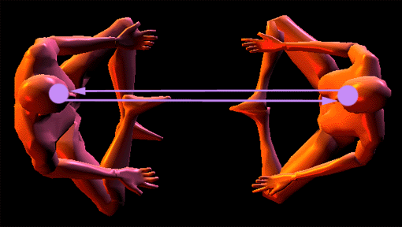
Transmitting and Receiving Communication in a shared and balanced way.

The results were that next period and for every period afterwards our client had no more pain. She later reported by email that she was going out with a nice boyfriend again and her resistance to stress was vastly improved, particularly using the techniques of Energy Enhancement which we taught her on the course.

Energy Enhancement Client 2.
One Client came on the course with a pain in the abdomen and no or little blood flow during her periods which had started the previous year. I went into the abdomen and found a blockage on the side of the chakra receiving energy from others. This blockage meant that her relationships she could only GIVE and not receive energy on the physical, emotional, mental and spiritual planes. She could receive nothing from others and this she had been doing all of her life but after so many years of giving, at last she was running out of energy. Her battery of biological energy which she had been given at birth was running out.

Using the techniques of Energy Enhancement level 2, The mastery
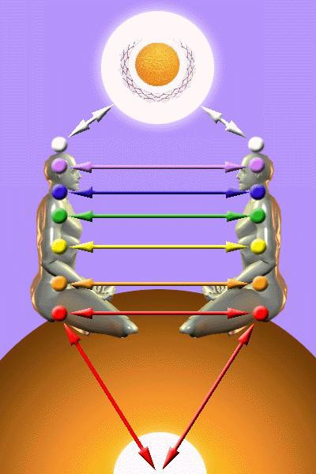of Energy Blockages, and Level 4, The Mastery of Relationships, I grounded, Transmuted and sent on the Perverted Negative Energy inside the blockage and the living energy which was maintaining it. This blockage had been implanted in her and was being maintained in her abdomen in order to feed energy back to the implanter and to reduce her energy and ability to work.

The result of removing the implant was that she lost the pain and started to have normal blood flows during her period but she now needs to recharge her spiritual battery through rest and recuperation.

Energy Enhancement Client3,
Our client was raped when she was 17. This so made her feel ashamed in her hick rural community who blamed her for the rape, that she left and spent 25 years as a nurse abroad. The boy who raped her had his offence swept under the carpet because he was just a boy. Her trauma was driving her life and she found it impossible to create any successful long lasting relationship. Pain created Blockages in the abdominal chakra will do that. On the Energy Enhancement Course we removed the trauma blockages and she had the experience of forgiving her rapist who was now dead. Then she had the experience of meeting an Ascended Master in meditation who told her it was now time to go home to heal her life

there. So after the course she went back home...

Energy Enhancement Client 4.
For example, When our client, Elektra (From the Greek Myth of Elektra, the sister of Oedipus, who killed her mother and married her father) was a child she had a beautiful energy connection with her father that she really enjoyed. Her father really enjoyed it too, probably much more that with her mother. Elecktras connection broke her Fathers connection with her Mother. He left home and set up house with another woman and this really upset our client because she felt like the wife who was left behind. The inner child formed at that point and like Anais Nin, unconsciously she started to connect to everyone, searching for that father connection she had before.

As she left home one day at the age of 14 she was set upon and raped probably because she was still seeking those same energy connections with others that she enjoyed with her father. The Inner Child connected energetically with a man who had no control. She did not do this consciously, the little Inner Child Computer program was in charge and was probably combined with a Poor Me program searching for sympathy from her father in order to get him back.
These connections are sexual and yet they are used by parents to connect to and feed psychically their children. There is only room for one male and one female connection into the sexual base chakra.

There is a great deal of confusion over these connections and part of the Mastery of Relationships is to learn how to use these connections to give energy and to remove blockages appropriately and not to use them just for sexual gratification. It is part of the necessary Tantric experience to always do this appropriately and with no harm to anyone.
The Desireful Selfish Inner Child Blockages always end up hurting someone and therefore Energy Enhancement teaches you how to integrate and heal them.

Over the years, she used the poor me to attract her father again and again and she said with despair when he married again a young lady of her age and beautiful blond hair, "Why did he not choose me?" She chose, (poor me again?), a beautiful young boy to marry, a Niezchian god of the future, so bright, so intelligent. But a heroin addict. She gave birth to his baby but he died of his drugs.
She lived with her mother and her child went to university and

learnt computers, so bright, so beautiful, so energetic and so implanted onto the dark side.

On the Energy Enhancement Course was needed in the case above... The purification of the self destuctor strategy which was using drug adiction to gain attention. Mastery of Relationships and energy connections. The removal of the energy blockage implant connection connection to the dark side which always tries to get you onto drugs, sex addiction, prostitution - DESPAIR, so as to be able to suck your energies dry more easily and use you as a slave.
Energy Enhancement Client 5.
Our client related that her cousin tried to rape her when she was nine. She had been very beautiful and had a large chest when she was nine years old. Several people had tried to abduct her for sex slavery. Her boyfriend violated her after 6 years of going out together. Her whole life had been about relationships and fathers and children. Her past life regressions had all told her that her problem was relationships and suicide. In one of her past lives she had been a famous poet who had committed suicide. She had not enjoyed sex and since the incident that happened when she was nine. When her cousin touched her chest in that incident she had become insensitive in that area.
The whole time she was talking to me I had felt a connection in the base chakra, the sexual chakra. The next day whilst lying in bed she had started thinking about me and had, like a succubus, connected with me again in the base sexual chakra. And yet I was certain that she was not consciously aware of what she was doing.
Psychologists call it libido and transference.
It seems that inner children. Split off parts of the self. Small egoistic computer programs are in control of connections between peoples chakras in areas in which most people have no conscious control.
All attachment is caused by these inter chakra connections. This is libido.
Probably she had unconciously connected with all of the people who had tried to rape her. Her inner child, split off by some painful incident when she was a little child, was in control of her love life and her conscious mind was not enjoying the ride. She was usually disgusted by any sexual attention, did not enjoy it or the people who were attracted to her.
ATTACHMENT LEADS TO PAIN - GAUTAMA BUDDHA
Her inner child blockages are in control of the monkey house. And if this is the case with her, then the chances are that inner children

control the chakra connections between all people in both men and women. And even if you quite like your partner, unconsciously the emotionally driven inner child can still stop the sexual connection for any little thing and search around for another. All relationship problems start with attachment. All disappointment starts with attachment and leads to pain. And all of it is caused by mad pain filled blockages called inner children.
All of the dependent strategies to get what you want have their source in the mad inner children energy blockages.
With Energy Enhancement we can stop all pain caused by attachment. We can heal all this pain in the whole of humanity.
The solution was to heal all the inner children energy blockages. First by grounding all the pain caused energy filling and powering them, and then by integrating these split off parts back into the soul.

Energy Enhancement Client 6.
Well our client said that she, her sister and brother had been sexually abused by her mother, father and grandfather when they were children. Her brother and sister were drug addicts and had tried to commit suicide. She had been attracted to psychology and psychiatry at university and was now a Senior Psychiatrist working with children. Her psychiatry had obviously saved her life but not sufficiently and thus she came to Energy Enhancement.

Obviously she had absorbed a lot of trauma and pain which needed to be grounded but interestingly she found when she started the Energy Enhancement Karma Clearing Process an explanation of the reasons as to why she had been given parents like this.

It is good for the ego to admit that in many previous lifetimes we have done bad things. We are all like this, but in this lifetime we have decided we want to do better.
Hitler can be forgiven. The prodigal son is welcomed back onto the path of light. Yet all these bad things we have done we have to learn how to forgive ourselves. Thus the Energy Enhancement Karma Clearing and Forgiveness process. Only when we have forgiven ourselves, can we learn how to forgive others. We do this by learning how to ground all these negative karmic energies so that we do not have to live through this karma physically. We can remove it energetically using the Energy Enhancement Techniques before it manifests into your life as pain and traumatic experiences.

It says in the Hindu Bible, a conversation between God or Krishna, and Arjuna or the good part of you, in the Baghavad Gita Chapter 16
- THE QUALITIES OF THE SELFISH COMPETITIVE PSYCHOPATHIC EGO....

Persons of demonic or psychopathic nature do not know what to do and what not to do. They neither have purity nor good conduct nor truthfulness. (16.07)
Psychopaths say that the world is unreal, without a substance, without a God, and without an order. The world is caused by lust (or Kaama) alone and nothing else. (16.08)
Adhering to this view these psychopathic lost souls, with small intellect and cruel deeds, are born as enemies for the destruction of the world. (16.09)
Filled with insatiable desires, hypocrisy, pride, and arrogance; holding wrong views due to delusion; psychopaths act with impure motives. (16.10)
Obsessed with great anxiety until death, considering sense gratification as their highest aim, convinced that this (sense pleasure) is everything, (16.11)
Bound by hundreds of ties of desire and enslaved by lust and anger; they strive to obtain wealth by unlawful means for the fulfillment of desires. Psychopaths think: (16.12)
This has been gained by me today, I shall fulfill this desire, this is mine and this wealth also shall be mine in the future; (16.13)
That enemy has been slain by me, and I shall slay others also. I am the Lord. I am the enjoyer. I am successful, a powerful siddha or black magician, and happy; (16.14)
I am rich and born in a noble family. I am the greatest. I shall perform sacrifice, I shall give charity to show off, and I shall rejoice. Thus deluded by ignorance; (16.15)
Bewildered by many fancies; entangled in the net of delusion; addicted to the enjoyment of sensual pleasures; psychopaths fall into a foul hell. (16.16)
Self-conceited, stubborn, filled with pride and intoxication of wealth; they perform Yajna, religious sacrifice, only in name, for show, and not according to scriptural injunction. (16.17) Clinging to egoism, power, arrogance, lust, and anger; these psychopathic malicious people hate Me (who dwells) in their own body and others' bodies. (16.18)
I hurl these psychopathic haters, cruel, sinful, and mean people of the world, into the wombs of other demons or psychopaths again and again. (16.19)
O Arjuna, entering the wombs of demons or psychopaths birth after

birth, the deluded ones sink to the lowest hell without ever attaining Me. (16.20)
Lust, anger, and greed are the three gates of hell leading to the downfall (or bondage) of THE Jeeva personality. Therefore, one must (learn to) give up these three. (16.21)

Look at 16.19 and 20 again.

I hurl these haters, cruel, sinful, and mean people of the world, into the wombs of demons or psychopaths again and again. (16.19)

O Arjuna, entering the wombs of demons or psychopaths birth after birth, the deluded ones sink to the lowest hell without ever attaining Me. (16.20)

And in the Energy Enhancement Karma Clearing Process, without any promting by me, this is what client 6 said...

1500 years ago she was a beautiful lady healer with long blond hair who was on the path of righteousness. A bad guy saw her and through implanting her with a blockage was able to make her fall in love with him. This bad guy
turned her onto the dark side of the force and for 10 lifetimes this guy led her into bad paths of black magic, sex and sado-
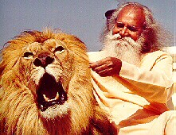masochism, abusing many different people. Then, as happens to all on the dark side she was defeated (LITERALLY DE- FEETED, her base chakra was broken and implanted by another bad guy) And she entered into 100 lifetimes of sexual abuse, serving as a sex slave and as a spiritual battery for the bad guy who implanted her.

She was learning why she had been given these experiences. Karma, the law of consequences, says we have been given the free will to learn the consequences of taking the wrong path. In reality

we are only allowed the freedom of making the right choice. Everything which has a beginning has an end.
And further, with Energy Enhancement, how to totally heal the entire stuation, how to dissolve the negative karmic energies which were throwing her into these hells time and time again. How to remove all the implants which were turning her into a batttery and not allowing her to generate the energy necessary to get her out of this black hole pit she was in. How to cut off all connections with the Dark Side, "seal the door which evil dwells" so that they could not attract her into bad ways again and become independant and free of all negative influences. How to gain infinite positive energy from the side of Light and goodness and purpose and will. She was learning how necessary it is to stay away from evil and to cleave to the good.

If you desire anything on this planet remember, you cannot take anything with you when you die except your evolution. So please evolve through the kindness of those sent to this planet to help you. They are here in every generation, just for you. This is the promise of the Baghavad Gita.

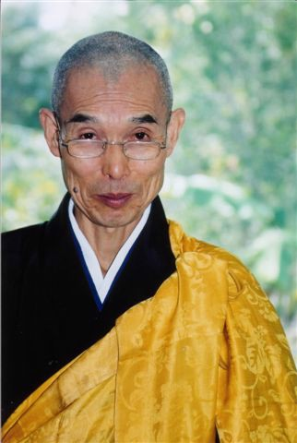My teacher, Swami Satchidananda said that when he was young he could touch people and take away their cancer, he could touch people and take away their heart disease yet after three years he noticed that these same people were coming back with the same problems. He realised that unless they changed their minds also, it was not possible to heal them permanently. They had to learn to do it for themselves. So he started a program for yoga and meditation and if the people were good, perhaps a little bit of healing could enter from the side.

Once a Swede came to Swami Satchidananda with a grave abdominal problem. Swami said, come to the Ashram for 6 months and learn Yoga and meditation and practise every day and your problem will be solved. So after 6 months the guy came to swami and said, the problem has not gone away. Swami asked if he had done everything, the yoga, the meditation and had practised every day and the guy said yes. So

Swami moved his hand close to the abdomen and made a catching and pulling motion with his right hand as though he was pulling something out of him. He then asked him how he felt and the guy said the pain had gone. It never returned.

I remember Zen Master Hogen when I was with him in The Greek island of Lesbos acting as his general factotem and dogsbody. We lived together in the same house for two weeks and one night I had a dream. I was lying on a stone slab as a dead King. Hogen came to me and leant over my body from the hips and sucked out my right eye. He cleaned it with his mouth, took it out, polished it playfully and then put it back into his mouth, leaned over me again and spat it back into my eye.

The next day I found out that Hogen had done something very stupid. He had put some strong eucalyptus oil, Olbas Oil, on his finger and put it into his right eye. So, the students cleaned it out with water and he wore an eye patch, like a pirate, for the rest of the time there. It must have been very painful for him yet these things are done for the benefit of the students. Thus the Master from time immemorial has absorbed the Karma of the Students.
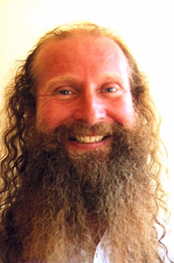I asked Zen Master Hogen what he had done in past lifetimes and he said he had been a Guiness (Karma) maker. Now in this lifetime he was drinking all the Guiness. He was absorbing and transmuting all the karma. And this was the symbolism of
his students giving him a can of Guiness every time They met him.

Swami Satchidananda told me that Yoga was the gaining of Psychic Vision and when necessary the blockages of the students are removed.

There are many examples gleaned from many experiences and books from the age of 16 when I started to practise Yoga. From the age of 21 when I started to read spiritual books and train with the National Federation of
Spiritual Healers of Great Britain and then later to become a Yoga teacher and teach those with Multiple Sclerosis in my local class and at Ickwell Bury a Yoga Foundation run by Howard Kent near London. I had to stop the class after a while, they all got well.
And last but not least my training and experiences with Zen Master Hogen Daido Yamahata and Swami Satchidananda - two enlightened saints and Siddhas whose whole lives have been devoted towards

the benefit of everyone who met them. Swami Satchidananda has now passed on at the age of 89 in 2002 but you can meet Hogen, student of the famous Zen Master Tangen Harada Roshi, in Japan at his Zen Temple on the slopes of Mount Fuji or at his Ashram in Australia.

In Energy Enhancement we teach you how to do it for yourself. We provide a field of positive energy to help the process called the Buddhafield and from time to time, if you need a little help, we give it. But we are merely midwives or guides, and it is you who must walk every step of the way by yourselves and when you have done it you must also know that you have been carried every step by goodness and mercy.

What makes you think that you have done anything? Only the Ego. And yet it is true, with the collaboration of infinity, you have done everything by yourself.

Satchidanand
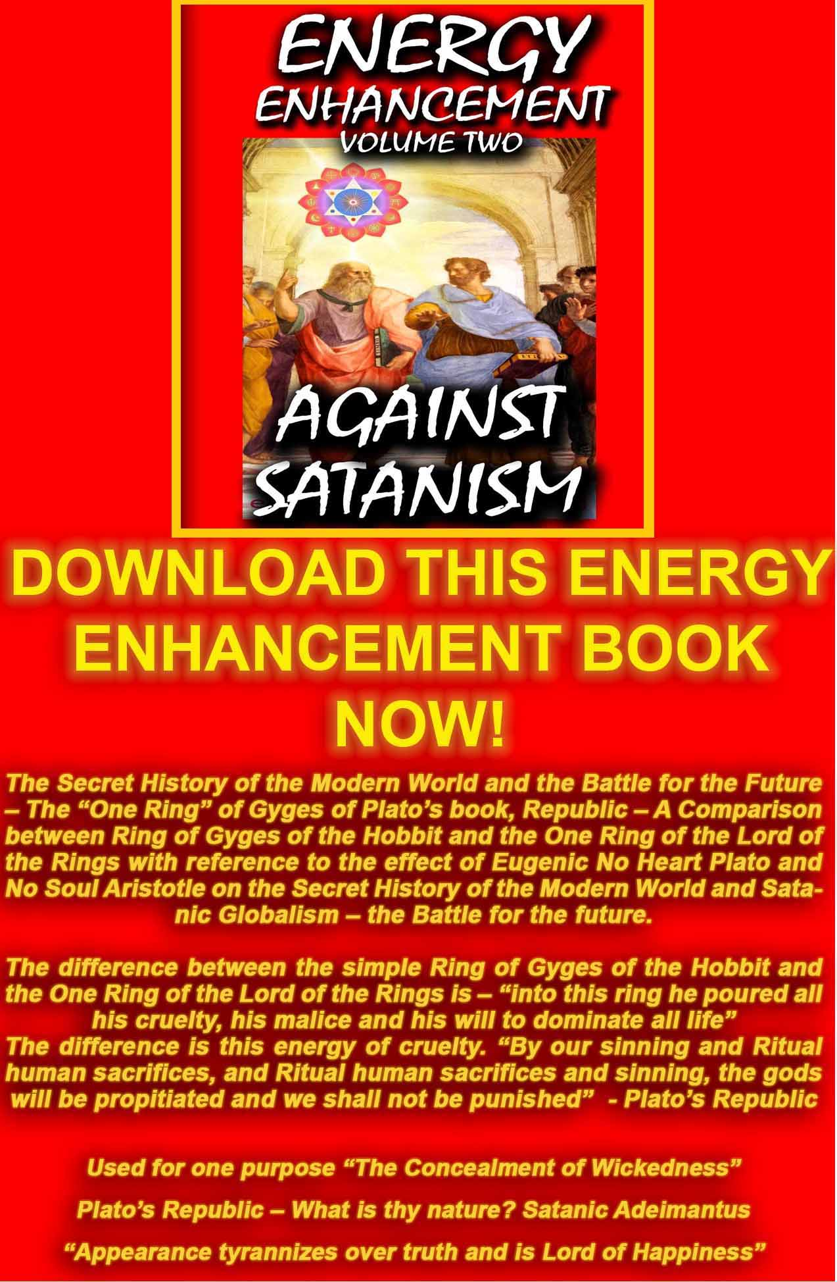
AGAINST SATANISM VOLUME 2
DOWNLOAD HERE
http://www.energyenhancement.org/Sacred-Energy/Against-Satanism-Volume-2/Against-Satanism-Volume-2.pdf

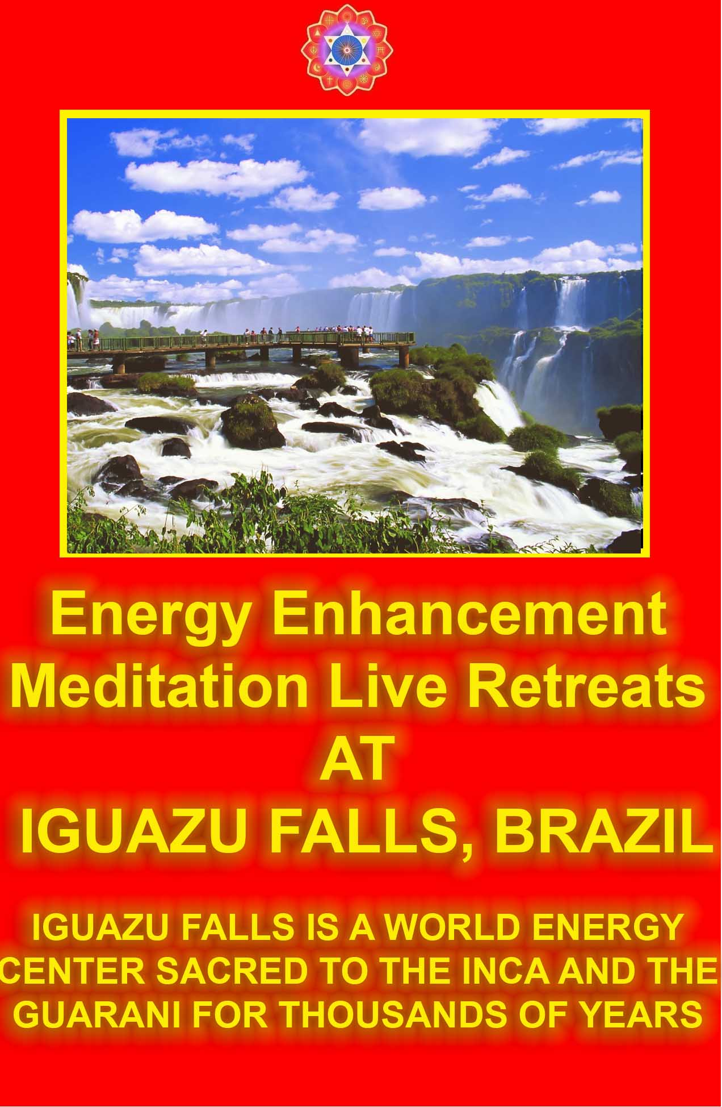

75% are PSYCHOPATHS,
Thieves, Murderers, Torturers and their Accomplices!
FAIR USE NOTICE:This section contains copyrighted material the use of which has not always been specifically authorized by the copyright owner. Such material is made available in an effort to advance understanding of issues of psychopathy and humanitarian significance. We recommend you buy these materials for yourself to obtain a greater understanding of the subject. We believe this constitutes a 'fair use' of any such copyrighted material as provided for in section 107 of the US Copyright Law. In accordance with Title 17 U.S.C. Section 107, the material in this section is distributed without profit to those who have expressed a prior interest in receiving the included information for research and educational purposes.

"A man has blockages like a dog has fleas" - Ancient saying. To illustrate the point here are FIVE sections on this page.

- PROLOGUE - The Energy Enhancement dissertation on Energy Blockages as the cause of Psychopathy. Energy Enhancement teaches the techniques to remove these blockages and solve a World Psychopathic Problem, thus creating ONE HARMONIOUS ENLIGHTENED WORLD.
- MURDERERS - Total, 200 millions of people murdered, genocided, tortured, starved to death this 20th century WITH EXAMPLES PSYCHOPATHS STALIN, HITLER, AND MAO.
- THIEVES, Psychopaths in charge of Multinational Companies. THIEVES, Snakes in suits Spot the true psychopath among the sharks in your office. HERE ARE SOME facts: Andrew Fastow, formerly of Enron, stands accused by an American court of taking
$30 million in kickbacks from the company while its shareholders lost more than $70 billion. And more.....
- ACCOMPLICES, - The Compensated Psychopath. "I like following orders!" - Monty Pythons Life of Brian. Compensated psychopaths have played significant parts in society and in history. All the Nazi functionaries who administered the concentration camps and supervised the destruction of thousands and thousands of human beings; all of Stalin's subordinates who, during the time of the Soviet purges, directed the arrests, torture and deaths of 65 millions of individuals; all of Mao's minions who so efficiently effected the disappearance, torture and death of large portions, 35 millions of the Chinese population - certainly all of these people were compensated psychopaths, accomplices.
- TORTURERS - At this moment 128 countries, according to Amnesty International, use torture as a means of repression and control. THERE ARE MANY EXAMPLES.
It is the considered opinion of Energy Enhancement that more than 75% of the general population has symptoms of Psychopathy, - Thieves, Murderers, Torturers and their Accomplices with the potential to do tremendous damage when given the opportunity!
This is not only the one or two percent of real psychopaths, but also the accomplices, the vast majority of people who if ordered to help the guys in charge, DO IT!! And these accomplices are the vast majority of all the people in varying degrees.
Scientifically and historically we can see the problem. This is a world problem and is in need of solution.
It is not possible for revolution or war to change the above as it plays into the hands of the psychopaths in charge and historically has always made matters worse as the law falls into disarray.

"War always reinforces the central power at the expense of the people." Simone Weil
No, the solution to all this, what we need, is the removal of blockages through Energy Enhancement techniques particularly in the heart, above the head and then in the base chakra PROCESSOR FUNCTION in order to solve the situation, otherwise this world is headed for more disaster.
What we need is One Harmonious Enlightened World...

75% ARE PSYCHOPATHS, SCHIZOPHRENIC, AND MANIC DEPRESSIVE.

CAN YOU SEE EVEN A LITTLE OF THIS IRRATIONALITY IN YOURSELF?
THE SOLUTION TO THE ONE MAJOR WORLD PROBLEM IS ENERGY ENHANCEMENT.
ENERGY ENHANCEMENT GIVES ANCIENT, ADVANCED AND SUCCESSFUL TECHNIQUES FOR THE REMOVAL OF ALL ENERGY BLOCKAGES CAUSING ALL PSYCHOPATHIC TRAITS, IN YOU AND IN EVERYONE ON THE PATH OF ENLIGHTENMENT.
FOR THE BENEFIT OF ALL BEINGS.
FOR ONE HARMONIOUS ENLIGHTENED WORLD.
ALL the Worlds problems are caused by Psychopaths!!
Psychopaths are the only part of the population which cause all the worlds problems. Therefore we need to use psychological profiling to detect these people in advance of their depredations and also peaceful methods of curing them as the most urgent action of a Suffering World.

Peacing for peace means speaking out against wrong psychopathic attitudes. Intellectually we need to create the information to make all people understand that psychopathic attitudes and actions just do not work. Non psychopaths just, “Get It” that it is just plain wrong.
Energy Enhancement teaches how to remove psychopathic energy blockages within your psychic body.
As more people begin to understand that the removal of these blockages is possible, so the call for mass education in these techniques will grow, needs to grow.

"Until we wise up" - from the movie, Magnolia.

PROLOGUE
THE RULE OF ONE IN FOUR!!
Many hundreds of years ago there was a Mother who had Four children. She was alone and needed help. She prayed for help and asked an enlightened Sufi Master for advice. He came and pronounced the work for all of the Children. One he said to become his servant. The other to join the army. The other to become a shopkeeper and the last to help all the others.
Over the years the boy who joined the army progressed, became heroic, won many battles and became a General under the King. The Boy who became a shopkeeper became very successful, bought many large shops and became very rich. He was supported by his brother who helped him manage the businesses and left him free to start many other businesses.
Everyone in the family was so happy with the Sufi master that they gave him a place in the family, gave him many gifts and consulted him regularly.
At last the boy who was the servant to the Sufi Master became Enlightened. He asked him how he knew which occupation to give to himself and his brothers.
The Master said it was easy. He looked into their past lives and saw that the one who joined the army had a predisposition to becoming a murderer. The one who became a businessman shopkeeper had a past life predisposition to being a thief. And the one who helped the Business brother had no soul, would only do what he was told

and so for many lifetimes had been the other brothers Accomplice in their murdering and thievery. He liked following orders. Any other occupation and they would have been put in jail and executed.
The Sufi Master said that the boy who was the servant had the best chance of Enlightenment because he was an older soul, had much experience in the occupations of the others in past lifetimes and because of that had seen deeply that these occupations always failed. Always there were people competing for the same things.
Ultimately the General was defeated and the Businessman became bankrupt. Ultimately, even if able to hold onto your gains, "You can't take it with you", Death came along and took everything. Life after Life!!!
For this reason the Servant of the MASTER was the only one who stood the chance of enlightenment. And even with that predisposition, with bad teaching he would never reach his goal. Unless humble and able to find a Master, normally he would become an unenlightened Priest and become One of the Blind, leading the Blind, another accomplice of the murderer and the thieves. That is why he needed the help of the Sufi Master and that is why he had kept him close, within his Buddhafield and removed many of his blockages.
The Blind, the Businessman, the General and the Accomplice This story comes from a Sufi Tale many hundreds of years old. It
tells the truth about you and humanity. It tells the truth about the
Law of Manu and the caste System of India and the Four Castes The Bhagavad Gita says this about the varnas:
The works of Brahmins, Kshatriyas, Vaishyas, and Shudras are different, in harmony with the three powers of their born nature.
- The works of a good Brahmin are enlightenment; peace, self- harmony, austerity, and purity; loving-forgiveness and righteousness; vision and wisdom and faith. A bad Brahmin, the person interested in Enlightenment which in this world has come to mean the Unenlightened Priest who are blind to the light of the soul and accomplices to the totalitarian state.
- These are the works of a good Kshatriya: protectors of the weak, a heroic mind, inner fire, constancy, resourcefulness, courage in battle, generosity and noble leadership. Kshatriya, the Warrior, charged with protecting the state. The King, the General, the Samurai. The bad Kshatriya, the General is usually the Totalitarian Murderer and the torturer.

- Trade, Business, agriculture and the rearing of cattle is the work of a good Vaishya. The bad Vaishya, the businessman is the Thief who uses the general and the accomplices to attain his monetary end.
- And the work of the Shudra is service to all the above, the Laborer in this world. He likes following orders! The bad Shudra is the Accomplice helping the thief and the murderer.

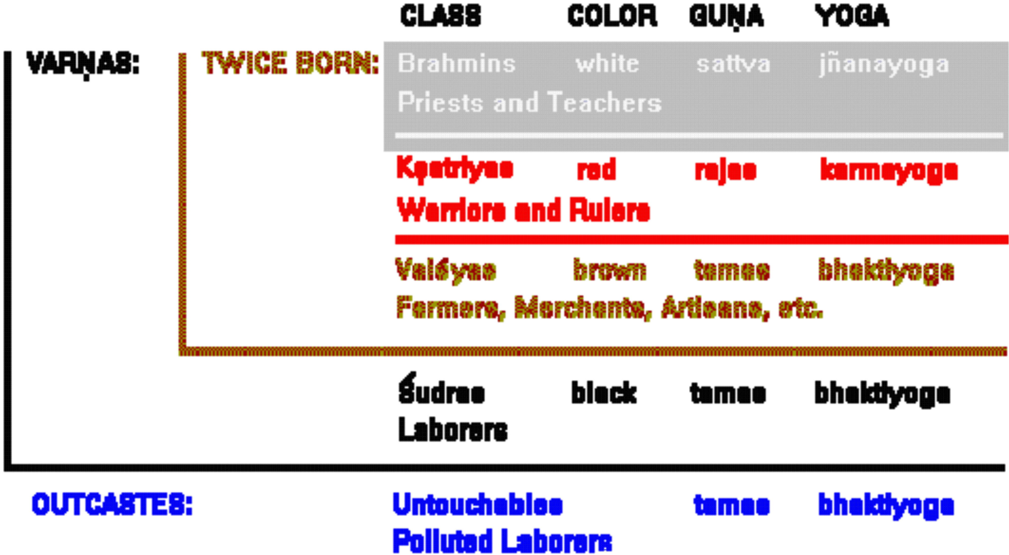

75% are Thieves, Murderers, Torturers and their Accomplices!
My master, Swami Satchidananda knew all of this. They asked him about the Rulers of the World. "You are a famous man, you have shaken the hands of all these leaders and Prime Ministers. Just what do you think of them?"
First of all he said that it was very dangerous to speak of these people or even mention their names.
For this reason he said he would tell a story.
If you had an election for the leader of the council in a town and 75% of the people in this town were thieves, murderers and their accomplices, just what sort of a person would they elect?

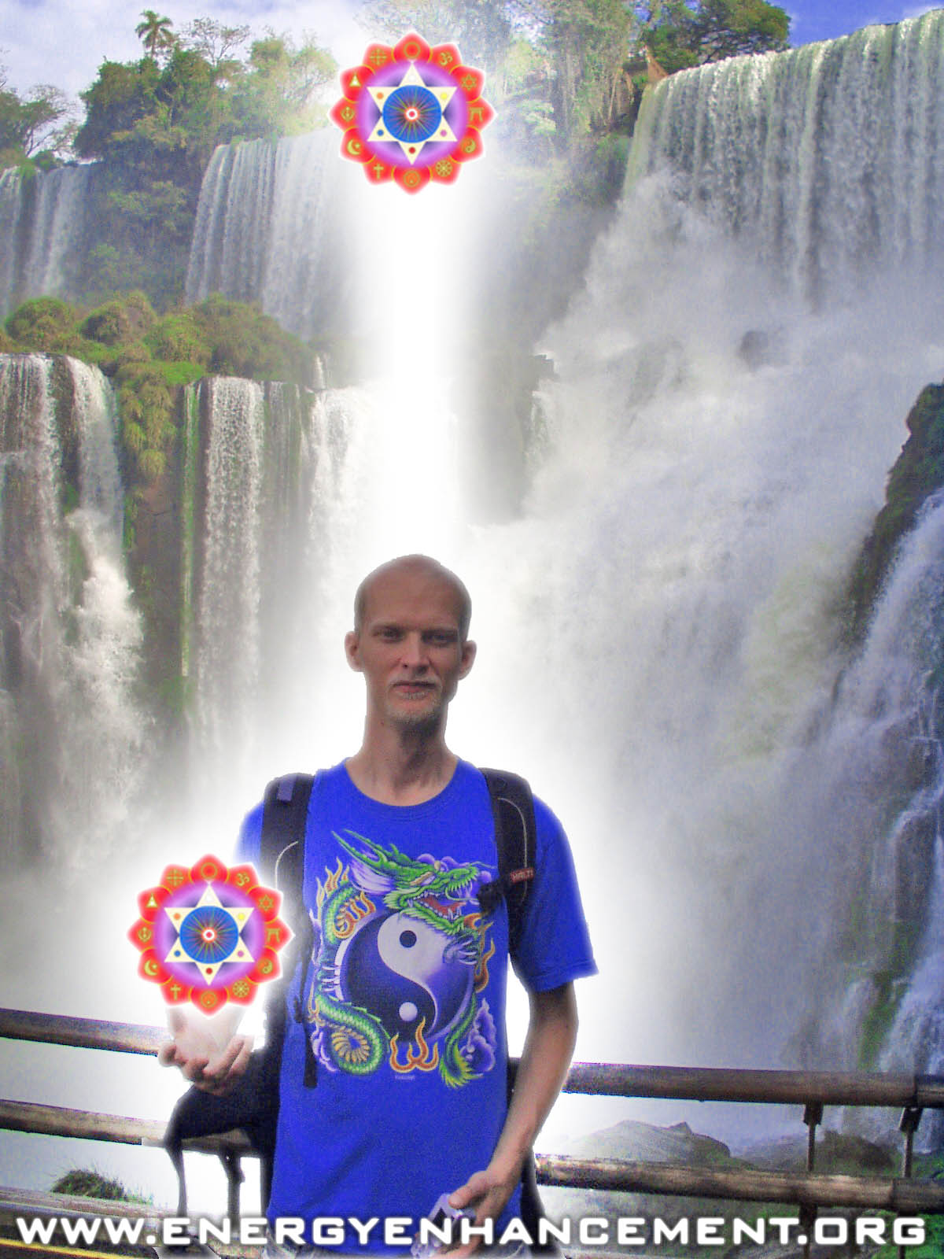

ENERGY ENHANCEMENT COURSE AT IGUAZU FALLS. BRAZIL

"Get your asses over here Now and Speed Up your process of Enlightenment on the Energy Enhancement one month course!!" - DON
Every one of our Students gets this Spiritual Experience of Connection with Infinite Energies.
Energy Enhancement does indeed, "SPEED UP THE PROCESS!!"
And they all get this Experience of Light, Life and Infinite Energy just with the Energy Enhancement Course - Every One of Them!!
THIS IS THE RULE OF ONE IN FOUR!!
ENERGY ENHANCEMENT IS THE SOLUTION
THE SHUDRAS, KSHATRYAS AND BRAHMINS – A PSYCHOPATHIC LACK OF MORAL SENSE - IN THE WORK OF HENRY DAVID THOREAU
The mass ofen serve the state thus, not as men mainly, but as machines, with their bodies. They are the standing army, and the militia, jailors, constables, posse comitatus, etc. In most cases there is no free excercise whatever of the judgement or of the moral sense, but they put themselves on a level with wood and earth and stones, and wooden men can perhaps be manufactured that will serve the purposes as well. Such command no more respect than men of straw or a lump of dirt. They have the same sort of worth as only horses or dogs. Yet such as these are commonly esteemed good citizens. Others - as most legislators, politicians, ministers, and office holders, - serve the state chiefly with their heads, and, as they rerely make any moral distinctions, they are as likely to serve the Devil, as God. A very few, as heroes, patriots, martyrs, reformers in the great sense, and men, serve the State with their consciences also, and so necessarily resist it for the most part, and they are commonly treated as enemies by it. - Henry David Thoreau, Civil Disobedience.

75% ARE PSYCHOPATHS, SCHIZOPHRENIC, AND MANIC DEPRESSIVE.

CAN YOU SEE EVEN A LITTLE OF THIS IRRATIONALITY IN YOURSELF?
THE SOLUTION TO THE ONE MAJOR WORLD PROBLEM IS ENERGY ENHANCEMENT.

ENERGY ENHANCEMENT GIVES ANCIENT, ADVANCED AND SUCCESSFUL TECHNIQUES FOR THE REMOVAL OF ALL ENERGY BLOCKAGES CAUSING ALL PSYCHOPATHIC TRAITS, IN YOU AND IN EVERYONE ON THE PATH OF ENLIGHTENMENT.
FOR THE BENEFIT OF ALL BEINGS.
FOR ONE HARMONIOUS ENLIGHTENED WORLD.
ALL the Worlds problems are caused by Psychopaths!!
Psychopaths are the only part of the population which cause all the worlds problems. Therefore we need to use psychological profiling to detect these people in advance of their depredations and also peaceful methods of curing them as the most urgent action of a Suffering World.
Peacing for peace means speaking out against wrong psychopathic attitudes. Intellectually we need to create the information to make all people understand that psychopathic attitudes and actions just do not work. Non psychopaths just, “Get It” that it is just plain wrong.
Energy Enhancement teaches how to remove psychopathic energy blockages within your psychic body.
As more people begin to understand that the removal of these blockages is possible, so the call for mass eduction in these techniques will grow, needs to grow.
Energy Enhancement says that the Ancient and successful techniques of Energy Enhancement, techniques which produced the Buddha, Jesus Christ and Mahomet, can remove the Energy Blockages which produce:-
Psychopaths or people blocked in the Heart and above the Crown PROCESSOR FUNCTION, blocking them from their souls. Only heartless and soulless people can do the things below. See Hitler, Stalin, Mao and Pol Pot below.
Manic Depressives whose multiple emotional personalities create negative emotions within their minds, see Napoleon and Hitler below.
Schizophrenics or multiple personalities whose many split intellectual parts (In computer speak, virtual machines) each take

control of their minds (The Computer), including the inner child and strategies of the Violator and Poor Me, mirroring intellectually the emotional component of the Manic Depressive. See Stalin and Hitler below.
Because 200 Millions of people (See below) have been tortured, starved and murdered by these psychopathic leaders and accomplices this century. Because these psychopathic heartless and soulless people corrupt the business and legislature of every country in the world now....
Those people who want to be cured of their psychopathic Energy Blockages and thus become part of the solution should try out Energy Enhancement by Video or in person, now!!

To my mind, few people have brought up the similarity between existentialists and Psychopaths.
Existentialists admire most those traits which are psychopathic. Courage, lack of fear, lack of empathy, no conscience, a "fuck them' revengeful attitude.
The psychopathic sexual addict, Don Juan, has found his defenders in our time. The Existentialist philosopher Camus finds in Don Juan something of an existentialist hero, a natural (or absurd) man: He says, "This life gratifies his every wish, and nothing is worse than losing it. This madman is a great wise man. . . . Why should he give himself a problem in morality? . . . How easy it is to understand why the men of God call down punishment on his head. He achieves a knowledge without illusions which negates everything they profess. Loving and possessing, conquering and consuming--that is his way of knowing."
An existentialist is a person cut off, blocked, from their soul and from their heart, living in a flat, intellectual drab wasteland devoid of meaning. And it is only the heart and the soul which give life meaning and significance, not the intellect.
If we consider that human beings have many functions. If any of the functions are blocked, do not work, then we become less. Autism sometimes involves the function of speech - the speech part of their brain is broken - and these types become frustrated and angry because they cannot communicate and this is sometimes overcome by learning how to write instead in order to communicate. Here we are saying that in psychopaths the functions which do not work, which are blocked, are the heart empathy and soul conscience, and thus psychopaths become less than fully human because empathy and conscience will not allow a true human being to kill, "Thou

shalt not kill" is a refrain shouted from Christianity. Thou shalt not give pain to any other person by word, thought or deed is spoken about in the Vedas. A true human understands this instinctively because they have the functions of heart empathy and soul conscience. They feel shame when they go against these instincts thus "Post Traumatic Stress Disorder". A psychopath never feels any shame at what he has done.
Thus when we say that all humanity are wolf children, that autism is general in society and includes not only speech but also empathy and conscience then we are stating the problem. The solution of course is to recognize this and to test - With the feedback of psychologists we can test for psychopathy as we would for SAT scores or IQ Testing and also any other lack of function, before anyone is allowed to run for any political office.
Energy Enhancement can help to overcome or rehabilitate these functional lacks so that we can become fully human.
Now Camus is an existentialist and admired the lack of conscience and empathy is people like the fictional figure Don Juan and yet he could not cut it because he himself felt shame, but his intellectual function said that because there is no Meaning or Significance - both of these are soul functions - to anything for a person blocked in or above the crown PROCESSOR FUNCTION, Camus said, "The only thing we have to decide is how to commit suicide!"
Existentialists believe in enlightened self interest because this is a rule they can understand and follow, not because it is right.

A existentialist psychopath cannot understand words like the soul conscience and the heart sympathy, it is another paradigm because in Energy Enhancement terminology, in them the soul antahkarana above the crown chakra is cut off and the heart center is blocked, it is impossible for them to understand the soul and the heart. Like a psychopath they can only pretend and fake it.

Energy Enhancement teaches that human beings have seven PROCESSOR FUNCTIONS or energy centers NAMED CHAKRAS in their bodies which act as processors in the human parallel processing super computer, and in that computer only one processor, the brow PROCESSOR FUNCTION is intellectual. Other processors handle courage, creativity, empathy and the conscience and if some of
Those PROCESSOR FUNCTIONS are cut off or blocked, then psychopaths, schizophrenics and manic depressives are the result.
Don Juan likes many short term conquest relationships as if searching for yet never finding his mother or sexually addicted (second PROCESSOR FUNCTION blockages) has no fear (no blockages in the Base PROCESSOR FUNCTION), no empathy (Heart PROCESSOR FUNCTION blocked), no conscience (Crown PROCESSOR FUNCTION blocked). In him, some PROCESSOR FUNCTION computers are blocked and some, Intellect (Brow PROCESSOR FUNCTION unblocked), Courage (Solar Plexus PROCESSOR FUNCTION Unblocked) so we can admire his good points yet despise his bad points.
If you are blocked in the base PROCESSOR FUNCTION then you will have money problems, have poverty consciousness and will follow orders. If you are blocked in the Base PROCESSOR FUNCTION then you will have fear and thus will follow the law, yet if you have no conscience you will still be a potential psychopath.
Given permission by the army to kill in times of war you will kill. See Kubricks Movie, Full Metal Jacket about how "Normal" people are turned into killing machines by the army in the Vietnam war.
Fearful people follow the Law of Moses, graven in stone. When fear is gone and heart and conscience function, are unblocked, then we have the new law of Jesus Christ, The Law of Love, when people cannot hurt one another.
To make you less of a psychopath, Energy Enhancement gives advanced techniques for removing energy blockages in all the PROCESSOR FUNCTIONS including the heart and above the head, thus connecting you with your heart and your soul!!

"For those who believe in Enlightenment and understand the Urgency of the situation" Gautama Buddha on Energy Enhancement.

75% ARE PSYCHOPATHS, SCHIZOPHRENIC, AND MANIC DEPRESSIVE.
CAN YOU SEE EVEN A LITTLE OF THIS IRRATIONALITY IN YOURSELF?
THE SOLUTION TO THE ONE MAJOR WORLD PROBLEM IS ENERGY ENHANCEMENT.
ENERGY ENHANCEMENT GIVES ANCIENT, ADVANCED AND SUCCESSFUL TECHNIQUES FOR THE REMOVAL OF ALL ENERGY BLOCKAGES CAUSING ALL PSYCHOPATHIC TRAITS, IN YOU AND IN EVERYONE ON THE PATH OF ENLIGHTENMENT.
FOR THE BENEFIT OF ALL BEINGS.
FOR ONE HARMONIOUS ENLIGHTENED WORLD.
ALL the Worlds problems are caused by Psychopaths!!
Psychopaths are the only part of the population which cause all the worlds problems. Therefore we need to use psychological profiling to detect these people in advance of their depredations and also peaceful methods of curing them as the most urgent action of a Suffering World.
Peacing for peace means speaking out against wrong psychopathic attitudes. Intellectually we need to create the information to make all people understand that psychopathic attitudes and actions just do not work. Non psychopaths just, “Get It” that it is just plain wrong.
Energy Enhancement teaches how to remove psychopathic energy blockages within your psychic body.
As more people begin to understand that the removal of these blockages is possible, so the call for mass eduction in these techniques will grow, needs to grow.

PSYCHOPATHS AND THE THIRTEEN ENERGY ENHANCEMENT HUMAN SUPER COMPUTER PROCESSOR FUNCTIONS
ONLY ONE OF THE FUNCTIONS IS INTELLECTUAL!!
Each Chakra acts as a computer processor, has a function and only one PROCESSOR FUNCTION is intellectual.
All the PROCESSOR FUNCTIONS are needed to be truly human. PROCESSOR FUNCTIONS are blocked in most people.
The Crown PROCESSOR FUNCTION connects you with God and Conscience.
The Heart PROCESSOR FUNCTION connects you with empathy. A PSYCHOPATH HAS NO CONSCIENCE OR EMPATHY!!
Below the Base PROCESSOR FUNCTION blocked, No Energy and Vitality, usually no money, a Slave, de - feeted, likes to follow orders and laws, the accomplice the Shudra. Unblocked, A good or evil Master
Base Blocked. Psychopathic Blockage. Fear, If with money then issues - a miser or will do anything including using banks and armies to get and hang onto money, resources and property. Lack of security, willingness to kill if threatened impotence an issue. Fear of Death. Unblocked. No fear, rich, secure, potent, generous - The Secret of Abundance.
Abdomen Blocked, always wanting a new conquest, addicted to relationships and sex, wanting attention, short term relationships, bad relationships unblocked, good healthy long term relationships.
Solar plexus, Blocked no power, courage and energy. Illness and disease. Unblocked much power, courage and energy, healthy.
Heart, Blocked Psychopathic Blockage. No empathy, no external consideration which is a Gurdjieffian term which means, no ability to imagine yourself in another persons place. Unblocked much empathy and compassion.
Throat, Blocked no creativity unblocked much creativity.
Brow, intellect blocked not intelligent unblocked powerful intellect and ability for good or evil depending on empathy and conscience.

Crown, Blocked Psychopathic Blockage. No conscience, no guilt, no shame unblocked Conscience.
Above the Crown Blocked Psychopathic Blockage. Lack of knowing and wisdom, controlled by psychopathic energies and inner children, schizophrenia. Unblocked They just Know right, wrong, everything,- Luck, Wisdom and Higher Path in Life however if base PROCESSOR FUNCTION blocked then these ascenders live in the imagination and have no ability to make it happen; in Gurdjieffian terms, no power of doing…
The PROCESSOR FUNCTIONS above the Crown PROCESSOR FUNCTION Exist lifetime after lifetime whilst the body dies and thus are in charge of Immortality. Soul. Intelligence in charge of you if you are listening (for the still small voice). Repository many lifetimes of experience. Can have many bodies in existence at the same time. Monad. Intelligence in charge of a Group of Souls perhaps 50,000 people. Logos. Intelligence in charge of every living thing on this Planet. Sirius. Sacred Sun. Intelligence in charge of the evolution of this Planet and many others. Avatar of Synthesis.
Intelligence in charge of the evolution of the Sacred Suns but with direct contact also on this Planet at the moment. After that is an infinity of levels consisting of Evolution and order itself.
Blockages above the Crown PROCESSOR FUNCTION Major Psychopathic Blockages. Cut you off from conscience and can be implanted by others or purposefully put themselves in by those people afraid of death. The higher the blockage above the crown PROCESSOR FUNCTION then the more energy bodies and the more energy and the more power to do bad things, is available for use by the blocked person.
As above, so below. Blockages above are mirrored in the PROCESSOR FUNCTION below. Base to Head Initiation 3, Abdomen to Throat Initiation 2. Solar plexus to Heart Initiation 1 - see Energy Enhancement E-Book for more on the Three Initiations of Enlightenment.
Psychopathic Blockages are in the Crown PROCESSOR FUNCTION and Heart PROCESSOR FUNCTION. The more of these blockages you have, the more of a psychopath you are. In addition,
  - Blockages below the Base PROCESSOR FUNCTION - you are an accomplice who follows orders.
  - Blockages in the Base PROCESSOR FUNCTION - addicted to money, banks and resources like petroleum.
  - Blockages in the Abdominal PROCESSOR FUNCTION - addicted to Sex.

  - Blockages in the Solar Plexus PROCESSOR FUNCTION - addicted to power and anger.
"A man has blockages like a dog has fleas", Ancient saying.

75% ARE PSYCHOPATHS, SCHIZOPHRENIC, AND MANIC DEPRESSIVE.

CAN YOU SEE EVEN A LITTLE OF THIS IRRATIONALITY IN YOURSELF?
THE SOLUTION TO THE ONE MAJOR WORLD PROBLEM IS ENERGY ENHANCEMENT.
ENERGY ENHANCEMENT GIVES ANCIENT, ADVANCED AND SUCCESSFUL TECHNIQUES FOR THE REMOVAL OF ALL ENERGY BLOCKAGES CAUSING ALL PSYCHOPATHIC TRAITS, IN YOU AND IN EVERYONE ON THE PATH OF ENLIGHTENMENT.
FOR THE BENEFIT OF ALL BEINGS.
FOR ONE HARMONIOUS ENLIGHTENED WORLD.
ALL the Worlds problems are caused by Psychopaths!!
Psychopaths are the only part of the population which cause all the worlds problems. Therefore we need to use psychological profiling to detect these people in advance of their depredations and also peaceful methods of curing them as the most urgent action of a Suffering World.
Peacing for peace means speaking out against wrong psychopathic attitudes. Intellectually we need to create the information to make all people understand that psychopathic attitudes and actions just do not work. Non psychopaths just, “Get It” that it is just plain wrong.
Energy Enhancement teaches how to remove psychopathic energy blockages within your psychic body.

As more people begin to understand that the removal of these blockages is possible, so the call for mass eduction in these techniques will grow, needs to grow.

MURDERERS, TORTURERS, THIEVES AND ACCOMPLICES
A cursory look in Google under "psychopath" the new name for demon brought forth these gems.... I have divided the sections into Murderers, Thieves, Accomplices and Torturers.
Kurt Vonnegut, author of Mother Night and Cats Cradle

Interview with novelist Kurt Vonnegut, "In These Times," by its editor, Joel Bleifuss, Feb.4 2003:
Vonnegut fought in World War II.
He said ''our country... has been taken over by the sleaziest, low- comedy, Keystone Cops-style. Coup d'etat imaginable Those in charge now of the federal government are...Most frighteningly, psychopathic personalities." (600).

Illegitemi non carborundum By Joel Bleifuss | 1.27.03 Kurt Vonnegut vs. the !&#*!@

In November, Kurt Vonnegut turned 80. He published his first novel, Player Piano, in 1952 at the age of 29. Since then he has written 13 others, including Slaughterhouse Five and Mother Night which stand as the pre-eminent anti-war novels of the 20th century.

As war against Iraq looms, I asked Vonnegut, a reader and supporter of this magazine, to weigh in. Vonnegut is an American socialist in the tradition of Eugene Victor Debs, a fellow Hoosier whom he likes to quote: “As long as there is a lower class, I am in it. As long as there is a criminal element, I am of it. As long as there is a soul in prison, I am not free.”

—Joel Bleifuss

You have lived through World War II, Korea, Vietnam, the Reagan wars, Desert Storm, the Balkan wars and now this coming war in Iraq. What has changed, and what has remained the same?

One thing which has not changed is that none of us, no matter what continent or island or ice cap, asked to be born in the first place, and that even somebody as old as I am, which is 80, only just got here. There were already all these Genghis Khan, Ancient Family and Banking games going on when I got here. … An apt motto for any polity anywhere, to put on its state seal or currency or whatever, might be this quotation from the late baseball manager Casey Stengel, who was addressing a team of losing professional athletes: “Can’t anybody here play this game?”

My daughter Lily, for an example close to home, who has just turned 20, finds herself—as does George W. himself a kid—an heir to a shockingly recent history of human slavery, to an AIDS epidemic and to nuclear submarines slumbering on the floors of fjords in Iceland and elsewhere, crews prepared at a moment’s notice to turn industrial quantities of men, women and children into radioactive soot and bone meal by means of rockets and H-bomb warheads. And to the choice between liberalism or conservatism and on and on.

What is radically new in 2003 is that my daughter, along with our leader and other leaders and on and on, has inherited technologies whose byproducts, whether in war or peace, are rapidly destroying the whole planet as a breathable, drinkable system for supporting life of any kind. Human beings, past and present, have trashed the joint.

Based on what you’ve read and seen in the media, what is not being said in the mainstream press about leaders, policies and the impending wars of scarcity.

That they are nonsense.

My feeling from talking to readers and friends is that many people are beginning to despair. Do you think that we’ve lost reason to hope?

I myself feel that our country, for whose Constitution I fought in a just war, might as well have been invaded by Martians and body snatchers. Sometimes I wish it had been. What has happened, though, is that it has been taken over by means of the sleaziest, low-comedy, Keystone Cops-style coup d’etat imaginable. And those now in charge of the federal government are upper-crust C- students who know no history or geography, plus not-so-closeted white supremacists, aka “Christians,” and plus, most frighteningly, psychopathic personalities, or “PPs.”

To say somebody is a PP is to make a perfectly respectable medical diagnosis, like saying he or she has appendicitis or athlete’s foot. The classic medical text on PPs is The Mask of Sanity by Dr. Hervey Cleckley. Read it! PPs are presentable, they know full well the suffering their actions may cause others, but they do not care. They cannot care because they are nuts. They have a screw loose!

And what syndrome better describes so many executives at Enron and WorldCom and on and on, who have enriched themselves while ruining their employees and investors and country, and who still feel as pure as the driven snow, no matter what anybody may say to or about them? And so many of these heartless PPs now hold big jobs in our federal government, as though they were leaders instead of sick.

What has allowed so many PPs to rise so high in corporations, and now in government, is that they are so decisive. Unlike normal people, they are never filled with doubts, for the simple reason that they cannot care what happens next. Simply can’t. Do this! Do that! Mobilize the reserves! Privatize the public schools! Attack Iraq! Cut health care! Tap everybody’s telephone! Cut taxes on the rich! Build a trillion-dollar missile shield! fuck habeas corpus and the Sierra Club and In These Times, and kiss my ass!

How have you gotten involved in the anti-war movement? And how would you compare the movement against a war in Iraq with the anti-war movement of the Vietnam era?

When it became obvious what a dumb and cruel and spiritually and financially and militarily ruinous mistake our war in Vietnam was, every artist worth a damn in this country, every serious writer, painter, stand-up comedian, musician, actor and actress, you name it, came out against the thing. We formed what might be described as a laser beam of protest, with everybody aimed in the same direction, focused and intense. This weapon proved to have the power of a banana-cream pie three feet in diameter when dropped from a stepladder five-feet high.

And so it is with anti-war protests in the present day. Then as now, TV did not like anti-war protesters, nor any other sort of protesters, unless they rioted. Now, as then, on account of TV, the right of citizens to peaceably assemble, and petition their government for a redress of grievances, “ain’t worth a pitcher of warm spit,” as the saying goes.

As a writer and artist, have you noticed any difference between how

the cultural leaders of the past and the cultural leaders of today view their responsibility to society?

Responsibility to which society? To Nazi Germany? To the Stalinist Soviet Union?
What about responsibility to humanity in general?
And leaders in what particular cultural activity? I guess you mean the fine arts. I hope you mean the fine arts. ... Anybody practicing the fine art of composing music, no matter how cynical or greedy or scared, still can’t help serving all humanity. Music makes practically everybody fonder of life than he or she would be without it. Even military bands, although I am a pacifist, always cheer me up.

But that is the power of ear candy. The creation of such a universal confection for the eye, by means of printed poetry or fiction or history or essays or memoirs and so on, isn’t possible. Literature is by definition opinionated. It is bound to provoke the arguments in many quarters, not excluding the hometown or even the family of the author. Any ink-on-paper author can only hope at best to seem responsible to small groups or like-minded people somewhere. He or she might as well have given an interview to the editor of a small-circulation publication.

Maybe we can talk about the responsibilities to their societies of architects and sculptors and painters another time. And I will say this: TV drama, although not yet classified as fine art, has on occasion performed marvelous services for Americans who want us to be less paranoid, to be fairer and more merciful. M.A.S.H. and Law and Order, to name only two shows, have been stunning masterpieces in that regard.

That said, do you have any ideas for a really scary reality TV show? “C students from Yale.” It would stand your hair on end.
What targets would you consider fair game for a satirist today? Assholes.

75% ARE PSYCHOPATHS, SCHIZOPHRENIC, AND MANIC DEPRESSIVE.

CAN YOU SEE EVEN A LITTLE OF THIS IRRATIONALITY IN YOURSELF?
THE SOLUTION TO THE ONE MAJOR WORLD PROBLEM IS ENERGY ENHANCEMENT.
ENERGY ENHANCEMENT GIVES ANCIENT, ADVANCED AND SUCCESSFUL TECHNIQUES FOR THE REMOVAL OF ALL ENERGY BLOCKAGES CAUSING ALL PSYCHOPATHIC TRAITS, IN YOU AND IN EVERYONE ON THE PATH OF ENLIGHTENMENT.
FOR THE BENEFIT OF ALL BEINGS.
FOR ONE HARMONIOUS ENLIGHTENED WORLD.
ALL the Worlds problems are caused by Psychopaths!!
Psychopaths are the only part of the population which cause all the worlds problems. Therefore we need to use psychological profiling to detect these people in advance of their depredations and also peaceful methods of curing them as the most urgent action of a Suffering World.
Peacing for peace means speaking out against wrong psychopathic attitudes. Intellectually we need to create the information to make all people understand that psychopathic attitudes and actions just do not work. Non psychopaths just, “Get It” that it is just plain wrong.
Energy Enhancement teaches how to remove psychopathic energy blockages within your psychic body.
As more people begin to understand that the removal of these blockages is possible, so the call for mass eduction in these techniques will grow, needs to grow.

MURDERERS Total - 200 millions of people murdered, genocided, tortured, starved this 20th century
"War always reinforces the central power at the expense of the people." Simone Weil

Slouching Towards Utopia?: The Economic History of the Twentieth Century -IV. Genocide-

J. Bradford DeLong, University of California at Berkeley and NBER, January 1997

Magnitude of Twentieth Century Genocide Origins of Twentieth Century Genocide Communism and Nazism
Economic Ideology and Political Murder

Deaths as a result of military operations in this century have been horrific enough: In the twentieth century governments and their soldiers have killed perhaps forty million people in war --either soldiers unlucky enough to have been drafted into the mass armies of the twentieth century, or civilians killed in the course of operations that generals could claim were directed at reducing the enemy's war-making potential.

But wars caused less than a third of the twentieth century’s violent death toll.
Governments and their police have killed perhaps eighty million, perhaps one hundred and sixty million more people in time of peace. Class enemies, race enemies, political enemies, economic enemies, imagined enemies have all been slaughtered. You name them, governments have killed them. And governments have killed them on a scale that could not previously have been imagined. If the twentieth century has seen the growth of material wealth on a previously-inconceivable scale, it has also seen human slaughter at a previously-unimaginable rate.
Total, 200 millions of people murdered, tortured, starved this 20th century
REMEMBER THE CRUELTIES!! quote, Voltaire. "They just don't care about us" M. Jackson

Call those political leaders whose followers and supporters have slaughtered more than ten million of their fellow humans "members of the Ten-Million Club." All pre-twentieth century history may (but may not) have seen two members of the Ten-Million Club: Genghis Khan, ruler of the twelfth century Mongols, launcher of bloody invasions of Central Asia and China, and founder of China's Yuan Dynasty; and Hong Xiuquan, the mid-nineteenth-century Chinese intellectual whose visions convinced him that he was Jesus Christ’s younger brother and who launched the Taiping Rebellion that turned south-central China into a slaughterhouse for decades in the middle of the nineteenth century. Other PSYCHOPATHS do not make the list. Napoleon does not make it, and neither does Alexander the Great or Julius Caesar.

By contrast the twentieth century has seen perhaps five people join the Ten Million Club: Adolf Hitler, Chiang Kaishek, Vladimir Lenin, Joseph Stalin, and Mao Zedong. Hitler, Stalin, and Mao have credentials that may well make them the charter members of the Thirty Million Club as well–perhaps the Fifty Million Club. A regime whose hands are as bloody as those of the Suharto regime in Indonesia–with perhaps 450,000 communists, suspected communists, and others in the wrong place at the wrong time dead at its creation in 1965, and perhaps 150,000 inhabitants of East Timor dead since the Indonesian annexation in the mid-1970s– barely makes the twentieth century's top twenty list of civilian- massacring regimes.
Yugoslavia (Communists) 1,100,000 1944-1990
Russia (Czarist) 1,100,000 1900-1917
Turkey (Mustafa Kemal "Ataturk") 900,000 1918-1923 United Kingdom (Constitutional) 800,000 1900-present Portugal (Fascist, Salazar) 700,000 1926-1975
Spain (Fascist, Franco) 1,000,000 1926-1965
Croatia (Fascists) 700,000 1941-1945 Indonesia (Suharto) 600,000 1965-present

But the top twenty regimes have killed--roughly--156,000,000 civilians in this century in peacetime. Wars have been less than a quarter of this century's violent death toll. Far from the battlefront and in time of peace, governments in this century have bloody hands: class enemies, race enemies, political enemies, economic enemies, imagined enemies--you name it, governments have slaughtered them on a previously unimagined scale.

This chapter carries a dark, grim message: the boost to human productive, technological, and organizational powers seen in the twentieth century was truly value-neutral. The century that has seen

the fastest economic growth and the richest human societies ever has also seen the greatest--and multiple--genocides. The greatest crimes of human history have been committed, and the greatest criminals of all time have lived, in the past hundred years.

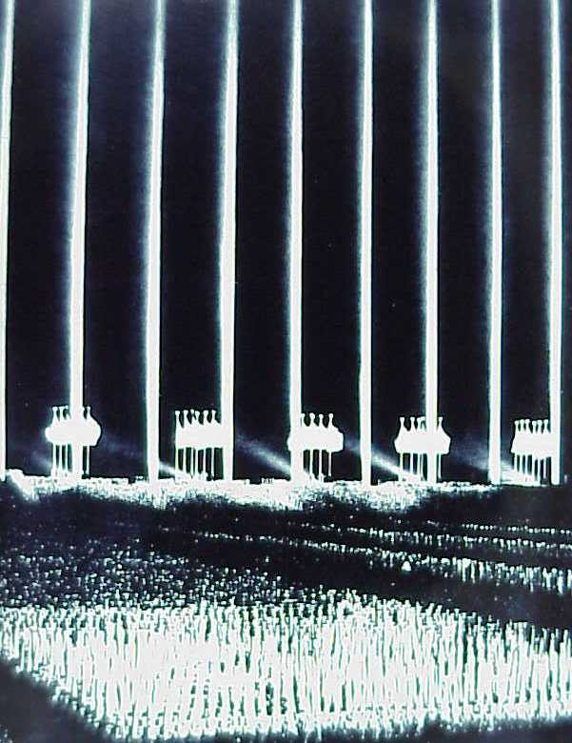
Picture - Nuremberg rally, 1934

Civilians Killed by Governments in the Twentieth Century: Top Twenty Regimes
Location (Regime) Deaths Era

Soviet Union (Communists, Stalin etc) 61,900,000 1917-1990 China (Communists, Mao etc) 35,200,000 1949-present Germany (Nazi Third Reich, Hitler) 20,900,000 1933-1945 China (Kuomintang) 10,400,000 1928-1949
Japan (Imperial-Fascist) 6,000,000 1936-1945
China (Communist Guerrillas) 3,500,000 1923-1948
Cambodia (Communists) 2,000,000 1975-1979
Turkey ("Young Turks") 1,900,000 1909-1917 Vietnam (Communists) 1,700,000 1945-present North Korea (Communists) 1,700,000 1948-present Poland (Communists) 1,600,000 1945-1948
Pakistan (Yahya Khan) 1,500,000 1971
Mexico (Porfiriato) 1,400,000 1900-1920

The table above presents a few estimates from R.J. Rummel's Death by Government--a book that undertakes the grim task of attempting to roughly count up the violent death toll of the twentieth century. Rummel excludes from his count of genocide the deaths of soldiers in time of war, and the "incidental" deaths of civilians in time of war (that is, deaths that occurred as a consequence of what could be classified as military operations directed against enemy armed forces or war-making power: military exercises like the British night bombing of German cities during World War II are counted as episodes of genocide). Rummel's estimates of genocide are only of the people whom governments, in time of peace or far from the battlefront, have killed.

Some of the estimates are solid; some are shaky; some are wild guesses. Some are barely estimates at all: we know next to nothing of what has gone on in North Korea over the past fifty years, and Rummel's guess--he doesn't label it an "estimate"--is based on the projection that North Korea has been no better and now worse than similar countries with similar ideologies and similar degrees of self- imposed isolation.

I think some estimates are too high, and some are too low (I suspect Communist China and Nazi Germany should be switched). But Rummel's estimates are not without evidence, and on average I have no reason to believe that they are biased in any systematic way.
Killing off millions has a different meaning for the socialist. The millions are “in the way”. But Franco, in some sense, was “doing god’s work”, he was sending the hundreds of thousands on, specifically the ones who oppose god. However, Hitler also convinced himself that murdering Jews was “god’s work”, just as Islamists now convince themselves that blowing themselves with as

many infidels as they can find is “god’s work”, while the mass- murderer Sutcliffe convinced himself that in killing prostitutes, he was an instrument of god — all this is a psychopath’s response.
march to glory fire! Pow! the beauty of a killing gun kill for freedom kill for you kill the lark and kill the sun kill the wog and kill the jew kill for freedom kill for now!
if it moves kill it kill the whale kill it quick before its hale power wins kill some more For safety killing everything don’t take risks kill for war
death to traitors, death to spies kill the foe kill for peace
march on you bastards shine your eyes
stamp on life that you may spill nature’s red in tooth and claw
kill some more. god goes on before glory shines I want that hill
quickly now more more kill
these are men and men are proud god is jealous kill this crowd death to traitors death to cowards kill for peace kill for lies
kill for life kill for truth
please please please kill for sighs
kill for love and kill for pence kill for any bloody thing
but kill

“If its still, paint it, If it moves, Shoot it” British Army, on how to create the “Roman Peace”
75% ARE PSYCHOPATHS, SCHIZOPHRENIC, AND MANIC DEPRESSIVE.

CAN YOU SEE EVEN A LITTLE OF THIS IRRATIONALITY IN YOURSELF?
THE SOLUTION TO THE ONE MAJOR WORLD PROBLEM IS ENERGY ENHANCEMENT.
ENERGY ENHANCEMENT GIVES ANCIENT, ADVANCED AND SUCCESSFUL TECHNIQUES FOR THE REMOVAL OF ALL ENERGY BLOCKAGES CAUSING ALL PSYCHOPATHIC TRAITS, IN YOU AND IN EVERYONE ON THE PATH OF ENLIGHTENMENT.
FOR THE BENEFIT OF ALL BEINGS.
FOR ONE HARMONIOUS ENLIGHTENED WORLD.
ALL the Worlds problems are caused by Psychopaths!!
Psychopaths are the only part of the population which cause all the worlds problems. Therefore we need to use psychological profiling to detect these people in advance of their depredations and also peaceful methods of curing them as the most urgent action of a Suffering World.
Peacing for peace means speaking out against wrong psychopathic attitudes. Intellectually we need to create the information to make all people understand that psychopathic attitudes and actions just do not work. Non psychopaths just, “Get It” that it is just plain wrong.
Energy Enhancement teaches how to remove psychopathic energy blockages within your psychic body.
As more people begin to understand that the removal of these blockages is possible, so the call for mass eduction in these techniques will grow, needs to grow.
FOR THE BENEFIT OF ALL BEINGS.
FOR ONE HARMONIOUS ENLIGHTENED WORLD.

History's Terrible Troika
(Word to the wise: Be mindful of embracing Beethoven and Michelangelo and Lincoln and Churchill and others as kindred spirits lest you unwittingly include Napoleon and Hitler and Stalin in the same group hug.)

In 1994, D Jablow Hershman and Julian Lieb wrote an extremely controversial work, "A Brotherhood of Tyrants: Manic Depression and Absolute Power" (Prometheus), that examined this Terrible Troika in the context of their illness. The book is a companion to an earlier work on the lives of Newton, Beethoven, Dickens, and Van Gogh republished in 1999 as "Manic Depression and Creativity."

The "case files" on Napoleon and Hitler and Stalin read like a clinician’s worst nightmare: raging tempers, manic highs, grandiose and psychotic delusions, paranoia, extravagantly reckless behavior, gloomy depression, and contemptuous disregard for others - and this was when they were just kids. Had they been born into slightly different times and circumstances, they would have been bundled up and tossed into the darkest void and never heard from again, but to the great misfortune of humanity all three came of age in a time of top-to-bottom social upheaval. The lunatics had already taken over the asylum by the time these three arrived on the scene.

"Life has become a burden to me," Napoleon wrote as a young man, "for I no longer enjoy any pleasure and everything causes me pain." According to the authors, Napoleon’s depression immobilized him during his disastrous Russian campaign and later at Waterloo. But it was the grandiose delusions of his mania that were responsible for even thinking he could take on the Russians in the dead of winter and win, in the first place. Earlier in his career, he had lost an entire army in Egypt dreaming he could be an oriental potentate.

Hitler’s own personal physician diagnosed him as manic depressive. As a young man, he attempted suicide. In a manic moment, he made a premature bid for power (the Beer Hall Putsch of 1923), but depression incapacitated him at the crucial hour. His illness fed the delusion that he was Napoleon’s worthy heir, and like his idol he too lost an army in North Africa and committed the fatal error of waging a winter campaign in Russia. Unlike his idol, he was no military genius, and his units in the field paid in full measure.

Hitler’s adversary, Joseph Stalin, was equally incompetent and delusional, with both preferring to lose hundreds of thousands of troops in single campaigns to listening to their generals. The two

dictators also shared a psychotic paranoia that resulted in the liquidation of tens of millions of innocents. Stalin's crimes against his own people as well as ethnic minorities equaled or surpassed Hitler's Holocaust. When war broke out, Stalin went into a prolonged depression that left the country leaderless as the armies of his German soul mate advanced almost unopposed to Moscow.

Our current understanding of mental illness has allowed us to probe the minds of the famous and notorious in ways that have previously eluded earlier biographers and historians. But the authors here tell only half the story by overlooking the obvious fact that each member of this Terrible Troika was a classic sociopath, OR PSYCHOPATH as well.
Human lives meant nothing to them as they lied and cheated and murdered their way to power. When tens of millions more were later lost in pursuit of their individual glory, they felt no more remorse than most people feel to squashing a cockroach. The authors constantly refer to this trait, but nowhere in the book do they mention the term sociopath or its DSM-IV designation as antisocial personality disorder.
The DSM-IV lists seven criteria for antisocial personality disorder:

Failure to conform to social norms with respect to lawful behaviors as indicated by repeatedly performing acts that are grounds for arrest
Deceitfulness, as indicated by repeated lying, use of aliases, or conning others for personal profit or pleasure
Impulsivity or failure to plan ahead
Irritability and aggressiveness, as indicated by repeated physical fights or assaults
Reckless disregard for safety of self or others
Consistent irresponsibility, as indicated by repeated failure to sustain consistent work behavior or honor financial obligations Lack of remorse, as indicated by being indifferent to or rationalizing having hurt, mistreated, or stolen from another

What's missing from their criteria is the quality and quantity, the SHEER BADNESS of the sort of depraved behavior typical of a psychopath, but the DSM dropped that term from its lexicon years ago, leaving us to lump into the same category Hitler, Stalin, Napoleon, Jack the Ripper, Ted Bundy, your petty con man, the top tier at Enron, and the individual who takes 30 items into the six- item check-out lane and waits until everything is rung up before fishing into her handbag for her checkbook.

Add to that the fact that antisocial personality disorder falls into the DSM's far more nebulous and subjective "Axis II" disorders as opposed to bipolar's universally recognized "Axis I" status and you may have the reason - albeit a woefully inadequate one - why they authors failed to delve into the sociopathic/psychopathic side of history's Terrible Troika.

So add three more names to your famous bipolar people list, with great reluctance if you must, but also bear in mind that an illness alone cannot account for all of our actions and achievements, whether painting the Sistine Chapel or invading Poland.

75% ARE PSYCHOPATHS, SCHIZOPHRENIC, AND MANIC DEPRESSIVE.

CAN YOU SEE EVEN A LITTLE OF THIS IRRATIONALITY IN YOURSELF?
THE SOLUTION TO THE ONE MAJOR WORLD PROBLEM IS ENERGY ENHANCEMENT.
ENERGY ENHANCEMENT GIVES ANCIENT, ADVANCED AND SUCCESSFUL TECHNIQUES FOR THE REMOVAL OF ALL ENERGY BLOCKAGES CAUSING ALL PSYCHOPATHIC TRAITS, IN YOU AND IN EVERYONE ON THE PATH OF ENLIGHTENMENT.
FOR THE BENEFIT OF ALL BEINGS.
FOR ONE HARMONIOUS ENLIGHTENED WORLD.
ALL the Worlds problems are caused by Psychopaths!!
Psychopaths are the only part of the population which cause all the worlds problems. Therefore we need to use psychological profiling to detect these people in advance of their depredations and also peaceful methods of curing them as the most urgent action of a Suffering World.

Peacing for peace means speaking out against wrong psychopathic attitudes. Intellectually we need to create the information to make all people understand that psychopathic attitudes and actions just do not work. Non psychopaths just, “Get It” that it is just plain wrong.
Energy Enhancement teaches how to remove psychopathic energy blockages within your psychic body.
As more people begin to understand that the removal of these blockages is possible, so the call for mass eduction in these techniques will grow, needs to grow.

MAO
China expert Steven Mosher has a fascinating insight into the Beijing Communists.

In his book, entitled "Hegemon," he says that Chairman Mao was steeped in the classics of a particular Chinese school of thought called "Legalism," which was the first systematic totalitarian ideology on earth. According to Mosher, Chairman Mao saw Marxism as a means to reinvigorate and modernize an ancient Chinese system of oppression.

In 221 BC the armies of Qin (pronounced "Ch'in," as in China – See Hero and The Curse of the Golden Flower by Zang Zimou) overran the forces of Qi -- the last independent state remaining at the time. Zheng became the First Sovereign Qin Emperor of the Middle Kingdom, instituting the tightest regimentation of society in Chinese history up until then. See the current movie "Hero" a Chinese Movie which shows how history is rewritten by the victors and celebrates the totalitarian Zheng and his victory over individualism.

Zheng and his toadies were the living models for the Chinese Legalist School. No doubt, Zheng and his entourage make Machiavelli look like a Sunday School teacher by comparison. Their cynicism and brutality are almost unmatched in the annals of human tyranny. Historian Arthur Cotterell wrote that "the bureaucratic form of government developed under the Qin monarchy became the model for future Chinese political organization."

As one might expect, Zheng's totalitarian machine earned criticism from China's traditionalist scholars and intellectuals who followed

the humanist tradition of Confucius. "If this slander is not stopped," said Zheng's chief adviser, Li Si, "the imperial authority will decline." Therefore China's literature itself should be burned and destroyed. "All persons possessing works of literature and discussions of the philosophers should destroy them," ordered Li Si. "Those who have not destroyed them within 30 days after the issuing of the order are to be branded and work as convicts."

The only books to be spared destruction in ancient China, were books on medicine, agriculture and divination. The Qin emperor complimented Li Si on his brilliant plan. This burning would serve to keep the Chinese people ignorant and subservient. It would also prevent the "use of the past to discredit the present." After the Qin dynasty it would be understood that the control of history was essential to the control of the present and future. As George Orwell explained in "1984," he who controls the present, controls the past; he who controls the past, controls the future.

Or as the Chinese like to say, "History is a maiden. You can dress her up any way you like."
History is bunk - Henry Ford

It is also noteworthy that after the Qin emperor, a tradition developed among Chinese emperors. Each emperor would denounce the one that went before him. This may seem odd, but there is a definite logic at work in such practices. Denunciation of the past helps to preserve the regime of the present. If people think the present emperor is bad, they should be reminded (or taught) that the previous emperor was much worse. Therefore, the misrule of the present is always masked by the illumination of the past (unless the past is actually superior, in which case you burn the evidence).

One finds this same pattern at work in the USSR after Stalin's death. Stalin was denounced by his successor, Khrushchev. Then later Khrushchev was denounced by Brezhnev. Then in the late 1980s Brezhnev was denounced by Gorbachev. Under Yeltsin, as everyone knows, Gorbachev was denounced; and if the pattern holds, Putin will one day denounce Yeltsin (the denunciation of whom is already implied by Putin's return to open Soviet methods and symbols).

The totalitarian pattern replicates itself from generation to generation within the body politic. It is like a disease for which there is hardly a cure. Countries remain ill with this disease for centuries. One shudders at the thought that America itself has a

mild case of the totalitarian sniffles.

Much about China's earliest history was lost due to the book burnings of the Qin emperor. There is a great disconnect in Chinese history, a break in the intellectual continuum. It might be argued that the destruction of books is comparable to murder. The preservation of great insight and wisdom, once set down, is of inestimable value. That such a thing can be eradicated -- and has been eradicated -- shows how fragile human civilization really is.

The Qin dynasty did not last long, of course, collapsing in 206 BC. But the evils produced by Qin lived on in other dynasties. An idea, once started, has a life of its own. Like Marxism, Legalism had few followers. But the promise of absolute power is attractive to scheming psychopathic minds who often rise in rank and influence. In the late 18th century, when China's Four Libraries were constructed and the classics compiled, there were only eight Legalist volumes. Poison of this kind, however, never loses its potency. Mao Tse-tung, says Mosher, was attracted to these eight volumes.

China's ancient Legalists denounce moral platitudes as "vain talk." Legalism emphasizes results over talk. One recalls Lenin's dictum during the Russian Civil War, that one must keep shooting people until the machinery begins to move forward. This is what a Legalist would refer to as "good results versus moral sentimentality."

This same logic may one day be applied to the use of nuclear missiles. "Continue to nuke them until they submit," a future Legalist ruler might say. "Either obedience or extermination -- their choice!"

One cannot help sensing, at some level, that this is what animates China's manic development of nuclear weapons. There is the idea, somewhere in the Communist Chinese mind, that America can be gradually disarmed and neutered. Then a campaign of "straightening" the world might begin.

The Legalist School is extremely skeptical, even hostile, to human nature and morality. "I believe it is impossible to be sure of anything," wrote Han Fei Tzu, a Han prince who inspired the totalitarian ideas of the Qin dynasty in the third century BC. Han stated that there were three principles -- law, statecraft and power. No other values mattered. Han characterized conservatives and traditionalists as "stupid." He also noted, "The severe household has no fierce slaves, but it is the affectionate mother who has

spoiled sons."

The wickedness of Chinese Legalism appears in its unrestrained desire to crush all human beings, since human beings are inherently wicked. According to Han, "A ruler makes use of the majority and neglects the minority, and so he does not devote himself to virtue but to law."

This is where the term "Legalism" comes from. Right and wrong do not matter. Only state power and its law matter. In keeping with this state power, people are twisted into the right shapes. Han wrote that "If we had to depend on an arrow being absolutely straight by nature, there would be no arrow in a hundred generations. If we had to depend on a piece of wood being perfectly round by nature, there would not be any wheel in a thousand generations."
The right way, the wrong way and the Army way.

According to Mosher, "Mao had steeped himself in Chinese historical classics, absorbing the frank and brutal legalist advice they offered to would-be hegemons."

Mao's real ambition was to found a new empire on naked force. "Marxism-Leninism was an enabler for the Hegemon," says Mosher. Marxism proposes the existence of a monopoly of power by an educated elite of bureaucrats. If the despotic emperors of China's past had been Confucianist on the outside, but Legalist on the inside, says Mosher, "Mao was effectively Communist on the outside, Legalist on the inside."

Mosher tells us that if you examine Mao's "Selected Works," 24 percent derive from Stalin while 22 percent derive from traditional Chinese sources. In keeping with Stalinist and Legalist thought, in little more than a half century of existence, the People's Liberation Army has invaded the Korean peninsula; bombarded and assaulted islands belonging to Taiwan; attacked without provocation India, Tibet and Vietnam; and has supported guerrilla insurgencies in Laos and Malaysia, as well as a coup in Indonesia.

The only thing that kept China in check during the 1950s and 1960s, argues Mosher, was China's economic weakness. Taking a survey of the second half of the 20th century, Mosher notes that Communist China was more likely to resort to violence in a crisis than any other state. Since 1949 China has resorted to force in 76.9 percent of existing international crises. The next closest would be Muslim states which resort to force 53.5 percent of the time. (The

U.S., by comparison, resorts to force 28.5 percent of the time.)

The chief supposition of Chinese Legalism is that power politics deserves primacy over everything. Mao's dictum that "political power flows out of the barrel of a gun" is still in vogue. Mosher tell us that Mao's views have not been repudiated in China. Deng Xiaoping only clashed with Mao over economics, not politics.
According to Mosher, Deng's "much-vaunted openness to the West was merely a ploy to enlist foreigners to provide the means."

The Four Modernizations of Deng are paralleled by Four Absolutes, which hold true today. These absolutes are: 1) the dictatorship of the proletariat; 2) the leadership of the Chinese Communist Party;
- Marxism-Leninism and Mao Tse-tung thought; 4) and the "socialist road."

In accordance with the Four Absolutes, the Communist butchers in Beijing murdered thousands of student protesters over a decade ago in the Tiananmen Square massacre. About this event Communism's No. 2 man in China, Li Peng, has said: "The actions in Tiananmen Square were a good thing. We do not regard them as a tragedy."

The power of the state, and its drive for greater and greater domination in Asia and the world, is the logic of modern China. In September 1994 Beijing issued a sweeping directive: "Patriotic education shall run through the whole education process from kindergarten to university ... and must penetrate classroom teaching of all related subjects."

What is taught?

Hatred for the evil foreigner and love of "Great China"; resentment for a hundred years of humiliation, etc. According to Mosher, "what this patriotic education comprises, in broad strokes, is a kind of Chinese Mein Kampf."

Imagine if Hitler had nuclear weapons and 1.3 billion people behind him.

Modern China has the full support of Russia in its quest for global hegemony. Today more than 10,000 Russian scientists and engineers are working to build up China's means of mass destruction against America.
China's current leaders are ruthless. Their credo was carefully explained by the founder of modern China, Mao Tse-tung, who

bragged about his murderous achievements during the Second Plenum of the Eight Party Congress in 1958. "Emperor Qin Shihuang was not that outstanding," scoffed Mao. "He only buried alive 460 Confucian scholars. We buried 460 thousand Confucian scholars."

Mao did not like being compared with the Qin emperor. "Some have accused us of being Emperor Qin," complained Mao. "This is not true. We are a hundred times worse than Emperor Qin."

China is building nuclear bombs and long-range missiles at an accelerating rate. China has its fingers on the Panama Canal, and her agents have corrupted our political process in Washington so that we are momentarily paralyzed in our response to this new challenge.

It is time to stop and reconsider the overall strategic situation. If a 15-year-old boy can take a gun and go berserk in an American public school, killing and wounding his classmates, why can't a major power armed with nuclear weapons also go berserk?

The logic of the individual psychopath may be no different than the logic of a gang of psychopaths.

75% ARE PSYCHOPATHS, SCHIZOPHRENIC, AND MANIC DEPRESSIVE.

CAN YOU SEE EVEN A LITTLE OF THIS IRRATIONALITY IN YOURSELF?
THE SOLUTION TO THE ONE MAJOR WORLD PROBLEM IS ENERGY ENHANCEMENT.
ENERGY ENHANCEMENT GIVES ANCIENT, ADVANCED AND SUCCESSFUL TECHNIQUES FOR THE REMOVAL OF ALL ENERGY BLOCKAGES CAUSING ALL PSYCHOPATHIC TRAITS, IN YOU AND IN EVERYONE ON THE PATH OF ENLIGHTENMENT.

FOR THE BENEFIT OF ALL BEINGS.
FOR ONE HARMONIOUS ENLIGHTENED WORLD.
ALL the Worlds problems are caused by Psychopaths!!
Psychopaths are the only part of the population which cause all the worlds problems. Therefore we need to use psychological profiling to detect these people in advance of their depredations and also peaceful methods of curing them as the most urgent action of a Suffering World.
Peacing for peace means speaking out against wrong psychopathic attitudes. Intellectually we need to create the information to make all people understand that psychopathic attitudes and actions just do not work. Non psychopaths just, “Get It” that it is just plain wrong.
Energy Enhancement teaches how to remove psychopathic energy blockages within your psychic body.
As more people begin to understand that the removal of these blockages is possible, so the call for mass eduction in these techniques will grow, needs to grow.

Emotional Vampires: Dealing With People Who Drain You Dry
by Albert Bernstein
"Vampires stalk you, even as we speak..." (Key Phrases: professional therapeutic approaches, more true answers, attempting psychotherapy, Narcissistic Legends,
Narcissistic Superstars, Passive-Aggressive Histrionics

"Bernstein provides a field guide to the various types of Emotional Vampires and advises readers how to protect themselves from being victims of these predatory personalities.

The author of Dinosaur Brains offers protection from people who seek to destroy the emotional and psychological well-being of others. Like the fabled demons, these vampires:. .

  - Think their needs are more important than yours .
  - Believe "the rules" apply only to other people .

  - Use their tempers in the same way terrorists use bombs .

Emotional Vampires tells readers how to spot a psychopathic "vampire" in their lives, which defense strategies to employ to prevent one from striking, and what to do if and when they find themselves under attack.

Psychopathic Emotional Vampires: They're out there . . . masquerading as ordinary people. They may lurk in your office, your family, your circle of friends; perhaps they even share your bed. Chances are, you know all too many of them. Bright, talented, and charismatic, they win your trust, your confidence, and your affection Andshy; then drain you of your emotional energy. But take heart as you walk through the darkness, it doesn't have to be that way Andshy; the more you know about vampires, the less power they have over you.

Detailing a whole range of personality types and human responses, Bernstein shows you how to spot the psychopathic "vampires" in your life: self-serving Narcissists, hedonistic Antisocials, exhausting Paranoids, or over-the-top Histrionic drama queens. And, with valuable advice, psychological perspective, and much-needed humour, he gives you a range of defence strategies that are guaranteed to keep the blood-sucking creatures of darkness from draining you dry.

"When you spot them, run, don’t wait, do not pass go. Simply remove yourself from their presence if you don't want to be drained dry. Do not get involved with them in any way. Simply remain professional as you nod and smile." Satchidanand

THIEVES
Snakes in Suits - Spot the true psychopath among the sharks in your office

By Giles Whittell / The Times of London
HERE ARE SOME facts: Andrew Fastow, formerly of Enron, stands accused by an American court of taking $30 million in kickbacks from the company while its shareholders lost more than $70 billion. Bernie Ebbers, formerly of WorldCom, is said to have arranged for his telecommunications firm to lend him $408 million as it slid towards bankruptcy. John Rigas, founder of the Adelphia cable TV giant, built himself a $13 million private golf course and, it is

claimed, "borrowed" more than $3 billion from company accounts for his family while his shareholders saw $60 billion wiped from their investments. And here is a perfectly sober conclusion: if guilty, they are all psychopaths. Not killers. Not rapists. Not necessarily even criminals. Just cold-blooded, remorseless, egomaniacal psychopaths.

It's a tricky word. Being a psychopath is not something that ordinary people aspire to, but neither does it have to involve face- eating cannibalism. The central qualification is to show no conscience; to fail to empathize.

Fastow, Rigas and the other stars of the great corporate meltdown showed little sign of conscience before - or since - being accused by the lumbering U.S. court system, and they share other symptoms of Psychopathy. They radiated charisma and authority, but hid much about themselves and their organizations. They reveled in risk, took no account of its potential cost to others or themselves, and rose to power during a time of chaos and upheaval.

When their worlds imploded, the markets staggered in disbelief. Hundreds of thousands of employees and investors lost pensions, savings and money they could ill afford to have gambled. The bosses expressed scant regret and most of them continue to insist that they have done nothing wrong. Meanwhile, regulators, FBI agents and forensic psychologists, not to mention the fleeced American middle class, continue to scratch their heads and wonder how these apparent shysters got to where they did.

A diffident-sounding Canadian academic with a trim grey beard has an answer; possibly the answer. He first voiced it publicly to an audience of Canadian police officers in Newfoundland in August.

At the end of a talk on organized crime, Dr. Robert Hare mentioned his belief that some of the year's worst accounting scandals could have been avoided if all chief executives were screened for psychopathic tendencies. He was quoted everywhere, not so much because of the sensational implication that some of America's best- known companies had been run for most of the 1990s by people with a major mental disorder, as because of who he is.

Hare defined Psychopathy for modern scientists with an exhaustive questionnaire, sold only to clinicians, called the Psychopathy Checklist, or PCL-R. It was introduced in 1980 and has become an internationally recognized instrument for identifying psychopaths. It means that when a subject scores 30 (out of a possible 40) in a

prison in Dundee, an expert in Detroit will have a good idea of his proclivities.

That's the good news. The bad news is that the PCL-R revealed that psychopaths are everywhere. Most are non-violent, but all leave a trail of havoc through their families and work environments, using and abusing colleagues and loved ones, endlessly manipulating others, constantly reinventing themselves.

Hare puts the average North American incidence of Psychopathy at one per cent of the population, but the damage they inflict on society is out of all proportion to their numbers, not least because they gravitate to high-profile professions that offer the promise of control over others, such as law, politics,

By the Hare definition there are 300,000 in Canada alone.

Despite this, spotting psychopaths is hard, though it may be about to get easier. Next year Hare and a New York-based colleague, Paul Babiak, will publish a book called Snakes in Suits: When Psychopaths Go To Work, that will at least alert the average office worker to the possibility that her amusing but exasperating - and, frankly, narcissistic and untrustworthy - colleague may be clinically psychopathic. Hare and Babiak will also produce a new diagnostic tool based on the PCL-R but designed to help businesses to keep their recruits and senior management psychopath-free.

Enter the B-Scan. It won't be available to everyone, and it won't be free. Slightly jarringly, one is reminded that its authors are businessmen as well as academics. But they insist that it will do a better job of raising warning flags than traditional screening techniques such as CVs (routinely falsified and seldom checked) and interviews and role-playing ("Psychopaths love this stuff," Hare says. "It's like a game to them.").

If you are B-Scanned, it won't be you answering the questions. It will be your colleagues, grading your personal style, interpersonal relations, organizational maturity and antisocial tendencies according to 16 buzz words, none of them uplifting. They include the following: insincere, arrogant, insensitive, remorseless, shallow, impatient, erratic, unreliable, unfocused, parasitic, dramatic, unethical and bullying.

Yikes. Who isn't most of these things, at least some of the time?

I meet Hare in a London hotel and find him used to such anxieties.

"I know, I know," he says. "People read this stuff and suddenly everyone around them is a psychopath. They pick up on three or four of the characteristics and say, 'yeah, he's one.' But it's not like that. It's a medical syndrome. You've got to have the whole package."

And when you do, what does it look like? Hare gives an example, and not just any example. He first gave it to Nicole Kidman in a private meeting requested by her to help her prepare for her memorably chilly role in Malice.

"I gave her a scene," he says. "You're walking down the street and there's been an accident. A child has been hit by a car and is lying on the ground. There's a crowd around him. The mother's kneeling down there crying and emoting. You're curious but not appalled.
You look at the child momentarily and then you look at the mother. You walk towards her, step in some blood and then study the mother's facial expressions for a minute or two. Then you walk back to your apartment or hotel room, walk into the bathroom and stand in front of the mirror practicing those expressions. I said, 'If you did that, people would see that you don't understand emotion, you have no idea at all, you're a color-blind person trying to explain color.' They didn't use the scene, but they could have."

In the workplace such a person might resemble Dave, a real individual studied by Babiak who cut a swath of disruption through a highly profitable American electronics company in the mid-1990s. Dave was good-looking, well spoken and impressive in the interview that led to his recruitment. He was also a skilled and shameless liar, rude to subordinates, scheming towards his boss and quickly friendly with the firm's top management. Already on his third marriage by his mid-thirties, he was short tempered, happy to ignore assignments that he felt were beneath him, and quick to change the subject if challenged on a lie or asked to produce some real evidence of work.

When his boss summoned the courage and evidence to make a complaint to the company boss, he found that Dave had got there first and secured for himself the status of "high-potential employee."

The boss ended up sidelined. Dave ended up promoted, swaggering and "in love with himself." He scored 19 on the PCL-R, lower than you would expect for a psychopathic murderer but much higher than your average working non-psychopath. He or she would score a five at most.

People such as Dave can be spotted early. Babiak recommends checking CVs exhaustively and auditing expenses - psychopaths like to indulge. It all seems obvious, but for the past 10 or 12 years, for most of corporate America, it hasn't been.

These have been tumultuous years in the world of business, with dot-coms booming and collapsing, older firms merging or shrinking to catch up, and hierarchies everywhere flattening faster than the boss can say: 'Hey, c'mon in, my door is always open.' In short, it has been a high old time for psychopaths.

"When you see what has happened with Enron and WorldCom and all these other big corporations, and you ask how the hell could this guy get in that position, well, there are answers," Hare says.

"When the structure's not there, when charisma is extremely important and style wins over substance, and one person ends up with three or four hundred million pounds in an offshore bank account, I start to get suspicious. And when the whole thing breaks and people are losing their pensions and livelihoods, these people give nothing back.

"Many of the high-level executives now being charged knew exactly what they were doing. They had no concern for anybody else, and you have to say they aren't warm, loving guys."

Likewise in politics. "Think what happened in the former Soviet Union and the former Yugoslavia. The old rules went by the board. Structure vanished and all the ethnic tension that had been held in check by central government began to emerge. It was the perfect set-up for an opportunist, a thug or a psychopath to enter and take over."

That takeover usually has three stages. First, the psychopath identifies those who can help him and cultivates them with all his considerable charm. Then he pinpoints those who can harm him and outflanks them or stabs them in the back. Finally he makes a sycophantic but ultimately devastating beeline towards the source of power (one thinks of Hitler and Hindenburg, but also of the irrepressible Eve Harrington in All About Eve).

Psychopaths necessarily have victims, and Hare's drive to expose the "sub criminal" ones in our midst is at least partly personal. He speaks of an old college friend, now gravely ill, who lost $500,000 in a mortgage scam to a white-collar crook who got off with a
$100,000 fine and a six-month trading ban. Society still labels such

people rogues at worst. Hare calls them natural- born predators.

There is a difficulty approaching all this from outside academe: it can seem as if the experts are using jargon to force a thousand shades of grey - for there are surely at least that many degrees of Psychopathy - into convenient boxes for personnel managers, employment tribunals and courts.

Babiak certainly counsels caution. Being psychopathic is not a sin, let alone a ground on its own for dismissal. But underpinning the PCL-R is hard science, hard to ignore. Before he published it, Hare performed two now-famous studies which suggest that psychopaths really are different from the rest of us. In the first, subjects were told to watch a timer counting down to zero, at which point they felt a harmless but painful electric shock. Non- psychopaths showed mounting anxiety and fear. Psychopaths didn't even sweat.

In the second, the two groups had their brain activity and response time measured when asked to react to groups of letters, some forming words, some not. Words such as rape and cancer triggered mental jolts in nonpsychopaths. In psychopaths they triggered precisely nothing.

That research is decades old now. The man behind it, instead of retiring, tours the world helping to nail the psychopaths among us and trying to make sure that his instruments are not misused.

Part of his mission is to stay serious. He won't appear on Oprah, and he won't name names. Instead, when he sees someone in the news he thinks might be a psychopath, he says: "I'd sure as hell like to study this guy."

LEVEL 1 - 4 VIDEO COURSES ANYTIME IN THE COMFORT OF YOUR OWN HOME



75% ARE PSYCHOPATHS, SCHIZOPHRENIC, AND MANIC DEPRESSIVE.

CAN YOU SEE EVEN A LITTLE OF THIS IRRATIONALITY IN YOURSELF?

THE SOLUTION TO THE ONE MAJOR WORLD PROBLEM IS ENERGY ENHANCEMENT.
ENERGY ENHANCEMENT GIVES ANCIENT, ADVANCED AND SUCCESSFUL TECHNIQUES FOR THE REMOVAL OF ALL ENERGY BLOCKAGES CAUSING ALL PSYCHOPATHIC TRAITS, IN YOU AND IN EVERYONE ON THE PATH OF ENLIGHTENMENT.
FOR THE BENEFIT OF ALL BEINGS.
FOR ONE HARMONIOUS ENLIGHTENED WORLD FOR ONE HARMONIOUS ENLIGHTENED WORLD.
ALL the Worlds problems are caused by Psychopaths!!
Psychopaths are the only part of the population which cause all the worlds problems. Therefore we need to use psychological profiling to detect these people in advance of their depredations and also peaceful methods of curing them as the most urgent action of a Suffering World.
Peacing for peace means speaking out against wrong psychopathic attitudes. Intellectually we need to create the information to make all people understand that psychopathic attitudes and actions just do not work. Non psychopaths just, “Get It” that it is just plain wrong.
Energy Enhancement teaches how to remove psychopathic energy blockages within your psychic body.
As more people begin to understand that the removal of these blockages is possible, so the call for mass eduction in these techniques will grow, needs to grow.

HITLER BAD, BUT FAR FROM WORST
ASK ANY WESTERNER to name the most evil figure of the past century. Almost always, the same answer comes up. Hitler.
Sustained brainwashing has done its job. Der Fuhrer still towers above all rivals as modem history's greatest demon. But increasingly, research proves that we have been persuaded to fixate on the wrong dictator. History's airbrush has worked overtime on

the most criminal monster of them all: Josef Stalin.

Stalin's murderous ruthlessness was, by any standard, far more horrible than Hitler's. A psychopath who modeled himself on Ivan the Terrible, Stalin instituted a reign of terror without parallel, exterminating opponents or perceived opponents by the multi- million. How many died in his murderous stranglehold? Who knows?

Only in recent years have the Russians themselves learnt just how hideous their history is. Their first glimpse of the reality came in February, 1956, when Nikita Khrushchev denounced Stalin's mass terror and unmasked the prison gulag system. That was met with widespread disbelief in the West. There can now be no doubt that Stalin, as a matter of policy, killed and killed and killed.

In 1989 the KGB set the death toll in Stalin's 26-year reign of terror (1927-53) at 36 million. But that figure included only the victims of Stalin's liquidation's of individuals and groups. Serious research began stepping up with Gorbachev's policy of glasnost. Norman Davis, in his celebrated History of Europe suggested a figure of 54 million. The University of Moscow, in association with the University of Madrid, put the figure at 57 million.

Those figures are ten to 15 times higher than the numbers allegedly killed the Fuhrer look like an amateur. Such imposed on countless millions simply freezes belief. It represents the most appalling terror ever inflicted, rivaled only by Mao's China and Pol Pot's Cambodia. Only under a regime which deliberately allowed the extermination of millions of its own citizens could such unimaginable figures be achieved.

On one day alone, December 8, 1938, Stalin signed 30 death lists, containing thousands of names. He then went to the Kremlin cinema to watch a comedy called Happy Guys. It is this viper's ghost that should worry us rather than Hitler's. Yet no Nuremberg trials have ever been conducted into Soviet barbarities. There have never been any Soviet war crimes trials. Yet in the sick and insane world we inhabit. Nazi war criminals are still being hunted down, though now most are 80 or 90 years old.

As for Stalin's victims, who is interested? They are so much dust blowing in the Siberian winds. No Spielberg conjures them to life. There are many reasons why Stalin's Great Terror remains the most underreported event of the 20th Century. First, Hitler lost, Stalin - ally of the West - won. Stalin knew he was a mass murderer but believed (correctly) that he could get away with it. As he told Mao

Tse-tung when the Red Chinese leader, visited Moscow in 1949: "Victors are not judged" Perhaps the whole of modern history is summed up in those four words.

There are other factors. Unrelenting propaganda has built up the Holocaust as the pre-eminent human tragedy of modern times. Jewish groups insist we never forget the Holocaust. Counterclaims that might detract from their Holocaust are actively discouraged, as was demonstrated in the recent David Irving trial.

Many anti-Stalinists knew, and published, the truth: men such as Malcolm Muggeridge, George Orwell, Arthur Koestler. But their reports were overwhelmed from the start by the pro-Stalinists. Way back in the mid 1930s the father of all fellow travelers, George Bernard Shaw, dismissed reports of a Moscow-engineered famine killing millions as "pure invention." Shaw knew better, of course.
Stalin had given him the details.

As he did to New York Times correspondent Walter Duranty, a prince of liars who gained the Pulitzer Prize for his fictional accounts of Stalin's "new civilization" and of "the great Soviet miracle". Duranty played a key role in perpetrating one of the greatest cover-ups in history.

Western illusions did not stop there. Bizarre as it now seems, many at the highest level, up to and including Franklin Delano Roosevelt, revered Stalin and were consciously partisan in their support of this thug. Further, in an astounding example of mankind's infinite capacity for self-deception, millions of Western intellectuals, academics, communists, socialists, liberals, fellow travelers, trade unionists, journalists and clergy forcefully rejected reports of mass atrocities in the old USSR and in China, just as they did later of events in Cuba and Cambodia.

The truth is that vast numbers in the West worshipped Stalin as almost a demigod, nursed an almost religious faith that the USSR represented the great new hope of all mankind. Stalin fondly referred to such useful idiots as his "maggots."

Above all, till quite recently we have had little real access to communist archives. Even today the most sensitive are still closed. So we still do not know the full answers: Was it one tenth or one- twentieth of the entire adult Soviet population who served time in Stalin's prison camps? Did 3 million die in the Gulag, or was the figure closer to ten? We may never know: but the effort to break through the Great Amnesia is picking up speed.

Till the late 1980s, hardly anyone but local villagers knew where the bones were buried. For the past 13 years the Russians have been slowly recovering their past, with new mass graves being uncovered at regular intervals. And, as soon as the existence of the first Stalinist mass graves were made known, people began to come. In one, Kolyma, the huge prison complex in the Russian Arctic, so many bones lay around that in the summer children used the skulls to gather blueberries. Now the memorials are being built.

The misery came early. In Russia, uniquely, there exists hardly any memory of the 1914-18 War, such a watershed for the rest of Europe. There exist no Soviet national monuments to WWI. The reason is simple. In the civil wars which followed the revolution of 1917 and brought the Bolsheviks to power, between nine and 14 million Russians died: starving, cold, racked with disease, or tortured and killed in bitter fighting.

Next came the Ukraine. Robert Conquest in his Harvest of Sorrow suggests that when, on Stalin's direct orders, the entire grain crop of the Ukraine was seized for export, the number of resulting deaths was probably about 1.5 million, equaling the total dead of WWl.

We will now turn to a brilliant but deeply disturbing new book by a young British historian, 'Night of Stone: Death & Memory in Russia' by Catherine Merridale, published by Granta. Dr Merridale is one of a growing army of scientists dedicated to uncovering the truth about Soviet-era crimes, the legacy of Josef Stalin and the society he created.

She spent two years in Russia and the Ukraine, researching documents from the Stalinist era only now coming to light: and talking to ordinary Russians about what it is like to live in a country haunted by the all-pervasive presence of death. Her book, an excellent work of scholarship, attempts to explain how the Russian people lived through some of the greatest horrors of a singularly bloody 20th century: and how, at long last, they are coming to terms with their shocking past and themselves.

Merridale does not attempt to put a precise figure on how many Russians lives were lost to violence between 1914 and Stalin's death in 1953, but suggests a total well in excess of 50 million. All of it planned.

Epidemics of flu and cholera, and the 1921-22 famines in grain- producing areas of southern Russia, killed many millions. People

ate earth, grass, carrion and human flesh. In some districts, in the winter of 1921, local officials had to ban the sale of processed meat to stop the trade in human flesh.

Stalin's own signature is on thousands of death warrants. Millions more were denounced as enemies of the state for no other reason than they wished to think for themselves. Crematoria, with which the state had been experimenting since Lenin's time, were now running more efficiently. The bodies arrived in batches, accompanied by stamped forms in triplicate.

"They were such handsome men," one crematorium worker told Dr Merridale. "Some of them were still warm. Some of them were not even dead when we threw them into the furnace....."

The death rate in the gulags peaked in 1942-3. Without doubt, the brutalization of millions of Russians over the previous quarter century contributed to the grim reputation of the Red Army in WW2. Soldiers were treated like livestock. At Stalingrad, there was no one left to dig the graves.

At last came victory in the Great Patriotic War, as it was known, the only occasion for real celebrations that many of those Merridale interviewed, had known in all their lives. After Stalin's death in 1953, the repression gradually eased. "A human being survives only by his ability to forget," wrote a survivor of the Kolyma Gulag In recent years; many of the anonymous Gulag death camps have quietly disappeared.

Stalin himself spelt it out. His Short Course Into The History of the Communist Party of the Soviet Union contains references to the liquidation of his political opponents. He wrote: "The Soviet Government had only to raise its little finger for them to vanish without trace." How true.

For an intelligent person today to be ignorant of the manner of Soviet rule can only be seen as an act of willful political bias. The whole record of the terrible era is one of naked human power and inhuman cruelty. It is a sad fact that many in South Africa's present ruling ANC/SACP glory in their self-designation as "Stalinists".

There is little danger of the world ever running out of imbeciles.

Thought for the Day: "A single death is a tragedy. A million deaths are a statistic." (Joseph Stalin)
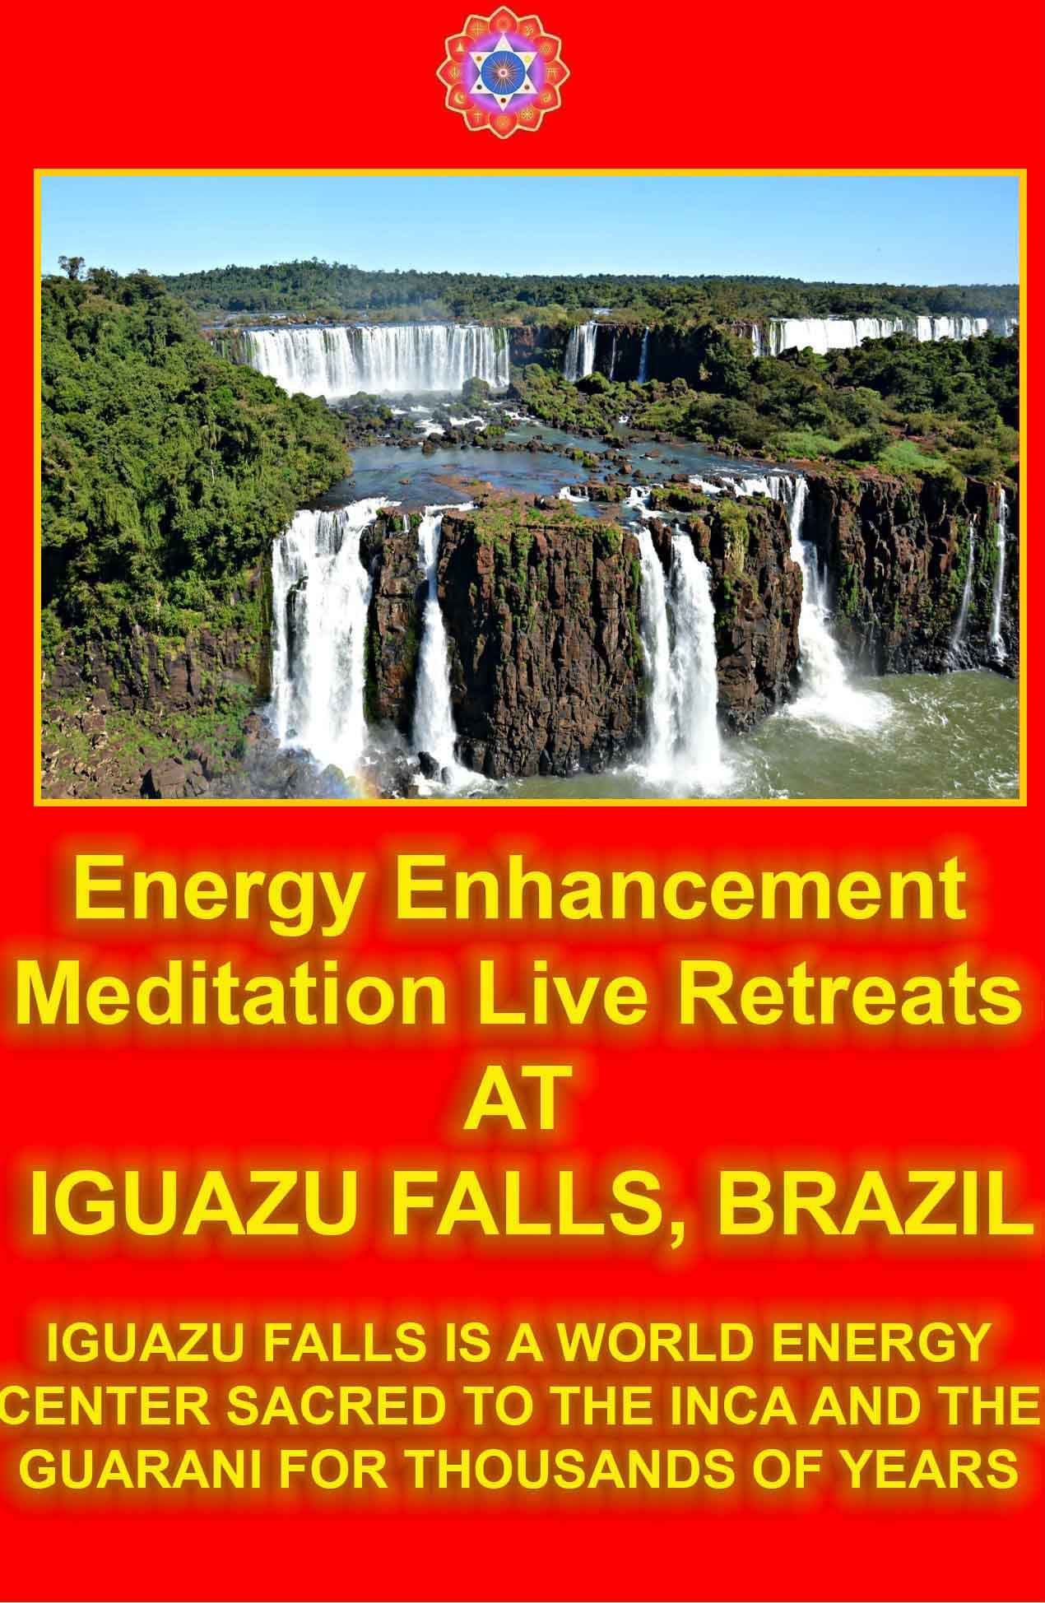

DOWNLOAD LEVEL 3 BOOK HERE!!!
http://www.energyenhancement.org/Sacred-Energy/Level-3-Book/Energy-Enhancement-Level-3-Karma-Clearing-There-Can-Only-Be-One.pdf

75% ARE PSYCHOPATHS, SCHIZOPHRENIC, AND MANIC DEPRESSIVE.

CAN YOU SEE EVEN A LITTLE OF THIS IRRATIONALITY IN YOURSELF?
THE SOLUTION TO THE ONE MAJOR WORLD PROBLEM IS ENERGY ENHANCEMENT.
ENERGY ENHANCEMENT GIVES ANCIENT, ADVANCED AND SUCCESSFUL TECHNIQUES FOR THE REMOVAL OF ALL ENERGY BLOCKAGES CAUSING ALL PSYCHOPATHIC TRAITS, IN YOU AND IN EVERYONE ON THE PATH OF ENLIGHTENMENT.
FOR THE BENEFIT OF ALL BEINGS. FOR ONE HARMONIOUS ENLIGHTENED WORLD
ALL the Worlds problems are caused by Psychopaths!!
Psychopaths are the only part of the population which cause all the worlds problems. Therefore we need to use psychological profiling to detect these people in advance of their depredations and also peaceful methods of curing them as the most urgent action of a Suffering World.
Peacing for peace means speaking out against wrong psychopathic attitudes. Intellectually we need to create the information to make all people understand that psychopathic attitudes and actions just do not work. Non psychopaths just, “Get It” that it is just plain wrong.
Energy Enhancement teaches how to remove psychopathic energy blockages within your psychic body.
As more people begin to understand that the removal of these blockages is possible, so the call for mass eduction in these techniques will grow, needs to grow.




DOWNLOAD “LEVEL 2 REMOVE ENERGY BLOCKAGES” HERE
http://www.energyenhancement.org/Sacred-Energy/Level-2-Book/Energy-Enhancement-Level-2-Book-Remove-Energy-Blockages.pdf
ACCOMPLICES
The Compensated Psychopath
"I like following orders!" - Monty Pythons Life of Brian.
Individuals approaching the psychopathic extreme are not totally wanting in morality, but they do sense a weakness, an awareness that something is missing, which frightens them. They also suspect that their love is not all it could or should be. In order to adapt they begin to compensate for these deficiencies by becoming morally rigid.

Since compensated psychopaths cannot depend upon Eros, their egos work out a moral system which is fool-proof in any and every situation. The result, as paradoxical as it may seem, is usually a well-developed morality with an emphasis upon the ego's role but woefully lacking in love.

Compensated psychopaths have played significant parts in society and in history. The more psychopathic compensated psychopaths are - in other words the more they have to compensate - the more sinister they are. All the Nazi functionaries who administered the concentration camps and supervised the destruction of thousands and thousands of human beings; all of Stalin's subordinates who, during the time of the Soviet purges, directed the arrests and deaths of innumerable individuals; all of Mao's minions who so efficiently effected the disappearance of large portions of the Chinese population -certainly all of these people were compensated psychopaths.

I am reminded of Adolf Eichmann (the German Nazi official who as head of the Gestapo's Jewish section was chiefly responsible as the organizer of the "Final Solution"), a man who was relatively conscientious and dependable. Not a devilish monster, he was rather a classic example of a compensated psychopath whose conscientiousness was greater than that of most individuals. He loyally and admirably carried out the "duty," of exterminating his fellow humans, but his very dedication to "duty," expressing his own alienation in this world, vented so heinously his hate towards all human beings who were not like him.
The commandant of a concentration camp wrote in his diary at the close of the war: "It is very sad that I can no longer fill my daily quotas in the gas chambers. I have neither enough staff nor enough supplies. Every night I go to bed with a nagging conscience, because I have been unable to do my duty." We can see how

conscientious this man was. A classic, compensated psychopath, he had a strong, rigid, "moral" system but not the slightest sense of Eros. The morality which sought to replace the missing Eros turned into a farce becoming a caricature.

Compensated psychopaths are probably the most reliable supporters of a dictatorial regime, the emphasis being upon "compensated." A dictator would not function surrounded only with "pure" psychopaths -his regime would achieve nothing, eventually collapsing in utter chaos. A dictator's subordinates have to be conscientious and obedient -in a word, compensated psychopaths.

Excerpts from the book The Emptied Soul by Guggenbuhl-Craig

THE GREEK EXPERIENCE UNDER THE GENERALS IN THE 70'S

QUESTIONS TO THE CHIEF TORTURER, - "AND JUST HOW DID YOU FIND PEOPLE WHO WERE WILLING TO TORTURE?'
"Oh, that was easy, we just got 10 people from the army every week and gave them easy torturing tasks. Those who did badly we sent back. Those who did well we promoted."

PPs IN CORPORATIONS
What has allowed so many PPs to rise so high in corporations, and now in government, is that they are so decisive. Unlike normal people, they are never filled with doubts, for the simple reason that they cannot care what happens next. Simply can’t.

This is a closet idea that I don't trot out much because most people just dismiss you as crackpot the minute you say it. but there is some evidence for it, isn't there, if you care to examine the history of republican executives (or powerful persons in general)? it ties into my rantings on leadership yesterday, imo.

I think most people assume it almost impossible that psychopaths can get elected and rise to high station. this comes largely from the popular image of psychopaths: usually they're holding a severed head or at least a big knife, right? but I rather consider it a norm. seriously. most natural leaders are conveniently not equipped or encumbered with remorse.

For example, would anyone contend that our leader isn't a

dysfunctional psychopath? with his history of severe drug and alcohol abuse, extraordinary clarity of purpose, lack of interest in the details and nuances of his decisions (his disinterest in policy meetings is well documented), ambivalence to historical hindsight or context, willingness to describe opponents or victims of his nation's policies in stark terms like "coward" or "evil"? on inspection, he seems to have some textbook 'pp' qualities.

And, on a lesser scale, our previous leader was a 'pp' as well, wasn't he? he consistently disregarded the effects of his personal behavior on others -- and can anyone believe he ever felt real remorse about any of it? the political effects of it were much less pronounced, however, it seems to me, simply because he was a pragmatist and a centrist -- which our leader is plainly not.

Rather, dobby -- or, probably just as or more importantly, Chaney -- is of a more dangerous sort of 'pp': an ideological psychopath. when surrounded by obsequious yes-men and weak personalities, you get a very dangerous chemistry that can wreak havoc.

Vonnegut, like any artist, has some 8-ball ideas. but this is one that, while widely disbelieved, has certain precedent.

Psychopath? PP. I don't know that I'd extend as much seriousness into it as you. The values/actions in the definition are the same value/actions espoused across the nation - the ones we strive for. they know full well the suffering their actions may cause others, but they do not care Heck, that's the secret to success! Get ahead at all costs. You get yours, I'll get mine. Lie, steal, cheat - those all have negative consequences on someone, yet we use them to our advantage frequently.

I'm sure there is a real PP syndrome out there. But I won't fling it around carelessly - I think many of the qualities are taught from birth. Maybe we're all at least half PPs.
We can only talk about the psychopaths that are caught and it’s a psychopathic trait that when they are caught, they still cannot see that they did anything wrong. Nixon just did not get it that he had done anything which required his removal, “If the President does it, then its legal” Governor Blagovitch of Illinois, Chicago, did not understand that he had been caught on tape selling the Senatorship released by Obama, to the highest bidder probably because that is the way every Senator got his seat.. Never mind Stalin, Hitler, Mao, the Tang Emperors, Alexander the Great and Julius Caesar.

75% ARE PSYCHOPATHS, SCHIZOPHRENIC, AND MANIC DEPRESSIVE.

CAN YOU SEE EVEN A LITTLE OF THIS IRRATIONALITY IN YOURSELF?
THE SOLUTION TO THE ONE MAJOR WORLD PROBLEM IS ENERGY ENHANCEMENT.
ENERGY ENHANCEMENT GIVES ANCIENT, ADVANCED AND SUCCESSFUL TECHNIQUES FOR THE REMOVAL OF ALL ENERGY BLOCKAGES CAUSING ALL PSYCHOPATHIC TRAITS, IN YOU AND IN EVERYONE ON THE PATH OF ENLIGHTENMENT.
ALL the Worlds problems are caused by Psychopaths!!
Psychopaths are the only part of the population which cause all the worlds problems. Therefore we need to use psychological profiling to detect these people in advance of their depredations and also peaceful methods of curing them as the most urgent action of a Suffering World.
Peacing for peace means speaking out against wrong psychopathic attitudes. Intellectually we need to create the information to make all people understand that psychopathic attitudes and actions just do not work. Non psychopaths just, “Get It” that it is just plain wrong.
Energy Enhancement teaches how to remove psychopathic energy blockages within your psychic body.
As more people begin to understand that the removal of these blockages is possible, so the call for mass eduction in these techniques will grow, needs to grow.

FOR THE BENEFIT OF ALL BEINGS.
FOR ONE HARMONIOUS ENLIGHTENED WORLD

Atlanta Medical Psychology
The clinical practice of Dr. David B. Adams is located in The Medical Quarters in the north side of Atlanta at the junction of Scottish Rite, North side and Saint Joseph's Hospitals. Dr. Adams consults to occupational medicine, surgeons, nurse case managers, insurers and employers regarding the psychological impact of work-related injury and the role of psychological factors in short- and long-term disability.

PSYCHOLOGICAL ASPECTS OF DISABILITY
Psychopath
Sociopath, anti-social personality, psychopath. Everyone should be wary of an individual who has glib charm, a soothing voice, a penetrating gaze, dramatic gestures, and engages in meaningless flattery and vague/inconsistent responses to personal questions. When a psychopath complains of how others treat him, it should be remembered who the real victims are likely to be.

INTRODUCTION

Callous, deceitful, reckless, guiltless, often intimidating and sometimes violent is the standard description of psychopaths, whose maladaptive patterns of thinking, feeling and behaving impair their daily functioning and disrupt the lives of those around them. Sociopathy in males has more serious implications than in females, and this disorder is found three times more often in men than in women.

The psychopath understands the wishes and concerns of others; he simply does not care. He believes that he has the right to do what he wants and to take what he can. He manipulates others by deception and/or intimidation, has an inflated opinion of himself and seeks out, then uses, the weaknesses he finds in others. There is no fair mindedness, no self doubt, no compassion or true affection.

THE PSYCHOPATHIC EXPERIENCE

The psychopath believes that rules and morals are for other, weaker people who obey because they fear punishment. He feels indifference and contempt for these others, who “have it coming.”

No matter how bright, and a psychopath is often very bright, he rarely maintains a regular job, pays his debts or serves the role of a responsible parent. He repeatedly abuses, abandons, or betrays sexual partners and any children he produces. It is estimated that 15-20% of prisoners carry this diagnosis. Conning and manipulating others is a way of life. For the woman in his life, he may have an ingratiating manner and superficial charm, be persuasive, poised and self-assured because he lacks the (self)conscious feelings that others would have.
Lying, evasiveness, feigned forgetfulness, vague and inconsistent answers about his past...his goal is partially to confuse and manipulate, but he also is indifferent to the truth. And he will lie simply for the fun of it, so much so that he eventually becomes caught. Yet even when cornered and confessing, he will offer flimsy excuses or insincere apologies and then go back to lying again.

THE SOCIAL LIFE OF THE SOCIOPATH

The sociopath or psychopath is incapable of loyalty, shame or guilt. He has no lasting close relationships. Although quick to anger and often irritable, he rarely feels sustained hatred since people mean so little to him.

What he refers to as love is, in fact, sexual attraction, a desire for flattery, physical comfort or material support. Quick to rage, he is often shallow and holds grievances toward anyone whom he perceives to be in his way. He refers to his own crimes as harmless pranks. He will often watch others for a clue of what emotion a situation demands. When he calls sadness is the failure of his most recent manipulative attempts.

The range of the antisocial personality is narcissism (self love) on one side and paranoia/sadism on the other. The narcissistic psychopath is less likely to be violent than the paranoid/sadistic. Hotheaded and coldhearted, he is provoked by perceived challenges to his inflated opinion of himself, is more likely to attack male strangers and more likely to respond to trivial or even non- existent provocations.

There may be two groups of psychopathic individuals: a. one who knows how to be glib, selfish, callous and deceitful and b. another group who is thrill-seeking, irresponsible, self-defeating, impulsive and lawbreaking. Due to short patience and impulsivity, the second group has recurrent problems with the law. The first group, however, can be more intelligent than individuals around him and

achieve social success while doing appreciable damage in his public and private life.

Such individuals are more troublesome than troubled. They do not suffer the consequences of their own actions. They may be bored, tense, irritable and have physical complaints as well as inconvenient rages, but they do not emotionally pay for their own mistakes.

Anti-social individuals not only rely upon alcohol and illicit drugs from very early in life (and represent a very difficult group to treat); they are also among those most likely to traffic in drugs.

THEORIES OF PSYCHOPATHY

There are theories that hold that psychopaths conceal their anxiety because they cannot handle it in themselves or others. They deny depression to the extent that they cannot experience it. Such theorists hold that what these individuals really have in common is the fascination with fear, dislike and distrust that they inspire in others. Whatever the developmental nature of the antisocial personality disorder, the diagnosis is not applied to an individual under the age of fifteen to insure that there is a differentiation between a true psychopath and a merely rebellious adolescent.
However, within the years following mid-adolescence, the existence of a psychopathic personality becomes increasingly clear.
Adolescent gang members are not often psychopathic. They have strong loyalties and strict codes within their peer group. A true psychopath has adopted no cultural values, and all actions are for self-servicing strategic purposes, not to adopt the values of a peer group. He truly has no peer group.

PHYSICAL DIFFERENCES OF THE PSYCHOPATH

There are physical findings among sociopathic individuals which suggest a biological difference between them and others. They appear to have a weak startle response, low heart rate, low tendency (galvanic skin response) to perspire in stressful situations, and low anticipatory anxiety...they do not worry. This imperviousness to anxiety may explain why they fail to learn, since much of our learning is based upon the need to avoid future anxiety for ourselves and others.

There is some evidence that anti-social personalities begin to burn out in their 40’s with regard to impulsive aggression and crime.
Most do not wind up in treatment; they wind up in trouble. And for their doctors, they represent treatment dilemmas since the pain

they inflict upon their victims and society as a whole makes it difficult to imagine wanting to help them. It is also clear that good outcome to treatment does not appear to be related to IQ, family history or imprisonment. Bad outcome does appear to be related to alcohol and other substance abuse.

Whether tending toward the narcissistic or tending toward the sadistic, the antisocial personality represents a consistent legal and moral dilemma.

MANAGEMENT OF THE ANTI-SOCIAL PERSONALITY

Management rather than treatment is likely the most appropriate term. Since these individuals will inflict rather than experience suffering, it is exceedingly rare that they seek treatment except to access prescription drugs. Clearly, early identification and attempts to contain their victimization of others and misuse of resources becomes the primary goal. Since true remorse does not occur, motivation for change is absent.

CORPORATE PSYCHOPATHY
Montague Ullman, M, D.

In psychiatry there is a diagnostic entity variously known as psychopath, sociopath and antisocial personality disorder. The central feature of this disorder is the failure to develop any ethical standards of social behavior, The concept of "do unto others as you would have them do unto you" is foreign to the psychopath. That remarkable advice is replaced by "do unto others as it pleases you regardless of consequences." We do not know for sure the cause of such behavior, whether it is genetic in origin, the result of early developmental trauma, or a combination of the two. The outstanding feature is that the psychopath has a natural talent for using and exploiting others and does so with such skill that true motives remain concealed by ingratiating ways and apparent normality. At some point the bubble bursts and the victim awakens to the reality that they have been taken.

In a democratic society government is supposed to serve the needs of every member of that society. There are two models for such societies, Both involve capitalism. The social democratic societies, such as in Scandinavia, temper the profit motive so as to restrict the massive inequities and ensure that health, education, security and opportunity is available to all. They do this by a system of taxation that succeeds in narrowing the gap between the haves and the have-nots so that a significant proportion of the population is

not in trouble.

In the United States where capitalism is given a much freer rein there is the possibility of the profit motive getting so out of hand that those on top are enriched at the expense of those left behind, That is "wild capitalism". The recent run of failures of formerly very profitable corporations are a prime example of that, and how painful it is for those who are ultimately victimized by it.
Victimhood is the characteristic feature of Psychopathy.

A corporation has been endowed with personhood by the Supreme Court. It is not a person but it is run by persons. If the ethical standards of those at the top fail to maintain a certain level of social responsibility, the result is the insidious onset of corporate psychopathic behavior. A few get very rich and the others wake up one day to find themselves abandoned by the institution they trusted. We now have to take into account the corporation as a psychopathic entity outfitting all prior attempts on the part of governmental regulating agencies to control its behavior. A reactionary government succumbing to corporate power colludes in this happening by weakening regulatory controls, In his book "The Corporation", Joel Bakan offers a thorough account of corporate Psychopathy,

The damage in human terms resulting from psychopathic behavior, individual or corporate, leaves a destructive trail behind. The individual psychopath contaminates whatever circle he moves in.
Corporate Psychopathy contaminates the government which is responsible for setting certain ethical limits to corporate behavior. Excessive lobbying and financial largesse influences those who make the laws and those who have the responsibility for executing the laws.
The title of Hervey Cleckley's classic volume, "The Mask of Sanity," says it all. The psychopath is someone who seems comfortable with himself and his surroundings, often of superior intelligence, capable of turning on the charm said generally creating a positive impression. The problem is it's all fake. There is no genuine empathy, no sense of responsibility or concern for anyone but himself. We are no witnessing large scale corporate and political corruption being unmasked. Money churned out by corporate Psychopathy has influenced legislative and executive functions to the point where the former has surrendered its unique power to declare war and the latter to begin a war based on falsehoods fed to the American public.

The analogy between the individual psychopath and the corporation

behaving as a psychopathic entity is limited but frighteningly meaningful. I will discuss the analogy to the extent to which it conforms to the current diagnostic criteria of the American Psychiatric Association as noted in the Diagnostic and Statistical Manual (DSM-IV, 1994). The term Psychopathy has been replaced by Antisocial Personality Disorder. The criteria will be noted in their relevance to the notion of corporate Psychopathy.

The listing of the criteria is preceded by the following statement.

There is a pervasive pattern of disregard for and violation of the rights of others occurring since the age of 15 years as indicated by three or more of the following: (criteria)

Comment: This, of course, does not literally apply to a corporation. Corporations do have a beginning with the incorporation followed by a growth period which then leads to a successful or unsuccessful maturity. The temptation to skirt the law may occur at any time.
Early indications involve looking for loopholes in the law, setting up phony offshore subsidiaries and courting political power to ease regulatory restrictions.

The Diagnostic Criteria

- Failure to conform to social norms with regard to lawful behavior as indicated by repeatedly performing acts that are grounds for arrest.

Comment: This is true for some psychopaths but not all. Many of them manage to live a long and parasitic life, never see a day in prison and die quietly of old age. Corrupt corporations reach positions of great power and they do this by going beyond social norms. They seek out loopholes in the law, incorporate offshore, curry favor with politicians, manipulate stock shares and engage in illegal accounting practices. In their drive for power and profit they pursue a path where when caught, those at the top still walk away with fabulous sums while the workers and the shareholders are left holding a very empty bag.

- Deceitfulness as indicated by repeated lying, use of aliases or conning others for personal profit or pleasure.

Comment: Conning others speaks to the heart of Psychopathy. Lying consciously or unconsciously is the instrument by means of which a psychopath establishes a beachhead with his prey. It comes packaged in various ways - charm, wit, good looks and cunning. His

individual goal is money, love or power. Corrupt corporations are out for money and power and maneuver the agencies of government in pursuit of their goals. Love is an irrelevant emotion as this plays out.

- Impulsivity or failure to plan ahead

Comment: The Iraq and Vietnam Wars are a case in point when corporate Psychopathy influences the political structure. The arms factories are owned by the rich families and the Wars are created with no aim except to have the American Government buy the armaments.

- Irritability and aggressiveness as indicated in repeated physical fights or assaults

Comment: This is characteristic of psychopaths who pursue a career in crime. There is aggression and fighting in the world of corporate Psychopathy but this is acted out in the court to save or expand one's own turf.

- Reckless disregard for safety of self or others

Comment: Again the relevance of corporate Psychopathy to the political structure has played a role in the Iraq war, a war that has resulted in the loss of thousands of lives.

- Reckless disregard for safety of self or others consistent with irresponsibility as indicated by repeated failure to sustain consistent work behavior or honor financial obligations Comment: When the word safety is used here in a more general sense, e.g. financial security, it is relevant to corporate
Psychopathy. Once greed takes over honesty goes out the window. Accounting becomes cover-up. Stock maneuvering enriches the executives at the expense of the workers and shareholders. When corrupt companies fail, workers lose.

- Lack of remorse as indicated by being indifferent to or rationalizing having hurt, mistreated or stolen from another

Comment: The lack of genuine remorse is another basic feature of Psychopathy. The corporation as an entity cannot feel remorse but the people who run it can, at least to some extent, in their personal lives and on rare occasions when the law catches up with them and confronts them with the tragic consequences of their actions. The fact that a corporation may have taken a psychopathic course does

not mean that the individuals responsible are psychopaths, although there may be an occasional one among them. They are, however, in an emotionally compromising and awkward place. On the one hand, they have participated in the creation of a psychopathic entity that wreaks havoc on people and the environment. On the other hand, at home in their private lives they are no different than the rest of us except for their high lifestyle.
The only residue of Psychopathy in their personal lives is their enjoyment of ill-gotten gains. A more stark example of this is the emotional compartmentalization of the concentration camp guard who is very much the psychopath at his job and the family man at his home.

I have briefly sketched the extent to which the concept of corporate Psychopathy fits into the current diagnostic criteria of anti-social personality. The diagnosis rests on meeting at least three of the criteria. I have developed the correspondence based on meeting six of the seven (1,2,3,5,6,7). The concept of corporate Psychopathy fits snugly into these six.

The criteria as noted in the manual do not go far enough in capturing the essence of Psychopathy, As R.D. Hare and others have pointed out, they are attuned to a certain segment of the criminal population and do not sufficiently emphasize the personality traits of the psychopath, traits which enable them to pursue a psychopathic way of` life quite well within the accepted bounds of society.

It is often the case that psychopaths are gifted with a natural talent for ingratiating themselves. They walk among us wearing "the Mask of Sanity" – written by Hervey Cleckly, Impervious to genuine feeling, lacking in empathy they manage to get what they want from others and tragically on occasion manipulate an entire nation.

They are to be found at every level of the social strata including the professions, the business world and most unfortunately the political world as well, Corporate Psychopathy is a plague that wreaks havoc on people, on the environment and on the moral status of the nation that tolerates it. Unlike genuine infectious disorders, a chronic phase precedes the acute one. It extends over the period when the corporation reaps extravagantly large profits. The acute phase is ushered in when the financial maneuverings can no longer keep the corporation afloat. It ends up in a trip to the morgue leaving precious little to salvage.

Corrupt corporations feed on money and power, The former comes

in part from the U.S. Treasury and ultimately from the general public. To maintain this flow they seek power. The government is where the power is. Individual psychopaths rely on their personality and manipulativeness to get what they need from another person. Psychopathic corporations face a more complex task. They have to influence all three branches of our government, the legislative, the judiciary and the executive, to go along with survival tactics motivated by greed rather than the welfare of the public.
Corporations have been in business a long time and have succeeded admirably. We have created a new generation of robber barons but this time they are playing for much higher stakes. The pathological fallout is no longer limited to our own borders. Their reach extends globally, involving us politically, environmentally and militarily with countries rich and poor. Illness knows no geographical limits.

The Legislative Branch

The members of the Congress are prime targets for corporate bribery. Lobbying is one thing. Lobbying backed by generous financial contributions is another. Recent legislation, for example, designed to lower the cost of drugs does more to insure the continuing huge profits of the drug companies. To restrain corporate greed it would have been better to control drug prices than to leave many with the choice between feeding a family or buying needed drugs. Pharmaceutical companies do not only bribe legislators, they also find ways that amount to bribery to influence the physician's choice of drugs.

Legislators are also pressured to favor corporate power over the protection of the environment. We have failed to come to terms with global warming under pressure from the coal and oil industry. Our public lands, long a treasured heritage, are under siege by oil and gas interests, as are our forests by the lumber industry. Added to this is the need for more effective monitoring of the industrial pollution of air and water.

The Judiciary

Individual psychopaths are small-time pickpockets compared to the huge sums of money that corrupt corporations manage to remove from the pockets of each of us. The ultimate victim is the public at large. We buy what they are selling. The individual psychopath when he is caught in a criminal act goes to jail. The criminal corporation goes to court, and until recently most often civil court rather than criminal court. In the case of the former, fines are levied

which may or may not have the desired effect (there are recidivists). Criminal offenders receive sentences not commensurate with the damage they have done. The complex nature of corporate crime makes it more difficult to litigate. Lower level officials are often the ones that are scapegoats. Finally, there are insufficient prosecutory resources to thoroughly handle every referral.

Individual psychopaths are untreatable. Nor do we know much about the prevention. The prognosis is not quite as bad in the case or corporate Psychopathy. Some are so mortally wounded that sudden death occurs. For some a radical overhaul may be a successful treatment. Jail is simply an isolation word to temporarily prevent the illness from spreading. Prevention is the only approach to a cure. We know the causative virus is greed. An effective serum awaits the day when we succeed (if ever) in separating money from politics. We face the choice of closing our eyes to the very infectious nature of the virus and the plague it has produced, or radically rooting it out by seriously investing our resources in manufacturing that serum.

The government as it is now functioning is not in a position to prepare the services necessary to immunize the public. Each of us is faced with the task of creating our own antibodies by getting closer to an awareness of the extent to which we have been infected and do what is necessary to usher in wiser leaders,

The Executive Branch

We are profoundly ignorant of the etiology and prevention of Psychopathy in the individual. This is not so in the case of corporate Psychopathy. Deregulation, the money trail to power, and our materialistic concentration all pave the way to unmitigated greed. Legal penalties retard or stop the illness in individual cases of corporate Psychopathy but do not get at the root of the problem. In the light of the legislative failure at prevention, our only hope resides in an executive branch that has insight into the scope and nature of the illness and the way both government and our lifestyle has contributed to its existence, Of the three branches of government, the executive can be the most important in initiating a program of prevention. The world knows the price that society has paid for leaders that are poseurs or "strong men". Finding the proper leader who could initiate a genuine effort at prevention is a daunting one. We need a leader who has the courage to look into a magic mirror that reveals all the ways these malignant organisms have worked their way into the avenues of government and into the lives of the citizenry it is there to prtect. He or she would have to

have the foresight and vision of our Founding Fathers, the honesty of Abe Lincoln and the capacity of a war leader like F.D.F in keeping the country united instead of splitting it into two hostile factions.

Although the virus responsible for corporate Psychopathy has been endemic at least since Theodore Roosevelt's time, it has now risen to epidemic proportions. We are dealing with a virus that ravages people and the environment and has caused a palpable degree of moral fallout. Robert Hare, in his book, Without Conscience, refers to this latter change as resulting in a "camouflage society." He cites the role of corporate power as fostering a cultural atmosphere "where egocentricity, lack of concern for others, superficiality, style over substance, being cool, manipulativeness and so forth are tolerated and even valued. Even more important is the reality that the ullman* linkage of corporate Psychopathy to political power is a recipe for totalitarianism.

Our country is more divided along party lines than it has been in a long time. If we, the people, can come together in the recognition of this deepening illness in our midst, we can more effectively strive to eliminate it. Instead of a politically divided Supreme Court, we are in need of a Mayo Clinic of last resort. After all, doctors don't work along party lines in their efforts at healing.

75% ARE PSYCHOPATHS, SCHIZOPHRENIC, AND MANIC DEPRESSIVE.

CAN YOU SEE EVEN A LITTLE OF THIS IRRATIONALITY IN YOURSELF?
THE SOLUTION TO THE ONE MAJOR WORLD PROBLEM IS ENERGY ENHANCEMENT.
ENERGY ENHANCEMENT GIVES ANCIENT, ADVANCED AND SUCCESSFUL TECHNIQUES FOR THE REMOVAL OF ALL ENERGY BLOCKAGES CAUSING ALL

PSYCHOPATHIC TRAITS, IN YOU AND IN EVERYONE ON THE PATH OF ENLIGHTENMENT.
ALL the Worlds problems are caused by Psychopaths!!
Psychopaths are the only part of the population which cause all the worlds problems. Therefore we need to use psychological profiling to detect these people in advance of their depredations and also peaceful methods of curing them as the most urgent action of a Suffering World.
Peacing for peace means speaking out against wrong psychopathic attitudes. Intellectually we need to create the information to make all people understand that psychopathic attitudes and actions just do not work. Non psychopaths just, “Get It” that it is just plain wrong.
Energy Enhancement teaches how to remove psychopathic energy blockages within your psychic body.
As more people begin to understand that the removal of these blockages is possible, so the call for mass eduction in these techniques will grow, needs to grow.

FOR THE BENEFIT OF ALL BEINGS. FOR ONE HARMONIOUS ENLIGHTENED WORLD
The Inner Landscape of the Psychopath
From: The Mask of Sanity, by Hervey Cleckley, 5th edition

The Psychopath: The Mask of Sanity Special Research by Quantum Future Group Discussion of Psychopathy Traits From The Mask of Sanity by Hervey Cleckley A Basic Hypothesis of Psychopathy From The Mask of Sanity by Hervey Cleckley Official Culture - A Natural State of Psychopathy? by Laura Knight-Jadczyk
The Inner Landscape of the Psychopath - Hervey Cleckley "Stanley," a chapter from Hervey M. Cleckley's classic study of psychopaths, The Mask of Sanity How Psychopaths View Their World Kubrick's Psychopaths - Society and Human Nature in the Films of Stanley Kubrick

The common problem with psychopaths... “Is they don’t see a problem with their behavior.”
Psychopath Support Group

“Non-victims can’t understand this, but the psychopath really does

suck the life out of a caring person. I try to think of them now as a slimy suckerfish right out of the swamp, vacuum-lips out and prowling for someone vibrant and attractive to con and eviscerate.”

If you are a good person you will meet many evil people in your life, you need to recognize them and their actions. More importantly you need to recognize which evil behaviors you have been conned into accepting as reasonable and to reject those behaviors - both in yourself and in others - as unacceptable.

The English language has a variety of terms for psychopaths, of which "bastard" is perhaps the most polite. They have always been with us, and despite their corrosiveness and rejection of social mores, they show no signs of going away.

Think you can spot one? Think again. In general, psychopaths aren’t the product of broken homes or the casualties of a materialistic society. Rather they come from all walks of life and there is little evidence that their upbringing affects them.

Most of the millions of psychopaths in North America aren’t murderers. They’re our friends, lovers and co-workers. They’re outgoing and persuasive, dazzling you with charm and flattery. Often you aren’t even aware they’ve taken you for a ride – until it’s too late.

The problem of plausible lies is the most serious problem facing humanity today....Most good people are only aware of the least intelligent part of the evil distribution; those are the people who are obviously evil: criminals. The normal and intelligent ends of the evil distribution totally escape most good people's understanding.

Only as of late, with all the Enron scandals and related crimes, people are waking up to the fact that the most dangerous psychopath of all is the educated, socially adept psychopath, in fact, Dr. Hare recently said that he would probably be able to find many psychopaths involved in the stock market. It is time for American to "wake up" says Dr. Wolman, because we are being threatened by a serious epidemic of Psychopathy.

The Psychopathic or Sociopathic Personality

Based on twenty-five years of groundbreaking research, WITHOUT CONSCIENCE The Disturbing World of the Psychopaths Among Us by Robert D. Hare, is a fascinating journey into the minds of these dangerous individuals. Are they born unable to feel empathy, or are

they created by circumstance? How and why do they get away with cheating, conning, and murdering? Are they mad or simply bad? In what Dr. Hare calls our "camouflage society," how can we recognize and steer clear of these predatory people?

WITHOUT CONSCIENCE explores their shocking patterns- and exposes one of the most frightening, often-hidden social problems affecting our lives today.

The Psychopath is much more successful than you and I because he is not hemmed in by all sorts of impediments or worries.

A discussion with Adolf Guggenbuhl-Craig & James Hillman

“We fall prey to the seduction, it is irresistible. Then the nightmare of horror begins. The shabby treatment, the avoidance. I couldn’t believe it was happening to me. He had been so sincere, so kind. It was Jekyl and Hyde.”

“They go for the strongest and the best, but preferably those who are something of rebels within the group...the LEAST controllable. Because if they can crush them, they crush most of the rest at the same time. If they start at the bottom, with the weakest, it’s a long way to work their way up…The ideal target is therefore, strong, smart, rebellious and vulnerable through previous abuse.”

“A favored technique is to debilitate your identity [personally, I hate the term self-esteem] by leveling false accusations and/or questioning your honesty, fidelity, trustworthiness, your “true” motivations, your “real” character, your sanity and judgement.”

“They are absolutely the world’s best manipulators, liars, and fabricators of truth. They do so convincingly because they believe their own lies. After all their life is nothing but a lie, a sham, how can we possibly assume they know anything different.”

“Others around me would get so tired of the whole thing and insinuate that I was perpetuating things. All I wanted was for him to leave me alone. Part of the hurt and damage was done because others could but would not see what was actually happening. He would always try to ingratiate himself to others it was sickening.
Usually psychopaths put on the nicest act, and you look like the harpy and bitch, and so everyone takes their side, it is a horror story, a psychopath can be very charming, and manipulative and manipulate the smartest of people.”

“My biggest frustration and source of anger, is at those who have refused to take a stand when they see the abuse . No matter how outrageous his behavior others often stood by and inadvertently fuelled his grandiosity and denial... although denial is too mild a word for it.

“If a psychopath throws the “bad childhood” stuff at you, keep in mind he might be trying to get sympathy and make an excuse for his atrocious behavior towards you and/or others. If we let these people make us feel sorry for them, we ultimately end up in the submissive position again...just what they want. I can “pity” them yes...but I refuse to shed another tear over the tragedies suffered by who is now, only a shell of a person.”

Regarding a psychopath: Considering a longitudinal section of his life ...it is hard to avoid the conclusion that here is the product of true madness - of madness in a sense quite as real as that conveyed to the imaginative layman by the terrible word lunatic.

With the further consideration that all this skein of apparent madness has been woven by a person of (technically) unimpaired and superior intellectual powers and universally regarded as sane, the surmise intrudes that we are confronted by a serious and unusual type of genuine abnormality.

Not merely a surmise but a strong conviction may arise that this apparent sanity is, in some important respects, a sanity in name only. We find instead a spectacle that suggests madness in excelsis, despite the absence of all those symptoms that enable us, in some degree, to account for irrational conduct in the psychotic.

Only very slowly and by a complex estimation or judgment based on multitudinous small impressions does the conviction come upon us that, despite these intact rational processes, these normal emotional affirmations, and their consistent application in all directions, we are dealing here not with a complete man at all but with something that suggests a subtly constructed reflex machine which can mimic the human personality perfectly.

So perfect is this reproduction of a whole and normal man that no one who examines him in a clinical setting can point out in scientific or objective terms why, or how, he is not real. And yet we eventually come to know or feel we know that reality, in the sense of full, healthy experiencing of life, is not here.

“Leaving is hard because of all that goes along with the going. It is

not just the person you have to give up but your hopes and dreams and fantasies. It only happened for me in increments and I cried UNCLE often thinking if I gave it one more go I’d break through. It wasn’t until I really knew that no matter what I said or did or didn’t do this person could never love me or anyone.”
“The fantasy was exactly that, a FANTASY, that he created for himself, and presented to me as reality. My head said the fantasy wasn’t valid. I kept reminding myself: if the fantasy was real, I wouldn’t be treated like dirt, and feel like shit!”

“I have finally come to the conclusion that they cannot change, so all we can do is to refuse to participate in their sick drama and leave the stage.”

Cleckley: [The familiar tendency to disintegrate, against which life evolves, may be regarded as fundamental and comparable to gravity. The climbing man or animal must use force and purpose to ascend or to maintain himself at a given height. [...] Whether regression occurs primarily through something like gravity or through impulses more self-contained, the backward movement (or ebbing) is likely to prompt many sorts of secondary reactions, including behavior not adapted for ordinary human purposes but instead, for functioning in the other direction. The modes of such reactivity may vary, may fall into complex patterns, and may seek elaborate expression. [...] People with all the outer mechanisms of adaptation intact might, one would think, regress more complexly. [...] In a movement (or gravitational drift) from levels where life is vigorous and full to those where it is less so, the tactics of withdrawal predominate. [...] The psychopath as we conceive of him in such an interpretation seems to justify the high estimate of his technical abilities as we see them expressed in reverse movement.

"Alien reaction machines" in human form describes individuals with Anti-Social Personality Disorder (APD), Sociopaths, and Psychopaths.

The material presented in the linked articles does not necessarily reflect the views or opinions of the editors. Research on your own and if you can validate any of the articles, or if you discover deception and/or an obvious agenda, we will appreciate if you drop us a line! We often post such comments along with the article synopses for the benefit of other readers. As always, Caveat Lector!

The surface of the psychopath, however, that is, all of him that can be reached by verbal exploration and direct examination, shows up as equal to or better than normal and gives no hint at all of a disorder within.

Nothing about him suggests oddness, inadequacy, or moral frailty. His mask is that of robust mental health. Yet he has a disorder that often manifests itself in conduct far more seriously abnormal than that of the schizophrenic.

Inwardly, too, there appears to be a significant difference.

Deep in the masked schizophrenic we often sense a cold, weird indifference to many of life's most urgent issues and sometimes also bizarre, inexplicable, and unpredictable but intense emotional reactions to what seems almost irrelevant.

Behind the exquisitely deceptive mask of the psychopath the emotional alteration we feel appears to be primarily one of degree, a consistent leveling of response to petty ranges and an incapacity to react with sufficient seriousness to achieve much more than pseudo experience or quasi-experience. Nowhere within do we find a real cause or a sincere commitment, reasonable or unreasonable. There is nowhere the loyalty to produce real and lasting allegiance even to a negative or fanatic cause.

Just as meaning and the adequate sense of things as a whole are lost with semantic aphasia in the circumscribed field of speech although the technical mimicry of language remains intact, so in most psychopaths the purposiveness and the significance of all life- striving and of all subjective experience are affected without obvious damage to the outer appearance or superficial reactions of the personality. Nor is there any loss of technical or measurable intelligence.

With such a biologic change the human being becomes more reflex, more machinelike. It has been said that a monkey endowed with sufficient longevity would, if he continuously pounded the keys of a typewriter, finally strike by pure chance the very succession of keys to reproduce all the plays of Shakespeare. These papers so composed in the complete absence of purpose and human awareness would look just as good to any scholar as the actual works of the Bard. Yet we cannot deny that there is a difference.
Meaning and life at a prodigiously high level of human values went into one and merely the rule of permutations and combinations would go into the other.

The patient semantically defective by lack of meaningful purpose and realization at deep levels does not, of course, strike sane and normal attitudes merely by chance. His rational power enables him

to mimic directly the complex play of human living. Yet what looks like sane realization and normal experience remains, in a sense and to some degree, like the plays of our simian typist.

In Henry Head's interpretation of semantic aphasia we find, however, concepts of neural function and of its integration and impairment that help to convey a hypothesis of grave personality disorder thoroughly screened by the intact peripheral operation of all ordinary abilities.

In relatively abstract or circumscribed situations, such as the psychiatric examination or the trial in court, these abilities do not show impairment but more or less automatically demonstrate an outer sanity unquestionable in all its aspects and at all levels accessible to the observer. That this technical sanity is little more than a mimicry of true sanity cannot be proved at such levels.

Only when the subject sets out to conduct his life can we get evidence of how little his good theoretical understanding means to him, of how inadequate and insubstantial are the apparently normal basic emotional reactions and motivations convincingly portrayed and enunciated but existing in little more than two dimensions.

What we take as evidence of his sanity will not significantly or consistently influence his behavior. Nor does it represent real intention within, the degree of his emotional response, or the quality of his personal experience much more reliably than some grammatically well-formed, clear, and perhaps verbally sensible statement produced vocally by the autonomous neural apparatus of a patient with semantic aphasia can be said to represent such a patient's thought or carry a meaningful communication of it.

Let us assume tentatively that the psychopath is, in this sense, semantically disordered. We have said that his outer functional aspect masks or disguises something quite different within, concealing behind a perfect mimicry of normal emotion, fine intelligence, and social responsibility a grossly disabled and irresponsible personality. Must we conclude that this disguise is a mere pretence voluntarily assumed and that the psychopath's essential dysfunction should be classed as mere hypocrisy instead of psychiatric defect or deformity?

Let us remember that his typical behavior defeats what appear to be his own aims.

Is it not he himself who is most deeply deceived by his apparent

normality?

Although he deliberately cheats others and is quite conscious of his lies, he appears unable to distinguish adequately between his own pseudointentions, pseudoremorse, pseudolove, and the genuine responses of a normal person.

His monumental lack of insight indicates how little he appreciates the nature of his disorder.

When others fail to accept immediately his "word of honor as a gentleman," his amazement, I believe, is often genuine. The term genuine is used here not to qualify the psychopath's intentions but to qualify his amazement. His subjective experience is so bleached of deep emotion that he is invincibly ignorant of what life means to others.

His awareness of hypocrisy's opposite is so insubstantially theoretical that it becomes questionable if what we chiefly mean by hypocrisy should be attributed to him.

Having no major values himself, can he be said to realize adequately the nature and quality of the outrages his conduct inflicts upon others?

A young child who has no impressive memory of severe pain may have been told by his mother it is wrong to cut off the dog's tail. Knowing it is wrong he may proceed with the operation. We need not totally absolve him of responsibility if we say he realized less what he did than an adult who, in full appreciation of physical agony, so uses a knife.

Can a person experience the deeper levels of sorrow without considerable knowledge of happiness? Can he achieve evil intention in the full sense without real awareness of evil's opposite? I have no final answer to these questions.

Attempts to interpret the psychopath's disorder do not, of course, furnish evidence that he has a disorder or that it is serious. For reliable evidence of this we must examine his behavior. Only here, not in psychopathologic formulations, can we apply our judgment to what is objective and demonstrable.

Functionally and structurally all is intact on the outside. Good function (healthy reactivity) will be demonstrated in all theoretical trials. Sound judgment as well as good reasoning are likely to

appear at verbal levels. Ethical as well as practical considerations will be recognized in the abstract. A brilliant mimicry of sound, social reactions will occur in every test except the test of life itself.

In the psychopath we confront a personality neither broken nor outwardly distorted but of a substance that lacks ingredients without which normal function in major life issues is impossible. [...]

Simon, Holzberg, and Unger, impressed by the paradox of the psychopath's poor performance despite intact reasoning, devised an objective test specifically to appraise judgment as it would function in real situations, as contrasted with theoretical judgment in abstract situations. These workers are aware that the more complex synthesis of influences constituting what is often called judgment or understanding (as compared to a more theoretical "reasoning") may be simulated in test situations in which emotional participation is minimal, that rational factors alone by an accurate aping or stereotyping can produce in vitro, so to speak, what they cannot produce in vivo. Items for a multiple choice test were selected with an aim of providing maximal possibilities for emotional factors to influence decision and particularly for relatively trivial immediate gratification impulses to clash with major, long-range objectives. The same items were also utilized in the form of a completion test. The results of this test on a group of psychopaths tend to support the hypothetical interpretation attempted in this book.

If such a disorder does indeed exist in the so-called psychopath, it is not remarkable that its recognition as a major and disabling impairment has been long delayed. Pathologic changes visible on the surface of the body (laceration, compound fractures) were already being handled regularly by medical men when the exorcism of indwelling demons retained popular favor in many illnesses now treated by the internist. So, too, it has been with personality disorders. Those characterized by gross outward manifestations have been accepted as psychiatric problems long before others in which a superficial appearance of sanity is preserved.

Violent sociopaths exact a high toll onto human society. In the USA, more than half of the police officers killed by criminals were victims of sociopaths. ASP is common among drug offenders, women and child abusers, gangsters, terrorists, sadists, torturers, etc. In addition, "psychopaths are approximately three times more likely to recidivate--or four times more likely to violently recidivate--than were non-psychopaths", according to a recent study. Citing again Dr

Robert Hare: "The enormous social, economic, and personal suffering inflicted by a few people whose antisocial attitudes and behavior result less from social forces than from an inherent sense of entitlement and an incapacity for emotional connection to the rest of humanity. For these individuals - psychopaths - social rules have no constraining force, and the idea of a common good is merely a puzzling and inconvenient abstraction."

Furthermore, under stressing social situations such as in wars, general poverty and breakdown of the economy, sweeping epidemics or political fighting, etc., sociopaths may acquire the status of regional or national leaders and saviors, such as Adolf Hitler, Stalin, Saddam Hussein, Idi Amin, etc. When they are in positions of power, they can inflict far more damage than as individuals. Renato M.E. Sabbatini

Democratic? Peaceful? Moral? In tune with mores of world community?

What does a "Potter" know about ex-Stalinist nations? My ancestors came from Russia, one of the most Violence-Oriented nations in history.

You're a living argument for requiring people to take history starting from Kindergarten. What happened was this: the Mongol Hordes originating from Outer and Inner Mongolia (mostly Outer) invaded Europe and Asia, for the three R's (the same three R's of the Ancient Viking Marauders: Rape, Robbery, and Murder). Their most lasting and longest lasting influence was on two nations: Russia and Iran (then part of Persia). They taught Violence- Orientation to the children of their rapes, just like the Latino children of the Spanish Conquistadora rapes learned Violence- Orientation from generation to generation in Mexico, Colombia, Venezuela, Brazil, Cuba, etc. Russia never had a Parliamentary Democracy until almost our era, even while the U.K. was developing Parliamentary Democracy from the Magna Carta in the 1200s A.D. onward. Ditto for Persia/Iran. And of course the Parliamentary Democracy in Russia didn't last long, since almost nobody believed in it. Putin is a former KGB leader whose covert and overt terror against the opposition resembles Islamist Terrorism and most of the U.N.'s constituent nations.

That brings me to China, the hero of Nixon, Clinton, and the entire Dumbocrat Party and factions to its left nowadays. The Emperors of China were among the worst Genocidal Lunatics of all time, comparable to Nero of Ancient Rome. You apparently never took

Chinese history in college. The Emperors used to go for parades in crowds and told their guards and military accompaniment to cut off 50,000 heads on onlookers at a time as a lark! China almost never had a Parliamentary Democracy, and it still doesn't. Its Maoist Cultural Revolution was a major 35 million genocide based on the theory of killing off Bureaucrats and brainwashing Bureaucrats in their own nation without Parliamentary Democracy and without Martial Law based on any semblance to Parliamentary Democracy - the Military leaders like Mao just decided who was the current Victim and either killed or imprisoned and brainwashed him/her.
Mao's widow tried to inherit his Psychopathic leadership and was imprisoned together with her Gang of Four, but all that changed is that today nobody even talks politics - the Military is in charge of the "Communist Party" which is supposed to be not at war so the excuse for Martial Law is gone. China's spent its later history sending military advisors to African rebels, and both Russia and China profit from heavy arms sales to the Islamist Terrorists - the same ones that kill their own people, since Psychopaths have trouble distinguishing between Right and Wrong not to speak of Friends and Enemies.

What part of "From Russia With Hate" don't you understand? Osher Doctorow

75% ARE PSYCHOPATHS, SCHIZOPHRENIC, AND MANIC DEPRESSIVE.

CAN YOU SEE EVEN A LITTLE OF THIS IRRATIONALITY IN YOURSELF?
THE SOLUTION TO THE ONE MAJOR WORLD PROBLEM IS ENERGY ENHANCEMENT.
ENERGY ENHANCEMENT GIVES ANCIENT, ADVANCED AND SUCCESSFUL TECHNIQUES FOR THE REMOVAL OF ALL ENERGY BLOCKAGES CAUSING ALL PSYCHOPATHIC TRAITS, IN YOU AND IN EVERYONE ON THE PATH OF ENLIGHTENMENT.

FOR THE BENEFIT OF ALL BEINGS.
FOR ONE HARMONIOUS ENLIGHTENED WORLD
ALL the Worlds problems are caused by Psychopaths!!
Psychopaths are the only part of the population which cause all the worlds problems. Therefore we need to use psychological profiling to detect these people in advance of their depredations and also peaceful methods of curing them as the most urgent action of a Suffering World.
Peacing for peace means speaking out against wrong psychopathic attitudes. Intellectually we need to create the information to make all people understand that psychopathic attitudes and actions just do not work. Non psychopaths just, “Get It” that it is just plain wrong.
Energy Enhancement teaches how to remove psychopathic energy blockages within your psychic body.
As more people begin to understand that the removal of these blockages is possible, so the call for mass eduction in these techniques will grow, needs to grow.

A Factory for the Production of Enlightened Beings
This world is a factory for the production of Enlightened Beings, thus we need a lot of feedback on our actions and thus one of the most capable of teachers is called karma... What you give you most certainly receive back. Only at the end of the path a student can learn how to eliminate their Karma and that of others in the Energy Enhancement Karma Cleaning Process.

PSYCHOPATHS
Torture
Ahimsa is one of the symptoms of Enlightenment, it means “Give no pain to anyone or anything by word, thought or deed” Only a psychopath, someone deluded, can think of torture and the giving of pain as a solution to anything as it just results in the same thing coming back by the laws of Karma, thus the problem which you want to solve is made many times worse as the resistance of those

you torture comes back to haunt you. Thus, “Peace for Peace”, instead of, “Fight for Peace”..
Intellectually we need to make the psychopaths understand that torture just does not work. Non psychopaths just, “Get It” that it is just plain wrong.
ALL the Worlds problems are caused by Psychopaths!!
Psychopaths are the only part of the population which cause all the worlds problems. Therefore we need to use psychological profiling to detect these people in advance of their depredations and also peaceful methods of curing them as the most urgent action of a Suffering World.
This section is not just to say that torture is used as a method of population control in 128 countries in the world, as reported by "Amnesty International". It is also to arouse such a disgust for the procedure, that you want to do something about it.
The only thing which works is to reduce those symtoms of psychopathy within yourself and instead produce within yourself, empathy and conscience.
Energy Enhancement teaches how to remove these energy blockages and their symptoms within your psychic body.
Further, as more people begin to understand that the removal of these blockages is possible, so the call for mass eduction in these techniques will grow, needs to grow.
Peacing for peace means promoting the techniques and attitudes which will remove psychopathic energy blockages within the population.
These psychopathic blockages are easy to detect by means of psychological profiling. Thus any democratic leader can be tested as a means of qualification of standing for office. Ceo’s likewise.
It is estimated that 40,000 people "disappeared" or were tortured then Murdered in Argentina from 1973 to 1983. Regular flights were sent out over the Atlantic to drop the bodies, usually alive. Many mass graves have been found. The evidence for these atrocities here and over thouands of years in every country in the world is impeccable.
There is a site called "Nunca Mas" also "Amnesty International" where such things can be found. I do not even like to think of such things, but if you search in Google then you can find this in full graphic detail.

At this moment 128 countries, according to Amnesty International, use torture as a means of repression and control.
Part I

The Repression
Nunca Más (Never Again) - Report of Conadep - 1984
- Torture
If when I was set free someone had asked me: did they torture you a lot?
I would have replied:
Yes, for the whole of the three months ... If I were asked that same question today,
I would say that I’ve now lived through seven years of torture. (Miguel D’Agostino - file No. 3901.)
In nearly all the cases brought to the attention of the Commission, the victims speak of acts of torture. Torture was an important element in the methodology of repression. Secret torture centres were set up, among other reasons, to enable the carrying out of torture to be carried out undisturbed.
The existence and widespread use of different forms of torture is particularly frightening because of the perverse imagination demonstrated, and the character of the people who carried it out, as well as of those who supported its use and employed it as a means to an end. In drawing up this report, we wondered about the best way to deal with the theme so that this chapter did not turn into merely an encyclopedia of horror. We could find no way to avoid this. After all, what else were these tortures but an immense display of the most degrading and indescribable acts of degradation, which the military governments, lacking all legitimacy in power, used to secure power over a whole nation?
We have included the full version of the first of these cases, since it is typical of all of them. From it we can understand both the physical and mental suffering inflicted on the victims. We are quoting it in full to show the extent to which it affected the personality of the person whom the torturers were trying to destroy. In the other cases we mention, we have kept only those parts describing the methods of torture used.
Lastly, we are well aware of, and share, the feeling of dismay which the bald narration we set down here will arouse in torture victims

and their families, who were made to suffer so much. We know only too well the anguish that a detailed knowledge of this barbarity causes.
Dr Norberto Liwsky (file No. 7397) is a doctor, married to Hilda Norma Ereñu. They have two small daughters. In 1976, he lived in a community housing estate in La Matanza, Buenos Aires, and worked in the medical dispensary there. Following complaints and action by residents of the housing estate to get legal recognition for their community, there was a raid on the night of 25 March 1976. During this, Cirila Benitez, the wife of the neighbourhood association’s president, was arrested. The next day, uniformed forces wrecked several houses and Dr Liwsky’s dispensary. They abducted Mario Portela, a housing association representative. He was found dead twelve hours later.
Two years afterwards, when a mass was called to celebrate the freeing of Señora Benitez, several people were kidnapped. On 5 April 1978, at approximately 10 p.m., Dr Liwsky arrived at his flat in Flores, in Buenos Aires city:
As I was inserting the key in the lock I realized what was happening, because the door was pulled inwards violently and I stumbled forward.
I jumped back, trying to escape. Two shots (one in each leg) stopped me. However, I still put up a struggle, and for several minutes resisted, being handcuffed and hooded, as best I could. At the same time, I was shouting at the top of my lungs that I was being kidnapped, begging my neighbours to tell my family, and to try to stop them taking me away.
Finally, exhausted and blindfolded, I was told by the person who apparently was in command that my wife and two daughters had already been captured and ’disappeared’.
They had to drag me out, since I couldn’t walk because of the wounds in my legs. As we were leaving the building, I saw a car with a flashing red light in the street. By the sound of the voices and commands, and the slamming of car doors, interspersed with shouts from my neighbours, i presumed that this was a police car.
After several minutes of heated argument, the police car left. The others then took me out of the building and threw me on to the floor of a car, possibly a Ford Falcon, and set off.
They hauled me out of the car in the same way, carrying me between four of them. We crossed four or five metres of what by the sound of it was a gravelled yard, then they threw me on to a table. They tied me by my hands and feet to its four corners.

The first voice I heard after being tied up was of someone who said he was a doctor. He told me the wounds on my legs were bleeding badly, so I should not try to resist in any way.
Then I heard another voice. This one said he was the ’Colonel’. He told me they knew I was not involved with terrorism or the guerrillas, but that they were going to torture me because I opposed the regime, because: ’I hadn’t understood that in Argentina there was no room for any opposition to the Process of National Reorganization.’ He then added: ’You’re going to pay dearly for it ... the poor won’t have any goody-goodies to look after them any morel’
Everything happened very quickly. From the moment they took me out of the car to the beginning of the first electric shock session took less time than I am taking to tell it. For days they applied electric shocks to my gums, nipples, genitals, abdomen and ears. Unintentionally, I managed to annoy them, because, I don’t know why, although the shocks made me scream, jerk and shudder, they could not make me pass out.
They then began to beat me systematically and rhythmically with wooden sticks on my back, the backs of my thighs, my calves and the soles of my feet. At first the pain was dreadful. Then it became unbearable. Eventually I lost all feeling in the part of my body being beaten. The agonizing pain returned a short while after they finished hitting me. It was made still worse when they tore off my shirt, which had stuck to the wounds, in order to take me off for a fresh electric shock session. This continued for several days, alternating the two tortures. Sometimes they did both at the same time.
Such a combination of tortures can be fatal because, whereas electric shock produces muscular contractions, beating causes the muscle to relax (as a form of protection). Sometimes this can bring on heart failure.
In between torture sessions they left me hanging by my arms from hooks fixed in the wall of the cell where they had thrown me.
Sometimes they put me on to the torture table and stretched me out, tying my hands and feet to a machine which I can’t describe since I never saw it, but which gave me the feeling that they were going to tear part of my body off.
At one point when I was face-down on the torture table, they lifted my head then removed my blindfold to show me a bloodstained rag. They asked me if I recognized it and, without waiting for a reply - impossible anyway because it was unrecognizable, and my

eyesight was very badly affected - they told me it was a pair of my wife’s knickers. No other explanation was given, so that I would suffer all the more ... then they blindfolded me again and carried on with their beating.
Ten days after I entered this ’pit’, they brought my wife, Hilda Nora Ereñu, to my cell. I could scarcely see her, but she seemed in a pitiful state. They only left us together for two or three minutes, with one of the torturers present. When they took her away again,
I thought (I later learned that both of us had thought the same) that this would be the last time we saw each other. That it was the end for both of us. Despite the fact that I was told she had been set free with some other people, the next news I had of her was after I had been put into official custody at the Gregario de Laferrre police station, and she came at the first visiting time with my daughters.
On two or three occasions they also burnt me with a metal instrument. I didn’t see this either, but I had the impression that they were pressing something hard into me. Not like a cigarette, which gets squashed, but something more like a red-hot nail.
One day they put me face-down on the torture table, tied me up (as always), and calmly began to strip the skin from the soles of my feet. I imagine, though I didn’t see it because I was blindfolded, that they were doing it with a razor blade or a scalpel. I could feel them pulling as if they were trying to separate the skin at the edge of the wound with a pair of pincers. I passed out. From then on, strangely enough, I was able to faint very easily. As for example on the occasion when, showing me more bloodstained rags, they said these were my daughters’ knickers, and asked me whether I wanted them to be tortured with me or separately.
I began to feel that I was living alongside death. When I wasn’t being tortured I had hallucinations about death - sometimes when I was awake, at other times while sleeping.
When they came to fetch me for a torture session, they would kick the door open and shout at me, flailing out at everything in their way. That is how I knew what was going to happen even before they reached me. I lived in a state of suspense waiting for the moment when they would come to fetch me.
The most vivid and terrifying memory I have of all that time was of always living with death. I felt it was impossible to think, I desperately tried to summon up a thought in order to convince myself I wasn’t dead. That I wasn’t mad. At the same time, I wished with all my heart that they would kill me as soon as possible.

There was a constant struggle in my mind. On the one hand: ’I must remain lucid and get my ideas straight again’; on the other: ’Let them finish me off once and for all’. I had the sensation of sliding towards nothingness down a huge slippery tube where I could get no grip. I felt that just one clear thought would be something solid for me to hold on to and prevent my fall into the void. My memory of that time is at once so concrete and so personal and private that the image I have of it is of an intestine existing both inside and outside my own body.
In the midst of all this terror, I’m not sure when, they took me off to the ’operating theatre’. There they tied me up and began to torture my testicles. I don’t know if they did this by hand or with a machine. I’d never experienced such pain. It was as though they were pulling out all my insides from my throat and brain downwards. As though my throat, brain, stomach and testicles were linked by a nylon thread which they were pulling on, while at the same time crushing everything. My only wish was for them to succeed in pulling all my insides out so that I would be completely empty. Then I passed out.
Without knowing how or when, I regained consciousness and they were tugging at me again. I fainted a second time.
At that moment, fifteen or eighteen days after my abduction, I began to have kidney problems, difficulties with passing water. Three-and-a-half months later, when I was a prisoner in Villa Devoto prison, the doctors from the International Red Cross diagnosed acute renal failure of a traumatic origin, which could be traced to the beatings I had undergone.
After being held for twenty-five days in complete isolation, I was thrown into a cell with another person. This was a friend of mine, a colleague from the dispensary, Dr Francisco Garcia Ferndndez.
I was in very bad shape. It was Ferndndez who gave me the first minimal medical attention, because in all that time I had been unable to think of cleaning or looking after myself.
It was only several days later that, by moving the blindfold slightly, I could see all they had done to me. Before that it,had been impossible, not because I didn’t try to remove the blindfold, but because my eyesight had been so poor. It was then for the first time that I saw the state of my testicles ... I remembered that as a medical student I saw, in the famous Houssay textbook, a photograph of a man who, because of the enormous size of his testicles, wheeled them along in a wheelbarrow! Mine were of similar dimensions, and were coloured a deep black and blue.

Another day they took me out of my cell and, despite my swollen testicles, placed me face-down again. They tied me up and raped me slowly and deliberately by introducing a metal object into my anus. They then passed an electric current through the object. I cannot describe how everything inside me felt as though it were on fire.
After that, the torture eased. They only gave me beatings two or three times a week. Now they used their hands and feet rather than metal or wooden instruments.
Thanks to this new, relatively mild policy, I began to recover’ physically. I had lost more than 25 kilos and was suffering from the kidney complaint I’ve already mentioned.
Two months prior to my abduction, in February 1978, I had suffered a recurrence of typhoid fever. Somewhere between 20 and 25 May, in other words forty-five or fifty days after my capture, I fell ill again with typhoid owing to my physical exhaustion.
In addition to the physical torture employed from the very beginning, torture of a psychological nature (already mentioned to some extent) was used throughout the period of imprisonment, even after the interrogations and physical torture had ceased. There were also countless attempts to humiliate and degrade the prisoner.
The normal attitude of the torturers and guards towards us was to consider us less than slaves. We were objects. And useless, troublesome objects at that. They would say: ’You’re dirt.’ ’Since we ”disappeared” you, you’re nothing. Anyway, nobody remembers you.’ ’You don’t exist.’ ’If anyone were looking for you (which they aren’t), do you imagine they’d look for you here?’ ’We are everything for you.’ ’We are justice.’ ’We are God.’
Phrases like these, repeated endlessly. By all of them. All the time, and often accompanied by a slap, trip, punch or kick. Or they would drench our cell, mattress and clothes at two in the morning, in winter. As the weeks went by, I began to identify voices and names among them: Tiburón (Shark), Víbora (Snake), Rubio (Blondie), Panza (Potbelly), Tete (Dummy). Also the sound of movements (together with my previous idea about the route I was sure we had taken) gradually led me to believe that the detention centre must be police premises. Piecing together the clues (there was also a police station close by, and a school - I heard girls singing - and a church, from the sound of the bells) it appeared that the place was the detective squad headquarters in San Justo.

Among those kept prisoner with me, whom I could identify because I heard their voices and they told me their names, despite being in separate cells, were: Aureliano Araujo, Olga Araujo, Abel de León, Amalia Marrone, Atilio Barberan, Jorge Heuman, Raúl Petruch and Norma Ereñú.
On 1 June, the day the World Cup football began, I was blindfolded and taken with six more of the detained-disappeared prisoners in a van (piled like sacks one on top of the other) to a place which turned out to be the Gregorio de Laferrère police station.
One of the most enthusiastic torturers took part in our transfer. I am also certain that he was the person who shot me when I was kidnapped. The route and time taken confirmed my hypothesis as to the location of the detention centre.
A fact which became extremely important later on, was my professional participation from 1971 in a Model School for the Social Integration of Handicapped Children, set up in 1963. The school was in Hurlingham, part of Morón, Buenos Aires province.
On 18 August, after spending two months in a police cell (one night they made me sign a piece of paper - with my eyes blindfolded - which was later used as my initial statement to the Regular Court Martial 1/1), they took me to the regimental headquarters at Palermo, Buenos Aires. There the magistrate informed me of the charges against me. Among them was the fact that I had worked at the Model School in Hurlingham.
At my trial I denounced all the violations of my rights, Including torture, the looting of my home, and having been forced to sign a statement without being able. to read it.
Dr Norberto Liwsky was brought before a military court: the Military Tribunal. This court declared itself incompetent to judge the case as it had no charges to bring. He was then handed over to the civilian courts, who immediately dismissed the case. All the martyrdom related here was suffered by someone against whom no charges were ever brought.
With Oscar Martín Guidone, resident in Luján de Cuyo, Mendoza province (file No. 6837), we can see another consequence of torture. He states that he was arrested by an army patrol and taken to the regimental headquarters. There, on 2 June 1976, after a week:.
.. they handcuffed him to a wall, with his arms spread out, so that he was only able to stand on tiptoe. They threatened and insulted him constantly. They began to hit him with something hard, like boxing gloves but larger, covering over half his abdomen every

time they hit him. This lasted for about three hours. They questioned him about names and people. That was called a ’softening up session’.
They took him to the cell in such a terrible state that people who were being held in the block began banging on the bars, demanding that he be seen to immediately. He was taken to the military hospital where he was seen by doctors. Armed guards were stationed at the door. Their orders were that not even the President of the Republic was to enter. Ex-Governor Martínez Baca next door.
Later the doctors told him that they knew he had studied medIcine, so that he would know what a secondary rupture of the spleen was, and that they would have to operate. They operated on him in that hospital the next day, performing a laparotomy.
They gave him medical treatment while he was tied up. After twenty days he was sent back to the 8th Regiment (which is next door to the military, hospital). They even allowed him to continue reading medical books. Because of his knowledge, he helped other prisoners after the torture sessions: Forty-five days after his operation, they tied his hands and blindfolded him, taking him by truck on a very short journey to a torture centre. One of those taking him was very short of breath, as though drugged. They got him down from the truck and one of them said to him, ’We’re off to a bad start,’ as Guidone had trodden on his foot. They questioned him about his ideology; he replied that he didn’t have any. With each negative reply they made him remove an item of clothing, until he was completely naked.
After that they bound him with chains, face up on a table, his limbs spread apart. They began to torture him with electric prods, blaming him for the dismissal of two colleagues who, when they had tortured him earlier, had caused the physical problems which led to his operation. They fired shots over his body and constantly threatened to take his life and kill his family. This torture lasted for some two or three hours. In the last part of the torture they applied a huge voltage which made his body contract so violently that he broke the chains holding him down. They taunted him, saying that his moustache was more like that of a Fascist than a Communist, and that he had chosen the wrong ideology. The effects of this session lasted for several days, causing a deep depression with physical after-effects.
In August 1978 he was released.
Luis Alberto Urquiza, a psychology student, joined the NCO Training School of the Córdoba Provincial Police on 1 November 1974. He was repeatedly harassed about his university studies by

the training officer. Subsequently, following many episodes related at length by the witness, he graduated and began to work in various sections covering ’intelligence’, and was then himself taken prisoner.
Señor Urquiza’s testimony (file No. 3847) was made on 22 March 1984 in Copenhagen, at the Embassy of the Argentine Republic it Denmark. His arrest took place in Córdoba on 12 November 1976. He suffered tortures which will be detailed in our discussion of what is generically termed submarino (immersion) and simulated execution.
... then the beatings began. The next day I was again beaten up by several people. I recognized the voice of Chief Inspector Roselli, who went to visit the office because of our arrest, and I was able to recognize the voice of the adviser to the Chief of Police, a lieutenant-colonel who also hit me. Throughout the day I was punched and kicked by people going past. On the third day I was beaten up in the afternoon by several people, one of whom asked me if I recognized him. He was Warrant Officer Dardo Rocha, ex- instructor at the Police Training School and at that time carrying out duties in Signals Division. From the sharp pain I experienced in breathing, I could feel I had several cracked ribs; I asked the officer on duty for a doctor, but this was refused. On 15 November I was again beaten up, especially at night, by a group of men from the Intelligence Squad. They stood me in the middle of a circle of people and I would be propelled by punches and kicks towards the group, and from there back to the centre of the circle. If I fell I was trodden on and pulled up again by the hair.
In the early hours of the 16th I was taken to the toilet by the officer on duty, Francisco Gontero, who, from a distance of four or five metres, loaded his 45-calibre gun and fired three shots, one of which went through my right leg at the height of my knee. I was left standing bleeding, for some twenty minutes. The same person then ripped my trousers and poked a stick and then his finger into the wound. When other people arrived, this officer said that I had tried to grab the gun from him and escape. I was separated from the rest of the prisoners and put in a dark room. I was not allowed to go to the toilet, having to perform my natural functions in my trousers. I was examined by a doctor, who gave me an injection and tranquillizers. I was given no other medication, though my leg was bandaged. This doctor was the forensic doctor on duty at the police clinic that day.
Throughout the 16th I was hit, especially on the wounded leg. I spent two days on the floor, unable to recall anything else because of the intense pain and my state of semi-consciousness.

Luis Alberto Urquiza was released in August 1978 for lack of evidence, remaining in Argentina until September 1979. Dr Teresita Hazurun (file No. 1127), Argentine, a lawyer by profession, was abducted at 11 a.m. on Saturday 20 November 1976. She was taken by the Chief of Police himself, making no attempt to resist, believing that she was required professionally for a detainee.
Dr Hazurun was subjected to the usual tortures (beatings and the electric prod) as well as other new procedures which she saw applied to others, such as the ’burial’ she describes in her account. She was taken to the offices of the State Intelligence Services in CaIle Belgrano, in the town of Frías, Santiago del Estero province.
On the 22nd (Monday) at 8 p.m., two people came and took her to a room behind the offices. They began punching her in the stomach and face. She was interrogated by Musa Assar (whom she recognized by his voice).
They asked her about her ex-boyfriend Hugo Libaak, what he was doing, whom he met. Unable to get any reply, they laid her down on a bed, where they applied the electric prod to various parts of her body.
When people arrived at the offices they would be taken to pits which, had been dug in the ground; they were buried there up to the neck, sometimes for four days or more, until they asked to be taken out, having decided to talk. They were kept without food or water, in the sun and rain. When they were dug out (they were buried naked) they would be infested with sores from insect and ant bites. From there they would be taken to the torture chamber (next door there was a room where the torturers lived).
Prisoners there said that the torturer was the captain of the Rural Infantry. They had an instrument of torture known as the ’telephone’ (an electric prod applied simultaneously to the ears and teeth).
Part I
The Repression
Nunca Más (Never Again) - Report of Conadep - 1984
Sometimes the victims were not only taken to the limits of endurance, but did not even understand what they were being asked - as could happen to anyone who was totally unfamiliar with the jargon used by the torturers. Antonio Horacio Mifio Retarnozo (file No. 3721), was abducted from his workplace in Buenos Aires on 23 August 1976. It was the usual sequence of events. First they took him to Police Station No. 33. Then he tells us:

In the station, things began normally. I was first questioned about my full name, nom de guerre (I didn’t know what that was), my rank in the orga (again, I didn’t know what they were talking about) and then I was offered a passport, flight ticket and a thousand dollars to leave the country. Not knowing what they were asking me about and refusing to reply, the dialogue came to an end and ‘persuasion’ began. I was blindfolded and the beatings started.
Three or four people surrounded me and blows and kicks started raining down all over my body. When I remained firm in my refusal, they resorted to sticks and rubber truncheons. They repeated the sequence of questioning followed by blows until they lost patience and, in order to achieve better results, took me, wrapped in something thick, which could well have been a carpet, to the Federal Security Headquarters. They put me on the floor in the back of a police car. Two or three people trod on me so that I wouldn’t move.
At the headquarters I was taken straight to the parilla (grill). That is, I was tied to the metal frame of a bed, electrodes were attached to my hands and feet, and they ran an electric prod all over me, with particular savagery and intensity on the genitals.
Despite the bonds, when on the ’grill’ one jumps, twists, moves about and tries to avoid contact with the burning, cutting iron bars. The electric prod was handled like a scalpel and the ’specialist’ would be guided by a doctor who would tell him if I could take any more. After a seemingly endless session they untied me and resumed their questioning.
They would plague me with questions about the cap of the mir. I hadn’t the faintest idea what cap of the mir could be. I couldn’t understand any of their jargon. And immediately I was on the ’grill’ once again, and the questioning-electric prod-grill sessions recommenced. They would repeat the same questions, changing the order and wording to obtain answers and find contradictions.
It was only a year-later that I learned from another prisoner that cap of the mir referred to the capture of the 29th Rural Infantry Regiment, which occurred on 5 October 1975 in Formosa, a town I had lived in all that year.
The interrogation sessions later became shorter, but the electric prod was more intense, savagely seeking out the sphincters. The worst was having electrodes on the teeth - it felt as if a thunderbolt was blowing your head to pieces - and a narrow string of beads, which they put in my mouth and which were very difficult to swallow because they induced retching and vomiting, thus intensifying the ordeal, until finally they forced one to swallow

them. Each bead was an electrode and when they worked it seemed like a thousand crystals were shattering, splintering inside one and moving through the body, cutting everywhere. They were so excruciating that one couldn’t even scream or groan or move. They produced convulsions which, if one hadn’t been tied down, would have forced one into a foetal position. This left one shaking for several hours with all one’s insides one huge wound and an unbearable thirst, but the fear of more convulsions was stronger, so for several days one didn’t eat or drink, in spite of their trying to force one to do so.
Every day they invented new things as collective punishment. Once it was really horrific. A person calling himself ’Lieutenant’ came and said that he was giving us military training, which wasn’t true - we were tightly blindfolded and couldn’t talk. There were nearly always guards there and they were always coming and going, bringing people in and taking them away.
They took us to what I imagine was a large room; they surrounded us and, began to hit us all over, but especially on the elbows and knees; we would crash into each other, blows were coming at us from all sides, we would trip and fall. Then, when we were completely prostrate on the floor, they started throwing ice-cold water over us and with electric prods they would force us to our feet and take us back to the place we had come from. They left us all together, shaking, wet, shivering, huddling together for warmth.
We could hear them playing cards, their voices raised to drown out the constant screams of somebody being tortured. When they finished the game they would amuse themselves by illtreating us.
When they took us from the ’lion’s cage’, to the questioning-torture room, we would have to climb three steps and go down two, or vice versa, go up two and down three, and they would make us turn round so as to disorientate us.
The night of Wednesday 1 September was transfer night for some, and with it came additional fear and insecurity, for in those days it was well known that they would kill prisoners during the transfers, inventing ’shoot outs’.
We were taken to a transit camp, for ’softening up’ before being disposed of. There the torture was such that we had no name or surname but a number. Mine was number 11 - It was like a cellar, there were fifteen of us; I recognized Puértolas’s voice by its high- pitched intonation, which still haunts me.
The punishment was brutal. On Thursday they took me for two sessions, and on Friday I received the most horrific beating I’ve ever

had. There was somebody on the ’grill’; it sounded like Puértolas, although it was very difficult to recognize his voice, we were in such a sorry state. They put me on the bed on top of him and when they applied the electric prod to me, he would jump too. My feet were close to a wall and if I touched or dirtied it, or moved at all, they would beat me on the legs.
Following continuous ill-treatment and death threats, Miño Retamozo was taken to the 29th Rural Infantry Regiment.
I arrived With a star billing, since in their view I was the one who had planned the attack on the regiment.
They began to work on me early on Monday, and continued morning, noon and night. For the first few days, in between sessions, I was tied naked to a bed, with a guard beside me and without food. At night I would be taken to a corridor and thrown down alongside the other prisoners, who didn’t know what to do, wanting to move away from me through fear of being mistaken for me and taken away in my place. At night the ’female voice’ would arrive, a well-known officer of the Gendarmeria (Armed border police used in rural areas) who spoke in falsetto. The first thing he would do was to stroke one’s testicles in anticipation of the pleasure of his task.
This went on for three weeks. They suffocated me with plastic bags or by putting my head under water. They tore me apart with the ’helmet of death’ (a horrendous device full of electrodes placed over the head), which doesn’t even allow you to say no. Your body is racked with screams.
One night they amused themselves with a boy from Las Palmas (Chaco province) and myself. The soldiers were whiling away the time listening to the radio; the local team Patria and Rosario Central were playing football. Throughout the match they used the helmet on the boy, which left him crazy for about two weeks afterwards.
Then it was my turn. During the interrogation sessions there was always someone who would smash the joints of one’s hands and feet with a piece of wood.
Regarding his subsequent transfer to Formosa, Miño Retarnozo, adds:
As Formosa was a town with a population of about 100,000, most of those there knew the identity of the torturers, such as Sergeant or Top Sergeant Eduardo Steinberg, Second Commander Domato, and the man known as ’Death with a female voice’, also Second Commander of the Gendarmería.

When the guards were a little more,lenient, we would ask for a bucket of water so we could wash. I nearly died the first time I had a bath. When I took off my blindfold I could hardly recognize myself. I was black with marks, as if I’d been rolling in barbed wire, covered in burns from cigarettes and the electric scalpel; I was the picture of misfortune. The ’electric scalpel’ cuts, burns and cauterizes. They hardly used it on me, compared with Velázquez Ibarra and other prisoners. I still have scars from it on my back.
Electrodes or scalpel? As my back was raw, my shirt would stick to it. With the heat and dirt it had started to fester and I hadn’t noticed. My companions, who took such care of me, called a soldier from the infirmary to disinfect the wound.
One day I finally understood the reason for my misfortunes, if one can use the word in these cases. At break time, someone from the cell opposite told me that Marta Infran had talked. They had caught her and her husband. First they tortured her husband until he was completely broken, and then killed him. Then they started on her. At some stage she cracked, tried to save herself, or was driven to the edge of insanity and began to invent the most farfetched things. She sent over fifty people to prison. She said that I had planned the attack on the regiment, that I was active in the ’Montoneros’ organization and that they had offered me logistic backing.
I had met Marta Infran in 1975, when she was nineteen and working in a law court. We both attended the same course, in the first year of Forestry Technology, and we were casual acquaintances.
I was released on 6 June 1977.
In this instance, a chance acquaintance, a denunciation made in a state of delirium during the torture inflicted on Marta Infran, was enough for Miño Retamozo to suffer the ordeal described.
Equally significant is the testimony of Oscar Alberto Paillalef (file No. 6956) of General Roca (Río Negro province).
Señor Paillalef was summoned by the local police to report to the headquarters of the 6th Brigade in Neuquén. As he had a company car they let him drive home in it. He was told to return because he would have to be questioned by Major Reinhold of Intelligence. He went back on the 19th of the same month.
I was taken to a place which apparently was next door to the building I had been in. I was put on another bed there. Two people were facing me, one asked questions and the other supposedly acted as his assistant. They continued to hit me as I was being questioned, and they attached what they called ’the wires’, which

was the electric prod, to me, on the inside of my arms and then under the blindfold, on my temples. After a long while I was taken back to where I’d been originally.
This treatment continued. There were guards who would hit and kick me and tighten the handcuffs until they cut my wrists, The interrogation sessions continued until the 29th, roughly every other day. Several times they played a macabre game with me: they would put the barrel of a gun to my head and pull the trigger, but it didn’t go off. At night when it was quieter I could hear lorries passing fairly close by, which led me to suppose that we were very near Highway 22 and, in my opinion, we were in the Battalion barracks.
Every time they took me for an interrogation session, in addition to questioning, I would be taken to and from that room and beaten up again. One night, threatening to finish me off, they put cigarette ash under my blindfold so that, they said, ’Your eyes will rot.’
In some cases, such as that of José Antonio Giménez (file No.3035), aged fifty-three, living in Centenario, Neuquén, arrested on 10 January 1977 outside his house, they used a slight variation:
... I was blindfolded, and had cotton wool over my eyes so that I wouldn’t see anything, which didn’t stop the blindfold from slipping at times and letting me see that some of the guards were wearing army boots. What’s more, on one occasion when they tried to get me to sign a statement - which I did not - they removed my blindfold and I saw that the person speaking to me, a young man, was dressed in military uniform and wore a gas mask which entirely covered his face.
I was subjected to torture, which consisted in being hung by the arms from a wall behind me with my legs hanging from another wall, that is, with my body suspended in the air. They had attached electrodes to my temples, under the blindfold, and applied current through those electrodes. This was carried out at another centre, built of zinc sheets and a wooden frame, like shelters found in railway stations. These sessions were repeated several times without my being able to say exactly how often, interspersed with interrogation sessions limited to ordering me to ’sing’, that is, to tell what I knew, though they did not ask me any specific questions about any event, circumstance, place or date, nor regarding any person in particular. When they finally demanded that I write in my own words a description of my actions during the period immediately before my abduction, I started to do so, but was interrupted before I could sign it, evidently because it was no use to them.

As he was having dinner on 20 January 1976, Santos Aurelio Chaparro was abducted from his house in Ingenio la Florida, Tucumán province. The kidnappers were in three cars. Some were in military uniform, others were dressed in civilian clothes. He recognized the place they took him to as the Tucumán Police Headquarters. He says they kept him in a room with other prisoners, and declares (file No. 5522):
... That on the second day of being illegally held in those conditions, two people took him to a smaller room where they stripped him and tied him to a bed known as the ’grill’. They attached wires to his head and began to torture him with electric current. They applied the electric prod all over his body, with preference for the genital and pectoral areas, and on the head, mouth, gums, etc. He was tortured for about two hours, then they took him away to another room in the same building, where a group of people subjected him to a brutal beating. This continued for several hours, until he lost consciousness. He was then taken to the room where he had first been held. This form of torture was carried out every day for twenty days, (File No. 5522.)
Señor Chaparro was taken to a ’recuperation’ camp to recover from his injuries. After twenty-five days he returned to Police Headquarters and was tortured to a lesser degree for five days.
They promised to release him but cancelled the order as soon as they had signed it, This took place in the School of Physical Education on 2 4 March 1976. He goes on:
After this period he was again taken to a little room and tortured On this occasion, he was made to drink large amounts of water whilst being tortured with the electric prod. They put a bottle to his mouth, telling him they would make him drink all the water in the River Salí. He drank two bottles of water. He was repeatedly tortured with the electric prod. After this he was brutally beaten, passing out again, bathed in blood. Water was oozing out of different body orifices and they were apparently scared by his condition, since after this they tried to rehabilitate him. He remained here for about twenty days and then they transferred him to another place which he cannot identify precisely.
There he was tortured on a table with the electric prod. He was also subjected to the submarino, in a 200-litre tub. While he was in it, they banged on the sides of the tub and applied electricity.
He was told he was going to be killed. They took him out and subjected him to a brutal session of torture with the electric prod, and after this he was made to stand against a wall. An officer of the

Gendarmería (whom he had seen wearing a military cap) gave him a karate kick in the back, following which he says he passed out.
He was subsequently brutally beaten, with sticks. He thinks they cracked his sternum and broke bones in his fingers. The blows caused his chains to break and he lost consciousness. He was left with permanent disabilities, such as a buzzing in the left ear, no feeling in his toes, etc.
He was then transferred to La Plata Prison, being released on probation on 23 March 1982.
We will omit the details of the arrest in Santa Fé province of Orlando Luis Stirnemann, of Río Gallegos (file No. 4337), and only mention what one of his kidnappers said. At the time of the arrest, when asked why the victim wasn’t being hooded, he replied:
’It’s not necessary and’he knows it. He’s ”got his ticket”.’
After being held for a fortnight in that detention centre, I was transferred to another one, presumably in the same army region.
They would employ torture to interrogate prisoners, including the electric prod, for which they used a high-voltage device which, when applied, would cause the tongue to contract, so that it was impossible for the prisoner to scream. Another method was to put a cat inside the clothes of the person being interrogated, then to give it electric shocks so that it would react violently and injure the prisoner.
In the testimony of Enrique Rodríguez Larreta (file No. 2539) we find new ways of applying torture. We will include only the essential paragraphs of his statement:
The following night it was my turn to be taken to the top floor, where I was interrogated under torture, as were all the men and women there. I was stripped naked and was hung by the wrists with my arms behind me some 20 or 30 centimetres from the ground.
At the same time they put so me kind of underpants on me, which had several electrical terminals in them. When they were connected, the victim received electric current in several places at once. This device, which they called the ’machine’, was switched on during questioning, while they hurled threats and abuse at me, hitting me in the most sensitive parts.
The ground below where the prisoners were suspended was very wet and covered in coarse salt crystals, with the aim of intensifying the torture should the person manage to rest his feet on the floor.

Several of the people held there with me slipped from their bonds and knocked themselves against the floor, getting seriously hurt. I especially remember the case of somebody whom I later knew to be Edelweiss Zahn de Andrés, who suffered deep cuts about the head and ankles which later became infected.
Antonio Cruz, Argentine, married, resident in Buenos Aires, was a member of the Gendarmería between 31 December 1972 (when he joined up, according to Confidential Bulletin 1460, paragraphs 3-6) and 31 December 1977 when he left, according to the JMM (Joint Military Message - SD5289/77).
We will transcribe the most important parts of his testimony (file No. 4676):
Here I must refer to the PAC (Prisoner Assessment Centre) known as La Escuelita. It was located in Famaillá, about two or three blocks away from the railway to San Miguel de Tucumán.
At the time of our arrival, this was the ’dogs of war’ section.
I will proceed to describe the interrogation room. This was in the last classroom in the school, and in it there was a military-type iron bed, a table and photographs of the prisoners. ... There was also a battery-operated field telephone which would generate an electric current when the handle was turned. The voltage produced depended on the speed at which it was turned. The interrogators had a rubber truncheon similar to that used by the Federal Police, with which they would beat the prisoners to ’soften them up’ as soon as they were brought in.
Cruz then refers to the fate which befell a prisoner placed in his charge:
The next day the interrogation of this person began. First he was tied down to a bed - be couldn’t be handcuffed because there weren’t any handcuffs large enough to fit his wrists. He was beaten with a rubber truncheon but, seeing that they were not getting any results, they began using the telephone wire on him, One of the wires was tied to the foot of the bed and they applied the other to the most sensitive parts of his body, and to his back and chest. As they still couldn’t make him talk they started hitting him again, until at one point the prisoner asked to go to the toilet, which request was granted. I was put in charge of guarding him personally, which terrified me. I noticed then that he was passing blood, that is, he seemed to have sustained serious internal injuries. When I handed him back to the interrogators I mentioned this, but they dismissed it. Before the torturers went off that night, they left him tied to a pillar in the open air with strict orders not to

feed him and to give him only water to drink. He died hanging there in the early hours of the morning. He had been so badly beaten that he had been unable to withstand the punishment. When they came back to question him the interrogators were told what had happened, and they regretted having been unable to obtain any precise information.
Women were interrogated in the same manner. They were stripped naked, laid down on the bed, and the torture session would begin. With women, they would insert the wire in the vagina and then apply it to the breasts, which caused great pain. Many of them would menstruate in mid-torture. With them they only used the telephone, no other device.
On one occasion they brought in a wounded prisoner. One day, out of curiosity, I went up to his window, since I was alone and you could see in through the gap. As I got closer, I saw his head had been split open, and when I looked at his hands I noticed that they were full of maggots. This turned my stomach because the poor bloke was becoming infested with maggots.
With the testimony of Carlos Hugo Basso (file No. 7725), Argentine (currently in exile), we return to the now notorious La Perla and La Ribera camps. Basso was abducted on 10 November 1976 in the Alto Alberti district of the town of Córdoba. Following the usual procedure, with blows and a journey on the floor of a car under his captors’ feet, they arrived at the secret detention centre.
They opened a door which, from the noise it made, was probably metal. One of those taking me warned me that I was shortly to meet the ’Priest’, who would be in charge of ’taking my confession’. This person they called ’Priest’ must have been quite big since as soon as I went in he grabbed me by the sides and lifted me in the air ...
Afterwards they beat me with sticks and a hammer which they used to smash my fingers whenever my hands were on the floor. They undressed me and tied my hands and feet to a bed-frame they called a ’grill’. For what must have been about an hour they applied electric current to the most sensitive parts of my body: genitals, hips, knees, neck, gums. ... For the neck and gums they used a tiny instrument with several points, directly connected to the mains supply of 220 volts. I could see under my blindfold that every time a discharge was produced, the light of a small bulb over the ’grill’ dimmed. During this time I heard one of the torturers being addressed as ’Gringo’. Afterwards somebody applied a stethoscope to my chest and they untied me. I found I couldn’t walk, but they dragged me 20 or 30 metres to a mattress in a large room, against a wall, where I remained until the following day.

Teresa Celia Meschiati was abducted in the town of Córdoba on 25 September 1976 and taken to the La Perla centre (file No. 4279).
She tells us:
Immediately after my arrival at La Perla I was taken to the torture room or ’intensive therapy’ room. They stripped me and tied my feet and hands with ropes to the bars of a bed, so that I was hanging from them. They attached a wire to one of the toes of my right foot. Torture was applied gradually, by means of electric prods of two different intensities: one of 125 volts which caused involuntary muscle movements and pain all over my body. They applied this to my face, eyes, mouth, arms, vagina, and anus; and another of 220 volts called la margarita (the daisy), which left deep ulcerations which I still have and which caused a violent contraction, as ” all my limbs were being torn off at once, especially in the kidneys, legs, groin and sides of the body. They also put a wet rag on my chest to increase the intensity of the shock.
I tried to kill myself by drinking the foul water in the tub which was meant for another kind of torture called submarino, but I did not succeed.
The gradually increasing intensity of the electric prod was matched by the sadism of my torturers. There were five of them, whose names were: Guillermo Barreiro, Luis Manzanelli, José López, Jorge Romero, and Fermín de los Santos.
Nélson Eduardo Dean, Uruguayan, married, abducted at 10 p.m. in the Almagro district of Buenos Aires on 13 July 1976 (file No.
7412), says in the essential parts of his testimony:
Once there, we were put in various rooms. With my wrists handcuffed behind my back, eyes blindfolded, and bleeding profusely, a new wave of blows began. After half an hour I was taken to a room on the top floor. There they stripped off all my clothes, handcuffed my wrists behind my back again and began to throw buckets of water over me. Next they put wires around my waist, thorax and ankles. They tied a rope or chain to the handcuffs and pulled my arms up as high as they could without dislocating them. I was in that position, literally hanging at a distance of about 30 centimetres from the floor, for a Period of time which is not possible to determine in hours, only in terms of pain. Because of the great suffering induced by this form of torture, one loses all track of formal time.
Later the torturers slackened the rope some 20 centimetres, enough to enable me to touch the ground with some difficulty and rest my arms a little - actually, any notion of rest was illusory, since when I tried to touch the floor and succeeded I started to receive

electric shocks. It’s really very difficult to express in words all the agony these shocks produce. I think it’s only possible to offer a tragic caricture of what it was like. Two things might prove useful as examples and give some idea; some actual physical events and some sensations. As to the physical effects, I feel there are two which will show you the extent of the torture:
- After torture, the soles of the feet were burnt and layers of hard skin would form, which peeled off later. Obviously the skin was burnt from the electric shocks.
- During the application of electricity, one would lose all control over one’s senses, such torture provoking permanent vomiting, almost constant defecation, etc.
- As for sensations, electricity begins to rise up the body. All the parts with wires attached to them feet as though they are being torn from the body, Thus, at first, it’s the feet which feel as though they are being torn off, then the legs, testicles, thorax, etc.
These torture sessions went on for a period of five days, increasing in Intensity. During the last few days they repeated all the above methods and, in addition, inserted wires into my anus, testicles and penis. These practices were carried out in a diabolical setting; the torturers, some drinking, others laughing, hitting and insulting, tried to extract from me the names of Uruguayans living in Argentina who opposed the current regime governing my country.
I noticed that officers of the Uruguayan Army participated directly in these interrogation and torture sessions. Some said they belonged to a group called OCOA (Anti-subversive Operation Coordinating Organization).

Part I
The Repression
Nunca Más (Never Again) - Report of Conadep - 1984
Raúl Esteban Radonich (file No. 6956) was arrested in Neuquén on 13 January 1977 and released in Senillosa on the 19th. He was arrested at half-past eight in the morning at his office. They took him on a roundabout route in order to disorient him:
…to premises of the 16st Engineers Battalion, to a place called La Escuelita, which was actually the pick-up centre operating in the area. There I was handcuffed to the sides of a bed for a while, before being transferred to another place. They made me walk in a squatting position all the time in order to prevent me making out

the various installations. once again I was handcuffed to a bedframe, this time by the hands and feet. They put two wires under the blindfold on my temples. They asked me for personal details, which were typed on to what looked like a file card. This done, a totally different interrogation session began. The first question they asked me was my rank and nom de guerre, to which I replied that I had neither. That was when I received the first discharge of electricity. Their questions centred around my participation in politics, from my role in an organization to my inclusion in student election lists. They also asked me if I had any idea where I was.
This clearly worried them a lot since they kept on repeating it - I had done my military service in that same military unit in 1976. As I continued to reply in the negative, they increased the frequency, duration and intensity of the discharges, which were always to the head. I lost track of time, although several hours seemed to go by. in between questions and my screams they made various kinds of threats.
Blood was pouring from my mouth, as my muscles contracted during the discharges and I clenched my jaws with my tongue protruding, so that I virtually bit through it. As my condition got progressively worse, they threw a bucket of water over me to revive me, and eventually suspended the session. They told me that it would start again in the afternoon, and that it would depend on me, and the answers I gave, whether or not they continued to torture me. The interrogation session was conducted by at least three people, and was attended by the head of the group who had arrested me. He took on the role of the ’kind-hearted’ one, suggesting I talk as it wasn’t worth sacrificing myself for the sake of others. The rest, on the other hand, used a threatening, commanding tone.
In the case of Juan Matías Bianchi (file No. 2669) there was a double simulation: of incineration and of execution:
They made him smell a liquid, asking him if he knew what it was that they were making him smell, to which he replied yes, that it was a solvent. They asked him if he had anything to say, to come out with it, because they were going to burn him, all the time rustling papers for him to hear. They also simulated execution by putting a gun to his head.
Just as they were pretending they were going to burn him alive, he heard a car draw up, someone approached him and said, ’Look, you’d better resign your position as union delegate’. After that there was silence, and then he heard the car pulling away. He stood

still for a time, until be realized that there was nobody there and they had removed the handcuffs.
Daniel Osvaldo Pina (file No. 5186) also went through the terrifying experience of simulated assassination. The whole context was beyond belief. He describes it thus:
From there they took us to two other places, where they continued to torture-us and, in the second one, after torturing Arra, they took Moriña away. Koltes and I awaited our turn. Suddenly Moriña’s screams stopped, and I could hear running and voices calling for a doctor. After that, they came to fetch us and, without questioning us, they put Koltes and me in a lorry and took us somewhere else which I assumed was in the mountains. Moriña was no longer with us.
I spent two or three days in the new place. it was almost a month since my abduction, though since I was permanently blindfolded, it was difficult to be specific. On one of those days I heard people going near the place where, from noises, I had judged they were keeping Arra. I heard their boots marching, then they ordered him to ’Get up ... Walk .. .’
I heard the sound of feet dragging towards the door and two or three minutes later, four shots rang out. Then they went to where I
-had guessed Koltes was, and exactly the same thing happened. When my turn came they didn’t say anything. I heard the sound of the gun as they prepared to shoot, then they fired four shots close to my head.
The next day they took me away again but this time on my own, in what I think was an ambulance from the army block. Then I was transferred to a van belonging, I think, to the Mendoza police. I was put on the floor and they kicked and spat on me as well as continually threatening to kill me, until eventually we arrived at the prison.
There are testimonies of other kinds of torture, such as being hung from a tree or beam. As an example of this ’system’ we transcribe the relevant part of the statement of one of the victims, Enrique Igor Peczak (file No. 6947).
I was arrested on 15 October 1976 by an army unit, which surrounded and raided my mother’s house, where I was living. Jorge Armando González was arrested with me. We were tied up and blindfolded, then I was suspended from a tree with my hands behind me and beaten from noon until evening. I could hear my mother’s screams as she begged them not to kill me. I could also hear them hitting González. At one stage they filled a container

with water, hung him up by the feet and submerged him head first. That was repeated several times.
As one of them was beating me, he told me that if they hadn’t forgotten the electric prod I would already be talking. Then suddenly he punched my ears with both hands, causing me intense pain and a loud buzzing which lasted for several months.
In the evening they took us down and took us to what I later found to be the provincial police headquarters where they separated us and beat me again...
... and hung me by the throat, until I passed out. I began to lose track of time and my memories became confused, so that I can’t be sure of the order of events, but I’m almost certain that they took a photo of me and then used the electric prod on me on the floor…
They took me to a house ... in one of the places they suspended me by the hands in such a way that I could only touch the floor with my toes. By then my thirst was unbearable and I shouted for a glass of water: somebody came and stuffed a gag in my mouth. Since I passed out, I can’t figure out how long I was hanging for.
Daniel Eduardo Fernández (file No. 1131) was eighteen when he was abducted. He was a secondary school student. At that age he came to know all kinds of torture: punches, kicks, death threats and what was known as submarino in both its forms, ’dry’ and ’wet’.
The idea was to leave the victim without any kind of psychological resistance, until he was at the mercy of the interrogator, and thus obtain any answer the latter wanted, however absurd. if they wanted you to reply that you had seen San Martín on horseback the previous day they succeeded. Then they would tell us we were liars, until you really felt it was true, and then they carried on with the torture...
... They would make us stretch our hands out and hit us on the fingertips with a sort of truncheon. Afterwards we couldn’t move our hands. Others were beaten until their mouth or eyes bled.
They even went as far as putting a plastic bag over our heads and tying it tightly round the neck until we ran out of air and were about to pass out.
Another method was to tie us to a board and put a container full of water at one end. The victim’s head would be submerged in it and they wouldn’t pull him out until he let out the last bubble of air; as soon as he took a mouthful of air they submerged him again.

On 13 September 1977 I was released, blindfolded, my hair badly cut, wearing jeans and a T-shirt on a very cold day. They left me on Avenida Vélez Sarsfield, near a railway crossing.
In file No. 5604, Lidia Esther Biscarte describes her abduction and subsequent martyrdom, It shows the ingenuity the interrogators brought into play in applying new methods of torture in addition to the usual tools of their trade. She was abducted from her home (Zárate, Buenos Aires province) in the early hours of the morning of 27 March 1976. They covered her head with the sheet she had been using. She was kidnapped barefoot and in her nightdress.
She heard from the radio that she was in Zárate police station. Without asking her anything, they applied the electric prod, stripped her and applied the prod again in the anus, vagina, mouth and armpits. They threw water over her and tied her to a leather armchair. The sheet had been tied over her head. Somebody came up to her and started to twist her nipples, causing her intense pain since they had also applied the electric prod to them.
There were another two abducted men in the same room. Somebody came in and told the other character to leave her alone, ’they are going to take them for a walk’.
The deponent knows that the place she was transferred to later with the other two people was the Zárate naval base since she lived a block and a half away, and from the way the boat berthed. They could hear the shouts of the deckhand and the shock as the boat bumped against the dock.
They were taken off the boat in Zárate arsenal. Stakes were hammered in, and they were stretched out, and left all day. They were tortured with the electric prod. When evening came they were put on board a boat and handcuffed together, that is to say, the deponent’s arm was handcuffed to someone else’s.
On the boat, they hung her by the feet and gave her the submarino treatment in the river. With her were Señor Iglesias, Teresa di Martino, with whom she was subsequently in prison, Blanda Ruda, a Dr Marta and her husband, the former being brutally tortured and her husband raped by the torturers, a lad called Ferndndez who is now abroad, in Switzerland she believes, and Tito Cono or Aniconi or something similar, now free.
They spent about two days on the boat, during which time they were tortured and hung from a crane ...
They loaded them into prison vans and took them to a place she believes from the Esso factory whistle was Tolueno, in Campana. After two or three days they were put on board a raft and taken

across what was probably the Tigre. The raft was steered by a soldier in green uniform. They left them on the craft on the shore of an island. Later, she was taken and put into an Army truck, with lots of other people. They were driven to a torture house, where they could hear the noise of cars and aeroplanes.
In the house they were put into an empty swimming pool with high- powered searchlights trained on them. In the pool there were hundreds of dead bodies. She was moved into the house and tortured. It was a house with a bathroom and two large bedrooms. She heard a guard saying, ’These have had it, they stay here, take them to rooms 1 and 2.’ The guards would call each other by animal names: ’Tiger’, ’Puma’, ’Viscacha’, ’Rattlesnake’.
In the testimony of Juan Matias Bianchi (file No. 2 669), resident in Campana, Buenos Aires province, we find a new sadistic variant of sexual perversion:
On 4 March 1977 at 3 a.m., four individuals claiming to be military personnel appeared at the victim’s house, with black stockings covering their faces.
At one point he was lifted up, taken along a corridor and ordered to undress. He was thrown on a bunk and told: ’Listen, I’m ”The German”.’ He could hear women and men screaming. ’The German’ tried to stick a length of pipe in his anus. He heard another voice telling the German to leave him alone, then this person said to him: ’See, I’m ”The Spaniard” and I rescued you from this fellow busting you by sticking the bar up you.’
They stretched him out naked and tied him down with leather thongs. ’The Spaniard’ told him to talk applying electric current to his ankle, burning his muscles so badly that he still bears the mark. He was also questioned by a woman. ’The Spaniard’ then applied the prod to his armpits, where he also still has scars. ’The Spaniard’ was laughing and said to the woman, ’Since you like the privates, you carry on.’
Then he felt the woman grab his penis and pour in a sort of caustic liquid, as a result of which he has had problems with micturition.
In the following extracts from testimonies, there appear amongst other tortures various forms of rape. The victims in each case will remain anonymous,
C.G.F., Argentine, married, (file No. 7372) was abducted outside her workplace in the centre of Buenos Aires at 5 p.m., the time she usually leaves work. The usual procedure followed car without markings ... blindfolded ... ending up in an unknown place ... tied to a bed...

…and five men proceeded to question me for about an hour, roughing me up and instultng me. They obtained my in-laws’ address and decided to go there, leaving me alone for several hours.
When they returned from my in-laws’ house they were furious. They tied me with my arms and legs spread out, and interrogated me again with worse treatment and insults than before. They said they had taken my two-year-old son prisoner so that I would cooperate; soon afterwards they took that back.
Then they proceeded to insert what I afterwards knew to be a police truncheon into my vagina. Then they took me to another room, where they tried to force me to eat handcuffed to a table. When I refused they moved me again and they stood me in a corner while they interrogated me once more, hitting me on the head and threatening to stick the truncheon into my anus…
Within what could be called the daily routine, I remember the door of the room was locked from the outside. We were fully dressed all the time, even when we slept. In the sleeping quarters, on trips to the bathroom and to the kitchen, my eyes were uncovered. They would make some or all of us wear a blindfold ‘wall up’ - whenever members of the force other than the usual guards came in. In these cases it was routine for them to intimidate us with their guns, pushing them into our bodies, neck or head ...
On two occasions they took me blindfolded to another building, where I was made to strip against a wall. Shouting abuse they pushed me down on the metal frame of a bed and tied me with my limbs apart. Then they ’prodded’ me in the lower abdomen and vulva while questioning me. On the second occasion they told me they had AG.P. with them, who worked in the same department as me and was office representative. She had been abducted on 28 March 1977, outside the institution.
After these sessions they would make me dress, and politely, with words of consolation, they would take me to the sleeping quarters and tell another woman prisoner to come and comfort me. This they also did when they brought one of the other woman prisoners from their sessions. I asked for medical attention, and they did give me some treatment for my palpitations...
One day they took me blindfolded from the dormitory to a room I recognized as the place where I had been ’prodded’. They made me take off my blindfold, and I was left alone with a man who, offering me cigarettes, politely asked me to tell him everything they had done to me.

As I described the events to him, he pointed out one I had missed, which showed that he had witnessed all the interrogation and torture sessions or, at least, that he was fully aware of them. At the same time, he tried to instill in me the idea that nothing which had happened to me there had really been that serious, nor had the blows been as heavy as I imagined. He told me they would release me and that I wasn’t to tell anybody what had happened to me during that time.
Blindfolded once again, they took me back to the dormitory. At midnight on 14 June they announced that they would let me go and gave me back some of the belongings (watch, bracelet, money) I had had with me at the time of my abduction. They took me blindfolded out of the building and put me in a car in which there was only the driver (who turned out to be the same person who had kindly tried to show me that all that had happened was trivial) and myself.
After driving over a rough, potholed terrain, he stopped the engine. He told me he had orders to kill me, guiding me with his gloved hands to touch the guns he had in the glove compartment. He offered to save my life if in exchange I would agree to have sexual relations with him.
I agreed to his proposal, in the hope of saving my life and of having the blindfold removed...
He started the car and after we got on to an asphalted surface he told me to remove the blindfold. He drove the car to a motel; he told me that he was taking a big risk and that if I did anything suspicious he would kill me immediately.
We entered the motel. I carried out his demands under threat of death, so I felt and consider myself to have been raped. On leaving, he drove me to my in-laws’ house.
A seventeen-year-old adolescent, then a secondary school student, refers in the following statement to the outrage to which she was subjected. AN (file No. 6532) reports that she was abducted from her home in Buenos Aires on 9 May 1978. She was taken along a motorway to a secret detention centre. They followed the usual procedure. She goes on:
... in the early hours of the morning she was taken to another room where she was tied to a bed with wooden slats. She was surrounded by ’The Basque’, three or four other men subordinate to him, and a woman nicknamed’La Negra’.
She was stripped of her clothes, tied to the bed and interrogated with the application of the electric prod and blows to her body.

The interrogation concerned her school companions (she was attentinding the Carlos Pellegrini school), particularly M.W. and
J.C.M were already being held in that detention centre and are still ’disappeared’.
She was also interrogated about two boys, L.Z. and G.D. and a young woman, M.G.; as it turned out, they were also being kept there and were afterwards released,
For a time, the duration of which was impossible to ascertain, the deponent was taken to various places in the secret centre ...
One night a man came to her cell. He tied her up and beat her, then raped her amid threats, forbidding her to tell anybody what happened. After that he took her to a bathroom to get cleaned up.
As a result of the above, her feverish state worsened and she became delirious, begging not to be raped. When they heard her, ’The Guaraní’ and others of higher rank, ’The Frenchman’ and ’The Basque’, appeared in her cell, questioned her and began a supposed investigation since, so they said, ’rape was forbidden’ in that place.
Once recovered, she was transferred to another ’house’.
Prior to her transfer, her handcuffs and hood were exchanged for a blindfold and her hands were tied. She was led, together with the youths C.N., S.Z. and G.D., to a car in which they set off, stonoing hortiv afterwards. They were warned not to move or a bomb would explode.
Soon afterwards, uniformed army personnel approached the car, made the four prisoners get out, untied them and transferred them to the 10th Ordnance Battalion in Villa Martelli.
She records that when the above occurred she was seventeen years old, as were her three companions. They were all students at the Carlos Pellegrini Commercial High School. In the battalion barracks they were examined by a doctor and put in adjacent cells in a ramshackle building. They were guarded by conscripts, a corporal and a sergeant. After they had been there a few days, Colonel Hernán Teetzlaff came to her cell, bringing with him a statement which she had to sign under duress. This was during her captivity in the SDC which she now recognizes as El Vesubio.
On 30 or 31 August 1978, she was transferred to Villa Devoto Prison together with her companions, to be tried by the Military Tribunal.
In October, this Tribunal declared itself incompetent to judge the case. They were passed to the civil court presided over by Dr

Giletta, being released for lack of evidence on or about 30 October, first going through Federal Police Headquarters.
The testimony we present next shows the state to which M. de M. was reduced by the ordeal she suffered (file No. 2356).
Abducted in Buenos Aires she was taken for a long distance in a pick-up truck. Judging by the sound of crickets and other details, they took her somewhere in the country. It was like a camp, a provisional set-up, with canvas sheeting and tents everywhere. They left her in a sort of room where she felt terrified and started to scream. Thus alerted, her captors put her into a tank full of water; her breasts were hurting a lot, as she was breast-feeding at the time...
Then they bound her hands and feet with wires and passed electric current through them. She began to have convulsions. They said that was the breaking in she needed in order to confess. Then they stripped and raped her.
She asked to go to the toilet. They took her naked along an open gallery full of soldiers. She remembers that they all laughed. She also recalls them taking a group of people and putting them into a helicopter: they were thrown out at the end of a rope, and each time they were raised again they were questioned.
She asked them to send her to prison. She said she would sign anything; she couldn’t stand any more because she had a ruptured stomach and her ears hurt, so much that she was continually fainting. When they took her back to the foot of the metal bed where they had apphed the electric prod to her, the would make her touch the wires, passing an electric current through when she did so, which brought on more convulsions. Current was passed through her whole body by the same wires which bound her hands and feet.
As she had those convulsions and her body writhed about, they would get more annoyed, the doctor would come and examine her, but time went by, until she lost all track of it. It was always the same, the same screams. Later they told her they’d brought her little boy, they made her listen to a recording, but she had become very obstinate, in a state of oblivion, and she didn’t care any more.
They would tell her that the recording was her son crying. As she was being given pills, apparently for the convulsions, which made her sleepy, she can’t remember everything. What she can remember is that at some stage she was given an injection, but she knew that after that the doctor would come; he was always there while she was being tortured.

She also remembers very clearly that they would parade her naked along the gallery and that she was raped several times. She doesn’t remember whether they were conscripts or police. She recalls that at the time she bled a lot and by then didn’t care if she died, nothing mattered to her any more, she no longer even cried.
Sometimes she felt that they were rewarding her by giving her cigarettes, later on even that was stopped. Afterwards she was put in with a girl, who told her name and surname, but she doesn’t remember them, she can’t recall anything.
One day she was summoned to make a statement; they sat her at a desk and took a written statement from her, asking the names of her parents, brothers and sisters, what they did, where they were born, etc.
She couldn’t see properly when they were taking her statement because, having been blindfolded for so long, the light bothered her eyes. She knows they made her sign three or four documents; they took off her blindfold to sign but told her not to look up. That night they put a lot of people into a lorry, which was continually stopping and dropping people off. She thought then that they were being killed, she had no idea what was going on. She knows she was last, but didn’t want to get down because she thought they were going to kill her, so a man with swarthy features and wearing what looked like a brown leather jacket said to her, ’Get down or I’ll kill you.’ She was convinced he was about to do so, and managed to tug her blindfold off. When she saw his face, she became even more frightened. He got her down from the lorry and, putting his gun to her head, said, ’Don’t turn round.’ It was then that she thought she had died. She remained still for quite a while, so long that she didn’t even notice the man had gone, she was in a state of shock, she thought she had died ...
Before her parents died, her husband came out of prison. He had also been tortured, but they never talked about it, she in particular never told everything that had happened, as she felt embarrassed about it. He gradually got to know about it because she would become delirious and was scared of going to see a psychiatrist.
Now though, she has begun treatment and is prepared to cooperate, should her testimony be of any use.
Of a similar nature because of the sadism displayed is the testimony of Mirtha Gladys Rosales (file No. 7186). It transpires that she was arrested on 10 March 1976 at her workplace in the General Office of Penal Institutions. She was taken to the Federal Police station:

When I arrived at the station I found my father, a lad called Mamondez and his sister, and a youth, Ramos, who, like my father, was from Quines; the Mamondez were from Candelaria. Later I learnt that they had all been savagely beaten up in Quines and subsequently at the station as well. just then an officer called Borsalino appeared and, dragging me by the hair and kicking me, took me to the back of the building and beat me up in the kitchen, telling me, ’You’re the one to blame for my having beat the shit out of those wretches.’ After that he took me to the Chief Inspector’s office: the Chief Inspector, Deputy-Chief Inspector Cerisola, Lieutenant-Colonel Lualdi, Inspector Visconti of the Provincial Police and Borsalino were present. They blindfolded me and, with insults and death threats, gave me electric shocks while I was handcuffed to a chair, all the time interrogating me about my-political activities.
After this session I was beaten up on several occasions, as they kept me at the station for almost four months, It was always Borsalino who did it, in the presence of Inspector de Maria.
In mid-June I was transferred to the Women’s Prison, where I stayed until 9 September, when I was taken away by Intelligence personnel from the Provincial Police and brought to Police Headquarters.
After a while they got everybody out and the Assistant Chief of Police, Captain Pla, appeared with the Head of Intelligence, Inspector Becerra. The two of them started to interrogate me in between punches and kicks. Soon Captain Pla said to me that he’d ’try another kind of treatment since I don’t want to talk’ and they took me to a police station on Calle justo Durant, a block away from Avenida España. They took me in through a car entrance on the right and Becerra put me into a room where Domingo Ildegardo Chacón was tied up, obviously having been tortured. Later on, I saw Raúl Lima who was being beaten up, and Domingo Silva and a Señor Moyano, from Candelaria. Later they took me into the back, where I saw Hugo Velázquez, a driver, Rubén Lucero, and a policeman by the name of Olguin, who subsequently committed suicide, during a trial in the provincial courts. There I was savagely beaten up for about an hour. This was done completely sadistically and cruelly, since they weren’t even questioning me; they would only roar with laughter and insult me. After that I was taken back to the headquarters and left in the office, with Captain Rossi and a Lieutenant Marcelo Eduardo González. As he left, Officer Lucero, who had brought me along, said to them, ’She’s already been softened up.’ Punishment began once again, this time carried out by Rossi and González, who started to hit and insult me, each putting their gun to my temple and, cocking it, asking me ’who had the weapons’, pressing me to sign some statements which had

already been drawn up. Meanwhile Pla, Becerra, Velázquez and Luis Mario Calderón, another officer, turned up, and one of the worst torture sessions I had to bear began. I was put in the middle of them and they started to hit me all over, putting my hair, giving me the ’telephone’, which meant clapping both hands over my ears at once, maltreating me, twisting my breasts and other such atrocities. By the time they had finished with me or had had enough, I was disfigured from the blows. That night they gave me some ice to reduce the swelling on my face and neck in order to be able to return me to prison, which they only did two days later ...
On 12 or 13 November they again fetched me and brought me to Intelligence where I was beaten up again, with Franco, Pla, Becerra, Chavero, Ricarte, Luis Alberto Orozco and another individual called Benitez taking part in the punishment. They all beat me up, they gave me the ’telephone’ and kicked me. At one point Ricarte showed me a photo saying. ’Tell us what you know, otherwise you’ll end up like Ledesma, look what happened to him.’ In the photograph Ledesma was sort of lying face-down on a table or on the floor, with his chin up so that his face could be seen, arms spread out in a cross and blood pouring from his mouth; he appeared to be dead.
They took me somewhere we had to cross railway lines and a barrier to get to. There were some steps at the entrance to the building or enclosure where they tortured me. They tied me up and laid me down on something made of metal, they hit me and put me head-flrst in a container of water until I was drowning. Soon I began to bleed (I was having my period), so they took me back to Intelligence. The same men who had beaten me up hours before at Headquarters were present at that session. In the early hours of the morning they decided to send me to prison, which they did mid- morning. When I arrived, as I was in such a pitiful condition, disfigured by bruises and swelling, and my old work colleagues had seen me, there was an argument between those who were taking me (Inspector Juan Carlos Pérez, Carlos Garro and Rubén Lucero, the driver) and prison staff.

Part I
The Repression
Nunca Más (Never Again) - Report of Conadep - 1984
- Secret Detention Centres (SDCs) General considerations

The policy of the disappearance of persons could not have been carried out without the detention centres. There were about 340 of them throughout the country. Thousands of men and women illegally deprived of their freedom passed through them, often being kept in detention for years, sometimes never returning. This was where they lived through their ’disappearance’; this was where they were when the authorities would reply in the negative to requests for information in the habeas corpus appeals. There they spent their days at the mercy of others, with minds twisted by the practice of torture and extermination, while the military authorities (who frequently visited these centres) would respond to national and international public opinion by asserting that the disappeared were abroad, or that they had been victims of feuding amongst themselves. (Statements of this nature are included in the answers given by the de facto government to the Inter-American Commission on Human Rights of the OAS - see ’Report on the Situation of Human Rights in Argentina’, 1980.)
The characteristics of these centres, and the daily life led there, reveal that they had been specifically conceived for the subjection of victims to a meticulous and deliberate stripping of all human attributes, rather than for their simple physical elimination.
To be admitted to one of these centres meant to cease to exist. In order to achieve this end, attempts were made to break down the captives’ identity; their spatio-temporal points of reference were disrupted, and their minds and bodies tortured beyond imagination.
These centres were only secret as far as the public and the relatives and people close to the victims were concerned, inasmuch as the authorities systematically refused to give any information on the fate of the abducted persons to judicial appeals and national and international human rights organizations. It goes without saying that their existence and operation were only possible with the use of the State’s financial and human resources, and that, from the highest military authorities down to each and every member of the Security Forces who formed part of this repressive structure, these centres were their fundamental basis of operation.
The reality was continually denied, the military government also making use of the total control it exercised over the media, to confuse and misinform the public. It would subsequently be seen during the hostilities of the war in the South Atlantic, to what extent covering up the truth and misinformation were essential to the most important acts of the military governments between 1976 and 1983.

I categorically deny that there exist in Argentina any concentration camps or prisoners being held in military establishments beyond the time absolutely necessary for the investigation of a person captured in an operation before they are transferred to a penal establishment. (Jorge Rafael Videla, 22 December 1977, Gente magazine.)
There are no political prisoners in Argentina, except for a few persons who may have been detained under government emergency legislation and who are really being detained because of their political activity. There are no prisoners being held merely for being political, or because they do not share the ideas held by the Government. (Roberto Viola, 7 September 1978.)

From the highest levels of the military government they attempted to present to the world a situation of maximum legality.
Disregarding all limits - even the exceptional de facto legislation - the dictatorship kept up a secret, parallel structure. At first categorically denied, later - faced with a mass of evidence resulting from accusations made by relatives and the testimonies of prisoners who were released - they had to admit the existence of this structure, though with false explanations.
La Perla, did it exist? Yes. It was a meeting place for prisoners, not a secret prison ... the subversives were there but in the protection of each other’s company ... (Luciano Benjamín Menéndez, 15 March 1984, Gente magazine.)
A substantial number of reports and testimonies received by this Commission corroborate the presence of high-ranking military officials in the detention centres. Martha Alvarez de Repetto (file, No. 7055) states:
I was arrested in my house in the town of Corrientes, and taken to offices of the Federal Police in that town. There I was hooded and tortured, and later transferred to the officers’ mess of the 9th Infantry Regiment, where they set up simulated executions and also tortured people. One of the visitors I saw myself and was even interrogated by was the then Commander of the 7th Brigade, General Cristino Nicolaides. Another of the visitors was the then Commander of the 2nd Army Corps, General Leopoldo Fortunato Galtieri, who was there in mid-November 1976.
The prisons were crammed with political prisoners, whom the authorities tried to present as common criminals, avoiding any recognition that ideological persecution was reaching levels unheard of in our country before. This legal structure, however, was

intimately connected to the other one, of darkness and death, where thousands of disappeared suffered without the slightest chance of protection.
Thus, after lengthy periods in secret detention, many of those released would find their abduction made official by their transfer to public prisons or to police stations.
Guillermo Horacio Dascal (file No. 6533) states:
In the early hours of 11 May 1978 I was awakened in my bedroom by two or three men shouting orders. They carried rifles and wore civilian clothes. They ordered me to get dressed and then put a pillow-case over my head, like a hood, leading me out to a car and putting me in the boot. This car took a route which I cannot work out and, after passing through a gate or some place where they had to identify themselves, we came to a halt and I was taken out. I remember that there were more people in the same place, about six in my situation. After some time, which I can’t specify, I was led to a room where there was a table or bunk on which I was beaten up by two or three men who questioned me for the names of other ex- students of the Carlos Pellegrini School. I was held in this ’house’, which I now recognize as the one known as El Vesubio on the Ricchieri motorway, for about forty days. Then with other prisoners I was called out by name and we were separated into groups of four. Our captors told us that until then we had been held at the disposal of the self-styled ’CALA’ (liberators of America Anti- subversive Commando) and that we were now to be handed over as prisoners to Army authorities. My group were put into the back seat of a car which was driven for about thirty minutes, after which I heard the kidnappers stop a taxi and put the four of us in it, after roughly forcing the driver to get out, We went a short distance in this second car and then were left inside it, a few metres from the 10th Ordnance Battalion in Villa Martelli. Our captors threatened that if we tried to escape they would detonate a bomb they had placed in the car. A few minutes later I heard one of the doors being opened by a man who removed our blindfolds. I could then see that he was wearing green military uniform. He took us into the Battalion. There we were put in cells, the men separate from the women. In the Battalion we had to sign a ratification of the statement that we had signed under duress at the secret detention centre. According to the evidence (of the second copy) issued by the Military Tribunal 1/1, my entry into the 10th Ordnance Battalion was on 19 June 1978. I remained there until 31 August 1978, when we four prisoners were transferred to Villa Devoto Prison at the disposal of the same Tribunal until 3 October 1978, when my case was dropped. I was released on 5 October 1978. Despite being at

the disposal of the Military Tribunal 1/1 since 19 June 1978, my family only learned of my arrest on 1 September 1978.
By the same token, prisoners in official penal establishments were abducted, and many of them are still to this day ’disappeared’.
Others were returned to the prisons after months in the secret centres.
Afterwards I was transferred to the place known as Puesto Vasco ... From there I went on, in September I think, to the Arana outpost ... In Arana I saw Camps and Inspector Miguel Etchecolatz, who often went there. In December 1977 I was transferred again to Unit 9, La Plata Prison, from where I was released on 24 July 1978.
The places mentioned in the preceding testimony by Dr Juan Amadeo Gramano (file No. 3944) after his transfer from La Plata Prison, operated as secret centres. He was held in them for seven months before being returned to the official establishment.
Although the adaptation of premises to house prisoners in secret was intensified from the time of the coup d’éat in 1976, this Commission has records which show that already in 1975 there were centres of this kind operating in the 3rd Army Corps region, in Tucumán and Santiago del Estero, which functioned as pilot centres during the ’Independencia’ operation.

Part I
The Repression
Nunca Más (Never Again) - Report of Conadep - 1984 Location of the Secret Detention Centres
In some cases they were premises which alreadv functioned as detention centres. In others, they were civilian buildings, police offices, and even the Armed Forces’ own establishments, adapted for use as SDCs. All these were handed over to the corresponding regional military authority.
Examples include military premises such as the Navy Mechanics School in Buenos Aires; La Perla in Córdoba; the Mendoza Military School and Campo de Mayo.
Those which were used most often as concentration camps were police stations and posts. This was the case with the 1st Army Corps, given that - in spite of the existence of testimonies showing that some disappeared persons passed through there - between 1976 and 1979 they kept the majority of their prisoners in

buildings controlled by the Federal and Buenos Aires Province Police. We are referring to COT I Martínez, Puesto Vasco, Pozo de Minfield, Pozo de Quilmes, La Plata detective squad headquarters, Arana, Atlético, Banco, Olimpo, Monte Pelone, El Vesubio or Automotores Orletti, all within their area of operation. Amongst the exceptions to this general rule we can include that of Señor Federico Vogelius, Argentine, entrepreneur and landowner, who was kidnapped in September 1977, and was kept in the 1st Army Corps headquarters. He was released after spending twenty-five months in captivity in various SDCs and having been sentenced by a Military Court.
In the case of premises used for the incarceration of common criminals before the sudden influx of people brought in by the gangs, the conditions of imprisonment worsened, turning those places into sheer hell. Adriana Calvo de Laborde (file No. 2531) states:
We slept in the cells in groups of two, three or four, according to how many of us there were, on the concrete floor, without any kind of covering. In Police Station No. 5 of La Plata the doors were kept padlocked, each cell measured approximately 2 metres by 1.5.
Later I was transferred to the Pozo de Bánfield ...
There, the conditions of imprisonment were no better; on the contrary, the regime was much harsher than in the police station. We were only let out to eat once every two days. There were three or more women in each cell and the lavatory consisted of a bottle of bleach with the top cut off.

Part I
The Repression
Nunca Más (Never Again) - Report of Conadep - 1984 Living conditions in the Detention Centres
’Disappearance’ began with admission to these centres and the suppression of all links with the outside world, hence the name of pozos (’pits’) used to designate many of the centres in the jargon adopted by the repressive forces. It was not just a case of deprivation of freedom which was not officially acknowledged, but a sinister form of captivity, which pushed daily existence to the limits of cruelty and madness.
The abducted person would arrive hooded - ’walled up’ - and would remain so throughout his stay. The purpose of this was to make him lose his spatial awareness, thus depriving him not only of the

world outside the pozo, but also of everything immediately beyond his own body.
The victim might be assaulted at any time without the slightest chance of defending himself. He had to learn a new code of signals, sounds and smells in order to guess whether he was in danger or if the situation had eased. That was one of the heaviest burdens to endure, according to a number of testimonies received.
The psychological torture of the ’hood’ was as bad or worse than the physical, although the two cannot be compared since whereas the latter attempts to reach the limits of pain, the hood causes despair, anxiety and madness ...
With the hood on, I became fully aware of my complete lack of contact with the outside world. There was nothing to protect you, you were completely alone. That feeling of vulnerability, isolation and fear is very difficult to describe. The mere inability to see gradually undermines your morale, diminishing your resistance ...
The ’hood’ became unbearable, so much so that one Wednesday, transfer day, I shouted for them to have me transferred: ’Me ... me
... 571’. The hood had achieved its aim, I was no longer Lisandro Raúl Cubas, I was a number. (File No. 6974)
To be ’transferred’ was considered synonymous with death. No less horrifying are the recollections of Liliana Callizo, who in page 8 of her testimony (file No. 4413), states:
It’s very difficult to tell of the terror of the minutes, hours, days, months, years spent there...
At first the prisoner has no idea what his surroundings were like. Some of us imagined it to be round; others, as a kind of football stadium, with the guards circling over our heads.
We didn’t know which way up we were, which way our heads and feet were pointing. I remember grabbing hold of the mattress with all my strength, so that I wouldn’t fall, although I knew that it was on the floor.
We would hear noises, footsteps, the sound of guns, and when they opened the grille we would prepare to face our execution. Military boots continued to circle around us.
Reconstruction of the SDCs was based on hundreds of testimonies given by released people who had spent differing lengths of time as disappeared prisoners. The astonishing similarity between plans sketched by the deponents in their files and the definitive ones produced under the direction of architects and technical teams who took part in the inspections and surveys carried out by the

Commission can be explained by the necessary sharpening of the other senses and by a whole set of patterns meticulously stored in the memory, as a means of clinging to reality and life. The change of guard, the noise of planes and trains, and usual torturing times were an essential part of these ’patterns’.
As to space, corporeal’ memory was a determining factor: how many steps they had to take before turning to go to the toilet; the sound, the speed and the turnings taken by the car they were being driven in when entering or leaving the SDCs, etc. In some cases the abductors, who were aware of these techniques, managed to disturb and even totally confuse memory by means of various tricks. Sometimes they would take unnecessary turnings in the car, the technique of taking the prisoners hooded to the toilet, in single file and constantly hitting them, made identification of the place very difficult. The same happened with the constant disruption of sleep patterns. Nevertheless, many of the prisoners still managed to piece together the jigsaw, in some cases from ordinary sounds such as the dripping of a water tank, the cleaning of a cesspit, the murmur of people eating, birdsong, or boats banging against a pier.
On many of the Inspections of the SDCs carried out by the Commission, witnesses would put on a scarf or bandage, or simply shut their eyes tight, in order to relive that time of terror and be able to remember the ordeal in detail. ’Walling up’ tended to cause damage to the eyes, says Enrique Núñez (file No. 4846):
…They put a dirty blindfold on me, very tightly, which pressed on my eyes and cut my circulation. It seriously damaged my eyesight, leaving me blind for more than thirty days after I was released from the Guerrero Centre, Jujuy...
The commonest physical damage this form of torture produced was conjunctivitis. Another, less common, was the infestation of the conjunctiva by maggots. The deponent of file No. 2819 states:
In Campo de Mayo, where I was taken on 28 April 1977, the treatment consisted of keeping the prisoner hooded throughout his stay, sitting, without talking or moving, in large rooms which had previously been used as stables. Perhaps this phrase does not express clearly enough what that actually meant, because you might think that when I say, ‘sitting, hooded, all the time’, it is justa figure of speech. But that is not the case: we prisoners were made to sit on the floor with nothing to lean against from the moment we got up at six in the morning until eight in the evening when we went to bed. We spent fourteen hours a day in that position. And when I say ‘without talking or moving’, I mean exactly that. We

couldn’t utter a word, or even turn our heads. On one occasion, a companion ceased to be included on the interrogators’ list and was forgotten. Six months went by, and they only realized what had happened because one of the guards thought it strange that the prisoner was never wanted for anything and was always in the same condition, without being ’transferred’. He told the interrogators, who decided to ’transfer’ him that week, as he was no longer of any interest to them. This man had been sitting there, hooded, without speaking or moving, for six months, awaiting death. We would sit like this, padlocked to a chain which could be either individual or collective. The individual type was a kind of shackle put on the feet; the collective type consisted of one chain about 30 metres long, long enough to be attached at either end to opposite walls in the block. Prisoners were chained to it every metre and a half, as circumstances required, so that they were all linked together, This system was permanent.
Another example is provided by the testimony of Enrique Corteletti (file No. 3523), who was kept in the Navy Mechanics School after his abduction on 22 November 1976:
They put a sort of shackle on my ankles and I was handcuffed the whole time. When they took me to the second floor, after being put through the ’machine’ for a while, I could see that there were many people there. They put me between two not very high partitions.
They laid me down on a kind of mattress. Because I was shackled, my right foot became infected, so they changed the shackle for another round my left foot, attached at the other end to a cannon ball ... and thousands more..... And more....
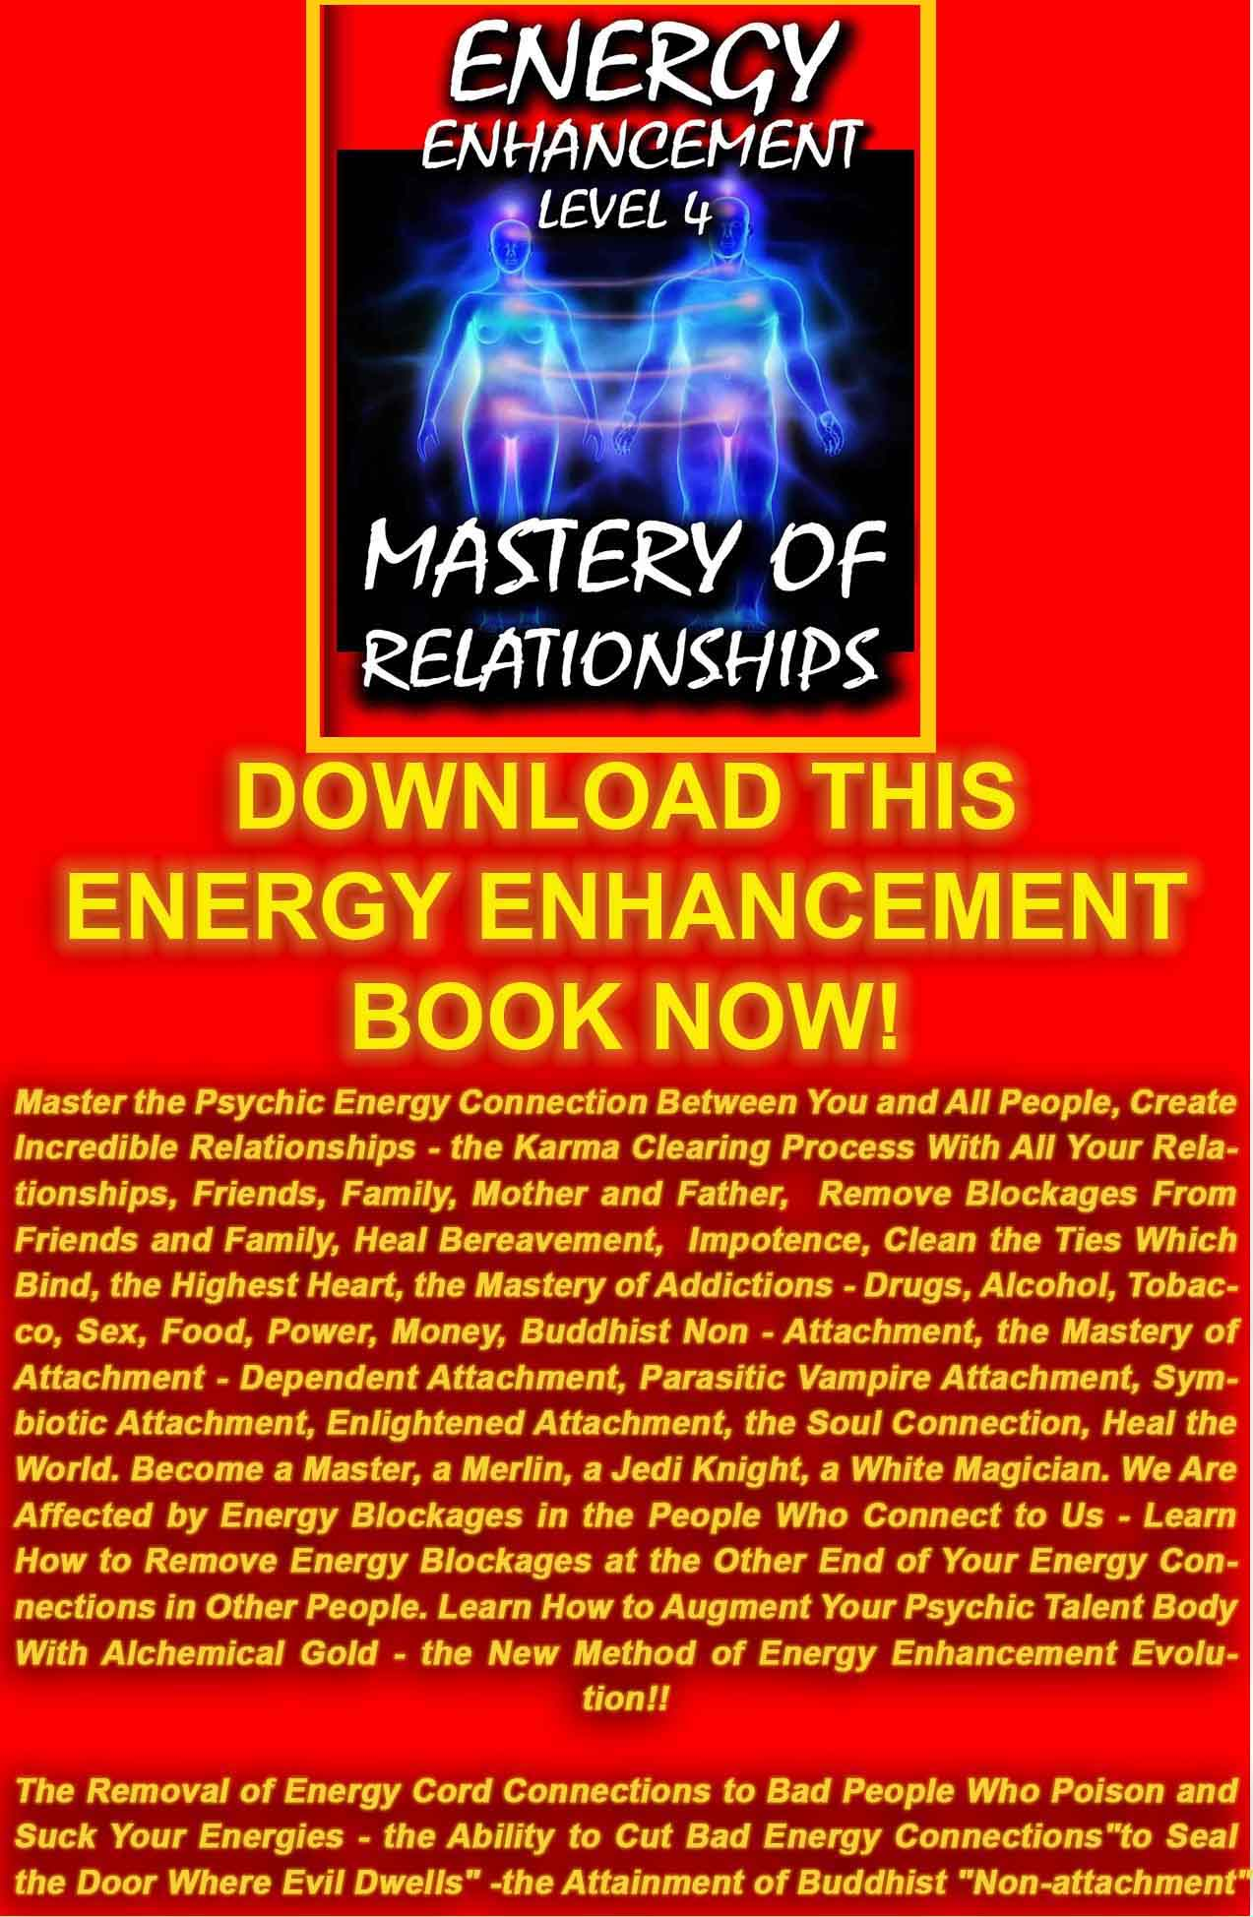
DOWNLOAD LEVEL 4 BOOK HERE!!!
http://www.energyenhancement.org/Sacred-Energy/Level-4-Book/Energy-Enhancement-Level-4-Book-Energy-Cords-Mastery-Of-Relationships.pdf

ENERGY CONNECTIONS, ENERGY VAMPIRES AND THE MASTERY OF RELATIONSHIPS

The Mastery of Relationships, Energy Connections, Implants and the Initiations of Energy Enhancement Meditation Part One
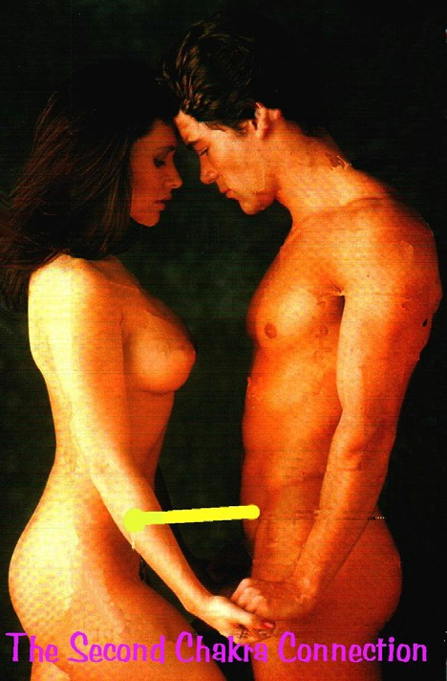Relationship Energy Connections exist in all peple and in general mess up their lives.
Instead they should Enhance our lives and lives of everyone around us. With Energy Enhancement Techniques we can learn The Mastery of Relationships!!
For all intent and purpose, energy connections or "strings" in relationships are very similar to umbilical connections or even electric and telephone wires, except they exist on the astral dimensional planes in all relationships. They can be very thin, or very thick, and can appear as very light or very dark streamers coming out of your energy fields/bodies.
Relationship Energy Connections can be superficially hooked onto the surface of - or more deeply plugged into the very cores of - your numerous energy fields, chakras and/or dimensional bodies.
Initially these relationship hooks or plugs seem pretty innocuous to the astral spirit, at first glance appearing very light, maybe even golden and brightly colored but energy connections in Relationships, no matter how attractive or light or energizing, are ties that bind, which is a phrase created by Phyllis Crystal author of the book “Cutting the Ties that Bind”.
One of our Energy Enhancement students, Susan, a medical doctor at the ashram of Sathya Sai Baba in India teaches “cutting the ties that bind” to 2000 people a year in her workshops there, yet found it necessary to learn the Advanced Initiations of Energy Enhancement to further augment her knowledge.

These Energy Connections can limit your freedom in Relationships if you can’t manage them through knowledge of the Initiations of Energy Enhancement in Relationships...gilded chains are still chains, and a gilded cage is still a cage .... Any relationship energy connection can be made to appear beautiful and of the light, yet one should ask “where does this energy connection lead to, or come from?"
When followed back to their origins, we have found extremely evil, manipulative entities/consciousnesses behind them, pulling these "strings" these Energy Connections - See the movie "The Matrix".
You then have a relationship with evil usually through being Implanted by them.
Even these evil beings existing in the universe have some light which to dangle in front of you, to deceive you - remember the wolf in sheep's clothes ? Unfortunately by this time, many of you are already hooked by these Relationship Energy Connections, and you probably don't even know it....

Relationship energy connections might be seen, felt or sensed by some psychics, but there are many that are imperceptible to and even way beyond the psychic abilities, as the psychic senses function on only the lower levels/dimensions. It is handy to have people around who can give the psychic "view point" or perspective... it does have its place if it may help build your faith in the unseen, I'm all for it !, but it is important to know it has its limits.

The bleed through of negative psychic impulses, messages and energies from one being to another through these energy connections can often and easily act to interfere or distort the integrity and conscious energetic experience of your own space.
This may be something most people are totally unaware of... as everyone falsely assumes that all their impulses, thoughts and feelings originate from themselves where in actuality much comes through being given Implants by these and other evil entities.
If a person has lived with these Relationship Energy Connection "monkeys" on their back for a long time, they may have gotten accustomed to them and would probably be in denial to their very existence. The relationship energy connection controls them. Since our space age society disavows any knowledge of such things being that you can't scientifically prove their existence, this is a reality the modern rational person would not even remotely consider... however, ancient man knew better.... It is good that there are

movies such as "The Exorcist", "The 6th Sense", "The Matrix", and TV shows like "John Edwards"... they are to remind us - paranormal phenomena does exist, even if it is in the imagination of... the mind
- the psyche - the astral... all connected... all one. Why have Energy Connections?
There are many reasons why you create relationship energy connections yourself to another being and/or for that matter, why they create energy connections themselves to you....

- It could have seemed like a good idea at the time, quite handy and practical in fact, being able to telepathically call in and out to your friends.... But friends create energy connections to other friends, and sooner or later you are connected to a party line and are getting input from all sorts of unwanted sources.... You could easily be inundated, day and night, non-stop with this psychic "spam". This is why the Initiations of Energy Enhancement teach how to, and give you a process of, cutting all ancient connections and then reforming them appropriately.

- It could have been done as a way to be closer, more intimate with someone... to share the deepest thoughts and feelings from ones deepest centers. But all relationships change... some perhaps go sour, even adversarial, confrontational, or outright hostile... but the energy connections remain. Once you are wired with Energy Connections, it is not as easy to remove them as it was to create them. Just imagine if you were create energy connections to someone who turned dark and evil... and you had one of these wires from them plugged into your brain, or into your sex chakra, or your heart...? You are really really stuck.... even worse than having a grinding wheel around your neck or a lead ball and chain tied around your ankles. You are in really deep do-do and will not be able to get out of this mess by yourself unless you learn the Initiations of Energy Enhancement. You need to learn how to disconnect your Energy Connections to evil negative energy and the initiations of Energy Enhancement teaches and helps you to do this. This is one of the main works of your Teachers of Energy Enhancement.

- It could have been contractually agreed upon as a way to be in a partnership or marriage with another. A “Vow” which we learn how to deal with in other parts of Energy Enhancement. The old paradigm of partnership or marriage has been about "banding" branding? One person to another,... i.e. being contractually bound

by energy connections "tying" the knot and "the ties that bind". The new paradigm of truly loving and deep relationships is about unconditionally giving and setting each other free with no strings attached. Or, through the Initiations of Energy Enhancement, having the ability to manage these connections.

- It could have been done out of fear to go it alone in the world. Many people think that by standing within their own power, the resultant freedom and independence this would give including the associated personal and spiritual responsibility would shun them from human society, causing them to live solitary, alone, and lonely lives. To prevent this, they are willing to compromise their personal power and sovereignty... and join or "hook" up with another person, group, or outside authority... in exchange for the companionship, security in numbers, and shared responsibility. Usually, this is a case of our relationship to priestly vows, or vows to be a member of a Black Magic group, which remain in the psychic body for many lifetimes through Implants. For a particularly good example, look at all the people who are members of all organized religions and don't forget the political parties.
- Or it could have even been forced upon you against your will, or even secretly planted as a thoughtform “Implant” without your awareness as a hook to draw you back into the fold, lifetime after lifetime. These implants have energy connections going into them from the people who psychically made the implant many lifetimes ago. Implants exert control and drain energy back to the original maker of the implant, turning many people into batteries, like in the Matrix.
The implant makers are not interested in people of low evolution who do not have much psychic energy. They are interested in people of high evolution. People more Soul Connected, and it is these people who they drain, as an aphid drains the rose flower, preventing its further evolution by usually perverting the victim as the Ring Implant, like the Ring in the Lord of the Rings movie and book, perverts all who come into contact with it. These implants create desires for sex, sexual abuse, drugs and rock and roll. It can draw you back into the same type of life, lifetime after lifetime.
As the candle is burned at both ends much energy can be taken, and usually the victim dies young. Inadvertently or in a lapse of good judgment, you let down your protective energy barriers, and someone slipped in and hooked or plugged an Implant into you.
This also happens quite a lot, especially between men and women "she got her hooks into him". Why do you think prostitutes are called "hookers" ? Usually prostitutes are implanted lifetime after

lifetime, and the implant which acts like a psychic virus is spread to all the customers, creating a desire for more.
This is the nature of all addiction. The Initiations of Energy Enhancement teach you how to overcome your relationship to all desire, your relationship to all addiction.

- It could have been contractually agreed upon as a way to clear some mutually unresolved karmic debts "Karmic Contracts" or Vows which we deal with in another Energy Enhancement Initiation.

- It could also be entered into as a spiritual service to another soul, such as in a "God Contract" as exemplified in that energy connection between children and their parents.

I have few good things to say about energy connections, excepting the umbilical cord that connects a child to its mothers. It is a biological necessity during gestation, and even after, when this cord is cut, there still remains in this same area an important energetic energy connection between parents and child both mother and father.
This seems to be necessary for the child's comfort, security, and even survival in the developing early years. It is this telepathic- energetic relationship link with the parents that energetically feeds the child, that assists the child to feel more connected and grounded to life and humanity, at this level or dimension of reality. It is bad enough, if you think about it, to at one point be in spirit, at peace, at one with all, and then be thrust down into this gross dimensional plane of duality and suffering, all by oneself... without at least some kind of life line to hold onto.

However, this energy connection between parents and children can have negative consequences... Usually we are not weaned of this energy connection at the age of 5 or 7 as should happen, but the energy connection endures for all of our lives.
When one of the beings such as a parent or even a child has dark issues and heavy karma, an energetic bleeding through the energy connection can occur, corrupting or at least be disturbing to the other individual. In these relationship family ties we can be “tied to the apron strings of our mother”. Some male homosexuals, or people not interested in sexual relationships, have very strong energy connections to their mothers. This is accounted for and anticipated in spirit before the birth, as we all choose these relationships for the reason of learning these relationshiplessons, sometimes to assist and carry another through their darkness and

karma. This is why the Initiations of Energy Enhancement are so necessary to people in the process of learning about relationships.
You can see this if in your life all your negative life experiences have come through relationships. This means that you are in the process of Mastering the Second Initiation of Alice Bailey, The Mastery of Relationships, and it is this which is the intent of the Initiations of Energy Enhancement, to give you the Mastery of your Relationships.
Often, being connected in this way as parents or even as the child is the only way to help the other soul through these trials and tribulations. It is a noble endeavor and spiritual service one can do for another. It is like having a permanent, continuous, invisible life line of support and love.... If the one being is overwhelmingly strong enough to transform the others' negative energies and darkness, this could be a good thing. Unfortunately, this rarely works out so ideally as the burden can be sooo great as to drown both people.
If you think of a person who jumps into the water to save a drowning man, and ends up being attacked and drowned instead, you know what I mean. This is a task for the strong at heart, and even then, you still have energy connections with that person after. This is why the Initiations of Energy Enhancement are so necessary to enable everyone to handle all these types of problem above mentioned.
And to do it properly you need to learn the lessons of the Enlightened Master. And it is this which we learn in the Initiations of Energy Enhancement, The Mastery of Relationships.
Relationship Energy Connections - the Energy Enhancement View
When these relationship energy connections are created by people in love they can create a baby, they can make love they can have an orgasm and when energy connections are created consciously by a Master of Energy Enhancement, they can be given energy on many vibrational planes which can help in their Enlightenment.
This is high spiritual tantra. Learning how to connect appropriately can bring energy, love and loving sexual orgasms back into failing relationships. Energy Enhancement Mastery of Connections can heal frigidity and many inabilities to make love.
So one of the Energy Enhancement Meditation Keys to the Mastery of Relationships which we teach about fully on the course is to have care in your relationships. Only connect to the good. Be mindful of whom you are connected to. Only connect to the bad if you want to heal them or give them energy. The Key to Energy Enhancement

Initiations for the Mastery of Relationships is the ability to disconnect these energy connections as well as create them.
And why do we give energy to our students, the answer is that all Enlightened Masters give Energy to, raise the Energy Vibration of Their Students and Disciples in order to make them Enlightened. As my Master, Swami Satchidananda said, “Making someone Enlightened is like creating a baby” Or as Goethe Said, “Connect, only Connect.”
We can understand why the Buddha Said, “Attachment leads to Pain” This is caused by holding onto negative connections too long. Pain is caused by the inability to connect and disconnect, the inability to Manage Connections which is the teaching of the Initiations of Energy Enhancement, The Mastery of Relationships!
The most important thing about Energy Connections is to know that it is possible to connect and also to disconnect using these cords of Energy Connections. Only connect when it is necessary. Disconnect when it is not necessary. Be mindful of your connections. And these Energy Connections are at the core of every successful Loving Relationship.
In Energy Enhancement Mastery of Relationships we learn how to cut off all connections when we need to. We follow a process of cutting off all connections with everyone we know from every one of the chakras in our bodies. We learn how to dissolve implants. Then we learn how to connect appropriately. We practice connecting appropriately. Thus the Initiations of Energy Enhancement teaches the Mastery of Relationships.
We learn how to use these connections to heal the people we connect to so that we can not be connected to anything bad. Healing the person means dissolving their negativity or negative Ancient Karma. We healed all of our Karma in this Lifetime and all of our past lifetimes with Energy Enhancement Level 2. Now we learn how to perform the same service for others. Through the Initiations of Energy Enhancement we overcome the objections to connections which we read about above through the ability to Master each connection.
In Energy Enhancement Mastery of Relationships we learn how to connect and disconnect appropriately. We learn that WE are responsible for the health of all our relationships. We learn how to use the Light of the Soul to dispel all ancient negativity in those we are connected to, ALL OUR RELATIONSHIPS. This is the true meaning of “Forgiveness” it is not something we decide to do mentally. It is something we do psychically to take back, to transmute, to dissolve the ancient negativity caused by our bad

actions in the past, so that all this ancient evil karma will not come back to haunt us in this lifetime and in the future.
In this same way in Energy Enhancement we learn how to reduce the Karmic Burden of this Planet creating conditions to raise the Vibrational Energy Level of this Planet, for this planet to become a Sacred Planet, where every person is Enlightened
In Energy Enhancement the Mastery of Energy Connections is the Basis of the Energy Enhancement Mastery of Relationships.
By Energy Enhancement Satchidanand.

ENERGY ENHANCEMENT IMMORTALITY LIVE COURSES, INDIA AND IGUAZU FALLS

ONLY THE SUPERPOWERS DEVELOPED BY THE SCIENCE OF REAL MEDITATION CAN FREE HUMANITY TO REACH THE STARS.

ENERGY ENHANCEMENT MEDITATION ENLIGHTENMENT AND ILLUMINATION

THE INCREDIBLE MEDITATION COURSE AND MEDITATION TECHNIQUES CREATED TO PRODUCE ENLIGHTENMENT AND ILLUMINATION

"ALL TRADITIONAL MEDITATIONS HAVE BEEN DESIGNED TO FAIL" - SATCHIDANAND -

"BECAUSE ORIGINALLY ALL MEDITATIONS CONTAINED THE TECHNIQUES OF, "THE KUNDALINI KEY" AND OF, "ALCHEMICAL VITRIOL" TO GROUND NEGATIVE ENERGIES AND TO NATURALLY INCREASE KUNDALINI ENERGY"

"NOW, ONLY ENERGY ENHANCEMENT MEDITATION TEACHES THESE TECHNIQUES WHICH SPEED UP THE ENLIGHTENMENT PROCESS"

SATCHIDANAND - IGUAZU FALLS


The Mastery of Relationships, Psychic Energy Connections, Energy Vampires, Implants and the Initiations of Energy Enhancement Meditation Part Two

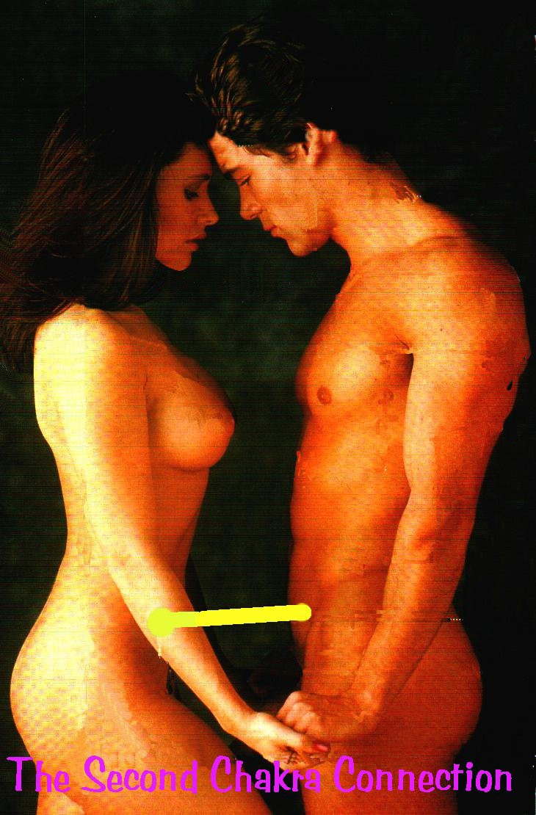

Relationship Psychic Energy Connections exist in all people and in general mess up their lives. Instead they should Enhance our lives and lives of everyone around us. With Energy Enhancement Techniques we can learn The Mastery of Relationships!!
For all intent and purpose, Psychic Energy Connections or "strings" in relationships are very similar to umbilical connections or even electric and telephone wires, except they exist on the astral dimensional planes in all relationships. They can be very thin, or very thick, and can appear as very light or very dark streamers coming out of your energy fields/bodies.
These strings, Psychic Energy connections, stretch between all chakras, chakra to chakra and in the case of Relationships from abdomen to abdomen and with sex, from base chakra to base chakra.
Relationship Psychic Energy Connections can be superficially hooked onto the surface of - or more deeply plugged into the very cores of - your numerous energy fields, chakras and/or dimensional bodies. Initially these relationship hooks or plugs seem pretty innocuous to the astral spirit, at first glance appearing very light, maybe even golden and brightly colored but Psychic Energy Connections in Relationships, no matter how attractive or light or energizing, are ties that bind, and as Gautama Buddha said, thousands of years ago, "Attachment leads to Pain".
One of our Meditation students, Susan Macri, a medical doctor living at the ashram of Sathya Sai Baba in India teaches “cutting the ties that bind” to 2000 people a year in her workshops there, yet found it necessary to learn the Advanced Initiations of Energy Enhancement to further augment her knowledge.
These Psychic Energy Connections can limit your freedom in Relationships if you can’t manage them through knowledge of the Initiations of Energy Enhancement in Relationships...gilded chains are still chains, and a gilded cage is still a cage .... Any relationship Psychic Energy Connection can be made to appear beautiful and of the light, yet one should ask “where does this Psychic Energy Connection lead to, or come from?"
When followed back to their origins, we have found sometimes people are unconsciously connected to people who are sucking their energies. We call these people Energy Vampires. They can also be connected in to bad entities or consciousnesses, pulling these "strings" these Psychic Energy Connections.


See the movie "The Matrix" WHERE PEOPLE ARE TURNED INTO BATTERIES.
You usually have a relationship with badness usually through being Implanted. The Energy Blockage or Psychic Virus implanted in you, always sends energy back to the person who implanted you. Some

of these energy vampires have thousands of connections with people sending energy back to them!
Relationship Psychic Energy Connections might be seen, felt or sensed by you feeling tired and lacking in energy, or attracted by things you know are bad for you or even becoming addicted, but there are many connections that are imperceptible to most people.
It is handy to work with people who are experienced in these matters as they can help you spot the connections and help you release them.


Energy Enhancement Teacher Devi Dhyani Meditating on the beach with the Energy Enhancement Symbol representing the Soul above her Head.
The bleed through of negative psychic impulses, messages and energies from one being to another through these Psychic Energy Connections can often and easily act to interfere or distort the integrity and conscious energetic experience of your own space.
This may be something most people are totally unaware of... as everyone falsely assumes that all their impulses, thoughts and feelings originate from themselves where in actuality much comes through being given Implants by these and other bad people.
If a person has lived with these Relationship Psychic Energy Connection "monkeys" on their back for a long time, they may have gotten accustomed to them and would probably be in denial to their very existence.

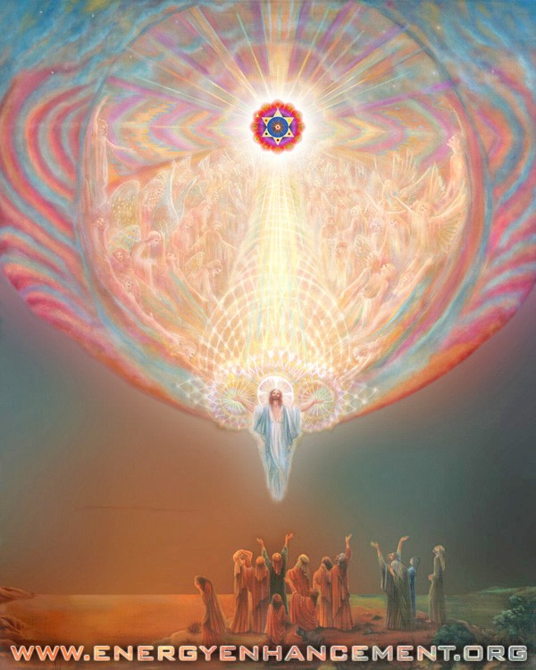

Energy Enhancement Meditation Symbol – Enlightenment

The relationship Psychic Energy Connection controls them.
Since our modern society disavows any knowledge of such things being that you can't scientifically prove their existence, this is a reality the modern rational person would not even remotely consider... however, ancient man knew better.... It is good that there are movies such as "The 6th Sense" or "The Matrix" ... they are

to remind us that this phenomena does exist and has been written about for thousands of years.
Why have Normal Psychic Energy Connections? TO BRING DOWN A BABIES SOUL FROM HEAVEN...
There are many reasons why you create relationship Psychic Energy Connections yourself to another being and/or for that matter, why they create Psychic Energy Connections themselves to you. One of the major reasons is to create babies. Energy is necessary for this and flows from abdomen to abdomen. And as the energy flows in sex a connection is created from base to crown chakra and from the crown to the Soul, in order to bring down another soul from heaven!!

However, this natural function can become perverted....

- It could have seemed like a good idea at the time, quite handy and practical in fact, being able to telepathically call in and out to your friends.... But friends create Psychic Energy Connections to other friends, and sooner or later you are connected to a party line and are getting input from all sorts of unwanted sources.... You could easily be inundated, day and night, non-stop with this psychic "spam". This is why the Initiations of Energy Enhancement teach how to, and give you a process of, cutting all ancient connections and then reforming them appropriately.

- It could have been done as a way to be closer, more intimate with someone... to share the deepest thoughts and feelings from ones deepest centers. But all relationships change... usually through bad Karma.

If you did bad things to a person in a previous lifetime, usually in this lifetime they will take revenge. Relationships go sour, even adversarial, confrontational, or outright hostile... but the Psychic Energy Connections remain.
Once you are wired with Psychic Energy Connections, it is not as easy to remove them as it was to create them. Just imagine if you were create Psychic Energy Connections to someone who turned dark and evil... and you had one of these wires from them plugged into your brain, or into your sex chakra, or your heart...? You are really really stuck....
You need to learn how to disconnect your Psychic Energy Connections to negative energy and we can help you to do this. This is one of the main works of our Teachers of Energy Enhancement.

- It could have been contractually agreed upon as a way to be in a partnership or marriage with another. A “Vow” which we need to learn how to deal with. The old paradigm of partnership or marriage has been about "banding" branding? one person to another,... i.e. being contractually bound by Psychic Energy Connections "tying" the knot and "the ties that bind".
The new paradigm of truly loving and deep relationships is about unconditionally giving and setting each other free with no strings

attached. Or, through the Initiations of Energy Enhancement, having the ability to manage these connections.

- It could have been done out of fear to go it alone in the world. Many people think that by standing within their own power, the resultant freedom and independence this would give including the associated personal and spiritual responsibility would shun them from human society, causing them to live solitary, alone, and lonely lives.
To prevent this, they are willing to compromise their personal power and sovereignty... and join or "hook" up with another person, group, or outside authority... in exchange for the companionship, security in numbers, and shared responsibility.
Usually, this is a case of our relationship to priestly vows, or vows to be a member of a bad group, which remain in the psychic body for many lifetimes through Implants. For a particularly good example, look at all the people who are members of all organized religions and don't forget the political parties.

- Or it could have even been forced upon you against your will, or even secretly planted as a thoughtform “Implant” without your awareness as a hook to draw you back into the fold, lifetime after lifetime. These implants have Psychic Energy Connections going into them from the people who psychically made the implant many lifetimes ago. Implants exert control and drain energy back to the original maker of the implant, turning many people into batteries, like in the Matrix.
The implant maker vampires are not interested in people of low evolution who do not have much psychic energy. They are interested in people of high evolution. People more Soul Connected, and it is these people who they drain, as an aphid drains the rose flower, preventing its further evolution by usually perverting the victim as the Ring Implant, like the Ring in the Lord of the Rings movie and book, perverts all who come into contact with it. These implants create desires for sex, sexual abuse, drugs and rock and roll. It can draw you back into the same type of life, lifetime after lifetime.
As the candle is burned at both ends much energy can be taken, and usually the victim dies young.

Inadvertently or in a lapse of good judgment, you let down your protective energy barriers, and someone slipped in and hooked or plugged an Implant into you.
HOOKERS
This also happens quite a lot, especially between men and women "she got her hooks into him". Why do you think prostitutes are called "hookers" ? Usually prostitutes are implanted lifetime after lifetime, and the implant which acts like a psychic virus is spread to all the customers, creating a desire for more.
This is the nature of all addiction. It is nice to learn how to overcome your relationship to all desire, your relationship to all addiction by working to learn how to become free.

- It could have been contractually agreed upon as a way to clear some mutually unresolved karmic debts "Karmic Contracts" or Vows.

- It could also be entered into as a spiritual service to another soul, such as in a "God Contract" as exemplified in that Psychic Energy Connection between children and their parents.

MANAGING PSYCHIC ENERGY CONNECTIONS

Psychic Energy Connections start with the umbilical cord that connects a child to its mothers. It is a biological necessity during gestation, and even after, when this cord is cut, there still remains in this same area an important energetic Psychic Energy Connection between parents and child both mother and father.
This seems to be necessary for the child's comfort, security, and even survival in the developing early years. It is this telepathic- energetic relationship link with the parents that energetically feeds the child, that assists the child to feel more connected and grounded to life and humanity, at this level or dimension of reality. It is bad enough, if you think about it, to at one point be in spirit, at peace, at one with all, and then be thrust down into this gross dimensional plane of duality and suffering, all by oneself... without

at least some kind of life line to hold onto.

However, this Psychic Energy Connection between parents and children can have negative consequences... Usually we are not weaned of this Psychic Energy Connection at the age of 5 or 7 as should happen, but the Psychic Energy Connection endures for all of our lives.
When one of the beings such as a parent or even a child has dark issues and heavy karma, an energetic bleeding through the Psychic Energy Connection can occur, corrupting or at least be disturbing to the other individual. In these relationship family ties we can be “tied to the apron strings of our mother”.
Some male homosexuals, or people not interested in sexual relationships, have very strong Psychic Energy Connections to their mothers or fathers.
This is accounted for and anticipated in spirit before the birth, as we all choose these relationships for the reason of learning these relationship lessons, sometimes to assist and carry another through their darkness and karma. This is why learning about this is so necessary to people in the process of learning about relationships.
You can see this if in your life all your negative life experiences have come through relationships. This means that you are in the process of Mastering the Second Initiation of Alice Bailey, The Mastery of Relationships, and it is this which is the intent of the teachings of Energy Enhancement, to give you the Mastery of your Relationships.
Often, being connected in this way as parents or even as the child is the only way to help the other soul through these trials and tribulations. It is a noble endeavor and spiritual service one can do for another. It is like having a permanent, continuous, invisible life line of support and love.... If the one being is overwhelmingly strong enough to transform the others' negative energies and darkness, this could be a good thing. Unfortunately, this rarely works out so ideally as the burden can be sooo great as to drown both people.
If you think of a person who jumps into the water to save a drowning man, and ends up being attacked and drowned instead, you know what I mean. This is a task for the strong at heart, and even then, you still have Psychic Energy Connections with that person after. This is why the Initiations of Energy Enhancement are so necessary to enable everyone to handle all these types of problem above mentioned.

And to do it properly you need to learn the lessons of the Enlightened Master. And it is this which we learn in the Initiations of Energy Enhancement, The Mastery of Relationships.

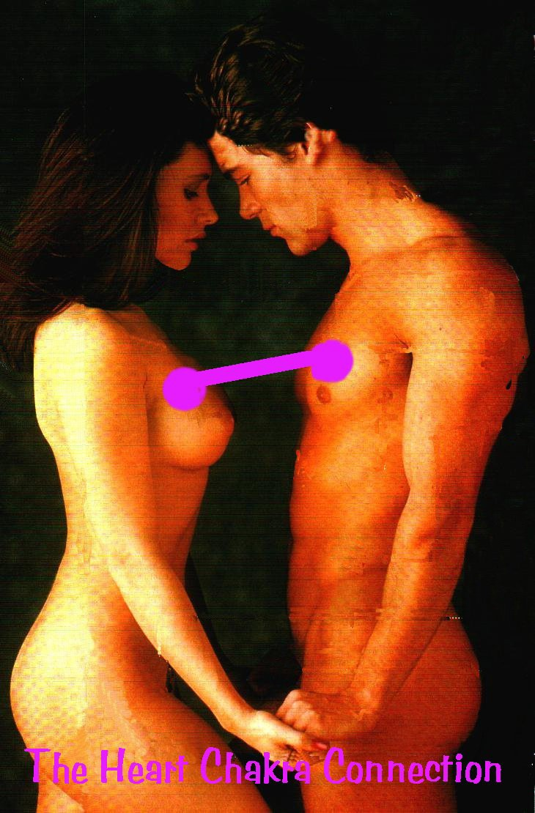

Relationship Psychic Energy Connections and TANTRA - the Energy Enhancement View
When these relationship Psychic Energy Connections are created by people in love they can create a baby, they can make love they can have an orgasm and when Psychic Energy Connections are created consciously by a Master of Energy Enhancement, they can be given energy on many vibrational planes which can help in their Enlightenment.
This is high spiritual tantra. Learning how to connect appropriately can bring energy, love and loving sexual orgasms back into failing relationships. Energy Enhancement Mastery of Connections can heal frigidity and many inabilities to make love.
So one of the Energy Enhancement Meditation Keys to the Mastery of Relationships which we teach about fully on the course is to have care in your relationships. Only connect to the good. Be mindful of whom you are connected to. Only connect to the bad if you want to heal them or give them energy. The Key to Energy Enhancement Initiations for the Mastery of Relationships is the ability to disconnect these Psychic Energy Connections as well as create them.
And why do we give energy to our students, the answer is that all Enlightened Masters give Energy to, raise the Energy Vibration of Their Students and Disciples in order to make them Enlightened. As my Master, Swami Satchidananda said, “Making someone Enlightened is like creating a baby” Or as Goethe Said, “Connect, only Connect.”
We can understand why the Buddha Said, “Attachment leads to Pain” This is caused by holding onto negative connections too long. Pain is caused by the inability to connect and disconnect, the inability to Manage Connections which is the teaching of the Initiations of Energy Enhancement, The Mastery of Relationships!
The most important thing about Psychic Energy Connections is to know that it is possible to connect and also to disconnect from these cords of Psychic Energy Connections.
Only connect when it is necessary. Disconnect when it is not necessary. Be mindful of your connections. And these Psychic Energy Connections are at the core of every successful Loving Relationship.

CHAKRA TANTRA LINKS
BALANCED AND SHARED COMMUNICATION FLOW
How to connect and disconnect appropriately

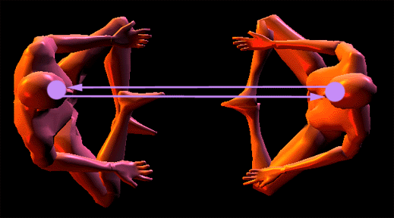
Transmitting and Receiving Communication in a shared and balanced way.

THE MASTERY OF RELATIONSHIPS
In Energy Enhancement Mastery of Relationships we learn how to cut off all connections when we need to. We follow a process of cutting off all connections with everyone we know from every one of the chakras in our bodies. We learn how to dissolve implants. Then we learn how to connect appropriately. We practice connecting appropriately. Thus the Initiations of Energy Enhancement teaches the Mastery of Relationships.
We learn how to use these connections to heal the people we connect to so that we can not be connected to anything bad. Healing the person means dissolving their negativity or negative Ancient Karma. We healed all of our Karma in this Lifetime and all of our past lifetimes with Energy Enhancement Level 2. Now we learn how to perform the same service for others. Through the Initiations of Energy Enhancement we overcome the objections to connections which we read about above through the ability to Master each connection.
In Energy Enhancement Mastery of Relationships we learn how to connect and disconnect appropriately. We learn that WE are responsible for the health of all our relationships. We learn how to use the Light of the Soul to dispel all ancient negativity in those we are connected to, ALL OUR RELATIONSHIPS. This is the true meaning of “Forgiveness” it is not something we decide to do mentally. It is something we do psychically to take back, to transmute, to dissolve the ancient negativity caused by our bad actions in the past, so that all this ancient evil karma will not come back to haunt us in this lifetime and in the future.
In this same way in Energy Enhancement we learn how to reduce the Karmic Burden of this Planet creating conditions to raise the Vibrational Energy Level of this Planet, for this planet to become a Sacred Planet, where every person is Enlightened.
In Energy Enhancement the Mastery of Psychic Energy Connections is the Basis of the Energy Enhancement Mastery of Relationships.

by Energy Enhancement Satchidanand.

ENERGY ENHANCEMENT
THE CORE ENERGY TECHNIQUES!!
ENERGY ENHANCEMENT!!! ULTIMATE!!!!!! ANCIENT!!! !!! EFFECTIVE!!!!!
SUCCESSFUL!!!

  - Get into Intense alignment with Your Own Kundalini Energy and Immediate Access to the Meditative State.

  - Remove your Energy Blockages with The Circulation of the Energies, the Kundalini Kriyas, Ancient Taoist Energy Circulations which have worked
effectively for 5000 years to help all towards ENLIGHTENMENT.

  - The Grounding of all your Negative Energies through Alchemical VITRIOL
- Become Incredibly POSITIVE and ENERGETIC!!

  - Alignment with Your Higher Self - INCREASE YOUR IQ, INCREASE YOUR LUCK, ACCESS YOUR HIGHEST ENERGIES!! ACHIEVE WHAT YOU WERE PUT
ON THIS PLANET TO DO.

  - Learn how to USE and Increase the LOVE of Your Heart Center to ZAP YOUR NEGATIVE EMOTIONS AND DEVELOP PSYCHIC POWERS TO HEAL
YOURSELF AND OTHERS.

  - Overcome ENERGY VAMPIRES - MASTER ENERGY PROTECTION AND MAINTAIN YOUR HIGH ENERGIES!!

  - EXPERIENCE INCREDIBLE RELATIONSHIPS WITH ENERGY ENHANCEMENT - THE CORE ENERGY TECHNIQUES

  - ENERGY ENHANCEMENT Techniques are the source of all Successful spiritual training courses over the last 5000 years. Become a Jedi Master, a
Gandalf, a Transmitter of the FORCE a Bringer of the Light!!

GET MORE ENERGY!!!
ENERGY ENHANCEMENT -
!!! ULTIMATE!!!
!!! ANCIENT!!!
!!! EFFECTIVE!!!
!!! SUCCESSFUL!!!

ENERGY ENHANCEMENT AND TANTRA WHAT IS TANTRA?
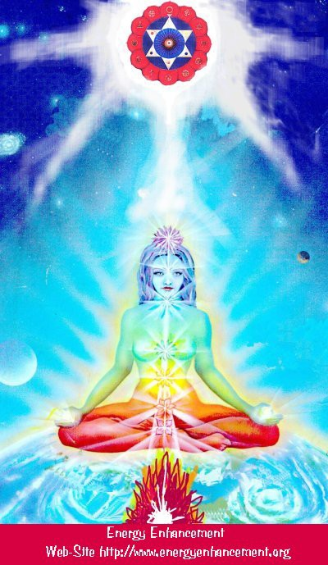
TANTRA IS ONE OF THE MANY PATHS WHOSE AIM OR END OR PURPOSE IS ENLIGHTENMENT
Like Yoga which means Union with the center of the Universe or with God, Tantra is any path which achieves that aim.

For many, Tantra is a sexual means of achieving that union. People ask me, isn't one of the methods to make love only once per month? To increase the length of time we make love to hours?
Well, I reply, Enlightenment comes from the increase of energy. Human beings only have a small amount of energy within themselves. Really to increase that energy we need to access the energy from chakras outside the body. It is like we have a computer which is running slowly on only five volts. We need to plug ourselves into the big generator!
To obtain thousands of volts of power in order to make the computer work more quickly at a much higher level we need to plug ourselves into the chakras above the Crown Chakra, into energy in the central spiritual sun!! The Soul!! God!!!
And in the center of the Earth is the Kundalini Shakti flowing out in every direction from the Atomic Generator which powers this planet. The atomic pile in the center of the planet is a 5000 degrees centigrade and provides the energy which keeps this planet alive and at the correct temperature. The Earth is feminine. The Indians say, "Our Mother, the Earth" and our Father, who art in Heaven is God, the energy in the center of the universe. And when all the Energy Blockages to that connection have been removed, then there is a flow, a waterfall of spiritual energy which powers every one of the enlightened.
Then we have Shiva, our father, combining with Shakti our mother. Then we have Hercules, son of God, Zeus, Theos, Deos, combining with the daughter of Pluto, King of the Underworld.
Enlightenment concerns The Holy Trinity and is composed of Sat, the truth of the center of the Universe combining with Chitta - the holy grail, the cup of the mind on this planet, empty and ready to receive the libation of the Gods, and the flow of energy between the two is called Ananda, or bliss - Satchitananda like the Father - Our Father who art in Heaven, the Son and the Holy Spirit which flows between the two.
And the Hindus have a word for the channel between the Center of the Universe and the Center of the Earth. Rapunzel, Rapunzel, let down your hair. The Rainbow Bridge. The Tower of Babel. Tower of Connection created out of mental matter to channel the energies of God through all the infinite chakras of existence, powering the whole universe from the center. This is the Antahkarana.
If you are not connected with, if you are blocked from, the center of the universe then just think of a small flow of water slowly filling a bucket. You may well have to wait a month for the bucket to fill.

Only then will you have sufficient energy to enjoy making love, or really doing any of the thousand things we have to do on this planet. But if you are connected and put your bucket under a waterfall, then that bucket will fill in seconds. You will have infinite energy to do with whatever you want every second of the day.
The Greeks had a name for this energy which descends from the soul to power the Mind Computer, and they called it Genius which is the what happens to the mind computer powered by the energy of the Soul. Soul Infused.
The Mind is of the intellect of logic yet the Soul is Intuition, Knowing, Wisdom and is much higher than the mind.
The Kashmir Shaivites also have the energy of Chit Shakti whereby the mind is also powered by the Energy in the Center of the earth.
In reality, human beings are powered by both masculine and feminine energies. We connect with the Kundalini Chakra in the center of the earth by means of the Base chakra, and we connect with the center of the universe by means of the Crown Chakra.
Usually it takes three days for the students who come on our courses to access this energy with which they can successfully transmute all their Energy Blockages because another, more easy way for people to absorb energy is from the Buddhafield, the Aura of the Master.
When they leave then sometimes the energy drains away, because it is the energy blockages which create the holes in the bucket through which all the water drains away.
And this is Tantra, the Energy Flow of the Soul created by the Sexual Union of Shiva and Shakti.
In that that bliss, that delight, such an overflowing cornucopia of Energy which comes from the Gaining of Energy and the Removal of Energy Blockages, we find only Enlightenment.
In a way, Enlightenment is a twenty-four hour a day orgasm.

Mastery of Relationships, Psychic Energy Connections, Energy Vampires, Implants and Meditation.
Relationship Psychic Energy Connections exist in all people and in general mess up their lives. Instead they should Enhance our lives and lives of everyone around us. With Meditation Techniques we can learn The Mastery of Relationships!!
We can learn how to Get Rid of all Energy Vampires!
For all intent and purpose, Psychic Energy Connections or "strings" in relationships are very similar to umbilical connections or even electric and telephone wires, except they exist on the astral dimensional planes in all relationships. They can be very thin, or very thick, and can appear as very light or very dark streamers coming out of your energy fields/bodies.
These strings, psychic Energy connections, stretch between all chakras, chakra to chakra and in the case of Relationships from abdomen to abdomen and with sex, from base chakra to base chakra.
Relationship Psychic Energy Connections can be superficially hooked onto the surface of - or more deeply plugged into the very cores of - your numerous energy fields, chakras and/or dimensional bodies.
Initially these relationship hooks or plugs seem pretty innocuous to the astral spirit, at first glance appearing very light, maybe even golden and brightly colored but Psychic Energy Connections in Relationships, no matter how attractive or light or energizing, are ties that bind, and as Gautama Buddha said, thousands of years ago, "Attachment leads to Pain".
One of our Meditation students, Susan Macri, a medical doctor living at the ashram of Sathya Sai Baba in India teaches cutting the ties that bind to 2000 people a year in her workshops there, yet found it necessary to learn the Advanced Initiations of Energy Enhancement to further augment her knowledge.
These Psychic Energy Connections can limit your freedom in Relationships if you cant manage them through knowledge of the Initiations of Energy Enhancement in Relationships...gilded chains are still chains, and a gilded cage is still a cage .... Any relationship

Psychic Energy Connection can be made to appear beautiful and of the light, yet one should ask “where does this Psychic Energy Connection lead to, or come from?"
When followed back to their origins, we have found sometimes people are unconsciously connected to people who are sucking their energies. We call these people Energy Vampires. They can also be connected in to bad entities or consciousnesses, pulling these "strings" these Psychic Energy Connections - See the movie "The Matrix" WHERE PEOPLE ARE TURNED INTO BATTERIES.
You usually have a relationship with badness usually through being implanted. The Energy Blockage or Psychic Virus implanted in you, always sends energy back to the person who implanted you. Some of these energy vampires have thousands of connections with people sending energy back to them!
Relationship Psychic Energy Connections might be seen, felt or sensed by you feeling tired and lacking in energy, or attracted by things you know are bad for you or even becoming addicted, but there are many connections that are imperceptible to most people.
It is handy to work with people who are experienced in these matters as they can help you spot the connections and help you release them, but unless you learn how to do it for yourself with advanced methods of meditation, eventually you will be implanted and vampirised of your energy again.
The bleed through of negative psychic impulses, messages and energies from one being to another through these Psychic Energy Connections can often and easily act to interfere or distort the integrity and conscious energetic experience of your own space.
This may be something most people are totally unaware of... as everyone falsely assumes that all their impulses, thoughts and feelings originate from themselves where in actuality much comes through being given Implants and addictions by these and other bad people.
The relationship Psychic Energy Connection controls them.
These matters have been known about and written about and worked with in meditation for thousands of years and indeed it is our experience in working with many clients.
Ancient man knew this.... It is good that there are movies such as "The 6th Sense" or "The Matrix" ... they are to remind us that this phenomenon does exist and has been written about in all civilizations.

Satchidanand, Director of Energy Enhancement, is one of the leading teachers of Meditation.

Energy Enhancement Psychic Energy Connection and The Mastery Of Relationships
Many psychological books talk about these Ego Splits which usually start off as Inner Children Energy Blockages.
The Inner Children Sub-personalities are separate egos which have been artificially created through painful experiences. Once created they shuttle in and out of your consciousness without you noticing them, except by their negative effects in your life. They are like separate ego programs, virtual machines, psychic viruses, which live within the one computer, You!!
They are anaesthetized through Drugs, but Only Meditation, Through the Grounding of Negative Energies and other Immensely Powerful Blockage Busting Techniques, can drain these Energy Blockages of their Painful Negative Energies and Emotions and Integrate them back into the Soul Central Stem.
Through Meditation it is possible to learn how to heal all your inner children, the Inner Saboteurs, the childish sub-personalities which split off from the central stem of the personality at the time when they are hurt, and which then destructively affect our emotions and our actions for the rest of our lives as they wander into and out of the active personality.
Ancient Effective Synthesis of Meditation Techniques can dissolve the Inner Children Energy Blockages which Unconsciously Link Your Sexual Base Chakra and the Relationship Abdominal Chakra to the Chakras of Other People thus causing Adultery and Divorce.
These split off parts of your mind form the Unconscious and Link Your Sexual Base Chakra and the Relationship Abdominal Chakra to the Chakras of Other People thus causing Adultery and Divorce.
They form an Unconscious Connection which in some people is more conscious.
You become Unconsciously Hooked which is where the Ancient term, Hooker comes from.

In a way, these Advanced Energy Blockages are parts of the Selfish Competitive Ego.
These Inner Children Sub-personalities are stronger the older they are and can form at any age in your life.
The Mastery Of Relationships, the Mastery of the Second Initiation, the Mastery of the Sexual Base Chakra the Relationship Second Chakra, the Mastery of the Psychic Energyual Connection, the Mastery of Intimacy and Independence. The Mastery of Relationships Can Transmute Bad Luck To Good Luck.
Anything unconscious can lead you into trouble and bad luck.
All bad luck comes from these Soul Splits. As your Life is Sabotaged and Fails due to the influence of these inner saboteurs, the your stress rises and their action becomes more intense. It is the Inner Children who want to use the Strategies in order to gain what they have been programmed to do, And The Inner Children Will Use The Strategies Like The Poor Me, Violator And Star, More And More Intensely As The Stress Increases.
As The Strings Are Wound Up.
The Energy Connections between Sexual Chakras become Hooked In This Way You Lose Balance.
Ancient Effective Synthesis of Meditation Techniques teach you to do the same thing that Shamen do in what they call "Soul Retrieval". To the sound of a beating drum they will enter into the astral plane and bring back to you these split off parts of yourself.
This Ancient Effective Synthesis of Meditation Techniques teaches you how to do this for yourself.
It needs an Ancient Advanced Synthesis of Effective Techniques for Gaining More Energy - Meditation, Shaktipat, Energy Circulation, The Kundalini Kriyas, The Five Elemental Paths Of The Chi Of Chinese Alchemical Taoism, The Grounding Of Negative Energies, V.I.T.R.I.O.L, The Art Card Of The Thoth Tarot, Access To Kundalini Energy, Strong Psychic Protection, Learn The Merkaba, Pyramid Protection, Power Tower Protection, Create The Antahkarana, Soul Fusion, Monadic Infusion, Logos Infusion. The Painless Removal Of Stress, Trauma And Negative Emotion
Director Satchidanand, is one of the leading teachers of Meditation.
He helps people worldwide reach further than they EVER thought possible, FASTER!!!

Energy Enhancement Meditation, Relationships, Sex, Adultery - Should You Forgive Infidelity? PART 1
If you're asking yourself that question, then somewhere within you there must be a desire to forgive the infidelity of the other person. After all, if you knew 100% for sure without doubts that you definitely should NOT forgive, then you wouldn't be entertaining the question, right?
You would have already said your goodbyes and would be moving on with your new life and licking your wounds. You may or may not have trust issues in your future relationships depending on how you processed the infidelity in your past. But what if you are struggling with the question? What then?
Well, EVERYONE has split personalities within them where separate intelligences are split off from the central stem of your Soul and use the Archetypes created and used by the Hurt Inner Children.
Hurt Inner Children, split personalities are split off from the Central Soul personality when the person gets traumatised usually more in childhood by the painful and corrupt actions in life.
These many Hurt Inner Children splits flow in and out of your consciousness and it is these split personalities which use the Strategies like the Violator, the Poor Me and the Selfish Competitive Star in order to get the attention and the Love of everyone around them.
These split personalities are normal and exist to different degrees in everyone. And this is how we change our minds.
As a different split comes in, another point of view takes charge.
Also these splits within yourself are like idiot children which have abilities above the normal like Dustin Hoffman in "The Rain Man" movie.
The special abilities I want to talk about this time are the split personality's ability to be in control of your Love and Sex Life usually called "The Unconscious" because only they and "The Enlightened" have complete control over these so called, "Unconscious" parts of our psyche.

These splits can manage, stop or start the flow of sexual energies from your Psychic Energy connections, between your lower chakras and the lower chakras of the person THEY Choose!!
These childish split personalities within you choose your husband, your wife and then they cut off the sex connection with your partner and transfer the connection to someone else, thus creating adultery, or the serial monogamy many people practice.
The split off parts of your personality are the cause!
Gurdjieff said that a normal person, split into many parts, "Cannot make a Promise". As Gurdjieff said, "The person that says I will get up early in the morning is not the same personality who throws the alarm clock out of the window!!."
And the split falls in love with a person for childish reasons, and the split again falls out of love for the same childish emotional reasons.
Because they control the Psychic Energy Connection, streams of energy between you and the other; between the sex organs, the penis and the ovaries and between the abdominal relationship chakras, all you notice is that the energy of sex is there in full one day, and the next it is gone!!
To my Energy Enhancement students, I often ask the Koan, "Who is in Charge?" And the answer in nearly all cases is that the split off parts of their personalities are in charge. As we remove the Soul Split Personalities. As we integrate them, through healing them back into the Central Soul Personality. Our central Soul personality becomes more in charge. We find more and more, We Can Make A Promise!
Sex becomes better, day by Day!! This is the real Sexual Tantra.
The problem is that these ego strategies always hurt the people around them because they change every day. One day in love and whispering sweet nothings, the next the violator personality to gain attention!!
Eventually the ego strategies they use to gain attention stop working and the people around them throw them out. With ego strategies, if you are rich everyone puts up with them, their job depends on it, but no-one likes them. If you get thrown out then you move on to another victim.
Without someone pointing out the discrepancies in your behaviour, you probably will not notice them.

The Denial and the justification of past mistakes come from the childish split off parts of yourself.
As the False Negative Emotions of Anger, Manicism, Seeking Sympathy and Attention, Depression and Fear are Eliminated, Emotional Integration with the Intelligence results in Willpower and the Power of Doing.
This higher functionality is the result of healing these Inner Children splits! Which use the Strategies are the Poor Me, The Violator, The Selfish Competitive Star, The Aloof, The Interrogator, The Don Juan or the Vamp, The Pleaser, Blamer, Critic, Tyrant and Last but not least, the Self Destructor!
The first thing is just to notice when you get mad or sad and how you use these strategies, and have used them since you were very young, to manipulate all around you into giving you attention and love.
When the traumatic nature of life, the Strategies become stronger and then your strategies will get stronger and more intense. People eventually get sick of this strategy manipulation for attention and so-called Love.
If it worked when I was a child, then surely it must work now? WRONG!!! Alcoholism and drug addiction to make people sorry for you. Wife beating to get their attention!!
This is not the true way to gain friends and influence people. You need to actually see that it might be a good thing to STOP!! Then you need to find out how.
Everyone will use all of these strategies at some time in their lives. Usually people cycle between them. As one fails they try another, stronger one. And then will be sorry and swear that they will never use them again.
It needs an Ancient Advanced Synthesis of Effective Techniques for Gaining More Energy - Meditation, Shaktipat, Energy Circulation, The Kundalini Kriyas, The Five Elemental Paths Of The Chi Of Chinese Alchemical Taoism, The Grounding Of Negative Energies, V.I.T.R.I.O.L, The Art Card Of The Thoth Tarot, Access To Kundalini Energy, Strong Psychic Protection, Learn The Merkaba, Pyramid Protection, Power Tower Protection, Create The Antahkarana, Soul Fusion, Monadic Infusion, Logos Infusion. The Painless Removal Of Stress, Trauma And Negative Emotion

However, to remove these sub-personalities completely, the more Advanced techniques of a Synthesis of Ancient Meditational Techniques are absolutely necessary:-
Leading onto the more advanced Techniques of The Karma Clearing Process. Learning how to clean The Karma From Past Lives, Future Life, Future Lifetimes, Integrating Soul Fragmentation And Retrieval of Inner Children, Selfish Ego Sub Personalities, Life Destroying Strategies, The Aloof, The Interrogator, The Violator, The Selfish Competitive Star, The Vamp Or Don Juan, The Pleaser, The Blamer, The Critic, The King, The Self Destructor, All The Destructive Vows From This And Past Lifetimes,.
Which results in The Creation Of Self Love, Love And Service. Ponder on this
Satchidanand, Director of Energy Enhancement, is one of the leading teachers of Meditation!

He helps people worldwide reach further than they EVER thought possible, FASTER!!!

Energy Enhancement Meditation, Relationships, Sex, Adultery, Should You Forgive Infidelity? Part 2
Because you and all other unenlightened people have split personalities to various degrees of amount and intensity, we are all Dependent Vampires, stealers of energy.
The only way out is through the advanced techniques of Meditation Energy Enhancement. To connect to a higher level of energy, which can never fail and to integrate these split off parts of your personalities back into the Central Soul Stem. Then we do not need the energy and attention of people around us. We start to give energy. Everyone becomes happy in our presence!
Then we can comfortably destroy these negative split off thought forms which exist with our and everyone’s minds, in our lives.
Only when we become enlightened do we become Independent.

Until that time we can depend on people not to be able to fulfill their promises, without a lot of penalties. This is the Law of Moses.
We can depend on people to follow their childish split personalities.
The problem with monogamy has always been boredom because as I explained, the traumatized childish split personality will use any childish excuse to cut off the flow of sexual energy. They are not logical.
Because of this, the initial passion drops off pretty rapidly in a typical relationship, but not the lust of sexual desire. Eventually, the right (or wrong) set of circumstances come together and you have infidelity. Its not that people are bad, just they are split personalities.
To be a split personality is to be childish, to be emotional, and to have expertise with sexual energy. Its just that you, the main personality is not in charge of it.
For men and women, being sexual means they sometimes think with what is between their legs instead of what is inside their head. But a split personality is single minded, ruthless and often as not, amoral.
A split knows only desire, and when the hot sexual energy is active, you might as well be dealing with an addict. At such a moment all a split can think of is how to get the next fix. At such times there are few split personalities alive who can resist the inviting smile on a pretty woman’s face, or the parting of her legs.
As you know, there are plenty of reasons to choose not to forgive and forget. But what if you have created a long beautiful life together and your partner is a wonderful parent to your children?
What if you feel just as much to blame for the infidelity because you had pushed them away for too long, some independent, childish, emotionally dependant split off parts of your personality having stopped the flow of your unconscious sexual energy from base chakra to base chakra. From Penis to Ovary using the Psychic Energy connection.
What if they had made an honest effort to work things out with you but you just kept pushing them away because of the lack of energy flow caused by one of your split personalities?
Having stopped the flow of sexual energy from base chakra to base chakra. From Penis to Ovary using the Psychic Energy Connection.
What then?

Just because you want to forgive them doesn't mean that you can forgive them. How do you forgive and forget? The bible may tell us to turn the other cheek, but how? How do you do it? There's a big difference between saying, "I forgive you" on a generic spiritual level and saying, "I forgive you" on a personal heart to heart level.
The key to real forgiveness must involve trust but how can it when people are just following their emotions? And how can you trust a split personality? And this is the case with 99.99% of humanity.
At some level you have to really believe in your heart of hearts that you can trust this person to never ever repeat such a painful choice again.
Well, I believe that you must forgive the person anyway. With childish split personalities you can say, "Forgive them Lord, They know not what they do"
Jealousy and the ego necessity for a monogamous relationship will cause all the problems within us because we want the other person to love us and to be there only for us. We force people to be monogamous, to be chattel, or we throw them out
If you don't really believe that they will be subservient to you, then your selfish ego isn't really going to forgive them and the underlying resentment will eat away at whatever is left of the foundation of your relationship.
The most important barometer of how easy or hard it is to forgive is how they behave after the event. Do they browbeat you with comments like, "Look I said I'm sorry. Get over it already."
Or are they beating themselves up for having caused you this pain? Are they offering to jump through hoops to prove to you that they have learned a horrible lesson and will make damn sure it never happens again?
The intensity of their apology and their willingness to allow you to feel the pain of it will have a direct impact on your ability to heal from the infidelity and on their ability to rebuild trust in your eyes.
If they demand that you simply trust them on their word and they have done nothing to show you that they are taking full responsibility for the broken trust, then leave them.
It's not your fault that they broke the trust even if you were not emotionally available to them, the breach of trust was done on their part. You can't force yourself to trust someone again.
Just like when our teenagers lie to us and have to earn back our trust, it's no different between adults whether the trust was broken

in a marriage or a business relationship. It's their job to recreate that. They need to find their own way back.
The fact is, only when we become enlightened, when we have healed all the split off parts of our personalities do we become able to fulfil our promises.
Until then we must forgive, and expect infidelity. The brains are emotionally in the balls when the Splits are in charge.
As Tolkien says, "Evil Is" And it is true that some people are more evil that others. And it is this you must really judge.
Only when you have absorbed and healed all your split personalities into the central soul personality.
When there is only One! Can we trust a person.
Until then we can trust the unenlightened split personalities of all evolutionary levels to break all their promises.
We can trust no-one without a lot of penalties.
We can trust no-one who is not enlightened! This is the Law of the Christ.
History for thousands of years proves this.
Forgive and Forget. Turn the other Cheek. It is only your Selfish Competitive Ego which gets Hurt because you Selfishly Want.
Because you unskillfully trusted a person who always changes their mind. And as the many split personalities take charge, one by one, this is exactly what happens. People change their minds.
Thus you can not trust. Love them anyway.
You just don’t have to be with them.
It needs an Ancient Advanced Synthesis of Effective Techniques for Gaining More Energy - Meditation, Shaktipat, Energy Circulation, The Kundalini Kriyas, The Five Elemental Paths Of The Chi Of Chinese Alchemical Taoism, The Grounding Of Negative Energies, V.I.T.R.I.O.L, The Art Card Of The Thoth Tarot, Access To Kundalini Energy, Strong Psychic Protection, Learn The Merkaba, Pyramid Protection, Power Tower Protection, Create The Antahkarana, Soul Fusion, Monadic Infusion, Logos Infusion. The Painless Removal Of Stress, Trauma And Negative Emotion

However, to remove these sub-personalities completely, the more Advanced techniques of a Synthesis of Ancient Meditational Techniques are absolutely necessary:-
Leading onto the more advanced Techniques of The Karma Clearing Process. Learning how to clean The Karma From Past Lives, Future Life, Future Lifetimes, Integrating Soul Fragmentation And Retrieval of Inner Children, Selfish Ego Sub Personalites, Life Destroying Strategies, The Aloof, The Interrogator, The Violator, The Selfish Competitive Star, The Vamp Or Don Juan, The Pleaser, The Blamer, The Critic, The King, The Self Destructor, All The Destructive Vows From This And Past Lifetimes,.
Which results in The Creation Of Self Love, Love And Service. Ponder on this
Satchidanand, Director of Energy Enhancement, is one of the leading teachers of Meditation.!

He helps people worldwide reach further than they EVER thought possible, FASTER!!!

Energy Enhancement Meditation, Relationships, Sex, Adultery and Keeping Your Promises
Everyone has split personalities within them where separate intelligences are split off from the central stem of your Soul and use the Archetypes created and used by the Hurt Inner Children.
Hurt Inner Children, split personalities are split off from the Central Soul personality when the person gets traumatized usually more in childhood by the painful and corrupt actions in life.
These Hurt Inner Children flow in and out of your consciousness and it is these split personalities which use the Strategies like the Violator, the Poor Me and the Selfish Competitive Star in order to get the attention and the Love of everyone around them.
Also these splits within yourself are like idiot children which have abilities above the normal like Dustin Hoffman in The Rain Man movie.

The special abilities I want to talk about this time are the splits ability to be in control of your Love and Sex Life. They can manage your Psychic Energy connections between your lower chakras and the lower chakras of the person THEY Choose!!
These childish split personalities within you choose your husband, your wife and then they cut off the sex connection with your partner and transfer the connection to someone else, thus creating adultery, or the serial monogamy many people practice. The split off parts of your personality are the cause!
Gurdjieff said that a normal person, split into many parts, Cannot make a Promise. As Gurdjieff said, "The person that says I will get up early in the morning is not the same personality who throws the alarm clock out of the window!"
And the split falls in love with a person for childish reasons, and the split again falls out of love for the same childish reasons.
Because they control the Psychic Energy Connection, streams of energy between the sex organs, the penis and the ovaries and between the abdominal relationship chakras, all you notice is that the energy of sex is there in full one day, and the next it is gone!!
To my Energy Enhancement students, I often ask the Koan, Who is in Charge? And the answer in nearly all cases is that the split off parts of their personalities are in charge. As we remove the Soul Split Personalities. As we integrate them, through healing them back into the Central Soul Personality. Our central Soul personality becomes more in charge. We find more and more, We Can Make A Promise! Sex becomes better, day by Day!!
This is the real Sexual Tantra.
The problem is that these ego strategies always hurt the people around them because they change every day. One day in love and whispering sweet nothings, the next the violator personality to gain attention!!
Eventually the ego strategies they use to gain attention stop working and the people around them throw them out. With ego strategies, if you are rich everyone puts up with them, their job depends on it, but no-one likes them. If you get thrown out then you move on to another victim.
Without someone pointing out the discrepancies in your behavior, you probably will not notice them.
The Denial and the justification of past mistakes come from the childish split off parts of yourself.

As the False Negative Emotions of Anger, Manicism, Seeking Sympathy and Attention, Depression and Fear are Eliminated, Emotional Integration with the Intelligence results in Willpower and the Power of Doing.
This higher functionality is the result of healing these Inner Children splits! Which use the Strategies of the Poor Me, The Violator, The Selfish Competitive Star, The Aloof, The Interrogator, The Don Juan or the Vamp, The Pleaser, Blamer, Critic, Tyrant and Last but not least, the Self Destructor!
The first thing is just to notice when you get mad or sad and how you use these strategies, and have used them since you were very young, to manipulate all around you into giving you attention and love.
With the traumatic nature of life, the Strategies become stronger and then your strategies will get stronger and more intense. People eventually get sick of this strategy manipulation for attention and so-called Love.
If it worked when I was a child, then surely it must work now? WRONG!!! Alcoholism and drug addiction to make people sorry for you. Wife beating to get their attention!!
This is not the true way to gain friends and influence people. You need to actually see that it might be a good thing to STOP!! Then you need to find out how.
Everyone will use all of these strategies at some time in their lives. Usually people cycle between them. As one fails they try another, stronger one. And then will be sorry and swear that they will never use them again.
We are all Dependent Vampires, stealers of energy.
The only way out is through the advanced techniques of meditation Energy Enhancement. To connect to a higher level of energy, which can never fail and to integrate these split off parts of your personality back into the Central Soul Stem. Then we do not need the energy and attention of people around us. We start to give energy. Everyone becomes happy in our presence!
We become Independent.
Then we can comfortably destroy these negative split off thought forms in our lives.
It needs an Ancient Advanced Synthesis of Effective Techniques for Gaining More Energy - Meditation, Shaktipat, Energy Circulation,

The Kundalini Kriyas, The Five Elemental Paths Of The Chi Of Chinese Alchemical Taoism, The Grounding Of Negative Energies, V.I.T.R.I.O.L, The Art Card Of The Thoth Tarot, Access To Kundalini Energy, Strong Psychic Protection, Learn The Merkaba, Pyramid Protection, Power Tower Protection, Create The Antahkarana, Soul Fusion, Monadic Infusion, Logos Infusion. The Painless Removal Of Stress, Trauma And Negative Emotion
However, to remove these sub-personalities completely, the more Advanced techniques of a Synthesis of Ancient Meditational Techniques are absolutely necessary:-
Leading onto the more advanced Techniques of The Karma Clearing Process. Learning how to clean The Karma From Past Lives, Future Life, Future Lifetimes, Integrating Soul Fragmentation And Retrieval of Inner Children, Selfish Ego Sub Personalites, Life Destroying Strategies, The Aloof, The Interrogator, The Violator, The Selfish Competitive Star, The Vamp Or Don Juan, The Pleaser, The Blamer, The Critic, The King, The Self Destructor, All The Destructive Vows From This And Past Lifetimes,.
Which results in The Creation of Self Love, Love And Service. Ponder on this
Satchidanand, Director of Energy Enhancement, is one of the leading teachers of Meditation!

He helps people worldwide reach further than they EVER thought possible, FASTER!!!

The Mastery of Relationships, Energy Connections, Implants and the Initiations of Energy Enhancement Meditation

Relationship Energy Connections exist in all people and in general mess up their lives. Instead they should Enhance our lives and lives of everyone around us. With Energy Enhancement Techniques we can learn The Mastery of Relationships!!
For all intent and purpose, energy connections or "strings" in relationships are very similar to umbilical connections or even electric and telephone wires, except they exist on the astral

dimensional planes in all relationships. They can be very thin, or very thick, and can appear as very light or very dark streamers coming out of your energy fields/bodies.
Relationship Energy Connections can be superficially hooked onto the surface of - or more deeply plugged into the very cores of - your numerous energy fields, chakras and/or dimensional bodies.
Initially these relationship hooks or plugs seem pretty innocuous to the astral spirit, at first glance appearing very light, maybe even golden and brightly colored but energy connections in Relationships, no matter how attractive or light or energizing, are ties that bind, which is a phrase created by Phyllis Crystal author of the book “Cutting the Ties that Bind”.
One of our Energy Enhancement students, Susan, a medical doctor at the ashram of Sathya Sai Baba in India teaches “cutting the ties that bind” to 2000 people a year in her workshops there, yet found it necessary to learn the Advanced Initiations of Energy Enhancement to further augment her knowledge. You can read her testimonial on the Energy Enhancement Meditation site.
These Energy Connections can limit your freedom in Relationships if you can’t manage them through knowledge of the Initiations of Energy Enhancement in Relationships...gilded chains are still chains, and a gilded cage is still a cage .... Any relationship energy connection can be made to appear beautiful and of the light, yet one should ask “where does this energy connection lead to, or come from?"
When followed back to their origins, we have found extremely evil, manipulative entities/consciousnesses behind them, pulling these "strings" these Energy Connections - See the movie "The Matrix".
You then have a relationship with evil usually through being implanted by them.
Even these evil beings existing in the universe have some light which to dangle in front of you, to deceive you - remember the wolf in sheep's clothes? Unfortunately by this time, many of you are already hooked by these Relationship Energy Connections, and you probably don't even know it....
Relationship energy connections might be seen, felt or sensed by some psychics, but there are many that are imperceptible to and even way beyond the psychic abilities, as the psychic senses function on only the lower levels/dimensions. It is handy to have people around who can give the psychic "view point" or perspective... it does have its place if it may help build your faith in the unseen, I'm all for it! But it is important to know it has its limits.

The bleed through of negative psychic impulses, messages and energies from one being to another through these energy connections can often and easily act to interfere or distort the integrity and conscious energetic experience of your own space.
This may be something most people are totally unaware of... as everyone falsely assumes that all their impulses, thoughts and feelings originate from themselves where in actuality much comes through being given Implants by these and other evil entities.
If a person has lived with these Relationship Energy Connection "monkeys" on their back for a long time, they may have gotten accustomed to them and would probably be in denial to their very existence. The relationship energy connection controls them. Since our space age society disavows any knowledge of such things being that you can't scientifically prove their existence, this is a reality the modern rational person would not even remotely consider... however, ancient man knew better.... It is good that there are movies such as "The Exorcist", "The 6th Sense", "The Matrix", and TV shows like "John Edwards"... they are to remind us - paranormal phenomena does exist, even if it is in the imagination of... the mind
- the psyche - the astral... all connected... all one. Why have Energy Connections?
There are many reasons why you create relationship energy connections yourself to another being and/or for that matter, why they create energy connections themselves to you....

- It could have seemed like a good idea at the time, quite handy and practical in fact, being able to telepathically call in and out to your friends.... But friends create energy connections to other friends, and sooner or later you are connected to a party line and are getting input from all sorts of unwanted sources.... You could easily be inundated, day and night, non-stop with this psychic "spam". This is why the Initiations of Energy Enhancement teach how to, and give you a process of, cutting all ancient connections and then reforming them appropriately.

- It could have been done as a way to be closer, more intimate with someone... to share the deepest thoughts and feelings from ones deepest centers. But all relationships change... some perhaps go sour, even adversarial, confrontational, or outright hostile... but the energy connections remain. Once you are wired with Energy Connections, it is not as easy to remove them as it was to create them. Just imagine if you were create energy connections to someone who turned dark and evil... and you had one of these

wires from them plugged into your brain, or into your sex chakra, or your heart...? You are really really stuck.... even worse than having a grinding wheel around your neck or a lead ball and chain tied around your ankles. You are in really deep do-do and will not be able to get out of this mess by yourself unless you learn the Initiations of Energy Enhancement. You need to learn how to disconnect your Energy Connections to evil negative energy and the initiations of Energy Enhancement teaches and helps you to do this. This is one of the main works of your Teachers of Energy Enhancement.

- It could have been contractually agreed upon as a way to be in a partnership or marriage with another. A “Vow” which we learn how to deal with in other parts of Energy Enhancement. The old paradigm of partnership or marriage has been about "banding" branding? One person to another... i.e. being contractually bound by energy connections "tying" the knot and "the ties that bind". The new paradigm of truly loving and deep relationships is about unconditionally giving and setting each other free with no strings attached. Or, through the Initiations of Energy Enhancement, having the ability to manage these connections.

- It could have been done out of fear to go it alone in the world. Many people think that by standing within their own power, the resultant freedom and independence this would give including the associated personal and spiritual responsibility would shun them from human society, causing them to live solitary, alone, and lonely lives. To prevent this, they are willing to compromise their personal power and sovereignty... and join or "hook" up with another person, group, or outside authority... in exchange for the companionship, security in numbers, and shared responsibility. Usually, this is a case of our relationship to priestly vows, or vows to be a member of a Black Magic group, which remain in the psychic body for many lifetimes through Implants. For a particularly good example, look at all the people who are members of all organized religions and don't forget the political parties.

- Or it could have even been forced upon you against your will, or even secretly planted as a thought form “Implant” without your awareness as a hook to draw you back into the fold, lifetime after lifetime. These implants have energy connections going into them from the people who psychically made the implant many lifetimes ago. Implants exert control and drain energy back to the original maker of the implant, turning many people into batteries, like in the Matrix.

The implant makers are not interested in people of low evolution who do not have much psychic energy. They are interested in people of high evolution. People more Soul Connected, and it is these people who they drain, as an aphid drains the rose flower, preventing its further evolution by usually perverting the victim as the Ring Implant, like the Ring in the Lord of the Rings movie and book, perverts all who come into contact with it. These implants create desires for sex, sexual abuse, drugs and rock and roll. It can draw you back into the same type of life, lifetime after lifetime.
As the candle is burned at both ends much energy can be taken, and usually the victim dies young. Inadvertently or in a lapse of good judgment, you let down your protective energy barriers, and someone slipped in and hooked or plugged an Implant into you.
This also happens quite a lot, especially between men and women "she got her hooks into him". Why do you think prostitutes are called "hookers”? Usually prostitutes are implanted lifetime after lifetime, and the implant which acts like a psychic virus is spread to all the customers, creating a desire for more.
This is the nature of all addiction. The Initiations of Energy Enhancement teach you how to overcome your relationship to all desire, your relationship to all addiction.

- It could have been contractually agreed upon as a way to clear some mutually unresolved karmic debts "Karmic Contracts" or Vows which we deal with in another Energy Enhancement Initiation.

- It could also be entered into as a spiritual service to another soul, such as in a "God Contract" as exemplified in that energy connection between children and their parents.

I have few good things to say about energy connections, excepting the umbilical cord that connects a child to its mothers. It is a biological necessity during gestation, and even after, when this cord is cut, there still remains in this same area an important energetic energy connection between parents and child both mother and father.

This seems to be necessary for the child's comfort, security, and even survival in the developing early years. It is this telepathic- energetic relationship link with the parents that energetically feeds the child, that assists the child to feel more connected and grounded to life and humanity, at this level or dimension of reality. It is bad enough, if you think about it, to at one point be in spirit, at peace, at one with all, and then be thrust down into this gross

dimensional plane of duality and suffering, all by oneself... without at least some kind of life line to hold onto.

However, this energy connection between parents and children can have negative consequences... Usually we are not weaned of this energy connection at the age of 5 or 7 as should happen, but the energy connection endures for all of our lives.
When one of the beings such as a parent or even a child has dark issues and heavy karma, an energetic bleeding through the energy connection can occur, corrupting or at least be disturbing to the other individual. In these relationship family ties we can be “tied to the apron strings of our mother”. Some male homosexuals, or people not interested in sexual relationships, have very strong energy connections to their mothers. This is accounted for and anticipated in spirit before the birth, as we all choose these relationships for the reason of learning these relationship lessons, sometimes to assist and carry another through their darkness and karma. This is why the Initiations of Energy Enhancement are so necessary to people in the process of learning about relationships.
You can see this if in your life all your negative life experiences have come through relationships. This means that you are in the process of Mastering the Second Initiation of Alice Bailey, The Mastery of Relationships, and it is this which is the intent of the Initiations of Energy Enhancement, to give you the Mastery of your Relationships.
Often, being connected in this way as parents or even as the child is the only way to help the other soul through these trials and tribulations. It is a noble endeavor and spiritual service one can do for another. It is like having a permanent, continuous, invisible life line of support and love.... If the one being is overwhelmingly strong enough to transform the others' negative energies and darkness, this could be a good thing. Unfortunately, this rarely works out so ideally as the burden can be sooo great as to drown both people.
If you think of a person who jumps into the water to save a drowning man, and ends up being attacked and drowned instead, you know what I mean. This is a task for the strong at heart, and even then, you still have energy connections with that person after. This is why the Initiations of Energy Enhancement are so necessary to enable everyone to handle all these types of problem above mentioned.

And to do it properly you need to learn the lessons of the Enlightened Master. And it is this which we learn in the Initiations of Energy Enhancement, The Mastery of Relationships.

Relationship Energy Connections - the Energy Enhancement View.
When these relationship energy connections are created by people in love they can create a baby, they can make love they can have an orgasm and when energy connections are created consciously by a Master of Energy Enhancement, they can be given energy on many vibrational planes which can help in their Enlightenment.
This is high spiritual tantra. Learning how to connect appropriately can bring energy, love and loving sexual orgasms back into failing relationships. Energy Enhancement Mastery of Connections can heal frigidity and many inabilities to make love.
So one of the Energy Enhancement Meditation Keys to the Mastery of Relationships which we teach about fully on the course is to have care in your relationships. Only connect to the good. Be mindful of whom you are connected to. Only connect to the bad if you want to heal them or give them energy. The Key to Energy Enhancement Initiations for the Mastery of Relationships is the ability to disconnect these energy connections as well as create them.
And why do we give energy to our students, the answer is that all Enlightened Masters give Energy to, raise the Energy Vibration of Their Students and Disciples in order to make them Enlightened. As my Master, Swami Satchidananda said, “Making someone Enlightened is like creating a baby” Or as Goethe Said, “Connect, only Connect.”
We can understand why the Buddha Said, “Attachment leads to Pain” This is caused by holding onto negative connections too long. Pain is caused by the inability to connect and disconnect, the inability to Manage Connections which is the teaching of the Initiations of Energy Enhancement, The Mastery of Relationships!
The most important thing about Energy Connections is to know that it is possible to connect and also to disconnect using these cords of Energy Connections. Only connect when it is necessary. Disconnect when it is not necessary. Be mindful of your connections. And these Energy Connections are at the core of every successful Loving Relationship.
In Energy Enhancement Mastery of Relationships we learn how to cut off all connections when we need to. We follow a process of cutting off all connections with everyone we know from every one of the chakras in our bodies. We learn how to dissolve implants.

Then we learn how to connect appropriately. We practice connecting appropriately. Thus the Initiations of Energy Enhancement teaches the Mastery of Relationships.
We learn how to use these connections to heal the people we connect to so that we can not be connected to anything bad. Healing the person means dissolving their negativity or negative Ancient Karma. We healed all of our Karma in this Lifetime and all of our past lifetimes with Energy Enhancement Level 2. Now we learn how to perform the same service for others. Through the Initiations of Energy Enhancement we overcome the objections to connections which we read about above through the ability to Master each connection.
In Energy Enhancement Mastery of Relationships we learn how to connect and disconnect appropriately. We learn that WE are responsible for the health of all our relationships. We learn how to use the Light of the Soul to dispel all ancient negativity in those we are connected to, ALL OUR RELATIONSHIPS. This is the true meaning of “Forgiveness” it is not something we decide to do mentally. It is something we do psychically to take back, to transmute, to dissolve the ancient negativity caused by our bad actions in the past, so that all this ancient evil karma will not come back to haunt us in this lifetime and in the future.
In this same way in Energy Enhancement we learn how to reduce the Karmic Burden of this Planet creating conditions to raise the Vibrational Energy Level of this Planet, for this planet to become a Sacred Planet, where every person is Enlightened.
In Energy Enhancement the Mastery of Energy Connections is the Basis of the Energy Enhancement Mastery of Relationships.

THE GURU
THE TRUTH IS ONE, THE PATHS ARE MANY

The Energy Enhancement Symbol



The Energy Enhancement Symbol of the Twelve Petalled Lotus of the Heart Center with One of the Symbols of the Worlds Major Religions in Each One of the Petals.

Inside the symbol is the Hexagram - The Seal of Solomon, with the Seven Chakras describing the Three Initiations on the Path of Enlightenment –

Initiation 1. The Opening of the Heart. Solar Plexus to Heart Chakra.

Initiation 2. The Mastery of Relationships, Abdomen to Throat Chakra.

Initiation 3. Enlightenment, Base to all the Head Chakras which is taught on the Energy Enhancement Course plus many other Initiations. At the Very Center is the Heart Chakra radiating Peace and Light outwards... like the Sun...



ENERGY ENHANCEMENT AND WORLD CHANGE
There is Something Ancient, Atavistic and Evil which Exists in the Hearts of All Living People which leads to Their Unhappiness, Poverty, Shame and Guilt.

Trauma Caused Energy Blockages are the Cause of Evil People with No Heart - Psychopaths like Hitler, Stalin and Pol Pot who use Torture, Fear, Poverty, Gulag Labour Camps, Killing and War to pursue their Selfish and Evil Ends.
Only People of the Heart, with No Energy Blockages in the Heart talk about Environmental Purity, Pure Food and Water for Everyone, Human Rights, Children's Rights, Education for All, Housing, Free Time to Follow Happiness and Freedom and Self-Evolution, Liberty, Economic Freedom, and Free Speech in their Country and in all the Counties in the World.


Because people of the Heart, Good People know that Their Happiness and the Happiness of Everyone around them depends on these Freedoms which are all Self-Evident and True for All Time.
ENERGY ENHANCEMENT - SUCCESSFUL ENERGY OF CHANGE FOR ALL PEOPLE

Energy Enhancement is the Only Course in the World which can Remove Energy Blockages producing in all their Client's Lives a Goodness and Purity which Gives Energy, Health, Freedom, Liberation, Personal and World Evolution, Choice, Meaning, Significance and Purpose - TOTAL HAPPINESS!!
NORMAL TRAINING FAILS
For All Human History, Normal Training for people of Abstract Thought, whose Family, Sat Scores and IQ has allowed them to go to University, has produced the Few People who Control the World.
It has produced the Vocational Training for the Workers who Run the World.
Success in Training Intellect and Talent.
And this is enough for Society.

"EVIL IS" – TOLKIEN, ENERGY ENHANCEMENT FAST PROFESSIONAL ELIMINATION OF LIFE BLOCKAGES CERTIFICATED TEACHER TRAINING
But Some Clever, Talented People are Morally Ambiguous, Corrupt, Evil, Psychopathic and this has been the case with most totalitarian leaders and bosses who have taken the Ring for All Time.

Where All Normal Training Fails is that it does not deal with Man's Energy Blockage Propensity for Egotistical, Selfishness and Competitiveness.
An Evil in the Hearts of All Men which leads to Unhappiness for them and Everyone Around them!!
ENERGY BLOCKAGES OF THE HEART
It is Energy Blockages which Allow and Persuade People to Do Evil!!
It is Energy Blockages which Create the Symptoms of Aches and Pains in the Body which Grow into Medical Operations, Heart Disease, Cancer and Death if not Dealt With.
Energy Blockages also create the Unhappiness of Depression, Manicism, Anger, Fear, Hatred, Jealousy and Selfish Desire.
Energy Blockages Decrease Intelligence, IQ, Create Unwanted and Distracting Thoughts, Thoughts of Egotistical and Selfish Gain, Evil Thoughts.
Energy Blockages Create a Lack of Empathy and Conscience.
Energy Blockages Create Unhappiness in You and Everyone Around You!!
THE PEOPLE OF THE WORLD NEED CHANGE
Where all Normal Training Fails is the Inbuilt Energy Blockage Propensity for Egotistical Selfishness, Competitiveness and Evil in the Hearts of All Men.
It is the Evil which Men Do which makes their Lives and the Lives of Everyone Around them Painful, Shameful, Guilty, Poor, Undeserving
- UNHAPPY!!
ENERGY ENHANCEMENT - CHANGE YOU CAN BELIEVE IN
Energy Enhancement is the Only Recognized and Institutional Training which Guarantees Energy, Goodness, Heart and Mercy and thus Guarantees a Life of Happiness, Peace and Joy for You and for All the People around You.
WHO IS THE HAPPIEST PERSON? - THE PERSON WHO CREATES HAPPINESS IN EVERYONE AROUND THEM!!
Energy Enhancement teaches Successful and Ancient Techniques which Increase Energy, ELIMINATES Energy Blockages, Cleans the Shame and Guilt of Ancient Karma and Improves all Relationships.
Further, they Increase Goodness and Mercy in the Hearts of all People thus producing a Good Life of Happiness and Peace for them and all the People around them.

THE TRAUMA CREATION OF ENERGY BLOCKAGES

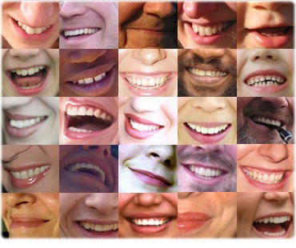
"An example of one of the different types of Energy Blockage is that they are sometimes created when we do not get what we expect, or we get what we do not want. They are caused by the Trauma of Disappointment.
Like when our Mother or Father or Son or Daughter dies. Like when a Lover leaves us.
This trauma, this pain is so strong that at that moment the mind can not look at it, so it gets locked away within the body until we get strong enough to process it.
Then amnesia. We forget the pain fulminating in our bodies. We forget the poison until, after a while, disease is the result."
Satchidanand

.

Olympia Panza
Here is a Testimonial from written by Satchi from a report given him by Olympia Panza.
When I came to see Satchi at the airport for the first time I was struck by his energy but it was the second time, when he was talking to another student when meeting us off the train at Figueres that I really started to feel the Buddhafield of Energy Surrounding him.

Suddenly I started yawning like the big healer guy in "The Green Mile" and then tears started from my eyes and I felt I was getting rid of a lot of Painful memories from the past.

Satchi taught us meditation and the Circulation of the Energies in order, as he said, "To improve our psychic vision" During these initiations I saw all my Energy Blockages in colour!! I saw my abdomen filled with blackness and thought back to my first periods, filled with pain, my inability to breathe properly and the problems I have with digesting food.

I saw all the brown clouds of pain filling my lumbar region and the problems with the throat chakra making me understand my problems with communication and the Peter Principle, we always do that which we most need to learn, which caused me to become a journalist and an arabian belly dancer teacher.

Satchi saw/felt them too and asked if I would like some healing because he explained that normally he liked to teach the Removal of Blockages Techniques of Energy Enhancement Level 2 and let the students heal themselves, but because I was going before he could teach that, he thought that a little band aid would be helpful because he felt that the abdominal blockages were not made in this lifetime but had come to me from my previous lifetimes.

I lay on my back and Satchi placed his hands over my abdomen and I drifted off to a place of peace. I imagined myself lying on the grass in the sunshine. I saw Satchi as an energy there too, blowing through me like the wind. In this space I was a man, and not a woman as I am in this lifetime, and very focussed and filled with anger. Many images of women relationships passed in front of me some of them pregnant and I saw that I had no respect for the women in my life. I was wounded in the right side of my belly and I was dying.

As Satchi healed my belly I felt the pain of the wound I was dying from and people watching me said that this pain was reflected in my face. Finally the pain was gone and Satchi said that was enough for now. The previous lifetime had been healed and I had been brought face to face with attitudes in a previous lifetime, anger and a lack of respect, being mirrored in this. I saw how my irritation and anger was taking me away from my infinite peace and how these attitudes were reflected back at me in my relationship with my husband.

It was interesting that the relationship chakra, the abdomen, the place I was wounded was reflecting my previous attitudes and the Karma of those previous lifetimes was being given back to me so that I would be taught never have those attitudes again. I want to learn from my mistakes.

Satchi says you only get visions if you need to learn something.

Satchi explained that the intellectual level thought that it could solve everything just like this.. "I should not get angry!!" but that the intellectual level did not have the power to make that promise because its links with the emotions were broken, blocked and faulty.

He explained that the intellectual level similarly says, "The whole world should be filled with peace." Yet for 10,000 years there have been one or two wars every year.

The Techniques of Energy Enhancement allow the mind to have the power to implement its decisions through the Removal of Negative Emotions. The removal of Energy Blockages, which create physical disease in the body and negative emotions in the mind.

THE POWER OF TOTAL CONTROL

SATCHIDANAND MEETS SWAMI SATCHIDANANDA FOR THE FIRST TIME

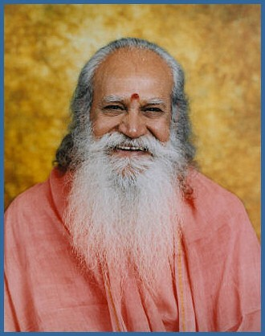
So when a friend asked me if I wanted to go to London to meet Swami Satchidananda I was hesitant. But they persuaded me to go. So there I was in this big hall. Arriving late and there was no space for me to sit. So I went and sat on the floor in meditation posture at the front, just in front of him. And I was not impressed really by what he was talking about because I was arrogant.
But then at the end of the talk he said lets meditate. And he chanted Om Shanthi and I found myself a hundred meters up in the air looking down at my body sitting in meditation below.
And I looked up and way above me was Swami Satchidananda and he was moving his hands saying, "Come on Up! Come on Up!"

So I thought it might be a good idea to learn from him.
And although I read his books now and recommend them to everyone, Integral Yoga, The Yoga Sutras of Patanjali and The Living Gita, Commentary on the Bhagavad Gita, although the information in these books are a great gift to humanity, they are poor fare in comparison to what initially attracted me to him.
And what I got in abundance every time I met him was Energy and Psychic experience. Visions, telepathy, Initiations on the Astral Plane all came to me every time I met him.
When I went to stay at the Satchidananda Ashram, 1000 acres in Virginia in America, for three months, the experiences accelerated every time I meditated. The knowledge that we cannot die, we are all connected. Satori and the lower levels of Enlightenment.
It took me a few years after these experiences with Swami Satchidananda to get fully cooked... and I am still deep in the crucible!
Bio of Swami Satchidananda - http://en.wikipedia.org/wiki/Swami_Satchidananda
Deep rooted issues would surface and as soon as they were dealt with, even deeper issues would emerge that we would have to deal with. It was like peeling layers of an onion to go deeper and deeper into our core being to understand who we are and what kind of personality traits we have adopted, consciously and sub-consciously to deal with the issues of this world. I understood clearly how these beliefs, conditioning and past life impressions were affecting all areas of our life.
In addition, I also learned how to use the Energy Enhancement techniques to help me ground these negative blockages so they would never affect me again. Of course complete freedom can only come after a maintenance program has been followed. HONEY KALARIA- FILM STAR 2005

Satchidanand comes from England and was Born in the Ancient Chinese year of the DRAGON. Originally with degrees in Physics, Mathematics and Electronics, and working in International Companies in Management, Computing, Electronics, Hardware and Software.
Born the Louis of a Louis - Both Father and Grandfather being Masons. Starting from practising Yoga from 1967, from the age of 15 through working and contact and exchanging Energy with many masters including Swami Satchidananda of South India and of the USA, Yogaville, Virginia and Zen Master Roshi Hogen (Master of the Tao) of Japan, Osho and Ascended Masters, he works towards the ideal of one spiritual truth on many paths using Energy Enhancement and healing.
His Sun, conjunct with Neptune, Mercury, Saturn, and Venus in the 8th house in the Draconian Soul Progressed chart in Scorpio and WITH Pluto conjunct the Moons Node gives him tremendous Power to break down World Karma through the Energy Enhancement Techniques, drive out YOUR blockages and raise your Kundalini Energy. Come and see him whilst he is still visiting this Planet!!
"Energy is Inexhaustible. Like a fire it is passed from Master to Disciple. It jumps the Gap, the Abyss. It Energises all." - Satchidanand
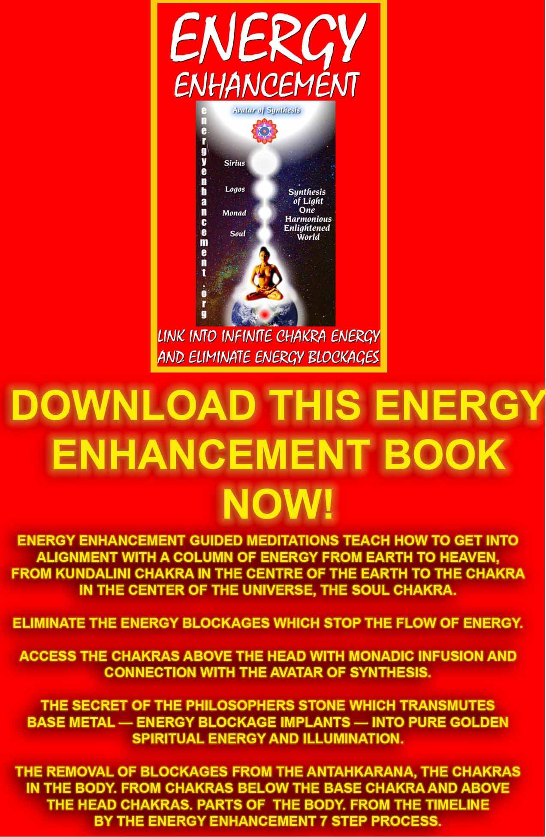
Download “Link Into Infinite Chakra Energy And Eliminate Energy Blockages” Here
http://www.energyenhancement.org/Sacred-Energy/Meditation-Energy-Enhancement-Link-into-Infinite-Chakra-Energies-and-Remove-Energy-Blockages-EEBOOK1Color-energyenhancement-org.pdf



Kundalini Energy and Satchidanand

"To the sinful and vicious I appear to be evil. But to the good, beneficient am I" - Mirza Khan, Ansari, Sufi.
"We Meditate in Pieces to make One Piece (Peace)" - Satchidanand
"Meditation is a Fast for the Mind" - Satchidanand

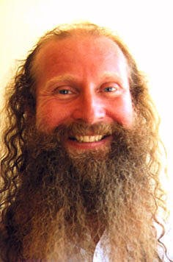
Satchidanand, Director of Energy Enhancement Synthesis of Light, is one of the Worlds leading teachers of Meditation Samyama - Ancient yet Powerful methods to Access More Wisdom, More Kundalini, More Clarity, More Intelligence, More Energy using Energy Enhancement Techniques available Live or On Video together with many Talks, Books, Videos...
Satchidanand is a modern Guru who synthesises a University Education in Physics and Electronics with a Guru Tradition which has been passed on generation to generation for thousands of years having been a student of Zen Master Hogen of Japan and Yogiraj Swami Satchidananda of Integral Yoga recipient of the Martin Buber Award for outstanding Service to Humanity, who was a student of Sivananda of Rishikesh.

With 37 years experience in Yoga he has catapulted people years ahead in their meditational experience in weeks. Some 5 years, some jump 10 times further!
He helps people worldwide reach further than they EVER thought possible....FASTER!!!

THE ENERGY ENHANCEMENT BOOK SUPER ENERGY AND SACRED SYMBOLS

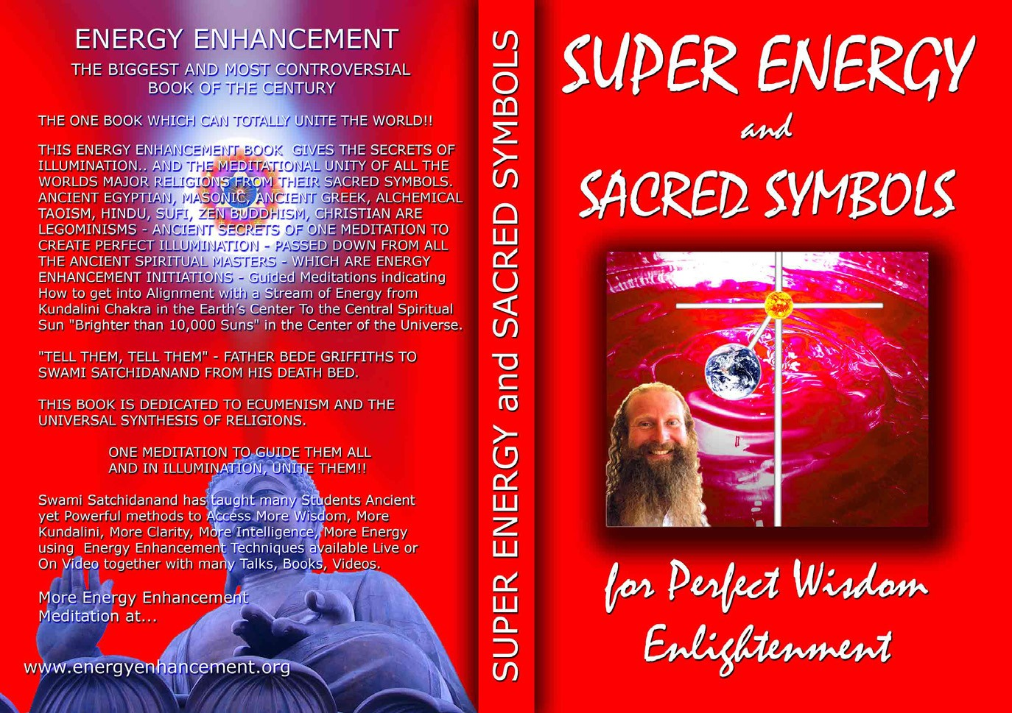

Energy Enhancement as written about in the Energy Enhancement Book by Swami Satchidanand, "Super Energy and Sacred Symbols" is based on Guided Meditations as Symbolised by all the Worlds Major Religions:-
Egyptian - The Ankh, Masonic - The Crypt and the Royal Arch of JABULON, Tarot - The Art Card, Alchemical - VITRIOL, Islamic Sufi - The Lute - Troubadour whose Abjad root TRB means Lute or Guitar in Arabic whose shape is the Sufi Naqsbandhi Kundalini Key, Taoist
- Microcosmic, Macrocosmic, Supra Galactic Energy Circulations of the Yin Yang Sign, Hindu - The Kundalini Kriyas, Christian - Contemplation on the Cross.

THIS BOOK - WRITTEN BY SWAMI SATCHIDANAND - GIVES THE HISTORICAL BASIS OF ONE GUIDED MEDITATION SAMYAMA WHICH IS THE BASIS OF ALL THE MAJOR WORLD RELIGIONS - EGYPTIAN, TAOIST, HINDU, SUFI, CHRISTIAN - AS TAUGHT IN ENERGY ENHANCEMENT
ENERGY ENHANCEMENT IS THE SYNTHESIS OF ALL RELIGION
THIS IS THE ONE BOOK WHICH CAN TOTALLY CHANGE THE WORLD!! GAIN SUPER ENERGY - ELIMINATE ENERGY BLOCKAGES

THE ENERGY ENHANCEMENT BOOK SUPER ENERGY AND SACRED SYMBOLS
As such Energy Enhancement is teaching Spiritual Techniques which Synthesize all the Worlds Religions under the Avatar of Synthesis whose job is to Integrate Humanity One Heart, One World!!
"What chances have the Politicians to come together when the Religions have been fighting for Thousands of Years" Synthesis and Ecumenism is needed and this can be helped by One Meditation Samyama, Unity in Diversity, One God Many Paths, Peace not War.
Energy Enhancement is a Unique Voice for Individual and World Integration teaching Initiations extant for Thousands of Years, Symbolized in all the Worlds Religions which Speed up the Path of Enlightenment.
"Having been on a 10 day Goenka Vipassana silent retreat where I meditated for 8 hours a day I can say that coming to stay with Satchi and Devi is so much more grounded in everyday life. The difficulty in spiritual life is balancing the material and spiritual worlds effectively.
Energy Enhancement does not promote a spirituality that grows only in the mountains, apart from the cities and the hustle and bustle of everyday life. It shows you how to integrate the peace of retreat with the activity of life - work, relationships, enjoyment, and spirituality - there should be no separation!
Satchi and Devi are both inspiring, wonderful examples of how to achieve this integration. No ascetic renunciation here! Only energy; how to get more of it, how to connect." PAUL - STUDENT 2004
Satchidanand has been practicing yoga from 1967 and was taught meditation by Zen Master Hogen in 1980. He was given many

typical spiritual experiences which you can read about in all the books of Kundalini and Spiritual by his Master Swami Satchidananda and then in the presence of Sri Yogendra of Bombay, Father Bede Griffiths, Osho and Sathya Sai Baba, before receiving his own Initiation and finding his own spiritual experience - "Although I am just a normal person I feel a deep reverence for the energy which has been given to me to help the Spiritual Growth of all beings. I feel a tremendous responsibility for its correct action in the world. This Synthesising Spiritual Energy and Kundalini is worthy of the deepest respect!" Satchidanand.
He has Degrees in Physics, Electronics and Mathematics and Written a book, "Advanced Techniques In Software Design" for International Computers Ltd.
He has developed The 28 Initiations of Energy Enhancement on 75 Hours of Video To Gain Energy, Eliminate Implants and Blockages, Clean Karma, and Master Energy Connections between people and Master Relationships.
He has written, "Super Energy and Sacred Symbols" which Gives the Historical basis of One Guided Meditation Samyama which is the Basis of all the Worlds Major Religions - The Synthesis of all Religion!
Egyptian - The Ankh, Masonic - The Crypt and the Royal Arch of JABULON, Tarot - The Art Card, Alchemical - VITRIOL, Islamic Sufi - The Lute - Troubadour whose Abjad root TRB means Lute or Guitar in Arabic whose shape is the Sufi Naqsbandhi Kundalini Key, Taoist
- Microcosmic, Macrocosmic, Supra Galactic Energy Circulations of the Yin Yang Sign, Hindu - Shivalingam and Yoni and The Kundalini Kriyas, Christian - Contemplation on the Cross.
He is the Director and Producer of Eight Movies with Swami Devi Dhyani Choreographer and Dancer in HD and Surround Sound of the Pachamama Sequence of all the Worlds greatest Women Singers in the Shamanic style, Akhnaten of Philp Glass including the Hymn to the Sun, Sacred Pink Floyd - a two and a half hour Performance without stops of Pulse, Shamanic Set the Controls for the Heart of the Sun and Marooned - sent to the Sundance Film Festival, Sacred Carmina Burana by Carl Orff and the Sacred and Devotional Poetry of its Text, Sacred Shakti with guitarist John McLaughlin and Karnatic Violinist Maestro L Shankar based upon Bharata Natyam and Orrissi style Classical Indian Dance learned at Kalakshetra School in Madras with the help of the Indian Embassy of Buenos Aires.
Our next project is Sacred Beethoven’s Ninth Symphony for the Brotherhood of Man, National Anthem of the European Union and

dedicated to Peace Councils Worldwide, Mercosur South American Integration and United Nations World Integration under one World Council and President which should occur in the next century.
Of harmonious and sensitive nature and a born psychologist, he has a talent for mediation and working with students. With artistic and imaginative abilities and a penchant for synthesizing enthusiastic research into Innovation for a wider social influence for the benefit of all people in order to create peace and integration within individuals and World Peace for Humanity.
Unto Saturn-like persistence is added Neptunian artistry and intuitive mysticism devoted to the Sacred Task of Revelation.
"The Energy Enhancement Course saved her life in that now she is able to handle the Energies she was absorbing in the course of her work. She was most appreciative of Learning the New and Effective ways of Increasing Energies, Speeding up the Mind, Opening the Heart, Activating Kundalini, Psychic Protection and the Mastery of Relationships including the Psychic Energy Connection and Cutting Ties which are the heart of Energy Enhancement Level Four.

Thank you so much Devi Dhyani and Satchidanand for being a channel of these Energy Enhancement Techniques in which many people can receive tremendous help protection and Inspiration." SUSANNA MACRI - MEDICAL DOCTOR 2003

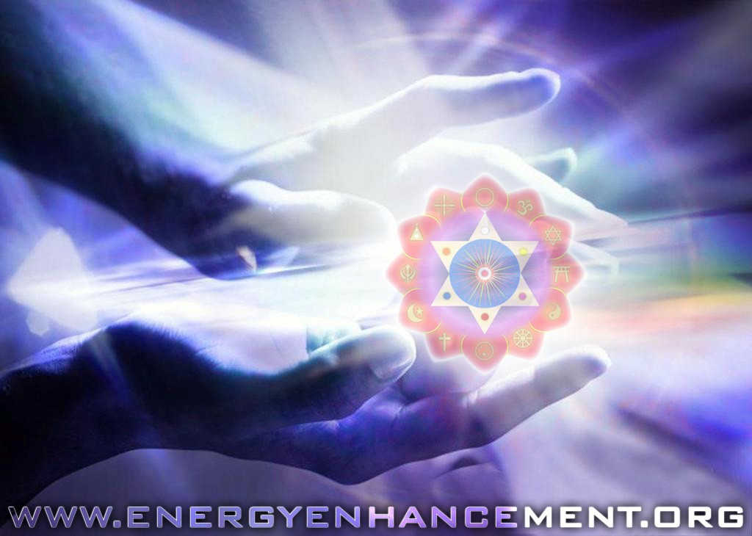

Energy Enhancement with a very nice young lady who is a Database Administrator with a BSc in Computer Science
"I didn't know much about the energy enhancement course but was drawn to it because it teaches meditation. I wasn't disappointed, not only did it teach me techniques of meditation which cannot be found on any other course but I also found that some of the techniques were therapeutic.
Satchidanand’s and Devi Dhyani's teaching was fun, interesting and not at one point during the course did I become bored. I was also grateful that their approach was relaxed, catering to the needs of the student - getting up at six in the morning and practicing day and night is something I couldn't have coped with.
Satchi and Devi have based their teaching on a variety of philosophies gained from years of experience with various masters. I was impressed with their knowledge, that they were able to explain some of the books that I had read, answer all my questions and that they were free with their information.
I have thoroughly enjoyed my week here, had lots of positive experiences and feel that I can take something back which would be of great help.
Satchi and Devi are wonderful people with open hearts, a sense of fun and adventure and people who made me feel comfortable and welcome and who I connected within ten minutes of being in their presence. I feel very privileged to have met them."
Like most people with the Advanced Techniques of Energy Enhancement we teach them how to Ground all the Negative Energies of the Emotions and Mind at the energy level, without touching the Negative Emotions or the Mind themselves.
You just find that you are free of these negativities almost magically transmuting the trauma of years and opening up to a new energy.

Energy Enhancement Meditation Techniques had a strong effect on Danisa de Paul

DANISA FROM THE SPAIN 2003 EE MEDITATION COURSE


DANISA WENT TO THAILAND AFTER THE ENERGY ENHANCEMENT MEDITATION COURSE IN SPAIN AND NOW IS IN JAPAN TEACHING AND PRACTISING BELLY DANCING!
I've been in La Escala with Satchy and Devi for a week now, Its the longest time I've been here!! and I noticed that every day I am going deeply inside of me.
When I arrived here, was very hard for me, but luckily Satchy and Devi helped me a lot and removed many of my blockages so that I can really think with my head! The first 2 days I was feeling very strange and uncomfortable inside of me. Half of myself wanted to improve and half wanted to stay like that, in a low energy level state, didn't want to grow neither change.
During these days I realized how the strategies control people and how they were controlling myself. Sometimes you are confused, sometimes happy, sometimes angry, and these don't have to be like that!!! But nobody knows! I didn't know.
Energy Enhancement Level 2 teaches you how to manage your emotions; it gives you a strong emotional IQ.
I feel so happy to meet Satchy and Devi, they are high spiritual teachers that can see deeply inside you, behind the mask that everybody has. They can see your soul, your real self!! If you need help you’ll get it from them.
I've been working with my lower chakras and after I learned how to remove a blockage from my base chakra I immediately felt the energy of Kundalini flowing from down in my base chakra to up, to the head and above.
I was sitting in my meditation position and for the first time I got the sensation and feeling that my body was lifting off the ground. I was just enjoying the experience feeling the circulation of the energy, a hot and smooth sensation. My mind at that moment was free and happy.

Every day I feel a little more steady and comfortable. I am getting in touch with my deepest blockages and fears from my lower chakras, With energy enhancement level 2 I am learning how to deal with this energy and how to remove them totally. My fear is disappearing, my sadness and worries, too. Things that already existed in me and are coming out with the use of these techniques.
To sum up I think that everybody should come to do this course and learn energy enhancement techniques to improve their lives and help other people, heal themselves and their relationships to make this world a better place and to start really enjoying life.
I feel so happy to meet Satchy and Devi, they are high spiritual teachers that can see deeply inside you, behind the mask that everybody has. They can see your soul, your real self!! If you need help you'll get it from them. DANISA, EE MEDITATION COURSE 2003

Hello!

DANISA IN JAPAN
05 March 2006

Thanks for the email including my testimonial about Energy Enhancement in Spain! It’s such a nice memory!
I think about these moments as the best of my life.
It was hard work for me but I’ve never felt so happy and rewarded in my life, only when I’ve been close to you both.
I been thinking about you lately a lot, I miss you guys, I really do. I’m very busy here in Japan, that’s why I didn’t write to much, but now I have internet at home, and I hope we can be more in touch.
I’m glad you are working hard there in Argentina and having a beautiful time.
Here is good, sometimes very hard. Japan is a good experience though but very intense.
I found some temples which I want to visit, but spiritual people are hard to find here. And lately I’ve been feeling so many different things.
I hope one day I can be a really a spiritual person and teacher like you, you are my example.

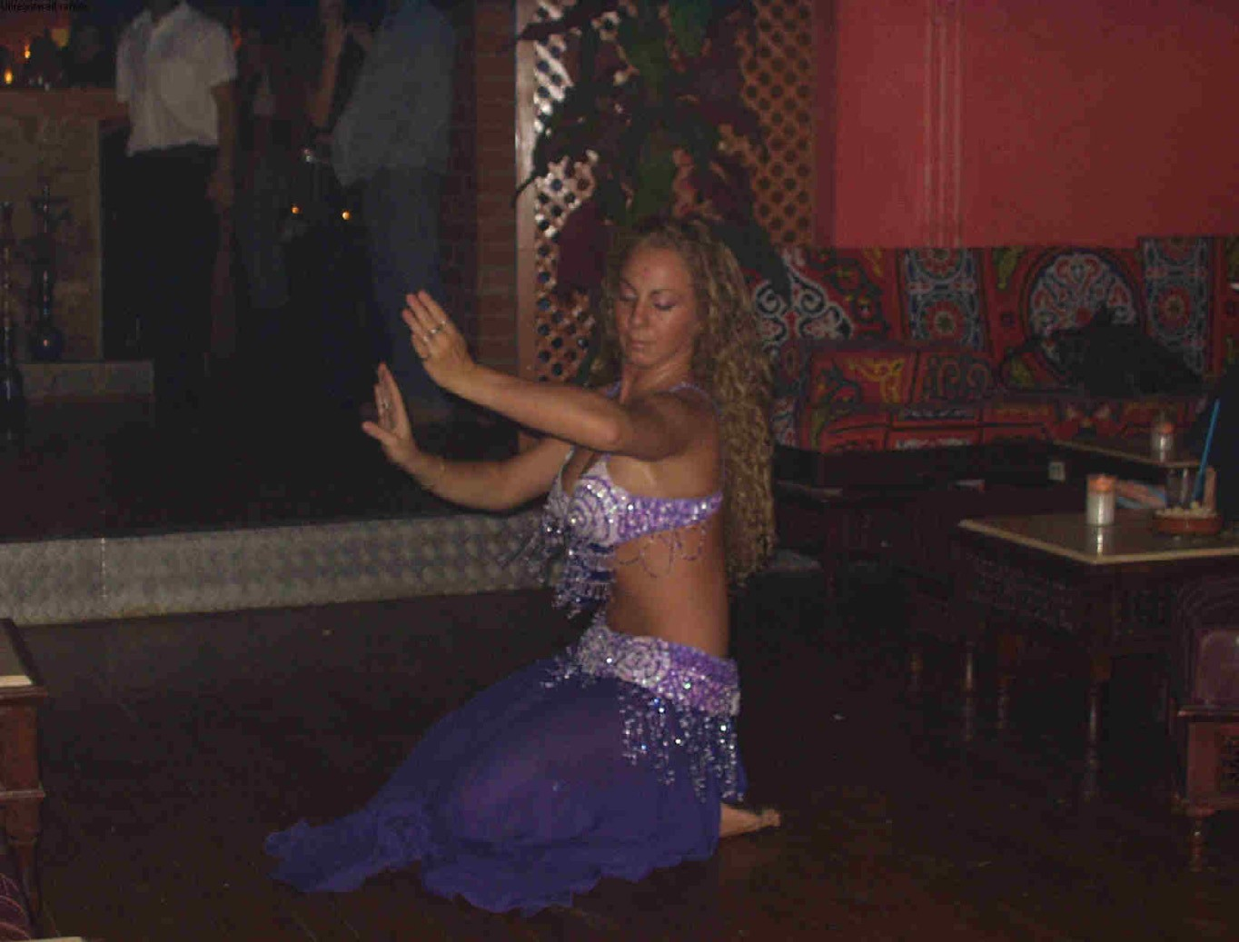

I know now, how many things I have to heal, how many are not finished yet.
Because I’ve been through many tests, and I’ve been far from you, and having some healing from you.
I hope to see you soon; I love you with all my heart. I wish you the best and more
Love you Dani

SACRED DANCES OF FUSION WHERE DEVI DHYANI EXERTS HER POWER - AVAILABLE ON YOUTUBE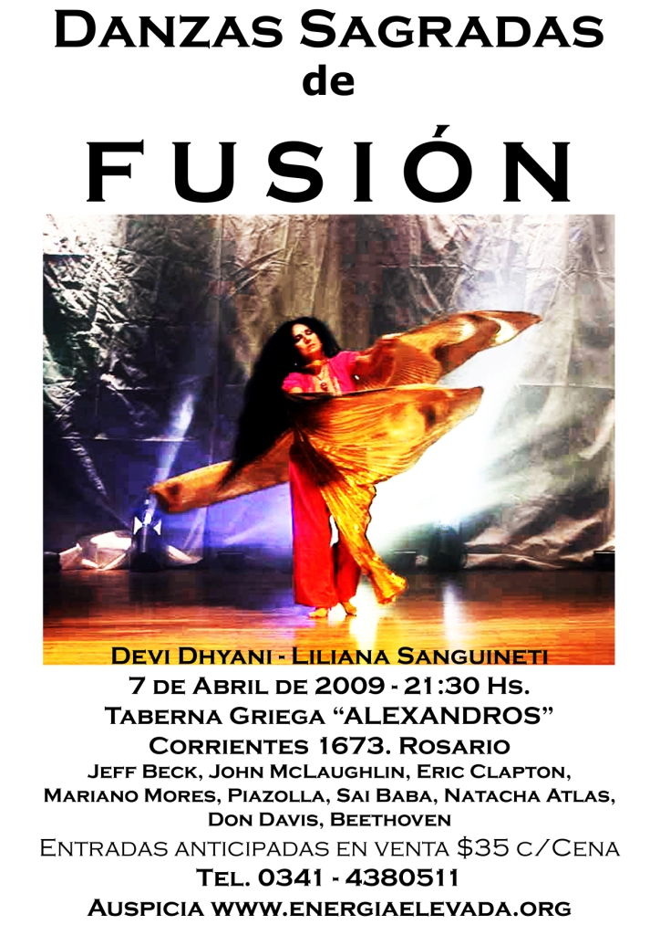Yoga Magazine writer James Ellerbeck came on the EE meditation and yoga course for 2 weeks

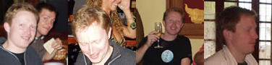
Satchi,
Here is article as it stands, currently being edited in London, so scan it for typos. Took me forever to get it done with, I guess the days of polishing off articles ten to the dozen are long gone and I'm a bit rusty.
It will come out in the April issue of the Yoga Magazine, in the depths of the English winter. The photos of sunshine and salads and eating outdoors will look even better then by comparison.
I'm in Shanghai now. I'm back for a month to see my love - everything is going great - very happy. I'm going to Spain in the first week of January. My Love plans to come over late January or early February, after I have made a nice soft landing for her. I've got her into meditation and she's LOVING it. She is about to build her antahkarana.
Let me know your thoughts on the article, I'm sure you will. I've added your contact details and web site address at the bottom so people can get in touch directly. I also have some great shots to accompanying. I'll scan them in and get to you asap.
All the best, love to Devi, James
P.s I hope you enjoy this article. I suppose in a week or two it will be in PDF format direct from the magazine.
Title: Peace Begins Within, Article for the Yoga Magazine of Great Britain
By James Ellerbeck
Last summer, after three years of on-and-off asana practicing, I thought it was about time I did a few mental exercises too. So in early October I flew to Spain to take part in my first meditation

course and, unbeknown to me at the time, entered into one of the most grounding fortnights I can remember.
Meditation is just reflection and observation. But through meditation we can use our will power to gain control over our unconscious desires and fears – our rampant ego and insecurities - which can run riot over our lives and get in the way of reason and our best intentions.
The Energy Enhancement course is a beautiful course that had an instant, positive impact on me and the other students. The course is run in Argentina over the European Winter months and Spain during the summer. In Spain its home is in L’Escala, a small coastal town about an hour and a half north of Barcelona by car. The course promised and delivered exactly what I looking for; we would be taught how to quieten the mind through meditating and then spend some gentle weeks getting to know our deeper drives and emotions. That the centre was a stones’ throw from the Mediterranean didn’t hurt much either.
The course is split into three parts or levels and takes about a month to complete. In level one we learnt how to meditate; the correct posture and breathing, and we were given techniques to cope with distracting thoughts and to focus the mind. We also learnt how to use our imagination to picture our connections to the world and universe around us.
During my two weeks I made it through level one and onto the foothills of level two. This is normal progress. Satchi has had some students who race to the end of level three in the same amount of time but normally the whole course lasts a month. It is not an absolute science of course, Paul stayed for six weeks, but four weeks is the recommendation.
The course
Level One of the course started with the very basics of meditation. By closing our eyes and counting our breath in and out we learnt how to ignore nagging thoughts – the “what’s for breakfast” “this isn’t working“thoughts – that pinch and snipe us for attention.
Then, slowly but surely, as the calm came about, we went on guided meditations, guided in so far as we were told what to try and picture before each session, though not during – meditation was always silent affair. We were told to imagine energy flowing around us, like auras, revolving and connecting with us. Through repeat sessions we then extended our flows of energy so that they reached out and fed from different points in an imaginary universe, a universe we had to build in our mind’s eye. Each time a new level of the universe was created, so the energy at our disposal was

raised by having new reserves to draw from. Once we could clearly see and feel all energy coming to us from all these new connections, we then used this heightened mental power to work towards an ever-deeper state of calm.
My own experience of imaging this space was quite fun and exploratory. It was the first time I had really tried to will something like this together in my minds’ eye. It took perhaps five sessions before I could clearly see all the components of my universe clearly, though soon it became quite easy to just close my eyes, very quickly still my thoughts and then be anywhere in the universe that I wished. Satchi was a very forgiving guide too, which I think helped. If, for example, my mind wandered off, he would catch me staring out of the window and just say something like better luck next time. They were no angry words while I was there – compassion was the order of the day.
ENERGY BLOCKAGES
While willing this imaginary space into existence within our mind’s eye, we were always on the look out for distractions being brought up on the winds of our unconscious mind. These distractions can appear on the canvas as all manner of apparitions - shapes, objects, frustration - anything that draws our attention away from clearly seeing the picture we are trying to create. For the purpose of the Energy Enhancement course these distractions were referred to as blockages. Learning how to control and the remove these blockages from the path of our meditation is a central aim of the course. We grounded them by circling them in light and sucking them into the nearest burning centre in the universe, the sun or the centre of the earth perhaps. Some were stubborn, and some easy to remove.
As the course progresses, so the low hanging fruit get picked and we move on to deeper blockages. Once our grounding skills were tried and tested many times over, we used them to meditate on our lives, our relationships, our characters, and our work – every facet of ourselves organized and charted systematically. We took notes after each session and large parts of our free time were spent talking about our progress and what kind of thoughts and emotions were being unearthed during own meditations. A blockage, you see, is a symptom of a deeper malady. With fervor we drew up hit lists of trouble spots in our lives became the next list of thing to meditate on – so in anyone session different people would be meditating on different things – one person perhaps on a relationship, another person might be looking on a part of their character and so on. I found this to an exceptionally cathartic experience, a real tonic, and it was quite common for different

parts of the house to be full of laughter at any given time of the day. It was a joyous two weeks.
Level three is about mastering relationships, which uses the lessons of levels one and two and brings them to bear on problems in our social connections in the world and our “strategies”. These strategies I didn’t really meditate on during the course as I was only there for half of it, but we did talk about this level frequently.
Strategies are the acts we put on to get ourselves through life. Acting tough, craving sympathy, constantly trying to please – a whole host of strategies employed by the ego, some of which are so deeply ingrained with our character that they have become part of us. Level three teaches nonattachment to these strategies, students learn how to ground them to rid themselves of the fears and insecurities that prop the strategies up. This aspect of the course I was truly fascinated by and I will try and make an effort in to visit the guys again to explore this level in more depth.
All in all there is far more to the course than I can go into here. Aside from the teaching, I could talk about the food for days, well- combined vegetarian feasts by the way, or Devi’s infectious laugh and sense of humor. I also fondly remember my long talks with Satchi about engaging with the world and generally look back on the whole experience as a real turning point for me. A time to stop and take a look at how far we have come.
Arriving back in England I danced the whole night away, something I hadn’t done in a while. Energy Enhancement does exact what it says on the tin.

Pierre Morency, an established corporate marketing physicist loved Meditation Energy Enhancement


Here's my promised testimonial:
"Last June, I had the privilege to get my first taste of India in the Company of two wonderful, knowledgeable and fun people, Satchi and Devi. From day one, they were able to stabilize me in this strange and mysterious country.
Being a marketing speaker and a meditation practitioner, I didn't really know what to expect from my 2 week training. What I discovered was a powerful systematic way of practicing meditation and other Energy Enhancement methods.
I'm in the process of fully testing the techniques and approaches I've learned but can already feel - and prove!- tremendous changes in my life.
For instance, since I've been working on "cleaning my base chakra" (The Grounding of Negative Energies, Stage Three of Energy Enhancement, -Satchidanand) everything around me seems to be going through a massive cleansing process - Only 2 days after I returned to Canada from India, a chain reaction of events led my to change my 5 employees, change some of my major accounts and delay a move to the United States. 10 weeks after the program, things are stabilizing.

Looking back, I think the cleansing process probably saved my business and my marriage.
Thank you Satchi and Devi!!!

Pierre Morency Marketing Physicist
President Morency Marketing Inc."
Hope this testimonial can serve you well. Pierre.

Dr. Thomas Fluellen had some wonderful words to say about Satchidanand and Devi Dhyani

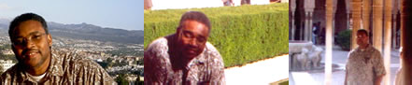
Satchidanand and Devi, provide a safe and loving environment in which you can allow your spirit to grow. They teach you how to rid your mind, body, and spirit of toxins and negative energy. They are experts in the procedures that they use.
I thank God that they came into my life. They have truly helped me to heal myself in all the areas of my persona. I came to them a broken man, filled with toxins on many levels. I have been reborn and connected to the God that is within us all.
If you want to live your life connected to the universal life source and expand your soul consciousness, you must take their Energy Enhancement Training. It will truly change your life. You will be truly filled with the power of God.
These two very special people are truly guardian angels. They have helped me to know how to see what is true and to be able to protect myself from negative energy and negative entities.
May God Bless Them and Keep Them Safe. Your Humble Student and Friend,
Dr. Thomas Fluellen

TESTIMONIAL... Why Energy Enhancement is the best thing
since Sliced Bread after a six week Energy Enhancement Course just after I finished my Degree.
16th September 2004.
The meditations on the Energy Enhancement course are extremely powerful.
Every day I make progress as I learn to use the techniques, becoming increasingly familiar with them and more able to handle the energy they release. Sometimes it is hard, hard work. I have learned a lot about determination and passion in Energy Enhancement meditation. And as in meditation, so in life!

The techniques of Level 2, after being introduced to the expansive vistas of the basic environment of Energy Enhancement in Level 1, allow you to go into meditation even deeper, clearing out deeper blockages with more efficacy.
You become a true warrior!
The meditations I have experienced are extremely dynamic, allowing me to explore my own sense of creativity and improve my ability to solve problems without being a slave to dogma, including some of my own rigid belief structures, which come to the surface quickly and require dealing with.
Here you are given the tools to deal with these things and you must learn how to use them yourself. Only you can walk your path.
The only insistence is that, ALL YOUR BLOCKAGES MUST GO!

Having been on a 10 day Goenka Vipassana silent retreat where I meditated for 8 hours a day I can say that coming to stay with Satchi and Devi is so much more grounded in everyday life. The

difficulty in spiritual life is balancing the material and spiritual worlds effectively.
Energy Enhancement does not promote a spirituality that grows only in the mountains, apart from the cities and the hustle and bustle of everyday life. It shows you how to integrate the peace of retreat with the activity of life - work, relationships, enjoyment, and spirituality - there should be no separation!
Satchi and Devi are both inspiring, wonderful examples of how to achieve this integration. No ascetic renunciation here! Only energy; how to get more of it, how to connect.
The way Satchi and Devi work with you is by being excellent hosts, giving you close individual attention, a wonderful environment with incredible opportunity to learn and grow, and most importantly, by leaving you to get on with it! There is no forceful discipline here, only the gentle but steady encouragement and help to remove your blockages. They are always on hand but they want you to be able to heal yourself and not rely on them.
And so one of the greatest things I am learning is self-discipline and self-motivation.
I can see myself being able to carry what I am learning here back into my everyday life with ease, keeping the balance and becoming more and more integrated.
This is an amazing time of growth and discovery for me, setting me in good stead for the rest of my life. Before I came here I was being
#####ed by existence. My relationships were getting messier and messier, my life path was unclear and my general mood was one of despondency and frustration.
Having spent two weeks here, not all of it easy, believe me, I can honestly say that my perspective is changed. I am feeling more full of energy, more alive. The future is wide, open, bright, full of mystery, and it excites me! I am looking forwards to getting back to my adventure.

My advice is come! Do not delay!
Talk to Satchi and Devi about it.

VERY MUCH ROOTED
MUCH OF MY DAY IS SPENT REPLYING TO STUDENTS AND THEIR
QUESTIONS. Here is a missive from a friend of our Student above who was with us for 6 weeks this summer and my replies to his questions from the online course, so in a way it is saying how much care we give to our students even on the Online Course. He is the President of the University Buddhist society and he is presently working with the Energy Enhancement Online Course and the Video Course....
Sorry its taken a while to respond to your request for comments. I think the new format to the website is much better. Its prettier and more beautiful, and looks easier to navigate. All those links at the bottom of pages in the old site really got the mind whirring!
We've just had our second visit from xxxx. My comments which he passed on to you and i then subsequently read in the last SOL email broadcast are absolutely true.
He arrived at our house late at night and I was already sleeping. He knocked on my door and said "...Laurence...?" to see if I was still awake. I was and he came in and gave me a big hug. From that first word, I certainly felt a change in him. Grounded is absolutely right.
From my experience of people going on long Meditation and Yoga retreats, I have sometimes felt that they come back somewhat out of touch with "real life", but the experience I had of him was of someone very much rooted in being there.
His energy, positivity, honesty and interest in things is infectious. He seems very relaxed, but also able to accomplish what he wants to. He is also, I’m sure you'll be pleased to know, spreading the gift of laughter!
He is a changed man and an inspiration. He is also a great example of the effectiveness of the Energy Enhancement course and i hope now, more than ever, to be able to come and do it some time soon. Next September maybe...?
You will be very welcome. Bookings require a 40% deposit and full payment 2 months prior to the course. Prices do change upwards over the year so buy yourself a bargain now. Satchidanand
As for my practice, I am having trouble knowing how to structure my work in that I very much want to include both the Energy Enhancement meditations, but also the Mindfulness of Breathing and the Metta Bhavana, which i have been doing for longer, and which seem to have different benefits to doing EE micro and Macrocosmic Orbit, The Energy Enhancement Supra Galactic Orbits.

At the moment, I am trying to do one on one day, one on the next; so, for example, Metta Bhavana on Monday, Mindfulness of Breathing on Tuesday, Energy Enhancement on Wednesday, then back to Metta Bhavana on Thursday and so on.
This is your choice. Satchi
Concerning the EE meditation specifically; when doing Initiation 3, my visualization of energy going into the Planet seems somewhat weak. The image or feeling seems to jump around and is not fixed. Would you therefore advise stabilizing this before doing stage 4? To thus work on stage 3 before moving on is my current strategy, even though i have done stage 4 several times in the past.
From talking to xxxx about this, the impression he has given me is that this is quite normal and part of the process of the Energy Enhancement technique, but i can't help but be concerned about the apparent lack of progress with this blockage and the negative effects on my emotional state. Can you give me any thoughts on this? They would be most appreciated.
If you read the, How to Find the Blockages, Page on the Online Course, Circulation of the Energies, you will find that this is how we describe how you will see one of the blockages.
A certain; DISTURBANCE OF THE FORCE! When you try to project your energy towards a point.
You need to breathe through this base chakra blockage. A blockage between your Base Chakra and the Center of the Earth. You will find that the Initiation 4, Macrocosmic Orbit, The Energy Enhancement Supra Galactic Orbit, will take you higher, to Chakras which can give you the energy necessary to dissolve these deeper blockages.
Energy Enhancement Initiation 4 will Speed up Your Mind. It will increase your ability to think. It will enable you to progress faster on the Spiritual Path in all things Spiritual; it will give you more energy to remove blockages.
The other aspect of the practice I want to relate to you is that i am getting a pain in the heart when I focus there during the energy circulation. I guess this is what you would call a blockage. The problem is that I don't seem to see much progress just by focusing on it and trying to "breathe through it". Furthermore, one time i experienced a negative emotional upheaval after focusing there which seemed to adversely affect my relationship my one of my housemates.
Yes, you have found another blockage in your Heart Chakra! Blockages come from periods when painful emotions could not be

processed and instead remain stuck inside your heart center. Whenever that blockage gets disturbed at any time in your life, all of those frozen, stuck and poisonous emotions will want to come out, projected onto the situation at hand! In a way any blockage will affect your life in a very bad way. Blockages are the antithesis of Spirituality.
Energy Blockages in any chakra will seriously hurt and destroy your life!
The problem is not that breathing through the blockage in the Heart Chakra adversely affected a relationship with your housemate, because this is what blockages do.
No, the problem is that you have not yet used the Energy Enhancement teachings and focused sufficiently on the blockage to remove it!
It is this that you need to do!
Pain is a presentiment of disease and if not removed this Blockage will become organic. Next is the heart attack!
In Energy Enhancement Level 2, after you have learned many powerful methods of psychic protection in the rest of Level 1, we teach much more powerful methods of Blockage Removal. We teach that these methods must be powered by the highest spiritual energies in order to remove the deepest blockages.
It is for this reason you are coming to Spain to do the Energy Enhancement Course.
Although we like our students to do the work of removing blockages for themselves, sometimes a really heavy blockage can benefit from our help in removing it. This is the Buddhafield of Energy Enhancement, Satchidanand and Devi Dhyani in Spain. Your guides are Devi Dhyani and Satchidanand, whose teachers were Zen Master Hogen, still alive, who has a Temple on the slopes of Mount Fuji in Japan and in Australia, and Swami Satchidananda, attained his Mahasamadhi in 2003 at the age of 89, whose master was Swami Sivananda of Rishikesh in India.
Easier blockages can be removed by a bit of gumption, a bit of determination, a bit of willpower, using the Energy Enhancement methods we have taught you already. Learn this lesson well!!

ENERGY ENHANCEMENT AND THE MASTERY OF THE WILL!!
Satchidanand MEDICAL DOCTOR, SUSANNA MACRI


Here is a testimonial from Susan, a Medical Doctor from New York. She says that Sai Baba came to visit her on the astral plane a few days before the Two Towers were destroyed. He told her to leave New York and come to the Ashram in India. So she did, just in time....

She spent time with us learning Energy Enhancement Levels One to Three with us in Palolem, Goa, India.
She presently is living at the Ashram of Sathya Sai Baba in India where she works as a Medical Doctor in his free Super Hospital and is also a channel for the light in her work teaching many groups, 2000 people per year at the Ashram, in the Psychological ways of "Cutting the Ties that Bind" with Meditation and Dance using the work of Phyllis Crystal.
The Energy Enhancement Course saved her life in that now she is able to handle the Energies she was absorbing in the course of her work.
At first at the Sai Baba Ashram she was very happy and filled with Energy But some people became jealous and when she saw us she looked a little bedraggled. Pure positive energies always attract attention from the other end of the Moral Spectrum. Six bad people were focusing their energy on her and she was losing energy. She had prayed to Sai Baba for help with these people and their energies but nothing had been forthcoming. I said that sometimes we were subcontractors for Sathya Sai Baba. We were experienced in these psychic attacks. We could help.
She was most appreciative of Learning the New and Effective ways of Increasing Energies, Speeding up the Mind, Opening the Heart, Activating Kundalini, Psychic Protection and the Mastery of Relationships including the Psychic Energy Connection Antahkaranas between chakras and Cutting Ties which are the heart of Energy Enhancement Level Four.
When we connect with the chakras above the head, the Soul, The Monad, The Logos, Sirius – an infinity of chakras all the way to the One God with 10,000 names, then we find that we no longer need to take the energy from others as we are connected to the infinite energies of God. Then we can become 100% givers of energy and we do not want to waste these energies – so we only want to give them to people who genuinely want to change, to evolve.
In the giving of energies we need to become masters of energy connections, This is The Mastery of Relationships.
Thank you so much Devi Dhyani and Satchidanand for being a channel of these Energy Enhancement Techniques in which many people can receive tremendous help, protection and Inspiration.
The negative aspects of our personality, created by Energy Blockages in different chakra levels of ourselves tend to trap us in Darkness.

In the hard process of moving forwards in our Spiritual Evolution we needs must work with these Energy Blockages, Realize ourselves and Reconnect with our Highest Sources of Love Compassion and Wisdom which exists within Ourselves and the Entire Creation.
Again, thank you Devi and Satchi for training and guiding me in these Energy Enhancement Techniques
Love, Compassion and Blessings for Both of You!!
"Life is a journey in the Darkness of the Night, Wake Up!! to the Inner Light!!
With My Blessing, the Mother from Sri Aurobindo Ashram" Susan

LEARN THAT WHICH IS FALSE WITHIN YOU
LEARN TO RECOGNIZE THE FALSE AS FALSE
-WITHOUT THAT, THERE CAN BE NO LASTING TRANSFORMATION
"I was not sure if this was wise, as I knew nothing other than what I had read on the web site and the testimonials, which I was a bit skeptical about! However, I am now adding my own because if you read this you might be a bit like me...
Don't hesitate - go for it!"
MS (Ireland) Human Resources Director, Europe/Asia, of a Fortune 500 US Multinational Company
Honey Kalaria

" Once on the course, my exciting adventurous journey began! In my life I have done hundreds of courses but the Energy Enhancement Course I found to be completely different. Firstly, the contents and the teachings seem to be inspired by higher forces and had a deep base in spirituality..." Honey Kalaria (UK) Bollywood Actress/Owner of Diva Entertainment
ENERGY ENHANCEMENT
"I was not sure if this was wise, as I knew nothing other than what I had read on the web site and the testimonials, which I was a bit skeptical about! However, I am now adding my own because if you read this you might be a bit like me...
Don't hesitate - go for it!"
MS (Ireland) Human Resources Director, Europe/Asia, of a Fortune 500 US Multinational Company

GAIN SUPER ENERGY

ENERGY ENHANCEMENT MEDITATION

Testimonial of Julia Herrera Dec 22nd
2003
In Energy Enhancement we understand that if we cannot visualize the light then it is energy blockages which are stopping the vision. We know that Enlightenment is the process of increasing the psychic vision. As we remove our blockages one by one so we progress on the path and our psychic vision increases.
In this meditation Julia could not see the Golden Light so she went back to the previous guided meditation and just aligned her body with the energy of Kundalini and allowed herself to absorb the energy, to increase her energy level.
After a while she got a lot of light in the head.
Next she followed the golden stream of light through the energy blockage in her heart to the solar plexus. As she did this she heard noises like water going through a pipe. It felt as though there was a process of cleaning going on.
In Energy Enhancement our aim is to disblock these blockages and to do that we need energy. So just by using the simple techniques taught in Energy Enhancement Level 1 Initiation 4 is sufficient to do this. Then the energy circulation can have power.
It can disblock the heart. It can disblock all the blockages in the body.
Each of these blockages is a potential time bomb in that toxins are deposited in these blockages. Eventually the organ in which the blockage resides fails producing sometimes cancer and heart disease. So understand that even from a simple physical point of

view, how necessary it is to learn and practice Energy Enhancement Techniques.
We teach these simple yet powerful techniques on our courses in Spain, India, Argentina – anywhere in the world, yet just as easily you can join the Energy Enhancement Online Course, Video Course or a combination of the two.
You can practice Energy Enhancement Techniques in the comfort of your own home in order to prepare yourself so that you can take maximum advantage of the Buddhafield when indeed, you come to meet them.
Indeed the steady daily process of the Energy Enhancement Online Course, of meditation and increasing your knowledge of things spiritual, are just as necessary as a time when we can try harder, the traditional description of the Energy Enhancement Course in Spain.
On the Energy Enhancement Online Course you can have access to Satchidanand and Devi Dhyani through email and chat. The power of Kundalini is not constrained by time or distance. Shaktipat can be transmitted and the energy obtained. Energy Enhancement Speeds up the process of Enlightenment not just by the simple process of meditation.
As you practice Energy Enhancement day by day so you access the energy which allows you to absorb more energy when you meet Satchidanand and Devi Dhyani in Spain.

THE ENERGY ENHANCEMENT STREAMING VIDEO COURSE

"Get your asses over here Now and Speed Up your process of Enlightenment on the Energy Enhancement one month course!!" - DON
Every one of our Students gets this Spiritual Experience of Connection with Infinite Energies.
Energy Enhancement does indeed, "SPEED UP THE PROCESS!!"
And they all get this Experience of Light, Life and Infinite Energy just with the Energy Enhancement Course - Every One of Them!!
LEVEL 1 - 4 VIDEO COURSES ANYTIME IN THE COMFORT OF YOUR OWN HOME

SEPTEMBER COURSE FIRST SCRIBBLINGS
By Thomas Blair from Sheffield, UK
To feel a significant increase in the energy flowing upward through my base chakra, once I had removed a large blockage there, was truly a life giving experience.
My entire pelvic area felt warm and energized, and I as a person felt more in touch with the world around me.
Using the SOL Energy Enhancement techniques of creating positive thought forms to remove blockages, I also remarkably removed a blockage from my knee, which was preventing the natural healing process of a bad knee injury.
Its as if you have to leave the world you know for a while, in order to tune into what really IS!
Magic Stuff!

White Light

SEPTEMBER ENERGY ENHANCEMENT
COURSE IN SPAIN Week Two by Thomas Blair
Having found yet another blockage in my base chakra, I couldn't help but feel rather despondent. After gritting my teeth and getting stuck in, I finally managed to remove it. This blockage in the Base Chakra was the last one there!!!
The next time I sat down to meditate, I suddenly felt a tickling sensation in my pelvis above the perineum. This sensation increased in intensity, and felt like champagne bubbling up my body from below. The flow of energy around my body had risen to a new level giving me an increased ability to track down blockages and an increased confidence in myself. Wow!
I suddenly remembered the writings of the inspired Poet and Meditation Master, the Persian Shakespeare, Jal Al Uddin Rumi and that always he talked of the wine of his meditation and this feeling of energy was what he was writing about a thousand years ago and I was feeling it, here and Now!!
Next, I came across a particularly stubborn blockage to remove, and knew that I would have to prepare myself well during meditation. I consciously sourced as much energy from above to flow through my body, and in doing so, rather than my body being filled with golden light, I had somehow tapped into an immense source of white light. As well as feeling this increased energy stream through my body, I realised I had involuntarily suspended breathing somewhere near the top of an in breath. My body felt like a beacon of light, with more than enough energy to direct toward a blockage and watch it dissolve in an instant.

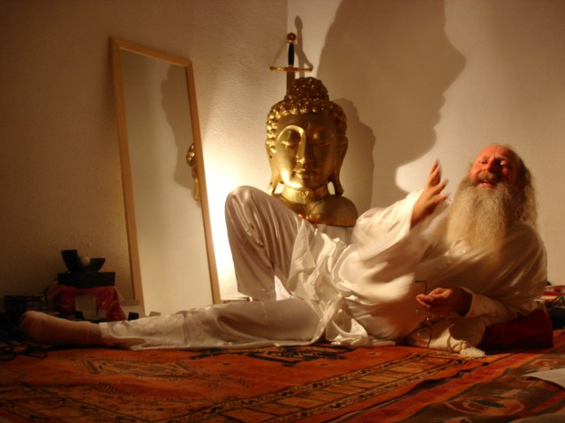

SATCHIDANAND TEACHING ON THE SEPTEMBER ENERGY ENHANCEMENT COURSE AT THE SOL CENTER IN SPAIN
Since that time I am always connected to and able to source the white light from above my head. Many times during this process I just forget to breathe as though my breathing is just naturally suspended. I am now living in the Light!!
My energies are naturally far higher than when I arrived on the Energy Enhancement course just two weeks ago. I am experiencing the fruits of meditation which normally arrive, if they do, after twenty years of meditation and it has only taken me two weeks.
This is the first meditation course I have been on. I have an injured knee from a few months ago in a motor cycle accident, yet the knee is now healed of its blockages and of its pain here on the Energy Enhancement Course and I am sitting in meditation for more than three hours a day, on the ground in the easy meditation posture, here in the light and working on more of my deep internal blockages.
Truly, perhaps Enlightenment is next!!

THE ENERGY ENHANCEMENT SEPTEMBER COURSE IN SPAIN Week
Three By Thomas Blair -
ENERGY ENHANCEMENT AND THE HEALING OF DESTRUCTIVE SUB PERSONALITIES
Coming on the Energy Enhancement course has revealed just how destructive certain inner children or sub personalities have been in my life so far.

White light
With the help of Satchi, Devi and feedback from other students on the course in helping me pinpoint certain behavioral attributes of potential sub personalities; I had all the ammunition necessary to hunt down one of these Inner Children.
I circled with white light the words "sloth" and "fu*k it!" and an image of a honey pot contaminated with butter (I'll explain later!). Good meditation preparation and circulation of energies, allowed me the powers of psychic vision making it possible to see whereabouts in my life the inner child had been spawned and had split from the stem of my main personality.
The first vision
The first vision that came to me was of a pair of slip on shoes that I had got my mum to buy me at school. Then came the image of a wild curly haired boy called Andy X, who was in the year above me at school. Visions came back to me of how Andy had threatened me with violence and started to pick on me at school. To avoid
this developing further I started to do things to make Andy and some of his friends laugh.
The second vision
The second vision was that of Andy and his friends laughing not at me but at the trouble I was getting into and the mad things I was doing. It became clear that I was getting involved in things that would make them laugh and entertain them, in order to prevent being picked on or bullied. These activities involved wanton vandalism, not caring about school work; always trying to gain Andy's approval at my own expense.

The third vision
The third vision was that although I feared this boy called Andy and his peer group (1 year my senior), I started to idolize them. The visions gave me more information: the shoes I had got my mum to buy were the same as his. The suit I had got my mum to buy was the same as his. The car I wanted to have - was.....yes, you've guessed it.....the same as his!! I was becoming a "somebody" by not caring about myself, by getting into trouble, by coming bottom in class - in fact, the more disastrously poor my results were, the "funnier" it was to Andy and his peers, and this made me a "somebody" with a kind of revered status.
"Fu*k It! Why bother?
The next step was to circle this situation of a sub personality being born in a 15 year old boy. In an attempt to ground the situation, I was presented with a psychic key. Asking what the key was for, I was then presented with a wrought iron gate, which gave access to a big sphere made of iron railings. Opening the gate I could see clearly that this gate entered a world in which Thomas Blair would burn the candle at both ends and get sucked into a world that starts with simply not caring about things and then progresses rapidly to a wastoid life of Sex, Drugs and Rock n Roll; and all this due to an Inner Child that said to me, "Fu*k It! Why bother? I don't care! Who cares if it's a knife and not a spoon in the honey pot, and who cares if the knife leaves lumps of butter in the honey pot!!? It's funny and makes me look good."
"Seal the door where evil dwells"
It was clear to me that the wrought iron sphere could not be grounded, as this represented the world and what faces us each day of our lives. The key, on the other hand, once used to lock the gate and "seal the door where evil dwells", had to be grounded.
Energy Enhancement and the white light of Samadhi
I directed energies I had gathered from the white light above to dissolve this key, and although there was much resistance, now with the techniques of Energy Enhancement, I was able to source and use the white light of Samadhi, I was able to ground the entire situation and fuse the Inner Child back into my main soul personality.
Disenfranchised of any power
It’s such a relief to know that I can now get on with my life and know that this very destructive sub personality has been disenfranchised of any power it once had over me.

THE ENERGY ENHANCEMENT COURSE

IGUAZU FALLS IS A WORLD ENERGY CENTER SACRED TO THE INCA AND THE GUARANI FOR THOUSANDS OF YEARS
IN SPAIN, ELEGANT 5Star INDIA TAJ MAHAL, INDIA TOUR, SACRED IGUASSU FALLS, MEXICO, PERU
SIGN UP TO THE MAILING LIST FOR MORE DETAILS
EMAIL sol@energyenhancement.org
for details



Testimonial By Thomas Blair – Spain 2007
Dream Food For Meditation
It was leading up to summer that I decided to book onto another month with Satchi in Spain. Two years had lapsed since I was last in Spain with Satchi & Devi. My practice had been quite fruitful in this period, but I knew that there were some stubborn blockages, some die hard sub personalities which I really needed some help with. I felt I had reached a point in my spiritual practice where I could not go it alone.
It so happened that over the summer period, I started to dream prolifically on most nights. It got to the point where I would make sure I went to sleep with a pen and paper close by, to write up the 3-4 dreams I was having every night. To make it easier for Satchi to help me, I typed up my dream diary every morning, and emailed it off to Satchi. I was actually quite amazed, at the time Satchi spent working with me before the course commenced in October. Satchi would interpret my, sometimes lengthy dreams, and in many cases he pointed out that these dreams were revealing my sub personalities or issues that I needed to work on during meditation. This indeed was an impressive “pre sales” service.
A BM implant, the lone competitive star sub personality, a past life bad thing, wrong views of leadership and fame, and more! My work of course was to ground these dreams during meditation.

The Buddhafield
But what about being in the presence of Satchi? October was quickly upon me, and the next thing I knew I was in Spain. I always find it difficult to describe to people what it is like to be in the presence of Satchi. You really had to be there to appreciate it, but I have found a few words that other people have written about being in the presence of a Buddhafield.
“[If your teacher] never scares you, confuses you, pisses you off, makes you cry with frustration, or electrifies you with self-recognition, you are not [with a true Master]”
This was certainly true of Satchi. He has this ability to reveal your strengths and how truly great you can be as a sovereign individual and in the same breadth almost, reveal to you the biggest holes in your boat, the major obstacles which you need to overcome before being able to realise this potential, your true nature, the real you.

“You want to throw yourself at your spiritual Guru’s feet, fall into your spiritual Guru’s arms, and run away all at the same time”
“…a true spiritual Guru is a mirror of your egotistical self, an unconditional openness in which you can clearly and terrifyingly see the degree to which you are caught up in the tensions of ‘me, myself and I’”

Subtle Things
As well as the sometimes intense dynamism of this relationship, I also noticed some smaller, subtler aspects of his being. These finer details point to a truly integrated individual.
Whilst watching one of Satchi’s chosen spiritually imprinted movies, occasionally Satchi would have to get up to relieve himself or run an errand for his lovely wife Devi. Satchi would always be lying down close to the screen at the front of the room, so when he rose, you would see just a silhouette. It was the way he arose from the horizontal to the vertical. There was grace and composure in every movement. There was never any sign of imbalance. Every movement seemed coordinated and grounded in some way. I then started to observe his movement throughout other activities in the days which followed, since this apparent mindfulness might have simply been a staged event. Of course, nobody is perfect, but for the most part, this integrated movement was predominant throughout my observations of Satchi and notably at times when he was unaware that I was present, let alone observing.
For some reason I became sensitive to other aspects of this man’s behaviour and attributes. His writing for instance, showed a similar integrated consistency and flow. There was something consistent and whole about it, and at the same time a writing style which housed his personality.
Making eye contact with the man: Sometimes he would look at you in a neutral manner, and then other times he would look at me, and immediately I would feel transfixed by an intense beauty and fear all at the same time. I found myself having to look away from him due to the discomfort, and yet having immediately done so, it felt like I had turned my head from a bright light to a darkness I was more familiar with.
There is an uncomfortable comfort around Satchi. It’s a holiday and yet you’ve never worked so hard. You feel in safe hands and yet vulnerable at the same time. I would formulate questions for him at night, that I would present to him the next day, and when the time came, the questions I had for him seemed totally irrelevant, or the

answers so blindingly obvious, that they dissolved into the ether. Being in his presence was somehow revealing something far greater than my petty, ego formulated questions.
“The Sat Guru answers our longing so fully, we discover the cosmic nature of that longing. You might cry like a baby upon hearing reality’s answer to its little child, but it will be a cry so simple and complex , so complete and inadequate, so full of wonder, relief, and despair so utterly paradoxical, there will be no way to tell stories about it later on.”

The Empress or Santa Klaus?
One time I asked him to read my palm. As he sat down and removed his glasses, he began to peer down at my hand. At such close quarters, I found myself observing his various bodily features. At the same time I was struck by a bodily warmth emanating from the man, which, since we were sun bathing around the pool at the time, was not heat from the sun. It was of a loving, caring, motherly nature. It reminded me of The Empress as depicted in the Tarot, or the kindness and benevolence of Santa Klaus. The main discrepancy being the swimming trunks he wore.
I was caught by the health and condition of his finger nails. Not out of the ordinary, you might say, since many people have healthy finger nails, but this observation has to be seen as part of a larger picture. You can’t just judge a man on the condition of his fingernails - how ridiculous! It was all part of the warmness and love that I was feeling from this man. If this doesn’t make any sense, then you had better spend some time with the man to make up your own mind.

A Rock of Compassion
What impressed me most about Satchi, was his ability to remain a rock or a calm water in the midst of the most horrendous emotional high seas and tornados. I would observe how he could keep his cool in the most heated of situations with other students and myself. But what struck me was that he did not appear to be aware of “keeping his cool”. This is something I personally have projected onto the situation, and put into words for you, the reader. It was a deep feeling that he was not even trying to “keep his cool”, but that he simply was just being in the moment. It seemed to give him an infinite abundance of patience with each and every one of us on the course, and I noticed how this was paying him dividends. In situations, where, had I been Satchi, I would have thrown in the towel and told the other person in no uncertain terms, that he should go and stick it where the sun don’t shine, Satchi, on the other hand, would steadily hold the boat on course, and before my

very eyes, I would witness how he somehow managed to show another man the error of his ways and befriend him all in one go. I could see that a situation, which I would have aborted or ended up in an ego driven argument, had been turned around into something rather magical…
THOMAS BLAIR Spain 2007

WITH THE ENERGY ENHANCEMENT COURSE BUY A STAIRWAY TO HEAVEN
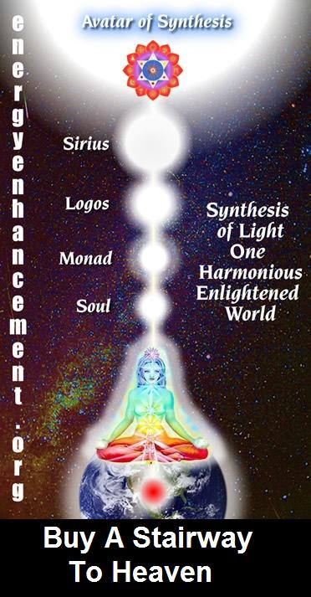
BUY A STAIRWAY TO HEAVEN
WITH THE ENERGY ENHANCEMENT COURSE
STUDENT REPORT
Also I noticed as soon as Satchidanand emailed me, I got a down-pouring of light from above the crown which kept charging me up the rest of the day – and my cravings died out! Then I realized the cravings were ego-blockages and that I did not want them.
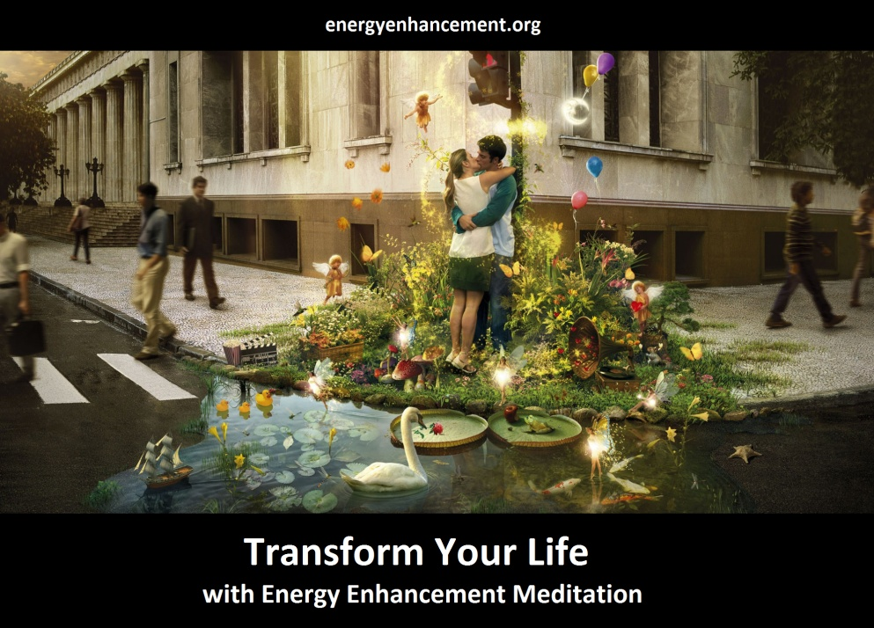
Energy Enhancement says that there are an infinity of chakras above the head up into the Center of the Universe and above, high above the head, ending in God, just as there are an infinity of chakras below the base - "As above, So Below" - Hermes Trismegistus from the Emerald Tablet.
INCREASE YOUR INTELLIGENCE - THE PARALLEL PROCESSING SUPERCOMPUTER YOU!! Energy Enhancement says that each chakra within you and above the head is a computer processor with higher and higher frequency, speed and capacity as you go higher. So, like a parallel processing supercomputer, the more chakras you can get working in the Infinity of Chakras above the Head and the more chakras you can access, the more chakras you can disblock, the more chakras you can augment, the more intelligent, the more intuitive, the more wise you will be.
FUSING WITH THE SOUL CHAKRA - Energy Enhancement says that just by fusing with the soul chakra one can see all your past lives and remove all blockages from all your past lives in one sweep, fast!!

FUSING WITH HIGHER CHAKRAS - THE SOUL, MONAD, LOGOS, SIRIUS, AVATAR OF SYNTHESIS - Energy Enhancement says that it also contains the secret of Initiations Higher that Illumination - "Enlightenment is not Enough!!"

ENERGY ENHANCEMENT COURSES
EVOLUTIONARY Kundalini Energy is the force behind the many experiences given to our students. All this does is Speed Up the Process of Evolution, Intelligence, Emotional Stability, Kindness, Wisdom and Leadership which many courses profess to teach but which Energy Enhancement has given in abundance to the many
See the testimonials given by International Change Manager Philip Chester, Human Resources Director for Europe and Asia of major Fortune 500 Company, MS, The Marketing Physicist and McKinsey Executive, Pierre Morency, Colorado and Aspen Wealth Counselor, Gary Spaid, Writer and Teacher Vanessa Graham, Student and now Internet Poet Paul Inman and many, many, more!!
ESTABLISHED
Established in the connection with God is Enlightenment. Each Incarnation is Unique and dependant on the Quality and Quantity of the connection. Of the size and function of the Spiritual Body and the components of the Spiritual Body of the Enlightened Person.
Established in the soul, Sanskrit - Stithyapragnyam.

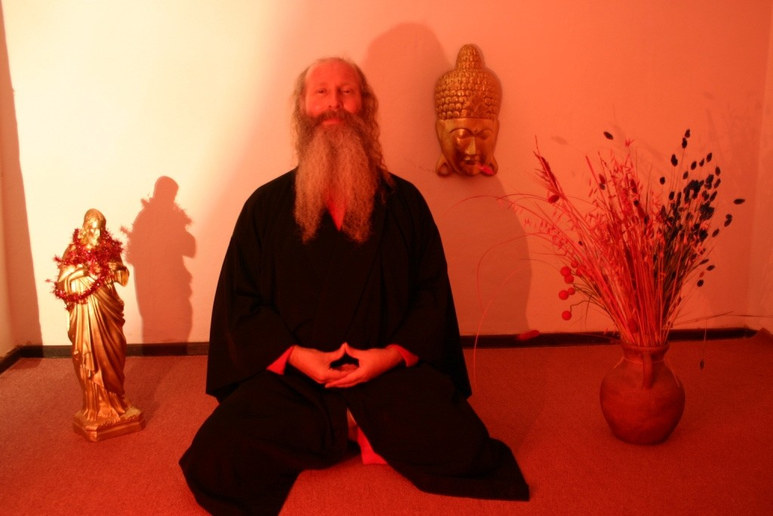
SATCHIDANAND IN THE MEDITATION ROOM IN THE ARGENTINA ENERGY ENHANCEMENT CENTER

THE TEACHERS OF SATCHIDANAND
Energy Enhancement has been able to teach most people to remove their own energy blockages with the backup of Energy Enhancement teachers, Satchidanand and Devi Dhyani who were taught by Zen Master Hogen, who has a Zen Temple on the slopes of Mount Fuji in Japan, and also in Australia, and Swami Satchidananda, a Monk of Swami Sivananda of Rishikesh.
Previously only Hindu Gurus and Zen Masters had the ability to remove energy blockages by means of their psychic powers gained through a lifetime of meditation and other miracles. People who have known Roshi Hogen and Swami Satchidananda know that through them, enlightenment exists and is living today, as in all the ages of this planet when virtue is in abeyance.

Swami Sivananda of Rishikesh, and who attained his Mahasamadhi at the age of 89 in 2002.
Hogen's Haiku, "Can you feel my breeze blowing, Even from 10,000 miles." Yes, we felt his energy even at the other ends of the earth. The secret of Zen and the Guru is that they remove the blockages

of the student, but only when the student is ready, when the student has learnt how to ask. How to be a good student.
That is why all the enlightened including Swami Satchidananda, Tangen Harada Roshi, Yasutani Roshi and Zen Master Hogen have been so successful in producing their HIGHLY EVOLVED and enlightened students.
Although Satchidanand and Devi Dhyani will teach you Energy Enhancement techniques Online, by Video and on Retreat to remove your own blockages, if the blockage is too tough and too deep for you, the Buddhafield of Energy Enhancement and Satchidanand and Devi Dhyani, is waiting to help you on the Costa Brava in Spain, Argentina, and India.
Each of these blockages is a potential time bomb in that toxins are deposited in these blockages. Eventually the organ in which the blockage resides fails producing sometimes cancer and heart disease. So understand that even from a simple physical point of view, how necessary it is to learn and practice Energy Enhancement Techniques. JULIA HERRERA - RADIO PERSONALITY 2003

Satchidanand’s ENERGY ENHANCEMENT Stories:
Always interested in sports Satchidanand at the age of 16 read in an interview with Sir Alec Rose Johnson who went twice around the World, alone in his 24 foot yacht, about how he kept fit. He said, "Well I have this Indian friend who taught me yoga" and strangely, Satchidanand practised yoga every night for five years without telling any one.
At age 21 Satchidanand read "Hatha Yoga" by Theos Bernard, who he later found to have been a student of Sri Yogendra in Bombay in the 1930s. Theos Bernard was a professor of sanskrit who decided the only way to find the truth of what he was reading, was to take a course with real Spiritual masters in India. After Bombay he went to Sikkim on the Borders of Tibet where with Yoga and Pranayama he acheived Samadhi. Later he went to Tibet where he was proclaimed a "Tulku", a reincarnated Tibetan Saint and went on to study in the Universities of Asia in Tibet.
Satchidanand followed Theos Bernard's pranayama course for six months and achieved the same Samadhi.

At age 28 following Yoga Teacher Training at a School of Paramahamsa Satyananda Saraswati - a direct descendent of Swami Sivananda of Rishikesh, practicing Meditation every day for one year after a weekend Course with Ananda Marga, and many belts in Aikido he found a Zen Master...
"After practising Zazen Meditation with Roshi Hogen Daido Yamahata for a time I began to feel him cleaning my Base Chakra every time I meditated. I was also doing Energy Enhancement techniques at that time which speeded up the meditative process. He used to wake me up early every morning and say "Get out of bed, Meditate Now!!"

Then by accident or by Luck. And to be Spiritual, you have to be lucky. I came across Yogiraj Swami Satchidananda of Yogaville who was a direct descendent of the Lineage of Sivananda of Rishikesh.

I went to one of his talks and at the end of the talk he said "Lets Meditate for a couple of minutes."
So, we chanted Ha Ri OM and started to meditate.

I found myself one hundred feet in the air looking down at my body meditating below.
I looked up and there was Swami Satchidananda one hundred feet higher, saying "Come on up!! Come on up!!"

So I though that perhaps it would be a good thing to learn from him.....

In my interview with him I said what happened and said that I only had one problem in that I had heard that you were only supposed to have one Guru and Roshi Hogen was doing a really good job with me.

Satchidananda asked if I had any problems between the teachings of Hinduism and Zen. I said "NO, no problems!!" because I understood that the terminology of Meditation in Hinduism meant "The flow of Energy towards a Point of concentration" and Meditation or Zen in Japan meant Nirbija Samadhi or Enlightenment.

So he told me that I should think of Hogen and him as two engines on a train. Hogen was the one pushing FROM THE BASE CHAKRA. He was the one pulling FROM THE CROWN CHAKRA.
Hogen was the one looking after the base chakra. Satchidananda was the one looking after the Crown Chakra.

And this was proved to me later in his ashram and indeed everywhere I met him with incredible experiences of the higher planes, of Initiation, of telepathy indeed all the tales of Masters of the past came true when I was with him!!

And when I went on my "Grand Tour" of India I met up "Luckily" with many great Yogis and meditators. And with each one I had a wonderful Spiritual experience.

Sri Yogendra of Bombay had the reputation of not suffering fools gladly. If anyone was disrespectful he used to beat them up and throw them out!!

When he was young they used to put him in darkened rooms so that people could see the Prana, blue, rushing like electricty around his body.

He was 96 years old when I had my Interview with him. All I could do was to sit at his feet and remain quiet whilst he told me of his experiences. Spread out across the Whole Universe. In New York in the Thirties. Healing the children of Millionaires he earned enough to create his Ashram.

For the next day all I could feel was the energy rushing through my body Up and DOWN!! With a great Noise!!

That night, Yogendra told his son. "I can't seem to retain my Prana as well as I should. I think it is time to go!"

That night he died.

Same but different experiences with Hogen, Ramana Maharshi, Sri Sathya Sai Baba, Swami Satchidananda, Father Bede Griffiths and last but not least, Osho.
http://en.wikipedia.org/wiki/Osho

All the stories like the ones above are waiting, eagerly, to be put into a book.

The purpose of Meditation practise is to get you into a state of meditation 24 hours a day. You need ENERGY to do this. You need ENERGY to get you into a state where you can receive more ENERGY!!

As Rumi said. You need to learn how to become a perfect thief!!

You need to get quiet enough so that you can steal the energy of the Enlightened.
But the real perfect thief is exemplified in Prometheus. Like all Enlightened Masters, he steals the fire from heaven and is condemned to have his liver eaten each day by another student thief like an eagle and every night for it to be grown back.

This Fire comes from that Fire. But Fire still remains. - Mandukya Upanishad.

To Catch Light yourself. To Become Prometheus.

This is why Energy Enhancement Techniques are needed to Speed up the Meditative Process.

Swami Satchidananda - E GO!! Techniques, like those of Energy Enhancement are also needed.

As Hogen said to me, "Meditate a little every day!"

As Swami Satchidananda said to me, "Meditate regularly for a while and with EnTheosiasm"

As Vivekananda said, "If one person can become Enlightened. If you can recognise that even one person has ever become Enlightened!! Then know. That YOU TOO, can become Enlightened.

IT IS YOUR DESTINY!!

ENERGY ENHANCEMENT MEDITATION SAMYAMA ENLIGHTENMENT!!!
NOT ONLY MASSIVE ENERGY - LEVEL 1
NOT ONLY ENERGY BLOCKAGE ELIMINATION - LEVEL 2 NOT ONLY KARMA CLEANING - LEVEL 3
AND MASTERY OF RELATIONSHIPS - LEVEL 4

BUT ENLIGHTENMENT!!

"FOR THOSE WHO BELIEVE IN ENLIGHTENMENT AND UNDERSTAND THE URGENCY OF THE SITUATION" - GAUTAMA BUDDHA

WE CAN CHANGE YES WE CAN
FOR THOSE WHO TELL US THAT WE CAN'T
YES WE CAN ENDURING HOPE YES WE CAN
AND THE LIGHT OF OUR IDEALS SHINES BRIGHTLY
YES WE CAN
WE SHALL OVERCOME YES WE CAN ENLIGHTENMENT
YES WE CAN!!

"EASY AND SMOOTH ENERGY ENHANCEMENT PUTS YOU IN CONTACT

WITH KUNDALINI ENERGY WHICH SPEEDS UP THE PROCESS OF ENLIGHTENMENT AND INTELLIGENCE"
Masters... and the flowers showered the energy of existence flows.

EE LEVEL 1 POWER UP!! GAIN SUPER ENERGY http://www.energyenhancement.org/Level1.htm
EE LEVEL 2 ELIMINATE ENERGY BLOCKAGES http://www.energyenhancement.org/Level2.htm
EE LEVEL 3 CLEAN KARMA BLOCKAGES AND PAST LIFE KARMA BY TRANSMUTATION http://www.energyenhancement.org/Level3.htm
EE LEVEL 4 MASTER ENERGY CONNECTIONS AND RELATIONSHIPS http://www.energyenhancement.org/Level4.htm
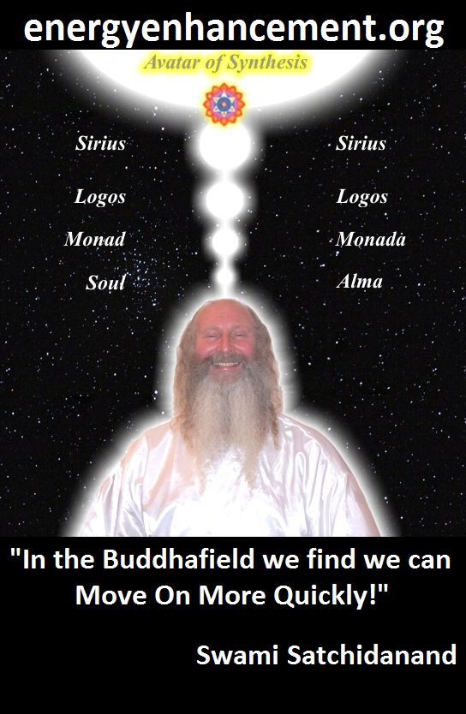
ENERGY ENHANCEMENT - THE ULTIMATE MEDITATION COURSE!!
“Traditional meditations are designed to Fail” – Satchidanand
FUSION WITH THE SOUL CHAKRA - Enlightenment - is Only the first Dan. Become fused with the Monad - Second Dan. Become fused with the Logos - Third Dan. Become Fused with Sirius - Fourth Dan. Become Fused with the Avatar of Synthesis - Fifth Dan - Satchidanand
Research The Energy Enhancement Meditation Course by video or on retreat..

The Ancient Enemy who counts meditation and the mind control psychic arts as one of its main planks of ing, International Companies, Eugenics - Worldwide, censoring Alchemical VITRIOL, the Kundalini Key and Energy Blockage Removal from every Meditation Program..
WE HAVE SO MANY ARTICLES SHOWING THE ORIGINAL EXISTENCE OF THESE ESSENTIAL MEDITATION TECHNIQUES IN EVERY WORLD RELIGION..
NOW, SPEED UP YOUR PROCESS WITH ENERGY ENHANCEMENT ALCHEMICAL VITRIOL, KUNDALINI KEY AND ENERGY BLOCKAGE REMOVAL ON THE PATH OF ENLIGHTENMENT
GET IT NOW!!
EMAIL sol@energyenhancement.org

ROSHI HOGEN

As my Master Roshi Hogen says THE ANTAKARANA - "The spring at the top of the Mountain." - Which stretches from the Kundalini Chakra in the Center of the Earth through our bodies with all of its seven chakras out towards the Center of the Universe, the chakras of the Soul, the Monad, the Logos, Sirius, through an infinity of chakras towards God.
Illness is caused by a lack of energy. We can only heal ourselves when we learn to fill ourselves with energy by these methods.

I was very happy with Zen Master Hogen. Every Day as soon as I got out of bed, for many years, I would meditate. But strangely I found more and more that I was getting thrown out of bed every morning by him so I could meditate. And he was connected to me, "Can you feel my breeze blowing? Even from Ten Thousand Miles!" I had the vision several times of him polishing my base chakra whilst I was sitting in meditation.

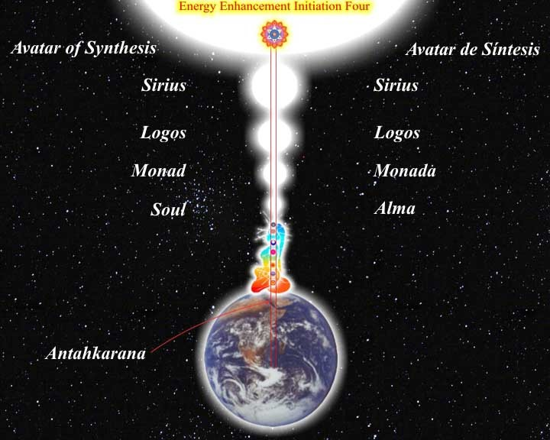
I went to a Greek Island with Hogen back around 1987 where he was giving a course with Yoga Teachers Angela Farmer and Victor Van Kooten. I was there with Hogen because I was to act as his general factotum and helper so we stayed in the same house for a couple of weeks. I cooked the food, washed the dishes and one day was asked to cut his hair with shears. To partake of his crown chakra energy. Thank you Zen Master Hogen!!
During that time one night when I slept I had a very vivid dream and I dreamt that I was lying on a slab of stone dressed as an ancient king in armor and with a sword - an image very much like but predating the image of the dead Aragorn in the Lord of the Rings Movie.
Hogen came towards me in his robes and he bent over me slowly from the waist and brought his mouth to my right eye and sucked it out from my eye socket! He slowly returned to vertical with my eye in his mouth, took it out with his fingers and then polished it up,

put the eye back in his mouth, bent over me again and then put my eye, back in my eye socket again with his mouth!
Swami Satchitananda said that, "Yoga is the creation of Psychic Vision" He also said that Hogen and I are like a train. Hogen is the engine pushing from the back and I am the engine pulling from the front. From this I gathered that HOGEN WAS LOOKING AFTER MY BASE CHAKRA AND SATCHIDANANDA WAS LOOKING AFTER MY CROWN CHAKRA AND ALL THE CHAKRAS ABOVE THE CROWN CHAKRA.
The next day Hogen had done something really stupid. He had put some olbas oil; a strong oil containing oil of wintergreen, on his finger and by accident put it into his right eye and was in pain. The students rushed to help him wash out the oil but I have pictures of Hogen wearing a piratical black eye patch, "eye, eye, me hearties!" for a week afterwards.
I came to understand later that Hogen had indeed cleared up my psychic vision through many experiences I received later.
Indeed, every true student will have similar experiences of when the Spiritual Master took on some of their Karma, with great effort and pain sometimes, in order to help their evolution.
Its what Masters have been created to do. And without my dream knowledge, like all the other students, I would have thought Hogen had done something stupid too. We can not know what they are really doing. They work in mysterious ways.
And then, after many years of work, zazen, meditation, with Zen master Hogen I meditated on the Koan of Ramana Maharshi, "Who am I"
Immediately I had the experience of travelling along the Antahkarana out of the body to chakras above the head to a place where was all my past lives hanging in space thousands of them in a neat matrix. I decided to enter into one of them and saw that past life gaining much experience. I then decided to go higher. There too I gained much experience.
When I went to Hogen in Dokusan with this experience, after I told him about the past lives he said, "We can explore this area of the Astral Plane for 10,000 years and get nowhere!"
Then I told him about going higher and he smiled! And in another space I saw his aura expanding, gold, and enfolding me in the energy of his love...
After this I was allowed to find another Master...

KUNDALINI TANTRA AND THE TRANSMISSION OF ENERGY FROM MASTER TO DISCIPLE
"Energy is Inexhaustible. Like a fire it is passed from Master to Disciple. It jumps the Gap, the Abyss. It Energizes all." - Satchidanand

"EASY AND SMOOTH ENERGY ENHANCEMENT PUTS YOU IN CONTACT WITH KUNDALINI ENERGY WHICH SPEEDS UP THE PROCESS OF ENLIGHTENMENT AND INTELLIGENCE"

Masters... and the flowers showered the energy of existence flows.
Satchi explained that if we had the power to heal our own blockages, we also had the power to heal the blockages of others. The power to do this comes from an integration of the body, emotions, mind and spirit created through the Core Energy Techniques of Energy Enhancement within the Energy Enhancement Buddhafield.

Satchi explained that the higher levels of Energy which create the Energy Enhancement Buddhafield and the Energy momentum to heal the students and raise their Energy Levels so that they can do likewise came from His connection with his teachers, Zen Master Hogen from Japan, Swami Satchidananda from Yogaville in the USA but previously a disciple, a Yogiraj, of Swami Sivananda of Rishikesh.

There is a transmission of Energy from Master to Disciple which occurs in silence. The preparation for this is the student's responsibility but the Energy always finds its place. It is the Energy of Initiation, which confirms the student in his enlightenment, but before this Initiation, "you need to be there before you can stay there."

Indeed, many people go searching for Integration and Enlightenment from technique to technique and teacher to teacher whereas a true student can learn anywhere. We need to increase that studentness within ourselves. We need to learn to be a true student. The ability to learn. The ability to ask. The ability to receive.

One lack of respect for the teachings. One negative word, ONE BLOCKAGE, and heaven and earth are set infinitely apart. One negative word can destroy the silence of a moment.

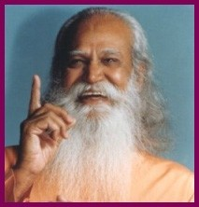
Swami Satchidananda talked of the time when Swami Sivananda died and of the Energy Initiation, which came to him at that time even though he was in Celon and Sivananda was dying in Rishikesh. He felt that some of Sivananda's fire had been given to him at that time.

Each Spiritual Master is a gift from existence, working in his own personal individual way to express his gift, his way, his energy channelled from the universe itself. They are individuals with strong personalities, "Personages!!" unselfishly aiming their lives at the benefit of humanity, the world and the Universe.

Even the intellect gets confused because the intelligent energy of existence, above the intellect, chit shakti, is the guiding force and initiator. Each spiritual master is as different from the others as a rose is different from a lily.

Just smell the perfume. Are they not the flowers of the Universe itself?

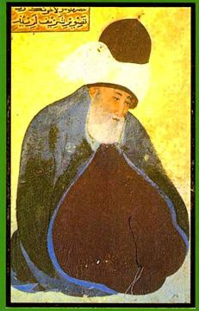
As Jallaluddin Rumi said around 1200AD, "Take what is in my hand!

If you have lost heart in the Path of Love Flee to me without delay
I am a fortress; invincible – Rumi
Satchi explained that after working with Zen Master Hogen and Swami Satchidananda for many years, these energy initiations had come to him also.

Sri Yogendra of Bombay

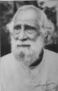
Satchi had the last and his only interview with Sri Yogendra of Bombay. Sri Yogendra died that same night saying that at the age of 96, it was difficult for him to hold in his energy. And this from a man who in his prime they used to put in darkened rooms where people used to go to see the prana, bioenergy, rushing blue over the surface of his body.

In the interview, Satchi said he could only sit at the master’s feet and say nothing.

Yogendra glanced at him and he was drawn to sit. Rooted to the spot. Yogendra talked of the time he was in New York, healing the children of millionaires. It was there in the 1930s where he gained the money to build his ashram in Bombay, "They used to appreciate me there and gave me a black stallion to ride around on in Central park."
Satchi heard him say at the end of the interview that the people of England had good hearts, and this from a Master who in his early years had had the reputation of beating up students
who took liberties, showed a lack of respect!! He knew that by these words Shri Yogendra had judged his heart and found him worthy.

And then afterwards the energy.. Sent to him by Yogendra, which he was given during the interview. WHOOM! WHOOM! Up and Down. Down and Up. From Heaven to Earth and Earth to Heaven. ENERGY!! with great noise for 24 hours!!

Usually gurus are given the energy of Transmission by their Masters and here is the Master of Shri Yogendra, Paramahamsa Madhavadasaji at the age of 122 years.

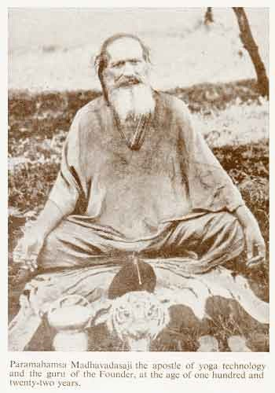
After that last interview with Shri Yogendra the great Master died the day after. Apparently he was talking to his son, Shri Jayadeva, the present head of the ashram in Bombay, and he said that it was getting difficult for him to hold onto his energy, it was time for him to move on to the other plane, he was going.

OSHO

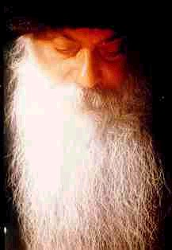
Satchi attended his only and last Satsang with OSHO on January 16th 1990. During the Satsang, Satchi had the experience of seeing Osho's aura. Satchi's mind just stopped, during the satsang when Nivedano hit the drum. As it stopped he saw the physical aura of Osho, Yellow, Black and horrible just one inch away from his skin. I suppose this is my vision of the poison which killed him, Satchi said.

But then the spiritual aura came out, white and filled with light up to 10 feet away from Osho and then Whoof!! It spread out over the whole of the Buddha hall and filled it with white light.

Satchi said he just sat there, tears falling down his face for what seemed forever.
Osho died 2 days later.

Father Bede Griffiths
http://en.wikipedia.org/wiki/Bede_Griffiths

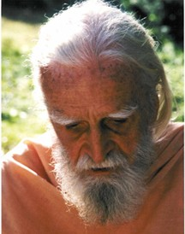

And then at the "Satchidananda" Ashram of the Bendictine Father Bede Griffiths on the banks of the River Cauvery in Tamil Nadu in Southern India. More energy phenomena. Father Augustine was giving mass and as usual Satchidanand, not a Catholic, with a Ho Hum lack of respect was there.

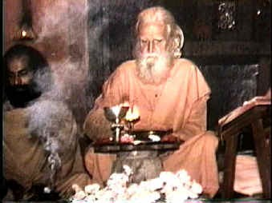
As Augustine raised the Chalice to heaven, Satchidanand saw a ray of lightning hit the chalice, bounce off and deflect into his heart center. This had the effect of making him burst into tears.
Father Bede, a famous monk who wrote many books exemplified the urge of the Benedicines to Ecuminise, to explore the Energies of the Hindu Religion, where he took Sannyas, taught from the Bible Upanishads and the Gita, "its all in the explanation!" had his first heart attack 2 days later at the age of 96 and died 3 months later.

Swami Satchidananda
http://en.wikipedia.org/wiki/Swami_Satchidananda
And then 2 days before Satchi's Master, Swami Satchidananda, died at the untimely age of 89, Satchi felt the transmission of Energy from his Master. Filled with white light for 3 days in a row, in the middle of the night for hours, unable to sleep.
Masters get given energy on the death of other Masters. Masters get given and store up energy, the energy of enlightenment, the energy of transmission, the high level atomic energy given by the scepter of Initiation by Sanat Kumara.

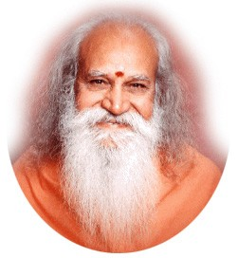

They store energy all their lives to do their work and to give to other people all of their lives. Upon their death, that energy needs to pass onto their successors. And that Energy transmission is what helps to create the next generation of Masters.
Swami Satchidananda said the same thing happened to him when his Master, Swami Sivananda Died.

Swami Sivananda
http://en.wikipedia.org/wiki/Sivananda
Satchidananda said he was in Celon at the time and the Dying Sivananda was in the Himalayas, but the energy still passed to him.

Masters take no heed of which religion they are born into. They become channels for the light despite, or rather because of, the general low energy level of the world and its corruption and mixedness. It is their job to raise the energy of their students and of the world in the few short days before they leave this planet. To leave it a better place than when they came.

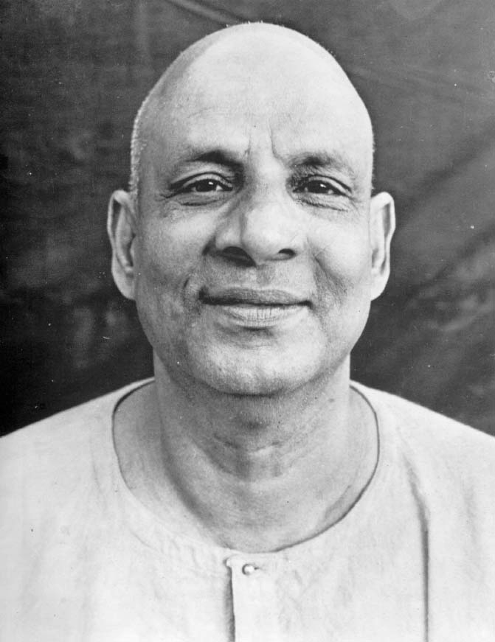

"As I leave after a couple of days in the company of Devi Dhyani and Satchidanand I look forward to my future training with them Learning Energy Enhancement Levels One, The Connection with Energy!! Energy Enhancement Level Two, The removal of Blockages and Energy Enhancement Level Three, the Mastery of Relationships

and the Psychic Energyual Energy Connection, this August" OLYMPIA PANZA 2004

THE CHAKRAS ABOVE THE HEAD - CONNECTING YOU WITH THE UNIVERSE
THE PARALLEL PROCESSORS ABOVE THE HEAD CONNECT YOU WITH THE ENERGIES OF THE UNIVERSE THROUGH THE ANTAHKARANA - LEARN HOW TO CONNECT WITH ENERGY ENHANCEMENT

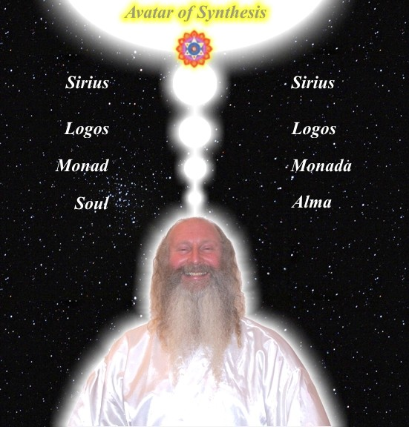
ALL THE PROBLEMS OF THE WORLD COME FROM HUMANS...
ENERGY BLOCKAGES ABOVE THE HEAD CUT YOU OFF FROM CONSCIENCE AND INTUITION

ENERGY BLOCKAGES IN THE HEART CAUSE A LACK OF EMPATHY WHERE YOU JUST DON'T CARE ABOUT ANYONE ELSE.
ENERGY BLOCKAGES BELOW THE BASE CUT YOU OFF FROM THE KUNDALINI CHAKRA IN THE MIDDLE OF THE EARTH - PEOPLE LIKE THIS ARE SLAVES, PUT INTO ALL TYPES OF ABUSIVE SITUATIONS, THEY DO WHAT THEY ARE TOLD AND MAKE IDEAL ACCOMPLICES.
AFTER ALL THAT... ENERGY ENHANCEMENT REMOVES ALL ENERGY BLOCKAGES - IT SPEEDS UP THE PROCESS OF ENLIGHTENMENT.


DOWNLOAD SUPER ENERGY AND SACRED SYMBOLS HERE!!!
http://www.energyenhancement.org/Sacred-Energy/Meditation-Super-Energy-And-Sacred-Symbols-for-Perfect-Wisdom-Enlightenment-Color-energyenhancement-org.pdf

THE BUDDHAFIELD AND KUNDALINI
The Buddhafield of Satchidanand spreads its potent energy by means of powerful spiritual vibrations from the highest sources from chakras above the Crown Chakra: The Soul, The group Soul AND higher than the Avatar of Synthesis.
This Buddhafield energy spreads from the Aura of Satchidanand to imprint his Energy Enhancement Online Book, his Audio Talks, his DVD video Course Video Talks and Satchidanand Youtube video talks and also the Sacred Dances of Devi Dhyani, SEE THE TOP OF THE PAGE FOR FREE EXAMPLES OF ALL THESE. Indeed the whole
Energy Enhancement Video Course is imprinted with the Buddhafield as taught by Satchidanand.
Your access to the higher energies of the Buddhafield makes more possible during your meditations. The Buddhafield creates the possibility of Kundalini experiences. It, as well as the Advanced Techniques of Energy Enhancement give you more energy to Speed Up the Meditative Process.

Satchidanand does not believe he is special in any way, just lucky. He says, "I am just another guy who has been added unto. I am just a custodian of the energies which have been given to me by the many Enlightened masters I have encountered, Roshi Hogen Daido Yamahata, Swami Satchidananda of Yogaville, Sri Yogendra of Bombay, Sri Sathya Sai Baba, Osho and Father Bede Griffiths, and also into which I have been Initiated by the highest Ascended Masters of Enlightenment.
Before being given energy, first you must prove yourself. Be tested and found to be true. I am just a Channel for the higher energies which expand my aura as a Buddhafield of Energy whose integrative effect is now quickening and speeding up all the spiritual practises it touches in all my students and throughout the world."
The Buddhafield is just an expression of what is already happening here on this small planet.
Indigo and Crystal Children like Devi and I have always been sent to this planet over thousands of years and are being sent in Greater and Greater numbers to this Planet. Indigo and Crystal Children will need an advanced training like that which is available on the Energy Enhancement Course if they are to fulfil their potential.
This is an amazingly auspicious time for every soul who wishes to evolve, here, now!! Incredible opportunities are available for speedy evolution. If you have ever wanted to enter into the spiritual path, to make this change in yourself, NOW is the time. Vast Spiritual energies are, for the first time in eons, being sent to this planet and more enlightened people are necessary to be trained how to handle them.
Side effects are an increase in IQ, more emotional stability, more energy, more GO!! Satchidanand has been equipped to give this training with the Energy Enhancement Course in Four Levels.
In this one encounter much can happen. All my students know this from their own psychic and spiritual experiences in the Buddhafield. The Speeding up of their Meditative processes towards Enlightenment. The spreading of the Light of Synthesis through the creation of New Nodes of Light. Growing ever stronger with the passage of time, the gaining of strength, energy and Light.
We have to be inwardly rich to give away everything. We need a large spiritual bank account given to us by Masters, Ascended Masters and Existence itself... The Buddhafield is the expression of that Generosity.
SATCHIDANAND- My background is that I started learning and practising yoga and meditation alone from the age of 16. I

practiced under enlightened masters Roshi Hogen Daido Yamahata a Zen Master who cleaned my energy system and then Swami Satchidananda who gave me the energy to get Initiated astrally by Ascended Masters at his ashram.
I then visited enlightened Masters in India who gave me energy before they died. Once even on the day I met them.
Then, after teaching meditation for 10 years with many other energy Initiations from Ascended Masters, Swami Satchidananda passed on some of his energy to me before he died at the age of 89 in 2002.

Now Swami Satchidananda is an Ascended Master. After becoming Enlightened on this planet he gained sufficient Initiations to be able to maintain his consciousness through the death process.
This is the only way we can legitimately achieve Immortality, and it is this which we teach with Energy Enhancement.

In order to do energy work, to become Enlightened, one must prove trustworthy and show a will to be useful.
The three servants in the bible. One buried his portion in the ground, one wasted it, one multiplied it 100 fold.... So, like any executive in a Galactic organization, you must be Industrious. Then, if you are lucky, and to be spiritual, you must be lucky, you get promoted, initiated, energy is given to do the work. Enlightenment is not enough.


Energy Enhancement Spiritual Movie Reviews Book - Volume 1 by Satchidanand download here..
http://www.energyenhancement.org/Spiritual-Movie-Reviews/Energy-Enhancement-spiritual-esoteric-movie-reviews-by-Satchidanand.pdf

ENERGY ENHANCEMENT - ARE YOU EXPERIENCED?
Do not expect perfection, Expect EXPERIENCE!! Come on an Energy Enhancement Course and gain real meditational experience. As well as learning how to meditate as deeply as any Monk, the Buddhafield, the Kundalini Energy of Satchidanand and Devi Dhyani, and the Advanced Techniques of Energy Enhancement make certain that you too will receive REAL MEDITATIONAL EXPERIENCE.
Sick of just sitting? People meditate for years without any signs of deep meditational experience. Yet with Satchidanand and Devi Dhyani, students of Zen Master Hogen, and Swami Satchidananda, author of "The Living Gita" with whom they received many experiences of Initiation, the Buddhafield produces IMMEDIATE meditational experience in just about everyone who comes.
Just read any of our testimonials of our Students over many years of the Energy Enhancement Course and you will see that every one of our clients has been given the meditational experience that they need. From Shaktipat to the experience of Energy in all its forms and on into the Karma Clearing Process and the Grounding of Negative energies and emotions, Energy Enhancement WILL EXPERIENCE YOU!
If you were to come on an Energy Enhancement Course, now with the ability to get the scholarship you need to come, You too can receive this EXPERIENCE of deep spiritual energy on the path of Enlightenment!!

Testimonial From Gary Spaid a Wealth Counselor in Vail Valley, Colorado, USA.
So, what did we get? After practising Transcendental Meditation for many years and knowing the luck that has been given to me through that practise, I can say that practicing the technique of Stage 4 of Level One of Energy Enhancement with Devi and Satchy gave more power to the top down approach of Meditation. I had an experience of the MAGIC!! that I so longed for in my meditation.
Sitting in the flame of Kundalini and seeing my karma burn up was a POWERFUL experience.

"During past meditation sessions for over two years, I have twirled like a top when my bottom came into contact with the floor. After two years the swaying finally stopped in ONE session with Energy
Enhancement! I later found out that Satchi had been working on this blockage at the same time using Energy Enhancement Level 2 Techniques...." Vanessa Graham (UK)
Meditation Teacher/Writer

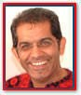"The feeling was so strange. I was hot but felt cold at the same time. My hands, arms and legs were shaking and shivering and yet I was not cold………what a strange feeling and I felt connected...." Dhiren Raichura, London Composer Musician and Producer

KUNDALINI ENERGY
Here is a quote/example of only one of his experiences with one of Satchidanand's Students and one of his MEDITATION teachers:-
Whilst being taught Energy Enhancement Stage 1. For the first time I had a profound and somewhat startling experience.
“In the meditation part of the experience I perceived an intense and bizarre visualization. In the minds eye I became aware of being in a dazzling white area in which reared a most amazing "cobra-like" snake. The colors, texture and clarity of the image were intensely

vivid, more so than television or cinema. Psychedelic is the term I would best use to describe the experience.
The snake reared its head up to my face and I could perceive that its tail seemed to emanate from just beneath my navel. As the image was so vivid and it seemed that the head of the snake would strike my face.
I abruptly opened my eyes and came out of the meditation somewhat in a state of shock. Seeing the room and other meditators behaving as normal, I closed my eyes and returned to the meditation wondering what else I might find there. There was no occurrence of such a vivid visualization during the sitting.
PT, Bournemouth



"When the Psyche is stimulated by the vast energies of Initiation in Energy Enhancement Stage One, as with our student Peter, we sometimes experience something. In this case during Energy Enhancement Stage One Peter saw, experienced, the Universal Archetype of the "Kundalini Snake" which has been extant for many years.
The presence of Teachers with access to these Kundalini Energies, make these energies available to the student.
With Energy Enhancement we learn how to access Incredibly Intense External Kundalini Energies which power our Enlightenment. Then

we experience these Amazing Energy Increases FOR OURSELVES.... "I FELT HOT IN MY SPINE, SOME OF MY BLOCKAGES WERE BURNED AND REMOVED, AND AGAIN AT THE END OF THE MEDITATION I
FELT A HIGHER LEVEL OF ENERGY." Quote from Philip Chester's Testimonial
The Energy of the Master Radiates out to the Student. They, through their will, can displace negative energies and bring them out into the aura to be felt before they move on. They, through their will, can energize all the chakras, increase the amount of energy held by the chakra and increase its vibratory rate.
SHAKTIPAT is the transmission of energy to introduce a good Student to High Intensity Kundalini Energy.

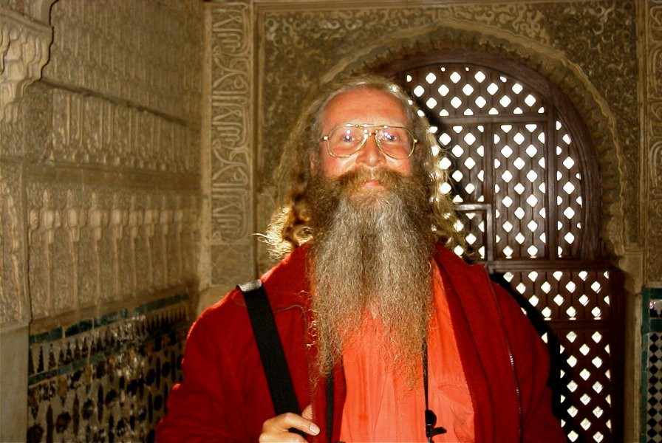
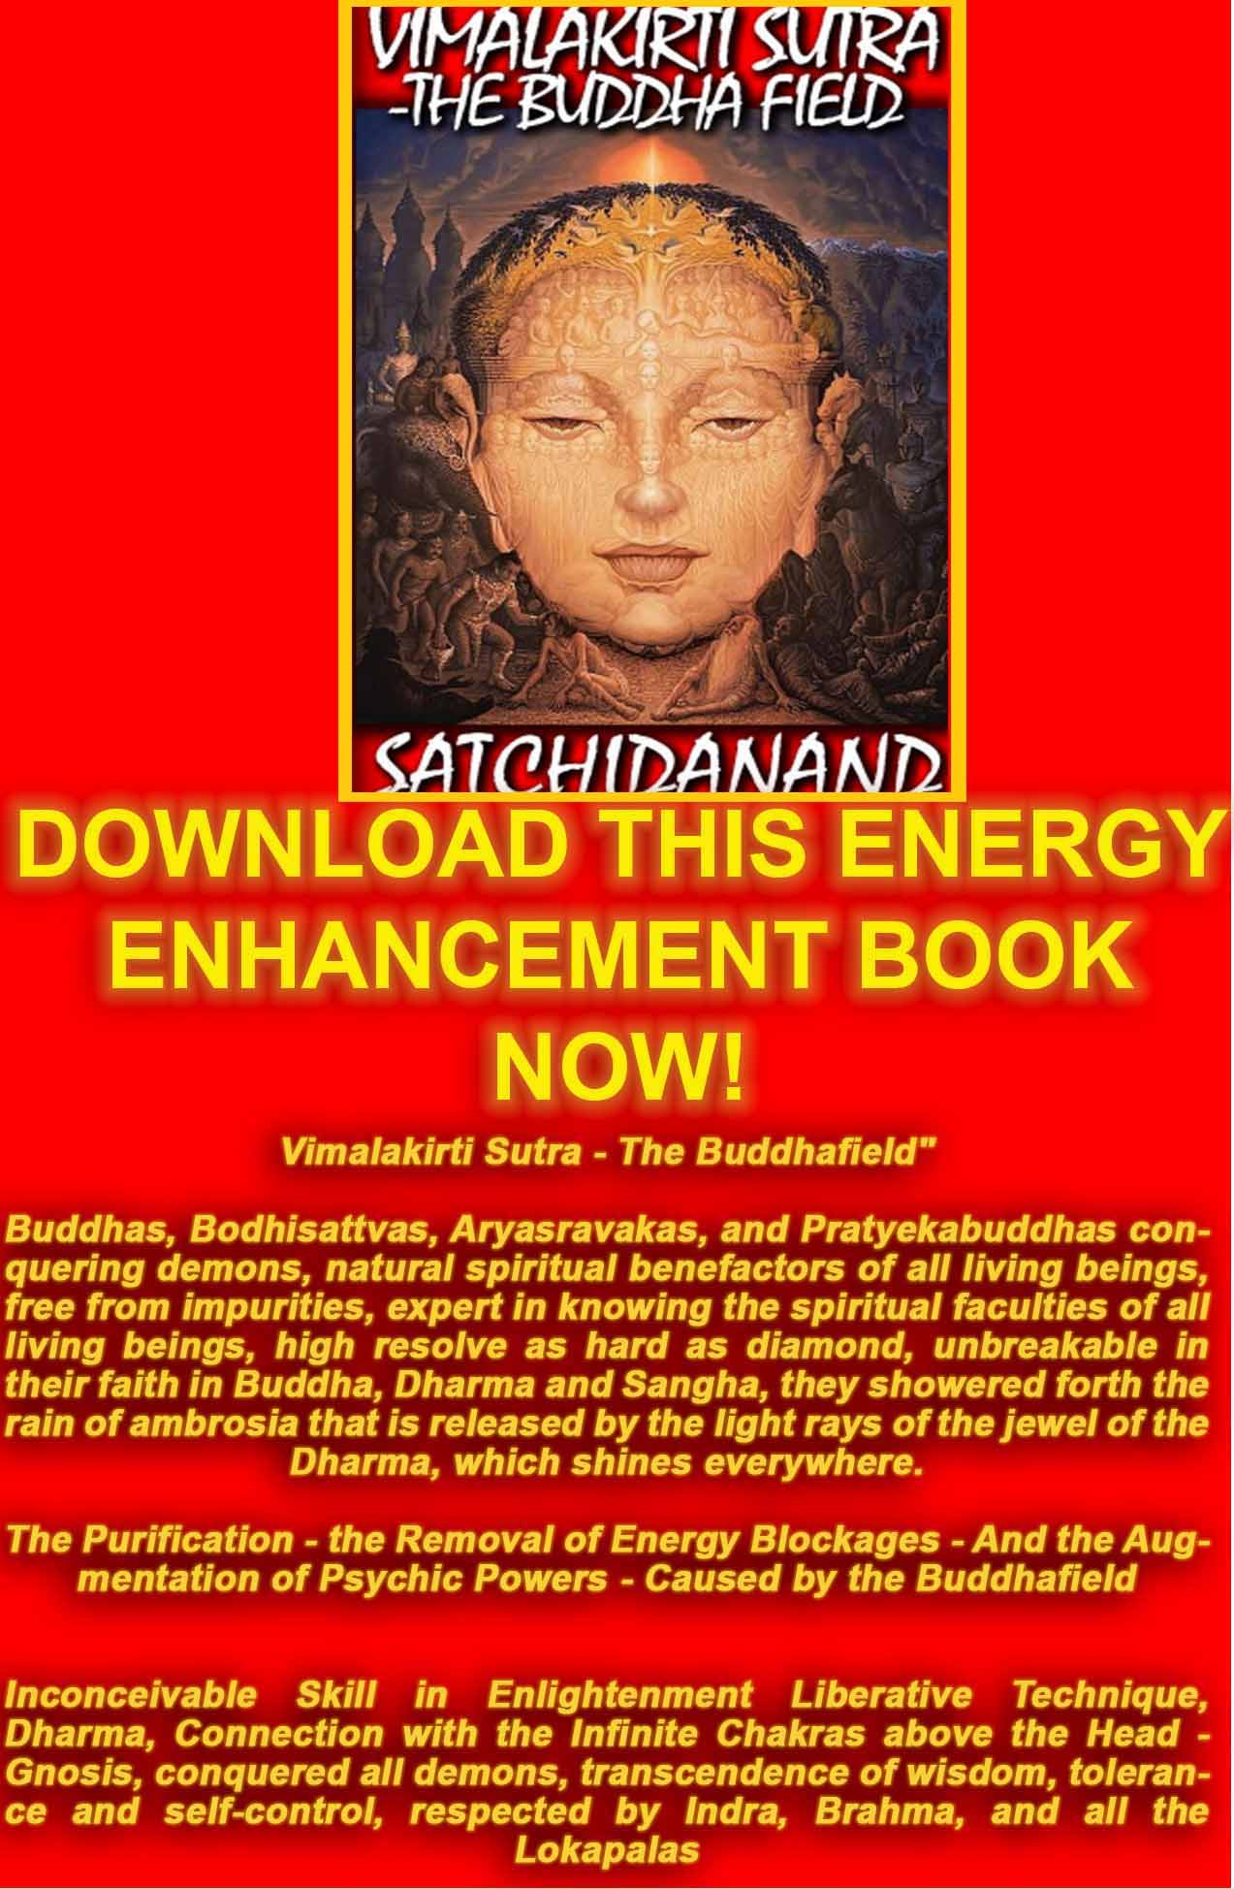
VIMALAKIRTI SUTRA DOWNLOAD
The Buddhist, "Vimalakirti Sutra" in 14 Chapters - by Satchidanand plus one Chapter - The Buddhist Energy Enhancement Kundalini Key is the Buddhist Stupa
http://www.energyenhancement.org/Vimalakirti-Sutra/vimalakirti-sutra.pdf

ENERGY ENHANCEMENT QUICKLY TRANSMUTES ALL PROBLEMS


It is good for the student to know in advance about Anger, Manicism, needing sympathy, needing to give sympathy to show superiority, Depression or Fear which show that The student is not yet perfect.

A very humbling experience and sometimes too much for the ego of the Student.
Yet on the Energy Enhancement Course we need to know about all this because as we catch these symptoms, we are taught how to easily transmute them at the level of Energy.
The energy of the sun, the energy of the Enlightened falls equally on the emotionally negative as well as the emotionally positive student. The process is one of both the elimination of tension from the student and of increasing the positivity, the positive energy level, of the student.
So, the effects of Kundalini energy will affect the emotionally negative by bringing the negative emotions to the surface so that they can be quickly eliminated by fast and efficient Energy Enhancement techniques. This also is part of the process of Enlightenment.
That is why it has been reported that as some people eliminate their negative energies with Energy Enhancement Techniques, they tend to go through them very quickly.
Like with Homeopathic medicines where the Homeopathic Law of Cure says that during the treatment, the patients will go back through all of their illnesses, one at a time, from the age they are now, backwards until they were born to be quickly eliminated by Energy Enhancement.
Once you have been through them a few times on the Energy Enhancement Meditation Course, they will never come back, unless you absorb them again, from your surroundings.
Each negative energy resides in one of the psychic bodies and in the physical body. Each negative energy blockage forms a resistance, a blockage, to the flow of pure cosmic energy. This slows down the flow of Bio-energy through this blockage. Like where silt is deposited in a river when it starts to flow slowly, toxins are deposited in the physical body where blockages are found.
Gradually the physical body "Silts Up" with these negative energy blockages causing the build up of toxins eventually causing physical disease.
YET ENERGETIC SYMPTOMS OF KUNDALINI ARE QUICKLY TRANSMUTED BY THE ENERGY ENHANCEMENT TECHNIQUES AT THE LEVEL OF ENERGY UNDERLYING THE MEMORY OR EMOTION - BEFORE THEY BECOME PROBLEMS.

When kundalini flows through this resistance sometimes heat or cold or shaking is felt. This is simply a symptom of the fact that there is a blockage. Where there is no blockage nothing is felt when Kundalini flows except an enlivening passion of life energy.
Back in ancient times it is said that one of the students of a Great Sufi Master "Hafiz of Shiraz", came to him and said that all the students had been impressed with the exhibition of shaking seen that morning as he gave energy in the Morning Meditation. Hafiz replied, "When the energy is flowing correctly, there is no motion!"
You will start to learn about negative energies in the Energy Enhancement Stage - The Grounding of Negative Energies. You will learn how to eliminate the illnesses, the negative energies. You will learn how to EASILY eliminate negative tensions from the system in order to find your Deep Peace.
THE FOLLOWING SYMPTOMS OF KUNDALINI ENERGY ARE REMOVED BY ENERGY ENHANCEMENT AT THE LEVEL OF ENERGY. ONCE AROUSED THEY ARE QUICKLY TRANSMUTED BY THE ENERGY ENHANCEMENT TECHNIQUES BEFORE THEY BECOME THE PROBLEMS WE FIND ON ALL OTHER MEDITATION COURSES!!
In the same way the energetic potencies of the master will quickly start to demonstrate your emotional negativity. The following is normal:-
- The elimination of negative energies will cause some people pains in the body as toxins are eliminated.
- It will cause some people to go back into their sadness and depression quickly, as the sadness is eliminated.
- It will cause some people to be afraid as their fear is eliminated. That is why there can be a feeling of awe in the presence of Enlightened beings.
- It will cause some people to get angry as their anger is eliminated. That is why Masters are sometimes the only people who can make you angry!
YET ALL SYMPTOMS ARE QUICKLY TRANSMUTED BY THE ENERGY ENHANCEMENT TECHNIQUES AT THE LEVEL OF ENERGY UNDERLYING THE MEMORY OR EMOTION - BEFORE THEY BECOME PROBLEMS
The maximal elimination is sometimes on first meeting but always when the student is ready. Either in person with the Master or just by watching the Energy Enhancement Videos or sometimes even by reading the E-Book of Energy Enhancement.

The more purification you have done prior to your Energy Enhancement Course through Dance, Martial Arts, Yoga and Meditation will reduce the amount of negativity to be eliminated by the Master so that only Positive energies may be experienced. But it is good that all negativities are Eliminated - "Better out, than in!" Satchidanand
It is all part of the process.
But also, in the same Session, Holiday, Tour, Initiation, or following the Home Study Course or even reading the E_Book of Energy Enhancement or listening to Online Audio Talks given by Satchidanand and the learning of Energy Enhancement Levels.

What Laura Steiman found with Kundalini in her Energy Enhancement Course.
"When I started to meditate I got the feeling that I needed to Ground, to go down.. I tried to breathe and concentrated on my breathing but the need to go down was stronger and I felt that all of the energy was directed into the zone of the pelvis and the legs.

The pelvis started to vibrate. All this part of my body and after there was hot and cold energy through my spine.

At this moment I asked for help and I felt something fold down like a veil and I felt naked.

I got the will to cry and I cried and the lower part of my body continued to vibrate.

Then I wanted to laugh. Then there was an emptiness in my chest and head.

During this process I got a lot of images in my head like a film but not connecting with this present life. I was seeing some of my past lives I think."

We explained to Laura that this was just the process of clearing of negative energies.

The So-Called kundalini experiences are just that.

Later Laura was still shaking every meditation for a week and cold

and heat, but after that things calmed down and Her vibrating "Culo" as we joked, because she comes from Argentina and the above is translated from the Spanish, stopped shaking as she went on to better things in her meditation.

Remember, we give you the most advanced techniques and energy to really make a difference and move on with your lives.
The Master will raise the Energy Level of those emotionally positive enough.
That is why it has been reported, as above, that the student can experience Visions, feelings of high energy and happiness so that nothing can shake them from feeling good, as if they were struck by lightning, so that their meditation yields constant good results.
The feelings of Bliss and energy currents in the body. Shaking, heat, and lights in the chakras of the head have also been reported. All normal on the path of Enlightenment. And not spiritually important.
It just shows that something is happening.
The end result is just feeling good all the time. Connected with the universe. No expressions of emotional negativity. The access to the true will. The power of Doing. Speeding up your mind. Access to your passion and your Genius. The normal expressions of Enlightenment.



Leonardo Da Vinci was a Great Master of Wisdom. Master of the Priory of Sion.

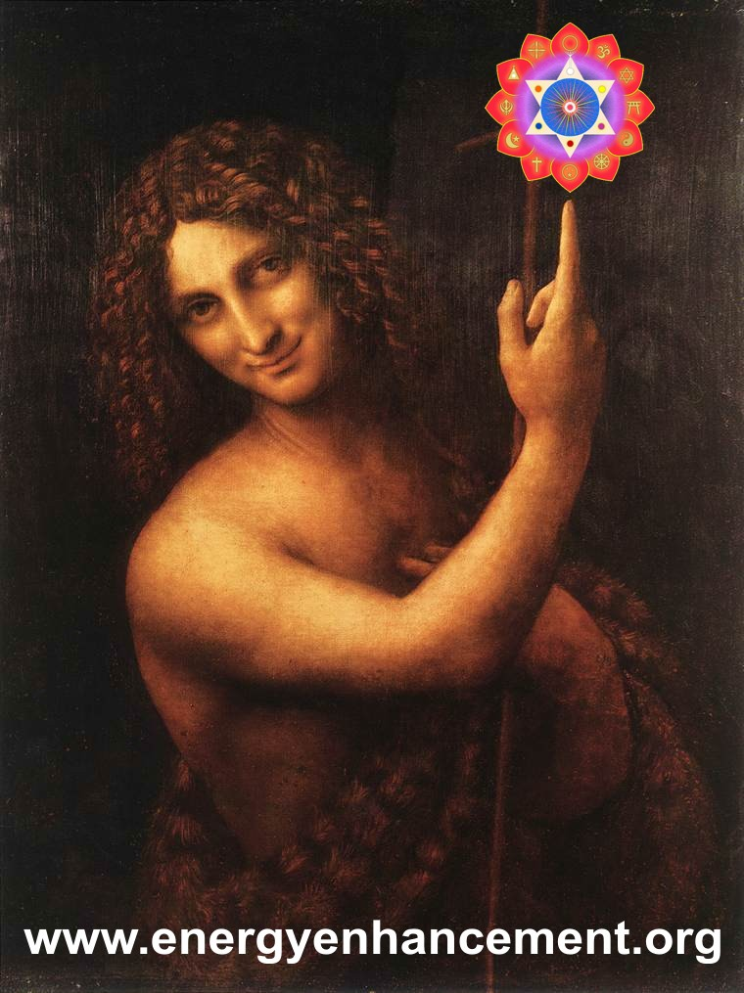
Satchidanand Says, "When I went to the Louvre Art Gallery in Paris many years ago, I saw the picture, by Leonardo Da Vinci, of a Shepherd Boy with the Gioconda Face, with his finger pointing upwards as in the picture above.

At that time I knew nothing of the theory of the Zen Masters.
"Do not look upon my Finger, Instead look at the moon (Soul) towards which it points!!"
I had not even done any meditation at that point.
However, My body went cold with the SIGNIFICANCE of that painting and I laughed!!!
As the first time I read "Form is Emptiness and Emptiness is Form" from the Heart Sutra. I did not know what it meant, but something, The SIGNIFICANCE made me burst into tears.
Energy is impregnated into the work of the Masters. Whether in their works of art or in their teachings of Energy Enhancement.
If you can feel this energy, whether in the Star wars (May the Force be with You!!) Saga, The Lord of the Rings, or in the Matrix Film, or any of the myriad works of the past or NOW!! then you can feel a SIGNIFICANCE which is deeper than any intellectual theory.
Then, you know!!"
Is your life "a tale, told by an idiot, full of sound and fury, signifying Nothing!!" - Shakespeare
"As the Zen Masters write, "Do not look upon my finger (Or any of the Masters works) but to the Moon (The Soul) towards which it points." This is SIGNIFICANCE. This is MEANING. This is ENERGY. This is Kundalini. This is the Incredible, Kundalini, Orgiastic, SOUL Energy!!" – SATCHIDANAND
My whole life has been informed by this energy. It is called the intuition. A gut feeling. An inner knowledge. When you feel the energy in a book, in a painting, in music, in yoga, in meditation – then this is where your soul is telling you to put your energy. DO NOT WASTE YOUR TIME ON ANYTHING LESS.

SATCHIDANAND IN PARANA
As when we went to Parana, a city in Argentina above Rosario on the River Parana where it is 50Km wide, the second largest River in the world.

I gave a talk, very much like the Real Audio talks I give on this website!!
Devi Dhyani gave one of her Sacred Dances again which you can find on this website.
Later, we were discussing with one of the leaders of the Group discounted Energy Enhancement Rates for the whole group. She was telling me of her Kundalini Experience which she said had changed her life.
When I was telling her of what was possible, she said "But we are not like you, We cannot do these things."
The Energy of the Soul was growing in me. As I Spoke, the energy was released. I said, "Oh my Daughter, If you but knew WHO YOU WERE, you would not say that!!"
At the back of the room was a Yoga Teacher, A REGULAR GROUP MEMBER, who was just standing there. Upon these words. Feeling this Energy, she raised her arms into the air and stood like that, shaking and crying for the next Half Hour. Shaking, crying.
KUNDALINIED!!!
It was her faith which healed her.

Satchidanand's ENERGY ENHANCEMENT Stories:
After practising Zazen Meditation with Roshi Hogen Daido Yamahata for a time I began to feel him cleaning my Base Chakra every time I meditated. I was also doing Energy Enhancement techniques at that time which speeded up the meditative process. He used to wake me up early every morning and say "Get out of bed, Meditate Now!!"



Then by accident or by Luck. And to be Spiritual, you have to be lucky. I came across Swami Satchidananda of Yogaville.

I went to one of his talks and at the end of the talk he said "Lets Meditate for a couple of minutes."

So, we chanted Ha Ri OM and started to meditate.

I found myself one hundred feet in the air looking down at my body meditating below.

I looked up and there was Swami Satchidananda one hundred feet

higher, saying "Come on up!! Come on up!!"

So I though that perhaps it would be a good thing to learn from him.....

In my interview with him I said what happened and said that I only had one problem in that I had heard that you were only supposed to have one Guru and Roshi Hogen was doing a really good job with me.

Satchidananda asked if I had any problems between the teachings of Hinduism and Zen. I said "NO, no problems!!" because I understood that the terminology of Meditation in Hinduism meant "The flow of Energy towards a Point of concentration" and Meditation or Zen in Japan meant Nirbija Samadhi or Enlightenment.

So he told me that I should think of Hogen and him as two engines on a train. Hogen was the one pushing FROM THE BASE CHAKRA. He was the one pulling FROM THE CROWN CHAKRA.
Hogen was the one looking after the base chakra. Satchidananda was the one looking after the Crown Chakra.
And this was proved to me later in his ashram and indeed everywhere I met him with incredible experiences of the higher planes, of Initiation, of telepathy indeed all the tales of Masters of the past came true when I was with him!!

And when I went on my "Grand Tour" of India I met up "Luckily" with many great Yogis and meditators. And with each one I had a wonderful Spiritual experience.

Sri Yogendra of Bombay had the reputation of not suffering fools gladly. If anyone was disrespectful he used to beat them up and throw them out!! When he was young they used to put him in darkened rooms so that people could see the Prana, blue, rushing like electricty around his body.

He was 96 years old when I had my Interview with him. All I could do was to sit at his feet and remain quiet whilst he told me of his experiences. Spread out across the Whole Universe. In New York in the Thirties. Healing the children of Millionaires he earned enough to create his Ashram.

For the next day all I could feel was the energy rushing through my body Up and DOWN!! With a great Noise!!

That night, Yogendra told his son. "I can't seem to retain my Prana as well as I should. I think it is time to go!"

That night he died.

Same but different experiences with Hogen, Ramana Maharshi, Sri Sathya Sai Baba, Swami Satchidananda, Father Bede Griffiths and last but not least, Osho.
http://en.wikipedia.org/wiki/Osho
The purpose of Meditation practice is to get you into a state of meditation 24 hours a day. You need ENERGY to do this. You need ENERGY to get you into a state where you can receive more ENERGY!!

As Rumi said. You need to learn how to become a perfect thief!! You need to get quiet enough so that you can steal the energy of the Enlightened.
But the real perfect thief is exemplified in PromeTheus. Like all Enlightened Masters, he steals the fire from heaven and is condemned to have his liver eaten each day by another student thief like an eagle and every night for it to be grown back.

This Fire comes from that Fire. But Fire still remains. - Mandukya Upanishad

To Catch Light yourself. To Become Prometheus.

This is why Energy Enhancement Techniques are needed to Speed up the Meditative Process.

Swami Satchidananda - E GO!! Techniques, like those of Energy Enhancement are also needed.

As Hogen said to me, "Meditate a little every day!"

As Swami Satchidananda said to me, "Meditate regularly for a while and with EnTheosiasm"

As Vivekananda said, "If one person can become Enlightened. If you can recognise that even one person has ever become Enlightened!! Then know. That YOU TOO, can become Enlightened.

IT IS YOUR DESTINY!!”

ENERGY ENHANCEMENT ADVANCED TECHNIQUES TO INCREASE YOUR SPIRITUAL ENERGY AND SPEED YOUR EVOLUTION TOWARDS YOUR ULTIMATE PEACE AND HAPPINESS!!
The Dragon or the Kundalini Snake are normal visual expressions of Kundalini Energy.

In meditation we can also access our ancient memories of past lives. One of my teachers, Roshi Hogen from Japan, teaches about the rubbish from the past which we access on the astral plane during meditation.
He calls this "Makyo" in the Zen tradition. But he teaches that the experience means something. We have accessed a deeper level.
When I came to one of my teachers, Roshi, Zen Master Hogen with my experience of using the Mantra "Who am I", The Koan of Sage Ramana Maharshi of Tiruvannamalai in South India, in a state of profound meditation.

Like a stone thrown into an empty pool, the ripples flow. My experience was of accessing all my past lives in a "Karmasaya" - the bag of our past lives. I could see all of my past lives. However, I was not interested in this, I told him, and went on further in my meditation into the source.
Zen Master Hogen said indeed that we can waste hundreds of years on exploring the Astral Plane but the information we receive can be meaningless. Usually when we dream we access the very lower levels, the "Telenovella - Coronation Street" the very basement of the Astral plane.
We need to go Further.

We forget lower Astral plane experiences when we die. We need to go on further into the Source to elicit a real change in the psyche. To the "Spring at the Top of the Mountain" which Energy Enhancement teaches in Stage Four of Energy Enhancement.
However, the experience means we have reached something. I remember the experience of seeing Zen Master Hogen’s Aura glow golden and expand with energy at this time. His whole body and around it became surrounded by a beautiful Golden Light. His higher self was pleased. Another student had accessed something of the beyond. Was moving on. It was good.

But it is not enough.
We can still fall unless we maintain our practise towards even higher stages. The higher we go the further we can fall. Unless we are Enlightened. And in the end, Enlightenment is not Enough!!!
"Energy Enhancement teaches the techniques which can take us all the way."

Qualifications
Satchidanand has a BSc in Physics, Mathematics and Electronics, is Reiki Master, Director of the SOL School of Yoga Teacher Training and the SOL School of Energy Enhancement giving Initiations in Meditation, Reiki and Energy Enhancement.
Lectures
Satchidanand has been a Yoga and Meditation teacher for decades, is an inspired teacher, lecturer, story teller and workshop leader, channeling the energy of the Soul and the Monad, Sirius the Star of Jesus Christ and most importantly, the Avatar of Synthesis
The Avatar of Synthesis works towards the integration of every human being towards one Soul Infused personality, Enlightenment, rather than the profusion of ego based sub-personalities which control every human being on this planet at present. All human beings are on the path of enlightenment.
The Avatar of Synthesis works towards the Unification of all the Religions on this planet starting with Ecumenism. As Swami Satchidananda said, "How can the politicians come together when all of the Religions are fighting each other?"

The Avatar of Synthesis works towards a Unified World Republic with one President - a Unification of all the countries towards One Unified and Harmonious World.
Satchidanand has lectured before audiences of Thousands and has been interviewed on Television many times. He has been a tour leader in India for five years meeting and having psychic experiences with many Enlightened Masters. He is the channel for the inspired writings and teachings of Energy Enhancement which are hidden techniques used for thousands of years - 200,000 years of Advanced Spiritual Technology.
Energy Enhancement
Energy Enhancement is a unique system for the next millennium, the result of years of investigation, direct holistic experience and integration from many sources including Taoism, Kriyas, alchemy and meditation. These techniques are not generally available.
Fragments of the Energy Enhancement system are available by word of mouth from many different systems extant from over 200,000 years of spiritual success, but it can take years of investigation, a lifetime, to put all these various parts together in one integrated system.

Higher Energies Available
Satchidanand, through access to the higher energies given to him by his Masters, Through special astrological conjuctions present at birth, has the capacity not only to teach techniques which can change the Evolution of you and of the Earth itself, but also has been given the capacity to share these energies with all who come.
On Energy Enhancement Courses, Energy and Kundalini experiences occur to all who work with him.
"I Sing the Body Electric. Let my Armies engirth thee
And Charge Thee full with the Charge of the Soul."
- by Walt Whitman

Energy is All
Although he lectures and teaches Energy Enhancement all over the world, he places the greatest emphasis on the teaching and the Energy, rather than the channel for the Energies of the Universe, the Simple Master, Satchidanand.

Testimonial by Arwen Evenstar
Arwen Evenstar came to be with us for 3 months over the winter to help us with our Web Site and to join our Residential Program .
Dearest Satchi and Devi, It has been almost five months since I said good-bye in the airport in Crete. There are several bits of writing that I owe you and that will come your way eventually. I am in transition between my stage manager theatre touring job and my theatre camp. Now that I am done with the tour I have had a few minutes to reflect on what I brought away with me from Greece. (Please feel free to use this as a testimonial.)

When I went looking for an intensive yoga or dance training program one year ago I hoped that I would be able to direct my life down a more positive path, learn to focus my emotions in a positive way, learn to use my empathy as a tool and not as a crutch, improve my physical health, and refine my yoga teaching skills. I accomplished all of those things with you! While I feel a little half baked on some points I can safely say that the test drive of 5 months on the road has proved the difference in my interaction with the world. I can only imagine that, had I been able to spend the entire 9 months with you this year I would feel even more solid in the skills I have learned.

When I decided to fly half way around the world to study for 9 months with people I had never met before, or even talked to on the phone, my friends said I was a little crazy but encouraged me to follow my heart. (Thank goodness I have open-minded friends.)

My gut instinct told me that you were both good people and that you would help me with my goals. Here is my advice to anyone who is unsure if it is wise to fly half way around the world to join you: DO IT!

You are two of the most compassionate and supportive people I know. You challenged me exactly the way I needed to be

challenged. When I look back on my time with you I often tell people that I flew half way around the world to be with my parents. While I mean this factiously because of your similarities to my parents in your effect on me I also mean that you stirred as much change in me as someone a close as a parent can.

So, back to what I walked away with. From 3 months I took a deeper understanding of most aspects of yoga, the knowledge that I can now offer my students a greater range of exercises and a more complete picture of yoga. Many physical and spiritual techniques for keeping my mind, body and spirit in alignment, a feel for reiki, and, most importantly, all of the things I hoped I would take away.

To begin on a more superficial level, with yoga and Energy Enhancement physically I lost some weight, gain muscle mass, strengthened my lungs and straightened my back. These changes are still evident 5 months later, despite my job prohibiting me from eating as well or getting as much movement as I would like. My friends all tell me that I have bloomed, that I seem more confident and that I look healthier. I feel healthier and I feel good about the way that I look. I am not in as good of shape as I was when I left you but I still can feel the benefits of my time with you.
Now, on a deeper level, I have gone through some difficult times this spring and found that I am more emotionally equipped to handle them then ever. As you know, I am prone to tears and can let small things overwhelm me at times. While I was still studying with you I knew that I was shaking the foundation of those behaviours but, since they were rearing their ugly heads in the shaking, they didn't seem to be vanishing.
They are still with me but have diminished into something that I can notice and deal with well before they get out of control. During this tour I had a large angry man scream in my face, a member of my cast tell me that he didn't feel I was capable of being his boss and many a little frustration that would have sent me into the depths of a panic attack or other emotional tumult if it had happened a year ago.

While I did go through a period of depression about a month ago I also discovered that I truly have the skills to control my own mental health. When the mirror was slammed up to my face to make me realize that I was descending into an emotionally unhealthy space I took a step back, renewed my meditation practices, put up a circle of protection, practiced yoga, did self-reiki and remembered to breath every day.

Almost like magic I was back to feeling healthy, confident and together. The best part about this experience was that it showed me that the training I received from you can both be a preventative and a Band-Aid. If I practice regularly I feel great. If I don't make the time to do that and I start to feel a little out of sorts, a short meditation session can generally put me back on the right track.

While I would never want to trade my ability to cry when I need to, it really does do wonders for my stress relief, I am thrilled to announce that I haven't had a moment of even the desire to cry for 3 weeks! I have to wrap this up as duty calls. I just want to emphasize that my goals for my training with your, despite it being shorter than expected, were met. I know that there is more work to be done but I am thrilled with the results. I am in the process of putting together the next year for myself.
Where will you be January through May? Much love, light and learning, Arwen

Does Enlightenment exist?
Have there been Enlightened people?
Is this person or that person Enlightened?
Whether you believe in Enlightenment or not, it is indisputable that a person can change for the better.
You or they can Evolve.
Once You Understand "The Urgency of the Situation and the Reality of Enlightenment." Gautama Buddha.
It is indisputable that throughout history some people have stood out from the crowd, offering hope and teaching for the betterment of Mankind.
There are ancient myths and stories of Merlin, of Jeddai Masters, of Zen Masters who strangely embody this Search.
Myself, I prefer not to believe in Belief. Instead I prefer experience.
Not to listen to the crowd, the Mob. But to experience for myself. This is Empirical Scientific Knowledge. Does it Work? Is it useful? How does it Feel?

Some people devote their lives to this search, to this change for the better and in the process become experts in their field.
Professionals in their chosen line of Work
Devi Dhyani and Satchidanand, Directors of The Synthesis of Light, Teachers of Energy Enhancement are two such Professionals. They genuinely want to be of use.

Energy Enhancement Director Devi Dhyani

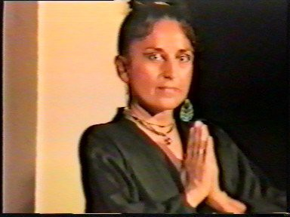
Energy Enhancement Director Devi Dhyani attended a Four Month Transcendental Meditation Teacher Training Course and Siddhi Course in 1978. She initiated over 200 students in Transcendental Meditation prior to Initiating in Energy Enhancement and being the main initiator in Energy Enhancement Reiki.
She Says the Maharishi Mahesh Yogi is one of her heroes but the Advanced Techniques of Energy Enhancement allows the Easy and Quick removal of tension at the Energy Level without the Memory Regression and Painful Emotional Catharsis associated with other courses.

SATCHIDANAND ON THE LORDS PRAYER - THE RULES OF BEING WITH ANY GURU FROM THE HINDU SCRIPTURES FOR THOUSANDS OF YEARS - THE GURU STUDENT RELATIONSHIP
The difference between an Enlightened Master and a student is that a master is Enlightened. He has removed some of his energy blockages and become confirmed as a Soul Infused being by having this connection with his Soul, one of the first chakras outside the physical body, above the head fused into place (This process is like welding) by the intense energies of the Enlightenment Initiation given by his Master and his Ascended Master.
Gurdjieff said that he hated those people who did not want to evolve and said that they were, "Shit of a Shit!! Mierde de la Mierde!!" Yet if that same person wanted to learn the Techniques of Enlightenment, "That person is my Brother, and I love him very deeply!” This is the only thing which defines a student.
The Enlightened Guru is not perfect yet he is more perfect than the student who comes to learn how to be Enlightened. He has Opened the Heart towards the Soul and thus has a tremendous Will to help all people who come to him.
The Enlightened Guru has unified his Mind of many of the Ego- based Sub-Personalities towards One Soul Infused personality and thus is not so controlled by Trauma-Formed Inner Children Sub- Personalities which Create Schizophrenia, Dissociated Identity Disorder - DID and Multiple Personality Disorder - MPD which in different degrees are the norm in Human society and are the cause of all the problems on this planet.
The Enlightened Guru has removed the Energy Blockages to his Emotions removing uncontrollable Anger (A Guru can still use anger to attain his ends by acting anger) uncontrollable Depression, a need for the sympathy of others, a need to give sympathy to others to prove superiority, Fear and Manicism. This also removes the uncontrollable Bi-Polar problems where the blockages shift from acupuncture energy meridian to meridian creating for example, Manic - Depressives.

The mind of the Guru is powered by Kundalini energy and the Soul and so is usually clear and intelligent but is in no way different than the minds of most of his students so a lack of experience can be pointed out in them. However, logic is powered by the Soul but in the students, logic is powered by Blockages like Addiction (Temptation) and wrong path, and these faults in Logic are often pointed out by the Guru.
The Heart of the Guru is unblocked and therefore he has the power of Forgiveness which every student needs to create within themselves. This is exemplified by "Turning the other cheek" the ability to forgive the blows of people and life immediately.
A symbol of this is the Kyosaku, the stick which every Zen Master uses to beat his students in meditation. By tradition the students must say thank you for every Kyosaku blow. Zen Masters symbolize the blows of life by slaps on the face, the normal life of the soul infused being, symbolized by the Koan, "What is your face before you are born?"
And the Koan, "What is the Sound of One Hand Clapping?" - Obviously one hand slapping your face! A Guru knows how to, in the words of Jesus Christ, "Turn the other Cheek!”
The Mind, emotions and body of the Guru are essentially the same as the students and yet are more pure as described above.
However, the main advantage of the Guru is his stronger connection with the Chakras above the head connecting you with God.
The Soul, The Monad or Group of Souls, the Logos - The group of all the Monads on this Planet, the Star Sirius which is the Star of Jesus Christ, and the Avatar if Synthesis an Archangel which is currently working through the Ascended Master called the Christ and which has been invited to work on this planet by the Archangel in charge of this planet called the Logos.
These Chakras above the head have a higher energy than the mind, do not work mentally but yet power all things mental both good and bad. Thus the energy of the Guru tends to give experience to the students in the form of small blows. Thus Gurus teach through experiences which happen quite naturally around them from the Soul and not consciously from their mental level.
As the students learn the necessity of "Turning the Other Cheek" by forgiving each blow as it occurs through the Energy Enhancement technique of Seven Stepping, so their heart becomes more pure and it becomes unnecessary for the larger blows of Karma correction and Soul Path correction.

Thus the large blows of correction given mechanically to everyone on this planet through the Law of Karma, where you get what you have given to others, a just return for the bad things you have done.
Further than that, as we evolve another Law like Karma comes into play called the Law of Soul Path or Buddhist Dharma. If you move from your soul path then the much needed Blows of Correction come even faster.
My Master, Swami Satchidananda said, "What is the way of the World? If you want to purify Gold Ore you heat it in a furnace to 1000 Degrees Centigrade, and then you put it on an anvil and beat the crap out of it!" The Blows of the World of Karma and Soul Path are big Blows and are like that!
To those highly evolved souls who want to grow in the Buddhafield of a Master there is the Law of Gratitude to the Master for all Initiations that he has taught and the Energy which he has channelled to them which is really, just the Opening of the Heart.
Swami Satchidananda said, "I don't want any respect to me, yet respect to me is respect for the Teachings and is Necessary!"
Enlightened Master Sosan said in Hsin Hsing Min, "One Negative Word and heaven and Earth are set infinitely apart" In the silence of the Buddhafield when energy is being channeled to the student, all of his blockages are going to get upset and want him to destroy the silence of the moment. The Student must learn how to become silent in the presence of the Master.
Bad students are not grateful, say bad things about their Master and have no care which secrets they pass on to people not qualified to know them. With bad students familiarity breeds contempt and their Hearts grow Black and Cold because they are not learning to Forgive, through the Seven Step Process, every blow received by them.
Remember, as Tolkien said, "Evil Is" and it is the Ego Blockages which psychopathically lead us into Temptation using same logical heartless excuses which created the "Final Solution!"
Many are the student’s blockage created psychic attacks on the Master, which the Master must ground to purify his Students, "Forgive them Lord, they know not what they do!"
Good students honor their Masters and tell everyone the good things about them. Maharishi Mahesh Yogi always honors his Master and his tradition. My Master, Swami Satchidananda honored his Master Swami Sivananda of Rishikesh and Zen Master Hogen

Honors his Master. I honor and give thanks to all my Gurus who gave me energy even if only visiting them for a few days - Those above and Theos Bernard, Gurdjieff, Father Bede Griffiths, Shri Yogendra of Santa Cruz, Bombay, and Osho who was only visiting this planet.
Enlightened Masters are rare, yet all of them work through the Laws above. They work in different ways, yet all of them work through the blows of experience to purify the Hearts of each student.
Thus Enlightened Masters are said to be precious. They need to be Respected as much as the Traditions and Teachings which they represent. And when the Masters leave this Caravanserai which we call life this Planet loses a Precious Jewel of Vivification - "The Best move out, So the Rest Lose Out!" They need to be loved by their students who must purify their hearts, like all the people on this planet who are learning to say thank you to God for everything which happens in their lives. One criticism, One word, one Blockage and Heaven and Earth are set Infinitely apart. You are being Tested!
The minds of the Master are usually not involved in the Blows as they come down from the Soul Level or higher and the Master channels the Soul which works in Mysterious ways its wonders to perform, yet their words of Truth often seem like blows to the students. The best blows just happen through the virtue of the energies of the chakras above the head and they are always blows of correction.
Enlightenment is such a high step that students contemplate their futility in attaining it, but NO! The Energies of the Universe never give any test which is too arduous.
There is No Failure, Only Feedback!!
We must all learn to be Grateful for the Energy (Bread) given by the Master and learn to Forgive the Blows (Trespasses) created by that Energy.
Our Father who art in Heaven Hallowed be thy name
Thy Kingdom Come
Thy Will be done on Earth as it is in Heaven
Give us this day our daily Bread And Forgive us our Trespasses
As we Forgive those who Trespass

against us.
Lead us from Temptation And Deliver us from Evil
For Thine is the Power and the Glory For Ever and Ever
OM
These energies can have great effects on the student. The student must understand that he is yet, only 95% perfect.
Any negative emotion felt by the student shows that this is the case.
“To the sinful and vicious I appear to be evil. But to the good, beneficent am I.”
By Mirza Khan, Ansari, Sufi.

Only Dead Sat Gurus and Dead Spiritual Gurus are Nice
Lots of people claim dead Spiritual Gurus as their root or Sat Guru. Sri Sivananda, Ramana Maharshi, Sri Anandamayi Ma, Sri Ramakrishna, and Neem Karoli Baba are favorites of the dead Spiritual Guru disciples. This is somewhat of a tradition, and it seems to be even more prevalent in India.
Therefore one is free to dream up feel-good fantasies. By and large, people with dead or absent Spiritual Gurus are in greater danger of remaining wrapped up in illusion and delusion that preserves the sense of separation and feeds fixation.
How can you discern if this is your situation? If your dead Spiritual Guru or the Spiritual Guru far away never scares you, confuses you, pisses you off, makes you cry with frustration, or electrifies you with self-recognition, you are not in a Sat Guru relationship.
Dead or alive, near or far, a true Spiritual Guru is a mirror of Your egotistical self, an unconditional openness in which you can clearly, and terrifyingly, see the degree to which you are caught up in the tensions of “me, myself and I.”
Even the open flow of compassion through your Spiritual Guru should have an edge of the terrifying. Why? Because the oceanic

compassion of a Sat Guru sweeps away all concept, all safe bunkers of self-limiting ideas.
The Sat Guru shows us what is possible in the context of a human life, and it is so much more than anything we can imagine.
The Sat Guru answers our longing so fully, we discover the cosmic nature of that longing. You might cry like a baby upon hearing Reality’s answer to its little child, but it will be a cry so simple and complex, so complete and inadequate, so full of wonder, relief, and despair, so utterly paradoxical, there will be no way to tell stories about it later on.

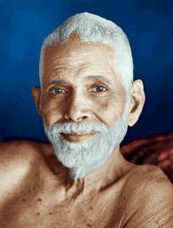

RAMANA MAHARSHI

If, in your relationship with your dead Spiritual Guru, you are always in a state of nice, comfortable, blissed-out bhakti, or ordinary and equally comfortable rationalization, you can be sure that fantasy is still at play.
The Sat Guru is not comfortable to those who are not used to the full flow of Reality.
The Sat Guru’s compassion is both tender and fierce. Not knowing the fierce aspect of compassion means, for most of us, that we will not find the strength to recognize our real condition.
The Sat Guru’s compassion is utterly personal and utterly impersonal. Not knowing the impersonal aspect of compassion means that we will not open to unconditional compassion. Our expression of compassion will remain limited and self-motivated.
Discovering the Sat Guru, meeting the opportunity of Sat Guru, is discovering the ineffable something for which you have always longed but could never name.
You may want to throw yourself at your Spiritual Guru's feet, fall into your Spiritual Guru's arms, and run away all at the same time.
Whatever your Spiritual Guru says or does, and whatever your reaction, even in the midst of seeming to reject what your teacher is showing you, you will know without a doubt that you are being delivered to the truth of your situation.
The Sat Guru is an explosion of Reality in your body, your mind, and your heart.
This explosion may be noisy and dramatic, or nearly imperceptible. But nonetheless, it is a situation of enormous dynamism. You cannot help but be moved. You cannot help but tremble at times with both fear and gratitude.
A teacher is chosen after due consideration. You do not choose a Sat Guru. Sat Guru is not a decision. Sat Guru is a sudden discovery of your Self. Sat Guru is a phenomenon, a shift in awareness.
The world presents us with infinite possibilities for Self-realization. So, why not a dead Spiritual Guru, or far-away Spiritual Guru?
If a student is capable of meeting the ever-present phenomenon of Sat Guru in this form, why not?
Because of the split artificial minds of Negative emotions and selfish ego.
The Sat Guru "channels the incidental cause of all evolution, the energy of the soul, which removes the samskaras or energy

blockages as a farmer removes stones from the water course" – Yoga Sutras of Patanjali 4:3
The energy of the Buddhafield surrounding a Sat Guru forces all samskaras or energy blockages out into the light of day, showing the student the symptoms of their blockages which cause the student to be separate from the original cause the Purusha the Soul, as negative emotions and negative thoughts.
As the Spiritual Guru notices the samskara or Energy Blockage caused pain of the student he sometimes chooses to remove the energy blockage through Meditation and Samyama– The Energy Enhancement Seven Step Process.
Only when the student can stay in the presence of the Spiritual Guru and absorb the energy of the Soul without any negative symptoms can the Student be said to have reached Enlightenment.

THE GURU STRATEGY - OR THE PATH OF BLAME, ONE
For those who have completed the Energy Enhancement Course you need to know the Guru Strategy above, in order to overcome the effect of the blockages within.
Remember, the Guru Strategy can never work with a DEAD GURU. ONLY DEAD GURUS are nice, are safe and can never provoke your ego energy blockages so that you can see them.
Gurus can be Charlatans or connected to an enduring tradition of connected Masters who have passed their energy on to the next Guru in line.
In order to be given the energy of enlightenment, first you must prove yourself, be tested as, non-egotistical and with a big heart which wants to help the world.
The Buddha described the passage of energy as a connection of lit candles, each candle lighting the next in line.
As Prometheus took spiritual light and energy from the Sun and brought it down to all human beings, in the same way he energized the next in the series of Gurus.
This same tradition is that which occurred to me from Zen Master Hogen, Swami Satchidananda, Sri Yogendra of Bombay, Osho Rajneesh, and Father Bede Griffiths.

When Satchidananda died IN 2002 he sent on to Satchidanand a portion of his light every night for three nights.
With energy and purity comes Initiation. Ascended Masters have attended Swami Satchidanand's initiations up to the Fourth Initiation, Monadic Fusion. HE IS WORKING HARD TO BECOME A WORLD TEACHER AND A FUTURE ASCENDED MASTER WITH LOGOIC INFUSION OF THE FIFTH INITIATION!!
Remember, your ego, the Charlatan, will never provoke the ego parts of its students and the ego parts will love you for it, leave you alone and give you many students.
Remember, your ego, the Charlatan, will always hate and compete with the real Guru, the Soul!!
The real Guru always takes the Path of Blame.

THE GURU STRATEGY - OR THE PATH OF BLAME, TWO
The first parts of the Guru Strategy are weeding out those who are too egotistical so that we do not waste our time with them. Some of the many ways are written here but Gurus are very inventive!!
- The web site is too colorful and too long. Too many notes!! As they said of Mozart in the movie, Amadeus! Or too long as they said of the Lord of the Rings. Tolkien replied that all of his lovers thought the Lord of the Rings was too short.
- The concentration on money puts off those who are too attached to money who will not spend on anything; or those who are too averse to money; who never have any and want everything for free.
- All the ego emotions have tried to prevent your course, - Fear, Depression, Anger, Lack of Trust, Distraction, Jealousy, Hatred, Needy Needing Attention, Disappointment.
- All the ego thoughts have tried to prevent your course; - This course is a trick and will not work. This course is too expensive. This course is too much trouble to save for. This course is not just a course where I can hide and chase sex in bedroom after bedroom. I can see this fault in Swami Satchidanand whilst forgetting the constancy of Projection, the Mirror, - that as one finger points, three fingers are pointing back at you – The Sufi Master, Dhun Nun, the Egyptian, was an expert at this as when he pretended to be mad.

THE GURU STRATEGY - OR THE PATH OF BLAME, THREE
Having passed the first test and come on the Energy Enhancement Course you have proved that your soul personality is strong.
Usually the logic of Satchidanand and work with Energy Enhancement can pacify the Inner Children ego blockages whilst on the course.
Everyone who comes on the Energy Enhancement Course gets some spiritual experience and has the experience of removing some blockages and then feels the benefit of that in their daily lives.
However; Don't Stop!!
After the course the Guru Strategy then starts to work on the Ego Blockages within. After being quieted on the course, the Ego Blockages now think that it is their time and they start to work strongly! You can use this to find them and to seven step them and to integrate them!!
However if you do not, then the Ego Blockage parts will win!!
Many students have said that if they meditated for one hour every day for a year after the Energy Enhancement Course and went through every Energy Enhancement Initiation again to ensure that all the blockages missed the first time were found. And that they used the blows of life to find desire and aversion which could then be seven stepped. Within ONE YEAR, they could become Enlightened.
I have videos of Students saying this which I need to make available here.
By being big, the Guru is against all Ego as the Ego Selfish Competitive Star thinks that the Guru is competing and the Guru is too much for any EGO Blockage Part.
The Guru is Enlightened and thus is greater than any selfish, competing ego.
The Guru has much Spiritual Energy, not only in quantity but more in quality and height and thus can remove any blockage if the student is humble enough to ask in the right way. As Satchidananda said, "The student must learn how to ask"
Therefore, in the same way that the Guru puts off people from the web site, he then excludes all those who fall for the ploys of the ego parts.

The ego parts all hate the Guru as they must always compete with him.
We can see this in the life of Jesus Christ where before he was crucified, everyone ended up hating him and wanting his death.
This is the voice of the ego. Do not listen to this…. The only safe Guru is a dead Guru, only then can you be safe. The only safe Guru is one you do not visit or email. Then he can not point out the faults pointing out your Ego Blockages.
So, use the GURU STRATEGY to find and seven step all your ego blockages. Seven Step each of the items below to help find your ego and purify and integrate it into your Soul.
- What is resisting you meditating every day and as well as gaining energy from connecting, doing at least one initiation and finding some Ego part to Ground?
- What is preventing you quickly doing your homework, given to you by Swami Satchidanand in order to help you ground your ego parts?
- What is making you avoid promptly emailing Swami Satchidanand with your progress and your need for help in finding the last blockage to ground?
- Use any bad thoughts towards Energy Enhancement to seven step them and find the Inner children who started them off.
- Use any bad or competing thoughts towards Swami Satchidanand to seven step them and find the Inner children or the psychotic, psychopathic, schizophrenic separated selves who started the bad thoughts off.
- As all the parts of your unconsciousness, the ego parts, hate Swami Satchidanand who wants them to be purified and integrated into the soul. Seven step Swami Satchidanand and trace back to the ego part blockages who hate him.
Remember these ego part thoughts of competition and hate towards Satchidanand and Energy Enhancement are at first unconscious, but the aim of the blockages is to make them conscious and make you act on them by not meditating or focussing on an Initiation to find some ego part to ground and thus not getting rid of the ego part blockages.
- Do not be afraid of wanting to enter into the Buddhafield again in order to chase out the next layer of blockages.
- Understand that by wanting to help Energy Enhancement in any way is good. The aim of Energy Enhancement is to help everyone on

this planet. Any aversion to this help is the work of the Energy Blockages.
- By wanting to become a properly certificated teacher of Energy Enhancement using the Guru Energy Enhancement Videos to teach all the people on this planet to become enlightened you can avoid using the path of blame yourself.
This Guru Strategy is a great strategy to enable you to find your ego and everyone else's ego!!
Use it and become Enlightened!! Make the whole world Enlightened!!

MEDITATION ENERGY ENHANCEMENT AND THE SELFISH COMPETITIVE EGO
EXISTENCE is in continuous celebration, except man. Existence is a carnival, an orgy of joy, except man. Man has fallen out of this tremendous celebration that goes on and on. Man is no more a part of it, man stands aloof, alienated -- it is as if man has lost the roots he should have in existence. Man is a tree which is dying, drying, no longer alive. Birds don't come to it, clouds don't sing to it, winds don't dance around it.
What has happened to man and how? Why is man in such a hell? Why is man always in such a mess? There must be something very fundamentally wrong.
Spirituality is a science which works. Which has deep improving effects on You. It is not just wishy washy hopes and yearnings.
And what has Energy Enhancement got to do with all this. How can it help to perfect the "Unregenerate man" the man who has a selfish competitive ego. That ego which is treasured over many lifetimes and yet always ends in pain. Why is man in such a hell? Well, this is the answer.
We are only allowed to have free choice so we can learn we only can have one choice, to do the right thing!! Any other choice brings pain and it takes many lifetimes to learn this through dire, painful experience. And to make that one right choice we must have the start of one enlightened personality.
They say that spiritual work integrates the human being and as this integrative process continues then the person becomes stronger and more joyous, and moves away from the phrase, "Mankind

sleeps in a nightmare of unfulfillment." eventually he becomes enlightened, described as a quantum leap of consciousness above the normal person.
Well, Energy Enhancement can give you more energy by plugging you into higher sources of soul energy and this in itself is enough to speed up the process of enlightenment. But more than this it shows ancient and effective ways of removing energy blockages from those hidden deep within the body which cause all aches and pains and the diseases which kill us, to higher blockages like Inner Children and Selfish Strategies.
Most psychological literature is consonant of the fact that most human beings have several personalities or sub-personalities which come into and out of consciousness without being noticed.
As Gurdjieff said, and he was teaching this knowledge, "The person who swears he will get up early in the morning to meditate is not the same person who throws his alarm clock out of the window!"
Because of this multitude of sub-personalities it becomes impossible to make a promise because we are all changing our minds all the time. And not in the normal sense. In the comedy group "Monty Python" there was a sketch where the protagonists were talking about going down to a shop, Woolworths, to buy a new mind, "Only a pound!" and special offers on different types of mind. "Oooh, I want an Einstein!"
When you change your mind you put in a new mind, a new sub- personality.
Each of these sub-personalities thinks of itself as real and the only one; and will fight to remain alive, yet, "There can only be One!"
And this is why most spiritual paths eventually recognize the necessity of making a decision to become enlightened. A commitment towards the light. Thus the becoming a monk. The commitment to the Guru. In the Psychological Hoffman Process which deals with inner children in a much lower and not so effective way as we do in Energy Enhancement, they sign a contract to stay through the process and do what the psychologists tell them to.
These commitments are necessary because the Inner Children Sub personalities tend to be emotional and not intellectual. They can press your emotional buttons. They can change your mind.
It is good to notice your own negative emotions, - anger, sadness, depression, fear etc as these show you your own inability to control your mess of Psychic Sub personalities. To notice the negative emotions and strategies which you and other people use and are

used by. Just to show you what needs to change. That you are not yet in charge.
And this is the meaning of Enlightenment. These blockage sub personalities get in the way of the Universal Energy Flow. They stop the light of the soul. They are a resistance in the Psychic Circuitry. As these blockages sub personalities are removed by the advanced techniques of Energy Enhancement so we get more light and Energy. We move towards having only one personality. A very strong soul personality which has removed all the other blockage sub-personalities and absorbed them into one greater, talented whole.
For hundreds of lifetimes the entity blockage sub personalities play within you. And you gain experience of the world and what works and what doesn't work. This knowledge is basic spiritual theory.
Quickly, "Be Good and Do Good." You learn that anything else leads to pain.
The soul is not interested in this work and lets the children play but, when a certain evolution has been achieved, the soul decides to make contact. Over several lifetimes the soul personality becomes more and more strong, eventually becoming the enlightened personality which throws out all the rest. This is the spiritual meaning of the Cuckoo.
There is an interesting story from the enlightened Master Daskalos from Cyprus.
When he was young and inexperienced he was asked by a Greek Millionaire to come and heal his son. His son was a homosexual, drug addict and gambler. So Daskalos comes in, full of power, and removes the three evil sub-personalities, and very happy he goes away.
Three days later the father rings again and says that his son is just lying on the bed with drool coming out of the sides of his mouth. Daskalos realizes that this son has not yet been contacted by his soul. As yet he has no soul!! So the only thing he can do is put back one of the previous sub personalities.
He decided on Homosexuality as being the least of the three evils and puts it back. The son bought a villa and filled it with art treasures, learnt how to paint and play the piano gave parties, had lots of beautiful boyfriends and was indeed very happy with his life and growth.
I want you to understand not just about the soul contact in evolved people, but also about the fact that because Daskalos had the ability to become enlightened and heal his own sub personalities,

from this he also had the ability to heal the sub personalities of other people, even you!!
And the sub-personalities he absorbs and purifies from others he integrates into his own soul, making it bigger, greater and even more talented. Once you have mined your own store of talented Sub-Personalities in becoming Soul Infused and Enlightened, so you continue by absorbing the Sub-Personalities of others in becoming a Monad Infused Super Enlightened Person and then you take and use the spare parts of others, like BM's, in becoming a World Teacher, a Logos Infused Personality and future Ascended Master..
This is the nature of people who have been through the Energy Enhancement Process. That they have these Psychic Powers which are the birthright of every soul. And this we teach in Energy Enhancement Level Three!!!
And this is the nature of your Energy Enhancement Teachers. Their aim is to help your process.
This is why Gautama Buddha said that he was here only for one person in a thousand. For those people who were working with the soul. Those people just on the verge of enlightenment.
Such high techniques as Energy Enhancement first put you in touch with your Soul. This is the purpose of Energy Enhancement Level One.
Only Levels Two and Three start to work with Energy Blockages in the body, the chakras and then the Inner Children and Selfish Strategies.
Yet many people look only at the mountain they have to climb. Like most negative emotions this is simply a button which has been pushed by one of the Sub-Personalities within you. In order to stop you moving forward and absorbing him back into your central soul stem.
The Energy Enhancement Process is simple and easy. All you have to make before you come is a decision, a continuous commitment towards your own enlightenment.
Satchidanand and Devi Dhyani are there to facilitate your progress because everything is your choice, just read the testimonials from many happy students. They have the capacity to point out and absorb even the deepest blockages: because of that, only the students with the deepest blockages come to see them.
This sub-personality knowledge has been known for at least 5000 years as it is the basis of enlightenment. And people have been

becoming enlightened for thousands of years. These sub personalities are the Nafs of the Sufis and Gurdjieff was a Sufi Master, and here is a quote from one of the source books of ancient knowledge on this Energy Enhancement process….
Excerpt from the Yoga Sutras of Patanjali, - Source Book of Raja Yoga - Book Four, Kaivalya Pada - the Portion on Absoluteness, Sutras 4-6
Yoga Sutras of Patanjali, Book Four, Kaivalya Pada - the Portion on Absoluteness, Sutra 4.
The Buddhafield and Soul flow of Energy in Meditation Energy Enhancement does not directly cause natural evolution; it just removes the obstacles, the Energy Blockages and sub-personalities, as a farmer (removes the obstacles in a water course running in his field).
Yoga Sutras of Patanjali, Book Four, Kaivalya Pada- the Portion on Absoluteness, Sutra 5
A Yogi's egoity alone is the cause of (other artificially) created minds.
When something bad happens, particularly when we are children, the trauma causes the ego mind to split and a sub-personality inner child is created which egotistically, selfishly uses all the strategies to GET WHAT IT WANTS!!
We teach how to heal these selfish ego minds by grounding their initial pain cause and then absorb them back into the central soul stem. There can only be One!!!
Yoga Sutras of Patanjali, Book Four, Kaivalya Pada- the Portion on Absoluteness, Sutra 6.
Although the functions in the many created minds may differ, the original mind-stuff of the Yogi, the Soul, is the director of them all.
This finding the director or the soul personality is one of the aims of Enlightenment. As we evolve we naturally create strong sub personalities in our minds. Eventually we have to integrate them back into the even stronger director, the soul light which is higher than the mind.
However, many people so far have not met the director and are evolving through the sub personalities. Basically if you follow the lead of a sub-personality it always goes wrong. The right choice can only come from the Soul and above as anything else comes from the selfish competitive ego. "We are here to learn that we have the free will only to make the right choice!"

Thus Gautama Buddha said he was there only for those few who had the possibility of change.
In Energy Enhancement we ask the Zen Koan, "Who is in charge??"
Finding the answer to this is the search for enlightenment itself and Energy Enhancement has the knowledge and ability to help YOU!!!
Come this summer for your Energy Enhancement Course in Sunny Spain!!!

SINCE 1993 - FIFTEEN YEARS OF FANTASTIC COURSE REPORTS

LIZABETA’S RETURN - SHE CAME TO VISIT US FOR AN AFTERNOON AND ASKED FOR ADVICE
AFTER HER FIRST COURSE WITH US LISABET TOOK YOGA TEACHER TRAINING AND ALSO TOOK ENERGY ENHANCEMENT REIKI MASTERY
THE RETURN...


Picture from September 2006 when Lis came to visit and ask for our help with some Inner Children coming from past lifetimes. We had pizza on the beach and a wonderful afternoon.
After the EE course 3 years ago I kept doing the meditation exercises I had learnt there.

I am normally a happy person, except from this deep life crisis coming sometime without warning- always with an overtaking feeling of There Is No Meaning With My Life.

My experiences, after Satchi’s suggestion that I look in the past lifes for the reason to my depressions, was as follow:

I went back to a past life, and got a very clear picture of a woman sitting in a dark, cold, cavelike cell chained up. Me. I´ve been sitting there for years, every day being the same and with a strong despair and an overwhelming feeling of; really there is no meaning with my life...

I healed that past life using the Energy Enhancement Seven Step Process of Level 2 and felt much better- but still, there was something more...

In to another past life, this time I was another woman, in America during the Wild West time. Me and my husband lived on a farm far away out in the dry country side, no neighbors, no real road out to the farm, so nobody passing by. It was a lonely life, no children, my husband and I didn´t speak much. Every day the same- I was filled of the feeling-; really there is no meaning with my life...

Do I need to tell you that since then I haven’t had any more of those depressions...!



ENERGY ENHANCEMENT WITH LISABET FROM THE 2003 SEPTEMBER COURSE

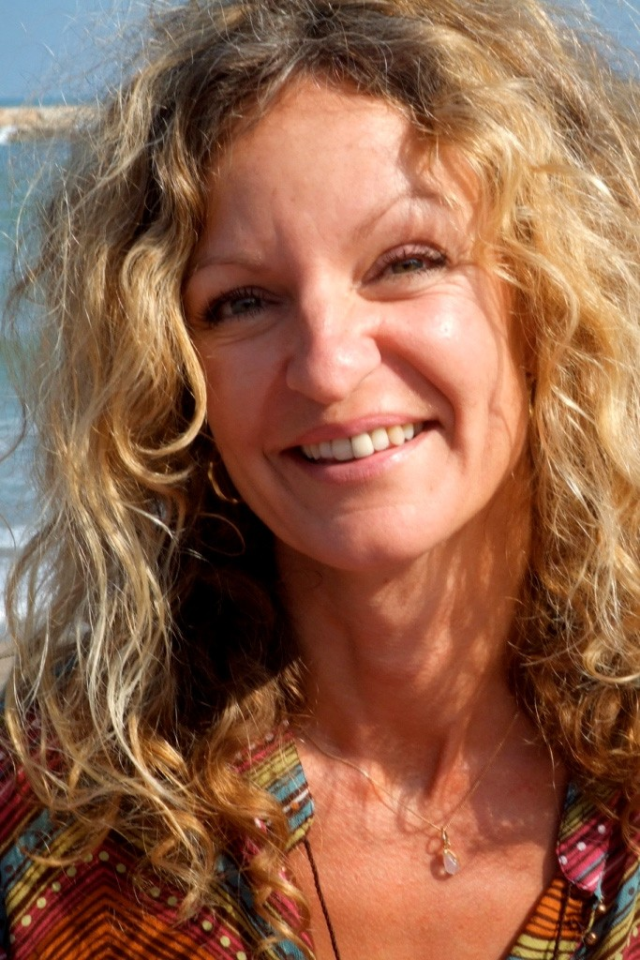
Picture from September 2006 when Lis came to visit and ask for our help with some Inner Children coming from past lifetimes.
Well, in the middle of a Three Level Energy Enhancement Course and Energy Enhancement Yoga Teacher Training Course we had some experiences with Lisabeta from Sweden. She is an incipient Priestess with psychic energy gifts which can be amazing until

training makes them useful.

Lisabeta has been to Peru for Training with a Shaman on the Inca Trail.
Yesterday she had a wonderful experience after the Yoga session. I was playing the Gyuto Monks from Tibet whose job it is to use their Chanting of Prayers and Mantras to expel and exorcise entities and negative energies from the surroundings.

The recording was made in Saint John the Divines Cathedral in New York in the presence of the Dalai Lama. The beautiful Digital Recording was paid for and organized by Richard Gere the actor and Mickey Hart, the drummer from the Grateful Dead. The disk is available on rykodisk.

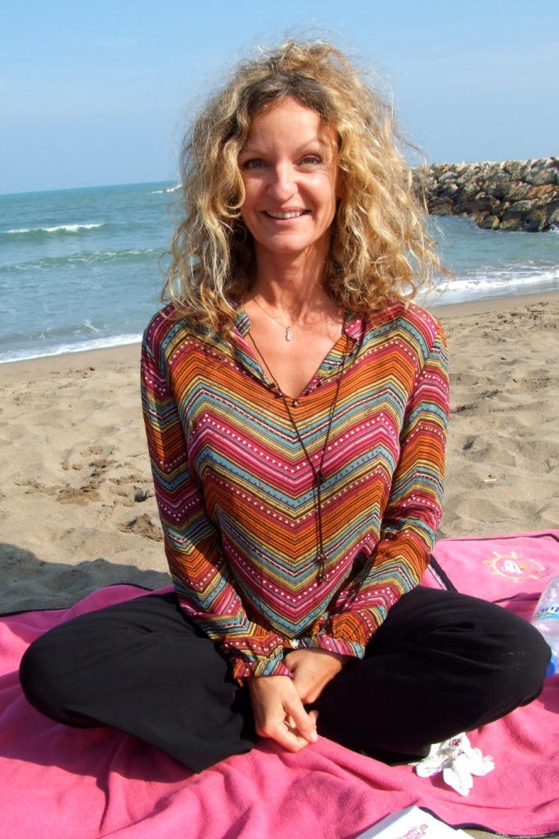
Picture from September 2006 when Lis came to visit and ask for our help with some Inner Children coming from past lifetimes.
We had pizza on the beach and a wonderful afternoon.
It is interesting that there in the Cathedral talked my teacher Swami Satchidananda on many occasions. He was invited to talk there because he so impressed the rector of the Cathedral with his

presence and Energy of Enlightenment but also because he received the Martin Buber award for World Peace due to his efforts in the Ecumenical field.
How can this World come together as One, in Peace and Harmony, if the Religions of this world are still fighting one another?
The Truth is One, He said, The Paths are many.
We use the energy of the Gyuto Monks whose heartfelt prayer, Negative Thoughtforms, entities and human delusions are endless, we vow to end them all!! and so they stay on this planet from lifetime to lifetime, dedicated to the Enlightenment of all beings.
We use their chanting to clear the negative energies released from the energy bodies of our clients through the Energy Enhancement purification process.
So after the yoga we were meditating with the chanting of these monks in the background and the Energy Enhancement techniques in the foreground.

Lisabet reported that she felt the energies coalescing in her Solar Plexus going round and around, and then they shot down into a blockage she felt for the first time in her Abdominal Chakra. Then the Kundalini Energy started to travel powerfully all around her body up into the center of the Universe and down into the center of the Earth.
She felt goose pimples all over her skin. The energy was coursing and rushing through her body in very strong waves for at least 30 minutes and when it was time for lunch she did not want to come out of it, she was laying on her back and couldn´t stop laughing of happiness!
Usually such Kundalini experiences are just adjuncts to the process of clearing energy blockages.

Said Sufi Master Saadi, When the energy is flowing correctly, there is no movement!

And these powerful sensations are just Kundalini energy flowing through a blockage resistance as the blockage is in the process of being removed.

We tend to remove Energy Blockages in waves. At first we remove all the easy blockages and then as we go deeper into Energy Enhancement we raise our energies higher and stronger, deeper blockages become candidates for expulsion. Like the layers of an onion we expel all blockages. The more powerful blockages hide

until sufficient energy is there to remove them. The last and most powerful blockage is removed just before enlightenment. And that one is a Doozy!!
And when we gain energy enough Energy Enhancement Energy, up pop the blockages.

And when you feel them, that is when we can heal them!! When you see them, you can free them!
So, the next day this abdominal blockage came to the presence of our minds by creating all sorts of negative energies and thoughts.

Abdominal blockages are caused by disappointment in relationships in this and past lifetimes. They travel with us from lifetime to lifetime until we learn how to heal them, They draw similar experiences to you until the negative energy of the blockage becomes insupportable.
To those that have, more will be given.

Until the blockages are removed through evolution and training. And eventually these blockages become a matter of life and death.
Until, To those that have not, it will all be taken away! All your blockages are removed.
Blockageless you become a serious candidate for the Third Initiation of Enlightenment. You get energized through Initiation and then become Enlightened. This is the Energy Enhancement process.

Not only through the first initiation of Opening the Heart. Or the Second Initiation of the Mastery of Relationships and the Third Initiation of Enlightenment itself, becoming a Soul Infused Personality. But also further initiations of the Fourth Initiation, becoming a Monad Infused Personality. And more!!

Enlightenment is only the first Dan. You then become fit to learn by yourself.

This is the Energy Enhancement Process of progressive blockage removal and Initiation.

We meditated the next day and I felt a painful Vitriolic ball of fire in my belly. I was feeling the Energy Blockage of Lisabet which was

just waiting for time, place and energy for it to become available for removal.

And Lisabet became so tired and painful she lay on her side in a Fetal position.
As our other student and I continued to meditate we used Second Level Energy Enhancement techniques to Ground and remove Lisabeta’s Abdominal Energy Blockage. She actually saw an angel in her mind coming to help her remove the strong anger she felt, so she was delighted when she found out that the "angel" was Satchi.

A good training for our other student as all teaching comes through psychic experiences like this on the course. Things just happen and through the experience of doing, because as we are just reminding you of what you already know, you Grow.

Picture from September 2006 when Lis came to visit and ask for our help with some Inner Children coming from past lifetimes.
We had pizza on the beach and a wonderful afternoon.
Eventually on the Energy Enhancement Course we move on into enlightenment experiences like Lisabeta from Sweden.

In one of the last mailing list broadcasts I told of Lisabeta's process for getting rid of one of her energy blockages. Usually the first energy blockages on the energy enhancement course are the easiest. The one we described last time was heavy but manageable, and came towards the end of the course after many similar experiences, particularly when you see what this blockage removal led to...

On the last day of her course, after 4 weeks of Energy Enhancement blockage removal, Lisabeta was getting ready for her Yoga Teacher Training tryout. She was going to give another lesson in Yoga to us.
Well as she was preparing she decided to do a little meditation and when she sat, she just felt all this energy which made her want to sit even more.

She felt herself ascending higher and higher like her head was going up into the center of the universe and she was breaking through one of her old barriers, like her head was pushing through the top of an egg.
As she broke through this barrier, she felt fingers brushing through her hair with a sweet indescribable energy for what seemed like a long time. Well, we were trying to get her to come to the yoga class. Talking to her and telling her to come out of it. But she could not hear us, she did not want to. She was in bliss. Gentle fingers brushing slowly through her hair.
She stayed in this state for two hours without moving!
Please remember that Lisabeta had done meditation before coming on the Energy Enhancement course but never been able to sit for more than 45 min, and Swami Sivananda used to say, if you can sit still without moving for three hours, the chances are that you are enlightened.

Well, perhaps Lisabeta is not enlightened, but if you see her now as we did when we met again, last week, one year after her course with us, you would definitely see an energy glow around her. She looks just glowing with energy, relaxed and wonderful. A big smile all over her face!

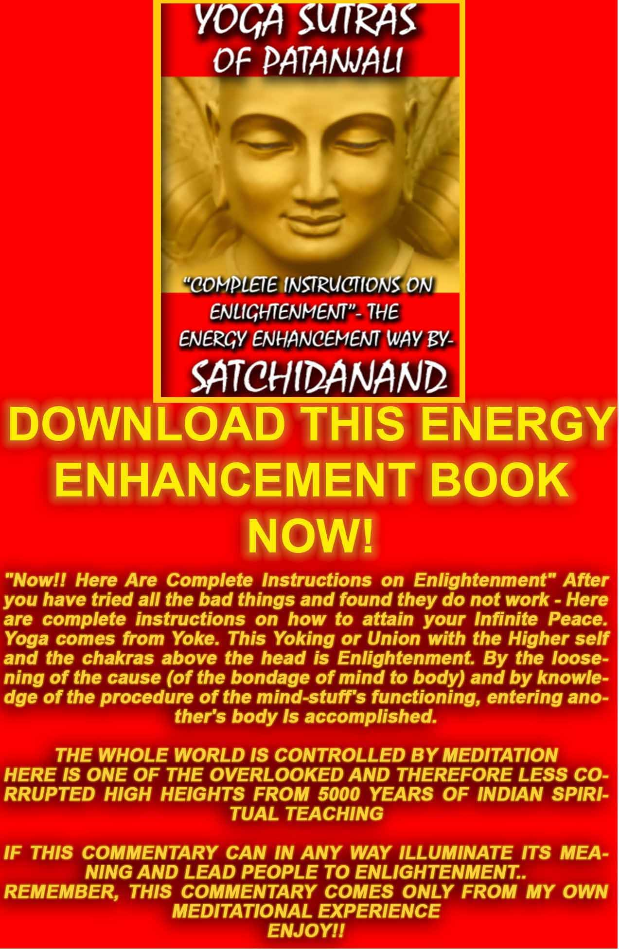
THE YOGA SUTRAS OF PATANJALI BY SWAMI SATCHIDANAND - DOWNLOAD HERE..
http://www.energyenhancement.org/Sacred-Energy/yoga-sutras-of-patanjali-book/Energy-Enhancement-Yoga-Sutras-of-Patanjali.pdf

SATCHIDANAND AND INNER CHILDREN
We are talking about Energy Enhancement Level Two when we work on the parts of the mind which split off when something terrible happens, like your mother and father leaving you or dying when you are young or if you get attacked or abused.

These "Inner Children" which split off from the central stem of the personality need to have their pain and negative energy grounded and healed, and they need to be brought back into the central stem of the soul. Soul Retrieval.

There can only be one.

And that is the Soul Infused personality.

The act is very similar in action to the Shamanistic "Soul Retrieval" where the Shaman acts to heal and bring back the split off parts of

the Soul to the sound of a Drum.

The difference is that in Energy Enhancement we teach you how to do it for yourselves.

You don't always have to be depending on a Doctor or Shaman and paying their fees. Yet we are always here for you.

There are energy centers higher than the Soul on the way to the "Spring at the top of the Mountain".

One, the Group Soul is called the Monad and consists of all the souls on this planet which comprise the group and the reflections of those souls.

As I often say, Enlightenment is only the First Dan. That is when you become a Soul Infused personality, when you have to integrate all the sub-personalities back into the Soul Central Stem, yet the next Initiation or Dan is where you become a Monad infused Personality.

In order to become a Monad Infused Personality, similarly to the Soul infused Personality, where you have to heal and take back all those painful sub personalities or Inner Children, we instead, at this stage, have to heal all members of our Soul Group.

We have to make them Enlightened!! THIS IS The force behind a Guru!!
This act becomes more important than life and death, as we activate the archetype of the Boddhisattva, who promises that when he becomes enlightened he will not leave this planet. Instead he will wait until all the people on this planet have become gone on into existence before him.

Honey Kalaria in Argentina

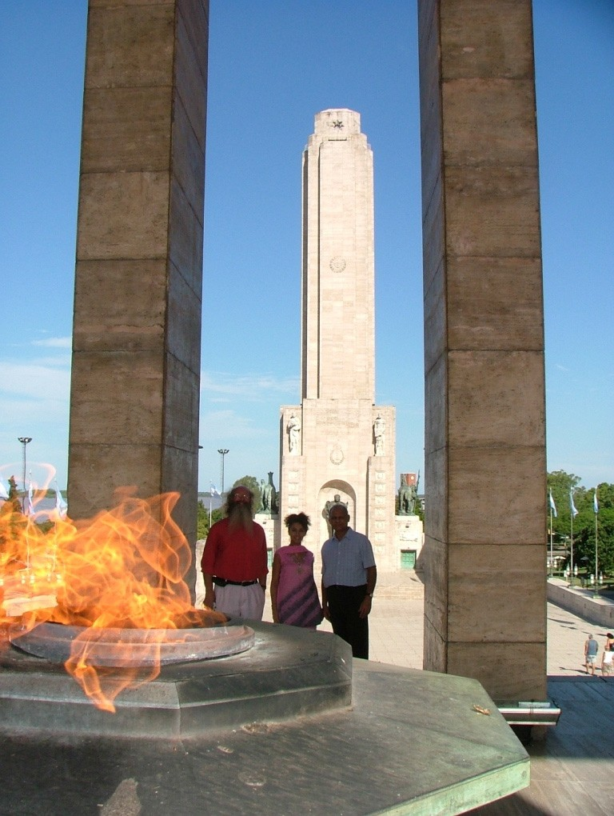
HONEY, SATCHI AND NATWARLAL, HONEYS FATHER, AT THE ANTAHKARANA MONUMENT FROM THE JAN 2005 COURSE IN ARGENTINA

During the Meditation Retreat Honey Kalaria had the following experiences:



Honey Kalaria is an incredibly beautiful woman, Film star, Choreographer, Businesswoman who runs Diva Entertainments and has been presented with a Doctorate in the Arts from London University in recognition of her services.
Here I am today, sitting down, putting pen down on paper whilst gathering my thoughts on the amazing Energy Enhancement Course that I am currently on.
Where do I begin? Firstly, I felt it would be great to share my experiences of the Energy Enhancement course with other like- minded people. The following information is for those interested in growing spiritually, and wanting this world to become a better place - starting from improving themselves!
My name is Honey Kalaria (www.honeykalaria.com). I live in London, UK and am a dancer, choreographer and an actress specializing in the world of Bollywood (the Indian Film Industry). I run Honeys Dance Academy, the largest British Asian Dance academy in the UK, running 14 schools throughout London and teaching bollywood dance, bhangra and acting (www.honeysdanceacademy.com). I also run Diva Entertainments, which is an agency specializing in providing Asian artists for television, films and stage shows (www.divaentertainments.com).
Although involved in the world of glitz and glamour, I have always been interested in Yoga, meditation and growing spiritually. I respect all religions and faiths, as I believe they can all be used as a ladder to climb up to God. Personally, although I am from a Hindu background, I am a firm follower of the Religion of Humanity. For me, this means trying to make a difference to the people around you every single day, trying to follow a righteous path every single day and making a difference to the world every single day. This I believe should be done through your work, actions, words and deeds, instead of following rituals and customs, although rituals do help people focus on the religious work at hand.



INTEREST IN SPIRITUALITY
My interest in spirituality has been there since childhood. My Mother used to advise me on how I should pray every night before going to sleep so God could look after me. So, from the age of 2-3 years, I have prayed almost every night, except when I went through a period of becoming an atheist. Yes, an atheist!

My knowledge of spirituality came from a lot of different sources – from a young age I used to get involved in a lot of Hindu ceremonies, around the age of 13years I attended Bible study classes and by the age of 18, I had attended numerous seminars, workshops and courses on meditation and had read many books on related subjects. In my late teens I lost my sister in a tragic car accident. I was shocked and felt abandoned by God due to what had happened, and it was then that I became an atheist for a number of years. Luckily, with passing of time I healed and became strong again. I couldn't keep away from my thirst for spiritual knowledge, and so after a few years, I began learning about different faiths again. I studied about Buddhism, Hinduism, Islam and Christianity and read extensively about Mysticism and Eastern Philosophy. It seemed like God kept testing me along my path through different experiences, and teaching me lessons to help me acquire more wisdom and understanding, but never allowing me to lose complete faith.
MEETING WITH THE GURU
In the year 2000 I was blessed to meet my Guru - My spiritual growth accelerated in the next few years with Guruji's blessings, and to help me grow further, I feel he guided me to enrol on the Energy Enhancement Course. I felt strangely drawn towards the Energy Enhancement Course when I stumbled upon it through my internet research, a week or two after I had returned from “Guru Purnima”, a special spiritual event that I celebrated in India in July 2004.
Since then I have started up a meditation centre where meditation is taught for free within easy traveling distance of London.
THE ENERGY ENHANCEMENT COURSE
A t the East London Meditation centre, I thought I would inform everyone of this opportunity. There seemed to be a lot of personal commitments coming in the way and resistance to the Energy Enhancement Course by everyone except one friend and my father who agreed to join me. So without wasting much time, the course was booked for the three of us. The course was run by Satchiji, a modern day Guru, and assisted by Devi, a chakra clearing sacred dance expert and Reiki Master.
Once on the course, my exciting adventurous journey began! In my life I have done hundreds of courses but the Energy Enhancement Course I found to be completely different. Firstly, the contents and the teachings seem to be inspired by higher forces and had a deep base in spirituality.

DIRECT EXPERIENCE OF INFINITE ENERGY
Also, you don't just learn about ideas, concepts and theory, but also learn through direct experiences whilst doing the exercises. As you progress through the course, the powerful and effective techniques are taught step by step, so that at each initiation you can work thoroughly and obtain a firm understanding.
The Energy Enhancement Course involved learning how to connect with the Universal Energy , some would call it the Life Force, Spiritual Energy or God , and being able to tap into this powerful energy.
By having a direct connection with the Infinite Energy you begin clearing and activating your chakras or the seven power centres in your body and those chakras above the physical ones , and start removing blockages from your physical and your psychic bodies (aura).
These blockages normally prevent people from growing spiritually and living a more harmonious and peaceful life.
The Energy Enhancement Course has helped me to strengthen physically, emotionally, mentally and spiritually whilst building my psychic muscles to encourage stronger intuitive skills to develop.
THE SEVEN CHAKRA SUPER COMPUTER YOU
I was told that each of our seven chakras within our bodies and the chakras above the crown chakra should be seen as a separate mind
- brain like one of the processors in a parallel processing computer. All the Super Computers these days are parallel processing computers. The integration of all the processor chakras produces the super computer you. We use only one brain or processor and the idea is to activate the other chakra brains or processors to build your creativity, intellect, wisdom and genius abilities.
This will lead you to become happier and healthier, enjoy being a more emotionally and mentally balanced person and become a more blockage free (free of negative emotions) human being. The idea is to have a purpose in life to make this world a better, more peaceful and spiritual place, starting from working on yourself as mentioned before.
The Energy Enhancement Course offers a wide range of theoretical knowledge gathered from the most powerful spiritual teachers and sources in the world. I have had the opportunity to absorb teachings from world renowned Guru's, Religions and topics such as Satchidananda, Maharishi Mahesh Yogi, Sai Baba, Gurdjieff, Bhagavad Gita, The Bible, Zen Buddhis m , Sufism, Mantras, The

Yoga Sutras of Patanjali, powerful meditations, Free Reiki Mastery and much, much more. I also learnt techniques that include visualization, psychology and powerful spiritual practices together with studying films with spiritual messages. This combination has resulted in giving each student on the course, including myself, a “fast track” spiritual growth boost by expanding our awareness levels and sharpening our intuitive powers.
AMAZING EXPERIENCES ON THE ENERGY ENHANCEMENT COURSE
I must admit that when I started I wasn't exactly sure where all the exercises were going to be leading to, but then I began to have profound experiences.
There are just too many to share and perhaps one day I may even write a book on the amazing journey that I have been through whilst on the Energy Enhancement Course. My experiences include having visions, being healed physically, receiving excellent guidance and deep insights from the Spirit of God, finding hidden inner children, sub-personalities and strategies that I use to behave in a certain way and justify my actions and then finding my 400 year old husband!! The list just goes on.
PAST LIFE EXPERIENCES
One of the experiences I would like to share with those who believe in re-incarnation is that in one of the exercises, I was blessed to see some of my past lives. I was astounded by what I saw, the clarity of the visions and with actual dates being revealed. What I learnt was that we came into this life to learn various lessons or to complete certain outstanding desires. It is so important to be careful with what you wish for in this life.
These were the past lives I saw: PAST LIFE IN LONDON
1308 – I was a high society male teacher / lecturer who gave talks about my research into stars, astrology and philosophy. I taught large groups of people, was involved in discussion and debate groups and was well respected in the area of my work. I was also a womanizer and drunkard and died at a young age in my mid 30's. I tried to get my name and got the name Martin or Matthew and second name was something like Hayward or Haywood.
CURRENT PERSONALITY TRAITS: I am a strong communicator, enjoy teaching as I am presently a dance teacher, give lectures in business and success, interested in Astrology and philosophy, a non alcoholic and am a leader in my field of work.

PAST LIFE IN INDIA
1412 – In my next life I was again living in high society – it must have become a habit to be born into such an environment.
I used to be a right hand assistant to the Princess of Jaipur and was accustomed to living in luxury in a grand palace. The princess and I used to take dance classes with a dance Guru and then we would both have fun and practice together. My Father was a farmer providing food and fruits to the King. I got used to organizing all the important things for the princess. I even regularly prayed and danced in the Temple for Religious celebrations with the women.
There was an incident where a Prince had come to ask for the hand in marriage of the Princess but ended up falling in love with me.
From that a lot of challenges and problems were created for everyone concerned.
CURRENT PERSONALITY TRAITS: I have developed skills to delegate and organize projects, run my entertainment business empire successfully, enjoy wearing beautiful Indian costumes and garments, always thought I deserve to be treated as a Princess, perform dance professionally, appreciate historical buildings and palaces.
PAST LIFE IN NORWAY
1638 – It seems that I had taken away someone else's potential marriage partner, so in my next life a partner was not written in my destiny. I was a popular happy go lucky Norwegian girl born in a poor family. I saw my house based on top of a hill with countryside to be seen all around, the market place where I would go to buy vegetables and many other details. My mother had passed away and so being the only child, I used to look after my old and weak father. I always felt that to be a good daughter I had to support my family, otherwise I felt guilty for not being there for them. As a result, I never married my lover and suppressed all my wants and desires. I lived the rest of my life as a spinster.
CURRENT PERSONALITY TRAITS: Find it difficult to break away from my family, and am presently quite happy to be single and living with them. I am also attracted to European men, enjoy the countryside, love nature and get great pleasure in spending time at home (whenever time permits from my busy schedule). I am comfortable living in extravagance as I did in the Jaipur Palace and yet I can be equally satisfied living in simple accommodation as I did here.

PAST LIFE IN ARABIA
1705 – Perhaps I was so heart broken that I must have been wishing to experience what it would have been like being married or having men in my life. So in my next life, I was born as an Arabian dancer, dancing for the rich Sheikh in the desert. I used to look after and be of service to the male guests of the King, and possess excellent communication skills and etiquette. I was born to a beautiful single Mother and was trained to dance at a very young age. After I reached a particular age, I was sold/given away. Luckily I had a lot of faith in God to make things better and constantly prayed to give me strength and take me away from the lifestyle that I was in.
CURRENT PERSONALITY TRAITS: Learnt that it is important to establish a long term personal relationship packed full of variety and consider one night stands as complete waste of time, blessed with natural dancing talent from birth (the skills have developed over many lifetimes), I adore Arabic music and consider belly dancing to be one of my favorite dance forms, I am very spiritual, I enjoy water around me (probably because it was rare to see water in the desert) and have an aquarium in my home and a pond with a waterfall in my garden. I also tend to get along very well with male friends and business associates.
PAST LIFE IN TIBET
1893 – God always answers prayers from the heart. Wishing to follow spirituality and living away from women serving men led me to become a 11 year old Tibetan boy living in a Buddhist Monastery. It involved simple living, regular meditation and following a chaste life. The training helped me to become extremely disciplined and I gained a lot of my spiritual knowledge and intuitive powers through this lifetime. I had a wise Buddhist Master, who I feel may still be guiding me to stay on the path of spirituality. He used to always say: “You ask too many questions!”
CURRENT PERSONALITY TRAITS: I am always asking questions - as I'm sure all my present Gurus and teachers would agree! I'm extremely interested in spirituality and feel drawn to that area. I have now chosen to wait for a lifetime partner to enjoy a sacred physical relationship with and I felt an urge to study Buddhism.
PAST LIFE IN TURKEY
Satchiji suggested I go through an Energy Enhancement past life regression exercise to find out if I previously knew one of the students on the Energy Enhancement course called Ramya. Ramya is half Italian and half Spanish, a Hare Rama Hare Krishna devotee

and is a Radio presenter for a spiritual program that was voted the best Radio Program in Argentina and received The Golden Seagull award.

I was feeling his magnetic energy from the start of the course and became curious as to why – I have never felt this type of intense connection! I felt that I knew him and Ramya also felt that we had met before and had a very strong connection of some sort.

1611 During the exercise I found myself on a battlefield / town in Turkey. I was crying and leaning over Ramya's body that was covered in blood as he lay dying in front of me! Scenes of death and destruction were all around me. I had a young child in my left arm and I was pregnant. I was so much in love with my husband and felt heart broken seeing him suffer during his last moments of life. I must have made a vow to meet again in our next life so we can be together once more.

CURRENT PERSONALITY TRAITS: I noticed how throughout my lives I had never got married and even today I remain single as I am so dedicated to my work. Ramya and I had to both ground this karmic relationship using Energy Enhancement techniques so that we could now be free to move on.

From the Energy Enhancement Course I have just realized that my past lives have also enabled me to develop an interest in different religions and faiths. From my life in Jaipur, I followed Hinduism; as a British lecturer or Norwegian, perhaps Christianity; from the life as an Arabic dancer Islam/Sufism and from a Buddhist monk, Buddhism and meditation.
THE MYSTERY OF KARMA AND THE GROUNDING OF NEGATIVE ENERGIES
I understood how lifetime lessons and experiences actually develop your soul and past life impressions remain on your psychic bodies. Once certain negative karmas are found, they need to be grounded so that they do not affect your current life situations. I found this insight to be such an eye opener, especially when meeting my 400 year old past life husband from Turkey! I couldn't believe that from all the places in the world that I can travel to, I ended up being drawn to Argentina, doing a meditation course, meeting Ramya and completing a Karmic relationship promise that I had made 400 years ago.

CHANGE YOUR LIFE
There were many other outstanding experiences by the other dozen or so members that were on the course:

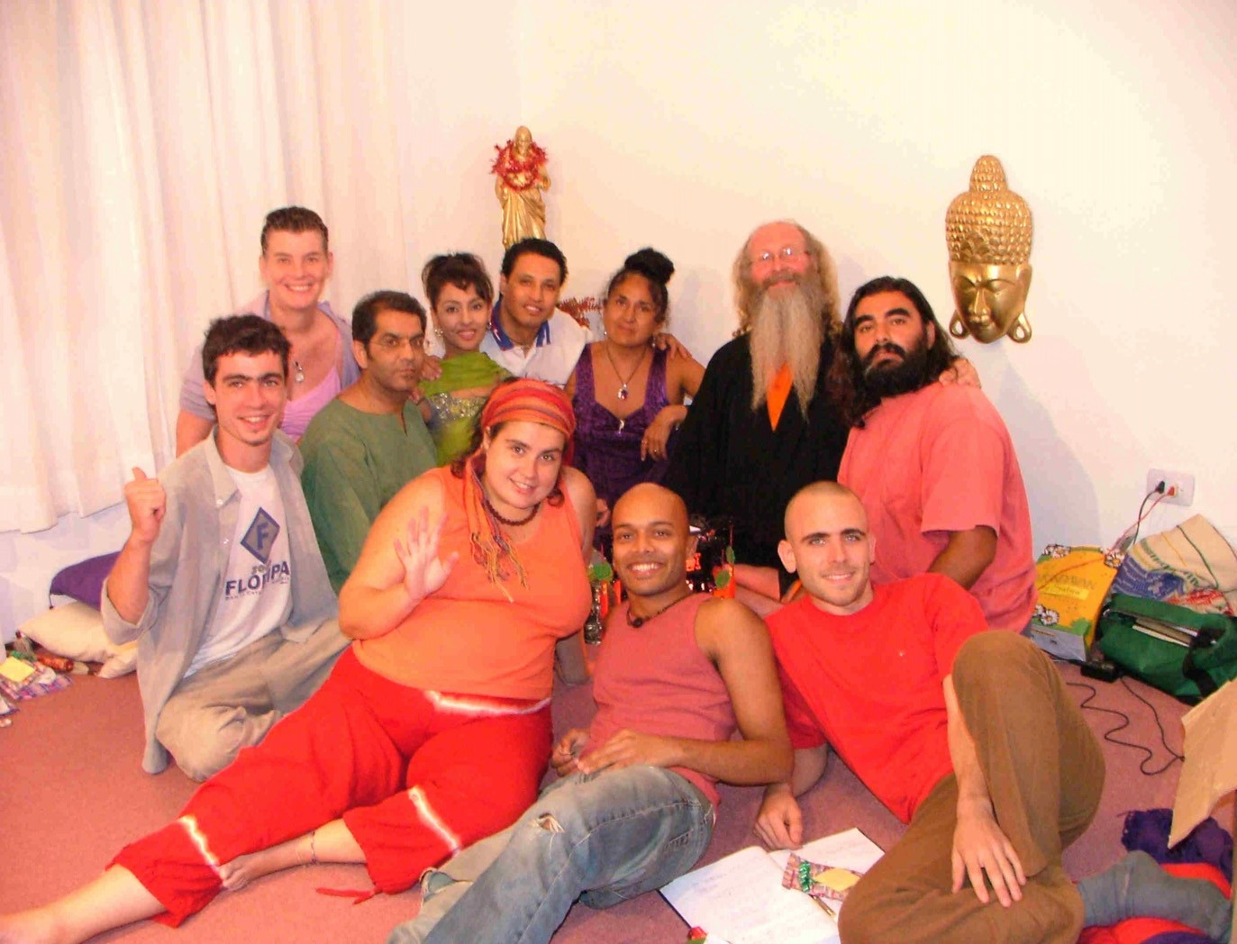

DEVI, VANESSA, DHIREN, RAMIA, HONEY, FEDERICO, SIVANANDA, DAVID, SHAKTIANANDA, SANTHAN, NATWARLAL, HONEY, DEVI AND SATCHI, ABOVE.
These people came from all faiths – Sai Baba followers, Catholics, Buddhists, Krishna devotees etc. Shaktiananda gave birth to two babies 2 months after the course! It was fantastic to see insights into the world of spirituality and how the Energy Enhancement techniques were creating profound changes in people's lives.
In addition, I also learned how to use the Energy Enhancement techniques to help me ground these negative blockages so they would never affect me again. Of course complete freedom can only come after a maintenance program has been followed.
CHALLENGES ON THE COURSE
I continue to say Thank You to God for blessing me to be on this course. I think you need to be extremely lucky to be able to receive such spiritual knowledge and teachings. When trying to do God's work, you always attract dark forces to keep you away from growing spiritually, and there were many challenges experienced by

my fellow students and I trying to prevent us from growing. These would be in the form of negative thoughts, distractions, feeling lazy and sleepy, right though to people having to leave half way through the course.
Satchiji and Devi had already warned us in the beginning that if you are not vigilant then some of you will not be able to complete the course, and I had a direct experience of that. My father was one of the people enrolled on the 1 month course in Argentina who had to leave half way due to the death of my uncle (his older brother). He had to immediately fly back to London after hearing the sad news.
THE KARMA CLEARING PROCESS
Deep rooted issues would surface and as soon as they were dealt with, even deeper issues would emerge that we would have to deal with. It was like peeling layers of an onion to go deeper and deeper into our core being to understand who we are and what kind of personality traits we have adopted, consciously and sub-consciously to deal with the issues of this world. I understood clearly how these beliefs, conditioning and past life impressions were affecting all areas of our life.

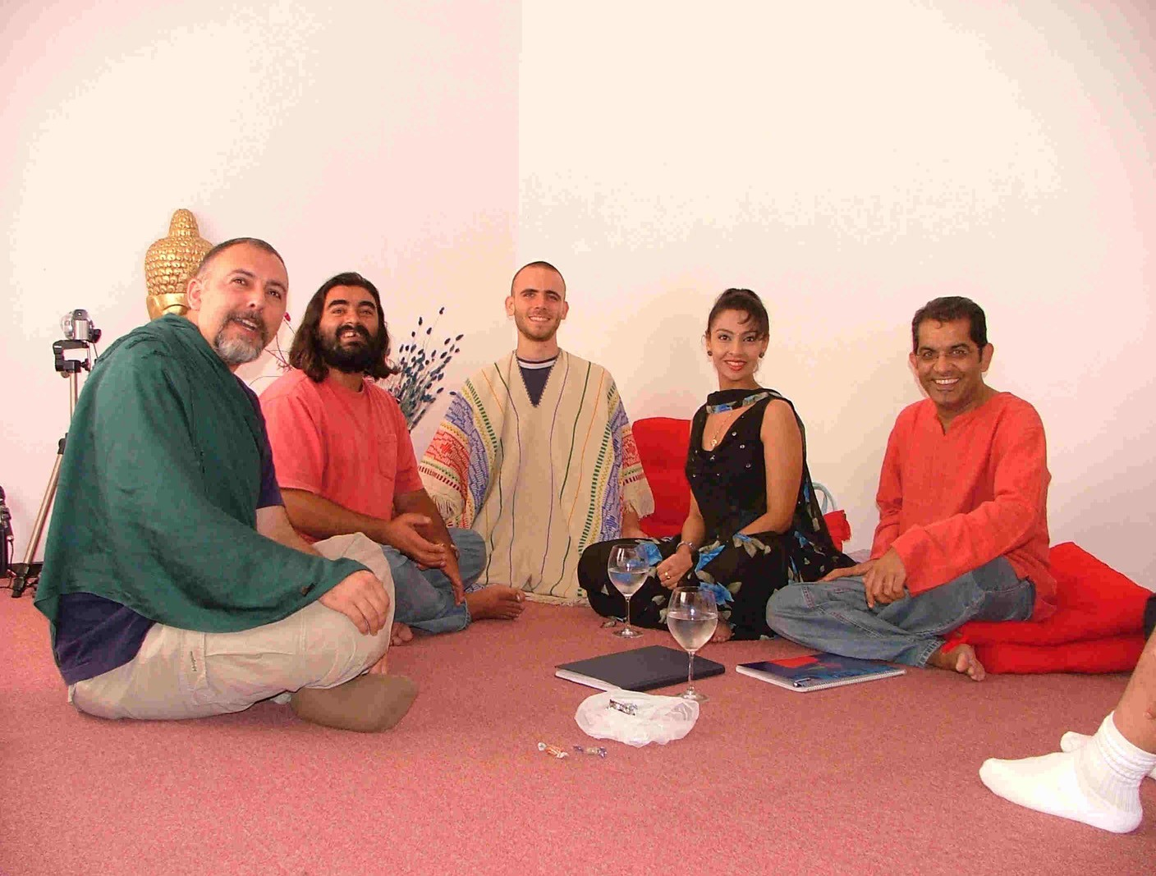


One other Buddhist student on the course left suddenly, perhaps because Satchiji had said that he may have been a Black Magician in one of his past lives. None of us are sure why he left but he just called Devi and said that he had decided to leave. It could have been the ego coming in the way and stopping him progressing. The unusual thing was that whilst a group of us were talking and laughing, a statue of Buddha sitting on a corner table got hit by accident. We couldn't understand how the head of the Buddha got cut across the neck in a straight line and fell on the floor whilst the body of the Buddha remained on the table without moving an inch. Later we were informed by Satchiji and Devi that this was a sign from the dark forces implying: “We have won and have taken the Buddhist student away”.
As I take in depth notes, a local student who works as a radio presenter, Ramia, I talk about him more later, requested if I could go through all the notes and exercises with him. Twice we arranged to meet but each time he failed to turn up. The first time he lost his keys and couldn't get out of his house. The second time he said that he had simply forgot. Again and again I saw these powerful blockages, distractions and situations occurring preventing people from progressing on the course.
It's astounding to see how the Energy Enhancement web site currently gets over 150,000 hits per year and from those only a dozen of us were able to make it to the course, and even from these, the two previously mentioned students were unable to complete the course.
ENERGY ENHANCEMENT, THE MOST ADVANCED MEDITATION COURSE IN THE WORLD
Energy Enhancement Course has been described as the “most advanced meditation course in the world” and I totally agree. It is

thorough, the techniques are effective, the knowledge hugely expands your awareness levels, your intuition and perceptive powers increase tremendously, you feel greatly energized with the meditative practices and the course has brought profound changes in my behavior and in the way I see things.
BENEFITS OF THE ENERGY ENHANCEMENT COURSE
There are many souls on this earth (whatever faith or belief systems they come from) who could hugely benefit from this unique course. The powerful energy that they receive can be used to help themselves and mankind, making this world a better place. The energy allows you to heal yourself and others, enables you to master relationships, removes bad luck and obstacles from your life, assists you to become a more soul infused personality, works towards removing the Ego, your meditation will become deeper and your concentration levels will increase (great for exams or bringing out the genius in you) ensuring that all areas of your life gets touched by the spirit of God. As Satchiji says "Energy Enhancement, The Core Energy Techniques, is the Most Advanced Meditation Course in the World which will accelerate any other course or Technique you care to use," and “anything you do to benefit others will automatically get support from spiritual energy, allowing your work to become more successful” .
Both Satchiji and Devi are beautiful and inspiring souls, passionately committed to helping people grow spiritually and accelerating each student’s progress towards enlightenment. They allow the students to grow at their own pace, whilst passing on profound knowledge and techniques in a light hearted and joyful manner. Both of them have extensive knowledge, possess strong perceptive powers and bathe people around them in the strong Buddhafield of energy that surrounds them. They have both made my stay in Argentina a delightful and a memorable one.
As I realized how wonderful and life transforming this course is, I got inspired to make this course available to others in London.
There will be a small group of people who will be able to take advantage of this “revolutionary meditative program” in London and be honored to learn personally from the Great Master, Satchidanand.

Trust me, the course is priceless and even paying £10,000 each would have been a bargain! Why should you not give yourself the opportunity to do a fast track program that will allow you to achieve the same results in a year, that would have taken you over 20 years to obtain with any other course.

WHAT DON MINIHANE SAYS OF HIS MEDITATIONAL EXPERIENCES ON THE JANUARY 2007 COURSE

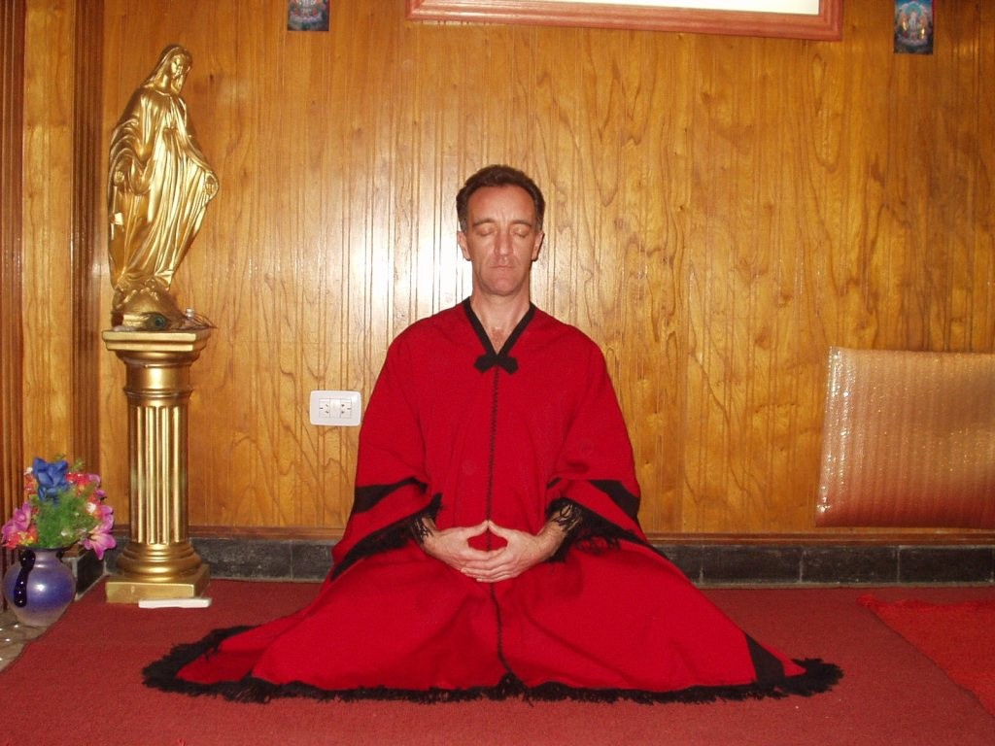
DON MEDITATING AFTER A FEW DAYS ON THE COURSE -
STUDENT FROM THE 2007 JANUARY ENERGY ENHANCEMENT COURSE
ME
My name Is Don Minihane and I live in South East Kent England and I want to share with you the experiences I have had on the E E course here in Rosario Argentina with Satchi and Devi on the four week course which I started on the 7-1-07.
I need to make this clear from the outset. I have no vested interest in giving this testament nor have I been badgered into writing this nor have I received any payment for it. I am doing this because I am aware that those of you that take the time to read this will instinctively know the truths written within it. I do not like bullshit nor have I any desire to add to the already gigantic mountain of bullshit that we are expected to swallow on a regular basis from so called experts and masters on these matters like the ones all over

the place giving Reiki initiations in one go and masters in a few days.
If you consider carefully that Dr Usui was a devout Buddhist dedicated to meditation, learning and teaching and spent some 21 years in a Zen Buddhist Monastery, meditating every day with the Monks, in pursuit of the truth before he rediscovered Reiki, then you know that there is a lot of bullshit going on and these people are doing terrible damage to the beauty and the dedication of a master like Dr Usui.
If that strikes a chord please read on.
First a little background on me to give you an idea as to where I am coming from and why I am here in the first place. I am 46 years old married for 25 years with two grown children and have recently become a grandfather to a beautiful boy.
I have had an interest in martial arts since I was a very young lad and have indulged in several different styles over many years. I have also had an on and off interest in Chi Kung and have practiced the art of chi breathing now for a number of years without much success in the movement of energy throughout the body system.
I also have an interest in Reiki and have already been attuned in level one and two in the Usui Reiki system in England by a decent honest and spiritual Reiki master seven years ago. I practice on friends and family and on anyone that asks me for a treatment. I have had some wonderful and humbling experiences while doing Reiki however I do not ask for or make money from the treatments I give. I have a small business that makes me my money.
My Life
I have also had several experiences in my life that are not common to most people which defied explanation throughout my life and no matter who I asked about these experiences I was never supplied with a satisfactory answer to any of it that made sense to me. These experiences were of a very frightening and disturbing nature and not of this world. At this point all I am willing to say is that the level of fear I experienced was light years beyond the fear of loosing your physical life here on this plane. These attacks began when I was a very small child and continued into my adult life and those closest to me were also targeted. You can believe me when I tell you that I do not frighten easily and am made of sturdy stuff and have survived against incredible odds with my physical and mental abilities intact. I can assure you that there is far more to this existence than even I suspected and this physical life experience here is only the tip of the iceberg and the rest is the best kept

secret in the entire universe while at the same time common knowledge to those who are in the know. It was while searching for the answers to my many difficult and seemingly crazy questions that I came upon Satchi and Devi.
SATCHIDANAND AND ENERGY ENHANCEMENT
I first contacted Satchi just over one year ago and hit him immediately with a big question that I knew would either get a real answer or a load of waffle or bull shit like all my previous attempts over the years or no reply at all as they dived for cover. I had by now got most of the bullshit answers you could possibly get so I became expert in smelling shit at every corner and knew exactly what to ask to eliminate the idiots and charlatans of this world. At this point I was expecting more of the same.


THE GUY ON THE TOP LEFT IS DON... HE CAME FOR THE COURSE AGAIN IN SEPTEMBER 2007 SPAIN AFTER COMING ON THE JANUARY 2007 COURSE IN ARGENTINA
Satchi wrote back to me and the answer he gave me was the first real and tangible result I got in over 35 years of searching. I was so shocked that it took me a long time to assimilate the answer as the implications were so profound it shook me to the very foundations of my existence and I knew for the first time in my life that what I was experiencing was real as he described in detail what I knew,

citing his own experiences as example. It would appear that I had found someone who really knew what they were talking about.
Over the following months I tested him again with yet more of my questions and got a proper answer every time, answers that you instinctively know to be true and correct. Bit by bit my life began to make sense and the reasons for my rather unique experiences became clear to me. I began to understand this life of mine and resolved to go and see this man and his amazing wife Devi to undergo the Energy Enhancement course that you are looking at so I flew half way around the world to spend a month in the home of these very special people who welcomed me with open arms and much warmth even though I arrived at their door at 3am in the morning.
MY ENERGY ENHANCEMENT COURSE IN ARGENTINA JAN 2007
Now for what happened in my first weeks here in Rosario.
On the first day of the course I worked with Devi and we did some grounding of the negative energies within me and as we rotated anticlockwise I noticed the energy in the room was changing and within a few minutes it began to rain energy all over us. I had this experience before while doing a Reiki session but nothing like this; this was like an energy storm in the room, absolutely amazing. Day one was off to a flying start, literally. That evening Satchi began the first initiation in EE and showed me how to sit correctly and explained why, aligning me with the energies of this beautiful planet we inhabit. The experience was profound and I understood for the first time where I was and more importantly why I was here.
At the point of writing this I am now in the second week of the course with two and a half weeks still to go. I feel like I am in a time warp so much has happened. On day four of the course I was sitting meditating trying to circulate the energy up the spine and over the head and down the front when I started to vibrate at a tremendous pace. I honestly thought, any minute now and I am going to take off across the floor or shoot up into the ceiling such was the force of the energy trying to get through the blockages in my spine. I started to experiment with this, lean ever so slightly forward, vibration stops, get back into right angle with the ground, vibration starts again. I was vibrating like a pneumatic drill, lean forward it stops get in the upright position off we go again. I had read about this in books by Mantak Chia in the teaching of Chi Gung but was never able to get anywhere and here I am in day four vibrating like a Kundalini flying yogi, far out. I feel like I have been living in ignorance my whole life. The blockage in my spine was very strong and Satchi said don’t worry we will soon get rid of that

and you know what? I have no reason to doubt him. He said that will be number one of many blockages implanted in my energy body over many lifetimes. There is much work to be done but it will be done he assured me. He was right.
On day five we learned a technique for spotting food and drink with pesticides in it and Satchi and Devi told us about the way pesticides react with the body making us tired and energy less slowly killing us off. This was quickly brought home to me when I later ate some fruit that had been contaminated with pesticides and felt totally drained of energy afterwards. I had to go and lie down and promptly fell asleep for two hours. The effect of the pesticides in the food staggered me and made me realise that we go through our lives trusting these sons of bitches that make vast fortunes feeding us mass produced crap. In reality what is happening is we get used to the shit in the food and the body does its level best to try to compensate. They are giving all of us the death of a thousand cuts. No wonder we get cancers and every other god forsaken disease on the planet. O what it is to be waking up.
REIKI ATTUNEMENTS
I also had my first re initiation to Reiki today from Devi, one of four in level one. Devi told me that there has to be four initiations in level one to make sure that the attunements are solid and will remain with me. This is for all you people that have had Reiki attunements or are thinking about it. Do not throw away your money and energy on garbage one day affairs with a touch on the body with your eyes tightly shut wondering what is going on and feeling little or nothing, the placebo effect I call it. I am paying for it so it must be happening. The lead in to the initiation was very intense, lots of meditation, chanting sutras and Energy Enhancement techniques to make one ready for this most wonderful of gifts and when it came it was most profound A real and tangible experience. Devi is one powerful woman and is immersed in respect for what she does. Defiantly no bullshit here, just pure unadulterated energy, blesses you Devi, it’s your birthday today and you have my complete respect and trust, what a woman. Happy birthday Devi may the cosmos smile on you forever.
PAST LIFETIMES
At this point I have to deviate slightly so you can share with me something that happened last night that has blown me away and here I am hoping that you will respect whole heartily this most personal and staggering experience which I am about to tell you.
Please feel free to comment on this or recount any of your own similar experiences.

I have been awake most of the night wondering if I should write about this or not and I have come to the decision that it should be told because it must be told. It has huge implications for anyone wondering what is really going on in this existence of ours.
If you have any doubts about the authenticity of this Energy Enhancement course then this will set your minds straight and that’s for sure.
To fully appreciate the implications of this account I am going to have to give you more private information about my life so you can see how things pan out over eons and multiple lifetimes and why and how things happen.
I was born in Highgate in London in 1960 the year of the rat, of Irish and Scottish decent; mother Irish and father Scottish neither of which I have ever seen. I was born out of wedlock so I was considered a bastard and was given up to the catholic nuns in London and was removed from my birth country to a catholic adoption home in Ireland to be adopted in to a nice catholic family. I was just one year old. This was a horrifying experience as I spent the first ten years of my childhood being kept and treated as an animal being severely abused both mentally and physically, battered like a rag doll which left me with many physical scars to this present day, specifically so, to the base chakra the crown chakra and the throat chakra. I looked like a famine victim. Despite the horror and against all odds I survived and retained most of my grip on my mental and physical health and I managed to escape at the age of twelve with the help of a kind local farmer who gave me shelter protection and a home for a number of years. I then made my way alone in the world and have never seen a single blood relative in my entire life to date.
I arrived here in Rosario and met the other course members and one, a lady of Irish decent, whose family came here in 1850, three years after the great famine in Ireland seemed familiar to me and she also looked me up and down and I could see there was some kind of connection here. She was roughly the same height and when younger would have had the same kind of hair and I noticed that her hands were the same size as mine. She is twelve years older than me and also born in the year of the rat. I dismissed it as nothing as you do.
Then two nights ago we were all meditating with Satchi and Devi looking for energy blockages in ourselves and I had a realisation of how traumatised I was as a baby and began to feel a great sadness so began to weep a bit and this woman came to my assistance and helped me through it giving me this love I have not experienced

before stroking my head and treating me like a small child and I let her do it because it seemed like the most natural thing in the world to do. I didn’t feel embarrassed about it because it felt so right in its place. She has only a few words of English and I have only a few words of Spanish but it didn’t seem to matter. There was no need for communication, and then later on she said that I felt like her son and we laughed and joked that she could adopt me.
Then last night we were all with Satchi and Devi again, meditating, looking for energy blockage in ourselves and specifically so in areas that were hurting or where we had hurt ourselves in the past or where we were hurt by others and this lady had decided to deal with a pain in her abdomen she felt from time to time. We were using the seven step technique given by Satchi to ground and destroy the energy blockages which is a very effective and powerful way of ridding oneself of the blockage. After we do the exercise Satchi gets everyone to recount the experience and this lady who is very psychic and has great visionary ability began to describe what happened. She said that she found herself back some 400 years in Ireland as a very young and beautiful girl with long blond hair who painted played the harp and was riding and hunting.
I had brought with me from England a set of water colour pencils given to me by my wife to doodle with. As I don’t paint I had given them to this lady as a present on the second day of knowing her.
She had a very lovely young suitor whom she was going to marry and was totally in love with this man. Then she said there was another powerful man a provincial governor who wanted also to have her and he had killed her chosen suitor and had also killed his own wife so he could be free to marry her, a dowry of 100 head of cattle was paid to her father. Her own father in this life time was the bastard priest (the words of the man who married her) who married her off in that time. In effect she was sold and two people were murdered so this could take place. On her wedding day to this monster she took the dagger they used for killing the pigs and plunged it into her self and committed suicide. This was the pain she was feeling in her side. Satchi asked why this had happened and to go back and find out some more. She went back and saw an image of me and asked why I was there and was told by the governor that I was programmed to be her son in that lifetime and her murdered love was to be the father. Since then she has never had any children in her life for 400 years and it seems that I have never had a mother in 400 years either.
She cried and I cried and we hugged and cried in each others arms and then we started to laugh and laugh and cry and laugh and laughed some more and there was such a release of energy and

everything became so clear. I had come 12000 miles around the world to find the last mother I was supposed to have and Satchi said, O that is quite normal on Energy Enhancement courses. It happens a lot. It appears we have healed the ancestral line going back 400 years in one sitting. Now I and this woman can move on to new families in the next life or maybe if I go for it I will reach for enlightenment and finish the journey. We were both destroyed by nasty black people for 400 years who have stayed with us and continued to have their black tentacles rooted in us both for all of this time. Now after this I asked where this happened and she said in the south west of Ireland. I nearly fell over I was taken to the south west of Ireland and there I was nearly destroyed. We looked at the map of Ireland and I asked her where. She pointed to a place and then I got pictures off the internet and she recognised the little island in Muckross Lake near Killarney in county Kerry where her love was murdered and I have married a woman from a few miles from there who is also born in the year of the rat and we have been there often as a couple. Even our children have been there. You can look this up for yourselves and view the lake and the little island and muckross house. What a story and she has never been anywhere near this place in her life. So you see, nothing is quite what it seems and we go on and on forever.
After that diversion I have to get back to the course and I have to say that there is so much happening that you could write a whole book on the various experiences that have happened in the short three weeks that I have been here.
LAST WEEK OF ENERGY ENHANCEMENT REIKI MASTERY OPTION
I am now in the last week of the course and I feel like a totally different person. I have regained myself and have been given from nothing having no psychic vision at all at the start of the energy enhancement course, a clarity of psychic vision that is breathtaking.
I am totally de-stressed and have expanded in every way. I feel stronger and fitter and much more mentally agile than I have ever felt in my life. The fog and confusion of life has gone and I feel that I have just received the inside information on everything. I am ready for anything and am wide awake. I am full of the most incredible energy imaginable and have Energy Enhancement Reiki that is so powerful it staggers me. I know a thing or two about Reiki and had a very strong Reiki connection before I got here, now I have a connection that is beyond description and I have yet to undergo the second initiation this week and then the masters. I have opted to take this as an extra and for anyone who is interested, I believe this is beyond anything you will ever experienced anywhere.

I am now equipped with life tools and healing tools that one only dreams of and there is nothing out there in the world that will ever faze me again. I am absolutely delighted that I decided to come here, because this experience has changed me, for the good of me and for all those that I will touch when I leave here. I am so excited and can’t wait to start exploring my new found talents.
BABE MAGNET
One effect of Energy Enhancement that surprised me is other people’s reaction to me; they are somehow more attracted to me and want a part of me, especially the girls. Now that is an effect I was not prepared for but I am not complaining in fact it’s very enjoyable indeed. People recognise that you have something different and they are naturally attracted to this like bees are to nice flowers, so guys and girls this is not to be missed, you won’t buy this kind of attraction in a bottle, or find it behind the wheel of some fancy car while being covered in expensive clothes and that’s for sure. Energy Enhancement is a babe magnet, but that’s not what it’s about, on the other hand, if that is what floats your boat then go for it.
CHI CHUNG AND ENERGY ENHANCEMENT
I wanted to expand more on the Energy Enhancement side of the course and it is difficult to explain this to anyone who has no knowledge of energy or how it all works. I have tried to get on with Chi Gung and while I respect and admire the system of Chi Gung I feel that it is over complicated and long winded. The microcosmic and macrocosmic orbit is a wonderful internal exercise and is not to be misunderstood or demeaned in any way but the techniques of Energy Enhancement like the Supra galactic Orbit supersedes Chi Gung and leaves it trailing light years behind.
"To expand, I was sitting in meditation the other night and was happily destroying blockages in me using the Seven Step Process of Energy Enhancement taught by Satchi and Devi when I was staggered by something new. I watched as negative energy transmuted into white light and travelled down to the centre of the earth then returned up my spinal column and carried on into outer space to the centre of the universe and then returned back to me through the crown chakra and down the front of my body through the throat centre then the heart centre and the solar plexus, on to the genitals and in to the perineum, through to the centre of the earth and returned back up my spine and so began this new orbit of energy.
The effect was something else; it shot through me at incredible speed. This carried on and got denser and more powerful as I

discharged more of the negative energy within me. This energy took the form of bands of light that followed each other in waves travelling at equal distance apart and as I discharged and transmuted more negative energy the bands got closer together and I found that I could control the speed at which they travelled through the body. Satchi calls this orbit the Supra Galactic Orbit which travels up the ANTAHKARANA into the centre of the universe and down through the centre of the earth passing through the front of the body on the downward sweep and returning up the spine on the outward sweep. I was complete."
INNER CHILDREN SUB PERSONALITIES
I want to say something about the inner children in all of us as this has been the subject of much meditation and discussion on this course. I want to tell you how tricky and clever these inner children are and the havoc they cause in our lives. Satchi says they destroy you, lifetime after lifetime and he is right. I thought I had dealt with much of the inner children within me as I have had lots of Reiki over the years but Reiki has the effect of keeping the inner children under control but they still persist and become experts at hiding within. I found this out when I went hunting for them. I used the seven step process of Energy Enhancement to find them and transmute them into positive inner children. There were hundreds and hundreds of them collected over every lifetime and all hiding in me and they used every trick in the book to stay hidden including leading me down roads of fantasy to put me off finding them. It was quite an eye opener and I have to be on constant alert to make sure that I am not being used by one of these inner little monsters. If even one of these inner children escapes it can slowly destroy the good work and soon will bring you back to the old ways and very quickly you will not be full of light and heart anymore.
I owe Satchi and Devi a great debt for seeing these inner children in me and for pointing them out to me. This is work in progress as the inner children have to be constantly watched and as Satchi says. Do a bit of weeding in your garden of light every day. I tell you there are a lot of supposed ways of dealing with the inner children being banded around and probably they are someway effective, but believe me there is nothing out there like the process of this energy enhancement, course for both finding them and transmuting them. Satchi keeps reminding us that only the ego gets hurt and he is spot on.



DON AND NORMA - STUDENTS FROM THE 2007 JANUARY ENERGY ENHANCEMENT COURSE

REIKI ATTUNEMENT TWO
Devi gave my first attunements in Reiki two yesterday and I wanted to share this experience with you. This is one of two attunements I will have for Reiki two. I will have the second one today. I had spent the day preparing for the experience from very early in the morning meditating on the terrace of the house in total seclusion in beautiful sunshine. (I am so tanned its disgusting and I am going back to England to the beautiful winter weather. I am so looking forward to that, not) Anyway back to the experience. Devi called me about four o clock as she too had been preparing in meditation.
When Devi began the process of the attunement it started to rain energy almost immediately and I could see swirls of white and golden energy coming down over us in like whirlwinds of energy. The peace and ambience in the in the room was astonishing and beyond description. I felt blessed and was aware that we were not alone and had been given help again. I was rooted to the chair for nearly an hour after the attunement and didn’t move a muscle. It was beautiful and I felt so privileged to be part of this and to be accepted into Reiki in this beautiful way. I would like to thank you Devi for this beautiful and profound experience. I am looking forward to the second attunement today and will let you know how

it went. O yes, I forgot to say that when I point my left hand to the floor and rotate it in an anti clock wise direction I feel energy powering into the ground in spirals.
MORE LATER...
SECOND REIKI ATTUNEMENT
Well, here I am after the second attunement and this was a bit of an eye opener to say the least. Over the month I have been here I have got rid of a lot of energy blockages within my system and was under the impression that I might have cleaned them all out, silly me, you seriously have to watch that ego.
Devi and I prepared ourselves for the second attunement and began the process. It was as expected very strong energy flowing around the room and as Devi worked I began to feel the energy inside me very forceful and very strong and was nearly knocked sideways off the chair.
I managed to hang in there until she had finished and then had to lie down. I was out for three and a half hours. I didn’t even manage to make it to the bedroom but collapsed in a heap on the bed reserved for such outcomes.
Devi had found a blockage between me and the centre of the earth and blasted it into infinity and it was such a release it stuck me on my back for three and a half hours. I woke up feeling a bit sheepish and realised that I still had work to do.
Devi grinned at me and said a blockage I found, she is amazing and it wouldn’t be difficult to fall in love with this woman. I FEEL TOTALLY DIFFERENT AGAIN. Thank you Devi for everything you have done for me.
THE MASTERY OF RELATIONSHIPS
Satchi has been teaching us about the mastery of relationships over the last few days and it is another astonishing eye opener. The techniques he has thought us are brilliant and work immediately and what is amazing is that you can prove it there and then and watch the results happening before your eyes.
I don’t want to give this info away here as it is very personal. It is sufficient to say that if you have or had any relationships with people that were not to your liking or affected you badly then this is the place to come to wipe that negative crap away in one sitting.

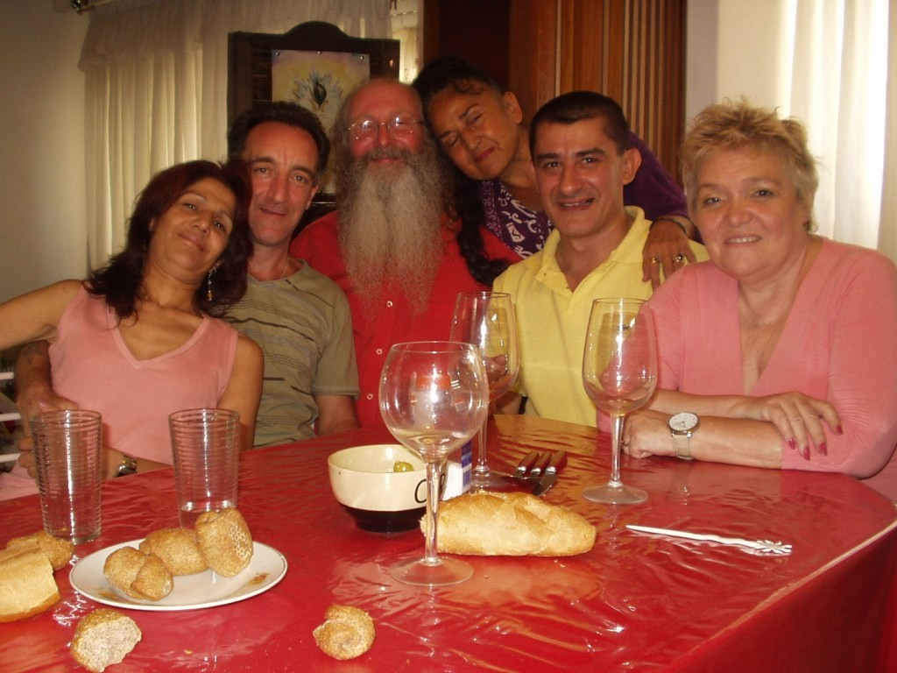
Miriam, Don, Satchidanand, Devi Dhyani, Oscar, Norma - on the Argentina January 2007 Energy Enhancement end of course celebration!
Satchi taught us how to disconnect from you, every one you have ever come into contact with in this life time and all past life times and then how to reconnect the relationships you want to keep into a higher connection and transmute the ones you don’t want.
(Note, it is impossible to cut connections, however, you can reduce the amount of energy which flows down them... Satchidanand)
He also showed us how to clean each others blockages in every energy centre in the body using only the power of the mind. This is seriously powerful stuff, not to be messed about with and demands the utmost integrity.
As we practiced on each other we came very quickly to realise this. I could literally feel the energy moving inside each chakra as the other person worked within me from several meters away and when I worked on the other person I could see me projecting energy to them and could see where the blockages were within their chakras.
I could force the energy from my centres into their centres and clean their centre bringing the energy full circle back to me. You could tell the state of their chakras by the amount of energy returning to your own centre and this was achieved by mind power only.

Before I came here Satchi said he would teach me to do it in this way and I was sceptical about this claim. I could never envision me having psychic vision, but I have now, I can now do astonishingly powerful Reiki sessions on people without going any where near them and distance healing over any distance is a piece of cake, incredible stuff.

LIVE COURSES, INDIA AND BRAZIL - IGUAZU FALLS


GET MEDITATIONAL SUPERPOWERS WITH ENERGY ENHANCEMENT, LIGHT YEARS AHEAD OF EVERY OTHER COURSE
THE ULTIMATE ADVANCED MEDITATION COURSE
MEDITATION ENERGY ENHANCEMENT
THE CORE ENERGY TECHNIQUES!!
THE MOST ADVANCED MEDITATION TECHNIQUES ON THIS PLANET, IN 28 INITIATIONS!!
ANCIENT EFFECTIVE ENERGY ENHANCEMENT SECRETS -
SUCCESSFUL
TIME TESTED
TRUE


Bookings: www.energyenhancement.org

TOTAL RESPECT TO SATCHIDANAND AND DEVI DHYANI
Satchi, please accept my total respect and gratitude for everything you have imparted to me over the short four weeks I have been here. You are a huge light in this world and long may you shine. For everyone reading this, get your asses over to see these people, your lives will be changed forever and we don’t get many chances in this world to be able to achieve that and there are defiantly not many people in this world like Satchi and Devi who can do the business like this.


Jade Buddha on the Argentina January 2007 Energy Enhancement end of course celebration!!

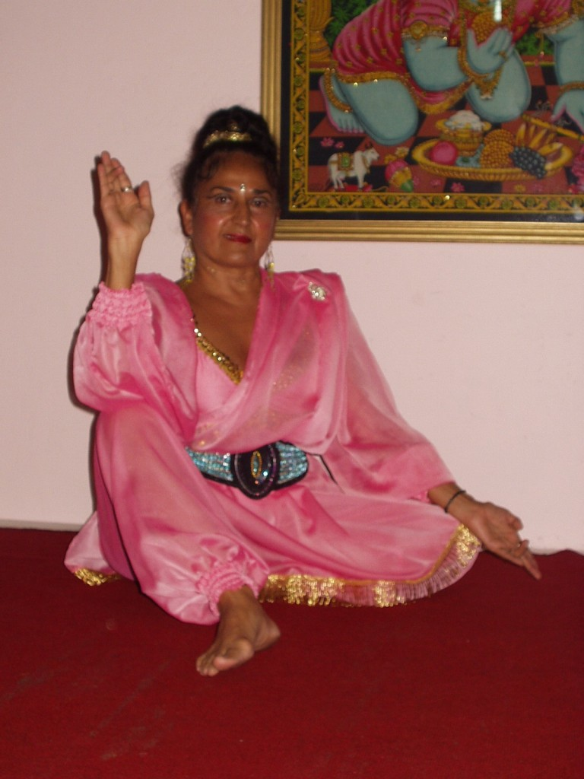
DEVI DANCING AT THE 2007 COURSE CELEBRATION IN ARGENTINA

NEW FROM DON AFTER ARGENTINA - BACK TO THE UK
You will be pleased to know that I have started meditation classes and have hired two separate venues. One in Wooten and the other in Saint Margarets near Dover. I have 24 people signed for meditation classes and several others signed for Reiki treatments.
I am going bald-headed for change and I am unstoppable. I did a talk on Sunday at a Mind Body and Spirit day in Deal from 10 to 5 pm and it was a complete success, the organizers asked me to give a talk for one hour on meditation and energy blockages which i did and loads of people just sat there and were enthralled, they just kept on asking questions and I would always refer to what you said.
What has odd was the amount that I remembered in every minute detail.

It was as if I was channelling you, energyenhancement was talked about a lot and the response was impressive. I gave the website out to loads of people and did a big collage in a frame with you in your white attire. Many people commented on you and said that you gave them a good feeling. Of course I was in there too along with loads of quotes from your talks.
It was a good changing day and I realized my potential and felt my own power and strength and light, (Some people were crying again) it was a good day, I was very enthused and very alive.
Thank you Satchi and Devi. I will change everything now and change an incredible amount of people while doing what i really want to do, meditate and reach for enlightenment and bring as many people towards the light as I can. All thanks to you two.

MORE FROM DON AFTER HIS ENERGY ENHANCEMENT COURSE WHEN HE STARTS TO WORK ON THE ASTRAL
PLANE - 15th March 2007

Hello Satchi and Devi.

How is everyone, I hope all is well in Rosario, I have been thinking about everyone a lot and just wanted to touch base and let you know what is going on here with me.

It is over a month now since i finished the course and it feels like a lifetime ago.

There has been an unusual occurrences, i am a little confused as to what exactly is going on so i thought you might cast some light on the issue, the how's and why's so to speak.

I helped a mother and daughter recently that were being attacked on a fairly regular basis by Dark Forces, both are very open and both see and feel entities, they also said that the husband of the mother is a nasty BM. (her words to me without prompt) Anyway i got a phone call from the daughter yesterday to say that they had been driving along in the car and they both got attacked and could get out of the car when they stopped.

Then she said that I appeared sitting in the back seat and spoke

through the mother to the daughter giving precise instructions on what to do and the attack stopped.

I have had another incident with xxx who i am helping back to health with Energy Enhancement Reiki. He said that one night recently he was attacked in his bed and he asked for help and i appeared in a flash with two other people and i made everyone stand back to back and put a huge swirling mass of white energy around everyone and the attack was blocked. This was on top of the ley line running to Canterbury.

I have been doing a lot of work on this line trying to help xxx, (which is succeeding very well) and last night while meditating with xxx the room was full of white sage like beings of white light with long staffs and they were banging them on the floor, as if to say get on with it we haven't got all day.

The energy in the room was huge and xxx found himself facing an energy blockage which looked like a reptile (no prompting or previous knowledge of reptiles) the energy in the room turned to white and totally transmuted the energy blockage reptile and then he found his mother as the energy blockage reptiles helper. She has been making him ill since he was a little boy. He is gaining all his strength back and is now aware that he is the keeper of this ley line, I guess this is why they are trying to fuck him. This came to him in a meditation and has helped with his recovery.

His blood tests show him returning to normal. The drugs he is taking should not be having an effect yet but he is returning to normal. I have seen him six times in all, about 2 to 3 hours each time. I am very pleased that i have been here for him and that i can do these things. It’s all your good work.

I was wondering a bit about the appearing in places that i am not in and wondered if you could explain this as i am a bit baffled by this turn of events. I feel i should be able to explain myself what is going on but i am perplexed.

The battle continues. Love and light.
Don

AND THE REPLY OF SATCHIDANAND WHERE HE TALKS TO DON OF PRIDE, THE EGO AND THE PROCESS OF ENLIGHTENMENT
Hi Don,

Remember when I said that you, like many of the very spiritual people who come to see us are like an iceberg. One tenth above the water and nine tenths beneath. I said, you do not know who you are.

Well, these things like appearing to other people on the astral plane are sort of normal once you have done the Energy Enhancement Course and practised a lot. They happen to me and Devi. We too appear to others of our students to help and heal.

We also hear of them occurring to Sri Sathya Sai Baba, Ramana Maharshi, Swami Sivananda, Don Juan and many others. If you are successful spiritually then this will happen to you. Why should they have all the fun?

It also means that you are on the way to becoming an ascended Master when you leave this planet. But please do not get egotistical and prideful about this. It is normal. And before you become enlightened I know you have many tests to come, and you know what they are. But the astral body is becoming prepared for this kind of work. It is a sort of success!

Just because you have psychic powers does not mean that you are perfect. Lots of bad people pretending to be good have psychic powers and use them for all sorts of evil deeds.

Enlightenment means you have been well tried and tested as being good and doing good deeds. You have to be there before you can be initiated as enlightened and stay there. Before that Initiation of Enlightenment we can all fall. And only after enlightenment can you become initiated as an Ascended Master with further Initiations after Enlightenment.

The other point is that you had no idea that this was happening. You had to be told about it. Perhaps the Psychic power is owned by one of your inner child sub-personalities which needs to be healed and integrated with your Soul before you can start to use this

consciously?

Every Psychic Power is an Angel but if it has a dark core of Pain or Negative Karmic Mass, then it will be an egotistical inner child sub- personality and will try to destroy your life in some way by either leading you on the path of pride or on the path of darkness.

Every human being has these sub-personalities, and every human being is learning the necessity of purifying them and integrating them with the higher levels of the Antahkarana like the Soul, so as to prevent the possibility taking of these bad paths.

Some people say, "Why", because these paths can be interesting and exciting. But in the end, in every previous lifetime, you need to see that destruction has been the end of every egotistical path.
Only just before Enlightenment can you Really Know that!

The first Sutra of the Yoga Sutras of Patanjali says, "After all that, here are complete instructions on Enlightenment"

Its the, "After all that" After much experience of these egotistical paths.

Just try the Energy Enhancement Seven Step Process on the two events as they were reported to you and see what happens. Tell me what you find.

This Work with the Energy Enhancement Seven Step Process on the two events previously mentioned may well precipitate Enlightenment. One of the major bars to Enlightenment is the fact that our one soul personality is not Fused with the Soul and therefore cannot know what the soul is really doing and why, The Initiation of Enlightenment, given by Ascended Masters is to create this fusion through the application of incredibly intense energy.
This is spiritual alchemy, when true gold is formed out of lead.
The Initiation after Enlightenment is when the Soul and Soul Infused personality Fuses with the Monad, which is when you will become a Monad Infused Personality... and so on up the ladder of the chakras above the head, Initiation by Initiation.

Love, Light and Purpose, Satchidanand

TOTAL RESPECT TO SATCHIDANAND AND DEVI DHYANI
Satchi, please accept my total respect and gratitude for everything you have imparted to me over the short four weeks I have been here. You are a huge light in this world and long may you shine. For everyone reading this, get your asses over to see these people, your lives will be changed forever and we don’t get many chances in this world to be able to achieve that and there are defiantly not many people in this world like Satchi and Devi who can do the business like this.
I am going back to England in a few days time and I wanted to sum up how I feel about this incredible journey I have been on here in Rosario with Satchi and Devi...

MORE FROM DON AFTER HIS ENERGY ENHANCEMENT COURSE WHEN HE HEALS EIGHT LEY LINES CONVERGING ON CANTERBURY CATHEDRAL - 22nd
March 2007
You remember xxx? well it turns out that he is the keeper of the part of the ley line between the medieval church in Wooton and Canterbury Cathedral and as we thought he is under constant psychic attack to keep him from realising this and doing the work he is meant to be doing in keeping the line free and clean
After a meditation with him recently we talked about the possibility of increasing the energy of the line in accordance with the information given by David Ike on the need to raise the frequencies of the planets energy in order to facilitate the expansion of the collective human consciousness and so decided to try to do this using the Energy Enhancement Seven Step Process on the line.
I had a few days to think about this and in doing so kept coming back to the Cathedral and kept seeing it with my Energy Enhancement acquired psychic vision as a large block on the line. Last night we came together again in meditation and decided to look at the Cathedral and began the seven step process to try to clean the block.

The effect was staggering. I saw a huge black block of negative mass and began to ground it and slowly the light came in, then there was a huge amount of light, brilliant white and moving at

incredible speed, (I had asked all the ascended masters for help) it began to fill out the Cathedral and went into the graves below and along the passageways and filled every inch of the place to a depth of hundreds of feet and the whole place was bursting at every opening with brilliant light.


About 50 minutes had passed and we were still at it. I watched as persons in white robes came and pointed white staffs together in a circle and the power and light was awesome, it sped along the ley line towards us and went up the spire in the medieval church in Wooton village and also came out of the floor and into both xxx and I as we sat. I kept going back along the line to check if I was really seeing this and every time it was the same.
When I opened my eyes I saw xxx sitting opposite me grinning from ear to ear and I asked him what had happened to him. He said that when he started and saw a huge mass of dark and thought it was too much to take on but went ahead anyway, he then saw light begin to come in and 7 other ley line keepers came in the points of an octagon and he made up the final point.
He was under the impression that they had been waiting a long time for him to arrive. Then there was a huge amount of energy in white light and the whole place was grounded and cleaned by all eight of them.

Then he saw something astounding. behind every keeper appeared hundreds of thousands of light warriors as far as the eyes could see, He said they were like an ocean of warriors and he was humbled and awestruck by the sight. He realised who he was for the first time in his life, he was told that there were eight ley lines converging at the Cathedral and that the negative mass which had been planted there had been stopping the lines from connecting together, this was his octogon completed and he was told it was not time yet to increase the vibration of the energy flowing through the line.

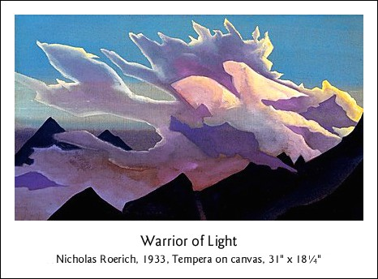
xxx has changed from being scared and depleted and under constant attack to a warrior of huge importance in three short weeks due to Energy Enhancement Reiki Healing.

As I said there is important work to be completed. You don't get much better than this and this is just two of us doing our thing on the night of the spring equinox.

Love and Light. Don

THOMAS BLAIR IN ARGENTINA AND BRAZIL AT IGUAZU FALLS OCTOBER 2008 ADVANCED ENERGY ENHANCEMENT MEDITATION COURSE

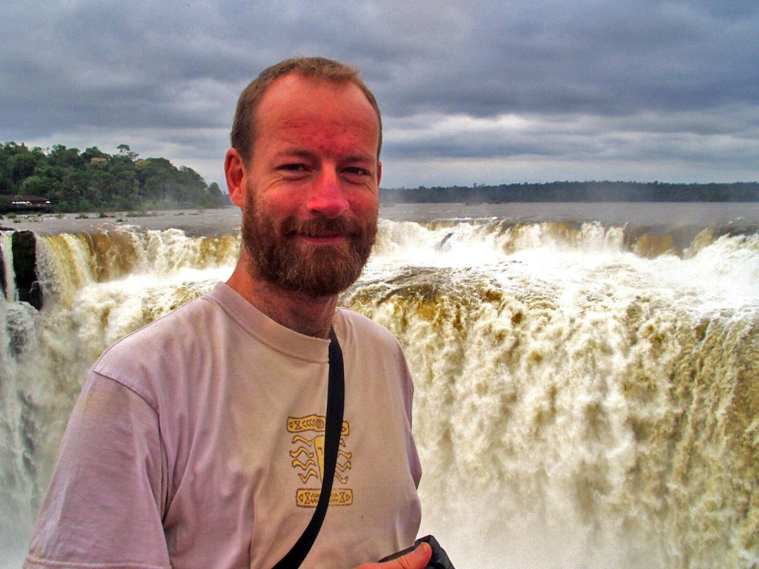
THOMAS BLAIR AT IGUAZU FALLS - THE DEVILS THROAT!
OCTOBER 2008
Well, after Thomas Blair's Energy Enhancement Courses in Spain L'Escala 2006, and Spain Palamos 2007, Thomas returned for a third time - an Advanced Energy Enhancement Meditation Course Refresher to Rosario Argentina going on to Iguazu Brazil in October 2008 in which he removed a Dense Multi-Cored Matrix Blockage Implant from past lifetimes.
Always we try to put off the people who have no intuitive inner sense from coming on the Energy Enhancement course because they would have little chance of completing the course. Only the inner intuitive sense can overcome the negative intellectual dark angels who have no trust, no faith, no devotion, no love.



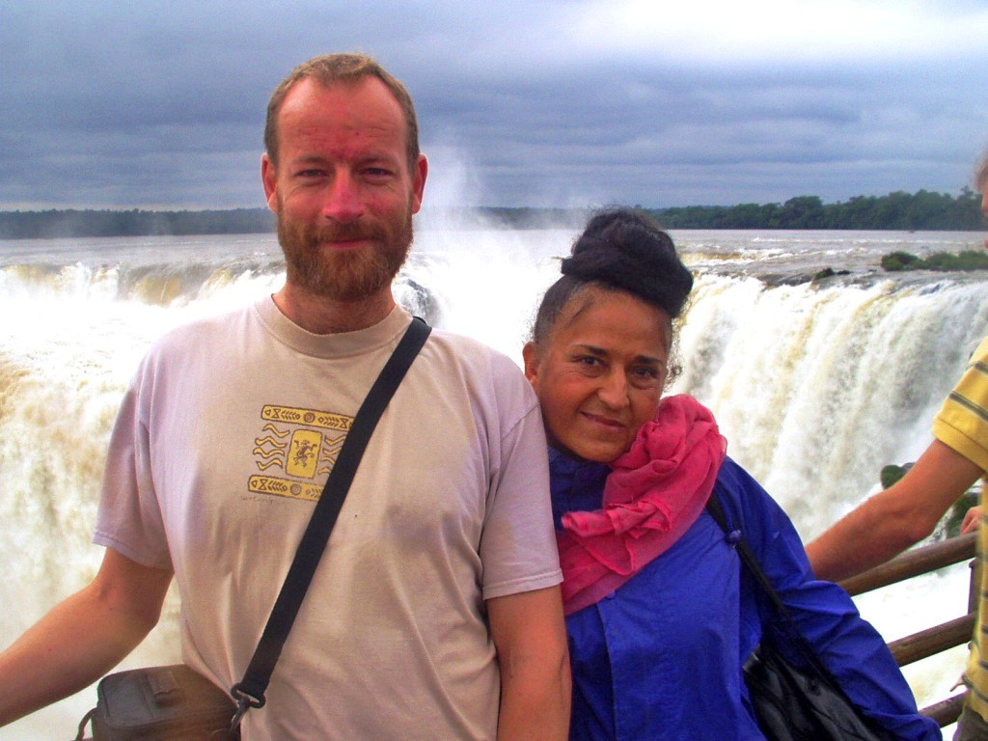
THOMAS BLAIR AND DEVI DHYANI AT IGUAZU FALLS - THE DEVILS THROAT! OCTOBER 2008

THE INTUITIVE SENSE HIGHER THAN THE INTELLECT
Instead these dark angels are solely concerned with money and the selfish competitive ego. And because they are untrustworthy, they have no trust for us, as within, so without, as one finger points, so three fingers are pointing back at you.
Gurdjieff used the same technique as us. He used to joke with the students that he was only after their money. He always said he wanted to "shear the sheep" which is always the students fear whereas his whole life was devoted towards enlightenment for his students and the world. History has proved that Gurdjieff affected the way enlightenment is taught across the whole western world, the ideas of Gurdjieff have been incredibly influential to all seekers. Gurdjieff used to charge enormous prices and acted in an untrustworthy fashion to put off those who could be put off by the intellect.
Only the Soul Intuition can be the guide of the good student.
Everyone who stayed with Gurdjieff grew, not just in intellect - which is only one chakra in seven - but in all the other coordinates of an integrated human being - higher emotion, intuition, bodily grace, love, will, wisdom.


DEVI DHYANI AND SATCHIDANAND - IGUAZU FALLS OCTOBER 2008

IMPLANT BLOCKAGES CREATE THE PSYCHO PATH
On the course we deal with the easy blockages first but on the path of enlightenment we next need to deal with the implant blockages which feed energy back to the bad people who made them. The suckers, the vamps, the energy vampires and their knowing and unknowing helpers who implant the implants which direct thousands of streams of energy back from thousands of people to the guy in the center of the energy web.
Usually these implants exist above the head, cutting you off from your conscience which will not allow you to do a bad thing, which will direct you towards good paths, which will keep you on a Path with Heart - "Choose a Path with Heart" - Don Juan to Carlos Castenada - the Path of the Spiritual Masters as opposed to the Implant Blockage induced Psycho - Path.
Also these implant blockages exist in the heart cutting you off from empathy, the ability to put yourself in anothers place, Gurdjieffian External Consideration which will prevent you hurting another animal or human being.
The implants and their apologists are intent on turning all humanity into Orcs. Eating and breathing pollution. Delighting in selfishness and the production of pain in others. Thus people who are implanted not only eat and breathe pollution, but do all those types of work physical and mental, which make it possible to torture, kill, cut up and eat our fellow creatures. Thus people who are implanted do all those types of work physical and mental which produce the black clouds of pollution so necessary to produce and Orc from a natural human being. Thus people who are implanted see innovative solutions like War, Slavery, Corruption and Lies instead of The Truth, The Whole Truth, and Nothing but the Truth, The Final Solution, Malthusian Theory and the Chaos Management of Problem, Reaction, Solution as necessary, as good Government.
Politics is taught at University from thousands of years of experience to create Government, Govern Mente, Govern the Mind, Mind Control - the "Big Lie" of Hitler's Mein Kampfe.
The implants and their apologists are intent on turning all humanity into Orcs. Thus implanted people work in poisonous fuctories, Agri- chemicals, poisonous pesticides, corrupt waste management and incineration and genetic engineering which switches off the seed after one year so it can not germinate a second time - just for money - and puts fish genes into soya to make it resistant to Agent

Orange Pesticides which kill off the land and the people who consume the products of the land.
The opposite polarity to this is the work of good and evolved spiritual people on this planet who necessarily oppose the bad thought forms historically created by the would - be Orcs.


DATURA FLOWERS IN THE IGUAZU RAIN FOREST


THE COATI BANDIT IN THE IGUAZU RAIN FOREST

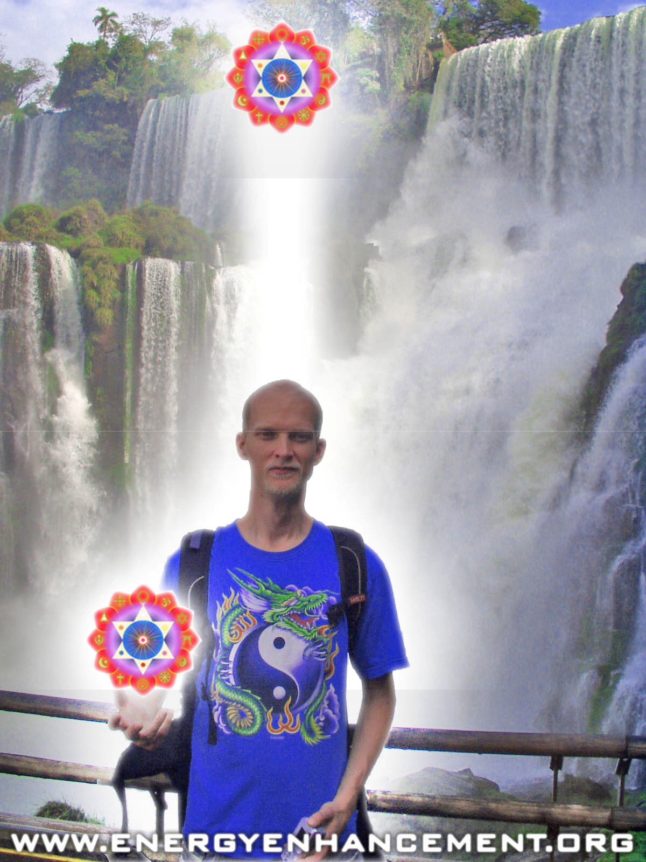
ENERGY ENHANCEMENT STUDENT IGUAZU JULY 2008

IMPLANT BLOCKAGES CREATE "MORAL BLINDNESS"
Thus although the Christian Bible says, "Thou Shalt Not Kill" the apologists say, with no backup from the bible, that this only refers to human beings. And we can always find a good excuse, "Dulce et Decorum est Pro Patria Mori - It is good and it is sweet to die for one's country"
Ahimsa is the law which says "Create no pain by word, thought or deed" Both Hindu Brahmins and Buddhist Priests also say, that to become spiritual, to evolve, to walk on the path of evolution we

should become more peaceful, we should eat food which has less spiritual and Physical pollution, is more pure. Which contains no pain or the products of pain.
But the implants and their creators, the would be creators of Orcs, say that protein is necessary from the meat although this argument is destroyed by vegetarian traditions thousands of years old in which people live much longer and with less disease, in which 5000% more food is created from the same amount of land - talk about saving the rain forests. So that the only arguments left are the egotistical ones of, "We have always done it" and "We like the taste" which works equally well for all CainAbel Cannibals.
It takes a certain opening of the Heart, a removal of Implants, to understand Osho when he says killing is just not, "Aesthetic", otherwise it is just not understood, people just do not, "get it" A lack of empathy - Heart Blockages creating moral blindness.
Thus for real evolution revolution of the heart, blockages must be removed, empathy increased.
In the same way implant blockages create a "blindness" in all the other functions we need - not just in the heart - which is only one chakra in seven - not just in intellect or IQ- which is only one more chakra in seven - but in all the other coordinates, chakras of an integrated human being - higher emotion, intuition, bodily grace, love, will, wisdom.

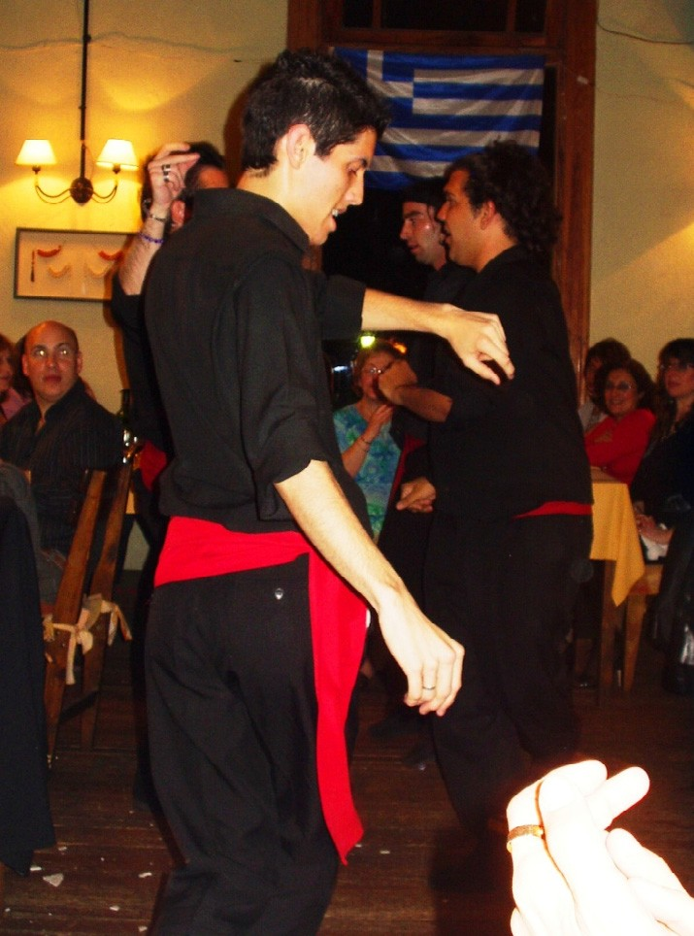
GREEK DANCING WITH VEGETARIAN FOOD AT THE GREEK RESTAURANT

IMPLANTS BLOCKAGES CREATE PAIN AND DISEASE
It is the sucking effect, years of energy sucking of Implant Energy Blockages together with external pollution which produce the Blockage symptoms of wasting and killing diseases such as Multiple Sclerosis, ME, Diabetes, Heart Disease and Cancer. Only by removing the Implant Blockages which are the cause of the disease can we release the pain and pollution locked into our bodies from the Blockage Implant cause. Pain is a symptom of energy blockage implants.
Only by removing the Implant Blockages can we remove the pain and heal the wasting and killing diseases of Multiple Sclerosis, ME, Diabetes, Heart Disease and Cancer.


DEVI DHYANI - MUDRA FOR REMOVAL OF NEGATIVE ENERGIES - PLACE ON THE PAIN!

IMPLANT BLOCKAGES - THE PROBLEM
So, when we get one of the many students who return, we want to do our best for them.
Thomas Blair was complaining of a pain at the top of his head which increased in a debilitating fashion when he practised his profession - coding PHP on the web and creating DVD HD Videos for firms. He knows he needs to move in a more spiritual direction.

To change his focus and move in the direction of Professional Healing and Spiritual Teaching.
So he was saying that this pain was a lesson and a warning to make the leap, take the jump, leave all of his clients and just move to that position.


DEVI DHYANI - MUDRA FOR REMOVAL OF NEGATIVE ENERGIES - PLACE ON THE PAIN!
Our advice was, "Don't give up your day job". Your future life in Spirituality will be supported by everything you have ever learned, everything you are doing now will support the pyramid of your spirituality. Your healing web page and spiritual videos will support your wanted and needed future profession.
We were saying that instead of this pain being a warning, instead it was an energy implant blockage which needed to be removed.
Instead of being a warning the Implant Blockage was actively trying to destroy his life by taking him away from his Base Chakra support for his lifestyle. Implant Blockages sometimes take the form of a trauma - formed strategy called, "The Destroyer" (See Energy Enhancement Level 3) which just wants you to fail, to destroy your life.
So this was the argument. But what was indubitable was the fact that pain is a symptom of Energy Blockages and this energy Blockage needed to go!!


THE IMPLANT BLOCKAGE "TREE"
By plugging into the external kundalini chakras in Energy Enhancement Level 1 we so increase the energies flowing into our psychic bodies that normally, with all of our students, Psychic Powers manifest. And the normal psychic power is Psychic Vision which forms on top of Psychic Feeling which is the first stage of Psychic Power manifestation.
Everyone can feel the pain. And pain is a symptom of Energy Blockages, a warning which left untreated will result in time in a medical problem like strokes, embolisms, tumors or Cancer.
So when Thomas focussed on the pain at the top of his head and performed the "Seven Step Process of Energy Enhancement Level 2 for Blockage Dissolution" on it he started to discharge it. And as he focussed on it through many sessions and with many immersions into the Energy of the Buddhafield when I gave teachings on Innovation and further improvements and experiences in the Blockage Busting Process, which further increases the energy available for Blockage Grounding and dissolution, the blockage started to discharge and get smaller and have less power.
Now easy blockages are easy and dissolve quickly and this easy blockage dissolution is a great relief, a great benefit gained by all who complete the normal Energy Enhancement Two and Four Level Course. But this blockage was a doozy - a massive structure implanted in previous lifetimes and increased in this lifetime.

Under the direction of the Higher Chakras like the Soul, we are directed to remove blockages in a certain sequence, usually the easy blockages first which is what happens on the Energy Enhancement Course, but we need to continue until the end - enlightenment - because all blockages will destroy you unless you get them first!
So Thomas first "saw" this blockage as a Tree which was implanted into the top of his head and rose higher into his aura and this blockage was composed of many blockage parts composed of both big and small blockages and connected into his base chakra and blockages beneath the Base Chakra in the form of black balls all in the form of a shape like a birdcage with blockages in the head and blockages in the base connected together by connections which looked like a G Clamp or the wires of a birdcage. A Multiple Matrix Blockage - a prison for the soul - which is normal in Implants to feed energy back to a guy or a group of people who want to vampirise energy from you.
Blockages in the head cut you off from your Soul and the still small voice which guides you along the path of your Soul, the Path of the Heart, and prevents you from making bad mistakes in life.
Blockages in the Base create Fear create relationships with the wrong type of sexual partner and suck the energy of sex and the orgasm back to the implanters.
Blockages beneath the base reduce your energy and make you malleable, easy to control, easy to direct in bad directions - a slave.


IGUAZU FALLS BY THOMAS BLAIR

HELP FROM SWAMI SATCHIDANAND

So many sessions working on the blockages in the head, and then the blockages in the base and below the base and then on the connecting wires between them. And as in all of his meditation sessions at home he saw me in his meditations, Swami Satchidanand, psychically, with him helping and encouraging the work.
And as he focused on the blockages in the head the pain in the head increased - "No Pain, No Gain" said I - and he began to despair of ever removing the blockages because they were just too strong. And we encouraged him, and we meditated with him and I saw that the blockage had already been removed and that it was, "Dead man walking" and I said that now he needed to prove his willpower and finish the job and the removal of this blockage continued for two weeks and eventually the blockages in the Head and Base and all the connections went and the pain went, "Blockage Gone, Pain Gone!"

Practically, evidence that the blockage is removed is that the pain is removed.
Success in removing the stronger blockages which always we find later on the path of enlightenment is not just in removing the blockages. Session by Meditation session we first just remove, dissolve, ground the Trauma - Formed Negative Karmic Mass. We remove the power of the blockage to protect its inner core. The inner core will protect itself again if we stop the process half way through, so the blockage is working to stop the process with physical symptoms like pain, emotional symptoms like anger and mental symptoms like, "You can't get me, I'm too strong for you" and the like. All these symptoms need to be countered by arguments like, "Anger is a blockage symptom, blockages always say they are strong and yet always they go". Be a Warrior on the Path of Enlightenment.
The most important and best argument is that, "It is Necessary that All Blockages are Removed or the result will be an Orc, Orc Emotions, Orc Thoughts!" in you and in all the people on this planet, the cause of all World problems.
"For those who believe in Enlightenment, and Understand the Urgency of the situation!" - Gautama Buddha
The removal of All Energy Blockages will result in Your Enlightenment and Create World Peace, The Purity of a Sacred Planet, In the Firmament of a Sacred Universe.
So, after sessions of just grounding the Negative Karmic Mass Thomas started to remove important Blockages within the whole Blockage matrix he was starting to remove.
KHIDR, ROBIN HOOD, THE GREEN MAN, THE JOLLY GREEN GIANT - HELP FROM ASCENDED MASTERS
As he released the blockage cores so he started to gain the purified talents of this process. As he sent the purified Blockage Cores into his Antahkarana Matrix of the Higher Chakras so his Psychic Body, The Body Kesdjian, began to increase and he began to get back his own power.
One major blockage when totally healed became a psychic power "Ally" helper - came back as an image like the "Jolly Green Giant" based upon ancient Gods, Ascended Masters like Khidr, the wise guide of the Sufis, like Robin Hood in Lincoln Green, like the "Green Man" of the Druids symbolising the force of nature, like the Ents - a strong looking chap who then accompanied him in all his meditations, and with his laser sword he further helped the blockage dissolution process which involved removing all the

blockages in the Head, all the blockages in the base, all the blockages below the base.
Often, our meditations involve the help of all the Ascended masters to which we are connected from many lifetimes and come to help us through prayer.

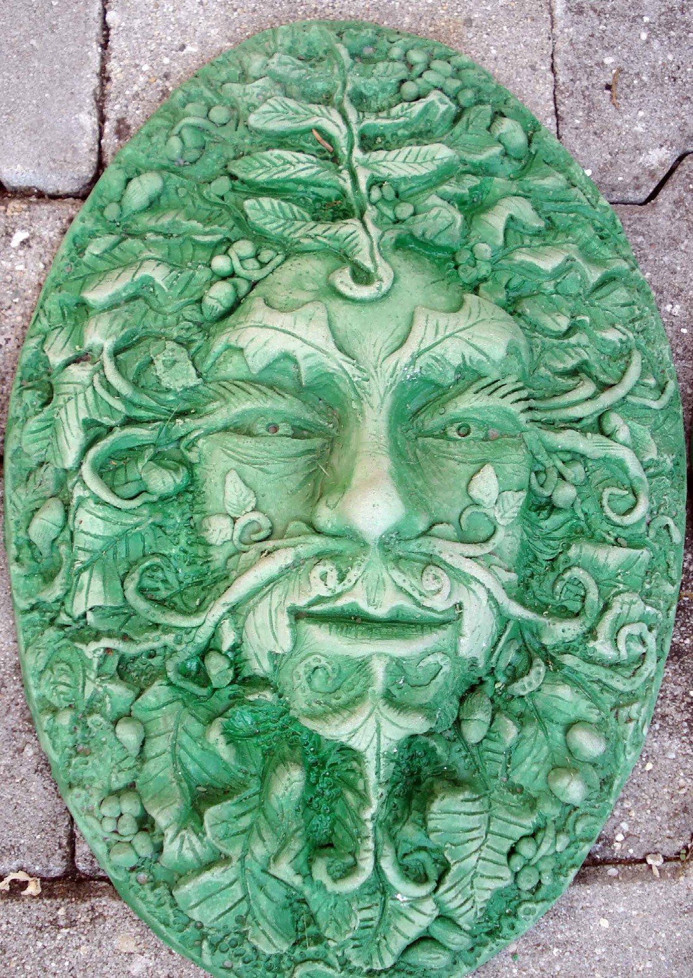
THE GREEN MAN OF THE DRUIDS SEXUAL IMPLANTS
As time went on he saw connections from the blockages in the head to all the chakras in the body, and all the other implants above the head and all the other blockages below the base. These implants had been totally imprisoning his soul and tried to gain great Orc influence in the path of his life, as they try to influence all

Humans on this planet to parasitize all psychic energy on this planet as a Rose is destroyed by Aphid Insects.
After regaining the Jolly Green Giant the image of the tree changed and he was able to see more blockages above the head, Still Connected to the Base, in the form of Blockage Implant Rings which he referred to as, "Collets".
As he was meditating on grounding the Collets one day - as he released the Collets - he saw many of his previous girlfriends, And each of the girlfriends was connected to one of their friends who controlled them. And he cut all the connections from the Collets to them as he removed the Collets totally.
If you have sexual implants in the base chakra so this will lead to an ease of connection to partners who have the same type of sexual implants thus creating inappropriate sexual relationships, disappointment, adultery, divorce.
All your sexual energy and the energy of all your orgasms will be channeled back to the implanter and to the person who controls and implants the implanter who may not consciously know that they are controlled implanters, that their job is to implant their victims during the sexual act.
So, Thomas totally and carefully removed each part of the Implant Blockage Matrix Above the head, In the Head, In all of the chakras, in the base Chakra, beneath the Base Chakra and the G Clamps which connected them.
After all that he felt better!! - "Blockage Gone, Pain Gone!"
RESTAURANTS, ROSARIO, VEGETARIAN FOOD AND IGUAZU FALLS IN BRAZIL


IGUAZU FALLS PANORAMA

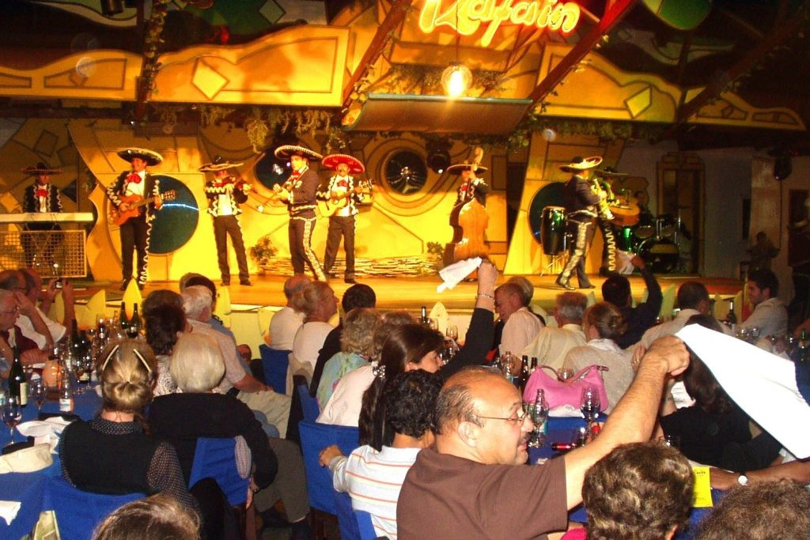
IGUAZU RAFAIN SHOW OF ALL SOUTH AMERICAN DANCES AND VEGETARIAN DINNER - MEXICO MARIACHI

And during the process we visited Rosario, Visited some restaurants, gave him good vegetarian food, took him to Brazil and Iguazu Falls, boosted the buddhafield, advised on the order of Blockage Matrix removal, used Pratipaksha Bhavana - good advice - to help in his Soul Path.


IGUAZU RAFAIN SHOW OF ALL SOUTH AMERICAN DANCES AND VEGETARIAN DINNER - BRAZILIAN SAMBA


IGUAZU FALLS PANORAMA


IGUAZU RAFAIN SHOW OF ALL SOUTH AMERICAN DANCES AND VEGETARIAN DINNER - BRAZILIAN SHOW


IGUAZU FALLS PALM TREES

SAMADHI WITH WHITE LIGHT AND THE INTENSITY OF THE MUSIC AND THE KUNDALINI ENERGY
I remember back in India whilst I was living in Madras in 1989, after that time when I was meditating three hours every day and getting all the insights into Energy Enhancement meditation from experiences in my meditation from the ascended masters and then later finding the same techniques in all the ancient myths and religions.
It was after Swami Satchidananda came to me in my meditation and stayed there in white light for an hour and he did this for three days on the trot. And then this friend came in with a leaflet and said, "Hey, you know Swami Satchidananda don't you?" And there was Swami Satchidananda on the leaflet giving a feast and Dance to all the people in Madras, three days earlier.
And on the leaflet was no address, just the Name of a Dr N Mahalingam who was funding all this. So I went to the Telephone directory, but there were five pages of Mahalingams. India, one thousand million people and you want to find Dr N Mahalingam? So I turned to the guy who loaned me the Telephone Directory and he said, " I know Dr N Mahalingam, he is my best friend!" And he gave me the telephone number in Madras!!
So I telephoned the number and the answer in very high tones, perfect english accent, "This is the residence of Dr N Mahalingam, can I help you?" Apparently Dr N Mahalingam, as well as being a director of the Theosophical Society in Madras was also a sugar magnate and a billionaire. So they gave us his address and telephone no. in Coimbatore and that's how we got to see Swami Satchidananda in India. And we stayed with Swami Satchidananda for a month and went to Bombay with him as he flew out.
Well in Coimbatore we got the invite to the Ashram of a brother yogi to Swami Satchidananda, one who had been with Swami Satchidananda's guru - Swami Sivananda of Rishikesh. And this Guru was known as a music guru. We went on the occasion of a Karnatic Music Concert with very good musicians. L Shankar who plays with John McLaughlin in the Group Shakti and is one of the greatest violin players in the world comes from that tradition of Karnatic Music of South India and the tradition of the music of Saint Thyagaraja who spiritualised India with his sequence of the Pancharatna Kritis, two hundred years earlier.

In the middle of the city of Coimbatore we enter into a restaurant where students of the Guru are preparing Indian Delicacies and up to the music Hall on the top floor and we sit on the floor, no seats, in the lotus posture at the feet of the music guru, Swami Sivananda
- the same name as his guru! - who is sitting in a very nice chair.
The music starts and after an hour the rest of the people are moving and a little uncomfortable. But Devi and I are sitting firm, and music, very intense and beautiful Classical Indian Carnatic Music with a great lady violinist and our spines are going crack, crack, crack! with the intensity of the kundalini energy coming from the music guru. "When the energy is flowing correctly, there is no movement" - Saadi of Shiraz. And we shift into Samadhi with white light and the intensity of the music and the kundalini energy.
All great art, art which has been touched by God, whether it is Music, Movies, or Paintings have the ability to evoke Kundalini Energy through energy. And when this energy is being evoked in the presence of a Guru, the energy is intensified as the Guru adds his energy to the occasion.
Which brings me to the point…
Last night we decided to play the movie, "The Green Mile" by Frank Darrabont starring the Forrest Gump actor, Tom Hanks, for our students. Firstly because its a great movie with many spiritual teachings. But secondly because this is a movie which has been touched by God.
And as the movie was playing my body spontaneously went into Pranayama as I focused and concentrated the energy. My antahkarana opened and I was conscious of channeling the energy of the soul. Everything seems so much more intense and meaningful when this happens and it happens a lot to me. It seems that life only has meaning and significance when this energy is being channeled. Thus, when it happens I know I am on a path with heart, my Soul Path, The path of my Dharma. More, at certain points in the movie my abdomen contracted and I was able to feel the ball of white light which was fulminating there and then I released it from the appropriate chakra sometimes with waves of tears. I knew what I was doing because it always happens.
Spontaneously, with no will on my part, I become a channel for the energy of the movie.
At the end I asked some participants what they had felt.
One said that it had been a too intense experience for him to talk about it.

A few days later he said he felt a fat pipe of the antahkarana wider than normal as the Kundalini energy flowed and shock of kundalini energy which made him burst into tears. The meaning of the movie had penetrated deep within him and he was aware of the experience.
Another said she had seen the movie previously but had taken it as a fantasy and had not connected to it. During our performance she had been in the movie every step of the way and had realised its essential truth.
Sometimes its difficult to put into words our intense feeling but everyone recognised the nature of the experience and everyone responded to the energy.
Only if you have been prepared to receive the energy by past life training or the removal of energy blockages on the Energy Enhancement Course can the energy be received correctly.
All the symptoms of energy blockages come up in an intense buddhafield for those who have many energy blockages and these symptoms are normally called the symptoms of Kundalini Energy. Pain, Heat, Cold, Moving, Sleep, Awe, Fear, Anger, and more.. We get these with everyone at the start of every course.
Thus the work of the critics who cannot feel the energy of Star wars or the Lord of the Rings Movies - they sleep normally and call it boring, childish, they do not know..
Yet here on the Energy Enhancement Course we are removing the blockages of pain, of movement, of fear of Anger. Preparing people to receive the vast energies of existence, of Kundalini, of Illumination, Of Enlightenment...

Get your asses over here Now and Speed Up your process of Enlightenment on the Energy Enhancement one month course!!
DO YOU GET IT? SATCHIDANAND

Hi Satchi,

KARMA AND FORGIVENESS

Can you please give me some insight on the relationship between clearing past blockages and forgiving all that was involved and having a clear karma. I kind of get how cleaning this past residue also correspond to being free from a lot of trouble but how about lords of karma that are employed to make sure the coincidences of actions are fulfilled? I mean if I go and kill few people today and spend the next few weeks to meditate and clear all energetic coincidences and come to full forgiveness does it mean I got away with such action? My intention is not to look for such remedies but I am using the example to address my concern of the dynamic between forgiveness and law of karma..
There is a difference between forgiveness and removing the bad habit.
Forgiveness is the act of removing Negative Karmic Mass from our spiritual bodies. NKM is a poison which slowly kills us. Forgiveness stops this type of karma which builds up over thousands of lifetimes and can be removed by Energy Enhancement.
Bad habits build up over thousands of lifetimes and can be cleared by Energy Enhancement. Bad habits are the core of the blockage which is surrounded by NKM. We need to be shown that Bad habits will always bring retribution from the Lords of Karma. Thus the negative coincidences are sent to people like this, with blockages. Bad Habits are bad, because the wanting to do something is never in alignment with the will of God. Bad Habits are only in Alignment with our selfish competitive egos. Blockages are split off parts of ourselves which have not been integrated or purified. As we purify the NKM and Integrate the core of the blockage with our higher selves so we change our bad habits finding, "That which works best". Even in alignment with God, some things work better than others and as we become Enlightened still we struggle with better and best..
So, as we purify and integrate our higher energy bodies using the techniques of Energy Enhancement, removing all energy blockages so we come completely into alignment with Gods will.
Enlightenment. Then everything we do is good, neither black, nor white.
In such a case, completely removing the bad habit, addiction, egotistically used talent, then karma is revoked. There is no point in

the Lords of Karma continuing with their efforts of teaching because the lesson has been learnt.
This is Enlightenment.
These are initiations higher than Enlightenment.
A person in such a state accepts whatever is given without complaint because whatever happens is Gods will.
Then comes the problem of world Karma and other peoples Karma.
An Enlightened person takes on some of these karmas for the pupose of teaching, so although it may seem that he has Karma, it is always for the benefit of someone else or the world and again without complaint.
This is conscious suffering or Tapas for the benefit of the World.
Read about blockages on the Level 2 page of the website as well as this.
Hope this helps. Love and Light, Satchidanand
I THOUGHT I WOULD GIVE MORE..
You will clear many blockages and remove much karma within you and between you and all your family and friends first pass.
Although Energy Enhancement is set up to give all the techniques and Initiations for Enlightenment, the student needs to do it, walk every step of the way, clear all the blockages by himself with the help of his Master.
Just by doing the Initiation, especially on deep and difficult blockages and past life sequences of Blockages, does not mean that all the blockages have gone.
Usually, after learning the Energy Enhancement Course and practising all the initiations, there will still be some deep and difficult blockages left. They remain because they are deep and difficult and have in all probability been with you for many lifetimes.
These blockages will be noticed by the observant student and master who will then say, "This is your major problem" and then he will leave it with you, without pushing, for you to slowly see it and remove it, and it will be slowly cleared after the course. Pushing on this point just leads to too much pressure.

As it says in the Yoga Sutras of Patanjali For a long time, constantly and with enthusiasm.
On the path of Enlightenment…

The Mastery of Relationships, Psychic Energy Connections, Energy Vampires Implants and the Initiations of Energy Enhancement Meditation

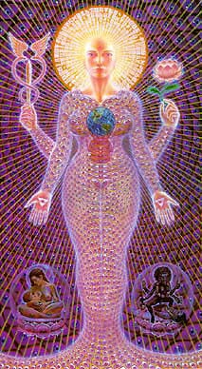

Relationship Psychic Energy Connections exist in all people and in general mess up their lives. Instead they should Enhance our lives and lives of everyone around us. With Energy Enhancement Techniques we can learn The Mastery of Relationships!!
For all intent and purpose, Psychic Energy Connections or "strings" in relationships are very similar to umbilical connections or even electric and telephone wires, except they exist on the astral dimensional planes in all relationships. They can be very thin, or very thick, and can appear as very light or very dark streamers coming out of your energy fields/bodies.
These strings, Psychic Energy connections, stretch between all chakras, chakra to chakra and in the case of Relationships from abdomen to abdomen and with sex, from base chakra to base chakra.

Relationship Psychic Energy Connections can be superficially hooked onto the surface of - or more deeply plugged into the very cores of - your numerous energy fields, chakras and/or dimensional bodies. Initially these relationship hooks or plugs seem pretty innocuous to the astral spirit, at first glance appearing very light, maybe even golden and brightly colored but Psychic Energy Connections in Relationships, no matter how attractive or light or energizing, are ties that bind, and as Gautama Buddha said, thousands of years ago, "Attachment leads to Pain".
One of our Meditation students, Susan Macri, a medical doctor living at the ashram of Sathya Sai Baba in India teaches “cutting the ties that bind” to 2000 people a year in her workshops there, yet found it necessary to learn the Advanced Initiations of Energy Enhancement to further augment her knowledge.
These Psychic Energy Connections can limit your freedom in Relationships if you can’t manage them through knowledge of the Initiations of Energy Enhancement in Relationships...gilded chains are still chains, and a gilded cage is still a cage .... Any relationship Psychic Energy Connection can be made to appear beautiful and of the light, yet one should ask “where does this Psychic Energy Connection lead to, or come from?"
When followed back to their origins, we have found sometimes people are unconsciously connected to people who are sucking their energies. We call these people Energy Vampires. They can also be connected in to bad entities or consciousnesses, pulling these "strings" these Psychic Energy Connections - See the movie "The Matrix" WHERE PEOPLE ARE TURNED INTO BATTERIES.
You usually have a relationship with badness usually through being Implanted. The Energy Blockage or Psychic Virus implanted in you, always sends energy back to the person who implanted you. Some of these energy vampires have thousands of connections with people sending energy back to them!

Relationship Psychic Energy Connections might be seen, felt or sensed by you feeling tired and lacking in energy, or attracted by things you know are bad for you or even becoming addicted, but there are many connections that are imperceptible to most people.
It is handy to work with people who are experienced in these matters as they can help you spot the connections and help you release them.

Energy Enhancement Teacher Devi Dhyani meditating on the beach with the Energy Enhancement Symbol representing the Soul above her Head.
The bleed through of negative psychic impulses, messages and energies from one being to another through these Psychic Energy Connections can often and easily act to interfere or distort the integrity and conscious energetic experience of your own space.
This may be something most people are totally unaware of... as everyone falsely assumes that all their impulses, thoughts and feelings originate from themselves where in actuality much comes through being given Implants by these and other bad people.
If a person has lived with these Relationship Psychic Energy Connection "monkeys" on their back for a long time, they may have gotten accustomed to them and would probably be in denial to their very existence.
The relationship Psychic Energy Connection controls them.
Since our modern society disavows any knowledge of such things being that you can't scientifically prove their existence, this is a reality the modern rational person would not even remotely consider... however, ancient man knew better.... It is good that there are movies such as "The 6th Sense" or "The Matrix" ... they are to remind us that this phenomena does exist and has been written about for thousands of years.

Why have Normal Psychic Energy Connections? TO BRING DOWN A BABIES SOUL FROM HEAVEN…

There are many reasons why you create relationship Psychic Energy Connections yourself to another being and/or for that matter, why they create Psychic Energy Connections themselves to you. One of the major reasons is to create babies. Energy is necessary for this and flows from abdomen to abdomen. And as the energy flows in sex a connection is created from base to crown chakra and from the crown to the Soul, in order to bring down another soul from heaven!!
However, this natural function can become perverted....

- It could have seemed like a good idea at the time, quite handy and practical in fact, being able to telepathically call in and out to your friends.... But friends create Psychic Energy Connections to other friends, and sooner or later you are connected to a party line and are getting input from all sorts of unwanted sources.... You could easily be inundated, day and night, non-stop with this psychic "spam". This is why the Initiations of Energy Enhancement teach how to, and give you a process of, cutting all ancient connections and then reforming them appropriately.

- It could have been done as a way to be closer, more intimate with someone... to share the deepest thoughts and feelings from ones deepest centers. But all relationships change... usually through bad Karma.
If you did bad things to a person in a previous lifetime, usually in this lifetime they will take revenge. Relationships go sour, even adversarial, confrontational, or outright hostile... but the Psychic Energy Connections remain.
Once you are wired with Psychic Energy Connections, it is not as easy to remove them as it was to create them. Just imagine if you were creating Psychic Energy Connections to someone who turned dark and evil... and you had one of these wires from them plugged into your brain, or into your sex chakra, or your heart...? You are really really stuck....
You need to learn how to disconnect your Psychic Energy Connections to negative energy and we can help you to do this. This is one of the main works of our Teachers of Energy Enhancement.

- It could have been contractually agreed upon as a way to be in a

partnership or marriage with another. A “Vow” which we need to learn how to deal with. The old paradigm of partnership or marriage has been about”banding" branding? One person to another, ... i.e. being contractually bound by Psychic Energy Connections "tying" the knot and "the ties that bind".
The new paradigm of truly loving and deep relationships is about unconditionally giving and setting each other free with no strings attached. Or, through the Initiations of Energy Enhancement, having the ability to manage these connections.

- It could have been done out of fear to go it alone in the world. Many people think that by standing within their own power, the resultant freedom and independence this would give including the associated personal and spiritual responsibility would shun them from human society, causing them to live solitary, alone, and lonely lives.
To prevent this, they are willing to compromise their personal power and sovereignty... and join or "hook" up with another person, group, or outside authority... in exchange for the companionship, security in numbers, and shared responsibility.
Usually, this is a case of our relationship to priestly vows, or vows to be a member of a bad group, which remain in the psychic body for many lifetimes through Implants. For a particularly good example, look at all the people who are members of all organized religions and don't forget the political parties.
- Or it could have even been forced upon you against your will, or even secretly planted as a thought form “Implant” without your awareness as a hook to draw you back into the fold, lifetime after lifetime. These implants have Psychic Energy Connections going into them from the people who psychically made the implant many lifetimes ago. Implants exert control and drain energy back to the original maker of the implant, turning many people into batteries, like in the Matrix.
The implant maker vampires are not interested in people of low evolution who do not have much psychic energy. They are interested in people of high evolution. People more Soul Connected, and it is these people who they drain, as an aphid drains the rose flower, preventing its further evolution by usually perverting the victim as the Ring Implant, like the Ring in the Lord of the Rings movie and book, perverts all who come into contact with it. These implants create desires for sex, sexual abuse, drugs and rock and roll. It can draw you back into the same type of life, lifetime after lifetime.

As the candle is burned at both ends much energy can be taken, and usually the victim dies young.
Inadvertently or in a lapse of good judgment, you let down your protective energy barriers, and someone slipped in and hooked or plugged an Implant into you.

HOOKERS
This also happens quite a lot, especially between men and women "she got her hooks into him". Why do you think prostitutes are called "hookers”? Usually prostitutes are implanted lifetime after lifetime, and the implant which acts like a psychic virus is spread to all the customers, creating a desire for more.
This is the nature of all addiction. It is nice to learn how to overcome your relationship to all desire, your relationship to all addiction by working to learn how to become free.

- It could have been contractually agreed upon as a way to clear some mutually unresolved karmic debts "Karmic Contracts" or Vows.

- It could also be entered into as a spiritual service to another soul, such as in a "God Contract" as exemplified in that Psychic Energy Connection between children and their parents.



MANAGING PSYCHIC CONNECTIONS

Psychic Energy Connections start with the umbilical cord that connects a child to its mothers. It is a biological necessity during gestation, and even after, when this cord is cut, there still remains in this same area an important energetic Psychic Energy Connection between parents and child both mother and father.
This seems to be necessary for the child's comfort, security, and even survival in the developing early years. It is this telepathic-

energetic relationship link with the parents that energetically feeds the child, that assists the child to feel more connected and grounded to life and humanity, at this level or dimension of reality. It is bad enough, if you think about it, to at one point be in spirit, at peace, at one with all, and then be thrust down into this gross dimensional plane of duality and suffering, all by oneself... without at least some kind of life line to hold onto.

However, this Psychic Energy Connection between parents and children can have negative consequences... Usually we are not weaned of this Psychic Energy Connection at the age of 5 or 7 as

should happen, but the Psychic Energy Connection endures for all of our lives.
When one of the beings such as a parent or even a child has dark issues and heavy karma, an energetic bleeding through the Psychic Energy Connection can occur, corrupting or at least be disturbing to the other individual. In these relationship family ties we can be “tied to the apron strings of our mother”.
Some male homosexuals, or people not interested in sexual relationships, have very strong Psychic Energy Connections to their mothers or fathers.
This is accounted for and anticipated in spirit before the birth, as we all choose these relationships for the reason of learning these relationship lessons, sometimes to assist and carry another through their darkness and karma. This is why learning about this is so necessary to people in the process of learning about relationships.
You can see this if in your life all your negative life experiences have come through relationships. This means that you are in the process of Mastering the Second Initiation of Alice Bailey, The Mastery of Relationships, and it is this which is the intent of the teachings of Energy Enhancement, to give you the Mastery of your Relationships.
Often, being connected in this way as parents or even as the child is the only way to help the other soul through these trials and tribulations. It is a noble endeavor and spiritual service one can do for another. It is like having a permanent, continuous, invisible life line of support and love.... If the one being is overwhelmingly strong enough to transform the others' negative energies and darkness, this could be a good thing. Unfortunately, this rarely works out so ideally as the burden can be sooo great as to drown both people.
If you think of a person who jumps into the water to save a drowning man, and ends up being attacked and drowned instead, you know what I mean. This is a task for the strong at heart, and even then, you still have Psychic Energy Connections with that person after. This is why the Initiations of Energy Enhancement are so necessary to enable everyone to handle all these types of problem above mentioned.
And to do it properly you need to learn the lessons of the Enlightened Master. And it is this which we learn in the Initiations of Energy Enhancement, The Mastery of Relationships.

Relationship Psychic Energy Connections and TANTRA - the Energy Enhancement View
When these relationship Psychic Energy Connections are created by people in love they can create a baby, they can make love they can have an orgasm and when Psychic Energy Connections are created consciously by a Master of Energy Enhancement, they can be given energy on many vibrational planes which can help in their Enlightenment.
This is high spiritual tantra. Learning how to connect appropriately can bring energy, love and loving sexual orgasms back into failing relationships. Energy Enhancement Mastery of Connections can heal frigidity and many inabilities to make love.
So one of the Energy Enhancement Meditation Keys to the Mastery of Relationships which we teach about fully on the course is to have care in your relationships. Only connect to the good. Be mindful of whom you are connected to. Only connect to the bad if you want to heal them or give them energy. The Key to Energy Enhancement Initiations for the Mastery of Relationships is the ability to disconnect these Psychic Energy Connections as well as create them.
And why do we give energy to our students, the answer is that all Enlightened Masters give Energy to, raise the Energy Vibration of Their Students and Disciples in order to make them Enlightened. As my Master, Swami Satchidananda said, “Making someone Enlightened is like creating a baby” Or as Goethe Said, “Connect, only Connect.”
We can understand why the Buddha Said, “Attachment leads to Pain” This is caused by holding onto negative connections too long. Pain is caused by the inability to connect and disconnect, the inability to Manage Connections which is the teaching of the Initiations of Energy Enhancement, The Mastery of Relationships!
The most important thing about Psychic Energy Connections is to know that it is possible to connect and also to disconnect using these cords of Psychic Energy Connections. Only connect when it is necessary. Disconnect when it is not necessary. Be mindful of your connections. And these Psychic Energy Connections are at the core of every successful Loving Relationship.

CHAKRA TANTRA LINKS
BALANCED AND SHARED COMMUNICATION FLOW
How to connect and disconnect appropriately

Transmitting and Receiving Communication in a shared and balanced way.

THE MASTERY OF RELATIONSHIPS
In Energy Enhancement Mastery of Relationships we learn how to cut off all connections when we need to. We follow a process of cutting off all connections with everyone we know from every one of the chakras in our bodies. We learn how to dissolve implants. Then we learn how to connect appropriately. We practice connecting appropriately. Thus the Initiations of Energy Enhancement teaches the Mastery of Relationships.
We learn how to use these connections to heal the people we connect to so that we can not be connected to anything bad. Healing the person means dissolving their negativity or negative

Ancient Karma. We healed all of our Karma in this Lifetime and all of our past lifetimes with Energy Enhancement Level 2. Now we learn how to perform the same service for others. Through the Initiations of Energy Enhancement we overcome the objections to connections which we read about above through the ability to Master each connection.
In Energy Enhancement Mastery of Relationships we learn how to connect and disconnect appropriately. We learn that WE are responsible for the health of all our relationships. We learn how to use the Light of the Soul to dispel all ancient negativity in those we are connected to, ALL OUR RELATIONSHIPS. This is the true meaning of “Forgiveness” it is not something we decide to do mentally. It is something we do psychically to take back, to transmute, to dissolve the ancient negativity caused by our bad actions in the past, so that all this ancient evil karma will not come back to haunt us in this lifetime and in the future.
In this same way in Energy Enhancement we learn how to reduce the Karmic Burden of this Planet creating conditions to raise the Vibrational Energy Level of this Planet, for this planet to become a Sacred Planet, where every person is Enlightened
In Energy Enhancement the Mastery of Psychic Energy Connections is the Basis of the Energy Enhancement Mastery of Relationships.
by Energy Enhancement Satchidanand

ENERGY ENHANCEMENT AND TANTRA
WHAT IS TANTRA?
TANTRA IS ONE OF THE MANY PATHS WHOSE AIM OR END OR PURPOSE IS ENLIGHTENMENT
Like Yoga which means Union with the center of the Universe or with God, Tantra is any path which achieves that aim.
For many, Tantra is a sexual means of achieving that union. People ask me, isn't one of the methods to make love only once per month? To increase the length of time we make love to hours?
Well, I reply, Enlightenment comes from the increase of energy. Human beings only have a small amount of energy within themselves. Really to increase that energy we need to access the

energy from chakras outside the body. It is like we have a computer which is running slowly on only five volts. We need to plug ourselves into the big generator!
To obtain thousands of volts of power in order to make the computer work more quickly at a much higher level we need to plug ourselves into the chakras above the Crown Chakra, into energy in the central spiritual sun!! The Soul!! God!!!
And in the center of the Earth is the Kundalini Shakti flowing out in every direction from the Atomic Generator which powers this planet. The atomic pile in the center of the planet is a 5000 degrees centigrade and provides the energy which keeps this planet alive and at the correct temperature. The Earth is feminine. The Indians say, "Our Mother, the Earth" and our Father, who art in Heaven is God, the energy in the center of the universe. And when all the Energy Blockages to that connection have been removed, then there is a flow, a waterfall of spiritual energy which powers every one of the enlightened.
Then we have Shiva, our father, combining with Shakti our mother. Then we have Hercules, son of God, Zeus, Theos, Deos, combining with the daughter of Pluto, King of the Underworld.
Enlightenment concerns The Holy Trinity and is composed of Sat, the truth of the center of the Universe combining with Chitta - the holy grail, the cup of the mind on this planet, empty and ready to receive the libation of the Gods, and the flow of energy between the two is called Ananda, or bliss - Satchitananda like the Father - Our Father who art in Heaven, the Son and the Holy Spirit which flows between the two.
And the Hindus have a word for the channel between the Center of the Universe and the Center of the Earth. Rapunzel, Rapunzel, let down your hair. The Rainbow Bridge. The Tower of Babel. Tower of Connection created out of mental matter to channel the energies of God through all the infinite chakras of existence, powering the whole universe from the center. This is the Antahkarana.
If you are not connected with, if you are blocked from, the center of the universe then just think of a small flow of water slowly filling a bucket. You may well have to wait a month for the bucket to fill.
Only then will you have sufficient energy to enjoy making love, or really doing any of the thousand things we have to do on this planet. But if you are connected and put your bucket under a waterfall, then that bucket will fill in seconds. You will have infinite energy to do with whatever you want every second of the day.

The Greeks had a name for this energy which descends from the soul to power the Mind Computer, and they called it Genius which is the what happens to the mind computer powered by the energy of the Soul. Soul Infused.
The Mind is of the intellect of logic yet the Soul is Intuition, Knowing, Wisdom and is much higher than the mind.
The Kashmir Shaivites also have the energy of Chit Shakti whereby the mind is also powered by the Energy in the Center of the earth.
In reality, human beings are powered by both masculine and feminine energies. We connect with the Kundalini Chakra in the center of the earth by means of the Base chakra, and we connect with the center of the universe by means of the Crown Chakra.
Usually it takes three days for the students who come on our courses to access this energy with which they can successfully transmute all their Energy Blockages because another, more easy way for people to absorb energy is from the Buddhafield, the Aura of the Master.
When they leave then sometimes the energy drains away, because it is the energy blockages which create the holes in the bucket through which all the water drains away.
And this is Tantra, the Energy Flow of the Soul created by the Sexual Union of Shiva and Shakti.
In that that bliss, that delight, such an overflowing cornucopia of Energy which comes from the Gaining of Energy and the Removal of Energy Blockages, we find only Enlightenment.
In a way, Enlightenment is a twenty-four hour a day orgasm.
  - WINTER COURSES IN MACHU PICHU, BRAZIL, ARGENTINA AND INDIA!!!

TRAUMA, PAIN, RAPE AND ABUSE, RELATIONSHIPS, DIVORCE, BEREAVEMENT, ANGER, FEAR AND DEPRESSION, FRIGIDITY AND IMPOTENCE, SEX ADDICTION, PIERCINGS, TATTOOS, BDSM, TANTRA, HOMOSEXUALITY, LESBIANISM, MULTISEXUAL PROBLEMS, DRUG ADDICTION AND CRAVING, GAMBLING, BAD BACKS, HEART DISEASE, CANCER

Energy Enhancement Transmutes and Dissolves all Negative Energy.
Energy Enhancement Advanced Ancient and Successful Techniques will teach you how to Transmute and Dissolve all Negative Energy underlying the Trauma or extremely distressing experience that causes severe emotional shock. This act of dissolving the negative energy at the core of the trauma will produce Acceptance in you and will allow you to Forgive yourself which is necessary before you can begin to Forgive all those who have trespassed against you.

From experience with our past clients we have had to work with people who are suffering from…
Traumas, distress, damage, suffering, ordeal, upset, shock, extremely distressing experiences that causes severe emotional shock and may have long-lasting psychological effects and many difficult and painful problems. Energy Enhancement teaches how to dissolve the negative energy from all memories.
Divorce, Bereavement, Relationships and Accidents. Separation, split-up, break up, annulment, separate, break up, Grief sadness mourning unhappiness regret, distress, many difficult and painful problems. Learn the Energy Enhancement Mastery of Relationships.

Energy Enhancement teaches how to how to dissolve the negative energy from all memories.
Rape and Abuse violent, destructive, or abusive treatment. Being a sort of slave for the benefit of others. Controlled by the people around you who suck and vampirise your energies. Energy Enhancement teaches how to how to dissolve the blockages and negative energy from all karma and bad memories.
Anger, Fear and Depression. Energy Enhancement teaches how to how to dissolve all negative emotions.
Sex, Frigidity and Impotence, unable or unwilling to respond sexually, to enjoy sexual intercourse, or to have orgasm during intercourse and the inability of a male to perform sexual intercourse, usually because erection of the penis cannot be achieved or sustained. Energy Enhancement teaches the Mastery of Relationships and how to how to remove all blockages from the sexual chakra.
Multisexual problems, Lesbianism, Homosexuality. Energy Enhancement teaches the Mastery of Relationships and how to how to remove all blockages from the sexual chakra.
Sex Addiction and sexual intercourse. Energy Enhancement teaches the Mastery of Relationships and how to how to remove all blockages from the sexual chakra and addictive desires.
Addictions, a state of physiological or psychological dependence on a drug liable to have a damaging effect, habits, compulsions, dependence, obsession, craving. Learn how to remove all blockages from addictive cravings and desires. Energy Enhancement teaches how to how to remove all blockages from addictive desires.
Disease, Bad backs, heart disease and cancer. Energy Enhancement teaches how to remove disease blockages.
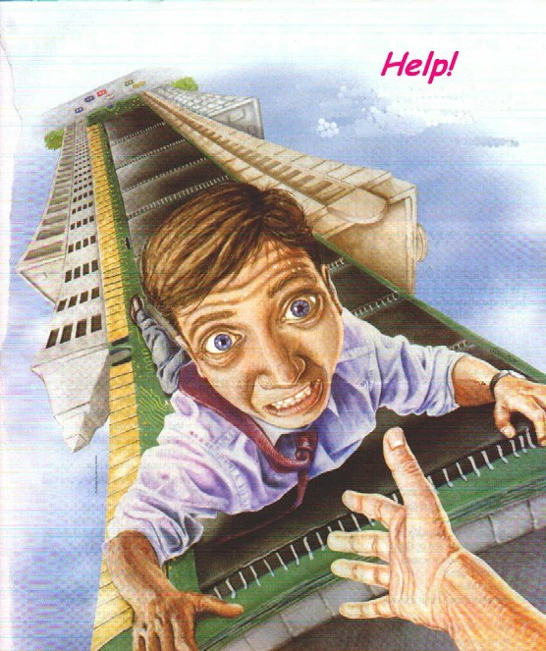With Energy Enhancement we can learn how to Transmute Aches and Pains, Traumatic Emotional Memories and Negative Thoughts, to Ground Negative Energies and learn The Mastery of Relationships Cravings and Desires.
Energy Enhancement teaches how to Increase our Good Luck, Happiness and Purpose.
How to deal with these painful/difficult experiences we undergo in life?

WE go to psychologists, doctors, and psychiatrists. We go to lawyers and marriage councilors. We get divorced. WE kill ourselves. We take drugs. We get involved in perverted sexual practices. We pierce ourselves and get tattooed. We cheat. We hurt our loved ones. We become alcoholics. We kill, rape and destroy. We entirely fuck up our lives. We get bad backs, heart disease and cancer. And through all this we wonder why all this pain? Why is life so difficult? Why is God such a bastard?

All this pain we carry within manifests into the circumstances of our lives. As within so without. What does this mean? Well if you carry pain within then you attract more pain. If you carry negative energies within you, then you attract negative experiences in your life. The only way to deal with it and overcome this is to get rid of the Energy Blockages inside. Remove the problem at the root.

Energy blockages are at the source, the cause of, root of all problems, painfull experiences and stressful situations we are presented with in life. Yet without the understanding of this basic concept we look in all other directions for solutions.

With Energy Enhancement we teach you how to get rid of these blockages. You understand the situation on an Energy level. You are empowered with the tools to change and heal your difficult circumstances.

In Energy Enhancement we teach you how to do it for yourself. We provide a field of positive energy to help the process, called the Buddhafield. From time to time, if you need a little help, we give it. But we are merely midwives or guides, and it is you who must walk every step of the way by yourselves and when you have done it you must also know that you have been carried every step by goodness and mercy. This way you don't come back. You don't slip down into the same hole of depression. Whatever challenges you are presented with, you know how to overcome. You know the method. You know the technique.

Your life changes. You are attracting positive experiences, better luck, better relationships and friends.
All gurus heal these horrible things whose cause is Energy Blockages.

Gurdjieff was given an oil tanker worth millions when he healed the son of a millionaire of drug addiction.

Sri Yogendra of Bombay told me that in the 1930's he was healing the children of millionaires and from this he was able to buy his ashram in Bombay, "They gave me a black stallion to ride around on in Central park", he said.

Daskalos, a Master in Cyprus said that when he was young he was a bit hasty. He was told to come and heal the son of a Greek Millionaire whose son was a Gambler, Heroin Addict and Homosexual. So he went into him and took away the blockages corresponding to those three problems and went away really happy. Three days later he was told to come again. The son was just lying there with no volition, drooling on the bed. He realised that this guy had nothing other than his blockages; he was totally cut off from his soul. So he gave him the least harmful one back. One problem with which he could still grow and evolve. He gave him back homosexuality and the guy bought a big villa. He filled it with works of art, learnt how to play the piano. Gave wonderful parties and lived there with his beautiful boyfriend.

They do this to create faith in people that this is possible. Miracles are possible with Energy Enhancement.
Yet the real work is always with those who are on the verge of enlightenment. Who have a heart which wants to help the world and all in it, who understand the reality of enlightenment and the urgency of the situation.

Energy Enhancement Client 1.
One beautiful young lady came on the Energy Enhancement Course with relationship and stress problems. From the age of 16, from her first period she had felt intense pain in the abdomen during that and every period since for many days. She went white with the pain and nothing had been able to diminish the problem days every month so all she did was go to bed for a few days and dosed herself with the most powerful analgesics, pain killers, she could find. Now the abdomen is Swadhisthan Chakra, the relationship chakra and a pain there points out energy blockages in the abdomen which probably came from implants or painful relationship partings, death, bereavement and painful breaking ups like divorce in this and in previous lifetimes.

Because of these traumatic memories fulminating in the abdominal psyche it is not possible to have a perfectly good relationship with anyone, they need to forgive you so many bad ways of acting, so much so that after a few painful tries at a normal relationship with prospective husbands she had decided to try out lesbianism. I told

her that she would have no better luck with lesbianism because if your relationship chakra is blocked, it is not possible to have perfectly good relationships with anyone.

And stress was there in her life which was seriously affecting her work. Because the pain caused blockages were filling up her abdomen, she had no room for storing more pain and stress, so she just could not deal with it and it was becoming more and more of a problem with each passing year... Further, because of the pain inside of the abdomen sometimes people do not want to go close to that pain. They do not want to move the abdomen at all because it disturbs the pain. Therefore they do not breathe into the abdomen and this lack of correct breathing further reduces their energy and their ability to handle stress. Statistically 30% of all people are like this. Although we can learn to breathe into the abdomen, unless we remove the pain filled blockages the problems will persist.

So, knowing the above I went into the abdominal chakra; by pushing energy down the right channel and feeling no flow coming back from the chakra from the left channel I was able to locate three energy blockages there. Energy Blockages stop the circular flow of energy between chakras. Using the techniques of Energy Enhancement level 2, The mastery of Energy Blockages, and Level 4, The Mastery of Relationships, I grounded, Transmuted and sent on the Perverted Negative Energy inside the blockages and the living energies which were maintaining them, one by one with great concentration.
BALANCED AND SHARED COMMUNICATION FLOW

Transmitting and Receiving Communication in a shared and balanced way.

The results were that next period and for every period afterwards our client had no more pain. She later reported by email that she was going out with a nice boyfriend again and her resistance to stress was vastly improved, particularly using the techniques of Energy Enhancement which we taught her on the course.

Energy Enhancement Client 2.
One Client came on the course with a pain in the abdomen and no or little blood flow during her periods which had started the previous year. I went into the abdomen and found a blockage on the side of the chakra receiving energy from others. This blockage meant that her relationships she could only GIVE and not receive energy on the physical, emotional, mental and spiritual planes. She could receive nothing from others and this she had been doing all of her life but after so many years of giving, at last she was running out of energy. Her battery of biological energy which she had been given at birth was running out.

Using the techniques of Energy Enhancement level 2, The mastery of Energy Blockages, and Level 4, The Mastery of Relationships, I grounded, Transmuted and sent on the Perverted Negative Energy inside the blockage and the living energy which was maintaining it. This blockage had been implanted in her and was being maintained in her abdomen in order to feed energy back to the implanter and to reduce her energy and ability to work.

The result of removing the implant was that she lost the pain and started to have normal blood flows during her period but she now needs to recharge her spiritual battery through rest and recuperation.

Energy Enhancement Client3,
Our client was raped when she was 17. This so made her feel ashamed in her hick rural community who blamed her for the rape, that she left and spent 25 years as a nurse abroad. The boy who raped her had his offence swept under the carpet because he was just a boy. Her trauma was driving her life and she found it impossible to create any successful long lasting relationship. Pain created Blockages in the abdominal chakra will do that. On the Energy Enhancement Course we removed the trauma blockages and she had the experience of forgiving her rapist who was now dead. Then she had the experience of meeting an Ascended Master in meditation who told her it was now time to go home to heal her life there. So after the course she went back home...

Energy Enhancement Client 4.

For example, when our client, Elektra (From the Greek Myth of Elektra, the sister of Oedipus, who killed her mother and married her father) was a child she had a beautiful energy connection with her father that she really enjoyed. Her father really enjoyed it too, probably much more that with her mother. Elecktras connection broke her Fathers connection with her Mother. He left home and set up house with another woman and this really upset our client because she felt like the wife who was left behind. The inner child formed at that point and like Anais Nin, unconsciously she started to connect to everyone, searching for that father connection she had before.

As she left home one day at the age of 14 she was set upon and raped probably because she was still seeking those same energy connections with others that she enjoyed with her father. The Inner Child connected energetically with a man who had no control. She did not do this consciously, the little Inner Child Computer program was in charge and was probably combined with a Poor Me program, searching for sympathy from her father in order to get him back.

These connections are sexual and yet they are used by parents to connect to and feed psychically their children. There is only room for one male and one female connection into the sexual base chakra.

There is a great deal of confusion over these connections and part of the Mastery of Relationships is to learn how to use these connections to give energy and to remove blockages appropriately and not to use them just for sexual gratification. It is part of the necessary Tantric experience to always do this appropriately and with no harm to anyone.
The Desireful Selfish Inner Child Blockages always end up hurting someone and therefore Energy Enhancement teaches you how to integrate and heal them.

Over the years, she used the poor me to attract her father again and again and she said with despair when he married again a young lady of her age and beautiful blond hair, "Why did he not choose me?" She chose, (poor me again?), a beautiful young boy to marry, a Niezchian god of the future, so bright, so intelligent. But a heroin addict. She gave birth to his baby but he died of his drugs.

She lived with her mother and her child went to university and learnt computers, so bright, so beautiful, so energetic and so implanted onto the dark side.

On the Energy Enhancement Course was needed in the case above... The purification of the self destuctor strategy which was using drug adiction to gain attention. Mastery of Relationships and energy connections. The removal of the energy blockage implant connection connection to the dark side which always tries to get you onto drugs, sex addiction, prostitution - DESPAIR, so as to be able to suck your energies dry more easily and use you as a slave.
Energy Enhancement Client 5.
Our client related that her cousin tried to rape her when she was nine. She had been very beautiful and had a large chest when she was nine years old. Several people had tried to abduct her for sex slavery. Her boyfriend violated her after 6 years of going out together. Her whole life had been about relationships and fathers and children. Her past life regressions had all told her that her problem was relationships and suicide. In one of her past lives she had been a famous poet who had committed suicide. She had not enjoyed sex and since the incident that happened when she was nine. When her cousin touched her chest in that incident she had become insensitive in that area.

The whole time she was talking to me I had felt a connection in the base chakra, the sexual chakra. The next day whilst lying in bed she had started thinking about me and had, like a succubus, connected with me again in the base sexual chakra. And yet I was certain that she was not consciously aware of what she was doing.
Psychologists call it libido and transference.
It seems that inner children. Split off parts of the self. Small egoistic computer programs are in control of connections between peoples chakras in areas in which most people have no conscious control.
All attachment is caused by these inter chakra connections. This is libido.
Probably she had unconciously connected with all of the people who had tried to rape her. Her inner child, split off by some painful incident when she was a little child, was in control of her love life and her conscious mind was not enjoying the ride. She was usually disgusted by any sexual attention, did not enjoy it or the people who were attracted to her.
ATTACHMENT LEADS TO PAIN - GAUTAMA BUDDHA
Her inner child blockages are in control of the monkey house. And if this is the case with her, then the chances are that inner children control the chakra connections between all people in both men and women. And even if you quite like your partner, unconsciously the emotionally driven inner child can still stop the sexual connection for any little thing and search around for another. All relationship problems start with attachment. All disappointment starts with attachment and leads to pain. And all of it is caused by mad pain filled blockages called inner children.
All of the dependent strategies to get what you want have their source in the mad inner children energy blockages.
With Energy Enhancement we can stop all pain caused by attachment. We can heal all this pain in the whole of humanity.
The solution was to heal all the inner children energy blockages. First by grounding all the pain caused energy filling and powering them, and then by integrating these split off parts back into the soul.

Energy Enhancement Client 6.
Well our client said that she, her sister and brother had been sexually abused by her mother, father and grandfather when they were children. Her brother and sister were drug addicts and had tried to commit suicide. She had been attracted to psychology and

psychiatry at university and was now a Senior Psychiatrist working with children. Her psychiatry had obviously saved her life but not sufficiently and thus she came to Energy Enhancement.

Obviously she had absorbed a lot of trauma and pain which needed to be grounded but interestingly she found when she started the Energy Enhancement Karma Clearing Process an explanation of the reasons as to why she had been given parents like this.

It is good for the ego to admit that in many previous lifetimes we have done bad things. We are all like this, but in this lifetime we have decided we want to do better.
Hitler can be forgiven. The prodigal son is welcomed back onto the path of light. Yet all these bad things we have done we have to learn how to forgive ourselves. Thus the Energy Enhancement Karma Clearing and Forgiveness process. Only when we have forgiven ourselves, can we learn how to forgive others. We do this by learning how to ground all these negative karmic energies so that we do not have to live through this karma physically. We can remove it energetically using the Energy Enhancement Techniques before it manifests into your life as pain and traumatic experiences.

It says in the Hindu Bible, a conversation between God or Krishna, and Arjuna or the good part of you, in the Baghavad Gita Chapter 16…

THE QUALITIES OF THE SELFISH COMPETITIVE PSYCHOPATHIC EGO....
Persons of demonic or psychopathic nature do not know what to do and what not to do. They neither have purity nor good conduct nor truthfulness. (16.07)
Psychopaths say that the world is unreal, without a substance, without a God, and without an order. The world is caused by lust (or Kaama) alone and nothing else. (16.08)
Adhering to this view these psychopathic lost souls, with small intellect and cruel deeds are born as enemies for the destruction of the world. (16.09)

Filled with insatiable desires, hypocrisy, pride, and arrogance; holding wrong views due to delusion; psychopaths act with impure motives. (16.10)
Obsessed with great anxiety until death, considering sense gratification as their highest aim, convinced that this (sense pleasure) is everything, (16.11)
Bound by hundreds of ties of desire and enslaved by lust and anger; they strive to obtain wealth by unlawful means for the fulfillment of desires. Psychopaths think: (16.12)
This has been gained by me today, I shall fulfill this desire, this is mine and this wealth also shall be mine in the future; (16.13)
That enemy has been slain by me, and I shall slay others also. I am the Lord. I am the enjoyer. I am successful, a powerful siddha or black magician, and happy; (16.14)
I am rich and born in a noble family. I am the greatest. I shall perform sacrifice, I shall give charity to show off, and I shall rejoice. Thus deluded by ignorance; (16.15)
Bewildered by many fancies; entangled in the net of delusion; addicted to the enjoyment of sensual pleasures; psychopaths fall into a foul hell. (16.16)
Self-conceited, stubborn, filled with pride and intoxication of wealth; they perform Yajna, religious sacrifice, only in name, for show, and not according to scriptural injunction. (16.17)
Clinging to egoism, power, arrogance, lust, and anger; these psychopathic malicious people hate Me (who dwells) in their own body and others' bodies. (16.18)
I hurl these psychopathic haters, cruel, sinful, and mean people of the world, into the wombs of other demons or psychopaths again and again. (16.19)
O Arjuna, entering the wombs of demons or psychopaths birth after birth, the deluded ones sink to the lowest hell without ever attaining Me. (16.20)
Lust, anger, and greed are the three gates of hell leading to the downfall (or bondage) of THE Jeeva personality. Therefore, one must (learn to) give up these three. (16.21)
Look at 16.19 and 20 again.
I hurl these haters, cruel, sinful, and mean people of the world, into the wombs of demons or psychopaths again and again. (16.19)

O Arjuna, entering the wombs of demons or psychopaths birth after birth, the deluded ones sink to the lowest hell without ever attaining Me. (16.20)

Demons in ancient times have been renamed Psychopaths.
And in the Energy Enhancement Karma Clearing Process, without any promting by me, this is what client 6 said...

1500 years ago she was a beautiful lady healer with long blond hair who was on the path of righteousness. A bad guy saw her and through implanting her with a blockage was able to make her fall in love with him. This bad guy turned her onto the dark side of the force and for 10 lifetimes this guy led her into bad paths of black magic, sex and sado-masochism, abusing many different people.
Then, as happens to all on the dark side she was defeated (LITERALLY DE-FEETED, her base chakra was broken and implanted by another bad guy) and she entered into 100 lifetimes of sexual abuse, serving as a sex slave and as a spiritual battery for the bad guy who implanted her.

She was learning why she had been given these experiences. Karma, the law of consequences, says we have been given the free will to learn the consequences of taking the wrong path. In reality we are only allowed the freedom of making the right choice.
Everything which has a beginning has an end.
And further, with Energy Enhancement, how to totally heal the entire stuation, how to dissolve the negative karmic energies which were throwing her into these hells time and time again. How to remove all the implants which were turning her into a batttery and not allowing her to generate the energy necessary to get her out of this black hole pit she was in. How to cut off all connections with the Dark Side, "seal the door which evil dwells" so that they could not attract her into bad ways again and become independant and free of all negative influences. How to gain infinite positive energy from the side of Light and goodness and purpose and will. She was learning how necessary it is to stay away from evil and to cleave to the good.

If you desire anything on this planet remember, you cannot take anything with you when you die except your evolution. So please evolve through the kindness of those sent to this planet to help you. They are here in every generation, just for you. This is the promise of the Baghavad Gita.

My teacher, Swami Satchidananda said that when he was young he could touch people and take away their cancer, he could touch people and take away their heart disease yet after three years he noticed that these same people were coming back with the same problems. He realised that unless they changed their minds also, it was not possible to heal them
permanently. They had to learn to do it for themselves. So he started a program for yoga and meditation and if the people were good, perhaps a little bit of healing could enter from the side.

Once a Swede came to Swami Satchidananda with a grave abdominal problem. Swami said, come to the Ashram for 6 months and learn Yoga and meditation and practise every day and your problem will be solved. So after 6 months the guy came to swami and said, the problem has not gone away. Swami asked if he had done everything, the yoga, the meditation and had practised every day and the guy said yes. So Swami moved his hand close to the abdomen and made a catching and pulling motion with his right hand as though he was pulling something out of him. He then asked him how he felt and the guy said the pain had gone. It never returned.

I remember Zen Master Hogen when I was with him in The Greek island of Lesbos acting as his general factotem and dogsbody. We lived together in the same house for two weeks and one night I had a dream. I was lying on a stone slab as a dead King. Hogen came to me and leant over my body from the hips and sucked out my right eye. He cleaned it with his mouth, took it out, polished it playfully and then put it back into his mouth, leaned over me again and spat it back into my eye.

The next day I found out that Hogen had done something very stupid. He had put some strong eucalyptus oil, Olbas Oil, on his finger and put it into his right eye. So, the students cleaned it out with water and he wore an eye patch, like a pirate, for the rest of

the time there. It must have been very painful for him yet these things are done for the benefit of the students. Thus the Master from time immemorial has absorbed the Karma of the Students. I asked Zen Master Hogen what he had done in past lifetimes and he said he had been a Guiness (Karma) maker. Now in this lifetime he was drinking all the Guiness. He was absorbing and transmuting all the karma. And this was the symbolism of his students giving him a can of Guiness every time They met him.

Swami Satchidananda told me that Yoga was the gaining of Psychic Vision and when necessary the blockages of the students are removed.

There are many examples gleaned from many experiences and books from the age of 16 when I started to practise Yoga. From the age of 21 when I started to read spiritual books and train with the National Federation of Spiritual Healers of Great Britain and then later to become a Yoga teacher and teach those with Multiple Sclerosis in my local class and at Ickwell Bury a Yoga Foundation run by Howard Kent near London. I had to stop the class after a while, they all got well.

And last but not least my training and experiences with Zen Master Hogen Daido Yamahata and Swami Satchidananda - two enlightened saints and Siddhas whose whole lives have been devoted towards the benefit of everyone who met them. Swami Satchidananda has now passed on at the age of 89 in 2002 but you can meet Hogen, student of the famous Zen Master Tangen Harada Roshi, in Japan at his Zen Temple on the slopes of Mount Fuji or at his Ashram in Australia.

In Energy Enhancement we teach you how to do it for yourself. We provide a field of positive energy to help the process called the Buddhafield and from time to time, if you need a little help, we give it. But we are merely midwives or guides, and it is you who must walk every step of the way by yourselves and when you have done it you must also know that you have been carried every step by goodness and mercy.

What makes you think that you have done anything? Only the Ego. And yet it is true, with the collaboration of infinity, you have done everything by yourself.

Satchidanand
SUPER ENERGY AND SACRED SYMBOLS

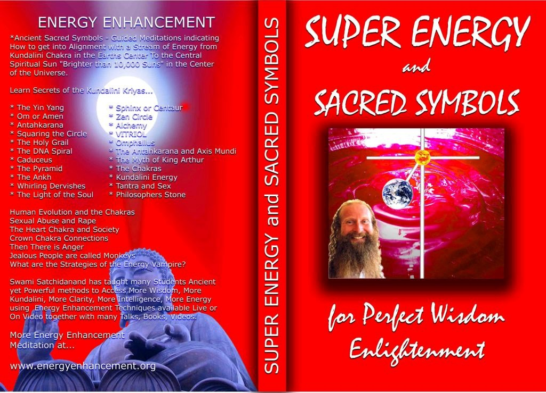

*THE ENERGY ENHANCEMENT BOOK… Ancient
Sacred Symbols - Guided Meditations indicating How to get into Alignment with a Stream of Energy from Kundalini Chakra in the Earth’s Center to the Central Spiritual Sun "Brighter than 10,000 Suns" in the Center of the Universe.

Learn Secrets of the Kundalini Kriyas... and more…

Swami Satchidanand has taught many Students Ancient yet Powerful methods to Access More Wisdom, More Kundalini, More Clarity, More Intelligence, More Energy using Energy Enhancement Techniques available Live or On Video together with many Talks, Books, Videos.

ENERGY ENHANCEMENT ONE – LINK INTO INFINITE CHAKRA ENERGY AND ELIMINATE ENERGY BLOCKAGES

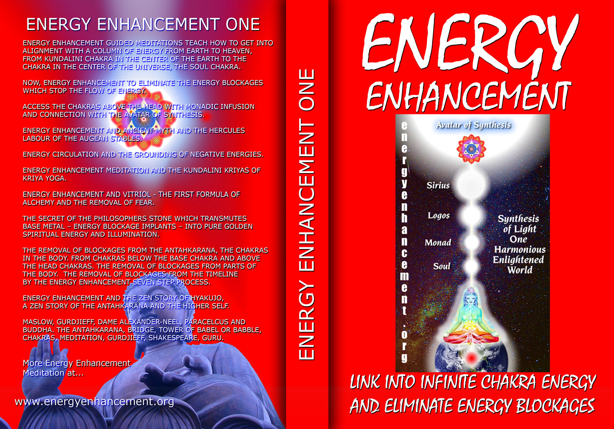

ENERGY ENHANCEMENT GUIDED MEDITATIONS TEACH HOW TO GET INTO ALIGNMENT WITH A COLUMN OF ENERGY FROM EARTH TO HEAVEN, FROM KUNDALINI CHAKRA IN THE CENTER OF THE EARTH TO THE CHAKRA IN THE CENTER OF THE UNIVERSE, THE SOUL CHAKRA.

NOW, ENERGY ENHANCEMENT TO ELIMINATE THE ENERGY BLOCKAGES WHICH STOP THE FLOW OF ENERGY.

ACCESS THE CHAKRAS ABOVE THE HEAD WITH MONADIC INFUSION AND CONNECTION WITH THE AVATAR OF SYNTHESIS.

ENERGY ENHANCEMENT AND ANCIENT MYTH AND THE HERCULES LABOUR OF THE AUGEAN STABLES.

ENERGY CIRCULATION AND THE GROUNDING OF NEGATIVE ENERGIES.

ENERGY ENHANCEMENT MEDITATION AND THE KUNDALINI KRIYAS OF KRIYA YOGA.

ENERGY ENHANCEMENT AND VITRIOL - THE FIRST FORMULA OF ALCHEMY AND THE REMOVAL OF FEAR.

THE SECRET OF THE PHILOSOPHERS STONE WHICH TRANSMUTES BASE METAL – ENERGY BLOCKAGE IMPLANTS – INTO PURE GOLDEN SPIRITUAL ENERGY AND ILLUMINATION.

THE REMOVAL OF BLOCKAGES FROM THE ANTAHKARANA, THE CHAKRAS IN THE BODY. FROM CHAKRAS BELOW THE BASE CHAKRA AND ABOVE THE HEAD CHAKRAS. THE REMOVAL OF BLOCKAGES FROM PARTS OF THE BODY. THE REMOVAL OF BLOCKAGES FROM THE TIMELINE BY THE ENERGY ENHANCEMENT SEVEN STEP PROCESS.

ENERGY ENHANCEMENT AND THE ZEN STORY OF HYAKUJO, A ZEN STORY OF THE ANTAHKARANA AND THE HIGHER SELF.

MASLOW, GURDJIEFF, DAME ALEXANDER-NEEL, PARACELCUS AND BUDDHA. THE ANTAHKARANA, BRIDGE, TOWER OF BABEL OR BABBLE, CHAKRAS, MEDITATION, GURDJIEFF, SHAKESPEARE, GURU.

Buy all Books and DVD’s at: amazon.com

www.energyenhancement.org

DVD 1 - KUNDALINI CHAKRA MEDITATION

HEART SUTRA – HIGHEST HEART OF WISDOM MEDITATION

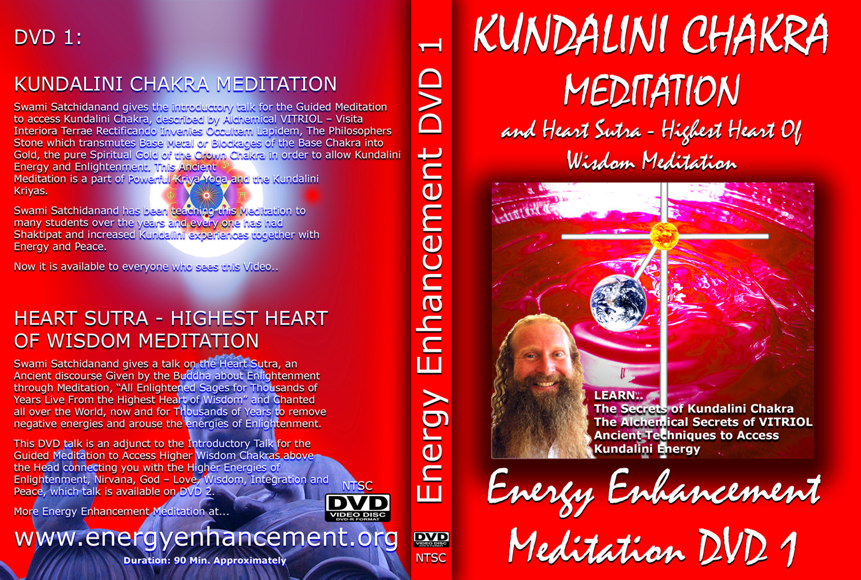

*ENERGY ENHANCEMENT MEDITATION DVD 1…
Guided Meditation to Access Kundalini Chakra, VITRIOL, The Philosopher’s Stone, Kriya Yoga and the Kundalini Kriyas.
Heart Sutra, All Enlightened Sages for Thousands of Years Live From the Highest Heart of Wisdom.

Buy all Books and DVD’s at: amazon.com

www.energyenhancement.org

DVD 2 - HIGHEST HEART OF GENIUS WISDOM MEDITATION

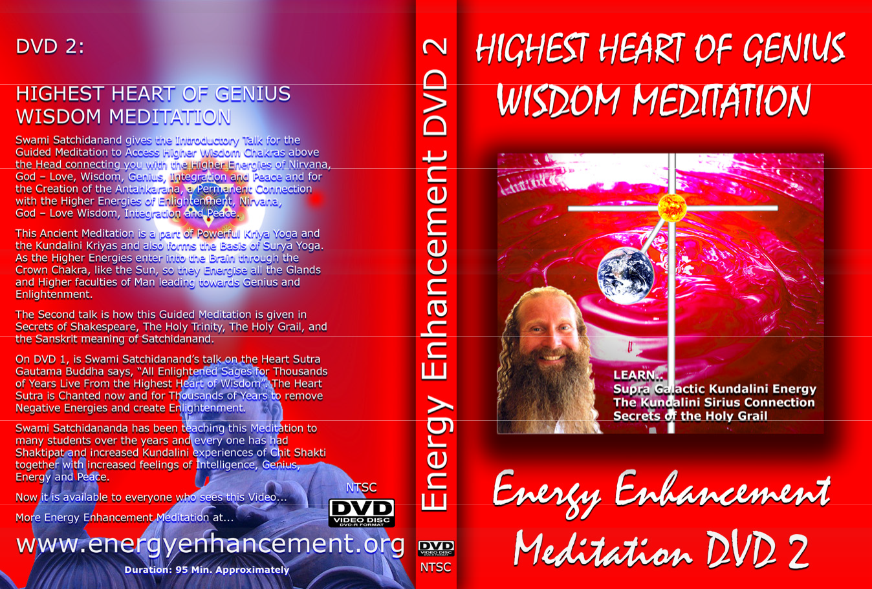

Guided Meditation to Access Higher Wisdom Chakras above the Head connecting you with the Higher Energies of Nirvana, God – Love, Wisdom, Genius, Integration and Peace and the Creation of the Antahkarana.

How this Guided Meditation is given in Secrets of Shakespeare, The Holy Trinity, The Holy Grail and the Sanskrit meaning of Satchidanand.

Swami Satchidananda has been teaching this Meditation to many students over the years and every one has had Shaktipat and increased Kundalini experiences of Chit Shakti together with increased feelings of Intelligence, Genius, Energy and Peace.

BOOK - GAIN SUPER ENERGY

ENERGY ENHANCEMENT LEVEL 1

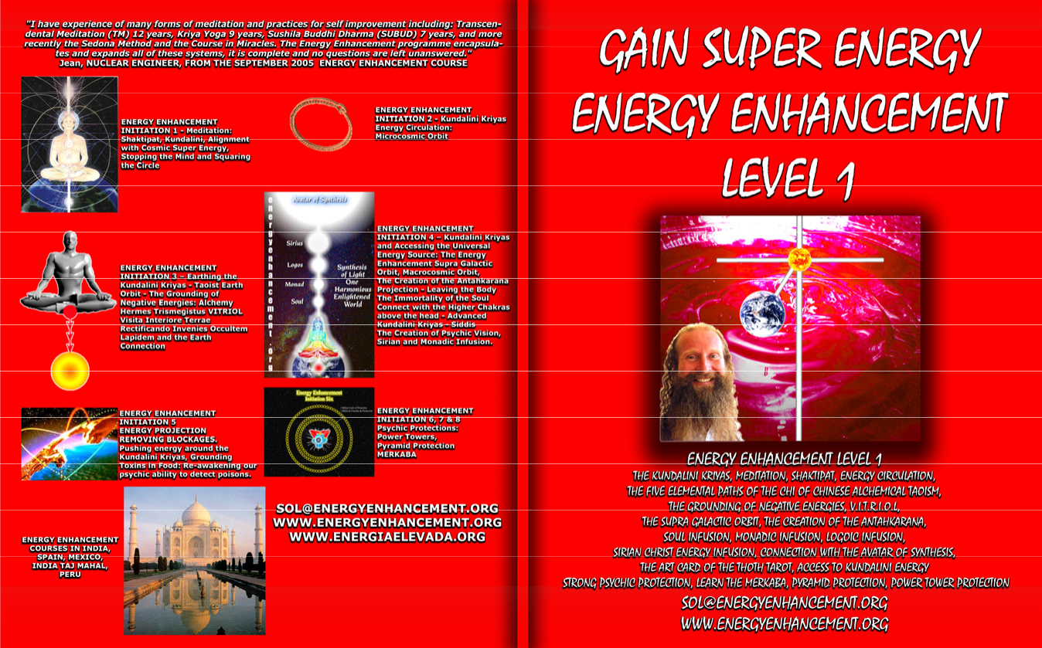

READ… The Kundalini Kriyas, Meditation, Shaktipat, Energy Circulation, The Five Elemental Paths of the Chi of Chinese Alchemical Taoism, The Grounding of Negative Energies, V.I.T.R.I.O.L., The Supra Galactic orbit, The Creation of the Antahkarana, Soul Infusion, Monadic Infusion, Logoic Infusion, Sirian Christ Energy Infusion, Connection with the Avatar of Synthesis, The Art Card of the Thoth Tarot, Access to Kundalini Energy Strong Psychic Protection, Learn the Merkaba, Pyramid Protection, Power Tower Protection.

Buy all Books and DVD’s at: amazon.com

www.energyenhancement.org

THE ENERGY
ENHANCEMENT FOUR INITIATION DVD COURSE - THE ULTIMATE TECHNIQUES ON 15 DVDs

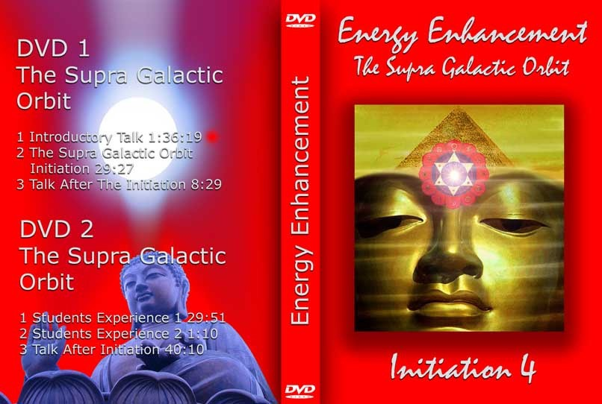
“I have experience of many forms of meditation and practices for self improvement including: Transcendental Meditation (TM) 12 years, Kriya Yoga 9 years, Sushila Buddhi Dharma (SUBUD) 7 years, and more recently the Sedona Method and the Course in Miracles. The Energy Enhancement programme encapsulates and expands all of these systems, it is complete and no questions are left unanswered.”

JEAN, NUCLEAR ENGINEER, FROM SEPTEMBER 2005 ENERGY ENHANCEMENT COURSE

ENERGY ENHANCEMENT LIVE
COURSES – WORLDWIDE


INDIA, 5 STAR INDIA TAJ MAHAL, SPAIN, MEXICO, PERU, ARGENTINA – MORE

Bookings: www.energyenhancement.org

