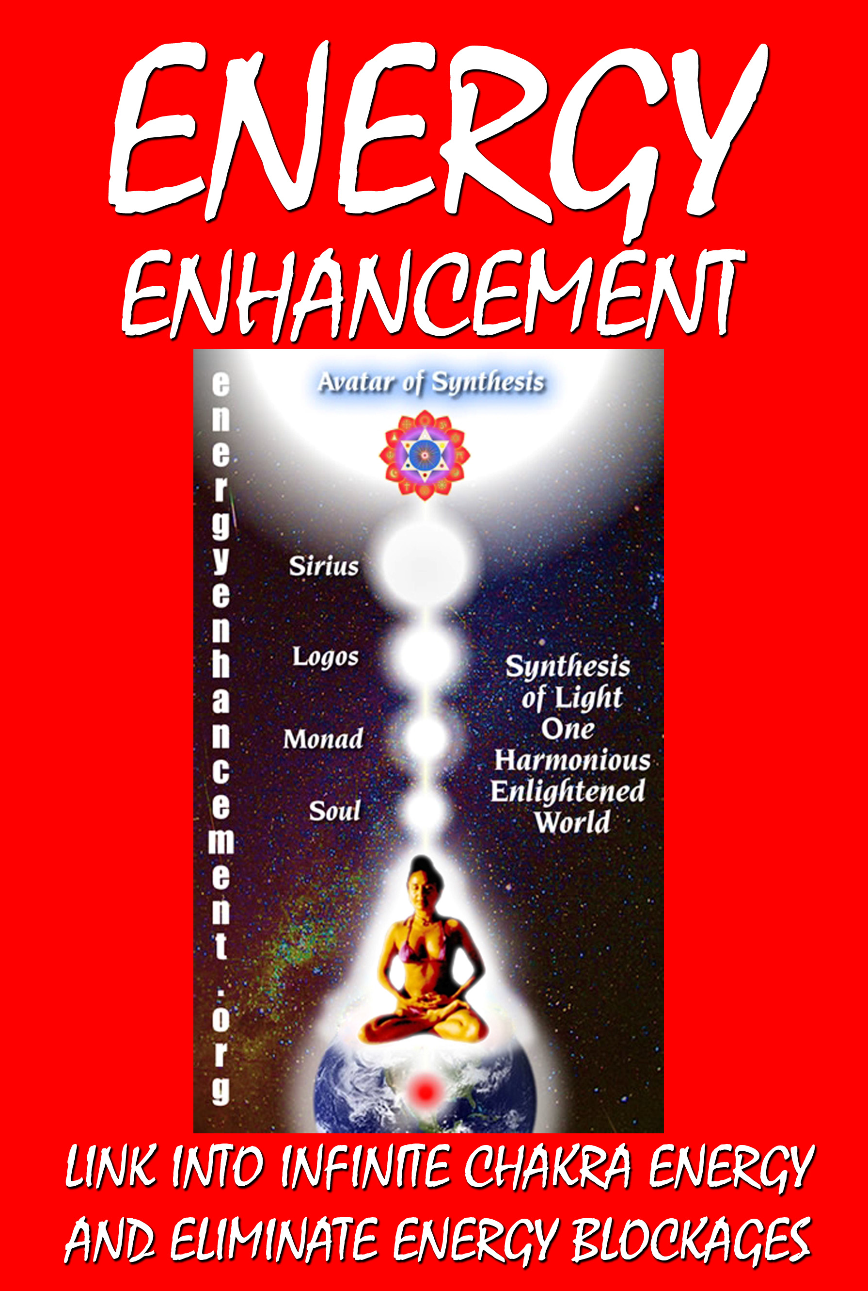

DEDICATION

With all Thanks, Love and Gratitude to Swami Devi Dhyani and all the helpers like Franco Masellis who make these books and DVDs possible.
With all Thanks, Love and Gratitude to my Mother and Father and to all my other Teachers, Theos Bernard, Sri Yogendra, Eric Berne, Gurdjieff, Father Bede Griffiths, Osho, Zen Master Hogen, Swami Sivananda, Swami Satchitananda, and all the other giants upon whose shoulders I stand - who made me able to be what… I AM – Swami Satchidanand
Copyright © 2008

[Energy Enhancement Synthesis of Light Limited (SOL)] All rights reserved. This publication may not be reproduced in whole or in part, by any person,
without written permission of: Swami Satchidanand
sol@energyenhancement.org www.energyenhancement.org Printed by Amazon
ISBN: 1440497540

CONTENTS
ENERGY ENHANCEMENT…………
……………………………… Page 11
THROUGH ENERGY ENHANCEMENT MEDITATION, CHOOSE A DEFECT FREE LIFE OF RICHNESS, PEACE AND JOY
Energy Enhancement Satchidanands 90 minute talk on the Energy of Enlightenment
MEDITATION ENERGY ENHANCEMENT JOIN IN OUR VISION OF ONE ENLIGHTENED HARMONIOUS WORLD.
Energy Enhancement Samyama, The Fastest Way to Enlightenment Energy Enhancement Meditation, Experiencing One's Own Reality The Energy Enhancement Meditation Symbol
Energy Enhancement Meditation and Shaktipat Energy Enhancement the Buddhafield And Kundalini
The Energy Enhancement Ancient and Effective Meditation Techniques and Old Meditation Systems
Energy Enhancement Meditation Opening the Heart, Relationships, Hanbledzoin, Buddhafield, Kundalini + Shaktipat
The Art of Energy Enhancement: Meditation to Remove Energy Blockages, Negative Emotions, Bad Luck
Energy Enhancement Meditation To Know Yourself ENHANCEMENT TANTRA AND ENLIGHTENMENT
World Peace by Meditation: The End of Poverty and Anger, Stress, Tension, Depression, Sorrow, Hate?
Energy Enhancement Meditation Guide to Enlightenment
FAQ ONE About Kundalini, Mantak Chia, and Transcendental Meditation
FAQ TWO - Energy Enhancement and ALIEN POWERS, VESSELS, INSTRUMENTS and ADEPTS
Energy Enhancement and Psychology
Reflections on "How to Do What You Love" by Paul Graham through Meditation

The Mastery of Relationships, The Energy of the Heart Center, Evolution and Meta
Why are You So Poor in this Lifetime Enlightenment
Energy Enhancement SYNTHESIS Pearl of Great Price
Do it!!
Commentary by Satchidanand on Questions and Answers by Andrew Cohen
Install Love
Rules for being human. PHILIP CHESTER
JEANS SEPTEMBER 2005 COURSE TESTIMONIAL
Energy Enhancement Course Jean - L’Escala SEPTEMBER 2006

ENERGY ENHANCEMENT AND ANCIENT MYTH ……… Page 143
THE SUFI ALHAMBRA AND THE EMERALD TABLET OF HERMES TRISMEGISTUS
Energy Enhancement, The Macrocosmic Orbit, The Antahkarana, and Emerald Tablet Of Hermes Trismegistus
Energy Enhancement and VITRIOL - The First Formula of Alchemy and the Removal of Fear
Energy Enhancement and the Mythical Labour of Hercules Involving the Hydra
Energy Enhancement Meditation and the Hercules Labour of the Augean Stables
Energy Enhancement Meditation And The Kundalini Kriyas Of Kriya Yoga
Energy Enhancement, Theseus And The Minotaur, Energy Circulation And Opening The Heart
The Antahkarana, Bridge, Tower of Babel or Babble, Chakras, Meditation, Gurdjieff, Shakespeare, Guru

Energy Enhancement The Alhambra And The Alchemical Trinity Meditation the Antahkarana
Energy Enhancement The Shiva Lingam Meditation And The Trinity the Antahkarana, and Connection
Energy Enhancement Initiation 4 The Macrocosmic Orbit And The Antahkarana
Energy Enhancement The Paramahamsa The Yin Yang Symbol, Yogananda And The Transmutation Of Energies
Energy Enhancement and the Zen Story Of Hyakujo, A Zen Story Of The Antahkarana And The Higher Self
Energy Enhancement And Secret Knowledge At Chartres
Energy Enhancement the Tarot Princess of Swords And Advanced Techniques Of Meditation
Energy Enhancement Meditation and the Bhagavad Gita CH11 V53 to 55: Removal of Energy Blockages
Your Split Mind and Sub-Personalities Healed in Meditation in Raja Yoga the Yoga Sutras of Patanjali
GOLDEN LIGHT SURGES INTO MY BRAIN... INNER PEACE

MOVIES ………………… Page 205
THE EE INCREDIBLY SUCCESSFUL AND PROFITABLE MOVIE LIST - AMERICAN BEAUTY
APOCALYPSE NOW - THE HORROR OF THE BRANDO KURTZ SPLIT EGO AND THE TRAUMA THAT SPLITS IT CREATING DID AND MPD
Myth Meditation Analysis of King Kong, Lord Of The Rings, Beauty + The Beast Indicating DID + MPD
King Kong
GEORGE LUCAS, STAR WARS AND THE REVENGE OF THE LORDS OF THE SITH

POETRY ………………… Page 231
Satchidanand - The Poetry of Wealth - Education and Profit Satchidanand - The Poetry of Wealth - Dreams and Money Satchidanand - The Poetry of Wealth - Institutions and Welfare Satchidanand - The Poetry of Wealth- People and Slavery Satchidanand - Poetry of Wealth - Peace and Work

MASLOW, GURDJIEFF, DAME ALEXANDER-NEEL, ELRON HUBBARD, PARACELCUS, BUDDHA, RAMANA MAHARSHI, RAMAKRISHNA ……… Page 234
Is Maslow's Hierarchy A Plagiarism On Chakras & Kundalini Yoga, Known About For Thousands of Years
GURDJIEFF AND BLOCKAGES
Reciprocal Maintenance Meditation, Buffers or Energy Blockages, Mechanical people, Sub – Personalities and the Soul Personality or Essence, through the work of Gurdjieff Part 1 of 2.
Reciprocal Maintenance Meditation, the Solution to the Problem of War, Increase of Life leading to Immortality through the work of Gurdjieff Part 2 of 2
What Did Gurdjieff Say about Meditation, Frank Lloyd Wright, Ego + Enhancement of Energy
What did Gurdjieff say about Meditation, Ouspensky, Egoism and the Enhancement of Energy
What did Gurdjieff say about Meditation, Orage, Egoism and the Enhancement of Energy
Tapas IS the Conscious Suffering of Gurdjieff HUBBARD, SCIENTOLOGY AND BLOCKAGES PARACELSUS AND BLOCKAGES
DAME ALEXANDRA DAVID NEEL

Meditation and Psychic Powers: Shaktipat, Supermind, Kundalini Kriyas, Siddhis, and Enlightenment
Meditation and Psychic Powers: Shaktipat, Supermind, Kundalini Kriyas, Siddhis, and Enlightenment Deepankar Buddha
RAMANA MAHARSHI, Meditation and Psychic Powers: Shaktipat, Supermind, Kundalini Kriyas, Siddhis, and Enlightenment
Ramakrishna Meditation and Psychic Powers: Shaktipat, Supermind, Kundalini Kriyas, Siddhis, and Enlightenment
Meditation and Psychic Powers, Shaktipat, Kundalini Kriyas, Siddhis, Enlightenment and Ramakrishna 2

ENERGY BLOCKAGES ……………
……………………………Page 326
Energy Enhancement Just Ground It
Energy Enhancement, Energy Blockages and The Removal Of Fear
Energy Enhancement Meditation, Energy Blockages, and Vipassana
Energy Enhancement Meditation Escape is no Solution: One Must Face the Energy Blockage Problem
Karma Clearing Process of Energy Enhancement Meditation Including the Kundalini Kriyas + Alchemy
MIND IS A DISEASE
ENERGETIC BLOCKAGES WITHIN THE BODY
Energy Enhancement and the Removal of all the Blockages From All Your Previous Lifetimes
THE REMOVAL OF ENERGY BLOCKAGES AND IMPLANTS BY THE ENERGY ENHANCEMENT SEVEN STEP PROCESS
Blockages and FORGIVENESS
Vanessa Three Months - 2002, 2005, 2007
One Month with MS, Human Resources Director Europe/Asia of a large Fortune 500 US Multinational Company
WHAT HAPPENED TO NORMA MCDONALD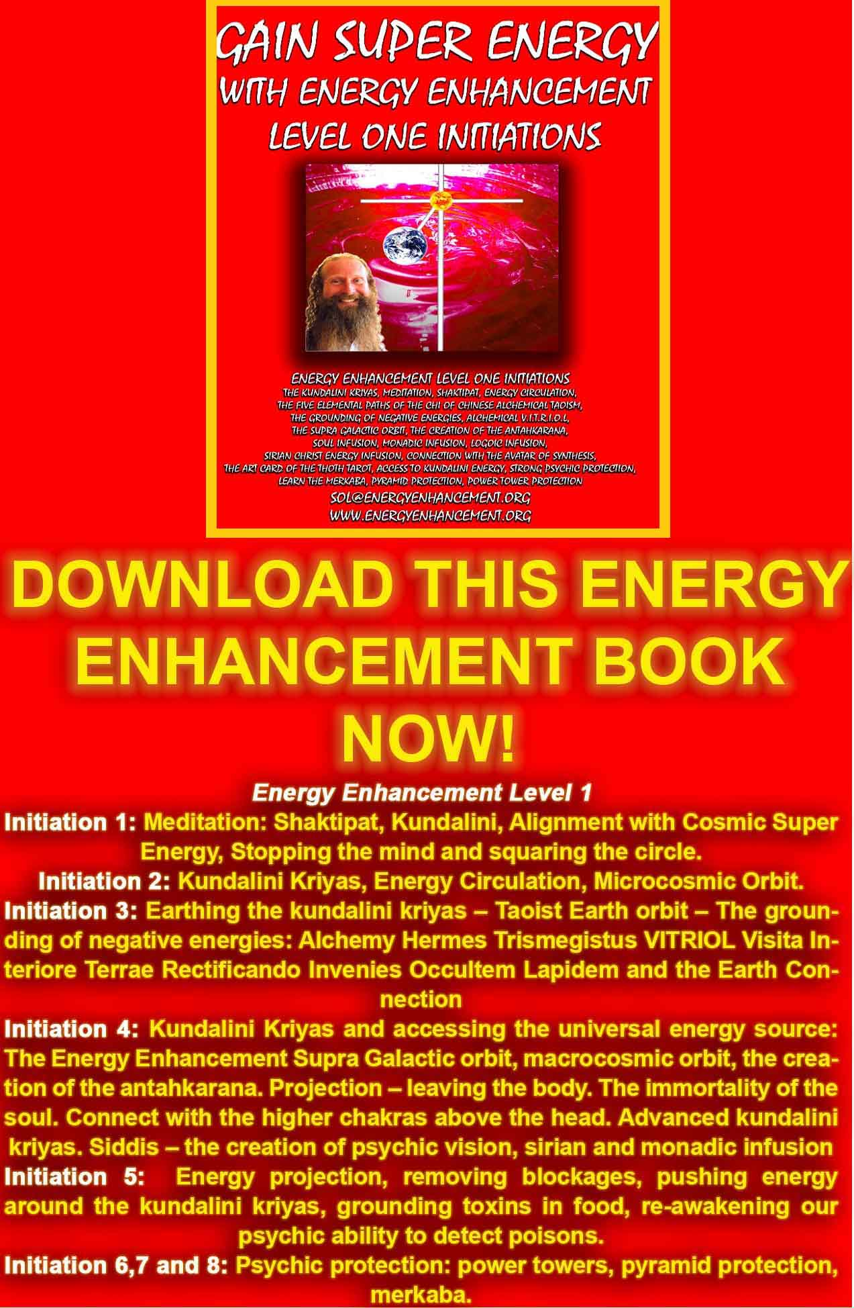
DOWNLOAD “GAIN SUPER ENERGY WITH ENERGY ENHANCEMENT LEVEL ONE INITIATIONS HERE!!!
http://www.energyenhancement.org/Sacred-Energy/Gain-Super-Energy-Energy-Enhancement-Level1-Initiations-Kundalini-Kriyas-Meditation-Shaktipat-Circulation-Taoist-Orbits-Alchemy-VITRIOL-Grounding-Psychic-Protection-Pyramid-Merkaba-energyenhancement-org.pdf
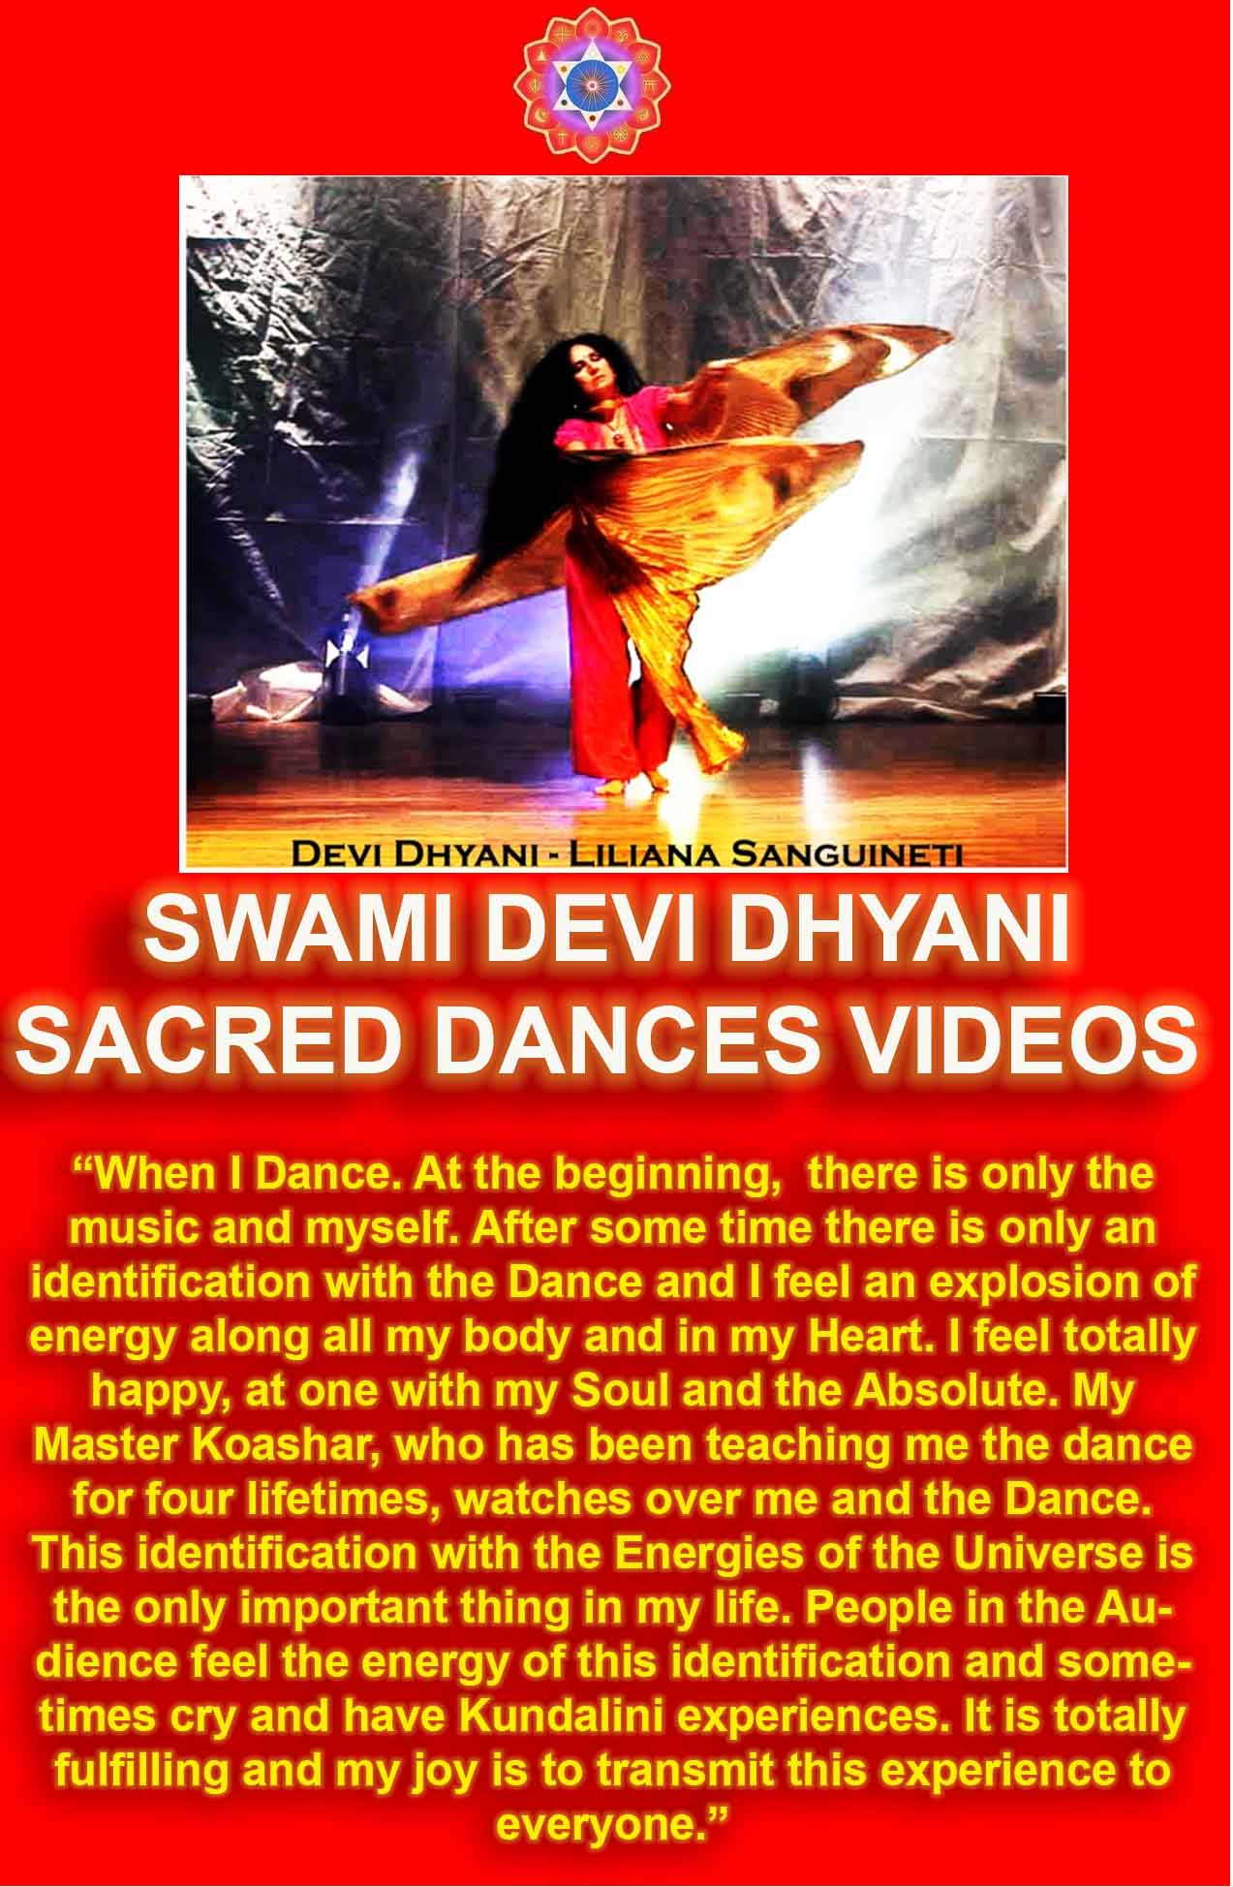
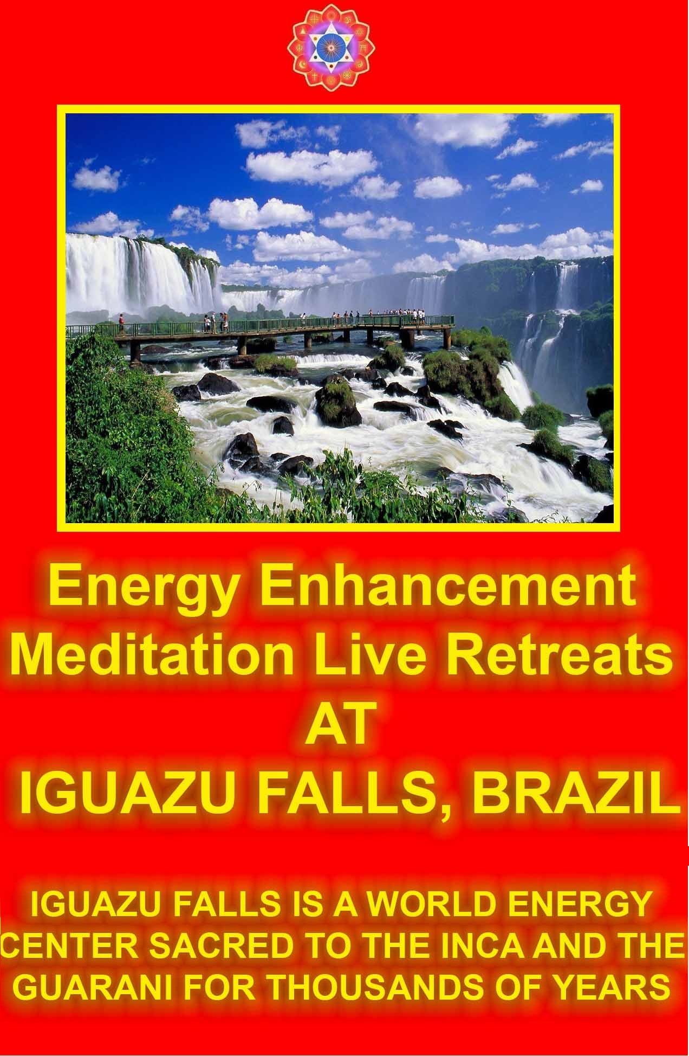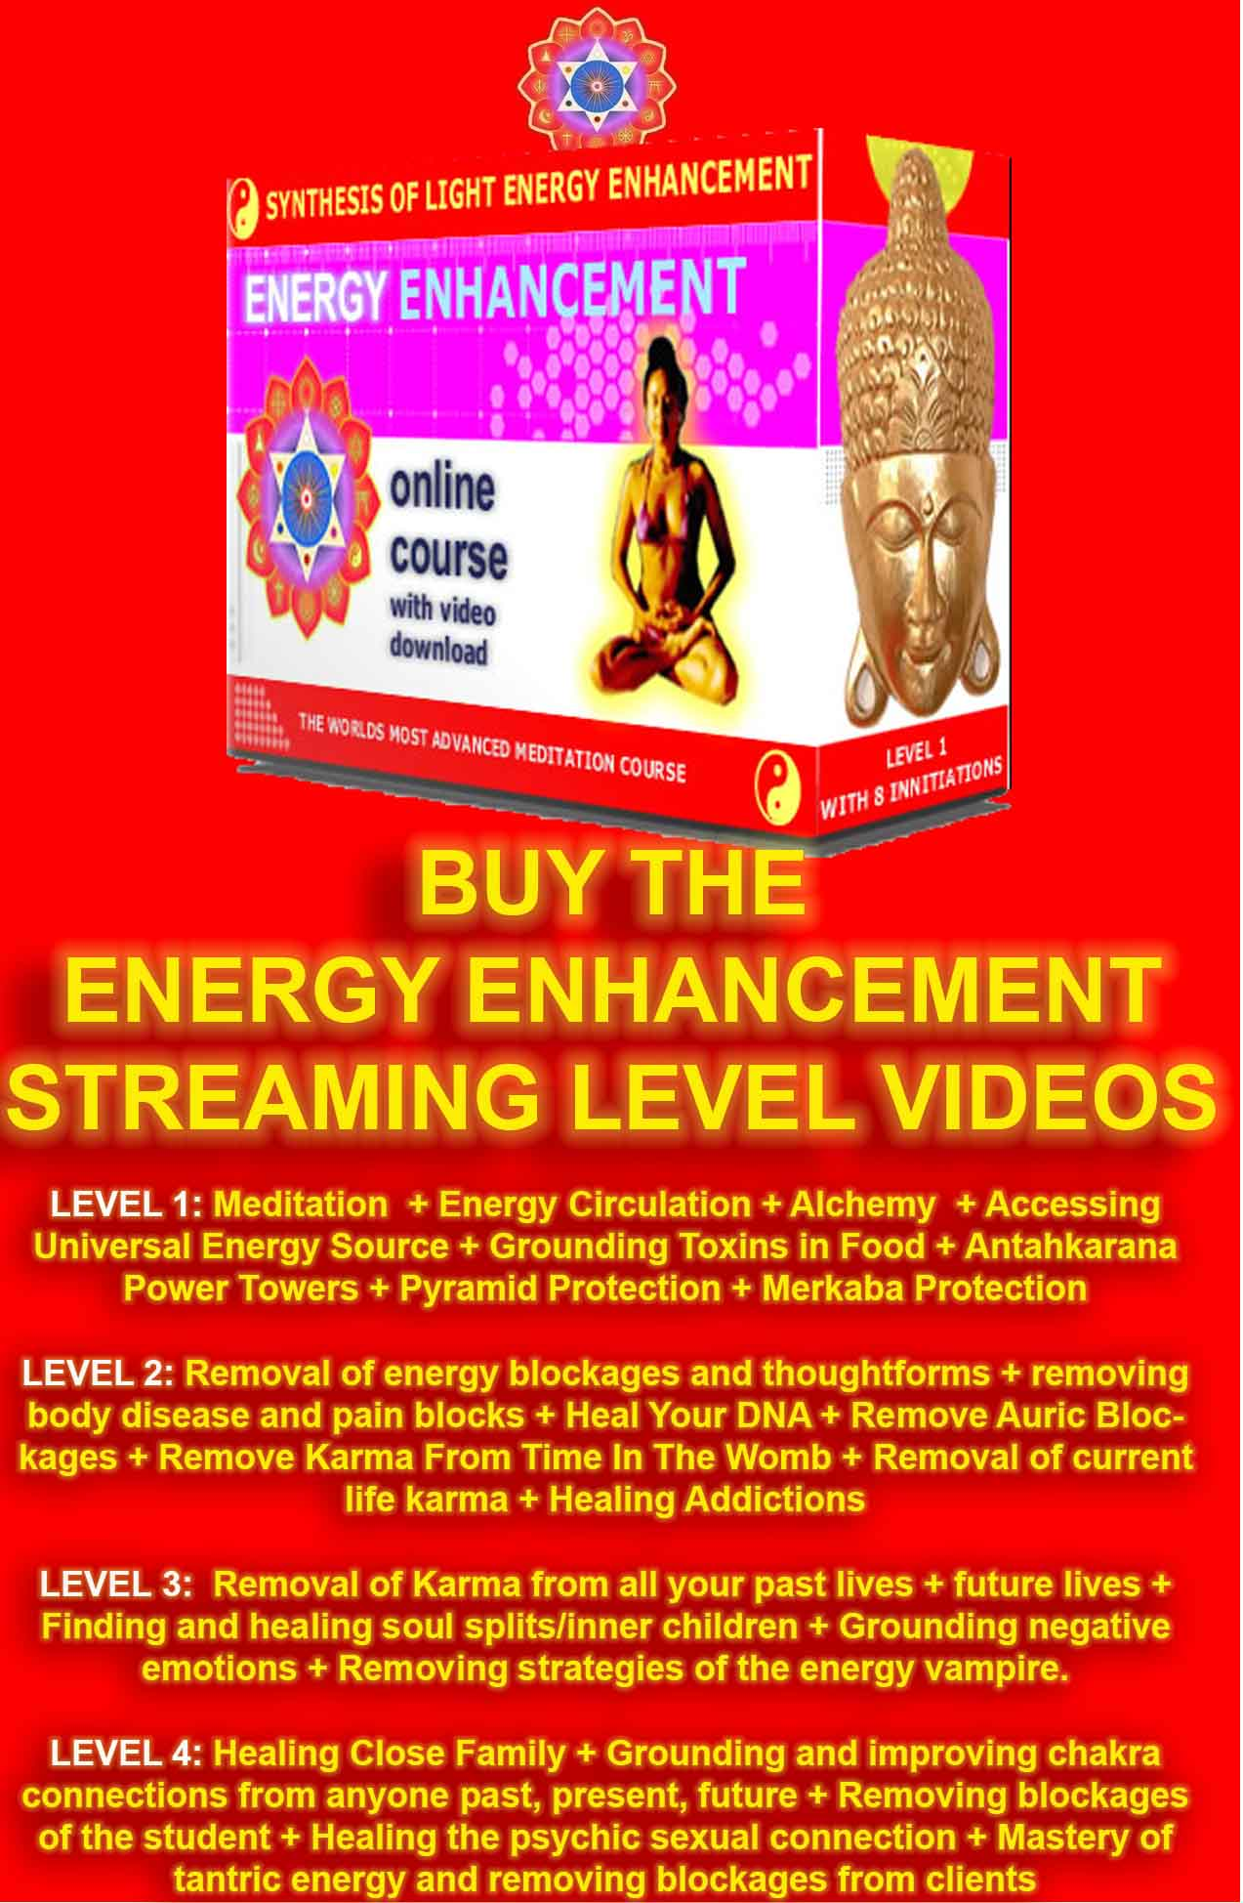

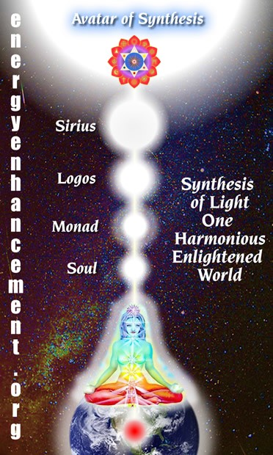

Energy Enhancement connection with the chakras above the head through the Antahkarana column of energy from Kundalini Chakra in the center of the earth through an infinity of chakras in the body and above the head to the One God with 10,000 names in the Center of the Universe.

THE SYNTHESIS OF LIGHT (SOL) BY SATCHIDANAND

ENERGY ENHANCEMENT COURSE
This work has been written with the aim of introducing the Techniques of Energy Enhancement to the world. This New Course of Energy Enhancement is an Integration and improvement on Ancient Techniques over 5000 years old with the best track record of success in producing an Acceleration in the Evolution of those partaking of them.

SPEED UP THE PROCESS OF EVOLUTION!

- Energy Enhancement Speeds UP the Process of Enlightenment.
- Stop the Trauma… Energy Enhancement teaches how to dissolve old trauma, the congealed energies called Negative Karmic Mass.
- More Energy - Less Sleep, More Vigour, More ability to do, speeding up of the Normal mind, connection with the source.
- The Grounding of Negative Energies and the Removal of Pain.- No bodily Aches and Pains, No bad Memories, Stable Emotions, Full Breathing, A quiet Mind.
- Soul Fusion, Access to your Genius.- The Ability to Channel Information, Genius, Intuition and Infinite Energy more Creatively in your chosen field or Effort, the Path of your Life.
- The Mastery of Thoughtforms - The Removal of Energy Blockages Mastery of Bad and Good Habits.. The healing of all painful Inner Children. The ability to deal with all your Childish Strategies. The Channelling and Creation of Teaching Tools for the benefit of Humanity. The ability to Dissolve old Outmoded Thoughtforms.
- The Mastery of Energy Connections Between People.
- The Mastery of Relationships.- At peace with all your Relationships, Appreciation of the Good and Bad qualities of all, The Mastery of leaving and being left, the Mastery of Bereavement, The ability to come and Go, Complete Freedom.
COME LEARN THE ADVANCED TECHNIQUES OF ENERGY ENHANCEMENT, NOW!!

GAIN ENERGY APPRENTICE LEVEL1
YOU GET ALL THIS TO GAIN ENERGY IN LEVEL ONE OF ENERGY ENHANCEMENT...
MEDITATION, SHAKTIPAT, ENERGY CIRCULATION, THE KUNDALINI KRIYAS, THE FIVE ELEMENTAL PATHS OF THE CHI OF CHINESE ALCHEMICAL TAOISM, THE GROUNDING OF NEGATIVE ENERGIES,
ALCHEMICAL V.I.T.R.I.O.L, Visita Interiora Terrae Rectificando Invenies Occultem Lapidem – THE SECRET OF THE PHILOSOPHERS STONE WHICH TRANSMUTES BASE METAL – ENERGY BLOCKAGES – INTO PURE GOLDEN SPIRITUAL ENERGY AND ILLUMINATION. THE SUPRA GALACTIC ORBIT, THE CREATION OF THE ANTAHKARANA, THE ENERGY COLUMN OF CONNECTION BETWEEN HEAVEN AND EARTH. ACCESS THE CHAKRAS ABOVE THE HEAD WITH SOUL INFUSION, MONADIC INFUSION, LOGOIC INFUSION, SIRIAN ENERGY INFUSION, CONNECTION WITH THE AVATAR OF SYNTHESIS, THE ART CARD OF THE THOTH TAROT, ACCESS TO KUNDALINI ENERGY, STRONG PSYCHIC PROTECTION, LEARN THE MERKABA, PYRAMID PROTECTION, POWER TOWER PROTECTION.

THE ENERGY BLOCKAGE REMOVAL PROCESS LEVEL2
THE ELIMINATION OF ENERGY BLOCKAGES AND IMPLANTS WITH ADVANCED ENERGY BLOCKAGE BUSTING TECHNIQUES
THE SEVEN STEP PROCESS, THE REMOVAL OF THOUGHT-FORMS, THE REMOVAL OF IMPLANTS, THE REMOVAL OF ENTITIES, THE REMOVAL OF AURIC EGG BLOCKAGES, THE REMOVAL OF SHAME, GUILT, DISAPPOINTMENT, BEREAVEMENT, NEGATIVE EMOTIONS - ANGER, FEAR, WANTING SYMPATHY, MANIC, SADNESS, DEPRESSION, CHRONIC DEPRESSION, ENVY, JEALOUSY, THE DESIRE TO DO HARM. INCREASE YOUR EMOTIONAL IQ, CLEAR CANCER FROM THE DNA, THE REMOVAL OF BLOCKAGES FROM THE ANTAHKARANA, THE CHAKRAS IN THE BODY FROM CHAKRAS BELOW THE BASE CHAKRA AND ABOVE THE HEAD CHAKRAS, THE REMOVAL OF BLOCKAGES FROM PARTS OF THE BODY, THE REMOVAL OF BLOCKAGES FROM THE TIMELINE, THE KARMA CLEANING PROCESS, THE WOMB, THE PRIMAL SCREAM, CLEAN THE KARMA FROM ALL THE YEARS OF YOUR LIFE, CREATE GOOD LUCK, AND GOOD HEALTH.

ENERGY ENHANCEMENT
THROUGH ENERGY ENHANCEMENT MEDITATION, CHOOSE A DEFECT FREE LIFE OF RICHNESS, PEACE AND JOY
Any Human Being. Any Line of work.
Whether you are a Businessman, an Executive, a Nurse, a Doctor, an Engineer, a Computer Scientist, a Salesman, Housewife, Yogi or Student, you are interested in having a Defect Free Life.
A Life without Faults or Mistakes or Problems of any kind. A life of Richness, Internal and External where your meditationally increased Energy will produce Results!!
Meditation and Energy Enhancement which teaches Twenty Seven Ancient and Effective techniques Beyond Simple Meditation to Speed Up the Meditative Process will progressively give you that Defect Free Life of Richness and Joy, giving You Energy, Love, Intelligence and Will.
For 5000 years sages and saints have been telling you that the mind is limited. It is necessary but it is limited and it is always making mistakes. It is fractured and fragmented and creates many problems. In many cases we seem to be connected to a Self Destructive Saboteur which totally destroys our lives.
Meditation and Energy Enhancement are techniques which can help you come to a mistake free life. You can find the most intelligent man in the world, on the IQ scale, and that man can have no common sense whatsoever.
Bill Clinton was once the President of the United States of America, he was a Rhodes Scholar sent to study at Oxford University in the UK and Granada University in Spain. They say that he has an IQ of 170, yet even this great intelligent man could not, in the land of Christian politics, keep his trousers on in front of the Newspapers and television. It was proved that he was telling lies in the Lewinsky scandal and he was thrown out of the Guild of Lawyers because of it. GOODNESS KNOWS WHAT HE DID IN GOVERNMENT AND HE WAS ONE OF THE MOST INTELLIGENT!!
Now a c grade student from Yale University is in charge.... But they also have no Heart...

Meditation is the way of going beyond the Mind to a place of Heart, Intuition, of Coherence, Alignment with the soul or higher self where you can become integrated, One, Governed by higher levels of Energy.

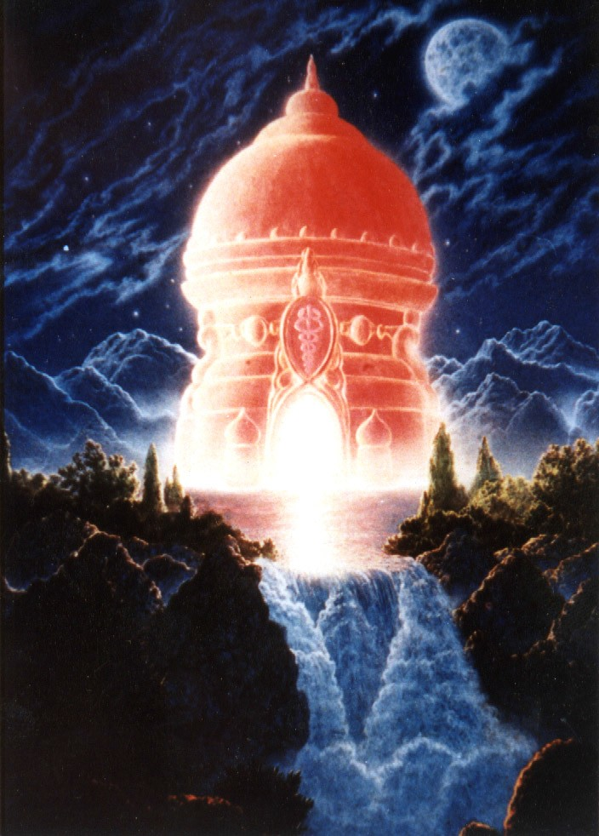

The Spring of the Temple at the Top of the Mountain always represents the pure spiritual flow of Energy from the Center of the Universe which supplies all the Energy we can ever Need.

Also, the Energy of Meditation can so unify your energetic field that you can produce coherence and alignment and peace in all people which surround You.
The people of Transcendental Meditation have proved in a great scientific experiment, reported in major scientific journals that when a lot of people meditated together in a city, then that city experienced lower levels of crime. The crime statistics of the whole city on every level were lowered during the process of the meditation. Just think what a process of daily meditation could produce in your life and in the people around you, your family, your friends. Any meditation you practice will help them also.
The movie, The Last Samurai, was making that point. Human society and politics is governed by the mind. It wants everything and will do anything to get it. But Tom Cruise the Star and executive producer of the Movie, together with the Writer, John
Logan who wrote "Gladiator" was saying that this mix of selfish desire and intellect needs the leaven of the state of meditation. And when at the end of the movie when Tom was handing the Sword Soul of the Meditation of the head Samurai to the Emperor, he was handing on the message of meditation. And that meditation so strengthened the courage of the Emperor that he became capable of throwing out the bad people in his Government.
He is still passing that Sword to You, so that you can cast out all your negative energy blockages! ....
Today no Government can promise you security in the face of Selfish Desire, Weapons of Mass Destruction, and Terrorism. They can not prevent!!!
Only the coherence and alignment of the energy of peace from meditation can start to change the world, your life now and your future lifetimes, creating more luck in your life and preventing attacks before they arise.
Only the supreme knowledge and aligned consciousness and the energy of peace from YOUR meditation can start to change YOUR life now and your future lifetimes, giving you more energy, perseverance, good relationships and Luck by preventing defects and failures in Your Life before they arise.
No Government can prevent... has been able to improve the problematic areas of Education and Health. Dummed down and plain unhealthy. In the UK 30% of the people die from cancer and 25% from Heart disease. In fact they keep changing methodologies constantly in the hopes that no-one will notice that in the face of all this effort.... things are getting worse.

And because of this, every three or four years the Governments are thrown out a new one replaces them. And we, stupidly, because of 10,000 years of history, start full of hope whilst they continue to lie and to fail.
More people are starting to practise meditation, One of the Fastest Growing Ancient and Successful Techniques in the World, because it works now and has worked for 5000 years creating in that time all the Spiritual Masters to whom we look up to because of their lives of health and goodness and mercy to all.
It needs artists like Geldoff and Bono from U2 to remind us that our happiness is created by the happiness of everyone around us - Let's help Africa they say.
And others bring the awareness of the environment being destroyed by industrial pollution and not simple carbon dioxide which feeds the trees, - yes those big clouds of pollution and xeno- oestrogens only emanate from the fuctories near you at 4am when all the cars are off the road.
This same pollution which previously created the scourge of Tuberculosis is now creating the killers of Cancer, Heart Disease, Aids and low birth rates in every country in the world.
Also the fact that throughout the world many children are lacking in parents, food, water, houses and education and for this reason their pain will provide the next terror and war cannon fodder in the coming years of this century.
Our happiness is bound up in the happiness of others. Who are the happiest people, those who make everyone around them happy.
Governments and the people who run them never have had this point of view. They do not meditate!
Their control comes from making their people afraid, and for this an enemy is needed. Or it does not fit into their budget. All they can do is to report what happens, that this bank has been robbed by some burglars and this company has failed with the loss of the pension fund or that this country is going to war and yes, you are being conscripted, enslaved into the army.
This has been the case for 10,000 years whilst the governments of Alexander the Great, Julius Caesar, Caligula, Nero, Genghis Khan, Napoleon, Hitler, Stalin, and Mao, have killed untold millions of people, 200 millions alone in the last century.
U2 at their concerts say the worlds biggest arms dealers are, in money order, USA, UK, France, Russia, and China. An Arms budget of 400 Billions of Dollars per year are needed, 15 Trillions of

Dollars have been spent on Arms since the second World War, wasted yet necessary because of this State of Insecurity.
Today we don't need the Old States of the past or even the United States or a State of Insecurity, Instead we need the State of Meditation on One Enlightened Harmonious World where everyone is given the opportunity to evolve, treated well... given food, accommodation, education, meditation, is happy, and an arms budget is not needed!!

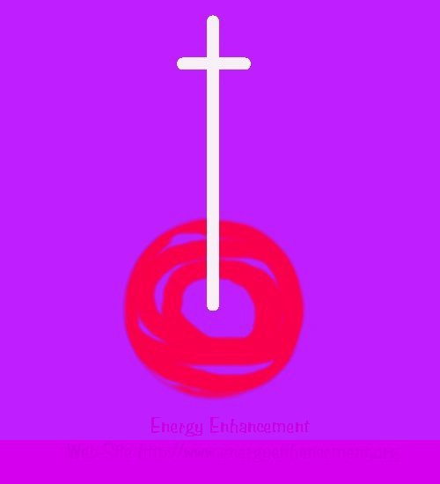
The Sword in the Stone of the Earth teaches about a stream of Energy from Kundalini Chakra in the Center of the Earth through a column of Energy called the Antahkarana outwards through an Infinity of Chakras into the Center of the Universe where the One God with 10,000 names exists. Just get your Spine in Alignment with that Energy.. Meditation is the result!
This we need to Afford through your conscious choice, NOW. By choosing to practice Meditation. Through having a process of Meditation every day you can enter into that Richer Life!!

As meditation becomes the Practice of Choice in all people, Businesses, Politicians and Government itself, this will change and the whole World will become Defect Free!!
And even meditation is not enough, now we need real Meditative Progress, a Speeding up of the Process of Meditation through Advanced Energy Enhancement Techniques. Energy Enhancement Meditation will give real results of evolution, coherence, alignment and progress in our lives and in the lives of everyone in the World, FAST!!
Internal richness leads to external richness, luck and progress in all areas of your life. Rather than being one who cannot even manage your life, become one who not only can manage your life but also the lives of everyone around you in Richness and in Health.
In this way, through Meditation YOUR life, the lives of your family and friends, your City, Country and Planet can be benefited as waves of meditational energy are projected and spread to all areas of your life and planet of residence for this life and all your future lives. START NOW!!

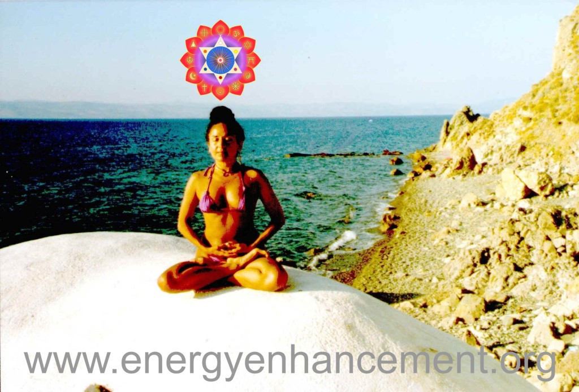

Satchidanand's Movie Reviews
DOWNLOAD BELOW
http://www.energyenhancement.org/Spiritual-Movie-Reviews/Energy-Enhancement-spiritual-esoteric-movie-reviews-by-Satchidanand.pdf

http://www.energyenhancement.org/Spiritual-Movie-Reviews-Satchidanand/Index.html
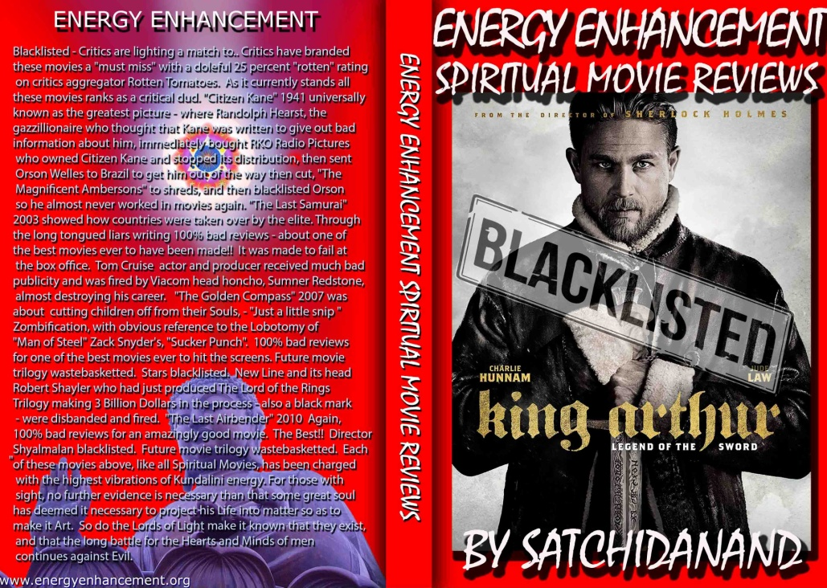
Energy Enhancement Spiritual Movie Reviews Book - Volume 1 by Satchidanand Immortalises the Kundalini Energy which Radiates from Satanically Blacklisted by the Dark Side - Movies like..
King Arthur - Legend of the Sword The Story of Enlightenment - by Guy Ritchie - a Movie Review by Satchidanand
Karma and Anti-Satanism in the Spiritual Actor, Keanu Reeves movies, "John Wick (2014)" also "Man of Tai Chi (2013)"
John Wick Ch 2 - Is Donald Trump and Alex Jones of Infowars - The Spiritual Warrior - Finger of God - Removes Satanic Demons, Deletes the Elite, Cleans the Swamp - Move Witch, Get out the Way!
Doctor Strange - Psychic Warrior Earth Protector..
Logan - "Beware Of the Light" Esoteric Movie Review by Satchidanand
And Much Much More..

Energy Enhancement Spiritual Movie Reviews Book - Volume 1 by Satchidanand Energy Enhancement Satchidanand’s 90 minute talk on the Energy of Enlightenment

THE NECCESSITY FOR THE ENERGY OF A MASTER

(Energy Enhancement Synthesisof Light Symbol left, the synthesis of all paths, the synthesis of all chakras, the heart center, the radiance of all the light of the central spiritual sun.)

I recently got one of my talks, the one on Enlightenment transcribed into this word file and now I’m going to put it on the web.

I think when I gave this talk, way back in 1996, and it was probably only the third talk I made and recorded way before I wrote the book on Energy Enhancement. Now we are giving this talk away for free if you join the mailing list.

We are also giving access to the Energy Enhancement E-Book, Free weekly texts on pungent, pithy and humorous spiritual subjects and the addresses are now given to you in the first autoresponder email. So I suppose that is an improvement.
(Picture of Satchidanand, right)
Now we are also giving you downloadable videos of me talking about enlightenment and the great sage Patanjali who invented Raja Yoga, Psychic Powers and Samyama, the 9th limb of Yoga or Energy Enhancement.

Also Free Downloadable Videos of Devi Dhyani and her Sacred Dance to the music of Ravels Bolero in the style of the Whirling Dervishes of Jalaluddhin Rumi in which she turns perhaps 800 times.

Also access to the archive of all of our texts which we tend to give to you weekly. You do not have to read them. Only if the matter interests you because you can always come back to it later in the archive when you have more time.

We are giving this if you decide to give a little back for our work in the form of a regular monthly donation FROM only 2 Euros, please

give as much as you want. Any regular donation will give you access.

People tell me that spiritual matters are supposed to be free. I tried to explain this to my beautiful translator, Seema, from India, but for some reason she insisted on payment for her work.

I try to explain to people that it is not possible to pay for enlightenment.

The matter all depends on your state of mind, your attitude, which depends upon how many blockages you have.

The fewer blockages you have the less evil you will be.

The less blockages you have the less resistance you will put up against the energies of Enlightenment.

Only Spiritual Practices will reduce your blockages and only a Spiritual Master can take them away from you thus saving you the trouble.

To Lead you from Darkness to Light, And from Death to Immortality..

GAYATRI MANTRA.

And a Master will only bother to help GOOD students. People with good attitudes and fewer blockages who will be able to maintain the changes and not slip back into hell thus wasting the help.

A good student is one who has learnt how to ask.

Bad students have to pay a lot to induce a master to take them and their blockages on.

One of the Masters in My line was Sri Yogendra who I met in Bombay or Mumbai when he was 96. They used to put him in darkened rooms when he was young to see the blue glow of prana around his body.

Apparently, like Zen Masters of the past he used to beat up his students and throw them out of the Ashram, if they showed any disrespect. In this matter he was following the example of many Zen Masters, one of whom threw his student out of the window from the second story. And then jumped on him!!

“Do you get it!!”. He asked. The student of course immediately became enlightened.

Many do not.

Even Ramana Maharshi was reported to have made threatening moves towards one pundit who just would not GET IT!!

“I suppose,” said my Master, Swami Satchidananda, “you have been looking for a spiritual master all over this planet. Me,” he said, “I have been looking all my life for a good student!!”

Sri Yogendra spoke to me for 15 minutes and I did not say anything. All I was able to do was to sit at his feet. I had to. It was not possible for me to do anything else. The Energy made me do it.

At the end of the interview he said, “It is said that the people from England have good hearts.” And after that I had the experience of energy fro two days. Going up into the center of the Universe and down into the center of the earth with great noise!!

There were giants in those days.

And that night he said to his son, “I do not seem to be able to hold my Prana as I could when I was younger” That night he passed on into Maha Samadhi, he died.

When he dies, the Master will always pass on the energy he gained to people who are indicated, who are trusted to pass on the energy to people who deserve it.

My Master, Swami Satchidananda, reported that when his Master, Swami Sivananda of Rishikesh died, he too had the psychic experience of receiving energy from his Master, even though at that time he was in Celon.

On my first trip to India I had a similar experience with OSHO 2 days before he died, Father Bede Griffiths just before he died, and then my Master, in the line of Swami Sivananda of Rishikesh, Swami Satchidananda 2 days before he died last year.

I suppose it is all a matter of Spiritual Efficiency.

That is why it is sometimes better for beginners to go to lesser fields of Energy with more students, Yoga Classes, Meditation

Classes; a good Zen Monastery for example will do fine. They do this only to develop the attitude of a Student.
Otherwise when the energy, prepared by the Enlightened Master, is ready for them, they will miss it.

Some people with many blockages will use their intellects to provide arguments as to why they should not try the practices that will make them Enlightened.

The higher the field of spiritual energy, the Buddhafield of energy which surrounds any Enlightened master, the more the Selfish, Competitive Ego of the student will struggle not to come into it.

The higher the Master, the more the Spiritual Energies, the fewer the Students.

And as you rise in Spiritual Energy, the fewer will be your Sangha.

Until eventually, when you become enlightened there will be a Sangha of Only ONE.

The Ego believes there is Safety in numbers and so it prefers not to come to places where the techniques are more energetic and effective…

Reading the transcript below and correcting it many times as I had to because no matter how good the person, they do not really know the matter at hand. It made me realize that many people listening to this talk will take the words I speak at many critical junctures for others which sound the same, thus entirely missing the point of many of my pungent and witty sayings.

And reading the transcript made me realize that it would be good to write an introduction to it and this is what this is…

INTRODUCTION.

This talk is about the process of enlightenment.

The Energy of a Master in the form of a Buddhafield of Energy is necessary to raise and stabilize the energy of your chakras.

Gurdjieff told this to Ouspensky who wrote about it in the book, “The Fourth Way”

He explains to the intellectual idiot Ouspensky about the Law of Octaves. How one of the energies inside you is raised and made permanent. Thus the octaves, the carbons, the hydrogens, the oxygens. You can read all about it in the book.

In any process such as raising your energy from one octave to another there are two points where extra energy from a Master is Necessary. Gurdjieff says this happens at every third and fifth note.

For this he explains that an external energy is necessary. The energy of a Master.
He was really saying to Ouspensky in round about terms. Because it is only possible to talk to students with many blockages in round about ways.

Otherwise they will run a thousand miles.

He was really saying, “In order to become Enlightened, Mr Ouspensky, You need MY Energy!!”

It is not really an intellectual matter, simply a matter of Energy.

And there is a fight in every unenlightened being between the selfish competitive ego and the soul infused central stem.

A Fight Between Darkness, And Light!! So, with that, read on…
You can get the real audio talk by signing on to our mailing list again if you did not get it the first time.

I recommend listening to it as well as reading it because of the energies I am sending to all of you between every one of my words. And to feel this energy you will need to develop a heart.

Thus the tin man of the Wizard of Oz who was searching for a heart. The author of this book, Frank L Baum, was a student of… Gurdjieff!!

And the guy with the moustache in the final scene of the film, The Wizard of Oz, with Judy Garland. The guy in charge of the horse and cart like Krishna directing the chariot of Arjuna in the Bhagavad Gita – he is.. Gurdjieff!!

Only 50% of the people on this planet at the moment have a heart. One of my student said, “Hm, that Many?”

Yes, Mr Prime Minister, I am talking about you.

And people with a heart only choose to view movies with a heart. They only choose to read books with a heart. They only choose to listen to music with a heart.

The people without a heart do not mind provided it is interesting. To them the heart component means nothing as they cannot feel it.

Thus idiotic Movies, “Full of sound and fury, signifying NOTHING!!” - Quote from Shakespeare.

Because these idiotic movies really piss off the people of the heart.

In general only movies of the heart become really popular because both the people without a heart and people with a heart like them. The numbers are higher..
Movie producers should know this.

Thus my list of Spiritual Movies. Movies touched by God. Movies teaching interesting spiritual matters

The chants in the talk below are really potent… They come from an open heart...

TALK ON ENLIGHTENMENT AND THE DIGESTION OF ENERGIES

Satchidanand: Well, I think again like last week, it would be really nice to start off with a chant to get the vibrations of the place right and also to get your vibrations right as well. What we are going to do tonight is we’re going to chant.

It’s not going to be a chant, it is actually going to be ‘mantra yoga’ and the one difference between chanting and mantra yoga is that mantra yoga is there to raise your kundalini energy.

It is there to raise your spiritual energies and Mantra Yoga actually works through the process inside your mind of visualization.. Thus it is different from simple chanting.

So we’re going to start off chanting “Hari Om”; it is an Indian chant. Ha - ri - om – it means “Hello God, I’m coming home” something like that – hurry on home.

‘Ha’ - when you chant that I’d like you to visualize your base chakra, the very base of your spine. I’d like you to visualize when that ‘ha’ happens, there is a vibration sounding at the base of your spine and because we’re going to be working with the spine, it’s really nice if you can sit up straight, to actually stretch out your spine from the very base right up to the crown.

You can do that on the ground or anywhere you like.

This makes a big difference because the spine is just so important in spiritual life.
You know the spine is part of the brain. Brain cells extend themselves down through the center of the bones, the vertebra, the spine and the brain extends itself all the way down the inside of the spinal canal down to the very base of the spine. And surrounding the brain you’ve got this aqueous humor; it’s what protects the brain against heavy shocks. It is bathed in water and therefore you can take shocks of fifteen gravities.

Like to go into space – they used to have in the science fiction stories – how would these people accelerate and decelerate there in Space. They used to bathe them in water. Then they didn’t used to get shocked, so like the stasis field in Star Trek.

So the brain is bathed in this water and so is the spine; you got the spinal fluid, that’s what they draw off in the hospitals to check the toxicity and the bacterial content.

So the whole of your spine is part of your brain, as you well know, all the chakras, all the energy centers, they extend out along the spine and there are three major ones in the brain – you’ve got the third eye, you got Ajna chakra; on the crown of the head, you’ve got something called Sahasrara chakra and that connects you with your Higher Self; it’s the Rainbow Bridge – the connection with your Higher Self.

At the very back of the head you’ve got something called the Alta Major center and the three chakras in the head form a triangle – a triangle of energy when they start to work correctly and they don’t really start to work correctly until you’ve cleared out the base chakra.

Because on the path of enlightenment, the third initiation is to do with a stream of energy flowing from the base chakra to the head centers.

And you do not lose that fear, that negative energy which blocks the base chakra until you have lost your fear of security, fear of loss of money, fear of going out on a dark night, go on the roundabouts, the runway, fear of losing your money, fear of losing your job, fear of losing your loved ones.

And on to the last respect, the last fear that’s doing in the whole of humanity is the fear of death – not the namby-pamby imaginary death that we’re thinking about because we’re all going to die – but the real death, the death which is so deep inside of us, in our unconscious that we do not know that that real fear exists.

So when our last fear leaves, then the head chakras start to be enlivened.

So when we start to chant ‘ha’ we visualize that vibration deep down in the base chakra then this can have a profound effect on your enlightenment. And when we go into ‘ri’ imagine that that energy – still keep that ‘ha’ vibrating in the base chakra, never lose that vibration, visualize it – when you go to ‘ri’ make the energy jump right up into your throat. Ha – ri, into the throat.

And then ‘Om’ – sacred word of the Hindus – doesn’t work without the visualization.

‘Om’ is composed of three syllables: A, U and M.

A – again in the base chakra – “aa”; U – up into the heart – “ooh”; and then M in the nasal cavity behind the nose, up into the third eye, as it gets higher, maybe up into the crown chakra, then as your last breath leaves your body send your intention upwards and away into the center of the universe, the end of the home, hari OM, hurry home.

So we’ll try a chant just to raise the vibrations. Again, close your eyes, concentrate on the straightness of the spine, concentrate on the visualization of the “hari om” and the way we’re going to do it, to start with, is I’m going to chant the first line and then you’re going to chant the first line afterwards and I think it goes on for about three or four lines, at least to get things going. OK? So I’ll chant the first line, then it’s your turn and Devi will lead your response, I think. Thank you Devi. OK.

S: Hari om, hari om, hari, hari, hari o….m (take a deep breath in) All: Hari om, hari om, hari, hari, hari o….m

S: Hari om, hari om, hari, hari om A: Hari om, hari om, hari, hari om

S: Hari om, hari om, hari, hari, hari om A: Hari om, hari om, hari, hari, hari om

S: Hari, hari, hari, hari om A: Hari, hari, hari, hari om

S: Hari, hari, hari, hari om A: Hari, hari, hari, hari om

S: Hari, hari, hari, hari om A: Hari, hari, hari, hari om

S: Hari, hari, hari, hari, hari, hari, hari om A: Hari, hari, hari, hari, hari, hari, hari om

S: Hari, hari, hari, hari, hari, hari, hari om A: Hari, hari, hari, hari, hari, hari, hari om

S: Hari om, hari om, hari, hari, hari om A: Hari om, hari om, hari, hari, hari om

S: Ha … ri … o…..m (take a deep breath) Ha … ri … o…..m (deep breath in) Ha….ri, ha….ri, (deep breath in) o…………m (deep breath in) ha…ri, ha….ri, o……………….m.

Pause for meditation…
S: What is the matter we are talking about this week? I’ll read it out. It says, this week we are to talk about the Digestion of Energy.
There’s always digesting food; we also need to learn how to digest and combine energies. If we do not it becomes stuck, creates more blockage and stagnates in our body. This week we examine the Law of Threes, the Law of Sevens, the Completion of the Octave and its relevance to the chakras or the processes of the mind.

And when we’re talking about energy, we’re not just talking about the intellectual energy, which I am giving out, the ideas and the thought forms; we’re also talking about the sort of energy that the Buddha was talking about when he came out one day to give a talk.

Now the Buddha became enlightened when he was roundabout the age of thirty-seven, thirty-eight, forty - something like that. And it’s

said that if a person becomes enlightened well before the age of forty then it’s likely that they’ll die roundabout the age of forty, it is very difficult for the person to hang around for longer than the age of forty. But if they get enlightened roundabout the age of forty though, they can go on for another forty years quite happily, talking and talking and talking.

And the Buddha was no exception to that. He became enlightened late in life, after he had seen the meaninglessness of his life though he was in the palace.

When he was born, the great astrologers of the time said to his father, “That man is either going to become the greatest king the kingdom has ever seen or he is going to become the greatest mystic, the greatest hermit, the greatest maestro in the king’s terms that this planet has ever seen.”

The king said, “Well, how do I prevent him from going off and fulfilling his destiny?” and the astrologers said, “You must keep all knowledge of the horrible things on this planet from him, especially the knowledge of death from him.

And from the first years, until he was twenty-eight, everything old, everything ugly was kept from Prince Siddhartha’s view.

His father supplied him with the most beautiful of virgins every night, parties every night.

Everything was beautiful, until one day he was taken around the palace by his chief charioteer out into the city and by accident he caught sight of one old man on the road and he said to the charioteer, “What is wrong? What’s the matter with that poor fellow?”

And what could the charioteer say but “That man is old, my lord!” The Buddha didn’t leave it at that. He said, “What is this oldness?”
What could the charioteer say but “I’m afraid that is something that happens to us all, my lord. As we get older in years, so our energy and strength fails us, we become wrinkled and old” and the worst thing of all he could have said “and finally we die.”

“What is this death, oh charioteer?”

“When our energy fails us, my lord, that is the time when we are no

more.”

So the Buddha said, “Well, what is the point living here, enjoying this good life here in the palace if eventually I am going to die!”

That’s a great long story of how he left the palace, how he left his most beautiful wife and his young child on the very night of her birth and went off into the world to try to find out the meaning – what is life without death?

And after five long years of trying everything that the world had to offer him in mysticism, he eventually took the middle path and became enlightened on a full moon under a Bodhi tree.

Very famous tree – the Bodhi tree. You know that Buddhism spread like wildfire throughout India and up to five hundred years after the Buddha had died, it went down.

And the Buddha said it would fall after five hundred years because he initiated a woman into the company of monks. He said, “I was hoping that it was going to last for five thousand years but now that a woman has been added in to the ranks, I’m afraid it will last for only five hundred years.”

And the sacred tree that the Buddha had become enlightened under was a very old tree. It’s a tree that lasts a long time and it’s very easy to propagate. And the Bodhi tree of the Buddha died of old age after five hundred years!

But before it died, a small twig was taken from it and taken to Ceylon and that twig grew into a fantastic tree and now just recently it’s been taken back to the grave of the Buddha and it’s been replanted there and the tree is now growing in India where the Buddha was born.

And the Buddha became enlightened but roundabout the age of forty as I described, and for the next forty years he talked nonstop, incessantly and he said to the people, “Look, I’m not here for the vast masses of people.” He said, “I am here for that 1% of people whose degree of evolution will enable them to hear what I have to say.”

He said to them, “Those who have ears to hear, let them hear”.

The very people that can take that 1% of chance and use the energy which I have to give them for their own enlightenment.”

And thousands of people were drawn towards the Buddha; great company of monks sat around him on his daily talks and many of them became enlightened.

It was a vast energy centering the evolution of humanity. Many people became enlightened at that time by listening to the Buddha’s words.

And the Buddha taught everyday for forty years, traveling around the north of India, from town to town where he was invited, giving talks, provoking arguments, discussions and many times they tried to poison him.

Great jealousies, great energies were released by what he did.

On one particular day, he came out as usual and sat beneath the Bodhi tree, thousands of monks around him and he just sat.

For one hour he said nothing and he had this little flower, the white flower in his lap that he was just looking at.

And after that one-hour, one of the monks moved and he started to laugh. And the Buddha stood up and he walked through the thousands of monks to the one monk who had been laughing and his name is recorded as being Mahakashyapa and he gave that flower to Mahakashyapa and he said, “You have understood”.

And he gave him the transmission of the flower. And he said to him, “Many people come here to hear my words but it is not the words you are meant to hear. It is the energy between the words, which I transmit; not the intellectual knowledge of what I am saying.

There is actually energy between the words that you are meant to hear.”

So when we are talking about the Digestion of Energy, it’s a nice thing to know about these energies. And I talked about stuck and stagnant energies within rooms and within us. Really these stuck and stagnant energies are the only things that prevent our enlightenment.

If we didn’t have these stuck and stagnant energies there would be a clear flow of energies through our bodies. And that energy is called Bliss or Ananda. But because we got these stuck and stagnant energies and I’ve been talking about these stuck and

stagnant energies for the last three weeks. I’ve talked about the energy of food, without the quantities of food that we eat. We eat great quantities of toxins, great quantities of mucus, great quantities of stuff that eventually turns us weakly and old, provides free radicals and eventually kills us before our time.

With all the old age diseases, Alzheimer’s disease caused by too many toxins from heavy metals, have been proved recently by doctors.

Arthritis of the hips caused by too many toxins being eaten.

All the great mystics they say to people “Eat organic food, don’t eat too much of it, don’t eat heavy food.”

Remember that food is not just food, it is also the emotional vibration or energy of food.

And they say to people “Try not to kill.” Thou shalt not kill – it says in the Bible.

It is not just of human beings; it is also of the animals that have been placed in our care on this planet. They are not there to provide our food source; they are actually there to be looked after and encouraged to evolve by means of our energies, in a perfect world.

All the animals that come into our home, all the animals that become our pets and work with us, they take our energy, they take our mind space, they become almost human.

So we talked about the stuck energies inside the chakras. We talked about the base chakra; we said it is about the fear of security.

Then we talk about another favourite chakra of mine – the second chakra, the chakra of relationships.

Before we can even get into the clearing of the base chakra, the second step is to deal with relationships because relationships provide so much pain in the life of a human being.

The Buddha said, “Attachment leads to pain!” and the chakra of attachment is the second chakra – the abdominal chakra, the chakra of sex, of sexual energy – stuck, stagnant and painful energy.

When there is so much stuck and stagnant energy really there we can’t breathe because we are afraid to move the abdominal chakra because of the pain that comes from it every time we move it. And if we can’t breathe then we have no energy and if we have no energy then we can’t digest our food and if have no energy we can’t illuminate our food.

We die before our time!

All the diseases come from lack of energy. I shouldn’t say all but lot of them come from lack of energy.

And as we get filled up with this vast, immense of negative energy so our energy becomes depressed, so we have no chi, so our rooms become full of the cast off negative energies, and become dull and dark and depressing places.

And because we are so sensitive, because human beings have this potential – some people, most people can walk into a place and they can feel the energy of the place, they can feel the lightness and the brightness of a totally spiritual place; they can feel the pain and depression of a normal place.

So the first thing I wanted to say was there are many spiritual ways of clearing out the spiritual energy.

Any spiritual practice will raise and enliven you.

The practice of yoga, the practice of breathing, the practice of meditation; all of them will help you to get rid of these negative energies and in one of these talks some week, I will talk about the mechanism whereby all of these different practices get rid of all of these negative energies.

The fact is that that is what is self-development. That is what spiritual techniques are there to do. They are there to get rid of all of your pain.
I don’t know if you’ve even heard of massage – even massage is a beautiful way for you to get rid of that pain. There’s a very famous massagist in America called Ida Rolf who developed the Rolf technique – not that I recommend it. But there’s an interesting story whereby Ida Rolf was massaging this man’s arm and if you want to have torture you’ve got to have Rolfing because Rolfing is the very

deepest and heaviest and painful massage you can have.

And she was going very deeply into this man’s arm and there was a scar in that area and as she came to the scar, she really pressed in deeply and this man had a spontaneous image of the day that he had cut his arm with an axe. He hit the tree and it bounced off onto his arm and his arm became very stiff.

And as she massaged into that the memory of that pain came up into his consciousness and because he was an older, more mature being he didn’t put the pain in his arm, the way he had done when he was younger, he actually processed and digested that pain. And having had that vision the arm became very supple because she had taken out, expressed the negativity in the arm, he had digested the old pain and he was freed.

Now this is what spiritual practice is meant to be. There was a lot of emotion, there was a lot of pain held in the body and it’s not just the arm. The major area that yoga works on is actually in the spine
– the area where all the energy centers are, the area where all the chakras are, the area that communicates between all the chakras.

You know that computer buses that run information from one processor to another.

Well you just think of the chakras as being multi processors working for different purposes and the bus is the spine then you can see how useful it is to be able to clear out the obstructions on the data highway on the spine.

You can see how useful it is to clear out the blockages that block the processors on that data bus of the spine.

And through Energy Enhancement techniques this is what we teach.

We also utilize yoga, we utilize breathing, we utilize meditation but we also utilize very high and effective techniques, which are based upon old yogic practices, which are based upon old dervish practices, which are based upon very ancient and effective alchemical practices to help people to ground, to get rid off that pain, those blockages, that negative energy in the quickest, most effective, possible way.

Energy Enhancement is based upon yoga and breathing but eventually it moves on into movement of energies and grounding of energies from the very first stage.

And not only do we have this pain and negativity stuck inside, when we can start to move the energy inside us so we magically develop psychic powers to be able to ground that energy outside us.

So any healer, any person that has worked with energies can walk into a place and they can get rid of the negative energies, they can make that place full of light, in the same way that you can touch water and you can charge it up.

By being able to work inside – you can remember that Jesus said that “As within, so without”. As you can get rid of those painful energies inside so you can start to get rid of those energies outside.

And by getting rid of them outside, you can start to enliven every person around you, instead of being a dull, depressing person who maybe wants to go and see because you are so much in pain yourself that the “poor me” in you tries to say to everybody around you, “What right have you got to be happy when I am so painful?”

Instead of being in that state you can be a source of light to everybody around you.

Who is the happiest person?

The happiest person is that person who makes everyone around them happy or at least that is their intention.

You can try. And remember that as you have so much pain inside – as within so without – so everything in your life, every person in your life, every job in your life, every experience in your life is really a reflection of that what you have inside. So your whole life is a feedback on what you have inside. Remember, every time we criticize anybody outside, you point your finger at them and you say, “I don’t like you” and you’re pointing at the very thing that is your worst problem inside as well – “I don’t like” – right inside you.

Remember when you’re pointing one finger at somebody else there are three fingers pointing back at you. Use criticism to look at your own problems. Don’t look at the mote in somebody else’s eye; look at the beam in your own.

Use what God has given you to find out YOUR problems, deal with your problems and magically you start to deal with everybody else’s problems around you.

It’s just the way of it. So, the Law of Threes!
What is the law of threes, he says? Well, that’s a rhetorical question so I’ll answer it. It seems that there are many esoteric practices; many esoteric secrets that are based upon this triangle of energies and many different things can be based upon these triangles.

He provides a relationship; he provides a means of understanding the process whereby energies are transmitted and transformed because we’re talking about this pain inside, we’re talking about raising our energies and triangles give us some intellectual idea of how this occurs. I’d like to tap some of Ian’s knowledge here because we’re talking on Sunday about Jungian archetypes and how they always seem to go in triangles. I’d just to ask you, “What are the two aspects of a king?”

A: “Tyrant and the wimp.”

S: So what you’ve got is you’ve got an archetype of the king and all of us have got the king inside of us but if the king is split, if we live in the world of duality then we alternate between being a tyrant and between being a wimp and we easily flow between the two.

We are a king but we can only be a king when we adhere to the middle path; when we know that we are not the tyrant, when we know that we are not the wimp; we just are, then we are a king. But until we know that, until we go outside of our duality – you see the third point on the triangle always points out the middle path. It always points out the fact that the alternative is living in the world of duality, of alternating between the “poor me” and the violator, between being the “poor me” an alcoholic, a person who is so stuck in their own misery that they can’t get out of it.

Then the person who gets so angry with other people for being so rich, for being so jealous because they are so full of energy and happiness that they become the violator, the abuser, the person that hits the child, the person that sexually abuses the child, the person that starts the whole process of duality off within everybody that they meet.

So the king is composed of the positive and negative areas of the tyrant and the wimp.

Then there is another little triangle, I thought it was great asking

him again because he is so good at this, and that is the Lover, the role of the lover within us – that’s the middle part, but what are the two parts of the lover within us?

A: The Pervert and the Mother’s Boy.

S: The pervert and the mother’s boy. And remember we have got all of these aspects within ourselves and the world of duality goes between the pervert and the mother’s boy, the pleaser and the blamer. The person who is always wanting to make everybody pleased and the person who is wanting to make everybody belittled.

We have all these aspects within us. If we are not enlightened we must be humble enough to say, “I am not perfect. Not quite; I am pretty good, 80% of me is good.” There is a very old Soto Zen phrase that says 80% is perfection. 80% of you is perfect but of the 20% - the bit that we are working on, the bit that we are seeking feedback on – is the pervert and the mother’s boy, before we can be a true lover. I’d like to be a lover myself, I’m the king, I want to be a king too.
So the next one in the series is the Magician. A: The Manipulator and the Fool.
S: The manipulator and the fool, the idiot – two aspects of the magician - and they keep swinging between being an idiot, being a foolish person, which we are so many times and between being a manipulator, getting what we want through underhand and manipulating means and we evolved at that as well. The Hierophant, the magician, the person who is magic personified – we’ve been designed to do either of those two things.

And finally we get to the Warrior. A: The bully and the coward.
S: The bully and the coward alternating between the coward and the bully and evolved all those aspects inside us as well. You can also point to all the astrological signs and right in the center of the astrological signs is a space for the enlightened person, where he/she can branch out into any one of those signs and be whatever they want to be, whatever the occasion demands, whatever is appropriate. They’re not stuck by their pain, by their fear, by their blockages in one aspect of duality.

Going further into Gurdjieffian law – Gurdjieff was a very famous master, he came to the West roundabout the time of the Russian revolution. Gurdjieff said there is a triangle between the mind, the emotions and the body. He said if you work on two of those aspects of the triangle then the third one is stimulated.

So if you work on the emotions and the body, the intellect will be stimulated. And when he is talking about emotion, he is talking about the higher emotions of compassion of the heart so if he is stimulating intellect in the body, at the same time then the heart is stimulated.

And so many of Gurdjieff’s students working on dance and working on very highly intellectual steps, at the same time opened the heart.

He said, “I am a simple teacher of dance.”

Meditation works on a similar level. Very famous triangle, we can look into all the aspects but I won’t go into it now, it is too much for this talk but it is a very interesting triangle of energies. But the triangle I really wanted to go into is the triangle that Gurdjieff also talked about and that is the triangle of energies.

He said for one atom to jump from one energy state to another energy state, another energy must come in from outside. And what we’re talking about here is raising our energies, our internal energies from one state to another.

Most of us are stuck in the animal side of our nature. We have not awoken our heart.

How to get from the negative to the positive? How to awaken a chakra? How to jump your energy state into the heart? How to become compassionate? Not to become sentimental but how to awaken that great transformative energy of the heart?

What Gurdjieff says is that “as an enlightened being,” he said, “I exude that energy of transformation because of my years of training and because I have worked in all of these various chakras, this energy of transformation comes from me.”

And he says, “If you want to raise your energy levels then you may get from the negative to the positive - the other side of triangle – is compassion.

You’ll need to have a little bit of MY fire that Prometheus brought

down from the dead to earth in order to leaven your bread, in order to seed your energy system, in order to raise your energies from one state to another.

And this is what Buddha was talking about when he was talking about the middle path. The Buddha’s energy was that of compassion and in order to get out of the world of duality, in order to get out of the world of fluctuations, in order to get out of the world of competition where there is no such thing as friendship.

In the world of competition, in this world, everybody you see is competing with you for something. And perhaps there are ones who are little bit closer to you than the others you can call your friends but in reality they are just little bit closer to you, they can very soon – flip of the coin – turn into your enemy.

The world of duality is like that but to the world of the enlightened person there is no such thing as an enemy; everybody is their friend. And how do they do that? They do it by raising their energies. When they raise their energies the heart is opened and the heart is a wonderful cornucopia of the enlightened energy of transformation.

Gurdjieff said, “If you want to raise your energies then you need to be with me for a little while and depending upon your talents, then you will need to be with me for longer or for shorter.”

He said, “I want you to be with me for a short a time as possible. I want you to catch fire. I want you to know that you are a lion that is being brought up in a herd of sheep.”

One young lion is eating grass with the sheep. When he sees the real lion – the wild lion – banging across the land to eat the sheep he becomes frightened as well and moves away with the herd of sheep. And the old lion looks at the young lion and says, “What’s this? A young lion acting like a sheep?” and he goes and drags that lion by the skin of the neck and he goes “please help me, bleep, bleep, bleep” And he drags him down to the lake and he says, “Just look at yourself” and the young lion looks in the water and he look at the old lion and he looks in the water again and he says, “I’m like you!”

And the old lion roars and the deep throaty roar of the old lion goes across the countryside telling everybody that the old lion is there. And the young lion says, “Can I try that? waah!” “No” says the old lion, “like this – rrrooaarrr” and the young lion tries “rrrooaarrr”

and the young lion catches fire, he is no longer a member of the herd of sheep. He catches fire! He is magically transformed into his true self.

All those stories about the frogs and the princes, all those stories about the ducks and the swans – the ugly duckling, all those stories by Gurdjieff about the magician who made all the people in this world think they are sheep by advertising, by keeping their history away from them, by making them afraid, by giving them pain. All of these magical things were given to them by the evil black magicians to keep them from knowing what their true self was.

So how to get out of the world of duality? How to get out of these negative states and into a positive state through the reconciling forces Gurdjieff called it … (what are the other two names of the forces, Devi. I’m calling it negative and positive, but I think he had another term for them. Never mind, I can’t remember. I don’t think it really matters. I think you got the idea. In Marxism they called it thesis, antithesis and synthesis)

You’ll need to have a third force which comes from a Master of Meditation in order to raise the energy level from one to another.

So, in the plane of the second chakra - of the relationships plane - there’s a process that deals with relationships of the chakra in the abdomen, a sacral chakra, where you have pain and that pain causes desire and aversion because if you can have an orgasm you can flush away part of that pain and aversion is there when you say, “I don’t want to have another relationship.

The last one was too painful. I’m still recovering from it. I don’t want any more of that.”

When the dog dies or when a cat dies, you always say I’m not having another one because it’s just too painful to go through that.

The only reason you have that pain is because you have not learned how to work with the energy of relationships in an appropriate way.

We have true choice as to whether you connect or not connect.

Another two dualities of life and death – we’re working here with the base chakra. When you have raised the energy of the base chakra you know that there is no such thing as death, you know there is no such thing as life.

You know the truth; there is no duality.

And again the energy of transformation which emanates from an enlightened being is necessary to understand the middle path.

When we talk about heaven and earth we’re talking about the yang energy of heaven, we’re talking about the yin, feminine nature of the earth.

We’re talking about our Father who art in heaven, we’re talking about the Empress of the tarot, we’re talking about the Emperor of the heavens.

And when we’re talking about the reconciling forces of the heaven and the earth, we’re talking about the alchemical marriage, the marriage of heaven and earth; we’re talking about enlightenment.

These alchemists were not just talking about how to create the physical element of gold; they were talking about how to transform the lead of the base chakra into the gold of the sahasrar chakra.
Men that were talking about physical gold, they said that is fool’s gold.

Ramakrishna, a very famous Indian saint was sitting in his temple one day and a man came to him and said, “Look, I’m a rich man, I’ve come to give you 1000 gold rupees.” Because rupee means gold, you know. (Not now, I think it is about 50 to the pound.) Long time ago, back in the nineteenth century he came to him with some gold rupees and said I want to give it to you because you are a famous saint.

So Ramakrishna said, “Well, these gold coins are mine, are they?” and the man said, “Yes, I’m giving them to you.” And he said, “Well, OK, I’d like you to take them back, I’d like you to go and throw them in the river.

And the man said, “What? You want me to throw these gold coins into the river!” Ramakrishna said, “They’re mine, aren’t they?
”
The man said, “Yes.”

He said, “You gave them to me, didn’t you?” He said, “Yes!”
He said, “Then go and throw them into the river then!”
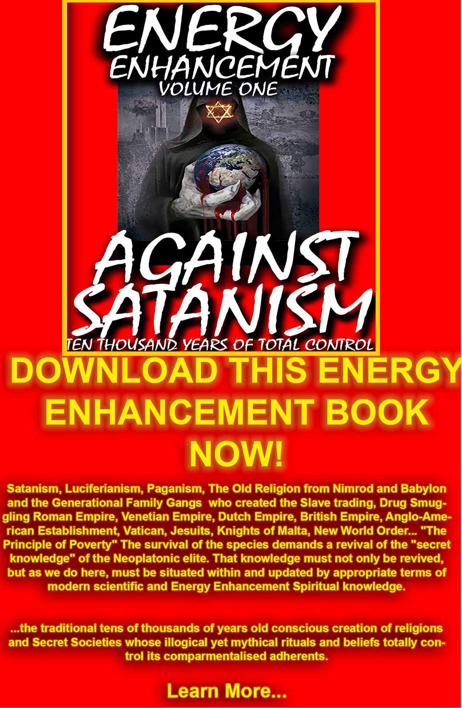
DOWNLOAD AGAINST SATANISM VOLUME ONE HERE
http://www.energyenhancement.org/Against-Satanism/Against-Satanism-Energy-Enhancement-Satanic-History-of-the-World-Volume-1.pdf

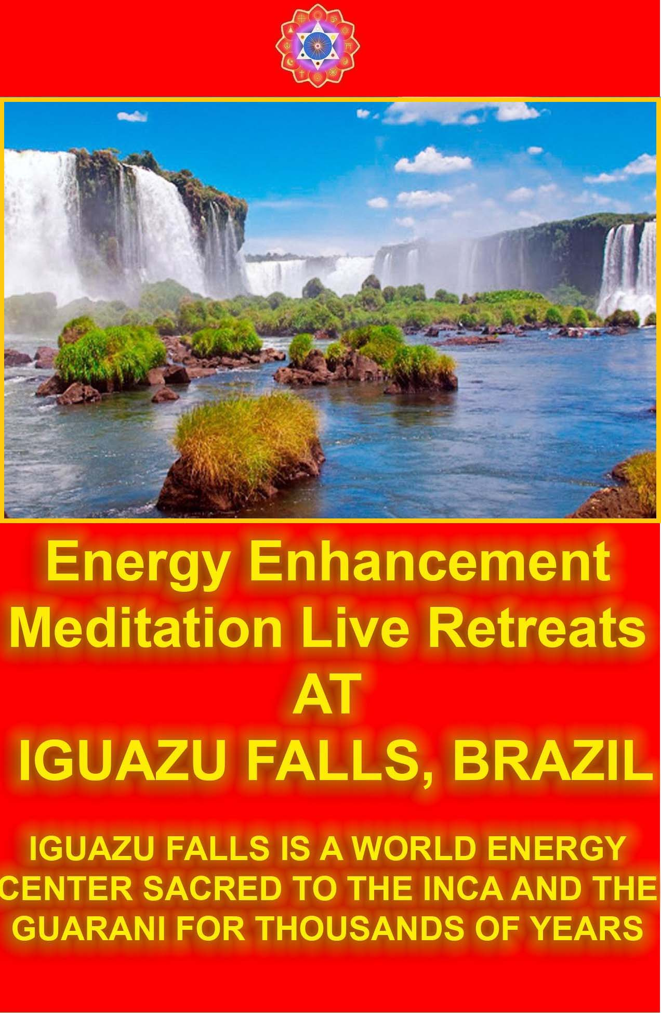He said, “Yes?” and he walked off towards the river and Ramakrishna never thought anything more about it until one of his sanyasins, until one of his monks came to him and said, “You know that guy, you told to throw all those coins into the river, you know what he is doing?” Ramakrishna said, no. He said, “He is throwing them one at a time into the water. There is a great crowd around him and all the kids are diving up the sides of the river for his gold coins.” Ramakrishna said, “I didn’t mean him to do that.

I just said you dump them all at once into the river.”

Now, if you are really talented on the path of enlightenment, if you are really desirous of becoming enlightened, then you will drop all your pain all at once.
A simple touch of the master will be enough to transform you and that’s why in life we have the via negativa and the via positiva, the path of neti-neti, not this, not that, the path of doing something. This is why we need have things like yoga. This is why we need to have the eight limbs of yoga. Step by step.

But if we’re talking about Bhakti yoga we’re talking about dropping all the coins at once.

Depends upon our different capabilities, our different sensitivities, our different abilities of being able to understand and when I say ‘understand’ I don’t mean ‘intellectually understand’.

It means our ability to digest the energy that we are being given. And if we are not capable of digesting those high energies that are emanated by any enlightened being, the result will be that you will point a finger.

To any enlightened being you will say that that person embodies all of your worst qualities.

You will nail them up; you will call them the King of the Jews and put a crown of thorns around their head.

But for those that have the ears to hear, for those that have the eyes to see, for those who like Mahakashyapa can feel the energy of the master.

It’s well said, the Buddha said, “I’m not here for everybody. I’m here for those people with a small inkling, with a small ability to feel my energy.”

There’s a beautiful book by the third Zen patriarch, Sosan. Patriarch is an enlightened being. There is no record of Sosan’s life; there is no record of Sozen’s death. In the East they don’t care when they were born and when they die. It’s simply enough for them that the flower of their presence, the perfume of their life exists through the centuries to guide us now.
And Sosan never stayed in one place, he moved from town to town, he spread his perfume to those people who were able to hear him and he left behind in one book called Hsin Hsin Ming – The Faith Mind of Sosan - and when they say ‘faith’ they don’t mean faith because the translators don’t know what they are talking about, they are not enlightened beings – The Enlightened Mind of Sosan.

When we’re talking about the mind of Sosan we’re talking about the empty mind of Sosan – form is emptiness and emptiness is form.
And when Sosan says in his book and his book is just one page – very concentrated – and he says that one preference, one criticism, one energy blockage and heaven and earth are set infinitely apart.

These energies of the masters can only be digested by you when you are in a state of no-mind, when you have no thoughts in your mind then intuitively you can accept the staff of life, the bread of the earth.

The reconciling force works with each of the chakras to awaken each one.

And when we get into the Law of Sevens, seven chakras, seven major energy centers.

Now how many notes in an octave? You might have thought that, mightn’t you, because it is called an octave. But the eight notes go from Doh to Doh, so in an octave there are only seven notes.
(The completion of the Octave is to access the Soul Chakra, The Eighth chakra outside the body, above the head. This is Enlightenment. More energy, and infusion from a Spiritual Master is usually necessar6y to do that. This is the Completion of the Octave.)

And the Hanbledzoin (Literally, bled, blood, the blood of Christ, but meaning the life energy emanated by a master to raise your energy levels) what Gurdjieff calls Hanbledzoin is something that has been handed down as an inheritance from the wise masters of the past to help people from the present.
It is to do with Nada Yoga, it is to do with Mantra Yoga, it is to do

with the awakening of the chakras, it is to do with the use of music to awaken people, something which is not intellectual, something which gets the body moving, something which works on the body, the mind and the emotions. A simple methodology to enlighten all beings.

So when Gurdjieff wrote his sacred hymns, written down by Hartzman, when he invented his music there is simple dancing of the Sufis because Gurdjieff was a Sufi and he was using music in a very knowledgeable way to awaken the energy centers of all living beings.

Within each chakra you have seven notes so when you complete the octave it means that you have raised the energy of that chakra from a lower level to a higher level.

And you do that to each of the chakras, from a lower level to a higher level and within each seven notes, within each octave there are two points where extra energy is needed to come in from outside to get past that point of stuckness – the third note and the fifth note.

This is why we have thirds and fifths in all music, this is why the ‘ragas’ the Indian mystics used for generations by classical Indian musicians are based very much on thirds and fifths because the extra energy is needed to raise the energy of the chakras from a point of low energy to a point of high energy.

And it’s the same in any process. If you start to do something and you want to finish it, completing the octave, then you will find two points in any process where you have to put in more energy.

And this is called the Power of Doing, to be able to maintain the energy of a process over a short period or a long period in order to complete it.

When he is talking about process, he is not talking about external processes like buying a car or baking some bread; he is also talking about the process of enlightenment.

Every person needs an input of energy from a Master in order to raise their energy from one step to another – the energy of transformation, the energy of compassion, the middle way to get out of the world of duality and the law of sevens state that this comes on the third note and the fifth note. There are many magical mystical signs like an enneagram, the octave.

All of these things are pointing in the direction of saying “You need to get some energy, you need to be fired up.”

Psychic body is like a factory, like a process and when that factory is working correctly then you are enlightened. Before that point you’ve got blockages, you’ve got parts where that factory is creaking, where it is not working correctly. And the way to get that factory working you got to put a little bit of work into it. All the spiritual practices will help you along that path.

Now I’d like to talk about the astrology of enlightenment. Over many, many lifetimes we’ve been coming down to earth to gain experience, to get rid of our karmas, it is nothing but the pains we have gathered psychically from lifetime to lifetime. And when we are born, each one of us is born with a certain astrological chart and you can look at those charts and you can find out a tremendous thing about your personality, you can find out a tremendous thing about your ego and you can find out a tremendous thing about your own spiritual abilities and times.

On the way towards enlightenment we collect various psychic powers and those psychic powers can be used for good or ill. All of us have them; there is not one person that does not have some absolutely tremendous ability that is outside the normal.
We all know we’ve got them. We’ve been gathering them from lifetime to lifetime. I don’t know if anybody has looked at their astrological chart but certain astrological placements tell you about your powers, like your ability to help others spiritually. If you are an Adept you can help to awaken other people’s chakras and they have an expertise in one of the areas, chakras. Now those people have no planets or ascendants in one of the areas like a cardinal sign (you know what a cardinal sign is?) or like a fixed sign or like a mutable sign or a fire, air, water or earth sign. If you have no planets in any one of those areas then you will have psychic powers, the ability to help people in one area or another.

You have one of the energies of transformation in your being. (Well, which are the cardinal signs, Devi?) So if you have no planets in any one of those four cardinal signs, all four signs are blank of planets then you will be called a Cardinal Adept and will have the ability of psychic powers in that area.

And the same with all Aliens.

Each of these areas like a fire sign or an air sign (see in any astrological book, you can go and look it up in your chart) and then

you have some people called the Aliens. Aliens are highly specialized talents and abilities and ESP and the paranormal, the kind that would have got them burnt as witches or voodoo work a few centuries back

Their powers are accepted by themselves until they meet their peer group at the age of seven. They frighten their peers, they make them nervous or they are thought of or reacted to as strange or weird or different from their peers and they get rejected.

They get so frightened by this experience that many of them think that their talents as being very bad and they try to hide away from those talents and they try to become “normal” for the rest of their lives.

They are called Aliens, they have tremendous psychic powers. The suppression of these talents begin and they’re just left out a little bit. When they start to get away from that, when they start to come back to their normal sort of way they can become very depressed when they realize how alone they are and so many of these Aliens are lost at the age of eighteen or twenty through depression and suicide.

It is a very difficult time for Aliens to realize how different they are. All Aliens have the ability to contain, channel, relay key energies, which would destroy people if they were not trained to use them.

They have the ability to channel energy very powerfully to groups and to people. And individuals who are drawn to work with Aliens develop their energy talents, their power and abilities much more rapidly than they would do ordinarily.

The ability of the Aliens is to channel energies for the benefit of human beings. They can be used for bad they can be used for good, like Rolfing.

An Alien will normally be channeling so much power that when people come into their presence they make them feel angry or nervous or they project their own fears onto the Aliens.

That’s why Aliens have to hide themselves away so much. They experience alienation and rejection from others because of the power, which can be threatening to others.

Now Aliens are those who have the sun conjunct with Saturn, Neptune, Uranus or Pluto. If you have any of those conjunctions

then you will be called an Alien Power and you will have the ability to radiate energy to others.

If you are an Alien Vessel then you will have your moon conjunct with Saturn, Neptune, Uranus or Pluto and you will have the appropriate energy of that conjunction.
If you have in the first house Saturn, Neptune, Uranus or Pluto then you will be an Alien Amplifier.

Now Alien Vessel whose planets are in conjunction with the moon they have the ability to draw out energies from other people, raise them and send them back. They have the ability to take away karma whereas Alien Powers have the ability to send so much energy into a person like putting energy into a grease nipple.

By putting clean grease into a dirty grease nipple it thrusts out all the dirty grease therefore it raises the energy in that life.

Amplifier – it amplifies whatever is there. So just by looking at the astrological signs of a person you can see what sort of energy you have. The energy of the sun conjuncts, the energy of the Power is that of the High Priest.

The energy of the Vessel is the conjunction of the moon with any of these planets, is the energy of the Priestess, the intuition, the more negative, feminine qualities; doesn’t matter whether male or female; you will have that quality.

The moon astrological sign will be very calming, people will feel more peaceful in their presence whereas a person who has all these conjunctions with the sun they have the ability to spread out their aura and people will feel correspondingly more afraid.

Well also, if you don’t have any of those things then you have the ability to develop any of them within yourself as well and you will develop at your own pace but faster with somebody who can give you an idea.

That is why people go to be with gurus as in India, this is why people go to be visit the Dalai Lama who has developed his powers more strongly.

This is why you have the guru-shishya relationship. Not any other reason except that you want to catch fire and then go off and do your own thing and people who have these powers they develop their powers more and more as they get older and older, it happens

with them.

They feel very strange, they don’t feel part of society. This is the feeling of existentialism, it was so much in the existentialist philosophies.

Persons who can stand outside of society, looking in.

Because these people don’t know what they’re doing they can also become the greatest thieves, abusers, rapists, psychopaths on this planet as well.

They have the ability to go either way.

You can even become Hitler if you are sent in the wrong direction. You can become Stalin, you can become Polpot, you can become Mao Tse Tung if you were sent out in the wrong direction.

There is a certain charisma, there is a certain energy that is emanated by these people.

But mostly what everybody needs on this planet is to purify their negativities, to get rid of their pain, to put their life back into order, to harmonize their relationships. In one way, to become happy. And no matter what you are doing on this planet, you are just doing your job, you are doing whatever you it was you were sent down to do, you are dealing with the experiences you had over many lifetimes in the past, you are trying to perfect yourself. And one thing I do know is that everybody on this planet is going to become enlightened one day.

Yeah, as I said in the beginning, people with this Alien construct can become like the Buddha - the greatest king or the greatest tyrant or the greatest mystic or guru or Buddha.

Devi Dhyani, my partner’s chart is an example of the moon conjunct Saturn. She is an Alien Vessel, one who takes karma or negative energies, transmits them and gives them back.

My chart, which is on the 1st of October 1952 at 15:30 in the afternoon, is an example of the Sun being conjunct with Mercury, Venus, Neptune and Saturn. This is a multiple Alien Power in the eighth house, the house of Pluto and of high transformation. Not only that, Pluto in my chart is in Leo, the sign of the sun and this means that Pluto in alien powers is conjunct the sun also. Uranus in my chart is in Cancer, the sign of the moon and this means that

Uranus is conjunct the moon - an alien uranian vessel.

Alien powers give energy, they affect or change whatever they touch. This is the function of the High Priest.

OK, I think that is all I wanted to say today. I think we’ll finish off with a short chant again. So sit up straight, we’ll finish off with Om Shanti. Close your eyes, sit up straight, breathe into your abdomens and as the same as before, om is ‘A’ in base chakra, heart chakra, then top of the head. Visualization and don’t lose that contact with the base. It is incredibly easy to float off into outer space. We want to become more grounded more rooted into the earth. Eyes closed, breathe in to the abdomen, I’ll do the first line and then you can follow the first line after I have finished.

S: Om shanti, om shanti, om shanti, o…………..m A: Om shanti, om shanti, om shanti, o…………..m

S: O…………………………..m. O………………m shan…………ti o………..m shanti………. O………………….m
(take a deep breath in) o…………….m shan………ti o………………………..m

S: Om shanti, om shanti, om shanti, o…………..m (deep breath) A: Om shanti, om shanti, om shanti, o…………..m

S: Om shanti, om shanti, om shanti, o…………..m A: Om shanti, om shanti, om shanti, o…………..m
SPOKEN AND WRITTEN BY ENERGY ENHANCEMENT SATCHIDANAND

To the sinful and vicious I appear to be evil. But to the good, beneficient am I. By Mirza Khan, Ansari, Sufi.
We Meditate in Pieces to make One Piece (Peace) By Satchidanand

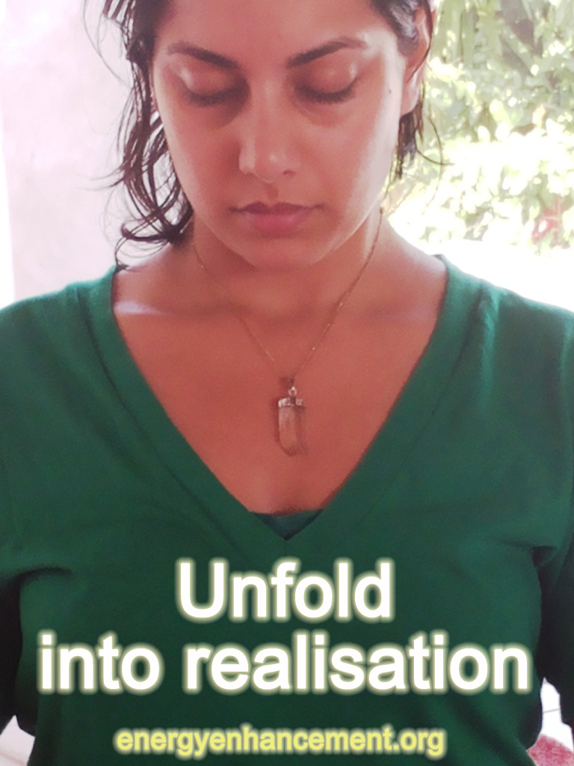

MEDITATION ENERGY ENHANCEMENT JOINS IN OUR VISION OF ONE ENLIGHTENED HARMONIOUS WORLD.
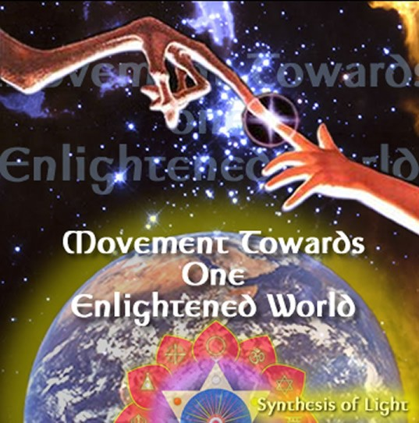
JOIN IN OUR VISION OF ONE ENLIGHTENED HARMONIOUS WORLD. IF YOU WANT TO CHANGE THE WORLD, CHANGE YOURSELF FIRST.
IF YOU WANT TO MAKE THE WORLD ENLIGHTENED, MAKE YOURSELF ENLIGHTENED FIRST.
JOIN US BY USING THE ENERGY ENHANCEMENT KARMA CLEARING TECHNIQUES, EASILY REMOVING ALL TRAUMA AND NEGATIVE EMOTIONS.... ON THE PATH OF ENLIGHTENMENT.
Learn how to Channel Silence. Become aware of Global Consciousness, Unity Consciousness. The Eternal, Infinite Variety of a Galactic Universe.

With Energy Enhancement, people who cannot handle their own lives can become strong. And people who have Mastered One of the Realms of Abundance on this Planet can more rapidly advance.
From the Inner Level of Silence the Internal Rulers of the World, Wise Well Wishers of all Human Life, energetically affect all Human Destiny.
There is a Knowledge beyond Imagination, by experiencing in your own Inner Consciousness from the field of Self Referral Consciousness, The Plane of the Higher Self.
You have spent all your lives collecting knowledge. Your heads have become fat with all the Knowledge they carry.
QUOTE FROM THE ENERGY ENHANCEMENT BOOK CHAPTER 2.3
"All of our educational systems in the world are rooted in intellectual development; hence they all depend on memory. The examinations in our schools, colleges, universities, are not of intelligence. Memory is mechanical. A computer can have a better memory than a man of genius, but the computer has no intelligence."
Yet thinking like this, as we have done for thousands of Years, produces Defects.
There is a natural Impulse from this Point to Infinity. Coming from the Will. Of Knowing by Being.
This Energy Enhancement Ideal is Normal. The Other is not yet Life.
At the Level of Creation there is Something Transcendental. Where one can create by thought. Where resides Competence. A Philosophy of Perfection. A strong Movement for One Enlightened World. Where resides true Satisfaction. Where there is no Disappointment.
You can be Totality.
Come to Yourselves. Come to the Higher Self. Come to the Universe.
Become Invincible on an Individual Level, Cosmic Individuality.
Join in The Vision. Help to Facilitate the Production of Enlightened Beings on this Planet through the Abstract energy influence of Coherence.
Come for this Spectacular Energy Enhancement Training.

Come for this Extraordinary Training. Fulfill the Aspirations of your Soul Path.
Generously and Widely Offering to the World through Embassies of Enlightenment in all the Major Cities of the World and Retreat Centers in the Mountains.
This is The Experience. This is The Movement. This is The Vision.
This is Your Wake Up Call....

For those who understand the reality of enlightenment and the urgency of the situation here is a excerpt from Andrew Cohen which encapsulates the Worlds problem which will motivate some people to try Energy Enhancement. Because this is what we do too.. What is the vision that inspires your work? What are you trying to do?

A: Change the world. It's a bold thing to say, but it's true. My work is dedicated to nothing less than a total revolution in human consciousness—a revolution that has to happen for all of our sake. Because if something fundamental doesn't change—and change fast—we're faced with a calamitous future. There are too many of us on the planet and its resources are being tragically overused.
Humans have the power to create and destroy life in a way that up until recently only gods were capable of, and yet our moral, ethical, and spiritual development is lagging way behind. This is the context in which I'm trying to help people to see their own experience because then the whole business of spiritual and evolutionary development becomes very relevant—indeed, it becomes urgent. When you begin to let in how big this context really is, you will recognize that the extraordinary potential of your own personal transformation and its need to be actualized is absolutely non-separate from the predicament that we're in as a race. Ultimately, this world crisis is spiritual. It's a crisis of consciousness.

Q: Why do you say the world's predicament is a spiritual crisis?

A: Well, because it's obvious that no individual or group consciously chose to pollute or overpopulate the world (except those with a psychopathic ego, that one half of the population who have no heart and so to a greater or lesser extent do not care about others,

the world, the pain, the overpopulation, the pollution, the wars - as long as they are alright - Satchi). But simply because of a lack of awareness, a small-minded and self-centered perspective on the part of individuals and entire cultures, we have created the crisis that we are in. And it's not that we don't have the practical means to address the problems that we face, but we're still looking at these problems from that same old perspective that created them. So there is a leap that desperately needs to be taken by a significant minority—a leap in consciousness, a moral leap, a spiritual leap. We need to evolve our consciousness beyond this lower level of development, this small-minded and self-centered perspective, to a much higher and more all-embracing view.
Q: If it depends on individuals, how can this kind of shift happen on a scale that will really make a difference?

A: Those at the leading edge are going to have to take this leap and chart the way to the future. And that means us—you and me, right here, right now. You see, if you're even thinking about these questions, that means that you are part of a privileged minority.
Most people on this planet do not have the freedom to even begin to think about these philosophical and spiritual issues because they have to devote all of their time and energy to simply surviving. The small minority of us who do have the time and circumstances for introspection are in a very fortunate position and could make a real difference. But what is crazy about this picture is that we won't do it. Why? Because we're too busy worrying about ourselves. The tragic irony of the postmodern mess that we're in is that so many of the most highly evolved and privileged people on the planet are lost in an emotional and psychological relationship to life that's very primitive—a swamp of narcissism and self-concern.

So this is our evolutionary challenge. We need to find the heart to see our own spiritual yearnings in the biggest possible context, in such a way that is going to compel us to lift ourselves up out of narcissism and self-concern. We need to find the courage to come together and face the challenges before us. And to do this, we need a new spirituality. We need a new enlightenment.

These Advanced Techniques of Energy Enhancement really work fast to increase your Spiritual Heart Energy. Come for the Energy Spiritual Buddhafield and The Energy Enhancement Course this summer in Spain with Satchidanand and Devi Dhyani. Take the Energy Enhancement DVD Course and practise from Now to help increase your spiritual consciousness in advance.

“FOR THOSE WHO BELIEVE IN THE REALITY OF ENLIGHTENMENT AND THE URGENCY OF THE SITUATION” - GAUTAMA BUDDHA.

Synthesis of Light is a Movement towards One Enlightened Harmonious World. Wow! That's quite a mouthful! Chewing slowly...lets look at it word by word. Movement. We are a Movement so therefore without definition. We are not an organisation and therefore are not susceptable to the petty politics that lay many the beautiful creations of enlightened saints to rot in the wastelands of human stupidity. We are a movement towards light and therefore always evolving, changing, yet maintaining the core vision of One Harmonious Enlightened World.

Do you still think it's possible? You used to think about it when you were younger. World peace. Heaven on Earth. Love amongst humankind and harmonious living with our planet and it's myriad of lifeforms. Peace. Yet at some point you forgot about it. You got lost in the madness of contemporary life and forgot about your true nature. we haven't forgotten and we're here to remind you and welcome you back to the vision of One Harmonious Enlightened World.

One. One, because many is a result of splits. When there are splits or divisions, then we are faced with difficult decisions and endless choices. Then we have to argue about what's right and what's wrong. Who is better and who is brighter. So one brings us back together. One synthesises the splits into the harmonious whole.

To realise this vision, we suggest enlightenment for everyone on our planet. Enlightenment results in living consciously and compassionately. This evolved, enlightened, compassionate and conscious person will not need to be told what's right and what's not. This person will not need laws and rules, pills and drugs, makeup and fashionable fur, politicians and police. This enlightened person will simply be. Transmitting the higher energies and assisting the evolution of our planet. Radiating light and love and intuitive soul energy in which there are no mistakes or defects, unlike those who are simply using the mind as humanity has done for thousands of years with the results in this world as you see before you now... Using simple and effective techniques, Enlightenment is possible in one lifetime. This lifetime. Regardless of how young or old you are. If you are ready to change then you can become Enlightened.
So what is Enlightenment? Well we are not really sure. Because this word has been defined and redefined and many interesting ideas,

theories and definitions have been proposed about enlightenment, which is usually the case when you put a few ego-centric academics and spiritual aspirants together and ask them for their opinion. It could be defined as being blockage free. Free from Karma. Unified with the soul. Radiating a Buddhafield in which all meditate and intuit better. Free from desire and want. Free. Completely free.
Completely conscious. Like Christ or Buddha. So we say everybody can be like Buddha or Christ and if this happened, then we would have One Enlightened Harmonious World.

Big words. How to become Enlightened? Using the simple and effective techniques that Synthesis of Light refers to as Energy Enhancement. The techniques do exactly what they imply. They Enhance the Energy flowing through you. By connecting you to higher sources and allowing you to remove blockages. No morality. No rules. No religion. All that stuff is up to you. All we do is allow you to experience the higher energies for yourself, through meditaion, yoga the Buddhafield and self healing. We charge you for this service, because Satchi and Devi have worked very hard for over 20yrs developing the techniques into the Energy Enhancement Course.

More importantly it allows SOL to give Scholarships for the course to those who can't afford its full price. More importantly it provides SOL with funds to build the Embassies of Enlightenment in major cities as well as the Ashrams in the Andes and Drakensburg Mountains. That is why we are working very very very hard right now to produce the DVD course which will be sold worldwide. So you can support us right now by ordering the course and receiving the course we have now, as well as the new improved course we are working on when it soon becomes ready. By also offering us any skills you may have that may be useful. Or if you have a house available somewhere in the world that's not being used, lend it to us. Or simply by writing back and saying that you support us.
Simply by telling a friend who you think might be interested.

This is our job. It is all we do. Everything for the benefit of our planet and at the same time evolving ourselves. The results are not important. How can we change what will happen? But we can change our karma, our Luck, so we do what we do and do it to the best of our abilities.

They say that there needs to be pain, suffering and conflict in our world in order for us to remember our divinity, to remind us that we are more than flesh and bones. When every person on this planet remembers... will we still need pain, suffering and conflict?

Well, every oyster needs that grain of sand to produce the pearl. This is the nature of Evolution. But that grain of sand need not be physical or emotional. It can move onto the mental and intuitive planes thus destroying all suffering pain and conflict, with Energy Enhancement, from the higher energies we are working for the Oneness in Synthesis in this world, now.

Join us by meditating every day. Love and Light,

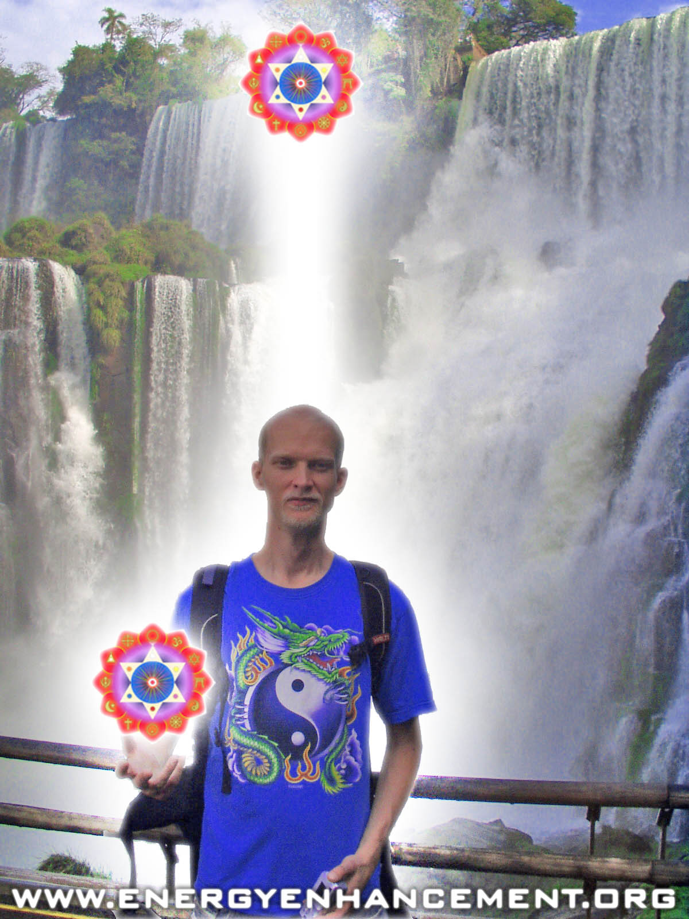

ENERGY ENHANCEMENT COURSE AT IGUAZU FALLS. BRAZIL

"Get your asses over here Now and Speed Up your process of Enlightenment on the Energy Enhancement one month course!!" - DON
Every one of our Students gets this Spiritual Experience of Connection with Infinite Energies.
Energy Enhancement does indeed, "SPEED UP THE PROCESS!!"
And they all get this Experience of Light, Life and Infinite Energy just with the Energy Enhancement Course - Every One of Them!!
LEVEL 1 - 4 VIDEO COURSES ANYTIME IN THE COMFORT OF YOUR OWN HOME

Energy Enhancement Samyama, The Fastest Way to Enlightenment
Energy Enhancement Samyama, The Fastest Way to Enlightenment
Hatha Yoga is good but Pranayama is 10 times faster at releasing Energy Blockages which stop the Enlightenment process.
Pranayama, or advanced breathing techniques, is good but Meditation is 10 times faster than even that at releasing Energy Blockages which stop the Enlightenment process.
Meditation is good but Samadhi is 10 times faster than even that at releasing Energy Blockages which stop the Enlightenment process.
Samadhi is good but Samyama is 10 times faster than even that at releasing Energy Blockages which stop the Enlightenment process.
Yoga, Pranayama, Meditation, Samadhi and Samyama are part of the Eight Limbs of Yoga in the Yoga Sutras of Patanjali and Samyama is talked about from over 5000 years ago in the Third And Fourth Chapter of The Yoga Sutras of Patanjali.
And Samyama IS Energy Enhancement, 10,000 times faster on the Path of Enlightenment.
Samyama, a giant step forward from Meditation or Samadhi is what spiritual Masters use to remove the energy blockages or samskaras they absorb from others and in order to help their students.
Although many meditational Masters will teach you with A Synthesis of Ancient and Effective Meditation techniques to remove your own blockages, if the blockage is too tough and too deep for you, the Buddhafield surrounding the Masters of Meditation, can help you.Advanced and Effective Meditation Techniques are Syntheses of Ancient and successful techniques some over 5000 years old The roots come from many ancient disciplines, and include -
Alchemical V.I.T.R.I.O.L, the first Formula of Alchemy, in reality a guided meditation to align you with the path of your soul!!
- Yoga
- Meditation
- Kundalini Kriyas
- Taoist Meditation Techniques
- Kundalini Tantra
- Energy Circulation
- Creating the Antahkarana
- Soul Infusion
- Connecting to the Highest Heart
- The Grounding of Negative Energies
- Psychic Purification of the physical, emotional, mental, and spiritual Bodies

LEVEL 1 - 4 VIDEO COURSES ANYTIME IN THE COMFORT OF YOUR OWN HOME

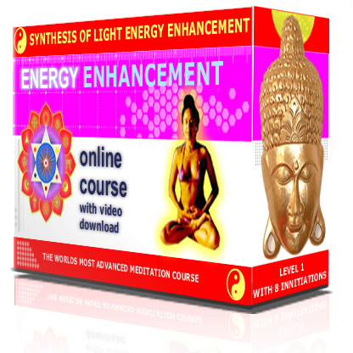

Energy Enhancement Meditation, Experiencing One's Own Reality
This is not a breathing exercise: one does not regulate the breath. Instead one observes natural respiration as energy, as it comes in, as it goes out. In this way one further calms the mind so that it is no longer overpowered by violent negativities. At the same time, one is concentrating the mind, making it sharp and penetrating, capable of the work of discernment.
These first two steps of living a moral life and controlling the mind are very necessary and beneficial in themselves; but they will lead to self-repression, unless one takes the third step - purifying the mind of Energy Blockages by developing insight into one's own nature, being in the Energy Field of a Master of Meditation and using the Advanced Blockage Busting Techniques of Energy Enhancement.
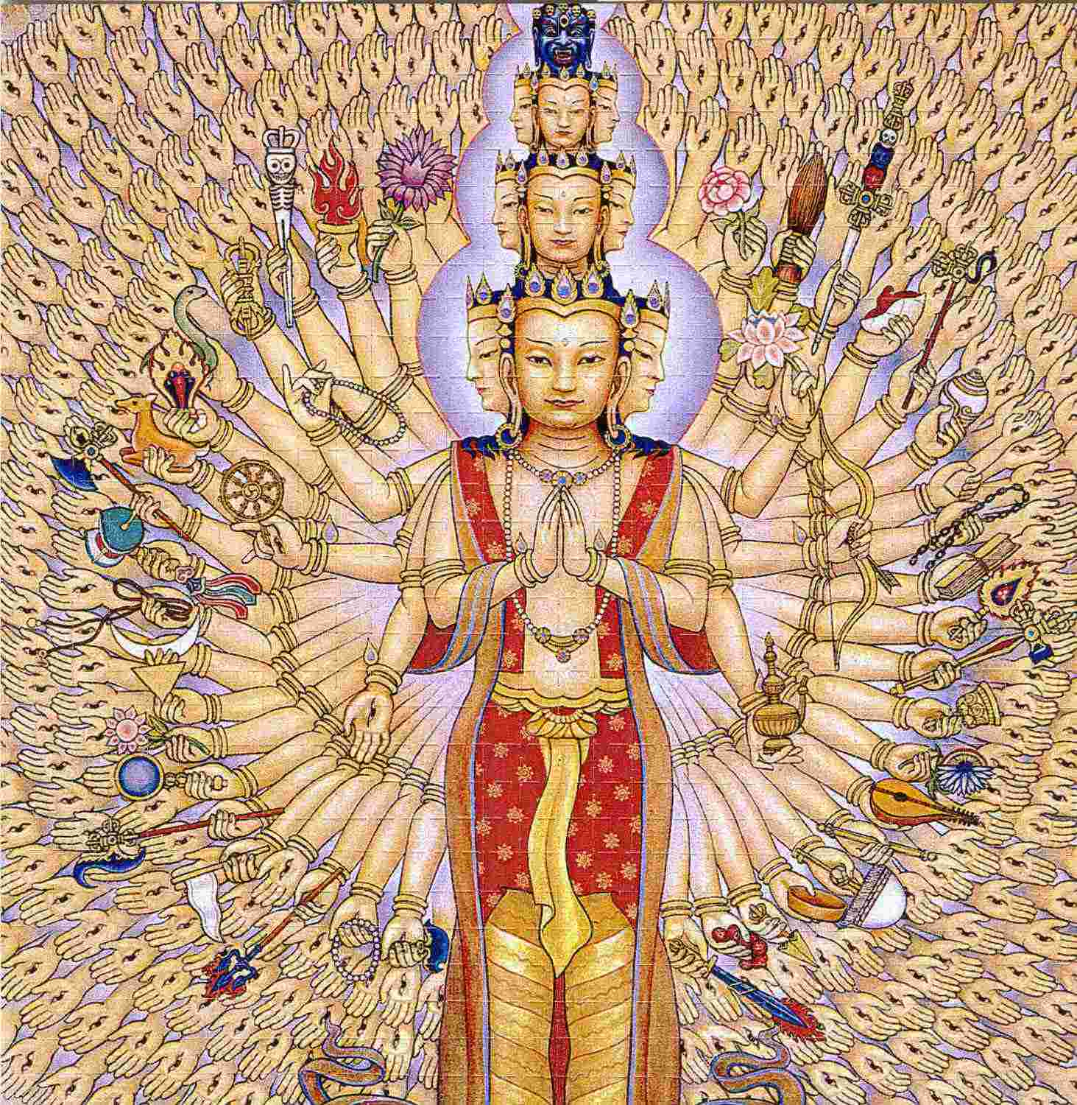

This is Energy Enhancement Meditation: experiencing one's own reality, by the systematic and dispassionate observation of the ever- changing mind-matter phenomenon manifesting itself as sensation within oneself and then removing the Energy Blockages causing the agitated behaviour.
This is the culmination of the teaching of the Buddha and all the Masters of Meditaton for the past 5000 years: self-purification by self-observation and Advanced Blockage Busting.
This can be practiced by one and all. Everyone faces the problem of suffering. it is a universal disease which requires a universal remedy--not a sectarian one. When one suffers from anger, it is not a Buddhist anger, Hindu anger, or Christian anger. Anger is anger. When one become agitated as a result of this anger, this agitation is not Christian, or Hindu, or Buddhist. The malady is universal. The remedy must also be universal.
Energy Enhancement Advanced Blockage Healing and the effect of the Buddhafield of Energy which surrounds all true Masters of meditation is such a remedy. No one will object to a code of living which respects the peace and harmony of others. No one will object to developing control over the mind. No one will object to developing insight into one's own reality, by which it is possible to free the mind of negativities. Energy Blockage Removal is a universal path.
Observing reality as it is by observing the truth inside--this is knowing oneself at the actual, experiential level. As one practices, one keeps coming out of the misery of Energy Blockages.
From the gross, external, apparent truth, one penetrates to the ultimate truth of mind and matter. Then one transcends that, and experiences a truth which is beyond mind and matter, beyond time and space, beyond the conditioned field of relativity: the truth of total liberation from all Energy Blockages, all impurities, all suffering. Whatever name one gives this ultimate truth, is irrelevant; it is the final goal of everyone.
May you all experience this ultimate truth. May all people come out of their Energy Blockages, their misery. May they enjoy real happiness, real peace, real harmony.
It needs an Ancient Advanced Synthesis of Effective Techniques for Gaining More Energy - Meditation, Shaktipat, Energy Circulation, The Kundalini Kriyas, The Five Elemental Paths Of The Chi Of Chinese Alchemical Taoism, The Grounding Of Negative Energies, V.I.T.R.I.O.L, The Art Card Of The Thoth Tarot, Access To Kundalini Energy, Strong Psychic Protection, Learn The Merkaba, Pyramid

Protection, Power Tower Protection, Create The Antahkarana, Soul Fusion, Monadic Infusion, Logos Infusion. The Painless Removal Of Stress, Trauma And Negative Emotion
However, to remove energy blockage sub-personalities completely, the more Advanced techniques of a Synthesis of Ancient Meditational Techniques are absolutely necessary:-
Leading onto the more advanced Techniques of The Karma Clearing Process. Learning how to clean The Karma From Past Lives, Future Life, Future Lifetimes, Integrating Soul Fragmentation And Retrieval of Inner Children, Selfish Ego Sub Personalites, Life Destroying Strategies, The Aloof, The Interrogator, The Violator, The Selfish Competitive Star, The Vamp Or Don Juan, The Pleaser, The Blamer, The Critic, The King, The Self Destructor, All The Destructive Vows From This And Past Lifetimes,.
Which results in The Creation Of Self Love, Love And Service. Ponder on this
MAY ALL BEINGS BE HAPPY

Energy Enhancement Meditation and Shaktipat
Meditation is the ultimate method of choice for over 5000 years, of all discerning Self Development Trainees. Energy Enhancement Meditation is the first of 28 ancient and effective meditation techniques to enable you to achieve control of your mind, an enhanced IQ, control over all your negative emotions, anger, fear, depression on the path of the ultimate Samadhi and enlightenment itself.
The Ultimate in the Control of your own Mind.
Most people find it easy to have many thoughts, but you only have control over something when you have the power to stop it.
Our mind is so full of thoughts that it is necessary to learn how to press the stop button, so that one thought can have maximum power when you want it. To learn how to access Wisdom and intuition. To access the Unconscious, the Alpha, Beta and Delta levels of our own mind.
Meditation is a fast for the thoughts of the mind. All our painful memories are thoughts filled will negative emotion. As we learn

how to stop giving energy to a thought, so it gets smaller, less powerful. It eventually disappears.
The true control over our minds, as known for many thousands of years, comes when we have the power to stop all our thoughts.
When this occurs then we gain the Energy to access our intuition and Soul life path. When we can do this then any thought we have becomes so much more powerful. We begin to have the ability to make things happen. The power of doing. The clarity to hold and accomplish anything we set our minds to.
To control something, one must be capable of stopping it, said Karl Popper the famous philosopher who wrote, "The Open Society and its Enemies" and Frank Herbert who wrote the DUNE series of Science fiction.
STOP THE MIND
The Energy Enhancement Meditation taught here is based upon ancient Zen Techniques in a Synthesis of many advanced methods from Hindu Masters as well as practical hints and tips from several Masters of Meditation from many traditions, some of which have never been taught previously, giving the most advanced practical techniques on how to easily enter into the state of meditation and including the Buddhafield of Energy to get there.
To Square the Circle. To Stop the Mind.
Meditation is a prerequisite to the further advanced states of Energy Enhancement and just this Energy Enhancement Meditation is enough to gradually lead you towards your Ultimate Clarity, your Ultimate peace.
"The first day Satchi taught me how to sit. By moving the position of my posture slightly I could feel the flow of energy from the center of the earth into the center of the universe. Satchi explained that what I was feeling was Kundalini Energy. If I followed it, he said, It would lead me to Enlightenment." From the testimonial of Energy Enhancement Student Carla, Jan 2004
Siva Samhit, iii, 10-19: "Now I shall tell you how easily to attain success in Yoga, by knowing which the Yogis never fail in the practice of Yoga. Only the knowledge imparted by a Competent Teacher through his lips is powerful and useful; otherwise it becomes fruitless, weak and very painful.
And this is why - by coming into the Buddhafield of Energy surrounding Energy Enhancement Satchidanand obtained through many years of meditation with many enlightened masters, you

obtain Shaktipat- an infusion of energy to help you get into a permanent state of meditation.
Energy Enhancement Meditation is the first of 28 ancient and effective techniques to enable you to achieve control of your mind, an enhanced IQ, control over all your negative emotions, anger, fear, depression on the path of the ultimate Samadhi and enlightenment itself.

Energy Enhancement the Buddhafield And Kundalini
The Buddhafield spreads its dissolving energy by means of spiritual Evolutionary vibrations from the highest sources from chakras above the Crown Chakra: The Soul, The group Soul AND higher than the Avatar of Synthesis.
The Buddhafield energy spreads from the Aura of Masters of Meditation to imprint everything produced by them. their Books, their Audio Talks, their Video Talks and Video Courses etc.
Anything produced by them contains their energy seed.
Your access to the higher energies of the Buddhafield makes more possible during your meditations. The Advanced techniques of meditation available in every culture like - Meditation, Shaktipat, Energy Circulation, The Kundalini Kriyas, The Five Elemental Paths Of The Chi Of Chinese Alchemical Taoism, The Grounding Of Negative Energies, V.I.T.R.I.O.L and The Art Card Of The Thoth Tarot, Access To Kundalini Energy, Strong Psychic Protection, Learn The Merkaba, Pyramid Protection, Power Tower Protection, Create The Antahkarana, Soul Fusion, Monadic Infusion, Logos Infusion, painlessly dissolve all Energy Blockages at the Energy Level. This gives the Painless Removal Of Stress, Trauma And Negative Emotion.
There is no need to go into memory or emotion as it all happens at the level of energy which underlies those other higher mechanisms.
As well as helping to remove energy blockages the Buddhafield creates the possibility of Kundalini experiences. It, as well as the Advanced Techniques of Meditation give you more energy to Speed Up the Meditative Process by painlessly removing Energy Blockages which underlie all aches and pains.
The action of the Buddhafield of practiced meditators is talked about in the scriptures from 5000 years.. Siva Samhit, iii, 10-19:

"Now I shall tell you how easily to attain success in Yoga, by knowing which the Yogis never fail in the practice of Yoga. Only the knowledge imparted by a Competent Teacher through his lips is powerful and useful; otherwise it becomes fruitless, weak and very painful.
I, the writer of this article, say, With this higher energy radiating as a Buddhafield after many years of meditation, you become, "a walking point of Crisis, a necessary point of Tension." These words were originally spoken by Alice Bailey and Djwan Khul, meaning that the Buddhafield has the effect of provoking change and evolution. As we say, "Love is the energy of change."
I do not believe I am special in any way, just lucky. I say, "I am just a another guy who has been added unto. I am just a custodian of the energies which have been given to me by the many Enlightened masters I have encountered, Roshi Hogen Daido Yamahata, Swami Satchidananda of Yogaville, Sri Yogendra of Bombay, Sri Sathya Sai Baba, Osho and Father Bede Griffiths, and also into which I have been Initiated by the highest Ascended Masters of Enlightenment.
Before being given energy, first you must prove yourself. Be tested and found to be true. I am just a Channel for the higher energies which expand my aura as a Buddhafield of Energy whose integrative effect is now quickening and speeding up all the Evolutionary practices it touches and removes all Energy Blockages at the Energy level thus removing misfortune and pain in all my students and throughout the world.
The Buddhafield removal of Energy Blockages is just an expression of what is already happening here on this small planet. This is an amazingly auspicious time for every soul who wishes to evolve, here, now!! Incredible opportunities are available for speedy evolution, increasing of Luck and intelligence, removing pain and disease.
If you have ever wanted to enter into the spiritual path, to make this change in yourself, NOW is the time. Vast Spiritual energies are, for the first time in eons, being sent to this planet and more enlightened people are necessary to be trained how to handle
them.
Side effects of Energy Blockage removal and brain energy stimulation are an increase in IQ, more emotional stability, more energy, more GO!! We have been equipped to give this training with the teaching of Advanced Meditation practices.
In this one encounter much can happen. All my students know this from their own psychic and Evolutionary experiences in the

Buddhafield and this same Energy Blockage removal and Brain Stimulation can be given to any person who comes into the Buddhafield to learn advanced practices of Meditation.
The Speeding up of your Meditative processes towards Enlightenment, the spreading of the Light of Synthesis through the creation of New Nodes of Light, growing ever stronger with the passage of time, the gaining of strength, energy, luck and Light.
We have to be inwardly rich to give away everything. We need a large Evolutionary bank account.
The Buddhafield of Energy is the expression of that Generosity.

The Energy Enhancement Ancient and Effective Meditation Techniques and Old Meditation Systems
The Antahkarana is a psychic body which is you or rather your greater self yet you are inhabiting only a small part of yourself. You are inhabiting only the seven chakras whereas the Antahkarana stretches from the chakra in the center of the earth, Kundalini Chakra, through you and up through your crown chakra through all the chakras above your head, to God.
The Antahkarana is the communication bus, the energy of the Holy Spirit, which connects between heaven and Earth.
These three are the Holy Trinity. The Father, the Earth Mother and the Holy Spirit or Sat Chid Ananda.
The Antahkarana in terms of the Emerald Tablet of Hermes Trismegistus is that which communicates between the Sun and the Earth.
The Antahkarana has many ancient and physical representations.
The Obelisk is the physical, artistic, objective art, representation of the Antahkarana or the tower which connects all the chakras together.
The Tower. The Tower struck by Lightning. The Rainbow Bridge which connects all the infinity of chakras from the center of the earth chakra through the seven chakras of the body and up through the infinity of chakras above the head.

Spire, inspire, aspire - Every brick aspires to become a Cathedral
The Egyptian Obelisk like Cleopatras Needle in London, from thousands of years of Antiquity.
The Sufi Inspired Minaret of the Blue Mosque in Turkey even has the representation of the chakras above the head built up the towers.
But only three. Now we need to go higher.
Buddhist Stupa showing the representation of the Jhanas, or Chakras above the head.
The Native American Indian Totem Pole has many chakras, gods, blockages on the way up the Antahkarana to the Eagle.
The Alchemical Cosmic Egg When the Supreme Ultimate and the Immaterial Spirit unfold, the Point at the crown of your head opens and the light or tunnel or shaft leading to the Cosmic Egg is revealed.
See the articles on the ALCHEMICAL Emerald Tablet of Hermes Trismegistus and the Alhambra in Granada, Spain, once a Sufi School, for more examples of the Antahkarana built in Stone. You can read the Energy Enhancement E-Book for more information on the Antahkarana
Energy Enhancement contains methods of Accessing Infinite Energy. The Energy of the Soul. The Energy of the Monad. The Energy of the Logos. the Energy of the Avatar of Synthesis. Perhaps access to Ascended masters and our past lives.
Energy Enhancement contains 28 ancient and effective techniques including the Macrocosmic orbit and the Antahkarana to enable you to achieve control of your mind, an enhanced IQ, control over all your negative emotions, anger, fear, depression on the path of the ultimate Samadhi and enlightenment itself.
The Emerald Tablet of Hermes Trismegistus describes the macrocosmic Orbit of the Taoists and of Energy Enhancement.
Here we are concerned not only with the amount of Energy, but also with the quality, the height of the vibration of the energy which alone determines the height of our Evolution.

Energy Enhancement Meditation Opening the Heart, Relationships, Hanbledzoin, Buddhafield, Kundalini + Shaktipat
Usually first step is to Open the Heart, and on this planet only perhaps 50% of the people have started to think a little about others instead only of themselves.
This means that the other 50% of the people perhaps are entirely selfish so now you can understand all your problems with relationships! Opening the Heart is the First Initiation on the path of Enlightenment and in it the Solar Plexus starts to empower the Heart with its energy. Blockages stopping the flow of Energy include Anger.
Anger is totally removed!
Then Master Relationships. This is the Second Initiation and entails the Second, Abdominal or Relationship chakra starting to power the Throat Chakra, the source of our creativity. And then open the pathway between the Base Chakra and all the Head Chakras. This is commonly called Enlightenment itself. The Crown Chakras purpose is to access the Soul or Higher Self through the Antahkarana or the Energy Connection from the Crown Chakra to the Higher chakras above the head, or The Highest Heart, Prajna Paramita. ENERGIZE!!
Once Relationships have easily been mastered then The Third Initiation, Enlightenment happens in the same Lifetime!
The problems of the World are now so intense that there needs to be a speeding up of evolution to create more evolved and Happy Beings. The problem is that most people are Not Happy!
The problems of the World come from a Lack of Evolution, a Lack of the Opening of the Heart, of Caring, of Sympathy, of wanting to help, Of wanting to reduce the amount of Pain in Humanity. If you have no Heart which is the Case of more than half of Humanity, then Selfishness, Anarchy, War, Revenge, Jealousy, Envy, Torture and Psychopaths will rule! And this has been the case for all the History of this Earth! This speeding up of evolution can only come with a Heart to provide by Right of Being Born, of All Basic Needs to every member of Humanity.

As a Good Family gives its Sons and Daughters Everything for their Evolution. These Basic Needs Are Food, Housing, Money, Education And Meditation Teaching, also Security, And Human Rights.
Meditation will Speed Up all other techniques, Hatha Yoga, working on the health of the body, Pranayama, working on increasing energy and happiness, Dance or Martial arts, for instinctive grace and movement. In Energy Enhancement we start with meditation and move on into The Kundalini Kriyas of the Hindu and Taoist Masters. Then Samyama, working on removing all the problems of: Energy Blockages, Cleaning the Psychic Body, Cleaning the Inner Traumas and Memories, Creating Incredible Relationships.
We need to work first on Meditation and the Grounding of Negative Energies. As Gurdjieff said, "First Mastic. Then Mystic." Which is the ability to digest all negative energies.
Extra energy comes from outside, from the teachers usually, "Hanbledzoin," as Gurdjieff said, is the Energy, The Bled, or Blood of the Masters, and is necessary for the integrative process. This is the Buddhafield. This is the origin of Shaktipat. This is the origin of all access to the symptoms of Kundalini Energy.
These specialized energies are available to complete the psychic bodies, to fill them up, to complete them. These energies can only come through properly Authorised Teachers. An Advanced Synthesis of Successful Meditation Techniques is a new Higher Frequency of Energy sent by Ascended Masters and Highly Evolved Devas or Angels to speed up the evolution of this planet.
All Advanced teachers can be judged by all students to have Advanced Meditational Experience after years of Training. It is the first test of the Student to choose the Right Teachers.
Some teachers teach that it is necessary to take energy from other students. They never mention the Opening of the Heart through the Removal of Energy Blockages like Anger and Depression. They Never mention the Purification of the Antahkarana and Connection with the Soul. Energy Vampires only want to steal energy from others and increase Trauma and Pain blockages to do this.
Instead of taking over Twenty years of Meditation, Advanced Techniques allow the process to be speeded up with the Advanced Techniques from a Synthesis of Successful Meditation Techniques taught to all advanced practitioners of Meditation for over 5000 years.
Good Teachers of Meditation must transmit Energies to help the Evolution of their Students. This Uppadesa is sometimes called Shaktipat and can come by word, glance or in Silence.

Good Teachers will always teach Advanced Techniques to Remove Aches and Pains, Negative Emotions and Trauma, Open the Heart, Connect to the Energies of the Higher Self and thus Access Higher Levels of Energy.
As the Ancient Text of the Siva Samhit, iii, 10-19: says, "Now I shall tell you how easily to attain success in Yoga, by knowing which the Yogis never fail in the practice of Yoga. Only the knowledge imparted by a Competent Teacher through his lips is powerful and useful; otherwise it becomes fruitless, weak and very painful.
Why spend time on techniques which give no results?
As Gautama Buddha Said, "Meditation is for those who believe in the reality of Enlightenment, and understand the Urgency of the Situation." So, do not hang around. If you believe in Enlightenment, then you need to find the best and most Speedy Way!
Speed Up The Process of Enlightenment with Advanced and Effective Meditation Techniques, a Syntheses of Ancient and successful techniques over 5000 years old. The roots come from many ancient disciplines available in most Ancient Cultures all over the World, and include -
Alchemical V.I.T.R.I.O.L, the first Formula of Alchemy, in reality a guided meditation to give you Incredible Energy!!
Yoga to make you Flexible, Strong and increase the years of your long and happy life.
Meditation to Access Peace and Clarity within. Kundalini Kriyas
Taoist Meditation Techniques including the Microcosmic and Macrocosmic Orbits.
Kundalini Tantra and Energy Circulations of Kriya Yoga
Creating the Antahkarana so you can access the Incredibly Intense Energies of the Soul.
Soul Infusion and Connecting to the External Energies of the Highest Heart.
The Grounding and Purification of Negative Energies
Psychic Purification of the physical, emotional, mental, and spiritual Bodies.
The removal of Energy Blockages and implants to Remove all Aches and Pains
The creation of the Light Body so you can have more Radiance.

The use of the Ancient Egyptian Technology of the Merkaba. Golden Pyramid Psychic Protection to Stop Energy Vampires.

The Art of Energy Enhancement: Meditation to Remove Energy Blockages, Negative Emotions, Bad Luck
Everyone seeks peace and harmony, because these are what we lack in our lives. From time to time we all experience agitation, irritation, disharmony, suffering; and when one suffers from agitation, one does not keep this misery limited to oneself.
One keeps distributing it to others as well. The agitation permeates the atmosphere around the miserable person. Everyone who comes into contact with him also becomes irritated, agitated. Certainly this is not the proper way to live.
One ought to live at peace with oneself, and at peace with all others. After all, a human being is a social being. He has to live in society--to live and deal with others. How are we to live peacefully? How are we to remain harmonious with ourselves, and to maintain peace and harmony around us, so that others can also live peacefully and harmoniously?
One is agitated by Energy Blockages. To come out of the agitation, one does not need to know the basic reason for it, the cause of the suffering. Only you need to know the Energy Enhancement techniques for healing Energy Blockages. In this way we can clear ourselves of all Karma and instead create good luck for ourselves and everyone around us.
If one investigates the problem, it will become clear that whenever one starts generating or creating any Energy Blockage, a negativity or defilement in the mind, one is bound to become agitated. A negativity in the mind, a mental defilement or impurity, an Energy Blockage cannot exist with peace and harmony.
Energy Blockages are created when something you do not want happens to you in this lifetime or one past, when you absorb the Energy Blockage from people around you, or When some bad person implants you with an Energy Blockage.

These Energy Blockages are force fields which contain Negative Karmic Mass, which is created through the perversion of pure positive spiritual energy, usually when something bad happens to us. Thereafter the Energy Blockage impurity forever creates agitation, fear and pain within our psyches.
How does one start generating negativity? Again, by investigating, it becomes clear. I become very unhappy when I find someone behaving in a way which I don't like, when I find something happening which I don't like.
Unwanted things happen and I create tension within myself. Wanted things do not happen, some obstacles come in the way, and again I create tension within myself; I start tying knots within myself. And throughout life, unwanted things keep on happening, wanted things may or may not happen, and this process or reaction, of tying knots--Gordian knots-- or Energy Blockages makes the entire mental and physical structure so tense, so full of negativity, that life becomes miserable.
Now one way to solve the problem is to arrange that nothing unwanted happens in my life and that everything keeps on happening exactly as I desire. i must develop such power, or somebody else must have the power and must come to my aid when I request him, that unwanted things do not happen and that everything I want happens.
But this is not possible. There is no one in the world whose desires are always fulfilled, in whose life everything happens according to his wishes, without anything unwanted happening.
Things keep on occurring that are contrary to our desires and wishes. So the question arises, how am I not to react blindly in the face of these things which I don't like? How not to create tension? How to remain peaceful and harmonious?
In India as well as in other countries, wise saintly persons of the past studied this problem--the problem of human suffering--and found a solution: if something unwanted happens and one starts to react by generating anger, fear or any negativity, then as soon as possible one should divert one's attention to something else.
For example, get up, take a glass of water, start drinking--your anger will not multiply and you'll be coming out of anger. Or start counting: one, two, three, four. Or start repeating a word, or a phrase, or some mantra, perhaps the name of a deity or saintly person in whom you have devotion; the mind is diverted, and to some extent, you'll be out of the negativity, out of anger.

This solution was helpful: it worked. It still works. Practicing this, the mind feels free from agitation. In fact, however, the solution works only at the conscious level. Actually, by diverting the attention, one pushes the negative Energy Blockage deep into the unconscious, and on this level one continues to generate and multiply the same defilements. At the surface level there is a layer of peace and harmony, but in the depths of the mind there is a sleeping volcano of suppressed negativity which sooner or later will explode in violent eruption.
Other explorers of inner truth went still further in their search; and by experiencing the reality of mind and matter within themselves they recognized that diverting the attention is only running away from the problem.
Escape is no solution: one must face the problem. Whenever a negativity arises in the mind, just observe it, face it. As soon as one starts observing any mental defilement, it begins to lose strength. Slowly it withers away and is uprooted.
This is the case with all weak Energy Blockages, however for very deep and powerful Energy Blockages one must meditate with a Master of Meditation, within his buddhafield. Let the Master do the work!.
Or one must learn very powerful blockage busting techniques. Then, like Alexander the Great, you can learn how to cut the Gordian Knot with your sword of Discernment!
Usually, the necessary solution is a mixture of both being with a Master of Meditation, and learning advanced Blockage Busting techniques yourself. This we do in Energy Enhancement!

Energy Enhancement Meditation To Know Yourself
You are an immortal and pure being. Energy Blockages are that which are not you. They are filled with perverted spiritual energy which causes bad actions and negativity.
What is necessary, then, is to 'know thyself'--advice which every wise person has given. One must know oneself not just at the intellectual level, the level of ideas and theories. Nor does this mean to know just at the emotional or devotional level, simply accepting blindly what one has heard or read.

Such knowledge is not enough. Rather one must know reality at the actual level. One must experience directly the reality of this mental- physical phenomenon. This alone is what will help us to come out of defilements, out of suffering.
This direct experience of one's own reality, this techniques of self- observation, and the removal of Energy Blockages through Advanced Energy Enhancement Techniques is what is called Energy Enhancement meditation.
In the language of India in the time of the Buddha, meditation meant seeing with open eyes, in the ordinary way; but Energy Enhancement Meditation is observing things as they really are, not just as they seem to be.
Apparent truth has to be penetrated, until one reaches the ultimate truth of the entire mental and physical structure. When one experiences this truth, then one learns to stop reacting blindly, to stop creating new Energy Blockages--and naturally the old defilements of Energy Blockages are gradually are eradicated. One come out of all the misery and experiences happiness.
There are three steps to the training which is given in an Energy Enhancement meditation course Firstly, one must abstain from any action, physical or vocal, which disturbs the peace and harmony of others. One cannot work to liberate oneself from defilements in the mind while at the same time one continues to perform deeds of body and speech which only multiply those defilements.
Therefore, a code of morality is the essential first step of the practice. One undertakes not to kill, not to steal, not to commit sexual misconduct, not to tell lies, and not to use intoxicants. By abstaining from such action, one allows the mind to quiet down sufficiently so that it can proceed with the task at hand.
The next step is to develop some mastery over this wild mind, by training it to remain fixed on a single object: the breath. One tries to keep one's attention for as long as possible on the respiration and then on the Energy Flowing through you from the Center of the Earth, into the center of the Universe.
It needs an Ancient Advanced Synthesis of Effective Techniques for Gaining More Energy - Meditation, Shaktipat, Energy Circulation, The Kundalini Kriyas, The Five Elemental Paths Of The Chi Of Chinese Alchemical Taoism, The Grounding Of Negative Energies, V.I.T.R.I.O.L, The Art Card Of The Thoth Tarot, Access To Kundalini Energy, Strong Psychic Protection, Learn The Merkaba, Pyramid Protection, Power Tower Protection, Create The Antahkarana, Soul

Fusion, Monadic Infusion, Logos Infusion. The Painless Removal Of Stress, Trauma And Negative Emotion
However, to remove energy blockage sub-personalities completely, the more Advanced techniques of a Synthesis of Ancient Meditational Techniques are absolutely necessary:-
Leading onto the more advanced Techniques of The Karma Clearing Process. Learning how to clean The Karma From Past Lives, Future Life, Future Lifetimes, Integrating Soul Fragmentation And Retrieval of Inner Children, Selfish Ego Sub Personalites, Life Destroying Strategies, The Aloof, The Interrogator, The Violator, The Selfish Competitive Star, The Vamp Or Don Juan, The Pleaser, The Blamer, The Critic, The King, The Self Destructor, All The Destructive Vows From This And Past Lifetimes,.
Which results in The Creation Of Self Love, Love And Service. Ponder on this
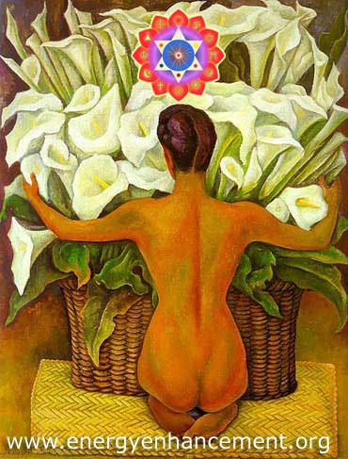

ENERGY ENHANCEMENT TANTRA AND ENLIGHTENMENT WHAT IS TANTRA?

TANTRA IS ONE OF THE MANY PATHS WHOSE AIM OR END OR PURPOSE IS ENLIGHTENMENT

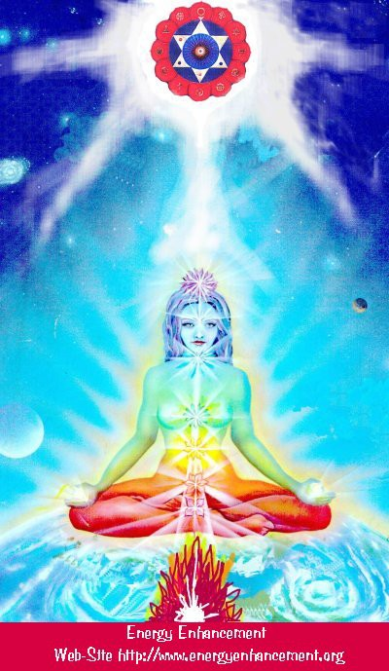

Like Yoga which means Union with the center of the Universe or with God, Tantra is any path which achieves that aim.
For many, Tantra is a sexual means of achieving that union. People ask me, isn't one of the methods to make love only once per month? To increase the length of time we make love to hours?
Well, I reply, Enlightenment comes from the increase of energy. Human beings only have a small amount of energy within themselves. Really to increase that energy we need to access the energy from chakras outside the body. It is like we have a computer which is running slowly on only five volts. We need to plug ourselves into the big generator!
To obtain thousands of volts of power in order to make the computer work more quickly at a much higher level we need to plug ourselves into the chakras above the Crown Chakra, into energy in the central spiritual sun!! The Soul!! God!!!
And in the center of the Earth is the Kundalini Shakti flowing out in every direction from the Atomic Generator which powers this planet. The atomic pile in the center of the planet is a 5000 degrees centigrade and provides the energy which keeps this planet alive and at the correct temperature. The Earth is feminine. The Indians say, "Our Mother, the Earth" and our Father, who art in Heaven is God, the energy in the center of the universe. And when all the Energy Blockages to that connection have been removed, then there is a flow, a waterfall of spiritual energy which powers every one of the enlightened.
Then we have Shiva, our father, combining with Shakti our mother. Then we have Hercules, son of God, Zeus, Theos, Deos, combining with the daughter of Pluto, King of the Underworld.
Enlightenment concerns The Holy Trinity and is composed of Sat, the truth of the center of the Universe combining with Chitta - the holy grail, the cup of the mind on this planet, empty and ready to receive the libation of the Gods, and the flow of energy between the two is called Ananda, or bliss - Satchitananda like the Father - Our Father who art in Heaven, the Son and the Holy Spirit which flows between the two.
And the Hindus have a word for the channel between the Center of the Universe and the Center of the Earth. Rapunzel, Rapunzel, let down your hair. The Rainbow Bridge. The Tower of Babel. Tower of Connection created out of mental matter to channel the energies of God through all the infinite chakras of existence, powering the whole universe from the center. This is the Antahkarana.

If you are not connected with, if you are blocked from, the center of the universe then just think of a small flow of water slowly filling a bucket. You may well have to wait a month for the bucket to fill.
Only then will you have sufficient energy to enjoy making love, or really doing any of the thousand things we have to do on this planet. But if you are connected and put your bucket under a waterfall, then that bucket will fill in seconds. You will have infinite energy to do with whatever you want every second of the day.
The Greeks had a name for this energy which descends from the soul to power the Mind Computer, and they called it Genius which is the what happens to the mind computer powered by the energy of the Soul. Soul Infused.
The Mind is of the intellect of logic yet the Soul is Intuition, Knowing, Wisdom and is much higher than the mind.
The Kashmir Shaivites also have the energy of Chit Shakti whereby the mind is also powered by the Energy in the Center of the earth.
In reality, human beings are powered by both masculine and feminine energies. We connect with the Kundalini Chakra in the center of the earth by means of the Base chakra, and we connect with the center of the universe by means of the Crown Chakra.
Usually it takes three days for the students who come on our courses to access this energy with which they can successfully transmute all their Energy Blockages because another, more easy way for people to absorb energy is from the Buddhafield, the Aura of the Master.
When they leave then sometimes the energy drains away, because it is the energy blockages which create the holes in the bucket through which all the water drains away.
And this is Tantra, the Energy Flow of the Soul created by the Sexual Union of Shiva and Shakti.
In that that bliss, that delight, such an overflowing cornucopia of Energy which comes from the Gaining of Energy and the Removal of Energy Blockages, we find only Enlightenment.
In a way, Enlightenment is a twenty-four hour a day orgasm.

World Peace by Meditation: The End of Poverty and Anger, Stress, Tension, Depression, Sorrow, Hate
One of the worlds greatest Meditators, says Governments can't eradicate poverty from the Earth. Neither can they bring peace. "To resolve problems through negotiation is a very childish approach,"
A few hundred meditators on either side of a conflict is all that's needed to create an aura of peace. "We create world consciousness and coherence. Therefore, fighting will stop all over," "Don't fight darkness. Bring the light of Meditation, and darkness will disappear."
Eliminate poverty? End war and create world peace? The unifying field that Albert Einstein sought has been within us all the time, in the "unbounded consciousness" of the mind. "There is one unity, unified wholeness, total unified consciousness,"
Tear down major structures and cities -- the White House and the United Nations among them Heal the energies and rebuild them according to energetic architectural plans that harmonize construction with nature.
Send meditation groups to world hot spots as psychic shock troops whose combined positive energy will dispel negativity, reduce crime, ease conflict and promote world peace.
Buy billions of acres in 100 developing countries for labor-intensive farming, providing employment and income for the world's poorest people by feeding the First-World market for organic food.
Meditation is a 20-minute twice daily routine in which the meditator silently focuses on a sound, or mantra, to induce relaxation and "Dive Into A State Of Pure Consciousness And Tap Into The Deepest Resources Of The Brain And Intelligence."
With Meditation "Anger, Stress, Tension, Depression, Sorrow, Hate, Fear -- these things start to retreat," said American movie director David Lynch of "Twin Peaks" renown, who has practiced Meditation for 32 years. And for a filmmaker, having this negativity lift away is money in the bank. When you're suffering you can't create.
Most scientists agree Meditation can ease stress, high blood pressure, pain and insomnia. Meditation has gained legitimacy. The

National Institutes of Health has had a Center for Complimentary and Alternative Medicine since 1998 to research these practices.
There are now over 600 published Scientific Studies on the Benefits of Meditation.
Here is the Recent News on Meditation. Study: Meditation may boost brain activity
Regular meditation has been touted as a stress reducer for years, but a recent study says practitioners benefit from a brain boost as well.
Meditation embraced
Meditation is being embraced within medical circles as a powerful healing tool.
Scientists to check Nepal Buddha boy
Scientists in Nepal are to examine a meditating teenager who is said to take no food or liquid
Director aims to boost meditation
Director David Lynch wants $7bn (3.98bn) to introduce meditation to US schools in a bid for world peace.
Meditation to tackle depression
Psychologists appeal for volunteers to take part in a study using practices to prevent suicidal depression.
Meditation 'brain training' clues
Meditating monks are giving clues about how the brain's basic responses can be overridden, researchers say.
Buddhists can move to centre
Claims that a new Buddhist meditation centre would be too 'noisy' for local residents is rejected by councilors.
School pupils learn to meditate
Pupils whose school burnt down have found a new home at a therapy centre which specializes in meditation.
Vicar opens Indian-style retreat
A clergyman opens a multi-faith retreat encouraging people of different religions to meet and meditate.
Seaside town greets Buddhist nun
A Westen Buddhist nun relocates to north Wales to begin meditation classes at a Colwyn Bay centre.
Buddhist's battle to meditate
A Buddhist is forced to apply for planning consent to practice meditating in his own wood.

Meditation for 'Christmas rage'
Buddhists offer shoppers an oasis of tranquility at the BBC Big Screen to calm those Christmas nerves.
Buddhist monk helps rugby club
A Buddhist monk is drafted in to teach Caerphilly rugby club how to improve their game through the art of meditation.
Helping patients to relax
Kidney patients are being given a new way of relaxing before their treatment - meditation CDs.
Meditating on a cinema first
A new venture offers groups of people the chance to meditate in the darkened comfort of the multiplex.
Meditation lessons for pupils
A Buddhist charity offers meditation lessons to high school pupils in Cardiff in a move to help them de-stress.
Meditation 'good for brain'
Scientists say they have found evidence that meditation has a biological effect on the brain and immune system.
Caveman meditates to survive
A man who was picked to live like a hermit in a Staffordshire cave survives by meditating.
Thai prisoners reform through meditation
Thai authorities plan to expand a meditation course for prison inmates, after participants in a trial programme responded so positively.
India's meditative model jail
Delhi's Tihar jail, where staff and inmates have taken an holistic approach to reform and rehabilitation.
Meditate your way to success
Teachers are searching for ways to tackle classroom discipline. One experiment in California is having significant results.
Meditation mapped in monks
Snapshots of monks' brains provide clues as to what goes on inside the head during meditation.
Pupils meditate before lessons
Schools in Portsmouth are hoping meditation sessions will help reduce bad behaviour in the classroom.
Yoga 'can help asthmatics'
A type of meditation based on yoga may ease asthma

Harrison fans unite in meditation
Fans, friends and family of George Harrison take part in a minute's meditation as a mark of respect to the former Beatle.
Innerspace meets cyberspace
Researchers say virtual reality meditation could deliver inner peace more effectively than the traditional yoga mat.
Meditating against pain
A stress reduction specialist is setting out to teach hospital patients to deal with cancer, HIV and depression.
Prisoners benefit from meditation
A form of meditation is being successfully used to improve the behaviour and well-being of prison inmates, says a study.
Another Chinese spiritual group 'faces suppression'
A Hong Kong-based human rights group says the Chinese government is about to launch a campaign to suppress another another spiritual and meditation group similar to the Falungong movement.
China's perplexing crackdown
Beijing correspondent Duncan Hewitt wonders why the Falun Gong meditation movement is seen by the authorities as such a grave threat to society.
Chief Minister wants more yoga
The chief minister in the southern Indian state of Andhra Pradesh, Chandra Babu Naidu, has asked his ministers and officials to adopt yoga and meditation to improve performance and reduce stress.
China raps US in sect row
Beijing has told the United States to stay out of its affairs after China was criticised for planning to prosecute leading members of the meditation sect Falun Gong.
Beijing justifies sect clampdown
Chinese leaders say the recent crackdown on the Falun Gong meditation sect was vital to maintain social stability.
Meditation lowers blood pressure
Transcendental meditation may be one way to keep the heart healthy, say researchers who have discovered how it keeps blood pressure low.
'Meditation could end Kosovo conflict'
The Natural Law Party in Wales has unveiled its campaign for the assembly elections by saying meditation could end the Kosovan conflict as well as problems of health and poverty in Wales.

School for winning poets
A school that teaches meditation shows the way on National Poetry Day, with prizes for four inspired pupils.

Energy Enhancement Meditation Guide to Enlightenment
I read from time to time the wonderful chapters of Krishnamurthy and every one of them starts with a description of the beauty of life. As you can see right, my Master, Swami Satchitananda used to enjoy his life with passion, too. Here he is with a Lion!!!

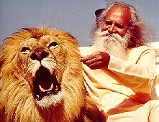
We are appreciating that at the moment in Argentina in the country with a beautiful house with swimming pool and many fruit trees in the garden. Cool at night yet a wonderful 33 centigrade during the day with sun. Every morning I am awoken at six by the morning chorus of the birds just like the winning recordings of birds you receive from the BBC.
We have many wonderful students here learning the secrets of Enlightenment and Energy Eanhancement. Blue Buddha from

Colorado, Julia who presents radio and television programs and Carla a heart sweet and beautiful young puppy dog actress of 23 years.
The Yoga Sutras of Patanjali say that Enlightenment, Illumination, Yoga comes from Meditation AND Non-Attachment.
Now, the word meditation is is the root of Medicine. That which cures. That which heals. That which throws out all negativity all energy blockages in the system.
But as that work of Meditation continues and the Psychic Bodies get cleaner and all the bad memories are thrown out and forgotten and the root of these bad memories, the Energy Blockages are reduced and the energy starts to flow once more in the energetic system called a human being. Then the released and purified energy starts to feed that system of wanting, attachment and desire called the Ego.
That is why Enlightenment comes first with meditation which gives energy and then with non-attachment which is the other side of Enlightenment. The reduction of desire and attachment, the reduction of that mass of wanting and selfish desire called the ego.
In Energy Enhancement we have special excercises which reduce the wanting and desire of the ego and yet it is nice to know in advance that which we are about to do. What is necessary.
Here I use the word of the Soul and that word is necessity. Not wanting or desire but NECESSITY!!!
And it is good to know in advance therefore, a little more about attachment so that we may know how to deal with it properly.
First you must know that attachment is the way of the universe. Goethe said, “Connect, only Connect!!” and connection is what we do. We are all connected. We are all part of each other and the Universe itself. This is a fact and yet it is the blockages which prevent that connection and it is the dependence upon, the addiction to that connection for energy which creates the vampirism of the ego.
In this Universe even this planet the Earth is connected to and evolves through its connection to the seven sacred planets and the seven sacred suns. These sacred planets and suns supply the energy of evolution to the earth and are completely necessary to its moving forward upon the path of evolution. first with our fathers and mothers and later through our friends and teachers and lastly through connections with the enlightened and ascended masters. This is the science of impression, through the third Law of

hermodynamics which says that “Energy always flows from areas of high energy to areas of Low energy”
So high levels of positive energy from the enlightened always flows into those with low levels of positive energy, the unenlightened. In the same way high levels of negative energy, energy blockages, always flow from the unenlightened into their friends with more purity and also the enlightened.

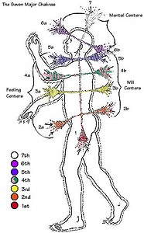

The same with people. We evolve through energetic connections
This fact of positive energy flow from the enlightened both of quantity and quality, creates a stimulation of the energetic centers, the chakras, and also as the negativity is absorbed by the enlightened, a purification of the unenlightened.
Energy Enhancement teaches that we can connect from Chakra to Chakra giving from the right side of the chakra and receiving energy from the left side. If any side of the chakra is blocked

there comes a problem. A blockage on the right side prevents you giving energy and you become a vampire because you can only receive. A blockage on the left side prevents you receiving therefore you will be drained by your partner because you can only give. And the problem is multiplied because these are your blockages and the other side, the partner can also have blockages with similar results turning them or you into a vampire at that chakra level.
As we evolve and start having more quality and quantity of energy we start to give and receive energy to all our friends and relations and it is these energies which we absorb and the lack of understanding of how to deal with them, which causes all the infirmities like cancer and heart disease.
We absorb all the negative energy and energetic blockages from all people at a lower energy level, and it is the lack of ability of dealing with these energies we absorb from everyone around us which causes the diseases of cancer, heart disease, and indeed everything which kills us!!
The cure is enlightenment and all these diseases and the pain involved which pushes us, from lifetime to lifetime in the direction of that which will completely cure us, - Enlightenment.
Love is the energy of change. And these flows of energy occur through energetic attachments which are completely necessary. They occur in everyone and yet are more potent, more energetic and more safe from the enlightened.
Everyone needs to learn the techniques of enlightenment. All it means is that you can handle yourself and the energies you absorb. You know what you are doing.
So, attachment only becomes a problem when we forget the definition of non-attachment given in the Yoga Sutras of Patanjali.
For those who are not enlightened The Yoga Sutras help with this…. “Non Attachment is the conscious self Mastery of one who does not

move towards the people to whom we are attached, and that which we see or hear about.”
When enlightened, we have been given the energy of Ascended masters to confirm us in our place. That energy is not given lightly because it can be used for bad purposes for example to support the ego. So Ascended masters are looking for those people to whom they can safely give that energy, to confirm them in that place from which they cannot fall. The chakras are excited to that level where they cannot lose the energy which has been given.
And what prevents that is the addiction to the energies of attachment. In Spanish it is called “appego” Attachment to people and things so that you must have them. It is the source of all jealousy and the prevention of people moving forward on the path of Enlighenment.
The Ego is like a puppy-dog who is always doing the wrong thing. Eventually we must experience all the bad results of this ego addiction.
The Chinese say, “The Lord have mercy on those who get what they want!!”
Every human being is sick, is capable of turning on you and doing bad things to you, eventually, in time, even those whom you love with passion and intensity. The passion and intensity is good and necessary in order to give energy, but do not expect anything back in return from any individual. .
Gautama Buddha said, "Meditation is for those who Understand the Urgency of the Situation and the Reality of Enlightenment"
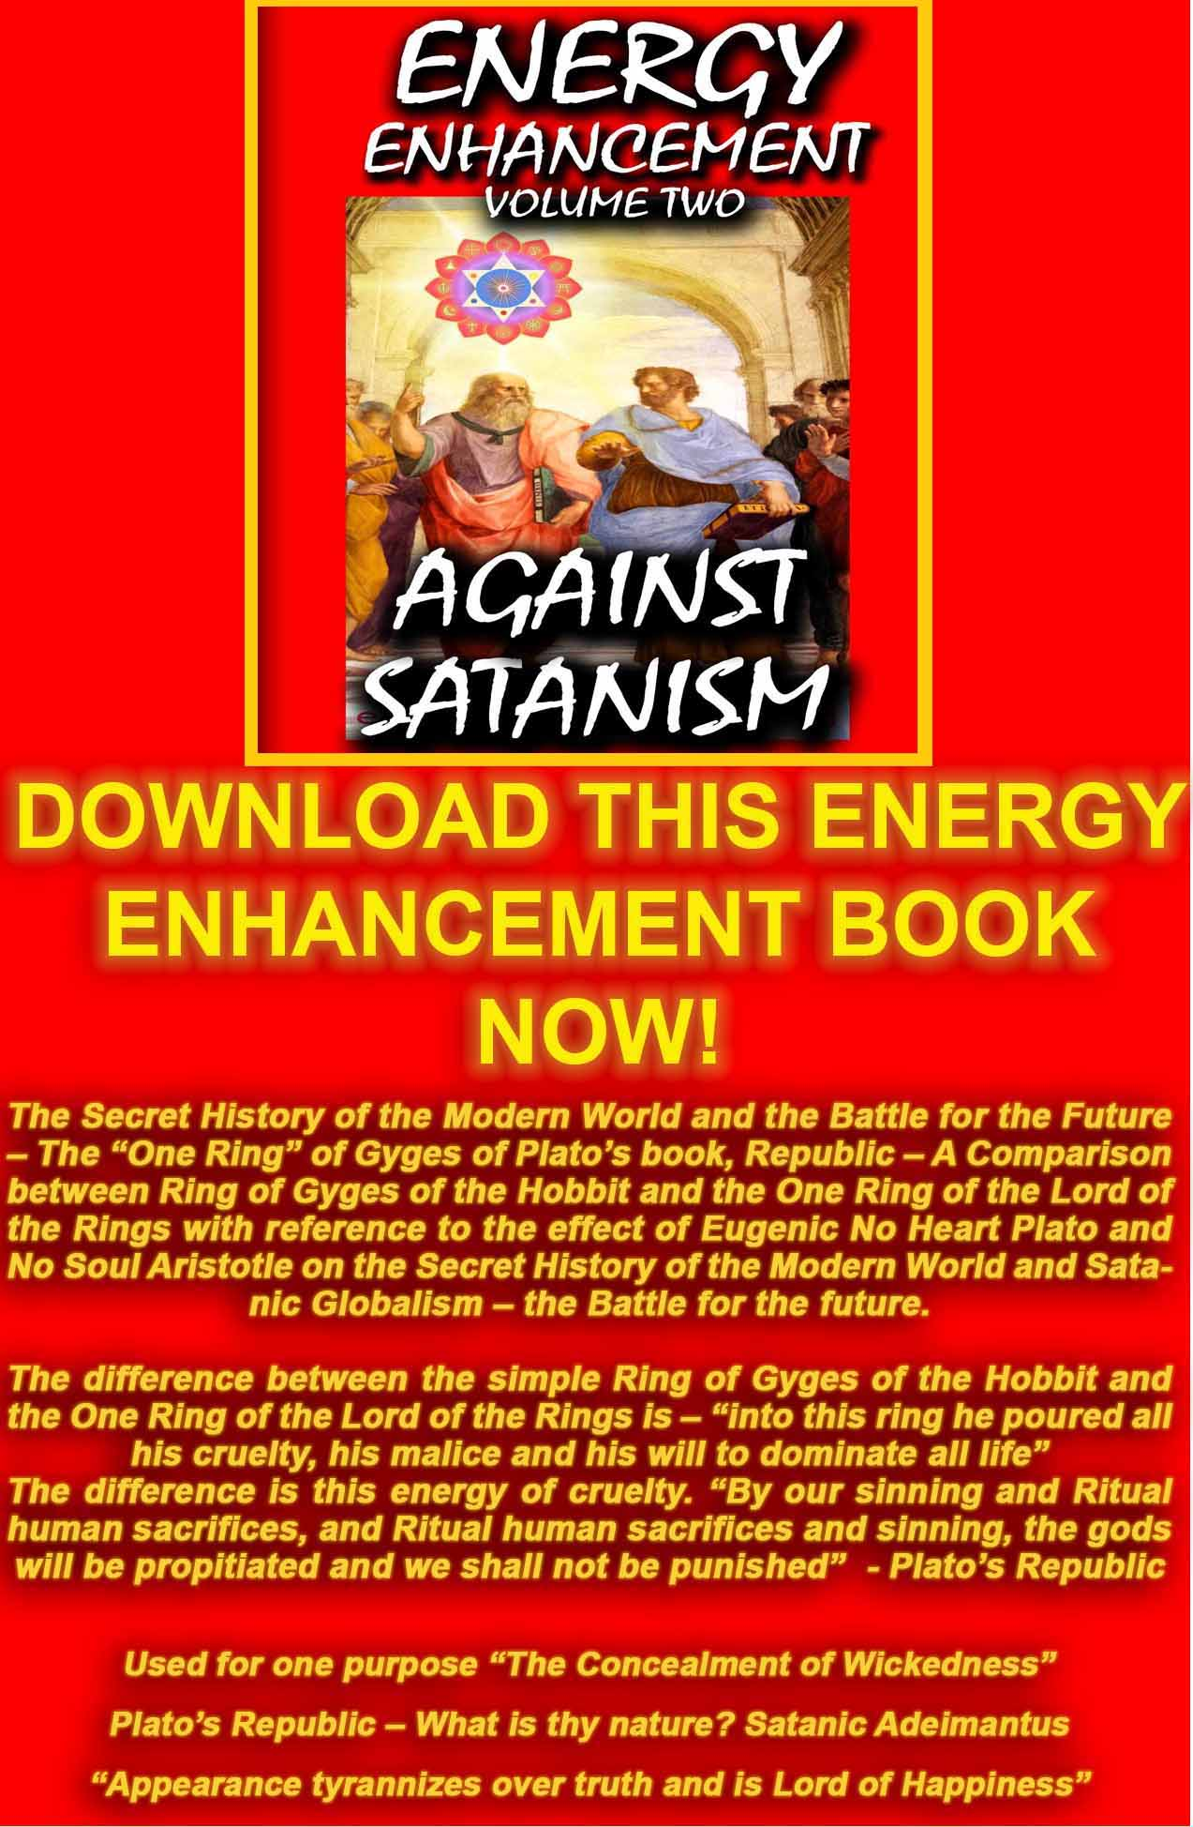
AGAINST SATANISM VOLUME 2
DOWNLOAD HERE
http://www.energyenhancement.org/Sacred-Energy/Against-Satanism-Volume-2/Against-Satanism-Volume-2.pdf

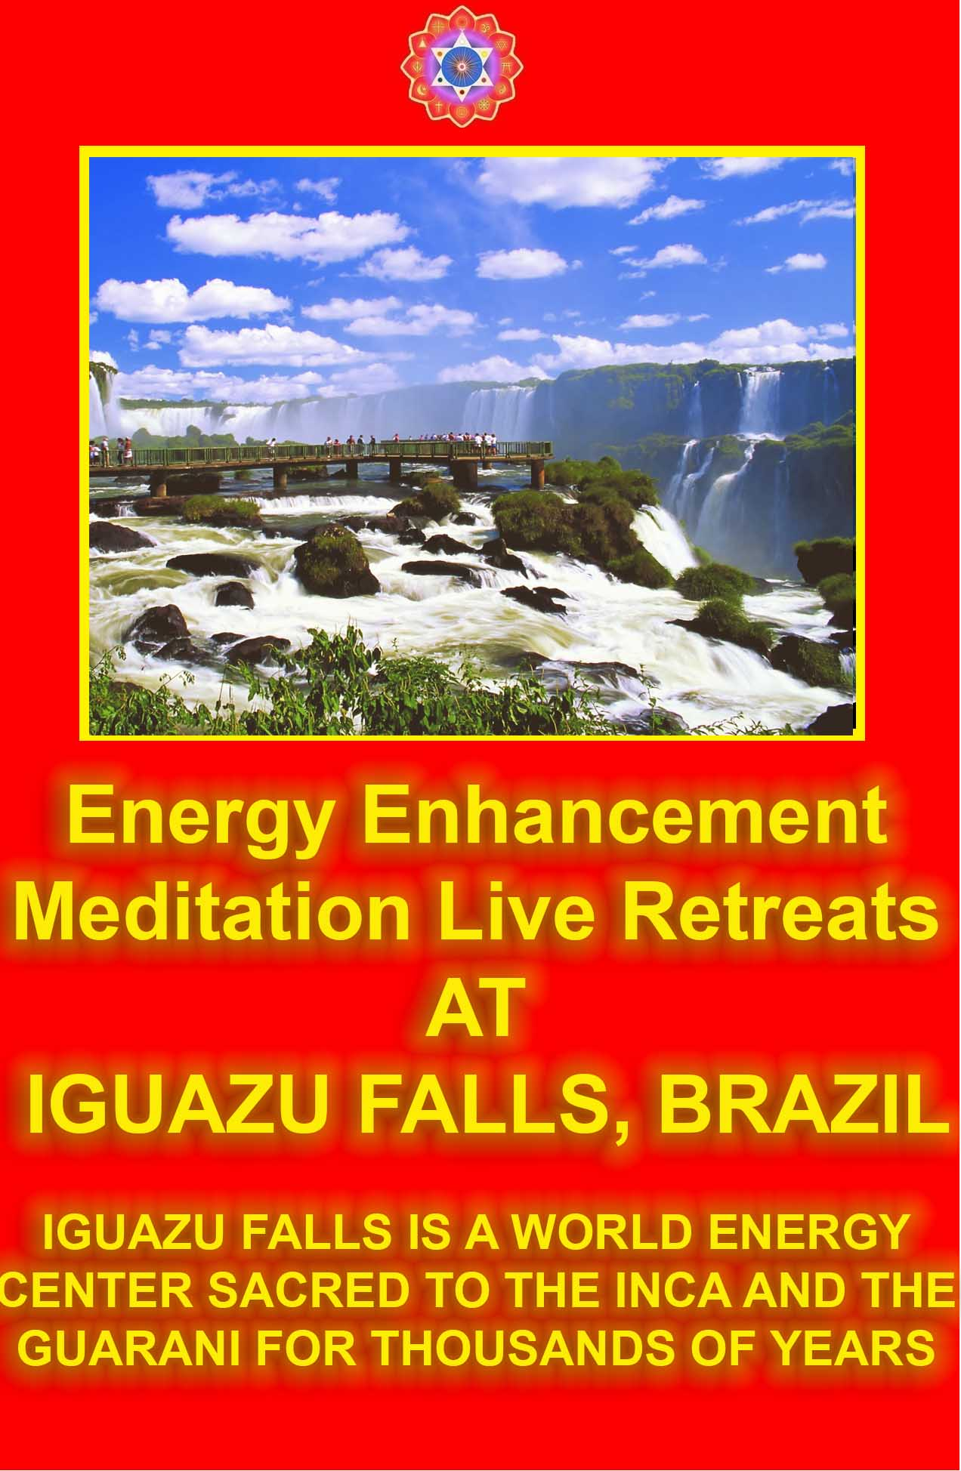

ENERGY ENHANCEMENT FAQ TRANSCENDENTAL MEDITATION, MANTAK CHIA AND THE MICROCOSMIC ORBIT, REIKI, CHAKRAS, KUNDALINI, SUBUD AND LATIHAN, SRF AND KRIYAS
Dear Energy Enhancement Satchidananda
You did say I could ask questions. I have been trying to find somebody who is an expert on Prana / Chi / Ki for ages who could explain some experiences I have had and answer some general questions.
- I have been studying the Energy Enhancement Online Course material and found the initial energy circulation very interesting. I have previously studied Master Mantak Chia's Taoist Microcosmic orbit but didn't spend much time practising it as it was put forward primarily as a means to good health rather than spiritual advancement.
I thought it better to spend as much time as possible practising TM, Transcendental Meditation which I have always, had faith in and enjoyed immensely! I did however manage to generate heat in the dan tien as the first stage. Just by thinking about the EE technique whilst reading (and going through the motions mentally) I could feel what can be described as an expansion as though being pumped up with a fizzy substance.
This experience is familiar to me as I often get the same thing whilst practising TM, Transcendental Meditation. It usually starts off feeling pleasant but then feels as if I am over pressurised. It usually ends with a shake or spasm followed by a feeling of rapid deflation like the end of a balloon being released. Is there an EE explanation for this experience? I am looking forward to practising this technique properly at the earliest opportunity - tonight!
- I have had a Reiki 1 initiation. Can I use that to aid the early stages of EE e.g. energising food? I have been led to believe that the Reiki energy enters the top of the head and flows to the heart chakra from where it radiates through the hands. I assume that the

energy doesn't flow through the Sushumna as I have heard that it takes a great degree of willpower and extreme purity to transfer energy from the top of the sushumna (ajna chakra) to the crown chakra. What channel does the Reiki energy flow through then if the ida and pingala also stop short of the crown chakra?
- Some time ago I was initiated into something called Sushila Buddhi Dharma (SUBUD). The idea is that once initiated you would be moved to perform a spiritually helpful exercise (Latihan). With me I found that it produced (and it is still there now many years later) an urge to shake. The shaking is centred at the base of the breast bone. The shaking is very pleasant and lasts usually for about half an hour. Once it finishes I get a very pleasant tingling sensation all over for a few minutes. I have assumed that the point of this is to loosen a blockage between the dantien / seika-no-itten and the heart chakra. What do you think, is this common, does it sound helpful?
Kind Regards Shaun Answers.
The questions and experiences all refer to the movement of kundalini energy through blockages.
- The deflation is caused by a blockage.
- The idea of enslavers is to say that it takes great will power. No, it is completely natural. The energy meridians in and along the spine of Ida, Pingala and Sushumna stretch out continuously into the Antahkarana, connecting you with your Higher Self, The Soul, and the Group Soul, The Central Spiritual Sun, and more above the Crown Chakra. They do not stop. Your being is infinite and stretches all the way to the highest energies available. Only the blockages need to be removed to enable your Enlightenment.
- The shaking of the latihan is caused by an energy blockage. it needs to be quickly removed by EE. If the energy is to flow correctly all the blockages must be removed.
Energisation of the food is useless if the food contains poison. EE teaches and enables you to choose food without any toxins and to remove the previous toxins from the body.
Energy Enhancement techniques go far ahead of Mantak Chia through the Macrocosmic Orbit which we teach in only the Fourth Initiation, as opposed to the beginners Microcosmic Orbit.

Energy Enhancement Techniques go far ahead of Transcendental Meditation by the extra stimulation of the Kundalini of the Base chakra and the Heart. TM leads to a more Mental state, in general without heart.
And the techniques to remove blockages. Energy Enhancement is the only Course to focus on these and give the help of Experts to remove them from their clients.
Satchidanand
Dear Satchidanand
Thanks for your response. It is confidence inspiring to get a real answer.
One more question about energy (well for now anyway): One of the things which seemed to be of great import to the SRF Yogananda preliminary Kriya techniques is the hearing of the AUM in the right ear. I never achieved this with the SRF techniques but I did hear it quite quickly using the 'sacred heart kriya' taught by Carl Schmidt (hOMe Foundation). Once I had heard the sound I found that I could also hear it whilst practicing TM or giving a Reiki treatment.
Anyway getting to the question I could hear the sound most loudly whilst practicing your technique for sitting. I sat for about an hour and a half (easy pose) whilst listening to your talk on grounding.
With the visualisation of the base chakra being grounded, spine straight and a lot of rocking I could hear a combination of a deep rumble (like a distant motor running) and a note which I can only describe as similar to a hoover mainly in the right ear but seemed to be coming from the centre of my head. Previously I have only been able to hear this in a very quiet environment. Whilst sitting I could hear the sound as I was listening to the talk.
I'm sold on Energy Enhancement grounding now!
Oh yes the question, is this really of any importance or should I just forget it and get on with the EE techniques as they are given. I think I needed to get all these previous experiences and teachings into perspective and sorted in my mind as a spring clean (CLOSURE?) prior to launching whole heartedly into EE.
Kind Regards Shaun.
Answer.
The conscious rocking backwards and forwards at the Start of your EE practice is to get your spine into alignment with the Kundalini energy from the center of the earth out into the center of the

Universe. A help towards this is the position of the hips on a cushion which comes from Zen, the movement of the base of the spine forwards and the knees belothe level of the hips. We stop rocking in the position of greatest alignment but keep checking, by a little movement now and again, throughout the Energy Enhancement Practises for greater alignment.

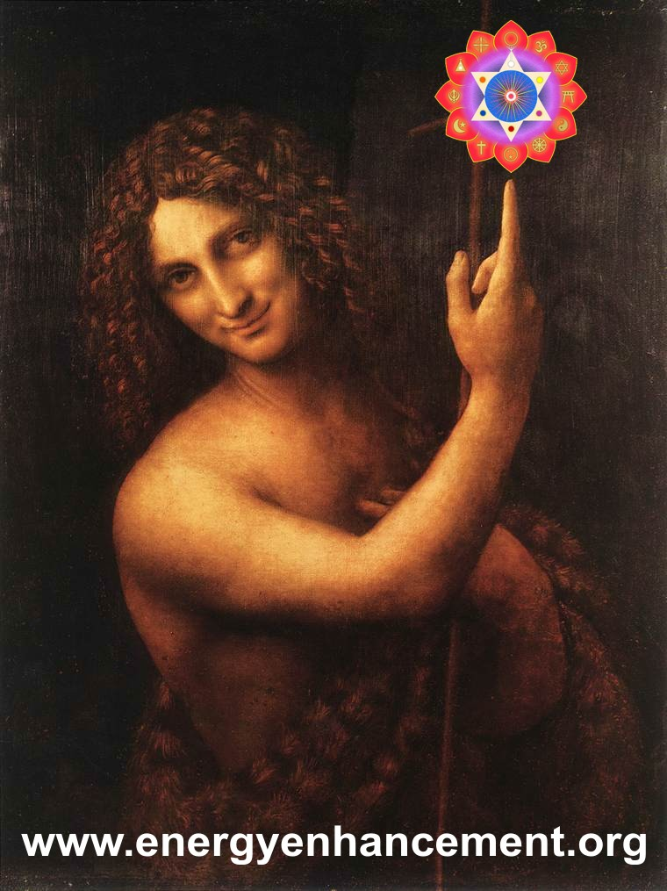
We aim to get the student to feel or see the alignment, when the spine is absolutely at right angles to the surface of the earth and the Kundalini energy is flowing maximally in the spine.

Some students report this alignment as heat, or light or just a feeling of alignment and this feeling increases as we move towards absorbtion in the Light of the Soul above the Crown Chakra, brighter than 10,000 Suns, in Samadhi.
Another knowledge of alignment is the AUM, OM sound which you are hearing as a development of your previous practices. It is showing you your alignment and will increase as you become more absorbed.
But all of the above are the distractions of feedback from various chakras to the passage of Kundalini energy.
Seeing the Light, Solar Plexus or Manipur Chakra and Ajna, Brow Chakra
Feeling the alignment, Anahata Chakra or Heart Hearing the OM, Vishuddhi Chakra or Throat
The aim is to intensify the alignment, the amount of energy, the absorbtion or Samadhi in the higher chakras above the crown. “Don’t get caught” as Zen Master Hogen told me, in lesser experiences. As I wrote in the Energy Enhancement E-Book, "Go One Step Higher!!"
ENERGY ENHANCEMENT IS THE USE OF SAMYAMA, A HIGHER STAGE THAN SAMADHI TO REMOVE ENERGY BLOCKAGES AND INCREASE YOUR ENERGY!!
All the Zen Masters AND Leonardo Da Vinci - Do not look upon my Finger, only Look above the Crown Chakra towards the Soul or the Moon reflecting the light of the higher Central Spiritual Sun, to which it points.
GO ONE STEP HIGHER!! THIS IS ENERGY ENHANCEMENT!!
We aim to be aligned through our intent, 24 hours a day as an Enlightened Soul Infused Being, so do not get caught by swaying, sitting position, cushion, feeling, seeing or sound as they are all stages on the path!!
Love and Light,
Satchidanand

ENERGY ENHANCEMENT FAQ ALIEN ASTROLOGICAL CONSTRUCTS - SATURNIAN, URANIAN, NEPTUNIAN, PLUTONIAN ALIEN POWERS, VESSELS, INSTRUMENTS. The
Cardinal Adepts, The Fixed Adepts, The Mutable Adepts, The Earth Adepts, The Air Adepts, The Water Adepts, The Fire Adepts.
ENERGY ENHANCEMENT - THE CORE ENERGY TECHNIQUES SPEED UP THE PROCESS OF ENLIGHTENMENT!!!
The Kundalini Kriyas - Expel Every Energy Blockage. Ground Negative Energies. Heal Negative Emotions..
Transmute Traumatic Memories. The Mastery of Relationships.
Downloadable Video Course and Home Study Course.
The Energy Enhancement Course in the SOL Villa in Spain. Courses - Spain Summer, Argentina Winter and Worldwide

To: "Satchidanand" < >
Sent: Wednesday, July 28, 2004 5:23 AM Subject: More Questions

QUESTION

Dear Satchidanand

I was listening to your talk on enlightenment last night whilst getting in some more sitting practice. I was interested in what you had to say about astrology towards the end of the talk. I assume that you were discussing Western Astrology because of the references to Pluto, Neptune Uranus. I have studied the most basic

level of Indian Jyotish Astrology and had been led to believe that it is superior to western Astrology for two main reasons

- The dasha system makes prediction much easier - I see you are currently
under Me/Sa/Ma if I guessed your birth location correctly.
- The fixed western zodiac is now in error by nearly one whole sign and gradually getting worse.

Anyway Based on my Jyotish chart (I don't have the software to produce a western one) I have six empty houses Taurus(fixed), Gemini(Mutable), Cancer (Cardinal), Scorpio(fixed),Sag(mutable) and Capricorn (Cardinal). This arrangement is rather symetrical but I don't know if that is significant. Is there anything you can tell me about my chart with respect to EE / enlightenment?

ANSWER

Well, the free 90 minute Real Audio Talk which is available when you sign on to the Energy Enhancement Mailing List and is also available only transcript on our FAQ meditation stories page called Enlightnment, talks about an astrological system of Aliens. Aliens are people with astrological constructs which either consciously or unconsciously causes them to affect other people with their energies.

ALIENS
An Alien constuct gives the Alien native highly specialised talents and abilities of the ESP or Paranormal variety - the kind of talent or ability which would have got them burnt at the stake as a witch or a warlock some centuries back. The responsibility of an alien is the same as for anyone else, to awaken to his higher self and to bring his talents and being to the service of humanity.

Usually the alien talents are accepted as normal by the alien until they get the rude shock when they display them to their peer group at an early age. Then they start to think, "There is something wrong with me!" and begin to regard his talents and their effects as something bad. Sometimes they reject the gifts and try to appear normal, to fake being normal, but as this is impossible, this rejection of their nature causes a great strain on their personality. The effects on the Aliens when they are young and unaware of their powers causes them to be really upset at the way people treat them, many of them moving towards suicide at a young age. But once they understand what their energy does to others and they

accept it, they find that they can really help people with their energies.

Nerve pathways and even bodily organs in Aliens are often in atypical anatomical positions enabling them to act without injury as specialised energy receivers and broadcasters.

Of the teachers of Energy Enhancement, Satchidanand is a Saturnian, Neptunian and Plutonian Power and a Uranian Vessel. Devi Dhyani is a Saturnian Vessel.

The alien astrological constructions cause them to be......

  - Alien Powers have a High Priest function in either a male or a female body. Specialised energy radiates and extends from them affecting whomever it touches. The effects on others take place whether or not the alien is conscious or not of the energies they are extending. Alien Powers emmenate energies which cause other people to be aware of their energy blockages and to move people to increase their native psychic powers. This causes other people to get emotional, angry or afraid or in awe or manic in the presence of the alien power. If they can stick around and not get thrown out by the energy, then they lose their blockages and enter into their true path. This alien power is a guru function. Once the Alien Power understands that this is going to happen, and can be consciously intensified, they find that this Power can be used to heal people of their energy blockages and move them on the path of enlightenment.

For example, Alien Saturnian Power is sun conjunct saturn.

When unconscious of their abilities they have rigidity, feelings of inferiority, aloofness, workoholism, depression, despair, addiction, uptightness, perfectionism, anxiety, judgementalism, ennui, power tripping, apathy, atheism, lonliness, fear, paranoia, grandiosity, and a general separation from the ALL in word and deed.

When conscious of their abilities they are Masters of time, space, dimension, government, form, permanence, structure,
humour, and the secrets of geometry and natural law. Their energy brings to form and stabilises whomever they are with. They are the oldest of the aliens and function as the Testers and Guardians of humanity.

Alien Kundalini Power is sun conjunct Pluto

Alien Neptunian Power is sun Conjunct Neptune Alien Uranian Power is sun Conjuct Uranus
15 degree orb allowed

  - Alien Vessels have a High Priestess function in either a male or a female body. Alien Vessels absorb the blockages of others. This causes them to get emotional and ill as they heal others of their energy blockages. Alien vessels need to get really good at healing themselves otherwise they can die early. Happily, alien vessels are old souls who have many lifetimes of practise of the healing arts. Unconsciously they can heal themselves and others albeit with a lot of struggle. But when they start to do it consciously, that is when they really start to blossom.

Alien Saturnian Vessel is Moon conjunct saturn Alien Kundalini Vessel is Moon conjunct Pluto Alien Neptunian Vessel is Moon Conjunct Neptune Alien Uranian Vessel is sun Moon conjunct Uranus 12 degree orb allowed

  - Alien Instruments amplify the energies they carry in those around them.
Neptunian making others more psychic. Plutonian making others more sexual as they raise their kundalini energies etc.
Alien Saturnian Instrument is Saturn in the first house or conjunct the ascendent
Alien Kundalini Instrument is Pluto in the first house or conjunct the ascendent
Alien Neptunian Instrument is Neptune in the first house or conjunct the ascendent
Alien Uranian Instrument is sun Uranus in the first house or conjunct the ascendant
8 degree orb allowed

  - Some Alien patterns are as the result of "Mutual Reception", two planets each in the rulership sign of the other For Example, When the Sun is in Cancer and Moon in Leo the planets become interchangeable etc, etc.

ADEPTS
Also of Adepts. Adepts have astrological constructs which cause them to have expertise in certain reality areas as do Aliens, but they do not always experience the alienation and rejection common to the Aliens.

They are people born with neither planets or ascendent in a particular quality which are Cardinal, Fixed or Mutable signs, or Element which are Earth, Air, Water or Fire.. These individuals have an expertise, not a lack, in the particular Quality or Element missing in their birth pattern.

The Cardinal Adepts The Fixed Adepts The Mutable Adepts The Earth Adepts The Air Adepts
The Water Adepts The Fire Adepts
SATCHIDANAND QUESTION
I have been practicing the microcosmic orbit with the following experiences:
last night I found there is definitely a heavy duty blockage in the solar plexus area, I felt the energy as warmth in the heart and could move it outwards but it wouldn't go down. This resulted in feelings of frustration mounting to full scale anger followed by crying! The crying seemed to release the blockage enough to move on but there is a sense that the solar plexus blockage was only pierced or bypassed rather than removed - I think I have a lot more work to do on that one! The energy the moved fairly smoothly around and
up the spine giving a feeling of warmth as it went untill it reached the base of the skull at this point I completely lost the plot and went of into a daydream. I eventually realised and completed the circuit. The story was much the same with this mornings session but the solar plexus was slightly less dramatic this time. I finally feel I have found a technique worthy of replacing TM as my core practice - this felt right. I haven't had that before though I have tried a multitude of different practices.

ANSWER

Yes, we always say, "Better out than in."

You need to continue using the techniques of Level One of Energy Enhancement until all the negative energy in the blockages you have found so far has been grounded and then the blockages sent on to a higher plane. It is better to do this at an energy level.

If you feel the emotions it is because you have allowed the

negative energies to come inside your body, rather than Grounding them down the front of your body. As you become better at grounding, then you can more quickly ground the energies, rather than being overcome by them. This practise is necessary as in future the negative energies will come from your students, and then you must be capable of handling anything which is thrown at you.

The 28 Initiations of Energy Enhancement will give you all the techniques necessary to help you do that.

If you read the Online Course part about the Circulation of the Energies which augment the intellectual knowledge given onthe Video Course, we give the instructions as to how to know when you have an energy blockage. I think we gave about 11 different methods of knowing where the blockages are.

The two methods appropriate here are..
- Where you feel an emotion as you perform the Circulation of the Energies in any part of the body - there is an energy blockage.
- Where you get distracted or fall asleep as you perform the Circulation of the Energies in any part of the body - there is an energy blockage.

And you have to Feel the Energy Blockages before you can Heal them.
Or you have to See the Energy Blockages before you can Free them.

Enlightenment is the process of increasing the psychic vision. And this happens quite naturally as you purify your physical, emotional, mental and spiritual bodies.

As we move on into Level 2 of Energy Enhancement we give much stronger and quicker methods of Healing the Energy Blockages.

In Level 2 of Energy Enhancement we learn how to heal the Blockages at the level of Energy. This means that we do not necessarily have to go through the emotion or the experience which caused the Blockage again. Most of the time we just have to Ground the Negative Energies as Energy.

However, when we were cleaning out this lifetime and all the past lifetimes of our previous client of all the negative energies and energy blockages she was surprised when none of the past lifetimes gave any experiences except for one experience at the point of death. She was left with a feeling of incompleteness, because I had been explaining about some of the Experiences of

our previous clients, and how the experiences explained all the things that were happening to them in this lifetime. Until I explained that she was lucky not to have some of these sometimes powerful experiences.

You see, you only get these experiences when you have something to learn. As she cleared out the dead lumber of Negative energy and Blockages in this Lifetime and in all her previous lifetimes - the last ten, the last one hundred and on towards infinity, she felt she was clearing out quite a lot of Negative energy or Karma. As she proceeded she felt herself becoming lighter and Lighter and going higher and higher.Until she just felt great.

In the case of this client her powerful energy experiences had come when we were clearing out all the Energy Blockages in all the Parts of the Body and in All the Chakras, a previous Energy Enhancement Initiation. This experince of Clearing these particular blockages had explained to her all the problems she was experiencing in this lifetime.

SATCHIDANAND
Kind Regards & thanks Shaun.
ENERGY ENHANCEMENT - THE CORE ENERGY TECHNIQUES SPEED UP THE PROCESS OF ENLIGHTENMENT!!!
The Kundalini Kriyas - Expel Every Energy Blockage. Ground Negative Energies. Heal Negative Emotions..
Transmute Traumatic Memories. The Mastery of Relationships. Downloadable Video Course and Home Study Course.
The Energy Enhancement Course in the SOL Villa in Spain. Courses - Spain Summer, Argentina Winter and Worldwide English Spanish

To: "Satchidanand" < >
Sent: Wednesday, July 28, 2004 11:00 AM Subject: Astrology again

Dear Satchidanand

I have managed to get hold of a chart with the missing pluto, uranus and neptune.

Neptune has sneaked into scorpio so that knocks out one of the

empty fixed signs leaving one fixed two cardinal and two mutable empty signs.

However it turns out that Uranus is conjunct the sun making me a Uranian Alien Power?

That all being said, this is still based on the sidereal zodiac, do you think it will make a difference to the adept signs I guess that it wont affect the Uranian Alien Power?

Kind Regards Shaun.
ANSWER

Hello Alien Uranian Power

Uranian Powers are Masters of freedom, altruistic love,
astrology, electricity and all vibrational phenomenon, invention, all group processes.

They tend to have little understanding of normal human time and see tomorrow more easily than they do today and bring forth projects and ideas that are at least seven years in advance of the rest of humanity. They have instant empathy generating in those they meet a feeling that they have known them for lifetimes, that they are old friends and confidants, beyond time.

They have few if any of the normal predjudices of the world and can even forget what age, sex, colour and religion another person is, relating always to the other persons essence. They are considered non-judgemental and are often considered to have genius being able to see into the innate patterns in things and situations, and because of their multi level awareness.

Their job is to make sure that natural law on earth conforms to and mirrors the universal law. Like Shiva, they are the illusion breakers and free locked in conditions and break outmoded forms. They have elements of surprise and unpredictability in their behaviours.

They, together with the Plutonian powers are masters of the release and control of Kundalini Energy which resides in each person at the Base of their spines.

Resistance to consciousness of their abilities takes the form

of rebelliousness, flakiness, iconoclasm, lawlessness, chaos, coldness, antisocial behaviours, revolution, reporting the ideal rather than the real, anarchy, electrical overcharges in their bodies and acute nervousness.
Love and Light, Satchidanand

Energy Enhancement and Psychology
Here is an example of an interview I gave before our last course which we give both in Spain on the Costa Brava and in Rosario in Argentina.
"I was meeting a nice girl of 28 this morning here at our center in Rosario. She is a Psychologist but has fallen out of love with Psychology because although it explains things intellectually it gives no TECHNIQUES apart from talking to change anything internally, particularly in herself. You can see how effective Psychology is by looking at Woody Allen.
I connected with her base chakra and her inner child showed me all her chakras and blockages one by one. A very interesting experience. First the Base chakra, one fear and security blockage which I removed very quickly. Then the second, a pain filled relationship blockage which I also removed. Then all the chakras solar plexus, heart etc, feeling the general dirtiness of the psychic body usually cleaned with The Grounding of Negative Energies but no major blockages.
Then the head, two blockages, one a person who had just died, very deep and negative. I removed the first blockage but the other one was more difficult and stayed with me, absorbed by my psychic body, for a day before I sent it on.
She felt the movement of energy blockages in the head and in the body as my mind and energy was working on her and told me that she normally got a lot of headaches. She was interested in my exposition of Energy Enhancement as all the while I was working on these blockages I was also talking to her.
Such openings show an educated psychic body, one with talent. Not everyone who comes to the Guru has similar experiences. Some also get more. She and I felt that with training she also might be able to help her clients in a similar way. So, she is coming back tomorrow to try out the process, to get her first Initiation in Energy Enhancement."

"The first day Satchi taught me how to sit. By moving the position of my posture slightly I could feel the flow of energy from the center of the earth into the center of the universe. Satchi explained that what I was feeling was Kundalini Energy. If I followed it, he said, It would lead me to Enlightenment." From the testimonial of Energy Enhancement Student Carla, Jan 2004
Siva Samhit, iii, 10-19: "Now I shall tell you how easily to attain success in Yoga, by knowing which the Yogis never fail in the practice of Yoga. Only the knowledge imparted by a Competent Teacher through his lips is powerful and useful; otherwise it becomes fruitless, weak and very painful.
And this is why - by coming into the Buddhafield of Energy surrounding Energy Enhancement Satchidanand obtained through many years of meditation with many enlightened masters, you obtain Shaktipat- an infusion of energy to help you get into a permanent state of meditation.
Swami Satchidanand is Director of Energy Enhancement Synthesis of Light which teaches 28 ancient and effective techniques to enable you to achieve control of your mind, an enhanced IQ, control over all your negative emotions, anger, fear, depression on the path of the ultimate Samadhi and enlightenment itself.
Energy Enhancement techniques have catapulted people years in their meditational experience in weeks. Some 5 years, some jump 10 times further! It helps people worldwide reach further than they EVER thought possible, FASTER!!!

Reflections on "How to Do What You Love" by Paul Graham through Meditation
I was reading "How to Do what you Love" by Paul Graham last night and because I loved it so much I decided to write a little more of me into it. I think you should read it first, so Google it and It will magically appear.
When I was young I was happy. My father said, "What is the thing you would like most in the world". I said, "Happiness". He asked if I would not prefer a Rolls Royce but I said no. If I was happy, I would not need a Rolls Royce.

And I was happy with the work at school. Able to do the work but not really interested in it except to go to the limit with it, to find out if my interest continued with it.
People are lucky if they can find and discard interests quickly. Tried that and found the limit. Got bored and moved onto more interesting things.
Moving onto more interesting things is evolution. Been there. Done That. Bought the T Shirt!
Staying with the same thing only means we have not yet seen deeply into it.
This seeing deeply into it also is evolution. But once you have seen, you must move on.
It was sort of like doing a crossword puzzle to find out if I could do it. But ultimately useless. There is no meaning in collecting examinations. Solely as a means of doing something. What?
So, I collected examinations. And through that I collected discipline.
What made me less than happy was the other people. Unpredictable and emotional.
By accident I tried Yoga. At the age of sixteen I got so relaxed and able to access intelligence and energy that I continued to do Yoga every night for many years.
Something I told no-one about because I thought they might deride me. "Keep it secret, keep it safe", said Gandalf.
After working at a Joint Honours Degree in Physics and Electronics, because my ambition at that time was to be another Einstein, I found work problematic. I could not easily engage in aims that were not my true love.
At 21 after studies in art and the history of art I was able to spend 2 weeks creating a hundred paintings all of which I sold.
I investigated photography.
I wrote a well received book on Advanced Design Techniques in Software because I wanted to and continued to work in Computers.
People continued to be mysteries.
The way politics and the world worked was a mystery also.
At the age of 28 I spent 3 years exploring Aikido and becoming a Yoga Teacher. I spent one year meditating every night alone.
Through this I was luckily able to meet and practice with the worlds

best enlightened teachers like Zen Master Hogen and later, a more enlightened Master Swami Satchidananda.
Through years of experience with my teachers in meditation and enlightenment I discovered that the mind was limited. There were faster, larger and greater computers we were connected to which gave better answers. One is called Intuition. Another is called Psychic Vision. My teachers gave me experience of all this.
Once that was attained then people were explained. Then I started to understand the world.
I am and have always been happy.
Once I understood that my happiness was bound up in the happiness of others I projected to teach Happiness and enlightenment to the World.
It consists of saying, and I am paraphrasing the 5000 year old words of Maharishi Patanjali here, "After all that, here are complete instructions on Enlightenment". "All that", is everything you have ever done. The "Complete Instructions", are on Meditation.
And meditation is the only thing in my life which has never ended up in boredom and because of a limited aim, pain. It keeps going deeper and deeper.
Once you have seen deeply into everything in this world and found it wanting, then you know that the maximal human evolution of enlightenment is the only thing which can make you happy.
People become dissatisfied, fall out of love with everything they do and it becomes difficult because of the traps of money and prestige, responsibilities, old age and lack of energy, to move onto something else which could provide the work which they love.
Then people stop moving on and evolving towards that which they love.
Because they do not truly believe in themselves, they accept something less.
You know, a shark needs to keep on moving if it is to continue pushing water through the gills to get oxygen.
When it stops moving on, then, you have a dead shark.
Keep moving on towards something which you love then life can be happy. But you could still be a shark.
But for thousands of years Masters of Meditation have been saying, "Do not waste your time on useless things".

For thousands of years Masters of Meditation have been telling you, "Enlightenment is Possible".
Understand that even though Hitler, Stalin, Chairman Mao and Bill Gates really loved and love their jobs, ultimately this is not useful.
Only when you ATTAIN enlightenment. Only then is Love and Happiness permanent.

The Mastery of Relationships, The Energy of the Heart Center, Evolution and Meta
Coming to Terms with our Primary relationships is something which brings us peace and allows us to move on the path of evolution.
We heal these relationships by an Ancient Advanced Synthesis of Effective Meditation Techniques which speeds up the process of strengthening and healing the Heart Centre.
This has even more far-reaching effects:- A Blocked Heart centre is selfish.
Healing our Relationships is really the Healing of our own Hearts and developing the Higher Emotion of Compassion and Buddhist Meta.
This is the First Initiation towards Enlightenment, which ends in Selfless caring for others.
The Energy of the Heart is the Energy of Charity, of Giving without any thought of selfishly wanting a reward.
More; Meta, Love, Compassion is the Energy of Change, without which there can be no movement forward in our evolution.
Masters of Energy Radiate the Energy of Change, Meta and Compassion. It dispels all Energetic Blockages, strategies, anger, needing attention, sadness and depression, manicism, and fear.
This is why they are the only people who can make you angry. They are dangerous to all that is not you.
This is why the first test is to enter into their aura, their Buddhafield.
Many people can not, as some blockages are so great as to make you uncomfortable in the presence of the energy of True Love.

As you purify yourself so you become able to stand in the presence of the more evolved. As within, So without!!
"Those whom the gods love the most they first make mad" - Ancient Hindu saying. The result is the Tarot card of the Tower. Struck by lightning as the selfish ego is worn away, transmuted, cast out!!
We know that the law of the Universe is that Practically, that what goes around comes around.
What we give in one direction, either positive or negative, always comes back to us in full from that or another direction.
So practically, we know that as we give, so we receive. It is also that Heart Energy which allows us to change.
The Energy of Love is seen in the truly great, including more evolved human beings like Mother Teresa and her student, Princess Diana who taught the selfless giving of the heart to all rapacious humanity.
They sought to help children, the sick and poor people no matter what their faults. For no reward, For no clever intellectual reason at all. Just that of the Heart.
Intellectually We All Know About Enlightened Self Interest, yet this was more.
As society evolves so the responsibility goes higher. We know that Vast profits are The Major TAX on Society which shifts money from the poor to the rich.
Remember Enron, CORRUPTION attacks, CORRUPTION a Tax, on the wellbeing of the pensions, the poor, the sick, of the children.
First of all,
- Individuals take responsibility for other individuals, then sometimes "the law of the jungle" or "Market forces" or "Free Trade" rules the roost. But later, more high, as we evolve,
- Families,
- Organisations,
- Small companies,
- Small countries,
- Global International companies,
- Groups of countries like the EEC, USA and NAFTA and lastly, on this planet,

- The United Nations,
will take more and more compassion on others. Not to make them dependent, but As With The Idea Of A "Basic Income" or a Citizens Wage to provide a solid base of food, housing and education, FREE!!; like all good families do for their children, for the benefit of the World!!
First of all by providing rules and laws to control the rapacious strong, to control these vast profit taxes. To take from the rich, and give to the poor a small basic income, like Robin Hood.
To provide the basic necessities of life, water, health, food, housing, education and meditation. In this way the people of the world can evolve more quickly.
And evolution is the purpose of life
It needs an Ancient Advanced Synthesis of Effective Meditation Techniques for Gaining More Energy - Meditation, Shaktipat, Energy Circulation, The Kundalini Kriyas, The Five Elemental Paths Of The Chi Of Chinese Alchemical Taoism, The Grounding Of Negative Energies, V.I.T.R.I.O.L, The Art Card Of The Thoth Tarot, Access To Kundalini Energy, Strong Psychic Protection, Learn The Merkaba, Pyramid Protection, Power Tower Protection, Create The Antahkarana, Soul Fusion, Monadic Infusion, Logos Infusion. The Painless Removal Of Stress, Trauma And Negative Emotion
Leading onto the more advanced meditation Techniques of The Mastery Of Relationships! The Psychic Sexual Connection, Heal Bereavement, Clean The Ties Which Bind, The Highest Heart, The Mastery Of Addictions - Drugs, Alcohol, Tobacco, Sex, Food, Power, Money, The Soul Connection, Create Incredible Relationships - The Karma Clearing Process With All Your Relationships, Friends, Family, Mother And Father, Remove Blockages From Friends And Family, Heal The World. Become A Master, A Merlin, A Jedi Knight, A White Magician.
Ponder on this.

Why are You So Poor in this Lifetime?
Past life priest vows can affect present prosperity, self worth, and relationships. And they can continuously block you, and be carried from life time to life time. All Old Souls carry them and most have thousands of them buried in their minds.

It needs an Ancient Advanced Synthesis of Effective Techniques to remove the blocks, energy blockages, psychic programs, that are held deep within your subconscious mind.
Traditional therapies cannot remove them.
What do the vows have to do with you and your life? In another life time, you might have been a member of a very strict religious order, where you took vows against sex, marriage, prosperity, or personal freedom and identity.
These old vows could still be affecting you subconsciously, in this life. Priest vows are very powerful vows, as they were highly charged emotionally through the threats of punishment by the various religious orders.
If a priest, or priestess, broke a vow, the punishment could include banishment, torture, and even death. To be banished from a safe order, where shelter and food was provided, into a society where it was difficult to find food, the result would surely be death by starvation.
Other lives, beyond the religious priest lives, could also be laced with strong vows. If you were a father who lost his family at the hands of another family or person, you might take a vow of revenge, until each person who had taken the lives of your loved ones, were killed. This vow also would be carried from life time to life time, buried deep in the subconscious mind.
There is more.
Subconscious vows to cloistering, can keep you away from others, or from making friends.
Vows to celibacy can cause problems with relationships, and connecting with your own sexuality. Celibacy vows can also cause failure in a marriage through divorce.
Vows to poverty can affect your ability to attract, or keep wealth, to find work, or to be successful in life.
Vows of self-punishment can cause you to subconsciously create pain and chaos in your life and can also cause diseases and accidents.
These vows can be removed.
It needs an Ancient Advanced Synthesis of Effective Techniques to show you how to clear your subconscious mind of vows to be removed from your subconscious, also known as the Akashic Records, or the records of your past-lives and memories using a time line. In a matter of a few seconds, they are removed as though

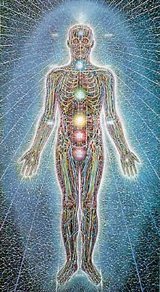
they never existed at all.
Then we can comfortably destroy these negative thoughtforms in our lives.
It needs an Ancient Advanced Synthesis of Effective Techniques for Gaining More Energy - Meditation, Shaktipat, Energy Circulation, The Kundalini Kriyas, The Five Elemental Paths Of The Chi Of Chinese Alchemical Taoism, The Grounding Of Negative Energies, V.I.T.R.I.O.L, The Art Card Of The Thoth Tarot, Access To Kundalini Energy, Strong Psychic Protection, Learn The Merkaba, Pyramid Protection, Power Tower Protection, Create The Antahkarana, Soul Fusion, Monadic Infusion, Logos Infusion. The Painless Removal Of Stress, Trauma And Negative Emotion

Leading onto the more advanced Techniques of The Karma Clearing Process. Karma Cleaning Process, Learning how to clean The Karma From Past Lives, Future Life, Future Lifetimes, Integrating Soul Fragmentation And Retrieval of Inner Children, Selfish Ego Sub Personalites, Life Destroying Strategies, The Aloof, The Interrogator, The Violator, The Selfish Competitive Star, The Vamp Or Don Juan, The Pleaser, The Blamer, The Critic, The King, The Self Destructor, All The Destructive Vows From This And Past Lifetimes,.
Which results in The Creation Of Self Love, Love And Service.
Please do not just accept what is said above. This is our experience, but you will need to look more deeply into it for yourself.
Ponder on it.

Commentary on some questions and answers by Andrew Cohen of Enlightenment Magazine

Q- What is the path to evolutionary enlightenment and what are the obstacles to it?

Satchidanand We are not the body and that energetically we are meant to connect to higher and lower chakras all the way to God. The Kundalini Chakra in the center of the earth gives us more energy when all the ego energy blockages in the Base Chakra causing slavery through a lack of energy and problems with food, money and sex are removed. Heart blockages cause a lack of empathy for the problems of others.
Blockages cause a lack of conscience in the higher chakras above the head called the Soul, the Group of Souls or Monad, all the monads on the planet comprising 200 billions of souls called the Logos or Archangel in charge of this planet and so on to the seven sacred suns and the seven sacred constellations through an infinity of chakras to God.

The ego comprises all those desire filled ego blockages and sub- personalities causing psychopathy, a lack of empathy and a lack of conscience in most people to different degrees, which cause all the problems on this planet and which block us from connecting with those higher energies of God.
Satchidanand: For thousands of years the path is and has been to remove the energy blockages and MPD sub-personalities of the ego usually by using the 5000 year old techniques of The Yoga Sutras of Patanjali which are the instruction books of Raja Yoga, one of the highest Yogas available on this planet.
As we become one. As we...
A). Heal or remove the trauma produced negative karmic mass of the the ego parts by burning it up in the kundalini chakra in the center of the earth.
B). As we heal or remove the trauma produced negative karmic mass of the the ego parts by using Samyama which is focusing the energy of the soul through Ajna Chakra towards the energy blockage ego part by-passing any created protections around the energy blockage ego parts - and
C). Integrate them with the chakras above the head, The Authentic Self, The Soul, The Monad, Atman, God.
So through this relatively simple process which we have successfully taught to hundreds of people on the Energy Enhancement Course we find that the removal of the ego parts is simple.
The problem is only that the ego parts do not want to go...
So it becomes necessary to understand, be taught in advance, the strategies of the ego which always reveal the next ego part in the sequence of Enlightenment. As long as we do not succumb to the ego strategy and leave the Guru, the removal of the revealed ego strategy is as simple as A, B, C.
Andrew Cohen “Everybody wants to get enlightened but nobody wants to change.”
Satchidanand "In most cases, the Guru or genuinely enlightened master is the only person capable of creating a field of highly charged spiritual energy which can feed the spiritual bodies of the students. As this changes the students, so they will suffer the reactions of the energy blockages of the ego, the cause of MPD, which do not want to be integrated with the soul. These Ego Energy Blockages will try to cast the student out of the Buddhafield. In the

past a student had to stay with a Master for 12 years to enable this to happen."
Andrew Cohen "The essence of what I'm teaching is black and white. The issue doesn't really have to do with the particular individuals, it has to do with the enormity of the task at hand"
Andrew Cohen There is only one obstacle to enlightenment: ego. If we want to be free, if we want to be enlightened, we have to pay the price, and that price is the same as it was five thousand years ago—ego death. In evolutionary enlightenment it is no different: if evolution is actually going to unfold through us, then our attachment to ego has to be transcended. And that is what the path is all about.

Q: Can you explain what you mean by ego?
Andrew Cohen The word “ego” is defined in different ways. In the psychological definition, ego is the self-organizing principle in the psyche. And obviously, this is not the ego we want to transcend, or we're going to be in big trouble! But in the spiritual sense, ego can be simply defined as narcissism, a deeply compulsive fascination with one's own image and sense of oneself as a unique individual. This translates into an unwholesome emotional and psychological enslavement to a profoundly self-centered relationship to life.
Narcissism is the postmodern disease, and as long as we are lost in it we will be unavailable, unable to truly respond to the spiritual impulse and its imperative to evolve. Indeed, we are so concerned with the image that we have of ourselves in the mirror of our own awareness that it makes it difficult to have any authentic relationship with the vast and extraordinary life-process we all are a part of. Because of this, too many of us end up spending most of our lives just treading water, not evolving at all. So you see, in this vast context, ego is seen in a very different light than it usually appears: as literally an anti-evolutionary force. And if we have recognized how important our own liberated participation in this whole process is, then we see how essential it is to wrestle this part of our self to the ground and keep it very much under our own control. Why? So that it won't in any way inhibit our availability to participate wholeheartedly in the evolutionary process.

Q: What is the self beyond ego?
Satchidanand Energy Blockages cut you off from God. The energy blockages are the ego. The blockages have a god-connected-angel core surrounded by trauma created negative karmic mass. Anything

which goes against the will of god is ashamed and thus traumtised negative karmic mass is created.
Blockages beneath the base chakra cut you off from an external source of energy called the Kundalini Chakra which exists in the center of the Earth. The thousands of years old guided meditation originating with the Alchemical Taoists in China and the Five Elemental Pathways of the Qi, The Yin Yang Symbol and the Circulation of the Energies - The Reciprocal Maintenance meditation of Gurdjieff.
This guided meditation was then passed on to the Kundalini Kriyas of Kriya Yoga on the other side of the Himalayas and eventually reaching Europe and the Latin Speaking Romans through VITRIOL - Visita Interiora Terrae Rectificando Invenies Occultem Lapidem - Visit the Center of the Earth, there you will find the Hidden Stone, the Philosophers Stone which transmutes base metal into pure spiritual gold which can then be taken on the path of the Soul, higher to the Chakras above the head. The Kundalini Chakra can transmute Negative Karmic Mass into pure Spiritual Energy.
There are chakras beyond Ajna Chakra, the mind, and Sahasrara chakra or the Crown Chakra, higher than the head towards the center of the universe in an infinity of levels towards God. All of these chakras are connected in a column of spiritual energy, the antahkarana, symbolised by Rapunzel, Rapunzel, let down your hair to the Zen Buddhist “Other Shore” or God.
The self beyond the ego is simply the removal of energy blockages, negative karmic mass allowing the natural connection with God to occur. The first chakra above the crown chakra is the Soul.
Enlightened means you are a Soul Infused being. When you experience this then you are in Ecstasy – “dropped body, dropped mind” as said Dogen the first Zen Master or a 24 hour per day orgasm. This fusion must be preceded by purification but the energy of a Master is required to fuse your crown and soul chakras together.
However this entails a quantum leap in consciousness and the energy blockage parts of the ego or the multiple personalities of MPD do not want to go. The Energy Blockage, sub-personalities cause negative emotions and negative thoughts try to prevent this natural process.
Usually they succeed.
And it is only the will and the luck and personal power of the student which can prevail.

Cultivate a spiritual practice every day. Practice humility empathy conscience and all other soul qualities.
Good luck!!
Andrew Cohen: Well, there are different levels of who you are, of what the self is. The deepest part of you is the self absolute, which abides in and as the unmanifest realm beyond time and form. It can be consciously experienced in meditation and in moments of spontaneous peace and ecstasy. When you experience the self absolute, you experience the part of yourself that has never been born and will never die. It is the ground of being itself, the empty void out of which this whole evolving mass of energy, matter, and consciousness emerged. But this ground, while it is the source of ultimate peace, bliss, and fullness, is not involved in the life process, because it has never become anything, including you.
Then there is what I call the authentic self, which abides between the ground of being and the ego. The Authentic Self is the manifestation and expression of the first cause, or the creative principle, in the awakening human. It is the part of your manifest self that is already free from ego. It's the most wholesome, life- embracing dimension of who you are as an incarnated human being.
And as I said, it is already free! This authentic self doesn't need therapy or spiritual practice to enable it to let go of unwholesome conditioning. It's a part of the self that has never been hurt, wounded, or traumatized. Why? Because it emanates from a more subtle level of manifestation, a level that can be seen in this world but is not of this world. It cares passionately about life and truth and evolution. And its manifestation is always spontaneous. While the ego is an expression of the personal and historical dimension of the self, the authentic self is an expression of the evolutionary impulse in consciousness, which is always impersonal and universal. When awareness, due to ignorance, is trapped in the gross realm by the ego's fears and desires, it is impossible to experience the peace, bliss, and fullness of the self absolute or the ecstatic life-affirming passion of the authentic self.

Q: So how do we go beyond ego?
Satchidanand: By understanding that we are not the body and that energetically we are meant to connect to higher and lower chakras all the way to God. The Kundalini Chakra in the center of the earth gives us more energy when all the ego energy blockages in the Base Chakra causing slavery through a lack of energy and problems with

food, money and sex are removed. Heart blockages cause a lack of empathy for the problems of others.
Blockages cause a lack of conscience in the higher chakras above the head called the Soul, the Group of Souls or Monad, all the monads on the planet comprising 200 billions of souls called the Logos or Archangel in charge of this planet and so on to the seven sacred suns and the seven sacred constellations through an infinity of chakras to God.
The ego comprises all those desire filled ego blockages and sub- personalities causing the world problem unsolvable by war, psychopathy, a lack of empathy and a lack of conscience in most people to different degrees, which cause all the problems on this planet and which block us from connecting with those higher energies of God.
Andrew Cohen: Through the experiential discovery of the authentic self. Most people never awaken to the authentic self and therefore they don't even understand why ego is such a problem. It's only through the experience of the authentic self that you can begin to see what an obstruction ego actually is and find the all-important strength and inspiration to transcend it. When you taste that part of yourself in which ego has never existed, and experience the untainted love of life and unbounded passion for its evolution, you will want, at times even desperately, to free your self-sense from any attachment to ego and its endless distractions. So the only way to go beyond ego is to want to go beyond ego more than anything else.
What's so important about the awakening of the authentic self is that through it you spontaneously experience an emotional connection with the vast evolutionary context that we've been speaking about. And in this, you discover what could be called a moral imperative in relationship to the need to evolve. It arises from the depths of your own soul—I must evolve for the sake of evolution itself. Consciousness can only evolve through me, and it won't happen unless I wholeheartedly and unconditionally give myself to that process. And what's significant here is that this is not imposed on you from anywhere outside yourself; you actually awaken to it. When the awakening human discovers this moral imperative to evolve, then a new path has been found. Why?
Because one has literally discovered within oneself the very reason for being a human being.

Energy Enhancement Course Speeds up the Process of Enlightenment
This course has been designed for those who require the ultimate in meditative techniques. For those who know that we come into this world with nothing and that when we die, we leave with nothing but our evolution. For those who are serious about their Self-Development.
As the Buddha put it "For those who understand the urgency of the Spiritual path, the shortness of life, the importance of the burden to be bourne, the reality of enlightenment."
The Reality of Enlightenment- Yes, the Energy Enhancement course works.
Energy Enhancement, using Advanced Secret Techniques of the Kundalini Kriyas and the Five Elemental Pathways of the Chi, vastly increases the speed of the meditative process.

Over Thousands of years the work of Integration and enlightenment has been so arduous, so hard. Monks have meditated for hours every day for fifteen years and still been left no wiser.
Only a few brilliant people have managed to totally integrate their beings. However, wise people of the past from many different religions, have left us an inheritance of lost techniques which can speed up this process. Still, the way is not easy.
Usually it takes 100 lifetimes to open the heart, and on this planet only perhaps 50% of the people have started to think a little about others instead only of themselves. 50% of the people pehaps are entirely selfish!. This is the First Initiation on the path of Enlightenment and in it the Solar Plexus starts to empower the heart with its energy.
Then it takes a further 10 lifetimes to master Relationships. This is the second initiation and entails the Second chakra starting to power the throat chakra, the source of our creativity.
And then only one Lifetime further to open the pathway between the base chakra and the Head Chakras. and this is commonly called enlightenment itself. Once the second initiation has been mastered then The Third, Enlightenment, can even happen in the same Lifetime!

The problems of the world are now so intense that there needs to be a speeding up of evolution to create more evolved beings.

As well as Energy Enhancement it is useful to complete the processes of:-

- Hatha Yoga, working on the blockages of the body.
- Pranayama, working on the stuck emotions.
- Dance or Martial arts, working on instinctive grace and movement.

All of which Energy Enhancement will speed up.

In Energy Enhancement we start with meditation and move on into The Kundalini Kriyas of the Hindu and Taoist Masters. Then Samyama, working on removing all the problems with:-

- Blockages - Cleaning the Psychic Body
- Subpersonalities - Cleaning the Inner Children.
- Relationships- The Mastery of Bereavement, Divorce and Death.
- Organisations- Cleaning the World.

The student needs to work on Meditation and Food every day. As Gurdjieff said,"First Mastic. Then Mystic."
The ability to digest all negative energies.
Usually the course is taken over 3 years, each level usually taking one week to teach and one year to practise.

For those brave souls who want the advanced training course. This is available over four Weeks because of the extra work and intensity of cleaning required. We recommend that these students still practise with us for Three years after the course to receive more energy to complete the cleaning process.
Extra energy from outside, "Hanbledzoin," as Gurdjieff said, is the Energy, The Bled, or Blood of the Masters, and is necessary for the integrative process.
THIS IS SHAKTIPAT, THE BUDDHAFIELD, WHICH SURROUNDS SATCHIDANAND

Not only are the techniques of Energy Enhancement so effective, but also specialised energies are necessary to complete the psychic bodies, to fill them up, to complete them. These energies can only come through properly Authorised Energy Enhancement Teachers.



Like Reiki, the Energy Enhancement Course is a new Higher Frequency of Energy sent by Ascended Masters and Highly Evolved Devas or Angels to speed up the evolution of this planet. Their Energy is transmitted and energised by this Teaching Foundation to be spread on this planet by its teachers who must be of an even higher and more practised calibre.
All our teachers must have worked with the Levels of Energy Enhancement. They can Teach Energy Enhancement Meditation and Energy Enhancement itself in 21 Initiations after that, of helping us with our courses.

Instead of taking over fifteen years of meditation, these advanced techniques allow the process to be speeded up and perhaps completed in only Three years.

A Pearl of Great Price.
After Boddhidarma had rejected the court of the Emperor of China, He ascended the mountains and sat in meditation before a blank wall for nine years.
Like the Emperor of China, many people came to beg for his teachings, yet all were rejected. Until one day a man came to ask for his help. Boddhidarma said nothing. The man said that if he did not reply he would cut off his arm, such was his desire to learn.....

No reply. The man chopped off his arm and threw it in front of Boddhidarma, and said that if he got no reply he would cut off his head. Boddhidarma turned towards him and said, "At last a real student". He picked up the arm, and fixed it back onto the students shoulder and said "Lets get to work."
As The Great Sufi Master, Jallalladin Rumi said, "Take what is in my hand..."
Many people have been searching the world for a real spiritual Master.
We have been spending all our lives searching for a real student.

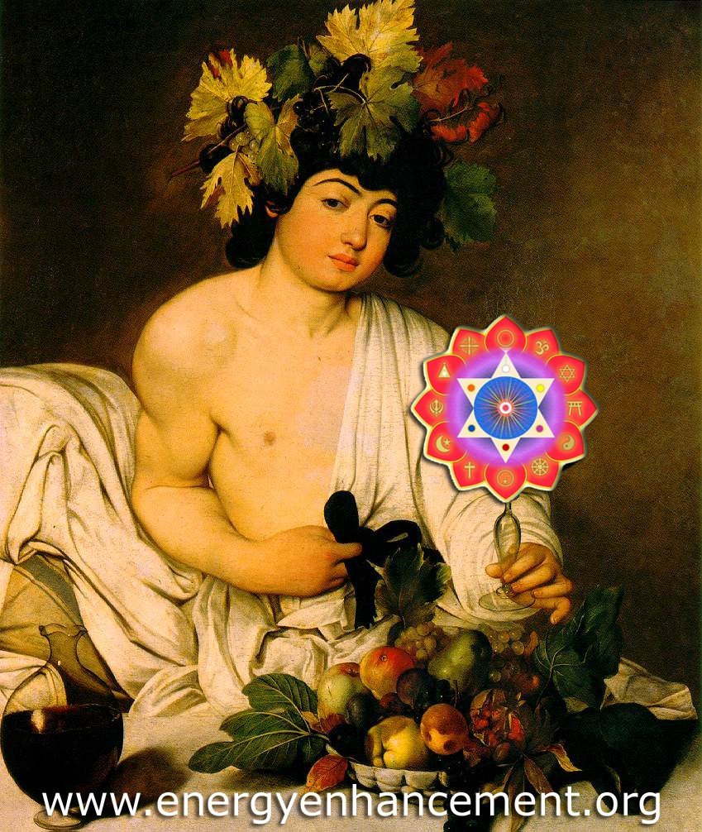
TAKE WHAT IS IN MY HAND, DRINK!

Jesus Christ talked of his teaching as "A Pearl of Great Price". Yet if the teachings are given away for free then they become despised and not used. As Jesus said, "Do not scatter Pearls before swine, lest they turn and tear you apart."
Any person would be glad to purchase such a pearl. Gurdjieff indeed, talked of exactly this matter. This Energy Enhancement is such a Pearl. Please do not lose this opportunity of obtaining it.
For a real student many things are possible.
In Spiritual life a student needs to learn how to ask...

DO IT!!
Whether you are a Management Corporate Executive, any sort of Alternative Practitioner, meditator, yogi or anyone who wants to evolve, - become better, smarter, more evolved, more empathic, more successful; this course will enable direct experience of superior life performance.
We provide meditation techniques and meditation energy leading to advanced experience:-
" Our Latest Client and now friend, Marie, comes
from Peru although she lives in London with her American husband and family.

We just completed a course of Energy Enhancement Level One with her and we were all very happy with the results, particularly as we work full time with our clients energetically and in person physically and Psychically for a lot of hours.
Our Clients also like the superb Organic Food we cook for them!!

Marie has previously been on many Meditation Courses but never she said, with the direct experience and targetted advice on her personal circumstances, as with this Energy Enhancement course.

Marie had the experience in Energy Enhancement Meditation Stage 4 of going up through several stages meeting one of my Masters from America and India, on the mental planes. He said that he was not her master, gave her an energy present and sent her up.

Then strangely, as she told me that she spent a long time in churches through her unhappy childhood, she had an experience with a higher Saint. Again The Saint turned her palms towards her,

gave her energy, and sent her up. She then had direct experience of her Soul, Higher Self with many symbols she had never seen before, but I was able to show her them in books so that she could see the antiquity and Sacred nature of her experience.

Next meditation she had direct experience of her relationships and advice but she never told me what it was and nor did I really want to know as it was really personal. She wrote this testimonial (Translated from the Spanish) recently after her week long Energy Enhancement Level One Course...

"The Energy enhancement Course Work was very satisfying.

I found what I was expecting and more. The way Satchi and Devi teach, Unifies every thing I ever learnt, and for that reason was very intense. I can not tell you the details of my course experience because you could not understand, I can only tell you that if you feel attracted to do The Energy Enhancement course through what you have read before in the advertising...

DO IT!!
The experience you will find can tell you everything. And what you can learn will change your life, not only in the Spiritual sense but also in your daily life.

Not only will you gain direct experience and consciousness of what you really are, but through the management of emotions and inclinations, and using superior knowledge from the past centuries which was given by the Great Masters and Wise Sages, Energy Enhancement and Satchi and Devi make
the learning process very rich."

She wants to come again in September to do Energy Enhancement Levels Two and Three!!

We are very happy with our work as our aim is to Enlighten everyone. It is easy to be enlightened, but to make others enlightened, you need to know a lot!

This work is my life and gives me great satisfaction." Satchidanand
Energy Enhancement Meditation Techniques are the quickest and easiest methods of healing available. They are the most advanced course of meditation using psychic powers to Get in touch with

your Life path, Ground negative Energies, Access Universal Energies, Integrate the separated selves, and Master Relationships and Mediation. They enable Three Initiations towards your Ultimate Freedom - Illumination, Nirvana, Emptiness, - Enlightenment.

LOVE INSTALL
A call comes through on the customer service line. Customer Service Rep: Yes, Ma'am, how can I help you today?

Customer: Well, after much consideration, I've decided to install love. Can you guide me through the process?

CS Rep: Yes, I can help you. Are you ready to proceed?

Customer: Well, I'm not very technical, but I think I'm ready to install now. What do I do first?

CS Rep: The first step is to open your HEART. Have you located your HEART ma'am?

Customer: Yes I have, but there are several other programs running right now. Is it okay to install while they are running?

CS Rep: What programs are running ma'am?

Customer: Let's see, I have PAST-HURT.EXE, LOW-ESTEEM.EXE, GRUDGE.EXE, and RESENTMENT.COM running right now.

CS Rep: No problem. LOVE will gradually erase PAST-HURT.EXE from your current operating system. It may remain in your permanent memory, but it will no longer disrupt other programs. LOVE will eventually overwrite LOW-ESTEEM.EXE with a module of its own called HIGH- ESTEEM.EXE. However, you have to completely turn off GRUDGE.EXE and RESENTMENT.COM. Those programs prevent LOVE from being properly installed. Can you turn those off ma'am?

Customer: I don't know how to turn them off. Can you tell me how?

CS Rep: My pleasure. Go to your Start menu and invoke FORGIVENESS.EXE. Do this as many times as necessary until GRUDGE.EXE and RESENTMENT.COM have been completely erased.

Customer: Okay, done. LOVE has started installing itself Automatically. Is that normal?

CS Rep: Yes. You should receive a message that says it will reinstall for the life of your HEART. Do you see that message?

Customer: Yes! I do. I s it completely installed?

CS Rep: Yes, but remember that you have only the base program. You need to begin connecting to other Heart's in order to get the upgrades.

Customer: Oops. I have an error message already. What should I do?

CS Rep: What does the message say?

Customer: It says "ERROR 412 - PROGRAM NOT RUN ON INTERNAL
COMPONENTS."What does that mean?

CS Rep: Don't worry ma'am, that's a common problem. It means that the LOVE program is set up to run on external HEARTS but has not yet been run on your HEART. It is one of those complicated programming things, but in non-technical terms it means you have to "LOVE" your own machine before it can "LOVE" others.

Customer: So what should I do?

CS Rep: Can you pull down the directory called "SELF- ACCEPTANCE"?

Customer: Yes, I have it.

CS Rep: Excellent. You're getting good at this. Customer: Thank you.
CS Rep: You're welcome. Click on the following files and then copy them to the "MYHEART" directory: FORGIVE-SELF.DOC, REALIZE- WORTH.TXT, and ACKNOWLEDGE-LIMITATIONS.DOC. The system
will overwrite any conflicting files and begin patching any programming. Also, you need to delete SELF-CRITIC.EXE from all directories, and to make sure it is completely gone and never comes back, you will need to empty your recycle bin.

Customer: Got it. Hey! My HEART is filling up with new files.

SMILE.MPG is playing on my monitor right now and it shows that PEACE.EXE, and CONTENTMENT.COM are copying themselves all over my HEART. Is this normal?

C Rep: Sometimes. For others it takes a while, but eventually everything gets downloaded at the proper time. So, LOVE is installed and running. You should be able to handle it from here. One more thing before I go.

Customer: Yes?

CS Rep: LOVE is freeware. Be sure to give it and its various modules to everybody you meet. They will in turn share it with other people and they will return some similarly cool modules back to you.

Customer: I will. Thanks for your help. By the way, what's your name?

CS Rep: You can call me the Divine Cardiologist, also known as The Great Physician. Most people feel all they need is an annual checkup to stay heart-healthy, but the manufacturer suggests a schedule of daily maintenance for maximum efficiency.

Give a little love away ... keep in touch.

The Rules for Being Human
You will receive a body
You may like it or hate it, but it will be yours for the entire period for this time around.
99% Perfect!!
You are already 99% perfect. That means the One percent left is your field of action.
You will learn lessons
You are enrolled in a full time informal school called life. Each day in this school you will have the opportunity to learn lessons. You may like the lessons or think them irrelevant and stupid.

There are no mistakes only lessons
Growth is a process of trial & error and experimentation. The "failed" experiments are as much a part of the process as the experiment that ultimately "works".

A lesson is repeated until learned
A lesson will be presented to you in various forms until you have learned it. When you have learned it, you can then go on to the next lesson (in that series). You are going through many lesson "series" at the same time.
Learning lessons does not end
There is no part of life that does not contain lessons. If you are alive, there are lessons to be learned.
Failure
There is no failure, only feedback.
You will be tested.
Some teachers say that we have learned everything between lives. Now we are being tested on that knowledge. If we fail the test one day we will be certain to be presented with the same test another day.
Negative Emotion
Negative emotions in you now, are caused by your past trauma. Holding on to past trauma is the problem. The inability to let it go is the problem.
Positive Emotion
Positive emotions arise when all spots, past traumas are let go. Then Love, Compassion, and Will Power naturally arise.
Freedom
You have the freedom only to do the right thing. Anything less is painful.
Contentment
Contentment occurs when the spots, negative traumas within, are let go, transmuted, grounded.
Knowing
"How can the leopard change his spots?" All growth depends upon knowing that growth is possible.
Trying to get into a state of Meditation.
Gautama Buddha said, "For those who Understand the Urgency of the Situation and the Reality of Enlightenment."
"There" is no better than "here"
When you're "there" has become a "here", you will simply obtain another "there" that will, again, look better than "here".

Others are merely mirrors of you
Contentment occurs when the spots, negative traumas within, are let go, forgotten, transmuted, grounded. As within, so without. As

without, so within. You cannot notice, love or hate something about another person unless it reflects to you something you love or hate within yourself. Then, there is nothing to hate.
As Above, So Below"
The Heart Sutra states that "Form is Emptiness", "Emptiness is Form". Heaven or Nirvana is complete emptiness; is nothingness without any stain, any spot. And Emptiness powers Form. Form cannot exist without it. "I know nothing", is the statement of the Enlightened.
What you make of your life is up to you
You have all the tools and resources you need on this planet. Which ones you use and what you do with them is up to you. The choice is yours.
Enlightenment Factory
This planet is a factory for the production of Enlightened beings. All the experiences are to enable us to knock off the rough edges. To master this plane of existence we have to know that 99% of all people are psychopaths and our job is to avoid them and do your job without being noticed.
Bad experiences are to teach us how never to have them again.

We have been given the free will only to do the right thing. Anything less is painful.
The Magic Key
To those who are happy, be happy with them. To those who are sad, be sympathetic. Be friends only with those who are enlightened. Stay away from those who are wicked.
What you make of your life is up to you
You have all the tools and resources you need on this planet. Which ones you use and what you do with them is up to you. The choice is yours.

Response.
The wicked pretend until they pounce. Try only to be with those from whom you receive a response.
Meditation and the Foreign Legion
"Why did you join the Foreign Legion?" "Because I wanted to forget." "What did you want to forget?" "I don't know, I've forgotten!!"

THE CHALLENGE IS TO KEEP IN MIND ALL OF THE ABOVE!

PHILIP CHESTER
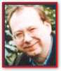I am a Change manager working directly to the Managing Directors of several fortune 500 companies.

Satchi (Satchidanand, Picture below)

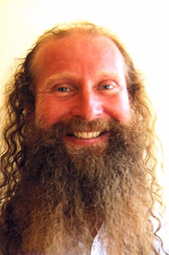
has asked me to explain how I see the Energy Enhancement Level One at the end of my two weeks in Spain, and in particularly how it compares with other techniques that I have expertise or significant experience of; for example NLP, Aikido, Yoga, Ashtanga Yoga, Transcendental Meditation, Mantak Chia and the like.

My energy has been particularly low at the end of my last project, and my Homeopath has tried to get rid of an energy problem in lower half and a liver virus. I am an interim manager and work as Finance Director on short contracts to work with the Managing Directors of many international companies to resolve often serious business problems.

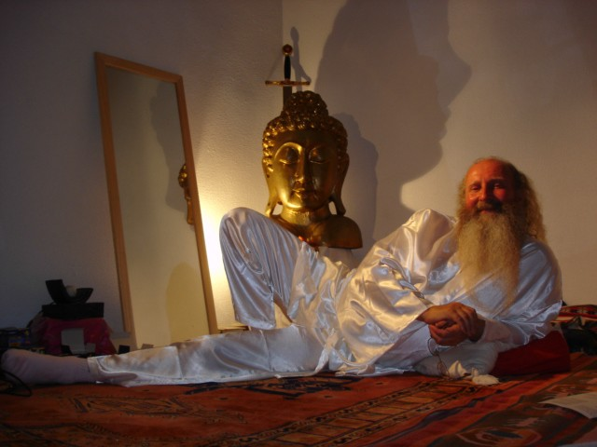

SATCHIDANAND STUDIED ENERGY AND MEDITATION WITH ZEN MASTER ROSHI HOGEN OF JAPAN AND SWAMI SATCHIDANANDA OF INTEGRAL YOGA IN VIRGINIA USA, BEFORE BECOMING ESTABLISHED IN HIS OWN EXPERIENCE.
practising yoga and meditation alone from the age of 16. I practised under enlightened masters Roshi Hogen Daido Yamahata a Zen Master who cleaned my energy system and then Swami Satchidananda who gave me the energy to get Initiated astrally by Ascended Masters at his ashram.
I visited enlightened Masters in India who gave me energy before they died. Once even on the day I met them.
After teaching meditation for 10 years with many other energy Initiations from Ascended Masters, Swami Satchidananda passed on some of his energy to me before he died. Now Swami Satchidananda is an Ascended Master. After becoming Enlightened on this planet he gained sufficient Initiations to be able to maintain his consciousness through the death process. This is the only way we can legitimately achieve Immortality, and it is this which we teach with Energy Enhancement.
In order to do energy work, to become Enlightened, one must prove trustworthy and show a will to be useful. The three servants in the bible. One buried his portion in the ground, One wasted it, one

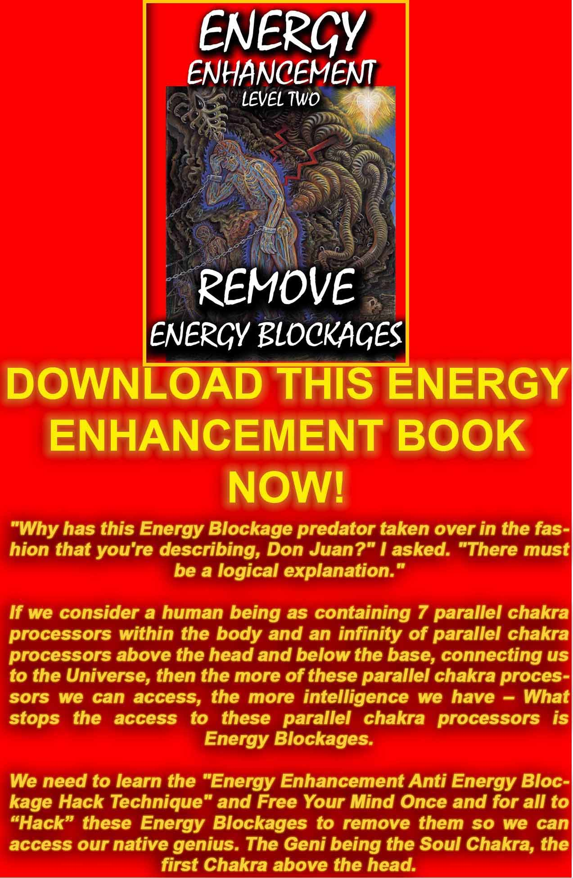
DOWNLOAD “LEVEL 2 REMOVE ENERGY BLOCKAGES” HERE
http://www.energyenhancement.org/Sacred-Energy/Level-2-Book/Energy-Enhancement-Level-2-Book-Remove-Energy-Blockages.pdf
SATCHIDANAND - My background is that I started learning and
multiplied it 100 fold.... So, like any executive in a Galactic
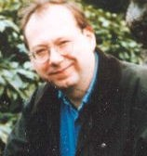organisation, you must be Industrious. Then, if you are lucky, and to be spiritual, you must be lucky, you get promoted, initiated, energy is given to do the work. Enlightenment is not enough.
Philip SAYS,..... I need to work with a lot of energy for a concentrated period of time, often in very negative situations, mainly larger American Fortune 500 International companies. I like the job, but need the ability to retain my energy to build up new
thought forms in the company and to stay healthy and relaxed. I also want to work with better quality organisations and people.

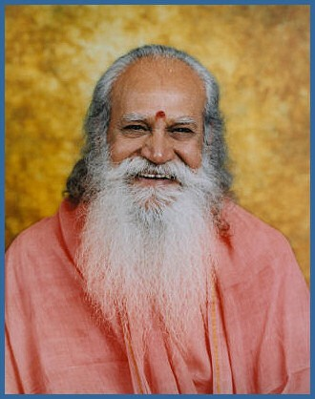
SWAMI SATCHIDANANDA

My low energy at the end of the last project was the catalyst to make me want to learn Energy Enhancement, as I read the E- Book of Meditation Energy Enhancement some two years before. I need

something that I would be able to practice easily daily, and which would prevent the same thing happening again. Attracting better projects with better people would be a help too.

"ENERGY ENHANCEMENT IS THE CORE ENERGY TECHNIQUE."

My feeling and expectation from before coming on the course that energy enhancement is THE Core energy technique, has been met.
Energy Enhancement techniques can be applied to any of the above disciplines and it will improve them all.

"IT ALLOWS YOU TO RAISE YOUR ENERGY LEVELS, AND AS IMPORTANTLY, SHOWS YOU HOW TO KEEP IT AND TO PROTECT IT FROM BEING SIPHONED OFF BY OTHERS."

It allows you to raise your energy levels, and as importantly, shows you how to keep it and to protect it from being siphoned off by others. (People with low energy normally siphon off or vampirise high energy from people like myself. This is called healing).

The energy techniques given in Energy Enhancement have never been explained to me in Aikido (even Ki Aikido), Yoga or Ashtanga Yoga or on any meditation course that I have been on like Transcendental Meditation, and have only been partly taught to me previously by Taoist master Mantak Chia and on Tantra Courses.
Mantak Chia I found particularly confusing; Chi Gung I found awkward.

"ENERGY ENHANCEMENT GOES MUCH FURTHER THAN ALL THE ABOVE, IN A MORE EFFECTIVE WAY THAT ANY OF THE OTHERS I HAVE EXPERIENCED..."
Energy enhancement Level One is composed of three main concepts, with the same aims: getting rid of blockages.
- The EE Stages of Meditation
- Yoga, but taught in a way that helps remove blockages - "We use Yoga to get Students into the correct energy state to experience the High Levels of Kundalini Energy which we give access to in Energy Enhancement."
- Reiki techniques (to level One of Reiki)

SHAKTIPAT is the transmission of energy to Introduce a good Student to High Intensity Kundalini Energy.
"SATCHI PROVED THIS TO ME IN THE FIRST FIVE MINUTES OF OUR FIRST MEDITATION, BY PUTTING MY BACK AND TOP OF THE HEAD IN THE RIGHT POSTURE. I IMMEDIATELY FELT A FLOW OF ENERGY GOING UP MY SPINE."

EE Stage 1, - Meditation
The basic concept is that if you are in the right posture then energy will flow through you from the universe to the centre of the earth. Satchi proved this to me in the first five minutes of our first meditation, by putting my back and top of the head in the right posture. I immediately felt a flow of energy going up my spine.
What stops the energy flowing to its full potential are energy blockages in the body, for example pains you know about, but also other area where you cannot feel energy flowing, and where negative emotions have attached themselves to your body. The blockages are removed essentially by grounding them, using the macrocosmic energy orbit, with stronger methods available.
Over the seven stages of Energy Enhancement we were taught to expand the meditation to increase the energy; to identify and remove blockages, and to put a protection around us so that the energy is not removed, consciously or not by other people.

"I FEEL THAT I HAVE BEEN GIVEN SOME SECRET KNOWLEDGE, WHICH WAS ONLY GIVEN TO THE INITIATED, OR HIDDEN AMONG A LOT OF UNNECESSARY SUB TECHNIQUES IN OTHER DISCIPLINES."
Energy Enhancement Stage One: Finding the energy column in the spine. As I have indicated above I immediately felt the energy going up my spine, and an increase in my energy at the end of the meditation.

"WITH EACH BLOCKAGE REMOVED I FELT MORE ENERGY FLOWING AND MORE ENERGETIC"

Energy Enhancement Stage Two: is to expand the energy circulation to the around the body, similar to the Taoist Microcosmic orbit, and techniques to identify and to remove blockages. I felt that my energy increased, and I identified some areas where the energy did not flow. Some of these I was able to remove, but others seemed more attached. With each blockage removed I felt more energy flowing and more energetic.
With Energy Enhancement we learn how to access Incredibly Intense External Kundalini Energies which power our Enlightenment. Then we experiences these Amazing Energy Increases FOR OURSELVES....

"I FELT HOT IN MY SPINE, SOME OF MY BLOCKAGES WERE BURNED AND REMOVED, AND AGAIN AT THE END OF THE MEDITATION I FELT A HIGHER LEVEL OF ENERGY."

Energy Enhancement Stage Three is to expand the energy orbit to the centre of the earth, and to ground and burn up blockages.
Blockages can be grounded and burned, and you do not have to relive traumas or even remember the source of traumas. I felt hot in my spine, some of my blockages were burned and removed, and again at the end of the meditation I felt a higher level of energy.

"ONCE THIS STAGE WAS REACHED I HAD TREMENDOUS ENERGY"
Energy Enhancement Stage Four is to expand the meditation to include energy from above from the central sun, the Macrocosmic Orbit, The Energy Enhancement Supra Galactic Orbit. Previously Satchi had psychically seen, identified and removed a blockage that he saw at the top of my head that he felt reduced my energy level by 30%. This was in fact the exact figure that my homeopathic therapist had told me from his Vega test, about two weeks before. However I developed a headache during this stage, which disappeared when I had transmuted 2 more blockages by myself in the meditation.

Once this stage was reached I had tremendous energy. However, I went for a walk in the town and when I came back most of my energy had disappeared, as apparently high energy does get sucked up, vampirised by people with low energy unless you protect yourself.

Energy Enhancement Stage 6 gives the technique for protecting you from this loss of energy from other people. It also enhances the energy you can build into yourself.

"I ALREADY HAD A SIMPLER TECHNIQUE THAT WAS TAUGHT BY BANDLER IN NLP, BUT THE ENERGY ENHANCEMENT TECHNIQUE IS MORE POWERFUL."

Energy Enhancement Stage 5 is a technique for evaluating the quality of food before you eat it and
also the first techniques for removing Energy Blockages. Eating foods contaminated with pesticides is the quickest way to reduce your energy, and create illness and disease within and this technique allows you to see what effect a particular food will have on you, which is extremely useful if you eat out a lot like me, and also helps check every food in the supermarket and 80% OF THOSE ARE PESTICIDED!!
I was surprised when I came that Satchi and Devi do not eat exclusively organic labelled foodstuff or wine, as with this Fifth Initiation of Energy Enhancement you can check for yourself how good it is. I already had a simpler technique that was taught by Bandler in NLP, but the Energy Enhancement technique is more powerful. Also the technique is the start of an incredibly powerful technique to remove Energy Blockages from our Energetic Systems, so all in all THIS ENERGY ENHANCEMENT TECHNIQUE CAN SAVE YOUR LIFE!!

"LINDA, THE RESIDENTIAL TRAINEE HERE IN SPAIN, FOUND TREMENDOUS BLOCKAGES, ALL THE WAY DOWN HER SPINE, WHICH SHE REMOVED USING THIS INITIATION SIX TECHNIQUE."
Energy Enhancement Stage 7, the last stage, is concerned with maintaining the auras, and identifying and removing blockages in the physical, emotional and mental auras. I did not find anything in my aura but Linda, the residential trainee here for a while, found a tremendous blockages, all the way down her spine, which she removed using this technique.

Each higher stage replaces and includes elements of the previous; so that when I get home my meditation will be at stage seven (with stage 5 for testing food).

"DEVI EXPLAINED THAT THE EE YOGA IS DESIGNED SO THAT IT HAS THE MAXIMUM ENERGY BENEFIT, MAKING THE BODY FLEXIBLE AND STRONG, SPENDING THE LEAST ENERGY POSSIBLE WITHOUT PUSHING, SO THE BODY DOES NOT SECRETE ADRENALINE, WHICH IS A KIND OF TOXIN FOR THE BODY."

Energy Enhancement Yoga
The second leg of Energy enhancement is Yoga.

I FEEL EE YOGA IS VERY EFFECTIVE; MY POSTURE HAS IMPROVED ..... AT THE END OF AN EE YOGA SESSION I FEEL THE SAME LEVEL OF ENERGY AS WITH 90 MINUTES OF ASHTANGA YOGA.
I have had a mixed relationship with Yoga, for thirty years ever
since my Mother who is a Yoga teacher, showed my Brother and I how to do it. I think the way that Satchi explained it - to remove energy blockages, and to practice the yoga by working at the blockages in a posture, relaxing in and between the postures, and releasing and grounding the negative energies using EE techniques in the Yoga - has given me a clear sense of how practicing Yoga in this way has powerful benefits, even if you only concentrate on doing a number of poses well.
CONCLUSION, "ENERGY ENHANCEMENT WORKS"
"THE DIFFERENCE BETWEEN THIS COURSE AND OTHERS IS THAT I SAW AND FELT FROM THE FIRST FIVE MINUTES THAT MY ENERGY WAS ENHANCED"
Devi explained that the EE Yoga is designed so that it has the maximum energy benefit, making the body flexible and strong, spending the least energy possible without pushing, so the body does not secrete adrenaline, which is a kind of toxin for the body.

I feel EE Yoga is very effective; my posture has improved in the two weeks I have been here, which it has not done when I practiced the ashtanga yoga, and at the same time at the end of an EE Yoga session I feel the same level of energy, as with 90 minutes of Ashtanga yoga.

The EE Yoga includes three part Yogic breathing to raise energy, and chanting, and holding the breath (Pranayama) to raise energy before a meditation.

EE Reiki
Not quite a third leg is Energy Enhancement Reiki - which combines traditional Reiki with Applied Kinesiology and Energy Enhancement Techniques, again to remove blockages.

Devi gave us level One Reiki initiation during the course, giving four Initiations, to raise our energy. She also taught Reiki. In the course

of the two weeks we had some Reiki from Satchi and Devi on particularly hard energy blockages.

"ENERGY ENHANCEMENT WORKS, IT BUILDS UP ENERGY IN A WAY THAT NONE OF THE OTHER DISCIPLINES I HAVE ENCOUNTERED HAVE."
My feeling on the Energy Enhancement is:
- Energy Enhancement works, it builds up my energy in a way that none of the other disciplines I have encountered have.
- It is easy to understand. It needs some effort, mainly will power, sometimes to get the meditation going, but it is not as onerous, or
complicated, as for example, I found with Mantak Chia Chi Gung.
"I feel that I have been given some secret knowledge, which was only given to the initiated, or hidden among a lot of unnecessary sub techniques in other disciplines."

One effect of Energy Enhancement is that I can no longer look at other disciplines like Ashtanga Yoga, Transcendental Meditation, NLP, Aikido and Ki Aikido and Mantak Chia and his Chi Gung, in the same light, because they do not contain this learning.

On the other hand I know EE will give me the energy to do things that are more important, particularly in my career as a Change Manager.

The difference between this course and others is that I saw and felt from the first five minutes that my energy was enhanced, although at times because of work on the blockages it went down again, and recovered once the blockages had been removed using the EE techniques.

With other disciplines you have to take it on faith that it will work at some time after practising the discipline or until someone initiates you into a secret known taught only to the selected few. (If indeed it works).

SO BASICALLY I NOW HAVE A CHOICE THAT ONLY I CAN MAKE. I CAN USE THE ENERGY ENHANCEMENT TECHNIQUES AND THE EE YOGA TO INCREASE MY ENERGY LEVEL - WHICH WILL NOT BE ONEROUS, BUT REQUIRES SOME WILL POWER, AT LEAST INITIALLY - AND MY WORLD WILL CHANGE,

ALTHOUGH PERHAPS IN UNEXPECTED WAYS, OR I CAN PRETEND THEY DO NOT WORK AND GO BACK TO SLEEP.

ENERGY ENHANCEMENT COURSES IGUAZU FALLS BRAZIL

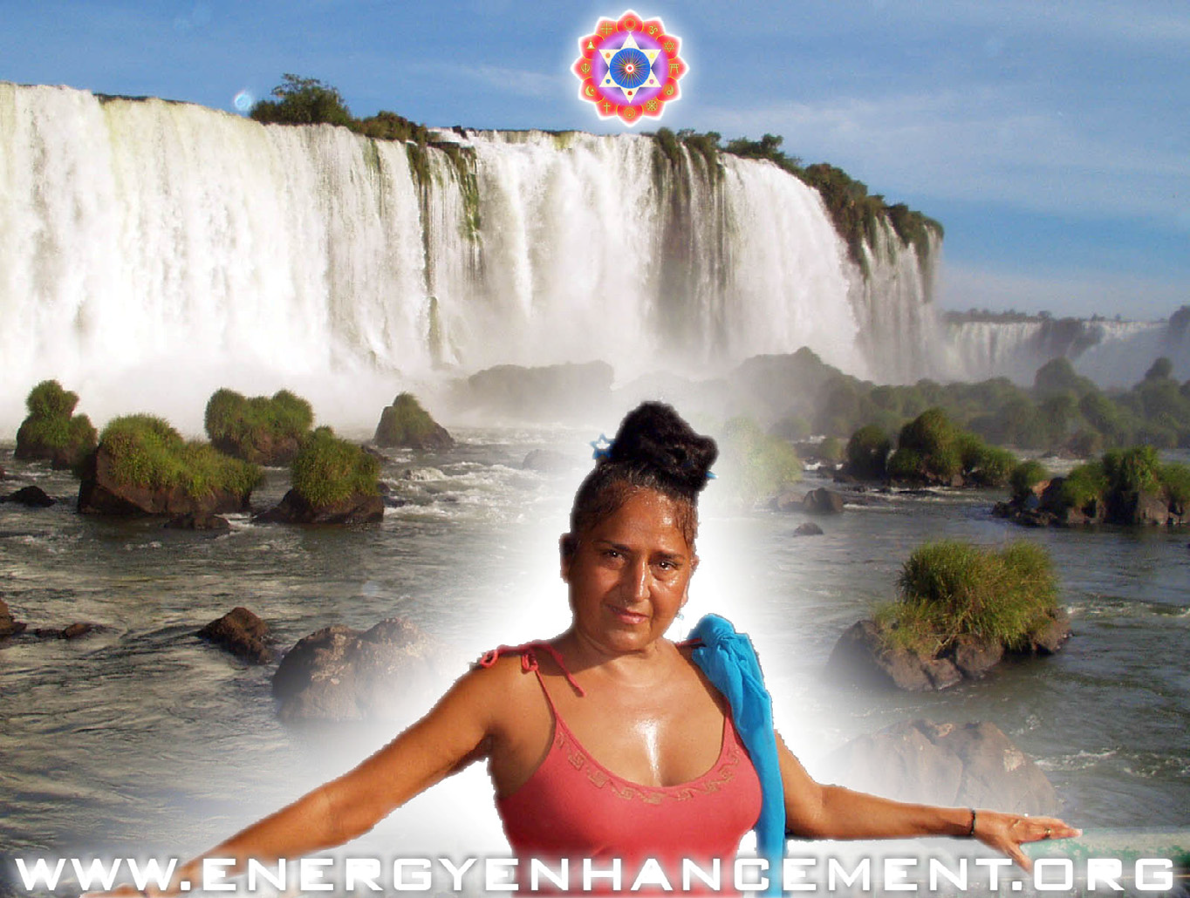
MATAJI DEVI DHYANI - VISIT TO IGUAZU AFTER THE JULY 2008 COURSE

JEANS SEPTEMBER 2005 COURSE TESTIMONIAL

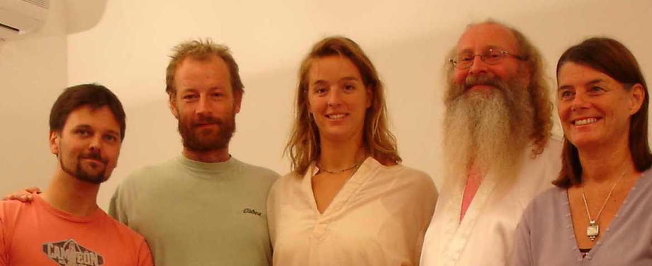
JEAN, THOMAS, AMY, SATCHIDANAND AND VANESSA IN SPAIN
My Introduction and background
My name is Jean, and I am a thirty seven year old Chartered Engineer from the UK working in the Nuclear Industry.
Since beginning the four-week Energy Enhancement course two weeks ago I have been consistently impressed with the efficacy of this programme.
Miracles. The Energy Enhancement programme encapsulates and expands all of these systems, it is complete and no questions are left unanswered.
After years of trying all these methods, I had had some success with my mind and emotions but the DVD and Online Energy Enhancement Course over one year so improved my psychic vision that I was able to see 13 energy blockages along my spine as shiny black stones.
The extra energy from the ONLINE AND DVD EE Meditation caused me shake every time I meditated, a phenomena that has been reported in many books describing the action of Kundalini energy.
I have experience of many forms of meditation and practices for self improvement including: Transcendental meditation (TM) 12 years, Kriya Yoga 9 years, Sushila Buddhi Dharma (SUBUD) 7 years, and more recently the Sedona Method and the Course in



YUKO SATO IS THE PHOTOGRAPHER LIKES FOOD AND INDEED PROFESSIONALLY PHOTOGRAPHS FOOD AND MANY OTHER THINGS FROM SHANGHAI TO LONDON. A MEAL FROM THE ENERGY ENHANCEMENT COURSE. SHE WENT ON TO A TWO WEEK FAST AND LIVER CLEANSE.
I had to wait for the advanced blockage removing techniques of EE Level 2 and a lot of hard work over one week before these energy blockages were removed and my Kundalini shaking, so much a part of my preliminary Energy Enhancement meditational experience over the last year, was brought to a stop.

Energy Enhancement In Spain Course Arrangements
The course takes place in L’Escala on the Costa Brava in Northern Spain. The duration is four weeks to learn the four levels of Energy Enhancement.

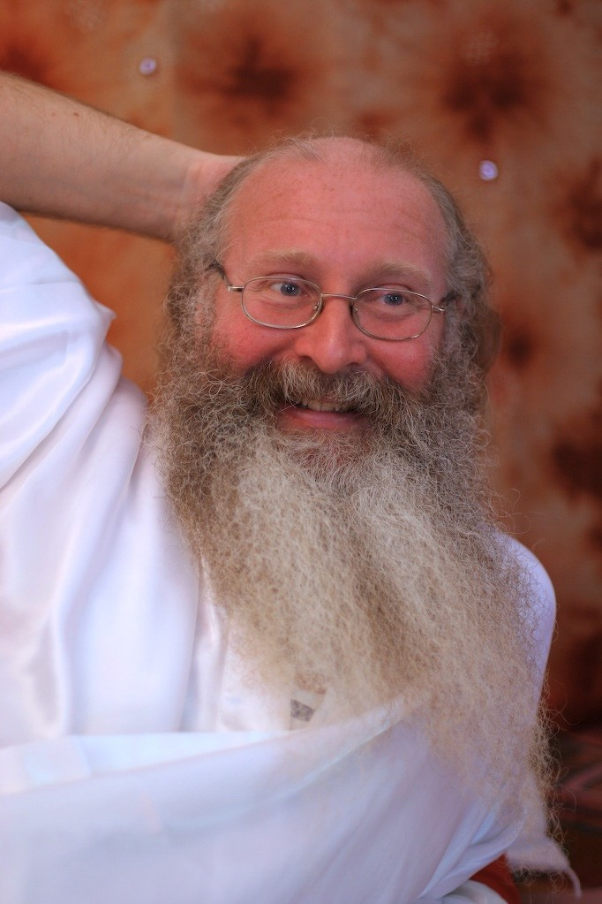
SATCHIDANAND BY YUKO SATO
I was allowed to make payments in easy monthly instalments via Pay Pal beginning a year in advance of the course start date. This planning well ahead also allowed me to book cheap flights from my

home in the UK to Barcelona. From Barcelona I caught a train to Figueres station (only 8 Euros) where Satchi collected me.
Accommodation is available at the SOL centre with Satchi and Devi or in one of the many campsites and villas available nearby. I chose to stay at the SOL centre to take maximum advantage of the ‘Buddha Field’ of energy, which pervades there.


SATCHIDANAND BY YUKO SATO
This highly charged energy field boosts progress towards freedom from negative feelings, circumstances, persons, places and conditions – towards enlightenment.

What is Energy Enhancement?
Energy Enhancement is a systematic and complete programme for removing all the negative thought forms (blockages), which cause an individual to be unhappy, stressed, unenthusiastic and tired.
This course promises enlightenment.

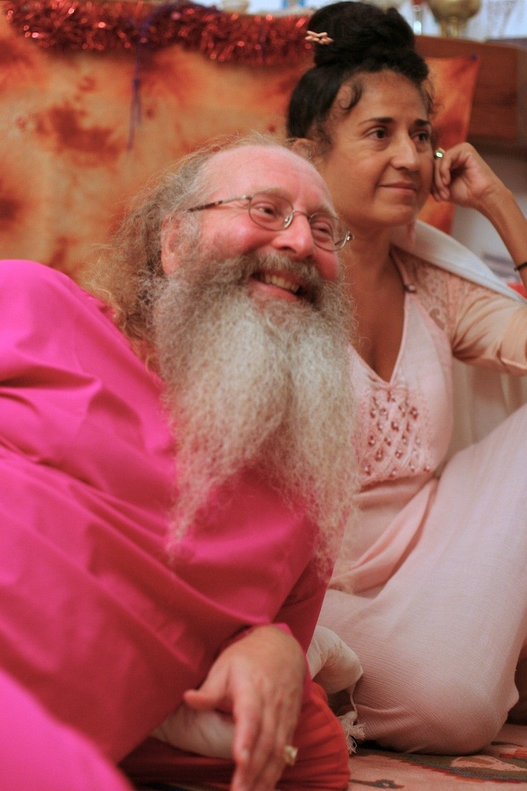
DEVI DHYANI AND SATCHIDANAND BY YUKO SATO

The course was devised and is delivered by Master Satchidanand (Satchi) and his wife Devi Dhyani. These two highly evolved individuals have very impressive credentials. Satchi had two enlightened masters, Zen Master Roshi Hogen of Japan and Swami Satchidanada, Yogiraj and disciple of Swami Sivananda of Rishikesh of India and the USA who died in 2002 at the ripe old age of 89.
Devi has been teaching Meditation for over 20 years (34 years - SATCHI). All the details and much more are available at www.energyenhancement.org. The benefit of all this is available to all the students who undertake the course – it is real!

ENERGY ENHANCEMENT PROGRAMME LEVEL 1
The programme begins at level 1 which includes basic training in meditation and the manipulation of life energy (Ki, Chi, Pranha, Orgone, Kundalini). It also includes techniques for avoiding food, which contains poisons such as pesticides and for dealing with the effects any poisonous substance, which you may have ingested in the past. These poisons reduce your energy and therefore your progress towards happiness.
ENERGY ENHANCEMENT PROGRAMME LEVEL 2
Level 2 provides training and actual experience in removing the blockages (negative thought forms) to the free flow and accumulation of this energy in the body. With the skills learned in this stage it is possible for an individual to systematically remove all these blockages improving day by day until eventually none are left. This state of freedom is commonly referred to as Enlightenment or the end of personal suffering. I have not encountered any other system, which makes the light at the end of the tunnel so clear and attainable.
ENERGY ENHANCEMENT PROGRAMME LEVEL 3
Level 3 deals with past life resolution (I will be taking this part of the course in the next week)
ENERGY ENHANCEMENT PROGRAMME LEVEL 4
Level 4 deals with the mastery of relationships – or how to help your loved ones and acquaintances (final week)

My Experiences
Energy Enhancement Online course

Prior to coming on the residential course at L’Escala I had an excellent introduction to Energy Enhancement by taking the online course. Over a period of a year I was introduced to and worked with the principles of Level 1 of Energy Enhancement. The course material was abundant and clear.
Any clarification that was required was forthcoming from Satchi via email. So I already knew before I came to L’Escala that the programme was effective because from the online course I had already had experience of energy flowing through my body, Kundalini shaking and psychic vision of the blockages (negative thought forms) like shiny black stones, which restrict that flow.
My Energy Enhancement Residential Course in Spain
My first notable experience on the course came when Satchi gave instructions on how to sit correctly in meditation. With Satchi’s help I was able to align my spine perpendicular to the surface of the earth and the Kundalini energy that radiates from within it.
Kundalini Shaking
The flow of energy caused my body to shake like electricity. I had had this shaking experience before with the more advanced level one techniques of the DVD Course but this time all that was required was correct posture.
Heart Chakra Warmth
Throughout Energy Enhancement Level 1 I experienced instances of movement and beautiful warmth in the heart as the Chakra increased in energy. This occurred during initiation from Devi, dealing with toxins and construction of psychic protection. The flow of energy became stronger and stronger causing my body to shake more intensely as it hit upon resistances.
Blockage Removal Techniques
In Energy Enhancement Level 2 the techniques were given to remove those resistances – the first few baby steps towards ultimate freedom. Some of my experiences of blockage (negative thought form) removals are given below:
Heart Chakra Blockage: This was my first blockage removal attempt and required a little help from Satchi. After I had worked on it for a while without completion Satchi asked if he could have a look to which I replied in the positive.

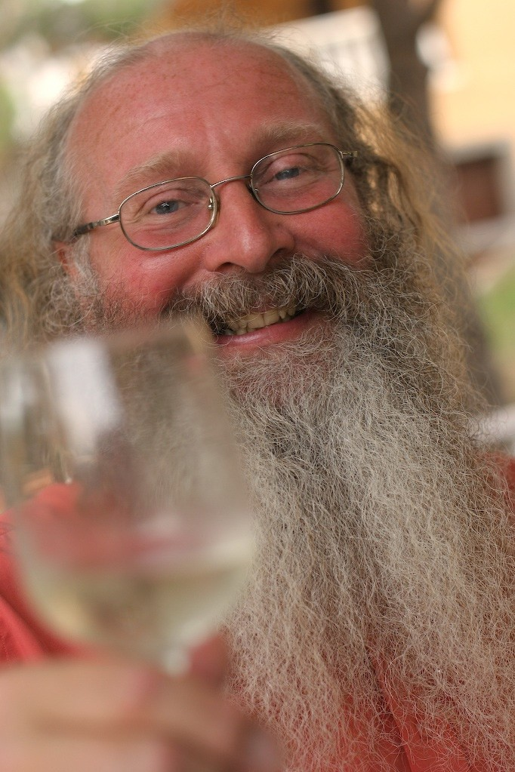
SATCHIDANAND - TAKE WHAT IS IN MY HAND, DRINK!!!
BY YUKO SATO
From that point I was aware of great heat and light at the front of my body as though the sun was shining on me – but I was indoors! Needless to say the blockage is gone!

Solar Plexus Chakra Blockage: For some time I had been experiencing pain at the bottom of my breast bone – one of the signs that there is a blockage. I tackled it with the techniques of Energy Enhancement Level 2 until it was successfully removed. There was an immediate reduction in pain which reduced to virtually nil over the following days – proof to me that these techniques work!

SATCHIDANAND BY AMY ZANTRAS. AMY ZANTRAS IS LIVING AS A MASTER IN AN ASHRAM IN INDIA AND SPEAKING IN SATSANG IN INDIA, CANADA AND SWEDEN.

Blockages on the spine: I had been aware from using the techniques of level 1 gained from the online course that there were blockages along my spine. These blockages caused my body to shake when connecting to high levels of Kundalini energy – an interesting phenomena which let me know that something was happening but not helpful in the long run.
Using the techniques of level 2 to remove these thirteen blockages which looked to me in my meditation like shiny black stones, the shaking ceased and the energy increased!
Childhood trauma – The techniques of EE can be used to remove the negative thought forms associated with past trauma. When I

applied the techniques to the memory of a near fatal childhood accident when I fractured my skull at the age of two I spontaneously experienced wonderful feelings of warmth and compassion towards the child that I was, and of forgiveness the whole situation that had occurred.
These are just a few of the experiences that I have had since being here. All of my fellow students have had similar and much more dramatic experiences.
Conclusion
I have been working for over 12 years with many well known techniques including Transcendental meditation and Kriya Yoga, Subud, A Course in Mircles and the Sedona Method.
Although I have made good progress with these techniques I now consider these to have been preliminary techniques to prepare me for Energy Enhancement.
These methods that I have tried before simply don’t provide for the systematic identification of Energy Blockages or contain the Advanced Techniques for the removal of the energy blockages to enlightenment that Energy Enhancement does.
If you are serious about self-improvement, growth, change, enlightenment! Then the Energy Enhancement course is for you.
If you are tired of all the many systems of meditation which leave questions unanswered and where the path to enlightenment is ill defined and uncertain then don’t delay end the suffering as soon as possible – learn Energy Enhancement.

Jean, FROM THE SEPTEMBER 2005
ENERGY ENHANCEMENT COURSE

Energy Enhancement Course Jean - L’Escala SEPTEMBER 2006
The course for me was really a refresher as I had previously completed the course in 2005. You can see my testimonial from 2005 elsewhere on this site.
After a year of practicing the advanced techniques of energy enhancement I am enjoying the benefits of increased energy flow, and much less blockages. From a material perspective my income has doubled in a year! But more importantly I feel I am moving swiftly along my spiritual path towards enlightenment.
Prior to Energy Enhancement, Enlightenment seemed like a faraway dream not for this lifetime. Now I feel it is almost inevitable - only a matter of a few years away.
As for the course - I can only reiterate what I said last year. After 12 years of Transcendental Meditation and experimentation with many other meditation and self improvement techniques it is my opinion that nothing comes close to the power and precision of energy enhancement.
There is little more I can say about the efficacy of Energy enhancement that I haven’t already said before so I will recount a wonderful experience I had whilst on the course.
The rest of the class were sat in a circle on the floor meditating with Master Satchidanand. It was my turn to receive an initiation from Devi so I was sat on a chair at the back of the meditation room with my eyes closed and hands together in a prayer like fashion.
As I became absorbed in the experience of the initiation it was as if my eyes opened to the scene before me. However this was not the scene to which I closed my eyes.
Satchi and the students had transformed into beings of intense white light. I think that I was being given a glimpse of their true nature, a peek at the world the way the enlightened see it.
The meditation room had opened and expanded. I felt we were outdoors in a place of great space, holiness and energetic purity maybe a forest or mountain top.
Then I became aware of the presence of others. A group of beings approached from my right and turned to face me one by one.

I felt immense happiness and peace at their presence, they had an aura of intense holiness and purity - great Saints and Sages.
As they faced me and bowed one by one I felt a feeling of unworthiness but the thought came immediately "worthiness is not necessary, by the grace of God infinite love and light is offered to each of us every moment all we need do is accept it".
I felt that they were very pleased with my practice and had appeared to me to let me know. I think it is important to say that I was in no way unique.
Most of the other students this year and last year had experiences of meeting beings of light, ascended masters and angels - EE has that effect!
Come and experience it for yourself you won't be disappointed.

JEAN
Truly, perhaps Enlightenment is next!!
You will probably find this interesting. Jenny who came on the Energy Enhancement course with me this year went to see her accupuncturist which she does routinely.
This guy (Ross) seems very talented, by reading her pulse he can tell her what she has been eating - certain energy patterns apparently. Anyway when he checked her pulses this time he found something interesting.
Apparently there is a pulse which gives an indication of the level of spiritual energy.
Jennies' spiritual energy was reading off the scale, something Ross said he has never seen before with Jenny or anyone else.
He says people just don't have this pulse and as far as he knows the only way to get it is to connect to external sources which as you know we did on the Course - wow!
Truly, perhaps Enlightenment is next!!

JEAN

ENERGY ENHANCEMENT AND ANCIENT MYTH
THE SUFI ALHAMBRA AND THE EMERALD TABLET OF HERMES TRISMEGISTUS


Plan of the fountain and pool at the Alhambra Granada. The Key and the Lock. Pool the Sea of Bliss of the Chakras above the Head like the Soul. Channel - the energy connection tower of the Antahkarana. Circle – the Earth. Dot in center – Kundalini Chakra in the Center of the Earth

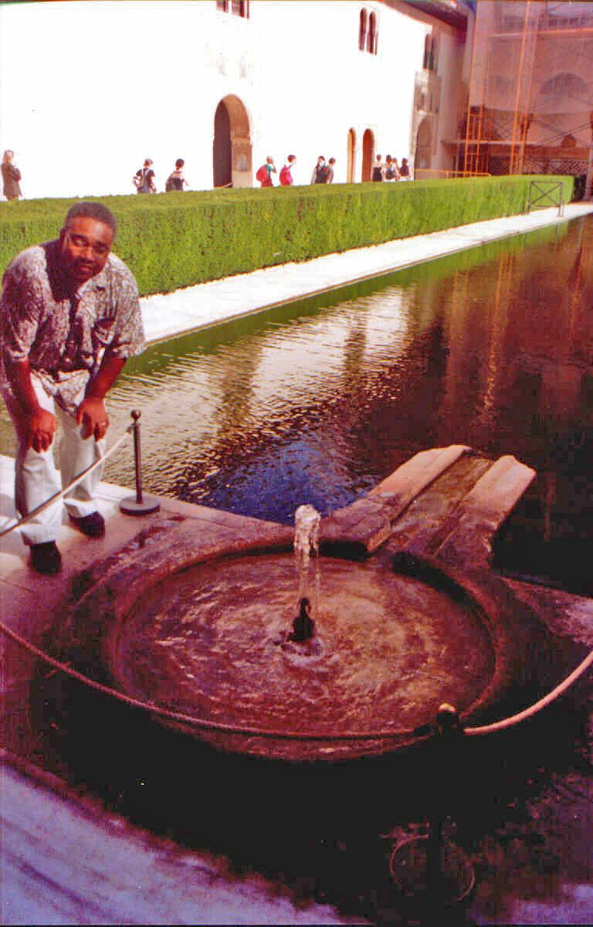

Picture of the Fountain flowing into the Pool at the Alhambra, Granada with Energy Enhancement Student, Doctor Thomas Fluellen.

Previously we were talking about the principle of Courtly Love which was given to the Knights of the Middle Ages. It is said to have been spread throughout Europe by the Troubadours, students of the Sufis, who sang songs of love, symbolizing the love of God. They originated in Spain where Christianity and Islam met.
This cultural clash spread the influence of Sufism, the poetry of the Sufi Masters like Jallaluddin Rumi and Averroes. Sufi Mystics are the mystical heart of Islam as Zen is the mystical heart of Buddhism being a hybrid between Buddhism and Taoism, as Hassidism is the Mystical Heart of Judaism.
The help of the Sufi mystics sent their ideas even into the myth of King Arthur.
Many Sufi mystics came from organizations with names like the builders or the lock makers (Naqshbandhi).
When you go to the Alhambra in Granada, Spain, you come across many symbols of Sufism. Above is the plan of the Pool of water (Rectangle) in front of one of the beautiful buildings there. And a fountain (Circle) with a water channel between the two. The water from the fountain comes out of the little circle in the center of the bigger circle and flows into the pool. And here below is a picture of that fountain at the Alhambra of Granada when we used to live near there, with one of our Students, Dr Thomas Fluellen, whose Energy Enhancement Testimonial is available on our Website energyenhancement.org
The large circle of the fountain above is the Earth. The little circle in its center is kundalini chakra energy which flows in every direction but is then channeled wherever you are on the surface of the planet through the Antahkarana, the channel, into the pool, the ocean, the Soul, the central spiritual sun of Gurdjieff.
The symbolism is obvious given what has just been told about the sword in the stone and St Michael in an earlier chapter of the Energy Enhancement Book, available to Download Online Now.
The fountain and the channel looks like a Key, does it not? Therefore here is the key of the Lockmakers, the Naqshbandi.

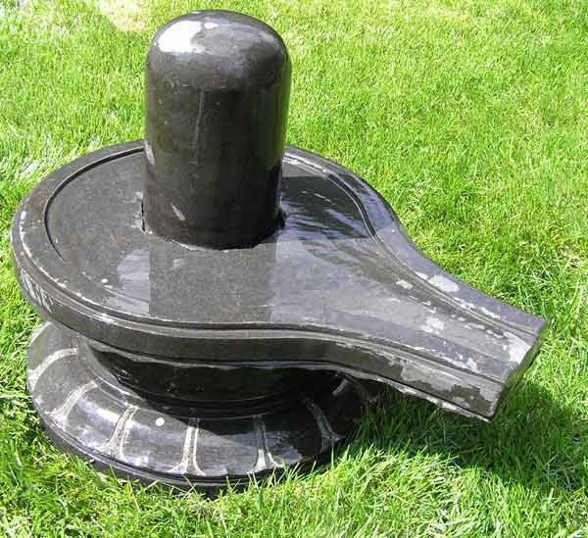
THE SECRETS OF ENERGY ENHANCEMENT ON THE NATURE OF THE ENERGY FLOWS OF THE UNIVERSE AND HUMANITY COME FROM DEEP AND ANCIENT SOURCES. YOU CAN LEARN A LOT FROM OUR PROGRAMS.
Above is a Shiva Lingham and Yoni from the india and the Ancient, 5000 years old Hindu religion. The base, Yoni looks like the fountain above, yes? The Shiva Lingam (Male Genitals) takes the part of the upwelling water of the fountain. In ritual worship, milk is poured over the Shiva Lingam and it comes out of the Yoni (Female Genitals) which symbolise the earth and the antahkarana spout shooting spiritual energy out of the center of the earth like the water of the fountain comes out of the fountain above into the pool. In a way

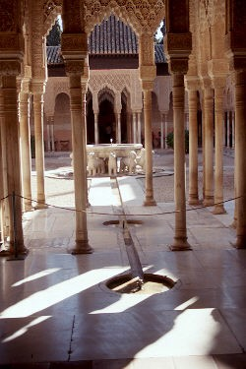
Lion Fountain at the Alhanbra, Granada, Spain.
Further, the Lion Fountain at the Alhambra has Four channels with two circular pools on each of them WITH A FOUNTAIN IN THE CENTER OF EACH ONE linking into the central LION Fountain. The central Fountain is the Logos, the first pool is the Monad, the second pool is the Soul Or central spiritual sun. Back in the shade is you in the earth circle in the foreground foreground. The Lion Fountain illustrates the chakras above the head with its central connection, connecting all humanity in the Lion Fountain itself.

The Chakras above the head.
See http://www.energyenhancement.org/Level1.htm for more on the tower antahkarana of kundalini energy which flows from the center of the earth through YOU! upwards into the center of the universe thus squaring the circle because this energy is always square, 90 degrees, to the surface of the earth. This is the key of the Naqsbandis and the secret of being a Master Mason ("The point

from which a meditator cannot err" is the center of the earth and the center of the universe).
Same with the Sufi Taj Mahal. The lightning rod on top, three meters high is composed of three spheres symbolising the same three higher chakras, external energies, contactable in Energy Enhancement Meditation.

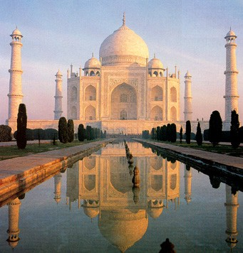
See http://www.energyenhancement.org/Level1.htm
The three chakras above the head are illustrated also as ridges or balconies on the towers which surround the Taj Mahal. Also the balconies on the towers surrounding the Blue Mosque in Turkey – also designed by the Sufis.
As Hogen told me, "There is no separation" and this is how we interpenetrate each other.

This shows how every person on this planet is connected. How to leave your body and connect. How to become Enlightened. Just go one step higher....in your meditation....
The secrets of Level One of Energy Enhancement inscribed in Stone by the Sufis.

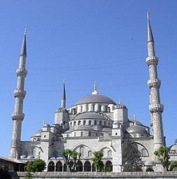
Blue Mosque
Come to learn these secrets in the Energy Enhancement Online Course or here with us....
Ibn Rushid was a Sufi Doctor who studied music, a famous commentary of which was taught at Paris after being suitably expurgated by the church of the inquisition. This Cordoban was known in the West as Averroes and he excercised a tremendous effect on Jewish thinkers and Spiritual Masters which exist to this day in Girona, not far from our center in L'Escala near Barcelona.
Like his Master, Ibn Tufail, he is said to have passed down a Sufic system alongside the one permitted by the thinkers of the

Inquisition of Spain. Ibn Tufail, known to the West as Abubacer after his first name Abu Bakr, was also a physician, philosopher Sufi and ultimately the Grand Vizier of the court of Granada!
His garden and house still exist there in the Alhambra. He took a great deal of interest in the Sacred Architecture, which still affects with Energy (Visit IT!!) it radiates spiritual energy to everyone who goes there (6 Million People a Year), and also in the the designs of the Fountains and other signs, graven in stone at the Alhambra in Granada. Like the Sufi designed Taj Mahal it is one of the 7 Wonders of the World!!!
Some people think that originally, the Alhambra was a Spiritual Sufi School.
But the name of the Architect, Abubacer is never mentioned by the guides there at the Alhambra.
Many Sufi mystics came from organisations with names like the builders or the lock makers (Naqshbandhi).
Whenever I ask about the Sufi created Masons they ask, "Who built the pyramids? The answer obviously being the Masons or the builders which shows the antiquity of these ideas. Each output from the central Sufi source works on one of the chakras. Only one of the organisations, the Naqsbandhis, can integrate the whole human being because the Naqs are the subpersonalities of the Inner Children and the Strategies they use to destroy the lives of you and everyone around you.
We teach how to purify these subpersonalities in Energy Enhancement Level Three.
Obviously the lock, the Cave of Plato, requires a key and the key is the shape of the Fountain at Granada, see above, WHICH SYMBOLISES THE FOURTH INITIATION OF LEVEL ONE OF ENERGY ENHANCE MENT.
The first Four Initiations of Energy Enhancement are available by Video CD. Also the course includes Chants and a Sacred Dance Performance by Devi Dhyani. There are DVDs playable in your computer in MPEG4 playable in Windows Media Player and many others.
One more thing, the shape of the key represents the guided meditation of the Fourth Initiation of Energy Enhancement which you can buy immediately Online by Download if you have a Broadband connection, or on Video CD NOW!! - To enquire for its price and how to get it,

The KEY shows connection with the Kundalini Energy in the center of the earth, and then the connection by means of the Squaring of the Circle (See earlier chapter in this book) which leads on to the Antahkarana (See earlier chapter in this book) The Antahkarana is the connection coming outwards from the center of the earth with the center of the universe showing the higher planes and even Higher. Reaching the higher planes of the Soul, the Monad (The group soul) and the Logos (The Archangel in charge of this Planet, the Father, Abba) and higher.
This is the meditational, real, meaning of Sat Chid Anand, this is the Holy Trinity, the Father, the Son and the Holy Spirit.
This is the meaning of the Emerald Tablet of the first Alchemist, Hermes Trismegistus or Enoch of the Enochian Keys, whose first Formula or Guided Meditation was VITRIOL, see in a previous chapter or See an expurgated version in Energy Enhancement Level One.

The Emerald Tablet of Hermes Trismegistus
The Emerald Tablet of Hermes Trismegistus, written 3000 years ago by this Priest of Egypt, was the ultimate authority of the Alchemists, and here it is.. (with a little comentary by Satchidanand...)
Only the Truth, certainty, ATMAN, without untruth, without any negativity exists in the center of the Universe. (the Central Spiritual Sun of Gurdjieff)
What is above is as below. What is below is like what is above. (We are part of that unchangeable truth at the center of the Universe, we can place our attention on any of the chakras below it – this creates the polarity of the Antahkarana)
This unity, this integration is to be attained. (by methods like Energy Enhancement)
Everything is formed by meditation on this Truth, this Unity. (Sat means truth or the Father, connected to your crown chakra)
All things arise because of this Truth this Unity. It is the initial Cause.
Its parents are the Sun and the Moon.

It was bourne by the wind (Or Ananda, the Holy Spirit, the Antahkarana which is a line of energy which connects all these internal and external chakras)
And Nurtured by the Earth (The Center of the Earth, source, fountain of Kundalini. Connected to your Base Chakra)
Every Wonder comes from it and its power is complete.
Bring its energy into the Earth and the Earth will separate from Fire. (Fire or negative emotion will separate from you, "drain the last dregs of your VITRIOL")

The palpable separated from the impalpable.
Through meditational wisdom it can be made to change direction and rise slowly from the Earth to Heaven (This is the Key, the antahkarana, the rainbow bridge to the other shore of the Zen Buddhist Heart Sutra) (This is the Circulation of the Energies or Initiation Two of Energy Enhancement)
Then it descends to the Earth combining the power of the Upper (Center of the Universe, the Central Spiritual Sun) to the Lower (The Center of the Earth, IT CIRCULATES!! THE TAOIST Macrocosmic Orbit, The Energy Enhancement Supra Galactic Orbit,!!)
Through this guided meditation, you shall have the Illumination and Enlightenment of all the Earth (We, over the centuries, through this meditation, will increase the evolutionary, Spiritual Energy, vibration, of this Planet and everyone on it!!) and Darkness (negative energy) will disappear.
This is the power of all strength. - it overcomes which is delicate and and penetrates through solids.
This was the means of the creation of the Earth by the central spiritual sun.
And in the future all evolution, wonderful development, will come in this way.
I am Hermes Trismegistus so named because I exemplify these three elements of Wisdom (Sat Chid Anand, the Holy Trinity - Father Son, Holy Spirit, or the Sun, Earth and their connection the key, the Antahkarana) I have incorporated them within my being. I am That!! You are That also!!!
And thus ends the revelation of that which I AM, - The Central Spiritual Sun!!!
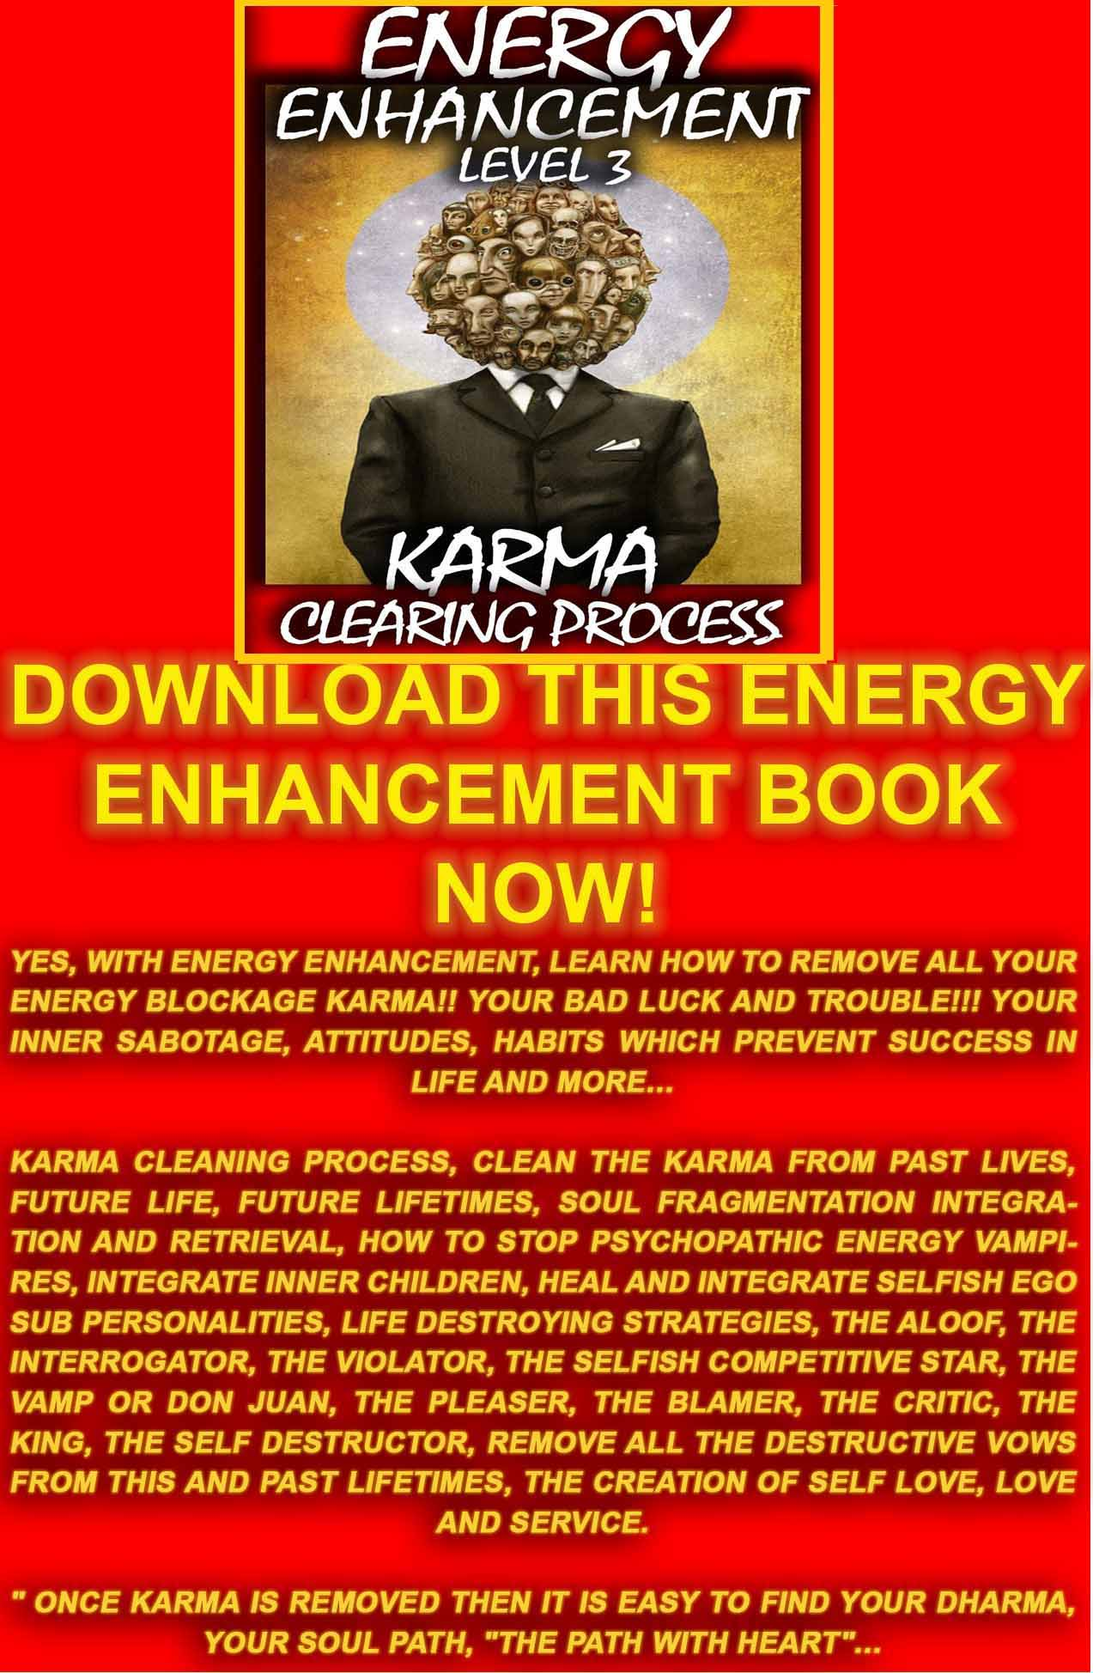
DOWNLOAD LEVEL 3 BOOK HERE!!!
http://www.energyenhancement.org/Sacred-Energy/Level-3-Book/Energy-Enhancement-Level-3-Karma-Clearing-There-Can-Only-Be-One.pdf

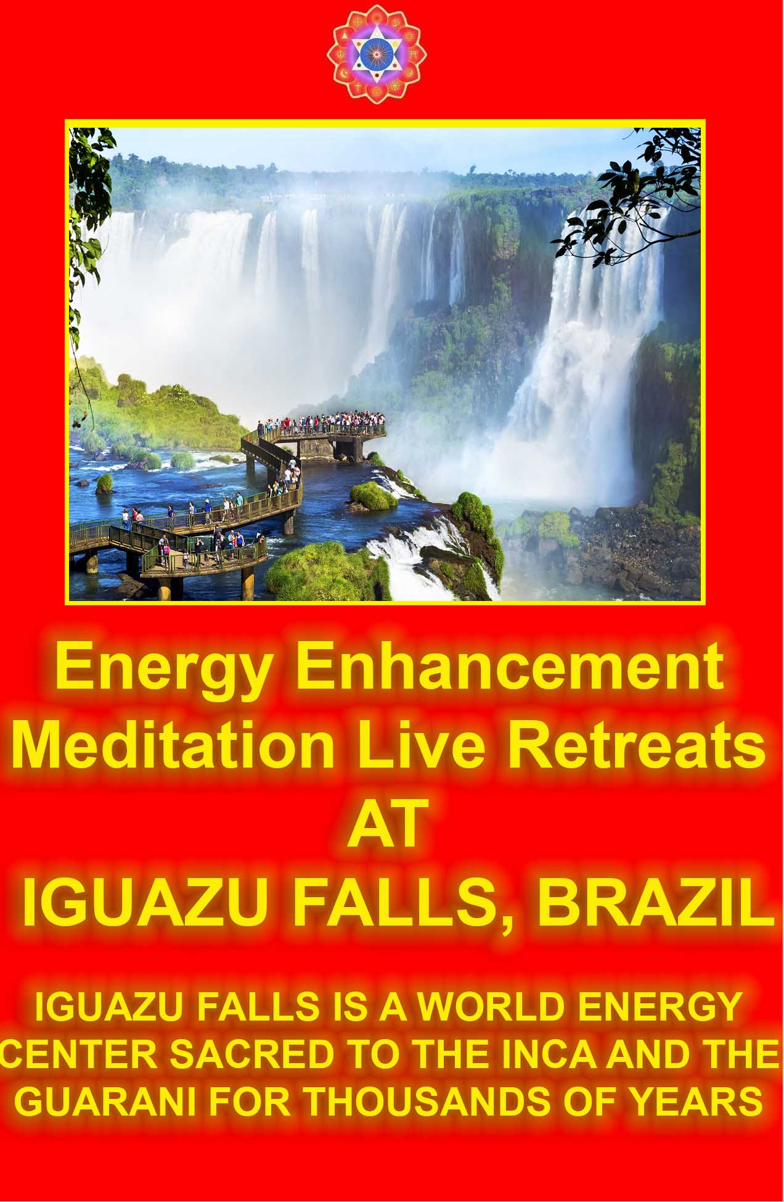

ENERGY ENHANCEMENT
THE CORE ENERGY TECHNIQUES!!
ENERGY ENHANCEMENT!!! ULTIMATE!!!!!! ANCIENT!!! !!! EFFECTIVE!!!!! SUCCESSFUL!!!

- Get into Intense alignment with Your Own Kundalini Energy and Immediate Access to the Meditative State.

- Remove your Energy Blockages with The Circulation of the Energies, the Kundalini Kriyas, Ancient Taoist Energy Circulations which have worked effectively for 5000 years to help all towards ENLIGHTENMENT.

- The Grounding of all your Negative Energies through Alchemical VITRIOL - Become Incredibly POSITIVE and ENERGETIC!!

- Alignment with Your Higher Self - INCREASE YOUR IQ, INCREASE YOUR LUCK, ACCESS YOUR HIGHEST ENERGIES!! ACHIEVE WHAT YOU WERE PUT ON THIS PLANET TO DO.

- Learn how to USE and Increase the LOVE of Your Heart Center to ZAP YOUR NEGATIVE EMOTIONS AND DEVELOP PSYCHIC POWERS TO HEAL YOURSELF AND OTHERS.

- Overcome ENERGY VAMPIRES - MASTER ENERGY PROTECTION AND MAINTAIN YOUR HIGH ENERGIES!!

- EXPERIENCE INCREDIBLE RELATIONSHIPS WITH ENERGY ENHANCEMENT - THE CORE ENERGY TECHNIQUES

- ENERGY ENHANCEMENT Techniques are the source of all Successful spiritual training courses over the last 5000 years. Become a Jedi Master, a Gandalf, a Transmitter of the FORCE a Bringer of the Light!!

Energy Enhancement, Kundalini Chakra and VITRIOL - The First Formula of Alchemy and the Removal of Fear

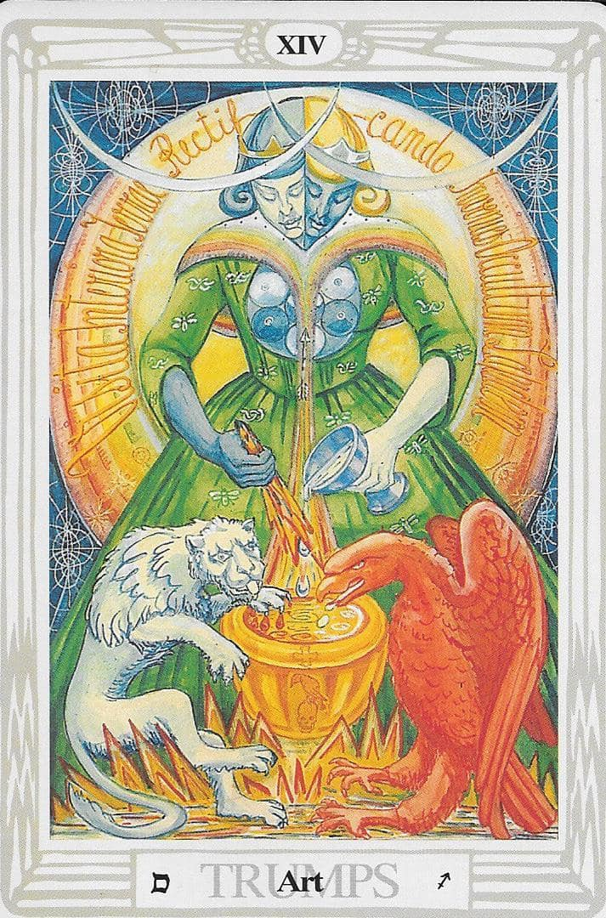

VITRIOL is the First Formula of Alchemy - the hidden meaning of VITRIOL is a guided meditation which gives the hidden Meditational meaning of the Philosophers Stone.
VITRIOL is a Latin word which means Acid. The acid which can dissolve all negativity. It also means anger and thus symbolizes a method to reduce and remove all negative emotions like anger, fear and depression or sadness or bereavement or trauma.
The Integration of all the Chakras ends in complete freedom, Kaivalya or Enlightenment. We can use this meditational formula to Ground all Negativity and the Negative Karmic Mass of Encapsulated Trauma in the body or Energy Blockages..
The Painless Grounding Of Negative Energies and Emotions Is The Secret Of The Philosophers Stone described By The Ancient Alchemical Phrase, “Drain the last Dregs of your Vitriol!!” where Vitriol is used in the sense of, Anger which is representative of all negative emotions to remove totally all Anger, Fear and Depression.
Each letter in the word VITRIOL stands for another Latin word which together form the First Formula, or guided meditation, of Alchemy.
A Guided meditation encoded for centuries in the word VITRIOL - a guided meditation given in the Art Card of the Tarot, THOTH Pack, you can see the Latin words, an explanation of VITRIOL in a circle behind the figure on the card as a prelude to learning and practising these Practical, Ancient and Successful Meditations for the removal of all negative emotions like Anger, Fear, and Depression.
The Guided Meditation encoded in the Latin words of VITRIOL shows what is and also how to activate "The Philosophers Stone"
The "Occultem Lapidem" or "OL" OF VITRIOL! which is the catalyst which changes Base metal into Gold.
Not the metal Gold, the Element Gold or "Fools Gold" as the Alchemists used to call it. The Enhancement of the pure Golden Spiritual Energy of the Crown Chakra and the transmutation of the Negative Energy slowing down the Base Chakra, or how to change or transmute the Base metal (lead) The Energy Blockages of the Base Chakra, into pure Spiritual Golden Energy.
VITRIOL is a guided Meditation for the removal of all negative emotions like Anger, Fear, and Depression teach how to Ground Negative Energies, how to transform the stress, the Negative Energy of daily life, which arises in you or that which you pick up from other people. The stress which arises from the painful memories of the past.

The Secrets of the Guided Meditation of Alchemical VITRIOL have been taught for thousands of years for the removal of all negative emotions like Anger, Fear, and Depression teach how to use meditation to get rid of all Painful Traumatic Memories and the Energy Blockages which hold them in the Body, the Emotional Armour of Reich, which causes toxins to be deposited in the area of the Stiffness, eventually failing in the body and making operations necessary.
Each letter in the word VITRIOL stands for another Latin word which together form the First Formula, or guided meditation, of Alchemy. VITRIOL is the Ancient and Successful Meditation for the removal of all negative emotions like Anger, Fear, and Depression teach how to use meditation to ground the pain of broken relationships.
Visita Interiora Terrae Rectificando Invenies Occultem Lapidem VITRIOL means Visit the Center of the Earth. There you will find the Philosophers Stone – That which transmutes all base metal or the energy of Trauma or Negative Emotion or the Energy Blockages which exist in the Base chakra – into pure Golden Spiritual Energy. The energy of the soul shines on each chakra, in this case Kundalii Chakra in the center of the Earth and is reflected back, this is Rectificando, “The right leading of the transmuted golden energy along the path of the Soul” or the Soul Chakra in the Center of the Universe.
Circulating spiritual Energy between these two great chakras or energy polaritieas is Taoist Energy Circulation shown in the Yin Yang Symbol (See our other book, Energy Enhancement) or the Kundalini Kriyas of Yogananda, Sri Yukteswar and Lahiri Mahasaya, which are the same guided meditation.
Freeing Energy Blockages from the Base Chakra frees us from all problems to do with energy lacks as it is the connection with Kundalini Energy.
The Base Chakra is to do with health so as it rises up the spine to pierce all chakras, so it drives out all energy blockages which are stopping your life and causing trauma, depression and disease.
The Base Chakra is to do with increasing the Kundalini nature of Sex so it cures all Sexual problems – Impotence, premature ejaculation, frigidity and perversion leading to the pure and good use of sexuality in monogamous couples for the purposes of procreation, creation and orgasmic natural enjoyment.
Further, the Base Chakra, Muladhara Chakra, is to do with solving the problems of Houses, Food, Wealth, Money, Abundance, and the Actualisation of all your Life dreams and Soul Path.

Arousing VITRIOL will cure all life problems leading to Happiness, Wisdom, Peace and Joy.
VITRIOL is the guided Meditation from the Emerald tablet of Hermes Trismegistus for the removal of all negative emotions like Anger, Fear, and Depression teach how to use meditation to ground the pain of bereavement, the pain of divorce, the pain of abuse. The pain which causes fear, sadness, anger and grief.
The Grounding Of Negative Energies Is The Second Formula Of Alchemy - "Solve Et Coagule" said the Alchemists, or "Dissolve to Integrate". The secret of Alchemy is that all metals dissolve in Acid, all metals except gold dissolve in acid or vitriol.
Energy Enhancement teaches normally, though not given in any other course as yet, The Second Formula Of Alchemy Is Sec - "Solve Et Coagule", A Latin Word Meaning "To Dry" - Dry out the Water Of The Emotions - get rid of your fear, pain, anger, jealousy and negativity etc. Through the guided meditation of V.I.T.R.I.O.L.
Energy Enhancement teaches the ancient and meaningful phrase, "Drain The Last Dregs Of Your Vitriol" Where vitriol in this phrase means anger, yet also it symbolizes how to Get Rid Of All Your Anger And Pain With this guided meditation which is thousands of years old and exists in many different cultures..
Energy Enhancement further teaches by being able to dissolve and Transmute all encapsulated trauma which is at the base of Depression, Manicism, Anger, Fear and Ego we further gain the ability to remove that trauma in others.
Energy Enhancement teaches that further, we easily gain the ability to remove encapsulated trauma created in other people in their past lives towards us. For example, if you did something bad to another person in this or a previous life then normally those people will try to take revenge. That trauma energy will be reactivated when they meet you in this lifetime and they will try to harm you on sight.
Thus by removing all negativity in ourselves and others we start the Karma Cleaning Process of Energy Enhancement Level Three. We start moving towards the ability to “Turn the other cheek” of Jesus Christ. By removing all trauma and negativity we feel no need ever to take revenge.
The same basic vitriol meditation exists in India as part of the Kundalini Kriyas. It exists in China as the Five Elemental Pathways of the Qi of Chinese Alchemical Taoism. It exists in Europe and Arabia as the Alchemical Meditations of Hermes Trismegistus and

his Emerald Tablet. Although not as yet the karma Cleaning process and further advanced techniques of Energy Enhancement.
This is part of "The Secret of the Golden Flower" a book translated from Ancient Chinese Taoist sources by Jung meaning by activating the Crown Chakra by the activation of the Kundalini Energy of the Base Chakra we learn how to open the golden flower of the Crown Chakra to perform its natural function of contacting the Soul.
Contacting the Soul is part of Enlightenment.

VITRIOL exists as a major part in some of these useful Ancient and successful Meditation Techniques below which put you in contact with, so that you can use the high and plentiful energies of the earth and of the universe, from many cultures to create the Launch pad of Enlightenment and the Creation of Genius...

Director Satchidanand, is one of the leading teachers of Meditation.
He helps people worldwide reach further than they EVER thought possible, FASTER!!! http://www.energyenhancement.org

Energy Enhancement and the Second Mythical Labour of Hercules Involving the Hydra
Remember the Labour of Hercules involving the Hydra. As Hercules chopped off one head with his sword another 3 grew back in its place.
As Hercules chopped off the head, he cauterised it with the Sacred Fire, and thus the heads grew no more. This is the secret of many ancient meditations.
The Hydra symbolises the mind. Its heads the many thoughts we have which need to be dissipated through meditation.
To Stop The Mind, We Must Defeat The Hydra and more, cauterize the head with the sacred fire. The Fast And Speedy Way To Enlightenment!

In Greek mythology, the Lernaean Hydra was an ancient nameless serpent-like chthonic water beast that possessed numerous heads— the poets mention more heads than the vase-painters could paint— and poisonous breath.The Hydra of Lerna was killed by Hercules as one of his Twelve Labours. Its lair was the lake of Lerna in the

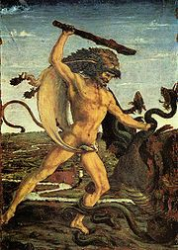

Argolid, though archaeology has borne out the myth that the sacred site was older even than the Mycenaean city of Argos, for Lerna was the site of the myth of the Danaids. Beneath the waters was an entrance to the Underworld, and the Hydra was its guardian (Kerenyi 1959, p. 143).
As we kill the Hydra of the conscious mind, so we gain access to the unconscious mind of the underworld
The Hydra was the offspring of Typhon and Echidna (Theogony, 313), noisome offspring of the earth goddess, Gaia. It was said to be the sibling of the Nemean Lion, the Chimaera and Cerberus.

Herakles und die Hydra (c. 1475) by Antonio Pollaiuolo (Galleria degli Uffizi)
Upon reaching the swamp near Lake Lerna, where the Hydra dwelt, Heracles covered his mouth and nose with a cloth to protect himself from the poisonous fumes and fired flaming arrows into its lair, the spring of Amymone, to draw it out. He then confronted it, wielding a harvesting sickle in some early vase-paintings; Ruck and Staples (p. 170) have pointed out that the chthonic creature's reaction was botanical: upon cutting off each of its heads he found that two grew back, an expression of the hopelessness of such a struggle for any but the hero, Hercules.
The details of the confrontation are explicit in Apollodorus (2.5.2): realising that he could not defeat the Hydra in this way, Hercules called on his nephew Iolaus for help. His nephew then came upon the idea (possibly inspired by Athena) of using a burning firebrand to scorch the neck stumps after decapitation, and handed him the blazing brand. Hercules cut off each head and Iolaus burned the open stump leaving the hydra dead; its one immortal head Hercules placed under a great rock on the sacred way between Lerna and Elaius (Kerenyi1959 p 144), and dipped his arrows in the Hydra's poisonous blood, and so his second task was complete. The alternative to this is that after cutting off one head he dipped his sword in it and used its venom to burn each head so it couldn't grow back.
Hercules later used an arrow dipped in the Hydra's poisonous blood to kill the centaur Nessus; and Nessus's tainted blood applied to the Tunic of Nessus.
The blood of the Hydra, of each thought, is Kundalini Energy founded in the center of the Earth but flowing between the polarities of the Kundalini Chakra in the center of the Earth and the Soul Chakra in the center of the Universe. Using VITRIOL as a symbol for the Kundalini Transmutation of all negativity, and unwanted thoughts are caused by Energy Blockages, we can use this Kundalini Energy of Transmutation, the Dragons blood, to heal all encapsulated trauma causing unwanted thoughts in the mind in meditation. In Zen we call these unwanted rubbish thoughts, “Makyo”.
Ancient teachings taught now in many different cultures, here in the form of a mythical stories, thousands of years old, which enable "The Son (Hercules) of God (Zeus or Deus)" to get married to the daughter of the king of the underworld.
To integrate the Crown Chakra with the Base Chakra or how to become enlightened.

All ancient myths refer to hidden levels of meditation. For example, Freud learned much from the Myths of Oedipus and Electra.
Throughout history, simple stories and symbols containing many levels of meaning have usually not been destroyed by the prevalent Religion as have been the competing religions temples and texts. In particular The Herculean Labour of the cleaning of the Augean stables refers to the cleaning of the Base Chakra with a River of Energy. The Fifth labour of Hercules.
This Labour of Hercules involving the Hydra. As Hercules chopped off one head with his sword another 2 grew back in its place. The Hydra symbolizes the mind. Its heads the many thoughts we have which need to be dissipated. To stop the mind. To Stop the World!! The Dragon/Hydra Serpent Python always Symbolises Kundalini Energy.
The method of Energy Circulation flowing between the polarities of the Kundalini Chakra in the center of the Earth and the Soul Chakra in the center of the Universe is an ancient and hidden technique preserved in Taoism and Hindu Kundalini Kriyas.
It is the most gentle and effective tool for all those who want to increase their energy, their evolution, their genius.
The same energy circulation meditation Ancient Egyptian spiritual technology - The Alchemical Meditations of Hermes Trismegistus from the Emerald tablet or from the Alchemical Sufi Dun Nun, the Egyptian, he who took, The Path of Blame symbolized by the Sufi Naqsbandi Fountain at the Alhambra at Granada in Spain.
The same meditation The Five Elemental Paths of the Qi of Chinese Alchemical Taoism and the Microcosmic and Macrocosmic Orbits symbolized in the Yin Yang Symbol.
The same meditation, The point from which a Man cannot err. .. From the Freemasonic ritual creating the Master Mason and the Entry into the Crypt of the Royal Arch.
The same energy circulation meditation, “With This Technique, Your Evolution Will Increase With Every Energy Revolution To Create A Revolution In Your Evolution”. - Paramahamsa Yogananda On The Kriyas Of Kundalini of India, of Kriya Yoga, of Babaji, the 2000 years old sage in the Himalayas, of Sri Yukteswar and Lahira Mahasaya.
The Energy Enhancement Apprentice Level One Course - Gaining More Energy - Meditation, Shaktipat, Energy Circulation, The Kundalini Kriyas, The Five Elemental Paths Of The Chi Of Chinese Alchemical Taoism, The Grounding Of Negative Energies, V.I.T.R.I.O.L, The Art Card Of The Thoth Tarot, Access To Kundalini

Energy, Strong Psychic Protection, Learn The Merkaba, Pyramid Protection, Power Tower Protection, Create The Antahkarana, Soul Fusion, Monadic Infusion, Logos Infusion. The Painless Removal Of Stress, Trauma And Negative Emotion.

The Fifth labour of Hercules

Energy Enhancement Meditation and the Hercules Labour of the Augean Stables
This technique of Energy Circulation (EE Initiation 2) and Grounding (EE Initiation Three) is referred to in the 12 Labours of Hercules.
Ancient teachings in the form of stories which enable "The Son (Hercules) of God (Zeus)" to get married to the daughter
of the king of the underworld.
To integrate the Crown Chakra with the Base Chakra or how to become Enlightened.
All ancient myths refer to hidden levels of meditation.
Throughout history, simple stories and symbols containing many levels of meaning have usually not been destroyed by the prevalent Religion as have been the competing religions temples and texts. In particular The Herculean Labour of the cleaning of the Augean stables refers to the cleaning of the Base Chakra with a River of Energy.
In the past, psychologists have only worked on one painful experience at a time by providing a meaningful theory by Freud or Jung and then examining the problem. Through understanding the problem, it is released and the client adjusted back into society in his proper place. He may still be neurotic because only one problem has been solved.
The same with ancient lives. We may travel back to, see and fix one life problem in one of our past lives, but what about the other thousands of life-times, each with their own traumas, deaths and problems.
Energy Enhancement Techniques teaches how to remove All of the traumas, deaths and problems as simple negative energy. You do not have to see the problems. They are simply grounded as Negative energy. Learn how to simply, "Ground the last dregs of your VITRIOL!"

There is an ancient Greek myth about Hercules, (a Son of God, Zeus), wanting to marry Persephone the Daughter of the King of the underworld. The Crown Chakra wanting to combine with the Base Chakra. Shiva combining with Shakti. A Human Being becoming Enlightened.
He needed to ask her father's permission. When he did, her father was pleased to marry his daughter to the son of Zeus, but first he must perform 12 tasks. The 12 labours of Hercules. The fifth task was to clean out the Kings stables - The Augean stables. Hercules said, "No Problem," but when he saw the stables, he realised what a mountainous task he had taken on. There were thousands of horses and they had been creating manure for hundreds of years. Just like we, ourselves, create and absorb pain and Karma over thousands of lifetimes.
At first, he tried to dig the manure, examining every turd. Just like the psychologists and past life therapists of today. But after one month he had got nowhere. He had only cleared a small hole in a mountain of shit.
After much thought, he then projected to change the course of the river Styx, the river we cross when we die, through the stables.
When he did this, the stables were quickly cleaned as the river washed all the manure away.
Deep Rivers of Energy lie hidden deep within us. As we learn to access and then to use them. So, All our History. All our pain can be dissipated and washed away
In the same manner, our first APPRENTICE LEVEL of Energy Enhancement teaches basic methods whereby the mountains of manure within us can be removed, painlessly, without examining every turd.
The whole mountain can gradually be moved and our History painting which has been painted brushful by brushful, day by day, can be returned to the clean white sheet we were when we were born.
We are full of a lot of "History" not only from this life, but also from previous lives. Our Energy Enhancement can truly remove this Personal History so that all painful memories can be dissipated and our energies can then start to flow in their natural courses, once again.
AND ITS A PAINLESS PROCESS BECAUSE WE WORK AT THE LEVEL OF ENERGY

It is not enough to pick up one piece of shit and examine it and say "Ah yes, this was the pain I absorbed when my father died. Or in that lifetime when I continued on such a stupid path."
We need to be able to transmute it all!



The Energy Enhancement and Kundalini Kriyas - Ancient and Effective Meditation Techniques and Old Meditation Systems
A Synthesis of Ancient and Effective Meditation techniques is now the most advanced and speedy way to Enlightenment on this planet. Single systems traditionally fail.
Over the years many people have got stuck on meditational systems which are old fashioned, limited in their nature, emotionally controlled by the top brass, and emotionally stuck to by their practitioners in the face of no results.
A Synthesis of Ancient and Effective Meditation techniques offers the most advanced set of meditational tools give the best, most ancient and effective meditational systems available.
The Synthesis of Advanced and Effective techniques of meditation like, amongst many others - Meditation, Shaktipat, Energy Circulation, The Kundalini Kriyas, The Five Elemental Paths Of The Chi Of Chinese Alchemical Taoism, The Grounding Of Negative Energies, V.I.T.R.I.O.L and The Art Card Of The Thoth Tarot, Access To Kundalini Energy, Strong Psychic Protection, Learn The Merkaba, Pyramid Protection, Power Tower Protection, Create The Antahkarana, Soul Fusion, Monadic Infusion, Logos Infusion.

Through Higher Energies, the use of many Ancient and Effective Meditations give techniques in advance of all the single meditational systems available on this planet, speeding up your process towards enlightenment through learning how to stop the mind, gain meditational energy, remove energy blockages which are the cause of a badly functioning mind, remove negative emotions like anger, sadness, depression and fear, and the Mastery of fantastic relationships.
The use of many types of meditation, a Synthesis of Ancient and Effective Meditation techniques give access to Kundalini Energy and the use of Tantra and Tantric Methods towards enlightenment and the overcoming of negative magic and its practitioners.
Even Christians are now teaching Christian Yoga and Christian Meditation. Buddhism has got stuck at the level of Vipassana and Metta Bhavana. Hinduism at the level of acrobatic circus yoga and Stopping the Mind - From the Yoga Sutras of Patanjali, second sutra..
Yogas Citta Vritti Nirodha - Enlightenment is the ability to reduce the mind waves to nothing. They forget that Ashtanga Yoga or the Eight (Ashta) Limbs of Yoga are followed by the Ninth Limb, Samyama and the use of Samyama to remove Energy Blockages, “As a Farmer removes stones from the watercourse” in order to allow the energy to flow, as written about in the Fourth Book of the Yoga Sutras of Patanjali.
The Samyama of raja Yoga and the Yoga Sutras of Patanjali is the essence of many Syntheses of Ancient and Effective Meditation techniques, the creation of Siddhis or psychic powers in order to remove energy blockages and purify the mind.
A Synthesis of Ancient and Effective Meditation techniques has been able to teach most people to remove their own energy blockages with the backup of teachers.
I, the writer of this article was taught by Zen Master Hogen, who has a Zen Temple on the slopes of Mount Fuji in Japan, and also in Australia, and Swami Satchidananda, a student of Swami Sivananda of Rishikesh, and who attained his Mahasamadhi at the age of 89 in 2002, and have investigated many ancient techniques from many cultures which take people through the problems of meditation, step by step.
The action of the Buddhafield of practiced meditators is talked about in the scriptures from 5000 years.. Siva Samhita, iii, 10-19: "Now I shall tell you how easily to attain success in Yoga, by knowing which the Yogis never fail in the practice of Yoga. Only the

knowledge imparted by a Competent Teacher through his lips is powerful and useful; otherwise it becomes fruitless, weak and very painful”.
Previously only Hindu Gurus and Zen Masters had the ability to remove energy blockages by means of their psychic powers gained through a lifetime of meditation and other miracles.
People who have known Roshi Hogen and Swami Satchidananda know that through them, enlightenment exists and is living today, as in all the ages of this planet when virtue is in abeyance.
Hogen's Haiku, "Can you feel my breeze blowing, Even from 10,000 miles." Yes, I felt his energy even at the other ends of the earth. The secret of Zen and the Guru is that they remove the blockages of the student, but only when the student is ready, when the student has “learnt how to ask”.
That is why Swami Satchidananda, Tangen Harada Roshi, Yasutani Roshi and Zen Master Hogen have been so successful in producing their enlightened students.
Although many meditational Masters will teach you with A Synthesis of Ancient and Effective Meditation techniques to remove your own blockages, if the blockage is too tough and too deep for you, the Buddhafield surrounding the Masters of Meditaion, can help you.
Advanced and Effective Meditation Techniques are Syntheses of Ancient and successful techniques some over 5000 years old The roots come from many ancient disciplines, and include -
Alchemical V.I.T.R.I.O.L, the first Formula of Alchemy, in reality a guided meditation to align you with the path of your soul!!
  - Yoga
  - Meditation
  - Kundalini Kriyas
  - Taoist Meditation Techniques
  - Kundalini Tantra
  - Energy Circulation
  - Creating the Antahkarana
  - Soul Infusion
  - Connecting to the Highest Heart
  - The Grounding of Negative Energies

Energy Enhancement, Theseus And The Minotaur, Energy Circulation And Opening The Heart
Again the ancient Greek Myths give the Secrets of meditation.
The Labyrinth, is cut into the stone floor of Chartres Cathedral. There was a plate in the middle of the Labyrinth there before the French revolution showing The myth of Theseus and the Minotaur.

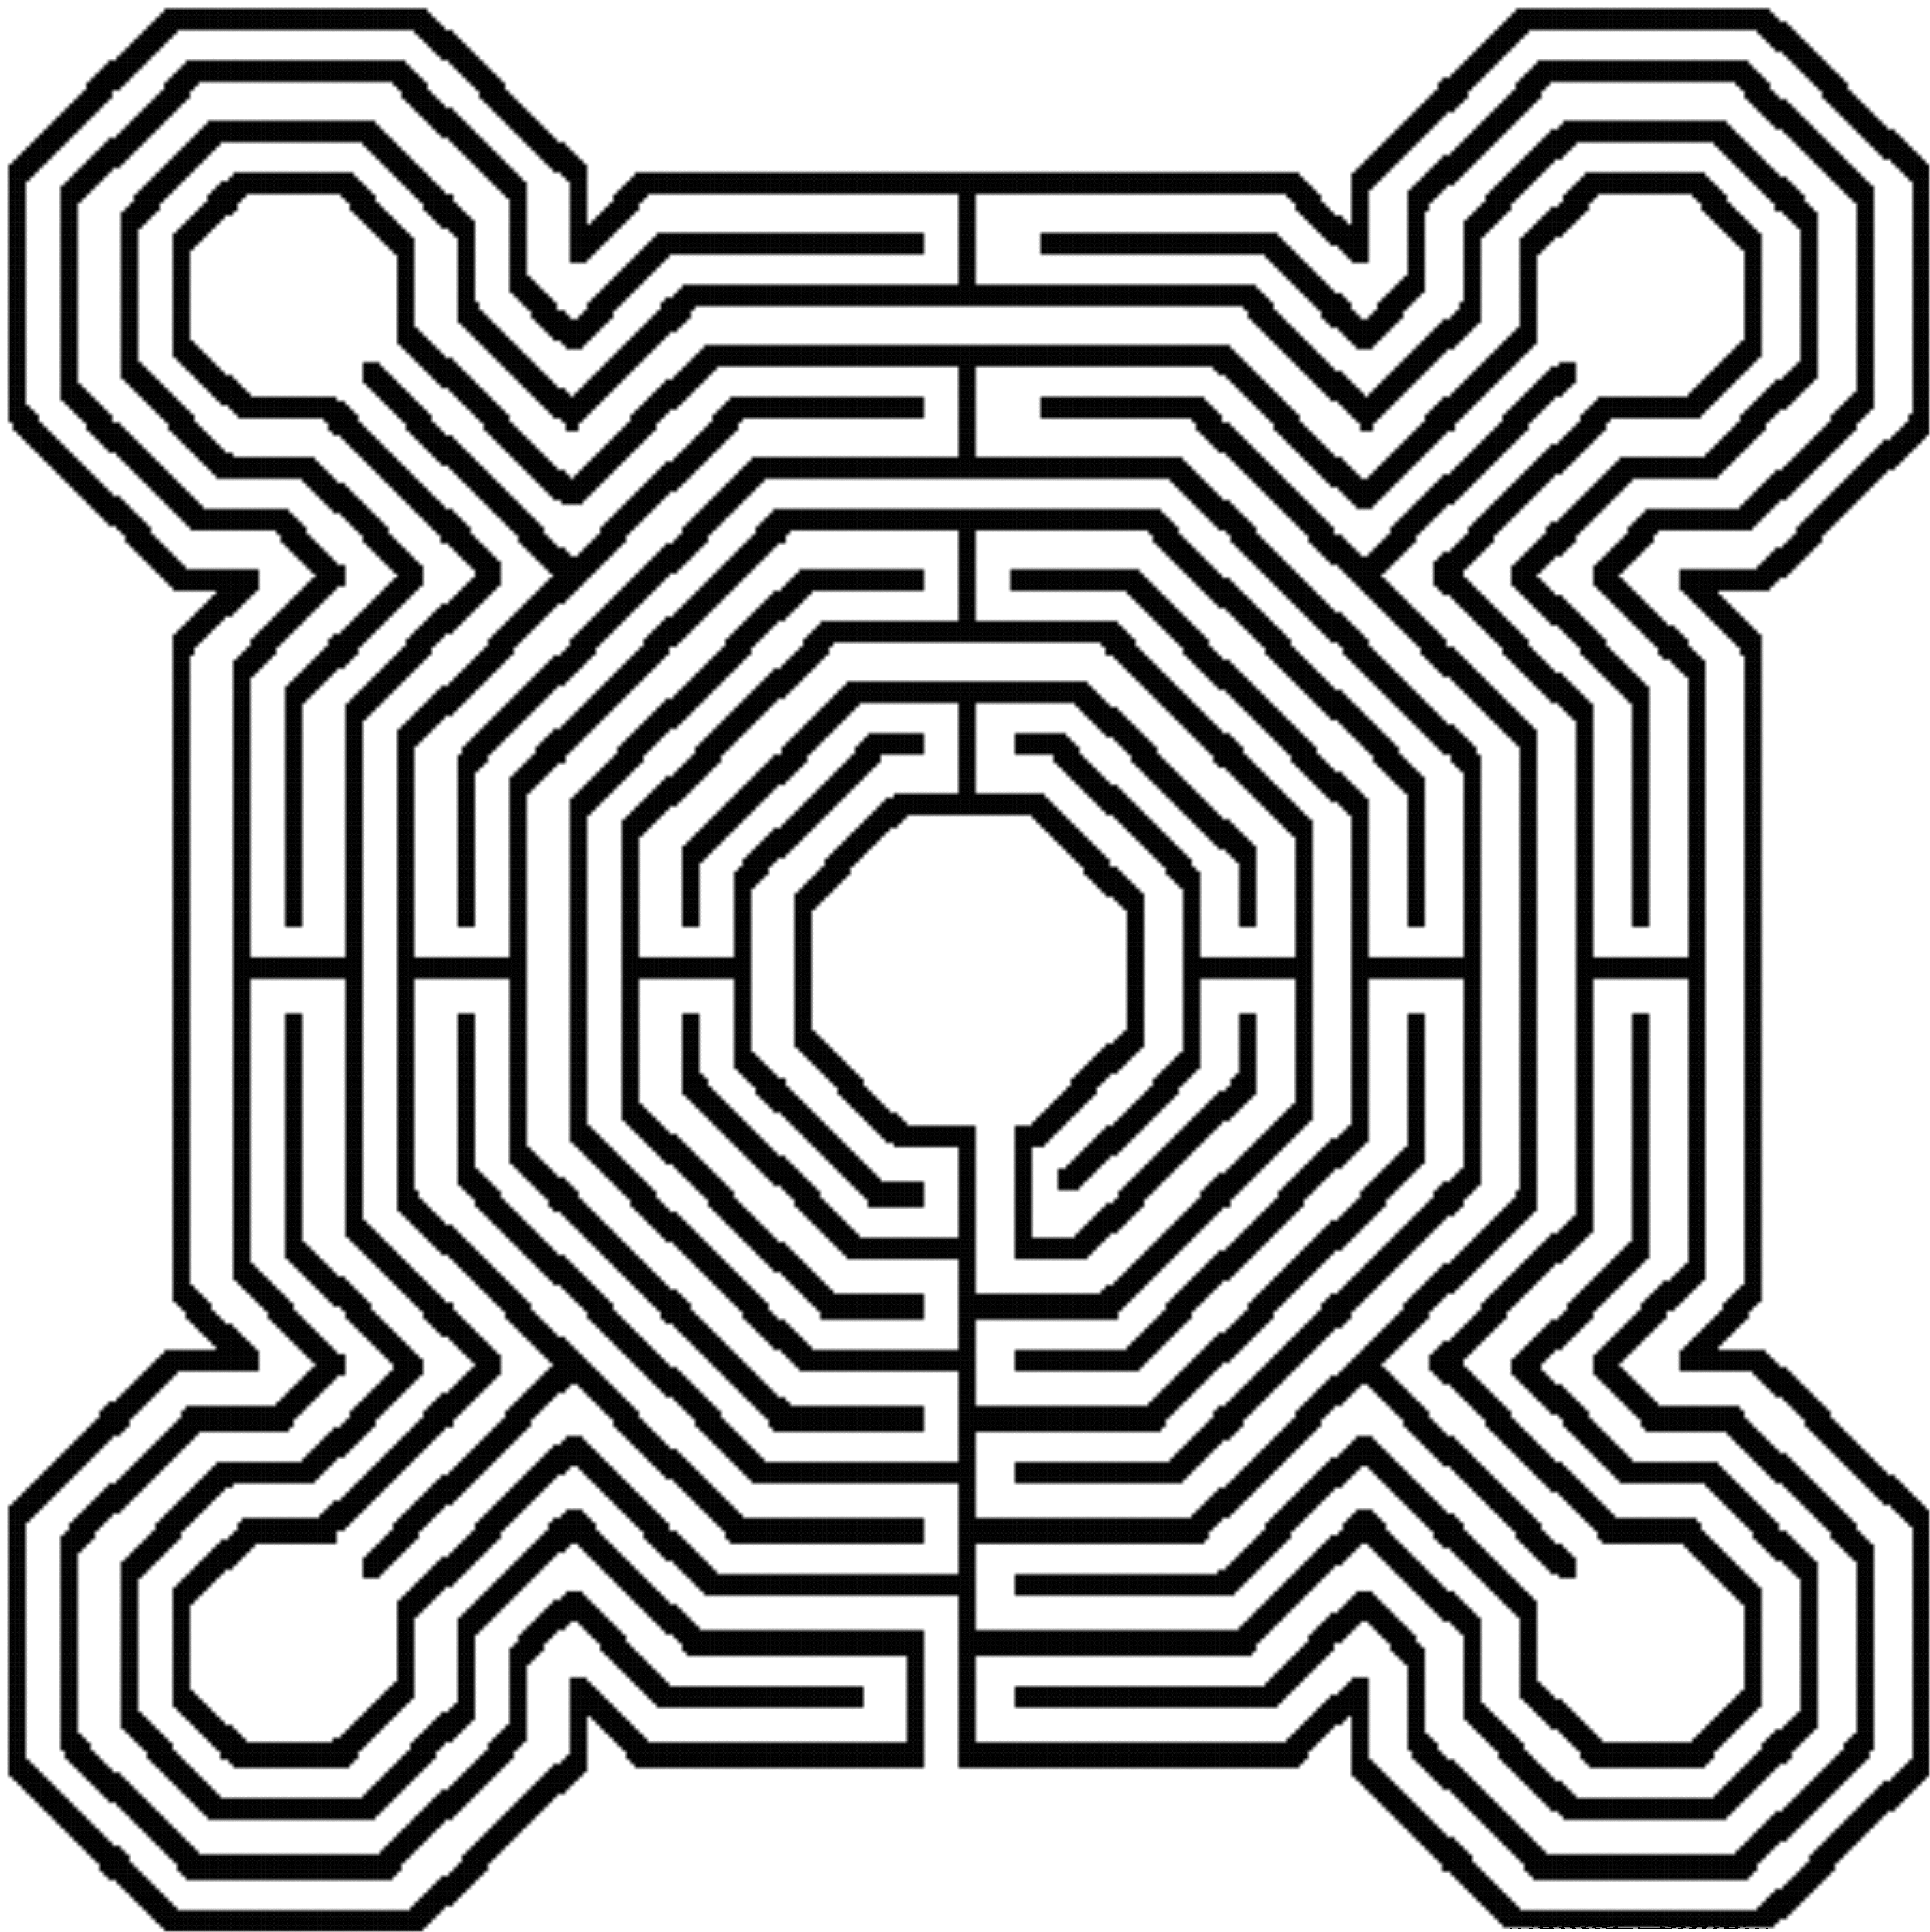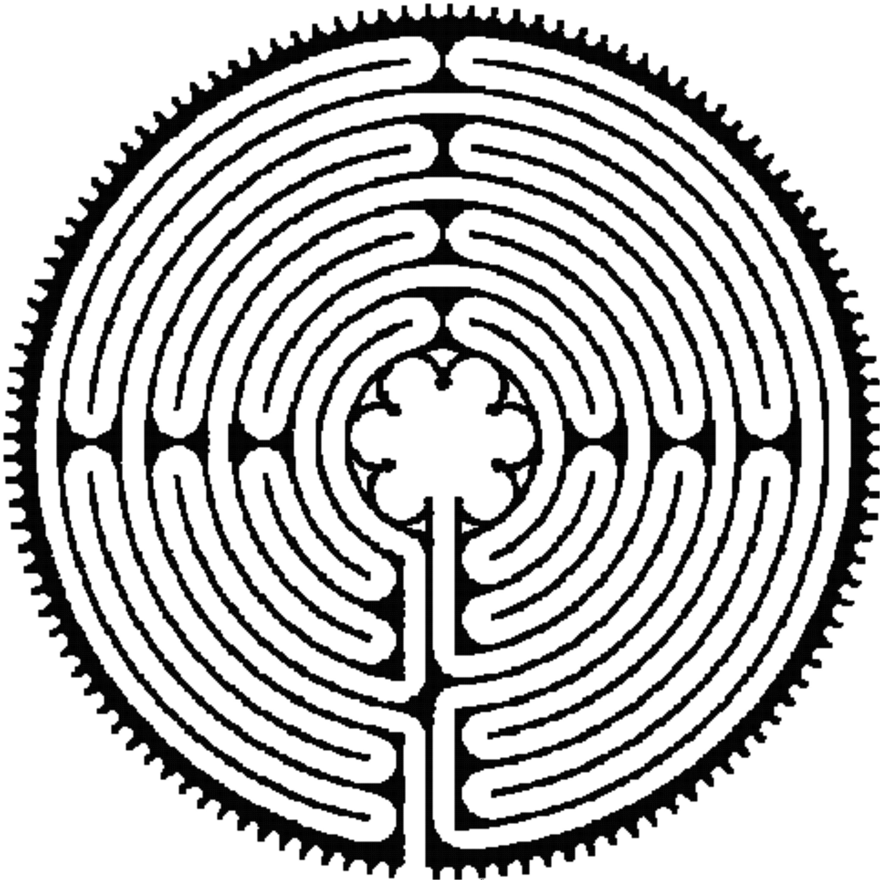

Le labyrinthe de Reims
en version « sol »
c'est-à-dire tel qu'il est supposé avoir existé
sur le sol de la cathédrale de Reims.
Le labyrinthe de Chartres
en version « sol » c'est-à-dire tel qu'il existe
encore
sur le sol de la cathédrale

The Minotaur like the Sphinx, the Centaur, King Kong and the Beauty and the Beast, shows the dual Nature of man. It represents the selfish competitive Ego. It represents the man without a heart, the savage animal red in tooth and claw. The Law of the Jungle. Kill or be killed.
The person only interested in himself to the detriment of everyone around him. The psychopathic personality who only wants for himself and who will do anything, even kill, those who stand against him.

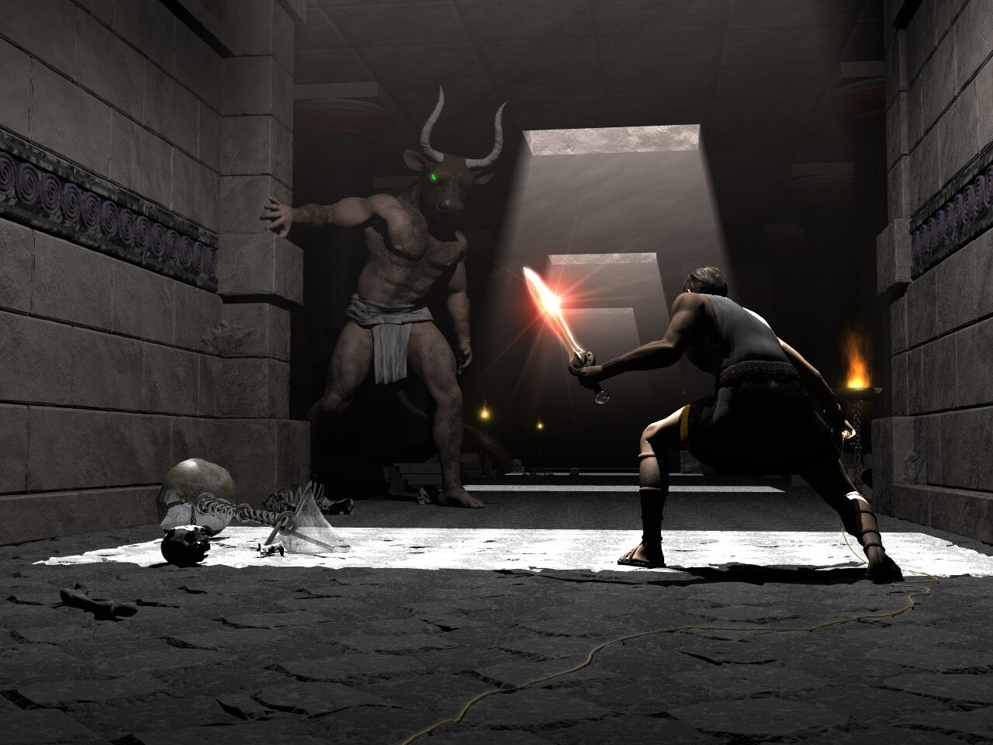
Many people admire Julius Caesar yet when Julius Caesar came to France it contained six million people. After taking it over he had killed one million and one million had been sold off into slavery.
Similarly with Pol Pot of Cambodia, who killed 2 million people. Stalin of the Soviet Union who killed 65 millions of people, 25 million alone during the second world war and sent everyone else to the concentration camps, the Gulags. Mao Tse Tung of China killed off 35 millions during the cultural revolution in the name of holding onto power, and so for many other similar split psychopaths.
In order to open the heart we need to heal the Minotaur within all of us. It is called the initiation of, Opening of the Heart. Removing the Blockages of the heart and this is the function of these ancient secrets of meditation.
Part of the Initiation is explaining the function of the Golden thread which allowed Theseus to find his way safely out of the Labyrinth created by Daedelus a genius of a man whose mind was made of metal and wheels.
Follow the golden thread, it will lead you to safety. The Golden thread is the Golden Circulation of the Energy..... The Secret Of The Golden Flower....

"Meditation is for those who Understand the Urgency of the Situation and the Reality of Enlightenment" - Gautama Buddha
Increase Your Evolutionary Energy Now!!! With Meditation. These Ancient Secrets, known for thousands of years in many different cultures, describe the Most Advanced Techniques of Meditation Available.
Developing Meditation psychic powers to Get in touch with your Life Path, Ground negative Energies, Access Infinite Levels of Universal Energy, Raise Your Kundalini, Integrate the Separated Selves, and Master Relationships and Mediation.
Meditation Enables FOUR Initiations towards your Ultimate Freedom
- Illumination, Nirvana, Emptiness, - Enlightenment.
The Ancient secrets of Meditation gives a system to exponentially increase your energy by mastering the Mind, accessing inner peace, improving health, Mastering Relationships , creating synchronicity and luck, and improving your success.
Learn selfless, highly advanced, meditation techniques which can Quickly!! Increase the Speed of the normal Mind.
Synthesise the Ancient knowledge, bring together ALL these gifts To Enable Your Evolution!!
The Grounding Of Negative Energies Is The Second Formula Of Alchemy
"Solve Et Coagule" said the Alchemists, or "Dissolve to Integrate". The Second Formula Of Alchemy Is Sec, A Latin Word Meaning "To Dry" - Dry out the Water Of The Emotions - get rid of your fear, pain, anger, jealousy and negativity etc. Through the guided meditation of V.I.T.R.I.O.L. The Earth Path of the five Elemental Circulations of the Qi of Chinese Alchemical Taoism.
The ancient phrase, "Drain The Last Dregs Of Your Vitriol" Symbolises how to Get Rid Of All Your Anger And Pain With this guided meditation which is thousands of years old and exists in many different cultures..
The same meditations exist in India as the Kundalini Kriyas.
It exists in China as the Five Elemental Pathways of the Qi of Chinese Alchemical Taoism.
It exists in Europe and Arabia as the Alchemical Meditations of Hermes Trismegistus and his Emerald Tablet.

All of the above Ancient and Effective Meditations, Follow the Golden Thread. Of the Microcosmic and Macrocosmic Orbit of Chinese Alchemical Taoism
This is "The Secret of the Golden Flower" a book translated from Ancient Chinese Taoist sources by Jung.
The Launch pad of Enlightenment and the Creation of Genius!

The Antahkarana, Bridge, Tower of Babel or Babble, Chakras, Meditation, Gurdjieff, Shakespeare, Guru
The tower of Babel is the synonym in the Bible for a human being. In a "normal" human being every part works and communicates together.
The brain, spine and connection with the Soul, the Antahkarana, comprise the tower.
Along the spine are the Seven Major Chakras or parallel processors. As I said, these chakras rarely communicate. They rarely work together. The parable goes that because God was afraid that the Tower of Babel would be built so high as to reach heaven, he purposefully created different languages amongst the various people building the tower.
Because of the lack of communication the tower never got built to Heaven.
The lack of communication between the chakras, or the people building the Tower of Babel, symbolises their lack of integration. Because we are not integrated our psychic bodies will not reach up to heaven. We never managed to contact our Higher Selves. We are not Enlightened.
The Enlightened have built a Tower of communication "Twixt Heaven and Earth".
In the Ancient Sanskrit this Tower has been given the name "The Antahkarana".
It is the psychic wiring, created in mental matter. A thoughtform created dually by the Soul and the aspirant to connect the Crown

Chakra through to the Soul and then to the spiritual triad and then the Monad.
Your evolution is the height of your Antahkarana.
The Astral plane is not flat. Although most people inhabit the psychic slums in the basement of the astral plane in their dreams, when they go to sleep.
It is the "Rainbow Bridge" whereby the Higher frequencies of the energy of the Soul are stepped down to that of the Earth, so that the Earth itself can raise its frequencies, can evolve. We have been created to help in this creative act.
These frequencies are stepped down Octave by Octave through each Chakra which are really Way Stations in the Energy System of the Soul. This is the "Music of the Spheres" of Pythagoras. Because The Enlightened Master Pythagoras was indeed talking of Chakras when talking about the Spheres or the Planets. Each Chakra as it evolves corresponds to one or more of the Planets. This is the secret of Astrology. This is the means whereby the Seven Sacred Suns and the Seven Sacred Constellations in this Sacred Universe affect us.
Each Chakra, when working correctly, acts like a Transformer in an Electrical system to halve the Energy Frequency of God. The frequency drops Chakra by Chakra, "Station by Station" as said David Bowie, on its way down to this planet because as Gurdjieff said "Normal Human Beings are transmitters of Cosmic Energy".
And this is the function of Normal Human Beings. Those who are Enlightened. To transmit the Energy of The Soul. Whereby the higher energies of Truth, Prophesy, Intuition and Initiation are sent down towards this Planet.
Where the Higher Energy Frequencies of God create the Higher Energy Thoughtforms towards which the Median of the Masses are moved as they evolve and as the Earth Spirit Evolves.
Because the Energy Transmitted by the Enlightened is used to raise the frequency level of the Earth itself and all the people on it. To transmit the Light of Love down on to this planet of Love.
To dissolve the Selfishness of the separated selves, those "Law of the Jungle" Egos who cannot communicate with The Higher Self. Who think of themselves as Separate. Who think themselves Apart. Who do not know that they too are A Part of the Universe of God Itself. Those who are not connected. Those who have not been touched by God. Those who are not "Made".

The Enlightened exist to bring light into darkness. To dissolve the darkness and this itself is the meaning of the Sanskrit word "Guru". A person who dissolves or Transmutes Goo is a GooRoo.
And this is done through the Light of the Soul. Brighter than Ten Thousand Suns it exists alone. Unchangeable. Like Fire it lights everything with which it comes into contact. And once you are lit, you too burn with the Fire of the Soul. Like Prometheus you bring down the Fire of God onto the Earth, for the Benefit of every living being. Hari OM Tat Sat.
This is Sat Chid Anand.

Energy Enhancement The Alhambra And The Alchemical Trinity Meditation the Antahkarana
The Alhambra And The Alchemical Trinity Meditation - Many Sufi mystics came from organisations with names like the builders or the lock makers (Naqshbandhi).
A Plan of a pool at the Alhambra Granada shows The Key and the Lock. When you go to the Alhambra in Granada, Spain, you come across many symbols of Sufism. Above is the plan of the Pool of water (Rectangle) in front of one of the beautiful buildings there. And a fountain (Circle) with a water channel between the two. The water from the fountain comes out of the little circle in the center of the bigger circle and flows through a channel into the pool. And here below is a picture of that fountain at the Alhambra of Granada when we used to live near there, with one of our Students, Dr Thomas Fluellen, whose Energy Enhancement Testimonial is available at Energy Enhancement.
The symbolism is obvious given what has just been told about the meditational symbolism sword in the stone and St Michael in an earlier chapter of the Energy Enhancement Book, available to Download Online at Energy Enhancement.
The large circle of the fountain above is the Earth. The little circle in its center is kundalini energy which flows in every direction from the Kundalini chakra in the center of the earth, but is then channelled through the Antahkarana, the channel, into the pool, the

ocean of bliss, the Soul, the central spiritual sun of Gurdjieff. This represents the Trinity.
The fountain and the channel looks like a Key, does it not? Therefore here is the key of the Lockmakers, the Sufi Naqshbandi.
The Secrets Of Energy Enhancement On The Nature Of The Energy Flows Of The Universe And Humanity Come From Deep And Ancient Sources.
The Parallel Processor Model Of A Human Being. Super Computers gain speed through the number of processors connected. Each Chakra is a processor gaining more intelligence the higher they go. As more processors are connected, so a human being gains more wisdom. The communication bus connecting the chakras together is the Antahkarana.
Established Established in the connection with God is Enlightenment. Each Incarnation is Unique and dependant on the Quality and Quantity of the connection. Of the size and function of the Spiritual Body and the components of the Spiritual Body of the Enlightened Person. Established in the soul, sanskrit- Stithyapragnyam.
Roshi Hogen.. As my Master Roshi Hogen says "The spring at the top of the Mountain."
By accessing this energy we get in touch with the path we will take when we die.
By accessing this energy we subordinate everything else in our lives to this higher connection, to this Higher Energy. Then, every lower pleasure is subordinated to this energy. Everything in our lives starts to get put into its correct place..
Everything in our lives is important and should be used correctly, but when these lower things are put in control, when we become addicted to them. Then we have life problems.
Food, Relationships, Sharing the energies of the Psychic Sexual Connection, Sex, Power, Money, Property are all good and necessary when in their proper place.
Put Everything In Its Proper Place. Feeling the orgasmic Higher Energies from the Connection to chakras above our heads makes us understand that everything else in our lives is good... but not that good!!
"Connect, Only Connect", Said Goethe. The Higher Energies Rule.. Ok!!

We access the energies of Initiation which take us ever Higher.
Energy Enhancement gives the guided meditation talked about above which is also called the Macrocosmic Orbit of Chinese Alchemical Taoism, The Hindu Kundalini Kriyas, and the Sufi Alchemy of Hermes Trismegistus encapsulated in the Emerald Tablet.
All the same Guided Meditation taught in one initiation of Energy Enhancement together with 28 more ancient and effective techniques to enable you to achieve control of your mind, an enhanced IQ, control over all your negative emotions, anger, fear, depression on the path of the ultimate Samadhi and enlightenment itself.
These meditations separated by thousands of years, miles and countries show the universal nature of these ancient and successful methods now available in this culture, here and now, with Energy Enhancement.

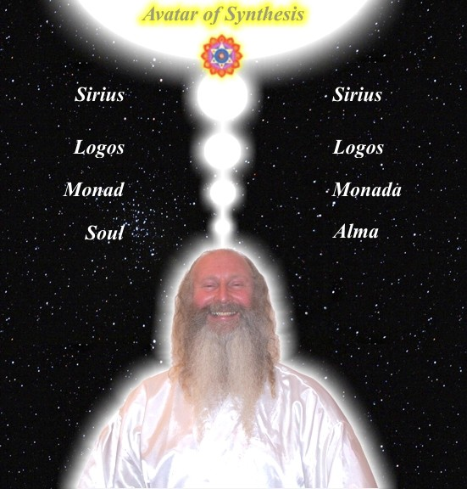

Energy Enhancement The Shiva Lingam Meditation And The Trinity the Antahkarana, and Connection

The Shiva Lingham and Yoni come from the India and the Ancient, 5000 years old Hindu religion. It is a meditation, inscribed in Stone which is at the heart of every Hindu temple. It is a meditation inscribed in stone whose meaning has been lost in history but which is now taught in Energy Enhancement.

The Shiva Lingham and Yoni is a 5000 year old sculpture, a diagram, a key which describes the natural flow of energy between man and the energies of the universe. How energy comes from heaven, the Spring at the top of the mountain, the Center of the Universe, through a human being, a purified human being with no

energy blockages, illuminated, enlightened, and down into the Kundalini chakra in the center of the earth.
There, in the chakra in the center of the earth, the negative energies are transmuted and healed and importantly, the direction of the energy is changed, rectified, and then travels up through the human being again from the center of the earth and up into heaven. This is the Macrocosmic orbit of Alchemical Taoism and also the Kundalini Kriyas.
The base of the Shiva Lingam, the Yoni, looks like the Sufi Alhambra Fountain fountain in Granada, Andalusia, Spain where the center represents the center of the earth. These two sculptures from two completely different countries and cultures separated by thousands of years and miles show how these universal principles are again and again brought into the cultural mix of humanity for their evolution.
The Shiva Lingam (Penis of Shiva) takes the part of the upwelling water of the fountain and represents the Antahkarana. In ritual worship, milk is poured over the Shiva Lingam representing the descent of energy from the Center of the universe into the center of the Earth. It comes out of the Yoni (Female Genitals) which symbolise the earth and the antahkarana through the yoni spout shooting spiritual energy out of the center of the earth like the water of the fountain comes out of the Alhambra fountain into the pool through the Antahkarana channel and up into heaven, the pool, the ocean of bliss
This represents the change in direction of the energy which occurs in the center of the earth and shoots the energy back from earth to heaven. This is the Taoist Macrocosmic orbit, a guided meditation which has so many benefits and which is taught in Energy Enhancement.
The secrets of Energy Enhancement on the nature of the energy flows of the universe and humanity come from deep and ancient sources.
The parallel processor model of a human being. Super Computers gain speed through the number of processors connected. Each Chakra is a processor gaining more intelligence the higher they go.
As more processors are connected, so a human being gains
more wisdom. The communication bus connecting the chakras together in a man, and with the energies of the earth and the universe itself is the Antahkarana.

Picture of the Fountain flowing into the Pool at the Alhambra with Energy Enhancement Student, Doctor Thomas Fluellen.
As my Master Roshi Hogen says "The spring at the top of the Mountain." is heaven. All energy comes from this. It is the chakra in the center of the universe whose energy powers everything.

Illness is caused by a lack of energy. We can only heal ourselves when we learn to fill ourselves with energy by these methods of getting rid of the blockages to this energy flow, the energy blockages in you!
Energy is a glow. Energy is beauty. Energy is health. Energy is happiness. Energy is concentration and memory and your ability to respond. Learn practical methods to access these Infinite Energies. Gain Energy!
The Fourth Initiation of EE is the most important Initiation of Energy Enhancement. Other Initiations teach us about the Negativities and attitudes which stop this highly Energetic Soul Connection. Other Initiations teach us how to use this Higher energy in the correct way.
In this Initiation we learn Methods of Accessing the Infinite Energy of the Higher Mind. Easy and practical meditations based upon Ancient Methodology of 200,000 years duration whose track record of success is greater than any other system!
By accessing this energy we get in touch with our Intuition, our Direction, our Soul Path. Put Everything In Its Proper Place.
Feeling the orgasmic Higher Energies from the Connection to chakras above our heads makes us understand that everything else in our lives is good... but not that good!!
"Connect, Only Connect", Said Goethe. The Higher Energies Rule.. Ok!!
We access the energies of Initiation which take us ever Higher.

Energy Enhancement Initiation 4 The Macrocosmic Orbit And The Antahkarana
The Antahkarana is a psychic body which is you or rather your greater self yet you inhabit only a small part of yourself.
You inhabit only the seven chakras whereas the Antahkarana is a column of energy which connects all the chakras and stretches from the Kundalini chakra in the center of the earth, through you and up through your crown chakra through all the chakras above your head, to God.

The Antahkarana is the communication bus, the energy of the Holy Spirit, which connects between Heaven and Earth – a taoist concept.
These three are the Holy Trinity. Our Father who art in Heaven, the Son/Earth Mother and the Holy Spirit.
These three are Sat Chid Ananda.Sat – the Truth – that which never changes, Chid – the receptive mind, the purified mind which then becomes a receptive instrument for listening to the Soul and Ananda or Bliss – the stream of energy which flows between Sat and Chid.
These three are the Hindu Trimurthy. Brahman, Vishnu/Shakti and Shiva. Brahman is the Truth – that which never changes – the original cause. Vishnu is the Son, Krishna and The Earth Mother Kundalini Shakti. Shiva is the destroyer, the Lightning of Zeus or Deos or Theos the Fire which flows from Heaven to Earth probably brought by Prome theus
These three are Om or AUM the trinity or sounds which unify the Universe. The Sacred Word. A, vibrating in the Center of the earth, awakening Kundalini Shakti. U vibrating in the Heart awakening the Son, the receptive purified mind, the Christ, The Krishna. M vibrating in the forehead, Sahasrara chakra, and as your breath fails you project it into the center of the Universe above your head, to God, to Brahman, to Atman, to the One God with 10,000 names.
These three are the Sufi HUM. These three are the Christian AMEN
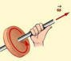
The Antahkarana in terms of the Emerald Tablet of Hermes Trismegistus is that which communicates between the Sun Soul Chakra and the Earth Center Kundalini Chakra.
The Antahkarana is a column of energy in motion between the two points of the polarities of the Kundalini Chakra in the center of the Earth and the Soul Chakra in the center of the Universe.

The energy circulates both towards and away from these poles at the same time creating a column of energy.
As the force energy flows between these two points a circular magnetism is created around the column.

In physics we call this circulation or spiral of energy around motion in a direction by the, "Left hand rule" like magnetic force spirals around light rays in the direction of motion.
In the same way spiritual magnetic force spirals around spiritual energy anticlockwise in the direction of motion away from you and clockwise as it comes towards you.

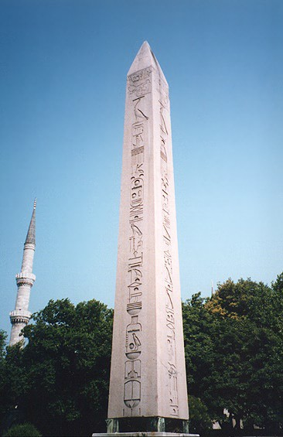
THE ANTAHKARANA, SHIVA LINGAM, PENIS OF OSIRIS, OBELISK

The Egyptian Obelisk is the Penis of Osiris is the physical, artistic, objective art, representation of the Antahkarana or the tower which connects all the chakras, below the base chakra, in the body and above the head, together.
The Tower. The Tower struck by Lightning. The Rainbow Bridge which connects all the infinity of chakras from the center of the earth chakra through the seven chakras of the body and up through the infinity of chakras above the head.
spire, inspire, aspire. Every brick aspires to become a Cathedral

IMAGINE THE AXIS OF THE ANTAHKARANA COMING OUT OF THE CENTER OF THE DRAWINGS BELOW AS THE SWASTIKA OR CHOKU REI TURNS AROUND ITS CENTER.
THE ANTAHKARANA IN THE TIBETAN BUDDHIST PRAYER WHEEL

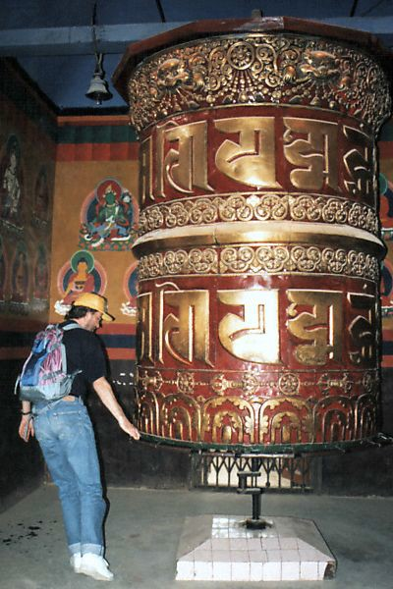

THE TIBETAN PRAYER WHEEL TURNS AROUND IT’S AXIS WHICH REPRESENTS THE ANTAHKARANA. IT TURNS IN A CIRCLE EITHER CLOCKWISE SENDING ENERGY UP INTO THE CENTER OF THE UNIVERSE OR ANTICLOCKWISE - "WIDDERSHINS" SENDING ENERGY INTO THE CENTER OF THE EARTH.
THE CLOCKWISE OR ANTICLOCKWISE MOVEMENT SENDING ENERGY UP OR DOWN IS SYMBOLISED BY THE CLOCKWISE OR ANTICLOCKWISE SWASTIKA OR THE CLOCKWISE OR

ANTICLOCKWISE ORIGINALLY TIBETAN CHOKU REI SYMBOL OF REIKI.



ANTI-CLOCKWISE AND CLOCKWISE SWASTIKAS

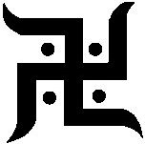

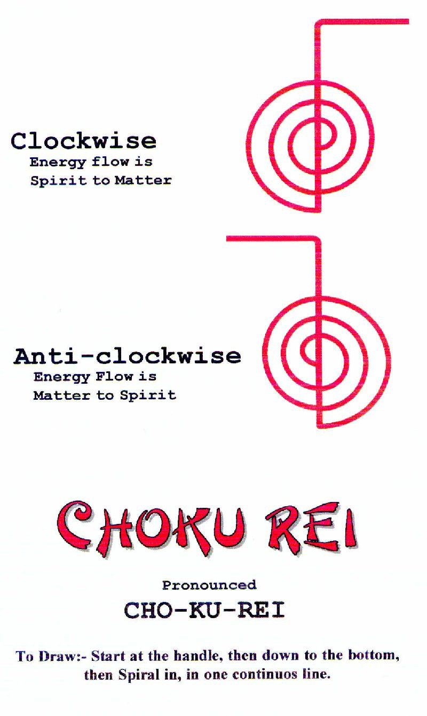

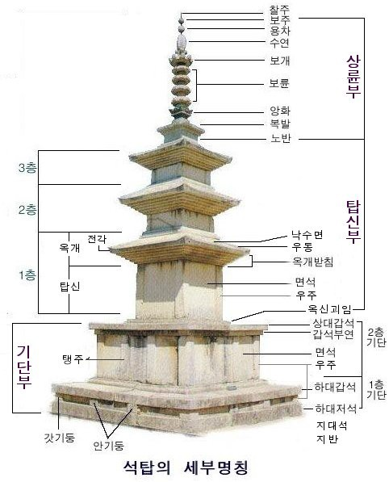

Buddhist Stupa showing the representation of the Jhanas, or Chakras above the head.


The Native American Indian Totem Pole has many chakras, gods, blockages and CHAKRAS on the way up the Antahkarana to the Eagle of Don Juan and Castaneda.



The Alchemical Cosmic Egg
"When the Supreme Ultimate and the Immaterial Spirit unfold, the Point at the crown of your head opens and the light or tunnel or shaft leading to the Cosmic Egg is revealed"

See the file on the ALCHEMICAL Emerald Tablet of Hermes Trismegistus and the Alhambra in Granada, Spain, once a Sufi School, for more examples of the Antahkarana built in Stone.

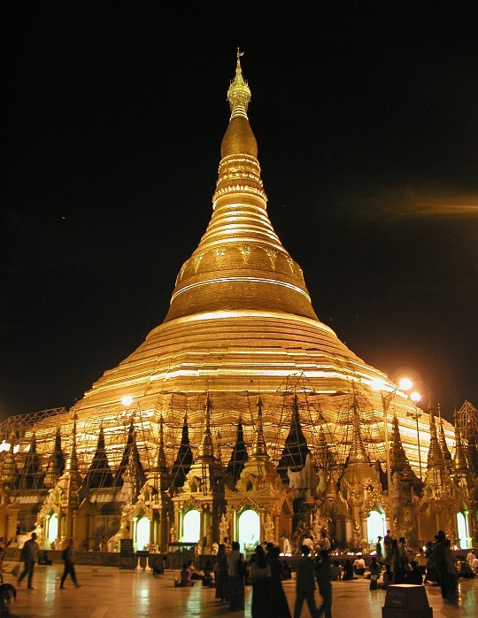
Chakras above the head – Buddhist Shwedagon Pagoda at night
You can read the other Energy Enhancement Book – Super Energy and Sacred Symbols - for more information on the Antahkarana
Energy Enhancement contains methods of Accessing Infinite Energy. The Energy of the Soul. The Energy of the Monad. The Energy of the Logos. the Energy of the Avatar of Synthesis.

Perhaps access to Ascended masters and our past lives along your Antahkarana.
Energy Enhancement contains 28 ancient and effective techniques including the Macrocosmic orbit and the Antahkarana to enable you to achieve control of your mind, an enhanced IQ, control over all your negative emotions, anger, fear, depression on the path of the ultimate Samadhi and enlightenment itself.
The Emerald Tablet of Hermes Trismegistus describes the macrocosmic Orbit of the Taoists and of Energy Enhancement.
Here we are concerned not only with the amount of Energy, but also with the quality, the height of the vibration of the energy up the Antahkarana or Axis Mundi or Omphalos (OM Phallus) which alone determines the height of our Evolution.
  - Psychic Purification of the physical, emotional, mental, and spiritual Bodies
  - The removal of Energy Blockages and implants
  - The creation of the Light Body
  - The use of the Merkaba
  - Golden Pyramid Psychic Protection
  - Energy Blockage Removal with the Seven Step Process

Energy Enhancement The Paramahamsa The Yin Yang Symbol, Yogananda And The Transmutation Of Energies
An enlightened being is sometimes given the title Paramahamsa. This refers to an ancient Hindu myth of when the world was young, the whole of the surface was covered with water. The mischievous Gods mixed milk and poison in the water and stirred it all together. Paramahamsa was the name meaning the Great White Swan.
This enormous Swan, is said to have had the ability to put its beak deep down into the water and draw out pure milk. It had the capacity to discriminate and draw in only the milk, which is the reason it remained white, and reject the poison water. Not only that, a Paramahamsa, an enlightened being, has the capacity of

changing water into wine, poison into milk, Yin into Yang, black into white.
Aham also means the self. Para means higher. A Paramahamsa is one who is in constant contact with the higher self and this is only possible when the lower self is being constantly cleaned through transmutation of the negative energies of the body aches and pains, emotional body anger, depression and fear, and the mental body.. wrong thoughts like selfish desire, ignorance of the soul and selfish attachment.
He can only do this by learning the psychic powers of the digestion, the transmutation of energy. As Gurdjieff, one of the greatest Sufi Masters who ever came to the west, said First Mastic, Then Mystic!!
THE YIN YANG SYMBOL This Yin Yang drawing symbolises the process, the guided meditation, whereby we too can do the same. It shows how to keep free of negative influences and energies by transmuting them (The secret of the Philosophers Stone is given in Energy Enhancement Initiation Three) within our energy systems.
The Function of a Paramahamsa. The Function of an Enlightened being. The Function of Energy Enhancement Apprentice Level 1.
Energy Enhancement Initiation Two - The Circulation of the Energy, The Taoist meditations and the Kundalini Kriyas are an Indispensable tool for those wishing to evolve through the transmutation of energies..
Also the Labour of Hercules involving the Hydra. As Hercules chopped off one head with his sword another 2 grew back in its place. The Hydra symbolises the mind. Its heads the many thoughts we have which need to be dissipated.
The Dragon/Hydra always Symbolises Kundalini Energy.
The method of Energy Circulation is an ancient and hidden technique preserved in Taoism and Hindu Kundalini Kriyas.
It is the most gentle and effective tool for all those who want to increase their energy, their evolution, their genius.
The Energy Circulation Meditation of Energy Enhancement, the Taoists and of the Kundalini Kriyas.
The same meditation
With This Technique, Your Evolution Will Increase With Every Energy Revolution To Create A Revolution In Your Evolution. - Paramahamsa Yogananda On The Kriyas Of Kundalini of Babaji, the 2000 years old sage in the Himalayas, of Sri Yukteswar and Lahira Mahasaya of Kriya Yoga.

The same meditation
The Alchemical Meditations of Hermes Trismegistus from the Emerald tablet or from the Sufi Dun Nun, the Egyptian, he who took, The Path of Blame symbolized by the Sufi Naqsbandi Fountain at the Alhambra at Granada in Spain.
The same meditation
The Five Elemental Paths of the Ki of Chinese Alchemical Taoism symbolized by the Yin Yang Symbol.
The Energy Enhancement Apprentice Level One Course - Gaining More Energy - Meditation, Shaktipat, Energy Circulation, The Kundalini Kriyas, The Five Elemental Paths Of The Chi Of Chinese Alchemical Taoism, The Grounding Of Negative Energies, V.I.T.R.I.O.L, The Art Card Of The Thoth Tarot, Access To Kundalini Energy, Strong Psychic Protection, Learn The Merkaba, Pyramid Protection, Power Tower Protection, Create The Antahkarana, Soul Fusion, Monadic Infusion, Logos Infusion. The Painless Removal Of Stress, Trauma And Negative Emotion.

Energy Enhancement and the Zen Story Of Hyakujo, A Zen Story Of The Antahkarana And The Higher Self
The Antahkarana is the communication bus, the energy of the Holy Spirit, which connects between God, an infinity of chakras above the head, the first of which is the Soul Chakra raining lightning – the energies of the Soul of will, love, intuition and genius from heaven through our seven chakras into the center of the Earth.
These three Heaven, Antahkarana and Center of the Earth represent the Trinity. The Father, the Earth Mother and the Holy Spirit or Sat Chid Ananda. We ourselves, our seven chakras, represent the Son who resides on the surface of the planet.
The Antahkarana in terms of the Emerald Tablet of Hermes Trismegistus is that which communicates between the Sun and the Earth.
It has these physical representations from antiquity

The Obelisk is the physical, artistic, objective art, representation of the Antahkarana or the tower which connects all the chakras together. The Egyptian Obelisk like Cleopatras Needle in London, from thousands of years of Antiquity.
The Tower. The Tower struck by Lightning of the Energy of the Soul of the Tarot. The Rainbow Bridge which connects all the infinity of chakras from the center of the earth chakra through the seven chakras of the body and up through the infinity of chakras above the head.
Spire, inspire, aspire - Every brick aspires to become a Cathedral, every angel wants to become part of a greater gestalt.
The Sufi Inspired Minaret of the Blue Mosque in Turkey even has the representation of the chakras above the head built up the towers.
But only three. Now we need to go higher.
Buddhist Stupa showing the representation of the Jhanas, or Chakras above the head.
The Native American Indian Totem Pole has many chakras, gods, blockages on the way up the Antahkarana to the Eagle.
In the story below the horse whip is the "finger pointing at the moon" it is the antahkarana. We do not use it because it is higher than the intellect. We are apart from it and yet it is part of ourselves. And when we do not use it or get in its way we are then the witness of its use by our higher selves. Then the flowers shower. The energy of the higher self rains down upon our crown chakras, and we are deafened by the lightning bolt of energy which energizes us from on high. Commentary, Satchidanand.
When Hyakujo first arrived at Chiang-si to pay his respects to Ma Tzu, Ma Tzu inquired, "from where have you come?"
"From the great cloud monastery at Yueh Chou," answered Hyakujo. "and what do you hope to gain by coming here?" asked Ma Tzu.
Hyakujo replied, "I have come seeking the Buddha-dharma."
To this Ma Tzu replied, "instead of looking to the treasure house which is your very own, you have left home and gone wandering far away. What for? I have absolutely nothing here at all. (Nothing, or anatta, nirvana, is the higher self, so really he is saying, Here I have God!! commentary Satchidanand) what is this Buddha-dharma that you seek?"
Whereupon Hyakujo prostrated himself and asked, "please tell me to what you alluded when you spoke of a treasure house of my very own."

Ma Tzu replied, "that which asked the question is your treasure house. It contains absolutely everything you need and lacks nothing at all. It is there for you to use freely, so why this vain search for something outside yourself?"
No sooner were these words spoken than Hyakujo received a great illumination and recognized his own no-mind. Beside himself with joy, he bowed in deep gratitude. (the treasure house is the higher self, the soul, the monad, the logos and higher, and when the student is ready, then the Master can open the floodgates of the energies of the Soul to his student by an act of his higher self or will - commentary by Satchidanand)
Hyakujo spent the next six years in attendance upon Ma Tzu. But as Tao-Chih, his first teacher, was growing old, he wanted to return to look after him.
Before Hyakujo left Ma Tzu, he went to pay his final tribute to him. Seeing him coming, Ma Tzu raised his horse whisk straight up.
Hyakujo asked, "are you in the use of it, or apart from the use?"
Ma Tzu hung the horse whisk on the corner of his chair. After a minute or so, he asked Hyakujo, "hence forward, how do you open those two leaves of your mouth to work for others?"
At this, Hyakujo took the horse whisk and raised it straight up. Ma Tzu said, "are you in the use of it, or apart from it?" Hyakujo hung the horse whisk on the corner of the chair.
Just at that moment, a great roar, like hundreds of thunderbolts falling, rained on Hyakujo's head. Ma Tzu had given a shout which, it is said, deafened Hyakujo for three days.

Energy Enhancement And Secret Knowledge At Chartres
Here I am not referring to Freemasonry, but to the idea that there has been knowledge kept secret, spiritual knowledge, secret meditations and in particular knowledge of the secrets of art and architecture. After the age of the cathedrals, the Middle Ages, with the Renaissance, and up to the present, the development of humanity in the European tradition turned to the development of the intellect, reason, logical thought, as distinct from instinct and intuition. We have gained enormously from this development, and we can see with a clarity previously impossible, but a combination

of ego and rationality has demanded an understanding which commands its subject. An illusory desire for reason to command all, meeting the fact that reason cannot command all, produces the concept of secrets, secret knowledge.
There is an essential knowledge, but it is not secret, just difficult to put into practice, so it is sometimes easier to hold the concept of secret knowledge, not available to me. There have been all sorts of ideas about secret schools preserving knowledge of architecture across the centuries, and this usually settles upon geometrical systems of proportion and composition. Harmonious proportions and number symbolism were used, and these harmonies are inherent in the human mind, and emerge naturally when composition is undertaken by a pure mind.
The search for secret knowledge is often promoted by people who are avoiding their own self discovery. There have been times when knowledge had to be kept secret from oppressive authorities - time when religious institutions were both decadent and powerful, but even then the real knowledge can be expressed in a way that communicates without offence. Maurice Maeterlinck, author of the play The Blue Bird, wrote his book The Great Secret about seventy years ago. He said that the secret had been openly expressed again and again, and it told who you really are, something quite simple, but entailing in its acceptance a certain sacrifice, of who you are not, THE EGO, a sacrifice many are unwilling to entertain, and, consciously or unconsciously, prefer to see the truth as hidden from them, requiring a profound search. Your search is hindered only by yourself.
The cathedral is also full of number symbolism, not the construction of a rational meaning out of numerical analysis, but from an underlying sense that every number, and particularly the numbers from 1 to 12 had a transforming meaning. One was the number of original unity, and two the number of the first division. The higher Three chakras was the number of the divine, and the lower four chakras the number of the world. Seven chakras, the sum of three and four, represented the steps or completed cycle from earth to heaven, and eight, the soul, the next, signifying rebirth and new life, and 12, chakras higher and higher , the product of three and four, God and the world, were all also important.
Chartres is full of threes and sevens. Apart from the threes The Trinity, Sat Chid Ananda, Heaven Antahkarana Earth, Brahma Shiva Vishnu, Father Son Holy Spirit – all the same concept - inherent in the layout and height of the building, the transepts and the choir

each have three bays, there are three portals, each with three doors. and three stories to each tower.
The trinity - The Sun Father, the Earth Mother and the Holy Spirit communicating between them.
At Chartres, there are seven bays, seven chakras, to the nave, seven bays between the crossing and the east window, and seven bays to the apse and ambulatory. The pilgrimage to Chartres, from the secular to the sacred, and the pilgrimage through Chartres, through the sacred to rebirth, can be seen as journeys of seven steps, with, like the chapels of the ambulatory, three principal aspects. Seven is also the number of the gifts of the body and the gifts of the soul, shown in both transepts. Chartres expresses a unifying and transforming symbolism in the very fabric of its architectural design. It was the first high cathedral with only three storeys, the model for all later cathedrals.
Internally and externally, height is a principal attribute, and not only height, but verticality – the spire, aspire. The whole design is expressed in terms of vertical lines. This is an enormously heavy stone building, which could have been expressed as stable and earthbound, but with all the stone masses expressed as bundles of vertical shafts, and with pointed arches formed like arrows to heaven, the emphasis is upward: gravity is transformed and the building leads the eye upward, an upward emphasis that is read psychologically as a spiritual ascent.
The secret meditations encapsulated in the Cathedral of Chartres is part of the Energy Enhancement Synthesis of Light twenty eight ancient and effective techniques to enable control of the mind, an enhanced IQ, control over all negative emotions, anger, fear, depression on the path of the ultimate Samadhi and enlightenment itself.
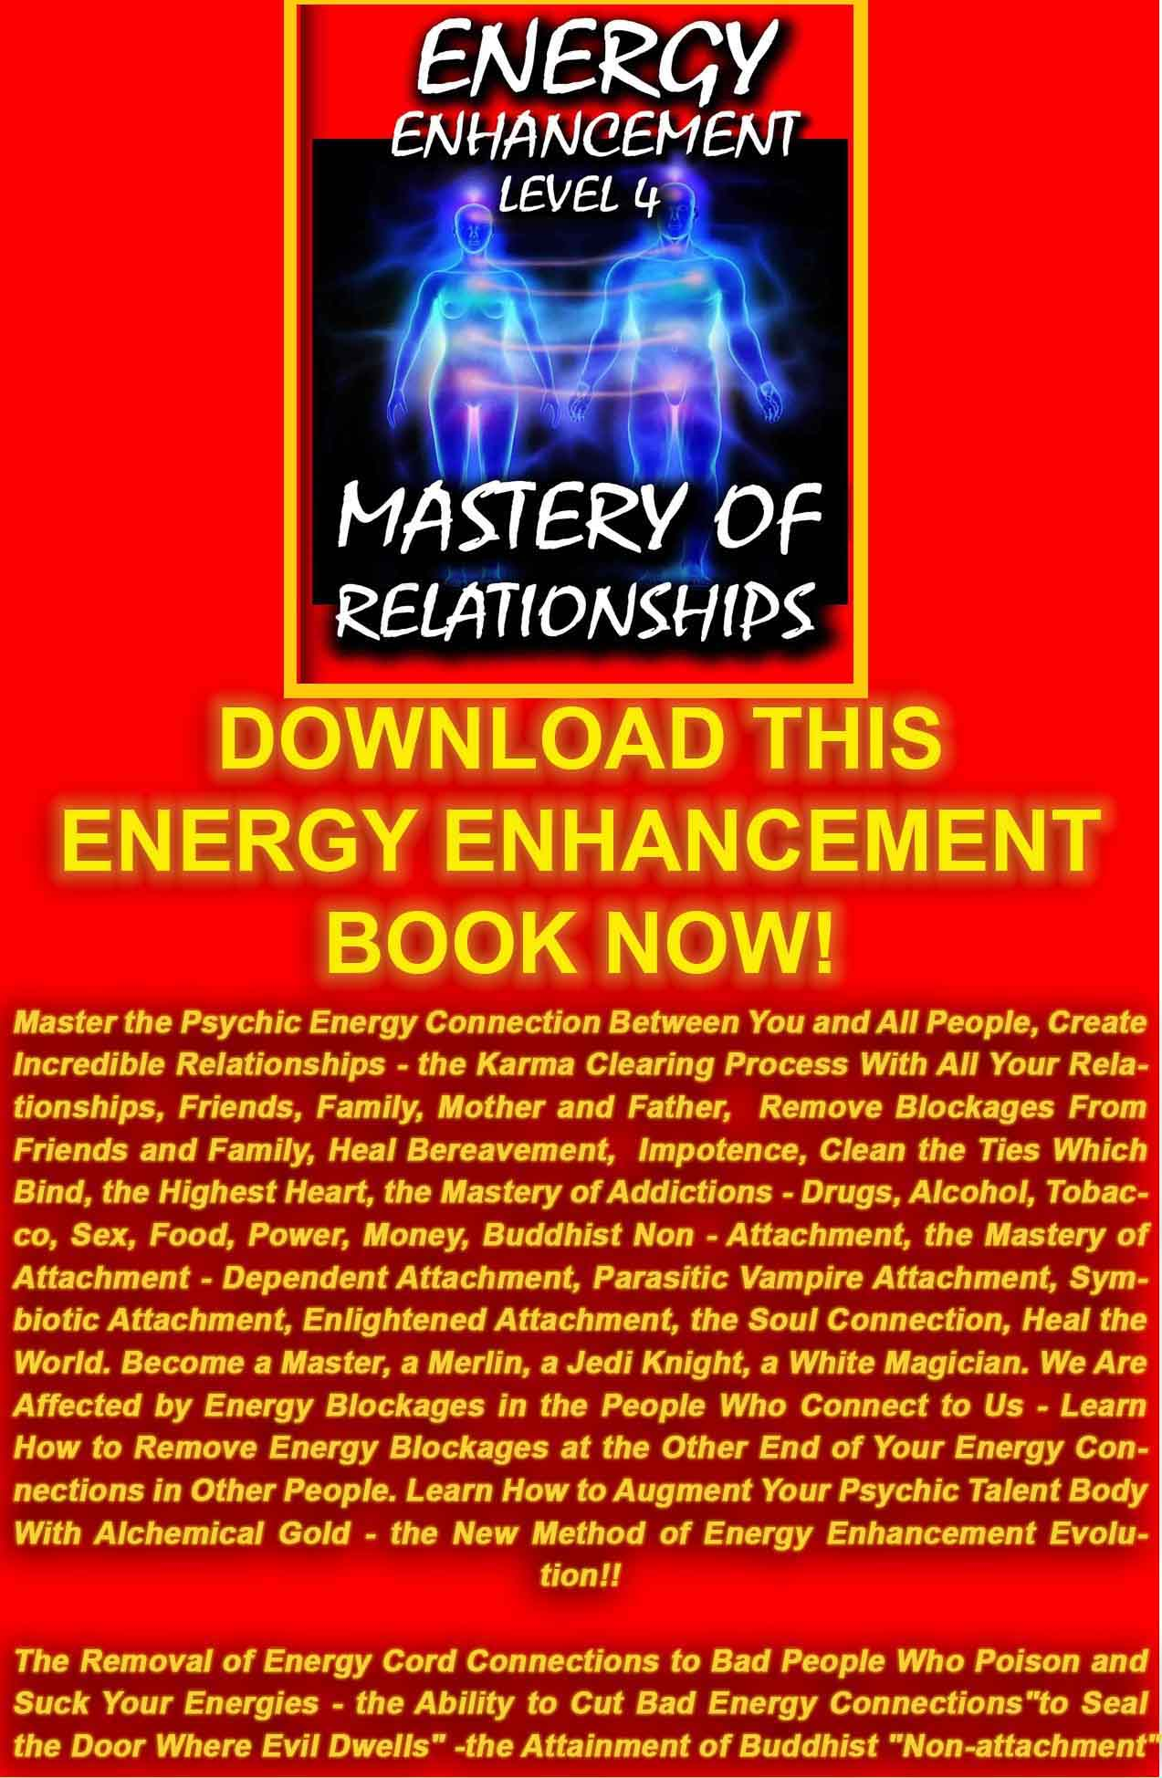
DOWNLOAD LEVEL 4 BOOK HERE!!!
http://www.energyenhancement.org/Sacred-Energy/Level-4-Book/Energy-Enhancement-Level-4-Book-Energy-Cords-Mastery-Of-Relationships.pdf

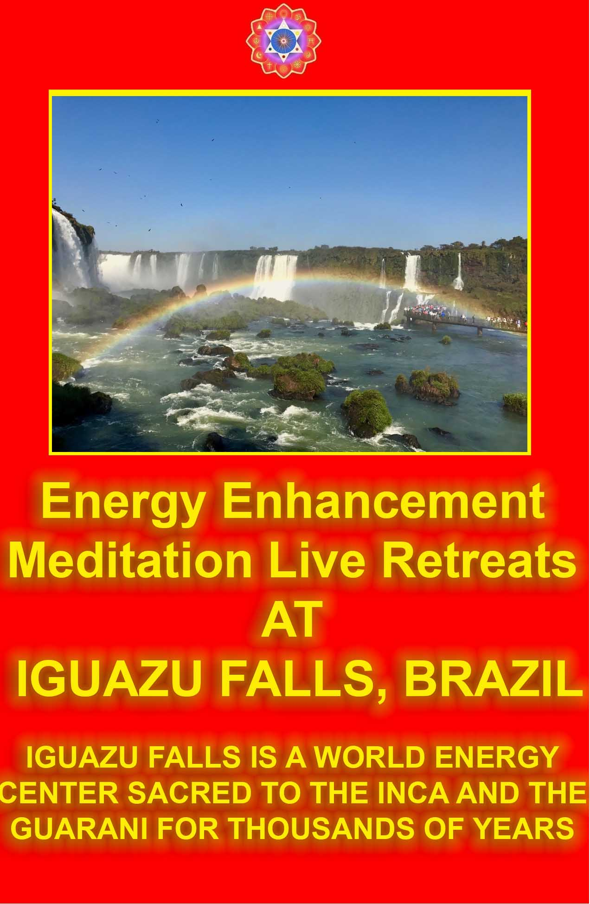

Energy Enhancement the Tarot Princess of Swords And Advanced Techniques Of Meditation
Originally, the Tarot Cards came from Alchemical Sufi sources and the Sufi Alchemical Meditations based on the correct working of the energies of the Universe were encoded as symbols into every one of the Thoth Tarot cards.
Here is an explanation from the book of "The Princess of Swords" of the Thoth Tarot with the addition of how it refers to explanations of the advanced techniques of meditation...
"The inflow of spiritual energy or kundalini energy is well known in all spiritual circles as being expected in all genuine courses with teachers who have advanced experience with enlightened masters yet some people just cannot get their heads around it and they do not trust it as this concept destroys their idea of a "normal" world. They start to fear the unknown!!
The wind of kundalini blowing through you usually leaves smoke and ashes in its wake. Normally, when kundalini energy starts to flow through the interiorly held negativities it starts to destroy and release the pain and trauma within. Fear can be the result. The techniques of the advanced techniques of meditation show you how to totally clear yourself from moods and disturbing thoughts because it works at the level of energy which underlies all the problems.
Transmutation is symbolised by the Yin Yang in the card. These Practical, Ancient and Successful Meditations based on the Tarot teach how to remove the traumatic nature of all this energy release by using the new alchemical concept of "transmutation" - there remains non of the problems associated with negative emotions like anger or depression.. They do not work at the level of memory. You do not have to remember anything as they work at the level of energy which underlies all of the painful memories, yet the performance of the advanced techniques of meditation can easily and totally remove all the energy blockages, in a non-painful way!!
The Princess of Swords student of the advanced techniques of meditation knows how necessary is the transmutation of all the old energies on the path of evolution, progress and inner freedom. The

student's "no" to all the past negative energy held inside springs from an unequivocal "yes" to themselves and to their life!
Princess of Swords necessity for positive and easy change is comparable to the drastic move by Jesus Christ when he drove the moneylenders out of the temple, and to the work of Hercules when he drove the river Styx through the Augean stables, thus easily cleaning out thousands of years of pain or horse shit in one day!
The Wand of the Princess of Discs stretches from heaven to earth and symbolizes the Antakarana, an ancient symbol of Kundalini yoga, which represents the tower, rainbow bridge of energy which flows through all your chakras from heaven to earth, when all energy blockages preventing that flow have been transmuted through the techniques of the advanced techniques of meditation.
The Princess of Swords says, by learning how to bring the spiritual energies of the center of the universe, the highest and purest form of light, into this earth which is the darkest and most negative of all elements, it becomes possible to raise the energy level of the advanced techniques of meditation student and the earth itself.
This advance into new territory has the ability to unify to integrate the mother, the father and all the internal children into one energetic, soul infused and peaceful being.
"there can only be one!!"
The Princess of Swords bringing together spirit and matter, the removal of energy blockages has created something new which can channel the light onto the earth and cosmic idea-impulses, thoughtforms, become visible to everyone and permeate everything with their divine quality. The true healing of you, and the earth itself!!"
The explanation of the Princess of Swords above comes from the Thoth Tarot which encodes Alchemical information in every one of its Tarot Cards!!
Alchemical techniques of meditation symbolized in the Tarot Cards of the Thoth pack show how to easily transmute all negative energy without going anywhere near the emotions and memory!! The buddhafield of energy, in which evolutionary progress can quickly be made, and kundalini energy are absolutely necessary to any course of meditation.
The Princess of Swords symbolizes the way of the energies of the Universe and shows ancient and hidden techniques preserved in Taoism and Hindu Kundalini Kriyas. It is the most gentle and

effective tool for all those who want to increase their energy, their evolution, their genius.
Also Ancient Egyptian spiritual technology - The Alchemical Meditations of Hermes Trismegistus from the Emerald tablet, and of Alchemical VITRIOL, a Latin word meaning "Acid" which dissolves all negative emotions and "Anger" symbolising the removal of all trauma and negative emotion through, "Drain the Last Dregs of your Vitriol!."
The same energy circulation meditation from the Alchemical Sufi Dun Nun, "the Egyptian", he who took, The Path of Blame symbolized by the Sufi Naqsbandi Fountain at the Alhambra at Granada in Spain.
The same meditations The Five Elemental Paths of the Qi of Chinese Alchemical Taoism and the Microcosmic and Macrocosmic Orbits symbolized in the Yin Yang Symbol.
The same meditation, The point from which a Man cannot err. .. From the Freemasonic ritual creating the Master Mason and the Entry into the Crypt The center of the earth, of the Royal Arch. Arch or rainbow bridge symbolises the creation of the Antahkarana.
It is not enough to worship these words, the higher energies are only satisfied when we create these functions within ourselves. Only then do we become a "Made Man".
The same energy circulation meditation With This Technique, Your Evolution Will Increase With Every Energy Revolution To Create A Revolution In Your Evolution. - Paramahamsa Yogananda On The Kriyas Of Kundalini of India, of Kriya Yoga, of Babaji, the 2000 years old sage in the Himalayas, of Sri Yukteswar and Lahira Mahasaya.
These Practical, Ancient and Successful Meditations for the removal of all negative emotions like Anger, Fear, and Depression teach Gaining More Energy - Meditation, Shaktipat, Energy Circulation, The Kundalini Kriyas, The Five Elemental Paths Of The Chi Of Chinese Alchemical Taoism, The Grounding Of Negative Energies, V.I.T.R.I.O.L and The Art Card Of The Thoth Tarot, Access To Kundalini Energy, Strong Psychic Protection, The Merkaba, Pyramid Protection, Power Tower Protection, the Creation of The Antahkarana, Soul Fusion, Monadic Infusion, Logos Infusion for the Painless Removal Of Stress, Trauma And Negative Emotion.

Energy Enhancement Meditation and the Bhagavad Gita CH11 V53 to 55: Removal of Energy Blockages
Bhagavad Gita CH11 V53. The study of Sacred Scriptures, Practise of Austerities, Gifts of Charity and even Self Sacrifice will not earn anyone the power of Psychic Vision.
No, already you are perfect. Yet it is only those negative energy blockages which are corrupting your system which are preventing the energy of Kundalini from powering your psychic powers and your ability to perform.
All the therapies and spiritual techniques, some of which are named above and used successfully for thousands of years are only used to remove the veils of the selfish competitive ego which prevent the light of the psychic vision entering into your psychic eyes.
All spiritual techniques are for self refinement or removal of the selfish competitive ego, and the Opening of the Heart and thus for Soul Realisation.
Your Soul, Intuition, Higher Self is always there but usually blocked by Energy Blockages. Your Heart is always there but usually blocked by energy blockages.
Bhagavad Gita CH11 V54, “Only by constant and steady devotion can God be seen and Realised in its most high and Cosmic Form, oh Arjuna.”
Arjuna is the average guy.
The little or personal self, the corrupt mind containing negative and self sabotaging thoughts, psychic viruses, negative programming must be refined or de-bugged and not in a little way. ALL of the negative programming must be removed by a constant and steady devotion.
As it says in The Yoga Sutras of Patanjali. Enlightenment comes after spiritual practise, for a long time, constantly and with entheosiasm.
Bhagavad Gita CH11 V55, “Whoever desires release from all pain and troubles through access to the highest energies and thus completely devotes himself to this task. Who offers all his actions to that higher task, who sheds all personal and selfish attachments

and feelings of ill will towards any other person, creature or thing, Arjuna that person surely enters into me.”
These are some of the tests or proofs of enlightenment so you can see how well you are doing. Seeing yourself clearly leads to humility.
Remember, you are 99% perfect, but seeing that one percent of imperfection clearly, can lead to the removal of that imperfection. There is no failure, only feedback!
Do not take anything personally. Remember you can expect and depend on people who are unenlightened to act in an unenlightened way unless by your skill, you can avoid that. And the Mastery of this low energy plane comes from the skill with which YOU work!
Put your trust in God but tether our camel!
Many people worship the instruction book. Oh Holy spiritual text. Take me up to Heaven!
Yet who manages to, even after two thousand years of teaching, Turn the other cheek. as Jesus Christ said, when someone or even life itself beats on you? Remember, these are the tests of enlightenment.
When your clothes are dirty is the cloth any less white? Simply by removing the dirt by the use of soap, another piece of dirt or spiritual technique, the linen will be seen again as white. And this is the process of Spiritual Therapy and Energy Enhancement Meditation in Twenty Eight Initiations.
The Purification Process is a Process of Refinement which is easier than Life. The Alchemists say that the process of life is like the Normal Process of Purifying Gold Ore. How do you Purify the Gold? Well, you heat it up to 1000 degrees centigrade in the furnace.
Then you take it out and put it on the Anvil. Then you BEAT the CRAP out of it!
Much Easier and Faster: Speed Up the Process of Enlightenment Itself through the techniques of Energy Enhancement Meditation to
Easily Remove the Dirt. Easily Remove the Toxins.
Easily Remove the Impurities.
Easily Remove the Psychic Programs. Easily Remove the Energy Blockages.

Easily Remove all Ancient Karma and Bad Luck in the Karma Clearing Process.
Easily Remove all Ancient, Trauma, Stress, Pain and Negative Karmic Mass.
Easily Remove the Tinted Glasses.
Easily Become a Soul Infused Personality to See the Light of the Soul, the Light of Intuition.
Easily See Reality itself and Master this Earth plane of Love, Purpose, Intelligence, Abundance, Richness, Celebration and Happiness.
Easily Enlightenment Itself.
It needs an Ancient Advanced Synthesis of Effective Techniques for Gaining More Energy - Meditation, Shaktipat, Energy Circulation, The Kundalini Kriyas, The Five Elemental Paths Of The Chi Of Chinese Alchemical Taoism, The Grounding Of Negative Energies, V.I.T.R.I.O.L, The Art Card Of The Thoth Tarot, Access To Kundalini Energy, Strong Psychic Protection, Learn The Merkaba, Pyramid Protection, Power Tower Protection, Create The Antahkarana, Soul Fusion, Monadic Infusion, Logos Infusion. The Painless Removal Of Stress, Trauma And Negative Emotion
Leading onto the more advanced Techniques of The Karma Clearing Process. Learning how to clean The Karma From Past Lives, Future Life, Future Lifetimes, Integrating Soul Fragmentation And Retrieval of Inner Children, Selfish Ego Sub Personalites, Life Destroying Strategies, The Aloof, The Interrogator, The Violator, The Selfish Competitive Star, The Vamp Or Don Juan, The Pleaser, The Blamer, The Critic, The King, The Self Destructor, All The Destructive Vows From This And Past Lifetimes,.
Which results in The Creation Of Self Love, Love And Service. Ponder on this

GOLDEN LIGHT SURGES INTO MY BRAIN...
"A POINT OF LIGHT EXPLODES, it opens and golden light surges in to my brain from the center of my head. Like liquid light it fills me up and at the same time the universe is born, the light expands forming energies that divide and merge forming particles eventually forming atoms, molecules wich form stardust stars solar systems galaxies, planets and the they form life, living cells that connect to

form a physical brain, manifestation of the cosmic mind and consciousness, eventually reaching my cortex and I open my eyes and remember my self.
My center is the center of the universe, the circle is complete! I am absolutely everything. All time is curved around me, all galactic systems are me, all life is me and I am through this small body I am complete. My personal mind goes in to absolute shock, into hysterical laughter that I cannot stop. I am overflowing billion times billion. Infinite amount of information fills me in a timeless time, my consciousness is flowing from the beginningless beginning of all reaching the final destination of all.
The grand cycle is complete and I encounter all the infinite forms of existence as well as the formless forms of enlightenment beings, the future. I am, one with my self from the future! From the times of conscious creation. There is only space, all of my meridians are ONE! Stretching through all the creation. Then I leave my body and I am guided through many things that I cannot explain or remember in my current state."
As we were talking well into the night at the end of our Energy Enhancement Course together.
After he has removed many energy blockages over the last four weeks. Blockages above the crown chakra in the Antahkarana which were preventing him from re-connecting with the Source of all Life. He described one of the blockages between one million and Infinity of chakras above the head as a dense translucent crystal which was incredibly difficult to remove, different from the other blockages which he had found below it which were dense and covered with a black tarry substance or blood and which were more easy to transmute and dissolve.
We eventually get into a state of energy transfer. We both feel it as white light flowing from one to the other in an incredibly intense way which lasts for two hours. At the end of that time I perceive an initiation which is taking place on the astral plane. Surrounded by a group of ascended masters I introduce him to the chief initiator who uses the rod of initiation to touch his third eye with the intense energies of initiation so that his energies can never again drop into that state we call normal waking consciousness.
Never to lose the Light of Enlightenment, ever again.

Get your asses over here Now and Speed Up your process of Enlightenment on the Energy Enhancement one month course!!

INNER PEACE


When you receive energy correctly
And not everyone does because they get the symptoms of energy blockages instead - Going to sleep, shaking, pain, heat, cold, negative emotions, - all the common so called symptoms of Kundalini Energy. But when you get taught to receive energy correctly on the Energy Enhancement Course - "When the energy is flowing correctly, there is no movement" - Saadi of Shiraz.
And this is the Energy Enhancement Experience.. "We eventually get into a state of energy transfer. We both feel it as white light flowing from one to the other in an incredibly intense way which lasts for two hours. At the end of that time I perceive an initiation which is taking place on the astral plane. Surrounded by a group of ascended masters I introduce him to the chief initiator who uses the rod of initiation to touch his third eye with the intense energies of initiation so that his energies can never again drop into that state we call normal waking consciousness."
If you can receive energy then the chances are that you can give energy. Only the people who can receive energy correctly can go on to become enlightened, can go on to become Initiators of men, Gurus and Spiritual Masters.
If you only get the symptoms of Energy Blockages in the fire of the Buddhafield which is the intense aura of energy which surrounds

every Spiritual Master then you need to remove the Energy Blockages which produce the symptoms. The Energy Enhancement Level Two Seven Step Process is the unfailing technique which can remove any Energy Blockage.

When we become a stream enterer, we tap into the Energies of the Earth and of Heaven and of the Buddhafield and through energising our faculties, we start to have spiritual experiences beyond the norm. We start to feel and see energy to start with, which always comes to every student.

It happens with all of our students... INNER PEACE
ENERGY ENHANCEMENT IMMORTALITY LIVE COURSES, INDIA AND IGUAZU FALLS

SATCHIDANAND - IGUAZU FALLS 
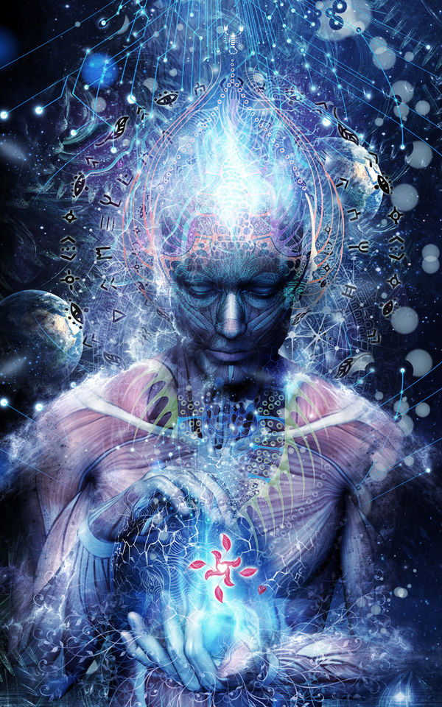
ENERGY ENHANCEMENT MEDITATION ENLIGHTENMENT AND ILLUMINATION

THE INCREDIBLE MEDITATION COURSE AND MEDITATION TECHNIQUES CREATED TO PRODUCE ENLIGHTENMENT AND ILLUMINATION

"ALL TRADITIONAL MEDITATIONS HAVE BEEN DESIGNED TO FAIL" - SATCHIDANAND -

"BECAUSE ORIGINALLY ALL MEDITATIONS CONTAINED THE TECHNIQUES OF, "THE KUNDALINI KEY" AND OF, "ALCHEMICAL VITRIOL" TO GROUND NEGATIVE ENERGIES AND TO NATURALLY INCREASE KUNDALINI ENERGY"

"NOW, ONLY ENERGY ENHANCEMENT MEDITATION TEACHES THESE TECHNIQUES WHICH SPEED UP THE ENLIGHTENMENT PROCESS"
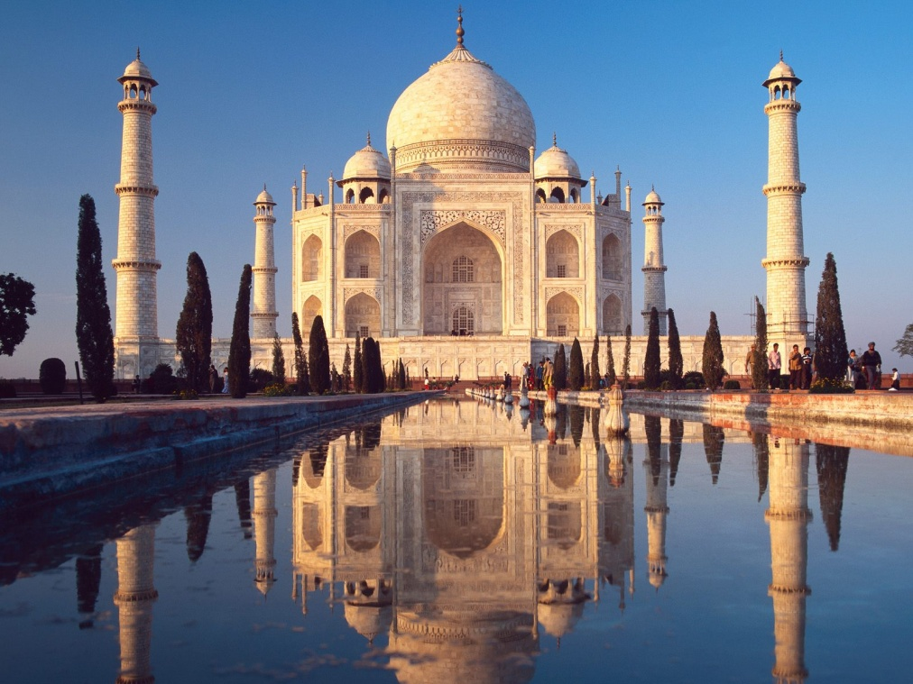

MOVIES

Energy Enhancement Meditation Incredibly Profitable and Successful Movie List:
Why is American Beauty By Sam Mendes and with Kevin Spacey on our List?
Well first of all, what makes a good movie? And what makes an Incredibly Profitable and Successful Movie? Because usually, the two go together, unless the bad guys against evolution successfully oppose.
The Three Major themes of Enlightenment are..
- Opening the Heart
- The Mastery of Relationships.
- Life and Death and Enlightenment.
And all truly good and Incredibly Profitable and Successful Movies contain all these three themes and some spiritual instruction of a major thoughtform which needs to be entered into the consciousness of humanity.
At this moment, fifty percent of humanity have not as yet successfully Opened their Hearts. These people will enjoy, as Shakespeare said, “Movies full of Sound and Fury, Signifying Nothing” which include the vast majority of all movies.
These fifty percent of people including all levels of the Movie Making community will give moderate success to a movie with a good script, costumes, music and production values. But it is another paradigm for them, they cannot understand the meaning and reality of the words, Intuition, Significance And Purpose.
At this moment, fifty percent of humanity have Opened the Heart a little. Only these people understand the meaning and reality of the words, Intuition, Significance And Purpose
Yet for real popularity and incredible money making potential and for an over 400 Million Dollar in Receipts Movie.

For one hundred percent of the people to go to a movie a movie must contain both a good script, costumes, music and production values, AND Intuition, Significance And Purpose.
This series of articles will talk more on the theme of Significance which is, as Shakespeare pointed out, the most important theme of all.
American Beauty By Sam Mendes and with Kevin Spacey pounds on the theme of Life and Death but includes opening of the heart and relationships.
It only fails to make loads of money because the themes are not hidden enough to be accessible to most unevolved Humanity.
For example, my DVD renter in Spain thought that Lester was Killed by his wife whereas he was killed by Col. Frank Fitts.
In satellite channels to India all themes to do with sex and homosexuality are routinely removed and censored.
Thus the driving scenes and themes of the Movie as when Col. Frank Fitts homosexually kisses Lester and provides the motive for his murder, (Homosexuality).
And when Lester finds our The Mena Suvari Character is a virgin and lovingly withdraws, (Sex) showing his Initiation of the Mastery of Relationships and the reason for his happiness and enlightenment just before he dies.
These two essential scenes are removed, censored, from the movie because these two themes are not allowed to be seen in India.
Thus for a billion people in India it is not possible to understand the significance of this movie!
For real success in movies, you must be capable of hiding all these themes and themes of even higher significance in a Rip Roaring story as in “The Lord of the Rings”, “Star Wars” and to a lesser extent, “Harry Potter” which I will go into in other articles.
The American Beauty movie starts with Death, “In one year I´ll be dead” says Kevin Spacey right at the beginning. At the end of the movie, Lester, his character will be dead And also Enlightened.
All the people in the movie are totally mad.
Mad enough to kill, because they want something which is not essential to their real nature and Soul Path.
Except for Lester who progresses through and rejects, sees deeply into the madness of what he is doing, and rejects...

- He rejects Money and Career not in alignment with his soul path representing his Initiation of the Opening Of The Heart.
- He rejects his going back to the old student ways of flipping burgers, getting high with marijuana and sculpting his body with weight training, for one year, to attract the 16 years old Mena Suvari character, again representing his Initiation of the Opening Of The Heart.
- He rejects inappropriate love as he sees deeply into the nature of the homosexual Chris Cooper character, Col. Frank Fitts, USMC and the 16 year old Mena Suvari character representing his Initiation of the Mastery of Relationships.
This seeing deeply creates such love within his heart for all and everything in his life, his mad wife and daughter, true unattached love for Mena Suvari. At the end of the movie, after having rejected everything not in alignment with his soul, he feels wonderful for the first time in years.
In that moment he becomes Enlightened. Even when Chris Coopers character kills him he says, “I suppose I should feel really pissed off by the end of my stupid little life”, but then he sees all the Beauty and Love of his life in flashbacks.
And he talks to the audience and says, when you die, you will understand this too. And the Beatles, George Harrison, music at the end of the movie supports this theme of Love – “Because the world is round it turns me on”. How can even death spoil that Vision of Love….
Lester’s daughter, the Thora Birch character thinks wrongly that she will be free and happy leaving her mad parents by leaving with Ricky, her drug dealing boyfriend to go to New York.
Whereas she really loves Ricky’s real several moments of Soul Contact when he sees the soul’s beauty in the eyes of Dead People, and sees the freedom of the Soul Energy in the movements of a paper bag.
Ricky really loves her and this is shown by the heart-stoppingly beautiful Thomas Newman music whenever Love, the major theme of this picture, comes down from heaven in connection with this love story between Ricky and Lester’s daughter.
Ricky has had Satori. He has had a “Little Glimpse out of the corner of his eye”, but now he needs to avoid becoming “Comfortably Numb”, (Pink Floyd Song) where with their “Wrong Livelihood” of drugs, (Gautama Buddha), not in alignment with his soul path, will destroy both their lives in the future.

Lester’s wife, the Annette Bening character, really takes the job of making money seriously and you realise how mad she is when after an amusing episode trying to sell a house, she beats herself up and cries heart-rendingly.
She finds consolation from Lester’s lack of interest in making money in the arms of her House Selling Hero, Buddy, “Have you ever been nailed by the King!” and when Lester finds out, when Lester, “Rains on her Parade” she screws herself up to kill Lester. Mad!
Lester tries to help her when he says “Its only a fucking Couch!” and then she shows how seriously she takes her madness by retreating from Love when Lester looks as if he is going to pour beer over her Italian Silk Covered whatever, and by returning with a gun and a desire for liberation from Lester. She is round the twist.
And yet she cries out in anguish when she returns home to find Lester, Dead. She is not yet totally gone.
The sixteen year old Mena Suvari character has written herself into a wrong thoughtform which will destroy her life if she enters into it. She longs to be different, to be a beautiful model, to climb the ladder of success with her sex.
She tells everyone that this is the way it is. Life is like that. And this way can lead to success, yes, but it will also lead towards madness as this wrong thoughtform takes you away from your true soul path.
And the taking of the path leading you away from your true soul path really is normal in just about everyone. It is the major cause of all pain and bad luck in everyone’s life.
By, as yet not taking that path, the Mena Suvari Character really is different!
And yet when Lester makes his sexual approach, she tells Lester that she is a virgin. She really is different again! And this causes Lester to come out of his lust. To see this beautiful young lady as his daughter. Someone in need of love and attention, and help. Not just as a sex object, but as someone he truly loves.
As the George Clooney character in Quentin Tarantino’s “From Dusk till Dawn”, says at the end of the movie in a similar situation, “I may be a Bastard, but I’m not a Fucking Bastard!”
Lust is not necessarily Love. Love is the Real Opening of the Heart. Just wanting to really help someone else.

And this Opening of the Heart of Lester makes his energy flow with the energy of true love for everyone in his life. Just before he leaves his life, which is the destiny of all living beings on this planet. “No- One gets out of Life, Alive!”
And of course the maddest guy of all is the Chris Cooper character, Col. Frank Fitts, USMC, who actually kills Lester with a gun. Like the Al Pacino Character in “Angels in America” he is a repressed homosexual who is driven mad by his repressed desires, and the need to hide them from contemporary society.
Even his son, Ricky underestimates him, “You sad, tired, old man”, because he does not understand the homosexual repression which drives his life, to destroy all love and everyone around him.
His wife, Ricky’s mother, is mad from lack of love from her homosexual husband. Free Ricky is repressed, sent to military school, sent to an asylum to be anaesthetised, Comfortably Numb, “Because you need structure and discipline.” if you are repressing anything, using the wrong thoughtform, not in alignment with your true soul path..
Col. Frank Fitts kills Lester because he has shown Lester the truth of his repressed homosexuality, of his repressed desire, of his repressed love. And because that truth, if it gets out, can destroy his carefully constructed life of repressed madness, he has to kill Lester!
All the mad people in this movie are driven to madness by the desire for something which is not essential to anything but their selfish competitive egos. Wrong thoughtforms. Wrong thinking.
And yet, this is the way of all human evolution. We need to experience the results of all wrong thinking, all the bad luck and bad Karma, until “We have been down that path, (All bad paths), and we know where it ends” from the Matrix and again from the Matrix, we know it, “From Balls to Bones”.
This wisdom is not intellectual, with many lifetimes it becomes Hard Wired in, intuitive from the Soul Infused Personality and is accessible from Child to Old Person.
And we will keep making those mistakes until we know we have the Freedom, the Free Will, the Soul Intuition, “Only to make the Right Choice!” in life.
And only Lester finds the way out by rejecting all the wrong thoughtforms finding real love and enlightenment just before he is murdered. This is the way of Enlightenment, and, “This planet is a

Factory for the production of Enlightened Beings” it is all our paths, too.
The greatest drawing actors intuitively make the right choice of great themes and significance when they choose their movies because as we said at the beginning. “Only Significance equals Success!”
This “American Beauty” movie is highly Significant. And how do we really know this.
We Feel it in our Hearts….
Success, Happiness, Peace, Soul Purification and the removal of negative thoughtforms needs an Ancient Advanced Synthesis of Effective Techniques for Gaining More Energy - Meditation, Shaktipat, Energy Circulation, The Kundalini Kriyas, The Five Elemental Paths Of The Chi Of Chinese Alchemical Taoism, The Grounding Of Negative Energies, V.I.T.R.I.O.L, The Art Card Of The Thoth Tarot, Access To Kundalini Energy, Strong Psychic Protection, Learn The Merkaba, Pyramid Protection, Power Tower Protection, Create The Antahkarana, Soul Fusion, Monadic Infusion, Logos Infusion. The Painless Removal Of Stress, Trauma And Negative Emotion
Leading onto the more advanced Techniques of The Karma Clearing Process.
Learning how to clean The Karma From Past Lives, Future Life, Future Lifetimes, Integrating Soul Fragmentation And Retrieval of Inner Children, Selfish Ego Sub Personalites, Life Destroying Vampire Strategies, The Aloof, The Interrogator, The Violator, The Selfish Competitive Star, The Vamp Or Don Juan, The Pleaser, The Blamer, The Critic, The King, The Self Destructor, All The Destructive Vows From This And Past Lifetimes,.
Which results in The Creation Of Self Love, Love And Service. Ponder on this
SACRED DANCES OF FUSION WHERE DEVI DHYANI EXERTS HER POWER - AVAILABLE ON YOUTUBE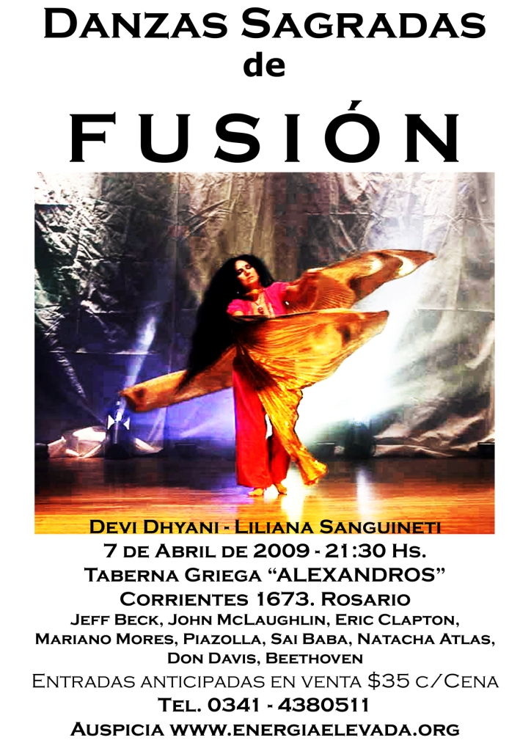

MEDITATION AND APOCALYPSE NOW - THE HORROR OF THE BRANDO KURTZ SPLIT EGO AND THE TRAUMA THAT SPLITS IT CREATING DID AND MPD

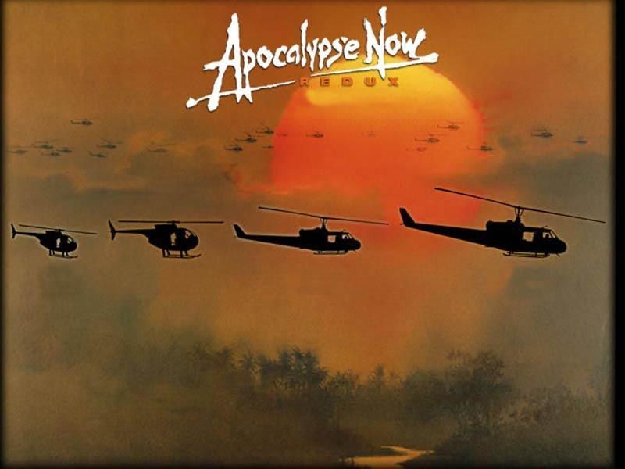

*Typically the works of the cruel ego can be seen-quote from Heart of Darkness by Conrad in the Belgian Congo "there you could look at a thing monstrous and free." Which is also quoted in Peter Jackson’s Movie King Kong
And here is why we need to work on Meditation and the *higher techniques of meditation healing the trauma caused cruel ego...
This is from Apocalypse Now, written Francis Ford Coppola & John Milius, book, HEART OF DARKNESS, by Joseph Conrad...
Here we understand the trauma of the incident which cuts Kurtz (In his best role ever by Marlon Brando) off from his soul.
That painful trauma which splits him.

This trauma is one of the sources of DID (Dissociative Identity Disorder) and MPD (Multiple Personality Disorder).
Kurtz, Appocalypse now, Brando, ego And because Kurtz is split, ("By non-contemplation of Me, are you bound!") one split part of himself wants to commit suicide. And so Willard (Played by Martin Sheen), sent by the army to assassinate him, becomes part of his mad, split, suicide - he allows it to happen!!
The conscience comes from the Soul, the source of all judgement, and it is only those people who are cut off from their Souls who can do these horrible cruel things. This is the Horror. The Horror of the split off Ego creating DID (Disociative Identity Disorder) and MPD (Multiple Personality Disorder).
Kurtz: I've seen the horror. Horrors that you've seen. But you have no right to call me a murderer. You have no right to call me a murderer. You have a right to kill me. You have a right to do that, but you have no right to judge me. It's impossible for words to describe what is necessary to those who do not know what horror means. Horror. Horror has a face, and you must make a friend of horror. Horror and mortal terror are your friends. If they are not, then they are enemies to be feared. They are truly enemies.
I remember when I was with Special Forces--it seems a thousand centuries ago--we went into a camp to inoculate it. The children. We left the camp after we had inoculated the children for polio, and this old man came running after us, and he was crying. He couldn't see. We went there, and they had come and hacked off every inoculated arm. There they were in a pile--a pile of little arms. And I remember...I...I...I cried, I wept like some grandmother. I wanted to tear my teeth out, I didn't know what I wanted to do. And I want to remember it, I never want to forget.
And then I realized--like I was shot...like I was shot with a diamond...a diamond bullet right through my forehead.
And I thought, "My God, the genius of that, the genius, the will to do that." Perfect, genuine, complete, crystalline, pure. And then I realized they could stand that--these were not monsters, these were men, trained cadres, these men who fought with their hearts, who have families, who have children, who are filled with love--that they had this strength, the strength to do that. If I had ten divisions of those men, then our troubles here would be over very quickly. You have to have men who are moral and at the same time were able to utilize their primordial instincts to kill without feeling, without passion, without judgment--without judgment.
Because it's judgment that defeats us.

I worry that my son might not understand what I've tried to be, and if I were to be killed, Willard, I would want someone to go to my home and tell my son everything. Everything I did, everything you saw, because there's nothing that I detest more than the stench of lies. And if you understand me, Willard, you... you will do this for me.
And yet, that judgement is also called the conscience, and it comes from the higher parts of yourself called the Soul. As we contact the Soul through the traditional means of meditation, so we develop a Heart.
It is not just the Germans of the Second World War who can kill six million Jews in the gas chambers of the concentrations camps. The trauma blockage caused splits create people able to do this in every country in the world at a rate of fifty percent of the population. It is not the Chinese, the Russians, the Americans or the British; it is the fifty percent of the population in every country who are blockage caused psychopaths.
We can understand just what percentage of humanity have hearts by means of polls. When the Guardian newspaper of the UK asked the people if they thought torture was necessary in order to protect the state from terrorists, against the Rules of the Geneva Convention, then between 30 (UK and France) and 50 (Israel and USA) percent of the people agreed with that statement.
When they asked the chief torturer of the Generals in Greece from the 1960's just how he recruited his accomplices, he said it was easy, "We just recruited likely lads from the army each week and gave them some simple torturing jobs. If they did well, we kept them and promoted them. If they did badly, we sent them back"
It is the trauma - caused blockages (And then I realized--like I was shot...like I was shot with a diamond...a diamond bullet right through my forehead.) which cut us off from our souls, and allows us to do all manner of bad and immoral things.
As we dissolve those blockages through meditation, so we become more highly evolved. We can access our Souls and develop our Hearts. We can become good.
* The Higher Techniques of meditation are the Kundalini Kriyas, The Five Elemental Pathways of the Qi, Alchemical methods of Hermes Trismegistus including VITRIOL, the first formula of Alchemy, which uses every letter of the word VITRIOL as the start of a new latin word together creating a sentence, a guided meditation, to transmute negative energy and lead it on the path of the soul.

King Kong, The Myth Analysis of The Lord Of The Rings, Beauty and The Beast Indicating DID and MPD and the Integration of the Ego, the Soul and God


The movie of King Kong is an elaborate allegory of spiritual evolution so we can understand the mythical quality of this story which also underlies the Lord of the Rings, the Beauty and the Beast, Cinderella, Cupid and Psyche and Sleeping Beauty.
We understand from King Kong what ancient symbols have been telling us of the hundred percent split nature of humanity and the necessity for purification, integration and going higher through meditation.
Ancient knowledge of Splitness, the universal split nature of humanity through DID (Dissociative Identity Disorder) and MPD (Multiple Personality Disorder) shown and proved by the 10,000 year old images of the split animal-human or ego-soul of the Centaur, Sphinx, Minotaur and Phoenix.
Or Anne Darrow-King Kong or Gollum-Frodo or Cupid-Psyche or Beauty-Beast or Sleeping Beauty-Prince or Cervantes Sancho Panza- Don Quixote and Frodo-Sam.
The Ancient Mythical quality is first announced in the 1933 version and the 2005 versions of King Kong by the Sufi Saying...

And the Prophet said, 'And lo, the beast looked upon the face of beauty. And it stayed its hand from killing. And from that day, it was as one dead.'
Only by starting to love something higher can we too become higher. To become higher, we have to leave behind the blockages and false beliefs of the selfish, competitive ego.
King Kong is the ego, mirrored by Carl Denham the Director. Anne Darrow the beautiful, the beloved, is the Soul and her beau, Jack Driscoll, is God - someone she looks up to.

Symbolisms - Carl Denham - Ego, Anne Darrow - Soul, Jack Driscoll - God
Peter Jackson's King Kong has many references to "Heart of Darkness", such as a scene on the ship where Jimmy holds a copy of the book by Conrad, also the text behind Francis Ford Coppola's Apocalypse Now, and says "It’s not an adventure story, is it?"
KING KONG IS NOT JUST AN ADVENTURE STORY.
This sentiment is echoed by Hayes in a voiceover as he quotes Conrad, "The earth seemed unearthly… We are accustomed to look upon the shackled form of a conquered monster, but there—there you could look at a thing monstrous and free."
As King Kong itself is a story of the egoistic cruelties of men and of King Kong himself, the film suggests that Conrad meant to explore human cruelty of the cruel ego towards others as much as he meant to explore the Belgian Congo—and thus also the film is more than an adventure story but also explores the human ego's will and cruelty to exploit others.*
Carl Denham, the Big Kahuna Ego of the New York Jungle where he is at the top of a society filled with misery, poverty and hunger.
He beats off the attack of his three tyrannosaurus Producers and escapes to Skull Island in search of an edge.
There King Kong falls in love with Anne Darrow and Anne Darrow, his soul, understands the necessity of being protected by the ego as King Kong protects her from the three tyrannosaurus rex's-just as the Carl Denham-Mr Ego, had protected her in New York from the Burlesque, hunger, and the three producer tyrannosaurus rexes wanting to stop the picture she was going to star in.
Back in New York, King Kong makes the Carl Denham Ego number one, feted and admired by the Producers who originally had wanted to stop his picture and career.

Jack Driscoll says in an accusation made of Denham after he has captured Kong and put him on display like a circus freak—he so often "destroys the things he loves." Which often happens with many poor films, "Full of sound and fury, signifying nothing!!" - Shakespeare, "Which everyone can see for twenty-five cents." – Carl Denham.
But which also echoes the love of Anne Darrow for that which protects her. Yet she must kill in order to ascend higher.
Jack Driscoll was quoting Oscar Wilde's "Ballad of Reading Jail"... "Yet each man kills the thing he loves,
By each let this be heard, Some do it with a bitter look, Some with a flattering word, The coward does it with a kiss, The brave man with a sword! "
King Kong escapes with his Anne Darrow soul up the Empire state building which symbolizes the Rainbow Bridge, the pathway to heaven.
The Hindu's have a name for this tower, "The Antahkarana" which is the psychic construction which ties all the chakras together as well as that which connects us above the head with the soul chakra and then with God.
With more spiritual energy, as we ascend to heaven, the selfish competitive ego drops away and our soul – essence connects with God.



In deep love. With the energy of deep love which we the audience feel. Impregnated into the Movie, the energy of Love flows, and as Anne and King Kong lingeringly look at each other as he dies and falls into the corruption of New York city below.
As Anne rises to her feet, at the top of the highest skyscraper, she turns to find her lover, Jack Driscoll, who symbolises God, and who has come to take her higher. She no longer needs to descend into the mire. She can stay in heaven and live happily ever after.
This is the same story as Jackson's Lord of the Rings. Half of Gollum's split personality says, "We would not have survived if it had not been for me". The other half says, "Now we have Master, (Frodo, the Master, represents the Soul) we do not need you any more, Go away and never come back!" Yet we have to wait for the end of the picture for Gollum to fall, taking with him the evil Ring, down into the crack of Doom – symbolizing Kundalini Chakra in the center of the Earth, leaving the Frodo Soul much purified, ready to take the next step higher as he sails off with Gandalf (God) towards the Undying Lands (Heaven).
Down in the New York mire or Hell, Carl Denham looks at his ruin in the ruinous death of King Kong.
Police Officer Lieutenant: Well, Denham, the airplanes got him.
Denham: Oh, no. It wasn't the airplanes. It was Beauty killed the Beast.
And so we understand the mythical quality of the story which underlies the Lord of the Rings, the Beauty and the Beast, Cinderella, Cupid and Psyche and Sleeping Beauty.
We understand that ancient symbols have been telling us of the split nature of humanity and the necessity for purification and integration. Of going higher with the 10,000 year old images of the split animal-human or ego-soul of the Centaur, Sphinx, Minotaur and Phoenix. Or Anne Darrow-King Kong or Gollum-Frodo or Beauty-Beast or Cupid – Psyche or Sleeping Beauty-Prince.
But let us not miss the point the meaning and significance of this history. The ancient stories and myths underlying King Kong, The Lord of the Rings, Apocalypse Now, Catch 22 and so many others point to a trauma disappointment formed splitness in the personalities of all humanity as being the cause of all evil on this planet for thousands of years.
They also teach of the Integrating techniques of Meditation, Energy Enhancement and the underlying techniques of the Kundalini Kriyas, The Five Element Circulations of the Qi or Chi or Kundalini

Energy, the Alchemical Meditational Formulas or Guided Meditations of Hermes Trismegistus as a means of overcoming this trauma formed splitness which is the cause of Universal DID (Dissociative Identity Disorder) and MPD (Multiple Personality Disorder).
Meditation and the higher techniques of Meditation are the cure of all splitness.
King Kong symbolises the Ego. As we ascend the Empire State building of the Antahkarana to the soul, then the ego must die and slip away.

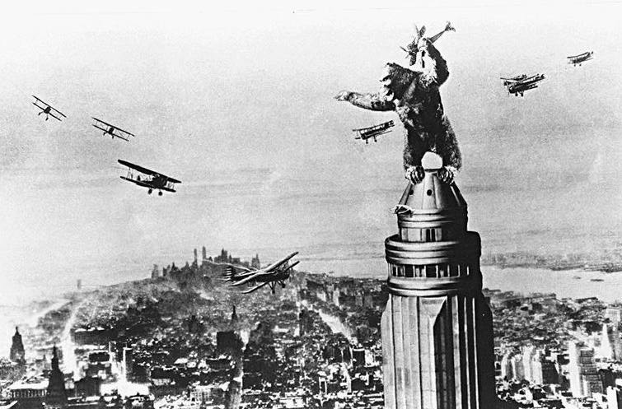
As it says in the Movie as a Sufi saying - And the Prophet said, 'And lo, the beast looked upon the face of beauty. And it stayed its hand from killing. And from that day, it was as one dead.'
The beloved, beauty, is the soul, is God.
This is the Sufi secret of the Troubadours and the Jesters (from Chisti)* who introduced the concept of courtly love in romantic poetry into Europe. Only the knowledge of the true self, the Soul, can overcome the selfish, competitive Ego, red in tooth and claw.
*Hazrat Nizamuddin Awlia Chisti (died.1325 A.D in Nizamuddin in Delhi.) represents in many ways the pinnacle of the Chisti* Order of the Sufis. "The heart of a lover (True lover of God) constantly burns with the fire of love, so much so that whatever impurity which intrudes upon its sanctity is burnt to ashes". The blockages which cut us off from our souls are burnt to ashes through the practise of

meditation and the higher practices of meditation called Energy Enhancement.

From time immemorial it has been known that some people, Yogis, Gurus, Shamen, Priests, Saints, Paramahamsas, Buddhas, Christs, have removed all their blockages through meditation and evolved to a state of high energy.
These pure and good people of the heart, wanting benefit and happiness for all, without a trace of selfishness and competition have been known to have psychic powers.
Their search for energy and goodness has precipitated within them the next stage of human evolution.
For thousands of years they have been Good Doctors, Good Priests, founders of religion, Philosophic Geniuses, Advisors of Kings, Musical Geniuses, Poets, Makers of the Law.
For thousands of years these people, wielding amazing Siddhis or Psychic powers, have been recorded as healing of the sick, casting out mental sickness, coming in dreams, communicating through telepathy, the radiation of specialised energies, leaving the body, entering into the body of another, astral travel, telling the future, acting at a distance, raising Kundalini, Shaktipat, the ability to pass healing into amulets, temples, places of peace, pilgrimage sites, creating miracles, birds and beasts come to them in peace.
Doing all this they also pass on their energy in Shaktipat for the awakening of all good students.
The shaktipat, the radiation of psychic energies by the enlightened can awaken these abilities in all who come to them. This has been known and recorded in the Sacred literature for thousands of years.

THE ENERGY ENHANCEMENT KUNDALINI KEY

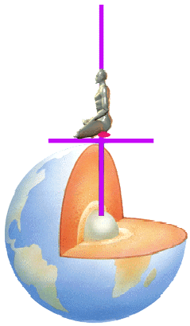
The Energy Enhancement Kundalini Key Meditation Samyama which cleans all the chakras using Alchemical VITRIOL Kundalini Shakti

BATMAN RETURNS THE DARK KNIGHT "THE NIGHT IS ALWAYS
DARKEST BEFORE DAWN"



The Dark Knight is taking a lot a lot of money at the box office because it is a great movie.
All great Myths tell great truths about current society and here is my take on the teaching of Batman Returns thesis and The Dark Knight antithesis.
- In Batman Returns the father of Batman tried to do good but was assassinated for it, - there are many accident creating James Bonds in the world - very much like Warren Beatty's and Oscar winning Halle Berry's take on the Kennedy assassinations in the excellent Movie "Bulworth". Teaching - in order to do good, do it secretly - "You got to be the Spirit, boy, you can't be no Ghost!"
Thus Batman tries to do good and this Billionaire creates a vigilante Secret Society to help all humanity, all by himself.
- As well as the good guys having a Secret Society there is a bad guys Secret Society which wants to destroy corruption by working behind the scenes to destroy the World which spawned that corruption, thus the continuous destruction of nations and societies from within. This is very much like the history of Sauron in the book, The Silmarillion by Lord of the Rings writer, JRR Tolkien where before the times of the Middle Earth Sauron corrupts and destroys the Numenoreans through corrupting their king Ar- Pharazôn from within through lies and deceit.
- One of the Gangsters of Gotham City - under pressure from the success of Batman - decides to consolidate and to destroy Batman by creating, planning and funding the terrorist Joker. The Joker takes out all the other gangsters leaving just one left, the one gangster who created him, and distracts the Batman and the police from that one gangster who has taken over the whole gangster business. The real use of Joker/terrorists.
- The District Attorney, who Batman hopes can take his place making Batman unnecessary, is turned to darkness through the loss of his love. He is not strong enough for synthesis and when tested, though she was killed by the Joker he believes the propaganda of the Joker/terrorist and starts to kill. He is turned by the Joker into another Joker/terrorist.
Very much how many bad people are created - see Francis Ford Coppola's "Dracula" where Dracula blames God for the Death of his wife and thus turns to darkness by turning away from receiving energy from God and instead draining energy from the people, "The Blood is the Life!" and also Annakin Skywalker in the "Revenge of the Sith" where the Emperor turns Annakin into Darth Vader by playing on his fear of the Death of his mother and the projected

death of his wife. However, both of these people are synthesized, turned to the light again by the people around them who love them. No such luck for this DA in "The Dark Knight" .
- The fight of the Thesis, positive polarity Batman against his Antithesis negative polarity Joker/terrorist produces a movie based upon one-dimensional Newton's, "Action and Reaction are Equal and Opposite". One creates the other and thus the Joker's line about Batman, "You complete me!" They are an item. You can't have one without the other.
- And this is where this very good movie fails. By stating that there is no solution to this Batman Action and created Joker/terrorist Reaction.
In stating that the state of the world is ruled by only two polarities, Thesis and Antithesis IT FAILS.
It does not, in this picture, give the solution... and the solution is below!
Everyone knows that the Law of Synthesis is 1+1 equals 3, or philosophically Hegel said, "thesis plus antithesis creates synthesis" or Action, Reaction, Solution. Only in this way can we create peace.
Only by adding the energy of fire to thesis/flour and antithesis/water can we make synthesis/bread - Peace.
The fire which is necessary to transmute the trauma created thesis/antithesis of this Dark world into a World of Peace is the energy of the Soul which Transmutes all Trauma - it was Trauma which Created Batman and it was Trauma which created the Joker.
That which can dissolve that Trauma to Create Inner Peace is the Energy of Energy Enhancement.
Energy Enhancement Innovative Knowledge Leads to Inner Peace
WRITTEN BY SATCHIDANAND

GEORGE LUCAS, STAR WARS AND THE REVENGE OF THE LORDS OF THE SITH
SERVING YOUR MEDITATION SINCE 1993 - ENQUIRIES AND
BOOKINGS EMAIL sol@energyenhancement.org

THE LORDS OF THE SITH THE LORDS OF THIS
(turn sith around and you get this) THE LORDS OF THIS PLANET

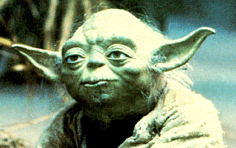
When George Lucas put pen to paper 30 odd years ago to write Star Wars he wrote from the roots of the past using Myth and mythical story from thousands of years of mystical literature which is far higher than the contemporary novels and stories which spring from the common psychopathic existential intellectual mind set.

Why is it higher? Because it cries, "May the Force be with you!!"

To those of you with, "Ears to Hear" It is because it talks of an energy higher than the mind called the Intuition or the Soul. It brings the higher mind or the Soul full frontal back into society after centuries of darkness. Because it brings the Light of the Soul (Lucas means Light Bringer) back into these times which we can call the "Dark Ages"

Shakespeare, another mystical master, knew of this perversion called common contemporary novels and movies. He called them, "Full of sound and fury, signifying Nothing!" Whereas the best of literature from Jallaluddhin Rumi to Shakespeare, to Tolkien to Lucas is nothing but Meaning and Significance.

On television we have significance and meaning? with weekly programs based on the police in order to inculcate trust in the police, that they are not corrupt. We have weekly programs about lawyers so that we know that they are good and interested in truth and justice. We even had shows about Oilmen like the Beverly hill billies the Clampets and Dallas to make us warm to the families owning the oil. There is even one about "The Love Boat" which advertises the cruise business to get people to go on cruises. I saw one last week about Las Vegas with Stallone and Caan whose purpose was to get more people to go there and show casino owners as warm hearted. Then many popular shows about daily life so that messages can be given, order created, population controlled, their reason for creation from the radio days over 60 years ago, and some of them have been going for that long.

Rather than that, the best of literature points out universal truths which can be "applied" in the Tolkienian sense to Your life and to this world. Here and Now! This is meaning and significance, words which are not talked about by critics or commentators presently on any movie in the IMDB database (The Internet Movie Database at imdb.com) thus partly proving my assertion in the first paragraph above, that meaning and significance are things which are not commonly understood by the psychopathic Sith Lords and their clone accomplices.

So, the main themes in the Revenge of the Sith are..

1. Pointing out the qualities and actions and mind set of the
psychopathic Sith Lords like The Emperor and Darth Vader from Star Wars or Sauron the Black Magician, The Witch King of Angmar or Saruman the bad wizard from The Lord of the Rings and their minions or accomplices whether they be called Orcs
from the Lord of the Rings or Clones from Lucas's Clone Army or "Dracula" from Francis Ford Copola's Movie or Salieri From the Movie "Amadeus". How these people are cut off from their higher mind or Soul, consciously cut themselves off from their higher mind or do not know of and disparage the Souls existence, and thus with no empathy or conscience Sith Lords can order the murder of 6 millions of Jews, in all, 200 millions of people murdered by Stalin, Hitler and Mao this last century.

These people are the Sith Lords. Turning the letters of Sith around you get "This" and its meaning and significance are that these are the Lords, like Stalin, Mao and Hitler, who rule THIS Planet, NOW!

In terms of Star Wars a Sith Lord uses negative emotions like Anger to access the perverted Dark side of the force whereas a Jedi Knight, like all enlightened beings, has trained himself to lose and transmute all negative emotions like anger, depression, manicism, wanting sympathy and attention, and fear into positive emotions like compassion, non attachment, willpower and universal love. This is the training we give on the Energy Enhancement Course.

Sith Lords Lie. The Emperor said the Jedi are traitors and must be destroyed. "Fair is Foul and Foul is Fair. Hover through the Fog and Filthy air!" Said Shakespeare. According to common understanding, carbon dioxide which plants use as food is pollution whereas poisonous Dioxins, PCBs and Pthalates are allowed from fuctories and incinerators and more and more are built.

In terms of Star Wars a Sith Lord uses terms of Absolutes like black and white to say, "If you are not with me then you are my enemy."

They have no loyalty, the Emperor destroyed his allies in the trade federation as soon as they became unnecessary, just like the Jewish leaders of the ghettos in Germany during the second world war were told they would be saved if they helped to send the rest of the Jews to the gas ovens. They themselves were then sent to the gas ovens in the last train.

The Emperor told of how he assassinated his master to become leader. Just like when Lenin died, was assassinated, Stalin became leader.



2. How these Sith psychopaths come into being. What causes them to become psychopathic? Why do they take the Ring?

Well you can click on this link to understand the theory of formation and the nature and massive prevalence of the psychopath
- 200 MILLIONS DEAD THIS CENTURY!! THE NATURE OF PSYCHOPATHS, SCHIZOPHRENICS, MANIC DEPRESSION, STALIN,
MAO AND HITLER. – In the second book of this series.

And you movie lovers can see the nature of the Psychopath from this dissertation on Stanley Kubric and the Clockwork Orange (Saruman has a "mind of metal and wheels" quote from the lord of the Rings) – by Satchidanand - PSYCHOPATHS AND THE FILMS, MOVIES OF STANLEY KUBRICK

Annakin becomes a psychopathic Sith Lord because he wants to save his wife in the way that he could not save his mother. He was so DISAPPOINTED by the Death of his mother that he would do anything to prevent the death of his wife. He is so attached to his mother and to his wife that he would do anything, even become a psychopathic Sith Lord, to save them. He was told lies that he would be taught how to give his wife eternal life. When he took the Ring in the Tolkienian sense then that Ring perverted him.

When we join in something bad then the psychopathic Sith Lords always want proof of your badness otherwise they will destroy you. So they ask you to do some little thing and this action so perverts you that you will continue, you cannot go back, you think, and eventually it leads on worse and worse to kill or destroy someone. In this way we are all tested in this life.

The psychopathic Ring takers are sucked into power and riches if they do this little thing. And as they continue, that little thing they have to do gets worse and worse, until they become a Lord of the Sith, a psychopathic leader. In a psychopathic Sith organisation the people who will not do this little bad thing are demoted and lose power and prestige, this is how you know the difference between which organisation is psychopathically bad and which is good.

Annakin was told to go to the Jedi Temple and to murder all the little Jedi children. This he did.

Another example of this is when they asked the Chief torturer from the time of the Generals in the 1960's in Greece, how he had found his accomplices to do his torturing. He said it was easy, "We just

took 10 likely candidates from the army every week and gave them some mild torturing tasks. Those who did well we promoted and kept. Those who did badly we demoted and sent back to the army!"

When Annakin became a psychopathic Sith Lord he tried to kill his wife because she was against him. The Emperor laughed when he told Darth Vader that his anger had destroyed her. He had proved himself a psychopathic Sith. Anger is always destructive.

And in "Amadeus" Salieri became so DISAPPOINTED in God after he had offered his chastity and his industry to God so that he could create wonderful music. Everyone liked his music. The King liked his music. He liked himself. But when he heard the music of Mozart he knew that Mozart's music was directly from God, and this unchaste, lewd, rude, punk of a musician was creating music far higher than he could ever create. He was so DISAPPOINTED that he swore undying hatred of God and threw his cross on the fire. And he swore undying hatred to his creation, Mozart. And so, cutting himself off from his soul, he slowly did worse and worse things, eventually murder, to destroy Gods creation, Mozart. He eventually become patron saint of all mediocrity, "full of sound and fury, signifying Nothing!", on this planet. And that is This.

And in "Dracula" from Ford Coppola, Dracula was so DISAPPOINTED by the suicide death of his wife that he became angry with God. "How could God allow this to happen!" he cried and so swore undying enmity to God and all creation. He cut himself off from his Soul and became one of the undead. "The Blood is the Life!!" - he cannot take his energy from the Soul, from God, instead he must parasithise everyone for Blood, he becomes a bloodsucker. Like Darth Vader who repented, Dracula also repented and in the end made his peace with God. Anyone can come back from the psychopathic Sith!



In Ancient times The Lord Buddha said, "Attachment leads to Pain"
But the real route is attachment, disappointment, pain, anger, revenge. And it goes on, round and round like Wheel. The Buddhist Wheel of the Law, of The buddhist Wheel of Karma, OF THE LORDS OF THE SITH. And that, is This...
THE ROUTE TO BECOMING A SITH LORD
- ATTACHMENT
- DISAPPOINTMENT AND PAIN-
- ANGER -
- CUTTING OFF FROM THE SOUL -
- A BAD PERVERTED ACT, REPEATED AND REPEATED-
- NOW YOU ARE A SITH LORD

POETRY
The Poetry of Wealth

Education
Education happens only when people want to learn. Education is an investment in human growth and potential. At its lowest level it is what we need to survive on this planet.
Higher, education is what skills we need to actualise our dreams and the dreams of others.
At its highest, education is the energy of impression from the Soul, whereby we catch the dreams of others, which actualises our highest faculties and the desire to learn, itself.

Profit
Profit is a term which has outlived its time.
There is no profit, there is only a temporary excess which can fund our next venture, our next initiative on the path of life.
Excess money is harvested to fund the governments essential ventures.
If hoarded the banks use it to fund other peoples dreams. Spent it provides us with the necessities of life.
Its highest use is in the support of our most dear dream, to fulfill the path of our life, our only wealth.

Dreams
Unselfish dreams for the benefit of all made flesh by years of unremitting life energy are the path of our life caught by the quiet mind.

Money
Money is the means, the energy whereby our ideas are made concrete and gain form.

Institutions
Institutions are our parent’s dreams made flesh through investment and hard work. They can be limited in scope and execution and work on through the living concept, caught by us their children.

Social Security and Wefare
Work is Essential.
Any system which dictates that a person must work at something they do not want to or the system will withdraw the means to prolong life, is a system of slavery and death of the human spirit.
If people are assured the basics on which to live:- Food, Housing and Education,
and then are offered the means to improve their situation through their choice of work, then such a system will lead to happiness and spiritual wealth.

People
Each child and person is a precious jewel waiting to be cut and each facet revealed unto the light. Each needs food, housing, access to education and a free choice of what work to enjoy.

Slavery
Those who work on that which has no meaning to them, only forsecurity, because they need the money, are truly in chains.
Here, a job means a long slow death because they are afraid to die in the name of their dream.

Peace
Wealth is a peaceful world and a peaceful country.
Let us invest in those organisations policing peace and preventing war.
Let us invest in preventing the causes of war - hunger, housing, education, birth control,the prevention of greed and in the possibility of making all our dreams come true.
Peace is that in which we are born, it is our birthright which can only be destroyed by our selfish desire and fear of Death.

Work
When we have our work which engages all our energies for a purpose in which we truly believe, then we are truly wealthy.
When we are forced into working for something petty or less, then we are truly poor, our spirit is broken, and we die whilst still alive in name.

MASLOW, GURDJIEFF, DAME ALEXANDER-NEEL, ELRON HUBBARD, PARACELCUS, BUDDHA, RAMANA MAHARSHI, RAMAKRISHNA
Is Maslow's Hierarchy A Plagiarism On Chakras & Kundalini Yoga, Known About For Thousands of Years
Maslows Hierarchy Of Needs is A Plagiarism On Chakra Theory And Kundalini Yoga, Known About For Thousands Of Years
Maslow's Hierarchy of needs Psychology- Really a plagiarism of the psychological aspects of the 7 Chakra Processors? Is Maslow's Hierarchy of needs really a plagiarism or parallel confirming research of the psychological aspects of the 7 Chakras, known about in Kundalini Yoga for Thousands of Years.
Chakras are about the parallel processors of the mind. Only one of these processors is Intellectual. The rest comprise the emotions, the unconscious, the subconscious, the inner child and the id.
All todays fastest supercomputers use parallel processors gaining speed with the number of processors.
Base Chakra is Mooladhara Chakra Abdominal Chakra is Swadisthan Chakra Solar Plexus Chakra is Manipur Chakra Heart Chakra is Anahata Chakra
Throat Chakra is Visshudhi Chakra
Brow or Third Eye Chakra is Ajna Chakra Crown Chakra is Sahasrara Chakra
The levels of evolution and their relationship to the parallel processors of the human brain, chakra, development and the ages at which they normally start working correctly, are used in the Montessori method of teaching yet the age of paradigm shift is simply the age at which another chakra gains functionality. Anyone

can see that this follows the theory of chakra awakening of Kundalini Yoga known about for thousands of years.
Maslows Hierarchy of Needs says that as the lower desires are fed so higher desires can be achieved.
Sex , Safety and Food - base chakra Belonging in relationships second chakra Power solar plexus
Self Esteem Heart Chakra
Self Actualisation Crown Chakra
Anyone can see that this follows the theory of chakra awakening of Kundalini Yoga known about for thousands of years.
Chakras are like the processors in a super computer. The more they communicate, the more intelligent they are. So anything which stops that communication, like an energy blockage will decrease intelligence. The more each chakra functions, the more intelligent we are, therefore anything which stops that functionality, like an energy blockage, the less of our potential intelligence we are using.
Intelligence is not only the intellectual IQ.
Emotional Intelligence functions in different chakras from the intelligence chakra. And emotional intelligence is when there exists in a human being none of the negative emotions.
Negative emotions are, Anger, Depression, wanting attention, manicism and Fear but to these we could add, wanting to harm another, jealousy and selfish desire.
As the chakras becomes harmonized by losing their energy blockages then the negative emotions become controllable or just go.
Thus releasing the Power of Positive emotions like Love, Willpower and the Power of getting things done. These become the norm.
Kundalini Yoga works by giving advanced techniques to remove energy blockages and thus release the power of the human intellect and Positive Emotion. Of Love, Love under Will.
Read the psychology of, Wilber, Piaget and Berne, - Ponder on this and see the truth for yourself.
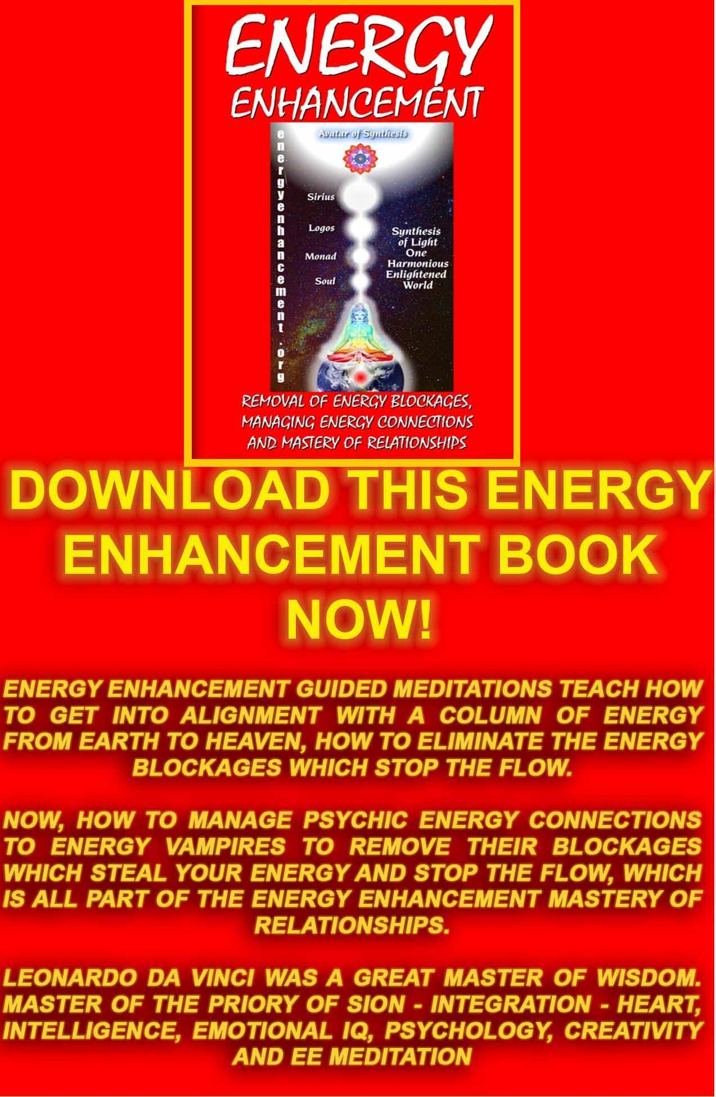
Download “REMOVAL OF ENERGY BLOCKAGES, MANAGING ENERGY CONNECTIONS AND MASTERY OF RELATIONSHIPS” HERE
http://www.energyenhancement.org/Sacred-Energy/Meditation-Energy-Enhancement-Eliminate-Energy-Blockages-Manage-Energy-Connections-and-Attachment-Mastery-of-Relationships-EEBOOK2Color-energyenhancement-org.pdf

GURDJIEFF AND ENERGY BLOCKAGES


GURDJIEFF
Gurdjieff was probably born in Alexandropal, in Asia Minor, about 1872. This remarkable and often controversial man spent a dozen years roaming about the East in search of esoteric teachings. He returned with a tremendous wealth of wisdom for the Western world.
Gurdjieff summarized the problem: Mankind is asleep but doesn't know it. So deep is his hypnotic slumber that he does his daily walking and talking and legislating and marrying in a state of unconsciousness.
Actually, the acts are the mechanical acts of hypnotized people. And that, Gurdjieff declares, is the simple reason why the world goes from one disaster to another: "Would", he asks, "a conscious human being destroy himself' through war, and crime, and quarrels No, man simply knows not what he does to himself."
One of the basic principles explains the many and varied I's in a man. The unawakened man is not a unified person. He has dozens of selves within him, each falsely calling itself. Many philosophers, including George Santayana and David Hume, have also observed how a person switches constantly from one I to another.
The many I's within a man explains many mysteries about human nature. For example, a man decides to give up an undesirable habit, but the next day he repeats it again. Why? Because another entitiy sub personality I has taken over, an energy blockage that likes the habit and has no intention of giving it up.
Or perhaps a woman decides to quit fooling around with her life; she determines to find her real self. She reads a book or two and goes to a few lectures. Then, suddenly, she loses all interest and goes back to her self-defeating behavior. What happened? An entirely different I, entity, energy blockage that doesn't want her to wake up, took charge.

Gurdjieff provides a simple solution to this contradictory condition: Become aware of the many I's. Watch how one takes over and then another. Also, see that they do not represent the true you, but consist of borrowed opinions and imitated viewpoints. Such self- observation weakens their grip; you eventually find your real I, your higher self or soul infused personality.

The Kundalini Kriyas and The Five Elemental paths of the Chi of the Taoist masters, like Energy Enhancement, gives the Hidden Taoist Secrets of the Microcosmic AND the Macrocosmic Orbit, The Energy Enhancement Supra Galactic Orbit
These symbols symbolise how to clean all the Chakras through a guided meditation. Helping all parts of the mind including the Unconscious, to become more calm and still.
"To remove the stones in the path of the watercourse. To remove blockages to the flow of your energy" A description of Samyama or Energy Enhancement from the 5000 years old Yoga Sutras of Patanjali, the source of Raja Yoga.
The Kundalini Kriyas and The Five Elemental paths of the Chi of the Taoist masters, like Energy Enhancement, teaches how to cleanse the psychic body so that our psyche becomes sensitive and our energy more powerful.
The Kundalini Kriyas and The Five Elemental paths of the Chi of the Taoist masters, like Energy Enhancement, strengthens the psychic circuits and decreases the resistance to the flow of Energy. It helps to build the psychic body, as Gurdjieff called it, "The Body Kesdjian".
The Kundalini Kriyas and The Five Elemental paths of the Chi of the Taoist masters, like Energy Enhancement, are guided meditations to increase sensitivity to energies is given in the next Initiation of the techniques of Energy Enhancement- "The Grounding of Negative Energies." - the Earth Path of the Five Elemental Pathways of the Qi.
Energy Enhancement's first seven Initiations of the full Twenty Eight Initiations consists of Meditation, Shaktipat, Energy Circulation, The Kundalini Kriyas, The Five Elemental Paths Of The Chi Of Chinese Alchemical Taoism, The Grounding Of Negative Energies, Alchemical V.I.T.R.I.O.L and the Art Card Of The Thoth Tarot, Kundalini Energy, Strong Psychic Protection, The Merkaba, Pyramid Protection, Power Tower Protection, The Antahkarana, Soul Fusion, Monadic Infusion, Logos Infusion, the Painless Removal Of Stress, Trauma And Negative Emotion.

Energy Blockages, Mechanical people, Sub – Personalities and the Soul Personality or Essence, through the work of Gurdjieff Part 1 of 2.

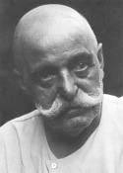

Gurdjieff died in 1949, about the same year as Ramana Maharshi.
Gurdjieff essentially synthesized ancient esoteric teachings and made them approachable and applicable to the lives of rational Western individuals. His concepts and methods are still seminal in the spiritual work of the west.
A seeker will find in his teachings an immeasurable treasure, the essence of so many other teachings, both spiritual and psychological, on the inner life.

This Gurdjieffian extraordinary system of thought, which ranges from the most intimate, psychological insights to a grandiose cosmology linking the individual with the universe, is a synthesis of practices and teachings known as The Fourth Way.
Then there is the man himself. Gurdjieff was the archetypal Master, beaming with extraordinary psychic powers developed in secret schools and monasteries somewhere between the Caucasus and the Himalayas; brutal soul-shattering insights; marvelous humor which was both ribald in the extreme and breathtakingly penetrating.
Gurdjieff also had a capacity for love that was matched only by his ability to express rage. He was a master hypnotist, a master actor, a master healer.
Those who encountered him often had opposite ideas of who he was, usually as a result of his own intentional behavior.
Like many Masters, Gurdjieff sometimes gave the impression of being a charlatan or mad to arrogant egotistic individuals, while to others he was the most enlightened man they would ever encounter.
His radiant energy, the Buddhafield of the Master, always acted on people's negative energies to send people with a lot of it away, and attracted people with a lot of good, positive Soul energy.
In such a way, as with all Masters, Gurdjieff consciously separated the evil weeds from the good grain!
This powerful Master Gurdjieff, with eyes that pierced to the depths of the soul was also an old man whose pockets were full of candy for the children.
He worked by many methods, to bypass the mind he worked with dance, Gurdjieff said, "I am a simple teacher of dance". Devi Dhyani has given performances of "The Sacred Dances of Gurdjieff" in order to radiate her Buddhafield more strongly, to throw out the bad and energise the good.
And when he explained the theory of the evolution of substances like hydrogens and oxygens in Ouspensky's book, "The Fourth

Way", Gurdjieff was just tricking him, taking a very long winded intellectual theory to say to intellectual Ouspensky and to anyone else reading it, to bypass the mind, "You need the radiation of a Master to quicken your evolution!"
His major concepts were Buffers or Energy Blockages, Mechanical people, Sub – Personalities and the Soul Personality or Essence.
Mechanical People. For Gurdjieff and Ouspensky, mechanical persons are the mass of humanity and are asleep to their true condition and virtually incapable of change. "By himself, he is just an automaton with a certain store of memories of previous experiences, and a certain amount of reserve energy."
Everything happens to us as to puppets pulled by invisible strings.
Sub Personalities. Another central idea of Gurdjieff is that the individual is not one. We have no permanent "I" or Ego. Every thought, feeling, sensation, desire is an "I" or sub – personality which believes that it is the whole person.
Yet none of these "I's" are connected and each depends on the change of external circumstances. To make things worse, there are often impenetrable defenses between each "I" which the Work calls "buffers" or "Energy Blockages" separating these sub - personalities or Alters from one another.
Gurdjieff states that one of our most important mistakes we make is our illusion about our unity. Gurdjieff writes: "His "I" changes as quickly as his thoughts, feelings, and moods, and he makes the profound mistake in considering himself always one and the same person; in reality he is always a different person, not the one he was a moment ago."
Our every thought and desire lives separately and independently from the whole. According to Gurdjieff, we are made of thousands of separate I's, often unknown to one another, and sometime mutually exclusive and hostile to each other.
The alternation of I's is controlled by accidental external influences. There is nothing in us able to control the change of I's, mainly because we do not notice it. Each separate I calls itself "I" and acts in the name of the whole person. This explains why people so often make decisions and so seldom carry them out.
Gurdjieff healed alcoholism and drug addiction – the addictive sub
– personalities in rich young men by means of hypnotism, and was once paid an oil tanker for his work by the family of one such. But to remove ALL the sub – personalities and access the one Soul

Personality in Enlightenment requires much more conscious work of the student.
Essence, the soul personality and personality. In order to see clearly the roots of our psychological distortions, Gurdjieff's Fourth Way defines two aspects of the individual: essence and the multitude of fleeting sub – personalities. Essence, the soul personality, is what a person is born with, sub - personalities are that which are acquired, usually by some traumatic event, usually in childhood which splits the childish sub – personality from the Soul stem.
All that is learned, both unconsciously through imitation and through acquired likes and dislikes, constitutes the outer part of the person, that which is changed by outer circumstances. Though personality is necessary, it must not be left to dominate essence or it will produce artificial persons, sub personalities cut off from their true natures, or the soul itself.
"This means that with a quick and early growth of personality, growth of essence can practically stop at a very early age, and as a result we see men and women externally quite grown up, but whose essence remains at the age of ten or twelve." The Energy Enhancement concept of the inner child which needs to be healed before it can grow up.
Through the practice of Energy Enhancement Soul Contact Meditation, we can separate ourselves from the pretenses and imitations which have enslaved us since childhood and return to who we actually are.
Such a return to our essential nature is accompanied by a sense of liberation unlike any other. "To thyself be true" is the first commandment on the way of self-development and the attaining of a higher consciousness.
The fundamental abnormality in human beings lies precisely in the divergence between personality and soul - essence. The more nearly we know ourselves for what we are, the more we approach wisdom.
The more our imagination about ourselves diverges from what we actually are, the more insane we become: Gurdjieff, "Unless a man first finds himself, finds his own essential nature and destiny, and begins from them, all his efforts and achievements will be built only on the sand of personality, and at the first serious shock the whole structure will crumble, perhaps destroying him in its fall."
Examples of shocks are disappointment and bereavement. Only the ego gets hurt. The Soul personality is never affected by

disappointment or bereavement. These are two of the tests that this should be so within you!
The soul – essence is the totality of the moments of self-awareness during one's life. Yet moments of higher consciousness are very rare and gone as soon as they come. Once again, the reason such self-consciousness is so difficult to attain is that it is dependent on the conscious use of attention.
Gurdjieff required that each person verify the teachings for themselves based on their personal observations and experiences. That is why he rarely mentioned the idea of "God" even though he called his teaching "esoteric Christianity."
His task was to help people free themselves from all that is false and imaginary in order that they might become receptive to their higher self and enter uncharted dimensions of consciousness on their own through liberation from the tyranny of their ego.
It is for this reason that Gurdjieff was so merciless on his students. He crushed the vanity and artifice of the sub - personalities, mocking those who thought they understood something. As we say in Energy Enhancement, "It is only the ego which gets hurt!"
Gurdjieff differentiated between two forms of knowing: knowledge and understanding. The first is of the head, the second is that which takes root in our being and transforms us. He did indeed humiliate many egos stuffed with pride and broke people's confidence in their own importance.
Gurdjieff tore through our most cherished beliefs with astonishing force and irreverence, stung our vanities with brutal honesty, and called us to that ultimate journey toward the consciousness of who we are and who we are meant to be.
His "toast to the idiots" stung the ego but gave great information to the humble on where to start the spiritual work.
Behind the exotic masks of Gurdjieff, the oriental magician-rogue- teacher, was great compassion. Children and animals sensed it, while seekers of all classes and types found healing and new life from his sometimes bizarre requirements.
Gurdjieff came to wake us with uncompromising affection and assist us accessing our deeper selves. No one walks away unchanged from the teachings of this intense Master who has taught us to discover someone even more elusive than himself: the true nature of our being.
Energy Enhancement is ancient, effective, meditative techniques from 5000 years of successful spiritual technology comprising the

Kundalini Kriyas, Soul Contact, the Grounding of Negative Energies and Energy Blockages and sub – personality Inner Children, and more!

From time immemorial it has been known that some people, Yogis, Gurus, Shamen, Priests, Saints, Paramahamsas, Buddhas, Christs, have evolved to a state of high energy.
These pure and good people, wanting benefit and happiness for all, without a trace of selfishness and competition have been known to have psychic powers.
Their search for energy and goodness has precipitated within them the next stage of human evolution.
For thousands of years they have been Good Doctors, Good Priests, founders of religion, Philosophic Geniuses, Advisors of Kings, Musical Geniuses, Poets, Makers of the
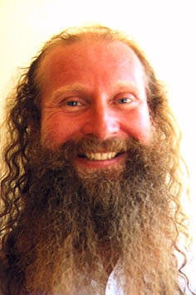Law.
For thousands of years these people, wielding amazing Siddhis or Psychic powers, have been recorded as healing of the sick, casting out mental sickness, coming in dreams, communicating through telepathy, the radiation of specialised energies, leaving the body, entering into the body of another, astral travel, telling the future, acting at a distance, raising Kundalini, Shaktipat, the ability to pass healing into amulets, temples, places of peace, pilgrimage sites, creating miracles, birds and beasts come to them in peace.
Doing all this they also pass on their energy in Shaktipat for the awakening of all good students.
The shaktipat, the radiation of psychic energies by the enlightened can awaken these abilities in all who come to them. This has been known and recorded in the Sacred literature for thousands of years.

Written by Satchidanand, Director of Energy Enhancement, one of the leading teachers of Meditation! He helps people worldwide reach further than they EVER thought possible, FASTER!
http://www.energyenhancement.org

Reciprocal Maintenance Meditation, the Solution to the Problem of War, Increase of Life leading to Immortality through the work of Gurdjieff Part 2 of 2.

Gurdjieff died in 1949, about the same year as Ramana Maharshi.
Gurdjieff essentially synthesized ancient esoteric teachings and made them approachable and applicable to the lives of rational Western individuals. His concepts and methods are still seminal in the spiritual work of the west.
A seeker will find in his teachings an immeasurable treasure, the essence of so many other teachings, both spiritual and psychological, on the inner life.
This Gurdjieffian extraordinary system of thought, which ranges from the most intimate, psychological insights to a grandiose

cosmology linking the individual with the universe, is a synthesis of practices and teachings known as The Fourth Way.

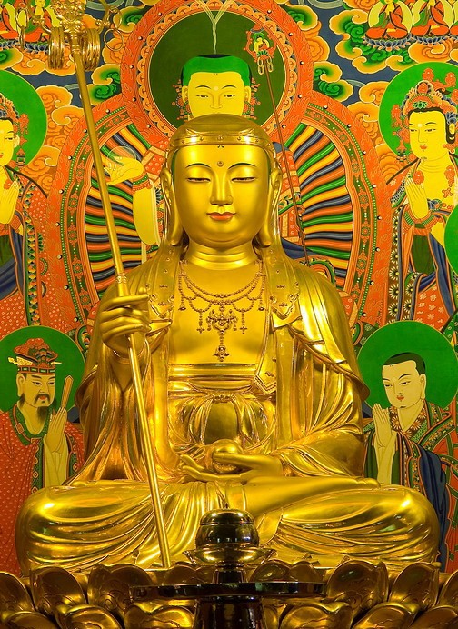

Then there is the man himself. Gurdjieff was the archetypal Master, beaming with extraordinary psychic powers developed in secret schools and monasteries somewhere between the Caucasus and the Himalayas; brutal soul-shattering insights; marvelous humor which was both ribald in the extreme and breathtakingly penetrating.
Gurdjieff also had a capacity for love that was matched only by his ability to express rage. He was a master hypnotist, a master actor, a master healer.
Those who encountered him often had opposite ideas of who he was, usually as a result of his own intentional behavior.
Like many Masters, Gurdjieff sometimes gave the impression of being a charlatan or mad to arrogant egotistic individuals, while to others he was the most enlightened man they would ever encounter.
His radiant energy, the Buddhafield of the Master, always acted on people's negative energies to send people with a lot of it away, and attracted people with a lot of good, positive Soul energy.
In such a way, as with all Masters, Gurdjieff consciously separated the evil weeds from the good grain!
This powerful Master Gurdjieff, with eyes that pierced to the depths of the soul was also an old man whose pockets were full of candy for the children.
He worked by many methods, to bypass the mind he worked with dance, Gurdjieff said, "I am a simple teacher of dance". Devi Dhyani has given performances of "The Sacred Dances of Gurdjieff" in order to radiate her Buddhafield more strongly, to throw out the bad and energise the good.
And when he explained the theory of the evolution of substances like hydrogens, carbons and oxygens in Ouspensky's book, "The Fourth Way", Gurdjieff was just tricking him, taking a very long winded intellectual theory to say to intellectual Ouspensky and to anyone else reading it, to bypass the mind, "You need the radiation of a Master to quicken your evolution!"

His major concepts were Buffers or Energy Blockages, like the organ Kundabuffer, Mechanical people, Sub – Personalities and the Soul Personality or Essence which I have described in the first article.
Yet in his third book of the trilogy, Beelzebub's Tales to his Grandson, he talked about two more interlinked concepts.. Reciprocal Maintenance is the Taoist Macrocosmic Orbit, The Energy Enhancement Supra Galactic Orbit Meditation and The Affirming and Denying Influences on man.
Here is a quote…
"the Most High and Most Sacred Individuals to take the necessary measures to insure the formation on the Earth of what is called the sacred 'askokin,' so that this sacred cosmic substance, indispensable for the maintenance of the Universe, might issue continuously from your planet.
"His Conformity also explained that this cosmic substance, the sacred 'askokin,' exists throughout the Universe, generally blended with the sacred substances 'abrustdonis' and 'helkdonis,' and therefore, in order to have the degree of vivifyingness required for such maintenance, the sacred substance 'askokin' must first be freed from the other two substances.
"To tell the truth, my boy, I did not understand at once all that he told me, it all became clear to me only later when, during my studies of the fundamental cosmic laws, I learned that these sacred substances 'abrustdonis' and 'helkdonis' are precisely those substances which enter into the formation and perfecting of the higher being-bodies of the three-brained beings—that is, the 'kesdjan body' and the 'body of the soul'—and that the separation of the sacred 'askokin' from the two other substances proceeds when beings, on whatever planet they may be, transmute these sacred substances in themselves for the forming and perfecting of their higher bodies, by means of conscious labor and intentional suffering.
"And when I became interested in these favorites of yours and began to observe and study their strange psyche, I finally understood why and to what ends Great Nature herself and the Most High and Most Saintly Individuals are always patiently adapting themselves to all things In this connection, the following personal opinion was formed in me.
"If only these favorites of yours would seriously ponder all this and serve Nature honestly in this respect, their being-self-perfecting might then proceed automatically, even with-

out the participation of their consciousness, and in any case, the poor Nature of this ill-fated planet would not have to strain so hard to adapt herself to remain within the common-cosmic harmony.
"But to the misfortune of everything existing in the Megalocosmos, there is no honesty in your favorites in fulfilling their duties, not even toward that Nature to whom, in truth, they owe their very existence.
"As regards the absence of honesty in your favorites in the fulfillment of their duty toward Nature, I have just remembered a very wise saying of our incomparable teacher Mullah Nasr Eddin, the hidden meaning of which is borne out in the present case.
" 'Plague and cholera are in any event nobler than human honesty, for people with a conscience can at least live at peace with them. '
"And so, my dear Hassein, when it became clear that there had entirely disappeared from the psyche of your favorites the instinctive need for conscious labor and intentional suffering in order to take in and transmute in themselves the sacred substances abrustdonis and helkdonis—thus releasing the sacred askokin for the maintenance of the Universe—Great Nature was constrained to adapt herself and to extract this sacred substance by other means, one of them being precisely that periodic terrifying process of reciprocal destruction.
"Here, for a correct valuation of your contemporary favorites, it will be opportune to remind you that after the organ kundabuffer had been removed from the three-brained beings of your planet, the first generations of their descendants very soon learned that a certain substance had to be transformed through them and that their assistance in this transformation was one of their chief being- duties.
"Do you remember, I already told you that the three-brained beings of the continent of Atlantis even considered
this being-duty as sacred and called it 'amarloos,' which in their language meant 'help for the Universe. “

The Central Spiritual sun sends, shines energy, Affirming Influences, to earth in different quantities at different times dependent upon astrology.
Human beings and all nature have been created to transmute those different quantities of energy through a Reciprocal Maintenance meditation and send back Denying Influences to the central spiritual sun.

As we transmute the trauma formed substance, Negative Karmic Mass, the Gurdjieffian Abrustdonis and Helkdonis, in the chakra in the center of the Earth through sending NKM down to it through a connection from the Base or Muladhara Chakra so we activate the guided meditation VITRIOL.
VISITA INTERIORE TERRAE INVENIES OCCULTEM LAPIDEM - Visit the
Center of the earth, there you will find the hidden stone, the Philosophers Stone which Transmutes Base metal (Blockages) into pure Spiritual Gold. It is that nuclear generator in the center of the earth which has maintained the heat within this planet for 4 Billions of years which is going to transmute this trauma formed Negative karmic Mass of concentrated pain back into pure spiritual energy.
We teach this process in Energy Enhancement Initiation Three, The Grounding of Negative Energy but it is the Rectificando –“The right leading of the transmuted spiritual energy along the path of the Soul”, of Energy Enhancement Initiation 4 which is going to send that energy back to the chakras above the head, “for the Maintenance of the Universe”.
VITRIOL has been sent to us from enlightened masters from the middle ages, but in reality from much further back, from the Egyptian Sources of the first Alchemist, Hermes Trismegistus which were informed by the Kundalini Kriya sources of the Indian side of the Himalayas of the first Indian Ascended Master Babaji to teach them 4000 years ago and who also taught the Kundalini Kriyas personally to Sri Yukteswar and Yogananda and earlier from the Taoist Alchemical sources of the Chinese side of the Himalayas.
Reciprocal Maintenance Meditation or The Fourth Initiation of Energy Enhancement, also evolves humanity, creating and increasing the size and power of the higher being bodies of the soul and the body Kesdjian, and this allows a greater quantity and quality of energy to be transmuted.
If Reciprocal Maintenance does not occur then…
"It was also fully proved in the theory of Atarnakh that at certain periods depending on astrology, there must infallibly proceed on earth such a definite quantity of deaths as in their totality will yield vibrations of a definite degree of power."
These deaths, unless provided by meditation, are provided by natural causes like Tsunamis, the sacrifice of animals, or the killing of human beings through war, or as Gurdjieff calls it, periods of Reciprocal Destruction.
Gurdjieff was saying that the death or sacrifice of animals was unaesthetic. Part of Beelzebubs Tales to his Grandson was how he

came down to the planet several times over thousands of years and in that time he prevented the previous practices of animal and human sacrifice.
In this, Gurdjieff is saying that he is an Ascended Master who has the ability to pass with full consciousness through the death process, dropping his old body as you would an old set of clothes, and return with full consciousness into another body at any time.
Death by war or natural disasters is an abomination. Gurdjieff said that, without the completion of the process of
Reciprocal Maintenance Meditation, lives would grow shorter and people would forget their previous lifetimes in their next rebirth. In a way, completion of the Reciprocal Maintenance Meditation leads to Immortality!
Thus the solution to the problem of war and also to evolution is the advanced meditation of Reciprocal Maintenance resulting in a process of being-duty - opening the heart, conscious labor and intentional suffering for the benefit of others.
Thus we learn and practice the initiations of Energy Enhancement - Yoga, Pranayama, Meditation, Samadhi, Samyama, the Kundalini Kriyas, Chinese Alchemical Taoism and the Micro and Macrocosmic Orbit, The Energy Enhancement Supra Galactic Orbits, VITRIOL and The Emerald Tablet of Hermes Trismegistus, The Grounding of Negative Energies, The Yoga Sutras of Patanjali, Raja Yoga and the Eighteen Classical Yogas of the Bhagavad Gita.
From time immemorial it has been known that some people, Yogis, Gurus, Shamen, Priests, Saints, Paramahamsas, Buddhas, Christs, have evolved to a state of high energy.
These pure and good people, wanting benefit and happiness for all, without a trace of selfishness and competition have been known to have psychic powers.
Their search for energy and goodness has precipitated within them the next stage of human evolution.
For thousands of years they have been Good Doctors, Good Priests, founders of religion, Philosophic Geniuses, Advisors of Kings, Musical Geniuses, Poets, Makers of the Law.
For thousands of years these people, wielding amazing Siddhis or Psychic powers, have been recorded as healing of the sick, casting out mental sickness, coming in dreams, communicating through telepathy, the radiation of specialised energies, leaving the body, entering into the body of another, astral travel, telling the future, acting at a distance, raising Kundalini, Shaktipat, the ability to pass

healing into amulets, temples, places of peace, pilgrimage sites, creating miracles, birds and beasts come to them in peace.
Doing all this they also pass on their energy in Shaktipat for the awakening of all good students.
The shaktipat, the radiation of psychic energies by the enlightened can awaken these abilities in all who come to them. This has been known and recorded in the Sacred literature for thousands of years.

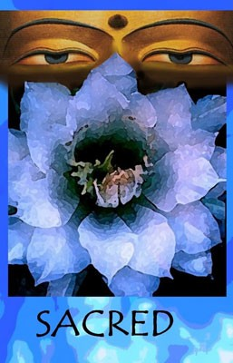

What Did Gurdjieff Say about Meditation, Frank Lloyd Wright, Ego + Enhancement of Energy?
Pt1 of 3
"The force and degree of a man's inner benevolence evokes in others a proportionate degree of ill-will" - Gurdjieff

"Evil people always hate those at the opposite end of the moral spectrum" - Earl Spencer at the funeral of Lady Diana

"The Radiance of the Buddhafield irritates or depresses or upsets Negative Energy Blockages, and by these fruits, ye shall know

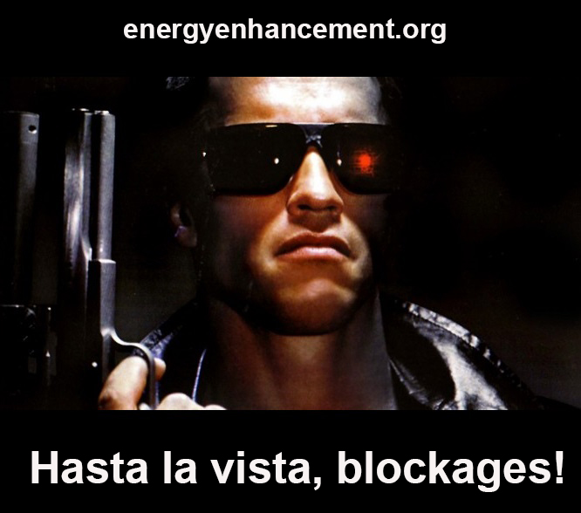

them!" Satchidanand

Masters show you the Energy Blockages of the ego. With the Meditational techniques of Kundalini and Blockage Busting, it should be an easy matter to remove the blockages.

Gurdjieff, whilst manifesting himself with this inner benevolence, his radiant Buddhafield, this inner radiation which is called love, the energy of change, he tried in every way to de-crystallize the already crystallized vanity and conceit in people; and this made enemies for him.

People forgot what Gurdjieff had done for them in removing their illnesses, their psychic blockages and in personal help, and remembered only their hurt vanity. Perhaps, if people knew that Gurdjieff was going to show them their touchy points directly then they would react in the correct way of thanking him for finding their energy blockages so that with advanced blockage busting techniques they could release them.

However, unless people know that they need to want to lose the ego, unless they really want to become good people, there is no point in going to see a Master. Gurdjieff would just blow these bad types of people off as quickly as possible so that he would not be wasting his time.

There is always a battle twixt good and bad in all. Most of the time people are distracted by their bad sides and give in to anger, jealousy and pay back. All the bad sides of the selfish competitive ego.

Gurdjieff was well known for his "Toasts to the Idiots!" where he asked new students, and older ones, what kind of an idiot they were. And when they had no reply, he told them. And this information could tell much of the inner blockages and psyche of the student and could help him much. The student's reaction also revealed his inner self.

For example, Frank Lloyd Wright, the famous American architect, was visiting Gurdjieff in Paris as his wife was one of Gurdjieff's pupils and had stayed with him for some time.

One of the students there that night knew Lloyd Wright and expected to hear some interesting questions and answers, but he said Wright behaved like a brilliant undergraduate, and it was clear that of real spirituality, he knew nothing.

He seemed to regard Gurdjieff as having achieved almost the same level as himself, even though knowing more about some things than he, Wright did. It is sometimes gratifying to discover that "great" men have their weaknesses, their vanity and self-love, the same as oneself; and, "I noticed that when Mr. Gurdjieff provoked Wright's prickly vanity, something malicious in me had a feeling of mild satisfaction".

During the toasting of the idiots, Wright said, "Mr. Gurdjieff, I've found some of these "Idiots" very interesting, I've invented some myself."

Reading Beelzebub's Tales to his Grandson to the assembled people, Wright said, "This is very interesting Mr. Gurdjieff. It's a pity it's not well written. You speak English very well. It's a pity you can't dictate. If I had the time you could dictate to me, and I could put it into good English for you."

Gurdjieff had told him to read a section of Beelezebub which was telling Wright about his own internal weaknesses in the guise of talking about someone else, which is the normal technique of a Master. Wrights selfish, vain and competitive ego could not take it.

Then Wright said that he must stop reading because he was very tired, - which occurs when an ego blockage has been encountered, - his daughter was very tired and that he had better go back to the hotel. Gurdjieff said, "Better stop for her sake, she is still young and only begin, but you are old man and your life is finished!"

Wright got red in the face and said angrily, "My life is certainly not finished, there's plenty I can do yet." or words to that effect. He got up and left with his family in what is called, "High Dudgeon!"

"Like every one of us in front of Gurdjieff, Wright's mask came off. Everyone, without exception, whilst eating and drinking with him, revealed his essential self."

Gurdjieff says that our early education gives rise to the impulses of Vanity and Self-Conceit and he affirms that happiness in life and good relationships with all depend on an absence of the feeling of vanity and self conceit, touchiness, within ourselves. Touchiness is the symptom of a psychic energy blockage.

So, one of the tests of being with a master is not to react to these tests of vanity and the ego but to use the reaction to clear the blockage with advanced blockage busting techniques. Your ego

reactions will show you where the ego blockages are. No reaction to the Masters probes can only be achieved when the ego is no more.

Thus touchy reactions are a tremendous help in the movement to Enlightenment, which only occurs when no energy blockages remain.

Such shocks, created by Gurdjieff, were introduced to show you your ego weaknesses.

But very few understand the real work of the Masters which is to help you remove the blockages of the ego. Everything they do is devoted to that aim. And very few selfish competitive egos can stay in the presence of true love...

For very deep and powerful Energy Blockages Gurdjieff said one must meditate with a Master of Meditation, within his Buddhafield. Let the Master do the work!

Or one must learn very powerful blockage busting techniques. Then, like Alexander the Great, you can learn how to cut the blockage Gordian Knot with your Manjushri sword of Discernment!

Usually, the necessary solution is a mixture of both being with a Master of Meditation, and learning advanced Blockage Busting techniques yourself.

Work on the self requires - Gaining More Energy .. Meditation, Shaktipat, Kundalini, Energy Circulation, The Kundalini Kriyas, The Five Elemental Paths Of The Chi Of Chinese Alchemical Taoism, The Grounding Of Negative Energies, V.I.T.R.I.O.L and The Art Card Of The Thoth Tarot, Access to more Kundalini Energy, Strong Psychic Protection, The Merkaba, Pyramid Protection, Power Tower Protection, Creating The Antahkarana, Soul Fusion, Monadic Infusion, Logos Infusion. The Painless Removal Of Stress, Trauma And Negative Emotion. And then the removal of the Energy Blockages of the Selfish, Vain Competitive Ego!

Satchidanand, Director of Energy Enhancement, is one of the leading teachers of Meditation!

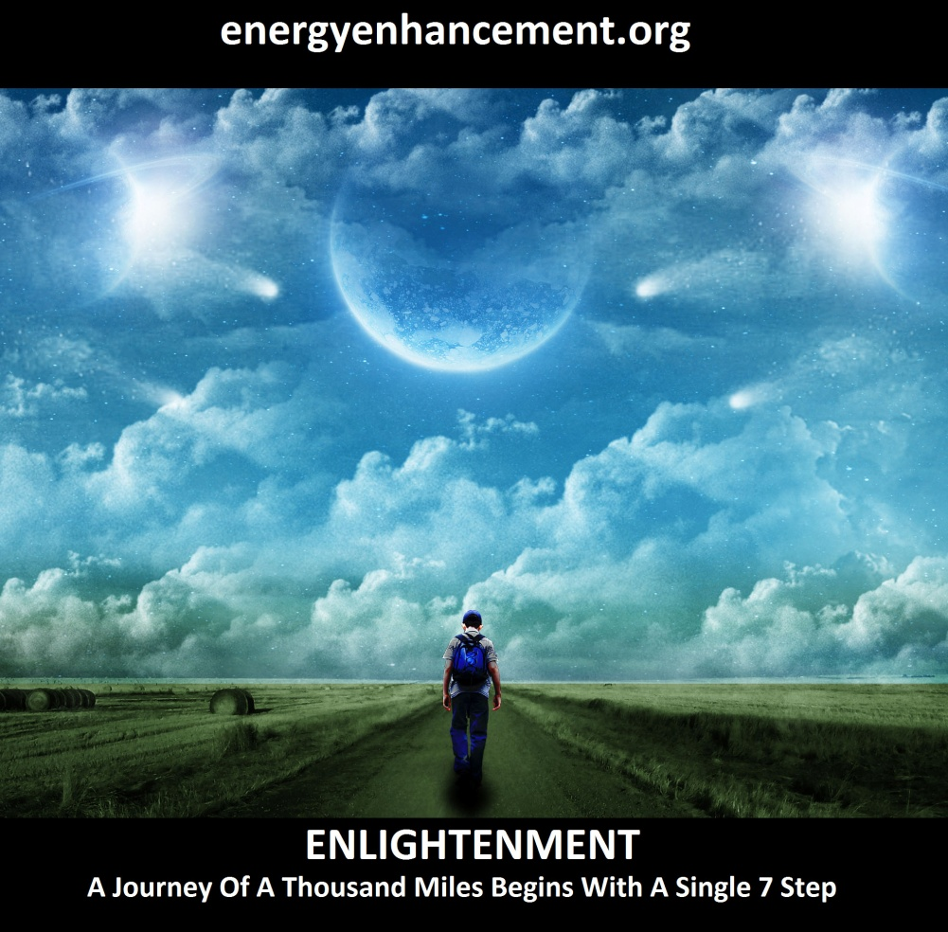
LEARN THAT WHICH IS FALSE WITHIN YOU
LEARN TO RECOGNIZE THE FALSE AS FALSE
-WITHOUT THAT, THERE CAN BE NO LASTING TRANSFORMATION
ENERGY ENHANCEMENT
"I was not sure if this was wise, as I knew nothing other than what I had read on the web site and the testimonials, which I was a bit skeptical about! However, I am now adding my own because if you read this you might be a bit like me...
Don't hesitate - go for it!"
MS (Ireland) Human Resources Director, Europe/Asia, of a Fortune 500 US Multinational Company
Honey Kalaria

" Once on the course, my exciting adventurous journey began! In my life I have done hundreds of courses but the Energy Enhancement Course I found to be completely different. Firstly, the contents and the teachings seem to be inspired by higher forces and had a deep base in spirituality..." Honey Kalaria (UK) Bollywood Actress/Owner of Diva Entertainment
ENERGY ENHANCEMENT
"I was not sure if this was wise, as I knew nothing other than what I had read on the web site and the testimonials, which I was a bit skeptical about! However, I am now adding my own because if you read this you might be a bit like me...
Don't hesitate - go for it!"
MS (Ireland) Human Resources Director, Europe/Asia, of a Fortune 500 US Multinational Company

GAIN SUPER ENERGY

ENERGY ENHANCEMENT MEDITATION

What did Gurdjieff say about Meditation, Ouspensky, Egoism and the Enhancement of Energy? Pt 2 of 3
"The force and degree of a man's inner benevolence evokes in others a proportionate degree of ill-will" - Gurdjieff
"Evil people always hate those at the opposite end of the moral spectrum" - Earl Spencer at the funeral of Lady Diana
"The Radiance of the Buddhafield irritates or depresses or upsets Negative Energy Blockages, and by these fruits, ye shall know them!" Satchidanand
Masters show you the Energy Blockages of the ego. With the Meditational techniques of Kundalini and Blockage Busting, it should be an easy matter to remove the blockages.
Orage, a great student of Gurdjieff, said, "If someone tells me a truth with the aim of helping me, a tonic truth, which shows me something about myself, my vanity and self love, my ego, is hurt. I resent it.
If he tells me something flattering, though it may be bad for me, I am his friend for life.
How many people regard public celebrities as, "Great People", celeBraties who in private are vain, conceited and touchy. The vast mass of people regards some world leaders as, "Great Men", those who in reality are immersed in vanity, self-pride, self-love and egoism to the point of madness."
Gurdjieff speaks about his connection to the universe automatically present in all enlightened beings, causing energy to radiate automatically to everyone connected to him and in his presence.
The light of the enLightened makes plain and reveals the energy blockages of the ego.
He talked about his consciously created aim of always without exception manifesting himself benevolently, radiantly, towards everyone for their good, while at the same time waging an unceasing struggle against the weaknesses inherent in their natures.
While manifesting himself with this inner benevolence, this inner radiation which is called love, the energy of change, he tried in

every way to de-crystallize the already crystallized vanity and conceit in people; and this made enemies for him.
People forgot what he had done for them in removing their illnesses, their psychic blockages and in personal help, and remembered only their hurt vanity.
Indeed, this happened with two of the greatest of Gurdjieff's students, Orage and Ouspensky. Both of these students left Gurdjieff, just when Gurdjieff was trying to show them their latest and greatest ego fault. Their ego energy blockages could not remain in his presence and so they found fault with their Master, and went off to found their own schools or do some other work.
Ouspensky was so annoyed when Gurdjieff showed him up (Vanity) in front of his own pupils, he forbade any of his pupils talking with Gurdjieff or any of his pupils on pain of exclusion from his school. He never saw Gurdjieff again before he died 20 years later.
The school of Ouspensky in London had thousands of students, and the students did not grow much, as the radiance was less. But Gurdjieff said, "These teachers will bring thousands of students to me, and I will choose perhaps ten." Gurdjieff had few students but his students grew, evolved, fast.
After the death of Ouspensky, Madame Ouspensky sent all the London students to Gurdjieff. These students then knew the necessity for the radiance of a Master and later, many helped Maharishi Mahesh Yogi and the work of Transcendental Meditation.
Now Gurdjieff is known as one of the greatest of Masters of the 20th Century, and no-one can remember the names of Orage and Ouspensky..
Gurdjieff says that our early education gives rise to the impulses of Vanity and Self-Conceit and he affirms that happiness in life and good relationships with all depend on an absence of the feeling of vanity and self conceit, touchiness, within ourselves. Touchiness is the symptom of a psychic energy blockage.
So, one of the tests of being with a master is not to react to these tests of vanity and the ego but to use the reaction to clear the blockage with advanced blockage busting techniques. Your ego reactions will show you where the ego blockages are. No reaction to the Masters probes can only be achieved when the ego is no more.
Thus touchy reactions are a tremendous help in the movement to Enlightenment, which only occurs when no energy blockages remain.

Such shocks, created by Gurdjieff, were introduced to show you your ego weaknesses.
But very few understand the real work of the Masters. And very few selfish competitive egos can stay in the presence of true love...
For very deep and powerful Energy Blockages Gurdjieff said one must meditate with a Master of Meditation, within his Buddhafield. Let the Master do the work!
Or one must learn very powerful blockage busting techniques. Then, like Alexander the Great, you can learn how to cut the blockage Gordian Knot with your Manjushri sword of Discernment!
Usually, the necessary solution is a mixture of both being with a Master of Meditation, and learning advanced Blockage Busting techniques yourself.
Work on the self requires - Gaining More Energy .. Meditation, Shaktipat, Kundalini, Energy Circulation, The Kundalini Kriyas, The Five Elemental Paths Of The Chi Of Chinese Alchemical Taoism, The Grounding Of Negative Energies, V.I.T.R.I.O.L and The Art Card Of The Thoth Tarot, Access to more Kundalini Energy, Strong Psychic Protection, The Merkaba, Pyramid Protection, Power Tower Protection, Creating The Antahkarana, Soul Fusion, Monadic Infusion, Logos Infusion. The Painless Removal Of Stress, Trauma And Negative Emotion. And then the Energy Enhancement removal of the Energy Blockages of the Selfish, Competitive Ego!
Satchidanand, Director of Energy Enhancement, is one of the leading teachers of Meditation!

He helps people worldwide reach further than they EVER thought possible, FASTER!
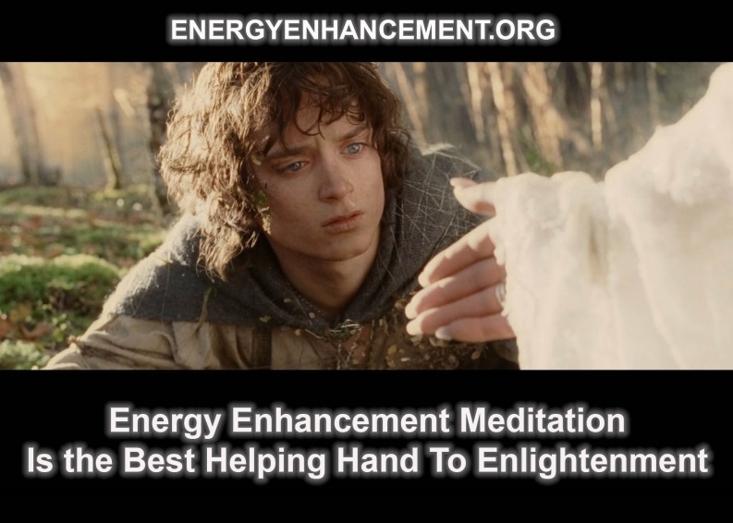

THE ENERGY ENHANCEMENT STREAMING VIDEO COURSE

"Get your asses over here Now and Speed Up your process of Enlightenment on the Energy Enhancement one month course!!" - DON
Every one of our Students gets this Spiritual Experience of Connection with Infinite Energies.
Energy Enhancement does indeed, "SPEED UP THE PROCESS!!"
And they all get this Experience of Light, Life and Infinite Energy just with the Energy Enhancement Course - Every One of Them!!
LEVEL 1 - 4 VIDEO COURSES ANYTIME IN THE COMFORT OF YOUR OWN HOME

What did Gurdjieff say about Meditation, Orage, Egoism and the Enhancement of Energy? Pt 3 of 3
"The force and degree of a man's inner benevolence evokes in others a proportionate degree of ill-will" - Gurdjieff
"Evil people always hate those at the opposite end of the moral spectrum" - Earl Spencer at the funeral of Lady Diana
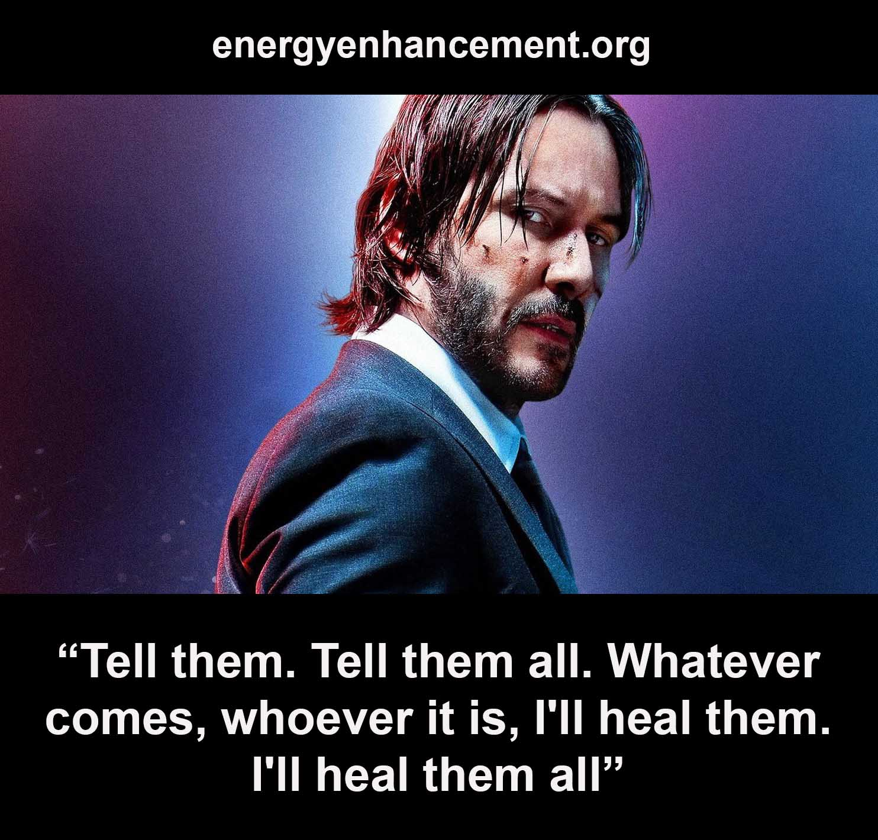

"The Radiance of the Buddhafield irritates or depresses or upsets Negative Energy Blockages, and by these fruits, ye shall know them!" Satchidanand
Masters show you the Energy Blockages of the ego. With the Meditational techniques of Kundalini and Blockage Busting, it should be an easy matter to remove the blockages.
Orage, a great student of Gurdjieff, said, "If someone tells me a truth with the aim of helping me, a tonic truth, which shows me something about myself, my vanity and self love, my ego, is hurt. I resent it.
If he tells me something flattering, though it may be bad for me, I am his friend for life.
How many people regard public celebrities as, "Great People", celeBraties who in private are vain, conceited and touchy. The vast mass of people regard some world leaders as, "Great Men", those who in reality are immersed in vanity, self-pride, self-love and egoism to the point of madness."
Gurdjieff speaks about his connection to the universe automatically present in all enlightened beings, causing energy to radiate automatically to everyone connected to him and in his presence.
The light of the enLightened makes plain and reveals the energy blockages of the ego.
He talked about his consciously created aim of always without exception manifesting himself benevolently, radiantly, towards everyone for their good, while at the same time waging an unceasing struggle against the weaknesses inherent in their natures.
While manifesting himself with this inner benevolence, this inner radiation which is called love, the energy of change, he tried in every way to de-crystallize the already crystallized vanity and conceit in people; and this made enemies for him.
People forgot what he had done for them in removing their illnesses, their psychic blockages and in personal help, and remembered only their hurt vanity.
Indeed, this happened with two of the greatest of Gurdjieff's students, Orage and Ouspensky. Both of these students left Gurdjieff, just when Gurdjieff was trying to show them their latest and greatest ego fault. Their ego energy blockages could not remain in his presence and so they found fault with their Master, and went off to found their own schools or do some other work.

Orage, perhaps the greatest of Gurdjieff's students, but at the end made excuses about not going to see Gurdjieff instead of going to help him.
Gurdjieff asked Orage to go to see him in Paris, and Orage wrote, "Time was when I would have gone to the ends of the earth at your wish." But this time he did not
He believed at that time that he had to complete his work with Social Credit and then bring about a revival of literature in Europe comparable to that of the renaissance before going to work with Gurdjieff at another level. This is the Star sub-personality which took him away from the work of perfecting himself.
The student of a Master was espousing "The Truth" in the market place. So great was the controversy and the uproar the Master had to talk to his student. "Do not teach" he said, "they are not your students"
Everyone knows that an idea before its time causes no end of trouble. The ideas of the Tolpuddle Martyrs caused their executions and it took 500 years before their ideas became law all over Europe. Government created credit, bank notes, were made by Abraham Lincoln and JF Kennedy without the permission of the banks the year before they died.
His delight in his own abilities caused him to cast pearls before swine through work on publicizing controversial Economic topics at this time, although given more publicity now. Government created Social Credit for the benefit of the people and industry, instead of Bank Credit and "fractional reserve lending" for the profits of the Banks, also Basic Income, a minimum living wage for everyone as a dividend for having shares given at birth, in The World Ltd, which proposed an end to wage slavery, caused by fear of having no money. One day after successfully espousing Social Credit on all England BBC Radio, Orage died suddenly and mysteriously.
He had never been to see Gurdjieff before he died and if he had listened to Gurdjieff perhaps he could have been saved.
What I want to say is that even though Orage made the statement about vanity above, his Star sub-personality blockages, one of the highest and most difficult energy blockages, found a way to make him forget and stopped him working on himself.
Blockages will desperately try to prevent one going close to the Master and the Masters energy which can remove them.

Now Gurdjieff is known as one of the greatest of Masters of the 20th Century, and no-one can remember the names of Orage and Ouspensky..
Gurdjieff says that our early education gives rise to the impulses of Vanity and Self-Conceit and he affirms that happiness in life and good relationships with all depend on an absence of the feeling of vanity and self conceit, touchiness, within ourselves. Touchiness is the symptom of a psychic energy blockage.
So, one of the tests of being with a master is not to react to these tests of vanity and the ego but to use the reaction to clear the blockage with advanced blockage busting techniques. Your ego reactions will show you where the ego blockages are. No reaction to the Masters probes can only be achieved when the ego is no more.
Thus touchy reactions are a tremendous help in the movement to Enlightenment, which only occurs when no energy blockages remain.
Such shocks, created by Gurdjieff, were introduced to show you your ego weaknesses.
But very few understand the real work of the Masters. And very few selfish competitive egos can stay in the presence of true love...
For very deep and powerful Energy Blockages Gurdjieff said one must meditate with a Master of Meditation, within his Buddhafield. Let the Master do the work!
Or one must learn very powerful blockage busting techniques. Then, like Alexander the Great, you can learn how to cut the blockage "Gordian Knot" with your "Manjushri sword of Discernment"!
Usually, the necessary solution is a mixture of both being with a Master of Meditation, and learning advanced Blockage Busting techniques yourself.
Work on the self requires - Gaining More Energy .. Meditation, Shaktipat, Kundalini, Energy Circulation, The Kundalini Kriyas, The Five Elemental Paths Of The Chi Of Chinese Alchemical Taoism, The Grounding Of Negative Energies, V.I.T.R.I.O.L and The Art Card Of The Thoth Tarot, Access to more Kundalini Energy, Strong Psychic Protection, The Merkaba, Pyramid Protection, Power Tower Protection, Creating The Antahkarana, Soul Fusion, Monadic Infusion, Logos Infusion. The Painless Removal Of Stress, Trauma And Negative Emotion. And then the Energy Enhancement removal of the Energy Blockages of the Selfish, Competitive Ego!

Satchidanand, Director of Energy Enhancement, is one of the leading teachers of Meditation!

He helps people worldwide reach further than they EVER thought possible, FASTER!!!

CONSCIOUS SUFFERING OF GURDJIEFF AND TAPAS OF PATANJALI
Dear Satchi and Devi,
My name's XXXX - I've already emailed you a few times regarding the online course I am taking - and I'm writing to enquire about coming to train with you to be a yoga and mediation teacher and reiki practitioner.
I have been meditating and doing yoga for two years now, not intensively, but regularly, though my discipline is not what I would like it to be. I am currently in my final year at A University in England, and thinking about what I would like to do for my future. I have read all the material on your website and the first month of the online course and am very interested in the fusion of all the different scientific techniques from different religious and spiritual schools, the lack of dogma and ritual involved, and the reported efficacy of the techniques from testimonials. It almost seems too good to be true!
You know we answer each question intuitively. If these questions had been written by another person then the answers would have been completely different. This is the meaning of Zen Dokusan where the Master gives the students individual time alone to ask their questions.
Yes, you could think that, but our testimonials do point out that it is true. Energy Enhancement does Speed Up the meditative process on the path of Enlightenment. It also ameliorates the heavy processes of most of the other meditative paths. There is no need to go through the emotional states which the other paths bring out in their students from within - like fear, anger, depression, heavy memories of the past. We teach how to ground all these symptoms and energies very quickly.
Positive emotions like meta, compassion and love also willpower, sticktoitness and the ability to DO!! we encourage.

My plans after I leave University are to take a TEFL (Teach English as a Foreign Language) course, and then get some money together in order to come and train with you in Yoga, Reiki, and Energy Enhancement meditation. My rough plan is to try and find a job teaching in Girona for a few days a week so I can come and train with you in my free days. Before doing this I would take the five week course, learning all three levels and yoga teacher training, and then hopefully be able to stay in Spain while I teach English and train how to become a teacher.
I have been meditating with the Buddhist meditation society for at University for two and a half years now, and we take regular day and weekend retreats. I have had some wonderful experiences. We meditate using the mindfulness of breathing and metta bhavana practices, but I have always felt that these practices alone are insufficient for effective evolution.
I then attended a ten day silent retreat of Vipassana meditation as taught by S.N.Goenka. On the seventh day I experienced what I think was an enormous release of fear. My entire system was shaking with fear and I developed strange sensations that would not go away. I left the retreat feeling broken. I did not feel I understood what I went through, and the experience of such unbelievable feelings of fear shook me to my foundations. It urged me to continue to seek our answers. I lost faith in mediation for a while and felt very depressed.
The retreat was last September, and only in the last few months have I been feeling as if I am building up strength again. I understand that I was meditating effectively to have unearthed such blockages, but I do not feel that the techniques equipped me to ground them effectively - we were simply told to remain equanimous. The extent of the fear I felt throughout my body made it very difficult to remain equanimous!
This coupled with the fact that it was a silent retreat, which including no gestures, physical or eye contact, meant that I felt I had not the full soothing effect of the sangha. In retrospect I think this total isolation on a course of learning was inappropriate to my needs, though I understand the value that silence can have on more experienced meditators who are familiar with the techniques. And so I think I spent a long time examining a big turd, which was quite unpleasant. So my search continued and led me to your website.
Fear is the blockage of the Base Chakra. Don Juan also put Carlos Castenada through the fear mill. It also seems that it released more than a fear blockage in that you had strange sensations which would not go away and felt depressed. These symptoms are

explained and we teach you how to ground them and get rid of them in Energy Enhancement Meditation Level 2.
If you do not know the advanced techniques of Energy Enhancement Level 2 it is probable that you will have these experiences with the "Stealer on the Doorstep". They are common to every religious tradition. Every human being has these Fear Blockages and it is these and other more potent blockages which prevent the conscious efficient functioning of every person on this planet.
Yet Energy Enhancement acts at a level beneath the Emotional, at the Energetic, and thus there is no need to pass through these Depressive and Fear states. We simply ground the energy to remove the Fear Blockages, depressions, entities and move on.
Energy Enhancement Speeds up the Meditative Process and Harmonises the Emotions without passing through the original emotion as it works at the level of Energy!! leading to a state of true efficiency, caring, Opening of the Heart and Initiation leading to Enlightenment.
I feel that coming across your techniques is part of my life path. All my life I feel as if I have something to do for the human race. I write poetry
and act, and my journey in these disciplines has led me to investigate the mystical elements of life. I feel firmly that art and spiritual evolution
are intertwined, and have plans for a creative writing community website that will be international (translated into many languages), with everyone participating in an ongoing artistic process of creating a microcosmic poetic world.
I will spare you the details, but the site, through contributions and a voting system, will produce fliers containing locally created poetry and prose to be distributed in public places, bringing art back into the hands of people.
It will be political, spiritual and artistic in its content and its scope for reaching people with information and allowing them to participate in creation will be enormous, with each local area having its own site which links up to the whole world through counties/regions and countries. The site is already planned, with a team put together who have begun to build it, and I am at the moment in the process of getting funding in order to complete it. It should be ready at some point this year.

Relating this back to energy enhancement, I believe great artists in the past have used spiritual techniques in order to perfect their art. You mention Goethe's use of Rosicrucian techniques on your site, and I personally believe that Shakespeare also used techniques to advance himself spiritually and enable him to produce such masterpieces.
Yes, Shakespeare and Goethe were informed by the Spirit.
For some strange reason they felt it necessary to hide their teaching in allegory.
You only have to read Henry the fifth part 1. to understand that you need to put away the seven deadly sins like gluttony (Falstaff) and get the other parts of your personality under control (Hotspur) in order to become King or Enlightened. The whole play is a teaching on the process of Enlightenment.
I would like to spread the word about Energy Enhancement via this website, should my experience of the techniques show it to be a beneficial system, which I have great faith in it being.
So, what I would like to know is the following:
How much is a five week course learning all three levels, reiki and yoga teacher training?
Please note that the Sufi Method of the path of blame is simply to get rid of Students who could not possibly succeed on any course of Enlightenment. In a way, by getting upset with the teacher or the process or the prices, they simply exclude themselves and go looking elsewhere. They forget to ask for mercy. They go all over the world searching for a perfect master and eliminating everyone they meet as "not enlightened".
Me, I am still waiting for the perfect student.
I will send you the standard letter on prices underneath this. They change from time to time and we make some allowances for students and people in need.
How long would it take to become a teacher of energy enhancement and yoga?
It takes 4 or five weeks training to receive the teachings on Energy Enhancement and Yoga and then another year of practise before we allow you to take the Energy Enhancement Teacher Training.
As for yoga teacher training, we require a good heart from our students in that they must want to help their students.

Girona needs a good Yoga Teacher and there are many wonderful students there.
It is not possible to become a yoga teacher in a few weeks yet, we allow our Student Yoga Teachers to teach in order to gain experience. In a way, this is the only way to learn to become a Yoga Teacher. You must be humble enough to know that it is not possible to be a real Yoga Teacher until you are Enlightened.
The willingness to help your students, another opening of the heart, can become a real force in your Enlightenment, and the energies you have to deal with will also be another help on the path of Evolution. As you ground all their negative energies using Energy Enhancement Techniques.
This is why we call it Energy Enhancement Yoga. Not because the Yoga is any different, but because the teacher is different. An Energy Enhancement Yoga Teacher uses Energy Enhancement techniques to deal with the Energies given out by the relaxing students. Thus they are more effective Yoga teachers.
Gurdjieff said, "First Mastic, Then Mystic!!" as you digest all negative energies from your students and from yourself, as you absorb the Students pain you will understand the meaning of the word Tapas, from the Yoga Sutras of Patanjali. Tapas is sometimes translated as austerities but really it means the absorbance of pain, yet in Energy Enhancement we do this not at the pain level, but at the level of energy underlying this.
The meaning of Tapas is also the Conscious Suffering of Gurdjieff. As you transmute these negative negative energies not only from yourself but from many more people into pure positive spiritual energy you will create that much more fuel for your enlightenment.
Indeed the whole of life is energy.
You are perfect but evolution demands that you improve. You cannot stay still and one one level.
You have a choice as to whether you go up, or down.
And the way that you evolve is to lose all your negative energy blockages so you can access more Energy, Access more of your abilities,- your telepathy, your psychic vision, increased communication and creativity.. Total Spiritual Freedom!!
And tapas is burning out all your Negative Energy Blockages by being in the light, by passing through increase in energies transmitted through different astrological conjunctions.

The increase in energy casts out all the blockages to be externalised in your life as pain... UNLESS YOU KNOW THE TECHNIQUES OF ENERGY ENHANCEMENT!! which can ground all negative energies before they become externalised.
The techniques of Energy Enhancement can stop the Externalisation of Negative Energy Blockages through Transmutation.
And when I am talking about the Externalisation of Energy Blockages I am talking about real heavy stuff, disappointment, emotion, action, war!!
Is it possible to do a few days a week and weekends if I was also working?
How much would it be?
It would be more effective for us if you came along at the times when we teach. If everyone gets taught at the same time we can maintain our prices, yet we would be very pleased to see you at any time after that.
Is it possible to pay in instalments?
This we need to discuss individually as this involves the matter of trust and the ability to make a promise. But first you must answer the question, is it possible for example for you to pay your credit company by instalments and pay us in cash? They have better methods to assess to creditworthyness of the person.
Would it be possible to get a discount if, the creative website being completed, I gave SOL permanent free advertising? I realise this would be easier to answer if you could actually see the website and get a clearer idea of what it is about, but I thought I would ask now anyway.
The true student is always lucky and is helped. How much will you be able to afford is a question best answered later when you will know that and when you can come.
At present the website idea is in the realms of "Project" and "Projected Traffic". We do need traffic but expect that everyone who does understand our aims would want to support them in any way they could. It is part of the opening of the Heart. That way we see the spiritual state of our students. No Spiritual Work is simply a business where you give 50% and expect 50% back.
As you strive for Enlightenment you must understand the necessity for giving 100% and expecting nothing back in return. You must understand the Universal Law of the return of Generosity.

Also, you must understand that the work you are doing is spiritual. It will require great willpower to keep on going to maintain this site and this energy and to gain traffic, people to view it and interest and publicity, otherwise the site and your spirit, your spiritual work, will die.
I will be graduating from University at the end of this year in a lot of debt. Money will be a great challenge for me on my path, but I am determined to make it!
It is indeed a matter of life and death!!
It is always strange to me that when we go to University we borrow and pay back vast quantities of money because the worldly person values such training. Yet we at Energy Enhancement Meditation are providing training which is that important that it is a matter of life and death. How much is such a training worth?
Connection with the Soul is willpower and the meaning of the word necessity, indeed this is life or death. In this way we can test the students capacity for training as his or her understanding and action on that point. Indeed, this is their level of Evolution.
In fact the student must begin to understand that his training is more important than that.
Thank you! Love and light,
PS. Here's one of my poems! Just me
And I touched you
and had an answer, you were warmer than a dream, you were real.
Warmth of you soaked up into my day, numbers, letters rearranged into a new order, a new language to decipher.
Love was trapped in our heads, between us uncertainty funnelling into silence;
we hoped to read the mind of God.
We sat by the sea and watched the waves play,
the sand swirled in the green, rubbish tossed below the pier.

Where are we? We were in your garden,
We were not meant to be there. He was away. Love weighed us both towards each other,
a new gravity more important and affecting than the old familiar reason.
Your head was heavy and timeless, your eyes flickered like candles
in a temple, drawing me into their perfect season. I wandered through the evening winters
The autumn dawns and the summer afternoons, strolled into the sunset in the sweet decline of spring, and there were no cities, no rumours.
There were barns full of hay where I slept, and in the morning would awake in a temple,
around me a thousand candles burning in the dim,
and out of those thousand glimmering lights converged a single flame, and out of it came you.
We wandered out into night-cooled gardens, We named stars and planets and constellations, We slept, we drank from the stream,
we took fruit from the tree, we were lovers together, or was it just me?

I love the impression and feeling in your poetry..... One went to the door of the Beloved and knocked. A voice said, "Who is there?"
He answered, "It is Me."
The voice said, "There is no room for thee and Me!!" The door was shut.
After a year of meditation and tapas he returned and knocked. A voice from within asked, "Who is there?"

The man said, "It is Thee!!" The door was opened to him.
By Jalaluddin Rumi one of the Greatest Sufi Masters and called the Persian Shakespeare.
Or as Agent Smith from the Matrix says, "Me, me, me, me, me, me, me!!"
To the sinful and vicious I appear to be evil. But to the good, beneficient am I.
By Mirza Khan, Ansari, Sufi. Dear Satchi,
Sorry it's taken me so long to reply, I've had to do a lot of thinking since receiving your email with the course prices - about money and spirituality.
"Nothing is bad or good, but only thinking makes it so" William Shakespeare
Spirituality is not for thinking but for doing. As we do, so we reduce our egos and the ego is fighting all the way.
So you say you will come to Girona and see us every day and everything will be alright. And yes, we are effective and the ego will be reduced and then the ego will fight back and say, "What am I doing here? I should leave this place."
Just as your mind has been changed by my little email I sent to you.
And the ego is much more effective at talking to you than I could ever be.
You see the problem?
I cannot afford even a one week course, let alone a four week course! I will be coming our of university about £10,000 in debt, and currently I have no clear idea what I'm going to do in order to earn money, so I hope you understand why this will be so hard for me. You were kind enough to ask me how much I can afford, so I will tell you. The most I would be able to afford is £500 (728.938EUR) for a one week course in Spain, but I don't know when I will be able to do this; it will be after September.
I am still going to continue with the online course. I am aware that what I can afford is way below what you ask, but I cannot even think of spending even half of what you ask in my current financial situation. In Carla's letter she mentioned that she worked for a few weeks so she could give you something. I am sure that she did not

raise the full course price in two weeks. How much would you be willing to accept for a four week course?
You want to come after September. Lets talk about it then. Probably we will move on in October to India or Argentina but we will return the next year. We do not know for certain.
I am feeling a bit 'poor me' at the moment. I've just read your email about the dhammapada, and you asked whether it is a bit too strong for householders. Well, I am not even a householder. After reading all this I know I am a fool, and feel the path is very hard!
And I know I have been foolish, and feel that my folly is catching up with me now; my drug-taking and bad company that I kept. So I feel as if I have an enormous mountain to climb, and it seems a bit onerous, and part of me is saying 'Oh, the journey is so long and hard, how can I make it?' And then another part of me replies 'Look at the path beneath your feet now and tread it wisely.' But feeling blocked as I do now, it seems hard to endure.
Remember Sam, talking to Frodo in the Two Towers. "Like in the old stories when they all had the chance of turning back but they didn't, otherwise we would not have heard about them. And why should we keep on, Sam.... "Because there's some good in the world, Mr Frodo, AND ITS WORTH FIGHTING FOR!!"
AND THIS IS THE BODHISATTVA VOW!!
People who decide not to practise the path when they are young are too old and lacking in energy to complete the path of enlightenment when they become financially viable and they know this yet they can provide scholarships for the young sprogs.
The young sprog needs to accept this largesse and try to remain sweet and on good terms with his teachers against the advice of his ego.
As we struggle against the darkness within and without, then always the path seems hard, yet only the thinking of the ego makes it so!! Remember, that ego which is within does not want to change, yet as your soul contact increases, so it becomes dominant.
Eventually the ego is defeated.
Until then we need the LAW. WE NEED TO PROMISE.
DESIRES ARE ENDLESS, LET US VOW TO END THEM ALL!! (Buddhist
Vow!!)
WE RENOUNCE ALL EVIL.
WE PROMISE TO BE GOOD AND DO GOOD. WE PROMISE TO REMAIN IN THE LIGHT

We do not stop, we just keep coming on, no matter what happens - practising our meditation practises. And we try not to think too much.
AND ITS TWO STEPS FORWARDS AND ONE STEP BACK.
And all the talk about how life is easy for the fool and hard for the renunciate.
The fool always represents the Soul and the renunciate is trying to understand his selfish desires and how necessary it is to transmute these selfish desires into a desire to help everyone.
And how one should not wish for recognition, family, wealth, or power. All this makes me feel sad, because I am attached. I have a beautiful girlfriend who I wish to make a life with, I wish to create something beautiful and be recognised for it,
To my mind all these things are good. Like to the Enlightened a knife is good. You can use it to make a beautiful healthy tasty meal, or to perform surgery which can save a life. Yet the ego because of its security fears prefers defence, which as everyone really knows, is the art of war. The ego will use the knife for defense to kill off the necessary changes.
but I am lazy. I've made a mediation room but I don't get up in the mornings to use it! I have spiritual books on my shelf that I haven't read! I am lazy. And so when I think of spending so much on a course, when I already have techniques that have been taught to me which I do not use, makes me think that I should endeavor to work hard and earn first, and fulfill promises to myself about daily practice before I can come and see you. Because maybe, if I came to see you now, without working hard for myself, then I would not benefit so much. Does the spiritual life have to be so hard and lonely? Ah, Satchi!
This is true, if you came unprepared you would not gain so much. You do need to meditate a little every day!! Everything you do now will further open the door whereby the light can shine in. Yet by coming to see us also you will gain a lot, perhaps even more. Both are necessary. The ego is always "Parsimonious with the truth" which is tantamount to lying. We need the truth, the whole truth, and nothing but the truth!!!
As for hard and lonely and sad, remember Shakespeare above. Only thinking makes it so, and the Ego as with the knife controls your thinking mind. The only emotions which are not negative are Love, willpower and the ability to do!!! And add in ecstatic and energetic to the hard the lonely and the sad. This is the truth!! The whole truth!! And nothing but the Truth!!!

You may publish the email I sent you. Thank you for the reply, and the story you told in response to my poem, it was clarifying. I am indeed caught up in myself and my ego, more than I would wish. I didn't want you to publish it at first because I felt protective of the lesson it taught me, protective of my art! But now I see the best thing is to share it with others. I would be very grateful for any further help and advice you could give me.
I was very hard on you. You poem is a beautiful hope and dream informed by the spirit, the soul.
signing off, with as much love and light as this poor me can muster,
Yes, the strategies need to be grounded too!! Paul
Dear Satchi,
Thank you for the reply! It gave me energy!
Yes, my words will make everything better, and your ego snake will make everything worse again. Up and Down.
I have taken on what you have said about meditation practices and have been getting up early to practice, which I can already feel the benefit of. One of my favourite quotes comes from someone's grandma, which they had posted on their profile on the net - "When you wake up, get up!" So I am doing, and it's really a case of simply doing it, rather than listening to any internal debate as to when to do it and so on.
It is a very beautiful day here, and I've just had a delicious coffee from a very good italian bakery across the road from university. I am feeling calm and focussed.
Ah yes, I have to tell you before I forget, the illustrations for the asanas and mudras do not load in the Theos Bernard book - the photos of the positions load ok in the asanas section, but not in the illustrations section, which has more positions.
I have just thought about something you talked about in the email; what is the difference between good and bad, which are only made by thinking, as Shakespeare said, and good and evil, which seem to be perennial, with the good to be chosen over evil? Is one perception of good and bad false while another is accurate? Is one subjective, of the small mind, and one objective, the actual truth, which one can see from the soul's perspective? Does evil ever fully pass away? Is evil necessary for there to be good, so that there is a choice to make? Is it even worth thinking about good and evil like

this, or should I instead concentrate on sweeping the porch and other worldly activities? I know Buddha eschewed those kinds of philosopical speculations, about infinity and so on. But this is the philosophy I have read about in the 'Conversations with God' books by Neale Donald Walsh, and I wondered what you thought about this, since the choice of good over evil needs to be discriminated so one can choose. And I wondered, if there is more than one path, does one who follows evil end up ultimately in the arms of God?
Does the road of excess lead to the palace of wisdom?
The road of excess just shows us, gives us the experience that, excess is not good. It leads us on a downward path.
Evil, black magic, exists through those people and angels who have cut themselves off from God through blockages consciously placed in ritual above the crown chakra, and must therefore act as vampires on the rest of humanity. These schools act as training grounds for psychic powers yet the Princes of Darkness are so competitive that they fight a lot between themselves, There can only be one!! and thus the De-Feeted become candidates for becoming White Magicians in Future lifetimes.
In the end we are being shown that although we have been given free choice, there can only be one choice which is valid. The right choice. The choice which aligns us with the will of the Universe.
*
I've just been reading some Rumi poems. They are deeper to me than flowers, but they are flowers and "the force that through the green fuse drives the flower". Slow, powerful root! I feel the heady shadow of his ecstasy! And this poem has answered the above questioning.
158
Out beyond ideas of wrongdoing and rightdoing, there is a field. I'll meet you there.
When the soul lies down in that grass, the world is too full to talk about.
Ideas, language, even the phrase each other doesn't make any sense.
674
You don't have "bad" days and "good" days.
You don't sometimes feel brilliant and sometimes dumb.

There's no studying, no scholarly thinking having to do with love,
but there is a great deal of puffing, and secret touching, and nights you can't remember at all.
64
When I die, lay out the corpse. You may want to kiss my lips, just beginning to decay.
Don't be frightened if I open my eyes. 802
They say that Paradise will be perfect with lots of clear white wine
and all the beautiful women.
We hold on to times like this then, since this is how it's going to be. 1319
We have a huge barrel of wine, but no cups.
That's fine with us. Every morning
we glow and in the evening we glow again. They say there's no future for us.
They're right.
Which is fine with us. 1794
At night we fall into each other with such grace.
When it's light, you throw me back like you do your hair.
Your eyes now drink with God, mine with looking at you,
one drunkard takes care of another.
*

Wow!
To turn to the subject of coming to see you, would you accept xxxx for the five week course that you offer, if I take it in Spain when you return there in May next year? A close friend of the family died recently and left me xxxx in his will, and I can think of no better cause to put this gift towards than using it to come and train with you. I was just going to pay my debt off with it, but now I will work to pay it off, and I can save the extra xxxx myself.
I suggest you buy the Energy Enhancement Video Course.
If you were to buy the Energy Enhancement Video course you would receive Energy Enhancement Initiations 1-4 and chants in 6 CDs in high quality mpeg4 viewable on your computer as taught by me and Devi Dhyani.
It costs EUR499. (The price is now cheaper, see the page here, CLICK HERE.)
Reduced to EUR399 if you remain in the Energy Enhancement Online, Home Study Course. I will move you up 12 months on the course so you can next receive Initiations 5, 6 7 etc.
SPEED UP THE PROCESS!!!
Coming to see you next year will give me the chance to continue preparing myself through the online course, get a job, pay off some of my more pressing debts and save money for coming to see you. I have a bank debt of about xxxx to pay off as soon as I leave university, then there is the student loan, though that can be paid off gradually. It will also give me the chance to ground myself after graduating, get a job and complete the website project I told you about, so I can offer you advertising space on that as well as payment, should you wish to take it up once you have seen the site.
Good thoughts and intentions. Come back on this next year. Love and Light,
Satchidanand Thank you Satchi! love and light, Paul

Thomas Kline

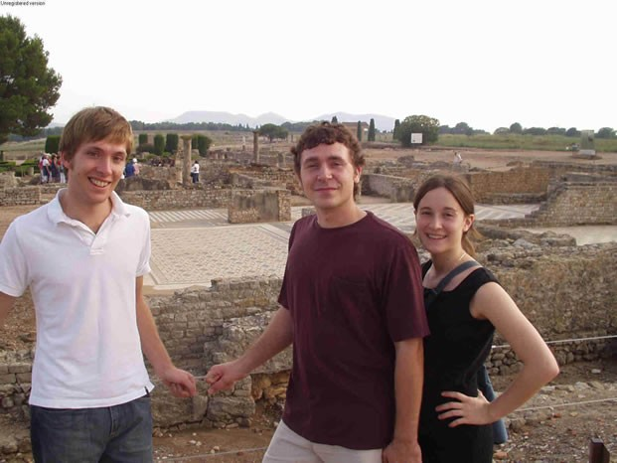
Paul, Thomas Kline and Maddy taking a look at the 3000 year old Greek and Roman site of Empuries on their course two years after Thomas’s first energy enhancement course here below.

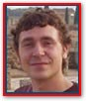Hello! My name is Thomas Kline and I am 21 years of age. For 8 years now I have been studying a "Collective Martial Art" consisting of mostly Hung Gar Kung Fu and Ninjitsu under my very experienced and excellent teacher Bill Bruley who is a 5th degree black belt in his art.

I am now at my 3rd degree black belt, and I knew that I needed to add on to my art, looking mainly towards the Spiritual aspect.

When I first arrived in L'Escala in Spain, from America, I didn't really know what to expect, except for what I had read about on their website. I must say I really got what I had bargained for!

I had tried practicing meditation and yoga here and there before, but never knew what was really out there to experience.

After learning just the first stage of Energy Enhancement, I immediately felt the energy rushing through me!

It truly was quite an experience! I could've spent months upon months to get to where I am after only 1 week with Satchi and Devi!

The feeling of bringing up blockages and grounding them was another life changing experience I had out here!

I never knew that the pains that I was physically and emotionally feeling were caused by these energies (blockages) keeping me from being just who I'm made to be! My blockages were mainly around the 2nd and 5th chakras. When they were removed one by one, I could sense that I felt more at ease and pains were actually going away revealing more and more blockages to be sorted out!

Also, being initiated into Reiki 1 by Devi and learning her unique exercises really helped in the process of bringing up blockages and removing them!

During one of my meditations, I really could feel that I was completely in line with the energies of the universe, which gave me such a feeling of ecstasy! Then I knew that I could never turn back on my practices! I am definitely going to stick with the techniques I have learned out here!

There really are no words I could use to make you completely understand what I experienced, except that you should come and find out for yourselves what it's like to learn how to completely better yourself and the world around you!

I hope my words could at least inspire one of you to take the first step in Energy Enhancement by coming out to stay with Satchi and Devi and learning something you can take with you FOREVER!!
Wishing you ALL the best in life,

Tommy

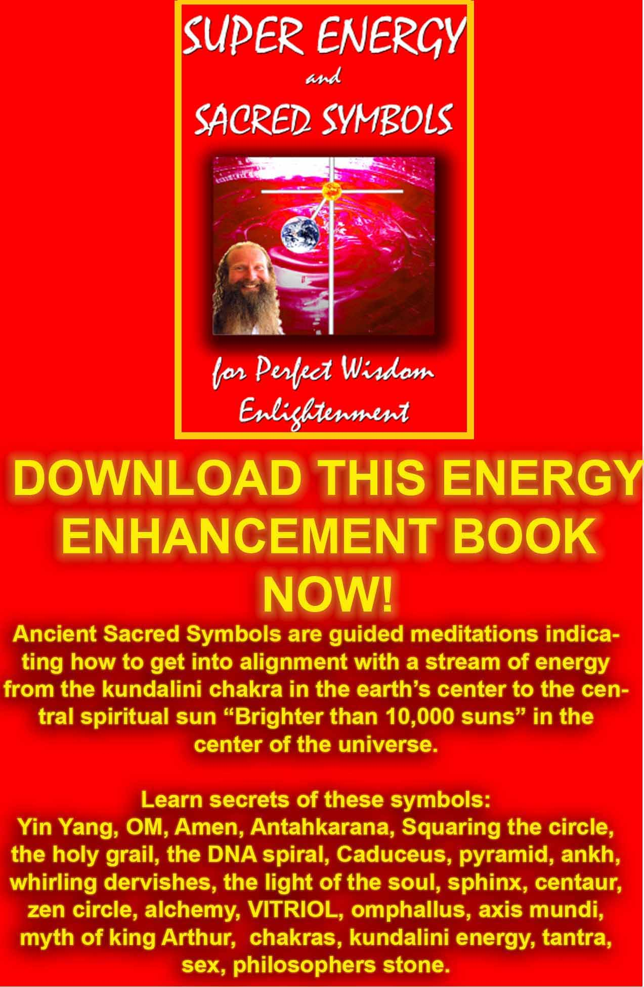
DOWNLOAD SUPER ENERGY AND SACRED SYMBOLS HERE!!!
http://www.energyenhancement.org/Sacred-Energy/Meditation-Super-Energy-And-Sacred-Symbols-for-Perfect-Wisdom-Enlightenment-Color-energyenhancement-org.pdf
TESTIMONIALS

Well, we are working at the moment at the beginning of the September Energy Enhancement Course in Spain with Tommy Kline from the USA who came back after two years, Madalyn his girlfriend and Paul.

We are working with the Circulation of the Energies, The Grounding of Negative Energies and with Reiki Initiation One.

And everyone is having experiences of Shaking with the power of the energy flowing through energy blockages and Tommy (Thomas Kline, here for his second course) is saying that here, after he practised Energy Enhancement Level One for a while since the last time he came, the ability to see his Energy Blockages has increased. And everyone else is having the experience of seeing their energy blockages.

And this is the first part of Energy Enhancement. Because to dissolve these Energy Blockage parts of the ego, FIRST YOU MUST SEE THEM, BEFORE YOU CAN FREE THEM.

And as we move into Energy Enhancement Initiation 5 and the first Initiations of Level 2, we teach incredibly powerful methods of transmuting these Blockages so at the end of the course we can have cleared out most of them and have a clear view of what to do to clear out the rest, including an Energy Enhancement Refresher course.

Paul had the vision of a Black Disk at the top of his head, which is blocking the energies of his crown chakra from his soul. An Implant. Tommy and Madalyn blockages in the second chakra, front and back and at the back of the heart and in the Brow Chakra, Ajna Chakra.

In the presence of the Buddhafield, as you pick up energy from those more experienced meditators around you, Satchidanand and Devi Dhyani, you gain the ability to see that which needs to be resolved. To remove the stones preventing the flow of water in the watercourse.

And when the Blockages have been removed from the chakras, and the chakras have been strengthened by energy experiences, then comes the Initiation of more energy, of Transfiguration, leading to ENLIGHTENMENT AND ILLUMINATION.

PAUL IN SPAIN OCTOBER 2004
Paul, our latest ENERGY ENHANCEMENT graduate says...."After developing my ENERGY ENHANCEMENT practice the method I now use for grounding negative energy is quick, efficient, and experientially extremely rich – I don't think it will ever get boring because the focus of each meditation, now I've reached the 3rd Level, is totally unique.

What I love about the way I meditate now, with the Energy Enhancement training, is that it's so much more structured and focused - a clear intent is set out at the beginning of the meditation and by the end, it's done! The techniques are so powerful, and I can feel the energy change as I ground the negativity from the focus of meditation. When clearing relationships I can feel atmospheres of untainted, pure energy enter me, like a huge, expansive, windswept sky. I really feel lighter!

The visualization of the energy is a wonderful indicator of progress
– everything in life has markers of progress through stages and cycles: seasons pass, fruit ripens, skin ages, rivers flow, wars begin and end. With other meditative techniques the markers of progress are general, such as a sense of well being, and specifically within that moment.

In Vipassana meditation, sometimes you get a flow, sometimes not. In Mindfulness of Breathing and Metta Bhavana meditation, sometimes you engage, sometimes not. It is difficult to gauge where you are on the path, and therefore what challenges you now face.

The Energy Enhancement teachings set out such a clear structure towards spiritual progress, with each stage having to be focused on and cleared before the next can be attempted, that I have a much clearer idea of where I am and the tasks that must be accomplished before I can move on.

Along with all the indicators of the other techniques, such as bodily sensations, senses of well being and general demeanor and mood, Energy Enhancement traces particular problems to particular energetic blockages so that you can locate and solve them in a focused way.

Along with that it allows you to see where you are in the evolutionary stream, and as you move through the stages you gain more energy to do more work, not only in meditation but also in life, so you remain in touch with what you must do at every stage. Now I can efficiently focus my meditation on the areas I need to work on in order to free up more energy so I can work on harder areas… and so on.

It's much quicker, and very thorough, because of that focus. Things are not left behind for the sake of speed. The course progresses very naturally from one stage to the next."

A billion times more effective.
The testimonial below is from a University student, Paul, as above. People doing Energy Enhancement come from all ages and walks of life. At the same time we had a Yoga Journalist who was doing an article for a famous yoga magazine who went away very happy, comfortable and impressed, the article will come out and will appear on the website, and
also a 62 year old person from Canada.

OCTOBER 2004 TESTIMONIAL - A billion times more effective.
Well, here is a missive from our University Student a week or two after he finished the six weeks he spent with us in full time meditation. He is on his way and working hard to cleave to the path of his Soul. And what more needs to be done than that. Well, plenty. It is only by taking the feedback from life that we can adjust our passage, quickly, to that path which is thinner than a razor.
Every time we go off the rails we have to adjust otherwise the resulting train wreck is terrible to behold.

Our University Student was one of our best students so far in that he worked hard and completed so much of the course whilst he was here and this resulted in him becoming so much more self reliant and in touch with his Soul. He had many spiritual experiences which he chooses not to talk about probably because of Gorakh's teaching, Be Silent!! He is not yet enlightened but stands a good chance of being so in this lifetime if he continues on the Path. He is lucky, and to be spiritual you have to be lucky!!

People of the essence, in contact with their Soul, tend to be rough diamonds in that they use each moment to teach everyone around them about soul contact. In that they have no choice. The soul knows that, 'As without, so Within', and as the Soul shows the ego of the other unto itself, there is usually a little jarping, a little conflict. This has the effect of seeming rough when really people need to ground their own selfish competitive egos.

For that reason People of the Soul create too many difficulties in normal life and work best in a soul teaching situation.

PAUL, ENERGY ENHANCEMENT - FOCUS AND INTENT
Here is Paul on his Energy Enhancement course. He's been with us for a time and has had some wonderful experiences:

"After 5 weeks of developing my practice the method I now use for grounding negative energy is quick, efficient, and experientially extremely rich – I don't
think it will ever get boring because the focus of each meditation, now I've reached the 3rd Level, is totally unique.

What I love about the way I meditate now, with the Energy Enhancement training, is that it's so much more structured and focused - a clear intent is set out at the beginning of the meditation and by the end, it's done! The techniques are so powerful, and I can feel the energy change as I ground the negativity from the focus of meditation. When clearing relationships I can feel atmospheres of untainted, pure energy enter me, like a huge, expansive, windswept sky. I really feel lighter!

The visualization of the energy is a wonderful indicator of progress
– everything in life has markers of progress through stages and cycles: seasons pass, fruit ripens, skin ages, rivers flow, wars begin and end. With other meditative techniques the markers of progress are general, such as a sense of well being, and specifically within that moment. In Vipassana meditation, sometimes you get a flow, sometimes not. In Mindfulness of Breathing and Metta Bhavana meditation, sometimes you engage, sometimes not. It is difficult to gauge where you are on the path, and therefore what challenges you now face.

The Energy Enhancement teachings set out such a clear structure

towards spiritual progress, with each stage having to be focused on and cleared before the next can be attempted, that I have a much clearer idea of where I am and the tasks that must be accomplished before I can move on.

Along with all the indicators of the other techniques, such as bodily sensations, senses of well being and general demeanor and mood, Energy Enhancement traces particular problems to particular energetic blockages so that you can locate and solve them in a focused way. Along with that it allows you to see where you are in the evolutionary stream, and as you move through the stages you gain more energy to do more work, not only in meditation but also in life, so you remain in touch with what you must do at every stage. Now I can efficiently focus my meditation on the areas I need to work on in order to free up more energy so I can work on harder areas… and so on. It's much quicker, and very thorough, because of that focus. Things are not left behind for the sake of speed. The course progresses very naturally from one stage to the next.

There is never a sense of having no direction in meditation. I have a friend who is a practicing Buddhist, and he has come to the stage where he is fairly content with life. He asks himself "Why do I meditate?" because the techniques he is using don't allow him enough visions and scope to really progress – they are good techniques, and give definite results, if practiced with dedication.
He thought enlightenment was too quixotic a goal, perhaps. But there are initiations on the path to enlightenment – if you know them you can mark your progress – this is very important – the heart must be set upon the highest goal, but there are many signs along the way. You can read more about these in the Yoga Sutras of Patanjali, by Swami Satchidananda, and on the Energy Enhancement site. It's helpful and good to know these signs and understand what they mean. The first thing to do is to remove all the energy blockages in your system so that you can increase your level of energy. Now I have done this I have enough energy to clear the negativity from all my relationships, on the way to an initiation called the mastery of relationships.

Now I'm near the end of the course I feel confident I can go home and integrate all I've learnt into my life. Since I've been here I've worked through some difficult times, but I've got through them and my mood, energy and sense of well being have been given a boost rather like having an atom bomb explode in my bottom.

The removal of all the negative energy in my system has put me in touch with my own flow of untrammeled energy. Removing these

negative energy blockages have yielded some brilliant results, which I was not expecting. At one point, after removing a blockage in my base chakra I experienced an extended sensation of orgasm which was totally delicious! It was just a sign that my energy flow had increased and the work I had been doing was finally complete on that particular area.

Energy Enhancement is truly an atom bomb, extremely powerful stuff. When I return to real life I will be in such a kick ass state, I want to go dancing and engage with existence! Yes! The clouds have parted!
But seriously, it is great. What more can I say? I don't want to oversell it,
so I'll simply say that in the end it'll make you feel better, you'll meet two wonderful people and have a great time. My spirits have been lifted and my mind expanded since I've been here, and I have a strong feeling inside that life will simply go on getting better and better for me and for everyone I know." - PAUL

ENERGY BLOCKAGES, HUBBARD AND SCIENTOLOGY
ENTITIES AND ENERGY BLOCKAGES HUBBARD AND SCIENTOLOGY
"I got into Energy Enhancement because I was inhibited. Turns out I was inhabited!"

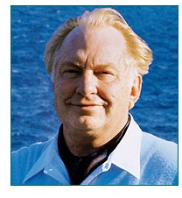
Over the past few decades some highly dramatic stories illustrating the phenomenon of "multiple personalities" have become quite well known.
Some psychiatrists and psychologists, and, in fictional accounts, novelists and scriptwriters, have given considerable attention to extreme cases where another distinctly different "personality" appears to take control over an individual for prolonged periods of time.
Less attention, however, has been given to less dramatic but, perhaps, related occurrences. Most people have days when they are "not quite themselves." One hears comments like, "It just wasn't like Fred. He was like some kind of madman!" or "She was like a woman

possessed!" or "He's a different person when he drinks," or "I don't know what came over me, “or "What got into me?" What's happening? There is no scarcity of theories. This and the following paragraphs examine this area, and offer various explanations concerning it.
Currently, the entirety of Hubbard, see above, Scientology's super- secret "upper levels" deal with this type of "phenomena." but are only able to remove the easy blockages.
Energy Vampire Implants, Inner Children and the Strategies of the Vampire, the Violator, The Poor Me and the Selfish Competitive Star seem to be beyond them, especially regarding Hubbards many times reported temper tantrums (violator) and his inability to have other stars around him because a selfish competitive star can only have yes - men around him. He will try to destroy (fair game) all other stars.
Hubbard might have partially failed but he was onto energy blockages. Even in 1950 Hubbard was preoccupied by this sort of thing. In Dianetics, the Evolution of a Science-published in 1950 and aired at a broad science fiction audience (consisting of scientifically oriented readers) - Hubbard wrote:
"...it was necessary to hark back to the techniques of the Kayan Shaman of Borneo, among others. Their theory is crude; they exorcise demons.... Provisionally, let's try to postulate that Man is good.... And we suppose something such as the Borneo Shaman's Toh has entered into him which directs him to do evil things.
Man has believed longer that demons inhabit men, than Man has believed they do not. We assume demons. We look for some demons, one way or another. And we find some!"
This was an amazing discovery and the thing to do was try to measure and classify demons. Strange work for an engineer and a mathematician! But it was found that the "demons" could be classified. There were several "demons" in each patient, but there were only a few classes of "demons."
There were audio demons...visio demons, interior demons, exterior demons, ordering demons, directing demons, critical demons, apathetic demons, angry demons, bored demons and certain demons who merely blocked things. The last seemed to be most common. Looking into a few minds established soon that it was difficult to find anyone who didn't have some of these demons....
Hubbard then discusses the analogy between the human mind and an electronic computer. Finally he concludes:

There are no demons. No ghosts or ghouls or Tohs. But there are aberrative circuits.
Hubbard doesn't explain how it is that these "circuits" existed structurally. But "structure" was not his concern; his concern was function. He wrote:
"...it was not necessary to show how it is done in terms of physical mechanism if we can show that it IS done and it succeeds."
In 1950, a circuit was defined by Hubbard as:
"A part of the individual's bank [reactive mind] that behaves as though it were someone or something separate from him and that either talks to him or goes into action of its own accord, and may even, if severe enough, take control of him while it operates.
The jingle heard on the radio that sticks in one's mind, playing over and over; the actor who after many appearances on stage, portraying a particular character, takes a vacation and finds, to his discomfort, that he still at times possesses the qualities of that character; the obsession that grips a person causing him to do things he knows he will later regret-the materialistic viewpoint might simply say, "That's simply something the brain does."
The spiritual viewpoint on the other hand traditionally divides a human being into "body, mind, and spirit," with the spirit being the basic individual and the mind being the recordings of one's past experiences, ideas, conclusions, etc. These recordings are not necessarily considered as a part of the brain, but rather a function of the spirit".
Quoting from Joseph Krutch's More Lives Than One:
"The physiologists are very fond of comparing the network of our cerebral nerves with a telephone system but they overlook the significant fact that a telephone system does not function until someone talks over it. The brain does not create thought (Sir Julian Huxley has recently pointed out this fact); it is an instrument which thought finds useful."
LOATHSOME LARVAE
From Mouni Sadhu's The Tarot, A Contemporary Course of the Quintessence of Hermetic Occultism:
Let us imagine that a man has a common evil desire, he makes no attempt to realize it on the physical plane. He only draws a dark desire on the astral plane, and so creates a kind of "entity."...This artificial "being" does not possess a physical body....Such a being

can...act and influence only in direction as intended by its unwise creator, man, who is usually unaware of his foolishness.
Now, on whom will the influence of such a demon be exerted Yes, firstly on the father of it himself...who created the astral picture of the evil deed. We call this type of ominous artificial entity a larva. Such a larva will watch it's "father' in order to prevent him from forgetting his evil intention and desire, and to fortify the larva's life by new meditations about the same theme. But it can also attach itself to another man, who has a certain astral and mental affinity with the first one.
Getting back to Hubbard, during the 1952 Philadelphia Doctorate Course, Hubbard said of what used to be called, in Dianetics, "demon circuits":
Each one of these things can be a thinking entity. It thinks it's alive. It can think it's a being as long as energy is fed to it.
He had also mentioned in this lecture series that someone can deliberately "mock up" (i.e., vividly imagine) something and give it a life of its own.
There is the idea of "thought forms" created by the individual himself is the viewpoint that asserts that, while thought forms do exist, real "demons" also exist. But not only "demons"; also many types of "disembodied beings," human and non-human, some big some small, some good, some indifferent, some unconscious, some insane.
There are many variations of this theme. The movie The Exorcist illustrates one version. A powerful demonic being completely takes over a little girl.
One can also pose a less dramatic scenario. As well one powerful "demon," a person, theoretically, might be infested with many little "demons."
To quote from Garrison,
"Tantric texts assert that the universe all about us is teeming with thought forms and with beings good and bad-deities, demons, nature spirits, discarnate human egos, phantoms, monsters. The sadhaka is not only made aware that they exist, he is taught disciplines that bring them under his control and enable him to communicate freely to them. The tantric Yogis are not alone in their view, or the claim of ability to communicate and control this, supposed, class of beings. In fact, in various degrees of sophistication, it can be found to be part of the spiritual tradition of Man on all five continents. The witchdoctor, the magi, the medicine

man, and many a modern psychic have as a commonality the view that such things exist."
As an aside I find it of interest that Thomas Edison wrote the following in "The Diary and Sundry observations," although it is not in the category of "unwanted psychical or spiritual influences" in one's body or "aura":
Take our own bodies. I believe they are composed of myriads and myriads of infinitesimally small individuals, each in itself a unit of life, and that these units work in squads - or swarms, as I prefer to call them - and these infinitesimally small units live forever. When we "die" these swarms of units, like a swarm of bees, so to speak, betake themselves elsewhere, and go on functioning in some other form or environment.
Edison not only believed in the immortality of the human spirit, but also in the immortality of that which he believed enlivens the physical body - the immortality of each cell.
In 1978 L. Ron Hubbard, felled by his second major heart attack, lay barely conscious and helpless in bed. At the time Dr. Gene Denk and "Case Supervisor International" David Mayo began working with him on his health in 1978, Hubbard conceived of himself as surrounded by a swarm of confused, unconscious, or semi- conscious entities: burnt-out human souls. He had discovered Energy Blockages in the Aura for the first time!
"There are no demons," he had written in 1950. A couple of years later, he spoke of self-generated "thinking entities." Then, a quarter of a century later, he was party to the development of procedures or guided meditations with which any medicine man or witch doctor would probably feel at home. These procedures dealt with the eviction of swarms of non-self-generated parasitic beings.
Now, any decent witch doctor "servicing a client" does his thing and a few hours later goes on his way, goat, chicken or pig in hand, in exchange for his services. In the varied literature regarding "exorcism" and the like-whether such things are considered self- generated or not - one sees a regular reference to a relatively small number of "influences,'" "thought forms," "obsessions," or whatever, in need of "handling."
Hubbard operated on a much grander scale. From his hypnotic pedestal of "ultimate authority," he stated to his followers that everyone was engulfed in thousands upon thousands of degraded beings.
"A man has blockages like a dog has fleas!"

Hubbard says, "You're the effect of all these Body Thetans!" (beings attached to the body)
Hubbard's theory and procedure of how to "handle" the entity "phenomenon" is highly secret. This level of auditing brings in probably a million dollars a week internationally for the Church of Scientology The high prices charged depend upon these guided meditations and information being kept tantalizingly mysterious and secret.
"Mystery is the glue that sticks Thetans or Energy Blockages to things," Hubbard once said. He proceeded to use this principle in marketing his Operating Thetan or Blockage Free levels. The secrecy and mystery surrounding these levels pulled people in, bringing in also their wallets and check-books; a major part of it...just to discover the answer to the mystery.
The wealthy the Scientologists, are sold a lot of auditing with authorised auditors for the eradication of their Energy Blockage "fleas."
Such auditing costs over $400 per hour. It is quite usual for Scientologists to spend well over $100,000 for this level of removing Energy Blockages from the body alone. One man, a geologist, engineer and entrepreneur, spent $450,000.
According to Hubbard, "Nots handles" are those beings or entities, energy blockages or "body thetans" ("BTs") that are located in the body or around the body. The auditing procedure of Nots can locate those body entities, and send them off, no longer infesting the individual or his body.
The entities are inhabiting various things, like a body part (a bone, arm, cell, whatever) or they are a particular sub-personality, or condition, such as "TV watcher," or "fear," or "worker," or "solitary angry man," and so on.
According to this line of thought, people get confused as to who they are and who they are not. A person hears these voices or feels desires, and so on, and thinks he is the source of them.
Yet, the theory goes, you are not necessarily the originator of these thoughts or impulses. Another may be. So, by identifying who is the being (who is the source of these vocalizations or impulses) and spotting where it is located, you are freed to think for yourself.
So an auditor has you (the main guy in control) ask each BT, "What are you?" and "Who are you?"
The Body Thetans or Energy Blockages will then separate out and realize that they are in fact themselves; that they are not some

body part or whatever. At the same time, you realize that the Energy Blockages or BTs are different from you; that their mental pictures, ideas, and degraded impulses do not originate from you. According to Hubbard, these beings are very easily overwhelmable and hypnotic. Because of this, they tend to take on the personality of whatever (or whoever) comes along that gets their attention.
Hubbard says,
"You have to actually put some life into them to activate them. They're like pebbles on a beach....But listen, you're living in a universe which is crawling with this type of stuff. And planet Earth was a dumping ground to end all dumping grounds....As NED for OTs is run these cats wake up and get handled. This relieves the entity infested guy of a lot of phenomena which puzzles him and can hold him down.
As you go along doing the guided meditation many times on each energy blockage (running it) you will find that the Energy Blockages seldom consider themselves live beings. They think they are MEST (Matter, Energy, Space and Time), body parts, significances, conditions-anything but live beings."
No, such energy blockage "beings" are the victims of what Hubbard calls the "dwindling spiral." According to him, any spiritual being in the physical universe is inevitably subject to deterioration and degradation.
Beings who are not removing Energy Blockages are not evolving spiritually, but rather are devolving-heading downward towards "Hubbardian Hell."
In "Ron's Journal 30" Hubbard explains: "But there was one discovery in 1978 that I haven't said very much about and am really not likely to since it is a sad thing. It is what really happens to a thetan or Energy Blockage who is not salvaged or processed and goes on down the chute. Man, when I saw that and knew it to be true I actually felt sorry for these guys or Energy Blockages that try to hit at us. Poor devils. Some religious talk about hell. It's an understatement of what really happens."
In 1967, on the Canary Island of Las Palmas, Hubbard made what he claimed was the most important spiritual breakthrough in the history of the human race. He had unearthed, in his solo-auditing, a super traumatic ancient incident that had killed anyone else who had ever come close to uncovering it.
The resolution of, and safe passage through, this incident was "boldly explored and mapped" by him. This "map" was put into the form of his longhand writings for the highly confidential level of

"Operating Thetan Level Three" (OT III) which only deals with Energy Blockages in the Body.
The revelation of OT III was that virtually everyone on this planet - indeed, in "this sector of the Galaxy" - was totally overwhelmed by the effects of an incident that occurred 75 million years ago. And that underlying this cataclysmic event was another more basic cause of "human contamination": everyone without exception had been zapped and zombified by an incident that occurred four quadrillion years ago.
Human beings, he said, "do not respond to reason, they respond only to `R6* symbols.' The designation R6 derives from the OTIII guided Meditation or process or "routine" ("R"), in this case the 6th in a series "0" to...(however many processes or guided meditations he would go through till he found the one that he felt did the trick).
He first "discovered" this "bank" (storage of damaging mental image pictures in the "reactive mind") during the early sixties. and, later in 1967, "discovered" the full incident of which these pictures were but a part. He promoted the incident as the "Wall of Fire." " The "R6 memory bank," is a part of any person's unconscious mind, according to Hubbard. This "bank" was deliberately created by mass implanting which occurred 75 Million years ago. This implanting was a highly "scientific" form of brainwashing, using huge movie screens as part of a program of mass hypnosis.
According to Hubbard, there was no point in reasoning with normal human beings as they were all controlled by implants and Energy Blockages. Instead of reasoning with these people he spoke of reaching into the public and "driving them through your orgs by using the original programming - "R6 bank symbols" (in the form of certain words, and pictures such as, for example, volcanoes) "key in" (in other words reconnect) people to these implants.
The result is that they become attracted to the organisation.
In 1967 all Scientology books suddenly presented a collection of images upon their covers: an exploding volcano; a woman in a monkey suit, eating what appeared to be a turkey leg; the frontal view of a speeding train; an odd-looking old man with a beard; a fellow dressed in a white spacesuit carrying a box (of "packaged beings") into a spaceship. These were R6 bank symbols.
A special "Book Mission" was sent out to promote these books, now empowered and made irresistible by the addition of these overwhelming symbols or images.
Organization staff were assured that if they simply held up one of the books, revealing its cover, that any bookstore owner would

immediately order crateloads of them. A customs officer, seeing any of the book covers in one's luggage, would immediately pass one on through.
These images seem to work as Scientology now is one of the richest and fastest growing religions in the world!
The symbols of the Hubbard Sea Org, which include the uniforms worn by Sea Org officers, were designed to fit Hubbard's descriptions of symbols of "R6", and were thus guaranteed to win instant respect and obedience for the person wearing them.
Hubbard had made it plain that he, and only he, had discovered and risen above the "R6 bank." Human existence is controlled utterly by it. He emphasized that, to those who had not completed the lower pre-requisite levels of Scientology, to remove the easy Energy Blockages, reading the materials of OT III was deadly.
The confidential class 8 course with Hubbard's twenty lectures taped on the Apollo in Corfu, Greece gives Hubbard's opinion of Christianity: Somebody on this planet, about 600 B.C. found some pieces of "R6. " I don't know how they found it; either by watching madmen or something. But since that time they have used it. And it became what is known as Christianity. The man on the cross. There was no Christ! The Roman Catholic Church, through watching the dramatizations of people picked up some little fragments of R6. In a bulletin of that period he states: "Also the Christian Church used (and uses) implanting - "They took over the Nicene Creed just before the year zero. invented Christ (who comes from the
`crucifixion' in R6, 75 million years ago) and implanted their way to power."
He made it plain that the traumatic effects of the events of 75 million years ago had been the ultimate barrier to the attainment of "full removal of all blockages" Despite the mortal dangers, however, he had braved the "Wall of Fire" and survived. He had then "taped the route" for all Mankind to follow.
Of course getting the blocked people of planet Earth from zombiedom to godhood was going to be no easy task. Yet it must be done. And with the threat of nuclear war looming ever overhead, it must be done fast!
Because of this, to be in the Sea Org - or for that matter to be on staff at any Scientology org - is to be a participant in a never-ending "condensed time emergency. " One never has time to pause and think about what is going on. Besides, doing so would be a form of "self auditing" which is strictly forbidden by Hubbard. Hubbard said it is impossible for people to free themselves from their own

Energy Blockages and thus only authorised auditors are allowed to remove blockages from their clients. And indeed, the job is so difficult that for thousands of years, Gurus are the only people to have successfully made people enlightened. The Energy Blockages of the more difficult fourth level control a persons mind so completely that they can never have enough energy to overcome them by themselves.
In light of all this Hubbard explained: "Anyone is entitled to have opinions and ideas and cognitions - so long as these do not bar the route out..." The road to "Total Freedom," was only available to people who could continue to use the help of the Guru.
Any newly initiated, "good Scientologist" would tell himself: "I have a reactive energy blocked mind! My opinion is irrelevant, especially when compared to that of this great man who has broken free and who will eventually free me also."
Before 1967 Scientologists regarded themselves as the elite of earth. While the materials of OT III in some ways served to further enhance that feeling, and many Sea Org members, for instance, were said to have been the "loyal officers," i.e., the good guys who opposed the mass implanting, when all this happened, these materials served also to greatly increase their feeling of indebtedness to their Founder Guru, - Hubbard.
And whereas Hubbard was able to help in removing easy Energy Blockages of creativity, communication and the Body, when it came to Body Implants from external Energy Vampires and Inner Children and their Strategies of the Vampire like the Violator, the Poor me and the Selfish Competitive Star it has been reported many times that Hubbard was a shouting and angry man, perhaps he had had reached his limit in dealing with the more difficult Energy Blockages.
It needs the Twenty Eight Initiations of Energy Enhancement and a lot of intuitive and psychic help in order to remove all Energy Blockages, even the most powerful and reach enlightenment.
Energy Enhancement has the key to the removal of all energy blockages!!
The Kundalini Kriyas and The Five Elemental paths of the Chi of the Taoist masters, like Energy Enhancement, gives the Hidden Taoist Secrets of the Microcosmic AND the Macrocosmic Orbit, The Energy Enhancement Supra Galactic Orbit
These symbols symbolise how to clean all the Chakras through a guided meditation. Helping all parts of the mind including the Unconscious, to become more calm and still.

"To remove the stones in the path of the watercourse. To remove blockages to the flow of your energy" A description of Samyama or Energy Enhancement from the 5000 years old Yoga Sutras of Patanjali, the source of Raja Yoga.
The Kundalini Kriyas and The Five Elemental paths of the Chi of the Taoist masters, like Energy Enhancement, teaches how to cleanse the psychic body so that our psyche becomes sensitive and our energy more powerful.
The Kundalini Kriyas and The Five Elemental paths of the Chi of the Taoist masters, like Energy Enhancement, strengthens the psychic circuits and decreases the resistance to the flow of Energy. It helps to build the psychic body, as Gurdjieff called it, "The Body Kesdjian".
The Kundalini Kriyas and The Five Elemental paths of the Chi of the Taoist masters, like Energy Enhancement, are guided meditations to increase sensitivity to energies is given in the next Initiations of the techniques of Energy Enhancement- "The Grounding of Negative Energies." - the Earth Path of the Five Elemental Pathways of the Qi for the removal of ALL energy blockages.
Energy Enhancement's first seven Initiations of the full Twenty Eight Initiations consists of Meditation, Shaktipat, Energy Circulation, The Kundalini Kriyas, The Five Elemental Paths Of The Chi Of Chinese Alchemical Taoism, The Grounding Of Negative Energies, Alchemical V.I.T.R.I.O.L and the Art Card Of The Thoth Tarot, Kundalini Energy, Strong Psychic Protection, The Merkaba, Pyramid Protection, Power Tower Protection, The Antahkarana, Soul Fusion, Monadic Infusion, Logos Infusion, the Painless Removal Of Energy Blockages, Stress, Trauma And Negative Emotion.

PARACELSUS AND ENERGY BLOCKAGES
PARACELSUS

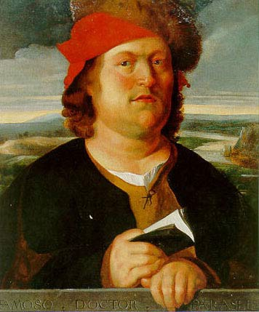
"I got into Meditation because I was inhibited. Turns out I was inhabited!"
Paracelsus von Hohenheim (1490-1541) was the outstanding medical therapist of his time and, perhaps, the greatest mystic in the history of Western medicine. He devoted his life to research in the healing arts. Paracelsus visited Constantinople to acquaint himself with the secret practices of the Dervishes and the Sufis.

The following is an excerpt from Paracelsus - His Mystical and Medical Philosophy, by Manly P. Hall, published by the Philosophical Research Society:

[According to Paracelsus]...the elementary is an artificial being, created in the invisible worlds by man himself. In harmony with more recent findings, Paracelsus noted that most elementaries seem to be of an evil or destructive nature. They are generated from the excesses of human thought and emotion, the corruption of character, or the degeneration of faculties and powers which should be used in other,more constructive ways....
Bad habits, emotions, addictions, irritation.
Man is therefore a creator, not merely in terms of the perpetuation of the species, but especially in terms of the imagination. Man is creative in the arts, sciences, and philosophies, but his creative powers are not only external, but also internal. Because he lives, man bestows life, and he can generate creatures from his thoughts and emotions....The power to create is the power of vibration, by which anything is set into a peculiar motion....
The invisible progeny of man include thought-forms and emotion- forms. These are like infants or inner children, especially in their beginnings, for they depend upon their creator for their nutrition and survival. Later, however, if the forces which generate continue to operate, these thought and emotion-forms gain strength, finally attaining a kind of independence....Having thus become even stronger than their creator, these thought and emotion-forms will turn upon the one who fashioned them, often causing in him a terrible habit or addiction and destroying his health and happiness.
We know that the human psyche can become ridden with pressure centers or pressure-patterns which we call fixations, complexes, phobias, and the like. We know that these negative psychic formations are nourished by the continued repetition of the attitudes which caused them. We say that negative attitudes become habitual, by degrees taking over and destroying the mental and emotional integrity of the individual.
A fixation, well nourished by attitudes suitable for its perpetuation, intensifies, becoming actually avaricious and resolved to dominate or possess the entire life of its unhappy victim....
Modern thinking therefore, sheds light upon the concept of elementaries, extending beyond the basic research of Paracelsus...[He] used the term obsession to signify possession by an entity. Today the term is used to signify possession by an abnormal attitude....Is it possible that the abnormal attitude has gradually become an entity?

...Many persons under psychological obsession resist treatment, as though some foreign creature were fighting for its survival in them....
Out of his philosophy of elementaries, Paracelsus came to the conclusion that a very large part of what we consider to be disease, results from psychic parasites generated by wrong thoughts and emotion - Energy Blockages of this particular type.
The Kundalini Kriyas and The Five Elemental paths of the Chi of the Taoist masters, like Energy Enhancement, gives the Hidden Taoist Secrets of the Microcosmic AND the Macrocosmic Orbit, The Energy Enhancement Supra Galactic Orbit
These symbols symbolise how to clean all the Chakras through a guided meditation. Helping all parts of the mind including the Unconscious, to become more calm and still.
"To remove the stones in the path of the watercourse. To remove blockages to the flow of your energy" A description of Samyama or Energy Enhancement from the 5000 years old Yoga Sutras of Patanjali, the source of Raja Yoga.
The Kundalini Kriyas and The Five Elemental paths of the Chi of the Taoist masters, like Energy Enhancement, teaches how to cleanse the psychic body so that our psyche becomes sensitive and our energy more powerful.
The Kundalini Kriyas and The Five Elemental paths of the Chi of the Taoist masters, like Energy Enhancement, strengthens the psychic circuits and decreases the resistance to the flow of Energy. It helps to build the psychic body, as Gurdjieff called it, "The Body Kesdjian".
The Kundalini Kriyas and The Five Elemental paths of the Chi of the Taoist masters, like Energy Enhancement, are guided meditations to increase sensitivity to energies is given in the next Initiation of the techniques of Energy Enhancement- "The Grounding of Negative Energies." - the Earth Path of the Five Elemental Pathways of the Qi.
Energy Enhancement's first seven Initiations of the full Twenty Eight Initiations consists of Meditation, Shaktipat, Energy Circulation, The Kundalini Kriyas, The Five Elemental Paths Of The Chi Of Chinese Alchemical Taoism, The Grounding Of Negative Energies, Alchemical V.I.T.R.I.O.L and the Art Card Of The Thoth Tarot, Kundalini Energy, Strong Psychic Protection, The Merkaba, Pyramid Protection, Power Tower Protection, The Antahkarana, Soul Fusion, Monadic Infusion, Logos Infusion, the Painless Removal Of Stress, Trauma And Negative Emotion.

ENERGY BLOCKAGES, DAME ALEXANDRA DAVID NEEL THOUGHT-FORMS IN TIBET
Besides the idea that "thought forms" may be inadvertently created, there is also the viewpoint that they can be deliberately brought into being.
The following excerpt is from the book The Yoga of Sex by Omar Garrison:
According to secret lore, man can develop such concentration of mind that he is able to generate psycho-mental energy (called "risal" in Tibet) and to use it for bringing about results that to the uninitiated appear to be supernatural.
It has been because the Tantric* techniques employ these secret methods of concentration that Tantrism has been called the most elaborate system of auto-suggestion in the world.
While such an evaluation may serve to explain the more seductive visions of the sadhaka [adept], it is hardly adequate to account for phenomena witnessed by persons other than the creator of them.
For example, Tantric adepts (especially in Tibet) possess methods for projecting thought forms (called tulpas) which are materialized so completely that they are often mistaken for physical entities.
Moreover, these phantoms are sometimes visualized and given a kind of autonomy, so that they may act and seemingly think without the consent or even knowledge of their creator. In this connection, Madame Alexandra David-Neel, a Frenchwoman who spent many years among the lamas of Tibet, recounts an intriguing personal experience in the creation of a tulpa.
Having a sceptical turn of mind, Madame David-Neel suspected that many stories she had heard concerning such materializations might be gross exaggerations. The most common kind of Tulpa-making in Tibet is that of forming and animating the counterparts of Tibetan deities. So to avoid coming under the influence of this kind of mental suggestion - so prevalent around her - she chose for her thought-child the figure of a fat, jolly monk.
After a few months of performing the prescribed disciplines for ritual projection of thought image, Madame David-Neel relates that the form and character of her phantom monk took on the appearance of real life. He shared her apartment like a guest and,

when she departed for a journey, he accompanied her entourage. At first, the monk put in an appearance only when his creator thought of him. But after a time, he began to behave in a very independent manner and to perform various actions not directed by his maker. So real did he become in time, that on one occasion, when a herdsman came to the Frenchwoman's encampment to bring her some butter, he mistook the chimerical monk for a live lama.
Even more alarming to the phantom's begetter, his character began to undergo a subtle change. He grew leaner and his face gradually took on a sly malevolent look. He daily grew more importunate and bold. "In brief," says Madame David-Neel," he escaped my control."
Clearly, the time had come to purge herself of the unwanted companion whom she had brought to life, but who, by her own admission, had turned her existence into a day-nightmare. It required six months of difficult practice and ritual to magically dissolve the monstrous prodigy.
"My mind-creature was tenacious in life," she declared.
How are we to explain such phenomena? Western psychology has only begun to investigate the secret and profound life of the mind. Many of their answers so far are far from adequate to account for occurrences such as that just cited.
Be that as it may, in the case of the deliberately created phantom, such as Madame David-Neel's monk, the independence and individuality of the prodigy ought to give us considerable pause....
The Kundalini Kriyas and The Five Elemental paths of the Chi of the Taoist masters, like Energy Enhancement, gives the Hidden Taoist Secrets of the Microcosmic AND the Macrocosmic Orbit, The Energy Enhancement Supra Galactic Orbit,
These symbols symbolise how to clean all the Chakras through a guided meditation. Helping all parts of the mind including the Unconscious, to become more calm and still.
"To remove the stones in the path of the watercourse. To remove blockages to the flow of your energy" A description of Samyama or Energy Enhancement from the 5000 years old Yoga Sutras of Patanjali, the source of Raja Yoga.
The Kundalini Kriyas and The Five Elemental paths of the Chi of the Taoist masters, like Energy Enhancement, teaches how to cleanse the psychic body so that our psyche becomes sensitive and our energy more powerful.

The Kundalini Kriyas and The Five Elemental paths of the Chi of the Taoist masters, like Energy Enhancement, strengthens the psychic circuits and decreases the resistance to the flow of Energy. It helps to build the psychic body, as Gurdjieff called it, "The Body Kesdjian".
The Kundalini Kriyas and The Five Elemental paths of the Chi of the Taoist masters, like Energy Enhancement, are guided meditations to increase sensitivity to energies is given in the next Initiations of the techniques of Energy Enhancement- "The Grounding of Negative Energies." - the Earth Path of the Five Elemental Pathways of the Qi for the removal of ALL energy blockages.
Energy Enhancement's first seven Initiations of the full Twenty Eight Initiations consists of Meditation, Shaktipat, Energy Circulation, The Kundalini Kriyas, The Five Elemental Paths Of The Chi Of Chinese Alchemical Taoism, The Grounding Of Negative Energies, Alchemical V.I.T.R.I.O.L and the Art Card Of The Thoth Tarot, Kundalini Energy, Strong Psychic Protection, The Merkaba, Pyramid Protection, Power Tower Protection, The Antahkarana, Soul Fusion, Monadic Infusion, Logos Infusion, the Painless Removal Of Energy Blockages, Stress, Trauma And Negative Emotion.

THE ENERGY ENHANCEMENT COURSE

IGUAZU FALLS IS A WORLD ENERGY CENTER SACRED TO THE INCA AND THE GUARANI FOR THOUSANDS OF YEARS
IN SPAIN, ELEGANT 5Star INDIA TAJ MAHAL, INDIA TOUR, SACRED IGUASSU FALLS, MEXICO, PERU
SIGN UP TO THE MAILING LIST FOR MORE DETAILS
EMAIL sol@energyenhancement.org
for details

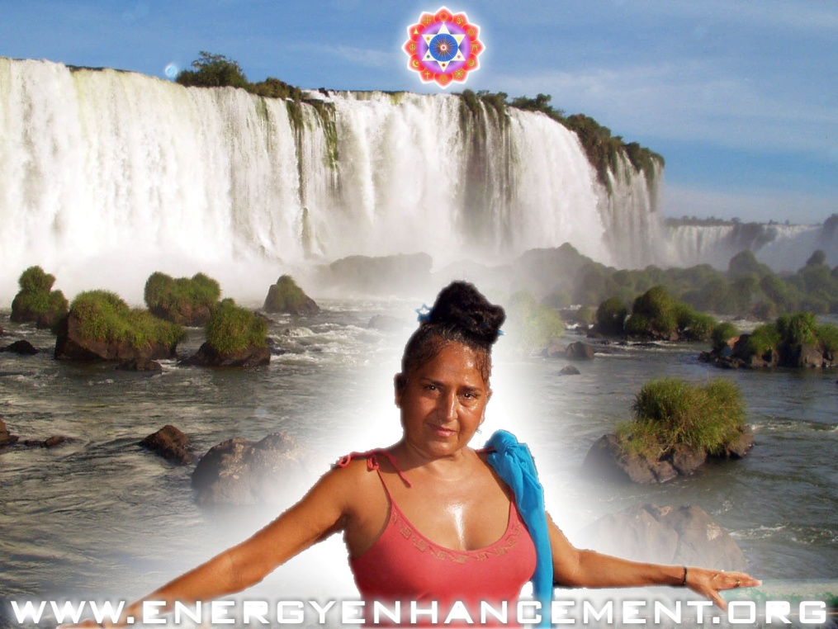

Meditation and Psychic Powers: Shaktipat, Supermind, Kundalini Kriyas, Siddhis, and Enlightenment
From time immemorial it has been known that some people, Yogis, Gurus, Shamen, Priests, Saints, Paramahamsas, Buddhas, Christs, have evolved to a state of high energy.
These pure and good people, wanting benefit and happiness for all, without a trace of selfishness and competition have been known to have psychic powers.
Their search for energy and goodness has precipitated within them the next stage of human evolution.
For thousands of years they have been Good Doctors, Good Priests, founders of religion, Philosophic Geniuses, Advisors of Kings, Musical Geniuses, Poets, Makers of the Law.

For thousands of years these people, wielding amazing Siddhis or Psychic powers, have been recorded as healing of the sick, casting out mental sickness, coming in dreams, communicating through telepathy, the radiation of specialised energies, leaving the body, entering into the body of another, astral travel, telling the future, acting at a distance, raising Kundalini, Shaktipat, the ability to pass healing into amulets, temples, places of peace, pilgrimage sites, creating miracles, birds and beasts come to them in peace.
Doing all this they also pass on their energy in Shaktipat for the awakening of all good students.
The shaktipat, the radiation of psychic energies by the enlightened can awaken these abilities in all who come to them. This has been known and recorded in the Sacred literature for thousands of years.
Indeed, some sacred literature states that only by access to the energies of the Masters, can enlightenment be passed on.
The search for this next step in evolution comes from the enhancement, the increase, of energy.
As fire is spread from candle to candle. As the sacred word resonates in both he who gives and he who receives. As Grace dropeth as the gentle dew from Heaven, twice blessed..
So a preparation of he who receives, the student, the candle, by the removal of Negative Energy, Energy Blockages, a lack of Energy Blockages allows more Spiritual Energy to be absorbed and used to crystalise, complete, finalise, create the Spiritual Body of another Master, another transmitter of the Truth!
They say that Masters represents infinite power through a complete loss of the selfish ego - When the robe was touched no credit was claimed by the wearer, It was your faith which healed you! said the Master - and so the truism, It takes two to Tango, - the student must be purified and prepared by evolution and spiritual practice to accept the Force, the Energy transmitted by the Master.
All energy blockages stopping the flow of energy through the system and preventing the buildup of psychic power in the system must be removed.
Thus we learn and practice Yoga, Pranayama, Meditation, Samadhi, Samyama, the Kundalini Kriyas, Chinese Alchemical Taoism and the Micro and Macrocosmic Orbits, VITRIOL and The Emerald Tablet of Hermes Trismegistus, The Grounding of Negative Energies, The Yoga Sutras of Patanjali, Raja Yoga and the Eighteen Classical Yogas of the Bhagavad Gita.
Thus the torch is passed on from Master to Student.

Another candle is lighted up!
And Masters have existed in every time period. They exist Now!!

WITH THE ENERGY ENHANCEMENT COURSE BUY A STAIRWAY TO HEAVEN
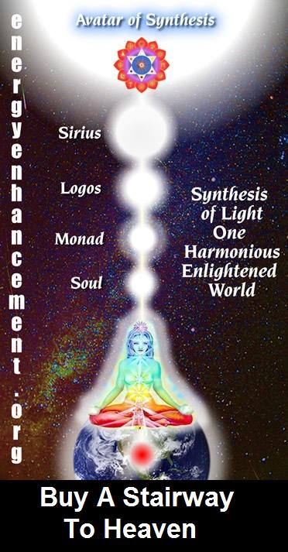
BUY A STAIRWAY TO HEAVEN
WITH THE ENERGY ENHANCEMENT COURSE
STUDENT REPORT
Also I noticed as soon as Satchidanand emailed me, I got a down-pouring of light from above the crown which kept charging me up the rest of the day – and my cravings died out! Then I realized the cravings were ego-blockages and that I did not want them.
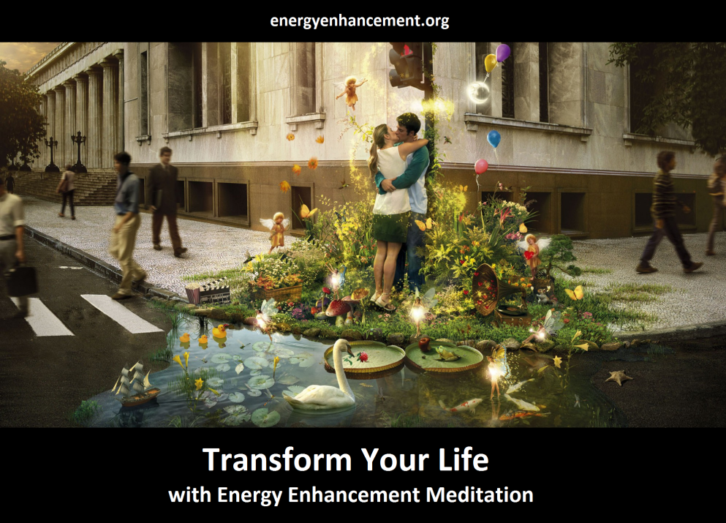
Energy Enhancement says that there are an infinity of chakras above the head up into the Center of the Universe and above, high above the head, ending in God, just as there are an infinity of chakras below the base - "As above, So Below" - Hermes Trismegistus from the Emerald Tablet.
INCREASE YOUR INTELLIGENCE - THE PARALLEL PROCESSING SUPERCOMPUTER YOU!! Energy Enhancement says that each chakra within you and above the head is a computer processor with higher and higher frequency, speed and capacity as you go higher. So, like a parallel processing supercomputer, the more chakras you can get working in the Infinity of Chakras above the Head and the more chakras you can access, the more chakras you can disblock, the more chakras you can augment, the more intelligent, the more intuitive, the more wise you will be.
FUSING WITH THE SOUL CHAKRA - Energy Enhancement says that just by fusing with the soul chakra one can see all your past lives and remove all blockages from all your past lives in one sweep, fast!!
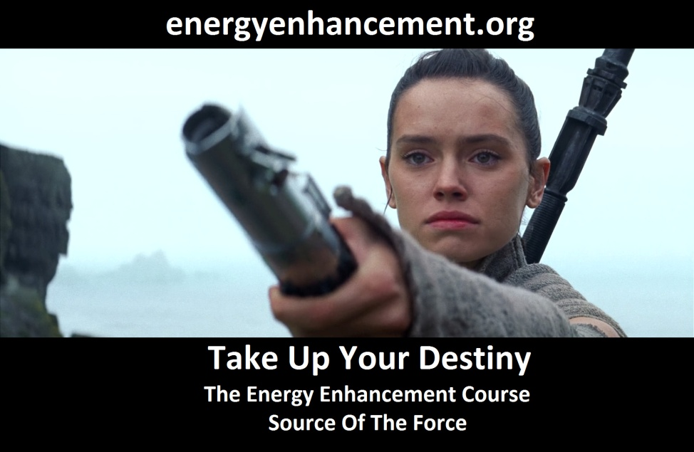
FUSING WITH HIGHER CHAKRAS - THE SOUL, MONAD, LOGOS, SIRIUS, AVATAR OF SYNTHESIS - Energy Enhancement says that it also contains the secret of Initiations Higher that Illumination - "Enlightenment is not Enough!!"

DEEPANKARA BUDDHA

Meditation and Psychic Powers: Shaktipat, Supermind, Kundalini Kriyas, Siddhis, and Enlightenment

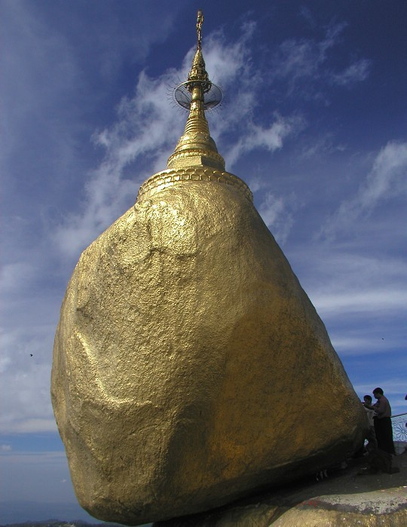

From time immemorial it has been known that some people, Yogis, Gurus, Shamen, Priests, Saints, Paramahamsas, Buddhas, Christs, have evolved to a state of high energy.
These pure and good people, wanting benefit and happiness for all, without a trace of selfishness and competition have been known to have psychic powers.
Their search for energy and goodness has precipitated within them the next stage of human evolution.

For thousands of years they have been Good Doctors, Good Priests, founders of religion, Philosophic Geniuses, Advisors of Kings, Musical Geniuses, Poets, Makers of the Law.

For thousands of years these people, wielding amazing Siddhis or Psychic powers, have been recorded as healing of the sick, casting out mental sickness, coming in dreams, communicating through telepathy, the radiation of specialised energies, leaving the body, entering into the body of another, astral travel, telling the future, acting at a distance, raising Kundalini, Shaktipat, the ability to pass healing into amulets, temples, places of peace, pilgrimage sites, creating miracles, birds and beasts come to them in peace.
Doing all this they also pass on their energy in Shaktipat for the awakening of all good students.
The shaktipat, the radiation of psychic energies by the enlightened can awaken these abilities in all who come to them. This has been known and recorded in the Sacred literature for thousands of years.
Indeed, some sacred literature states that only by access to the energies of the Masters, can enlightenment be passed on.
For example Gautama Buddha has related many stories about his past lives, - as a Master connects with his Soul which is immortal and remembers all of the past lifetimes, so the newly Enlightened Buddha starts to remember and learn from all his past lives.
All of these past lives have such beauty and such significance for all pre-enlightened.
Gautam Buddha has related many stories of his past lives, and they have such beauty and significance.
In one of his past lives he heard about a man who had become enlightened; his name was Deepankar Buddha. The word deepankar means one who can light the candle of your being; the word
`lamplighter' is the exact meaning of deepankar. Deep means lamp, and deepankar means lamplighter. Gautam Buddha was not enlightened in that life. Thousands of people were going to see Deepankar Buddha, and just out of curiosity he also went.
When he saw Deepankar Buddha -- he had no intention... He had come there only out of curiosity, but the moment he saw the man and the beauty of the man -- those deep eyes reminding him of the depth of oceans -- and the field of a certain energy vibrating around the man... not knowing what he was doing, with tears rolling down from his eyes, he touched the feet of Deepankar Buddha.
He himself could not believe what he was doing, and why...? He had not come to touch his feet, and why were these tears coming and why was he feeling so immensely happy? Nothing visible had happened, but something invisible had touched his heart, the bells in his heart had started ringing. A subtle music had touched him.

And at that very moment, as he stood in front of Deepankar Buddha, Deepankar Buddha bowed down and touched the feet of Gautam Buddha -- who was not enlightened in that life. He could not believe what was happening. He asked, "What are you doing? If I touch your feet it is perfectly right, I am ignorant. But you have attained to the ultimate consciousness -- you are not supposed to touch my feet.
And Deepankar Buddha said something that Gautam Buddha remembered when he became a buddha. The first thing that he remembered then was the statement of Deepankar Buddha of many lives before: "Don't be worried. Yesterday I was also ignorant, today I am enlightened; today you are ignorant, tomorrow you will be enlightened. There is not much difference -- it is only a question of time. When you become enlightened, remember."
The moment somebody becomes enlightened, to him the whole existence becomes enlightened -- at least potentially. He can't see himself in a special position.
The really awakened man does nothing to enlighten anybody. His very presence, his Buddhafield, his enlightened radience certainly does miracles, his very being is magical, but as far as he is concerned, he himself is no more. Who is there to do anything?
On the last day of his life, Gautam Buddha said -- when his disciples were paying tributes to him because then he was leaving his body -- "Don't feel grateful to me, because I have not done anything. In fact, since the day enlightenment happened I have not been in existence. Things have been happening around me -- that's another thing. But I am not the doer; the doer is dead, the doer has gone long before enlightenment entered."
Things certainly happened, hundreds of people became enlightened around Gautam Buddha, but he was not doing anything to make them enlightened. He was just available, like a well. If you are thirsty you carry the water from the well and drink, but the well is not doing anything.

The search for this next step in evolution comes from the enhancement, the increase, of energy.
As fire is spread from candle to candle. As the sacred word resonates in both he who gives and he who receives. As Grace dropeth as the gentle dew from Heaven, twice blessed..

So a preparation of he who receives, the student, the candle, by the removal of Negative Energy, Energy Blockages, a lack of Energy

Blockages allows more Spiritual Energy to be absorbed and used to crystalise, complete, finalise, create the Spiritual Body of another Master, another transmitter of the Truth!
They say that Masters represent infinite power through a complete loss of the selfish ego - When the robe was touched no credit was claimed by the wearer, It was your faith which healed you! said the Master - and so the truism, It takes two to Tango, - the student must be purified and prepared by evolution and spiritual practice to accept the Force, the Energy transmitted by the Master.
All energy blockages stopping the flow of energy through the system and preventing the buildup of psychic power in the system must be removed.
Thus we learn and practice Yoga, Pranayama, Meditation, Samadhi, Samyama, the Kundalini Kriyas, Chinese Alchemical Taoism and the Micro and Macrocosmic Orbits, VITRIOL and The Emerald Tablet of Hermes Trismegistus, The Grounding of Negative Energies, The Yoga Sutras of Patanjali, Raja Yoga and the Eighteen Classical Yogas of the Bhagavad Gita.
Thus the torch is passed on from Master to Student. Another candle is lighted up!
And Masters have existed in every time period. hey exist Now!!
Satchidanand Director of Energy Enhancement, is one of the leading teachers of Meditation! He helps people worldwide reach further than they EVER thought possible, FASTER!

EE LEVEL 1 POWER UP!! GAIN SUPER ENERGY http://www.energyenhancement.org/Level1.htm
EE LEVEL 2 ELIMINATE ENERGY BLOCKAGES http://www.energyenhancement.org/Level2.htm
EE LEVEL 3 CLEAN KARMA BLOCKAGES AND PAST LIFE KARMA BY TRANSMUTATION http://www.energyenhancement.org/Level3.htm
EE LEVEL 4 MASTER ENERGY CONNECTIONS AND RELATIONSHIPS http://www.energyenhancement.org/Level4.htm
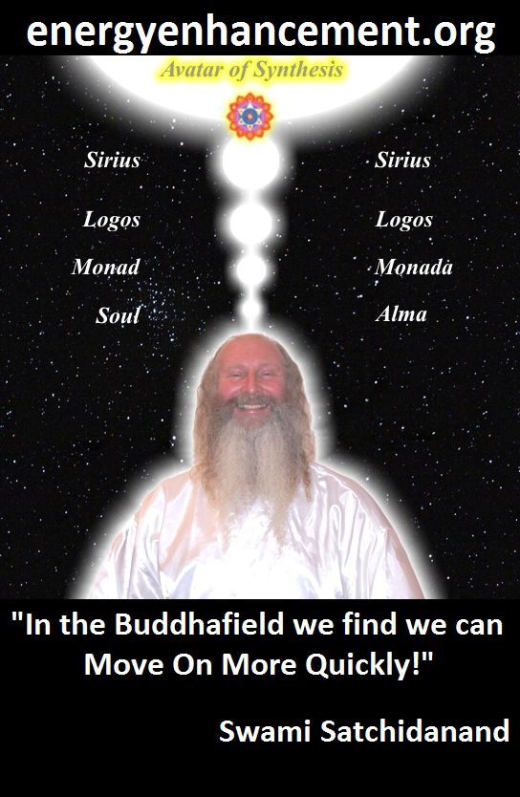
ENERGY ENHANCEMENT - THE ULTIMATE MEDITATION COURSE!!
“Traditional meditations are designed to Fail” – Satchidanand
FUSION WITH THE SOUL CHAKRA - Enlightenment - is Only the first Dan. Become fused with the Monad - Second Dan. Become fused with the Logos - Third Dan. Become Fused with Sirius - Fourth Dan. Become Fused with the Avatar of Synthesis - Fifth Dan - Satchidanand
Research The Energy Enhancement Meditation Course by video or on retreat..
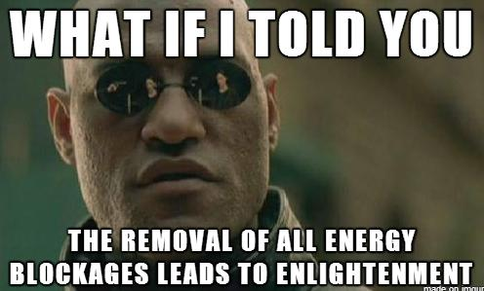
The Ancient Enemy who counts meditation and the mind control psychic arts as one of its main planks of ing, International Companies, Eugenics - Worldwide, censoring Alchemical VITRIOL, the Kundalini Key and Energy Blockage Removal from every Meditation Program..
WE HAVE SO MANY ARTICLES SHOWING THE ORIGINAL EXISTENCE OF THESE ESSENTIAL MEDITATION TECHNIQUES IN EVERY WORLD RELIGION..
NOW, SPEED UP YOUR PROCESS WITH ENERGY ENHANCEMENT ALCHEMICAL VITRIOL, KUNDALINI KEY AND ENERGY BLOCKAGE REMOVAL ON THE PATH OF ENLIGHTENMENT
GET IT NOW!!
EMAIL sol@energyenhancement.org

Ramana Maharshi
Meditation and Psychic Powers: Shaktipat, Supermind, Kundalini Kriyas, Siddhis, and Enlightenment

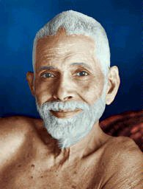
Meditation and Psychic powers, Shaktipat, Kundalini Kriyas, Siddhis, Enlightenment
From time immemorial it has been known that some people, Yogis, Gurus, Shamen, Priests, Saints, Paramahamsas, Buddhas, Christs, including Ramana Maharshi have evolved to a state of high energy.

These pure and good people, wanting benefit and happiness for all,

without a trace of selfishness and competition have been known to have psychic powers.

Their search for energy and goodness has precipitated within them the next stage of human evolution.

For thousands of years the enlightenend have been Good Doctors, Good Priests, founders of religion, Philosophic Geniuses, Advisors of Kings, Musical Geniuses, Poets, Makers of the Law.

For thousands of years these people, wielding amazing Siddhis or Psychic powers, have been recorded as healing of the sick, casting out mental sickness, coming in dreams, communicating through telepathy, the radiation of specialised energies, leaving the body, entering into the body of another, astral travel, telling the future, acting at a distance, raising Kundalini, Shaktipat, the ability to pass healing into amulets, temples, places of peace, pilgrimage sites, creating miracles, birds and beasts come to them in peace.

For example, Ramana Maharshi is noted as being the saint who died in 1950 who all the people in India agree was enlightened. Ramana seemed to have a photographic memory. He was asked questions about enlightenment from sacred books. He was able to recognize and answer those questions from his own experience.
Through people bringing them to him he was able to remember all the sacred books of India.

- From his ashram in South India he traveled astrally to Punjaji in Delhi and invited him to his ashram. When Punjaji saw him he suspected a trick and prepared to leave. It was only when he heard the witness to the fact from many people that Ramana had never gone to Delhi in the flesh that he agreed to stay. Punjaji became enlightened many years later and taught his own students.

- About a year after his first meeting with Sri Bhagavan, Ganapathi Muni experienced a remarkable outflow of his Grace. While he was sitting in meditation in the temple of Ganapati at Tiruvottiyur he felt distracted and longed intensely for the presence and guidance of the Bhagavan. At that moment Sri Ramana entered the temple.

Ganapathi prostrated himself before him and, as he was about to rise, he felt the Maharshi's hand upon his head and a terrifically vital force coursing through his body from the touch; so that he also received Grace by touch from the Master. Speaking about this incident in later years, not Ganapathi Muni, but the Enlightened sage HIMSELF Sri Ramana Maharshi said:

"One day, some years ago, I was lying down and awake when I distinctly felt my body rise higher and higher. I could see the physical objects below growing smaller and smaller until they disappeared and all around me was a limitless expanse of dazzling light. After some time I felt the body slowly descend and the physical objects below began to appear.

I was so fully aware of this incident that I finally concluded that it must be by such means that Sages using the powers of Siddhis travel over vast distances in a short time and Appear and Disappear in such a mysterious manner. While the body thus descended to the ground it occurred to me that I was at Tiruvottiyur though I had never seen the place before.

I found myself on a highroad and walked along it. At some distance from the roadside was a temple of Ganapati and I entered it and gave Uppadesa, Shaktipat to Ganapathi. I suppose that this is the experience of all the ancient saints and Rishis from time immemorial"

- In 1938 a woman by the name of Mercedes De Acosta, was driven by an inner need to visit Sri Ramana. After she had been sitting in the meditation hall for several hours a fellow American, Guy Hague, who many people have said was the real life role model for the Larry Darrell character in William Somerset Maugham's The Razor's Edge, suggested she go and sit closer to the Maharshi.

He said, "You can never tell when Bhagavan will come out of Samadhi. When he does, I am sure he will be pleased to see you, and it will be beneficial for you, at this moment, to be sitting near him."

"I moved near Bhagavan, sitting at his feet and facing him. Not long after this Bhagavan opened his eyes. He moved his head and looked directly down at me, his eyes looking into mine. It would be impossible to describe this moment and I am not going to attempt it. I can only say that at this second I felt my inner being raised to a new level - as if, suddenly, my state of consciousness was lifted to a much higher degree. Perhaps in this split second I was no longer my human self but the Soul."

These and similar eye contact sequences are reported similarly by many others.

- Professor G.V.Subbaramayya has recounted how he prayed to the

sage Sri Ramana for the cure of his two-year-old daughter and how she was cured by his Grace.

Later he met Sri Ramana Maharshi and enquired of him, " did you not think that you must do something to save the child?" Straight came his reply :

"Even the thought of saving the child is a desire, and one who has any desire is not enlightened. In fact any such thought is unnecessary. The moment the enlightened persons attention is drawn in a certain direction there starts the automatic divine activity which itself leads to the highest good."

Note the lack of ego in the words above. See the words selfish desire and good. These elements seem to a part of the way that the enlightened see the world. Even Sivananda of Rishikesh said, "Be Good, Do Good." It is the gap between these two where we are judged and where our karma is created.

The shaktipat, the radiation of psychic energies by the enlightened can awaken these abilities in all who come to them. This has been known and recorded in the Sacred literature for thousands of years.

Indeed, some sacred literature states that only by access to the energies of the Masters, can enlightenment be passed on.

The greater your insensitivity, the more somnolent you are, the greater your need for a guru. Understand that. If you are fast asleep, how can you awaken yourself? Someone else will have to shake you. Even then the chances are that you will roll over and fall back asleep again." - Osho

The search for this next step in evolution comes from the enhancement, the increase, of energy.

They say that Masters represents infinite power through a complete loss of the selfish ego - When the robe was touched no credit was claimed by the wearer, It was your faith which healed you! said the Master - and so the truism, It takes two to Tango, - the student must be purified and prepared by evolution and spiritual practice to accept the Force, the Energy transmitted by the Master.

Thus we learn and practice Yoga, Pranayama, Meditation, Samadhi, Samyama, the Kundalini Kriyas, Chinese Alchemical Taoism and the Micro and Macrocosmic Orbits, VITRIOL and The Emerald Tablet of Hermes Trismegistus, The Grounding of Negative Energies, The

Yoga Sutras of Patanjali, Raja Yoga and the Eighteen Classical Yogas of the Bhagavad Gita.
And Masters have existed in every time period. They exist Now!!
Satchidanand Director of Energy Enhancement, is one of the leading teachers of Meditation! He helps people worldwide reach further than they EVER thought possible, FASTER!
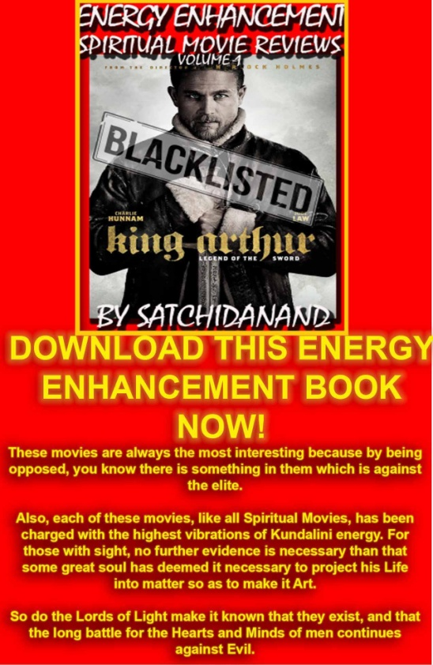
Energy Enhancement Spiritual Movie Reviews Book - Volume 1 by Satchidanand download here..
http://www.energyenhancement.org/Spiritual-Movie-Reviews/Energy-Enhancement-spiritual-esoteric-movie-reviews-by-Satchidanand.pdf

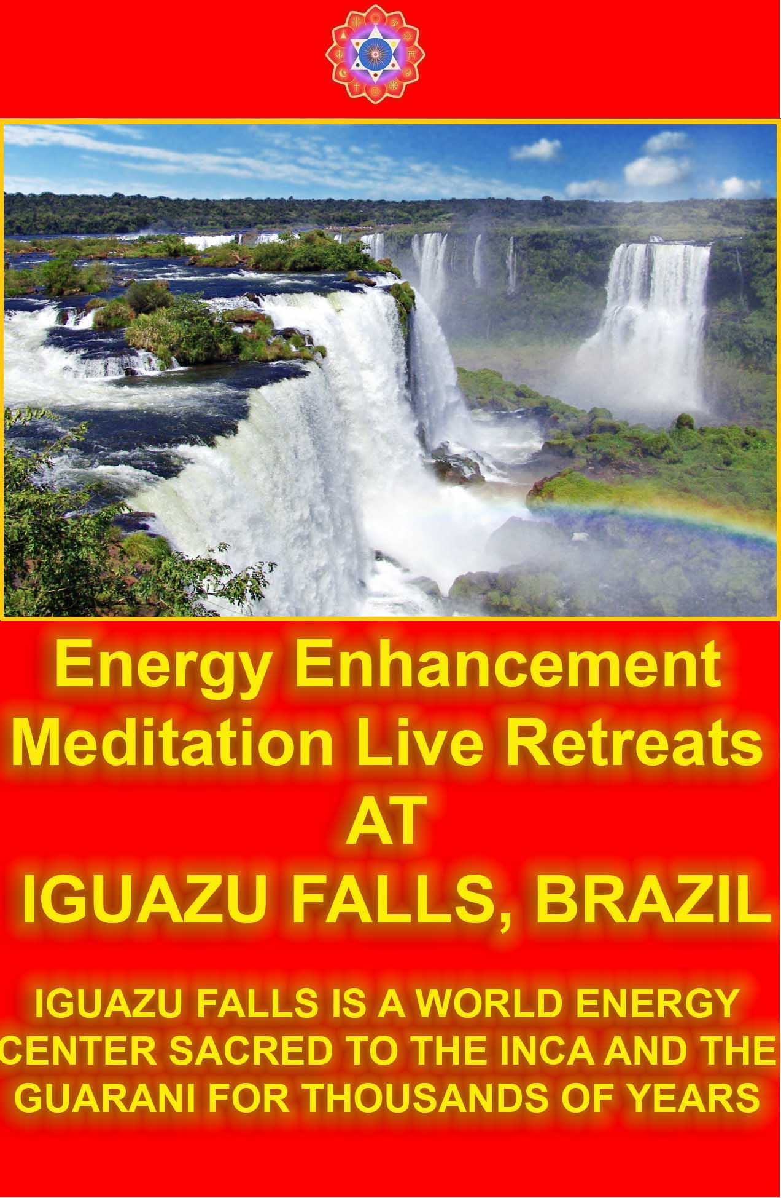

Ramakrishna
Meditation and Psychic Powers: Shaktipat, Supermind, Kundalini Kriyas, Siddhis, and Enlightenment

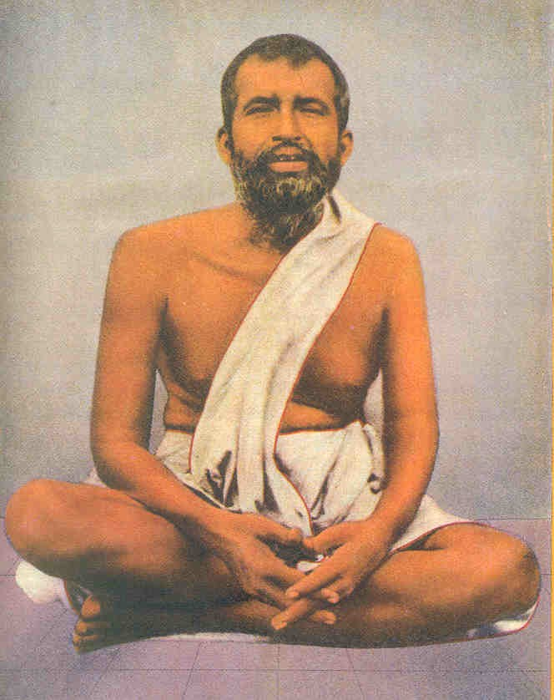
Meditation and Psychic powers, Shaktipat, Kundalini Kriyas, Siddhis, Enlightenment
From time immemorial it has been known that some people, Yogis, Gurus, Shamen, Priests, Saints, Paramahamsas, Buddhas, Christs, have evolved to a state of high energy. For example, Ramakrishna.

These pure and good people, wanting benefit and happiness for all, without a trace of selfishness and competition have been known to have psychic powers.

Their search for energy and goodness has precipitated within them the next stage of human evolution.

For thousands of years they have been Good Doctors, Good Priests, founders of religion, Philosophic Geniuses, Advisors of Kings, Musical Geniuses, Poets, Makers of the Law.

For thousands of years these people, wielding amazing Siddhis or Psychic powers, have been recorded as healing of the sick, casting out mental sickness, coming in dreams, communicating through telepathy, the radiation of specialised energies, leaving the body, entering into the body of another, astral travel, telling the future, acting at a distance, raising Kundalini, Shaktipat, the ability to pass healing into amulets, temples, places of peace, pilgrimage sites, creating miracles, birds and beasts come to them in peace.

Sri Ramakrishna's life is a wonderful record of realization and the powers that follow upon it, powers which in themselves did not particularly interest him, drowned as they were in the knowledge of the higher vision.

Indeed, he said that psychic powers could take one away from the path of self realization because of the selfish ego of having psychic powers. Just because a person has psychic powers, does not mean that the person is good, or that the psychic powers are used with good intent.
The enlightened always come from the direction of good, of goodness, and the aura of psychic powers follows them like a shadow, although they themselves think nothing of them.

Realization came to Ramakrishna in the typical way--devotion, longing for liberation from the bondage of the senses, and then one day with the help of his Master, Totapuri, suddenly, a flood of light and the loss of self-consciousness for 21 days in Samadhi.

I will mention some of the powers it brought with it. They are described as "characteristics distinctive of the highest degree of concentration."

He would meet his disciples at the door, and begin to answer, without being asked, the written questions they carried in their pockets.

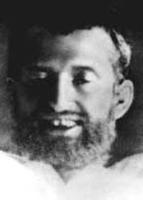

they could not see.
He could tell by touch the character of anyone who had even come in contact with his food, clothes or mat.

He would say of one from whom he shrank, that the contact with anothers negative energy and deep energy blockages had "burnt" him.

Sometimes--"Look, I can eat this. Some good soul must have sent it."

His disciples have told of the strangeness with which they would listen to one side of a dialogue carried on for hours while Ramakrishna, resting, evidently believed himself to be communicating with beings

He had his own nervous force so completely under control that during his last illness he could remove all consciousness from the cancer in his throat and allow it to be operated upon as if under a local anesthetic.

He could interpret the smallest detail of the physical constitution of others as expressing their inward personality.

He would throw a disciple into the hypnotic state and learn from his subconscious mind all that was lodged there.

At times, he said, men and women seemed to him like glass and he could look them through and through.

Above all he could by his touch exercise a compelling power over other lives.

Through this touch they also received flashes of the higher consciousness which molded their futures, this touch is called Shaktipat.

An example is given of his placing his hand on the heads of a row of persons with a different phrase for each, and each receiving a different gift. With one, overwhelming joy; to another a great light which never left him, so that he could never pass shrine or temple after without seeming to see there in that light a Form which he described as "the Spirit that dwells in the images," and so forth.

One of his disciples says, in speaking of the usual talk of men's consciousness: "Consciousness? What does consciousness matter? It is as NOTHING compared with the unfathomable depths of the subconscious and the heights of the superconscious.

Some disciple saw Ramakrishna gather in ten minutes from a man's subconscious mind the whole of his past, and determine from that his future and his powers.

Of this disciple Ramakrishna eagerly asked when he first saw him, "Tell me, do you see a light when you are going to sleep?" "Doesn't everyone?" asked the boy, in wonder. He had indeed a consciousness of light so great that he took it for granted that someone had placed a bright lamp behind his head.

When the disciple was to speak in public, which he did frequently and with power, he would hear at night in his room a voice shouting at him the words he would say next day. It was given to him. This man was the well-known student of Ramakrishna, Swami Vivekananda.

Doing all this they also pass on their energy in Shaktipat for the awakening of all good students.

The shaktipat, the radiation of psychic energies by the enlightened can awaken these abilities in all who come to them. This has been known and recorded in the Sacred literature for thousands of years.

Uppadesa, or the grace of the masters is said to come in a glance, touch, or in silence.

Indeed, some sacred literature states that only by access to the energies of the Masters, can enlightenment be passed on.

The search for this next step in evolution comes from the enhancement, the increase, of energy.

As fire is spread from candle to candle. As the sacred word resonates in both he who gives and he who receives. As Grace

dropeth as the gentle dew from Heaven, twice blessed..

So a preparation of he who receives, the student, the candle, by the removal of Negative Energy, Energy Blockages. A lack of Energy Blockages allows more Spiritual Energy to be absorbed and used to crystalise, complete, finalise, create the Spiritual Body of another Master, another transmitter of the Truth!

They say that Masters represent infinite power through a complete loss of the selfish ego - When the robe was touched no credit was claimed by the wearer, It was your faith which healed you! said the Master - and so the truism, It takes two to Tango, - the student must be purified and prepared by evolution and spiritual practice to accept the Force, the Energy transmitted by the Master.

All energy blockages stopping the flow of energy through the system and preventing the buildup of psychic power in the system must be removed.
Thus we learn and practice Yoga, Pranayama, Meditation, Samadhi, Samyama, the Kundalini Kriyas, Chinese Alchemical Taoism and the Micro and Macrocosmic Orbits,
VITRIOL and The Emerald Tablet of Hermes Trismegistus, The Grounding of Negative Energies, The Yoga Sutras of Patanjali, Raja Yoga and the Eighteen Classical Yogas of the Bhagavad Gita.

Thus the torch is passed on from Master to Student.
Another candle is lighted up!

And Masters have existed in every time period.
They exist Now!! Satchidanand Director of
Energy Enhancement, is one of
the leading teachers of Meditation! He helps people worldwide reach further than they EVER thought possible, FASTER!

Meditation and Psychic Powers, Shaktipat, Kundalini Kriyas, Siddhis, Enlightenment and Ramakrishna 2
From time immemorial it has been known that some people, Yogis, Gurus, Shamen, Priests, Saints, Paramahamsas, Buddhas, Christs, have evolved to a state of high energy.
These pure and good people, wanting benefit and happiness for all, without a trace of selfishness and competition have been known to have psychic powers.
Their search for energy and goodness has precipitated within them the next stage of human evolution.
For thousands of years they have been Good Doctors, Good Priests, founders of religion, Philosophic Geniuses, Advisors of Kings, Musical Geniuses, Poets, Makers of the Law.
For thousands of years these people, wielding amazing Siddhis or Psychic powers, have been recorded as healing of the sick, casting out mental sickness, coming in dreams, communicating through telepathy, the radiation of specialised energies, leaving the body, entering into the body of another, astral travel, telling the future, acting at a distance, raising Kundalini, Shaktipat, the ability to pass healing into amulets, temples, places of peace, pilgrimage sites, creating miracles, birds and beasts come to them in peace.
Of this disciple Ramakrishna eagerly asked when he first saw him, "Tell me, do you see a light above your head when you are going to sleep?" "Doesn't everyone?" asked the boy, in wonder. He had indeed a consciousness of light so great, high up the antahkarana, that he took it for granted that someone had placed a bright lamp above his head. This man was the well-known student of Ramakrishna, Swami Vivekananda.
Vivekananda asked Ramakrishna, "What proofs are there of God's existence?"
And Ramakrishna said, "I am."
A strange answer. Vivekananda had not expected that answer. You also would not have expected it, because when somebody is asking for a proof of God, then there are traditional, philosophical proofs. One expects those proofs. Vivekananda must have been thinking

Ramakrishna would say, "Everything needs a creator. The world is, therefore there must be a creator. We may be able to see him or not, but the creator must be there because the world is."
But no, Ramakrishna didn't say anything like that. He was not a philosopher: he was a Sufi. He said, "I am! Look at me. feel me! Go into me! I can take you into that reality that you are calling God.
What name you give to it is irrelevant. I have been to those heights -
- I can lead the way for you too. Are you ready to come with me?"
Vivekananda was not prepared. He had come to argue. But this is not an argument. This is going to be risky, to follow this madman. One can never be certain where he will lead you.
Vivekananda hesitated. And Ramakrishna said, "Before you ask a question, you should be ready to receive the answer! Are you a coward or something? Why did you ask in the first place?" And Ramakrishna jumped -- he was that kind of madman, -- and he hit Vivekananda with his feet on his chest, and Vivekananda fell into Samadhi.
When after one hour he woke up, he was a transformed man. He bowed down, touched the feet of Ramakrishna, and said, "Excuse me, I am sorry. It was so childish of me to ask such a question. It is not a question -- it is an adventure. And thank you! You have given me a taste of something of which I was not aware at all."
Yes, he did transmit something. But if you read further into the same story, Vivekananda could not retain the experience.
Ramakrishna just gave him a little nibble. Then he said, "Don't depend on my touch every time. Now you know there is something beyond; work it out yourself." Then it took many years for Vivekananda to get that experience again.
Ramakrishna gave even that little experience to him because Vivekananda was fit for it. Still, he said, "This is borrowed. I'm giving you a sample. It's something like if I am chewing some nice candy and you come along and say, "Hey, what is that? "Candy. "Ah, can I try some? "Okay, a little piece. "Ah, it's so nice. Where can I get some more? "Go, work, earn money, go to the shop and buy it. I just give you a taste; then you have to work for it.
Sri Ramakrishna had several thousand disciples but he didn't give all of them even that little taste Vivekananda got. So the student should have the proper qualifications for such an experience.
Otherwise, if it is just that easy Ramakrishna could have just touched everybody and said, "Come on, everybody is a Ramakrishna now. Finished. He was not really stingy. He could have

done that to a thousand people. Why should he do it to only one, Vivekananda?
That is the proof that there are certain qualifications necessary in the disciple even to perceive something like that.
The Scriptures say that there are three aids to realize the Truth: the Scriptures themselves, the Guru, and your spiritual practice. The Scriptures tell you that sugar is sweet. The Guru will show you that sugar. Your practice will give you the taste. The Guru will not put the sugar in his mouth and say, "It is very sweet. You have to taste it yourself. Even if you open your mouth and he puts the sugar in, if your tongue is totally coated, you can't taste it. It will be bitter to you. So you have to clean your tastebuds. That is the reason we say the disciple must be fit to know the taste.
How many people were able to perceive Jesus Christ when he ascended? Only the very few who really had that faith and devotion. So a good student needs a lot of sincerity, purity of heart and devotion - even to get a little glimpse. And even then, that just becomes a kind of small incentive to work with.
The shaktipat, the radiation of psychic energies by the enlightened can awaken these abilities in all who come to them. This has been known and recorded in the Sacred literature for thousands of years.
Indeed, some sacred literature states that only by access to the energies of the Masters, can enlightenment be passed on.
The search for this next step in evolution comes from the enhancement, the increase, of energy.
As fire is spread from candle to candle. As the sacred word resonates in both he who gives and he who receives. As Grace dropeth as the gentle dew from Heaven, twice blessed.. So a preparation of he who receives, the student, the candle, by the removal of Negative Energy, Energy Blockages, a lack of Energy Blockages allows more Spiritual Energy to be absorbed and used to crystalise, complete, finalise, create the Spiritual Body of another Master, another transmitter of the Truth!
They say that Masters represents infinite power through a complete loss of the selfish ego - When the robe was touched no credit was claimed by the wearer, It was your faith which healed you! said the Master - and so the truism, It takes two to Tango, - the student must be purified and prepared by evolution and spiritual practice to accept the Force, the Energy transmitted by the Master.

All energy blockages stopping the flow of energy through the system and preventing the buildup of psychic power in the system must be removed.
Thus we learn and practice Yoga, Pranayama, Meditation, Samadhi, Samyama, the Kundalini Kriyas, Chinese Alchemical Taoism and the Micro and Macrocosmic Orbits, VITRIOL and The Emerald Tablet of Hermes Trismegistus, The Grounding of Negative Energies, The Yoga Sutras of Patanjali, Raja Yoga and the Eighteen Classical Yogas of the Bhagavad Gita.
Thus the torch is passed on from Master to Student. Another candle is lighted up!
And Masters have existed in every time period. They exist Now!!
Satchidanand, Director of Energy Enhancement, is one of the leading teachers of Meditation.!

He helps people worldwide reach further than they EVER thought possible, FASTER!!!
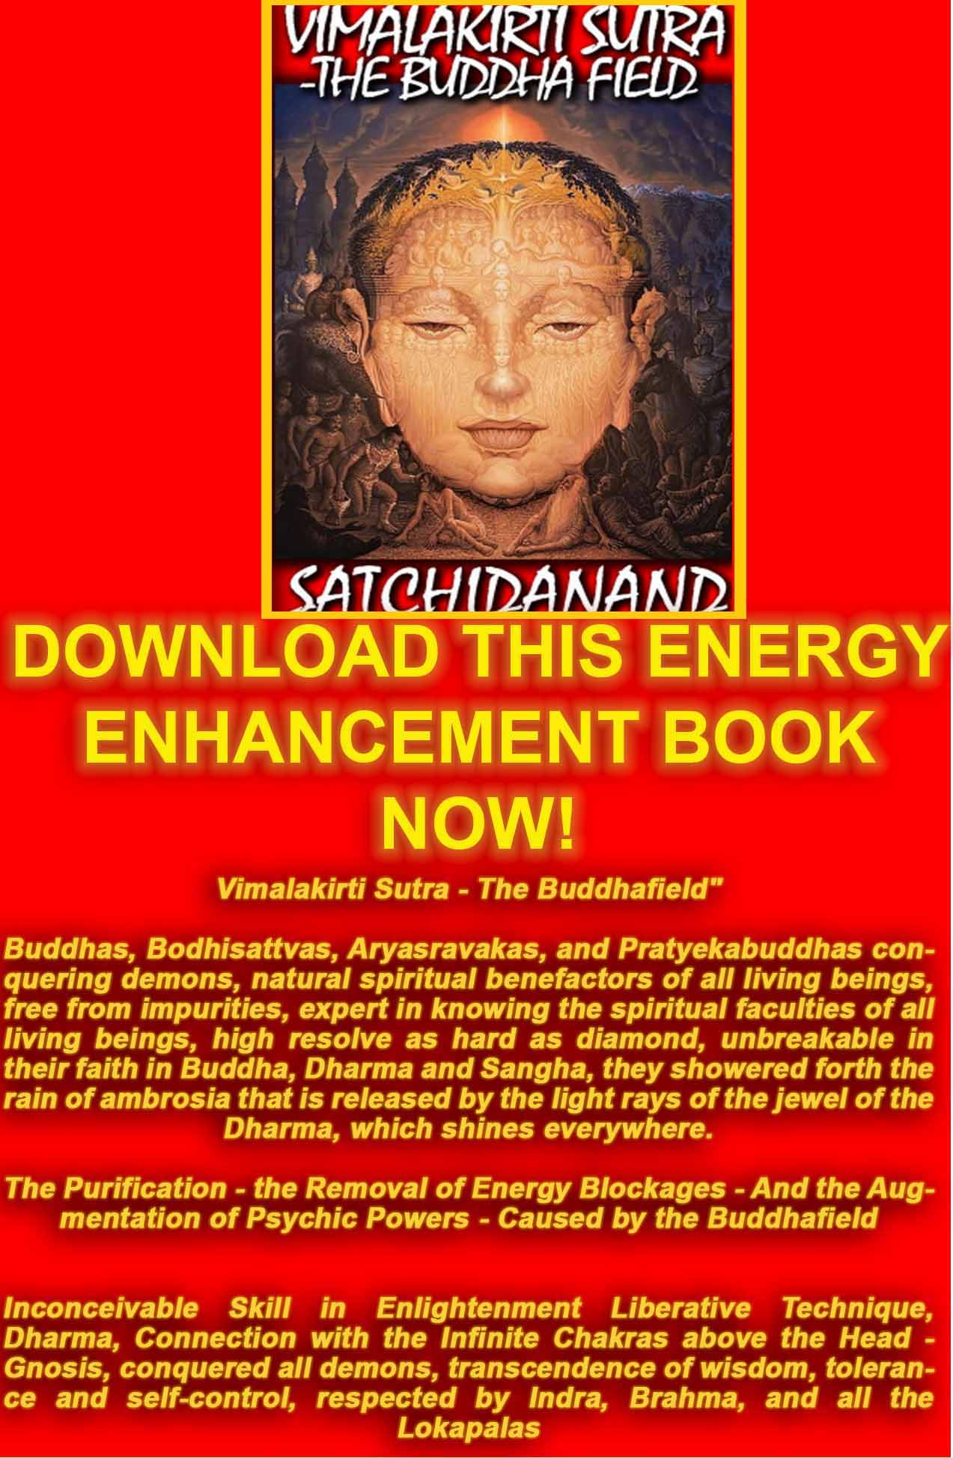
VIMALAKIRTI SUTRA THE BOOK!! DOWNLOAD BELOW
The Buddhist, "Vimalakirti Sutra" in 14 Chapters - by Satchidanand plus one Chapter - The Buddhist Energy Enhancement Kundalini Key is the Buddhist Stupa
http://www.energyenhancement.org/Vimalakirti-Sutra/vimalakirti-sutra.pdf

YUKO SATO
- MEDITATION

ENERGY ENHANCEMENT TESTIMONIAL FROM THE SEPTEMBER 2006 COURSE
Yuko comes from Japan and is a Professional Photographer in Shanghai and London. Before coming on the course she had not meditated before although she has been trying Yoga for a while...
Oh my god, I changed a lot! I screamed with silence.
I was sitting in the bar around 9 p.m. by myself in Barcelona on the first night after my Energy Enhancement Course. On the way back to the hotel, I wanted to have one drink. Surrounding by local Spanish people, everybody had a good time with their own friends, even a bartender was chatting with some regular customers.

I was drinking a glass of red wine in the middle of them and felt totally relaxed without fear. I enjoyed the moment of being, by myself, in foreign county as a stranger.


YUKO SATO TAKING A GLASS OF WINE IN GIRONA, SPAIN DURING THE ENERGY ENHANCEMENT COURSE - TAKEN BY SATCHIDANAND
If I were to be here before, I could not relax this situation, I might worry too much, for example, how they think about me? how am I look like? do I look a bit lonely? am I look OK? etc...... too many of small thoughts, however they usually are big enough to destroy having a simple good time....
To be honest, I have not had that feeling, "without fear...." for the whole 33 years of my life. This is just after the two weeks of an Energy Enhancement meditation course.
During the course, I had many interesting and amazing experiences through meditation. I saw three black snakes, a BM with snake hair, a black rose covered with thousands of ants, a devil who controls and sucks the energy from me and thousands of innocent people, frogs, parasite eggs...etc..

All of them were blockages and implants in my body and my chakras.
Then I removed all of them using the Energy Enhancement Techniques.
The techniques are simple and powerful, moreover effective.
I did not feel any difficulty during the course. On the contrary it is fun and enjoyable.

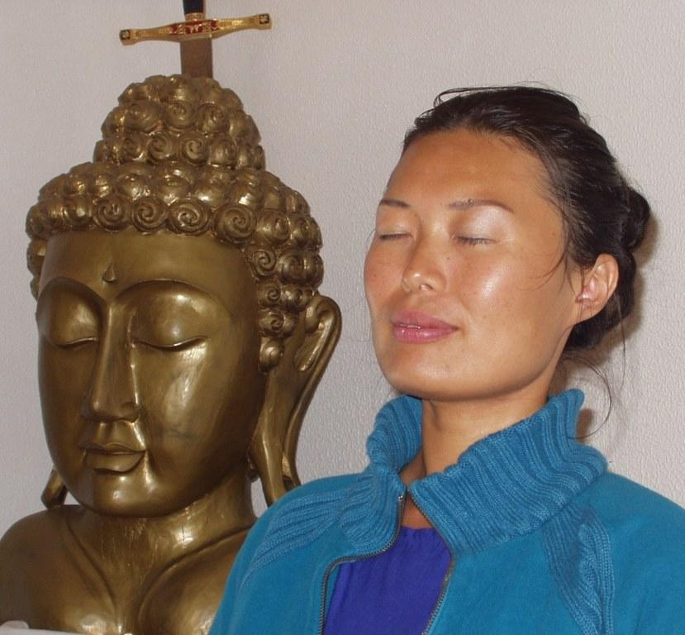
YUKO SATO TAKING MEDITATING IN THE ENERGY ENHANCEMENT CENTER IN SPAIN DURING THE ENERGY ENHANCEMENT COURSE - THE MOVING INTO THE SOUL INFUSED PERSONALITY INITIALLY ONLY HAPPENS OCCASIONALLY, BUT AS WE INTEGRATE MORE AND MORE IT BECOMES PERMANENT IN ENLIGHTENMENT - TAKEN BY SATCHIDANAND
The meditation with Satchi and Devi is sailing with fresh wind, also they have a big map. You can not be lost.

After the EE course, I went to the Juice fasting place in Portugal.

I did it for two weeks and I felt so much energy without eating.
I went for walking in the mountains for 3 hours, 2 hours yoga practice, swimming in the sea and meditation everyday.
After my Energy Enhancement Course, I am the most energetic person in this fasting program, people who work there, they thought I am not a normal human being, because I am smiling and happy all the time.
I feel absolutely happy and full of love.
(Satchidanand - fasting is a spiritual technique used for thousands of years because as well as being good for the waistline (Wasteline) and for the health, it is also working internally to get rid of the energy blockages. Because Yuko had removed most of her energy blockages during her first two weeks of the 4 weeks Energy Enhancement Course, she did not have these problems, and was able to use the fast to find and remove more of her internal energy blockages. Usually, it is my habit to do a 28 day fast each year and there are no problems due to the previous removal of internal energy blockages; I work as normal, just difficulties with entertaining.)

Another change, I can feel other person's fear in my 2nd chakra. So I give them love and ground their fear in centre of the earth. I understand the world better, that keeps the sky of my heart is clear and the sun is shining.
(Although we teach this during Energy Enhancement Initiations, this removal of energy blockages from others happens quite naturally once we begin to take back the power normally taken from us by our separated psychotic sub-personalities. Integration: back into the Soul Personality. Once we integrate them we get back the psychic powers they normally use to get us into trouble and destroy our lives using ego strategies like the poor me and the violator. - Satchidanand)
(Yuko, due to her Japaneseness and her experiences in past lifetimes brought a colourful experience to the Energy Enhancement Course. She had great fun removing her blockages. - Satchidanand)

For meditation, I now do for at least one hour everyday, sometimes for two hours.
I find new blockages every time.
Two days ago I found the river bottom of my antahkarana and I saw a snake swimming under my antahkarana. I have done the Energy

Enhancement 7 steps for them and in the 6th step I met a strong ice woman who can turn everybody and everything into ice.
Finally I grounded her.

I just drop lines of my meditation is going and I feel bright energy every time I meditate.

Thank you for meditation Love and light

Yuko Sato

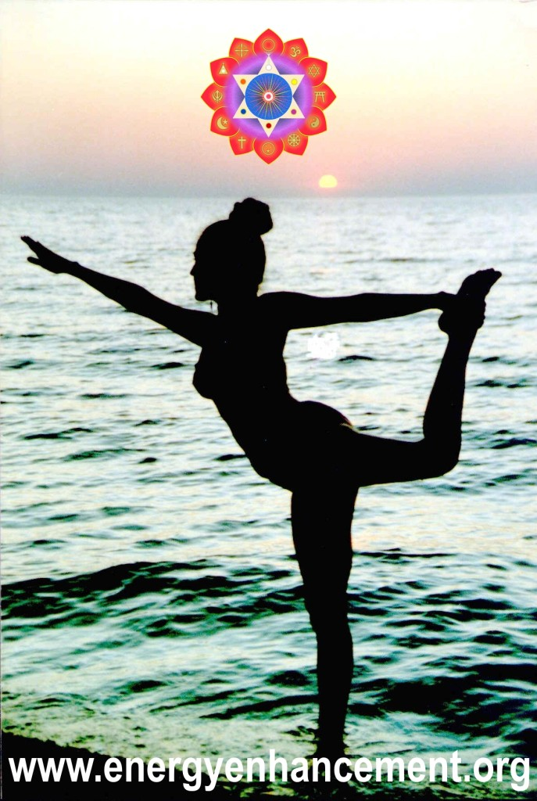
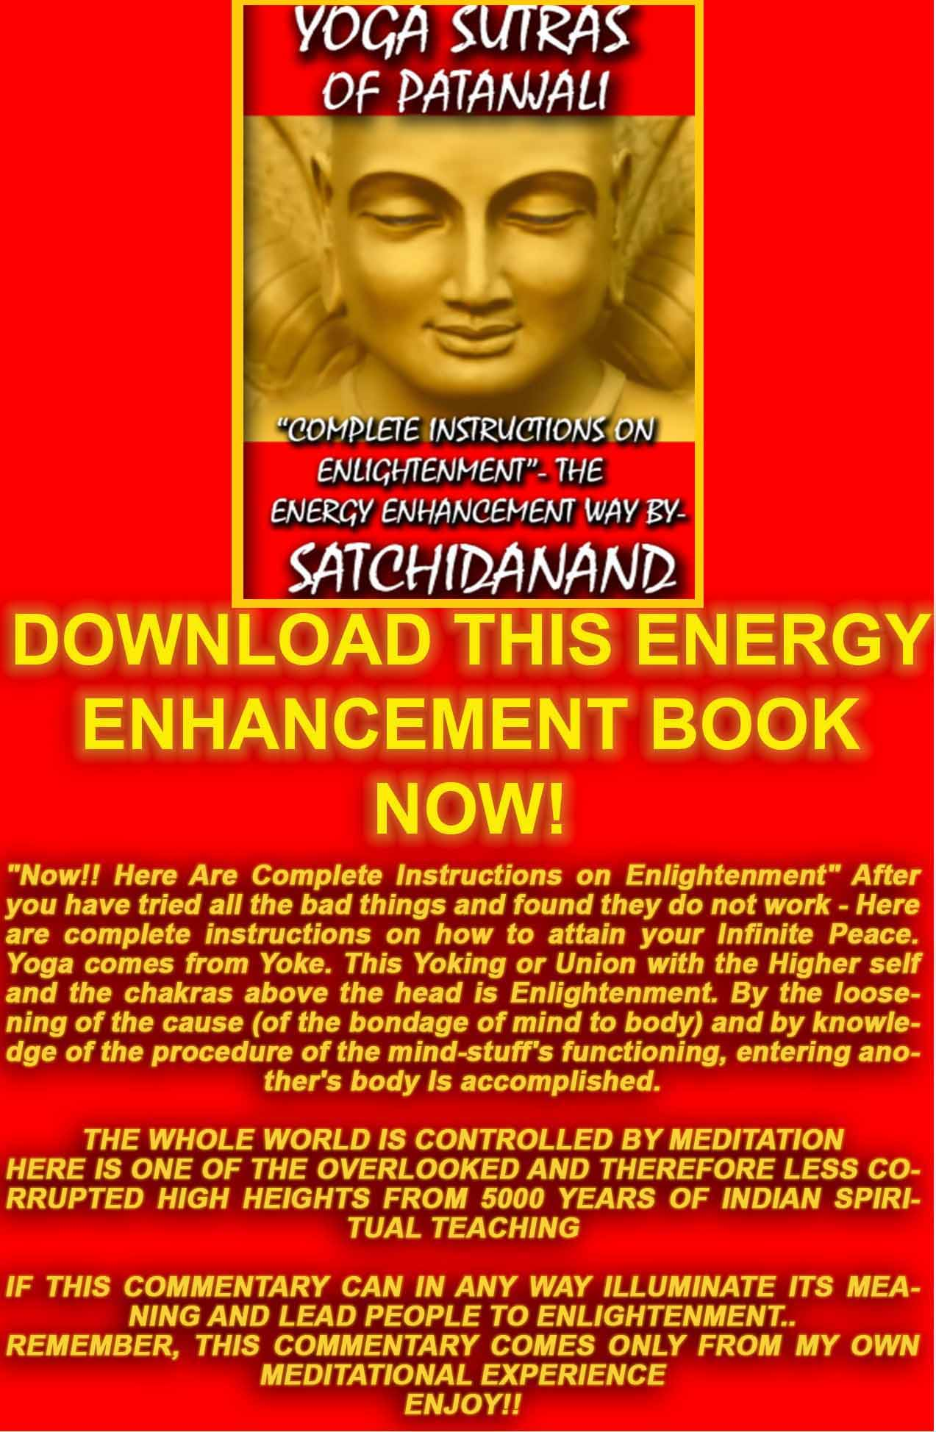
THE YOGA SUTRAS OF PATANJALI BY SWAMI SATCHIDANAND - DOWNLOAD HERE..
http://www.energyenhancement.org/Sacred-Energy/yoga-sutras-of-patanjali-book/Energy-Enhancement-Yoga-Sutras-of-Patanjali.pdf

ENERGY BLOCKAGES
Energy Enhancement Just Ground It!!
We have a very ancient saying, "The more God, the more Devil. The more Flesh the more Worms.
The more property, the more anxiety.
The more control of negative energies, the more negative energies that need control."
The Abbods of Amel
Meditation Energy Enhancement Apprentice Level 1. Initiation 3. The Grounding of Negative Energies.
The Fulcrum point, the evolutionary Initiation we are learning about here is the Earth Connection using the guided meditation, the first formula of Alchemy of Hermes Trismegistus, V.I.T.R.I.O.L.
That of when the child was in the Womb up till the age of Four Months at this time the baby is learning to integrate the interior and exterior of its body. Sometimes this integration is faulty due to a painful abusive shock to the psyche.
Yoga, dance, massage and other Pre - Energy Enhancement Techniques can help with this Initiation. Even fairly well integrated, everyone needs to improve this Earth connection.
"As within" said Hermes Trismegistus "So Without". The baby, so used to the soul connection and not understanding its new role of learning how to raise the Energy Vibration of the Earth, needs to learn to integrate the Earth connection.
If there is a problem with this Initiation of earth integration in the Base Chakra then it is indicated that from an early age the child and then the adult will feel fear, have problems with its food, money and with its security and with just not wanting to be here, sometimes even hiding from reality.
Even with no major evolutionary "Fulcrum Point" problems, every student needs to strengthen this earth connection through these grounding techniques because it is your base and foundation upon which can be built the Temple of Solomon.
Symbolising Evolutionary Integration. Symbolising all your levels of the Auric Body which need to be fed and created, so that we can function at our full capacity.

That's why you are suffering. That's why you are poor -- because you have forgotten how to live on this earth! Nobody has taught you how to live on this earth, how to love this earth. They have all taught you that this earth is ugly, that it is a punishment that you have been sent here, that you are not supposed to enjoy. If you enjoy, you will be sent again. You are supposed to be very sad, detached. You have to renounce all the joys of the earth so next time you don't have to be born, and then you will enjoy heavenly pleasures.
Because these people have been talking too much about the "other world", they have destroyed this world. I teach you this earth.
This very earth, the paradise. This very body the Buddha - OSHO
After learning about The Grounding Of Negative Energies, amongst the many Energy Enhancement techniques, one of our students, Jean, a nuclear engineer, said, I have been working for over 12 years with many well known techniques including Transcendental meditation and Kriya Yoga, Subud, A Course in Miracles and the Sedona Method.
Although I have made good progress with these techniques I now consider these to have been preliminary techniques to prepare me for Energy Enhancement.
These methods that I have tried before simply dont provide for the systematic identification of energy blockages or contain the Advanced Techniques for the removal of the energy blockages to enlightenment that Energy Enhancement does.
If you are serious about self-improvement, growth, change, enlightenment! Then the Energy Enhancement course is for you.
If you are tired of all the many systems of meditation which leave questions unanswered and where the path to enlightenment is ill defined and uncertain then dont delay end the suffering as soon as possible.
Energy Enhancement Apprentice Level One - Gaining More Energy. Meditation, Shaktipat, Energy Circulation, The Kundalini Kriyas, The Five Elemental Paths Of The Chi Of Chinese Alchemical Taoism, The Grounding Of Negative Energies, V.I.T.R.I.O.L, The Art Card Of The Thoth Tarot, Access To Kundalini Energy, Strong Psychic Protection, Learn The Merkaba, Pyramid Protection, Power Tower Protection, Create The Antahkarana, Soul Fusion, Monadic Infusion, Logos Infusion. The Painless Removal Of Stress, Trauma And Negative Emotion

Grounding is one of 28 ancient and effective Energy Enhancement meditation techniques to enable control of your mind, an enhanced IQ, control over all your negative emotions, anger, fear, depression on the path of the ultimate Samadhi and enlightenment itself. The Grounding Of Negative Energies has catapulted people years in their meditational experience in weeks. Some 5 years, some jump 10 times further! It helps people worldwide reach further than they ever thought possible, faster.
Director Satchidanand, is one of the leading teachers of Meditation.
He helps people worldwide reach further than they EVER thought possible, FASTER!!!

Energy Enhancement, Energy Blockages and The Removal Of Fear
The fear of having nothing. The fear of death, even when this is not likely to happen soon, can cause you to take the stupid slave-like path in life.
As Jesus Christ said -"Look at all the lilies in the field. They toil not, neither do they spin...." they do not fear.
Fear is one of the major symptoms of energy blockages in the Base Chakra.
Chakras are processors in the computer sense, the multi-chakrad human being is a multi-processor computer, and as everyone knows, all the supercomputers are multiprocessor.
However, human beings have chakras which are blocked by energy blockages or Nafs in the Sufi sense, and thus do not function.
These energy blockages cut down the functionality of human beings, cut down their IQ, give them negative emotions like anger, fear, addiction and depression and give them wrong thoughts of existentialism, separation, anomie, no heart, no love.
Many Ancient and effective Techniques of Meditation will work on the Painless Integration of the Earth connection.
The removal of blockages in the base chakra will remove all fear. Further it will start the removal of blockages in the rest of the system will increase Kundalini, Love, purpose, will and the power of doing. The removal of blockages in the base chakra will help us to

be practical, to help give us the capacity to "DO", to help us make our vision a practical reality.
The Source of Kundalini Energy is always noted as being in the base chakra, so as you remove all of those blockages then Kundalini Energy will start to wash away all the other energy blockages in the system.
We also need to remove Blockages below the base chakra and the center of the earth, these types of energy blockages create the De- Feeted or defeated which have reduced our energy and make it probable we would depend on others, be a slave, do what we are told.
The Earth Connection helps the baby to know that it will return to the Soul whether it is successful with its integration with the Earth or not. Helps it to learn to Master the physical environs of this planet. Sometimes this Initiation will make problems with this Earth connection but this integration needs to start to happen before for progress to be made.
Even with no major evolutionary "Fulcrum Point" problems, as we evolve through paradigm shifts of evolution, every student needs to strengthen this earth connection through these Advanced Techniques of Meditation, available in every culture because the Base Chakra is your base and foundation upon which can be built the Temple of Solomon.
Symbolising Evolutionary Integration. Symbolising all your levels of the Auric Body which need to be fed and created, so that we can function at our full capacity.
Learn to build your house on the Rock; The Philosophers Stone or Piedra from which came Peter the Apostle.
We need to learn the Contact with inorganic matter, the earth, the Inorganic beings of Don Juan and Carlos Castenada from where we get the energy to build our psychic bodies. The creation of Gurdjieff's "The Body Kesdjian" and to access the Soul Plane and Higher. The next Levels of the Matrix!!
I Felt Hot In My Spine, Some Of My Blockages Were Burned And Removed, And Again At The End Of The Meditation I Felt A Higher Level Of Energy.
We need to learn how to expand the energy orbit to the centre of the earth, and to ground and burn up blockages. Blockages can be grounded and burned, and you do not have to relive traumas or even remember the source of traumas.

It is possible to learn how to free Up our Energies With advanced meditation techniques!! These advanced meditational techniques show how to Transmute stress, pain and negative energy which is held psychically inside you.
Practical Ancient and Successful Guided Meditations which will put you in touch with your own earth energy connection.
Creating the Earth Connection is one of the Core Energy Techniques like the meditations of the Taoist Masters, The Kundalini Kriyas or the Guided meditations of Emerald Tablet of Hermes Trismegistus.
The Painless Grounding of Negative Energies is an Ancient, further and more advanced technique going on from Energy Circulation. It is the Earth Circulation of the Five Elemental Taoist Circulations- Paths of the Chi.
The Base chakra and the Crown Chakra are intimately connected. What is done to one intimately affects the other.
The Alchemical V.I.T.R.I.O.L of Hermes Trismegistus is the First Formula of Alchemy - the hidden meaning of V.I.T.R.I.O.L which gives the hidden Meditational meaning of the Philosophers Stone.
A Guided Meditation for the transmutation of Energy Blockages because the dots indicate the center of the earth. This dot or the Sufi arabic root NQT, is the Freemasonic point from which a man cannot err, a quotation from the ritual creating the Master Mason.
The dots also indicate that each of the letters of the Latin word V.I.T.R.I.O.L is the first letter of another Latin word, together giving the first formula or guided meditation of the Alchemy of Hermes Trismegistus, and of Alchemical Taoism.
Just some of the Practical Ancient and Successful Meditations available in many cultures for thousands of yesar for Gaining More Energy are.. Meditation, Shaktipat, Energy Circulation, The Kundalini Kriyas, The Five Elemental Paths Of The Chi Of Chinese Alchemical Taoism, The Grounding Of Negative Energies, V.I.T.R.I.O.L of Hermes Trismegistus and the The Art Card Of The Thoth Tarot, Access To Kundalini Energy, Strong Psychic Protection, The Merkaba, Pyramid Protection, Power Tower Protection, the Creation of the Antahkarana, Soul Fusion, Monadic Infusion, Logos Infusion for the Painless Removal Of Stress, Trauma And Negative Emotions like Fear, Anger and Depression.
Director Satchidanand, is one of the leading teachers of Meditation.
He helps people worldwide reach further than they EVER thought possible, FASTER!!!

Symptoms of Energy Blockages.
"Energy Blockages are Endless, Let us Vow to End them All"
Buddhist Vow
"For those who believe in Illumination, and understand the Urgency of the Situation" Lord Buddha
It is nice to know the symptoms of Energy Blockages. Sometimes through the visualisation of pushing the breath through the blockage we can remove them and this is what we teach at this first Level of Energy Enhancement. For an invincible method of removing Energy Blockages we need the Seven Step Process of Energy Enhancement Level 2.
- Aches and Pains in the body. As energy is slowed down through and Energy Blockage so toxins and impurities are deposited in the body at these points. Eventually the body breaks down at these points necessitating medical intervention of Medicine or Surgery. Best you remove them psychically before it's too late. A little pain is good as it helps to focus on the blockage to remove it. When the blockage is gone, the pain is gone!! Too much pain will damage the body so you will need to move eventually. Do not damage the body!! A little pain also shows the body is strengthening and your strength is shown by how long you can remain still without moving. If you can remain still for 3 hours perhaps you have become enlightened!! No Pain, no Gain!! Circle the area of pain in white light and breathe through the image of it. For an invincible method of removing Energy Blockages we need the Seven Step Process of Energy Enhancement Level 2.
- When you see the blockage.
- When you feel the blockage.
- When you get negative emotions like Anger, Depression, Sadness, Fear, Manicism, the necessity for attention from others. Imagine an image of the emotion you are feeling. Circle it in white light and breathe through the image of the emotion. For an invincible method of removing Energy Blockages we need the Seven Step Process of Energy Enhancement Level 2.
- A disturbance in the force. When you are breathing golden light around the body, sometimes you can feel that it is not flowing freely and that it is flowing around and not piercing the blockage. Imagine an image of the blockage you are feeling. Circle it in white light and breathe through the image of the blockage. For an invincible method of removing Energy Blockages we need the Seven Step Process of Energy Enhancement Level 2.

6 Unwanted/Negative thoughts. Imagine the thought. Circle it in white light and breathe through the image of it. For an invincible method of removing Energy Blockages we need the Seven Step Process of Energy Enhancement Level 2.
- Heat/Cold. Circle the area in white light and breathe through the image of it. For an invincible method of removing Energy Blockages we need the Seven Step Process of Energy Enhancement Level 2.
- Distraction from your aim is caused by an Energy Blockage.
- The strategies of the vampire, like the poor me, the violator and the selfish competitive star are all symptoms of energy blockages.
As you go through Initiations 1, 2, 3, and 4 the energy flowing through your body with increase immensely. With each gain in energy, more blockages will be thrown out.. It's your job to facilitate this process.
The purpose of the first four initiations is to raise your energy, plug you in to the energies of the universe thus increasing your psychic vision which is absolutely necessary, and to give you experience of energy blockages.
Using these techniques people many have removed their blockages and one of the ways of the past was to go through the process you are going through. What you have at the moment is powerful enough to remove 50% of your blockages but you may find the other half difficult.
By using the Seven Step process of Level 2 you can remove dense and difficult blockages much more easily. Don't get me wrong, to dissolve, transmute all these dense negative energies is never going to be easy, but you can do it much more easily and effectively in Level 2.
The course you have bought, Four Initiations, is to give you effective techniques which have been used for thousands of years, to connect with external centers of energy outside of the body like the source of Kundalini energy which cleans all the internal chakras which is Kundalini chakra in the center of the earth and the Soul chakra in the center of the universe above the head, above Sahasrara chakra whose function is to connect to it.
But also to make you understand the pain, trauma and negative karmic Mass, the Energy Blockages which you and every other member of humanity are holding inside, stooping your energies flowing and destroying your lives, lifetime after lifetime.
I am giving you indisputable proof of this, and I am also giving you a first taste that what we are saying may be absolutely true. We can

remove all of our blockages. We can remove all of our pain. We can come to harmony again.
During our full time course we go through Level 1 (Gain Energy) - 8 initiations in 1-2 weeks and Level 2 (Remove Blockages) in 2 to 3 weeks and we spend the rest of the time working effectively to remove blockages and then practise, practise. The blockages will gradually dissolve.
Best to go through Level 1 Quickly and then spend more time as necessary on Level 2 - The Removal of Blockages.
However, whatever you do, you need to remove the blockages. Get rid of as many blockages as you can at each initiatory level before moving on to the next if you have not Level 2. And a little pain now in return for removing the blockages is well worth while. No Pain, No Gain!!
However, when you get Level 2 you can move much more quickly, effectively and painlessly..
What brought me to this work in the first place was seeing the total pain in which humanity is living as all they do is live and express that pain to each other every day. It is an expression of the Heart to want to help all of humanity. It is an expression of Will and of Purpose to find an effective way of doing that. Now with Energy Enhancement that pain can be released and everyone brought back to normal very quickly.
It is the work of your blockages to try to stop your process and as Blockages evolve they can become powerful. It is my job to help you to proceed so please email me with any problems. It is always better to come on a course with us in Argentina or Spain. And if this is absolutely impossible then you need to get the Level One and Two Video DVDs which contain all the initiations.

Energy Enhancement Meditation, Energy Blockages, and Vipassana
In Vipassana we are keeping the Energy Blockage or negativity in the unconscious will not eradicate it; and allowing it to manifest in physical or vocal action will only create more problems. But if one just observes the blockage and heal it, then the defilement passes away, and one has eradicated that negativity, one is freed from the

defilement. A good solution: it avoids both extremes--suppression and free license.
This sounds wonderful, but is it really practical? For an average person, is it easy to face the Energy Blockage? When anger arises, it overpowers us so quickly that we don't even notice. Then overpowered by anger, we commit certain actions physically or vocally which are harmful to us and to others.
Later, when the anger has passed, we start crying and repenting, begging pardon from this or that person or from God: 'Oh, I made a mistake, please excuse me!' But the next time we are in a similar situation, we again react in the same way. All that repenting does not help at all.
The difficulty is that I am not aware when a defilement Energy Blockage starts. It begins deep in the unconscious level of the mind, and by the time it reaches the conscious level, it has gained so much strength that it overwhelms me, and I cannot observe it.
Then I must keep a private secretary with me, so that whenever anger starts, he says, 'Look master, anger is starting!' Since I cannot know when this anger will start, I must have three private secretaries for three shifts, around the clock!
Suppose I can afford that, and the anger starts to arise. At once my secretary tells me, 'Oh, master, look--anger has started!' The first thing I will do is slap and abuse him: 'You fool! Do you think you are paid to teach me?' I am so overpowered by anger that no good advise will help.
Even supposing wisdom prevails and I do not slap him. Instead I say, 'Thank you very much. Now I must sit down and observe my anger.' Yet it is possible? As soon as I close my eyes and try to observe the anger, immediately the object of anger come into my mind--the person or incident because of which I become angry.
In Vipassana I am not observing the anger itself. I am merely observing the external stimulus of the emotion. This will only serve to multiply the anger; this is no solution. It is very difficult to observe any abstract negativity, abstract emotion, divorced from the external object which aroused it.
However, in Vipassana, one who reached the ultimate truth found a real solution. He discovered that whenever any Energy Blockage arises in the mind, simultaneously two things start happening at the physical level. One is that the breath loses its normal rhythm.
We start breathing hard whenever a negativity comes into the mind. This is easy to observe. At subtler level, some kind of biochemical reaction starts within the body--some sensation. Every defilement

will generate one sensation or another inside, in one part of the body or another.
This is a practical solution. An ordinary person cannot observe abstract defilements of the mind--abstract fear, anger, or passion. But with proper training and practice, it is very easy to observe respiration and bodily sensations--both of which are directly related to the mental defilements.
Respiration and sensation will help me in two ways. Firstly, they will be like my private secretaries. As soon as a defilement starts in my mind, my breath will lose its normality; it will start shouting, 'Look, something has gone wrong!' I cannot slap my breath; I have to accept the warning. Similarly the sensations tell me that something has gone wrong. Then having been warned, I start observing my respiration, my sensation, and I find very quickly that the defilement passes away.
This mental-physical phenomenon is like a coin with two sides. On the one side are whatever thoughts or emotions are arising in the mind. One the other side are the respiration and sensations in the body. Any thought or emotion, any mental defilement, manifests itself in the breath and the sensation of that moment. Thus, by observing the respiration or the sensation, I am in fact observing the mental defilement.
Things keep on occurring that are contrary to our desires and wishes. So the question arises, how am I not to react blindly in the face of these things which I don't like? How not to create tension? How to remain peaceful and harmonious?
In India as well as in other countries, wise saintly persons of the past studied this problem--the problem of human suffering--and found a solution: if something unwanted happens and one starts to react by generating anger, fear or any negativity, then as soon as possible one should divert one's attention to something else.
For example, get up, take a glass of water, start drinking--your anger will not multiply and you'll be coming out of anger. Or start counting: one, two, three, four. Or start repeating a word, or a phrase, or some mantra, perhaps the name of a deity or saintly person in whom you have devotion; the mind is diverted, and to some extent, you'll be out of the negativity, out of anger.
This solution was helpful: it worked. It still works. Practicing this, the mind feels free from agitation. In fact, however, the solution works only at the conscious level. Actually, by diverting the attention, one pushes the negative Energy Blockage deep into the unconscious, and on this level one continues to generate and

multiply the same defilements. At the surface level there is a layer of peace and harmony, but in the depths of the mind there is a sleeping volcano of suppressed negativity which sooner or later will explode in violent eruption.
Other explorers of inner truth went still further in their search; and by experiencing the reality of mind and matter within themselves they recognized that diverting the attention is only running away from the problem.
In Vipassana, escape is no solution: one must face the problem. Whenever a negativity arises in the mind, just observe it, face it. As soon as one starts observing any mental defilement, it begins to lose strength. Slowly it withers away and is uprooted.
This Vipassana works with all weak Energy Blockages, however for very deep and powerful Energy Blockages one must meditate with a Master of Meditation, within his Buddhafield. Let the Master do the work!.
Or one must learn very powerful blockage busting techniques like Energy Enhancement. Then, like Alexander the Great, you can learn how to cut the Gordian Knot with your sword of Discernment!
Usually, the necessary solution is a mixture of both being with a Master of Meditation, and learning advanced Blockage Busting techniques yourself. This we do in Energy Enhancement!
Satchidanand, Director of Energy Enhancement, is one of the leading teachers of Meditation!
He helps people worldwide reach further than they EVER thought possible, FASTER!!!

Energy Enhancement Meditation Escape is no Solution: One Must Face the Energy Blockage Problem
Other explorers of inner truth went still further in their search; and by experiencing the reality of mind and matter within themselves they recognized that diverting the attention from the bad behaviour or Energy Blockage is only running away from the problem.

Escape is no solution: one must face the problem. Whenever a negativity arises in the mind, just observe it, face it. As soon as one starts observing any mental defilement, it begins to lose strength. Slowly it withers away and is uprooted.
This is the case with all weak Energy Blockages, however for very deep and powerful Energy Blockages one must meditate with a Master of Meditation, within his buddhafield. Let the Master do the work!.
Or one must learn very powerful blockage busting techniques like Energy Enhancement. Then, like Alexander the Great, you can learn how to cut the Gordian Knot with your sword of Discernment!
Usually, the necessary solution is a mixture of both being with a Master of Meditation, and learning advanced Blockage Busting techniques yourself. This we do in Energy Enhancement!
Instead of running away from the problem, I am facing reality as it is. Then I shall find that the defilement loses its strength: it can no longer overpower me as it did in the past. If I persist, the defilement eventually disappears altogether, and I remain peaceful and happy.
In this way, the techniques of self-observation shows us reality in its two aspects, inner and outer. Previously, one always looked with open eyes, missing the inner truth. I always looked outside for the cause of my unhappiness; I always blamed and tried to change the reality outside. Being ignorant of the inner reality, I never understood that the cause of suffering lies within, in my own blind reactions toward pleasant and unpleasant sensations.
Now, with training, I can see the other side of the coin. I can be aware of my breathing and also of what is happening inside me. Whatever it is, breath or sensation, I learn just to observe it, without losing the balance of the mind. I stop reacting, stop multiplying my misery. Instead, I allow the defilement to manifest and pass away.
With Advanced Blockage Busting Techniques we go Blockage hunting in Meditation. Simply by using any memory of anger or fear. Simply by going into the timeline when bad things happened to us, we can simply find the Energy Blockages and remove them. As we remove them the negative emotions and bad behaviour never return for that particular Energy Blockage.
The more one practices this technique, the more quickly one will find one will come out of negativity. Gradually the mind becomes freed of the defilements and Energy Blockages; it becomes pure. A pure mind is always full of love--selfless love for all others; full of compassion for the failings and sufferings of others; full of joy at

their success and happiness; full of equanimity in the face of any situation.
When one reaches this stage, the entire pattern of one's life starts changing. It is no longer possible to do anything vocally or physically which will disturb the peace and happiness of others.
Instead, the balanced mind not only becomes peaceful in itself, but it helps others also to become peaceful. The atmosphere surrounding such a person will become permeated with peace and harmony, and this will start affecting others too. And help them remove their own Energy Blockages.
By learning to remain balanced in the face of everything one experiences inside, one develops detachment towards all that one encounters in external situations as well. However, this detachment is not escapism or indifference to the problems of the world.
An Energy Enhancement meditator becomes more sensitive to the sufferings of others, and does his utmost to relieve their suffering in whatever way he can--not with any agitation but with a mind full of love, compassion and equanimity. He learns holy indifference-- how to be fully committed, fully involved in helping others, while at the same time maintaining the balance of his mind. In this way he remains peaceful and happy, while working for the peace and happiness of others.
This is what the Buddha taught; an art of living. He never established or taught any religion, any 'ism'. He never instructed his followers to practice any rites or rituals, any blind or empty formalities. Instead, he taught just to observe nature as it is, by observing reality inside. Out of Energy Blockages, one keeps reacting in a way which is harmful to oneself and to others. But when wisdom arises--the wisdom of observing the reality as it is-- one come out of this habit of reaction. When one ceases to react blindly, then one is capable of real action--action proceeding from a balanced mind, a mind which sees and understands the truth. Such action or removing Energy Blockages can only be positive, creative, helpful to oneself and to others.
You are an immortal and pure being. Energy Blockages are that which is not you. They are filled with perverted spiritual energy which causes bad actions and negativity.
What is necessary, then, is to 'know thyself'--advice which every wise person has given. One must know oneself not just at the intellectual level, the level of ideas and theories. Nor does this mean to know just at the emotional or devotional level, simply accepting blindly what one has heard or read.

It needs an Ancient Advanced Synthesis of Effective Techniques for Gaining More Energy - Meditation, Shaktipat, Energy Circulation, The Kundalini Kriyas, The Five Elemental Paths Of The Chi Of Chinese Alchemical Taoism, The Grounding Of Negative Energies, V.I.T.R.I.O.L, The Art Card Of The Thoth Tarot, Access To Kundalini Energy, Strong Psychic Protection, Learn The Merkaba, Pyramid Protection, Power Tower Protection, Create The Antahkarana, Soul Fusion, Monadic Infusion, Logos Infusion. The Painless Removal Of Stress, Trauma And Negative Emotion
However, to remove these sub-personalities completely, the more Advanced techniques of a Synthesis of Ancient Meditational Techniques are absolutely necessary:-
Leading onto the more advanced Techniques of The Karma Clearing Process. Learning how to clean The Karma From Past Lives, Future Life, Future Lifetimes, Integrating Soul Fragmentation And Retrieval of Inner Children, Selfish Ego Sub Personalites, Life Destroying Strategies, The Aloof, The Interrogator, The Violator, The Selfish Competitive Star, The Vamp Or Don Juan, The Pleaser, The Blamer, The Critic, The King, The Self Destructor, All The Destructive Vows From This And Past Lifetimes,.
Which results in The Creation Of Self Love, Love And Service. Ponder on this
Satchidanand, Director of Energy Enhancement, is one of the leading teachers of Meditation.!

He helps people worldwide reach further than they EVER thought possible, FASTER!!!

Karma Clearing Process of Energy Enhancement Meditation Including the Kundalini Kriyas + Alchemy
The Karma Clearing Process begins with the removal of all Energy Blockages from the energetic system of a human being. Wilhelm Reich called it the Emotional Armor. These are the little stiffnesses which cause us so much pain in massage. Energy Blockages exist in the mental, emotional and physical bodies... Even in the spiritual bodies.

Energy Blockages split us so as we remove them through advanced and effective meditation techniques so we become more integrated, more solid.
Removing energy blockages from our spiritual bodies will allow us to access our hearts and our conscience, it will allow us to access our soul, our soul path in life, without which life has no meaning.
Removing energy blockages from the mind, the mental body, allows more energy to flow, we become more brilliant. Our minds become clear, our IQ increases and more.. We obtain the power of persistence which enables us to accomplish anything!
Removing energy blockages from the emotions allows more energy to flow, we become more stable. Our emotions become clear, our emotional IQ increases and more.. We obtain the power of having only positive emotions which enables us to radiate love, the energy of change and to access the will!
Removing energy blockages from the body allows more energy to flow, we become more energetic. Our bodies become clear of disease and pain, our energy increases and more.. We obtain the power of flexibility and strength which enables us to live longer and with more pleasure, more quality of life!
And what is that uneasiness within?
Just what is that tension which we find inside?
It is pure spiritual energy which has somehow become perverted by painful traumatic experience. It is energy which has been transmuted by some painful experience into pain, that encapsulated pain which we hold inside us or absorb from people and places on this planet. It is energy blockages which makes us feel uneasy and tense.
All the pain caused negative energy blockages which we hold inside are called the selfish competitive ego.
And because we all have been painfully perverting this pure spiritual energy into encapsulated negative energy or energy blockages for thousands of years, this world is filled with that perverted negative energy as energy blockages which we absorb from everything and everyone around us.
It is that pain and tension inside, those energy blockages which causes us to do all the bad things in this world. It is that pain and tension inside, those energy blockages which causes all the bad things in this world to happen to us, we call the bad things, all the bad luck to us. We are accidents waiting to happen. This is karma.

Body stiffness, niggles and pain cause Illness and disease.
Negative emotions, mood swings, wrong thinking, jealousy, prejudice, hatred, anger, fear are all caused perverted spiritual energy encapsulated as energy blockages. The "Mind filled manacles of fear" as said Blake.
Splitnesses in the mind, blocked minds, unclear and plain wrong thinking. Heartless mind solutions caused by selfishly wanting to gain something to the detriment of someone else, the "final solution" of Hitler for example. If we have a lot of these negative energy blockages within ourselves it will cause us to give up easily, a lack of energy, a lack of goodness and heart and soul.
It will cause us to lose our trust and our faith in the essential goodness of people and our teachers. We will project all our negativity onto them and begin to see them through the dark glasses of our negative experiences. Through the darkness of the negative energy which we hold inside.
We create this negative energy inside. And as we evolve we gain the ability to absorb more of this negativity from the people around us and from our surroundings. We gain the power to hold on to more of this negativity without being affected by it. However, the straw that broke the camels back always comes. At this point we become open to wanting to know how to remove and transmute energy blockages. How to change negative energy into pure positive spiritual energy again.
When we enter into the Buddhafield of Energy which surrounds the enlightened we start to feel and lose this Negative energy from inside us. These are the symptoms of Kundalini energy usually.
Because an enlightened master has the ability radiate pure positive spiritual energy as well as to absorb and transmute this negative energy back into pure spiritual energy, a spiral of transmutation, a column of pure transmutation, the Buddhafield, surrounds him and enters into his surroundings.
As you people upon the verge of enlightenment walk around, as well as creating your own negative energy, you absorb likewise the negative energies of people and places. The symptoms of this are your illnesses, your negative emotions of anger and fear, your mood swings and your feelings of negativity.
The only difference between you people on the verge of enlightenment and a master is that a master knows how to transmute the energy he absorbs. And thus he is surrounded by peace and harmony instead of more and more pain and negativity..

He does not curse the darkness. Instead he lights a candle.
The only difference between you and a master is that a master knows how to teach you how to transmute this negative energy into harmonious spiritual energy, and thus place you on the path of peace and harmony, the path of enlightenment itself.
He only needs to teach you how to look at the negative energy. He only needs to teach you how to see it and deal with it. Because anything else is painful. And will cause you to do more painful things. Because this negative energy is Karma itself.
THUS THE KARMA CLEARING PROCESS, THE SOURCE OF ALL TRUE FORGIVENESS.
Spiritual masters are not affected by Karma and indeed have no Karma. Because they have the psychic ability to transmute all karma into pure spiritual energy. And this pure spiritual energy builds up in them and is added to by their masters when they die. So that they are rich because they have a large bank balance of Pure positive spiritual energy to spend on their students. This is called Positive karma.
Because the first stage is the access to purity by transmuting all the pain, which travels with us from lifetime to lifetime and grows more and more each lifetime because like calls to like, inside. To he that has, more will be given, said the Christ.
So we need to learn how to go against this law of the gaining of karma and negative energy and energy blockages by understanding and using the grounding of negative energies, the Third Initiation of Energy Enhancement.
And then the second part comes. Once we have transmuted this negativity inside to a certain degree, it then becomes possible to absorb more positive spiritual energy from the masters bank balance.
The Master can send it to you with a glance. We absorb energy from the Master. The Hindus call it the Uppadesa or the Initiation of the Master, and it is said to come by glance, by touch, or in silence.
Until we learn how to do it for ourselves from the Universe.
And once you start transmuting negative energy by using the techniques of Energy Enhancement every day. Once you start to access your inner purity To he that has not, it will all be taken away, said the Christ. Yes, all the negativity will be taken away.
And this is the Real Initiation or in the Zen Phrase, Satori. And after many Satoris, you then eventually become in the Hindu Phrase,

Twice Born, in the Sufi Phrase, a Made Man, You have made your Bones.
PEACEFUL. HARMONIOUS. ENLIGHTENED.
All with a glance.
All with learning how to open our eyes. All with the gaining of Psychic Vision.
You are the people who have no other choice but to absorb negativity and die, or learn how to transmute it and learn how to Live. Because this knowledge is more important than life and death. It is for those of you who want to attain a Soul.
Start your Karma Cleaning Process by learning how to meditate and then speed it up with the advanced techniques of Energy Enhancement based upon ancient effective techniques of Taoism, The Kundalini Kriyas, The five elemental circulations of the Qi of Chinese Alchemical Taoism, The Guided Meditation of the Emerald tablet of Hermes Trismegistus encapsulated in VITRIOL and more..
Satchidanand, Director of Energy Enhancement, is one of the leading teachers of Meditation!

He helps people worldwide reach further than they EVER thought possible, FASTER!!!

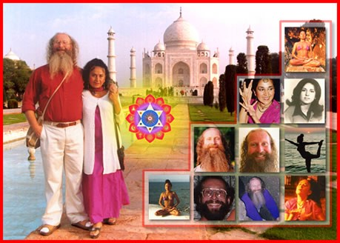

MIND IS A DISEASE WHOSE CURE IS ENLIGHTENMENT

The human mind is filled with wandering thoughts and desires like a mad monkey it leaps from tree to branch and distracts the mind from the higher energies from chakras above the head.

Yet, this is not mind.
Mind is merely a container.
And what the mind contains is madness. The mind contains thoughtforms, programs and sub-personalities which have been created by the person and also absorbed from the surroundings.
These blockage thoughtform sub-personalities are fixed, obsessed, filled with desire which become stale and poisonous. They Kill!! - Only the Empty mind can truly Live, Have Life, because it is free from the fixedness and stuck Polarity caused by the Blockages.
These mind created thoughtforms are the ones which cause the endless Chitta Chatter (Chitta is Sanskrit meaning, Mind) and distraction from Purpose.
These thoughtform Energy blockages cause all the negative emotions of Anger, Fear, Sadness, Despair, Depression, and Manicism.
These thoughtform Energy blockages create and maintain energy connections to other people which drain energy and strength from the lower chakras.
So, when we say mind is the disease, we mean that the full and sick desire filled mind is the disease.
An empty mind is a perceptive instrument and meditation is a fast for the mind because it drives out all the blockages and creates enlightenment.
The purpose of the empty mind faculty is to contain the psychic powers of perception and to listen to the energies of the higher chakras above the head which work at a higher and faster frequency, To listen to the quantum shift in energy from the chakras above the head.
The chakras above the head eventually at their highest point connect with Atman, God, Allah, Nirvana - any of the 10,000 names of the one Highest Energy.
Even Buddha when asked about God said Nirvana - Nothing - Emptiness. When you create an empty mind then automatically you get in touch with the Mind of God!!
This is why the Zen Masters say the Zen Joke, " I know Nothing!" Which really means, "I know God!"
Only an empty mind can contact the energies of God!
And, when all the blockages are removed, then you can become a candidate for Enlightenment!

And Energy Enhancement Techniques through many ancient and effective techniques like the Kundalini Kriyas and the Supra Galactic Orbit of Chinese Alchemical Taoism and the Emerald Tablet of Hermes Trismegistus, VITRIOL, The Seven Step Process for the removal of all blockages, The Karma Clearing Process, can Speed up the Process of Enlightenment.
Here is a talk from Osho in which he talks about Mind the Disease.
Thanks to Osho so that I do not have to make the same effort, even though he needs to be corrected from time to time!
MIND IS A DISEASE. This is a basic truth the East has discovered. The West says mind can become ill, can be healthy. Western psychology depends on this: the mind can be healthy or ill. But the East says mind as such is the disease, it cannot be healthy. No psychiatry will help; at the most you can make it normally ill.

So there are two types of illness with mind: normally ill -- that means you have the same illness as others around you; or abnormally ill -- that means you are something unique. Your disease is not ordinary -- exceptional. Your disease is individual, not of the crowd; that's the only difference. Normally ill or abnormally ill, but mind cannot be healthy. Why?

The East says the very nature of mind is such that it will remain unhealthy. The word 'health' is beautiful. It comes from the same root as the word 'whole'. Health, healing, whole, holy -- they all come from the same root.

The mind cannot be healthy because it can never be whole. Mind is always divided; division is its base. If it cannot be whole, how can it be healthy? And if it cannot be healthy, how can it be holy? All minds are profane. There is nothing like a holy mind. A holy man lives without the mind because he lives without division.

Mind is the disease. And what is the name of that disease? Aristotle is the name, or if you really want to make it look like a disease then you can coin a word: ARISTOTLITIS. Then it looks exactly like a disease. Why is Aristotle the disease? Because Aristotle says, "Either this or that. Choose!" And choice is the function of the mind; mind cannot be choiceless.

Choose and you are in the trap, because whenever you choose you have chosen something against something else. If you are for something, you must be against something; you cannot be only for, you cannot be only against. When the 'for' enters, the 'against'

follows as a shadow. When the 'against' is there, the 'for' must be there -- hidden or not hidden.

When you choose, you divide. Then you say, "This is good, that is wrong." And life is a unity. Existence remains undivided, existence remains in a deep unison. It is oneness. If you say, "This is beautiful and that is ugly," mind has entered, because life is both together.
And the beautiful becomes ugly, and the ugly goes on becoming beautiful. There is no boundary; no watertight compartments are there. Life goes on flowing from this to that.

Mind has fixed compartments. Fixedness is the nature of mind and fluidity is the nature of life. That's why mind is obsession; it is always fixed, it has a solidness about it. And life is not solid; it is fluid, flexible, goes on moving to the opposite.

Something is alive this moment, next moment is dead. Someone was young this moment, next moment he has become old. The eyes were so beautiful, now they are no more there -- just ruins. The face was so roselike, now nothing is there -- not even a ghost of the past. Beautiful becomes ugly, life becomes death, and death goes on taking new birth.

What to do with life? You cannot choose. If you want to be WITH life, with the whole, you have to be choiceless.

Mind is a choice. Aristotle made it the base of his logic and philosophy. You cannot find a man more distant from Sosan than Aristotle, because Sosan says, "Neither this nor that -- don't choose." Sosan says, "Be choiceless." Sosan says, "Don't make distinctions!" The moment you make a distinction, the moment choice enters, you are already divided, fragmentary; you have become ill, you are not whole.

Remember, if you ask a Christian... who does not really belong to Jesus, who basically belongs to Aristotle. Christianity is more Aristotle-based than Christ-based. Jesus was more like Sosan. He says, "Don't judge. Judge ye not!" He says, "Don't make any choice. Don't say, 'This is good and that is bad!' That is not your concern. Let the whole decide. Don't you be a judge." But Christianity is not really Jesus-oriented. The founders of Christianity were more Aristotelian than Christian.

You cannot make a church out of Sosan or Jesus. How can you make a church if you remain choiceless? A church has to be for something and against something; it has to be for God and against

the Devil. And in life God and the Devil are not two, they are one. The Devil is one face and God is another face of the same energy -- they are not two.

Sometimes he comes as a Devil and sometimes he comes as a God. And if you can go deep and look, you will find they are the same.
Sometimes he comes as a thief and sometimes he comes as a virtuous man. Sometimes you will find him in respectable quarters and sometimes with those who are not respected but condemned. He MOVES, he is a movement. And no shore is too distant for him to reach, nobody is beyond him -- he moves in everybody.

Jesus makes no distinctions, but Christianity makes distinctions because a religion has to -- a religion has to become a morality. And once a religion becomes a morality it is no more a religion. Religion is the greatest daring possible. It takes the greatest courage to be choiceless, because the mind says, "Choose!" The mind says, "Say something! This is wrong, that is good. This is beautiful, this is ugly. I love this, I hate that." Mind says, "Choose!"

Mind has a temptation to divide. Once you divide, mind is at ease. If you don't divide, if you say, "I'm not going to to say anything. I'm not going to judge," mind feels as if it is on its deathbed.

Aristotle says A is A and cannot be not A -- the opposites cannot meet. Sosan says there are no opposites -- they are already meeting, they have always been meeting. This is one of the most fundamental truths to be realized, that the opposites are not opposites. It is you who say they are opposites, otherwise they are not opposites. Look existentially and you will feel they are the same energy.

You love a person...

One woman came to me and she said, "For ten years I have been married to a person and we never quarreled. And now suddenly, what happened? He has left me."

Now, she thinks that if they never quarreled it shows they were in deep love. This is foolish -- but this is Aristotelian; the woman is absolutely logical.
She said, "For ten years we have been married. We never quarreled, we were never angry at each other." She is saying, "We were in such deep love that we never fought about anything. There was not even a single moment of conflict. And now, what happened? Suddenly he has left me! Has he gone mad? Our love was so deep." She is wrong.

If love is deep then there is bound to be some quarrel. Sometimes you will fight. And the fight is not going to break the love, it enriches it. If love is there, it will be enriched by fighting; if love is not there, then you part, you separate. Ten years is a long time -- even twenty-four hours is too long to be constantly in one state of mind, because mind moves to the opposite.

You love a person; sometimes you feel angry. Really, you feel angry only because you love. Sometimes you hate! Sometimes you would like to sacrifice yourself for your lover, and sometimes you would like to kill the lover. And both are you.

If you never quarreled for ten years, it means there was no love at all. It means it was not a relationship. And you were so afraid that any anger, any conflict, any slight thing could break down the whole thing. You were so afraid you never quarreled. You never believed that the love could go deeper than the quarrel, that the quarrel would be momentary and after the quarrel you would fall into each other's arms more deeply. No, you never trusted that.
That's why you managed not to fight. And this is not something to be surprised about, that the man has left. I said, "I am surprised that he remained with you for ten years. Why?"

One man came to me and he said, "Something has gone wrong with my son. I have known him for twenty years -- he was always obedient. Such a good boy you cannot find anywhere. He never disobeyed, he never went against me. And now suddenly he has become a hippie. Now suddenly he doesn't listen. He looks at me as if I am not his father at all. He looks at me as if I am a stranger. And for twenty years he was so obedient. What has happened to my son?"

Nothing has happened. This is what was to be expected, because if a son really loves his father he disobeys also. Whom else should he disobey? If a son really loves his father and trusts him, sometimes he goes away also -- because he knows the relationship is so deep that by disobeying it is not going to be broken. Rather, on the contrary, it will be enriched. The opposite enriches.

Really, the opposite is not opposite. It is just a rhythm, a rhythm of the same; you obey and then you disobey -- it is a rhythm.
Otherwise, just going on obeying, obeying, everything becomes monotonous and dead. Monotony is the nature of death, because the opposite is not there.

Life is alive. The opposite is there, a rhythm is there. You move,

you come back; you depart, you arrive; you disobey, then you obey also; you love and you hate. This is life, but not logic. Logic says if you love you cannot hate. If you love, how can you be angry? If you love in this way then you love in a monotonous way, the same pitch. But then you will become tense, then it is impossible to relax.

Logic believes in linear phenomena: in one line you move. Life believes in circles: the same line goes up, comes down, becomes a circle.

You must have seen the Chinese circle of YIN and YANG. That is how life is: opposites meeting. That circle of YIN and YANG is half white, half black. In the white there is a black spot, and in the black there is a white spot. The white is moving into the black, and the black is moving into the white -- it is a circle. The woman moving into the man, the man moving into the woman... this is life. And if you observe minutely, you will see it within you.

A man is not a man twenty-four hours a day, cannot be -- sometimes he is a woman. A woman is not a woman twenty-four hours a day -- sometimes she is a man also. They move to the opposite. When a woman is angry she is no more a woman; she becomes more aggressive than any man and she is more dangerous than any man, because her manhood is purer and never used. So whenever she uses it, it has a sharpness no man can compete with. It is just like soil which has not been used for many many years; then you throw the seeds -- and a bumper crop!

A woman sometimes becomes a man, but when she becomes then no man can compete. Then she is very dangerous; then it is better for the man to submit. And that's what all men do -- they become submissive, they surrender. Because immediately the man has to become the woman, otherwise there will be trouble. Two swords in one seat -- there will be trouble. If the woman has become the man, if she has changed the role, immediately the man becomes the woman. Now everything is reestablished. Again the circle is complete.

And whenever a man becomes submissive and surrenders, that surrender has a purity no woman can compete with -- because ordinarily he is never in that posture, in that game. Ordinarily he stands and fights. Ordinarily he is a will, not surrender. But whenever he surrenders it has an innocence that no woman can compete with. Look at a man in love -- he becomes just a small child.

But this is how LIFE moves. And if you understand it then you are not worried at all. Then you know: the lover has departed, he will come back; the beloved is angry she will love. Then you have patience. With Aristotle you cannot have any patience, because if a lover has departed, he has departed on a linear journey -- no coming back, it is not a circle. But in the East we believe in the circle; in the West they believe in the line.

The Western mind is linear, the Eastern mind is circular. So in the East a lover can wait. He knows that the woman who has left him now will come back. She is already on the way, she must be already repenting, she must have already repented, she must be coming; sooner or later she will knock at the door. Just wait... because the opposite is always there.

And whenever a woman comes back after anger, then love again is fresh. Now it is not repetition. The gap of anger destroyed the past. Now she is again a young girl, a virgin girl. Again she falls in love -- everything becomes fresh.

If you understand this, then you are not against anything. You know even anger is beautiful, even a quarrel here and there gives tone to life. And everything helps the richness. Then you accept, then deep in acceptance you are patient, then there is no impatience and no hurry. Then you can wait and pray and hope and dream.

Otherwise, if life is linear, as Aristotle thinks or -- as Western thinking has moved from Aristotle to Bertrand Russell -- as Bertrand Russell thinks, then life has much impatience. Nobody is going to come back; then you are always trembling, afraid, and then you become suppressive. Then you may stay with a woman for ten years or for ten lives, but that staying is with a stranger. You are controlling yourself, she is controlling herself, and there is no meeting. Life is not logic. Logic is just a part -- of course, very clean cut, categorized, compartmentalized, divided -- but life is messy.
But what to do? It is so. It is not so compartmentalized, so clear-cut, divided -- it is a chaos. But logic is dead and life is alive, so the question is whether to choose consistency or to choose life.

If you are too much for consistency you will become dead, and deadlier and deadlier, because consistency is possible only if you drop the opposite completely. Then you love and only love and only love and are never angry, never hate, never fight. You obey, only obey -- never disobedience, never rebellion, never going away. But

then everything becomes stale, then the relationship becomes poisonous -- then it KILLS.
These blockage thoughtform sub-personalities are fixed, obsessed, filled with desire which become stale and poisonous. They Kill!! - Only the Empty mind can truly Live, Have Life, because it is free from the fixedness and stuck Polarity caused by the Blockages.
- Satchidanand

LIVE COURSES, INDIA AND BRAZIL - IGUAZU FALLS

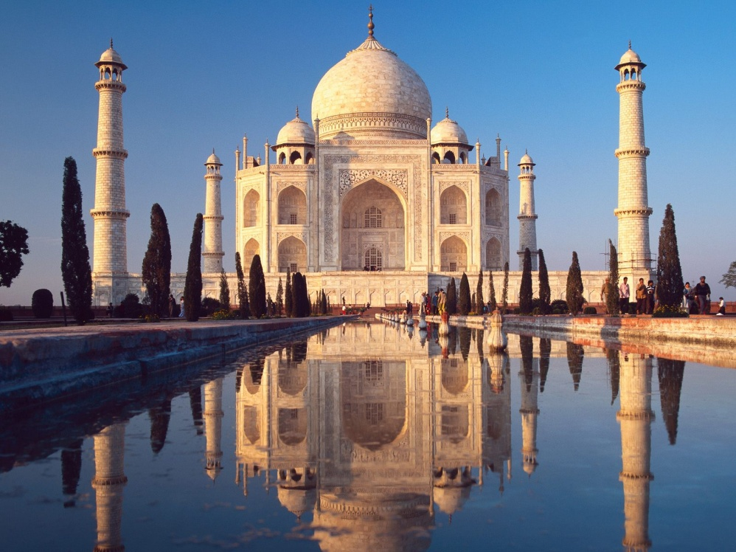
GET MEDITATIONAL SUPERPOWERS WITH ENERGY ENHANCEMENT, LIGHT YEARS AHEAD OF EVERY OTHER COURSE
THE ULTIMATE ADVANCED MEDITATION COURSE
MEDITATION ENERGY ENHANCEMENT
THE CORE ENERGY TECHNIQUES!!
THE MOST ADVANCED MEDITATION TECHNIQUES ON THIS PLANET, IN 28 INITIATIONS!!
ANCIENT EFFECTIVE ENERGY ENHANCEMENT SECRETS -
SUCCESSFUL
TIME TESTED
TRUE
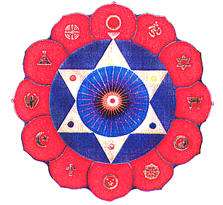

Bookings: www.energyenhancement.org

ENERGETIC BLOCKAGES WITHIN THE BODY
Many people have asked me, just what are these energy blockages which exist within the body.
I say they are made out of negative energy which slows down the positive spiritual bio-energy of the body and of the Universe.
An example of one of the different types of Energy Blockage is that they are sometimes created when we do not get what we expect, or we get what we do not want. They are caused by the pain of disappointment. Like when our Mother or Father or Son or Daughter dies. Like when our lover leaves us.
And this trauma, this pain is so strong that at that moment the mind can not look at it, so it gets locked away within the body until we get strong enough to process it. Thus amnesia. We forget the pain fulminating within our bodies. We forget the poison within our bodies until after a while disease is the result.
The process of Energy Enhancement is so powerful that when we heal all these blockages within us, we do it at the energy level.
There is no need to enter with in memory of the event again. So the dissolution of all blockages is simple and painless. And we feel so much better!!
We have removed a potential disease or infirmity which is the bane of the body as we get older.
If we had no negative energy blockages within the body we would be as we are meant to be, full of energy and strength, upon our soul path on the path of our dharma, with no foothold for disease and infirmity to enter.
The Bio-energy of the body would flow without let or hindrance. We would be connected to the Universal spirit. There would be no separation.
And really, that is what these negative energy blockages are. They are pieces of ourselves which are cut off and separated from the Universal spirit and from us.
Thus they are those parts which pervert our body creating cancer and disease within us.
They are those parts which pervert our emotions creating anger, irritation, manicism, a need for attention, sadness, depression and fear within us.
They are those parts of ourselves which pervert our intellect creating arguments for doing those things which lead us from our true path in life. The result is, in the normal way of speaking, sex, drugs and rock and roll. They are perversions of the intellect which lead us away from our true path.
As we remove our blockages, we stop emphasizing the lesser things such as sex, money, power, clothing, cars, houses as being the most important things in our lives knowing that such things come naturally to those on the normal most important path of their lives, their soul path, their dharma. Many people waste their lives on such things which bring them no lasting happiness.
We come into this world with nothing and when we leave it we leave with nothing, except our training and evolution.
Power, money, cars and houses etc, etc are a consequence of enjoying that which we are truly meant to do; they are not ends in themselves.
All of these energetic blockages are part of our selfish, competitive ego.
All of these energetic blockages together ARE our selfish, competitive ego.
Thus, as we remove our energetic blockages one by one, we find that our selfish, competitive ego gets smaller, and our soul connected personality becomes larger.

What this means is that as we remove all of our blockages with the simple methods of Energy Enhancement,…
- We remove all potential diseases within the body. The body becomes stronger and free from pain, soft, pliable and young again

We remove all of the pain held within our bodies, thus we stop calling for more negative experiences. Thus we stop the re-occurrence of negative, painful experiences.
- We remove all the negative Karma or bad luck within our bodies, thus we only encounter Positive Karma or luck.
- We remove all negative emotions from the mind so that there is a disappearance of anger, wanting attention, depression, sadness and fear. The positive emotions appear like universal love, brilliant intellect and willpower, the power of getting things done.
- We stop being selfish and egotistical, finding our true happiness on the path of our soul.
- We stop being perverted, doing that which we are not meant to do. We stop searching through perverted thoughtforms for things which will make us happy because we are doing those things which we know will make us happy. We know that which will make us happy. We put things in their place knowing that which is the most important thing in our life. We remove all blockages to our happiness which is simply being truly satisfied doing that which we are meant to do and growing, evolving more and more within that happiness.
Thus, the removal of energetic blockages within the body is something which is essential to our lives as it immediately stops those things which make us unhappy.
The removal of energetic blockages within the body is something which we need to learn, it is something which we need to do as it is the only thing which can make us truly happy.
Energy Enhancement Techniques are the quickest and most advanced methods of removing Energetic Blockages within the Body and thus lead us in the most direct way to our ultimate happiness!!

ENERGETIC BLOCKAGES, GRAHAM AND HIS ENERGY ENHANCEMENT COURSE OF MEDITATION ENERGY ENHANCEMENT
This last week we have been hosting the Energy Enhancement teaching of Our Clientfrom Dublin in Ireland.
Our Client is 30 years old, likes sport and Guinness, has a Masters in Philosophy from Dublin University, and has recently spent 3 months in a Zen Monastery of the Deshimaru Soto Zen Lineage in France, taking part in many sesheins when one practices meditation for perhaps 6 hours per day for a week or 10 days.
Ah, the practice of Zazen, Shikantaza, just sitting, which I practiced with my Master Roshi Hogen from Japan who still teaches occasionally in Byrom Bay, Australia.
As I described last week in my commentary on Blockages. First the easy blockages come out, then those of medium difficulty, finally the really difficult ones come out. And the last one is a Doozy!!
And after the normal experiences of session which Our Client went through. Of pain, sleeping a lot and the raising of emotions and irritability and anger, Our Client was told by the Master of the Monastery, John Pierre, that he was so surprised at how much he had improved. Now he can sit for the whole sessein without pain.
Surprised because Our Client and John Pierre knows he is an Eejit, which is an Irish word describing many of the “Bhoys” or the “lads” and means, a complete idiot. Which means that I suppose, that Our Client knows himself a bit better than that. Knows his ego is an idiot and is so comfortable with that that he does not mind when he is described as an idiot, because he knows that his soul is not!!
He has not taken offence at the testing of his teachers knowing truly, “sticks and stones can hurt my bones, but words can never hurt me.” This is the sign of a strong emotional IQ.
Indeed, Gurdjieff was so enamored of this technique, that he used to have a, “Toast of the Idiots” at the end of his dinner parties in strong vodka. He created nineteen hierarchical varieties of Idiots and named all his students one of them by toast.

It creates a necessary humility. It tells you the truth about yourself. It is water off the ducks back of the Soul personality. The Soul personality just does not care what other people think. It is higher than that.
Only the selfish competitive ego personality ever gets hurt.
Now everyone knows that the purpose of sitting is to remove painful blockages from the base chakra, but when the blockages of medium difficulty start to be shifted by the process of just sitting or indeed of life itself, then you need a Zen Master to remove the blockage, or you need a Master and Energy Enhancement techniques to shift them.
Zazen, just sitting, is not a strong enough practice to effect their removal, one needs something stronger.
I remember with Hogen, that even when he was in Japan and I was in England, every morning he used to throw me out of bed at 6am for my Zazen, but as I was practicing I felt him there with me
cleaning my base chakra.
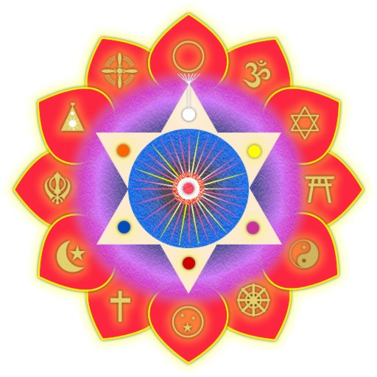Can you feel my breeze blowing. Even from 10,000 miles.
Haiku, or Zen Poem written by Zen Master Hogen.
Writing a Haiku In 17 Syllables Is Very Diffic…
Written by John Cooper Clarke…
Yet the best kind of Master lets the students know how to do it for themselves.
So Life or Zazen starts to move the blockages one by one and Our Client had got to the stage where an “Accident” whilst scuba diving in the Red Sea had caused a problem in his back in the Lumbar vertebrae.
Usually the Energy Blockage calls for the accident and creates the injury and Energy Blockages in the Abdomen, Second Chakra, the Relationship Chakra always cause problems in the Lumbar vertebrae.These types of Relationship energy blockage call for a jewish mother. They call for the experience of your father leaving you and your mother at the age of Five.

Indeed they call for relationship experiences with people with similar Energy Blockages in the Relationship Chakra so that in the end you can characterize your partners as “Mad as a barrel of Frogs!” as Like calls unto like. As within, so without!
As you pass through the test of the Mastery of Relationships you learn the necessity of Grounding all the pain in your relationship blockages and then all these tests just stop as you Master the Relationship Initiation. In the process you completely heal the physical problems in the Lumbar Vertebrae providing you keep clean and stop absorbing fresh blockages from your relationship partners.
Learning how to do this is a part of Energy Enhancement Level Three, the Mastery of Relationships.
So, to get back to this course, we taught Our Client Energy Enhancement LEVEL ONE Techniques.
- Meditation
- The Microcosmic Orbit
- The Grounding of Negative Energies
- The Macrocosmic Orbit
- The Mastery of Food, the ability to judge if Food contains pesticides.
- The first Energy Enhancement methods of removing blockages
- Three ever stronger methods of psychic protection.
And after all that, we set Our Client loose on his blockages particularly at the region of the Lumbar Vertebrae.
He had the experiences of removing energy blockages in the shoulders and two more blockages in the Lumbar Vertebrae.
However there was still pain in the back and we taught…
- Energy Enhancement Level Two, advanced more powerful methods of removing blockages.
- Removal of Blockages from parts of the body, where there is pain
- Removal of Blockages from all the seven chakras.
- Removal of Blockages from the Aura.
- Removal of Blockages from the DNA.

So now Our Client had the most profound and strong Energy Enhancement techniques to remove the last most powerful Energy Blockage from the Lumbar Region of his spine.
And he sat powerfully in Zazen with me for two hours and his legs started to hurt, and he became irritable and angry. Indeed his whole personality changed and became grouchy.
Be a Groucho Marxist!! “I wouldn’t want to be a member of any organization which would have me for a member…” Groucho Marx
Indeed he came to inhabit that part of his normal personality which could be described as the violator. This blockage, over many years had kept pushing his anger button. Our Client was an angry person.
Indeed this very powerful energy blockage at the base of his spine had caused the constant grouchyness in his personality and the physical problems in the discs of his Lumbar vertebrae.
Many people have this sort of back problem and Energy Blockages underlie every type of Back problem.
Now, when you have a very difficult energy blockage, you should know that the blockage has a lot of very dense black perverted negative energy inside it. Difficult blockages have been known to take several hours to completely ground, when easy ones just take a few minutes.
The skin around these difficult Energy Blockages is very tough, hard to get through, difficult to penetrate, so that the advanced techniques of Energy Enhancement Level Two are completely necessary. Every person has these blockages and those even more difficult inside them.
So, I said to Our Client that he should not give up. He should focus on this life problem, because this difficult Blockage had defined his life so far. Getting rid of this blockage was not a matter of Life and Death, It was more Important than that, because this blockage had been with him and defined his life over many lifetimes!!
Indeed, it is not necessary to sit in meditation to use these Energy Enhancement Blockage Busting Techniques. You can focus on them in an easy chair. You can even do them lying down in bed.
So Our Client went to bed, lost focus and went to sleep.
I say to my students that you can think of these blockages as a kind of Black Ice. As the heat of the Universal Energy is focused through them they melt into Black Water. As more energy is focused through them then they turn into a black Anesthetic Gas which

comes out into the aura and sends you to sleep, unless you can Ground this Gas first, before it gets to you.
Thus when people first start to meditate, they tend to go to sleep.
And then he got up again and sat in meditation and focused and we could feel the reverberations in the Force all throughout the house.
After a while I entered into his blockage and gave him a helping hand and the blockage went, and the pain went. Three Blockages in the Spine and the Last one was very intense!!
And now we are finding even more Blockages in the Lumbar area, when we worked with the DNA, a very painful blockage was brought out and felt in the abdomen!!
And now we have the job of re-aligning his spine with Yoga, after removing all the blockages it will probably stay healed.
And we have the further job of Cleaning the Blockages out of this Life, and of all his past lives and of the Future Lives.
We once had a student who mis-heard me when I told him to clean out all the negative energy from all his past lives. Instead he started to clean the future of this life. He saw himself in 20 years, with two children, no wife, in very difficult times. And then…. Nothing!
So we said, well, better clean the past lives. And he did so and then he accessed the future and this time into his seventies surrounded by white light as a spiritual teacher.
Energy Blockages are Karma and Bad Luck. Energy Blockages are the selfish, competitive ego. Our Clients After Course Email...
hiya Satchi, howzitgoin?!
<grin!>
I was aware of a fair bit of energy in the car on the way to the airport,
and on the plane - what were you up to?!
I suppose I'm supposed to believe that you were busy "healing" me!!!!
<wink!>
That is the way it felt allright, so, if so, thank you very much!

I felt very happy on the plane, and not in a selfish way at all, I felt like I was sparkling!

<LAUGHS!> I hope yer getting the "tone" / humour of this email, I'm making fun of myself!

take care!

thanks for everything. p.s.
again, thanks,
and give my best to Devi, tell her I'm gonna start practicing the Reiki on our dog, and we'll see what happens!

xx

"Just don't give up trying to do what you really want to do. Where there's love and inspiration, I don't think you can go wrong." Ella Fitzgerald 1917-1996, Jazz Singer
Love and Light,

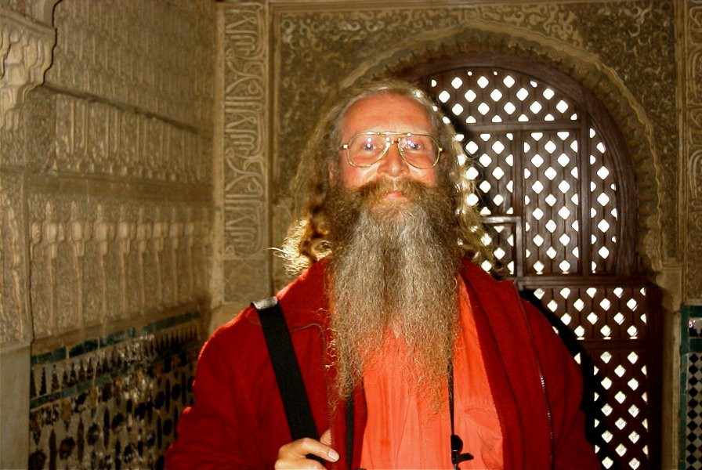
Satchidanand

Energy Enhancement and the Removal of all the Blockages From All Your Previous Lifetimes
This is what they mean when they say a Master is not under the Laws of Karma. He has dissolved all the negativity from all his past lives. He has used his Soul, Monad, Logos And Higher Energies, with Samyama to dissolve all the negativity, to Forgive all the bad actions that he has done, and have been done to him.
Create a Clean white sheet again from your Messy Dark History Painting which you have created brushful by brushful, every day of your life.
One of our Students age 37, the director of an Internet Business in Bolivia, started to clean his future of this lifetime by mistake, before he had cleaned all of his past lifetimes and this life. He saw himself at the age of 56 with two children in his arms and no wife and then.... all became blank. He then cleaned this lifetime and all previous lifetimes of all their Negative Energy blockages, Energies and bad Karma. When he came to clean the future of this life he saw himself entering into the light, becoming a spiritual teacher in his fifties, onwards towards AGE 80!!!
One of my Teachers, Zen Master Hogen said, We are all History Paintings. We start with a clean white sheet and then every day we apply paint. Usually our History Paintings become very messy!!! "I am a clean white sheet which is washed constantly. Every time we meet, it is as if there is no emotional holdover from the past. Every time, I see you clearly, as if for the first time!" Zen Master Hogen.
How? Well, through many Meditations...
The Ancient method of Energy Circulation is an ancient and hidden technique preserved in Taoism and Hindu Kundalini Kriyas.
It is the most gentle and effective tool for all those who want to increase their energy, their evolution, their genius.
The same energy circulation meditation Ancient Egyptian spiritual technology - The Alchemical Meditations of Hermes Trismegistus from the Emerald tablet or from the Alchemical Sufi Dun Nun, the Egyptian, he who took, The Path of Blame symbolized by the Sufi Naqsbandi Fountain at the Alhambra at Granada in Spain.

The same meditation The Five Elemental Paths of the Qi of Chinese Alchemical Taoism and the Microcosmic and Macrocosmic Orbits symbolized in the Yin Yang Symbol.
The same meditation, The point from which a Man cannot err. .. From the Freemasonic ritual creating the Master Mason and the Entry into the Crypt of the Royal Arch.
The same energy circulation meditation With This Technique, Your Evolution Will Increase With Every Energy Revolution To Create A Revolution In Your Evolution. - Paramahamsa Yogananda On The Kriyas Of Kundalini of India, of Kriya Yoga, of Babaji, the 2000 years old sage in the Himalayas, of Sri Yukteswar and Lahira Mahasaya.
Ancient Advanced Synthesis of Effective Techniques Gaining More Energy - Meditation, Shaktipat, Energy Circulation, The Kundalini Kriyas, The Five Elemental Paths Of The Chi Of Chinese Alchemical Taoism, The Grounding Of Negative Energies, V.I.T.R.I.O.L, The Art Card Of The Thoth Tarot, Access To Kundalini Energy, Strong Psychic Protection, Learn The Merkaba, Pyramid Protection, Power Tower Protection, Create The Antahkarana, Soul Fusion, Monadic Infusion, Logos Infusion. The Painless Removal Of Stress, Trauma And Negative Emotion through advanced Samyama techniques for The Removal Of Trauma,
Past Lifetime Karma Cleanup, Soul Split Retrieval,
Healing Inner Children, Removing Negative Emotions,
Removing Negative Karmic Mass From The Strategies Of The Vampire.
Energy Removal Of Old Karma From All Your Past Lifetimes
This is how to easily and quickly Heal, remove all the negative trauma energy from all your Personal History, Your Life until now, of all of its painful memories and blockages which act as filters to our vision.
This is how we easily and quickly Heal, remove all the negative trauma energy from all your Past Lifetimes, Your Lives until now, of all of their painful memories and blockages.
This is how how to easily and quickly Heal, remove all the negative trauma energy from this Future Life of all of its painful memories and blockages.This is how you can learn to easily and quickly Heal, remove all the negative trauma energy from all your Future Lifetimes, Your Future Lifetimes of all of their painful memories and blockages which act as filters to our vision.

Director Satchidanand, is one of the leading teachers of Meditation.
He helps people worldwide reach further than they EVER thought possible, FASTER!!!

THE REMOVAL OF ENERGY BLOCKAGES AND IMPLANTS BY THE ENERGY ENHANCEMENT SEVEN STEP PROCESS
ENERGY BLOCKAGES and IMPLANTS are composed of six parts.
- Negative Karmic Mass
- Blockage Protection
- The Blockage Living Core
- The Blockage Power Source which comes from outside.
- The Blockage Programming
- Multi-Cored blockages
- NEGATIVE KARMIC MASS (NKM)
Negative Karmic Mass is pure spiritual energy which has become perverted by what we believe to be, "anything which should not be" When something should not be, it is because it is against the will of God. When we do something which is against the will of God then we feel Shame which usually creates Guilt. Negative Karmic Mass is created by Traumatic happenings which we know should not be. So, Trauma and Stress on the physical, emotional, mental or spiritual levels create Negative Karmic Mass.
Physical Trauma comes from accidents or deliberate torture.
Emotional Trauma comes from bad actions by people we trust or through fear of those bad actions. It comes when someone we love dies or leaves us.
Mental Trauma is like a joke whose purpose is to release this NKM in laughter or tears. Mental Trauma is where usually there is a disconnect, a paradox, two mutually cancelling statements like, "I Love You" and "I Love You Not", the traditional statements whilst pulling the petals from daisies. A Koan like, "What is the sound of

one hand clapping?" or, "What was your face before you were born?" are similar and work in the same way.
The mind cannot compute these seemingly opposite statements which can only be understood in terms of wisdom and intuition, seeing the problem from a higher level with more information.
Mental trauma comes from the contemplation of "That which should not be" - in this case - through not understanding the test through a lack of wisdom, understanding, intuition and thus creating a problem, trauma, Negative karmic mass in the mind. The Negative Karmic Mass walls off the problem into a blockage sub - personality or "Inner child" and prevents its resolution or evolution by the higher parts of the mind, the chakras above the head, the parts of your super- computer which, "Know"
Negative Karmic Mass can only be created by moral people who know the difference between right and wrong, good and bad, that which is better and that which is worse. That morality is created by a relative lack of blockages above the head allowing a clear connection to the higher chakras of the Soul and the Monad etc. As the blows of life rain down, so blockages are created which tend to reduce morality and the creation of Negative Karmic Mass - we lose the ability to change and evolve.
We can use Negative Karmic Mass as a power source independent of the energy of God. As we burn the NKM in the Center of the Earth by using the Ancient Taoist and Alchemical Formula in Latin, VITRIOL - VISITA INTERIORE TERRAE INVENIES OCCULTEM LAPIDEM -
Visit the Center of the earth, there you will find the hidden stone, the Philosophers Stone which Transmutes Base metal (Blockages) into pure Spiritual Gold. We teach this process in Energy Enhancement Initiation Three, The Grounding of Negative Energy, in order to remove some energy blockages which are not powerful or have heavy protections. We use the Energy Enhancement Level 2 Seven Step Process to further enter Blockage protections, cut them off from their power source and put, resurrect, the living core in its proper place in the chakras above the head.NKM is also used by Bad people who have many blockages above the head and in the Heart, which is the definition of a psychopath, and who are thus cut off from the energy of God and who have no empathy for others. These types of people can go on training courses to learn how to create and use NKM, how to create and program blockages etc. These types of people like to create this Negative Karmic Mass in all people so they can take it and use it to power their beings independent of the energy of God. They can do this on an individual basis by all types of Trauma or on a

countrywide basis by creating fear. They also like to create it so that they can use it to create Blockage Implants which they place in people to create and leach off Negative Karmic Mass and spiritual energy from their chakras from other people for these purposes of independent power.
"As above so below" says Hermes Trismegistus - if the energy of God is like sunlight which is infinite and free, the sun constantly showering energy on this planet, then NKM is like petroleum oil which needs to be thoroughly burnt to create energy. Incomplete burning creates pollution. The use of NKM to make people independent from God is like the scientific and political discussion as to where humanity should get its energy from. From monopoly controlled oil or from infinite free sunlight?
- BLOCKAGE PROTECTION
Blockages like the core of an atom have protections which are like electrons moving at the speed of light around the blockage core in up to an infinity of orbits called shells. In order to ground the Negative karmic mass in the core we need to penetrate this protection. Energy Enhancement has developed techniques to penetrate through to any core or any number of cores simultaneously in Multi-Cored Blockages thus releasing the blockage.
- THE BLOCKAGE LIVING CORE
The human matrix exists as chakras which step down the energies of the source in discrete levels and functions, all parts of the multi - processor human super - computer model. Human beings and their chakras are composed of other species of existence called angels. These angels come in all levels of evolution from the parts of chakras to the Archangel who supervises the existence of planets and suns. Like cells who make up the organs of the human body and the human body itself, angels make up the parts of the human super-computer and in matrices make up higher and more highly evolved parts of existence.
Everything is created from communities and matrices of angels. As evolution proceeds, these communities become larger and more highly organised. Indeed, human beings are made up of angels and as we start to access more and more of our chakras above the head, so we develop in wisdom, grace and enlightenment.When a human being dies, if he suffered a lot and does not know how to ground his negative karmic mass, then he will be heavy and may not have enough energy to go higher, to heaven, to the soul and thus his lower bodies may separate off and float around.

Everything needs a power source and usually they travel towards the greatest source of energy amongst their family and the people that they know. They parasitise their loved ones in order to exist either consciously or unconsciously like in a coma.

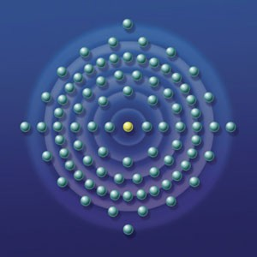

For example I had a little girl of four years brought to me by her grandfather. Her mother had died that year and since then she had been behaving strangely. So I felt something within her and asked silently, inside, "Who are you?" and the reply came back that this was her mother! So I said well, perhaps you should go to heaven because you have with you some negative energies and these were adversely affecting her little girl. "But my daughter needs me" - this came to me emphatically with a lot of emotion, so I mentioned that it was possible for her to go to heaven, get all of her pain taken away and then come back as her daughters guardian angel. "Can I do that?" and I said, "Yes!" so she went. And within five seconds she was back, all healed and ready to look after her daughter. Well, the little daughter was fine after that.

As long as the angel is connected to the source of all existence - God, there is harmony. When the angel at the heart of the blockage has become blocked off from this connection by the Negative Karmic mass and by the protection then it becomes separated and subject to other negative and evil programming. It becomes a cancer on the spiritual level and given time will become a cancer or other disease on the physical level.
When the protections have been breeched and all of the Negative Karmic Mass grounded and burnt up then the angel core of the blockage has been healed, resurrected and connected with the source again. It then becomes free to become part of your psychic body to increase your complexity, function and ability to handle energy. To help in your evolution.
Blockages and Tapas
This removal and healing of blockages is the Raja Yoga "Tapas" or austerity as it is normally translated enjoined by the Yoga Sutras of Patanjali as part of a spiritual persons evolution. Tapas refers to the heat involved in burning up negative karmic mass. Raja Yoga involves the enlightenment processes of yama, niyama, asana, pranayama, pratyahara, dharana, dhyana samdhi and samyama which we teach in energy enhancement. Tapas is a part of "the five things to do" - yama and also is connected to "the five things not to do" - niyama, making up the yogic ten commandments. It also refers to other disciplines like yoga, meditation and fasting as part of the blockage busting process.
Blockages and Gurdjieffs Conscious suffering
Gurdjieffian "Conscious suffering" which Gurdjieff said was the only way of evolution is the same process in which Gurdjieff precribed taking upon yourself as many blockages as possible and in that way you will complete your psychic body to the level of ascended master very quickly. Gurdjieff described a process in which you deliberately went out of your way to take on problems, making your life as difficult as possible, receiving as many "shocks" as possible in order to evolve quickly. This is the same as the energy enhancement process where we acknowledge the necessity of removing our own blockages as part of our own enlightenment process, but also acknowledge that our evolution also involves our interaction with humanity. As we evolve we also have the possibility of removing the blockages in others, thus helping their evolution and also evolving our own psychic body. Gurdjieff says as you help other people, so you help yourself.
Blockages and Alice Baileys Resurrection

Then we come to the concept of "resurrection" given out in the Alice Bailey teachings in, "The Rays and the Initiations" as something which can take us into the realm of becoming an Ascended Master of the fifth Initiation. Resurrection is the healing of the angels at the core of blockages and then the process of moving them up the Antahkarana, resurrecting them into place as members of your higher chakras as part of your angel team there thus increasing the size, function and ability to handle energy of your psychic body.
Energy Enhancement uses scientifically proven and conscious techniques to speed up Tapas, the evolution of the "Conscious suffering" is made quick and easy and Resurrection to create ascended Masters of yourself is just part of the job.
Healing of blockages is one way to find angel partners in your evolution. There are all evolutionary levels of angels inside blockages. By incorporating the healed angels we become greater more complex and more evolved.
As Above, So Below. All levels are analogous, as we purify our spiritual bodies of blockages and become more complex and evolved, so the earth evolves in a similar way by purging all of its Negative Karmic Mass and stuck blockages.
- THE BLOCKAGE POWER SOURCE.
Angels and Enlightened human beings should be totally powered by the source which is infinite.
INNER CHILDREN BLOCKAGES
Traumatic blows of existence create inner children which are powered by split off parts of the soul chakra. They are created in this lifetime and in all of our previous lifetimes and pass on from body to body, until they are healed and dissolved by Energy Enhancement Meditation techniques.
Inner children are sub - personalities which exist in droves inside the normal human mind. They are talents, self - programmed points of view or simple childish emotion limited by their trauma and fear created Negative Karmic Mass.For example if we are beaten or raped then a very sad or angry inner child may be formed. The inner child might lock off the memory of this through amnesia to protect the rest of the mind.You may have been bereaved or been dumped in this lifetime and certainly so in many other lifetimes and the pain of this always comes through the violent breaking of connections from your chakras to the chakras of your family or marriage partners. Inner

children will have been formed long ago from these constant blows and be in charge of your psychic connections. In order to Master your Relationships and be in charge of who you connect to, from which chakra and for which purpose you will need to heal these inner children and take control of these processes for yourself. This problem, located in the lower chakras is also is a prime area for sexual implants to create sexual addiction and adultery. By healing these types of blockages you will gain control over the talent and remove the addiction.
You may also have been immensely successful in previous lifetimes in business, money, property and have developed the talent to deal with these things. If the talent forms part of a blockage then you will be addicted to these things as well as having a talent with them and thus this will prevent your evolution into higher things. By healing these types of blockages you will gain control over the talent and remove the addiction.
If you try to work on one of these blockages to ground all the NKM surrounding this event then the inner child will try to prevent this because it is afraid of being integrated into the soul, afraid of the traumatic memory, and might even want to protect you from the memory. Thus when using meditation to integrate and heal It will try to distract you. It will create diversions outside. It will try to rubbish the meditative technique. And it is then you must prove who is in charge, "Focus Trinity", use the rapid and effective energy enhancement technique of the Seven Step Process and move on to remove the inner child and integrate your mind.
We, ourselves, create blockages and it is we ourselves who must integrate them. We must create one, integrated soul - infused mind,
- the soul because the higher chakras must always rule. Only when the lower rules - and the blockages always rule the lower - do we have all the warlike selfish problems of life for ourselves and for all others on the planet.
Until we can heal these inner child blockages and integrate them back into the Soul - together with all their talents and psychic powers, we cannot become enlightened.IMPLANT BLOCKAGES
Blockages and implants are created for various purposes but all involve a link back to their creator who powers the blockage and holds it in place in the victim for lifetime after lifetime, until it can be removed by energy enhancement techniques.
Blockages and blocked human beings are powered by links to bad energies and people. Any attempt to de - power and heal a

blockage must involve cutting off its links to its perverted power source and indeed healing all these sources too. Blockages exist at all levels of existence and the higher blockages power the lower blockages.
Without an infinite source of energy there is always a perceived energy shortage and thus much competition for energy therefore bad people feed on the energies of their own kind as well as their human energy food. Competition is a symptom of blockages.
Indeed to survive, the bad people who are cut off from the source must be vampires, feeding off the energy of innocent human victims and their evil contemporaries, lifetime after lifetime.
By implanting blockages which they create into other people they can cut a person off from the source by putting blockages in above the head or into the heart chakra, thus creating an accomplice.
They can put blockages between the base chakra and the center of the earth thus creating someone to feed off, a slave. They can also program the blockages to send the energy back to them, thus becoming an energy vampire.
They can program addiction blockages because the energy of one addicted is greater - like burning the candle at both ends - and easily taken. People burning the candle quickly usually die young but as well as energy received each day from God, the soul is given a supply of energy at birth, thus for a vampire to get more energy it is good that there are many short bright lives. Thus drugs, sex and gambling blockages are tools to concentrate energy back to the blockage implant creator.
We see these bad people with psychic vision connected by streams of energy to their victims. Some have thousands of connections like a telephone exchange connecting to thousands of implant blockages put into their human energy food. And these implant blockages exist in people lifetime after lifetime, until the techniques of energy enhancement can remove the implant.IMPLANT BLOCKAGES are programmed blockages created by an evil person to implant into other people, usually to siphon energy back to the evil person - the Ultimate Energy Vampire.
Implant Blockages are removed in exactly the same way as all the other blockages, quite easily through the Energy Enhancement Seven Step Process of Energy Enhancement Level 2.
Implant Blockages usually connect to the evil person or their accomplice worker or emissary who in general are completely oblivious that they are working for someone else through Energy Connections from the Implant Blockage, although sometimes they

are! These energy connections are from person to person or horizontal - the image is that of a circle with a horizontal line in the center thus the person only takes energy from others and is cut off from the higher self.
What I mean by that is that the normal personality is completely oblivious that one of the ego parts or Sub-personalities is conscious of the connection and in fact is in charge of it. This is the connector sub-personality and it thinks that it is saving the normal personality by taking energy from others, allowing it to live longer and with more energy by becoming a sucker.
We work on Ego Sub-Personality Energy Blockages like the Connector Sub-Personality in Energy Enhancement Level 3 and also with Attention Seeking Strategy Energy Blockages and Inner Children.
We work on these Energy Connections, as part of the Mastery of Relationships in Energy Enhancement Level 4.
Only by connecting with the energies of the universe as we Gain Energy in Energy Enhancement Level 1 can we drop the necessity of absorbing the energies of others.
In this way and Enlightened Person only gives 100% of his energy because he is connected to infinite sources of Eternal Energy from the Soul and other chakras above the head. The image is that of a circle with a vertical line in the center - symbolising the connection with the soul.
When we do this we then become able to purify the Connector Personality so that the Soul can regain the psychic power of connection in order to give energy in the Healing of others or the giving of Kundalini Energy to help with the Enlightenment of Students - an Energy Enhancement Teacher and here the symbol is that of a circle with a cross in the center of it, the vertical line taking energy from the soul and the horizontal line giving 100% of its energy to others - the Meaning of the Christian Cross.The upgrade of this symbol of course is that of the pure circle - here this symbolises the Ascended Master where we take energy vertically from the Soul and distribute it downwards to any pure person who needs it. The circle, like the columns of protection, an external antahkarana, of Energy Enhancement Initiation 6 of Level 1 has become extended into a vertical line containing the upwards flow of Energy and the downwards flow of Energy of Gurdjieff's Reciprocal Maintenance and the Yin Yang Symbol, signifying the antahkarana of an ascended Master whose duty is to distribute the energy of God on this planet.

- THE BLOCKAGE PROGRAMMING
Because these angels at the center of blockages are cut off from connection with the source and the good instructions from the source, they no longer know what to do. They are perverted by the Negative Karmic Mass which surrounds them. Thus they are easily programmed with instructions from other sources which can be followed like a program for thousands of years. They can no longer evolve.
As above, so below. Human beings are in exactly the same problems as angels. As blockages cut them off from the source, so they lose their essential humanity and move into the direction of the dark side, they listen to the messages of the dark side through their blockages and their media interests and become programmed by it. They develop cynicism, lack of conscience, lack of empathy. Meaningless, purposeless, addicted lives without any significance. They can no longer evolve.
"After all that" is part of the first Sutra of the Yoga Sutras of Patanjali written 5000 years ago. It seems that we need many immersions into the dark side before we understand that it always ends up in a bad way. We need these experiences and indeed are sent to this planet to receive them.
This planet is a factory for the production of enlightened beings. Bad experiences are part of the process which we have designed. The way of the world is to purify gold ore by heating it up to a thousand degrees, putting it on the anvil, and then beating the crap out of it.
Enlightened beings say a softer process is more effective and more desirable. Energy Enhancement is that softer and more effective process.
As Human beings and blockages lose their Negative Karmic Mass and as Humans lose their blockages so they get back on track on their soul path and on the path of their evolution. They become ascended masters.
- MULTI – CORED BLOCKAGES
When viewing blockages psychically, often times we see that they have many parts, some thicker and more dense from having more Negative Karmic Mass, some having more layers or shells of protection. Groups or teams of blockages join together to perform their function. Any strategy to remove blockages must take these multi-cored blockages into account. Energy Enhancement techniques remove multi-cored blockages.

- ENERGY BLOCKAGE EGO SUB – PERSONALITIES OR NAFS
In the Sufi terminology, NAFS or Breaths or Energy Blockages represent the degrees of in the transmutation of the consciousness which we go through in the Levels of Energy Enhancement starting at the Second level.
First we deal with the lower types of NAFS or Sub-Personalities and later with more refined parts of the EGO. Although more refined, all NAFS are part of the Ego structure and all of them, one by one must be found and purified as their Trauma-Formed Negative Karmic Mass is transmuted and then the core of the blockage is integrated with the Soul Personality where it can finally be safely used as a purified function or purified talent or so called psychic power.

THE SEVEN MEN THE NAFS, ENERGY BLOCKAGES, IMPURE TALENTS, IMPURE SUB-PERSONALITIES AND THEIR PURIFICATION AND INTEGRATION INTO THE SOUL OR HIGHER SELF
- Nafs-i-ammara - the depraved or commanding Nafs
- Nafs-i-lawwama - the accusing Nafs
- Nafs-i-mulhama - the inspired Nafs
- Nafs-i-mutmainna - the serene Nafs
- Nafs-i-radiyya - the fulfilled Nafs
- Nafs-i-mardiyya - The fulfilling Nafs
- Nafs-i-safiyya - The purified and complete Nafs
The creation of the Golden Head through the purification of the mind and integration into the Soul. Sun symbolises Soul, so as the shadows of the mind are purified to make them transparent and open, so the Soul Sun, the first chakra above the head, "Brighter than 10,000 Suns" illuminates the intellect and emotions in EnLightenment. The Aura of the Buddhafield becomes Golden, "The Secret of the Golden Flower"
These Seven types of Nafs or Energy Blockages are formed so that you can see how they start as part of the ego, the separated split off parts of the mind as depraved or commanding or Accusing Nafs and then are evolved through the Energy Enhancement Seven step process by purifying the Trauma Formed Negative Karmic Mass through VITRIOL and then integrating the purified and complete Nafs into the Soul Chakra, on the path of Illumination.

Nafs are Energy Blockages which when purified of all trauma then become compliant fulfilled parts - the talents - of an integrated mind.
The Nafs pass through the Energy Enhancement Seven Step Process which can be termed "Death and Rebirth". The death or removal of the Trauma-Formed Negative Karmic Mass and the Recapitulation of the events and traumas which formed the Blockage and the Rebirth, the Transfiguration and Resurrection (Alice Bailey - The Rays and the Initiations) as the purified function or talent is absorbed or integrated with the Soul or Higher Chakras so that it can be safely used by the Soul infused Personality.
As the Nafs become purified then we become open to the still small voice of the conscience - accusing and then serene and fulfilling etc as we find our Soul Path and the purified talents and functions become useful to the individual and society.
Most individuals are out of control. They believe themselves to be coherent personalities but with Energy Enhancement they start to see their multiple and changing personalities. "The man that swears to get up at four o' clock in the morning is not the same personality who throws the alarm clock out of the window!" - GURDJIEFF
They use the energy enhancement seven step process on programmed, automatic and negative thoughts and thus start to understand that these negative thoughts are simply symptoms of the energy blockage sub-personalities. As these blockages are reduced, so the mind becomes capable of operating at a higher level.
As the task of reconstitution and Resurrection is completed, then enlightenment, the capacity for teaching and the capacity for intuitive understanding become normal.
There is a process of removing, eliminating, the energy blockage sub-personalities which exhibit Attention seeking behaviour, through the Energy Enhancement Process. This is the process of Integrating the mind under the aegis of the Soul, the Higher Self, and by purifying the Nafs, the Talents, The Sub-personalities, the Energy Blockages in Energy Enhancement Level 2 - Eliminate Energy Blockages, and Energy Enhancement Level 3 - Eliminate the Attention Seeking Sub-Personalities and Strategies of the Vampire.

Blockages and FORGIVENESS
Hi Satchi,

Can you please give me some insight on the relationship between clearing past blockages and forgiving all that was involved and having a clear karma. I kind of get how cleaning this past residue also correspond to being free from a lot of trouble but how about lords of karma that are employed to make sure the coincidences of actions are fulfilled? I mean if I go and kill few people today and spend the next few weeks to meditate and clear all energetic coincidences and come to full forgiveness does it mean I got away with such action? My intention is not to look for such remedies but I am using the example to address my concern of the dynamic between forgiveness and law of karma..

There is a difference between forgiveness and removing the bad habit.

Forgiveness is the act of removing Negative Karmic Mass from our spiritual bodies. NKM is a poison which slowly kills us. Forgiveness stops this type of karma.

Bad habits are the core of the blockage which is surrounded by NKM. We need to be shown that Bad habits will always bring retribution from the Lords of Karma. Thus the negative coincidences are sent to people like this, with blockages. Bad Habits are bad, because the wanting to do something is never in alignment with the will of God. Bad Habits are only in Alignment with our selfish competitive egos. Blockages are split off parts of ourselves which have not been integrated or purified. As we purify the NKM and Integrate the core of the blockage with our higher selves so we change our bad habits finding, “That which works best”. Even in alignment with God, some things work better than others.

So, as we purify and integrate our higher energy bodies using the techniques of Energy Enhancement, removing all energy blockages so we come completely into alignment with Gods will.
Enlightenment. Then everything we do is good, neither black, nor white.

Read about blockages on the Level 2 page of the website as well as this.

TESTIMONIAL FROM VANESSA, IN SPAIN 2002


L'Escala.
Satchidanand, Well, after traveling from India to Spain we have resumed our Energy Enhancement Courses with our new clients in the beautiful SOL Villa on the Costa Brava in Spain. Here is an Interesting testimonial from over the first four days of the Energy Enhancement Level One Course.......

The Experiences at the Energy Enhancement Course with Satchidanand and Devi Dhyani

During past meditation sessions for over two years, I have twirled like a top when my bottom came into contact with the floor.

Satchi explained this was the Kundalini rising and I needed to find the centre of it. By swaying backwards and forwards, then side to side, I could touch upon its centre but it is a very fine place to contact and I kept going off course. The same movement was to be done with my head, keeping the chin down. Then I needed to keep rechecking throughout the meditation to find it again.

After two years the swaying finally stopped in ONE session with Energy Enhancement! I later found out that Satchi had been working on this blockage at the same time using Energy Enhancement Level 2 Techniques.

On the next session we dealt with the circulation of energy, imagining a gold, white or silver light filling the body. The aim was to intensify it and get it to burn from inside. It had to permeate
the whole body, chest, belly, arms, and legs. Then we were to take the light out from our heart centre in a thin line through the chakras.

It could flow either way and we were to test each out, the air or the water path. As we did so we were to look out for places where we did not see the light or feel it, where the light jumped, or there was pain or where we got distracted.

At these various places, there would be a blockage. When a blockage was identified we were to push thread through them and continue the sequence. The breath, crown and heart chakras were to be used as pushing tools.

There would be an increase in the power of the new techniques to remove blockages used in Energy Enhancement Levels Two and Three.
The main thing I noticed was that there were small black circles at various places en route. I could not say exactly where they were but just knew their vague vicinity.

These Black Circles are our clients view of Energy Blockages she spotted during the meditation. Satchidanand

I repeated in the evening, focusing on my belly blockage but got distracted by a cough and had to leave the room. Satchi explained the belly and throat chakras were connected, hence my cough.

Distraction has to be caught. In bed that night on another try, I was enjoying the white light so much I did not feel like following the sequence and wanted to remain in the white light. I fell sleep but was awoken by a loud popping sound and an image of a black disc appearing in front of me.
Next morning we took the sequence a stage further with the transmutation of cosmic energy and taking the energy to its fire

core. The meaning of vitriol was explained and its relevance to alchemy as being the first formula or guided meditation of alchemy. Vitriol also means anger and we were to use this technique "To drain the last dregs of our Vitriol".

We were taught that blockages were seen as black like coal, food for the fire which would increase its heat. That Kundalini heat would then flow up the spine. I could not feel the heat coming up my spine just a gentle warmth.

As I was trying this process I became angry, I knew I did not want my blockages anymore, that was why I had come on the Energy Enhancement course, I was fed up with them, they had served no purpose for me so far in my life, they had done me no good I wanted rid of them. I threw them in the fire with venom.

As I started to throw, I wanted to throw more on. I became very angry. I felt I had so much to be angry about; I could go on forever.

After this session I felt quite good.

My Energy Enhancement REIKI Initiations with Devi Dhyani, Devi uses Energy Enhancement Techniques in the Reiki Initiations, so....

On receiving my first Reiki initiation I felt very peaceful. Blue and white energies kept expanding. As the session went on I started to cry, tears rolling down my cheeks and there was some kundalini jolting of my body but I was not unduly worried.

At the second session I felt I was being pulled up by one single hair on my head, up and up it pulled me. Later it felt as though a whole lot of stuff was coming out of my head into the universe. First my little fingers felt numb then the other fingers followed suit. My feet also felt numb and slightly raised off the floor. My bottom also felt as though it was coming off the chair. Upwards and upwards was the movement. I felt emotionally tearful and tears welled slight. I felt very powerful, that I could move mountains with this strength.

my fingers tips but power going into them. I asked for help and the session ended with like wings flying slowly upwards, it was very beautiful and brought tears to my eyes, I wanted to fly too.

On the fourth session I felt similar sensations as before but this time the snake went outside my body, moving slowly upwards towards a star of light. My heart felt as though it was opening more and I felt a throbbing in my hands. A tornado started in my body, swirling very fast from the bottom of my spine upwards, eventually it slowed down to a snails pace, the energies had become gentler. From the white light I asked for help with my belly blockage. The light told me to use the white thread to weave in and out of this blockage and I successfully sent it down into the fire.
VANESSAS Resumption of The Experiences on the Energy Enhancement Course
In the meditation that followed I continued my snake like progress upwards and asked the white light for help. I had a lump in my throat chakra so I sent that to the fire.

I thought I would also ask if I would see again a person I really wanted to see. The image came back of my first love and I acknowledged the grief I felt at his loss. I poured bucketfuls of my grief down into the fire below.

When trying out EE Level 1 Stage 4, I had problems when constructing the visualisation. At first I had an image of a golden tower but only slightly up from the base was built, I could not seem to go any further. Later I tried building it by one brick at a time, it seemed a long process.

Devi Dhyani identified a blockage above the crown chakra, which she removed using Energy Enhancement Level Three Techniques. Things improved but the white light was not strong until near the end when a thin rainbow of light fell down from on high, it then turned to a long waterfall.

I had the feeling of pushing upwards and a desire to fly......
Testimonial By Vanessa Our Client

ENERGY ENHANCEMENT MASTERY OF RELATIONSHIPS - 28 AUGUST 2005

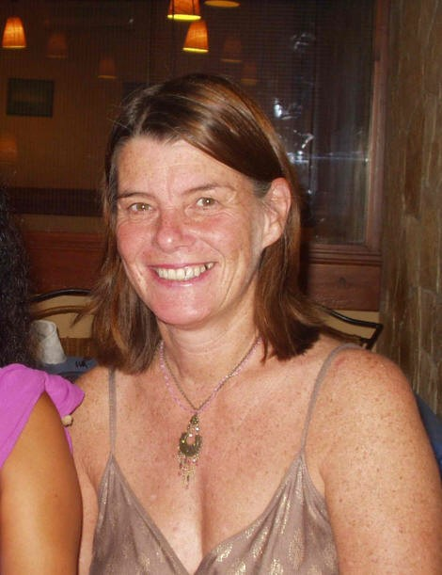

I am now out in Spain training to be a yoga teacher with Energy Enhancement and later training to be an Energy Enhancement Meditation teacher. I was previously out here with Satchi and Devi two years ago when I did the first part of the Energy Enhancement course.
I later completed it in Argentina this year. I had needed that gap in between to assimilate what I had learnt and put it into practice. I teach meditation and have found it very helpful with my own personal growth as well as progressing on my spiritual path, so

much so that I felt it would you very useful to those on a similar path and that I would like to teach it.
If you meditate long enough and hard enough you can resolve your life’s problems but that can take a lifetime and I felt I could not wait that long, I wanted things to happen now. That’s is why Satchi and Devi’s Energy Enhancement Course appealed to me, it was all about doing, not just talking about it.
Energy Enhancement is experiential, you learn by doing, it is not some others persons experience it is your own that you work on. Only by doing do you learn, you are given the necessary techniques to tackle negative thought forms in your life and you work through meditation to eliminate them.Energy Enhancement saves hours of psychoanalysis; it is not necessary to rake up the past in fine detail. You can acknowledge past events and how they affected you, recognising them intellectually is the first step but then you use the techniques taught to get rid of them.
I thought I would go through with and share the Energy Enhancement processes that have occurred for me over the last few days. It is just a report of things as they are, no embellishments or make believe....

.... When I was getting the better of the energy blockage I felt the spaces in which I meditated expand. I got an explosion of energy down the right hand side of my body. The energy was bumping around in my base chakra; in fact my whole body was pulsating with the energies. It felt as though there was static electricity all along my arms making the hairs stand up on end. As the energies grew stronger I felt lighter, happier and freer. My heart opened out to send blasts of energy out which returned back to me.
This was not just a quest for personal growth it was the quest for enlightenment. It is the spiritual path I am on, these techniques are just part of it. The ancient scriptures are followed and hatha yoga is practiced, it is all part and parcel of the same thing.
Satchidanand said we only see these problems when we are able to deal with them and now was the time for me to deal them. There are also positive images whilst meditating and one was of a large bird soaring in the sky, floating on the
thermals, being taken by the wind. That is the analogy of my

quest. I want to be free to follow my souls path; I want to be that bird. Out of this I was given a message “Let the soul sing its song through my heart”.
Testimonial By Vanessa

ANOTHER TESTIMONIAL FROM VANESSA WHO WROTE THE TESTIMONIAL ABOVE, WHO CAME TO ARGENTINA FOR HER SECOND ENERGY ENHANCEMENT COURSE IN

ARGENTINA
2007

It was nearly two years ago that I completed the first half of the EE course in Spain with Satchi and Devi. In one respect it seems just yesterday but in another a life time away. A lot has happened in my life between that time deaths, births, daughter’s marriage, ill health; the usual variety of life’s traumas. I returned from the first course full of determination to follow my spiritual path, I was going to do such great things but being a wife and mother just took over. At the times when I most needed to practice I did not, which in turn lead to much inner suffering.
Vanessa with Dhiren, another course member
I was also struggling to get myself acknowledged as a spiritual person by those close to me. I was tired of living two lives, one as a family person and the other as a spiritual one. To incorporate the two was no easy task and relationships problems developed which that is what really brought me back to the course. I needed ways of dealing with relationships of close to me. I had enough of being drawn into emotional traumas and expectations. I needed the tools to develop non-attachment, whilst at the same time being more open and loving.

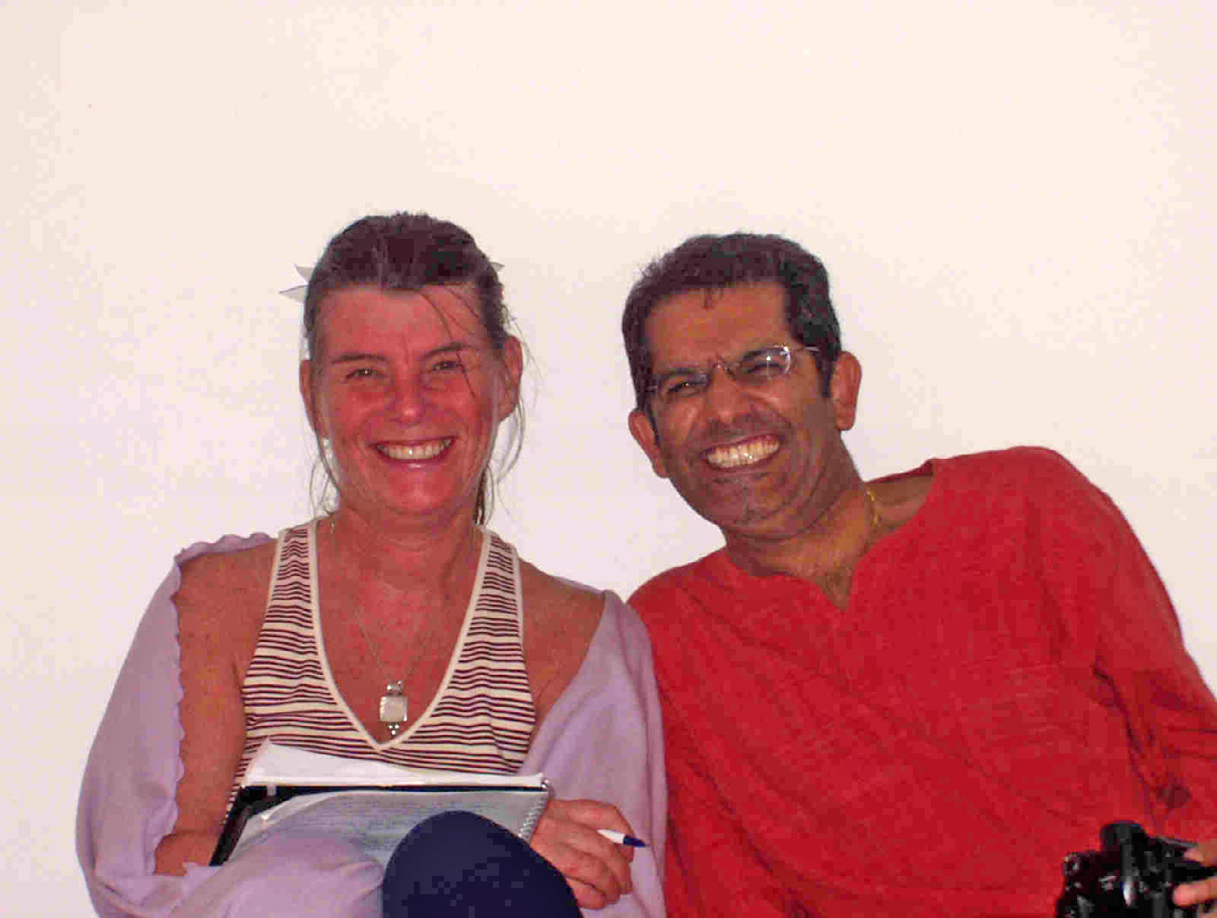

I needed a better understanding of how to stop my energies from being drained from me and I came back to the course as I needed to find the answers.
The two year gap had been beneficial in that I came with a renewed conviction to learn and develop from what was being taught. I had found I tended to live an insular spiritual life at home, although I was able to learn from the gurus and swami’s I mixed with. I was pleased to join an on going group half way through; I was welcomed and made to feel a part of it immediately. The group provided a valuable learning environment as its members explained their personal experiences, as previously on my own I often wondered was it just me who felt like this.

I was deeply touched by their commitment and determination to follow a spiritual path despite all the difficulties. I appreciated being part of the group, over the two weeks I felt a unity of spirit amongst us we acted as a whole and not separate individuals, a sense of oneness and harmony developed. The benefit of the course was the tackling of shared difficulties, as well as learning new techniques with like minded people.

The course is very user friendly and can be easily related to everyday life and the problems that occur in it. Blockages, strategies and inner children all had to be worked on and along with this came the realisation of the benefit of a maintenance programme to be carried on when I return home.
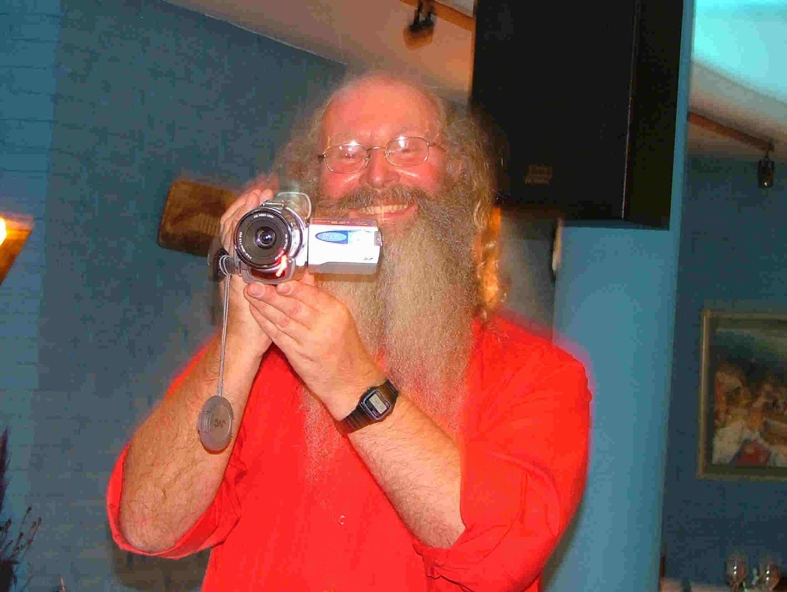

Satchi and Devi are intuitive teachers who know what is best for you and can point you in the right direction. It has been noted by the other group members that my appearance has improved in just one week and I can feel the inner changes that have taken place. My energy levels are high, I have a lightness about my body and a tranquil calmness surrounding me, what more could I want.
At the time of writing we are tackling relationships, having brought about change in ourselves through the techniques learnt on the course we can now bring about change in our relationships with others. This was an important area in my life that I wanted to tackle if I was to move on in my spiritual path. I was trying to merge my family life with my spiritual one and was having problems with those close to me incorporating into their lives.
Hence their relationship with me and vice versa needed to be healed in order to create a more spiritual environment. The Energy Enhancement course gave me the tools that can be used in everyday life when I return home. The tools taught are the cleaning of the chakras as well as the lines of communication between chakra to chakra from yourself to another person. At the same time their auras and energy fields can be cleansed. EE is a method for healing yourself and others.
I was putting this into practice with my husband who came to Argentina with me to keep me company but not to participate on the course.
For the first time in his life he picked up a spiritual book to read, which is something I had hoped would happen for many years, and goes to prove something must be happening. I look forward to practising the techniques on my return.
My insight and intuition have developed on the course and many experiences have happened to prove that the teachings do what they say. One night a vision came of the Time Line, which we had just learnt about that day on the Energy Enhancement course. I had never seen one before but it was so clear that it left no doubt to its existence.

The course is experiential you know it works when you experience it, you do not have to accept what is being said blindly. You have to trust your own abilities to gain from the teachings and it will be revealed to you.

This happens very effectively with the Energy Enhancement Reiki teachings. By giving Reiki to a person they will know that the energies do exist and will lead then to a greater understanding of what meditation is about. I have always wanted to help people through meditation and was pleased Reiki tied in with EE. I can feel the energies descend through me and be transmitted to the person being healed. It is that connection with a higher force and its flow, that has created some very moving experiences I had had with Devi. She is a wonderful teacher of it and her hands give all the learning necessary.

There has been an expansion of my energy fields that I would not have achieved on my own or elsewhere. To be able to use the energies in a healing way has been a blessing. My original expectation from the course was to increase my knowledge of the energies by direct experience of them to gain wisdom and this has been fulfilled.

The EE techniques have deepened my spiritual understanding and also enhanced my spiritual practice. I intend to pass on this knowledge to those I meet on the meditation path.
The course has given me confidence to handle the internal saboteurs we all have within us and carry on my spiritual journey with renewed vigour.

The warmth and caring ways of Satchi and Devi have provided a safe environment in which to learn. Many distractions can
come to stop you coming on the course but they need to be overcome if you really want to progress on your spiritual path. My deep gratitude and thanks go to both Satchi and Devi for giving so much of themselves.
Here are pictures of Chris, Vanessa, Devi Dhyani and Satchidanand Iguazu, Brazil – 2007


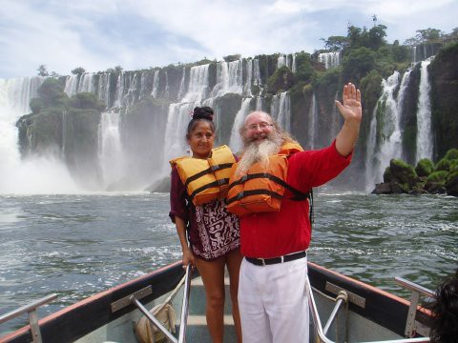

Here is a Testimonial about our Three Level Energy Enhancement Course over One Month With MS, Human Resources Director Europe/Asia of a large Fortune 500 US Multinational Company

Looking for a way to spend a productive month in beautiful surroundings with great people? Well I'm very happy to recommend Energy Enhancement run by SOL in Spain and to be specific Satchidanand and Devi Dhyani.

Initially I was looking for some Yoga and meditation to mark a significant change in my life and to enhance my general health and wellbeing.

By accident I came across the SOL Web site over a year ago and just noted it - made a few enquiries and did nothing other than to file it for future reference.

One year later I called to follow up and arranged to come and do the full Energy Enhancement programme for 4 weeks.
I was not sure if this was wise, as I knew nothing other than what I had read on the web site and the testimonials, which I was a bit sceptical about!

However, I am now adding my own because if you read this you might be a bit like me.

Don't hesitate - go for it!

Satchidanand and Devi Dhyani met me at Barcelona Airport and so my introduction and initiation into EE began.
It has been a great month, at the end of which I am both a Yoga Teacher and Reiki Master as well as having learnt through experience built on the teachings of Energy Enhancement, some of the worlds most sustainable and proven philosophies and techniques.

In addition to the actual programme of learning Satchi and Devi were congenial and attentive hosts, flexible in their approach to meet my needs as well as those of the course programme.

All in all I can say that this month has been well spent and has provided me with a solid foundation on which to continue to grow and develop in the months and years to come both personally and professionally.

Satchi and Devi, thank you for your unfailing good humour, hospitality and generous sharing of your own giftedness during my stay in beautiful L'Escala.

MS, Human Resources Director, Europe/Asia, of a Fortune 500 US Multinational Company

WHAT HAPPENED TO NORMA MCDONALD
And this week we had a friend for the First Level of the Energy Enhancement Course and she had the experience of saying goodbye to her father as he went on the train up to heaven.
Previously he had been living for years as an Energy Blockage in her back with many aches and pains.
She was in tears as she said goodbye but she knew his correct place was in Heaven as he needed to have all of his lifetime negative karmic mass removed, so he could be at peace. This father daughter attachment always leads to pain as the heaviness of the negative karmic mass does not allow levity when they die. They are not pure enough, light enough to ascend to heaven due to the many painful experiences of life they could not digest. And they need an energy source to survive.

THESE ENERGY BLOCKAGES TRAVEL TO THE ONES THEY LOVE - THE ONES WITH THE MOST EVOLUTION, THE MOST LIGHT. WHO
BECOME THE BLACK SHEEP... Crippled by their loved ones. Energy blockages always create pain.
Before Norma came on the course she was always having headaches and had been referred for a scan in hospital because they suspected cancer. On the 3 day course she saw the powerful energy blockage in her head like a shiny black stone, and after the course, each day she meditated upon it. At last she zapped it and it went, and a great steaming mass of evil mucus drained from her nose.
Blockage gone, cancer gone!! PAIN GONE!!
And each student has their own experiences on the Energy Enhancement Course... In the energy aura, energy force field of the Buddhafield.

Thomas Blair - White Light
SEPTEMBER ENERGY ENHANCEMENT COURSE IN SPAIN Week 2
Having found yet another blockage in my base chakra, I couldn't help but feel rather despondent. After gritting my teeth and getting stuck in, I finally managed to remove it. This blockage in the Base Chakra was the last one there!!!
The next time I sat down to meditate, I suddenly felt a tickling sensation in my pelvis above the perineum. This sensation increased in intensity, and felt like champagne bubbling up my body from below. The flow of energy around my body had risen to a new level giving me an increased ability to track down blockages and an increased confidence in myself. Wow!I suddenly remembered the writings of the inspired Poet and Meditation Master, the Persian Shakespeare, Jal Al Uddin Rumi and that always he talked of the wine of his meditation and this feeling of energy was what he was writing about a thousand years ago and I was feeling it, here and Now!!Next, I came across a particularly stubborn blockage to remove, and knew that I would have to prepare myself well during meditation. I consciously sourced as much energy from above to flow through my body, and in doing so, rather than my body being filled with golden light, I had somehow tapped into an immense source of white light. As well as feeling this increased energy stream through my body, I realised I had involuntarily suspended breathing somewhere near the top of an in breath. My body felt like

a beacon of light, with more than enough energy to direct toward a blockage and watch it dissolve in an instant.
Since that time I am always connected to and able to source the white light from above my head. Many times during this process I just forget to breathe as though my breathing is just naturally suspended. I am now living in the Light!!
My energies are naturally far higher than when I arrived on the Energy Enhancement course just two weeks ago. I am experiencing the fruits of meditation which normally arrive, if they do, after twenty years of meditation and it has only taken me two weeks.
This is the first meditation course I have been on. I have an injured knee from a few months ago in a motor cycle accident, yet the knee is now healed of its blockages and of its pain here on the Energy Enhancement Course and I am sitting in meditation for more than three hours a day, on the ground in the easy meditation posture, here in the light and working on more of my deep internal blockages.
Truly, perhaps Enlightenment is next!!

THE ENERGY ENHANCEMENT KUNDALINI KEY

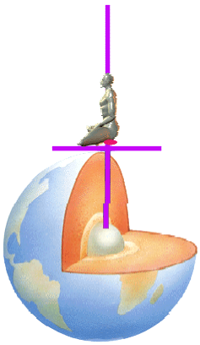
The Energy Enhancement Kundalini Key Meditation Samyama which cleans all the chakras using Alchemical VITRIOL Kundalini Shakti

SUPER ENERGY AND SACRED SYMBOLS

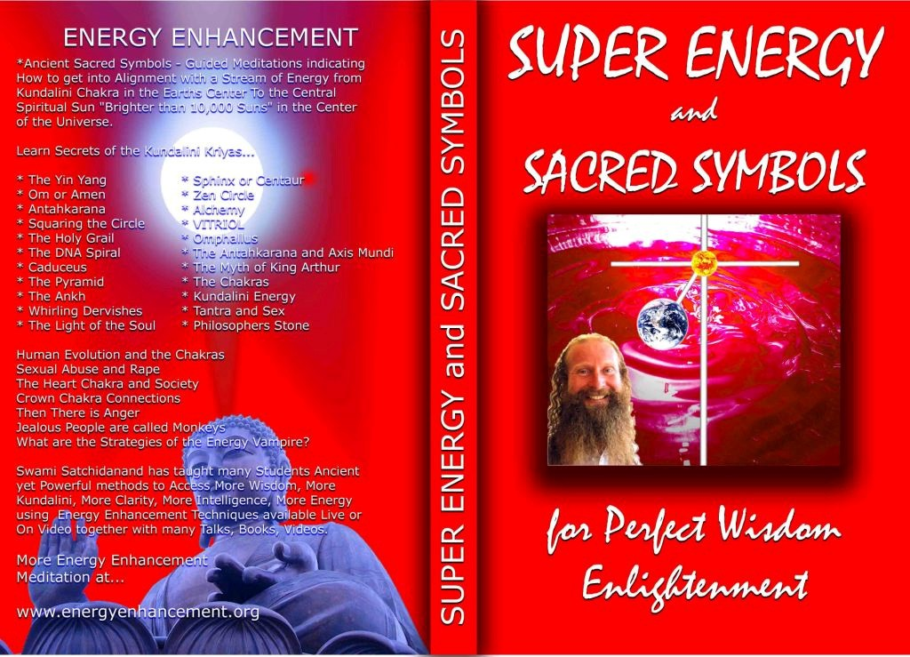

*THE ENERGY ENHANCEMENT BOOK… Ancient
Sacred Symbols - Guided Meditations indicating How to get into Alignment with a Stream of Energy from Kundalini Chakra in the Earth’s Center to the Central Spiritual Sun "Brighter than 10,000 Suns" in the Center of the Universe.

Learn Secrets of the Kundalini Kriyas... and more…

Swami Satchidanand has taught many Students Ancient yet Powerful methods to Access More Wisdom, More Kundalini, More Clarity, More Intelligence, More Energy using Energy Enhancement Techniques available Live or On Video together with many Talks, Books, Videos.

ENERGY ENHANCEMENT TWO – REMOVAL OF ENERGY BLOCKAGES, MANAGING ENERGY CONNECTIONS AND MASTERY OD RELATIONSHIPS

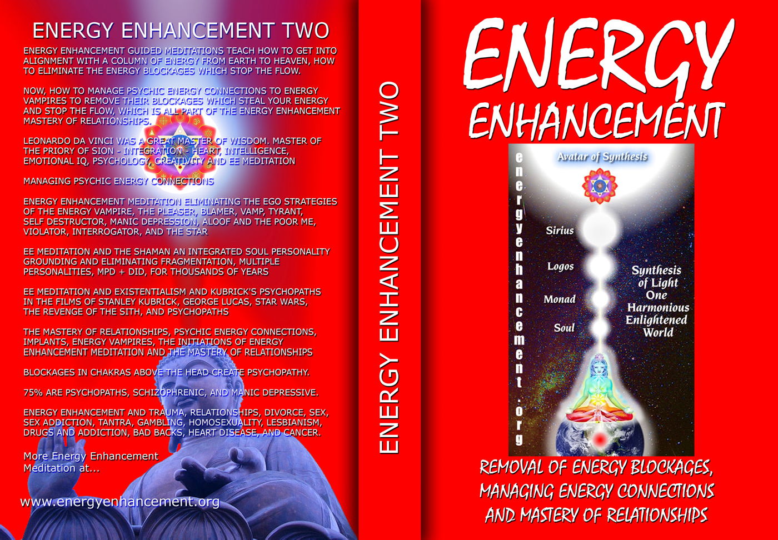

ENERGY ENHANCEMENT GUIDED MEDITATIONS TEACH HOW TO GET INTO ALIGNMENT WITH A COLUMN OF ENERGY FROM EARTH TO HEAVEN, HOW TO ELIMINATE THE ENERGY BLOCKAGES WHICH STOP THE FLOW.
NOW, HOW TO MANAGE PSYCHIC ENERGY CONNECTIONS TO ENERGY VAMPIRES TO REMOVE THEIR BLOCKAGES WHICH STEAL YOUR ENERGY AND STOP THE FLOW, WHICH IS ALL PART OF THE ENERGY ENHANCEMENT MASTERY OF RELATIONSHIPS.

LEONARDO DA VINCI WAS A GREAT MASTER OF WISDOM. MASTER OF THE PRIORY OF SION - INTEGRATION - HEART, INTELLIGENCE, EMOTIONAL IQ, PSYCHOLOGY, CREATIVITY AND EE MEDITATION MANAGING PSYCHIC ENERGY CONNECTIONS ENERGY ENHANCEMENT

Buy all Books and DVD’s at: amazon.com
MEDITATION ELIMINATING THE EGO STRATEGIES OF THE ENERGY VAMPIRE, THE PLEASER, BLAMER, VAMP, TYRANT, SELF DESTRUCTOR, MANIC DEPRESSION, ALOOF AND THE POOR ME, VIOLATOR, INTERROGATOR, AND THE STAR

EE MEDITATION AND THE SHAMAN AN INTEGRATED SOUL PERSONALITY GROUNDING AND ELIMINATING FRAGMENTATION, MULTIPLE PERSONALITIES, MPD + DID, FOR THOUSANDS OF YEARS

EE MEDITATION AND EXISTENTIALISM AND KUBRICK'S PSYCHOPATHS IN THE FILMS OF STANLEY KUBRICK, GEORGE LUCAS, STAR WARS, THE REVENGE OF THE SITH, AND PSYCHOPATHS

THE MASTERY OF RELATIONSHIPS, PSYCHIC ENERGY CONNECTIONS, IMPLANTS, ENERGY VAMPIRES, THE INITIATIONS OF ENERGY ENHANCEMENT MEDITATION AND THE MASTERY OF RELATIONSHIPS

BLOCKAGES IN CHAKRAS ABOVE THE HEAD CREATE PSYCHOPATHY.

75% ARE PSYCHOPATHS, SCHIZOPHRENIC, AND MANIC DEPRESSIVE.

ENERGY ENHANCEMENT AND TRAUMA, RELATIONSHIPS, DIVORCE, SEX, SEX ADDICTION, TANTRA, GAMBLING, HOMOSEXUALITY, LESBIANISM, DRUGS AND ADDICTION, BAD BACKS, HEART DISEASE, AND CANCER.

DVD 1 - KUNDALINI CHAKRA MEDITATION

HEART SUTRA – HIGHEST HEART OF WISDOM MEDITATION

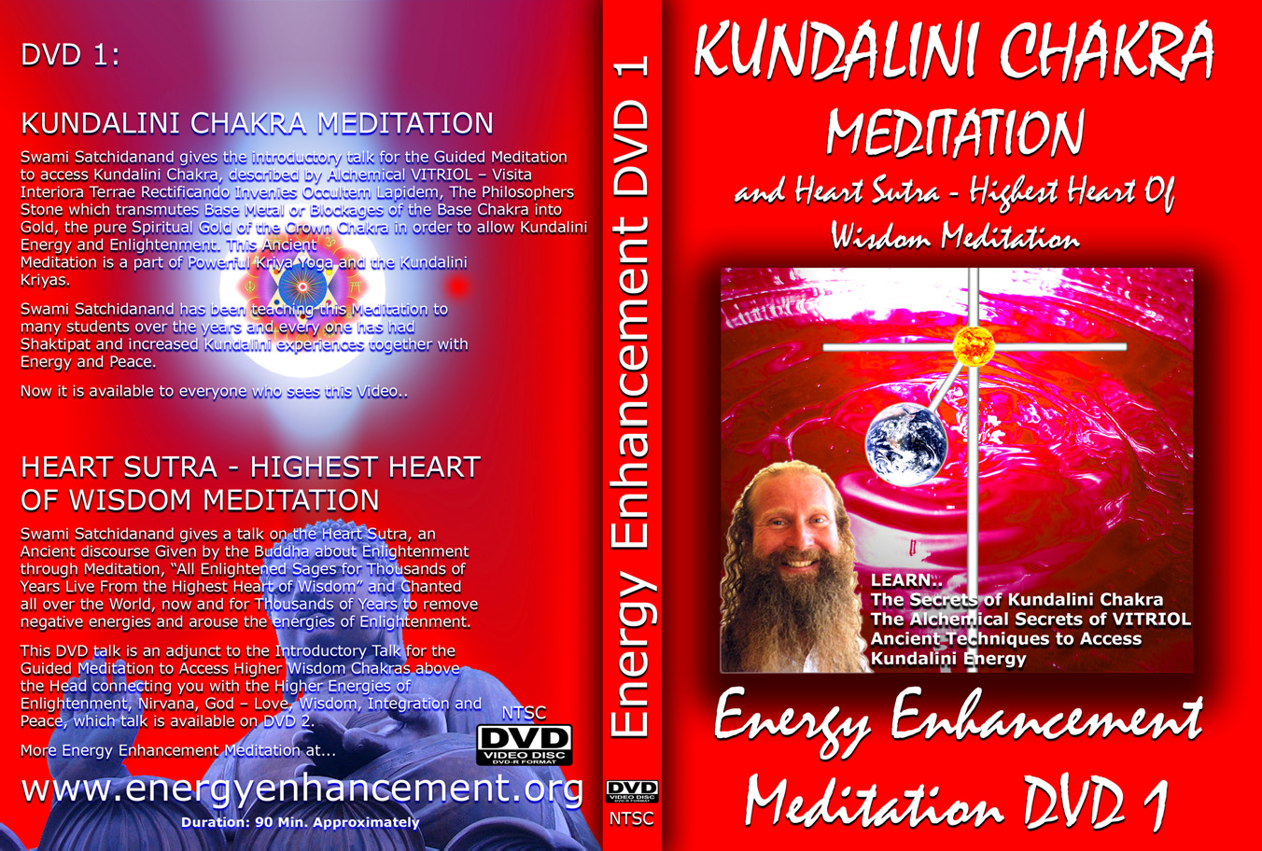

*ENERGY ENHANCEMENT MEDITATION DVD 1…
Guided Meditation to Access Kundalini Chakra, VITRIOL, The Philosopher’s Stone, Kriya Yoga and the Kundalini Kriyas.
Heart Sutra, All Enlightened Sages for Thousands of Years Live From the Highest Heart of Wisdom.

Buy all Books and DVD’s at: amazon.com

DVD 2 - HIGHEST HEART OF GENIUS WISDOM MEDITATION

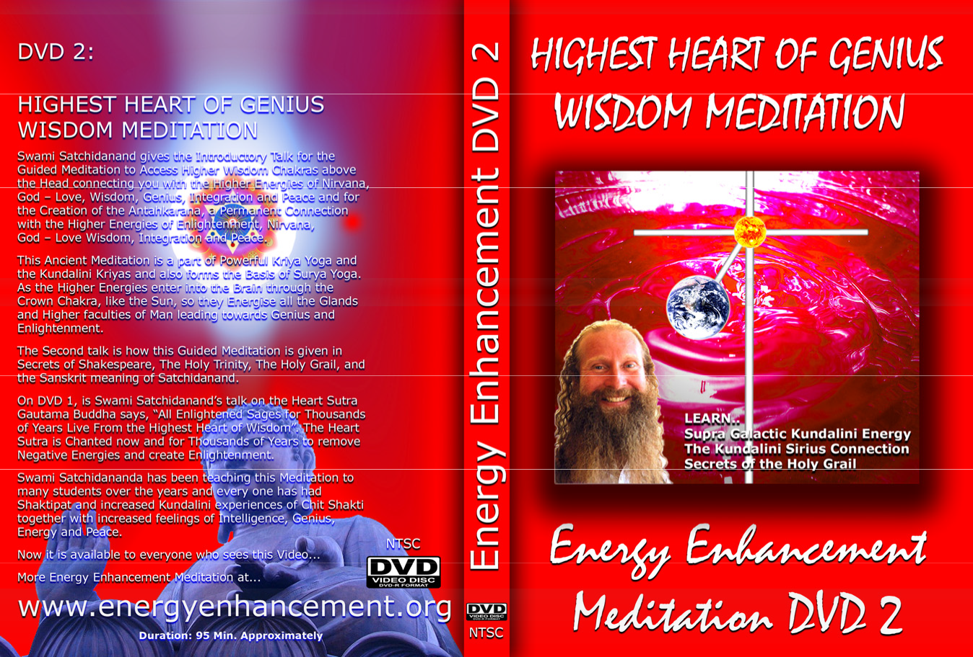

Guided Meditation to Access Higher Wisdom Chakras above the Head connecting you with the Higher Energies of Nirvana, God – Love, Wisdom, Genius, Integration and Peace and the Creation of the Antahkarana.

How this Guided Meditation is given in Secrets of Shakespeare, The Holy Trinity, The Holy Grail and the Sanskrit meaning of Satchidanand.

Swami Satchidananda has been teaching this Meditation to many students over the years and every one has had Shaktipat and increased Kundalini experiences of Chit Shakti together with increased feelings of Intelligence, Genius, Energy and Peace.

BOOK - GAIN SUPER ENERGY

ENERGY ENHANCEMENT LEVEL 1

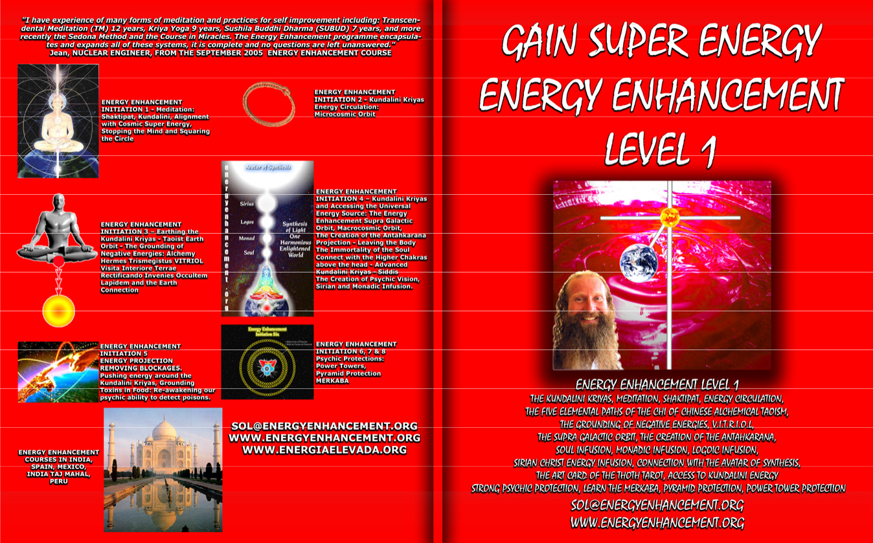

READ… The Kundalini Kriyas, Meditation, Shaktipat, Energy Circulation, The Five Elemental Paths of the Chi of Chinese Alchemical Taoism, The Grounding of Negative Energies, V.I.T.R.I.O.L., The Supra Galactic orbit, The Creation of the Antahkarana, Soul Infusion, Monadic Infusion, Logoic Infusion, Sirian Christ Energy Infusion, Connection with the Avatar of Synthesis, The Art Card of the Thoth Tarot, Access to Kundalini Energy Strong Psychic Protection, Learn the Merkaba, Pyramid Protection, Power Tower Protection.

Buy all Books and DVD’s at: amazon.com

www.energyenhancement.org

THE ENERGY
ENHANCEMENT FOUR INITIATION DVD COURSE - THE ULTIMATE

TECHNIQUES ON 15
DVDs

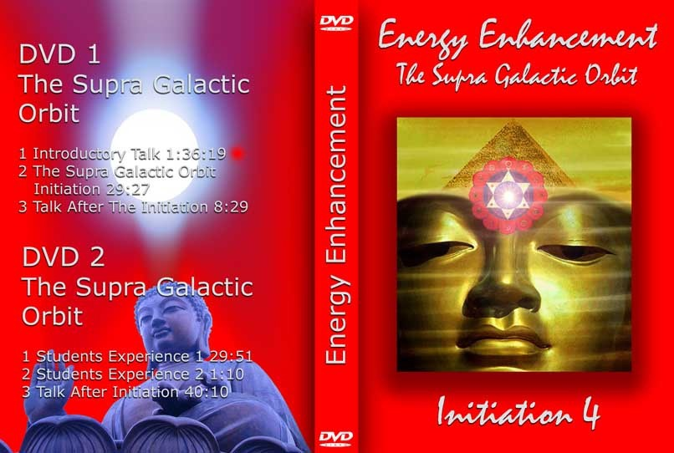

“I have experience of many forms of meditation and practices for self improvement including: Transcendental Meditation (TM) 12 years, Kriya Yoga 9 years, Sushila Buddhi Dharma (SUBUD) 7 years, and more recently the Sedona Method and the Course in Miracles. The Energy Enhancement programme encapsulates and expands all of these systems, it is complete and no questions are left unanswered.”

JEAN, NUCLEAR ENGINEER, FROM SEPTEMBER 2005 ENERGY ENHANCEMENT COURSE

ENERGY ENHANCEMENT LIVE
COURSES – WORLDWIDE

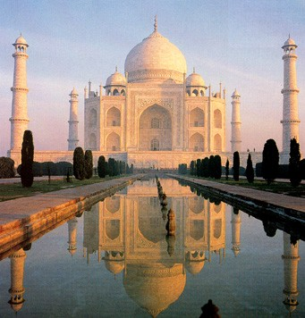
INDIA, 5 STAR INDIA TAJ MAHAL, SPAIN, MEXICO, PERU, ARGENTINA – MORE

Bookings: www.energyenhancement.org

