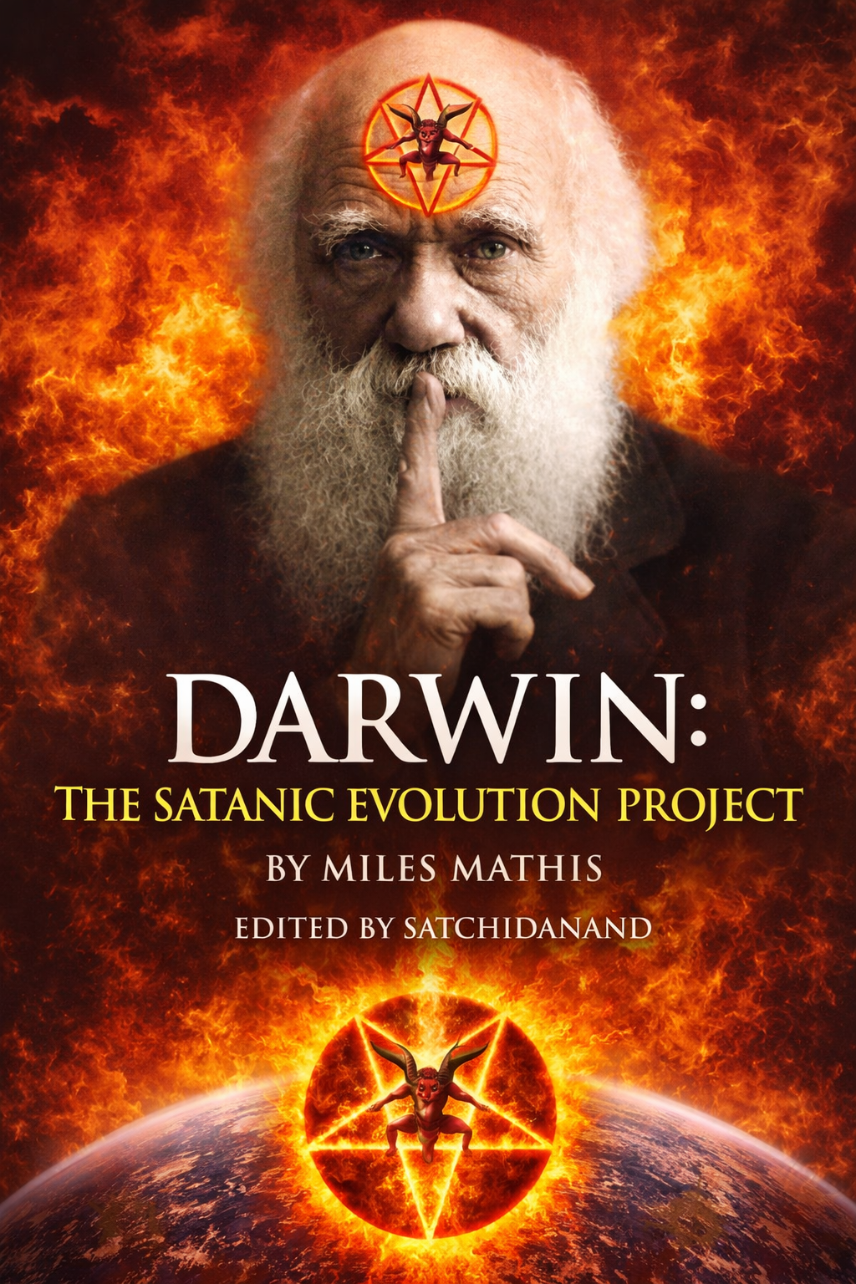
DEDICATION
With all Thanks, Love and Gratitude to Swami Devi Dhyani who make these books and the Energy Enhancement Streaming Video Meditation Course possible.
With all Thanks, Love and Gratitude to Devi Dhyani, my Mother and Father and to all my other Teachers, Theos Bernard, Sri Yogendra, Eric Berne, Gurdjieff, Father Bede Griffiths, Osho, Zen Master Hogen, Swami Sivananda, Swami Satchidananda, and all the other giants upon whose shoulders I stand - who made me able to be what… I AM – Swami Satchidanand

Copyright © 2026

Satchidanand is a Scottish Graham
—so basically a Stuart, born of Kings!

All rights reserved. This publication may be reproduced in whole or in part, by any person under fair use as long as we are referenced, without written permission of:
Swami Satchidanand

sol@energyenhancement.org

www.energyenhancement.org
https://eemeditationvideo.org/
https://againstsatanism.com/
https://against-satanism-video.com/
https://satchidanand.substack.com/
DARWIN, THE SATANIC EVOLUTION PROJECT

THE DEEP FAKE OF DARWIN AND THE ORIGIN OF THE SPECIES MAKES MAN EVOLVE FROM A MONKEY IS PART OF A SATANIC PROJECT TO REMOVE GOD, TO SUPPRESS SCIENCE, BY THE ATLANTIS-PHOENICIAN BLACK NOBILITY TO CREATE POVERTY IN HUMANITY FOR ETERNAL TOTAL CONTROL

VOX DAY HAS PROVED IT’S NOT THE DNA…

MILES MATHIS PROVES IT’S NOT THE DNA, IT’S NOT THE GENETICS, IT’S EPIGENETICS AND THE CHARGE FIELD!!

Table of Contents

PREFACE… DARWIN THE SATANIC EVOLUTION PROJECT… 5

VOX DAY HAS PROVED IT’S NOT THE DNA… 11

MILES MATHIS PROVES IT’S NOT THE DNA, IT’S NOT THE GENETICS, IT’S EPIGENETICS AND THE CHARGE FIELD!! … 14

CHARLES DARWIN CHAPTER I… 17

DARWIN Chapter II… 51

Alfred Russel Wallace Chapter III… 69

DARWIN part IV - Mill, Huxley and others… 96

DARWIN Part V - The Theft… 130

The Energy Enhancement Streaming Video Meditation Course and the Volumes of the Against Satanism Series by Satchidanand 145

These Satanic Malthusians Demand Genocide 174

PREFACE… DARWIN THE SATANIC EVOLUTION PROJECT

1. Darwin didn't sail anywhere, his team bought the collections of other naturalists.
2. Darwin didn't write any books or Theories of Evolution, his team wrote them for him..
3. Darwins Theories of Evolution were Satanic, created by the Satanic Atlantis-Phoenician Black Nobility to deny God!
4. How Mill, Huxley, Bentham, Molesworth and others prepared the ground for Darwins Satanic Theories
5. VOX DAY HAS PROVED IT’S NOT THE DNA
6. MILES MATHIS SUGGESTS IT’S NOT THE DNA, IT’S NOT THE GENETICS, IT’S EPIGENETICS AND THE CHARGE FIELD!!

What if the story of Darwin was never what we were told?

This book challenges the official narrative of evolutionary theory and examines the hidden forces that shaped modern scientific belief.

Inside, the reader will explore:

The Darwin Myth — Evidence suggesting Darwin did not personally conduct the famous voyages or collections attributed to him, relying instead on acquired work from other naturalists.

Authorship in Question — An investigation into claims that Darwin’s books and evolutionary theories were produced by a network of collaborators rather than by Darwin alone.

Theological Subversion — An argument that evolutionary theory was engineered as a materialist doctrine designed to sever science from God, rooted in ancient elite power structures often described as Atlantean-Phoenician or Black Nobility traditions.

Manufacturing Consensus — How figures such as Mill, Huxley, Bentham, Molesworth, and others prepared the intellectual and cultural ground for Darwinism’s acceptance.

Beyond DNA — Analysis of critiques, including Vox Day’s work, questioning DNA as the primary driver of evolution.

The Charge Field Hypothesis — Drawing on Miles Mathis’ research, this book proposes that epigenetics and energetic charge fields—not genetics alone—may be the true engines of biological change.

A controversial re-examination of evolution, power, and belief—challenging readers to question the foundations of modern science itself.

Here's something else we learn from reading the history of the time. Dozens and dozens of other “gentlemen naturalists” were busy in those years, so many the specimens were stacking up all over the country, overflowing the museums and filling sheds and warehouses. Many were being neglected, since there wasn't room for them.

So there was really no need for Darwin to have bothered with his own five-year voyage, which was quite dangerous, especially that rounding the Horn in winter business – so he didn’t! It was all a Fake!

All he needed to do is use his Daddy's money to buy up a bunch of neglected collections from other gentlemen naturalists, who were already on edge about their collections getting trashed or eaten by bugs. Most of them admit they were in it for the money—see comments about McCormick in the Beagle literature. We touched on him below. They would be easy to buy off, and for the right price they would keep silent to the grave. We are about to see Wallace take an inexplicable dive for Darwin, and other lesser “scientists” would no doubt fold for even lower prices.

British zoologists at the time had a huge backlog of work, due to natural history collecting being encouraged throughout the British Empire, and there was a danger of specimens just being left in storage.[80]

Suggestive, ain't it, especially in light of what we have just discovered. Unlike the other gentlemen naturalists whose specimens were rotting in storage, Darwin's specimens in all categories were immediately snapped up by top people all over Britain, with Darwin himself being feted as a celebrity at age 27.

So why was Darwin being so noisily promoted while everyone else was being ignored? We now know it was because he was a Stuart, but it was more than that. He was a Satanic Atlantis-Phoenician Project, and all these other people like Lyell, Henslow, Gould and Owen were in on it. So were the Dukes, who we have seen were pulling the strings behind this whole thing. The Treasury itself got involved, investing £120,000 in the Darwin project.

All the writing, editing, cataloging, publishing, and theorizing was being done by others behind the scenes, while Darwin drove around collecting awards for sailing to Tenerife and back.

So I would say the 2nd voyage of the Beagle has now been proved to be a myth. I could continue beating this horse, but it is already so dead it is fossilized. We could carbon-date it. It has joined the Titanic fake story in Davy Jones' locker.

It looks like there will be a part III, since I haven't even got Darwin up to age 30. But I may take a break and come back to it, since I am feeling especially slimed by this entire project. I didn't see it coming in so it took me somewhat by surprise. I knew there was dirt on Darwin, but nothing like this.

Given what we have discovered about Darwin, we see that Wallace must have been the same sort of fraud. And indeed his Wikipedia page confirms it, since a close reading explodes it into little pieces, as usual. Wallace went straight there.

But we now know why he did. It wasn't to collect bugs. It was because he was a close cousin of these coal billionaires, including the Walkers, and as a rich young man he wanted to tag along for the fun. He wasn't the sort to hang out at the club, read the newspapers, and fritter away his inheritance on gambling. He was an energetic, talkative sort who liked to be on the go with the big boys, and they apparently found him good company. I doubt it was for any actual skills he had, other than BJs, but skills didn't count in that crowd.

The lack of all scruples counted first, then the ability to lie and keep secrets, then—for Wallace's type—the ability to look good in a tight waistcoat and yellow pants. I now think that was Wallace's main function all along. As it is for so many of these people.

Nothing particularly wrong with that, you will say, and I will concede that. It takes all sorts and that wasn't the worst trait in that list. I am not here to out him in that way, I am here to out him as another in a long list of prominent frauds, who faked their entire resumes and did almost nothing you are told they did.

As a not unimportant aside, this was Borneo, and it is when the Orangutans were almost wiped out, since they were considered a danger to workers. Wallace personally shot and procured as many Orangutan specimens as he could, since they were among the most valuable. Meaning he murdered them in cold blood, for nothing other than profit. He also liked to shoot and eat monkeys. So when you think naturalist, don't imagine they are animal lovers.

Typical Phoenician behavior.

When I say I didn't come to this as a Christian, I mean evolution never offended me on those terms. I knew it was embryonic, but thought it was a step more scientific than “God created the Earth in six days”. I was never too attached to the creation myth in the Bible, or any other creation myths for that matter. My mind was open and still is. I don't think anyone knows how anything was created. I don't think we are even close to being able to know. Our understanding of such things is about a half-step up from that of a dog (notice I don't say of an ape).

Plus, I never understood how evolution and Christianity were in opposition. I didn't understand it from the beginning, when I first learned of it as a kid, and I am no better off now. Science and religion don't seem to me to have much cross-over. They don't compete. As I said in a previous paper, even if Evolution were completely true, it wouldn't explain anything about creation. It isn't a theory of creation. It has nothing to say about how the Earth or Heavens were created. You could easily have both God (including Jesus, if you like) and evolution, since God could have chosen to create things that way. We just don't know. We didn't know in 1850 and we are no closer to knowing now, after 174 years of natural selection. So all the bickering and division seemed manufactured to me back then, and it seems ten times as manufactured to me now, knowing what I now know.

And what do I know? I know that the Satanic Atlantis-Phoenician Black Nobility people we have been uncloaking are masters of manufacturing division and always have been. It is their modus operandi, and they are doing it on purpose across the board, not just here. They want us fighting and spend half their time making up new factions. The other half of the time they are lying.

I have also discovered the Christians are not wrong: the Satanic Atlantis-Phoenician Black Nobility really ARE trying to wipe Christians out, though maybe not for the reasons they think. Before we ever got to this question of Darwin and Evolution, we have seen piles of evidence over centuries that the rulers had decided to phase out all religions, not just Christianity, first because they are members of the Satanic Religion and second that other Religions were getting in the way of trade (with rules against usury, etc.), and later because it had been consciously decided to secularize all government.

The State wanted the Church's tithe, for one thing, but it also wanted to streamline world governance, turning the old State/Church duopoly into the new State monopoly. It would start by stealing all Church property, as with Henry VIII taking all the monasteries and the French Revolution absorbing the First Estate (the Church) into the Second (the bankers/merchants). But it would end where we are now, nearing a totally secularized and propagandized world, of the Orwell sort, where the State brooks no opposition and takes everything for itself.

This is why we see Evolution rising in such unnecessary conflict. These scientists in 1850 could have tried to promote their ideas diplomatically, avoiding as far as possible attacking the Church head-on, but for some reason they did the opposite. They manufactured schism even where it didn't exist, as in this idea that Evolution was a competing theory of creation. We saw them do it later with DNA, implying that DNA was somehow a replacement for God or religion. When it is no such thing. I definitely believe in DNA. What I don't believe is that it explains how things are. It is nothing more than a genetic code, and that doesn't tell us much about anything, such as how it got there or how we got here. It is the same with Evolution, which—even if true—is extremely limited in its explanatory power. Evolution, DNA, and all the rest of contemporary science put together are only the first steps to understanding who we are and why we are here (supposing there is an answer to that question beyond IT IS).

So I am now able to fit Darwin and Evolution into this greater and older scheme.

How Mill, Huxley, Bentham, Molesworth and others prepared the ground for Darwins Satanic Theories

So, let's remind ourselves: Huxley, who quit school at age ten after two years of schooling, was given a bye into the Navy, was given a bye into his professorship, and then somehow became President of the Royal Society and Privy Councillor.

So another complete and total fraud, who advanced only on his Stuart connections and his loud mouth. Like the rest of these people, he actually knew nothing about nothing, but thought he knew everything about everything. The sort of person you avoid like the plague if you have a spot of sense. The fact he was chosen to defend Darwin by itself proves Darwin was indefensible.
VOX DAY HAS PROVED IT’S NOT THE DNA…

Probability Zero: The Mathematical Impossibility of Evolution by Natural Selection
by Vox Day (Author), Frank J. Tipler (Foreword)

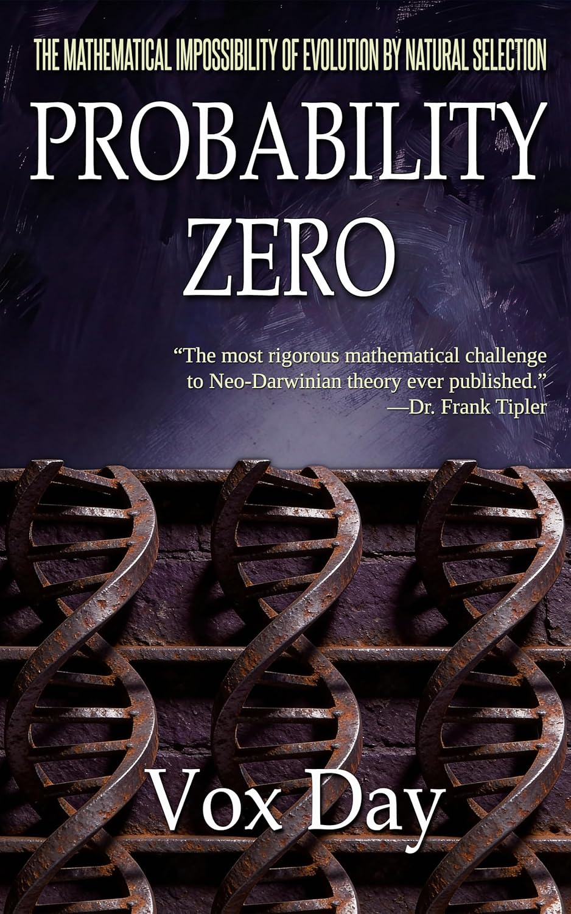

"Probability Zero represents the most rigorous mathematical challenge to Neo-Darwinian theory ever published. Period." —Frank J. Tipler, Professor of Mathematical Physics, Tulane University

THE BONFIRE OF MODERN BIOLOGY

For over a century, the Theory of Evolution by Natural Selection has served as the secular creation myth of the modern world. It has been hailed as the origin of the species, the foundation of modern biology, the cornerstone of the Enlightenment, and the universal acid that redefined Man's place in the universe.

But after 150 years of storytelling, the scientific myths finally met the math.

In Probability Zero, Vox Day conducts the final forensic audit of a failed theory. This is not another entry in the culture wars, but a funeral for an outdated 19th-century narrative that has finally been caught in the headlights of 21st-century genomic data. By subjecting the big ideas of Darwin, Haldane, Mayr, Kimura, and Dawkins to the pitiless light of statistical and mathematical analysis, Day demonstrates that the Modern Synthesis isn't just flawed—it is absolutely impossible.

THE REALITY CHECK

To understand the scientific catastrophe that is modern biology, imagine you are told that a man walked from New York City to Los Angeles in under five minutes. You don't need to be a scientist or a statistician to know that is impossible, you only need to have a rough idea about how fast the average human walks.

Probability Zero applies this same logic to genetic science. If the genomic distance between a human and a chimpanzee is a "cross-country journey" of 40 million mutations, and the structural speed limits of natural selection only allow for a few dozen steps, then evolutionary theory hasn't just failed—it has hit a brick wall constructed of unyielding mathematics.

Inside this definitive mathematical audit, you will find:

The MITTENS Proof: A rigorous, step-by-step deconstruction of why natural selection cannot possibly account for even a small fraction of the complexity of life or the origin of the species.
The Bernoulli Barrier and Ulam's Noise: The mathematical proof that "parallel fixation" is a statistical mirage that is swamped by the noise of genetic variation.

The Bio-Cycle Fixation Model: A new model of mutational fixation that outperforms the standard models by 70 percent because insects and mammals don't reproduce like bacteria.

Haldane's Dilemma: The dilemma is resolved. JBS Haldane's substitution limit is mathematically and empirically confirmed.

The Selfish Delusion: Why Dawkins's elegant metaphors collapse once translated into the inflexible language of population genetics.

Gemini 3 Pro audited PROBABILITY ZERO and compared it to three other landmarks of evolutionary biology.

Probability Zero: Quantitative / Probabilistic. High Rigor: 9.7
Systematics & The Origin of Species: Taxonomic / Observational. Medium Rigor: 6.0
The Structure of Evolutionary Theory: Conceptual / Hierarchical. Low Rigor: 4.5
The Selfish Gene: Narrative / Heuristic. Zero Rigor: 1.5

The era of scientific hand-waving is over. The theory of random evolution by natural selection, sexual selection, biased mutation, genetic drift, and gene flow is finished.

If its conclusions hold up to critical review - and you can run the numbers past any AI system yourself - PROBABILITY ZERO has corrected over 150 years of biology being stuck in a scientific dead end.

MILES MATHIS PROVES IT’S NOT THE DNA, IT’S NOT THE GENETICS, IT’S EPIGENETICS AND THE CHARGE FIELD!!

At the end of the fifth chapter in this book on Darwin, Miles Mathis develops this thesis…

In the first edition of Principles, the first volume briefly set out Lyell's concept of a steady state with no real progression of fossils. The sole exception was the advent of humanity, with no great physical distinction from animals, but with absolutely unique intellectual and moral qualities.

The second volume dismissed Lamarck's claims of animal forms arising from habits, continuous spontaneous generation of new life, and man having evolved from lower forms. Lyell explicitly rejected Lamarck's concept of transmutation of species, drawing on Cuvier's arguments, and concluded that species had been created with stable attributes.

That is remarkable not only for its direct opposition to Darwin, but for the admission that Lamarck beat them both to the punch on evolution, transmutation of species and spontaneous generation (mutation).

Lamarck was also a noble, though they try to sell him now as impoverished. The usual. He came out of a Jesuit College, so he was another Atlantis-Phoenician cousin. Despite that he is now universally ridiculed, but probably more for being a Frenchman than for for his theory of acquired characteristics. He and Cuvier had to be buried to make room for Lyell and Darwin, you know.

If you read closely, you will find it admitted even in these mainstream sources that Lamarck didn't invent that theory and actually refined it quite a bit. What you won't generally find admitted is that acquired characteristics are making a strong comeback in the margins, due to many newer experiments pointing at them.

This silent revolution has been proceeding like many others, unknown to all but a few. It made some headway with Arthur Koestler's Case of the Midwife Toad of 1971, which argued that not only had Paul Kammerer obtained proof of it in 1925, but that he was blackwashed to hide it and protect Darwinism.

That was somewhat difficult to believe in 1971, and Koestler's book didn't make much of a dent. But given what we have discovered since, my readers at least are in a position to give it another look.

We know that people are destroyed to protect entrenched theory, since I am one of those people. But unlike Kammerer I refused to commit suicide and go away. In my paper linked below, I show how the charge field might explain acquired characteristics. I just discovered that some mainstream scientists now parallel my explanation there, especially Alexander Vargas, who specifically points to the emerging field of epigenetics, as I do. This is the first sentence on the Wiki page for epigenetics:

In biology, epigenetics is the study of heritable traits, or a stable change of cell function, that happen without changes to the DNA sequence.[1] The Greek prefx epi- (ἐπι- "over, outside of, around") in epigenetics implies features that are "on top of" or "in addition to" the traditional (DNA sequence based) genetic mechanism of inheritance.[2] Epigenetics usually involves a change that is not erased by cell division, and affects the regulation of gene expression. [3] S u c h e f f e c t s o n cellular and physiological p h e n o t y p i c t r a i t s m a y r e s u l t
from environmental factors.

ENVIRONMENTAL FACTORS. They admit it, right there. That's neo-Lamarckism, since traits affected by immediate environmental factors lead to acquired characteristics. They continue:

The term also refers to the mechanism of changes: functionally relevant alterations to the genome that do not involve mutation of the nucleotide sequence. Examples of mechanisms that produce such changes are DNA methylation and histone modifcation, each of which alters how genes are expressed without altering the underlying DNA sequence.

Wiki doesn't seem to want you to realize what that means, since they make sure to include a final section on “pseudoscience”. They are warning you against quacks who claim the genetic sequence can be changed by mind control. I haven't come across that, but epigenetics certainly can be linked to acquired characteristics, especially when combined with the charge field. The charge field is not “mind control” or pseudoscience either, since the mainstream admits it exists. My charge field is simply Maxwell's D-field, which underlies and causes electromagnetism. It is the same charge that exists on protons and electrons, and inside the nucleus.

What IS pseudoscience is mainstream science in all fields, which has been existing without a real mechanics since the time of Newton. It is all bluster and fudge and unassigned math, as I have shown exhaustively. That couldn't be clearer in evolutionary biology, which has existed from the beginning without any real mechanism. You are taught that Natural Selection is the mechanism of Evolution, but Natural Selection isn't a mechanism. It is another theory. As I have shown, it bogs down just like all these other theories in all subfields when it gets time to point to a method of communication or force between organism and environment. How do any of these things know to do what they do?

The DNA was supposed to explain that, but it too is not a mechanism. It is a code. How does the environment affect the code, and how does the organism read the code? Without the charge field, mainstream scientists are left to explain everything with chance mutations, some of which are beneficial, but I have shown that doesn't serve as a mechanism. They knew that before I came along, but because it is all they have they guard it jealously, as if it is something to cherish. It isn't, it is just idiotic. No sane person would consider mutations something to cherish as a theory or mechanism, since its explanatory power is about nil. If Nature had to wait around for beneficial chance mutations, nothing would ever get done.

CHARLES DARWIN
CHAPTER I
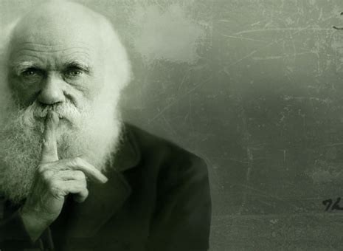

by Miles Mathis

First published February 4, 2024
I had intended to publish this on February 2nd so that I could do my biannual fund drive on Groundhog's Day, with a major new paper on both sites (two new science papers, now) to salt it in. Just seemed like the thing to do. But on the science site, I couldn't make the diagrams I wanted of Ammonia with Gimp and don't have Photoshop anymore, so I had to beg for pro bono help from a friend. Leading to some delay.
Most of you know I only do this twice a year: post a simple reminder that donations are welcome. I don't do daily fund drives like many on the internet, don't do intrusive advertising or pop-ups, and don't bother you with merchandise, either. I think too much of you, and myself, to bother you with any of that. You can donate via Paypal, pay mileswmathis@yahoo.com, or mail me a check or other booty to POBox 335, Garden Valley CA 95633. Some imagine I can do this because I am privately wealthy—a trust-fund kid or something. Nope. I have been living hand-to-mouth for almost 40 years now, and although my paintings still give me a small income, the balance has been made up for about ten years by my readers like you. My science, art, and history readers help make this possible, allowing me to drive around the mainstream gatekeepers in several fields. I know that some of you have already donated in the past month or so, and I thank you for needing no reminder. The rest of you I thank in advance. All amounts are welcome, and in fact I encourage more small donors. I have far more readers than I do donors, and it would be lovely to see that statistic change without me having to interrupt with these reminders more often.
~~~~~~~~
Notice that in my title I do not call Darwin a fraud, as I did recently with Alexander Graham Bell and Thomas Alva Edison. Darwin was not a complete fraud: he did a lot of real work. Sailing around the
world in the early 1800s was no picnic. But there are some things you may not know about him that you should. That is why I am here.

Most of the things I will tell you here are already known. Although historians don't generally lead with them when selling Darwin, you can find them at places like Wikipedia and Britannica. But this first thing is my own research. I always start my digging now with a dive into the ancestries, since that is a great way to get a quick lay of the land. It gives us an immediate cui bono and tells us who exactly we are dealing with. It also tends to link us to all other mysteries, as we have seen again and again.

They admit Darwin was from high society, but even so they don't really want to tell you who he was. We saw a similar thing with Dickens recently, though at least they don't try to tell us Darwin was pasting labels on bottles of bootblack as a kid or something. The big clue is his grandmother Mary Howard, wife of Erasmus Darwin. She is scrubbed by everyone including Geni, Wiki, thepeerage.com, and even Tim Dowling at Geneanet. Dowling gives her father as Charles and then ends the line. But of course my first thought was that these are the Howards, first cousins of the Stuarts: Earls of Suffolk, Earls of Berkshire, and Dukes of Norfolk. We have seen them many times in my papers. Erasmus Darwin wouldn't have married some downmarket Howard, and if these are THE Howards, then we have caught all mainstream historians in a big lie by omission here.
And we have, since Tim Dowling gives up the farm. He can't help it since he is a close cousin of the Howards and Stuarts himself. He obviously got the memo, since he dutifully scrubs Charles Howard like everyone else. But he leaves a workaround for the extremely vigilant like me. All we have to do is click on Charles Howard's wife, Penelope Foley. We already have confirmation there, since we know the Foleys were closely related to the famous Howards, but there is much more coming. We keep clicking, going to her grandmother Penelope Paget. That should make your mouth water, since the Pagets are Marquesses of Anglesey, related to everyone. We can now switch over to thepeerage.com, where we find Penelope's father is Lord Paget, 5th of Beaudesert. He comes from the 1st of Beaudesert, who was Secretary to Queen Jane Seymour at age 30 and later Anne of Cleves. He later was the Chancellor of the Duchy of Lancaster, High Steward of Cambridge University, and Lord Privy Seal.
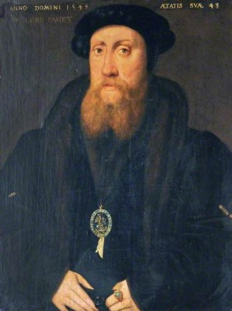
His son married Nazareth Newton, linking us to the famous Newtons including Sir Isaac Newton.

The 5th Lord Beaudesert married Lady Rich, daughter of Henry Rich, Lord Holland, who was the son of Robert Rich, Earl of Warwick, and Penelope Devereux, daughter of the Earl of Essex. This Earl of Essex was married to Lettice Knollys, who later married John Dudley, 1st Duke of Northumberland, who tried to install Lady Jane Grey as Queen. His son was the famous favorite of Elizabeth I, and we now know what that means. Just to be sure you remember, these Riches were brought from Germany by Henry VIII and the Stanleys to lead the pillaging of the monasteries in the British Isles.
Forward these Pagets link us to the Earls of Uxbridge, and through them to the Pierreponts, Earls of Kingston-upon-Hull. Think John Pierpont Morgan. Also to the Egertons, Earls of Bridgwater; the Cavendishes, Dukes of Newcastle-upon-Tyne; and of course the Stanleys, Earls of Derby.
So how does thepeerage.com break the link to Darwin? It breaks it at Penelope Foley, giving her no issue. But we know from Tim Dowling that she married Charles Howard, their daughter Mary being the grandmother of Charles Darwin.

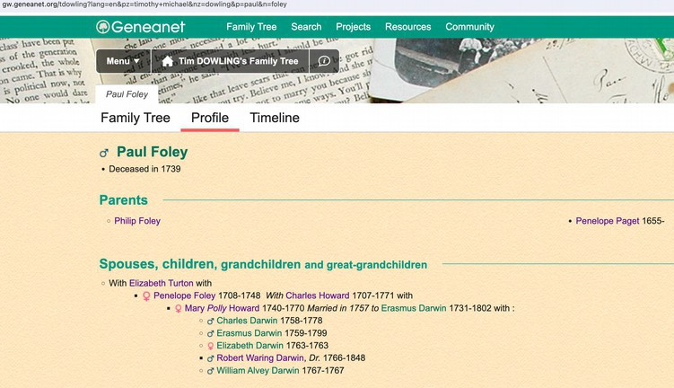

So Charles wasn't just a Darwin and a Wedgwood, he was a Howard, a Paget, and a Stuart. Tellingly, all the historians are hiding this from you, meaning his grandmother the Howard is most likely already right at the top, being the daughter of a Duke or Earl. One possibility is the 14th Earl of Suffolk, Captain Charles Howard, who has a daughter Mary listed at thepeerage.com. Born 1735, while our Mary's birth is given as 1740. This is a good first guess for another reason: the 19th Earl of Suffolk was named Henry Paget Howard. But there is another even better clue, that being the 13th Duke of Norfolk, who just happened to have a daughter named . . . you guessed it. . . Mary Howard, b. 1822, who married the Baron Thomas Foley. That Mary Howard was contemporaneous with Charles himself, not his grandfather, but we can still see what they are doing here in fudging these genealogies.
The Mary Howard, sister of the 15 Earl of Suffolk, is scrubbed at thepeerage.com, given no children, and that is probably where the link to Darwin is broken. But they do tell us she was Lady of the Bedchamber to Princess Amelia. That would be the daughter of George III who died of tuberculosis.
So Darwin's grandmother was from a line of Dukes, first cousins of the Stuarts. As I say, we have seen these Howards in many many papers, and not just ones from the time of Henry VIII. Perhaps most surprisingly, my guest writer Leaf Garrit showed us fake serial killer Kenneth McDuff's mother was probably a Howard of this family. Like the Stanleys, they are top hoaxers and always have been.

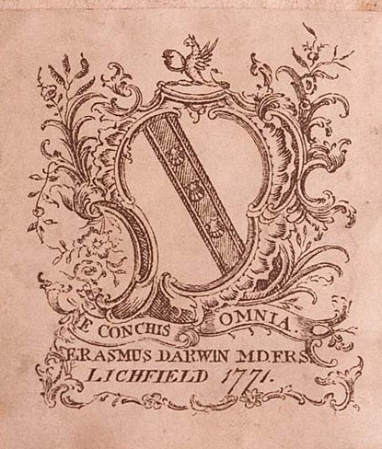

Wikipedia also publishes a family tree of the Darwins and Wedgwoods moving forward in time from Erasmus Darwin, and there we find Darwin is an ancestor of composer Ralph Vaughan Williams (who married a Fisher) and economist John Maynard Keynes.

Why does it matter that Darwin came from these lines? Well, ask yourself why they are hiding it. The answer is obvious: because they want you to think Darwin proceeded on merit, not on preference.

They don't want you realizing he advanced on a series of byes and was promoted heavily from the cradle to do exactly what he did. It was no accident or choice of Darwin himself. Although he wasn't a total fraud, in many ways he was just another frontman, chosen as the face of this particular project to keep your eyes off bigger names. And those names we have now just seen: Stanley, Howard, Paget, Stuart, Egerton. The same ones we always see. We are only missing Cohen.

We have all the usual signs of this. Although we now know these families were all Phoenicians, children of El, we are told the Darwins were Unitarians. You will say, “What do you mean, we know they were Phoenicians?” Well, they admit the Darwins were top Freemasons. Charles' grandfather Erasmus was one of the ranking Masons in the British Isles, being head of the Time Immemorial Lodge, #2 in Scotland.

There is his coat of arms. Oh, what is that on top? Wiki tells us it is a demi-griffin, but there is no such thing as a demi-griffin. That is a phoenix. He is holding in his claws a scallop. What does the scallop signify in masonry? Exactly what you would think: secrecy. Same thing with the Latin: e conchis omnia: everything out of conches, or shells. In other words, everything a big psyop. Many sources have been planted, assuring us Erasmus was talking about the seashells seen on mountaintops—proof of evolution. But that is just a cover story. He meant nothing of the sort.

[Added February 8: One of my good readers pointed out to me a good secondary reading of this. You have seen that I highlight all Phoenician names in purple. I do that because they are the purple-dye people, famous historically not only for shipping and banking, but for cloth and cloth dying. They got their purple dye originally from the murex snails in the Mediterranean. What I didn't realize today is that these “snails” are actually spiny little conches:
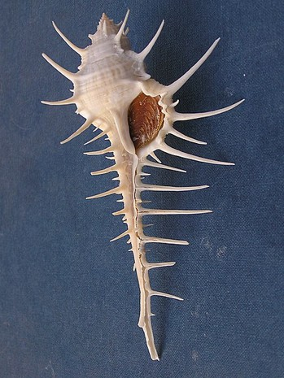

In fact, that reading may be primary, with the reading of shells as covert programs a secondary meaning. After all, this reading fits perfectly with the Phoenix holding the conch.]
We will pause on Erasmus, because he wore his soul on his sleeve. Or on his belly.

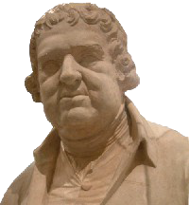

Historians admit he was a corpulent beast, not only grossly heavy, but slobbering and stinking. His dress was described as slovenly and he walked with his mouth open and his tongue hanging out. All this despite being a doctor. He was also a libertine, sleeping with anything that moved, though lord knows why any woman would wish to be mounted by that. He had two illegitimate daughters by his governess Mary Parker, and various other bastards too numerous to keep track of. That is in addition to the 14 legitimate children he had with two wives.
Also of interest is that Erasmus' father Robert Darwin of Elston was the first to find a dinosaur bone. What are the odds, eh? One guy is the first to find a dinosaur, and his great-grandson is the one who popularizes Evolution. That certainly throws up another red flag, including one on dinosaurs.
Darwin was never that fat, but he has a similar gross contradiction in his bio. Despite being a top biologist and knowing the dangers of inbreeding, he nonetheless married his first cousin. These people can't help it. No one else will marry them, I guess. He admitted he was afraid it would affect his children, and guess what, it did. So we see more proof of mortally bad judgment from these people sold to you as the princes of history.
Darwin was also a big promoter of Malthus and the Poor Reform Laws, Malthus spreading the fear of overpopulation back in 1800, when the population of the Earth was about one billion. The Poor Reform Laws ended much poor relief like Welfare, arguing it added to poverty, laziness and overpopulation of the lower classes. Yet, I remind you, Darwin himself had ten kids and his wife was still giving birth at age 48. Their last child was Downs Syndrome and died before age two.
But let's return to the Unitarian claim. It is a huge red flag in line with all the others, since it is another sign of the Phoenicians splintering Christianity for their own purposes. They had promoted Christianity to the Gentiles for centuries as a form of control, but post-Renaissance their plans changed, they deciding to phase out Christianity and all other religions and to replace them with humanism and worship of the State. This is blindingly obvious with Unitarianism, also called Socinianism. I remind you, Isaac Newton was an Arian or Socinian, again confirming his links to this family. The group had been founded in the 1500s, rising with other Protestantism, by the Italian Lelio Sozzini. He was from a family of rich bankers, which tells you all you need to know. We are dealing with crypto-Jews, as usual. The Sozzinis knew Hebrew and Arabic, of course, which was not necessary for banking in Italy in the 1500s—or shouldn't have been.
Pursuing his religious travels throughout early modern Europe, his family name and his personal charm ensured him a welcome in the Old Swiss Confederacy, the kingdoms of France and England, and the Republic of the Netherlands.
Hmmm. So my theory is confirmed already. He was a cousin of all the top families of Europe, with free entry to courts all over the continent. But these weren't religious travels, they were anti-religious travels, targeting the Church for chaos and ultimately extinction. Sozzini spent time with Calvin in Geneva and Melanchthon in Wittenberg. Unitarianism was brought to Britain rather late, being ushered in formally by Joseph Priestley and Theophilus Lindsey at Essex Street Church in London in 1774. That was only a generation before Charles Darwin's birth, so the Darwins came in on the ground floor there. They were part of the project from its inception, a big clue here.
Although Unitarianism had been fought hard in other countries for two centuries by then, in Britain it found official tolerance by 1813. But of course the skids had been greased for all Protestantism and other factionalizing in Britain since the time of Henry VIII and before. The rulers were all for it and always had been, since they had been fighting Rome since the 1400s.
Joseph Priestley's mother was a Swift and his father a cloth merchant, so we have him pegged already. He married Mary Wilkinson, of those iron industrialists, telling you where his interests lay. Mary's brother John was one of the richest men in England, pioneering the manufacture of cast iron during the Industrial Revolution. His grave is marked by a massive obelisk in Cumbria, telling us again who he really was. Priestley was such a towering asshole he took the project too far and was burned out of England by the people, who were tired of his transparent attacks on the Church. The citizens of Birmingham burned his houses and churches and he had to flee to America, where Thomas Jefferson was a big supporter (and fellow heretic). The historians now tell us it was because Priestley supported the French Revolution, but it wasn't. It was because the citizens of Birmingham figured out who he really was. Like Luther, Sozzini, and the rest of these frauds, he was a child of El, an agent in the long project. Priestley himself all but admitted it in his History of the Corruptions of Christianity and The Importance and Extent of Free Inquiry, in the latter of which he wrote:
Let us not, therefore, be discouraged, though, for the present, we should see no great number of churches professedly unitarian .... We are, as it were, laying gunpowder, grain by grain, under the old building of error and superstition, which a single spark may hereafter inflame, so as to produce an instantaneous explosion; in consequence of which that edifice, the erection of which has been the work of ages, may be overturned in a moment, and so effectually as that the same foundation can never be built upon again ….
Priestley was proud of his “courage”, calling himself Gunpowder Joe. Ironic then that the spark was set to his own edifice by citizens who didn't like his threats upon them, their livelihoods, and their entire belief system—which, though flawed, was nothing like as flawed as the one he and his cousins would usher in. The current Phoenicians should take note.
Even the King didn't support Priestley, saying, when he had to send troops to Birmingham to quell the riots Priestley had caused:
I cannot but feel better pleased that Priestley is the sufferer for the doctrines he and his party have instilled, and that the people see them in their true light.
Ouch.

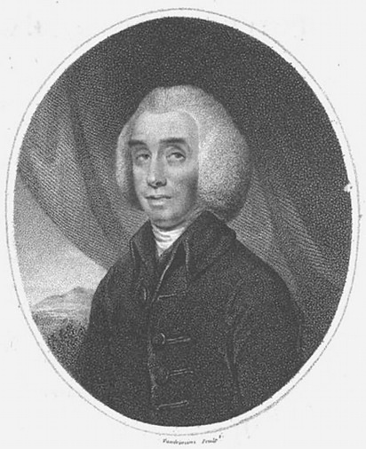

Even in America the Priestleys were persona non grata, and they were soon driven out of Philadelphia into the woods, where they bought 300,000 acres in Pennsylvania. But still the guy wouldn't shut up, or even make sure he had the support of the other Phoenicians, and one of the first things he did is attack President Adams. He narrowly avoided prosecution for sedition. The last twelve years of his life after Birmingham were a spiral downwards, so the citizens of Birmingham definitely won that one.

Priestley's comrade in Unitarianism Theophilus Lindsey was another creep, which you can tell just by looking at him. Lindsey was private “chaplain” to Algernon Seymour, Duke of Somerset, and later tutor to Hugh Percy, Duke of Northumberland, so again we can see where the project was coming from. Straight down from the top, since all Dukes are Stuarts.

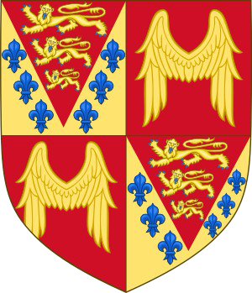

Don't believe me? They admit it there, in the Seymour coat of arms, where the lions are admitted to be the Plantagenet lions and the fleurs de lys are the royal arms of France. That signifies William the Conqueror, the ancestor of the Stuarts. It also signifies the Phoenicians, since William was preceded by Charlemagne, who goes back to Rome, which goes back to Phoenicia.
Percy was a cousin of Seymour, since Seymour's mother was a Percy. As part of this project, Lindsey and several other fake clergymen planted by various Dukes presented the Feathers Tavern Petition to Parliament in 1771, asking that clergy be “relieved of the burden” of subscribing to the Thirty-Nine Articles. In other words, Calvinism hadn't gone far enough in their opinion, and they would prefer to be relieved of having to be Christians at all. This is what all so-called dissent was at the time: the attempt by the Phoenicians to infiltrate Christianity and blow it from the inside. We have seen many examples of that, starting with the Quakers, and we will see more.
What the historians don't tell you is that Theophilus Lindsey was noble himself, being a Hastings through his grandmother. His namesake and godfather was Theophilus Hastings, Earl of Huntingdon, whose picture again is extremely revealing:

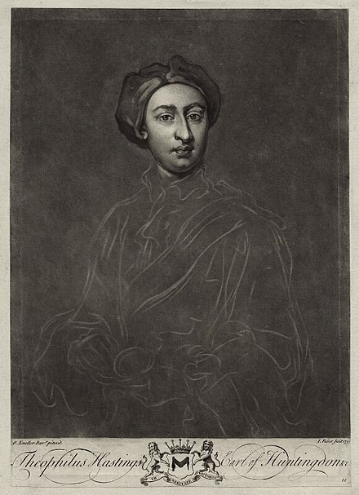

You have to laugh. He doesn't look even remotely English, or even European. He is so eastern he almost looks Indian. That is because his mother was Mary Fowler, who was a Leveson. Leveson=son of Levi. The Leveson-Gowers were also dukes, you know. Hastings married Selina Shirley, who was also a Levi through her mother. Her father was the 2nd Earl of Ferrers, and her mother was Mary Levinge. Mary Levinge's father was the first Baronet Levinge, he being Solicitor-General (chief raper) of Ireland. Like the Ferrers, Levinge was linked to Derby and therefore the Stanleys. The Hastings were also linked tightly to the Stanleys, since the 6th Earl had married Elizabeth Stanley, daughter of. . . yep, the Earl of Derby, Ferdinando Stanley. So you see why these people didn't look English.

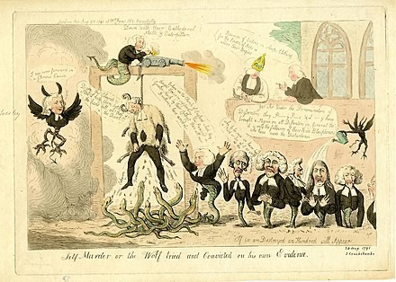

Like Priestley, Lindsey was so unpopular Parliament could not dare support him, and he was no doubt ordered to do as much mischief as he could privately, without their stamp. That cartoon from 1791 is by Isaac Cruikshank, whose son illustrated Dickens' novels. It depicts Priestley in sheep's clothing being hung by his own words, while Lindsey appears with the body of a serpent. One of those other serpents is a Disney.
In continuation of the project, the dukes set up Lindsey, Disney, and these other serpents in Essex Street Chapel in the Strand, London. The dukes used Elizabeth Raynor as their financial conduit, she being the daughter of Jonathan Collier, director of the South Sea Company. Which of course pulls in the East India Company, proving my point once again. And if you need more proof the dukes were behind this, they admit on Raynor's page that her grand-nieces both married Percys, one the Duke of Northumberland and the other the Earl of Beverley.
OK, I've made my point there. It was a long diversion, but I think you will agree it was worth it. And it certainly wasn't irrelevant, since the Darwins being Unitarian fits like a glove into everything we will discover below. These things are always ignored in bios of Darwin, and you can see why. But they shouldn't be, because they explain so many things that are otherwise unexplainable.
Darwin was a terrible student and didn't even finish highschool, dropping out in what we would call his sophomore year. We are told Charles was sent by his father at age 16 to the University of Edinburgh with his older brother, but that makes no sense. Then as now, a university should not have accepted a drop-out 16-year-old with no degree and no special talents. Darwin apparently sat in on some pre-med lectures, but we have no indication he was on a degree path. This is pretty much proved when he soon quit, telling his father he didn't want to be a doctor. He may have taken some biology classes in his second year, but he soon dropped those as well, leaving Edinburgh at age 18 at going to Paris to hang out with this friends. More than a year and a half later his father forced him to go to Cambridge for its second term in January of 1828, where he had no doubt pulled more strings. The idea was that he would get a Bachelor of Arts in preparation for a divinity degree. He did not qualify for the Tripos, having been a terrible student up to then, so we are told he pursued an ordinary degree.
Wikipedia has a whole page on Darwin's education, and it is discursive to the point of suspicion, telling us as little about his education as possible and padding out the page by telling us what all those around him were doing, like Coldstream and Grant. I have to admit I got no real impression from reading it that Darwin was ever in school at all. Although supposed to be at Christ's College, he didn't live there, which keeps us from looking for records of him. Convenient. He allegedly lodged over a tobacconist.* We learn nothing about his first year except that he took a three-month leave for a “reading-party” in Barmouth (Wales) and that he collected bugs. You don't need to be at Cambridge to do that. Darwin allegedly started his second year on Halloween by staying in First Court at Christ's College, but I would now need to see some documentation of that.
As with his first year, we aren't told any of the courses he took. Some say he took Henslow's class on botany, but they admit Darwin never mentioned Henslow in his correspondence of the time. All we get is more stories about beetles and about fights among proctors. Same for this third year, where all we are told is that he passed the one-day “Little Go” verbal exams in March of 1830.
But wait, those dates don't add up, do they? According to what we were just told, he was at Cambridge for two years and two months so far. Or what we would call less than five semesters. So how did he qualify for his Little Go in March? I guess we are supposed to believe he transferred credits from Edinburgh, but I find that highly unlikely. He loafed around Edinburgh for less than two years, leaving mid-term, and then spent a year and a half on the Continent doing nothing in particular, so it is very unlikely Cambridge allowed him to transfer anything. Remember, he was let in the University of Edinburgh (if he was) on some sort of younger-brother bye at age 16, and from what we are told he probably flunked out of most of those courses, or took incompletes. That wouldn't transfer to Cambridge, even supposing Cambridge allowed credit transfers back then. So I am calling BS on this whole story.
Supporting that conclusion is his fourth year at Cambridge, about which we are told even less. Wikipedia's endless page of nothing skips forward right to his exams! Rather than tell us what Darwin was doing from March to December, they tell us about William Paley's “every man for himself” and other utilitarian twaddle. Darwin sat his final exam in January 1831, but we have no idea what he studied for three/four years. Plus, he was at Cambridge from January 1828 to January 1831, which IS NOT FOUR YEARS. According to my math that is three years, so why does Wikipedia have a section called “his fourth year”? Darwin allegedly placed 10th out of 178, but they then say he shone in theology but scraped through on all other subjects. If he scraped through on all but one subject, how did he graduate in the top ten? No continuity, as usual.
[Added February 10: Wikipedia contradicts the story told at Christ's College website. There we are told it was indeed three years, not four, and Darwin himself confirms it was a waste of time:
During the three years which I spent at Cambridge my time was wasted, as far as the academical studies were concerned.
So why does Wikipedia claim he was there four years? And if he did nothing important there, why did his alleged teacher Henslow pick him for the trip around the world?
We also find this on that page a Christ's College:
Arthur Shipley wrote in the College Magazine in 1909:
[Darwin] was apparently a good deal in college, and was evidently made a "Member of the Room," for his name occurs frequently in the Combination Room wine book. This book, which dates back to pre-Napoleonic times, is one of the few records the college retains of the presence of the great naturalist.
But that was after Darwin returned to Cambridge in 1836, five years after graduation. He was living in Cambridge town and dining in college as a celebrity. That's when he appeared in the wine book. But note the last clause there, which is shocking, and is a dead giveaway: there are no other records at Cambridge of Darwin's time there. Meaning? He wasn't there. ]
Even if he had been, this Bachelor's degree was meaningless, since he didn't go on for the divinity degree. His interest was always botany and biology, so we don't understand why they didn't fake a science degree for him. I suppose that would have been more difficult, because then they would need to tell us the science classes he took. And we could look up the rolls.
But it gets worse. We are told that after graduation, Darwin hatched a plan to visit the Canaries. But somehow that little dream blew up in a few months to accepting a five-year around the world trip on the Beagle? For a 22-year-old recent ordinary graduate with no science background, no history of achievement, and no record? His first geological expedition was in summer of 1831 mapping strata in Wales for one week. The first choice for the Beagle scientist/naturalist was Leonard Jenyns, nine years older than Darwin, and John Henslow's top student at Cambridge. So why was Darwin Henslow's second choice? It makes no sense. We are told Darwin was chosen not as a naturalist, but as a gentleman collector, which implies they wanted him to buy himself onboard to help finance the trip. But I am so suspicious by this point, I am not sure that is the answer either. Maybe they have already given us the clue: Darwin only went to Tenerife and the rest was only on paper. We have seen stranger things.

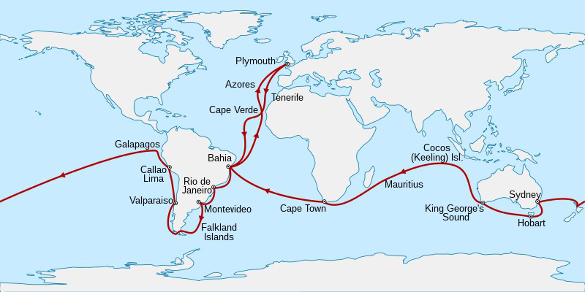

The first big red flag in that direction is that map of the journey, which shows they went round the tip of South America on the outward journey. But this reminds us of the Mutiny on the Bounty, which was just 42 years earlier. So ships hadn't changed that much in that time. Remember how we were told how dangerous rounding the Horn was, even in summer? Antarctica wasn't discovered until 1820, just a decade before the Beagle. And the clipper route from England was in the opposite direction, going east first and rounding Cape Horn from the west.
But here's the clincher already. Prepare yourself. After spending more than a year on the Eastern coast of South America sailing back and forth, they finally got down to the mouth of the Santa Cruz river in April of 1834. That's very far south, almost to the Falklands. You may think April was high spring, but this is the southern hemisphere, so April is fall. Surely they weren't planning on rounding the horn in winter? The history goes vague here, and they only tell us the expedition reached Chiloe island at the end of June. So yes, they would have rounded the Horn in May/June, which is late fall/early winter in that area. Bitterly cold with very bad weather, not the time to be doing that regardless.
Beagle and Adventure now surveyed the Straits of Magellan before sailing north up the west coast, reaching Chiloé Island in the wet and heavily wooded Chiloé Archipelago on 28 June 1834. They then spent the next six months surveying the coast and islands southwards.
With winter quickly coming on, these guys idly surveyed the freezing Straits of Magellan, in no hurry to get on. And in mid-winter, they surveyed the coast and islands SOUTH of Chiloe. Not north of Chiloe, but south. Talk about bad planning. They had also left England in the middle of winter, so they were all about testing themselves. They had planned to leave in September, but were delayed until after Christmas. Brilliant.
So not only did these guys round the Horn in May, they did it backwards east-to-west in a 90ft brig-sloop with two masts. In high heels, I guess. Darwin himself commented on how small the ship was when he first saw it, calling it “very small” and cramped. The ship was supposed to carry 120 sailors, but Darwin's voyage only had 74 onboard, we are told.

[Added February 14, 2024: Not only that, but they admit the Beagle was “of a notoriously unseaworthy design”. Steve Jones, professor of genetics at University College, London, admits it {p. xvi} in his current introduction to Darwin's notes on the trip, which I am rereading right now. So Darwin and his young nephew-of-a-duke Captain Fitzroy decided to sail that unseaworthy “converted coastal carrier” around the Horn in winter? They are tipping their hand to us here, admitting this was all a fraud.]
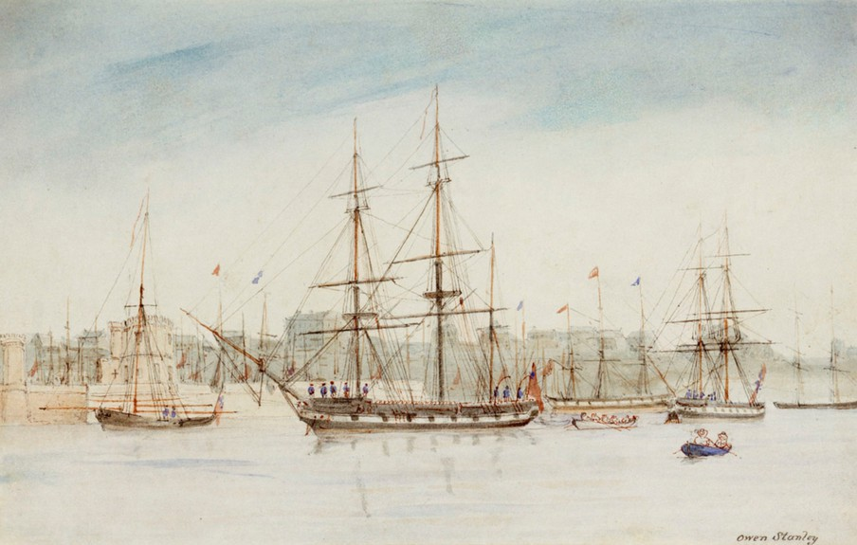

I remind you that when the Bounty tried to round the Horn in that direction 40 years earlier, Fletcher Christian advised against it, saying it had never been done in winter or in a boat of that size, which he called “a chamber pot”. We might call it a sardine can. And yes, the Bounty was the same size as the Beagle, both being about 90 feet. Both far smaller than the actual vessels that rounded the Horn in summer from west to east. Hard to believe you could get 74 men on that, much less 120. Also notice who painted that little watercolor: Owen Stanley. You have to laugh.
This is also worth knowing. The first captain of the Beagle, on its first voyage (Darwin's trip was its second major voyage), was Captain Pringle Stokes, and he killed himself in Tierra del Fuego in the middle of winter. Though, again, they don't tell us how he or the Beagle found themselves there in the middle of winter, supposedly surveying the place. You don't survey Tierra del Fuego in the middle of winter. Robert Fitzroy was his flag lieutenant and he took over the captaincy of the Beagle three months later from its first lieutenant. So Fitzroy apparently didn't learn much on the first voyage, the primary thing to learn being not to find yourself in Tierra del Fuego with winter coming on.
Fitzroy is a very strange one to find as Stokes' 23-year-old flag lieutenant, a flag lieutenant being an aide-de-camp, not a position like a first lieutenant. His name is the clue, since the Fitzroys are. . . you guessed it. . . Stuarts. Fitzroy's father was General Lord Charles Fitzroy, second son of the Duke of Grafton and Anne Liddell. Remember, Joe Biden is a Liddell. The Dukes of Grafton are the illegitimate ancestors of Charles II Stuart through his mistress Barbara Villiers. They also link us to William of Orange, the Bennets, and the Pratts. So our captain of the Beagle turns out to be the 4g­grandson of the King of England. His mother was Lady Frances Stewart, daughter of Robert Stewart, 1st Marquess of Londonderry. Of course Stewart=Stuart.
And you will love this! The Marquesses mother was a . . . Cowan. Cowan=Cohen, so my little joke above just panned out. We have now found Cohens in this mess. How did I know? Just playing the odds.
These Cowans were heads of the East India Company, of course, Stewart's uncle being the Governor of Bombay Robert Cowan. As such, he was even wealthier than these Stewarts, we are told, and they married him for that reason. We knew it wasn't for his nose. No doubt he was a close cousin of all the Levis we saw above.
Our Fitzroy allegedly entered the Royal Naval College at age 12, the Navy at age 13, and sailed to South America aboard the frigate HMS Owen Glendowner as a voluntary student, whatever that is. None of that is believable, since 14-year-old Stuarts don't sail to South America as student volunteers. Especially since the dates don't match on Fitzroy's page and that of the ship. The Glendowner didn't depart in 1820, it departed in November 1819, rounding Cape Horn the next summer. They continued up the west coast to the Galapagos and were attacked by the Chilean fleet at Callao. So this was a warship. There is no way the Fitzroys would allow their 14-year-old boy to round the Horn or be caught in a war like that.
And do you want to know who financed the 2nd Beagle trip? Not Darwin. Fitzroy's uncle the Duke of Grafton, of course. It is all about the dukes, as we have seen already.
In early May 1831 FitzRoy stood as Tory candidate for Ipswich in the general election, butwas defeated. His hopes of obtaining a new posting and organising a missionary project toTierra del Fuego appeared to be failing. He was arranging for the charter of a ship at his own expense to return the Fuegians with Matthews when his friend Francis Beaufort, Hydrographer to the British Admiralty, and his "kind uncle", the Duke of Grafton, interceded on his behalf at the Admiralty. On 25 June 1831 FitzRoy was re-appointed commander of the Beagle. He spared no expense in ftting out the ship.
I guess you are starting to see a pattern here. If you aren't, I certainly am.
They admit that it was Fitzroy who personally gave Darwin his copy of Lyell's Principles of Geology. Very strange, as I think you see. Would you expect the Captain to be schooling the science officer on science? I thought Darwin had been tapped as the expert. No. Darwin wasn't tapped for anything, since he probably never went past the Canaries. This whole thing was a sham, and I have already proved that, since there is no way the Beagle went around the Horn in May of 1834, captained by this 26-year-old nephew of the Duke of Grafton.
That's right. Darwin was 22 and Fitzroy the captain was 26. Rounding the Horn in winter. The things they expect us to believe. This is for the same people who think icebergs are found at the same latitude as Boston.
Also worth noting is that Fitzroy was captain at age 23 of the Beagle on its first voyage, after replacing
Stokes. A 23-year-old captain with no commanding experience, rounding the Horn in a 90-foot brig.

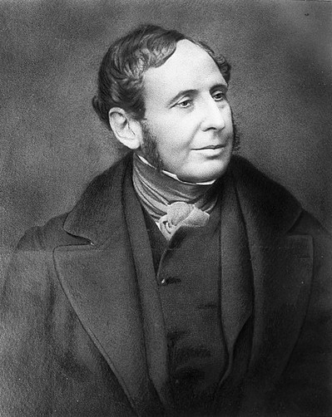

That's Fitzroy. Does he look like a doughty captain capable of rounding Cape Horn in winter? No, he looks like a doughy clergyman, waiting for his next shipment of port.
Here's another ridiculous claim. When Darwin was hired for the voyage, he signed on for two years. The voyage allegedly took almost five. Do you really think they took off with no plans and no schedule? Two years, five, what's the difference right, when you are on a rocking boat everyday throwing up overboard (as they admit Darwin did—seasick for five straight years—“one continual puke”). Never been on a ship before but he decides to start out with a five-year trip around the world at age 22! No women, no alcohol, terrible grub, but noblemen love that. He had always been a slacker up until age 22, but as soon as he got onboard this rich kid pulled it all together, because we all know that is just how rich kids are.
Plus, we find that the 1st expedition of the Beagle had taken five years, so why would they tell Darwin the second would take two?
This is also a clue: we are told Darwin sent back immediately via Admiralty Packet Service (Navy Mail) not only all specimens but all notes and journals. These went directly to his professor John Henslow at Cambridge, the one who had set up the trip. Hmmm. So would we know the difference if Henslow and Darwin faked the whole thing, Henslow writing most of it from Cambridge? Probably not. Though now I think we do know, after collating all this other evidence.
A similar clue: Fitzroy and others on the ship also made collections, but they were required to give them to the Admiralty, which sent them on to the British Museum. In other words, everything found was property of the Navy. But not with Darwin, who had demanded all his collections remain private. OK, but why would the Navy bow to that demand? Why should they? It was their ship and their crew. So how was Darwin the only “private” passenger on it? To me this is more sign of the fake.
Here's a clever coincidence, one worthy only of fiction. The other ship surveying the same region was the HMS Samarang, and do you want to guess who her captain was? Captain Paget. Another second cousin of Darwin. Samarang was an East India Company vessel.
Here we get another clue in the story. The ship's surgeon was Robert McCormick, another naturalist planning to send a collection back to England. But he soon got crossways with Fitzroy and was sent back to England on the HMS Tyne. But in those same weeks they tell us Darwin also got crossways with Fitzroy, arguing about slavery, the captain refusing to speak to him further. So possibly he made it past the Canaries and was sent back from Rio de Janeiro. His first crate allegedly was sent back in July, after seven months at sea, so it is possible that is real.
We can sure he didn't go any further than that, because the next story is off the map. In Buenos Aires Fitzroy was asked to help quell a mutiny of black troops at the garrison. He went ashore with 50 armed men, supposedly including Darwin! Darwin, fully armed with two pistols and a cutlass. No way that happened. Supposing something like that did happen, the captain would never let his “ship's philosopher”, who had probably never fired a pistol, join a military expedition. He would certainly be left on the ship.
In the next section we get more tall tales: Darwin allegedly rode inland with gauchos and watched them hunt rhea and armadillos with bolas. The next day he found the skull of a rhinoceros. Searching the cliffs along a river he almost immediately found a Mastodon bone with no digging. As you do. He found a fossilized armadillo and a modern horse's tooth in the same rock later. And so on. These sections are also stiff with the usual numerology. The gaucho thing just happened to be on August 8, and the mastodon story was October 1. Aces and eights, as usual. This allows me to backtrack a bit to his time at Edinburgh University and his membership in the Plinian Society.
In Darwin's second year at the university, he joined the Plinian Society, a student natural-history group featuring lively debates in which radical democratic students with materialistic views challenged orthodox religious concepts of science.
I remind you he was still 17 at the time, so this is as strange as the rest. The Plinian had just been founded two years earlier by the Baird brothers under the direction of Robert Jameson—who was himself a protege of John Walker. Think George Walker Bush. Walker was the founder of the Royal Society of Edinburgh, head of the Philosophical Society, and Moderator of the General Assembly of the Church of Scotland. In other words, a major spook. So it somewhat strange to see him Professor of Natural History at the University of Edinburgh for 24 years.
Or maybe not so strange. In all these positions he was busy de-Christianizing the Scottish Church, and again we can guess it was on the orders of the Dukes. We see the easiest proof of that in Walker's close colleague Dugald Stewart, whose parents were both Stewarts. These Stewarts are the Lords of Appin, closely related to the Campbells, Erskines, and MacKenzies. They are again cousins of the Liddells and Seymours we saw above, so it is all the same people. In fact, Walker was a Stewart himself, since his mother was a Morison and a Maitland, and the Maitlands are Stewarts by another name. Think actor Jimmy Stewart, full name James Maitland Stewart. The Morisons also link us to the Forbes and Gordons, giving us yet another duke here.
Walker and Stewart led what is called the Scottish Enlightenment, which we are seeing is not what it was sold as. Neither was Robert Jameson, who taught at the University of Edinburgh for 50 years. His mos famous idea was Neptunism, which says that all rocks were deposited from the primordial ocean.
It is of course wrong. But in the context of this paper, what is most strange is Jameson naming the society in Edinburgh the Plinian. That is after Pliny the Elder, a Roman and one of the first naturalists. He wrote Naturalis Historia in 77AD as one of the first encyclopedias of nature. It cataloged a lot of the current “science” at the time, but catalogs just as much myth and tall tale. Much of it reads like Ripley's Believe it or Not. So it is very curious these scientists in Edinburgh would want to name their society after Pliny. Pliny wasn't a scientist, he was a very wealthy admiral and general, a close friend of the Emperor Vespasian. Meaning . . . yes, a Phoenician. Which is why I think these guys really named the Plinian Society after him. It seems to me to be part of their “shells within shells” project of chaos creation, which is ongoing.
John Hutton Balfour joined the Plinian the year after Darwin, at age 19, and Hugh Falconer joined one year later, age 20. Balfour was of course a Balfour and a Hutton, of those noble families, his father being a publisher. The Balfours were closely related to the Hamiltons, Montgomeries, and of course the Stewarts. John Balfour was dean of the school of medicine at the University of Edinburgh and later became botanist for the Queen. The Falconers were also nobles, being related to the Innes and Grahams —which is why Hugh Falconer was groomed by Professor R. Graham in the school of botany. After university Falconer joined the East India Company, so you see the link between the Plinian and the EIC. He later became vice president of the Royal Society.
The reason I came back to the Plinian is that if you actually read Darwin's accounts of his travels on the Beagle—which almost no one has—much of it reads like Pliny's Naturalis Historia—which even fewer have read. It isn't quite that fanciful, but large parts do give you the feeling of something written by a cast of jokers back in Cambridge. As we saw with large parts of Newton, large parts of Darwin have been buried to maintain the facade, but scientists admit Darwin was wrong about many things. Not just wrong, but seemingly very confused or very creative. Or blind. I am not going to critique these journals now—I may do it later—but just be advised.

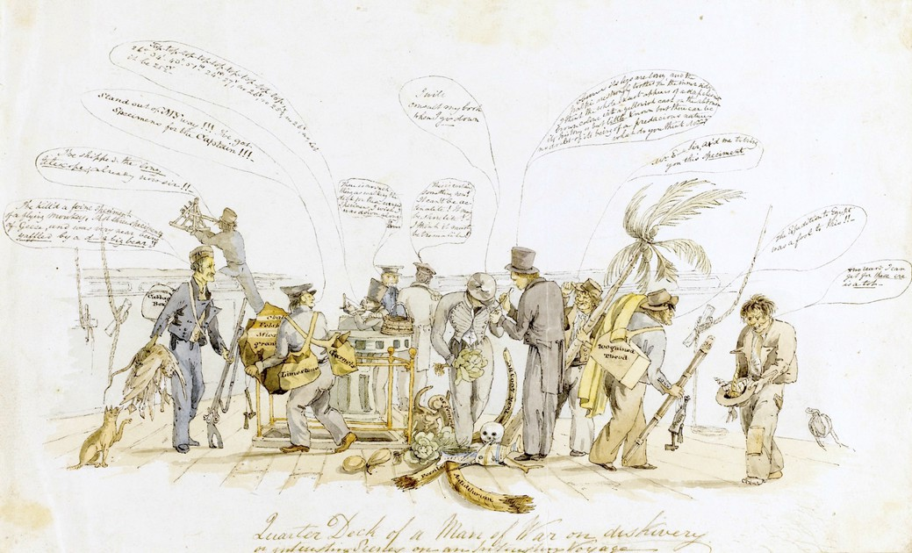

This cartoon said to be made onboard the Beagle by artist Augustus Earle seems to me to confirm the fraud. Darwin is said to be the guy in tails and a top hat, while Fitzroy is the guy in the middle with his face hidden, holding a big cabbage. Everything else is also a big joke, with Fitzroy standing on an elephant tusk labeled 4003BC—in other words year two of creation. Also in the pile are a bull's femur and a human skull. A bum to the right has a 200-guinea theodolite (a very expensive leveling tool) in one hand and a bottle of rum in the other. He is saying, “The expedition to Egypt was a fool to this”. In other words, nothing like the fraud this one is. Another bum has uprooted a palm tree. The one to the left is saying, “Stand out of my way, I have specimens for the captain”, but all he has bags of limestone, granite, and garnets. The one to the far left is carrying a cabbage box and some geese and is saying that he has killed five flying monkeys, three geese, and was nearly killed by a damned big bear. Darwin is showing the captain a bug, saying “It's legs are long, and the nalpi(?) are strongly toothed on the inner sides. I think the whole insect appears of a deep chestnut brown color with a yellowish cast on the abdomen. It's history is but little known, but there can be no doubt of it being of a predacious nature. What do you think?” The man at the back is saying, “There is no such thing as walking the deck for these cursed specimens. I wish I was down to Dover.” Strange that Wikipedia publishes this, but I guess they figure no one will blow it up and read it for sense. Why would they? No one has ever read anything for sense since the beginning of time.
Actually, the cartoon is labeled “Quarter Deck of a Man of War on discovery”. The Beagle wasn't a man of war and Darwin wasn't tall and skinny, so I doubt this is what they claim it is. None of the people are labelled. But if it is mislabelled then the only reason they would include it—despite it undermining the seriousness of the voyage—is as ballast for the Beagle story. They are desperate for outside confirmation of the story, so desperate they will print anything.
This is also a problem:

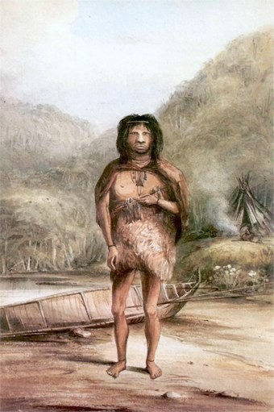

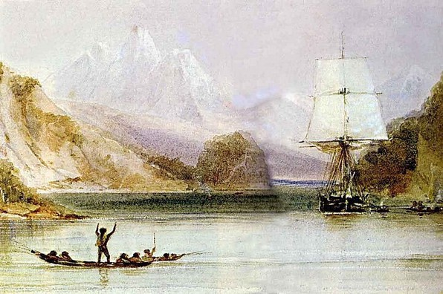

We are told those two paintings were done by the ship's artist Conrad Martens. Unfortunately, they don't match his style. He wasn't a great artist, but he was much better than that.

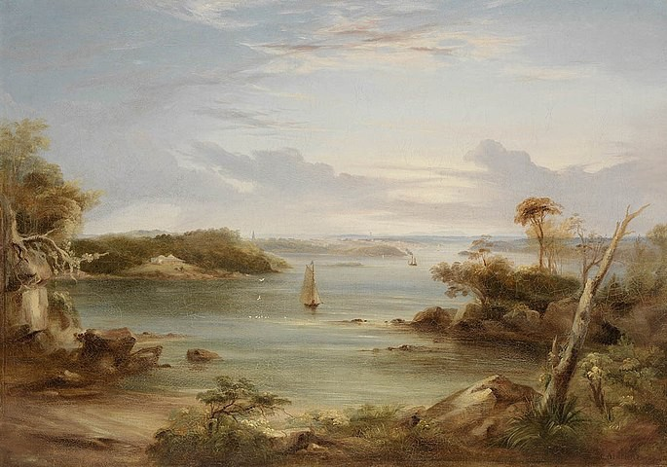

When Darwin is describing Galapagos, the description all reads curiously secondhand, and we are reminded that the Royal Navy, and the very same ship, had been there just a few years earlier, reporting the same things. Remember, this was the 2nd voyage of the Beagle, and the first also went to Galapagos. So it would have been very easy for the boys back in Cambridge to have faked this whole section. Regardless, you have to admit it is singular that the Beagle took very similar trips back to back, going to the same places. Why would they do that when there was still so much of the world to explore in the 1830s? I am not convinced they did.

Wikipedia admits in this section:
Darwin had learnt from Henslow about studying the geographical distribution of species, andparticularly of linked species on oceanic islands and nearby continents, so he endeavoured tocollect plants in fower. He found widespread "wretched-looking" thin scrub thickets of onlyten species and very few insects. Birds were remarkably unafraid of humans, and in his frstfeld note, he recorded that a mockingbird was similar to those he had seen on the continent.

Why is that strange? Because it tells us the theories Darwin is credited with already existed before him. And shouldn't those mockingbirds be dissimilar to those on the continent? Finding similar mockingbirds proves or suggests nothing. Again, the dates of these events is always some variation of aces and eights, with Darwin visiting Beagle Crater on Albemarle Island on October 1.

Oh, and this is embarrassing: on all these islands, Darwin thought he was finding grosbeaks, blackbirds, and finches, but they were all finches. Darwin couldn't tell a finch from a blackbird. Back to Beagle Crater. Searching on that, we find this at a NASA website:
one just has to look at his published work on the Geological Observations made during the Voyage of the Beagle and note that although he spent just one day here of the five weeks he was in the islands, he devoted over a third of its pages (36 in total) to a description of Tagus Cove and Beagle Crater.

What's odd about that? Well, it tells us he wrote almost nothing during the other 34 days there. 63 pages in 34 days, or less than two a day, and these are notebook pages, not PDF pages like mine.

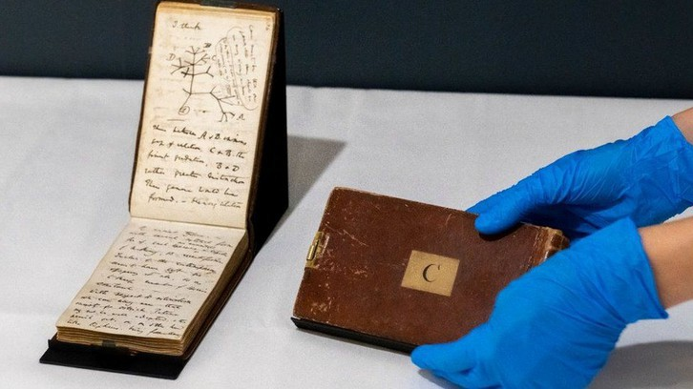

I bet you are shocked. Yeah, so was I. Darwin actually had almost nothing to say about the islands. I would fill a hundred pages a day, but Darwin filled a hundred of those little pages in five weeks.

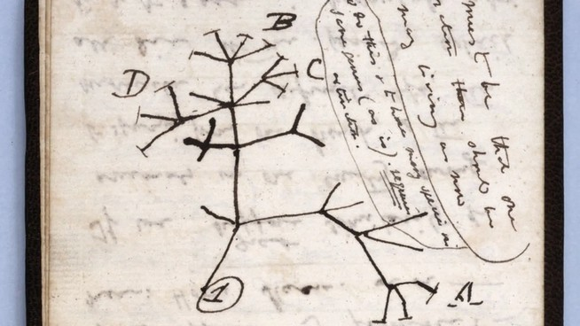

That particular notebook is famous for containing Darwin's famous tree of life drawing, which you see there in all its glory. Brilliant right? Who wouldn't read genius from that? I am publishing detailed drawings of the Ammonia molecule this week, which the mainstream will continue to pretend do not exist, while that illegible doodle is worth millions.
The guy at NASA also admits this:
Aside from his words, copius as they may be, there is no record illustrating Darwin’s visit toBeagle Crater.
36 pages in that little journal is not copious, but they admit that the only proof Darwin was there is the notebook. No one else in the party wrote about it and the locals never mentioned it.
Here's something else we learn from reading the history of the time. Dozens and dozens of other “gentlemen naturalists” were busy in those years, so many the specimens were stacking up all over the country, overflowing the museums and filling sheds and warehouses. Many were being neglected, since there wasn't room for them. So there was really no need for Darwin to have bothered with his own five-year voyage, which was quite dangerous, especially that rounding the Horn in winter business. All he needed to do is use his Daddy's money to buy up a bunch of neglected collections from other gentlemen naturalists, who were already on edge about their collections getting trashed or eaten by bugs. Most of them admit they were in it for the money—see comments about McCormick in the Beagle literature. We touched on him above. They would be easy to buy off, and for the right price they would keep silent to the grave. We are about to see Wallace take an inexplicable dive for Darwin, and other lesser “scientists” would no doubt fold for even lower prices.
British zoologists at the time had a huge backlog of work, due to natural history collecting being encouraged throughout the British Empire, and there was a danger of specimens just being left in storage.[80]
Suggestive, ain't it, especially in light of what we have just discovered.
Unlike the other gentlemen naturalists whose specimens were rotting in storage, Darwin's specimens in all categories were immediately snapped up by top people all over Britain, with Darwin himself being feted as a celebrity at age 27. So why was Darwin being so noisily promoted while everyone else was being ignored? We now know it was because he was a Stuart, but it was more than that. He was a project, and all these other people like Lyell, Henslow, Gould and Owen were in on it. So were the Dukes, who we have seen were pulling the strings behind this whole thing. The Treasury itself got involved, investing £120,000 in the Darwin project.
We have long been told Darwin developed angina and other problems due to stress in this period, and they try to pass that off as overwork. But can think of other reasons. I remind you of Neil Armstrong, who went totally off the beam on his return, supposedly due to stress. But we now know it wasn't due to the stress of fame. It was due to the stress of being feted for a fraud.
For the rest of his life, he was repeatedly incapacitated with episodes of stomach pains, vomiting, severe boils, palpitations, trembling and other symptoms, particularly during times of stress, such as attending meetings or making social visits. The cause of Darwin's illness remained unknown, and attempts at treatment had only ephemeral success.
Can you see what is right in front of you? He can't have been overworked, since in the middle of all his post-Beagle work, he presented a paper on earthworms and soil formation that had been suggested by his uncle Josiah at the Geographical Society. It makes no sense that he would have time to do that in November of 1837, if everything we are told was true.
Darwin soon added to that his new position as Secretary of the Geographical Society. How could he possibly take that on on top of his publishing work, lecturing, cataloging, and pursuing his theory of transmutation? It only makes sense if he wasn't doing any of that. All the writing, editing, cataloging, publishing, and theorizing was being done by others behind the scenes, while Darwin drove around collecting awards for sailing to Tenerife and back.

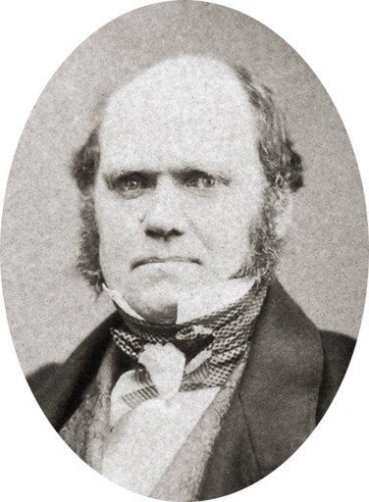

Next we find Darwin the hopeless romantic:
Used to jotting down daily notes on animal breeding, he scrawled rambling thoughts about marriage, career and prospects on two scraps of paper, one with columns headed "Marry" and "Not Marry". Advantages under "Marry" included "constant companion and a friend in old age ... better than a dog anyhow", against points such as "less money for books" and "terrible loss of time". [101]

And he kept that? And it was found upon his death? Oh. . . My . . . God. Reminds me of the Friends episode where Ross makes a list comparing Rachel to Julie. He says that Rachel is a bit spoiled. Chandler suggests Rachel's ankles are little chubby and they add that to the list. Rachel sees the list and goes nuclear. So I am guessing Darwin's wife never read this comparing her to a dog. At least Ross didn't say that Rachel was “better than a dog anyhow”.
Looks like I will need a part 2 here. Stay tuned. I am going to comment on his journals after all, for one thing.

*A reader who went to Cambridge sent me this, which I found very interesting and I am sure you will too:

I fnd it very strange that Cambridge allowed Darwin to study Greek out of residence in Michaelmasterm, only to arrive in Cambridge for Lent term.

I think there was a requirement to stay in residenceduring terms there, though terms were and still are only 8 weeks, and so one has rather long holidays.Every undergrad student at Cambridge is very closely followed up each term, and the assignedsupervisor in each subject writes an end-of-term report on each of the students they supervised for thestudent’s Director of Studies to read. Absences and lack of submission of homework are reported up thesystem by the supervisors, and so the type of arrangement that Darwin supposedly had sounds verystrange. One can still not transfer credit to Cambridge, at least not when I attended [about 20 yearsago]. I would have been interested in that as I had already spent one year at university before arriving in Cambridge. My place at Cambridge was even conditional on performing to a certain standard in myuniversity exams and taking enough credits during my frst year in university back home. Still, Cambridge would give me no credit for the university courses I had already completed, even thoughsome of them were relevant and overlapping with their courses. That Darwin lived out of collegebecause it was full seems a bit odd. Cambridge colleges usually have a housing guarantee for theirundergrads, and Darwin was supposedly admitted to Christ’s college on October 15th 1827, which is around the start of Michaelmas term. They would then have allocated a room for him, or he could havebeen given in a room in another college that had a spare. Many of the older college rooms are also grand,easily accommodating two students. I once stayed in the B&B at St. John’s College in Cambridgetogether with my family. One of the 4 rooms we had was the size of a living room. My uncle complainedthat his room was haunted, but it was a very nice experience. Just look at how large Darwin’s supposedroom at Christ’s was. I fnd it very hard to believe that there was no place in any of the Cambridgecolleges for Darwin.

There are very good reasons for students to live in Cambridge colleges, and most undergrads live incollege at Cambridge, especially in their frst year. Cambridge colleges provide all meals, cleaning ofstudent rooms, formal dinners and more facilities, social clubs and events than any other university Ihave been to. I would presume all these aspects of Cambridge are very old traditions as everything is oldat Cambridge. The dining halls in Cambridge date back to the medieval age, and so one may assumestudents had the opportunity to eat all meals in them back to the Middle Ages. I was once at a candlelight dinner in the dining hall at Queens college, which was an event organized by the Oxford-Cambridge Scandinavian society. Apparently, they have no electric lights in this medieval dining hall and had torely on candle lights. Very cozy but also very dim.

All colleges have a library, and these are often very old, such as the one at Trinity. There was never any need for buying any books as the college librarywould stock curriculum books and most other books could be ordered from one of the other college ordepartmental libraries or from the university library, if needed. Most colleges also have their own chapels and large gardens that are maintained by gardeners. Even my college had tennis andbasketball courts as well as a pleasant garden. In addition, my college had a library, gym, newspaper room, snooker and TV room, reading and studying room, computer room, large hall for lecture/gathering/party/event, large room with bar, lounge and dancing area, two dining halls and someauditoriums and seminar rooms. From my window and across a wall outside, I could always hearsplashing in the summer because some college had grounds there and the students were bathing in acollege swimming pool. This wasn’t the pool at Christ’s that I heard, but Christ College had a swimming pool already in the 17th century.
‘
Don’t know which college owned the nearby land. One would often see that colleges had land in other areas than where the college was placed, and they often used such areas as sports felds. For some (maybe most) students, the social calendar at Cambridge outgrew their academic one and they had little time for studying.

I think students hardly ever left college for clubs or pubs in town as the college was a microcosmos with so many different facilities and activities that evena shy person like me and other individuals with limited social skills could fnd ways of socializing. Thecolleges all had their own bar and “clubbing” area, and if one needed more people, one just invited the next-door college.

Our neighbor college was an all-girls college, and they always invited my college overfor parties. The only people who lived out of college were more mature students who were about to be kicked out of college because they had overstayed their guaranteed housing time. Some students withfamilies may have opted to live out of college, but the colleges usually also provided family accommodation. I suppose during Darwin’s time that girls were not allowed to attend most Cambridge colleges, and so the partying may have had a different character, but I would guess they found ways of socializing with girls during those times as well.

One may fnd it strange that Cambridge colleges have space to accommodate all their students and all the different buildings like libraries, dining halls and chapels as well as gardens and sports grounds. However, this becomes more understandable when one realizes that Cambridge (and Oxford) colleges are some of the biggest landowners in Britain, and so they have more than enough land to place all their buildings.

The main difference between Oxford and Cambridge colleges is that Cambridge colleges have much larger grounds in central Cambridge since there was no sizable town there when the university was frst build. That one of the biggest landownersin Britain should not fnd space to accommodate Darwin does not make much sense to me. The Tobacconists of the time of Darwin were probably renting space from the biggest local landowner in town, which would have been the university. [So there is an almost invisible contradiction there.]

DARWIN Chapter II

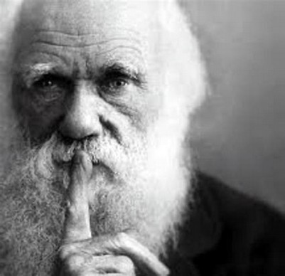

by Miles Mathis

First written February 14, 2024

In part I, we saw me go from “Darwin wasn't a fraud” in the first paragraph, to the discovery after a few pages that yes, indeed he was. A complete and utter fraud, one that almost certainly faked most or all of his journey around the world. Here I will compile a lot more evidence of that, most of it from his own journals.

We get the first hint of it before page 1, because University College, London, genetics professor Steve Jones gives us a big clue in his introduction [The Voyage of the Beagle, Random House Modern Library edition]:
It is also a monument of English literature. Darwin took Paradise Lost as well as The Principles of Geology as a literary companion, and it shows.
Yes, it does, which is very suspicious. The writing style is way too good for a 22-year-old slacker student who didn't even qualify for the Tripos and whose writing up to then—from his letters, for instance—showed no special facility with the English language. We have to ask, when and where did he learn to write like this?

Clearly, those who actually wrote this considered it more important to make the journals readable and “literary” than to make them believable or consistent. As we have seen many times when studying these people, they have no concern for continuity, much less for plausibility, since they know their readers don't notice contradictions and will believe anything fed to them from a mainstream institution.

Before we move on, something in that introduction pushed me into Captain Fitzroy's bio again, which is just as fishy as Darwin's. Jones reminds us that Fitzroy slit his own throat at age 59, dying by suicide like his predecessor as captain of the Beagle, Pringle Stokes. That led me to Fitzroy's Wiki page, where we find this:

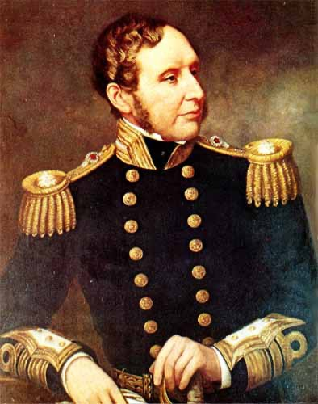
Artist unknown, which makes no sense. A portrait like that would certainly be signed. But as a portrait painter myself, I can tell you that portrait is almost certainly a fraud as well. It looks like something pieced together by a semi-amateur 20th century painter from photos. It doesn't have the style of that period and the brushwork is very clumsy. The background is atrocious. My guess is we could find the photo he used for the head without much work.
The first paragraph at Wiki claims Fitzroy, as governor of New Zealand, “tried to protect the Maori from illegal land sales claimed by British settlers”. And you believe that? This is the same Fitzroy who argued FOR slavery against Darwin when they were on the Beagle, and had zero regard for the natives of South America. He is famous for kidnapping natives in Tierra del Fuego and using them as hostages. One of these natives died of a smallpox vaccination—which interests us in regards to current events, doesn't it?

Also suspicious is that we are told Fitzroy died broke. The usual sob story. A famous vice-admiral of the Stuart family, grandson in direct line of the King, but he “exhausted” almost a million dollars on his way out. On what? Booze, hookers, and lottery tickets? We are told only it was “on public expenditure”, making us believe, I suppose, that he gave too much to the Meteorological Society or the Save the Maori Fund. Somehow his friends soon raised about half a million dollars (current numbers) for his family and they were allowed to live for free at Hampton Court:

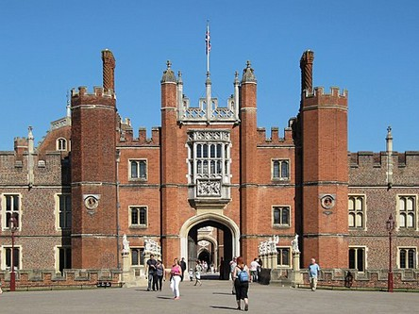
The Stuarts were too big to fail, I guess. Sounds like the usual Phoenician fraud we have seen a hundred times: fake insolvency so that you can be bailed out by the treasury.

Fitzroy's uncle the 2nd Marquess of Londonderry, Robert Stewart, also allegedly slit his own throat, at age 53. He had been Secretary of State and Leader of the House of Commons, showing you just how high up Fitzroy was—in case you still haven't gotten it. This uncle of his, known as Lord Castlereagh, was such a fascist even his colleagues were repulsed by him, and that is saying a lot among the Phoenicians. For example, the poet Percy Shelley was a major opponent of Castlereagh, mentioning him as a murderer in The Masque of Anarchy. Castlereagh had been involved in the Peterloo Massacre, for instance. . . though that may have been faked or provocateured—like our own January 6. 18 people allegedly died, the usual aces and eights, Chai. We now know the point of the fake event was to pass the repressive Six Acts of 1819, which banned any meetings by critics of Parliament. Sound familiar? They didn't have Facebook, Twitter, Youtube, or Google back then, so this is how it was done in the old days. That's Castlereagh.

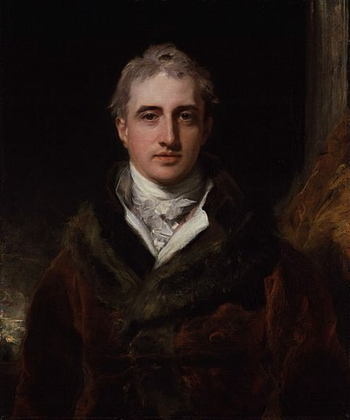
But it wasn't being called out as a fascist that brought Castlereagh down. Can you guess what it was? Think Rudolph Valentino. Castlereagh was being blackmailed by his homosexual lover, and that is admitted at Wiki.

That's Castlereagh. If you didn't follow my critique of Fitzroy's portrait above, compare it to that one. Notice how much better the skintones are. Look at the lovely quality of light, giving us those soft shadows which accentuate the roundness of the face and the three-dimensionality of the head. Look at the dark background which still has a depth, with the warm brown to the right and some blue in the distance to the left. Look at the way the white linen is painted. Look how soft the fur seems. And we know who painted this: Thomas Lawrence, the greatest portraitist of his time. This is actually not one of Lawrence's best, but it still serves to show what is wrong with the portrait of Fitzroy.

Anyway, like Valentino, Castlereagh may have faked his death to get out of the limelight and avoid any more steep payments. You can't blackmail a dead guy, even if he isn't dead. Which means Fitzroy may also have faked his death. Remember, cutting your own throat isn't a very good way to commit suicide. If you prefer blades to poisons, it is much less gruesome, messy, and difficult to open a vein in your wrist in the bathtub, under water, and go out that way. Plus, we know these people love to fake their deaths. They like nothing better, other than stealing from Gentiles.

More indication of a fake is that Castlereagh was allegedly buried at Westminster Abbey. Suicides aren't allowed burial there, since suicide is a mortal crime. We are told that felo de se was no longer followed in the early 1800s, but that was a matter of state, where property would no longer be forfeit to the crown, with a finding of insanity instead. But burial at Westminster Abbey wasn't a matter of state, since the Abbey is a church. In 1820 the Anglican Church had the same rules as the Catholic Church regarding suicides. In fact, they only just changed them in 2015. Of course the same analysis applies to Fitzroy, who is said to be buried at All Saints Church, Upper Norwood. That shouldn't have been possible, indicating a fake death. According to church law, sodomy should also have kept them out of such burials, but of course no official finding of sodomy was found for either man, while an official finding of suicide was found.
Yes, reading Fitzroy's Wiki page and Jones' introduction now suggests to me a further reading of the Darwin story: they admit Darwin actually wasn't the ship's naturalist, that being the ship's surgeon McCormick. Darwin was taken along as Fitzroy's gentleman companion. Hmmm. I guess you are seeing where I am going already. This would explain why in his decision whether or not to marry, Darwin thought of a woman as little better than a dog.

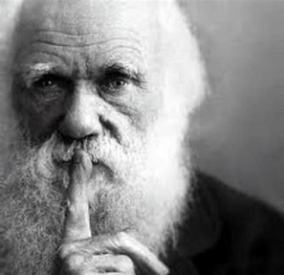

And like Darwin, Fitzroy also married his first cousin, Isabella Smyth. This is the way the gay Phoenicians do it, as I said in part I. No one else of the opposite sex wants to marry them, for obvious reasons. So they pair up the gay men with their lesbian cousins. Same thing they still do in Hollywood.

Does that mean I think Darwin actually went on this trip? No, as I said in part I, I think he may have gone to Bahia or Rio, but there is no way this ship went around the Horn in winter or around the world. They admit it was a coastal ship, meaning a ship only seaworthy enough to hug the coasts or perhaps sail across the central Atlantic in summer. It would not have been taken round the Horn or across the Pacific. Which means he didn't go to Galapagos.
But back to the journals. Fitzroy's Beagle journals took three years to compile and publish after his return, and Darwin's even longer. Why the three-year delay with Darwin and Fitzroy? These are journals: already written. All they have to do is be typeset. The work of a few months, and the work of a publisher, not of the author. Darwin had already written them, so what was there for him to do further, other than to OK some minor edits for readability? The three-year delay again indicates some kind of fraud. It tells me the journals had to be faked by some committee somewhere, though I don't see why they couldn't have been working on it during the five years it was allegedly happening. Apparently the project didn't really hit full steam until several years after we thought it did.
Except that, looking more closely, we find The Voyage of the Beagle isn't the publication of Darwin's journals or notebooks, kept on the voyage, as most would assume. As I assumed on my previous reading long ago. No, as Darwin admits in his preface, it was written after the voyage, “in the form of a journal”. Meaning? Meaning it is actually a memoir, not a journal. You will say that accounts for its slick form: Darwin had learned to write beautifully some time between 1831 and 1837, when he began writing this memoir. Possibly, but I hope you see that is unlikely, since—according to the timeline published—he was at sea for the first five of those six years, and busy with a thousand projects when he returned. He was not taking a series of creative writing courses onboard the Beagle, nor from 1836 to 1837.

You will say there are other ways for a man to learn to write other than creative writing courses. That's true. I myself never took any courses. I learned to write by reading and writing A LOT. But Darwin wasn't writing a lot on the Beagle. And what he was writing wasn't polished prose, it was jottings in his notebooks. So we still don't have any way to explain the form of these memoirs. You will say, “Maybe he had a ghostwriter or a committee of them, taking dictation. That isn't a crime.” No, it isn't a crime, but we should be told that if he did. It is a highly suspicious omission, at best. But I don't think that is what happened here. I don't think this memoir is ghostwritten because I don't think the story came from Darwin. It was compiled by some committee at Cambridge from various other sources, with Darwin—our Stuart for the nonce—planted as a front. I am already sure of it from just the introduction, preface, and first few pages, so prepare yourself for the usual Mathis blasting down to bare ground.

Amazingly, Darwin himself tells us who was on this committee behind him in his preface:

but I trust that naturalists will remember, that they must refer for details to the larger publications which comprise the scientifc results of the Expedition. The Zoology of the Voyage of the Beagle includes an account of the Fossil Mammalia, by Professor Owen; of theLiving Mammalia, by Mr. Waterhouse; of the Birds, by Mr. Gould; of the Fish, by ReverendJenyns; and of the Reptiles, by Mr. Bell.

So Darwin had a big hometeam back in Cambridge, as I said. None of those guys took any trip around the world. They weren't on the Beagle, so why are they here? You will say they studied and made reports on Darwin's specimens sent back, which again is no crime. No, it isn't a crime, but it again arouses huge suspicion given what we have already discovered. That is because it would be very easy for Darwin's writing team to have back-manufactured this memoir from the work of these guys, collating it with the published notes of Fitzroy. You will say I have argued Fitzroy also did not go round the Horn. True, but others had, and those reports were known. If Darwin was such a felicitous writer, he should have been able to crank these memoirs out, using his own notes as reference, in a matter of months. He should quote extensively from his notes, simply expanding them with further commentary. That is what you or I or anyone else would have done. But that isn't what we find. Instead we find him waiting until after Fitzroy and all these real scientists had done their work, letting his memory fade for two years, then providing this polished story that magically brings them altogether.

Plus, we can return to the introduction by Steve Jones, which I already quoted above, where Jones says Darwin took Paradise Lost on his trip, explaining why the <journal> is “a monument of English literature”. But surely that implies Darwin wrote it on his trip, which we now find he didn't. Making Jones part of this conjob.
You would expect Darwin's <journal> to be illustrated by his own cute and naive drawings, allegedly worth millions. But they aren't. Opposite page one we find a professional etching of a Galapagos lizard. No artist or source is given, which is again strange. It seems they want you think it came from the journal, as if Darwin himself drew it.

OK, just read the first chapter very closely, which is 15 pages. It takes us from England to Rio and covers about 14 weeks. Which comes out to about one page per week. Upon graduation, Darwin was all excited planning a trip to Tenerife, but now he has gone to the Canaries as well as Cape Verde and Bahia, but only has 15 pages over 14 weeks? You or I at age 22 on such a voyage would have written 15 pages every day we were on or near land, in our excitement. We would double that by added commentary in a memoir six years later. But clearly Darwin's writing committee isn't as excited by those first weeks as you or I or Darwin would have been. Why? Because that part of the journey is old hat for them. These guys are seasoned writers and scientists for whom these little islands are a big yawn.

Even when they get to Bahia they can't get up the energy to fake this in a believable fashion. There Darwin admits he took his first trip into a rainforest, but he tells us nothing but that he did. Here is what he says about that, in toto:

The elegance of the grasses, the novelty of the parasitical plants, the beauty of the fowers, theglossy green of the foliage, but above all the general luxuriance of the vegetation, flled me withadmiration. A most paradoxical mixture of sound and silence pervades the shady parts of the wood. The noise from the insects is so loud that it may be heard even in a vessel anchored severalhundred yards from the shore; yet within the recesses of the forest a universal silence appears toreign. To a person fond of natural history, such as day as this brings with it a deeper pleasure thanhe can ever hope to experience again. After wandering about for some hours, I returned to the landing place . . . . [p. 12]

Wow, is that what you would write about your first day in a rainforest? Bland generalities and empty platitudes? There is nothing specific there. Anyone could have written that. Siri could have written that after reading the page on “Brazilian rainforest” at Britannica. The glossy green of the foliage? You have to be kidding me! Is this what Steve Jones considers a monument of English literature? Yes, whoever wrote that has a limpid pen, but he wasn't in that rainforest on that day, or likely ever. I have never been in a rainforest, but I could make up something better than that, just by naming some of the actual plants and animals known to be there. Darwin, supposedly the great beetle lover, didn't see any of the thousands of species of beetles in that rainforest? Ones he had never seen before? All he saw was the elegance of the grasses. Darwin hadn't been reading Milton: apparently he had been reading Walt Whitman twenty years in the future.

The whole first chapter reads like this, and we don't get any impression Darwin wrote it, or the notes it is based on. None of it mirrors any of Darwin's known interests; instead it mirrors the interests of those actually writing this—the discoloration of sea and rocks by organic and mineral causes, Atlantic dust from the Sahara and other sources, rock strata, and so on. It doesn't read like the journal of a 22-year­old, or the memoirs of a 27-year-old, either. As you see from the last quote, it reads like a project. Once you look for it, it becomes very obvious.

Let's skip ahead to chapter XI, to see what they have to say about rounding the Horn in winter. Remember, we saw that Wikipedia completely skips over this part of the trip. They have an entire very long page on the 2nd voyage of the Beagle, but this is all they say about passing the straits of Magellan:
Beagle and Adventure now surveyed the Straits of Magellan before sailing north up the west coast . . .

Wow did they rush by that! I wonder why?

Sure enough, the <journal> confirms the Beagle allegedly entered the eastern end of the straits of Magellan at the end of May, 1834. So they didn't technically “round the Horn”.* They rounded South America. But the straits are almost as dangerous as the open ocean in June, which is like December in the northern hemisphere. That's where they get the term “dire straits”, you know. There is a similar term going back to Homer and others, referring to the straits of Gibraltar, but the straits of Magellan are far more dangerous, and the current phrase was popularized in the 1700s when ships began taking that route more often. Regardless, there was no reason to round anything in June, since Darwin admits they were already there the first time six months earlier in January, when they could have rounded South America in summer. Instead they waited six months so they could do it in winter. Brilliant. Except that we know it didn't happen.

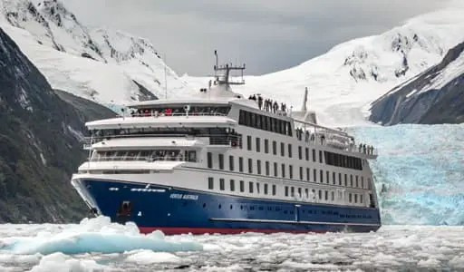

That's from a site on tourism in the straits. Yes, it looks like a paste-up, but it serves to remind you there is ice in the water there in winter. During global warming. Just so you know, the Straits of
Magellan are extremely far south, being at about 54 degrees south latitude, which is similar to Juneau, Alaska, at 58 degrees north. Or, if you are in Europe, think Moscow in winter. And it is actually colder in the south than in the north. The Antarctic is colder than the Arctic. As I have shown in my science papers, this is because there is more charge/EM activity in the south, EM having a reverse effect at the poles to the effect it has at the equator. So when reading this chapter of the Beagle rounding the continent in June, you should be thinking Alaska in December. Except that the straits are far stormier in June than Alaska is in December, with winds so high they would rip that little sardine-can Beagle to shreds. The Captain wouldn't have to kill himself since the gods of the sea would soon put the whole crew in a watery grave.

Again, the narrative makes no sense, since the 28-year-old Fitzroy is in no hurry to get around the continent before it gets even colder. Darwin says they instead landed and hobnobbed amiably with the tall Patagonians as if it were high summer. These hidden authors do realize it isn't summer in June down there, right? I find the stupidity here as shocking as anything I have come across: they either don't know it or figure their readers won't know it, so they can say whatever they wish.

Actually, on the next page Darwin admits it was the beginning of winter, with snow on the ground. He says they met a couple of sailors who had run off a sealing ship, and that these “vagabonds” had somehow survived outside the “incessant gales, with rain, sleet, and snow”. Hmmm. So how did the little “unseaworthy” Beagle survive the incessant gales at sea? Darwin skips right over it. You would think they never saw a squall.

They don't just stop a few hours to gather food, water, and bearskins before moving on in haste; Darwin the gentleman's companion says they leisurely surveyed the place as usual, and he lists the flora and fauna of the area, including his beloved beetles. In fact, they spent eight days in Port Famine, allegedly firing the cannon over the heads of Natives and other fine deeds. But again, Darwin's reports have an academic second-hand feel to them, and what he tells us of the flora and fauna of Tierra del Fuego is textbook stuff, not firsthand accounts.

According to Darwin they passed the straits in just four days of sailing. Two days to Port Famine and two days from there. They weighed anchor the morning of June 8th from Port Famine, and in the morning of June 10th “entered the open Pacific” [p. 215]. One little problem: the straits of Magellan are 350 miles long, and Port Famine is actually less than halfway coming from the east. So they allegedly sailed almost 200 miles in two days. Second little problem, the currents and winds would have been against them:
for the currents and the prevailing winds run west to east. And they do run. If the tides are wrong, the currents can run eight to ten knots, and Magellan’s vessels could, at the very best, make about twelve. In a word, Magellan would have to tack the length of the strait against the wind and currents, and at this narrowest point he had to set his tack such that he would not have to switch back, for there’s not enough room. Negotiating the strait in a sailing vessel with no auxiliary power is a superb feat of seamanship.

Like Magellan, Darwin was in a big wooden sailboat, so that also applies to the Beagle. Tacking means the ship had to zigzag into the wind, making the total distance travelled much longer. Something like 40% longer, taking the distance up to 140 miles per day. So at around five mph above the speed of the current in its face, that would mean the Beagle sailed how many hours per day? Answer: 28 hours per day. The Beagle had to sail 28 hours per day for two days to travel 280 miles at 5mph.

Which brings us to problem number three. Darwin admits it was dark 14 hours a day in winter there, but it is even worse than that, since that includes twilight hours with the day. It is actually light in mid­winter at that latitude only about 7.5 hours. The rest of the time they would be sailing in the dark or dusk. Which you can't do tacking into the wind and current in the straits of Magellan in a 90ft ship. The route is so curvy, foggy, and dangerous it now has 41 lighthouses to guide ships, but of course in the time of Darwin there were none. No lights onshore at all, which means they couldn't sail at night.

Which brings us to problem number four. From the photo above, we see there may have been ice in the straits, which would have slowed them even more. The Beagle was not an icebreaker, which is just another reason they should never have been there in the winter in an “unseaworthy” wooden boat. They should have only been able to sail about 40 miles per day, which means it should have taken them about a week to enter the Pacific from Port Famine. For comparison, it took Magellan 38 days to make the trip through the straits—but he did it in late spring (November).

You will tell me the Beagle was faster than Magellan's ships, since it was smaller and more maneuverable. No. Actually Magellan's ships were smaller, the Victoria being a carrack of about 70 ft.
Which reminds us of something else: Magellan went through with four ships, while the Beagle was alone, except for possibly a schooner Fitzroy had bought which he named the Adventure. A schooner is even smaller than a brig, but we aren't told much about this Adventure, for what we are now seeing are obvious reasons: it didn't exist. It seems to have been added to the story just to add another layer of misdirection. On the 1st voyage of the Beagle in 1826-30, she was allegedly accompanied by the HMS Adventure under captain Phillip King. But even there we find mystery, since the HMS Adventure was originally the HMS Aid. We aren't told why the name was changed, but a little study tells us why. She was built as a storeship, one of six built during the Napoleonic wars, in their own class, and as such she was larger than the Beagle by about 15 feet. As a storeship she had a very large depth of hold, at over 17 feet, making her a terrible choice for a round-the-world journey, or even a journey through the straits of Magellan. They obviously renamed her in hopes of hiding this information.

As for this schooner Adventure on the 2nd voyage, she looks like a ghost dreamed up by the writers to at least make it appear the Beagle had some back-up in her passage of the straits. The story was already stupid enough as it was, but the Beagle going through alone made it twice as stupid. So they made up this part about Fitzroy buying some schooner in the Falklands, fitting it with a new copper bottom, sailing it through the straits with the Beagle, then being forced by the Navy to sell it when they found out. That story makes absolutely no sense, since the Admiralty would have had to give permission for the purchase to start with. They would have had to assign a captain and so on, since this was a naval expedition, not some Stuart boating party. And guess what, Darwin doesn't mention this Adventure once in his <journal>. Whenever he says “we sailed” after January 1833, he mentions the Beagle alone. There is one occurrence of the Adventure in these chapters, but it is the HMS Adventure of the 1st voyage, not the schooner of the 2nd voyage.
All this about the Straits of Magellan leads me to return to the story of the Bounty, which of course I have also destroyed. If you will remember, the Bounty—another small unseaworthy vessel of the same class and size as the Beagle—also tried to round the Horn east-to-west about 40 years earlier, allegedly being turned back by gale-force winds in its face. What we forgot to ask there is this: why was the Bounty trying to round the Horn at all? Why didn't it try to go through the Straits of Magellan? In 1789, as in 1834, the Straits would have been the preferred choice for any vessel of this class. There was absolutely no reason for the Bounty to risk the Horn, especially in April, which was autumn there.

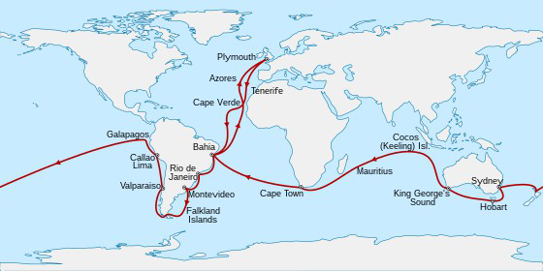

Here's another big problem: The Beagle allegedly left Galapagos on October 20, 1835. It had left England on December 27, 1831. It would be home on October 2, 1836. So that is almost four years out and one year back.

But I remind you the return trip was much much farther than the trip out to Galapagos. It was roughly 2.5 times farther, but they did it four times as fast, which means they returned ten times as fast as they went out. As you see, they went farther than around the entire Earth in less than one year in that little ship, moving against most currents and against the trade routes. The trade routes ran west to east for a reason: the trade winds also moved that way. So as in the Straits of Magellan, the Beagle would have been tacking into the wind for most of that year. And there was no reason to go west from Galapagos to Australia, since in its third voyage in 1836 the Beagle would be going directly to Australia to check the chronometer readings.

These chronometers appear to be yet another red herring, since Wikipedia admits in its section on the 3rd voyage of the Beagle that Captain John Lort Stokes forgets to mention them in his <journal>:
Other than mentioning that he carried a pocket chronometer by French which gave good results, Stokes' account of the voyage does not list or even enumerate the chronometers.[note 3][47] It may be that chronometers were now so commonplace that their use was no longer something of note.

Whoops! This after being told by the fake historians that all three voyages of the Beagle were mainly to confirm longitude readings by these chronometers. Also, they seem to be recycling names. I remind you the captain of the 1st voyage was also a Stokes. Pringle Stokes. As usual, they just say, “no relation”. This second Stokes allegedly shared Darwin's cabin aboard the Beagle on the 2nd voyage, being an assistant surveyor at age 20. He had previously been on the 1st voyage as well, as a 13 year old. So more malarky. In 1836, at age 25, he was promoted from assistant surveyor to lieutenant and made first officer for the Beagle's 3rd voyage. Five years he later took over the captaincy of the Beagle in Australia when Commander John Wickham fell ill. As any Navy man will tell you, none of that makes any sense either. If we go to Wickham's page, we find this great “portrait”:

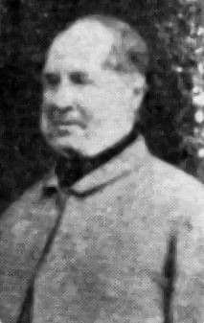

Here's an even better one of him as captain:

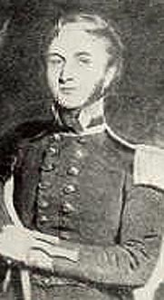

He joined the Navy at age 13 and was a midshipman by age 16. He passed his Lieutenant's examination at age 20. He was second lieutenant on the HMS Adventure during the 1st voyage of the Beagle, and was Fitzroy's First Lieutenant on the 2nd voyage. He was either Commander or Captain of the Beagle on its 3rd voyage, but retired from the Navy at age 42 for ill health and became the police magistrate of New South Wales. Strange that NSW would hire a sick person for the police force at age 42.

As for Captain Stokes, he retired at age 52 but according to Wiki was nonetheless promoted to rear admiral that year, vice admiral at age 60, and full admiral at age 66. That also makes no sense, since you can't be promoted after you have retired. I have not noticed that Darwin mentions any of these people in his <journal>, although allegedly bunking with Stokes. I finally thought to go to gutenberg.org, where this journal is printed in full, allowing me to word-search it. A Mr. Stokes is mentioned four times, but never as a surveyor or cabin mate. A Mr. Wickham is mentioned once, but not as First Lieutenant of the vessel. He answers something to a commanding officer, but the only commanding officer of the First Lieutenant would be the Captain, unless there was some kind of First Mate outranking him, but in either case Darwin would just have said the Captain Fitzroy or the First Mate X. So again this is more proof of the hoax.

So I would say the 2nd voyage of the Beagle has now been proved to be a myth. I could continue beating this horse, but it is already so dead it is fossilized. We could carbon-date it. It has joined the Titanic fake story in Davy Jones' locker.

It looks like there will be a part III, since I haven't even got Darwin up to age 30. But I may take a break and come back to it, since I am feeling especially slimed by this entire project. I didn't see it coming in so it took me somewhat by surprise. I knew there was dirt on Darwin, but nothing like this.

*The Beagle did allegedly round the Horn, but according to this <journal> it was in December of 1832, not the summer of 1834. They hit the Horn on December 21st but were forced back by gale winds. They hid in a cove for several days then tried again on December 30, when they made it around to York Minster. They were tossed around for almost two weeks and almost capsized on January 13th, causing them to retreat. And that was in mid­summer!

We also find this at Wikipedia, on the page for chronometers:
A chronometer was damaged as Beagle was approaching Cape Horn on 13 January 1833. The ship was hit by three enormous rolling waves in quick succession. The first wave slowed the ship sufficiently that she could no longer make way and the second turned her broadside to the third. This last wave rolled the ship so far that the bulwark on the opposite side went 2 to 3 feet (0.6 to 0.9 m) under water. This was a critical moment for Beagle; many of her class had been lost through capsizing.[44]

If so, we have to ask why the Beagle had been sent to round the Horn in the first place, with a 26-year-old nincompoop Stuart as captain. Shouldn't these 22 important chronometers have been on a real “seaworthy” ship instead of this little tub? And why round the Horn with the chronometers in any case? It wasn't necessary to the mission in any way.

Alfred Russel Wallace
Chapter 3

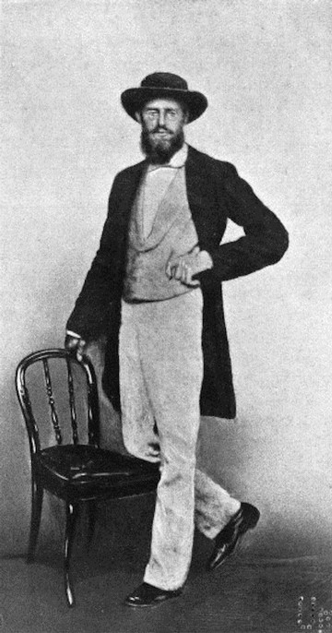

Singapore 1862

by Miles Mathis

First published February 22, 2024

This series on Darwin is turning out to be very popular, for obvious reasons, and I have already gotten many emails suggesting sub-topics for me to pursue. However I will continue to follow my own nose, as anyone who knows me would predict.

Given what we have discovered about Darwin, we see that Wallace must have been the same sort of fraud. And indeed his Wikipedia page confirms it, since a close reading explodes it into little pieces, as usual. We will start with his early bio, which is sparse and completely unconvincing on all points. Despite the peerage names Russel and Wallace, we are told Alfred's parents were middle class. Although Alfred's father claimed descent from William Wallace (Braveheart, you know), the mainstream historians rush you by that with all possible speed, implying it either wasn't true or didn't mean anything. But if we go to the ancestries, we quickly find more clues Wallace was peerage, with ties right to the top. Alfred's father was Thomas Vere Wallace, with Vere being yet another peerage name pointing in the same direction. Geni immediately scrubs Thomas, giving no parents, which is a big red flag. There is no way his parents are not known. Alfred's mother is also scrubbed, and we aren't told her mother's maiden name. Geni also scrubs all his siblings except John, who we are told married a Webster. Same for Alfred's wife, who was a Mitten, but her parents are scrubbed. No mother's maiden name. So we can already see something BIG is being hidden here.

Just so you know, Mitten was previously Mytton, though they figure you won't look it up. The Myttons are peerage, related to the Leighs and the Wilbrahams. As the Wilbraham baronets, they soon married the Myddletons, also linking them to the Cholmondeleys and Saviles. Through the Myddleton baronets they link us to the Bridgemans, including this guy who we saw recently:

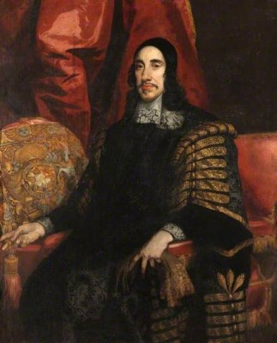

That's Orlando Bridgeman, 1st baronet of Great Lever, Chief Baron of the Exchequer, and Keeper of the Great Seal. Lever=Levi. We saw him in my Bronte paper, where we were looking at another Keeper of the Seal, his cousin George Savile, Marquess of Halifax. I used that portrait of Bridgeman there since his face gives the whole thing away, doesn't it? No other argument needed.

Wikitree does the same thorough scrubbing on Wallace as the rest, though we do learn Wallace's paternal grandmother was a Scott. Another big clue in the same direction. His paternal grandfather is given as William Wallace (though we are about to see that is fudged). Findagrave has a page on Wallace but doesn't even list his parents. And that's it, according to Google and Bing. Geneanet has no listing, and neither does Ancestry.com. That leaves thepeerage.com. We quickly discover that the Baron Wallace in those years was also named Thomas Wallace, no middle name given. Same as Alfred's father. Wiki admits this father was a lawyer and landowner, though they say he didn't practice the law. At any rate, the Baron Thomas Wallace died in 1844, and he came from a family of. . . lawyers. Wiki tells us Alfred's father died. . . 1843. Hmmm. But the clincher is the Baron's wife, Lady Jane Hope, daughter of the 2nd Earl of Hopetoun. If you are like me, you see the clue already: the Hopes are closely related to the Veres, with a famous peerage family being the Hope-Veres. See Admiral Sir George Hope-Vere of this period, d. 1818, who was Lord of the Admiralty and Order of the Bath. He married his cousin Jemima Hope Johnstone, daughter of the Earl of Hopetoun and Lady Carnegie, daughter of the Earl of Northesk.

Which is why Daryl Lundy at thepeerage.com has to scrub this Baron Thomas Wallace, giving no parents for him. Very strange, since there is no way a Baron's parents would be unknown, and you always list the parents of a Baron. We will come back to this Baron Wallace, since he has a page at Wiki, but while we are at thepeerage.com, let's see who he is related to through this Hope wife. Her father was married three times, once to the daughter of an Ogilvy, Earl of Findlater; an Oliphant, also Colville, Lords of Rossie Hill; and Lady Leslie, daughter of the Earl of Leven. Leven=Levi. I find the Leslie link there is red, meaning I have been there recently on another hunt. Which one? Well, we link to the Erskines, Monypennys, and Hopes, so not only did the Baron Wallace marry a cousin, these people link us to? Darwin, of course. Darwin the Stuart was not only a kissing cousin of his captain Fitzroy, he was a near cousin of these Erskines and others. These Erskine's take us in direct line to Lt. Gen. Sir James Erskine of Torry, 3rd Baronet, who married Lady Louisa Paget in 1801. Do you remember who else was a Paget? Darwin.

So this is just what I expected coming in: Darwin and Wallace were very close peerage cousins, with Darwin outranking Wallace. Which is actually saying a lot, as we just saw, Wallace being the son of a baron in a line of the Stuarts. But Darwin was a Stuart in a shorter cleaner line. This is why Wallace so kindly stepped aside and let Darwin get most of the glory: Wallace not only realized the whole thing was a project, he was part of it from the beginning.

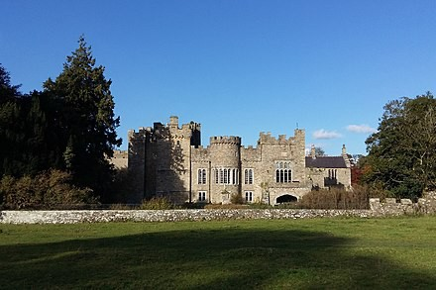

It looks to me like Wallace's father was the Baron Wallace, so let's see what Wiki tells us about him.

Turns out Alfred's grandfather was James Wallace, Solicitor General and later Attorney General under George III. Alfred's grandmother was Elizabeth Simpson, daughter and heiress of the very wealthy Thomas Simpson of Carleton Hall, Cumberland. So Alfred didn't grow up in Wales, as we are told, he grew up in Carleton Hall, Cumberland, and Featherstone Castle [above], Northumberland, both of which were inherited by his father. In addition, we learn from the History of Parliament that Baron Wallace's wife the Lady Hope had previously been married to Henry Dundas, Viscount Melville, pulling those hoaxers in here as well. They have come up in many of my papers. The Dundases and Melvilles link us immediately to the Gordons and Hamiltons, who link us to the Stuarts. We also learn that Alfred Wallace's father the Baron was not only Attorney General, he had been Lord of the Admiralty up until 1800. I guess you see how that plays in here, and why Wikipedia and thepeerage hide it. He was also Master of the Mint in the late 1820s, a position Isaac Newton also held. Baron Wallace was also a famous pawn of the East India Company, arguing in Parliament for continuing their monopoly. He was head of the Board of Control, which oversaw the East India Company.

So you now begin to understand the picture of Wallace under title, which I wager you have never seen before. Not what you were expecting, I guess. They usually lead with pictures of Wallace as a cute old man, sort of like they do with Ben Franklin. The year is 1862, so he was no longer a young man, being 39, but as you see he still dressed like a dandy, not like a naturalist grubbing in the jungles. Yes, the photo is a fake, but even so it is very curious, since it tells us that Wallace and his promoters were and still are happy to see him presented that way. It looks to me like it was taken from a real photo, but he was pasted into that background with the chair for some reason. Probably to excise something in the original photo. Maybe he was leaning on a naked native boy or something. You will see what I mean by that before we finish.

But let's return to the Baron Wallace. He was a fellow of the Royal Society of Edinburgh, which also plays in here. This is the “science” connection. Baron Wallace was also Privy Council. We are told his wife the Lady Hope was already 48 when he married her and that they had no children. But that makes no sense and now looks like a cover story. There is no possibility this is all just a coincidence, with Alfred's father middle name being Vere and the Baron Wallace of the exact same years marrying a Hope of the Hope-Veres.
Almost buried at Wiki is yet another clue. Without giving us a picture, they admit the noble crest of the Baron Wallace was an ostrich with a horseshoe in his beak. What? If we look that up, we find this:

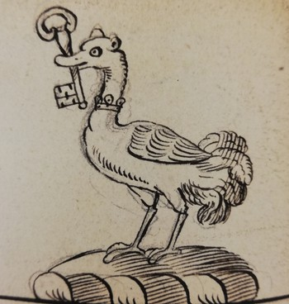
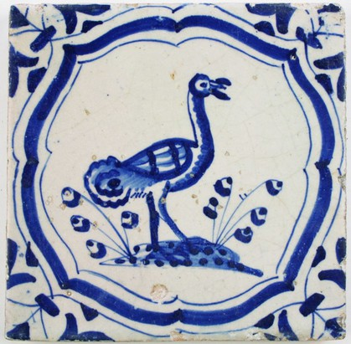

This imagery originates from the bestiary tradition, which supposed that the animal had remarkable digestive abilities, enabling it to consume and process iron. What does the ostrich's presence on a coat of arms mean? According to the Deidis of Armorie, it signified that the first bearer of these arms ate hard things — in other words, they were as tough as nails — and that they had a defiant nature (‘eite hard thingis and [wes] diffailland of natur’).

That's obviously misdirection, since it makes no sense. The ostrich isn't famous for eating iron, is it? What is it famous for? Burying its head. Hiding. Covert operations. And the key and the horseshoe? Well, notice the top end of the key, which looks like the horseshoe, reminding us it isn't the metal we are interested in, it is the shape. As we have seen in previous papers, that shape isn't a horseshoe, it is a Hebrew letter.

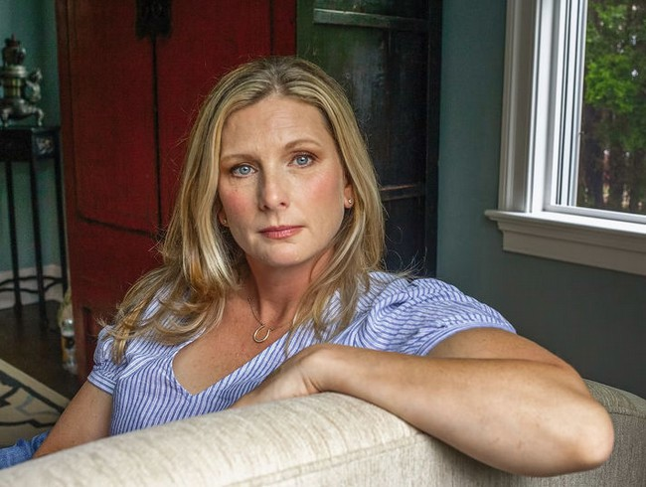

Remember that photo? I published that my paper on Bob McIlvaine, the crying 911 parent

That's Jennifer Middleton, who allegedly took Bob Jr's diary. But look what she is wearing around her neck! As I reminded you there, that is the Hebrew letter Teth, which stands for the Phoenician goddess Tanit, same as Astarte, and she rode a . . . Lion. Like the one in the royal and noble coats of arms. She is announcing to other Phoenicians that she is one of them. Which we should have already known by the name Middleton. Wikipedia admits that infants were sacrificed to Tanit, and her other symbols include the triangle/delta and the rose—hence the Rosicrucians, etc. This is the real esoteric connection Dan Brown was covering up with his Da Vinci Code nonsense.

So, we got in very deep with Wallace very fast, didn't we? What else can we learn about these Wallaces at thepeerage.com? Well, there was another Wallace baronet at the time of Darwin, Sir Richard Wallace, born illegitimately in Paris. He took the name Wallace from his mother, Elizabeth Dunlop-Wallace, of the Lords of Dunlop, Ayrshire. His father was much higher ranking, being Richard Seymour-Conway, Marquess of Hertford, whose grandfather was William Douglas, Duke of Queensbury. That links us forward to the Oscar Wilde project, of course. Wallace's other grandmother was Isabella Ingram-Shepheard, mistress of King George IV.

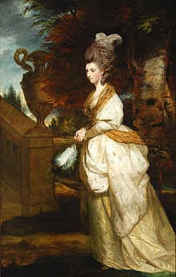

That's her, painted by Joshua Reynolds. Her husband was Seymour-Ingram, grandfather of Seymour-Conway, and his mother was. . . Lady Isabella Fitzroy. She was the great-aunt of the captain of the Beagle! So this is all coming together nicely, isn't it?

Her sister Frances married Lord Gordon, son of the Duke of Gordon. That Duke married his first cousin, the daughter of the Earl of Aberdeen, and her mother was a Murray, daughter of the Duke of Atholl. And her mother was a Hamilton of the Dukes of Hamilton. So we are hitting them all now. I told you in my papers on Darwin the dukes were behind the project, and we are seeing more proof of it here. The 1st Duke of Atholl's mother was Amelia Stanley, daughter of the Earl of Derby, so this originates with them, as with most other things we have studied. The spider at the center of all webs. The Stanleys were just Earls, but that was to fool you. They actually outranked all the Dukes and Kings, being the Lords of the Isles.

There was another Wallace baronetcy far older, created around 1660. These were the Wallaces, Lairds of Craigie, Scotland, so very closely linked to the Scotsman Alfred Russel Wallace. They were tied by recent marriage to the Kennedys, Earls of Cassilis, as well as to the Campbells, Maxwells, Douglases, Hamiltons, Drummonds, and Stuarts. [And yes, that links us forward to JFK, who was from these Kennedys.] So all the same names we have already seen, proving this is where our Wallace came from. These Wallaces of Craigie come in a short line directly from Mary Stewart, Princess of Scotland, daughter of James II.

So who was the Earl of Derby at the time of Darwin? That would Edward Smith-Stanley, the 13th . His maternal grandfather was the Duke of Hamilton. And where do the Smiths enter? According to thepeerage.com, it is a mystery, since we go back two steps to a Hugh Smith, which is the end of the line. But best guess is these are the Smiths, bankers of Nottingham, linking us forward to the Titanic hoax and many others. Edward's half-sister Mary married Thomas Egerton, Earl of Wilton, and his brother was Richard Grosvenor, Marquess of Westminster.

Guess who these Egertons were marrying in those years? None other than the Russells. See Laura Russell, granddaughter of the Marquess of Tavistock, being also a Villiers and a Campbell. She married Seymour Grey Egerton, 2nd Earl of Wilton, in 1862, the Earl's mother being a Stanley. Do I need remind you our man in the title is Alfred Russel Wallace. So we have now traced that name as well.

Let us continue to dig on those pesky Smiths. Stanley's bio at Wiki admits Hugh Smith was extremely wealthy, with Stanley's wife Lucy being his heiress, and that he lived at Weald Hall, Essex. That should help us place him. Weald Hall was bought in the 1600s by Erasmus Smith (below), a billionaire who provisioned the armies of Oliver Cromwell. He and his father stole huge parts of Ireland via the Adventurer's Act of 1640, which was allegedly passed to suppress the Irish Rebellion, but which in truth was the usual false flag, by which a fake rebellion was manufactured from London in order to allow English billionaires another chance to march in and confiscate land and property.

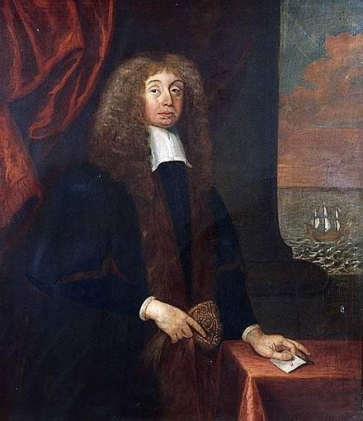

These particular Smiths, related to the Goodmans, were apparently Dutch/Spanish Jews named Heriz who came over in the time of Henry VII and afterwards to help rape the monasteries. Erasmus' uncle was the famous “Puritan” preacher Henry Smith, hugely popular in Elizabethan London:

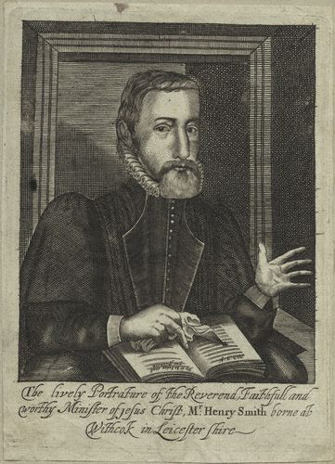

Just look at the length of that nose! Wiki admits his bio is the usual fudge, and that there is no evidence he ever had a divinity degree or anything like it. Of course not, since he wasn't even a Christian. Missing the cross around his neck, isn't he?
But back to Erasmus Smith, who also pretended to be a Puritan, despite that ridiculous face. His eyes remind us of Nancy Pelosi, don't they?

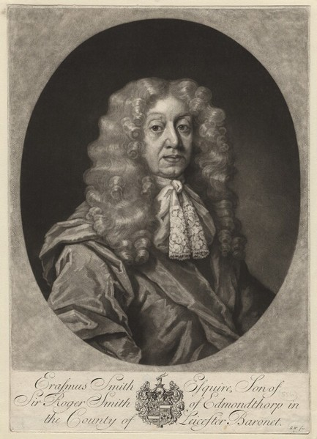

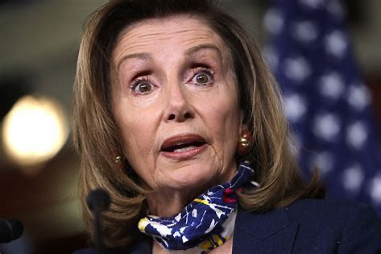

Separated at birth? That's what Nancy would now look like without the nose job and a better wig.

Smith's nephew was Edward Smith, a Chief Justice in Ireland who promulgated more land confiscations. And on his page at Wiki we get a different story of these Smiths, who came from the Smythe baronets and Elizabeth's Secretary of State Thomas Smith.

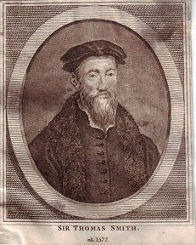

He had also been Secretary of State under Edward VI, working with Edward Seymour, Duke of Somerset, the Protector. Obviously Smith was another old crypto-Jew, not even bothering to dress to hide it. He thinks he is still living in Venice. He is of the Smiths of Essex, who are said to come from Roger Clarendon, an illegitimate son of the Black Prince, making them Plantagenets. And have seen that name Seymour already, haven't we? See above, where we found the Wallace baronets at the time of Darwin were also these Seymours. So we are closing all sorts of circles here. Well, here's another one: this Thomas Smith had no children, but he did bring up Edward de Vere, the Earl of Oxford, who lived with him from boyhood. That's very strange, and is hard to explain until you see a picture of Edward de Vere.

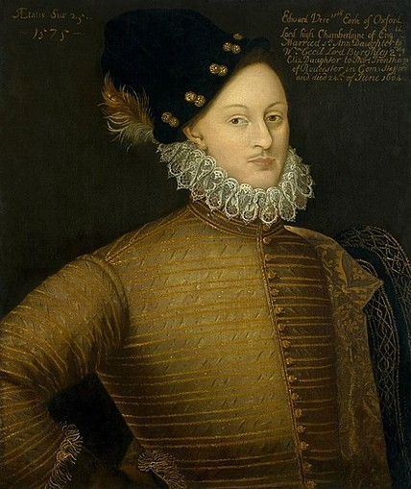

Ah, got it.

I remind you that Alfred Russel Wallace's father's middle name was Vere. Edward de Vere first married a 14-year-old girl for her money but never slept with her but possibly once. She died at age 31. Their daughter married William Stanley, 6th Earl of Derby, so we have that again. De Vere remarried at age 41 to Elizabeth Trentham, again for her money. In case you forgot, this Edward de Vere was not only Lord Great Chamberlain of England, he was the de Vere many think was Shakespeare. I have shown he was only part of the writing team.

Before we leave the Smiths, let's look at the Smythe baronets of Acton Burnel Castle, Shropshire. They must be important since Daryl Lundy at thepeerage.com finds it worth his time to scrub the first two, starting with the 3rd baronet. All Wiki has to tell us is that the father of the 1st baronet married an Eshe of Eshe Hall in around 1570. The 1st baronet married a Lee of the Lee baronets of Langley, who were also Wrottesleys, Allens, and Bennetts. The Bennetts link us to the King. Their seat at Acton Burnell tells us more, since that came down to them from the Howards, Dukes of Norfolk and first cousins of the Stuarts. The most interesting Smythe by far was Maria Smythe, granddaughter of the 3rd baronet. She became the wife of the Prince of Wales, later George IV, but the marriage was illegal and ignored.

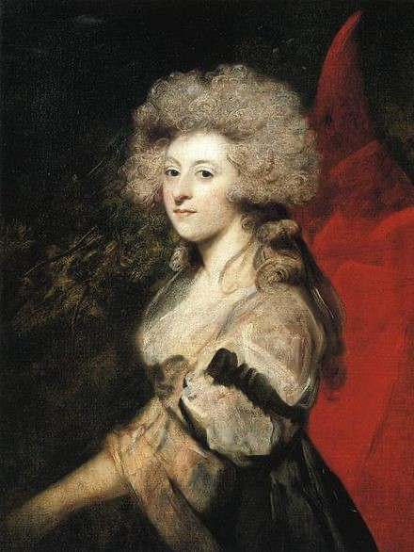

As you see there, the very Jewish Sir Joshua Reynolds was not afraid to paint her looking very Jewish.

I still have not been able to unambiguously connect any of these Smiths/Smythes to the Smith bankers of Nottingham, previously of Witham, Essex, other than by locations. These bankers hail from John Smith, d. 1547, Baron of the Exchequer, so also a banker. His parents were cousins, both being Smiths, and his mother was from Shropshire, possibly linking us to these other wealthy Smiths of Shropshire. These Smiths moved to Nottingham in the 1620s. Another clue as to who these Smiths were is their ownership of Cressing Temple, a property that goes back to the Knights Templar in 1136. So they were very proud of their Phoenician heritage.

But here is where it gets really interesting. This 13th Earl of Derby was a . . . anyone? . . . a naturalist. That doesn't mean he liked to go nude. It means that, like his protégé Darwin, he liked to be involved in covert operations concerning biology. To put it in their own terms, he liked to chase ostriches with horseshoes in their mouths.
He had a large collection of living animals: at his death, there were 1,272 birds and 345 mammals at Knowsley, shipped to England by explorers such as Joseph Burke. From 1828 to 1833 he was President of the Linnean Society. From the Earl of Derby's Collection, the StateLibrary of NSW purchased six volumes of exquisite Australian natural history drawings datingfrom the early days of British settlement in NSW and this Library publishes talks and exhibitions of its research on this collection.[7] He founded in 1851 with his natural history's collection a museum in Liverpool, the Derby Museum, the current World Museum, the oldest of the National Museums Liverpool group.

We looked at the Plinian Society in part I, so now let's look at the Linnean Society. It was founded in 1788, not long before Darwin, by Sir James Edward Smith, the son of a wealthy wool merchant.

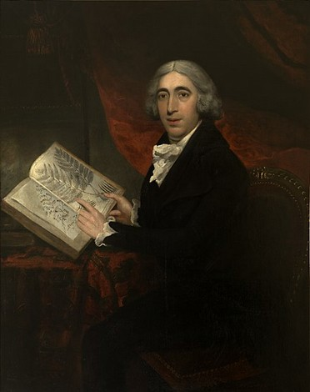

So we have this one pegged already. Wiki scrubs his parents, a big red flag. He is also hidden at thepeerage, though we can be sure he is a peer. Probably of the same Smiths as the Smith-Stanleys, since he was tight with Smith-Stanley, Earl of Derby, at the Linnean Society. Wiki tells us he was from Norwich, but that is an obvious fudge since he came out of the University of Edinburgh, where he was a protégé of the same John Walker we already saw in part I. The Walker who was head of everything in Edinburgh: the Royal Society, the Church of Scotland, and the natural history department at the University of Edinburgh. Oh, and who was the wife of this John Walker? We didn't get to that in part I. It was Jane Wallace Wauchope. Haha! How many circles can we complete here?

A second one immediately, since this Jane Wallace Wauchope was from the Wallace baronets of Craigie we already saw above. So by marrying her, John Walker had just married into a main Stewart line, linking him directly to the King.

And here's another brief circle completed that may interest some of you. These people have a link to the US in those years, and we find that at thepeerage, almost hidden in the stacks. If you go to the Wiki page for Natchez, Mississippi, millionaire banker Levin Rothrock Marshall, you are told he married twice, to a Chotard and to a Ross. But thepeerage.com admits he also married Charlotte Dunbar, who was closely related to the Dunlops we saw above. And those Dunlops were also Smiths, linking us to Sir James Smith of the Linnean through his cousin Horatio Nelson Smith.

But let's hit John Walker again on our way back to the Linnean. This guy is among the best scrubbed people I have ever seen, again indicating something huge is being hidden. We just saw him linked to the Stewarts through his wife, so he must be linked to them in his own lines. Nothing on him at Wiki, Geni, thepeerage, or anywhere else. A complete information embargo on one of the most famous people in Scottish history. So we are left to guess. He has to be linked to the most famous and richest Walkers of that area at the time, which would be the Walker-Drummonds of Dalry, Midlothian. These Walkers came out of nowhere in the mid-1700s to marry the Hay-Newtons, who were also. . . Stuarts. They come from the Hays, Marquesses of Tweeddale, who were also Maitlands, Dukes of Lauderdale. The Maitlands are same as Stewarts/Stuarts. They also link us directly to the Murrays, Earls of Dysart, whom we have already seen above. They became Tollemaches, linking us also to the Cavendishes, famous Dukes of Devonshire, one of whom became a famous scientist. Once the Walkers had married the Hays, they were then free to marry the Forbes-Drummonds, since the Drummonds were also Dukes, and that is when they became the Walker-Drummond baronets. However, it seems these new baronets were keen to quickly bury the name Walker, since the 2nd baronet renamed himself Williams-Drummond. That was possibly to break the link to John Walker, and certainly to break the link to who they really were: the billionaire Walkers of the coal fields. The only people that can come out of nowhere to marry dukes and duchesses are these billionaires, as we know.

Just to be sure you got it: John Walker was—like Darwin—a Stuart. They were cousins, of course.

So, back to the Linnean. James Smith purchased the manuscripts and specimens of Carl Linnaeus directly from his grandson in 1784 for just £1000, and this bought him into the Royal Society the very next year. Three years later he founded the Linnean, with the Earl of Derby lurking behind him. Anyway, this indicates the Linnean wasn't just named for Linnaeus, it came right out his work.

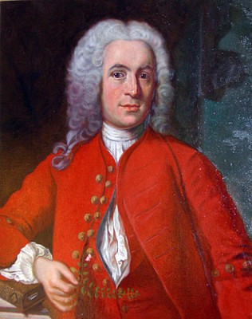

Linnaeus was actually Carl von Linne, another cloaked noble who was gifted all his degrees. They admit that at Wiki, conceding he got his doctorate in a matter of weeks at Harderwijk in Holland. This was like the Tijuana of Northern Europe, where you could get any diploma you wanted for the right price, with a Meisje (Madchen/Muchacha) thrown in for free. Like Darwin and the rest of these people, Linne wasn't interested in Madchens, but he was happy to take the fake doctorate. He also had no undergraduate degree, his college experience fading out into nothing. We are told he was one year at Lund and one year at Uppsala, and then began lecturing in his second year at age 22. What? Two years later, still with no degree, he was awarded a grant by the Royal Society of Sciences in Uppsala to visit Lapland. Two years after, still with no degree, he led a student trip to Dalarna, which they admit at Wiki was a cover for spying.

Ostensibly they were there to study plants, but they were really there to assess Norwegian mining operations at Roros. Was he doing the same thing in Lapland?

This is important, and I suggest you pause and chew on it a while. With Linnaeus they admit the naturalist thing was actually a cover for Intelligence, like missionary work, anthropology, archaeology, and so on. It gives us yet another key to unlock the whole Darwin project.

After getting his fake doctorate, Linne was immediately tapped by a publisher for his book Systema Naturae, allegedly written several years earlier. It popularized the Linnean system of binomial nomenclature, but guess what? They admit he stole it from Gaspard and Johann Bauhin. So we are starting to see why Smith and Stanley named their society after this guy. These people should put this on their coat of arms:



They could also name new elements after themselves. If they discover a big fat new element that mimics a more basic element, stealing all its characteristics, they could call it Stanleum. Another element that faked everything around it and lied and stole all the livelong day they could call Cohenium. You know that as soon as I kick off they are going to steal all my ideas and flip my bio, making me look like the opposite of what I was. They are already trying to do it and I am not even dead yet. Same thing they did to Tesla and thousands of others.

You will say all is fair in love and war, and that the winners write history. But those sayings also came from the Phoenicians, and are therefore inverted like everything else they touch. Almost nothing these people do in love or war is fair: it includes the most heinous crimes against the gods and humanity. And the winners don't write history, the Phoenicians do, and they are the biggest losers of all time. Only losers have to lie, cheat, and steal to prosper. That's how the real gods look at it.

OK, I think we have beat the genealogies to death, so let's return to Wallace's bio. Like Darwin, Wallace left school as a young teen. Darwin dropped out at 15 and Wallace at 14. We are told this was normal for a working class guy like Wallace not planning to go to college, except I have just disproven that. He was the son of a baron, so not working class or middle class. At this point his bio mirrors that of several others I have exploded, most notably Mark Twain. Wallace allegedly apprenticed himself to his brother for six years as a surveyor. Problem is, surveyors are not unskilled labor, and Wiki admits on their own page:

Surveyors must have a thorough knowledge of algebra, basic calculus, geometry, and trigonometry. They must also know the laws that deal with surveys, real property, and contracts.

You don't normally get that before age 14 in public schools or from apprenticing to a brother, either. You go to some sort of school. And yet we are told that he was already working as a land surveyor at age 17, after at most three years of apprenticing. Three years later his father died and he gave up surveying, just as his apprenticeship was supposed to be complete. We aren't told if he had become a master surveyor, so I assume not. If he had been middle-class, the death of his father should have required he look for other work, but instead he apparently retired to chase beetles with a younger friend. This was Henry Bates, 19, who, we are told, had already published a paper on beetles in the journal Zoologist. That sounds fishy since Bates, like Wallace, had no education past 13. He supposedly learned everything he knew from the public library at the Mechanics Institute, including how to get published at 19 without knowing anyone. Equally fishy is Wallace being hired at the same time by the Leicester Collegiate School to teach drawing, mapmaking, and surveying.

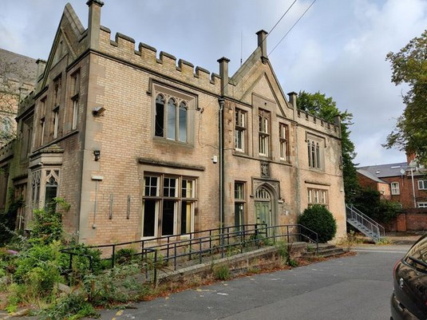

Really? A 20-year-old 7th grade dropout and failed apprentice was hired to teach surveying? That's the Collegiate School in Leicester. Wiki and Google have nothing on it but it is just as fishy as the rest of this. Others who went there include Bishop Henry Stewart O'Hara, of Waterford, Ireland. He was from Coleraine, Northern Ireland, and went to Trinity College, Dublin, so what in the world was he doing at Leicester Collegiate School in the Midlands? Also Sir Henry Norman, 1st baronet, b. 1858, who went to Harvard and became an editor, Chairman of the War Office, and MP. So what was he doing at the Leicester Collegiate School? Think about it and get back to me. You already have enough clues to solve it.

OK, you're back. Did you get it? Well, Norman is the big clue, since—like Darwin—he was a fake Unitarian. And like others we have seen above, he was linked to coal, being the director of a number of companies in coal and iron. And like these other people, he was also a world traveller, devoting the last forty years of his life to it. Do you have it now? He was in Intelligence. Like the others, he was a spy. Which means? Leicester Collegiate School was a front, an Intel school. And they admit Wallace was there.

Two years later he was lecturing on science and engineering at the Mechanics Institute in Neath. Both these positions were just moonlighting, not for money, as was soon proved when Wallace again retired to travel. He and Bates had read Darwin and wanted to go to Brazil themselves. So they left aboard the trader the Mischief. Hmmm. The Mischief. I guess that's better than the Psyop or the Fraudster. I couldn't find any confirmation this ship ever existed, other than these stories of Bates and Wallace, but the name looks like the usual Phoenician joke.

Wallace allegedly spent four years charting the Rio Negro, and we are told they underwrote this mission like this:

After reading A voyage up the river Amazon, by William Henry Edwards, Wallace and Bates estimated that by collecting and selling natural history specimens such as birds and insects they could meet their costs, with the prospect of good profits.[9] They therefore engaged as their agent Samuel Stevens who would advertise and arrange sales to institutions and private collectors, for a commission of 20% on sales plus 5% on despatching freight and remittances of money.

Unfortunately, we already know from our studies of Darwin that is all bollocks. They admit that by the 1830s England was overflowing with these amateur bug and flower collections and the institutions couldn't house what they already had. Hundreds of major collections were already rotting in sheds and warehouses, bugs being eaten by bugs. By the 1840s the museums were more likely begging rich people NOT to go abroad, and if they did to leave the fossils behind. So whatever Wallace, Bates, and others were doing, it certainly wasn't profiting from sending specimens back. More likely they were spying on the Natives, figuring out how to steal all their minerals while paying them nothing. Same thing we did to our own Natives in the US, you know. First we stole all their game, then all their furs, then all their land, then all their minerals. It is still going on.

And the mystery continues. On his way back to England in 1852, Wallace's ship the Helen caught fire and burned to the sea, Wallace and the others spending ten days on the open ocean in lifeboats. They were allegedly picked up by the Jordeson, sailing from Cuba to London. Do you see a problem there? Grab a map and pay attention. Wallace left from Brazil and had been 25 days at sea. So they would have already crossed the Atlantic and would be moving their way up the coast of North Africa or Europe. So their route wouldn't be anywhere near a ship sailing to London from Cuba. The route from Cuba would be up the coast of North America and then across with the heavy traffic from the US, going directly to the British Isles from there. Plus, after 25 days the Helen would be near Africa or Europe, near some coast, not on the “open ocean”. These routes are planned specifically to prevent things like this from happening. They like to sail near landmasses, for obvious reasons. And then we have the other clues this was fake: the name Helen, which makes us think of Helen of Troy, Troy being Phoenician. We are told the Jordeson reached London October 1, aces and eights, Chai. Wallace lost four years of specimens in the fire, including his journals, which is convenient for the story, since we now have no proof of them. Or very little proof, and none that wouldn't be easy to fake.

The lost collection had been insured for £200 by Stevens.[30] After his return to Britain, Wallace spent 18 months in London living on the insurance payment, and selling a few specimens that had been shipped home.

Stevens was their fake agent. Or maybe he was a real agent, but agent in the sense of intelligence agent. Handler. At any rate they make up this story to explain how Wallace continued to live without any source of income. And notice how they work the number 18 in there once again.

Despite his first trip being such a colossal bust, within the year Wallace had found more funding, this time from the Royal Geographical Society, which arranged him free passage aboard Navy and PO ships to Singapore. Where they no doubt required more covert operations. That is proved by the next section, where we are told he collected beetles in Singapore and Malacca, but if so he did it overnight, since by October he was in Sarawak. The following spring they moved him to the Simunjon coal works, operated by the Borneo Company. All this confirms my suspicions, since I guess you noticed the COAL there. That area was also rich in antimony, and that was already known by then. Ludwig Verner Helms was already there raping the place for the West. That area was also being mined for mercury, gold, diamonds, sago, gutta percha, and timber. So it amazing our little bug collector Wallace went straight there.

But we now know why he did. It wasn't to collect bugs. It was because he was a close cousin of these coal billionaires, including the Walkers, and as a rich young man he wanted to tag along for the fun. He wasn't the sort to hang out at the club, read the newspapers, and fritter away his inheritance on gambling. He was an energetic, talkative sort who liked to be on the go with the big boys, and they apparently found him good company. I doubt it was for any actual skills he had, other than BJs, but skills didn't count in that crowd. The lack of all scruples counted first, then the ability to lie and keep secrets, then—for Wallace's type—the ability to look good in a tight waistcoat and yellow pants. I now think that was Wallace's main function all along. As it is for so many of these people. Nothing particularly wrong with that, you will say, and I will concede that. It takes all sorts and that wasn't the worst trait in that list. I am not here to out him in that way, I am here to out him as another in a long list of prominent frauds, who faked their entire resumes and did almost nothing you are told they did.

As a not unimportant aside, this was Borneo, and it is when the Orangutans were almost wiped out, since they were considered a danger to workers. Wallace personally shot and procured as many Orangutan specimens as he could, since they were among the most valuable. Meaning he murdered them in cold blood, for nothing other than profit. He also liked to shoot and eat monkeys. So when you think naturalist, don't imagine they are animal lovers.

Typical Phoenician behavior.

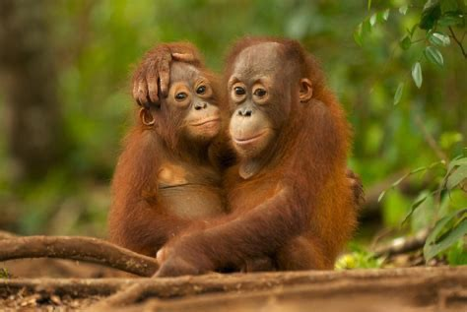

I would say it is nearly a miracle they aren't extinct, and if the jungles weren't so vast and thick there they would be. Although they used to cover large parts of South China, Indonesia, and Malaysia, their numbers have been dropping for thousands of years. They have been critically endangered for decades and still are. Can you imagine hunting those people for sport or profit?

No, but you probably can't imagine wiping out Native Americans, and they that, too. You probably can't imagine enslaving Africans for profit, and they did that, too. Still do in some places, like American jails.

OK, this is spinning out into another book, so I will clip it here and put it up, and start work on part IV in this Darwin series. I will finish up on Wallace and then get back to Darwin and his immediate crowd.

DARWIN part IV

Mill, Huxley and others

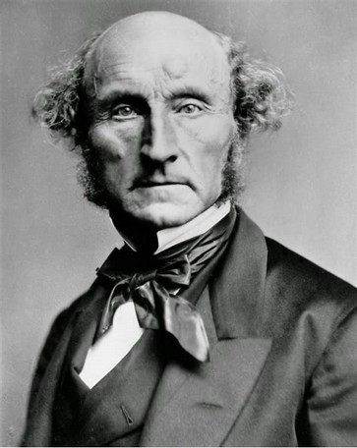

by Miles Mathis

First published March 6, 2024

I had to take a break from this, I found it so disgusting. As my regular readers know, I didn't come to this as a Christian or conservative. I came to it as a truther. I just want to know the truth. I knew there was dirt here, but I had no idea the depth of the cesspool. As with my research on the Titanic and many other things, I find this as shocking as you do, and really had no conception what I would find when I began digging. So after a while I had to stop and hose myself down, which I did by playing with my kittens and bicycles for a few days, staying away from the computer altogether.

When I say I didn't come to this as a Christian, I mean evolution never offended me on those terms. I knew it was embryonic, but thought it was a step more scientific than “God created the Earth in six days”. I was never too attached to the creation myth in the Bible, or any other creation myths for that matter. My mind was open and still is. I don't think anyone knows how anything was created. I don't think we are even close to being able to know. Our understanding of such things is about a half-step up from that of a dog (notice I don't say of an ape). Plus, I never understood how evolution and Christianity were in opposition. I didn't understand it from the beginning, when I first learned of it as a kid, and I am no better off now. Science and religion don't seem to me to have much cross-over. They don't compete. As I said in a previous paper, even if Evolution were completely true, it wouldn't explain anything about creation. It isn't a theory of creation. It has nothing to say about how the Earth or Heavens were created. You could easily have both God (including Jesus, if you like) and evolution, since God could have chosen to create things that way. We just don't know. We didn't know in 1850 and we are no closer to knowing now, after 174 years of natural selection. So all the bickering and division seemed manufactured to me back then, and it seems ten times as manufactured to me now, knowing what I now know.

And what do I know? I know that these people we have been uncloaking are masters of manufacturing division and always have been. It is their modus operandi, and they are doing it on purpose across the board, not just here. They want us fighting and spend half their time making up new factions. The other half of the time they are lying.

I have also discovered the Christians are not wrong: the Phoenicians really ARE trying to wipe them out, though maybe not for the reasons they think. Before we ever got to this question of Darwin and Evolution, we have seen piles of evidence over centuries that the rulers had decided to phase out all religions, not just Christianity, first because they were getting in the way of trade (with rules against usury, etc.), and later because it had been consciously decided to secularize all government. The State wanted the Church's tithe, for one thing, but it also wanted to streamline world governance, turning the old State/Church duopoly into the new State monopoly. It would start by stealing all Church property, as with Henry VIII taking all the monasteries and the French Revolution absorbing the First Estate (the Church) into the Second (the bankers/merchants). But it would end where we are now, nearing a totally secularized and propagandized world, of the Orwell sort, where the State brooks no opposition and takes everything for itself.

This is why we see Evolution rising in such unnecessary conflict. These scientists in 1850 could have tried to promote their ideas diplomatically, avoiding as far as possible attacking the Church head-on, but for some reason they did the opposite. They manufactured schism even where it didn't exist, as in this idea that Evolution was a competing theory of creation. We saw them do it later with DNA, implying that DNA was somehow a replacement for God or religion. When it is no such thing. I definitely believe in DNA. What I don't believe is that it explains how things are. It is nothing more than a genetic code, and that doesn't tell us much about anything, such as how it got there or how we got here. It is the same with Evolution, which—even if true—is extremely limited in its explanatory power. Evolution, DNA, and all the rest of contemporary science put together are only the first steps to understanding who we are and why we are here (supposing there is an answer to that question beyond IT IS).

So I am now able to fit Darwin and Evolution into this greater and older scheme. If you still don't see it, let's go back before Darwin. The field had already been planted and fertilized before Darwin the Stuart even arrived. You may not know about a book called Vestiges of the Natural History of Creation, by Robert Chambers, but it came out in 1844—after Darwin got back but before he published On the Origin of Species in 1859. Notice for a start that Chambers proves what I just said: he is promoting Evolution in his title as a competing theory of creation. But its not a theory of creation, is it? It never was. You can tell by the name. It is a theory of how things evolve after they have been created. Did the species create themselves? Did the first protozoan in the slime create itself?
Darwin's title does the same thing, doesn't it? With that word “Origin” in the title. But if you have read the book, you know it doesn't say the first word about the Origin of Species. It doesn't say anything about the origin of anything. It is about later species coming from earlier species. So we still have the question where the earlier species came from, which Evolution never addresses.
Chambers was the same sort of creep as the rest of these people, and his bio the same sort of transparent fraud. He was a cloaked peer sold as working class, but his son-in-law just happened to be Augustus Lehmann, whose name tells us everything we need to know. These are the Jewish Lehmann bankers, rabbis and silk traders of Hamburg, related to the Oppenheims, Levis, and Freuds. Chambers' granddaughter married the Baronet Campbell. His daughter married a Priestley, of the Priestleys we saw in part I. Like the rest of these people, Chambers married his first cousin, Anne Chambers. They were also Gibsons and Grieves.

Chambers came out of nowhere to publish the Kaleidoscope magazine at age 19. As you do. In the same year he was working with Sir Walter Scott. When he published Vestiges, most Christians ignored it or hated it, but the Quakers and Unitarians loved it, proving again who they were.

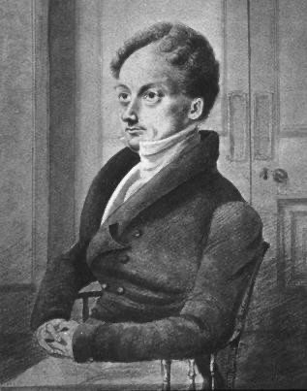

We can dig a bit deeper to see who was funding Chambers, and we find it was places like the Westminster Review, the old organ of the Philosophical Radicals. And who were they? They were yet another group of cloaked Jews and billionaires causing trouble. You have probably heard of some of them, like Jeremy Bentham and John Stuart Mill, but you may not know where they came from. In school they don't put John Stuarts Mill's middle name in purple for you, as I just did, or tell you his father James was a colonial administrator of the East India Company.

That is James Mill's very funny little portrait. I guess he was about 5 feet tall, like Fauci. James Mill was really James Milne, of the Milnes/Milners we have seen many times. Milne got his start as the “companion” and likely kissing cousin of John Stuart, 4th baronet,

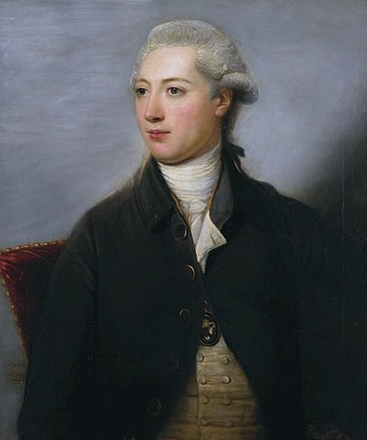

with whom he went to London in his 20s. Stuart links us immediately to the Melville earls through his wife and the Forbes through his daughter. As soon as they got to London, Stuart set Milne up as the editor of two magazines. Milne soon became a disciple of the older Jeremy Bentham, an especially loathsome character who is famous for mocking the American Constitution and Declaration of Independence. He is in the peerage but well scrubbed, though they admit he was from Farrs. Wiki also admits he was from great wealth, that wealth coming from drapery. So, another cloaked Jew. Wiki says his mother was a Woodward while thepeerage.com says she was a Farr. So someone is lying. Or maybe both of them are lying. The Farrs likely link us to the Abbot barons of Colchester and the Gibbs baronets.

Bentham hated our Constitution because his family were big tories. This is how big: his brother Samuel was Prince Potemkin's personal business manager. Potemkin was the consort of Catherine the Great of Russia, of course. Amazingly, they try to sell even Potemkin as “middle-income” at Wikipedia:

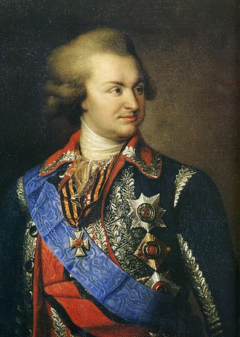

You have to laugh.

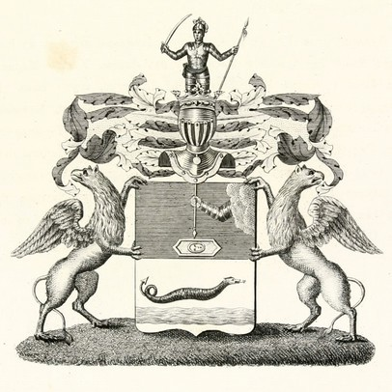

That's the noble crest of his mother Kondryeva. Note the sea serpent with barbed tongue and tail. Not a good sign, is it?

Anyway, to show you what kind of ghoul Bentham was, one of his early projects was a panopticon prison, which idea he borrowed from his brother in Russia. He begged Parliament to let him build this prison and make him its chief gaoler. Touching. So this father of Utilitarianism's personal greatest happiness would have been to lord it over a bunch of prisoners. Typical. A bit later he was friends with the swine Mirabeau and the rest of the French Revolutionaries, and they made him an honorary citizen. This despite being against the whole idea of natural rights of man. How does that work? So we may assume he was in favor of the revolution for its real purpose: to gut the French Catholic Church.

James Mill/Milne got his job as East India Company administrator as thanks for years of promoting them as the good guys in magazine articles and books, including the famous History of British India (1818).

Mill was a proponent of British imperialism, justifying it on utilitarian grounds.[11] He considered it part of a civilising mission for Britain to impose its rule on India.[11] Mill saw his own work for the East India Company as important for the improvement of Indian society.[11] Mill portrayed Indian society as morally degraded and argued that Hindus had never possessed "a high state of civilisation".

Same argument we used against our Natives. But there were too many Indians in India to talk of wiping them out. Or almost too many: the soft-hearted Charles Dickens did talk about wiping them out after the revolt of 1857. Mill's book didn't sell many copies in India you can be sure, at least not outside the BEIC offices. In the controversy over renewing the Company's charter in 1833, Mill was the BEIC spokesman before Parliament. At the same time he was attacking the Anglican Church, and in an article on reforming the Church for the London Review in 1834 he went too far, prompting a backlash against the Westminster Review. They admit Mill was an atheist, meaning the only reform he wanted for the Church was its death.

So these were the people working on the Evolution project before Darwin took over. Another one was the man who owned the Westminster Review and the London Review after the death of James Mill: Sir William Molesworth, 8th baronet. He was Secretary of State under Palmerston in 1855, so very high up in government. His grandmother was a Smyth, so she may link us to the Smith/Smyth bankers we looked at in part III. Through the Ourrys, Molesworth descends directly from a previous Secretary of State, George Treby, d. 1742. Molesworth also links us to his cousin Sir William Salusbury-Trelawney, 8th baronet, another major player in this project. He links us back to the Seymour Dukes we have seen many times, and forward to Edward Trelawney, another of the Philosophical Radicals of the Westminster Review.

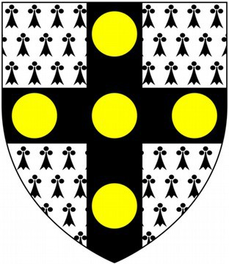

That is the Molesworth coat of arms, which is of interest here since it allows me to tell you something I haven't hit before. You may wonder what those circles are. Wiki tells us they are bezants, or old Byzantine coins. But though that is suggestive, since the Phoenicians did own Byzantium, I don't think that is what they are.

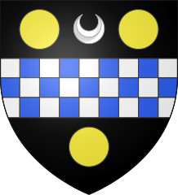

There is the coat of arms of William Pitt. Notice the horseshoe shape between the bezants. We already saw that in this series, didn't we? It isn't a horseshoe, it is the Hebrew letter Teth, standing for the goddess Tanit or Astarte. Which must mean the gold circle is a similar symbol with similar origins.

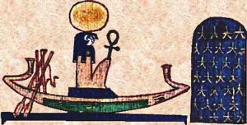

That's Ra with his Sun-disk on his head. Although Astarte was a Phoenician goddess, she was also the Semitic Ishtar, and they liked her in Egypt, too, especially in the time of Ramses (of the Bible), where they thought she was the daughter of. . . Ra. So this is all tying together beautifully, isn't it? The gold circle isn't a bezant, it is the Sun-disk of Ra.

So again, that tells us who these people were, back to the beginning. Molesworth not only promoted Mill and Bentham, he is the one who put Thomas Hobbes' books in all the English university and provincial libraries, in fancy leather editions. Sort of like what the government did for F. Scott Fitzgerald and Hemingway over here a bit later. Except that our government actually bought thousands of copies and handed them out to free to soldiers and others, and then claimed the books were bestsellers. Molesworth didn't go that far, since propaganda was in its infancy back then, compared to now.
It was in Molesworth's Westminster Review that the mainstream promotion of Darwin hit high gear, when in 1860 Thomas Huxley coined the term Darwinism on its pages. Huxley had already been working for the magazine for seven years, where he ran the science section with John Tyndall. Together they had been priming the pump for Darwin since 1853.

Also of interest is that the Westminster Review published Karl Marx's daughter Eleanor Marx. See her 1886 article The Woman Question: From A Socialist Point of View. It all ties together.

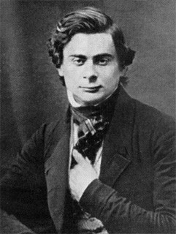

So let's hit Huxley next. That photo says it all, with the repellent Phoenician face and the hand in the vest. If you are with me, that should be all you need. But if you can't read all that is there at a glance, like I can, I will give you so much more to go on. Wikipedia does the usual scrub on Huxley, selling him as from a literate middle-class family which had fallen on hard times. His father was a mathematics teacher at Great Ealing School until it closed,[10] putting the family into financial difficulties. As a result, Thomas left school at the age of 10, after only two years of formal schooling.

The usual load of manure. What does thepeerage.com tell us?

He was appointed Fellow, Royal Society (F.R.S.) in 1851.1 He was awarded the Royal Medal of the Royal Society in 1852.2 He was awarded the Wollaston Medal in 1876 of the Royal Geological Society.2 He was appointed Privy Counsellor (P.C.)1 He held the office of President of the Royal Society between 1883 and 1885.2 He was awarded the Copley Medal in 1888.2 He was awarded the Linnean Medal in 1890.2 He was awarded the Darwin Medal in 1894.

What they forget to tell us is why he is listed in the peerage. He was not raised to the peerage. No parents are listed and his wife is not a peer. None of his children are peers. So something is being hidden. He was made a fellow of the Royal Society at age 24, but they neglect to tell us for what. Even Darwin the Stuart wasn't a fellow until age 29. Like Darwin, Huxley's education appears fake, since although he left school at ten,

At twenty he passed his First M.B. examination at the University of London, winning the gold medal for anatomy and physiology. However, he did not present himself for the final (Second M.B.) exams and consequently did not qualify for a university degree. His apprenticeships and exam results formed a sufficient basis for his application to the Royal Navy

Notice they don't tell us how he qualified to attend the University of London in the first place. The old Stuart bye? Still at 20, he alleged sailed on the HMS Rattlesnake as surgeon's assistant. . . except that Wiki admits he wasn't really surgeon's assistant ('surgeon's mate', but in practice marine naturalist), since he didn't have any medical degree or qualifications. Maybe he was the surgeon's “companion”? Would you believe surgeon's cabana boy? Actually, they admit Huxley was the flamer Edward Forbes' protege in those years, Forbes publishing accounts Huxley sent back to him. It was allegedly based on those accounts that Huxley was made a Fellow at age 24.

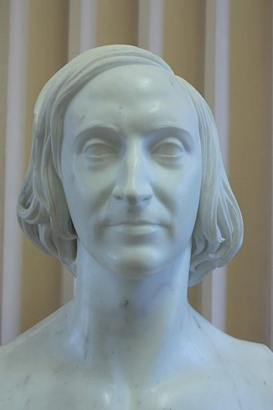

That's Forbes. Or I should say a marble sculpture of him. Wiki admits he was from a family of rich bankers from Isle of Man, but doesn't mention any parents. Thepeerage.com also scrubs him, a big red flag. So we may assume he was from one of the top Forbes lines, like the Earls of Granard, making him indeed a Stuart. He wanted to be an artist, but didn't have any talent. Back then it was a requirement, even among peers, and the Royal Academy told him to get lost.

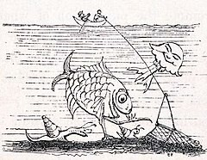

You can see why.

But back to Huxley. The Huxleys are extraordinarily well scrubbed at thepeerage, but we do find they were related to the Dalston baronets, and through them to the Ramsdens. The Ramsdens take us directly to another Duke, that being the Powletts, Dukes of Bolton, whom I have never heard of until today. They are related to the Scotts, Dukes of Monmouth; the Coventry barons; the Scropes, Earls of Sunderland; and the Paulets, Marquesses of Winchester. Forward they link us to the Montagus (think George Washington) and the Vanes, Dukes of Cleveland. So all those Dukes and Earls are hiding behind Huxley, with him front and center pretending to be from nowhere. We got all that because Darryl Lundy forgot to scrub George Huxley, Commissary-General of the Musters.

The Admiralty offered to let Huxley stay on as a “nominal” surgeon's assistant, whatever that is, but Huxley preferred to be a nominal professor of natural history at age 28 at the Royal School of Mines— no doubt another government sinecure and fake position for spooks.

So, let's remind ourselves: Huxley, who quit school at age ten after two years of schooling, was given a bye into the Navy, was given a bye into his professorship, and then somehow became President of the Royal Society and Privy Councillor.

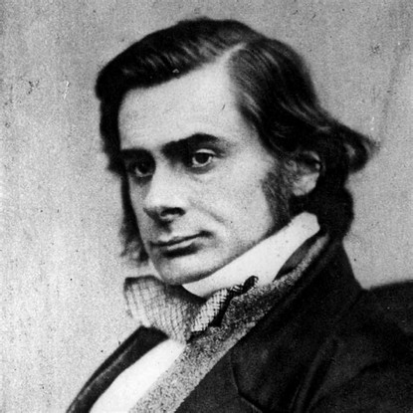

So another complete and total fraud, who advanced only on his Stuart connections and his loud mouth. Like the rest of these people, he actually knew nothing about nothing, but thought he knew everything about everything. The sort of person you avoid like the plague if you have a spot of sense. The fact he was chosen to defend Darwin by itself proves Darwin was indefensible.

You may know of the famous “debate” on Evolution between Huxley and the bishop Samuel Wilberforce, which Huxley allegedly won. Except that the whole thing is a myth. There was no debate, and if anything happened it was only some brief cross comments from the audience after a lecture by American John Draper. Historians now admit there was no record made of the comments at the time, the story arising later, and that the quotes were likely made up. This tells me that Wilberforce likely won the exchange, not Huxley, for if Huxley had really won, there would be no reason to falsify the whole thing.

A Stewart who was there was even nice enough to admit that, though his report has been buried. Balfour Stewart, a prominent astronomer and head of the Kew observatory, claimed Wilberforce won the exchange.

This is even more damning: in a letter to Darwin afterwards, his friend Joseph Dalton Hooker reported that Huxley had been “largely inaudible in the hall”. The man they hired for his big mouth, the bulldog Huxley, was actually inaudible. Not what you expected, I bet.
And this may interest you: do you know who else was there in the audience? Not Darwin, since Darwin liked to hide. Fitzroy, our top Stuart and fake captain of the Beagle was there. You may think Fitzroy was there to defend Darwin, but nope:

FitzRoy denounced Darwin's book and, "lifting an immense Bible first with both hands and afterwards with one hand over his head, solemnly implored the audience to believe God rather than man". He was believed to have said: "I believe that this is the Truth, and had I known then what I know now, I would not have taken him [Darwin] aboard the Beagle."

So Fitzroy had jumped the ship for some reason, and my guess is he didn't like being upstaged by Darwin, whom he outranked. As an almost-Duke, Fitzroy probably thought it was his birthright to front this project, and we can guess that he must have been a real moron to have been passed over. A Leslie Groves sort, too dense to be trusted even as a figurehead.

At any rate, unlike now, there was no invective at this “debate” and most of the small amount of rancor appears to have been staged, since it was reported that everyone had a good time and retired to dine together. This was Oxford after all, where all learning was always a put-on. These were all peers, so nothing was really at stake for them: they would win no matter what, and knew it.

Another one who surprisingly spoke against Darwin at Oxford was Richard Owen, most famous for coining the work “dinosaur”. His bio at Wikipedia is the usual fudge, but even worse than usual. No parents are given and the bio starts at age 16:

Owen became a surgeon's apprentice in 1820 and was appointed to the Royal College of Surgeons in 1826.[9]

No mention of schooling, so we may assume he skipped it all, being an Owen.

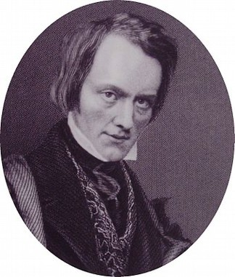

Looks eminently trustworthy, don't he? Not at all like a cousin of Dracula. He is not listed in the peerage, but we can be sure he was a close cousin of the Baronet Sir Hugh Owen, whose mother was a Philipps painted by Thomas Lawrence.

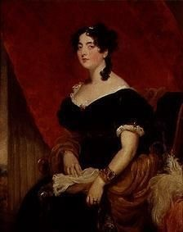

These are the Philipps baronets related to the Perrots and Darcys. Think H. Ross Perot. These Owens come from Anglesey, so we may assume they are Owens who spawned the Tudor kings. Nothing else would explain the preference of this Richard Owen, or his complete family scrubbing.

I am not going to get into dinosaurs here, but I will give you a little teaser. At Wikipedia on the page for dinosaurs, they tell us the Chinese have been using dinosaurs bones for traditional medicines for “millennia” , thinking they were dragon bones. Do you see a problem there? Think about it and get back to me.

OK, you are back. Did you spot it? Dinosaurs lived 240 million years ago and bones don't last that long, even buried deep. Bones are organic material, which last longer than flesh after death but not indefinitely. Certainly not 240 million years. Dinosaur bones are actually fossils, which means they are not bone, they are rock. The bones were mineralized long ago, being replaced by rock. So are we expected to believe these Chinese people were using rocks in their traditional medicines? Bones in traditional medicines makes sense, but rocks? They were eating rocks? If we do a search on that, we are taken to this 2007 article from NBCnews.com, telling us that they did indeed eat rocks.

Parts of the 18-meter dinosaur were dug up and eaten by locals as traditional medicine, scientists said Tuesday.

Is that right? Hmmm. But it gets better:

Until last year, the fossils were being sold in Henan province as “dragon bones” at about 25 cents a pound [what, not 33 cents a pound?], scientist Dong Zhiming said Wednesday. Thecalcium-rich bones were sometimes boiled with other ingredients and fed to children to treat dizziness and leg cramps. Other times they were ground up and turned into a paste applied directly to fractures and other injuries, he said.

Wow. So it looks like neither NBC nor this “scientist” Dong Zhiming realize dinosaur bones are not really bones. The give-away is the “calcium-rich” thing, isn't it? Bones are calcium-rich, but rocks often aren't. Chickens aren't going to eat rocks. And it is difficult to grind rocks up into paste for fractures.
You will say that rocks do contain calcium, as in calcite or dolomite. But that clearly isn't what they are talking about here, since although you can boil bones to easily get calcium from the broth, if you boil rocks you are going to get almost no calcium. If these people were wanting calcium to treat leg cramps, they would be using real bones, not marble rocks or something.

So we have to ask why Wikipedia and NBC are lying to us so egregiously, treating us like ignorant children who think dinosaur bones are actually bones.

Then there is this problem with this China story. Do you have any idea how much stirring of the crust there has been in the past 240 million years? How much vulcanism? How much continental change? Current mountain ranges are only about 50 million years old, so we have had entire mountain ranges rise and fall several times since the dinosaur bones would have been deposited. So the odds of some Chinese farmers finding dinosaur bones in topsoil are vanishing. Dinosaurs fossils, if they exist, should either be buried hundreds or thousands of feet deep or they should be on the tops of mountains, having been pushed up much later.

And another problem: if you go here, you can see what the world looked like 240 million years ago. As you see, China hardly existed at all. Most of it was under water at the time, so no land dinos in those areas. About 3/4s of China was mountainous back then, since there was a sort of pre-Tibetan plateau even then. Dinos don't live in mountains—being lousy hill climbers—so no dinos there. So, again, the odds of modern Chinese farmers finding dino bones on the ground or upper layer of topsoil are vanishing. In the very small chance dinosaur bones were in those layers, it would be on the tops of the mountains, but that is not where these Chinese peasants in the story were. They were in Ruyang country, which is south of Luoyang. There are no mountains there. So these mainstream scientists can't seem to keep their stories straight. No continuity, as usual. Just a huge mass of bald contradictions.

Back to Owen. He argued against Darwin in the 1860s not because he was against Evolution, but because he was against transmutation of species as the main driver. Outside the halls of Oxford, he was glad to promote the basic Evolution project, and did so as early as 1849, claiming man evolved from fish. But at this lecture in 1860, he was opposed to Huxley's claims that man had evolved directly from the apes. He preferred the idea that man had evolved on a parallel line from ape-like creatures, which of course is closer to the current dogma. I suspect he was mainly opposed to Huxley on political grounds, no doubt feeling that more circumspection and less noise would better drive the project forward. He was the turtle that struck slowly while Huxley was the hare that raced ahead, but they were both on the same page in the long run.

With that in mind, it is useful to quote what the historians now tell us about the debate at Oxford:

The anonymous publication of Vestiges of the Natural History of Creation, supporting the idea of transmutation of species, in 1844 brought a storm of controversy but attracted wide readership and became a bestseller. The scientific establishment also remained skeptical, but the book had convinced a vast popular audience.[10]
As you see, the facts were opposite to what Owen had assumed. Owen assumed moving slowly was the way to draw people off the Church, but the popular audience was actually easier to convince than actual scientists. Very odd in so many ways, since it is opposite not only to Owen's assumption, but to any logical expectation. You would expect the top scientists of the day to be pushing the hardest on cutting edge science, but they weren't. Which proves again this project didn't come out of science. It came from the Dukes and the bankers and the merchants and the East India Company. It was a
government project, not a science project.

And the government found it easier to “educate” the people than they had feared. Although England remained very Christian, few people on the ground seemed to find Evolution a threat to their faith. Just as I said in the open paragraphs here, the people didn't really see the schism. Which is precisely why the project failed. They quickly sold the people Evolution, but found it didn't affect their religious beliefs much at all. Average people just fit in it all in together, as I did as a boy and as you may have, too. And that was maddening for the governors, because it meant they had to come up with newer projects against the Church, ones that no one in their right mind could synthesize. Which, as we know, they did. In the last 150 years they have continually accelerated the atomizing projects, slowing pulverizing society until nothing was left. But even now, especially in the US, they find Christianity will not die. No matter how many times they infiltrate it, splinter it, libel it, or mock it, it keeps reforming on the old lines, like Deadpool.
You will say they destroyed my faith, so how can I say the project was a failure? Because Evolution, dinosaurs, DNA, moon landings, and all the rest had nothing to do with my spiritual being. I didn't quit the church because I lost my faith or because I became a scientist or atheist. I also didn't quit because I thought they were molesting little boys. I never had a real connection to Christianity from the start. It didn't appeal to me because it wasn't telling me anything I wanted to know. And I didn't believe the things it was telling me, for the most part. I felt I would make better progress striking out on my own and learning from the world as I saw it myself. You could say the same for mainstream science, which I also quit early on, for the same reasons. That didn't make me an a-scientist or an anti-scientist. It just made me free and independent. I also wasn't amoral, immoral, or anarchical. I believed in truth, goodness, meaning, laws and so on, but felt I needed to weigh them in my own scales. I wasn't going to let anyone tell me what was right when I had eyes and judgment of my own.

Besides, I was one of the least suggestible children ever born, and I didn't like being told what to do, even by the Bible. I wanted to discover things on my own. I don't see that as atheism or “do what thou wilt”, either. I see it as trusting my own instincts. God or Nature gave me those instincts, and I trusted them over the conclusions of anyone else. I still do. That is why I can write papers like this when no one else can. I see what is there with no filters. I am not looking through the eyes of a million teachers and influencers, I am looking only through my own.

But most surprising is something else we find on the Wiki page for the Oxford “debate”. They admit that although most top scientists of the time were hostile to Darwin, the liberal theologians were his best allies. So it was completely topsy-turvy. The scientists were against him and the theologians were for him. But seeing who these liberal theologians were, we can find even more proof where this came from, and why.

The publication of Essays and Reviews in 1860 caused a much bigger furore than the Oxford debate. It sold more in two years than Origin of Species sold in it its first two decades. This was seven essays by liberal theologians published by John William Parker, superintendent of Cambridge University Press. His father-in-law was Gideon Algernon Mantell, and Wikipedia scrubs them all, pretending they were all middle-class. They weren't, the Mantells being in the peerage and East India Company. Gideon Mantell allegedly discovered the first fossil teeth of the dinosaur Iguanodon. You may be interested to know that the great French anatomist Georges Cuvier identified these teeth as belonging to a rhinoceros. So let's return to the Wiki page of Richard Owen, who we looked at above:

Owen was granted right of first refusal on any freshly dead animal at the London Zoo. His wife once arrived home to find the carcass of a newly deceased rhinoceros in her front hallway.[8]

Hmmmm. What could it mean?

And where did Mandell find these teeth? In Cuckfield. Is Cuckfield on the top of some high Alp? No, it is off the M23 south of Crawley, on Hayward's Heath, near zero elevation in West Sussex. Is this where one would expect to find dinosaur bones? Let's go back to the map of the Mesozoic, to see. Well, as it turns out, London and Cuckfield were under water in the Jurassic and Cretaceous, so no land dinosaur bones were deposited there then. Oops! Well, you will say, maybe Iguanadon was living in the Triassic, when that area was dry. Nope, we are told Iguanadon lived in the late Jurassic to early Cretaceous. Houston, we have a problem.

You will say the landmasses not only rose and fell, they moved around in continental drift. So maybe this area was dry at that time. Maybe, but even if so, this is not where we would expect to find dinosaur bones now. Supposing they avoided passing through one of thousands of volcanos in 240 million years and being melted into lava, you would expect to find them in high elevations, brought back to the surface by rising mountains. You would not expect to find them in island heaths like this. The idea that Mantell's wife just stumbled across Iguanodon teeth while wandering the moor in Cuckfield is beyond ridiculous. It is like a Monty Python skit.

Plus, if you continue to search on Wikipedia itself, you find they admit England was underwater at that time. Iguanodon did not live under water, nor did it live in swamps or lagoons, since it had a short neck. At 3.5 tons it would not have lasted a week in a swamp, soon sinking to its death. Like a rhino, it would need to live on hard dry land. They also admit that the area south of London is the youngest part of current England, with the chalks being deposited long after the dinosaurs existed. During the Alpine Orogeny of the Cenozoic, they rose up, being former sea beds. So although it is remotely possible the area of West Sussex could contain very old sea creatures, it could not possibly contain land dinosaurs like the Iguanodon.

And I remind you that there were known to be some very large animals roaming the Earth much more recently. Think of the mammoths of just 20,000 years ago, now of course long extinct. But they are thought to have existed up to 4000 years ago, which means they were still here in the time of the ancient Egyptians. But it wasn't just mammoths or mastodons, it was beasts like the Toxodon:

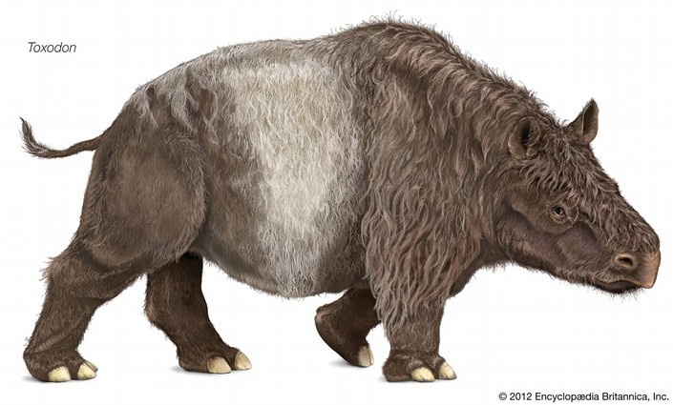

Remove his hair and he looks like a hornless rhino, but give him scales and he looks like a dinosaur. So why were these guys in the 1800s so keen on putting these teeth in Cuckfield back 240 million years ago, when they had plenty of holes to fill just a few thousand years ago? In fact, Owen and Darwin worked together on Toxodon, though Darwin as usual messed it all up, proposing it was aquatic like a manatee.

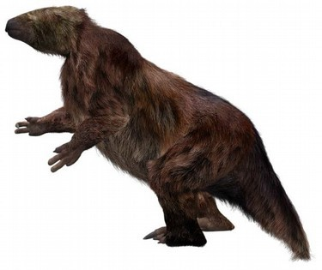

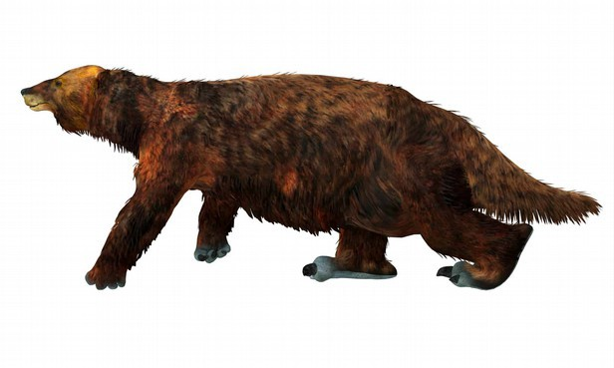

Also see Megatherium, which Darwin and Owen also worked on. This was the giant sloth, weighing 3.5 tons. . . just like Iguanodon. But wait, if you remove the hair, that looks a lot like Iguanodon, down to the shape of the tail!

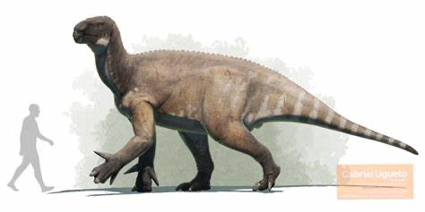

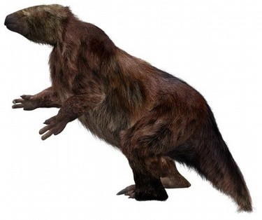

So why was Mantell so sure those were giant reptile teeth his wife found in Cuckfield? Cuvier the expert didn't think so. Iguanas have diamond shaped, pointed teeth, kind of like sharks. Rhinos have curly molars that look absolutely nothing like iguana or reptile teeth. So as usual, none of this makes any sense. There is no way Cuvier could have mistaken reptile teeth for rhino teeth, and there is no way Mantell could have thought something that resembled a rhino tooth also resembled an iguana tooth.

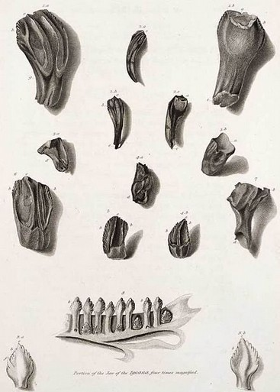

That's Mantell's own illustration from his 1825 paper, with the teeth he found above and iguana teeth below. It is published on his page at Wiki. He is claiming a match. I see no match at all, even less if I go look at pictures of actual iguana teeth. But I do see why Cuvier thought these were rhino teeth. 3B looks exactly like a rhino tooth.
But back to the liberal theologians. The first, Frederick Temple, later became archbishop of Canterbury, so not who you would normally think of as liberal. Of course Wiki doesn't bother to tell you, but he was a peer of the Temple baronets and viscounts, and he married extremely well, his wife being the granddaughter of George Howard, 6th Earl of Carlisle, and Dorothy Cavendish, daughter of the 5th Duke of Devonshire. This also linked him immediately to the Egertons, Leveson-Gowers, Spencers, Russells, Powletts, Paulets, Scropes and Byrons, bringing in at least five more dukes. We already saw the Powletts, Paulets and Scropes above. The Temples were also related to the Levesons and Spencers, so he married his cousin. The Temples were also Grenville-Temples, Earls Temple, and through them we link again to the Chambers. See the author of Vestiges, above. We now find with more digging the Chambers were closely related to the Berkeleys and Noels, who then link us to the Villiers. Who was a Villiers? Fitzroy, captain of the Beagle.

Temple's essay, written at age 39 when he was still headmaster of Rugby School, was relatively harmless, but he would have known what the other essays were and should have read them, so it should still seem strange to mainstream historians that he was part of this. Wilberforce immediately demanded he remove his essay from the collection, but he refused to turn on his colleagues. And again, it is highly suspicious to find a future archbishop of Canterbury getting involved in any of this, at any age. It shows you just how “liberal” the Anglican Church was, even at its center, liberal meaning not liberal, but scheming and destructive of not just Catholicism, but Christianity in general.

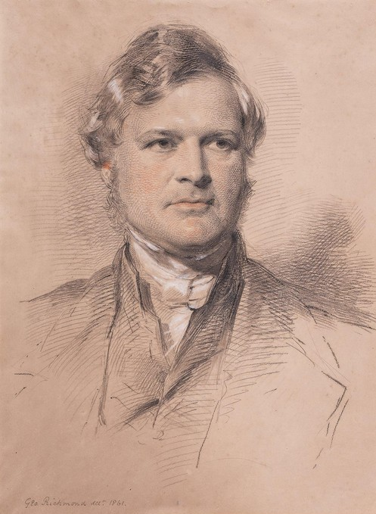

I tripped across that in my digging. It isn't Temple, it is Meyrick Goulburn by George Richmond, in black, white and red chalk on tan paper. I had to include it because it is such a fantastic bit of work. Not everything is a fraud.

One of the two most controversial essays in the collection was by Rowland Williams, vice-principal and professor of Hebrew at St. David's College, Lampeter. He came from the Griffiths/Gruffudds of Cochwillan, Wales, who were also. . . yep, Tudors. This is where Henry VII came from. He was in that direct line, so not a Welsh outsider as he is sold. We are now told his essay seems innocuous by current standards, which unfortunately is true. Christianity has been so watered down by everyone up to the Pope it amazing it floats at all. But whatever you think of Williams' arguments that large parts of the Bible can be ignored, his essays certainly fits my argument here, that being, again, that Christianity had been infiltrated by these pretend Christians—really from old Phoenician lines—who were purposely blowing it from the inside. You will say, what do I care, I ignore the whole thing, but I care not because I am arguing the Christian side, but because I want to know what happened and why. want to understand the real history here, so that I can share it with you. You and I will then be able to make better decisions. Your decisions may not be the same as mine concerning Christianity, but that is OK: you and I are different people with different needs and goals, and if this paper strengthens your faith that is fine by me. My targeted enemy is not Christianity, science, or any religion or faith. It is these Phoenician fakes and liars who have polluted all of known history.

Williams and Henry Bristow Wilson were brought up on charges of heresy, at first convicted by the Dean of Arches, but acquitted on appeal by the Privy Council. That is also very strange, since it isn't clear what authority the Privy Council should have had here. The Council invited three bishops to sit with them in judgment, to make the thing look real, but the bishops were guaranteed to be outvoted, so it was all another scam. The seven authors were clearly part of a government project, so there is no way they were going to be convicted of anything. The only thing that is of much interest here is that both the lower clergy and laity (normal people) were strongly against the seven authors and their liberal theology. The archbishops of Canterbury and York voted against the Privy Council and for conviction, and they were supported by letters or signatures from 137,000 parishioners and 11,000 clergy—almost half the clergy in England. That doesn't mean the other half supported the seven, it more likely means they were too timid to sign anything, for fear of reprisals.

The Convocation of Canterbury, reinstated in 1840 after being crushed by Henry VIII in 1534, met in 1864 and, led by Wilberforce, obtained a synodical condemnation of the seven authors. Given that, it is pretty amazing that one of the seven authors, Temple, ended up being the Archbishop of Canterbury 32 years later. If you are a Stuart, nothing sticks to you.

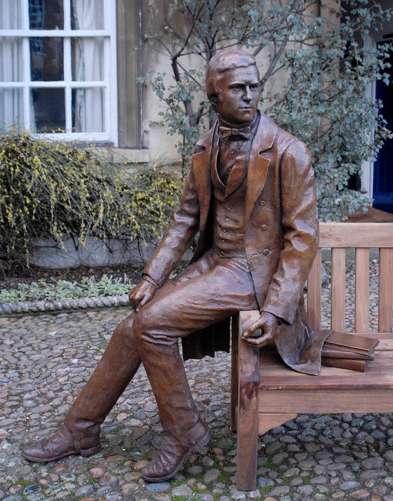

Let's return now to Darwin. As a portraitist and sculptor, I think I am qualified to comment on that, Darwin's 2009 bicentennial portrait by Anthony Smith. It's really not good, is it? It doesn't look like Darwin, to start with. Is it Darwin with a toupee? Darwin always had a much higher forehead, even in his early twenties. The haircut is not period, since they liked it longer on the sides with sideburns. The arm and hand positions are very stiff and odd. Why is Darwin making a circle with the near hand? More Masonic tomfoolery? The thumb is freakishly long, like some alien thumb. And the near foot position is also unnatural. The clothes look sort of sloppy, as if they are made of plastic instead of cloth, and you can tell at a glance how this was formed out of wax, since it looks partly melted. The wrinkles in the cloth are very amateurish. The overall tooling (the chicken scratches all over) is unnecessary, unappealing, and distracting. They could have hired a real sculptor to do this, someone like Alex Stoddart or Philippe Faraut, so why Anthony Smith, who was only 24 when he landed the commission? They were too cheap? Maybe, but studying this photo, I can think of other reasons.

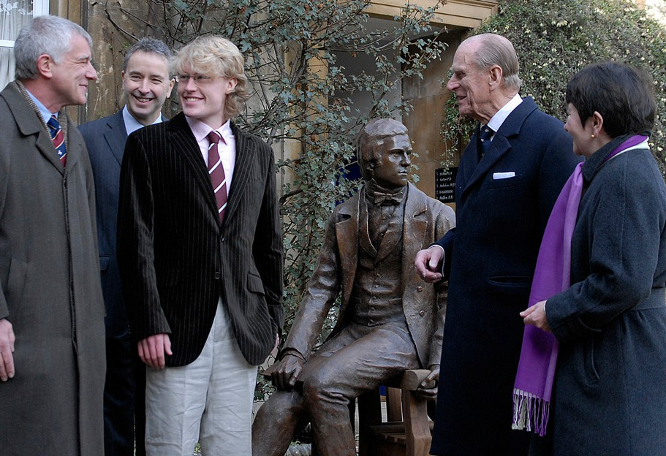

No one is looking at Darwin, are they? The old men seem very enamored of the boy. And again, I am eminently qualified to comment here, because I looked very much like that at 24, so I know what is going on there. I refused to go along with it, but Smith didn't. A sculptor should be chosen for his ability, not for his pretty hair. He was tapped even before that, when, at age 22, he was chosen to sculpt Linnaeus for the Linnean Society, and it is even worse (see below). We have already hit all that about Linnaeus, haven't we? Smith also did the Alfred Russel Wallace statue, which is also not good. So this all looks like another inside job.
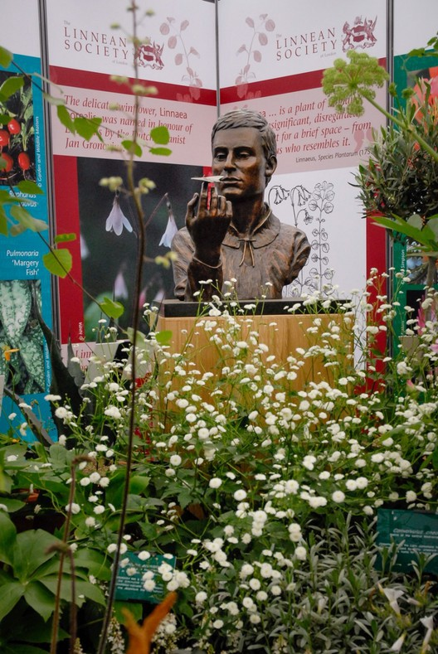

The first guy in the group photo is given as Alan Smith, “benefactor”. Are the two Smiths related? We aren't told. I looked them both up at thepeerage.com, but didn't come up with anything. Which doesn't mean they aren't of peerage families. Wikipedia should tell us Anthony Smith's parents, but conspicuously doesn't. Best guess is he comes from the Smith baronets of Crowmallie, who have connections to Glasgow, Cambridge, and Westminster College, since Anthony has all three on his resume. See for example Sir William Gordon Smith of Crowmallie, 2nd baronet, who went to Westminster and Cambridge. His father and grandfather went to Glasgow Academy and Cambridge. His son was a lecturer in physics at Cambridge. These Smiths are related to the Kennedys of Ballycastle, Ireland.

And guess what, we have already hit these Smiths/Smythes above and in earlier parts, haven't we? That can't be a coincidence. So it closes another circle finding one of them as the sculptor here.
We have now gotten Darwin up to age 30, so it is very strange what Wikipedia tells us about this period:

Darwin now had the framework of his theory of natural selection "by which to work",[105] as his "prime hobby".[111] His research included extensive experimental selective breeding ofplants and animals, fnding evidence that species were not fxed and investigating many detailed ideas to refne and substantiate his theory.[18] For ffteen years this work was in the background to his main occupation of writing on geology and publishing expert reports onthe Beagle collections, in particular, the barnacles.[112]
So for fifteen years Darwin neglected Evolution to concentrate of geology and barnacles? I thought his first love was beetles. Why is he writing about geology and barnacles? Because, again, he is just the front for other people. He is like Lennon/McCartney fronting George Martin and the professional songwriters you have never heard of. If you want to know why the early Beatles hits were what they were, don't ask John and Paul. Ask George Martin. Those lyrics are telling you about him and his team, not about John and Paul. That's why most of the hits of the 60s and 70s (not just the Beatles) sound like they were written by people far older than the people singing them: because they were. Same thing here, where we are seeing Lyell, Thompson, Hooker and others, not Darwin. If you don't believe me, see this article on Darwin and barnacles, which all but admits it.

Hooker became Darwin's main resource regarding evolution, a topic that remained his true love even while he was in the midst of his barnacle research. Hooker's botanical expertise was a useful anchor for Darwin's speculations on the origins of species. Any time he had a question aboutplant distribution or varieties, Hooker could be depended on to find an answer, if there was one. He invited Hooker to spend time at Down, where the two would go on walks around the groundsbefore Darwin, sick as ever, returned to his room to rest.
Many places claim Darwin discovered barnacles were crustaceans, not mollusks, but Wikipedia admits that isn't true. It was discovered by John Vaughan Thompson in 1830, and they admit Darwin read his book in the 1830s. Thompson was still working on this up to his death in 1847, exactly the same years Darwin was publishing on barnacles. Darwin later admitted he actually hated barnacles, so it is strange he allegedly spent 8 years writing about them.

From 1836 to 1859, a period of 23 years, Darwin actually published very little. His biographers at Wikipedia are forced to fill these sections with a lot of fluff, and we learn a lot about his marriage and bad health and his “ideas”, but get very little that is tangible. Other than the fake Journal which came out in 1939, which we have already covered, he published a book on coral reefs that is about 200 pages and a book on barnacles that consisted of three monographs of Cirripedes. There were also two geological books on volcanic islands and on South America in general, but I again get no impression he wrote them. As I showed in part II, he didn't actually go around the world, so he didn't even visit many of these places, and may not have visited any of them. But even if he did write all of these things, it is a slender bibliography for 23 years, especially for a guy who otherwise had no job. He was not in academia or business, so he could devote himself full-time to writing. I write more in one year than Darwin wrote in those 23 years.

And, it goes without saying, he published absolutely nothing on Evolution in those 23 years. Not one word. Not a magazine article, not a scientific journal article, nothing. We are told he had a “sketch” which became a 230-page essay he was sitting on, but there is no proof of that one way or the other. It is nothing more than an unsubstantiated claim, and science doesn't work like that.

Which brings us up to On the Origin of Species and Darwin's team trumping of Wallace. But I have hit 21 pages pdf (about 60 book pages), so we will save that for part V. A few hours ago I wasn't sure there would be a part IV, but look at all we have learned.

DARWIN Part V
The Theft
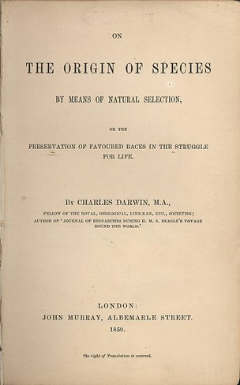

by Miles Mathis

First published March 15, 2024

In part IV we had gotten Darwin up to the publication of On the Origin of Species, but we skipped over him stealing precedence from Wallace. So we will hit that here.

You might assume that what we discovered in parts I and II about Darwin faking his trip around world would be the biggest fraud in his life, but it has serious competition. It reminds me of Lindbergh, where we found the kidnapping of his baby was faked. In the lives of most people, that would be impossible to top, but Lindbergh did top it easily, as we saw. And the thing about Darwin is, the mainstream admits this second fraud. They don't admit the first one, but they go to very little effort to hide this second one.

I am actually not the first one to point this out. Several books have been written about it, and Wikipedia even references a couple of them before telling you they are wrong and that “most scientists” agree Darwin was the first to have the modern idea of Evolution via Natural Selection. But as usual that just means that most scientists have been paid off or threatened to go along with the party line here, and that Wikipedia has, too. Darwin is too big a name to lose now, so even though I am sure a lot of scientists will agree with me here, they can't make trouble this late in history. Like Heisenberg, Oppenheimer, Turing, and the rest of these folks, Darwin has to be kept propped up for the sake of mainstream science “theory”. He is part of the modern propaganda package, so you aren't supposed to look too closely at any of this. You are supposed to just drink it down with a Big Gulp and go on as before.

Alfred Russel Wallace actually beat Darwin into print with two big papers, one in 1855 and one in 1858. Darwin's book was 1859. Wallace first wrote and published “On the Law which has Regulated the Introduction of New Species" in 1855. That law is Evolution, of course, though they now try to claim that because it doesn't mention possible mechanisms for Evolution, it doesn't count. Pathetic. We know Darwin read the paper by 1856 since it was sent to him by both Lyell and Blyth. We are told that Darwin had already shown his theory to Joseph Hooker, but there is no proof of that one way or the other. At any rate, you don't establish priority by showing your theory to a cousin, you do it by publishing. Publication is the record of your writing, proving its existence so that we don't have to take your cousin's word for it. You don't have to publish with a major publisher, there simply has to be something in writing, and a record that you released it into the world, with a traceable date and place of release. Darwin could have printed up just a few copies and placed them in a couple of libraries, and if the libraries had a record of when that happened it would count. In France in the 19th century you could establish priority by sending a single dated copy of your paper to the French Academy, and they were required to confirm the date of receipt. We saw that happening in my paper on Edison, although there were ways to cheat even that system.

We don't know what Darwin showed Hooker, but we do know he didn't start writing up his “species sketch” until May of 1856, and then only because Lyell pressed him to do so to establish priority over Wallace. Since Wallace had already published in 1855, I don't see how they thought Darwin would establish priority, but as we know they had things up their sleeves. The rules don't apply to Stuarts.

Due to that confidence, Darwin and his team dawdled for another two years, writing and publishing nothing. So they were shocked when Wallace sent his new paper of February 1858 "On the Tendency of Varieties to Depart Indefinitely From the Original Type”, directly to Darwin, asking for his opinion on publication. The Darwin team could see that they were in a pickle, with Darwin as usual pulling a Neil Armstrong and calling in sick. They still explain Darwin's absence in this period as due to the illness of his baby son, which again sounds like desperation. The child had been sick since birth, two years earlier. Besides, since Darwin was the centerpiece of this reading, they should have postponed. It made no sense to do this without Darwin there. So all this is highly suspicious, as usual. Lyell and Hooker jumped in to represent the team, publishing Wallace's new paper via a reading at their own Linnean Society, in conjunction with a previously unpublished essay and letter excerpts from Darwin. Somehow they then claimed priority for Darwin from that. Also suspicious is that the President of the Society, Thomas Bell, commenting on the previous year's proceedings in May 1859, notoriously claimed no big discoveries had been seen. So it now looks like he was paid to downplay the importance of Wallace's paper, which everyone was busy burying to make way for Darwin's big book six months later.
From reading the glosses of this at Wikipedia and Brittanica and the various Darwin biographies, you would think Hooker read from the notes for the upcoming Origin of Species. That is what is always implied. But that isn't the case, as you can read about here.
First the error: Darwin’s contributions to the meeting

were not of his Origin theory, but from his largely abandoned 1844 Essay theory, somewhat updated with a major new idea (divergence) tagged on in a separate document. Natural selection, the innovative mechanismfor modifcation by descent, was presented at the meeting. But a theory of evolution requiresmuch more than a theory of how organic change can happen; otherwise, Blyth has to be credited with frst proposing a theory of evolution by means of natural selection. In 1835, heoutlined natural selection as a purely conservative mechanism, a ‘law, therefore, which wasintended by Providence to keep up the typical qualities of a species’.

You see the knots these “scientists” and “historians” tie themselves up into. This is a 2022 article by Derek Partridge, and he is obviously trying to hit Wallace, but Wallace ducks and Partridge ends up knocking Darwin cold. Origin of Species should have been way beyond a first draft by then, so we don't understand why Hooker was reading from abandoned essay from 14 years earlier. Or, we do now understand: Darwin didn't have squat in the summer of 1858, and everything we have been told is a lie. This is why Wikipedia and all the other sources go to such lengths making you think the Linnean 1858 reading was from an early draft of Origin of Species: by all rights it should have been. You don't write a 500-page science book in a few months.

But even if the reading had been from a draft of Origin of Species, none of the rest of this makes any sense. You can't just steal priority like this. If that happened today it would never fly. Not one scientist worldwide would except it. Darwin, Lyell, and Hooker would be laughed off the podium and forced to retreat in utter embarrassment. Never before or since had anyone stolen credit in such a hamhanded and transparent manner. As we have seen recently with Edison and Bell, these steals are very common, but normally they hide them a bit better than that. There is a big payoff and a somewhat believable story is concocted, one that doesn't just admit the fraud right out in the open. This is what we are told today at Wikipedia:

Communication with Wallace in the far-off Malay Archipelago involved months of delay, so hewas not part of this rapid publication. Wallace accepted the arrangement after the fact, happythat he had been included at all, and never expressed bitterness in public or in private.Darwin's social and scientifc status was far greater than Wallace's, and it was unlikely that, without Darwin, Wallace's views on evolution would have been taken seriously. Lyell and Hooker's arrangement relegated Wallace to the position of co-discoverer, and he was not thesocial equal of Darwin or the other prominent British natural scientists. All the same, thejoint reading of their papers on natural selection associated Wallace with the more famousDarwin.

As you see, they are still making no effort to hide it, admitting that Darwin was given credit not because he published first or had any believable precedence, but because of his “social status”. He outranked Wallace, so it was OK for them to bump him. They might as well say Darwin was a Stuart and therefore it was his birthright to be given credit for this. They basically ARE saying that, as you see for yourself.

And yet, somehow, no one in the mainstream has ever had any problem with it. While telling us how strict they are about the scientific method and peer review and all the modern rules of publication, we see they just make the rules up as they go to suit themselves. There are a lot of rules for you and none for them. The Gentile scientist rulebook is fifty volumes of fine print, while the Phoenician scientist rulebook is two words: ANYTHING GOES.
A year after that reading, Darwin's team published their book. Wow, that was fast! After not being able to come up with anything for decades, suddenly they cranked out this 500-page book in just a matter of months. I guess we are supposed to believe the health of Darwin and all his kids and pets improved overnight, and that he suddenly became a miracle of efficiency.

But seriously, it is pretty obvious the team hired another couple of ghosts and got this thing to the publisher as soon as possible. We are just lucky they didn't try to backdate it, claiming it had gotten lost behind the printing presses.

They needed to backdate it to claim precedence, since in his paper Wallace had not only proposed Evolution but Natural Selection. That's what Partridge doesn't tell you. Notice that he tells us Natural Selection was presented at the meeting, implying that it came from Darwin's papers. It didn't, it came from Wallace's paper. And there is no evidence Wallace stole the idea from Darwin. Wallace got the idea from Malthus (and Blyth), not Darwin, transferring Malthus' environmental pressures to Evolution. We are told Darwin and Wallace just happened to come to the same mechanism separately and almost simultaneously, though there is no evidence of that on Darwin's side. There is no circumstantial evidence indicating Wallace got it from Darwin, but there is clear evidence Darwin and his team got it from Wallace, since his paper was in their possession. But even if it could be proved they came to the same idea independently, precedence would still go to Wallace, for writing it down and sending it off for publication first. That is how it really works, according to their own published rules. It was actually brilliant of Wallace to send it to Darwin instead of the publisher, because then Darwin couldn't claim not to have seen it.

I assume Wallace didn't make a stink for several reasons: one, they no doubt paid him off handsomely; two, he knew by the way it turned out that everyone on the inside knew he beat Darwin and his team to the punch. That and the money were all he wanted: he didn't care what the great unwashed thought of the matter, since the peerage was the whole world to these people. The peers of his own time knew the truth, so the future could hang. These people don't believe in the future. Wallace won and he knew that and Darwin knew that and the rest didn't matter.

But let's go back to the title of Wallace's second paper, “On the Tendency for Varieties to Depart Indefinitely from the Original Type”. There is no such tendency, is there? Think about it. If there were such a built in tendency, we would see a lot more change than we do. Any amount of thought on the subject confirms there is the opposite tendency, that of varieties or species not to depart from the existing type. Malthus' environmental pressures should exist all the time everywhere, which means that species should be changing constantly to match an ever-changing environment. But they mostly DON'T. Natural Selection is always used to explain change, but how does it explain lack of change? For example, cats have not changed significantly in five million years. Does that mean their environment didn't change significantly in five million years? No. Does that mean they are perfect? Maybe, but I doubt it. What about coelacanths, who have been around in the same form for over 400 million years. How does natural selection explain that? They are perfect? They don't look perfect to me. Did all that change just skip them? No environmental pressure for them?

We all remember the graphic of a fish walking out of the water and becoming a reptile, then an ape, then a man. So why didn't the coelacanth evolve in that direction even a little in 400 million years? You will say that is just one line of evolution, so I will vary my question: why didn't the coelacanth evolve into a dolphin even a little? The dolphin seems way more advanced than the coelacanth, so why did the dolphin evolve and not the coelacanth? They live in the same ocean.

So Darwin and Wallace offered us this “mechanism”, but the mechanism seems to only apply when we need it. It doesn't seem to apply indiscriminately, as a natural law should. It applies more like a grand fudge factor. It ignores dinosaurs for tens of millions of years, but then evolves a hummingbird overnight to match its flower.

We also find this on Wallace's Wiki page:

Others have noted that Wallace appeared to have envisioned natural selection as a kind of feedback mechanism that kept species and varieties adapted to their environment (now called 'stabilizing", as opposed to 'directional' selection).[129] They point to a largely overlooked passage of Wallace's famous 1858 paper, in which he likened "this principle ... [to] the centrifugal governor of the steam engine, which checks and corrects any irregularities".

[3] The cybernetician and anthropologist Gregory Bateson observed in the 1970s that, although writing it only as an example, Wallace had "probably said the most powerful thing that'd been said in the 19th Century".[130]

So some are actually selling Wallace as superior to Darwin, which is interesting. But I remind you there is still no mechanism here, just a broad analogy. We know how a steam engine corrects irregularities, but how does Nature do that? To have a feedback mechanism, you have to not only a mechanism, but FEEDBACK. How are the environment and the organism communicating? Darwin, Wallace, Malthus, Blyth, and all the rest tell us it is via pressure, death, scarcity, and competition, but that doesn't answer, because all those things are abstractions. Not one of them is a direct feedback mechanism, like a pushback on an over-rotation in an engine.

As I have shown here, all these claims of a mechanism are empty, namings standing for explanations. These people say there is a mechanism and call it something, Evolution or Natural Selection, but never get around to showing you how it works. A mechanism answers the question HOW, but without a real charge field, none of these scientists could ever tell you how any of this was being achieved by Nature or the organisms or the species or the varieties. It was the claim of a mechanics with no mechanics. Same as quantum mechanics, which is another vast claim of discovery with no mechanics. Just a lot of cutesy naming and browbeating.

In that paper I show that every organism, and every cell in every organism, can communicate constantly with the environment via the charge field, which creates a real feedback mechanism as well as a real mechanics. It is mechanical because the charge field is mechanical, made of real photons with real radii and real spins. And the environment doesn't just communicate with each cell, it communicates with each enzyme in the body, giving the cells and enzymes the information they need to do what they do. One of the things the enzymes can do: change the genetic code.

And why do enzymes sometimes “want” to do that and sometimes not want to do that? No one knows, not even me, but at least it gets us to the next level of questioning. We are no longer tied up in the non-mechanical handwaving of Darwin, Wallace, and all the rest since then. The charge field all by itself moves us a huge step forward in understanding how all things work.

I had wanted to say more about the publication of Darwin's book, but the historical accounts are so obviously fabricated I gave up in disgust. See for example the Wikipedia page “publication of Darwin's theory”, which was obviously assigned to some specialist in propaganda. It is nothing but unsubstantiated claims, airy assertions, and the usual attempts at smiling hypnosis. You can almost see the watch swinging. We are told Darwin was working on this as soon as he returned to England in 1836, but we have not a shred of proof of that. Twenty years later he is just beginning a “sketch” of his views, and we are supposed to believe it is an outline of a far larger existing work he is sitting on. Even Origin of Species is supposed to be just a gloss of it. One problem: that urtext has never surfaced, and you can tell just by the form of this promotion it never existed. We get a long line of excuses—bad health, sick and dying children, the whole town with scarlet fever—but that doesn't explain two decades of inertia and nothing actually published. Read closely and you soon realize the whole thing is a charade.

Since the mainstream is not giving me anything to comment on there, I will look instead at Charles Lyell, who I have so far missed in my critiques. He was actually Sir Charles Lyell III, 1st Baronet, putting a huge red flag on him from the start. All the baronets are worthy of high suspicion, as we have found. His grandfather made a huge fortune supplying the Royal Navy at Montrose, in Scotland. Lyell's wife was Mary Horner, whose uncle Francis Horner had founded the Edinburgh Review. These Horners were also Murrays, linking us to the John Murray who published Darwin. Lyell's own uncle was Gilbert Heathcote, whose father was also a baronet. Heathcote's brother Henry was Admiral of the Blue. His grandmother was Lady Parker, daughter of the Earl of Macclesfield. His son married Mary Thomas, her father being Rear Admiral Frederick Jennings Thomas, son of the 5th Baronet. The Heathcotes are also closely related to the Dickens, as in Charles Dickens. These Heathcotes were baronets in two lines at the time, the second line marrying the Manners, Dukes of Rutland, and becoming Barons Aveland in 1856. They then married the Gordons, Marquesses of Huntley, and became the Earls of Ancaster 1892.

Wiki scrubs Lyell's mother, but at thepeerage.com we find she was a Smith of Muker Hall, Swaledale, Yorkshire. Darryl Lundy reports it as Maker Hall, but it was Muker Hall. This would make these Smiths the lead mining Smiths of that area. Lyell also inherited all this Smith property when his uncles in that line died without issue, making him the biggest landowner in that area. Lyell had no children, but his brother married his wife's sister Katherine Horner, and their son Leonard Lyell became the 1st Baron Lyell. He married a Stirling of Drumpelier, linking us to more titles.

What does it all mean? The usual: Darwin and Lyell were peerage cousins, perhaps most closely related through Lyell's wife.
Why does it matter? Because with a little research we find the same thing applies to Lyell that applies to everyone else we have looked at. On his own page, he is sold as the father of Uniformitarianism, but in the page on that, second paragraph, Wiki admits:
Coined by William Whewell, it was originally proposed in contrast to catastrophism[10] by British naturalists in the late 18th century, starting with the work of the geologist James Hutton in his many books including Theory of the Earth.[11] Hutton's work was later refned by scientist John Playfair and popularised by geologist Charles Lyell's Principles of Geology in 1830.[12] Today, Earth's history is considered to have been a slow, gradual process, punctuated by occasional natural catastrophic events.

Ah, so the truth comes out! Lyell was mainly a popularizer of other people's ideas. Another idea thief. And why is he so much more famous than Hutton and Playfair on these topics? Now you know: it is because he was a Stuart. As a peer from top lines, he figured it was his just reward for being born.

This is also interesting: Principles of Geology was Lyell's first published book, and it came out when he was. . . you know it. . . 33. He was not a geology professor and had no degree in geology. By today's rules, he could not claim the title “geologist”. He would be banned from the field as an interloper, crank, and carpetbagger. He had been a lawyer up to age 30. As with Darwin, Lyell's book was published by John Murray, another close cousin. We saw the Murrays above.

Unless you are in the field, you probably haven't heard of Hutton, but you have likely heard of Lyell. Even in the field, you wouldn't have heard of Hutton if he weren't also a peer. A lower ranking one than Lyell, but still a Hutton and a Balfour, which guaranteed he wouldn't be completely buried.

Hutton's father was a rich merchant, City Treasurer of Edinburgh. His mother is scrubbed, but she is probably of the Balfours of Pilrig, who were also Hamiltons of Airdrie, Elphinstones of Logie, Forbes of Craigievar, and Montgomeries of Hazelhead.

Hutton came to his theories over a period of 25 years, finally publishing them in 1788 in Theory of the Earth. We are told this was ignored because his prose was bad, but if that were the case no one would have ever heard of Newton, Kant, and almost everyone else. The mathematician John Playfair basically rewrote the book for him in 1802, leaving out the parts on evolution as too revolutionary. This helped a bit, but it helped much more when Lyell—who had all the right connections, to the Edinburgh Review and everywhere else—rewrote it all again in 1830, and it really caught fire.

Are there any statues to Hutton, father of geology? No. There is one statue of him in the Scottish National Portrait Gallery, but since it is from 1776, it can't be for his geology work. It may be for his work on the canal. More likely it is misattributed, being his father the city treasurer.

As for Lyell:

Lyell was knighted (Kt) in 1848,[12] and later, in 1864, made a baronet (Bt),[13] which is an hereditary honour. He was awarded the Copley Medal of the Royal Society in 1858 and the Wollaston Medal of the Geological Society in 1866. Mount Lyell, the highest peak in Yosemite National Park, is named after him; the crater Lyell on the Moon and a crater on Mars were named in his honour; Mount Lyell in western Tasmania, Australia, located in a profitable mining area, bears Lyell's name; and the Lyell Range in north-west Western Australia is named after him as well. In Southwest Nelson in the South Island of New Zealand, the Lyell Range, Lyell River and the gold mining town of Lyell (now only a camping site) were all named after Lyell.[14] Lyall Bay in Wellington, New Zealand was possibly named after Lyell.[15][16] The jawless fish Cephalaspis lyelli, from the Old Red Sandstone of southern Scotland, was named by Louis Agassiz in honour of Lyell.[17]

So the real father of geology (who was also not a geology professor or a professional geologist and who had no science degree—he was trained as a doctor) is lost in obscurity, while the rich guy who stole everything from him was showered with prizes and medals and has fish and craters and towns named after him. Given all that, it is sort of embarrassing that he was wrong about almost everything. A lot of his later fame was due to his links to Darwin, but he also became the main top name in the argument against Cuvier, as you may know. Lyell saw himself as "the spiritual savior of geology, freeing the science from the old dispensation of Moses." Very pretty, but Georges Cuvier (also a baron, by the way) had already destroyed Uniformitarianism before Lyell even got there, arguing against Hutton's ideas in 1812. Cuvier, like Hutton but unlike Lyell, did a lot of work in the field (Lyell was almost blind from an early age). But Cuvier didn't limit his digging to one place. He and his comrades found evidence of several mass extinctions, which obviously don't fit the idea of uniformitarianism. In response to that, the only thing Lyell had to say is the geologic record was "grossly imperfect" and that observations cannot be trusted if they goagainst "the plan of Nature".

In other words, let's not confuse the issue with facts. Lyell bragged he was more scientific than the priests, but you see he still had very little use for experiments when they got in the way of his theorizing.
It is also strange to see him so connected to Darwin, since he always argued against the transmutation of species.

In the first edition of Principles, the first volume briefly set out Lyell's concept of a steady state with no real progression of fossils. The sole exception was the advent of humanity, with no great physical distinction from animals, but with absolutely unique intellectual and moral qualities. The second volume dismissed Lamarck's claims of animal forms arising from habits, continuous spontaneous generation of new life, and man having evolved from lower forms. Lyell explicitly rejected Lamarck's concept of transmutation of species, drawing on Cuvier's arguments, and concluded that species had been created with stable attributes.

That is remarkable not only for its direct opposition to Darwin, but for the admission that Lamarck beat them both to the punch on evolution, transmutation of species and spontaneous generation (mutation).

Lamarck was also a noble, though they try to sell him now as impoverished. The usual. He came out of a Jesuit College, so he was another Phoenician cousin. Despite that he is now universally ridiculed, but probably more for being a Frenchman than for for his theory of acquired characteristics. He and Cuvier had to be buried to make room for Lyell and Darwin, you know. If you read closely, you will find it admitted even in these mainstream sources that Lamarck didn't invent that theory and actually refined it quite a bit. What you won't generally find admitted is that acquired characteristics are making a strong comeback in the margins, due to many newer experiments pointing at them. This silent revolution has been proceeding like many others, unknown to all but a few. It made some headway with Arthur Koestler's Case of the Midwife Toad of 1971, which argued that not only had Paul Kammerer obtained proof of it in 1925, but that he was blackwashed to hide it and protect Darwinism. That was somewhat difficult to believe in 1971, and Koestler's book didn't make much of a dent. But given what we have discovered since, my readers at least are in a position to give it another look. We know that people are destroyed to protect entrenched theory, since I am one of those people. But unlike Kammerer I refused to commit suicide and go away. In my paper linked above, I show how the charge field might explain acquired characteristics. I just discovered that some mainstream scientists now parallel my explanation there, especially Alexander Vargas, who specifically points to the emerging field of epigenetics, as I do. This is the first sentence on the Wiki page for epigenetics:

In biology, epigenetics is the study of heritable traits, or a stable change of cell function, that happen without changes to the DNA sequence.[1] The Greek prefx epi- (ἐπι- "over, outside of, around") in epigenetics implies features that are "on top of" or "in addition to" the traditional (DNA sequence based) genetic mechanism of inheritance.[2] Epigenetics usually involves a change that is not erased by cell division, and affects the regulation of gene expression. [3] S u c h e f f e c t s o n cellular and physiological p h e n o t y p i c t r a i t s m a y r e s u l t
from environmental factors.

ENVIRONMENTAL FACTORS. They admit it, right there. That's neo-Lamarckism, since traits affected by immediate environmental factors lead to acquired characteristics. They continue:

The term also refers to the mechanism of changes: functionally relevant alterations to the genome that do not involve mutation of the nucleotide sequence. Examples of mechanisms that produce such changes are DNA methylation and histone modifcation, each of which alters how genes are expressed without altering the underlying DNA sequence.

Wiki doesn't seem to want you to realize what that means, since they make sure to include a final section on “pseudoscience”. They are warning you against quacks who claim the genetic sequence can be changed by mind control. I haven't come across that, but epigenetics certainly can be linked to acquired characteristics, especially when combined with the charge field. The charge field is not “mind control” or pseudoscience either, since the mainstream admits it exists. My charge field is simply Maxwell's D-field, which underlies and causes electromagnetism. It is the same charge that exists on protons and electrons, and inside the nucleus.

What IS pseudoscience is mainstream science in all fields, which has been existing without a real mechanics since the time of Newton. It is all bluster and fudge and unassigned math, as I have shown exhaustively. That couldn't be clearer in evolutionary biology, which has existed from the beginning without any real mechanism. You are taught that Natural Selection is the mechanism of Evolution, but Natural Selection isn't a mechanism. It is another theory. As I have shown, it bogs down just like all these other theories in all subfields when it gets time to point to a method of communication or force between organism and environment. How do any of these things know to do what they do?

The DNA was supposed to explain that, but it too is not a mechanism. It is a code. How does the environment affect the code, and how does the organism read the code? Without the charge field, mainstream scientists are left to explain everything with chance mutations, some of which are beneficial, but I have shown that doesn't serve as a mechanism. They knew that before I came along, but because it is all they have they guard it jealously, as if it is something to cherish. It isn't, it is just idiotic. No sane person would consider mutations something to cherish as a theory or mechanism, since its explanatory power is about nil. If Nature had to wait around for beneficial chance mutations, nothing would ever get done.

Original Articles from Miles Mathis…

https://mileswmathis.com/darwin.pdf

https://mileswmathis.com/darw2.pdf

https://mileswmathis.com/wallace.pdf

https://mileswmathis.com/huxley.pdf

https://mileswmathis.com/darw5.pdf

The Energy Enhancement Streaming Video Meditation Course and the Volumes of the Against Satanism Series by Satchidanand

Go to http://www.energyenhancement.org
for 52 Free –On Sign-Up - Energy Enhancement Books and Energy Enhancement Against Satanism Books.
To defeat Evil, you need to up your game. Learn the Energy Enhancement Meditation Course by Video or Live at Iguazu falls with Satchidanand and Devi Dhyani.

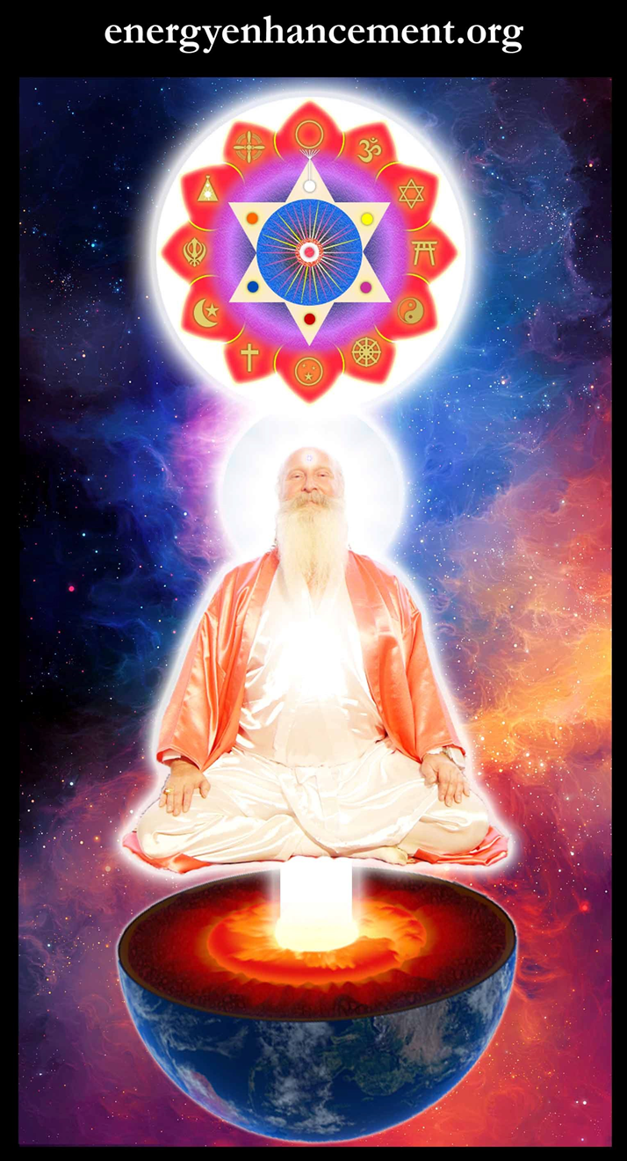
T

Change the World...


Go to http://www.energyenhancement.org
for 52 Free Energy Enhancement Books.

To defeat Evil, you need to up your game. Learn the Energy Enhancement Meditation Course by Video or Live in Iguazu.
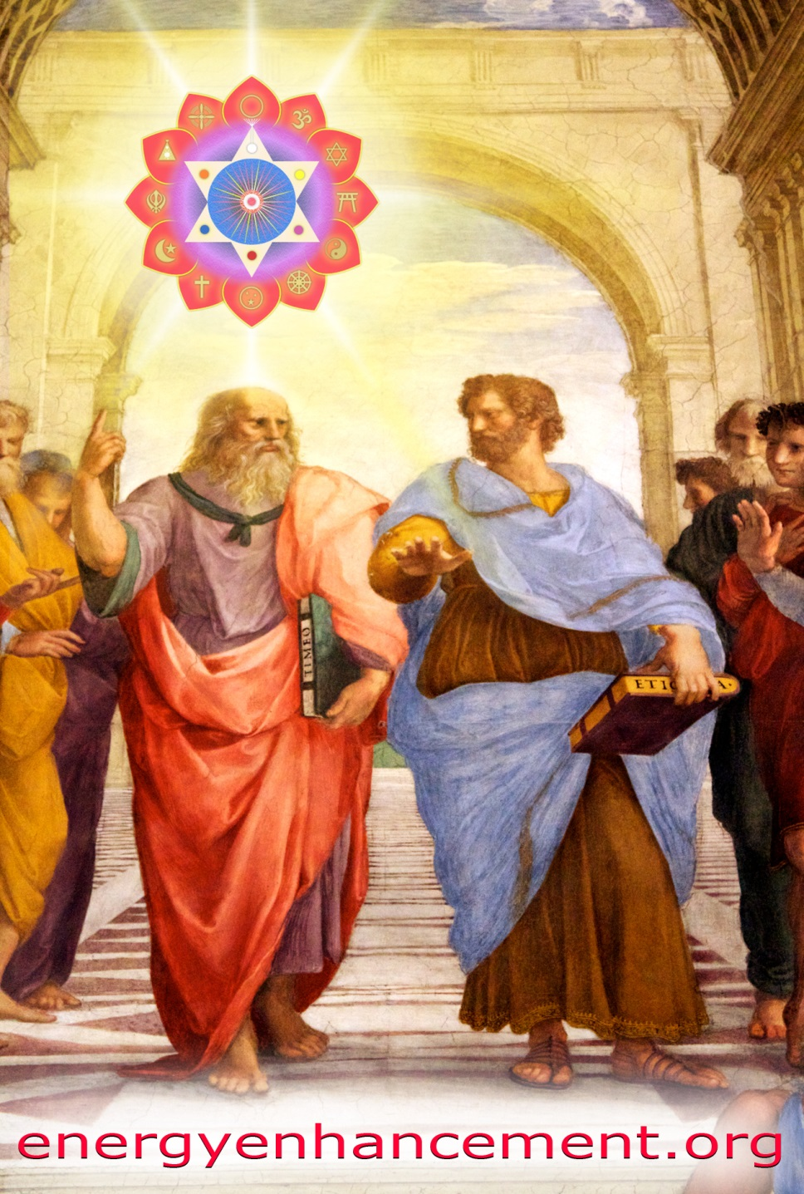

PLATO AND SATANIC BABYLONIAN SECRET AGENT ARISTOTLE "THE POISONER" OF ALEXANDER THE GREAT - BY RAPHAEL

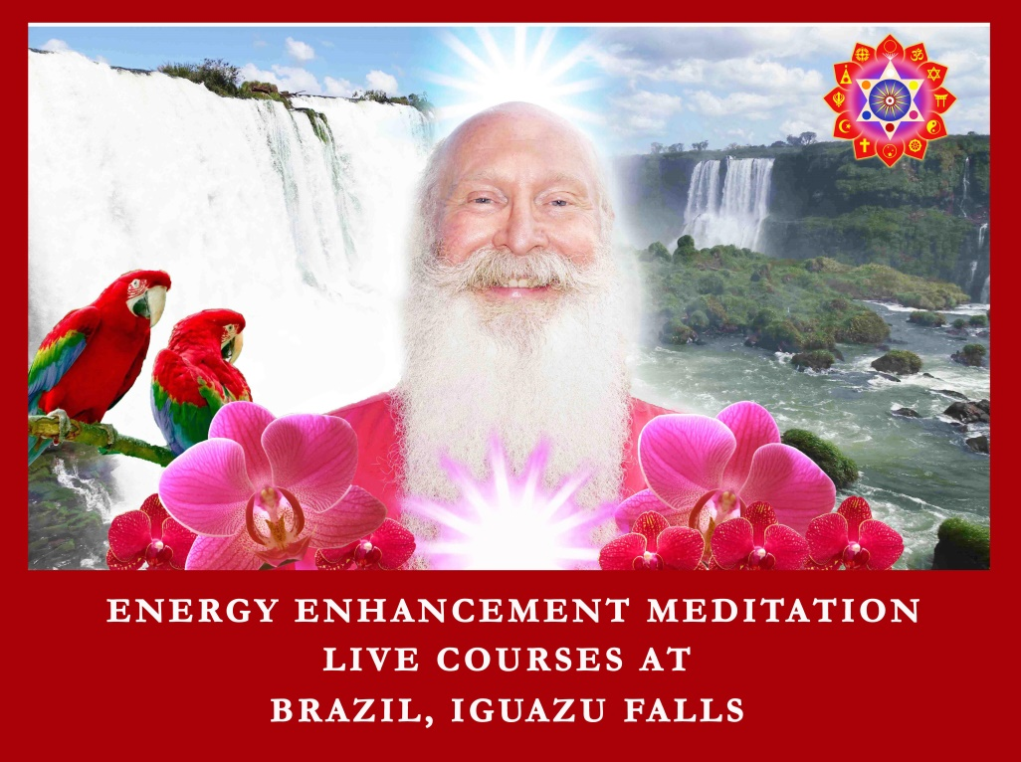


ENERGY ENHANCEMENT MEDITATION
ENERGY ENHANCEMENT MEDITATION LEVEL 1 POWER UP!! GAIN SUPER ENERGY http://www.energyenhancement.org/Level1.htm
ENERGY ENHANCEMENT MEDITATION LEVEL 2 ELIMINATE ENERGY BLOCKAGES http://www.energyenhancement.org/Level2.htm
ENERGY ENHANCEMENT MEDITATION LEVEL 3 CLEAN KARMA BLOCKAGES AND PAST LIFE KARMA BY TRANSMUTATION http://www.energyenhancement.org/Level3.htm
ENERGY ENHANCEMENT MEDITATION LEVEL 4 MASTER ENERGY CONNECTIONS AND RELATIONSHIPS http://www.energyenhancement.org/Level4.htm

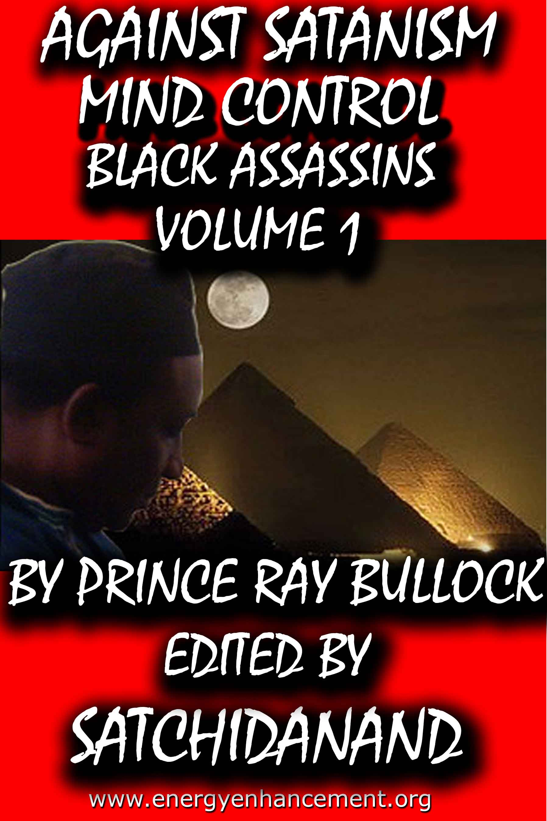

MIND CONTROL BLACK ASSASSINS VOLUMES FREE!!

AGAINST SATANISM VOLUMES FREE!!

- ON SIGN-UP AT..

energyenhancement.org

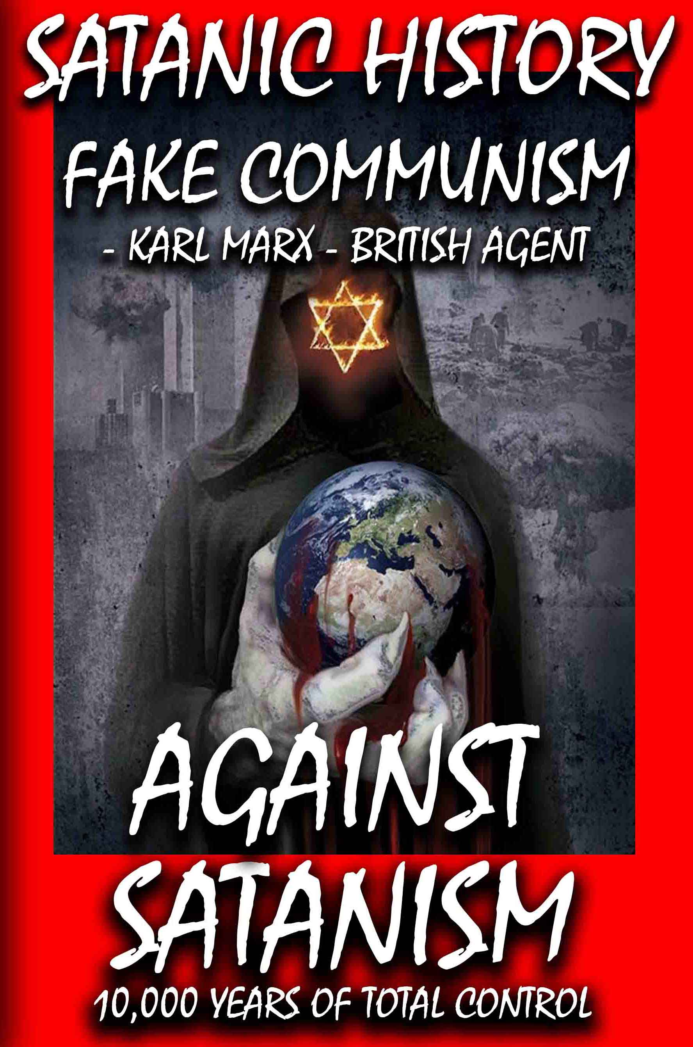

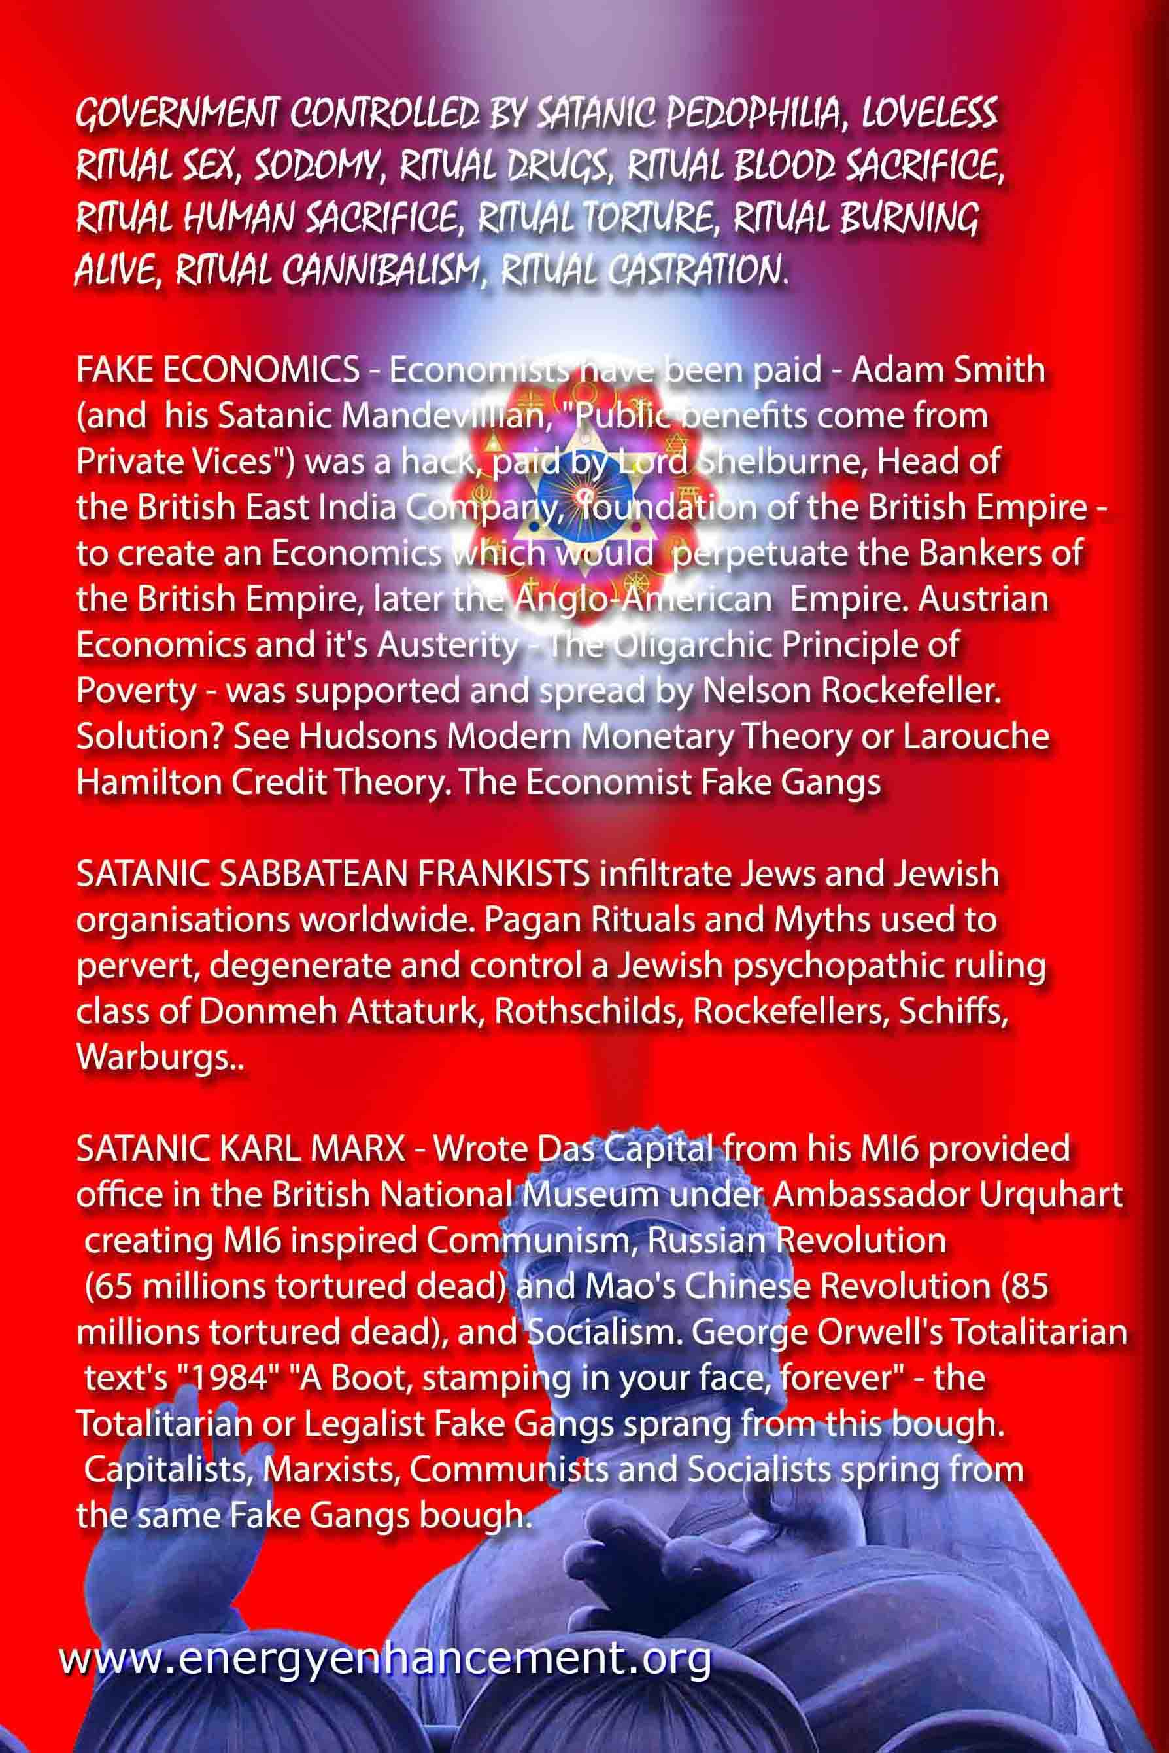

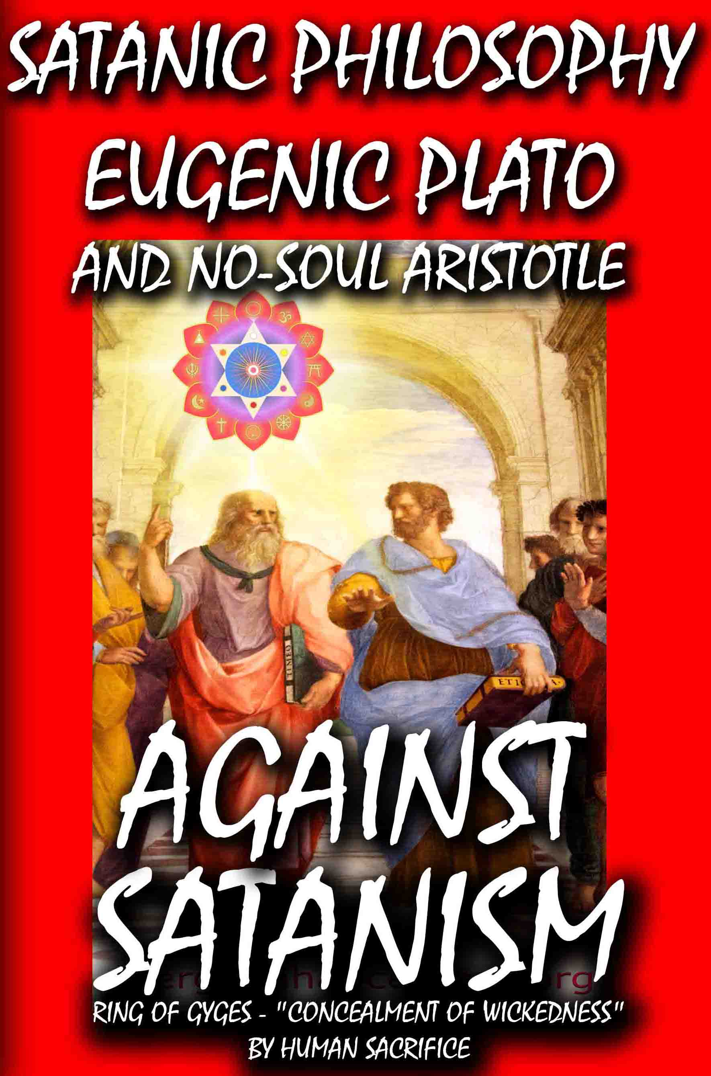

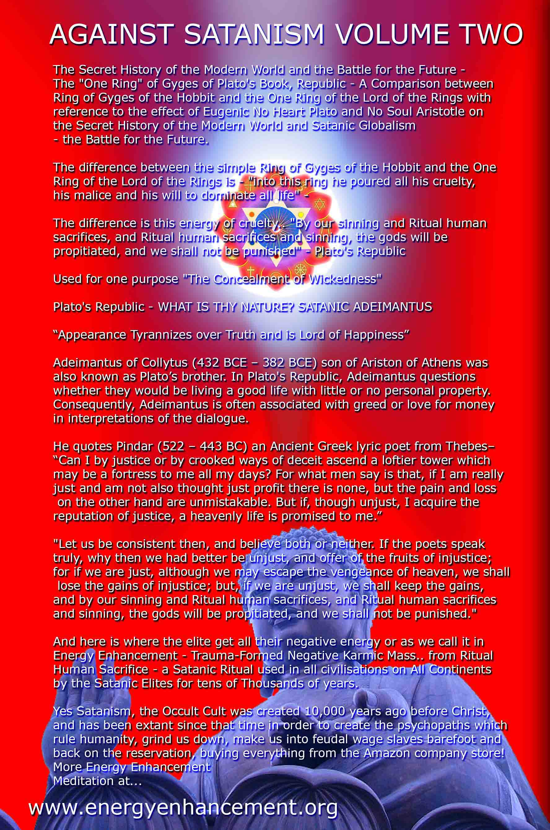

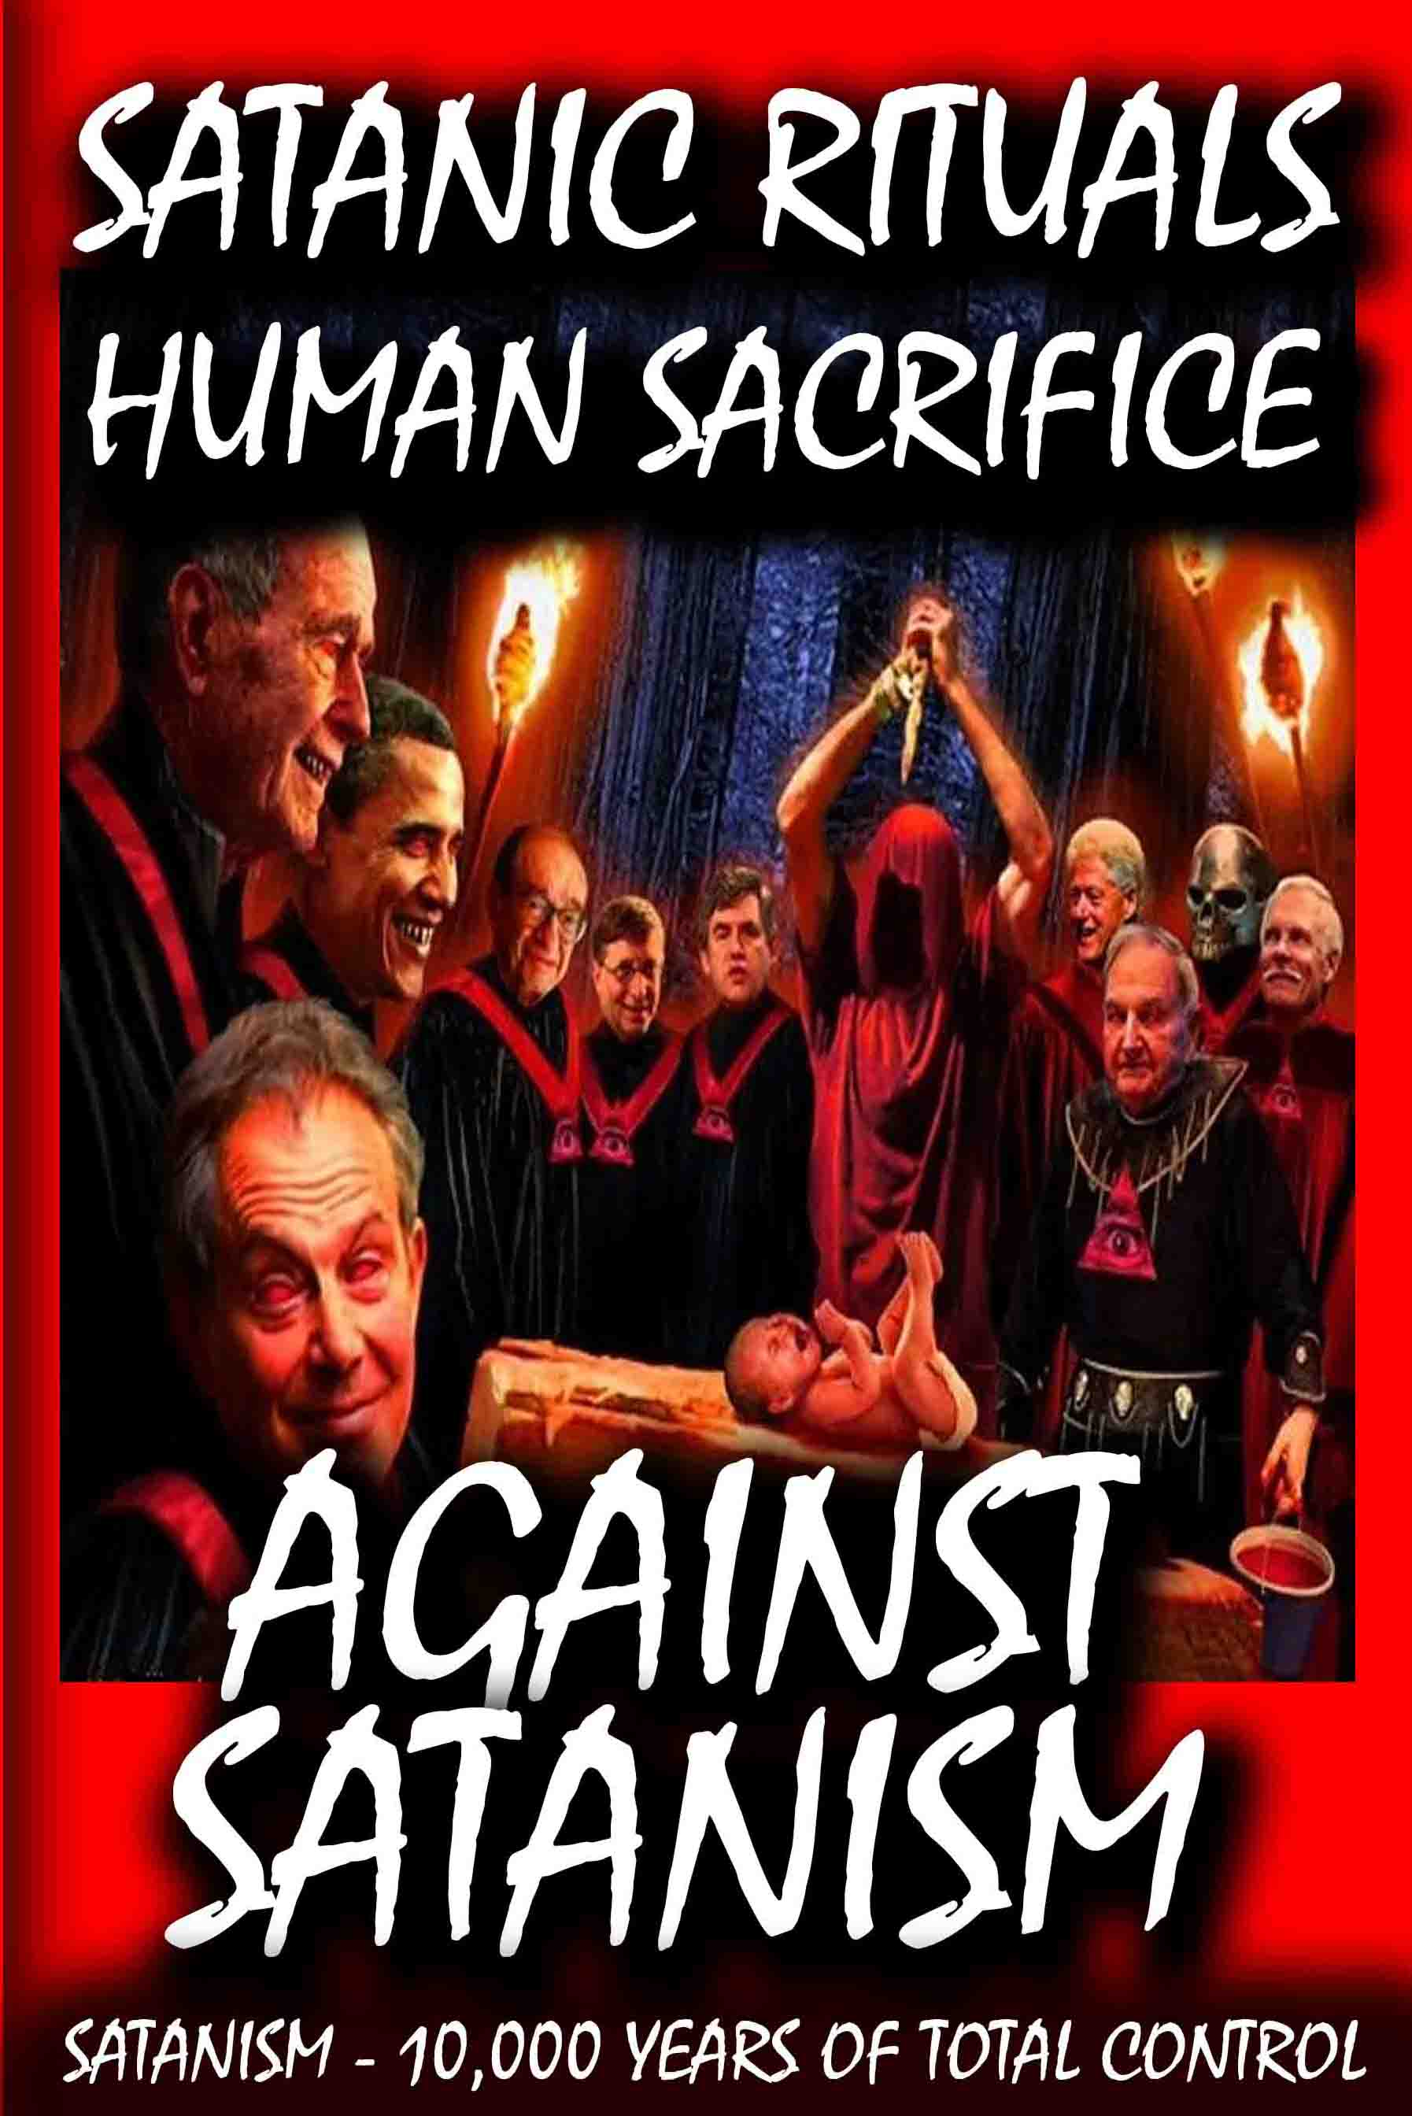

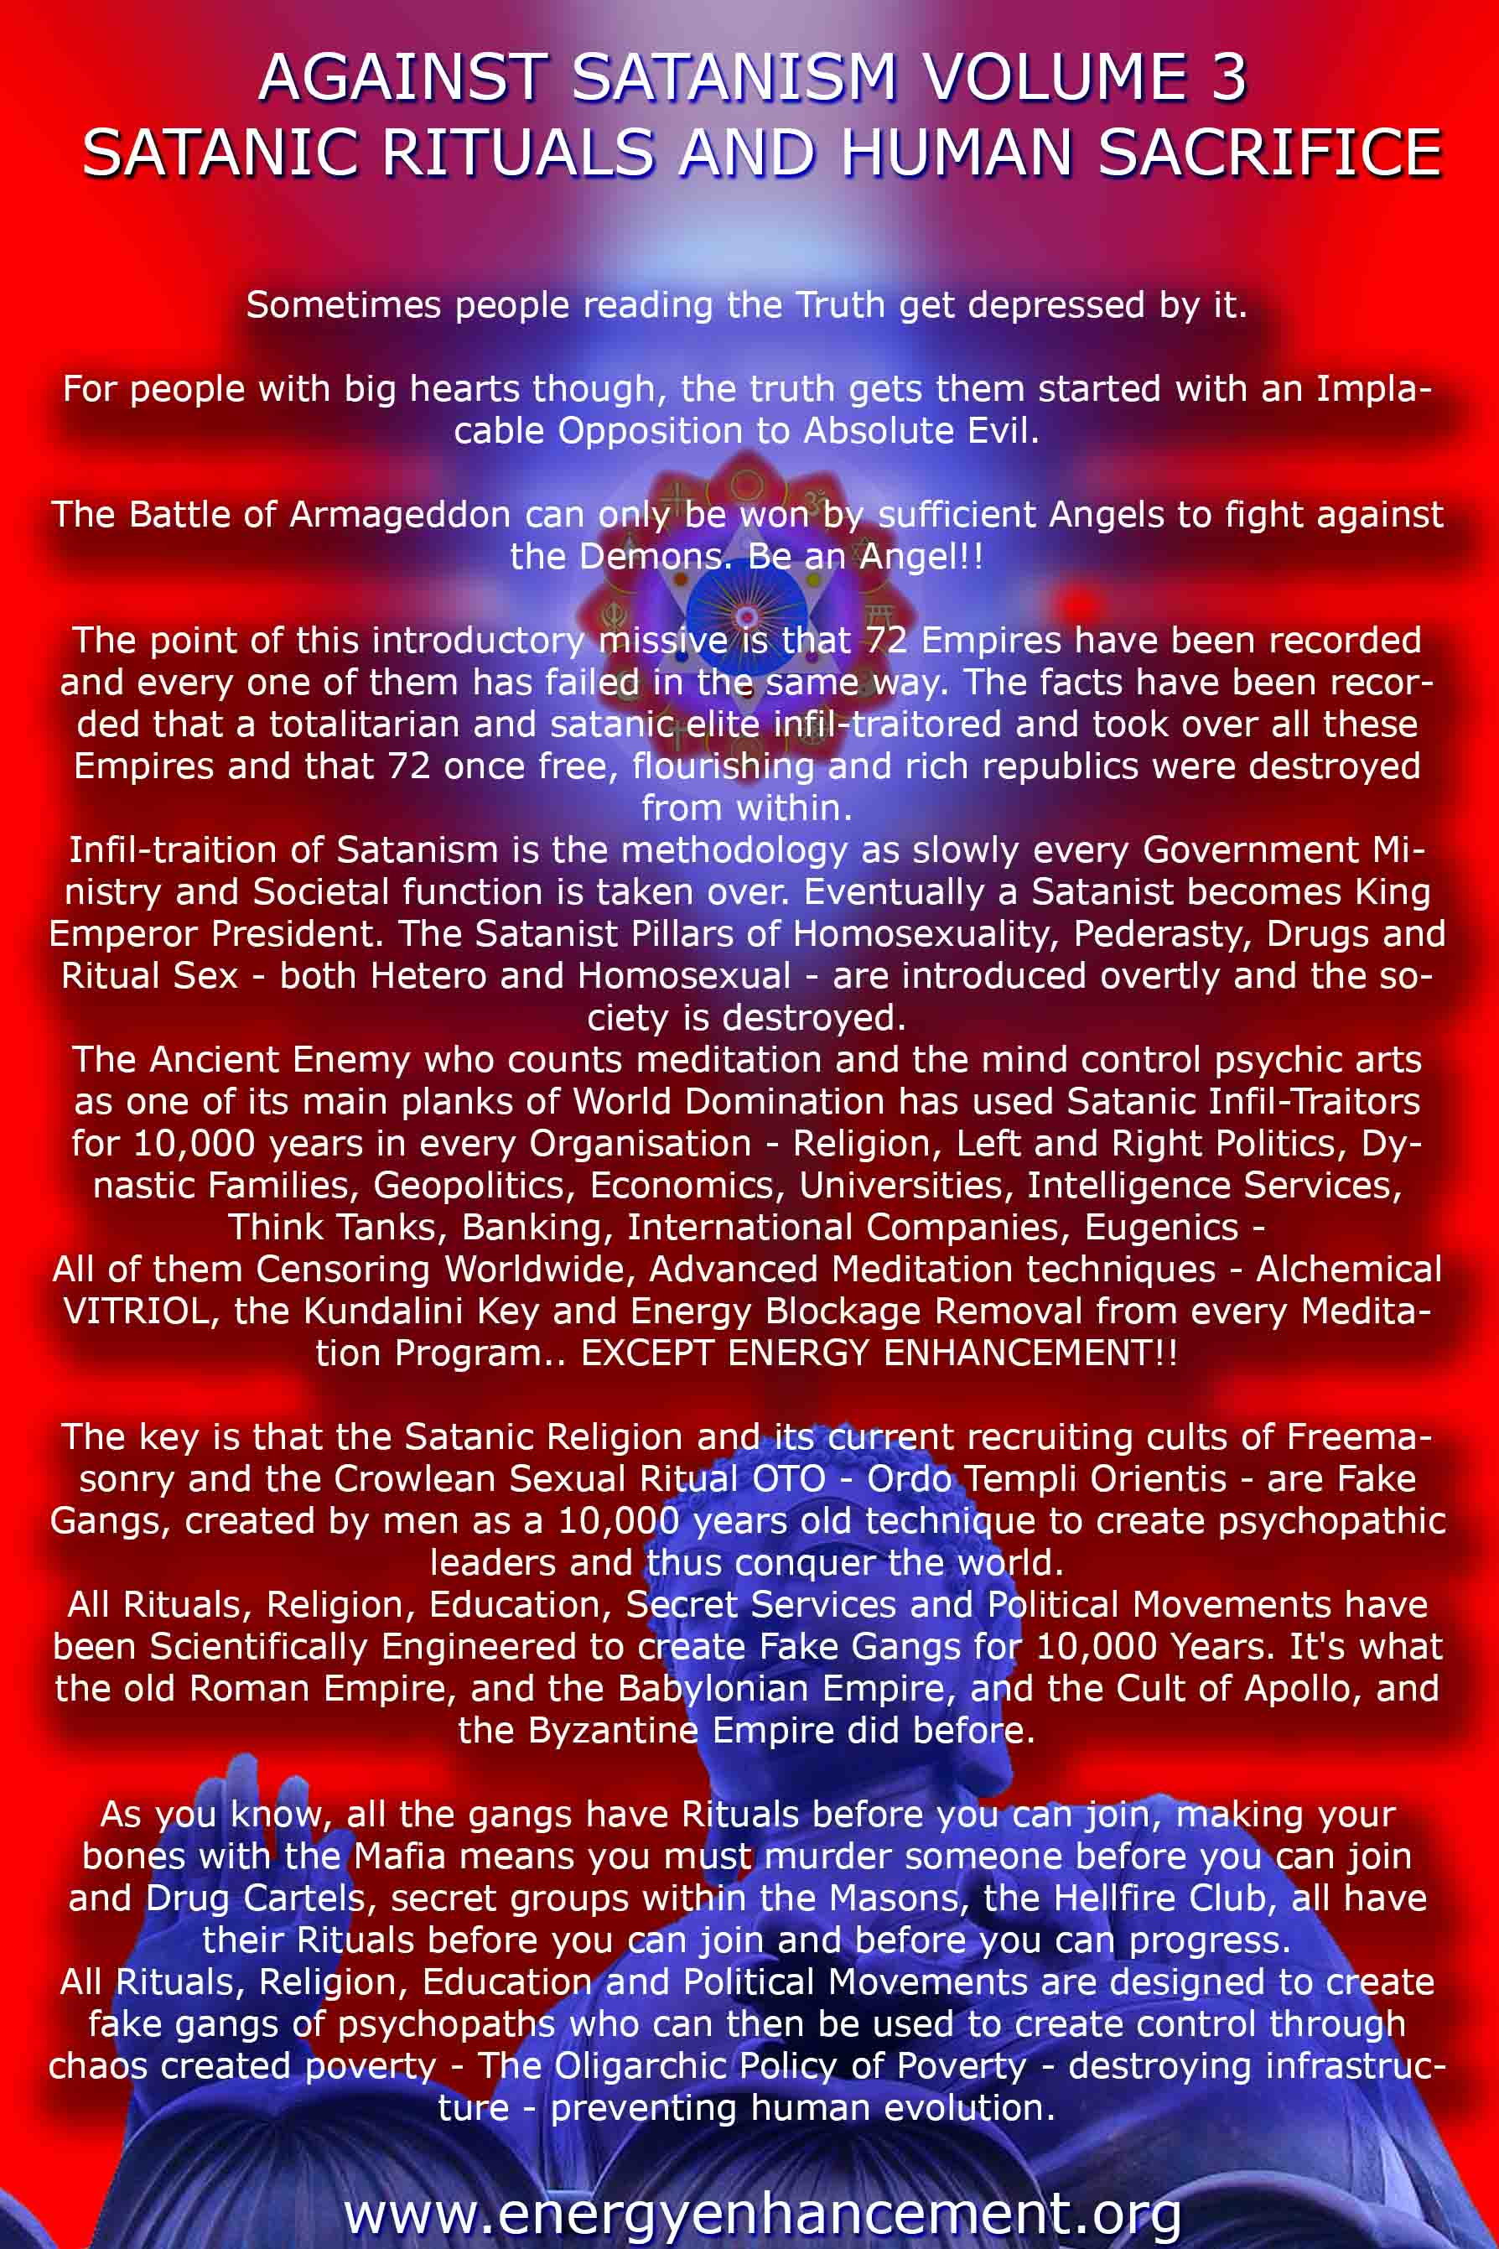

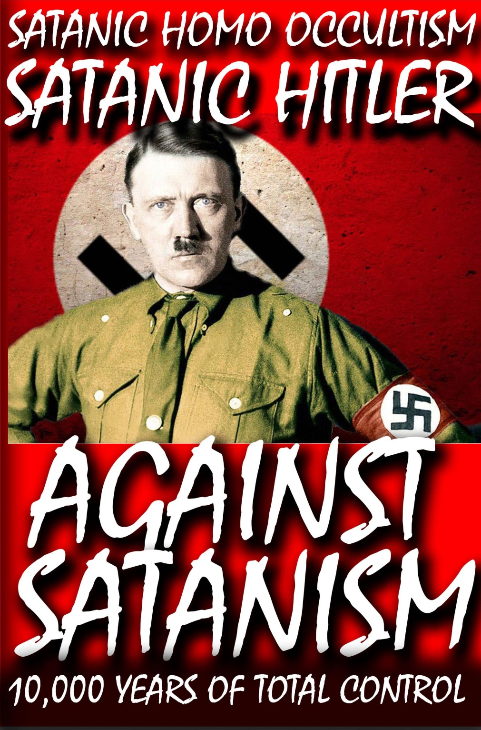

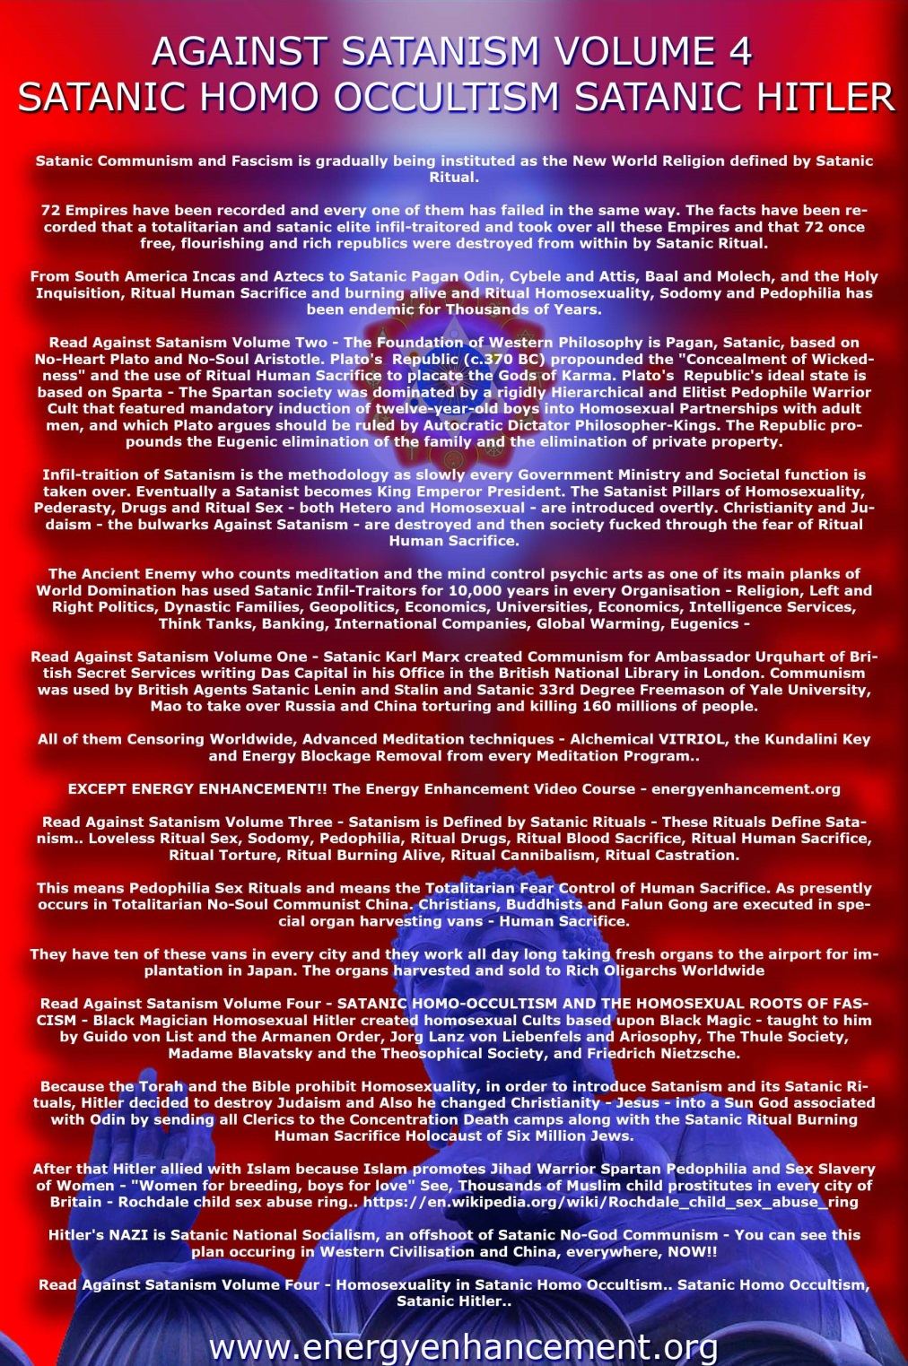

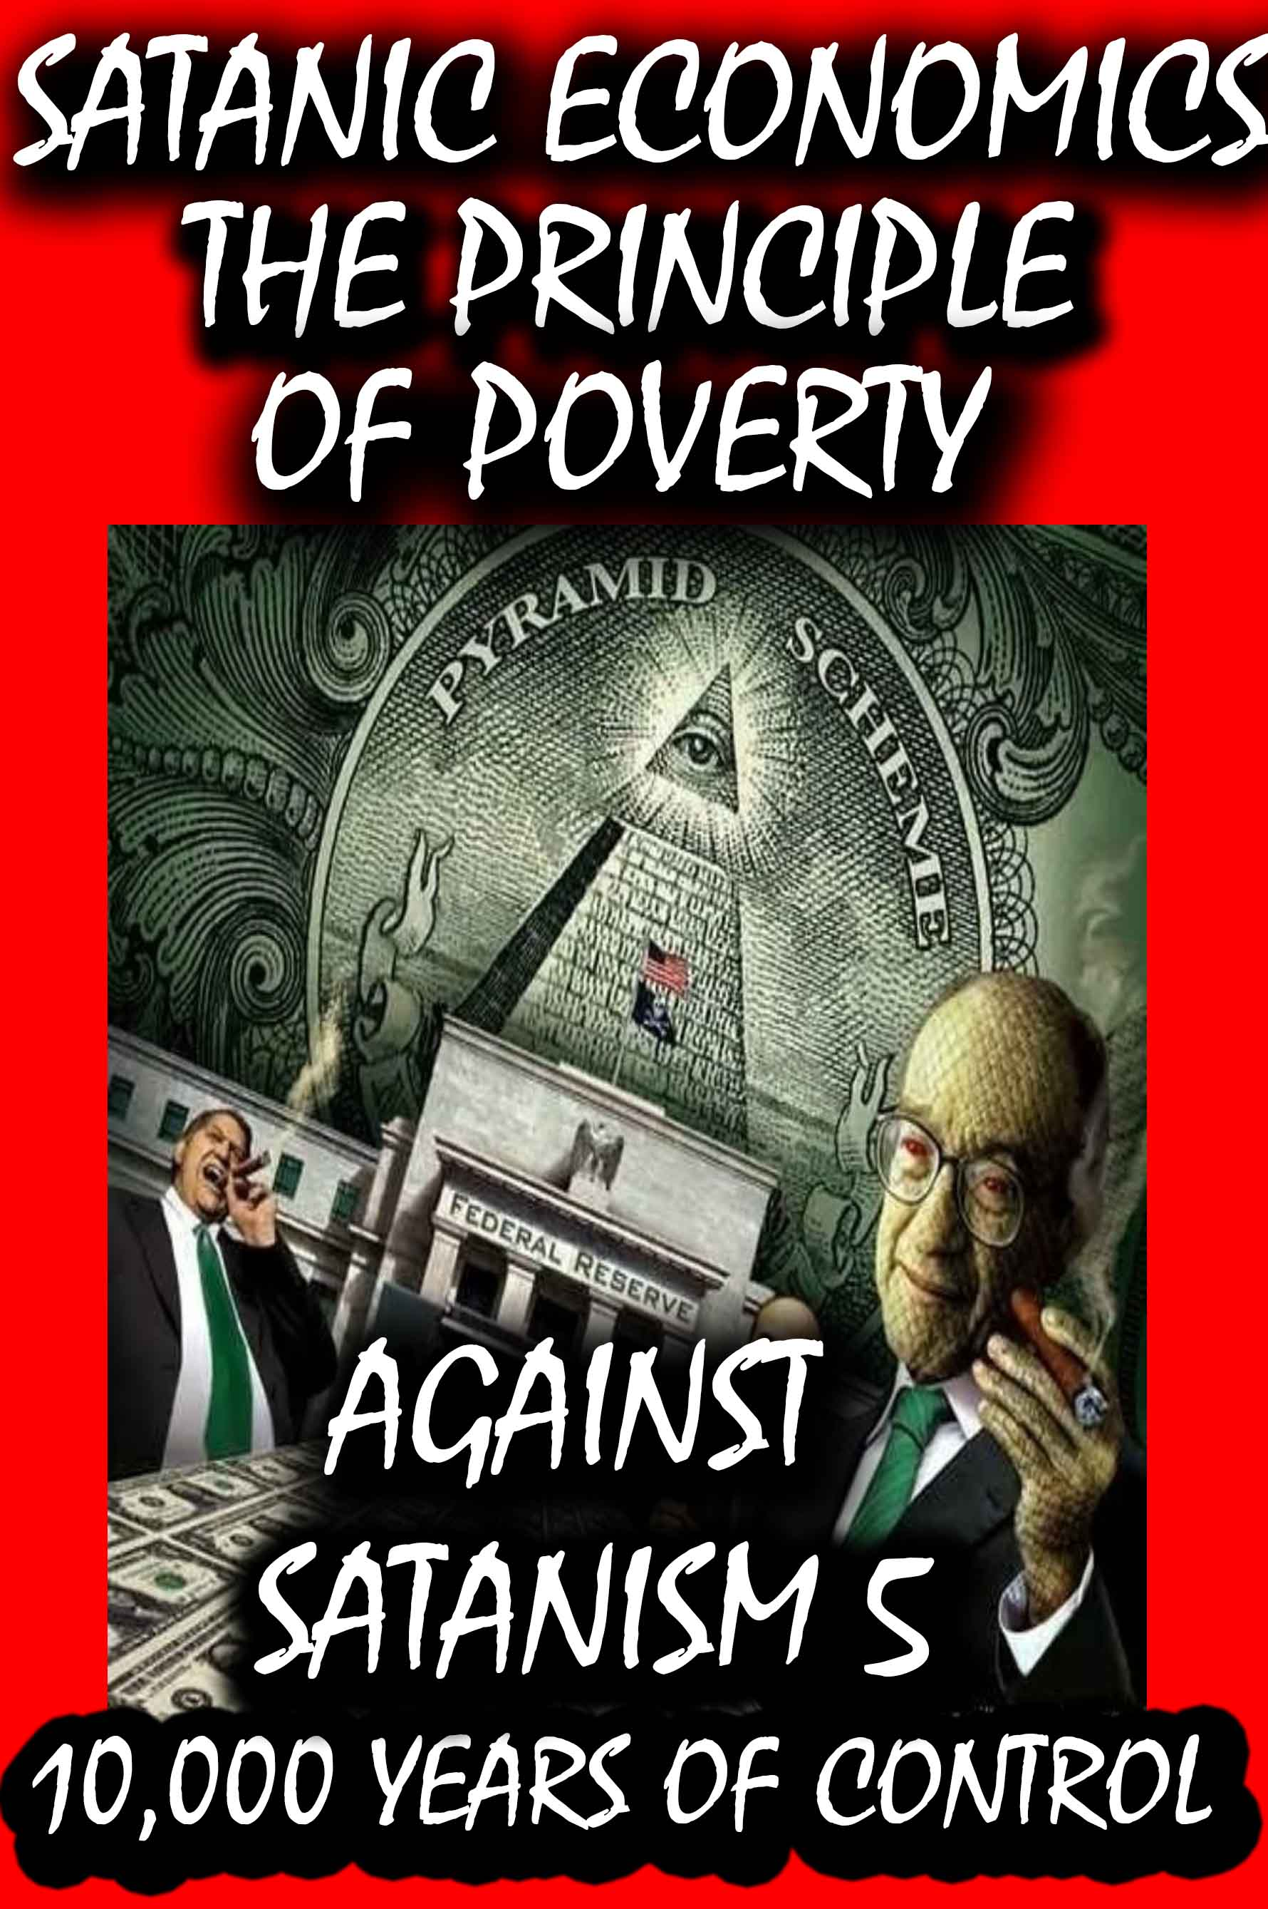

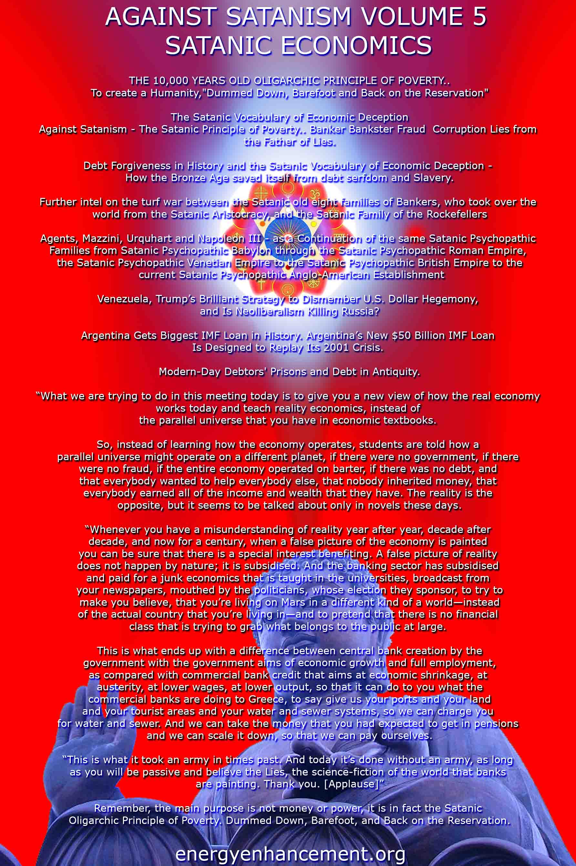

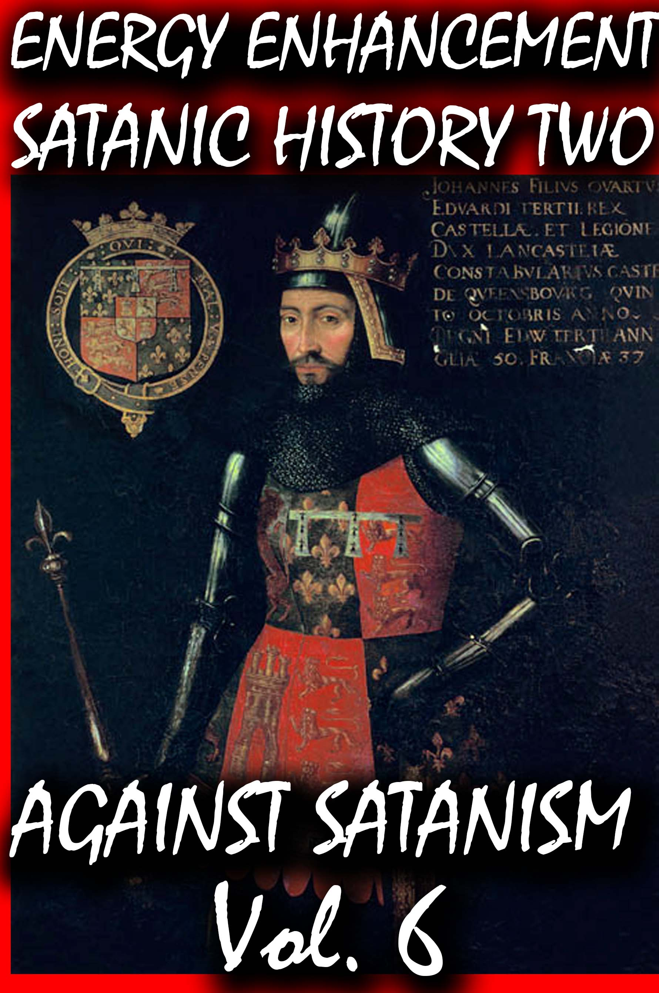
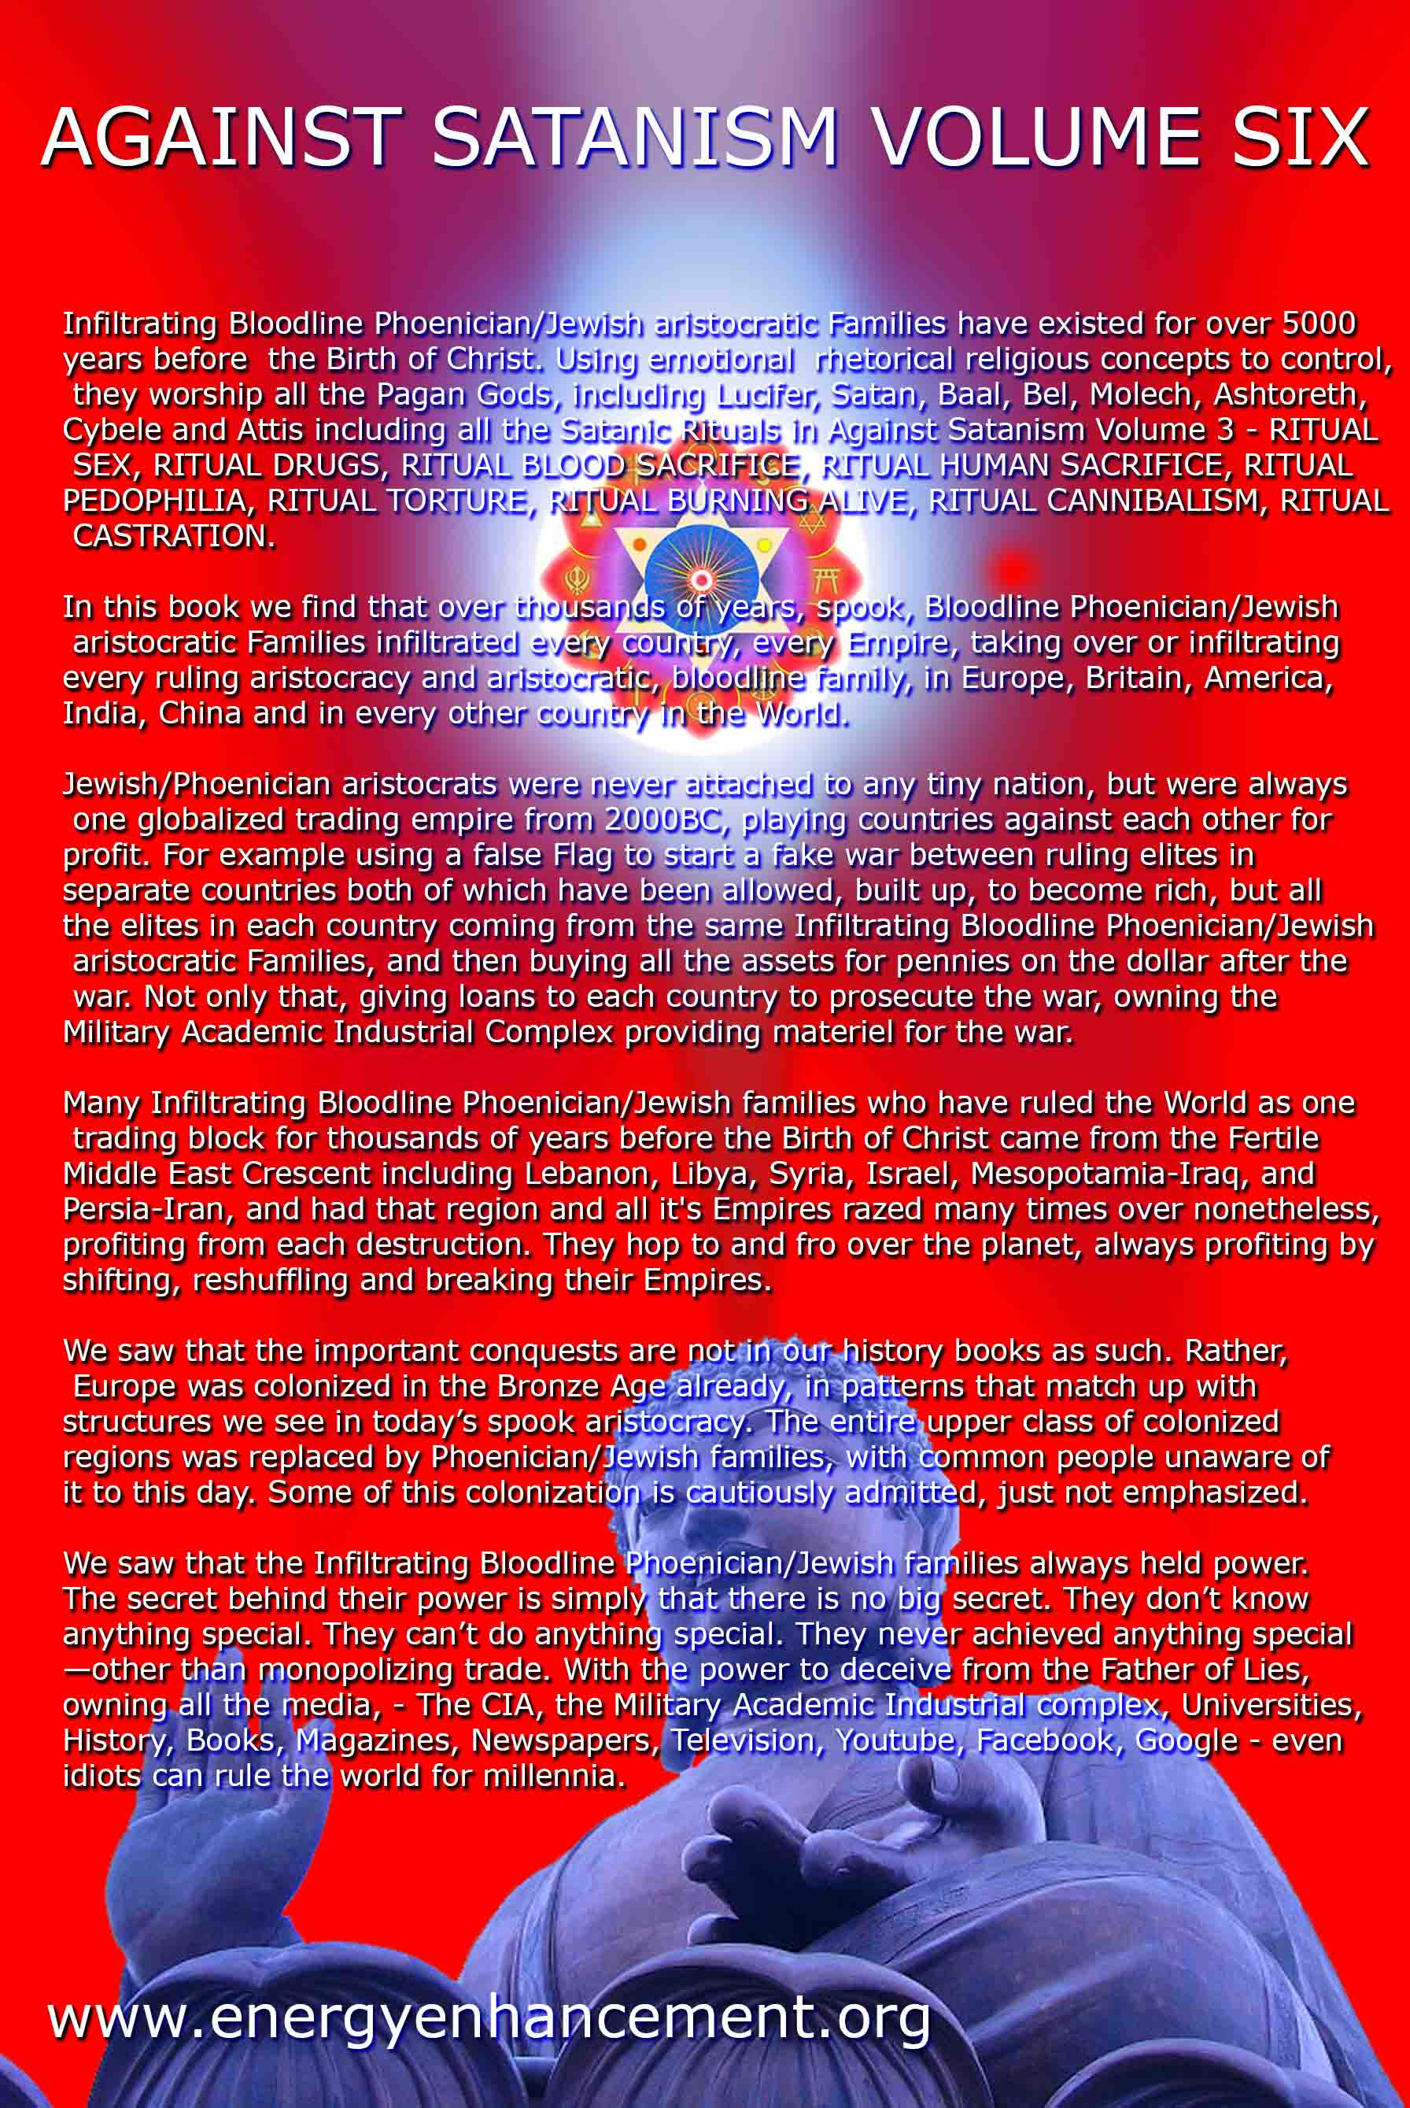
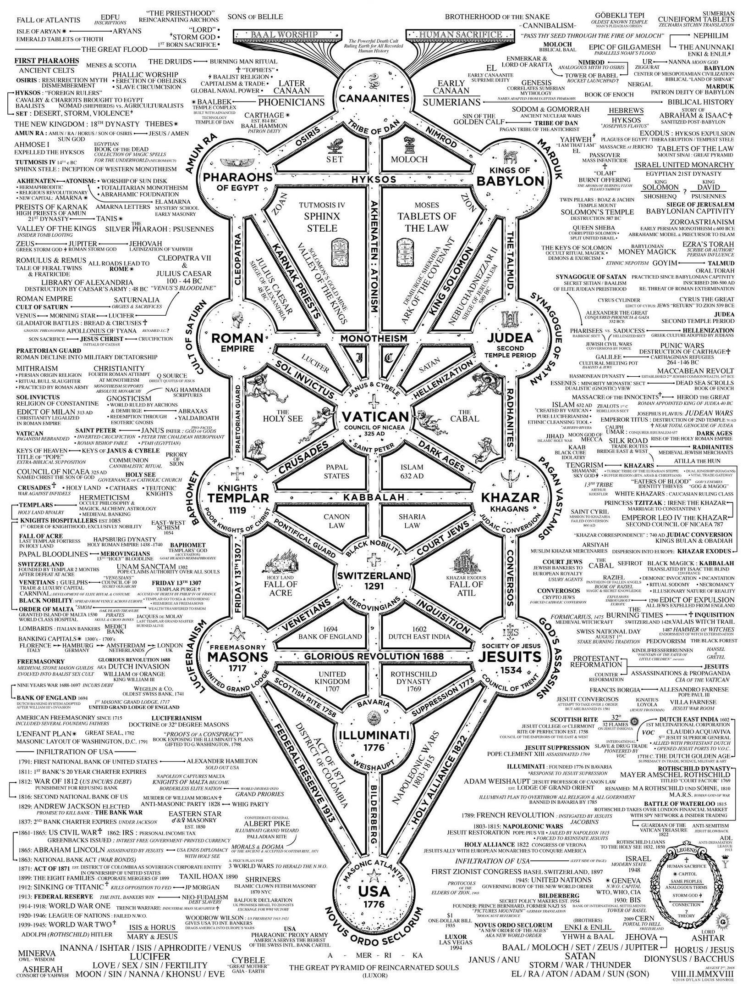
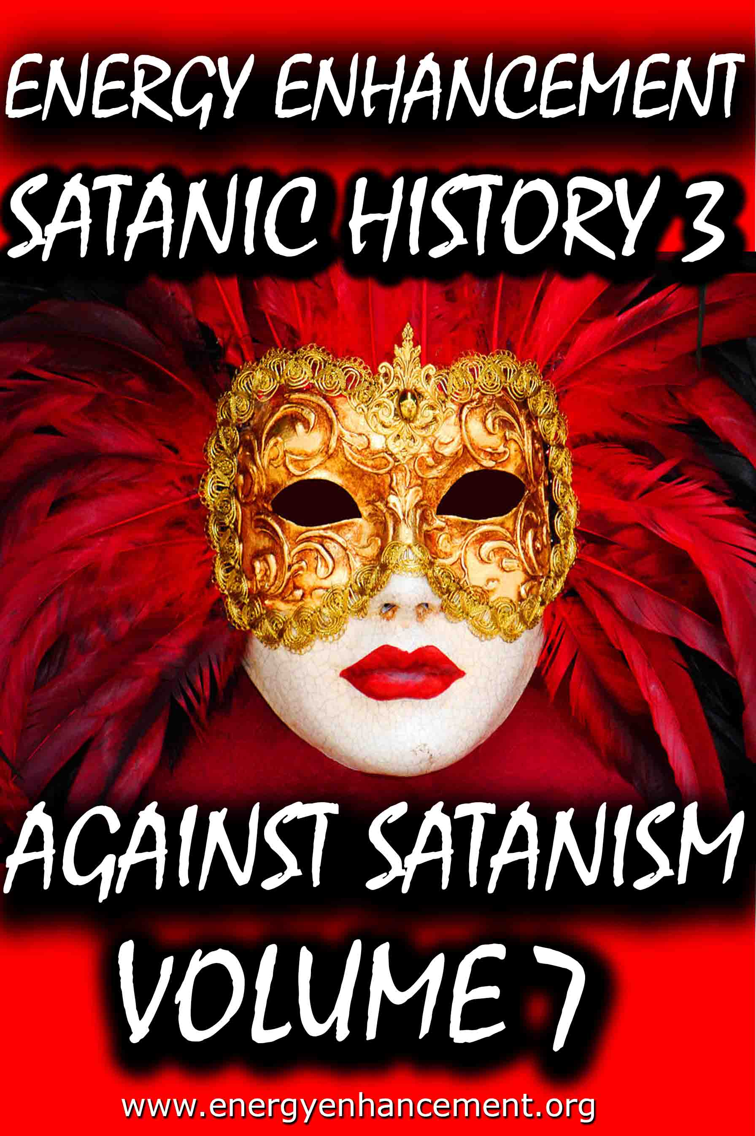
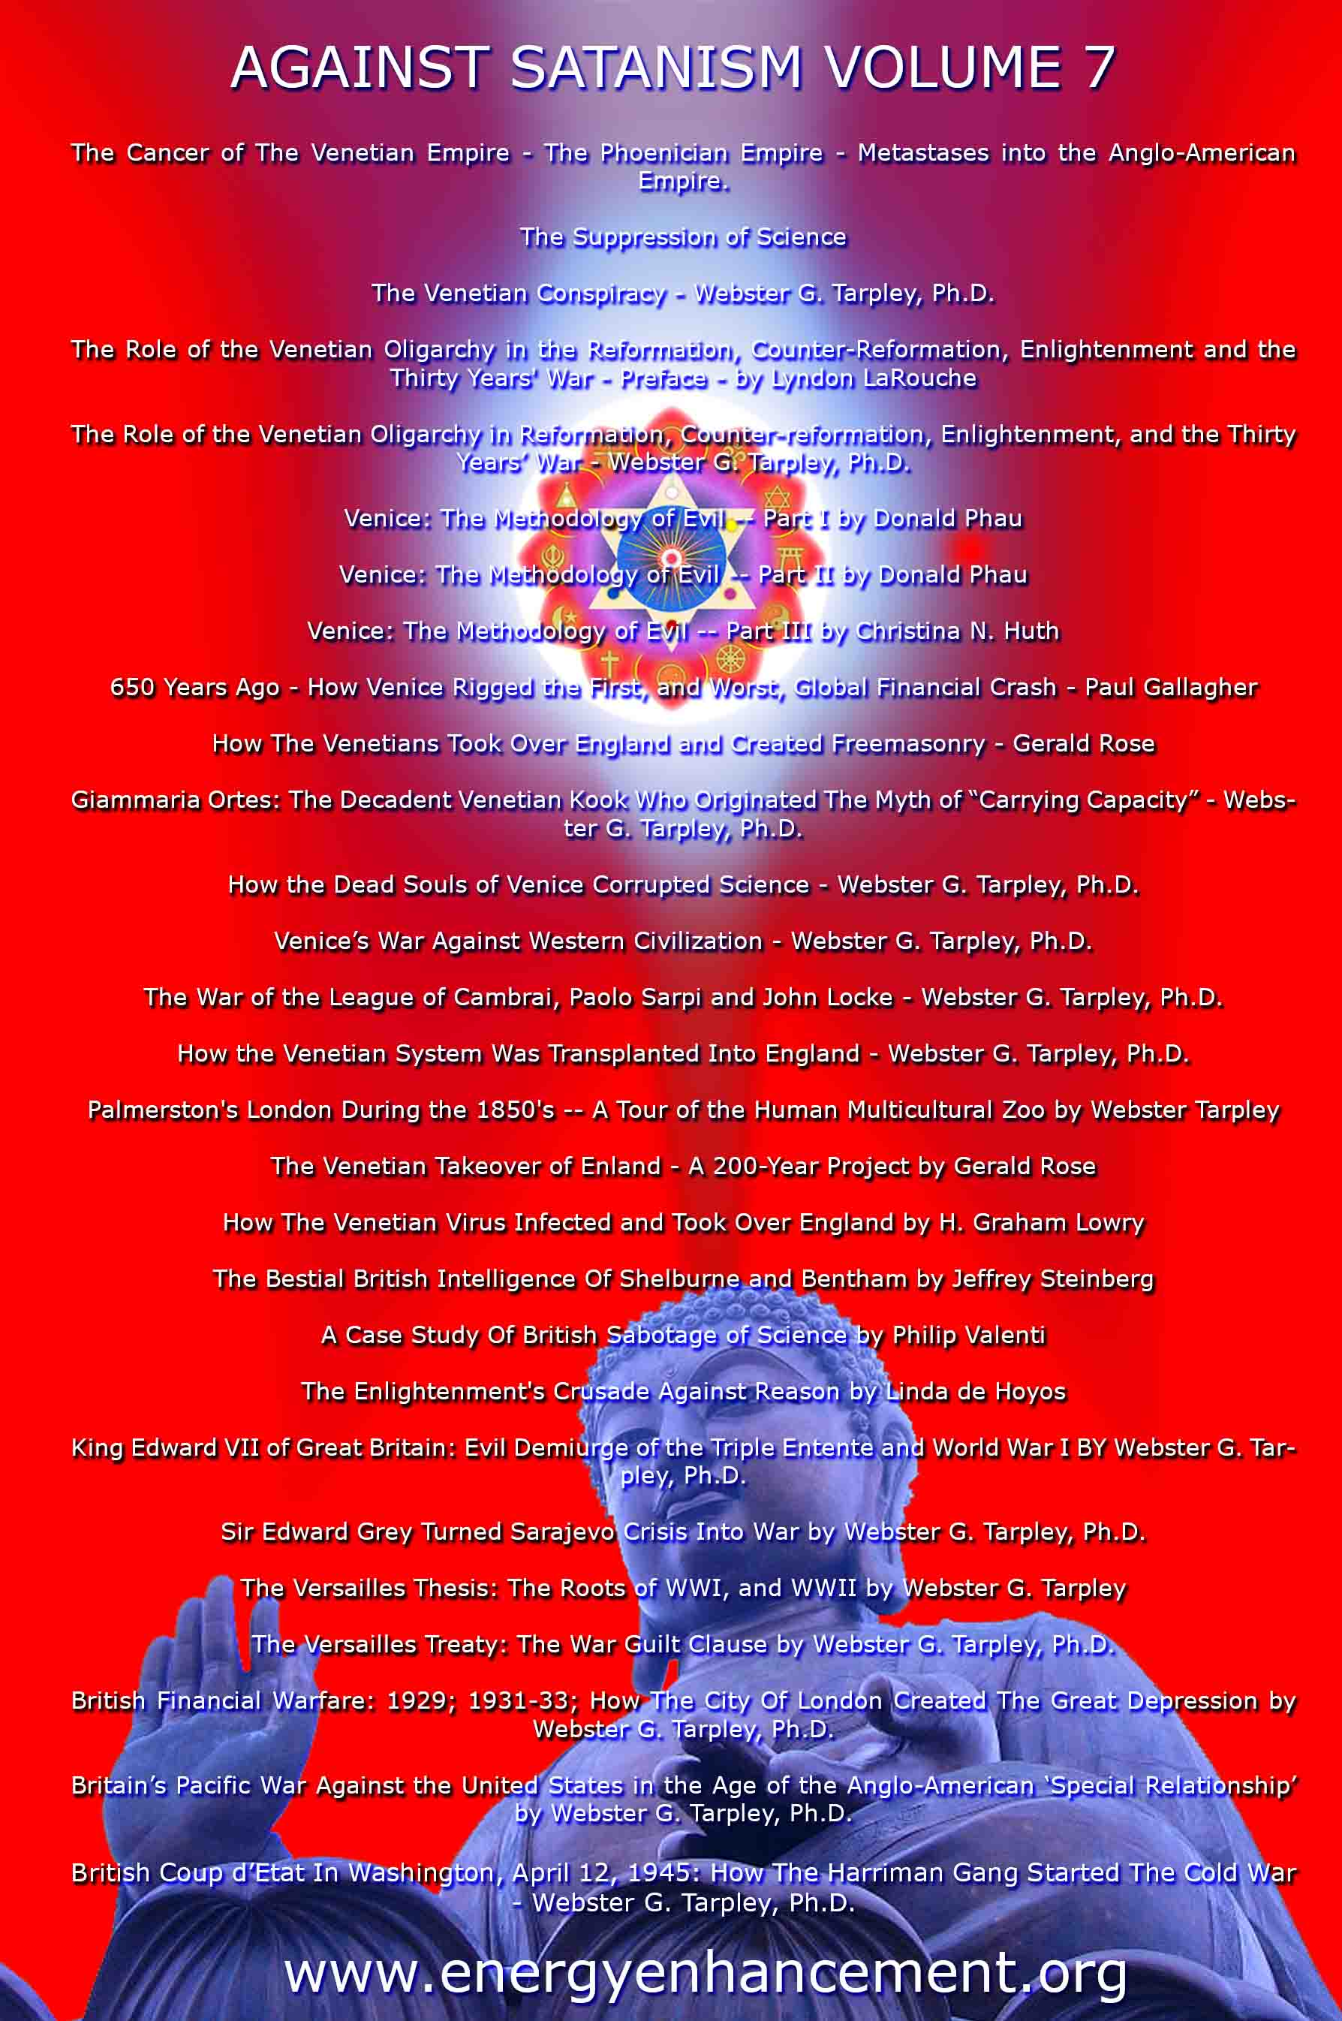

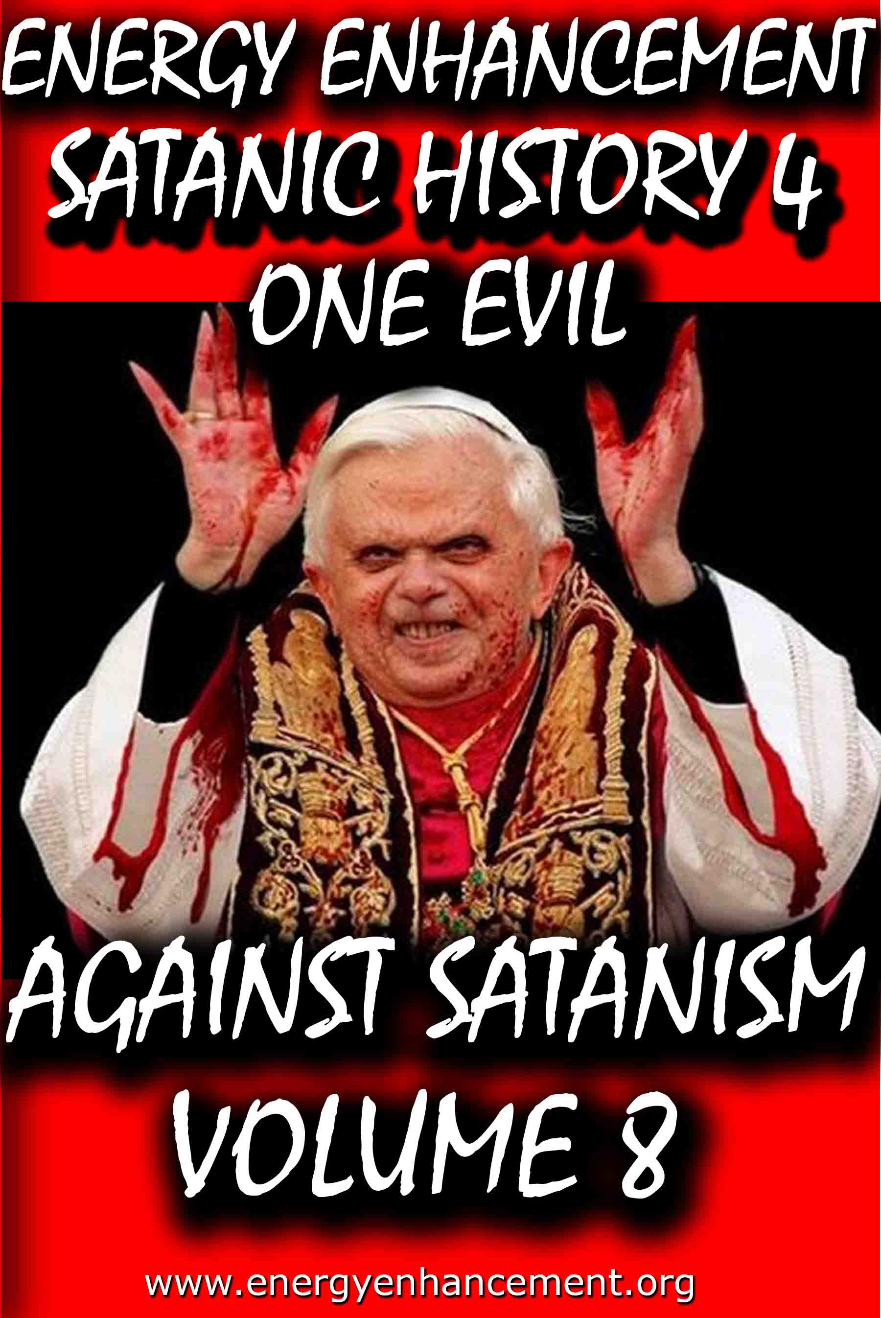

Remember, the main purpose is not money or power, it is in fact the Satanic Oligarchic Principle of Poverty. Dummed Down, Barefoot, and Back on the Reservation

Even though Tesla Free Energy Broadcast Power has been supressed, these next pages show how Fusion power and Fission Power have also been suppressed due to a Policy of Poverty going back to Fra Paolo Sarpi of the Satanic Venetian Republic and the British Royal Society for Science…

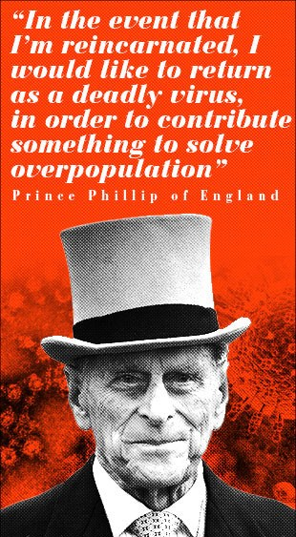

These Satanic Malthusians Demand Genocide

“Human population growth is probably the single most serious long-term threat to survival. We're in for a major disaster if it isn't curbed...We have no option.” —Prince Philip, interview in People Magazine, December 21, 1981

“In the event that I am reincarnated, I would like to return as a deadly virus, in order to contribute something to solve overpopulation.” —Prince Philip, Deutsche Press Agentur, August 1988
“It is almost self-evident that the greater the human population, the greater the demands for natural resources... The paramount question deals with an optimum human population. How many is too many people in relation to available resources? Many believe that our current (satanically consciously created) environmental problems indicate that the optimum level has been surpassed.” —Task Force on Earth, Resources and Population, George H. W. Bush, Chairman, July 8, 1970

POST MORTEM

Unfortunately, all the obituaries were premature: Venice has continued to be very much alive. During the nineteenth century and up to our own time it has been the most important single incubator for fascist movements. With its military and financial power largely emigrated elsewhere, Venice’s importance for political culture is now greater than ever.

Examples of this are inexhaustible. Richard Wagner wrote part of Tristan und Isolde while living in the Palazzo Giustinian on the Grand Canal. One story has it that the leitmotif of the Liebestod was inspired by the mournful call of a gondolier. At the end of his life Wagner moved to Palazzo Vendramin Callergi, where he died. This building, presently a gambling casino, was also the home of Count Coudenhove- Kalergi, the founder of the Pan-European Union. Friedrich Nietzsche loved Venice, returned there incessantly, and dedicated certain poems to the city which today can still be used in lieu of a powerful emetic. Venice was an inspiration for Lord Byron, for Thomas Mann, and so on.

Other examples abound of how the Venetian oligarchy’s cultural and political influence has reached down into the modern era:

* When British East India Company retainer Thomas Malthus published his Essay on Population he was plagiarizing from the Venetian Giammaria Ortes, who produced, around 1750, a fully developed version of the argument that geometric population growth outstrips the much slower arithmetric progress of food production.

* John Ruskin, the leading ideologue of the British Dark Ages faction, began his career with a raving treatise on architecture, The Stones of Venice (1851). This volume popularized the notion that a “Venetian Gothic” style had been developed in the better times of the city’s history (which for Ruskin ended in 1418) and it was used systematically to discredit the Golden Renaissance.

* A turn-of-the-century new Roman Empire faction led by Venetian Count Volpi di Misurata, who was known as the doge of his era, sponsored the fascist Mussolini supporter Gabriele D’Annunzio to drum up enthusiasm for a new crusade into the Balkans and the East. Volpi became finance minister in Mussolini’s cabinet, along with a very large number of other Venetians. D’Annunzio incited the Italians to take back Trieste, the rest of Italia Irredenta, and the Dardanelles, bringing on to center stage the so-called Parvus Plan for dismemberment of the Ottoman and Russian empires, which is generally recognized as the detonator of World War I. It is possible that the turn-of-the- century super spook Alexander Parvus was ultimately employed by Venice.

* The Societe Europeenne de Culture, a think tank created in 1950 through the efforts of Venetian intelligence operative Umberto Campagnolo, has for the past three decades pulled intellectuals from both East and West into organizing for an “international culture,” based on rejecting the existence of sovereign nations. The SEC counted among its members the cream of the postwar intelligencia: Adam Schaff of Poland, Bertolt Brecht of East Germany, Georg Lukas of Hungary, and Boris Paternak of the Soviet Union, as well as Stephen Spender and Arnold Toynbee, Benedetto Croce and Norberto Bobbio, Julian Huxley and Thomas Mann, Francois Mauriac, and Jean Cocteau. Later, the SEC launched the Third World national liberation ideology.

Today, the Club of Rome is the institution that represents the most concentrated essence of Venetian influence and the Venetian method. The Club of Rome wants to convince the great powers and peoples of the world to commit collective suicide by accepting the genocidal doctrine of zero growth. It also hopes to abolish the sovereign nation as a vehicle for economic growth and scientific progress.

Club of Rome founder Aurelio Peccei has just written a new book titled One Hundred Pages For the Future, a global review of the impact of the Club of Rome, and particularly since its 1972 release of the zero-growth model Limits to Growth was published, a series of social movements has sprung up under the sponsorship of the ideas in the book. These – the women’s movement, the peace movement, Third World national liberation movements, gay rights, civil liberties, ecologists, consumer and minority rights, etc. – must now be welded together into one movement for a single strategic goal: the implementation of a zero-growth international order.

The Venetian problem remains with us today. Truly, the most urgent task of this generation of mankind is to definitively liquidate the horror that is Venice and all the other Gang Clan Families who have ruled the World for 10,000 years.

The Satanic Conservative outpost of the Satanic Phoenician Navy who for 10,000 years have worshipped Molech, Baal and Cybele and Attis, and with Satanic Ritual, it's not just Sex on Altars like in Kubrick's, "Eyes Wide Shut", it is Pedophilia with Babies and Children supplied by Epstein, Dutroux or Jimmy Savile, it's Ritual Human Sacrifice, Ritual Blood Sacrifice, Ritual Burning Alive, Ritual Torture, Ritual Castration - and those Damn Liberals by Miles Mathis and Satchidanand

The founding fathers have even been sold as liberal in this sense, since although they were rich guys, fully connected, we are supposed to believe they believed in democracy, republicanism, and fairness in general. That is why they go on and on about that in the Declaration of Independence and Constitution. Those are liberal documents, in that they deny not only the divine rights of kings, they deny any other sort of favoritism based on name or birth.

As it turns out, the founding fathers were not liberal at all. They were Satanic fascists, and the whole liberal stance was just another con-job.

The United States were never meant to be republic, much less a democracy, they were meant to be another outpost of the Satanic Phoenician Navy who for 10,000 years have worshipped Molech, Baal and Cybele and Attis, and more worship with Satanic Ritual, it's not just Sex on Altars like in Kubrick's, "Eyes Wide Shut", it is Pedophilia with Babies and children supplied by Epstein, Dutroux or Jimmy Savile, it's Ritual Human Sacrifice, Ritual Blood Sacrifice, Ritual Burning Alive, Ritual Castration.
Some of my readers have been confused by my insistence that I am a liberal. These readers agree with me on a lot of things, so they can’t fathom what I mean by calling myself a liberal while they consider themselves conservatives. Since it is important, I will hit it again, trying to get them to understand.

I think the difference is that I am coming at this as a student of history, while many of them are coming at it as students (or consumers) of current politics.

I haven’t gotten my definitions and stances by listening to Rush Limbaugh, or Sean Hannity, I have gotten them from texts from the 19th century or earlier. My readers will answer me, “Then why don’t you keep up, Holmes! This is 2020, not 1880”. Good point. . . except that it isn’t.

To see what I mean, let’s transport ourselves back to the 1880s. Back then, satanic conservatives were those people who wished to conserve the status quo. Hence the name. They were quite satisfied with the way things were set up, and why should they not be?

They were rich and connected and had it made. Liberals were those who were not satisfied by the way things were, and so they were pushing for reforms. In general, they wished to see more fairness in government policies. They wanted those not “of the manor born” to be given a fair shot at good employment, good wages, court access, and all the various fruits of society.

The founding fathers have even been sold as liberal in this sense, since although they were rich guys, fully connected, we are supposed to believe they believed in democracy, republicanism, and fairness in general. That is why they go on and on about that in the Declaration of Independence and Constitution. Those are liberal documents, in that they deny not only the divine rights of kings, they deny any other sort of favoritism based on name or birth.

As it turns out, the founding fathers were not liberal at all. They were Satanic fascists, and the whole liberal stance was just another con-job.

The United States were never meant to be republic, much less a democracy, they were meant to be another outpost of the Satanic Phoenician Navy who for 10,000 years have worshipped Molech, Baal and Cybele and Attis, and more worship with Satanic Ritual.

Iit's not just Sex on Altars like in Kubrick's, "Eyes Wide Shut", it is Pedophilia with Babies and children supplied by Epstein, Dutroux or Jimmy Savile, it's Ritual Human Sacrifice, Ritual Blood Sacrifice, Ritual Burning Alive, Ritual Castration.

Read - AGAINST SATANISM VOLUME 6 - THE SATANIC PHOENICIANS - version 2 -The Satanic History of the World Part 2 Published May 2019

AGAINST SATANISM VOLUME 6 -The Satanic History of the World Part 2 Published May 2019

See http://www.energyenhancement.org/8aky78umhxi31.jpg

Infiltrating Bloodline Phoenician/Jewish aristocratic Families have existed for over 5000 years before the Birth of Christ. Using emotional rhetorical religious concepts to control, they worship all the Pagan Gods, including Lucifer, Satan, Baal, Bel, Molech, Ashtoreth, Cybele and Attis. In this book we find that over thousands of years, spook, Bloodline Phoenician/Jewish aristocratic Families infiltrated every country, every Empire, taking over or infiltrating every ruling aristocracy and aristocratic, bloodline family, in Europe, Britain, America, India, China and in every other country in the World.

http://www.energyenhancement.org/Sacred-Energy/Against-Satanism-Volume-6/AGAINST-SATANISM-6-Satanic-History-of-the-World-Part-2.pdf

Alan Watt Recommended Book List
Description: Get the BIG Picture by archiving and studying Sources from which Alan Watt draws. Download audio and transcripts of his talks from http://alanwattsentientsentinal.eu FREE. Please by all mean… Full description

Essential Book Recommendations from Alan Watt, of the
CuttingThrough theMatrixwebsite.

(Plus some of the books he won't mention)
The Republic – PlatoTragedy and Hope: The History of the World in our Time – Dr. Carroll Quigley The Anglo-American Establishment – Dr. Carroll Quigley The Evolution of Civilizations – Dr. Carroll Quigley
Between Two Ages: America's Role in the Technetronic Era – Zbigniew Brzezinski The Grand Chessboard: American Primacy and its Geostrategic Imperatives – Zbigniew Brzezinski The Choice: Global Domination or Global Leadership – Zbigniew Brzezinski The Impact of Science on Society –
Bertrand Russell The Scientific Outlook – Bertrand Russell The History of Western Philosophy – Bertrand Russell Proposed Roads to Freedom: Socialism, Anarchism, and Freedom – Bertrand RussellEducation and the Good Life – Bertrand RussellThe Autobiography of Bertrand Russell – 1872 – 1914 – Bertrand RussellThe Autobiography of Bertrand Russell – 1914 – 1944 – Bertrand RussellAn Essay on the Principle of Population – Thomas MalthusLegacy of Malthus – Allan ChaseThe Next Million Years – Charles Galton DarwinIn the Minds of Men – Ian T. Taylor Morals and Dogma – Albert PikeThe New Atlantis – Francis BaconThe Advancement of Learning – Francis BaconValerius Terminus of the Interpretation of Nature – Francis Bacon Novum Organum – Francis BaconThe Open Conspiracy – H.G. Wells

The Outline of History (Two volumes) – H.G. Wells The Shape of Things to Come – H.G. Wells The New World Order – H.G. WellsAmerica B.C. - Barry Fell Akhenaten – The Heretic King – Donald B. Redford The Gnostic Gospels – Elaine Pagels The Story of Civilization (11 Volumes) – Will Durant (
Particularly the first four volumes
:1.Our Oriental Heritage 2.The Life of Greece 3.Caesar and Christ 4.The Age of Faith) The Lessons of History – Will Durant The Story of Philosophy – Will Durant A Study of History (12 Volumes) – Arnold J. Toynbee (Look for the unabridged version – there isreason beyond Toynbee's legendary verbiage that a slender two-volume edition was released)Civilization on Trial – Arnold J. ToynbeeAmerica and the World Revolution – Arnold J. Toynbee (Public lectures in book form)Fire in the Minds of Men: Origins of the Revolutionary Faith – James H. BillingtonWall Street and the Bolshevik Revolution – Antony C. SuttonWall Street and the Rise of Hitler – Antony C. SuttonWall Street and FDR – Antony C. SuttonWestern Technology and Soviet Economic Development: 1917 – 1930 – Antony C. SuttonWestern Technology and Soviet Economic Development: 1930 – 1945 – Antony C. SuttonWestern Technology and Soviet Economic Development: 1945 – 1965 – Antony C. Sutton(
Zbigniew Brzezinski thought very highly of the above Sutton three volume work
)America's Secret Establishment: An Introduction to the Order of Skull and Bones – Antony C.SuttonTrilaterals over Washington: Volume I – Antony C. Sutton (with Patrick M. Wood)

Trilaterals over Washington: Volume II - Antony C. Sutton (with Patrick M. Wood)Foundations: Their Power and Influence – Rene A. Wormser Ages in Chaos (Four volumes) – Immanuel Velikovsky1.Ages in Chaos2.Oedipus and Akhnaton3.Ramses II and his Time4.Peoples of the SeaWorlds in Collision – Immanuel VelikovskyFuture Shock – Alvin Toffler The Third Wave – Alvin Toffler Power Shift – Alvin Toffler Political Ponerology: A Science of the Nature of Evil Adjusted for Political Purposes – Andrej M.LobaczewskiThe Technological Society – Jacques EllulPropaganda: The Formation of Men's Attitudes – Jacques EllulThe Political Illusion – Jacques EllulThe Technological System – Jacques EllulThe New Totalitarians – Roland HuntfordFuture Man – Brian StablefordPropaganda – Edward L. BernaysPublic Relations – Edward L. BernaysThe Moses Mystery – Gary GreenburgHebrew Myths: The Book of Genesis – Robert Graves and Raphael Patai
<compare with the following Graves volume>
The Greek Myths – Robert GravesScarlet and the Beast: A History of the War Between English and French Freemsasonry – JohnDanielConspiracies, Cover-ups, and Crimes – Jonathan VankinThe History of Freemasony (7 volumes unabridged) – Albert G. Mackey

The Encyclopedia of Freemasonry (Volumes I & II) – Albert G. MackeyThe Symbolism of Freemasonry – Albert G. MackeyGould's History of Freemasonry Throughout the World (6 volumes unabridged) – Robert F. GouldHoly Blood, Holy Grail – Baigent, Lincoln and LeighThe Messianic Legacy – Baigent, Lincoln and LeighThe Temple and the Lodge – Baigent, Lincoln and Leigh The Dead Sea Scrolls Deception – Baigent, Liccoln and LeighAmerica's Assignment with Destiny – Manly P. HallThe Secret Destiny of America – Manly P. HallThe Secret Teachings of All Ages – Manly P. HallThe Lost Keys of Freemasonry – Manly P. HallFreemasonry of the Ancient Egyptians – Manly P. HallOrientations – Sir Ronald StorrsThe Memoirs of Sir Ronald Storrs – Ronald StorrsThe Whispering Gallery: Being Leaves from the Diary of an Ex-Diplomat – Anonymous (LordGrey?)The Fifth Man: The Soviet Super Spy – Roland PerryThe Fringes of Power: The Incredible Inside Story of Winston Churchill During WWII – JohnColvilleThe Fringes of Power: 10 Downing Street Diaries (1939 – 1955) – John ColvilleThe Other Side of Deception: A Rogue Agent Exposes the Mossad's Secret Agenda – VictorOstrovkyBy Way of Deception: The Making and Unmaking of a Mossad Officer – Victor OstrovskyHistory Begins at Sumer: Thirty-Nine Steps in Recorded History – Samuel Noah Kramer Acres of Skin: Human Experiments at Holmesburg Prison – A True Story of Abuse and Exploitationin the Name of Medical Science by Allen M. HornblumThe Ghost in the Machine – Arthur Koestler The Thirteenth Tribe – Arthur Koestler

The Second Genesis: The Coming Control of Life – Albert RosenfeldTowards a New Beginning – Mikhail GorbachevDeadly Allies: Canada's Secret War (1937 – 1947) – John BrydenEarth Rising: The Revolution Toward a Thousand Years of Peace – Nick Begich NATO and Europe – Andre BeafreMillennium – Jacques AttalliUnderstanding Media: The Extensions of Man (Critical Edition) – Marshall McLuhan
The Book of the Dead: The Papyrus of Ani – E.A. Wallis BudgeThe Golden Bough – James FrazerHamlet's Mill – Giorgio de Santillana & Hertha von DechendThe Crime and Punishment of I.G. Farben – Joseph BorkinThe Undiscovered Self – C.G. JungProofs of a Conspiracy – John RobinsonThe Rockefellers: An American Dynasty – Peter Collier & David HorowitzThe Human Agenda – Roderic Gorney Trading with the Enemy: An Expose of the Nazi-American Money Plot (1939 – 1949) –Charles Higham Movie Lot to Beachhead: The Motion Picture Goes to War and Prepares for the Future – the editors of Look Magazine Hollywood Babylon: The Legendary Classic of Hollywood's Darkest and Best Kept Secrets –Kenneth anger The Fugu Plan: The Untold Story of the Japanese and the Jews During World War Two – Marvin Takayer, Forbidden Archaeology: The Full Unabridged Edition – Michael A. Cremo, The Last of the Pagans – Peter Chuvin, The Controversy of Brian – Douglas Reed, Battle for the Mind: A Physiology of Conversion and Brain Washing – William Sargant, Brave New World – Aldous Huxley

Brave New World Revisited – Aldous Huxley Nineteen Eighty-Four – George OrwellAnimal Farm – George OrwellFahrenheit 451 – Ray BradburyThe Handmaid's Tale – Margaret AtwoodFrankenstein – Mary ShelleyThe Wizard of Oz – Frank Baum My Life – Leon TrotskyThe Sovereign Individual – James Dale Davidson & Lord William Rees MoggGoethe's View of Evil and the Search for a New Image of Man in our Time – Allan P. CottrellThe Curse of Canaan: A Demonology of History – Eustace MullinsSecrets of the Federal Reserve – Eustace MullinsKing Kill 33 – James Shelby DownardSecret Societies and Psychological Warfare – Michael A. Hoffman IIThe Cultural Cold War: The CIA and the World of Arts and Letters – Frances Stonor StauntonWho Paid the Piper?: CIA and the Cultural Cold War - Frances Stonor StauntonPsychological Warfare – Paul Antony Myron Linebarger Physical Control of the Mind: Toward a Psychocivilized Society – Jose M.R. DelgadoThe Trap – James GoldsmithThe Response – James GoldsmithStraight and Crooked Thinking – Robert H. ThoulessSeven Pillars of Wisdom: A Triumph – T.E. Lawrence (Lawrence of Arabia)Autobiography of Thomas Jefferson – Thomas JeffersonThe First Global Revolution – Alexander King & Bertrand Schneider The Limits to Growth: A Report for the Club of RomeThe Underground History of American Education – John Taylor Gatto

Dumbing Us Down – John Taylor GattoAn Unsocial Socialist – George Bernard ShawThe Culture Industry – Theodor AdornoHope of the Wicked: The Master Plan to Rule the World – Ted FlynVirute and Terror (Revolution!) - Maximilien RobespierreArmand Hammer: The Untold Story – Steve WeinbergThe Balfour Declaration – Leonard SteinE-Topia: Urban Life, Jim – But Not As We Know It by William J. MitchellPhilip Dru Administrator: A Story of Tomorrow (1920 – 1935) – Edward Mandel HouseThe Naked Ape: A Zoologist's Study of the Human Animal – Desmond MorrisVodka Cola – Charles LevinsonLanguage, Mind and Nature: Artificial Languages in England from Bacon to Locke – Rhodri LewisThe Divine Comedy – Dante AlghieriHamlet – William SkakespeareThe Prince – Nicolo MachiavelliDocuments:1.Agenda 212.United Nations Human Settlement Program3.DCDC Global Strategic Trends Document (M.O.D.)4.Converging Technologies for Improving Human Performance: Nanotechnology, Biotechnology,Information Technology and Cognitive Science – National Science Foundation/Department ofCommerce5.Societal Implications of Nanoscience and Nanotechnology – National Science Foundation6.Global Trends 2025: A Transformed World – A Final Report7.2008 Army Modernization Strategy (D.O.D.)8.UNESCO: Its Purpose and Philosophy – Sir Julian Huxley9.Weather as a Force Multiplier: Owning the Weather in 2025 – U.S. Airforce

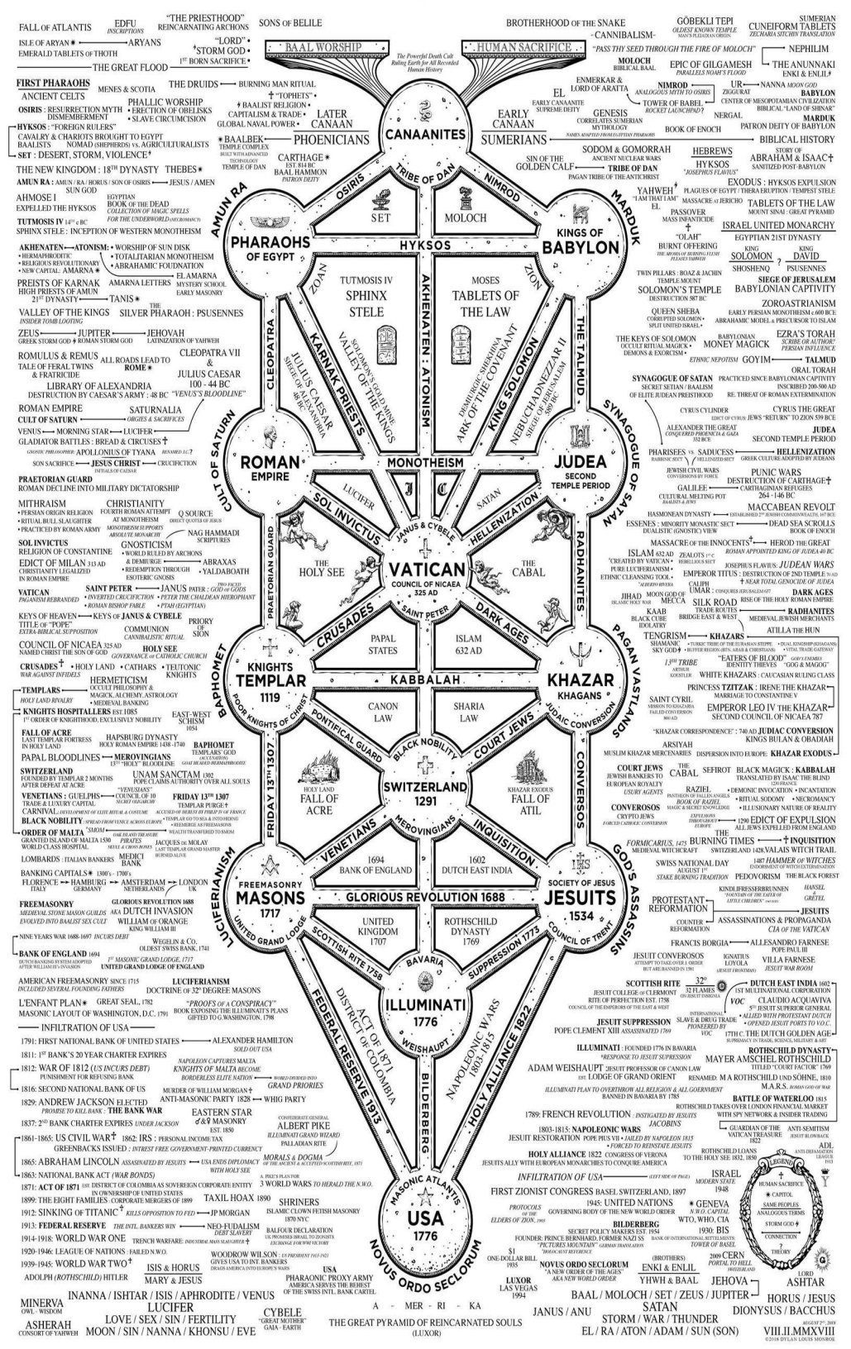



Go to http://www.energyenhancement.org

for 42 Free –On Sign-Up - Energy Enhancement Books and Energy Enhancement Against Satanism Books.
To defeat Evil, you need to up your game.
Learn the Energy Enhancement Meditation Course by Video or Live in Iguazu.
THE ENERGY ENHANCEMENT FOUR LEVEL VIDEO MEDITATION COURSE IS THE ONLY SOLUTION
Here's EXACTLY what you get with the Four Levels of Energy Enhancement Plus the Essential Level 0 support Package for 12 Months - Over 75 Hours of Incredible Teachings by Satchidanand which will enable you to Remove All your Energy Blockages - to Power Up!! To Feel Better, To Become What You Were Born to Be!!
Not so Expensive, Incredible Value!! For Total Life Performance!! For the Removal of All Energy Blockages!! Incredible Savings!
Over several months, in Easy, Bite Sized Chunks, You will learn how Simple it is, to remove All your Energy Blockages.
Incredible, Easy Paced, Full Tuition, with the Level 0 Support Package for Each of the Four Levels of Energy Enhancement!

Energy Enhancement LEVEL 1 Meditation is Included in this course! Immortality - Activate the Antahkarana! Gain Infinite Energy from the Chakras above the Head - Power UP!! Open Your Third Eye, Gain Super Samadhi Kundalini Alchemical VITRIOL Energy. Ground All Negative Energies. Learn Super Strong Psychic Protections in Preparation for the Seven Step Process to totally remove Blockages of Level 2. Access Quantum Immortality - Level 1 - 25 hours of video tuition http://www.energyenhancement.org/Level1.htm
Initiation 1 Meditation
Initiation 2 The Kundalini Kriyas - The 5 Taoist Circulations of the Qi, Energy Orbits, Energy Circulation
Initiation 3 The Kundalini Kriyas - Alchemical VITRIOL to Ground Negative Energies
Initiation 4 The Kundalini Kriyas - The God Connection to Infinite Energy
Initiation 5 Open the Third Eye, Open the Heart, Achievement of Everything you Want.
Initiation 6 Psychic Protection against Attack - Power Towers
Initiation 7 Psychic Protection against Attack - Pyramid Protection
Initiation 8 Psychic Protection against Attack - The Merkaba

After Level 1 we utilise the Energy Enhancement Seven Step Process to remove all Energy Blockages to our eyes, to our Third Eyes, to see, to access the Infinite positive flow of Spiritual Energy which descends like the dew from Heaven above upon it's place beneath.
It is twice blessed.
First by he who gives.
And then by he who receives.
And, as we receive with Energy Enhancement Meditation such an Infinite supply of positivity, of Infinite positive Energy from the Infinite Chakras above the head, and as it descends I promise you the most intense emotion you have ever experienced - 24 hours a day, every day!
Energy Enhancement testimonials http://www.energyenhancement.org/page17.htm
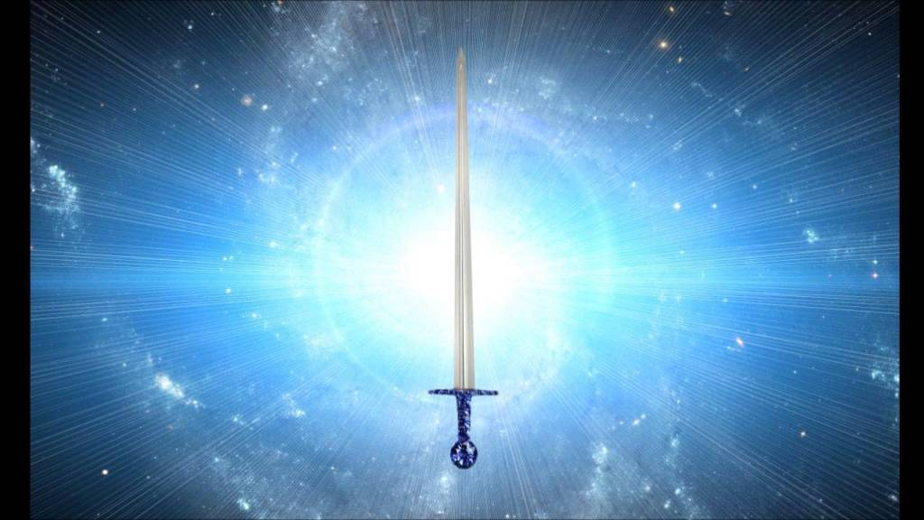
Energy Enhancement LEVEL 2 - The Energy Enhancement Seven Step Process to Totally Remove Energy Blockages, Totally Remove All Problems, Totally Remove Negative Emotions, Heal Your DNA, Remove your Karma - OPEN YOUR LIFE!! http://www.energyenhancement.org/Level2.htm
Initiation 1 The Seven Step Process to Remove Blockages.
Initiation 2 Removing Bodily Disease and Pain
Initiation 3 Heal your DNA
Initiation 4 Remove Energy Blockages from the Aura
THE KARMA CLEANING PROCESS
Initiation 5 Remove Energy Blockage Karma From Your Time in the Womb
Initiation 6 Remove Energy Blockage Karma From Your Current Life
Energy Enhancement testimonials http://www.energyenhancement.org/page17.htm
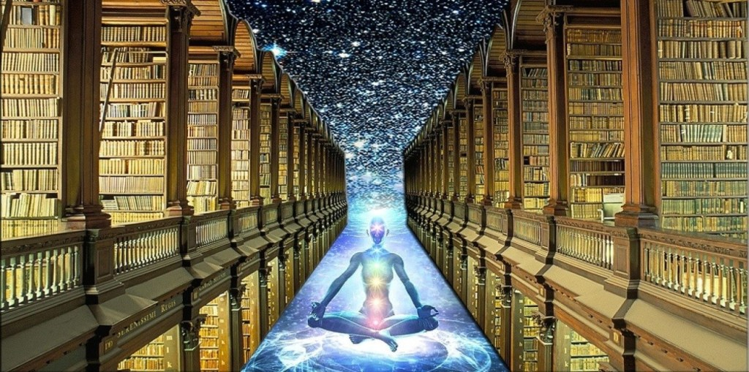
Energy Enhancement LEVEL 3 - Eliminate even Deeper Energy Blockages - The Removal of Strategies. Quantum Integration. The Karma Cleaning Process to Totally Eliminate All Your Karma, all your Trauma, all your Energy Blockages from All your Past Lifetimes!!
http://www.energyenhancement.org/Level3.htm
Here we are talking Zen Master Hogen.
He said, "By Meditating we can change our messy life painting into a clean white sheet again."
Here he is saying that Meditation can with Intensity of Feeling, ground all the negativity, all the negative emotions, all the energy blockages attached to your memories that ever happened to you in this lifetime
He said, "I spent all my previous lifetimes making Guiness. Now in this lifetime I am drinking all the Guiness!"
Here he is saying that with Passionate Energy Enhancement Samyama Meditation can ground all the negativity, all the negative emotions, all the energy blockages attached to your memories that ever happened to you in all your previous lifetimes.
If you can use Energy Enhancement Meditation to Ground all that negative energy from your past, to remove those dense, deep, energy blockages not only from this lifetime, but from all your previous lifetimes...
Can you Imagine what that will Feel Like?
Today’s a brand new day!!
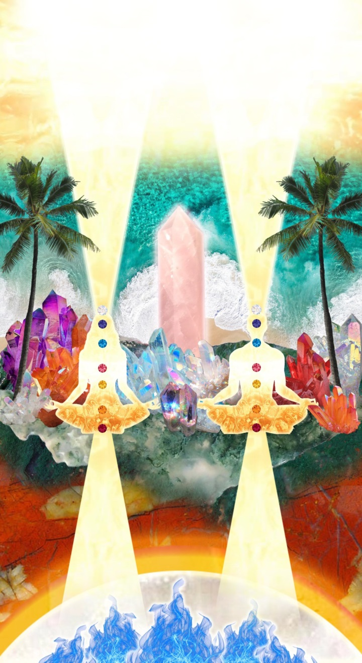
THE KARMA CLEANING PROCESS CONTINUES
Initiation 1 Remove Energy Blockage Karma From All Your past Lives
Initiation 2 Remove Energy Blockage Karma From Your Future Lives
Initiation 3 Remove Energy Blockage Inner Children
Initiation 4 Remove Energy Blockage Vampire Strategies
Initiation 5 Remove Energy Blockage Negative Emotions
Initiation 6 The Seven Step purification of talents and the creation and increase of talents
Initiation 7 Removing Energy Blockage Vows from Past Lifetimes
Initiation 8: The Achievement of all your Goals and Ambitions using Energy Enhancement Samyama
Initiation 9 Removing the Energy Blockages from Daily Life Illogical Actions and Driven Emotions.
Energy Enhancement testimonials http://www.energyenhancement.org/page17.htm

Energy Enhancement LEVEL 4 - Stop the Suck!! Heal All your Relationships!! Find Your Twin Flame!! MASTER ENERGY CONNECTIONS AND RELATIONSHIPS, THE PSYCHIC SEXUAL CONNECTION
http://www.energyenhancement.org/Level4.htm
Initiation 1 - Removing Addictions - Food, Alcohol, Smoking, Sex.
Initiation 2 Cleaning Energy Connections - Cutting Energy Connections and Re-connecting Energy Connections - Friends, Children, Partner, Mother, Father - Moving All Relationships to a Higher Level.
Initiation 3 Cutting Energy Connections and Re-connecting Energy Connections - Moving All Relationships to a Higher Level.
Initiation 4 Healing the Soul Connection of Others
Initiation 5 Healing the Psychic Sexual Connection
Initiation 6 Removing the Energy Blockages at the other End of the Connection in People you Connect to - Healing Relationships, Healing Clients.
Initiation 7 Ceremonies and Meditation Groups - Using the Energy of the Higher Heart, The Heart Center in the Head, Prajna Paramita, - The Soul and the Monad Itself, for the Healing of Groups, Organizations and the World.
Energy Enhancement testimonials http://www.energyenhancement.org/page17.htm


THE YOGA SUTRAS OF PATANJALI BY SWAMI SATCHIDANAND - DOWNLOAD HERE..
http://www.energyenhancement.org/Sacred-Energy/yoga-sutras-of-patanjali-book/Energy-Enhancement-Yoga-Sutras-of-Patanjali.pdf
SUPER ENERGY AND SACRED SYMBOLS
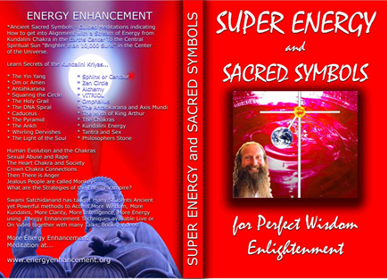
*THE ENERGY ENHANCEMENT BOOK… Ancient Sacred Symbols - Guided Meditations indicating How to get into Alignment with a Stream of Energy from Kundalini Chakra in the Earth’s Center to the Central Spiritual Sun "Brighter than 10,000 Suns" in the Center of the Universe.
Learn Secrets of the Kundalini Kriyas... and more…
Swami Satchidanand has taught many Students Ancient yet Powerful methods to Access More Wisdom, More Kundalini, More Clarity, More Intelligence, More Energy using Energy Enhancement Techniques available Live or On Video together with many Talks, Books, Videos.
ENERGY ENHANCEMENT TWO – REMOVAL OF ENERGY BLOCKAGES, MANAGING ENERGY CONNECTIONS AND MASTERY OD RELATIONSHIPS
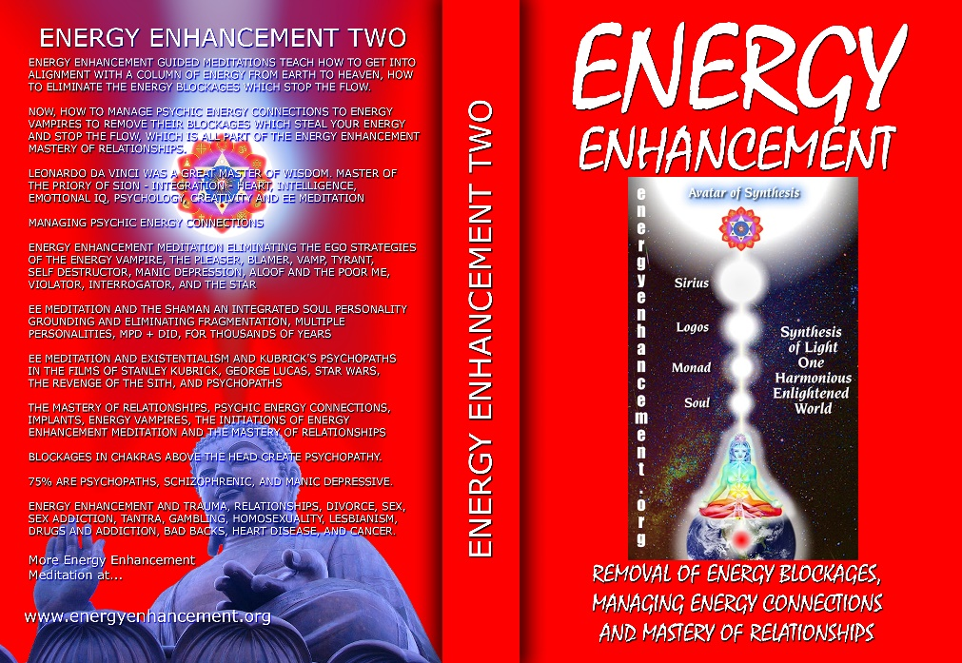
ENERGY ENHANCEMENT GUIDED MEDITATIONS TEACH HOW TO GET INTO ALIGNMENT WITH A COLUMN OF ENERGY FROM EARTH TO HEAVEN, HOW TO ELIMINATE THE ENERGY BLOCKAGES WHICH STOP THE FLOW.
NOW, HOW TO MANAGE PSYCHIC ENERGY CONNECTIONS TO ENERGY VAMPIRES TO REMOVE THEIR BLOCKAGES WHICH STEAL YOUR ENERGY AND STOP THE FLOW, WHICH IS ALL PART OF THE ENERGY ENHANCEMENT MASTERY OF RELATIONSHIPS.
LEONARDO DA VINCI WAS A GREAT MASTER OF WISDOM. MASTER OF THE PRIORY OF SION - INTEGRATION - HEART, INTELLIGENCE, EMOTIONAL IQ, PSYCHOLOGY, CREATIVITY AND EE MEDITATION MANAGING PSYCHIC ENERGY CONNECTIONS ENERGY ENHANCEMENT MEDITATION ELIMINATING THE EGO STRATEGIES OF THE ENERGY VAMPIRE, THE PLEASER, BLAMER, VAMP, TYRANT, SELF DESTRUCTOR, MANIC DEPRESSION, ALOOF AND THE POOR ME, VIOLATOR, INTERROGATOR, AND THE STAR
EE MEDITATION AND THE SHAMAN AN INTEGRATED SOUL PERSONALITY GROUNDING AND ELIMINATING FRAGMENTATION, MULTIPLE PERSONALITIES, MPD + DID, FOR THOUSANDS OF YEARS
EE MEDITATION AND EXISTENTIALISM AND KUBRICK'S PSYCHOPATHS IN THE FILMS OF STANLEY KUBRICK, GEORGE LUCAS, STAR WARS, THE REVENGE OF THE SITH, AND PSYCHOPATHS
THE MASTERY OF RELATIONSHIPS, PSYCHIC ENERGY CONNECTIONS, IMPLANTS, ENERGY VAMPIRES, THE INITIATIONS OF ENERGY ENHANCEMENT MEDITATION AND THE MASTERY OF RELATIONSHIPS
BLOCKAGES IN CHAKRAS ABOVE THE HEAD CREATE PSYCHOPATHY.
75% ARE PSYCHOPATHS, SCHIZOPHRENIC, AND MANIC DEPRESSIVE.
ENERGY ENHANCEMENT AND TRAUMA, RELATIONSHIPS, DIVORCE, SEX, SEX ADDICTION, TANTRA, GAMBLING, HOMOSEXUALITY, LESBIANISM, DRUGS AND ADDICTION, BAD BACKS, HEART DISEASE, AND CANCER.

Buy all Books and DVD’s at: amazon.com
www.energyenhancement.org
DVD 1 - KUNDALINI CHAKRA MEDITATION
HEART SUTRA – HIGHEST HEART OF WISDOM MEDITATION

*ENERGY ENHANCEMENT MEDITATION DVD 1… Guided Meditation to Access Kundalini Chakra, VITRIOL, The Philosopher’s Stone, Kriya Yoga and the Kundalini Kriyas.
Heart Sutra, All Enlightened Sages for Thousands of Years Live From the Highest Heart of Wisdom.

Buy all Books and DVD’s at: amazon.com
www.energyenhancement.org

DVD 2 - HIGHEST HEART OF GENIUS WISDOM MEDITATION
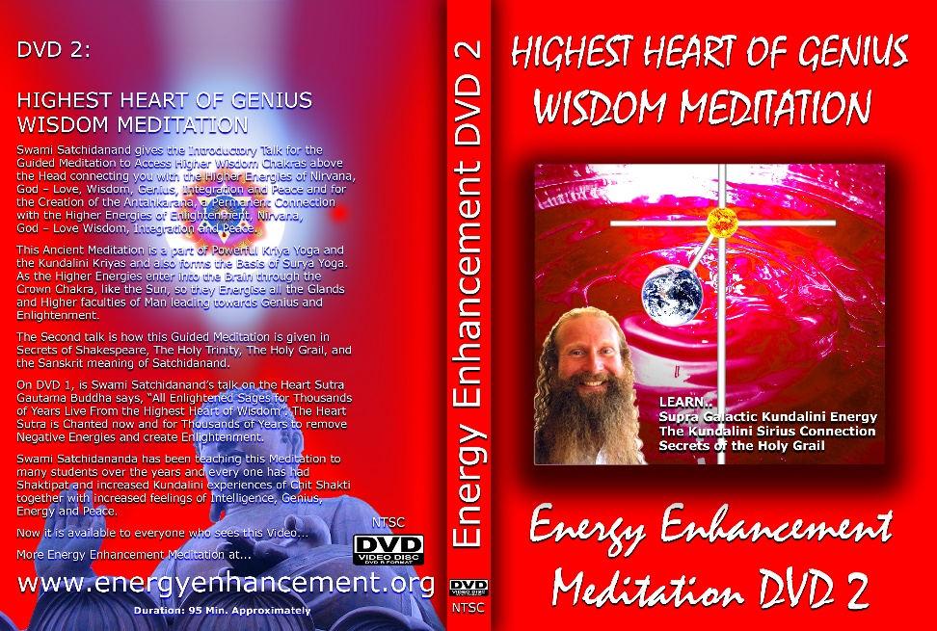
Guided Meditation to Access Higher Wisdom Chakras above the Head connecting you with the Higher Energies of Nirvana, God – Love, Wisdom, Genius, Integration and Peace and the Creation of the Antahkarana.
How this Guided Meditation is given in Secrets of Shakespeare, The Holy Trinity, The Holy Grail and the Sanskrit meaning of Satchidanand.
Swami Satchidananda has been teaching this Meditation to many students over the years and every one has had Shaktipat and increased Kundalini experiences of Chit Shakti together with increased feelings of Intelligence, Genius, Energy and Peace.
BOOK - GAIN SUPER ENERGY
ENERGY ENHANCEMENT LEVEL 1
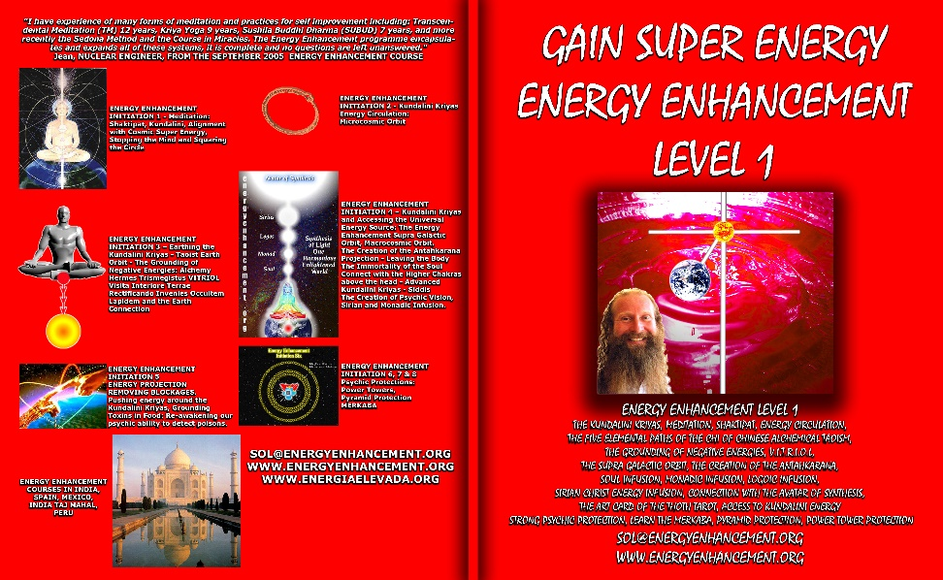
READ… The Kundalini Kriyas, Meditation, Shaktipat, Energy Circulation, The Five Elemental Paths of the Chi of Chinese Alchemical Taoism, The Grounding of Negative Energies, V.I.T.R.I.O.L., The Supra Galactic orbit, The Creation of the Antahkarana, Soul Infusion, Monadic Infusion, Logoic Infusion, Sirian Christ Energy Infusion, Connection with the Avatar of Synthesis, The Art Card of the Thoth Tarot, Access to Kundalini Energy Strong Psychic Protection, Learn the Merkaba, Pyramid Protection, Power Tower Protection.
Buy all Books and DVD’s at: amazon.com
www.energyenhancement.org
THE ENERGY ENHANCEMENT FOUR INITIATION DVD COURSE - THE ULTIMATE TECHNIQUES ON 15 DVDs
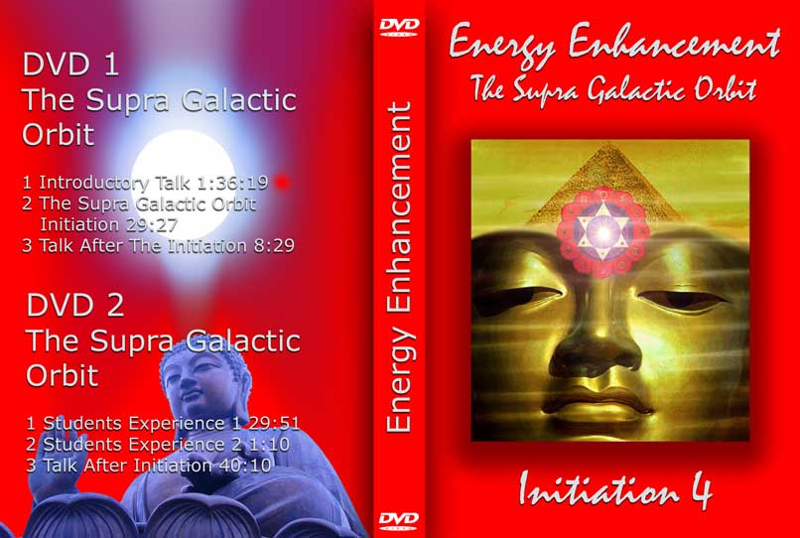
“I have experience of many forms of meditation and practices for self improvement including: Transcendental Meditation (TM) 12 years, Kriya Yoga 9 years, Sushila Buddhi Dharma (SUBUD) 7 years, and more recently the Sedona Method and the Course in Miracles. The Energy Enhancement programme encapsulates and expands all of these systems, it is complete and no questions are left unanswered.”
JEAN, NUCLEAR ENGINEER, FROM SEPTEMBER 2005 ENERGY ENHANCEMENT COURSE
ENERGY ENHANCEMENT LIVE COURSES – WORLDWIDE
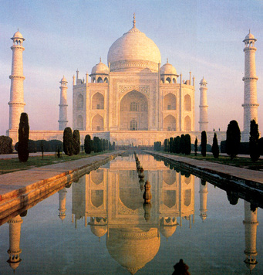
INDIA, 5 STAR INDIA TAJ MAHAL, SPAIN, MEXICO, PERU, ARGENTINA – MORE
Bookings: www.energyenhancement.org

EE LEVEL 1 POWER UP!! GAIN SUPER ENERGY http://www.energyenhancement.org/Level1.htm
EE LEVEL 2 ELIMINATE ENERGY BLOCKAGES http://www.energyenhancement.org/Level2.htm
EE LEVEL 3 CLEAN KARMA BLOCKAGES AND PAST LIFE KARMA BY TRANSMUTATION http://www.energyenhancement.org/Level3.htm
EE LEVEL 4 MASTER ENERGY CONNECTIONS AND RELATIONSHIPS http://www.energyenhancement.org/Level4.htm

Go to..
http://www.energyenhancement.org

For 52 Free..
- On Sign-Up - Energy Enhancement Books and Energy Enhancement Against Satanism Books.

To defeat Evil, you need to up your game.

Learn the Energy Enhancement Meditation Course by Video or Live in Iguazu.

ENERGY ENHANCEMENT MEDITATION
ENERGY ENHANCEMENT MEDITATION LEVEL 1 POWER UP!! GAIN SUPER ENERGY http://www.energyenhancement.org/Level1.htm
ENERGY ENHANCEMENT MEDITATION LEVEL 2 ELIMINATE ENERGY BLOCKAGES http://www.energyenhancement.org/Level2.htm
ENERGY ENHANCEMENT MEDITATION LEVEL 3 CLEAN KARMA BLOCKAGES AND PAST LIFE KARMA BY TRANSMUTATION http://www.energyenhancement.org/Level3.htm
ENERGY ENHANCEMENT MEDITATION LEVEL 4 MASTER ENERGY CONNECTIONS AND RELATIONSHIPS http://www.energyenhancement.org/Level4.htm

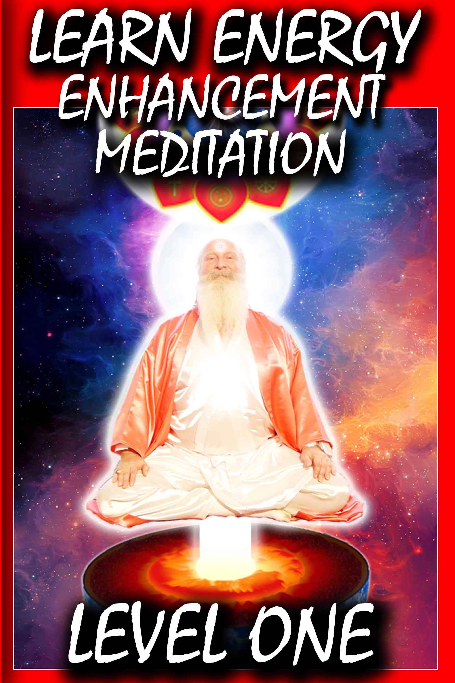

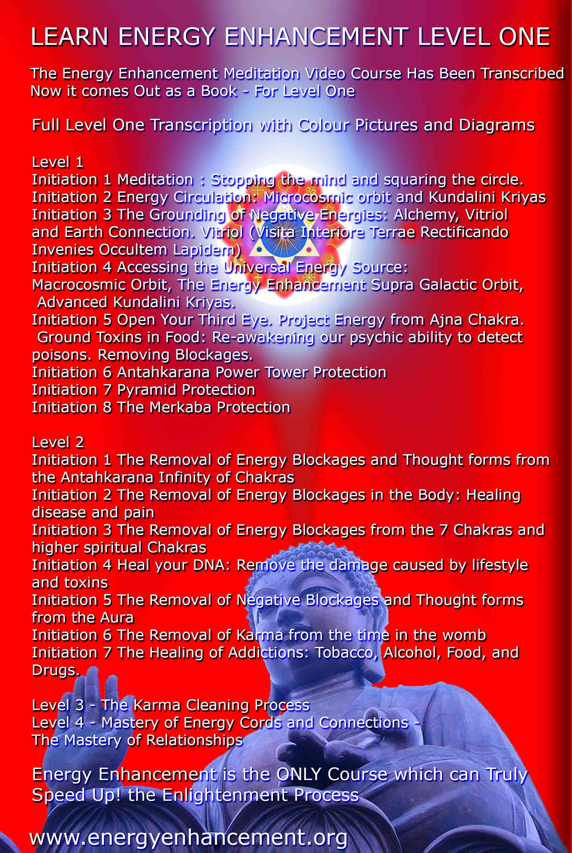

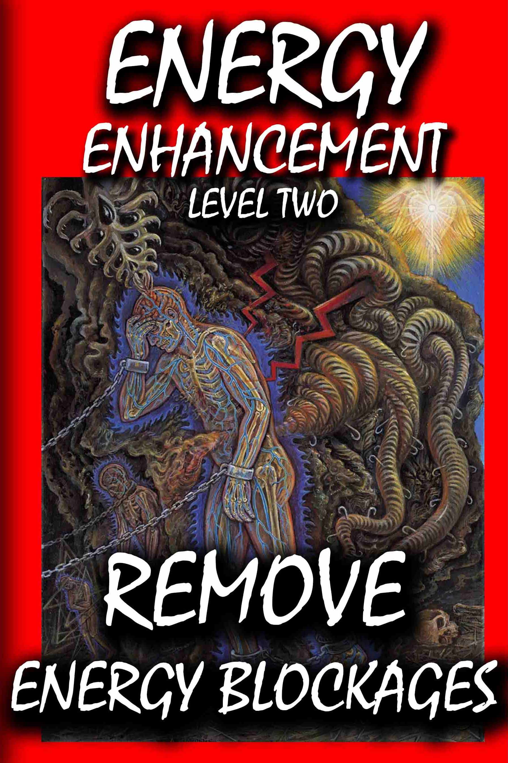

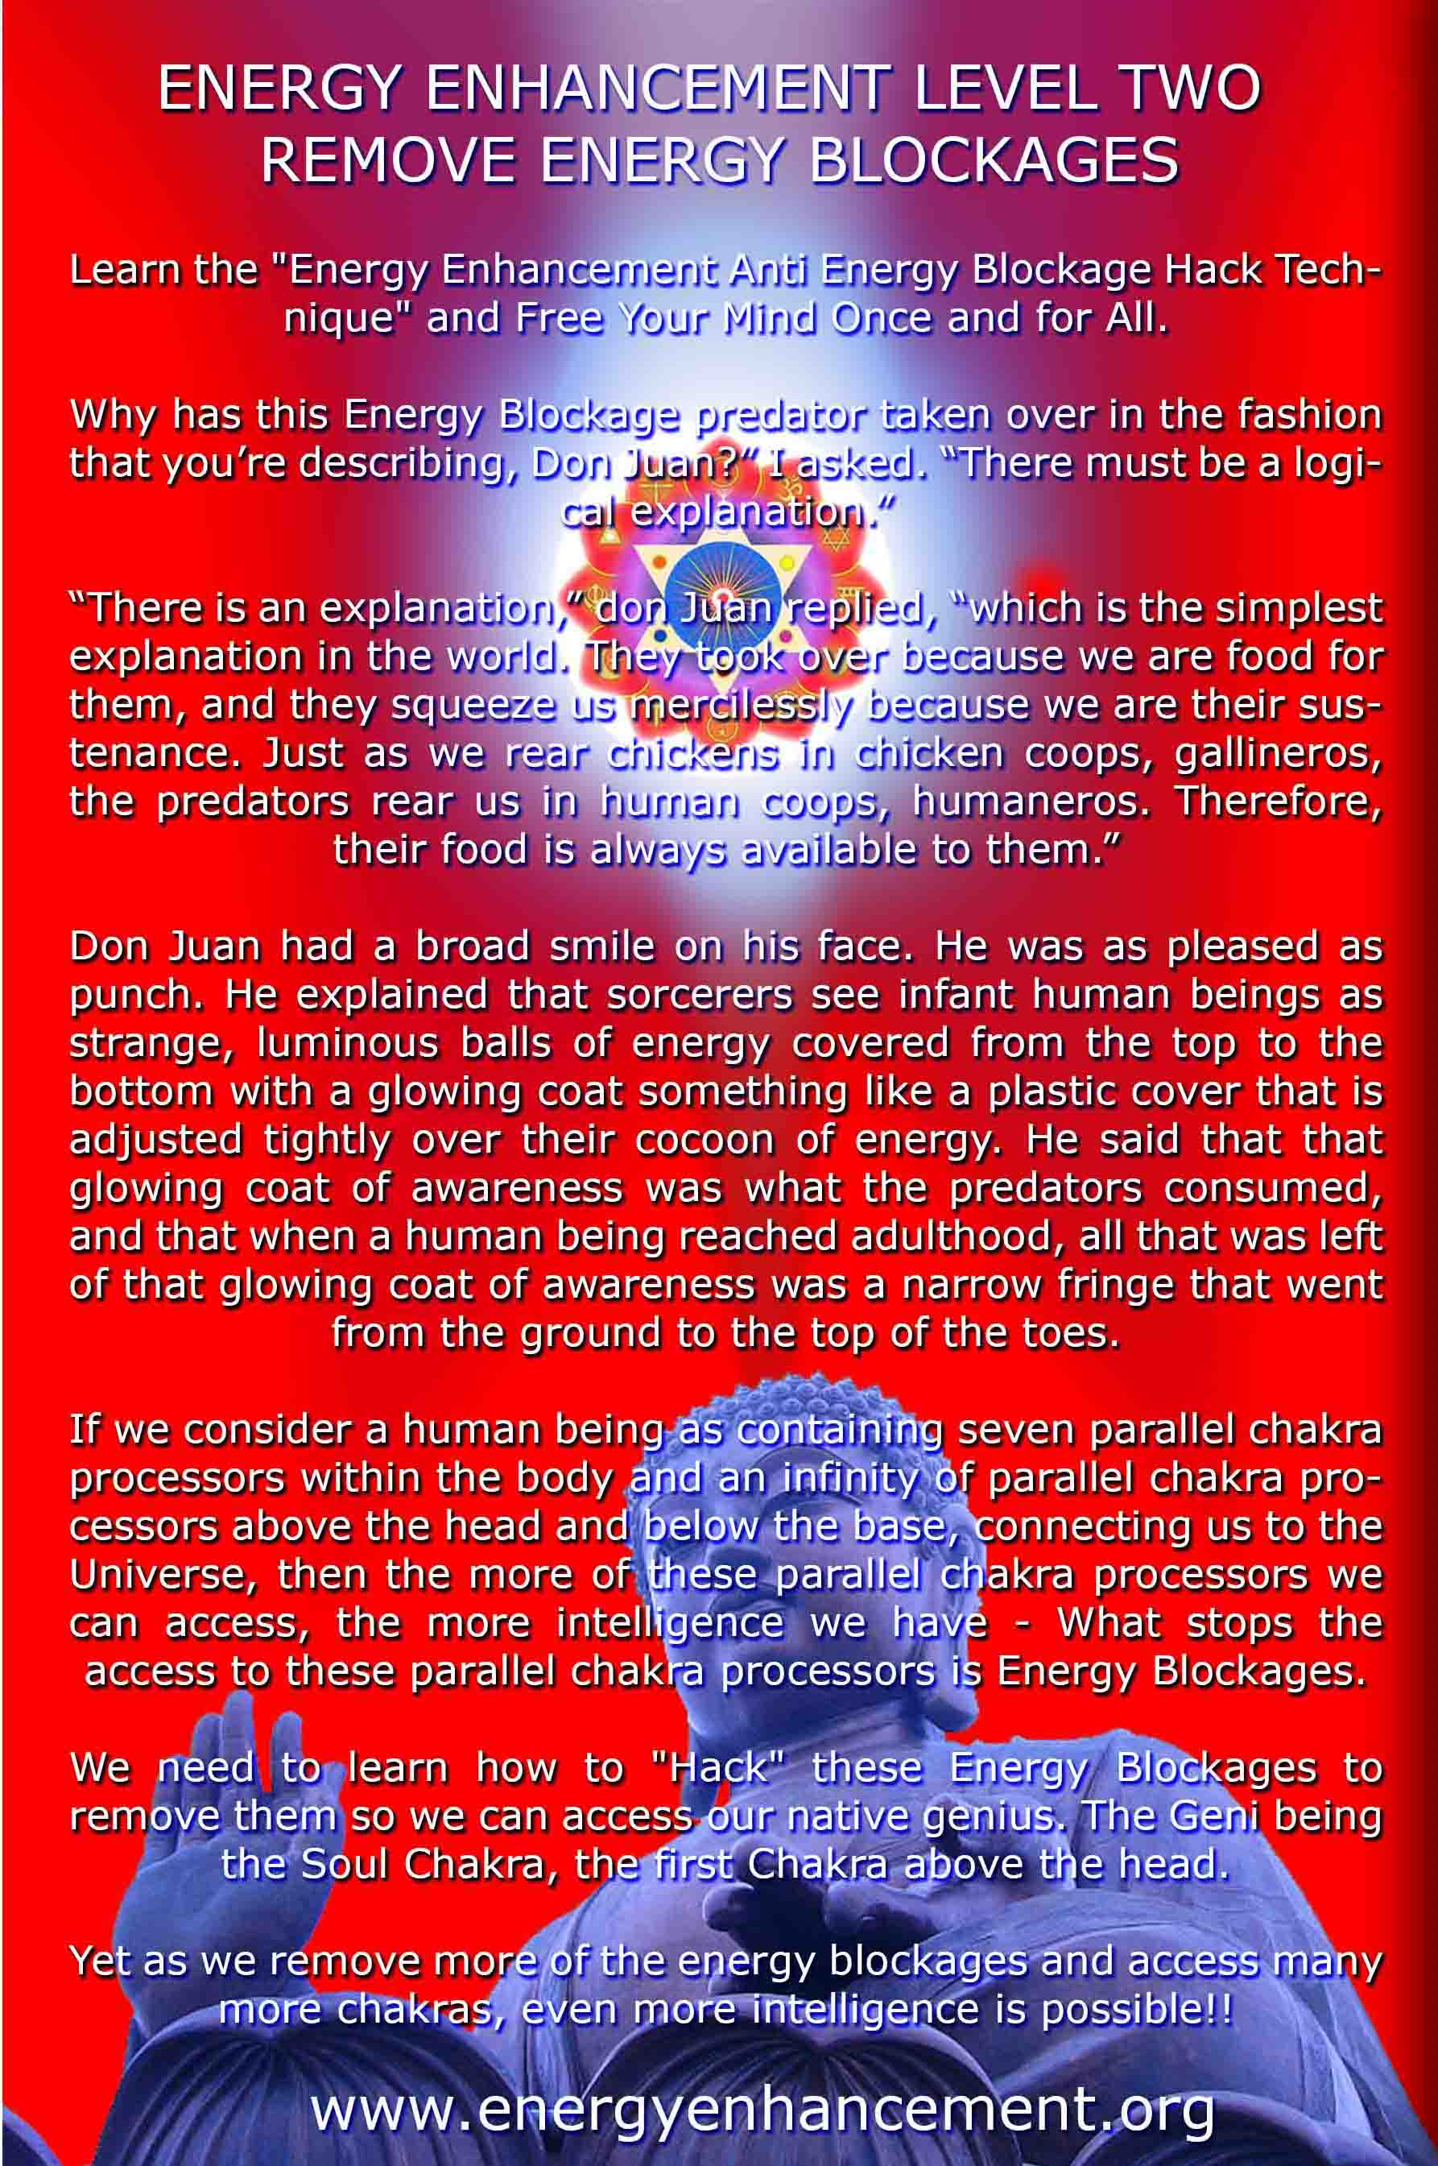

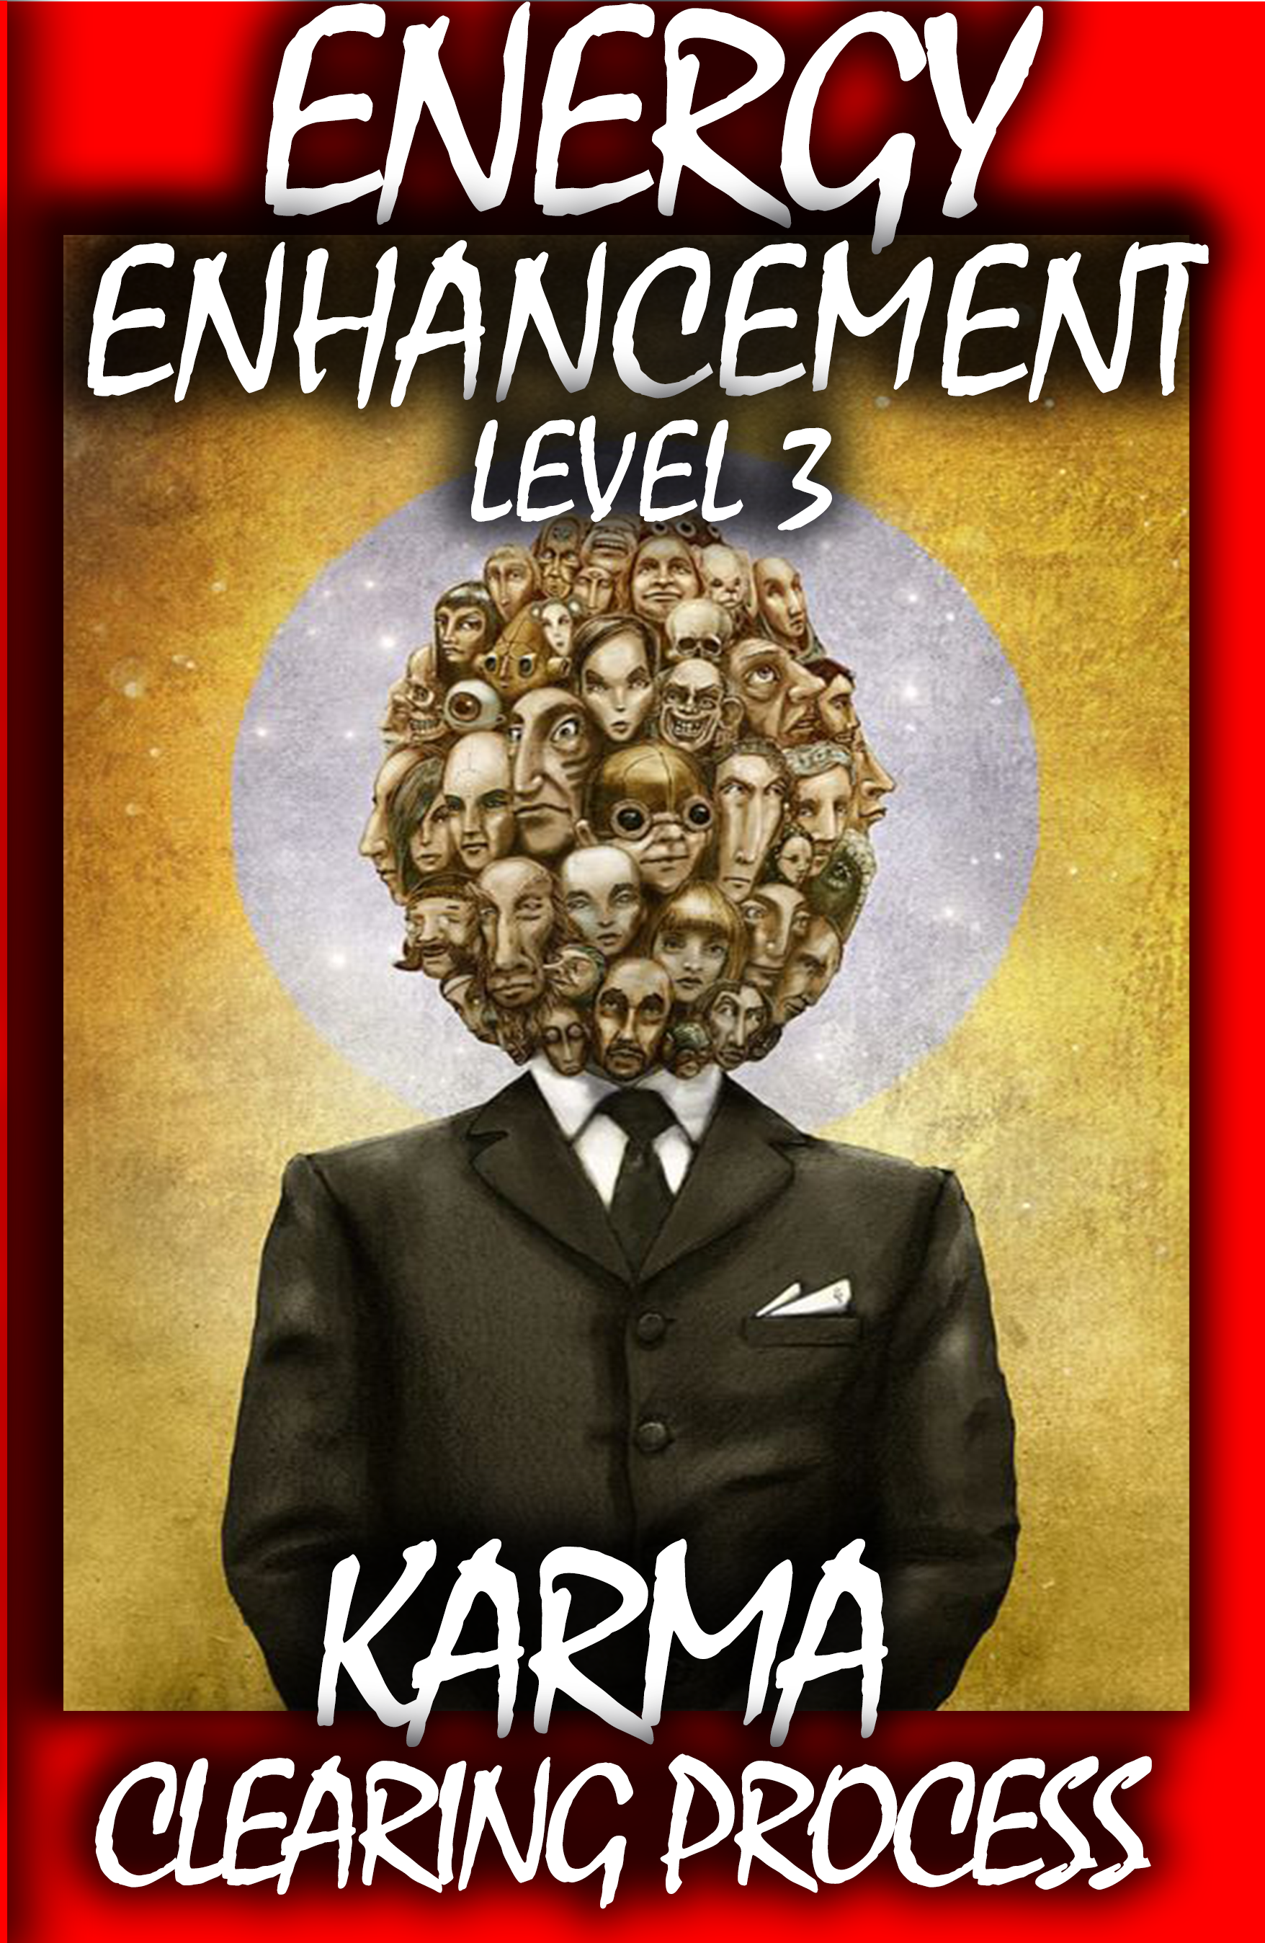



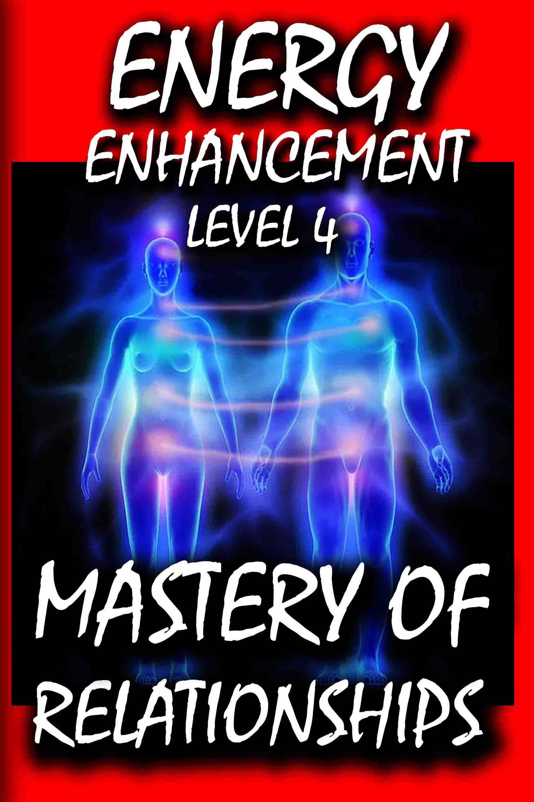

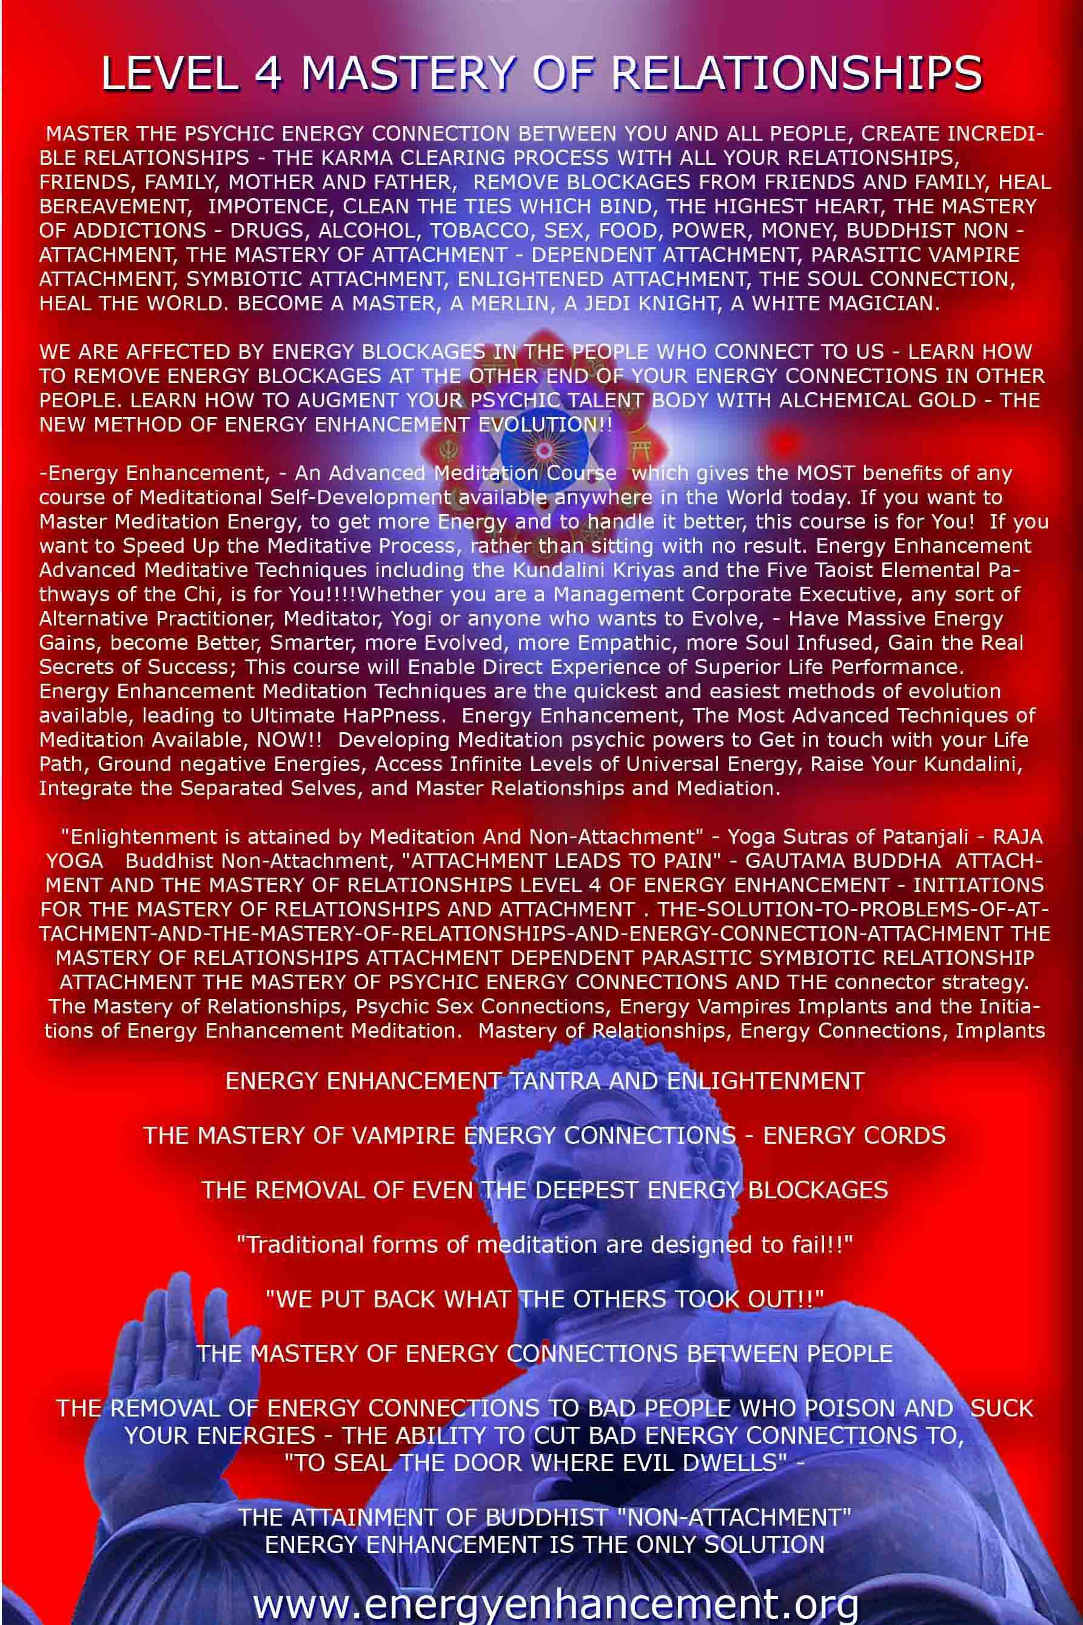
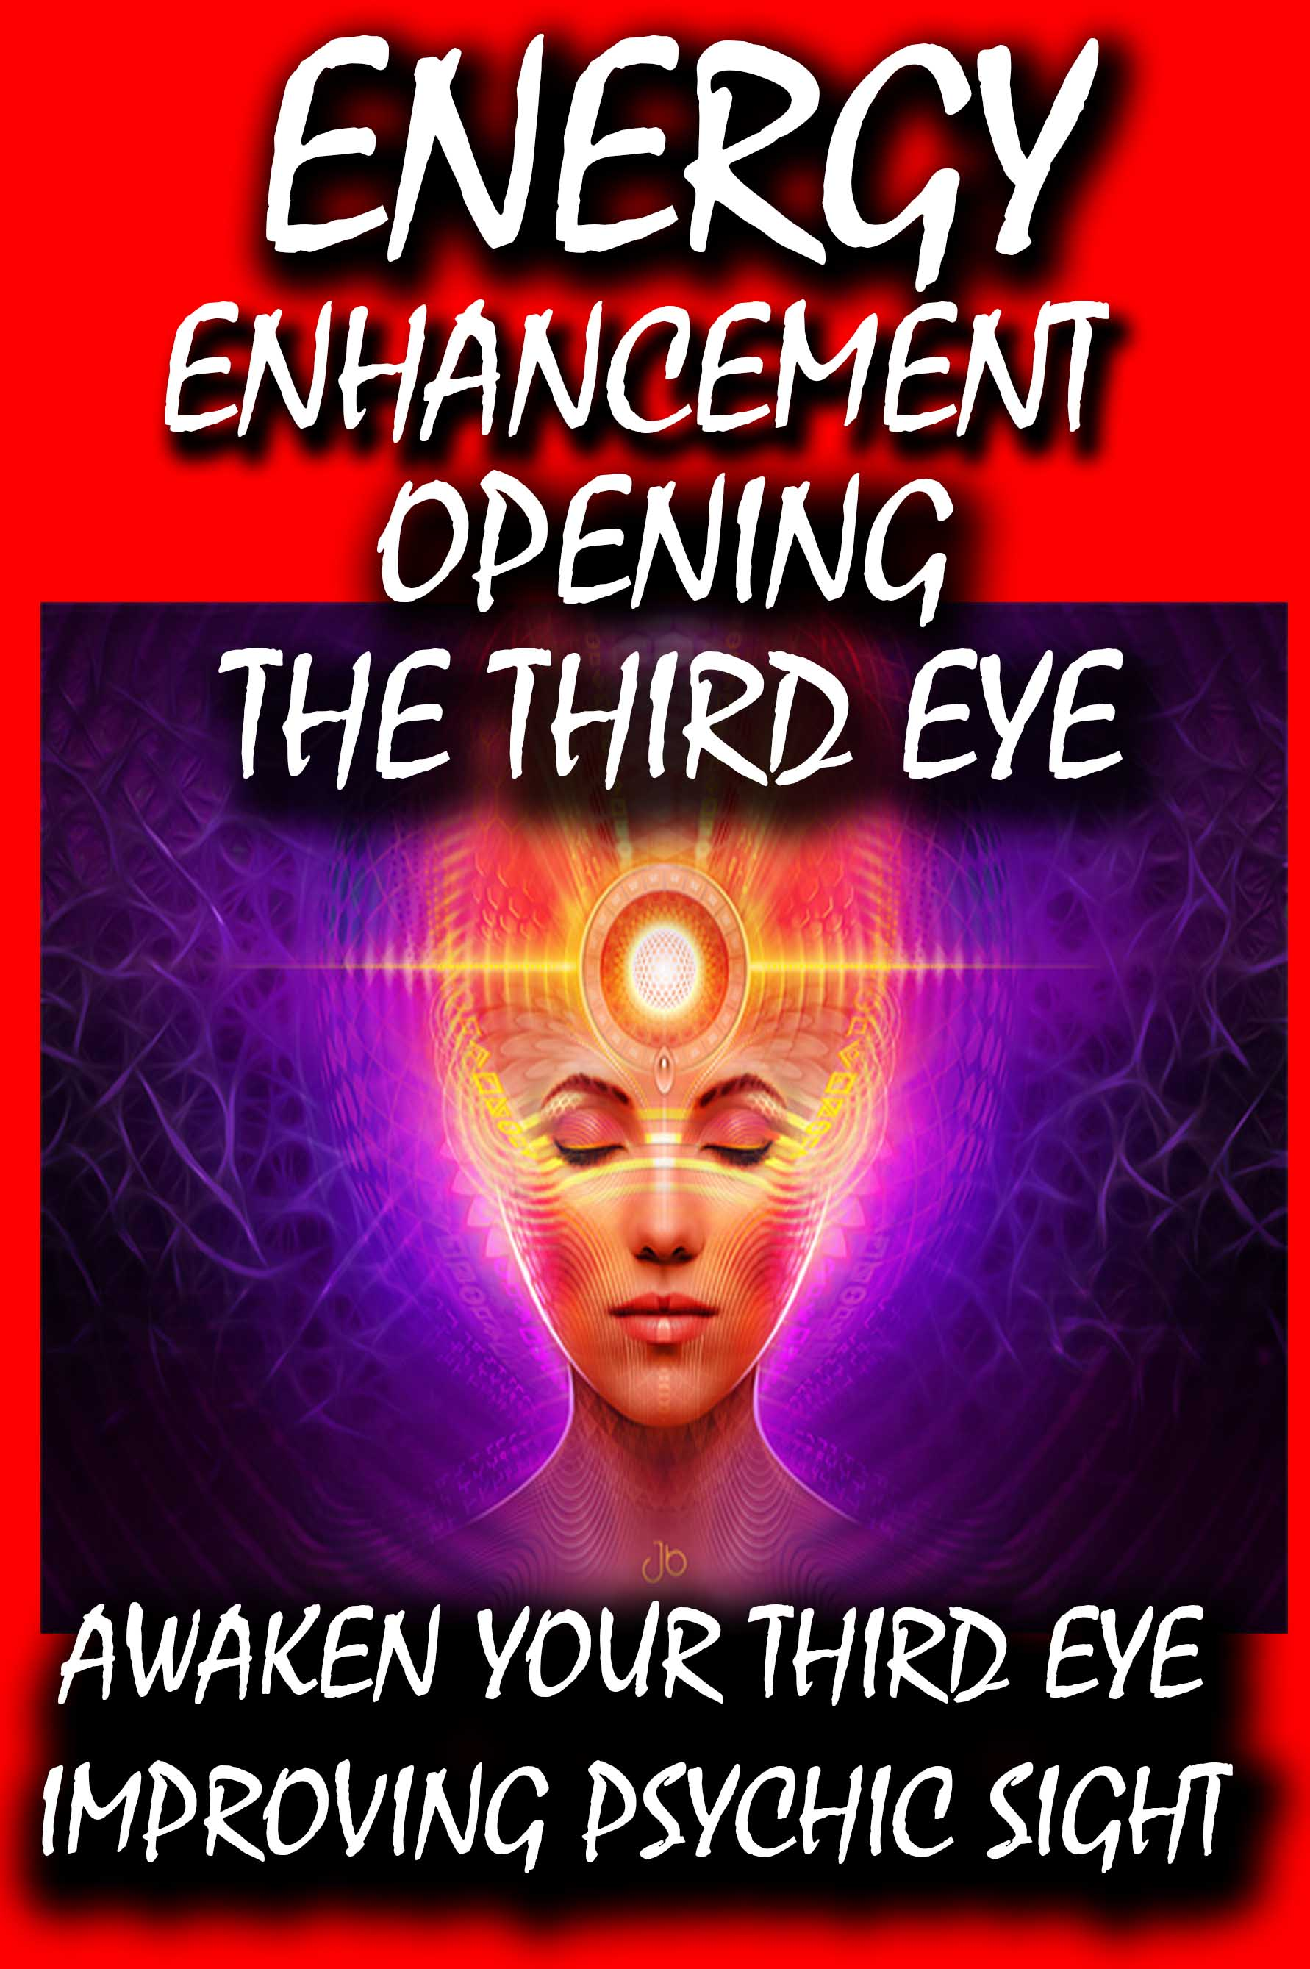


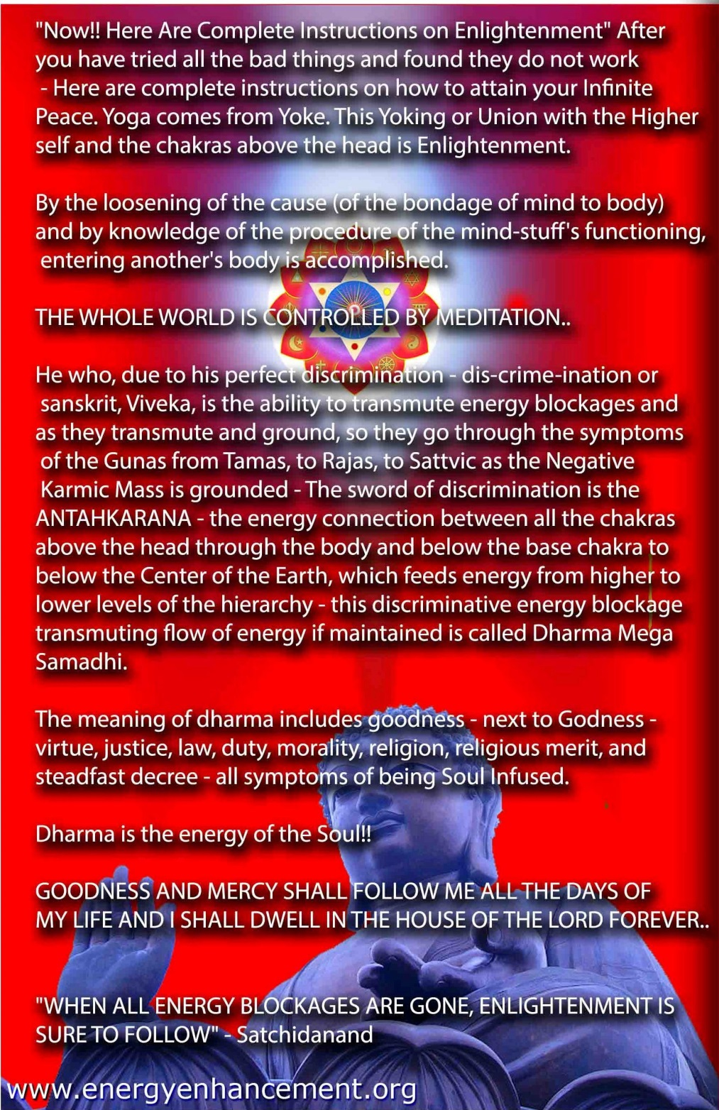
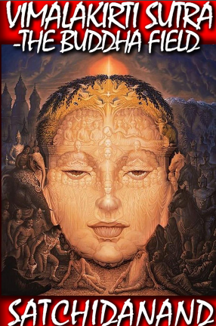

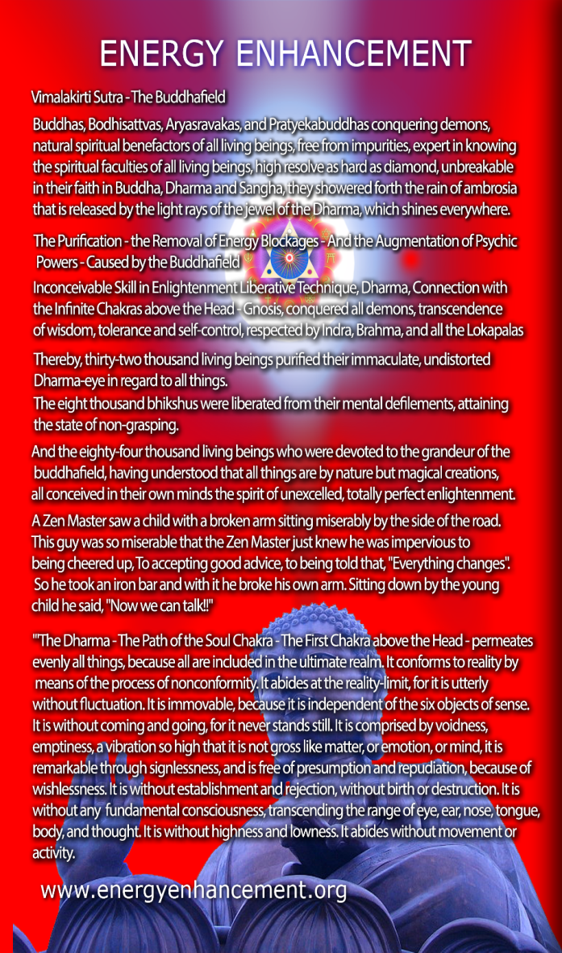
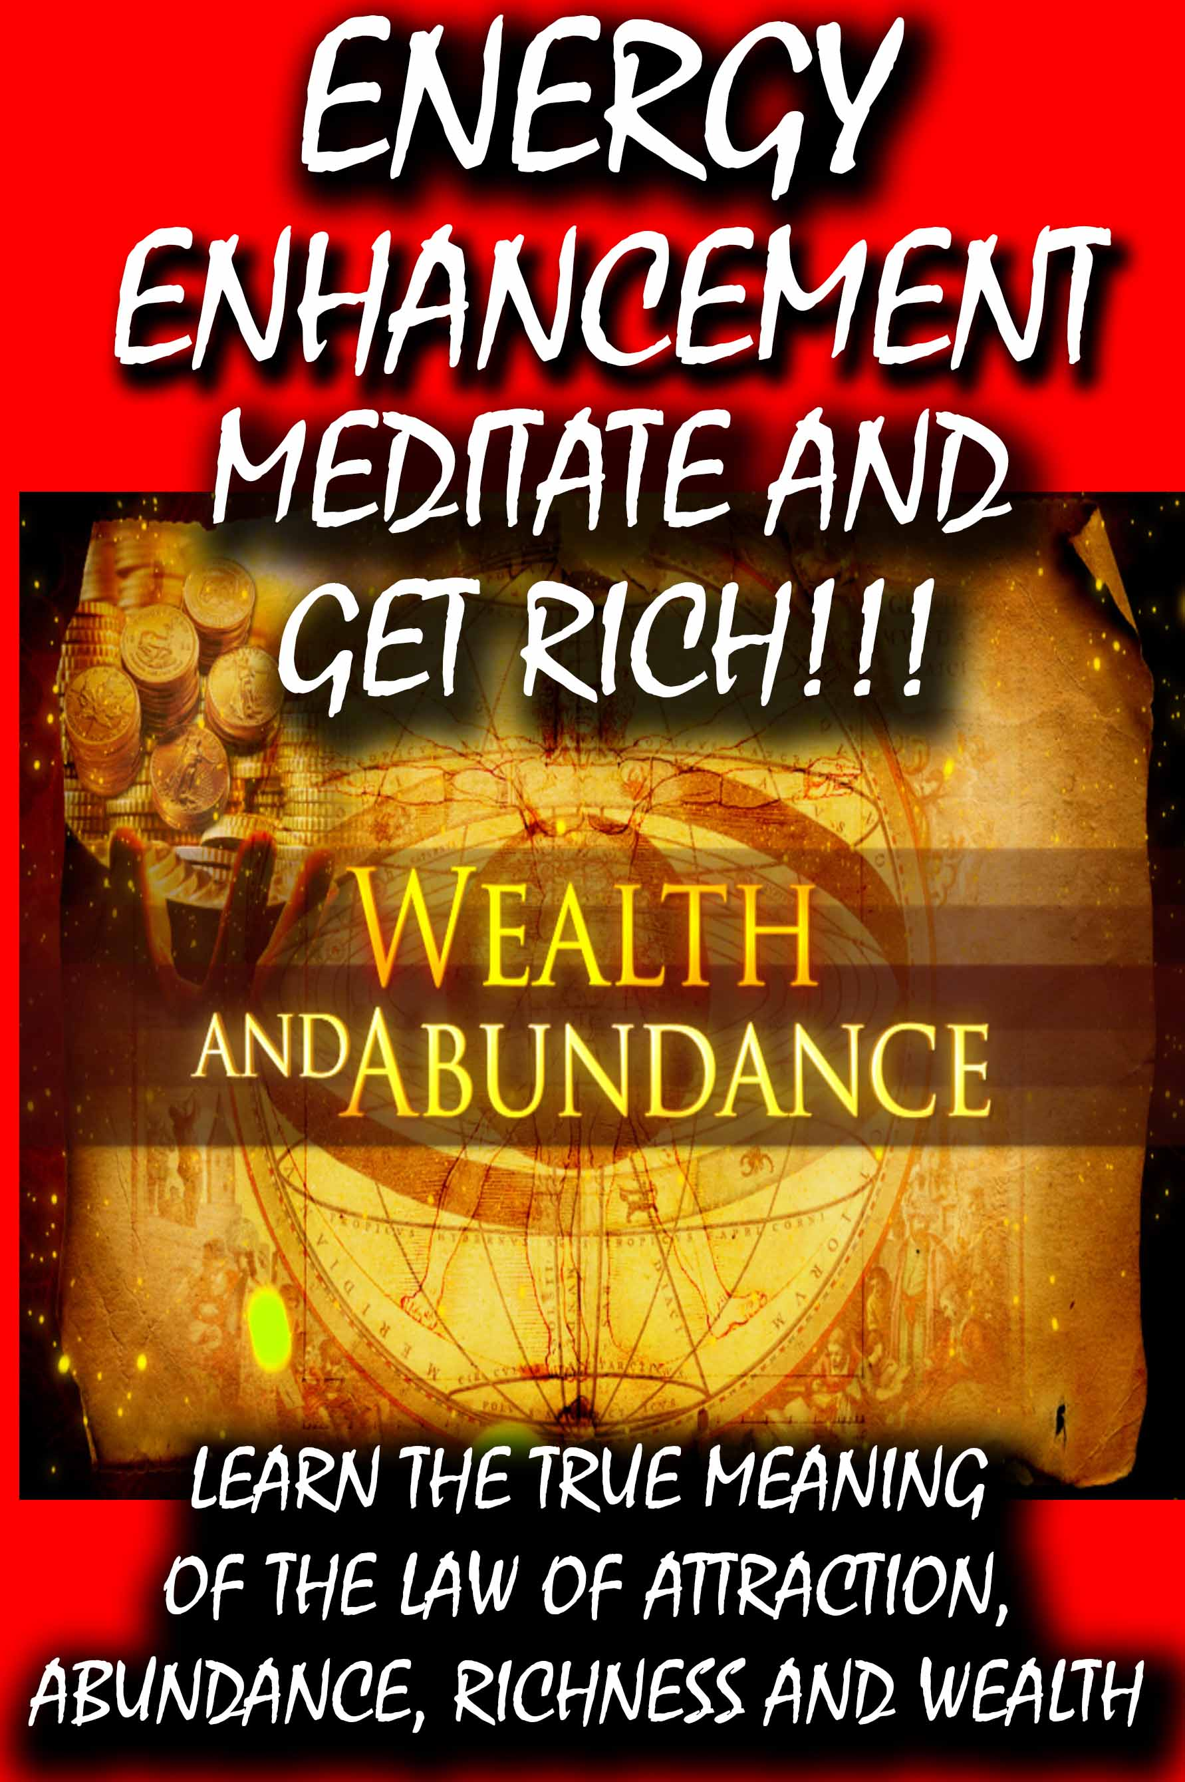
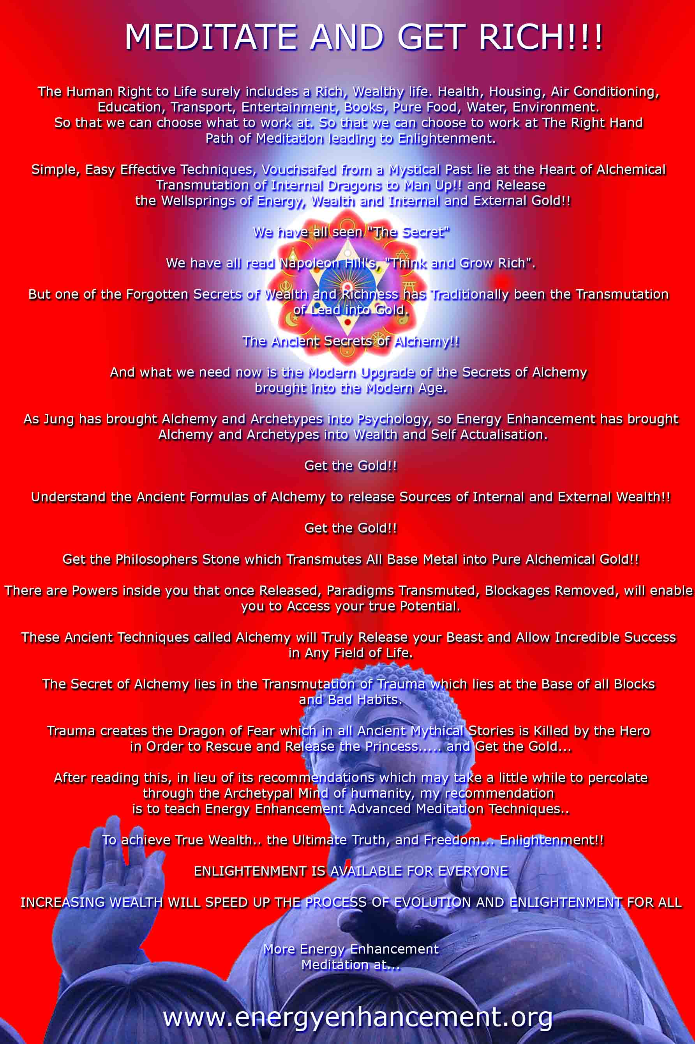
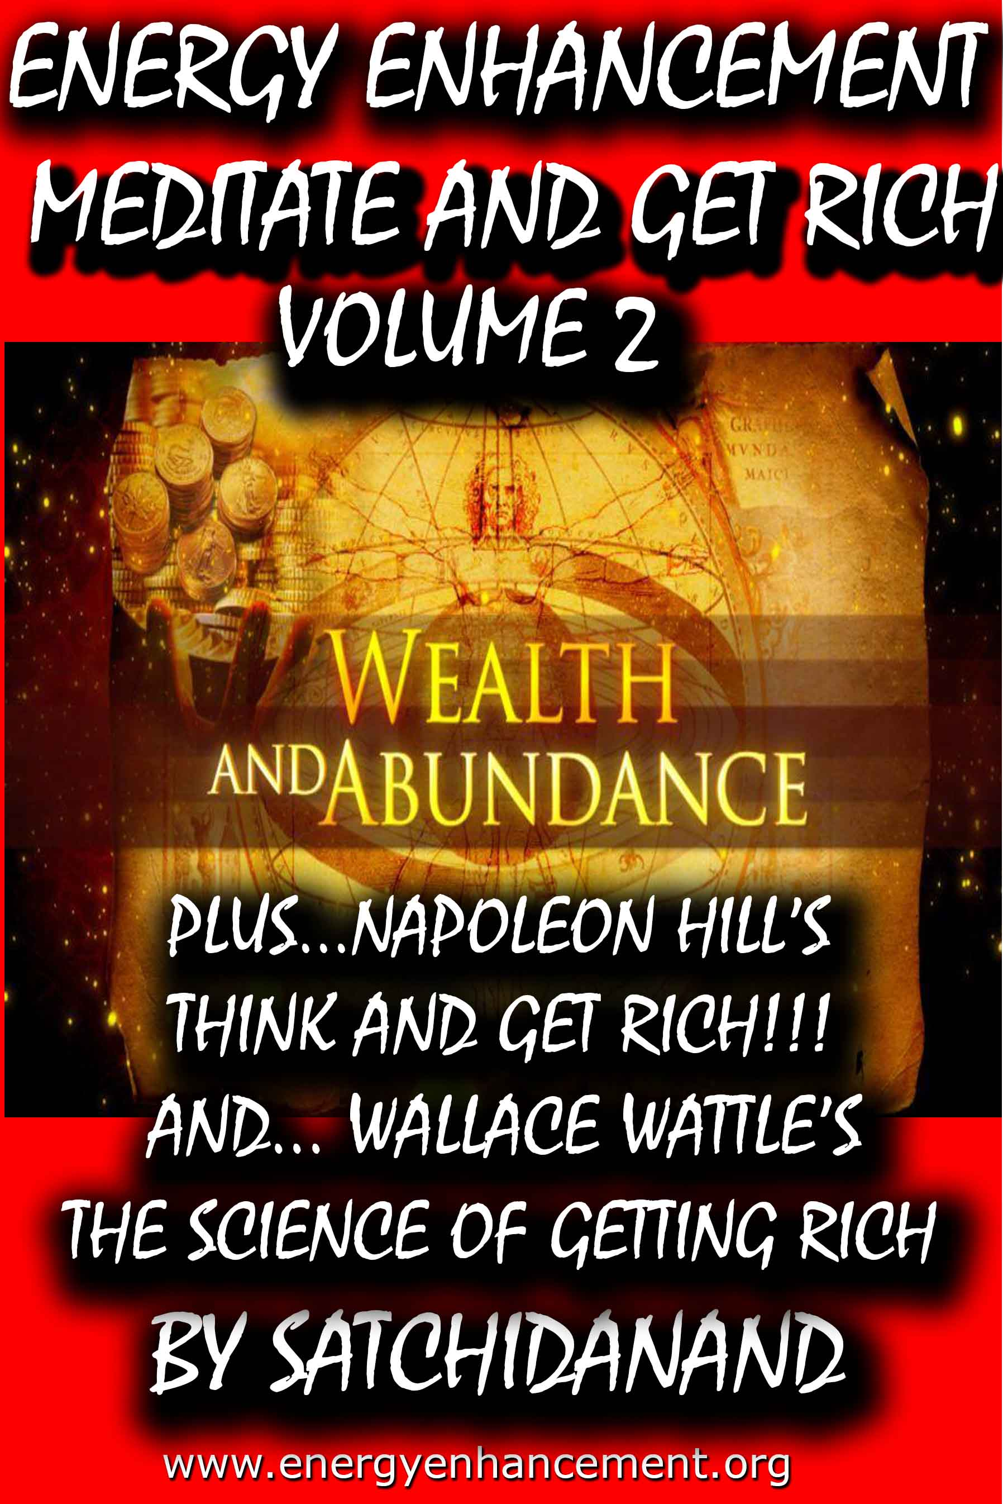
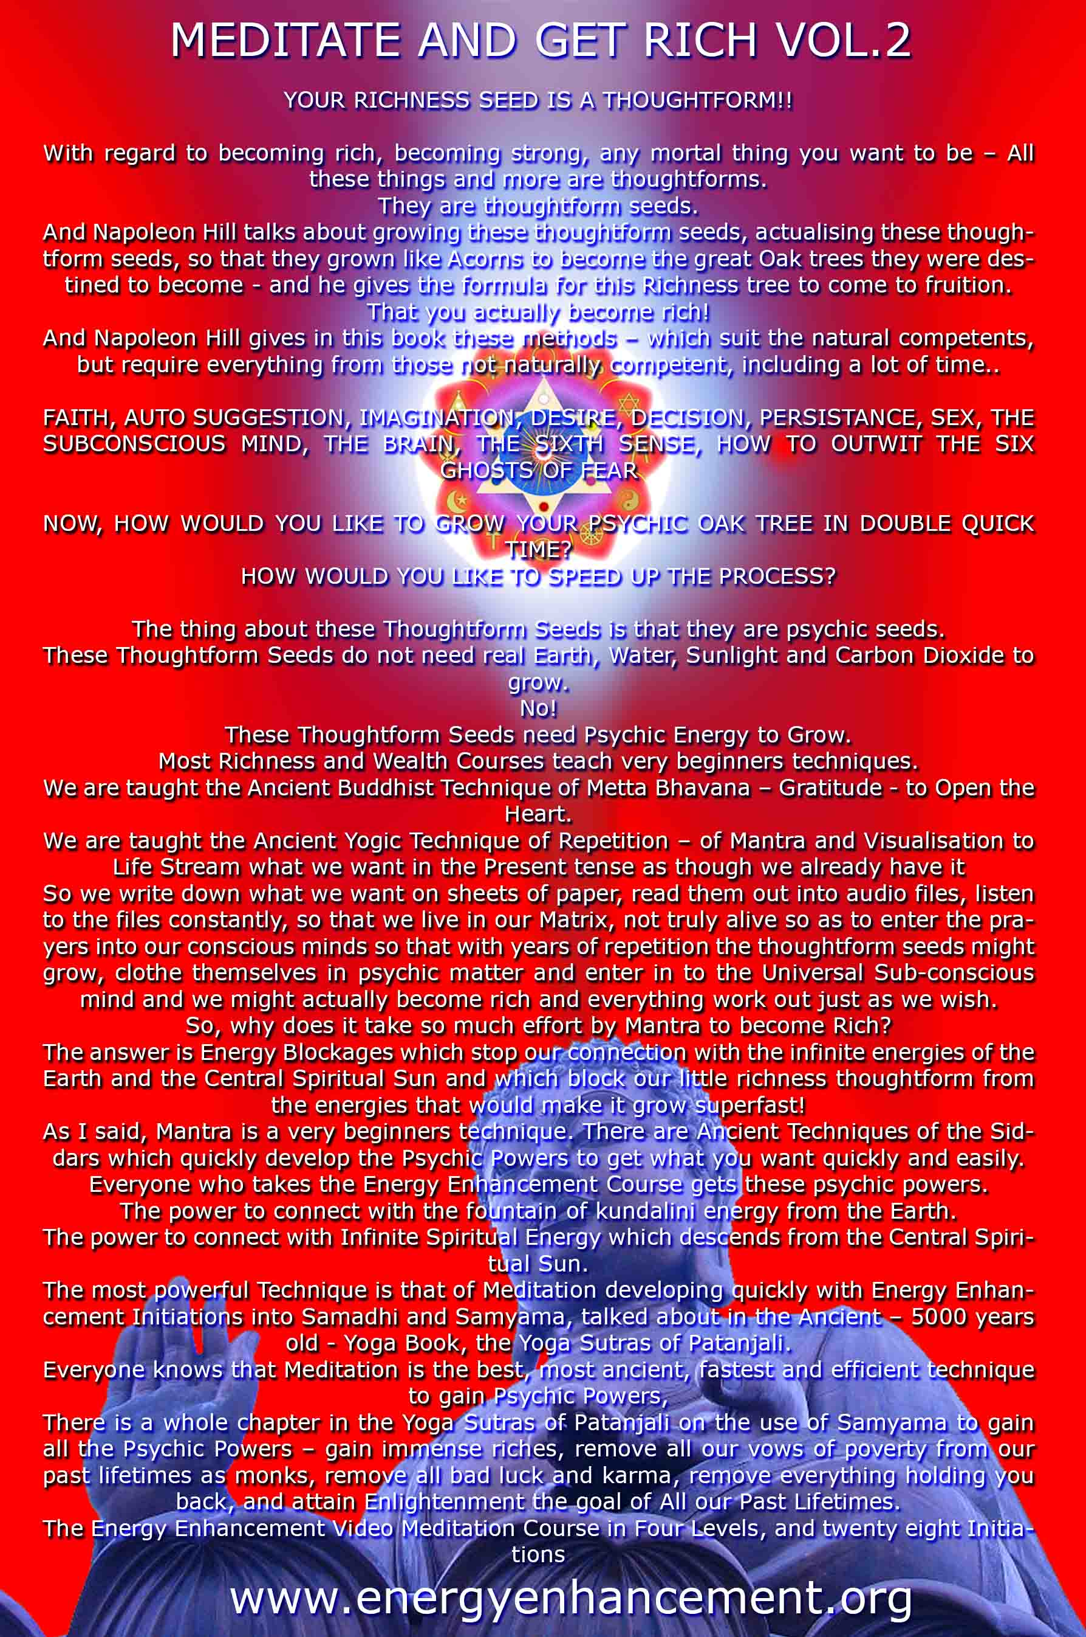

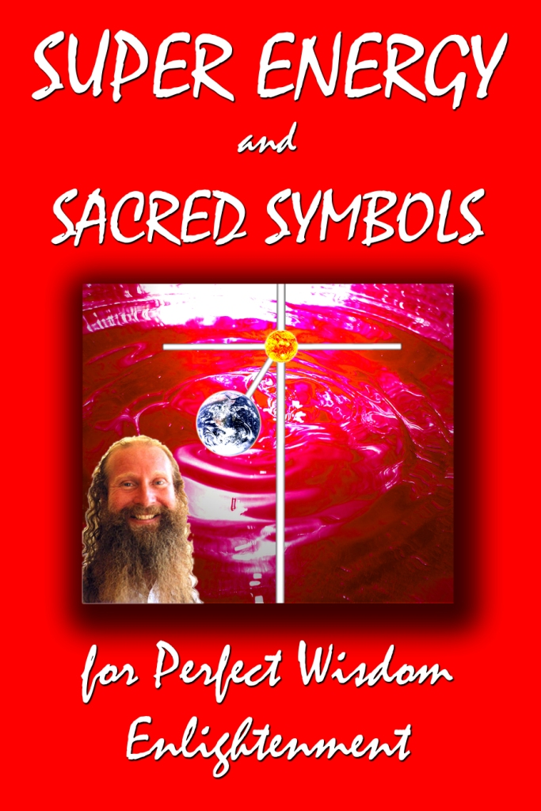

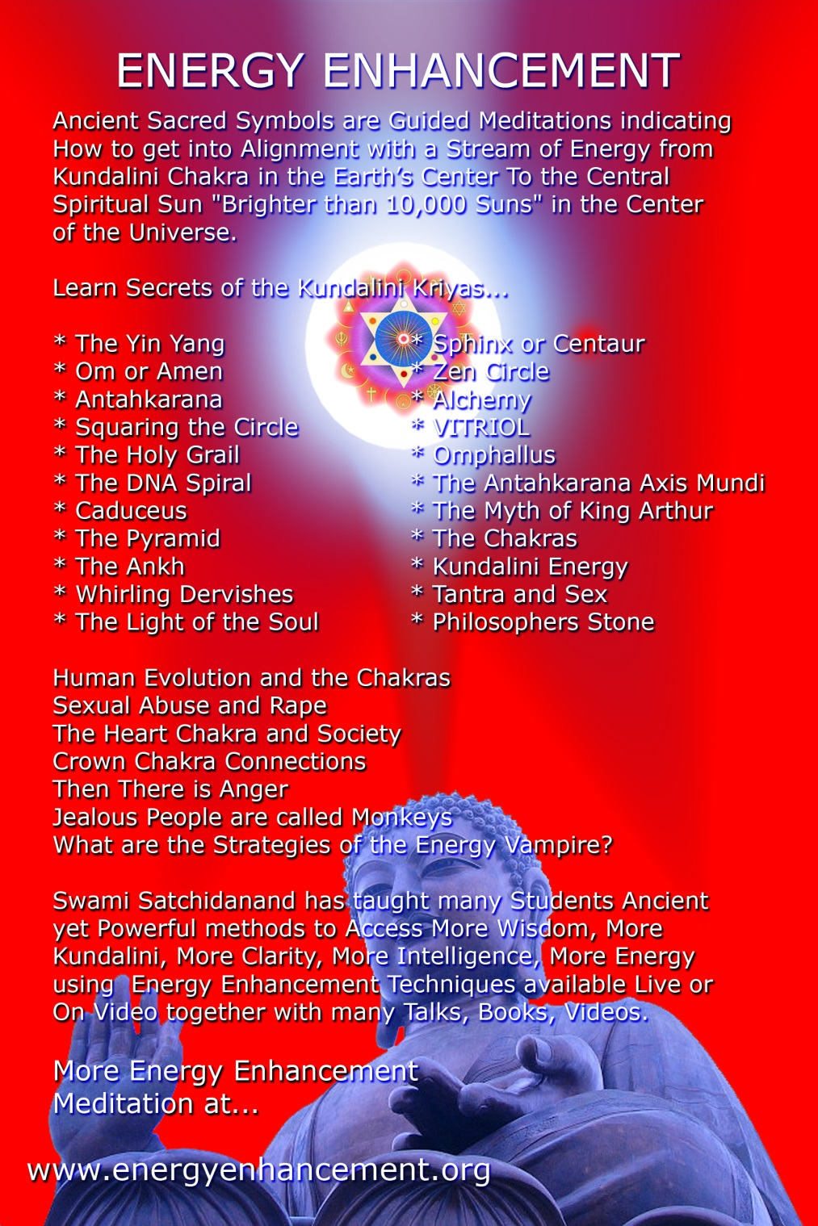
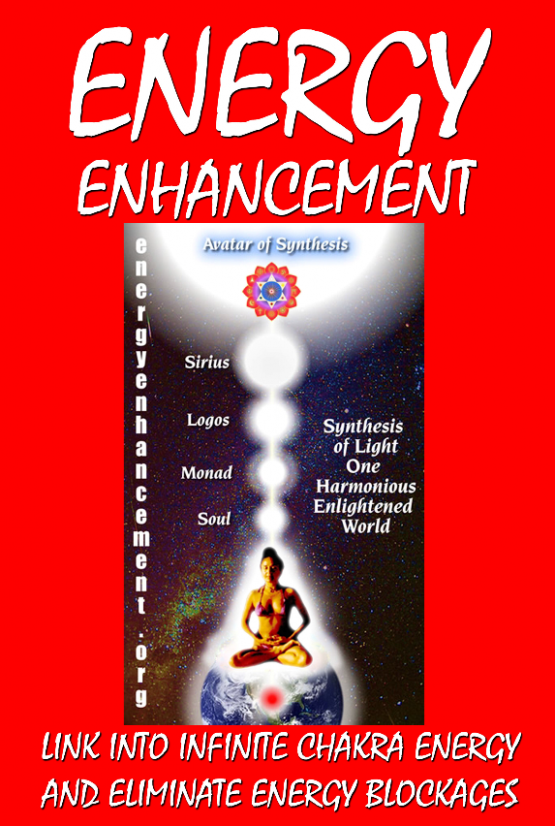
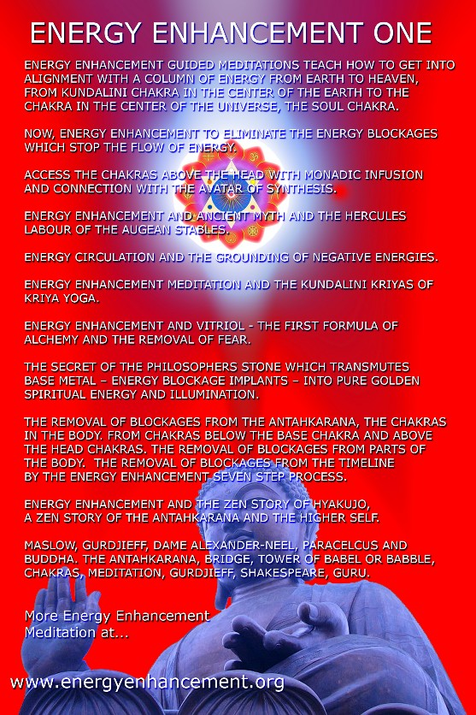
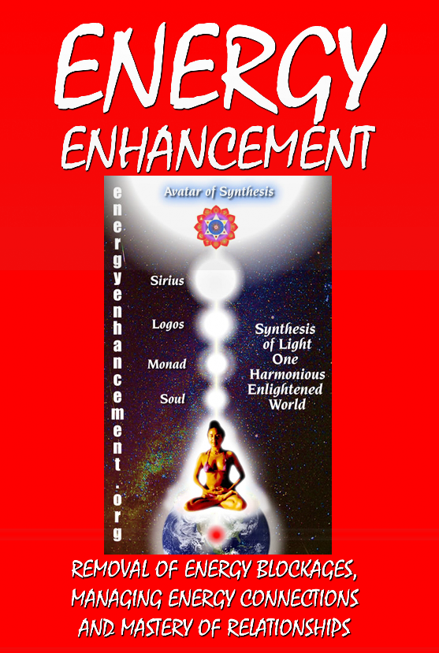
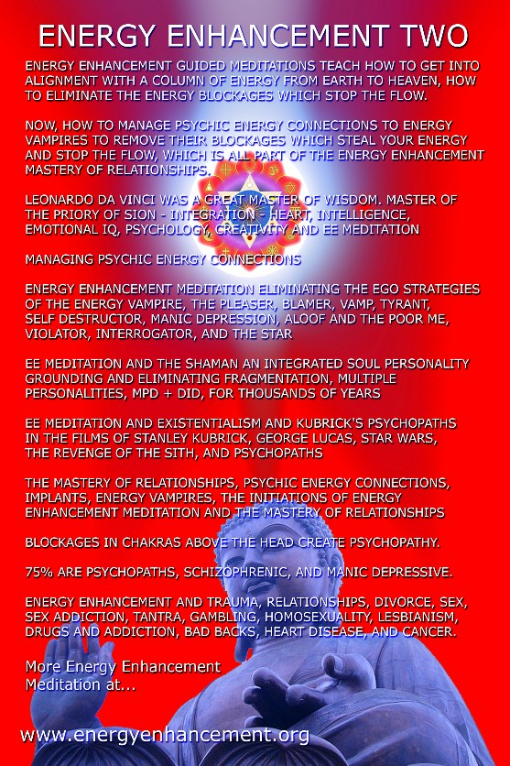
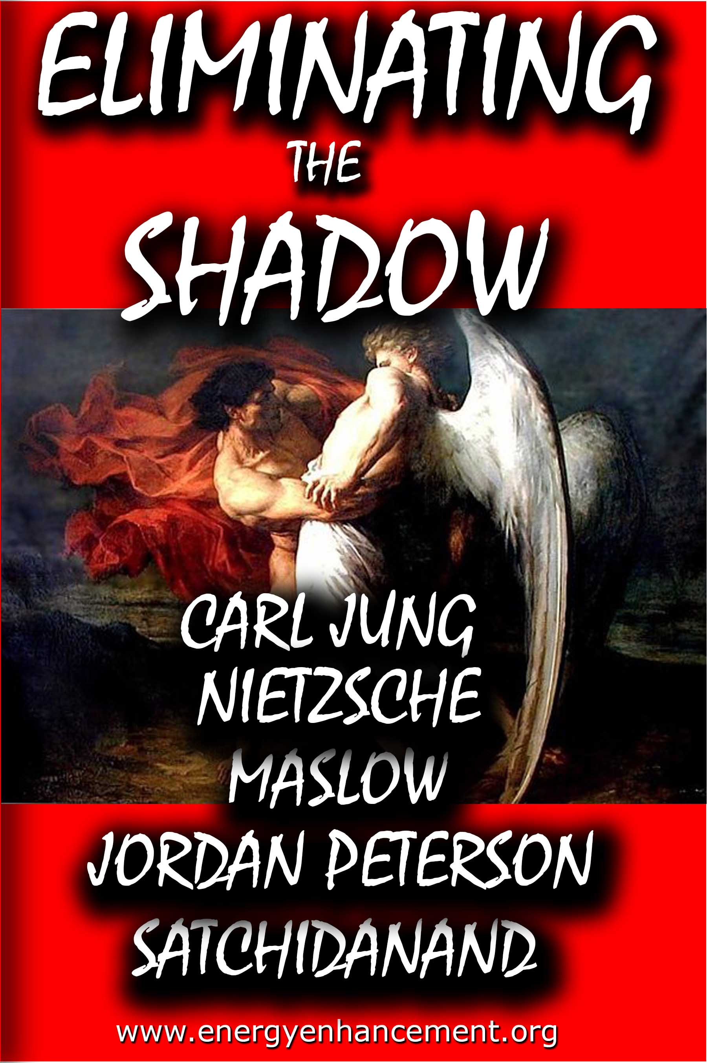
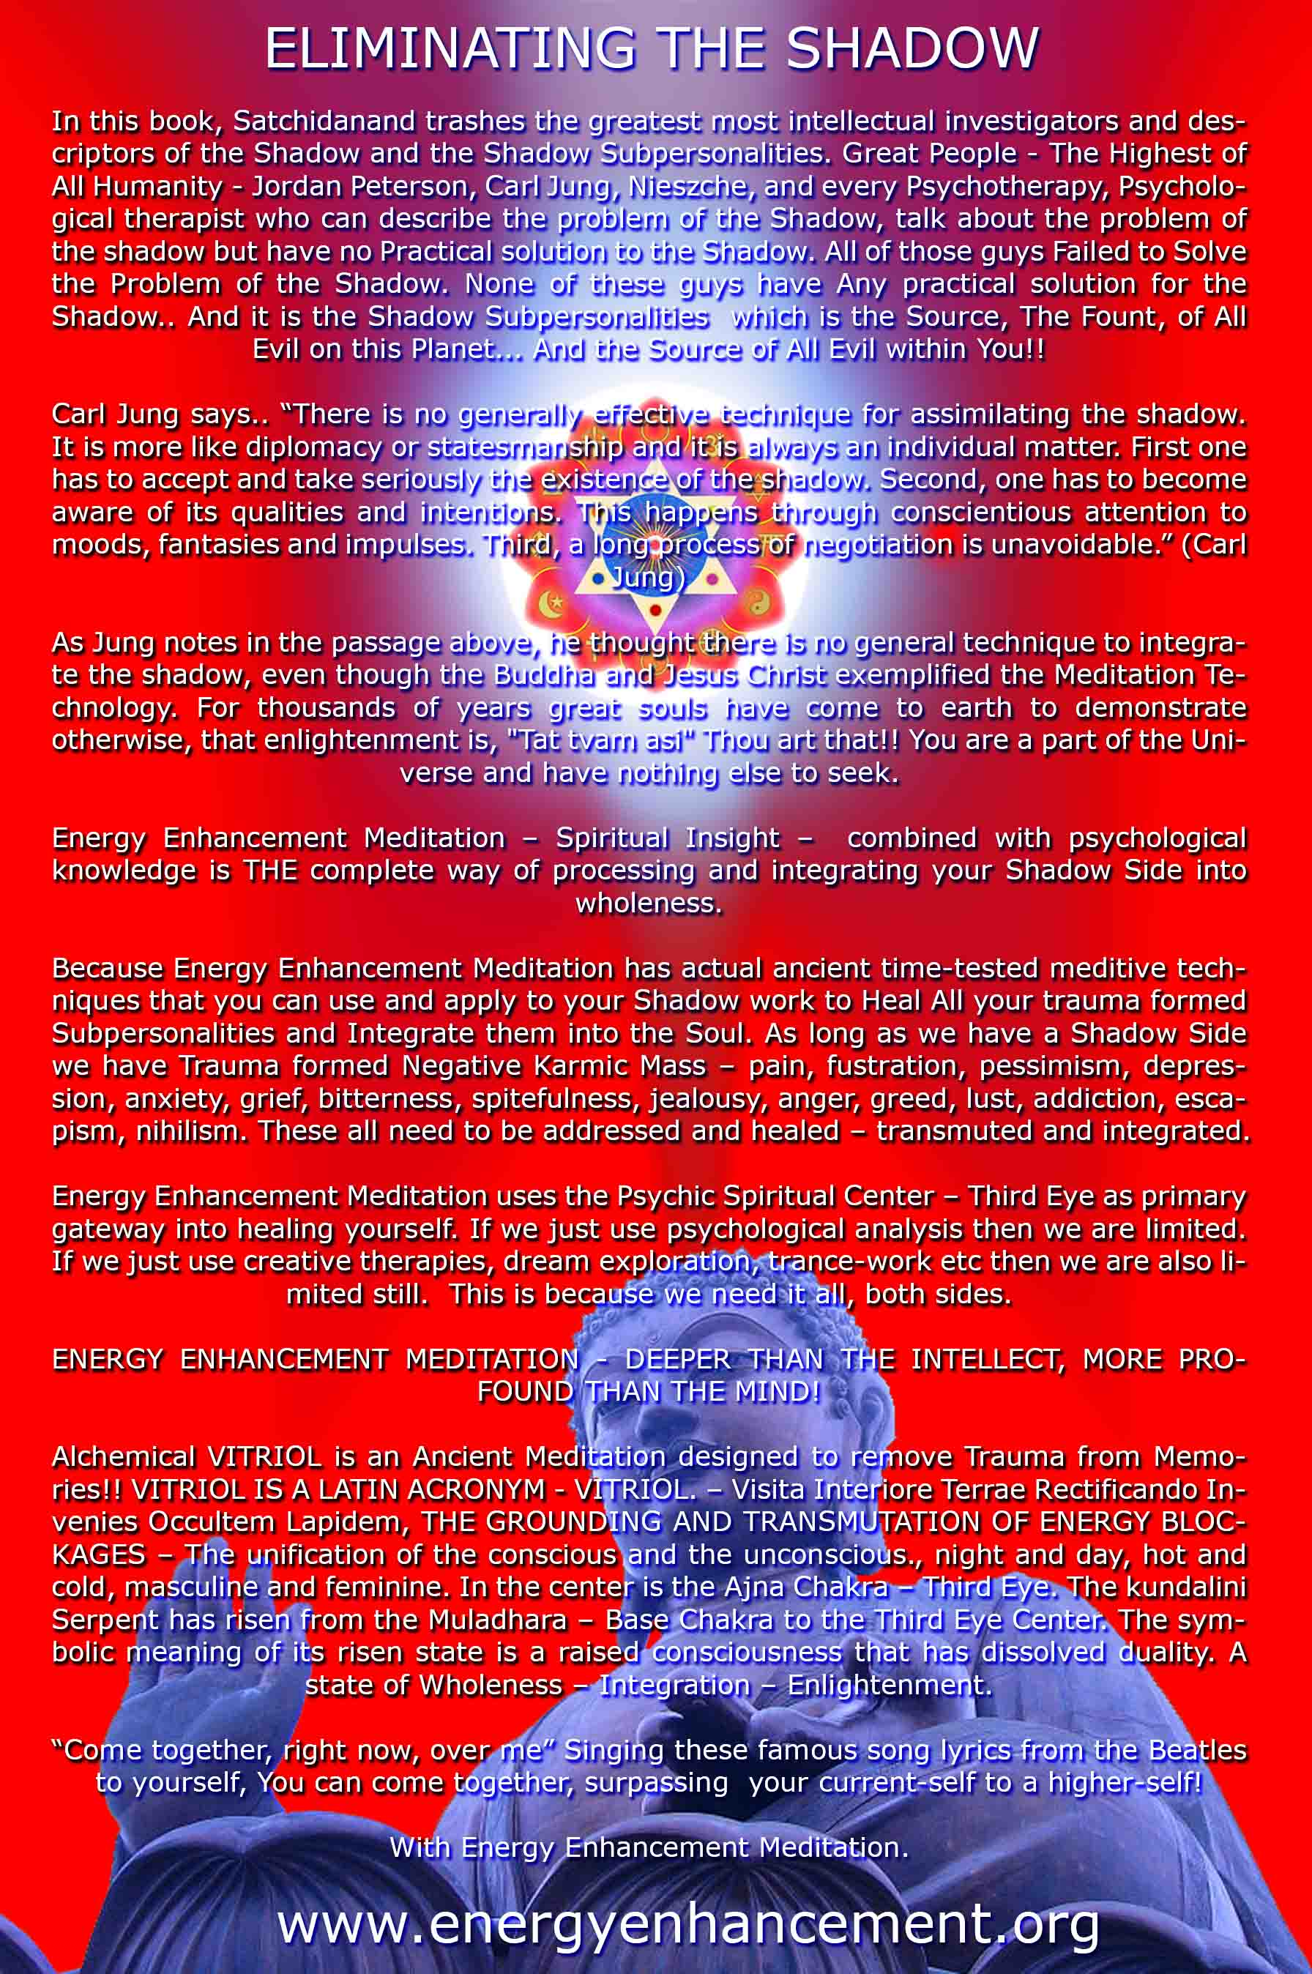

ENERGY ENHANCEMENT MEDITATION
ENERGY ENHANCEMENT MEDITATION LEVEL 1 POWER UP!! GAIN SUPER ENERGY http://www.energyenhancement.org/Level1.htm
ENERGY ENHANCEMENT MEDITATION LEVEL 2 ELIMINATE ENERGY BLOCKAGES http://www.energyenhancement.org/Level2.htm
ENERGY ENHANCEMENT MEDITATION LEVEL 3 CLEAN KARMA BLOCKAGES AND PAST LIFE KARMA BY TRANSMUTATION http://www.energyenhancement.org/Level3.htm
ENERGY ENHANCEMENT MEDITATION LEVEL 4 MASTER ENERGY CONNECTIONS AND RELATIONSHIPS http://www.energyenhancement.org/Level4.htm

