CHARLES DARWIN

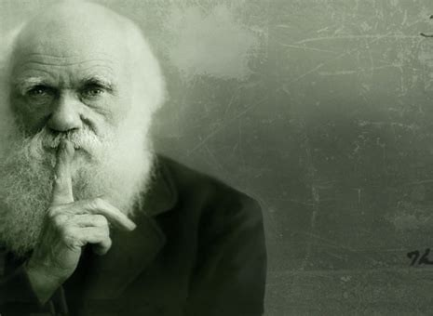
by Miles Mathis
First published February 4, 2024

I had intended to publish this on February 2nd so that I could do my biannual fund drive on Groundhog's Day, with a major new paper on both sites (two new science papers, now) to salt it in. Just seemed like the thing to do. But on the science site, I couldn't make the diagrams I wanted of Ammonia with Gimp and don't have Photoshop anymore, so I had to beg for pro bono help from a friend. Leading to some delay.

Most of you know I only do this twice a year: post a simple reminder that donations are welcome. I don't do daily fund drives like many on the internet, don't do intrusive advertising or pop-ups, and don't bother you with merchandise, either. I think too much of you, and myself, to bother you with any of that. You can donate via Paypal, pay mileswmathis@yahoo.com, or mail me a check or other booty to POBox 335, Garden Valley CA 95633. Some imagine I can do this because I am privately wealthy—a trust-fund kid or something. Nope. I have been living hand-to-mouth for almost 40 years now, and although my paintings still give me a small income, the balance has been made up for about ten years by my readers like you. My science, art, and history readers help make this possible, allowing me to drive around the mainstream gatekeepers in several fields. I know that some of you have already donated in the past month or so, and I thank you for needing no reminder. The rest of you I thank in advance. All amounts are welcome, and in fact I encourage more small donors. I have far more readers than I do donors, and it would be lovely to see that statistic change without me having to interrupt with these reminders more often.

~~~~~~~~

Notice that in my title I do not call Darwin a fraud, as I did recently with Alexander Graham Bell and Thomas Alva Edison. Darwin was not a complete fraud: he did a lot of real work. Sailing around the world in the early 1800s was no picnic. But there are some things you may not know about him that

you should. That is why I am here.

Most of the things I will tell you here are already known. Although historians don't generally lead with them when selling Darwin, you can find them at places like Wikipedia and Britannica. But this first thing is my own research. I always start my digging now with a dive into the ancestries, since that is a great way to get a quick lay of the land. It gives us an immediate cui bono and tells us who exactly we are dealing with. It also tends to link us to all other mysteries, as we have seen again and again.

They admit Darwin was from high society, but even so they don't really want to tell you who he was. We saw a similar thing with Dickens recently, though at least they don't try to tell us Darwin was pasting labels on bottles of bootblack as a kid or something. The big clue is his grandmother Mary Howard, wife of Erasmus Darwin. She is scrubbed by everyone including Geni, Wiki, thepeerage.com, and even Tim Dowling at Geneanet. Dowling gives her father as Charles and then ends the line. But of course my first thought was that these are the Howards, first cousins of the Stuarts: Earls of Suffolk, Earls of Berkshire, and Dukes of Norfolk. We have seen them many times in my papers. Erasmus Darwin wouldn't have married some downmarket Howard, and if these are THE Howards, then we have caught all mainstream historians in a big lie by omission here.

And we have, since Tim Dowling gives up the farm. He can't help it since he is a close cousin of the Howards and Stuarts himself. He obviously got the memo, since he dutifully scrubs Charles Howard like everyone else. But he leaves a workaround for the extremely vigilant like me. All we have to do is click on Charles Howard's wife, Penelope Foley. We already have confirmation there, since we know the Foleys were closely related to the famous Howards, but there is much more coming. We keep clicking, going to her grandmother Penelope Paget. That should make your mouth water, since the Pagets are Marquesses of Anglesey, related to everyone. We can now switch over to thepeerage.com, where we find Penelope's father is Lord Paget, 5th of Beaudesert. He comes from the 1st of Beaudesert, who was Secretary to Queen Jane Seymour at age 30 and later Anne of Cleves. He later was the Chancellor of the Duchy of Lancaster, High Steward of Cambridge University, and Lord Privy Seal.

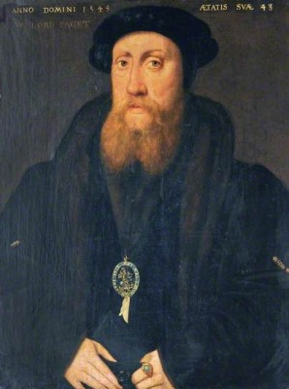

His son married Nazareth Newton, linking us to the famous Newtons including Sir Isaac Newton.

The 5th Lord Beaudesert married Lady Rich, daughter of Henry Rich, Lord Holland, who was the son of Robert Rich, Earl of Warwick, and Penelope Devereux, daughter of the Earl of Essex. This Earl of Essex was married to Lettice Knollys, who later married John Dudley, 1st Duke of Northumberland, who tried to install Lady Jane Grey as Queen. His son was the famous favorite of Elizabeth I, and we now know what that means. Just to be sure you remember, these Riches were brought from Germany by Henry VIII and the Stanleys to lead the pillaging of the monasteries in the British Isles.

Forward these Pagets link us to the Earls of Uxbridge, and through them to the Pierreponts, Earls of Kingston-upon-Hull. Think John Pierpont Morgan. Also to the Egertons, Earls of Bridgwater; the Cavendishes, Dukes of Newcastle-upon-Tyne; and of course the Stanleys, Earls of Derby.

So how does thepeerage.com break the link to Darwin? It breaks it at Penelope Foley, giving her no issue. But we know from Tim Dowling that she married Charles Howard, their daughter Mary being the grandmother of Charles Darwin.

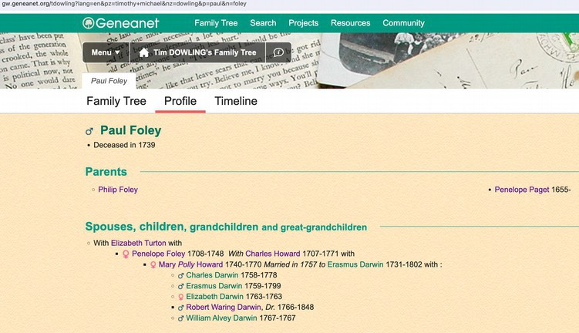

So Charles wasn't just a Darwin and a Wedgwood, he was a Howard, a Paget, and a Stuart. Tellingly, all the historians are hiding this from you, meaning his grandmother the Howard is most likely already right at the top, being the daughter of a Duke or Earl. One possibility is the 14th Earl of Suffolk, Captain Charles Howard, who has a daughter Mary listed at thepeerage.com. Born 1735, while our Mary's birth is given as 1740. This is a good first guess for another reason: the 19th Earl of Suffolk was named Henry Paget Howard. But there is another even better clue, that being the 13th Duke of Norfolk, who just happened to have a daughter named . . . you guessed it. . . Mary Howard, b. 1822, who married the Baron Thomas Foley. That Mary Howard was contemporaneous with Charles himself, not his grandfather, but we can still see what they are doing here in fudging these genealogies.

The Mary Howard, sister of the 15 Earl of Suffolk, is scrubbed at thepeerage.com, given no children, and that is probably where the link to Darwin is broken. But they do tell us she was Lady of the Bedchamber to Princess Amelia. That would be the daughter of George III who died of tuberculosis.

So Darwin's grandmother was from a line of Dukes, first cousins of the Stuarts. As I say, we have seen these Howards in many many papers, and not just ones from the time of Henry VIII. Perhaps most surprisingly, my guest writer Leaf Garrit showed us fake serial killer Kenneth McDuff's mother was

probably a Howard of this family. Like the Stanleys, they are top hoaxers and always have been.

Wikipedia also publishes a family tree of the Darwins and Wedgwoods moving forward in time from Erasmus Darwin, and there we find Darwin is an ancestor of composer Ralph Vaughan Williams (who married a Fisher) and economist John Maynard Keynes.

Why does it matter that Darwin came from these lines? Well, ask yourself why they are hiding it. The answer is obvious: because they want you to think Darwin proceeded on merit, not on preference. They don't want you realizing he advanced on a series of byes and was promoted heavily from the cradle to do exactly what he did. It was no accident or choice of Darwin himself. Although he wasn't a total fraud, in many ways he was just another frontman, chosen as the face of this particular project to keep your eyes off bigger names. And those names we have now just seen: Stanley, Howard, Paget, Stuart, Egerton. The same ones we always see. We are only missing Cohen.

We have all the usual signs of this. Although we now know these families were all Phoenicians, children of El, we are told the Darwins were Unitarians. You will say, “What do you mean, we know they were Phoenicians?” Well, they admit the Darwins were top Freemasons. Charles' grandfather Erasmus was one of the ranking Masons in the British Isles, being head of the Time Immemorial Lodge, #2 in Scotland.

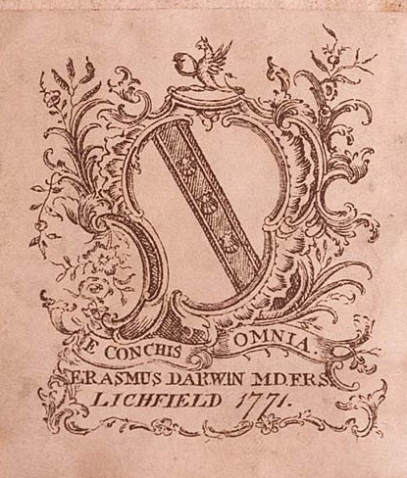

There is his coat of arms. Oh, what is that on top? Wiki tells us it is a demi-griffin, but there is no such thing as a demi-griffin. That is a phoenix. He is holding in his claws a scallop. What does the scallop signify in masonry? Exactly what you would think: secrecy. Same thing with the Latin: e conchis omnia: everything out of conches, or shells. In other words, everything a big psyop. Many sources have been planted, assuring us Erasmus was talking about the seashells seen on mountaintops—proof of evolution. But that is just a cover story. He meant nothing of the sort.

[Added February 8: One of my good readers pointed out to me a good secondary reading of this. You

have seen that I highlight all Phoenician names in purple. I do that because they are the purple-dye people, famous historically not only for shipping and banking, but for cloth and cloth dying. They got their purple dye originally from the murex snails in the Mediterranean. What I didn't realize today is that these “snails” are actually spiny little conches:

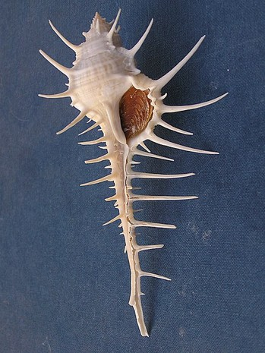

In fact, that reading may be primary, with the reading of shells as covert programs a secondary meaning. After all, this reading fits perfectly with the Phoenix holding the conch.]

We will pause on Erasmus, because he wore his soul on his sleeve. Or on his belly.

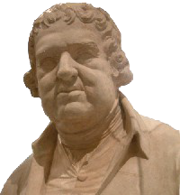

Historians admit he was a corpulent beast, not only grossly heavy, but slobbering and stinking. His dress was described as slovenly and he walked with his mouth open and his tongue hanging out. All this despite being a doctor. He was also a libertine, sleeping with anything that moved, though lord knows why any woman would wish to be mounted by that. He had two illegitimate daughters by his governess Mary Parker, and various other bastards too numerous to keep track of. That is in addition to the 14 legitimate children he had with two wives.

Also of interest is that Erasmus' father Robert Darwin of Elston was the first to find a dinosaur bone. What are the odds, eh? One guy is the first to find a dinosaur, and his great-grandson is the one who

popularizes Evolution. That certainly throws up another red flag, including one on dinosaurs.

Darwin was never that fat, but he has a similar gross contradiction in his bio. Despite being a top biologist and knowing the dangers of inbreeding, he nonetheless married his first cousin. These people can't help it. No one else will marry them, I guess. He admitted he was afraid it would affect his children, and guess what, it did. So we see more proof of mortally bad judgment from these people sold to you as the princes of history.

Darwin was also a big promoter of Malthus and the Poor Reform Laws, Malthus spreading the fear of overpopulation back in 1800, when the population of the Earth was about one billion. The Poor Reform Laws ended much poor relief like Welfare, arguing it added to poverty, laziness and overpopulation of the lower classes. Yet, I remind you, Darwin himself had ten kids and his wife was still giving birth at age 48. Their last child was Downs Syndrome and died before age two.

But let's return to the Unitarian claim. It is a huge red flag in line with all the others, since it is another sign of the Phoenicians splintering Christianity for their own purposes. They had promoted Christianity to the Gentiles for centuries as a form of control, but post-Renaissance their plans changed, they deciding to phase out Christianity and all other religions and to replace them with humanism and worship of the State. This is blindingly obvious with Unitarianism, also called Socinianism. I remind you, Isaac Newton was an Arian or Socinian, again confirming his links to this family. The group had been founded in the 1500s, rising with other Protestantism, by the Italian Lelio Sozzini. He was from a family of rich bankers, which tells you all you need to know. We are dealing with crypto-Jews, as usual. The Sozzinis knew Hebrew and Arabic, of course, which was not necessary for banking in Italy in the 1500s—or shouldn't have been.

Pursuing his religious travels throughout early modern Europe, his family name and his personal charm ensured him a welcome in the Old Swiss Confederacy, the kingdoms of France and England, and the Republic of the Netherlands.

Hmmm. So my theory is confirmed already. He was a cousin of all the top families of Europe, with free entry to courts all over the continent. But these weren't religious travels, they were anti-religious travels, targeting the Church for chaos and ultimately extinction. Sozzini spent time with Calvin in Geneva and Melanchthon in Wittenberg. Unitarianism was brought to Britain rather late, being ushered in formally by Joseph Priestley and Theophilus Lindsey at Essex Street Church in London in 1774. That was only a generation before Charles Darwin's birth, so the Darwins came in on the ground floor there. They were part of the project from its inception, a big clue here.

Although Unitarianism had been fought hard in other countries for two centuries by then, in Britain it found official tolerance by 1813. But of course the skids had been greased for all Protestantism and other factionalizing in Britain since the time of Henry VIII and before. The rulers were all for it and always had been, since they had been fighting Rome since the 1400s.

Joseph Priestley's mother was a Swift and his father a cloth merchant, so we have him pegged already. He married Mary Wilkinson, of those iron industrialists, telling you where his interests lay. Mary's brother John was one of the richest men in England, pioneering the manufacture of cast iron during the Industrial Revolution. His grave is marked by a massive obelisk in Cumbria, telling us again who he really was. Priestley was such a towering asshole he took the project too far and was burned out of England by the people, who were tired of his transparent attacks on the Church. The citizens of Birmingham burned his houses and churches and he had to flee to America, where Thomas Jefferson

was a big supporter (and fellow heretic). The historians now tell us it was because Priestley supported the French Revolution, but it wasn't. It was because the citizens of Birmingham figured out who he really was. Like Luther, Sozzini, and the rest of these frauds, he was a child of El, an agent in the long project. Priestley himself all but admitted it in his History of the Corruptions of Christianity and The Importance and Extent of Free Inquiry, in the latter of which he wrote:

Let us not, therefore, be discouraged, though, for the present, we should see no great number of churches professedly unitarian .... We are, as it were, laying gunpowder, grain by grain, under the old building of error and superstition, which a single spark may hereafter inflame, so as to produce an instantaneous explosion; in consequence of which that edifice, the erection of which has been the work of ages, may be overturned in a moment, and so effectually as that the same foundation can never be built upon again ….

Priestley was proud of his “courage”, calling himself Gunpowder Joe. Ironic then that the spark was set to his own edifice by citizens who didn't like his threats upon them, their livelihoods, and their entire belief system—which, though flawed, was nothing like as flawed as the one he and his cousins would usher in. The current Phoenicians should take note.

Even the King didn't support Priestley, saying, when he had to send troops to Birmingham to quell the riots Priestley had caused:

I cannot but feel better pleased that Priestley is the sufferer for the doctrines he and his party have instilled, and that the people see them in their true light.

Ouch.

Even in America the Priestleys were persona non grata, and they were soon driven out of Philadelphia into the woods, where they bought 300,000 acres in Pennsylvania. But still the guy wouldn't shut up, or even make sure he had the support of the other Phoenicians, and one of the first things he did is attack President Adams. He narrowly avoided prosecution for sedition. The last twelve years of his life after Birmingham were a spiral downwards, so the citizens of Birmingham definitely won that one.

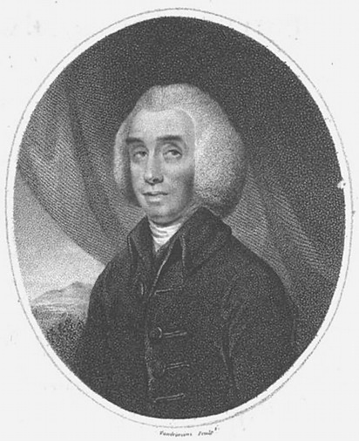

Priestley's comrade in Unitarianism Theophilus Lindsey was another creep, which you can tell just by looking at him. Lindsey was private “chaplain” to Algernon Seymour, Duke of Somerset, and later tutor to Hugh Percy, Duke of Northumberland, so again we can see where the project was coming from. Straight down from the top, since all Dukes are Stuarts.

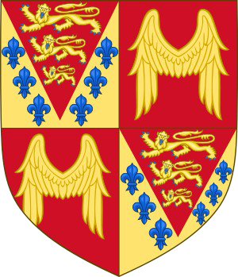

Don't believe me? They admit it there, in the Seymour coat of arms, where the lions are admitted to be the Plantagenet lions and the fleurs de lys are the royal arms of France. That signifies William the Conqueror, the ancestor of the Stuarts. It also signifies the Phoenicians, since William was preceded by Charlemagne, who goes back to Rome, which goes back to Phoenicia.

Percy was a cousin of Seymour, since Seymour's mother was a Percy. As part of this project, Lindsey and several other fake clergymen planted by various Dukes presented the Feathers Tavern Petition to Parliament in 1771, asking that clergy be “relieved of the burden” of subscribing to the Thirty-Nine Articles. In other words, Calvinism hadn't gone far enough in their opinion, and they would prefer to be relieved of having to be Christians at all. This is what all so-called dissent was at the time: the attempt by the Phoenicians to infiltrate Christianity and blow it from the inside. We have seen many examples of that, starting with the Quakers, and we will see more.

What the historians don't tell you is that Theophilus Lindsey was noble himself, being a Hastings through his grandmother. His namesake and godfather was Theophilus Hastings, Earl of Huntingdon, whose picture again is extremely revealing:

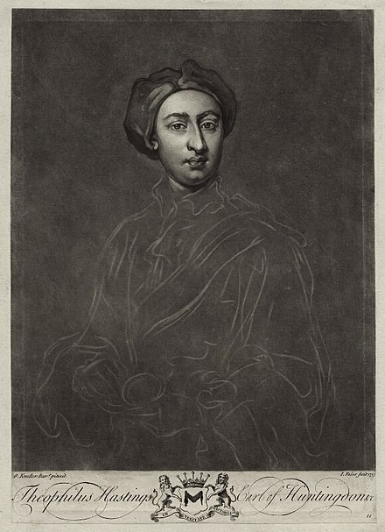

You have to laugh. He doesn't look even remotely English, or even European. He is so eastern he almost looks Indian. That is because his mother was Mary Fowler, who was a Leveson. Leveson=son of Levi. The Leveson-Gowers were also dukes, you know. Hastings married Selina Shirley, who was also a Levi through her mother. Her father was the 2nd Earl of Ferrers, and her mother was Mary Levinge. Mary Levinge's father was the first Baronet Levinge, he being Solicitor-General (chief raper) of Ireland. Like the Ferrers, Levinge was linked to Derby and therefore the Stanleys. The Hastings were also linked tightly to the Stanleys, since the 6th Earl had married Elizabeth Stanley, daughter of. . . yep, the Earl of Derby, Ferdinando Stanley. So you see why these people didn't look English.

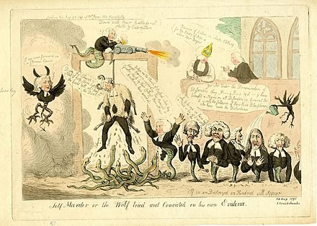

Like Priestley, Lindsey was so unpopular Parliament could not dare support him, and he was no doubt ordered to do as much mischief as he could privately, without their stamp. That cartoon from 1791 is by Isaac Cruikshank, whose son illustrated Dickens' novels. It depicts Priestley in sheep's clothing being hung by his own words, while Lindsey appears with the body of a serpent. One of those other serpents is a Disney.

In continuation of the project, the dukes set up Lindsey, Disney, and these other serpents in Essex Street Chapel in the Strand, London. The dukes used Elizabeth Raynor as their financial conduit, she being the daughter of Jonathan Collier, director of the South Sea Company. Which of course pulls in the East India Company, proving my point once again. And if you need more proof the dukes were behind this, they admit on Raynor's page that her grand-nieces both married Percys, one the Duke of Northumberland and the other the Earl of Beverley.

OK, I've made my point there. It was a long diversion, but I think you will agree it was worth it. And it certainly wasn't irrelevant, since the Darwins being Unitarian fits like a glove into everything we will discover below. These things are always ignored in bios of Darwin, and you can see why. But they shouldn't be, because they explain so many things that are otherwise unexplainable.

Darwin was a terrible student and didn't even finish highschool, dropping out in what we would call his sophomore year. We are told Charles was sent by his father at age 16 to the University of Edinburgh with his older brother, but that makes no sense. Then as now, a university should not have accepted a drop-out 16-year-old with no degree and no special talents. Darwin apparently sat in on some pre-med lectures, but we have no indication he was on a degree path. This is pretty much proved when he soon quit, telling his father he didn't want to be a doctor. He may have taken some biology classes in his second year, but he soon dropped those as well, leaving Edinburgh at age 18 at going to Paris to hang out with this friends. More than a year and a half later his father forced him to go to Cambridge for its second term in January of 1828, where he had no doubt pulled more strings. The idea was that he would get a Bachelor of Arts in preparation for a divinity degree. He did not qualify for the Tripos, having been a terrible student up to then, so we are told he pursued an ordinary degree.

Wikipedia has a whole page on Darwin's education, and it is discursive to the point of suspicion, telling us as little about his education as possible and padding out the page by telling us what all those around him were doing, like Coldstream and Grant. I have to admit I got no real impression from reading it that Darwin was ever in school at all. Although supposed to be at Christ's College, he didn't live there, which keeps us from looking for records of him. Convenient. He allegedly lodged over a tobacconist.* We learn nothing about his first year except that he took a three-month leave for a “reading-party” in Barmouth (Wales) and that he collected bugs. You don't need to be at Cambridge to do that. Darwin allegedly started his second year on Halloween by staying in First Court at Christ's College, but I would now need to see some documentation of that.

As with his first year, we aren't told any of the courses he took. Some say he took Henslow's class on botany, but they admit Darwin never mentioned Henslow in his correspondence of the time. All we get is more stories about beetles and about fights among proctors. Same for this third year, where all we are told is that he passed the one-day “Little Go” verbal exams in March of 1830.

But wait, those dates don't add up, do they? According to what we were just told, he was at Cambridge for two years and two months so far. Or what we would call less than five semesters. So how did he qualify for his Little Go in March? I guess we are supposed to believe he transferred credits from

Edinburgh, but I find that highly unlikely. He loafed around Edinburgh for less than two years, leaving mid-term, and then spent a year and a half on the Continent doing nothing in particular, so it is very unlikely Cambridge allowed him to transfer anything. Remember, he was let in the University of Edinburgh (if he was) on some sort of younger-brother bye at age 16, and from what we are told he probably flunked out of most of those courses, or took incompletes. That wouldn't transfer to Cambridge, even supposing Cambridge allowed credit transfers back then. So I am calling BS on this whole story.

Supporting that conclusion is his fourth year at Cambridge, about which we are told even less. Wikipedia's endless page of nothing skips forward right to his exams! Rather than tell us what Darwin was doing from March to December, they tell us about William Paley's “every man for himself” and other utilitarian twaddle. Darwin sat his final exam in January 1831, but we have no idea what he studied for three/four years. Plus, he was at Cambridge from January 1828 to January 1831, which IS NOT FOUR YEARS. According to my math that is three years, so why does Wikipedia have a section called “his fourth year”? Darwin allegedly placed 10th out of 178, but they then say he shone in theology but scraped through on all other subjects. If he scraped through on all but one subject, how did he graduate in the top ten? No continuity, as usual.

[Added February 10: Wikipedia contradicts the story told at Christ's College website. There we are told it was indeed three years, not four, and Darwin himself confirms it was a waste of time:

During the three years which I spent at Cambridge my time was wasted, as far as the academical studies were concerned.

So why does Wikipedia claim he was there four years? And if he did nothing important there, why did his alleged teacher Henslow pick him for the trip around the world?

We also find this on that page a Christ's College:

Arthur Shipley wrote in the College Magazine in 1909:
[Darwin] was apparently a good deal in college, and was evidently made a "Member of the Room," for his name occurs frequently in the Combination Room wine book. This book, which dates back to pre-Napoleonic times, is one of the few records the college retains of the presence of the great naturalist.

But that was after Darwin returned to Cambridge in 1836, five years after graduation. He was living in Cambridge town and dining in college as a celebrity. That's when he appeared in the wine book. But note the last clause there, which is shocking, and is a dead giveaway: there are no other records at Cambridge of Darwin's time there. Meaning? He wasn't there. ]

Even if he had been, this Bachelor's degree was meaningless, since he didn't go on for the divinity degree. His interest was always botany and biology, so we don't understand why they didn't fake a science degree for him. I suppose that would have been more difficult, because then they would need to tell us the science classes he took. And we could look up the rolls.

But it gets worse. We are told that after graduation, Darwin hatched a plan to visit the Canaries. But somehow that little dream blew up in a few months to accepting a five-year around the world trip on the Beagle? For a 22-year-old recent ordinary graduate with no science background, no history of achievement, and no record? His first geological expedition was in summer of 1831 mapping strata in Wales for one week. The first choice for the Beagle scientist/naturalist was Leonard Jenyns, nine years

older than Darwin, and John Henslow's top student at Cambridge. So why was Darwin Henslow's second choice? It makes no sense. We are told Darwin was chosen not as a naturalist, but as a gentleman collector, which implies they wanted him to buy himself onboard to help finance the trip. But I am so suspicious by this point, I am not sure that is the answer either. Maybe they have already given us the clue: Darwin only went to Tenerife and the rest was only on paper. We have seen stranger things.

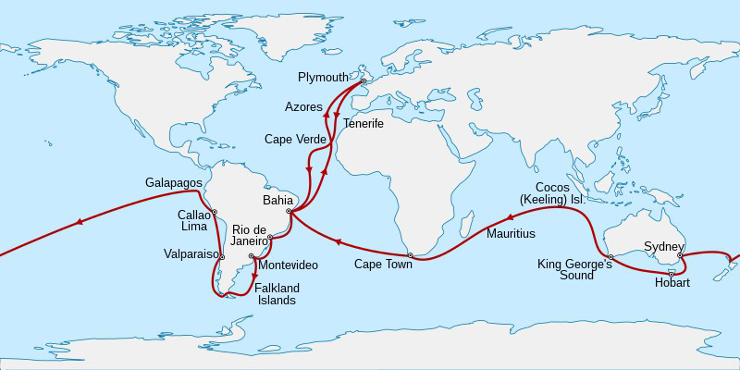

The first big red flag in that direction is that map of the journey, which shows they went round the tip of South America on the outward journey. But this reminds us of the Mutiny on the Bounty, which was just 42 years earlier. So ships hadn't changed that much in that time. Remember how we were told how dangerous rounding the Horn was, even in summer? Antarctica wasn't discovered until 1820, just a decade before the Beagle. And the clipper route from England was in the opposite direction, going east first and rounding Cape Horn from the west.

But here's the clincher already. Prepare yourself. After spending more than a year on the Eastern coast of South America sailing back and forth, they finally got down to the mouth of the Santa Cruz river in April of 1834. That's very far south, almost to the Falklands. You may think April was high spring, but this is the southern hemisphere, so April is fall. Surely they weren't planning on rounding the horn in winter? The history goes vague here, and they only tell us the expedition reached Chiloe island at the end of June. So yes, they would have rounded the Horn in May/June, which is late fall/early winter in that area. Bitterly cold with very bad weather, not the time to be doing that regardless.

Beagle and Adventure now surveyed the Straits of Magellan before sailing north up the west coast, reaching Chiloé Island in the wet and heavily wooded Chiloé Archipelago on 28 June 1834. They then spent the next six months surveying the coast and islands southwards.

With winter quickly coming on, these guys idly surveyed the freezing Straits of Magellan, in no hurry to get on. And in mid-winter, they surveyed the coast and islands SOUTH of Chiloe. Not north of Chiloe, but south. Talk about bad planning. They had also left England in the middle of winter, so they were all about testing themselves. They had planned to leave in September, but were delayed until after Christmas. Brilliant.

So not only did these guys round the Horn in May, they did it backwards east-to-west in a 90ft brig- sloop with two masts. In high heels, I guess. Darwin himself commented on how small the ship was

when he first saw it, calling it “very small” and cramped. The ship was supposed to carry 120 sailors, but Darwin's voyage only had 74 onboard, we are told.

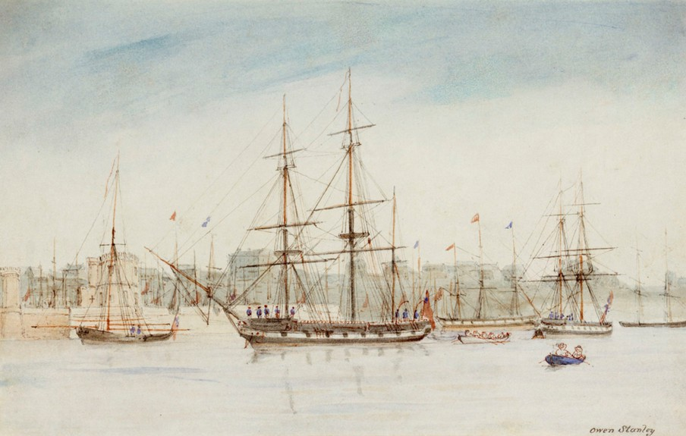

[Added February 14, 2024: Not only that, but they admit the Beagle was “of a notoriously unseaworthy design”. Steve Jones, professor of genetics at University College, London, admits it {p. xvi} in his current introduction to Darwin's notes on the trip, which I am rereading right now. So Darwin and his young nephew-of-a-duke Captain Fitzroy decided to sail that unseaworthy “converted coastal carrier” around the Horn in winter? They are tipping their hand to us here, admitting this was all a fraud.]

I remind you that when the Bounty tried to round the Horn in that direction 40 years earlier, Fletcher Christian advised against it, saying it had never been done in winter or in a boat of that size, which he called “a chamber pot”. We might call it a sardine can. And yes, the Bounty was the same size as the Beagle, both being about 90 feet. Both far smaller than the actual vessels that rounded the Horn in summer from west to east. Hard to believe you could get 74 men on that, much less 120. Also notice who painted that little watercolor: Owen Stanley. You have to laugh.

This is also worth knowing. The first captain of the Beagle, on its first voyage (Darwin's trip was its second major voyage), was Captain Pringle Stokes, and he killed himself in Tierra del Fuego in the middle of winter. Though, again, they don't tell us how he or the Beagle found themselves there in the middle of winter, supposedly surveying the place. You don't survey Tierra del Fuego in the middle of winter. Robert Fitzroy was his flag lieutenant and he took over the captaincy of the Beagle three months later from its first lieutenant. So Fitzroy apparently didn't learn much on the first voyage, the primary thing to learn being not to find yourself in Tierra del Fuego with winter coming on.

Fitzroy is a very strange one to find as Stokes' 23-year-old flag lieutenant, a flag lieutenant being an aide-de-camp, not a position like a first lieutenant. His name is the clue, since the Fitzroys are. . . you guessed it. . . Stuarts. Fitzroy's father was General Lord Charles Fitzroy, second son of the Duke of

Grafton and Anne Liddell. Remember, Joe Biden is a Liddell. The Dukes of Grafton are the illegitimate ancestors of Charles II Stuart through his mistress Barbara Villiers. They also link us to William of Orange, the Bennets, and the Pratts. So our captain of the Beagle turns out to be the 4g- grandson of the King of England. His mother was Lady Frances Stewart, daughter of Robert Stewart, 1st Marquess of Londonderry. Of course Stewart=Stuart.

And you will love this! The Marquesses mother was a . . . Cowan. Cowan=Cohen, so my little joke above just panned out. We have now found Cohens in this mess. How did I know? Just playing the odds.

These Cowans were heads of the East India Company, of course, Stewart's uncle being the Governor of Bombay Robert Cowan. As such, he was even wealthier than these Stewarts, we are told, and they married him for that reason. We knew it wasn't for his nose. No doubt he was a close cousin of all the Levis we saw above.

Our Fitzroy allegedly entered the Royal Naval College at age 12, the Navy at age 13, and sailed to South America aboard the frigate HMS Owen Glendowner as a voluntary student, whatever that is. None of that is believable, since 14-year-old Stuarts don't sail to South America as student volunteers. Especially since the dates don't match on Fitzroy's page and that of the ship. The Glendowner didn't depart in 1820, it departed in November 1819, rounding Cape Horn the next summer. They continued up the west coast to the Galapagos and were attacked by the Chilean fleet at Callao. So this was a warship. There is no way the Fitzroys would allow their 14-year-old boy to round the Horn or be caught in a war like that.

And do you want to know who financed the 2nd Beagle trip? Not Darwin. Fitzroy's uncle the Duke of Grafton, of course. It is all about the dukes, as we have seen already.

In early May 1831 FitzRoy stood as Tory candidate for Ipswich in the general election, but was defeated. His hopes of obtaining a new posting and organising a missionary project to Tierra del Fuego appeared to be failing. He was arranging for the charter of a ship at his own e x p e n s e t o r e t u r n t h e F u e g i a n s w i t h M a t t h e w s w h e n h i s f r i e n d Francis Beaufort, Hydrographer to the British Admiralty, and his "kind uncle", the Duke of Grafton, interceded on his behalf at the Admiralty. On 25 June 1831 FitzRoy was re-appointed commander of the Beagle. He spared no expense in ftting out the ship.

I guess you are starting to see a pattern here. If you aren't, I certainly am.

They admit that it was Fitzroy who personally gave Darwin his copy of Lyell's Principles of Geology. Very strange, as I think you see. Would you expect the Captain to be schooling the science officer on science? I thought Darwin had been tapped as the expert. No. Darwin wasn't tapped for anything, since he probably never went past the Canaries. This whole thing was a sham, and I have already proved that, since there is no way the Beagle went around the Horn in May of 1834, captained by this 26-year-old nephew of the Duke of Grafton.

That's right. Darwin was 22 and Fitzroy the captain was 26. Rounding the Horn in winter. The things they expect us to believe. This is for the same people who think icebergs are found at the same latitude as Boston.

Also worth noting is that Fitzroy was captain at age 23 of the Beagle on its first voyage, after replacing

Stokes. A 23-year-old captain with no commanding experience, rounding the Horn in a 90-foot brig.

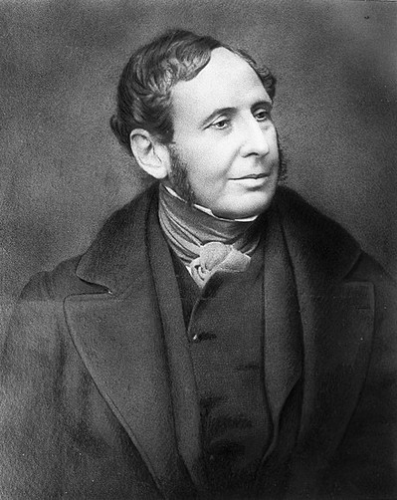

That's Fitzroy. Does he look like a doughty captain capable of rounding Cape Horn in winter? No, he looks like a doughy clergyman, waiting for his next shipment of port.

Here's another ridiculous claim. When Darwin was hired for the voyage, he signed on for two years. The voyage allegedly took almost five. Do you really think they took off with no plans and no schedule? Two years, five, what's the difference right, when you are on a rocking boat everyday throwing up overboard (as they admit Darwin did—seasick for five straight years—“one continual puke”). Never been on a ship before but he decides to start out with a five-year trip around the world at age 22! No women, no alcohol, terrible grub, but noblemen love that. He had always been a slacker up until age 22, but as soon as he got onboard this rich kid pulled it all together, because we all know that is just how rich kids are.

Plus, we find that the 1st expedition of the Beagle had taken five years, so why would they tell Darwin the second would take two?

This is also a clue: we are told Darwin sent back immediately via Admiralty Packet Service (Navy Mail) not only all specimens but all notes and journals. These went directly to his professor John Henslow at Cambridge, the one who had set up the trip. Hmmm. So would we know the difference if Henslow and Darwin faked the whole thing, Henslow writing most of it from Cambridge? Probably not. Though now I think we do know, after collating all this other evidence.

A similar clue: Fitzroy and others on the ship also made collections, but they were required to give them to the Admiralty, which sent them on to the British Museum. In other words, everything found was property of the Navy. But not with Darwin, who had demanded all his collections remain private. OK, but why would the Navy bow to that demand? Why should they? It was their ship and their crew. So how was Darwin the only “private” passenger on it? To me this is more sign of the fake.

Here's a clever coincidence, one worthy only of fiction. The other ship surveying the same region was the HMS Samarang, and do you want to guess who her captain was? Captain Paget. Another second cousin of Darwin. Samarang was an East India Company vessel.

Here we get another clue in the story. The ship's surgeon was Robert McCormick, another naturalist planning to send a collection back to England. But he soon got crossways with Fitzroy and was sent back to England on the HMS Tyne. But in those same weeks they tell us Darwin also got crossways with Fitzroy, arguing about slavery, the captain refusing to speak to him further. So possibly he made it past the Canaries and was sent back from Rio de Janeiro. His first crate allegedly was sent back in July, after seven months at sea, so it is possible that is real.

We can sure he didn't go any further than that, because the next story is off the map. In Buenos Aires Fitzroy was asked to help quell a mutiny of black troops at the garrison. He went ashore with 50 armed men, supposedly including Darwin! Darwin, fully armed with two pistols and a cutlass. No way that happened. Supposing something like that did happen, the captain would never let his “ship's philosopher”, who had probably never fired a pistol, join a military expedition. He would certainly be left on the ship.

In the next section we get more tall tales: Darwin allegedly rode inland with gauchos and watched them hunt rhea and armadillos with bolas. The next day he found the skull of a rhinoceros. Searching the cliffs along a river he almost immediately found a Mastodon bone with no digging. As you do. He found a fossilized armadillo and a modern horse's tooth in the same rock later. And so on. These sections are also stiff with the usual numerology. The gaucho thing just happened to be on August 8, and the mastodon story was October 1. Aces and eights, as usual. This allows me to backtrack a bit to his time at Edinburgh University and his membership in the Plinian Society.

In Darwin's second year at the university, he joined the Plinian Society, a student natural- history g r o u p f e a t u r i n g l i v e l y d e b a t e s i n w h i c h radical democratic students with materialistic views challenged orthodox religious concepts of science.

I remind you he was still 17 at the time, so this is as strange as the rest. The Plinian had just been founded two years earlier by the Baird brothers under the direction of Robert Jameson—who was himself a protege of John Walker. Think George Walker Bush. Walker was the founder of the Royal Society of Edinburgh, head of the Philosophical Society, and Moderator of the General Assembly of the Church of Scotland. In other words, a major spook. So it somewhat strange to see him Professor of Natural History at the University of Edinburgh for 24 years.

Or maybe not so strange. In all these positions he was busy de-Christianizing the Scottish Church, and again we can guess it was on the orders of the Dukes. We see the easiest proof of that in Walker's close colleague Dugald Stewart, whose parents were both Stewarts. These Stewarts are the Lords of Appin, closely related to the Campbells, Erskines, and MacKenzies. They are again cousins of the Liddells and Seymours we saw above, so it is all the same people. In fact, Walker was a Stewart himself, since his mother was a Morison and a Maitland, and the Maitlands are Stewarts by another name. Think actor Jimmy Stewart, full name James Maitland Stewart. The Morisons also link us to the Forbes and Gordons, giving us yet another duke here.

Walker and Stewart led what is called the Scottish Enlightenment, which we are seeing is not what it was sold as. Neither was Robert Jameson, who taught at the University of Edinburgh for 50 years. His mos famous idea was Neptunism, which says that all rocks were deposited from the primordial ocean.

It is of course wrong. But in the context of this paper, what is most strange is Jameson naming the society in Edinburgh the Plinian. That is after Pliny the Elder, a Roman and one of the first naturalists. He wrote Naturalis Historia in 77AD as one of the first encyclopedias of nature. It cataloged a lot of the current “science” at the time, but catalogs just as much myth and tall tale. Much of it reads like Ripley's Believe it or Not. So it is very curious these scientists in Edinburgh would want to name their society after Pliny. Pliny wasn't a scientist, he was a very wealthy admiral and general, a close friend of the Emperor Vespasian. Meaning . . . yes, a Phoenician. Which is why I think these guys really named the Plinian Society after him. It seems to me to be part of their “shells within shells” project of chaos creation, which is ongoing.

John Hutton Balfour joined the Plinian the year after Darwin, at age 19, and Hugh Falconer joined one year later, age 20. Balfour was of course a Balfour and a Hutton, of those noble families, his father being a publisher. The Balfours were closely related to the Hamiltons, Montgomeries, and of course the Stewarts. John Balfour was dean of the school of medicine at the University of Edinburgh and later became botanist for the Queen. The Falconers were also nobles, being related to the Innes and Grahams
—which is why Hugh Falconer was groomed by Professor R. Graham in the school of botany. After university Falconer joined the East India Company, so you see the link between the Plinian and the EIC. He later became vice president of the Royal Society.

The reason I came back to the Plinian is that if you actually read Darwin's accounts of his travels on the Beagle—which almost no one has—much of it reads like Pliny's Naturalis Historia—which even fewer have read. It isn't quite that fanciful, but large parts do give you the feeling of something written by a cast of jokers back in Cambridge. As we saw with large parts of Newton, large parts of Darwin have been buried to maintain the facade, but scientists admit Darwin was wrong about many things. Not just wrong, but seemingly very confused or very creative. Or blind. I am not going to critique these journals now—I may do it later—but just be advised.

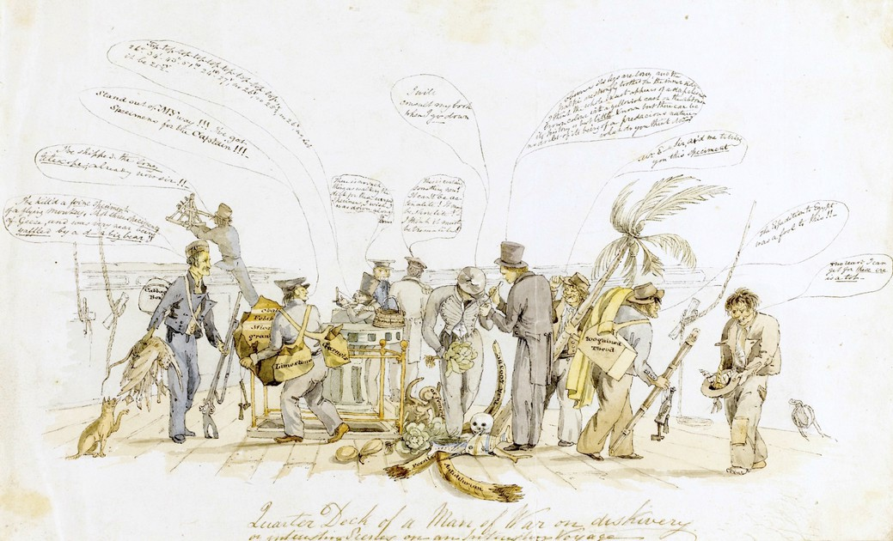

This cartoon said to be made onboard the Beagle by artist Augustus Earle seems to me to confirm the fraud. Darwin is said to be the guy in tails and a top hat, while Fitzroy is the guy in the middle with his face hidden, holding a big cabbage. Everything else is also a big joke, with Fitzroy standing on an elephant tusk labeled 4003BC—in other words year two of creation. Also in the pile are a bull's femur and a human skull. A bum to the right has a 200-guinea theodolite (a very expensive leveling tool) in one hand and a bottle of rum in the other. He is saying, “The expedition to Egypt was a fool to this”. In other words, nothing like the fraud this one is. Another bum has uprooted a palm tree. The one to the left is saying, “Stand out of my way, I have specimens for the captain”, but all he has bags of limestone, granite, and garnets. The one to the far left is carrying a cabbage box and some geese and is saying that he has killed five flying monkeys, three geese, and was nearly killed by a damned big bear. Darwin is showing the captain a bug, saying “It's legs are long, and the nalpi(?) are strongly toothed on the inner sides. I think the whole insect appears of a deep chestnut brown color with a yellowish cast on the abdomen. It's history is but little known, but there can be no doubt of it being of a predacious nature. What do you think?” The man at the back is saying, “There is no such thing as walking the deck for these cursed specimens. I wish I was down to Dover.” Strange that Wikipedia publishes this, but I guess they figure no one will blow it up and read it for sense. Why would they? No one has ever read anything for sense since the beginning of time.

Actually, the cartoon is labeled “Quarter Deck of a Man of War on discovery”. The Beagle wasn't a man of war and Darwin wasn't tall and skinny, so I doubt this is what they claim it is. None of the people are labelled. But if it is mislabelled then the only reason they would include it—despite it undermining the seriousness of the voyage—is as ballast for the Beagle story. They are desperate for outside confirmation of the story, so desperate they will print anything.

This is also a problem:

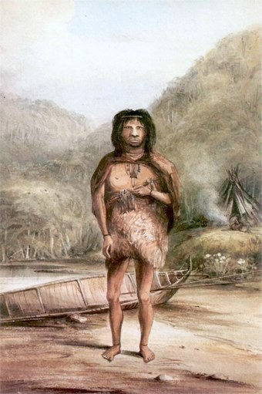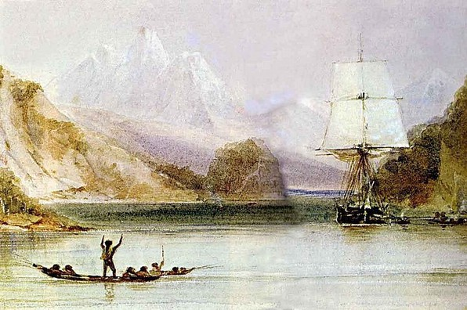

We are told those two paintings were done by the ship's artist Conrad Martens. Unfortunately, they

don't match his style. He wasn't a great artist, but he was much better than that.

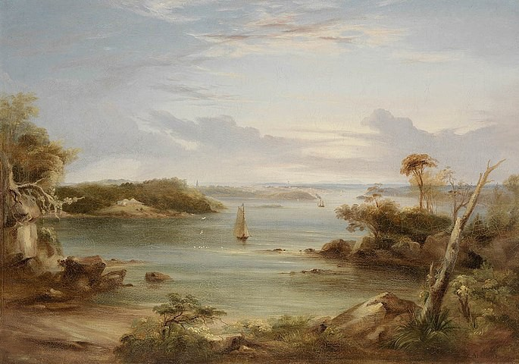

When Darwin is describing Galapagos, the description all reads curiously secondhand, and we are reminded that the Royal Navy, and the very same ship, had been there just a few years earlier, reporting the same things. Remember, this was the 2nd voyage of the Beagle, and the first also went to Galapagos. So it would have been very easy for the boys back in Cambridge to have faked this whole section. Regardless, you have to admit it is singular that the Beagle took very similar trips back to back, going to the same places. Why would they do that when there was still so much of the world to explore in the 1830s? I am not convinced they did.

Wikipedia admits in this section:

Darwin had learnt from Henslow about studying the geographical distribution of species, and particularly of linked species on oceanic islands and nearby continents, so he endeavoured to collect plants in fower. He found widespread "wretched-looking" thin scrub thickets of only ten species and very few insects. Birds were remarkably unafraid of humans, and in his frst feld note, he recorded that a mockingbird was similar to those he had seen on the continent.

Why is that strange? Because it tells us the theories Darwin is credited with already existed before him. And shouldn't those mockingbirds be dissimilar to those on the continent? Finding similar mockingbirds proves or suggests nothing. Again, the dates of these events is always some variation of aces and eights, with Darwin visiting Beagle Crater on Albemarle Island on October 1.

Oh, and this is embarrassing: on all these islands, Darwin thought he was finding grosbeaks, blackbirds, and finches, but they were all finches. Darwin couldn't tell a finch from a blackbird.
Back to Beagle Crater. Searching on that, we find this at a NASA website:

one just has to look at his published work on the Geological Observations made during the Voyage of the Beagle and note that although he spent just one day here of the five weeks he was in the islands, he devoted over a third of its pages (36 in total) to a description of Tagus Cove and Beagle Crater.

What's odd about that? Well, it tells us he wrote almost nothing during the other 34 days there. 63 pages in 34 days, or less than two a day, and these are notebook pages, not PDF pages like mine.

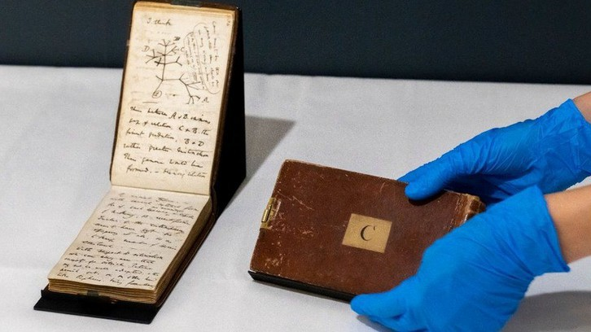

I bet you are shocked. Yeah, so was I. Darwin actually had almost nothing to say about the islands. I would fill a hundred pages a day, but Darwin filled a hundred of those little pages in five weeks.

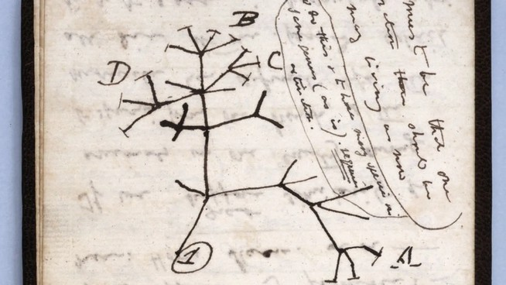

That particular notebook is famous for containing Darwin's famous tree of life drawing, which you see there in all its glory. Brilliant right? Who wouldn't read genius from that? I am publishing detailed drawings of the Ammonia molecule this week, which the mainstream will continue to pretend do not exist, while that illegible doodle is worth millions.

The guy at NASA also admits this:

Aside from his words, copius as they may be, there is no record illustrating Darwin’s visit to Beagle Crater.

36 pages in that little journal is not copious, but they admit that the only proof Darwin was there is the notebook. No one else in the party wrote about it and the locals never mentioned it.

Here's something else we learn from reading the history of the time. Dozens and dozens of other “gentlemen naturalists” were busy in those years, so many the specimens were stacking up all over the country, overflowing the museums and filling sheds and warehouses. Many were being neglected, since there wasn't room for them. So there was really no need for Darwin to have bothered with his own five-year voyage, which was quite dangerous, especially that rounding the Horn in winter business. All he needed to do is use his Daddy's money to buy up a bunch of neglected collections from other gentlemen naturalists, who were already on edge about their collections getting trashed or eaten by bugs. Most of them admit they were in it for the money—see comments about McCormick in the Beagle literature. We touched on him above. They would be easy to buy off, and for the right price they would keep silent to the grave. We are about to see Wallace take an inexplicable dive for Darwin, and other lesser “scientists” would no doubt fold for even lower prices.

British zoologists at the time had a huge backlog of work, due to natural history collecting being encouraged throughout the British Empire, and there was a danger of specimens just being left in storage.[80]

Suggestive, ain't it, especially in light of what we have just discovered.

Unlike the other gentlemen naturalists whose specimens were rotting in storage, Darwin's specimens in all categories were immediately snapped up by top people all over Britain, with Darwin himself being feted as a celebrity at age 27. So why was Darwin being so noisily promoted while everyone else was being ignored? We now know it was because he was a Stuart, but it was more than that. He was a project, and all these other people like Lyell, Henslow, Gould and Owen were in on it. So were the Dukes, who we have seen were pulling the strings behind this whole thing. The Treasury itself got involved, investing £120,000 in the Darwin project.

We have long been told Darwin developed angina and other problems due to stress in this period, and they try to pass that off as overwork. But can think of other reasons. I remind you of Neil Armstrong, who went totally off the beam on his return, supposedly due to stress. But we now know it wasn't due to the stress of fame. It was due to the stress of being feted for a fraud.

For the rest of his life, he was repeatedly incapacitated with episodes of stomach pains, vomiting, severe boils, palpitations, trembling and other symptoms, particularly during times of stress, such as attending meetings or making social visits. The cause of Darwin's illness remained unknown, and attempts at treatment had only ephemeral success.

Can you see what is right in front of you? He can't have been overworked, since in the middle of all his post-Beagle work, he presented a paper on earthworms and soil formation that had been suggested by his uncle Josiah at the Geographical Society. It makes no sense that he would have time to do that in November of 1837, if everything we are told was true.

Darwin soon added to that his new position as Secretary of the Geographical Society. How could he possibly take that on on top of his publishing work, lecturing, cataloging, and pursuing his theory of transmutation? It only makes sense if he wasn't doing any of that. All the writing, editing, cataloging, publishing, and theorizing was being done by others behind the scenes, while Darwin drove around collecting awards for sailing to Tenerife and back.

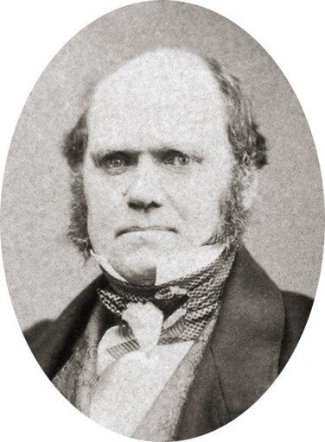

Next we find Darwin the hopeless romantic:

Used to jotting down daily notes on animal breeding, he scrawled rambling thoughts about marriage, career and prospects on two scraps of paper, one with columns headed "Marry" and "Not Marry". Advantages under "Marry" included "constant companion and a friend in old age ... better than a dog anyhow", against points such as "less money for books" and "terrible loss of time". [101]

And he kept that? And it was found upon his death? Oh. . . My . . . God. Reminds me of the Friends episode where Ross makes a list comparing Rachel to Julie. He says that Rachel is a bit spoiled. Chandler suggests Rachel's ankles are little chubby and they add that to the list. Rachel sees the list and goes nuclear. So I am guessing Darwin's wife never read this comparing her to a dog. At least Ross didn't say that Rachel was “better than a dog anyhow”.

Looks like I will need a part 2 here. Stay tuned. I am going to comment on his journals after all, for one thing.

*A reader who went to Cambridge sent me this, which I found very interesting and I am sure you will too:

I fnd it very strange that Cambridge allowed Darwin to study Greek out of residence in Michaelmas term, only to arrive in Cambridge for Lent term. I think there was a requirement to stay in residence during terms there, though terms were and still are only 8 weeks, and so one has rather long holidays. Every undergrad student at Cambridge is very closely followed up each term, and the assigned supervisor in each subject writes an end-of-term report on each of the students they supervised for the student’s Director of Studies to read. Absences and lack of submission of homework are reported up the system by the supervisors, and so the type of arrangement that Darwin supposedly had sounds very strange. One can still not transfer credit to Cambridge, at least not when I attended [about 20 years ago]. I would have been interested in that as I had already spent one year at university before arriving

in Cambridge. My place at Cambridge was even conditional on performing to a certain standard in my university exams and taking enough credits during my frst year in university back home. Still, Cambridge would give me no credit for the university courses I had already completed, even though some of them were relevant and overlapping with their courses. That Darwin lived out of college because it was full seems a bit odd. Cambridge colleges usually have a housing guarantee for their undergrads, and Darwin was supposedly admitted to Christ’s college on October 15th 1827, which is around the start of Michaelmas term. They would then have allocated a room for him, or he could have been given in a room in another college that had a spare. Many of the older college rooms are also grand, easily accommodating two students. I once stayed in the B&B at St. John’s College in Cambridge together with my family. One of the 4 rooms we had was the size of a living room. My uncle complained that his room was haunted, but it was a very nice experience. Just look at how large Darwin’s supposed room at Christ’s was. I fnd it very hard to believe that there was no place in any of the Cambridge colleges for Darwin.

There are very good reasons for students to live in Cambridge colleges, and most undergrads live in college at Cambridge, especially in their frst year. Cambridge colleges provide all meals, cleaning of student rooms, formal dinners and more facilities, social clubs and events than any other university I have been to. I would presume all these aspects of Cambridge are very old traditions as everything is old at Cambridge. The dining halls in Cambridge date back to the medieval age, and so one may assume students had the opportunity to eat all meals in them back to the Middle Ages. I was once at a candle light dinner in the dining hall at Queens college, which was an event organized by the Oxford-Cambridge Scandinavian society. Apparently, they have no electric lights in this medieval dining hall and had to rely on candle lights. Very cozy but also very dim. All colleges have a library, and these are often very old, such as the one at Trinity. There was never any need for buying any books as the college library would stock curriculum books and most other books could be ordered from one of the other college or departmental libraries or from the university library, if needed. Most colleges also have their own chapels and large gardens that are maintained by gardeners. Even my college had tennis and basketball courts as well as a pleasant garden. In addition, my college had a library, gym, newspaper room, snooker and TV room, reading and studying room, computer room, large hall for lecture/gathering/party/event, large room with bar, lounge and dancing area, two dining halls and some auditoriums and seminar rooms. From my window and across a wall outside, I could always hear splashing in the summer because some college had grounds there and the students were bathing in a college swimming pool. This wasn’t the pool at Christ’s that I heard, but Christ College had a swimming pool already in the 17th century. Don’t know which college owned the nearby land. One would often see that colleges had land in other areas than where the college was placed, and they often used such areas as sports felds. For some (maybe most) students, the social calendar at Cambridge outgrew their academic one and they had little time for studying. I think students hardly ever left college for clubs or pubs in town as the college was a microcosmos with so many different facilities and activities that even a shy person like me and other individuals with limited social skills could fnd ways of socializing. The colleges all had their own bar and “clubbing” area, and if one needed more people, one just invited the next-door college. Our neighbor college was an all-girls college, and they always invited my college over for parties. The only people who lived out of college were more mature students who were about to be kicked out of college because they had overstayed their guaranteed housing time. Some students with families may have opted to live out of college, but the colleges usually also provided family accommodation. I suppose during Darwin’s time that girls were not allowed to attend most Cambridge colleges, and so the partying may have had a different character, but I would guess they found ways of socializing with girls during those times as well. One may fnd it strange that Cambridge colleges have space to accommodate all their students and all the different buildings like libraries, dining halls and chapels as well as gardens and sports grounds. However, this becomes more understandable when one realizes that Cambridge (and Oxford) colleges are some of the biggest landowners in Britain, and so they have more than enough land to place all their buildings. The main difference between Oxford and Cambridge colleges is that Cambridge colleges have much larger grounds in central Cambridge since there was no sizable town there when the university was frst build. That one of the biggest landowners in Britain should not fnd space to accommodate Darwin does not make much sense to me. The Tobacconists of the time of Darwin were probably renting space from the biggest local landowner in town, which would have been the university. [So there is an almost invisible contradiction there.]

