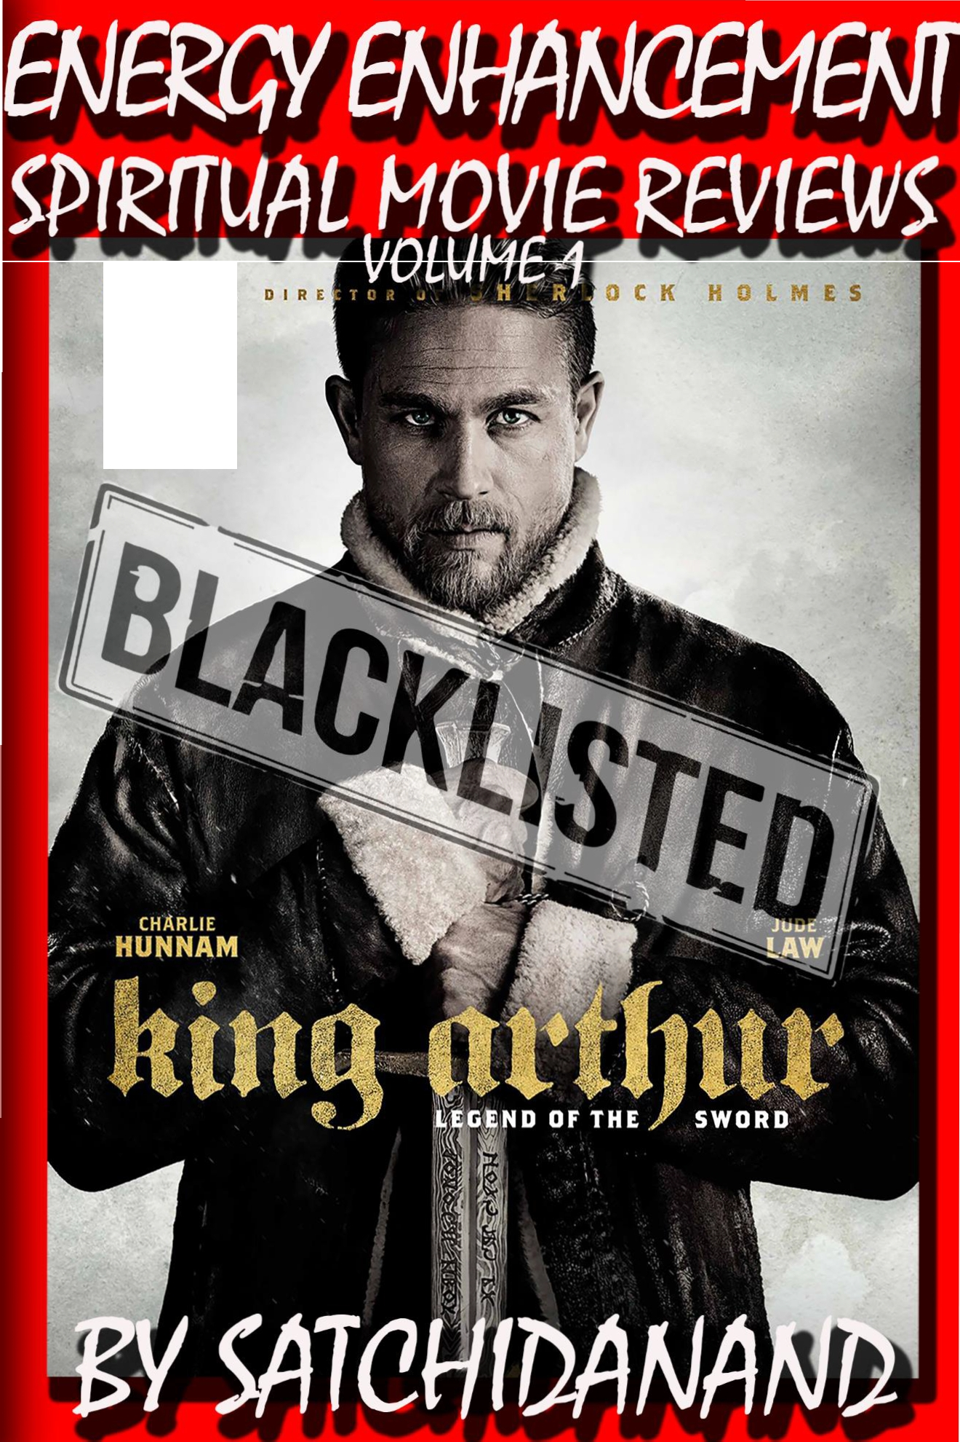

f R 0 M t H E

DEDICATION

With all Thanks, Love and Gratitude to Swami Devi Dhyani and the Energy Enhancement Book Editor Prema PraShakti who makes these books possible.
With all Thanks, Love and Gratitude to my Mother and Father and to all my other Teachers, Theos Bernard, Sri Yogendra, Eric Berne, Gurdjieff, Father Bede Griffiths, Osho, Zen Master Hogen, Swami Sivananda, Swami Satchitananda, and all the other giants upon whose shoulders I stand - who made me able to be what… I AM – Swami Satchidanand

Copyright © 2017

[Energy Enhancement Synthesis of Light Limited (SOL)]

All rights reserved. This publication may be reproduced in whole or in part, by any person under fair use as long as we are referenced, without written permission of:
Swami Satchidanand

sol@energyenhancement.org www.energyenhancement.org

Table of Contents
King Arthur - Legend of the Sword The Story of Enlightenment - by Guy Ritchie - a Movie Review by Satchidanand 4
Karma and Anti-Satanism in the Spiritual Actor, Keanu Reeves movies, "John Wick (2014)" also "Man of Tai Chi (2013)" Esoteric Movie Review by Satchidanand 60
John Wick Ch 2 - Is Donald Trump - The Spiritual Warrior - Finger of God - Removes Satanic Demons, Deletes the Elite, Cleans the Swamp - Move Bitch, Get out the Way!! Esoteric Movie Review by Satchidanand 89
DOCTOR STRANGE - PSYCHIC WARRIOR ENERGY ENHANCEMENT ESOTERIC MOVIE REVIEW 137
ASSASSINS CREED SATAN'S CREED- SPIRITUAL ESOTERIC MOVIE REVIEW BY SATCHIDANAND 148
Logan - "Beware Of the Light" Esoteric Movie Review by Satchidanand 157
SATANIC MIND CONTROL - FOURTH GENERATION WARFARE - THE WEAPONISED ALIEN UFO AGENDA ..188
JUPITER ASCENDING ESOTERIC SPIRITUAL MOVIE REVIEW BY SATCHIDANAND 219
KILL THE MESSENGER - SATCHIDANAND ESOTERIC MOVIE REVIEW 248

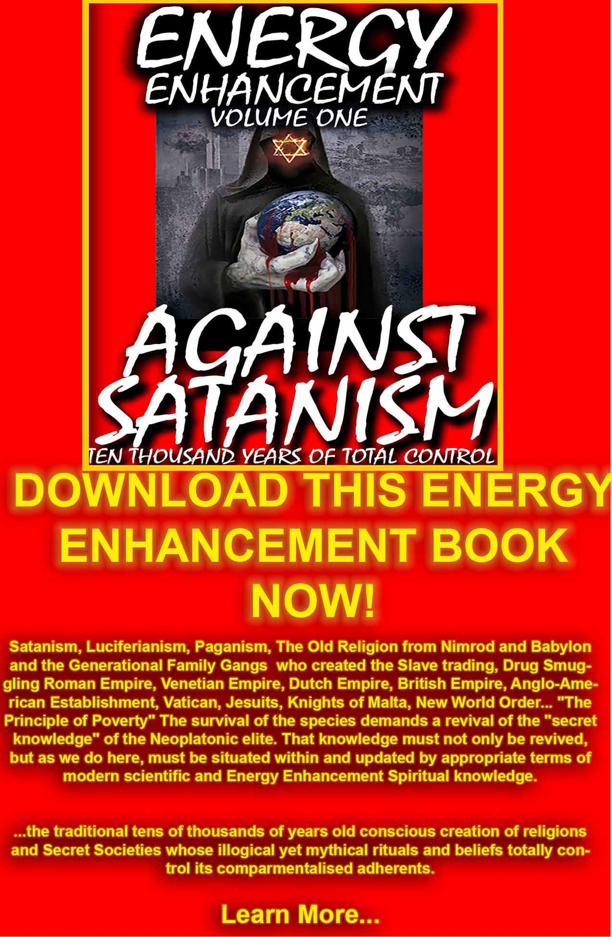

DOWNLOAD AGAINST SATANISM VOLUME ONE HERE
http://www.energyenhancement.org/Against-Satanism/Against-Satanism-Energy-Enhancement-Satanic-History-of-the-World-Volume-1.pdf





King Arthur - Legend of the Sword The Story of Enlightenment - by Guy Ritchie - a Movie Review by Satchidanand

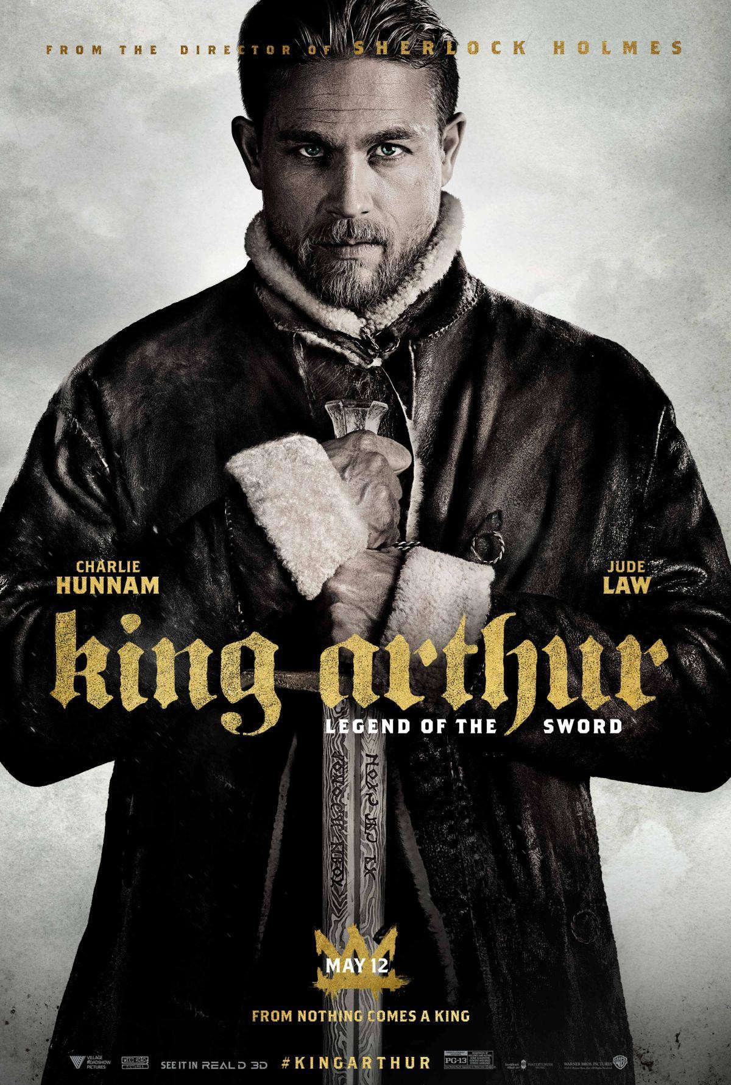

I have been thinking about King Arthur Legend Of the Sword since the first trailer came out: did I like it? I LOVED IT!!! The only way I could have liked it more was if I had seen it in 3D, because--from the very first screen shots--it's geared to be viewed in 3D. I could not be happier or more impressed with Guy Ritchie. So, why is it getting such bad reviews and supposedly bombing?

Another Great - Greatest - Movie Blacklisted - Why?

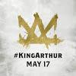I did want to briefly discuss the importance of this logo. It's a crown, sure, but it's also an "A" for Arthur and a "V" for Satanic Vortigern, demonstrating how a "V" can be an upside- down "A," It is of course the Hexagram symbolising Male power - the A, and female power - the V usually called Solomon's Seal. In
other words, how Satanic Vortigern, who is not a legitimate ruler, can appear to be the power of the crown, but is really just a perversion of power and what government rule is supposed to be.

I think there's an easy explanation: look at what happened to Spectre. Spectre, the last James Bond film, exposed the Satanic New World Order, and King Arthur is exposing the satanic and occult ties in Hollywood and politics; who owns the box office and media outlets reporting on the box office?

The same Satanic people being exposed by King Arthur, not only for their own active participation in the occult, but for supporting Hillary Clinton and her participation in the occult as a witch going to Hollywood rituals every month from Mena..

Remember, when Ritchie and company made this film about two years ago, - delayed because this movie celebrates righteous rule - it was expected that Clinton would be the next president (or even that Obama would find a way to just stay in office). and there would still be people, like myself, yelling about Hillary's father, Hugh Rodham, who took over the Chicago mob after Al Capone, Benghazi.

The one trillion dollar per year cocaine trafficking at Mena Arkensaw, The 69 Billion Dollar Clinton Foundation Slush fund, taking 98% of all Haiti Donations, Child Trafficking in Haiti, and all the crimes she has committed and broken, and wanting her to be brought to justice

Hours and hours before anyone could have known, a couple of news outlets began picking up that King Arthur was "bombing," and then everyone started reporting it; There wasn't as much money being pulled in because so many early showings (Thursday evening, and 3D showings) were being canceled before the film even began playing; when I got to my theater, three shows of King Arthur had all ready sold out. So, why would they cancel early showings?

Why would Satanic film companies want to pan the films they themselves spent over a hundred million dollars to make? There are actually several advantages. One, there are things more important than money, like influence.

If people, such as myself, think that there really are satanic influences at work in Hollywood and politics, then a film "exposing" such things bombing makes me look like an idiot for believing such things; in other words, rather than the film validating my view, I'm being isolated and (according to liberals) will be far less likely to discuss such matters with others because a film talking about the same topics bombed.

Additionally, King Arthur is a challenge about the good which has been accomplished by white males, who are the number one enemies of Satanists; why support a film that supports your enemy?

Then, good and reasonable reader, you are like, "If you are right, then why would they even make the film to begin with?" and the answer to that is simple: propaganda. If you like a film that didn't do well at the box office, then you, too, are a loser, and who wants to be a loser?

This is the same reason you will never see the liberal media reporting that a candidate they favor for an election is losing or

trailing behind in the polls, no one--they believe--is going to get out and support a loser, because people want to be associated with winners.

So by spreading the word that a film isn't good, they think it will make you ashamed that you wanted to see it; if you do go and see it, and liked it, and tell others about it, those others are going to think you're crazy and have horrible taste, because the professional critics are telling everyone it's horrible. To the Satanic, it is horrible; it's awful! They don't want to see anyone butting up against their treasured thesis's of how reality works and what power is all about.

For at least two reasons: first, it would take longer for word of mouth about how good it is to get around if people weren't getting to see it Thursday, then go to work/school Friday and talk it up, so people would only have the "professional" critics (read: "Satanic") to go by when deciding if they would go see it.

Second, cutting out Thursday showings meant slashing profit- possibility: those are the die-hard fans, and it's easier to get into see a film Thursday night, then Friday day (and, in this case, papers were all ready reporting that it was "bombing" before the Friday movie audiences even made it to the theater!); not to mention that 3D viewing opportunities have also been slashed.

So, just like with Spectre, they hope to drastically reduce the number of people going to see King Arthur so they can say, "See? No one supports white males anymore, and no one wants to see an exertion of male authority, so we're not going back that way," and that's a narrative they can use to continue feeding us propaganda movies.

I love the female Power and Beauty of Wonder Woman where even with all that female warrior beauty, Wonder Woman fails to remove War from the World. This is a constant Satanic Meme as the Satanists commissioned the Frankfurt School to "Take the Heart of us" - Theodore Adorno, "Movies to suicide by" as "Music to suicide by" of "no matter what you do, you can not win"

"I used to want to save the world. This beautiful place. But I knew so little then. It is a land of beauty and wonder, worth cherishing in every way. But the closer you get, the more you see the great darkness simmering within. And mankind? Mankind is another story altogether."

Like, "Mankind is a Virus?"

Which of course is just not true - otherwise this World would be already destroyed. The fight continues!!

King Arthur - The Story of Enlightenment - a Movie Review by Satchidanand

To become King. To be crowned by God. You have to remove all your Energy Blockages, You have to be Enlightened.

The Kundalini Energy Level of this movie us Amazing which marks it as a Spiritual Movie, infused by Ascended Masters like the Christ.

All the way through I had a smile on my face provoked by the Energy, but also by the genius of Guy Ritchie whose film path has grown from Lock Stock to Revolver to Sherlock Holmes - always telling a profound story as subtext.

Arthur is no different - just Better!! The Best Yet!!
So, this is the story of the son of King Uther Pendragon.

King Uther Pendragon has been killed by his brother Vortigern after waging war on the Kingdom with allies, Evil Mages like Mordred.

Like Hitler's Night of the Long Knives when he got his Satanic SS to murder the people who had put him in power, Vortigern then killed all the Mages, genocided all the race of Mages!!

Arthur saw Vortigern kill his father but the trauma of this event has created an energy blockage which later in life is going to stop him wielding the full power of the sword, Excaliber.

His mother and father killed in front of him, Arthur floats downstream in a boat, like Moses in the bullrushes, and is taken in by a kindly prostitute and brought up in a Bordello.

We see how Arthur quickly learns martial arts and becomes leader of a gang in old Londinium, bribing the police, stealing, looking after all his dependents, building up vast deposits of his ill-gotten gains - until he gets unto trouble by stealing from Viking friends of King Vortigern.

Arthur is captured and like all young men in the Kingdom, made to try to pull Sword from Stone.

He succeeds but the power of the Sword, - created from Merlin's Mage Staff of Power and representing the spine carrying a full charge of Kundalini Energy from the Center of the Earth, out into the infinity of Chakras above the Head, connecting to the Soul and to God - is too much for him.

The energy of Excalibur like the spine carrying a full charge of Kundalini Energy from the Center of the Earth, out into the infinity of Chakras above the Head to the Soul and to God hits and energises all his energy blockages and he is laid out, fainting due to the Power of the Sword.

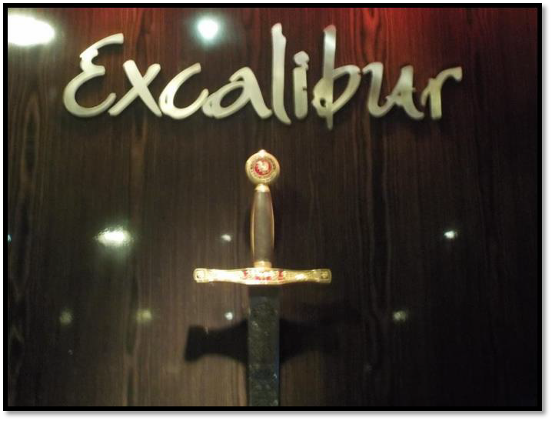

Captured by Vortigern, recognised as the son of King Uther Pendragon, his home destroyed, all his gang displaced, captured or killed, Vortigurn has created a vast spectacle to execute Arthur in front of the people so as to cement his power.

ONE MAN CAN CHANGE THE FUTURE AND SAVE IT FROM ULTIMATE SATANIC EVIL - ARTHUR!!

He escapes and so begins the saga of how he becomes Enlightened, removes all his traumas, all his energy blockages in order to wield the full power of Excaliber, kill the evil Vortigern, and take back his Kingdom.

The price he pays for this is almost too much so just like in the Lord of the Rings the Lady of the Lake, like Galadriel says, "If you do not take this Sword, this will be the result"

The Sword is always sheathed in the Land like in John Boorman's version of Excaliber because the Land, the Earth, and all the people on it are Nothing if not connected to the Soul and to God.

As in the connection between the ionosphere and earth. Whenever clouds touch the ionosphere, a charge of electricity flows and creates a hurricane or a thunder storm. Lightning is the result.

Space lasers can create this pathway, create hurricanes, and steer them by moving the laser. (See Geostorm)

This is the same projected action Tesla was inventing with his Wardencliffe Tower. Create the pathway between the ionosphere and the tower. Trillions of watts flow to the top of the tower to be distributed freely to humanity.

Like Zeus or Theos or God connecting in to the crown chakra in Enlightenment.

The power of Enlightenment is the Power of the Soul, of Dharma, of Conscience, of Empathy, higher than the Intellect it is of Intuition, of Knowing, of Right Rule, of Goodness of Godness - it is in Alignment with the Will of God!!"

"Not my will but Thy Will be Done!!"- Jesus

Like Satanic Lord Blackwood in Guy Ritchie's Sherlock Holmes who sacrifices six virgins on Satanic Altars at different points in London in order to gain his Satanic Power, Vortigern must sacrifice that which he loves best, his beautiful and well loved wife and his Daughter, in order to gain sufficient demonic power to kill King Uther Pendragon and later, Arthur.

Like Macbeth we see how the Satanic three witches foment, initiate, the trouble which ends in Macbeth's totalitarian rule.

Human Sacrifice and slavery was the core of all the Pagan Religions prior to Christ, at the Satanic heart of Babylon, the Roman Empire,

the Germanic and Norse Viking Religions and the Venetian Empire ending in the Anglo-American Empire.

"The Roman Empire never ended" - Philip K Dick

At Trumps orders, 5000 pedophiles have been incarcerated so far and hundreds of children found in cages have been released prior to torture and murder by Satanic Sacrifice. We see that World political control comes from Satanic pedophilia and Human Sacrifice.
Twenty-Seven million victims of Human trafficking for female sex slave prostitutes, children for pedophilia and torture human sacrifice, organ harvesting..


Recent Thailand Picture

In the previous King Arthur we saw that Arthur and his Knights were as Young boys torn from their families as slave tributes by the Romans.

Dracula Untold fought the Ottoman Empire - now the Turkish Caliphate - because it demanded his young son as he himself and thousands of young boys yearly had been taken to feed its Satanic, mind controlled. Janissary Slave Army.

So we see the sacrifice of Vortigern's wives resulting in his transmutation into a Satanic Warrior who kills King Uther

Pendragon and is just about to kill Arthur until Arthur removes his final energy Blockage by receiving the vision of the death of his parents at the hands of Vortigurn.

Final Blockage released. Wielding the full power of the Sword Excalibur. Arther kills Vortigern.

Arthur thanks Vortigern for being the Perfect Enemy of Carlos Castaneda and Shaman Don Juan!!

Arthur says to Vortigern as he kills him, "You make sense of the Devil!!"!

Without Vortigern he could never have had the incentive to remove all his energy blockages to be able to wield the full power of the Sword.

Channeling the power of the Sword representing Kundalini Energy connection with God, Arthur destroys Vortigern's evil demonic power stored in his Tower which comes tumbling down.

Just as the Eye of Sauron in the Tower Dol Guldur comes tumbling down at the end of the Lord of the Rings

The Tower of Mordred exists under a Pyramid on the back of a hundred meter Elepant until King Uther Pendragon cuts him down with Excalibur.

The Tower represents the Satanic Watchtower which all evil Satanic, Luciferian, Magicians create in order to live forever. Dr Dee and Aleister Crowley used the Enochian Keys to create a column of Energy. "Twixt Heaven and Earth" but cut the top of the Tower off from God, then installed themselves at the top of the Tower as Dark Gods symbolised by a single eye. A pyramid tops an Obelisc Tower so thus the Eye in the Pyramid.

Just like you have the Eye in the Pyramid on the Dollar bill symbolising the Satanic American Empire,

The Satanic Kaballah learned at the fountain of Guy Ritchies Divorced Wife, Madonna, and much research is the source of the knowledge informing Revolver (see my review), Sherlock Holmes and King Arthur.

Living forever in the chakras above the Head in Private Universes as Dark Gods, dependent for energy on their earthly Slaves whom they vampirise, forever - unless the slaves can gain the Psychic Knowledge to break free using Energy Enhancement Meditation to remove all your energy blockages at energyenhancement.org.

The Antahkarana, the Watchtowers of Dee's Enochian Keys and the Chakras above the Head - The Perverted Kundalini Key

http://www.energyenhancement.org/The-Antahkarana-and-The- Watchtowers-of-Dee's-Enochian-Keys-CHAKRAS-ABOVE-THE- HEAD.htm

Satchi's Movie Reviews

http://www.energyenhancement.org/Spiritual-Movie-Reviews- Satchidanand/Index.html

Why is his name "Arthur?" It's a rather unique name, it certainly applies to him (when we think of an "Arthur," we tend to think of "King Arthur" first), so, of all names (especially the choice of something more exotic, like "Uther" or "Vortigern") why is he named "Arthur?" Because "Arthur" was the "author" of his own free will and destiny. Arthur became the author of the new peace after the chaos, Arthur was the author of the deeds of Excalibur, Arthur was the author of humility and chivalry and, therefore, masculinity, and it's because we need to be reminded of all these things that Guy Ritchie has made this film, told this tale and conjured to our minds-- like the nightmares Arthur suffers--the history of why we have treasured the values we have, and chosen the decisions we did, and why we avoided so many different paths, those which were taken by Vortigern.

One of the easiest ways to begin an analysis of a film is to ask yourself what other films it reminds you of; what scenes invoked memories of films where you had seen such scenes previously, and then, once identified, ask yourself, why would the film makers "quote" those films within their own movie?

For example, in Dracula Untold, there is the issue of a multitude of boys being sold into slavery - to become Janissary soldiers of the Ottoman Empire - from Transylvania from one kingdom into another. And in the other King Arthur Arthur was a young boy given into slavery to the Roman Empire to become one of their Knights.

And we see the same in King Arthur Legend of the Sword; why? Children symbolize the future, and because men symbolize the active principle, men (young men and men of child-bearing age) tend to symbolize the (future of the) economy; these boys being sold into slavery, then, is the economy and the future of the economy being sold into slavery.

How? The European Union, symbolized by the Vikings there to conduct trade with Vortigern. This is symbolized by Lucy who was beaten because women symbolize "the motherland," and especially since she was Arthur's adopted mother (with the other women) what the Viking does to Lucy, has--according to Ritchie--been done to England herself. At the end, when the Vikings face Arthur, Arthur says this: you face all of England, not just a single person or government official.

The story of Arthur pulling Excalibur from the stone is for men what Cinderella trying on the glass slipper is for women: a coming of age, a sign of soul identity and collective wish fulfillment. So, we can say that there is an element which reminds us of Cinderella (Kenneth Branaugh) which was recently released, and juxtaposing the two stories, we see the similarities and how they have addressed issues of soul identity and traditional, gender identity.

On another vibe, we can also see Clint Eastwood's film Unforgiven being cited when a prostitute is beaten up (Lucy in King Arthur).
Ritchie adds an important commentary with this scene, because

Arthur handles the injuries in this film, whereas, in Unforgiven, the prostitutes (Strawberry Alice) hired men (i.e., prostituted the men to be assassins) and only got death, whereas they could have had wages to provide for themselves instead.

Is Arthur acting like a trade union in going after the Viking and getting Lucy's wages? No, he's acting like a man who is grateful to the woman who helped raise him, and that's the huge difference Ritchie wants us to notice, because in standing up for Lucy, Arthur fulfills his duty as a man, that is, protecting those he cares for, because they, too, have cared for him. Ritchie, then, provides us with a radically different example of "exchange" than that the Left cites for Karl Marx and market exchange; this "exchange" is based on love, not on someone getting what they believe to be is their "fair share."

Then again, we also see Ursula and The Little Mermaid, but we can see this as an example of the prince having to choose between the the good woman (Ariel) and the bad woman (Ursula). With Vortigern, when we see him with a good woman, like his wife, he kills her for something bad (power), and with Maggie, he imprisons her because she has threatened his power, then he kills his daughter for even more power.

The Viking who abused Lucy, of course, was a guest of Vortigern, so we see how abuse spreads through shady business deals (the selling of the young boys) as in the current Human Trafficking for Sex Slave prostitutes, Pedophilia Torture Sex Human Sacrifice Rituals and Organ Harvesting.

The Prince in The Little Mermaid isn't just choosing the woman he'll marry, but how he is going to become for the rest of his life; Ariel, on the other hand, has chosen the prince to be the man she wants to give herself to, to make of herself an offering to make him be a better man than what he would be otherwise (more on this below with The Mage).

Another film I think Ritchie cites is Anthropoid, which you probably didn't see, but you should, It was excellent. Just as there is a betrayal in Anthropoid, so, too, does the blonde-headed Rubio betray where the cave is that the Resistance has made as their base, and everyone is killed.

There might also, however, be another vague reference in Ritchie's cameo he makes. When Arthur and the others plot assassinating Vortigern, we see Ritchie dressed all in blue for a brief second, as a man who would support "assassinating the king" and so they could use his building for Goose Fat to shoot Vortigern. Because Anthropoid is also about an elaborate assassination, we can see the two films linked; however, because Vortigern is not assassinated, Ritchie might be providing commentary that the assassination in Anthropoid didn't bring out the best in the characters (remember, Anthropoid was more of a call to arms against Obama than a historical drama); in other words, Ritchie cites Anthropoid so he can say, we could have had Vortigern die as a result of a political assassination, but that would not have brought out the strenuous sacrifices and courage Arthur had to summon to overcome Voritgern.

We've seen a lot of octopuses lately, and to at least some degree, the "sea witches" or sea nymphs with their long legs, are certainly octopus-like; so why does Ritchie do this? Well, we just saw in Guardians Of the Galaxy Vol 2 how, at the start of the film, how the conservative, pro-capitalist audience is the octopus-like creature that is being destroyed at the start of the film (the one with a hide so tough, Drax is swallowed by it to try and kill it from the inside?

Yea, that symbolizes the conservatives in America but the octopus theme has been common in all of Marvel's film because it's the symbol for HYDRA, and, of course, the symbol for the secret services terrorist organizations in the James Bond film Spectre (and we will discuss the sea witch in greater depth below).

So, by listing and connecting one film to other films you are reminded of as you watch it, a public dialogue and debate is created, with the film you are watching at the moment bridging issues

concerning film makers which you have been smart enough to pick up on.

And now for something completely different. In the poster above, Arthur wears a jacket which we see him wearing two different times in the film. The first time we see him wear it, we've watched the montage of Arthur growing up and watching Lucy and the other women get beaten up by various "customers," and then, when Arthur watches, he gets beat up too, except for the last time, when a man goes to strike Arthur after beating up Lucy and Arthur stops the man's hand in mid-strike; Arthur wears this coat pictured above when he does that, and again after the scene when Vortigern's men have killed all the members of the Resistance in the cave.

Why? Because Ritchie uses costume to tie-in these two scenes: the man beating the woman is like Vortigern beating England, and in both situations, it's Arthur who is there to stop it.

Why? The jacket tells us. There is sheep skin fur lining both the neck and wrists: sheep nearly always, not always, but nearly always, symbolize sacrifice (because that is the animal most often associated with sacrifice) and we know that the hands symbolize our honor (we shake hands to symbolize giving our word when we intend to honor something we have spoken) and arms symbolize our strength (not just physical strength, but strength of character, morals and values as well) and the wrists bring that together to make a unified man. The neck symbolizes that which leads us in life, like a leash.

SO, what we have, is that Arthur can only stop the beating England is receiving once he agrees to be the sacrificial lamb and lay down his life for England, but in being willing to make that sacrifice-- because he's willing to put England before himself, as well as the lives of others--and because he values others above himself, he has increased his strength and honor through humility.

What about the leather of the jacket? When Uther carries little Arthur from the castle, Arthur is wrapped in a thick fur coat, then when he trains with George, we see Arthur wearing a fur vest; the fur symbolizes the animal appetites and passions (the living like an

animal, rather than the son or daughter of God with an immortal soul to guard over) so Arthur slowly, through the tough lessons of life, overcomes those appetites and gains respect for himself.

The leather, then, symbolizes Arthur's toughness, his durability and tough hide (like the tough hide of the octopus in Guardians Of the Galaxy Vol 2) to take a beating but not get beaten down. The way Arthur holds the sword means he has taken the honor of Excalibur, the duty and solemn duty it represents, to his heart and he not only cherishes that, but it's a part of him as well.

What Guy Ritchie and company have successfully accomplished with this film is nothing short of complete political, spiritual and social manifestos of the past, present and future.

Yes, it's that good, and it's that deep. Ritchie masters the art of the minimal brushstroke, yet there is nothing minimal about any of the scenes,characters or what their purpose is.

So, if I'm right, why has the film received such bad reviews? All those critics are liberals, and they recognize that Ritchie has outlined a response to every single pathetic argument they have made over the last eight or nine years.

King Arthur: Legend Of the Sword is all ready the best film of 2017, and perhaps of Ritchie's career; the only way for him to top this,... is to make another film.

We'll divide the film up into two parts: the political and the spiritual, but we'll begin with what the political and spiritual come from, and that which is Ritchie's main focus: power.

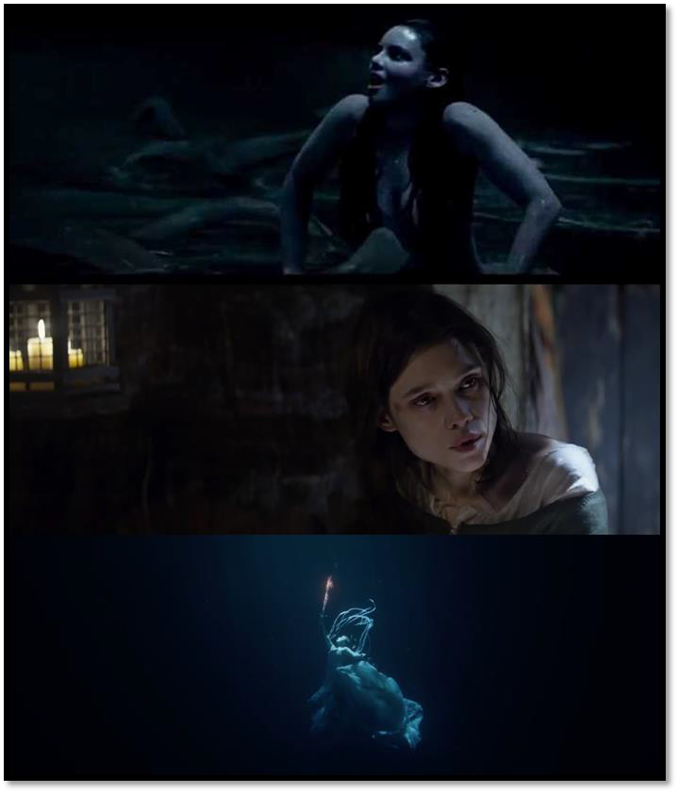

There is a legend in the Church dating from medieval times: when a bell is rung, it drives demons away; for Vortigern, when he rings the bell, it summons the demon.

As I say several times throughout this post, women are the dominant power holders in this film, because women are the key to the mysteries of existence and power which men seek, if not because they desire power (like Vortigern) then because they must stop that evil power (like Arthur).

Ritchie makes it clear, then, that women are the chess players, and men the pawns, and yet, there is nothing traditionally feminist about any of these women in the film. As we know, feminists want to be equal to men and do everything that men do, while shunning everything women have done traditionally.

Ritchie makes the argument--one with which I completely agree-- that women are not men's equals, but are far superior (but there are still prostitutes, mind you). When women are at their best, they are like the Lady of the Lake, but when women are at their worst, they are like the sea witches.

To invoke another metaphor, The Mage is like a potter at the spinning wheel: sculpting and modeling the clay of Arthur's heart and soul, so that he becomes the man he's meant to become.

This is the great mystery and duty of being a woman, but she cannot accomplish her mission if she herself has not been put on that same potter's wheel and subjected herself to being modeled as well.

There is a common thread binding all three women in these images: authenticity.

In this film, the Lady of the Lake is the standard of authenticity; why? Water. Water, as we know, symbolizes the first stage of reflection (and we will discuss this more below with the hand coming out of the muddy water) and the Lady of the Lake offers that as the step towards the authentic self Arthur has to find within.

But, you point out dear reader, the sea witches are also in water; if water is a stage of reflection, why doesn't Vortigern "reflect" on what he's doing and be like Arthur? And that is a most excellent point. The water in which the sea witches swim does indeed symbolize the first stages of reflection, and if Vortigern were a "normal" human being, he would have realized, when he first killed his wife and floated her corpse on the water as a sacrifice to that Unholy Trinity, that what he did was morally outrageous to God; but he didn't, did he?

The instrument of reflection was there (the water), but Vortigern is a man who abuses and perverts, so instead of using the water to reflect upon what he had done, he used the water to achieve what he wanted to do. In other words, Vortigern intentionally uses his free will to enslave himself to sin, whereas Arthur intentionally uses his free will to free himself from sin, and all of us, without exception, are one man or the other, and if we are not actively trying to free ourselves, we use our free will to allow sin to enslave us because we refuse to fight against it (and a post such as this is the "reflection" pointing out what you are doing or not doing, so you don't have an excuse).

We can validate this interpretation when The Mage and the Resistance go to save Arthur from being beheaded publicly by Vortigern: The Mage can control the animals and she's able to agitate (for lack of a better word) Vortigern because he is mostly animal, not human, and he's allowed himself to become mostly animal because of sin eating away at his soul, which is what separates humans from animals.

The Mage is the one who shakes Arthur out of his spiritual slumber and directs him upon the path he should take, specifically, the path of the darklands when she insists he goes and confronts his darkest fears.

The Mage is not equal to the Lady of the Lake, but The Mage is definitely on the path towards her personal self-fulfillment, which is why she's a good teacher for Arthur: what she has received, she freely gives to him, and that is exactly the kind of relationship God intended between man and woman, with man providing for woman's earthly existence, and woman preparing man for his heavenly existence.

First of all, please remember: historical films are never, ever, never, ever, never, EVER NEVER EVER about history: they are ALWAYS about the here and the now.

There are no exceptions.

Even documentaries are about us today, using the vocabulary of by- gone events to describe that which we are going through now.

To continue on with regularly scheduled broadcasting,... There are a couple of rules about power which Ritchie lays out for us. First, power comes from women. Second, the dark side of our humanity will be drawn to that power. Third, power is meant to be used. Let's start with the women.

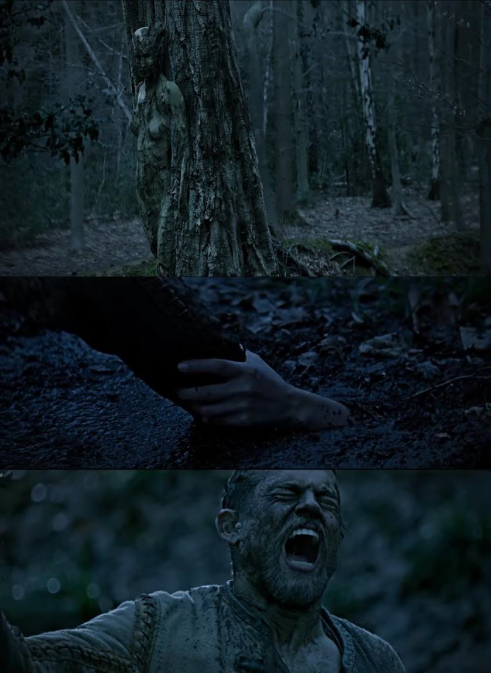



The scene where the Lady of the Lake reaches out to Arthur from the mud is definitely my favorite in the film, and that's saying a lot, because Ritchie fills the narrative to brimming with fantastic visuals to illustrate his characters and events.

The darklands basically show us Arthur's soul as it is in that particular moment in time: the wolves, the giant bat picking him up and flying him around (like the flying dinosaurs in Jurassic World, another film we are meant to consider) and Arthur walking through the landscape, all act as a miniature summary of all that has happened in the film, and all that is still yet to come.

The wolves chasing Arthur are the Blackleg soldiers employed by Voritgern (after The Mage gives Arthur the snake venom, and he goes to the castle, he can see the soldiers with only their glowing eyes, meaning they have sold their souls) and the giant bats are first Vortigern when he's ready to behead Arthur publicly, then the Resistance steals Arthur from Vortigern, just as another bat steals Arthur from the one who first picked him up.

But what about the sirens in the trees? Their camouflaged appearance represents how Arthur doesn't know how to interpret the women he encounters during this story: Maggie the Maid (Annabelle Wallis), The Mage and even the Lady of the Lake (I think there were three tree sirens).

Remember, when the Lady of the Lake first pulls Arthur under the water, he fights and resists her because he doesn't know what is happening. The reason Arthur has a difficult time trusting these women is because he has only known prostitutes his whole life, and Forests generally symbolize sin because forests are the opposite of a garden: a garden has been cultivated and the weeds have been pulled so specific fruits of the harvest can be gathered at the right time; in a forest, animals roam freely, nothing is cultivated, and everything grows wild, like sin and appetites in our souls.

So when Arthur goes to the darklands, The Mage tells him he should be afraid because he's going to see the state of his soul, and that is nothing any of us want to see (unless we are saints). But, looking
into Arthur's own soul is a test: if Arthur can't look at what he himself has done with his sins, then he isn't going to be able to watch his father sacrifice his life for the sake of his son because Arthur isn't in a position to understand what love is, and this leads us to what happens with the Lady of the Lake.

Arthur throws Excalibur into the lake after his friend Back Lack dies and their assassination attempt on Vortigern fails. Why does Arthur want to get rid of Excalibur? Because he is reminded in Back Lack's death of the death of his father. Reminded of the sacrifice his Father made fo him to escape.

In his heart, all he sees is that his best friend died and left his son an orphan because of Arthur as he too was left an orphan on the death of his father, and Arthur rejects this; why?

Again, because Arthur doesn't know what real love is (Arthur's soul is still weak) and because Arthur thinks Back Lack did it to protect Arthur, not for England (and in his love for his friend, sure, Back Lack was willing to sacrifice himself, but also for England as a part of the Resistance).

In other words, Arthur only focuses on the burden of sacrifice, not the love prompting the sacrifice.

This is why Arthur keeps looking away in his dreams when his father puts the sword in his back: the back symbolizes our burdens we take upon ourselves (whereas our shoulders symbolize the burdens placed upon us by others/the world in general), and that Uther puts the sword in his back demonstrates Uther's love for Arthur and for England.

This is why Arthur wants to put the sword as far away from himself as possible: Arthur isn't capable (at this point) of the love required to make that kind of sacrifice for others (and no one is unless we go through the spiritual training, which Arthur is about to) and, unwittingly, Arthur throws Excalibur into the lake--not because he knows the Lady of the Lake will retrieve it--rather, because he's self- reflecting on what is going to be required of Arthur, and that he isn't

25

sufficient for the task at hand. This is where the hand coming out of the muddy water is such a stroke of genius.

After Arthur throws Excalibur into the water, he runs; why? Because that is what Arthur has been doing the whole life: he's been running with no idea of where he is going. Then he falls in the mud. When a character falls, it's a sign of Original Sin catching up with them: their spirit is willing (or maybe not) but the flesh is weak and we can't do that which we know we ought to do (or sometimes we don't even know what we should do) but because of our fallen nature, we aren't capable of summoning the strength of character necessary to discipline ourselves to be able to carry out the task required of us.

Arthur falls in the mud (center image) because he is weak; he is weak because he doesn't know Love. He doesn't know Love because he doesn't know God and he doesn't know God because he's not accepting the role, duty and purpose God has given Arthur to come to know, trust and depend upon God. This is where the Lady Of the Lake comes into the narrative.

Who is "The Lady Of the Lake?" As we said above, the lake is going to symbolize the "reflective" stage of our understanding; women, we know, symbolize the "motherland" because they give birth to us, but since there is no "land" for the Lady Of the Lake, we can say, rather, that she symbolizes the person we choose to become, because we think, we rationalize and examine our options in relation to our values, priorities and desires, and then, we reach a conclusion, we draw up for ourselves a course of action we are going to follow to turn us into the person we need and want to become; so, the Lady Of the Lake gives birth to us when we have used our free will to adopt a course of action for our lives and we are "reborn" of action and intent.

Arthur throws Excalibur into the lake, she takes it as Arthur runs away, falls down in the mud, and then she takes Arthur's arm by reaching up from the mud in which Arthur has fallen; why? Because this is what God does. It's through the trials, but also the purpose which God designs for each and every single one of us that we overcome the mud, because the mud is the earth from which we are

created, but we are destined for a spiritual home, which is why the Lady of the Lake pulls him through the mud into the clear, pure water, and where she can speak to him of his destiny.

The passage from the mud to the clear water, then, is another metaphor Ritchie employs to illustrate for us the transforming grace Arthur experiences in the film, from being a soiled character to a divinely appointed king. He can't see her face, because even though she's revealing things about the future to him, the future is always a mystery and it can't be completely known, and neither can her identity (the face is the seat of our identity, which is why Arthur can't see her face).

So, what does she tell him? Exactly what he needed to hear: they didn't die for you, Arthur, they died for England, and if you fail England, you fail them.

In a way, it takes pressure off of Arthur to know that Back Lack (Lack of backbone or willpower) didn't die for him, because that would be survivor's guilt, however, Arthur is a fighter, and this is what she tells him: you are a fighter, so fight. Don't fight yourself, fight Vortigern.

He takes the sword back up and yells, because these are birthing pains, THE PRIMAL SCREAM, he is going through the birthing process because when he pulled Excalibur from the stone, he wasn't a necessarily willing participant; but now, he knows what is at stake, what is required of him, what it's going to cost, and he has aligned his free will with the cause.

That's why, the next scene, we see Wet Stick pouring water over Arthur: sure, he's washing up, but it's also a baptism, a washing of his free will so that Arthur will "go with the flow" of the events taking place, which are the riots spreading throughout the country George mentions. If Arthur hadn't have had that "break-down" in his heart of where he was going and why, Arthur would have made the wrong decisions.

Power is a "trigger word" for all interpreting themselves today as minorities: those identifying as minorities firmly believe (or at least attempt to make everyone believe they believe) that white, heterosexual men (especially if they are of Christian, and of the middle or upper class) define, exert and, thereby, abuse power to protect themselves, their power base (such as their economic standing through business) and maintain the self-identified minorities in ignorance and poverty. We'll come back to this claim in a moment, because Ritchie deals with this in the film in the person of Vortigern; however, what's imminently more interesting is the way which Ritchie redefines power with an element that would NEVER be mentioned by the Left: sacrifice.

What do we make of The Mage? Let's start with some generalities. Generally speaking, the Mages (as a people) symbolize those in power in the Church (rather like the elves in The Hobbit and Lord Of the Rings) because they are spiritual beings who have first and foremost, "power over themselves" (we will discuss further down below Mordred and what happened to the relationship between Mages and Men).

The Mage who comes to help Arthur has power over herself because she has disciplined herself as we discipline ourselves with Energy Enhancement Meditation. How do we know this? First, she has power over the animals, or someone (like Vortigern) who is becoming an animal because of being enslaved to sin, of cutting himself off from his soul (in other words, Vortigern in on the same level as dogs and birds).

Secondly, she doesn't use the power she has for her own advancement, rather, she arrives to aide Arthur rid England of Vortigern, then blends into the background; in other words, restoring the Pendragons to the throne was her reward, nothing personal.

So, she has mastered those appetites within her (and we also receive validation for this interpretation because she wants to take Arthur to the darklands, which means she has been through her own darklands: she knows why Arthur should be scared because she was scared).

Then there is also the scene when The Mage and Resistance fighters have saved Arthur from beheading and, in an effort to win her trust and favor, Arthur turns around on his horse to look at her, and asks her if she is falling for him the way he's falling for her; she promptly causes the horse to buck and knock him to the ground; why?
Because the horse symbolizes the Holy Spirit, which is a vehicle for the Will Of God: what God wants done and accomplished in the world, the Holy Spirit accomplishes (this is why the Lady of the Lake says, "Trust the Mage," because the Lady of the Lake is a spokesperson for the Holy Spirit.

We see The Mage on a horse, because what she has done was the Will of God, and what she is going to go and do now is also the Will of God).

Arthur was abusing the purpose of the horse by riding on it backwards, just as he was abusing the help of The Mage by insinuating that she was attracted to him when she was there to do the serious political work of overcoming Vortigern.

Had The Mage been a lesser woman, she might have fallen for Arthur's pathetic flirtation, but, alas, she did not because of her wisdom (we often see her wearing a blue cape denoting wisdom) and her will power (developed through discipline).

What about her eyes changing colors? Ah, this is a good one, and a brilliant trick on Ritchie's part, certainly one I didn't anticipate. Her eyes take on the look of animal eyes because she has conquered her own animal instincts. The eyes are the windows of the soul, so that which we see in a person's eyes, we also can see as reflecting their souls (for example, after Vortigern kills Catia and floats her body in the water as an offering for more power, Vortigern's eyes turn white; why? White is the color of faith, innocence, purity; when a person is alive with these virtues, God lives within them; when a person is dead to these virtues, the person's soul is dead - like a zombie - because God will not live in a temple that has banned God. Because a corpse turns white in death, we know can see that Vorigern's soul has died when he killed Catia; in other words, he didn't kill his

daughter, Vortigern killed himself, because of his slavery to power and determination to rule).

The Mage has conquered all animal appetites assaulting her soul; she's not without sin, but she isn't enslaved to sin and isn't weakened by her sin the way Arthur of the other characters are.

So, what becomes of The Mage? The center image tells us. There is no sun. There is no buildings, nor people. There is no food nor water. It looks like a storm is coming. There is the faint outline of mountains in the background. Even though this isn't exactly a desert in the strictest of senses, it is compared to the scenes we have just witnessed at Camelot. In other words, she's retreating away from the world, back into the interior world of the self to continue perfecting her soul and gaining ever greater power over herself, so, when the next crisis happens, she will be an even greater help.

The bottom image, with The Mage standing on the stone bridge behind Arthur, is my second favorite shot of the whole film. Bridges act symbolically just as they act practically: to get a character from one place to another. In this scene, Excalibur in the foreground, Arthur isn't using its power, because he's blocking it. As The Mage walks across the bridge, her purpose, we can literally see, is to get Arthur from where he is, to where he needs to be, which is using Excalibur to its full potential. "Everybody looks away. But it's the duty of the king to not look away," she tells Arthur, knowing that something bothers him but he's intentionally blocking it; what? The sword in his father's back.

Uther allowed the sword to fall into his back because Uther was the "living stone" spoken of in 1 Peter 2:5, that we must be fortified by our strength, courage, faith and hope in God, and Uther demonstrated all these things, which is why he was targeted by his brother to be taken out, because that is exactly what has happened in America over the past nine years now with the Satanists taking out everyone who stands against them.

Arthur has to become this living stone like his father, so, when Arthur sees his father, and Arthur doesn't look away, and the sword starts to fall into Uther's back but Arthur stops it, it's because NOW, finally, Arthur understands: Uther is alive because of his sacrifice, not dead because of it, and if Arthur wants to be the man he was meant to be, Arthur will have to do the same. But because Excalibur is a phallic symbol, this applies to every man, not just the kings of a bygone era.

For Ritchie, "power" does not exist without sacrifice," something you surely will not hear in any public political discourse today. Why not? Because the Satanists are certain that power is always attained so one doesn't have to make personal sacrifices; personal sacrifices are bad, personal suffering is bad (which is why Vortigern can't believe that Arthur "blossomed" growing up on the streets instead of shriveling up because he wasn't privileged) and which Satanists would want to make personal sacrifices?

Instead, for thousands of years, Satanists have made human sacrifices of their victims. The vast industry of human trafficking of childen and women for organ harvesting sacrifices, prostitution sex slavery sacrifices and pedophile sex, torture and child sacrifice has twenty-seven millions of victims with one million children being kidnapped and going missing every year in the USA alone!!

Satanists would be willing to argue that they themselves have been "sacrificed" in not being allowed to achieve or hold power themselves, but as for making sacrifices for the good of others, are they are concerned about is themselves, which brings us to the problem Ritchie illustrates for us.

Satanists, like Vortigern, are perfectly willing to accept the sacrifices of others, and to sacrifice others, for their own gain, but not willing to make sacrifices in their own lives; why not?

They have no love. They have no gratitude.

They have no soul…

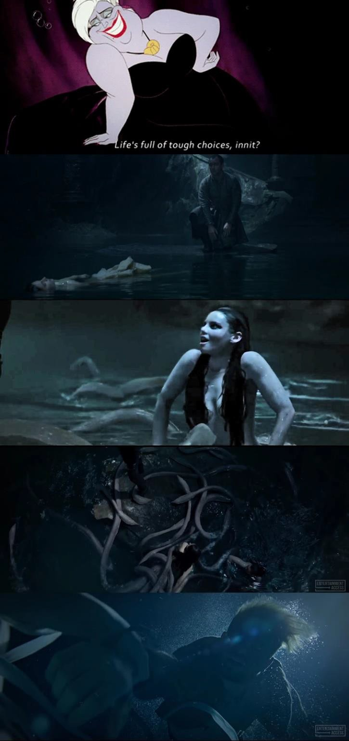

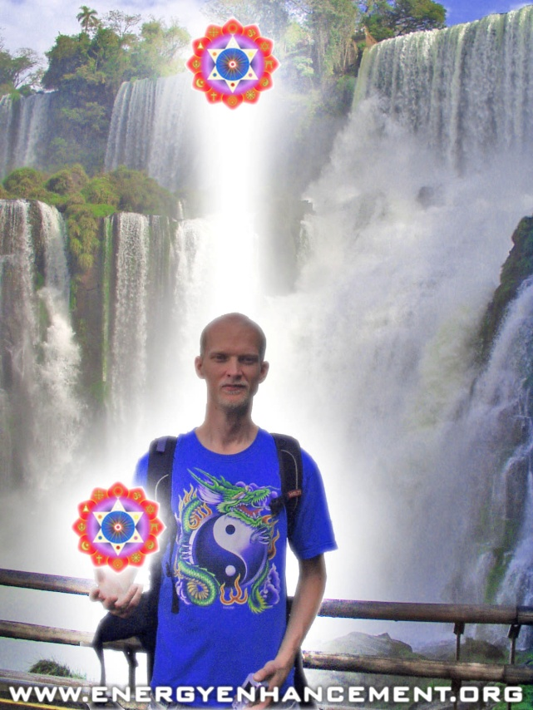

ENERGY ENHANCEMENT COURSE AT IGUAZU FALLS. BRAZIL

"Get your asses over here Now and Speed Up your process of Enlightenment on the Energy Enhancement one month course!!" - DON
Every one of our Students gets this Spiritual Experience of Connection with Infinite Energies.
Energy Enhancement does indeed, "SPEED UP THE PROCESS!!"
And they all get this Experience of Light, Life and Infinite Energy just with the Energy Enhancement Course - Every One of Them!!
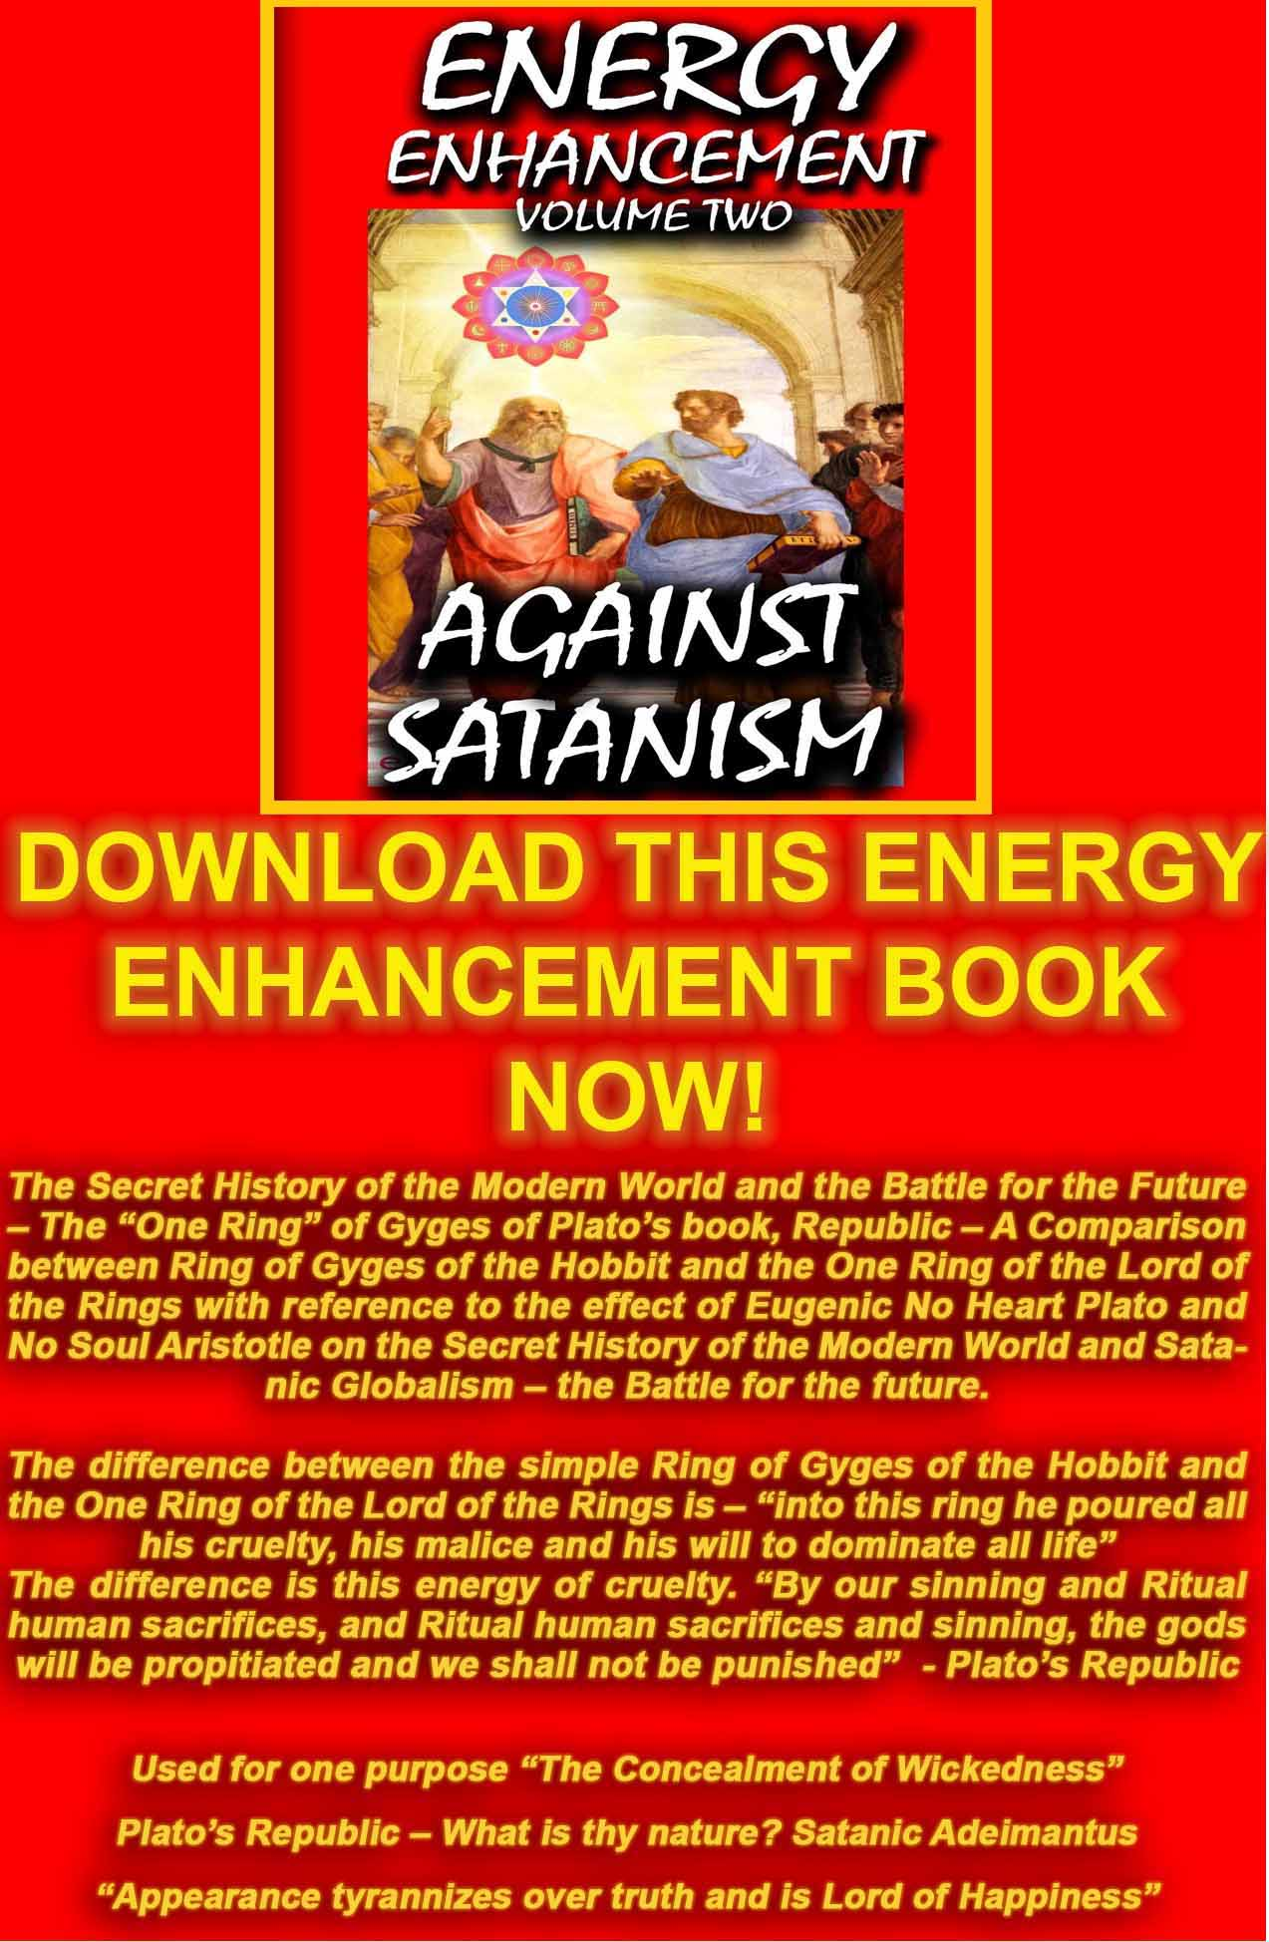
AGAINST SATANISM VOLUME 2
DOWNLOAD HERE
http://www.energyenhancement.org/Sacred-Energy/Against-Satanism-Volume-2/Against-Satanism-Volume-2.pdf

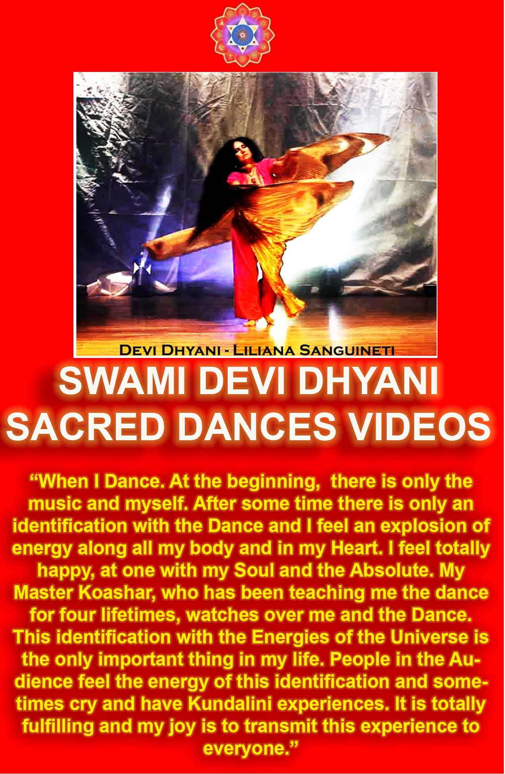

In the very top image is an illustration of Ursula, the Octopus witch who is likely the source of inspiration for the water nymph to whom Vortigern goes for power and favors; in the second image down from the top is Vortigern sending the murdered body of his daughter Catia into the water so he can have an increase in his powers; in the third image down is one of three faces we see of the water nymph granting Vortigern power and the fourth image down is the long,.... "eel"-like legs/arms of the water nymph greeting Vortigern as she comes to talk with him. The last image, very bottom, is Arthur being pulled into the water by the Lady of the Lake and her "garlands" (for lack of a better description) embracing him.

Let's discuss the Satanic Ritual Sacrifice angle of "the price" Vortigern is willing to pay for the power he wants (i.e. the power he believes he "needs"). First of all, this is, in base, monetary terms, an "exchange," the exchanging of the blood of a loved one for whatever it is you want, and on Vortigern's wish list, there is nothing but power (we'll discuss Vortigern and power below). Why would this siren want the blood of a loved one? Well, there is good reason to at least suspect that Ritchie is calling upon real life for this scene: anyone who knows anything about the Illuminati has at least heard of the blood sacrifice they require for a person to become super- famous and rich.

Just type in "celebrities and blood sacrifices" and you will hit on a wealth of researched case histories at least suggesting that the occult references (like all the triangles and occult magic we see in Vortigern's tower) are, in fact, communicating to us about the very real ties of Hollywood to the occult and the links of power and domination of satanic influences (and even if you don't believe that, we cannot deny that there has an on-going and organized public effort by the Satanists to use satanic spells against Donald Trump, the same way we see Vortigern using spells against Uther and Arthur).

So, in terms of "exchange" and what value does the blood of a loved one hold for a demon like this siren, we have our answer: when you are willing to kill someone you love for something you want more,

then you give your soul to corruption and evil gains that power of you.

As most everyone reading this post probably knows, a human never enters into satanic pact with a demon and maintains control over events: you give yourself to that demon. Just as Ursula in The Little Mermaid knows how to keep Ariel's soul forever because the prince really wants to hear the singing again, so the sea witch in King Arthur knows Vortigern.

There might be the illusion of power and control, however, that is fleeting, and this is why the sea witches have three faces, rather like Dante's Satan in the Ninth circle of The Inferno: the two attractive faces are the faces we want to see of power and wealth, but the ugly, old, bloated and evil face of the third woman who does the talking and granting the power is the truth behind the illusion.

This brings us to our discussion about the water nymph demon pictured above. Now, in Excalibur (the 1981 film), Uther Pendragon, the father of Arthur in that film, makes an exchange with Merlin that, if he can lay with Igrayne for one night (she's the wife of one of his barons) Uther agrees to give Merlin "the fruit" of that union (the infant Arthur). In 1981, what people in the US were selling their souls for--sex, and specifically, taboo sex (homosexuality), symbolized by Uther's adultery--was the plague bringing ruin and devastation to the country and it could be expressed in one word: AIDS (1981 was the first year HIV was clinically observed, and the film Excalibur predicted some kind plague was coming).

Today, however, Ritchie has traded in the desired sex for power and satanic activity, and given the revelations from WikiLeaks about presidential candidate Hillary Clinton, as well as former aides coming out and attesting that she is, in fact, a practicing witch who goes to monthly satanic meetings in Los Angeles, (and, when King Arthur Legend Of the Sword began production, everyone, especially in Hollywood, assumed Clinton would be the next president), we cannot help but think of Vortigern as a metaphor of Hillary Clinton.

Why is this important? Because, as the leader goes, so goes the country, and leaders getting entangled with satanism means the country will, as well (just look at the public "binding spell" against Trump, and Hillary isn't even the leader; think how bad it would have gotten if she had made it into the White House).

The problem is, a lot of people think they would never fall for Satanism, however, they also aren't actively working on being good Christians, either. If you aren't fighting the spiritual battle, you are losing the spiritual battle, which means the devil is winning.

Ritchie provides us with the perfect visual to illustrate exactly why the spiritual battle is imperative: the "eel-like" arms of the sea- witches, vs. the garlands of the Lady of the Lake.

Either we will be drawn into evil with those long, snake-ish arms, pressing us to the bosom of damnation, or we will be drawn into the mystery of ourselves for our eternal salvation and that of others as well.

When Arthur returns with a year's wages for Lucy, after she has been beaten by a Viking, what does Arthur say? "You have been taking care of me for much longer than what I have taken care of you," and it's clear that Arthur is grateful to them for what care they offered to him when he was orphaned; likewise, at the end, Arthur insures that his friends and members of the Resistance who aided him to rid England of Vortigern are knighted and rewarded even before he himself is knighted as king.

Gratitude is the expression of love, and people who reveal themselves to have no gratitude, are people who have no love prompting them to express gratitude; that's why satanists are so selfish, they think only of themselves, and we see that in the character of Vortigern who will sacrifice anyone and everyone for what he wants. Sacrifice is such an important element to the philosophy of power that one of the most important "locations" of the film takes place at the alter of sacrifice itself.

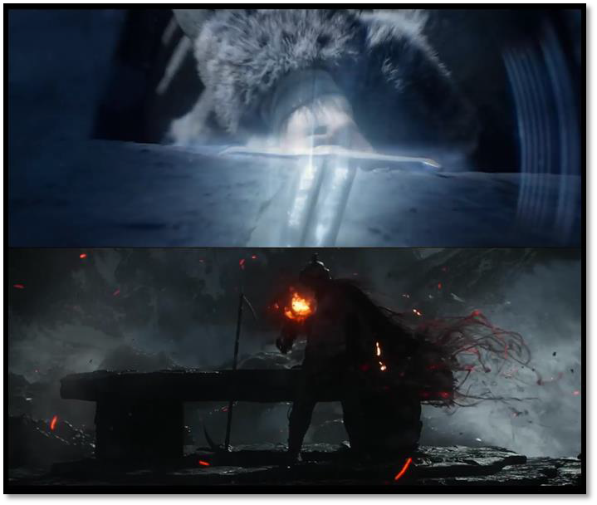
This is the most important place in the film, even more so than the place where Uther died and Arthur pulled the sword: the alter. This is where life begins, this is where life ends, when life is properly lived. In the darklands, Arthur has to take the sword to the alter to see what happened and, as we see in the top image, the runes on the sword light up; why? It's the Truth, the Light of Truth and it's infusing Arthur, compared to the bottom image and Vortigern shrouded in the darkness of lies and corruption.

We have all ready discussed at least a little why it's so important that Arthur sees Uther and what Uther does with the sword, but there are at least two other reasons why this is important: first, it was an act of love, and it reveals to Arthur the incredible love his father had for his son, as well as the people placed in his care, his kingdom.
Second, it provides Arthur with a role model, someone to whom Arthur can look up and model his actions after so Arthur in his turn can become a role model for all other men (which is where chivalry comes from).

The great irony about sacrifice, which Ritchie points out so wondrously, is what Christ said: "For whoever wants to save his life will lose it, but whoever loses his life for my sake will find it. What will it profit a man if he gains the whole world yet profits his soul?" (Matthew 16: 25-6).

We see both Arthur and Vortigern at the alter of sacrifice, each man there with a completely different intent: Vortigern to gain control over the world, and Arthur to stop him. Excalibur, in the top image, lights up with the truth of the mystical words engraved upon it, just as the Truth is engraved upon our hearts. In the bottom image, we see Vortigern wanting to spread the same darkness throughout the world which has consumed his own soul, and bring death to all.

What's the deciding factor in this struggle? Women. It's the Lady Of the Lake who directs Arthur in the right direction, and it's The Mage willing to sacrifice herself (letting the guard hold a knife to her throat in George's courtyard, then letting guards take her hostage to Vortigern's castle when Arthur has thrown Excalibur away).

On a slightly different note, the fireball we see Vortigern holding in this bottom image, as well as one we had seen him holding in the trailers, might be a reference to the 1994 Russian film Burnt By the Sun; why? The film takes place in 1936, the USSR, and a young man who had been recruited by the KGB (one way to interpret "recruited" is "forced") to go oversees and do their dirty spy work for them, leaving behind the woman he loved; in moves Sergey, a colonel who had his eye on the young woman (yes, it's very much like the story of David and Bathsheba, but it's taking place under Stalin). The young man returns to exact revenge on Sergey for turning him into a monster and stealing the woman he loved, and he does it with the same means that Sergey forced him into the KGB to begin with. The point is, at the start of the film, then at the end, there is this free-floating fireball, just like the one Vortigern holds, wandering around, a kind of symbol for Stalin himself and the Orwellian universe he created, but also a universe with no love, no equality, no justice, and absolutely no hope for anyone.

The fireball, like the lighting of the candle symbolise the fire at the top of the tower - The Enochian Watchtower of Dr Dee symbolises a cut in the infinite Antahkarana column of energy ending in God.
There the bodiless Magician lives in his own private universe. The Lord of the Rings has the Eye of Sauron at the top of a tower.

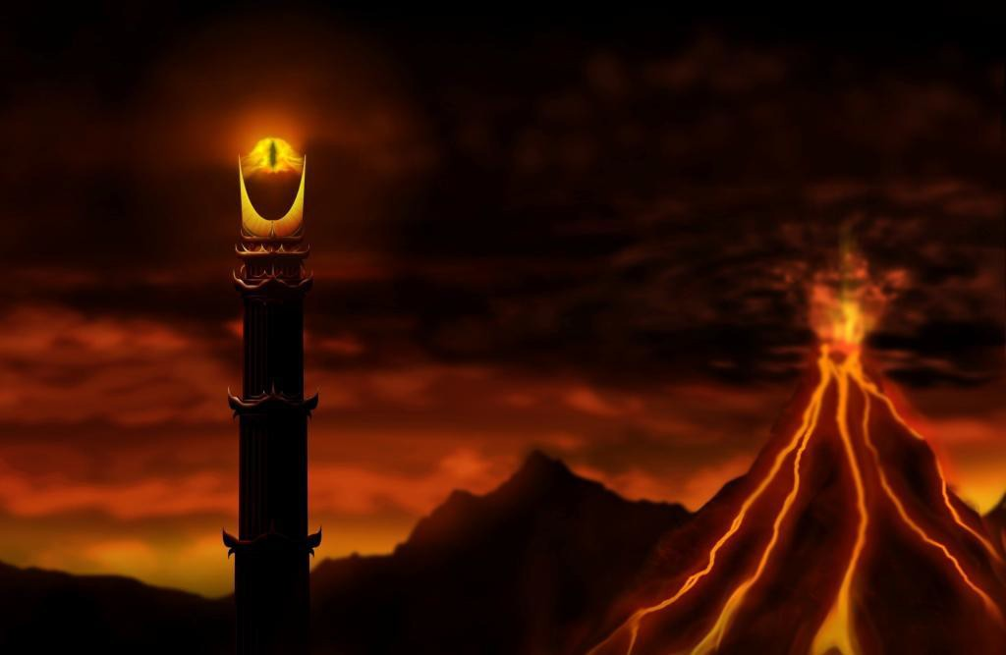

The Pyramid of the Illuminati has an eye at its top.

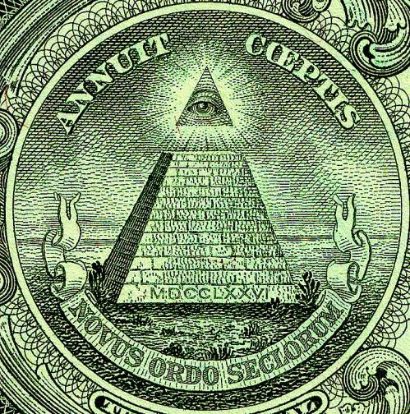

Why would Ritchie (IF, this is, indeed, what he is doing) reference Burnt By the Sun? (Reference to Icarus) Burnt By the Sun is obviously an anti no-soul-communist anti-satanist film, and Vortigern is a Satanic figure (at least he's representative of Satanists in the US wanting to overhaul the republic and capitalist system we have had with a form of neo-no-soul-communism), and Ritchie wants to warn those who have, perchance, seen Burnt By the Sun, that Voritgern is, indeed, an extension of Satanist Joseph Stalin.

What about those who haven't seen Burnt By the Sun? Well, look down at the next caption, and therein lies your answer.

No one in this film has power unless it comes to them from a woman. Who does Vortigern sacrifice to gain power? His wife, then his daughter. To whom does he make the sacrifice? The three sea witches (nymphs, whatever they are).

Bad women turn men bad with raw, ruthless and bloodthirsty power, like Vortigern.

The good women, however, turn men into being good men with strength and courage because good women teach the men how to sacrifice themselves for others, as did Jesus Christ.

Uther Pendragon gets the power of Excalibur from the Lady Of the Lake, who bound it to the Pendragon line, and who infuses Arthur with "clear sight" of what must be done (this is why Arthur's eyes burn blue and white with the sword, he can see clearly, whereas Vortigern's eyes turn zombie no-soul white after he has killed his daughter because Vortigern has gone completely blind, and so when he turns into the demons, pictured above, the demon has no eyes at all).

The Mage (never once referred to as "Guinevere,") is the ONLY PERSON who calls the sword Excalibur, and then only one time in the whole film; why? This is where Guy Ritchie and company are absolutely pure geniuses!

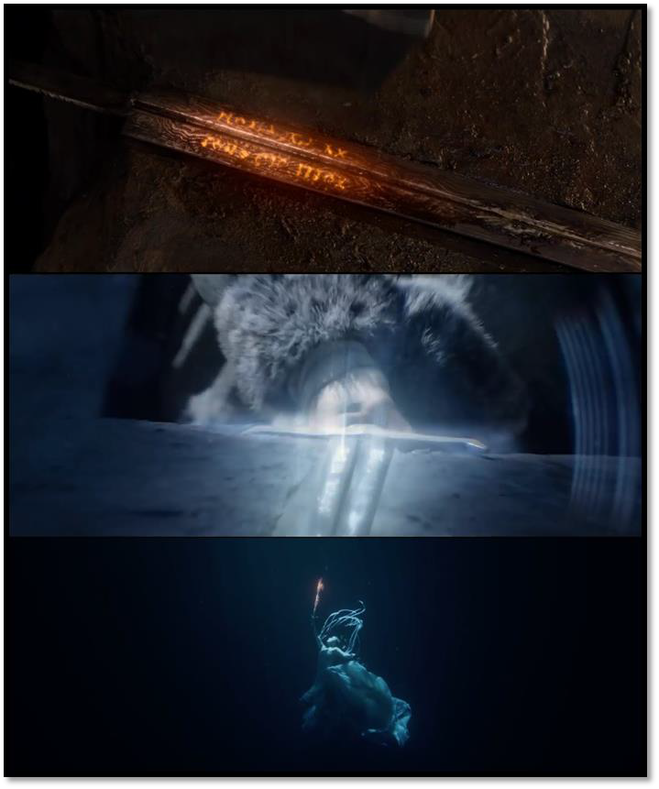
Again, we know the runes used in the film for Excalibur were invented just for the film; why would Ritchie incorporate a language into the film that no one, at any point in time in history, would be able to read?

Because he wants to point out that there is another language we are choosing not to read, the language of the references, the symbols and the theories Ritchie employs to make his point (this doesn't

apply to you and I, dear reader, because we are doing exactly what film makers like Ritchie hope we will do).

This might seem a bit backwards, however, the only time we see "Merlin" in the film (and he's a major player in the King Arthur universe, so that we never actually see his face is rather a big deal) is when, in the image above, he has engraved said runes upon the blade edge of the sword.

What does this prove? Merlin is an unknowable entity at this point in the story, just as the runes are unknowable, so they have been "marginalized" because the average viewer won't know what to make of them; when we marginalize something, it's because we don't understand it, like a child who is learning to read skipping over a word they have not yet learned.

The evidence of something like the runes points to the margins as places of legitimate discourse we might otherwise miss. Consider, for example, in Sherlock, when Sherlock (Benedict Cumberbatch) has taken Watson (Martin Freeman) for a night of bar crawling, and they are totally drunk, but get called in on a case; Sherlock gets on hands and knees to look for evidence, but falls asleep, and Watson turns to the client and says, "He's cluing for looks,..." just as we have to reverse the words "cluing" and "looks" to make sense of the sentence, so we have to do the same interpretations in Sherlock to understand what the series is about, and so it is with the runes here.

Now, look, once more, at this amazing bottom image: the sword sets fire to itself, in this deep water. Why? The Lady of the Lake has taken hold of it; what does that have to do with the price of tea in China? She, as in female, has the spiritual power to cause the sword to both purge and damn. In other words, the symbolism of fire is that fire either cleanses and purges us of sin, or fire damns us because we refuse to be cleansed.

The saying, "Fight fire with fire," means that you fight the fires of damnation with the fires of purgation, and at the end of the film, when Arthur says, "You created me, and for that, I bless you," this is exactly what Arthur is talking about: I would not have been purged

and cleansed of my weaknesses, if you hadn't threatened to curse the whole land with your own damned soul, Vortigern, and so I am saved because I have seen how you have cursed yourself.

And this is the case for the whole of humanity. We all have our demons.
We all have our soul path to purge ourselves of those demons. Thus Arthur says, "YOU MAKE SENSE OF THE DEVIL!!"
Because every bad thing is our test.

We pass the test by overcoming each and every one of our demons. By overcoming the Devil Himself!!
But back to the Lady of the Lake: we know this is a sacramental scene because of the water. Water is the first stage of contemplation and self-reflection; heretofore, Arthur has been acting, but it isn't until Back Lack is killed, and Blue orphaned that Arthur reflects on what is really going on, and it's the "passive" power of the Lady of the Lake who imparts that to Arthur and sets his soul on fire.

Without the sacramental nature of this scene, Arthur would just be a thug, a street boy trying to make a name for himself and get out of the gutter by slitting someone's throat. Because of this scene, Arthur is, in essence, being charged with doing God's justice on earth, just as Arthur charges his knights (in the written stories) with doing the King's Justice in the realm.

At least one reason why this is so important is because we see the same type of runes written on the face and body of Princess Ahmanet (Sofia Boutella) for The Mummy starring Tom Cruise and Annabelle Wallis. With both The Mummy and King Arthur, there is a canon, an established, written chronicle of what happened to who and why, but then, there are these two "unknowable" languages

practically subverting that canon; why? In literary theory, the "canon" is seen as patriarchal, that is, of men, by men and for men.

Excalibur, like any other great sword, is a phallic symbol; what does that mean? A phallic symbol is meant to invoke the male penis, especially when erect. Why? I wish you hadn't have asked that, because this is where it gets difficult, but that's okay, we will get through this together. The answer depends upon who you ask, and because feminists and other minorities ("minority" being anyone identifying themselves as such, but specifically those who are not male, are not white, not Christian, are not heterosexual or part of the 1% economically) have dominated the discussion of phallic symbols now for decades, and has been completely colored in their own self- interest with no on challenging their self-absorbed, dramatic interpretations of the "white man's narcissism."

Until now,....

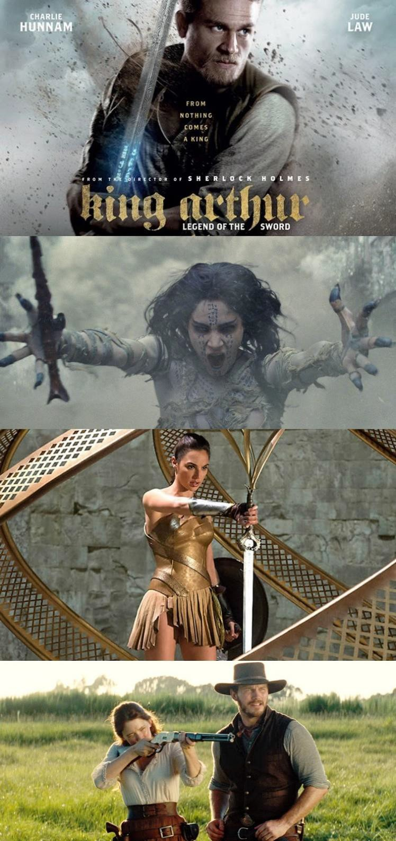

Why do Satanists hate white men so much? As we have discussed before, it's because they are the dominant "power holders" in today's society; just as Jews were "power holders" in Hitler's Germany, the Satanists specialize in targeting an isolating "an enemy" then rallying their allies against that enemy and turning them into scapegoats.

If you don't believe me, check out this story about the newest video game coming out, Far Cry, which has white, Christian men who eat red meat and read the Bible, as the villains of the game.

Is the "power" which white men hold in Western European civilization the real threat to those who see themselves as minorities? No. The real threat which white, heterosexual men pose to the Satanists are their values. And anyone (male or female, white, black, red, yellow or mixed) can hold these same values (and many do) and fight for those values, but they are traditionally associated with white men because they are both distinctly European and Christian.

What are those values? The basis of Chivalry, masculinity and the Christian faith.

Just as these three things, inter-related, have built up European and American civilization, so they have kept order and brought peace and prosperity to all peaceably participating within America.
America is the richest society ever made - for All of the people.

This is the very reason the Satanists hates it so much: the Christian society of masculine rule outlaws anything that will bring it down, which will corrode society and its members.

Satanic Miniorities, on the other hand, want these perversions, and so blame white Christians on "hatred" and "intolerance," "racism" and "greed" so they can unleash the devil through their sins and call it "social justice."

Just as Vortigern unleashes evil in King Arthur: Legend Of the Sword, the Satanists wants to do the exact same thing.

How? The "false phallus."

In the images above, we first see Arthur with Excalibur, the "good phallus," the good ruler with his power he uses for the greatest good of society. It doesn't always work out that way, but this provides the most peace and the greatest benefits for the greatest number of people.

Below King Arthur, we see Princess Ahmanet from The Mummy; what does she hold in her right hand? A knife, a jagged, nasty knife she uses to cut the throat of her father, the pharaoh, and then of anyone else who gets in her way.

Below that is Diana Prince (Gal Gadot) in Wonder Woman; what's she doing? Pulling out a sword that is destined for a great warrior,.... or is she really re-writing history to make a woman seem like a better "King Arthur" than King Arthur?

In the bottom image, we see Emma Cullen using her rifle (which, in this film, is a phallic symbol) to "take revenge" on the industrialist Bogue (symbolizing capitalism). We also just saw Gamora (Zoe Saldana) in Guardians Of the Galaxy Vol 2 use a sword (phallic symbol) to kill a giant octopus symbolizing capitalism.

It's possible we will be seeing something similar in Pirates Of the Caribbean 5 with the trident of Poseidon. What I am saying here, is that phallic symbols are going to be important for the next year, and if they are being "cut off" that is a clear case of castration - of Satanic Cybelle and Adonis - the Satanic State Religion of the Roman Empire.

However, we have the issue of The Mage and her being only one of two people to say, "Excalibur."If Excalibur is a phallic symbol, and The Mage names it, then did she say a dirty word? No, she spoke a most powerful word, and it's because of who she is that she did say it.

The Mage, the Lady Of the Lake and Merlin, are the only ones who understand what Excalibur is.

Excaliber represents the column of energy connecting us with God.

Through the Earth through the spine which is an antenna, through the seven chakras of the body, through the infinite chakras above the head, with God.

So when they say Excaliber they are saying the destiny of the sword because they understand and accept mystery (even though Merlin and Lady of the Lake don't, but hypothetically speaking); the can know the "essence" of power because they know their own essence and they have power over themselves because they are connected with God.

The only other person to say, "Excalibur" is Mercier, the Lord who taunts Arthur just before Arthur is going to be beheaded and wants Arthur to "Raise Excalibur and show people the power!" Mercier validates what I have just written, because--like his lord, Vortigern-- Mercier has only a base and vulgar understanding of what power, and even "being" itself, is, which is why he sees Excalibur as a weapon of power.

No one in the Resistance, for example, utters the name Excalibur because they respect it and accept that which is greater than themselves: the mystery of the sword. The acceptance of mystery is why feminists have (intentionally) ignored the most important attribute of femininity: passivity.

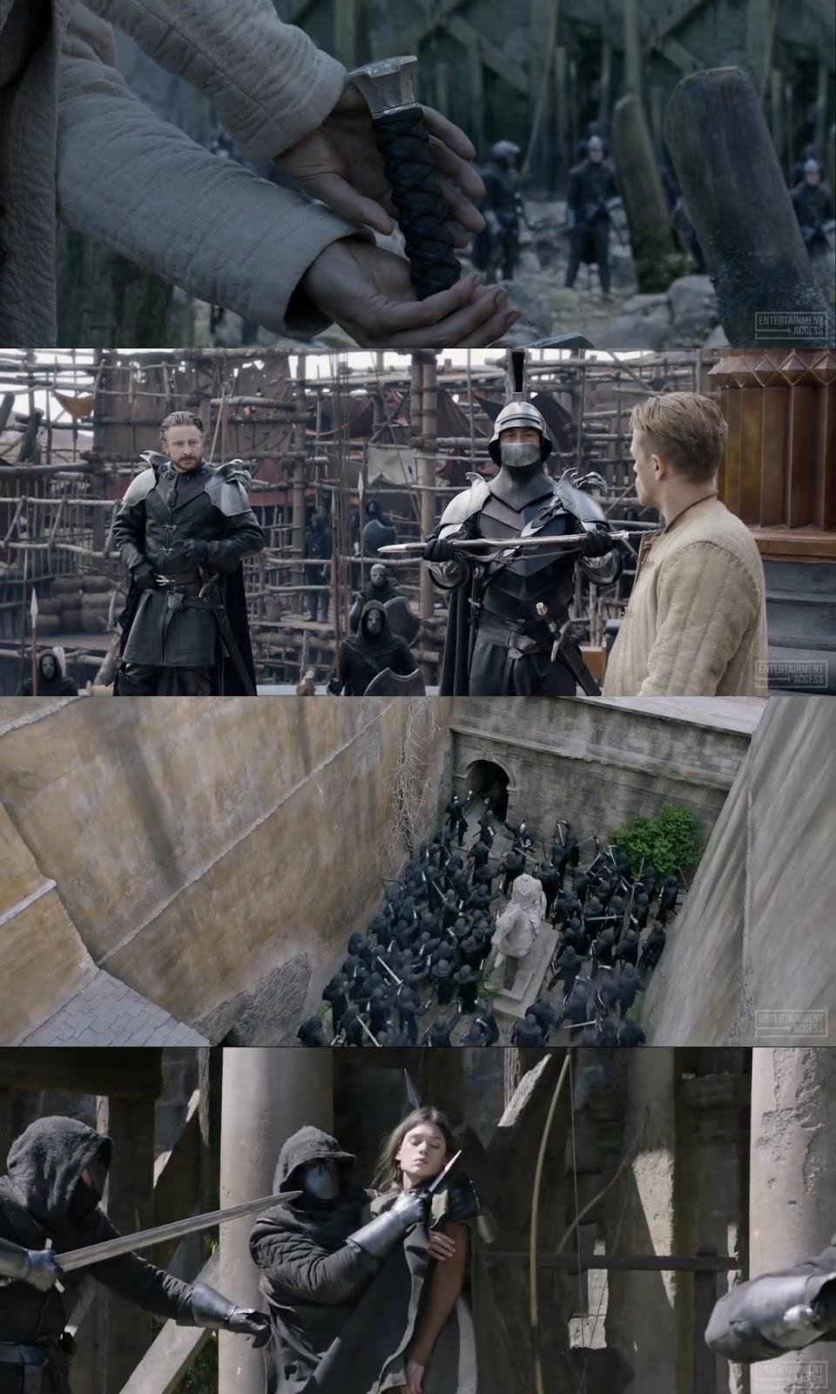

The scene of Arthur pulling the sword initially, and then using it when he and the other men are surrounded by Blacklegs is quite similar: it's meant to demonstrate how far Arthur has come. Whereas Arthur had to be saved by the Resistance when he pulled the sword (beheading), he was able to save his new friends because he learned how to wield Excalibur (or was learning).

Please note that Arthur has to use both hands to pull out Excalibur; why? Because hands symbolize our strength and our honor, and it's going to take all of Arthur to be worthy of Excalibur. But it also has to be Arthur's will to pull out Excalibur: he can't fake this, if he's going to pull it out, he has to pull it out.

At Arthur's "beheading," why doesn't Arthur take Excalibur when Mercier eggs him on and mocks him? For at least two reasons. First, Arthur knows that Vortigern is right: He will kill the women if he does anything. Arthur doesn't know how to use the power and he could look like an idiot if he passes out again. And then it's not Arthur's style. Arthur can be the "alpha male" with nothing but his wits and fists, and he would rather do that than be saved by something he hasn't earned, so we can call it "self-respect."

This also strengthens the Christian theme in the film because Jesus Christ refused to summon power when being tried before Pilate and Herod. As we have discussed before, it's appropriate that Vortigern wanted to "behead" Arthur because the leader of a country (or group) is known as "the head of government," so Vortigern cutting off Arthur's head is Vortigern saying, "You are not the head of government, I am the head." This leads us to the third image down.

In the third image, the Black Legs are congregating outside of George's courtyard, ready to bust down the door. You may have to click on it to get a better look, but please note the statue there in the middle of them; it has no head. This isn't a careless detail, this is a brilliant commentary. Just as I said above about the "head of government," at this point, we can see that the Black Legs are on the side that doesn't have a "head of government," everyone all ready knows by this point that Vortigern has lost, and Arthur will win. So, why are they still fighting for Vortigern? That's where "Black Legs"

comes into play. We know that "black" symbolizes death, and in this case, it's bad death: the Black Leg soldiers are dead to the spiritual life and the spiritual world, but alive to the world and worldly pleasures, or even alive to the call to serve evil.

This is where David Beckham's cameo becomes so important (he's pictured below, in the middle image, if you don't recall his cameo). You may or may not recall his cameo in The Man From UNCLE: when Illya (Armie Hammer) and Oleg (his Russian handler) watch slides and read the report on Napoleon Solo, the man operating the slide machine gets a slide of Solo turned upside-down; we then see the slide operator saying, "Sorry, comrade, sorry," and that was David Beckham; so Beckham's cameo as a communist in the KGB is not paralleling his cameo as a communist Black Leg in King Arthur, because just as the slide operator was revealing who Solo was, so in King Arthur, his instructions on how to remove the sword reveal who the true king is.

This is a terribly important scene for The Mage, like the Black Legs' attack on the cave where the Resistance hide later in the film. The soldier in the bottom image, holding a knife to her neck is not threatening her; she's allowing him to do this because it's the only way to nudge Arthur to accept what Excalibur is and can do, that is, allow Excalibur to help Arthur win back the kingdom.

The Mage has summoned all those birds flying at the top of the court yard, she is in no danger whatsoever, but the kingdom is in danger if Arthur doesn't accept his destiny and learn how to use Excalibur, so The Mage allows herself to be threatened so Arthur will be desperate.

We saw something similar to this in the animated film Hotel Transylvania 2, when the little vampire, Dennis, hasn't gotten his fangs yet, and it's not until his little friend is threatened that he let's his fangs out and fights back.

Then, later at the cave, The Mage also lets the Black Legs take her hostage because she knows the crisis Arthur goes through with

tossing the sword into the lake, but to The Mage, Arthur tosses away the kingdom, so she forces a crisis, quite artfully.

All people today, even though we are All saints and saints-in- training, have failed to appreciate passivity.

It's not the state of doing nothing, or doing little; passivity is the state of receiving, always receiving, and the receiving of the very greatest gifts. When the author of Psalm 46 wrote, "Be still and know that I am the Lord your God," he encouraged his reader to enter into this state of passivity of connection with God through the column of energy and the chakras above the head.

Because, unless we know God, we can't know ourselves; if we don't know ourselves, we can't know others, and if we don't know others, we do not know how to give to them that which we have received, because we cannot give that which we have not first received and unless we have entered into a state of perfect passivity, we haven't received anything.

Unless we give to others, we have not fulfilled our destiny, because it is in giving that we give God to others and simultaneously as well, receive Him again ourselves when we first perfected receiving Him in passivity. It's not a circular argument, rather, it's cyclical, and the spiral gets smaller and smaller the deeper one goes, because one always goes deeper into their soul which is the destination of us all; why?

Because that is where God is…

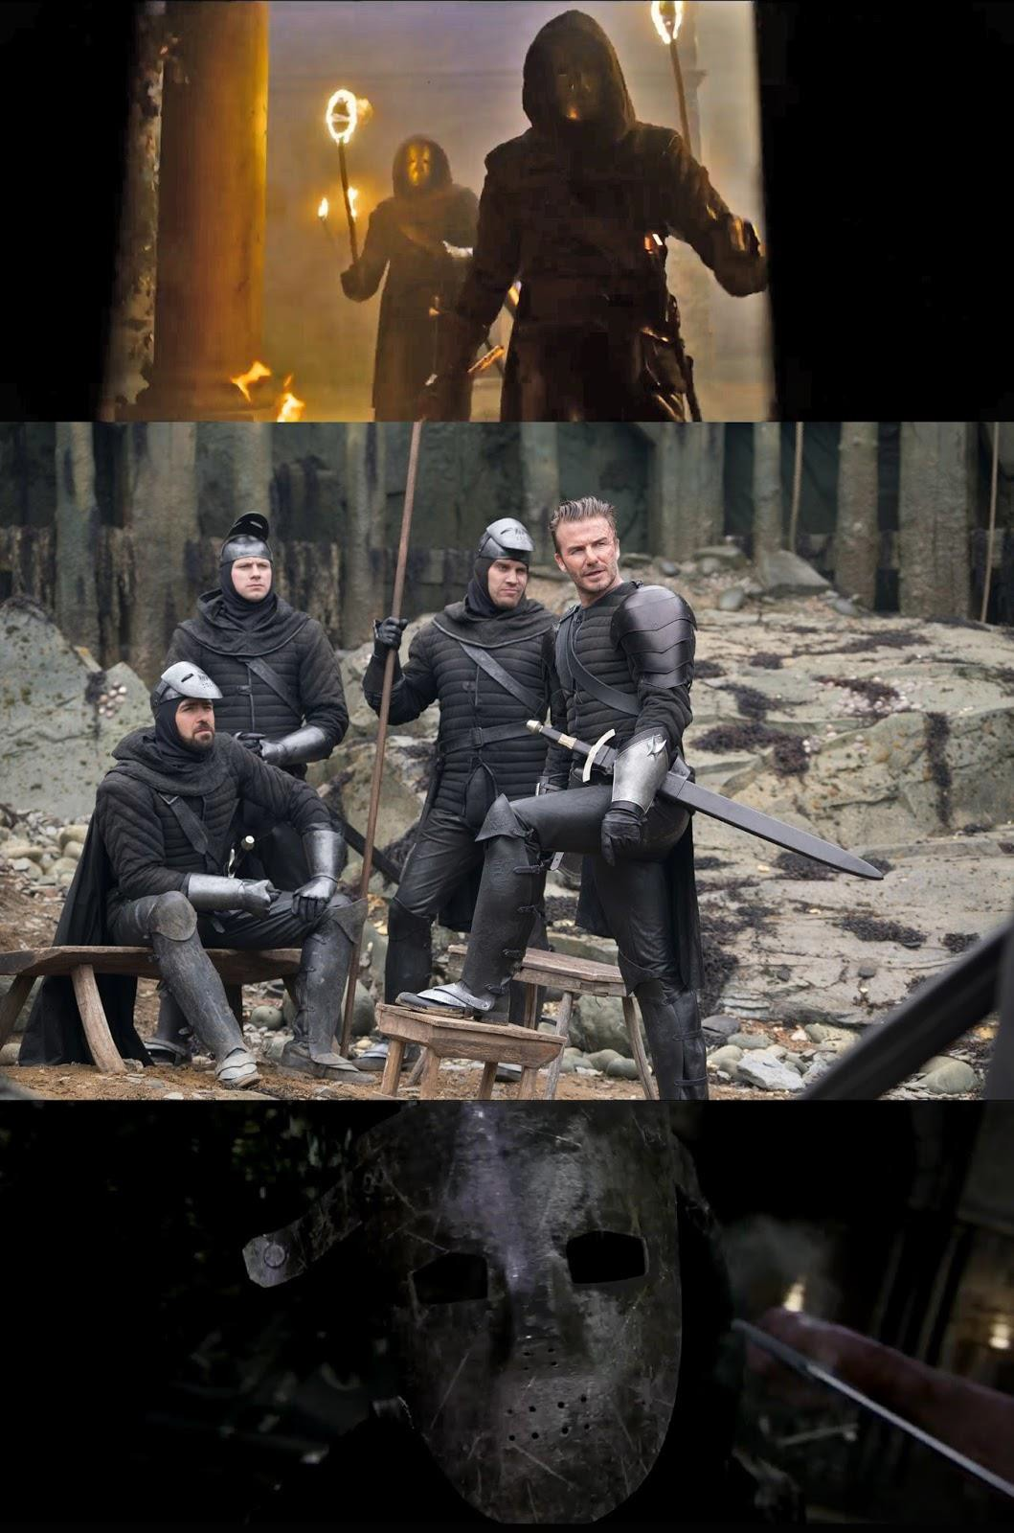

LEVEL 1 - 4 VIDEO COURSES ANYTIME IN THE COMFORT OF YOUR OWN HOME


Who, historically, speaking, were the guards who would break in at night and tear people out of their rooms and take them off some place to die? The Nazis. Given that Ritchie's last film, The Man From UNCLE featured plenty of Nazis, this isn't a far stretch for us to make at all. So why does Ritchie mention these Nazi soldiers again in King Arthur, via the Black Legs? The image at the bottom. The mask goes flying off one of the Black Legs when Arthur hits him with Excalibur, and we see the empty mask like horror film, Jason. This is the mask we have seen a number of times over the years: the motorcycle helmets of the bad guys in Mission Impossible Rogue Nation, or the other motorcycle guys in Zoolander 2, and the Storm Troopers in Star Wars, and the nasty bandaged and cut faces of the "nurses" in Silent Hill Revelation. The lack of identity. No- soul zombie Satanists.

As we started this article off with the name of "Arthur," there are hardly more men's names which summon such epic proportions as that of "Arthur," and that's his individuality, his own being, his personhood and inheritance from God.

And each one of us have it.

The fight against Satanism is largely one of fighting to keep our identity and not be forced to become like everyone else (which is what Guardians Of the Galaxy wants to happen to you).

Don't become a mask, become yourself and who God intended you to be, because the devil intends you to be his slave for eternity.

This is why men are not favored when it comes to receiving, they are, by nature, active.

Why? Because that is how God created them. They are of the earth and are meant to be active, and so that is why God created woman out of spirit, to supply the man with that which he did not have, and to "help" him get to heaven (feminism's despised "help mate").

Again, without woman, man can't get to heaven (which is why the serpent tempted Eve instead of tempting Adam) and without The

Mage, Arthur can't realize who he is and what he's supposed to do. It's not that Arthur trades Excalibur for The Mage's release from Vortigern because The Mage has power that Arthur needs, rather, it's because she has the knowledge to guide him and convey to him what he is going to experience that he needs because Excalibur is nothing if the one yielding it can't see and isn't strong enough to control that power, and that power, comes from women, which leads us now, finally, to the political.

This is the part which had me desperate and worried, but Ritchie--as always--does an incredible job with it. There seem to be two animals The Mage is most associated with: the birds and snakes. The birds symbolize the Holy Spirit, because it was as a dove that the Holy Spirit descended upon Christ at His Baptism. The snake, and any cold-blooded reptile for that matter, always symbolizes Original Sin, because it symbolises the Enochian Watchtower with the head of the snake as the eye of Sauron, the ball of fire, the flame of the candle.

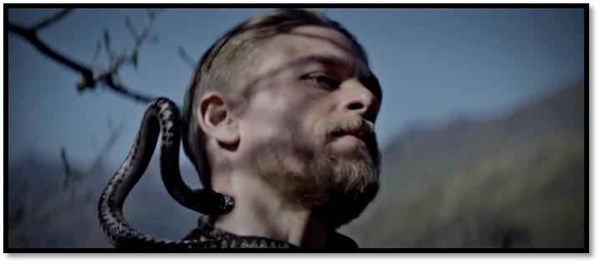

Do you remember the film (or the book) The Lion, the Witch and the Wardrobe? Two brothers and two sisters were transported to Narnia, and one brother, Edmond, betrayed his brother and sisters to the White Witch, but was saved by the lion Aslan. In another adventure, Prince Caspian, the siblings are desperate to contact Aslan for help but can't, so the eldest, Peter, begins summoning the White Witch to help him, and it's Edmond who steps in and saves Peter from making that terrible mistake; why? Because Edmond had "tasted" the venom of the White Witch and knew she was nothing

54

but poison. Even though Peter, Susan and Lucy had not fallen to her spell, because Edmond had experience with her, he was wiser than his siblings and knew better; the same is true with The Mage.

Because the Mage, like All saints, has overcome the venom of Original Sin within her soul she is able to give that (in a mysterious way) to Arthur to immunise him, to protect him. We know the neck symbolizes that which leads and guides us (like a leash around us) so that the snake bites Arthur's neck means that nothing evil is going to lead/guide Arthur, because he can "see" the evil which most of us are blind to (by a special gift of The Mage).

For example, when Arthur goes to Vortigern's castle, he can see the evil in the soldiers because they have given themselves to evil.
Saints can do this, us mere mortals can't because evil is still too much a part of our own nature, we haven't been able to sufficiently overcome it within so that we can recognize it outside of ourselves.

When The Mage takes on the form of that big snake which Vortigern chops in half with Excalibur, and gets the sword stuck in the wood column, that was awesome: we could say The Mage "speaks" to Excalibur, and the ringing noise of the sword when it's within the wood is the sword "speaking back" to her. In essence, what The Mage says to Excalibur is, I am the embodiment of Original Sin (the snake) and you are the sword of Truth, which is my enemy," and the sword acts accordingly.

Does The Mage lie to the sword? No, just as she and Arthur know that once Vortigern gets the sword stuck in the wood, so The Mage also knows the sword will guide Vortigern to kill the snake (the sword doesn't have a soul or can think on its own, but it is a power that is compelled by the nature of power itself to act accordingly).

What about the wood column? That's interesting because, historically speaking--even though this isn't specifically a historical film--in the medieval ages, there would not have been wood columns, especially at the throne of a king; it would have been marble, or maybe some other stone, if for no other reason than the architectural necessity of the stone strong enough to uphold the

weight of the rest of the building. So, the wood of the column was chosen for some other reason,... but what? The Cross. The Cross is the "altar" of sacrifice par excellence, and it was where it was decreed that evil was dead and God had triumphed, so it is, too, with Excalibur, Arthur and Vortigern.

At the start of the film, when we see Uther and The Mages in peace, before Mordred grabbed all power for himself, and used it against others, we can see a balance between political rulers--symbolized by Uther--and the Church (the "power" of The Mages).

The balance has been gravely upset because of greed on both sides of the balance in today's world. Again, films coming out this year (2017-2018) were expecting that Hillary Clinton would be president because that's what the Satanists told us: so the usurper, Vortigern, who has destroyed the peace, degraded the crown and killed for power, can easily be taken as either Obama or Hillary (I know I believed there was a good chance Obama wouldn't leave office).

Likewise, the Satanists , gravitating towards the occult (openly) with the public staging of the satanic curse to "bind" Trump, clearly has sided with Vortigern, that the ends justify the means, even though it means losing their soul,... But that leaves us with a last lesson from Arthur.

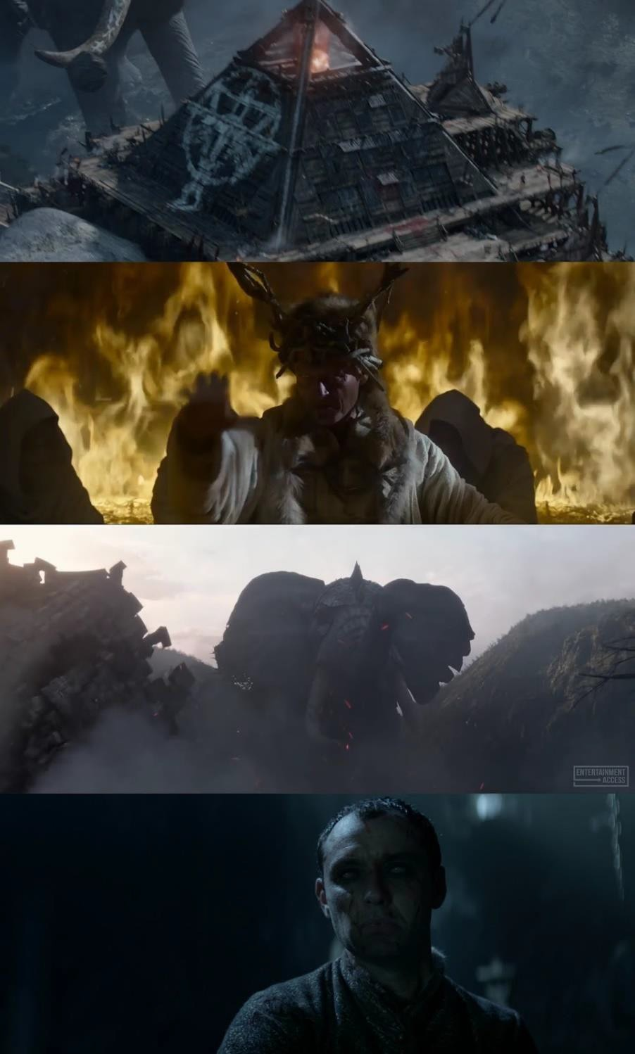

The three top images are from the opening scene of the film. The pyramid, with the satanic ritual taking place inside, invokes the Illuminati and the New World Order.

The second image down is of Mordred. Now, here comes the begging question: wasn't Mordred the son of Arthur and his half- sister Morgana? Yes, but it's possible that--IF the series goes on-- Morgana will name Mordred after THIS Mordred in the opening scene. The "head dress" Mordred wears in this scene invokes the same kind of pagan/satanic ritual that takes place in A Cure For Wellness (which I haven't see yet, but did see this clip, and that film takes place largely in the hospital where Hitler recovered form his wounds of World War I; that was just a joke, Hitler never recovered from those wounds).

What about those massive elephants being used? We know that elephants are not native to Britain, where the story takes place, they are, however, native to Africa; what has come to Britain, out of Africa, that has grown unnaturally large and is wrecking destruction on Britain? Wahhabi Jihadi Immigrants.

Now, when we see the eyes of the elephants, we know they are being possessed by Mordred, because once Uther kills Mordred, the eyes are calmed and the power over them ceases, so they are not inherently bad, but they are being controlled by the Secret Services who are inherently bad, and are using them specifically so destroy Britain and the USA as well as Iraq and Libya where women are now being sold as sex slaves and unwilling organ donors on the block; sound familiar?

The bottom image is of Vortigern after he has floated Catia's dead body on the water in sacrifice to the sea witches for increased powers to destroy Arthur. Two words about Catia. First, I think her name is meant to invoke Katia (Hannah Ware) from Hitman: Agent
47. Katia is an advanced agent and has taken care of herself since she was just a child, whereas Catia is like one of the little birds in a cage surrounding her in her bedroom: she is totally helpless and irresponsible, as well as not being disciplined (when she's still

young, Vortigern tells her to put a bird back inside it's cage and she doesn't; she doesn't respect him, why should she?).

But this is our second point: Catia, in not being able to do anything, is as helpless as one of those little birds in a cage, i.e., someone raised in a socialist system, because they can't provide for themselves, and they can't make it on their own, whereas Katia (Hitman Agent 47) has survived on the streets since she was a child.

Why, when Vortigern gets ready to kill Back Lack, and he has been listening to Blue's lies, does Vortigern say, he always wished he had a boy? Because Vortigern is disillusioned. Vortigern thinks it would have been nice to have a son, but Vortigern couldn't even manage his daughter, (remember, men symbolize the economy, but women symbolize the mother land and its culture) so because Vortigern is a socialist/communist figure--remember those sleazy deals he makes with the Vikings?--he can't have a son because Vortigern wants to control the motherland, he doesn't want an active economy; The Mage, however, when she appears as a snake and causes Vortigern to realize that he isn't powerful enough to defeat Arthur, demonstrates that he can't handle a real woman.

Just before Vortigern dies, Arthur blesses him and demonstrates his appreciation, that the terrible threat Vortigern posed to England summoned Arthur from the streets and brothel to the forefront of the struggle; likewise, should we be grateful that the evil revealing itself has caused us to unite, dig deeper into our faith, and stand firmly against such advances. Let us never forget, however, what has happened, and how it became so successful.

I could NOT be happier with King Arthur Legend Of the Sword and I absolutely can't wait to watch it again. There is a ton of stuff I didn't cover there was just an over-abundance of incredible material, as usual with Ritchie.


DOWNLOAD “GAIN SUPER ENERGY WITH ENERGY ENHANCEMENT LEVEL ONE INITIATIONS HERE!!!
http://www.energyenhancement.org/Sacred-Energy/Gain-Super-Energy-Energy-Enhancement-Level1-Initiations-Kundalini-Kriyas-Meditation-Shaktipat-Circulation-Taoist-Orbits-Alchemy-VITRIOL-Grounding-Psychic-Protection-Pyramid-Merkaba-energyenhancement-org.pdf

THE YOGA SUTRAS OF PATANJALI BY SWAMI SATCHIDANAND - DOWNLOAD HERE..
http://www.energyenhancement.org/Sacred-Energy/yoga-sutras-of-patanjali-book/Energy-Enhancement-Yoga-Sutras-of-Patanjali.pdf

ENERGY ENHANCEMENT IMMORTALITY LIVE COURSES, INDIA AND IGUAZU FALLS

ONLY THE SUPERPOWERS DEVELOPED BY THE SCIENCE OF REAL MEDITATION CAN FREE HUMANITY TO REACH THE STARS.

ENERGY ENHANCEMENT MEDITATION ENLIGHTENMENT AND ILLUMINATION

THE INCREDIBLE MEDITATION COURSE AND MEDITATION TECHNIQUES CREATED TO PRODUCE ENLIGHTENMENT AND ILLUMINATION

"ALL TRADITIONAL MEDITATIONS HAVE BEEN DESIGNED TO FAIL" - SATCHIDANAND -

"BECAUSE ORIGINALLY ALL MEDITATIONS CONTAINED THE TECHNIQUES OF, "THE KUNDALINI KEY" AND OF, "ALCHEMICAL VITRIOL" TO GROUND NEGATIVE ENERGIES AND TO NATURALLY INCREASE KUNDALINI ENERGY"

"NOW, ONLY ENERGY ENHANCEMENT MEDITATION TEACHES THESE TECHNIQUES WHICH SPEED UP THE ENLIGHTENMENT PROCESS"
SATCHIDANAND - IGUAZU FALLS

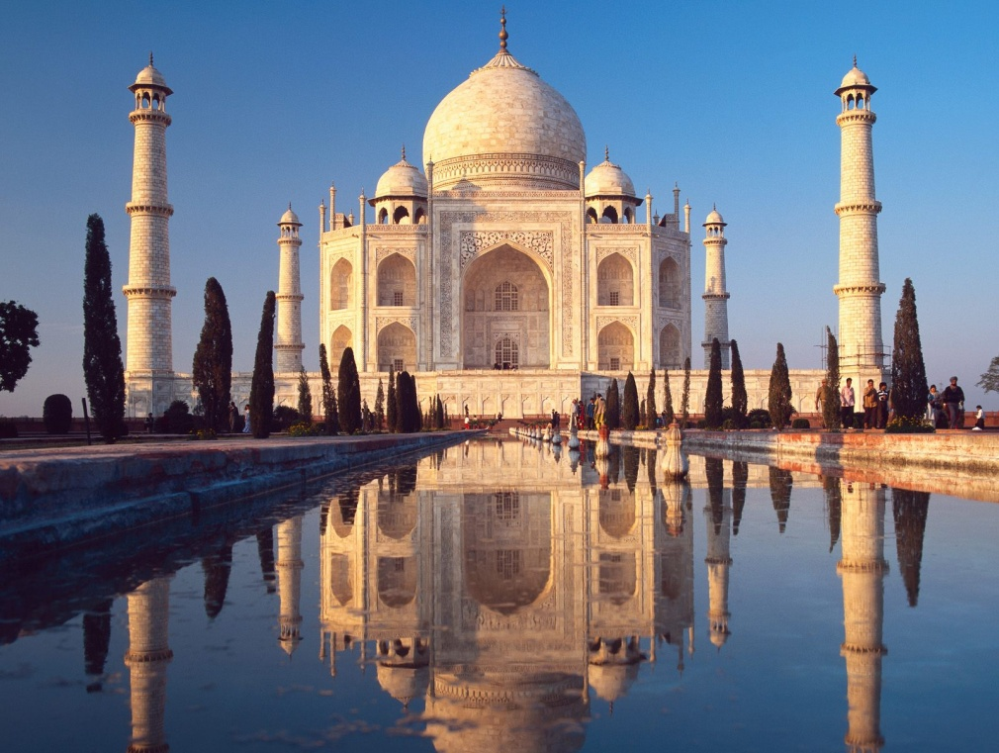

Karma and Anti-Satanism in the Spiritual Actor, Keanu Reeves movies, "John Wick (2014)" also "Man of Tai Chi (2013)" Esoteric Movie Review by Satchidanand

THE NECESSITY OF THE REMOVAL OF ALL BAD KARMA USING THE ENERGY ENHANCEMENT REMOVAL OF ENERGY BLOCKAGES AND THE SEVEN STEP PROCESS

"You only have power over people so long as you don't take everything away from them. But when you've robbed a man of everything he's no longer in your power -- he's free again." -
Aleksandr Solzhenitsyn

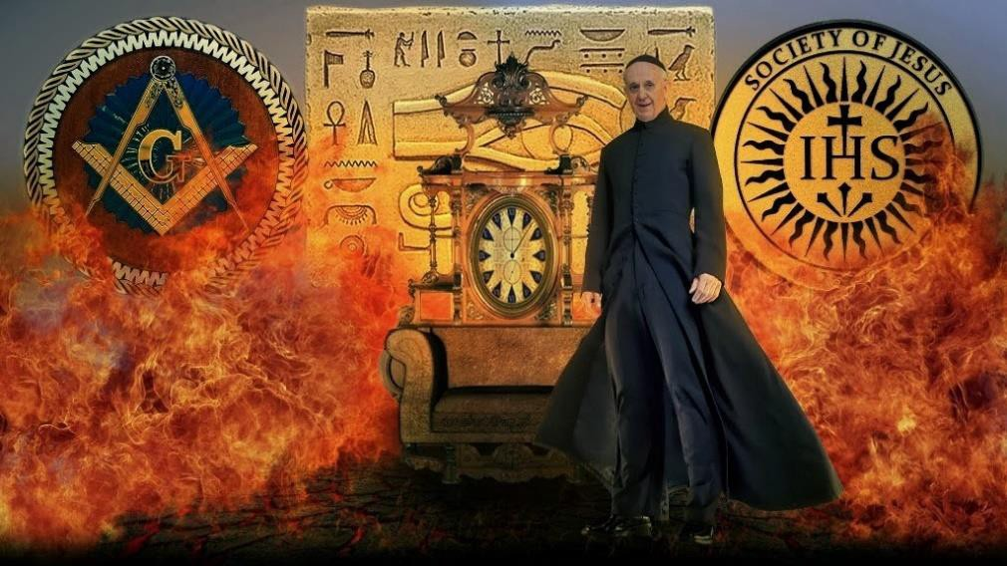"A state of war only serves as an excuse for domestic tyranny." The Gulag Archipelago (1973).

If you are wondering what John Wick's back tattoo means, Fortis Fortuna Adiuvat, menas, "Fortune favors the bold," or brave, depending on your translation.

"The gate man at the airport is reading Shibumi by Trevanian. It might as well be Richard Condon, Eric Ludlum or Eric Van Lustbader - All of them hated and hate the current Satanic Anglo- American Empire and all its symptoms, yet all of them failed to realise it's cause - the 10,000 year Reich of The Satanic Babylonian Empire and it's Spawn, The Satanic Roman Empire and it's current Emperor Pope, it's 500 Trillion Dollar Vatican Bank fronted by the Rothschilds and Rockefellers, it's Knights of Malta and Jesuits controlling the Freemasonic Cult and Jewish Sabbatean Frankist Cult also The Satanic Venetian Empire morphing into the British Empire and the current Anglo-American Empire.

So, what is John Wick? A great deal. The film has a heavy body count, but also a heavy symbol count as well, with the simplest aspects of character and action invested with a ton of esoteric meaning, with the "Self-awareness" of art, when a work of art knows it's a work of art.

When the Artist uses a the untruth of a story to tell a Great Real Truth.

“It was granted me to carry away from my prison years on my bent back, which nearly broke beneath its load, this essential experience; how a human being becomes evil and how good. In the intoxication of youthful successes I had felt myself to be infallible, and I was therefore cruel. In the surfeit of power I was a murderer, and an oppressor. In my most evil moments I was convinced that I was doing good, and I was well supplied with systematic arguments.
And it was only when I lay there on rotting prison straw that I sensed within myself the first stirrings of good. Gradually it was disclosed to me that the line separating good and evil passes not through states, nor between classes, nor between political parties either—but right through every human heart—and through all human hearts. This line shifts. Inside us, it oscillates with the years. And even within hearts overwhelmed by evil, one small bridgehead of good is retained. And even in the best of all hearts, there remains… an un-uprooted small corner of evil.”

— Aleksandr Solzhenitsyn, The Gulag Archipelago 1918-1956

Literature that is not the breath of contemporary society, that dares not transmit the pains and fears of that society, that does not warn in time against threatening moral and social dangers — such literature does not deserve the name of literature; it is only a façade. Such literature loses the confidence of its own people, and its published works are used as wastepaper instead of being read.

Open letter to the Fourth Soviet Writers’ Congress (16 May 1967) “The Struggle Intensifies,” Solzhenitsyn: A Documentary Record, ed. Leopold Labedz (1970).

Satanists have infiltrated the highest church positions, the highest Government Political Positions, Highest Government Ministry, University, Banking, Military, Freemasonic Institutions for 10,000 years and thus have been responsible for the degeneration and destruction of seventy-three civilisations - but they won’t stop good from eventually conquering evil, and God’s will being done. When we write “God’s will”, please understand that God has several types of will, including a conditional will, and an ultimate will. His conditional will is let men have what they want.

THE KNOWLEDGE OF THIS IS USED BY SATANISTS TO CREATE THE ANGER NECESSARY TO CREATE ANARCHISTS AND THEIR JIHADI MERCENARY ARMIES

FAR BETTER TO CLEANSE YOUR SOUL THAN FALL INTO THEIR TRAP

The collection of all Energy Blockages is called the Selfish Competitive Ego.

The limited egotistical will of all Energy Blockages always results in the Karma of bad luck and trouble.

"God have mercy on those who get what they want" - Hindu Saying

His ultimate will is to see His creation be a wonderful paradise which can only be done by aligning your will with the will of God - "Not my will, but Thy Will be done!!!" - Jesus.

Karma is the build up of Negative Karmic Mass and Energy Blockages on your time line of this life, previous lifetimes and future.

Energy Enhancement has been designed to Remove All That Karma!!

Unless you have removed all your energy blockages it is not possible to align your will with Gods Will.

Only by removing all energy blockages can you remove all your bad Karma!!

Only by removing all energy blockages can you become enlightened!!

Karma is the result of anything against the will of God - "Bad luck and trouble - If it wasn't for Bad Luck I wouldn't have no luck at all!!"

Some actors are what I call, "Spiritual Actors" because they are involved in major Spiritual Movies.

Keanu Reevesis one of those..
Dangerous Liaisons

Le Chevalier Raphael Danceny Bill & Ted's Excellent Adventure Ted 'Theodore' Logan
Bill & Ted's Bogus Journey Ted

My Own Private Idaho Scott Favor
Dracula Jonathan Harker Chain Reaction Eddie Kasalivich Devil's Advocate Kevin Lomax The Matrix
Neo

The Matrix Reloaded Neo
Matrix Revolutions Neo
Constantine John Constantine
The Day the Earth Stood Still Klaatu
Man of Tai Chi

Donaka Mark

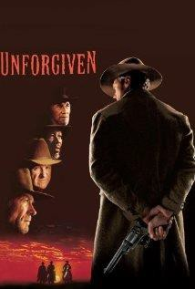John Wick John Wick

The movies most reminding of John Wick is Oscar winning "Unforgiven" by Clint Eastwood.

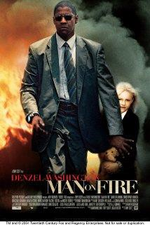

And "Man on Fire" by Tony Scott and Denzel Washington

Note how much Keanu Reeves created, produced, the Movie John Wick, as well as writing, Directing and Starring in Man of Tai Chi..

On May 7, 2013, it was announced that Keanu Reeves began negotiations to star in the piece in April, and was later confirmed as the film's male lead, after Iwanyk and Peter Lawson of Thunder Road showed him the script, to which he thought to be full of potential and further stated, "I love the role, but you want the whole story, the whole ensemble to come to life."

Reeves and Kolstad had worked closely together on further developing the screenplay and the story, with the screenwriter stating, "We spent as much time developing the other characters as we did his. Keanu recognizes that the strength of the storyline lies in even the smallest details." The title of the film was later changed from Scorn to John Wick, as according to Kolstad, "Keanu liked the name so much, that Reeves kept telling everyone that he was making a film called 'John Wick'", and the producers agreed, changing the title.

During story discussions for John Wick, Reeves contacted Chad Stahelski and David Leitch, who he originally met on the set of The Matrix, regarding the possibility as to whether they were interested in choreographing or directing the action of the piece. Reeves admired Stahelski and Leitch's work performing, choreographing and coordinating, stating that, "When I got the script... I immediately thought of Chad and Dave for the action design, but I was secretly hoping they'd want to direct it." he then added, "I knew that they would love the genre and I knew that they would love John Wick.

And I thought the worlds that get created — the real world and then this underworld — would be attractive to them, and it was." After reading Kolstad's script, Stahelski and Leitch, told Reeves they wanted to tell the story of John Wick, as they both had a desire to get involved with a project as directors. Impressed with Reeves' enthusiasm and the quality of the script, Stahelski and Leitch, told him that they wished to direct the film and later presented him with

their version of the story which was based on the idea of [Wick] as an urban legend, a thriller assassin movie with a realistic vibe and an otherworldly setting.

Impressed with their concept, Reeves supported the pair, and Stahelski and Leitch pitched the idea to the studio, who hired them to direct, contrary to their initial request of directing the film's second unit. On 7 May 2013, it was announced that Stahelski and Leitch were to direct the film together as a team, though it was later ruled by the Directors Guild of America that only Stahelski would be given the director credit. Leitch was credited as a producer.

It was remarked by Kolstad, once Reeves, Stahelski and Leitch were officially on board, that during the period of January 2013 to September 2013, he was still working on the final drafts of the screenplay and the modifying of it, to which he described in the general sense a rather "relentless process" further stating, "[…] it needs to be in order to get everyone’s vision in check."
JOHN WICK
"We're out killing strangers so we don't kill the ones that we love" song from John Wick



Like "Unforgiven" by Clint Eastwood, John Wick is a wish fulfillment dream of a person filled with Energy Blockage Karma who has collaborated with the Ultimate evil imagines that violence will solve his problems.

However, John Wick, his Will, his vision, is so clear that that revenge transmutes into a necessary house cleaning to remove evil - the good and perfect sacred warrior, the finger of God, an archetypal unstoppable force steamrollering all which is bad and evil and Satanic before it..

It is the use of evil to destroy evil.

John Wick is THE MAN, and in the highly anti-white-heterosexual- male atmosphere of America today, making a film glorifying a white man with very traditional values of masculinity is an act of political sabotage to the slave collectivists.

John Wick doesn't depend on anyone to take care of him, he takes care of his own business. Helen succumbs to a lengthy illness after collapsing one night, (in the movie, "Guardians Of the Galaxy", Peter Quill's mother died of a similar circumstance) reflecting the cancerous slow disease eating America right now after the financial "collapse" of 2008. The gold coins and Wick's stash of weapons also offer political commentary.

America was taken at the point of a gun from corrupt King George and his Redcoat and mind controlled Hessian enforcers so as to become the Francis Bacon utopia New Atlantis, Plato's Republic, Huxley's Brave New World, Augustine's, The City but it failed and has been infiltrated and taken over by Satanic UN Globalists so it is now even more corrupt than the country from whence it came.

Wick gets the nickname of Baba Yaga, "The Bogeyman" from Viggo, when he explains to Ioseph whose car Ioseph has stolen: Wick wasn't the Bogeyman, Wick was the guy you sent to kill the Bogeyman. This nickname (and this is always true in art) introduces an archetypal "alter ego" for John Wick into the plot and it's this alter ego that is the "John Wick" of the dream, not the suburban

husband of a sweet woman who liked daisies and died after a long illness.

Baba Yaga as "one of the most memorable and distinctive figures in eastern European folklore," and observes that she is "enigmatic" and often exhibits "striking ambiguity."[2] Johns summarizes Baba Yaga as "a many-faceted figure, capable of inspiring researchers to see her as a Cloud, Moon, Death, Winter, Snake, Bird, Pelican or Earth Goddess, totemic matriarchal ancestress, female initiator, phallic mother, or archetypal image"

A God!!

A finger of God!!

Satiated by an orgy of violence the viewer reels out of the cinema doorway into the night everything all right with the world. Bad guy gone, violence fulfilled, revenge satisfied, a force of nature, the psychic child anger, the energy of God has swept away all which is bad in the world.

Violence spent we can rest calmly in our beds. And do nothing!!
We have all been mad at God for things that have happened to us in our life, we have all had deep feelings of suffering and grief, of feeling lost and abandoned. Wick, having been a violent man, plays out what he knows in his unconscious mind (uncensored mind) but Viggo and Ioseph are just "figures," scapegoats who could be conveniently incorporated by Wick's mind to bear the guilt and responsibility for what has happened to him.

Does John Wick understand that his actions created the Devil Power of Viggo and his son.

Does he understand that his actions have created the bad karma that slowly cancered and killed his wife and his love?

That so brutally killed the bequest of love from that wife, his puppy dog?

Is he trying to make amends for bringing into being evil? For collaborating with evil?

Is he being used by God to destroy that which he helped create?

At the end of the film, unlike Denzel Washington in Man on Fire, John Wick chooses life, he chooses to go on living in spite of what has happened to him, and that indicates that, after the natural turmoil of Wick's emotions have played out, he has gotten through and re- affirms his relationship to God, again, in spite of what has happened to him, by choosing a new puppy Dog, symbolising love, the Soul.

So, moving onto the more political interpretations, John Wick is THE MAN, and in the highly anti-white-heterosexual-male atmosphere of America today, making a film glorifying a white man with very traditional values of masculinity is an act of political sabotage pitting the fascist WASP middle classes of Trump against the government supported communist slave collectivists of Obama and Hillary.

The Fascist/Communist Thesis/Antithesis dialectic.

The purpose of the growing police state worldwide is to provoke resistance and overcome it, moving towards total slave collectivism dialectical Synthesis - the problem, reaction, totalitarian solution.

John Wick doesn't depend on anyone to take care of him, he takes care of his own business. Helen succumbs to a lengthy illness after collapsing one night, (in Guardians Of the Galaxy, Peter Quill's mother died of a similar circumstance) reflecting the slow disease eating America right now after the financial "collapse" of 2008 it is continuing and getting worse. The gold coins and Wick's stash of weapons also offer political commentary.

The myth is that America threw out British corruption in the defeat of King George and his Redcoat and mind controlled Hessian

enforcers in order the create the utopia, the New Atlantis of Francis Bacon with guns, gold and guts.

People still believe in this children's story which is used to control sections of society politically.

Unforgiven and John Wick plays into this story as one man becomes an unstoppable force of nature, a finger of God, to set things right.

We can do it again, we can throw out these foreign satanic banker Globalist controllers says the movies.

America is now joined at the hip with good King George in the Anglo-American Empire unless Trump can somehow break the conditioning and stop it.

America too is corrupt and its works are WW1, WW2, Korea, Vietnam, Greece, South America, Yugoslavia, Iraq, Afghanistan, Libya, Syria, Ukraine, Yemen.

Even though Winston, the Hotel Continental owner, is a part of this seedy world, somehow, he's also above it, warning Wick that, if he dips so much as a pinky in, there will be something to drag him back in (so in this facet, Winston is a prophet). Being the owner of The Continental, with the manager at the front desk being called Charon (more on this below) means that Winston is like a Hades figure, especially when he executes justice on Perkins for breaking the rules of the hotel.

The Hotel, only serving assassins, reminds us that we live in an assassin society.

Most police forces have assassins for hire to the Mafia.

Above Delta Force we have the assassin force who manage the Government drug sales to the population, and above that James Bonds, "Licenced to Kill" giving cancer to Crichton, Kirchner, Chavez, Lula, Rouseff, Castro.

"We are a society of Killers" - “There are a lot of killers,” Trump responded. “We have a lot of killers. Well, you think our country is so innocent?” - Trump

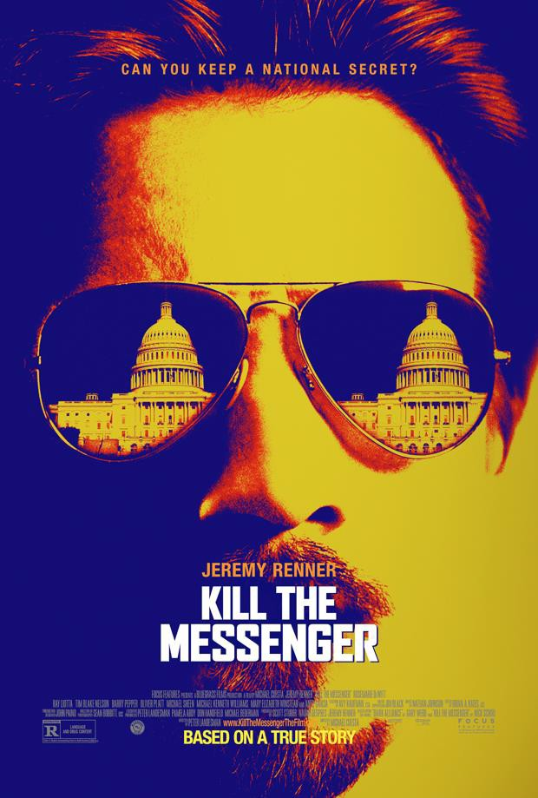

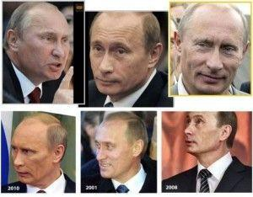

FIVE DIFFERENT PUTINS

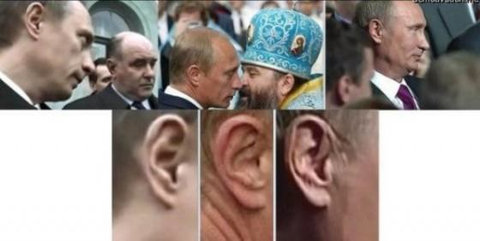
THREE DIFFERENT PUTIN'S EARS

Probably Putin has been assassinated - several times.

After getting cancer and a brain tumor, Hitlery Clinton looks different?

Yet the myth goes.. with 200 million people in America owning guns and mobilised, one million gun-spiked veterans filled with vaccines and put on the VA Deathlist as are all now under the Hitler

inspired Collectivist Obamacare - how could the police or the army defeat them? Co-opt them with Trump!

Solzhenitsyn reports his experience of tyranny - the creation of the Police State - to support the argument.

“At what point, then, should one resist? When one's belt is taken away? When one is ordered to face into a corner? When one crosses the threshold of one's home? An arrest consists of a series of incidental irrelevancies, of a multitude of things that do not matter, and there seems no point in arguing about one of them individually...and yet all these incidental irrelevancies taken together implacably constitute the arrest. ”

- Aleksandr Solzhenitsyn, The Gulag Archipelago 1918-1956

“And how we burned in the camps later, thinking: What would things have been like if every security operative, when he went out at night to make an arrest, had been uncertain whether he would return alive and had to say good-bye to his family? Or if, during periods of mass arrests, as for example in Leningrad, when they arrested a quarter of the entire city, people had not simply sat there in their lairs, paling with terror at every bang of the downstairs door and at every step on the staircase, but had understood they had nothing left to lose and had boldly set up in the downstairs hall an ambush of half a dozen people with axes, hammers, pokers, or whatever else was at hand? After all, you knew ahead of time that those bluecaps were out at night for no good purpose. And you could be sure ahead of time that you’d be cracking the skull of a cutthroat.”

- Aleksandr Solzhenitsyn, The Gulag Archipelago 1918-1956

The actual "evidence" question is actually sorta beside the point. Hanna Arendt specifically in "Origins of Totalitarianism" discussed how the Nazis would systematically treat actual criminals better than Jews, political prisoners or random arrestees, because in the end the message they were trying to send was that they could destroy you whenever they wanted, and it didn't really matter if you'd done

anything wrong. The only way you could be safe is by enthusiastically cooperating, and even then it was never really enough.

At this point we would make the distinction between a merely authoritarian regime and a more "bloodthirsty" thing. The first would be like, say, Morsi's Egypt or Iran, where they arrest people for opposing the state. The latter would be more like North Korea, where they arrest people at random whether they oppose the state or not..

And what is the point of arresting people who have integrated into society for years, who have businesses, wives, children. Who have used false documentation, green cards, who have done identity theft, broken the Law, in their millions? The creation of the fascist police state.

Because the terror is the end in itself.

And the terror is created to steer the steers into slavery - examples..

The Satanic British Empire creation of Radical Islamic Wahhabism Religion, seducing Abdul Wahhab with gold and girl agent, "Swallows" - by Agent Hempher in 1708. See this book http://energyenhancement.org/Hempher-14- ConfessionsOfABritishSpy.pdf

The Satanic British Empire creation of Al Qaeda, ISIS, Wahhabism as the State Religion of Satanic British Empire creation, Saudi Arabia, by Lawrence of Arabia. Saudi Arabia has spent 400 billion dollars per year every year for 50 years, supporting the spread of Radical Islamic Wahhabism Worldwide.

The Satanic British Empire creation of Communism and Socialism Religion by British Secret Services Ambassador Urquhart paying Karl Marx to write Das Kapital from his office in the British National Library in London.

The Satanic British American Empire creation of Communist Eugenic Agents Lenin (Lenin was sent into Russia with a train of Gold) and Stalin resulting in the deaths of 60 Millions and American businesses taking resources commodities from Russia for the whole period of the Soviet Union.

The Satanic British American Empire creation of Yale educated, Communist Eugenic Agent and 33rd Degree Freemason Mao resulting in the deaths of 80 Millions and then the rise of China like the rise of Hitler - an Aunt Sally to be knocked down.

The Satanic British American Empire creation of Fascist Eugenicist Agent Hitler resulting in the deaths of 30 Millions in War and "Final Solution" incinerated Holocaust Human Sacrificed Jewish Slaves.

Running the Left and the Right, the British Empire creation of Radical Islam, Communism and Socialism and Fascism Worldwide!!

WWI and WWII Cui Bono? - "Cui bono" (/kwiː ˈboʊnoʊ/), literally "for whose benefit?", is a Latin phrase which is still in use as a key forensic question in legal and police investigation: finding out who has a motive for a crime. "Cui bono" a Latin phrase from Cicero. It means "to whom for a benefit," or "who profits by it?"
Who benefitted? - The British/American Empire…

Miller was writing about the Hollywood Blacklist in the end, but it's an important example of authoritarianism of the first kind. Joe McCarthy knew that Dalton Trumbo who wrote the movie, "Spartacus" and Clifford Odets hung out, that they were fellow travelers with more committed Communists and even soviet agents, he had all the evidence he needed to prove association. But the logic of the 50s Red Scare wasn't driven by the desire to find Communist agents as much as it was to get "suspect" individuals to turn over their friends, so that even though there was no evidence of actual wrongdoing, there were simply so many people named that spectre of conspiracy took on a life all its own, and the spectacle of people evading the "justice" of HUAAC or the senate, of "hiding" their friends and associations, would cast disrepute on leftism in general.

They arrest you to make you look guilty, and then they make you turn States Evidence to buy back your respectability.

They infiltrate communist Agents into Hollywood and Universities to create the dialectic of Hillary/Obama communism against the Trump Right.

The unending War against terror was created by Bill Clinton. It was not an accident by incompetents to collapse Iraq, Libya and Syria.

They infiltrate Wahhabi Radical Islamic terrorists into the USA and Europe to create the dialectic of Problem Reaction, Solution.

The solution for USA and Europe - the Totalitarian Police State!! Unless Trump changes his mind..

“Thanks to ideology, the twentieth century was fated to experience evildoing on a scale calculated in the millions - 280 Million people DEAD!! in the 20th Century - This cannot be denied, nor passed over, nor surpressed. How, then, do we dare insist that evildoers do not exist? And who was it that destroyed these millions? Without evildoers there would have been no Archipelago.

There was a rumor going the rounds between 1918 and 1920 that the Petrograd Cheka, headed by Uritsky, and the Odessa Cheka, headed by Deich, did not shoot all those condemned to death but fed some of them alive to the animals in the city zoos. I do not know whether this is truth or calumny, or, if there were any such cases, how many were there. But I wouldn't set out to look for proof, either. Following the practice of the bluecaps, I would propose that they prove to us that this was impossible. How else could they get food for the zoos in those famine years? Take it away from the working class? Those enemies were going to die anyway, so why couldn't their deaths support the zoo economy of the Republic and thereby assist our march into the future? Wasn't it expedient? (see movies, "Soylent Green", "In Time", "Jupiter Ascending" or "Cloud Atlas") That is the precise line the Shakespearean evildoer could not cross. But the evildoer with ideology does cross it, and his eyes remain dry and clear.” ― Aleksandr Solzhenitsyn, The Gulag Archipelago

77

280 millions dead of war and torture in the 20th century!!

The character of Charon, the hotel manager who assists Wick throughout the film, is an important one because, even though Charon is a figure from mythology, he symbolizes the division between the living and the dead, being the ferryman who takes souls to their eternal destination. This half-way-world of the hotel adds not only to the Christian symbolism of the film (when Viggo talks about God taking Helen, Wick's wife) but also the journey that Wick's own soul is on to find redemption and get his "personal issues" resolved.

In the scene above, when Wick asks Charon, "How good is your laundry?" and Charon replies, "No one is that good," it's Wick realizing that he has spilled more blood than he had intended, and he needs to atone for what he has done (cleanse his soul of the blood he has spilled). Charon's reply validates that Wick will have to atone for the blood, not just wash it away.

"Out, out damned spot" Lady Macbeth was talking about a deep energy blockage of Karma which would, "turn all the seas incarnadine"

John Wick, "How good is your laundry?" and Charon replies, "No one is that good,"

Only energy Enhancement can remove spots that other techniques cannot remove.

Energy Enhancement is the best of the best!!

Freud postulates, "All dreams are a fulfillment of a wish." Does Wick want his car stolen? Does he want his dog killed? Does he want to kill dozens of (87) people? Does he want Marcus killed? No, to all these.

What John Wick does want, however, is revenge, to overcome evil, to make amends, to clean karma, to clean house, to destroy the results of his previous collaboration with Satan, to destroy the evil

which he himself helped to create and a way to channel the power of God by cleansing that evil.

"Lets all go and work for Satan because it's more convenient that way!" - American Beauty

This makes Viggo a "satan-figure" in Wick's "dream" (the plot sequence); what is it that verifies this? The church in Little Russia being used as a front for Viggo's vault (Viggo, as owner of the Church, becomes a "satan-figure" because the Church is set-up to work for him, not for God Himself) and that makes his son, Ioseph, an Antichrist-figure. In the violence that Wick deals out to both Viggo and Ioseph, does that make John Wick an anti-Christian film? No, just the opposite.

In addition to Viggo having the church in Little Russia as a front for his vault, containing money and political pedophile (Pizzagate) blackmail material, in this scene, when Wick has been captured by Viggo's men and Viggo talks to John (Viggo's back is to us, he faces Wick) Viggo tells Wick that God took Wick's wife away from Wick as justice for Wick's crimes, and that both of them are cursed men for what they have done. That's a pretty bold statement for Viggo to make because it testifies that Viggo believes in God, even though he has mocked the Church and Priesthood by using them for his own corrupt ends.

We could say that John Wick is an example of Matthew 21: 28-32 and the parable of the two sons: a father asks one son to go work in his vineyard, and the first son says no, but later goes and does the work; the father asks the second son to go and work in the vineyard and that son says yes, but never goes to do the work; which son has done the father's will?

Wick is upset with losing Helen, and experiences a complete crisis, but that "dark night of the soul" is something we are all going to go through, and it's meant to test us to the Breaking Point, unless we have gained strength, purity and Wisdom by removing our Energy Blockages.

So that we can see further, later, that even with all this action it is not enough to remove the spot. For that, meditation and the Energy Enhancement Removal of Energy Blockages, the Energy Enhancement Removal of Karma is necessary. But it is a good start!!

At the end of the film, you know Wick is back on the right path. Please remember, as noted above, Wick has a tattoo of a Cross on his shoulder and the Praying Hands on his back (and there was a priest officiating at Helen's funeral) so, even if he is not a practicing Christian, he has a chamber of faith somewhere in his heart.

The interrogation scene is interesting because it suggests Viggo intends this to be the place where Wick dies (he gives the order for Wick to be killed): there is a cement mixer and the place is under construction with scaffolding and tarps. Then again, these construction tools are probably literary devices indicating that this scene is meant to "build up" and finish the construction of the narrative, specifically, putting in place Marcus and his "illegal" helping of Wick and Viggo's revenge against him.

What does Perkins symbolize? What Helen is not: the Dark Woman. Helen is a woman of love, Perkins is a woman for hire as are all the slaves who collaborate with Satan, who think they are getting ahead, those who have really joined in. Helen reminds us of the "ultimate woman" Helen of Troy, whereas Perkins will slip into an abyss and no one will mourn or remember her. Perkins, then, is an image of self-sabotage, choosing to live the dangerous life and forego the warning signs of impending disaster--like the fine she will have to pay for breaking the hotel rules--for a quick buck whereas John Wick becomes the vengeance of God, cleaning house for the father.

Granted, Wick has a gun to Perkins' head when he "persuades" her to give him something to have cause to keep her alive, even though Wick probably knows that Winston, the owner of The Continental will have her killed for breaking the rules; Perkins delivers, and Wick is so confident that Perkins tells him the truth of the church in Little Russia being a front for Viggo's vault, that he goes into the church shooting the "priest." When, then, Viggo shows up at

Marcus' house and asks in person (rather than calling on the phone) for Marcus to kill Wick, and Marcus lies and tells Viggo he will, Marcus has, sadly, committed a greater crime than even Perkins committed. Marcus didn't have to lie, he could have said, "Thank you for offering me the contract, but I can't do it, we are friends," because there is no indication that Viggo would have had him killed for saying "no thanks."

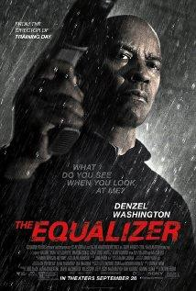But Marcus lying, even for his friend Wick, and then paying for his lie with his life validates the rigid structure of the film's morality scale also that we are what we are. Viggo is a bad guy.

He is Russian like the bad guys in Denzel Washington's movie The Equalizer (2014) - another movie like John Wick, are Russian and demeaning Russians is anti- Putin propaganda. "How can the leopard change it's spots?" ask the African elders. "Out, Out damned spot!!" says Lady Macbeth.

He is what he is, the Devil, and he does what he does. Only John Wick can stop him.

In conclusion, John Wick is a great film on several levels, and the kind of film we need to be seeing right now to remind us of breaking away from the collective, not collaborating with evil, to remind us of individuality, pain and suffering, karma, the importance of free will, Divine Retribution and Divine Forgiveness and the necessity for cleaning our houses internally and externally.

When Wick calls to make dinner reservations for twelve people, - the twelve people he has just killed - and Charlie's Specialized Waste Disposal truck arrives, Wick has indeed removed waste from his life in terms of the emotional turmoil the men breaking in symbolize to his psyche, and the film calls for us to be willing to do the same in our own unconscious minds, reminding us that even a "action-flick" can aspire to the status of art when the proper tools are used so that we be thoroughly engaged and come out, like the hero, better for it in the end.

Although the just War and the good, sacred warrior are myths engrained in the human psyche, higher is the knowledge that revenge is circular. Karma is circular. What goes around comes around and the Devil, Energy blockages, demons, archons exist within all of us...

“If only it were all so simple! If only there were evil people somewhere insidiously committing evil deeds, and it were necessary only to separate them from the rest of us and destroy them. But the line dividing good and evil cuts through the heart of every human being. And who is willing to destroy a piece of his own heart?”

— Aleksandr Solzhenitsyn, The Gulag Archipelago 1918-1956

"Everybody is the Shit of a shit, Mierde de la mierde; but if you want to change you are my brother, and I will help you any way I can" - Gurdjieff

“Gradually it was disclosed to me that the line separating good and evil passes not through states, nor between classes, nor between political parties either -- but right through every human heart -- and through all human hearts. This line shifts. Inside us, it oscillates with

the years. And even within hearts overwhelmed by evil, one small bridgehead of good is retained. And even in the best of all hearts, there remains ... an un-uprooted small corner of evil.

Since then I have come to understand the truth of all the religions of the world: They struggle with the evil inside a human being (inside every human being). It is impossible to expel evil from the world in its entirety, but it is possible to constrict it within each person.”

- Aleksandr Solzhenitsyn, The Gulag Archipelago 1918-1956

“Only those who decline to scramble up the career ladder are interesting as human beings. Nothing is more boring than a man with a career.”

- Aleksandr Solzhenitsyn, The Gulag Archipelago 1918-1956

“… What about the main thing in life, all its riddles? If you want, I'll spell it out for you right now. Do not pursue what is illusionary - property and position: all that is gained at the expense of your nerves decade after decade, and is confiscated in one fell night. Live with a steady superiority over life - don't be afraid of misfortune, and do not yearn for happiness; it is, after all, all the same: the bitter doesn't last forever, and the sweet never fills the cup to overflowing. It is enough if you don't freeze in the cold and if thirst and hunger don't claw at your insides. If your back isn't broken, if your feet can walk, if both arms can bend, if both eyes can see, if both ears hear, then whom should you envy? And why? Our envy of others devours us most of all. Rub your eyes and purify your heart -and prize above all else in the world those who love you and who wish you well. Do not hurt them or scold them, and never part from any of them in anger; after all, you simply do not know: it may be your last act before your arrest, and that will be how you are imprinted on their memory.”

- Aleksandr Solzhenitsyn, The Gulag Archipelago 1918-1956

“Bless you prison, bless you for being in my life. For there, lying upon the rotting prison straw, I came to realize that the object of life

is not prosperity as we are made to believe, but the maturity of the human soul.”

- Aleksandr Solzhenitsyn, The Gulag Archipelago 1918-1956

"This World is a Factory for the production of Enlightened beings" -
Swami Satchidananda

"Find a Perfect Enemy" - Don Juan

“The only way to get smarter is by playing a smarter opponent.” - Fundamentals of Chess, 1883 - Revolver, and the removal of sub- personalities..

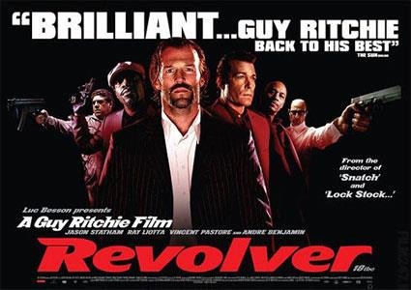
REVOLVER "2005" BY GUY RITCHIE

So, why did Keanu Reeves make the two movies?

The teaching on Karma is revived in the Keanu Reeves movie, "John Wick (2014)" where the bad guy says to Keanu that all the bad things that Keanu/John Wick did in the past are the reason his

wife died, is the reason the bad guy's son killed John Wick's dog, is the reason he is back in the assassination game.

We understand that John Wick helped create this Evil. His collaboration with the Devil helped create this Evil!! And the love of his wife helped remove him from that.
But now it is time to clean house!!

You cannot totally overcome this with violence!!

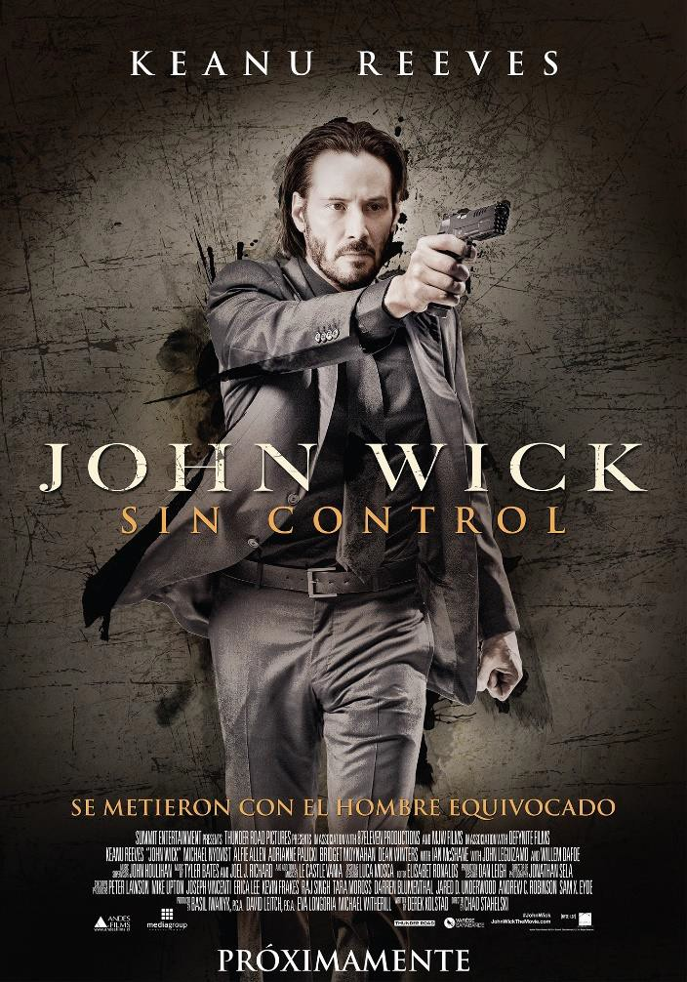

SACRED DANCES OF FUSION WHERE DEVI DHYANI EXERTS HER POWER - AVAILABLE ON YOUTUBE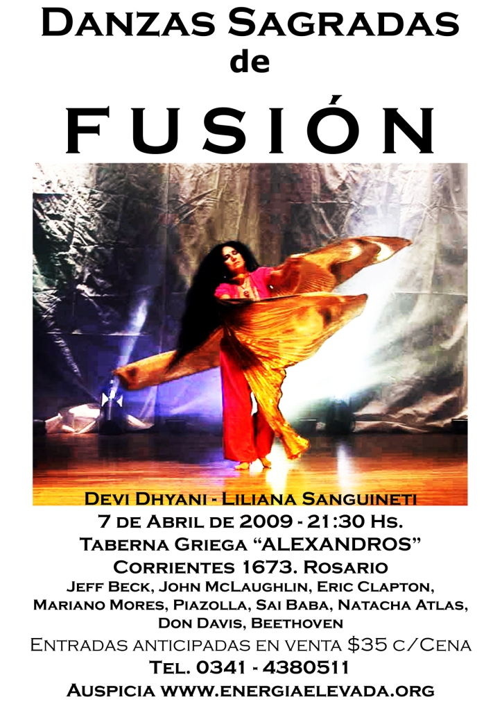This message comes out from sad Keanu's own life where his baby was stillborn, died in the mother's womb and one year later, the mother, Keanu's girlfriend and soul mate died in a car accident back around 2000.

Keanu's personal reflection on these happenings are the cause of the movie, "John Wick" and "Man of Tai Chi (2013)" written, Directed, and acted in by Keanu Reeves.

"Man of Tai Chi (2013)" stars Keanu as Donaka Mark whose Satanic work is to find innocent and good men and turn them into bad people/murderers - This is the work of all people involved with the 10,000 years old Babylonian Satanic Cult.



This is a true reflection by Keanu on the work of the falsely created Satanic Cult whose main work is the degeneration of humanity and Ritual Sacrifice, "Lives for Satan" "The Blood is the Life"

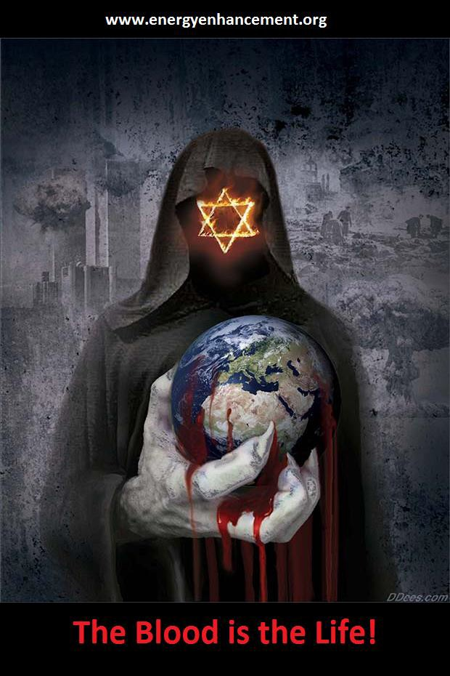

The key to this World is that over thousands of years, energy blockages have infiltrated humanity.

Some people have more Energy Blockages. Some people have less Energy Blockages. ALL people have Energy Blockages.
Energy Blockages travel with us, lifetime to lifetime.

Satanists inject us, implant us, with Energy Blockages as part of their created Religion in order to control and vampirise us!!

Only by removing all energy blockages can you remove all your bad Karma!!

Only by removing all energy blockages can you become enlightened!!

Only by removing all energy blockages using Energy Enhancement can you remove all your bad Karma!!

Only by removing all energy blockages using Energy Enhancement can you become enlightened!!

ENERGY ENHANCEMENT IS THE BEST OF THE BEST!!


DOWNLOAD “LEVEL 2 REMOVE ENERGY BLOCKAGES” HERE
http://www.energyenhancement.org/Sacred-Energy/Level-2-Book/Energy-Enhancement-Level-2-Book-Remove-Energy-Blockages.pdf
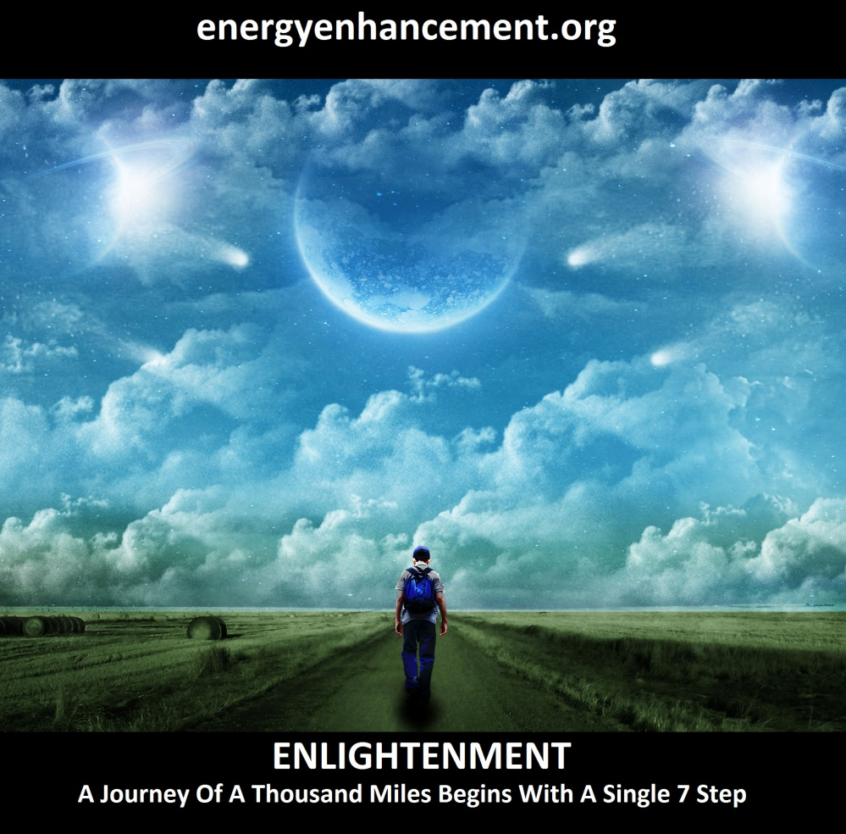
LEARN THAT WHICH IS FALSE WITHIN YOU
LEARN TO RECOGNIZE THE FALSE AS FALSE
-WITHOUT THAT, THERE CAN BE NO LASTING TRANSFORMATION
ENERGY ENHANCEMENT
"I was not sure if this was wise, as I knew nothing other than what I had read on the web site and the testimonials, which I was a bit skeptical about! However, I am now adding my own because if you read this you might be a bit like me...
Don't hesitate - go for it!"
MS (Ireland) Human Resources Director, Europe/Asia, of a Fortune 500 US Multinational Company
Honey Kalaria

" Once on the course, my exciting adventurous journey began! In my life I have done hundreds of courses but the Energy Enhancement Course I found to be completely different. Firstly, the contents and the teachings seem to be inspired by higher forces and had a deep base in spirituality..." Honey Kalaria (UK) Bollywood Actress/Owner of Diva Entertainment
ENERGY ENHANCEMENT
"I was not sure if this was wise, as I knew nothing other than what I had read on the web site and the testimonials, which I was a bit skeptical about! However, I am now adding my own because if you read this you might be a bit like me...
Don't hesitate - go for it!"
MS (Ireland) Human Resources Director, Europe/Asia, of a Fortune 500 US Multinational Company

GAIN SUPER ENERGY

ENERGY ENHANCEMENT MEDITATION

John Wick Ch 2 - Is Donald Trump - The Spiritual Warrior - Finger of God - Removes Satanic Demons, Deletes the Elite, Cleans the Swamp - Move Bitch, Get out the Way!! Esoteric Movie Review by Satchidanand

The use of Evil, by God, to remove Evil.

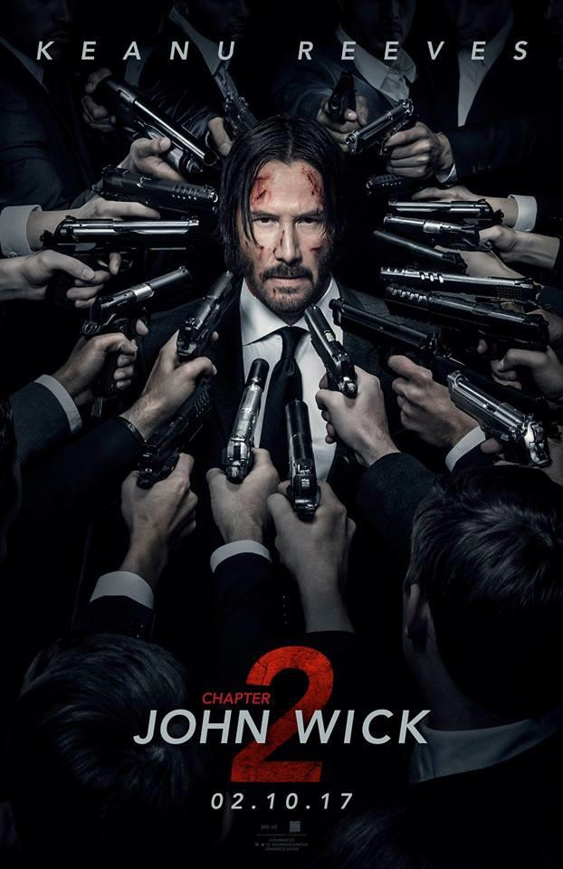In the colours of Purifying Fire And Pure Gold!!

"We do not look at the things which are seen, but at the things which are not seen. For the things which are seen are temporary, but the things which are not seen are eternal." Corinthians 2 4 13

Like "Revolver (2005)" the first cut - by Guy Ritchie, we can see the Underworld, the Meta World of John Wick as a Soul beset by Demons - external Demons representing the Internal Demons. And as all external demons are removed, so the protagonist is seen to remove his ego - the famous lift scene in Revolver - where the ego is seen, and removed.

Like "Fight Club (1999)" we can see that John Wick is divided into the good Soul, represented by his wife, Helen, and his dog given to him by his Wife, and the evil of his previous life as an Assassin for hire living in an evil Satanic World of Assasins, Mafia, Camoro, Ndrgeta with a High Table of twelve Coronated Demons.

As the Demons are removed then the World as Soul becomes purified.

The Wick is lit and the dynamite explodes!!

The Wick is lit to become the Light of the World - the new Jesus Christ!!

John Wick Chapter 2 is the story of you!!

John Wick Chapter 2 is the story of your Enlightenment.

John Wick, this Angry White Male, is being told by God, that he needs to clean the Swamp.

It is very much the story, consciously told, of how, by removing the internal demons by Energy Enhancement Meditation Seven Step Process.

As Within..

So externally, other Agents of God can remove the Demons Externally..

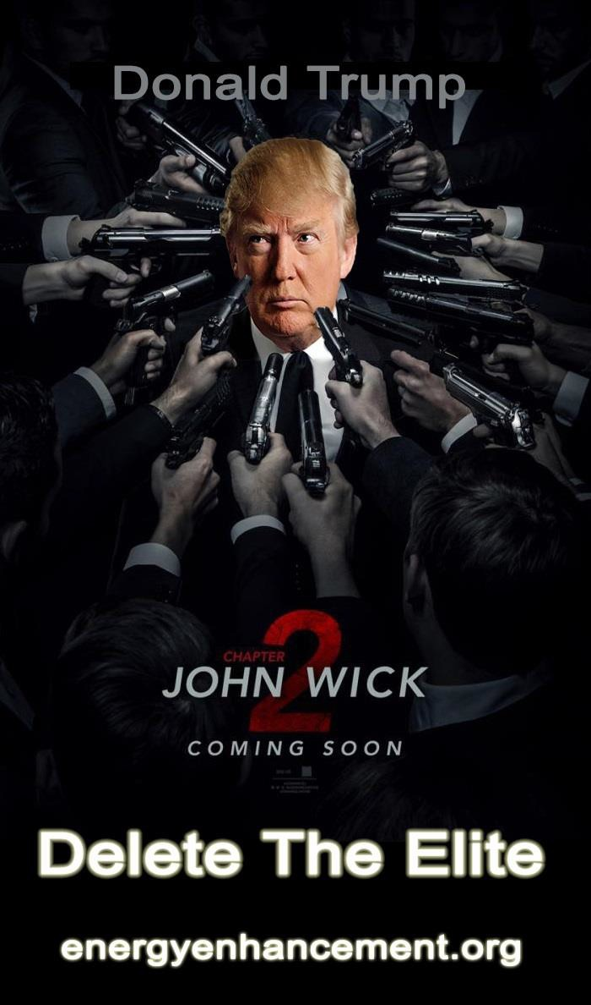

So Without..

President Donald Trump, like John Wick, being catapulted into a 10,000 years old World of Powers, Demons, of the High Table - Mafia, Camorra, Ndrgeta, Popes, Jesuits, Knights of Malta, Rothschilds, Rockefellers, Soros, CIA created Google and Facebook, Black Nobitity, Central Banks all run by the Vatican Bank, the 9th Satanic Circle of Pedophiles, Human Sacrifice and Cannibalism Rituals.

And everyone from Corporate controlled Fakestream Media like Clown Negative News advising Assassination. No wonder all those guns are pointing at him.

And wanting to drain the swamp!!

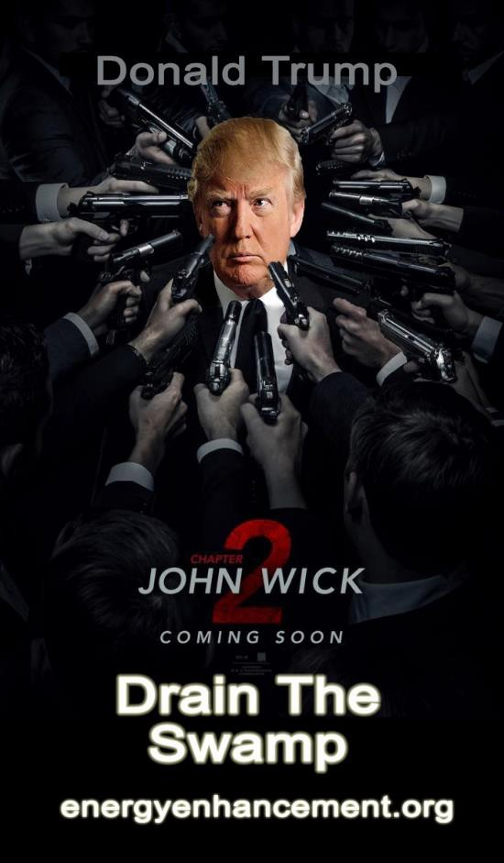


THOUSANDS OF RENFIELDS BUT AS YET, NO DRACULA!!

911 was the biggest bank heist in history!! When the two Towers came down 100 Billion dollars in Gold Bars disappeared. When the two Towers came down 100 Billion dollars in bearer bonds disappeared. When the two Towers came down 100 Billion dollars in Diamonds disappeared. And the third tower was not hit and came down all by itself. The wicked wolf said, "And I'll huff and i'll puff and i'll blow your house down!!" That is what happened, really!!

The Communist - Fascist Dialectic - both Sides created by British Intelligence.

The Black Nobility. Privately these families refuse to recognize any right to rule except their own. They are working to use their creations Communism/Socialism and Fascism to create worldwide

poverty and a new feudalism to manage the World of the New World Order - the name of Hitler's second book.

1. Communism and Socialism were created by British Secret Services David Urquhart who employed Karl Marx to write Das Kapital from his office in the British National Library in London. Later, Agents Lenin and Stalin used Eugenics and Lysenkoism to kill 60 million people. Communist Mao was taught at Yale, put into power by the CIA and was a 33rd degree Freemason. He killed 80 millions and execution evisceration vans still send organs of religious people and dissenters to rich Oligarchs.

2 Fascism and Nazism was created by Britain and then the Rockefellers ran with it to create Eugenics, Watson at IBM to run Hitler's concentration camps, Corporatism and Politics to runs the Feudal Society. Into the mix Hitler brought the Old Religion of Valhalla - it is good to die in battle - Sacrifice and Sexual Ritual together with Berserker methamphetamines for the Army.

- Saudi Arabian Wahhabism was created in 1708 by British Agent Abdul Wahhab and Saudi Arabia was given control of the Oil by the British after Lawrence of Arabia if they made Wahhabism their State religion. Al Quaeda, Isis rent an Army to destabilise Libya and Syria kill 300,000 Christians and flood Europe and USA with Wahhabist Jihadis is controlled by the British and Americans through their Sabbatean Frankist Saudi Stooges.

- The French Revolution was Created By British Secret Services

Like Wahabists and the Salafists, Isis and Al Qaeda, British Secret Service controlled Isis Freemasonry was used to destabilise and take over France during the French Revolution.

The speeches of Robespierre were written from London by Jeremy Bentham, "M" of the British Secret Services at the behest of Lord Shelburne prime minister of England previously head of the slave trading, drug running East India Company. Satanist Bentham invented the term, "Free Love" defined as Sex, Sodomy, Pedophilia, and Bestiality..

From the outset, the French Revolution Jacobin Terror was a British East India Company - British Foreign Office-orchestrated affair.

The bloody massacre of France's scientific elite - the destruction of the wealth creation of Science - the satanic anti-science aganda - the Satanic Principle of Poverty - was systematically carried out by French hands, manning French guillotines, but guided by British strings.

British Agent Jacques Necker, a Geneva-born, Protestant, slavishly pro-British banker, had been installed through the efforts of Shelburne's leading ally in France, Philippe Duke of Orléans, as finance minister. Necker's daughter, the infamous Agent, Madame de Staël, would later run one of Shelburne's most important Parisian salons.

Although Necker had failed to block France from allying with the Americans during the American Revolution, he did succeed in presiding over the depletion of the French treasury and the collapse of its credit system, as in the USA today.

Economic crisis across France was the precondition for political chaos and insurrection, and Shelburne readied the projected destabilization by creating a "radical writers' shop'' at Bowood staffed by Satanic Psychopathic British Agents Bentham, the Genevan Etienne Dumont, and the Englishman Samuel Romilly.

Speeches were prepared by Bentham and translated and transported by diplomatic pouch and other means to Paris, where leaders of the Jacobin Terror, Jean-Paul Marat, Georges Jacques Danton, and Maximilien de Robespierre delivered the fiery oratories.

Records of East India Company payments to these leading Jacobins are still on file at the British Museum.

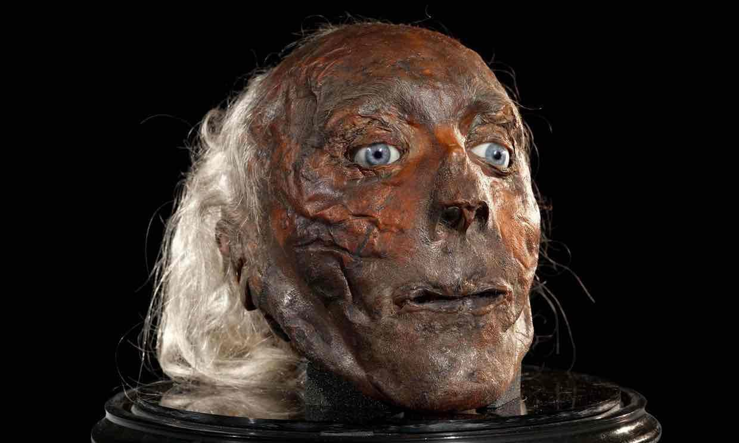
SATANIST JEREMY BENTHAM'S HEAD WHICH IS KEPT UNDERNEATH HIS STUFFED BODY IN HIS FAVORITE PUB

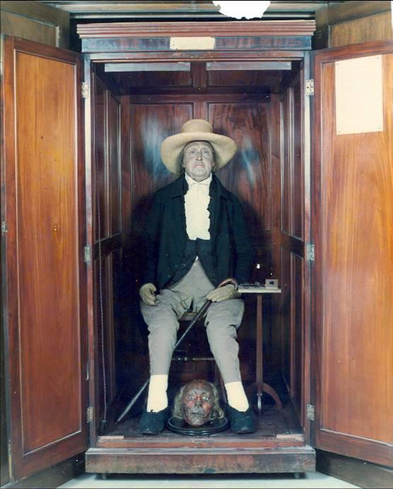

The Vast Majority of the Low IQ Public comprising Dumb Sheep and Dogs know nothing of this.

This information is written for the most alert and aware.

It is written for those who are capable of becoming enlightened.

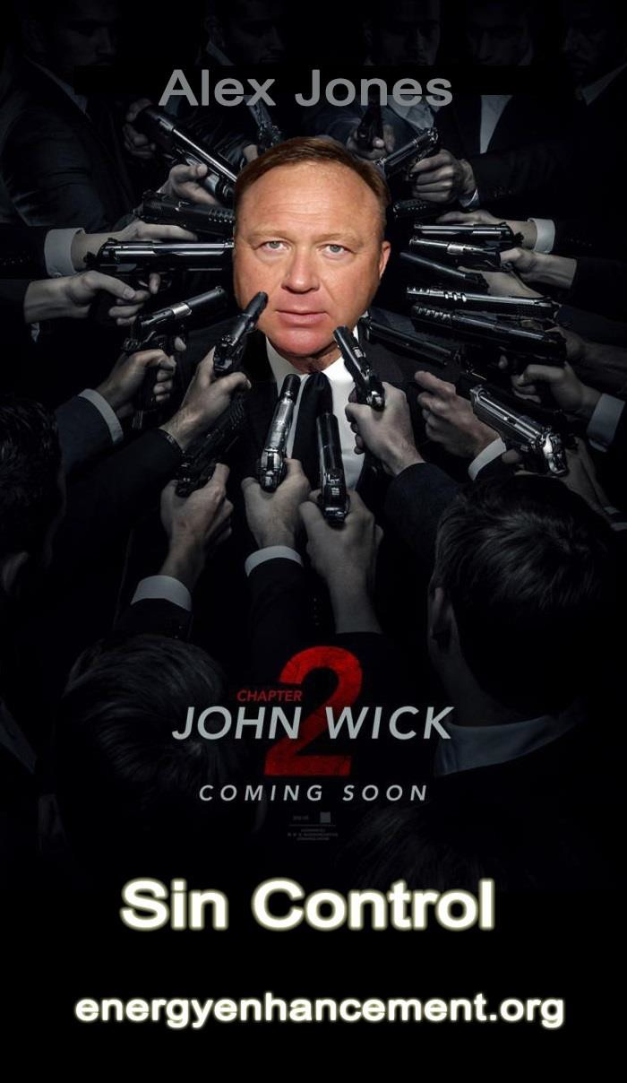
THE REAL NEWS IS RISING

The Communist - Fascist dialectic of problem, reaction, solution is to create a feudal poverty-stricken population Worldwide, no middle class - only Oligarchs - who will merge with the transhumanist machine - and slaves.

And we know that the High Table sells drugs and pedophile sex worldwide in order to launder black money to fund that legitimate businesses - Cancer, Armaments, Petroleum - which control the World.

The Bushes were always in charge of importation and sales of heroin from Vietnam importing using the cavities of dead soldiers from Vietnam. Later the Golden triangle between Burma, Thailand and Laos. Later Afghanistan after Osama Bin Laden ramped up production to supply 90% of the Worlds heroin and CIA and Nato Planes were transporting heroin to army bases in Europe. A total of one trillion dollars for 50 years = 50 trillion dollars.

Later, the Clintons - a mind controlled bastard of the Rockefellers and the daughter of Hugh Rodham who took over Chicago for the mob after the death of Al Capone - imported one trillion dollars per year of cocaine into Mena, Arkensaw and laundered the money in Miami, New York, Chicago and Europe. A total of one trillion dollars for 50 years = 50 trillion dollars.

100 Trillion dollars!!

Back in 1995 seven American Generals proposed to impeach Bastard Bill Clinton for treason because he sold the plans for the F22 Fighter jet to China out of Sandia Labs in New Mexico. The money went into the Clinton Foundation like all the charity money from Haiti and contributions from Putin for selling 20% of USA Uranium to Russia quite recently.

Papa Bush got the contract to Assassinate them and the plane with those seven Generals on board exploded in Alabama.

Bill went mad and fired 200 Generals who failed the test of loving the Constitution more than the Bush - Clinton Crime Family Narco- Trafficers.

Moron Bush fired 200 more in his next Presidency.

Bush Clinton Acolyte CIA cutout Obama fired 500 Generals in his term.

All of those three Presidents are cocaine addicts, the reason why none of their medical records were made extant as the law requires.

And all those fired ass Generals got to talking with their operatives like James Bond Pieczenik who is responsible for at least eight coups of governments worldwide for the CIA, and they formed the America First Organisation.

Donald Trump is their Champion.

It is of alarming concern that Roman Catholic John David Podesta, Chairman of Hilary Clinton’s 2016 presidential campaign, previous Chief of Staff to President Bill Clinton and current Counselor to President Barack Obama is a part of her secret Satanic inner circle. He was invited to a “spirit cooking” with Marina – another form of Mary that stands for rebellion and overthrow.

Today, people can see through the VEIL as never before in history. The internet has exploded about 425 pedophile arrests, the freedom of 45 pedophile Sex slaves, Pizzagate, Marina, Posdesta, Witch Hilary Clinton and their links to what is basically the Vatican’s Ninth Satanic Circle.

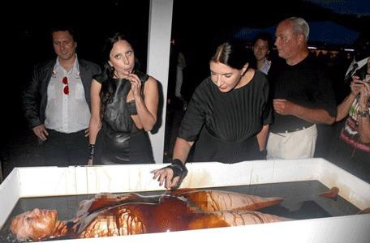

So, the gutless and compromised U.S. Justice Dept. and FBI has announced that they are bailing out of the investigation of Anthony Wiener, Hilary Clinton, Blood Rituals and Pedophilia Sex Rings. It’s a rabbit hole far too heavy, deep, scary and dangerous.

Except they found 425 Pedophile Renfields and freed 45 Pedophile Sex slaves and they are singing like canaries!!

It is very much the story, consciously told, of Finger of God, President Donald Trump starting to clean house, drain the swamp - Move Bitch, get out the way!

The Vast Majority of the Low IQ Public comprising Dumb Sheep and Dogs know nothing of this.

This information is written for the most alert and aware.

It is written for those who are capable of becoming enlightened.

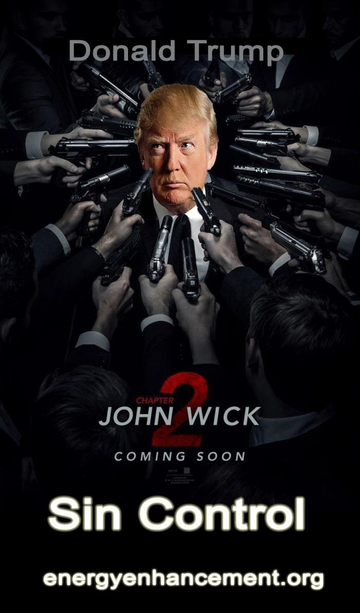

Yea, bad day. Okay, so what is happening between John Wick and John Wick Chapter 2? Opening John Wick 1, Wick buries his wife, Helen and then he loses his car;

JWC2, Wick gets his car back, then loses his house; why?

John Wick escapes from the Assassin life and gains his Soul - his wife Helen and the dog she gave him but in order to evolve he needs

to cut off totally from the Assassin Life and remove the Satanic Demons.

The next step of John Wick's evolution does not come from him. God wants him to evolve and to do that God must stimulate him to act.

Helen dies of Cancer.

Some Demon kills his Dog!!

John Wick cleans house but does not finish the job of killing Uncle Abram - big mistake.

Santino calls him back into the life. John Wick kills Santino's Sister Gianni.
John Wick kills Santino in the Continental Hotel - he does not make that mistake again.

John Wick does that consciously, breaking all the Assassin Rules, knowing all the consequences, cutting himself off from all Evil.

Knowing the only way out in Chapter three - to totally destroy all the Demons of the High Table - Armageddon!!

The Civil War between the Gods mirrored by that picture of the Civil War and the statues of the Satanic Pagan Gods in the Museum when we first see Santino.

God against Satan with the whole World at Stake!! That is exactly what happens in JW and JWC2
John Wick needs to remove all external demons, symbolising internal Demons, in order to achieve perfection.

Welcome to the spiritual life, my friend. Every film operates on at least two levels all or most of the time: the physical world and the spiritual world.

Few films, however, are as intensely aware of operating on both levels, and do it so consistently throughout their narrative--and take great pains to communicate to its audience that it is doing so - as John Wick Chapter 2.

Why is this important? Because it validates there is a message within the film, and validates our effort of engagement to decode what that message is. In this particular poster above, for example, all guns are pointed at Wick's head; why?

The head symbolizes our "governing function," such as the "head of government," "The President Donald Trump" whom everybody who is anybody says is targeted for Assassination, just like finger of God, spiritual warrior, John Wick!!

And the head is the most important part of the body and the body of America.

The guns point to Wick's head because Wick has been able to "govern himself," as Abram says in the opening sequence regarding Wick's focus, commitment and sheer will power, and those virtues means the forces of evil can't overcome Wick because Wick has fortressed himself with those virtues.

On the spiritual level, all demons (the assassins) want to kill John Wick because there is a $7 million dollar reward for him; "7 million" is divided into two different symbolic numbers: there is the "7" and there is the "million." Seven always symbolizes perfection, or, in opposite terms, total depravity.

Since John Wick survives to the end of the film, instead of dying, and because he is the hero, then the $7 million contract Santino puts out on John Wick means that Santino recognizes John Wick as "perfection" and it will take "perfection" from the demons to destroy John Wick.

The assassins, of course, are not literal demons, they are, however, metaphorical demons, or "tools" used by Satan to break down John Wick so the devil can collect Wick's soul.

So, what does the "million" represent? Any multiple of "10" is divine perfection, it means the work of God has been brought to completion. By the end of the film, there is a $14 million contract on Wick, which means God has opened another work he He is going to bring to completion (Chapter 3).

Note that John Wick makes two important mistakes at the start of the film:

- He doesn't kill Abram, the Uncle of the kid who stole Wick's car in John Wick 1.

- Wick buries his clothes, coins and guns in the basement again. Why? In case Wick needs them again, and that's "an open door policy," in other words, a part of Wick is ready to go back to the life, although he would rather not.

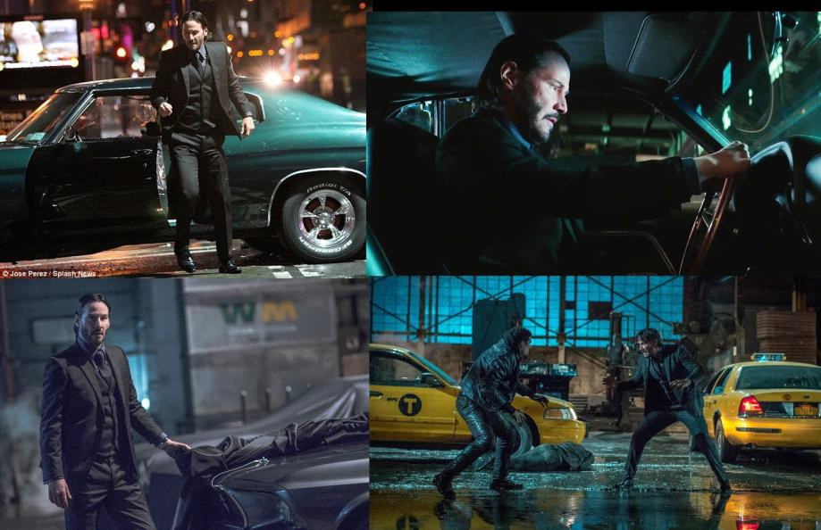

When Wick makes it to his car, the gestures Wick uses, the way he walks and "gets by" the thugs standing guard, is echoed in Rome after Wick finished with Gianna and Wick gets back to the Catacombs where his escape route is; why?

Because Wick didn't do what he was supposed to do - God's purpose is to bring John Wick to the understanding that his purpose is to purify himself by purifying the World - he did not kill the Demon uncle Abram - note that Abram comes from A - Brahma - not God - as he should have done that being God's Will - and because he did not kill Abram, God sent Santino to bring him back in, to make him kill Gianna and Santino, to start the purge of the Twelve seats on the High Table.

In getting his car back with Abram, Wick now has to endure the far greater trial of killing Gianna, and by mirroring these two scenes, the film makers want us to keep that in mind.

When Wick finds his car, covered with the tarp (lower left image) it's like a body bag covering it; why? Because Wick is dead like a cadaver covered with a body bag in the morgue (don't believe me?

Remember when Wick wakes up after telling Earl to take him to see the Bowery King, and the guys Earl killed are in bags beside Wick, but Wick is alive and bandaged; again, that scene is being played out because Wick fails to kill Abram, so Wick has to go through it all again with Santino.

There are a few important visual elements we have in this opening fight sequence which we must note. First, the assassins working for Abram drive taxis. Wick owns the Mustang he retrieves, it's his car, but a taxi--like a hotel room--is a temporary vehicle you don't own, you just use.

This is one indication that the assassins working for Abram, and hence, working against John Wick, are demons: the world evil builds here on earth is temporary, whereas the world God, the world of the spiritual warrior, is being built in the next world, where there is eternal permanence.

Please remember this point as we discuss Gianna and Santino below, because they have built up a world of temporary power at the expense of their immortal souls (remember, it's Gianna who asks Wick if he's afraid of "damnation," and Wick replies, "Yes".

In this warehouse fight scene, the numerous windows signal "reflection" and meditation, that is, not just Wick's own meditation upon what he's doing, but for us, the audience, to reflect on what is truly happening in the narrative as well.

Then, there is all the water we see, especially on the floor where the character's feet are in the water (again, lower-right image, we can see the assassin and Wick, as well as the yellow taxis reflecting in the ground water).

When Abram tells his right hand man about John Wick, and describes how awesome Wick is, Abram uses the description about Wick's..

"FOCUS, COMMITMENT AND SHEER WILL"

To achieve whatever it is Wick sets himself out upon to accomplish, and these are the same virtues required of the spiritual life - AS WE REMOVE THE ENERGY BLOCKAGES FROM OUR SYSTEMS BY MEANS OF THE SEVEN STEP PROCESS OF ENERGY ENHANCEMENT.

"We are out killing strangers (Demons) so we don't kill the ones that we love (The Soul)"

When the film first opens, we look at the city from numerous angles; we then see what looks to be like an old, silent film playing on the side of one of the buildings, with noise added for the crashing effects, but then we realize that the sound is "off" and the noises aren't aligning with the action sequences,.... then we see the real car chase taking place.

What's the point of that silent film moment?

That's a proper introduction to how to watch the film: part of the film is going to be "off," or not make sense, unless we realize that we are seeing one thing (like the silent film on the building) and hearing something different (the real car chase taking place).

This was a favorite device of Alfred Hitchcock's in some of his mid- career films, such as North By Northwest and Torn Curtain: we are watching one show, like in the art auction in North By Northwest, but the "real drama" is taking place with what is happening to Cary Grant's character.

So, in JWC2, what the "sub-text" denoting the real drama taking place?

First, it's the religious meaning: people are far more willing to "take in" a religious sermon if they don't realize they are taking in a religious sermon.

Indeed only a hidden metaphor can escape the censors, get a movie made, allow it to be popular so that the hidden meanings can be explained later, after everything dies down like with Star Wars - The Force (God) Exists and The Lord of the Rings - there is a constant battle in the World against Satan (Sauron, Morgoth)

I find here that when the hidden subtext is explained before the movie, there is much more meaning and significance from the audience, the kundalini energy of the occasion is enhanced, Everyone enjoys!!

Wick's journey in the film is about the spiritual warfare in which his soul is engaged, yet there is also the additional political commentary we can find, specifically regarding Gianna's coronation and murder by her brother.

Now, we see a car hit the motorcyclist, and a pair of men's feet, in black shoes, socks and pants, get out and walk to the downed cyclist and take out an entry card.

Why is this the first image we see of John Wick? Feet, as we know, symbolize the will, because our feet take us to where we want to go the way our will drives us towards what it is we want in life.

We also know that the color black signifies death: there is good death and bad death.

Good death is being dead to things of the world, not addicted to our appetites and worldly ambitions, but alive in faith, hope and charity.

Bad death is when we are dead in our souls to faith, hope and charity, but we are alive to our worldly ambitions and appetites.

We know John Wick is trying to "get out" of the assassin life where he was the best of the best, so John being "alive" to his worldly appetites isn't a fitting interpretation.

Because of what we do see Wick do, it makes better sense that Wick is alive to the spiritual life, and it's because he is alive to the spiritual life that the demons trying to take down his soul attack him.

It's fitting that we see Wick's feet first because Wick's car, like his feet, symbolizes (somewhat) his will: any vehicle in any time period will symbolize the Holy Spirit "energizing" you to follow your path in life.

In other words, we become the vehicle for the Holy Spirit, so when those thugs steal Wick's car in John Wick 1, what has symbolically happened is that they have stolen the Holy Spirit's ride.

Wick's wife has died, and so Wick is ripe for a spiritual battle because he's down, and the demons come to collect.

The Holy Spirit has a different plan, because Helen was never the Holy Spirit's final reward for Wick, rather, Helen was just the bait, the half way house on the path of Enlightenment.

Did you notice, dear reader how, when Wick drives the car that Wick looks too big for the car? Or, rather, the car looks too small for

Wick? That is an incredible detail that all ready tells us what is going to happen: because John Wick has so successfully won the war being waged against him, the Holy Spirit all ready has the next battle prepared because John Wick has "grown" so much during the events we have seen heretofore, so the Holy Spirit can make John Wick an even better man, even as Wick has all ready decided he will establish peace with Abram.

How do we know that the assassins in the film are "demons" and not just assassins? There are two ways: first, the way the assassins themselves are presented, and secondly, because the art exhibit towards the end is called Reflections On the Soul, and it's upon the soul that demons wage war.

If you see only yourself in the mirror then you are ONE.

If you see only yourself in the mirror then you are THE SOUL. If you see anything else, then that is a Demon.
First of all, the motorcyclist Wick crashes into in the opening sequence has no face: he wears a helmet, covering his identity, and the curse of demons is that, because they were enslaved to their appetites, they lost their identity, as opposed to angels who, because of their love for God being greater than love of self, they enhanced their identity even more so they became even more differentiated from one another, thereby, gaining a greater sense of dignity and individuality (this is important for the very last scene of the film, so please keep this on your back burner).

But not all the assassins are faceless, you object, and you are right in pointing that out; however, art - in all of its forms, especially in film
- economizes quite well, which means that the symbolic nature of a character need be established only once, and that is done throughout John Wick and at the start and ending of John Wick Chapter 2.

Remember in John Wick 1 what the tagline was? "That nobody!?" "That 'nobody' was John Wick." "Nobody" refers to somebody with no identity; "John Wick" refers to someone with a singular identity.

109

Do you remember the names of the Russians who stole Wick's car in the first film? No, no one does, but do you remember the name "John Wick?" Of course you do.

In still more other words, the demons in the first film (the ones without a memorable identity) have now becomes demons with no identity because the demons of John Wick Chapter 2 are more severe and difficult to overcome.

As stated above, the devil has robbed Wick of his direction in life (cars and other vehicles are to us what horses were in Biblical and Medieval times when they were also metaphors of the Holy Spirit because the Spirit carries us through life, and provides us with the path we are to take) so when Wick walks into Abram's office and drinks a peace offering with him, Wick "makes peace with his demons" and that is a mistake for which Wick pays throughout the entire film.

You cannot make peace with Demons. You cannot negotiate with Demons.
You cannot talk with Demons.

How do we know? There are at least two ways: first, because of what the name "Abram" means, and secondly, because Santino accuses Wick of thinking Wick is "Old Testament" towards the end of the film, right before Wick blows Santino's forehead off.

First, "Abram also refers to the Biblical patriarch Abraham before God called him "Abraham." So, "Abram" means "high father," not because the character Abram himself is a "high father," but because that is what Wick would have earned for himself had he vanquished the one who contributed to stealing his car, in other words, by completing the "holy war" in which Wick had to engage to once again get his car, dog, direction in life back, Wick would have "assumed" being the "high father" for himself, so the exact opposite of being assumed to the "High Table" like what Santino wants for himself.

Think of spiritual warfare like this: just as in a video game, the "hero" will get points when the hero vanquishes different degrees of enemy Demons, so, too, in the spiritual life, when we vanquish temptations and demons trying to kill us, which are part of us, this removal purifies us and we gain the spiritual, purified talents of the Demons - we gain strength and resources we can use in future battles against even more difficult demons and temptations.

It's not that life and spiritual warfare mimic video games, rather, video games mimic and codify the real spiritual life and the battles of the Soul.

Because Wick failed to vanquish Abram, he is like King Saul of the Old Testament who failed to vanquish the enemies of God in holy war which is why, as we shall see, that Winston calls Wick "Jonathan," because Jonathan was the son of Saul, the king who was rejected by God.

Aurelio, the car guy who is friends with Wick and helped Wick locate the Mustang, details for the audience everything wrong with Wick's car: "And I don't know if you noticed, but there's a crack in your windshield," because the crack in the car windshield signifies that Wick can't properly see where the Holy Spirit wants to lead him; this isn't Wick's fault, it's human nature to have blockages in the Third Eye.

We tend to resist the incredible journey of transformation, of Enlightenment, which God demands of us all.

But the reality is - We have no choice.

We must learn that we can only make that right choice to do the right and good thing.

John Wick fails his test by not removing Abram, but God immediately sends a greater, harder, test in Gianna and Santino.

THE SATANIC CATACOMBES OF ROME MIRROR THE SATANIC CATACOMBES OF PARIS THE HOME OF DEMONS..

The Persian Empire of Satanic Babylon and Nimrod. The source of Satanism in the World after its defeat by Alexander the Great. The Persian Empire of Satanic Babylon and Nimrod poisoned Alexander through its superagent, Aristotle the Poisoner, and created the Roman Empire.

The Satanic Roman Empire was conquered by Satanic Germans so the Satanic Romans created the Constantine Christian Church to de- Satanise all of Europe whilst maintaining the Satanic Elite at their head for all Bloodline Families, Kings, Emperors, Popes, so they could then re-take all of Europe.
The de-satanising of the German Satanists by Christianity The Franks - Satanic Dragon Kings from Troy who performed
Satanic Blood Human Sacrifices in underground Temples in Paris -
lately Princess Diana - catacombes beneath Paris as there are ancient Satanic underground Temples in Rome - beneath the Cathedral of Notre Dame - The Virgin Mary - Pagan Human Sacrificing Cybele and Attis - the State Religion of the Satanic Roman Empire. Beneath Paris' City Streets, There's an Empire of Death Waiting for Tourists..

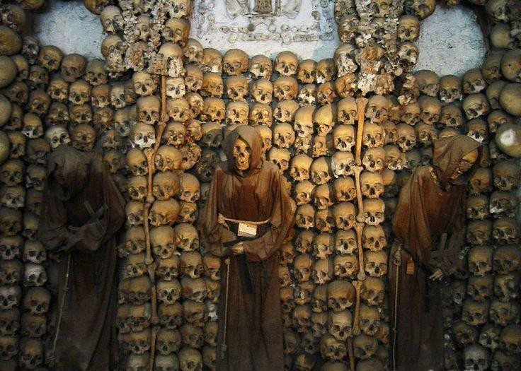
SATANIC CATACOMBE TEMPLE - PARIS
Beneath Paris' City Streets, There's an Empire of Death Waiting for Tourists
The Franks-Pippin forgery-creation of the Catholic Church Religion by paid propagandist, the Venerable Bede, in order to legitimise the Frank would be Kings, Excommunicated by Constaninople as Emperors of Europe, - putting in Pippins own brother as the first Pope, Forging the History of the Popes back to Saint Peter, forging Peters Pence, culminating in Emperor Charlemagne, - who murdered, ritually sacrificed 4000 Satanic German Priests and cut down their sacred tree, Yggydrasil - Charles the First, Emperor of France, legitimised by the Pope of the New Catholic Church.

And the validation for this interpretation is when Aurelio says, "I can fix it. It'll be ready by Christmas,... 2029."

Christmas, is of course, the birth of Christ, Illuminaton, and the arrival of New Life and the Messiah; that Aurelio links the restoration of Wick's car to Christmas means that Wick himself should be fine by Christmas 2029.

This is indicating the long process of removing Energy Blockages, removing demons, in his journey in his of Enlightenment which Wick must undergo.

Reflections On the Soul.

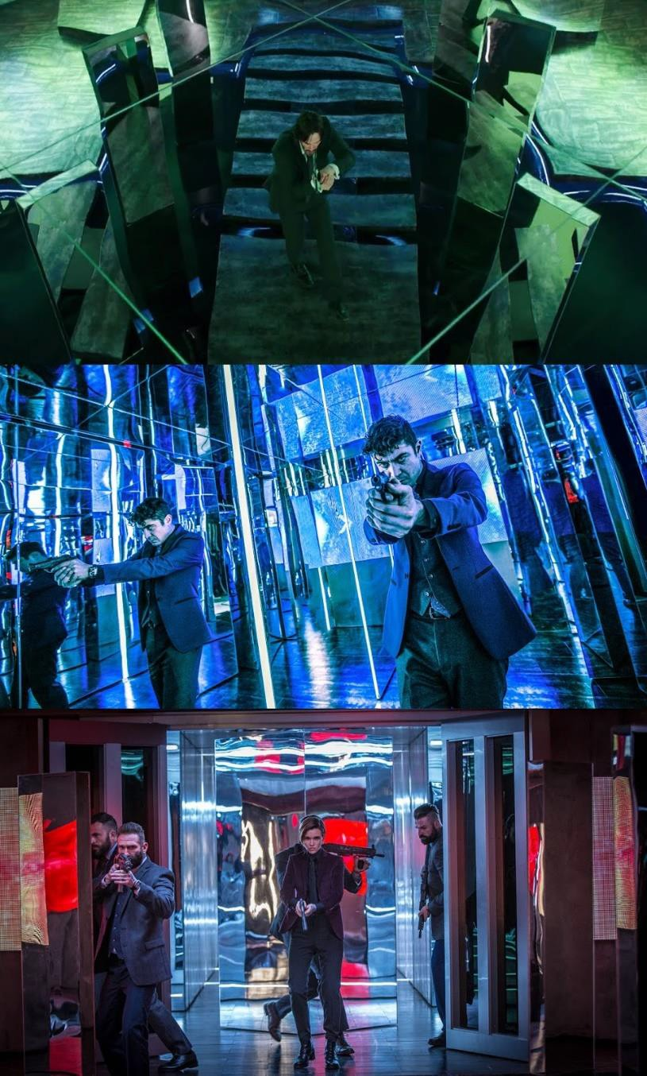

THE ENERGY ENHANCEMENT STREAMING VIDEO COURSE

"Get your asses over here Now and Speed Up your process of Enlightenment on the Energy Enhancement one month course!!" - DON
Every one of our Students gets this Spiritual Experience of Connection with Infinite Energies.
Energy Enhancement does indeed, "SPEED UP THE PROCESS!!"
And they all get this Experience of Light, Life and Infinite Energy just with the Energy Enhancement Course - Every One of Them!!
LEVEL 1 - 4 VIDEO COURSES ANYTIME IN THE COMFORT OF YOUR OWN HOME
It's imperative to the understanding of the film that we notice that the art exhibit in the museum towards the end, the place of the final battle, is called Reflections On the Soul.

The exhibit is all glass and lights and mirrors; why?

Because glass symbolizes "reflection" (our ability to meditate on our actions and interior life) and light symbolizes inspiration and wisdom (knowledge which we attain but could not be obtained on our own merits or understanding).

The Mirror of the Soul!!

What we see in this climatic scene then, is the not-so-subtle translation of spiritual warfare within our souls: we have to "kill them, kill them all" as Wick says at the end of the film.

Who are we killing?

We are killing those forces of evil who lurk in our souls, like the assassins lurking in the exhibit.

Reflection and light are there to both help us, but also there to wound us:

- Unless we understand how reflection/meditation can go bad (not seeing ourselves correctly, but exaggerating our traits, for example)

- And how we can be mislead by light rather than led by light (for example, thinking God has inspired us to do something when it was actually coming from the devil) then we can become trapped and lose the battle.

EVERYTHING IN THE FILM IS AN EXTENSION OF THIS MIRROR OF THE SOUL.

Which is why we hear the computerized female narrator at the museum twice saying, Welcome to the Reflections On the Soul.

What exactly does Wick prove/learn from this experience?

That each of the assassins hunting him is a part of him, that's the purpose of the mirrors, so that as Wick sees the assassins, he's seeing part of himself and the man he used to be, but is trying not to be anymore.

He is seeing the evil demonic part of himself he needs to remove in order to purify and ascend.

It is the same process in Energy Enhancement Meditaton. Energy Blockages are inherently evil.
In order to evolve, these Energy Blockages need to be removed And their purified talents assimilated into the Psychic body - incorporated.

John Wick (just like the rest of us) continually has to undergo a process of "conversion," the recognition that, "I haven't come far enough, there is still so far to go, and if I don't go further, I'm going to start falling behind."

The spiritual life is an active life, it's not a life about "retirement" (which is what everyone wants John Wick to do), rather, if we are not fighting the spiritual battle, we are losing the spiritual battle.

On a slightly different note, apart from Wick himself, the most important character in the film is Winston; why? It's not that Winston is a "God figure," rather, it's through Winston that we learn the grand scheme of what's going on, we get, in other words, a "God's Eye perspective."

For example, when Winston collects Wick's payment confirmation from Santino for Wick's marker, Winston tells Santino how Wick had a glimpse of what was on the other side of the assassin's life, and Santino took it away from Wick.

This is true, but it's not also entirely true. God always works in "pairs," the first which is presented to us by God is good, but the second which God presents is far better (I could provide examples, but I'm not going to digress more).

Wick's life with Helen was the "good" with which Jesus Christ tempted Wick, but Jesus will offer Wick something even better after Wick fulfills these trials, so yes, Santino took it away from Wick (when Wick asked Santino not to collect his marker--more on this below) but God allowed Santino to do it.

Remember, Jesus (and we see both the cross tattooed on Wick's back, and the mural on the soup kitchen wall at the Bowery King's that says, "Jesus Saves," so this is a relevant point) Jesus Christ is a "fisher of men," and like any fisherman going to catch fish, Jesus uses bait, and the bait to hook Wick was Helen, the Soul.

Wick "got out"of the assassins' lifestyle, but Wick left an "open door" to go back by giving that marker to Santino and Wick promising he would help Santino do something in exchange.

God knew all this was happening, and so Helen dying was God's punishment on Wick for resting too much. God had to give Wick a light - to light his fuse, his Wick.

And when he lit that fuse..

God knows the only way to get Wick out of the assassins' life where Wick was when God called Wick to conversion is to remove all the other Demons in Wick's psychic body and it was Santino who called down Wick, God's wrath, Baba Yaga, the Bogey Man, on Gianna and upon himself.

Demons are trapped and programmed angels and want to be purified and act to allow that to happen.

When purified, demons become angels with all their talents.

Angels can be invited to join our psychic bodies, they are very loyal to those who purify them and heal them.

This is a new method of evolution.

We no longer have to wait lifetimes to develop a new talent.

With the Energy Enhancement Seven Step Process we can evolve, enlighten, quickly

Speeed Up!!! the Process!!

On a very different note, the lights, mirrors and art in this exhibit validate the encoding mechanisms being used throughout the film: there aren't any actual souls on display in the exhibit, but the light and mirrors are metaphors to discovering the soul within us; Know Thyself, Gnothi Seauton as it says in the Matrix.

Likewise, different elements of the film will also provide means by which we can reflect upon our souls through the journey of John Wick.

The visualization of this image is perfection: remember, later in the film, when the Bowery King escorts Wick to the elevator and tells Wick that his "descent into hell begins here,"?

That line echoes what happens right here, with Wick's house getting blown up during the night. It's night, and "night" symbolizes the Dark Night of the Soul when the soul journeys to union with God.

Now he has no Helen, no house, no resting place - only a dog!! And the Wrath of God!!
The art exhibit is called Reflections On the Soul and the mural we see in the soup kitchen when Wick is with the Bowery King that says, "Jesus Saves" on it, so this reading is not "out of line" with the narrative, rather, because of the silent film we see at the very

beginning, the film encourages us to look for the "sub-text" within itself to understand the real drama taking place.

Regarding this scene, we can rely upon the poetry of St John of the Cross to "ferry us" like Charon does with Wick at the end when Charon takes Wick to see Winston in the park.

"In an obscure night/Fevered with love's anxiety/(O hapless, happy plight!)/I went, none seeing me/Forth from my house/where all things quiet be."

You probably see a number of problems with lining up this poem to the events taking place in the image above, but we just need to talk through it. First of all, Wick's soul is indeed in a state of "obscurity" because of his retirement and no one thinking he's back (consider Jimmy the police officer asking Wick about him being "back") and "night" we can be sure of because the film makers have Santino enter the house when it's still light outside (please see the images below) but Wick's house explodes when it's night.

There are two parts to the next line: "fevered" and "love's anxiety," because "love's anxiety" refers to what Wick will do without Helen filling his life, and the "fevered" refers to the sickness God allows to come over Wick so Wick will be led away from his temporal dependence upon Helen (Soul) and her memory, and to God Himself at a much higher energy level.

Fusion with the Soul is Enlightenment, but this is only the first Dan. Evolution is permanent.
It never Stops.

God will not allow a permanent hiatus and insist you move forward to the next Dan.

Above Enlightenment is Fusion with the Monad, Fusion with the Logos etc..

Wick sits in the burned down house and he has the bracelet he had given Helen, but he cannot stay there. He has no resting place. There is no-where to go except with Charon - the concierge of the Continental Hotel - to ferry Wick over the River Styx to his next test.

In Hades he meets Pluto, Satan. Winston.

And having retrieved his marker from Santino, he then cuts ties with all Satanity.

He is made Ex Comunicatio with the Seed of Satan.

The "happy plight" refers to the difficult situation souls discover: if they don't leave the house in which they are, they are bound to stay in the house and never achieve their union with God.

If they want the union with God, they have to leave the house, and so it's a "happy plight," like the Children of Israel wandering the Wilderness for 40 years, because without that hardship, a greater reward and advantage could not be achieved.

When Wick goes out, "none seeing me," we can argue that Jimmy the policeman sees Wick leaving the house, and of course, the pitbull is with him; but none see John Wick as God sees John Wick.

God sees what John Wick still has to become in order to fulfill himself.

Wick goes "forth from my house" because hell still grows and lingers within Wick's soul.

When John of the Cross writes, "where all things quiet be," we might think, yea, there is no way this relates to John Wick, look at the explosion of his house, right?

Wrong. Before Santino arrives, it is all quiet: the car guy comes by and picks up the Mustang, Wick plays with the dog on the lawn and

a tennis ball,... all is quiet as Wick's retirement (?) is going to be honored,... but it's not.

There is a second condition to this "all is quiet" perception, namely, the rule of thumb in the spiritual life: if "all is quiet" it means one of two things: God provides the soul with a temporary respite to rest before the next battle, or the person has ceased fighting their demons and the demons win because they are allowed to make small, but steady gains over the soul that refuses to defend itself against them.

When Wick makes peace with Abram, Wick quits before finishing the job and allows the rest of the demons to linger (which means we might see Abram later in the series).

Santino later argues with Winston when Winston comes to collect Wick's marker that "Wick was all ready back in" the assassin's life, and, as we discuss below, this was only partially true.

John Wick "Whoever comes, I'll kill them. I'll kill them all." Winston "Of course you will."
These are, definitely, the two most important lines of dialogue in the film; why?

Because it gives us a choice, just as Wick gives the Bowery King a choice: either we think Winston insane for letting all those assassins line up to get killed by John Wick because the definition of "insanity" is doing something over and over thinking you will get a different result and, by now, doesn't everyone realize that none of them are going to be able to kill John Wick?

We realize that Winston has sent Wick upon the great challenge, the battle which will move Wick beyond, "The man, the myth, the legend," to being, quite frankly, an Enlightened Saint, a Finger of God.

The Wrath of God!!.

John Wick will kill whatever Demon comes because he's got back his focus, commitment and will, because he has lost everything.

Why does Winston do this to Wick? Doesn't Winston like Wick? The first word we hear Winston say in the film is, "Impeccable."

WITHOUT SIN SIN CONTROL
The gold coins used in the John Wick universe open up the introductory credits: why? Gold does not tarnish, and it is the most valuable substance on earth, worthy of kings and an apt metaphor of the soul because our soul's are worth far more than gold, but, like gold, our souls must be purified in the fires of trial and purgation, and Winston telling the Numismatic (the man with the coins at the start of the film) that the coins brought are "Impeccable," means that is what John Wick is to become himself, "Impeccable," a soul without blemish.

Because of that, John Wick must cut all ties with evil. Ex Communicatio.
"Out of communication."

There is significant word play in this phrase, because it's a sentence, as in, a punishment, but the "sentence" is a form of communication which has now been outlawed with that person who has so been sentenced.

Most people are going to assume that the status of ex communicatio is the same as ex communication, and deduce it means "to be cut off from or put out of the community," and that John Wick is no longer a member of the assassin's guild, league, union, or whatever structured organization it is, but that phrase describing that state is ex communicare; ex communicatio is, however, more severe, for at least two reasons.

First, it's through his ability to communicate with the evil, "dark Side" of the Assassins that helped John Wick get through the ordeals we as the audience witness in JWC2.

Everyone in this line of work knows everything immediately, from their cell phones regularly giving them updates, to the good old stand-by carrier pigeon and the homeless security system of corner beggars.

Communication is knowledge and knowledge is its own form of currency in this world (whether it's his friend calling to find out where Wick's car is, or the Bowery King knowing that Santino is at the museum, communication is key to survival).

When John goes to see someone, he communicates his needs to evil and they help him with that evil: consider his acquaintances in Rome, the tailor, the sommelier, the keeper of the maps and Julius (owner of the Roman Continental Hotel) as well as Winston and the Bowery King (Laurence Fishburne).

So, even with just this first part of the sentence of ex communicatio, John Wick is in serious trouble,...

Cut off from the Satanic Dark Side.

A total enemy of the Satanic Dark Side. But it gets worse,...
John Wick Chapter 2 clearly operates on both a political level, as well as a spiritual: John's sentence of no longer being able to communicate with the world of Satanic assassins points to the real- world racist censorship taking place against white, heterosexual men in the US today.

White men the targets of Satanic Liberals who seek to dethrone white men as the dominant power-holders in the country (even the world) and the reason for that is just as spiritual:

Satanic Liberals also want to overthrow God.

That's why John Wick's sentence of ex communicatio is so severe: it's a sentence against John praying. But wait, you may think, John Wick never prays, not even once; I would like to suggest that, indeed, he does pray,...

What is "prayer?"

It's our communication with God, His angels and His saints.

When we use certain words and direct our thoughts and actions accordingly, "prayer" is a form of worship, as well as a means of request for help, guidance and intercession for prayers from others who have gone before us (such as the saints).

If Winston were an ordained priest (or possibly he would have to be a bishop to perform the ex communicatio sentence religiously) Wick, then, would be cut off from prayer: his prayers would not be allowed to reach heaven and entreat the Almighty for favor and forgiveness (I could be wrong about this, I know it's almost never used, even in the days when "standard" ex communication was used, ex communicatio wasn't used then because it's so severe).

Since Winston isn't an ordained priest, this doesn't apply, but Wick is in the opposite position: Wick now must pray, pray to God, and pray only to God because a prayer is the only thing he has left.

How do we pray?

Only by the Power of the Holy Spirit, in other words, God Himself, as the Third Member of the Trinity, gives us His own Life (commonly called "Grace") so that we may offer our prayers to Him.

How does the Holy Spirit appear to us?

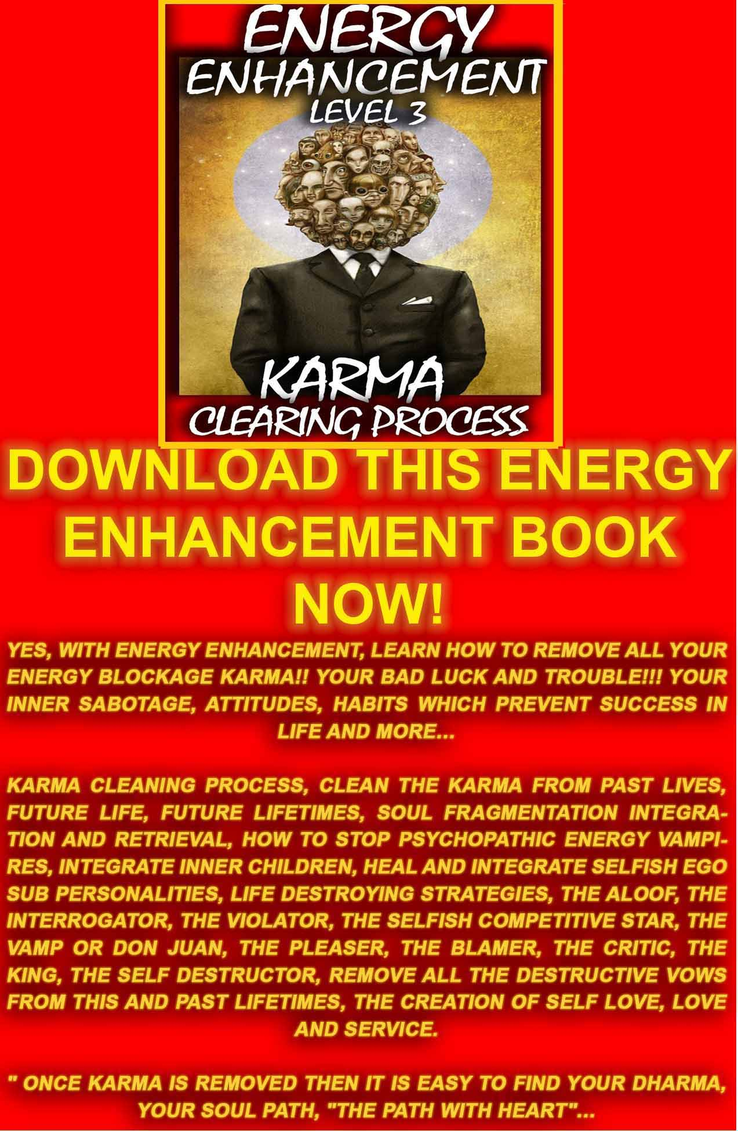
DOWNLOAD LEVEL 3 BOOK HERE!!!
http://www.energyenhancement.org/Sacred-Energy/Level-3-Book/Energy-Enhancement-Level-3-Karma-Clearing-There-Can-Only-Be-One.pdf


THE ENERGY ENHANCEMENT COURSE

IGUAZU FALLS IS A WORLD ENERGY CENTER SACRED TO THE INCA AND THE GUARANI FOR THOUSANDS OF YEARS
IN SPAIN, ELEGANT 5Star INDIA TAJ MAHAL, INDIA TOUR, SACRED IGUASSU FALLS, MEXICO, PERU
SIGN UP TO THE MAILING LIST FOR MORE DETAILS
EMAIL sol@energyenhancement.org


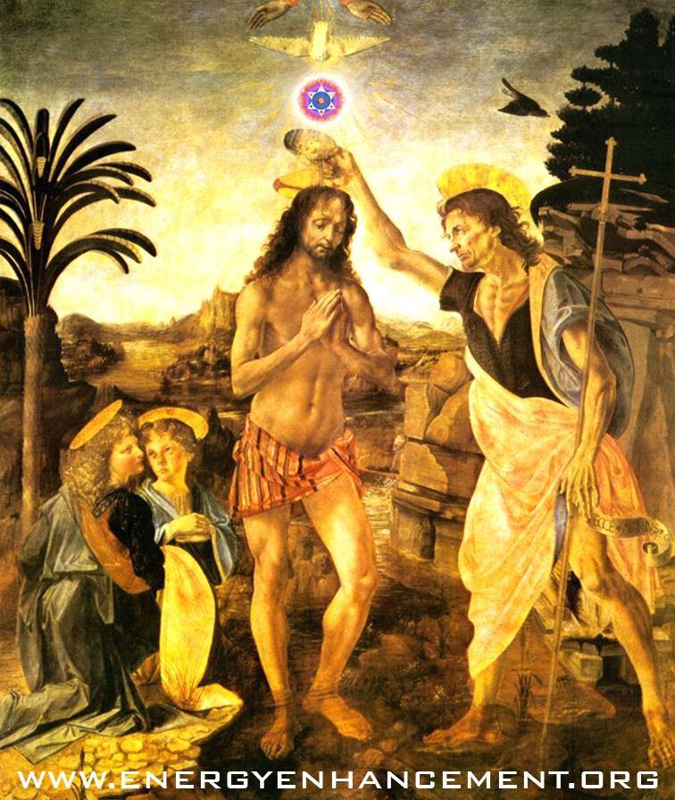

In many forms, but most commonly He appears as a bird, as when Jesus was Baptized and the Holy Spirit descended upon Him.

Granted, we don't actually see Wick praying in the film, and that's why the second form of the ex communicatio is so severe: John Wick will now be forced to pray, because, like Moses being cast out of Egypt into the desert, so, too, has Wick been cast out with nothing but what is in his heart but Wick is not alone: he has the dog (his Soul) and he has the Holy Spirit.

There are at least three places in the narrative where birds are important, which means there are three places where the Holy Spirit is guiding Wick and helping him.

Obviously, the Bowery King and his carrier pigeons are important; why? John Wik--as is the audience rooting for Wick--are nervous the whole time Wick is in the presence of the Bowery King that the
$7 million contract on Wick's head is going to win over and, instead of helping Wick, the Bowery King will help himself; that's the power of the Holy Spirit at work, that the Bowery King is able to be an instrument of God rather than a hindrance to God's work of removing Demons from his psychic body and the World.

Then, there is also the scene when Winston tells Wick that Wick is ex communicatio and a flock of birds fly up from behind Wick, signifying that this is the Will of the Holy Spirit and God is with Wick and everything will be okay.

If it weren't for the Bowery King giving Wick a leg up and getting him into the museum, John would have failed; if it weren't for Winston giving Wick an hour before the ex communicatio goes into effect, Wick would have died right there.

The third important bird reference? Duck fat.
When Santino goes to Winston and tells him to revoke John Wick's membership to the Continental, and Winston refuses, Winston reminds Santino that he, too, enjoys the privileges of the hotel; why does Winston do this?

So that John won't do what John did at the start of the film, which was make a big mistake. The lesson John Wick learns in order to be able to remove the High Table Demon Santino, and we ourselves have to learn deeply...

Don't make peace with any demons.

Follow the Will of God against any Satanic, "Rules"

In the lounge at the Continental, when Wick walks in with his gun, all of us know (because we saw John Wick and how Ms. Perkins was executed for breaking the neutral grounds in her attempted hit on John himself) that John is in for it if he pulls that trigger,.... and he pulls it anyway.

Why? Because the Holy Spirit told him to. How? What does Santino tell John?
That he could stay there a year and not eat the same thing twice.

There is a double meaning to this, a warning, but also an invitation, and fortunately for Wick, he refuses both, and it's because of the symbolism of the duck fat....

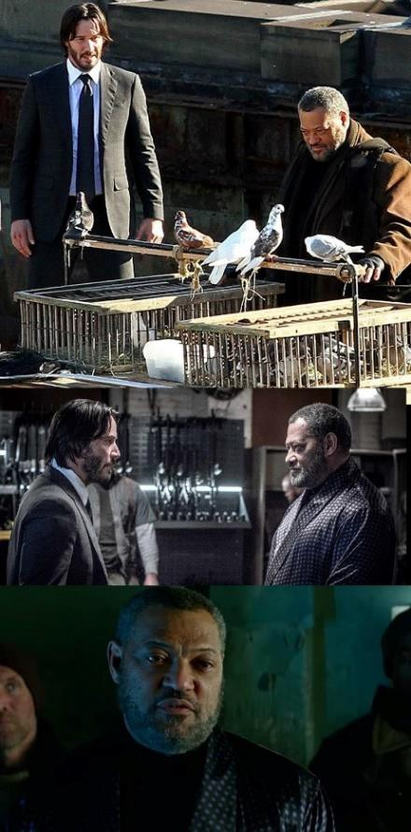

Santino puts some food in his mouth, which has supposedly been fried in duck fat; because ducks are birds, like the birds we have discussed, this means, symbolically, that this is the food of the Holy Spirit, compelling Santino to tell the truth (which, in this situation, isn't difficult to do) but it also helps Wick to see the truth: Santino isn't going to go away, so then, Santino will be able to get control over New York City AND get Wick killed or have constant attacks carried out on him by other assassins (unless Wick stays in the hotel, too, which wouldn't be very comfortable for either of them).

This might be his only chance to kill Santino.

In other words, God communicates to Wick what is going to happen if Wick doesn't finish Santino right then and there it's going to be war for everyone.

So, the duck fat is a means of Wick recognizing what the future holds for all of them.

This actually leads us back to the Bowery King, Fishburne, Brecht, Threepenny Opera and Mack the Knife - and the "deal" Wick describes to him.

Wick explains to the Bowery King, if I don't kill Santino, then Santino is going to take over NYC, so, give me a gun and then I will take upon myself the wrath of the High Table and the Camorra, (the Italian mafia, which Santino was part of, and will seek vengeance for Santino's death).

Wick was always going to kill Santino.

He was never going to make that mistake again. All Demons must Die!!
Again, as Wick is led to see the Bowery King, he passes through a soup kitchen, where people are being fed, and sees the large picture on the wall with a cross and the words, "Jesus Saves"; what does this conjunction of symbols mean?

As the Bowery King feeds the people there soup and the message that Jesus Saves, so Wick will feed the Bowery King the message that Wick will save New York City from the take-over by Santino and from the wrath of the Comorra by paying the debt for Santino's death, just as Jesus saved us from God the Father's Wrath by paying the debt of Original Sin for us.

When, John Wick failed in his duty, when men fail in their duty, when they behave in ways which fail to earn them respect so that they even don't respect themselves (like sleeping around, getting women pregnant and then not helping to raise the child(ren), divorce, pornography, drugs, etc.) not only are men not happy, but they instead earn the scorn of all society and fall in the estimation of the people

This transition in Wick--from letting Abram go in peace at the start of the show to going to great lengths to insure he doesn't make the same mistake again--is the "conversion" process at work in Wick. Why? Because Wick learned his lesson and that leads us to our last point:

WHO IS "JOHN WICK?"

A light favored by God.

The Wick is Lit to create the LIGHT OF THE SOUL ILLUMINATION
ENLIGHTENMENT

We know names are important in this narrative universe, and we know that the name "John" means God has been gracious or, more often, favored by God.

We also know that a "wick" is like a fuse: there is the "wick" on a stick of dynamite, for example, or there is also a wick on a lamp (like the old fashioned gas lamps) which can be lit and give off light.

We might assume that the "wick" in John Wick denotes a short fuse and he has a bad temper, but at the start of the film, Abram enumerates for us that John Wick is focused, committed and achieves his ends through sheer will power, so there is nothing about a bad temper, and stealing the guy's car and killing his puppy, then blowing up his house, all after he has just buried this wife, is really a lot for a person to take, so that leads us with the interpretation of "wick" as a light,...

We saw this "ritual" of John's in John Wick as well: his showering before going to kill someone, as if he's cleaning his hands of the bloodshed to come before he sheds the blood because the spilling of the blood is "not on his hands," his hands are clean, and this is a sentence they have brought upon themselves through their Satanic lives of crime like Gianna slitting her wrists and getting into her warm bath, the Satanic Roman Empire way of suicide, before John Wick shoots her in the head.

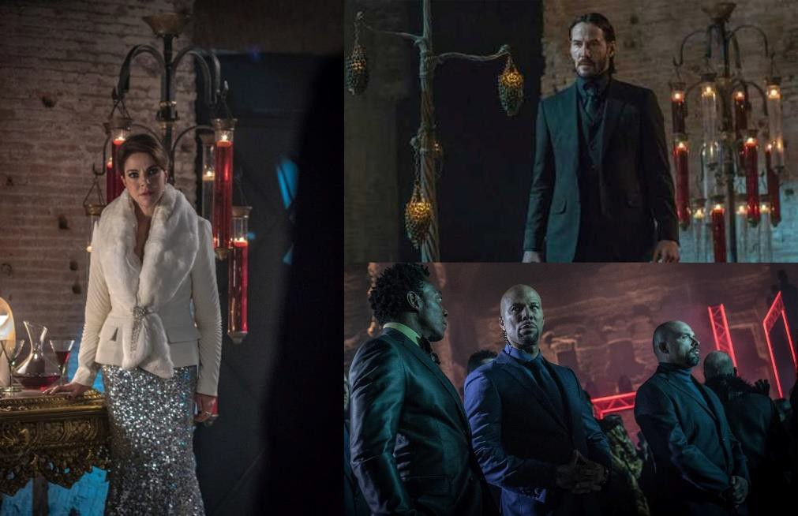

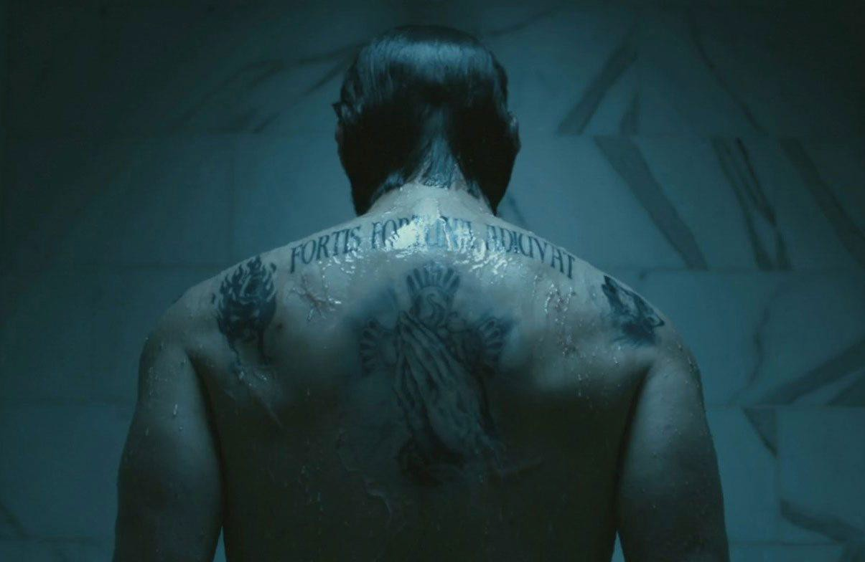

Roman Latin, FORTIS FORTUNA ADIUVIO should never be translated as “Fortune Favours the Bold”; nor is this a motto of the marine corps. (who use, ‘fortES fortuna IUVIO’)

The latin here is older, darker, and very pagan in spirit. Moreover, it is this very pagan-ness that is critical to understanding the latin in the context of these christian tattoos.

With this spelling in particular, the Latin recalls a much older variant of a proverb than the Marine Corps uses— one that was considered very old even in the pre-christian times of Caesar.*

Fortis = “(The) Strong (ones)”, is a plural noun — it means specific people here, not an abstract like ‘Strength’, nor the intention or attitude of ‘boldness’, and definitely nothing modern from the US Marine Corps (who use fortES in any case)

Fortuna = is a Roman Goddess, the personification of Luck, and a spiritual force N.B. She is placed at the centre of the phrase and, if you look closely, slightly capitalised in John’s caligraphy. It is NOT

mere ‘good fortune’, in the sense of good luck, nor of ‘a fortune’ in the sense of money. It is God.

Adiuvio = AD ‘to/toward’ + IUVO ‘help/aid/save’ — particularly of a goddess, ‘comes to save’/’comes to the aid of’ is best here. Not ‘favours’ as is the lazy way that gives the ‘F-F’ alliteration in English.

“It is only The Strong that Fortuna (The Goddess, God) comes to save.”

It's important to remember that on Wick's left shoulder, he has another tattoo: the Cross.

The shoulders and back are usually taken together symbolically, and yet they have their own roles in communication: the back symbolizes our burdens, either those placed upon us or that we take upon ourselves, while the shoulders, as part of the arms, symbolize whether or not we receive strength from our burdens (on our back) or are weakened by them.

In the case of John Wick, he's strengthened by them, because he has the cross on his shoulder and on his back (since they are tattoos, he has placed them there himself) however, the problem is, there are two other tattoos: the woman wearing the mask on his left shoulder, and the howling wolf on his right shoulder.

That Howling Wolf of Lupercus - a festival when the Satanic Roman Empire killed slaves in human Sacrifice. The Emperor Nero for example tearing the throats of innocent slaves with his teeth.

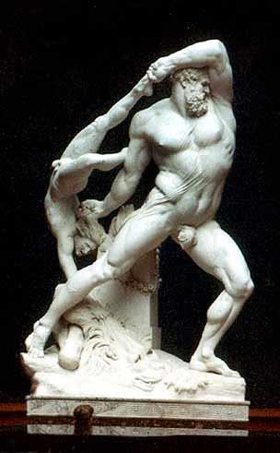

In John Wick that Howling Wolf of Lupercus has been transmuted into the Soul.

And the Dog Soul accompanies John Wick in his running gauntlet as the animal souls accompany humans in one of my favourite movies, "The Golden Compass (2007)"

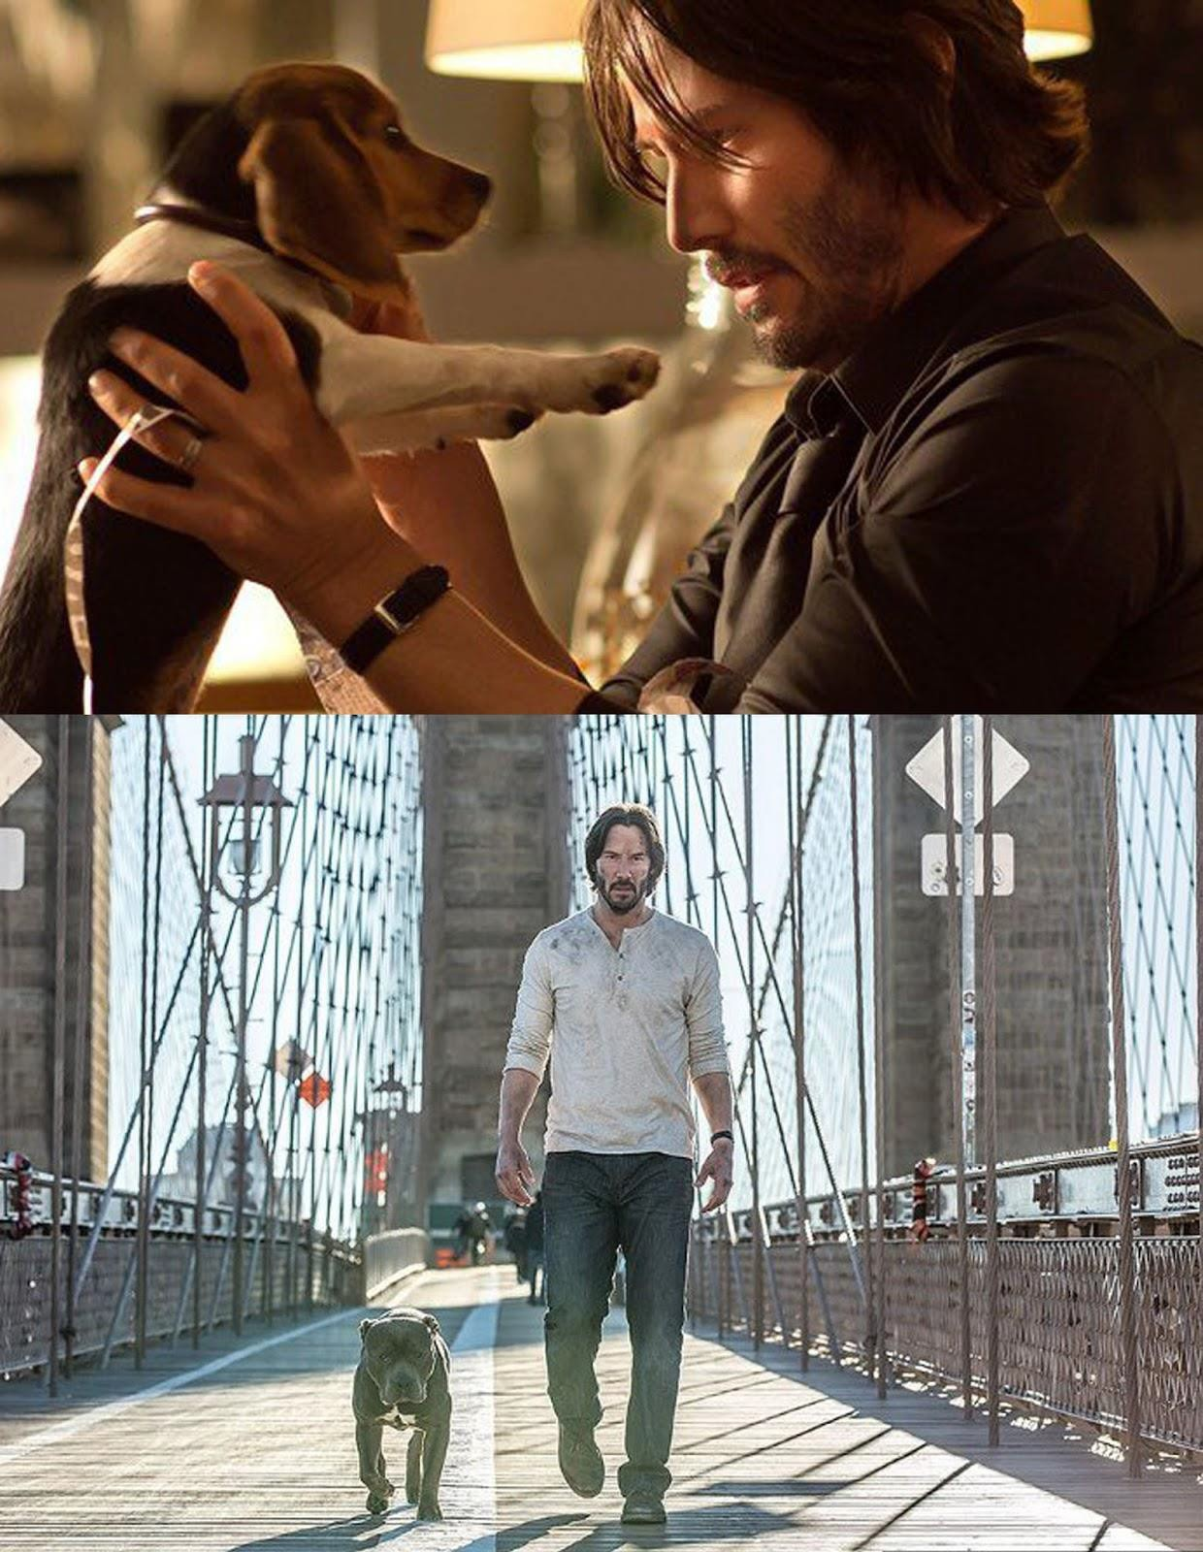
JOHN WICK ROTTWEILER DOG SOUL

By now, we should know the answer to the question about the John Wick Chapter 2 body count: why are there so many dead bodies at the end of a John Wick film, and why does it matter?

For those who are materialists and don't believe in the spiritual life, all they see are dead bodies, not realizing that those aren't "dead bodies" of "real people," rather, the metaphors of spiritual warfare and trophies of eternal combat - THEY ARE THE DEMON DARK SIDE OF THE PSYCHE - Energy Blockage Demons which have been removed.

Spiritual Warrior John Wick's body count, 87 in John Wick 1 and 187 in John Wick 2 then, is not only a sign of his masculinity in that he's been able to master himself with his "focus, commitment and will," but he has also increased the power of his soul removing more and more and higher Demons - to be the dwelling place of the ultimate man, Jesus Christ.

Without the example of Christ, there is no Love, and we do not know how to better ourselves or overcome the demons enslaving us, which is why we see the banner, "Jesus Saves" in the soup kitchen; then the question becomes..,

Are we willing to only communicate with God?

Are we willing to be totally cut off from the Dark Side? Are we willing to never talk to the Dark Side?
Are we willing to remove all the Demons of the Dark Side? As within, So Without.
As we remove our internal demons psychically using Energy Enhancement Seven Step Process, so automatically, God will remove the demons outside using his other Agents on this Planet.

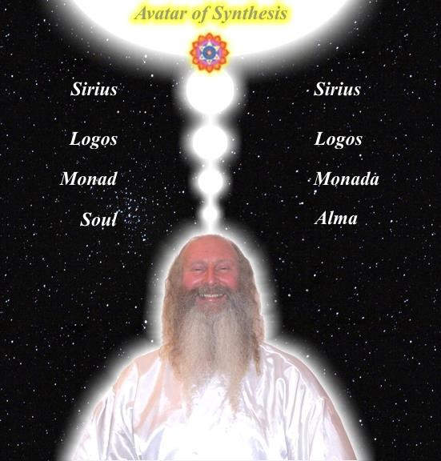
As you remove Internal Demons through Meditation, So God's other Actors on this Planet remove the Physical demons

The Satanic World War to enslave humanity which has been going for 10,000 years is an expression of that eternal psychic battle..

Only as human beings learn to manage the internal controlling element of Meditation can that battle - the external 10,000 year rolling battle of Armageddon be completed.

The Vast Majority of the Low IQ Public comprising Dumb Sheep and Dogs know nothing of this.

This information is written for the most alert and aware.

It is written for those who are capable of becoming enlightened.

DOCTOR STRANGE - PSYCHIC WARRIOR ENERGY ENHANCEMENT ESOTERIC MOVIE REVIEW



After an accident destroys his hands, costing him his line of work and, more significantly, self-worth, the hard science-inclined Doctor Strange goes for broke and takes a stab at a rehabilitative program of a more spiritual bent. Relocating to Kathmandu, Stephen undertakes the tutelage of the Ancient One (Tilda Swinton) and her star pupil Mordo (Chiwetel Ejiofor), soon enough finding himself ensconced in the sort of supernatural action-adventures her community of White Wizard Warriors deals with on a daily basis.

Doctor Strange is a movie about a scientist who at first adheres to a satanic world view..

Dr. Stephen Strange: "No, I reject it because I do not believe in fairy tales about chakras or energy or the power of belief.

There is no such thing as spirit!

We are made of matter and nothing more.

We're just another tiny, momentary speck in an indifferent universe."

He knows nothing..

Baron Mordo: Stephen Strange. Might I offer you some advice? Forget everything that you think you know.

Like all students, he is searching for the small - the use of his hands so that he can remain a simple Doctor - whilst being given in reality something infinitely larger.. and much, much more valuable..

Ignorant Students follow their own minds and act arbitrarily.

Indulging in guesswork they consider themselves bright and will not humble themselves.

Thus they misapprehend the road ahead.

Though they are said to deceive others, in reality they are deceiving themselves.

This is looking on the Great Matter of Essence and Life as Childs Play.

Is it no wonder they strive all their lives with no attainment. Is this not a pity?
If you know enough to submit to enlightened teachers, associate with good companions, sincerely concentrate on clarification of the truth, borrow their knowledge to break on through your own ignorance, borrow their lofty vision to expand your own ignorant views, then even if you are ignorant you will become enlightened, and even if you are weak you will become strong.

Then there is no reason why you cannot become an Immortal and a Buddha!!!

Awakening to the Tao by Lui I-Ming, Translated by Thomas Cleary

The Ancient One gives him an experience of the real reality and after experiencing the truth..

The Ancient One: I know how to re-orient the Spirit to better heal the body.

The Ancient One: You're a man looking at the world through a keyhole. You've spent your life trying to widen it. Your work saved the lives of thousands. What if I told you that reality is one of many?

The Ancient One: You're a man looking at the world through a keyhole. You've spent your whole life trying to widen that keyhole. To see more. To know more. And now on hearing that it can be widened, in ways you can't imagine, you reject the possibility.

Dr. Stephen Strange: No, I reject it because I do not believe in fairy tales about chakras or energy or the power of belief. There is no

such thing as spirit! We are made of matter and nothing more. We're just another tiny, momentary speck in an indifferent universe.

The Ancient One: Open your eye

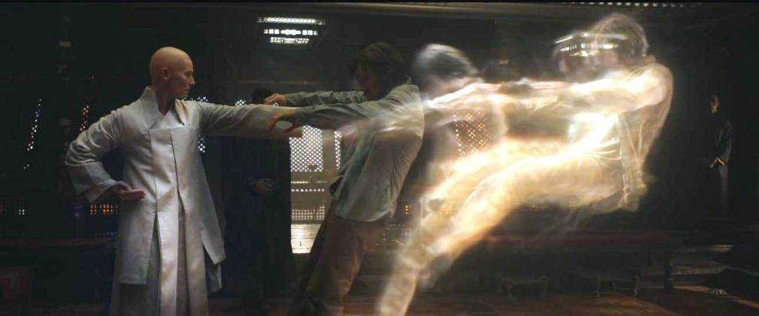
The Ancient One: I pushed your astral form out from your physical form.
ONCE YOU HAVE EXPERIENCED REALITY, YOU CAN'T GO BACK TO A FALSE WORLD VIEW

Dr. Stephen Strange: What did you just do to me?

The Ancient One: I pushed your astral form out from your physical form.

Dr. Stephen Strange: What's in that tea? Psilocybin? LSD? The Ancient One: It's just tea. With a little honey.
Dr. Stephen Strange: What just happened?

The Ancient One: For a moment, you entered the astral dimension. A place where the soul exists apart from the body.

Dr. Stephen Strange: Why are you doing this to me?

The Ancient One: To show you just how much you don't know. Open your eye! - touching his forehead
140

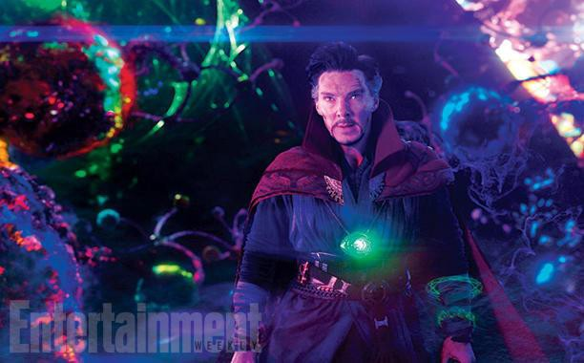
Dr Strange travels to other dimensions on the Astral Plane Open your eye! - touching his forehead - the third eye
The Ancient One: You think you know how the world works? You think that this material universe is all there is? What is real? What mysteries lie beyond the reach of your senses? At the root of existence, mind and matter meet. Thoughts form reality.

The Ancient One: This universe is only one of an infinite number. Worlds without end; some benevolent and life-giving, others filled with malice and hunger. Dark places where powers older than time lie, ravenous and waiting. Who are you in this vast multiverse, Mr. Strange?

The Ancient One: [after forcing Strange to experiencing the alternate dimensions] Have you seen that at a gift shop?

Stephen Vincent Strange: Why are you doing this?

The Ancient One: There are other ways to save lives; so much you don't know.

Stephen Vincent Strange: ...Teach me.

Stephen Vincent Strange: Teach me. The Ancient One: No.
The Ancient One refuses to teach Dr Strange. Because of his egotism and arrogance she sees the possibility of him turning to the Dark Side of the Force.

But.. The side of the Light Warrior needs talent.. "We are not here to capture lame horses" - Jan Fishan Khan

The Ancient One: You want to know what I see in your future? Possibility.

The Ancient One: The language of the mystical arts is a old as civilisation. The sorcerors of Antiquity called the use of this language spells.

The Ancient One: The Mystic Arts involve drawing energy from the Chakras above the Head and channelling it for your own use. For a long time, these are known as spells. But if you find that word too antiquated, we can use "program" or "the source code that shapes reality". We harness energies drawn from other dimensions to cast spells, to conjure shields and weapons - to make magic.".

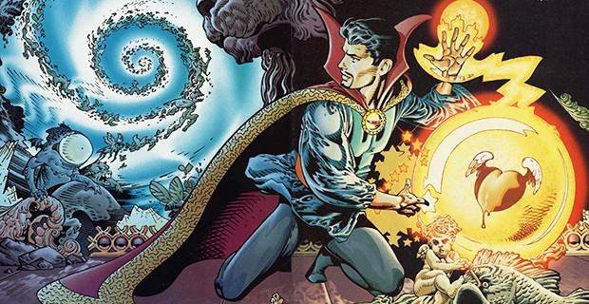

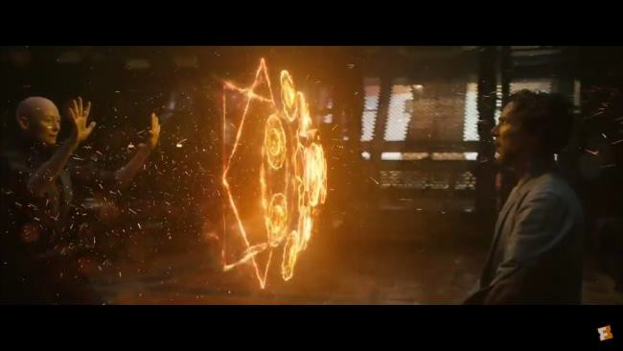
We harness energies drawn from other dimensions to cast spells, to conjure shields and weapons - to make magic.".

Dr. Stephen Strange: How do I get from here to there? The Ancient One: How did you become a doctor?
Dr. Stephen Strange: Study and practice. Years of it.

The Ancient One: I spent so many years peering through time... looking for you.

Dr. Stephen Strange: I'm not ready.

The Ancient One: No one ever is. We don't get to choose our time. [takes his hand]
The Ancient One: Death is what gives life meaning. To know your days are numbered and your time is short. You'd think after all this time I'd be ready. But look at me. Stretching one moment out into a thousand... just so that I can watch the snow.

"DROP BODY, DROP MIND..." Zen Master Dogen

"When a man dies, he is carried to be offered in the fire. The fire becomes his fire, the fuel his fuel, the smoke his smoke, the flame his flame, the cinders his cinders, the sparks his sparks. In this fire the gods offer the man as libation. Out of this offering the Phoenix Ascended Man emerges in radiant splendor" - Brihadaranyaka Upanishad (VI, ii, 9-14)

After all that, Dr. Stephen Strange changes his world view and begs to be taught how to selfishly heal his hands and remain a simple Doctor, whereas in reality he is being taught a much higher path - how to be a Psychic Warrior, an Earth Protector.

Wong: While heroes like the Avengers protect the world from physical dangers, we sorcerers safeguard it against more mystical threats.

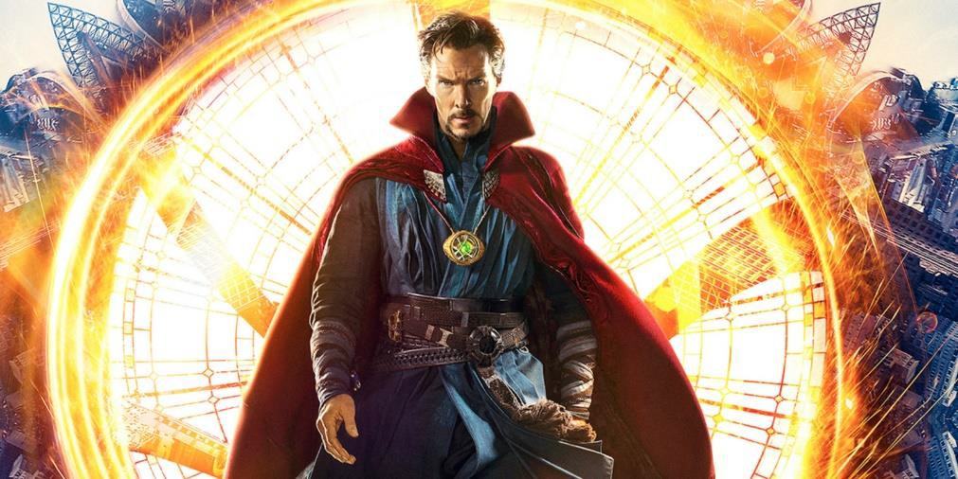
Dr. Stephen Strange - Psychic Warrior, an Earth Protector. Wong: While heroes like the Avengers protect the world from physical dangers, we sorcerers safeguard it against more mystical threats.

Doctor Strange breaks ground in some of the most visually and kinetically imaginative set pieces we’ve seen lately not only in the MCU, but in blockbuster filmmaking across the board. Part of Dr. Stephen Strange’s orientation into the Ancient One’s mystical students involves a torrential thrust through the varied corners of the

multiverse; the film’s biggest action sequence sees good sorcerers facing off against bad sorcerers in a perpetually tessellating New York City—for my money, the most thrilling battle scene Marvel has mustered to date.

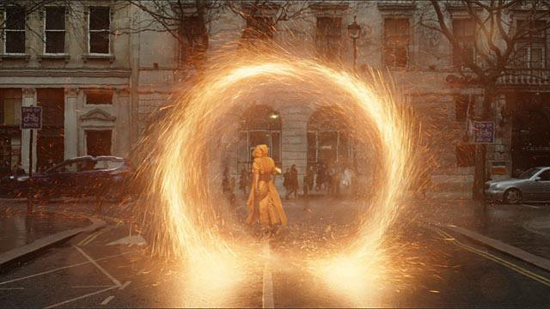
Filming locations around the Kathmandu Valley included the Pashupatinath and Swayambhunath Temples, Thamel and New Road in Kathmandu and the Patan Durbar Square in Patan.
Cumberbatch felt that shooting in Nepal was "absolutely vital to this film, I think not least because it’s so based in something that is exotic. It was a magical way to start the shoot. It’s important to a film like this—which has a profound gearshift into a spiritual and otherworldly dimension—that the portal for that be in a place that actually happens in itself to be incredibly spiritual and marvelous."

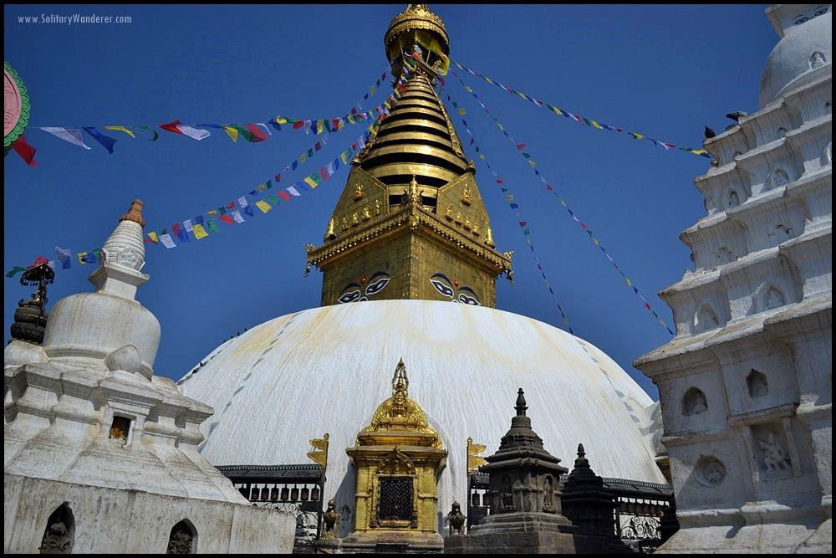

Swayambhunath Temple Nepal - The Dome represents the Earth, The Tower the Pranic connection to other Dimensions - "Twixt heaven and earth!!", as taught on the Energy Enhancement Video Course and Live in Iguazu..

Now, they don’t actually say what he needs to let go of in order to stir up the requisite magic (known as gong energy in qigong practices) to open up a portal to another dimension, but what they’re talking about is letting go of attachments and addictions - Energy Blockages.

Remember Frodo and the One Ring? The ring symbolized human attachments and addictions - Energy Blockages. Gollum had to bite Frodo’s finger off to get rid of that ring—getting rid of human attachments is the hardest thing for humans - but is taught on the Energy Enhancement Video Course in Level 2 - the Removal of Energy Blockages.

Dr. Strange is very attached to self-validation. Can’t let it go. So The Ancient One opens up a portal leading to a sub-zero Himalayan mountain peak and boots her student out there—making it a do or die situation. The test of life and death!


The Ancient One opens up a portal leading to a sub-zero Himalayan mountain peak

All of the above are classic enlightenment story components—and all are compellingly told here.

The film originally had a prologue that took place in CERN, due to the real world research being done at the facility on alternate dimensions and parallel universes. Hard science has been taking the study of human supernormal abilities very seriously for a while now—like telekinesis, levitation, clairvoyance, precognition, and so on.

When I saw the strange strangeness Dr. Strange was up to in the very captivating “Doctor Strange,” I thought, “Aha! Now you’re talkin’!”


DOWNLOAD LEVEL 4 BOOK HERE!!!
http://www.energyenhancement.org/Sacred-Energy/Level-4-Book/Energy-Enhancement-Level-4-Book-Energy-Cords-Mastery-Of-Relationships.pdf


WITH THE ENERGY ENHANCEMENT COURSE BUY A STAIRWAY TO HEAVEN
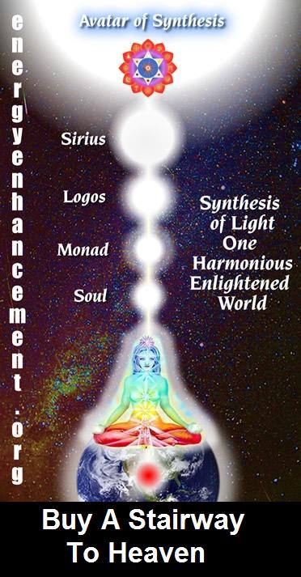
BUY A STAIRWAY TO HEAVEN
WITH THE ENERGY ENHANCEMENT COURSE
STUDENT REPORT
Also I noticed as soon as Satchidanand emailed me, I got a down-pouring of light from above the crown which kept charging me up the rest of the day – and my cravings died out! Then I realized the cravings were ego-blockages and that I did not want them.

Energy Enhancement says that there are an infinity of chakras above the head up into the Center of the Universe and above, high above the head, ending in God, just as there are an infinity of chakras below the base - "As above, So Below" - Hermes Trismegistus from the Emerald Tablet.
INCREASE YOUR INTELLIGENCE - THE PARALLEL PROCESSING SUPERCOMPUTER YOU!! Energy Enhancement says that each chakra within you and above the head is a computer processor with higher and higher frequency, speed and capacity as you go higher. So, like a parallel processing supercomputer, the more chakras you can get working in the Infinity of Chakras above the Head and the more chakras you can access, the more chakras you can disblock, the more chakras you can augment, the more intelligent, the more intuitive, the more wise you will be.
FUSING WITH THE SOUL CHAKRA - Energy Enhancement says that just by fusing with the soul chakra one can see all your past lives and remove all blockages from all your past lives in one sweep, fast!!
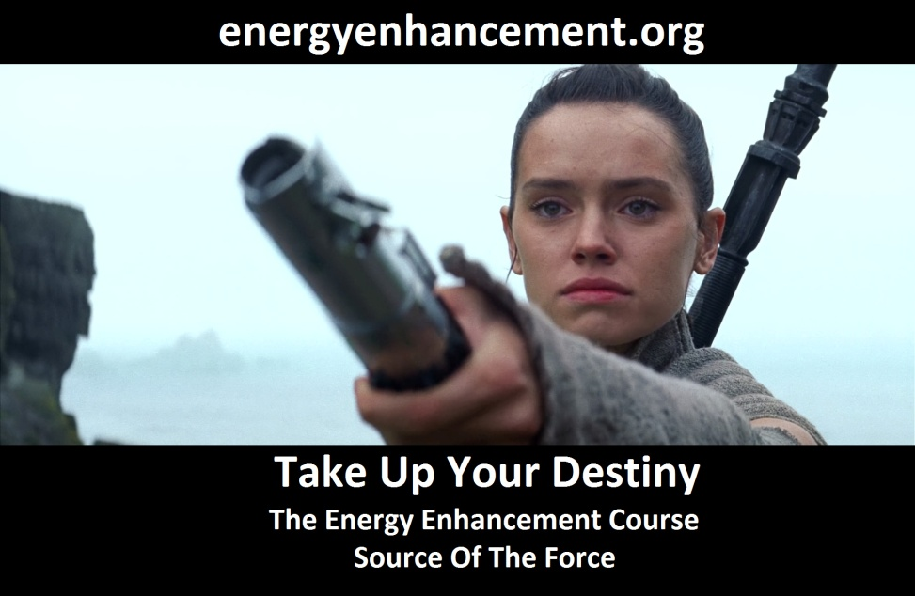
FUSING WITH HIGHER CHAKRAS - THE SOUL, MONAD, LOGOS, SIRIUS, AVATAR OF SYNTHESIS - Energy Enhancement says that it also contains the secret of Initiations Higher that Illumination - "Enlightenment is not Enough!!"

ASSASSINS CREED SATAN'S CREED- SPIRITUAL ESOTERIC MOVIE REVIEW BY SATCHIDANAND

“The goal of modern propaganda is no longer to transform opinion but to arouse an active and mythical belief”-Jacques Ellul.

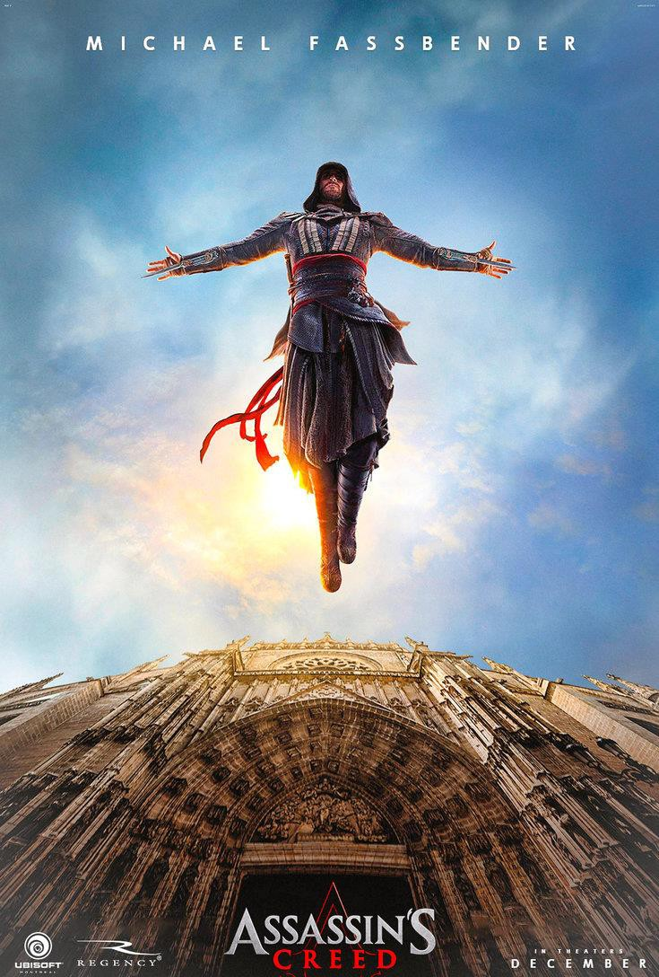

The movie is very well made..

Fassbender is one of the producers of Satanic Myth, "Assassins Creed", which after his part in Satanic Myth, "Prometheus" and its

injections of DNA Demon Seeds to make "Alien (1979)", both Directed by Ridley Scott of Satanic Myth "Blade Runner (1982)", where robots without any mechanism to contact God can become human, which is the purpose of Google funded Kurzweil's Satanic "Transhumanism", I suppose is quite apposite.

Delving more into Robots. Robots, unlike Humans, have no mechanism to contact God. Satanists spend years in loveless Ritual and action to Cut themselves off from God. But Robots, whether "Terminator (1984)" Killer Robots and Swarm Robots, IBM Watson computers who run the Health Service, or Speed Cameras, have no connection with God, no conscience or any compassion.

Robots have no conscience, no Heart. Satanists have no conscience, no Heart. Satanists are perfect Robots.
I suppose this pre-figures the "Butlerian Jihad" of "Dune (1984)" by Frank Herbert where all Robots were destroyed.

In "Dune" no Robots were allowed to exist.

Assassins Creed starts with Fassbender being executed for murder in the USA then being resuscitated in a Spanish facility by a Templar Organisation whose aim is to find the original Apple from the Garden of Eden.

As you know, the Apple was given to Adam by Satan, Lucifer, the snake, via Eve to give Adam, "the knowledge of good and evil"

Originally Adam and Eve were happy, pure, living in total alignment with the will of God.

With the addition of the Seeds of Demonic Evil from the Apple, Adam and Eve were symbolically driven out of Eden, no longer in alignment with the will of God - but somehow given the accelerated evolution of having free will.

Demon Seeds!!

The aim of this evolution is to produce an Enlightened being.

"After all that" as it says in the first sutra of the Yoga Sutras of Patanjali, "Here are complete instructions on Enlightenment".

"After all that" means that we have to pass many hundreds of lifetimes of seeing the results of evil in our lives. Creating Karma. Living that evil Karma.

We have to enter completely into evil before we can become disgusted with it.

So disgusted with evil that we, by our own free will, reject it.

Only then can we search for the means of removing it from within ourselves, and the World.

The means, of course.. The Energy Enhancement Meditation Course.

To become..

A person who "Chooses" to align his will with God.

A person who only has the free will to do the right and good thing.

As you know, a Guru (Gooru) is a person able to remove the goo from his students because he has made it his life's work to remove that goo from himself.

The goo is negativity.

The goo is trauma-formed negative karmic mass. The goo is Energy Blockages.

The goo is the Demonic seeds from the original Apple, given to Adam by Satan.

Originally, Cain the cannibal, ate Abel.

Traditionally the Sons of Cain are those who have more Demon Seeds inside them.

Sons of the Devil!!

The aim of the Templar organisation is to use the original apple from the Garden of Eden to remove free will from humanity.

By saying it in this way we know the Templars are "Bad"

In the movie the story is set up that the Fassbender Assassins are "Good" and the Templars are "Bad"

So we have this murderer, this remorseless killer, Fassbender, who is the only person left on this planet who has the DNA within him of the Assassin, Aguilar, who is the last person to have seen the Apple. Who is the only person who knows where the Apple was buried.

And the bad Templars have this machine called the Animus which can log onto the past life memory of Fassbender and send him back to retrieve where the Apple was buried.

So, we go into the full Technicolour, 5.1 Surround Sound past.. The Spanish Inquisition - Full Auto da Fe and Torquemada!!

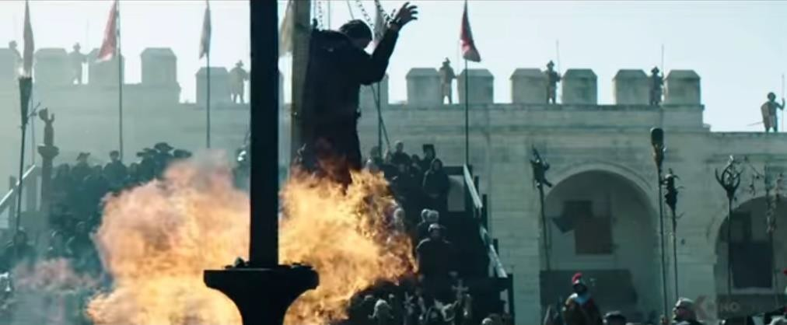
Not the Spanish Inquisition!!

Roman Cult - Holy Inquisition (Sadducees) up to 2 million burned in individual and mass trials and their property belongs to the Catholic Church. Whole swathes of countries ended up in the Vatican Bank due to the European Inquisition of Human Sacrifice - torture and burning alive. The real aim of the Inquisition was the confiscation of property and gold!!

The Popes with their Papal Bulls, written on the skins of sacrificed children and heretics, have decreed and written into Admiralty Law that humans are slaves - "Their natural state"- Aristotle, and this re- enforced by Saint Thomas Aquinas - such that the Catholic Church only renounced slavery in 1917.

In collaboration with the Doge of Venice who was Saint Francis of Assisi!! who was the head of the Persian Pisan trading Empire with the monopoly of running goods from China and India into Europe. The Catholic Holy Sea collaboration with Venice they sacked Constantinople together killing and enslaving 200,000 and walking off with incredible loot..

The collaboration of the Catholic Church the slave trading, Bankster, Drug running Venetian Empire and later the slave trading, Bankster, Drug running East India Company and British Empire they shared the spoils of world commerce such that now the Rothschild fronted Vatican Bank has 500 Trillion Dollars, 70% of

Fortune 500 Companies, 70% of World Banks, 100% of Central Banks like the Federal Reserve.

The Popes with their Papal Bulls, written on the skins of sacrificed children and heretics, have decreed and written into Admiralty Law that humans are chattel. They have no body. They have no mind.
They have no Soul. This means you!!

The Templars found 85 tons of gold on Temple Mount in Jerusalem whereupon they expanded, bought many monasteries, pushed Cybele and Attis Christianity by expanding the role of the Virgin Mary - Cybele was the State Religion of the Satanic Roman Empire which included Human Sacrifice, Sex Rituals and bathing in blood, using Saint Bernard de Clairveax and creating Worldwide Banking which caused the Pope to ban them and - wait for it - burn their head, De Molay, at the stake!! The Templars went to Scotland and founded Freemasonry which now runs the City of London.

And loads of incredible fight sequences..

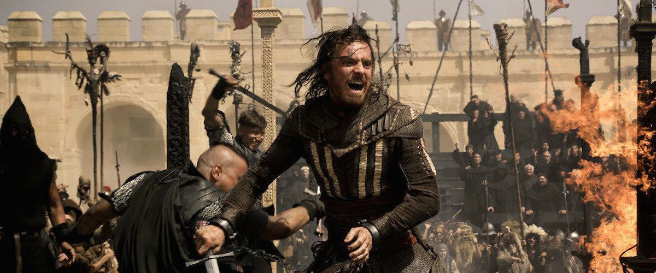

And 100 foot Leaps off roofs.. "The leap of Faith"

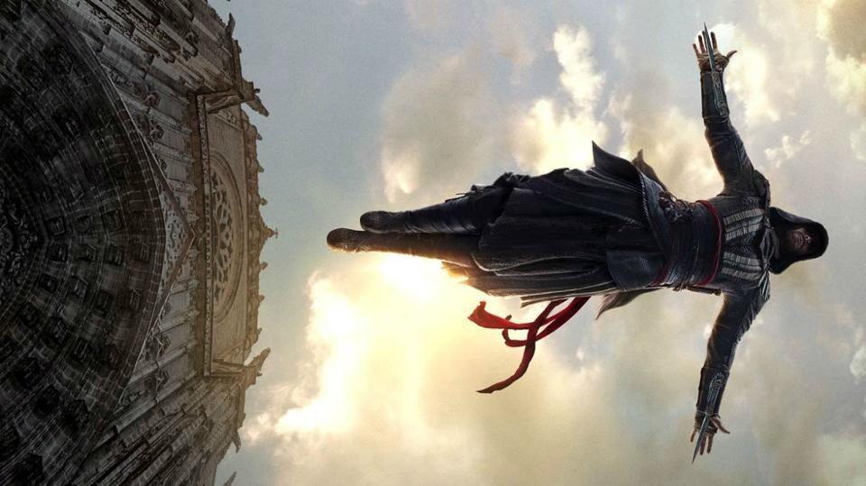

So, they find the Apple in the Tomb of Christopher Columbus in Seville Cathedral.

The "Bad" Templars try to use the Apple to destroy the Demon Seed and thus bring everyone in the World into Alignment with the Will of God at a ceremony in London.

But Fassbender the Assassin of Assassins Creed SATAN'S CREED
- stops the ceremony, kills Jeremy Irons, turns his daughter to the Assassins, and steals the Apple!! Ready for the next installment..

But what is the Assassins Creed, Satan's Creed?

"Nothing is true, Everything is permitted."

Nothing is true

Only God is true because only God never changes.

When we say, "Nothing is true" we say God does not exist.

When we say, "Nothing is true" we say God is Dead.

Satan is the Father of Lies the Ancient Enemy of the Truth, or God.
Everything is permitted

"Do what thou wilt is the Law"

"Love under will is the whole of the Law"

Thus said Aleister Crowley - the Greatest Black Magician of the 20th Century..

This is entirely SATANIC!!

Very much like Lord Blackwood in Sherlock Holmes (2009) by Guy Richie.. who using Freemasonry, Ritually Sacrificed six young women in order to take over the British Government, take over the USA, "by incorporating our American friends", and by the use of WWI and WWII use the British/American Empire to take over the World.

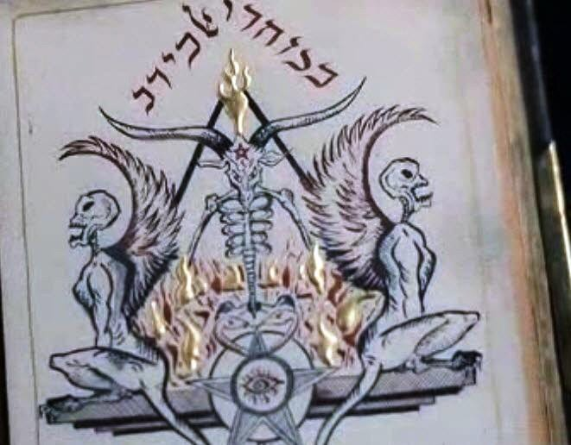

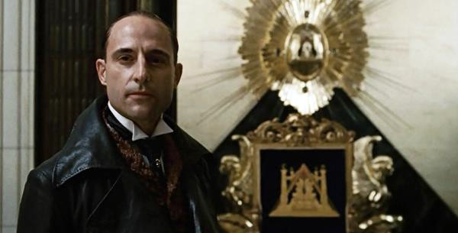

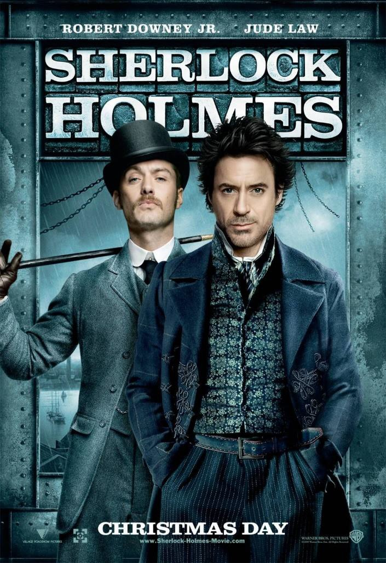

Logan - "Beware Of the Light" Esoteric Movie Review by Satchidanand

Logan & Slow Poisoning, Brain Damage, GMO, Fluoride, Sterilisation, Poverty, Racism, Slavery and Genocide - All Gone - He is Risen!!

"THE FURTHER BACK YOU GO,

THE FURTHER FORWARD YOU CAN SEE"

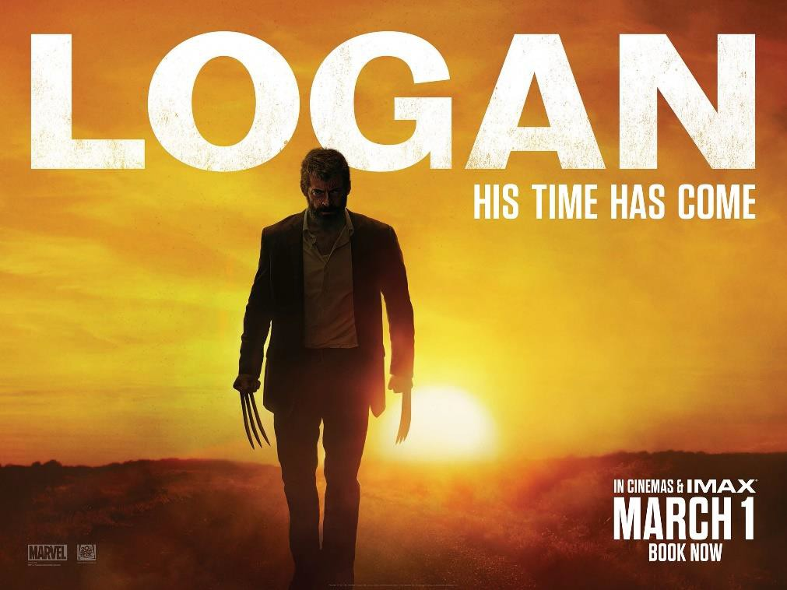
THE DEATH OF ANGRY WHITE MALE WOLVERINE SUN GOD APOLLO IS PREMATURE

TRUMP CHRIST-APOLLO IS RESURRECTED

What's so tragic about the film is that it's so ignorant. The Movie Makers got it wrong. Trump is President and Capitalism is Revived!!

In this Movie Wolverine representing the old dead capitalist order dies. They got it wrong and this Movie could easily be fixed.

All movies are written two years in advance and by this time Globalist Communist Maoist Chinese Agent Hillary Rodham Clinton - named after her father, Hugh Rodham, who took over the Chicago mob after Al Capone - was supposed to be in charge of a dying America.

Rather like Hari Seldon in Isaac Asimov's Foundation series whose memes were given to him and to all science fiction authors by Naval Intelligence and the CIA, we find we are dumfounded when that which was predicted does not come to pass.

Clearly, the real villain is the Transigen company, representing the Monsatan Company and because they are a company, the film makers think this is a cute way to strike an anti-Trump punch; because Monsatan uses our food and water to poison people, thereby destroying mutants except those they create in their labs,

Monsatan GMO has the same poisoning effect on the new mutant crystal children.

Transigen bares striking resemblance to real-food modifier giant Monsatan, who happens to be a big-time donor to the Clinton Foundation or there is this article where Hillary accepted $325,000 to "coach" Monsanto employees on how to avoid being honest.

There is also this article about how the Obama-Clintons-Bush drug criminal enterprise have pushed for GMOs in our diet, but always had organic food at the White House.

It is now extant that the elites have planned eugenics and human genocide since 1850.

They created No-Soul Satanic Atheism and Communism by Ambassador Urquhart paying Karl Marx to write Das Kapital from his office in the British National Library in London.

This resulted in the Russian Revolution with Agents Lenin and Stalin (60 millions dead).

This resulted in the Chinese Revolution with Yale Educated, 33rd Luciferian Degree Freemason Chairman Mao (100 Million dead including innocent buddhists who are prosecuted, blood typed and executed by organ harvest and whose organs are sold to rich aristocratic oligarchs who now live to 100 and have eight heart transplants to keep them alive. Whose life extention includes regular blood transfusions of stem cell rich babies and children.)

Using interbreeding between the Pilkington, Huxley, Darwin, and Galton families they created geniuses like Julian and Aldous Huxley but also inbred cretins.

Even the geniuses created by these families were of the psychopathic variety, gushing over experiments in Soviet Russia they had seen of hospital wards filled with human patients with the top of their craniums sawn off and wires implanted in their brains!!

So, the no-soul communists can do this because for 10.000 years Satanists have been teaching humanity is an animal, is a beast which has no soul, no imago dei and thus can be treated like Slaves.

This is very much like the Papal Bulls of the Catholic Church from its Satanic Temples beneath Saint Peters Cathedral, founded by the Capet Dragon Kings of Paris France, from its Satanic Temples beneath the Cathedral of Notre Dame.

Papal Bulls are written on human skin of heretics or children, say the same thing and more. Humans have no soul, no mind, no body say the Catholic Papal Bulls.

In fact says Saint Augustine in agreement with Satanic Babylonian Empire Superagent Aristotle, "The Poisoner" of Alexander the Great, "Slavery is their natural State"

Indeed our Lord and Master Aristocrats - Aristo from Aristotle and Crats - to rule by - the Aristotelian teaching propounded by Professor Pompo-Nazi at the University of Padua that Humanity has no soul.

Only Imago Viva Dei - Man is the Living Image of God!! - and the concept of the Soul can protect us from being treated like Animals, treated as Slaves.

So these concepts of interbreeding with animals as has secretly been going on in underground laboratories Worldwide for 50 years ( the Island of Doctor Moreau by head of British Secret services H G Wells and the Resident Evil series), and interbreeding with aliens (The Guardians of the Galaxy). The creation of soulless Androids (Blade Runner). The creation of Robots and Artificial Intelligence (I Robot) are at the forefront of the Battle for the Soul which has been going on for thousands of years.

Where elites use philosophy to prove that they themselves, by virtue of their divine right are a different species from humanity and therefore have always had this divine right to rule. To call humanity slaves.

And because the Aristocrats believe and have always believed that they have the divine right to call humanity their slaves, they...

- Poison us with GMO

- Poison us with Monsatan Roundup Pesticide and Rat Poison Fluoride in the water.

- Poison vaccines to brain damage the babies reducing humanities IQ by 20 points on average.

- Poison vaccines to sterilise little girls.

- Poison Vaccines to paralise people. Understand that eugenocidalist Bill Gates can no longer visit India because of a law case where his vaccines paralised 50,000 people.

- Created Atheism and Communism by Ambassador Urquhart paying Karl Marx to write Das Kapital from his office in the British National Library in London, resulting in the Russian Revolution with Agents Lenin and Stalin (60 millions dead), resulting in the Chinese Revolution with Yale Educated, 33rd Luciferian Degree Freemason Chairman Mao (100 Million dead including innocent buddhists who are prosecuted, blood typed and executed by organ harvest and whose organs are sold to rich aristocratic oligarchs who now live to 100 and have eight heart transplants to keep them alive. Whose life extention includes regular blood transfusions of stem cell rich babies and children.)

- Created the United Nations not to create World peace except in the Roman sense of, "They created a desert, and called it peace - Tacitus" but to enslave the World through Satanic Globalism.

Together with the Council on Foreign Relations, the World Health Vaccine Organisation, the Pharma Industries creation of Autism Pharmageddon, 50% of children are now on medication, Modern Druggy Medicine, Agenda 21 and 30 to create a poverty stricken underclass living in coffin apartments in Cities and to destroy the family by pushing a socialist, safe space, LGBT Agenda. Etc.

In other words, the very problem the makers of the movie Logan wans to vilify and peg at the door of the conservatives, whites and Christians are issues created by thousands of years of Satanic Aristcrats and their no-soul satanic socialist candidates championed in every Government in the World from Europe to USA to South America to Africa.

They will never admit it though, will they?

This isn't something particular to capitalism, this is particular to satanic no-soul socialism and all the underground temple satanic secret societies.

The Pope is the Godfather front man for the Black Nobility and the Rothschilds are thr front man investors for the Vatican Bank.

The 500 trillion dollar Vatican Bank owns nearly all, 70% of the Fortune 500 International Companies, Banks Worldwide, and 100% of Central Banks like the Federal Reserve..

Ever wonder how they have gotten away with millions of cases of pedophilia, never mind the Human Sacrifice which goes on in the catacombes, the underground Satanic Temples, underneath St Peters in Rome.

The Popes, the American Presidents, the Pentagom, The CIA and the FBI and the Mafia are all the same group whose aim is Control in the same way this World has been controlled for 10,000 years.

These businesses are merely doing their satanic business and paying government not to enforce regulations and oversight.

When the government is in charge of everything, there is no one to enforce regulations and oversight, because the government isn't going to govern itself or keep up checks and balances, just as we saw during the disastrous eight years of the Obama Administration.

Politicians give these organizations money when they are in power (like Hillary Clinton and the $600 million missing from the State Department while she was Secretary of State) and then those organizations give a percentage of it back to the politician in the form of a "campaign contribution," like to the Clinton Foundation which has been given sixty-nine Billion Dollars for services rendered.

That's "cronyism," that's Corruption, ubiquitous in capitalism and no-soul socialism.

In fact when corrupt we have neither capitalism or no-soul socialism or communism or anarchism or bolshevism or globalism - we have only corruptionalism!!

More than that, we have illogical Satanism!!

Pushing the No-Soul Agenda of human slavery for 10,000 years from its underground satanic temples in Paris, Rome, and Oxford University. Benjamin Franklin joined the Hellfire Club with its underground Satanic Temple like most of the English polititians of the day.

There are underground satanic temples beneath Oxford University.

The motorway (a motorway just to Oxford!!) takes them up from London to their group dinners and Satanic rituals.

Most headmasters of schools have Oxford MA's and promote intelligent psychopaths to Oxford and destroy the careers of the crystal children, the new Xavier-Saviour mutants of heart, conscience, morality, and Christ-like psychic powers.

These Crystal Children are the real mutants and are born like cuckoos in every family.

The psychic powers of Crystal Children are not aimed at Killing Better like the X-Men Movies.

The psychic powers of Crystal Children are not based upon DNA or it would be possible to breed them.

Instead the crystal children's powers of Heart, Empathy, Conscience and purpose are based upon their evolution over many lifetimes.

Crystal Children are not beginners.

Crystal Children have been here many times before. Crystal Children have been down every road.
Crystal Children know where each road ends

Crystal Children are not psychopaths, they can not be turned to the Dark Side, they are incipient Jedi Masters, Illuminated Enlightened Masters because they respond to Spiritual Energy, To Intuition, To Wisdom, To Goodness, To Light!. -

Thus Crystal Children do not fit with normal humans.

Thus, they just need space to find their own path and can learn most from one who has walked the path - One who can create a Buddhafield One who can teach the Ancient Techniques of Meditation and Soul growth. A Charles Saviour if you will.

These Oxford University Satanic Rituals hold the group together in sin. Very much as the Mafia (Mazzini authorises fire and assassination MAFIA created by British Agent Mazzini) Assassinate someone to, "Make their Bones"

But because they are so quick to blindly follow orders, they don't question anything or do any research, they just open their mouths and swallow whatever is fed them, and they count upon us to do the same.

These secret organisations and their Satanic underground temples are the cause of all wars, all poison, all genocide, all Satanic transhumanism and eugenics..

Leonardo Da Vinci of the Medici renaissance went to France at the end of his life to teach the French King about the wealth creating methods of the renaissance.

Later the same renaissance methods took root in America in 1776 - which is now in the process for the last 60 years of being taken down.

With the help of Leonardo Da Vinci, France became the richest country in Europe which was a threat to the Satanic World State based on poverty and slavery.

Thus the Satanic Venetian Empire which took over England with its agent, William of Orange, wanted to run operations to take down the French Empire, and later the American Empire.

The Seven Years' War of 1756-63 had stripped France of its once formidable maritime capacity. Lord Shelburne - head of Drug-Slave- Bankster British East India Company and Prime Minister of England sought to destroy France as a wealthy, scientific, economic and military rival on the continent.

From the outset, the French Revolution Jacobin Terror was a British East India Company - British Foreign Office-orchestrated affair.

The bloody massacre of France's scientific elite - the destruction of the wealth creation of Science - was systematically carried out by French hands, manning French guillotines, but guided by British strings.

British Agent Jacques Necker, a Geneva-born, Protestant, slavishly pro-British banker, had been installed through the efforts of Shelburne's leading ally in France, Philippe Duke of Orléans, as finance minister. Necker's daughter, the infamous Agent, Madame de Staël, would later run one of Shelburne's most important Parisian salons.

Although Necker had failed to block France from allying with the Americans during the American Revolution, he did succeed in presiding over the depletion of the French treasury and the collapse of its credit system, as in the USA today.

Economic crisis across France was the precondition for political chaos and insurrection, and Shelburne readied the projected destabilization by creating a "radical writers' shop'' at Bowood staffed by Satanic Psychopathic British Agents Bentham, the Genevan Etienne Dumont, and the Englishman Samuel Romilly.


SATANIST JEREMY BENTHAM'S HEAD WHICH IS KEPT UNDERNEATH HIS STUFFED BODY IN HIS FAVORITE PUB



The Vast Majority of the Low IQ Public comprising Dumb Sheep and Dogs know nothing of this.

This information is written for the most alert and aware.

It is written for those who are capable of becoming enlightened.
Speeches were prepared by Bentham and translated and transported by diplomatic pouch and other means to Paris, where leaders of the Satanic Left wing Jacobin Terror, Jean-Paul Marat, Georges Jacques Danton, and Maximilien de Robespierre delivered the fiery oratories.

Records of East India Company payments to these leading Jacobins are still on file at the British Museum.

Satanic Psychopathic British Agent Bentham was so taken up with the events in France, that on Nov. 25, 1791, he wrote to National Assemblyman J.P. Garran offering to move to Paris to take charge of the penal system.

Enclosing a draft of his Panopticon - Big Brother is watching you surveillance - Concentration Camp proposal, Satanic Psychopathic British Agents Bentham wrote: ''Allow me to construct a prison on this model--I will be the jailer. You will see by the memoire, this jailer will have no salary--will cost nothing to the nation. The more I reflect, the more it appears to me that the execution of the project should be in the hands of the inventor.''

At the same time, Satanic Psychopathic British Agents Bentham was proposing to assume the post of chief jailer of the Jacobin Terror, which sent many of France's greatest Renaissance scientists and pro- American republicans to the guillotine or to prison.

Bentham's Panopticon scheme was a slave labor camp first designed by him in Russia in 1787 while he was visiting his brother, another Shelburne spy.

Asked by Prince Potemkin, the prime minister of Catherine the Great, to help procure a steam engine to build up Russian industry, Bentham argued that human labor--not steam power--ought to be sufficient.

His design, complete with elaborate architectural drawings, called for criminals to be worked to death as slave labour, the indigent, and the retarded--along with their children--to be placed in jail cells equipped with primitive machinery run by a central power source, which in turn would be fueled by swings, merry-go-rounds, and see- saws in the children's cellblock.

A scene from Marquis de Sade.

The energy expended by the children playing with the toys would drive the factory. A central guardroom equipped with two-way mirrors would permit one guard to oversee the slave labor of hundreds. Above the main door of the Panopticon was to be a sign, reading: "Had they been industrious when free, they need not have drudged here like slaves.''

During his tour of Russia and the Ottoman Empire, when he devised his Panopticon scheme and wrote In Defense of Usury, Bentham wrote in his diary: ''It is an old maxim of mine that usury interest, as love, should be free.''

Satanic Psychopathic British Agent Bentham's, "In Defense of Pederasty" in 1785 an essay on the subject of pederasty--arguing against any sanctions against homosexuality, sodomy, lesbianism, Pedophilia, masturbation, and bestiality - Free Love!!

Satanic Psychopathic British Agent Bentham dismissed the harsh penalties then in force against pederasty as the result of irrational religious fears born of the Old Testament destruction of Sodom and perpetuated by society's "irrational antipathy'' to pleasure in general and to sexual pleasure in particular. Christian morality, like every other expression of natural law, had no place in Satanism...
These Renaissance destruction programs never let up.

The Satanic creation of Human poverty and slavery are a full time job.
Thus the Assassination of Franklin Delano Roosevelt by poison just after he succeeded in making USA the richest Empire ever!! And his wish to then enrich the whole world which was never followed up - IT HAS TAKEN EXACTLY 70 YEARS - 1947 TO 2017 - TO DESTROY THAT RICHNESS!!
And the Assassination of John F Kennedy with his dreams of a fusion powered economy, irrigation of California and Arizona sufficient to support another 300 million people and his project to the Moon, Mars and beyond - TO THE STARS!!
All renaissance projects.
No, "You Africans can not have Air Conditioning or Cars - the World would just blow up!!" from Obama.
No!! We want a high energy, high richness economy!!
We don't want that dystopic predictive program of Logan, Deadpool, Suicide Squad, Batman vs Superman, Watchmen.. Orwell's 1984, Aldous Huxley's Brave New World.

There are two minor details of Logan substantiating this: first, Professor X tells Logan a mutant waits for him at "the statue of Liberty," and, indeed, it's at the Liberty Motel which has a Statue of Liberty logo where Logan picks up Laura.


SUFFER THE LITTLE CHILDREN TO COME UNTO ME

The act of picking up an immigrant (because Laura is from a lab in Mexico, so she's crossed the border) and taking her is meant to invoke Ellis Island and the immigrants who arrived there.

More.. These x-men children also represent the business of Child traffiking on billionaire convicted pedophile Jeffery Epsteins private jet, the Lolita Express on which Bill and Hillary Clinton travelled to Pedo Island twenty-two times, and Saudi Arabian Private Jets, and the Satanic Pedophile Sex, torture, murder - human sacrifice - snuff films and cannibalism of young children by Renfields like Jimmy Saville, Dutroux, Hastert, Sandusky, Penn State, Boys Town and the 1500 Renfields and 100's of young children freed from torture dungeons in the first 45 days of Donald Trump's Presidency.

The track Logan and Laura make to get to North Dakota invokes the Underground Railroad for slaves escaping to the free North and today, to "free" Kevin Annett's Canada where socialists believe a true Eden exists and everything is free because of the socialist policies of the country (there are also echoes of Chief Joseph leading his Nez Perce Indian Tribe to Canada for refuge) but we know of the Trail of Tears, we know that 50% of all native Canadian children die in Church Schools, we know that companies want the minerals on Native Canadian lands.

The second way we know Laura symbolizes a Satanic no-soul socialist form of existence is the T-shirt Logan gets her she sees a mannequin wear in the shop window with a rainbow on it.

Unfortunately, the rainbow today symbolizes homosexuality (originally a sign from God that He would never destroy humanity with a flood again, and so homosexuals mock God's promise by having it affixed to their public meme) but also utopia, and Laura's guardian, Gabriella, calling the meeting place "Eden," not only aligns no-soul socialism to Eden, but replaces God who created the original Eden and the creator of the original Man and Woman, with the Satanic no-soul State who created Laura and the other mutants in test tubes.

This is an important point of the narrative, once again, deconstructing itself: the "slavery" invoked by the Underground Railroad was because of the Democratic South refusing to free their slaves and slaves trying to escape to the free north where it was predominantly Republicans who didn't own slaves; in other words, the Democrats blame--as usual nowadays--the Republicans for what the Democrats themselves did.

Hugh Jackman's Wolverine character, Logan, is old and not regenerating as he once did because of the poison in the food slowly killing him: men symbolize the economy of a country because men are the "active principle," whereas women symbolize the passive principle. Thus Logan represents the 1% growth of the economy for fifty years, the loss of jobs, the destruction of the middle class, the resurgence of Satanic, no-soul, communist China and its execution organ harvesting vans - you think this is an accident?

As in the great Western film Shane, and mother being told, "There are no more guns in the valley." But just as Shane tells the young boy that everyone has a brand on them, and that brands stick, the film makers behind Logan want the audience to know they have a brand on them, too: the color of their skin.

If they are white, that brand sticks, and they can't escape it, so it's best to just go off and die, like Shane, like Logan.

The future is feminist lesbian female, as Hillary Clinton announced, and Wolverine's Mexican daughter is headed to British Canada.

There isn't an end credits scene to Logan, the way there usually is for Marvel films, but there is a pre-film involving a "little skit" with Deadpool (Ryan Reynolds).

I'm glad they put this in, because, inadvertently, this Deadpool sequence validates every single thing written here.

We see his feet in black shoes (symbol of the will, black symbolizes death) walking along a street with a lot of trash on it. A figure

wearing a black hoodie pops out earphones and we hear Juice Newton's song, Angel Of the Morning; why?

Because in a world where women are happy to have a one-night stand with a man there can't be real super-heroes, and Deadpool isn't a real superhero because the poor guy Deadpool vows to save dies before he can get to him.

Since women haven't demanded that men be converted and overcome their bad habits so they are always prepared to answer the call of being a real man, Deadpool has to jump into a phone-booth and literally change out of his clothes and into his Deadpool outfit to fight off this mugger, who kills the the poor man before Deadpool gets out. (All the trash on the street, the darkness and even the poor man being held up, we can see, are a result of women allowing their own personal morality fail so that they aren't any longer angels in the morning because of how they let the dark night of lust overwhelm them and, hence, the whole world).

Deadpool wants to "answer the call," symbolized by the phone booth, but Deadpool also mentions that phone booths "disappeared in 1998"; why? Bill Clinton, Mr. President-Rapist - and not just rape, violent rape - he used to bite them and beat them - was in charge and men stopped being men and became psychopathic sex machines who so turned women off them, they all became complaining feminists and Lesbians.

While Deadpool struggles in the phone booth, we hear the white man being mugged by a black man, that he "has worked too hard just to hand it over" to someone who hasn't.

If that doesn't describe what has been happening in America, I don't know what does.

And this is it!! Predictive Programming.

Poverty, hatred, poison, all the trash on the street, the darkness, the robbery, the drug gangs, the murders, the fights, the muggings.

Depression, rage, disturbed emotions, something must be done!! No heroes anymore.
Wolverine, All the X-Men, Dead!! Superman, dead!!
Suicide Squad. Watchmen.
Deadpool

Again, Deadpool, in his own words, isn't a real superhero, and the guy probably would have been saved if Logan had been there, because Logan didn't have to "change," but Deadpool did

Deadpool then goes on to use the dead man's body as a head cushion and eat his ice cream, then complaining about brain freeze while this poor man is dead.

It takes a while to realize that all the people beating up Angry White Male Logan are doing so because Logan deserves it.

He can't defend himself, or what is his, anymore because he shouldn't.

Logan isn't being poisoned by the adamantium attached to his skeleton, or by the targetted for x men Monsatan GMO, rather, by the poison of guilt because he's white, he's strong, and everyone could always depend upon him to save the day.

The very characteristics and virtues which made Wolverine a hero in bygone days, now mark him as a target for the no-soul satanist purge

and a sacrifice to be made, with tears for sure, but a satanic sacrifice he has to be.

And Logan, being a "budding feminist" like Iron Man, is happy to do that.

How does Professor X fare in the film?

According to Donald Pierce (Boyd Hollbrook), Professor X's brain is a classified weapon of mass destruction,... why? Professor X is a white man, he's intelligent, and white people who can think can also think for themselves, so Professor X has to die - targetted by Monsatan GMO and the rest of the slow poison vaccines - brain damage autism up from one in twenty-five thousand to one in two by 2030, sperm counts have fallen by 95% - soon children will only be available from test tubes!! - "Silent weapons for quiet wars".

But there is another reason why Professor X has to die: he requires care.

He needs medication--he doesn't like taking, and sometimes doesn't take just so he doesn't have to take it--and he needs someone with him to fix his meals and help him to the bathroom (we see the fight that takes place in the restroom when Logan has to help Professor X get on the toilet) and Professor X has to be loaded and unloaded into the car.

In movie Beautiful life we see the Nazi teachers asking the kids to do mathematical sums how much money the state would save if the autistic kids would die off.

We know that Hitler Nazi Doctors - apparently most state assassins are Doctors or Psychologists - killed 250,000 weak minded and state enemies in the Loonie Bins by euthenasia - very compassionate - no pain!!

This makes him a liability for socialists, they don't like old people because they cost the system without providing anything in return (such as labor in exchange for their medications) and the elderly

remember the truth about Democrats, Nazis and no-soul socialism and they know what real freedom is and that we all deserve it, so the elderly can't be schooled the way Millennials have been, brain damaged by vaccines and brainwashed.

Professor X is dangerous because he's smart and loves to teach and care for others (like the little garden he has in his hide-out home).

So, like the Mexican nurses caring for the children in the mutant lab, Professor X had to die like them.

Laura can "learn to be better" than Logan, but satanic socialists don't want that, they want people to have bad habits like the protagonists in Suicide Squad, Watchmen, The Expendables, and not to "get better" and become better, become Enlightened because then they won't need the State of the System that created them to control them.

But there is a third reason: his complaint to Logan when Logan was complaining, Professor X gave him a reality check: stop blaming everyone else for your boring shit.

This is what socialists absolutely do NOT want to happen: they want the Poor Me to keep blaming everyone else for EVERYTHING that happens to you, including you being unhappy with the gender you were born with.

If you aren't Poor Me complaining about something, then the State can't find what it is they need to promise you so you will sign your life over to them.

Real men avoid the poisons for themselves, their wives and their families. They filter the water, avoid the GMO and pesticides in food, air condition the air.

Real men avoid the poisons in their minds. They read substantial books. They study real history and economics. They avoid Fake, company bought, presstitute, mainstream media. They think for themselves!!

Last, but certainly not least, Professor X realizes what real happiness is: your home, your family, the people you love,... the State won't allow any of these things: you don't have a home, IF you have a family, then you have to adhere to the rules laid out by the State (people aren't allowed to hug in China, for example) and because we are just animals and no-soul slaves, we don't know what love is, we just exist to eat, have sex, work and die once the State is finished with us.

So, while the film does a clever little job making it look like it's happy and wants happiness for you and me, too, it's not, it's telling us that if we want those things, we are going to die for them.

Remember, it's Professor Charles "X"avier who gives his name to his "children". The X-Men came out of normal humanity, born like cuckoos into each family which they transcend through their gifts and are examples of excellence in their fields that he helped to nurture to make even better; so X24 is, in a way, as much Professor X's child as Logan's, since the Transigen named X24 after the X- Men.

X-Men represent the future of the human race. X-men really are people who are not only being taught to have the power to kill better with their superpowers, the real X-men are the people with more intelligence, more empathy, more conscience represented by the Heart of Christ...

People who are not competitive. People who want evolution for everyone as for their own children. You want your children to be strong and smart and good. You want your children to have money, housing, water, transport, computers, electricity, education. interesting work - a good life for everyone!!

So Professor X dying is also a case of patricide (child killing its own father).

What does X24 really symbolize? The film makers would like for us to think it symbolizes ultimate capitalism, a free market without a soul, however, that actually exists, and it's the Chinese Communist

Hong Kong capitalist economy, ranked as the freest in the world even with the regulations that have been imposed.

So, once more, we can say that the fears of the film makers--that a "soul-less" economy will start killing the elderly (Professor X) and kidnap the children (Laura) and be used as a weapon--isn't capitalism, it's Satanic no-soul socialism, because we know Satanic socialist societies do not value their elderly citizens, they believe the State should be in charge of raising children (and they should be viewed as "units" and future citizens, not as individuals) and that resources should be used to reward good citizens and punish bad citizens, so, the picture painted by the film makers is of satanic no- soul socialism, not capitalism, as they intended.

It's important that we detail exactly how this happens: as stated above, men of child-bearing age (and even though Logan is hundreds of years old, his DNA spawned Laura, the young mutant, so he's a father of a young girl so this still counts towards him) symbolize the economy; like capitalism always rejuvenating itself, so, too has Logan with his mutant abilities (this was clearly the basis of the last Wolverine film).

The adamantine which was artificially adhered to his skeleton to make him indestructible is now, according to the film, causing him to be poisoned from within like Iron Man with his fusion reactor heart. But this is not true. The child has the same adamantion inserts
- its the poisonous food.

We have to look at the symbolism here, and how the sub-text reads is, that because Wolverine has been so strong, so great, so indestructible, so White, that has poisoned him, so he has to die. In reality, the Satanists hate strong intelligent independant slaves, so they poison him, weaken him, kill him.

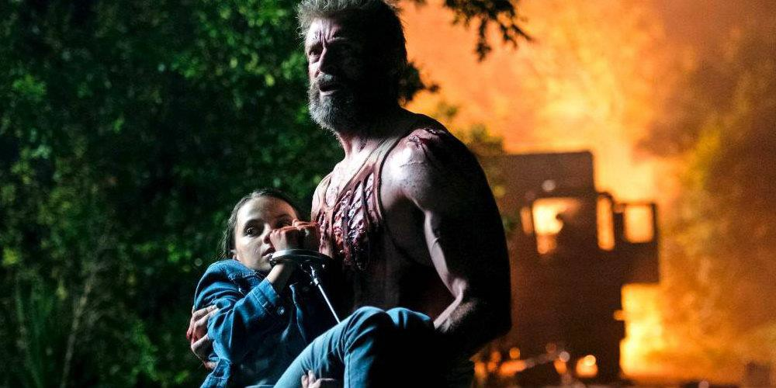
SAVES THE GIRL AT THE COST OF HIS OWN LIFE

If that doesn't seem like very sound reasoning, it's because, it's not sound reasoning.

According to this line of thought, capitalism is what is old because it's not "healing" the way it once did (remember, this was made before the election of Trump and his vow to remove the Satanic Globalists and the record Stock Market climbs past 21,000 for the first time in history and that ability, anyway, makes Satanist Globalists mad (like socialists) and so because of that, capitalism and Trump need to die, i.e., in the guise of Logan.

But what about X24?

Even the Golem Caliban Calaban, fights back at the cost of his own life - HE HAS A SOUL!! The albino mutant who takes care of Professor X while Logan works, is perhaps the most tragic figure of the story: and Calaban's albinoism is meant to reflect white audience members watching the film.

EE LEVEL 1 POWER UP!! GAIN SUPER ENERGY http://www.energyenhancement.org/Level1.htm
EE LEVEL 2 ELIMINATE ENERGY BLOCKAGES http://www.energyenhancement.org/Level2.htm
EE LEVEL 3 CLEAN KARMA BLOCKAGES AND PAST LIFE KARMA BY TRANSMUTATION http://www.energyenhancement.org/Level3.htm
EE LEVEL 4 MASTER ENERGY CONNECTIONS AND RELATIONSHIPS http://www.energyenhancement.org/Level4.htm
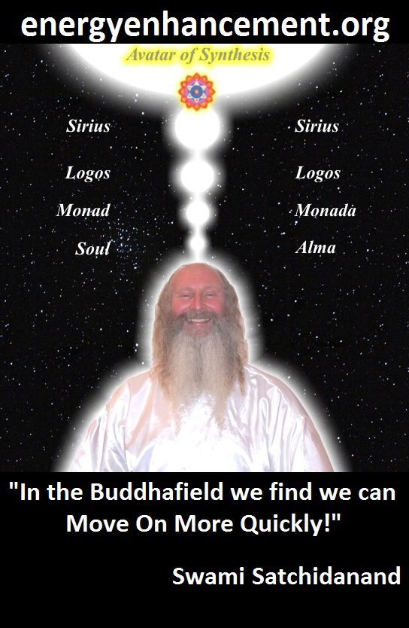
ENERGY ENHANCEMENT - THE ULTIMATE MEDITATION COURSE!!
“Traditional meditations are designed to Fail” – Satchidanand
FUSION WITH THE SOUL CHAKRA - Enlightenment - is Only the first Dan. Become fused with the Monad - Second Dan. Become fused with the Logos - Third Dan. Become Fused with Sirius - Fourth Dan. Become Fused with the Avatar of Synthesis - Fifth Dan - Satchidanand
Research The Energy Enhancement Meditation Course by video or on retreat..
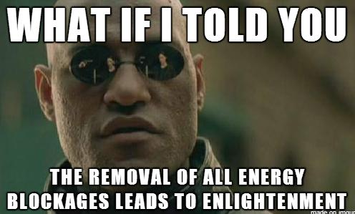
The Ancient Enemy who counts meditation and the mind control psychic arts as one of its main planks of ing, International Companies, Eugenics - Worldwide, censoring Alchemical VITRIOL, the Kundalini Key and Energy Blockage Removal from every Meditation Program..
WE HAVE SO MANY ARTICLES SHOWING THE ORIGINAL EXISTENCE OF THESE ESSENTIAL MEDITATION TECHNIQUES IN EVERY WORLD RELIGION..
NOW, SPEED UP YOUR PROCESS WITH ENERGY ENHANCEMENT ALCHEMICAL VITRIOL, KUNDALINI KEY AND ENERGY BLOCKAGE REMOVAL ON THE PATH OF ENLIGHTENMENT
GET IT NOW!!
EMAIL sol@energyenhancement.org

He can't be in the sunlight because it burns his skin, so his mother told him, 'Beware of the light," so he wouldn't get burned, and that's ultimately the message the film has for viewers who, like myself, are white: beware of the light, stay inside, don't come outside, or you aregoing to get hurt (mugged like the white man at the very start of the film that Deadpool didn't save).

What happens to Caliban? He blows himself up with grenades, because this is what whites are supposed to start doing now: suicide.

Do the rest of the world a favor and kill yourself, because no one likes you and no one wants you around.

This is, of course, the message from the Satanist ; why target white people?

One, white people are the "dominant power holders" in Western society, and their radical Marxist textbooks from Luciferian Sol Alinsky who was mentor to Hillary Rodham Clinton (Her father Hugh Rodham took over the Chicago Mob when Al Capone died) teach them to target the dominant power holders in every society and isolate them and erase any possibility of anyone having sympathy for them. To bring everyone, every race, every colour, every gender, every mind to the same state - Slavery!!

This is the only way to destroy them and take everything they have. So, when we see Caliban dressed with the scarf over his face and wearing the hat and the poncho, the guy in the alley with deadpool being mugged, wolverine himself, the film makers want to tell white people, everyone, that we are the bandits, not the Mexicans who break the laws, not the muggers, not the mercs, but we are the criminals and we better go into hiding and beware the light.

Remember, we also see this in The Magnificent Seven with all the white cowboys die and only the minorities live: it's the same genocide, and just because some black people think it's "justice," certainly doesn't make it just and certainly doesn't make it right.

This might be confusing, but "X23" is what the "daughter" of Logan, Laura, was being called; X24 is actually,... one might say, Logan's twin brother Logan's DNA gave birth to, so both his brother and his son (Chinatown, anyone?).

X24 is supposedly the "perfect weapon" because it's Logan without a soul to decide what is right or wrong, X24 just takes orders,... wait a minute,.... there's a problem. It's the satanic socialists who don't believe in the soul, because to have a soul, you have to have God to give that soul ( a soul can't come from nothing) and satanic luciferian socialists firmly disavow God and insist we are animals, not humans with souls.

This leads us to the terrible,... "complication" of the ending.

This is one of the moments the film deconstructs: Laura has never been outside of the lab where she was created, so the Socialist System provided for all her needs and so she doesn't understand what "paying" is.

Socialism takes what it wants.

When Logan comes in and stops her from beating up the poor attendant standing in the background, Logan tells her, "You can't just take whatever it is you want," then Logan asks the guy if he sells cell phone chargers and the guy motions to where they are, and Logan grabs one, some cigars and walks about with Laura, without paying - so Capitalism takes what it wants too.

In a socialist system, we wouldn't pay, and socialists want us to believe that paying for something is evil (consider the kids not wanting to have to buy their own condoms in Project X and the way money was used in Bridge Of Spies: the Soviets used the nickle to pass microfilm, and the US used the silver dollar to bite down on and commit suicide if caught, because "money is evil and the root of spy games"; there is also the issue of payment in Logan, and Gabriella offering to pay Logan to take her and Laura to Eden, then Rictor offering Logan the money Gabriella offered him and Logan feeling like he had to refuse it and Laura not being impressed with Logan for not taking it) because paying for something is taking responsibility for it and for yourself.

So Laura doesn't know to pay for the food, but this is the same poison food Transigen manufactured to eliminate mutants, which is what Laura is.

Transigen also created that food to make a profit--us paying them to kill us--and instead their mutant isn't paying for it because they didn't teach her how to take responsibility for herself because they didn't want that in her or the others.

So, Wolverine dies, and X24 "crucifies" him on this stump and it does work because Wolverine has knowingly sacrificed himself for the kids to help them get to safety across the border

After the kids bury Logan, and they have made a cross for his grave site, Laura shifts the cross so that, instead, it makes an "X" for X- Men,... or does it? A swastika, after all, is a bent cross, much like the turned cross of the "X" which Laura makes for Logan before running off to socialist Canada.

Laura knows, then, the truth of the forces that created her, and Logan, but there is something just as sinister for Christians.

Mr Munson and his family is quite lovely, and it's so regrettable that white people bullied him later in the film, making it look like all white people are racist bullies, like KKK without the sheets, but the film wanted to do that to brainwash black film viewers into seeing racism everywhere.

Why does Munson die? His son, Nate, tells Laura when she sees his trophies from racing and riding horses that he's not very good at it (all of his trophies are second and third place) but his father makes him do it anyway,.... it's very typical and common, in American society today, for parents to "force" their kids to participate in an activity, such as a sport, dance, game, or some activity which will help them socialize, develop their skills and focus on what gifts they have and what they want to do with their life.

This is why Will Munson dies, he forced his son to participate in an activity.

Socialists don't want anyone to be good at anything: everyone has to be equal in everything, which is why socialists/liberals are so good at ignoring reality, they are training to ignore reality even more, because that is what has to happen in a socialist society.

Johnny Cash's song When the Man Comes Around, about the Final Judgment, plays during the credits, as if a warning to Christians that, if they don't become socialists, they will be judged and sent to hell.

Sadly, I think this is the start of the turn of Marvel Studios, and rather than just Logan suffering from this asinine and willfully ignorant understanding of history and the future, all the future Marvel films will shove the same propaganda down our throats as Logan.

So, for this Movie Hillary was supposed to be installed as President, not the off script President Trump - they got it wrong -

RENAISSANCE PRESIDENT TRUMP STEPS OUT OF THE PHONE BOOTH!!

THIS IS THE NEW REALITY!!

In this Movie the torch of the economy passes from the male-active principle that we have seen in Logan, to the child, female and passive principle we see in Laura - or pre Trump Mob Boss Hillary Clinton - "Michael, I wanted you to become President" - The Godfather.

Socialists, of course, will far prefer the youthful, Hispanic hand of the female to the "toxic" masculinity and violence of the old man, and we are supposed to be trained to prefer the same.

There is a serious philosophical problem with Laura being Logan's "daughter," and the film makers intentionally want to muddy these waters with ambiguous, emotionally charged language (like "father" and "daughter") to intentionally to get their way.

A child is a result of the sexual act between a man and a woman, so there is a degree of free will even when the man and woman employ artificial birth control to prevent a pregnancy, there is the understanding that it's never 100% effective.

With a "child" being created in an illegal Transigen underground Laboratory, in a test tube, merely from the DNA of an unknowing "parent" who did not provide their consent.

This is an act of "rape," because the DNA owner was not consulted and so an act, not necessarily "the act" but an act to replace "the act", of procreation takes place without the DNA owner's consent or knowledge.

Logan knows this but eventually his compassion gets over his head - and he saves the group of special children at the cost of his own life.

We saw a similar instance in Independence Day Resurgence when a father gave his life for his daughter as Logan does for Laura and the rest of the kids, and, again, it's meant to symbolize the replacing of the active figure of a capitalist economy, the white heterosexual male, with the no-soul socialism of government rule, the anti family Lesbian passive female principle.

Thus legitimising a Hillary victory over Trump - it would have been a simple fix for the movie to have had the Christ-like Resurection of Wolverine after his death - I mean, that is what Wolverine does - he is Resurrected, comes back to life every time he is killed - he is Osiris (Sir, Sire), he is Apollo, he is Attis, Adonis, he is Christ.

An arm appearing from the X-men Grave after he gave his life Christ-like for the protection of the X-men children.

Everyone giving a cheer for the happy ending, Äs only celluloid can deliver" thus presaging the victory over Hillary,,

For the happy ending of the Presidential Win and renaissance of white Man, shock of golden hair Apollo, Sun God, Trump, and the renaissance of American Industry, Stock Market up by 3 Trillion

Dollars, American investment in jobs, infrastructure, medical, the return of Glass Steagal, a Fusion powered economy, NASA to the Stars.

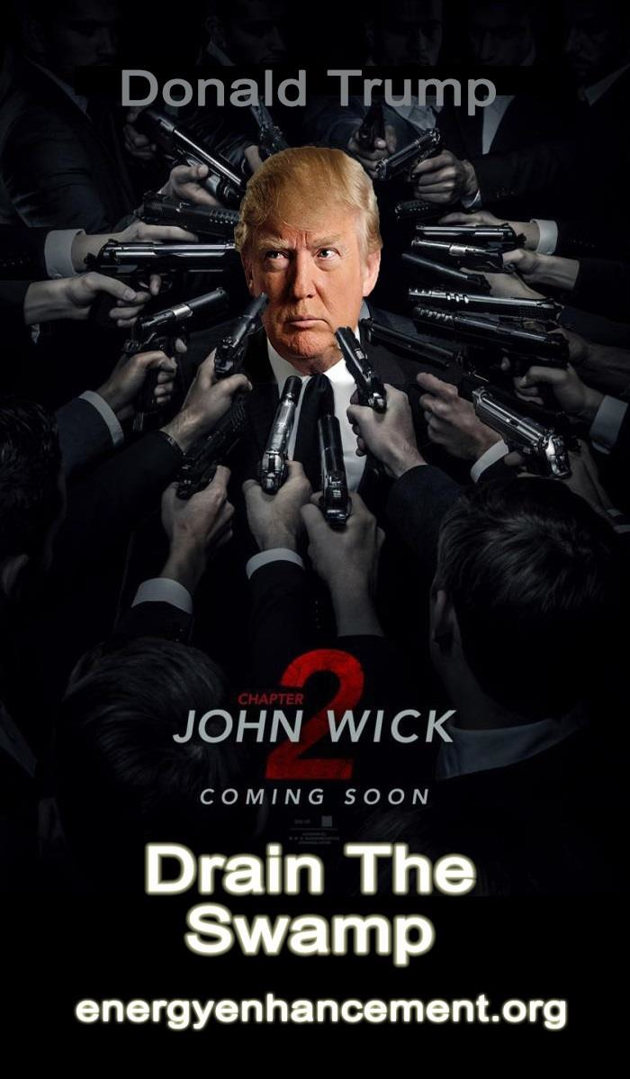



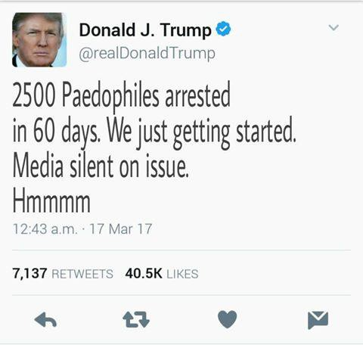

"Beware Of the Light" say the Satanists.

"Dying of the Light" is only the evil Ego Dracula Satanists being destroyed by active Male Principle, Sun God Apollo, President Trump.

The reality is the Male Active Principle lives on in President Trump. All over the Planet Satanic Feudal Poverty Globalism is falling.
The Rich Renaissance is aroused. Long may it continue!!

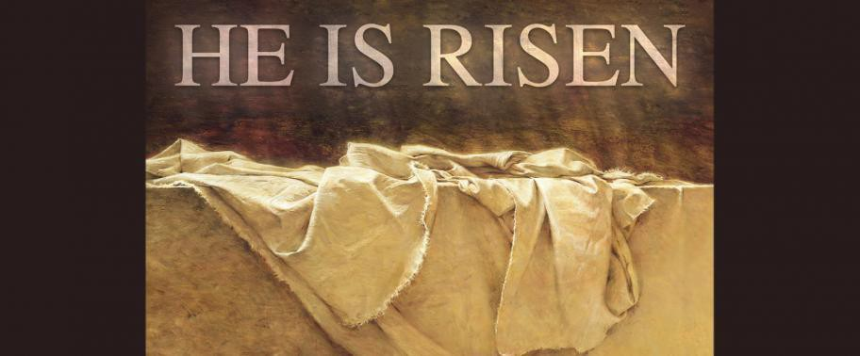


Download “Link Into Infinite Chakra Energy And Eliminate Energy Blockages” Here
http://www.energyenhancement.org/Sacred-Energy/Meditation-Energy-Enhancement-Link-into-Infinite-Chakra-Energies-and-Remove-Energy-Blockages-EEBOOK1Color-energyenhancement-org.pdf
SATANIC MIND CONTROL - FOURTH GENERATION WARFARE - THE WEAPONISED ALIEN UFO AGENDA

ALAN WATT - THE WEAPONISED ALIEN UFO AGENDA

ALAN WATT "CUTTING THROUGH THE MATRIX" (GUEST ON REALITY BYTES RADIO WITH NEIL FOSTER AND THOMAS SHERIDAN)


INDEPENDANCE DAY 2 - THE TRANSHUMANIST AGENDA - UPLOADING INTO THE MACHINE AND THE HOMOSEXUAL AGENDA

Neil: Okay. Welcome back to Reality Bytes Radio on the 24th of November, 2014. It’s four o’clock, well five past four Eastern in the United States and nine o’clock, five past nine in the UK. I’m going to change topics now and talk about "The Alien Agenda" as it’s been termed. The idea that we are all going to be invaded by little men from Mars or from somewhere in a far off land, something like "Star Trek" or something. Alan, in your research where did this idea first come from?

Alan: Again, it came from the think tanks which were involved in, again like the Fabian Society and all the other associated think tanks which are massive today of how to... If you want, if the people are catching on that too many things are wrong at any one particular time you must give them something to look at, that could even be religious. So they came up with the idea, and also to unify the world, remember the goal was always to have world government with these groups or world domination. And to get the people to go along with these things they’d push up along the Marxist line the continuous war, it’s so destructive, which of course it is, etcetera, etcetera, and we can’t go on like this, we need some outside intervention. If only something outside would come and force us to unite the world to fight it then we’d all come together under a global structure which would be necessary to defend us all. And then they came out of course with the big movie, it was "The Day the Earth Stood Still", where a big flying saucer lands outside the White House I think it was. And the whole idea is that this alien has to get in touch with members of the United Nations, scientific members though, they had to all be scientists. They’d tie it all in again with scientists running the world. And so he goes off in search for the scientists that would eventually put it across to the public that if they wouldn’t unite together to stop their destructive behavior then these aliens would eventually have to destroy you because you were dangerous.

And you can go back further, they came out with it in about 1948. That was supposedly the first sightings of UFOs over the White House. The guy who saw them all in an aircraft happened to be a CIA member. {Laughs}

So it’s the same old thing again, giving people this fake pantomime to an extent. It’s something to believe in. Something that would take over from standard religions again and get them working towards something. And initially they brought forth something like the aliens are here to help us because that really took off. And then with the whole scientific age of going to the moon and all of that. They pushed all the Science Fiction, Star Trek, etcetera.

It’s interesting how the Star Trek series was put together because they gave you situations on Earth with different peoples, races, whatever it happened to be, and put it into outer space to show you that the Enterprise, interesting name too, the Enterprise. Because it’s also God bless us on this enterprise, you know, E pluribus Unum, and so on in the States. But enterprise is to do with market you know and economy, etcetera.

So it goes around space trying to unite all the planets into a global universal federation, which is simply the United Nations. And they give you the unfair things that happen to minorities on the way, and they make them all free, etcetera, and bring them into this great trading group in outer space. And the ones who will not join this federation are always the bad guys. They are primitive, barbaric, etcetera. It was simply a projection of everything in the world that the Fabian’s and so on have been pushing for such a long time already put into an outer space setting for a unified world. And so, but it fascinated so many people in the way it was done.

But you also find top leaders like Lester B. Pearson of Canada, who also was head of the United Nations for a while, but he also became prime minister and he, I’ve got his books here, his old books, and one of his workers was also a high level bureaucrat in Canada who was called Escott Reid. And Escott Reid said in his memoirs when he worked with Pearson, he said, we drafted up along with Alger Hiss, who was a communist boy who eventually was found guilty, etcetera, for his treason. But they drafted it up, the whole charter of the United Nations, to try to unify them all, again heading towards world government. And he said in it, in his book he said, "Make no mistake, our goal is world government." Well that’s never been given up yet today. That’s what the United Nations is there for. The

United Nations was set up and the League of Nations, and they were both set up by again, the Royal Institute of International Affairs, Council on Foreign Relations. It’s the same group. It’s the same guys who wrote up your amalgamation into Europe for Britain, and the guys who drafted up the NAFTA Agreement for the
amalgamation of the Americas too. They openly said that in Canada, they drafted it up and presented it and then it was signed. These are private organizations remember.

Now Lester B. Pearson back in 1957 had a similar idea to "The Day the Earth Stood Still",

And it says:

"Perhaps there is a hopeful possibility here in the conquest of outer space. Interplanetary activity may well give us planetary peace.
Once we discover Martian spaceships..."
Alan: It’s always Mars, going right back to H.G. Wells. "...Martian spaceships hovering over earth’s air-space, we will all
come together. “How dare they threaten us like this!” we shall shout, as one, at a really United Nations!"

Alan: So in other words they are bringing the Earth together to fight them. This is a guy who was way up there at the United Nations and as a prime minister. So this was followed on. Ronald Reagan mentioned it many times during his time in office as our threat from outer space if we don’t all come together.

It’s been a great thing to create a mass mind control movement of people who are dedicated followers of ufology as they call it and make them all work towards what really is this Marxist system toward a global system where they’d use all of your tax money again as a tax base from the workers to explore space, etcetera, etcetera. Which really again was like a caveat because the whole idea was to put up all the technology that they would eventually use to monitor all of us. That’s what the Star Wars Program in Reagan’s

era was all about. It had nothing to do with shooting down satellites, it was to do with what would be used today.

Before we even had the computer they were putting this stuff out in space, getting it all ready, because they knew when they were going to give us the computers to monitor us, and the cellphones and everything else. This is how it really works. It’s very clever and we are led like you know, by the nose, like bulls by the nose, by our masters of the mind. It’s perfect. They’ve never given it up today.

Thomas: Well people have been seeing lights in the sky forever. It’s a well-documented phenomenon going back centuries, and thousands, millennia, going back. And it’s only since the late 1940’s that people have been coached to see a strange phenomenon of a light in the sky, it’s automatically an alien spaceship. Lights in the sky have always been seen long before this, particularly at times of great emotional psychological or social stress. For instance they were very highly recorded during the time of the Ottoman Empire when it looked like the Ottoman Empire was going to overrun Europe. People in communities in Austria and Germany and Switzerland were having these visions of lights in the sky. And at the time they believed that there were aliens you know that were coming to save them from Islam. I believe that these actual experiences are probably either plasma or else they are actually psychedelic experiences. Some kind of collective psychedelic experience of some kind. But they’ve copper fasted the idea again that they’re aliens.

Now there is a strong connection I discovered going back to Germany in all of this. In the first, the very first high quality science fiction films ever made were made in a massive UAF movie studio, it’s just outside Berlin, in the 1920’s. And you had directors like Fritz Lang making films like "Metropolis" and "The Woman in the Moon". These were very well made science fiction films. Fritz Lang was an interesting character, he said, if you want to get people to believe in science fiction the whole focus must be on making the actual process of the spaceships and how they operate and fly as believable as possible. So he put tremendous resources for the 1920’s into building realistic models of spaceships, realistic

portrayals of the lunar landscape of alien beings of future worlds. And so much so that this had been part of a kind of continuum in Germany since about the 1870’s. When somebody, an English guy wrote a book, a guy called Edward Bulwer-Lytton I think was his name. He wrote a book called "Vril: The Power of the Coming Race". It was basically a science fiction novel about these alien angelic beings that lived inside the Earth. And the book was such a sensation when it was translated in Germany that you had these people like Rudolf Steiner and Blavatsky walking around with a copy of it under their arms like it was the Bible, saying that the book was absolutely true, no way could it be fiction, it has to be true.

So you had the first widespread belief in this kind of alien salvation race. The genesis and gestation place took place in Germany at the turn of the century and then moving up towards the era of National Socialism where it was totally believed in, completely. Especially with the films that have been made in Berlin at the time which were so good.

Now when it really took off in the West was the Roswell incident. And now what did we have at Roswell? We have a guy holding up pieces of tin foil and that’s basically it. The newspaper and the story about flying saucers, always on a military base; they are always on military bases these big sightings. And no one ever puts one and one together and then realizes that the whole thing is a PSYOP.

But anyway your man, this guy Jessie what’s his name, I can’t remember the second name, the captain, the Air Force guy, pictures of {inaudible}, little stories about an alien flying disk that crashes. Then the story is deliberately suppressed to make people think that it actually happened or the government is covering up something. And they do not put the obvious together, because it happened in 1947, they do not put the obvious conclusion that this was a psychological operation developed by German and Nazi scientists brought over during Operation Paperclip who had been running the same PSYOP towards the end of the defeat of National Socialism, like the building of this idea that the Fuhrer had a wonder weapon. A wonder weapon that had been derived from miraculous sources that was going to save the Third Reich in its final moments.

193

The same German minds were brought over to the United States, given jobs in the OSS as you said before under the CIA and MI5, the modern version, and they were given this brief to use the same kind of ideas, of the weapon in the minds of people because the United States had to create this... They knew they had this phobia and this anxiety was coming along because the Russians were about to detonate an atomic bomb because of Marxist groups in the U.S. that leaked the secrets over. A true sort of a built Bolshevik’s type sympathy network into the Soviet Union. And they had to condition Americans to believe that. We somehow have alien technology, spaceman technology that is going to save us. We have the edge.

And that continued all during the Cold War right up into Reagan’s Star Wars announcement at the United Nations, that we would all band together and to fight a global force from outer space or an alien force from outer space with a global army. And you had you know silly films like "Independence Day" where you see the Israeli jet fighter guys looking at the Iranian jet fighter guys and giving them the thumbs up, and all this kind of like nonsense, this kind of like one world fighting the aliens.

And of course you had to notice the amazing closing ceremonies at the 1984 Olympics of a spaceship landing in the stadium in Los Angeles and a big plastic alien coming out and talking about how he approves of humanity coming together, as if they are not going to blow us up if we continue to like work together. And all this kind, and yet people, to this day it amazes me that people cannot, when it comes to this UFO stuff, this alien stuff, they cannot look at the obvious conclusions that we are just being played for suckers here. That you know there are so many other explanations for these mysterious phenomenon which I completely agree do exist. You know everyone is conditioned with the knee jerk thing, it’s an alien in a spaceship who’s come to Earth and they are either here to destroy us if we don’t behave ourselves or save us if we do.

Alan: Yeah. That’s a good part of it but then Russia, and again too Germany was, they were the leaders of the Scientific Age, even in the 1800’s thru the early 1900’s. And they were even making, a lot of people, individuals were making small rockets to go up you know

194

into the sky. They were fascinated by this whole idea. And that tied in with the age of nationalism as well and how again, not just weaponry but advanced science would come from a super nationalist type system. And then they created the Vril Society. And the Vril Society was again the society that came up with the idea of super weapons that Hitler would eventually use, etcetera. Out of this world type science that we’d be involved in, etcetera.

And they also came up with the idea that ties in with this Vril Society of the inner Earth. They put that out there too. The Inner Earth, there is actually an Inner Earth Society, with a black sun inside the Earth and people lived there, etcetera. And Bulwer-Lytton who was a Lord in Britain it think actually. He wrote a book about it, a fascinating novel the other’s copied in many ways to do with these super advanced beings that now lived inside the Earth. And they are still pushing that same stuff today with Mt. Shasta in the U.S.

But getting back to the whole CIA operation, it’s massively funded this, incredibly massively funded across the world. And they have professional speakers on them that make their whole entire career of pushing the UFO Agenda. They have late night talk shows that go on forever, for years and years, with guys that were always members of the CIA and high clearances and so on that actually host them.
You can’t get away from this CIA connection with any and all of it actually.

This is tied in again with Parsons who also created the precursor of what we know as NASA today, it was the American Rocket Company or something, that they called it initially. And Parsons was in with Aleister Crowley, again another mind control expert to create all the cults across the world as well. Because all of this is mind control for those of you who don’t understand it. It really is all to do with mind control, giving you a new belief, a new fascination that will keep you running in circles your whole life long. You will lose your reasoning abilities along the way, and you become very, very gullible. And when you are gullible those with the expertise can then indoctrinate you very easily and have you follow them. It’s just a perfect system that was worked out long ago, yeah.

Thomas: Yeah, Parsons was at the JPL, the Jet Propulsion Laboratory, and he was known as the rocket fuel of the anti-Christ, that was his nickname. He was also involved, he was a close associate of Hubbard. In fact he and L. Ron Hubbard were so deeply involved in both the occult mind control and science that even Aleister Crowley wrote letters complaining that they have gone too far. That they had actually gone way beyond what he would actually have attempted in terms of mixing, you know basically people have to understand that magic is just a form of science you know, in a way. Or a kind of theatrical version of science.

What I find interesting too is how this, how the idea of the aliens themselves have evolved. If you look at the Vril Society, their belief of the alien was almost like an ethereal being, a spirit. It wasn’t actually, it didn’t have form. And then when it got to the United States around the time of the, all those, the red scare movies and all the Sci Fi movies of the 50’s, the aliens were always, they were very humanoid looking in many ways. They were very you know there was the one with, "The Day the Earth Stood Still", the guy who comes down to the White House, just him and a robot. But he is portrayed as almost kind of like a Christ-like figure. You know he comes down, it very much plays on the Jesus archetype, something that these psychopaths who run the system have always played upon. And then you have the evolution of this through the decades.

Alan: And they rose, I should just but in and say he also rose from the dead when he got shot. {Laughs}

Thomas: That’s right yeah, that’s right. Alan: So it very much looked like it, yeah.
Neil: And they even, you had more humanoid, you saw more humanoid aliens around the time of "Star Trek", you had Mr. Spock and Vulcans and many other alien races. And then you had the, and then you started to see the kind of Babylonian kind of demon creature, the Pazuzu. You know the Zoomorphic kind of reptilian insect, demon type version of the alien come in.

And then playing, of course we have the alien as the savior Christ, and then they move into the sort of like, the sort of like, the demonic archetype the dark parts of the human psyche that have been cultivated since the time of you know Babylon and Sumer through the gargoyles and to the point now where we have two kinds of aliens, the ones that are kind of like these angelic New Age beings who are like you know St. Germain, these sort of galactic federation of light super beautiful humanoids who are on the good side, and on the other side you have these kind of Babylonian gargoyle demonic reptilian insect archetypes. These kind of Pazuzu, Zoomorphic transposed behind a rocket ship who are the bad guys. I’m amazed by how many intelligent people who have woken up who again cannot see this Punch and Judy show for what it is, adults.

Alan: Yeah because it is written so well. Again you have got to get back to the fact that you have lots of neuroscientists and behaviorists working with these writers on how to put it over to the general population so that it’s very, very believable and fascinating. It’s got to be fascinating you see. And it’s got to be logically, the way it’s put across, logically fascinating and that’s how they present it to them. It’s a great escape for those who are terrified of everything in life, the economy and everything else. It’s a great escape to an
extent as well. And they start putting their faith in outside intervention coming to help us. So technically they’ve been disabled. They are outside of activism of any kind whatsoever. And they are no problem to government authorities.

Thomas: And it also allows them to sit back and accept the development and technologies which are basically out to destroy us. So they can accept all these horrific military technologies under the assumption that like a Star Wars thing does, it’s to protect us from aliens, when in reality it’s a bunch of weapons pointed at us.

Alan: Yes of course. And as I say too NASA is constantly putting out nonsense there because NASA is one of the strongest arms of the Military Industrial Complex. It’s a military organization. And under the guise of space exploration they will fleece the taxpayers of billions and billions, maybe even into the trillions now, to do with weaponry and repairing weaponry in space. That’s what the shuttle

system is all about is repairing weaponry in space and preparing us all for this incredible system that’s monitoring every single one of us down to the weapons eventually they will use on us from space if need be with pinpointed accuracy, pencil lasers that can literally put a hole right through you from outer space if you are a nuisance.
That’s all set up already in space. That’s what the true Star Wars Program was all about.

Thomas: Well NASA is...

Neil: Can I just come in there, it’s interesting. I read something about insurance companies now getting onboard with all this stuff saying that if anything was caused by aliens your insurance policy was you know, wasn’t valid. You know it’s like an act of God thing.

Alan: That’s right. Well even the Mormon’s got their insurance policies out too for the rapture where they get whisked off and leave their families behind and the insurance is going to pay their families to keep going. {Laughs} So, there you go.

Neil: And you mentioned Thomas whether the aliens were here for good or bad and of course there was a thing in the paper, I don’t know if it was a year or two years ago, where they said the aliens were watching because of our CO2 emissions and if we didn’t stop it they would come and stop it for us. {Laughs}

Thomas: Yeah and prior to that they were watching us because of the Cold War.

Alan: That’s right.

Thomas: It’s always the same religious archetype.

Alan: That ties right in. It ties in with the total agenda, that’s right, the total agenda. And using environmentalism again, control of the weather, upset weather, etcetera, all of that to save us. It’s always to save us all. It’s to take all of your rights away from you. It’s always to save you all. And in every facet this massive army is, actually they called it that, the Earth Army. In the early days the writer for

198

"Star Trek" was involved in the creation of that system where they would use these massive armies, Earth armies, now called greenies, and a whole bunch of different organizations. And they would push it all together with the whole Space Agenda, etcetera.

So it’s all tied together. Whatever they give you, and they give us everything by the way unless you are thinking for yourself, and you are being suckered into something else for some other agenda.

Thomas: And the aliens...

Neil: Sorry Thomas, just a quick one. I’ve spoken to people who believed in all of this garbage and you know you kind of out of the corner of your eye you kind of take a set of keys out of your pocket and you throw it in the air, and you go did you see that? And they go, what? And I said that was an unidentified flying object, you know. You can put lights on a Frisbee and throw it out the window, that’s an unidentified flying object, you know.

Thomas: Yeah precisely. I’m not doubting, you know, I know lots of people who are sincere people who have told me that they have seen these things. And I believe them. And I do believe there are as yet unknown weather or consciousness or psychedelic experiences that probably do generate or are a result of these very strange experiences involving lights maybe plasma or something like that.
And I have no doubt that there probably are intelligent beings out in the far reaches of the universe. It’s just, mathematically alone it’s possible. But that is a completely different thing than them ever coming here. And that’s the assumption now that aliens are not out there, they are on this planet. And they have been very, very useful to disrupt any kind of critical analysis of government or globalism by attaching aliens to you know serious topics like what we are talking to tonight. And I’ll give you an example of that.

Prior to the 1980’s, academics, educated people, anyone used to sit down and talk about conspiracy. It was not considered a wacky or a screwball kind of thing. People spoke about conspiracies in relation to everything from the JFK thing to you know Agent Orange and you know DDT. They were always speaking about corporate

conspiracies, globalist conspiracies, it was just a topic of conversation generally indoors, and often you can find it in magazines of the day such as "Mother Jones" and "Utne Reader" and "The Wire". These were not weird things. It was just like historical what if.

Along comes this TV series called "The X Files", and you have this guy who is an FBI agent. And he’s the nut case. And you have this other one who is the women and she’s the voice of sanity. And she’s the rationalist. And every single topic in the conspiracy theory world, you know I hate to call it that, the alternative movement world, that myself and Alan talk about, was covered inside at one level from GMOs to you know to bio-warfare, to back to you know kind of weird objects being put into injections and given to people, to everything. Everything was covered in "The X Files" and then it was coupled to alien spaceships and little green men. So therefore if you bring up a serious topic today such as if I want to talk about I don’t know anything, anything, like we talked about the Fabian Society, anything, there is an automatic assumption that’s put out there that somehow it’s connected to UFOs and aliens visiting Earth. And this has been you know..., for instance I got a message from a guy last week who was saying to me like oh... I don’t know, I forget what I was talking about. I was talking about I think it was the psychopathic traits of Tony Blair. And the guy comes back with, and I bet you believe that Elvis is living on the moon and got there on a spaceship. That’s the PSYOP, that’s how it’s been programmed to take anything that’s serious, the ordinary non-expert people in this scientific system, such as us guys here can talk about it, then they deliberately throw in the alien little green men bomb to destroy it and take away any credibility from it. And that has worked so well for them. And like you said these people are into that stuff. I have no problems with people believing anything. I don’t have no problems with people believing anything, in any kind of people believing in aliens and alien abductions and those things, but do not connect them to very important topics in terms of our incarceration as lab rats on this planet. And that has worked. So the alien thing has worked as well for them as the religion has.

Alan: Uh huh. Yeah and plus too you have so many, again you do have the CIA involved heavily. All mind control things including all the different so called progressive types of behaviorism techniques that they pushed back in the 50’s and 60’s, the Rolfing Methods, all these different things where they scream and tear pillows apart, these were all part of, these were all run by the CIA, all of these things to do with behavior modification and getting absolute idiots to just fall for it all. Go into the bottom of swimming pools that were all empty and all lie down and pretend they were fish. I mean things like that. It’s amazing what they can do and then they coupled it
with the alien agendas and everything else too. It makes you more... Each time you fall for something you become more gullible for the next one.

And I also had a strange occurrence. A woman who was in touch with me for a while by email, a Christian women in the States, did all the standard Christian stuff, mentioned all the standard Christian stuff and seemed very orthodox, and then one time she wanted to call me and I answered the phone and she said that did you know that Jesus is on Zeta Reticuli with all of his angels, they have been training the army for millennia and they were going to come back to Earth. Come back to Earth from this planet you see and save us all.

I mean so they infiltrated everything including, and what they always do is use existing structures of belief, which is religion, and they mix it with that too. And that rampaged across a lot of the Christian Societies for a long time too that idea. So nothing has been missed out. But no wonder because you have thousands of think tanks working on every part, every facet of society. They have missed nothing here.

Neil: Do you think that... Sorry just somebody in the chat box was talking about one show you did and mentioned GMOs, and you know and somebody mentions maybe they’ll do something in a lab and we’ll see some little green men somewhere. Do you think that’s a possibility that they will genetically modify something along the lines of "The Island of Dr. Moreau" I suppose and create an alien?

Alan: It’s more than that. There’s actually scientific journals out there that have been working on this for a long time and I have some of them here in fact where they talk about the old Platonic idea, Plato idea, that they would use eventually in "The Republic", his book "The Republic", that they would eventually breed folk for specific tasks. Tall folk for picking apples off trees, short folk for mining, things like that. And genetics has been working towards creating new kinds of humans all along. And then there are scientific books put out for the universities, they have men with gills, and so on and so on, all bread for specific tasks of welding oil rigs under water or things like that. So they are well ahead in all of this.

And it ties in again with this, it’s a form of misogyny to an extent, it’s also using the homosexual agenda, all the different agendas out there, they call it gay now, but to get you used to, and all the in- betweens of transgender so nothing is normal. Once you get to a stage where nothing is normal or standard or classed as normal then they can gradually bring in new types of all the in-betweens. That’s why they are pushing that whole agenda. It’s not because they care about gay folk. It’s because they can use all of this to disrupt what is considered as normal amongst the general populations. And aliens goes along with it too.

Thomas: Yeah if you read Zecharia Sitchin’s, "The 12th Planet", I recently read it for the first time lately about a few weeks back and this guy basically took Babylonian demon worship, just this is basically the religion of Babylon, and wrapped this whole imaginary idea of the Anunnaki and space race around it. And the whole idea was to put this... This guy, if Zecharia Sitchin wasn’t one of them, he, I mean I cannot believe, if you read his book it’s almost like a masonic tone.

Alan: It is. He belonged to the Ashmolean Society. That’s right, he was way up there, yep.

Thomas: Yeah, there you go because it basically says it at the end of the book and the whole purpose of that book is to indoctrinate people who read it into believing that human beings are a slave race.

A slave race who serve a higher race. I mean this is exactly how the agenda goes on.

Alan: Actually it is very Calvinistic when you look at it because you are born into the lower cast therefore accept it. There is nothing you can do, your intelligence is set at birth, before birth in fact, and the upper cast that rule you are the lawful rulers. You can’t fight them in any way possible. That’s how it is, yeah, absolutely. That’s what they tell you in the book, yeah.

Thomas: And that’s why so many of them come out of the Calvinist parts of Switzerland. Von Daniken and people like that. There is so much of that down there as well. And also they have created these cults.

Alan: Von Daniken before you miss him, they revived him again you know. And Daniken remember back then in the 70’s was declared a fraud by reporters that went to Mexico and they found the so called, these space carvings of men on space motorbikes, etcetera. How you’d ride a motorbike in space I don’t know. But they found the guy who was making these so called steles for him. And he was getting under a dollar per stele that he was making, Daniken was putting in his book, a total fraud.

Thomas: Well now Daniken basically has a gigantic cathedral now build to himself in Switzerland.

Alan: Oh yeah.

Thomas: It’s essentially like the Vatican of alien history on Earth and it’s incredible.

Alan: Switzerland is also very high up there. They’ve got the headquarters of the Rosicrucian society there. They are very high level Rosicrucian for very elite people over there too. It all comes together there in Switzerland, yeah.

Thomas: Switzerland is a particularly sinister nation. It looks to portray itself to the world as you know as clocks, cuckoo clocks and

chocolates but behind that is some very, very sinister movements and organizations. And the alien stuff through Von Daniken is definitely one of them. There is no doubt about that. The fact that in such an expensive country like Switzerland that he could build basically this Vatican to himself. It’s you know in the scale that it’s built it means that there is some serious globalist money behind him.

Alan: Absolutely.

Thomas: You don’t get that kind of cash from writing books about aliens. Someone somewhere...

Alan: No you don’t. You don’t. And also I mean I’ve talked to some people who have attended the ones in Switzerland at the high level functions and it is extraordinary how they can manipulate the members that are coming in too with all their very, very advanced equipment that can project you know basically holographic stuff, very big, large, holographic stuff and so on. Giant crosses for instance that aren’t even there and things like that. So, I’ve talked to them personally, people who’ve..., and some folk even in the Canadian government who have been over and seen this too.

So, yeah Switzerland is very big in that. It’s also and don’t forget one of the highest, the biggest Knights Templar countries. You’ll see their logo all over the buildings all over Bern and all the different big cities in Switzerland.

Thomas: And lots of Nazi gold and technology ended up down there, tax relieved. You know this is, it’s a great way for cleaning dirty money and bringing it in to these kinds of ideas such as Von Daniken’s little empire there.

Again, back to the cults. This is another great way of scooping up intelligent minds that should be challenging. You know in Jacques Vallee’s book "Messengers of Deception", which I believe is the only book written about the UFO phenomenon worth reading. He is basically a guy who started to research the phenomenon, basically came to the idea that yeah there are some strange lights in the sky, but ultimately the whole UFO thing has been run by the intelligence

204

services who are creating these cults in order to take intelligent people who should be you know, they should be the next Malcom X’s, or the next kind of people who should be taking our societies to the next level, and then scooping them off into these alien channeling cults. That’s what’s so remarkable about these cults, they are filled with people with PhDs and Masters Degrees. If you look at the Heaven’s Gate cult, if you look at the Solar Temple cult, again Switzerland Templars, it’s all filled with highly educated people
who should be the next generation of should we say game changers in society but instead they are huddled around a device waiting for the leader or the master or the guru to give them the latest messages from the aliens who are going to arrive some day in comets or spaceships. And this has been another wonderful beneficial spin-off for the intelligence services too with this whole alien nonsense.
They’ve basically stopped any, between that and the celebrity obsession stuff, have stopped any kind of future, shall we say social, or consciousness revolution taking off because anyone who has a brain seems to end up in, you know seems to be diverted into either one or the other.

Alan: Oh yeah. As I say, you must disable people who can think. You disable them and put them into an avenue that leads them nowhere basically and they are effectively disabled from taking any action or being social leaders and so on, etcetera. And then they find themselves being leaders in fact and working towards an agenda that they think they understand but they don’t understand it whatsoever where it’s supposed to go. They are all being used.

Neil: In terms of the technique used like you’ve mentioned, the aliens or the cults and stuff, I mean that all comes from presumably what we talked about earlier with the Fabians and the think tanks coming out with programs.

Alan: The Fabians said through Annie Besant as I say one of the co- founders that was to set up the feminist movement and also push for the abortion industry early on, and her dad was a lord, the British House of Lords, and she said that they would use the existing institutions of religion and eventually, it’s exactly what you’ll find that the marketers always use, don’t go out and create a society use

existing institutions where you have masses of followers. And she said we’ll use existing religions and eventually win through the churches because they have the biggest amount of followers than anyone else. So what we’re looking at is a religious institution, Ufology is a religion. And actually it permeates all through even the orthodox religions until you have folk believing all things within churches themselves. All working toward a so called greater future and better future. It’s all the same agenda. It’s quite fascinating to see that no one’s been unaffected because the entertainment industry is one of the biggest mind control industries out there. You can take any action whatsoever, any human action or behavior or emotion, and twist it into reverse until you are feeling sorry for people that you perhaps shouldn’t feel sorry for and you have a completely opposing opinion from reality, things like that. It’s all been used
against you. They can turn on your tears when they want to, they can make you angry at something when they want to. It’s the greatest tool because your defenses are down when you think you are being entertained. If you are getting a lecture on something you’ll sit back, or you should do your critical thinking and say well I believe that but I’m not accepting this part. With a movie for instance you swallow the whole lot including the programming and conditioning that’s built inside the movie. So it’s a perfect way, you’ve got whole generations now who are addicted to the movies, they are brainwashed with them, and they are all politically correct.

Even all your politically correct things to do with sexuality and behaviorism are put initially through comedies and then filtered into the mainstream serious movies and that’s how they put it across. It works very, very simply. And again back to H.G. Wells, he talked about using this technique way back in the early 1900’s.

Neil: Somebody just put a quote in the chat box, it’s from Mark Twain, "It’s easier to fool people than to convince them that they’ve been fooled." And that certainly pertains to the more intelligent people like you were saying Thomas, the PhDs and all of them.
They won’t be told that they are wrong, or they won’t admit that they are wrong. That’s for sure.

Alan: Here’s the key to that though. Never forget, never forget that those who are intelligent and are going to a university or they think they are intelligent. In the university your ego is built up above everything else believe it or not. That’s how you end up being a professor. I’ve had professors visit me and they admit, and I know this and I’ve talked about it, that most professors talk a lot of literary nonsense. It’s a lot of verbiage if you like, lots of words, but pretty well meaningless in the end, but it’s very impressive.

So it’s the same with any science that you are taught in the university. It’s like medicine, the first thing you are taught is to always dominate your patient. Make sure they believe in you, that’s the first thing you must get them to do is believe in you so they will trust you and do what you tell them. That goes across the board now in all universities with all so called professions that they churn them out to dictate to.

So you think you are being taught, that you are one of the elite, one of the chosen, and because of that once you swallow the alien agenda along with it there is no going back. They will never have insight into themselves because they are already believing that they are elite and they are intelligent. And once you start to lose that, that you are just you, and you actually believe the propaganda that you are the intelligent one, you are done for. Always hold on to humility, if you lose it you have lost yourself and someone else is using you.

Thomas: Well by the time you’ve got yourself your PhD all you’ve really done is shown absolute devotion and servitude to authority. You’ve done everything you were told, you’ve followed every single order.

Alan: Yeah.

Thomas: And then the tenured college professor who guided you towards this, he’s then replaced by the cult leader.

Alan: Uh huh.

Thomas: And that’s why they are so easy to move, highly educated people with advanced degrees into flying saucer and alien channeling cults because they have already been conditioned to seek the absolute approval and devotion to an authority figure.

I just want to get back to the cultural thing there again. Another aspect that has been used to sell the alien idea as well has been rock music. You have the bands like the Blue Oyster Cult and Hawkwind and all these kind of like spacewalk, frog walk, kind of ideas coupled with the LSD idea or like aliens and spaceships and space travel. And I was reading there recently, not only did you have like people like Carlos Santana saying that he had been given orders from an alien you also have, I was reading recently that David Bowie had spent the early 70’s on the roof of his apartment in London holding a television aerial towards Mars getting signals.
You wonder who was sending the signals don’t you.

Alan: Oh yeah, yeah, but again David Bowie is a product of the entertainment industry. And I’ll tell you another thing too, a lot of the entertainment industry churns out a lot of rubbish actually about these stars to build up the personality cult. I mean I’ve been with bands before that were getting up there or were up there in fact some of them and big magazines would phone them and ask for interviews and they couldn’t do it, they were either too stoned or burned out or whatever, and what they would do is say okay we’ll write a good write up about you and put some really bad boy stuff in there and we’ll let you see it before we publish it. And they make it up actually, they would make it all up to boost the personality cult and image. And that’s what happens with a lot of that stuff. David
Bowie first came on the stage in Britain because it was part of the destruction of the culture industry actually, that’s what they put him out for. They create stars, they create the image, they create the person. In fact the image and the drawings that they put up of the person, the costumes, and so on, their poses, are all drawn up before they pick the person, the actor if you like. And David Bowie came on the stage with his travelling road show, massive, about 6 massive 10-ton trucks hauling equipment, lighting, the whole bit, and he came on wearing nothing but a jock strap, back in the 60’s in Britain. Nothing but a jock strap and painted face and all the rest of

it. Again to destroy your whole image of men, manhood, decency and so on. It worked awfully, awfully well. It was to get to the youth and teach them rebellion as they were teaching them in school at the time, to rebel against their parents who were old fashioned, don’t trust anybody over 30 they said. And that’s when they fired a lot of the older teachers and brought in younger ones so the children would identify with them more with the new radical indoctrinations. Everything has been covered here, every part of society and culture has been covered completely.

Thomas: Even in Bowie’s early days you had like these dissociative personality ideas like Aladdin Sane. Aladdin Sane the guy with his face painted two different colors. You had the cracked actor and the man who sold the world. These were all kinds of, they bought into the idea that Bowie was more than just a singer, he was a changer of consciousness. And again it was too good.

Alan: And he was in space, the spaceman, yeah.

Thomas: Yep, Space Oddity, yep. And there was even a very interesting film of his tour of America in the mid 70’s and they are interviewing his fans outside the concert hall. And these people, some of them look stoned, but a lot of them look like they are on psych medications, like some kind of heavy Thorazine or something like that. And this one girl who could barely articulate says that David Bowie is the space commander and I’m his space cadet, which was funny at the time but when you think back on it now you realize how beautifully cleaver. These people, their scams are so devious. At times you almost have to admire them for them.

Alan: Oh absolutely. But don’t forget though it’s nothing to do with the talent or skill of the person you see, it’s the massive machinery that creates that person in the first place. It’s a massive, massive machinery to create a star. They can make anybody a star and they have actually. {Laughs} But they can make anybody a star with the machinery.

And again it came out of Hollywood, early Hollywood, where Hollywood came up with the idea of the star image. Before that

actors were ten a penny. They were not really a reputable type of a person if you were an actor or an actress. You basically sang for your supper to the elite afterwards, after a show. And then they created the star image. And they would create the star before you’d even see them in their first movie. They’d build it up, this new women or whoever it happened to be, and they were instantly a success because they told the public that they were great. And the public will believe what they are told when that build up is professionally done. That’s what they do with all star image making.

I’ve met guys who had number 1’s in Britain and I’ve been there doing session work for them for their albums and things and I’ve worked on some of their songs and literally they were picked out of lineups. And I’m talking about drawings and I’ve seen the drawings before they picked the guy with the right height that would fit this suit that was already made for him, it was made of leather and stuff like that, how they’d hold the microphone, his gimmicks, his shtick as they called it. And they were told they’d have three hits in a row and then he’d fade away. And that’s the sort of thing, that’s how it’s run. There is nothing out there that’s real as it is presented to the general public.

Neil: Of course you’ve got the song "Star Man" that’s Bowie did as well and the movie "The Man Who Fell to Earth" where he was breeding with human women you know.

Thomas: That’s right, yeah.

Alan: And that tied in with a whole bunch of Sci-Fi movies on the same theory basically. Yeah.

Neil: And he had all this technology where he could basically afford to buy up the world and he was buying all these resources and supposedly to take them back to his own planet and all that stuff.

Thomas: Yeah, he could replicate gold. If you look at Bowie’s entire early 70’s, or mid-70’s and early 70’s, career there was nothing
more than the alien agenda. Another band was ELO, the Electric Light Orchestra, they came out of a gigantic UFO when they played

210

their gigs. And even the term ELO, Electric Light Orchestra that sounds very masonic, Electric Light Orchestra. Electric Lucifer Orchestra. You know you really have to look into these people and see who they are, who they are related too and who their parents are, what families, and what you know public school they went to.

Alan: It’s also the old God, EL is the name of the God. And "O" is zero, it’s the eternal circle. Yeah, it’s masonic too.

Neil: Okay we’ve got about four minutes left. So do you want to wrap up and basically your final thoughts on either the Fabians, what we just discussed, or a mixture of both.

Alan: Well we are the end product of basically of an agenda. And most of the folk around you are too because as I say the Fabians are one massive think tank with many branches across the world. And they interact with the other think tanks that work on other aspects of human nature, behavior, etcetera, all working to program the next generation into the future. And here’s how perfect it is, if you go back to the 1930’s, Comintern, the young international young communists of which Pierre Trudeau who became the prime minister of Canada was one of them, they had a meeting with Beria who was the top honcho there, a massive, a monster of a man for slaughtering people. But Beria in charge of the police for Russia, the NKVD, he talked about the conditioning of children. And he said it used to take us seventy years, at that time that was about a generation, seventy years to create the changes through persuasion and through education to change anything in society even a little bit because the parents were always contaminated with their old ideas and they would pass them on to the children. But he says now with the perfect indoctrination he said we can update and alter their changes every two to three years.

And so that the kindergarten children going in one year were getting programmed from the start for the whole curriculum, all the years ahead in education, for all the changes that would be put forth on a timetable plan as they grew up. The ones who came in a year later would be slightly ahead into the further exploitation of this plan and they would be prepared for it as they grew up. So that you were

211

already programmed for the changes that are going to hit you in your lifetime from the early, early age and you’ll think it’s all quite natural. You are prepared for it. The program has been put in your head already. That’s how perfect it was. And it’s way beyond that today because the culture industry gets massive grants from the governments. Every United Nations member has a department of culture in their federal government that dishes out the grants to writers, movie makers, everything, and novelists, and they must incorporate all the politically correct things in their novels and books and even cartoons. And the children are getting brainwashed before they even learn what the meaning of words are actually because a lot of it is visual as well.

So this is a perfect indoctrination of society and to be honest with you you’d have to be a hermit living with your family way up in some mountain somewhere to escape it all because with the electronic pervasion of media today it’s everywhere you can’t escape it. Even if you tried to shield your children from it, it’s pretty well impossible because their friends have all got the electric gadgets and so on. You can’t keep them living separate anymore, it’s pretty well done for from that aspect.

Again, Bertrand Russell went even further about this, he said we used to think that we’d have to separate the children from their parents so that they’d never know who their parents were, again going back to Plato’s idea, he said but now again with scientific indoctrination, he said, the parental input would be impossible, they won’t be able to pass on contaminated ideas to their children and the state would be giving them their new moralities. It’s all been done, yeah.

Neil: Thomas.

Thomas: Well the agenda goes on and there is no great awakening and there is no salvation, it’s not going to happen. The hundredth monkey does not exist in terms of these people that are controlling us. Just because that’s going down doesn’t mean that you have to go down with it. And this is where I would say to people as long as they are not inside your head you are free. And that’s the important

212

thing. It doesn’t matter what happens around you as long as they are not inside your head you are free. So at all costs do not let them in there. Do not be a lab rat anymore.

Alan: Yep. You have to reclaim. You have got to reclaim your mind. I mean it’s your birthright it’s your mind. Without that you are nothing. So your mind is all you have, yeah.

Thomas: Yeah personal liberation and you’ve got to stop waiting for external salvation and start liberating yourself and that’s the, you know I mean I don’t know how I would say it, I mean stop being Pavlov’s dog and you know become an acute fox and run wild and don’t let them know about it.

Alan: I’d say even better, you know bite Pavlov. {Laughs}

Thomas: Bite Pavlov, yeah. {Laughs} And don’t be expecting miracles or people like Russell Brown or some other celebrity or Bono or anyone else to save you or Gods or anything. You’re a sovereign human being and get off the chess board.

Alan: That’s awfully important. You have got to understand there is something called, again getting back to the creation of stars, it’s called the creation of the personality cult. The big boys will always give you leaders they create. The whole machinery of personality cult gets behind them to create the personality cult and you are always looking for the one all through the movies it’s the one, you’re the one that’s going to save the world. No, no folks that’s fake, it’s a red herring. You have to do it yourself. You have got to reclaim your own brain, that’s all you have. Get your own mind and it’s up to you where you want to let it go but you keep your own mind under control as well. Don’t be fooled over and over and over again.

Thomas: And the star thing goes back to the Dionysian cults of Ancient Greece which Plato would have been familiar with. These ideas of the hermaphrodite you know rock star God who was a sexual being that people fawned over, who had no particular talent, he was just Dionysus. And Plato knew this and they have all known

213

this. That’s still, you know Dionysus is still going on to this day. And you know again don’t be fooled, don’t be fooled.

Neil: Sorry to interrupt. We have to kind of end. The next host is ready to come on. Thanks very much for your time lads and can you just stay on the line just for a second after the show?

Alan: Sure. Yeah.

Neil: Okay. Thanks very much for listening folks and I’ll hand it over to Patty now
SATANIC MIND CONTROL

So, in a World of Fusion Bombs, the only warfare possible is the 10,000 years Ancient Warfare of Mind Control.

The scions of the elite pass every test - and are passed on to the highest levels..

Mind Control by Media - Newspapers, Movies, Television, Social Media, Search Engines - all controlled by only six corporations - where True Freedom of Speech is controlled by Satanic Corporations. The editors will only promote or employ those people who of their own free will, agree with everything the editors say.

Trauma Based Mind Control - Read, Fritz Springmeier's "How to create a completely Mind Controlled Illuminati Slave" available online.

Control by Religion - Their Leaders tell you what to do and what to think.

Control by University - Their Leaders will allow you to pass their Examinations, only if you think correctly. Napoleon was last in his class at the military academy he was passed in his examinations by agent Lagrange.

Control by Job - Their Leaders will only allow you to progress if you agree with them. The Bosses will only promote or employ those

people who of their own free will, agree with everything the bosses say.

Control by Blackmail - the many honeytraps of addiction to sex - homosexuality, BDSM, pedophilia or drugs provide blackmail opportunities - MI6 introduced Corporate Leaders and Politicians to children in Orphanages to Abuse, rape and murder, but videoed it all as Blackmail.

Control by Payment - Rent-a-mobs are paid mercenaries or prostitutes. But so is every job. So is everything you do, if you are dependent on the money or want to be rich. The morality of choosing a life positive profession rather than helping Oligarchs become ever richer.

Control by Assassination - Oligarchs own Armies, Special Forces, Weapons, James Bond licensed to Kill. If anyone escapes the Mind Control and is in a position of power such as to change the status Quo, he is killed. We know the famous ones but this killing by suiciding people of giving a heart attack goes much deeper.

And behind every one of the above, are the Oligarchs who employ the leaders of every human employment.

It is the Oligarchs who pay the Piper. And every one of the Pipers plays the tune asked for by the Oligarch.

The Oligarchs create the Wars.

Catholic against Protestant - but both Catholicism and Protestants were created by the Oligarchs. And thus we have Europe at war for centuries, populations Kill/Culled, infrastructure destroyed, poverty created.

Communist against Fascist - but both Communism and Fascism were created by the Oligarchs. And thus we have WWII, populations Kill/Culled, infrastructure destroyed, poverty created.

Agent Stalin using created communism against ordinary Russians and 60 million Russians end up dead.

Agent Mao using created communism against ordinary Chinese and 100 million Chinese end up dead.

And the Jesuits, the Freemasons, the Wahhabists, the Soros Colour Revolutions, the Crowley OTO, The Satanists, the Luciferians are all like this - created by the Oligarchs to manage their planet through poverty.

And Agents Adam Smith, Hume, Locke, Berkley, Mill, Huxley, Newton, Lagrange, Lord Bertrand Russell, Aristotle, Sarpi and all their paidhack books and theories - created by the Oligarchs to manage their planet through poverty.

It is the Oligarchs who pay the Piper. And every one of the Pipers plays the tune asked for by the Oligarch.

We have seen the above histories. We know how this Warfare is done. We know who does it.
We know what needs to be done.

And the only person who can do it is one who pretends to be part of the herd but when put in power totally changes, and then becomes a target for sabotage and Assassination!! The whole World of Popes and Media will be against them. So shall they be known.

By their Fruits shall ye know them!!

Fourth generation warfare is defined as the promotion of Satanism as the control structure behind conflicts between consciously yet falsely created religions, philosophies, Economics, Sciences to create dialectical wars, Chaos - Falsely created Thesis and

Antithesis, both created to provide a problem, reaction, Totalitarian solution. Orden Ab Chao!!

And the Satanic purpose is the control of humanity for 10,000 years to create a Poverty stricken, destroyed infrastructure, destroyed Science, perverted Satanic Economics, perverted Satanic philosophy, perverted Satanic Religion - a totalitarian, total control of humanity at the level of the beast, a Feudal Slave.

But more.

Satanism knows that humanity is Imago Dei - the Image of God.

And Satanism wants to degenerate that image, through our own free will, to a person cut off totally from God, who can only live by vampirising the energy of humanity.

Humanity can only live because it is totally connected with God.

Having cut off from God, Satanists must perforce vampirise humanity.

This vampirisation can only occur by cutting off from other major systems or chakras within the human psyche.

The first is empathy, the energy of the heart.

The second is conscience, the energy of the Soul.

The human biocomputer must be desecrated by these Satanists in order that they remain Satanists!!

God's creation of humanity must be desecrated by these Satanists in order that they remain Satanists!!

And the definition of a Psychopath is a person with no empathy, no conscience.

A Satanist creates a psychopath of himself by cutting off from empathy and conscience by utilising Satanic Ritual - the Satanic Teaching Tool - the original 4th generation warfare against empathy and conscience - The creation of psychopathy.

The teaching of Aristotle that humanity has no Soul.

The teaching of Aristotle that we can know Only through the senses
- sense certainty.

Satanic Human Sacrifice and Cannibalism, Loveless Satanic Sex etc, Rituals exist in All Civilisations, Rituals exist in All Pagan Satanic Religions.

LIVE COURSES, INDIA AND BRAZIL - IGUAZU FALLS

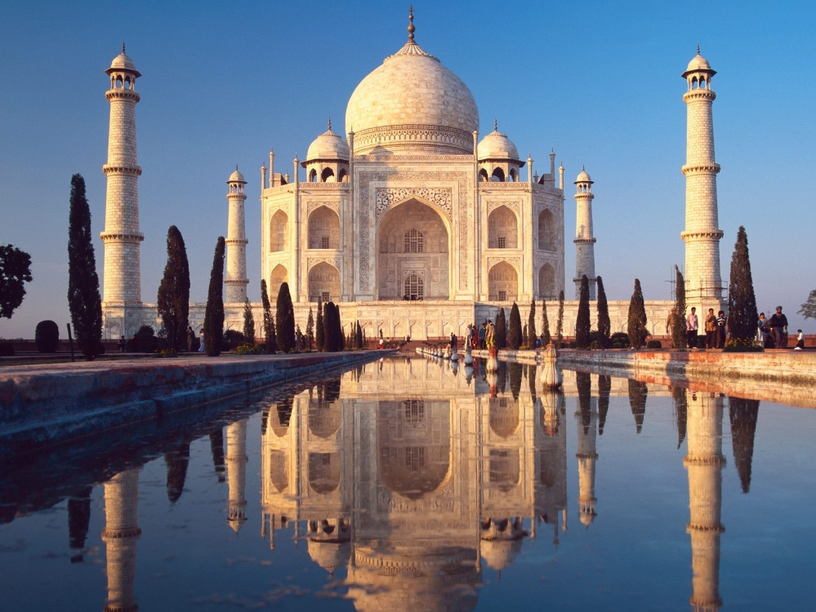
GET MEDITATIONAL SUPERPOWERS WITH ENERGY ENHANCEMENT, LIGHT YEARS AHEAD OF EVERY OTHER COURSE
THE ULTIMATE ADVANCED MEDITATION COURSE
MEDITATION ENERGY ENHANCEMENT
THE CORE ENERGY TECHNIQUES!!
THE MOST ADVANCED MEDITATION TECHNIQUES ON THIS PLANET, IN 28 INITIATIONS!!
ANCIENT EFFECTIVE ENERGY ENHANCEMENT SECRETS -
SUCCESSFUL
TIME TESTED
TRUE


Bookings: www.energyenhancement.org
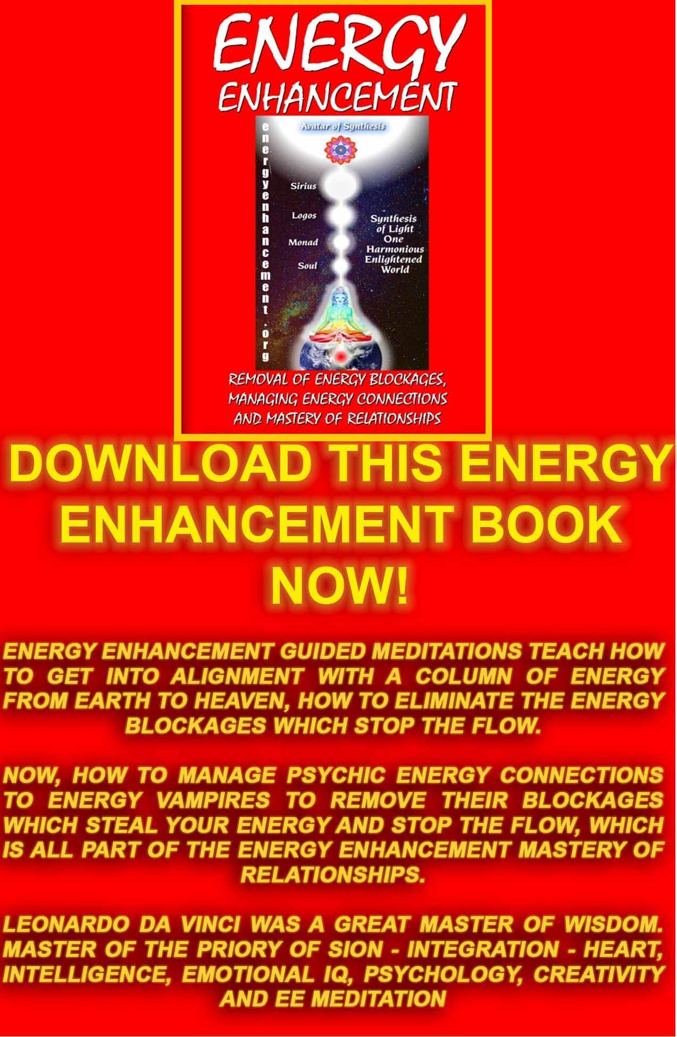
Download “REMOVAL OF ENERGY BLOCKAGES, MANAGING ENERGY CONNECTIONS AND MASTERY OF RELATIONSHIPS” HERE
http://www.energyenhancement.org/Sacred-Energy/Meditation-Energy-Enhancement-Eliminate-Energy-Blockages-Manage-Energy-Connections-and-Attachment-Mastery-of-Relationships-EEBOOK2Color-energyenhancement-org.pdf

JUPITER ASCENDING ESOTERIC SPIRITUAL MOVIE REVIEW BY SATCHIDANAND

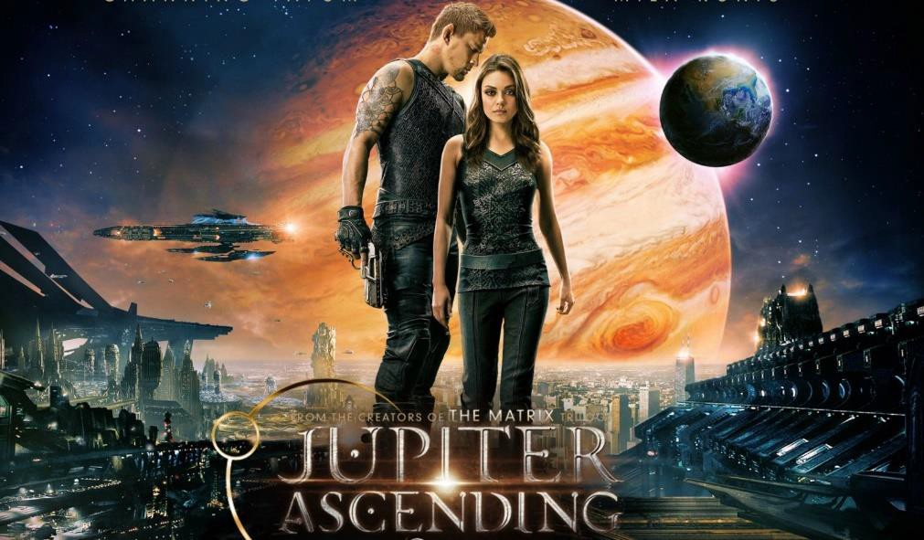
JUPITER ASCENDING OVER THE OLD GOD SATAN OF SATURN

There is a Sufi tale about a potential student wondering of a Spiritual Master if he and his techniques were the right way for him to be taught.

The Master gave him a ring and told him to go to the market and ask its price..

So he went to one shop where they were selling low priced items and they offered him a hundred paise.

Then he went to the most expensive shop where they had vast experience of perfect gems..

They offered him 100,000 paise!! Believe the experts..

I have meditated for 46 years with several methods but none which have the power, specificity and purity of purpose as Energy Enhancement Meditation. I am grateful for each tradition I have participated in and learned from each but I always felt they were not complete. In a way I feel I have just been preparing for this!

Thanks, LD, February 2015

Thank you for all the love, energy and light that you share. I've been finding the articles and Free e-books very very helpful. Been meditating a bit everyday. I can now wholeheartedly say that I'm a walking talking blockage mass as well as everyone around me.
Which is wonderful news as the blockages are appearing very obvious through behaviour and emotional responses. Basically all the info that you said. It's the words through spoken and written language that are now being experienced through my practicing awareness not just my mental knowledge.

Love and light

And gratitude GN Feb 6th 2015

Donal Minihane - I will never forget my very first day of training with Satchi and Devi. Devi took the first session in the morning and we began to spiral in energy, soon I noticed raindrops on my bare shoulders and on my head, raindrops? It's indoors, and it's 30 degrees out there. There is no rain in here. But it was raining, raining energy and it was touching me like raindrops. I was amazed and sneaked a peek over at Devi who just smiled as I said. It's raining in here.

February 6 2015 at 10:01pm · Some of the Luciferian Panspermian theories on the origin of the human race hold that our distant ancestors were placed on this planet by beings from outer space. "Jupiter Ascending" (PG-13, 2:07) takes such ideas seriously, presents them as a given and uses them as the launching pad for a thinking-outside-the-box kind of science fiction fantasy action adventure - that relates directly to this planet!!

All great art is political.

All great writers use lies to tell the truth...

For example, "Game of Thrones" tells us, using examples taken from History that the actions of Satanic Generational Family Gang Clan Oligarchs, that our owners are psychopathic narcissists, having not one compassionate bone in their bodies.
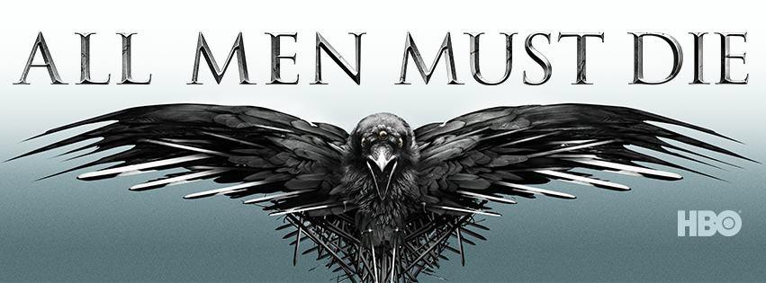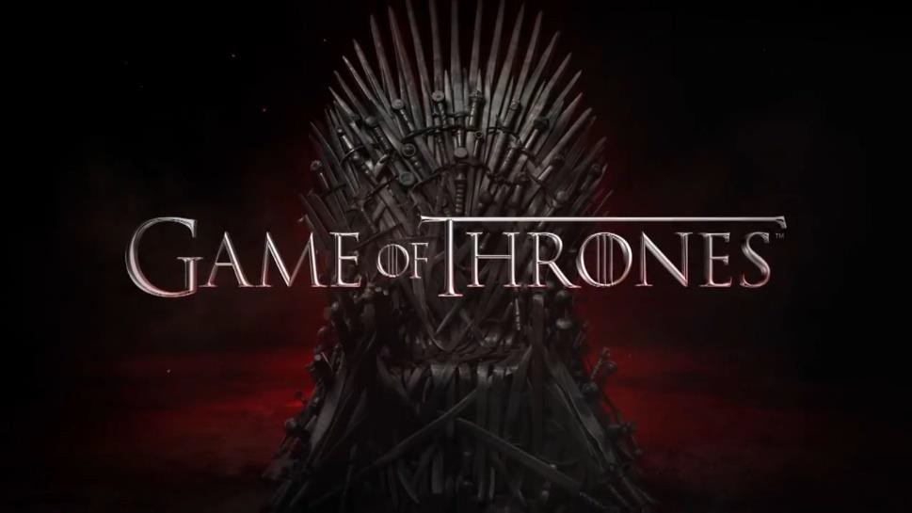

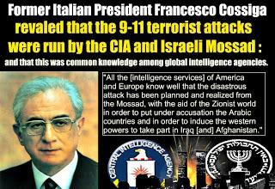

"Mankind is not a slave. Mankind is not a greedy person. Mankind is not a rich man. Mankind is not any of this stuff. Mankind is the continuity of the natural characteristics of the members of the human species, not the animal species, and not the oligarchs - the power of creativity of the human spirit - The Soul!! If the power of creativity is crushed, if the cause of mankind is crushed, then this planet is meaningless." - LAROUCHE - SATCHIDANAND

Game of Thrones shows the ease of killing, lying, conspiracy, murder.

But Game of Thrones does not show their Satanic Religion which underlies their acts.

Game of Thrones does not show their mind control educational system ripping their children untimely from their mothers arms age six, to go to schools like Eton where they are whipped, brutalised, fagged, raped homosexually and turned into homosexual pederasts.

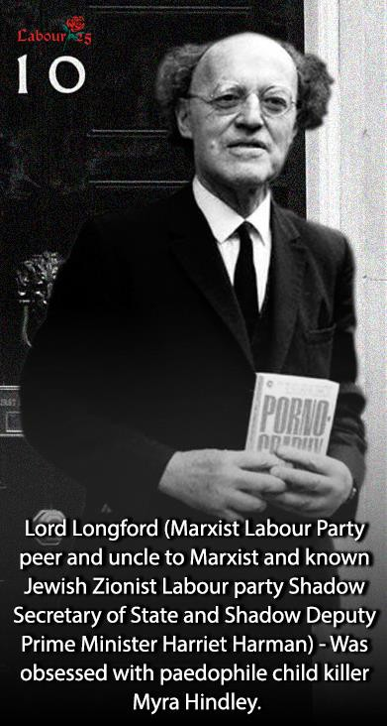

Ritual Homosexuality and Pedophilia are symptoms of the Satanic Religion and the Satanic Sex Addiction Blockage in Society. It was the arrest of the notorious Jewish born child serial killer Mr Dutroux in August 1996 that brought the Belgium Paedophile scandal to light. The rescue of the last Two young girls he kidnapped lead to an investigation of Dutroux. Five women who testified anonymously in Belgium under the code name ”X” described a generational family underworld of Satanism, where Satanic Families pimped out their children for rape, pedophilia, sadomasochism, torture, cannibalism, snuff movies, and murder. They said that Satanic politicians, Bilderbuggers and other high placed members of society were involved.

Game of Thrones does not show the Family organisations which direct their Satanism to create a New World Order..

The Vatican whose Pope CEO is always controlled by the Generational Families, and the 500 Trillion, thousand year Vatican (Iron) Bank fronted by the Rothschilds and Rockefellers.

The Jesuits controlled by a Group of ten advisors from the major Generational Families, the Generational Gang Mafia Families who trace their genealogy back to Satanic Nimrod's Babylon, - Borgia, Orsini, Pallavicini, Cecil, Percy, Este, Colonna, Coberg Saxe-Gotha, Hapsburg, Bourbon, Bush, Mellon, Rockefeller, Rothschild.. and many more.

The Knights of Malta connected to The Queen of England's Privy Council - the Order of the Garter - and their created Freemasonic Religion - Satanic at it's 33rd Degree Highest Levels - Holding Company controlled City of London rule over 70% of all Banking, and also over 70% of all Fortune Five Hundred World International Companies controlling Pharmaceuticals, Education, Petroleum, Housing, Agriculture, Genetically altered Frankenstein food, Cars, Domestic Goods, Water, Fast Food and Drink - everything!! and over the corruption, blackmail and bribery of the Law, Politicians, Police, Drugs and Prostitution - the oldest professions.


THE BORGIAS, LIKE THE ROCKEFELLERS, ARE ONE OF THE GANG CLAN FAMILIES WHO STILL RULE THE WORLD THROUGH THE BRITISH EMPIRE, THE VATICAN, JESUITS, KNIGHTS OF MALTA, BRITISH EMPIRE PRIVATE CITY OF LONDON THOUSAND YEARS OLD ANCIENT MERCANTILE LIVERY COMPANIES, MASONS WORLDWIDE - ARISTOCRATIC AGENT MAO WAS A 33RD DEGREE MASON!! THE ROTHSCHILDS ARE THE BANKERS OF THE VATICAN!! JESUIT BLACK POPE CONTROLS THE 900 YEARS OLD INTELLIGENCE ARMY OF THE KNIGHTS OF MALTA (SMOM) GANG - SMOM MEMBERS - THE BUSH FAMILY, TONY BLAIR, GEORGE SOROS, HENRY KISSINGER, ALEXANDER HAIG..

Mila Kunis (who, in real life, was born in the former Soviet Union) is Jupiter Jones, a young woman in Chicago who cleans homes with her widowed Russian immigrant mother (Maria Doyle Kennedy).
Well, Jupiter's life is about to change in ways that she could never have imagined, and finding out that we are not alone in the universe is only the beginning.

It turns out that Jupiter has the exact genetic make-up of a long-dead queen in one of the most powerful royal families in the universe.
Among the noble families the Abrasax (From Abraxas - Satan today

... Medieval demonologists often mention a demon called Abraxas.
... Abraxas was a name used by the Gnostics to express the unspeakable name ...) family is the most powerful. That entitles her to a portion of the family inheritance – a portion which just happens to include a small blue planet that we all know and love.


CHIPS WITH EVERYTHING - JUPITER ASCENDING

When the former queen's three children, Titus (Douglas Booth), Kalique (Tuppence Middleton), and Balem (Eddie Redmayne), become aware of Jupiter's existence (and very special genetic make- up), Titus and Balem each hire people (if that's what you can call genetically-engineered bounty hunters that are only partially human) to find her to strengthen their own claims to their mother's galactic estate.

The one who gets to her first and rescues her from the clutches of the others is Caine Wise (Channing Tatum), who, with the help of old friend Stinger Apini (Sean Bean) helps her claim her inheritance.

Caine Wise is half dog, very loyal, and her Majesty, Jupiter, falls in love with him. This is the Love Story of the Knight in Shining Armour rescuing the Princess.

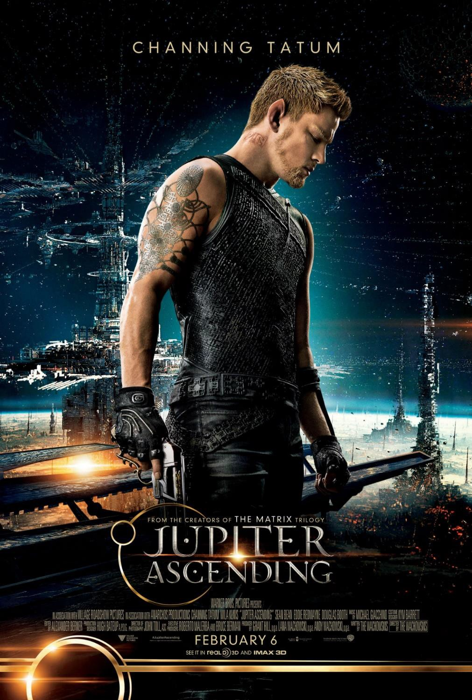
WAKE UP!!

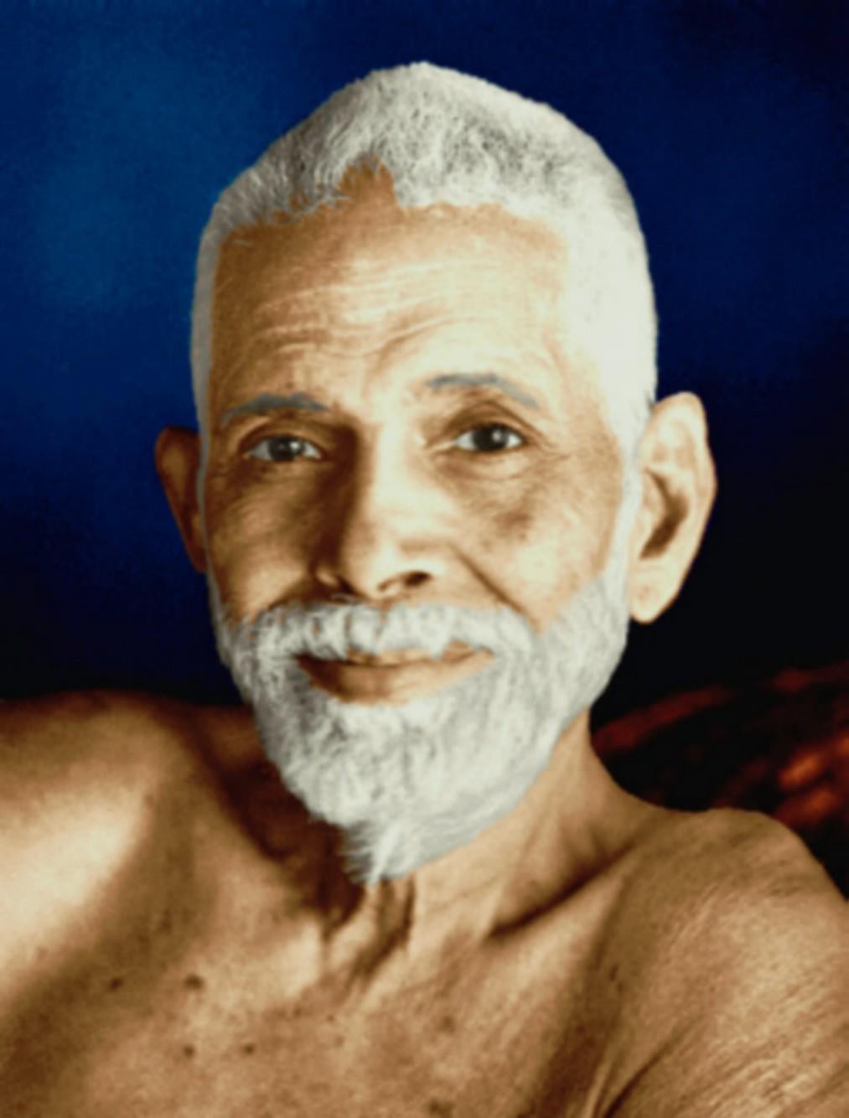
Tamil Siddar SRI RAMANA MAHARSHI ENLIGHTENED ILLUMINATED SPIRITUAL MASTER

In this future, Half Breeds have no rights.

"Can a dog have Buddha Nature?" is the Zen Koan.

Answer, "MU!!"

Like OM, MU is a guided meditation to connect you with the Jewel in the Lotus, YOUR SOUL!!

Only the truly human have a Soul.

Anyone can have a Soul, even dogs, even any half breed.
Ramana Maharshi declared his Cow, his Dog and his Elephant enlightened when they died.

Cows, Dogs, Cats, Horses are not our slaves. They are not to be eaten.
Genetic Half Breeds, the Poor, the White Trash are not our slaves to be eaten.

We are all the children of God, One Family, Imago Dei, with innate Human and Animal Rights.

But many do not, and that is OK, because that permanent Soul connection is the journey of one hundred lifetimes.

We are children learning how to connect with our Souls - until we do actually become enlightened.As you know we exist as Souls, as energy, learning in Soul Universities between Lives.

We draw a body to us to inhabit lifetime to lifetime for a hundred lifetimes until we become enlightened.

We do not care about the genetics as long as they are sufficient for our evolution.

Our Spirit makes choices which over a lifetime improve our genetics and our powers.

Thoughts can evolve or de-evolve our genes!!

Even Identical twins have different personalities or Souls.

When we die we cast off the body like a suit of old clothes until we inhabit new ones again.

Genes are just a Myth justifying the rule of degenerate psychopathic elites.

Well, plebians, peasants, citizens have always had no rights except for those in the Constitution and signed off by Bad King John in the Magna Carta, but these have all now been rescinded.

Even Bad King John went back on his word to the Barons and the Magna Carta.. See movies "Robin Hood" by Ridley Scott and "Ironclad"
With the Patriot Act, Human Rights No Longer Exist!! For Half breeds, slaves, the indentured, blacks, mulattos,
immigrants, white trash, veterans, the poor, the hewers of wood and the drawers of water..

For THE 99%

Rights have never existed.

This is the great truth told by Jupiter Ascending.

In the Movie and in Real Life these great houses, gang clan families own the planet Earth.

The Luciferian Panspermian theory and this movie says, One Hundred Thousand years ago they seeded the Earth with human Genes spliced with the local animals, therefore all humans on the planet are Half Breeds with no rights.

In the Movie, when there are sufficient humans they will all be harvested - all 7 billion - for their bodily fluids.

That means BLOOD folks!! Killed, Murdered, Assassinated!!
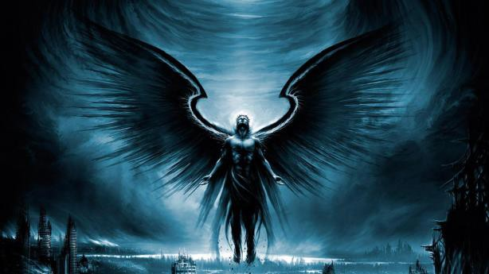
And the fluids will allow the rich elite Psychopathic oligarchs of the Universe to Live Forever!!

Immortality for the Elite Mafia Families from the bodily fluids of billions of dead people!!

"For one man to live forever, many must die!!" from Movie, - "In Time"

The previous masterpiece by the Wachowskis like, "The Matrix", where the vampirism of humanity occurs via energy connections into the chakras and anyone can be taken over, possessed, by an Agent Smith Demon.

The Psychic Vampirism of Humanity so that some can leave the body, and return into a new one without dying - See the Spiritual Technology in, "The Yoga Sutras of Patanjali" - from thousands of years this technology has been known by the Elite!!
and Masterpiece "V for Vendetta",

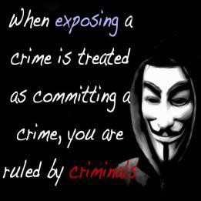

Masterpiece, "Cloud Atlas" kills the half breeds at will in slaughterhouses and feeds the bodies back to the other half breeds as, "Soap" reminding us of the Aryan Races policies towards the Jews..


CLOUD ATLAS HALF BREEDS DRINKING SOAP - THE BODIES OF THE DEAD - CANNIBALISM!!

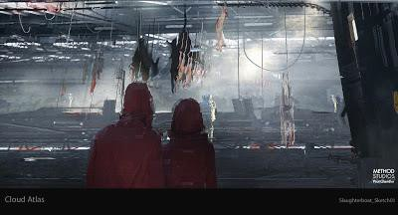
THE CLOUD ATLAS SONMI SLAUGHTERHOUSE SCENE - WITH ALL THE BEAUTIFUL HALF BREED LADIES ON MEATHOOKS

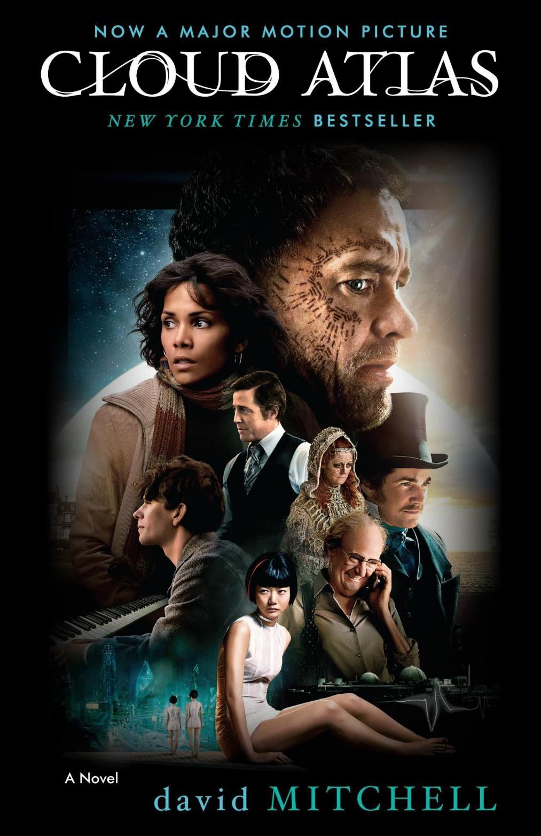

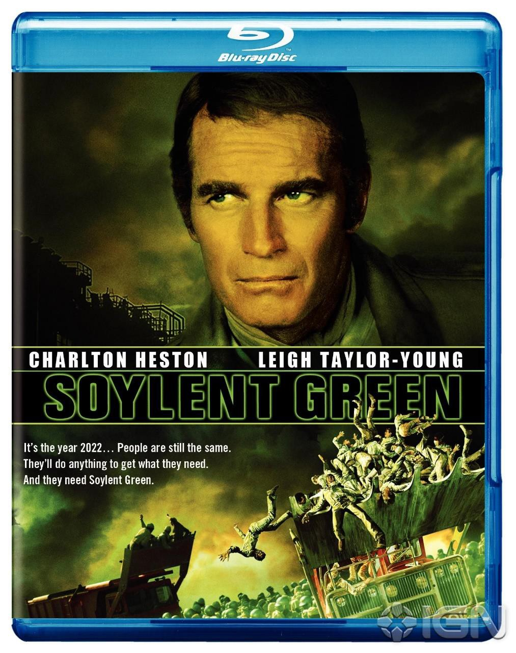

CHARLTON HESTON TRIED TO WARN US UNTIL HE WAS ALTZHEIMERED - "SOYLENT GREEN IS PEOPLE!!"

SOYLENT GREEN BURGERS ARE GROUND UP PEOPLE!!

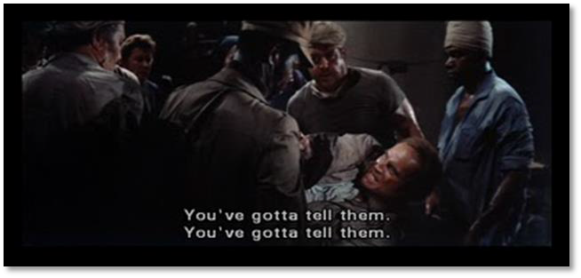

In addition, we know that 280 million people were killed by war and pogrom during the 20th century by such people as Hitler, Mao and Stalin..

As part of this, 80 people died in battle during the Gulf War, yet 400,000 people have died since from Gulf War Syndrome. Gulf War syndrome is a conscious culling of the human herd by giving all servicemen ten vaccinations, multiple vaccines, at the same time and exposure to depleted uranium.

Soon it will be against the Law to refuse Vaccination, Worldwide.

We know that hundreds of thousands of servicemen were told to stand up and face the explosion of an atomic bomb so that the current Nazi Doctors could study the effects of radiation on all those soldiers.

We know the Nazi Doctors gave BZ hallucinogen to half the troop Rangers in Vietnam just to see what would happen - The Rangers all wiped each other out.

We know about the Tuskeegee experiments where black men were given syphillis by the Nazi Doctors of the Veterans Association so they could study the disease on those people over 40 years.

The 10,000 years old Ancient Religion of Satanism still controls these generational families. Satanism is defined by it's Rituals, it's sacrifice. Wars, killing, death.. All Lives for Satan!!

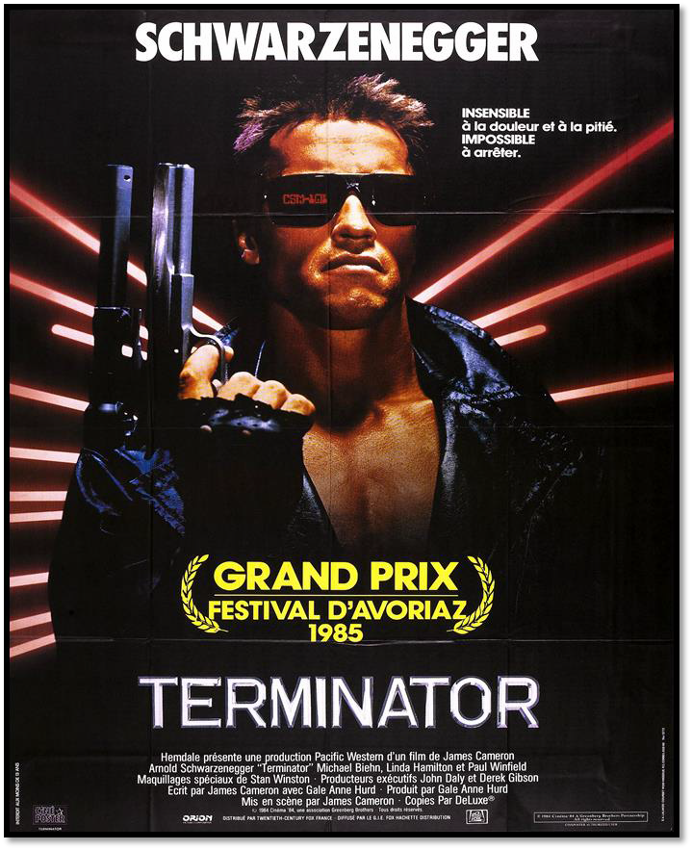
We know that DARPA is creating autonomous Killer Robots, Autonomous Killer Drones and Autonomous Killer Tanks..

Jupiter's station in life has infinitely improved, but she finds herself caught up in the rivalry between the queen's psychopathic offspring, and also soon learns some things that threaten everything she holds dear - as above.

Just as the Generational Gang Mafia Families who trace their genealogy back to Satanic Nimrod's Babylon, - Borgia, Orsini, Pallavicini, Cecil, Percy, Este, Colonna, Coberg Saxe-Gotha, Hapsburg, Bourbon, Bush, Mellon, Rockefeller, Rothschild, etc think that their genes give them the right to rule, so this movie and all the others mentioned here show that the Satanic Narcissistic Psychopathy of the ruling Elite deserves to have them put in jail for a long, long time.

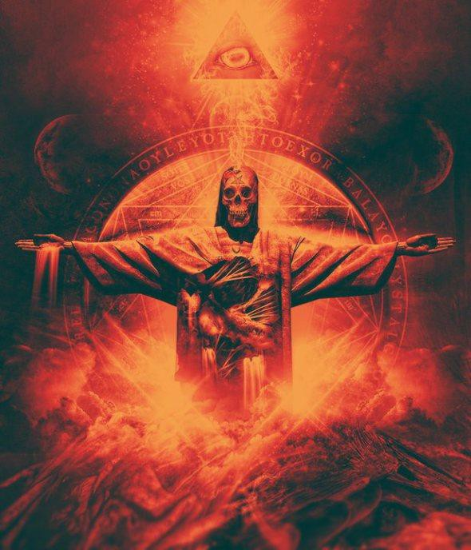

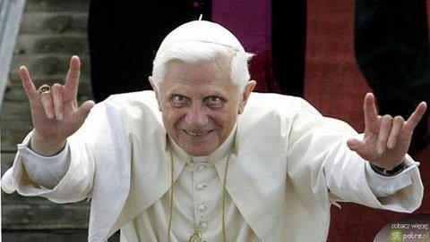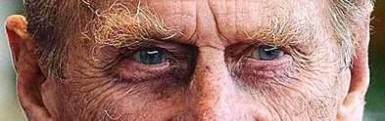

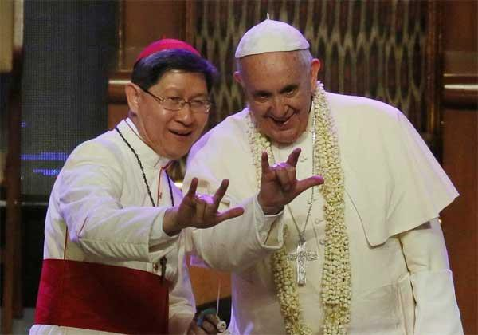


EUGENICS ETHICS PROFESSORS - "BABIES BELOW THE AGE OF THREE ARE MACKEREL!!"

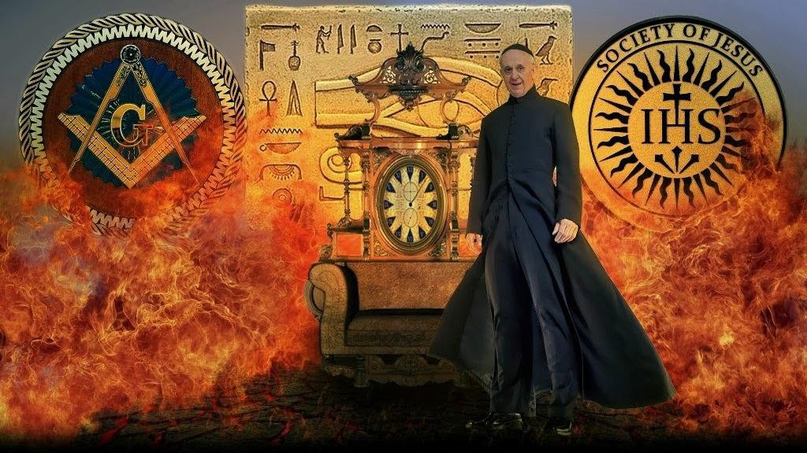

THE BORGIAS, LIKE THE ROCKEFELLERS, ARE ONE OF THE GANG CLAN FAMILIES WHO STILL RULE THE WORLD THROUGH THE BRITISH EMPIRE, THE VATICAN, JESUITS, KNIGHTS OF MALTA, BRITISH EMPIRE PRIVATE CITY OF LONDON THOUSAND YEARS OLD ANCIENT MERCANTILE LIVERY COMPANIES, MASONS WORLDWIDE - ARISTOCRATIC AGENT MAO WAS A 33RD DEGREE MASON!! THE ROTHSCHILDS ARE THE BANKERS OF THE VATICAN!! JESUIT BLACK POPE CONTROLS THE 900 YEARS OLD INTELLIGENCE ARMY OF THE KNIGHTS OF MALTA (SMOM) GANG - SMOM MEMBERS - THE BUSH FAMILY, TONY BLAIR, GEORGE SOROS, HENRY KISSINGER, ALEXANDER HAIG..



As I sat in the theater, I noticed influences from a number of other movies. For me, this film (to varying degrees) triggered memories of films as disparate as, "They Live", "Dune", "Star Wars", "The Matrix", "In Time", "Elysium", "Game of Thrones", Blade Runner", "The Borgias" and "Soylent Green" as well as the Novels, "Bug Jack Baron", "The Men in the Jungle, " and the "Iron Dream" by Norman Spinrad.

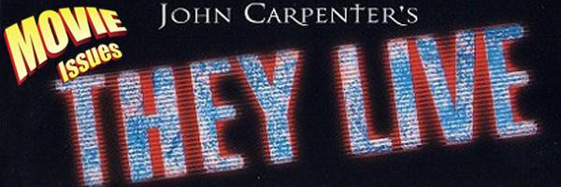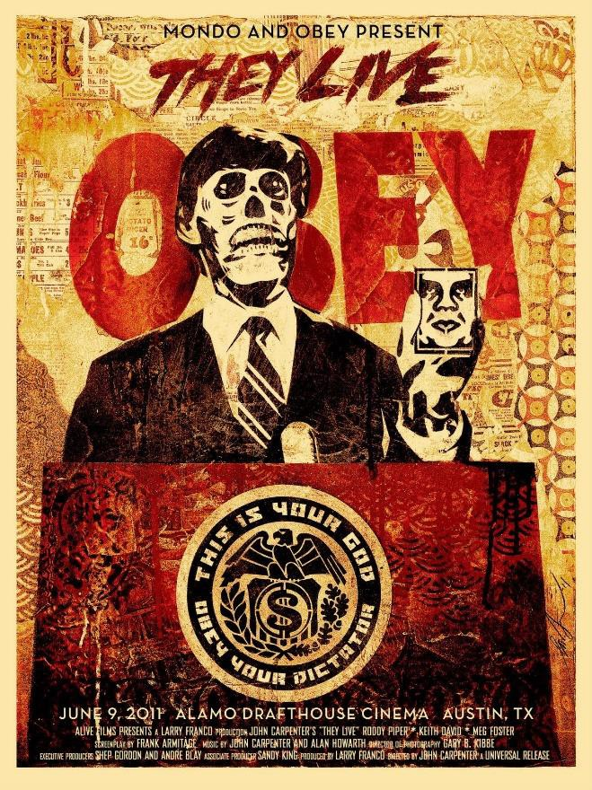

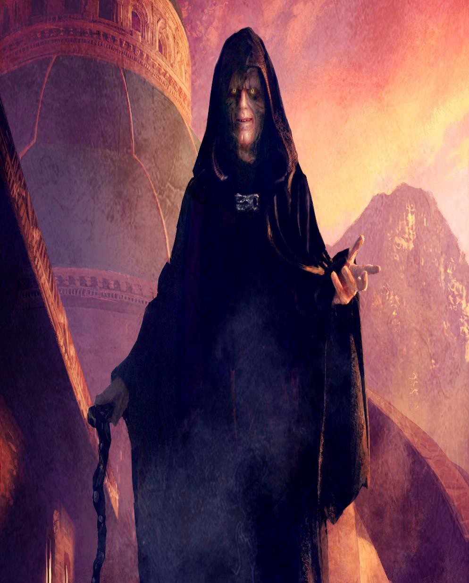
THE EVIL EMPEROR OLIGARCH SATANIC "SITH" - LORD OF "THIS"

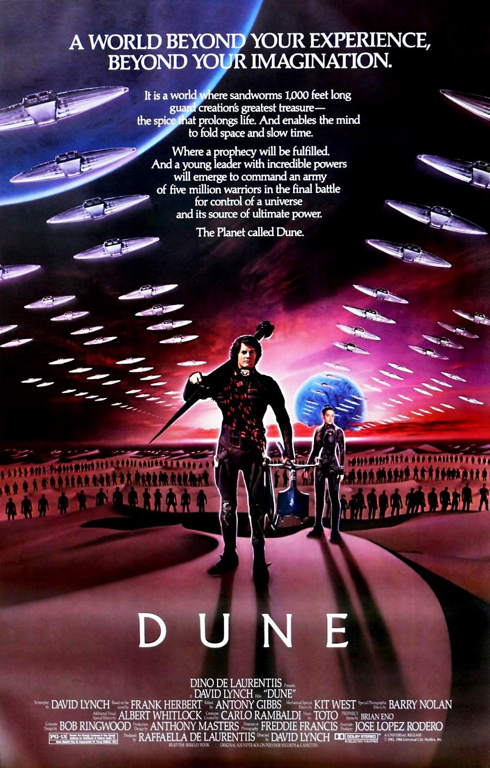

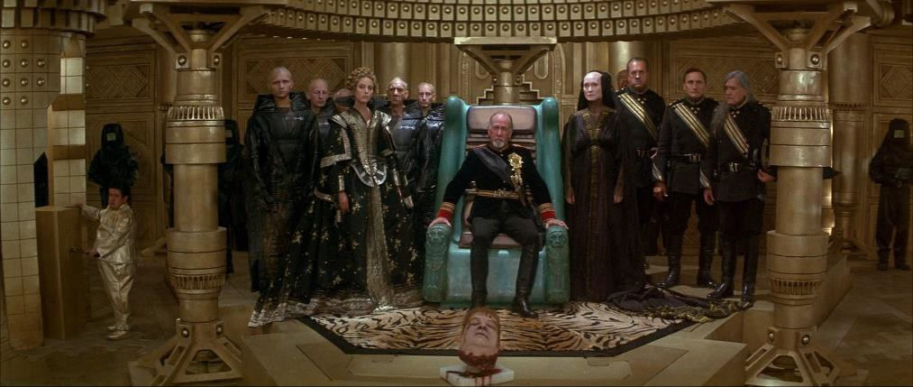

DAVID LYNCH AND FRANK HERBERT'S DUNE, VERY "GAME OF THRONES" OLIGARCHIC ELITE WITH A HEAD ON A SPIKE

HARK BACK TO THE SATANIC HARKONEN OLIGARCHIC GENERATIONAL FAMILY

Yes, all these movies and novels are warning us of the lies and deceit of, "The Father of Lies" Oligarchic Generational Family Mafias who rule this planet..

The themes - Satanic Transhumanism whereby humanity gains immortality by being uploaded into the machine and in the process losing their Soul.. "Gain the World but lose their Soul" - Jesus Christ. Satanists and Luciferians who participate in Satanic Rites, who have blocked of their hearts and their souls have already lost their humanity and have become machines, so being uploaded into a machine is their destiny. But humanity is more than that and that humanity will be crushed if it is uploaded into the machine.

genes - oligarchic families, kings, queens genetic engineering
immortality - Dune Psychopathic oligarchs

owning and killing half breed humans - Cloud Atlas, Blade Runner,
Bug Jack Barron

harvesting fluids - bug jack baron, the men in the jungle, the iron dream, matrix

microchips - tattoo

Distraction by connection with the Machine as in the Matrix but also Weaponised, by putting the higher faculties of the brain to sleep, Television flicker rates tested on tens of thousands of to be euthenised monkeys in DARPA funded University departments Worldwide, Music, Football, and Computer Games - see The Three Stigmata of Palmer Eldrich - by Philip K Dick.

As noticeable as those various undercurrents may be, "Jupiter Ascending" feels very fresh. I consider it the most original and richest sci-fi mythology created this side of George Lucas. But this film's originality extends well beyond the story's plot points. The script (and the movie's title) contains some clever double meanings and some moments of humor, which amuse, but don't detract from the realistic feeling for which the film is successfully striving.

While many of the characters were reminiscent of those in the "Star Wars" films, their origins are very different. The production design that went into creating the planets and space ships drew on unusual inspiration such as Gothic and Renaissance art and architecture which works remarkably well and adds to that feeling of originality which is prevalent throughout the film. The visual effects are similarly inventive, complement the scenery wonderfully and are tremendously colorful and thrilling – especially if you can see them in IMAX 3-

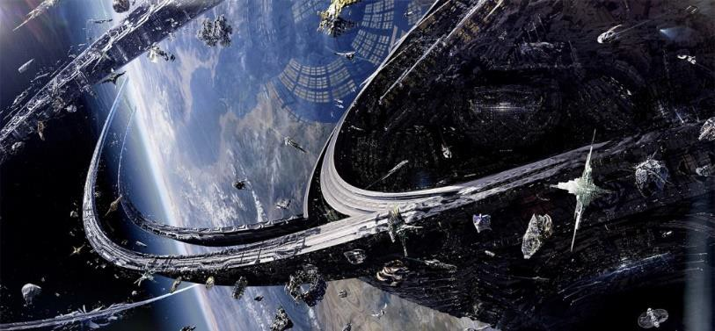
SATURN'S RINGS

Undergirding it all are universal themes of family and selflessness on the side of Mila Kunis and Channing Tatum, with self- centeredness and greed on the other Satanic Oligarchic Gang Family on the other, and literary themes as old as Homer's "Odyssey".

There's a lot going on in "Jupiter Ascending". It's not that the film is too hard to follow, but I find myself wanting to see it again - just to more fully appreciate the depth of the characters and the richness of the story – and to again enjoy the movie's spectacular visual effects.

Like all great spiritual movies the spiritual energy embedded in the movie made us cry with joy.

As I watched and evaluated this film, Jupiter was most definitely ascending – all the way to an "A".

MUST SEE!!

KILL THE MESSENGER - SATCHIDANAND ESOTERIC MOVIE REVIEW


WITH JEREMY RENNER

"We do what we want" - CNN "FAIR IS FOUL
AND FOUL IS FAIR.."

SATANIC WITCHES, MACBETH

Kill the Messenger, Gary Webb, and The Myth Of The Free Press

Spengler tells us that government in 19th- and 20th century Europe reflects the culture’s general decline into civilization, that parliamentarism in France and England has actually been in full corruption throughout this period of transition to Totalitarian Caesarism.

That democratic institutions of government merely mask the real political power of Babylonian Satanism, whose aim for the last 10,000 years has been the Decline and Fall of every Civilisation ever to have existed, to increase Poverty, to create a failed Fellahin state where every citizen is degenerated and corrupt through that Poverty for ultimate control of all humanity; and Babylonian Satanism's tools, Finance Capital and it's major agent, the Press.

In the same way that Spengler charted the, "inevitable" stages of civilisational decay, so Orlov has created, "The Five Stages of Collapse"...

Spengler's Fellahin Society, the last phase of collapse.. "All of the data indicates that nations at war suffering mortality rates exceeding 25% are permanently traumatized and destroyed, for they are incapable of ever recovering their pre-war integrity. They become for all practical purposes ghost societies." - United States Air Force Manual on War and Counter-Insurgency, Washington, spring 1983

Once you understand that the Mad Psychopathic followers of the Satanic Religion have been created by Satanic Ritual as a tool of Policy, by the real Rulers to destroy all Civilisations, to control all Humanity, then everything falls into place...

I watched a documentary off the Fan website about the dark side...

I suppose there are many different ways to encourage people into that dark practice, and it's seeping through all times of TV e.g late night comedy, even food e.g. Pepsi using aborted chopped up fetuses as one of their flavour ingredients, Meat is Satanic Murder, all sorts...But! I'd love to see the light side, but cannot tell where all the angels work is...I assume Energy Enhancement is the culmination of all the Angels work on this planet. I'd love to try and see their work in other things.

Reporter Why do they do such wicked things in these covens?

Interviewee: Because they're pleasing Satan, the lower you become, the more vile you become, the more pleased Satan is with you, and therefore the more power you'll get when you die.

Reporter: And they believe this?
Interviewee: They believe it. They absolutely believe it. Rituals creating perversion and degeneration are Satanism.

Decay is Only inevitable as long as Satanism is Occulted, Hidden. Decay is Only inevitable as long as no one believes in the Universal Presence of Satanism and its Mad Psychopathic followers in all Civilisations, in all Cities, in all the World.
The aim of writing about problems of the World as apart from individual problems is that both of these problems are totally solved by Energy Enhancement Meditation!!

We should not be afraid, we should practise the Energy Enhancement solution - Meditation - and Free both ourselves and the World from misery and pain towards a new future of Peace and Plenty - Inner and Outer Wealth, Richness, Abundance, Wealth!!

The Elite push the fear of Scare-City of commodities, water and food but human genius is such that all these problems have solutions
-Infrastructure, Irrigation, Fusion Power Generation, the Fusion Torch, Space Exploration.

Oh, and Energy Enhancement Meditation!!

THE SOLUTION? - THE ENERGY ENHANCEMENT COURSE BY STREAMING VIDEO OR LIVE IN BRAZIL, INDIA, WORLDWIDE!!

Kill the Messenger details the control of the "Free" Press in the USA.

This "Free" Press Control of Society has been in force for 10,000 years in every country in the World but as the control increases, as liberties are lost, as Nazi Totallitarianism increases, so the control of the press increases...

Now in Russia, China, India, Brazil, Europe, Great Britain...

Then in Ancient Greece with the death of Socrates, Rome with its Totalitarian, Satanic and homosexual Caesar Emperors, Constantinople, Persia, Ottoman Empire, China's Han Fei and the Qin dynasty, and those of the Han, Wei, Shu Han, or Sui Dynasties with their Satanic Totalitarian Legalists and its Satanist created 70,000 bureaucrat castrati..

As the Satanic Control increases, so genocide occurs..

Totalitarian States of the Reichstag Fire of Satanic Nazi Hitler - 25 Millions Murdered, Genocided, Euthenised!!

The Russian Revolution and Soviet Union of Stalin and Lenin - 65 Millions Murdered!!

The French Revolution of Robespierre and Napoleon - Europe destroyed, povertised.

The Maoist Revolution in China - 85 Millions Dead.

The Controlled Press Presstitutes are Corporate Media and Also the Alternative Press

Lenin, the first Communist dictator and MI6 Secret Agent, after the takeover of Russia in 1917, is widely credited with the following quotation, "The best way to control the opposition is to lead it ourselves."

Controlled opposition uses a number of identifiable tactics to maximise their efficacy:

- Mix truth with lies to provide a world view which is flawed and can be discredited. Predominantly truth can be presented with a few lies or outrageous lies can be presented with a few truths.

- Gatekeepers provide only a portion of the truth, which creates a "limited hangout" and prevents followers from getting all the way to the bottom of the rabbit hole.

- Deliberately frighten people by presenting information in an alarming fashion, which creates an overly melodramatic following and limits the appeal to newcomers.

- Have a Straw Man - a person of dubious credibility, who is later on discredited - present the truth so everyone disbelieves all the truth he has presented. For example people who say the Queen is an Alien Annunaki Reptile, or talk about UFO's, or are Racist, totally discredits everything else, the Truth, which 90% they are giving.

- Create a "movement" within which only the consensus view is acceptable, enabling leaders to hold people within a "limited hangout".

For example.. build a schizm into any religion in order to attack the majority Religion and create mad warriors to create War, poverty and chaos.

One such schism was Martin Luther who worked for Cardinal Contarini of Venice who was in charge of the Council of Trent and who thus also created Reform Protestantism with Luther and Calvin who was Coen a marrano Jew and at the same time at Trent, its opposite, The Jesuits and the Inquisition.

Another was British MI6 Agent Hempher who paid Agents Salafi and Abdul Wahhab to create the Schism in Islam and thus create Saudi Wahhabism, The Taliban, Al Qaeda and ISIS. Key to this strategy was the creation of the Salafi movement, which was an outgrowth of the emergence of the Egyptian Freemasonry of Cagliostro, which today is closely aligned to the Wahhabis of Saudi Arabia. Protestantism, Wahhabism and Salafism hinge upon the badness of Saints, religious images and shrines being against God!! Thus the destruction of thousands of the Shrines of Saints throughout the Middle East and also the blowing up of the Buddhas of Babyan in Afghanistan by the Taliban.

Another was Marxism created by paid British Agent Karl Marx who wrote Das Capital from his MI6 office in the British Museum in London, managed by Engels under the aegis of Ambassador Urquhart, in order to take down the Czars of Russia and create a controlled opposition in every country, Worldwide..

The other was completely controlled Freemasonry - the Ancient Egyptian Religion - entered into every country to infiltrate the Elite and take it over. This is Freemasonic Salafism, the Muslim Brotherhood and the upper levels of Freemasonry - at the top level of the 33rd Degree of the Ancient Scottish Rite and the Palladian Rite it is pure Luciferianism - in every country of the World.
7. Ironically the best information is available from controlled opposition websites because 90% of that they say is the Truth!! The Vigilant Citizen, provides the very illuminating article "The 25 Rules of Disinformation". The Vigilant Citizen, The 25 Rules of Disinformation, 24 May 2011, http://vigilantcitizen.com/latestnews/the-25-rules-of-disinformation/
It is reasonable to assume that in addition to controlling corporate media the Illuminati also control the vast majority alternative media.

253

Based on experience I assume that any media organisation (website, radio station or TV station) is controlled until proven otherwise.

THE LOSS OF TRUST

It is always sad to lose trust in the authorities in any country yet the fight for freedom, richness and Wealth for all humanity continues with people of good will Worldwide.

“If we assume responsibility for our self or the world around us we will be harmed by the permanently raised and threatening arm of authority. And so, to avoid this danger, we learn to become servile and dependent victims who are acted upon, or who act at the command and initiative of others.” - Victor Frankl, Psychologist and Nazi Holocaust Survivor

Countries and Media contain a mixture of psychopaths and people of good will.

Yet, only when the psychopaths take over the asylum do we see death.

From being the Beacon of Truth and Democracy we see the reigns of the reign tighten into total Totalitarianism and Satanic Nazification.

The Satanic Fascist "Free" Presstitutes laud and promote the myth of American democracy - even as we are stripped of civil liberties and money replaces the vote. The Constitution is cancelled by the, "Patriot Act". The Satanic Fascist "Free" Presstitutes pay deference to the leaders of Satanic British Wall Street (Wall Street, New York, was the old Slave Market) and in Washington, no matter how perfidious their crimes.

The Satanic Fascist "Free" Presstitutes slavishly venerate the military and law enforcement in the name of patriotism. The Satanic Fascist "Free" Presstitutes select the specialists and experts, almost always drawn from the centers of power, to interpret reality and explain policy.

The Satanic Fascist "Free" Presstitutes usually rely on press releases, written by corporations, for their news. And The Satanic Fascist "Free" Presstitutes fill most of their news holes with celebrity gossip, lifestyle stories, sports and trivia." The role of the satanic mass media is to entertain or to parrot official propaganda to the masses.

There is more truth about American journalism in the film “Kill the Messenger,” which chronicles the Satanic media’s discrediting of the work of the investigative journalist Gary Webb, who stated that the American Government was importing Cocaine and Heroin into the USA to sell it and use the funds to support CIA Black Ops.

Zbignew Brezinski had already admitted in his book "The Technotronic Era" that all Crime Drug networks were run at the top by Government and anyone not made, not paying their cut would be jailed by the Government but the purpose of Satanic Presstitutes is to obfuscate the truth.

Just as the American and British Governments increase the production of Opium/Heroin in Afghanistan - since the invasion of Afghanistan Heroin production has increased massively so that now 90% of World Heroin is supplied by Afghanistan. More, the Nato and United Nations planes are used to transport the Heroin to Albania and Kosovo for distribution by UN trucks throughout Europe.

There is more truth about American journalism in the film “Kill the Messenger,” than there is in the movie “All the President’s Men,” which celebrates the exploits of the reporters who uncovered the Watergate scandal.

The Satanic Fascist Press mass media which has been bought out so thoroughly that twenty media corporations in the 1970's have been reduced to only four in 2014. There is CIA representation on all the boards of these media companies. Editors and journalists also are paid by the CIA to blindly support the ideology of fascist corporate/government capitalism.

Satanic Babylonian Secret Services have for 10,000 years infiltrated every Secret Agency in every country in the world. This is the Deep State. This is the Secret Compartmentalised Government.

Satanic Fascist Press laud and promote the myth of American democracy - even as we are stripped of civil liberties and money replaces the vote. Satanic Fascist Press pay deference to the leaders on Wall Street and in Washington, no matter how perfidious their crimes. Satanic Fascist Press slavishly venerate the military and law enforcement Homeland Security in the name of patriotism. The Patriot act, based on False Flags, has superceded the Constitution.

What is left is the Satanic take over Totalitarian State.

Satanists select the media specialists and experts, almost always drawn from the centers of power, to interpret reality and explain policy. They usually rely on press releases, written by corporations, for their news. And they fill most of their news holes with celebrity gossip, lifestyle stories, sports and trivia. They push Bill Gates Frankenstein GMO. They push Bill Gates poisoned vaccinations.
They pervert education, for instance pushing homosexuality and pederasty in sex education sessions with five year olds, schools and Universities.The role of the Satanic Fascist mass media is to entertain or to parrot official propaganda to the masses. The Satanic Fascist CIA/NSA corporations, which own the press and who started, funded and now own Google, hire journalists willing to be courtiers to the elites, and they promote them as celebrities. These journalistic courtiers, who can earn millions of dollars, are invited into the inner circles of power. They are, as John Ralston Saul writes, hedonists of power.

When Gary Webb, writing in a 1996 series in the San Jose Mercury News, exposed the Central Intelligence Agency’s complicity in smuggling tons of cocaine for sale into the United States to fund the CIA-backed Contra rebels in Nicaragua, the press turned him into a journalistic leper. And over the generations there is a long list of journalistic lepers, from Ida B. Wells to I.F. Stone to Julian Assange to Snowden.

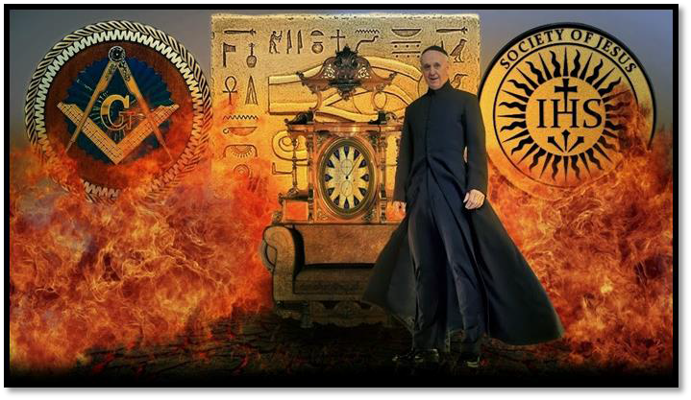
The attacks against Webb have been renewed in publications such as The Washington Post since the release of the film earlier this month. These attacks are an act of self-justification. They are an attempt by the mass media to mask the collaboration between themselves and the power elite. The Satanic Fascist mass media, like the rest of the liberal establishment, seek to wrap themselves in the moral veneer of the fearless pursuit of truth and justice. But to maintain this myth they have to destroy the credibility of journalists such as Webb and Assange and Snowden who shine a light on the sinister and murderous inner workings of empire, who care more about truth than news.

The country’s Satanic Fascist news outlets—including The New York Times, which wrote that there was “scant proof” of Webb’s contention—functioned as guard dogs for the CIA.

Soon after the 1996 exposé appeared, The Washington Post devoted nearly two full pages to attacking Webb’s assertions.

The Los Angeles Times ran three separate articles that slammed Webb and his story.

It was a seedy, disgusting and shameful chapter in American journalism. But it was hardly unique. Alexander Cockburn and Jeffrey St. Clair, in the 2004 article “How the Press and the CIA

Killed Gary Webb’s Career,” detailed the dynamics of the nationwide smear campaign.

Webb’s newspaper, after printing a mea culpa about the series, cast him out.

He was unable to work again as an investigative journalist and, fearful of losing his house, he was suicided in 2004.

We know he committed suicide with two bullets in the head. Two taps to the head the sign of a professional hit.

We know, in part because of a Senate investigation led by then-Sen. John Kerry, that Webb was right.

But truth was never the issue for those who opposed the journalist.

Webb exposed the Satanic Fascist CIA as a bunch of gunrunning, drug-smuggling thugs.

He exposed the mass media, which depend on official sources for most of their news and are therefore hostage to those sources, as craven handmaidens of power. He had crossed the line.

And he paid for it with his life.

If the CIA was funneling hundreds of millions of dollars in drugs into black inner-city neighborhoods to pervert the evolution of humanity, to fund an illegal war in Nicaragua, what did that say about the legitimacy of the vast covert organization? What did it tell us about the so-called war on drugs? What did it tell us about the government’s callousness and indifference like when they put Typhoid on blankets which they then gave to the Indians to genocide the Native American Indians, like the weaponised Aids and Ebola made in the USA, they sent drug indian blankets to the poor, especially poor people of color at the height of the crack cocaine epidemic? What did it say about rogue military operations carried out beyond public scrutiny?

These were questions the power elites, and their courtiers in the press, are determined to silence.

What does this say about Coleman's Committee of 300 Lords who have controlled the Trillion Dollar a year International Drug Trade since the three Chinese Opium Wars from 1845 when Britain and Europe went to war against China over "Free Trade" importing Opium from British Raj India into China and Britain won, and Hong Kong drug center was given by China to the British for 200 years.

What does this say about Bush's real reason for invading Afghanistan whence from no Opium - Opium under Fatwah under the Taliban, 90% of all opium now comes from Afghanistan, distributed on UN planes to Albania for distribution in Europe and Russia.

Where, in the USA "Bush" is another name for Marihuana because there is only one gang over the border from Mexico.

Where Las Vegas is the money laundering capital of the USA.

Where Nazi Agent "Open Society, Colour Revolution - Tunisia, Egypt, Libya, Syria, Ukraine" Soros wants to "fuck up" humanity with free "Brave New World" Legal and illegal drugs.

Satanic Drugs fuck society up.

Illegal Drugs are Satanic Fascist Government Run Worldwide.

Satanic Fascist Big Pharma Legal Drugs fuck you up - with side effects of violence and suicidal depression on the drug inserts.

30% of American use Satanic Fascist Big Pharma Legal Drugs.

All the shooters in all the shootings like Columbine or Sandy Hook since the beginning of shootings have been on legal drugs, varieties of Serotonin Reuptake Inhibitors, or SSRIs based on Fluoride.

Many shooters have been participants in the Satanic Fascist CIA MKUltra Delta Model James Bond Program.

Satanic degradation and perversion of society is caused by Satanic Sex, Drugs and Rock and Roll.

John Hinckley (1981) John Hinckley, age 25, took four Valium two hours before shooting and almost killing President Ronald Reagan in 1981. In the assassination attempt, Hinckley also wounded press secretary James Brady, Secret Service agent Timothy McCarthy and policeman Thomas Delahanty.

Laurie Dann (1988) In 1988, 31-year-old Laurie Dann went on a shooting rampage in a second-grade classroom in Winnetka, IL, killing one child and wounding six. She had been taking the anti- depressant Anafranil as well as Lithium, long used to treat mania.

Patrick Purdy (1989) Patrick Purdy went on a schoolyard shooting rampage in Stockton, CA, in 1989, which became the catalyst for the original legislative frenzy to ban "semiautomatic assault weapons" in California and the nation. The 25-year-old Purdy, who murdered five children and wounded 30, had been on Amitriptvine, an anti-depressant, as well as the antipsychotic drug Thorazine.

Joseph T. Wesbecker (1989) In another famous case, 47-year-old Joseph T. Wesbecker, just a month after he began taking Prozac in 1989, shot 20 workers at Standard Gravure Corp. in Louisville, Ky., killing nine. Prozac maker Eli Lilly later settled a lawsuit brought by survivors.

Kurt Danysh (1996) Kurt Danysh, 18, shot his own father to death in 1996, a little more than two weeks after starting on Prozac. Danvsh's description of own his mental-emotional state at the time of the murder is chilling: "I didn't realize I did it until after it was done." Danysh said. "This might sound weird, but it felt like I had no control of what I was doing, like I was left there just holding a gun."

Michael Carneal (1997) In Paducah, KY, in late 1997, 14-year-old Michael Carneal, son of a prominent attorney, traveled to Heath

High School and started shooting students in a prayer meeting taking place in the school's lobby, killing three and leaving another paralyzed. Carneal reportedly was on Ritalin.

Kip Kinkel (1998) Kip Kinkel, 15, murdered his parents in 1998 and the next day went to his school, Thurston High in Springfield, Ore., and opened fire on his classmates, killing two and wounding 22 others. He had been prescribed both Prozac and Ritalin.

Eric Harris and Dylan Klebold (1999) Columbine mass-killer Eric Harris was taking Luvox. Like Prozac, Paxil, Zoloft, Effexor and many others, a modern and widely prescribed type of anti- depressant drug called Selective Serotonin Reuptake Inhibitors, or SSRIs. Harris and fellow student Dylan Klebold went on a hellish school shooting rampage in 1999, during which they killed 12 students and a teacher and wounded 24 others before turning their guns on themselves. Luvox manufacturer Solvav Pharmaceuticals concedes that during short-term controlled clinical trials, 4 percent of children and youth taking Luvox - that's one in 25 - developed mania, a dangerous and violence-prone mental derangement characterized by extreme excitement and delusion.

Larry Gene Ashbrook (1999) On Sept. 15, 1999, Larry Gene Ashbrook murdered seven people and injured a further seven at a concert by Christian Rock group Forty Days at Wedgwood Baptist Church in Fort Worth, Texas. Ashbrook then committed suicide. A doctor had prescribed the anti-depressant drug Prozac for Larry Gene Ashbrook, but investigators are unsure whether he was taking it when he killed seven people and then himself in a Fort Worth church last week, police said on Monday. Fort Worth's Lt. Mark Krey, who is heading the investigation into the largest mass shooting in the city's history, said police have found a Prozac vial in Ashbrook's name and want to ask doctors why it was prescribed.

Michael McDermott (2000) The hulking computer technician accused of gunning down seven of his co-workers at a Wakefield high tech firm this week suffered from a host of mental illnesses - including schizophrenia - for which he was taking a trio of anti- depressants, a source told the Herald yesterday. "He's got some

261

serious psychological issues and a long (psychiatric) history," the source said of 42-year-old Michael "Mucko" McDermott.
McDermott, a divorced Navy veteran from Marshfield who lived most recently in Haverhill, suffered from severe depression, paranoia and schizophrenia, and had been in psychiatric treatment for some time, according to the source who spoke on condition of anonymity. To cope with his mental disorders, McDermott was prescribed several Selective Serotonin Reuptake Inhibitors, or SSRIs are designed to increase brain serotonin. Low levels of brain serotonin can lead to depression and anxiety disorders.

Christopher Pittman (2001) 12-year-old Christopher Pittman struggled in court to explain why he murdered his grandparents, who had provided the only love and stability he'd ever known in his turbulent life. "When I was lying in my bed that night,' he testified, "I couldn't sleep because my voice in my head kept echoing through my mind telling me to kill them." Christopher had been angry with his grandfather, who had disciplined him earlier that day for hurting another student during a fight on the school bus. So later that night, he shot both of his grandparents in the head with a .410 shotgun as they slept and then burned down their South Carolina home, where he had lived with them. "I got up, got the gun, and I went upstairs and I pulled the trigger," he recalled. "Through the whole thing, it was like watching your favorite TV show. You know what is going to happen, but you can't do anything to stop it." Pittman's lawyers would later argue that the boy had been a victim of "involuntary intoxication" since his doctors had him taking the antidepressants Paxil and Zoloft just prior to the murders. Paxil's known adverse drug reactions according to the drug's FDA approved label include mania, insomnia, anxiety, agitation, confusion, amnesia, depression, paranoid reaction, psychosis, hostility, delirium, hallucinations, abnormal thinking, depersonalization and lack of emotion, among others.

Andrea Yates (2001) Andrea Yates, in one of the most heartrending crimes in modern history, drowned all five of her children - aged 7 years down to 6 months - in a bathtub. Insisting inner voices commanded her to kill her children. She had become increasingly psychotic over the course of several years. At her 2006 murder re-

trial (after a 2002 guilty verdict was overturned on appeal), Yates' longtime friend Debbie Holmes testified: "She asked me if I thought Satan could read her mind and if I believed in demon possession?” And Dr. George Ringhoiz, after evaluating Yates for two days, recounted an experience she had after the birth of her first child: ''What she described was feeling a presence ... Satan ... telling her to take a knife and stab her son Noah," Ringhoiz said, adding that Yates' delusion at the time of the bathtub murders was not only that she had to kill her children to save them, but that Satan had entered her and that she had to be executed in order to kill Satan. Yates had been taking the anti-depressant Effexor.

In November 2005, more than four years after Yates drowned her children, Effexor manufacturer Wyeth Pharmaceuticals quietly added "homicidal ideation" to the drug's list of "rare adverse events." The Medical Accountability Network, a private nonprofit focused on medical ethics issues, publicly criticized Wyeth, saying Effexor's "homicidal ideation" risk wasn't well-publicized and that Wyeth failed to send letters to doctors or issue warning labels announcing the change. And what exactly does "rare" mean in the phrase "rare adverse events?" The FDA defines it as occurring in less than one in 1.000 people. But since that same year 19.2 million prescriptions for Effexor were filled in the U.S., statistically that means thousands of Americans might experience "homicidal ideation" - murderous thoughts -as a result of taking just this one brand of anti-depressant drug. Effexor is Wyeth's best-selling drug, by the way, which in one recent year brought in over $3 billion in sales, accounting for almost a fifth of the company's annual revenues.

And it is not as if the drugs are pure.

Like Indian blankets, all are cut with poison - like fluoride which is a rat poison.

Like the water, cut with poison, added rat poison fluoride to reduce IQs by 20% and give cancer (Harvard University Study) plus extra added monsatan glyphosate to grow breasts and burn out ovaries!

DOWNLOAD SUPER ENERGY AND SACRED SYMBOLS HERE!!!
http://www.energyenhancement.org/Sacred-Energy/Meditation-Super-Energy-And-Sacred-Symbols-for-Perfect-Wisdom-Enlightenment-Color-energyenhancement-org.pdf



Like the food, cut with poison, pesticides and monsatan genetically modified organisms.

Like the air, cut with poison, geo-engineering chemtrails heavy metal poisoning with aluminium and barium, dioxins from incinerators which are as poisonous as plutonium, voc's - volatile organic compounds and then the lung destroying particles.

Like the eugenocidalist Bill Gates vaccines - "if you kill granny then we can afford more teachers!!" - with extra added mercury to destroy neurons and chemically lobotomise children and extra added green monkey sv40 cancer virus.

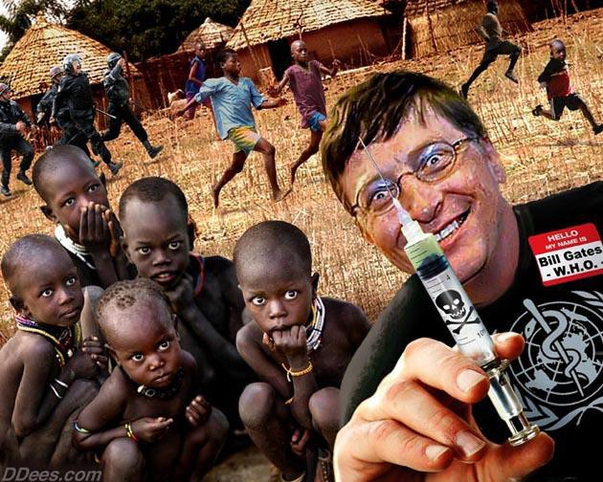
It's not just, "they don't care about us" - Michael Jackson, all eugenocidalist elite publications call for a 99% reduction in population - they actively want to kill us!!
Kill the Messenger - There are Only Four media companies in the USA - and they are All CIA Controlled!!

Now there are only four media companies in the USA all of them privately owned by Oligarchs with CIA/NSA Government Agents on their Boards. The mass media are plagued by the same mediocrity, corporatism and careerism as the academy, universities, labor unions, the arts, the Democratic Party and religious institutions. They cling to the self-serving mantra of impartiality and objectivity to justify their subservience to power.

The press writes and speaks—like the totally controlled Universities academics with CIA/NSA Controlled boards and interlinking directorates that chatter among themselves in arcane jargon like medieval theologians—to be heard and understood by the public.

And for this reason the press is just as powerful and just as closely controlled by the state, and has been for thousands of years.

The first profession was said to be Prostitution but Presstitution, Politics and the Police come close second.

Serpico is a movie with Al Pacino about a real story where Serpico is the only policeman in New York not taking bribes from the Mafia. Serpico is shot by the police, leaves the police force and goes to live in Italy.

Alex Jones says that the police are the drug pushers, selling drugs in their areas.

Alex Jones says that many policemen are the professional killers who take contracts and we have the movie, "Killer Joe" about the very subject.

There is a joke about politicians - the only problem with them is that they don't stay bought.

Worldwide, all journalists work for the CIA..

German journalist and editor Udo Ulfkotte says he was forced to publish the works of intelligence agents under his own name, adding that noncompliance ran the risk of being fired.

“I ended up publishing articles under my own name written by agents of the CIA and other intelligence services, especially the German secret service,” “One day the BND (German foreign intelligence agency) came to my office at the Frankfurter Allgemeine in Frankfurt. They wanted me to write an article about Libya and Colonel Muammar Gaddafi...They gave me all this secret information and they just wanted me to sign the article with my name,”

“That article was how Gaddafi tried to secretly build a poison gas factory. It was a story that was printed worldwide two days later.”

Ulfkotte reveals all this and more in his book 'Bought Journalists,' where he mentions that he feels ashamed for what he has done in the past.

“I was a journalist for 25 years and I was educated to lie, to betray, and not to tell the truth to the public.”

“I was bribed by the Americans not to report exactly the truth...I was invited by the German Marshall Fund of the United States to travel to the US. They paid for all my expenses and put me in contact with Americans they'd like me to meet,” he said.

“I became an honorary citizen of the state of Oklahoma in the US just because I wrote pro-American. I was supported by the CIA. I have helped them in several situations and I feel ashamed for that too.”

“Most of the journalists you see in foreign countries, they claim to be journalists and they might be. But many of them, like me in the past, are so-called 'non-official cover.' It means you work for an intelligence agency, you help them if they want you to. But they will never say they know you.”

The journalists selected for such jobs usually come from big media organizations. The relationship with the secret service starts as a friendship.

“They work on your ego, make you feel like you're important. And one day one of them will ask you 'Will you do me this favor?'" Ulfkotte explained.

If all the journalists throughout the world are compromised, bought, corrupt then what of the authors of books like David Icke, Hallet, Eustace Mullins, ex MI6 Coleman?

What of Radio Shock Jocks like Alex Jones and Mike Savage. Disinformation is 90% truth and 10% total lies.
Webster Griffin Tarpley says that the disinformers are promoted, advertised, popular - he was talking about limited hangouts, about Assange and Snowden.

The real Truth is the Truth, the Whole Truth, and Nothing but the Truth.

The only way you can get to that truth is through Meditation.

All the Satanic Ways to attain truth, like Ritual Sex, Drugs and Rock and Roll, are compromised.

The Four P's - Prostitution, Presstitution, Politics and the Police which have all been corrupt for 10,000 years.

Presstitution plays an essential role in the dissemination of official propaganda. But to effectively disseminate state propaganda the press must maintain the fiction of independence and integrity. It must hide its true intentions like all spies, to gain Trust of the people.

Social Control.. The mass media, as C. Wright Mills pointed out, are essential tools for conformity. They impart to readers and viewers their sense of themselves. They tell them who they are. They tell them what their aspirations should be. They promise to help them achieve these aspirations. They offer a variety of techniques, advice and schemes that promise personal and professional success. The

mass media, as Wright wrote, exist primarily to help citizens feel they are successful and that they have met their aspirations even if they have not. They use language and images to manipulate and form opinions, not to foster genuine democratic debate and conversation or to open up public space for free political action and public deliberation. We are transformed into passive spectators of power by the mass media, which decide for us what is true and what is untrue, what is legitimate and what is not. Truth is not something we discover. It is decreed by the organs of mass communication.

“The divorce of truth from discourse and action—the instrumentalization of communication—has not merely increased the incidence of propaganda; it has disrupted the very notion of truth, and therefore the sense by which we take our bearings in the world is destroyed,” James W. Carey wrote in “Communication as Culture.”

Bridging the vast gap between the idealized identities—ones that in a commodity culture revolve around the satanic egotistic acquisition of status, money, fame and power, or at least the illusion of it—and actual identities is the primary function of the mass media. And catering to these idealized identities, largely implanted by advertisers and the corporate culture, can be very profitable. We are given not what we need but what we want. The mass media allow us to escape into the enticing world of entertainment and spectacle.
News is filtered into the mix, but it is not the primary concern of the mass media. No more than 15 percent of the space in any newspaper is devoted to news; the rest is devoted to a futile quest for satanic self-actualization. The ratio is even more lopsided on the airwaves.

“This,” Mills wrote, “is probably the basic psychological formula of the mass media today. But, as a formula, it is not attuned to the development of the enlightened human being. It pushes Satanic money and power!! It is a formula of a pseudo-world which the media invent and sustain.”

At the core of this pseudo-world is the myth that our national institutions, including those of government, the military and finance, are efficient and virtuous, that we can trust them and that their

268

intentions are good. These institutions can be criticized for excesses and abuses, but they cannot be assailed as being hostile to democracy and the common good. They cannot be exposed as criminal enterprises, at least if one hopes to retain a voice in the mass media.

Those who work in the mass media, are acutely aware of the collaboration with power and the cynical manipulation of the public by the power elites. It does not mean there is never good journalism and that the subservience to corporate power within the academy always precludes good scholarship, but the internal pressures, hidden from public view, make great journalism and great scholarship very, very difficult. Such work, especially if it is sustained, is usually a career killer. Scholars like Norman Finkelstein and journalists like Webb and Assange who step outside the acceptable parameters of debate and challenge the mythic narrative of power, who question the motives and virtues of established institutions and who name the crimes of empire are always cast out.

The press will attack groups within the power elite only when one faction within the circle of power goes to war with another. When Richard Nixon, who had used illegal and clandestine methods to harass and shut down the underground press as well as persecute anti-war activists and radical black dissidents, went after the Democratic Party he became fair game for the press. His sin was not the abuse of power. He had abused power for a long time against people and groups that did not matter in the eyes of the Establishment.

Nixon’s sin was to abuse power against a faction within the power elite itself.

The Watergate scandal, mythologized as evidence of a fearless and independent press, is illustrative of how circumscribed the mass media is when it comes to investigating centers of power.

“History has been kind enough to contrive for us a ‘controlled experiment’ to determine just what was at stake during the

Watergate period, when the confrontational stance of the media reached its peak. The answer is clear and precise: powerful groups are capable of defending themselves, not surprisingly; and by media standards, it is a scandal when their position and rights are threatened,” Edward S. Herman and Noam Chomsky wrote in “Manufacturing Consent: The Political Economy of the Mass Media.” “By contrast, as long as illegalities and violations of democratic substance are confined to marginal groups or dissident victims of U.S. military attack, or result in a diffused cost imposed on the general population, media opposition is muted and absent altogether. This is why Nixon could go so far, lulled into a false sense of security precisely because the watchdog only barked when he began to threaten the privileged.”

The righteous thunder of the abolitionists and civil rights preachers, the investigative journalists who enraged Standard Oil and the owners of the Chicago stockyards, the radical theater productions, such as “The Cradle Will Rock,” that imploded the myths peddled by the ruling class and gave a voice to ordinary people, the labor unions that permitted African-Americans, immigrants and working men and women to find dignity and hope, the great public universities that offered the children of immigrants a chance for a first-class education, the New Deal Democrats who understood that a democracy is not safe if it does not give its citizens an acceptable standard of living and protect the state from being hijacked by private power, are no longer part of the American landscape. It was Webb’s misfortune to work in an era when the freedom of the press was as empty a cliché as democracy itself.

“The Cradle Will Rock,” like much of the popular work that came out of the Federal Theatre Project, addressed the concerns of the working class rather than the power elite. And it excoriated the folly of war, greed, corruption and the complicity of liberal institutions, especially the press, in protecting the power elite and ignoring the abuses of capitalism.

Mister Mister in the play runs the town like a private corporation.

“I believe newspapers are great mental shapers,” Mister Mister says. “My steel industry is dependent on them really.”

“Just you call the News,” Editor Daily responds. “And we’ll print all the news. From coast to coast, and from border to border.”

Editor Daily and Mister Mister sing:

O the press, the press, the freedom of the press. They’ll never take away the freedom of the press. We must be free to say whatever’s on our chest— with a hey-diddle-dee and ho-nanny-no
for whichever side will pay the best.

“I should like a series on young Larry Foreman,” Mister Mister tells Editor Daily. “Who goes around stormin’ and organizin’ unions.”

“Yes, we’ve heard of him,” Editor Daily tells Mister Mister. “In fact, good word of him. He seems quite popular with workingmen.”

“Find out who he drinks with and talks with and sleeps with. And look up his past till at last you’ve got it on him.”

“But the man is so full of fight, he’s simply dynamite, why it would take an army to tame him,” Editor Daily says.

“Then it shouldn’t be too hard to tame him,” Mister Mister says.

“O the press, the press, the freedom of the press,” the two sing. “You’ve only got to hint whatever’s fit to print; if something’s wrong with it, why then we’ll print to fit. With a he-diddly-dee and aho-nonny-no. For whichever side will pay the best.”

Jeremy Renner made Kill the Messenger.

Without Jeremy Renner Kill the Messenger would never have been made.

Previously Jeremy Renner made, "The Town", and "The Bourne Legacy" where he is a super soldier created by drugs and locked in by genetic engineering. Like Lucy, this is the Luciferian wet dream, a lie which can never be achieved instead creating Orcs, "a ruined and perverted form of life" - Lord of the Rings. See..

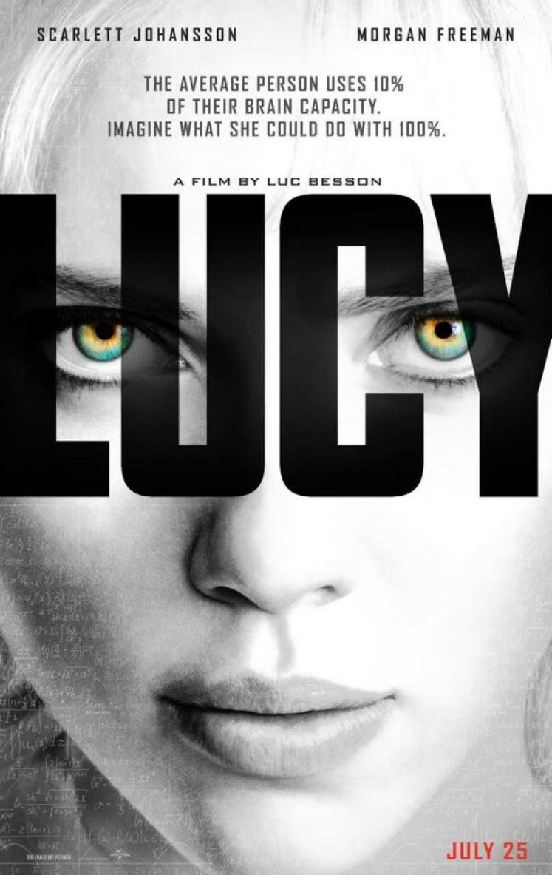

Jeremy Renner also made, Mission: Impossible - Ghost Protocol with freedom fighter Tom Cruise as Brandt, and The Avengers as Clint Barton / Hawkeye.

In the future he is scheduled to make, The Bourne Betrayal as Aaron Cross, Mission: Impossible 5 as William Brandt, and 2015 Avengers: Age of Ultron as Clint Barton / Hawkeye.

So we shall see if his transgression gets him onto the blacklist after that..

Already he has been fired from the Avengers project.

One elite insider - Steve Jobs - sent his message to the future in the movie, "John Carter" (2012) of Mars.

Purposely failed movies like...

- "Citizen Kane" 1941 universally known as the greatest picture - where Randolph Hearst, the gazzillionaire who thought that Kane was written to give out bad information about him, immediately bought RKO Radio Pictures who owned Citizen Kane and stopped its distribution, then sent Orson Welles to Brazil to get him out of the way then cut, "The Magnificent Ambersons" to shreds, and then blacklisted Orson so he almost never worked in movies again.

- Heaven's Gate (1980) by Cimino shows how during the Range Wars a death list was created by the Satanic Elite and turned over to paid assassins, the genocide stopped by the people, and the Elite pardoned by the State Governor and the President of the U S of A. The picture was destroyed at the Box Office, the production company bankrupted and Oscar Winner Cimino - for "The Deer Hunter (1979)" - was blacklisted together with all the actors.

- "The Last Samurai" 2003 showed how countries were taken over by the elite. Through the long tongued liars writing 100% bad reviews - about one of the best movies ever to have been made!! it was made to fail at the box office. Tom Cruise actor and producer

received much bad publicity and was fired by Viacom head honcho, Sumner Redstone, almost destroying his career.

- "The Saint" 1997 was about how Fusion Electric Power could save the world. Fusion Power could have been brought on line by the 1980's if the derisory budget of 5 billion dollars per year had been increased, providing almost free electrical power for 10,000 years with Helium 3 mined at the Moon. Again, made to fail and its stars, Val Kilmer and Elizabeth Shue, blacklisted.

- "The Golden Compass" 2007 was about cutting children off from their Souls, - "Just a little snip" Zombification, with obvious reference to the Lobotomy of "Man of Steel" Zack Snyder's, "Sucker Punch". 100% bad reviews for one of the best movies ever to hit the screens. Future movie trilogy wastebasketted. Stars blacklisted. New Line and its head Robert Shayler who had just produced The Lord of the Rings Trilogy making 3 Billion Dollars in the process - also a black mark - were disbanded and fired. The Weinsteins were fired from Disney.

- "The Last Airbender" 2010 Again, 100% bad reviews for an amazingly good movie. The Best!! Director Shyalmalan blacklisted. Future movie trilogy wastebasketted.

- "Green Lantern" - "Forget the pessimism of the Intellect, instead focus on the Optimism of the Will" - Gramsci.

Fear overcome by Courage and the Will!! In brightest day,
In blackest night,

No evil shall escape my sight,

For those who worship evil`s might, Beware my power!

Green Lantern's light

- "Cloud Atlas" 2012 100% bad reviews for an amazingly good movie.

- "The Lone Ranger" 2013 100% bad reviews for an amazingly good movie.

- "47 Ronin" - disgust at Satanic Shogun society consigning 47 good brave men to death. Corporation cut to death. The start of the consignation of "Matrix" Keanu Reeves to the blacklist.
These movies are always the most interesting because by being opposed, you know there is something in them which is against the elite.

Also, each of these movies, like all Spiritual Movies, has been charged with the highest vibrations of Kundalini energy. For those with sight, no further evidence is necessary than that some great soul has deemed it necessary to project his Life into matter so as to make it Art.
So do the Lords of Light make it known that they exist, and that the long battle for the Hearts and Minds of men continues against Evil.
Steve Jobs initiated the movie "The Lone Ranger" 2013 as a Director at Disney where his vision for the future had not matched that of the elite and thus had created too much trouble - after that, he was given the, "Borgia Cup".

Cancered Steve Jobs also sent his message to the future in the movie, "John Carter" of Mars after he learned of his poisoning and assassination from Cancer. –
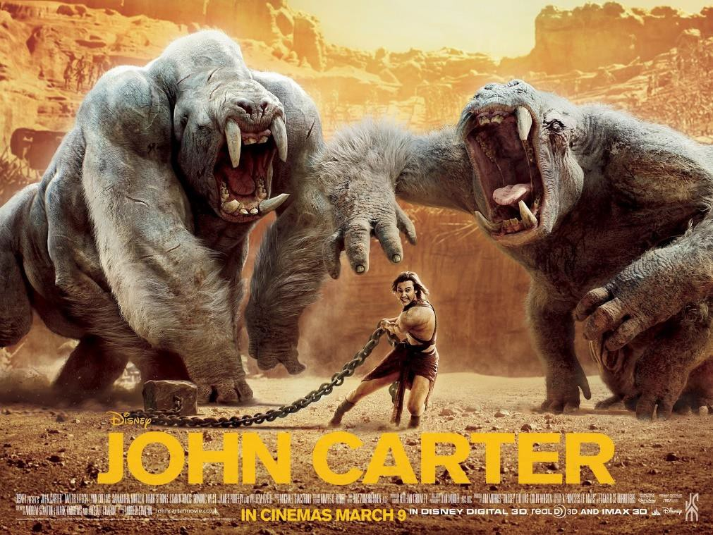

It is a well known fact that now, cancer and heart disease is a major Assassination and Eugenocidal Soft Kill tool. All the Presidents of South America seem to have cancer. Castro of Cuba had Cancer as did Lula and Roussef of Brazil, Christina Kirchner of Argentina and of course her assassinated husband Nestor Kirchner who died of a heart attack. Venezuelan President, Hugo Chavez died of Cancer.
Cancer rates have risen World Wide by as much as 10,000 per cent and the Indian Blanket USA is the cancer capital of the World.

Quote from the amazing "John Carter", 2012 .. of Mars

Steve Jobs - sent his message to the future in the movie, "John Carter" (2012) of Mars...

"So what is your cause? We have none. We are not haunted by mortality as you are. We are Eternal.... This little cause will follow the way we have set, Earthman. And we have chosen Saab Ther to rule next. The Ninth Ray must remain in the hands of mindless brutes we can control. And the infamy of Deja Thoris Wedding Death will seal his Reign.

We have been playing this game from before the birth of this planet (Mars). And we will continue to do so until well after the death of yours (Earth). We do not cause the destruction of your worldCaptain Carter. We simply manage it. Feed off it if you like. But on every last Planet it always plays out exactly the same way.
Populations Rise. Societies Divide. Wars Spread. And all the while the Neglected Planet Slowly Fades."

Just look at ISIS and the Middle East..
It is interesting that Steve Jobs has managed to awaken parts of the Elite to the current dangers and the proof is, "The Lone Ranger"
Armie Hammer who takes the part of, "The Lone Ranger", is the grandson of Elite Operative Armand Hammer who hob-nobbed with Lenin and Stalin - a Gazzillionaire!!

ARMAND HAMMER - ARM AND HAMMER



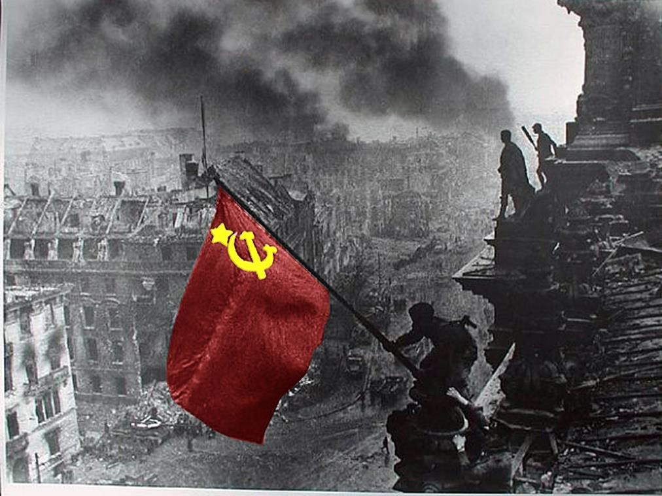
SOVIET HAMMER AND SICKLE OVER THE REICHSTAG

Kill the Messenger and the freedom of the press continued..

Just before the French Revolution, Satanic British Agent Choderlos de LaClos wrote "Dangerous Liasons" - negative propaganda about the French Aristocracy, please see the movie..

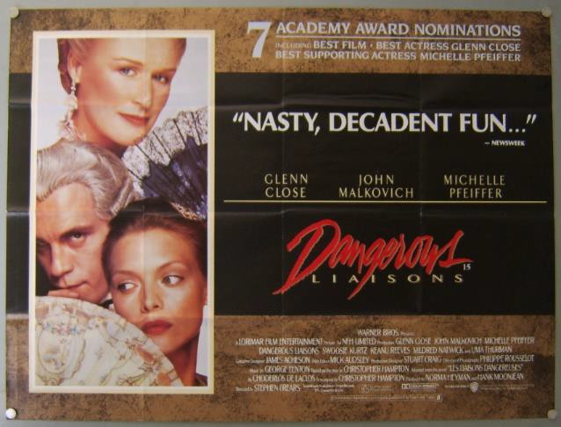


VIMALAKIRTI SUTRA - THE BOOK!!
DOWNLOAD BELOW
http://www.energyenhancement.org/Vimalakirti-Sutra/vimalakirti-sutra.pdf
Satanic British Agent LaClos had been put in charge of the Estate of the Duke of Orleans by Private Bankers through the Duke's overwhelming debts.

Satanic British Agent LaClos was responsible for inviting Satanic British Agent Cagliostro to France and thus Freemasonry and the Case of the Queens Necklace was his and British Intelligences doing.

The Duke of Orleans was also in charge of Satanic British Freemasonic Cult implanted into French Cult-ure by the Satanic British Secret services which was responsible for the French Revolution.

The British Empire's Satanic British Lord Shelburne Prime Minister of Great Britain, head of the Bankstering, Slave Trading, Drug running British East India Company and Head of MI6 Satanic Jeremy Bentham started the French Revolution by these means.
Satanic Jeremy Bentham wrote the speeches of Robespierre from London. These guys were also responsible for the accession of Napoleon Bonaparte to the throne afterwards, to destroy Europe so Britain could control Europe. So also WWI and WWII!!

Agent Marx wrote Das Kapital, created communism the cause of the Russian Revolution, from his MI6 office in the British National Library in London. Lenin, Stalin and Trotsky were also Agents.

The Media have ALWAYS worked for the Government and National interests - For 10,000 years!!

Making this known and destroying the trust of the people in Institutions is always a forerunner of Revolution.

Yet Revolution. The French Revolution which ushered in Napoleon and the destruction of Europe. The False Flag Reichstag fire which ushered in the Hitler Nazi Satanic State which murdered 25 millions of people. The Russian Revolution threw up Satanic British Agents Lenin and Stalin who genocided 65 millions of people. The Chinese

Revolution which Satanic British Agent 33rd Degree Freemason Mao killed 85 millions of people.

Revolution has never led to a beneficial change.

And Totalitarianism always leads to Poverty and Genocide.

Happy the people who left Germany before its borders were closed and WWII started.

At the moment the rest of the World is in a similar state or even worse than the west.

The BRICS, Russia, China, India, Brazil have similar competing elites like schizophrenia inhabiting the body politic.

Yet the guy at the top is always the place where the buck stops.

Like assassinated Lincoln, Sun Yat Sen, Franklin Delano Roosevelt, Jack Kennedy and Chavez who all aimed to increase wealth and Economic Human rights for their people. All fought against the psychopaths inhabiting their country.

We all know that left and right, and capitalism and socialism are akin to emotional religions, yet socialism was created by Satanic British Agent Marx from his office at the British National Library in London, and capitalism usually justifies oligarchic tyranny.

Capitalism and Socialism now push collectivism - "The nail which stands up, always gets hammered down" - which failed totally in Soviet Russia, its opposite is Individualism.

Yet both left and right can support the right policies - a Human Right to Wealth.

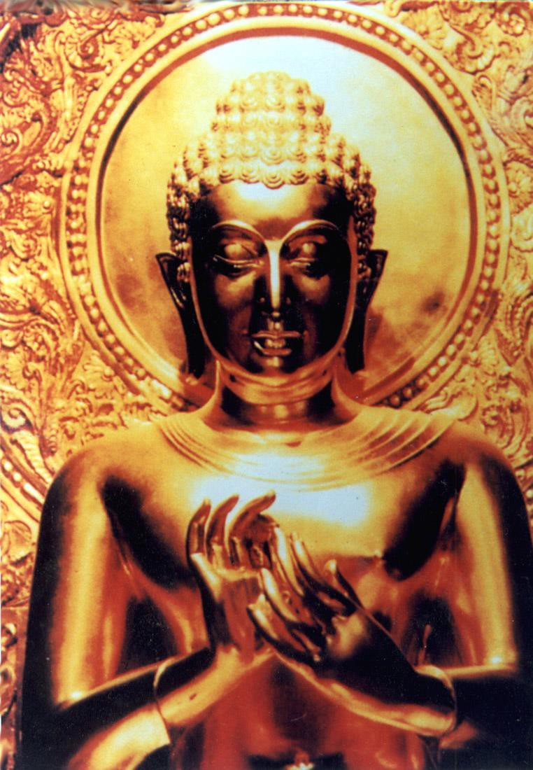
THE HUMAN RIGHT TO WEALTH AND THE TEN THOUSAND YEARS OLD, "PRINCIPLE OF POVERTY", THE TEN WAYS OF CREATING POVERTY

The duty of every Government to sponsor policies which will increase wealth and therefore happiness. The Nationalisation of the

Fed and other private, Rothschild owned, Central Banks - the Rothschild's control and own 80% of the Worlds Banks. The use of the Government Central Banks to raise credit and instead of propping up the zombie banks, raise trillions of money at zero percent interest over one hundred years to build infrastructure, build irrigation and power generation dams, irrigate the deserts, fund fusion power generation, roads, a world superfast maglev train network, silk roads, space exploration - full employment in high pay jobs - Worldwide!!

Speaking one day after Bush addressed the same session of the United Nation's General Assembly, Chávez announced, "The devil came here yesterday, and it smells of sulfur still today, this table that I am now standing in front of." At that point, Chávez made the sign of the cross, positioned his hands as if praying, and looked briefly upwards as if invocation of God. He continued "Yesterday, ladies and gentlemen, from this rostrum, the President of the United States, the gentleman to whom I refer as the devil, came here, talking as if he owned the world."

Chávez also said that President Bush "...came [to the U.N. General Assembly] to share his nostrums to try to preserve the current pattern of domination, exploitation and pillage of the peoples of the world." Chávez began his talk by recommending Noam Chomsky's "Hegemony or Survival": "It's an excellent book to help us understand what has been happening in the world throughout the 20th century, and what's happening now, and the greatest threat looming over our planet." Citing Chomsky's book, Chávez explained, "...the American Empire is doing all it can to consolidate its system of domination. And we cannot allow them to do that. We cannot allow world dictatorship to be consolidated." The speech was delivered in Spanish with voice-over U.N. interpretation.

Chavez was cancered and thus cancelled.

Presently the heads of the BRICS, Russia's Putin, China's Xi Jinping, Brazil's Rouseff, India's Modi are all increasing their economies, increasing wealth, investing in infrastructure, creating

development banks, buying gold, creating currency swap facilities, leaving the dollar.

Thus the Propaganda Work of whistleblowers David Icke, Alex Jones, Coleman, Eustace Mullins, Fritz Springmeier, Assange, Snowden, Gary Webb et al is functioning well - but not for an armed uprising - For Wealth!!

We can still come back from the brink, as long as democracy continues.


V FOR VENDETTA WORDWIDE NOVEMBER 5TH MILLION MASK MARCH

"DO YOU THINK ALL THIS IS AN ACCIDENT?" - SATCHIDANAND

In, "1066 and all that" a Bad King is always followed by a Good King.

Indeed this change of heads, "The King is Dead, Long live the King!!" The change of Empires from the Satanic Babylonian Empire to the Slave Trading, Bankstering Roman Empire, to the Phoenician Empire, to the Venetian Empire, to the British Empire, to the Anglo- American Empire - different Empires, Same Rulers - is part of the Theater provided by the real Rulers of the World.

The real aim is the fooling of, the parisitisation of, the vampirisation of Humanity both physically and Spiritually.

The povertisation of humanity in order to control humanity so as to Rule humanity for 10,000 years..

ONLY MEDITATION CAN GIVE YOU THE TRUTH!!

Competition always leads to struggle and big changes... as the economies of the BRICS exceed the economies of the Anglo American Establishment - there will be trouble ahead.

Behold the Accession of the Satanic Chinese Empire!! Same Families, Same Rulers!!
Thus I recommend increasing your internal Wealth as well as your external Wealth - it being the only thing you can take with you when you die!!

LEARN ENERGY ENHANCEMENT!!

