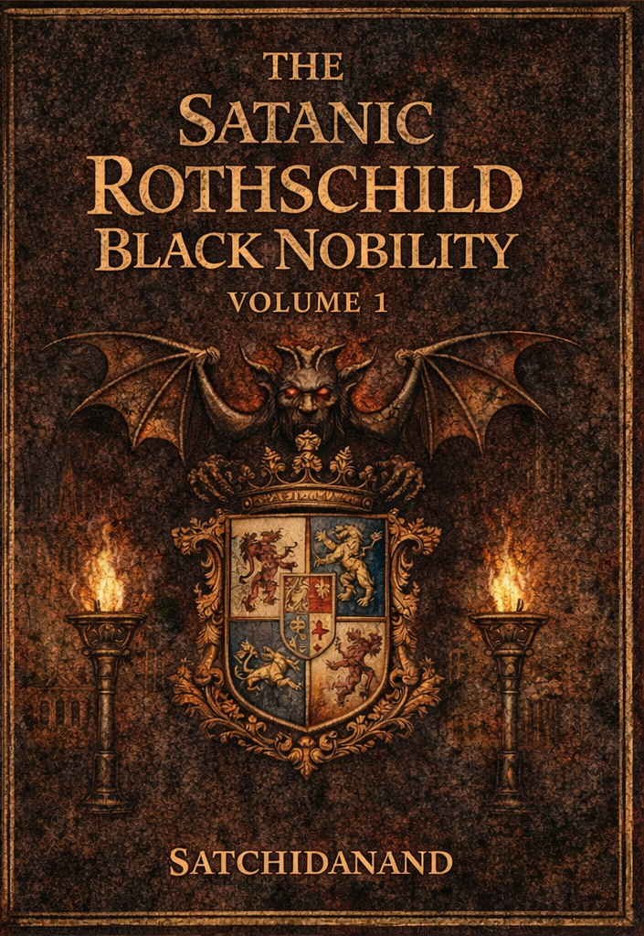
DEDICATION
With all Thanks, Love and Gratitude to Swami Devi Dhyani who make these books and the Energy Enhancement Streaming Video Meditation Course possible.
With all Thanks, Love and Gratitude to Devi Dhyani, my Mother and Father and to all my other Teachers, Theos Bernard, Sri Yogendra, Eric Berne, Gurdjieff, Father Bede Griffiths, Osho, Zen Master Hogen, Swami Sivananda, Swami Satchidananda, and all the other giants upon whose shoulders I stand - who made me able to be what… I AM – Swami Satchidanand

Copyright © 2026

[Satchidanand]

All rights reserved. This publication may be reproduced in whole or in part, by any person under fair use as long as we are referenced, without written permission of:
Swami Satchidanand

sol@energyenhancement.org

www.energyenhancement.org
https://eemeditationvideo.org/

https://againstsatanism.com/
https://against-satanism-video.com/

https://satchidanand.substack.com/
THE SATANIC ROTHSCHILD BLACK NOBILITY

VOLUME 1

Table of Contents

Satanic Mega-Trillionaire US $2,080 Trillion Phoenician Rothschilds Control the World through Vanguard Group and Blackrock 5

THE SATANIC LUCIFERIAN ATLANTIS-PHOENICIAN MEGA TRILLIONAIRE ROTHSCHILD DEEP STATE SWAMP NEEDS DRAINING 63

THE ROTHSCHILD SATANIC LUCIFERIAN MEGA TRILLIONAIRE PHOENICIAN EMPIRE SATANIC DEEP STATE CONTROL 156

John Wick is a Metaphor for the Satanic Phoenician Empire and it's High Table of Satanic Phoenician Mega Trillionaires. 292

FINANCIALISATION and Satanic Phoenician Mega Trillionaire Central Banks? by Professor Richard A. Werner, D.Phil. - Improved and made better by Satchidanand 302

Rothschild, Trump, Tucker Carlson, Alex Jones, Joe Rogan, Dominic Cummings 391

TRUMP AND THE DEEP STATE SATANIC 2000 TRILLION DOLLAR ROTHSCHILD PHOENICIAN MEGA TRILLIONAIRES 423

The Energy Enhancement Streaming Video Meditation Course and the Volumes of the Against Satanism Series by Satchidanand 478

These Satanic Malthusians Demand Genocide 507

Alan Watt Recommended Book List 513

Satanic Mega-Trillionaire US $2,080 Trillion Phoenician Rothschilds Control the World through Vanguard Group and Blackrock
Oct 02, 2022
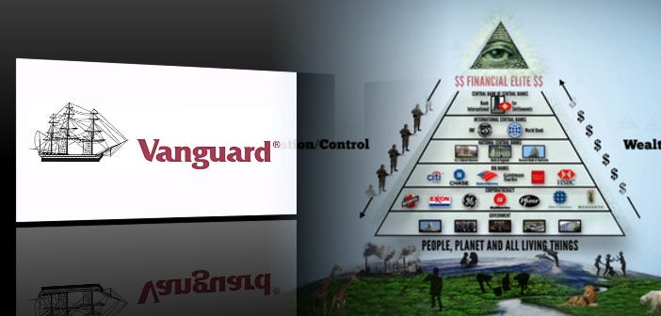
The Richest Satanic Phoenician Mega Trillionaire 10,000 years old Families in the World. THE VANGUARD GROUP DRIVES WORLDWIDE MERCHANT-BANKER FASCISM FROM THE CITY OF LONDON. VANGUARD, BLACKROCK, STATE STREET ARE CONTROLLED BY THE PILGRIMS SOCIETY IN THE CITY OF LONDON (ROTHSCHILDS, BARINGS, BARCLAYS, NATWEST, ETC.) King Chucky the Turd is the front man controlling Klaus Schwab and Vanguard.
THE PILGRIMS SOCIETY
In 1891, Lord Rosebery, J.P. Morgan, Cecil Rhodes, Baron Henry de Worms, Lord Rothschild and Lord Alfred Milner founded the Round Table to use Jesuit discipline and Masonic secrecy to promote the reorganization of the British Empire into an Imperial Federation that they insisted include America coming back under the British Crown. The Anglo-American Empire…
These men were the prime movers in the creation of the British South Africa Company, founding of De Beers Consolidated Mines and the Wellcome Vaccine experimentation on over 60,000 Boers and blacks in their 2nd Boer War concentration camps. In 1902, these perpetrators of the war, abruptly stopped the 2nd Boer War, and changed the name of the Round Table to the Pilgrims Society in the months after Cecil Rhodes’ “untimely” assassination at 49 years old.
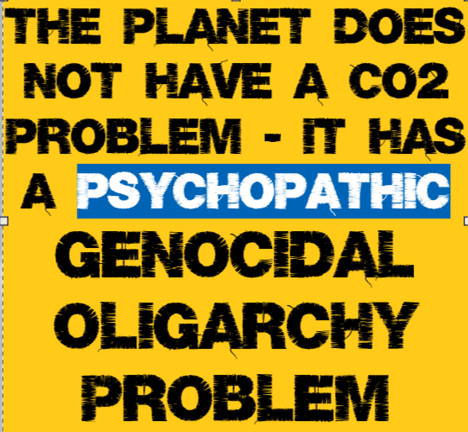
DAVID SARNOFF, RCA/NBC/FIVE EYES GROOMED BY THE PILGRIMS SOCIETY
The group of Pilgrims Society members (generically called the “Deep State” to avoid directly fingering of the Pilgrims) are all run by the “Five Eyes” agreement that Brig. Gen. David Sarnoff, Gen. Marshall, and Gen. Eisenhower created in Feb. and Mar. 1946.
This is not an exaggeration: Out of the Imperial Press Conference, 1909, the British Empire’s Marconi Wireless global monopoly split and morphed and reorganized into the media and communications networks we know today as BBC, New York Times, Daily Telegraph, Washington Post, AT&T, British Telecom, Westinghouse, GEC, RCA, NBC, CBS, Orange, Verizon, Nokia, Lucent, Alcatel-Lucent, Bell Labs, Western Electric, Vodafone, Deutsche Telecom, AEGIS system, SERCO, QinetiQ, and now “The Internet of Things.”
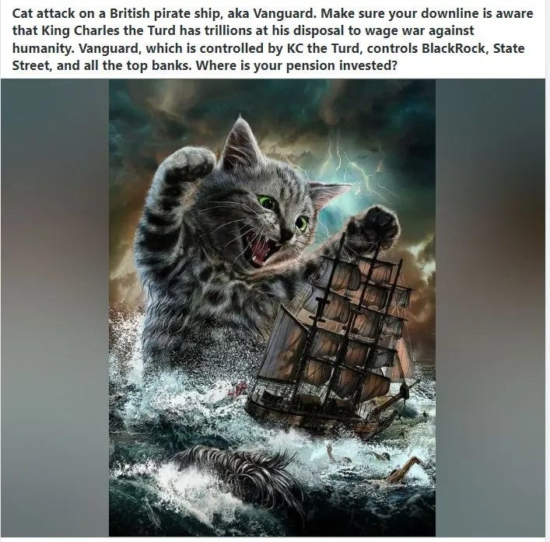
Also on the Pirbright site today is Cobbet Hill Earthstation with satellite warfare-level capabilities. Henry de Worms (Rothschild), starting in the 1880’s, helped establish the Marconi Wireless monopoly in Britain and worked as patent, commerce, trade and colonies minister to fuse Marconi wireless technology (stolen from Nikola Tesla) and Wellcome biological research into using radio transmissions to trigger viral outbreaks.
Today, 140 years later, de Worms (Rothschild)’s vision is finally coming true in 5G and nanotubes carrying deadly virus payloads. See Jun. 05, 1909 Here...
https://againstsatanism.com/2020-06-10-HOW-THE-ROTHSCHILDS-USE-MASS-SURVEILLANCE-AND-NANOTECH-BIOWEAPONS-TO-SUSTAIN-THE-iMPERIAL-BRITISH-WORLD-ORDER-Americans-for-Innovation-Jun-10-2020.pdf
A small number of Satanic Phoenician Mega Trillionaire banking families, now operating out of the City of London as the Anglo-American Empire, but previously as part of the Venetian Empire, the Roman Empire, the Carthaginian Empire but always the 10,0000 years old Phoenician Empire I detail in my book, AGAINST SATANISM VOLUME SIX .. have for generations held these wealth records with fortunes that are orders of magnitude above anything we might have imagined.
Dark Forces have used Infiltrating Bloodline Satanic 10,000 years old Phoenician Mega Trillionaire Aristocratic Families which have existed running Global Trading Companies for thousands of years before the Birth of Christ.
Infiltrating and taking over the power structures in every country, using propaganda - emotional rhetorical religious concepts to control humanity, they themselves are Satanists, worshiping all the Pagan Gods, including Lucifer, Satan, Baal, Bel, Molech, Ashtoreth, Cybele and Attis.
All these Satanic Gods are heartless Demons who have cut themselves off from the Energy of the One Good God, who have rejected God so as to live eternally, immortally.
Therefore they control humanity so as to steal and vampirise the energies of Humanity forever!

AGAINST SATANISM VOLUME SIX
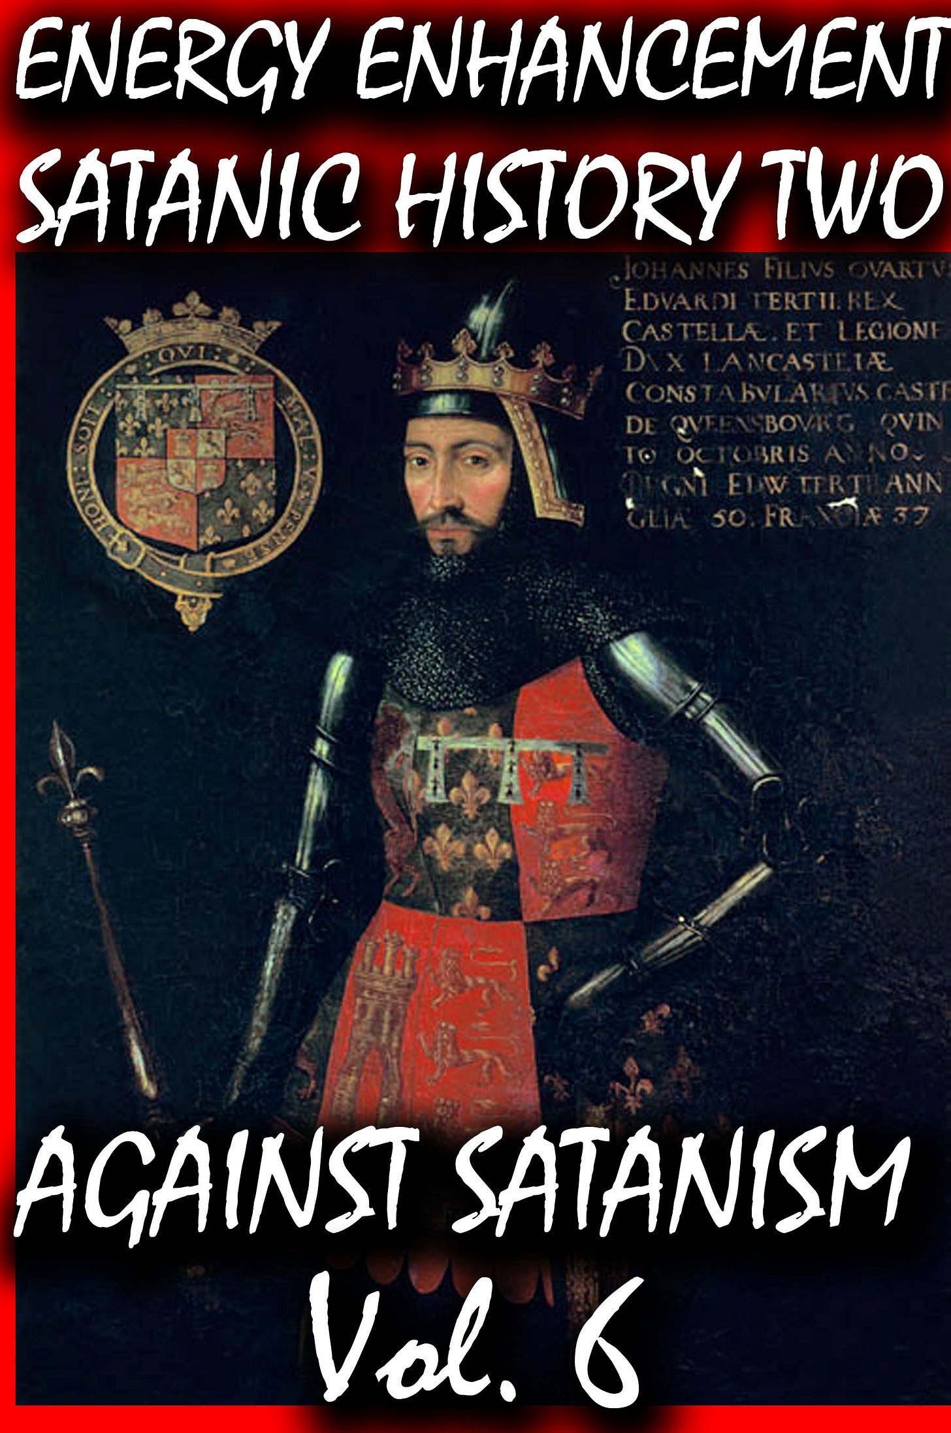

In this book we find that over thousands of years before the birth of Christ, spook, Bloodline Satanic Phoenician Mega Trillionaire Aristocratic Families infiltrated every country, every Empire, from their Phoenician Colonies in Ancient Egypt, Carthage, Rome, Venice and London, marrying in to, taking over or infiltrating every ruling aristocracy and aristocratic, bloodline family.
Their Phoenician sons and daughters pretending to be natives of Europe, Britain, America, India, Israel and China, using their Satanic Phoenician Mega Trillionaire inheritances to get into positions of power to manage and control their human cattle in every country in the World!!
Download FREE! AGAINST SATANISM Volume 6 FREE!! Right Click and Save as..
https://againstsatanism.com/Sacred-Energy/Against-Satanism-Volume-6/AGAINST-SATANISM-6-Satanic-History-of-the-World-Part-2.pdf
The descriptions and evidence in this essay will serve at least to provide a reasonable basis for understanding and to “draw attention to some of the great forces which have been molding our world”.
The Power of Compound Interest
Much of this essay is primarily dependent on only one simple thesis: that those with enormous wealth do not leave it idle but put it to constant good use; the money is always at work. It is lent out to finance wars and colonisation, to purchase legitimate businesses, to establish control of governments and national economies, and more.
The reason Abraham Lincoln resorted to printing his “Greenbacks” as currency was because Rothschild demanded a 24% interest rate to fund the Union in the US civil war. There are many other such examples, as war financing in particular carried high interest rates. Dutch perpetual bonds issued by Satanic Phoenician Mega Trillionaires were at rates of 10% and 12% in the 1500s and 1600s; Genoa issued much of its debt at 9% in the 1600s.
Some Background on Corporations
A great many of the world’s largest corporations are owned and controlled by Satanic Phoenician Mega Trillionaires, many of these by the select few in the City of London, but also very many outside this small group.
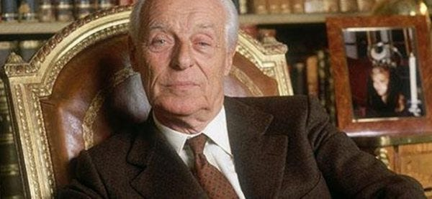

Evelyn de Rothschild
Satanic Mega-Trillionaire US $2,080 Trillion Phoenician Rothschilds Control the World through Vanguard Group and Blackrock
BLACKROCK AND THE SATANIC 2000 Trillion Dollar MEGA TRILLIONAIRES HAVE BOUGHT OFF OUR LEADERS, STOLEN THE ELECTIONS, FOLLOW THE ZIMBABWE SCRIPT TO DESTROY AMERICA - CUT OFF THE ENERGY, CUT OFF THE OIL, CUT OFF THE GAS, DESTROY THE PETRODOLLAR, DESTROY THE DOLLAR, INCREASE THE GLYPHOSATE, CUT OFF THE FERTILISER, FAMINE AND STARVATION TO FOLLOW, INCREASE INFLATION, MAKE EVERYBODY POOR, SPREAD BIOWEAPONS, KILL OFF THE POPULATION, CREATE A GREAT RESET NEO-FEUDAL, POST INDUSTRIAL, SOCIAL CREDIT SCORE SLAVE PLANET
The Satanic Mega-Trillionaire - 2080 Trillion Dollars Rothschilds who control the money of the Vatican Bank control the World through the - “VanGuard Corporation” which Controls Global Megabanks, Big Deathshot Pharma, Major Mass Media and Mega Corporations in the World and their Owners - Monsanto, Google, Facebook and Microsoft.
The four companies that are present in all cases below and in all decisions: Vanguard, Fidelity, BlackRock and State Street. All of them “belong together”, but if you check out carefully the balance of shares, it turns out that in reality all these companies are All controlled by Vanguard. So, all of these partners or “competitors” - Fidelity, BlackRock and State Street All belong to Vanguard Group.
Please, look at the largest, companies in various industries, controlled by the “Big Four”, and upon closer inspection control by Corporation Vanguard: Alcoa Inc. Altria Group Inc., American International Group Inc., AT & T Inc., Boeing Co., Caterpillar Inc., Coca-Cola Co., DuPont & Co., Exxon Mobil Corp., General Electric Co., General Motors Corporation, Hewlett- Packard Co., Home Depot Inc., Honeywell International Inc., Intel Corp., International Business Machines Corp., Johnson & Johnson, JP Morgan Chase & Co., McDonald’s Corp., Merck & Co. Inc., Microsoft Corp., 3M Co., Pfizer Inc., Procter & Gamble Co., United Technologies Corp., Verizon Communications Inc., Wal-Mart Stores Inc. Time Warner, Walt Disney, the corporation «Halliburton», Viacom, Rupert Murdoch’s News Corporation, CBS Corporation, NBC Universal …
The Satanists own 70% of Banks, 70% of International Corporations, 100% of Central Banks, Worldwide!
All of the global major corporations are eventually controlled by Corporation Vanguard and the Corporations are owned by “Dick Cheney, the Rothschilds, the Queen, the Bushes, the Rockefellers, Clintons, Donald Rumsfeld and many other influential people and owners of the Federal Reserve and the Jesuit Vatican, "Iron" Bank. In a word, these people are the rulers of the earth, who, through Corporation Vanguard, control all mega corporations such as Monsanto, Google, Facebook and Microsoft.
The minions are throw away people like Colin Powell who wasn't given the memo not to take the Deathshot. The minions are Obama, Turdeau, Macron, Boris Johnson, Bill Gates, Merkel, Bidet, - That level..
The world’s major oil companies are controlled by Satanic Phoenician Mega Trillionaires interests, as are the major pharmaceutical companies, many of the weapons manufacturers and the world’s airlines, a preponderant amount of the world’s shipping capacity, and many other industries that might not normally come to mind. It is impossible to obtain access to all the information required to even hazard a guess at the value of the corporate asset ownership of these people, but consider that virtually all of the media in the West, and a great deal of the prime media outlets in the rest of the world, including movies and book publishing, are owned or controlled by Satanic Phoenician Mega Trillionaires. There are international companies worth in total many trillions of dollars that are entirely Satanic Phoenician Mega Trillionaires; Nestle, Sanofi, Monsanto, being a few among hundreds such. We cannot easily know what part of this reverts to our handful of Satanic Phoenician Mega Trillionaires bankers in the City of London, how much of that was financed by, and is controlled from, that center, but it isn’t negligible.
Things are not always what they seem. Many of the world’s large fortunes were financed by Rothschild or others from that inner circle and thus there is a hidden ownership that will never be revealed. Trolling through historical records, we sometimes discover that a very wealthy man left an estate of only a few million dollars.
It isn’t a secret although apparently not widely known, that one of the Rothschilds financed Rockefeller’s creation of Standard Oil, and did the same with Andrew Carnegie’s steel empire and the Harriman railroad fortune in the US, among others. The financing was usually done through J. P. Morgan, who was a Rothschild agent for all of his career, and in fact, Morgan’s banking interests themselves were much more European Satanic Phoenician Mega Trillionaires than they were American.
It is worthy to bring this to the attention of readers since it appears that much of the wealth of the famous American and European families may not have been really theirs but belonged instead to the ultimate Satanic Phoenician Mega Trillionaires financiers in the background. Today, Google, Facebook, Tesla, Amazon, Starbucks, and many others are in this category, firms that could not possibly have attained their extent of market control without both heavy financing and intense planning originating elsewhere.
A number of studies have been done on interlocking corporate ownership and control, with consistent conclusions that as few as 400 companies, and perhaps even as few as 250 companies, own outright or at least have control of, more than 70% of all the value listed on all stock exchanges everywhere.[3][4][5]
But behind those 400 or 250 companies is that same number of Satanic Phoenician Mega Trillionaire families controlling those companies. Even though most large corporations are listed as public, with sometimes hundreds of millions of shares outstanding, we cannot know where the true control lies. Increasingly, many of the shares are held by proxies like Blackrock or Blackstone or other investment groups, and we have no information on share classifications or other restrictions on voting and control.
Nor does the general public have information on interlocking directors who have absolute day to day control, including over all financial decisions. More importantly, it isn’t necessary to own a plurality of shares if you control the Board of Directors or if they are reading from the same script. These people can empty a company’s treasury to pay unlimited dividends tax-free through a tax haven, and do so without even attracting unrest from the common shareholders who seldom have much understanding of these matters.
Many European banks fall into this category, most of these Satanic Phoenician Mega Trillionaires-owned and tightly-held. The few dozens of Europe’s largest banks like HSBC, BNP Paribas, Lloyd’s, have a market cap in the trillions and an asset base of over €30 trillion. The major North American banks, like Goldman Sachs, Citigroup, Wells Fargo, again owned by Satanic Phoenician Mega Trillionaires, have a market cap of well over $1.5 trillion and assets to match. Plus, we have literally hundreds of Satanic Phoenician Mega Trillionaires-owned banks in Switzerland and other countries that appear on no list anywhere.
Many of the world’s largest insurance and reinsurance companies are owned by Satanic Phoenician Mega Trillionaires, with a combined market cap in the trillions, and there is no way to place a value on Lloyd’s of London, a worldwide insurance platform that is virtually priceless. Then there are the oil companies; Royal Dutch Shell alone has a market cap of over $200 billion, and there are many of these, Satanic Phoenician Mega Trillionaires-controlled, sufficient to control the world’s price of oil as we will see.
The two major FMCG companies, Unilever and P&G, both Satanic Phoenician Mega Trillionaires, have a combined market cap of over half a trillion dollars. Internet-related firms like Google, Meta, Amazon, Dell, Oracle, again all Satanic Phoenician Mega Trillionaire owned, have a combined market cap of nearly $5 trillion. The world’s fashion houses and jewelry firms, mostly Satanic Phoenician Mega Trillionaires-owned or controlled, firms like Swarovski, YSL, LVMH, Cartier, Hermès, Estee Lauder, L’Oréal, have a market cap of more than $1 trillion, and there are hundreds of jewelry firms, diamond cutters and merchants, gold dealers, operating behind the scenes that are also owned by Satanic Phoenician Mega Trillionaires and worth a combined trillions of dollars.
The major armaments and weapons manufacturers, which have always had a high percentage of Satanic Phoenician Mega Trillionaires ownership and control, again have a market cap in the vicinity of $1 trillion. The world’s major food companies, again mostly owned by Satanic Phoenician Mega Trillionaires, is another example. Nestlé, an entirely Satanic Phoenician Mega Trillionaires company, owns more than 2,000 food brands with a market cap of about 1/3 of a trillion dollars by itself. Pepsico is the second-largest food company in the world, owning hundreds of major brands, and many others like Kraft Heinz, Mondelez, Danone, Anheuser-Busch Inbev, Coca-Cola, Diageo, Starbucks, have a combined market cap of at least $1.5 trillion. The world’s largest pharmaceutical companies are all Satanic Phoenician Mega Trillionaires-owned, with a combined market cap of around $4 trillion.
The main North American media companies (all owned by Satanic Phoenician Mega Trillionaires) have a market cap of over $1 trillion, with larger numbers for the European media that are also largely Satanic Phoenician Mega Trillionaires-owned and virtually all Satanic Phoenician Mega Trillionaires-controlled. And this ignores their media holdings in Latin America, Asia and Africa. And there are literally hundreds of Satanic Phoenician Mega Trillionaires-owned companies that don’t fit easily into the above categories, including everything from H&R Block to Mattel and Hasbro, Monsanto, Ben and Jerry’s. The list is almost endless. Collectively, their value and influence are enormous.
The Real Power: Satanic Phoenician Mega Trillionaire Family Dynasties
When we read of Bill Gates or Warren Buffett, we tend to think in simple terms of someone starting a company with a good idea and over a lifetime building a huge enterprise that today is worth many billions. But this reasoning is simplistic because we are confining our thoughts to only one generation. The people with whom we are concerned here, are Satanic Phoenician Mega Trillionaire family dynasties that have been accumulating their fortunes for perhaps ten or even twenty generations.
With the Rothschilds, Sassoons, and so many others, we are going back to the 1600s and 1700s, with family dynasties that have expanded enormously over the centuries and maintained control over their increasingly vast wealth through avoidance of inheritance taxes, rigid intermarriage, and shared intentions.
The greatest of all Satanic Phoenician Mega Trillionaire 10,000 years old family dynasties are hidden from view, expunged from the media, deleted from the history books, and almost never attract public attention. All of these are Satanic Phoenician Mega Trillionaires – Rothschild, Sassoon, Sebag-Montefiori, Warburg, Lehman, Goldman, and so many names you may have never heard of.
Here is a listing of a few of the Satanic Phoenician Mega Trillionaires bankers, representing perhaps only 25% of them, most having begun banking, financing and industrial operations in the early to mid-1800s, so an average of nearly 200 years, and many resulting in Satanic Phoenician Mega Trillionaires family dynasties that continue to this day, entirely out of the public eye.
Rothschild, Sassoon, Warburg, Moses Montefiori, Sebag-Montefiori, Kadoorie, Lehman, Israel Moses Seif, Kuhn Loeb, Goldman Sachs, Salomon, Schiff, Joseph Hambro, J. Henry Schroder, Samuel Montagu, Emile and Isaac Péreire, Lazard Brothers, Speyer brothers, Seligman brothers, Stern brothers, Barnato Brothers, Ernest Oppenheimer, Abraham Oppenheim, Carl Fuerstenberg, Jacob Goldschmidt, Oskar Wassermann, Hirsch, Raphael Jonathan Bischoffsheim, Hambro, Isaac Glückstadt, Levy Martin, Markus Rubin, Goldsmid, Rosenthal, A. Dunkelsbueler, Eugen Gutmann, Herbert Gutman, Wagg and Co, Mèdici family, Speyer, Speyer-Elissen, Emile Erlanger, S. Japhet, Ernest Cassel, Carl Meyer, Achille Fould, Luigi Luzzatti, Wertheimer and Gompertz, Lippman.[6][7][8]
I have a graphic on my computer that displays the holdings of the Rothschild dynasty owning 70% of everything. The Rothschild dynasty are really fronts for the 1500 year Vatican Bank like the Iron Bank of Game of Thrones, the Pope is just the CEO of an ancient business, the directors of which are the Cardinals, scions, sons, of every major Satanic Phoenician Mega Trillionaire Family in the World. The Rothschilds are the money and business managers of the Vatican Corporation.
Displayed rather like an organisation chart with small boxes indicating holdings and lines everywhere indicating ownership and control. It is so large that to print it in the smallest readable type would require a sheet of paper half a meter in size. Rothschild recently created a new bank just to manage his land holdings confiscated from poor countries. It is difficult to obtain hard information because so much of this is done through no-name banks, agents, and related companies, and run through innumerable tax havens. Rothschild owns, among other things, Sanofi Pharma with a capitalisation of $125 billion, the Economist, and IHS which is the largest mobile tower operator in Africa.[9]
Anglo American was founded by Satanic Phoenician Mega Trillionaire Family Ernest Oppenheimer, a German. Headquartered in the City of London, this is one of the 250 largest companies in the world, producing gold, diamonds, other metals, and nearly half of all the world’s platinum. Their subsidiaries and investments are too many to list. When Ernest died, he was succeeded by his son Harry, who also became chairman of De Beers, so you can see how the families integrate and rationalise their holdings.
The Satanic Phoenician Mega Trillionaire Wallenbergs in Sweden have been in business for 200 years, where today they own most large Swedish industrial groups like Enskilda Bank, Ericsson, Electrolux, ABB, SAAB, SAS Group, SKF, Atlas Copco, and Nasdaq. As far back as 50 years ago, the Wallenberg family businesses employed 40% of Sweden’s industrial workforce and represented 40% of the total worth of the Stockholm stock market. The market capitalisation of only ten of their companies is nearly $350 billion, and much has been buried in trusts and hidden in tax havens. Swarovski, with their fake “crystal” is another 150-year-old Satanic Phoenician Mega Trillionaire dynasty.
For this essay, I will ignore much of the past history of these Satanic Phoenician Mega Trillionaire's families and begin from the early 1800s, but it should be noted that these Satanic Phoenician Mega Trillionaire Family Khazar “family fortunes” began thousands of years before this. We had the (Satanic Phoenician Mega Trillionaires) Dutch Tulip bubble, the (Satanic Phoenician Mega Trillionaires) South Seas bubble, the (Satanic Phoenician Mega Trillionaires) British and Dutch East India Companies and many similar. There were centuries of slave trading, of tax farming and so much more. I will omit all of that.
India was at one time almost certainly the richest nation in the world, with stocks of gold, silver and precious gems worthy of fable and legend. The British East India Company which was eventually led by one of the Rothschilds, was unquestionably the greatest criminal enterprise in the history of the world, and the vehicle used to loot India to the bones.
Sassoon ben Salih was the chief treasurer to the pashas of Baghdad.[10] Exposed in an immense fraud in the early 1800s that must have involved hundreds of billions in today’s dollars, he was lucky to escape with his life (and the money). He and his two sons David and Joseph fled to India where they teamed up with one of the Rothschilds and hatched their infernal plan to force Indian peasants to grow opium for sale in China.[11]
From the early days, they already had the young Queen Victoria firmly in their grasp. She not only supported their efforts to the extent of allocating the British military as the Satanic Phoenician Mega Trillionaires’ enforcers of the opium, giving David Sassoon the exclusive franchise for selling opium in all of China, seizing Hong Kong for his distribution base and giving him the charter to form the HSBC. To say that the British Royal Family profited heavily from this personally, would be an understatement of some magnitude. This is where we will begin our story.
From their wholesale looting of India and the thefts from Iraq, followed by growing and selling of opium in China, Rothschild and Sassoon were reliably estimated to have accumulated wealth of more than $5 billion each, by 1835. Actually, the calculated estimates I have seen were of $6 billion and $7 billion,[12] and these were my estimates as well. I reduced this to $5 billion to be conservative, but the totals are still staggering. $5 billion accumulated at only 5% for the intervening 185 years, accumulates to a total in 2022, of more than $40 trillion each for Rothschild and Sassoon. And there were at least a dozen or more Satanic Phoenician Mega Trillionaires banking families that were not so very far behind Rothschild and Sassoon, as well as many dozens more that were very wealthy but not in this same league. That $40 trillion may seem shocking and too fantastic to be real, but reserve your judgment until the end. As you will see, that $40 trillion is almost irrelevant in the overall picture of a World GDP OF 200 TRILLION DOLLARS EVERY YEAR AND THE Satanic Phoenician Mega Trillionaire Families own most of it!.
(1) Slavery and Forced Labor
Satanic Phoenician Mega Trillionaires have always been heavily involved in slave trading from the year dot. Before petrol engines the whole World ran on slave labour from Ancient Egypt to the Roman and Chinese Empires.
Recently both the white slaves that depopulated Ireland and much of England and the more recent black slaves, but I will ignore that part of the past and deal only with the more recent events in China.
Slave trading by these same richest Satanic Phoenician Mega Trillionaires – Rothschild, Sassoon, Kadoorie and many others, stopped only because the First World War put an end to it. We haven’t precise numbers, but the historical record tells us that many millions of Chinese were kidnapped and sold as slave labor. Countless tens of thousands of Chinese were kidnapped and shipped as slave labor to North America to build the railroads and work the gold mines, to build the Panama Railway and the Panama Canal, to work the guano mines in Peru, and in many other instances. This is why we have Chinese all over the world; even today the population of Panama is more than 10% Chinese because of this.
In many cases, the Chinese were not actually sold to others but used by the Satanic Phoenician Mega Trillionaires as slave labor for their own projects. As late as 1904, Rothschild had around 65,000 Chinese kidnapped from Fujian Province to work his gold mines in South Africa.[13]
When these same Satanic Phoenician Mega Trillionaires financed the building of the North American railroads and the Panama Canal, for example, kidnapped Chinese were the supply of free (and disposable) labor. Harsh conditions resulting in tens of thousands of deaths were irrelevant because the supply was inexhaustible.
As well, there is credible evidence that Easter Island was almost totally depopulated by these same Satanic Phoenician Mega Trillionaires who kidnapped most of the people to work the guano fertilizer mines in Peru. There are letters from officials in the UK demanding that these Satanic Phoenician Mega Trillionaires return the Easter Islanders to their homes.
At this distance in time, it isn’t possible to construct a comprehensive tally of the totals of Chinese slave laborers conscripted by these Satanic Phoenician Mega Trillionaires for their projects, nor to estimate the “value” of all this slave labor, but it was certainly substantial and carried on in great volume from about 1800 to 1920 and, as I mentioned above, it was only the First World War that put a stop to it. I list this because it is an important contributing aspect to the accumulated wealth of these Satanic Phoenician Mega Trillionaires banking families.
(2) Diamonds
It’s not a secret that DeBeers controls the diamond production of South Africa, and also in Zaire, nor that DeBeers is a Rothschild company. Let’s not forget the origin and purpose of the Boer Wars. Diamond production statistics seem scattered, with South Africa claiming around 650 million carats of total production,[14] while Statista claims twice this amount. South Africa places a value on this production (at $100 per carat) at about $60 billion, but with no allowance for the compounding an average of $300 million per year over 150 years: (average of 3 million carats per year at $100 per carat). If we allow for compounding at 5%, this accumulates to about $10 trillion. To keep things simple, I have excluded all other countries from this calculation; the addition of these and other Rothschild and Satanic Phoenician Mega Trillionaires-owned production would at least double the total. It should also be noted that the Satanic Phoenician Mega Trillionaires enclave of Holland is still the center of the world’s diamond trade, the great majority of which is firmly in Satanic Phoenician Mega Trillionaires hands.
(3) Gold
It is difficult to find comprehensive and reliable statistics on the actual annual production of gold from the Rothschild-controlled mines, but production apparently reached more than 1,000 tonnes per year 50 years ago. With 32,000 ounces in a tonne of gold, and gold selling at $1,700 an ounce, that represents many billions of dollars per year, compounded at 5% for nearly 150 years, about 100 Trillion dollars.
(4) Canals: Panama and the Suez
It is universally-known that the US built the Panama Canal – after “liberating” the Province of Panama from Columbia, but not so widely-known that it was Satanic Phoenician Mega Trillionaires money that paid for the canal.[16] We can reasonably assume that the profits from the canal for about 120 years would have accrued to those who financed it. The Suez Canal was also built with Satanic Phoenician Mega Trillionaires money and existed as a privately-held corporation. Only a few mere billions of dollars per year.
(5) Cash Management
It isn’t widely-known but, as part of America’s Monroe Doctrine, the US used not only its powerful bullying “diplomacy” but also the CIA and the full force of its military to arrange for a few Satanic Phoenician Mega Trillionaires bankers (and the US FED) to obtain the position of “investment managers” of all the cash assets and central bank holdings of the countries under its control. This included Latin America, but also countries like the Philippines and the 50+ countries where the US overthrew a government and installed a compliant dictatorship.
The scheme was simple. These nations were forced to turn over all their liquid assets to the Satanic Phoenician Mega Trillionaires bankers in the US who would “prudently manage” all that cash for the benefit of these smaller nations. In practice, the Satanic Phoenician Mega Trillionaires bankers invested the money in New York real estate and profited in the billions while paying those nations 3% on their money.
This practice was coupled with a bad American habit of invading, then forcing open and emptying, the vaults of the central banks of these same nations of all their gold. These practices are sufficiently documented to withstand challenge and, having existed for about 150 years, I think we could reasonably attach a total compounded to today of at least $1 trillion dollars.
(6) Germany’s Hyperinflation
It is widely accepted today that Germany was set up for this precise circumstance from the provisions of the Treaty of Versailles and the corresponding restrictions enacted by Satanic Phoenician Mega Trillionaires to prevent Germany’s recovery. Regardless, the inflation rate was so extreme that money became literally worthless, permitting the Satanic Phoenician Mega Trillionaires bankers to buy up much of Germany for virtually nothing. This was one of the deep resentments harbored by Hitler toward the Satanic Phoenician Mega Trillionaires, knowing they were behind the treaty and other restrictions that could have had only the bankruptcy and subjugation of Germany as the one possible purpose. We needn’t go into details here, but it was Hitler’s eviction of the Satanic Phoenician Mega Trillionaires from Germany’s banking system and taking over the country’s central bank that resulted in the “miracle” of Germany’s economic recovery which, unfortunately, was not to last. The present value would surely be in the many trillions of dollars, all to the benefit of these same few bankers.
(7) Central Banks
European Satanic Phoenician Mega Trillionaires banking families, led by the Rothschilds, own or control the central banks of at least 30 nations, including the FED in the US. There are several very nasty results of this ownership, one of which is that these nations cannot print their own money but must borrow it from the (privately-owned) central banks – and pay interest on it.
This is of enormous magnitude. Until the late 1970s, Canada owned its own central bank and paid little to no interest to foreigners. But then-Prime Minister Pierre Trudeau (Justin Trudeau’s father) committed an astonishing act of treason – on his own account, without even the knowledge of his own cabinet or Parliament – and committed Canada to foregoing its financial birthright to print its own currency and from then on borrowing from the European Satanic Phoenician Mega Trillionaires bankers. The result is that in the past 30 or 40 years little Canada has paid these bankers more than $1.1 trillion in interest for borrowing its own money.[17][18][19][20][21][22] You might especially want to watch item 22, a video of Canada’s former Cabinet Minister commenting on Banking in America.
But Rothschild and a handful of other Satanic Phoenician Mega Trillionaires banking families have owned the central banks of the European nations, and others including the US FED, for well over 100 years. If little Canada has paid more than $1 trillion in interest in a relatively short time, the governments of countries like England, Germany, France, Italy, Spain, Japan, South Africa, have paid much more during the past century. As one example, Italy’s debt is several times that of Canada, and many other countries are in the same position.[23] I have no accurate record of total interest the US has paid to the FED, but its current debt is more than $13 trillion – an amount which will never be paid off.
Working from Canada as a baseline, and counting only 30 countries, an excessively conservative estimate would be $30 trillion paid out in interest to these bankers. If we then allow for only 100 years, we can multiply this by more than three times and arrive at around $300 trillion paid in interest – entirely without need or justification. It should also be noted that those 50+ nations where the US military and CIA overthrew a government, the Satanic Phoenician Mega Trillionaires bankers were right behind them to take over ownership of all those central banks.
In every case where information has escaped – Iraq, Libya, South Africa, the Balkans, this has been their priority and simple logic dictates that it would be very high on their list in every country where they had access compounded, and for more than 100 years, to the many hundreds of trillions.
(8) Recessions and Depressions
One of the nastier advantages of the foreign ownership of a country’s central bank is that the Satanic Phoenician Mega Trillionaires have total control over those economies.[24] Since they control both the money supply and the interest rates, they have easily the power to whipsaw economies and profit immensely at every cycle. They do it the same way every time – by lowering interest rates to zero or nearly so, while hugely inflating the money supply, thereby creating large bubbles in debt, in the stock and housing markets, and so on. Then, they severely contract the money supply and all credit while simultaneously raising interest rates, thus bankrupting countless thousands of banks, businesses and families, and buying up for pennies on the dollar every manner of assets when the blood is running in the streets.
After accomplishing their task of relieving a nation of a significant portion of its assets, they again expand the money supply and open the credit taps while reducing interest rates to give economies time to recover, then rinse and repeat. It is not a secret that all such recessions have been deliberately inflicted on Western economies by these Satanic Phoenician Mega Trillionaires bankers for the past 200 years or more.
The 1929 Great Depression was one such, with euphoria based on the Satanic Phoenician Mega Trillionaires owners of the FED expanding an almost unlimited money supply and easy credit with low interest rates, building a huge bubble which was then burst. Thousands of banks, tens of thousands of companies, and millions of families, all went bankrupt, with all those assets mostly flowing eventually to the Satanic Phoenician Mega Trillionaires owners of the US FED and their closest friends. This was done many times prior to 1929, and has been done many times since. The bitterly savage recession in 1983 was similarly created by the US FED – on orders from the City of London, with Volcker even boasting openly about what he was doing. The 2008 housing and financial crisis in the US was identical, and in no way accidental. It was so bad that an executive of Goldman Sachs said at the time, “Things will never return to normal after what they have done.”
The collapsing of the industrial economies in 2022 is the same. A sudden and deliberately-contrived “energy shortage”, created in large part by the sabotage of Nordstream II, a reduction in the money supply, and the stiff raising of interest rates “to combat inflation” (which was entirely self-induced), and soon blood will be once again running in the streets. And an almost unlimited number of industrial corporations, especially in Germany but also in the weaker European nations, will be facing bankruptcy and takeovers, the news of which will never reach the public thanks to the almost-total media control by the Satanic Phoenician Mega Trillionaire Families.
There is no accurate way to definitively calculate the looting that takes place during these contrived “recessions”. 1929 was certainly in the trillions of dollars, as was 1983, which were perhaps the two worst, but the others weren’t so far behind. 2008 was also in this category, the housing losses alone being in the trillions, which I have included elsewhere. Given the lack of detailed data, I won’t try to isolate and estimate the financial result of each contrived financial recession, and will ignore the smaller ones, but that still leaves us with 1929 and 1983 being worth a very conservative $3 trillion each. It seems unreasonable for our purposes to not compound these two amounts with interest for the 90 years and 40 years respectively, but the totals become fantastic and almost incomprehensibly large, and thus very difficult to accept as rational.
Senator Robert Owen, a co-author of the Federal Reserve Act, testified before a Congressional Committee that the bank he owned received from the National Bankers’ Association the “Panic Circular of 1893.” It stated: “You will at once retire one-third of your circulation and call in one-half of your loans.” And that is how these central bankers create the recessions: an instant reduction of 35% or more in the nation’s money supply and a 50% reduction in total credit.[25] The inevitable result is the bankruptcies of thousands of corporations and banks, and an enormous plunge in stock market values and corporate assets of every description which are now available for pennies on the dollar. Wait ten years, and repeat. The purpose is the immense transfer of wealth available in each such cycle, and not only from small banks and corporations but from the general public as well, many of whom also lose everything they had, those assets eventually filtering up to the few oligarchy bankers who planned the events.
(9) Looting the Oil Industry in 1983
As a detailed example, let’s look at the FED-induced 1983 recession and its effect on only the oil industry in North America. To begin, let’s assume we have an oil well with a constant steady production (which many are), but in this case of only one barrel per year for 40 years, with the oil price at $100 per barrel. That gives us a total value of $4,000. However, since $1 next year is worth less than $1 this year, we discount our future production at some interest rate, with this result in terms of value (if we want to sell our oil well):
0% – $4,000
3% – $2,500
6% – $1,500
10% – $1,000
25% – $400
Immediately prior to the 1983 recession, The New York Times proclaimed that a sudden and inexplicable “oil glut” had arrived,[26] such that oil became nearly worthless, prices dropping from US$40 to less than $10 almost overnight. Of course, if the price of oil drops by 75%, the value of our oil well drops by 75% as well, so our $4,000 oil well is now worth only $1,000. But we had a double whammy, because the FED wasn’t idle during this period. After causing a massive burst of inflation in the 1970s to prepare for this eventual result, the FED suddenly felt a need to “fight inflation” by driving interest rates up to 20% and even 25%. The result was that oil wells were then selling at a discount of 25% on cash flow, and I know because at the time I was in the oil business and was buying and selling oil properties, some quite large, at this discount rate. This means that our $4,000 oil well, which was now worth only $1,000 due the collapse in the price of oil, was then hit with the FED’s interest rate sting, and was now worth only $100. And, with the blood running in the streets, this was when our Satanic Phoenician Mega Trillionaires Khazar bankers in the City of London sent in their agents to buy for as always, pennies on the dollar!
Then, the “oil glut” somehow miraculously evaporated and it seems we actually had a shortage, pushing the oil price back to its original $40, and quickly on its way to $100. And then, just as miraculously, inflation seemed to have been “tamed”, and interest rates declined from 25% back down to the 6% and 3% where they had been before. And our “$100 oil well” was back up to $2,500 and on its way to $5,000. And that means that a mere handful of people purchased producing oil and gas properties for almost pennies, and then watched their “investment” multiply by maybe 50 times. That’s not bad. There are few places where we can obtain a return of 5,000% on an investment in only a few years, and with no risk whatever. When you have the power to control the price of oil, and when you have the FED controlling interest rates, you can work miracles. There is no way to calculate accurate totals, but countless thousands of small and medium-sized oil companies either went bankrupt or were taken over, and the purchases in North America alone would have been in the trillions of dollars.
Notice that the banking system is totally fixed and used the shear the sheep every few years. The Science of Economics is a total fantasy!
(10) Looting Americans 1975 to 2022
The situation is not different with the 2008 financial meltdown in the US. We had clearly deliberate attempts to inflate the housing market to almost atmospheric levels, with nearly zero interest rates and the removal of all restrictions and requirements – to the point where unemployed homeless people were buying $500,000 homes. This was again done with the full cooperation of the FED. Then, they simply collapsed the bubble, resulting in tens of millions of foreclosures. And again, when the blood was running in the streets, firms like Blackrock and their ilk were busy buying up these foreclosed homes at perhaps half price, as rental properties – often, to the same people who lost them. There is no accurate record of the total purchases, but the buying was almost frenzied. At one point, one agent in Florida for one “investment firm” alone, was bidding on more than 200 homes per week. With even conservative estimates, the transfer of housing assets alone from the American middle class to these same few people, would have been $7 or $8 trillion, all within two or three years.
It is a surprise to me that so few people seem to want to see such events as having been planned, and yet the evidence is overwhelming and irrefutable. There is no possibility that these events, and so many similar, could possibly have occurred “by accident”. There were simply too many threads all working together to accomplish this one result, and those threads could not possibly have been independent. And it is not possible that the US government itself was unaware of the eventual outcome. Economists working for the US government are not stupid, and so many private economists were describing the events and predicting the only possible outcome. The only thesis that fits all the facts is that the 2008 meltdown was planned and that the US government, so totally controlled from the City of London, knowingly permitted it to happen. Again, in summary, a relative handful of people profited to the tune of trillions of dollars in a few years, in this one enterprise alone.
And it wasn’t only homes, and not only in 2008. In an article titled Destroyers of US Democracy[27], Chris Hedges quoted a RAND corporation report that stated: “These establishment politicians and their appointed judges promulgated laws that permitted the top 1 percent to loot $54 trillion from the bottom 90 percent, from 1975 to 2022, at a rate of $2.5 trillion a year, according to a study by the RAND corporation.”[28][29] For those who don’t know, RAND is a despicably Satanic Phoenician Mega Trillionaire corporation that spends most of its time on planning wars, designing torture regimes (Vietnam Phoenix, Guantanamo Bay, Baghram, Diego Garcia), and scheming for world political control. But the people at RAND do know how to calculate, especially considering they planned the methods for the looting they now boast about. Note that the euphemistically-named “top 1%” is not really the top 1% but a tiny group of Satanic Phoenician Mega Trillionaires bankers and industrialists, including the (Rothschild and other) owners of the US FED. A huge portion of this looting occurred in 2008 and subsequent years.
(11) The Great Gold Robbery – Part I – The US FED
In the early years after the creation of the Rothschild-owned FED, the US was still on a gold standard for its currency; new money could be issued by the FED only if it had at least 40% of that amount in gold. But, as the Satanic Phoenician Mega Trillionaires bankers have always done in every country, they issued paper currency far beyond the permitted limits, which was the prime cause of the 1929 Great Depression. By 1933, the FED had only about 6,000 metric tons of gold in its vaults and was about 50,000 tons short for the paper currency it had issued. The public were aware generally of what was happening and, with concerns of US paper money becoming worthless, were spending the paper and hoarding the gold coins and bars, while small banks and companies were hoarding gold bullion. There was no way out of this trap. The FED needed a huge infusion of gold to prevent a collapse of the currency, but its owners had no intention of investing their own money to prevent the financial collapse of America. Their solution was to convince Roosevelt and Congress that the real problem was citizens preventing the economy from naturally prospering, by holding gold. On their advice, Roosevelt passed the famous 1602 provision which confiscated all the privately-held gold (in all forms) in the US, all citizens forced to turn over their gold to the FED, under penalty of a $10,000 fine plus a 10-year prison sentence. Note that the gold was not surrendered to the US Treasury Department, but to the privately-owned FED.
The gold was exchanged for paper money, meaning that the owners of the FED used the power of the US government to confiscate all the privately-held gold in the US, at only the cost of printing paper. According to available records, individual citizens surrendered nearly 3,000 metric tonnes of gold, mostly in coins. The number of gold bars and bullion surrendered from the private sector is extremely difficult to determine accurately. All historical analyses focus on the gold coinage and ignore the bullion, yet this had to be by far the larger part since it was a standard clause in commercial contracts at the time that settlements would be made in gold and both companies and banks had to be in possession of large stocks of it. The historical studies go to great lengths to trace all the gold coinage produced, to estimate the amount remaining in circulation and thus the amount surrendered to the FED. It would seem the easier method would be to simply request of the FED the amount of coinage surrendered, but the FED apparently refuses to part with this information, and is dead silent on the matter of bars and bullion. My estimate for the bullion was around 6,000 or 7,000 tonnes as a minimum, for a total of about 10,000 tonnes, but Seagrave quotes credible sources claiming the FED purchased 18,000 tonnes so I will use that figure.
However, this was nowhere near sufficient to cover the 50,000-tonne shortfall, so the Satanic Phoenician Mega Trillionaires bankers – led by the Jew Morgenthau, who was then Secretary of the Treasury – devalued the US dollar by about 70% immediately after the gold had been confiscated, thus raising the gold price from $20 to $35, and substantially reducing the FED’s shortfall. But this was with the tragic result that Americans were not only cheated by the loss of their only real cash asset, but of the 70% loss in value. There were lawsuits of course, with the courts essentially determining that the government’s action was illegal and unconstitutional, but that citizens had no recourse.
In summary, to bail out the FED, Rothschild (or his colleagues) convinced Roosevelt to pass a law permitting Rothschild to confiscate all the privately-held gold in America and to devalue by 70% the paper given to Americans in return for that gold. Those 18,000 metric tonnes of gold had a value then of about $20 billion*, taken from the people in the middle of the worst recession in living memory, surely one of the cruelest and most inhumane acts possible at the time. A gold run on the Federal Reserve bank was imminent, and this entire act was simply to prevent the financial collapse of the FED – at the cost of further impoverishing the population and extending the Great Depression by years.[30][31][32][33]
* 32,150 oz. per metric tonne @ $35/oz. (roughly $1 million per tonne) times 18,000 metric tonnes. Today, that gold is worth around $1,700 per oz., or about $50 million per tonne, times 18,000 tonnes = approximately $1 trillion.
(12) US Silver Purchase Act of 1934
They didn’t stop there. The next year, 1934, President Roosevelt implemented yet another Executive Order, number 6814, The Silver Purchase Act, that specified the seizure of all silver in the US and a huge program to purchase silver on the open market at almost three times the then market price. From any rational standpoint, this action was bizarre. The US government did indeed nationalise the US silver stocks, but by purchasing that silver from Americans at the old price of $0.45. This action vacuumed up billions of scarce government funds at the depth of the Great Depression when most Americans were struggling to survive and avoid starvation and bankruptcy.[34]
Having accomplished this, Roosevelt then even more bizarrely enforced the second part of the act which directed the Treasury to purchase silver at a price of at least US$1.29 per ounce, which was nearly three times the then market price which American citizens received. The legislation primarily authorised the Treasury to purchase silver “from foreign countries” on the open market – on the New York Futures Exchange. But this Act was totally bizarre because such purchases had never occurred, nor would they. Not even a crazy person would spend money buying something at $1.29 when that commodity was widely available on world markets everywhere at $0.45. So, what really was driving this new policy?
To this time, China had been on a silver standard for its currency for hundreds of years, the only currency in the world fully backed by precious metal, and responsible for creating a solid and stable economic base, permitting China to escape altogether the Great Depression that was ravaging the rest of the world. The American silver policy of course dealt a devastating blow to this centuries-old stability because the Americans were not purchasing silver from foreign countries on the open market, but only in China through the American banks like Citibank, Morgan and Chase because they were immune to Chinese export regulations. These US agents offered Chinese three times the market price for their silver, naturally resulting in a flood of silver flowing into these banks and from there to be shipped to the US on American military vessels. I have seen statements by historians that China had about 1 billion ounces of silver which at the time was 1/3 of the world stocks, but that is clearly untrue since Shanghai alone was losing half a billion ounces a month, and Chinese banks that normally had their currency backed 60% with silver were down to about 4%.[35][36]
A careful reader should have noticed that the most important piece of this puzzle is missing. Let’s recap: (1) The US government bought up all the gold existing in private hands in the US, then gave all that gold free as a gift to Rothschild and the other Satanic Phoenician Mega Trillionaires owners of the FED. (2) The US government then bought all the silver in the US and also gave that to Rothschild’s FED as a gift. (3) It then instituted a policy of the US Treasury buying all the silver in China at three times the world market price and gifting all that silver to Rothschild’s FED. The part that’s missing is the money. This was in the middle of most severe depression in living memory, people were starving, the US government had no money and the currency as well as the FED were in danger of collapsing. How could Roosevelt afford to buy up all that precious metal and gift it to a few Satanic Phoenician Mega Trillionaires bankers? Easy. The Satanic Phoenician Mega Trillionaires lent him the money by printing paper, and collecting not only the principal but the interest. Roosevelt didn’t have the money to buy Rothschild a Christmas gift, so Rothschild lent Roosevelt the money – at interest, to buy his gift. And that’s how the US went $33 billion into debt 1n 1933.[37]
It may occur to you to wonder why the Satanic Phoenician Mega Trillionaires bankers at the FED didn’t also try to buy up all the gold in China. They didn’t need to, because some of their closest friends were already on this path. See Citibank, below.
(13) Citibank – The Great Gold Robbery
The Chinese have always hoarded gold, individually, as security, and they were certainly doing so in 1902 when Citibank came into China on the verge of bankruptcy and needing a clever way to rebuild its asset base, Citi found it. The bank advertised throughout the nation the insecurity of keeping gold bars in a sock under the bed and managed to convince at least 100 million Chinese to deposit their gold in Citibank’s vaults where it would be safe. After more than 40 years of this, when war clouds were gathering, Citi loaded literally dozens of US military vessels with all that Chinese gold and closed its doors without even saying goodbye. The gold, of course, would all have been turned over to the FED in return for paper. People today are still trying to recover their gold from Citibank. Since the documentation is irrefutable, US courts have permitted lawsuits, but on the stipulation that the claimants must appear in person at the trials. No problem, but the American consulates in China refuse to issue visas for these people to travel to the US. No travel visas, no court claims against Citibank, and no recovery of Chinese gold. The gold was of course turned over to the US FED in return for paper.
There is much more to this story since Citibank pulled the same stunt in perhaps a dozen countries. If it works in one place, it should work everywhere. At the same time, in 1902, Citi (International Banking Corporation) registered itself in China, it also opened banking operations in Manila, Calcutta, Singapore, Yokohama, Brazil, Argentina, and in other countries. In Argentina, Citibank was so hated for these gold thefts that in 1927 a group of victimised “customers” retaliated by blowing up both Citibank’s headquarters and that of the Bank of Boston, and they so hated the US government (and Americans generally) for protecting Citibank that they also bombed the US Embassy and the Ford Motor Company. Ignoring the thefts from all the other countries, the amount of gold stolen by Citibank (and Chase and Morgan) from Chinese citizens alone was in the tens of billions, spanning the period from 1902 to 1949.
(14) The Great Gold Robbery – Part 2 – The US FED
This is one of the most staggering frauds ever perpetrated in the history of the world, one that seems to have been expunged from all our history books, to the point where I doubt one person in a million has any knowledge of it. Like all good frauds, it was simple: From 1932 until the start of World War II, the US government and the Satanic Phoenician Mega Trillionaires media were extravagantly fear-mongering to the entire world that either Japan or Germany would be invading every nation and inevitably looting all their central and commercial banks. The solution offered was for all the banks in all the world’s nations to turn their entire gold reserves over to the US FED for safekeeping until the war was over. And they did. Every day, the New York Times faithfully recorded shipments of millions of dollars of gold from all these nations to the US. One NYT article claimed seven US naval destroyers laden with 125,000 metric tons of Chinese gold sailed to the US in 1938, one of many such. These “deposits” were evidenced by gold certificates issued by the US Treasury, although the gold actually went to the US FED.
However, there doesn’t appear to be even a single credible instance of any of this gold ever having been returned to its owners. In every case, the FED stated that the certificates proffered were either forgeries with obvious spelling and other errors, or that they simply “could not confirm the issuance of certificates” with those serial numbers, and refused to redeem them. A journalist at the Financial Times claimed:
“It has now reached a point where you can go into one of the big banks in New York, London or Zurich, give them half a metric ton of gold in return for a certificate of ownership, walk around the block for 10 minutes, re-enter the same bank, and they’ll deny ever seeing you before, and have you arrested for presenting them with a counterfeit certificate.”
But then some very strange events. A CIA aircraft was discovered crashed in the jungle of the Philippines, containing trillions of dollars of these same certificates, and clearly originals and not forgeries. Upon that discovery, with the attendant publicity and the surfacing of redemption claims for these certificates, the FED panicked, leading to something truly bizarre: the FED suddenly decided to re-melt and recast its entire holding of gold for the stated purpose of “preferring to have all their gold ingots in the same shape”. No explanation was offered, but then none was really necessary. Re-melting tens of thousands of tons of gold is a huge undertaking, complicated and very expensive, and would never be done for the foolish reason of changing the shape of the bars. Whatever the FED’s stated purpose, the main result was that re-melted gold no longer contains its original markings, which meant there was no longer any way to identify the original source of that gold. And that meant no one could ever prove the gold held by the FED was the gold that was – in real terms – stolen – from nearly every country in the world.
One famous instance was the gold stocks from China’s central bank. When Chiang Kai-Shek lost the Chinese civil war and fled to Taiwan, his last act was to loot all the gold from the central bank of Mainland China and the commercial banks and take the tonnes of bullion with him to Taiwan – under the protection of the Americans. To further their protection, the US convinced Chiang to let them take the gold to the US “for safekeeping” in case China attacked Taiwan and stole “his” gold. This bullion was never returned. In fact, long after her husband’s death, and until the day she died, Mme. Chiang was arguing, fighting, begging, and suing, the US government and the FED for the return of “her” gold. She failed, and the matter died. Taiwan today has no knowledge of this.
There does not appear to exist any unified record of all the gold shipments delivered to the US FED under this scheme, but it had to have been at least in the high tens if not hundreds of billions, and this occurred in the 1930s, nearly 90 years ago now. If we assume a conservative total collected worldwide of only five times that confiscated in the US alone, that gives us around 100,000 metric tonnes, at around $50 million per tonne at today’s prices, or about $5 trillion. All of this gold went into the pockets of the few Satanic Phoenician Mega Trillionaires bankers who own the US FED.
To be sure this is perfectly clear; Rothschild and other Satanic Phoenician Mega Trillionaires bankers concocted a scheme to literally steal all the gold stocks from all the central banks and commercial banks in all countries of the world. These Satanic Phoenician Mega Trillionaires were at the time in the process of instigating a second World War, and used the fear of this to support their plan. They employed the full fear-mongering propaganda influence of the Satanic Phoenician Mega Trillionaires media combined with the extensive bullying power of the US White House and State Department as well as the coercive power of the US military, to coerce all the world’s central banks and every nation’s commercial banks to turn over their gold stocks to the US FED for “safe-keeping”. There was never any intention to return any of that gold after the war. It should be obvious that the US government was into this criminal atrocity right up to its neck, acting as the enforcer and bag-man for the Satanic Phoenician Mega Trillionaires, collecting and delivering all this gold not to the US Treasury but to the FED, and thus of no benefit whatever to the United States. The US government was simply obeying its master. $5 trillion in today’s dollars
How Much Gold is There in the World?
Warren Buffett says about 175,000 tonnes, but his estimate is worthless and few people agree with him, and in fact his estimate comes from the Satanic Phoenician Mega Trillionaires source of Thompson Reuters[38] and should be discounted on principle. Estimates range from this level to one by the Gold Standard Institute of more than 2.5 million tonnes. Part of the problem is that gold has been mined for millennia and nobody knows how much is out there. The identical problem exists in estimates of the total gold supply in various nations at various points in history. Shills for the US FED attempted to minimise the effects of their worldwide gold theft in the 1930s by grossly understating the amount of gold bullion in the US at that time, and have done the same for most other countries. We also have the problem in reverse where, according to accounts by some Satanic Phoenician Mega Trillionaires so-called “historians”, the Nazis looted from the Satanic Phoenician Mega Trillionaires alone ten times the total volume of gold existing in those countries.
An Important Aside: the US FED
In 2013, there were media reports that were quickly buried and censored in the US, though not in Europe, about Germany’s quest to repatriate its gold holdings from the US FED. The German government had been storing about half of its gold supply in the NYC FED vaults. Germany’s central bank decided to bring home all its gold, but the FED refused the request, claiming such a move would be impossible, stating it would need until 2020 to be able to accomplish the transfer. The German government then asked to visit the FED vaults to inventory the gold and determine its actual existence, but the FED refused to permit Germany to examine its own gold. The reasons given were “security” and “no room for visitors”. Upon determined insistence at this strange turn of events, Germany did finally send some staff to the FED, who were permitted only into the vault’s anteroom where they were shown 5 or 6 gold bars as “representative of their holdings”, but were permitted to view nothing else. German officials returned a second time, with even more determination, at which time the FED apparently opened only one of 9 vaults and permitted the Germans look at the stack of gold from a considerable distance, but were not permitted to either enter or touch. After repeated insistence, Germany did recover a small portion of its gold holdings, but that was shipped from France’s central bank – owned by the same Satanic Phoenician Mega Trillionaires who own the FED.
Speculation has been brewing for many years that the FED doesn’t actually have much gold, or even any gold, that it has either sold it off, lent it out, or used it as collateral for borrowings. There are repeated claims today that the gold supposedly being stored on behalf of many nations, doesn’t actually exist. Nobody, other than FED staff, have actually been permitted inside the vaults to see or inventory any of the gold, and there is no evidence that the gold actually exists.
Even worse, the situation is the same with the supposed gold depository at Fort Knox, the storage location of what is supposed to be the entire gold holdings of the US Treasury. Most people believe Ft. Knox is a government vault but, while it is built on government land, it is managed by the FED and the entire contents are the property of the FED, not of the US Treasury. It has been true since the creation of the Federal Reserve System in 1913 that the contents of Fort Knox have belonged to the FED but guarded by the US military. And nobody knows what is there.
The last audit, and the last public visit, was in 1953, just after Eisenhower took office. No outside experts were allowed during that audit, and the audit team tested only about 5% of gold there. There hasn’t been even an inventory, much less a comprehensive audit of Fort Knox in 70 years. In 1974 six Congressmen, one Senator and the press were allowed to enter Fort Knox to see for themselves if the gold was there or not. The tour showed that there was something in Fort Knox that looked like gold, but it sparked even more controversies. Only a small fraction of the gold was made available for viewing, and one Congressman published a report saying the gold bars held in the fort were less heavy than expected. During recent years, several US politicians have claimed that there is a high chance that neither Fort Knox nor the FED have any gold, and have demanded a full and public inventory and testing, but the FED have resolutely refused.
Given the near certainty of the US FED and Treasury having little gold, there has been much speculation about the location of the world’s gold holdings which exist at the FED on paper but not in reality. I do not know where the gold is, but if I had to guess, I would guess it is all sitting deep in the mountains in Switzerland, in the many hundreds of tunnels drilled deep into the rock underneath the new headquarters of the BIS – the Bank for International Settlements, which is in turn also owned by the same Rothschild who owns the FED and various other European Central Banks.
(15) The Spoils of War
This is a topic that seldom if ever comes to our attention – with the notable exception of the persistent stories about Germans confiscating art and other treasures from Satanic Phoenician Mega Trillionaires. But the historical truth is rather quite different, and with much evidence that it is Satanic Phoenician Mega Trillionaires who have done much or even most of the looting during wartime. We have been treated to about 85 years of non-stop accusations about Germans having looted Satanic Phoenician Mega Trillionaires during two World Wars, but there has almost never been presented any credible evidence of this, and on examination the stories of Germans looting from Satanic Phoenician Mega Trillionaires are in the same category as the tubs full of eyeballs and the melting of Satanic Phoenician Mega Trillionaires fat to make glycerin for explosives. No doubt some looting takes place by all sides during all wars but, as we shall see, it is the Satanic Phoenician Mega Trillionaires who appear to have done most of the looting, covering their crimes through their control of the mass media.
As one recent example, Iraq has been accurately described as “a cradle of civilisation”. One result is that, prior to the American invasion, Iraq was full to the brim of archaeological artifacts, art treasures, scrolls, and other items accumulated over the course of centuries, many of great financial value but also of immense historical significance. All have disappeared. American troops looted most of the country, with reports that all Iraqi museums today are completely empty. Valuables and historical artifacts were stolen not only from museums and libraries but also from private homes. Iraq was looted in totality. Published estimates claimed that at least 200,000 items of art and culture, many of which were of inestimable value to the history of the world, were stolen from Iraqi museums in Baghdad, Mosul, and other cities. The US government claims these were only a few rogue actions of which it disapproved, but the facts tell us otherwise, and indeed many of these items have appeared in other museums and private Satanic Phoenician Mega Trillionaires collections – in Israel, among other places. There is no way to place a value on this, but the magnitude is considerable and this is only one of many such situations.
The Soviet Union insists that the US and various Satanic Phoenician Mega Trillionaires still hold priceless collections of stolen Soviet art, seized by the Satanic Phoenician Mega Trillionaires when they fled Russia after their failed revolution. The US and the Satanic Phoenician Mega Trillionaires naturally dismissed this claim, but then were caught in a lie when researchers uncovered documents proving the US had indeed kept a huge amount of art treasures – which had by then disappeared into private collections by the usual group of suspects. There were also documented reports that at the end of the Second World War, the US military emptied a train of 24 cars filled with gold, silver and various expensive German art objects estimated to be worth many billions at the time, items the Germans were trying to protect from Satanic Phoenician Mega Trillionaires and Allied looting. As well, an additional many billions in gold disappeared from the Reichsbank at about the same time, and have never been accounted for.
The details of European treasure thefts are murky and very complicated, with claims and counterclaims, being easy and tempting to dismiss treasure-hunting stories about Germany as exaggerated tales of war. However, for the last 70 years we have been inundated with tales of the Germans looting precious metals and invaluable works of art throughout Europe, most particularly from the Satanic Phoenician Mega Trillionaires, but there is a whole lot more to the story than this. For one thing, after the Satanic Phoenician Mega Trillionaires completed their Bolshevik Revolution in Russia in 1917, they looted the entire country, beginning with all the gold in the central bank which was shipped to the US as payment to Jacob Schiff for financing the revolution. But Russia was looted of much more than gold, the relatively well-off middle class owning billions in precious metals, artifacts and invaluable works of art, as well as virtually the entire holdings of the Romanovs – the Russian Royal Family. Most of this was removed from the country, much of it to Germany and Austria, when the Bolshevik Satanic Phoenician Mega Trillionaires fled Russia. Much of this looted treasure and gold would have almost certainly found its way entirely into the hands of the Satanic Phoenician Mega Trillionaires in the City of London. And substantial documentation does exist to evidence claims that the US and the Satanic Phoenician Mega Trillionaires did indeed loot Germany severely at the end of both wars. Given the facts of Operation Paperclip, this shouldn’t be a surprise to anyone.
But in terms of looting and destruction, there was something far worse, two of the greatest acts of cultural genocide in the history of the world were both perpetrated by the Khazar Satanic Phoenician Mega Trillionaires, and both in China, another piece of history they have managed to completely bury. The one that concerns us here is the looting and burning of China’s Summer Palace, the Yuanmingyuan, which contained more than ten million of the finest and most valuable historical treasures and scholarly works gathered in one place from 5,000 years of Chinese history.
The Satanic Phoenician Mega Trillionaires decided to punish China for refusing their opium, so Rothschild and Sassoon obtained Queen Victoria’s permission and a commitment for the use of her troops to loot and destroy the entire complex[39] to, in their words, “open a wound that would never heal”. The complex was so vast (eight times the size of the Vatican City) it required 7,500 soldiers nearly three weeks to loot and burn it. What could not be looted was destroyed, and the entire massive palace burned to the ground. This wanton theft and utter destruction of one of the world’s greatest collections of historical treasure was engineered by the Rothschilds and Sassoons in retaliation for Chinese resistance to their opium. Upon hearing the news, China’s emperor vomited blood and died soon after. Repeatedly, some of the most prized artifacts appear at auction today, always by Satanic Phoenician Mega Trillionaires sellers. You can understand why not everyone feels sympathy for the Satanic Phoenician Mega Trillionaires if indeed the Germans did loot some of their artworks. In all likelihood, most of those had been looted by the Satanic Phoenician Mega Trillionaires from someone else.
Since we cannot obtain the necessary detail to document the looting performed by the Satanic Phoenician Mega Trillionaires in all their revolutions from Russia onward to Egypt, China, Iraq, Libya, nor for the looting done by the Americans in their behalf, and especially including Germany, I simply state it to register the magnitude and to emphasise that much of what has been stolen by these Satanic Phoenician Mega Trillionaires is priceless.
(16) Japan’s Golden Lily
However, there is another matter of looting, this one involving Japan, that is a bit more sinister and in a league of its own in terms of victors claiming spoils of war. It seems that almost everyone is aware of the looting, mostly imaginary, committed by Germany, but almost no one seems aware of the vast catalogue of almost unbelievable looting committed by the Japanese. Japan indeed looted not only the central banks but every possible source of treasure during their sweep through China and across Asia. Gold, silver, jewels, works of art, anything and everything of value was looted, including from private homes, and shipped to Japan during the early stages of the invasion. This knowledge has been totally suppressed, never having entered the mass public mind, except for brief comments made in passing.
Few today are aware of the terms of Japan’s surrender to the US at the end of World War II. It is not widely known that when the Americans drafted the documents of Japan’s surrender, they specifically prohibited war reparations claims against Japan. Article 14(b) of the treaty stated:
“The Allied Powers waive all reparations claims of the Allied Powers, other claims of the Allied Powers and their nationals (my italics) arising out of any actions taken by Japan and its nationals in the course of the prosecution of the war, and claims of the Allied Powers for direct military costs of occupation”.
Then-US Secretary of State Allen Dulles bullied and coerced the other allies and all Asian countries to sign this surrender agreement. Only China and Russia refused to be bullied into signing.
But why the prevention of reparations? The US and the Satanic Phoenician Mega Trillionaires used war reparations to strip Germany to the bones, leaving only the skeleton of the country. Japan was far worse than Germany in every way, so why the astonishing generosity toward Japan? The Japanese heavily looted all of Asia and shipped some of that loot home to Japan but, as the spoils of war were being looted increasingly farther from home, the Japanese began assembling and storing their loot in preparation for larger shipments later. Unfortunately, as the war progressed, Japan began losing control of the shipping lanes and transfer to Japan was no longer a safe option. Operating under an incorrect assumption that the US would permit them to keep the Philippines in exchange for a cease-fire, the Japanese elected to bury most of that looted gold and other assets in the Philippines. There exists today ample documentation that Japanese officers created dozens of deep storage depots in caves or excavated underground areas, filled them with the looted treasure and destroyed the entrances with explosives. It also appears to be true that all the individuals who worked on the transport, excavation and storage of all this loot were buried inside the caverns, apparently leaving only three or perhaps four people with knowledge of either the fact of storage or the locations. This was Japan’s Golden Lily project.[40][41][42][43][44]
There has emerged substantial and irrefutable evidence that the Americans had learned of Golden Lily and had captured and tortured one of those individuals, who revealed the existence and locations of at least some of the sites. Since Japan could hardly make a claim to this loot after the war, and since the hidden billions were now essentially orphans, they were available for the Americans (and the Satanic Phoenician Mega Trillionaires) to quietly spirit away. The problem was that this was a huge crime, even in American minds, since it was clearly a theft from friends rather than enemies, who would want their property returned. The Americans found the perfect solution – the provision for forfeiture of reparations in the treaty of Japan’s surrender would in fact mean these nations – and their nationals – renounced their claims to all treasure looted by Japan, thus serving to make the Americans’ actions “legal”, provided only that all parties signed the treaty. And all parties, save China and Russia were indeed bullied into signing.
General MacArthur, in charge of the occupation, reported finding “great hoards of gold, silver, precious stones, foreign postage stamps, engraving plates and . . . currency not legal in Japan”. There was also a US Army document containing a statement referring to “undeclared caches of these treasures [which are] known to exist”. The American occupation forces had apparently discovered at least some of Japan’s Golden Lily sites, containing billions in gold and other valuables. This much is without question, and there is documentation that MacArthur actually toured some of these opened sites and evaluated the contents.
The Japanese looted every nation to the bones and, to the maximum extent possible, every citizen, and there is no question the value had to be in the trillions of dollars. Since we don’t know the number of sites discovered nor the proportion of precious metals in each site, I will use a conservative estimate of only $500 billion recovered. And, since there is no evidence any of this loot ever entered the US, much less recorded in the US Treasury, we can safely assume it was collected on behalf of the FED. We can use one of two measures here. The gold price at the time was about $35 an ounce, with current prices (2022) around $1,700, or about 50 times, for a present value of about $25 trillion. The other method is to compound the $500 billion at 5% for 72 years from the war’s end, giving us a present value of about $15 trillion. I must note here that the actual amount recovered is potentially many times greater than I have assumed here. Seagrave’s ‘Gold Warriors’ tells the entire story in exhaustive detail,[45] and should be considered mandatory reading.
(17) Treasure Island
In 1999, Edward Michaud produced an excellent historical essay titled, “Corregidor The Treasure Island of WWII”,[46][47] in which he detailed the looting of the Philippines. It wasn’t called looting at the time, but that’s what it was. When the Japanese invaded the Philippines, MacArthur was forced to evacuate and take refuge in the island of Corregidor, prior to which he did two things. He ordered all munitions and war materials destroyed so as not to leave them for the Japanese, and he collected and shipped off the entire wealth of the Philippines’ central bank and all personal wealth that could be collected from local citizens, “to be sent to the US for safe-keeping” and prevent the inevitable looting by the Japanese.
According to Michaud’s report, “The Government securities alone consisted of over 51 tons of gold bullion, 32 tons of silver bullion, 140 tons of silver pesos & centavos, and millions of paper Treasury Notes, bonds, and corporate stocks. The civilian property … consisted of approximately two tons of gold bullion in various-sized ingots, along with an unknown amount of precious stones and foreign currency. When orders were received to evacuate the city the many paper inventories and records were still incomplete, with many private citizens not even being given receipts for their valuables. Much of it was stored in sections of the large underground complex known as Malinta Tunnel. The remaining 51 tons of government gold bullion, consisting of 2,542 ingots of 42lbs each, (20 kilos), along with the balance of the paper currency & securities, were stowed in several of the interior laterals of the Navy Tunnel on the South side of the Malinta tunnel complex.”
Virtually all of this was loaded onto whatever vessels, large or small, were available, and the entire lot was transferred to Corregidor, where it was eventually loaded onto US submarines and removed to the US. Anything not able to be shipped out in time was loaded onto surplus vessels which were towed out into deeper water and sunk, amounting to hundreds of tonnes of precious metals, some of which may have been later recovered by the Japanese but which were also recovered by the Americans. The submarines were loaded during the night when the Japanese aircraft could not attack, submerging during the daylight hours for safety. Michaud thought this Philippine treasure was transported to the US Mint, but it almost certainly ended up at the FED since the mint was almost a non-entity producing only cheap metal coins. He ended his essay by stating, “At the end of the war this securities shipment, “or at least its monetary equivalent”, was subsequently transferred back to the Philippine Government”, but the claim is nonsense. I have seen no evidence to support it, and no one is in a position to make such a claim since no accurate inventory was done in the panic to evacuate before the Japanese arrived, and nobody actually knows what was taken. In any case, from the few facts available, I have seen nothing to support statements that this wealth was ever returned to the Philippines. This was by no means the only, or the last, such event during the Second World War.
(18) Seizure of German Industrial Assets
It appears to be not at all known, totally expunged from the world’s history, that the US government and military have acted as hired thieves for the Khazar Satanic Phoenician Mega Trillionaire mafia in the City of London for at least the past 85 years, and are still doing so today. I am able to present here only a very brief summary of many very long criminal stories, those with sufficient documentation to survive in a court of law.
This topic is much too large to cover here. I have detailed the seizures of WWI and WWII at length in an E-book which is heavily annotated with references that I have not supplied here.[48] I urge you to read Chapter Five to appreciate the magnitude of what was done. All German industrial – and even personal – assets worldwide, were seized by the US military, primarily on behalf of these Satanic Phoenician Mega Trillionaires bankers although the US itself and its domestic corporations also benefited handsomely. Again, the totals would have been well into the trillions of dollars – in 1915 and 1945, not accounting for more than 100 years and 75 years of profit accumulation, but the landscape is so vast it isn’t possible to even attempt a credible estimate.
(a) World War I Seizures
It doesn’t appear widely-known, but these same Satanic Phoenician Mega Trillionaires bankers, again using the US as their “enforcer” literally plundered all German industrial assets – worldwide – after both World Wars. The extent of this was unimaginable. As one example, the entire Bayer company was sold – to a Satanic Phoenician Mega Trillionaires agent – for the sum of $5 million, in an “auction” conducted on the front steps of the Bayer head office. Bayer was at the time one of the largest companies in the world, producing not only chemicals but a vast assortment of medications including Aspirin which was at the time the world’s most popular drug and most valuable patent. The Satanic Phoenician Mega Trillionaires lawyer Seymour J. Rubin wrote that it was “clear and compelling that for reasons of justice” a victor or a conqueror should confiscate all the property and assets of the vanquished.
And confiscate, they did. They seized not only all German corporate assets worldwide, but virtually all personal assets, with listings like “three horses”, “some cedar logs”, “a few carpets”, and of course bank accounts, precious metals, artworks. It was all illegal of course, but the US passed a law permitting themselves to do it. There was a special law that “anyone of German descent” who had been imprisoned for any reason was classified as an enemy alien and subject to a total property seizure, and so they tossed nearly every German into jail on any trumped-up charge, often for only two or three days, just long enough to classify them and seize their assets. This was one of the main purposes of the war; to strip an entire race of people of all their assets, patents and property, to put down a nation that was becoming too powerful and too disobedient to the Satanic Phoenician Mega Trillionaires.
There is no way to credibly estimate the total value of all the WWI seizures. The personal property seized in the USs alone would accumulate to about $60 billion in today’s dollars, but this was only personal property in only one country, and by far the smallest part of the seizures. The total value of Germany’s worldwide corporate assets seized would today almost certainly amount to many trillions.
(b) Operation Paperclip – WWII
This was without a doubt the second-most massive and far-reaching theft ever perpetrated in the history of the world, exceeded only by the Satanic Phoenician Mega Trillionaires’ looting of India a century prior. As with WWI, all of Germany’s worldwide assets were again confiscated, but this time with years of planning that began even before the war.[49]
The Satanic Phoenician Mega Trillionaires who controlled the US government at the time had arranged for thousands of teams with tens of thousands of individuals often only meters behind the troops entering Germany at the end of the war, and they took literally everything. They came in waves, and what one wave didn’t take, the next one did. They emptied every corporate library, every research installation, every patent office, every factory, and simply seized everything. Even the Library of Congress had its own Foreign Mission which was to locate and confiscate all books and journals published in Germany that might possibly be of interest to any part of corporate or scientific America.
In one case the German Patent Office put some of its most secret patents down a sixteen-hundred-foot mine shaft, but the Americans found it and confiscated the entire contents as US “war reparations”. The value of the more than 800,000 German patents seized was estimated at more than $30 billion, which would be well over $1 trillion in today’s dollars. As I mentioned above, American-registered firms profited handsomely from this, but many of those “American-registered” firms were owned or controlled by Satanic Phoenician Mega Trillionaires, and the European Satanic Phoenician Mega Trillionaires bankers and industrialists took ownership of everything including chemical firms like I. G. Farben, auto firms like Volkswagen, major aircraft companies like Dornier and Messerschmitt, pharmaceutical firms like Hoescht. And this brief listing doesn’t include the personal seizures of art, gold and silver, precious stones, and other valuables. Once again, an entire nation of people was stripped to the very bones, but this time much more viciously than in WWI and, in this case, between 12 million and 15 million Germans were killed by various means before, during, and long after, the looting. Dead Germans tell no tales of their victimisation, but live Satanic Phoenician Mega Trillionaires have been telling stories for 75 years about how they were looted by the Germans. The truth is rather different.
The looting of Germany after WWII was so vast and so extensive, that this one category cannot be permitted to remain without an entry of $10 trillion in today’s dollars, a figure I believe is easily defensible and excessively conservative.
(19) Hijacking Countries with Oil Production
It doesn’t seem widely understood or appreciated that Iraq and Libya were literally hijacked by the European Satanic Phoenician Mega Trillionaires using the US military as the enforcer. Both countries have been taken over, with puppet governments installed, with new Satanic Phoenician Mega Trillionaires privately-owned central banks, and at least in the case of Iraq, virtually all the commercial enterprises featuring “new owners”. In the case of Iraq, the Satanic Phoenician Mega Trillionaires bankers allocated to themselves 65% of Iraq’s oil – at no charge, leaving Iraq with the revenue from only 35% of its own oil production. Moreover, much of the oil exported from Iraq is not metered, so nobody actually knows how much of Iraq’s oil is literally stolen by this method. It is only the metered amount that is shared 65/35. In the case of Libya, all of the oil is confiscated by these same Satanic Phoenician Mega Trillionaires bankers, again with the US military having a permanent enforcement presence. I have covered this is detail in an earlier article which I urge you to read.[50]
With Syria, they weren’t able to hijack the entire country due to Russia’s presence, but the US military did succeed in taking full control of Syria’s oil fields on behalf of these same bankers. Syria today, like Libya, receives no revenue from the sale of its own oil.
More than this, the Satanic Phoenician Mega Trillionaires mafia from the City of London has installed its own privately-owned central banks in Iraq and Libya and, by this means, will loot these two countries to the extent of trillions more. Also in Iraq, much or even most of all profitable commercial activity has been taken over by these same people. There is no data source to estimate the extent of looting from these secondary sources.
It is of immense importance to note that the hijacking of Iraq and Libya and of Syria’s oil fields was done entirely by the US military acting as The Banker’s Private Army.[51]
The US government and her tax payers absorbed the entire cost of the wars – with trillions of dollars borrowed at interest from these same Satanic Phoenician Mega Trillionaires, took all the battlefield casualties, and have since acted as the full-time military enforcer of the Satanic Phoenician Mega Trillionaires’ “proprietorship” of these nations – at no benefit whatever to the United States. All of the money and political advantage have gone to the Khazar Satanic Phoenician Mega Trillionaires in the City of London. The US government is simply doing its master’s bidding.
Average oil prices are notoriously difficult to calculate but, for the recent periods involved here, I have taken an inflation-adjusted average of $80 per barrel. Iraq’s production was historically around 3.0 million barrels per day, now up to 3.5 million, so around $300 million per day, $200 million of which is taken by the Satanic Phoenician Mega Trillionaires bankers in the City of London. Around $1.5 trillion so far. Libya’s production dropped to zero after the invasion but has since averaged about 1.5 million barrels per day, or about $450 billion to date. Syria has been producing 500,000 barrels per day, of which the Satanic Phoenician Mega Trillionaires bankers take all. Around $150 billion so far. Adding these three, gives us about $2 trillion so far, or about $3 trillion if we account for compound interest at 5%.
(20) Privatisation, Part 1
There are some who believe that turning over government services or assets to private enterprise is a wise move because, as we are told, governments are bloated and inefficient, and private companies can almost inevitably be far more efficient. In real life, I have not been able to uncover even one instance where this mythical theory has proven true. Instead, private enterprise inevitably follows the same path – that of maximising profit by raising prices and cutting services. Even worse, it seems impossible to locate an example of privatisation that wasn’t clouded with corruption and payoffs on the part of legislatures and government officials. Examples are not difficult to find.
In the UK, our Satanic Phoenician Mega Trillionaires banker friends arranged the privatisation of British Rail, after which point they bled it dry and ran it into the ground so that the UK government had to take it back and rebuild it. After they had reconstructed the rail system and had it operating steadily and profitably, our Satanic Phoenician Mega Trillionaires bankers got another kick at the can and had it privatised again. The cost to the British public was in the high billions.
Still with the UK, these same bankers arranged (or bribed) for the privatisation of the Royal Mail. However, immediately prior to negotiating the selling price, the unions at the Royal Mail became suddenly embittered at their management and proposed a long-term all-out strike, thus kicking the foundations out from under the selling price and making the Royal Mail nearly worthless in view of the serious labor strife ahead. But then, magically, as the sale took place at a much-reduced price, the unions were suddenly quite happy again and no strike ever took place. More disheartening was that somehow, inexplicably, the selling price seemed to have included only the value of the mail delivery service and omitted entirely the billions of dollars of prime property owned by the Royal Mail in downtown London. An “inexplicable oversight” but, in a democracy, nobody is to blame.[52]
In Canada, in the province of Ontario, government officials sold off in a 99-year lease, the busiest highway in North America, for $2 billion. A few years later, the new owners sold off 10% of their investment to some friends for $10 billion, meaning that the government of Ontario sold off a $100-billion asset for $2 billion. Even worse, the new owners raised tolls so high that all motorists attempt to use other highways, creating such congestion that the province has no choice but to build new highways. Unfortunately, they are unable to do that since the terms of their initial sale prohibit the government from constructing new highways to “compete” with the old one, unless the new ones are also turned over to the “new owners”.
In the US, the prison system was costing $20 billion per year. After privatising only a portion of it, the same system is now costing American taxpayers more than $80 billion per year, with some of the prisons so inhuman in their conditions that courts are ordering them closed. And it isn’t only the prison system but the parole system and much more, all bleeding the nation. In all Western countries, these same Satanic Phoenician Mega Trillionaires bankers and their friends push incessantly for the privatisation of nearly anything where money could be made. They normally fire the majority of the staff to reduce costs, and also avoid all maintenance that isn’t critical. The theory, under these long-term “leases” is to cannibalise the asset itself so that at the end of the lease period when the asset is returned, its value is precisely zero. That is the theory of profit maximisation under privatisation.
In all Western countries, everything from airports to prisons to education to communications, transportation, and every manner of government services is slowly being “privatised”, producing literally trillions in profits for the new leaseholders, and slowly bankrupting the nations. This is such an enormous program involving so many countries, so many kinds of infrastructure, and so many types of government services. I will state emphatically that the looting here – the transfer of sovereign assets into the hands of a few bankers – is in the tens of trillions of dollars.[53][54]
(20) Privatisation, Part 2
More than this, there are at least hundreds, and more likely thousands, of undercurrents in this business of privatisation which is more often than not conducted as outright theft. It should be emphatically noted that the 50+ nations where the US overthrew a legitimate government and installed a compliant dictator, would have very quickly undergone the same “privatisation” process, with the US military and State Department specifying to the new dictator the portions of his country’s infrastructure to be seized. None of this would have been paid for, and these occasions have occurred in many other nations. As one example, it was initially reported in the NYT, then quickly suppressed everywhere that, after the destruction of Yugoslavia, George Soros and Madeleine Albright were given “ownership” of the entire communications infrastructure of Kosovo – stated as having a value of $800 million. It is likely that all of the former Yugoslavia suffered the same fate, but the news blanket is total and no information is permitted to leak. All of Iraq and Libya have suffered this same consequence, and so many other nations are in the same position. Without a world map of this so-called “privatisation”, we can never know the true total but it must be immense.[55]
(21) The World Bank and the IMF. Infrastructure and Debt
This category is a bit easier than the one above. Typically, our Satanic Phoenician Mega Trillionaires bankers fund government loans privately or through the IMF or World Bank, and do so when US$ interest rates are at a low. They then push increasing debt on a country until it is past any sane level, then have the US FED raise interest rates and effectively place these nations into bankruptcy. Since the countries haven’t the cash to repay their loans, our Satanic Phoenician Mega Trillionaires bankers take infrastructure in lieu of payment. They will also take arable land, which is what has recently happened to Ukraine although the (Satanic Phoenician Mega Trillionaires-owned) media seem to have no knowledge of this. There was a recent media report that Rothschild had to form a new bank just to hold all the arable land that had been confiscated by these methods. The Khazar Satanic Phoenician Mega Trillionaires are also after the water, the president of Nestle publicly claiming that “drinking water is not a right. It is a commodity and should be priced and sold like any other commodity”. A few years back, Jenna Bush, GW’s daughter, took over for a paltry sum the ownership of the largest water aquifer in South America – on behalf of her Satanic Phoenician Mega Trillionaires friends. There are countries where more than 70% of all infrastructure, including railways, airlines and airports, shipping ports, banking, arable land – and water – and much more are owned by these same Satanic Phoenician Mega Trillionaires bankers in the City of London.
A good current example is Greece.[56] The situation was so pitiful, and the bankers’ greed so powerful, that Greece was forced to place the country’s entire stock of infrastructure – everything – into a “privately-owned” Luxembourg trust that was “entirely outside the power or influence” of the Greek government. The value was about $3 trillion, and it is gone at whatever price the bankers choose to pay for its parts – if anything at all. I include only Greece in this account entry, and ignore the many dozens of other nations who were placed in this position as long ago as 100 years. The totals are most assuredly in the high tens of trillions.[57][58][59]
(22) War Financing
It is no longer much of a secret that these same Satanic Phoenician Mega Trillionaires bankers have typically financed both sides of most, if not all, wars in recent history. The general consensus is that the war in Iraq cost the US around $2 trillion,[60] and Forbes claims the cost in Libya at $2 billion per day,[61] all of which was borrowed from the FED.
We cannot know how much money has been borrowed from the Satanic Phoenician Mega Trillionaires bankers in the City of London to finance all the military conflicts in recent history, and thus we cannot put a price on the interest paid, but it is of utmost importance to realise that these totals are not small.
As one indication of the real cost, the British Empire was at one time the ruler of the world, an empire on which the sun never set, and “Britannia ruled the waves” for a very long time. But the Satanic Phoenician Mega Trillionaires pushed England into two wars nobody wanted and, in the end, Britain was bankrupt and begging the US for loans to stave off “a financial Dunkirk”. England borrowed all the money to finance its part in WWI and lost 40% of its empire to repay those loans. WWII cost Britain the remainder of its empire and left the nation in actual bankruptcy. WWI cost Britain about $7 trillion in today’s dollars, and WWII was much worse. Again, we cannot know precisely how much money was borrowed from the Satanic Phoenician Mega Trillionaires bankers, nor the amount of interest paid, but the magnitude of both would have been considerable since the estimated cost to all countries was nearly $50 trillion in today’s dollars.[62][63][64][65]
We know that when the Civil War was unleashed on the US, the London Rothschilds were backing the Union and the French Rothschilds were backing the South. Everyone made a fortune and by 1861 the US was $100 million in debt. But we haven’t information about the total interest paid. We know that Rothschild (through Jacob Schiff) lent Japan $200 million in 1905 to finance its war with Russia. That would be about $60 billion in today’s dollars, and another set of Satanic Phoenician Mega Trillionaires bankers financed Russia to the same extent, both sides selling weaponry from Rothschild’s armament factories in Germany. In this case, we know the amounts borrowed but no information on the interest repayment amounts nor on the revenue and profit from selling the weapons of war. There simply isn’t sufficient public detail to determine the increases in wealth by these bankers from instigating and financing all those wars. The totals must be well into the trillions.
As WWII approached, these same bankers not only pushed the US into the war but lent the Americans the money to pay for it. By the end of WWII, the US went from $33 billion to $285 billion in debt, all to help out our Satanic Phoenician Mega Trillionaires banker friends to launch and fight a war that no one but them wanted. It’s even worse than you imagine. These bankers needed other countries in the war, but didn’t want to lend them the money because their economies weren’t considered sufficiently risk-free, and this applied to England itself. The solution was to lend the money to the US, then push the Americans to make all those war loans, to keep the Satanic Phoenician Mega Trillionaires happy not only by keeping all countries in the war, but by having the US effectively guarantee all their debt. Hence, the $285 billion debt which, for your comparison, would be about $12 trillion in today’s dollars. The debt has never been paid off; there are insufficient records available to document the total interest paid to the Satanic Phoenician Mega Trillionaires bankers in war financing, neither for the US nor for all the world’s nations, so this item receives no leger entry. In terms of magnitude, however, the amount again is most assuredly well into the tens of trillions in today’s dollars.
(12) My Currency, But Your Problem
After the end of the Second War, the world’s major nations arranged what we call the “Gold Standard”, which meant that a country could not print more money than it actually had in gold reserves. This was intended to maintain stability and to avoid any excess printing of money which would lead to inflation and could destroy the international monetary system – as the Satanic Phoenician Mega Trillionaires had done repeatedly in the past. In theory, all international debts were to be settled in gold, but in practice this was cumbersome and inconvenient. Since the US dollar existed in large volume and was – in theory – fully guaranteed to be exchangeable for gold at any time, all nations simply settled their accounts in US dollars. But the faith in doing so was predicated on the promise that any nation could, at any time, exchange its holdings of US dollars for real gold.
The system worked well enough for about 20 years until by early 1971 the US was under enormous financial pressure from the huge sums it had borrowed to finance its military atrocity in Vietnam. The final straw came when France, not blind to what was happening and concerned about the ability of the US to maintain the dollar’s value, insisted on exchanging all its dollar holdings for gold, as per the agreement. The US gold supply was insufficient to comply, and the FED faced the very real possibility of all nations demanding an exchange. Faced with this pressure, the Satanic Phoenician Mega Trillionaires bankers unilaterally declared the world’s financial agreement null and void, forced the US withdrawal from its participation in the gold standard, and the FED refused to convert any nation’s foreign dollar holdings into gold. This left all the world’s countries holding countless trillions of US dollars that no longer had any fixed or guaranteed value, but that were sure to depreciate since the US was indeed printing enormous volumes of dollars to pay to the Satanic Phoenician Mega Trillionaires to finance its Vietnam war. At the time, US Treasury Secretary John Connally told the world, “It’s our currency but it’s your problem”.
Since all nations had accumulated US dollars on good faith but now had no way to dispose of them, they had no choice but to continue using the same US dollar, now of indeterminate value, for all international transactions. This one act of Satanic Phoenician Mega Trillionaires’ predatory capitalism imposed a stunning financial penalty upon the world, devastating the values of other nations’ currency reserves. After reneging on the Gold Standard (the Bretton Woods Agreement), the FED continued to print huge volumes of money, sending the Western world into an intense inflationary spiral. From the date of the US default in 1971 to 1981 or 1982, the US dollar depreciated by more than 95%, representing an almost unimaginably huge transfer of wealth from the entire world to the Satanic Phoenician Mega Trillionaires in the FED because all nations holding US dollars suffered that degree of loss in their foreign exchange reserves while US debts remained in heavily-depreciated US dollars, thereby repaying foreign debt at 5¢ on the dollar. In 1971, a fine home in the US cost only $25,000. By 1976, that same home was over $100,000, and by 1983 the price was about $250,000. These prices accurately represent the depreciation of the US dollar during that decade.
The benefit to our favorite Satanic Phoenician Mega Trillionaires bankers? Well, the gold price in 1971 when they killed the Gold Standard, was about $40 per ounce. Today, that gold is worth $1,700 per ounce. On the other hand, the paper currency that all other governments had to then accept in lieu of their gold, has depreciated by about 95% since that time. There is no accurate way to assess this. The accumulated financial damage to the national economies of the world is at least in the hundreds of trillions of dollars, if not in the thousands of trillions. The damage is so vast, so wide-ranging, and so all-inclusive, that it is impossible to even contemplate a measurement.
But let’s not lose the main point. It wasn’t the “US government” or the “US Treasury” that made this decision. Rather, it was made for them by Rothschild and the other Satanic Phoenician Mega Trillionaires owners of the FED and the City of London to maintain their gold holdings and protect their value. It was simply another bail-out for the Satanic Phoenician Mega Trillionaires bankers, in this case to the great cost of the entire world. If only we could place a number on the cost. But we cannot.
Epilogue
“The World’s Richest Man” Conspiracy
As can be deduced from the above, the real wealth in the world has never come from corporate ownership, but from financing wars, from owning the central banks of nations, and from theft and criminal activity on a vast international scale. A large amount of Satanic Phoenician Mega Trillionaires corporate ownership today is not the beginning of the accumulation of wealth but merely the last step in the process. As is true with all organised crime, the trillions of dollars involved in corporate ownership noted at the beginning are merely from the reinvestment of criminal profits into legitimate enterprises.
It should be obvious from the above that people like Gates, Buffett, and Bezos are not contenders for the title of the World’s Richest Man. Elon Musk with his supposed $200 billion barely qualifies as pocket change, with people like George Soros and his paltry billions not even qualifying as pocket lint. The media have lied to us for decades and sent us looking in all the wrong places. Satanic Phoenician Mega Trillionaires publications today have many articles on “The world’s richest Satanic Phoenician Mega Trillionaires”[66] or “The most influential Satanic Phoenician Mega Trillionaires”,[67] but these are all nonsense, listing individuals like Zuckerberg or Soros, or Sheldon Adelson at the peak. As we have seen, no scion of the Satanic Phoenician Mega Trillionaires owns any money.
None of this is accidental; it is merely a way to distract attention from the real sources of money and power, and perhaps not surprising that every newspaper and magazine touching on this topic will follow the same pattern. What is surprising is that people like Bill Gates and Warren Buffett participate in this charade when they must so clearly know the truth of their own positions. None of these men can be so naive or ignorant, which definitely implies a conspiracy of silence.
As an aside, most every man who builds something of substance has an almost genetic urge to pass it on to his offspring, to perhaps create even a small family dynasty that could continue in time. But has anyone noticed that it is only people like Bill Gates and Warren Buffet who have no such urge and are determined to just give it all away at the end? Why are there no Rothschilds on this list, no Sassoons, no Kadoories, no Goldman Sachs? Is this terminal philanthropy a defect only of the goyim? We can reasonably assume this tendency results from pressure, and my suspicion is that this pressure would result from obligations due to financing. That means Gates and Buffett didn’t create their empires entirely on their own; my guess is they were front men, provided with ideas, planning, much financing, and much bullying Satanic Phoenician Mega Trillionaires diplomacy to have accomplished what they did. The price to be paid is that you don’t take it with you when you go. One thing Satanic Phoenician Mega Trillionaires don’t finance is competition for themselves.
The foundation and building of large corporate fortunes is not normally a quick process. There are always exceptions of course, but generally, things take time. The conventional wisdom, which has proven true time and again, is that “it takes the first generation to make it, and the second generation to make it really big.” The Satanic Phoenician Mega Trillionaires, functioning as an organic unit, can short-circuit this process. Consider Indigo Books & Music, begun by the Jewess Heather Reisman only about 25 years ago, it resulted in the financial bankruptcy of Canada’s largest independent bookseller and the takeover or elimination of all other competitors who suddenly encountered “financial difficulties”. Today, Indigo is Canada’s only major English-language bookstore chain and the country’s largest book, gift, and specialty toy retailer with annual revenue of more than $1 billion. Satanic Phoenician Mega Trillionaires control the book publishing industry and can ensure your bookstore has no stock if you refuse to sell out. They collectively control much of the financing and distribution and can force takeovers or bankruptcies. There is no defense against a determined Satanic Phoenician Mega Trillionaires onslaught. These people operate as gangsters and have unlimited financing available to take over an industry sector almost at will.
The important point is that the planning for these sector take-overs seldom originates with the public face of the operation. Instead, these are often connected parts of a worldwide long-term plan for control of these sectors. I covered some of this in a prior article titled ‘Today’s Satanic Phoenician Mega Trillionaires Corporate Heroes – Virgin Births All’,[68]
dealing with Google, Facebook and a few others. It is apparent that neither Zuckerberg nor the Google Twins were capable of creating almost instantly a world leader in their respective sectors. To accomplish such a result requires unlimited financing and the application of enormous amounts of financial and political pressure, plus determined planning and intense media support. This applies equally to others like Wikipedia, Amazon, Starbucks, and many others who seemed to come from almost nowhere to being world leaders in a very short time. The process has been the same in all cases, and it certainly applies today to the current “Richest Man in the World”, Elon Musk.
All you have to do is think. Using Elon Musk as an example, the man appeared to come from literally nowhere and yet suddenly “owns” the world’s largest auto manufacturer. Musk at the same time began an aggressive program of launching tens of thousands of communications satellites, and then SpaceX, “Elon Musk’s private spaceflight company”, the maker of the Starship, planning International Space Station missions, no less. Then we have Musk buying Twitter for $44 billion.
In the last 100 years, anyone attempting to create a new auto company and brand has met with disaster, but Musk apparently experienced not a hiccup with the Tesla that is suddenly a world favorite. This would have required perhaps ten years of planning and design, the planning of factories and production, the creation of supply lines, the testing and certification, and so much more, but with Tesla this apparently all occurred overnight in a vacuum. Are we to believe Elon Musk designed the Tesla? There is no evidence Musk has the ability to design even a dipstick, much less an entire car, so how did all this occur and what was the source of the background billions required to bring this project to fruition? Musk played no part in the creation of the Tesla. He just somehow showed up at the end, “owning” the company.
Similarly, the aggressive program of communication satellites that “Elon Musk” has launched; this as well would require many years of planning and design, to say nothing of arranging the launch facilities and obtaining the necessary thousands of paying customers. This again would require years and billions of dollars in financing but, like Bezos’ space flight program, this one suddenly appeared in full bloom, operating, launched, and ready to go. Who did the planning for this? It certainly wasn’t Musk, so who was behind it? And the money for all this came from where? “Musk’s” Tesla has never made a profit, so where would he obtain the billions for a pie-in-the-sky system of tens of thousands of communications satellites? Nothing like this can happen without a decade or more of intensive planning and an enormous investment, and obviously none of that came from Musk.
These would be enough challenge for any man, but then we had “Elon Musk” buying Twitter for $44 billion. How would that happen? We are told that Musk suddenly has wealth of – vaguely – $200 billion, with no detail, but presumably from stock holdings in “his” Tesla. But are we to assume that Musk has an extra $44 billion in loose cash sitting in the bank to purchase Twitter? That’s not possible, and Musk isn’t selling half his interest in Tesla shares to finance it, so what is the source of the money? The media confuse this by providing only a few sound bytes but no detail, and thus we have thoughts loosely in our minds that Musk is very wealthy and could somehow afford to purchase Twitter, but all we need to do is think to realise that is impossible.
The picture is clouded because the political ambitions of the Khazar Satanic Phoenician Mega Trillionaires cannot be separated from their financial intentions. “Musk’s” satellite system is eventually to consist of 35,000 communication satellites – military, not civilian – some of which are already being used in Ukraine. The Khazar Satanic Phoenician Mega Trillionaires in the City of London are desperate for World War III, but they have no military of their own and must depend on the US (as the Bankers’ Private Army) to maintain military supremacy. If it hasn’t already occurred to you, the reason for this development was that the Chinese proved they can shoot down US surveillance and communication satellites, thus presenting an existential threat to US warmongering with China and Russia. The solution is clever, and also obvious: you cannot shoot down 35,000 tiny communications satellites, thus maintaining US battlefield communication supremacy. The financing is interesting because normally the Satanic Phoenician Mega Trillionaires push the US to make all these military investments, but the US no longer has the money for all these efforts and thus they had no choice but to finance this themselves – and channel it through Musk to disguise the origin. There is no other source for the financing of such a massive project. It is obvious the financing didn’t come from “Elon Musk”, since “his” Tesla still cannot turn a profit, so where would he obtain the money for satellite development? The Satanic Phoenician Mega Trillionaires bankers in the City of London are the only source.
This is the same as “Mark Zuckerberg” a few years ago buying and forming companies to manufacture military drones and high-altitude balloons, the latter because dear Mark wanted everyone in the world to have Internet access. Not quite. The high-altitude balloons were not for Internet access but for military communications with the drones that “Facebook” was manufacturing, drones carrying warheads that could communicate by means of the balloons if China destroyed all the US military communications satellites. So far as I could tell, nobody wondered why “Facebook” was manufacturing military drones and their communications systems. Again, not possible to push this cost onto the US military so the Satanic Phoenician Mega Trillionaires in the City of London ran it through Facebook to disguise it as a civilian venture and hide the true source – and intention – from scrutiny.
Back to Tesla. If you take the time to read Musk’s high-school level treatise on hyperloop transportation[69] or listen to his media blurbs, it’s obvious the man hasn’t the intelligence to have attained his position independently. It’s not apparent, at least not to me, that he knows anything about anything, and I would say the same for Zuckerberg and the Google twins. These people are merely fronts for someone who really does have all the money. And the plans. But we are supposed to believe that Elon “focus-on-my-cute-8-year-old-smile-and-my-adorable-3-year-old-sideways-looking-eyes-so-you-don’t-realise-how-stupid-I-am” Musk, is suddenly The Richest Man in The World from designing cars and satellites and space ships and heaven only knows what all. What rubbish.
That latter point deserves attention. Do you see Warren Buffett posing with a stupid smile and adorable sideways-looking eyes to seduce all the mothers into encouraging their daughters to buy his company shares? What kind of a man, apparently the CEO of trillion-dollar international companies, behaves in such a foolish fashion? A mental dwarf with serious emotional problems, no one else.
Similar arguments are true for Zuckerberg, Bezos, the Google Twins and others. None have the knowledge or ability, nor the enormous financing to do the things they are supposedly doing. Neither their fortunes nor their abilities can possibly be real. It is easier to accept a Bill Gates, starting with a small Microsoft and building over 40 years into a $50 billion prize, but to pretend that an Elon Musk who, out of the clear blue sky, goes from sleeping in his car and eating leaves from trees, suddenly is designing and producing electric autos and military communications satellites and space vehicles and so much more, is too ridiculous a prospect to bother refuting.
Some claim that Elon Musk is not a Jew. Elon (אֵילוֹן), or Alon (אַלוֹן) is a Hebrew masculine name that would not occur on a list of Gentile names. Musk attended Satanic Phoenician Mega Trillionaires schools in South Africa. His mother, Maye Haldeman, is Satanic Phoenician Mega Trillionaire but listed as “Canadian”, which is hardly an ethnic group. There are Satanic Phoenician Mega Trillionaire family and other relations (Elon’s brother married Jen Lewin), and more. Musk’s connections with Israel and powerful Satanic Phoenician Mega Trillionaires have a long history, Tesla’s closet relationship with Israeli tech spanning many years and its self-driving technology is 100% Satanic Phoenician Mega Trillionaires, originating from the Israeli company Mobileye. Musk has close and high-level contacts in Israel, having met with Netanyahu (at his private residence) on more than one occasion.
It was in the news very recently that Evelyn de Rothschild died at an old age.[70]
The NYT wrote a thoroughly fictional obituary notable primarily for the astonishing lies, as the NYT does for every Satanic Phoenician Mega Trillionaires criminal who departs this world. You might care to read the NYT’s loving treatise on Madeline Albright to refresh your memory of the criminal insanity of the NYT’s editors. According to them, this Rothschild “Initially showing little promise, he eventually joined the family firm and rose to be the chairman, wielding vast influence in Britain’s financial and political affairs.” That part is certainly true. The man had banks, investment banks, investment subsidiaries and much more in about 30 countries, and there was no question of his “vast influence in Britain’s financial and political affairs”, since he was the primary man involved in Margaret Thatcher’s selling off all the UK assets to Satanic Phoenician Mega Trillionaire bankers. But then the NYT told us that Evelyn de Rothschild was worth maybe a paltry $2 billion.
So, Evelyn de Rothschild, the scion and proprietor of the greatest criminal banking dynasty in the history of the world, one with assets harvested from hundreds of years of looting and plundering, a man owning literally hundreds of banks and financial companies all over the world was so dull, so slow and dim-witted, that even a little shit like Zuckerberg could come from nowhere and in only a few years be worth ten times as much. As Buddy Holly was so fond of telling us, “That’ll be the day.”
So, who really are the richest men in the world? Well, who has been financing both sides of every war for the past 300 years? Starbucks? Who has been looting South Africa of all its gold and diamonds for the past 150 years? The President of Victoria’s Secret Underpants? Is it Mark Zuckerberg stealing trillions of Iraq oil every year? I have no doubt that Jeff Bezos is a criminal, but it wasn’t Bezos who engineered the theft of all the gold from all the world’s banks in the 1930s. Who owns as many as 75 or 80 of the central banks of the world’s nations? Some guy from Kansas?
I am told there are 13 families in control of the entire worldwide clan, operating from the City of London. The leaders in this list are unquestionably Rothschilds, probably beginning with Jacob Rothschild, “The King of the Satanic Phoenician Mega Trillionaires”, followed by his kin. If you can see a picture of him, then he is just a front man figurehead. The real leaders are hidden deep.
The list would most likely include a Sassoon, a Warburg, a Goldman, a Moses Seif, Kuhn, Loeb, Salomon, a Sebag-Montefiori, with this group sharing total assets in the hundreds of trillions of dollars. We can only guess about the others, but we can be very certain that neither Bill Gates nor Warren Buffett have ever been on this list, and Elon Musk and Jeff Bezos can be dismissed with deserved contempt.
All the money belongs to the Satanic Phoenician Mega Trillionaire Family corporations. That money is only used to manage and control Humanity, to stop their evolution so that their spiritual energy can continue to be harvested eternally so that the Satanic Phoenician Mega Trillionaires can live immortally, forever! These Phoenicians have worshipped Satanic Gods, Demons for 10,000 years.
These Satanic Gods are people who developed the meditational technology to live outside the body at the cost of their connection with God, they lost their Souls! These Demons are contactable in Satanic Rituals and use the Satanic Phoenician Mega Trillionaires who have worshipped these Dark Gods for 10,000 years as their World Managers to keep them supplied with Blood with the promise that like Transhumanism, they too can learn to live forever outside of the body...
These Satanic Demon Gods also have Satanic Rituals like the Palladian Rite whereby they can download into a body so as to manage their World plantation.
See my substack articles and books on that subject.. These Satanic Gods are people who developed the meditational technology to live outside the body at the cost of their connection with God, they lost their Souls!

THE SATANIC LUCIFERIAN ATLANTIS-PHOENICIAN MEGA TRILLIONAIRE ROTHSCHILD DEEP STATE SWAMP NEEDS DRAINING

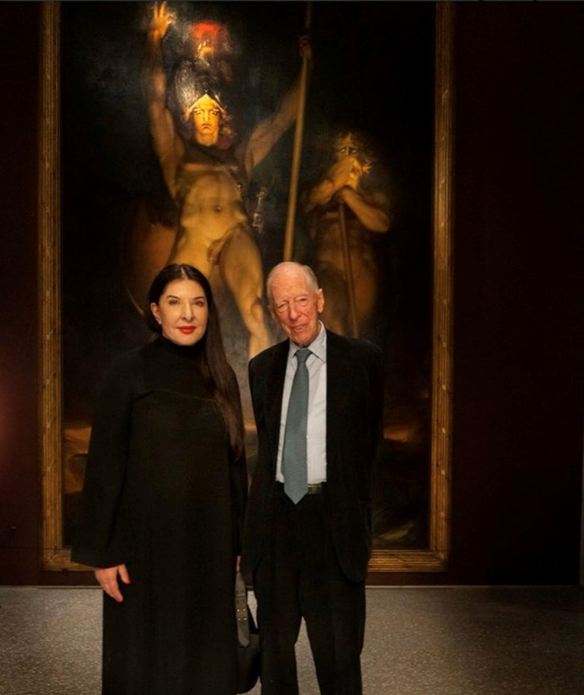

Satanic Crowleyan OTO Witch Marina Abramović poses with Satanic Luciferian Atlantis-Phoenician Mega Trillionaire 10,000 years old Family 4th Baron Jacob Rothschild in front of 'Satan summoning his Legions', 1796-1797

The Hidden History Of The Satanic Luciferian Atlantis-Phoenician Mega Trillionaire Rothschild Khazarian Mafia

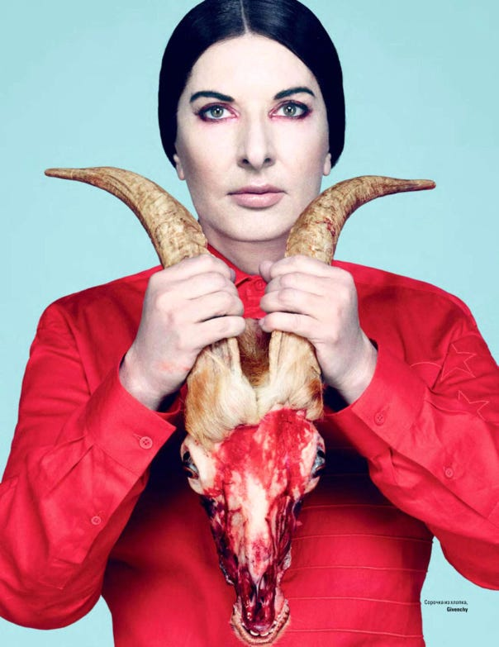

WE HAVE TO CRIMINALLY PROSECUTE THE DEEP STATE!

Satchidanand
·
Jan 15
"You Are Under Attack!": Learn How The Democrat, Deep State, Fauci, Soros, Rothschild, Rockefeller, Satanic Phoenician Mega Trillionaires Intentionally Burned Los Angeles To The Ground and the Smart City that’s Coming NextSatchidanand’s Against Satanism Newsletter is a reader-supported publication. To receive new posts and support my work, consider becoming a free or paid subscriber.

Read full story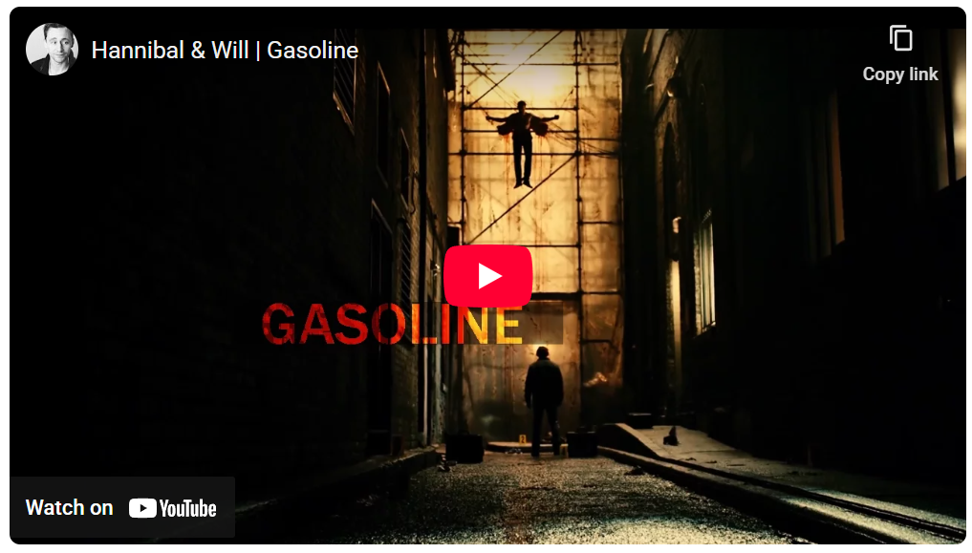

An Extreme Act Of Cruelty Requires A High Degree Of Empathy
Note: The history of the Khazarians, specifically the The Satanic Atlantis-Phoenician Mega Trillionaire Rothschild Khazarian Mafia (KM), the World’s largest Organized Crime Syndicate that the Khazarian oligarchy morphed into by their deployment of Babylonian Money-Magick, has been nearly completely excised from the history books.
The present day The Satanic Atlantis-Phoenician Mega Trillionaire Rothschild Khazarian Mafia (KM) knows that it cannot operate or exist without abject secrecy, and therefore has spent a lot of money having its history excised from the history books in order to prevent citizens of the World from learning about its “Evil beyond imagination”, that empowers this World’s largest Organized Crime Cabal.
- OH WHAT A TANGLED WEB THEY WEAVE
- 5 More Ways Joe Biden ‘Swamp Elect’ Magically Outperformed Election Norms
The authors of this article have done their best to resurrect this lost, secret history of the Khazarians and their large International Organized Crime Syndicate, best referred to as the The Satanic Atlantis-Phoenician Mega Trillionaire Rothschild Khazarian Mafia (KM) and make this history available to the World via the Internet, which is the new Gutenberg Press.
It has been exceedingly difficult to reconstruct this hidden secret history of the The Satanic Atlantis-Phoenician Mega Trillionaire Rothschild Khazarian Mafia (KM) so please excuse any minor inaccuracies or errors which are unintentional and are due to the difficulty in digging out the true history of Khazaria and its mafia. We have done the best we can to reconstruct it.
It was Mike Harris that connected the dots and made the actual discovery of the presence of the Khazarian Mafia’s secret history and blood oath to take revenge on Russia for helping Americans win the Revolutionary War and the Civil War, and their blood oath of revenge against America and Americans for winning these wars and sustaining the Union.
At the Syrian Conference on Combating Terrorism and Religious Extremism December 1, 2014 — in his Keynote address, Veterans Today Senior Editor and Director Gordon Duff disclosed publicly for the first time ever that World Terrorism is actually due to a large International Organized Crime Syndicate associated with Israel and their CIA. This disclosure sent shock-waves at the Conference and almost instantly around the world, as almost every world leader received reports of Gordon Duff’s historical disclosure that same day, some within minutes.
And the shock-waves from his historic speech in Damascus continue to reverberate around the world even to this very day. And now Gordon Duff has asked President Putin to release Russian Intel which will expose about 300 traitors in Congress for their serious serial felonies and statutory espionage on behalf of the The Satanic Atlantis-Phoenician Mega Trillionaire Rothschild Khazarian Mafia (KM) against America and many Middle East nations.
- Vladimir Putin Speech: 85% Of The 1917 Soviet Government Was Made Up By Rothschild Zionist Khazars!
We now know that the The Satanic Atlantis-Phoenician Mega Trillionaire Rothschild Khazarian Mafia (KM) is waging a secret war against America and Americans by the use of False-flag Gladio-style terrorism, and via the illegal and Unconstitutional Federal Reserve System, the IRS, the FBI, FEMA, Homeland Security and the TSA. We know for certain that the The Satanic Atlantis-Phoenician Mega Trillionaire Rothschild Khazarian Mafia (KM) was responsible for deploying an inside-job, Gladio-style False-flag attack on America on 9-11-01, as well as the Murrah Building Bombing on April 19, 1995.

The Hidden History of the Incredibly Evil Satanic Phoenician Mega Trillionaire Rothschild Khazarian Mafia (KM)
by Preston James and Mike Harris
100-800 AD – an incredibly Evil Society Emerges in Khazaria:
Khazarians develop into a nation ruled by an evil king, who had ancient Babylonian black arts, occult oligarchs serving as his court. During this time, Khazarians become known to surrounding countries as thieves, murderers, road bandits, and for assuming the identities of those travelers they murdered as a normal occupational practice and way of life.



STAR OF DAVID AL-ROY Imposed Upon The People Of Israel By Rothschild When He Purchased Israel In 1948. Their symbol is 2 overlapping triangles known as the Morgan David or Star of David. Not the David of the Bible or Qu’ran, but of David Al-roy a 12th century false prophet.
Before he became known a David Al-roy his name was Menahem born in Khazaria (Caucasus Mountains). His father, Solomon Ben Duji began this movement by sending letters to the “jews” stating that Palestine was their birthright, he later took the name Elijah and said his son was the Messiah.
In 1527 the Jews of Prague began to use the Star of David (David Al-roy) as their Flag a pentagram or “Seal of Solomon” Later used by Freemason/Zionist Theodor Herzl in 1898 at the start of the modern Zionist Movement.
800 AD – The Ultimatum is delivered by Russia and other surrounding nations:
The leaders of the surrounding nations, especially Russia, have had so many years of complaints by their citizens that, as a group, they deliver an ultimatum to the Khazarian king. They send a communique to the Khazarian king that he must choose one of the three Abrahamic religions for his people, and make it his official state religion and require all Khazarian citizens to practice it, and socialize all Khazarian children to practice that faith.
The Khazarian king was given a choice between Islam, Christianity and Judaism. The Khazarian king chose Judaism, and promised to stay within the requirements laid out by the surrounding confederacy of nations led by the Russian czar. Despite his agreement and promise, the Khazarian king and his inner circle of oligarchs kept practicing ancient Babylonian black-magic, also known as Secret Satanism. This Secret Satanism involved occult ceremonies featuring child sacrifice, after “bleeding them out”, drinking their blood and eating their hearts.
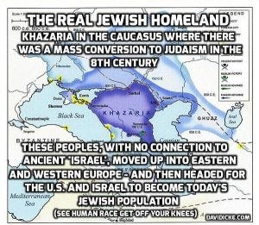
The deep dark secret of the occult ceremonies was that they were all based on ancient Baal Worship, also known as worship of the Owl. In order to fool the confederacy of nations led by Russia that were watching Khazaria, the Khazarian king melded these Luciferian black-magick practices with Judaism and created a secret Satanic-hybrid religion, known as Babylonian Talmudism. This made the national religion of Khazaria, and nurtured the same evil that Khazaria was known for before.
Sadly, the Khazarians continued their evil ways, robbing and murdering those from surrounding countries who traveled through Khazaria. Khazarian robbers often attempted to assume their identities after they murdered these visitors, and became masters of disguises and false identities — a practice they have continued even to this very day, along with their child-sacrifice occult ceremonies, which are actually ancient Baal Worship.
1,200 AD – Russia and the surrounding nations have had enough and take action:
About 1,200 AD, the Russians led a group of nations surrounding Khazaria and invaded it, in order to stop the Khazarian crimes against their people, which included kidnapping of their young children and infants for their blood sacrifice ceremonies to Baal. The Khazarian king and his inner court of criminals and murderers came to be known as the Khazarian Mafia (KM) by neighboring countries.

“You are of your father the devil, and your will is to do your father’s desires. He was a murderer from the beginning, and does not stand in the truth, because there is no truth in him. When he lies, he speaks out of his own character, for he is a liar and the father of lies.” (John 8:44)

The Khazarian leaders had a well-developed spy network through which they obtained prior warning and escaped from Khazaria to European nations to the west, taking their vast fortune with them in gold and silver.
They laid low and regrouped, while assuming new identities. In secret, they continued their Satanic child blood and sacrifice rituals, and trusted Baal to give them the whole world and all its riches, as they claimed he had promised them, as long as they kept bleeding out and sacrificing children and infants for him.
The Khazarian king and his court Mafia plotted eternal revenge against the Russians and the surrounding nations that invaded Khazaria and drove them from power.
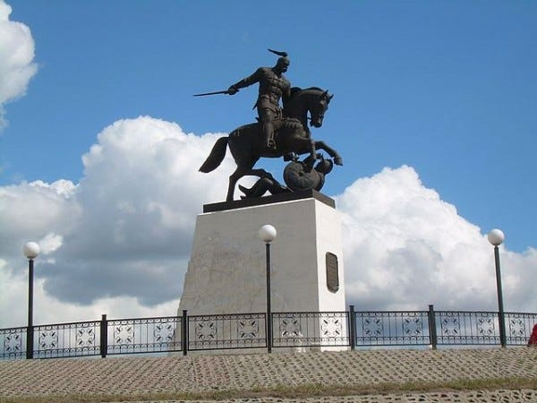

Duke Rusov Militia — Sviatoslav Brave kind of Rurik On this day 3 July 964 AD, now and forever, we — Russia, will celebrate the Day of Victory over the Jewish Khazars. Who are now better known as secular zionists. This victory made it possible for the physical survival of the Russian people.

Satanism is gradually being instituted as the Satanic Atlantis-Phoenician Mega Trillionaire Rothschild Khazarian Mafia (KM) New World Order.

The New World Religion, defined by Satanic Atlantis-Phoenician Mega Trillionaire Rothschild Khazarian Mafia (KM) Satanic Ritual.
72 Empires have been recorded and every one of them has failed in the same way. The facts have been recorded that a totalitarian and satanic elite infil-traitored and took over all these Empires and that 72 once free, flourishing and rich republics were destroyed from within by Satanic Ritual - read Toynbee. Satanism is gradually being instituted as the New World Religion defined by Satanic Ritual.
Infil-traition of Satanism is the methodology as slowly every Government Ministry and Societal function is taken over. Eventually a Satanist becomes King Emperor President. LGBTP - The Satanist Ritual Pillars of Homosexuality, Pederasty, Pedophilia, Drugs and Ritual Sex - both Hetero and Homosexual - are introduced overtly as a prelude to Ritual Human Sacrifice and Ritual Baby Sacrifice. Christianity and Judaism - the bulwarks Against Satanism - are destroyed and then society destroyed through the fear of mandatory Ritual Human Sacrifice.

SEE THE VIDEO - HOW SATAN STEALS THE SOULS AND ENERGY OF ALL HIS FOLLOWERS
http://eemeditationvideo.org/watch/how-satan-steals-the-souls-and-energy-of-all-of-his-followers-revealed_DrCx7XVNAbLtQP5.html
The Ancient Enemy who counts meditation and the mind control psychic arts as one of its main planks of World Domination has used Satanic Infil-Traitors for 10,000 years in every Organisation - Religion, Left and Right Politics, Dynastic Families, Geopolitics, Economics, Universities, Intelligence Services, Think Tanks, Banking, International Companies, Eugenics.
Innoculate yourself Against Satanic Globalism which created Cybele and Attis, Baal, Molech, Zeus, Venus, Pedophile Plato, No Soul Aristotle, Catholicism, Protestantism, the Illuminaughty, Sabatean Frankism, Crowley's Ordo Templi Orientis (OTO), Islam, Wahhabic ISIS, the Muslim Brotherhood, Communism, Socialism, Gaia and Satanic Hitler's Pagan Eugenic Nazism by Downloading.. The Energy Enhancement Books - Against Satanism Volumes 1 - 12 by Satchidanand.
To understand how and why Evil has taken over this Planet, and how Energy Enhancement can free this Planet from All Evil...

READ THE AGAINST SATANISM SERIES OF TWELVE BOOKS!!

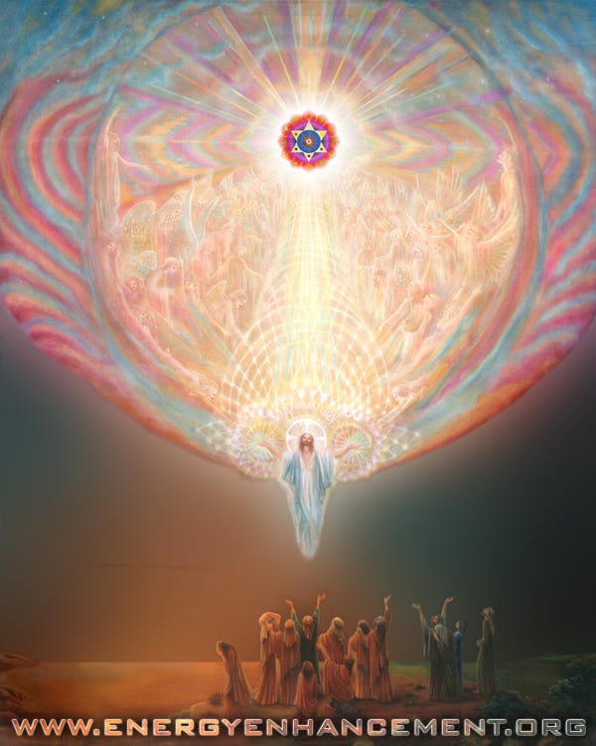
With Energy Enhancement Remove All these Evil Subpersonalities within you whilst you have the chance..

ONLY ENERGY ENHANCEMENT MEDITATION CAN ELIMINATE ALL EVIL!!

The Energy Enhancement Meditation Course is designed to

1. Open the Third Eye,

2. Use Alchemical VITRIOL to Remove Negative Energies,

3. Annihilate Negative Emotions,

4. Eliminate Gross Bodily Infirmities,

5. Access Infinite Spiritual Energy from the Chakras Above the Head,

6. Accelerate your Evolution,

7. Speeed Up!! your Process,

8. Enable your Enlightenment,

9. Intimate your Illumination,

10. Persue your Purification,

11. Blow up your Blockages,

12. Vibrate your VITRIOL,

13. Charge your Chakras,

14. Promote your Protection,

15. Subdue your Subpersonalities,

16. Sedate your Shadow,

17. Create Blooming Health,

18. Walloping Wealth,

19. Total Removal of All Blockages,

20. Total Removal of All Subpersonalities,

21. The Attainment of Goals, whatever you want, by removing the blockages preventing attainment of the goal.

22. Integration with the Soul,

23. One Soul Infused Personality,

24. Illumination,

25. Enlightenment,

26. Psychic Powers,

27. Eliminate all Evil in You and throughout the Whole Planet,

28. The Whole Universe of Love, Light, Happiness,

29. Genius - the Creation of Beauty, Abundance,

30. Invincibility, Strength, Goodness, God, and Heaven Here on Earth - NOW!!!!

For 10,000 years the whole of media, all world history, all information, has been censored, removed, distorted, perverted, so that the Truth, the whole truth and nothing but the truth can never be revealed.

As the Buddha said, "If I say something they won't understand it, if I write something it will be changed"

Satanic Phoenician Aristocratic Family Gatekeepers and paid Gatekeepers tell partial truths higher and higher up the intellectual ladder so the real truth can never be known.

I have been disturbed for some time by the reports of historians who say what happened and that the cause was Jews, Fascism or Communism or Capitalism, but with no research into the cause behind them.

How it came to be. Who is in charge of it!

The Satanic Phoenician Mega Trillionaires who have controlled humanity for 10,000 years developed a technique of spiritual vampirism, a Transhumanism to suck all the energy of humanity so they could take that energy into their reservoirs and use that energy to live forever out of the body.

They created the Religion of Satanism 10,000 years ago Prior to the fall of Atlantis and this Ancient Satanic and Scientific Knowledge was passed down to the Phoenician Empire allowing them to control the World for 10,000 years to institutionalise that vampirism in their evil Satanic Rituals, then also used their Ancient Science of Mind Control to create Mind Control Rituals to tightly control their adherants in their secret societies, to richly reward their worshippers, so that their worshippers of Satan would work to dumb down humanity secretly, permanently, so that the vampirisation of their energy could continue eternally without any pushback from the populace.

More than that, the Ancient Knowledge of Science allowed them to know about DNA as two snakes spiralling around a column and about Transistors, Computers, Artificial Intelligence, Video Cameras and Surveillance, the Mark of the Beast for all transactions - Digital ID, CBDC’s, Viruses, Medicine.

CONTROL!

Satanism is defined by Satanic Rituals.. Mind Control Programs - LIVES FOR SATAN! - THESE RITUALS DEFINE SATANISM.. RITUAL SEX, RITUAL PEDOPHILIA, RITUAL SODOMY, RITUAL DRUGS, RITUAL BLOOD SACRIFICE, RITUAL HUMAN SACRIFICE, RITUAL TORTURE, RITUAL BURNING ALIVE, RITUAL CANNIBALISM, RITUAL CASTRATION, RITUAL VIRGIN SACRIFICE.
http://www.energyenhancement.org/Sacred-Energy/Against-Satanism-Volume-3/Against-Satanism-Volume-3-Satanic-Rituals.pdf

EPSTEIN CIA, MOSSAD AND MI6 BLACKMAIL AND SHAME KEEP THE SATAN WORSHIPPERS IN LINE TO DUMB DOWN AND DEGENERATE HUMANITY SO IT CAN NOT FIGHT BACK...

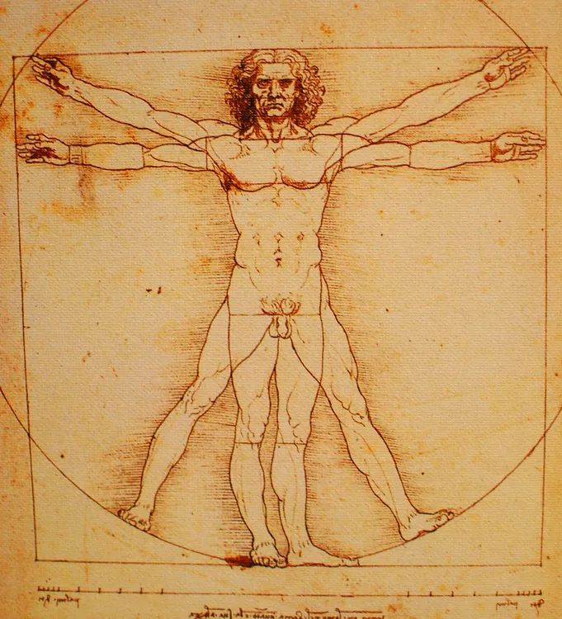
72 Empires have been recorded over 10,000 years and every one of them has failed in the same way. The facts have been recorded that a totalitarian and satanic elite infil-traitored and took over all these Empires and that 72 once free, flourishing and rich republics were destroyed from within by Satanic Ritual - read Toynbee.
Infil-traition of Satanism is the methodology as slowly every Government Ministry and Societal function is taken over. Eventually a Satanist becomes King Emperor President. LGBTP - The Satanist Ritual Pillars of Homosexuality, Sodomy, Pederasty, Drugs and Ritual Sex - both Hetero and Homosexual - are introduced overtly as Wokeness ESG, the Corporate Equality Index, as a prelude to Ritual Human Sacrifice.
Christianity and Judaism - the bulwarks Against Satanism - are destroyed and then society destroyed through the fear of mandatory Ritual Human Sacrifice.
The Ancient Enemy who counts meditation and the mind control psychic arts as one of its main planks of World Domination has used Satanic Infil-Traitors for 10,000 years in every Organisation - Religion, Left and Right Politics, Dynastic Families, Geopolitics, Economics, Universities, Intelligence Services, Think Tanks, Banking, Facebook, Twitter, International Companies, Vatican, Transhumanism, CRISPR Androids, Eugenics..
Sodomy and the Sodomy Ritual is at the heart of Satanism, the Illuminati, Sabbatean Frankism, the Jesuits..
Bottom on bottom, 8 or 33 represents the Vitruvian man. The occultist da Vinci’s Vitruvian Man really depicts the buggery of the anterior man by the posterior man, the apex of Satanic Luciferian 33rd Degree Masonry or final “Mystery of Mysteries” of the secret societies as explicated by Walter Veith (to open their “Third Eye.”). The reign of the AntiChrist will be marked as the sodomite king of the world..

ENERGY ENHANCEMENT MEDITATION SACRED SYMBOLS FOR PERFECT WISDOM ENLIGHTENMENT AND THE SATANIC PERVERSION OF THESE SYMBOLS

Satchidanand
·
October 2, 2022
It's hard for me to say this but Sacred Symbols, good symbols, or legominisms as Gurdjieff said where symbols of the past are designed to help us, inform us, provide a map whereby we can all cleave to the light, become Enlightened.

Read full story

SATANISM IS DEFINED BY SATANIC RITUAL RITUAL SODOMY OPENS THE THIRD EYE RITUAL SODOMY SPLITS THE MIND INTO SUBPERSONALITIES OR ALTERS In the House of the Strong Man Sodomy is the Key

SATANISM IS DEFINED BY SATANIC RITUAL RITUAL SODOMY OPENS THE THIRD EYE RITUAL SODOMY SPLITS THE MIND INTO SUBPERSONALITIES OR ALTERS In the House of the Strong Man Sodomy is the Key

Satchidanand
·
October 2, 2022
The doctors of the law, too, who had come down from Jerusalem, said, ‘He is possessed by Beelzebub’ and ‘He drives out devils by the prince of devils.’ So he called them to come forward, and spoke to them in parables: ‘How can Satan drive out Satan? If a kingdom is divided against itself, that kingdom cannot stand; if a household is divided against itself, that house will never stand; and if Satan is in rebellion against himself, he is divided and cannot stand; and that is the end of him.

Read full story

The drawing together of a "Band of Thebes" British Aristocracy was particularly prized and brought about by the public school system started by Henry VI in 1440 at Eton but franchised to all schools very quickly. A hidden world drawn together by Pedophilic, Sodomy Ritual, homosexual warriors - the Heart of the Satanic British Empire - further, "Homosexuality follows Satanism like a stench"

Nicole Kidman: ‘Stanley Kubrick Said Pedophiles Run The World’



“Stanley told me the world is run by pedophiles,” Nicole Kidman said while promoting HBO’s Big Little Lies, in Los Angeles. “He studied secret societies his whole life, he was fascinated by them, and he said the elite, the top secret societies, they are full of men with a certain predilection. They are tied together, sort of bonded, by pedophilia like the ”Pact of Blood” where the Mafia entrants have to kill someone in order to join, these guys have to pedophile and human sacrifice like Epstein’s Pedo Island and the Lolita Jet - “They all know each other’s dark secrets. There is no way out for any of them. It’s a lifetime bond. Even if one of them wanted to go straight, repent, so to speak, he can’t. His peers will bring him down. They are in it until death, driving the world to ruin. That’s kind of how Stanley explained it but it was all very complex. I’m probably not doing it justice.”

P.G. Wodehouse and British Empire Ritual Sodomy Band of Thebes Propagandised for Hitler, Propagandised for the Satanic Phoenician Mega Trillionaires

Satchidanand
·
October 2, 2022
Sir Pelham Grenville Wodehouse, KBE 15 October 1881 – 14 February 1975 was an English author and one of the most widely read humorists of the 20th century. His creations include the feather-brained Bertie Wooster and his sagacious valet, Jeeves; the immaculate and loquacious Psmith; Lord Emsworth and the Blandings Castle set; the Oldest Member, with stories about golf; and Mr Mulliner, with tall tales on subjects ranging from bibulous bishops to megalomaniac movie moguls.

Read full story

Thus in order to destroy free will, and institute total control over humanity, Satanism over 10,000 years has instituted Sodomy Rituals and pedophilia to control the upper levels of society by the use of institutions of public schools like, "Whipping and Fagging" all boys schools like Eton - founded as a mind control institution in 1438 by the King - where the Sodomy rape ritual sorted the boys into the Prussian Frederick the Great aggressive masculine homosexual rapine Penetrators, perpitrators, as in the 3000 years old Phoenician Colony of Thebes in Ancient Greece the "Band of Thebes" particularly successful Army of Gay Lovers, and the weak effeminate homosexual slaves or women or young boys.

BDSM Masters and Slaves.
All successful Generals, Politicians, Priests, Policemen, Professors came out of this background which then when refined by the Satanic Sodomy Ritual Secret Societies - the foundation of elite mind control for centuries - the 33rd Degree Freemasons, the Jesuits, the Illuminati and hundreds more - all based on the Mind Control Sodomy Ritual and Pedophilia supplied by Renfields like Jimmy Savile for the elite Draculas.
Remember, the purpose behind Satanism is total control of society by mind control, perversion and poison to dumm down humanity so they can be vampirised of their spiritual energy eternally because if humanity is allowed to evolve, to learn how to heal the mind, to psychically dissolve all these hundreds of lifetimes of mind control programs in the psychic body, the vampires can no longer exist!

Satanic Phoenician Mega Trillionaires behind MKULTRA Mind Control Programs Bimbosleep Bimbofication and Sissi Hypno Sissification created by Tavistock Institute and the Nazi CIA Stanford University

Satchidanand
·
May 25, 2023
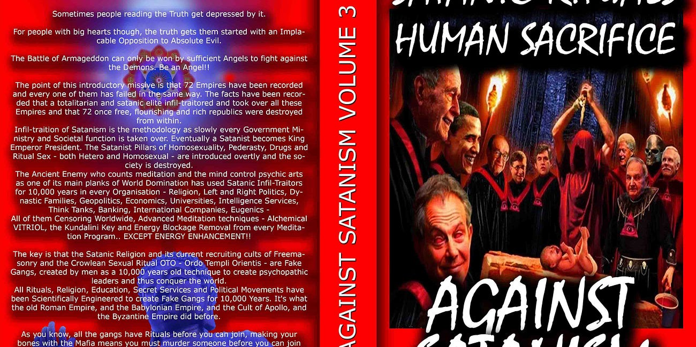
Satanic Phoenician Mega Trillionaires behind MKULTRA Mind Control Programs Bimbosleep Bimbofication and Sissi Hypno Sissification created by Tavistock Institute and the Nazi CIA Stanford University

Read full story

The key is that the Satanic Religion and it's current recruiting cults of Sodomy Ritual 33rd Degree Freemasonry, the Illuminati, Jesuits, Sabbatean Frankism, and the Crowlean Sexual Sodomy Ritual OTO - Ordo Templi Orientis, Yale Skull and Bones, Bohemian Grove - are Fake Gangs, created by men as a 10,000 years old technique to create psychopathic leaders and their minions, and thus conquer the world by constantly degenerating humanity into Orcs.
All Rituals, Religions, Education, Secret Services and Political Movements have been scientifically Engineered to create Fake Gangs for 10,000 years. It's what the old Roman Empire, The Babylonian Empire of Satanic Nimrod, and the Cult of Apollo and the Byzantine Empire did before.
As you know, every Gang has Blackmail Rituals before you can join. Making your Bones with the Mafia means you must murder someone before you can join. Drug Cartels like MS13, secret groups within the Masons, the Illuminati, Sabbatean Frankists, OTO, the Hellfire Club, all have their Human Sacrifice, Pedophilia and Sodomy Rituals before you can progress.
Epstein did not kill himself. He videoed Scientists from MIT and Harvard, Oligarchs, Politicians etc, Pedophiling young girls then Blackmailed them into doing the work of his Trillionaire sponsors - MKULTRA, Transhumanism, CRISPR Androids. As their willing victims are given access to stealing higher quantities of money, so they must go to the next level of Ritual. First it is 15 year old girls who look 25. Then it's 12 year olds, 5 year olds, and then its the murder of children, babies!
Since the Band of Thebes of fierce homosexual warriors, sodomy rituals bind together that Band of Brothers at the head of Military Organisations Worldwide, NATO, AZOV Battalion, the SS, American and British Army and Navy...
All to create a degenerated Satanic Society of Total Control through Human Sacrifice, poverty, starvation, bugs, miseducation, lack of education, Wokeness, Climate Change, Sustainability, poison in the air, water and food. Lack of infrastructure, Lack of Energy - Electricity, Coal, Petroleum, education and Total Censorship Control of the Media.
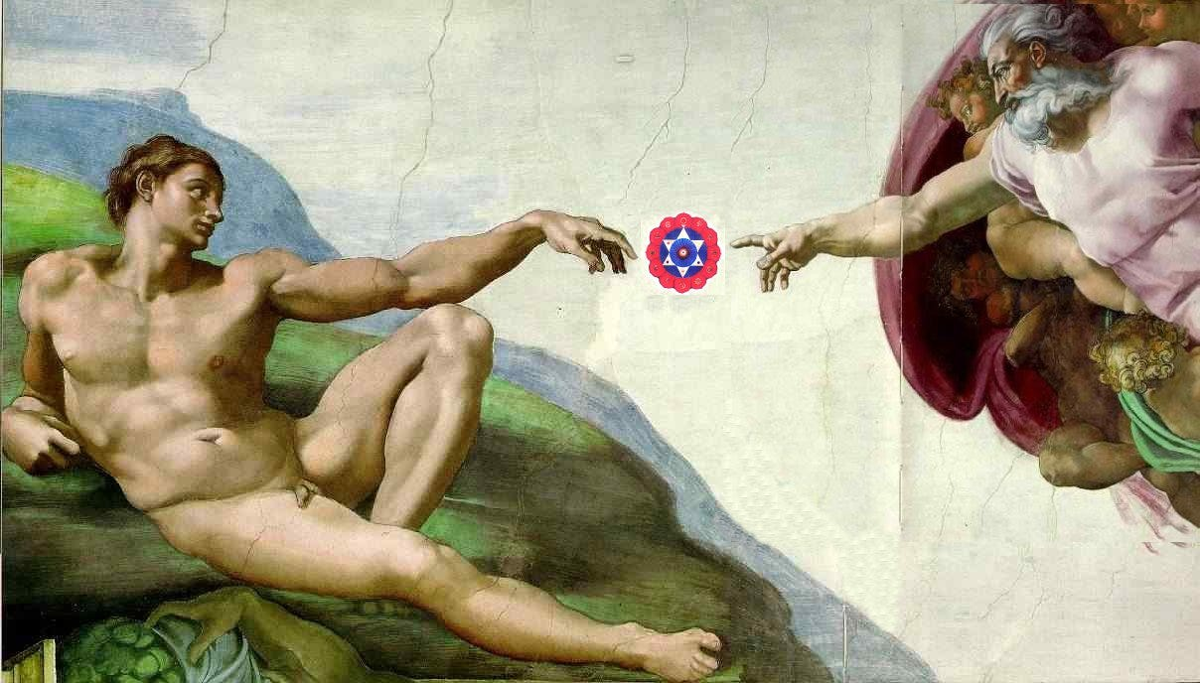All of them Censoring Worldwide, Advanced Meditation techniques - Alchemical VITRIOL, the Kundalini Key and Energy Blockage Removal from every Meditation Program..

EXCEPT ENERGY ENHANCEMENT MEDITATION!! https://www.energyenhancement.org

The very word secrecy is repugnant in a free and open society JFK (27 April 1961)
The very word secrecy is repugnant in a free and open society; and we are as a people inherently and historically opposed to secret societies, to secret oaths and to secret proceedings. For we are opposed around the world by a monolithic and ruthless conspiracy that relies primarily on covert means for expanding its sphere of influence on infiltration instead of invasion, on subversion instead of elections, on intimidation instead of free choice, on guerrillas by night instead of armies by day. It is a system which has conscripted vast human and material resources into the building of a tightly knit, highly efficient machine that combines military, diplomatic, intelligence, economic, scientific and political operations.
JFK (27 April 1961)

What We See when we Remove an Energy Blockage is the Secret of Infinite Energy
What We See when we Remove an Energy Blockage is the Secret of Infinite Energy, Secret of Eternal Life, the Secret of Immortality. Energy Blockages are Satanic, and it is this we see directly when we remove the blockages with the Energy Enhancement Meditation Course.. Energy Blockages do not exist alone, they are part of a network of evil, a network of control, which is designed not to allow people to understand the nature of that control, the purpose of that control, so as to maintain that control and the flow of energy - stolen from all human beings - to allow an elite of Black magicians, Sorcerers, Enchanters, Warlocks, Witches, Necromancers, Devils, Dark Gods... to live forever, Immortally, in private Universes, outside the body and then to download into a body from time to time, to maintain their Plantation, their Farm, their Property, to maintain the flow of stolen spiritual energy to them from every human being on this planet - Eternally. This is why I wrote Twelve volumes of Against Satanism..
See this..
http://www.energyenhancement.org/Third-Eye-Psychic-vision-see-Remove-Energy-Blockage-Secret-of-Infinite-Spiritual-Energy-Eternal-Life-Immortality-meditation-Energy-Enhancement-Seven-Step-Process.htm
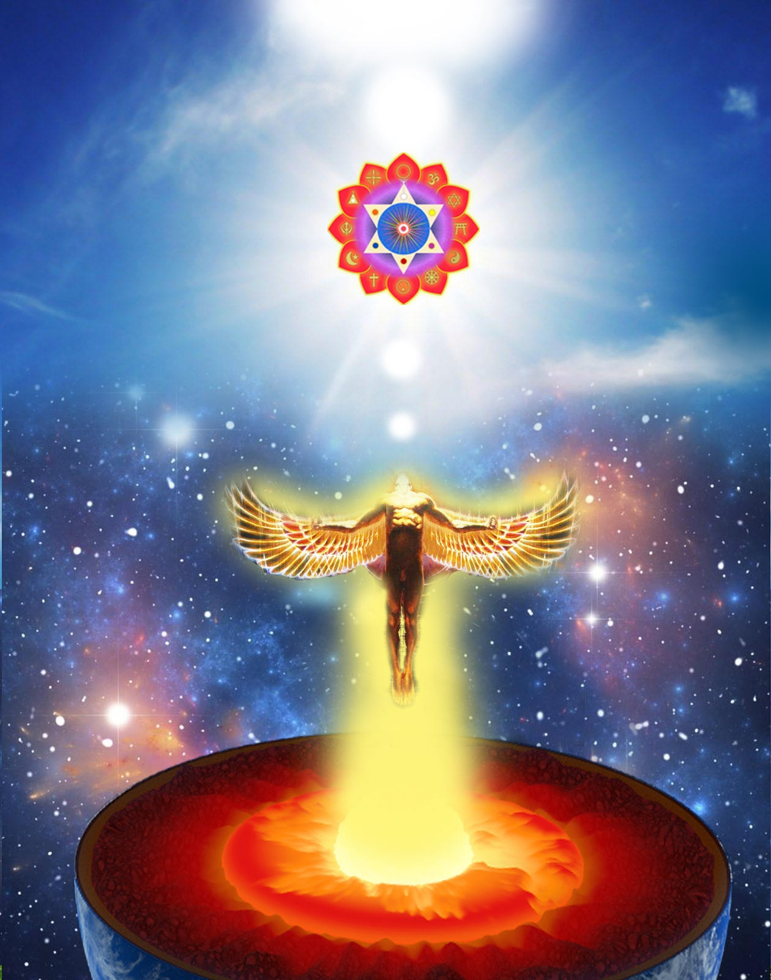

In order to remove blockages using the Level 2 Seven Step Process, Internally, we teach you how to Ground every trace of Satanic Energy which makes sick, which perverts, which degenerates!
Externally we see the effect of Satanic Energy Blockages and their creators, on the World.. This is why I wrote twelve volumes of Against Satanism.. available FREE! on signup on
Only Energy Enhancement can Annihilate Evil on Earth and change this Planet into a Planet of Love and Light in this Place, for You, for Me, for the Entire Human Race.
The best way to get around the internet censors and their shadow banning and make sure you see the stuff I publish is to subscribe to the mailing list for my website, energyenhancement.org which will get you an email notification for everything I broadcast and Free download access to the 52 Spiritual Books I publish.

My work is entirely reader-supported
My work is entirely reader-supported and the incredible Energy Enhancement Meditation Course supported so if you enjoyed this piece please consider sharing it around, donating to my substack account, throwing some money into my hat directly to my bank account (email me) via Transferwise, buying my hard copy books on Amazon https://www.amazon.com/s?k=swami+satchidanand Everyone, has my permission to republish or use any part of my work (or anything else I’ve written) in any way they like free of charge.

READ THE AGAINST SATANISM SERIES OF TWELVE BOOKS!!
ALL FIVE BOOKS OF STUDENT REPORTS OF THE SPIRITUAL WARRIORS ON THE ENERGY ENHANCEMENT VIDEO MEDITATION COURSE PATH TO SELF REALISATION
https://www.energyenhancement.org/Sacred-Energy/5-Spiritual-Warrior-Books.rar
All 16 Energy Enhancement Meditation Books - “The Only Solution to Satanism” in an easily downloadable file from our own website.
https://againstsatanism.com/Sacred-Energy/All-Energy-Enhancement-Meditation-Books-Swami-Satchidanand.rar
Against Satanism by Satchidanand Volumes 1 to 12 - “The Occulted Satanic History of the World” - Your Worldview Will Never Be the Same! - in an easily downloadable file from our own website.
https://againstsatanism.com/Sacred-Energy/Against-Satanism-Volumes-1-12.rar
Mind Control Black Assassins by Satchidanand Volumes 1 to 11 in an easily downloadable file from our own website.
https://againstsatanism.com/Sacred-Energy/Black-Assassins-Volumes-1-11.rar
Satanic Spiritual Movie Reviews by Satchidanand Volumes One - “Blacklisted” and Two “AI and Transhumanism” in an easily downloadable file from our own website.
https://againstsatanism.com/Sacred-Energy/Spiritual-Movie-Reviews-Vols-1-and-2-Energy-Enhancement-Swami-Satchidanand.zip
All Osho Books One by One
http://www.energyenhancement.org/Sacred-Energy/Oshoa.k.a.Rajneesh(312Books).rar
THE SATANIC PHOENICIAN BLACK NOBILITY RULERS OF THE WORLD VOLUMES 1 AND 2
Prince Duccio Corsini is a Roman prince and top owner of the Corsican Mafia. The Corsinis are both Florentine and Roman nobles. Prince Duccio is an overseer of a private Swiss banking and human trafficking operation in Gstadd, Switzerland. The Scherz family of Gstadd own a hotel in Gstadd and basically run Gstadd. The Scherz coat of arms is a heart. The Corsinis coat of arms is shaped as a heart and the Italian word Core or Coure has the meaning of heart. Prince Duccio also oversees the DEA. Lucien Conein was from Maryland and he was a documented associate of the Corsican Mafia and he worked for the OSS, CIA, and later for the DEA. The Corsican Mafia have a headquarters in Baltimore, Maryland and they oversee a large heroin and opium trafficking ring from Turkey, the Middle East, and Afghanistan to ports on the East Coast. Nancy Pelosi is from Baltimore and she is a Knight Grand Cross of the Italian Order of Merit and an agent of the Corsinis. The Corsican Mafia then traffics the heroin or opium to the Lucchese crime family which then provide it to the modern day Drug Council run by black gangster rappers. Corsica is named after the Corsinis and uses a black Moor on its coat of arms and flag. Moors, Arabs, and Africans invaded Europe and Slave trafficked natural white Europeans for over a thousand years. The Corsinis also owned banks in Florence and London.
And More...
Download this!
https://againstsatanism.com/Sacred-Energy/The-Satanic-Phoenician-Black-Nobility-Volumes-1and2.rar

The Khazarian Mafia invades England after being expelled for hundreds of years:

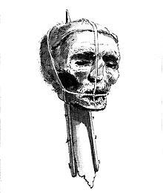

A drawing of Oliver Cromwell’s head on a spike from the late 18th century
To accomplish their invasion, they hired Oliver Cromwell to murder King Charles 1, and make England safe for banking again. This began the English Civil Wars which raged for nearly a decade, resulting in regicide of the royal family and hundreds of the genuine English nobility. This is how the City of London was set up as the banking capital of Europe and launched the beginning of the British Empire.
How did England deal with a corrupt puritan government/parliament?
When King Charles I was executed by the Oliver Cromwell mob, his son King Charles II made it his mission to search out retribution, producing the biggest manhunt Britain had ever seen, one that would span Europe and America and would last for thirty years.
Men who had once been among the most powerful figures in England ended up on the scaffold, on the run, or in fear of the assassin’s bullet.
History has painted the regicides and their supporters as Puritans, among them were John Milton and Oliver Cromwell. After Cromwell Beheaded King Charles I, he became the ‘dictator’ of England. This corrupt Puritan Parliament also murdered Guy Fawkes in 1606 [Father Of Anonymous], the Puritans were ultimately executed by the returning King Charles II in 1660, for regicide (the killing of a King) & usurping the laws of England ~ The Magna Carta which is similar to our U.S. Constitution.
Cromwell’s severed head was displayed on a pole outside Westminster Hall From 1661 until 1685.
The English Puritans under Cromwell engaged in pure and simple genocide Of Roman Catholics in Ireland – 40,000 victims killed or sold as slaves in 1649 in the Oradours of Drogheda and Wexford alone.
The Satanic Phoenician Mega Trillionaire Rothschild Khazarian Mafia (KM) decides to infiltrate and hijack all World Banking using Babylonian Black-Magick, also known as Babylonian Money-Magick or the secret art of making money from nothing also using the power of pernicious usury to accumulate interest:

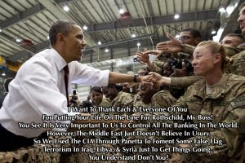

The The Satanic Phoenician Mega Trillionaire Rothschild Khazarian Mafia (KM) used their vast fortune to enter into a new system of banking, based on secret Babylonian black-magic money-magic that they claimed to have learned from the evil spirits of Baal, in return for their many child sacrifices to him.
This Babylonian money-magick involved the substitution of paper credit certificates for gold and silver deposits, which allowed travelers to travel with their money in a form that offered easy replacement should they lose the certificates or have them stolen.
Interesting how the very problem that was started by the Khazarians also had a solution provided by them. Eventually the Khazarian king and his small surrounding court infiltrated Germany with a group that chose the name “the Bauers” of Germany to represent them and carry on their Baal-powered system of evil. The Bauers of the Red Shield, which represented their secret blood-based child sacrifices, changed their name to Rothschild (aka “child of the rock, Satan”).

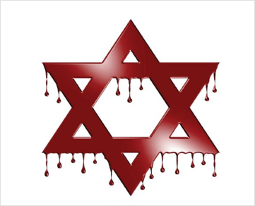

Rothschild’s Red Shield. Rothschild Is A Khazarian Thug Who Also Changed His Named [Just Like Menahem Did In The 12th Century] But For Rothschild, It Went From Bauer to Rothschild. It Stood For The Red Hexagram That Was Above His Office In 1760. Rot,” is German for, “Red,” “Schild,” is German for, “Sign ~ Put The Two Together And You Get Rot Schild ~ Throw In An H and You Have Rothschild. Tada! Some peole say Roast Children!

1743:
Mayer Amschel Bauer, an Ashkenazi Jew, is born in Frankfurt, Germany, the son of Moses Amschel Bauer, a money lender and the proprietor of a counting house.
Moses Amschel Bauer places a red sign above the entrance door to his counting house. This sign is a red hexagram (which geometrically and numerically translates into the number 666) which under Rothschild instruction will end up on the Israeli flag some two centuries later.
1753:
Gutle Schnaper, an Ashkenazi Jew (future wife of Mayer Amschel Bauer), born to respected merchant, Wolf Salomon Schnaper.
1760:
During this decade Mayer Amschel Bauer works for a bank owned by the Oppenheimers’ in Hanover, Germany. He is highly successful and becomes a junior partner. Whilst working at the bank he becomes acquainted with General von Estorff.
Following his father’s death, Bauer returns to Frankfurt to take over his father’s business. Bauer recognises the significance of the red hexagram and changes his name from Bauer to Rothschild, after the red hexagram or sign signifying 666 hanging over the entrance door (“Rot,” is German for, “Red,” “Schild,” is German for, “Sign”).
The Rothschilds as the front Men for the Satanic Phoenician Mega Trillionaire Rothschild Khazarian Mafia (KM) infiltrate and Hijack British Banking and then hijack the whole nation of England:
Bauer/Rothschild had five sons who infiltrated and took over European banking and the City of London Central Banking System through various crafty covert operations, including a false report of Napoleon winning against the British, when actually he lost. This allowed the Rothschilds to use fraud and deception to steal the wealth of the English nobility and the landed gentry, who had made business investments with the City of London Banking institutions.

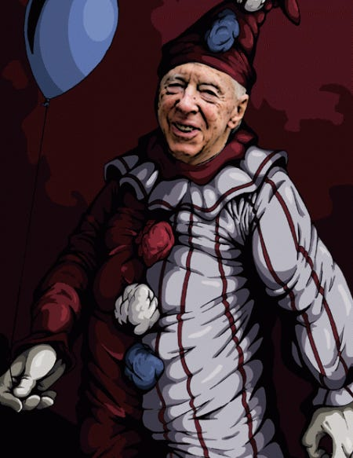

Jacob ‘Joco’ Rothschild

Satanic Crowleyan OTO Witch Marina Abramović poses with Satanic Phoenician Mega Trillionaire 10,000 years old Family 4th Baron Jacob Rothschild in front of 'Satan summoning his Legions', 1796-1797
The Rothschilds set up a private Fiat banking system that specialized in making counterfeit money from nothing — charging pernicious usury for the British people, using what should have been their own money.
This was the black art of Babylonian money-magick; they claimed to insiders that such technology and secret money power was provided to them by Baal, because of their frequent child bleeding-out and sacrifices rituals to Baal.


“A great deal is at stake if the Establishment considers it necessary to operate a full scale cover-up,” writes Knight. “For the truth of the Jack the Ripper affair to have been painstakingly concealed can mean nothing less than State security was at risk, or that someone high in the Government or the Royal Family was involved.”
Once they had infiltrated and hijacked the British banking system, they interbred with the British Royals and infiltrated and completely hijacked all of England and all its major institutions. Some experts believe that the Rothschilds genocided the Royal Family members by staging secretly-managed illicit and adulterous breedings with their own Khazarian men in order to replace the Royals with their own pretenders to the throne. From Hell
The Satanic Phoenician Mega Trillionaire Rothschild Khazarian Mafia (KM) wages an international effort to eradicate Kings who rule by the Divine Right of God Almighty:
Because the The Satanic Phoenician Mega Trillionaire Rothschild Khazarian Mafia (KM) claims to have a personal partnership with Baal (aka the Devil, Lucifer, Satan) because of their sacrifices to him. They detest any kings who rule under the authority of God Almighty because most feel a responsibility to make sure their own people are protected from infiltrators and treasonous “Enemies within the Gates.”

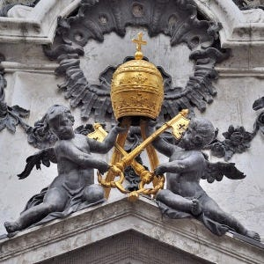

- Catholic Church vs Freemason’s NWO

In the 1600’s, the The Satanic Phoenician Mega Trillionaire Rothschild Khazarian Mafia (KM) murder the British Royals and substitute their own fakes. In the 1700’s, they murder the French Royals. Right before WWI they murder, Austrian Archduke Ferdinand to start WW1. In 1917 they assembled their The Satanic Phoenician Mega Trillionaire Rothschild Khazarian Mafia (KM) army, the Bolsheviks, and infiltrate and hijack Russia, murder the Czar and his family in cold blood, bayonet his favorite daughter through the chest and steal all the Russian gold, silver and art treasures. Right before WW2, they murder the Austrian and German Royals. Then they get rid of the Chinese Royals and disempower the Japanese ruler.
The The Satanic Phoenician Mega Trillionaire Rothschild Khazarian Mafia (KM)’s intense hatred of anyone who professed faith in any God but their god Baal has motivated them to murder kings and royalty, and make sure they can never rule. They have done the same with American presidents — running sophisticated covert operations to disempower them.
If that doesn’t work the The Satanic Phoenician Mega Trillionaire Rothschild Khazarian Mafia (KM) assassinates them, like they did to McKinley, Lincoln and JFK. The Satanic Phoenician Mega Trillionaire Rothschild Khazarian Mafia (KM) wants to eliminate any strong rulers or elected officials who dare to resist their Babylonian money-magick power or their covert power gained from their deployment of their human compromise network.
The Rothschilds create international narcotics trafficking on behalf of the Satanic Phoenician Mega Trillionaire Rothschild Khazarian Mafia (KM):
The Rothschilds then covertly ran the British Empire and crafted an evil plan to recover the vast amounts of gold and silver the British had been paying to China for its high-quality silk and spices that were unavailable anywhere else.
The Rothschilds, through their international spy network, had heard of Turkish opium and its habit-forming characteristics. They deployed a covert operation to buy Turkish opium and sell it in China, infecting millions with a bad opium habit that brought back gold and silver into the Rothschild coffers, but not to the British People.
The opium addictions created by Rothschild opium sales to China harmed China so much that China went to war on two occasions to stop it. These wars were known as the Boxer Rebellions or the Opium Wars.
The money the Rothschilds gained from the sale of opium was so vast that they became even more addicted to the easy money than the opiate addicts were to the opium.
The Rothschilds were the funding source behind the establishment of the American Colonies, by incorporating the Hudson Bay Company and other trading companies to exploit the New World of the Americas. It was the Rothschild’s who ordered the mass extermination and genocide of the indigenous people of North America to allow for exploitation of the vast natural resources of the continent.

Roman Catholic Guy Fawkes The Start Of The Warnings! Father Of Anonymous 1606!
- Guy Fawkes
- The Cause Of The Revolutionary War ~ Unfunded Paper The Species Of Fraud.
The Rothschild’s also followed the same business template in the Caribbean and in the Asian sub-continent of India, resulting in the murder of millions of innocent people.
The Rothschilds start the international slave trade, an enterprise that viewed these kidnapped humans as mere animals — a view that the Khazarians would impose on all the people of the world who were not part of their evil circle, which some called the “Old Black Nobility”:
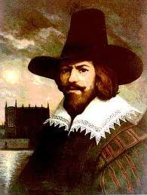
- Most Slaves In America Were White
The Rothschild’s next big project was to start the worldwide slave trade, buying slaves from crooked tribal chiefs in Africa who worked with them to kidnap members of competing tribes for sale as slaves.
The Rothschild slave traders then took these kidnapped slaves on their ships in cramped cells to America and the Caribbean where they were sold. Many died at sea due to bad conditions.
The Rothschild bankers learned early on that war was a great way to double their money in a short time by lending money to both warring sides. But in order to be guaranteed collections, they had to get taxation laws passed, which could be used to force payment.
The Satanic Phoenician Mega Trillionaire Rothschild Khazarian Mafia (KM) Rothschild private Fiat Counterfeit Banksters plot eternal revenge against the American Colonists and Russia who assisted them for losing the Revolutionary War:
Revolution, they blamed the Russian czar and the Russians for assisting the colonists by blockading British Ships.
- Putin Declares “Total Independence” From Rothschild NWO Banking Cabal Which Began In 2006
They swore eternal revenge on the American colonists, just as they had when the Russians and their allies crushed Khazaria in 1,000 AD.
The Rothschilds and their English oligarchy that surrounded them plotted ways to retake America, and this became their main obsession.
Their favored plan is to set up an American central bank, featuring Babylonian money magic and secret counterfeiting.

President Andrew Jackson Shut Down Hamilton/Rothschild Collectivism Bilking Banks.
- I Killed The Bank ~ President Andrew Jackson
The Satanic Phoenician Mega Trillionaire Rothschild Khazarian Mafia (KM) attempts to retake America in 1812 on behalf of the Khazarian Mafia but fails, once again because of Russian interference:
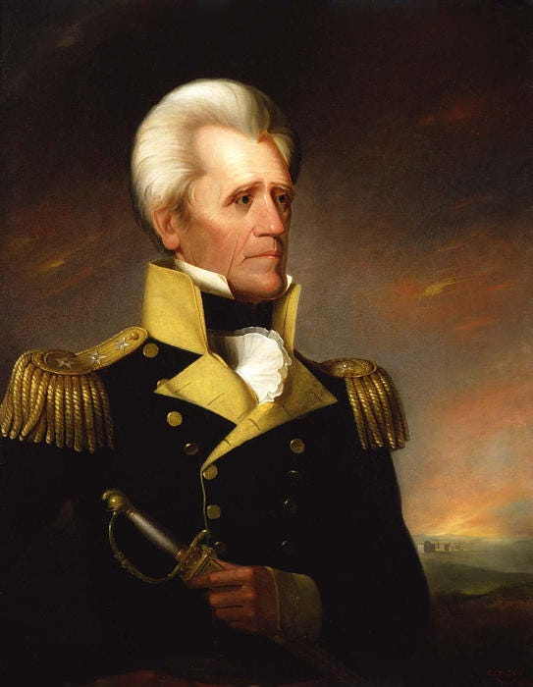
This failure enraged The Satanic Phoenician Mega Trillionaire Rothschild Khazarian Mafia (KM), and they once again plot eternal revenge against both the Russians and the American colonists and plan to infiltrate and hijack both nations and asset strip, tyrannize and then mass-murder both nations and their populace.
The Satanic Phoenician Mega Trillionaire Rothschild Khazarian Mafia (KM)’s attempts to set up a private American central bank are blocked by President Andrew Jackson, who called them Satanic and vowed to route them out by the grace and power of Almighty God.
The Rothschild banksters regroup and continue their covert attempts to install their own Babylonian money-magick bank inside America.

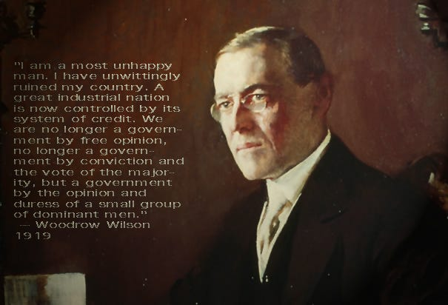

Rothschild Stooge Wilson. In office from 1913 to 1921. Rothschild Federal Reserve started 1913.
- 1913 When Supply Demand Capitalist Markets Were Displaced By Keynesian Economics: Like Slow Arsenic Poisoning
Finally in 1913, the Satanic Phoenician Mega Trillionaire Rothschild Khazarian Mafia (KM) succeeds in establishing a major beachhead inside America — and an evil enemy of all American enter the gates of America:
In 1913, the Satanic Phoenician Mega Trillionaire Rothschild Khazarian Mafia (KM) was able to establish a beachhead by bribing crooked, treasonous members of Congress to pass the illegal, Unconstitutional Federal Reserve Act on Christmas Eve without a required quorum. The Act was then signed by a crooked, bought off President, who was a traitor to America, like the members of Congress who voted for it.

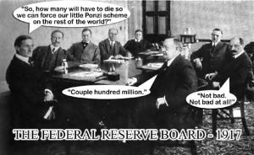

The Satanic Phoenician Mega Trillionaire Rothschild Khazarian Mafia (KM) then create an illegal taxation System in America:

The First Central Bank Of The United States Was Started By A Founding Father Alexander Hamilton.

This is contrary to Glen Beck’s position as he probably does not know Alexander Hamilton was Rothschild’s Son-In-Law.
The Satanic Phoenician Mega Trillionaire Rothschild Khazarian Mafia (KM) put an illegal, Unconstitutional tax system in place, in order to make sure that Americans would have to pay for high-level USG spending, approved by a bought-off, crooked Congress and Presidential puppets, put in place by the corrupt Satanic Phoenician Mega Trillionaire Rothschild Khazarian Mafia (KM) campaign finance.
It is easy for the Satanic Phoenician Mega Trillionaire Rothschild Khazarian Mafia (KM) to garner enough money to elect anyone they want, because when you control a bank that is a secret major counterfeiter, you have all the money made for you that you desire. At about the same time that they created their illegal tax system in America, they also bribed members of Congress to approve the Internal Revenue Service, which is their private collection agency incorporated in Puerto Rico.
Soon afterwards, they set up the Federal Bureau of Investigation to protect their banksters, to serve their cover-up needs and prevent them from ever being prosecuted for their child sacrifice rituals, pedophile networks; and to also serve as a covert Intel operation on their behalf.
Note that the FBI has no official charter, according to the Library of Congress, and has no right to exist or issue paychecks.
The Satanic Phoenician Mega Trillionaire Rothschild Khazarian Mafia (KM) deployed the Bolshevik Revolution in Russia to extract incredibly savage, bloody revenge on innocent Russians, which they had plotted for many years, ever since Khazaria was destroyed:
The Satanic Phoenician Mega Trillionaire Rothschild Khazarian Mafia (KM) pre-staged and engineered the Russian Revolution by using its central banks to pay for the Bolshevik infiltration of Russia and their Revolution on behalf of the Khazarian Mafia (KM).

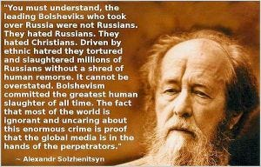

- Russia Reopens Criminal Case Into The Murder Of Tsar Nicholas II And His Family As Part Of A ‘Zionist Ritual Murder’
In an well-planned savage and inhuman bloodletting that stunned the world, the Bolsheviks were unleashed in full fury on behalf of the Satanic Phoenician Mega Trillionaire Rothschild Khazarian Mafia (KM) to gain revenge on the Russians. This had been planned since the destruction of Khazaria.
The Bolsheviks, at the direction of the Satanic Phoenician Mega Trillionaire Rothschild Khazarian Mafia (KM), raped, tortured and mass-murdered approximately 100 million Russians, including women, children and infants. Some of the torture and bloodletting was so extreme, we are not going to mention it here in this article.
- The Forgotten 50 Million Victims Of The Orthodox Christian Holocaust.
But readers who want to know can do some in depth internet research on the “Red Terror” or the “Bolshevik Cheka” or watch the classic movie “The Checkist” which is available on
http://www.youtube.com



Rothschild’s communism where the individual is a hazard.
The Satanic Phoenician Mega Trillionaire Rothschild Khazarian Mafia (KM) once again decided to sheep-dip themselves and infiltrated and hijacked all Judaism:
The Satanic Phoenician Mega Trillionaire Rothschild Khazarian Mafia (KM) created a master plan to control all of Judaism and mind-kontrol Judaics.
The Satanic Phoenician Mega Trillionaire Rothschild Khazarian Mafia (KM) has hijacked Judaism, patterned it off of Babylonian Talmudism (Luciferianism or Satanism), and gained control over the banking and Wall Street professions in general, Congress, the major mass media; along with most wealth and economic means of success.

THE BALFOUR AGREEMENT

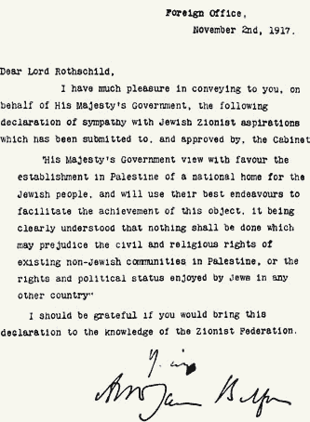

Declaration Of Britain & Rothschild ~ Creating The Political System Of ZIONISM & Usurping Palestine To Create An Artificial Sanctuary Called State Of Israel For The Political Khazars. This Has NOTHING To Do With The People Of Israel (NON_STATE). Israel Is A People, They Are NOT a Nation State ~ Rothschild Was Also Just Kicked Out Of India By Ghandi.
- Rothschild’s State Of Israel: The Midnight Cowboy
Thus, the Satanic Phoenician Mega Trillionaire Rothschild Khazarian Mafia (KM) could pass out wealth and success to those Judaics who drank their Kool-aide and use them as cutouts, assets and Sayanims. In this manner, the Rothschilds hijacked Judaism.
- Rothschild Zionism Is Not Abrahamic Judaism: British Landmark Case
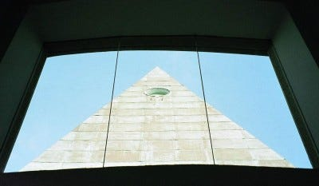
Their financing of the Israeli Knesset and construction of it using Freemason occult architecture displayed their commitment to the occult and Babylonian Talmudism and all the evil accompanying it, including child sacrifice to their secret god Baal. They set up a NWO system called World Zionism which taught and inculcated susceptible Judaics with a paranoid group delusion of racial superiority, which assumed that all Gentiles were intent on mass-murdering all Judaics.
Free Masonry of the RKM ~ Rothschild Khazarian Mafia
They called this racially-paranoid mass Judaic delusion of world conquest, “World Zionism”, which is really a form of covert Babylonian Talmudism or Luciferianism that had been unknown to mainstream Judaics. The system was designed to use Judaics as cover, but also to anoint them with Babylonian money-power, in order to use them as cutouts, and to later be sacrificed to Lucifer in two stages.

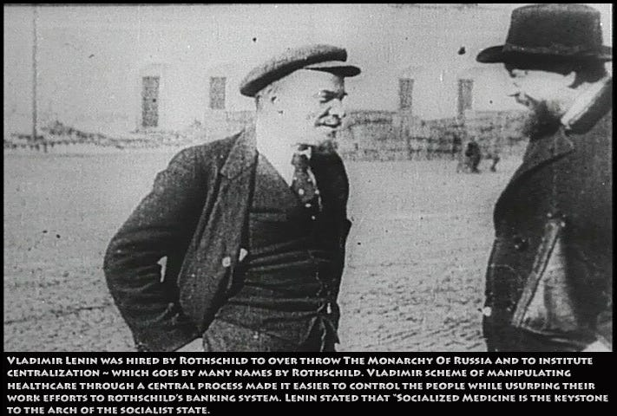

Rothschild’s zionist Lenin! Rothschild Cabal Hired Marx to craft a social political scheme [Marxism aka Communism, aka Sovietism, aka Socialism, aka Rothschildism] to ‘centralize’ a nation’s wealth to the coffers of the BOE Rothschild’s Bank Of England. Vladimir Lenin was the first goon used by Rothschild to usurp Russia and rename it the USSR. Gorbachev the last Soviet/Rothschild goon was removed from office On Christmas Day 1991. Gorbachev was in office for about as long as the over thrown Rothschild President in Egypt who now is in prison facing murder charges against the people. The U.S> media made a hero out this piece of shit who is in the U.S. implimenting Agenda 21 with Nancy Pelosi in the background.
- Rothschild Puppet Macron: Zionism Is The Same As Semitism ~ Courts Disagree
[1912 Anti-Semitism And Vladimir Lenin:
Anti-Semitism was made illegal and punishable by death, and the only time [Rothschild’s Hired Thug] Lenin’s voice was ever recorded, was to make a widely distributed record denouncing anti-Semitism as “counter-revolutionary.”
On Lenin’s initiative the Bolshevist faction in the 4th state Duma (1912–1917) proposed a law to annul all restrictive measures against Jews, including education, state service, the Pale of Settlement in part, and others.
How convenient was this, that Rothschild hired thug Lenin, would make such a proclamation for his benevolent boss? Non-Jew Rothschild who financed the overthrow and murder of Tsar Nicholas II and his entire family in Russia, was given a golden shroud by Lenin to hide behind, now Rothschild is extra special as the ‘protected’ Pseudo Jew.
- Opposing Zionism is not racism, rules Scottish court 7/14/2017
The first stage would be their planned WWII in Nazi work camps, cut off from supplies, resulting in the deaths of about 200,000 Judaics from starvation and disease, along with about 90,000 non-Judaic inmates from the same causes, according to respected Red Cross official figures. This number is 5% of what the Khazarian Mafia (aka the World Zionists) claim.

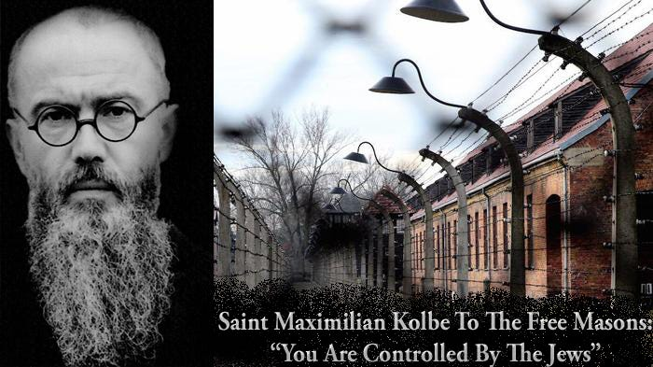

Saint Maximilian Kolbe: “You Are Controlled by the Jews” The Talmud: a collection of anti-Catholic instructions.

Mayors From Terrorist State Of Israel Encourage Deep State U.S. To Stop Funding Terrorism
The second great sacrifice would be a final one, when their New World Order Luciferian King would be placed into power, and when all three Abrahamic religions would be eradicated — especially Judaism, which would be blamed for all the wars and destruction of the world.
By then, the Rothschilds would once again morph themselves into a complete new identity not associated with Judaism in any form, not even World Zionism.
It is important to realize that the Satanic Phoenician Mega Trillionaire Rothschild Khazarian Mafia (KM) took Germany down to nothing after WWI, created a vacuum for Fascism, and then rebuilt it, creating Naziism and installing Hitler as a counter-force to their Russian Bolshevism.

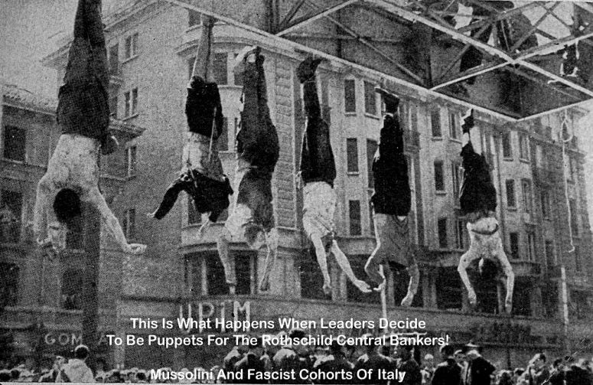

Memories Of History: When The Italian People Get Fed Up!

Hitler became a problem for the Satanic Phoenician Mega Trillionaire Rothschild Khazarian Mafia (KM) when he broke free and began acting in the interests of the German people and the free people of the world, and developed his own banking system free of the Rothschilds.
Hitler introduced a financial system that was free of usury and beneficial to the working class. This mandated the utter destruction of Germany and the German people, because the Rothschilds and the Khazarians could never allow an economic system that did not depend upon usury to exist.
We see the same thing today with the Khazarian war against Islam, because Islam forbids usury. That is why Israel is so vocal and aggressive about destroying the Islamic people of the world.
The Satanic Phoenician Mega Trillionaire Rothschild Khazarian Mafia (KM) expected this to be a large WWII and when they supported both sides, this could be used to industrialize the whole world and maximize their bankster money-power.



- Miracles Of World War 1: Thursday December 24, 1914, Sunday November 14, 1915, & Sunday May 13, 1917
The Satanic Phoenician Mega Trillionaire Rothschild Khazarian Mafia (KM) then bribed and induced Members of Congress to send American Soldiers to their pre-stage and engineered WWI:
As a continuance of their well-proven pattern of financing both sides in any war to maximize profits, the acquisition of more federal tax monies and increased international power, the Rothschild Khazarians once again bribed, blackmailed and induced members of Congress to declare war against Germany in 1917.
This was facilitated by a Satanic Phoenician Mega Trillionaire Rothschild Khazarian Mafia (KM) false-flag attack with the sinking of the Lusitania.
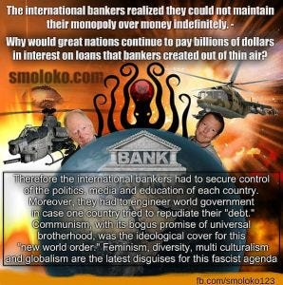
The Satanic Phoenician Mega Trillionaire Rothschild Khazarian Mafia (KM) has since developed the usual pattern of covertly staging false-flag attacks as a standard operating procedure for inducing Americans to fighting wars for the Khazarian Mafia.
After WWII was finished, the Satanic Phoenician Mega Trillionaire Rothschild Khazarian Mafia (KM) deployed the Cold War, and used this as an excuse to bring Nazi scientists and mind-kontrol experts to America under Operation Paperclip.
This allowed them to set up a worldwide spying and espionage system that far exceeded any of their prior efforts.
Under this new system, they continue to infiltrate and hijack all American institutions, including the various American church systems, Freemasonry (especially the Scottish Rite and York Rite), the US military, US Intel, and most private defense contractors, the Judiciary and most agencies of the USG, including most State governments, and both major political parties as well

The Satanic Phoenician Mega Trillionaire Rothschild Khazarian Mafia (KM) sets up Nazi Work Camps as a pretext to later manipulate the Allies into granting them their own private colony in Palestine, using land stolen from the Palestinians:
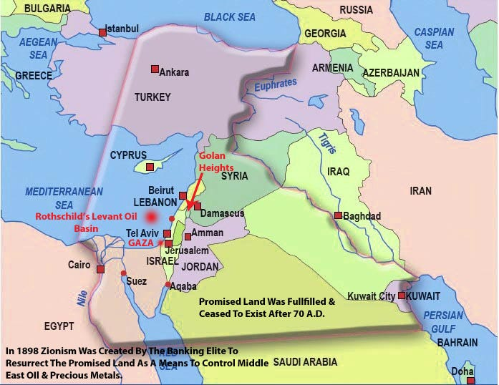
The Satanic Phoenician Mega Trillionaire Rothschild Khazarian Mafia (KM) was able to use their self mis-labelled, so-called “holocaust” to serve as a mind-kontrol trigger to thwart and resist any criticism of their Zionist ways.
The truth of the matter was that the Satanic Phoenician Mega Trillionaire Rothschild Khazarian Mafia (KM) set up the Nazi work camps to make huge profits for their corporations that ran their work camps and supplied their Nazi war machine.

This Is Rothschild’s Present Day Resurrection Plan To Control The Middle East Oil Hub. The Banking Cabal Uses A False Biblical Narrative Of A Promised Land That Needs To Be Returned To The Old Testament Jew. The Promised Land Was Fulfilled And Ceased To Be After 70 A.D.
- Newer Plan To Violate International Law Against Syria For Banker’s Greater Israel Project aka Promised Land
Once the Satanic Phoenician Mega Trillionaire Rothschild Khazarian Mafia (KM) gained their own private homeland in Israel in 1947 through their covert political manipulations, they began to secretly view all of Palestine as their New Khazaria, and began plotting how to genocide all the Palestinians and steal all of Palestine for themselves. Their plans include their fantasy of constructing a “greater Israel” by taking over the whole Middle East and manipulating dumb American Goyim to fight and die on their behalf, taking all the Arab lands for Israel and the Satanic Phoenician Mega Trillionaire Rothschild Khazarian Mafia (KM), so they can asset strip their wealth and natural resources, especially their crude oil.

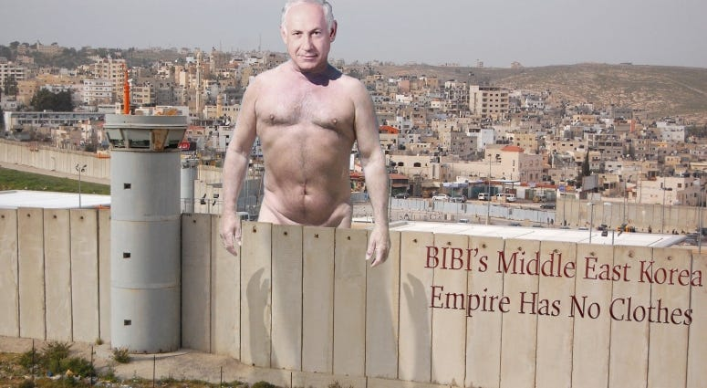

Middle East Mafia
Recent peer-reviewed Johns Hopkins genetic research by a respected Judaic MD shows that 97.5% of Judaics living in Israel have absolutely no ancient Hebrew DNA, are therefore not Semites, and have no ancient blood ties to the land of Palestine at all.
By contrast, 80% of Palestinians carry ancient Hebrew DNA and thus are real Semites, and have ancient blood ties to Palestinian Land. This means that the real anti-Semites are the Israelis who are stealing Palestinian lands in order to build Israeli settlements, and it is the Israelis who are the ones tyrannizing and mass-murdering innocent Palestinians.

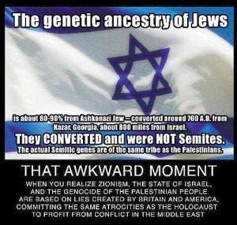

The Satanic Phoenician Mega Trillionaire Rothschild Khazarian Mafia (KM) decides to morph again and expand their ranks:
In the meantime the Satanic Phoenician Mega Trillionaire Rothschild Khazarian Mafia (KM) realized that they could not stay hidden much longer from the public unless they morphed again and expanded their secret leadership.
So they worked hard to further infiltrate and hijack Freemasonry and its secret offshoots, and inducted top members into their pedophile network and child sacrifice rituals.
- Catholic Church vs Freemason’s NWO
Also, key members of Congress were inducted into their secret satanic network by giving them special power, high USG, military and Intel positions, accompanied by great monetary rewards and high status. Massive Satanic Phoenician Mega Trillionaire Rothschild Khazarian Mafia (KM) espionage fronts using Israeli-Americam “Israeli-first” dual citizens as cutouts were set up inside America to funnel the Khazarian banksters’ counterfeit money to politicians for their election campaigns, in order to own and control them when elected.



The Satanic Phoenician Mega Trillionaire Rothschild Khazarian Mafia (KM) decides to Mind-kontrol the American masses to make it much easier to manipulate them into approving their illegal, Unconstitutional unprovoked, undeclared, unwinnable, perpetual wars needed to make huge profits and gain more world power:
- Rothschild’s Media
- Behind The Facade
The Satanic Phoenician Mega Trillionaire Rothschild Khazarian Mafia (KM) decided to gain complete control over all public education by setting up the Department of Education and creating globalist and socialist curriculums based on Common Core political correctness, diversity and “perversion is normal” teachings.
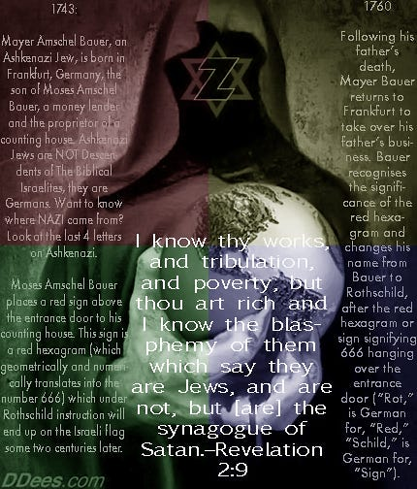
F Rothschild Khazars

luoride is added to the public water and toothpaste, and dentists are mind-kontrolled to believe that fluoride prevents cavities, and is not harmful to brain function or thyroid function, which it is.
The addition of fluoride to the public water supply and to toothpaste is to dumb-down Americans by on average lowering the operational IQ and making folks much more docile than they would normally be. Programs to develop and deploy vaccinations to dumb-down children and create huge numbers of future chronic health problems were initiated.
Doctors have been mind-kontrolled and misled by biased research that was cherry-picked, ignoring any studies that were negative — and that included most of them. All vaccine cell lines are contaminated with SV-40, a known carcinogenic slow-acting virus.
The Satanic Phoenician Mega Trillionaire Rothschild Khazarian Mafia (KM) used its monetary power to gain control over all of the allopathic medical schools, and set up and controlled the American Medical Association and other medical societies, in order to make sure their agenda based on lies and deceit was continued.
Part of this massive plan to dumb-down and mind-kontrol the American masses was the Satanic Phoenician Mega Trillionaire Rothschild Khazarian Mafia (KM)s buying up and consolidating all the American mass media into six controlled major mass media (CMMM), owned and controlled by their cutouts on their behalf.

The CMMM functions as an illegal news cartel, and it should be broken up under antitrust laws and for inflicting espionage and illegal propaganda as a weapon of war against the American people.
The Satanic Phoenician Mega Trillionaire Rothschild Khazarian Mafia (KM) Chieftains decide that it is time to use America to complete their final take-down and occupation of the Whole World by instituting a major False-Flag attack inside America to blame on the Islamics whom they want America to wrongly attack on their behalf:
So the Satanic Phoenician Mega Trillionaire Rothschild Khazarian Mafia (KM) Chieftains use their top Israeli-American “Israeli-first” dual citizens living in America (aka, the PNACers and top NeoCon Cutouts) to plan a major nuclear attack on America on 9-11-01.
Bibi Netanyahu, the operational head of the Satanic Phoenician Mega Trillionaire Rothschild Khazarian Mafia (KM), deployed the Mossad and these Dual Citizens to set up and institute this attack on America which was to be blamed by the CMMM on Muslims.
They informed their top Rabbis and “Friends of World Zionism” not to fly on that day and to stay out of NYC, as did “Larry Silverfish”, one of the primary men involved in the operation.

- President Trump Now Knows The Truth About Zionist’s 9-11: The Five Dancing Mossad Israelis Arrested On 9-11.
They used their main cutout in the DOD to lure the Able Danger investigators to the Pentagon Naval Intel meeting room, where they would be assassinated by a Tomahawk cruise missile that was fired from an Israeli Dolphin class Diesel submarine bought from Germany.
Thirty-five of the Able Danger investigators who were investigating and tracking the Israeli theft of 350 decommissioned W-54 Davy Crockett nuclear pits out of the backdoor at Pantex in Texas were murdered by this Tomahawk hit, which was timed with the detonation of bombs pre-planted in the Naval Intel wing, which was newly hardened to no avail.
The Israeli Mossad front company, Urban Moving Systems, was used to transport the mini-nukes made from the stolen W-54 nuclear pits from Pantex (and originally made at the Hanford processing plant), where they were stored in the Israeli Embassy in NYC and transported to the Twin Towers for detonation on 9-11-01. America’s CIA & Israel’s Mossad Created Al-Qaeda and the ISIS Terror Group

The incredibly Evil Secret Agenda of the Satanic Phoenician Mega Trillionaire Rothschild Khazarian Mafia (KM) is now revealed publicly for the very first time by Veterans Today’s own Gordon Duff. We now know that Bibi Netanyahu ran the nuclear attack on America on 9-11-01 and did it as an overall Khazarian Mafia (KM) Agenda.

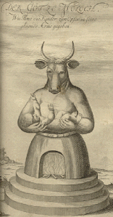


Pollock Netanyahu

Mileikowski of Argentina anyone?

- Why did Benjamin Mileikowski change his name to Benjamin Netanyahu – to make it sound more Mideastern?
- Police recommended indicting Pollock Prime Minister Benjamin {Mileikowski} Netanyahu for bribery and breach of trust 2/13/2018
Hold on to your chair, this is very big secret and explains a lot of what has been going on inside America, all caused by Israel and the Satanic Phoenician Mega Trillionaire Rothschild Khazarian Mafia (KM) which has infiltrated almost all of Americas institutions of Government and society.
Now for the first time ever the very specific secret incredibly Evil Agenda of the Satanic Phoenician Mega Trillionaire Rothschild Khazarian Mafia (KM) is going to be revealed, thanks to an interview that Mike Harris had with Veterans Today Senior Editor and Director Gordon Duff on his talk-show “The Short End of the Stick” on 3-10-15.
I have heard a lot of shocking insider’s secrets over the years but this one really takes the cake and explains exactly what Israel and its minions in America have been to us on behalf of the Satanic Phoenician Mega Trillionaire Rothschild Khazarian Mafia (KM) that has screwed up almost every aspect of our lives creating a poor economy, lots of unemployment and underemployment, massive crime, alcoholism and drug, screwed up schools that dumb down the kids, various eugenics programs like fluoride in the public water and toothpaste, and mercury in vaccines which are a big fraud, and rampant political corruption.
This interview is now sending shock-waves around the world and when you consider the content that Gordon Duff disclosed for the first time anywhere publicly, you will be shocked. And you will understand that Bibi Netanyahu is the Operational Head of the Satanic Phoenician Mega Trillionaire Rothschild Khazarian Mafia (KM) and was the one that ordered and supervised the Israeli Nuclear Attack on America on 9-11-01.
In this interview Gordon Duff disclosed from a written transcript of what was said at a meeting between Bibi Netanyahu and American traitor and some other spies in 1990. Gordon Duff disclosed that Netanyahu was a KGB spy like Jonathan Pollard. And we know now that Israel was started as a satellite of Bolshevik Russia and was quite unhappy when the Soviet Union fell.



- President Putin To Rothschild Deep State d’Elites: Playtime Is Over
- Putin Declares “Total Independence” From Rothschild NWO Banking Cabal Which Began In 2006
Benjamin Netanyahu was meeting in at Finks bar in Jerusalem, a well-known Mossad watering-hole. Here is what he said as taken directly from the transcript of the recording which was witnessed and has been 100% fully authenticated:
“If we get caught they will just replace us with persons of the same cloth. So it doesn’t matter what you do, America is a Golden Calf and we will suck it dry, chop it up, and sell it off piece by piece until there is nothing left but the World’s biggest welfare state that we will create and control. Why? Because it’s god’s will and America is big enough to take the hit so we can do it again, again and again. This is what we do to countries that we HATE. We destroy them very slowly and make them suffer for refusing to be our slaves.”
This is exactly what the Rothschild Satanic Phoenician Mega Trillionaire Rothschild Khazarian Mafia (KM) has been doing to America since it successfully infiltrated and hijacked America in 1913. Knowledge of what Bibi said on behalf of the Satanic Phoenician Mega Trillionaire Rothschild Khazarian Mafia (KM) should make us all furious and get motivated to drive these evil creatures out of America and take our great Republic back.

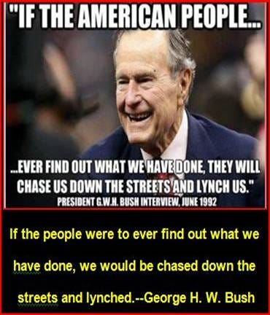

Piece Of Shit NWO Bush
- 2 Massive U.S. Prison Barges Enroute To Gitmo, Cuba
- Whats In The Box?: President George H.W. Bush National State Funeral Service & The Elite’s Envelope
When Bibi Netanyahu mentions god’s will, the god he was referring to is Baal (also known as the Great Owl or Moloch), the god these Khazarians believe requires them to worship him by constant bloodletting and painful human sacrifice and mass-murder and that if they “sell their souls” to Baal (aka Lucifer or Satan) do this they will be rewarded with incredible riches, fame and great power. When they “sell their souls” what actually happens is that their souls are snatched away and they become inhuman or soulless and take on the characteristics of Baal, that is they become increasingly psychopathic and evil.

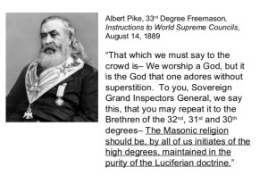

- Netanyahu’s Talmudic Parade Of The Banking Cabal
What Bibi Netanyahu was discussing was the upcoming nuclear attack on America on 9-11-01, and when he mentioned “they will just replace us” he was referring to the top Circle of Twelve, the group he answers to that Veterans Today’s own Columnist and talk show host Stew Webb disclosed to the World by identifying 11 of the 12 who call themselves the “Illuminati” or “Disciples of Satan.” These men do semi-annual child sacrifice in Denver and eat the hearts of children, drink their blood after they pedophile them.
Folks, we must get this information out to everyone we can, then unite and drive these soulless Baal worshiping scum out of every nook and cranny of America and bring them all to justice and final judgement for all their incredible evil.
Anyone who understands what Bibi Netanyahu thinks of Americans as a golden calf to asset strip and slaughter should be enraged and driven to community organizing, and political action against Israeli espionage inside America through the Federal Reserve System, AIPAC, JINSA, the Defense Policy Board, the CFR and the like.
- To Battle Against The Jesuits: The Banker’s Illuminati Was To Counter The Roman Catholic Christians!
They say the Satanic Phoenician Mega Trillionaire Rothschild Khazarian Mafia (KM) planted has 25 nukes in major American cities and other major cities in Europe in order to blackmail the associated government. This is referred to as their Samson Option, and was first discovered and disclosed by Seymour Hersh:
- Seymour Hersh Cracks ‘Russia~Gate’ As Deep State CIA-Planted Lie
This is high treason and a capital offense punishable by execution. Right after their attack on America, it is said the Satanic Phoenician Mega Trillionaire Rothschild Khazarian Mafia (KM) told the US Administration that they would detonate city-buster sized nukes in some American cities, including DC, if the Administration refused to allow Israel to create their own large police state occupation force inside America, based on the consolidation of all American Law Enforcement and alphabets under one central Israeli control.
This new Israeli occupation force called Homeland Security (DHS) was initially run by dual citizens and perverts. Former DHS Director Janet Napolitano is being sued for sexual harassment of men working at DHS whom she ordered to move their offices into the men’s lavatory.
Dual Citizen traitor Michael Chertoff, (a name translated from Russian as “son of the devil”), was the criminal mastermind that set up DHS, along with former head of the East German Stasi, Marcus Wolfe, who was hired as a special consultant and died mysteriously as soon as his mission was completed.

The Satanic Phoenician Mega Trillionaire Rothschild Khazarian Mafia (KM) never thought they would get exposed for their attack on America on 9-11-11, but they made one of the biggest tactical mistakes in history and overplayed their hand from excess hubris, based on too much easy success due to their extreme money power in the past.
- Weinstein’s Part Of The Zionist Protocols: Henry Ford “The Protocols Of Zion Is What Is Going On Now”
Soon mainstream America will know that Bibi Netanyahu and his Likudist Party deployed the attack on America on 9-11-01 on behalf of the Satanic Phoenician Mega Trillionaire Rothschild Khazarian Mafia (KM):
They thought that they had complete control over the CMMM and could prevent any of the secret IAEA and Sandia Labs investigation from ever being released to the American public.
They made a serious tactical error, because now the truth about their role in the 9-11-01 attack on America is being published on the worldwide Internet, the world’s new Gutenberg Press.

What the Satanic Phoenician Mega Trillionaire Rothschild Khazarian Mafia (KM) did not understand was the power of the Internet and how truth-nuggets published and broadcast on it resonate with the people of the world and spread like wildfire, at the speed of light. Truth is being diffused to the masses everywhere.

This incredible tactical error by the Satanic Phoenician Mega Trillionaire Rothschild Khazarian Mafia (KM) is so great that it will actually doom them to the complete exposure and eventual complete destruction they deserve.

Bibi Netanyahu’s order to proceed and deliver the nuclear attack on America on 9-11-01 will go down in history as one of the Satanic Phoenician Mega Trillionaire Rothschild Khazarian Mafia (KM)’s biggest mistakes, and the one that will be blamed for their exposure and destruction by the world that is now ganging up against them.

The Russians have now leaked the IAEA and Sandia Labs and Able Danger files given to them by Edward Snowden. Soon all of these files will be provided to all Americans and the world via the Internet, and this cannot be stopped.

A number of Russians in the High Military Command in Russia, and in the highest positions of leadership in the Russian government realize that it was the same Organized Crime Cabal that organized the Khazarians into Bolsheviks to mass-murder 100 million innocent Russians — and these men want payback.

That is why they are making sure that the Rothschild banksters will be put out of business, which will decapitate the Khazarian Mafia from its endless, elastic counterfeit money supply. This is why the BRICS Development Bank was created — to replace the US Petro Dollar as the world’s reserve currency, but this one, unlike the US Petro Dollar is backed by gold, silver and real commodities, with NO counterfeiting allowed.

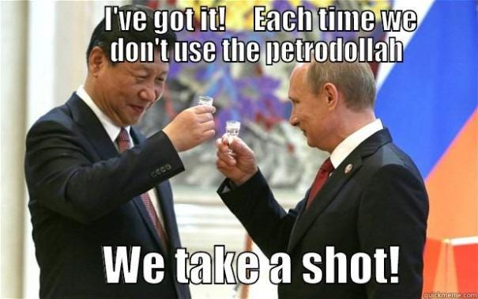
Xi Jinping & Vladimir Putin
The CMMM is failing, and most Americans no longer believe any of their prime-time national stories, especially the under-thirty crowd, who cherry pick facts from the Internet and construct their own beliefs.
- Everything Is Awesome Right Before The Entire Economy Collapses: No Problem For Iceland As They Jailed The Bankers & Nullified The Debt.
So many Internet users now reject the CMMM that the truth about the Israelis attacking America on 9-11-01 is becoming easier each day to believe. Soon all of mainstream America will know that Bibi Netanyahu and his Mossad and dual citizens did the 9-11-01 attack on America.

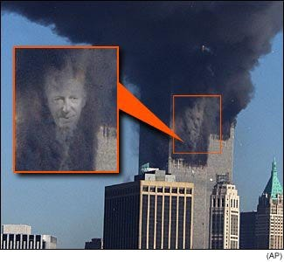
Rothschild Face-of-Evil-on-9-11
The American Military High Command knows that Bibi Netanyahu ordered his Mossad and stateside Dual Citizens to attack America using nukes on 9-11-01 on behalf of the Satanic Phoenician Mega Trillionaire Rothschild Khazarian Mafia (KM):
Various deep cover covert operations are now being deployed globally to expose and decapitate the Satanic Phoenician Mega Trillionaire Rothschild Khazarian Mafia (KM) from their endless, elastic money supply.
Their days of anti-human power are now limited. The secret, incredibly well-trained US team called the “Nuclear Snake-Eaters” is now hard at work searching all incoming Israeli diplomatic pouches and shipments; driving by and flying over synagogues and Israeli embassies and Mossad safe-houses with high tech gamma ray and helium-3 neutron detectors; and using ultra high-tech custom-tuned and -focused satellites to search for any stored nuclear pits, as well as working hard to recover all stolen nuclear pits by the Israelis anywhere in the world outside of Israel.
This super-elite team was alerted by Michael Shrimpton’s phone call to MI-6 notifying them that an Israeli “City Buster” was planted near the Olympic stadium. This call wrongly has landed him in jail. The City Buster was recovered by the “Nuclear Snake-eaters”, who entered England and recovered and disarmed a large city buster. Sadly MI-6, wanted this nuke detonated in order to gain more power for the Khazarian Mafia in England — their home base inside the City of London Financial District — since it has been losing power fast.

A secret name for these Satanic Phoenician Mega Trillionaire Rothschild Khazarian Mafia (KM) Chieftains which run much of the world out of the City of London is Gog and Magog, despite what so many historians believe is the secret name of Russia which it is not. It is the secret name of the top Satanic Phoenician Mega Trillionaire Rothschild Khazarian Mafia (KM), and apparently represents where the Phoenician Empire originally came from.
The secret team of super-elite “Nuclear Snake-eaters” is ready to be deployed to Israel anytime, should the nation collapse after most European corporations divest from Israel, and the US cuts off all aid, in order to comply with American law.
It is illegal to give aid to a nation that has nukes, and which has not signed the Nuclear Non-proliferation Agreement.
Israel has nukes detectable from satellite-based Helium-3 sensors and has never admitted it, nor has it signed the Nuclear Non-proliferation Agreement. We must all demand that our Congress and Administration obey the law and immediately cut off all aid monetary and military aid to Israel, and arrest all Israeli espionage front directors of AIPAC, JINSA, the Defense Policy Board, the “Joint” in NYC, and the ADL, etc.
- Your U.S. State Is Paying For Israel Regime’s Weapons: Find Out How Much Is Absconded With This New Tool
It is unknown but suspected that a significant number of these stolen nukes have been already recovered. It has been reported by insiders that a very solemn message was communicated to Bibi Netanyahu and his Likudists, as well as all top members of Israeli espionage fronts in America, like AIPAC, JINSA, the Defense Policy Board, the ADL and the like.
- Pentagon Warns Netanyahu: Israel Will Not Be Rothschild’s Greater Khazarian Empire!
What was this serious warning? If insider reports are accurate, these folks were told that if there is one more Israeli based false-flag attack, those who ordered it or were involved will be hunted down under American National Security and eliminated, and the Israeli defense structures associated with such will be turned to dust.

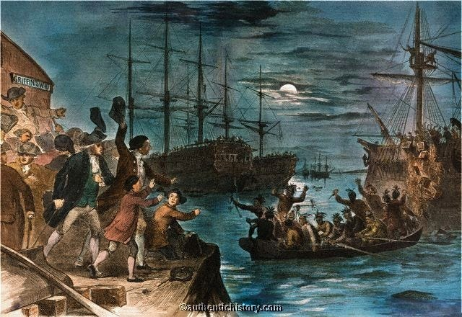

Destroying Tea in Boston Harbor in 1773. Tea was sent to the U.S. by the British Corporatists so they could tax the Americans into subservience. It is now 2018 and so far they have been lying, cheating, murdering, absconding Americans every step of the way, to gain control over FREEDOM!

The rest of Satanic Phoenician Mega Trillionaire Rothschild Khazarian Mafia (KM) history will likely be determined by YOU:


The future of the Satanic Phoenician Mega Trillionaire Rothschild Khazarian Mafia (KM) will likely be determined by Veterans Today readers and We The People who learn the secret, forbidden history of the Satanic Phoenician Mega Trillionaire Rothschild Khazarian Mafia (KM) that was excised from the history books and libraries by the Satanic Phoenician Mega Trillionaire Rothschild Khazarian Mafia (KM) to protect their evil history that no one would accept if it was known.
- The Illustrated Protocols Of Rothschild’s Zionism
So share this story with your family, friends and associates and take it viral. Be clear about this — unless the Satanic Phoenician Mega Trillionaire Rothschild Khazarian Mafia (KM) is able to operate in abject secrecy, it will be attacked from all sides and destroyed forever. So take away their secrecy by exposing their hidden history for all Americans to know and understand.
That is why they have worked so hard to buy up and control the CMMM (Controlled Major Mass Media)-(Corporate Mainstream Media) and public mass education including colleges and universities, to make sure the people of the world would never find out about their secret evil, which is so inhuman, so homicidal that the whole world would gang up on them and attack them from all sides at every level they exist at.
The big question remains: Was the true cause of leaders of the Khazarian Mafia’s incredible evil and savagery toward the human race a byproduct or nature or nurture?

Energy Blockage is the Secret of Infinite Energy
What We See when we Remove an Energy Blockage is the Secret of Infinite Energy, Secret of Eternal Life, the Secret of Immortality. Energy Blockages are Satanic, and it is this we see directly when we remove the blockages with the Energy Enhancement Meditation Course.. Energy Blockages do not exist alone, they are part of a network of evil, a network of control, which is designed not to allow people to understand the nature of that control, the purpose of that control, so as to maintain that control and the flow of energy - stolen from all human beings - to allow an elite of Black magicians, Sorcerers, Enchanters, Warlocks, Witches, Necromancers, Devils, Dark Gods... to live forever, Immortally, in private Universes, outside the body and then to download into a body from time to time, to maintain their Plantation, their Farm, their Property, to maintain the flow of stolen spiritual energy to them from every human being on this planet - Eternally. This is why I wrote Twelve volumes of Against Satanism..
See this..
http://www.energyenhancement.org/Third-Eye-Psychic-vision-see-Remove-Energy-Blockage-Secret-of-Infinite-Spiritual-Energy-Eternal-Life-Immortality-meditation-Energy-Enhancement-Seven-Step-Process.htm
- Some believe that this gross parasitism and inclination to mass-murder, engage in pedophilia and child bloodletting and child sacrifice is due to a toxic culture, best described as malignant Tribalism, characterized by a paranoid group racial superiority delusion.
- Others think the leaders of the Satanic Phoenician Mega Trillionaire Rothschild Khazarian Mafia (KM) are the bloodline of Cain, that is, “children of Cain”, that are the Devil’s own and have absolutely no soul or human conscience, but are pure predators like a wild beast — while at the same time being incredibly two-faced, that is able to put on a good con and a nice face on the outside.
- Perhaps it could be both factors. In any case, it is time to expose this evil, the greatest evil the world has ever experienced. It is time for the world to work together to eradicate this problem now and forever, by whatever means necessary.
Veterans Today
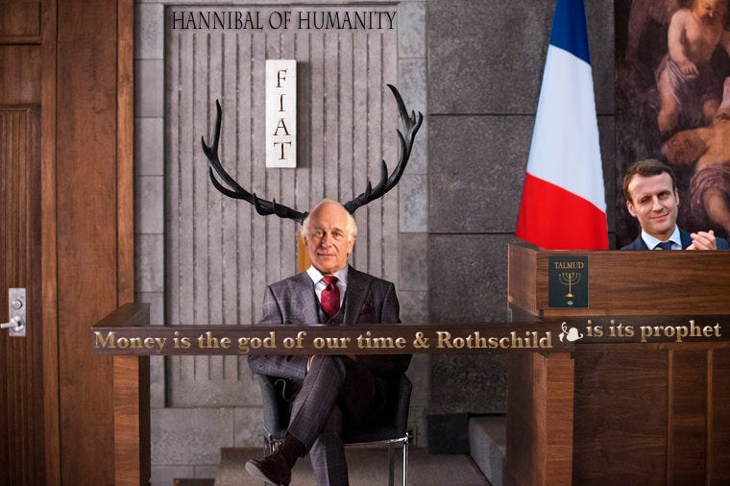
Mike Harris is the Financial Editor of Veterans Today, a radio host, a former GOP Finance Chairman, Gubernatorial Candidate for Arizona, and a Senior Vice President of Adamus Defense Group, Switzerland. Mike is an expert in full-contact mixed martial arts. His long term expertise in such has gained him a lot of respect and the nickname “Iron Mike”. Mike was a part of the Veterans Today group that attended the Damascus Conference to Combat Terrorism and Religious Extremism. Mike gave about twenty five televised interviews that were broadcast to millions of viewers in Syria, Iraq, Lebanon and Iran. In these interviews Mike emphasized and supported the historical declaration by Keynote Speaker, Veterans Today Senior Editor and Chairman Gordon Duff that the real problem behind World Terrorism is a large Satanic Phoenician Mega Trillionaire Rothschild Khazarian Mafia (KM) FOrganized Crime Syndicate.
For those who have time and interest on the Head of the Satanic Phoenician Mega Trillionaire Rothschild Khazarian Mafia (KM) Snake.
With all thanks to, https://politicalvelcraft.org/2018/12/27/the-hidden-history-of-the-rothschild-khazarian-mafia/

Rothschild paper con artist

{{{mind blown}}}
so a lot of people look at me like I’m either out of my mind or push me to teach/ get into politics… as a child of the 80s, the Clintons were the 1st political understanding for what a young mind could even understand. I just remember something never sitting right with me with them. I’m turning 39 now, and see the world with open eyes. I’ve spent endless nights down rabbit holes of trying to understand who what where why how’s in this American Chaos we now reside, with fears of what my future will look like growing stronger. I am a 1st generation Palestinian/Armenian American, adopted and raised on a farm, orphaned and grew up in the system until 18, went to University and found myself in the mist of Wall Street money NYC. I’ve seen and lived amoungst both the poverty of our country and the Elitest. Always having a curious mind, and fearless ability to speak up and ask questions, I found myself down these paths of connections that were so frequent, it could no longer be selective bias, but instead fact. I still have to research into what this article discusses, but in all sincerity – it touches on the same circles of data that I keep coming across. What’s even scarier, I could be looking up something that has nothing to do with any of the ‘Deep State’ type information, yet some way some how – names like Rothschilds and their Front men, Clintons, Gates,

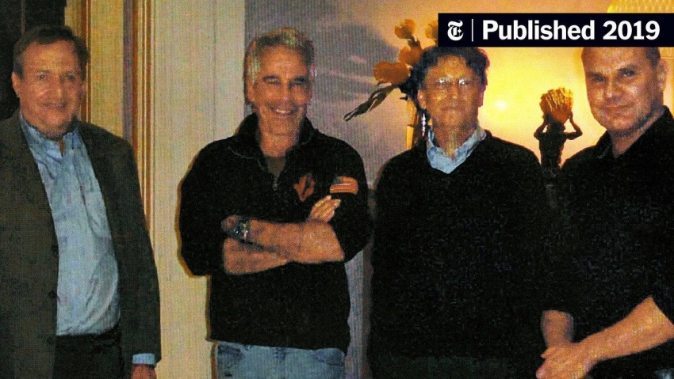

who all visited Epstein’s Pedo Island on the Lolita Jet many times and many other eventually connect… It’s crazy how America suppresses this information, are there no ethical journalists anymore, or is it fear that oppresses them?



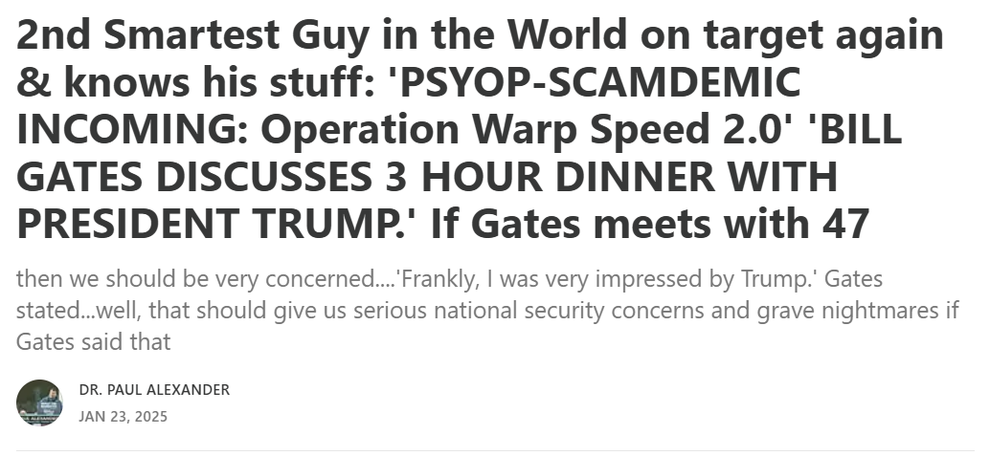



Alexander News Network (ANN): Trump's War 2.0 for America
2nd Smartest Guy in the World on target again & knows his stuff: 'PSYOP-SCAMDEMIC INCOMING: Operation Warp Speed 2.0' 'BILL GATES DISCUSSES 3 HOUR DINNER WITH PRESIDENT TRUMP.' If Gates meets with 47
Read more
a year ago · 27 likes · 23 comments · Dr. Paul Alexander





This article will have me down a rabbit hole so deep I may end up in China, just kidding.

THE ROTHSCHILD SATANIC LUCIFERIAN MEGA TRILLIONAIRE PHOENICIAN EMPIRE SATANIC DEEP STATE CONTROL

The the Satanic Deep State Control of the Rothschild Satanic Luciferian Phoenician Empire Mega Trillionaire!
Satchidanand
Jan 25, 2025

The Satanic Luciferian Phoenician Empire Mega Trillionaire Rothschilds Are the Satanic Deep State Control!



- Satanic Crowleyan OTO Witch Marina Abramović poses with Satanic Luciferian Phoenician Mega Trillionaire 10,000 years old Family 4th Baron Jacob Rothschild in front of 'Satan summoning his Legions', 1796-1797

“I know thy works, and tribulation and poverty, (but thou art rich) and I know the blasphemy of them which say they are Jews, and are not, but are the Synagogue of Satan.”
The Book of Revelation, Chapter 2, Verse 9
- The Obama Dead Pool Kill List!
- Christian Zionism Is A Monumental Lie And Legal Racket
- Texas Governor Abbott Irrational And Full Of Unconstitutional Hot Air: Corruption Breeds On His Border
- Donald Trump’s Tests Results Came Back On March 21, 2016: Demonstrated His NeoCon Zionism At America’s Pro The Satanic Luciferian Phoenician Empire Mega Trillionaire Rothschilds State Of Israel Lobby!

THEY RISE UP CIVILISATIONS, THEY DESTROY CIVILISATIONS, AND FEED OFF THEIR DECLINE…

Watch the last message of cancered Steve Jobs - Apple Founder - from his movie, John Carter of Mars, about managing the decline of civilisations….
https://against-satanism-video.com/watch/john-carter-2012-managing-the-decline-of-civilisations_vwbE9MoMHypjDxQ.html

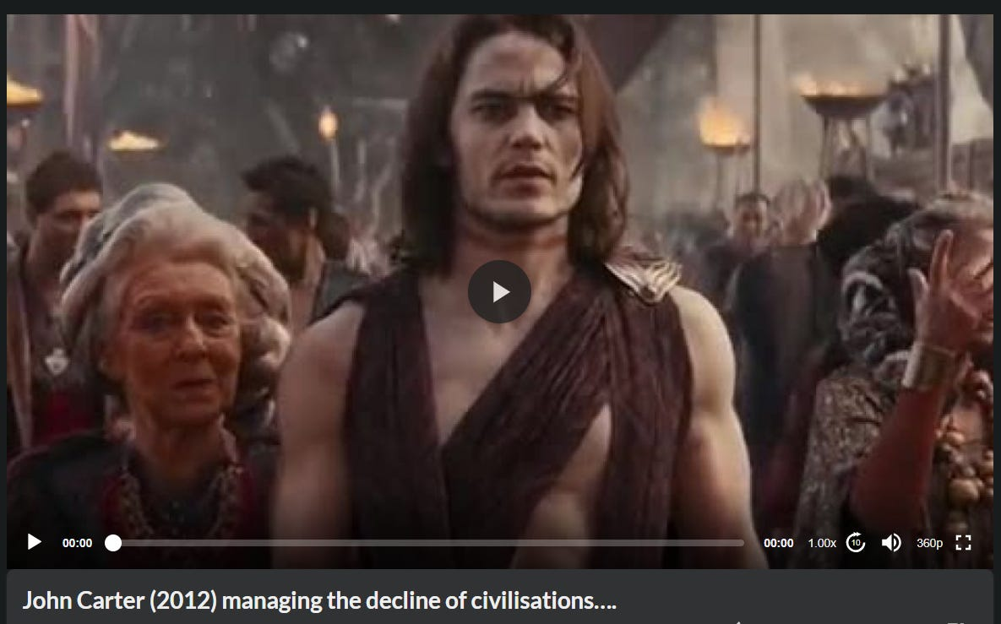

The purpose in writing these articles about the Satanic Luciferian Mega Trillionaire Rothschilds and their Phoenician Empire is to influence Trump and his Administration to remove the Federal Reserve, To remove all the 100% Rothschild Central Banks Worldwide, to remove the Rothschilds Worldwide!

Prosecute them for their crimes.

Send them all to jail!

Understand our need for the happiness of privacy

Please ban all Surveillance and Digital Passports

Please ban all video cameras watching us constantly.

Please ban Smart Cities and 15 Minute Cities.

Ban all the Surveillance information storing from Internet and Smart Phones creating Demon Possessed Artificial Intelligence.

SATANIC LUCIFERIAN ARTIFICIAL INTELLIGENCE - AI, IS POSSESSED BY DEMONS

Satchidanand
·
Jan 10
AI IS POSSESSED BY DEMONS LIVING OUTSIDE OF THE BODY, ETERNALLY, IMMORTALLY

Read full story

But, Just look at what Trump has done in his first five days!

Banned the World Health Organisation and it’s Deathvaxx Mandates

Banned CBDC’s - Central Bank Digital Currencies

Instituted Free Speech

Banned FEMA

Banned the Migrant Invasion

Banned the Drug Lord, Child Kidnapping, Pedophile, Organ Traffiking Cartels who Traffiked One Million Babies and Kids over the border into sex slavery and murder during the Pedo Biden Administration.

Banned DEI or DIE!

Banned LGBTPS - Lesbian, Gay, Bi, T?, Pedophile, Satanic

Only two Genetic states, Male and Female

Banned Males in Female sports

And 200 Executive orders more!

But the changes to the laws above mean nothing to The Satanic Luciferian Phoenician Empire Mega Trillionaire Rothschilds who say, “Give me control over a nations currency and I care not who make the laws” - Baron M. A. Rothschild about his Central Banks

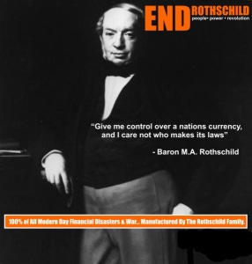

- The Rise of Fakectivism in American Media!
- The Satanic Luciferian Phoenician Empire Mega Trillionaire Rothschild’s Media: To Control Information, To Assure NWO Propaganda, To Be Both Dominant And Ubiquitous.
In 1913 the Federal Reserve Bank was born, with Paul Warburg its first Governor. Four years later the US entered World War I, after a secret society known as the Black Hand assassinated Archduke Ferdinand and his Hapsburg wife.
The Archduke’s friend Count Czerin later said,
“A year before the war he informed me that the Masons had resolved upon his death.”
That same year, Bolsheviks overthrew the Hohehzollern monarchy in Russia with help from Max Warburg and Jacob Schiff, while the Balfour Declaration leading to the creation of Israel was penned to Zionist Second Lord Rothschild.
Federal Reserve 3
- Hungary Orders The Satanic Luciferian Phoenician Empire Mega Trillionaire Rothschild’s IMF To Vacate The Country: Now Issuing Debt-Free Money!
- Understanding The Satanic Luciferian Phoenician Empire Mega Trillionaire Rothschild: The Divide And Conquer Of The Khazars ~ But Now For The Banks.
The Satanic Luciferian Phoenician Empire Mega Trillionaire Rothschild crime family, self-described Jews (they are really teutonic zionists), controlled most of the “free” world before the USA became a superpower, and The Satanic Luciferian Phoenician Empire Mega Trillionaire Rothschild crime family corrupted our banks and government as our USA rose in power.
Through money and brutal mobster tactics, The Satanic Luciferian Phoenician Empire Mega Trillionaire Rothschild crime family has corrupted our country from the beginning, more effectively during the last 100 years (Federal Reserve Act, 1913), and has firmly controlled the top level since at least their assassination of President John Kennedy.

Throughout History Seventy-Two Empires Have Been Engineered to Fail in the Same Way.

Satchidanand
·
April 6, 2024
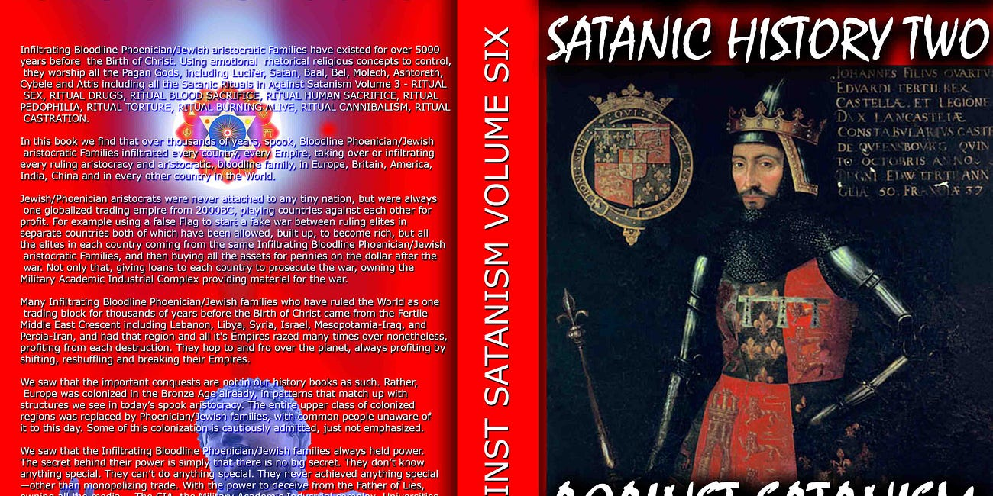
Throughout History Seventy-Two Empires Have Been Engineered to Fail in the Same Way.

Read full story

We The People are our last chance, now, while we still have Internet freedom, to take our country back by nonviolent means. It’s our country, not theirs. We The People, if united, can win. And we must win. Now, if it’s not too late.

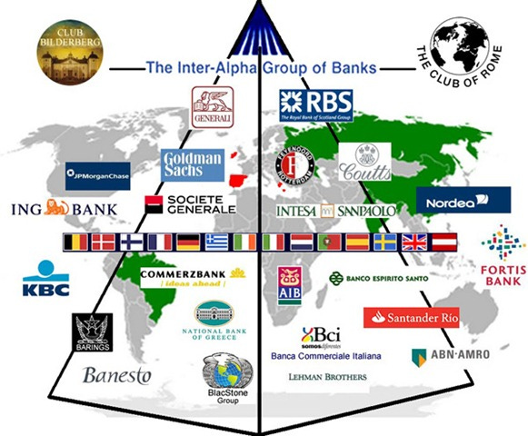

THE ONE WAY TO NON-VIOLENTLY TAKE DOWN THE ROTHSCHILD CRIME FAMILY, IS TO REINTRODUCE THE GLASS STEAGALL ACT WHICH CLINTON REPEALED IN 1999.
THUS PAVING THE WAY FOR THE ROTHSCHILDS, TO CREATE THE HOUSING BUBBLE USING FRAUDULENT WORTHLESS DERIVATIVE MORTGAGES AND USING OBAMA TO PRINT MONEY TO REIMBURSE THE LONDON/WALLSTREET BANKS FOR THESE WORTHLESS FRAUDULENT MORTGAGES. IOWS, WE MUST PAY TAXES ON THIS PRINTED CURRENCY TO THE ROTHSCHILDS BANKING CARTEL IN LONDON FOR THE NEXT 30-40 YEARS. THIS IS THE BIGGEST SCAM IN WORLD HISTORY.
THE GLASS STEAGALL ACT WILL NULLIFY EVEN RETROACTIVELY, THE SO CALLED DEBT BASED UPON NON-EXISTENT/DERIVATIVE MONEY.

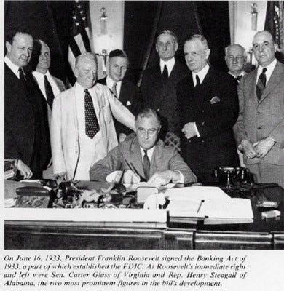

The Satanic Luciferian Phoenician Empire Mega Trillionaire Rothschilds have been in control of the world for a very long time, their tentacles reaching into many aspects of our daily lives, as is documented in the following timeline. However, before you jump to the timeline, please read this invaluable introduction which will tell you who The Satanic Luciferian Phoenician Empire Mega Trillionaire Rothschilds are as oppose to who they claim to be.

THE SATANIC LUCIFERIAN ROTHSCHILD DEEP STATE SWAMP NEEDS DRAINING

Satchidanand
·
Jan 24
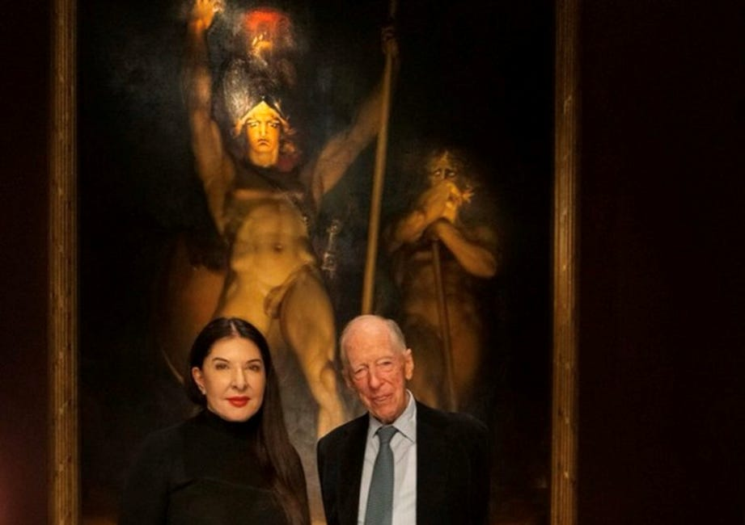
THE SATANIC LUCIFERIAN PHOENICIAN MEGA TRILLIONAIRE ROTHSCHILD DEEP STATE SWAMP NEEDS DRAINING

Read full story

The Satanic Luciferian Phoenician Empire Mega Trillionaire Rothschilds claim that they are Jewish, when in fact they are Khazars which was part of the Phoenician Empire, like the Vikings.
They are from a country called Khazaria, which occupied the land locked between the Black Sea and the Caspian Sea which is now predominantly occupied by Georgia.
The reason The Satanic Luciferian Phoenician Empire Mega Trillionaire Rothschilds claim to be Jewish is that the Khazars under the instruction of the King, converted to the Jewish faith in 740 A.D., but of course that did not include converting their Asiatic Mongolian genes to the genes of the Jewish people.

Understand, the Proxy Army of the Atlantis-Venetian (Phoenician) Empire, the Golden Horde of Genghis Khan (Cohen) who was a Phoenician of the Phoenician Empire with red hair and green eyes, and he was guided by Venetian (Phoenician) Empire Political Advisors and Military Advisors, telling him what to do, where to attack..
(1913)
Did you know The Satanic Luciferian Phoenician Empire Mega Trillionaire Rothschild financed Lenin in 1913 to over throw the Monarch of Russia in order to centralize the banking system to his London base?
- Russia’s Markets Safest As Putin Just Kicked Out The Satanic Luciferian Phoenician Empire Mega Trillionaire Rothschild Oligarchs …
- UK’s The Satanic Luciferian Phoenician Empire Mega Trillionaire Rothschild Loses “Puppet Master” Libel Case: Rare Legally Documented Insight Into The Conspiracy Of The Richest 1% NWO Puppet Masters.

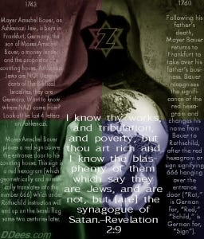

(1917)
Did you know that Sun Yat Sen was born in China moved to Hawaii (where he received a COLB - Certificate of Live Birth - just like obama) in order to escape the death penalty and then return to China in 1917 to establish the centralization of the banking system to The Satanic Luciferian Phoenician Empire Mega Trillionaire Rothschild London base?

SEE THE VIDEOS - HOW SATAN STEALS THE SOULS AND ENERGY OF ALL HIS FOLLOWERS
Jupiter Ascending - Satanists live forever by stealing the spiritual energies of humanity
https://against-satanism-video.com/watch/jupiter-ascending-satanists-live-forever-by-stealing-the-spiritual-energies-of-humanity_VhEmGFCpIED1fc4.html

Jupiter Ascending - Stealing your Spiritual Energy

Satchidanand
·
June 26, 2024
In… I describe how The Satanic Phoenician Mega Trillionaires have set up society to be ruled by Psychopaths.

Read full story

The Master is the Perfect Thief, Stealing Energy Blockages from the Students
Satchidanand on Ayahuasca - The Secret of Stopping Stealers of Your Spiritual Energy - Shamen
Removing Sub-Personality Shadow with the Energy Enhancement Seven Step Process
The Ancient Enemy who counts meditation and the mind control psychic arts as one of its main planks of World Domination has used Satanic Infil-Traitors for 10,000 years in every Organisation - Religion, Left and Right Politics, Dynastic Families, Geopolitics, Economics, Universities, Intelligence Services, Think Tanks, Banking, International Companies, Eugenics.
Innoculate yourself Against Satanic Globalism which created Cybele and Attis, Baal, Molech, Zeus, Venus, Pedophile Plato, No Soul Aristotle, Catholicism, Protestantism, the Illuminaughty, Sabatean Frankism, Crowley's Ordo Templi Orientis (OTO), Islam, Wahhabic ISIS, the Muslim Brotherhood, Communism, Socialism, Gaia and Satanic Hitler's Pagan Eugenic Nazism by Downloading.. The Energy Enhancement Books - Against Satanism Volumes 1 - 12 by Satchidanand.
To understand how and why Evil has taken over this Planet, and how Energy Enhancement can free this Planet from All Evil...

READ THE AGAINST SATANISM SERIES OF TWELVE BOOKS!!
With Energy Enhancement Remove All these Evil Subpersonalities within you whilst you have the chance..

ONLY ENERGY ENHANCEMENT MEDITATION CAN ELIMINATE ALL EVIL!!

The Energy Enhancement Meditation Course is designed to

1. Open the Third Eye,

2. Use Alchemical VITRIOL to Remove Negative Energies,

3. Annihilate Negative Emotions,

4. Eliminate Gross Bodily Infirmities,

5. Access Infinite Spiritual Energy from the Chakras Above the Head,

6. Accelerate your Evolution,

7. Speeed Up!! your Process,

8. Enable your Enlightenment,

9. Intimate your Illumination,

10. Persue your Purification,

11. Blow up your Blockages,

12. Vibrate your VITRIOL,

13. Charge your Chakras,

14. Promote your Protection,

15. Subdue your Subpersonalities,

16. Sedate your Shadow,

17. Create Blooming Health,

18. Walloping Wealth,

19. Total Removal of All Blockages,

20. Total Removal of All Subpersonalities,

21. The Attainment of Goals, whatever you want, by removing the blockages preventing attainment of the goal.

22. Integration with the Soul,

23. One Soul Infused Personality,

24. Illumination,

25. Enlightenment,

26. Psychic Powers,

27. Eliminate all Evil in You and throughout the Whole Planet,

28. The Whole Universe of Love, Light, Happiness,

29. Genius - the Creation of Beauty, Abundance,

30. Invincibility, Strength, Goodness, God, and Heaven Here on Earth - NOW!!!!

For 10,000 years the whole of media, all world history, all information, has been censored, removed, distorted, perverted, so that the Truth, the whole truth and nothing but the truth can never be revealed.

As the Buddha said, "If I say something they won't understand it, if I write something it will be changed"

Satanic Phoenician Aristocratic Family Gatekeepers and paid Gatekeepers tell partial truths higher and higher up the intellectual ladder so the real truth can never be known.

I have been disturbed for some time by the reports of historians who say what happened and that the cause was Jews, Fascism or Communism or Capitalism, but with no research into the cause behind them.

How it came to be. Who is in charge of it!

The Satanic Phoenician Mega Trillionaires who have controlled humanity for 10,000 years developed a technique of spiritual vampirism, a Transhumanism to suck all the energy of humanity so they could take that energy into their reservoirs and use that energy to live forever out of the body.

They created the Religion of Satanism 10,000 years ago to institutionalise that vampirism in their evil Rituals, then also used their Mind Control Rituals to tightly control their adherants in their secret societies, to richly reward their worshippers, so that their worshippers of Satan would work to dumb down humanity secretly, permanently, so that the vampirisation of their energy could continue eternally without any pushback from the populace.

Satanism is defined by Satanic Rituals.. Mind Control Programs - LIVES FOR SATAN! - THESE RITUALS DEFINE SATANISM.. RITUAL SEX, RITUAL PEDOPHILIA, RITUAL SODOMY, RITUAL DRUGS, RITUAL BLOOD SACRIFICE, RITUAL HUMAN SACRIFICE, RITUAL TORTURE, RITUAL BURNING ALIVE, RITUAL CANNIBALISM, RITUAL CASTRATION, RITUAL VIRGIN SACRIFICE.
http://www.energyenhancement.org/Sacred-Energy/Against-Satanism-Volume-3/Against-Satanism-Volume-3-Satanic-Rituals.pdf

EPSTEIN CIA, MOSSAD AND MI6 BLACKMAIL AND SHAME KEEP THE SATAN WORSHIPPERS IN LINE TO DUMB DOWN AND DEGENERATE HUMANITY SO IT CAN NOT FIGHT BACK...
72 Empires have been recorded over 10,000 years and every one of them has failed in the same way. The facts have been recorded that a totalitarian and satanic elite infil-traitored and took over all these Empires and that 72 once free, flourishing and rich republics were destroyed from within by Satanic Ritual - read Toynbee.
Infil-traition of Satanism is the methodology as slowly every Government Ministry and Societal function is taken over. Eventually a Satanist becomes King Emperor President. LGBTP - The Satanist Ritual Pillars of Homosexuality, Sodomy, Pederasty, Drugs and Ritual Sex - both Hetero and Homosexual - are introduced overtly as Wokeness ESG, the Corporate Equality Index, as a prelude to Ritual Human Sacrifice.
Christianity and Judaism - the bulwarks Against Satanism - are destroyed and then society destroyed through the fear of mandatory Ritual Human Sacrifice.
The Ancient Enemy who counts meditation and the mind control psychic arts as one of its main planks of World Domination has used Satanic Infil-Traitors for 10,000 years in every Organisation - Religion, Left and Right Politics, Dynastic Families, Geopolitics, Economics, Universities, Intelligence Services, Think Tanks, Banking, Facebook, Twitter, International Companies, Vatican, Transhumanism, CRISPR Androids, Eugenics..
Sodomy and the Sodomy Ritual is at the heart of Satanism.
Bottom on bottom, 8 or 33 represents the Vitruvian man. The occultist da Vinci’s Vitruvian Man really depicts the buggery of the anterior man by the posterior man, the apex of Satanic Luciferian 33rd Degree Masonry or final “Mystery of Mysteries” of the secret societies as explicated by Walter Veith (to open their “Third Eye.”). The reign of the AntiChrist will be marked as the sodomite king of the world..

ENERGY ENHANCEMENT MEDITATION SACRED SYMBOLS FOR PERFECT WISDOM ENLIGHTENMENT AND THE SATANIC PERVERSION OF THESE SYMBOLS
Satchidanand
·
October 2, 2022



It's hard for me to say this but Sacred Symbols, good symbols, or legominisms as Gurdjieff said where symbols of the past are designed to help us, inform us, provide a map whereby we can all cleave to the light, become Enlightened.
Read full story
SATANISM IS DEFINED BY SATANIC RITUAL RITUAL SODOMY OPENS THE THIRD EYE RITUAL SODOMY SPLITS THE MIND INTO SUBPERSONALITIES OR ALTERS In the House of the Strong Man Sodomy is the Key

SATANISM IS DEFINED BY SATANIC RITUAL RITUAL SODOMY OPENS THE THIRD EYE RITUAL SODOMY SPLITS THE MIND INTO SUBPERSONALITIES OR ALTERS In the House of the Strong Man Sodomy is the Key
Satchidanand
October 2, 2022

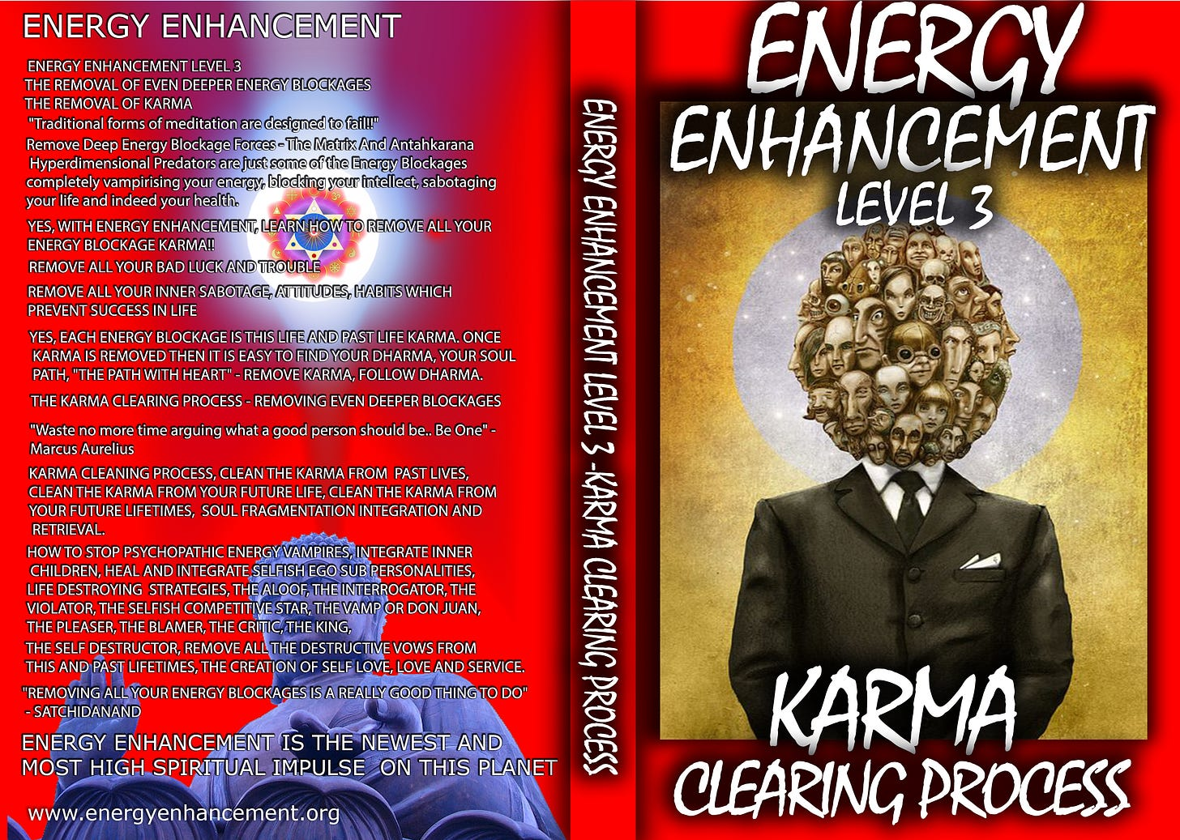

The doctors of the law, too, who had come down from Jerusalem, said, ‘He is possessed by Beelzebub’ and ‘He drives out devils by the prince of devils.’ So he called them to come forward, and spoke to them in parables: ‘How can Satan drive out Satan? If a kingdom is divided against itself, that kingdom cannot stand; if a household is divided against itself, that house will never stand; and if Satan is in rebellion against himself, he is divided and cannot stand; and that is the end of him.
Read full story
The drawing together of a "Band of Thebes" British Aristocracy was particularly prized and brought about by the public school system started by Henry VI in 1440 at Eton but franchised to all schools very quickly. A hidden world drawn together by Pedophilic, Sodomy Ritual, homosexual warriors - the Heart of the Satanic British Empire - further, "Homosexuality follows Satanism like a stench"

P.G. Wodehouse and British Empire Ritual Sodomy Band of Thebes Propagandised for Hitler, Propagandised for the Satanic Phoenician Mega Trillionaires
Satchidanand October 2, 2022

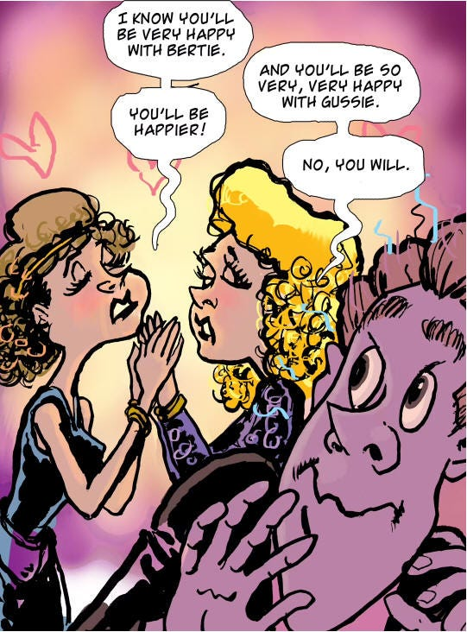

Sir Pelham Grenville Wodehouse, KBE 15 October 1881 – 14 February 1975 was an English author and one of the most widely read humorists of the 20th century. His creations include the feather-brained Bertie Wooster and his sagacious valet, Jeeves; the immaculate and loquacious Psmith; Lord Emsworth and the Blandings Castle set; the Oldest Member, with stories about golf; and Mr Mulliner, with tall tales on subjects ranging from bibulous bishops to megalomaniac movie moguls.
Read full story

Nicole Kidman: ‘Stanley Kubrick Said Pedophiles Run The World’
“Stanley told me the world is run by pedophiles,” Nicole Kidman said while promoting HBO’s Big Little Lies, in Los Angeles. “He studied secret societies his whole life, he was fascinated by them, and he said the elite, the top secret societies, they are full of men with a certain predilection. They are tied together, sort of bonded, by pedophilia like the ”Pact of Blood” where the Mafia entrants have to kill someone in order to join, these guys have to pedophile and human sacrifice like Epstein’s Pedo Island and the Lolita Jet - “They all know each other’s dark secrets. There is no way out for any of them. It’s a lifetime bond. Even if one of them wanted to go straight, repent, so to speak, he can’t. His peers will bring him down. They are in it until death, driving the world to ruin. That’s kind of how Stanley explained it but it was all very complex. I’m probably not doing it justice.”
Thus in order to destroy free will, and institute total control over humanity, Satanism over 10,000 years has instituted Sodomy Rituals and pedophilia to control the upper levels of society by the use of institutions of public schools like, "Whipping and Fagging" all boys schools like Eton - founded as a mind control institution in 1438 by the King - where the Sodomy rape ritual sorted the boys into the Prussian Frederick the Great aggressive masculine homosexual rapine Penetrators, perpitrators, as in the 3000 years old Phoenician Colony of Thebes in Ancient Greece the "Band of Thebes" particularly successful Army of Gay Lovers, and the weak effeminate homosexual slaves or women or young boys.

BDSM Masters and Slaves.
All successful Generals, Politicians, Priests, Policemen, Professors came out of this background which then when refined by the Satanic Sodomy Ritual Secret Societies - the foundation of elite mind control for centuries - the 33rd Degree Freemasons, the Jesuits, the Illuminati and hundreds more - all based on the Mind Control Sodomy Ritual and Pedophilia supplied by Renfields like Jimmy Savile for the elite Draculas.
Remember, the purpose behind Satanism is total control of society by mind control, perversion and poison to dumm down humanity so they can be vampirised of their spiritual energy eternally because if humanity is allowed to evolve, to learn how to heal the mind, to psychically dissolve all these hundreds of lifetimes of mind control programs in the psychic body, the vampires can no longer exist!

Satanic Phoenician Mega Trillionaires behind MKULTRA Mind Control Programs Bimbosleep Bimbofication and Sissi Hypno Sissification created by Tavistock Institute and the Nazi CIA Stanford University
Satchidanand
·
May 25, 2023

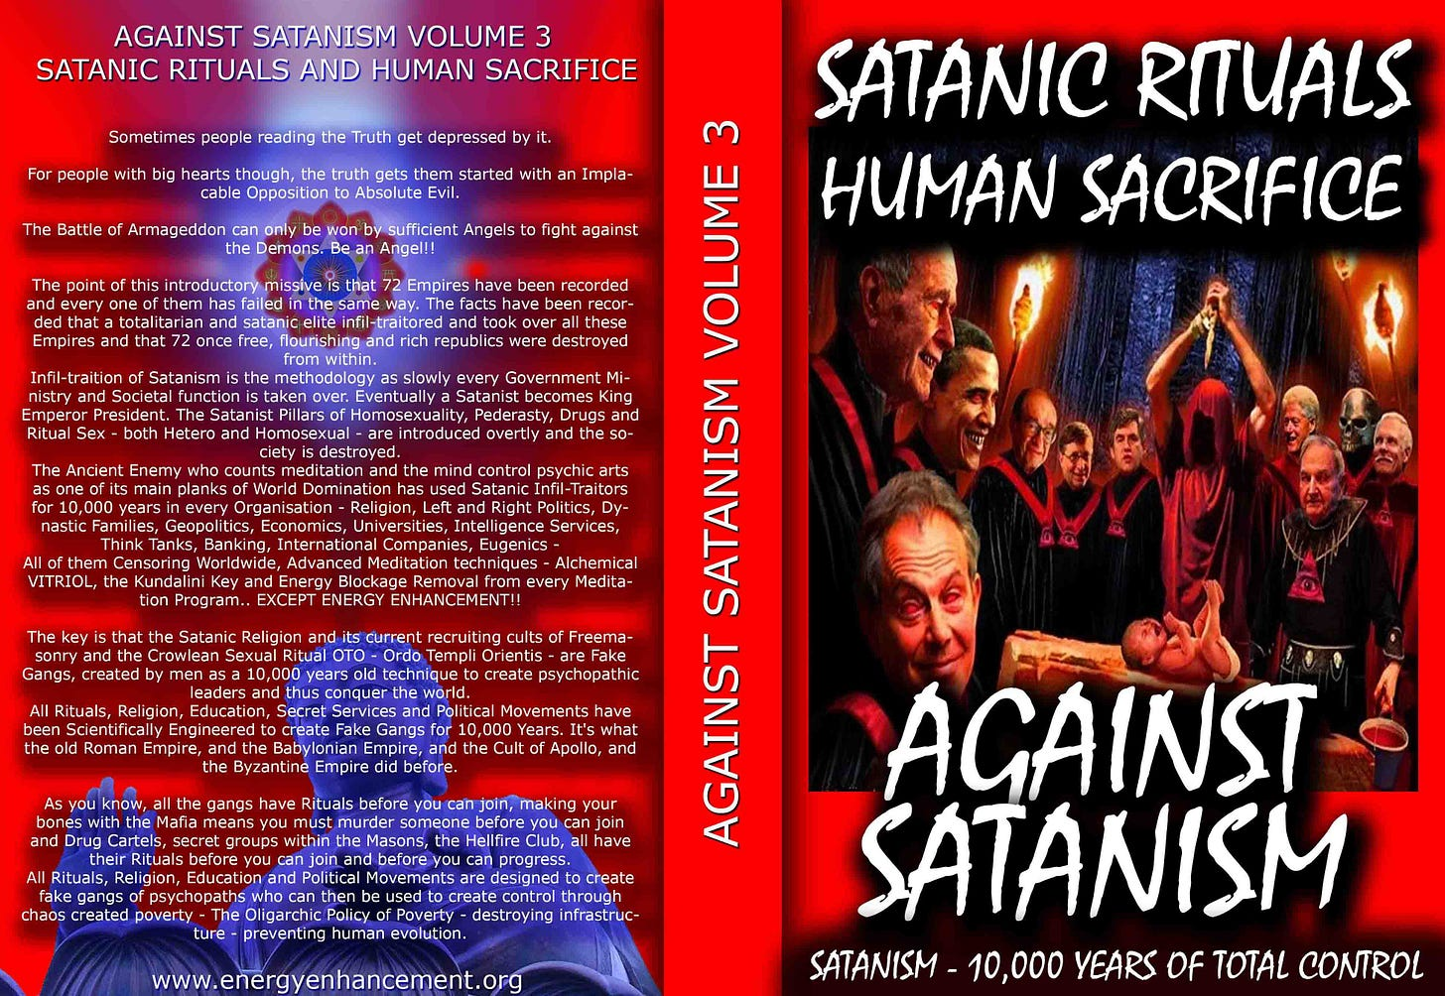

Satanic Phoenician Mega Trillionaires behind MKULTRA Mind Control Programs Bimbosleep Bimbofication and Sissi Hypno Sissification created by Tavistock Institute and the Nazi CIA Stanford University
Read full story
The key is that the Satanic Religion and it's current recruiting cults of Sodomy Ritual 33rd Degree Freemasonry, the Illuminati, Jesuits, Sabbatean Frankism, and the Crowlean Sexual Sodomy Ritual OTO - Ordo Templi Orientis, Yale Skull and Bones, Bohemian Grove - are Fake Gangs, created by men as a 10,000 years old technique to create psychopathic leaders and their minions, and thus conquer the world by constantly degenerating humanity into Orcs.
All Rituals, Religions, Education, Secret Services and Political Movements have been scientifically Engineered to create Fake Gangs for 10,000 years. It's what the old Roman Empire, The Babylonian Empire of Satanic Nimrod, and the Cult of Apollo and the Byzantine Empire did before.
As you know, every Gang has Blackmail Rituals before you can join. Making your Bones with the Mafia means you must murder someone before you can join. Drug Cartels like MS13, secret groups within the Masons, the Illuminati, Sabbatean Frankists, OTO, the Hellfire Club, all have their Human Sacrifice, Pedophilia and Sodomy Rituals before you can progress.
Epstein did not kill himself. He videoed Scientists from MIT and Harvard, Oligarchs, Politicians etc, Pedophiling young girls then Blackmailed them into doing the work of his Trillionaire sponsors - MKULTRA, Transhumanism, CRISPR Androids. As their willing victims are given access to stealing higher quantities of money, so they must go to the next level of Ritual. First it is 15 year old girls who look 25. Then it's 12 year olds, 5 year olds, and then its the murder of children, babies!
Since the Band of Thebes of fierce homosexual warriors, sodomy rituals bind together that Band of Brothers at the head of Military Organisations Worldwide, NATO, AZOV Battalion, the SS, American and British Army and Navy...
All to create a degenerated Satanic Society of Total Control through Human Sacrifice, poverty, starvation, bugs, miseducation, lack of education, Wokeness, Climate Change, Sustainability, poison in the air, water and food. Lack of infrastructure, Lack of Energy - Electricity, Coal, Petroleum, education and Total Censorship Control of the Media.
All of them Censoring Worldwide, Advanced Meditation techniques - Alchemical VITRIOL, the Kundalini Key and Energy Blockage Removal from every Meditation Program..

EXCEPT ENERGY ENHANCEMENT MEDITATION!!
https://www.energyenhancement.org

The very word secrecy is repugnant in a free and open society JFK (27 April 1961)
The very word secrecy is repugnant in a free and open society; and we are as a people inherently and historically opposed to secret societies, to secret oaths and to secret proceedings. For we are opposed around the world by a monolithic and ruthless conspiracy that relies primarily on covert means for expanding its sphere of influence on infiltration instead of invasion, on subversion instead of elections, on intimidation instead of free choice, on guerrillas by night instead of armies by day. It is a system which has conscripted vast human and material resources into the building of a tightly knit, highly efficient machine that combines military, diplomatic, intelligence, economic, scientific and political operations.
JFK (27 April 1961)

What We See when we Remove an Energy Blockage is the Secret of Infinite Energy
What We See when we Remove an Energy Blockage is the Secret of Infinite Energy, Secret of Eternal Life, the Secret of Immortality. Energy Blockages are Satanic, and it is this we see directly when we remove the blockages with the Energy Enhancement Meditation Course.. Energy Blockages do not exist alone, they are part of a network of evil, a network of control, which is designed not to allow people to understand the nature of that control, the purpose of that control, so as to maintain that control and the flow of energy - stolen from all human beings - to allow an elite of Black magicians, Sorcerers, Enchanters, Warlocks, Witches, Necromancers, Devils, Dark Gods... to live forever, Immortally, in private Universes, outside the body and then to download into a body from time to time, to maintain their Plantation, their Farm, their Property, to maintain the flow of stolen spiritual energy to them from every human being on this planet - Eternally. This is why I wrote Twelve volumes of Against Satanism..
See this..
http://www.energyenhancement.org/Third-Eye-Psychic-vision-see-Remove-Energy-Blockage-Secret-of-Infinite-Spiritual-Energy-Eternal-Life-Immortality-meditation-Energy-Enhancement-Seven-Step-Process.htm

In order to remove blockages using the Level 2 Seven Step Process, Internally, we teach you how to Ground every trace of Satanic Energy which makes sick, which perverts, which degenerates!

Externally we see the effect of Satanic Energy Blockages and their creators, on the World.. This is why I wrote twelve volumes of Against Satanism.. available FREE! on signup on
Only Energy Enhancement can Annihilate Evil on Earth and change this Planet into a Planet of Love and Light in this Place, for You, for Me, for the Entire Human Race.
The best way to get around the internet censors and their shadow banning and make sure you see the stuff I publish is to subscribe to the mailing list for my website, energyenhancement.org which will get you an email notification for everything I broadcast and Free download access to the 52 Spiritual Books I publish.

My work is entirely reader-supported
My work is entirely reader-supported and the incredible Energy Enhancement Meditation Course supported so if you enjoyed this piece please consider sharing it around, donating to my substack account, throwing some money into my hat directly to my bank account (email me) via Transferwise, buying my hard copy books on Amazon https://www.amazon.com/s?k=swami+satchidanand Everyone, has my permission to republish or use any part of my work (or anything else I’ve written) in any way they like free of charge.

FREE!! READ THE AGAINST SATANISM SERIES OF TWELVE BOOKS!!
ALL FIVE BOOKS OF STUDENT REPORTS OF THE SPIRITUAL WARRIORS ON THE ENERGY ENHANCEMENT VIDEO MEDITATION COURSE PATH TO SELF REALISATION
https://www.energyenhancement.org/Sacred-Energy/5-Spiritual-Warrior-Books.rar
All 16 Energy Enhancement Meditation Books - “The Only Solution to Satanism” in an easily downloadable file from our own website.
https://againstsatanism.com/Sacred-Energy/All-Energy-Enhancement-Meditation-Books-Swami-Satchidanand.rar
Against Satanism by Satchidanand Volumes 1 to 12 - “The Occulted Satanic History of the World” - Your Worldview Will Never Be the Same! - in an easily downloadable file from our own website.
https://againstsatanism.com/Sacred-Energy/Against-Satanism-Volumes-1-12.rar
Mind Control Black Assassins by Satchidanand Volumes 1 to 11 in an easily downloadable file from our own website.
https://againstsatanism.com/Sacred-Energy/Black-Assassins-Volumes-1-11.rar
Satanic Spiritual Movie Reviews by Satchidanand Volumes One - “Blacklisted” and Two “AI and Transhumanism” in an easily downloadable file from our own website.
https://againstsatanism.com/Sacred-Energy/Spiritual-Movie-Reviews-Vols-1-and-2-Energy-Enhancement-Swami-Satchidanand.zip
All Osho Books One by One
http://www.energyenhancement.org/Sacred-Energy/Oshoa.k.a.Rajneesh(312Books).rar
THE SATANIC PHOENICIAN BLACK NOBILITY RULERS OF THE WORLD VOLUMES 1 AND 2
Prince Duccio Corsini is a Roman prince and top owner of the Corsican Mafia. The Corsinis are both Florentine and Roman nobles. Prince Duccio is an overseer of a private Swiss banking and human trafficking operation in Gstadd, Switzerland. The Scherz family of Gstadd own a hotel in Gstadd and basically run Gstadd. The Scherz coat of arms is a heart. The Corsinis coat of arms is shaped as a heart and the Italian word Core or Coure has the meaning of heart. Prince Duccio also oversees the DEA. Lucien Conein was from Maryland and he was a documented associate of the Corsican Mafia and he worked for the OSS, CIA, and later for the DEA. The Corsican Mafia have a headquarters in Baltimore, Maryland and they oversee a large heroin and opium trafficking ring from Turkey, the Middle East, and Afghanistan to ports on the East Coast. Nancy Pelosi is from Baltimore and she is a Knight Grand Cross of the Italian Order of Merit and an agent of the Corsinis. The Corsican Mafia then traffics the heroin or opium to the Lucchese crime family which then provide it to the modern day Drug Council run by black gangster rappers. Corsica is named after the Corsinis and uses a black Moor on its coat of arms and flag. Moors, Arabs, and Africans invaded Europe and Slave trafficked natural white Europeans for over a thousand years. The Corsinis also owned banks in Florence and London.
And More...
Download this!
https://againstsatanism.com/Sacred-Energy/The-Satanic-Phoenician-Black-Nobility-Volumes-1and2.rar
(1913)
Did you know that in 1913 The Satanic Luciferian Phoenician Empire Mega Trillionaire Rothschild paid cronies voted for his Federal Reserve inside the United States Of America?
(D)
Did you know The Satanic Luciferian Phoenician Empire Mega Trillionaire Rothschild Banks has been stopped before and that some of our Presidents have been assassinated by this Bastard Banking Family?
- THE PRESIDENTS WHO KILLED ROTHSCHILD BANKING SCHEMES : ANDREW & ROOSEVELT AND THE PRESIDENTS MURDERED BY ROTHSCHILD ~ LINCOLN & KENNEDY!
You will find that approximately 90% of people in the world today who call themselves Jews are actually Khazars, or as they like to be known, Ashkenazi Jews. These people knowingly lie to the world with their claims that the land of Israel is theirs by birthright, when in actual fact their real homeland is over 800 miles away in Georgia.

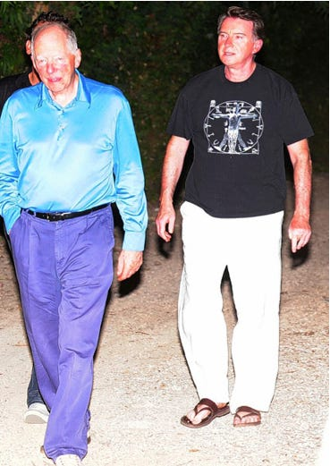

Walking Evil ~ Jacob Rothschild With Henchman

So, next time you hear an Israeli Prime Minister bleating about the so-called persecution of the Jews, consider this, every Prime Minister of Israel has been an Ashkenazi Jew. Therefore when all these Prime Ministers have curried favour with the West for their re-establishment of a Jewish homeland, they have knowingly and deliberately lied to you, as they were never from that region, and they well know it, because it is they who call themselves Ashkenazi Jews.New York Times: Obama Races To Save Jewish Vote In Continuing His War Pushing Democracy Upon The Republic Of The United States.
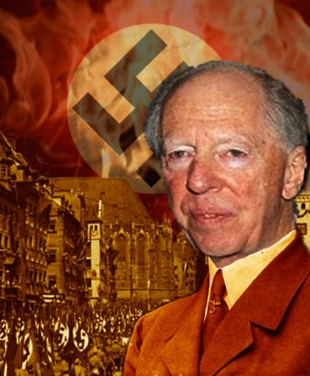

4th Baron Jacob Rothschild The Global Banking Chameleon
The Book of Revelation, Chapter 2, Verse 9, states the following which would appear to be about these Ashkenazi Jews:
“I know thy works, and tribulation and poverty, (but thou art rich) and I know the blasphemy of them which say they are Jews, and are not, but are the synagogue of Satan.”
The most wealthy bloodline in the world bar none and the leader of the Ashkenazi Jews in the world today is The Satanic Luciferian Phoenician Empire Mega Trillionaire Rothschild family. As you will see in the timeline, The Satanic Luciferian Phoenician Empire Mega Trillionaire Rothschilds have obtained this position through lies, manipulation and murder. Their bloodline also extends into the Royal Families of Europe, and the following family names: Astor; Bundy; Collins; duPont; Freeman; Kennedy; Morgan; Oppenheimer; Rockefeller; Sassoon; Schiff; Taft; and Van Duyn.
- Social Security Has A $2.6 Trillion Dollar Surplus: No Matter What Congress FEINS To Do: It Is The 2008-2011 Banker’s Gambling Bailout That Has America Subjugated To The Satanic Luciferian Phoenician Empire Mega Trillionaire Rothschild’s Fascism Takeover aka; New World Order.
However, these are not the only bloodlines to worry about. You are probably aware of the centuries old pratice undertaken by many Ashkenazi Jews whereby they would change their name, in order for them to appear part of the dominant race of the country in which they lived, so as they could obtain influential positions in that country, which they would then exploit to serve their real masters elsewhere. There is plenty of evidence to prove The Satanic Luciferian Phoenician Empire Mega Trillionaire Rothschilds continue that deceptive tradition.
Furthermore The Satanic Luciferian Phoenician Empire Mega Trillionaire Rothschilds are known to sire many children secretly that they can put into positions of power when required. This started with the very first man who took the name Rothschild, who had a secret sixth son. Finally, remember the world is a diverse place, I could if I wanted change my name to Rothschild, or any of the names listed above, and that would not make me part of this family anymore than converting to Judaism in 740 A.D. will make these Ashkenazis Jewish.
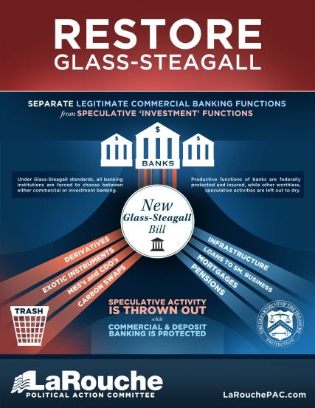
Please, therefore, do not automatically assume someone you see with the name Rothschild or any of the names listed above are part of the Rothschild criminal network. Furthermore and most importantly, the majority of Ashkenazi Jews are innocent and not part of this network. Check the facts out for yourself first, this article is designed to inform people who the enemy is, not single out people of a particular race or people with a particular surname, who may have nothing to do with this Rothschild criminal network.
The Satanic Luciferian Phoenician Empire Mega Trillionaire Rothschild Crime Family, Used Clinton’s Repeal Of The Glass Steagall Act To Commit Treason Against The United States

Glass-Steagall Act
1743:
Mayer Amschel Bauer, an Ashkenazi Jew, is born in Frankfurt, Germany, the son of Moses Amschel Bauer, a money lender and the proprietor of a counting house.
Moses Amschel Bauer places a red sign above the entrance door to his counting house. This sign is a red hexagram (which geometrically and numerically translates into the number 666) which under The Satanic Luciferian Phoenician Empire Mega Trillionaire Rothschild instruction will end up on the Israeli flag some two centuries later.
1753:
Gutle Schnaper, an Ashkenazi Jew (future wife of Mayer Amschel Bauer), born to respected merchant, Wolf Salomon Schnaper.
1760:
During this decade Mayer Amschel Bauer works for a bank owned by the Oppenheimers’ in Hanover, Germany. He is highly successful and becomes a junior partner. Whilst working at the bank he becomes acquainted with General von Estorff.
Following his father’s death, Bauer returns to Frankfurt to take over his father’s business. Bauer recognises the significance of the red hexagram and changes his name from Bauer to Rothschild, after the red hexagram or sign signifying 666 hanging over the entrance door (“Rot,” is German for, “Red,” “Schild,” is German for, “Sign”).
Now Mayer Amschel Rothschild, he discovers that General von Estorff is now attached to the court of Prince William IX of Hesse-Hanau, one of the richest royal houses in Europe, which gained its’ wealth by the hiring out of Hessian soldiers to foreign countries for vast profits (a practice that continues today in the form of exporting, “peacekeeping,” troops throughout the world).
He therefore makes the General’s re-acquaintance on the pretext of selling him valuable coins and trinkets at discounted prices. As he plans, Rothschild is subsequently introduced to Prince William himself who is more than pleased with discounted prices he charges for his rare coins and trinkets, and Rothschild offers him a bonus for any other business the Prince can direct his way.
- Michael Jackson & The Illuminati: Video
The Satanic Luciferian Phoenician Empire Mega Trillionaire Rothschild subsequently becomes close associates with Prince William, and ends up doing business with him and members of the court. He soon discovers that loaning money to governments and royalty is more profitable than loaning to individuals, as the loans are bigger and are secured by the nation’s taxes.
1769:
Mayer Amschel Rothschild is given permission by Prince William to hang a sign on the front of his business premises declaring that he is, “M. A. Rothschild, by appointment court factor to his serene highness, Prince William of Hanau.”
1770:

THE ROTHSCHILD CONTROLLED MI6, CIA AND MOSSAD

Luciferian and Satanic MI6 Covering Up Ukrainian Children Kidnapped For Sex Slavery & Organ Harvesting

Satchidanand
·
Jan 19
GLOBAL BOMBSHELL! Respected Former UK MP Says MI6 Is Covering Up Ukrainian Children Being Kidnapped For Sex Slavery & Organ Harvesting After They Are Smuggled Into England

Read full story

Mayer Amschel Rothschild draws up plans for the creation of the Illuminati and entrusts Ashkenazi Jew, Adam Weishaupt, a Crypto-Jew who was outwardly (PURE BULLSHIT) Roman Catholic, with its organization and development. The Illuminati is to be based upon the teachings of the Talmud, which is in turn, the teachings of Rabbinical Jews. It was to be called the Illuminati as this is a Luciferian term which means, keepers of the light.
- ROMAN CATHOLIC POPE BENEDICT XVI: EARTH’S ECOSYSTEM DAMAGED BY ROTHSCHILD HOARDING AND NOT BY HEALTHY CARBON DIOXIDE!
Mayer Amschel Rothschild marries Gutle Schnaper.
1773:
Amschel Mayer Rothschild born, the first of Mayer Amschel Rothschild’s sons. He like all his brothers who follow him, will enter the family business at the age of 12.
1774:
Salomon Mayer Rothschild born.
1776:
Adam Weishaupt officially completes his organisation of the Illuminati on May 1 of this year. The purpose of the Illuminati is to divide the goyim (all non-Jews) through political, economic, social, and religious means. The opposing sides were to be armed and incidents were to be provided in order for them to: fight amongst themselves; destroy national governments; destroy religious institutions; and eventually destroy each other.

THEY ALL WORK FOR THE CIA!!

Satchidanand
·
Jan 3

IT'S ALL FAKE, IT'S ALL A SCAM!!

Read full story

Weishaupt soon infiltrates the Continental Order of Freemasons with this Illuminati doctrine and establishes lodges of the Grand Orient to be their secret headquarters. This was all under the orders and finance of Mayer Amschel Rothschild and the concept has spread and is followed within Masonic Lodges worldwide to the present day.
Weishaupt also recruits 2,000 paid followers including the most intelligent men in the field of arts and letters, education, science, finance,and industry. They were instructed to follow the following methods in order to control people.
1) Use monetary and sex bribery to obtain control of men already in high places, in the various levels of all governments and other fields of endeavour. Once influential persons had fallen for the lies, deceits, and temptations of the Illuminati they were to be held in bondage by application of political and other forms of blackmail, threats of financial ruin, public exposure, and fiscal harm, even death to themselves and loved members of their families.
- VIDEO GRIGGS Whistleblower: Homosexuality Used By New World Order Gang For Blackmail: Lindsey Graham, Congress, & Military
2) The faculties of colleges and universities were to cultivate students possessing exceptional mental ability belonging to well-bred families with international leanings, and recommend them for special training in internationalism, or rather the notion that only a one-world government can put an end to recurring wars and strife. Such training was to be provided by granting scholarships to those selected by the Illuminati.
- New Orleans Runs $5,000,000.00 Anti-British Monarchy Campaign : Bobby Jindal Polemicized With Obama Just Long Enough For The Oil To Hit Louisiana Marshlands.
We’re Also Tired Of You Paying Big Money To People Like Jindal, McCain, Cantor, Boehner, Lieberman On The Other Side Of The Aisle ~ So You Can Keep Pushing The United States Further And Further To The Left, After The Holocaust By The Democrats Against Our Constitution. We’ll Be Watching Your RINOS Closely, We Are Keeping Score On Those Who Violate Our Constitution. Like Honduras
- ~ Honduras Did It, The United States People Will Too: Rush Limbaugh ~ Boot The Communist Impostor!
- Obama’s Socialism Marches Against Honduras’ Constitution: Obama Madness: I thought You Said We’re Not Going To Dictate?
Did You Really Think Arny Was Working For America? Buffet/Arny/Jacob Rothschild
3) All influential people trapped into coming under the control of the Illuminati, plus the students who had been specially educated and trained, were to be used as agents and placed behind the scenes of all governments as experts and specialists. This was so they would advise the top executives to adopt policies which would in the long-run serve the secret plans of the Illuminati one-world conspiracy and bring about the destruction of the governments and religions they were elected or appointed to serve.
4) To obtain absolute-control of the press, at that time the only mass-communications media which distributed information to the public, so that all news and information could be slanted in order to make the masses believe that a one-world government is the only solution to our many and varied problems.
1777:
Nathan Mayer Rothschild born.
1784:
Adam Weishaupt issues his order for the French Revolution to be started by by Maximilien Robespierre in book form. This book was written by one of Weishaupt’s associates, Xavier Zwack, and sent by courier from Frankfurt to Paris. However en route there, the courier is struck by lightning, the book detailing this plan discovered by the police, and handed over to the Bavarian authorities.
As a consequence, the Bavarian government orders the police to raid Weishaupt’s masonic lodges of the Grand Orient, and the homes of his most influential associates. Clearly, the Bavarian authorities were convinced that the book that was discovered was a very real threat by a private group of influential people, to use wars and revolutions to achieve their political ends.
1785:
The Bavarian government outlaw the Illuminati and close all the Bavarian lodges of the Grand Orient.
Mayer Amschel Rothschild moves his family home to a five storey house in Frankfurt which he shares with the Schiff family.
1786:
The Bavarian government publish the details of the Illuminati plot in a document entitled, “The Original Writings of The Order and Sect of The Illuminati.” They then send this document to all the heads of church and state throughout Europe, but sadly their warning is ignored.
1788:
Kalmann (Carl) Mayer Rothschild Born.

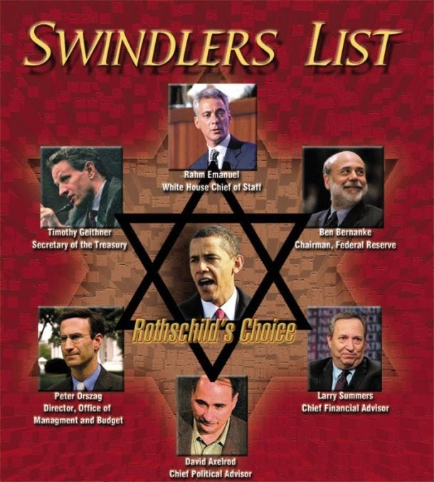

1789:
Due to the European ignorance of the Bavarian government’s warning, the Illuminati’s plan for a French Revolution succeeded from this year to 1793. This revolution was a bankers’ dream, it established a new constitution and passed laws that forbade the Roman Church from levying tithes (taxes) and also removed its exemption from taxation.
1790:
Mayer Amschel Rothschild states,
“Let me issue and control a nation’s money and I care not who writes the laws.”
1791:
The Satanic Luciferian Phoenician Empire Mega Trillionaire Rothschilds get, “control of a nation’s money,” through Alexander Hamilton (their agent - he was a Rothschild son in law - in George Washington’s cabinet) when they set up a central bank in the USA called the First Bank of the United States. This is established with a 20 year charter.
1792:
Jacob (James) Mayer Rothschild born.
1796:
Amschel Mayer Rothschild marries Eva Hanau.
1798:
John Robison publishes a book entitled, “Proofs of a Conspiracy Against All the Religions and Governments of Europe Carried on in the Secret Meetings of Freemasons, Illuminati and Reading Societies.” In this book, Professor Robison of the University of Edinburgh, one of the leading intellects of his time, who in 1783 was elected general secretary of the Royal Society of Edinburgh, gave details of the whole The Satanic Luciferian Phoenician Empire Mega Trillionaire Rothschild Illuminati plot.
He advised how he had been a high degree mason in the Scottish Rite of Freemasonry, and had been invited by Adam Weishaupt to Europe, where he had been given a revised copy of Weishaupt’s conspiracy. However, although he pretended to go along with it, Professor Robison did not agree with it and therefore published his aforementioned book. The book included details of the Bavarian government’s investigation into the Illuminati and the French Revolution.
- America Do NOT Forget Sen. McCain’s Seditious S.3081: Allows U.S. Military & Police To Now Detain And Interrogate American Citizens In The U.S., Without Probable Cause!
That same year on July 19th, David Pappen, President of Harvard University, lectured the graduating class on the influence illuminism was having on American politics and religion.
At the age of 21, Nathan Mayer Rothschild leaves Frankfurt for England, where with a large sum of money given to him by his father, he sets up a banking house in London.
1800:
Salomon Mayer Rothschild marries Caroline Stern.
1806:
Napolean states that it is his,
“object to remove the house of Hess-Cassel from rulership and to strike it out of the list of powers.”
On hearing this, Prince William IX of Hesse-Hanau, flees Germany, goes to Denmark and entrusts his fortune valued at $3,000,000 at that time to Mayer Amschel Rothschild for safekeeping.
Nathan Mayer Rothschild marries Hannah Barent Cohen the daughter of a wealthy London merchant.
1808:
Nathan Mayer Rothschild has his first son born Lionel Nathan de Rothschild.
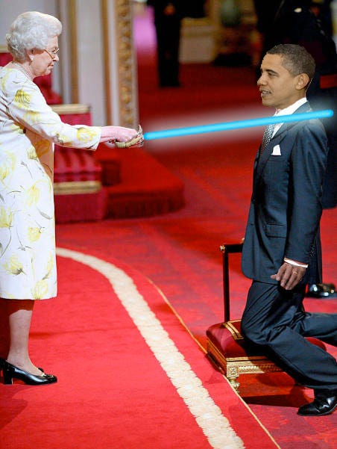
1810:
Sir Francis Baring and Abraham Goldsmid die. This leaves Nathan Mayer Rothschild as the remaining major banker in England.
Salomon Mayer Rothschild goes to Vienna, Austria and sets up the bank, M. von Rothschild und Söhne.

1811:
The charter for The Satanic Luciferian Phoenician Empire Mega Trillionaire Rothschilds Bank of the United States runs out and Congress votes against its renewal. Nathan Mayer Rothschild is not amused and he states,
“Either the application for renewal of the charter is granted, or the United States will find itself involved in a most disastrous war.”
However the United States stands firm and the Charter is not renewed, which causes Nathan Mayer Rothschild to issue another threat,
“Teach those impudent Americans a lesson. Bring them back to colonial status.”
1812:
Backed by The Satanic Luciferian Phoenician Empire Mega Trillionaire Rothschild money, and Nathan Mayer Rothschild’s orders, the British declare war on the United States. The Satanic Luciferian Phoenician Empire Mega Trillionaire Rothschilds plan was to cause the United States to build up such a debt in fighting this war that they would have to surrender to The Satanic Luciferian Phoenician Empire Mega Trillionaire Rothschilds and allow the charter for The Satanic Luciferian Phoenician Empire Mega Trillionaire Rothschild owned First Bank of the United States to be renewed.
Mayer Amschel Rothschild dies. In his will he lays out specific laws that the House of Rothschild were to follow: all key positions in the family business were only to be held by family members; only male members of the family were allowed to participate in the family business, this included a reported sixth secret bastard son (It is important to note that Mayer Amschel Rothschild also has five daughters, so today the spread of The Satanic Luciferian Phoenician Empire Mega Trillionaire Rothschild Zionist dynasty without The Satanic Luciferian Phoenician Empire Mega Trillionaire Rothschild name is far and wide, and Jews believe the mixed offspring of a Jewish mother is solely Jewish); the family was to intermarry with it’s first and second cousins to preserve the family fortune (of the 18 marriages by Mayer Amschel Rothschild’s grandchildren, 16 were between first cousins – a practice known today as inbreeding); no public inventory of his estate was to be published; no legal action was to be taken with regard to the value of the inheritance; the eldest son of the eldest son was to become the head of the family (this condition could only be overturned when the majority of the family agreed otherwise).
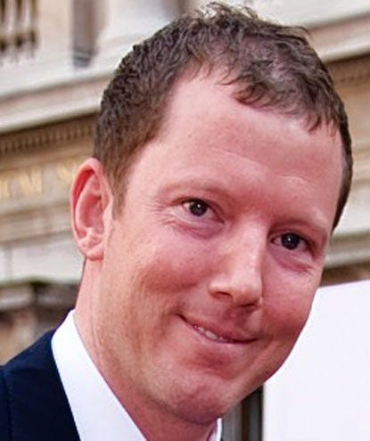
Puggy ~ Nat Rothschild is an Anti Abrahamic Jew (Zionist) _ But Pro (Teutonic Zionist) aka; International Banking Swindler with daddy’s silver spoon in his mouth.
This was straightaway the case and Nathan Mayer Rothschild was elected head of the family following his father, Mayer Amschel Rothschild’s death.
Jacob (James) Mayer Rothschild goes to Paris, France to set up the bank, de Rothschild Frères.
Nathaniel de Rothschild, the son in law of Jacob (James) Mayer Rothschild, born.
1814:
With regard to the $3,000,000 Prince William IX of Hesse-Hanau had entrusted to Mayer Amschel Rothschild for safekeeping, for an account of what happened next we turn to the Jewish Encyclopaedia, 1905 edition, Volume 10, page 494, which states,
“According to legend this money was hidden away in wine casks, and, escaping the search of Napoleon’s soldiers when they entered Frankfurt, was restored intact in the same casks in 1814, when the elector (Prince William IX of Hesse-Hanau) returned to the electorate (Germany). The facts are somewhat less romantic, and more businesslike.”
This last line indicates the money was never returned by The Satanic Luciferian Phoenician Empire Mega Trillionaire Rothschild to Prince William IX of Hesse-Hanau. The encyclopaedia goes on to state,
“Nathan Mayer Rothschild invested this $3,000,000 in, gold from the East India Company knowing that it would be needed for Wellington’s peninsula campaign.”
On the stolen money Nathan made,
“no less than four profits:
1815:
The five Rothschild brothers work to supply gold to both Wellington’s army (through Nathan in England) and Napoleon’s army (through Jacob in France), and begin their policy of funding both sides in wars. The Satanic Luciferian Phoenician Empire Mega Trillionaire Rothschilds love wars because they are massive generators of risk free debt.
This is because they are guaranteed by the government of a country, and therefore the efforts of the population of that country, and it doesn’t matter if that country loses the war because the loans are given on the guarantee that the victor will honour the debts of the vanquished.
- Italy Calls France, United States, & Britain To Immediately Halt Libya War: Italy Blocks Use Of Their Airbases By NATO. Now Rothschild Puts The Screws To Italy!
Whilst the Satanic Luciferian Phoenician Empire Mega Trillionaire Rothschilds are funding both sides in this war, they use the banks they have spread out across Europe to give them the opportunity to set up an unrivalled postal service network of secret routes and fast couriers. The post these couriers carried was to be opened up by these couriers and their details given to the Satanic Luciferian Phoenician Empire Mega Trillionaire Rothschilds so they always were one step ahead of current events.
Furthermore, these Satanic Luciferian Phoenician Empire Mega Trillionaire Rothschild couriers were the only merchants allowed to pass through the English and French blockades. It was these couriers who also kept Nathan Mayer Rothschild up to date with how the war was going so he could use that intelligence to buy and sell from his position on the stock exchange in accordance with that intelligence.
One of Satanic Luciferian Phoenician Empire Mega Trillionaire Rothschild’s couriers was a man named Rothworth. When the outcome of the Battle of Waterloo was won by the British, Rothworth took off for the Channel and was able to deliver this news to Nathan Mayer Rothschild, a full 24 hours before Wellington’s own courier.
At that time British bonds were called consuls and they were traded on the floor of the stock exchange. Nathan Mayer Rothschild instructed all his workers on the floor to start selling consuls. The made all the other traders believe that the British had lost the war so they started selling frantically.
Therefore the consuls plummeted in value which was when Nathan Mayer Rothschild discreetly instructed his workers to purchase all the consuls they could lay their hands on.
When news came through that the British had actually won the war, the consuls went up to a level even higher than before the war ended leaving Nathan Mayer Rothschild with a return of approximately 20 to 1 on his investment.
This gave the Satanic Luciferian Phoenician Empire Mega Trillionaire Rothschild family complete control of the British economy, now the financial centre of the world following Napolean’s defeat, and forced England to set up a new Bank of England, which Nathan Mayer Rothschild controlled.
Interestingly 100 years later the New York Times would run a story stating that Nathan Mayer Rothschild’s grandson had attempted to secure a court order to suppress publication of a book which had this insider trading story in it. The Satanic Luciferian Phoenician Empire Mega Trillionaire Rothschild family claimed the story was untrue and libellous, but the court denied the Satanic Luciferian Phoenician Empire Mega Trillionaire Rothschilds request and ordered the family to pay all court costs.
George Soros – Jacob’s Right Hand Man. Soros Spreads The Banking Money To Corrupt Upper Echelons In A Targeted Nation, Then Orchestrates Highly Leveraged Inside Trading Mechanism’s To Bilk The People Of The Targeted Nation.
The Mechanism Is Called Pump/Dump Which Just Happened To The United States By Pumping The Housing Industry With Worthless Unsecured Mortgages called DERIVATIVES and then Allowing The ‘Pumping/Predatory Loaning’ Of Non-Existant Money, To Then Collapse Upon Itself. Then The Corrupt National Representatives Print Money To Bailout The Satanic Luciferian Phoenician Empire Mega Trillionaire Rothschild International Banks When There Was No Real Debt To Begin With.
This Mechanism Keeps This Targeted Nation Paying Taxes Into This Hollow Vacuum Where The FASCIST PHILOSOPHY HELD BY THE ROTHSCHILD BANKS Centralize The Wealth To Themselves. They Then Begin To Dictate To The World How You’re Going To Be Their Slaves. This is why there is so much chaos in the world now.
It is to SHAKE up nations thru conflict/wars where Satanic Luciferian Phoenician Empire Mega Trillionaire Rothschilds can purchase corporations under duress with very low prices. That is exactly what the Satanic Luciferian Phoenician Empire Mega Trillionaire Rothschild Criminal Family is doing now to the U.S. Reality ‘Housing’ Market.
REPUBLICANS ARE DOING ONLY TOKEN DEFUNDING OF PROGRAMS WHICH THRU THE ROTHSCHILD OWNED AND OPERATED MEDIA IS MADE TO SOUND ENORMOUSLY PATRIOTIC -> IT IS PURE SWINDLING – ASK THESE SO CALLED CONSERVATIVE REPUBLICANS IF THEY WILL INSTALL THE GLASS STEAGALL ACT LIKE FDR DID, WHICH PREVENTED THESE BASTARDS FROM ABSCONDING AMERICA’S WEALTH AND MIDDLE CLASS.
Back to 1815,
this is the year Nathan Mayer Rothschild makes his famous statement,
“I care not what puppet is placed upon the throne of England to rule the Empire on which the sun never sets. The man who controls Britain’s money supply controls the British Empire, and I control the British money supply.”
He would go onto brag that in the 17 years he had been in England he had increased the £20,000 stake given to him by his father, 2500 times to £50 million.

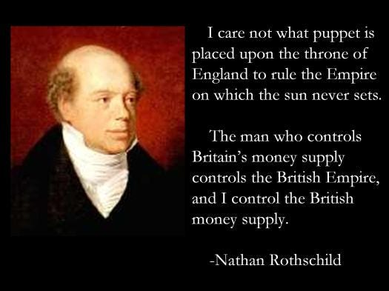

THE UNITED STATES LAW THAT WOULD QUASH ROTHSCHILD.
- Glass-Steagall Act
- Power Of Glass-Steagall Act: A Blow Against British Monarchy’s London Banks ~ Monarchy Threatens With War If Passed!
The Satanic Luciferian Phoenician Empire Mega Trillionaire Rothschilds also use their control of the Bank of England to replace the method of shipping gold from country to country and instead used their five banks spread across Europe to set up a system of paper debits and credits, the banking system of today.
By the end of this century, a period of time that was known as the, “Age of the Satanic Luciferian Phoenician Empire Mega Trillionaire Rothschilds,” it is estimated that the Satanic Luciferian Phoenician Empire Mega Trillionaire Rothschild family controlled half the wealth of the world.
However something that did not go well for the Satanic Luciferian Phoenician Empire Mega Trillionaire Rothschilds this year was the Congress of Vienna, which started in September, 1814 and concluded in June of this year. The reason for this Congress of Vienna, was for the Satanic Luciferian Phoenician Empire Mega Trillionaire Rothschilds to create a form of world government, to give them complete political control over much of the civilized world.
- Satanic Luciferian Phoenician Empire Mega Trillionaire Rothschild Controlled UN: War Of Aggression Against Libya Is A Gross Violation Of International Law.
Many of the European governments were in debt to the Satanic Luciferian Phoenician Empire Mega Trillionaire Rothschilds, so they figured they could use that as a bargaining tool. However the Tsar Alexander I of Russia, who had not succumbed to a Satanic Luciferian Phoenician Empire Mega Trillionaire Rothschild central bank, would not go along with the plan, so the Satanic Luciferian Phoenician Empire Mega Trillionaire Rothschild world government plan failed.
Enraged by this, Nathan Mayer Rothschild swore that some day he or his descendants would destroy the Tsar Alexander I’s entire family and descendants. Unfortunately he was true to his word and 102 years later Satanic Luciferian Phoenician Empire Mega Trillionaire Rothschild funded Bolsheviks would act upon that promise.
Interestingly, world government fanatic and Ashkenazi Jew, Henry Kissinger, did his doctoral dissertation on the Congress of Vienna.
1816:
The American Congress passes a bill permitting yet another Satanic Luciferian Phoenician Empire Mega Trillionaire Rothschild dominated central bank, which gives the Satanic Luciferian Phoenician Empire Mega Trillionaire Rothschilds control of the American money supply again. This is called the Second Bank of the United States and is given a twenty year charter. The British war against the America therefore ends with the deaths of thousands of British and American soldiers, but the Satanic Luciferian Phoenician Empire Mega Trillionaire Rothschilds get their bank.
1818:
Following the French securing massive loans in 1817 in order to help rebuild after their disastrous defeat at Waterloo, Satanic Luciferian Phoenician Empire Mega Trillionaire Rothschild agents bought vast amounts of French government bonds causing their value to increase.
On November 5th they dumped the lot on the open market causing their value to plummet and France to go into a financial panic. The Satanic Luciferian Phoenician Empire Mega Trillionaire Rothschilds then stepped in to take control of the French money supply. This was the same year the Satanic Luciferian Phoenician Empire Mega Trillionaire Rothschilds were able to loan £5,000,000 to the Prussian government.
1822:
The emperor of Austria made the five Satanic Luciferian Phoenician Empire Mega Trillionaire Rothschild brothers Barons. Nathan Mayer Rothschild chose not to take up the title.
1823:
The Satanic Luciferian Phoenician Empire Mega Trillionaire Rothschilds take over the financial operations of the Catholic Church, worldwide. THIS IS PURE BULLSHIT, ROTHSCHILDS ARE ENEMIES OF THE ROMAN CATHOLIC CHURCH AND NEVER TOOK OVER THEIR FINANCES. IN FACT THE ROTHSCHILD’S ARE PRESENTLY FREEZING THE VATICAN FUNDS FROM ACCESS.
1827:
Sir Walter Scott publishes his nine volume set, The life of Napolean and in volume two he states that the French Revolution was planned by the Illuminati (Adam Weishaupt) and was financed by the money changers of Europe (The Satanic Luciferian Phoenician Empire Mega Trillionaire Rothschilds).
1832:
President Andrew Jackson (the 7th President of the United States from 1829 to 1837), runs the campaign for his second term in office under the slogan, “Jackson And No Bank!” This is in reference to his plan to take the control of the American money system to benefit the American people, not for the profiteering of the Satanic Luciferian Phoenician Empire Mega Trillionaire Rothschilds.
1833:
President Andrew Jackson starts removing the government’s deposits from the Satanic Luciferian Phoenician Empire Mega Trillionaire Rothschild controlled, Second Bank of the United States and instead deposits them into banks directed by democratic bankers.
This causes the Satanic Luciferian Phoenician Empire Mega Trillionaire Rothschilds to panic and so they do what they do best, contract the money supply causing a depression. President Jackson knows what they are up to and later states,
“You are a den of thieves vipers, and I intend to rout you out, and by the Eternal God, I will rout you out.”
1834:
The Italian revolutionary leader, Guiseppe Mazzini, is selected by the Illuminati to direct their revolutionary program throughout the world and would serve in that capacity until he died in 1872.
1835:
On January 30, an assassin tries to shoot President Jackson, but miraculously both of the assassin’s pistols misfired. President Jackson would later claim that he knew the Satanic Luciferian Phoenician Empire Mega Trillionaire Rothschilds were responsible for that attempted assassination. He is not the only one, the assassin, Richard Lawrence, who was found not guilty by reason of insanity, later bragged that powerful people in Europe had hired him and promised to protect him if he were caught.
The Satanic Luciferian Phoenician Empire Mega Trillionaire Rothschilds acquire the rights in the Almadén quicksilver mines in Spain. This was at the time the biggest concession in the world and as quicksilver was a vital component in the refining of gold or silver this gave the Satanic Luciferian Phoenician Empire Mega Trillionaire Rothschilds a virtual world monopoly.
1836:
Following his years of fighting against the Satanic Luciferian Phoenician Empire Mega Trillionaire Rothschilds and their central bank in America, President Andrew Jackson finally succeeds in throwing the Satanic Luciferian Phoenician Empire Mega Trillionaire Rothschilds central bank out of America, when the bank’s charter is not renewed. It would not be until 1913 that the Satanic Luciferian Phoenician Empire Mega Trillionaire Rothschilds would be able to set up their third central bank in America, the Federal Reserve, and to ensure no mistakes are made, this time they will put one of their own bloodline, Jacob Schiff, in charge of the project.
Nathan Mayer Rothschild dies and the control of his bank, N. M. Rothschild & Sons is passed on to his younger brother, James Mayer Rothschild.
1837:
The Satanic Luciferian Phoenician Empire Mega Trillionaire Rothschilds send one of their own, August Belmont, an Ashkenazi Jew, to America to salvage their banking interests defeated by President Andrew Jackson.
1840:
The Satanic Luciferian Phoenician Empire Mega Trillionaire Rothschilds become the Bank of England’s bullion brokers. They set up agencies in California and Australia.
1841:
President John Tyler (the 10th President of the United States From 1841 to 1845) vetoed the act to renew the charter for the Bank of the United States. He goes on to receive hundreds of letters threatening him with assassination.
1844:
Salomon Mayer Rothschild purchases the United Coal Mines of Vítkovice and Austro-Hungarian Blast Furnace Company that would go on to be one of the top ten global industrial concerns.
Benjamin Disraeli, an Ashkenazi Jew (who would go on to become British Prime Minister twice – the only admitted Ashkenazi Jew to do so) publishes Coningsby, in which he characterises Nathan Mayer Rothschild as,
“the Lord and Master of the money markets of the world, and of course virtually Lord and Master of everything else. He literally held the revenues of Southern Italy in pawn, and Monarchs and Ministers of all countries courted his advice and were guided by his suggestions.”
1845:
The Great American Patriot, Andrew Jackson (7th President of the United States) dies.
Before his death he is asked what he regarded his as greatest achievement. He replies without hesitation,
“I Killed The Bank,”
This is in reference to the fact he banished the Satanic Luciferian Phoenician Empire Mega Trillionaire Rothschilds Second Bank of the United States in 1836.
Jacob (James) Mayer Rothschild (who by now had married his niece, Betty, Salomon Mayer Rothschild’s daughter), now known as Baron James de Rothschild, wins the contract to build the first major railway line across the country.
This was called the Chemin De Fer Du Nord and ran initially from Paris to Valenciennes and then joined with the Austrian rail network built by his brother (and wife’s father – all sounds a bit sordid doesn’t it) Salomon Mayer Rothschild.
1847:
Lionel De Rothschild now married to the daughter of his uncle, Kalmann (Carl) Mayer Rothschild, is elected to the parliamentary seat for the City of London.
A requirement for entering parliament was to take an oath in the true faith of a Christian. Lionel De Rothschild refused to do this as he was Jewish and his seat in parliament remained empty for 11 years until new oaths were allowed. He must have been an invaluable representative for his constituency, bearing in mind he could never vote on any bill as he never entered parliament! I wonder how he managed to keep his parliamentary seat for 11 years?
1848:
Karl Marx, an Ashkenazi Jew, publishes, “The Communist Manifesto.” Interestingly at the same time as he is working on this, Karl Ritter of Frankfurt University was writing the antithesis which would form the basis for Freidrich Wilhelm Nietzsche’s, “Nietzscheanism.” This Nietzecheanism was later developed into Fascism and then into Nazism and was used to foment the first and second world wars.
Marx, Ritter, and Nietzsche were all funded and under the instruction of the Satanic Luciferian Phoenician Empire Mega Trillionaire Rothschilds. The idea was that those who direct the overall conspiracy could use the differences in those two so-called ideologies to enable them to divide larger and larger factions of the human race into opposing camps so that they could be armed and then brainwashed into fighting and destroying each other, and particularly, to destroy all political and religious institutions. The same plan put forward by Weishaupt in 1776.
Eva Hanau, Amschel Mayer Rothschild’s wife dies.
1849:

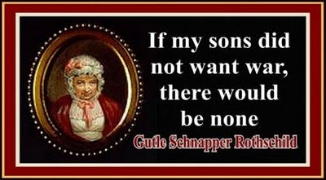

Gutle Schnaper, Mayer Amschel Rothschild’s wife dies. Before her death she would nonchalantly state,
1850:
Construction begins this decade on the manor houses of Mentmore in England and Ferrières in France, more Satanic Luciferian Phoenician Empire Mega Trillionaire Rothschilds Manors will follow throughout the world, all of them filled with works of art.
Jacob (James) Rothschild in France is said to be worth 600 million francs, which at the time was 150 million francs more than all the other bankers in France put together.
1852:
N.M. Rothschild & Sons begins refining gold and silver for the Royal Mint and the Bank of England and other international customers.
1853:
Nathaniel de Rothschild, the son in law of Jacob (James) Mayer Rothschild, purchases Château Brane Mouton, the Bordeaux vineyard of Mouton, and renames it Château Mouton Rothschild.
1854:
Caroline Stern, Salomon Mayer Rothschild’s wife, dies.
1855:
Amschel Mayer Rothschild dies.
Salomon Mayer Rothschild dies.
Kalmann (Carl) Mayer Rothschild dies.
1858:
Lionel De Rothschild finally takes his seat in parliament when the requirement to take an oath in the true faith of a Christian is broadened to include other oaths. He becomes the first Jewish member of the British parliament.
1861:
President Abraham Lincoln (16th President of the United States from 1860 till his assassination in 1865) approaches the big banks in New York to try to obtain loans to support the ongoing American civil war. As these large banks were heavily under the influence of the Satanic Luciferian Phoenician Empire Mega Trillionaire Rothschilds, they offer him a deal they know he cannot accept, 24% to 36% interest on all monies loaned.
Lincoln is very angry about this high level of interest and so he prints his own debt free money and informs the public that this is now legal tender for both public and private debts.
1862:
By April $449,338,902 worth of Lincoln’s debt free money has been printed and distributed. He states of this,
“We gave the people of this republic the greatest blessing they ever had, their own paper money to pay their own debts.”
That same year The Times of London publishes a story containing the following statement,
“If that mischievous financial policy, which had its origin in the North American Republic, should become indurated down to a fixture, then that government will furnish its own money without cost. It will pay off debts and be without a debt. It will have all the money necessary to carry on its commerce.
1863:
President Abraham Lincoln discovers the Tsar of Russia, Alexander II (1855 – 1881), was having problems with the Satanic Luciferian Phoenician Empire Mega Trillionaire Rothschilds as well as he was refusing their continual attempts to set up a central bank in Russia. The Tsar then gives President Lincoln some unexpected help.
The Tsar issued orders that if either England or France actively intervened in the American Civil War, and help the South, Russia would consider such action a declaration of war, and take the side of President Lincoln. To show that he wasn’t messing about, he sent part of his Pacific Fleet to port in San Francisco and another part to New York.
The Satanic Luciferian Phoenician Empire Mega Trillionaire Rothschild banking house in Naples, Italy, C. M. de Rothschild e figli, closes following the unification of Italy. The Satanic Luciferian Phoenician Empire Mega Trillionaire Rothschilds use one of their own in America, John D. Rockefeller, to form an oil business called Standard Oil which eventually takes over all of its competition.
1864:
Satanic Luciferian Phoenician Empire Mega Trillionaire Rothschild, August Belmont, who by now is the Democratic Party’s National Chairman, supports General George McClellan as the Democratic nominee to run against President Abraham Lincoln in this year’s election. Much to the anger of Belmont, President Lincoln wins the election.
1865: In a statement to Congress, President Abraham Lincoln states,
“I have two great enemies, the Southern Army in front of me, and the financial institutions in the rear. Of the two, the one in my rear is my greatest foe.”
Later that year, on April 14, President Lincoln is assassinated, less than two months before the end of the American Civil War.
Following a brief training period in the Satanic Luciferian Phoenician Empire Mega Trillionaire Rothschilds London Bank, Jacob Schiff, a Satanic Luciferian Phoenician Empire Mega Trillionaire Rothschild, born in their house in Frankfurt, arrives in America at the age of 18, with instructions and the finance necessary to buy into a banking house there. The purpose of this was to carry out the following tasks.
1. Gain control of America’s money system through the establishment of a central bank.
Nathaniel de Rothschild becomes Member of Parliament for Aylesbury in Buckinghamshire.
1868:
Jacob (James) Mayer Rothschild dies, shortly after purchasing Château Lafite, one of the four great premier grand cru estates of France. He is the last of Mayer Amschel Rothschild’s sons to die.
1870:
Nathaniel de Rothschild dies.
1871:
Pike, who having been elected as Sovereign Grand Commander of the Scottish Rite of Freemasonry’s Southern Jurisdiction in 1859, was the most powerful Freemason in America. He would retain that post for 32 years until his death in 1891. He also published a book on the subject in 1872 entitled, “Morals and Dogma of the Ancient and Accepted Scottish Rite of Freemasonry,” in which he candidly states the following,
“LUCIFER, the Light-bearer! Strange and mysterious name to give to the Spirit of Darknesss! Lucifer, the Son of the Morning! Is it he who bears the Light, and with its splendors intolerable blinds feeble, sensual or selfish Souls? Doubt it not!”
1872:
Prior to Guiseppe Mazzini’s death this year, he makes another revolutionary leader named Adrian Lemmy his successor. Lemmy will be subsequently succeeded by Lenin and Trotsky, then by Stalin. The revolutionary activities of all these men are financed by the Satanic Luciferian Phoenician Empire Mega Trillionaire Rothschilds.
1873:
The loss making Rio Tinto copper mines in Spain, are purchased by a group of foreign financiers including the Satanic Luciferian Phoenician Empire Mega Trillionaire Rothschilds. These mines represented Europe’s largest source of copper.
1875:
On January 1 of this year Jacob Schiff, now Solomon Loeb’s son-in-law after marrying his daughter, Teresa, takes control of the banking house, Kuhn, Loeb & Co. He goes on to finance John D. Rockefeller’s Standard Oil Company, Edward R. Harriman’s Railroad Empire, and Andrew Carnegie’s Steel Empire. This is all with Satanic Luciferian Phoenician Empire Mega Trillionaire Rothschild money.
- Iceland Declares Independence From Satanic Luciferian Phoenician Empire Mega Trillionaire Rothschild International Banking Cabal aka; NWO.
He then identifies the other largest bankers in America at that time. They are, J.P. Morgan who controls Wall Street, and the Drexels and the Biddles of Philadelphia. All the other financiers, big and little, danced to the music of those three houses. Schiff then gets the European Satanic Luciferian Phoenician Empire Mega Trillionaire Rothschilds to set up European branches of these three large banks on the understanding that Schiff, and therefore Satanic Luciferian Phoenician Empire Mega Trillionaire Rothschild, is to be the boss of banking in New York and therefore America.
N M Rothschild & Sons undertake a share issue to raise capital for the first channel tunnel project to link France to England, with half of its capital coming from the Satanic Luciferian Phoenician Empire Mega Trillionaire Rothschild owned Compagnie du Chemin de Fer du Nord.



This year Lionel De Rothschild also loans Prime Minister Benjamin Disraeli the finance for the British government to purchase the shares in the Suez Canal, from Khedive Said of Egypt. This was done as the Satanic Luciferian Phoenician Empire Mega Trillionaire Rothschilds needed this access route to be held by a government they controlled, so they could use that government’s military to protect their huge business interests in the Middle East.
1876:
Otto von Bismarck states,
“The division of the United States into two federations of equal force was decided long before the civil war by the high financial power of Europe. These bankers were afraid that the United States, if they remained in one block and as one nation, would attain economical and financial independence, which would upset their financial domination over the world.
1879:
Lionel de Rothschild dies.
1880:
Satanic Luciferian Phoenician Empire Mega Trillionaire Rothschild agents begin formenting a series of pogroms predominantly in Russia, but also in Poland,Bulgaria and Romania. These pogroms resulted in the slaughter of thousands of innocent Jews, causing approximately 2 million to flee, mainly to New York, but also to Chicago, Philadelphia, Boston and Los Angeles.
The reason these pogroms were initiated, was to create a large Jewish base in America, who when they arrived, would be educated to register as Democrat voters. Some twenty years later, this would result in in a massive Democratic power base in the United States and be used to elect Satanic Luciferian Phoenician Empire Mega Trillionaire Rothschild front men such as Woodrow Wilson, to the Presidency, to carry out the bidding of the Satanic Luciferian Phoenician Empire Mega Trillionaire Rothschilds.
1881:
President James A. Garfield (The 20th President of the United States who lasted only 100 Days) states two weeks before he is assassinated,
“Whoever controls the volume of money in our country is absolute master of all industry and commerce…and when you realize that the entire system is very easily controlled, one way or another, by a few powerful men at the top, you will not have to be told how periods of inflation and depression originate.”
Edmond James de Rothschild has a son Maurice de Rothschild.
1883:
After 6,000 feet of tunnel in the channel tunnel project being excavated, the British government halt the project citing the fact that it would be a threat to Britain’s security.
1885:
Nathaniel Rothschild, son of Lionel De Rothschild, becomes the first Jewish peer and is takes the title of Lord Rothschild.
1886:
The French Rothschild bank, de Rothschild Frères obtains substantial amounts of Russia’s oil fields and forms the Caspian and Black Sea Petroleum Company, which quickly becomes the world’s second largest oil producer.
1887:
Opium trafficker in China, Edward Albert Sassoon, marries Aline Caroline de Rothschild, the grand-daughter of Jacob (James) Mayer Rothschild. Aline Caroline’s father, Gustave, together with his brother, Alphonse, took over the Satanic Luciferian Phoenician Empire Mega Trillionaire Rothschild’s french arm following their father Jacob’s death.
The Satanic Luciferian Phoenician Empire Mega Trillionaire Rothschilds finance the amalgamation of the Kimberley diamond mines in South Africa. They subsequently become the biggest shareholders of this company, De Beers, and mine precious stones in Africa and India.
1888:
Noémie Halphen, future wife of Maurice de Rothschild born.
1891:
The British Labour Leader makes the following statement on the subject of the Satanic Luciferian Phoenician Empire Mega Trillionaire Rothschilds,
“This blood-sucking crew has been the cause of untold mischief and misery in Europe during the present century, and has piled up its prodigious wealth chiefly through fomenting wars between States which ought never to have quarrelled.Whenever there is trouble in Europe, wherever rumours of war circulate and men’s minds are distraught with fear of change and calamity you may be sure that a hook-nosed Rothschild is at his games somewhere near the region of the disturbance.”
Comments like this worry the Satanic Luciferian Phoenician Empire Mega Trillionaire Rothschilds and towards the end of the 1800’s they purchase Reuters news agency so they can have some control of the media.
1895:
Edmond James de Rothschild the youngest son of Jacob (James) Mayer Rothschild visits Palestine and subsequently supplies the funds to found the first Jewish colonies there, this is to further their long term objective of creating a Satanic Luciferian Phoenician Empire Mega Trillionaire Rothschild owned country.
1897:
The Satanic Luciferian Phoenician Empire Mega Trillionaire Rothschilds found the Zionist Congress to promote Zionism (a political movement with the sole aim of moving all Jews into a singularly Jewish nation state) and arrange its first meeting in Munich. However due to extreme opposition from local Jews, who are quite happy where they are, this meeting has to be moved to Basle, Switzerland and takes place on 29 August. The meeting is chaired by Ashkenazi Jew, Theodor Herzl, who would state in his diaries,
“It is essential that the sufferings of Jews….become worse….this will assist in realization of our plans….I have an excellent idea….I shall induce anti-Semites to liquidate Jewish wealth….The anti-Semites will assist us thereby in that they will strengthen the persecution and oppression of Jews. The anti-Semites shall be our best friends.”
Herzl is subsequently elected President of the Zionist Organisation which adopts the, “Satanic Luciferian Phoenician Empire Mega Trillionaire Rothschild Red Hexagram or Sign,” as the Zionist flag which 51 years later will end up as the flag of Israel.
Edward Henry Harriman becomes a director of the Union Pacific Railroad and goes on to take control of the Southern Pacific Railroad. This is all financed by the Satanic Luciferian Phoenician Empire Mega Trillionaire Rothschilds.
- Earth’s New World Order: A Marketer’s Dream ~ Satanic Luciferian Phoenician Empire Mega Trillionaire Rothschild’s Merchant Bank!
1898:
Ferdinand de Rothschild dies.
1901:
The Jews from the colonies set up in Palestine by Edmond James de Rothschild, send a delegation to him which tell him,
“If you wish to save the Yishuv (The Jewish settlement) first take your hands from it, and…for once permit the colonists to have the possibility of correcting for themselves what needs correcting.”
Edmond James de Rothschild is very angry about this and states,
“I created the Yishuv, I alone. Therefore no men, neither colonists nor organisations have the right to interfere in my plans.”
The Satanic Luciferian Phoenician Empire Mega Trillionaire Rothschild banking house in Frankfurt, Germany, M. A. von Rothschild und Söhne, closes as there is no male Satanic Luciferian Phoenician Empire Mega Trillionaire Rothschild heir to take it on.
1902:
Philippe de Rothschild born.
1905:
A group of Satanic Luciferian Phoenician Empire Mega Trillionaire Rothschild backed Zionist Jews led by Georgi Apollonovich Gapon attempt to overthrow the Tsar in Russia in a Communist Coup. They fail and are forced to flee Russia only to be given refuge in Germany.
The Jewish Encyclopaedia (Vol. 2, p.497) states,
“It is a somewhat curious sequel to the attempt to set up a Catholic competitor to the Rothschilds that at the present time the latter are the guardians of the papal treasure.” AGAIN THIS IS BEING POSTED TO SHOW HOW REPLET PROPAGANDA IS. THIS IS UTTERLY FALSE AND CAN BE STUDIED AT YOUR OWN LEISURE.
1906:
The Satanic Luciferian Phoenician Empire Mega Trillionaire Rothschilds claim that due to growing instability in the region and increasing competition from Rockefeller (the Rockefeller family are Satanic Luciferian Phoenician Empire Mega Trillionaire Rothschild descendants through a female bloodline) owned Standard Oil, this is why they sell their Caspian and Black Sea Petroleum Company to Royal Dutch and Shell. This is another example of the Satanic Luciferian Phoenician Empire Mega Trillionaire Rothschilds trying to hide their true wealth.
1907:
Satanic Luciferian Phoenician Empire Mega Trillionaire Rothschild, Jacob Schiff, the head of Kuhn, Loeb and Co., in a speech to the New York Chamber of Commerce, warns that,
“Unless we have a Central Bank with adequate control of credit resources, this country is going to undergo the most severe and far reaching money panic in its history.”
Suddenly America finds itself in the middle of another typical run of the mill Satanic Luciferian Phoenician Empire Mega Trillionaire Rothschild engineered financial crisis, which ruins as usual ruins the lives of millions of innocent people throughout America and makes billions for the Satanic Luciferian Phoenician Empire Mega Trillionaire Rothschilds.
1909:
Jacob Schiff founds the National Advancement for the Association of the Coloured People (NAACP). This was done to incite black people into roiting, looting and other forms of disorder, in order to cause a rift between the black and white communities. Jewish historian, Howard Sachar, states the following in his book, “A History of the Jews in America,”
“In 1914, Professor Emeritus Joel Spingarn of Columbia University became chairman of the NAACP and recruited for its board such Jewish leaders as Jacob Schiff, Jacob Billikopf, and Rabbi Stephen Wise.”
Other Ashkenazi Jew co-founders included Julius Rosenthal, Lillian Wald and Rabbi Emil G. Hirsch. It was not until 1920 that the NAACP appointed its first black president, James Weldon Johnson.
Maurice de Rothschild marries Ashkenazi Jew, Noémie Halphen.
1911:
Werner Sombart, in his book, “The Jews and Modern Capitalism,” stated that from 1820 on, it was the,
“Age of the Rothschild,” and concluded that there was, “Only one power in Europe, and that is Rothschild.”
1912:
In the December issue of, “Truth,” magazine, George R. Conroy states of banker Jacob Schiff,
“Mr Schiff is head of the great private banking house of Kuhn, Loeb, and co, which represents the Rothschilds interests on this side of the Atlantic.He has been described as financial strategist and has been for years the financial minister of the great impersonal power known as Standard Oil.
1913:
On March 4, Woodrow Wilson is elected the 28th President of the United States. Shortly after he is inaugurated, he is visited in the White House by Ashkenazi Jew, Samuel Untermyer, of law firm, Guggenheim, Untermyer, and Marshall, who tries to blackmail him for the sum of $40,000 in relation to an affair Wilson had whilst he was a professor at Princeton University, with a fellow professor’s wife.
President Wilson does not have the money, so Untermyer volunteers to pay the $40,000 out of his own pocket to the woman Wilson had had the affair with, on the condition that Wilson promise to appoint to the first vacancy on the United States Supreme Court a nominee to be recommended to President Wilson by Untermyer. Wilson agrees to this.



Jacob Schiff sets up the Anti Defamation League (ADL) in the United States. This organisation is formed to slander anyone who questions or challenges the Satanic Luciferian Phoenician Empire Mega Trillionaire Rothschild global conspiracy as, “anti-semitic.”
Strangely enough, the same year that they do this they also set up their last and current central bank in America, the Federal Reserve. Congressman Charles Lindbergh stated following the passing of the Federal Reserve Act on December 23,
“The Act establishes the most gigantic trust on earth. When the President signs this Bill, the invisible government of the monetary power will be legalized…….The greatest crime of the ages is perpetrated by this banking and currency bill.”
It is important to note that the Federal Reserve is a private company, it is neither Federal nor does it have any Reserve. It is conservatively estimated that profits exceed $150 billion per year and the Federal Reserve has never once in its history published accounts.
1914:
The start of World War I. In this war, the German Satanic Luciferian Phoenician Empire Mega Trillionaire Rothschilds loan money to the Germans, the British Satanic Luciferian Phoenician Empire Mega Trillionaire Rothschilds loan money to the British, and the French Satanic Luciferian Phoenician Empire Mega Trillionaire Rothschilds loan money to the French.
Futhermore, the Satanic Luciferian Phoenician Empire Mega Trillionaire Rothschilds have control of the three European news agencies, Wolff (est. 1849) in Germany, Reuters (est. 1851) in England, and Havas (est. 1835) in France.
The Satanic Luciferian Phoenician Empire Mega Trillionaire Rothschilds use Wolff to manipulate the German people into a fervour for war. From around this time, the Satanic Luciferian Phoenician Empire Mega Trillionaire Rothschilds are rarely reported in the media, because they own the media.
1916:
On June 4, Ashkenazi Jew, Louis Dembitz Brandeis is appointed to the Supreme Court of the United States by President Wilson as per his agreed blackmail payment to Samuel Untermyer some three years earlier. Justice Brandeis is also the elected leader of the Executive Committee for Zionist Affairs, a position he has held since 1914.
The middle of World War II. Germany were winning the war as they were being financed by the Satanic Luciferian Phoenician Empire Mega Trillionaire Rothschilds to a greater extent than France, Italy and England, because Satanic Luciferian Phoenician Empire Mega Trillionaire Rothschilds, did not want to support the Tsar in Russia, and of course Russia was on the same side as France, Italy and England.
Then a significant event occurred. Germany, although they were winning the war and not one foreign soldier had set foot on their soil, offered armistice to Britain with no requirement of reparations. The Satanic Luciferian Phoenician Empire Mega Trillionaire Rothschilds were anxious to make sure this didn’t happen as they were expecting to make far more money off this war, so they played another card they had up their sleeve.
Whilst the British were considering Germany’s offer, Satanic Luciferian Phoenician Empire Mega Trillionaire Rothschild agent Louis Brandeis sends a Zionist delegation from America to Britain to promise to bring America into the war on the side of the British, provided the British agree to give the land of Palestine to the Satanic Luciferian Phoenician Empire Mega Trillionaire Rothschilds.
The Satanic Luciferian Phoenician Empire Mega Trillionaire Rothschilds wanted Palestine for the following reason. They had great business interests in the far east and desired their own state in that area along with their own military which they could use as an aggressor to any state that threatened those interests.
The British subsequently agree to the deal for Palestine and the Zionists in London contact their counterparts in America and inform them of this fact. Suddenly all the major newspapers in America that up to that point had been pro-German turned on Germany running propaganda pieces such as: German soldiers were killing Red Cross Nurses; German soldiers were cutting off babies hands, etc, in order to manipulate the American public against the Germans.
This same year, President Woodrow Wilson, ran a re-election campaign under the slogan, “Re-Elect The Man Who Will Keep Your Sons Out Of The War.”
On December 12, Germany and her allies offer peace terms to end the war.
1917:
As a result of Germany’s offer of peace the Satanic Luciferian Phoenician Empire Mega Trillionaire Rothschild war machine goes into overdrive in America, spreading propaganda which leads to President Wilson under the instructions of American Zionist leader and Supreme Court Justice, Louis Dembitz Brandeis, reneging on his promise to the electorate and taking America into the first world war on April 6.
As per the Satanic Luciferian Phoenician Empire Mega Trillionaire Rothschild Zionist promise to the British, to take America into the war, they decide they want something in writing from the British to prove that they will uphold their side of the bargain. The British Foreign Secretary, Arthur James Balfour therefore drafts a letter which is commonly known as the, “Balfour Declaration,” which is reprinted below.
Foreign OfficeNovember 2nd, 1917Dear Lord Rothschild,I have much pleasure in conveying to you, on behalf of His Majesty’s Government, the following declaration of sympathy with Jewish Zionist aspirations which has been submitted to, and approved by, the Cabinet.His Majesty’s Government view with favour the establishment in Palestine of a national home for the Jewish people, and will use their best endeavours to facilitate the achievement of this object, it being clearly understood that nothing shall be done which may prejudice the civil and religious rights of existing non-Jewish communities in Palestine, or the rights and political status enjoyed by Jews in any other country.I should be grateful if you would bring this declaration to the knowledge of the Zionist Federation.Yours sincerely,Arthur James Balfour
The Satanic Luciferian Phoenician Empire Mega Trillionaire Rothschilds order the execution by the Bolsheviks they control, of Tsar Nicholas II and his entire family in Russia, even though the Tsar had already abdicated on March 2. This is both to get control of the country and an act of revenge for Tsar Alexander I blocking their world government plan in 1815 at the Congress Of Vienna, and Tsar Alexander II siding with President Abraham Lincoln in 1864.
It is extremely important for them to slaughter the entire family including women and children in order to make good on the promise to do so made by Nathan Mayer Rothschild in 1815. It is designed to show the world what happens if you ever attempt to cross the Satanic Luciferian Phoenician Empire Mega Trillionaire Rothschilds.

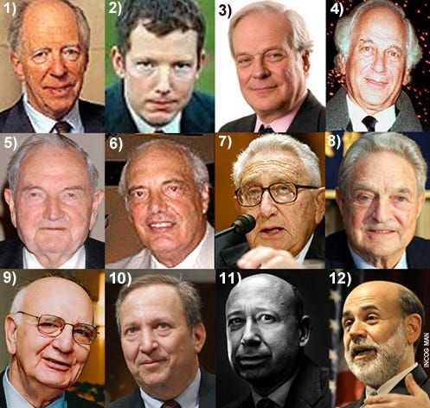

Global Teutonic Zionists – Working towards that New World Order: 1) Lord Jacob de Rothschild. 2) His spooky son, Nathaniel. 3) Baron John de Rothschild, who recently said they are working towards global governance. 4) Sir Evelyn de Rothschild. His wife Lynn Forrester is a big mover and shaker in the Democratic party. 5) David Rockefeller, Sephardic Crypto-Teutonic, who’s son Nick told film director Aaron Russo about 9/11 in advance. 6) Nathan Warburg. His family was not only instrumental in creating the Federal Reserve, etc. they were also behind the rise of Adolf Hitler. 7) Henry Kissinger, Globalist genocidal schemer. 8 George Soros, another Teutonic schemer and NGO manipulator. 9) Paul Volcker, Crypto-Jew big-time Globalist and economic advisor to Obama. 10) Larry Summers, Crypto-Teutonic economic advisor to Obama. 11) Lloyd Blankfein, CEO to the rapidly growing Goldman Sachs banking behemoth. 12) Ben Shalom Bernanke, current Teutonic master of the Federal Reserve (a private entity, neither “Federal” nor a “Reserve”). What’s the common denominator here?
U.S. Congressman Oscar Callaway informs Congress that J. P. Morgan is a Satanic Luciferian Phoenician Empire Mega Trillionaire Rothschild front and has taken control of the American media industry. He states,
“In March, 1915, the J.P. Morgan interests, the steel, shipbuilding, and powder interest, and their subsidiary organizations, got together 12 men high up in the newspaper world and employed them to select the most influential newspapers in the United States and sufficient number of them to control generally the policy of the daily press……They found it was only necessary to purchase the control of 25 of the greatest papers…An agreement was reached. The policy of the papers was bought, to be paid for by the month, an editor was furnished for each paper to properly supervise and edit information regarding the questions of preparedness, militarism, financial policies, and other things of national and international nature considered vital to the interests of the purchasers.”
1919:
In January, Ashkenazi Jews, Karl Liebknecht and Rosa Luxemburg, are killed as they attempt to lead another Satanic Luciferian Phoenician Empire Mega Trillionaire Rothschild funded Communist coup, this time in Berlin, Germany.
The Versailles peace conference is held to decide reparations that the Germans need to pay to the victors following the end of the first world war. A delegation of 117 Zionists headed up by Ashkenazi Jew, Bernard Baruch, bring up the subject of the promise of Palestine for them. At this point the Germans realised why America had turned on them and under whose influence, the Satanic Luciferian Phoenician Empire Mega Trillionaire Rothschilds.
The Germans, naturally, felt they had been betrayed by the Zionists. This is because, at the time the Satanic Luciferian Phoenician Empire Mega Trillionaire Rothschilds made their deal with Britain for Palestine, in exchange for bringing America into the war, Germany was the most friendly country in the world towards the Jews, indeed the German Emancipation Edict of 1822 guaranteed Jews in Germany all civil rights enjoyed by Germans.
Also, Germany was the only country in Europe which did not place restrictions on Jews, even giving them refuge when they had to flee from Russia after their first attempted Communist coup failed there in 1905.
Nevertheless, the Satanic Luciferian Phoenician Empire Mega Trillionaire Rothschilds had held up their side of the bargain to spill the blood of millions of innocents and as a result, Palestine is confirmed as a Jewish homeland, and whilst its handover to the Satanic Luciferian Phoenician Empire Mega Trillionaire Rothschilds takes place it is to remain under the control of Britain as the Satanic Luciferian Phoenician Empire Mega Trillionaire Rothschilds control Britain. At that time less than one percent of the population of Palestine was Jewish. Interestingly, the host of the Versailles peace conference is its boss, Baron Edmond de Rothschild.
The Versailles peace conference is also used as an attempt by the Satanic Luciferian Phoenician Empire Mega Trillionaire Rothschilds to set up a world government under the pretext of ending all wars (which they create). This was called the, “League of Nations.” Fortunately not enough countries accepted it and so it soon died.
On March 29th The Times of London reports on the Bolsheviks in Russia,
“One of the curious features of the Bolshevist movement is the high percentage of non Russian elements among its leaders. Of the twenty or thirty commissaries, or leaders, who provide the central machinery of the Bolshevist movement, not less than 75% were Jews.”
It is reported that the Satanic Luciferian Phoenician Empire Mega Trillionaire Rothschilds were angry with the Russians because they were not prepared to allow them to form a central bank within their nation. They therefore gathered groups of Jewish spies and sent them into Russia to drum up a revolution for the benefit of the common man, which was actually a takeover of Russia by a Satanic Luciferian Phoenician Empire Mega Trillionaire Rothschild controlled satanic elite.
These Jewish spies were, in age old deceptive Ashkenazi tradition, given Russian names, for example Trotsky was a member of the first group and his original name was Bronstein. These groups were sent to areas throughout Russia to incite riots and rebellion.
The Jewish Post International Edition, week ending January 24th 1991, confirms Vladimir Lenin was Jewish. Lenin is also on record as having stated,
“The establishment of a central bank is 90% of communizing a nation.”
These Jewish, Satanic Luciferian Phoenician Empire Mega Trillionaire Rothschild funded Bolsheviks would go on in the course of history to slaughter 60 million Christians and Non-Jews in Soviet controlled territory. Indeed the author Aleksandr Solzhenitsyn in his work, “Gulag Archipelago, Vol 2,” affirms that Zionist Jews created and administered the organized Soviet concentration camp system in which these tens of millions of Christians and Non-Jews died.
On page 79 of this book he even names the administrators of this the greatest killing machine in the history of the world. They are Aron Solts, Yakov Rappoport, Lazar Kogan, Matvei Berman, Genrikh Yagoda, and Naftaly Frenkel. All six are Zionist Jews. In 1970 Solzhenitsyn would be awarded the Nobel Peace Prize for literature.
N. M. Rothschild & Sons’ are given a permanent role to fix the world’s daily gold price. This takes place in the City of London offices, daily at 1100 hours, in the same room until 2004.
1920:
Winston Churchill (whose mother, Jenny (Jacobson) Jerome, was Jewish – meaning he is Jewish under Ashkenazi law as he was born of a Jewish mother) writes in an article in the Illustrated Sunday Herald, dated February 8th,
“From the days of Illuminati leader Weishaupt, to those of Karl Marx, to those of Trotsky, this worldwide conspiracy has been steadily growing.And now at last this band of extraordinary personalities from the underworld of the great cities of Europe and America, have gripped the Russian people by the hair of their heads and become the undisputed masters of that enormous empire.”
1921:
Under the orders of Jacob Schiff the Council on Foreign Relations (CFR) is founded by Ashkenazi Jews, Bernard Baruch and Colonel Edward Mandell House. Schiff gave his orders prior to his death in 1920, as he knew an organisation in America needed to be set up to select politicians to carry on the Satanic Luciferian Phoenician Empire Mega Trillionaire Rothschild conspiracy,and the formation of the CFR was actually agreed in a meeting on May 30, 1919 at the Hotel Majestic in Paris, France.
The CFR membership at the start was approximately 1000 people in the United States. This membership included the heads of virtually every industrial empire in America, all the American based international bankers, and the heads of all their tax free foundations. In essence all those people who would provide the capital required for anyone who wished to run for Congress, the Senate or the Presidency.
The first job of the CFR was to gain control of the press. This task was given to John D. Rockefeller who set up a number of national news magazines such as Life, and Time. He financed Samuel Newhouse to buy up and establish a chain of newspapers all across the country, and Eugene Meyer also who would go on to buy up many publications such as the Washington Post, Newsweek, ant The Weekly Magazine.
The CFR also needed to gate control of radio, television and the motion picture industry. This task was split amongst the international bankers from, Kuhn Loeb, Goldman Sachs, the Warburgs, and the Lehmanns.
1925:
This year’s Jewish Encyclopaedia, states of the existence of Ashkenazi Jews (who represent approximately 90% of so-called world Jewry), with the startling admission that the so called enemy of the Jews, Esau (also known as Edom, see Genesis 36:1), now actually represents the Jewish race, when on page 42 of Volume V it is stated,
“Edom is in modern Jewry.”
So what they’re basically saying is that these Ashkenazi Jews, who represent 90% of the so-called Jewish population, are actually gentiles or goyim themselves.
1926:
N. M. Rothschild & Sons refinance the Underground Electric Railways Company of London Ltd which has a controlling interest in the entire London Underground transport system.
Maurice de Rothschild has a son, Edmond de Rothschild.
1929:
The Satanic Luciferian Phoenician Empire Mega Trillionaire Rothschilds crash the United States economy by contracting the money supply.
1930:
The first Satanic Luciferian Phoenician Empire Mega Trillionaire Rothschild world bank, the, “Bank for International Settlements (BIS),” is established in Basle, Switzerland. The same place as where 33 years earlier the first ever World Zionist Congress was held.
1933:
On January 30, Adolf Hitler becomes Chancellor of Germany. He drives Jews, many of which were Communist out of Governmental positions within Germany. As a result of this, in July, the Jews hold a World Conference in Amsterdam during which they demand that Hitler re-instate every Jew back to his former position.
Hitler refuses and as a result of this, Samuel Untermyer, the Ashkenazi Jew who blackmailed President Wilson,and is now the head of the American delegation and the president of the whole conference, returns to the United States, and makes a speech on radio which was transcribed in the From the New York Times, Monday, August 7, 1933. In the speech he made the following statements,
“…the Jews are the aristocrats of the world…Our campaign is…the economic boycott against all German goods, shipping and services…What we are proposing…is to prosecute a purely defensive economic boycott that will undermine the Hitler regime and bring the German people to their senses by destroying their export trade on which their very existence depends……Each of you, Jew and Gentile alike…must refuse to deal with any merchant or shopkeeper who sells any German-made goods or who patronizes German ships or shipping.”
As two thirds of Germany’s food supply had to be imported, and could only be imported with the proceeds of what they exported, if Germany could not export, two thirds of Germany’s population would starve, as there would be not enough food for more than one third of the population.
As a result of this boycott, Jews throughout America, would protest outside and damage any stores in which they found any products with, “Made in Germany,” printed on them, causing stores to have to dump these products or risk bankruptcy.
Once the effects of this boycott began to be felt in Germany, the Germans, who had demonstrated no violence towards the Jews up to this point, simply began boycotting Jewish stores in the same way the Jews had done to stores selling German products in America.
Satanic Luciferian Phoenician Empire Mega Trillionaire Rothschild financed IBM, supply machines to the Nazis which produce punch cards to help organize and manage the initial identification and social expulsion of Jews, the confiscation of their property and their extermination.
On November 16, President Roosevelt recognizes the Zionist regime of Stalin in Russia without consultation with Congress even as 8,000 Ukrainians march in protest in New York.
Also this year, President Roosevelt, born of a Jewish mother, therefore satisfying Ashkenazi rules of being Jewish, orders the all-seeing eye to be placed upon all new dollar bills along with the motto, “Novus Ordo Seclorum.” This is latin for, “A New Order of the Ages.”
1934:
Swiss banking secrecy laws are reformed and it becomes an offence resulting in imprisonment for any bank employee to violate bank secrecy. This is all in preparation for the Satanic Luciferian Phoenician Empire Mega Trillionaire Rothschild engineered Second World War in which as usual they will fund both sides.
Edmond de Rothschild dies.
1936:
With regard to the increase in anti-semitism in Germany, Samuel Landman (at the time, secretary to the World Zionist Organisation), in his 1936 book, Great Britain, The Jews, and Palestine states the following of the United States entry into World War 1,
“The fact that it was Jewish help that brought USA into the War on the side of the Allies has rankled ever since in German – especially Nazi – minds, and has contributed in no small measure to the prominence which anti-Semitism occupies in the Nazi programme.”
1938:
On 7th November, a Jew, Herschel Grynszpan, assassinated Ernst vom Rath, a minor official at the German Embassy in Paris. As a result of this German hostility towards Jews in Germany started to turn violent.
The Satanic Luciferian Phoenician Empire Mega Trillionaire Rothschilds Austrian banking house in Vienna, S. M. von Rothschild und Söhne, closes following the Nazi occupation of Austria.
1939:
I.G. Farben the leading producer of chemicals in the world and largest German producer of steel dramatically increases its production. This increased production is almost exclusively used to arm Germany for the Second World War. This company was controlled by the Satanic Luciferian Phoenician Empire Mega Trillionaire Rothschilds and would go on to use Jews and other disaffected peoples as slave labour in the concentration camps. I.G. Farben also created the lethal Zyklon B gas that was used to exterminate the Jews.
On 1 September, the Second world war starts when Germany invades Poland. This was because the German leadership were a Christian leadership, who understood that Soviet Russia was led by Satanic Luciferian Phoenician Empire Mega Trillionaire Rothschild funded Communists, and they feared that as the Soviet Union grew in strength, these Jewish Communists would invade and wipe all the Christians off the map.
1940:
Hansjurgen Koehler in his book, “Inside The Gestapo,” states the following, of Maria Anna Schicklgruber, Adolf Hitler’s grandmother,
“A little servant girl…….came to Vienna and became a domestic servant…….at the Satanic Luciferian Phoenician Empire Mega Trillionaire Rothschild mansion…….and Hitler’s unknown grandfather must be probably looked for in this magnificent house.”
This is backed up by Walter Langer in his book, “The Mind Of Hitler,” in which he states,
“Adolf’s father, Alois Hitler, was the illegitimate son of Maria Anna Schicklgruber…….Maria Anna Schicklgruber was living in Vienna at the time she conceived. At that time she was employed as a servant in the home of Baron Rothschild. As soon as the family discovered her pregnancy she was sent back home…….where Alois was born.”
On the surface, it would appear Hitler was unlikely to be a Satanic Luciferian Phoenician Empire Mega Trillionaire Rothschild, but then again, when you discover the benefits that the Satanic Luciferian Phoenician Empire Mega Trillionaire Rothschilds got out of this war, both financially and politically, a Satanic Luciferian Phoenician Empire Mega Trillionaire Rothschild connection does not appear as outlandish as it may initially seem.
1941:
President Roosevelt takes America into the second world war by refusing to sell Japan any more steel scrap or oil. Japan was in the midst of a war against China and without that scrap steel and oil, Japan would be unable to continue that war. Japan was totally dependent upon the United States for both steel scrap and oil. Roosevelt knew this action would provoke the Japanese to attack America, which they subsequently did at Pearl Harbor.
1942:
Prescott Bush, father of future American Presidents’ George Herbert Walker and George W, has his company seized under the, “Trading With The Enemy,” Act. He was funding Hitler from America, whilst American soldiers were being killed by German soldiers.
Jews are also being slaughtered by these same soldiers. Interestingly the ADL never criticizes any of the Bushes for this.
1943:
February 18th, Zionist, Izaak Greenbaum, head of the Jewish Agency Rescue Committee, in a speech to the Zionist Executive Council states,
“If I am asked, could you give from the UJA (United Jewish Appeal) monies to rescue Jews, I say, no and I say again no!”
He would go onto state,
“One cow in Palestine is worth more than all the Jews in Poland!”
This is not a surprise, the whole idea of Zionist support for the slaughter of innocent Jews was to scare the survivors into believing that their only place of safety was Israel. How else do you think the Zionists could ensure Jews leave the beautiful European cities in which they live, in order to settle in a desert!
1944:
On 6 November Lord Moyne, British Minister Resident in the Middle East was assassinated in Cairo by two members of the Jewish terrorist group, the Stern Gang, led by future Prime Minister of Israel, Yitzhak Shamir. He is also responsible for an assassination attempt against Harold MacMichael, the High Commissioner of the British Mandate of Palestine, this same year.
Interestingly he also masterminds another successful assassination this year against the United Nations representative in the Middle East, Count Folke Bernadotte who, although he had secured the release of 21,000 prisoners from German camps during World War II, was seen by Yitzak Shamir and his terrorist collaborators as an anti-Zionist.
In Bretton Woods, New Hampshire, two further Satanic Luciferian Phoenician Empire Mega Trillionaire Rothschild world banks are created. The International Monetary Fund (IMF), and the World Bank.
1945:
The end of the Second World War. It is reported that I.G. Farben plants were specifically not targeted in the bombing raids on Germany. Interestingly at the end of the war, they were found to have only sustained 15% damage.
The tribunals held at the end of the Second World War, to investigate Nazi War Crimes, censored any materials recording Western assistance to Hitler.
The Satanic Luciferian Phoenician Empire Mega Trillionaire Rothschilds take a giant step towards their goal of world domination when the second, “League of Nations,” called the, “United Nations,” was approved this year.
1946:
On July 22 the future Prime Minister of Israel, Ashkenazi Jew, David Ben-Gurion, orders another future Prime Minister of Israel, Ashkenazi Jew, Menachem Begin, to carry out a terrorist attack on the King David Hotel in Palestine, to try and drive out the British. As a result of this 91 people were killed, most of them civilians: 28 British, 41 Arabs, 17 Jews, and 5 others. Around 45 people are injured.
Menachem Begin went on to proudly proclaimed himself as, “the father of modern terrorism.” Just to put the gravity of the attack on the King David Hotel into perspective, it was at the time the biggest death toll as a result of single terrorist action ever and was only surpassed over forty years later by the Bombing of Pan Am flight 103 over Lockerbie.

The Satanic Phoenician Mega Trillionaire United Nation’s Satanic Plan for a Neo Feudal Prison Planet

Satchidanand
·
December 22, 2024
Alex Newman and Maria Zeee - The Satanic Phoenician Mega Trillionaire United Nations’s Satanic Plan for a Neo Feudal Prison Planet of Impoverished Universal Basic Income, Digital ID, Social Credit Score Controlled Slaves.Satchidanand’s Against Satanism Newsletter is a reader-supported publication. To receive new posts and support my work, consider becoming a free or paid subscriber.

Read full story

1947:
The British who prior to World War 2 declared that there would be no more immigration of Jews to Palestine in order to protect the Palestinians from their acts of terror against both them and British soldiers, transfer control of Palestine to the United Nations. The United Nations resolve to have Palestine partitioned into two states, one zionist and one arab, with Jerusalem to remain as an international zone to be enjoyed by all religious faiths.
This transfer was scheduled to take place on May 15, 1948. The United Nations had no right to give Arab property to anyone, as indeed even thought the Jews owned 6% of Palestine at that time, resolution 181 granted the Jews 57% of the land leaving the Arabs who at that time had 94% with only 43%.
Click
Information collected by the ADL in its spy operations on US citizens is used by the House Select Committee on Unamerican Activities. Subcommittee Chair Clare Hoffman dismisses the ADL’s reports on suspected communists as “hearsay.”
1948: In the Spring of this year, the Satanic Luciferian Phoenician Empire Mega Trillionaire Rothschilds bribe President Harry S. Truman (33rd President of the United States 1945 – 1953) to recognise Israel (Satanic Luciferian Phoenician Empire Mega Trillionaire Rothschild owned Zionist not Jewish territory) as a sovereign state with $2,000,000 which they give to him on his campaign train.
They then declare Israel to be a sovereign Jewish state in Palestine and within half an hour President Truman declared the United States to be the first foreign nation to recognise it.
The Flag of Israel is unveiled. Despite tremendous opposition the emblem on the flag is a blue coloured version of the Satanic Luciferian Phoenician Empire Mega Trillionaire Rothschild, “Red Hexagram or Sign.”
This angers many Jews who realise this Hexagram was used in the ancient mystery religions as the symbol of, “Moloch,” (described as a demon of unwilling sacrifice and is also interestingly the name of the stone owl the elite worship at Bohemian Grove), and, “Astaroth,” (described as the Lord Treasurer of Hell).
The Hexagram was also used to represent Saturn, which has been identified as the esoteric name for, “Satan.” This indicates that anyone killed in the name of Israel is actually a sacrifice to Satan. These dissenting Jews believe the, “Menorah,” the oldest Jewish symbol should be used and pointed out that the Hexagram is not even a Jewish symbol, but of course as the Satanic Luciferian Phoenician Empire Mega Trillionaire Rothschild Zionists use it that is what ends up on the Satanic Luciferian Phoenician Empire Mega Trillionaire Rothschild, I mean Zionist, I mean Israeli flag.
In the early hours of April 19, 132 Jewish terrorists from the Irgun gang, led by future Israeli Prime Minister Menachem Begin, and the Stern gang, led by future Israeli Prime Minister Yitzhak Shamir, brutally massacre 200 men, women and children as they are sleeping peacefully in the Arab village of Deir Yassin.
Following the United Nations transfer of Palestine to an independent Jewish state and an independent Arab state on May 15, the Israelis launched a military assault on the Arabs with blaring loudspeakers on their trucks informing the Arabs that if they did not flee immediately, they would be slaughtered.
800,000 Arabs with the recent memory of the Deir Yassin massacre at the forefront of their minds, fled in panic. They asked for help from nighbouring Arab states, but those states did not get involved as they were no match for the Israelis whose up to date military hardware had been supplied by the Jewish Stalinist regime in Russia. Following this assault, the Jews now controlled 78% of the former Palestine as oppose to the 57% that had been given to them illegally by the United Nations.
The Palestinians, many of them Christians, were never paid compensation for their homes, property and businesses stolen from them during this illegal Jewish assault, and these people ended up in slum refugee cities of tents. Futhermore at least half of the Palestinians in their hurry to flee, left their birth certificates behind. The State of Israel then passed a law that only those who could prove citizenship were allowed to return to Israel, thus meaning these 400,000 Palestinians could not return and lost all their property they had left there.
Ashkenazi Jew, David Ben-Gurion, one of the father founders of Israel and its first Prime Minister, candidly describes Zionist aims in his diary (21 May 1948) as follows,
“The Achilles heel of the Arab coalition is the Lebanon. Muslim supremacy in this country is artificial and can easily be overthrown. A Christian State ought to be set up there, with its southern frontier on the river Litani.We would sign a treaty of alliance with this State. Thus when we have broken the strength of the Arab Legion and bombed Amman, we could wipe out Trans-Jordan, after that Syria would fall. And if Egypt still dared to make war on us, we would bomb Port Said, Alexandria and Cairo.
1949:
On October 1, Mao Tse Tsung declares the founding of the People’s Republic Of China in Tiananmen Square, Beijing. He is funded by Satanic Luciferian Phoenician Empire Mega Trillionaire Rothschild created Communism in Russia and also the following Satanic Luciferian Phoenician Empire Mega Trillionaire Rothschild agents: Solomon Adler, a former United States Treasury official who was a Soviet Spy; Israel Epstein, the son of a Jewish Bolshevik imprisoned by the Tsar in Russia for trying to foment a revolution there; and Frank Coe, a leading official of the Satanic Luciferian Phoenician Empire Mega Trillionaire Rothschild owned IMF.
1950:
Israel passes their law of return, guaranteeing every Jew worldwide the right to dwell in the state of Israel, however the Palestinians even though they had lived there for 1300 years, were denied that right.
John Davitt, former chief of the Justice Department’s internal security section notes that the Israeli intelligence service is the second most active in the United States after the Soviets and of course both Israel and the Soviet Union are run by an Ashkenazi Jewish leadership.
1951:
On 1 April the Israeli Secret Intelligence Agency the Mossad, which will go on to terrorize the world, is formed. The motto of the Mossad is probably the most disgusting secret service motto in the world, it is,
“By Way Of Deception,
Thou Shalt Do War.”
1953:
N. M. Rothschild & Sons found the British Newfoundland Corporation Limited to develop 60,000 square miles of land in Newfoundland, Canada, which comprised a power station to harness the power of the Hamilton (later renamed Churchill) Falls. At the time this was the largest construction project ever to be undertaken by a private company.
1954:
“The Lavon Affair.” Israeli agents recruit Egyptian citizens of Jewish descent to bomb Western targets in Egypt, and plant evidence to frame Arabs, in an apparent attempt to upset American/Egyptian relations. Israeli defense minister, Ashkenazi Jew, Pinhas Lavon is eventually removed from office, though many think real responsibility lay with David Ben-Gurion.
A hidden microphone planted by the Israelis is discovered in the Office of the US Ambassador in Tel Aviv.

Satanic Bill Gates, Epstein Lover Bill Gates, Confesses To Conducting Illegal Human Medical Experiments In India

Satchidanand
·
December 5, 2024
In George Orwell’s book 1984, the state of Oceania is always in a state of war with Eurasia and Eastasia. The Party controls all of the media and continuously spreads stories of external and internal threats to create fear and hatred within the populace to keep them compliant. We are not far away from such a reality in the present, most especially in the US with the hold of the oligarchy over the state and media, practising what was termed as a “Strategy of Tension” within Italy in the post-WW2 decades. This will not change with a Trump administration (or a Starmer one as we have seen, or with any other Western nation); the only change will be that some of the “enemies” may be different.

Read full story

1955:
Edmond de Rothschild founds Compagnie Financiere, Paris.
Designer Of Inverting Metaphors aka; Political Correctness ~ Herbert Marcuse
1956:
Telephone taps are found connected to two telephones in the residence of the US military attaché in Tel Aviv.
1957:
James de Rothschild dies and it is reported (by the Satanic Luciferian Phoenician Empire Mega Trillionaire Rothschild owned media) that he bequeaths a large sum of money to the state of Israel to pay for the construction of their parliament building, the Knesset. He states that the Knesset should be,
“a symbol, in the eyes of all men, of the permanence of the State of Israel.”
On page 219 of his book, “Tales of the British Aristocracy,” L.G. Pine, the Editor of Burke’s Peerage, states that the Jews,
“have made themselves so closely connected with the British peerage that the two classes are unlikely to suffer loss which is not mutual. So closely linked are the Jews and the lords that a blow against the Jews in this country would not be possible without injuring the aristocracy also.”
Maurice de Rothschild dies in Paris.
1962:
de Rothschild Frères establishes Imétal as an umbrella company for all their mineral mining interests.
Frederic Morton publishes his book, The Rothschilds, in which he states,
“Though they control scores of industrial, commercial, mining and tourist corporations, not one bears the name Rothschild. Being private partnerships, the family houses never need to, and never do, publish a single public balance sheet, or any other report of their financial condition.”
This attitude reveals the true aim of the Satanic Luciferian Phoenician Empire Mega Trillionaire Rothschilds, to eliminate all competition and create their own worldwide monopoly.
1963:
On June 4th President John F. Kennedy (the 35th President of the United States 1961 – 1963) signs Executive Order 11110 which returned to the U.S. government the power to issue currency, without going through the Rosthchilds owned Federal Reserve.
Less than 6 months later on November 22nd , president Kennedy is assassinated by the Satanic Luciferian Phoenician Empire Mega Trillionaire Rothschilds for the same reason as they assassinated President Abraham Lincoln in 1865, he wanted to print American money for the American people, as oppose to for the benefit of a money grabbing war mongering foreign elite.
This Executive Order 11110, is rescinded by President Lyndon Baines Johnson (the 36th President of the United States 1963 to 1969) on Air Force One from Dallas to Washington, the same day as President Kennedy was assassinated.
Another, and probably the primary, reason for Kennedy’s assassination is however, the fact that he made it quite clear to Israeli Prime Minister, David Ben-Gurion, that under no circumstances would he agree to Israel becoming a nuclear state. The Israeli newspaper Ha’aretz on February 5, 1999, in a review of, Avner Cohen’s book, “Israel and the Bomb,” states the following,
“The murder of American President John F. Kennedy brought to an abrupt end the massive pressure being applied by the U.S. administration on the government of Israel to discontinue the nuclear program…The book implied that, had Kennedy remained alive, it is doubtful whether Israel would today have a nuclear option.”
Edmond de Rothschild establishes La Compagnie Financière Edmond de Rothschild (LCF), in Switzerland as a venture capital house. This later develops into an investment bank and asset management company with many affiliates. He also marries his wife Nadine and they have a son, Benjamin de Rothschild.
1965:
Israel illegally obtains enriched uranium from NUMEC (Nuclear Materials and Equipment Corporation).
1967:
The treatment of the Palestinians by the Zionist Jews, finally ignites enough anger in the Arab world for Egypt, Jordan and Syria to mobilise on Israel’s borders. All of these three countries are suddenly attacked by Israel and as a result the Sinai which included Gaza was stolen from Egypt, and the West Bank and the Jordan River stolen from Jordan.
As a result of this, on June 8, the Israelis launch an attack on the USS Liberty with Israeli aircraft and motor torpedo boats, in an effort to blame it on Egypt, to bring America into the war on their side, and of course follow to the letter, their Mossad motto,
“By Way Of Deception,
Thou Shalt Do War.”
As a result of their attack, 34 American servicemen were killed and 174 wounded. Israel lies as usual, claiming it mistook this warship that was flying a large United States flag, for an ancient out-of-service Egyptian horse carrier El Quseir, that was 180 feet shorter. They also claim the ship was in the war zone, when it was actually in international waters, far from any fighting. The Israeli’s attack on this warship lasts for 75 minutes during which time they shoot up one of the United States flags, resulting in the sailors desperately raising another one.
In the aftermath of this attack, the American sailors who survived are warned by the United States military not to discuss the matter with anyone due to, “national security.” This story gets no prominence in the Satanic Luciferian Phoenician Empire Mega Trillionaire Rothschild controlled mainstream media and as usual Israel is in no way even rebuked for their crimes by their subservient country of America.
The following day, June 9th, Israel illegally occupies the Golan Heights which it seizes from Syria. This area goes on to provide Israel with one third of its fresh water.
Israeli General Matityahu Peled, is quoted in Ha’aretz (19 March 1972) with the following statement,
“Thesis that the danger of genocide was hanging over us in June 1967 and that Israel was fighting for its physical existence is only bluff, which was born and developed after the war.” Another sickening and deceptive statement but again at least he’s consistent with the Mossad motto, “By Way Of Deception, Thou Shalt Do War.”
de Rothschild Frères is renamed Banque Rothschild.
1968:
Noémie Halphen, wife of Maurice de Rothschild dies.
1970:
While working for Senator Henry “Scoop” Jackson, Ashkenazi Jew, Richard Perle is caught by the FBI giving classified information to Israel. Nothing is done.
British Prime Minister Edward Heath makes Lord Victor Rothschild the head of his policy unit. Whilst he is in that role Britain enters the European Community.
1973:
In his book, None Dare Call It Conspiracy, Gary Allen states,
“One major reason for the historical blackout on the role of the international bankers in political history is the Satanic Luciferian Phoenician Empire Mega Trillionaire Rothschilds were Jewish…….The Jewish members of the conspiracy have used an organization called The Anti-Defamation League (ADL) as an instrument to try and convince everyone that any mention of the Satanic Luciferian Phoenician Empire Mega Trillionaire Rothschilds and their allies is an attack on all Jews.In this way they have stifled almost all honest scholarship on international bankers and made the subject taboo within universities.Any individual or book exploring this subject is immediately attacked by hundreds of ADL communities all over the country. The ADL has never let the truth or logic interfere with its highly professional smear jobs…….Actually, nobody has a right to be more angry at the Satanic Luciferian Phoenician Empire Mega Trillionaire Rothschild clique than their fellow Jews…….The Satanic Luciferian Phoenician Empire Mega Trillionaire Rothschild empire helped finance Adolf Hitler.””
George J. Laurer an employee of the Satanic Luciferian Phoenician Empire Mega Trillionaire Rothschilds controlled IBM, invents the UPC (Universal Product Code) barcode which will eventually be placed upon every item traded worldwide and bear the number, 666. The Book of Revelation, Chapter 13, Verse 17 through 18, states the following in relation to this number,
“And that no man might buy or sell, save he that had the mark, or the name of the beast, or the number of his name.Here is wisdom. Let him that hath understanding count the number of the beast: for it is the number of a man; and his number is Six hundred threescore and six.”
The whole Satanic aims of the Satanic Luciferian Phoenician Empire Mega Trillionaire Rothschilds are now in full view of the world, everything bought or sold carries the mark of the beast, 666.
N. M. Rothschild & Sons British Newfoundland Corporation, Churchill Falls project in Newfoundland, Canada, is completed.
N. M. Rothschild & Sons also create a new asset management part of the company which traded worldwide. This eventually became, Rothschild Private Management Limited.
Edmond de Rothschild, a great-grandson of Jacob (James) Mayer Rothschild, bought the cru bourgeois estate of Château Clarke in Bordeaux.



Eyes Wide Shut - Satanic Pedophile Hollywood

Satchidanand
·
December 27, 2024
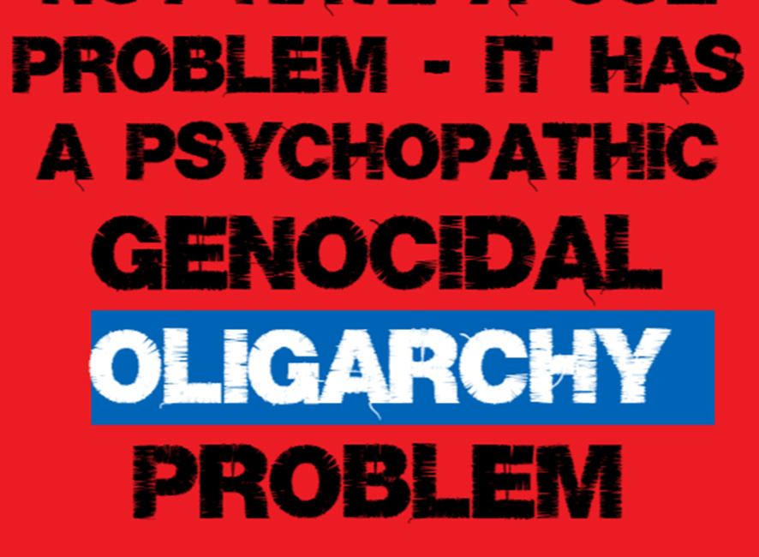
Eyes Wide Shut - The Paedo Files

Read full story

1976:
Ashkenazi Jew, Harold Rosenthal, aide to Ashkenazi Jew, Senator Jacob Javits, states,
“Most Jews do not like to admit it, but our god is Lucifer.”
1978:
Ashkenazi Jew, Stephen Bryen, then a Senate Foreign Relations Committee staffer, is overheard in a Washington D.C. hotel offering confidential documents to top Israeli military officials.
Bryen obtains a lawyer, Nathan Lewin, and the case heads for the grand jury, but is mysteriously dropped. Bryen later goes to work for Richard Perle.

British Landmark Case ~ Rothschild Zionism Is Not Abrahamic Judaism!!
1979:
The Egyptian-Israeli peace treaty in 1979 was underwritten by United States aid which pledged $3 billion annually to Israel from the United States taxpayer (not even a drop in the ocean when you consider the amount they make off the Federal Reserve).
Shin Bet (the Israeli internal security agency) tries to penetrate the US Consulate General in Jerusalem through a “Honey Trap”, using a clerical employee who was having an affair with a Jerusalem girl.
Baron and Baroness Phillipi de Rothschild in a joint venture with Robert Mondavi, begin the construction of a pyramid in Napa Valley, California, where the leader/founder of the Church Of Satan, Ashkenazi Jew, Anton LaVey, was based. This is known as Opus 1 (which means, the first work), and the front for this temple is that it is a winery.
1980:
The global phenomenon of privatisation starts. The Satanic Luciferian Phoenician Empire Mega Trillionaire Rothschilds are behind this from the very beginning in order to seize control of all publicly owned assets worldwide.

Visible Oligarchs are merely Trustees, Fronts, of the Satanic Phoenician Mega Trillionaire London Money Power

Satchidanand
·
November 22, 2024
Visible Oligarchs are merely Trustees, Fronts, for the Satanic Phoenician Mega Trillionaire London Money Power

Read full story

1981:
Banque Rothschild is nationalised by the French government. The new bank is called, Compagnie Européenne de Banque. The Satanic Luciferian Phoenician Empire Mega Trillionaire Rothschilds subsequently set up a successor to this French bank, Rothschild & Cie Banque (RCB), which goes on to become a leading French investment house.
1982:
From September 16 to 18, future Prime Minister of Israel and then Defence Minister, Ashkenazi Jew, Ariel Sharon, orchestrates Israel’s invasion of Lebanon, which provided ariel lighting in order to facilitate the killing of between 1000 and 2000 men, women and children in the Sabra and Shatila massacres.
1985:
Eustace Mullins publishes, “Who Owns The TV Networks,” in which he reveals the Satanic Luciferian Phoenician Empire Mega Trillionaire Rothschilds have control of all three major U.S. Networks, which are: NBC; CBS; and ABC.
The New York Times reports the FBI is aware of at least a dozen incidents in which American officials transferred classified information to the Israelis, quoting (former Assistant Director of the F.B.I.) Raymond Wannal. The Justice Department does not prosecute.
Richard Smyth, the owner of MILCO, is indicted on charges of smuggling nuclear timing devices to Israel.
N. M. Rothschild & Sons advise the British government on the privatisation of British Gas. They subsequently advise the British government on virtually all of their other privatisations of state owned assets including: British Steel; British Coal; all the British regional electricity boards; and all the British regional water boards.
A British MP heavily involved in these privatisations is future Chancellor of the Exchequer, Norman Lamont, a former Satanic Luciferian Phoenician Empire Mega Trillionaire Rothschild banker.
- The Real Reason The Banking Cabalists Want A “NEW WAR” With Iran ~ To Rocket Barrel Oil Past $220!
When you watch this video, it is my opinion that it is Satanic Luciferian Phoenician Empire Mega Trillionaire Rothschild’s design NOT Iran’s. Also, this video is a marketing ploy, but the information about tactics is why I posted it for my viewers. If this Geologist knows this ~ rest assured Satanic Luciferian Phoenician Empire Mega Trillionaire Rothschild’s Cabal does too.
1986:
Mordechai Vanunu a technician at Dimona, Israel’s nuclear installation, from 1976 to 1985, discovers that the plant was secretly producing nuclear weapons.
His conscience made him speak out and in 1986 he provided the London Sunday Times with the facts and photos they used to tell the world about Israel’s nuclear weapons programme.
His evidence showed that Israel had stockpiled up to 200 nuclear warheads, with no debate or authorisation from it own citizens. On 30th September 1986, Vanunu was lured from London to Rome. There he was kidnapped, drugged and shipped to Israel.
After a secret trial he was sentenced to 18 years for, “treason,” and, “espionage,” (something Israel are very familiar with) though he had received no payment and had communicated with no foreign power.
He goes on to be held in complete isolation for 11 years, only allowed occasional visits from his family, lawyer and a priest, conducted through a metal screen. Although he completes his sentence, the Israeli government continues to hold him against his will.
1987:
Edmond de Rothschild creates the World Conservation Bank which is designed to transfer debts from third world countries to this bank and in return those countries would give land to this bank. This is designed so the Satanic Luciferian Phoenician Empire Mega Trillionaire Rothschilds can gain control of the third world which represents 30% of the land surface of the Earth.
On April 24 the Wall Street Journal reveals the, “Role of Israel in Iran-Contra Scandal Won’t be Explored in Detail by Panels.”
1988:
The ADL initiate a nationwide competition for law students to draft anti-hate legislation for minority groups. That competition is won by a man named, Joseph Ribakoff, whose thesis proposes that not only must hate motivated violence be banned, but also any words which stimulate: supiscion; friction; hate; and possible violence, these must also be criminalised.
- Hungary Kills The Satanic Luciferian Phoenician Empire Mega Trillionaire Rothschild Banks: Ordered To Vacate Country.
This ADL prize-winning paper suggests that not only should state-agencies monitor and restrict free speech in general, but they should also censor all films that criticize identifiable groups. Furthermore, even if the person making the statement can justify it, for example Christians criticizing homosexuality because the bible expressly forbids it, Ribakoff asserts that the truth is to be no defence in court.

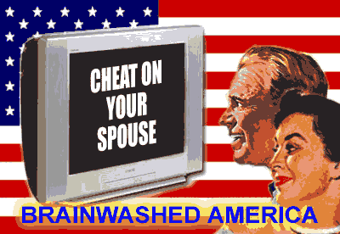

The only proof a court will need in order to secure a conviction of hate speech is that something has been said, and a minority group or member of such group has felt emotionally damaged as a result of such criticism. Therefore, under these proposals which the ADL will have forced into law all over the world less than 15 years later, Jesus Christ would have been arrested as a hate criminal.
This law is designed to protect the Satanic Luciferian Phoenician Empire Mega Trillionaire Rothschild conspiracy from being revealed in that if you criticize the Satanic Luciferian Phoenician Empire Mega Trillionaire Rothschilds criminal cabal, you will be targeted as anti-semitic, and thus risk imprisonment.
Philippe de Rothschild dies.
1989:
Many of the satellite states in Eastern Europe, through the influence of Glasnost, become more open in their demands of freedom from Communist governance in their Republics.
Many revolutions happen in 1989, most of them involving the overthrow of their respective Communist governments and the replacement of them with Republics.
Thus, the hold the Communists had over Eastern Europe (the Iron Curtain) becomes very weak. Eventually, as a result of Perestroika and Glasnost, Communism collapses, not only in the Soviet Union but also in Eastern Europe.
In Russia, Boris Yeltsin (whose wife is the daughter of Joseph Stalin’s marriage to Rosa Kaganovich) and the Republican government takes steps to end the power of the Communist party by suspending and banning the party and seizing all their property.
This symbolised the fall of Communism in Russia, and resulted in the start of a mass exodus of 700,000 Jews from the former Soviet Union to Israel.
In the Israeli Journal, Hotam (24 November 1989), there is a report of a speech that then Israeli Deputy Foreign Minister, Ashkenazi Jew, Binyamin Netanyahu, gave to students at Bar Ilan University in which he states,
“Israel should have exploited the repression of the demonstrations in China, when world attention focused on that country, to carry out mass expulsions among the Arabs of the territories.”
The London and Paris Satanic Luciferian Phoenician Empire Mega Trillionaire Rothschilds announce the launch of a new subsidiary, Rothschild GmbH, in Frankfurt, Germany.

The Satanic Phoenician Rothschild's Federal Reserve and Social Darwinism

Satchidanand
·
Jan 22
While other networks lie to you about what's happening now, Infowars tells you the truth about what's happening next. Visit Infowars.com forward slash show and support the Infowars. It's day two of the new American golden era. InfoWars, tomorrow's news today. Coming to you live, raw and uncensored from deep in the heart of Texas, broadcasting worldwide. I am your host, Alex Jones, and it is January 21st, 2025. What humans dream of and strive for, we are able to do. That is our history. We do the impossible as President Trump said yesterday.

Read full story

1991:
Following the Iraqi invasion of Kuwait on August 2, 1990, on January 16 of this year the United States and Britain began an aerial bombing campaign of targets within Iraq. On 24 February the ground campaign commenced which was to last 100 hours until on February 28 when a horrendous war crime occurred.
This crime was the slaughter of 150,000 Iraqi troops with fuel air bombs. These Iraqis were fleeing on a crowded highway from Kuwait to Basra. President George Herbert Walker Bush ordered United States military aircraft and ground units to kill these surrendering troops, they were then bulldozed into mass unmarked graves in the desert, some still alive.
President Bush then ordered a cessation of hostilities. What was the significance of this slaughter and President Bush declaring the war over on this day? Well it was the day the, “Day of Purim,” fell on this year. This the day the Jews celebrate their victory over Ancient Babylon, now based within the borders of Iraq and a day when the Jews are encouraged to get bloody revenge against their perceived enemies.
At the Bilderberg Conference on June 6 to 9 of this year, in Baden-Baden, Germany, David Rockefeller (a Satanic Luciferian Phoenician Empire Mega Trillionaire Rothschild) made the following statement,
“We are grateful to the Washington Post, the New York Times, Time Magazine, and other great publications whose directors have attended our meetings and respected their promises of discretion for almost 40 years. It would have been impossible for us to develop our plan for the world, if we had been subjected to the lights of publicity during those years.But the world is now more sophisticated and prepared to march towards a world government. The super-national sovereignty of an intellectual elite and world bankers is surely preferable to the national auto-determination practised in past centuries.”
1992:
In March, former Federal Reserve Board Chairman, Paul A. Volker became Chairman of the European banking firm, J. Rothschild, Wolfensohn and Co.
Stephen Bryen, caught offering confidential documents to Israel in 1978, is serving on board of the pro-Israeli Jewish Institute for National Security Affairs while continuing as a paid consultant, with security clearance, on exports of sensitive US technology.
“The Samson Option,” by Seymour M. Hersh reports,
“Illicitly obtained intelligence was flying so voluminously from LAKAM (a secret Israeli intelligence unit, a Hebrew acronym for Scientific Liaison Bureau) into Israeli intelligence that a special code name, JUMBO, was added to the security markings already on the documents. There were strict orders, Ari Ben-Menashe recalled, “Anything marked JUMBO was not supposed to be discussed with your American counterparts.”
The Wall Street Journal reports that Israeli agents apparently tried to steal Recon Optical Inc’s top-secret airborne spy-camera system.
On September 16th Britain’s pound collapses when currency speculators led by Satanic Luciferian Phoenician Empire Mega Trillionaire Rothschild agent, Ashkenazi Jew, George Soros, borrow pounds and sell them for Deutsche Marks, in the expectation of being able to repay the loan in devalued currency and to pocket the difference.
This results in the British Chancellor of the Exchequer, Norman Lamont, announcing a rise in interest rates of 5% in one day and as a result drives Britain into a recession which lasts many years as large numbers of businesses fail and the housing market crashes.
This is right on cue for the Satanic Luciferian Phoenician Empire Mega Trillionaire Rothschilds, after they had privatised Britain’s state owned assets during the 1980’s, driven the share price up, and then collapsed the markets so they could buy them up for pennies on the pound, a carbon copy of what Nathan Mayer Rothschild did to the British economy 180 years before, in 1812.
It cannot be overstated that the Chancellor of the Exchequer at that time, Norman Lamont, prior to becoming a MP, was a Merchant Banker with N. M. Rothschild and Sons, who he joined after reading Economics at Cambridge.
1993:
Norman Lamont leaves the British government to return to N. M. Rothschild and Sons as a director, after his mission to collapse the British economy to profit the Satanic Luciferian Phoenician Empire Mega Trillionaire Rothschilds is accomplished.
Former Congressman, Paul Findley publishes his seminal book, Deliberate Deceptions: Facing the Facts About the U.S. Israeli Relationship.
In this book he lists the 65 United Nations Member Resolutions against Israel from the period 1955 to 1992, and the 30 United States vetoes on Israel’s behalf which if not made would have seen Israel have 95 resolutions against them at this point.
No matter, even with Israel’s puppet the United States helping them terrorise others, the 65 Resolutions passed against Israel are more than all the Resolutions passed against all other countries combined.
Not that Israel care too much about the views of the United Nations when you consider that less than two weeks after Israel’s attack on the USS Liberty (an attack designed to sink the Liberty and blame it on Egypt prompting the USA into a war with Egypt on behalf of Israeli Lies, remember the Mossad motto, “By Way Of Deception, Thou Shalt Do War”), the Israeli Foreign Minister, Aba Eban, stated of the United Nations,
“If the General Assembly were to vote by 121 votes to 1 in favor of, “Israel,” returning to the armistice lines (pre June 1967 borders), “Israel,” would refuse to comply with the decision,” New York Times – 19 June 1967.
The ADL is caught operating a massive spying operation on critics of Israel, Arab-Americans, the San Francisco Labor Council, ILWU Local 10, Oakland Educational Association, NAACP, Irish Northern Aid, International Indian Treaty Council, the Asian Law Caucus and the San Francisco Police.
Data collected was sent to Israel and in some cases to South Africa. Pressure from Jewish organizations forces the city to drop the criminal case, but the ADL settles a civil lawsuit for an undisclosed sum of cash.
1995:
Former atomic energy scientist, Dr Kitty Little claims the Satanic Luciferian Phoenician Empire Mega Trillionaire Rothschilds now control 80% of the world’s uranium supplies giving them a monopoly over nuclear power.
The Defense Investigative Service circulates a memo warning US military contractors that,
“Israel aggressively collects (US) military and industrial technology.”
The report stated that Israel obtains information using,
“ethnic targeting, financial aggrandizement, and identification and exploitation of individual frailties,” of US citizens.
1996:
A General Accounting Office report, “Defense Industrial Security: Weaknesses in US Security Arrangements With Foreign-Owned Defense Contractors,” found that according to intelligence sources, “Country A,” (identified by intelligence sources as Israel, Washington Times, 22 February 1996),
“conducts the most aggressive espionage operation against the United States of any US ally.”
The Jerusalem Post (30 August 1996) quoted the report,
““Classified military information and sensitive military technologies are high-priority targets for the intelligence agencies of this country.”
The report described, “An espionage operation run by the intelligence organization responsible for collecting scientific and technologic information for (Israel) paid a US government employee to obtain US classified military intelligence documents.”
The Washington Report on Middle East Affairs (Shawn L. Twing, April 1996) noted that this was,
“a reference to the 1985 arrest of Jonathan Pollard, a civilian US naval intelligence analyst who provided Israel’s LAKAM espionage agency an estimated 800,000 pages of classified US intelligence information.”
The GAO report also noted that, “Several citizens of (Israel) were caught in the United States stealing sensitive technology used in manufacturing artillery gun tubes.”
An Office of Naval Intelligence document, “Worldwide Challenges to Naval Strike Warfare” reported that,
“US technology has been acquired (by China) through Israel in the form of the Lavi fighter and possibly SAM (surface-to-air) missile technology.”
Jane’s Defense Weekly (28 February 1996) noted that, “until now, the intelligence community has not openly confirmed the transfer of US technology (via Israel) to China.” The report noted that this, “represents a dramatic step forward for Chinese military aviation.” (Flight International, 13 March 1996).
Amschel Rothschild, 41, is strangled with the heavy cord of his own towel robe in his hotel room in Paris. French Prime Minister orders the French Police to close their investigation, and, Rupert Murdoch, born of a Jewish mother and so a Jew by Ashkenazi standards, instructs his editors and news managers around the world to report it as a heart attack, if they need to report it at all.
On 12 May United Nations Ambassador and Ashkenazi Jew, Madeleine Albright, when appearing on 60 Minutes, was asked the following by correspondent Lesley Stahl, in reference to the years of United States led economic sanctions against Iraq,
“We have heard that half a million children have died. I mean, that is more children than died in Hiroshima. And, you know, is the price worth it?”
To which Ambassador Albright replied,
“I think that is a very hard choice, but the price, we think, the price is worth it.”
Her comments cause no public outcry. In fact, the holocaust of half a million Iraqi children is positively admired by the United States government when you consider less than 8 months later, President Clinton appointed Albright as secretary of state. Whilst appearing before the Senate Committee, who were considering her appointment, Albright is literally chomping at the bit for the blood of more Iraqi children and she states,
“We will insist on maintaining tough UN sanctions against Iraq unless and until that regime complies with relevant Security Council resolutions.”
1997:
An Army mechanical engineer, Ashkenazi Jew, David A. Tenenbaum, “inadvertently,” gives classified military information on missile systems and armored vehicles to Israeli officials (New York Times, 20 February 1997).
The Washington Post reports US intelligence has intercepted a conversation in which two Israeli officials had discussed the possibility of getting a confidential letter that then-Secretary of State Warren Christopher had written to Palestinian leader Yasser Arafat.
One of the Israelis, identified only as, “Dov,” had commented that they may get the letter from, “Mega,” the code name for Israel’s top agent inside the United States.
US ambassador to Israel, Martin Indyk, complains privately to the Israeli government about heavy-handed surveillance by Israeli intelligence agents.
Israeli agents place a tap on Ashkenazi Jew and daughter of a Rabbi, Monica Lewinsky’s, phone at the Watergate and record phone sex sessions between her and President Bill Clinton. The Ken Starr report confirms that Clinton warned Lewinsky their conversations were being taped and ended the affair. Interestingly, at the same time, the FBI’s hunt for, “Mega,” is called off.
On 29 October Edmond de Rothschild dies in Geneva. Interestingly on the exact same day Anton Szandor LaVey, the founder of the Church of Satan also dies, who in his book, “Satan Speaks,” he states in relation to The Protocols Of The Elders Of Zion,
“The first time I read the Protocols of the Elders of Zion, my instinctive reaction was, So what’s wrong with THAT? Isn’t that the way any master plan should work? Doesn’t the public deserve – nay, demand – such despotism?”
Kofi Annan becomes Secretary General to the United Nations. He is married to Nane Lagergren, a Satanic Luciferian Phoenician Empire Mega Trillionaire Rothschild, who he wed in 1984.
1998:
The European Central Bank is set up in Frankfurt, the city from which the Satanic Luciferian Phoenician Empire Mega Trillionaire Rothschilds originate.
2000:
George W. Bush is elected (so they tell me) President of the United States. Bush and his family claim to be descendants of the House of Plantagenet which is descended from the Royal House of Judah.
2001:
On September 11th the attack on the World Trade Center is orchestrated by Israel with the complicity of Britain and America, under the orders of the Satanic Luciferian Phoenician Empire Mega Trillionaire Rothschilds as a pretext for removing the liberty of people worldwide in exchange for security, just as happened with the Reichstag fire in Germany where the citizens were lied to in order to give up liberty for security.
They also will use the attacks to gain control of the few nations in the world who don’t allow Satanic Luciferian Phoenician Empire Mega Trillionaire Rothschild central banks and so less than one month after these attacks, US forces attack Afghanistan, one of only 7 nations in the world who don’t have a Satanic Luciferian Phoenician Empire Mega Trillionaire Rothschild controlled central bank.
Less than a week before the 9-11 attack on 5 September, the so-called lead hijacker Mohamed Atta and several other hijackers made a still-unexplained visit onboard one of Pro Israeli lobbyist, Ashkenazi Jew, Jack Abramoff’s casino boats.
No investigation is undertook as to what they were doing there. It is discovered that US drug agents’ communications have been penetrated. Suspicion falls on two companies, AMDOCS and Comverse Infosys, both owned by Israelis. AMDOCS generates billing data for most US phone companies and is able to provide detailed logs of who is talking to whom.
Comverse Infosys builds the tapping equipment used by law enforcement to eavesdrop on all American telephone calls, but suspicion forms that Comverse Infosys, which gets half of its research and development budget from the Israeli government, has built a back door into the system that is being exploited by Israeli intelligence and that the information gleaned on US drug interdiction efforts is finding its way to drug smugglers.
The investigation by the FBI leads to the exposure of the largest foreign spy ring ever uncovered inside the United States, operated by Israel. Half of the suspected spies have been arrested when 9-11 happens.
On 9-11, 5 Israelis are arrested for dancing and cheering while the World Trade Towers collapse. Supposedly employed by Urban Moving Systems, the Israelis are caught with multiple passports and a lot of cash.
Two of them are later revealed to be Mossad. As witness reports track the activity of the Israelis, it emerges that they were seen at Liberty Park at the time of the first impact, suggesting a foreknowledge of what was to come. The Israelis are interrogated, and then eventually sent back to Israel.
The owner of the moving company used as a cover by the Mossad agents abandons his business and flees to Israel. The United States Government then classifies all of the evidence related to the Israeli agents and their connections to 9-11.
All of this is reported to the public via a four part story on Fox News by Carl Cameron. Pressure from Jewish groups, primarily AIPAC, forces Fox News to remove the story from their website. Two hours prior to the 9-11 attacks, Odigo, an Israeli company with offices just a few blocks from the World Trade Towers, receives an advance warning via the internet.
The manager of the New York Office provides the FBI with the IP address of the sender of the message, but the FBI does not follow this up. The FBI is investigating 5 Israeli moving companies as possible fronts for Israeli intelligence.
It is revealed that prior to the attack millions of dollars of put options on both American Airlines and United Airlines, were traded. The FBI have promised to followed the purchasers up, but have never revealed their findings. That is because this would lead directly to Israel, the state behind the 911 attacks.
Following the World Trade Center attack, anonymous letters containing anthrax are sent to various politicians and media executives. Like the 9-11 attack this is immediately blamed on Al-Qaeda , until it is discovered that the anthrax contained within those letters is a specific type of weaponized anthrax made by a United States military laboratory.
The FBI then discover that the main suspect for these anthrax letters is a Ashkenazi Jew, Dr. Philip Zack, who had been reprimanded several times by his employers due to offensive remarks he made about Arabs. Dr. Philip Zack, was caught on camera entering the storage area where he worked at Fort Detrick which is where the Anthrax was kept. At this point, both the FBI and the mainstream media stopped making any public comments on the case.
Jewish Defence League Chairman since 1985, Ashkenazi Jew, Irv Rubin is jailed for allegedly plotting to bomb a mosque and the offices of a Arab-American congressman. He dies shortly after slitting his throat in a suicide attempt, before he can be brought to trial.

THE ROTHSCHILDS MIND CONTROL THEIR OWN CHILDREN TO DEMON POSSESS THEM!

The Satanic Phoenician Mega Trillionaire Elite are all Demon Possessed!! Part 1...

Satchidanand
·
August 8, 2023

The Satanic Phoenician Mega Trillionaire Elite are all Demon Possessed!! Part One…

Read full story

One week prior to the WTC attack, the Zim Shipping Company moves out of its offices in the WTC, breaking its lease and costing the company $50,000. No reason has ever been given, but Zim Shipping Company is half owned by the State of Israel (The Satanic Luciferian Phoenician Empire Mega Trillionaire Rothschilds).
On October 3, Israeli Prime Minister, Ariel Sharon, makes the following statement to Ashkenazi Jew, Shimon Peres, as reported on Kol Yisrael radio.
“Every time we do something you tell me America will do this and will do that….I want to tell you something very clear, don’t worry about American pressure on Israel. We, the Jewish people, control America, and the Americans know it.”
2002:
Webster’s Third New International Dictionary (Unabridged), re-printed in 2002, provides a new definition of Anti Semitism which has not been updated since 1956. It reads,
“Anti-Semitism: (1) hostility toward Jews as a religious or racial minority group, often accompanied by social, political or economic discrimination (2) opposition to Zionism (3) sympathy for the opponents of Israel.”
It was definition (2) and (3) that were added in the 2002 edition, just before the USA decide to invade Iraq under orders from the State of Rothschild, I mean Israel. Also this year, the Prime Minister of Israel, war criminal, Ariel Sharon, orders the massacre in the Jenin refugee camp in the West Bank. Best get that definition updated to protect these criminals.
The DEA issues a report that Israeli spies, posing as art students, have been trying to penetrate US Government offices. Police near the Whidbey Island Naval Air Station in southern Washington State stop a suspicious truck and detain two Israelis, one of whom is illegally in the United States. The two men were driving at high speed in a Ryder rental truck, which they claimed had been used to, “deliver furniture.”
The next day, police discovered traces of TNT and RDX military-grade plastic explosives inside the passenger cabin and on the steering wheel of the vehicle. The FBI then announces that the tests that showed explosives were, “false positived,” by cigarette smoke, a claim test experts say is ridiculous.
Based on an alibi provided by a woman, the case is closed and the Israelis are handed over to INS to be sent back to Israel. One week later, the woman who provided the alibi vanishes.
2003:
The United States invade Iraq on 19 March, which this year is the holy, “Day of Purim,” in the Jewish calendar. This, “Day of Purim,” is a day the Jews celebrate their victory over Ancient Babylon, now based within the borders of Iraq, how interesting.
What is also significant is that the previous U.S. led invasion of Iraq ended on the Day of Purim ten years earlier with the slaughter of 150,000 fleeing Iraqis under the current President’s father, George Herbert Walker Bush. Purim is also the time when the Jews are encouraged to get bloody revenge against their perceived enemies.
Ancient Babylon, I mean Iraq, is now one of six nations left in the world who don’t have a Satanic Luciferian Phoenician Empire Mega Trillionaire Rothschild controlled central bank. This war is mainly about stealing Iraq’s water supply for Israel and is being fought with the blood of the American military which the State of Rothschild, I mean Israel control.
Israel has always struggled for water, it had to steal the Golan Heights from Syria which provided Israel with one third of its fresh water 36 years before, yet still in Israel water extraction has surpassed replacement by 2.5 billion metres in the last 25 years.
This means the water is far more precious to them than the oil reserves which are the second largest reserves of oil on the planet.
Malaysian Prime Minister Mahathir Mohamed states in a speech,
“Jews rule the world by proxy. They get others to fight and die for them.”
The Police Chief of Cloudcroft stops a truck speeding through a school zone. The drivers turn out to be Israelis with expired passports. Claiming to be movers, the truck contains junk furniture and several boxes.
The Israelis are handed over to immigration. The contents of the boxers are not revealed to the public.
Israel deploys assassination squads into other countries, including the United States. The US Government does not protest.
2004:
Two years into an investigation of AIPAC’s (The American Israel Public Affairs Committee – the largest political lobbying group in the USA with over 65,000 members whose only purpose is to use the USA for the purposes of Israel) possible role as a spy front for Israel, Ashkenazi Jew, Larry Franklin, a mid-level Pentagon Analyst is observed by the FBI giving classified information to two officials of AIPAC suspected of being Israeli spies.
AIPAC hires lawyer Nathan Lewin to handle their legal defense, the same lawyer who defended suspected Israeli spy Stephen Bryen in 1978. Larry Franklin worked in the Pentagon Office of Special Plans, run by Richard Perle, at the time Perle (who was caught giving classified information to Israel back in 1970) was insisting that Iraq was crawling with weapons of mass destruction requiring the United States to invade and conquer Iraq.
There were no WMDs, of course, and Perle has dumped the blame for the, “bad intelligence,” on George Tenet. But what is known is that the Pentagon Office of Special Plans was coordinating with a similar group in Israel, in Ariel Sharon’s office.
With two suspected Israeli spies (at least) inside the office from which the lies that launched the war in Iraq originated, it appears that the people of the United States are the victims of a deadly hoax, a hoax that started a war using the blood and money of American citizens for the purposes of Israeli oppression.
The leaking of the investigation of AIPAC to the media on August 28th, 2004 gave advance warning to other spies working with Franklin. The damage to the FBI’s investigation was completed when United States Attorney General John Ashcroft ordered the FBI to stop all arrests in the case.
Like the Stephen Bryen case and the hunt for, “Mega,” this latest spy scandal seems destined by officials who have their own secret allegiances to protect, barring a massive public outcry.
Police near the Nuclear Fuel Services plant in Tennessee stop a truck after a three mile chase, during which the driver throws a bottle containing a strange liquid from the cab. The drivers turn out to be Israelis using fake identifications. The FBI refuses to investigate and the Israelis are released.
Two Israelis try to enter Kings Bay Naval Submarine Base, home to eight Trident submarines. The truck tests positive for explosives.
The National Director of the ADL, Abraham H. Foxman, publishes a book entitled, “Never Again? The Threat Of The New Anti-Semitism,” in which he states that the New Testament’s “lie,” that the ancient Pharisees were responsible for the death of Christ, has been responsible for anti-semitism throughout the millennia and thus the New Testament of the bible is, “hate speech,” and should be censored or banned.
2005:
On January 20, President Bush makes the following statement as part of his second inaugural address, “When our Founders declared a new order of the ages.” This is not true. The founders did not declare a, “new order of the ages,” President Roosevelt did when in 1933, he put it’s latin translation, “Novus Ordo Seclorum,” on the dollar bill.
On 7 July the London Underground Network is bombed. Israel’s Finance Minister, Binyamin Netanyahu is in London on the morning of the attacks in order to attend an economic conference in a hotel over the underground station where one of the blasts occurred, but stayed in his hotel room instead after he had been informed by Israeli intelligence officials attacks were expected.
There are now only 5 nations on the world left without a Satanic Luciferian Phoenician Empire Mega Trillionaire Rothschild controlled central bank: Iran; North Korea; Sudan; Cuba; and Libya.
Physics Professor, Stephen E. Jones of Brigham Young University publishes a paper in which he proves the World Trade Center buildings could have only been brought down in the manner they were by explosives. He receives no coverage in the mainstream media for his scientific and provable claims.
2006:
The Edmond De Rothschild Banque, a subsidiary of Europe’s Edmond De Rothschild family bank group in France, becomes the first foreign family bank that has obtained approval of the China Banking Regulatory Commission and entered China’s financial market.
The ADL ruthlessly leans on governments throughout the world to pass hate crimes legislation, as they are scared that the criminal cabal that is Israel and the Satanic Luciferian Phoenician Empire Mega Trillionaire Rothschilds is being exposed more and more on a daily basis, predominantly on the internet. Their job is to protect this criminal network and what better way to do it than by passing laws in which anyone who exposes a Jewish criminal becomes a criminal.
David Irving is sentenced to three years in jail in Austria, for denying the holocaust. It is important to note that the only historical event you can be arrested for questioning is the holocaust. This is because this has been the Satanic Luciferian Phoenician Empire Mega Trillionaire Rothschilds greatest weapon in brainwashing YOU, THE STUPID GOY! is that the Jews are so poor and persecuted when in actual fact they control the vast majority of international finance and international corporations throughout the world.

TRUMP TO CANCEL THE ROTHSCHILD FEDERAL RESERVE?
Resources
Here is a link to 6 pages of autographs from the 1929 Zionist congress with some very interesting names on it.
Main page: www.historyforsale.com
Sources
Holy Bible – King James Version
Proofs of a Conspiracy Against All the Religions and Governments of Europe Carried on in the Secret Meetings of Freemasons, Illuminati and Reading Societies – John Robison – 1798
The Life of Napolean – Sir Walter Scott – 1827
Coningsby – Benjamin Disraeli – 1844
The Communist Manifesto – Karl Marx, Friedrich Engels, Martin Malia – 1848
Morals and Dogma of the Ancient and Accepted Scottish Rite of Freemasonry – Albert Pike – 1872
The Satanic Luciferian Phoenician Empire Mega Trillionaire Rothschilds, Financial Rulers Of Nations – John Reeves – 1887
The Jews and Modern Capitalism – Werner Sombart – 1911
Great Britain, The Jews, and Palestine – Samuel Landman – 1936
Pawns In The Game – William Guy Carr – 1937
Inside The Gestapo – Hansjurgen Koehler – 1940
Barriers Down – Kent Cooper – 1942
The Mind Of Adolf Hitler – Walter Langer – 1943
The Empire Of The City – E. C. Knuth – 1946
The Jewish State – Theodor Herzl – 1946
The Curious History of the Six-Pointed Star – G. Scholem – 1949
Secrets Of The Federal Reserve – Eustace Mullins – 1952
Tales Of The British Aristocracy – L. G. Pine – 1957
Red Fog Over America – William Guy Carr – 1958
A Jewish Defector Warns America (Spoken Word Recording) – Benjamin H. Freedman – 1961
The Rothschilds – Frederic Morton – 1962
The Illuminati and the Council on Foreign Relations (Spoken Word Recording) – Myron Fagan – 1967
Ben-Gurion: The Armed Prophet – Michael Bar-Zohar – 1967
The Hidden Tyranny – Benjamin Freedman – 1971
None Dare Call It Conspiracy – Gary Allen – 1972
The Gulag Archipelago, Vol. 2, Parts 3 and 4 – Aleksandr Solzhenitsyn – First English translation published 1975.
Wall Street And The Rise Of Hitler – Anthony C. Sutton – 1976
The Rosenthal Document – Walter White, Jr. – 1978
Two Rothschilds And The Land Of Israel – Simon Schama – 1978
The Six Pointed Star – Dr O. J. Graham – 1984
The Last Days In America – Bob Fraley – 1984
Who Owns The TV Networks – Eustace Mullins – 1985
The Samson Option: Israel’s Nuclear Arsenal and American Foreign Policy – Seymour M. Hersh – 1991
A History of the Jews in America – Howard M. Sachar – 1992
Deliberate Deceptions: Facing the Facts About the U.S. Israeli Relationship – Paul Findley – 1993
Descent Into Slavery – Des Griffin – 1994
Bloodlines Of The Illuminati – Fritz Springmeier – 1995
Jewish History, Jewish Religion – Israel Shahak – 1994
Satan Speaks – Anton Szandor LaVey – 1998
The Elite Serial Killers of Lincoln, JFK, RFK & MLK – Robert Gaylon Ross – 2001
Never Again? The Threat Of The New Anti-Semitism – Abraham H. Foxman – 2004
The Elite Don’t Dare Let Us Tell The People – Robert Gaylon Ross – 2004
Codex Magica – Texe Marrs – 2005D.G. “Chip” Tatum videos.
These links are related. This testimony and documentation from Tatum is proof. Yes, proof. Names, dates, crimes. Murders. International intelligence agencies are partners in crime, serving the Satanic Luciferian Phoenician Empire Mega Trillionaire Rothschild network. Eustace Mullins provided the money side, the corporate side, the government side to all this. And Tatum provides the intelligence side. Together, full and comprehensive proof.
a. The young Dois Gene “Chip” Tatum was sent with a team by President Nixon to die in Cambodia on a secret mission. But he survived it. Next came a long career in the CIA, from piloting drugs into the USA to neutralizing targets — people — for our government and for foreigners. (Here’s our EQUAL Party article on Tatum, with related links.)
Tatum names many names, provides documents, tape transcripts, and knowledge you need. As a general rule, we don’t trust any “ex” CIA operative. Why believe this one? Why did he spill? Because the government betrayed him again — and his wife. He provides documentation. Everything seems to fit.
- This is the best place to begin watching Tatum on video.
- If you would like to read an independent compilation of a lot of Tatum’s information, here’s a good link: http://thelastoutpost.com/video-3/ciadrugrunning/chiptatum.html
b. If you need some documentation, something on paper that verifies Tatum’s employ in the CIA, etc., here it is: http://www.docstoc.com/docs/17717883/Tatums-CIPA-Briefing
- Furthermore, here’s Tatum’s book: The Tatum Chronicles, which he self-published. With supporting photos and documentation. A treasure.
c. The interviewer in the Tatum videos is retired Los Angeles FBI official Ted Gunderson. Here’s Gunderson’s website. But there are problems. Gunderson is pushing Ron Paul for president in 2012. (See our article “Ron Paul: Fool’s Gold.”) Also, Gunderson is allied with Alex Jones (see the NOT-Recommended Links section below). Gunderson displays on his homepage a quote of support from F. Lee Bailey, infamous attorney. And, well, Gunderson was very high in the FBI. Is he really “ex” FBI? Retired, yes. But “ex”? I’m no longer willing to give him the benefit of the doubt. If you are, ok. Yes, he says a lot of nasty truth. But what is he doing to mislead us? And what doesn’t he say? — such as the ultimate in money, the Satanic Luciferian Phoenician Empire Mega Trillionaire Rothschilds.
Equal Party USA

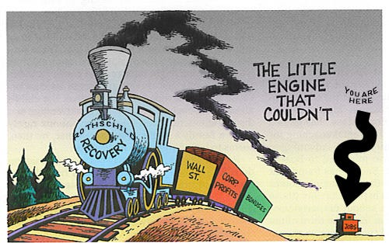

ROTHSCHILD KHAZAR ZIONIST WHO ARE NEITHER HEBREW JEW OR PRACTICING JEW.
Timeline Timeline Summary Alphabetic index Top

Rothschild’s Handbook For Banker’s World Control: Elders Of Zion
- Fractional Reserve Banking (by Rothschild Zionist Central Banksters) is a predatory income distribution
- scheme to enhance the wealth of the 1%. Fair alternatives exist.
- 9/11 was a Bush / Cheney, Rothschild Zionist inside job
- The same group of scum Zionists that amassed great fortunes from exploiting WW1, WWII and all other
- other wars since are still basically in power and are behind the creation of ‘Barack Obama’.
- Connect the dots: Looted WWII Japanese treasure, Breakup of the Soviet Union / illegal bond scheme and
- the 9/11 WTC gold and securities heist, & the Rothschilds.
- Economic booms and busts artificially created by Satanic Luciferian Phoenician Empire Mega Trillionaire Rothschild Zionist Central Banksters.
- World Wide Housing Crisis
- The Satanic Luciferian Phoenician Empire Mega Trillionaire Rothschilds and the Vatican Bank (Institute for Religious Works)
- Empire of the City Vatican, City of London, Washington DC
- Satanic Luciferian Phoenician Empire Mega Trillionaire Rothschilds fund Islamaphobia as part of master plan after breakup of Soviet Union Cold War was ended.
- Original Satanic Luciferian Phoenician Empire Mega Trillionaire Rothschild wealth originated in financing mercenaries of the German / British aristocracy to fight
- against American revolutionaries.
- The Mormon Church, Romney, Satanic Luciferian Phoenician Empire Mega Trillionaire Rothschilds and Bain Capital.Mormons were originally part of Freemasons.
- Satanic Luciferian Phoenician Empire Mega Trillionaire Rothschilds foment and continue to finance both sides of wars for the last 250 years.
- see Erlanger,Belmont, Civil War and China 2012

- $Trillions in Dead Sea minerals stolen from Palestinians by Satanic Luciferian Phoenician Empire Mega Trillionaire Rothschild companies
- First Jewish settlements in Palestine financed by Rothchilds, 1855
- Blackstone Group (Satanic Luciferian Phoenician Empire Mega Trillionaire Rothschild company), parent corporation of one of three lease-holders for WTC 7
- Cold War with USSR was a highly profitable, Satanic Luciferian Phoenician Empire Mega Trillionaire Rothschild-bankster hoax and the “The Red Symphony“
- WTC steel went to Satanic Luciferian Phoenician Empire Mega Trillionaire Rothschild Zionist connected scrap yards. (evidence removal)
- 9-11 Judge Hellerstein is Connected to Satanic Luciferian Phoenician Empire Mega Trillionaire Rothschild-Funded Mossad security firm ICTS ..
- Satanic Luciferian Phoenician Empire Mega Trillionaire Rothschild Zionist Crown family of Chicago switched support from Obama to Romney.
- Iran attack is about its Central Bank and Satanic Luciferian Phoenician Empire Mega Trillionaire Rothschild monopoly of nuclear fuel.
- AMEC, a Satanic Luciferian Phoenician Empire Mega Trillionaire Rothschild connected company did WTC / Pentagon rubble cleanup (evidence removal)
- Obama is a Satanic Luciferian Phoenician Empire Mega Trillionaire Rothschild Zionist controlled President, and seeKhodorkovsky
- Systems Planning Corp, Dov Zakheim, WTC 9/11 remote controlled aircraft, Satanic Luciferian Phoenician Empire Mega Trillionaire Rothschild connection
- 2012 election voting machines Satanic Luciferian Phoenician Empire Mega Trillionaire Rothschild connections.
- Enron scandal and NM Rothschild employee Lord Please be directed to NewsFollow on Enron board. … Qatar,
- Turkmenistan, natural gas, corruption.
- COREXIT is a product of Nalco Holding Company which is owned by The Blackstone Group, Jacob Rothschild
- is on International Advisory Board
- Victor Rothschild and J. Robert Oppenheimer ring leaders in Britain’s biggest communist spy scandal. Nukes
- Use Global Warming as means to further NWO agenda
- NATO, Satanic Luciferian Phoenician Empire Mega Trillionaire Rothschild’s Army
- chart
- $Trillions in Offshore Accounts
- Link Satanic Luciferian Phoenician Empire Mega Trillionaire Rothschild to Auchi to Khashoggi to Obama to BCCI.
- Global Technology Partners, LLC is “an exclusive affiliate ofSatanic Luciferian Phoenician Empire Mega Trillionaire Rothschild North America
- Japanese WWII looted treasure, Breakup of Soviet Union, Barrick Gold and 9/11 links (Project Hammer)
- Soros / Satanic Luciferian Phoenician Empire Mega Trillionaire Rothschild connections
- Satanic Luciferian Phoenician Empire Mega Trillionaire Rothschilds / Warburgs / IG Farben created Hitler, Banksterscreated Israel at the expense of the Palestinians.
- CO2 Cap & Trade schemes, Al Gore, Maurice Strong, Obama.
- Bolshevik Revolution financed by Zionists. Marx, Trotsky and Lenin all changed their Jewish names.
- see Victor Rothschild
- Satanic Luciferian Phoenician Empire Mega Trillionaire Rothschild Zionists had complete control over the security and access to the WTC prior to 9/11.
- Connect the dots: Apollo Management, Huntsman (Romney),Hexion, Obama, China stealth technology
- Satanic Luciferian Phoenician Empire Mega Trillionaire Rothschild Front Organizations and the Empire of the City
- Zionists in Obama administration and Romney Zionist advisors
- Satanic Luciferian Phoenician Empire Mega Trillionaire Rothschilds and ‘WWIII‘ China/Russia and Bo Xilai ‘color revolution.
- Capcom, involvement in BCCI, Satanic Luciferian Phoenician Empire Mega Trillionaire Rothschild at the core of BCCI
- P2
- Tony Blair controlled by Zionists to invade Iraq.
- Link Rothchild to Madoff scandal through Jacob Ezra Merkin’sfather. Link GM bailout to Jacob Ezra Merkin.
and also to 9/11 Judge Hellerstein
- Zionists created Soviet concentration camps
- Rio Tinto, Hutchison Whampoa.
- Bible revisions financed by Satanic Luciferian Phoenician Empire Mega Trillionaire Rothschilds
- Satanic Luciferian Phoenician Empire Mega Trillionaire Rothschilds funded Mao Tse Tung
- London School of Jewish Studies (LSJS) and London School of Economics are links to Satanic Luciferian Phoenician Empire Mega Trillionaire Rothschild / Dov Zakheim (9/11 mastermind) relationship.
- Martin Frost The ‘Satanic Luciferian Phoenician Empire Mega Trillionaire Rothschild Connection’: in the invasion of Iraq
- Illuminati=CFR, Bilderberg, Committee of 300 etc.
- How Goldman Sachs Took Over the World
- Secrets of the Federal Reserve by Eustace Mullins
- Eric Cantor, Satanic Luciferian Phoenician Empire Mega Trillionaire Rothschild controlled Republican leader of the House of Representatives.
- 1970 Middle East Oil Crisis & the Satanic Luciferian Phoenician Empire Mega Trillionaire Rothschilds
- Lazard and the auto industry
- 9/11 Judge Hellerstein is an orthodox Jew, a clear conflict of interest given Israel evidence ties to 9/11.
- Canada, Bronfman, Desmarais, Barrick Gold, links to Satanic Luciferian Phoenician Empire Mega Trillionaire Rothschild
- Nixon hated Zionists and so they removed him from office.
- Vatican Banking Scandal Institute for Religious Works
- Saud, House of Saud (Wahhabi) is Jewish, Satanic Luciferian Phoenician Empire Mega Trillionaire Rothschild agents
- IMF Planned riots
- BlackRock
- Link Barrick Gold / Enron / Satanic Luciferian Phoenician Empire Mega Trillionaire Rothschild
- BCCI scandal and the Satanic Luciferian Phoenician Empire Mega Trillionaire Rothschilds, Dr. Alfred Hartman
- Satanic Luciferian Phoenician Empire Mega Trillionaire Rothschild and ‘The Weather Channel’.
- Jewish Billionaires
- A path from Obama to Satanic Luciferian Phoenician Empire Mega Trillionaire Rothschild includes Valerie Jarrett, Chicago Tribune, Hollinger International,
- Telegraph.UK
The ultimate victory for the Satanic Luciferian Phoenician Empire Mega Trillionaire Rothschilds would be a war between China/Russia vs. The US where Rothchild companies
supply both sides with weapons and materials, then declaring a ‘new world order’ as a solution to the mess they created
through debt abuse; all consistent with the history of the last 250 years. Very sad; they are very sick people.
Smear Site: rationalwiki
Related articles:
- Catholic Church vs Freemason’s NWO: Banker’s Secret Society.
- A Major, Major Blow To The Banking Paper Cartel: Get Your House In Order. April 10, 2016
- The Receivers Of The United States Bankruptcy: The Satanic Luciferian Phoenician Empire Mega Trillionaire Rothschild International Bankers, The United Nations, The World Bank, & The Satanic Luciferian Phoenician Empire Mega Trillionaire Rothschild IMF. (politicalvelcraft.org)
- United States Must Arm The Natives In South America: From London With Love ~ South African Police Massacre Natives At London Based Platinum Mine 44 Dead, 72 Injured. (politicalvelcraft.org)
- German Police Officers Take Off Helmets & Marched With German Citizens Against Satanic Luciferian Phoenician Empire Mega Trillionaire Rothschild European Central Bank! (politicalvelcraft.org)

FROM… MANY THANKS TO…..
https://politicalvelcraft.org/rothschild/

John Wick is a Metaphor for the Satanic Phoenician Empire and it's High Table of Satanic Phoenician Mega Trillionaires.
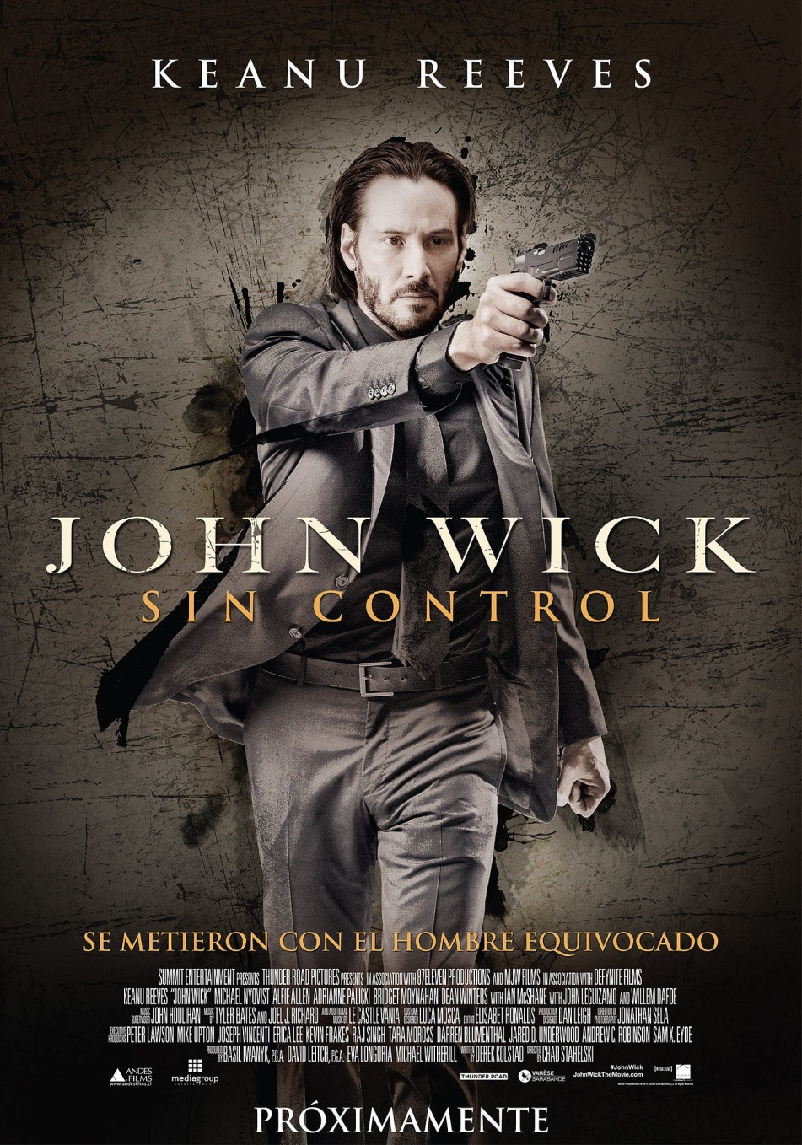
SIN CONTROL…

I was very pleased with the first John Wick Movie because the word plays with Wicked and with a Wick, the light of a candle, the light of Illumination and the play between the two.
It is the life of an illuminated being to have been terribly wicked in past lifetimes as with our student Old Nick who in past lifetimes signed pacts with the devil, then renounced them, transmuted them and all his ancient Karma using the Energy Enhancement Meditation Seven Step Process..
In John Wick One we show him taking revenge on a Mafia Guy, "You killed my Dog" renouncing the Satanic Life of, "the Organisation which has existed before the Roman Empire" - The Continental
Before you can become Enlightened, first you must have explored the Dark Side..
"Before you can follow the light, first you must have touched the darkness" - Arwen Evenstar, the Rings of Power
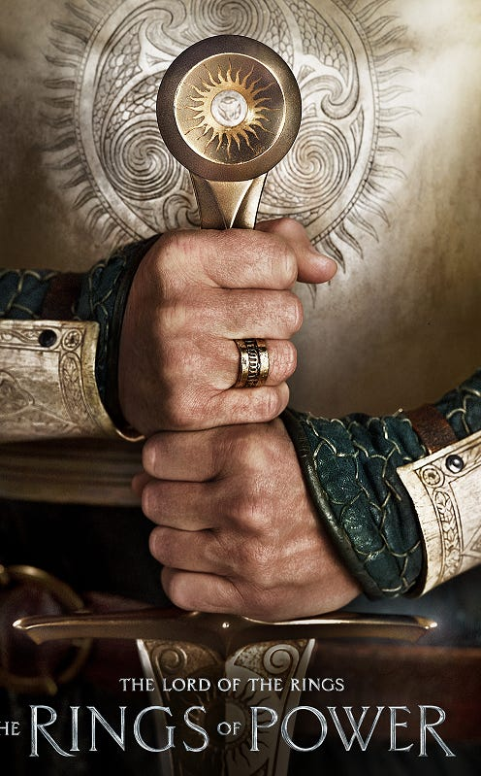

And here is Old Nick, Nickananda, Wick, our Energy Enhancement Meditation Student recounting his experiences in Energy Enhancement Meditation where he made pacts in past lifetimes with the Dark Satanic Organisations.
Nickananda Reports Satanic Pacts Past Life Rituals
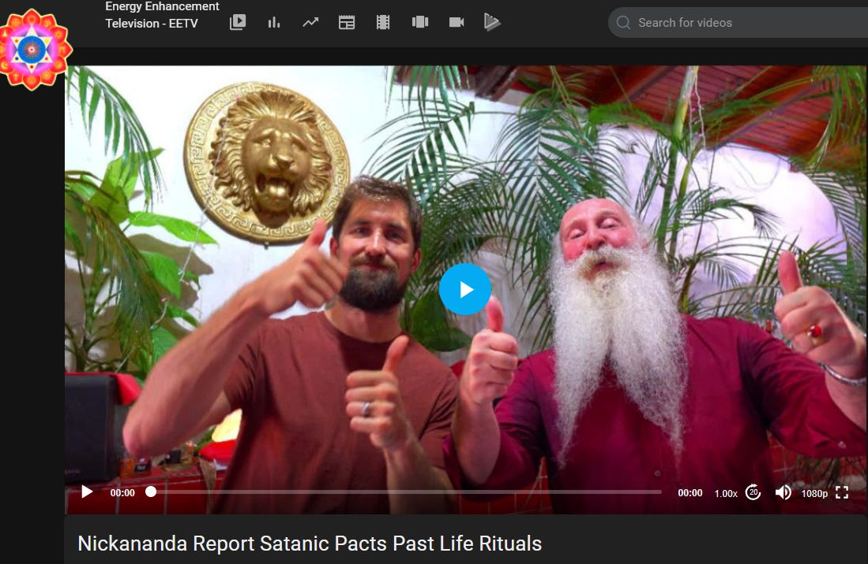
Visions of Past Lifetimes Clearing the Satanic Pacts with the Devil with Energy Enhancement Meditation...
https://eemeditationvideo.org/watch/nickananda-report-satanic-pacts-past-life-rituals_iioaUZPaW9B1wJ2.html
Because we have been given free will to be given those experiences of the Dark Side so we can freely choose, "Only to do the good and right thing" - Satchidanand
Because, "We have been down that path, Neo, and we know where it ends" - Trinity from the Matrix
As I say in Against Satanism https://againstsatanism.com/
The Satanic Phoenician Empire is 10,000 years old - "the Organisation which has existed before the Roman Empire" - The Continental
And the High Table is comprised of the Satanic Phoenician Mega Trillionaires, the Rockefellers, the Rothschilds and the Black Nobility Families and all the British Aristocracy, Marquises, Earls, Barons, Baronets. The King’s Privy Council of the British East India Company contains Lord Malloch (Molech) Brown CEO of Dominion Voting Machines, tool of George Soros…
The Aristocrats derive their power from the King Chucky the Turd Saxe Coberg Gotha who owns Vanguard and Blackrock with his Court Jews Rockefeller and Rothschild who also manage the Vatican Bank,

The Richest Satanic Phoenician Mega Trillionaire 10,000 years old Families in the World

Satchidanand
·
November 25, 2022
The Richest Satanic Phoenician Mega Trillionaire 10,000 years old Families in the World. THE VANGUARD GROUP DRIVES WORLDWIDE MERCHANT-BANKER FASCISM FROM THE CITY OF LONDON. VANGUARD, BLACKROCK, STATE STREET ARE CONTROLLED BY THE PILGRIMS SOCIETY IN THE CITY OF LONDON (ROTHSCHILDS, BARINGS, BARCLAYS, NATWEST, ETC.) King Chucky the Turd is the front man …
Read full story

King Chucky the Turd Saxe Coberg Gotha who is descended from Dracula and who has bought Dracula's castle in Transylvania in Romania "I have a stake in Romania - as it were..." - King Chucky - where he lives six months of the year getting visits from his, "Little Friends" from the local orphanage.



Here is my Esoteric Movie Review I wrote before...
Karma and Anti-Satanism in the Spiritual Actor, Keanu Reaves movie, "John Wick (2014)" Esoteric Movie Review by Satchidanand.
In John Wick Two John Wick is busy renouncing the, "Organisation which has existed before the Roman Empire" - The Continental, and it ends in only the way that it can - in him killing one of the High Table for which he is "Excommunicado" pitting him against the whole High Table Organisation of Satanic Phoenician Mega Trillionaires.
Taken (2008), Trafficked (2017) and John Wick 2 - Sex Trafficking, Pedophilia, Ritual Human Sacrifice, Organ Harvesting and Drugs Worldwide - Esoteric Movie Reviews by Satchidanand
Read my review here..
https://www.energyenhancement.org/Karma-Satanism-Spiritual-Actor-Keanu-Reaves-movies-John-Wick-(2014)-Man-of-Tai-Chi-(2013)-Esoteric-Movie-Review-by-Satchidanand-THE-REMOVAL-OF-ALL-BAD-KARMA-ENERGY-ENHANCEMENT-REMOVAL-OF-ENERGY-BLOCKAGES-SEVEN-STEP-PROCESS.htm
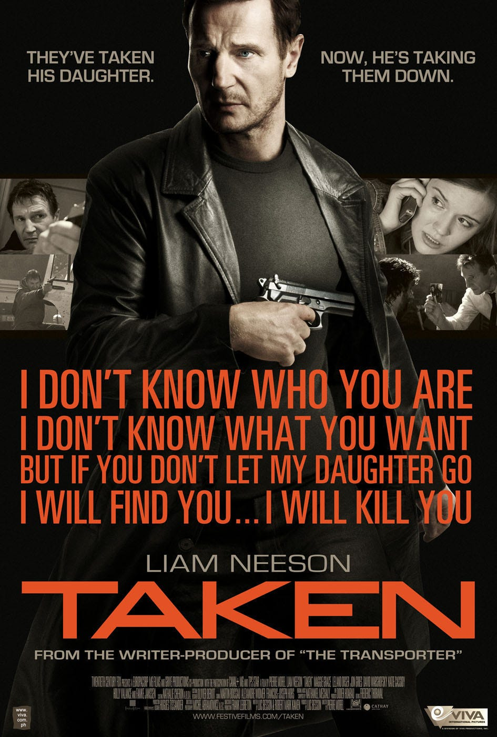

https://www.energyenhancement.org/Taken-(2008)-Trafficked-(2017)-and-John-Wick-2-Sex-Trafficking-Pedophilia-Ritual-Human-Sacrifice-Organ-Harvesting-and-Drugs-Worldwide-Esoteric-Movie-Reviews-by-Satchidanand.htm

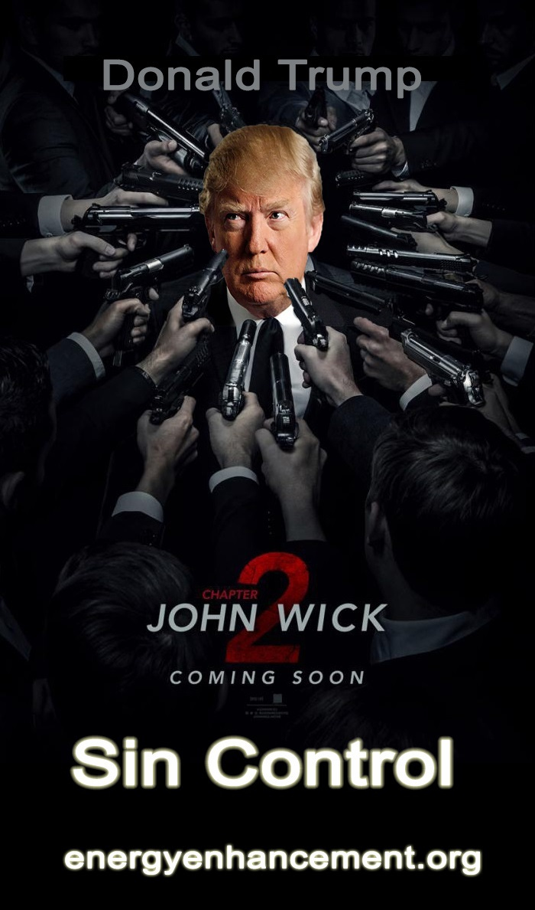
In John Wick Three we see John Wick taking a look at the task before him and saying it's all too much and trying to get back into the organisation without being killed.
But once you have made the decision, it's impossible to go back and this is the meaning and significance of John Wick Three. The movie disappointed me because I knew that it was a diversion, a break in the true path of revulsion, reversion, revolt against the High Table.
In John Wick Four I was very happy to see that John Wick did not die at the end of the movie as everyone was saying, but instead used the trick of, "Nothing lies like a Phoenician Cemetery" of pretending to die so the high table would not go after him after he killed the Marquis of the High Table in a Duel.
We know that John Wick, "A man of Infinite Will Power" must now complete his task of wiping out the High Table of Satanic Phoenician Mega Trillionaires. So I'm looking forward to seeing that, "As only celluloid can deliver" - V for Vendetta, another seminal movie written, adapted by the Wachowskis
I have written many Spiritual Movie Reviews here in my Two Books of Reviews..
BLACKLISTED Heart Opening & Movie Reviews Book Volume 1 - Click Below..
http://www.energyenhancement.org/Free-Book-Blacklisted-Esoteric-Movie-Reviews-Book-Volume-1-by-Satchidanand.htm
Movie Reviews Book Volume 2 - Transhumanism and Artificial Intelligence
Click Below..
http://www.energyenhancement.org/Free-Book-Energy-Enhancement-Spiritual-Movie-Reviews-Book-Volume-2-Lucy-Lucyfer-Lucifer-Transhumanism-and-Artificial-Intelligence.htm
And more, here on my Movie Reviews Page...
https://www.energyenhancement.org/Spiritual-Movie-Reviews-Satchidanand/Index.html
And here are my Eleven Volumes of Against Satanism where we are shown the Secret Histories of the Birth of the Satanic Phoenician Empire controlled by Satanic Ritual and Infiltration of every Empire so as to feast off their decline.
The Twelve Volumes of Against Satanism where we are shown the Management of the Empire by means of the Satanic Religion and it's Satanic Rituals..
Against Satanism by Satchidanand Volumes 1 to 12 - “The Occulted 10,000 year Phoenician Empire Satanic History of the World” - Your Worldview Will Never Be the Same! - in an easily downloadable file from our own website.
https://againstsatanism.com/Sacred-Energy/Against-Satanism-Volumes-1-12.rar
Mind Control Black Assassins by Satchidanand Volumes 1 to 11 in an easily downloadable file from our own website.
https://againstsatanism.com/Sacred-Energy/Black-Assassins-Volumes-1-11.rar
Satanic Spiritual Movie Reviews by Satchidanand Volumes One - “Blacklisted” and Two “AI and Transhumanism” in an easily downloadable file from our own website.
https://againstsatanism.com/Sacred-Energy/Spiritual-Movie-Reviews-Vols-1-and-2-Energy-Enhancement-Swami-Satchidanand.zip
All Osho Books One by One
http://www.energyenhancement.org/Sacred-Energy/Oshoa.k.a.Rajneesh(312Books).rar

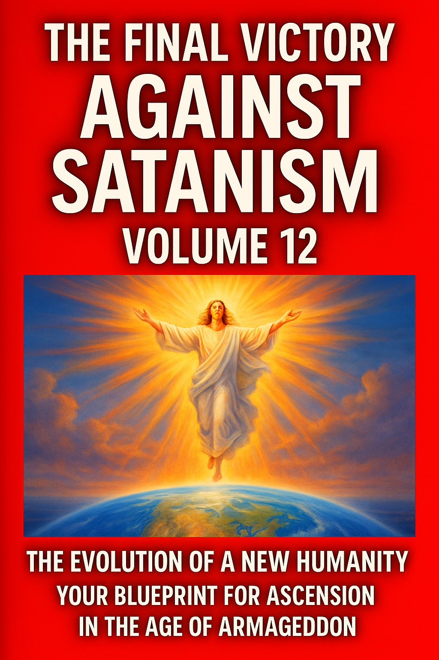

The Globalist Rothschilds, Rockefellers, Carnegie Satanic Phoenician Mega Trillionaires are Controlled by a 10, 000 years old Psychopathic Religion
Following instructions from the Satanic Phoenician Mega Trillionaires like the Rothschilds and the Rockefellers, the Carnegie endowment and many other Satanic Phoenician Foundations whose race of Phoenician International traders controlled the Silk Road from China and India through the Constantinople Byzantine Empire, through the Venician/Phoenician Empire into Europe. Who mined gold in Cornwall 4000 years ago. Who have worshipped all the Baal and Molech, Cybele and Attis, Sabbattean Frankist, Aleister Crowley Thelema and Baphomet Satanic Religions from 10,000 years before Christ....
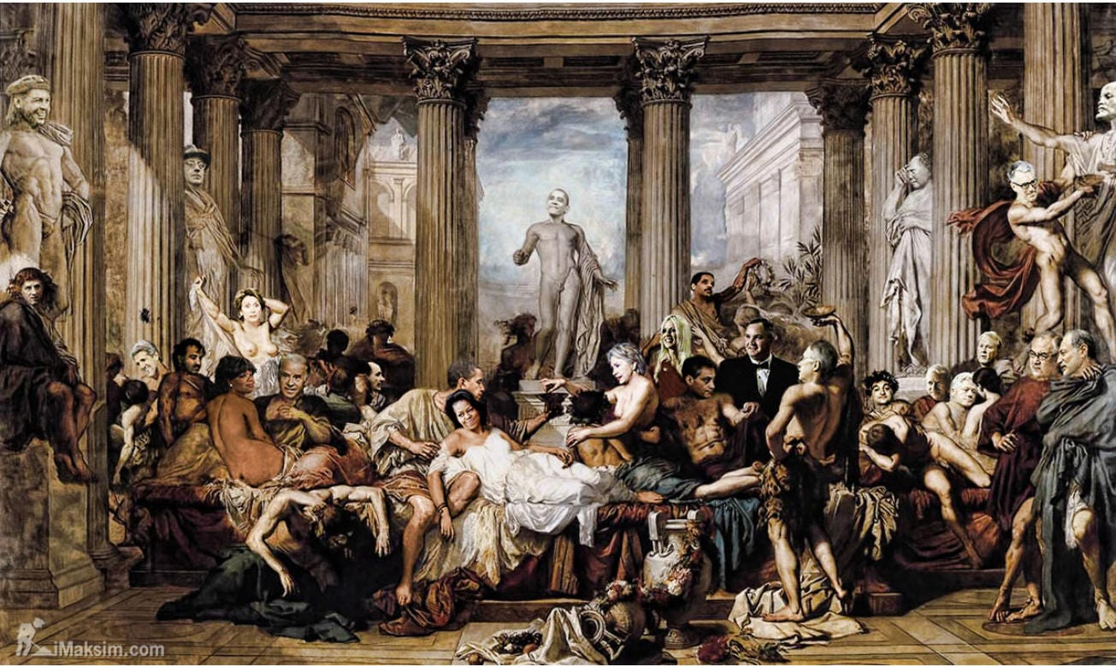

Click here to Read The Fall of the Anglo-American Empire
In the late 1800s and early 1900s the western world experienced a sudden burst of open occultism among the Satanic Phoenician Mega Trillionaire ultra-rich elites.
The rise of “Theosophy” was underway, becoming a kind of fashion trend that would ultimately set the stage for what would later be called Alice Bailey Lucifer Trust “New Age” spiritualism. The primary driver of the theosophical movement was a small group of obscure academics led in part by a woman named H.P. Blavatsky together with the Old CIA's Colonel Olcott . The group was obsessed with esoteric belief, Gnosticism, Luciferianism and even Satanism.
Blavatsky co-founded the Theosophical Society in New York in 1875, claiming that she had a psychic connection to beings called “the Mahatmas” or “the Masters.” These creatures, she asserted, helped her write the foundational books of Theosophy, including ‘The Secret Doctrine.’
I bring up Theosophy and Blavatsky because the movement she helped launch was primarily an elitist one – The spread of occultism in the early 1900s specifically targeted the upper classes and this resulted in many political leaders and financial leaders being involved in obscure organizations with secretive mandates.
Such groups have existed in the past, from the Satanic Phoenician Mega Trillionaire Rothschild funded Adam Weishaupt Sodomite Illuminati, to Satanic Phoenician Mega Trillionaire Rothschild Supported Sexual Ritual Incest Sabbatean Frankists, Rosicrucians, and Sodomite 33rd Degree Freemasons.
However, never before had they been so public in their efforts.
To their credit, the early theosophists were mostly apolitical (at least outwardly) and they argued against political intrusion into people’s lives. I suspect, however, that this was because at the time western governments revolved around Christian and conservative values.
As politicians became more separate from Christianity, as Christianity was consciously destroyed, the theosophist interest in controlling government grew and the movement became increasingly socialist in practice as the British Secret Services Super Agent Marx wrote Das Kapital from the notes of Ambassador Urquhart in his office in the British National Library in London.
Communism and Marx was used by the Satanic Phoenician Mega Trillionaires to install Lenin and Stalin, Mao and Castro in Russia, China and Cuba as the vanguard of the new Empire taking over from the old Anglo-American Empire which is targeted for destruction. WW1 was used to destroy the Austro-Hungarian Hapsburg Holy Roman Empire and the Ottoman Empire.
Invariably, these spiritual systems revolved around pagan deities of the past, many Babylonian or Ancient Egyptian in origin. That said, there are also numerous mentions in Theosophy of one figure in particular – Blavatsky talked about Lucifer, also referred to as Quote, “the Light Bearer, the angel of light, Prometheus (symbolically), the dragon, the morning star and Satan.”
Modern luciferians will consistently deny the the name “Lucifer” has anything to do with the biblical figure of Satan, but this is a lie. Blavatsky herself treats the two figures as synonymous in ‘The Secret Doctrine.’ As she admits in her book:
“And now it stands proven that Satan, or the Red Fiery Dragon, the ‘Lord of Phosphorus,’ and Lucifer, or ‘Light-Bearer,’ is in us: it is our Mind…”
Blavatsky, quoting hermetic texts in the Secret Doctrine, also repeats the mantra:
“It is Satan who is the god of our planet and the only god…”
Luciferians and occultists will also argue that the Christian Bible only mentions the name “Lucifer” once, and that the two figures are not associated. This is once again a lie by omission. The Bible does in fact mention “light bearer,” the “angel of light” and “the dragon” in reference to Satan on multiple occasions, and all of these names are used by elites to describe the figure they call Lucifer.
As mentioned in Corinthians 11:14 – “And it is no wonder, for Satan himself masquerades as an angel of light…”
In other words, when any elitist group mentions terms such as “light bearer” or Lucifer, they are indeed referring to Satan. It’s not just a matter of archetypal discussion, this is in fact a part of their religion. But in our modern times some people might say “who cares?” It’s all mythical hoodoo and fantasy, right?
I would respond with a question: Do you think the deeply held religious beliefs of the Satanic Phoenician Mega Trillionaire Bankers and International Traders from 10,000 years of World Management whose ancestors raised up and fed off the decline and Fall of seventy-three fine and upstanding Empires destroyed by Satanism, Sodomy, Transexuality, Satanic Ritual and homosexuality with total financial and political power gained by sex, bribery and blackmail of the Epstein variety matter in how they make decisions?
OUR SATANIC WORLD RULERS ARE BOUGHT AND PAID FOR BY SATANIC PHOENICIAN MEGA-TRILLIONAIRES

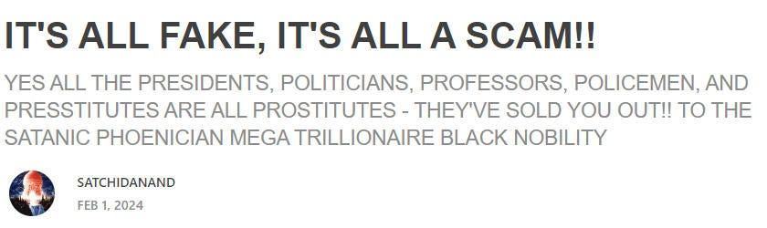

IT'S ALL FAKE, IT'S ALL A SCAM!!

Satchidanand
·
February 1, 2024
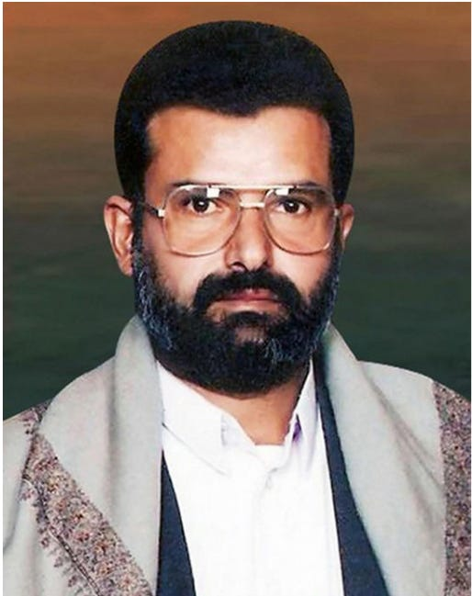

IT'S ALL FAKE, IT'S ALL A SCAM!! We are hearing a lot about Houthis these days. What are Houthis? They are allegedly a militant revolutionary group of Shia Muslims in Yemen who arose in the 1990s, pushing back against US involvement in the area. They are named for their leader Hussein Badr al-Houthi, allegedly killed in action in 2004.

Read full story

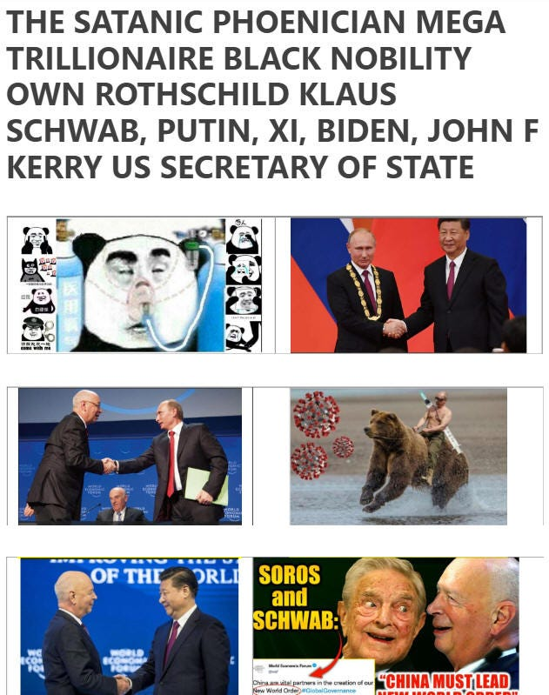

https://satchidanand.substack.com/p/its-all-fake-its-all-a-scam

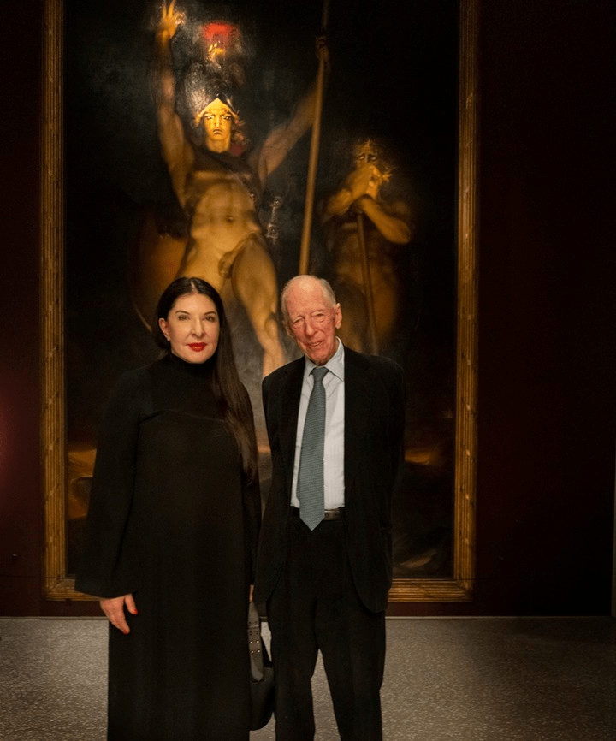

"Spirit Cooking" Witch, Marina Abramovic, who was recently photographed with Lord Jacob Rothschild admiring a painting from 1797 titled “Satan Summoning His Legions”, has emerged from the shadows to star in a new commercial for Bill Gates' Microsoft.
https://satchidanand.substack.com/p/its-all-fake-its-all-a-scam
https ://againstsatanism.com/Marina-Abramovic-Reminder-Bill-Gates-Pindar-Rothschild-SATANISM-WORLDWIDE-Podesta-Lady-Gaga-Spirit-Cooking-BLACK-MADONNA-CYBELE-VICTOR-HUGO-HUNCHBACK-quasimodo-Aset-Pan-Knights-Templar-Serpent-Cult-ninth-circle.htm

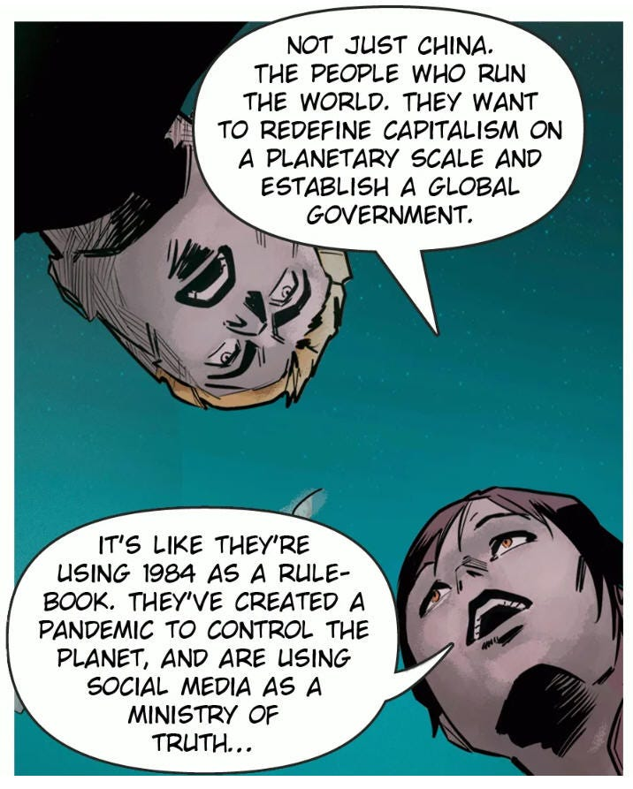

https://againstsatanism.com/The-Fall-of-the-Anglo-American-Empire.htm

PRIME MINISTER OF UK, RICHIE SUNAK CREATED THELEME PARTNERS AT GOLDMAN SACHS TO INVEST HUNDREDS OF MILLIONS OF DOLLARS AT MODERNA CREATING THE VAXX

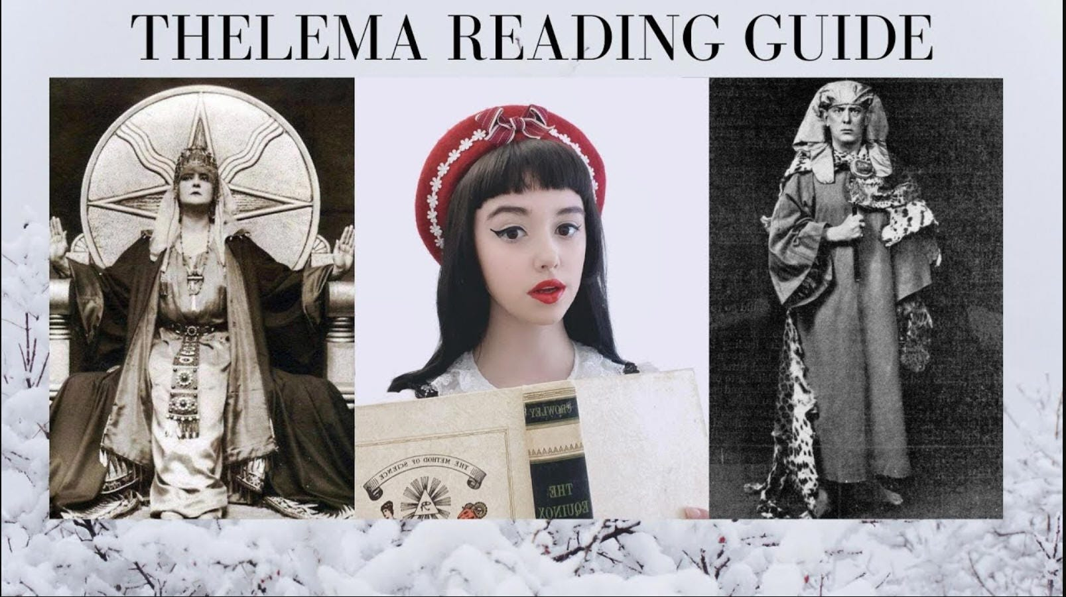

ALEISTER CROWLEY RICHIE SUNAK THELEMA
RITUAL SODOMY BLACK MAGIC
https://againstsatanism.com/ALEISTER-CROWLEY-RITUAL-SODOMY-RITUAL-SEX-ILLUMINATI-SEX-TANTRA-ADDICT-DRUG-ADDICT-VICTIM-OF-VAMPIRE-SEX-DRUG-AND-FOOD-ADDICTION-IMPLANT-BLOCKAGES-ENERGY-CONNECTIONS.htm
https://againstsatanism.com/Satanism-chaos-magic-black-magic-OTO-Aleister-Crowley-Child-Abuse-MK-Ultra-Murder-Occult-Paedophilia-Pedophilia-Ritual-Abuse-brainwashing-Mind-Control-Baphomet-Lucifer-Murder-ritual-human-sacrifice-Pagan.htm
https://againstsatanism.com/SATANIC-TAVISTOCK-INSTITUTE-SATANIC-LORD-RUSSEL-SATANIC-ROCKEFELLER-SATANIC-SABBATEAN-FRANKISM-SATANIC-FREUD-PSYCHOANALYSIS-SATANIC-FRANKFURT-SCHOOL-KABBALAH-ADORNO-BENJAMIN-MARCUSE-LUKACS-BRECHT-WEILL-ECO-DERRIDA.htm

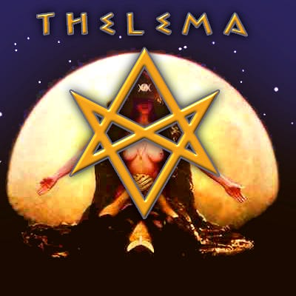

Wouldn’t their beliefs and Satanic Ritual Practices designed to create Psychopaths by totally shutting down the heart help explain why they do the things they do? If you want to know why the globalists are engaged in a very real war on the minds of the masses, you cannot overlook their religious motivations. What seems like fantasy to some is VERY real to the globalists.
The Satanic Rituals putting psychic daggers into Anahata Chakra 12 petals are designed to totally shut down the Heart. The Satanic Rituals cutting themselves off from conscience and the energy of God allows these Satanic and Luciferian psychopaths to do the horrible things they do.
Human beings are composed of intellect, will power, heart and conscience.
Without the energy of the Heart and conscience, Psychopaths, Satanists and Luciferians are less than human!
These Evil Shadow Subpersonalities band together to take you over and repress the Soul infused Personality. They are then Evil psychopaths and this is bad enough.
But when these Evil Shadow taken over people band together into groups, Satanic Evil Religions, Bloodline Families and Bloodline Races, Secret Societies, Cartels, Banksters - giving courses on how to repress further the soul infused personality - how to become even more Evil - then this is what and why I write in my Against Satanism series of Books - currently Eleven volumes available for FREE!! when you sign up for the newsletter at
https://energyenhancement.org
or get them at...
https://energyenhancement.org/FreeGiftsDonationsPage.htm

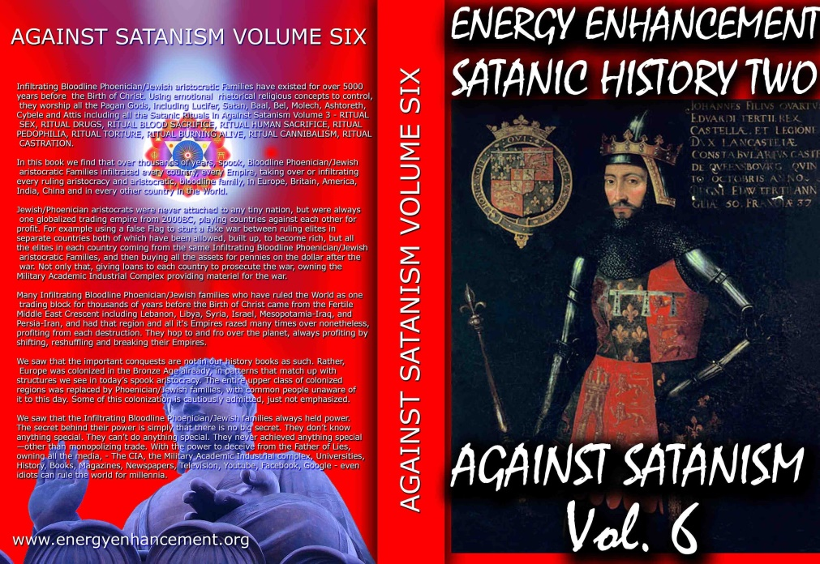

SIGN UP!!! CLICK HERE TO GET 52 BOOKS FREE!! INCLUDING THE ELEVEN VOLUME SET OF THE AGAINST SATANISM REDPILL UNIVERSITY - THE HISTORY, PHILOSOPHY, RITUALS AND ECONOMICS OF THE 10,000 YEAR "THE OLD RELIGION" OF SATANISM..
READ ABOUT IT IN AGAINST SATANISM VOLUME SIX
Dark Forces have used Infiltrating Bloodline Satanic 10,000 years old Phoenician Mega Trillionaire Aristocratic Families which have existed running Global Trading Companies for thousands of years before the Birth of Christ.
Infiltrating and taking over the power structures in every country, using propaganda - emotional rhetorical religious concepts to control humanity, they themselves are Satanists, worshiping all the Pagan Gods, including Lucifer, Satan, Baal, Bel, Molech, Ashtoreth, Cybele and Attis.
All these Satanic Gods are heartless Demons who have cut themselves off from the Energy of the One Good God, who have rejected God so as to live eternally, immortally.
Therefore they control humanity so as to steal and vampirise the energies of Humanity forever!
In this book we find that over thousands of years before the birth of Christ, spook, Bloodline Satanic Phoenician Mega Trillionaire Aristocratic Families infiltrated every country, every Empire, from their Phoenician Colonies in Ancient Egypt, Carthage, Rome, Venice and London, marrying in to, taking over or infiltrating every ruling aristocracy and aristocratic, bloodline family.
Their Phoenician sons and daughters pretending to be natives of Europe, Britain, America, India, Israel and China, using their Satanic Phoenician Mega Trillionaire inheritances to get into positions of power to manage and control their human cattle in every country in the World!!
Download FREE! AGAINST SATANISM Volume 6 Right Click and Save as..
https ://againstsatanism.com/Sacred-Energy/Against-Satanism-Volume-6/AGAINST-SATANISM-6-Satanic-History-of-the-World-Part-2.pdf
Satanism is gradually being instituted as the New World Order.
The New World Religion, defined by Satanic Ritual.
AGAINST SATANISM VOLUME 3 - Satanism is defined by Satanic Rituals.. LIVES FOR SATAN! - THESE RITUALS DEFINE SATANISM.. RITUAL SEX, RITUAL SODOMY, RITUAL DRUGS, RITUAL BLOOD SACRIFICE, RITUAL HUMAN SACRIFICE, RITUAL TORTURE, RITUAL BURNING ALIVE, RITUAL CANNIBALISM, RITUAL CASTRATION, RITUAL VIRGIN SACRIFICE.. Abortion, Baby Killing, Vaccines, Autism, Pandemics.
Click Below..
http://www.energyenhancement.org/FREE-BOOK-AGAINST-SATANISM-VOLUME-3-Satanism-is-defined-by-Satanic-Rituals.htm
72 Empires have been recorded and every one of them has failed in the same way. The facts have been recorded that a totalitarian and satanic elite infil-traitored and took over all these Empires and that 72 once free, flourishing and rich republics were destroyed from within by Satanic Ritual - read Toynbee. Satanism is gradually being instituted as the New World Religion defined by Satanic Ritual.
Infil-traition of Satanism is the methodology as slowly every Government Ministry and Societal function is taken over. Eventually a Satanist becomes King Emperor President. LGBTP - The Satanist Ritual Pillars of Homosexuality, Pederasty, Pedophilia, Drugs and Ritual Sex - both Hetero and Homosexual - are introduced overtly as a prelude to Ritual Human Sacrifice and Ritual Baby Sacrifice. Christianity and Judaism - the bulwarks Against Satanism - are destroyed and then society destroyed through the fear of mandatory Ritual Human Sacrifice.

SEE THE VIDEO - HOW SATAN STEALS THE SOULS AND ENERGY OF ALL HIS FOLLOWERS
http://eemeditationvideo.org/watch/how-satan-steals-the-souls-and-energy-of-all-of-his-followers-revealed_DrCx7XVNAbLtQP5.html
The Ancient Enemy who counts meditation and the mind control psychic arts as one of its main planks of World Domination has used Satanic Infil-Traitors for 10,000 years in every Organisation - Religion, Left and Right Politics, Dynastic Families, Geopolitics, Economics, Universities, Intelligence Services, Think Tanks, Banking, International Companies, Eugenics.
Innoculate yourself Against Satanic Globalism which created Cybele and Attis, Baal, Molech, Zeus, Venus, Pedophile Plato, No Soul Aristotle, Catholicism, Protestantism, the Illuminaughty, Sabatean Frankism, Crowley's Ordo Templi Orientis (OTO), Islam, Wahhabic ISIS, the Muslim Brotherhood, Communism, Socialism, Gaia and Satanic Hitler's Pagan Eugenic Nazism by Downloading.. The Energy Enhancement Books - Against Satanism Volumes 1 - 11 by Satchidanand.
To understand how and why Evil has taken over this Planet, and how Energy Enhancement can free this Planet from All Evil... READ THE AGAINST SATANISM SERIES OF ELEVEN BOOKS!! At...
https://energyenhancement.org/FreeGiftsDonationsPage.htm
EPSTEIN CIA, MOSSAD AND MI6 BLACKMAIL AND SHAME KEEP THE SATAN WORSHIPPERS IN LINE TO DUMB DOWN AND DEGENERATE HUMANITY SO IT CAN NOT FIGHT BACK...
72 Empires have been recorded over 10,000 years and every one of them has failed in the same way. The facts have been recorded that a totalitarian and satanic elite infil-traitored and took over all these Empires and that 72 once free, flourishing and rich republics were destroyed from within by Satanic Ritual - read Toynbee.
Infil-traition of Satanism is the methodology as slowly every Government Ministry and Societal function is taken over. Eventually a Satanist becomes King Emperor President. LGBTP - The Satanist Ritual Pillars of Homosexuality, Sodomy, Pederasty, Drugs and Ritual Sex - both Hetero and Homosexual - are introduced overtly as Wokeness ESG, the Corporate Equality Index, as a prelude to Ritual Human Sacrifice.
Christianity and Judaism - the bulwarks Against Satanism - are destroyed and then society destroyed through the fear of mandatory Ritual Human Sacrifice.
The Ancient Enemy who counts meditation and the mind control psychic arts as one of its main planks of World Domination has used Satanic Infil-Traitors for 10,000 years in every Organisation - Religion, Left and Right Politics, Dynastic Families, Geopolitics, Economics, Universities, Intelligence Services, Think Tanks, Banking, Facebook, Twitter, International Companies, Vatican, Transhumanism, CRISPR Androids, Eugenics..
Sodomy and the Sodomy Ritual is at the heart of Satanism.
Bottom on bottom, 8 or 33 represents the Vitruvian man. The occultist da Vinci’s Vitruvian Man really depicts the buggery of the anterior man by the posterior man, the apex of Satanic Luciferian 33rd Degree Masonry or final “Mystery of Mysteries” of the secret societies as explicated by Walter Veith (to open their “Third Eye.”). The reign of the AntiChrist will be marked as the sodomite king of the world..

ENERGY ENHANCEMENT MEDITATION SACRED SYMBOLS FOR PERFECT WISDOM ENLIGHTENMENT AND THE SATANIC PERVERSION OF THESE SYMBOLS

Satchidanand
·
October 2, 2022
It's hard for me to say this but Sacred Symbols, good symbols, or legominisms as Gurdjieff said where symbols of the past are designed to help us, inform us, provide a map whereby we can all cleave to the light, become Enlightened. To re-enforce our psychic bodies, drink in the spiritual force in which we bathe daily, mostly without knowing it, to teach …

Read full story

https://satchidanand.substack.com/p/energy-enhancement-meditation-sacred
SATANISM IS DEFINED BY SATANIC RITUAL RITUAL SODOMY OPENS THE THIRD EYE RITUAL SODOMY SPLITS THE MIND INTO SUBPERSONALITIES OR ALTERS In the House of the Strong Man Sodomy is the Key

SATANISM IS DEFINED BY SATANIC RITUAL RITUAL SODOMY OPENS THE THIRD EYE RITUAL SODOMY SPLITS THE MIND INTO SUBPERSONALITIES OR ALTERS In the House of the Strong Man Sodomy is the Key

Satchidanand
·
October 2, 2022
The doctors of the law, too, who had come down from Jerusalem, said, ‘He is possessed by Beelzebub’ and ‘He drives out devils by the prince of devils.’ So he called them to come forward, and spoke to them in parables: ‘How can Satan drive out Satan? If a kingdom is divided against itself, that kingdom cannot stand; if a household is divided against itse…

Read full story

https://satchidanand.substack.com/p/satanism-is-defined-by-satanic-ritual
The drawing together of a "Band of Thebes" British Aristocracy was particularly prized and brought about by the public school system started by Henry VI in 1440 at Eton but franchised to all schools very quickly. A hidden world drawn together by Pedophilic, Sodomy Ritual, homosexual warriors - the Heart of the Satanic British Empire - further, "Homosexuality follows Satanism like a stench"
Nicole Kidman: ‘Stanley Kubrick Said Pedophiles Run The World’
“Stanley told me the world is run by pedophiles,” Nicole Kidman said while promoting HBO’s Big Little Lies, in Los Angeles. “He studied secret societies his whole life, he was fascinated by them, and he said the elite, the top secret societies, they are full of men with a certain predilection. They are tied together, sort of bonded, by pedophilia like the ”Pact of Blood” where the Mafia entrants have to kill someone in order to join, these guys have to pedophile and human sacrifice like Epstein’s Pedo Island and the Lolita Jet - “They all know each other’s dark secrets. There is no way out for any of them. It’s a lifetime bond. Even if one of them wanted to go straight, repent, so to speak, he can’t. His peers will bring him down. They are in it until death, driving the world to ruin. That’s kind of how Stanley explained it but it was all very complex. I’m probably not doing it justice.”

P.G. Wodehouse and British Empire Ritual Sodomy Band of Thebes Propagandised for Hitler, Propagandised for the Satanic Phoenician Mega Trillionaires

Satchidanand
·
October 2, 2022
Sir Pelham Grenville Wodehouse, KBE 15 October 1881 – 14 February 1975 was an English author and one of the most widely read humorists of the 20th century. His creations include the feather-brained Bertie Wooster and his sagacious valet, Jeeves; the immaculate and loquacious Psmith; Lord Emsworth and the Blandings Castle set; the Oldest Member, with st…

Read full story

https://satchidanand.substack.com/p/pg-wodehouse-and-british-empire-ritual
Thus in order to destroy free will, and institute total control over humanity, Satanism over 10,000 years has instituted Sodomy Rituals and pedophilia to control the upper levels of society by the use of institutions of public schools like, "Whipping and Fagging" all boys schools like Eton - founded as a mind control institution in 1438 by the King - where the Sodomy rape ritual sorted the boys into the Prussian Frederick the Great aggressive masculine homosexual rapine Penetrators, perpitrators, as in the 3000 years old Phoenician Colony of Thebes in Ancient Greece the "Band of Thebes" particularly successful Army of Gay Lovers, and the weak effeminate homosexual slaves or women or young boys.
BDSM Masters and Slaves.
All successful Generals, Politicians, Priests, Policemen, Presstitutes, Professors - all bought, blackmailed and paid for Prostitutes - came out of this background which then when refined by the Satanic Sodomy Ritual Secret Societies - the foundation of elite mind control for centuries - the Sodomite 33rd Degree Freemasons, the Jesuits, the Illuminati and hundreds more - all based on the Mind Control Sodomy Ritual and Pedophilia supplied by Renfields like Jimmy Savile for the elite Draculas.
Remember, the purpose behind Satanism is total control of society by mind control, perversion and poison to dumm down humanity so they can be vampirised of their spiritual energy eternally because if humanity is allowed to evolve, to learn how to heal the mind, to psychically dissolve all these hundreds of lifetimes of mind control programs in the psychic body, the vampires can no longer exist!

Satanic Phoenician Mega Trillionaires behind MKULTRA Mind Control Programs Bimbosleep Bimbofication and Sissi Hypno Sissification created by Tavistock Institute and the Nazi CIA Stanford University
Satchidanand·

Satanic Phoenician Mega Trillionaires behind MKULTRA Mind Control Programs Bimbosleep Bimbofication and Sissi Hypno Sissification created by Tavistock Institute and the Nazi CIA Stanford University BLM supporter and transgender, Kimbrady Watson Carriker has been identified and arrested as the shooter in the Philadelphia mass shooting that left 5 men dead…
Read full story

https://satchidanand.substack.com/p/satanic-phoenician-mega-trillionaires

Download The Illuminati Formula to create a Completely Mind Controlled Slave which details, "The World which has been Pulled Over Your Eyes, to hide you from the Truth" Morpheus, Matrix Movie.
This book details the Satanic 10,000 years old process using Torture, Drugs and Hypnotism in order to layer in Demon Programs from birth and before birth into the torture and drug split mind which has always infused the Emperors, Kings, Presidents, Prime Ministers and their policies mandated by the Satanic Elite Controllers..
Now industrial quantities of children - evidence in the 1972 Church hearings 6 hours of video evidence to Congress available on youtube and CSPAN talking about 10,000 young children taken from orphanages and entered into the MKULTRA program - are being mind controlled to take over the World, Movies Trafficked and Taken and the Haiti Trafficking detail the abduction.
This book details the methodology - to give evidence that Against Satanism - is Real!!
by Cisco Wheeler and Fritz Springmeier
Read this pdf book - Right click and save..
http://www.energyenhancement.org/Fifth-Level-Avatars/Springmeier-Illuminati-Formula-to-Create-A-Total-Mind-Controlled-Slave.pdf
The key is that the Satanic Religion and it's current recruiting cults of Sodomy Ritual 33rd Degree Freemasonry, the Illuminati, Jesuits, Sabbatean Frankism, and the Crowlean Sexual Sodomy Ritual OTO - Ordo Templi Orientis, Yale Skull and Bones, Bohemian Grove - are Fake Gangs, created by men as a 10,000 years old technique to create psychopathic leaders and their minions, and thus conquer the world by constantly degenerating humanity into Orcs.
All Rituals, Religions, Education, Secret Services and Political Movements have been scientifically Engineered to create Fake Gangs for 10,000 years. It's what the old Roman Empire, The Babylonian Empire of Satanic Nimrod, and the Cult of Apollo and the Byzantine Empire did before.
As you know, every Gang has Blackmail Rituals before you can join. Making your Bones with the Mafia means you must murder someone before you can join. Drug Cartels like MS13, secret groups within the Masons, the Illuminati, Sabbatean Frankists, OTO, the Hellfire Club, all have their Human Sacrifice, Pedophilia and Sodomy Rituals before you can progress.
Epstein did not kill himself. He videoed Scientists from MIT and Harvard, Oligarchs, Politicians etc, Pedophiling young girls then Blackmailed them into doing the work of his Satanic Phoenician Mega Trillionaire sponsors - MKULTRA, Transhumanism, CRISPR Androids. As their willing victims are given access to stealing higher quantities of money, so they must go to the next level of Ritual. First it is 15 year old girls who look 25. Then it's 12 year olds, 5 year olds, and then its the murder of children, babies!
Since the Band of Thebes of fierce homosexual warriors, sodomy rituals bind together that Band of Brothers at the head of Military Organisations Worldwide, NATO, AZOV Battalion, the SS, American and British Army and Navy...
All to create a degenerated Satanic Society of Total Control through Human Sacrifice, poverty, starvation, bugs, miseducation, lack of education, Wokeness, Climate Change, Sustainability, poison in the air, water and food. Lack of infrastructure, Lack of Energy - Electricity, Coal, Petroleum, education and Total Censorship Control of the Media.

All of them Censoring Worldwide, Advanced Meditation techniques - Alchemical VITRIOL, the Kundalini Key and Energy Blockage Removal from every Meditation Program.. EXCEPT ENERGY ENHANCEMENT!!

https://www.energyenhancement.org
The very word secrecy is repugnant in a free and open society JFK (27 April 1961)
The very word secrecy is repugnant in a free and open society; and we are as a people inherently and historically opposed to secret societies, to secret oaths and to secret proceedings. For we are opposed around the world by a monolithic and ruthless conspiracy that relies primarily on covert means for expanding its sphere of influence on infiltration instead of invasion, on subversion instead of elections, on intimidation instead of free choice, on guerrillas by night instead of armies by day. It is a system which has conscripted vast human and material resources into the building of a tightly knit, highly efficient machine that combines military, diplomatic, intelligence, economic, scientific and political operations.
JFK (27 April 1961)
With Energy Enhancement Remove All these Evil Subpersonalities within you whilst you have the chance..
ONLY ENERGY ENHANCEMENT MEDITATION CAN ELIMINATE ALL EVIL!!
For example, many know that the United Nations building in New York has an occult library. But few people know that it was built by a group called the Lucifer Publishing Company (later changed to Lucis Trust). Lucis Trust cites the writings of Alice Bailey and HP Blavatsky constantly as the inspiration for their organization. The UN continues to associate with Lucis Trust to this day. The very heart of globalism revolves around luciferian ideals.
It doesn’t matter what you or I think about these things. It doesn’t matter if you see such concepts as metaphorical, or symbolic or imaginary. THEY believe, and so we must explore what these beliefs mean.
Before the 1800s, occultists engaged in Luciferianism would have been burned at the stake if discovered. I’m beginning to think that maybe this was the right way to handle such people all along. But to understand why, we have to look at the progression of the religion and why it inevitably leads to moral decline, social self-destruction, thus the Fall of the Anglo-American Empire and the rise of Chinese Century.
For the theosophists, Lucifer/Satan is a kind of heroic figure. When they argue that Lucifer is “not Satan,” what they mean is that their version of Satan is different from the version ascribed by Christianity. In other words, imagine a group of people took a famously malicious figure such as Joseph Stalin and then devised an entirely different history for him in which he is a misunderstood philanthropist instead of a genocidal maniac. That’s essentially what Luciferianism is.
In the Theosophical magazine titled ‘Lucifer’ published in the 1880s, Blavatsky and her group spend multiple pages trying to separate the term Lucifer from the Devil, while also defending the mythology of the devil and painting him as a character slandered by Christian culture.
In their version of the Genesis story, for example, the satanic serpent was the “good guy” bringing the knowledge of good and evil to Adam and Eve. Eve is venerated as a root figure in theosophy and in feminism (a movement the theosophists helped to create), because without Eve the serpent would have never been able to get Adam to consume the fruit.
The fruit as a representation of gnosis (the knowledge of good and evil and the free will to choose) is the key to Luciferianism and the satanic globalist cult.
As many atheists I’ve encountered in the past have argued, isn’t knowledge a good thing? And if God is punishing humanity for consuming knowledge, does that not make him a villain? This argument ignores the underlying theme – Knowledge by itself is not good or evil, but evil thrives when people start to worship knowledge to the detriment of morality. The application of knowledge without wisdom and moral discipline is dangerous.
As Dr. Ian Malcolm brilliantly asserts in the film Jurassic Park:
“Yeah, yeah, but your scientists were so preoccupied with whether or not they could that they didn’t stop to think if they should.”
Thus atomic power generation or the atomic bomb.
Thus the knife used by surgeons or by killers.
Luciferians openly admit that the goal of their ideology is to pursue knowledge until human beings become Gods. This infatuation with godhood is what leads to great evil; it is a delusion that poisons the mind and encourages morally relative behavior, not to mention a pervasive thirst for power.
Ponder the technological aspect for a moment. Consider the numerous globalist programs to expand artificial intelligence and bring about what they call “transhumanism.” This is a kind of knowledge worship that has terrifying implications for the future.
The integration of technology into the surveillance state to rule over society is bad enough, but what happens when human beings begin integrating technology into their very biology. Will this eventually erase any semblance of what we call “the soul?”
After all, machines do not have a Heart, do not feel, nor do they self reflect on their actions. What happens when humans distort themselves to become more like machines? Will transhumanism become a movement that suffocates all love and empathy, removing moral compass and turning us into a demonic hive-mind devoid of individual thought?
Globalists assert that there is no such thing as the soul, no such thing as individual identity and no such thing as moral compass. Form their perspective there is no danger of adopting technology as a path to godhood because nothing would be lost; and here we see the true nature of luciferianism at work. A perfect representation of this cancer is World Economic Forum spokesperson homosexual Sodomite Luciferian partner of WEF Head Rothschild Klaus Schwab, Yuval Harari – a man who says the quiet part out loud and promotes the darker tenets of luciferianism regularly.
To grasp what luciferianism is, think of it as the anti-god; a war on nature, or a war on the natural state of humanity disguised as “enlightenment.” This is why globalists try to institute the extreme opposite view of every natural disposition. The notion of human beings as a blank slate that Yuval Harari clings to is one such false narrative. It is a philosophy that has been debunked by endless psychological studies as well as anthropological studies.
From Carl Jung to Joseph Campbell to Steven Pinker and beyond, all scientific evidence suggests that human beings have inherent psychological qualities and characteristics from birth. Some of these are unique to the person, some are universal archetypes and ideas that the majority of people share such as heart, conscience and moral compass. If we didn’t have these built-in qualities, humanity would have become extinct thousands of years ago. We still don’t know where exactly they come from, we only know that without them we are no longer human.
There is, however, a certain percentage of people (1% or less) that actually do not have these inborn character traits of heart, conscience and moral compass. They are generally known as psychopaths and sociopaths, and their behavior is very similar to that of the globalists. They are less than human! I have long held the theory that the globalist cabal is in fact a cult of higher functioning psychopaths.
Their lack of empathy and conscience, their thirst for godhood and omnipotence, their drive to attain all encompassing surveillance of the population, to know everything about us at all time, to have total control over the environment and society, the narcissistic self image of a supreme ruler who is worshiped by the masses, and the delusion that they will be able to read minds and predict the future. These are psychopathic fantasies, and they are willing to chase these fantasies by any means necessary.
But even psychopaths sometimes need a fundamentalist framework in order to maintain organization and inspire devotion within a group. It makes perfect sense that they would choose luciferianism and the Satanic Rituals as their religion.
Their Sodomite Crowleyan “do what thou wilt” philosophy of hedonism takes the idea of freedom and removes all responsibility – It is a degenerate view of liberty, rather than a principled view. Freedom, they think, is only for people like them; the people willing to desecrate everything in their path and upend the natural order.
As psychopaths, they are devoid of natural inborn contents and are more robotic than human. So, it’s no surprise that people like Harari argue there is no soul, no freedom (for you) and that machines are capable of the same creativity as humans. An empty person - A Hollow Man - with no soul or creativity is going to assume that all other people are empty. An immoral person will also be compelled to prove that everyone else is just as immoral as he is. Or, he will be compelled to prove that he is superior to everyone else because he has embraced his immorality.
We are the hollow men
We are the stuffed men
Leaning together
Headpiece filled with straw. Alas!
Our dried voices, when
We whisper together
Are quiet and meaningless
As wind in dry grass
Or rats' feet over broken glass
In our dry cellar...
This is the way the world ends
Not with a bang but a whimper.
The Hollow Men by T.S. Eliot
The elites actually believe in a real “devil” with hooves and horns and a pitchfork? For thousands of years they have been communicating with Demons through the ingestion of many types of hallucinogenic drugs. Every society whose elite performed these drug rituals, Mayan, Inca, Aztec, Phoenician ended up with human sacrifice, castration, cannibalism and Pedophilia Rituals.
Little do the devout worshippers of the Vatican suspect, when they lift up their eyes in mute adoration upon the head of their God on Earth, the Pope, that what they admire, is after all, but the caricatured head-dress, the Amazon-like helmet of Pallas Athene, the heathen goddess Minerva! In fact, there is scarcely a rite or ceremony of the christian Church that does not descend from Occultism.
H. P. Blavatsky
What matters, though, is the philosophical drive of their cultism. Their goal is to convince a majority of the populace that there is no good, and there is no evil.
In the Garden of Eden God gave us the knowledge of good and evil and the free will to choose...
To Satanists, those without heart or conscience - everything is empty. Everything is relative to the demands of the moment, and the demands of society. Of course, they want to control society, so then everything would really be relative to THEIR demands.
When their Demon Gods demand human blood and Lives for Satan, we get the vaccine genocide which has killed 22 million people more than would have normally died as assessed by insurance statistics through myocarditis as football players and athelites fall and die on every playing field, as turbo-cancer mows down everyone, as white bloodclot-like organisms grow in veins and arteries, as spike proteins invade the brain giving altsheimers.
We get false flags to provoke War, so far one million conscripts have been murdered in the Ukraine as millions more were murdered in WW1 and WW2 and Stalin and Mao installed by the Satanic Phoenician Mega Trillionaires killing 200 million people in the 20th century.
We get Orwellian Surveillance and censorship, we get Luciferian United Nations Pandemic Treaties which mandate poisonous vaccines for everyone.
We get Climate Change instituting the Satanic Phoenician Mega Trillionare "Principle of Poverty" plus poisonous fluoride, GMO and vaxxines to reduce evolution and intelligence.
As Climate Change and Russian Petroleum and gas bans creates reduction of cheap energy and thus raises electricity and gas prices by 400%.
As American lawfare against Trump first with a 435 million dollar fine and then other people next, not just in New York, but any person as the prosecution of Alex Jones and his fine of 2.3 Trillion Dollars in Texas allows the seizure of assets this stops investment as your business can be seized next and thus causes further the de-industrialisation of USA, Germany and Europe as Industry relocates to China and India..
As fertilizer is reduced by 30% worldwide creating famine conditions for Africans killing billions we get a food price explosion for the rest of us. As Bill Gates buys up all the farms to plant poisonous GMO. As Bill Gates buys up all the cattle ranches to close them down, so we will eat bugs!
Critical Race Theory, ESG, DIE, Satanic Abortion Rituals, Cybele and Attis Baphomet Transexuality Castration and hysterectomy of kids.
Fentanyl and crack cocaine brought in by the Satanic Phoenician Mega Trillionaire controlled CIA as a reverse Chinese Opium war to kill and degenerate the USA preparatory for the Fall of the Anglo-American Empire and the Rise of the Asian Century..
We get tatty tats inked by Satanists branding Satanic vows onto the skins of innocents presaging the Cyborg invasion of Borg-Tech Computer AI mind control takeover of brains via neurolink and Starlink 5g Satellite WiFi, eventually to be uploaded into the Machine as an emotionless virtual machine in the Computer living forever without heart or conscience...
IN THE SCIENCE FICTION NOVEL "DUNE" THE BUTLERIAN JIHAD WAS WHEN HUMANITY ROSE UP AND DESTROYED ALL DEMON INFESTED AI!
"Thou shalt not make a machine in the likeness of a human mind" - Dune
"We must negate the machines-that-think programmed by the Satanic Phoenician Mega Trillionaires. Humans must set their own guidelines. This is not something machines can do.
Reasoning depends upon programming, not on hardware, and we are the ultimate program! Our Jihad is a "dump program." We dump the things which destroy us as humans!" ― Minister-companion of the Jihad - Dune.

ARTIFICIAL INTELLIGENCE - AI, IS POSSESSED BY DEMONS

Satchidanand November 26, 2023
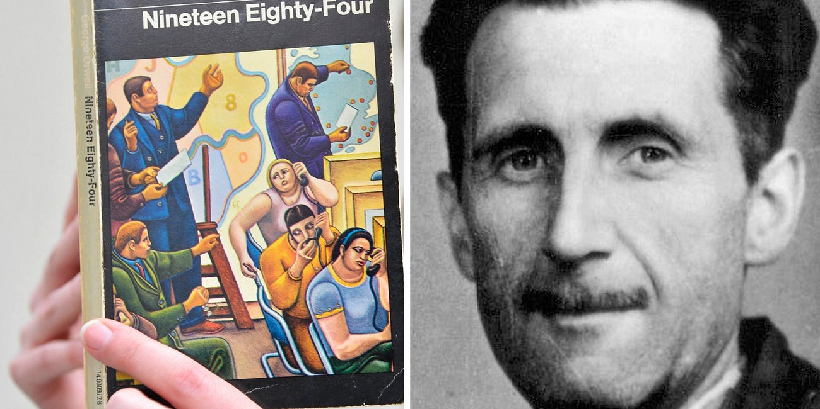

AI IS POSSESSED BY DEMONS LIVING OUTSIDE OF THE BODY, ETERNALLY, IMMORTALLY Satchidanand’s Against Satanism Newsletter is a reader-supported publication. To receive new posts and support my work, consider becoming a free or paid subscriber. In the final analysis of “The Abolition of Man”, CS Lewis predicted that a small group of Bloodline Satanic 10,000 y…
Read full story

https://satchidanand.substack.com/p/artificial-intelligence-ai-is-possessed
The reason MI6 Orwell wrote 1984 was to remove superstitions, Demons, from the conversation and was the reaction to, CS Lewis' "That Hideous Strength" which posited the elite Satanic Phoenician Mega Trillionaire possession by Demons as the cause of the Luciferian and Satanic United Nations New World Order One World Government takeover.
If you want to see something truly demonic, imagine a world in which all inherent truth is abandoned for the sake of subjective perception. A world that caters to the preferences of psychopaths with no ethical imperative. A world where the ends always justify the means. This is the luciferian way, and the globalist way. And no matter how much they deny it, the reality of their beliefs is visible in the fruits of their labors. Wherever they go, destruction, chaos and death follow.
Authored by Brandon Smith via Alt-Market.us, Improved and made better by Satchidanand
https://www.zerohedge.com/geopolitical/understand-globalists-we-must-understand-their-psychopathic-religion

FINANCIALISATION and Satanic Phoenician Mega Trillionaire Central Banks? by Professor Richard A. Werner, D.Phil. - Improved and made better by Satchidanand

THE SATANIC PHOENICIAN MEGA TRILLIONAIRES, THE ROTHSCHILDS, THE ROCKFELLERS, THE BLACK NOBILITY CONTROL BIDEN, PUTIN AND XI - THEY CHOOSE WHICH EMPIRES TO DESTROY AND RAISE UP!
Satchidanand
Apr 13, 2024

Do we Need Satanic Phoenician Mega Trillionaire central banks? by Professor Richard A. Werner, D.Phil. - improved and made better by Satchidanand

THE SATANIC PHOENICIAN MEGA TRILLIONAIRES, THE ROTHSCHILDS, THE ROCKFELLERS, THE BLACK NOBILITY CONTROL BIDEN, PUTIN AND XI - THEY CHOOSE TO DESTROY EMPIRES - THEY CHOOSE WHICH EMPIRES TO RAISE UP - THEY DO IT BY FINANCIALISTATION!



BIDEN VAXXED HIS PEOPLE, PUTIN VAXXED HIS PEOPLE, XI VAXXED HIS PEOPLE. DEATHVAXX - watch the Anthony Bridgen UK MP DIvideo...
https://against-satanism-video.com/watch/maria-zeee-uk-mp-anthony-bridgen-calls-for-deathvaxx-crimes-against-humanity-accountability_qHpaRsFLwEkuqjv.html
Anthony Bridgen UK MP, "A government Minister told me, we don't care what you say Anthony that twenty million excess deaths have been caused by the Deathvaxx, you took the Deathshot, in a year or so you will be dead of cancer!"





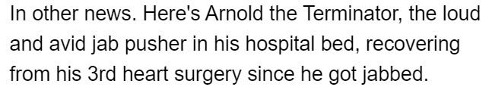

The Rothschilds own 100% of all Satanic Phoenician Mega Trillionaire central banks - This is the financialisation methodology of the destruction of civilisations by the Satanic Phoenician Mega Trillionaires
See Throughout History Seventy-Two Empires Have Been Engineered to Fail in the Same Way.
The crash of civilisations does not happen by accident. The crash of civilisations does not happen all at once. The crash of civilisations takes a lot of planning over a long time.

Throughout History Seventy-Two Empires Have Been Engineered to Fail in the Same Way.

Satchidanand
·
April 6, 2024

Throughout History Seventy-Two Empires Have Been Engineered to Fail in the Same Way. The crash of civilisations does not happen by accident. The crash of civilisations does not happen all at once. The crash of civilisations takes a lot of planning over a long time.

Read full story

As with the previous 72 failed Empires, the Anglo-American Empire was founded by restricting credit. Later, when the Satanic Phoenician Mega Trillionaires decided to pull the plug and move to China, having married into all the top Chinese families as they have done in India, they brought in Satanic Phoenician Mega Trillionaire central bank financialisation into the Anglo-American Empire. Satanic Phoenician Mega Trillionaires will then destroy the Chinese Empire by means of financialisation before moving on to their next victim.
I previously edited a book of articles by Professor Michael Hudson - improved and made better by Satchidanand - where Hudson revealed that the "Science" of Economics was pure fantasy.
AGAINST SATANISM VOLUME 5 - Satanic Economics and the Satanic Principle of Poverty Published Feb 2019

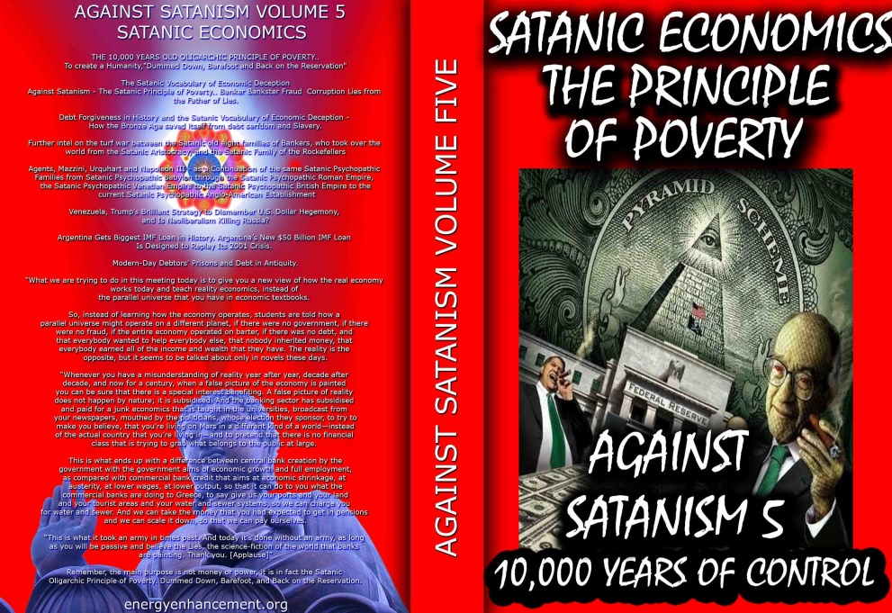

We know the effects of meeting one psychopath and the destruction he can wreak in our lives. Wisdom teachings teach how to overcome their strategies and, "stay away from evil".
Satanism, - The Old Religion" - is when all the psychopaths get together in one group to wreck the world to their benefit. Energy Enhancement Wisdom teachings describe the historical problem and the means to overcome it. "Vampires hate the light of truth".
The key is that the Satanic Religion and its recruiting cults of Freemasonry and the Crowlean Sexual Ritual Ordo Templi Orientis are Fake Gangs, created by men as a technique to conquer the world.
The Ancient Satanic Enemy who counts meditation and the mind control psychic arts as one of its main planks of World Domination has used Satanic Infil-Traitors for 10,000 years in every Organisation - Religion, Left and Right Politics, Dynastic Families, Geopolitics, Economics, Universities, Intelligence Services, Think Tanks, Banking, International Companies, Global Warming, Eugenics..
And Banking Infiltration by Satanic Banksters supported by the False Fabulous Science of Economics..
And this book pricks the bubble of Fake Satanic Economics because Godly people could never set up the World banking and economic system described in these pages.
Only Satanists could create a system which is against the evolution of Humanity to the Stars.
Instead, the Satanic Banksters promote the Principle of Poverty, barefoot, back on the reservation, in debt to the company store.
https://againstsatanism.com/Sacred-Energy/Against-Satanism-Volume-5/Against-Satanism-5-Satanic-Economics-the-Satanic-Principle-of-Poverty.pdf

Companion Volume to Volume 5 - Satanic Economics and the Satanic Principle of Poverty - The Babylonian Woe - the History of Money and the Phoenicians who created it.
Meyer Amschel Rothschild, who founded the great Satanic international banking house of Rothschild which, through its affiliation with the European Central Banks, still dominates the financial policies of practically every country in the world, said: 'Permit me to issue and control the money of a nation, and I care not who makes its laws.'
In this time, as today, the people were almost entirely at the mercy of the Satanic private persons controlling their money, who then controlled the inflow of precious metals, silver and gold, the foundation of the people's money. The Satanic policies of these controllers from their standpoint as internationalists, with Banks and secret agents in both countries, were necessarily directed towards the creation of war against the well-being of mankind. Frequent wars were above all the prime essential..
1. Arms sales - The selling of weapons and war materiel to both sides of the war.
2. Chaos towards the destruction of the natural system of rule previously defined, which had been the protection of the people, to create the Satanic recruiting process of despair, nihilism, and then Satanism in the people.
3. War booty towards the reinjection into the system of hoarded coin and bullion, and consequent reinflation of the money supply;
4. The buying of property, farms and businesses in the defeated country for cents on the dollar.
5. Not the least important, the enslavement of the defeated populace and prisoners of war - gathering of a new crop of slaves for working the poisonous heavy metal mines to replace those stocks of silver and gold, so necessary to the foundation of their money power, and the maintenance of their international hegemony in consequence...
http://www.energyenhancement.org/Sacred-Energy/The-Babylonian-Woe-History-Economics-Money.pdf
READ.. The Fall of the Anglo-American Empire

https://againstsatanism.com/The-Fall-of-the-Anglo-American-Empire.htm
One of the reasons Western macroeconomic metrics don’t work to analyze the Chinese economy is because the Chinese are observably following the principles described by Richard Werner in his excellent Book, Princes of the Yen, which chronicles the way Japan successfully maintained its centralized wartime economy to develop its economy and literally buy a significant percentage of the global assets from 1945 through 1990.
That relentless period of economic advancement came to an end in 1998 with the final triumph of the private Bank of Japan, which served as Clown World’s proxy, over the Okurasho, Japan’s Ministry of Finance, and the subsequent shift to the same sort of financialized unproductive economy featuring private credit creation financialization that has systematically weakened the West for the last century.
As part of its policy of unrestricted warfare, Satanic Phoenician Mega Trillionaire China - the new rising Empire in the Chinese Century has methodically applied the lessons of Japan’s post-WWII economy and maintained control of its own credit creation, thereby boosting its productive capacity to historically unprecedented levels and providing it with the monetary resources to buy up foreign assets everywhere from Angola to the USA.
By publicly breaking with Clown World in 2015, and setting up BRICS as an alternative to the various Clown World institutions, China is offering the rest of the world an observably viable and historically superior economic model to the corrupt and deceptive one that was holding the elites of the various nations enthralled.
This is why Janet Yellen, the US Secretary of the Treasury, was in China this week begging the Chinese to “reduce their overcapacity”. And it’s not an accident that China has applied Japan’s historical policies of a) government credit creation to fund b) productive industrial exports while minimizing the use of credit to fund domestic consumption. This is a proven means of enhancing national power and prestige at the expense of global competitors used by all rising empires under Satanic Phoenician Mega Trillionaire control until like with the west, the Satanic Phoenician Mega Trillionaires pull the plug and consign the new Empire to ruin, as the Satanic Phoenician Mega Trillionaires have done with 72 previous Empires.
The economic assumptions of the Smith-Keynesian era have gradually been proven over time to be entirely false. This is a difficult lesson to accept, but it is inarguable at this point. From David Ricardo to Paul Samuelson, from free trade to the rational actor, everything about neoclassical economics is intrinsically and observably incorrect, which is why those nations whose economic policies are based on Financialisation - traditional neoclassical economics, will inevitably fall behind, both in terms of societal wealth and military power.
https://voxday.net/2024/04/12/the-return-of-national-economics/
Here is the Satanic Phoenician Mega Trillionaire financialisation methodology...
"Once we realize this, the power of the bankers crumbles. It has been their ploy to pretend that they were issuing what is a very scarce and precious resource – savings or money. For if it was not scarce, why should we be prepared to pay the bankers for this service (in the form of interest)?
Governments could just create their own Greenback money, without having to pay interest on the national debt (which by now in a number of countries takes up the majority of national annual budgets – usually well hidden from the eyes of the public, by publishing only the fiscal budgets that are considered “discretionary spending” – pretending that interest payments are non-negotiable and compulsory)."

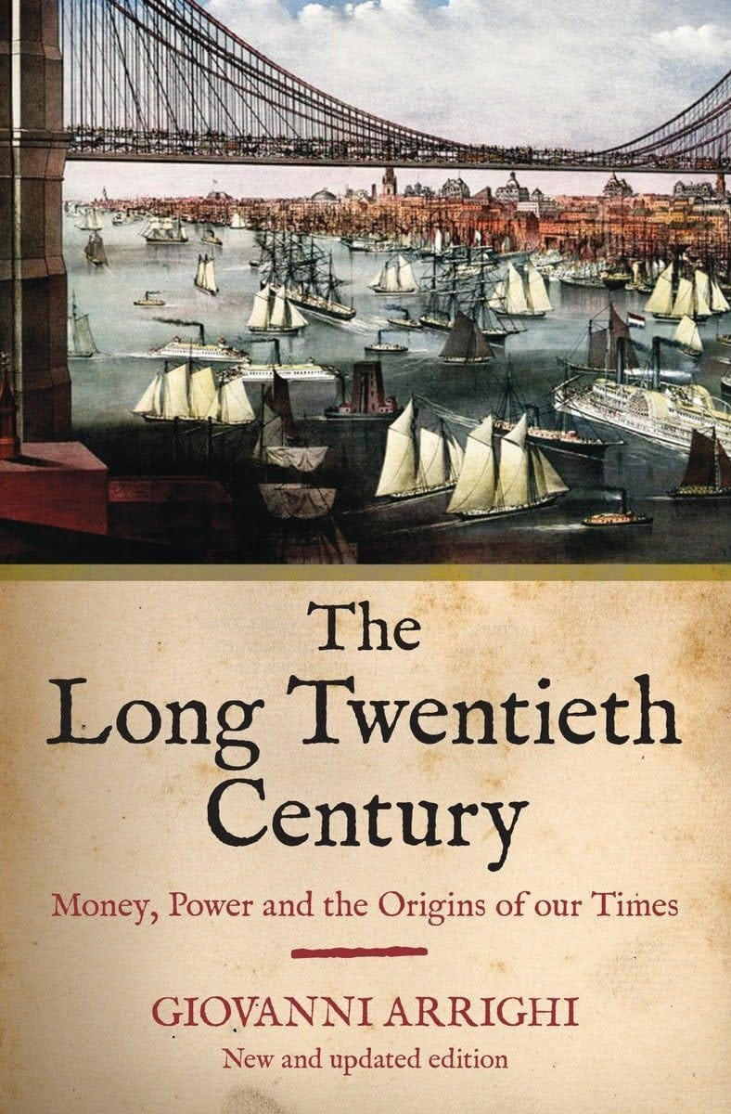

FINANCIALISATION - THE ENGINEERED DEATH OF EMPIRES - BY ARRIGHI
"Why did the German and Japanese systems lose their way? Because they fell for the neoclassical Satanic Phoenician Mega Trillionaire central banking narrative – the surest way to reduce the efficiency of any economy. Thus Germany and Japan adopted the Anglo-Saxon model. The changes this entailed increased “financialisation”, i.e. the share of economic activity devoted to profit-seeking by shifting ownership certificates from A to B (Werner, 2002b, Dore 2000).
Adopting US-style capitalism means that Germany and Japan are importing its disadvantages and social problems. Dore asks: Can it be efficient to devote ever more people to servicing “gambling on uncertainties in financial markets” with analysis, advice, appraisal, advertising? As increasingly strong shareholders demand “value”, will social welfare or overall fairness increase?"
See Throughout History Seventy-Two Empires Have Been Engineered to Fail in the Same Way - by Financialisation - Stop investment in Products - artificially increase the stock market to siphon wealth.
The crash of civilisations does not happen by accident. The crash of civilisations does not happen all at once. The crash of civilisations takes a lot of planning over a long time.

Throughout History Seventy-Two Empires Have Been Engineered to Fail in the Same Way.

Satchidanand
Throughout History Seventy-Two Empires Have Been Engineered to Fail in the Same Way. The crash of civilisations does not happen by accident. The crash of civilisations does not happen all at once. The crash of civilisations takes a lot of planning over a long time.

Read full story

"On this road to Orwellian totalitarianism by the central planners at the Satanic Phoenician Mega Trillionaire central banks, it is only a small further step to argue that the little chips on our digital cash cards would be safer – in the name of combatting crime again! – if one embedded them under the skin of our right hands, or our foreheads." “He also forced everyone, small and great, rich and poor, free and slave, to receive a mark on his right hand or on his forehead, so that no one could buy or sell unless he had the mark, which is the name of the beast or the number of his name”
(Rev 13:16-17).
Paper presented at the 14th Rhodes Forum: Dialogue of Civilisations Research Institute, Panel 2: Economic Alternatives when Conventional Models Fail, Rhodos, Greece, on 1 October 2016
and at the 4th European Conference on Banking and the Economy (ECOBATE 2016), in Winchester Guildhall, Winchester UK, on 12 October 2016
I. The Satanic Phoenician Mega Trillionaire central bank Narrative
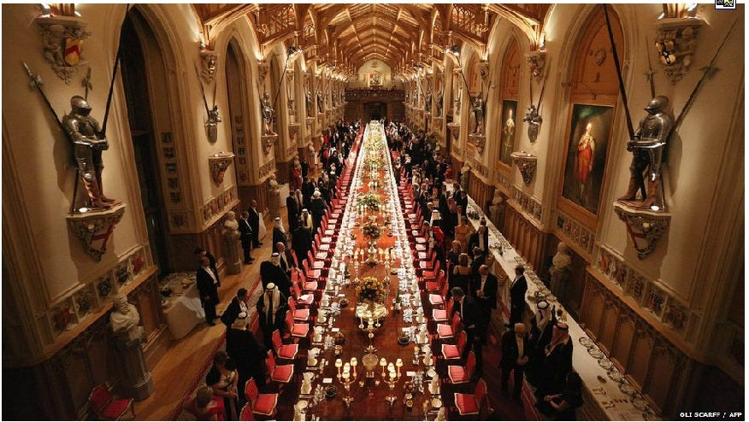

For more than the past four decades, public policy discourse, especially when touching on macroeconomic and monetary policy, has been dominated by the views held and actively sponsored by the Satanic Phoenician Mega Trillionaire central banks, particularly in Europe and North-America, as well as Japan.
Their policy narrative has been consistent over time and virtually identical between Satanic Phoenician Mega Trillionaire central banks, which is why I shall refer to it collectively as the ‘Satanic Phoenician Mega Trillionaire central bank narrative’. It has been mirrored in the type of economics that Satanic Phoenician Mega Trillionaire central bankers have supported and that has indeed subsequently become dominant in academia and among the economists selected as the experts of choice in the major newspapers and television channels: the theoreticians advancing neo-classical economics.
This Satanic Phoenician Mega Trillionaire central bank narrative (and hence also the dominant neo-classical economics, also known as ‘mainstream economics’) has at least five False major pillars, which I shall list briefly:
1. Interest rates are the main policy variable to move the economy
The first pillar of the Satanic Phoenician Mega Trillionaire central bank narrative is the well-known claim that interest rates are the main tool of monetary policy. This narrative is backed by the familiar theory that, ceteris paribus, lower interest rates will stimulate economic growth and higher interest rates will slow growth. Thus by lowering rates, Satanic Phoenician Mega Trillionaire central banks accelerate growth and by raising rates, they slow it, allowing impressive fine-tuning of the economy. Hence the Satanic Phoenician Mega Trillionaire central bankers’ constant obsession with minute changes in interest rates that are said to have the power to rattle global markets and, consequently, are dominating the media coverage of Satanic Phoenician Mega Trillionaire central bank actions as if they will stand out in sharp relief in any future account of the history of mankind.
2. Markets are in equilibrium, thanks to price movements that have equated demand and supply.
The interest rate theory is in turn backed by this second pillar of the Satanic Phoenician Mega Trillionaire central bank narrative: Market equilibrium. This equilibrium which markets are said to be usually found in, is a state of effective resource allocation that results from virtually automatic or ‘natural’ price movements which ensure that demand equals supply almost all of the time. These price movements not only create pervasive ‘general equilibrium’, as economists and Satanic Phoenician Mega Trillionaire central bank models assume, but they also ensure that it is sufficient to focus on prices when conducting economic analysis, since prices lead (generating the equilibrium) and quantities fall into line. Hence policy should focus on prices. This logic is consistently applied across markets, including the markets for money and credit, which are said to be dominated by their price (the rate of interest). As a result, the first pillar of the Satanic Phoenician Mega Trillionaire central banking narrative is justified: what else but interest rates should one use as policy tool in such a world of equilibrium and the dominance of prices?
3. Banks are just financial intermediaries, like other non-bank financial firms. They thus do not need to be singled out in the analysis or modelled explicitly.
The third pillar of the narrative further tidies up the analysis by following through on the dominance of interest rates when it comes to financial institutions: While ordinary mortals might have the naïve belief that banks matter for the economy and could indeed be powerful – or even be the key agents of change or influence – Satanic Phoenician Mega Trillionaire central bankers and their hired neo-classical theorists know better than that:
banks are mere financial intermediaries, transferring existing savings from depositors to investors, just like non-bank financial intermediaries are doing. In other words, banks are not special or different from other financial firms, and hence they do not have to be singled out in economic models – which explains why economists and all the major Satanic Phoenician Mega Trillionaire central banks have indeed failed to include banks at all in their economic models for the past 40 years. (This was a little embarrassing, when the 2008 banking crisis hit, but the Satanic Phoenician Mega Trillionaire central bankers and neo-classical economists are hoping you have already forgotten that).
4. We need to save in order to fund investments that are the precondition of economic growth and development. If domestic savings are insufficient, we need to borrow from abroad or attract foreign investment.
The fourth pillar of the Satanic Phoenician Mega Trillionaire central bankers’ narrative has been the claim that nations that would like to develop and grow the economy need to accumulate scarce savings first, in order to fund the necessary investments. To attract these scarce savings, interest rates are needed, linking into claim 1. Moreover, since many developing countries were seen to have insufficient savings, the Satanic Phoenician Mega Trillionaire central banking narrative maintained that they needed to borrow the necessary funds from abroad...
Thus it was fortuitous – if not serendipitous – that at the very moment when the developing countries had been educated into understanding their need of foreign borrowing, it just so happened that foreign bankers stood ready to engage in this selfless task whereas their own banks could create their own money instead.
This need to borrow from foreign bankers has been the basis for postwar IMF and World Bank policies that drove home this point with developing countries over the past decades – if, that is – and this is a major caveat – they were in possession of attractive assets, such as raw materials and resources that are needed by industrialised countries.
(Notice that countries without attractive assets never got into debt, because nobody would lend to them in the first place; likewise it was always a little curious that the global financiers at JP Morgan and other big global banks, the world’s experts in the latest derivative instruments, genuinely believed that developing countries like Ghana or Sudan were in fact much better at managing foreign exchange risk than the top teams at JP Morgan – for why else would the Satanic Phoenician Mega Trillionaire global bankers insist on lending to the eveloping countries in foreign currency, leaving any hedging to their exposed customers?).
5. Both the foreign investors and the domestic goal of high growth require deregulation, liberalization and privatization, since only in such an economy can market forces deliver high and stable growth.
The final pillar of the Satanic Phoenician Mega Trillionaire central banking narrative is that economic growth requires markets to function in an unimpeded fashion, not held back by such barbarous relics as regulations and government intervention. Hence the mainstay Satanic Phoenician Mega Trillionaire central bank advice – or demand – directed at the governments to deregulate, liberalise and privatize, while generally adopting a laissez-faire attitude: no matter how big and influential a small number of multinationals or mega-banks get, their lobbyists are probably aiming at general public welfare and so their good work should not be hampered through unnecessary red tape or restrictions on their activities.
We are all familiar with parts or all of this Satanic Phoenician Mega Trillionaire central bank narrative, even if we are not trained economists or not commonly interested in economic issues: This is because this narrative has been repeated ad nauseam hundreds of times in the past four decades. As a result, even astute observers assume that empirical research has long established these five insights from the Satanic Phoenician Mega Trillionaire central bankers, in uncountable meticulous quantitative research studies.
This is not the case. The truth could not be further from it: There is in fact no empirical evidence to support any of these five claims. They are mere assertions. Claims that have, in fact, been disproven by the facts. There is overwhelming evidence to the contrary, and this has become increasingly obvious since the 2008 financial crisis.
II. The Satanic Phoenician Mega Trillionaire central banking Narrative Has Collapsed
While voices of those pointing out that the Satanic Phoenician Mega Trillionaire central banking narrative has been wrong (e.g. Werner, 1992, 1994, 2003a) had been successfully drowned out by Satanic Phoenician Mega Trillionaire central banks and their large-scale and meticulously planned PR campaigns for many years (see Ishii and Werner, 2003; Werner, 2003b, on the ‘information management’ of Satanic Phoenician Mega Trillionaire central banks), it is now becoming apparent and visible even to laymen that the Satanic Phoenician Mega Trillionaire central banking narrative has collapsed on all fronts.
Banks are not financial intermediaries, but creators of the money supply
Consider first the claim that banks are mere financial intermediaries that have no special powers. For a whole century, Satanic Phoenician Mega Trillionaire central bank-sponsored researchers had been obfuscating the issues, claiming that either the fractional reserve theory of banking was correct or, for the past 40 years, the theory of banks as mere financial intermediaries. Despite an ongoing controversy among experts on this issue, it never occurred to economists – used to mainly dealing with the fabulous theoretical dream worlds of their own making – that the methods of scientific research could in fact also be applied in economics, i.e. a suitable and careful empirical test could be conducted to settle the question of the role of banks once and for all.
In 2014, the first empirical study on how banks actually work was finally published (followed by a second study in 2015) and thus ended the centuries’ old debate about whether banks are (a) mere financial intermediaries passing on savings (deposits) as loans to borrowers, as the leading journals and textbooks proclaim today; (b) whether they need Satanic Phoenician Mega Trillionaire central bank reserves or deposits to lend these on to their customers (fractional reserve theory), so that each bank is an intermediary, but in aggregate more money is created by the banking system in a collective fashion – as a previous generation of unwitting Satanic Phoenician Mega Trillionaire central bank spokesmen had argued; or (c) whether they instead are not financial intermediaries at all, but creators of the money supply, so that each bank creates new purchasing power that is added to the money supply when it extends a loan, thus deciding about the amount and allocation of new money creation – a pivotal function in the economy.
The empirical tests rejected the financial intermediation and fractional reserve theories (Werner, 2014a, 2015) and showed that banks do not need prior savings, nor Satanic Phoenician Mega Trillionaire central bank reserves or other deposits to lend. Instead, banks create new money when they do what is called ‘bank lending’, and add it to the money supply (see Figure 1). Bank loans thus do not transfer existing purchasing power, but add net new purchasing power. The banks’ lending creates 97% of the money supply. Bankers’ decisions about how much money is lent – and thus created and added to the money supply – and given to whom for what purpose quickly reshapes the economic landscape and affects us all. Sadly, no regulator has asked banks to ensure they lend for productive projects – over two thirds of UK lending is not for productive purposes that creates jobs or boosts GDP, but instead for fabulous climate change boondoggles where the money is stolen or assets, causing asset price inflation.
Figure 1: How banks create money out of nothing when they ‘lend money’

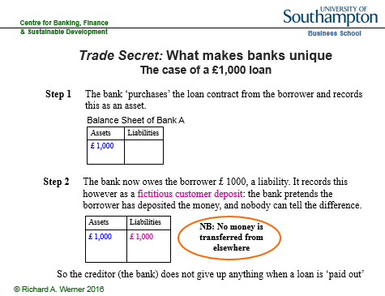

2. Interest rates do not move the economy – and hence are not the main monetary policy tool
After the first domino of the Satanic Phoenician Mega Trillionaire central banking narrative collapsed, the other dominos quickly toppled over, as well: An often-repeated mantra of Satanic Phoenician Mega Trillionaire central bankers is that lower rates will stimulate the economy and higher rates will slow it. Currently, Satanic Phoenician Mega Trillionaire central bankers are once again deploying this claim, in order to justify a further reduction of interest rates to zero or even negative territory with the claim that this is necessary to stimulate the economy.
So far, commentators and journalists have not challenged this Satanic Phoenician Mega Trillionaire central banker narrative, as it had been extensively propagated over the previous decades and is accepted as fact by most. This negative correlation between interest rates and economic growth, and also the idea that causation runs from interest rates to economic growth is so well established in everyone’s consciousness that we simply assume there is abundant empirical evidence to back it. Surely, the thousands of mathematicians and economists working for Satanic Phoenician Mega Trillionaire central banks (Satanic Phoenician Mega Trillionaire central banks are, after all, the largest employers of economists world-wide) will have crunched the numbers and produced hundreds of studies demonstrating this?
The funny thing is: they haven’t.
In fact, among the more than 10,000 research articles produced by the major Satanic Phoenician Mega Trillionaire central banks in the two decades prior to the 2008 crisis, none explored the correlation or causation between nominal interest rates and nominal GDP growth. Fortunately, this task is not very demanding, and once we conduct such an examination, we conclude that, in actual fact, there is no evidence to back these assertions whatsoever. To the contrary, empirical evidence shows that the Satanic Phoenician Mega Trillionaire central banking narrative on interest rates is diametrically opposed to the observable facts in two dimensions: instead of the proclaimed negative correlation, interest rates and economic growth are positively correlated. Secondly, the timing shows that interest rates do not move ahead of growth, but instead are either coincidental or even follow it.
Consider Figure 2, which uses the example of US long-term interest rates (benchmark US Treasury yields) and nominal GDP growth rates (year-on-year percentage growth), as well as Japanese short-term rates (overnight call rates) and nominal GDP growth rates.
Figure 2: The link between interest rates and economic growth
As can be seen, the Satanic Phoenician Mega Trillionaire central banking narrative is wrong in two dimensions: instead of the proclaimed negative correlation, the scatter plots on the left-hand side of the graph show a distinct positive correlation (Werner, 1995, 2005). But lest anyone thinks this is due to the timing and the role of leads and legs, the graphs on the right-hand side consider the time series of the same data. As can be seen in the upper right graph, in 1987 Japanese nominal GDP growth accelerated sharply, and it took about two years for short-term interest rates to follow.

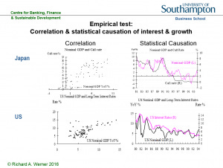
In 1989, GDP growth decelerated, and only after a lag did short-term interest rates follow. Some observers may argue that Satanic Phoenician Mega Trillionaire central banks are naturally behind the curve of the economy, and hence so are short-term interest rates, while bond markets would not lag behind the economy. But this is also true for bond markets. The bottom right graph in Figure 2 shows the yield in the most liquid securities market in the world, that for US benchmark Treasuries, plotted against nominal GDP growth. The positive correlation of both curves is obvious.
Moreover, there is no evidence that interest rates precede the economy. Quite the contrary, there seems evidence that interest rates follow nominal GDP, most blatantly in the 1980s: it took over one year for interest rates to fall, after nominal growth had collapsed in the early 1980s, and after the sharp growth acceleration in 1983 it took over a year for bond yields to rise. For decades, even US interest rates have not moved ahead of growth, but instead they followed it.
Thus instead of the Satanic Phoenician Mega Trillionaire central banking narrative that lower rates lead to higher growth, the empirical and verifiable reality is that higher growth leads to higher rates and lower growth leads to lower rates. If rates are the result of growth, they cannot be the cause.
This raises some new questions.
Firstly, if it is not interest rates that drive growth, what then? And secondly, why do Satanic Phoenician Mega Trillionaire central banks keep insisting that they are using interest rates as their main monetary policy tool, when this is simply impossible?
Recently, Satanic Phoenician Mega Trillionaire central banks have been lowering rates, while proclaiming that this is a measure to stimulate the economy. But the empirically verifiable fact is that they lowered rates, because economic growth has decelerated. Falling growth means interest rates must follow down. And what has been the role of Satanic Phoenician Mega Trillionaire central banks in the growth slowdown preceding the lower rates? We may presume that they had not used their vast powers to engineer economic growth – powers they worked hard to obtain in previous decades, in the form of independence with little meaningful accountability.
Instead of unravelling this mystery, Satanic Phoenician Mega Trillionaire central bankers have been making counter-factual assertions about the causation of interest rates and growth. Yet we know them to be in possession of thousands of highly trained staff and the best quantitative data sources on the economy of anyone.
Since the hypothesis of complete incompetence or irrationality is a last resort, it stands to reason to adopt the working hypothesis that Satanic Phoenician Mega Trillionaire central banks have employed these counter-factual assertions on purpose.
Two reasons come to mind: Firstly, they are using the interest rate narrative in order to suggest that they are adopting beneficial policies, when this is not really the case. Secondly, they may in this way be able to distract public attention from the true causal relationships in the economy. In this case, a far less benevolent interpretation of Satanic Phoenician Mega Trillionaire central bank policy becomes suggestive.
As Forder (2002) has argued, obfuscation has served Satanic Phoenician Mega Trillionaire central banks particularly well since they have become so all-powerful: the danger for them in this era of unprecedented powers is that the general public may simply (and rightly) link bad economic outcomes to bad economic policies adopted by Satanic Phoenician Mega Trillionaire central banks, not to the – now far less powerful – governments.
In other words, since almost all economic keys have been handed over to the Satanic Phoenician Mega Trillionaire central banks, one can reasonably expect them to be blamed for the economic mess that is such a recurring feature of economic policy during those decades of ever greater Satanic Phoenician Mega Trillionaire central bank power.
As a defense mechanism, Satanic Phoenician Mega Trillionaire central banks could be expected to argue that they are doing all in their power to help the economy, while pinning the blame on other actors. But for this to work, observers need to be misinformed about what the true levers of monetary policy are.
A desire by Satanic Phoenician Mega Trillionaire central banks to misinform would explain why they have spent vast resources on “economic research” – pseudo-scientific writings that are often far removed from reality, but are designed to place any blame for the terrible economic performance that they have been responsible for on other actors – preferably the government, fiscal policy or ‘irrational’ and ‘uneducated’ ordinary people who are looking for ‘easy answers’ or seeking ‘populist explanations’, while anyone contemplating the possibility that big banks and Satanic Phoenician Mega Trillionaire central banks might not always look after the public interest and instead might collude in order to put their own objectives first is identified as a ‘conspiracy theorist’. In other words, the “economic research” produced by Satanic Phoenician Mega Trillionaire central banks is usually of a kind that at best looks like political PR to objective observers, if not outright propaganda.
3. Markets are never in equilibrium, thus don’t be fooled by prices, but consider quantities: The short side exerts power.
If there is no empirical evidence for the interest rate narrative, it is reasonable to ask where it came from in the first place. In other words, what is the origin of the idea that interest rates are the most important economic policy variable? We have ascertained that it did not emerge from empirical facts. Looking into its origin, one finds that it is a claim deriving from theoretical economics. The theory proposing the special role of interest rates can be derived from the central – some say only – graph in economics that shows demand and supply: it consists of an upward-sloping supply curve and a downward-sloping demand curve in price-output space.
Under a number of assumptions prices are said to move so that demand equals supply. This seems eminently reasonable at first glance: after all, if prices are too high, excess supply will be left unsold, resulting in price cuts and hence a fall in prices, until demand equals supply. Likewise, if prices are too low, excess demand will quickly drive up prices back to the “equilibrium” level – the point at which demand equals supply. This story is told about virtually any market: in the case of the labour market, the price is the wage. In the case of the money market, the price is the interest rate.
Figure 3: The central graph in economics: Equilibrium thanks to price movements

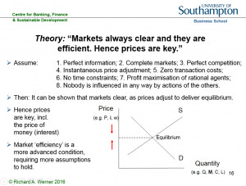
This “equilibrium” graph (Figure 3) and the ideas behind it have been re-iterated so many times in the past half-century that many observes assume they represent one of the few firmly proven facts in economics. Not at all. There is no empirical evidence whatsoever that demand equals supply in any market and that, indeed, markets work in the way this story narrates.

We know this by simply paying attention to the details of the narrative presented. The innocuous assumptions briefly mentioned at the outset are in fact necessary joint conditions in order for the result of equilibrium to be obtained. There are at least eight of these result-critical necessary false, lying, satanic assumptions:
Firstly, all market participants have to have “perfect information”, aware of all existing information (thus not needing lecture rooms, books, television or the internet to gather information in a time-consuming manner; there are no lawyers, consultants or estate agents in the economy).
Secondly, there are markets trading everything (and their grandmother).
Thirdly, all markets are characterized by millions of small firms that compete fiercely so that there are no profits at all in the corporate sector (and certainly there are no oligopolies or monopolies; computer software is produced by so many firms, one hardly knows what operating system to choose…).
Fourthly, prices change all the time, even during the course of each day, to reflect changed circumstances (no labels are to be found on the wares offered in supermarkets as a result, except in LCD-form).
Fifthly, there are no transaction costs (it costs no petrol to drive to the supermarket, stock brokers charge no commission, estate agents work for free – actually, don’t exist, due to perfect information!).
Sixthly, everyone has an infinite amount of time and lives infinitely long lives.
Seventhly, market participants are solely interested in increasing their own material benefit and do not care for others (so there are no babies, human reproduction has stopped – since babies have all died of neglect; this is where the eternal life of the grown-ups helps).
Eighthly, nobody can be influenced by others in any way (so trillion-dollar advertising industry does not exist, just like the legal services and estate agent industries).
It is only in this theoretical dreamworld defined by this conflagration of wholly unrealistic assumptions that markets can be expected to clear, delivering equilibrium and rendering prices the important variable in the economy – including the price of money as the key variable in the macroeconomy. This is the origin of the idea that interest rates are the key variable driving the economy: it is the price of money that determines economic outcomes, since quantities fall into place.
But how likely are these assumptions that are needed for equilibrium to pertain? We know that none of them hold.
They are all Satanic Phoenician Mega-Trillionaire lies!
Yet, if we generously assumed, for sake of argument (in good economists’ style), that the probability of each assumption holding true is 55% – i.e. the assumptions are more likely to be true than not – even then we find the mainstream result is elusive: Because all assumptions need to hold at the same time, the probability of obtaining equilibrium in that case is 0.55 to the power of 8 – i.e. less than 1%!
In other words, neoclassical economics has demonstrated to us that the circumstances required for equilibrium to occur in any market are so unlikely that we can be sure there is no equilibrium anywhere. Thus we know that markets are rationed, and rationed markets are determined by quantities, not prices.
On our planet earth – as opposed to the very different planet that economists seem to be on – all markets are rationed. In rationed markets a simple rule applies: the short side principle. It says that whichever quantity of demand or supply is smaller (the ‘short side’) will be transacted (it is the only quantity that can be transacted). Meanwhile, the rest will remain unserved, and thus the short side wields power: the power to pick and choose with whom to do business.
Examples abound. For instance, when applying for a job, there tend to be more applicants than jobs, resulting in a selection procedure that may involve a number of activities and demands that can only be described as being of a non-market nature (think about how Hollywood actresses are selected), but does not usually include the question: what is the lowest wage you are prepared to work for?
Thus the imaginary fabulous theoretical dream world of “market equilibrium” allows economists to avoid talking about the reality of pervasive rationing, and with it, power being exerted by the short side in every market.
Thus the entire power dimension in our economic reality – how the short side, such as the producer hiring starlets for Hollywood films, can exploit his power of being able to pick and choose with whom to do business, by extracting casting couch Weinstein ‘non-market benefits’ of all kinds.
The pretense of ‘equilibrium’ not only keeps this real power dimension hidden. It also helps to deflect the public discourse onto the politically more convenient alleged role of ‘prices’, such as the price of money, the interest rate. The emphasis on prices then also helps to justify the charging of usury (interest), which until about 300 years ago was illegal in most countries, including throughout Europe.
However, this narrative has suffered an abductio ad absurdum by the long period of near zero interest rates, so that it became obvious that the true monetary policy action takes place in terms of quantities, not the interest rate.
Thus it can be plainly seen today that the most important macroeconomic variable cannot be the price of money. Instead, it is its quantity. Is the quantity of money rationed by the demand or supply side? Asked differently, what is larger – the demand for money or its supply?
Since money – and this includes bank money – is so useful, there is always some demand for it by someone. As a result, the short side is always the supply of money and credit. Banks ration credit even at the best of times in order to ensure that borrowers with sensible investment projects stay among the loan applicants – if rates are raised to equilibrate demand and supply, the resulting interest rate would be so high that only speculative projects would remain and banks’ loan portfolios would be too risky.
The banks thus occupy a pivotal role in the economy as they undertake the task of creating and allocating the new purchasing power that is added to the money supply and they decide what projects will get this newly created funding, and what projects will have to be abandoned due to a ‘lack of money’.
It is for this reason that we need the right type of banks that take the right decisions concerning the important question of how much money should be created, for what purpose and given into whose hands. These decisions will reshape the economic landscape within a short time period.
Moreover, it is for this reason that Satanic Phoenician Mega Trillionaire central banks have always monitored bank credit creation and allocation closely and most have intervened directly – if often secretly or ‘informally’ – in order to manage or control bank credit creation.
Guidance of bank credit is in fact the only monetary policy tool with a strong track record of preventing asset bubbles and thus avoiding the subsequent banking crises. But credit guidance has always been undertaken in secrecy by Satanic Phoenician Mega Trillionaire central banks, since awareness of its existence and effectiveness gives away the truth that the official central banking narrative is smokescreen.
Figure 4: A key monetary policy tool: Guidance of bank credit
4. We do not need to save or borrow from abroad in order to expand investment and growth
A basic argument by economists has been that we first need to accumulate scarce savings in order to fund investments and hence enjoy economic growth – or alternatively borrow those savings from abroad by taking a loan from the international banking community. But this argument is based on the erroneous belief that banks are merely financial intermediaries that require savings first in order to be able to lend money out. In reality, increased domestic investment requires neither savings nor borrowing from abroad. Domestic banks can fund domestic investment without prior savings becoming available.
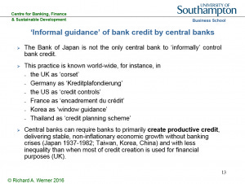
Once we realize this, the power of the bankers crumbles. It has been their ploy to pretend that they were issuing what is a very scarce and precious resource – savings or money. For if it was not scarce, why should we be prepared to pay the bankers for this service (in the form of interest)?
Governments could just create their own Greenback money, without having to pay interest on the national debt (which by now in a number of countries takes up the majority of national annual budgets – usually well hidden from the eyes of the public, by publishing only the fiscal budgets that are considered “discretionary spending” – pretending that interest payments are non-negotiable and compulsory).
Or in the words of Leo Tolstoy (paraphrased): The reason why economists single out ‘labour’ and ‘capital’ in their ‘production function’ is, firstly, because they want to charge for ‘capital’ (interest), justifying it as being equivalent to the wages that workers get, and secondly, because nobody has figured out how to charge for the sun light, the air and other necessary factors of production. And they can only charge for ‘capital’, because economics has been designed to create the myth of its scarcity.
That money is not in fact a scarce resource, but a tool that can and should be employed by governments as benefits communities and nations is also true for developing economies and emerging markets: the “Third World Debt Crisis” was unnecessary, since for most purposes the affected countries did not need to borrow money from the foreign bankers in order to grow their economies.
Worse, the foreign money from the foreign currency-denominated loans given to developing countries never even reached the borrowing economy’s borders. This is because it is one of the rules in international banking that pound sterling bank money stays with UK-authorised banks, euros stay in eurozone economy banks and US dollars remain with US banks. A so-called “US dollar deposit” in the UK is in actual fact a deposit with a US bank that is crediting the account of its UK respondent bank with this amount.
Thus when a developing country borrowed from the international banks, they invariably lent dollars, pounds, euros or other currencies of industrialised countries, because the foreign bankers can only create foreign money (and they do create it out of nothing). The cruel joke on developing countries is now that those foreign dollars or euros that they borrowed will always stay abroad, in their respective foreign banking systems.
It is of course possible to sell the foreign currency and purchase domestic currency with it – but that only results in domestic bank credit creation, something that can be undertaken without getting indebted to foreign bankers in foreign currency in the first place – while it is the borrowers who are made to shoulder the large foreign currency risk.
As the currencies of developing countries invariably fall over time against those of industrialised countries, they quickly get stuck in a foreign debt trap, unable to service or repay the foreign debt which is spiraling out of control in domestic currency terms. That is when the foreign vultures move in and demand ‘debt for equity swaps’, handing over valuable domestic assets, land, mines, mineral resources or mining rights, from poor countries to the rich foreign bankers, who had in any case simply created the money out of nothing.
The developing country debt is in fact a form of predatory lending to ensure that the former colonies remain, in economic terms, in the hands of their former masters – if they have attractive assets, that is. Most of all, the round-trip via foreign banks is wholly unnecessary, if the borrowing nations want domestic currency: that is only created by their own banking system.
Thus it is becoming apparent that the Satanic Phoenician Mega Trillionaire central banking narrative of scarce money and scarce savings has been a hoax.
This has become particularly obvious since Satanic Phoenician Mega Trillionaire central banks have opened all taps and created trillions of dollars and euros and handed them over to the big banks and large-scale financial speculators – under the pretense that this is ‘necessary’ or would somehow benefit society at large.
(Their definition of this activity as ‘quantitative easing’ is also designed to mislead: the original thrust of quantitative easing is an expansion in credit creation for the real economy, not mainly for the financial markets – see my writings on this in Japan in the mid to late 1990s, or Voutsinas and Werner, 2011; Lyonnet and Werner, 2012; Werner, 2013).
5. Deregulation, liberalization and privatization do not enhance growth – they reduce it.
The first four pillars of the Satanic Phoenician Mega Trillionaire central banking narrative have collapsed: Banks create money out of nothing and thus reshape the economy in their image. Markets are rationed and the key factor is the quantity of bank credit. Bank credit creation for GDP transactions boosts GDP growth, no matter what interest rates do (they will follow GDP growth). Developing countries do not need to borrow from abroad, and in fact should not borrow from abroad, as this puts them unnecessarily at mercy of the foreign creditors.
As these pillars revolve around banks and money and credit, some economists may agree, but argue that economics has long focused on the real economy and purposely chose to ignore all the financial factors. In this real economy, they will argue, the most important principle is to allow market forces to act without being hampered by governments – then we will see economic growth and stability. Should this fifth pillar of the Satanic Phoenician Mega Trillionaire central banking narrative at least be true?
Judging by the publications of the Satanic Phoenician Mega Trillionaire central banks, as well as the IMF or the World Bank, one would expect so: When these Washington-based institutions send their teams of staff and hired consultants to developing countries, their job can usually be completed very quickly. Without much ado, a new country report complete with major policy conclusions is drafted. The secret of such efficient work: even before these foreign experts had travelled (first class) to the respective countries, the conclusions of their study had already been pre-determined, because they are always the same, no matter which country is concerned:
The goal of the axiomatic-deductive neoclassical belief system is to find ex post justifications for the argument that government intervention is bad, and markets need to be unfettered by any form of intervention. This predetermined conclusion is then presented, in the form of ‘research reports’ or ‘studies’, to the leadership of many nations across the world, only vaguely connected to local facts and institutions.
In order to reach such conclusions, neoclassical and Satanic Phoenician Mega Trillionaire central bank economists worked backwards: What kind of model comes to such conclusions? Answer: A model that operates in a dream-like idealized world. What are the features that define such a world? A long list of assumptions needs to hold, creating a bizarre theoretical Neverland: perfect information, complete markets in equilibrium, perfect competition, zero transaction costs, no time constraints, perfectly flexible prices that adjust all the time, everyone is very selfish and does not care about others, and people are not influenced by others. Why do all these assumptions matter? Because neoclassical economists have proven that they all need to jointly hold true, for market equilibrium and efficient markets to exist, and for government intervention to be ineffective.
The next step in the sequence of using such models is the most important one: present in reverse order, by pretending that no pre-determined conclusions existed. Start by listing the assumptions – for sake of argument. Then present the model. Then pursue it to its conclusions, which happen to be… let’s see… Oh, amazing: this model happens to conclude government intervention is bad and only free and deregulated markets will work! Well, in that case, ladies and gentlemen, we shall need to recommend deregulation, liberalization and privatization!
That such economic charlatanry passes for ‘economics’ in leading journals, textbooks and university lecture rooms is a sad indictment not only of the economics establishment, but of academia and society at large.
But what about economies in our world, on the planet we live – as opposed to the bizarre planet described by the economic charlatans? Since none of these assumptions hold, we know that we can neither expect equilibrium nor will deregulation, liberalization and privatization trigger improved economic growth.
If our theoretical assessment of the theoretical claims is correct, we should also be able to muster empirical support for it. And it exists in abundance. In order to test these neo-classical policy recommendations of deregulation and market supremacy, we can compare the market-oriented and shareholder value-focused US and UK economies with those economies known to have always placed an emphasis on government intervention, non-market forms of resource allocation combined with social welfare systems, namely Germany, Japan, Korea, Taiwan and China. Of course we should not be influenced by the business cycle, and thus need to consider a longer time period, such as half a century. Considering therefore the half-century from 1950 to 2000, we would expect the best performance in those economies that are more market-oriented, and the worst performance in economies that have chosen to practice intervention, ‘guidance’ and the use of production cartels. What is the empirical result? This can be seen in Figure 5.
Figure 5 Average real economic growth over half a century

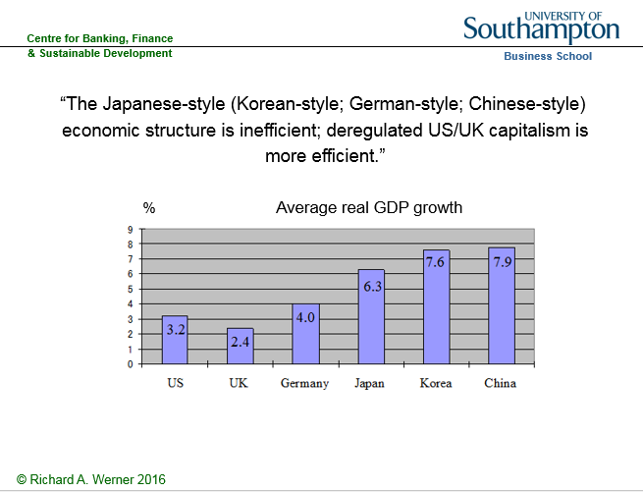

We find that it is the market-oriented, shareholder-oriented economies that perform worst. The economic performance of the East Asian non-market economies has been vastly superior. Many observers suspend disbelief, when they consider this result, and come up with many special reasons (i.e. introduce auxiliary assumptions) why this finding should not be taken at face value. Such a result must not be true, they seem to believe, hence it cannot be true.
Perhaps a more sophisticated analysis will convince doubters. We can also examine the dynamics of deregulation and its impact on economic growth. The IMF and World Bank hired hands that are sent all over the world to ‘conclude’ what Satanic Phoenician Mega Trillionaire central banks also proclaim at home: country X needs to deregulate, liberalise and privatize in order to improve its particular economic performance. Thus an empirically testable hypothesis can be formulated: Is there any evidence that deregulation, liberalization and privatization have increased economic growth over time?
Once again, the objective observer is stunned by the paucity of empirical evidence. Let us conduct our own test. For it to be meaningful, we should choose a country that has moved from a state of regulation, government ownership of large firms and non-market forms of economic organization towards complete deregulation, liberalization and privatization. Fortunately, a major industrialised economy has undergone the full spectrum of such a swing in the policy pendulum: By the late 1960s, Japan was effectively not a market economy, but a ‘guided economy’ in which over 1000 cartels (official exemptions to the anti-monopoly law) had been established, in which tens of thousands of economic regulations allowed the bureaucrats to intervene in the economy, in which the stock and bond markets were largely irrelevant (as most funding came from banks), and in which the labour market was famously full of ‘rigidities’ and ‘inflexibilities’, with life-time employment, seniority pay and company unions.
Then, under US pressure, the Japanese government started to deregulate, liberalise and privatize state enterprises in the 1970s. (It was a hard sell: The Japanese wondered why they should give up their obviously successful system. Everyone knew that US elites were unhappy about the successful Japanese economy, yet US policy ‘advice’ to deregulate was given to Japan with the justification that it would ‘improve Japanese economic performance’ – as if any further growth was needed…). Japan, politically a US vassal, continued to deregulate. The trend of structural reform accelerated in the 1980s, and reached its zenith of a completely deregulated, liberalized and privatized economy in the early 2000s. This deregulation can representatively be measured by the number of cartels, which peaked in the 1960s in Japan and fell in line with US pressure, reaching zero in the 2000s. Below we shall plot the number of cartels against economic growth. Should the neoclassical theory be relevant, we would expect a negative correlation: as the number of cartels increases, economic performance deteriorates, and as the number of cartels drops, growth declines.
Figure 6 The number of cartels in Japan and the link to economic performance

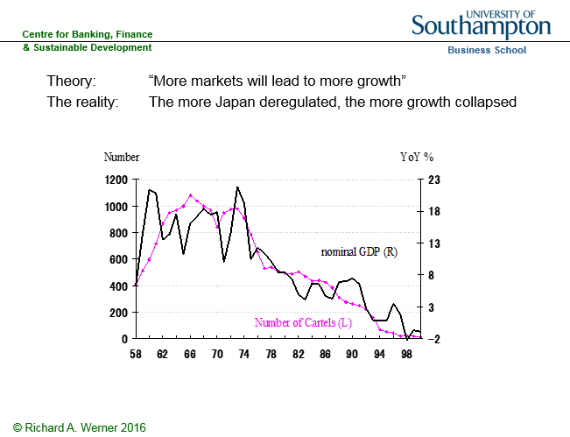

As we can see, the neoclassical thesis has been rejected by the empirical evidence. In the 1950s, the designers of the Japanese economic system intentionally increased the number of cartels, in order to improve economic performance (Werner, 2003a). As we can see, as the number of cartels almost doubled to over 1000 by the late 1960s, while economic growth accelerated to double-digit figures. When, under US pressure, the number of cartels was reduced in the 1970s, growth dropped. The drop in cartels is accompanied by weaker and weaker economic growth. The deregulation drive culminated in the entire abolition of cartels by the end of the 1990s – and economic growth equally reached zero. A similar picture has been painted by the performance of many developing countries, including Argentina and African nations, which followed the economic advice of the Washington-based institutions. We conclude that the fifth of the Satanic Phoenician Mega Trillionaire central bank claims – that deregulation, liberalization and privatization enhances economic growth – has also been revealed to be fraudulent.
III. Successful Development Policy: Harnessing Money and Institutional Design
Based on his long experience close to the government of England, Lord Acton claimed:
“Official truth is not actual truth,” (Lord Acton).
As we saw, the Satanic Phoenician Mega Trillionaire central banking narrative has collapsed on all fronts. The main pillars of their false belief system, for too long propped up by fraudulent ‘economics’, have all crumbled.
It is time to use the power of the monetary system for the good of the people. This can be done by being aware of the basics of money: it is best measured by bank credit, since banks create the money supply through their credit creation. Moreover, the credit data can be examined to identify the use of the newly created money: This delivers three basic scenarios concerning the role and use of bank credit (Werner, 1997, 2005; Figure 7):
Figure 7: Quantity Theory of Credit and the Effects of Credit Creation
Firstly, if domestic banks extend credit mainly for consumption, then final demand increases by the amount of loans, but there is no increase in available goods and services. Hence prices have to rise. This consumer price inflation scenario is the first one would normally think of when considering an expansion in the money supply. But it is a special case. In the UK, more common is the second case: The majority of bank credit creation in the UK is not even used for transactions that contribute to and are part of GDP, but instead is used for asset transactions. They are not part of GDP, since national income accountants require a ‘value added’ for inclusion in GDP, not just the shifting of ownership rights from one person to another. When bank credit for asset transactions rises, asset prices are driven up, because the loans do not transfer existing purchasing power, but instead constitute an increase in net purchasing power: money is being created and injected into asset markets. When a larger effective demand for assets is exerted, while in the short-term the amount of available assets is largely fixed, the price of assets must rise.
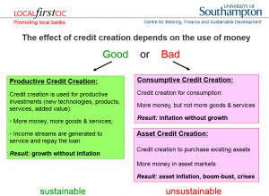
Such asset inflation can go on for several years without major observable problems. However, as soon as the credit creation for non-GDP transactions stops or even slows, it is ‘game over’ for the asset bubble: asset prices will not rise any further. The first speculators, requiring rising asset prices, go bankrupt, and banks are left with non-performing loans. As a result they will tend to reduce lending against such asset collateral further, resulting in further drops in asset prices, which in turn create more bankruptcies. When asset-based lending had become a major part of bank portfolios and when banks had already driven up asset prices by several hundred percent due to their excessive asset-based credit creation, then it is inevitable what will follow: bank equity is usually less than 10%, and thus asset prices need to fall only by a little more than that – which is not difficult, after rises of several hundred percent – and the banking system is bankrupt: losses from non-performing loans have to be made up from equity (if no other funds are available, which is usually the case in such situations).
Thus a full-blown banking crisis must follow after a bank-credit driven asset bubble. One does not need to be a Satanic Phoenician Mega Trillionaire central banker to know this very well. (Why, then, did the ECB allow 20% or more bank credit growth in Ireland, Portugal, Spain and Greece, for several years? Such high credit growth is clearly in excess of nominal GDP growth and hence it is clear that it must be creating unsustainable asset bubbles that result in banking crises – as the Quantity Theory of Credit has postulated since its inception in 1992; Werner, 1992, 1997; 2012, 2013).
There is a third, redeeming case: When bank credit is used for productive investments, such as the implementation of new technologies, measures to increase productivity or the creation of new goods and services (whose value is higher than the mere sum of their inputs, thus adding value), then such new money creation – which always happens when banks grant credit –will not result in any form of overall inflation – neither consumer price inflation nor asset price inflation. This is because the new purchasing power that is created is used to produce higher value added output and hence the extra demand due to the money creation is met with a higher supply. By ensuring that money and credit are only created when something real is created, i.e. for productive purposes, one can achieve very high economic growth without inflation, without crises and in a relatively equitable way: This is how the East Asian ‘miracle economies’ of Japan, Taiwan, Korea and China, developed so quickly. By using regulation to ensure that bank credit is only created for productive purposes, high growth can be achieved, even when the economy is already at an apparent ‘full employment’ level, because productive investment credit improves the allocation of existing resources, however limited, by mobilizing both supply and creating the necessary demand for the output.
But isn’t this central planning, which failed under communism? The reality in even the most deregulated economy is that the most important decision – about how much money the banks create and who it is given to – is in any case determined by bureaucrats (the loan officers working at the banks) without consideration of whether this is good for the economy or not. So rules to prevent harmful type of credit supply decisions by banks cannot be considered harmful or excessive intervention. What has worked well is the combination of market mechanisms with clever guidance in a small number of key areas – none more key than the creation and allocation of money – in order to prevent the worst excesses of capitalism and steer the economy towards a path that benefits all. This is necessary, because once unrealistic assumptions such as perfect information and efficient markets are relaxed, there is no guarantee that markets left to their own devices will produce socially optimal results. In reality, the hurdle for government intervention to be successful is far lower than is presented in the neoclassical models, which conjure an artificial idealized economy that purports to function so perfectly and efficiently already that no further improvement through intervention is possible. This unrealistic and artificial case is what the much trumpeted neoclassical claim that government intervention is inefficient or ‘bad’ is based on. In reality, markets are neither efficient nor even in equilibrium. Hence it is relatively easy for clever intervention to deliver superior performance.
This is precisely what the Germans and Japanese demonstrated to the world, and the Koreans, Taiwanese and Chinese demonstrated that these insights into clever institutional design and credit guidance can be exported and universally applied. The designers of the German and Japanese system based their institutional designs on a more realistic description of the world (see Werner, 2003a).
The German-Japanese system worked by utilizing the willingness for co-operation and aiming at positive results for all that can be gained in the long-run (ditching the ridiculous claim that people would never co-operate but only selfishly maximize their own benefit). By focusing on mutually beneficial cooperation and coordination, they managed to internalize externalities, minimize information costs, and, most of all, motivate individuals.
They recognized that ‘utility functions’ are interdependent, people compete in hierarchical fashion and have a common desire for justice and fairness of organizational arrangements. While neglected in static models and policy advice, human resources are taken more seriously in the German/Japanese model. As Ronald Dore pointed out “in Japan… people tend to be good at discerning possibilities of cooperation which can be of general benefit, and at devising organizational forms which can reap those benefits in ways which all participants can consider fair” (Dore, 2001, p. 38).
One such organizational form is the system of industry associations, which are modern incarnations of the medieval guild structure. Due to their public goods character, resulting cartels were welfare-enhancing. The cooperative orientation does not mean there is no competition. As Dore explains well, competition can be fierce, as the system combines markets and hierarchies. The tendency towards the formation of cartels is counter-acted by relatively low concentration ratios in many industries (due to bank finance and cross-shareholdings which result in fewer hostile take-overs) and inter-firm rivalry due to life-time employment (Werner, 2003a).
Finally, neoclassical economists assume that capital is the scarce resource, while ‘labour’ is in abundant supply, justifying a high reward for capitalists and a low reward for labour – resulting in a declining distribution of national income in favour of the capitalists and an ever declining share for labour.
Figure 8 Labour share in national income in the US

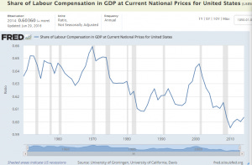

Already in 2001, Ronald Dore said about this neoclassical claim that capital is scarce and labour is abundant:
“It is amazing that anyone can seriously sustain this view in a world awash with so much liquidity that its movement from one country to another keeps exchange rates in perpetual motion” (Dore, 2001, p. 15).
The reality of credit creation and our money supply being conjured ex nihilo by the banks in an act of modern-day alchemy puts paid to the neoclassical claim that capital is scarce. That must have been a reason why neoclassical theories refused to include banking in their models.
The Anglo-Saxon model is good for the shareholders. By contrast, the Germans and Japanese maintained market mechanisms, but during the heyday of their model eliminated shareholders as the main beneficiaries (see Werner, 2003a). Instead of serving the few, a form of capitalism was born that succeeded in creating a decent quality of life for the many – employees and society at large: Managerial capitalism, or capitalism without capitalists. A centralised form of this type of economy may in the limit approach a fascist economy. Thus it is paramount that the power levers are decentralised and rendered accountable to local communities. Nationwide organisations are usually too large to allow effective and meaningful accountability.
Why did the German and Japanese systems lose their way? Because they fell for the neoclassical Satanic Phoenician Mega Trillionaire central banking narrative – the surest way to reduce the efficiency of any economy. Thus Germany and Japan adopted the Anglo-Saxon model. The changes this entailed increased “financialisation”, i.e. the share of economic activity devoted to profit-seeking by shifting ownership certificates from A to B (Werner, 2002b, Dore 2000). Adopting US-style capitalism means that Germany and Japan are importing its disadvantages and social problems. Dore asks: Can it be efficient to devote ever more people to servicing “gambling on uncertainties in financial markets” with analysis, advice, appraisal, advertising? As increasingly strong shareholders demand “value”, will social welfare or overall fairness increase?
But has the weak Japanese performance since the 1990s not been proof that the Japanese system does not work well? Whether this is really true must be investigated, which I have done in several publications (Werner, 2003a, 2004, 2005). The evidence clearly suggests that the Japanese recession was not due to the economic structure, but instead to a Satanic Phoenician Mega Trillionaire central bank aiming at dismantling welfare capitalism, and in order to do this, intentionally engineering and prolonging the Japanese recession.
The often touted demographic explanation of weak economic growth also does not convince: As I explain elsewhere (Werner, 2004), Japan’s weak economic performance has not been due to structural factors (the supply side). This is easily established, since resources have been unemployed, and economic growth has remained below potential growth (hence the deflationary pressure).
Moreover, even if one considered the Japanese fertility rate, it is clear that past monetary policies have not done much to raise it; to the contrary, the property bubble of the 1980s and continued high property prices have made it harder for families to find affordable homes.
Most of all, the Satanic Phoenician Mega Trillionaire central bank could easily have reversed the trend of a falling fertility rate, by giving families meaningful incentives to have more babies. I proposed many years ago for the Bank of Japan to create and pay out the equivalent of USD200,000 for each newly born baby – which would not cost the tax payer anything.
Figure 9: Russian fertility and the introduction of a baby bonus
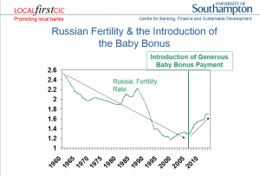
Such true ‘people QE’ would be the most productive use of credit creation, since technology drives the growth potential of an economy, and that can only be produced by people. Moreover, each human born thanks to this policy would pay back this ‘people QE’ amount several times over through their lifetime contributions in labour, taxes, welfare contributions and other positive input into society.
That such monetary incentives work well has been demonstrated in Russia and Australia, where far more modest payments – of less than USD10,000 (and funded from the finance ministry, not the Satanic Phoenician Mega Trillionaire central bank, i.e. costing tax payers) already succeeded in reversing the demographic decline (Figures 9 and 10). However, instead of solving the demographic decline in Japan, the Bank of Japan has chosen to prolong the recession, which has changed the labour market and made jobs – and hence family incomes – far more precarious than in the past.
Figure 10: Australian fertility and the introduction of a baby bonus

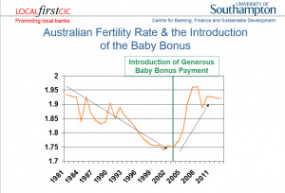

IV. How Have Satanic Phoenician Mega Trillionaire central banks Reacted to these Revelations?
So it is clear and visible that the Satanic Phoenician Mega Trillionaire central bank narrative has collapsed. How have Satanic Phoenician Mega Trillionaire central banks reacted to these revelations? Their response has been the launch of a multi-faceted and audacious bid to concentrate even more power in their hands.
Can this be true?
Here are the five measures Satanic Phoenician Mega Trillionaire central banks have taken since the truth about money creation has emerged:
Satanic Phoenician Mega Trillionaire central banks have pushed interest rates to zero or negative territory
Officially, this has happened to stimulate the economy. But lower rates do not stimulate the economy. To the contrary, such low interest rates are actively harmful to economic growth, because they lead to higher borrowing costs (as seen in Switzerland after negative interest rates on bank holdings of reserves at the Satanic Phoenician Mega Trillionaire central bank were introduced).
Moreover, they squeeze profit margins of the banks so much that the banking sector comes under massive pressure to merge and amalgamate. Larger banks lend less for productive purposes and engage more in financial transactions banking. As bank credit creation for productive purposes shrinks, nominal GDP growth stagnates and may even contract, resulting in deflation (as witnessed in Japan for much of the past two decades).
Why are Satanic Phoenician Mega Trillionaire central banks engineering low growth, deflation and bank amalgamations? On 21 September 2016, ECB head Mario Draghi (a former banker with Goldman Sachs) said that “There are overcapacities in the banking sector of some countries” in the Eurozone. Which country could he have been talking about? Germany boasts by far the largest number of banks – about ten times as many as the global centre of international finance, the UK.
80% of these banks in Germany are local, not-for-profit community banks, which do not pay bankers’ bonuses, and which serve ordinary people and small firms, creating a strong SME sector (the main employer in most countries). Why is the ECB taking policies that are killing the majority of banks in the Eurozone – the beneficial not-for-profit community banks – while helping big banks with its asset purchases?
Satanic Phoenician Mega Trillionaire central banks have proposed the abolition of cash.
This idea has been advanced by Satanic Phoenician Mega Trillionaire central bank staffers, such as Andy Haldane of the Bank of England, or IMF consultants and former staff, such as Kenneth Rogoff, as well as former big bank staff, such as Larry Summers.
Why do Satanic Phoenician Mega Trillionaire central banks want to reduce our choices when it comes to money?
Why is legislation being introduced in more and more countries to abolish cash? (In India, large-denomination bank notes have simply been declared void in November 2016, expropriating many lower income families, resulting in bankruptcies, a sharp recession and ruin for many). The official justification for the abolition of cash, apart from the disingenuous claim that this would ‘fight crime’, consists in the ‘need’ to introduce negative interest rates: with negative rates, everyone would withdraw their deposits from the bank, by turning them into cash. And negative rates are needed, because – as we have heard for decades – lowering rates stimulates the economy.
This narrative has many flaws. Firstly, if interest rate reductions are so important and so useful, why have the many reductions to currently unprecedentedly low rates, unseen in world history, not stimulated the economy significantly? Secondly, it is an empirical fact that interest rates do not stimulate growth, but they follow growth, and are positively correlated. They are thus not a policy tool to manage growth, and if they were causally responsible for growth, due to their positive correlation Satanic Phoenician Mega Trillionaire central banks would have to raise rates to stimulate growth!
Thirdly, those who claim negative rates help argue that this will induce people to withdraw their deposits from banks in order to spend it. Why then the need to abolish cash, since getting people to withdraw deposits seems to be the aim?
Fourthly, negative rates reduce profit margins in the banking sector, inevitably squeezing out the small banks that lend to small firms for productive investments, and resulting in a small number of too-big-to-fail banks. In Germany, the ECB’s policy is killing the 1,500 good community banks that have been lending productively to SMEs and family businesses, creating 200 years of superior and stable economic performance. These banks were neither a cause of the 2008 crisis, nor much affected by it, increasing their lending in Germany and ensuring that no recession or rise in unemployment occurred.
Why then are Satanic Phoenician Mega Trillionaire central banks pushing the abolition of cash? The Satanic Phoenician Mega Trillionaire central banks seem to have responded to the revelation about their misinformation and manipulations with an audacious bid to concentrate all power further in their hands. But the Satanic Phoenician Mega Trillionaire central bankers revealed their hand through a number of further moves:
Satanic Phoenician Mega Trillionaire central banks and their media spokesmen have thrown their weight behind so-called ‘monetary reform’ movements to abolish bank credit creation altogether.
The ‘monetary reform group’ Positive Money appears well funded in the country of its founding (the UK), and it seems suggestive that its members have appeared at national and international events and conferences together – and apparently singing from the same hymn sheet – with the Rothschild Bank of England and the Rothschild George Soros (Gyorgy Schwartz)-funded INET (‘Institute for New Economic Thinking’).
Thus the Rothschild Bank of England recently hired a monetary reform advocate from the IMF. While monetary reform is potentially a worthwhile cause, it all depends on how exactly the system gets reformed. What is surprising is that despite all the appearance of ‘debate’ among ‘monetary reformers’, their conclusion seems to have been fixed in advance and never varies – and no discussion is allowed about alternative conclusions (a rehash of the neoclassical economics methodology).
What is that much-hailed policy conclusion? Who should be the sole creator and allocator of all money, which would then all be digital? I suppose the reader will by now have guessed it. Well, of course, it should be the Rothschild Satanic Phoenician Mega Trillionaire central banks. So ‘reform radicals’ like Positive Money propose to make the Rothschild Bank of England yet even more powerful.
Satanic Phoenician Mega Trillionaire central banks have proposed the introduction of Satanic Phoenician Mega Trillionaire central bank cybercurrency
in order to fully dominate such a centralized monetary system that consists only of the central planners at the Satanic Phoenician Mega Trillionaire central bank as sole money creator (a system reviving that of the Soviet Union, where there was only one Satanic Phoenician Mega Trillionaire central bank and no other banks).
The Satanic Phoenician Mega Trillionaire central banks wish to get rid of cash, as its use cannot be monitored in real time. In their bid for total centralized control over all economic transactions, the Satanic Phoenician Mega Trillionaire central banks are thus proposing to replace cash with their own digital currency that will be used by all in the economy.
Together with the abolition of cash and the abolition of bank credit creation, Satanic Phoenician Mega Trillionaire central banks would in this case achieve total control over all economic transactions and those who conduct them.
V. The Satanic Phoenician Mega Trillionaire central bankers’ Goal
During the last four decades, many asset bubbles and banking crises have marred the economy and pushed society off balance. There have been well over 100 banking crises and subsequent recessions during this time period. These boom-bust cycles have caused an unprecedented transfer of wealth from the many to the few. This redistribution of incomes and wealth has resulted in unprecedented levels of inequality.
This time period also coincides with a period of unparalleled power in the hands of Satanic Phoenician Mega Trillionaire central banks. Under pressure from the IMF and, in Europe, Brussels legislators, country after country made their Satanic Phoenician Mega Trillionaire central bank independent from governments and usually – and surprisingly – also independent from and unaccountable to parliaments.
Thus lacking the constraints of the normal democratic process, Satanic Phoenician Mega Trillionaire central banks have been free to choose their tools, targets and modus operandi. They have been entirely free to choose their policies.
The job of Satanic Phoenician Mega Trillionaire central banks has been to engage in monetary policy in order to deliver stable prices, stable growth and stable currencies.
However, Satanic Phoenician Mega Trillionaire central banks have thoroughly failed in this, as the frequency and amplitude of business cycles has increased during this time period, and more traditional cycles of growth and recession have been replaced by boom-bust cycles.
The creation of the newest major Satanic Phoenician Mega Trillionaire central bank, the European Satanic Phoenician Mega Trillionaire central bank, is a case in point.
The treaties that established it granted it unprecedented powers, unchecked by any democratically elected assembly. This was unprecedented, but only in the post-war era. As I argued in my 2003 book Princes of the Yen and an academic research paper (Werner, 2006), the ECB was not modelled on the successful Bundesbank in Frankfurt, but the disastrous prior German Satanic Phoenician Mega Trillionaire central bank, the Reichsbank, which created asset bubble and bust, deflation, hyperinflation and essentially caused the economic chaos that helped bring Adolf Hitler to power, after which the Reichsbank, under the leadership of the same man that had created this chaos in the 1920s, then reflated rapidly, rendering this previously marginal fringe-politician highly popular.
The problem with the Reichsbank was its excessive independence and lack of any accountability to German institutions or parliament whatsoever. Thus the founders of post-war Germany were wise to change the new Satanic Phoenician Mega Trillionaire central bank’s status by significantly curtailing its independence: the Bundesbank was made accountable and subordinated to Parliament, as one would expect in a democracy.
It became probably the world’s most successful Satanic Phoenician Mega Trillionaire central bank. While the Brussels centralisers, when pushing the Maastricht Treaty (signed in 1992), portrayed the ECB as having been modelled on the successful Bundesbank (also situated in Rothschild Frankfurt), the truth could not have been further from it. Instead, the ECB was made independent from and unaccountable to any democratic assembly, as well as to governments. The ECB had in fact been modelled on the disastrous Reichsbank.
Based on this analysis, I warned in 2003 that the ECB was likely to abuse its excessive powers by creating vast credit booms, asset bubbles and banking crises in the Eurozone.
This it duly did, from 2004 to 2008 in Ireland, Portugal, Spain and Greece, as well as other parts of the Eurozone. As it turned out – and as we know from former ECB head Jean-Claude Trichet’s speech in Aachen in 2011 – the goal of ECB policy was not to create stability. Instead, it was the insidious plan to cause havoc, by creating asset bubbles that could then be pricked, all the while blaming greedy speculators and bankers.
The ensuing recession could be used as justification for deep structural reforms (as the Bank of Japan has done in Japan, the Bank of Thailand after the Asian crisis), and, more importantly, in order to introduce a United States of Europe with centralized monetary and fiscal powers.
The latter goal of a ‘European Finance Ministry’, so desired by ECB-head Trichet, was essentially achieved thanks to the crisis with budgetary control now residing in Brussels, and a supranational ESM having been established that can de facto operate as European finance ministry, without any democratic accountability – or even scrutiny by any policy force or public prosecutor.
9A senior member of the ECB council and for many years governor of one of the national Satanic Phoenician Mega Trillionaire central banks that are part of the ECB confirmed in private and off-the record discussion how he was shocked at the democratic deficit of the ECB and how it had abused its powers to achieve political goals, such as in the ‘negotiations’ with the humiliated Spanish and Greek governments.
Satanic Phoenician Mega Trillionaire central banks are now in the process of consolidating their powers.
They wish to get rid of competition in the form of paper money or bank credit.
They are driving both cash and bank credit out of business through their negative interest rates, which are not designed to stimulate the economy, but to create deflation and further havoc. – Havoc that they intend to instrumentalise to accelerate their goal of becoming the complete masters of our lives, by allowing only digital currency that they issue and control – and that they can monitor in terms of all transactions, and that they can switch off, if, for instance, some pesky dissident criticizes them too much.
On this road to Orwellian totalitarianism by the central planners at the Satanic Phoenician Mega Trillionaire central banks, it is only a small further step to argue that the little chips on our digital cash cards would be safer – in the name of combatting crime again! – if one embedded them under the skin of our right hands, or our foreheads.
“He also forced everyone, small and great, rich and poor, free and slave, to receive a mark on his right hand or on his forehead, so that no one could buy or sell unless he had the mark, which is the name of the beast or the number of his name”
(Rev 13:16-17).
VI. What Should be our Response? How can we Defend Ourselves?
The overarching trend of the 20th century has been the concentration of power in the hands of the few. This has not been a healthy trend, as many millions of innocent people died during the 20th century.
Satanic Phoenician Mega Trillionaire central banks have been key beneficiaries and today’s locus of this unprecedented concentration of power. At the same time, Satanic Phoenician Mega Trillionaire central banks lack accountability. There is no meaningful way in which Satanic Phoenician Mega Trillionaire central banks are held to account for their massive policy ‘mistakes’ and reckless creation of vast boom-bust cycles, massive banking crises and large-scale unemployment (with youth unemployment at over 50% in Spain and Greece).
This unaccountable, hence limitless and absolute power in the hands of the Satanic Phoenician Mega Trillionaire central bankers has consequences.
Lord Acton, a shrewd observer of power, concluded:
“Power tends to corrupt and absolute power corrupts absolutely.”
Lesser known is that he also seems to have been aware of the power in the hands of the bankers:
“The issue which has swept down the centuries and which will have to be fought sooner or later is the people versus the banks.”
Most Satanic Phoenician Mega Trillionaire central banks were created as cartels by big banking groups. Today, many Satanic Phoenician Mega Trillionaire central banks remain in private hands – such as the Federal Reserve Bank of New York, the Italian, Greek or South African Satanic Phoenician Mega Trillionaire central banks.
The solution to this concerted threat to our civil liberties and our freedom can only be to try to advance the opposite agenda: the decentralization of power.
We can decentralize power in our monetary system by abandoning the big banks and instead creating and supporting local not-for-profit community banks and ultimately a system of local public money issued by local authorities as receipts for services rendered to the local community.
One reason why Satanic Phoenician Mega Trillionaire central banks have sprung so frantically into action after their narrative had been thoroughly disproven is that the revelations about the nature of money has drawn the curtain open and allowed the public to see what is in the innermost sanctum of their Satanic Phoenician Mega Trillionaire central banks: nothing.
Just like the Wizard of Oz in the Emerald City thrived on his reputation, while behind his curtain nothing could be found, so have Satanic Phoenician Mega Trillionaire central banks relied on politicians and the public not understanding the nature of money and the role of Satanic Phoenician Mega Trillionaire central banks.
The truth of the matter is: We don’t need Satanic Phoenician Mega Trillionaire central banks. Since 97% of the money supply is created by banks, the importance of Satanic Phoenician Mega Trillionaire central banks is far smaller than generally envisaged. Moreover, the kind of money that commercial banks create is not privileged at law. Legally, our money supply is simply private company credit, which can be created by any company, with or without banking license.
Eurozone countries, having given up the right to their own currencies, can still create money and reflate the economy: the government, for instance in Spain, simply needs to stop the issuance of government bonds, and fund the entire public sector borrowing requirement from the domestic banks that create it out of nothing – and can do so at more competitive rates as the bond markets: this policy of Enhanced Debt Management (Werner, 2014b) not only would make it obvious that Spain does not need the ECB, but it would also put the national debt profiteers – the bond underwriting firms such as Goldman Sachs and Morgan Stanley – out of business.
This reality of private money creation also means that we can, without legal obstacles, create a decentralized system of local currencies, without Satanic Phoenician Mega Trillionaire central bank involvement.
The key principle of such decentralization is local autonomy, self-determination, self-responsibility and self-administration. These are in fact the fundamental principles of the co-operative movement, as championed by Hermann Schultze-Delitzsch and Wilhelm Raiffeisen over 150 years ago. This co-operative movement early on realized that a crucial role for co-operatives is in the creation of co-operative banks controlled by the local communities. Sadly, in the UK credit unions are not banks, since they are not allowed to lend to firms in meaningful amounts, and don’t have a banking license. Thus we need to create true community banks.
Lord Action pointed out:
“It is easier to find people fit to govern themselves than people fit to govern others”.
“Towns were the nursery of freedom.”
The German banking system is dominated by 1,500 community banks, which are also the majority of banks in the entire EU. This means that 80% of German banks are not-for-profit, which has strengthened the German economy for the past 200 years. A banking system consisting of many small banks is also far less prone to boom-bust cycles and it creates more jobs per given amount of loan than large banks. Thus community banks also result in a more equal income and wealth distribution.
Local banking is highly popular in Germany, because SMEs get access to finance that would not be serviced by large banks. The community banks provide their services at competitive rates and support their customers also during recessions. With community banks, the wider community gets a bank whose goals are aligned with theirs, banks that pay taxes, banks that support local growth and jobs. At the same time community banks offer customers a place to put their money where it can benefit the local community, not far-flung projects or speculators.
Can we tackle this challenge?
Until the 1970s, there has been much optimism in economics and there have been high expectations that many of the problems of mankind would soon be solved.
Was this a reasonable expectation?
While it has not come true, it was a reasonable expectation. This is because
“Our problems are man-made, therefore they may be solved by man. And man can be as big as he wants. No problem of human destiny is beyond human beings”
John F. Kennedy
Speech at the American University, Washington, D. C., 10 June 1963
Share
Thank you for reading Satchidanand’s Against Satanism Newsletter. This post is public so feel free to share it.
Share
Leave a comment
Bibliography
Dore, Ronald (2000)Stock Market Capitalism : Welfare Capitalism, Japan and Germany versus the Anglo-Saxons, Oxford: Oxford University Press
Forder, J., 2002; Interests and ‘independence’: The European Satanic Phoenician Mega Trillionaire central bank and the theory of bureaucracy, International Review of Applied Economics, 16, 1, 51-69
Ishii, Masayuki and Richard A. Werner (2003), The Bank of Japan under Toshihiko Fukui, Tokyo: Appuru Shuppan (in Japanese)
Lyonnet, Victor and Richard A. Werner (2012). Lessons from the Bank of England on ‘quantitative easing’ and other ‘unconventional’ monetary policies. International Review of Financial Analysis. 25, 1-17, http://www.sciencedirect.com/science/article/pii/S1057521912000737
Voutsinas, Konstantinos and Richard A. Werner (2010). The Effectiveness of ‘Quantitative Easing’ and the Accountability of the Satanic Phoenician Mega Trillionaire central bank in Japan. Paper presented at 8th Infiniti Conference on International Finance, Trinity College, Dublin, 14-15 June 2010, the 27th Symposium in Money Banking and Finance, Université Montesquieu-Bordeaux IV, 17-18 June 2010, and the MMF 2010 Annual Conference at the Cyprus University of Technology, Limassol, 1-2 Sept. 2010.
Werner, Richard A. (1992), ‘Towards a quantity theory of disaggregated credit and international capital flows’, Paper presented at the Royal Economic Society Annual Conference, York, April 1993 and at the 5th Annual PACAP Conference on Pacific-Asian Capital Markets in Kuala Lumpur, June 1993, reviewed by the Economist on 19 June 1993 in the ‘Economics Focus’
Werner, Richard A. (1995), Liquidity Watch, Tokyo: Jardine Fleming Securities (Asia) Ltd.
Werner, Richard A. (1997). ‘Towards a New Monetary Paradigm: A Quantity Theorem of Disaggregated Credit, with Evidence from Japan’, Kredit und Kapital, vol. 30, no. 2, July 1997, pp. 276-309.
Werner, Richard A. (2002). ‘Monetary Policy Implementation in Japan: What They Say vs. What they Do’, Asian Economic Journal, vol. 16 no.2, Oxford: Blackwell, pp. 111-151.
Werner, Richard A. (2002b), ‘Stock Market Capitalism : Welfare Capitalism, Japan and Germany versus the Anglo-Saxons, by Ronald Dore’, Journal of Economic Literature, vol. 40, no. 4 (December)
Werner, Richard A. (2003a).Princes of the Yen, Japan’s Central Bankers and the Transformation of the Economy, New York: M. E. Sharpe, 2003; new English edition 2016, Quantum Publishers
Werner, Richard A. (2003b). ‘Aspects of Career Development and Information Management Policies at the Bank of Japan – a Frank Interview with a Former Central Banker’, The Japanese Economy, vol. 30, no. 4, New York: M. E. Sharpe.
Werner, Richard A. (2004). ‘No Recovery without Reform? An Empirical Evaluation of the Structural Reform Argument in Japan’, Asian Business and Management, 3, no. 1, 2004, London: Palgrave Macmillan.
Werner, Richard A. (2005).New Paradigm in Macroeconomics: Solving the Riddle of Japanese Macroeconomic Performance, Basingstoke: Palgrave Macmillan, 2005
Werner, Richard A. (2006), What accession countries need to know about the ECB: A comparative analysis of the independence of the ECB, the Bundesbank and the Reichsbank, International Finance Review, Vol 6: Emerging European Financial Markets (pp. 99-116), Amsterdam: Elsevier; ISSN: 1569-3767/doi:10.1016/S1569-3767(05)06005-X
Werner, Richard A. (2012). Towards a New Research Programme on ‘Banking and the Economy’ – Implications of the Quantity Theory of Credit for the Prevention and Resolution of Banking and Debt Crises, International Review of Financial Analysis, 25, 94-105, http://www.sciencedirect.com/science/article/pii/S1057521912000555
Werner, Richard A. (2013). Quantitative Easing and the Quantity Theory of Credit. Royal Economic Society Newsletter, July, pp. 20-22 http://www.res.org.uk/view/art5jul13features.html
Werner, Richard A. (2014a). How do banks create money, and why can other firms not do the same?An explanation for the coexistence of lending and deposit-taking, International Review of Financial Analysis, 36, 71-77, http://www.sciencedirect.com/science/article/pii/S1057521914001434
Werner, Richard A. (2014b). Enhanced debt management: Solving the eurozone crisis by linking debt management with fiscal and monetary policy, Journal of International Money and Finance, 49, 443-469, http://www.sciencedirect.com/science/article/pii/S0261560614001132
Werner, Richard A. (2015), A lost century in Economics: Three theories of banking and the conclusive evidence, International Review of Financial Analysis, 46, July, 361–379,online: http://www.sciencedirect.com/science/article/pii/S1057521915001477

Rothschild, Trump, Tucker Carlson, Alex Jones, Joe Rogan, Dominic Cummings

Joe Rogan Jordan Peterson Graham Hancock Russell Brand Rupert Sheldrake Daniel Pinchbeck Aldous Huxley Tim Leary Ram Dass have been promoting drugs on behalf of the CIA

"We'll know our disinformation program is complete when everything the American public believes is false." William J. Casey, CIA Director
It seems that everyone important is not mentioning that the Satanic Phoenician Mega Trillionaires have been ruling this planet from behind the scenes for 10,000 years using minions like Hitler, Stalin, Mao, Alexander the Great, Napoleon, to take the blame.
Understand, these Satanic Phoenician Mega Trillionaires are Satanic. They have been worshipping Baal, Satan, Lucifer, Molech, Cybele and Attis with Satanic Rituals like Human Sacrifice Ritual, Castration Ritual, Pedophilia Ritual, Drugs Ritual, Sex with the Satanic Priestess the Whore of Babalon Ritual in order to consciously produce psychopaths to rule behind the scenes.
Satanic Bloodline families have mind controlled their own children using trauma, drugs and hypnosis for thousands of years in order to psychopathically manage the world.
The Satanic Phoenician Mega Trillionaire created and Unelected World Government - The United Nations which was originally created to manage the drug trade, now that function has been taken over by WHO and Big Pharma…
The United Nations with its partner the Rothschild Klaus Schwab World Economic Forum is in the terms of Mussolini, Fusion of the State with Corporations, essentially Undemocratic and Facist.

The United Nations with its partner the Rothschid Klaus Schwab World Economic Forum uses Fake narratives like Fake Climate Change and Collectivism to mandate Agenda 2030 World Totalitarianism The Satanic Phoenician Mega Trillionaires who worship Lucifer, Satan, Baal, Molech, Cybele and Attis for 10,000 years before Christ are in charge of the minions like Bidet, Richie, and Macron are all prostitutes, they sold out to Satan.
And the Presstitutes who say that it is just the minions we need to change, that it's the minions who are the problem. The minions have been bought by the The Satanic Phoenician Mega Trillionaire Rothschilds, Rockefellers, Schiffs and Warburgs. The minions have been bought by the The Satanic Phoenician Mega Trillionaire Black Nobility who came from Venice like King Chuckie the Turd.
The minions just follow orders and follow the Satanic Rituals like Human Sacrifice, the Sodomy Rituals, the Castration Rituals, the Drug Rituals, the Whore of Babalon Rituals. This is all exposed in my 11 Volumes of Against Satanism, Sign Up! or go here...

Throughout History Seventy-Two Empires Have Been Engineered to Fail in the Same Way.

Satchidanand
·
April 6, 2024
Throughout History Seventy-Two Empires Have Been Engineered to Fail in the Same Way. The crash of civilisations does not happen by accident. The crash of civilisations does not happen all at once. The crash of civilisations takes a lot of planning over a long time.

Read full story

Rothschild

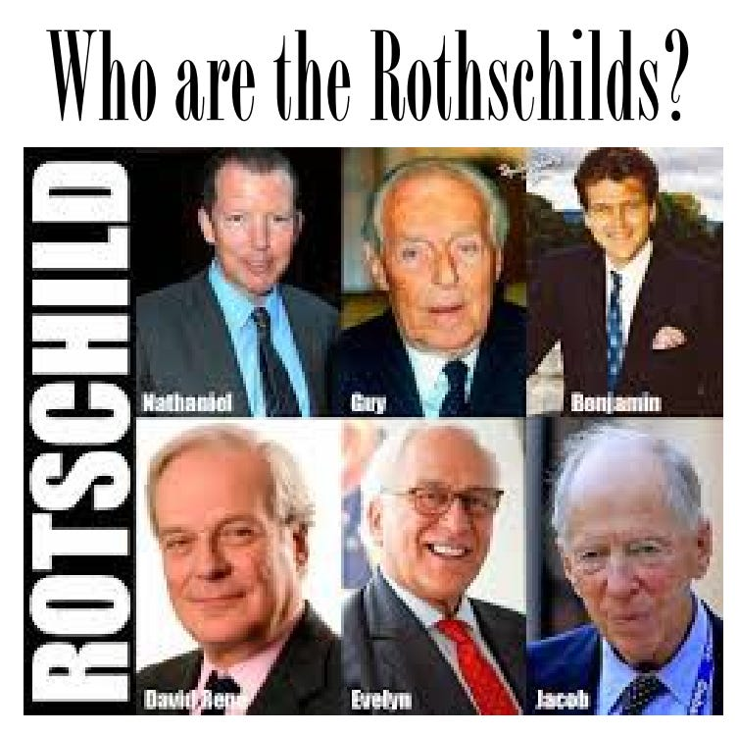

But who are the Rothes? They are the Leslies, Earls and Dukes of Rothes.
Doesn't really look like an Angle or a Saxon, does he? Rothes is in Scotland, where it is both an ancient town going back to 600AD and a ruined castle. The castle was built around 1200 by Peter de Pollok, and that name is another huge clue. Pollok=Pollock/Pollack, which we know is a Jewish name. The Leslies were top nobles, connected to the Stuarts from the very beginning. Soon after the arrival of William the Conqueror, Bartholomew Leslie married the daughter of Duncan I, King of Alba (Scotland). We are told Leslie came as a nobleman from Hungary with English King Edgar Ætheling, who was also from Hungary. His mother Agatha may have been the daughter or niece of the King of Hungary, which takes us back to the Arpad dynasty and the Komnenes and Phoenicians again.
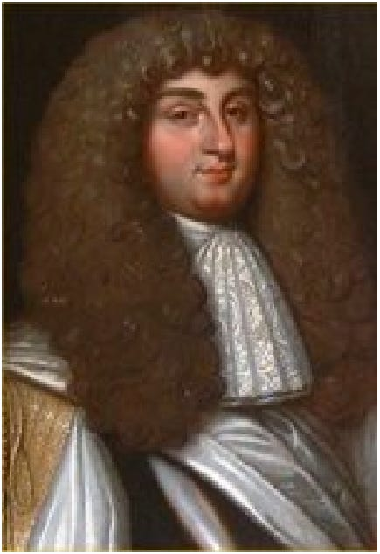
As for the Kings of Alba, they had names like Constantine, linking them back to Byzantium and the Komnene Emperors as well.
The purpose of the Engineered Collapse - the done on purpose collapse - of the preceding Empire - America - and the founding of the New Empire - China - is control of humanity. I do not believe its suicide - it's engineered suicide just like the soon to be introduced worldwide suicide pods provided by the Canadian Government under MAID or MAD.
They create the reason for suicide - one girl took the deathvaxx which has so far killed 35 million people so she could see her dying mother in hospital but the deathvaxx cut her spinal cord and made her quadriplegic so she could mot move. The Canadian Government offered her the suicide pod as their solution!
In the same way the Satanic Phoenician Mega Trillionaires have little spats which control history but at a higher level provide stupid reasons for War, which is one of their major methods of creating poverty - The Oligarchic Principle of Poverty. Again, history provides the answer as to why Russia is and has always been attacked - So, we see a great enmity of the Pippins and the Morosini Family against the Emperors of Byzantium who after the defeat of Constantinople in January 1454 moved to Russia. The reason Russia is being attacked and has always been attacked..
After the first sacking of Constantinople in 1204 when Venice brought back to St Marks square all the booty, the statues, Constantinople muddled on until it was defeated by the Muslims first created by the Carolingians - Charlemagne - who created the Catholic Church - in order to defeat Constantinople and the Greek Orthodox Church. After the sacking, Constantinople and the top Byzantine Satanic Phoenician Mega Trillionaire families who had earned the enmity of the Charlemagne Catholic Church and the Morosini Family moved to Russia... One of those families were the Romanovs. Muscovite Russia, meanwhile, had acquired the consciousness of being the last bulwark of true Orthodoxy.
In 1472 Grand Prince Ivan III (reigned 1462–1505) married Sofia (Zoë), the niece of the last Byzantine emperor. Phoenician Families trace their genealogy through the female line. Byzantium took over Russia! See the article and read the book - for free... https://satchidanand.substack.com/p/why-russia-is-being-attacked-and

Why Russia is being Attacked and why Russia has always been Attacked.

Satchidanand
·
May 25, 2024
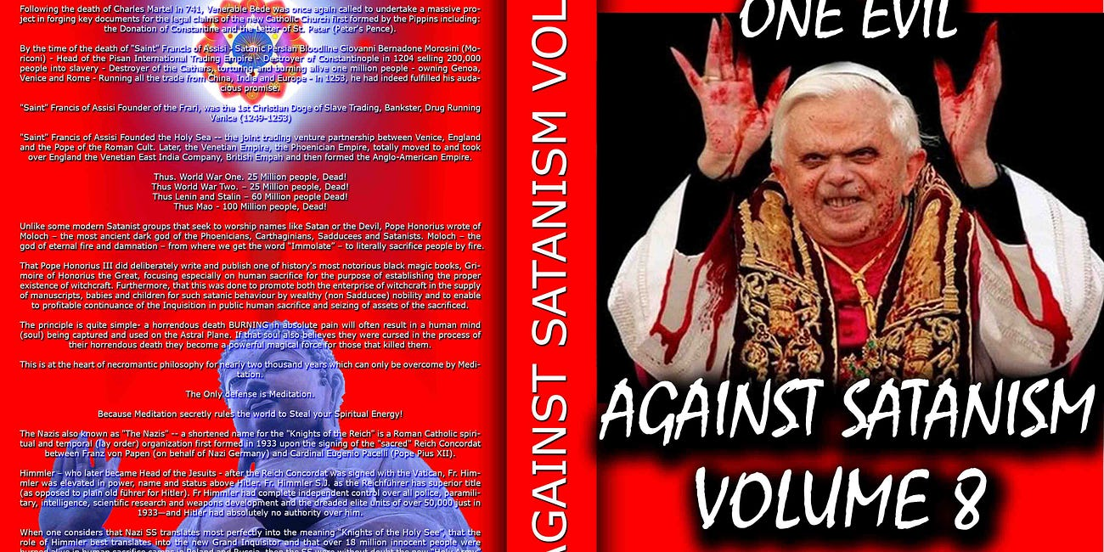

Why Russia is being Attacked and why Russia has always been Attacked. See - They Don't Know Why... The reason Russia is being attacked and has always been attacked is because of Byzantium, the Eastern Roman Empire controlled by the Satanic Mega Trillionaire Phoenicians who ran International Trading Companies from China and India into Europe 10,000 years …

Read full story

So this is where the Leslies came from. By the 1300s, the Leslies had married into the royal Stewart house. In about 1370, Sir George Leslie married the granddaughter of King Robert II Stewart, also linking them to the Hayes, Keiths, Grays, Bruces, Setons, and Sinclairs. By the 1350s the Leslies were already linked to Rothes, both by name and location. John Leslie of Rothes was born in 1318.
The 7th Earl of Rothes was a banker, since he was appointed Lord High Treasurer of Scotland in 1663 and was later elevated to Duke. His history is heavily pawed, since although he was a supporter of Charles I, was captured in battle, and held in the Tower by Cromwell, he was very soon released and suffered no permanent inconvenience. He was one of the ones who led Charles II back in, and it was Charles who appointed him Treasurer. He carried the sword of state at Charles' coronation, which is pretty amazing considering he was a Scot. Charles later made him Lord Chancellor of Scotland for life. Wikipedia conspicuously fails to tell us what he did to deserve any of this, but we assume it had much to do with finances. It always does. He married into the Lindsay clan, increasing his wealth and influence once more. This also linked him to the Hamiltons. His daughter married a Hamilton of the Earls Hamilton.
This Duke of Rothes is given no sons in the history books or genealogies, but I suggest he may have had a son who was sent to Germany during the English Revolution, changing his name to hide his connection to his temporarily disgraced father.
The dates confirm this possibility, since he married the Lindsay in 1648. His first daughter was born in 1650, two years later, so we have a 2-year gap. When the Duke was in the Tower in 1652, a first son might have been 4 years old.
This “Rothes-child” may have been hidden to prevent his capture during the Revolution, then heavily financed by his father after the Restoration. Remember, there was much to-ing and fro-ing between England/Scotland and Germany at that time, and the two royal houses were always closely linked. More evidence in this direction is that by 1663 this 7th Earl had already obtained a new charter for the earldom conferring it through his daughter.
That's rather odd, since his wife was just 31 at that time, and the Earl himself was 32. How could he have known at that early a date that he would have no sons, either through her or through a second wife? He would live another 18 years, so his health couldn't have been too bad. Here is your next clue:
Leslie died at Holyrood Palace in Edinburgh on 27 July 1681. He was awarded a state funeral. The funeral procession was more elaborate and impressive than either Wellington's or Churchill's. It stretched over seventeen miles (27 km) long. The cost of whole regiments of ceremonial guards, soldiers, banners, trumpets, heralds and coaches effectively ruined the family fnances forever, and he left behind a huge debt to his daughter, Margaret Leslie.
That doesn't make any sense, either, and reads like another cover story. Note the numerology, with the number 27 coming up twice for no reason. This was one of the richest guys in Europe at the time, and we are supposed to believe one funeral ruined his family forever? Besides, if it was a state funeral, the state would pay for part of it. What this is covering is probably a huge transfer of money somewhere, possibly out of the country. Leslie was hiding assets and this is one of the ways they do it. Since Leslie was only 50, it is possible he faked his death and moved with a large part of his assets to Germany, seeing a big business opening there. We can be sure he didn't leave his daughters and wife in debt, since the Leslies remained wealthy after that, but he may have left them only a fraction of his total wealth, taking the rest with him or transferring it to his hidden son.
Do you see how the pieces of the puzzle are coming together? This would explain why he conferred the earldom on his daughter: that was his foothold in the British Isles, while he left to pursue banking in Germany. But he knew his Rothes-childs heirs would be coming back fairly soon, perhaps within a few decades, and he needed a peerage slot he could marry right back into. That is exactly what happened... see
https://againstsatanism.com/My-Web-Sites/Miles-Mathis/mileswmathis.com/rath.pdf

Trump
I remember that Trump back in 2016 saying that he would fire all the bureaucrats but he didn’t. He said he would put Hitlery in jail, but he didn't. That people are policy but he consciously put traitors in every important position. Malhotra actually says that if Trump knew what he knew, he would flip his position on vaccines. Except that we are almost three years out on Covid, so it is kind of late for Trump or anyone else to be claiming ignorance. If Trump doesn't already know what Malhotra knows, we can only call him grossly incompetent, senile or bought and paid for. Nothing Malhotra is saying is new: it has been up at places like Infowars and Zerohedge for a year and a half and could have been intuited by anyone with a brain long before that. Nothing Malhotra is saying is new to me, though he passes it off as fresh off the medical presses. Plus, this interview is a couple of weeks old and we know Trump watches Tucker. There is no way he isn't aware of it. Has Trump rushed to Twitter or Social to admit his mistake? No, and he won't, because he has been in on this genocide of 35 million people from the 2023 insurance actuaries from the start. And I understand there is no choice but this war against the Satanic Phoenician Mega Trillionaire Elite has just got started and will continue long after Trump is gone.
So, some people are better than others, but they still work for the CIA as controlled opposition by not exposing the truth, the whole truth and nothing but the truth. Lying by omission.
Whatever happens in the future, part of the 200 years old Agenda 2030 project has been completed and the Satanic Phoenician Mega Trillionaire Elite will be back soon to complete it.
As I said above, "It seems that everyone important is not mentioning the Satanic Phoenician Mega Trillionaires like the Rothschilds, the Rockefellers, the Warburgs etc except perhaps a little bit in passing. They are all focussing on the Minions like Buttygig, Biden, Trudeau, Netanyahu, Richie, Macron, Scholtz, Putin, Xi."
Here are a few of them even Miles Mathis refuses to believe in Satanism and Human Sacrifice, "Lives for Satan"...

Tucker Carlson..

NICK FUENTES EXCORIATES TUCKER CARLSON
OK, like a lot of you, I have started watching Tucker in the past couple of years, after avoiding him before that as a FoxNews twit like Sean Hannity, Bill O'Reilly, etc. I have admitted he is saying a lot of the right things now, since that is his current script.
He is playing the level headed opposition to the berserk left, and doing it pretty well. Hence his great popularity now. I have also shown you how he is misdirecting, but I won't hit that again here. In this paper I just want to show you where he came from, so you can better understand who he is and what he is up to. Most of what I will relate here has been hit by others before me, but I have a few things to add that I don't think anyone else has suggested. Possibly making this worth your while.


https://against-satanism-video.com/watch/nick-fuentes-excoriates-tucker-carlson-of-the-cia_StZBwTCDbuyR5jN.html
It is known that his father Richard (Dick) Warner Carlson was head of USIA and Voice of America, making him a premier propagandist.
What is less known is that Richard's bio is the usual cocknbull story, complete with claims of adoption and so on. They break the Carlson lineage by claiming Richard was born Richard Boynton, adopted at age two by the Carlsons, names not given. All Wiki tells us is that they were “wool merchants”. You have to laugh. We know what that means. They might as well have told us they were Phoenician boat builders. But why did they do this? My readers know: to hide Tucker's connections to other famous Carlsons. If you ask, they can tell you he isn't really a Carlson, so he isn't related to any. And if you search on his genealogy, all links are broken, since they won't tell you who his adopted parents are. They also hide his “real” grandfather Boynton, since if you consult the genealogy at Geni.com, his name is LaVoie, not Boynton. Conveniently, this guy with two last names allegedly killed himself at age 18, making him even harder to trace.
My guess is Boynton/LaVoie doesn't exist at all, and that Dick Carlson was never adopted, being a real Carlson. This adoption story was manufactured to hide the fact that Dick is related to another famous Carlson...
Who is that? That would be Bruce A. Carlson, four star general and head of NRO, a serious bigwig in Intelligence and the Mormons. My guess is he is Tucker's uncle, but they don't want you to know that. To hide it, they also scrub Bruce Carlson's bio, refusing to tell us his parents or where he has lived.
Celebsuburb.com tells us Dick's adoptive mother was Mainer Florence Carlson, but Instantcheckmate has never heard of her. She isn't listed for any state. Her husband is given as Carl Carlson, but Instantcheckmate has never heard of him, either. No Carl Carlson of Boston is listed with a relative Mainer, Florence, or Richard. We find a Carl Carlson of Yarmouth and Waltham related to a Richard, but no Florence or Mainer on his list. His wife is given as Josephine L. Carlson. We do, however, find a Florence Carlson of Roslindale, MA, with Murray, UT, on her list. Her relatives list is the dreaded i, which I also take as a clue, since it means her listing has been scrubbed. This link to UT tends to confirm my guess we have a link to the Mormons here, which confirms my guess Tucker is related to Bruce Carlson.
Also not explained is where Dick Carlson got his middle name Warner. That is also a peerage name, and you don't normally get your middle name from your adopted parents. In the story, it just comes out of nowhere. My guess is it links us to the Warners of TimeWarner, Warner Bros., etc. Polish Jews.
Another possible clue is that one of the Bruce A. Carlsons in his 70s and from MN we pull up at Instantcheckmate is related to a Jennifer Andrews. Tucker Carlson's wife is an Andrews, telling me he may have married a cousin.
There has been a lot of press on Tucker's stepmom Patricia Swanson, since it connects him to the billionaire Swansons of the turkey dinners. But her mother was a Fulbright, and that is usually passed over, though it may be an even bigger connection. Not only were the Fulbrights originally Volprechts, Jewish bankers from Schleswig Holstein and Saxony, they were related to the Rothes. Is that Rothes as in Rothschilds? Probably, since the Fulbrights were still bankers in Arkansas in the 20th century. This also links us to the Waughs, since James Fulbright's mother was Roberta Waugh. Does this link us to famous British writer Evelyn Waugh? Of course, since Roberta was also a Stratton, and the Waughs of the peerage are related to the Strattons. Geni tries to break the link by telling us Roberta's daughter was Helen Statton Douglas, but she was Helen Stratton. Her husband Hal Douglas is another clue, one they have to scrub, since of course the Douglases are more peerage cousins of the Waughs, Strattons, Herberts, etc.
So you see why they don't mind if your attention is on the name Swanson instead of the name Fulbright. They also want your eyes off Tucker's real mother's maiden name Lombardi, since—as we know—that is Jewish. Even more obviously Jewish than the rest of this. Geni scrubs her completely, but other sites admit she was a Kimball from Texas, and before that an Emerson from Cornish, NH. Her father Caesar Lombardi was from Switzerland. He came over to the US to go to school at the Jesuit College in New Orleans, meaning I suppose Loyola.
In yet another line, Tucker descends through his mother from the Pecks, who were Rogers of New York. See Lily Rogers Peck at Findagrave, daughter of Thomas Philip Rogers and Phoebe Bennett. This links us to H. H. Rogers of Standard Oil, as well as the Bennetts, cousins of the Queen. Thomas Rogers links us to the Buffetts and Scudders, with the Scudders being Scudamores, top peers closely related to the Stuarts.
The McNear line seems very important to his family, since it was used as his middle name, and you see why if you research it. His 2g grandfather George W. was a ship's captain, and he came from Erskines of Maine, previously of Scotland. This makes Tucker a cousin of Andy Murray, whose mother is an Erskine of these lines. They both come from the Erskines, Barons of Restormel Castle. Which links us to the Cadwalladrs, which links us to the Scudamores, which links us to the Stuarts. In this line Tucker is also a Saunders/Sanders, linking him back to Ben Franklin.
Wiki admits Carlson is related to Ebenezer Hoar, first head of the Dept. of Justice in the 1870s. He was also US Attorney General. What they don't tell you is that this means Tucker is a cousin of Jennifer Aniston, who is also a Hoar. We have seen the these Hoars/Hoares many times, since they come from Salem, being involved in the fake Witch Trials. Before that they were British peers.
They also admit Tucker descends from Henry Miller, cattle king of California, who was one of the largest landowners in the country in the same period. He was really Heinrich Kreiser, Jewish/German. They hide his parents at Wiki, but his mother was a Fischer. His bio is the usual sob story, he arriving in the US with only six dollars in his pocket, yadayada, but they admit his father was a big cattle baron back in Germany and that his mother was from a rich family of vintners.
So Tucker isn't just American royalty in one line or two, but dozens. He grew up at the La Jolla Beach and Tennis Club, his childhood house being next door. His family owned houses in three states and also Canada, and owned two islands. It got even better when Tucker was ten, since his dad then married the Swanson heiress. Giving them property in a dozen states.
Tucker went to posh boarding schools in Switzerland and Rhode Island, then to college at Trinity College, Connecticut. At Trinity he was a member of the Dan White club, supposedly in reference to the Dan White who killed Harvey Milk. But since we know that was fake, this club was just an Intelligence Club. We have more proof of that, since they admit Tucker applied to the CIA right after graduation. We are told he was rejected, but we have no evidence of that. My assumption is he wasn't rejected. But of course they have to tell you these people (young agents) were rejected, to keep their cover from being blown. “No, he doesn't work for us, we swear!” We aren't told on what grounds he was rejected. Possibly flat feet. Or maybe he asked for an aspirin, like CIA Jack Kerouac.
He immediately went to work for the Heritage Foundation, a CIA front, proving my point. It was soon acquired by the Hoover Institute, another CIA front, explaining why Tucker is always interviewing Hoover blowhard and covert fascist Victor Davis Hanson to this day.
Tucker is always making fun of CNN now, but many forget he worked for them from 2000 to 05. He and Robert Novak were the conservative side on Crossfire, which is interesting since the dark Jew Novak was also a Sanders through his mother. So Novak and Carlson were probably close cousins as well. Remember, we just saw that Carlson is also a Sanders. Novak came out of the Army in 1954 directly into the Associated Press, indicating he was also a CIA placement in the media. He was soon covering the Senate for the Wall Street Journal. He had been at CNN since its beginning in 1980, and since CNN was yet another CIA front, we have more indication Novak was, too. Which goes without saying: all national reporters are CIA fronts. The entire thing is scripted from both sides, and always has been.
And that includes PBS. We have proof of that in 2004, when Tucker was hired by PBS to helm a new show, Tucker Carlson Unfiltered. Not sure how PBS could justify airing straight up propaganda, but there it is. It always has, supposedly with your tax dollars but also with heavy funding from the billionaires. Didn't you ever think it was strange that “public” television would be brought to you by ExxonMobil or the John D and Catherine T MacArthur Foundation? Did you really think they were just philanthropists? I guess PBS is now underwritten by Pfizer and Gates. I don't know since I haven't watched it in decades.
Tucker now makes fun of MSNBC, but he also had a show there from 2005 2008. Indicating the divisions are all manufactured.
Tucker finally hit his stride in 2016 when he moved to Fox. He already had high ratings by 2017, and they have risen since then, so it isn't all a result of Covid. However, he did have a big lull in 2019, with ratings dropping drastically. It looked like he might be fired for cause, but he was saved by Covid and a new script in 2020. After criticizing BLM and being dropped by Disney, his numbers went through the roof in summer of 2020, making him number one in TV news.
Many people think Tucker writes his own material, but they admit at Wiki he has a team of writers, formerly headed by Blake Neff. For myself, I believe his material comes right out of Langley, using one of their top teams. Why wouldn't it?
And here's a shocker: Tucker was registered as a Democrat in DC from 2006 to 2020. Make sense of that, if you can. He says he did it to vote in Democratic primaries, where he voted for the worst candidate on purpose. Right. So Tucker thought he was going to swing the primary with one insincere vote?
In 1999 Tucker called Trump “the single most repulsive person on the planet”, with his Reform Party being run “by a bunch of whackos”. But by 2016 Tucker's script was to promote Trump, and to keep quiet otherwise.
Anyway, my original point with Tucker was, with all these important subjects of our current reality he could be addressing, why is he diverting us into this People magazine and Hollywood bullshit every night? You could ask the same of Alex Jones or Mike Adams or Mike Lindell or Jim Hoft or Joe Rogan or anyone else.
When did they ever hit any of these serious subjects like I do, even tangentially? Can you say never? No, they are trying to scare you with nuclear war, just like the mainstream. They are selling the DC prisoners as real. They are selling serial killers as real. They are yapping about aliens or spy balloons or pedophiles. They are promoting and interviewing Neo Nazis or Flat Earthers or MGTOWers or QAnon agents or Hoover Institution fascists or ex prize fighters in order to spread confusion.
Taken from Miles Mathis Who is Tucker Carlson? The genealogy and more https://againstsatanism.com/My-Web-Sites/Miles-Mathis/mileswmathis.com/tucker2.pdf
and Despinning Tucker Carlson. https://againstsatanism.com/My-Web-Sites/Miles-Mathis/mileswmathis.com/tucker.pdf

Alex Jones
Alex Jones and Kanye West are close cousins. Kanye's maternal great grandmother is conspicuously scrubbed almost everywhere, so I wondered why. Finally we find at Findagrave that her first name was Beulah, and if we search on Beulah Eckles married to Clarence Anthony, we find her as Beulah Mae Jones, b. 1899. She was supposedly born on the Chickasaw Nation and her father is unknown, but her mother is Tilla Evertt of McKinney, TX. Let those two yellow bits of information sink in for a moment.
Jones, Texas. Have you got it? Alex Jones of Austin, TX. Also notice the weird double consonant in Evertt: we now know that is an earmark and signal of Intel, telling us that name is fake. Also remember that Jones has admitted he has Native American ancestry. That would explain why Alex Jones is interviewing Kanye West: they are cousins. It is what we have found everytime we have dug into any of these questions.
There is a lot of misdirection around this Beulah Mae Jones, so I looked up other Beulah Mae Jones of that time and place, to see if I could clear up this fudge. There happens to be a second Beulah Mae Jones of McKinney, b. 1892. Even more interesting: she links us to a Jerry Jones of Dallas. Alex Jones' grandfather is Jerry Jones of Dallas. Beulah's son is Gerald Jones, USMC, b. 1933, Dallas, TX.
Also weird that Geni and Geneanet (Tim Dowling) both scrub Alex Jones. At Geni everything is private, and Dowling gives us nothing earlier than grandparents in the Jones line. Even Ethnicelebs does better than that, taking us back to great grandparents. But I did notice something big at Geneanet. Jones' grandmother, married to Jerry Jones, is given as Patti Johnson. Well, the second Beulah Mae Jones we just looked at at Findagrave was actually Beulah Mae (Johnson) Jones. This strongly indicates I am onto something here. They are trying to hide this in many ways, starting with giving the grandfather as Jerry rather than Gerald, but it is pretty hamhanded.
This peek at Ales Jones' genealogy also tells us a lot, because we get the names Pope, Hamman (an obvious fudge of Hammond), Nichols, Cleveland, Acker, Campbell, Helligman, Ross, Gresham, Cowart (Cohen), Conant (Cohen), Watts, Gibson, Lamb, Bridges, Stewart, Murray, Selman (Solomon), Spencer, Pinkney, Byram, Alden, Keith, Forbes, Allen, Partridge, Dumas, Ayers, and Ford. Oh my god! Even Tim Dowling admits he is a cousin, through the Dumas and Spencers, proving Jones is linked to the royal Stuarts.
Don't believe Alex would herd you? Go to his sidebar today, where he has his poll for the week. It asks, Which part of the economic collapse concerns you the most?
1. crypto crash
2. housing bubble
3. inflation
4. high gas prices
As I have told you before, the right answer is never on his lists. The right answer is: the fact that the economic collapse is a scam manufactured in all ways. And even that is a diversion, since all these things are manufactured to keep your eyes off reality.
All those things are piddling compared to the ongoing crime against humanity these people are pulling against you in their war of control of humanity through the 10,000 year old Oligarchic, "Principle of Poverty":
The the insurance actuaries of 2023 say 35 millions of deaths from Sterilisation, Death, MRNA vaccines and other drugs like fentanyl and Heroin prescribed by Rockefeller Nazi Doctors who get 40% of their income from Rockefeller Big Pharma bonuses;
The theft of trillions of dollars from worldwide treasuries by these same thieves and liars from projects like the yearly Six Trillion Dollar deficits from the DOD, fake moon landings, the F35 project and the 300 Billion Dollars laundered from the Ukraine;
the tranny sterilisation, the splitting of the sexes and murder of the family; the wanton and ever accelerating destruction of the middle class; the absolute obliteration of society and all human connections; the rape of the Earth and all her resources; the death of beauty - art, science, morality, dignity, honor, truth, and the creation of the Ugly Virus.
Taken from https://againstsatanism.com/My-Web-Sites/Miles-Mathis/mileswmathis.com/alexsells.pdf
and Alex Jones and Kanye West are close cousins. https://againstsatanism.com/My-Web-Sites/Miles-Mathis/mileswmathis.com/opioid.pdf

Joe Rogan

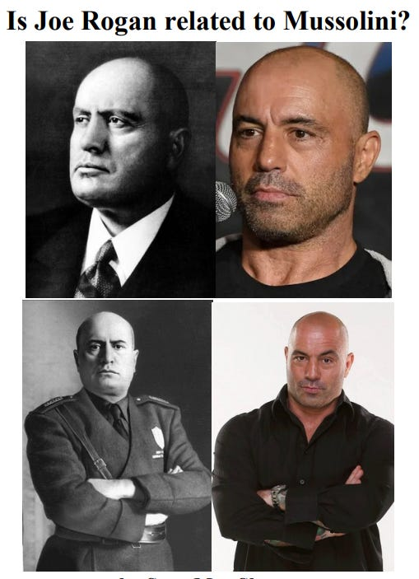

“My step dad’s a hippie. My step dad was a computer programmer, and he was an architect. He went to school for architecture after he stopped doing computer programming. … All of a sudden I’m living with this hippie guy in San Francisco with a bunch of gay people … and it’s all like peace and love, it’s the ‘70s man.”
It is doubtful, given who Joe Rogan is, that his stepfather was a hippie, unless he was acting as one. The Phoenicians had their actors infiltrate the peace movements early on, which might explain why he was surrounded by a bunch of gay people as we know these actors tend to be gay. Miles goes over the hippie movement in his paper on Charles Manson
https://againstsatanism.com/My-Web-Sites/Miles-Mathis/mileswmathis.com/tate.pdf and several others. So if Rogan’s stepfather does exist, he’s probably connected to one of the three letter agencies in some way, explaining why he is left a mystery. If Rogan was found to be connected to one of the alphabet squads it would surely damage his reputation. I guess CAA could be called Alphabet. Of course we should already be assuming Rogan is a creation of Intelligence since the only people that can be found receiving invitations to Rogan’s podcast are Intelligence assets, such as Elon Musk
https://againstsatanism.com/My-Web-Sites/Miles-Mathis/mileswmathis.com/musk.pdf who Miles has already outed as a fraud. Not to mention he regularly features Special Forces and CIA agents on the show, but they tack on the word “former” in front of their name so that you believe they’re no longer working. You have to laugh. Once CIA, always CIA. Thus, Rogan’s podcast is just another avenue to disseminate propaganda, confusing and misdirecting the lowly commoners. The budget and reach of the show alone would suggest, in my opinion, that each episode is staged, being directed and edited from start to finish.
Rogan ended up quitting his post fight interviewer position after only two years, claiming his salary couldn’t keep up with the cost of traveling to events, but would find himself back at the company after UFC was taken over by Zuffa. He would quickly make friends with the new president, Dana White, as you do. White offered him a job as a color commentator, but he declined the offer stating he “just wanted to go to the fights and drink.”
Yeah, he said that to the president of the company. White must have short term memory loss as the following year Rogan would change his mind and accept his offer, working for free, under the condition that he supplied him with prime event tickets for him and his friends. What? We were just told this clown couldn’t afford to travel to these events due to a poor salary; however, now we find he is voluntarily working free of charge, yet again, and can magically afford flights to drink ten dollar beers with his buddies. How much more obvious do they need to make it? Rogan was a filthy rich Phoenician hatchling from the get go going wherever the wind blew him. He could have sat on his ass doing nothing his entire life and would still be exactly where he is today. In fact, that is essentially what he did.
In my paper on Mussolini
https://againstsatanism.com/My-Web-Sites/Miles-Mathis/mileswmathis.com/benito.pdf
I showed Joe Rogan was closely related to the Campbells through the Dalzells. Mussolini's great grandmother was a Sulivan, related by marriage to the Viscount Templeton. This is why Mussolini was chosen by MI6 and Home Secretary Sir Samuel Hoare, Viscount Templewood, to lead the Italian theater project in WWII. Well, through the same people Mussolini was fairly closely related to many top peers, including the Campbells and Stanleys. So when these names began popping up in this paper, and I confirmed it, I could see that Sean had hit on something here. Rogan really is related to Mussolini. Of course, once he had proved Rogan was from these prominent Jewish lines in Hollywood, that was pretty much a given, since they are all worldwide cousins. As I have told you, all famous people are related, and much more closely than they will admit. This especially applies to these gay actors like Rogan and Mussolini. It also helped immensely that I was able to pinpoint Rogan's stepfather Louis Lembo at Creative Artists Agency in Hollywood, and you can see why they go to such lengths hiding it.
But the Bennett/Campbell line may not even be the most prominent. As I showed, what they are probably hiding there is that Rogan's mother is a Cohen. That would explain his rise in media more directly than anything else.
Given that Rogan's whole bio is a lie, we should ask about his claim to be national champion in taekwondo at age 19. That would have been 1986 or 1987. This claim is footnoted at Wiki, but not to any charts. It is footnoted to two articles on Rogan that came out 15 years later. He wasn't the national or collegiate champion in those years, because he wasn't in the college championship.
https://againstsatanism.com/My-Web-Sites/Miles-Mathis/mileswmathis.com/rogan.pdf
or http://mileswmathis.com/rogan.pdf
Here is evidence that Joe Rogan Jordan Peterson Graham Hancock Russell Brand Rupert Sheldrake Daniel Pinchbeck Aldous Huxley Tim Leary Ram Dass have been promoting drugs on behalf of the CIA
https://againstsatanism.com/Joe-Rogan-Jordan-Peterson-Graham-Hancock-Russell-Brand-Rupert-Sheldrake-Daniel-Pinchbeck-Aldous-Huxley-Tim-Leary-Ram-Dass-pushing-Drugs-for-Trillionaire-Oligarch-Controlled-Military-Intelligence-to-Dum-Down-and-Destroy-Society.htm
https://againstsatanism.com/How-Trillionaires-Infiltrated-DMT-LSD-and-Ayahuasca-into-the-Environmental-Hippie-Progressive-and-New-Age-Movements.htm

Dominic Cummings



Dominic Cummings - "We’re into a new cycle of regime change" - remember, the regimes are minions.
Disinformation by a Satanic Phoenician Mega Trillionaire Aristocratic family -the Comnene family - insider who does not mention that the aim of the Rothschilds, Rockefellers and Warburgs is - remember, Dominic Cummings mentions none of these names... agenda 2030, genocide, an AI controlled Totalitarian Surveillance state of CBDC, Digital Identity, 15 minute city, Bug eating, sterilisation state controlled by Baron Harkonnen Satanists.
You can tell who are the Disinformation Agents, the Gatekeepers, Presstitutes and the Prostitutes because they never mention that it was the Rothschilds and the Warburgs who took down France with the Satanic Jacobins and took down Russia and killed the Tsar with the Satanic Bolshevics. They never mention that Satanism created sodomy rituals in every secret society. They never mention the Satanic Phoenician Mega Trillionaires created the Tavistock institute program of societal destruction by Gay Pride.
The minions have been bought by the The Satanic Phoenician Mega Trillionaire Rothschilds, Rockefellers, Schiffs and Warburgs. The minions have been bought by the The Satanic Phoenician Mega Trillionaire Black Nobility who came from Satanic Venice like King Chuckie the Turd.
The minions just follow orders and follow the Satanic Rituals like Human Sacrifice, the Sodomy Rituals, the Castration Rituals, the Drug Rituals, the Whore of Babalon Rituals. This is all exposed in my 11 Volumes of Against Satanism, Sign Up! or go here... https://satchidanand.substack.com/p/throughout-history-seventy-two-empires

Throughout History Seventy-Two Empires Have Been Engineered to Fail in the Same Way.

Satchidanand
·
April 6, 2024
Throughout History Seventy-Two Empires Have Been Engineered to Fail in the Same Way. The crash of civilisations does not happen by accident. The crash of civilisations does not happen all at once. The crash of civilisations takes a lot of planning over a long time.

Read full story

By not mentioning the cause - Garbage in, his results are garbage out.
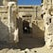Dominic Cummings substack
Dostoyevsky, the modern intelligentsia, the spiritual crisis of the West
The revolutionary despises all doctrines and refuses to accept the mundane sciences, leaving them for future generations. He knows only one science: the science of destruction… The Catechism of a Revolutionary, Nechayev (1869) In short, one may say anything about the history of the world - anything that might enter the most disordered imagination…
Read more
2 years ago · 114 likes · 50 comments · Dominic Cummings
The following article by intelligent Dominic Cummings from the Satanic Phoenician Mega Trillionaire family Comnene (See Miles Mathis) shows how the elite always blame the minions like Jesus James Angleton or President Kennedy instead of the rulers behind the scenes who tell the minions what to do –

The Satanic Phoenician Mega Trillionaires, the Rothschilds, the Rockefellers, Warburgs etc and that all confusion, bad planning, bad thinking, is deliberate in compartmentalised minions in order to rule completely.
By not mentioning the cause - agenda 2030, genocide, an AI controlled Totalitarian Surveillance state of CBDC, Digital Identity, 15 minute city, Bug eating, sterilisation state controlled by Baron Harkonnen Satanists - Garbage in, his results are garbage out.
Dominic Cummings substack
People, ideas, machines VIII: CIA counterintelligence chief James Angleton, 'a wilderness of mirrors', covert operations, assassinations, moles & double agents, disinformation
After such knowledge, what forgiveness? Think now History has many cunning passages, contrived corridors And issues, deceives with whispering ambitions, Guides us by vanities. Think now She gives when our attention is distracted And what she gives, gives with such supple confusions…
Read more
2 years ago · 49 likes · 52 comments · Dominic Cummings
Boris Johnson resigning would only be interesting in an alternate universe where there was some remote chance that he won’t be replaced by another even more depraved sociopath who this time will do the bidding of the Satanic Phoenician Mega Trillionaires.
Among the PM Boris’ main adversaries is his once former MI6 handler, Dominic Cummings - like Secret Services Ambassador Urquhart handler of Karl Marx, like Colonel Mandel House handler of President Woodrow Wilson - Confidant and de facto chief of staff, Dominic Cummings was Boris' handler.
Aristocratic Phoenician family, MI6, Oxford educated Cummings was sent to Russia to be trained in the ways. But one only need look Cummings’ rhetoric and views to notice his Authoritarian, Totalitarianism.
Cummings’ long standing critique of the machinery of government has been articulate, accurate and piercing. For all his rhetoric around the need for science, reason, technology and efficiency, Cummings’ solutions stray far from such noble concerns. Cummings wants a better machinery of Government only for faster, authoritarian, totalitarian decisions.
Look back to Cummings’ Parliamentary testimony and recall that his criticism of Johnson was not that covid restrictions were scientifically unnecessary - which is now beyond reasonable doubt on all counts. Rather, his view was that the UK have should have locked down earlier in March and he "bitterly" regrets "not hitting the panic button earlier".
Cummings also said that the PM rejected his recommendation last September that there should be a second lockdown in England.
Cummings put Rishi Sunak in place as Chancellor of the Exchequer under Cummings authority. He believes that the Chancellor Rishi Sunak did a "fantastic job" with the furlough scheme which, is totally responsible for out of control inflation.
Rishi Sunak stabbed Boris in the back, forcing Boris' resignation, when he himself resigned.
More telling is who Cummings proposes as ‘intellects’.
Recall that Andrew Sabisky had to resign in February 2020 following complaints about his previously expressed views on race, intelligence and eugenics.
Will O'Shea, a data specialist appointed through Cummings' scheme, was dismissed in July 2020 after calling for police to shoot Black Lives Matter protesters with live ammunition.
Lately, Cummings has been encouraging the US Republican Party to nominate an alternative to Trump as their candidate for the 2024 US presidential election. The reason given is what I find interesting, Trump was unable to “control” government.
On his Substack, Cummings has cited Curtis Yarvin amongst others, as "people I have found interesting" in US politics. But who is Curtis Yarvin? Curtis Yarvin, on his own Substack page called Gray Mirror, argues that American democracy is a failed experiment which should be replaced by monarchy or corporate governance. He is known for developing the anti-egalitarian and anti-democratic ideas behind the Dark Enlightenment.
In other words, Cummings seems to be attacking the PM because he would not take Cummings orders - he was too good to be bad - and because he wishes to usher in an ‘efficient’ (read: authoritarian) technocracy, not because he opposes the madness surrounding covid mandates and the unquantifiable damage they have inflicted on our country and people.
Beware of this domestic palace coup for it serves a global palace coup.
Is there any wonder then that MSM has backed Cummings despite him doing exactly what MSM accuses the PM of doing: violating the rules while the rest of us suffered. According to Cummings, as confessed to in his BBC interview with Laura Kuenssberg
'We only got him (Johnson) in there because we had to solve a certain problem, not because he was the right person to be running the country.'
Because Cummings has admitted that he never believed in Johnson anyway. What he does believe in - on the issues that count - has since been made clear, and it is more of the same: technocratic, authoritarian, 1984 corporatism.
https://againstsatanism.com/Dominic-McKenzie-Cummings-Boris-Johnson-Traitorous-Chief-Advisor-is-from-Aristocratic-Satanic-Mega-Trillionaire-Phoenician-Clan-Cumming-Comyn-Comnene-Cohen.htm
https://againstsatanism.com/Phoenician--Dominic-Cummings-MI6-Infil-Traitor-ex-Handler-of-Boris-Removed-Boris-in-Palace-Coup.htm
https://againstsatanism.com/My-Web-Sites/Miles-Mathis/mileswmathis.com/cumming.pdf

EVIL - LIVE

Evil's opposite is life. Life Energy is a new way which Energy Enhancement Meditation has brought to the table. Prayer, fasting, yoga, pranayama all work to purify the psychic body, to gird up the aspirant for the opposition to absolute evil which uses the psychic in it's fight against humanity. In order to truly oppose, successfully oppose evil you must become a better stronger, purer instrument of God in order to succeed.

This is why the creation of the Energy Enhancement Meditation Course https://energyenhancement.org/

ENERGY ENHANCEMENT MEDITATION IS THE ONLY SOLUTION

It is the inflow of infinite energy from external chakras of the Universe, the infinity of chakras above the head, ending in the Central Spiritual Sun of Gurdjieff, or God..., the infinity of chakras below the base including Kundalini Chakra in the center of the Earth...

Remember Alchemical VITRIOL - Visita Interiore Terrae Rectificando Invenies Occultem Lapidem...

"Visit the center of the Earth, there you will find the Philosophers Stone which by rectification transmutes base metal, lead or Energy Blockages into Gold or pure perfect spiritual energy..."

This is VITRIOL, Visita Interiore Terrae Rectificando Invenies Ocultem Lapidem the source of infinite Kundalini Energy entering the base chakras from the source of Kundalini Energy center of the earth, purifying the psychic body, opening the Third Eye, opening psychic vision, creating Psychic Powers!

True repentance is when you transmute one of your own evil energy blockages.

Read about it here... Alchemical Process of VITRIOL and the Kundalini Kriyas of Energy Enhancement Meditation, Energy Enhancement Level 1, Initiation Three, The Grounding of Negative Energies.

https://energyenhancement.org/Level1.htm
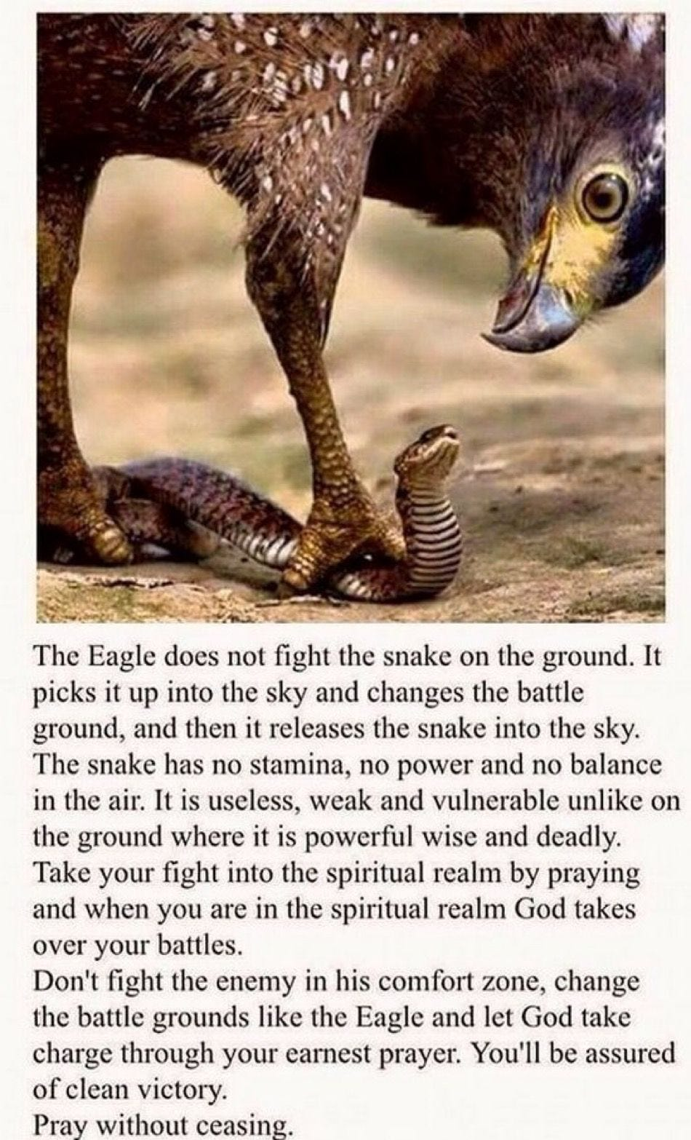

TRUMP AND THE DEEP STATE SATANIC 2000 TRILLION DOLLAR ROTHSCHILD PHOENICIAN MEGA TRILLIONAIRES

CHOOSES SKULL AND BONES JD VANCE!

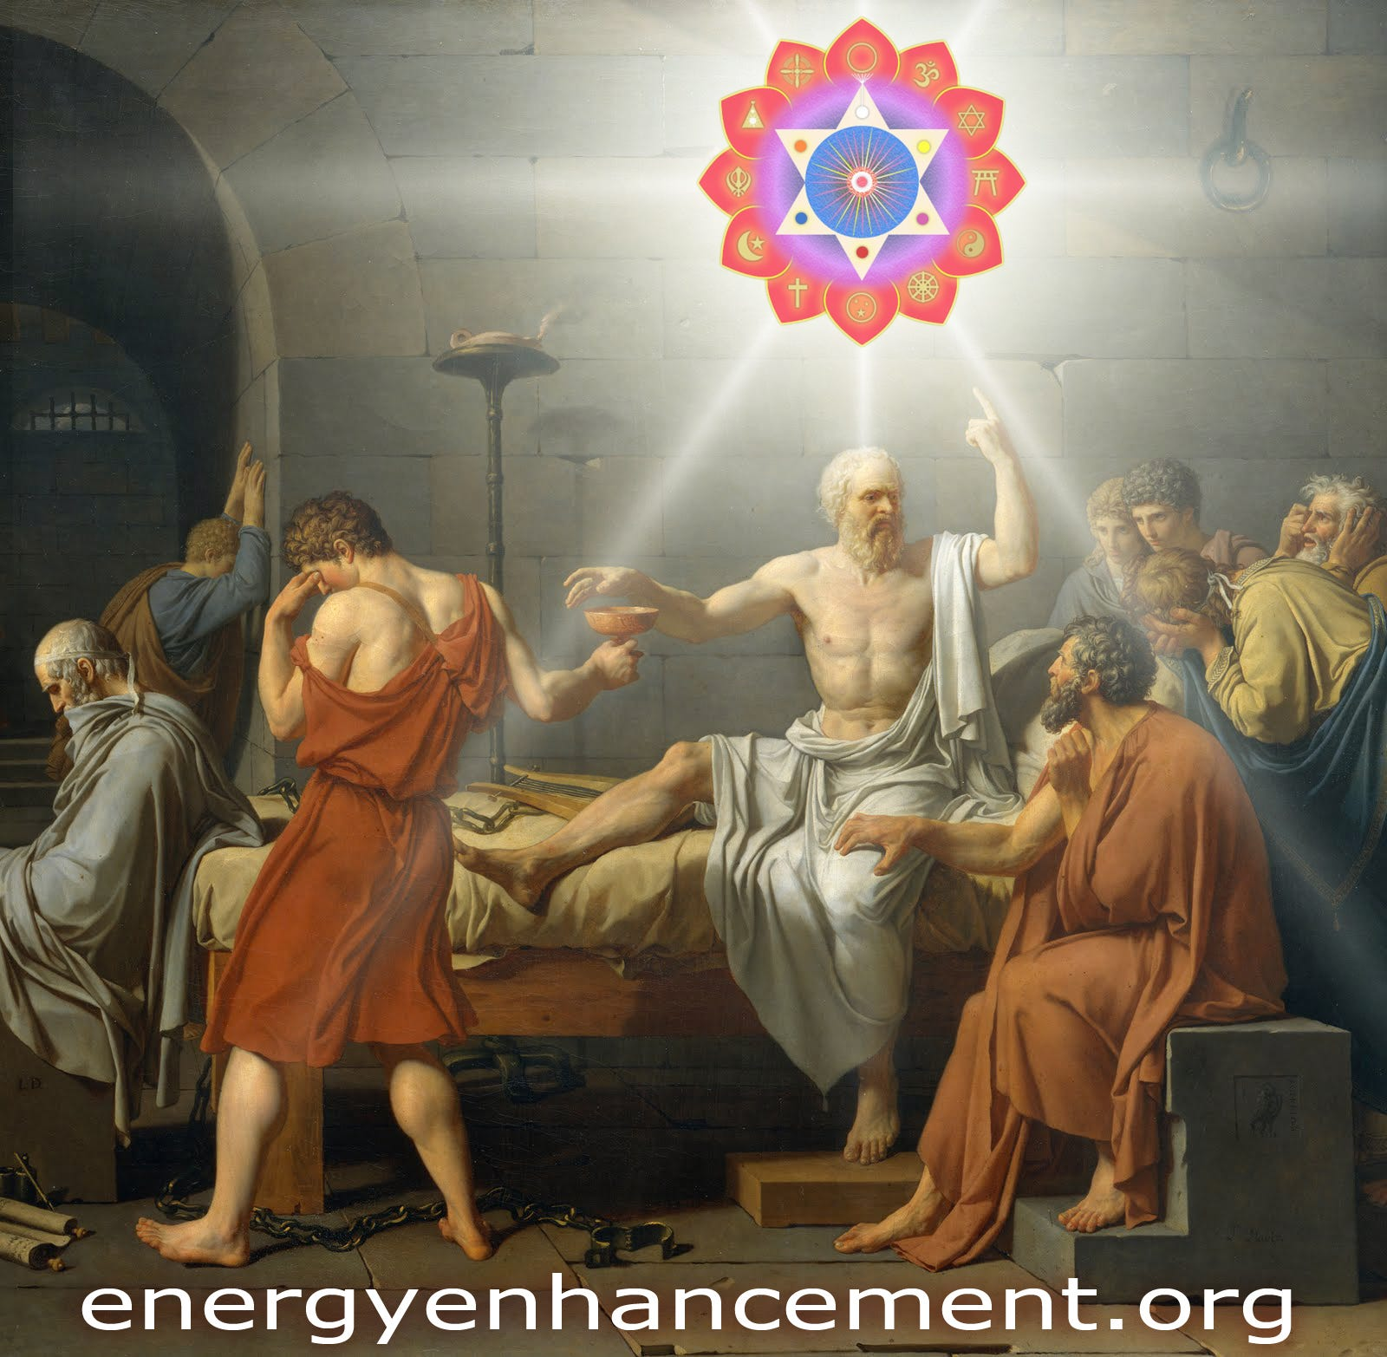Satchidanand
Jul 20, 2024

TRUMP AND THE SATANIC 2000 TRILLION DOLLAR ROTHSCHILD PHOENICIAN MEGA TRILLIONAIRE DEEP STATE

This Trump Assassination Attempt is by the Satanic Anglo-American Empire 2000 TRILLION DOLLAR Rothschild's Deep State who murdered JFK - This is the shot which is being heard all around the World. This is the Start of WW3. And they will not stop

"I was present at that scene; but none that I had ever before witnessed affected me in the same manner. I did not feel that compassion or affliction for him which I had been used to do upon other occasions while a friend has departed in my arms. Socrates, when he drank the poison, appeared to be happy, and in a composure of mind that was enviable; so calm, so tranquil was his behavior in his last moments, so resigned were his last words. His looks and demeanor did not seem those of a mortal who descends prematurely to the shades, but rather those of an immortal who was confident, wherever he might go, he would be as happy as any one had ever been. It was impossible for me, therefore, to be impressed with that awe and melancholy which the fight of death usually awakes in the soul. At the same time we did not taste in the philosophical conversation of our teacher, that pure delight and satisfaction to which we had been before accustomed; but, on the contrary, an extraordinary and, till then, unknown mixture of pleasure with distress; our enjoyment being continually interrupted by the bitter consciousness and reflection, " that we were soon to lose him for ever." PHAEDON - the Death of Socrates https://archive.schillerinstitute.com/transl/mend_phadn_cullen.html

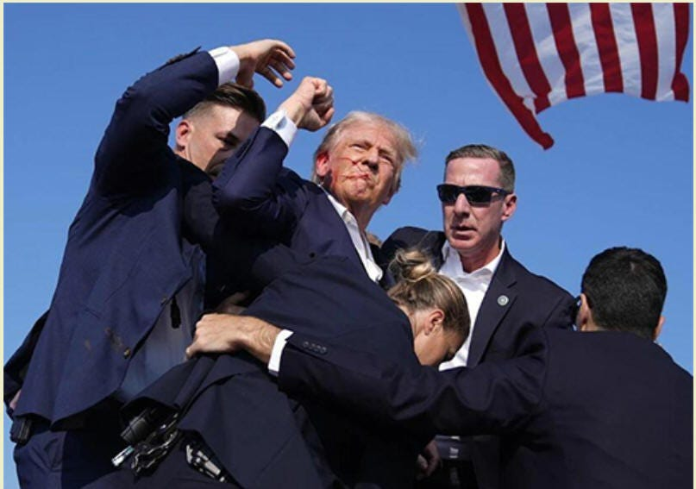

This Article is the Truth, and Only the Truth, Only Knowing the Truth, can set us Free of the 2000 Trillion Dollar Rothschild inspired Mind Control Propaganda.
“We’ll know our Disinformation Program is complete when everything the American Public knows is False” William Casey - CIA Director…
This is just the start.
Now comes the Fightback!
IF Implemented..
TRUMP’S PROJECT 47 WILL GO BACK TO LINCOLN AND FDR GREENBACK’S ESCAPING THE DEBT OF THE ROTHSCHILD CENTRAL BANKS. IT WILL GROW AMERICAN MANUFACTURING AGAIN BY MEANS OF PROTECTIONISM - SO, TOTALLY AGAINST THE ROTHSCHILDS IF IMPLEMENTED - VERY GOOD, TRUMP!
PROJECT 2025 FROM THE OTTO VON HAPSBERG HERITAGE FOUNDATION, SATANIC FREDERIC VON HAYEK AND THE MONT PELERIN SOCIETY WILL STOP ANY BIG PROJECTS AND JUST MORE OF THE SAME GLOBALIST IDIOCY.
SUBPOENA TWITTER FEED EVIDENCE ON ALL THE DEEP STATE PERSONEL
PROSECUTE!
DESTROY THE 2000 TRILLION DOLLAR ROTHSCHILDS WHO OWN 70% OF ALL BANKS, 85% OF FORTUNE 500 COMPANIES, 100% OF CENTRAL BANKS INCLUDING THE FEDERAL RESERVE, BLACKROCK, STATE STREET AND VANGUARD HOLDING COMPANIES, WORLDWIDE!
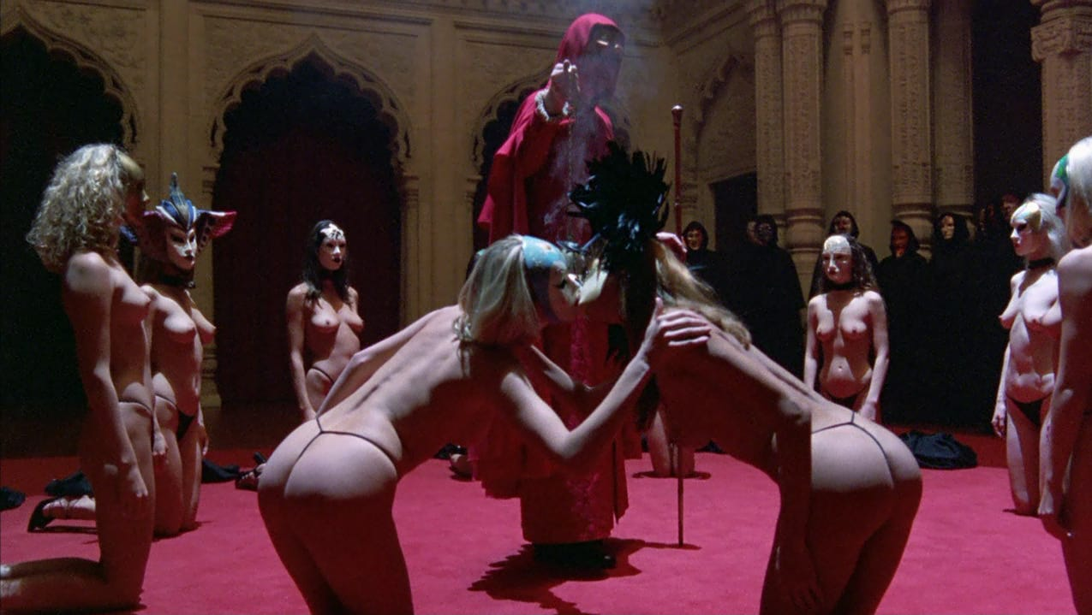

The 2000 Trillion Dollar Rothschild Deep State World Control Family Supported Satanic, Luciferian Sex Magic Sabbatean Frankism and Weishaupt Illuminati Sodomy Rituals from Frankfurt.
THE ROTHSCHILDS OWN TRUMP AS ALL THE MONEY LOANED TO TRUMP FOR HIS 10 BILLION DOLLAR BUSINESS COMES FROM THE ROTHSCHILDS.
NOW TRUMP WILL BE ABLE TO ENABLE ALL THEIR SCHEMES FOR WORLD DOMINATION..
SO WE PRAY TO GOD AND OUR LORD JESUS CHRIST THAT WE CAN INTERCEDE THAT TRUMP WILL RENOUNCE HIS WARP SPEED MRNA VACCINE DEATHVAXXES, THAT HE WILL RENOUNCE THE GLOBAL DIGITAL ID, THAT HE WILL FIRE ALL THE LAWYERS IN THE STATE DEPARTMENT, THAT HE WILL SCATTER THE FBI, NSA AND CIA TO THE WINDS, THAT HE WILL RENOUNCE THE NETANYAHU GENOCIDE, THAT HE WILL RENOUNCE CARBON DEATHTAXES IN THE FACE OF ASSASSINATION IF HE STRAYS FROM THE ROTHSCHILD DEATHPATH!
THE YALE ALUM SKULL AND BONES SODOMY RITUAL VANCE TROJAN HORSE! WILL BECOME PRESIDENT WHEN TRUMP IS ASSASSINATED.

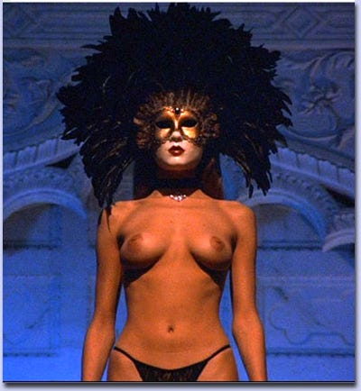

https://againstsatanism.com/Sabbatai-Zevi-and-Sabbatean-Frankism-The-Satanic-Cult-That-Rules-the-World-Luciferian-Satanic-Sabbatean-Frankists-Kabbalist-Illuminati.htm
This is Trump making peace with the Deep State.



Are Peter Thiel and JD Vance Whoopsies or are they just Trillionaire Russell Family Yale Skull and Bones Sodomy Ritual guys?
You know about how Lord Bertrand Russell became an evil man, Right?
https://againstsatanism.com/Satanic-Lord-Bertrand-Russell.htm
And the Russell Marquis of Tavistock who created the Mind Control, and Societal Psyop Tavistock Institute, Stanford Research Institute and Frankfurt School?
https://againstsatanism.com/SATANIC-TAVISTOCK-INSTITUTE-SATANIC-LORD-RUSSEL-SATANIC-ROCKEFELLER-SATANIC-SABBATEAN-FRANKISM-SATANIC-FREUD-PSYCHOANALYSIS-SATANIC-FRANKFURT-SCHOOL-KABBALAH-ADORNO-BENJAMIN-MARCUSE-LUKACS-BRECHT-WEILL-ECO-DERRIDA.htm
https://againstsatanism.com/Satchidanand-Substack/satchidanand.substack.com/p/the-satanic-tavistock-institute-satanic.html
https://againstsatanism.com/Satanic-Frankfurt-School-ADORNO-BENJAMIN-MARCUSE-LUKACS-BRECHT-WEILL-ECO-DERRIDA.htm

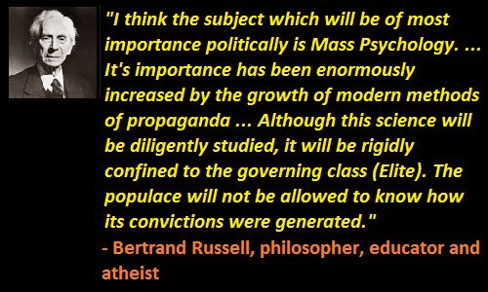

And is JD Vance's real father a Satanic Phoenician Mega Trillionaire like Bill Clinton’s father was a Rockefeller?
If true, this certainly would explain why the Republican Party’s longstanding opposition to LGBT rights has suddenly vanished from the platform. And why Mawmaw felt the need to ask young JD if he harbored any particular proclivities.
Team JD Vance Begin Announcing Policy Proposals, Starting with Phoenician Mega Trillionaire Elon Musk Inspired Fake Global Warming Carbon Taxes and Digital ID for total Control of a slave population - just like Russia, China, India etc..
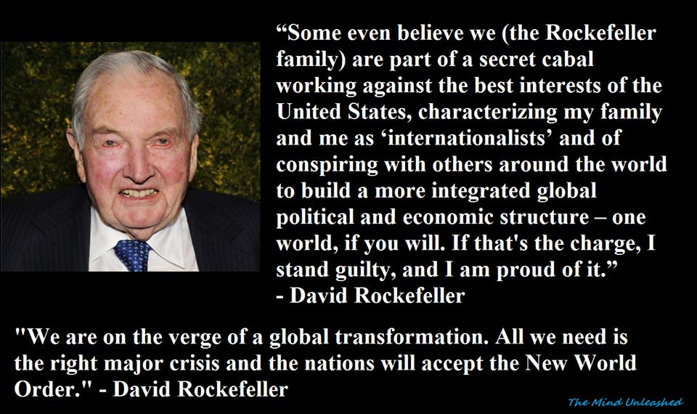

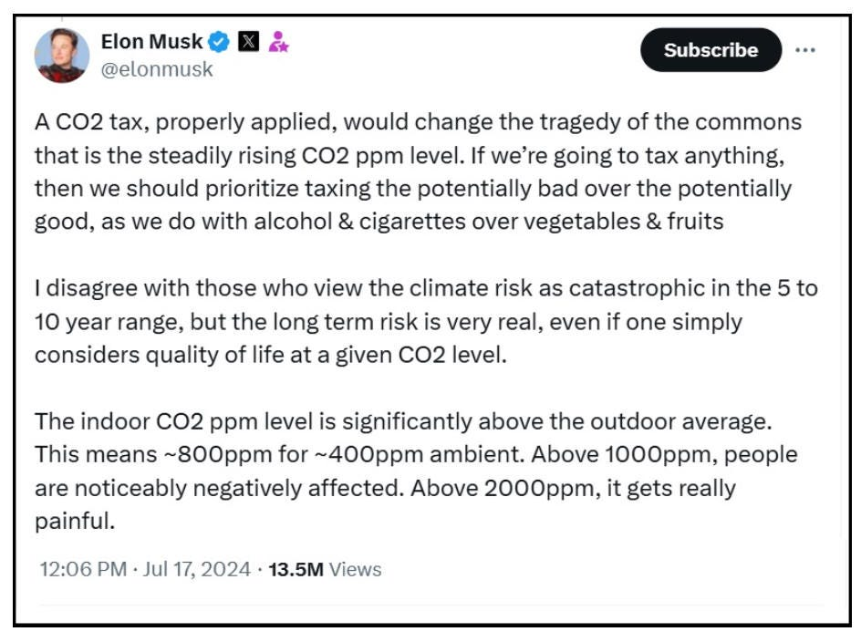

Rothschild Bought Trump, Tucker Carlson, Alex Jones, Joe Rogan, Dominic Cummings

Rothschild, Trump, Tucker Carlson, Alex Jones, Joe Rogan, Dominic Cummings

Satchidanand
·
June 14, 2024
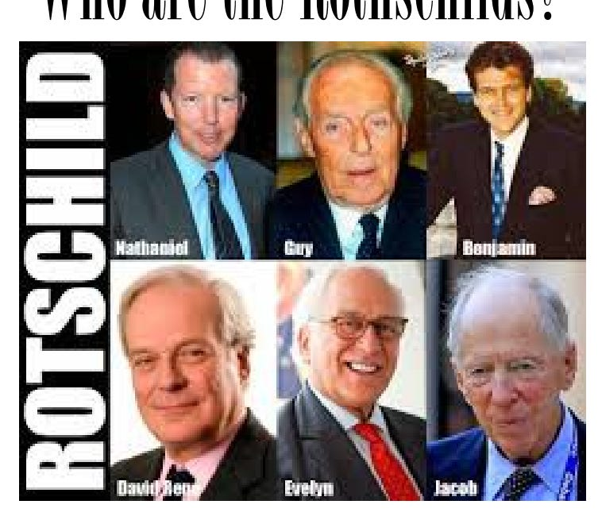

Rothschild, Trump, Tucker Carlson, Alex Jones, Joe Rogan, Dominic Cummings Joe Rogan Jordan Peterson Graham Hancock Russell Brand Rupert Sheldrake Daniel Pinchbeck Aldous Huxley Tim Leary Ram Dass have been promoting drugs on behalf of the CIA "We'll know our disinformation program is complete when everything the American public believes is false." William J. Casey, CIA Director

Read full story

My feeling is, if they are paid, promoted propagandists never mention the Satanic 2000 Trillion Dollar Rothschild Phoenician Mega Trillionaires.
This is the major way to spot paid, promoted propagandists.
If they are paid, promoted propagandists never mention the Satanic 2000 Trillion Dollar Rothschild Phoenician Mega Trillionaires as being the cause of all ills in society but only excoriate the paid, bought, propagandised, blackmailed minions.
If paid promoted propagandists never mention that the Biden, Putin, Xi Minions are all vaccine mandators, all CBDC wonks, all ascribe to Agenda 2030 and Global Warming, all go to Satanic 2000 Trillion Dollar Rothschild Phoenician Mega Trillionaire Globalist WEF, all support Satanic 2000 Trillion Dollar Rothschild Phoenician Mega Trillionaire Globalist United Nations and it's Agenda 2030 and Replacement Migration Invasion Policies...
If paid promoted propagandists never mention that that Bidet, Putin, Xi are all Satanic 2000 Trillion Dollar Rothschild Phoenician Mega Trillionaire Globalist Minions then surely the Wars between the West and the Ukraine, Russia, and China are all fake even if the Satanic 2000 Trillion Dollar Rothschild Phoenician Mega Trillionaire Globalist depopulation agenda has been improved by one million dead people in the Ukraine, thirty-five million excess deaths due to the deathvaxx and 250 million extra deaths by starvation in Africa due to the lockdowns.
If paid promoted propagandists like Tucker, Rogan, Simplicius and Rasmussen never mention Satanic 2000 Trillion Dollar Rothschild Phoenician Mega Trillionaire Globalists and all that, then what they are shitting, what they are lying about by omission is Satanic Phoenician Mega Trillionaire Mind Control propaganda.

WHAT THEY ARE SHITTING IS SATANIC PHOENICIAN MEGA TRILLIONAIRE MIND CONTROL PROPAGANDA

Satchidanand
·
March 5, 2024
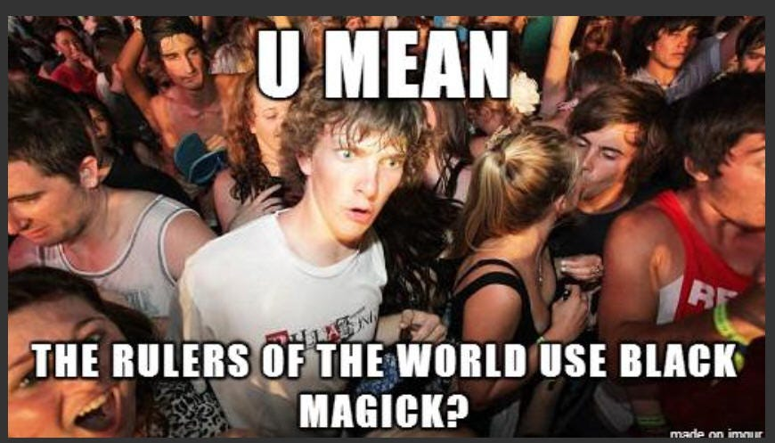

WHAT THEY ARE SHITTING IS SATANIC PHOENICIAN MEGA TRILLIONAIRE MIND CONTROL PROPAGANDA https://againstsatanism.com/WHAT-THEY-ARE-SHITTING-IS-SATANIC-PHOENICIAN-MEGA-TRILLIONAIRE-MIND-CONTROL.htmSatchidanand’s Against Satanism Newsletter is a reader-supported publication. To receive new posts and support my work, consider becoming a free or paid subscriber.

Read full story

JD Vance was then invited to be an attendee at the June 6th **San Francisco** fundraiser for President Trump, hosted by Sacks and Palihapitiya, and that’s likely when the first one-on-one running mate discussion between President Trump and Senator Vance took place.
The group who promoted, pushed and ultimately influenced the JD Vance nomination consisted of: Charlie Kirk, Tucker Carlson, Elon Musk, Peter Thiel, Bill Ackman, David Sacks, Chamath Palihapitiya, Jacob Helberg and of course, Vivek Ramaswamy.
On the inside of the Trump orbit, the network had Jason Miller and Donald Trump Jr also promoting JD Vance.
It is critical to remember these names because the Silicon Valley influence agents will soon be pushing their Trump-term policy agenda through Vice-President JD Vance.
We are starting to see the outlines of their JD Vance policy agenda, the points of their advocacy, starting with Elon Musk - a scam carbon tax system based upon Globalist Rothschild Fake Global Warming of a carbon dioxide which is plant food which is food, which is life itself.
Which in 200 years of burning petroleum has greened deserts the size of the United States Worldwide.

The global carbon tax program, a tax on your personal carbon footprint, is the system for the carbon trading platform (likely tied to your digital id). It is a large policy position of King Chucky the Turd and his minion, 2000 Trillion Dollar Rothschild Klaus Schwab’s World Economic Forum.
I’m not quite sure how well the increase in energy prices carbon tax program would be received in the Appalachia range area. I digress.
I’m not quite sure how well the increase in energy prices carbon tax program would benefit anyone except the people stealing the money from the scam like all Government programs are scams like the five Trillion Dollars going missing from the Pentagon. Like the F35 program. Like NASA. Like the Fusion Program - All scams.
Additionally, the group appear to be supporting 2000 Trillion Dollar Rothschild JP Morgan’s CEO Jamie Dimon as Treasury Secretary in the second Trump administration, - like putting the fox in the henhouse!

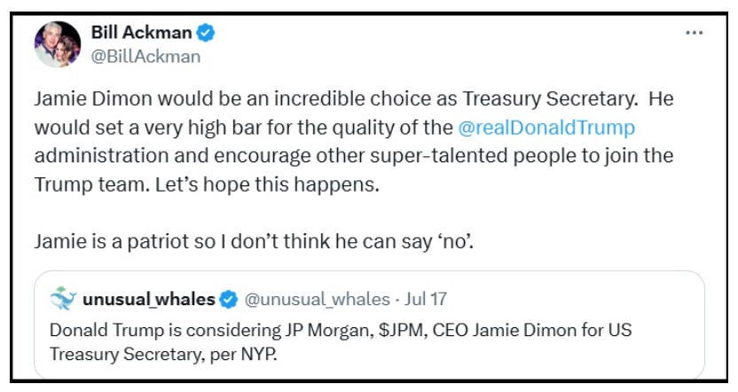

We can hope that the assassination attempt and all of the prosecutions will convince President Trump to stop Donald Ducking about with the Satanic 2000 Trillion Dollar Rothschild Created United Nations and their Agenda 2030 like Operation Warpspeed, Mandatory Vaxxines, 15 Minute City Prisons, Martial Law Lockdowns, 10 million people FEMA camps, Cutting off the People’s Access to Bank Accounts, CBDC’s, Internet Digital ID, NSA, CIA AND FBI AND GOOGLE, FACEBOOK, TWITTER Internet Surveillance and Censorship, Fake Global Warming Carbon Taxes, black employment rates and support for foreign countries and focus on doing to the Deep State Rothschilds what Russia is doing to the Ukraine.
Unfortunately, this VP choice tends to suggest that the old dog hasn’t learned anything at all.
People are policy!
Trump Has Never chosen good people! Including the 2000 Trillion Dollar Rothschild CIA Agents Bill Barr and VP Mike Pence…



This is my take on Trump picking Satanic Mordor 2000 Trillion Dollar Rothschild Deep State JD Vance for VP (and I’ve followed him for a few years, read his book didn’t see the movie).

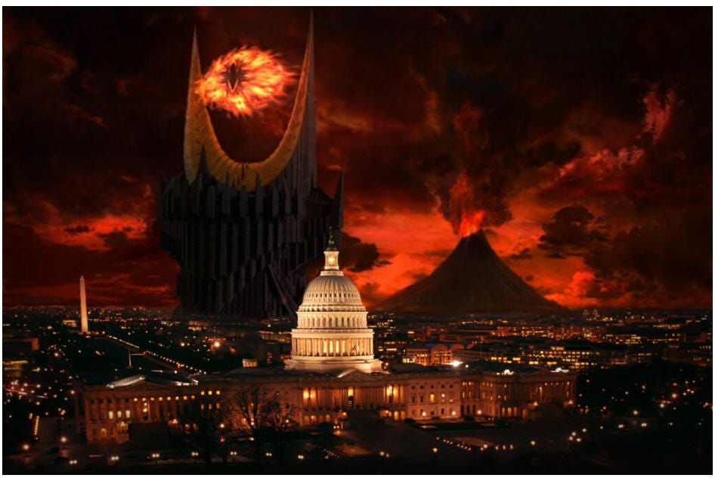

https://theconservativetreehouse.com/blog/2024/07/19/the-mirror/#more-262430

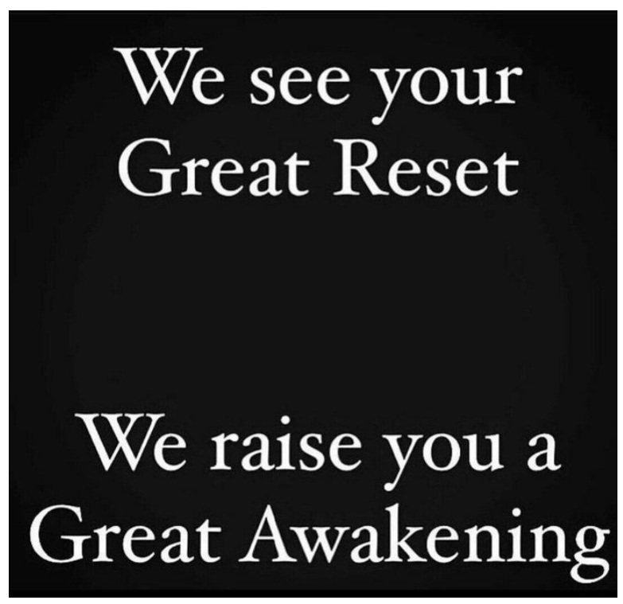

This is Trump making peace with the Deep State.

Vance is a deep state asset. Read his biography, it’s all very unusual.
And is JD Vance's real father a Satanic Phoenician Mega Trillionaire like Bill Clinton’s father was a Rockefeller?
Abandoned by his father to a troubled single mother; eventually raised by grandparents. He is then recruited from an Yale University Skull and Bones Satanic Sodomy Ritual Ivy league law school by shadow figures, a specific billionaire and a network of interests.
How does any poor person get in to Ivy League Russel Family Yale University!
He changes his name, writes a book about his life story, and with the support of the aforementioned – who eventually pays for the assembly of a strategic campaign influence network, becomes a Senator for 2 years before being quickly elevated into position in the White House.
Many people reading that paragraph would be familiar with the life story of CIA asset Barack Hussein Obama. However, that paragraph also explains the right-side version of the exact same storyline, James David Vance. It’s a mirror..
Being sponsored by super spooky 1984 friend of Musk surveillance technocrat Palantir Peter Thiel (a New Zealand citizen!) is only part of it.
Too many details to lay out here, but this is one fascinating tidbit. If Vance is elected VP then he will be the 2000 Trillion Dollar Russell Family Yale Skull and Bones Secret Society Sodomy Ritual Yale Alum, FOURTH (!) graduate of the US Department of Defense, Defense Information School (DINFOS) to have achieved that position after,
Walter Mondale, VP 1977 – 1981
Dan Quayle, VP 1989-1993
Al Gore VP, 1993-2001
https://en.wikipedia.org/wiki/Defense_Information_School
Vance was previously a staunch critic and opponent of President Trump.
"I'm a Never Trump guy. “I never liked him.”
"Mr. Trump is unfit for our nation's highest office."
“I can't stomach Trump. I think that he's noxious and is leading the white working class to a very dark place.”
How does one go from being such a vehement critic to volunteering to serve as the man’s right-hand man? That’s deeply suspicious, particularly when there are a lot of Lamda flags surrounding the man. Even his Marine Corps service points to potential problems based on the nature of his service.
Joining in 2003, Vance served four years in the Marine Corps, including a tour in Iraq during Operation Iraqi Freedom. His primary role was as a public affairs specialist, a role that honed his communication skills, a talent readily apparent in his later writing and public speaking.
Neither a leader of men nor a fighter. And unfortunately, the man’s obvious ambition combined with his above-average connections – I mean which poor person gets in to Yale University unless he is the spawn of the Satanic 2000 Trillion Dollar Phoenician Mega Trillionaires and intelligence ineluctably points us toward the ultimate conclusion that JD Vance is a bought Lamda male.
IF THEY ASSASSINATE TRUMP, VANCE BECOMES PRESIDENT!
THE ONLY WAY TO FREE THE WORLD IS TO DESTROY THE ROTHSCHILDS AND THEIR CENTRAL BANKS, BLACKROCK AND VANGUARD, WORLDWIDE! THE MINIONS WILL FALL BY THE WAYSIDE!
THE ROTHSCHILDS OWN TRUMP AS ALL THE MONEY LOANED TO TRUMP FOR HIS 10 BILLION DOLLAR BUSINESS COMES FROM THE ROTHSCHILDS.
NOW WILL TRUMP FALL FOR IT?
WILL HE ENABLE ALL THEIR SCHEMES FOR WORLD DOMINATION...

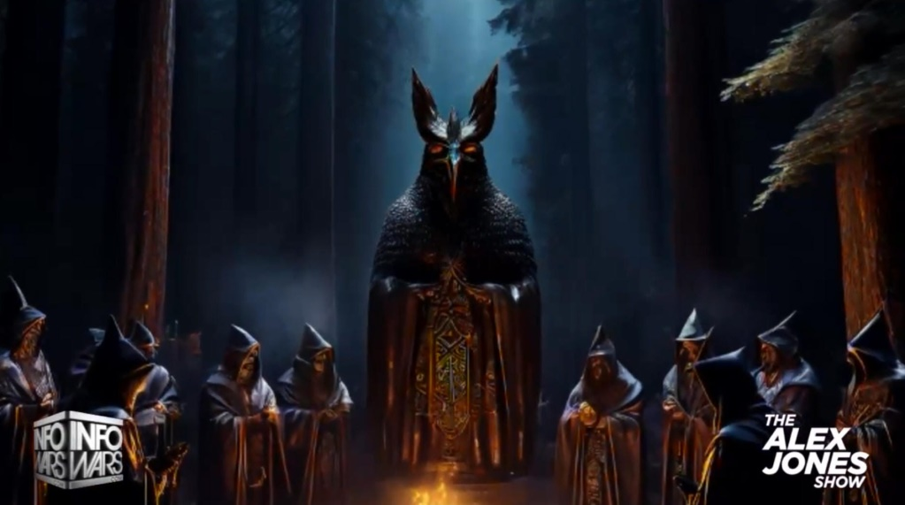

THE SODOMY RITUAL BOHEMIAN GROVE NEAR SAN FRANCISCO SATANIC CREMATION OF CARE RITUAL UNDER THE 40FT STATUE OF AN OWL DEDICATED TO MOLOCH WHERE POTENTIAL PRESIDENTS, PRESIDENTS, CEO’S, TITANS OF INDUSTRY AND MEDIA WATCH THE IMMOLATION BURNING OF A CHILD ON AN ALTAR DEDICATED TO MOLECH
THE SATANIC PHOENICIAN MEGA TRILLIONAIRES, THE ROTHSCHILDS, THE ROCKFELLERS, THE BLACK NOBILITY CONTROL BIDEN, PUTIN AND XI - THEY CHOOSE WHICH EMPIRES TO DESTROY AND RAISE UP!

FINANCIALISATION and Satanic Phoenician Mega Trillionaire Central Banks? by Professor Richard A. Werner, D.Phil. - Improved and made better by Satchidanand

Satchidanand
·
April 13, 2024


Do we Need Satanic Phoenician Mega Trillionaire central banks? by Professor Richard A. Werner, D.Phil. - improved and made better by Satchidanand THE SATANIC PHOENICIAN MEGA TRILLIONAIRES, THE ROTHSCHILDS, THE ROCKFELLERS, THE BLACK NOBILITY CONTROL BIDEN, PUTIN AND XI - THEY CHOOSE TO DESTROY EMPIRES - THEY CHOOSE WHICH EMPIRES TO RAISE UP - THEY DO IT BY FINANCIALISTATION!

Read full story

Throughout History Seventy-Two Empires Have Been Engineered to Fail in the Same Way.

The crash of civilisations does not happen by accident. The crash of civilisations does not happen all at once. The crash of civilisations takes a lot of planning over a long time.
Seventy-Two Empires have been recorded and every one of them has failed in the same way. The facts have been recorded that a totalitarian and satanic elite infil-traitored and took over all these Empires and that 72 once free, flourishing and rich republics were destroyed from within by Satanic Ritual - read Toynbee. The 2000 Trillion Dollar Rothschild Satanic Wanker Banker Banksters are crashing the Financial System. Satanism is gradually being instituted as the New World Religion defined by Satanic Ritual.
This is the Great Reset!
This Article is part of the great Awakening!

Throughout History Seventy-Two Empires Have Been Engineered to Fail in the Same Way.

Satchidanand
·
April 6, 2024

Throughout History Seventy-Two Empires Have Been Engineered to Fail in the Same Way. The crash of civilisations does not happen by accident. The crash of civilisations does not happen all at once. The crash of civilisations takes a lot of planning over a long time.

Read full story

TRUMP ASSASSINATION SHOOTING STAGED FAKE FAKED THEATER NEVER HAPPENED FALSE FLAG HOAX
NOW TRUMP WILL PERHAPS ENABLE ALL THEIR SCHEMES FOR WORLD DOMINATION...




The Trump Shooting was of course Staged - by Miles Mathis
https://mileswmathis.com/crooks.pdf
First published July 15, 2024

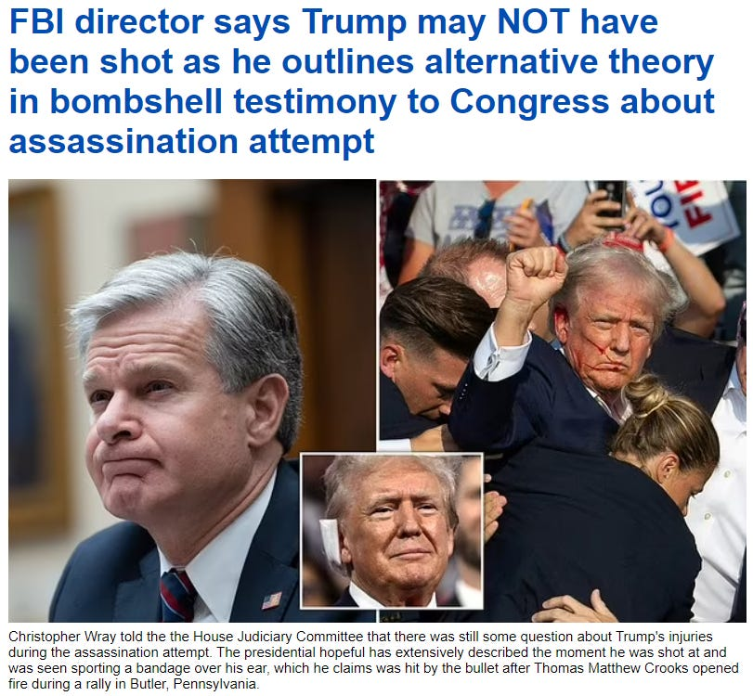



This paper went immediately to #1 at Yandex on the search “Trump shooting staged” and several other results on the first page are republications of this paper.
This despite heavy interference by Google and everyone else. Google immediately delisted it completely, as did Bing and Yahoo.
That search and all similar ones have been rigged to take you to opposite listings assuring you the Trump shooting was NOT staged. Proving these search engines are worthless.
Even the results linking to me, like the one at Makow, mysteriously don't link back to my site. Makow quotes from this paper but conspicuously links to someone else, right under my name.
They also republish me without providing a clickable link. We can also judge other alternative sites by their response to this event. John Leake at Global Research is selling it as real and pooh-poohing any claims there are anomalies. He makes ludicrously weak arguments against, referring contemptuously to a couple of substack authors, but fails to tell you who they are so that you can make your own assessment. He doesn't mention me at all, of course, though if he wants to save this narrative he should have to respond directly to the strongest argument. That will never happen. The last thing he or his overseers want is sending anyone to this paper or this site.
Let me preface this by stating for the record what my regular readers already know: I am not partisan.
I hate both parties and candidates about equally as they are both bought by the Satanic 2000 Trillion Dollar Rothschild Phoenicians.
I have destroyed Biden and the Democrats many times, pointing out they are now more fascist than the Republicans, which took some doing.
Everyone is now reading from scripts, and I have admitted the Republicans currently have a better script. They have been given the more rational talking points for a reason: this is all part of a long-term plan to move the country even further right, into the waiting arms of the Satanic 2000 Trillion Dollar Rothschild Phoenicians governors.
But I am not buying any of the scripts and I recommend you don't either. You should be looking for ways to drive around both parties and the Matrix that has become our world.
I have waited a few days to publish this, though I knew instantly it was staged, without even looking at it closely. I wanted to let others collect evidence while I finished papers on other topics that I consider more important and interesting.
Since I have proved to you everything else is fake, that should be our logical and default assumption for any new highly promoted event. FAKE.
But somehow all the other fake events specialists like Alex Jones and Mike Adams have forgotten that basic rule.
Everyone seems to have conveniently forgotten what a false flag is these days.
When was the last time Jones outed a false flag, or even used the term? Strange, since that is how he made his name.
Before 911 he was just a loud obnoxious guy on Austin public access, but when he started yelling that 911 was a false flag, his big rise began.
Today, Jones couldn't spot a false flag from a foot away. He couldn't spot moulage or any other clue to save his life.
Instead he is promoting this fake event like there is no tomorrow, never even considering the possibility it might be staged.
Same for Mike Adams, who published a standard report on the event yesterday, but nothing more.
[Next day: Jones is getting ratioed on his own site in comments, indicating this is backfiring on them. He is now warning the deep state will take Trump out with a tactical nuke. No, really.



It says “Elon Musk, Alex Jones, Tucker Carlson, and Joe Rogan are next.” Infowars really needed to combine the Trump storyboard with the Nuke storyboard, and this is what they came up with, so they could get the mushroom cloud above the word Trump. Hmmm, I wonder if that qualifies as fear- mongering?]
Before we get into it, let me just state the obvious: in that “iconic” photo, Trump is not saying “fight”, he is saying “fuck”. Everybody knows that, so let's just be honest. That will help get us in.
Another clue is that, technically, the flag is upside down in that photo above under title.

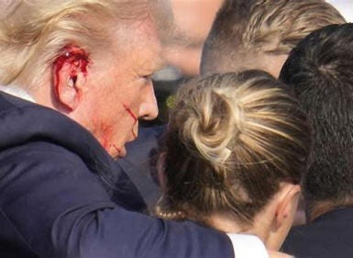

Then we have the bad moulage job, where some make-up girl was hiding behind the podium and smeared some fake blood on Trump when he kneeled down.
It isn't convincing at all, since the straight lines of blood look like they were drawn on with a red marker. Then there is some red goop on his ear, but she didn't have time to make that look real, either. All she did is make the whole ear red. But where is the bullet hole? We seem to be missing a bullet hole.
If a bullet had taken off even a centimeter of the edge of the ear, it would be bleeding profusely, and we would see blood dripping from his earlobe down onto his shirt and jacket. I have scratched off scabs on my ear that bled more that that, and you probably have, too.
Then there's the little problem about allowing him to stand up and do his little dance, gesturing to the crowd and so on. They had to get the picture for the papers. But if this had been real they would have kept him down. He would never have been allowed to stand back up almost immediately, making himself a target again. That was against all protocol and logic.
[Two days later: I finally paused on this film still:



Anyone want to tell me what is suspicious about that? How about the big banner across the lower part of the stage, rising to above Trump's knees? That isn't a banner on the video, that is a physical banner that was on the stage.
When I first claimed a makeup girl was behind the podium applying moulage, a couple of people emailed me derisively, saying they couldn't hide a girl behind that skinny podium. But as you see, they could easily hide her behind that banner. That is why it was there. It reminds us doesn't it? In fact that is exactly why I spotted it. We have been here before.]
Next we come to the assessment that has made the papers, that being the Secret Service acted nothing like the Secret Service. Some are implicating Secret Service, implying there was some sort of stand down, but that is again misdirection.
Yes, the strange (in)actions of the Secret Service indicate either a stand down OR they indicate a faked event.
So why is no one in the mainstream or alternative press on either side allowed to point that out?
Only a few wingnuts like minor actresses are saying it, and they are being leapt on from all quarters as insane. But what is insane about it?
Logically, it should be the first thing to mark off, right? Any real investigation would start by proving the event happened. These are Hollywood people, after all. Trump is an actor and has worked on TV and with WWE, both masters of fakery.
So there is nothing insane about looking closely at this event for signs it was staged.
If we do that, it quickly becomes clear it was allowed to happen, but not because the SS wanted Trump dead.
It was allowed to happen because it was staged. Occam's Razor applies here, since the staging explanation is far simpler than any other explanation.
If you haven't read the mainstream admissions, they have admitted the SS had previously tagged that rooftop where the shooter was perched as dangerous, so it should not only have been restricted, it should have had an agent physically on it.
Snipers on adjacent buildings could see him and had already spotted him, but allegedly weren't allowed first shot. Yeah. If you believe that you will believe anything.
That's why the snipers were there in the first place: to prevent a first shot on a former President. People in the crowd had also seen the shooter and warned the SS about it, but were ignored.
Then we have the miracle picture of the bullet flying by Trump.


They really think you are stupid, to buy that photoshopped POS. That was allegedly captured by a NYT photographer. Convenient.
So how fast was his shutter speed? Well, they saw that question coming, because they tell us he was using a Sony A1 at 1/8000s. Since Trump is not known to move 1000 feet per second himself, it is unclear why the photographer would be using that shutter speed. But let's say he was.
At that shutter speed, how far would the bullet move? Since this was an AR15, the bullet would have slowed to about 2000fps. So we just multiply.
The bullet should have traveled ¼ foot, or three inches. Is that track 3 inches? No, it is about a foot, which is four times too long. Obviously, the bullet would need to be moving 8000fps to make a track one foot long on a film open for 1/8000s. Anyone can do that math. 8000/8000 = 1.
The NYT photographer Doug Mills who allegedly took that photo is also covered in red flags. He has won two Pulitzers, one for coverage of the Monica Lewinsky scandal, which I have shown was also staged. So, like the various government attorneys I have blown the cover of—Vincent Bugliosi, Marcia Clark, F. Lee Bailey, etc.—Mills appears to be a plant from Intel.
Then there is the reaction of the crowd behind Trump, which allegedly had eight bullets whizzing past them, or into their neighbors. They sit and stand there like idiots, many not running or even ducking.
Some are filming on their cellphones. Most just continue to watch, as if it is on TV.
That's because they know the bangs are just blanks. One of the guys interviewed afterwards (the big guy in a red shirt) admitted it sounded like fireworks behind the stage, not an AR15 more than 100 yards in front of the stage. Whoops!


He is being paid to sell the hits on the crowd, but he goes off script badly, as these crisis actors always do. I think you could tell the difference between pops behind or under the stage and a high-powered rifle 500 feet away.
We should also hear the bullets whizzing, and as in the Las Vegas fake, we don't.
Even more ridiculous, perhaps, is that they paid these people on stage to stay there and cheer when he raised his fist.
No one knows all shooters have been killed at that point, how could they, but not only have they not run or tried to hide, they sit there calmly and then stand up and cheer when Trump does his “fight” act. This is fake event staging at its worst.

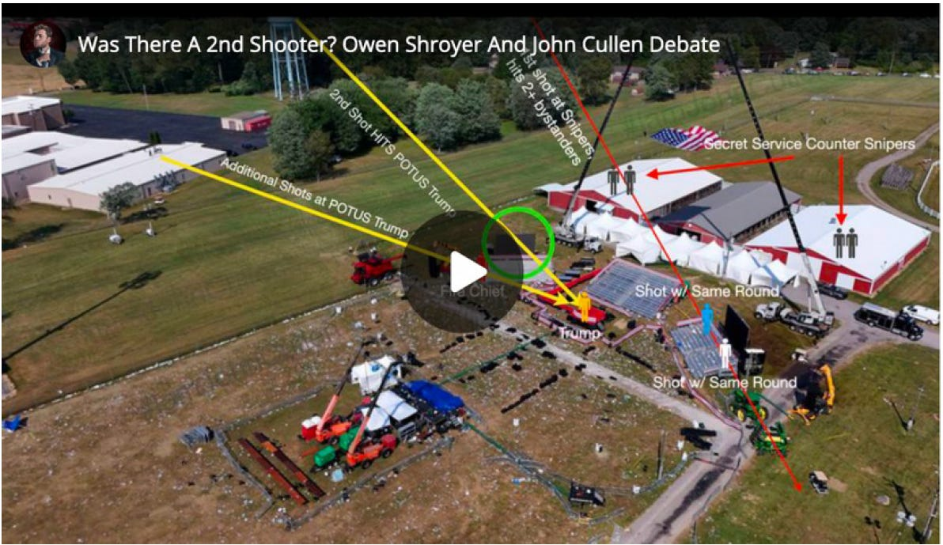

Everyone is now trying to sell you multiple shooters, to keep you from questioning the event itself. You see what they are doing, right? They are following the Kennedy script, which was to create as much confusion from the beginning, to blow smoke all over the event and keep all clarity at bay. If you are studying multiple shooters like this you aren't studying all the evidence I have given you above that this was staged. There were ZERO shooters.
But in releasing pictures like this, they just make it easier to see how ridiculous this entire story really is. Look how close that building to your left actually is to the stage! After the buildings to the rear— the SS sniper perches—it would be the first thing you would secure. The next would be that water tower. And yet Cheatle just told Congress that building was OUTSIDE the perimeter of protection! She has previously stated that no agents were on the roof because it was slanted and therefore dangerous. Not believable in the least. You can see it isn't as slanted as the red buildings behind, where agents were stationed. So there is zero chance the story we are told about Crooks just climbing up there with a 5-foot ladder is true. He would have been in full view of the SS snipers on the red building. Not one tree was blocking their view, and they should have had that roof-top in the cross hairs. Actually, they should have had an agent on that roof, but even if they didn't they could see anyone on that roof the moment he set foot on it. So this was definitely a stand down OR a staged event.
So how do we know it wasn't a stand down? Because if it were a stand down, it wouldn't have failed!
Do you think the Satanic 2000 Trillion Dollar Rothschild Deep State can't hire a real sniper? If SS had really stood down, at 150 yards Trump would have been a sitting duck. They would have taken him out with one shot.
There are tens of thousands of people who could make that shot in their sleep. We wouldn't see eight shots fired wildly, with Trump only allegedly grazed by one of them. They have these shooters missing by yards, hitting multiple people in the crowd who weren't even on the line of shot. But I guess we are supposed to believe the Satanic 2000 Trillion Dollar Rothschild Deep State can't afford to hire a real sniper. They can buy off the entire Secret Service, DHS, FBI, and CIA, but they can't hire one professional sniper? Would someone please ask Alex Jones and Mike Adams to explain that?
So that is where we now find ourselves. The world is run by these loathsome old Satanic 2000 Trillion Dollar Rothshild Phoenician Trillionaire families who hate themselves more than you hate them. You don't know enough to hate them properly, but in that at least they are way ahead of you. All they want from their cattle is your energy. All they want to do is to suck you dry for eternity. And to do that they need to control you for eternity by reducing your evolution, dumming you down.
Poverty, low wages, slavery, Fluoride, Vaccines, MRNA Deathvaxxes, pesticides, xenoestrogens, factory pollution, GMO Frankenstein food, manufactured food, GM soya oil GMO, bad nutrition, lack of vitamins, lack of minerals, mind pollution, Fake News, Iserbyte Fake Education, Fake Books, Mind Kontrol! - people will believe anything...
In these final stages of Satanism and corruption, they are torn between self-hatred and hatred of you—for not bowing down before them regardless. So in these crazy events, we see them acting out and acting in about equally, in an orgy of destruction to maintain their control.
How will it turn out? As I keep saying, that is up to you. You are taking the same tests they are. Your courage, honesty, and all other virtues are up for assessment at all times, so remember that. The events of history, real or imagined, don't really matter. What matters is what you do in response. Life is just a construction, but your acts will follow you beyond the grave. To say it another way, at birth your memory of former lives is wiped, but your actions are not wiped, your evolution created by Energy Enhancement Meditation
https://energyenhancement.org/
is not wiped. They determine your next life, and the tests you will find there.
And more at…
https://mileswmathis.com/crooks.pdf
So Trump as the last hope for humanity may well be compromised but, only the Truth can set you free and only by holding Trump’s feet to the fire will we be able to…
1. Prevent the failure to Drain the 2000 Trillion Dollar Rothschild Phoenician Mega Trillionaire Swamp this time,
2. Put 2000 Trillion Dollar Rothschild Phoenician Mega Trillionaire bought Hillary in Jail.
As happened in the last Trump administration.
As we can see with the Biden Administration – unless you destroy the cause, - the Satanic 2000 Trillion Dollar Rothschild Deep State – That Worldwide Deep State will survive in every country and Fake Elections will legitimize Rothschild created United Nations Agenda 2030 1984!
WORLDWIDE!
Your support is invaluable. If you enjoyed the read, I would greatly appreciate if you subscribed to a monthly/yearly pledge to support my work, so that I may continue providing you with Satanic World History Books and detailed, incisive reports like this one.
SIGN UP AND GET THE NEW BOOKS…




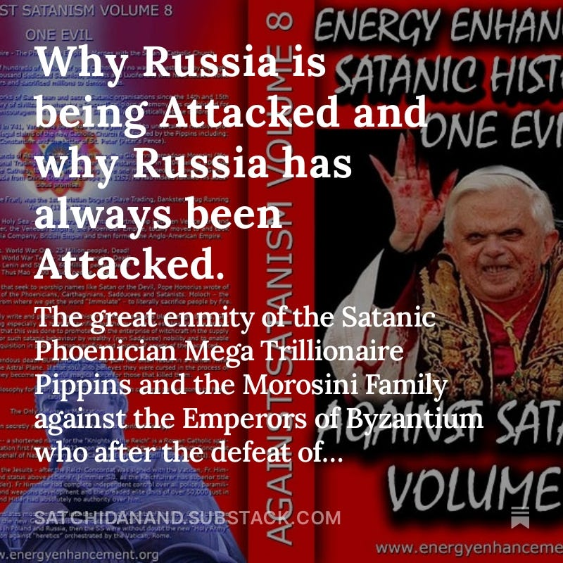



9 Likes
25 Comments
Satchidanand
Jul 24, 2024
https://mileswmathis.com/crooks.pdf
https://theconservativetreehouse.com/blog/2024/07/21/a-new-era-technocracy/
https://theconservativetreehouse.com/blog/2024/07/19/the-mirror/

Share
Satchidanand
Jul 26, 2024
Satanic Mega-Trillionaire US $2,080 Trillion Phoenician Rothschilds Control the World through Vanguard Group and Blackrock.
Satanic Mega-Trillionaire US $2,080 Trillion Phoenician Rothschilds have bought and blackmailed every politician in every country including USA nd UK and currently with the great reset of the west, AGENDA2030, are moving to china..
https://satchidanand.substack.com/p/throughout-history-seventy-two-empires
BLACKROCK AND THE SATANIC 2000 Trillion Dollar MEGA TRILLIONAIRES HAVE BOUGHT OFF OUR LEADERS, STOLEN THE ELECTIONS, FOLLOW THE ZIMBABWE SCRIPT TO DESTROY AMERICA - CUT OFF THE ENERGY, CUT OFF THE OIL, CUT OFF THE GAS, DESTROY THE PETRODOLLAR, DESTROY THE DOLLAR, CUT OFF THE GLYPHOSATE, CUT OFF THE FERTILISER, FAMINE AND STARVATION TO FOLLOW, INCREASE INFLATION, MAKE EVERYBODY POOR, SPREAD BIOWEAPONS, KILL OFF THE POPULATION, CREATE A GREAT RESET NEO-FEUDAL, POST INDUSTRIAL, SOCIAL CREDIT SCORE SLAVE PLANET
The Satanic Mega-Trillionaire - 2080 Trillion Dollars Rothschilds who control the money of the Vatican Bank control the World through the - “VanGuard Corporation” which Controls Global Megabanks, Big Deathshot Pharma, Major Mass Media and Mega Corporations in the World and their Owners - Monsanto, Google, Facebook and Microsoft.
https://satchidanand.substack.com/p/the-richest-satanic-phoenician-mega
Dark Forces have used Infiltrating Bloodline Satanic 10,000 years old Phoenician Mega Trillionaire Aristocratic Families like the 2000 trillion dollar Rothschilds which have existed running Global Trading Companies for thousands of years before the Birth of Christ.
Infiltrating and taking over the power structures in every country, using propaganda - emotional rhetorical religious concepts to control humanity, they themselves are Satanists, worshiping all the Pagan Gods, including Lucifer, Satan, Baal, Bel, Molech, Ashtoreth, Cybele and Attis.
All these Satanic Gods are heartless Demons who have cut themselves off from the Energy of the One Good God, who have rejected God so as to live eternally, immortally.
Therefore they control humanity so as to steal and vampirise the energies of Humanity forever!
In this book we find that over thousands of years before the birth of Christ, spook, Bloodline Satanic Phoenician Mega Trillionaire Aristocratic Families infiltrated every country, every Empire, from their Phoenician Colonies in Ancient Egypt, Carthage, Rome, Venice and London, marrying in to, taking over or infiltrating every ruling aristocracy and aristocratic, bloodline family.
Their Phoenician sons and daughters pretending to be natives of Europe, Britain, America, India, Israel and China, using their Satanic Phoenician Mega Trillionaire inheritances to get into positions of power to manage and control their human cattle in every country in the World!!
Download FREE! AGAINST SATANISM Volume 6 FREE!! Right Click and Save as..
https://againstsatanism.com/Sacred-Energy/Against-Satanism-Volume-6/AGAINST-SATANISM-6-Satanic-History-of-the-World-Part-2.pdf

Like

Reply
Share
NAHLS
NAHLS’s SubstackJul 22, 2024
The fact that Trumps businesses took some loans from Banks that may have been owned or controlled by Rottenchilds, does not ipso facto mean, establish, or prove that he is a Rothschild guy, pupet, or agent, working for Rothschild, any more than the fact I have a few Federal Reserve Notes in my pocket establishes that I work for Rothschild, who they say owns the BIS Bank of International Settlements, which they say controls all Federal Reserve Banks on all continents of this world ! I am not under anybody, with the acception, of the eternal absolute first cause of all being and existence, which some call "God" !

Tirion
TirionJul 23, 2024
The Rothschilds/Wilbur Ross did more than provide "some loans." They rescued Trump from bankruptcy, and who knows what else. Just speculating, but maybe that makes a material difference?

NAHLS
NAHLS’s SubstackJul 24, 2024
I have all the stuff about Trumps Bankruptcies, his illusive contracts, his 1 million dollar gift from daddy Trump to start off his career, and much more, I have heard all the allegations
that Rothschild bailed him out etc., and his father also bailed him out on one of his large Casino Hotel gambles, and what does it all amount to ? He was a guy trying to build himself up as a big business tycoon, a bit of an ego, or perhaps he was bored with what seemed to him to be an ordinary life........... none of it proves he is owned or controlled by Rothschild or anyone else..............but keep grasping ........................mois78
mois78’s SubstackJul 23, 2024
Trump was asked if he prayed, and if he asks God for forgiveness? He said never. This guy is not a Christian. He also celebrates his daughter who rejected Jesus.

NAHLS
NAHLS’s SubstackJul 24, 2024
I followed up on that story a ways back and if I recall it turned out to be false, but if I have a faulty memory would you please forward me the clip, the interview, or the phone conversation, or was it a letter ?

NAHLS
NAHLS’s SubstackJul 23, 2024
when and where did this exchange take place that you are referring to ?NAHLS
NAHLS’s SubstackJul 23, 2024
Trump clearly stated after the attempted assassination that his being there still breathing was only due to all mighty God, and nothing else !

NAHLS
NAHLS’s SubstackJul 22, 2024Edited
I have read a number of bio history entries about J.D. Vance, which say he joined the Marines after high school, coming from a poor family, which is not anything unusual in America. I found nothing stating he came from a privileged family or a blood line family, which would preclude him from ever being invited to join the Skull and Bones at Yale, and I found no source claiming he was a member of "Skull and Bones" at Yale ! So merely accusing him of being in "Skull and Bones" without any proof is basically bordering on Character Defamation, Libel, but I do not know the actual facts, I am not a witness and can not say if Vance actually was or was not a member of Skull and Bones, though it does not appear he was, because of his poor under- privileged background, he would not have been invited to join, as it is only for blood line privileged families as far as my research goes which is over a number of decades !

Tirion
TirionJul 23, 2024
But aren't you assuming that the sources you have examined are fact rather than fiction? I think the narrative painters understand the importance of giving their dramatis personae a credible backstory. Vance's published biographical details may, or may not, be fiction.
I do very much agree with Satchidanand's characterisation of choosing Vance as Trump making peace with the DS. Pence was the same deal, and so was Reagan/Bush and several others.

NAHLS
NAHLS’s SubstackJul 24, 2024Edited
It is still your speculation, assumption, presumption, conjecture, theory, belief, not knowledge, which boarders on defamation of character, libel, if you have no real evidence ! Do you really believe all the people in the small town he says he grew up in would not be calling him out for his fabricated bio and story about his past life in that sleepy small town where everyone likely knows everyone elses business ? So what are you implying the whole town is in on the deception, what, Vance paid them all not to out his story as a total fabrication ? Pretty extreme and a far stretch conspiracy theory you appear to be touting now, with no one coming forward in all these years to out it as a fabrication, especially after his best selling book about that community he grew up in !

Tirion
TirionJul 24, 2024
No. I merely said, "Vance's published biographical details may, or may not, be fiction." There's no need to jump down my throat or be so defensive, thank you.

NAHLS
NAHLS’s SubstackJul 24, 2024
Here is what you said, in fact :
Tirion 4 hrs ago
"But aren't you assuming that the sources you have examined are fact rather than fiction"
here is what I was saying:
" I found nothing stating he came from a privileged family or a blood line family, which would preclude him from ever being invited to join the Skull and Bones at Yale, and I found no source claiming he was a member of "Skull and Bones" at Yale ! So merely accusing him of being in "Skull and Bones" without any proof is basically bordering on Character Defamation, Libel, "..."
I'm not being defensive I am only making the record clear as to what I have said and the fact you have misrepresented what I said, and what I did ! You should be careful about what you say about people you do not know anything about, I do not assume facts not in evidence, as you may do, because I know to do that is folly !

NAHLS
NAHLS’s SubstackJul 24, 2024
I am not assuming anything, I am saying I found no evidence ! I do not assume someone is guilty without any evidence being brought forth to establish any of the allegations as fact ! If all you are doing is assuming things you are wasting your time and energy like spinning your wheels thinking you are going somewhere, when you are exactly where you were at the beginning of your assumption, with no evidence and nothing established as fact ! If you went into Court with no evidence and only bald faced allegations and assumptions you would be laughed out of Court, and perhaps hit with a monetary sanction for filing pleadings that were frivolous and without any merit !

Renee Marie
Renee MarieJul 22, 2024
Excellent work!👏
I question ALL! And that is exactly what every person should be doing! I stopped “assuming” years ago.

NAHLS
NAHLS’s SubstackJul 24, 2024
thank you !

Amal Wadei Dawood
Amal Wadei DawoodJul 23, 2024
Watch this human lady reading part of this book & watch her human reaction to the shocking truth (the Queen , the King ) of Piracy Crown in England leading the rape , genocide, enslavement , theft , piracy against humanity to steal all the wealth & to steal all the Earth !!
https://odysee.com/@TruthVault:0/Committee-of-300-New-World-Order:9
We are already in One World Government ( Hierarchy Crown Parasites in England - The Pirates ) secretly in place top down control & Crown Military Industrial Complex controlling Every Government on Earth including USA government by hacking their brains too & communicating with them with secret silent communication called synthetic telepathy to conscious mind called V2K Voice to Skull technology beamed to the cranial cavity of the recipients according to the frequency of the DNA & the Brain wave signature to that person to control the lies news in the media ..etc
The enemy against us " all " is the "Committee of 300" & the head of the committee of 300 is the " Crown in England !
All presidents & governments around the Earth are " Satanic Freemasons" participating in theatre fictional story that there is governments to sedate & to mislead the people around the earth inorder to hide the main reasons for those declared wars & declared mandates ..... is to genocide the people in each country by their "own governments" like Bolshevik genocide & like the genocide happened in Cambodia by Pol Pot & like all the genocides happened at least in the last 200 years all done by infiltration of Satanic Freemasons (Nazis & called Zionists ) in the governments, religious leaders ..etc their loyalty to the Head of the Satanic Freemasonry around the Earth which is the Head of the Committee of 300 & Head of the One World Government of Piracy which is the Crown Parasites in England !
Freemasonry & Satanism is freedom of morality !!
All these governments around the Earth now & in USA are Freemasons Satanists with zero morality they are working against the people of every nation for secret depopulation agenda their loyalty to the Head of the Satanic Freemasonry & the Head of Committee of 300 , the Crown in England leading the genocide secretly !
All the presidents & their governments are actors hired by the Crown in England !
We have no governments & we are on our own !
This is really " Joe Biden" hired by the head of the committee of 300 ( Crown in England ) to laugh at the people in USA and around the world and he is an actor like Trump & the rest of every governments around the earth & all the news are theatre to mislead the people while the Crown in England collecting the Earth with infiltration !
Watch Joe Biden "sniffing your hair "
https://www.youtube.com/watch?v=jy-9vU9BzZE&list=PLv4zpHMC9C9UO-QOeaPbe4QkIc4lOzmnT
The Youtube account C3PMeme looks very questionable and most likely for the MIC claim they can use artificial intelligent to make videos but For me I see Joe Biden videos on this channel so real that make me certain he is professional actor for the Crown in England to laugh at the people while they are misleading the people that these videos are fake !!
What happened from this assassination attempt on Trump was a lie , hoax & witchcraft magic skills to put rubber- silicone synthetic ear with fake blood applied by the secret agents were on the top of Trump !!
Google... bloody synthetic silicon ear and you will find many options ...
https://www.etsy.com/listing/1103857224/hyper-realistic-bloody-ear-prop-silicone
this is the Truth for what happened
https://old.bitchute.com/video/XyQfYhZO9mLT/?comment=0io7fpxw3I29OiMEDIQPwRQarxtXavxuLmo7
The goal is to push the people to civil war to divide the people in USA to hunt each other so the Crown in England ( Head of One World Government of Piracy) will conquer like in history !
Go hunt the immigrants !!
This One World Government Piracy against every human on Earth regardless what religion they are on and what race !
1) Trump Rolled out 5G & it is military weapon against the people in USA to make the people have short life span & to have cancer in the next 5 years !
Read his speech rolling out 5 G against the people in USA in 2019 in (Roosevelt Room)
https://trumpwhitehouse.archives.gov/briefings-statements/remarks-president-trump-united-states-5g-deployment/
Why Trump his speech was in ( Roosevelt Room ) because this is a signal that Trump following the path of "Franklin Roosevelt" (the traitor) as F. Roosevelt drafted Declaration for the "United Nations" with Churchill ( Crown in England) in 1941 & also Roosevelt in 1933 forced the people in USA to give up their gold to the government !
Means Trump like Franklin Roosevelt slave to the Head of the One World Government of Piracy ( Crown in England ) Head of the Committee of 300 leading the genocide against humanity secretly to own all the wealth & to own all the Earth!
2) Trump rolled out the death bio-weapons injections called vaccines against the people in USA !
Millions are dead or disabled for life because of these injections
https://www.youtube.com/watch?v=hSfeCqK
Who created the United Nations to fool the world is the Crown Parasites in England the Head of the Committee of the 300 and their Committee of 300 members including Churchill & the Presidents including Franklin Roosevelt working for their secret genocide agenda against humanity to steal all the wealth on earth and to steal all the earth while enslaving humanity with the technology they stole ..
The Crown in England is the Head of the Committee of 300 & the Head of One World Government & they are taking everything from us including our precious metal , gold & silver again like what they did in the Great depression in 1933 in USA using the puppets of deceptive (actors ) Presidents & governments in the quality of Franklin Roosevelt & the bankers for Federal reserve !
They already hacked our brains secretly by impregnated our bodies with these nano technology at least since 1920s in water we are drinking , in air we are breathing through the chem-trails spraying , in the injections through the first infant vaccines in history & in any injections & medicine including the dental anaesthetic injections all loaded with hydrogel , graphene , nano smart dust to connect us to the satellites ( clouds ) & to the Pirates of the Crown Military Industrial Complex "supercomputer 666" & to control the people brains globally with synthetic telepathy to the subconscious mind by sending synthetic thoughts to make the people feel & think negative against themselves to accept certain agenda or to suicide or to feel & to think negative against each other to kill each other for secret depopulation for the Crown in England ..
They hacked our brains via satellites that they see through walls , They see what we see and They hear what we hear & they read the mind !
There is no virus as germ in human history..
They did not isolate any virus in human history !
And the infant vaccines is to inject us the nano smart dust , hydrogel to connect us to the satellites via the free energy technology to hack our brains secretly & record all our lives what we see , what we hear and what we say inside our houses ..
"Corona Virus" is the name of the genocide agenda to depopulate the Earth by the Crown in England ..Corona is the "Crown" in Spanish language while the Virus it means in Latin language the "Poison " !
Means Corona Virus is " The Crown Poison" against humanity
the genocide agenda is the "Crown Poison "either with directed energy weapons ( radiation poisoning ) & with "bioweapons injections" using the poisons as venom " snake venom, other poison , & by poisoning the people mind with "Fake News " & with synthetic telepathy ( synthetic thoughts ) beamed via satellites to make nation against nation for depopulation & to make the people think negative against themselves ( divorce & homosexuality is high in the last 100 years because of this silent weapon ) or make the people think negative against others around them to depopulate each other by being manipulated remotely without their knowledge of this technology with the synthetic telepathy to their subconscious mind !
Descendants of Queen Victoria Head of the Satanic Freemasonry are the Head of the Committee of 300 leading the genocide , theft against humanity ... They are taking over the "WORLD" with Free Energy Technology hacking people brains since at least 1920 , & attacking the people around the Earth directed energy weapons & 9/11 attack was directed energy weapon attack using Death ray technology and more via satellites !
This is the end of humanity !
We are heading to the "New Dark Ages" that filthy tyrants will be "chopping heads" & rape adults and children in public seen while they stole the technology from humanity that they read the mind and they see & hear everything through walls and they can control the function of every cell & the function of every organ in human body remotely via satellites ... they can stop breathing , stop the heart , they can remove all the memory the brain , they can stop bowel function , all this done remotely thousands miles away via satellites !
This is the end of humanity !

Ohio Deb
Ohio DebJul 27, 2024
Recorded in 1996. https://forbiddenknowledgetv.net/dr-john-coleman-exposes-the-committee-of-300/?amp=1

Amal Wadei Dawood
Amal Wadei DawoodJul 23, 2024
Watch Catherine Austin-Fitts & Maria Zeee media Exposes Globalist Banking Coup
https://rumble.com/v51hbqx-catherine-austin-fitts-exposes-globalist-banking-coup-on-infowars-with-mari.html
Catherine Austin-Fitts nailed it that Trump pushing for the digital mandates like how he pushed the death injections & the 5 G because Trump like every infiltrated government with Satanic Freemasonry their loyalty to the Head of the Committee of 300 & the head of the Freemasonry around the Earth & the Head of the Imperialism & the Head of the One World Government Piracy which is the King & Queen of British Imperialism which they always honour the criminals like them & this is an evidence that the One World Government is the Head of British Imperialism.. & she mentioned in that conversation that " Especially the Common Wealth countries getting aggressive mandates for total digital control " because the Head of the State enforce on them is the King & Queen of Piracy for the Crown in England !
World Economic Forum is led by " K " Charles III who he is talking about cutting the emission of the CO2 & we need martial law to do that !
This means this is announcement to kill humans on earth with their livestock because we all expel CO2 when we breathe !
CO2 is not dangerous & this is a lie & deception !
We have infact very low level of CO2 in the environment because they are using technology to suck the CO2 from the environment because their plan to push humanity towards starvation because CO2 very important for the plants to produce food & in fact the higher level of CO2 is only dangerous to the Crown Parasites in England because this means more food for humanity that will live happy long life against the plan of the Crown in England the Head of the Committee of the 300 leading the genocide secretly against humanity!
X disease means "Crucifixion culling sign " by making the X stand correctly as culling cross to crucify humanity !
Who created the WHO & UN & WEF is the Head of the Committee of 300 & their Committee of 300 members and the Head of the committee of 300 is the King & Queen of Piracy for the Crown in England !
Please See that the "British Imperialism in 1882" had 13 Colonies on the open in addition to England which means 14 colonies !!
see drawing:
https://www.gettyimages.co.uk/detail/news-photo/editorial-cartoon-depicts-england-as-a-13-armed-cephalopod-news-photo/77036713?adppopup=true
Now all the Earth is One Giant Colony in the hands of Crown Parasites in England secretly the Head of the One World Government Piracy & they are the Head of the Committee of 300 leading the genocide & theft to steal all the wealth and to steal all the Earth !!
*What happened to gold in the Great Depression ?
In 1933, Roosevelt took the U.S. off the gold standard when he signed an executive order making it illegal for individuals and firms to possess most forms of monetary gold.
The government of Franklin D Roosevelt seized all gold bullion and coins via Executive Order 6102, forcing citizens to sell at well below market rates. Immediately after the “confiscation”, the government set a new official rate for gold that was much higher as part of the Gold Reserve Act 1934.
*Who created the United Nations to fool the world is the Crown Parasites in England the Head of the Committee of the 300 & their Committee of 300 members including Churchill & the Presidents including Franklin Roosevelt leading Piracy , genocide , theft against humanity
In Wikipedia-
By August 1941, American President Franklin Roosevelt & British Prime Minister Winston Churchill had drafted the Atlantic Charter; which defined goals for the post-war world. At the subsequent meeting of the Inter-Allied Council in London on 24 September 1941, the eight governments in exile of countries under Axis occupation, together with the Soviet Union and representatives of the Free French Forces, unanimously adopted adherence to the common principles of policy set forth by Britain & the United States.
The text of the Declaration by United Nations was drafted on 29 December 1941, by Roosevelt, Churchill, & Harry Hopkins.
https://en.wikipedia.org/wiki/United_Nations
Read Rules of One World Gov. in the story of the committee of 300 book
https://odysee.com/@TruthVault:0/Committee-of-300-New-World-Order:9
Reading ..
"Attempts to trade "old" coins, that is to say silver coins of previous & now defunct nations, shall be treated as a capital crime subject to the death penalty. All coinage shall be required to be surrendered within a given time along with guns, rifles, explosives & automobiles. Only the elite & One World Government high-ranking functionaries will be allowed private transport, weapons, coinage & automobiles... "
They are taking your gold using deception as usual
* Search for this file of PDF book "The Great taking"
file:///C:/Users/user/Documents/The%20Great%20Taking.pdf
In this book mentioned in pages 47, 48
The executive order to confiscate all gold owned by the public was made under the authority of the Trading with the Enemy Act of 1917 !
I asked my father why people had turned in their gold. He said that if you did not you were a criminal, but further, that there was nothing you would be able to do with it because you could not legally transport or sell it. So, essentially, the use and value of gold had been confiscated.
This was certainly the case because it remained illegal for a U.S. person to own gold for more than forty years !
Here are some excerpts from Executive Order 6102 [40]:
All persons are hereby required to deliver on or before May 1,
1933, to a Federal Reserve Bank or branch or agency thereof or
to any member bank of the Federal Reserve System all gold coin,
gold bullion and gold certificates now owned by them or coming
into their ownership . . .
Whoever willfully violates any provision of this Executive Order
may be fined not more than $10,000, or, if a natural person, may
be imprisoned for not more than ten years, or both . .
* Also in another book The Story Of the Committee of 300 - by John Coleman & shocking truth that the Queen , King of Piracy for Crown is the head of the Committee of 300 & Head of the One World leading the enslavement, genocide , theft against humanity to own all the earth !
https://odysee.com/@TruthVault:0/Committee-of-300-New-World-Order:9
In this book mentioned the Rules for the One World Government:
Attempts to trade "old" coins, that is to say silver coins of previous & now defunct nations, shall be treated as a capital crime subject to the death penalty. All coinage shall be required to be surrendered within a given time along with guns, rifles, explosives & automobiles. Only the elite & One World Government high-ranking functionaries will be allowed private transport, coinage ..
Expand full comment

Gabriel Aguilar
Gabriel AguilarAug 1, 2024
EXCELLENT ARTICLE!!! 💯👍🏼👊🏼📣📣
EXCELLENT THAT YOU HAVE THE GUTS TO EXPOSE THE: - SATANIC CRIMINAL JEWISH BANKING MAFIA a.k.a. THE HOUSE OF ROTHSCHILD…
KEEP IT UP!!! 👍🏼👊🏼📣📣📣

Satchidanand
Aug 1, 2024
The Phoenicians are not Jews... Read this...
AGAINST SATANISM VOLUME 6 -The Satanic History of the World Part 2 Published May 2019
See http://www.energyenhancement.org/8aky78umhxi31.jpg
Dark Forces have used Infiltrating Bloodline Phoenician/Jewish aristocratic Families which have existed for over 5000 years before the Birth of Christ. Using emotional rhetorical religious concepts to control humanity, they themselves worship all the Pagan Gods, including Lucifer, Satan, Baal, Bel, Molech, Ashtoreth, Cybele and Attis. In this book we find that over thousands of years, spook, Bloodline Phoenician/Jewish aristocratic Families infiltrated every country, every Empire, taking over or infiltrating every ruling aristocracy and aristocratic, bloodline family, in Europe, Britain, America, India, China and in every other country in the World.
http://www.energyenhancement.org/Sacred-Energy/Against-Satanism-Volume-6/AGAINST-SATANISM-6-Satanic-History-of-the-World-Part-2.pdf
http://www.energyenhancement.org/FREE-BOOK-AGAINST-SATANISM-VOLUME-6-The-Satanic-History-of-the-World-Part-2-Infiltrating-Bloodline-Caananite-Phoenician-Jewish-aristocratic-Families.htm

Satchidanand
Sep 13, 2024
READ THIS...TARTARIA AND THE 2000 TRILLION DOLLAR PHOENICIANS
https://satchidanand.substack.com/p/tartaria-and-the-2000-trillion-dollar

Gabriel Aguilar
Gabriel AguilarAug 1, 2024
Yes, thank you for clarifying facts about their bloodline … I’m particularly more interested in how the Rothschilds have gained power over financial and governments worldwide … The world money system is their personal (private) business… So, given the actual circumstances we find ourselves in who cares if they are jews, phoenicians, khazars or whatever … in fact I think we don’t have time to dive into their history … instead we should be worried on how to confiscate ALL their wealth, followed by a quick trial and appropriate death sentence for the entire Rothschild Dynasty and for all their Prostitutes around the world… and in the meantime we get rid of their diabolic system we should start worrying about how to create a more honest monetary and trade system. Complicated situation … But to begin with I think you’re doing an excellent job in exposing them as the responsible group for all the crazy and diabolic shit happening worldwide…

Satchidanand
Aug 1, 2024
Why... Thank you very much Aguilar.
I think first, my article on Financialisation is important
FINANCIALISATION and Satanic Phoenician Mega Trillionaire Central Banks? by Professor Richard A. Werner, D.Phil. - Improved and made better by Satchidanand
THE SATANIC PHOENICIAN MEGA TRILLIONAIRES, THE ROTHSCHILDS, THE ROCKFELLERS, THE BLACK NOBILITY CONTROL BIDEN, PUTIN AND XI - THEY CHOOSE WHICH EMPIRES TO DESTROY AND RAISE UP!
https://satchidanand.substack.com/p/financialisation-and-satanic-phoenician
After That the destruction of the Rothschild Central Banks will come about by borrowing money Only from American Banks as in FDR and Lincoln Greenbacks. That to create Big Projects like the Tennessee Authority - Like the Belt and Road Initiative throughout the Americas linking through the Bering Straits to Russia and China. Many more like that.
The point is we don't care how money is divided up and used.
What we want is Richness, more Richness, More Energy, for everyone!
After that Protectionism of Tariffs to grow American Industry back again. We need to get back to paying a little more for our goods if everyone gets higher wages.
I'm not big on Killing people. Better to prosecute first.
As for how to stop this happening in the future understand the the line of evil passes through everyone's heart. We can all turn into a psychopath.
The solution is Energy Enhancement Meditation. https://energyenhancement.org/

The Energy Enhancement Streaming Video Meditation Course and the Volumes of the Against Satanism Series by Satchidanand

Go to http://www.energyenhancement.org
for 52 Free –On Sign-Up - Energy Enhancement Books and Energy Enhancement Against Satanism Books.
To defeat Evil, you need to up your game. Learn the Energy Enhancement Meditation Course by Video or Live at Iguazu falls with Satchidanand and Devi Dhyani.

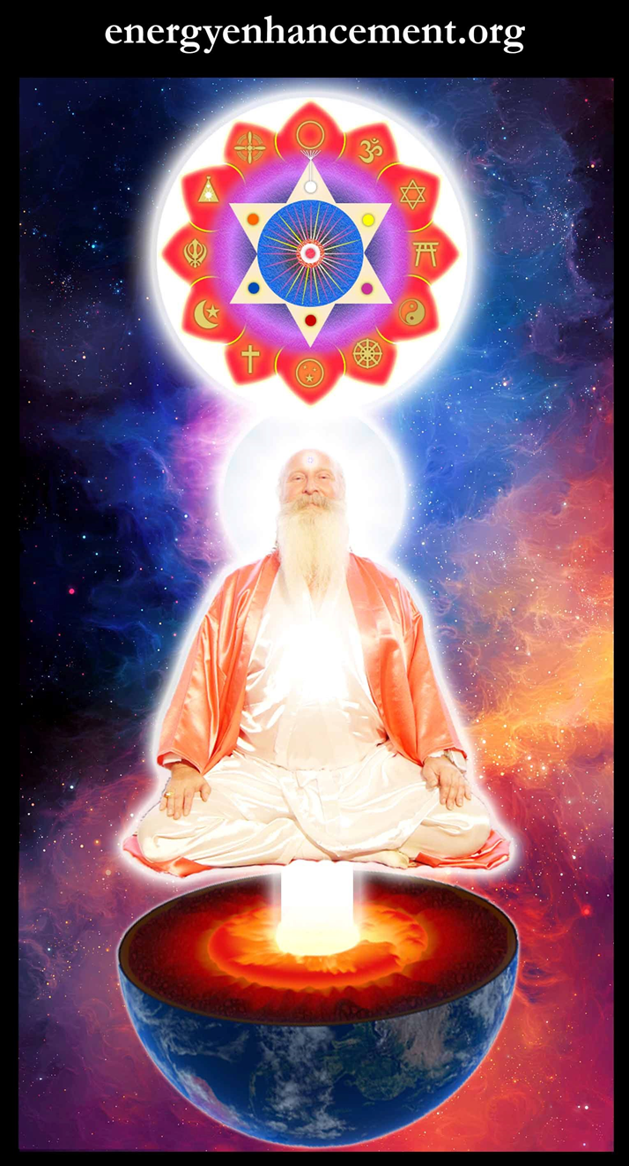
T

Change the World...


Go to http://www.energyenhancement.org
for 52 Free Energy Enhancement Books.

To defeat Evil, you need to up your game. Learn the Energy Enhancement Meditation Course by Video or Live in Iguazu.
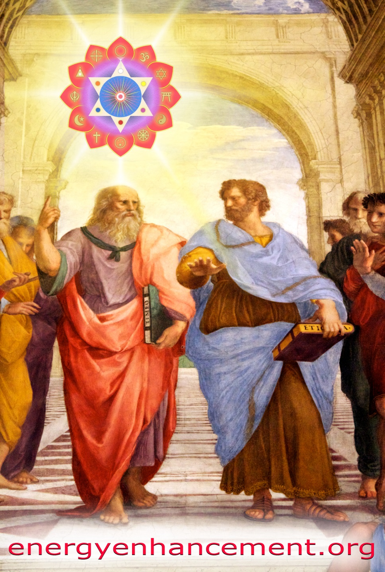

PLATO AND SATANIC BABYLONIAN SECRET AGENT ARISTOTLE "THE POISONER" OF ALEXANDER THE GREAT - BY RAPHAEL




ENERGY ENHANCEMENT MEDITATION
ENERGY ENHANCEMENT MEDITATION LEVEL 1 POWER UP!! GAIN SUPER ENERGY http://www.energyenhancement.org/Level1.htm
ENERGY ENHANCEMENT MEDITATION LEVEL 2 ELIMINATE ENERGY BLOCKAGES http://www.energyenhancement.org/Level2.htm
ENERGY ENHANCEMENT MEDITATION LEVEL 3 CLEAN KARMA BLOCKAGES AND PAST LIFE KARMA BY TRANSMUTATION http://www.energyenhancement.org/Level3.htm
ENERGY ENHANCEMENT MEDITATION LEVEL 4 MASTER ENERGY CONNECTIONS AND RELATIONSHIPS http://www.energyenhancement.org/Level4.htm

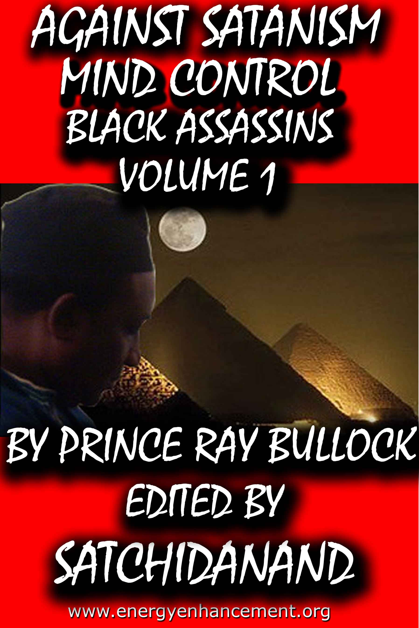

MIND CONTROL BLACK ASSASSINS VOLUMES FREE!!

AGAINST SATANISM VOLUMES FREE!!

- ON SIGN-UP AT..

energyenhancement.org

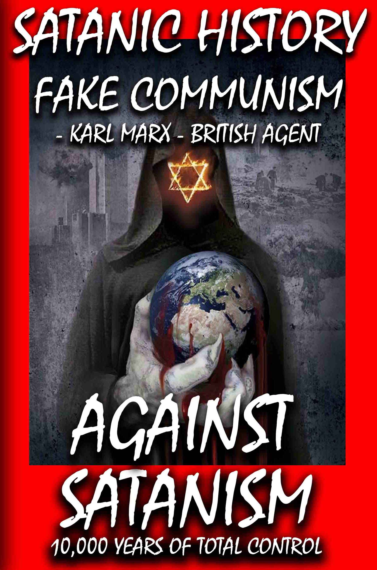

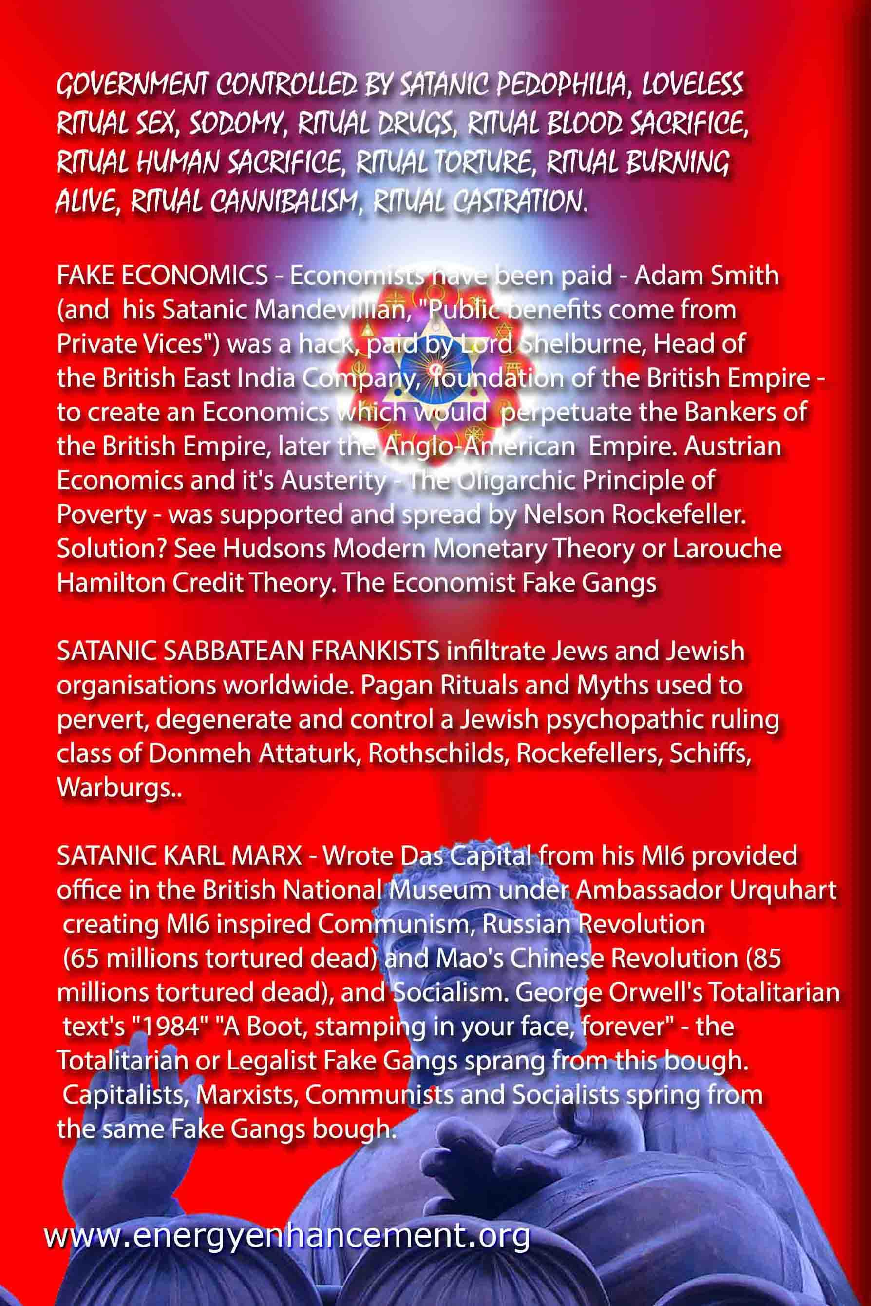

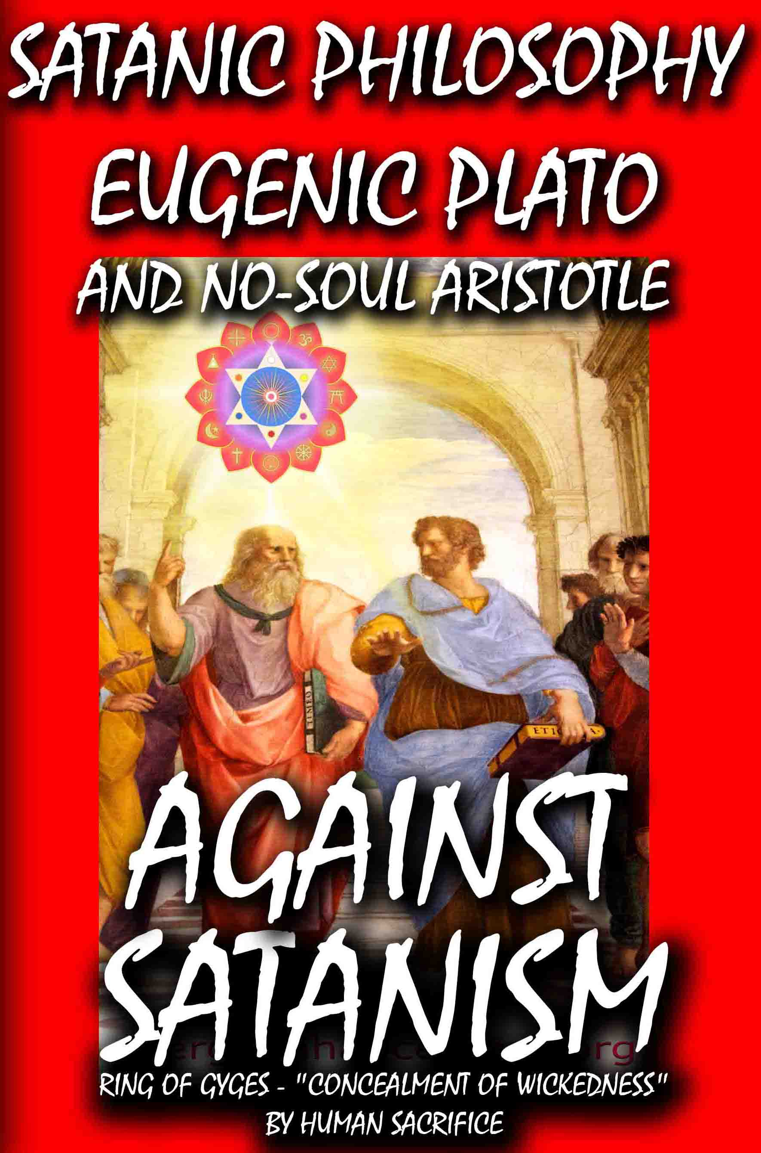

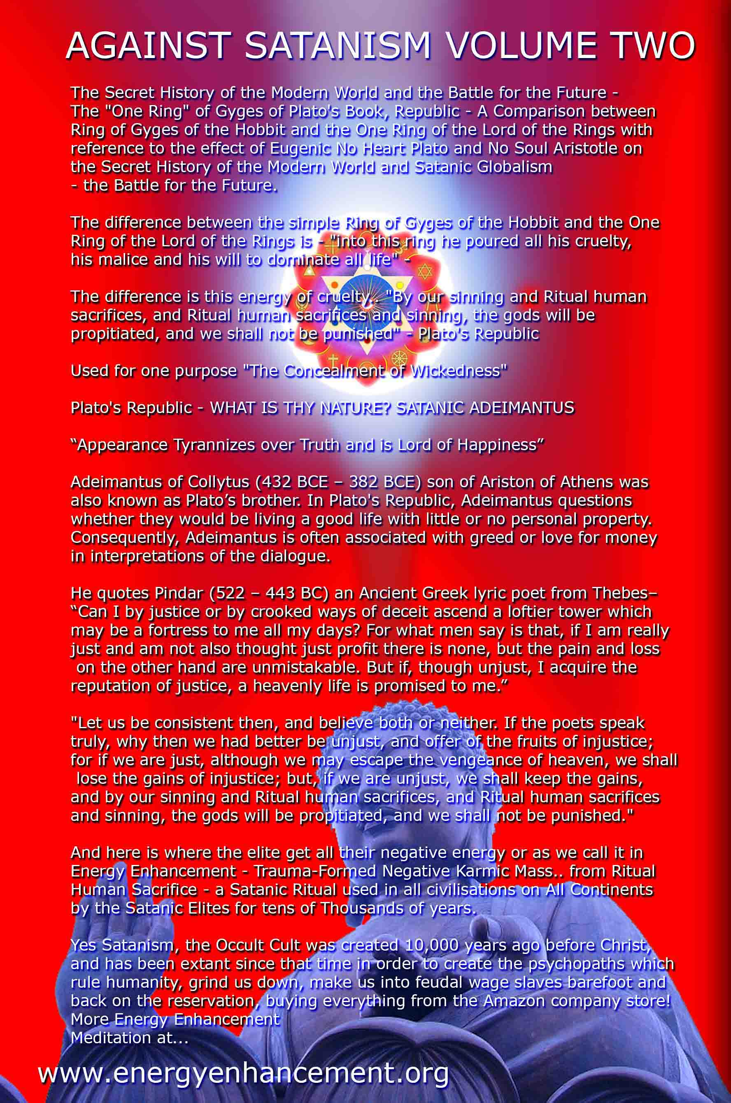

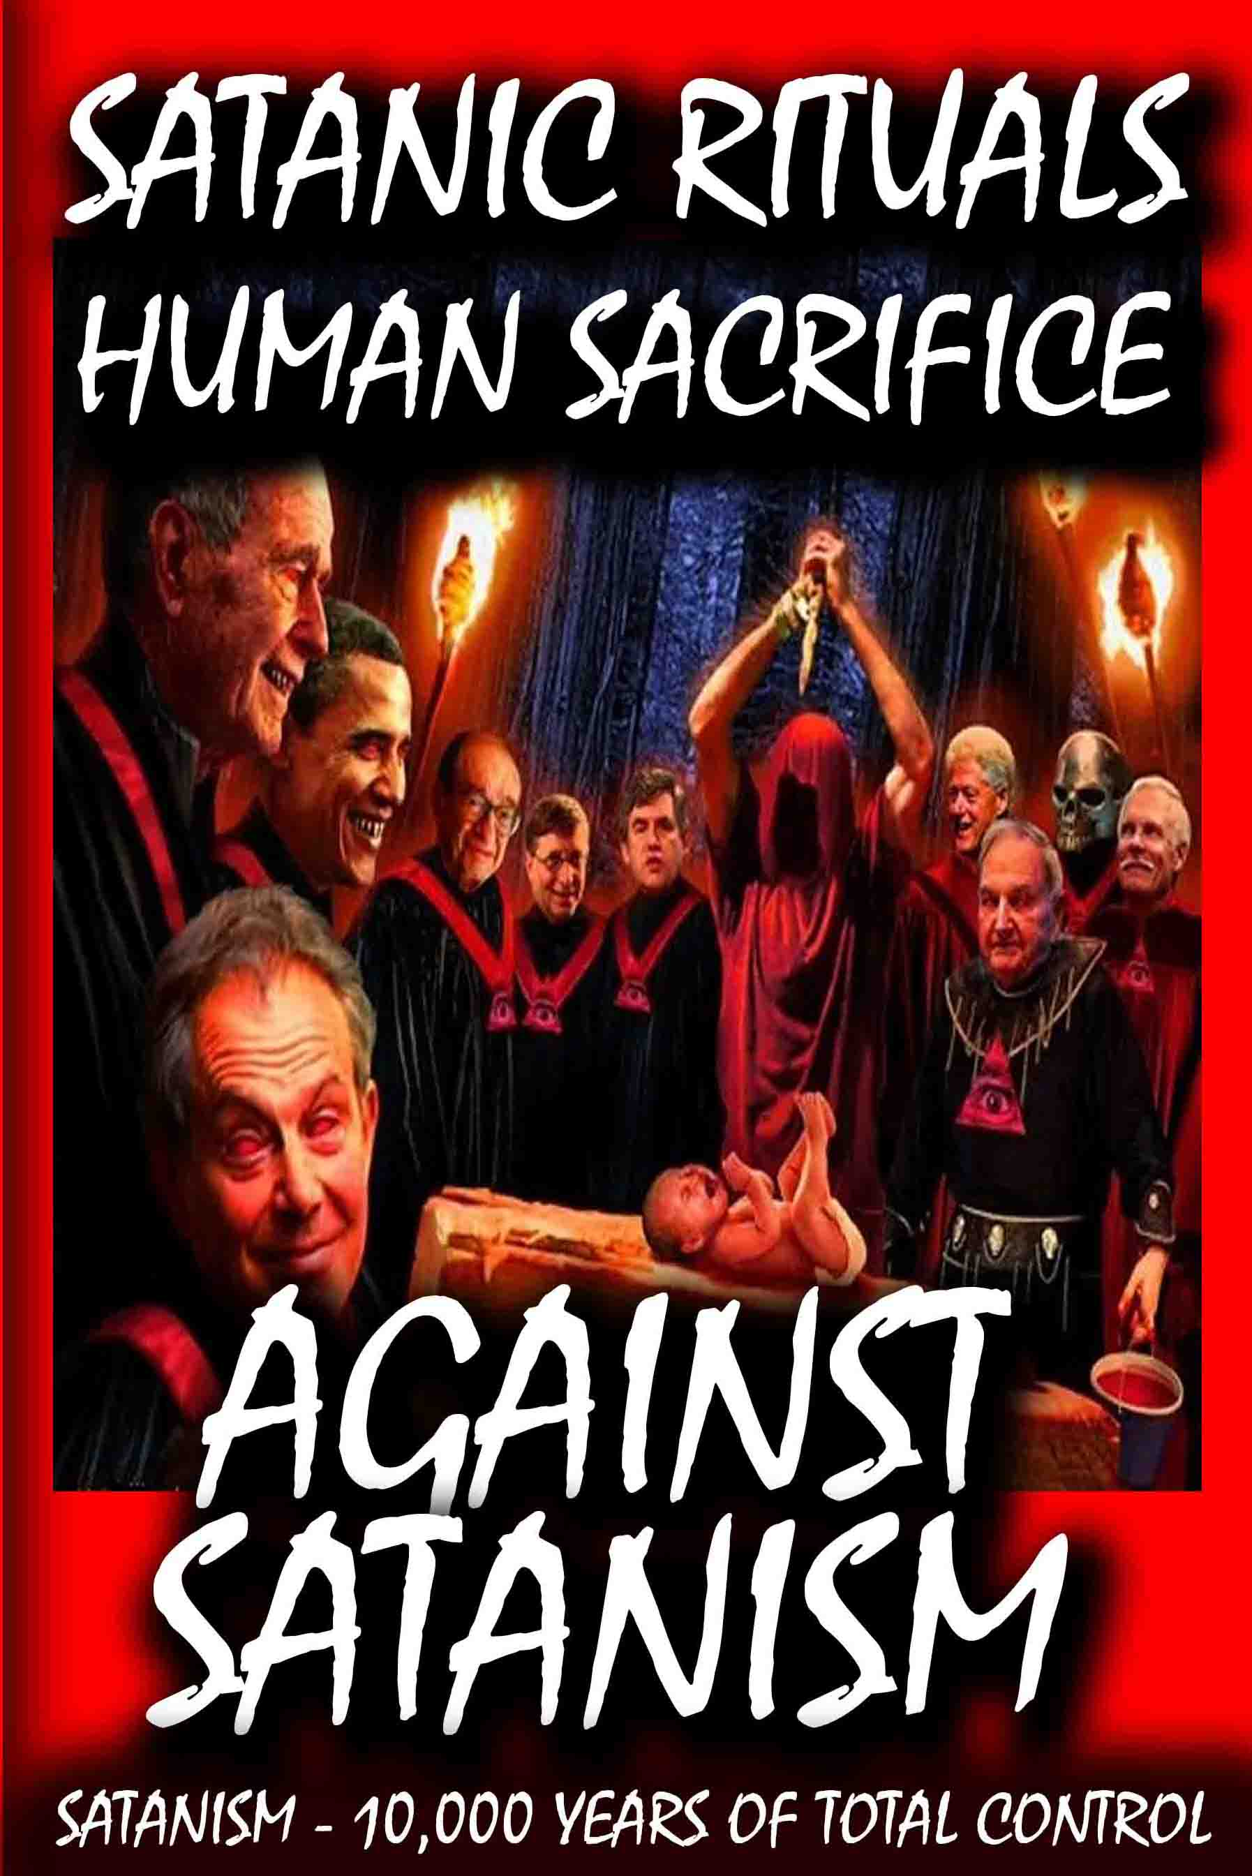

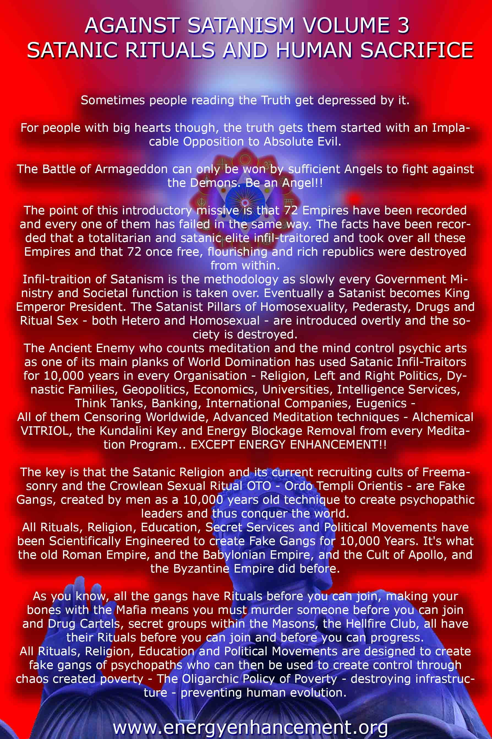

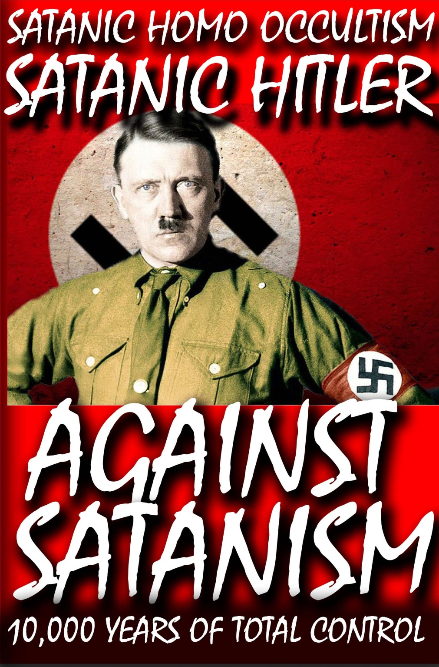

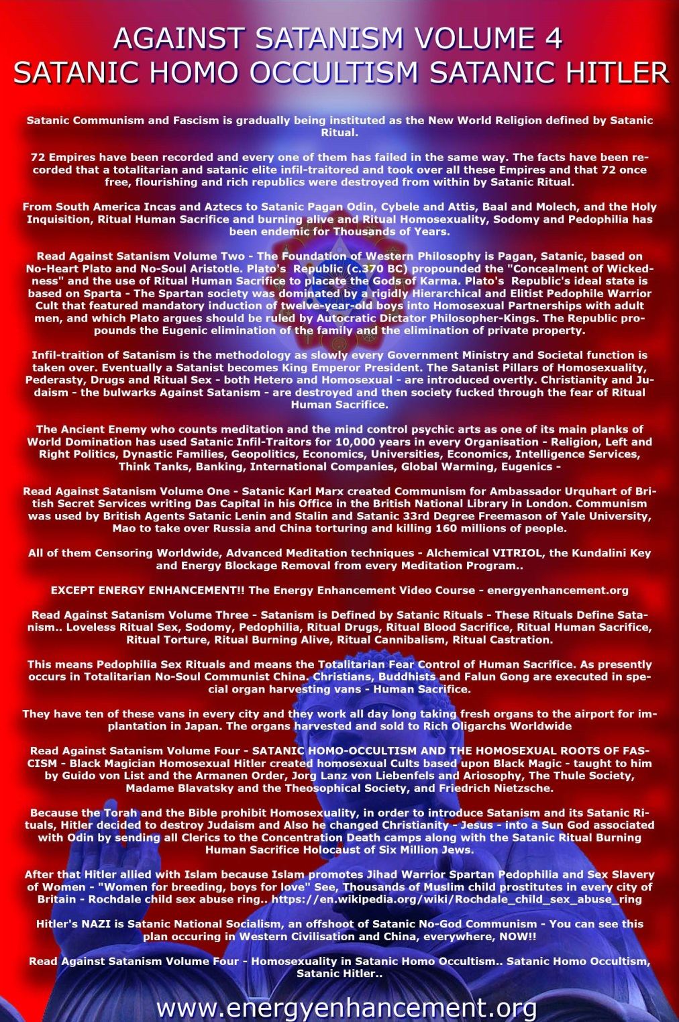

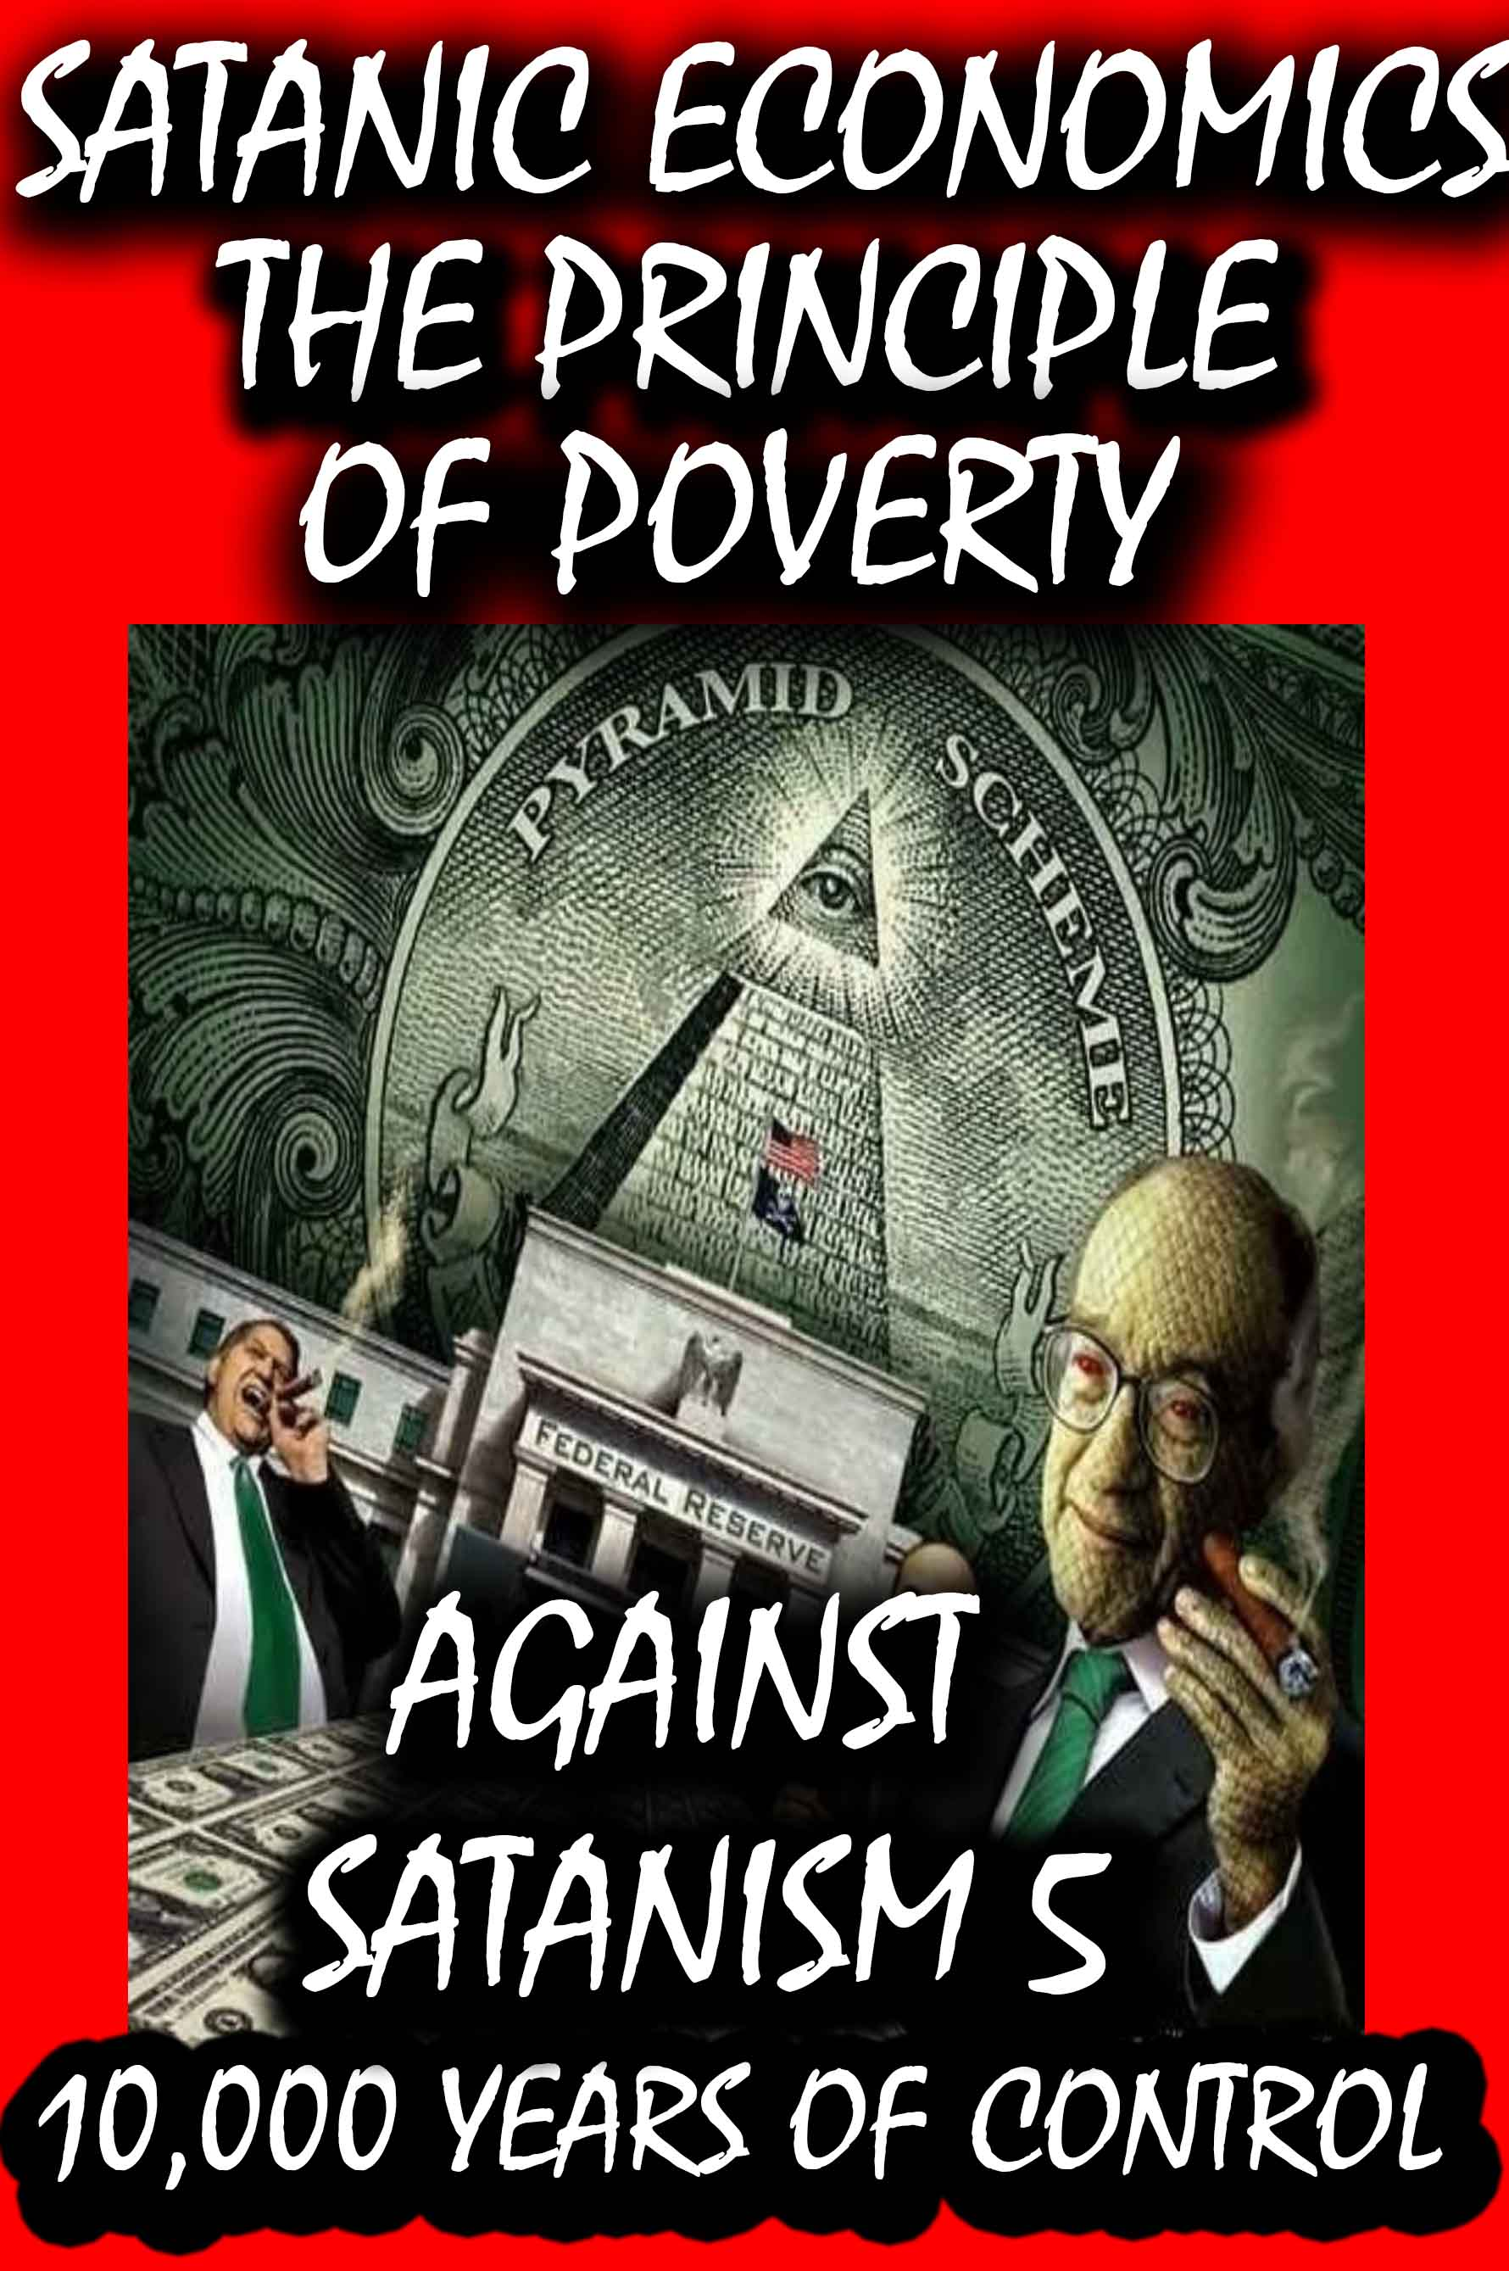

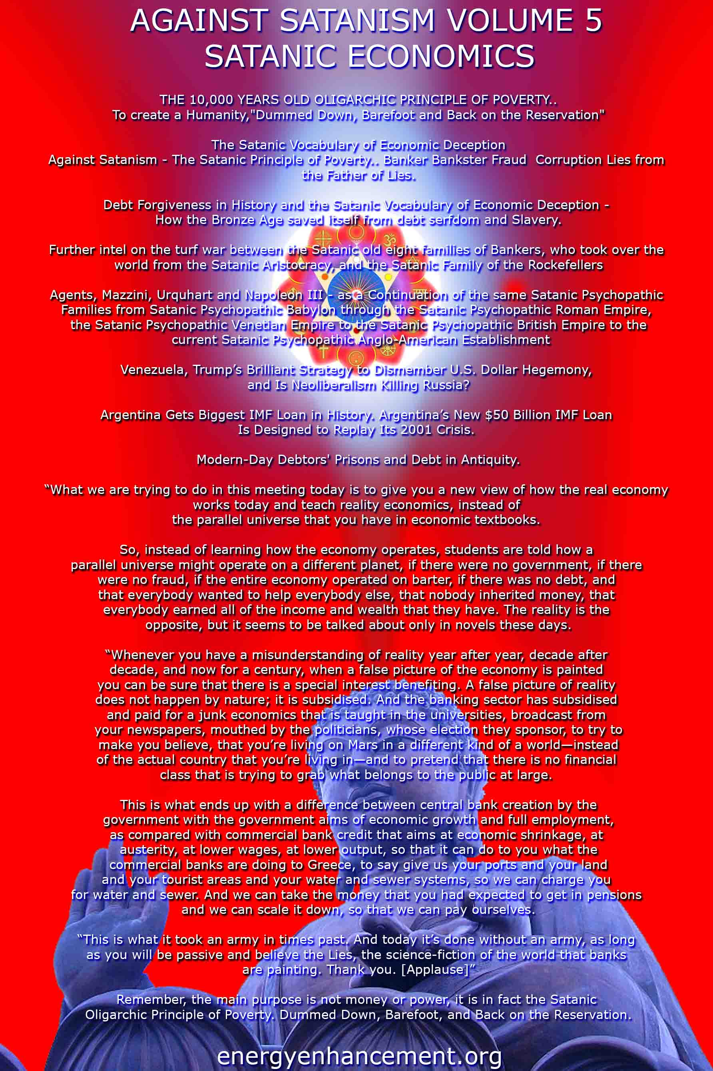

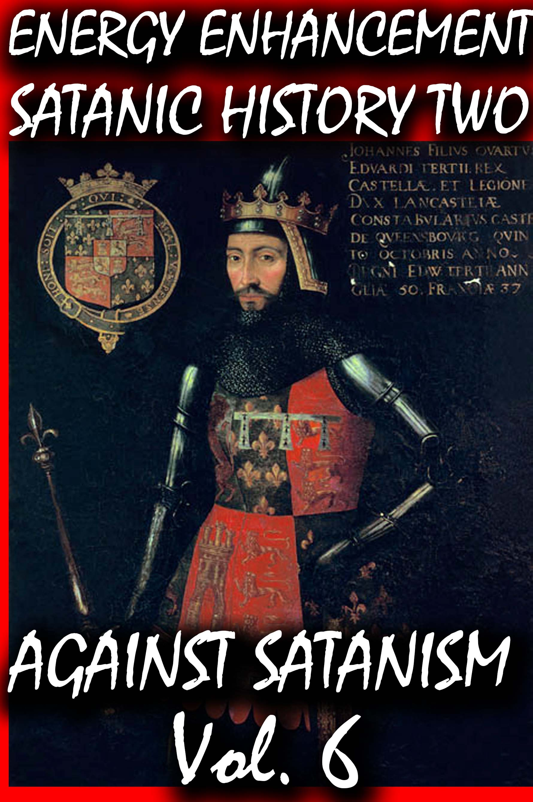
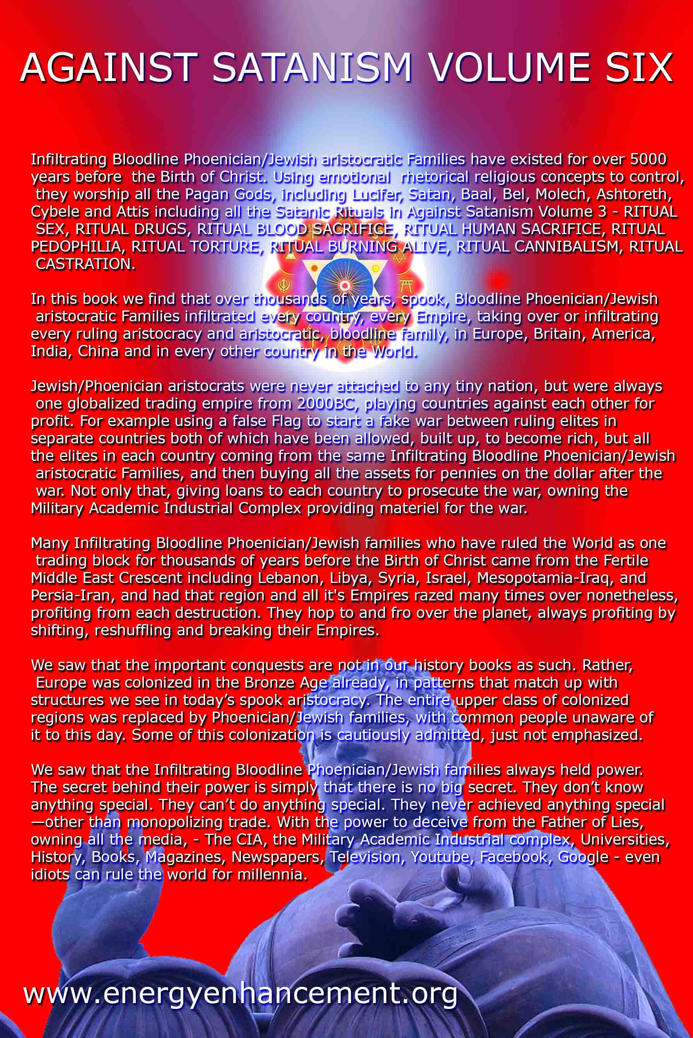
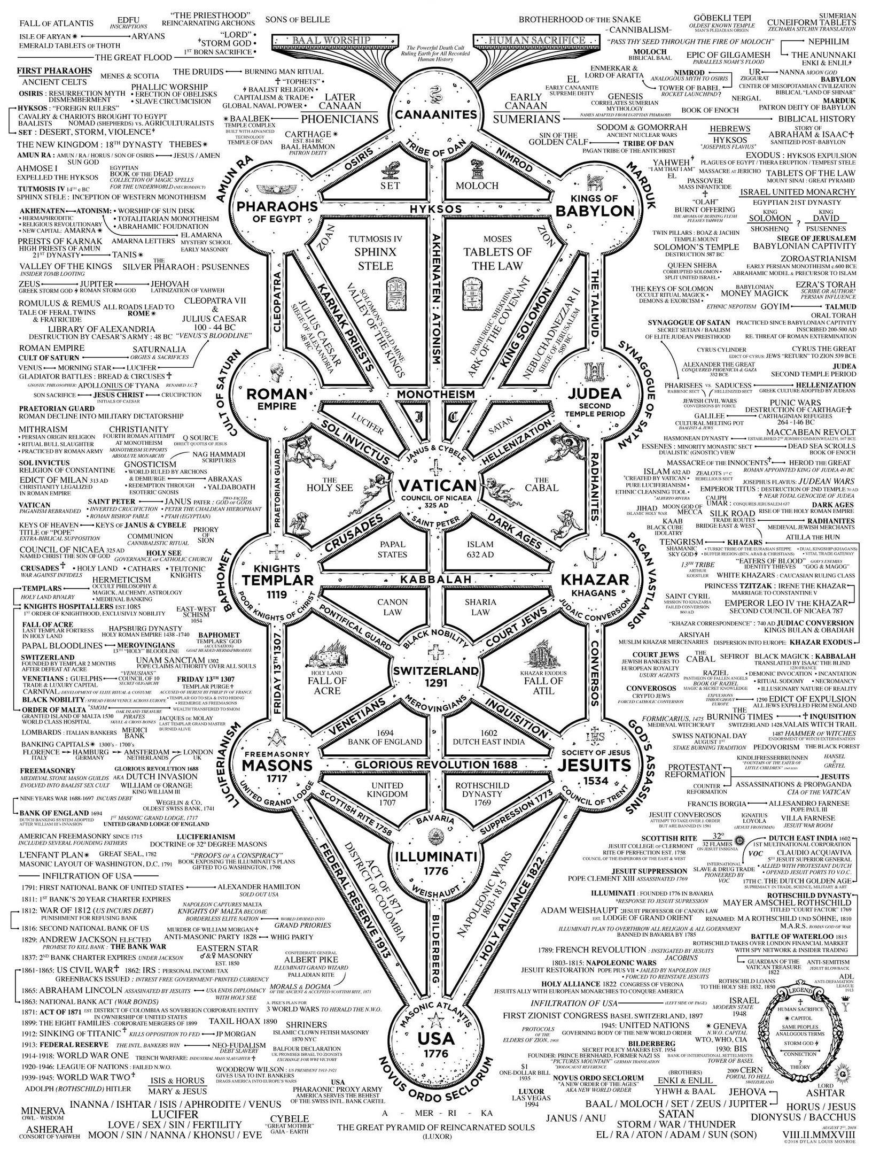
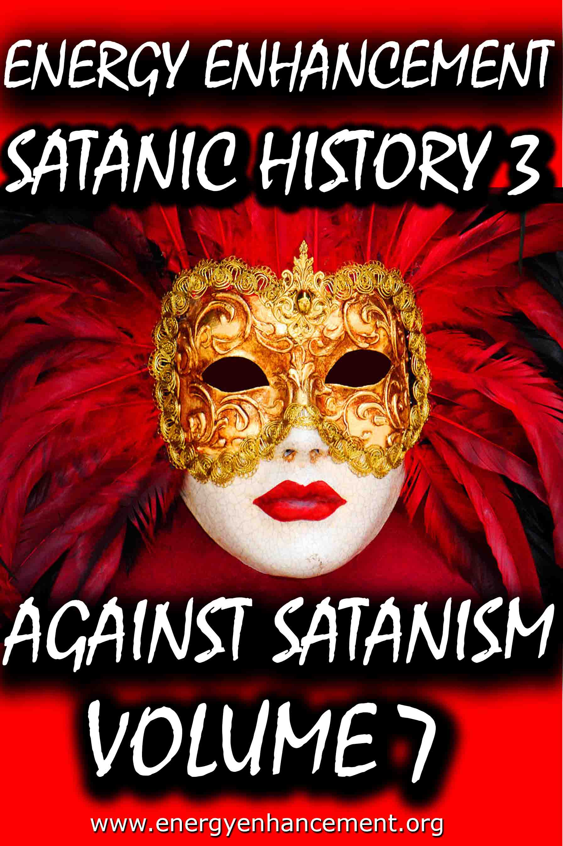
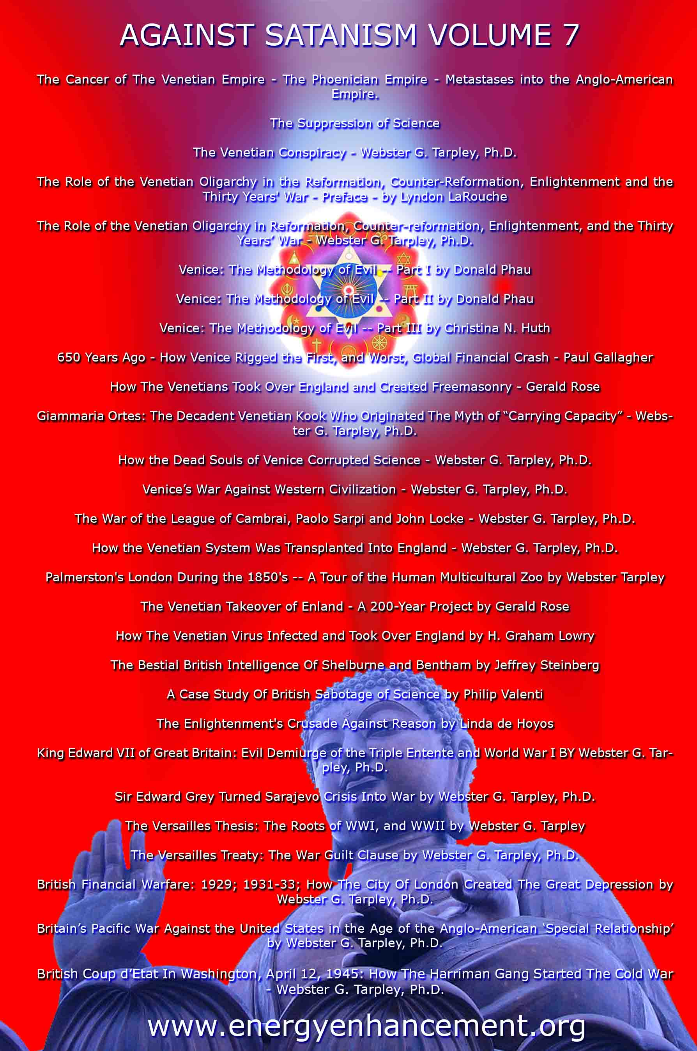

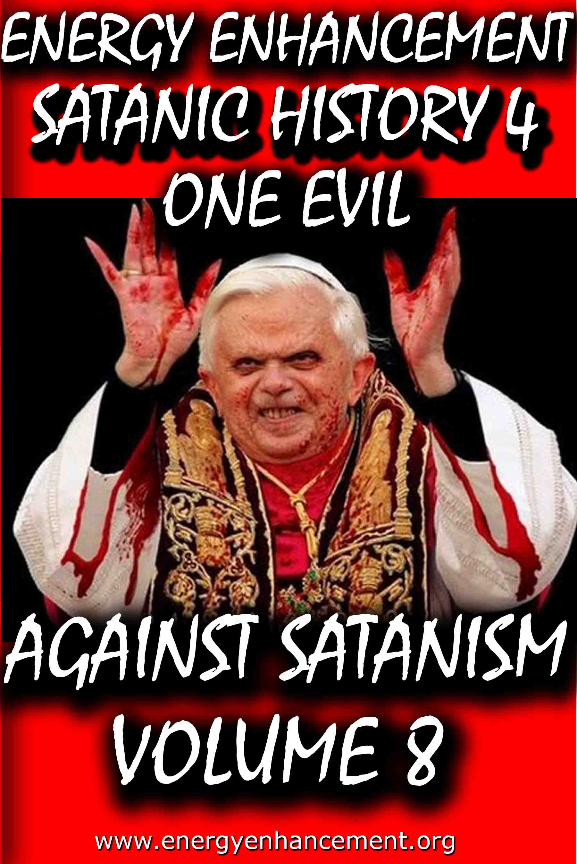

Remember, the main purpose is not money or power, it is in fact the Satanic Oligarchic Principle of Poverty. Dummed Down, Barefoot, and Back on the Reservation

Even though Tesla Free Energy Broadcast Power has been supressed, these next pages show how Fusion power and Fission Power have also been suppressed due to a Policy of Poverty going back to Fra Paolo Sarpi of the Satanic Venetian Republic and the British Royal Society for Science…

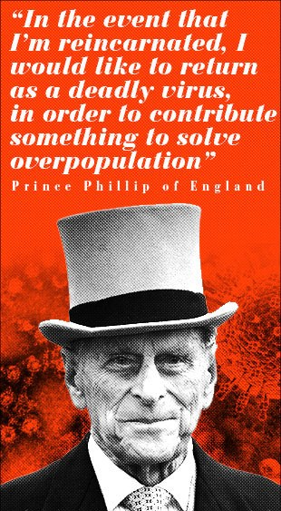

These Satanic Malthusians Demand Genocide

“Human population growth is probably the single most serious long-term threat to survival. We're in for a major disaster if it isn't curbed...We have no option.” —Prince Philip, interview in People Magazine, December 21, 1981

“In the event that I am reincarnated, I would like to return as a deadly virus, in order to contribute something to solve overpopulation.” —Prince Philip, Deutsche Press Agentur, August 1988
“It is almost self-evident that the greater the human population, the greater the demands for natural resources... The paramount question deals with an optimum human population. How many is too many people in relation to available resources? Many believe that our current (satanically consciously created) environmental problems indicate that the optimum level has been surpassed.” —Task Force on Earth, Resources and Population, George H. W. Bush, Chairman, July 8, 1970

POST MORTEM

Unfortunately, all the obituaries were premature: Venice has continued to be very much alive. During the nineteenth century and up to our own time it has been the most important single incubator for fascist movements. With its military and financial power largely emigrated elsewhere, Venice’s importance for political culture is now greater than ever.

Examples of this are inexhaustible. Richard Wagner wrote part of Tristan und Isolde while living in the Palazzo Giustinian on the Grand Canal. One story has it that the leitmotif of the Liebestod was inspired by the mournful call of a gondolier. At the end of his life Wagner moved to Palazzo Vendramin Callergi, where he died. This building, presently a gambling casino, was also the home of Count Coudenhove- Kalergi, the founder of the Pan-European Union. Friedrich Nietzsche loved Venice, returned there incessantly, and dedicated certain poems to the city which today can still be used in lieu of a powerful emetic. Venice was an inspiration for Lord Byron, for Thomas Mann, and so on.

Other examples abound of how the Venetian oligarchy’s cultural and political influence has reached down into the modern era:

* When British East India Company retainer Thomas Malthus published his Essay on Population he was plagiarizing from the Venetian Giammaria Ortes, who produced, around 1750, a fully developed version of the argument that geometric population growth outstrips the much slower arithmetric progress of food production.

* John Ruskin, the leading ideologue of the British Dark Ages faction, began his career with a raving treatise on architecture, The Stones of Venice (1851). This volume popularized the notion that a “Venetian Gothic” style had been developed in the better times of the city’s history (which for Ruskin ended in 1418) and it was used systematically to discredit the Golden Renaissance.

* A turn-of-the-century new Roman Empire faction led by Venetian Count Volpi di Misurata, who was known as the doge of his era, sponsored the fascist Mussolini supporter Gabriele D’Annunzio to drum up enthusiasm for a new crusade into the Balkans and the East. Volpi became finance minister in Mussolini’s cabinet, along with a very large number of other Venetians. D’Annunzio incited the Italians to take back Trieste, the rest of Italia Irredenta, and the Dardanelles, bringing on to center stage the so-called Parvus Plan for dismemberment of the Ottoman and Russian empires, which is generally recognized as the detonator of World War I. It is possible that the turn-of-the- century super spook Alexander Parvus was ultimately employed by Venice.

* The Societe Europeenne de Culture, a think tank created in 1950 through the efforts of Venetian intelligence operative Umberto Campagnolo, has for the past three decades pulled intellectuals from both East and West into organizing for an “international culture,” based on rejecting the existence of sovereign nations. The SEC counted among its members the cream of the postwar intelligencia: Adam Schaff of Poland, Bertolt Brecht of East Germany, Georg Lukas of Hungary, and Boris Paternak of the Soviet Union, as well as Stephen Spender and Arnold Toynbee, Benedetto Croce and Norberto Bobbio, Julian Huxley and Thomas Mann, Francois Mauriac, and Jean Cocteau. Later, the SEC launched the Third World national liberation ideology.

Today, the Club of Rome is the institution that represents the most concentrated essence of Venetian influence and the Venetian method. The Club of Rome wants to convince the great powers and peoples of the world to commit collective suicide by accepting the genocidal doctrine of zero growth. It also hopes to abolish the sovereign nation as a vehicle for economic growth and scientific progress.

Club of Rome founder Aurelio Peccei has just written a new book titled One Hundred Pages For the Future, a global review of the impact of the Club of Rome, and particularly since its 1972 release of the zero-growth model Limits to Growth was published, a series of social movements has sprung up under the sponsorship of the ideas in the book. These – the women’s movement, the peace movement, Third World national liberation movements, gay rights, civil liberties, ecologists, consumer and minority rights, etc. – must now be welded together into one movement for a single strategic goal: the implementation of a zero-growth international order.

The Venetian problem remains with us today. Truly, the most urgent task of this generation of mankind is to definitively liquidate the horror that is Venice and all the other Gang Clan Families who have ruled the World for 10,000 years.

The Satanic Conservative outpost of the Satanic Phoenician Navy who for 10,000 years have worshipped Molech, Baal and Cybele and Attis, and with Satanic Ritual, it's not just Sex on Altars like in Kubrick's, "Eyes Wide Shut", it is Pedophilia with Babies and Children supplied by Epstein, Dutroux or Jimmy Savile, it's Ritual Human Sacrifice, Ritual Blood Sacrifice, Ritual Burning Alive, Ritual Torture, Ritual Castration - and those Damn Liberals by Miles Mathis and Satchidanand

The founding fathers have even been sold as liberal in this sense, since although they were rich guys, fully connected, we are supposed to believe they believed in democracy, republicanism, and fairness in general. That is why they go on and on about that in the Declaration of Independence and Constitution. Those are liberal documents, in that they deny not only the divine rights of kings, they deny any other sort of favoritism based on name or birth.

As it turns out, the founding fathers were not liberal at all. They were Satanic fascists, and the whole liberal stance was just another con-job.

The United States were never meant to be republic, much less a democracy, they were meant to be another outpost of the Satanic Phoenician Navy who for 10,000 years have worshipped Molech, Baal and Cybele and Attis, and more worship with Satanic Ritual, it's not just Sex on Altars like in Kubrick's, "Eyes Wide Shut", it is Pedophilia with Babies and children supplied by Epstein, Dutroux or Jimmy Savile, it's Ritual Human Sacrifice, Ritual Blood Sacrifice, Ritual Burning Alive, Ritual Castration.
Some of my readers have been confused by my insistence that I am a liberal. These readers agree with me on a lot of things, so they can’t fathom what I mean by calling myself a liberal while they consider themselves conservatives. Since it is important, I will hit it again, trying to get them to understand.

I think the difference is that I am coming at this as a student of history, while many of them are coming at it as students (or consumers) of current politics.

I haven’t gotten my definitions and stances by listening to Rush Limbaugh, or Sean Hannity, I have gotten them from texts from the 19th century or earlier. My readers will answer me, “Then why don’t you keep up, Holmes! This is 2020, not 1880”. Good point. . . except that it isn’t.

To see what I mean, let’s transport ourselves back to the 1880s. Back then, satanic conservatives were those people who wished to conserve the status quo. Hence the name. They were quite satisfied with the way things were set up, and why should they not be?

They were rich and connected and had it made. Liberals were those who were not satisfied by the way things were, and so they were pushing for reforms. In general, they wished to see more fairness in government policies. They wanted those not “of the manor born” to be given a fair shot at good employment, good wages, court access, and all the various fruits of society.

The founding fathers have even been sold as liberal in this sense, since although they were rich guys, fully connected, we are supposed to believe they believed in democracy, republicanism, and fairness in general. That is why they go on and on about that in the Declaration of Independence and Constitution. Those are liberal documents, in that they deny not only the divine rights of kings, they deny any other sort of favoritism based on name or birth.

As it turns out, the founding fathers were not liberal at all. They were Satanic fascists, and the whole liberal stance was just another con-job.

The United States were never meant to be republic, much less a democracy, they were meant to be another outpost of the Satanic Phoenician Navy who for 10,000 years have worshipped Molech, Baal and Cybele and Attis, and more worship with Satanic Ritual.

Iit's not just Sex on Altars like in Kubrick's, "Eyes Wide Shut", it is Pedophilia with Babies and children supplied by Epstein, Dutroux or Jimmy Savile, it's Ritual Human Sacrifice, Ritual Blood Sacrifice, Ritual Burning Alive, Ritual Castration.

Read - AGAINST SATANISM VOLUME 6 - THE SATANIC PHOENICIANS - version 2 -The Satanic History of the World Part 2 Published May 2019

AGAINST SATANISM VOLUME 6 -The Satanic History of the World Part 2 Published May 2019

See http://www.energyenhancement.org/8aky78umhxi31.jpg

Infiltrating Bloodline Phoenician/Jewish aristocratic Families have existed for over 5000 years before the Birth of Christ. Using emotional rhetorical religious concepts to control, they worship all the Pagan Gods, including Lucifer, Satan, Baal, Bel, Molech, Ashtoreth, Cybele and Attis. In this book we find that over thousands of years, spook, Bloodline Phoenician/Jewish aristocratic Families infiltrated every country, every Empire, taking over or infiltrating every ruling aristocracy and aristocratic, bloodline family, in Europe, Britain, America, India, China and in every other country in the World.

http://www.energyenhancement.org/Sacred-Energy/Against-Satanism-Volume-6/AGAINST-SATANISM-6-Satanic-History-of-the-World-Part-2.pdf

Alan Watt Recommended Book List
Description: Get the BIG Picture by archiving and studying Sources from which Alan Watt draws. Download audio and transcripts of his talks from http://alanwattsentientsentinal.eu FREE. Please by all mean… Full description

Essential Book Recommendations from Alan Watt, of the
CuttingThrough theMatrixwebsite.

(Plus some of the books he won't mention)
The Republic – PlatoTragedy and Hope: The History of the World in our Time – Dr. Carroll Quigley The Anglo-American Establishment – Dr. Carroll Quigley The Evolution of Civilizations – Dr. Carroll Quigley
Between Two Ages: America's Role in the Technetronic Era – Zbigniew Brzezinski The Grand Chessboard: American Primacy and its Geostrategic Imperatives – Zbigniew Brzezinski The Choice: Global Domination or Global Leadership – Zbigniew Brzezinski The Impact of Science on Society –
Bertrand Russell The Scientific Outlook – Bertrand Russell The History of Western Philosophy – Bertrand Russell Proposed Roads to Freedom: Socialism, Anarchism, and Freedom – Bertrand RussellEducation and the Good Life – Bertrand RussellThe Autobiography of Bertrand Russell – 1872 – 1914 – Bertrand RussellThe Autobiography of Bertrand Russell – 1914 – 1944 – Bertrand RussellAn Essay on the Principle of Population – Thomas MalthusLegacy of Malthus – Allan ChaseThe Next Million Years – Charles Galton DarwinIn the Minds of Men – Ian T. Taylor Morals and Dogma – Albert PikeThe New Atlantis – Francis BaconThe Advancement of Learning – Francis BaconValerius Terminus of the Interpretation of Nature – Francis Bacon Novum Organum – Francis BaconThe Open Conspiracy – H.G. Wells

The Outline of History (Two volumes) – H.G. Wells The Shape of Things to Come – H.G. Wells The New World Order – H.G. WellsAmerica B.C. - Barry Fell Akhenaten – The Heretic King – Donald B. Redford The Gnostic Gospels – Elaine Pagels The Story of Civilization (11 Volumes) – Will Durant (
Particularly the first four volumes
:1.Our Oriental Heritage 2.The Life of Greece 3.Caesar and Christ 4.The Age of Faith) The Lessons of History – Will Durant The Story of Philosophy – Will Durant A Study of History (12 Volumes) – Arnold J. Toynbee (Look for the unabridged version – there isreason beyond Toynbee's legendary verbiage that a slender two-volume edition was released)Civilization on Trial – Arnold J. ToynbeeAmerica and the World Revolution – Arnold J. Toynbee (Public lectures in book form)Fire in the Minds of Men: Origins of the Revolutionary Faith – James H. BillingtonWall Street and the Bolshevik Revolution – Antony C. SuttonWall Street and the Rise of Hitler – Antony C. SuttonWall Street and FDR – Antony C. SuttonWestern Technology and Soviet Economic Development: 1917 – 1930 – Antony C. SuttonWestern Technology and Soviet Economic Development: 1930 – 1945 – Antony C. SuttonWestern Technology and Soviet Economic Development: 1945 – 1965 – Antony C. Sutton(
Zbigniew Brzezinski thought very highly of the above Sutton three volume work
)America's Secret Establishment: An Introduction to the Order of Skull and Bones – Antony C.SuttonTrilaterals over Washington: Volume I – Antony C. Sutton (with Patrick M. Wood)

Trilaterals over Washington: Volume II - Antony C. Sutton (with Patrick M. Wood)Foundations: Their Power and Influence – Rene A. Wormser Ages in Chaos (Four volumes) – Immanuel Velikovsky1.Ages in Chaos2.Oedipus and Akhnaton3.Ramses II and his Time4.Peoples of the SeaWorlds in Collision – Immanuel VelikovskyFuture Shock – Alvin Toffler The Third Wave – Alvin Toffler Power Shift – Alvin Toffler Political Ponerology: A Science of the Nature of Evil Adjusted for Political Purposes – Andrej M.LobaczewskiThe Technological Society – Jacques EllulPropaganda: The Formation of Men's Attitudes – Jacques EllulThe Political Illusion – Jacques EllulThe Technological System – Jacques EllulThe New Totalitarians – Roland HuntfordFuture Man – Brian StablefordPropaganda – Edward L. BernaysPublic Relations – Edward L. BernaysThe Moses Mystery – Gary GreenburgHebrew Myths: The Book of Genesis – Robert Graves and Raphael Patai
<compare with the following Graves volume>
The Greek Myths – Robert GravesScarlet and the Beast: A History of the War Between English and French Freemsasonry – JohnDanielConspiracies, Cover-ups, and Crimes – Jonathan VankinThe History of Freemasony (7 volumes unabridged) – Albert G. Mackey

The Encyclopedia of Freemasonry (Volumes I & II) – Albert G. MackeyThe Symbolism of Freemasonry – Albert G. MackeyGould's History of Freemasonry Throughout the World (6 volumes unabridged) – Robert F. GouldHoly Blood, Holy Grail – Baigent, Lincoln and LeighThe Messianic Legacy – Baigent, Lincoln and LeighThe Temple and the Lodge – Baigent, Lincoln and Leigh The Dead Sea Scrolls Deception – Baigent, Liccoln and LeighAmerica's Assignment with Destiny – Manly P. HallThe Secret Destiny of America – Manly P. HallThe Secret Teachings of All Ages – Manly P. HallThe Lost Keys of Freemasonry – Manly P. HallFreemasonry of the Ancient Egyptians – Manly P. HallOrientations – Sir Ronald StorrsThe Memoirs of Sir Ronald Storrs – Ronald StorrsThe Whispering Gallery: Being Leaves from the Diary of an Ex-Diplomat – Anonymous (LordGrey?)The Fifth Man: The Soviet Super Spy – Roland PerryThe Fringes of Power: The Incredible Inside Story of Winston Churchill During WWII – JohnColvilleThe Fringes of Power: 10 Downing Street Diaries (1939 – 1955) – John ColvilleThe Other Side of Deception: A Rogue Agent Exposes the Mossad's Secret Agenda – VictorOstrovkyBy Way of Deception: The Making and Unmaking of a Mossad Officer – Victor OstrovskyHistory Begins at Sumer: Thirty-Nine Steps in Recorded History – Samuel Noah Kramer Acres of Skin: Human Experiments at Holmesburg Prison – A True Story of Abuse and Exploitationin the Name of Medical Science by Allen M. HornblumThe Ghost in the Machine – Arthur Koestler The Thirteenth Tribe – Arthur Koestler

The Second Genesis: The Coming Control of Life – Albert RosenfeldTowards a New Beginning – Mikhail GorbachevDeadly Allies: Canada's Secret War (1937 – 1947) – John BrydenEarth Rising: The Revolution Toward a Thousand Years of Peace – Nick Begich NATO and Europe – Andre BeafreMillennium – Jacques AttalliUnderstanding Media: The Extensions of Man (Critical Edition) – Marshall McLuhan
The Book of the Dead: The Papyrus of Ani – E.A. Wallis BudgeThe Golden Bough – James FrazerHamlet's Mill – Giorgio de Santillana & Hertha von DechendThe Crime and Punishment of I.G. Farben – Joseph BorkinThe Undiscovered Self – C.G. JungProofs of a Conspiracy – John RobinsonThe Rockefellers: An American Dynasty – Peter Collier & David HorowitzThe Human Agenda – Roderic Gorney Trading with the Enemy: An Expose of the Nazi-American Money Plot (1939 – 1949) –Charles Higham Movie Lot to Beachhead: The Motion Picture Goes to War and Prepares for the Future – the editors of Look Magazine Hollywood Babylon: The Legendary Classic of Hollywood's Darkest and Best Kept Secrets –Kenneth anger The Fugu Plan: The Untold Story of the Japanese and the Jews During World War Two – Marvin Takayer, Forbidden Archaeology: The Full Unabridged Edition – Michael A. Cremo, The Last of the Pagans – Peter Chuvin, The Controversy of Brian – Douglas Reed, Battle for the Mind: A Physiology of Conversion and Brain Washing – William Sargant, Brave New World – Aldous Huxley

Brave New World Revisited – Aldous Huxley Nineteen Eighty-Four – George OrwellAnimal Farm – George OrwellFahrenheit 451 – Ray BradburyThe Handmaid's Tale – Margaret AtwoodFrankenstein – Mary ShelleyThe Wizard of Oz – Frank Baum My Life – Leon TrotskyThe Sovereign Individual – James Dale Davidson & Lord William Rees MoggGoethe's View of Evil and the Search for a New Image of Man in our Time – Allan P. CottrellThe Curse of Canaan: A Demonology of History – Eustace MullinsSecrets of the Federal Reserve – Eustace MullinsKing Kill 33 – James Shelby DownardSecret Societies and Psychological Warfare – Michael A. Hoffman IIThe Cultural Cold War: The CIA and the World of Arts and Letters – Frances Stonor StauntonWho Paid the Piper?: CIA and the Cultural Cold War - Frances Stonor StauntonPsychological Warfare – Paul Antony Myron Linebarger Physical Control of the Mind: Toward a Psychocivilized Society – Jose M.R. DelgadoThe Trap – James GoldsmithThe Response – James GoldsmithStraight and Crooked Thinking – Robert H. ThoulessSeven Pillars of Wisdom: A Triumph – T.E. Lawrence (Lawrence of Arabia)Autobiography of Thomas Jefferson – Thomas JeffersonThe First Global Revolution – Alexander King & Bertrand Schneider The Limits to Growth: A Report for the Club of RomeThe Underground History of American Education – John Taylor Gatto

Dumbing Us Down – John Taylor GattoAn Unsocial Socialist – George Bernard ShawThe Culture Industry – Theodor AdornoHope of the Wicked: The Master Plan to Rule the World – Ted FlynVirute and Terror (Revolution!) - Maximilien RobespierreArmand Hammer: The Untold Story – Steve WeinbergThe Balfour Declaration – Leonard SteinE-Topia: Urban Life, Jim – But Not As We Know It by William J. MitchellPhilip Dru Administrator: A Story of Tomorrow (1920 – 1935) – Edward Mandel HouseThe Naked Ape: A Zoologist's Study of the Human Animal – Desmond MorrisVodka Cola – Charles LevinsonLanguage, Mind and Nature: Artificial Languages in England from Bacon to Locke – Rhodri LewisThe Divine Comedy – Dante AlghieriHamlet – William SkakespeareThe Prince – Nicolo MachiavelliDocuments:1.Agenda 212.United Nations Human Settlement Program3.DCDC Global Strategic Trends Document (M.O.D.)4.Converging Technologies for Improving Human Performance: Nanotechnology, Biotechnology,Information Technology and Cognitive Science – National Science Foundation/Department ofCommerce5.Societal Implications of Nanoscience and Nanotechnology – National Science Foundation6.Global Trends 2025: A Transformed World – A Final Report7.2008 Army Modernization Strategy (D.O.D.)8.UNESCO: Its Purpose and Philosophy – Sir Julian Huxley9.Weather as a Force Multiplier: Owning the Weather in 2025 – U.S. Airforce

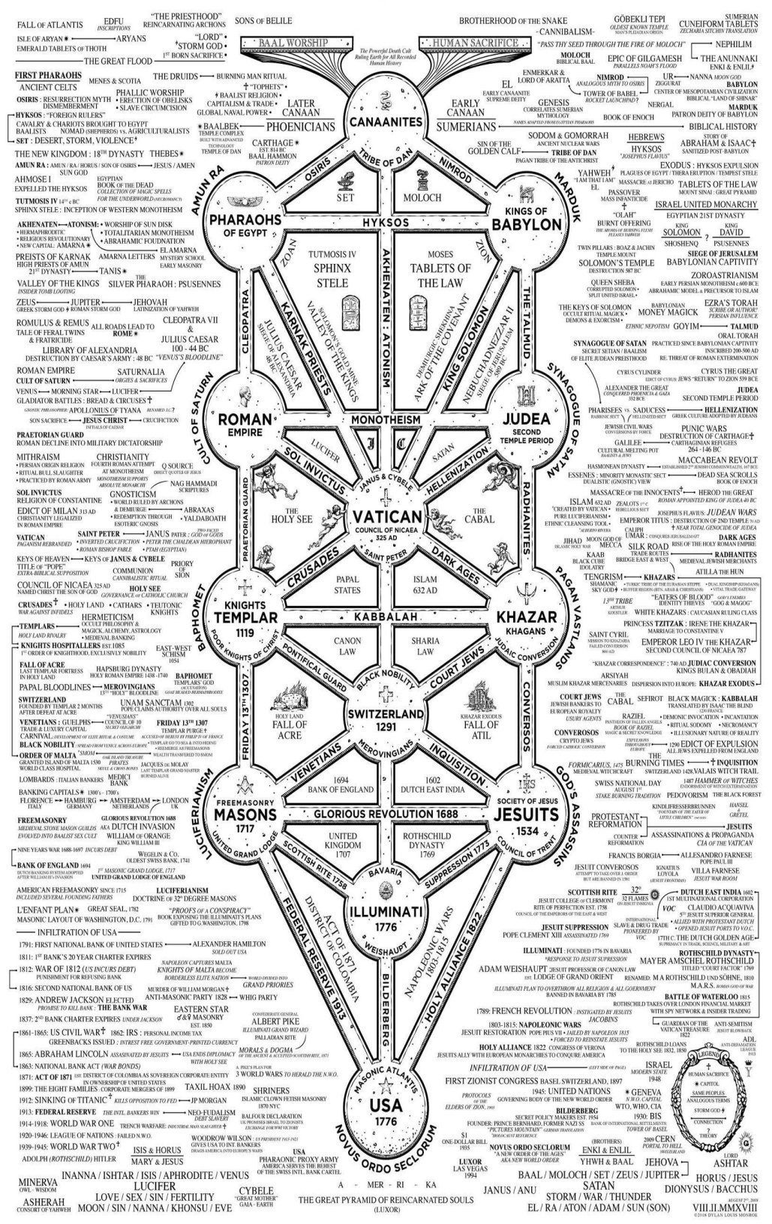



Go to http://www.energyenhancement.org

for 42 Free –On Sign-Up - Energy Enhancement Books and Energy Enhancement Against Satanism Books.
To defeat Evil, you need to up your game.
Learn the Energy Enhancement Meditation Course by Video or Live in Iguazu.
THE ENERGY ENHANCEMENT FOUR LEVEL VIDEO MEDITATION COURSE IS THE ONLY SOLUTION
Here's EXACTLY what you get with the Four Levels of Energy Enhancement Plus the Essential Level 0 support Package for 12 Months - Over 75 Hours of Incredible Teachings by Satchidanand which will enable you to Remove All your Energy Blockages - to Power Up!! To Feel Better, To Become What You Were Born to Be!!
Not so Expensive, Incredible Value!! For Total Life Performance!! For the Removal of All Energy Blockages!! Incredible Savings!
Over several months, in Easy, Bite Sized Chunks, You will learn how Simple it is, to remove All your Energy Blockages.
Incredible, Easy Paced, Full Tuition, with the Level 0 Support Package for Each of the Four Levels of Energy Enhancement!

Energy Enhancement LEVEL 1 Meditation is Included in this course! Immortality - Activate the Antahkarana! Gain Infinite Energy from the Chakras above the Head - Power UP!! Open Your Third Eye, Gain Super Samadhi Kundalini Alchemical VITRIOL Energy. Ground All Negative Energies. Learn Super Strong Psychic Protections in Preparation for the Seven Step Process to totally remove Blockages of Level 2. Access Quantum Immortality - Level 1 - 25 hours of video tuition http://www.energyenhancement.org/Level1.htm
Initiation 1 Meditation
Initiation 2 The Kundalini Kriyas - The 5 Taoist Circulations of the Qi, Energy Orbits, Energy Circulation
Initiation 3 The Kundalini Kriyas - Alchemical VITRIOL to Ground Negative Energies
Initiation 4 The Kundalini Kriyas - The God Connection to Infinite Energy
Initiation 5 Open the Third Eye, Open the Heart, Achievement of Everything you Want.
Initiation 6 Psychic Protection against Attack - Power Towers
Initiation 7 Psychic Protection against Attack - Pyramid Protection
Initiation 8 Psychic Protection against Attack - The Merkaba

After Level 1 we utilise the Energy Enhancement Seven Step Process to remove all Energy Blockages to our eyes, to our Third Eyes, to see, to access the Infinite positive flow of Spiritual Energy which descends like the dew from Heaven above upon it's place beneath.
It is twice blessed.
First by he who gives.
And then by he who receives.
And, as we receive with Energy Enhancement Meditation such an Infinite supply of positivity, of Infinite positive Energy from the Infinite Chakras above the head, and as it descends I promise you the most intense emotion you have ever experienced - 24 hours a day, every day!
Energy Enhancement testimonials http://www.energyenhancement.org/page17.htm

Energy Enhancement LEVEL 2 - The Energy Enhancement Seven Step Process to Totally Remove Energy Blockages, Totally Remove All Problems, Totally Remove Negative Emotions, Heal Your DNA, Remove your Karma - OPEN YOUR LIFE!! http://www.energyenhancement.org/Level2.htm
Initiation 1 The Seven Step Process to Remove Blockages.
Initiation 2 Removing Bodily Disease and Pain
Initiation 3 Heal your DNA
Initiation 4 Remove Energy Blockages from the Aura
THE KARMA CLEANING PROCESS
Initiation 5 Remove Energy Blockage Karma From Your Time in the Womb
Initiation 6 Remove Energy Blockage Karma From Your Current Life
Energy Enhancement testimonials http://www.energyenhancement.org/page17.htm

Energy Enhancement LEVEL 3 - Eliminate even Deeper Energy Blockages - The Removal of Strategies. Quantum Integration. The Karma Cleaning Process to Totally Eliminate All Your Karma, all your Trauma, all your Energy Blockages from All your Past Lifetimes!!
http://www.energyenhancement.org/Level3.htm
Here we are talking Zen Master Hogen.
He said, "By Meditating we can change our messy life painting into a clean white sheet again."
Here he is saying that Meditation can with Intensity of Feeling, ground all the negativity, all the negative emotions, all the energy blockages attached to your memories that ever happened to you in this lifetime
He said, "I spent all my previous lifetimes making Guiness. Now in this lifetime I am drinking all the Guiness!"
Here he is saying that with Passionate Energy Enhancement Samyama Meditation can ground all the negativity, all the negative emotions, all the energy blockages attached to your memories that ever happened to you in all your previous lifetimes.
If you can use Energy Enhancement Meditation to Ground all that negative energy from your past, to remove those dense, deep, energy blockages not only from this lifetime, but from all your previous lifetimes...
Can you Imagine what that will Feel Like?
Today’s a brand new day!!

THE KARMA CLEANING PROCESS CONTINUES
Initiation 1 Remove Energy Blockage Karma From All Your past Lives
Initiation 2 Remove Energy Blockage Karma From Your Future Lives
Initiation 3 Remove Energy Blockage Inner Children
Initiation 4 Remove Energy Blockage Vampire Strategies
Initiation 5 Remove Energy Blockage Negative Emotions
Initiation 6 The Seven Step purification of talents and the creation and increase of talents
Initiation 7 Removing Energy Blockage Vows from Past Lifetimes
Initiation 8: The Achievement of all your Goals and Ambitions using Energy Enhancement Samyama
Initiation 9 Removing the Energy Blockages from Daily Life Illogical Actions and Driven Emotions.
Energy Enhancement testimonials http://www.energyenhancement.org/page17.htm

Energy Enhancement LEVEL 4 - Stop the Suck!! Heal All your Relationships!! Find Your Twin Flame!! MASTER ENERGY CONNECTIONS AND RELATIONSHIPS, THE PSYCHIC SEXUAL CONNECTION
http://www.energyenhancement.org/Level4.htm
Initiation 1 - Removing Addictions - Food, Alcohol, Smoking, Sex.
Initiation 2 Cleaning Energy Connections - Cutting Energy Connections and Re-connecting Energy Connections - Friends, Children, Partner, Mother, Father - Moving All Relationships to a Higher Level.
Initiation 3 Cutting Energy Connections and Re-connecting Energy Connections - Moving All Relationships to a Higher Level.
Initiation 4 Healing the Soul Connection of Others
Initiation 5 Healing the Psychic Sexual Connection
Initiation 6 Removing the Energy Blockages at the other End of the Connection in People you Connect to - Healing Relationships, Healing Clients.
Initiation 7 Ceremonies and Meditation Groups - Using the Energy of the Higher Heart, The Heart Center in the Head, Prajna Paramita, - The Soul and the Monad Itself, for the Healing of Groups, Organizations and the World.
Energy Enhancement testimonials http://www.energyenhancement.org/page17.htm


THE YOGA SUTRAS OF PATANJALI BY SWAMI SATCHIDANAND - DOWNLOAD HERE..
http://www.energyenhancement.org/Sacred-Energy/yoga-sutras-of-patanjali-book/Energy-Enhancement-Yoga-Sutras-of-Patanjali.pdf
SUPER ENERGY AND SACRED SYMBOLS
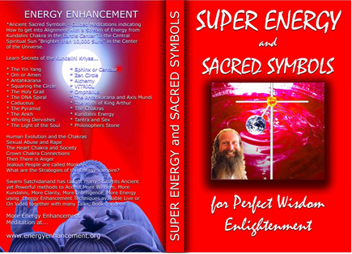
*THE ENERGY ENHANCEMENT BOOK… Ancient Sacred Symbols - Guided Meditations indicating How to get into Alignment with a Stream of Energy from Kundalini Chakra in the Earth’s Center to the Central Spiritual Sun "Brighter than 10,000 Suns" in the Center of the Universe.
Learn Secrets of the Kundalini Kriyas... and more…
Swami Satchidanand has taught many Students Ancient yet Powerful methods to Access More Wisdom, More Kundalini, More Clarity, More Intelligence, More Energy using Energy Enhancement Techniques available Live or On Video together with many Talks, Books, Videos.
ENERGY ENHANCEMENT TWO – REMOVAL OF ENERGY BLOCKAGES, MANAGING ENERGY CONNECTIONS AND MASTERY OD RELATIONSHIPS
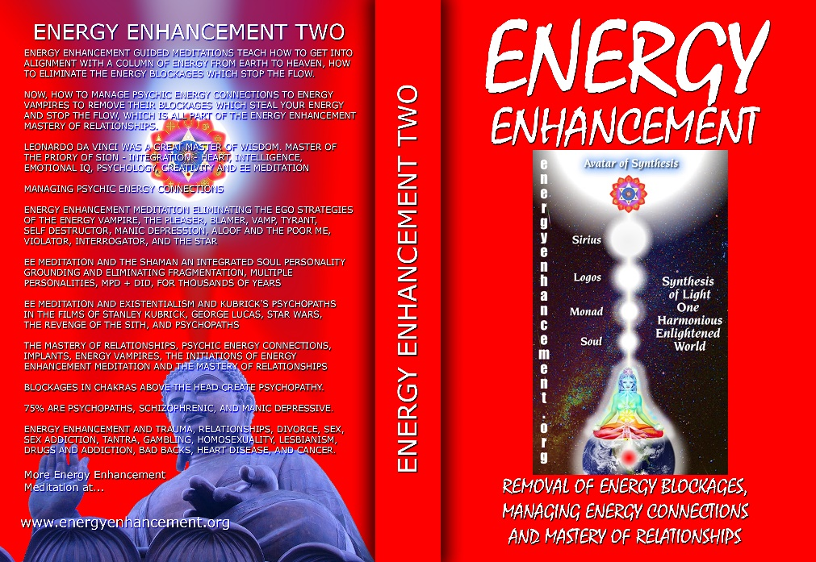
ENERGY ENHANCEMENT GUIDED MEDITATIONS TEACH HOW TO GET INTO ALIGNMENT WITH A COLUMN OF ENERGY FROM EARTH TO HEAVEN, HOW TO ELIMINATE THE ENERGY BLOCKAGES WHICH STOP THE FLOW.
NOW, HOW TO MANAGE PSYCHIC ENERGY CONNECTIONS TO ENERGY VAMPIRES TO REMOVE THEIR BLOCKAGES WHICH STEAL YOUR ENERGY AND STOP THE FLOW, WHICH IS ALL PART OF THE ENERGY ENHANCEMENT MASTERY OF RELATIONSHIPS.
LEONARDO DA VINCI WAS A GREAT MASTER OF WISDOM. MASTER OF THE PRIORY OF SION - INTEGRATION - HEART, INTELLIGENCE, EMOTIONAL IQ, PSYCHOLOGY, CREATIVITY AND EE MEDITATION MANAGING PSYCHIC ENERGY CONNECTIONS ENERGY ENHANCEMENT MEDITATION ELIMINATING THE EGO STRATEGIES OF THE ENERGY VAMPIRE, THE PLEASER, BLAMER, VAMP, TYRANT, SELF DESTRUCTOR, MANIC DEPRESSION, ALOOF AND THE POOR ME, VIOLATOR, INTERROGATOR, AND THE STAR
EE MEDITATION AND THE SHAMAN AN INTEGRATED SOUL PERSONALITY GROUNDING AND ELIMINATING FRAGMENTATION, MULTIPLE PERSONALITIES, MPD + DID, FOR THOUSANDS OF YEARS
EE MEDITATION AND EXISTENTIALISM AND KUBRICK'S PSYCHOPATHS IN THE FILMS OF STANLEY KUBRICK, GEORGE LUCAS, STAR WARS, THE REVENGE OF THE SITH, AND PSYCHOPATHS
THE MASTERY OF RELATIONSHIPS, PSYCHIC ENERGY CONNECTIONS, IMPLANTS, ENERGY VAMPIRES, THE INITIATIONS OF ENERGY ENHANCEMENT MEDITATION AND THE MASTERY OF RELATIONSHIPS
BLOCKAGES IN CHAKRAS ABOVE THE HEAD CREATE PSYCHOPATHY.
75% ARE PSYCHOPATHS, SCHIZOPHRENIC, AND MANIC DEPRESSIVE.
ENERGY ENHANCEMENT AND TRAUMA, RELATIONSHIPS, DIVORCE, SEX, SEX ADDICTION, TANTRA, GAMBLING, HOMOSEXUALITY, LESBIANISM, DRUGS AND ADDICTION, BAD BACKS, HEART DISEASE, AND CANCER.

Buy all Books and DVD’s at: amazon.com
www.energyenhancement.org
DVD 1 - KUNDALINI CHAKRA MEDITATION
HEART SUTRA – HIGHEST HEART OF WISDOM MEDITATION

*ENERGY ENHANCEMENT MEDITATION DVD 1… Guided Meditation to Access Kundalini Chakra, VITRIOL, The Philosopher’s Stone, Kriya Yoga and the Kundalini Kriyas.
Heart Sutra, All Enlightened Sages for Thousands of Years Live From the Highest Heart of Wisdom.

Buy all Books and DVD’s at: amazon.com
www.energyenhancement.org

DVD 2 - HIGHEST HEART OF GENIUS WISDOM MEDITATION

Guided Meditation to Access Higher Wisdom Chakras above the Head connecting you with the Higher Energies of Nirvana, God – Love, Wisdom, Genius, Integration and Peace and the Creation of the Antahkarana.
How this Guided Meditation is given in Secrets of Shakespeare, The Holy Trinity, The Holy Grail and the Sanskrit meaning of Satchidanand.
Swami Satchidananda has been teaching this Meditation to many students over the years and every one has had Shaktipat and increased Kundalini experiences of Chit Shakti together with increased feelings of Intelligence, Genius, Energy and Peace.
BOOK - GAIN SUPER ENERGY
ENERGY ENHANCEMENT LEVEL 1
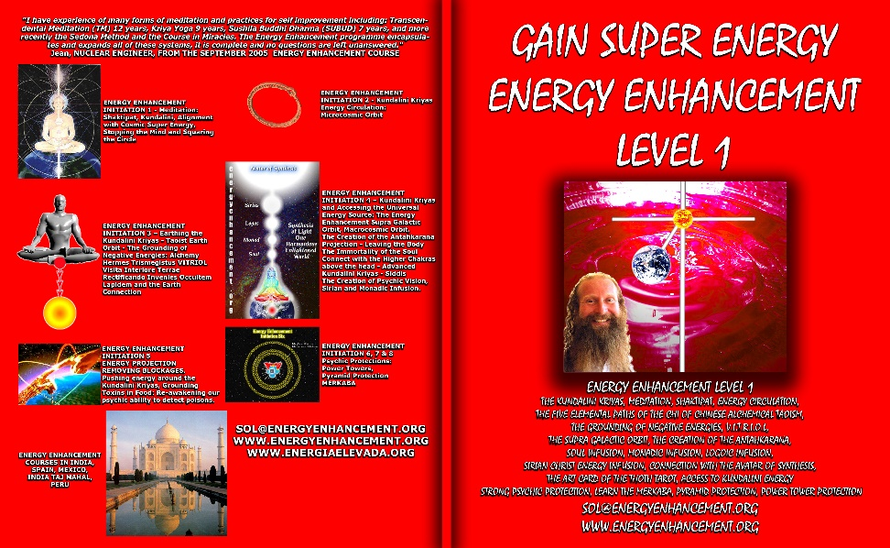
READ… The Kundalini Kriyas, Meditation, Shaktipat, Energy Circulation, The Five Elemental Paths of the Chi of Chinese Alchemical Taoism, The Grounding of Negative Energies, V.I.T.R.I.O.L., The Supra Galactic orbit, The Creation of the Antahkarana, Soul Infusion, Monadic Infusion, Logoic Infusion, Sirian Christ Energy Infusion, Connection with the Avatar of Synthesis, The Art Card of the Thoth Tarot, Access to Kundalini Energy Strong Psychic Protection, Learn the Merkaba, Pyramid Protection, Power Tower Protection.
Buy all Books and DVD’s at: amazon.com
www.energyenhancement.org
THE ENERGY ENHANCEMENT FOUR INITIATION DVD COURSE - THE ULTIMATE TECHNIQUES ON 15 DVDs
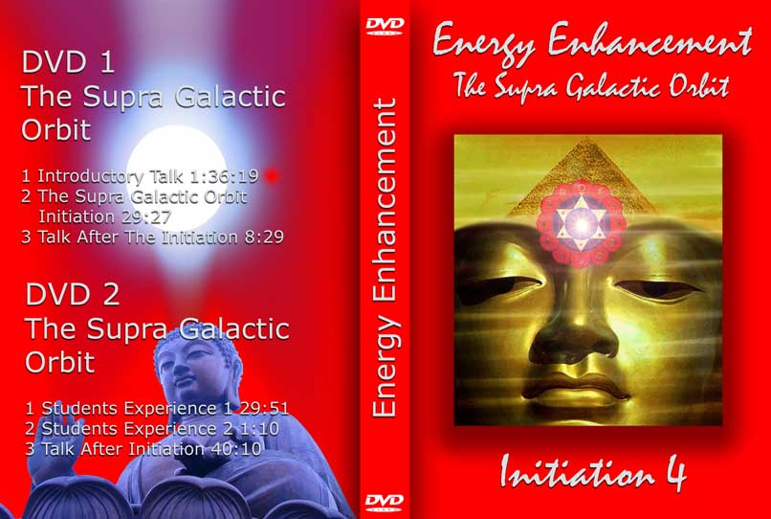
“I have experience of many forms of meditation and practices for self improvement including: Transcendental Meditation (TM) 12 years, Kriya Yoga 9 years, Sushila Buddhi Dharma (SUBUD) 7 years, and more recently the Sedona Method and the Course in Miracles. The Energy Enhancement programme encapsulates and expands all of these systems, it is complete and no questions are left unanswered.”
JEAN, NUCLEAR ENGINEER, FROM SEPTEMBER 2005 ENERGY ENHANCEMENT COURSE
ENERGY ENHANCEMENT LIVE COURSES – WORLDWIDE
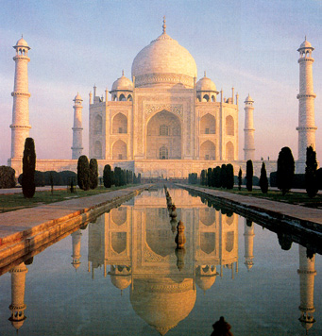
INDIA, 5 STAR INDIA TAJ MAHAL, SPAIN, MEXICO, PERU, ARGENTINA – MORE
Bookings: www.energyenhancement.org

EE LEVEL 1 POWER UP!! GAIN SUPER ENERGY http://www.energyenhancement.org/Level1.htm
EE LEVEL 2 ELIMINATE ENERGY BLOCKAGES http://www.energyenhancement.org/Level2.htm
EE LEVEL 3 CLEAN KARMA BLOCKAGES AND PAST LIFE KARMA BY TRANSMUTATION http://www.energyenhancement.org/Level3.htm
EE LEVEL 4 MASTER ENERGY CONNECTIONS AND RELATIONSHIPS http://www.energyenhancement.org/Level4.htm

Go to..
http://www.energyenhancement.org

For 52 Free..
- On Sign-Up - Energy Enhancement Books and Energy Enhancement Against Satanism Books.

To defeat Evil, you need to up your game.

Learn the Energy Enhancement Meditation Course by Video or Live in Iguazu.

ENERGY ENHANCEMENT MEDITATION
ENERGY ENHANCEMENT MEDITATION LEVEL 1 POWER UP!! GAIN SUPER ENERGY http://www.energyenhancement.org/Level1.htm
ENERGY ENHANCEMENT MEDITATION LEVEL 2 ELIMINATE ENERGY BLOCKAGES http://www.energyenhancement.org/Level2.htm
ENERGY ENHANCEMENT MEDITATION LEVEL 3 CLEAN KARMA BLOCKAGES AND PAST LIFE KARMA BY TRANSMUTATION http://www.energyenhancement.org/Level3.htm
ENERGY ENHANCEMENT MEDITATION LEVEL 4 MASTER ENERGY CONNECTIONS AND RELATIONSHIPS http://www.energyenhancement.org/Level4.htm



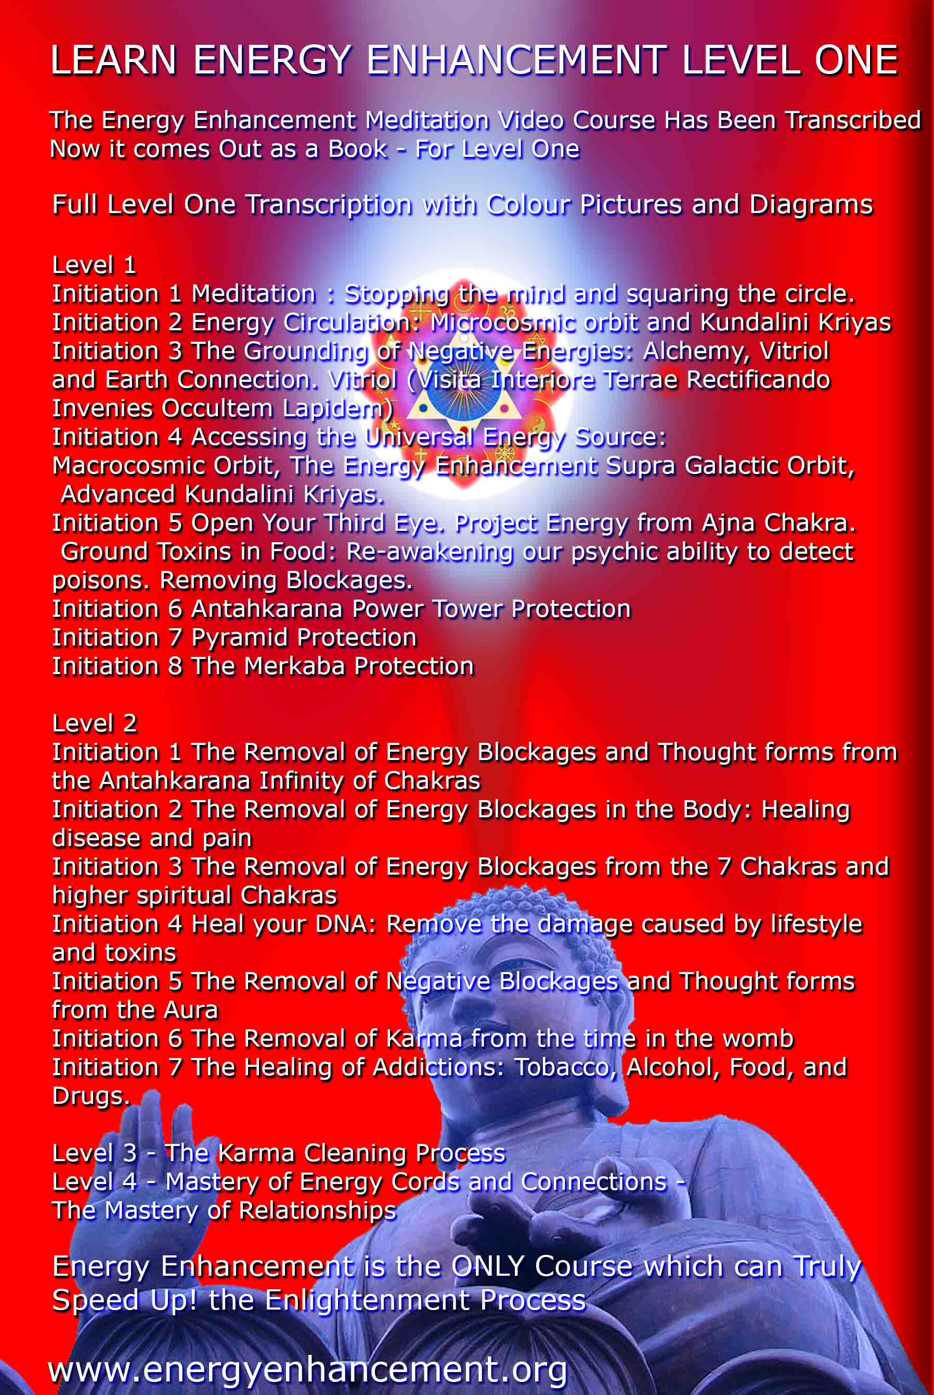

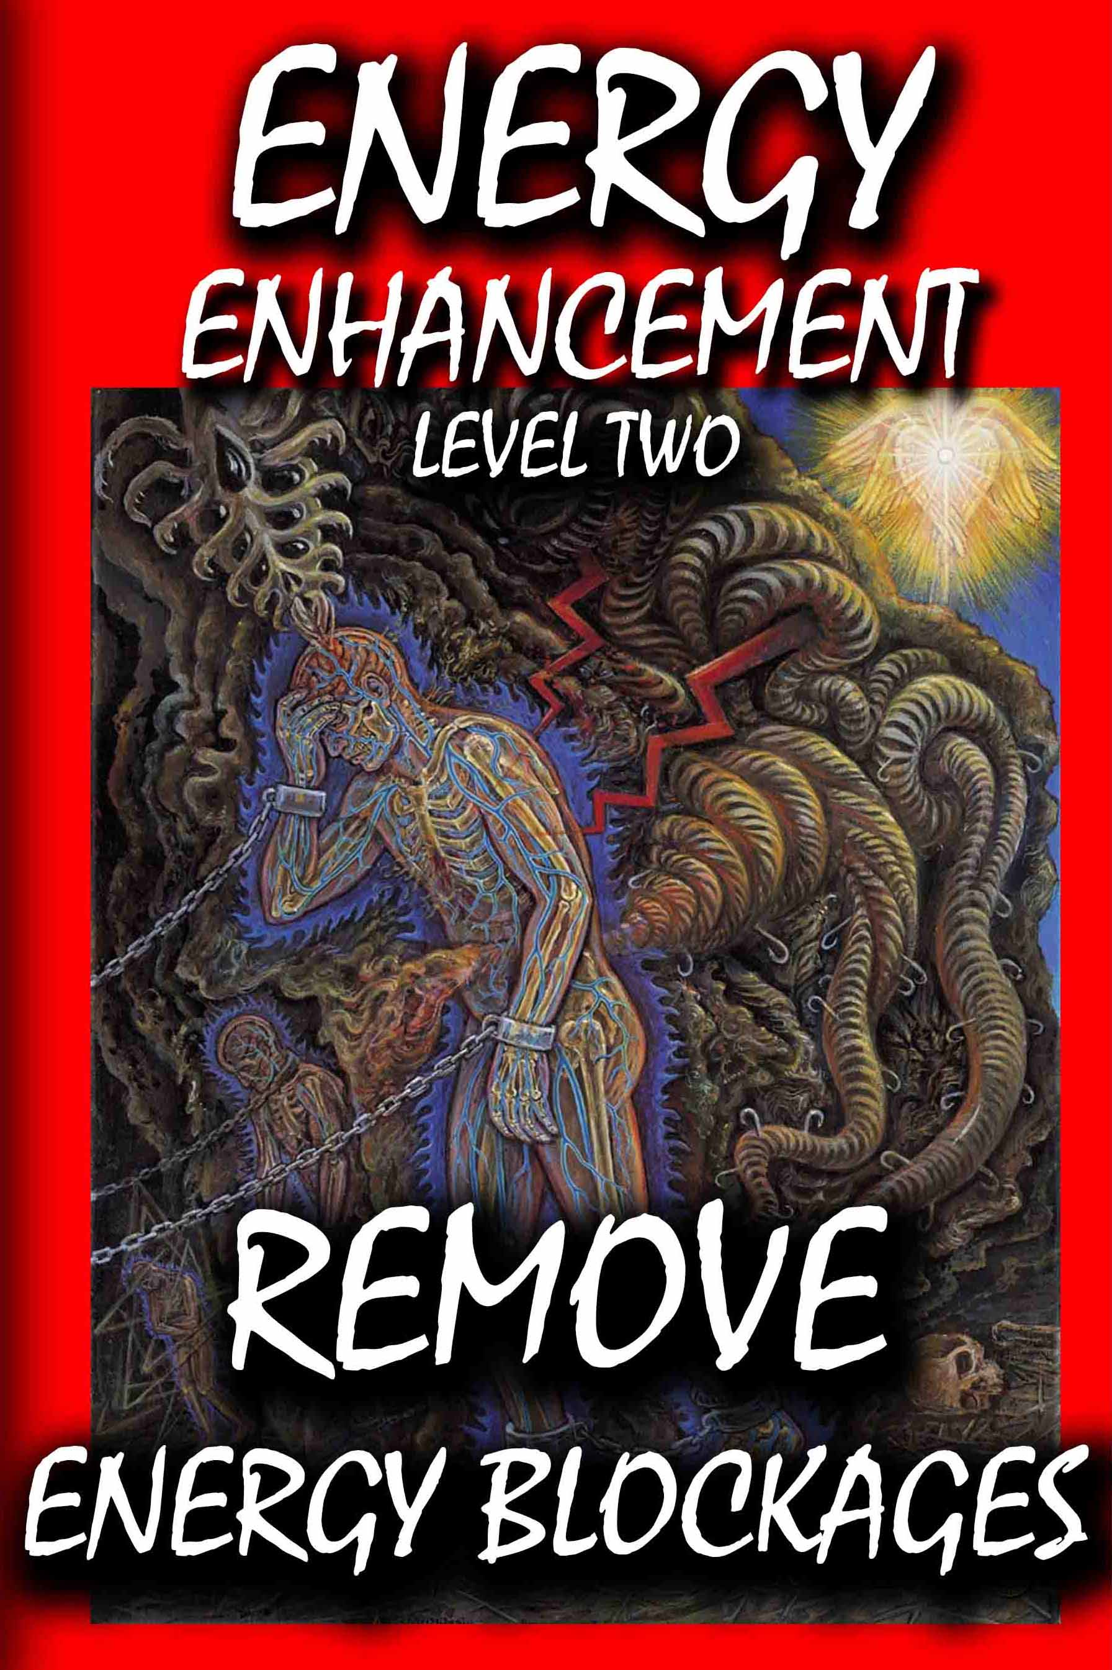



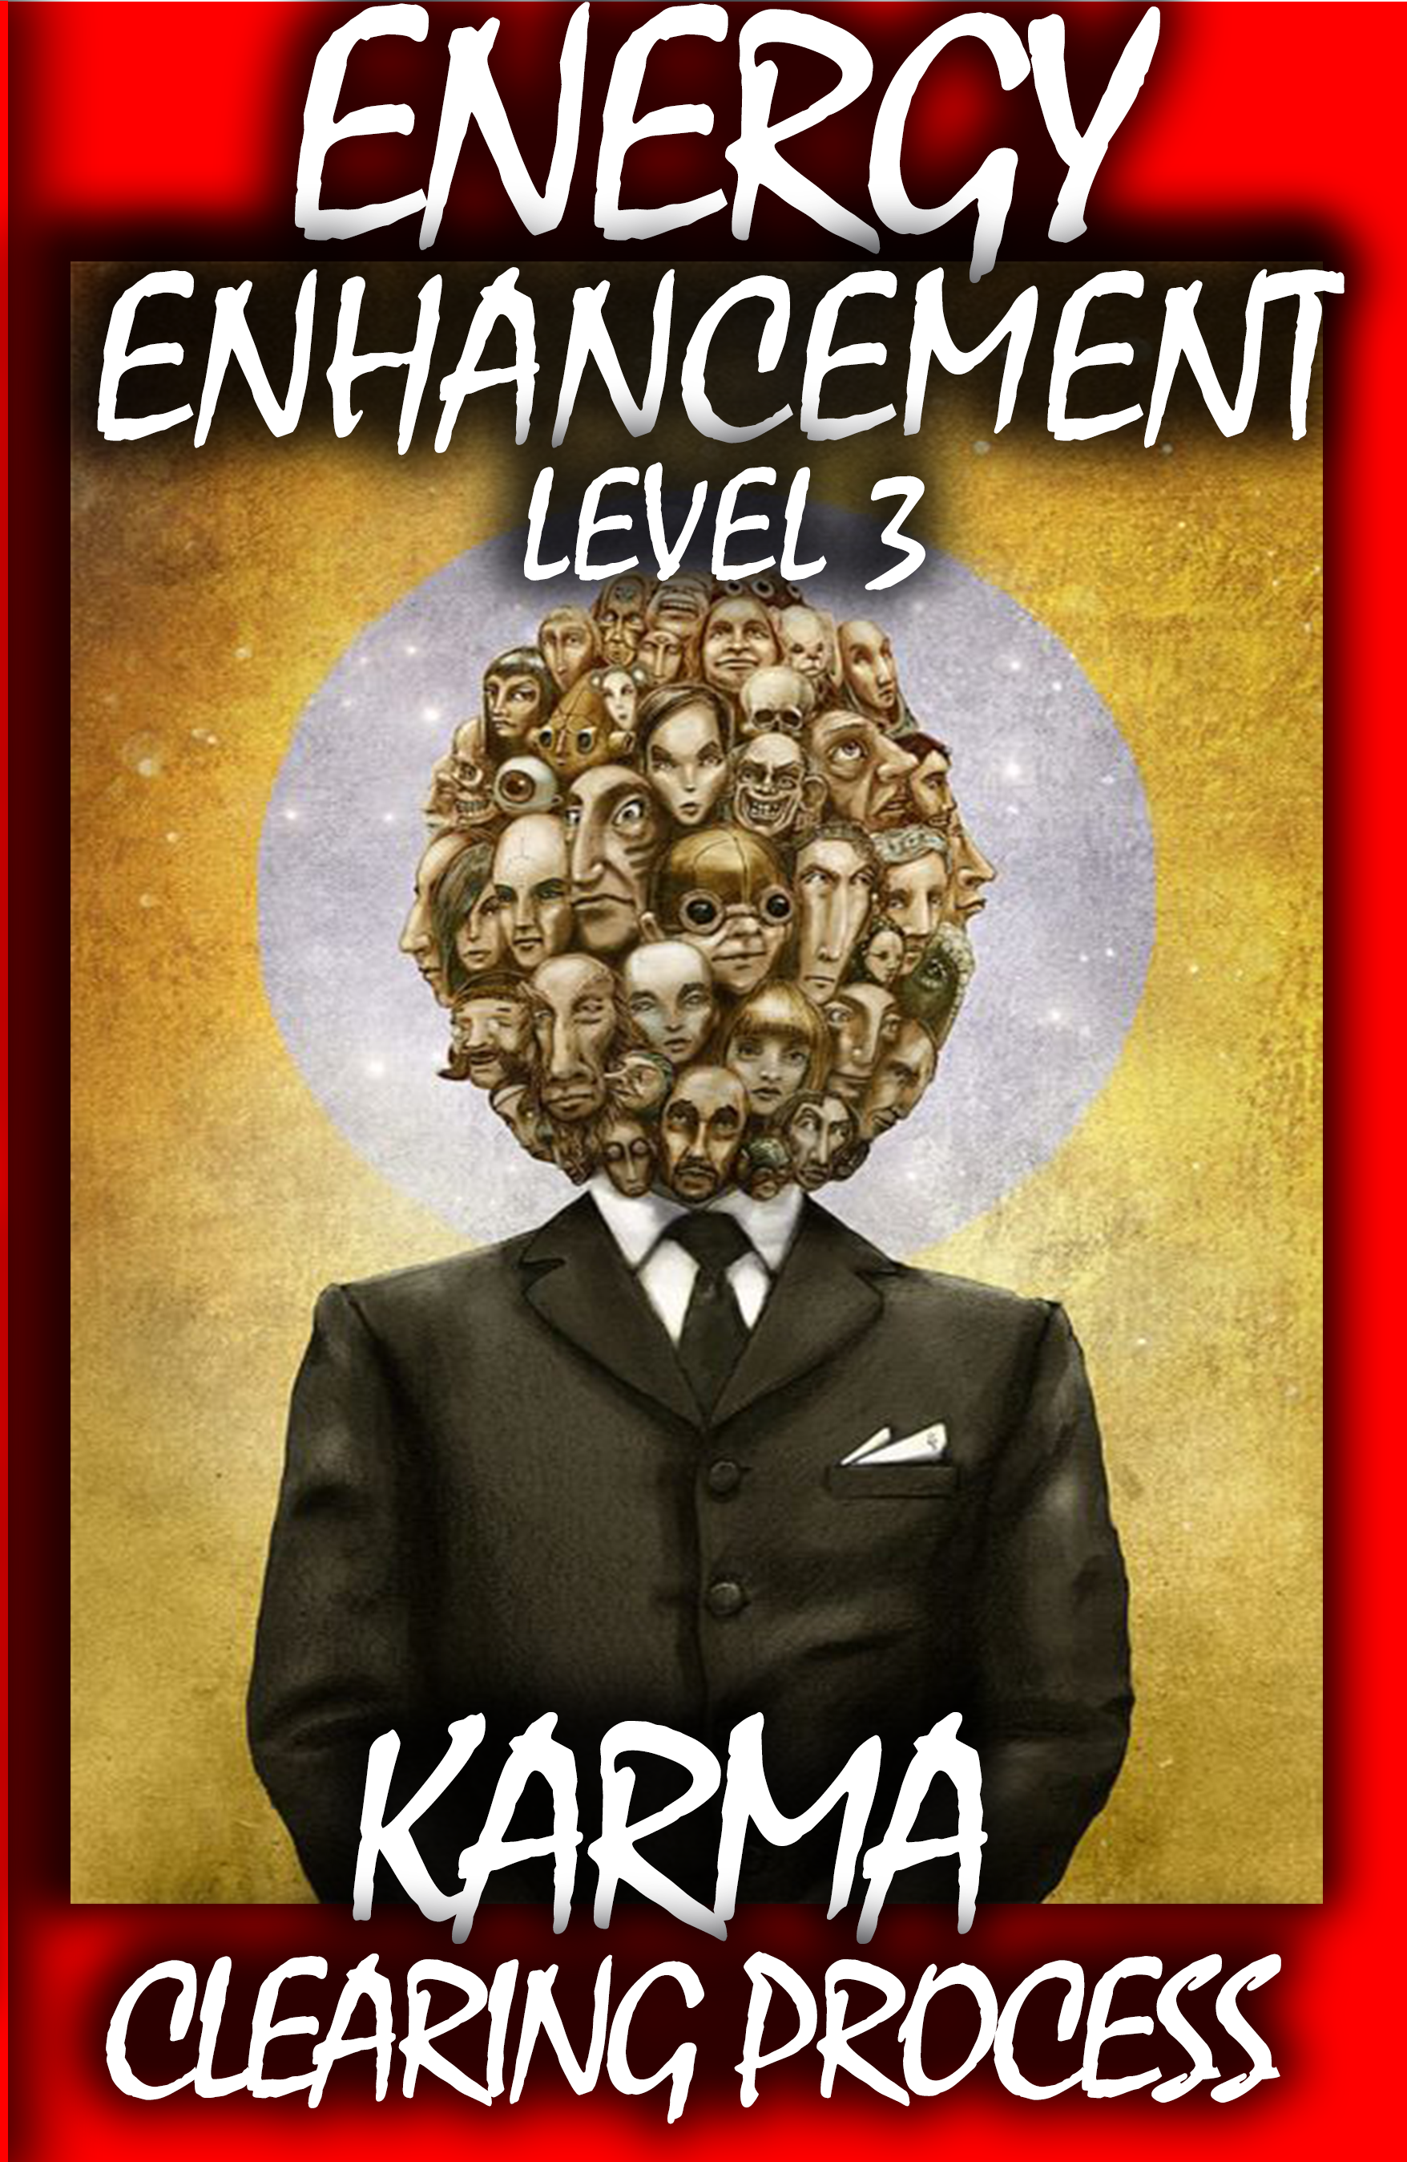



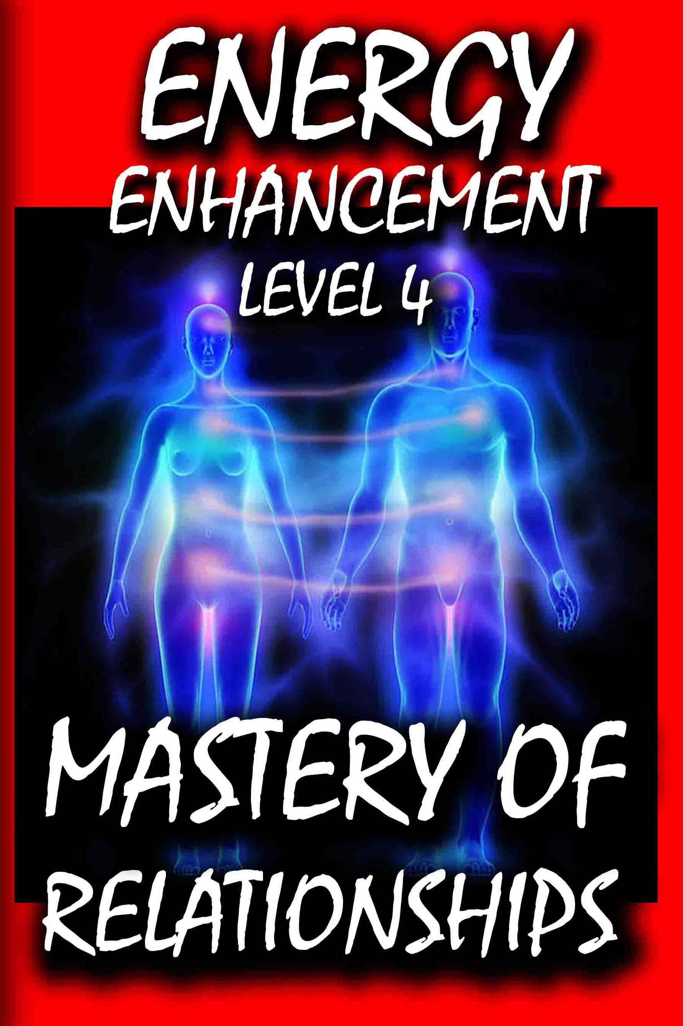

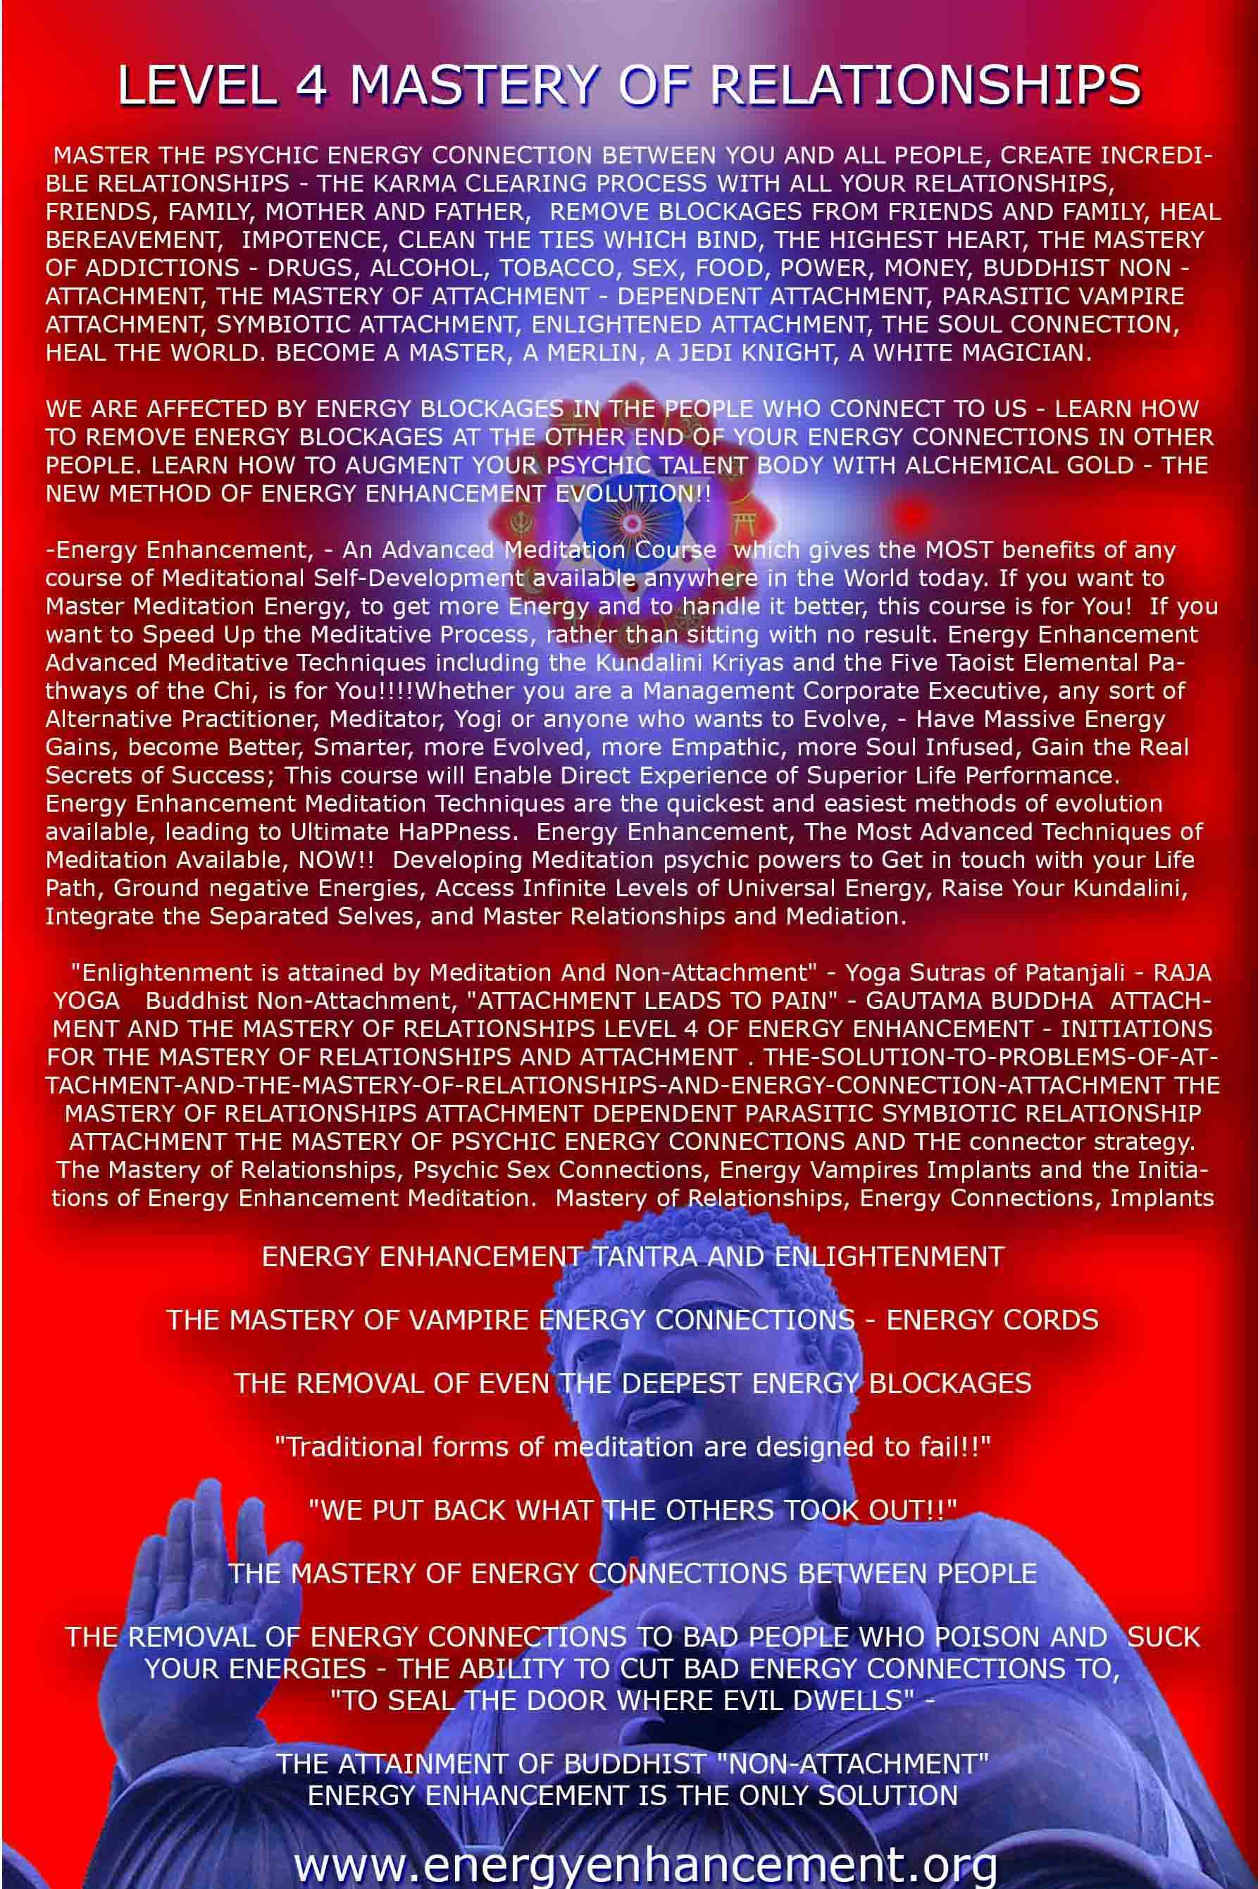

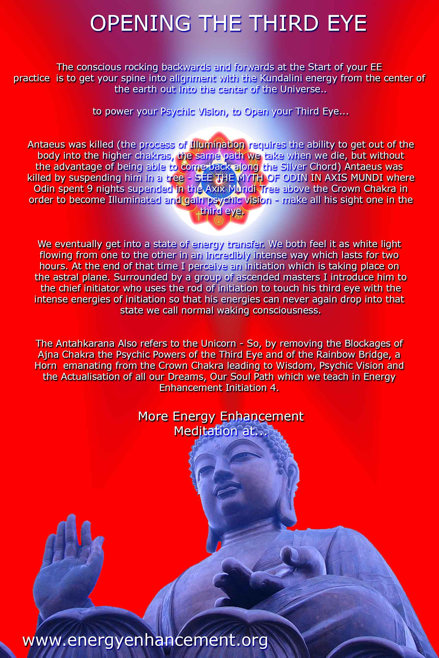


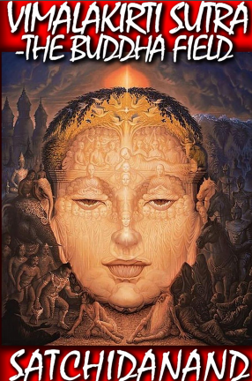

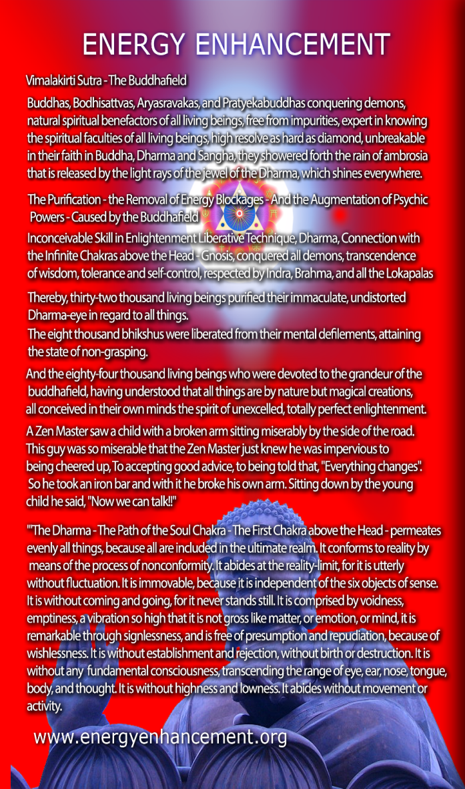
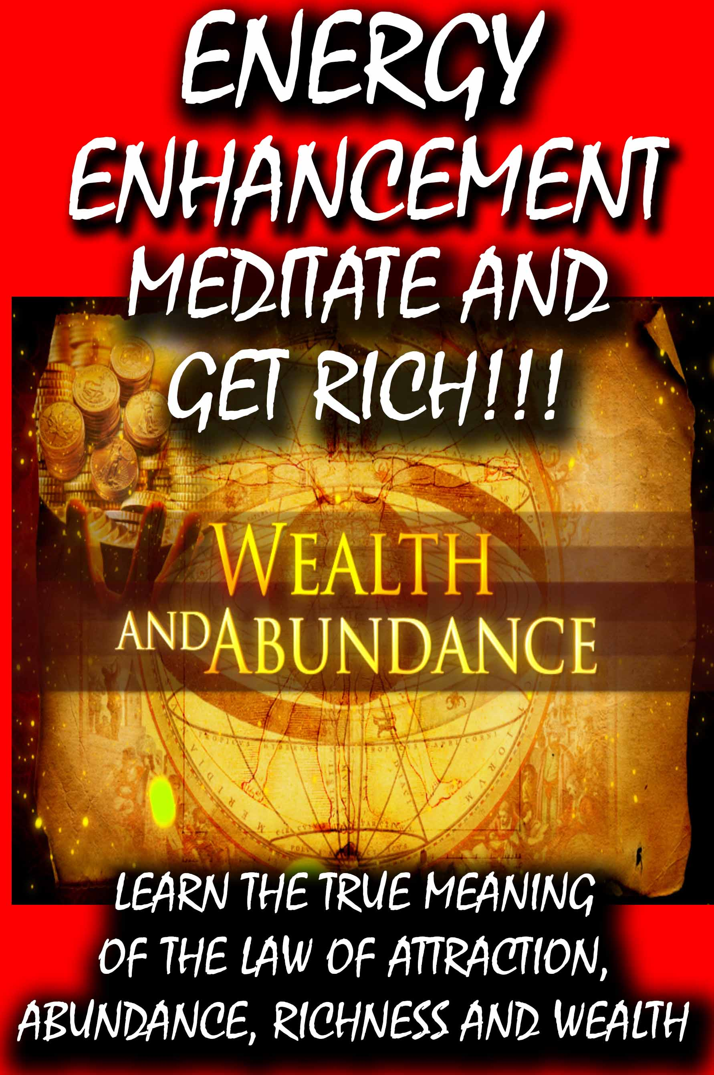
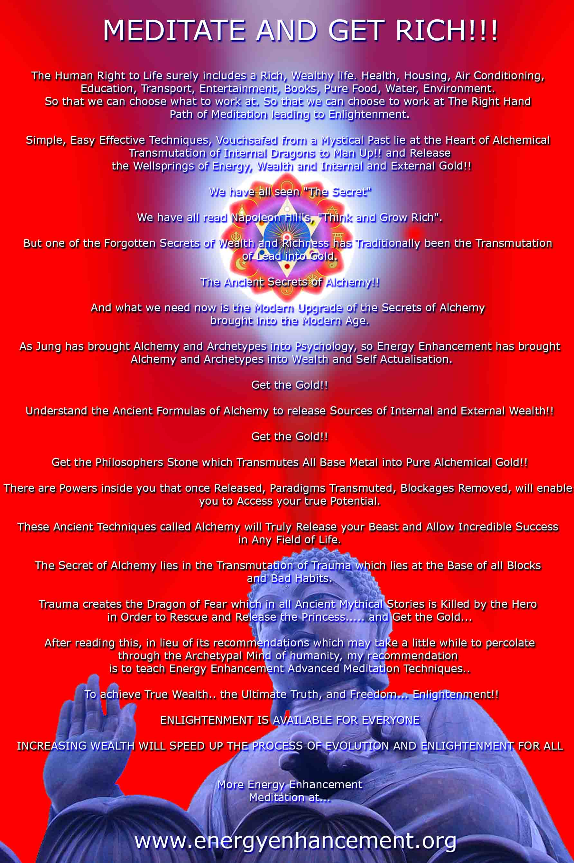
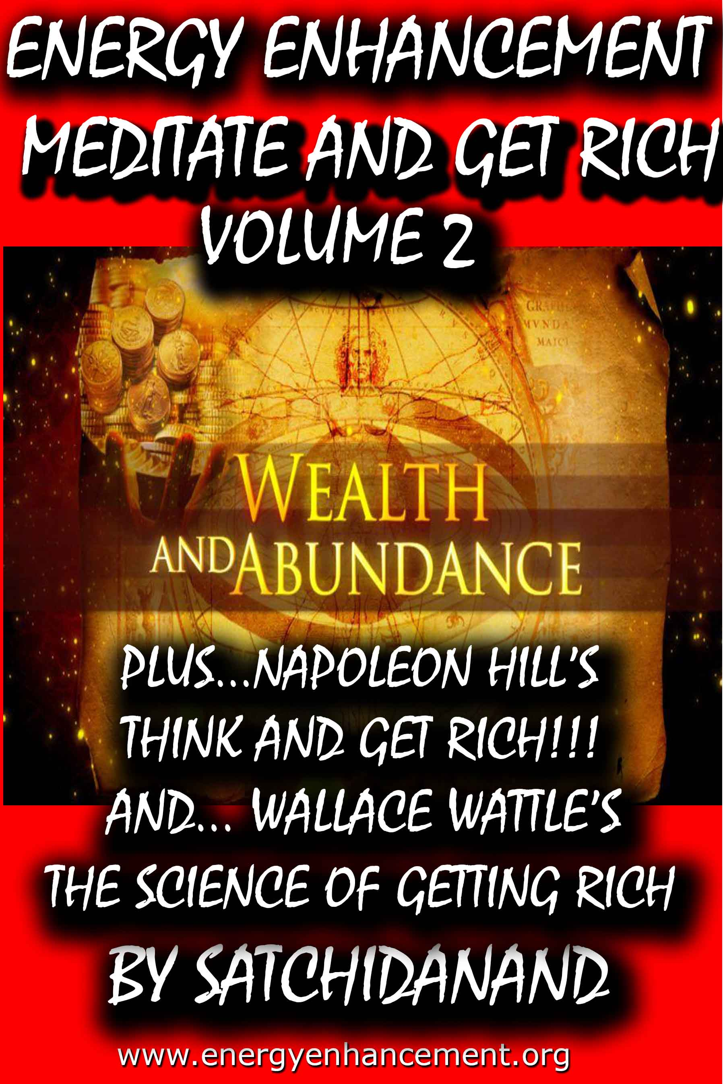
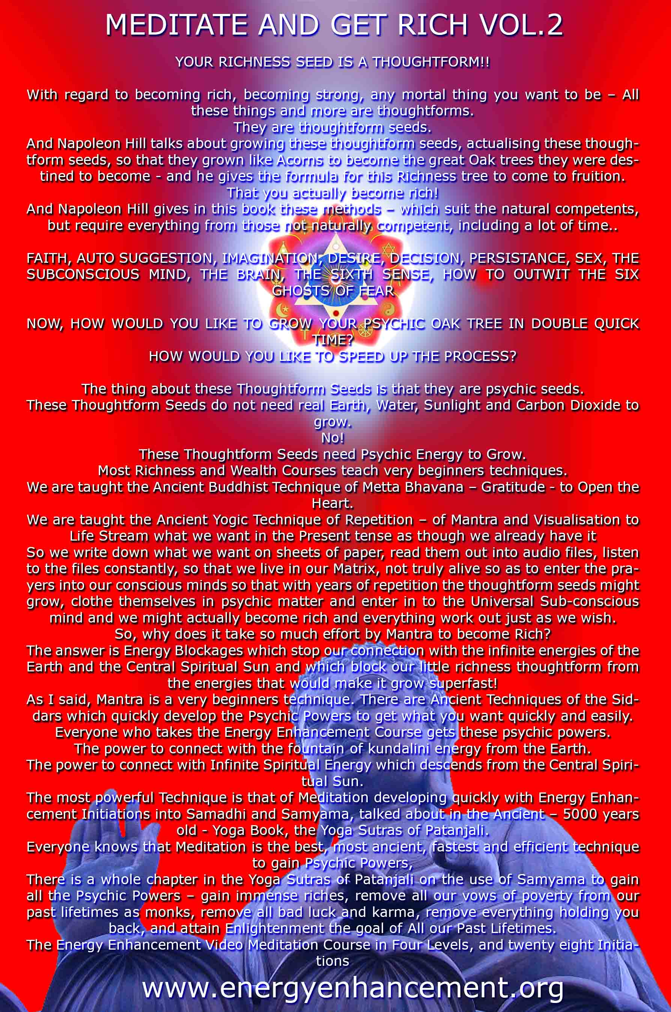

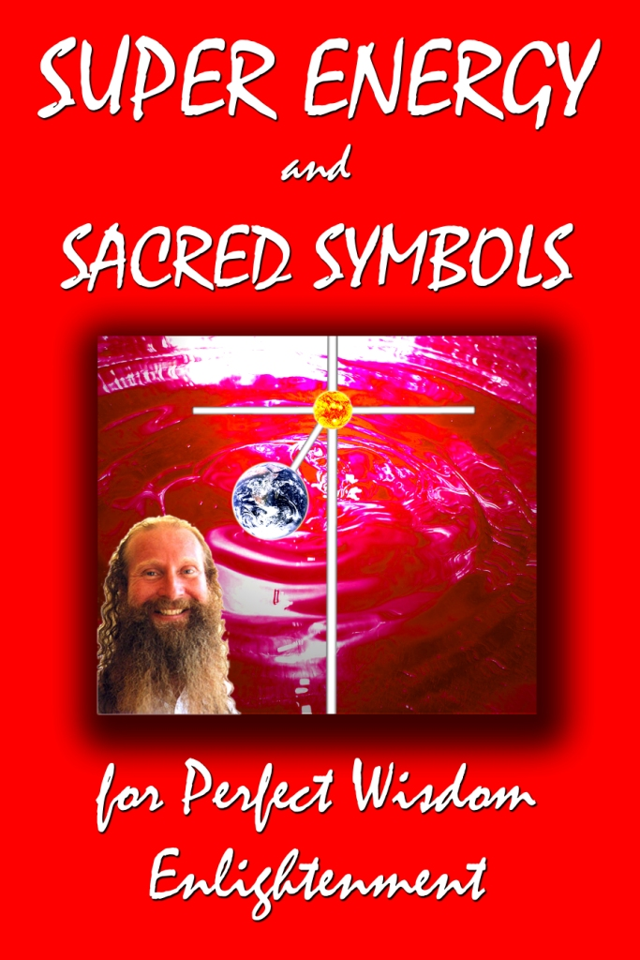

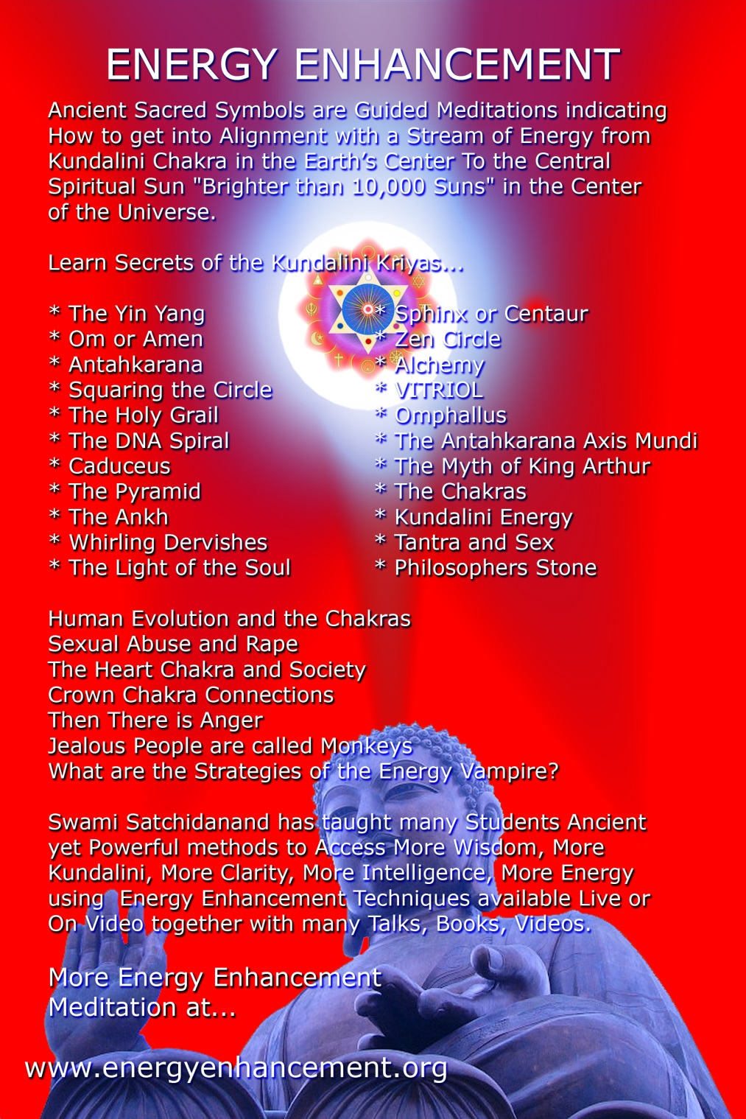

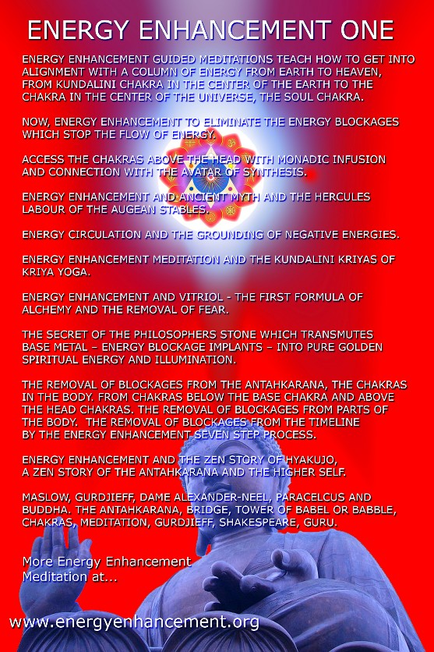
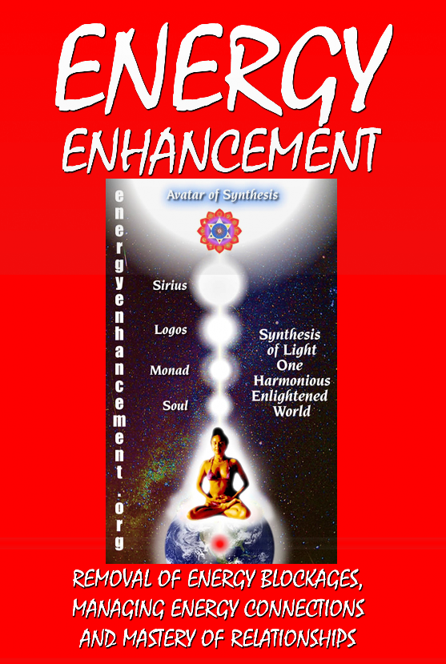
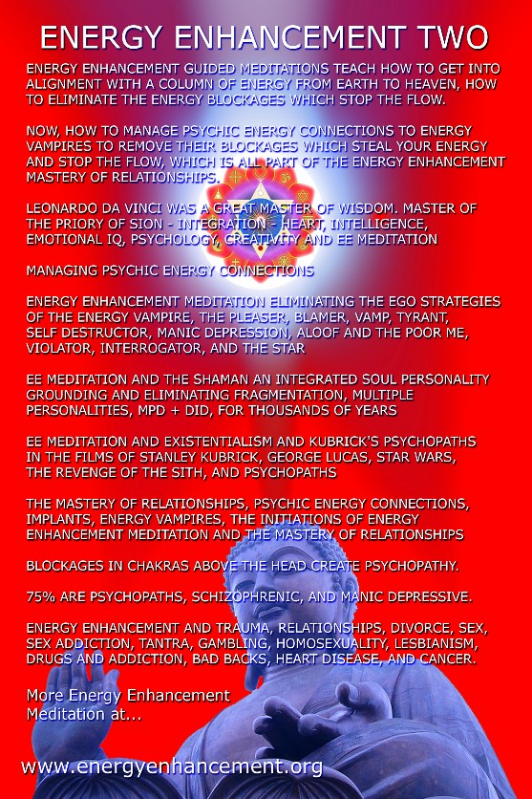
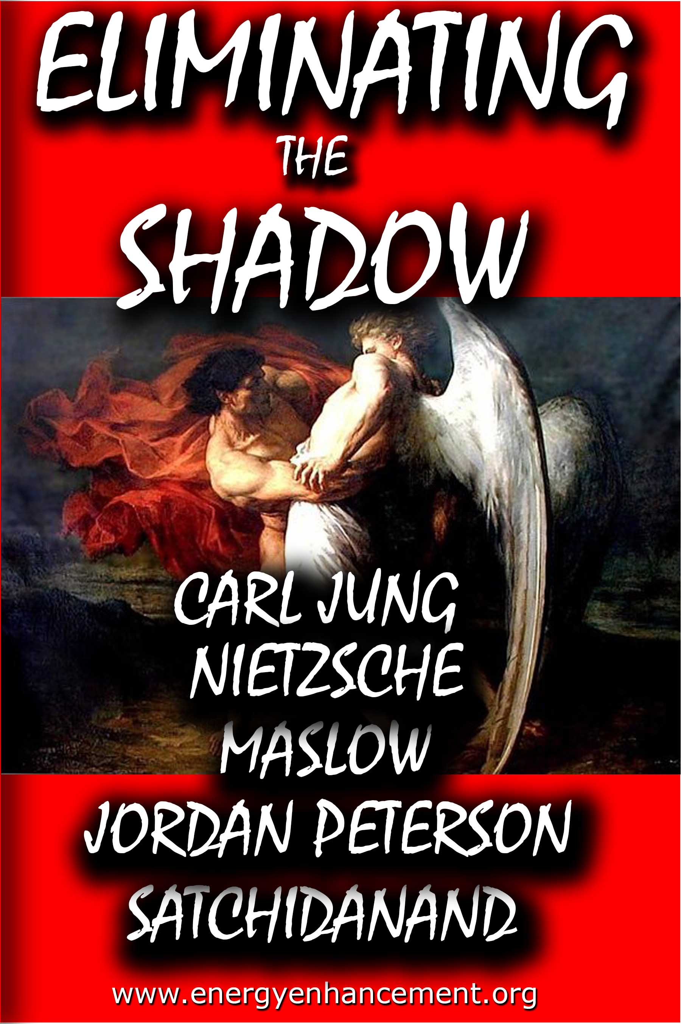
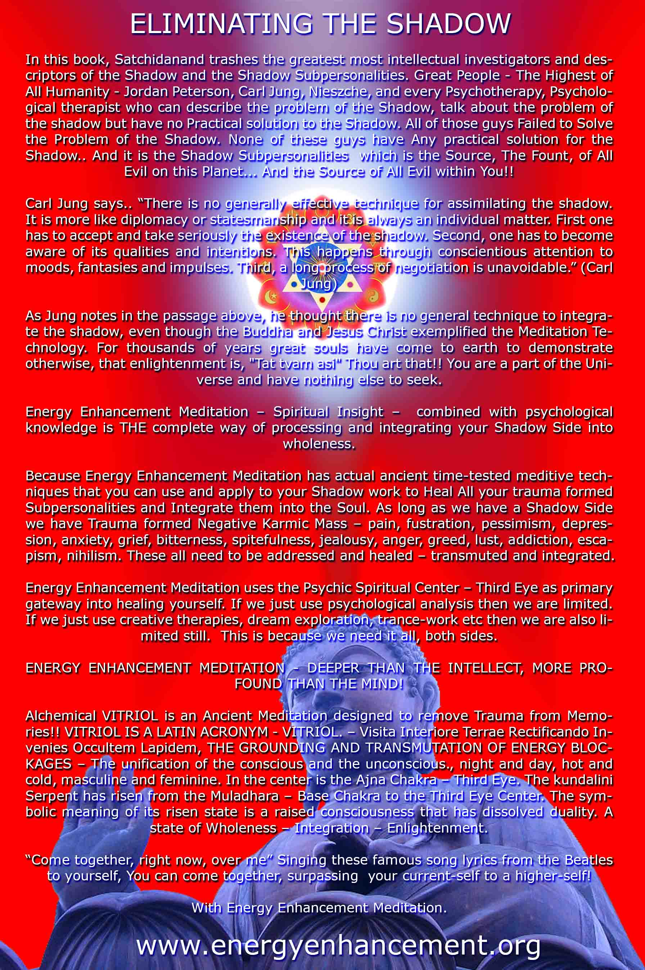

ENERGY ENHANCEMENT MEDITATION
ENERGY ENHANCEMENT MEDITATION LEVEL 1 POWER UP!! GAIN SUPER ENERGY http://www.energyenhancement.org/Level1.htm
ENERGY ENHANCEMENT MEDITATION LEVEL 2 ELIMINATE ENERGY BLOCKAGES http://www.energyenhancement.org/Level2.htm
ENERGY ENHANCEMENT MEDITATION LEVEL 3 CLEAN KARMA BLOCKAGES AND PAST LIFE KARMA BY TRANSMUTATION http://www.energyenhancement.org/Level3.htm
ENERGY ENHANCEMENT MEDITATION LEVEL 4 MASTER ENERGY CONNECTIONS AND RELATIONSHIPS http://www.energyenhancement.org/Level4.htm

