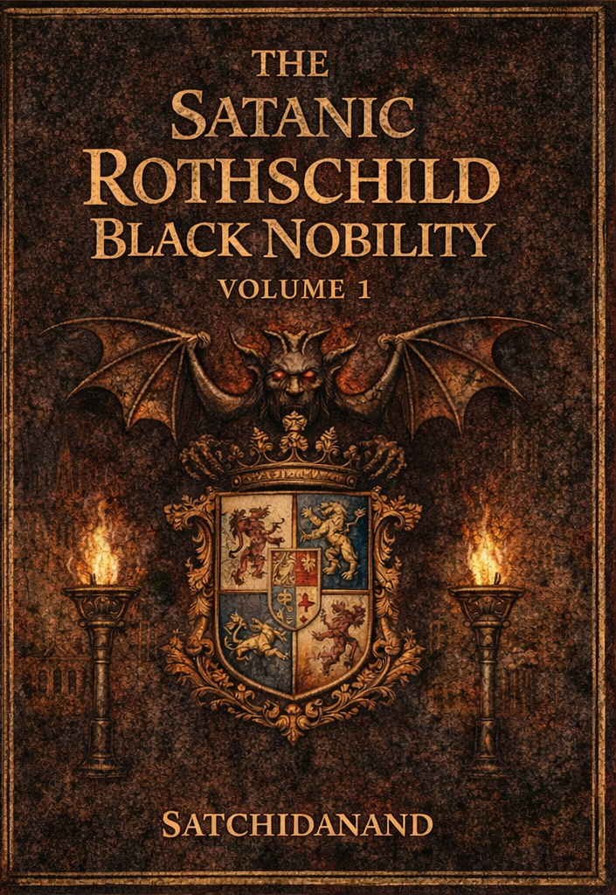
DEDICATION
With all Thanks, Love and Gratitude to Swami Devi Dhyani who make these books and the Energy Enhancement Streaming Video Meditation Course possible.
With all Thanks, Love and Gratitude to Devi Dhyani, my Mother and Father and to all my other Teachers, Theos Bernard, Sri Yogendra, Eric Berne, Gurdjieff, Father Bede Griffiths, Osho, Zen Master Hogen, Swami Sivananda, Swami Satchidananda, and all the other giants upon whose shoulders I stand - who made me able to be what… I AM – Swami Satchidanand

Copyright © 2026

[Satchidanand]

All rights reserved. This publication may be reproduced in whole or in part, by any person under fair use as long as we are referenced, without written permission of:
Swami Satchidanand

sol@energyenhancement.org

www.energyenhancement.org
https://eemeditationvideo.org/

https://againstsatanism.com/
https://against-satanism-video.com/

https://satchidanand.substack.com/
THE SATANIC ROTHSCHILD BLACK NOBILITY

VOLUME 1

Table of Contents

Satanic Mega-Trillionaire US $2,080 Trillion Phoenician Rothschilds Control the World through Vanguard Group and Blackrock 5

John Wick is a Metaphor for the Satanic Phoenician Empire and it's High Table of Satanic Phoenician Mega Trillionaires. 63

FINANCIALISATION and Satanic Phoenician Mega Trillionaire Central Banks? by Professor Richard A. Werner, D.Phil. - Improved and made better by Satchidanand 104

Rothschild, Trump, Tucker Carlson, Alex Jones, Joe Rogan, Dominic Cummings 163

TRUMP AND THE DEEP STATE SATANIC 2000 TRILLION DOLLAR ROTHSCHILD PHOENICIAN MEGA TRILLIONAIRES 195

THE WOLVES OF WALL STREET USE BLACK MAGIC 250

These Satanic Malthusians Demand Genocide 321

Alan Watt Recommended Book List 327

Satanic Bill Gates, Epstein Lover Bill Gates, Confesses To Conducting Illegal Human Medical Experiments In India
PROSECUTE THE ROTHSCHILDS, THE SATANIC PHOENICIAN MEGA TRILLIONAIRE, 3000 TRILLION DOLLAR ROTHSCHILDS! NOT JUST MINIONS!
Satchidanand
Dec 05, 2024

The Satanic Phoenician Mega Trillionaire Oligarch Ruling Class "Strategy Of Tension" and Trump…

Satchidanand
·
November 23, 2024
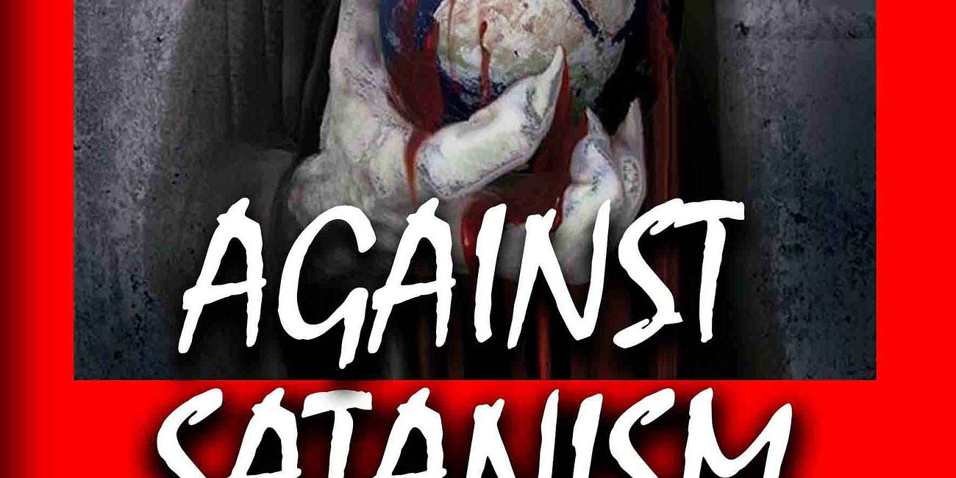
The Satanic Phoenician Mega Trillionaire Oligarch Ruling Class "Strategy Of Tension" and Trump…

Read full story

In George Orwell’s book 1984, the state of Oceania is always in a state of war with Eurasia and Eastasia. The Party controls all of the media and continuously spreads stories of external and internal threats to create fear and hatred within the populace to keep them compliant. We are not far away from such a reality in the present, most especially in the US with the hold of the oligarchy over the state and media, practising what was termed as a “Strategy of Tension” within Italy in the post-WW2 decades. This will not change with a Trump administration (or a Starmer one as we have seen, or with any other Western nation); the only change will be that some of the “enemies” may be different.
British Empire Agent George Orwell whose father ran the Opium Production from Bengal in India to China.
British Empire Agent George Orwell who went to Sodomite Central Eton where he was tutored by Satanist Agent Aldous Huxley who ran MKUltra in Hollywood and the introduction of drugs into the USA with his, “Doors of Perception” with Mescaline and LSD in the 1960’s, who wrote with his Eugenic Brother, Head of the United Nations WHO, Julian Huxley, the blueprint for the future, “Brave New World”.
George Orwell, who tortured terrorists in Burma like with the rats in Room 101 in 1984.
George Orwell who was head of the Fabian Socialists who ran the Brutish Empire.
George Orwell who was Chief of British Empire Propaganda for WW2.
George Orwell who wrote 1984 to remove any hint of Satanism, the Satanic Religion and Demons from the Dictators of the world, to hide the Satanic Religion of Satanism which infuses the Brutish Empire…

SATANIC PSYCHOPATH HUMAN SACRIFICE RITUAL TRAINING - RONALD BERNARD… I WAS IN TRAINING AND I FAILED

Satchidanand
·
November 18, 2024
RONALD BERNARD… I WAS IN TRAINING TO BECOME A PSYCHOPATH, AND I FAILEDSatchidanand’s Against Satanism Newsletter is a reader-supported publication. To receive new posts 55 free books and support my work, consider becoming a free or paid subscriber.
Read full story


Only Shakespeare talked of Satanism infusing bloody Dictator Macbeth using the Three Witches…
From the pricking of my thumbs
Something wicked this way comes…
Hubble Bubble Toil and Trouble
Fire Burn and Cauldron Bubble
When shall we three meet again
In thunder, lightning or in Rain
Upon the Heath!
Macbeth!
Shakespeare knew that the foundation of the Totalitarian State was Satanism!
I’ll Gild the faces of the Grooms withal
So it shall seem their Guilt!
Vaulting Ambition
Out! Out! Damned Spot! which Shall turn all the Seas Incarnadine!
Yet I have heard differently about Donald Trump being a real savior of the World.
I have heard that within Mar al Lago Trump is talking with the head of NATO about the ending of the Ukraine war.
As well as the head of NATO, Trump is talking with all the interested parties, Putin, Zelensky, et al and has been for several days hoping to end this corruption even before he becomes President.
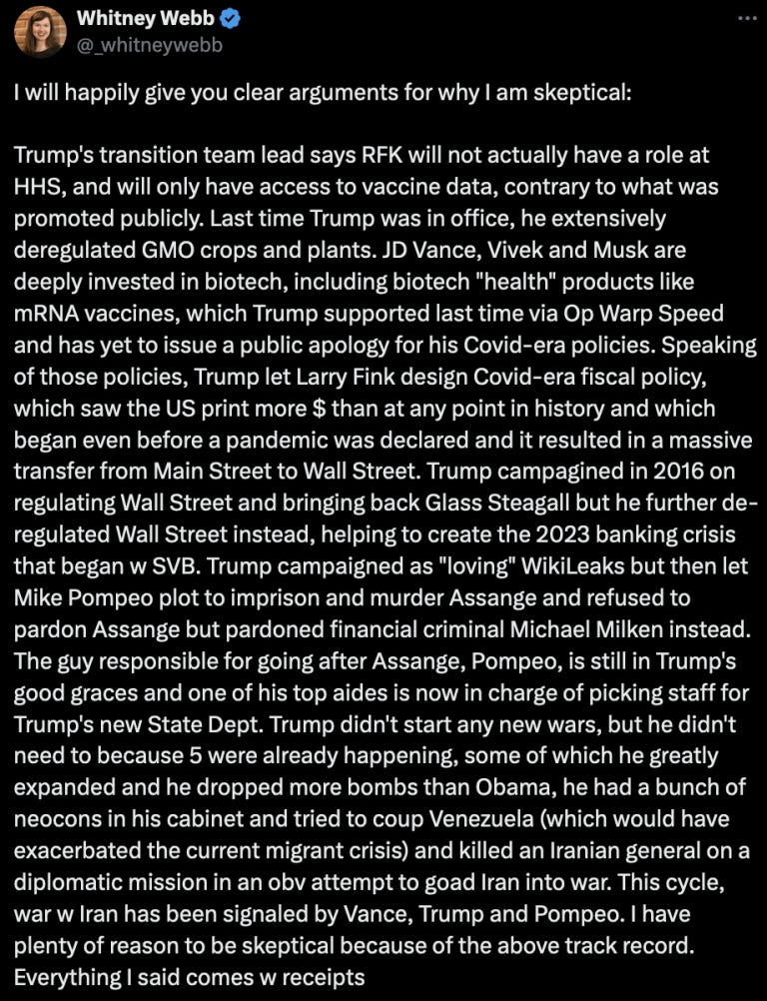
With his ambitious plans to remove Satanic Globalism from the American State apparatus like Milei in Argentina using Elon Musk in his DOGE apparatus to shut down Departments, and fire troves of useless idiots and save Trillions of corruption which has cost America so far 36 Trillions of Dollars, the Satanic Global elite are using the escalation of the Ukrainian War to pressure Trump into not prosecuting them as they pretend to relinquish their hundreds of years plan to take over the World in a New World Order using the unelected United Nations – like the unelected controllers of the EU - to become the World Governors and Moving the controlling Empire, destroying the controlling Empire from within by Satanic Phoenician Infiltration, from the Anglo-American Empire to China for it’s Chinese Century.
Threatening them with Nuremberg 2, probably Trump will need to forgive them and create a New Marshall Plan to rebuild the remains of the Ukraine so that these corrupt Satanic Globalists can continue to feed off it’s corruption so as to confirm the deal.
We shall see if Trump is Only Talking……
Video by Greg Reese…
You know, the Satanic Phoenician Mega Trillionaires have a plan and have been writing about it in white papers and books for over two hundred years. They have been searching for a Political methodology for controlling more billions of people with minimum resources so as to vampirise more people for their Spiritual Energy so as to live, immortally for ever, and they seem to have found it.
Without this historical knowledge and the Higher Hypothesis it is impossible to predict the future…
From there they used Communism to take over Russia but it’s strict communistic philosophy failed.
They used it also to take over China and with the reforms of Deng Xiou Ping created a communist slave state which so far, has worked wonderfully by allowing the implementation of.. the Satanic Phoenician Mega Trillionaire’s, “The Chinese Century” as the Empire is moved by the Satanic Phoenician Mega Trillionaires from the USA to China and the Chinese Communist politics is installed worldwide allowing..
The Communist Hell State of Satanic Phoenician Mega Trillionaire Biden and Harris based on the Satanic Phoenician Mega Trillionaire created United Nations Agenda 2030, 2045, 2075.
Based on the Vaccine Mandates of the Satanic Phoenician Mega Trillionaire created United Nations World Health Organisation helmed by terrorist Tedros.
Based on Artificial Intelligence controlling the censorship Surveillance State.
Based on the Satanic Phoenician Mega Trillionaire Communist Chinese Social Credit Score where if you do not agree with the Government you are de-banked, not allowed to use CBDC’s or credit cards in a cashless society, not allowed to use the Internet, not allowed to Travel, not allowed to receive Government Monetary benefits. But you are allowed a Government suicide pod!
The methodology of creating this movement, as always, is the Roman Empire, Satanic Phoenician Mega Trillionaire, “Divide and Conquer” which is the Satanic Phoenician Mega Trillionaire Deep State paying Terrorist Groups which they create to perform Terrorist acts to Scare, to Terrorise the public.
Since around the turn of the last century, the Satanic Phoenician Mega Trillionaire Western oligarchic ruling classes have engaged in a new Roman Empire Satanic Phoenician Mega Trillionaire, “Divide and Conquer”, “Strategy Of Tension” that is designed both to cow the general population into submission to their policies and to sow division within the general population to remove any focus from themselves.
The Roman Satanic Phoenician Mega Trillionaire, “Divide and Conquer” is the Satanic Phoenician Mega Trillionaire Deep State paying Terrorist Groups which they create to perform Terrorist acts the Scare the public.
This is a repeat of the policies that were carried out in post-war Europe to stop truly progressive parties from becoming part of the government; for example, the Communist Party in Italy and the 25 “years of lead”.
The Satanic Phoenician Mega Trillionaire vassal oligarchies and the security states that they dominated, working with the Satanic Phoenician Mega Trillionaire US security services, both sponsored, paid, funded, European terrorist groups and engaged in acts of terrorism against the general population in order to manage the politics of that country. This was called Operation Gladio.
While laying blame on left wing, and to a lesser extent right wing, groups (some of them security state front organizations). This is a history that we must understand if we are to understand the present.
The Roman Satanic Phoenician Mega Trillionaire, “Divide and Conquer” is the Satanic Phoenician Mega Trillionaire Deep State paying Terrorist Groups which they create to perform Terrorist acts the Scare the public.
The Roman Satanic Phoenician Mega Trillionaire, “Divide and Conquer” is the Satanic Phoenician Mega Trillionaire Deep State paying Al Qaida created by CIA asset Osama Bin Laden to destroy the Two Towers with CIA help, of course.
Later, of course the CIA funded ISIS as it’s proxy army to do the same thing in the Middle East.
Satanic Phoenician Mega Trillionaires created False Flags like the Two Towers which scared America to approve the Patriot Act which allowed Iraq and Afghanistan and one Trillion Dollars of Opium to fund Satanic Phoenician Mega Trillionaire CIA Black Ops.
But which was really designed to be used on the American public when creating the Communist Hell State of Satanic Phoenician Mega Trillionaire Biden and Harris based on the Satanic Phoenician Mega Trillionaire created United Nations Agenda 2030, 2045, 2075.
Based on the Vaccine Mandates of the Satanic Phoenician Mega Trillionaire created United Nations World Health Organisation helmed by terrorist Tedros.
Based on the Satanic Phoenician Mega Trillionaire Communist Chinese Social Credit Score where if you do not agree with the Government you are de-banked, not allowed to use the Internet, not allowed to Travel, not allowed to receive Government Monetary benefits. But you are allowed a Government suicide pod!

The Rise and Fall of the Surveillance State - Mike Benz

Americans will demand accountability for the Censorship Industrial Complex
This complex is an essential tool of what some describe as the Deep State, as well as the satanic construct that, for lack of any better term, we call Clown World. If President Trump is serious about fulfilling his duty to the American people, he will have to begin dismantling it as soon as he takes office rather than trying to work with it.

NOW AFTER THE ELECTION OF TRUMP, FOR THE FIRST TIME WE HAVE THE POSSIBILITY OF FIGHTBACK AGAINST THE SATANIC PHOENICIAN MEGA TRILLIONAIRES

Breaking: POTUS Donaldos Magnus Trumpos aka 47 says all military (8,000 purged by Biden) who were discharged for not taking deadly Malone Bancel et al. mRNA vaccine will be re-instated full back pay

Thats what I am talking about & Trump must stand now & all heads of the health agencies & call for the immediate stop of mRNA technology vaccines, or say 'I will stop it in hour one JAN 20th 2025'
Dr. Paul Alexander
Dec 5
And that is what is happening now…
In this Video above…
Here are some clips..

The Nature of Evil and Controversial Health Policies
Because, again, it goes back to the nature of evil. And once you get in the minds of the Satanists, it makes perfect sense from their sick perspective.
I mean, you and I sit back and go, you want to inject kids with something that causes blood clots, heart attacks, infertility, and gives them cancer, and it's going to make them sick and reduce their lifespan and kill many of them right away?
What the hell are you...
How do you think you're going to get away with that?
That's how you do get away with it.
It's so evil that people can't admit it to themselves because they just can't wrap their mind around it. And then once the first big mass murder happens, people that were compartmentalized, who went along with it, have a tendency to cover it up, even though they weren't consciously involved.

Demanding Truth and Accountability
You want answers? Well, so do I. You want the truth? Well, so do I. You want to fight the tyrants? Well, so do I. Now, if you were a radio listener, you heard Bill Gates. You heard the FDA board five minutes before they voted. Because I played the whole hour-long hearing years ago.
The Satanic FDA said, we have no idea what this MRNA Deathvaxx will do to kids.
Let's just do it.

Rallying Against the System
And you are literally funding revolutionary work against the Satanic death cult. You are the energy, the force, the will behind what we are doing on air right now. And that just enrages the deep state, enrages the corrupt system. And I don't even care if they come after me. I don't even care if they lie about me and demonize me and do horrible things to me. I don't like it being done in my family. But I know it goes with the territory.
We're all going to be slaves and dead anyways if we don't fight, so I have nothing left to lose. But I do want to win. And so the variable in the fight is you. I'm not going to stop. The globalists of the Satanic Religion aren't going to stop until they're defeated. It's starting to happen really quick.

Anti-Human Policies and Environmental Concerns
And that's why all the big fast food places and the airports are getting rid of humans. You got to go have a robot. They're displacing humans with AI in their own admissions. It's all the ESGs. It's all BlackRock. It's all anti-human. It's all designed to shut down family farms and organic farming and natural beef. And now they've got FDA approval to feed this poison feed to cows that totally makes them unhealthy. The quote, stop methane as if methane is bad in the atmosphere. As if farts from cows are bad.
They're saying your body is bad.
They even say you breathing is bad because gases come out that way too.

Confession Through Projection: Political Accusations
The McConnell family has made a bunch of money cashing in on the US of power and doing it for their personal enrichment at the expense of the people they're supposed to represent. So it's got to be some big names, some Bill Gates, some George Soros, some people of that. And it's not just the right thing to do. We have to do it to keep them off balance. They keep saying, don't go on offense, because that's how we beat them. Well, exactly, it's confession through projection, but in reverse. Look at, what would they have done? They made clear what they were going to do. They were gonna use the US military politically. That's why they're scared about Trump doing it, because they were planning on doing it. I mean, Harris made that really clear with a lot of her statements, a lot of her confession through projection.
(01:10:25):

We're Anti-Human. How dare you be a Natalist? We're Anti-Natalist, Anti Baby, meaning Anti-Family.
So here's the latest new clip. of him hiding it in plain view, trying to normalize it, just like they're trying to normalize pedophilia because they know we're bringing down their networks.
They're racing to just make it okay, hoping they don't get in trouble.
Not going to work, backfired on you.
But to somebody already awake, you're like, why did Netanyahu say we're using the people of Israel as guinea pigs? Why does Bill Gates say it? Why does Fauci say it? Remember that clip? They had to fire three different FDA boards and put people on the boards that were all board members of Pfizer, Moderna, and others three years ago, three and a half years ago. So they still wouldn't authorize for children. They wouldn't authorize down to six-month-olds. In fact, guys, give me that clip too.
(01:11:12):
FDA board member, we have to give kids the COVID vaccine to see what it does.
Just type in FDA board member. We have to give kids the COVID vaccine to quote, see what it does. Because even when I start talking about this, you see, I remember all the other times.
And then I've got C-SPAN events from 2017, 18, 19, where Fauci and others with all the federal regulators would get up on C-SPAN and say, quote, we're going to blow up the old FDA system of having to approve things and test things and make sure they're safe with a new virus out of China soon. And then Fauci, right after Trump gets into office 2017, says, don't worry, there's video.
Trump will soon be hit. Don't worry, Trump will soon be hit by a new novel virus. And it's going to be something completely new and challenge everything. And society's going to change. So don't worry about all the groups against us and everybody waking up to us. Because we're about to take over.
(01:12:15):
Want to see it? Fauci, Trump will be challenged by a new virus. Because he had it on the shelf. That's all come out. It's in the Senate report now. Not just Alex Jones saying it off the documents. You know...
We learned almost four years ago from the vice president of the EcoHealth Alliance who came on the show, former army officer. And he basically found out the CIA was really running the EcoHealth Alliance and that Google was funding it.
Remember, the heads of Google have said to Elon Musk, we want to get rid of people. We're anti-human. How dare you be a natalist? We're anti-natalist, meaning anti-family.

AND YET, THE TRUMP ADMINISTRATION IS STILL JUST GOING AFTER THE MINIONS LIKE GEORGE SOROS AND BILL GATES…

PROSECUTE THE ROTHSCHILDS, THE SATANIC PHOENICIAN MEGA TRILLIONAIRE, 3000 TRILLION DOLLAR ROTHSCHILDS!

Visible Oligarchs are merely Trustees, Fronts, of the Satanic Phoenician Mega Trillionaire London Money Power

Satchidanand
·
November 22, 2024
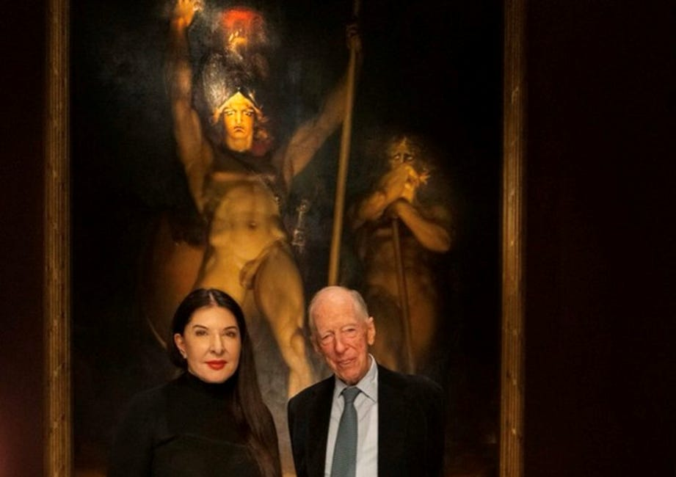
Visible Oligarchs are merely Trustees, Fronts, for the Satanic Phoenician Mega Trillionaire London Money Power

Read full story

Visible Oligarchs are merely Trustees, Fronts, for the Satanic Phoenician Mega Trillionaire Rothschild London Money Power

Fronts… The Rockefellers, Elon Musk, Jeff Bezos, Steve Jobs, Larry Page and Sergey Brin, Bill Gates, George Soros, Larry Ellison, Warren Buffett, Eric Schmitt, Peter Thiel, Robert Mercer and many others are Only Fronts for the Satanic Phoenician Mega Trillionaire Rothschilds.

Satanic Phoenician Mega Trillionaire Rothschilds Control Everything – Their Methods of Control

Meet Satanic Phoenician Mega Trillionaire Jacob “Jack” Rothschild ,- Nathaniel Charles Jacob Rothschild, 4th Baron Rothschild, OM, GBE, CVO - the "Protector- Owner," and his many minions and Fronts over centuries and nations...

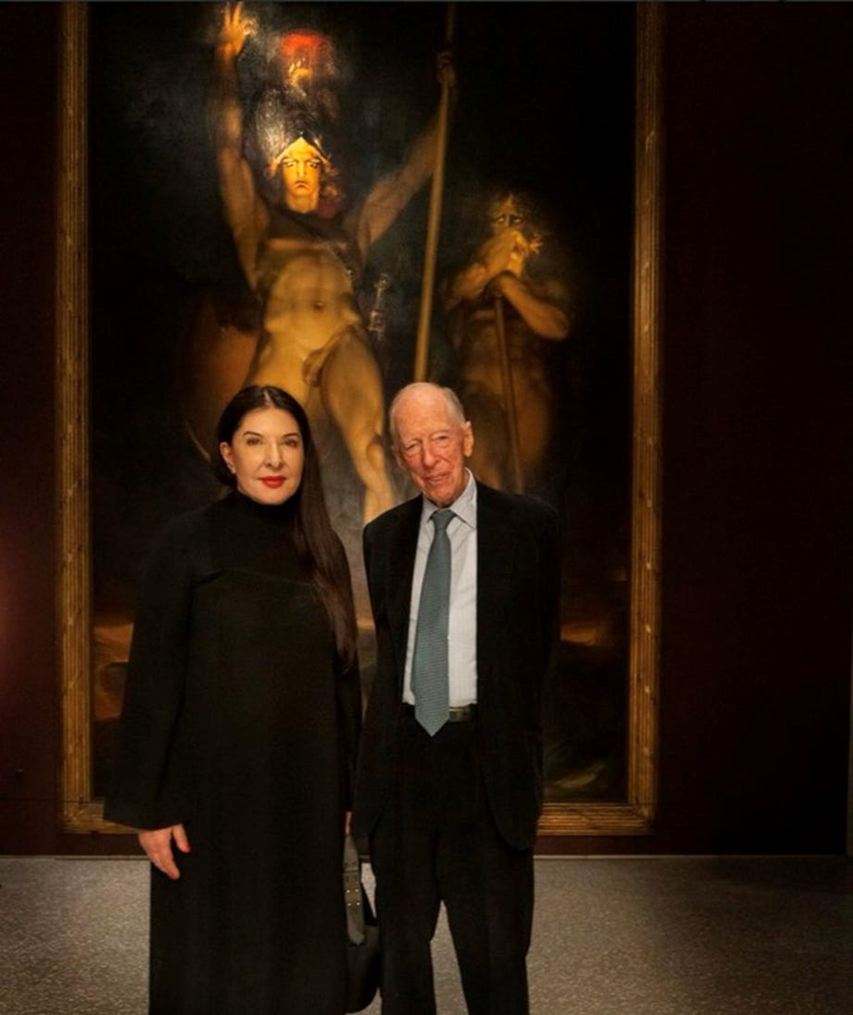

Satanic Crowleyan OTO Witch Marina Abramović poses with Satanic Phoenician Mega Trillionaire 10,000 years old Family Jacob Rothschild in front of 'Satan summoning his Legions', 1796-1797

The Satanic Phoenician Mega Trillionaire Elite are all Demon Possessed!! Part 1...



The Satanic Phoenician Mega Trillionaire Elite are all Demon Possessed!! Part One…
Read full story

So Far I have written around about Forty Four books on the two most important subjects in the World… Satanism and the Satanic History of the World as talked about above… AND ENERGY EHANCEMENT QUANTUM MEDITATION..



So Satanism is the Problem

And Energy Enhancement Quantum Meditation which is far in advance of any other meditation in the World…

IS THE SOLUTION!

ENERGY ENHANCEMENT QUANTUM MEDITATION REMOVES THE TRAUMA FROM THE MIND BY THE ALCHEMICAL TRANSMUTATION OF TRAUMA.. “FREE YOUR MIND!”

The Energy Enhancement Quantum Immortality Streaming Video Course and Live at Iguazu Falls.. –



Eyes Wide Shut - Satanic Pedophile Hollywood

Stanley Kubrick, Rothschild Illuminati, Apostles Higher Sodomy, Sodomy Ritual, Incest, Sabbatean Frankism
Satchidanand
Dec 27, 2024

Eyes Wide Shut - The Paedo Files
From.. https://againstsatanism.com/External-Websites/subliminalsynchrosphere/subliminalsynchrosphere.com/2016/03/index.html


It's gloves off time...

Nicole Kidman: ‘Stanley Kubrick Said Pedophiles Run The World’
“Stanley told me the world is run by pedophiles,” Nicole Kidman said while promoting HBO’s Big Little Lies, in Los Angeles. “He studied secret societies his whole life, he was fascinated by them, and he said the elite, the top secret societies, they are full of men with a certain predilection. They are tied together, sort of bonded, by pedophilia like the ”Pact of Blood” where the Mafia entrants have to kill someone in order to join, these guys have to pedophile and human sacrifice like Epstein’s Pedo Island and the Lolita Jet - “They all know each other’s dark secrets. There is no way out for any of them. It’s a lifetime bond. Even if one of them wanted to go straight, repent, so to speak, he can’t. His peers will bring him down. They are in it until death, driving the world to ruin. That’s kind of how Stanley explained it but it was all very complex. I’m probably not doing it justice.”
Nicole 'Eyes Wide Shut' Kidman's father Antony, died amid child abuse allegations, very serious allegations that relate to wider paedophile rings. The actual allegations go back as far as 1986, when the victim made claims against Dr Antony Kidman. These claims were allegedly ignored by health professionals (who have a mandatory duty to disclose) until as late as 2008. It is claimed that he fled the country after he was named at the Royal Commission. I cannot speak for the veracity of these claims, but they have been made nonetheless
With all this in mind, it's come to the point where I can withhold no longer, time to crack open the rotting corpse that is 'celebrity and paedo-Hollywood' and what it's doing to this planet and peoples. Previously, I've been aiming my lens at deciphering and uncovering the huge amount of 'mystery religion' within the body of MSM output and it has proved to be legion. Now I am aiming my lens at 'paedo Hollywood', at its corporate-based mind control programme and its personnel, you might be surprised at what I've managed to uncover. To the survivors (I know that you're real), proceed with caution, there's likely triggering elements within the body of my post.

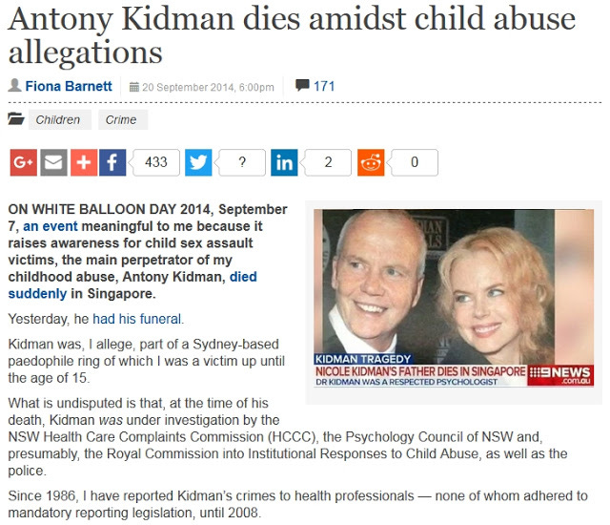

nicole-kidmans-father-dies-amid-pedophile-child-murder-ring-allegations-video-2446870.html

KINGS COLLEGE CAMBRIDGE UNIVERSITY APOSTLES CLUB OF HOMOSEXUALS
In the early 20th century, the Apostles formed something of a meeting place for people who would go on to form the Bloomsbury group. Virginia Woolf’s father, Lesley Stephen, had been an Apostle and her cousin, James Kenneth Stephen, also became one. Her future husband, Leonard Woolf, was a member, alongside the likes of John Maynard Keynes, Lytton Strachey, Roger Fry and others.
Lytton Strachey coined the term ‘higher sodomy’ for the love of men for men, as often felt among the Brethren, which was mostly platonic, though not always. According to Richard Deacon’s book on the Apostles, it was not until the 1970s that they elected their first female member.
With the influx of writers (Rupert Brooke, the poet, and E.M. Forster, who became a novelist), artists/critics (Roger Fry) and at least one future art collector (Etonian Economist Pedophile and Satanist John Maynard Keynes who created Keynesian Economics), the concept of Beauty began to be discussed.
Members like McTaggart and Goldsworthy Lowes Dickinson encouraged the discussion of metaphysics and philosophers like Satanic Lord Bertrand Russell, Alfred North Whitehead and G. E. Moore became influential members on the questions of Truth and Ethics. Russell even nominated Ludwig Wittgenstein for election but he only lasted one term.

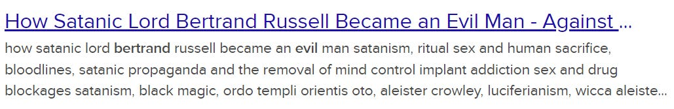

https://againstsatanism.com/Satanic-Lord-Bertrand-Russell.htm
Sodomy in Schools like Eton, consciously “Whipping and Fagging” from it’s inception by the King in 1436 AD in order to create a “Band of Brothers” from the 4000 years old “Band of Thebes” best and most fierce group of soldiers of Gay Lovers which became the template of all elite armies since then.
Just the Faggotry of domination by Sodomy and Sado-Masochism (Baron Lawrence of Arabia) and the love between boys at all male schools which leads on to pedophilia later in life and of course the next step of Ritual Sodomy in Satanic Cults like the Hellfire Club, Nine Angles and Aleister Crowley’s OTO and McGregor Mathers Golden Dawn.

Aleister Crowley's Satanic Secret Sex, Sodomy, Baby Sacrifice, Cannibal Rituals of Ordo Templi Orientis - O.T.O.

Satchidanand
·
September 15, 2024
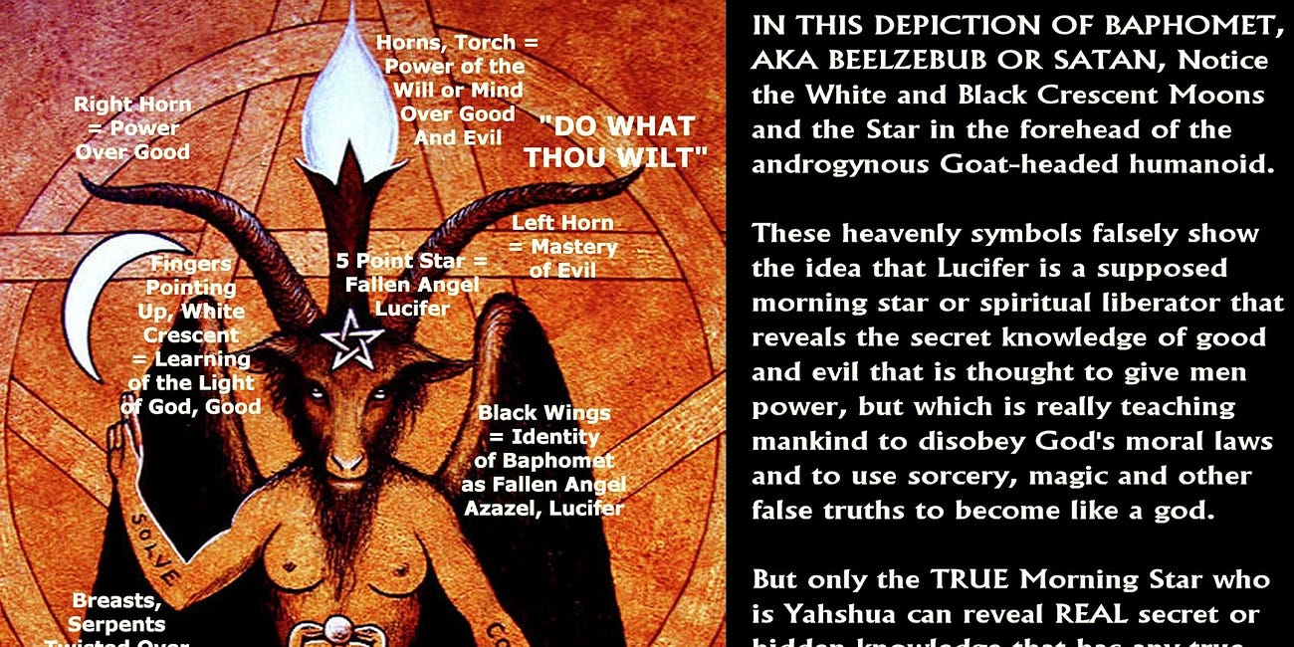

Aleister Crowley's Secret Sex, Sodomy, Baby Sacrifice, Cannibal Rituals of Ordo Templi Orientis - O.T.O.

Read full story

Satanic Cults practising Human Sacrifice in order to create psychopaths capable of following any order to become the Generals, Politicians, and Bishops in charge of running the British Empire for Satanic Phoenician Mega Trillionaires like the Rothschilds who run the World..

Confessions of Frater 616 - a Sydney Satanist

CONFESSIONS OF A SATANIST Frater 616

Satchidanand
·
June 18, 2023
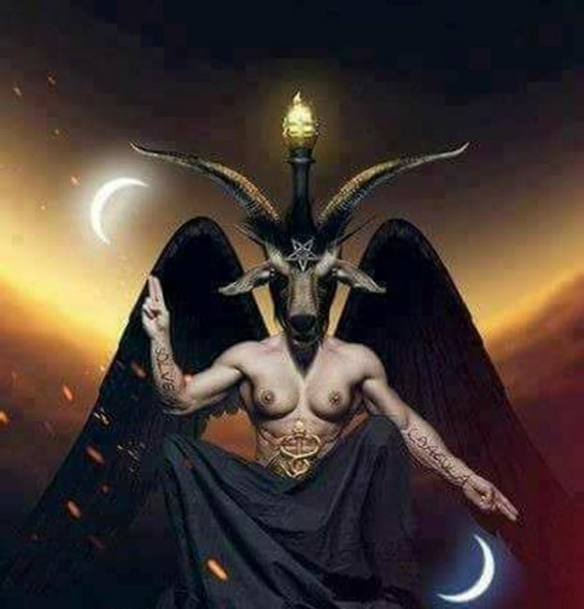
CONFESSIONS OF A SATANIST Frater 616

Read full story

Book 50 of the Against Satanism Free Books… Eyes Wide Open - by Fiona Barnett - Australian MKULTRA Survivor
- the only book after evidence in the 1977 Church Hearings - US Library of Congress in a document titled: Project MKULTRA, the CIA‘s Program of Research in Behavioral Modification, Joint Hearing Before the Select Committee on Intelligence and the Subcommittee on Health and Scientific Research of the Committee on Human Resources United States Senate Ninety-Fifth Congress First Session, August 3, 1977.
https://pedophilesdownunder.com/
Six hours of video evidence to Congress are available on youtube and CSPAN talking about 10,000 young children taken from orphanages and entered into the MKULTRA program and also Springmeier above - to talk about and tell more about the expansion of Luciferianism and Satanism in modern society - to give evidence that Against Satanism - is Real!!
Introduction
The Luciferian Cover-up
1. Watergate was Pedogate
2. Royal Whitewash
3. Victorian Pedophile Network
4. NSW Pedophile Network
5. Bond University Pedophile Network
6. ‘The Greater Good’
7. Conspiracy Fact
The Luciferian Philosophy
8. Justice Denied
9. MK-ULTRA & the Occult
10. MK-ULTRA in Australia
11. MK-ULTRA in Hillsong Church
12. Confessions of Frater 616 - a Sydney Satanist
My Witness Testimony
13. Ritual Abuse in Australia
14. Relevance of Intelligence
15. The Programming Matrix
16. Candy Girl Child Prostitute
17. MK-DELTA Child Soldier
How to Heal
18. Psychology 101
19. Trauma-Focussed Integration
20. Dirty Doctors
21. A Life Sentence
22. Source of Hope Within
https://againstsatanism.com/Fifth-Level-Avatars/eyes-wide-open-_fiona-barnett_first-edition_august-2019.pdf
https://againstsatanism.com/Fifth-Level-Avatars/Fiona-Barnett-Eyes-Wide-Open-june2020-lockdown-edition.pdf
Clearly, Barnett is correct in claiming that Kidman died while under investigation, which in itself seems rather strange timing, wouldn't you say? I cannot obviously vouch for the veracity of this lady's general claims, but we certainly know that she is making them, of that there is no doubt. Considering the recent issues with Savile and the blatant 'white wash' of the inquiry by state propaganda organ aka the BBC (absolving all senior management of any knowledge...cough, cough), more and more people are starting to listen. and more are starting to have open minds in regard to these kind of lurid details. Savile was clearly connected to 'royal circles' (particularly Prince Charles) and to political circles (particularly former PM Thatcher, and even the Israeli govt).
nicole-kidmans-father-dies-amid-pedophile-child-murder-ring-allegations/
Of course, being the father of Nicole, one is immediately reminded of her (oblique and not so oblique) related body of work,
especially her role in Kubrick's final film 'illuminati evoking' Eyes Wide Shut.

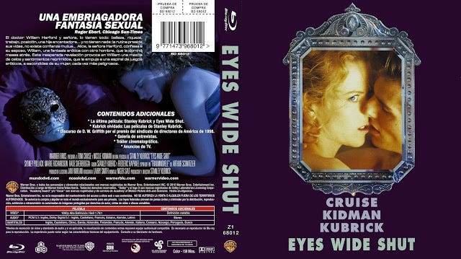

The film that references paedophilia, organised ritual sex orgies (evoking mind control sex slaves)
- and the (implied) uber-elite who indulge in such practices.
Kubrick the Illuminati progenitor
Kubrick wasn't fighting against the Illuminati, he was one of them!
This is a given in my mind and has been for a number of years. Hollywood IS 'Illuminati Sodomy central' and probably always has been, these folk are the 1% and below, the 1% and below that control the 99%. Kubrick was initiated into big-time Hollywood on Friday 13th February 1959 (Fri 13th, is a masonic/templar resonant date),
and given the job to direct (Illuminati Weishaupt evoking) Spartacus. This is no coincidence.

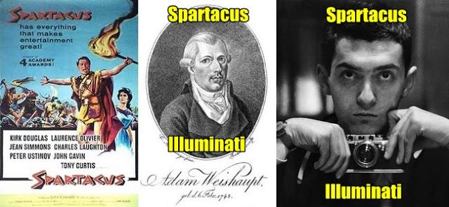

Are we to believe that 'knowledge sponge' Kubrick, was not aware or never became aware of these 'masonic/illuminist' cipher aspects, ones that were connected to his own self? It's the Rothschilds, who are the Illuminati family (they funded Weishaupt's Illuminati movement), that many have accused of practicing sodomy-based mind control.
Yes, even historical 'Spartacus' is mentioned in terms of being a 'gay icon'.
The following scene was cut from the original and restored in the 90s.
Some claim that Laurence Olivier was a homosexual (perhaps bisexual).
The acting profession has always been oversubscribed when it comes to homosexuality.
Is it a coincidence, that the Gay publication 'Spartacus' has been implicated in relation to UK based (and World-wide) organised (gay) paedophilia? The propaganda in these and related publications (PAN/PIE etc) is astounding, the justifications made for having sex with children are mind-boggling!
Spartacus and Paedophiles...a front for gay paedophiles to obtain their victims.
The link below has examples of some of these publications and the people behind them.

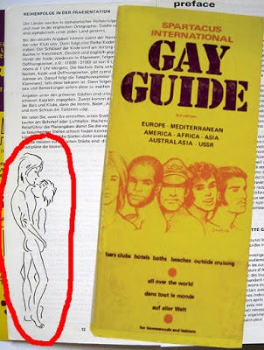

westminster-scandal-114-secret-files-on-paedophile-cases-missing/more-than-10-politicians-on-list-held-by-police-investigating-westminster-paedophile-ring

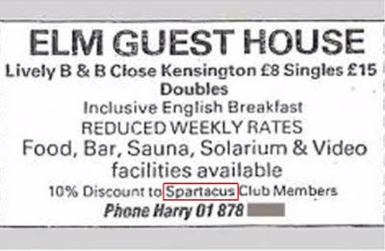

Oh look...Elm Guest House & Spartacus, the 10% discount a 'marker' for the abusers.
The Elm Guest House where all sorts of elite connected people have been supposedly implicated in paedophilia.
Leon 'missing paedo dossier' Brittan, Cyril Smith, Cliff Richard etc, and members connected to Royal circles/British Intel (MI5/MI6).
Children procured from children's homes and care systems, to be abused by the elite and likely involving blackmail traps.
Kubrick linked to homosexuality (via Spartacus) and paedophiles (via Lolita), & made back to back. Illuminati Kubrick and Foucault's (Illuminati) Pendulum. Kubrick wanted to make this into a film in the 90's, Eco declined due to his dissatisfaction with the adaption of his 'The Name of the Rose'.
The wicked foundations of Clown World
Clown World is built upon a series of intellectual pillars that range from Darwin, Diderot, and Freud to Einstein, Keynes, and Foucault. The first thing that rapidly becomes apparent when one regards them as a set is first, that they are all frauds. The second thing one realizes is what a collection of seriously evil sexual deviants they tend to be:
A French-American professor has accused fellow intellectual Michel Foucault of being a "paedophile rapist", a report by The Sunday Times said.
In an interview, Guy Sorman said he found out about Foucault's behaviour after visiting the late philosopher in Tunisia where he was living in 1969.
"Young children were running after Foucault saying 'what about me? take me, take me'," he said to The Sunday Times. "They were eight, nine, ten years old. He was throwing money at them and would say 'let’s meet at 10pm at the usual place'. He would make love there on the gravestones with young boys. The question of consent wasn’t even raised."
Sorman argued that Foucault was able to get away with this because of the racial element of his affairs.
"Foucault would not have dared to do it in France… There is a colonial dimension to this. A white imperialism," Sorman said.
In the interview Sorman said he "regrets" not reporting this "extremely morally ugly" behaviour to the police. He added that the press had been aware of Foucault’s conduct but were reluctant to publish stories due to his status as France’s "philosopher king" alike to that of a "god".
The philosopher who died in 1984 signed a petition in 1977, which sought to legalise sexual relations with children aged 13 or above.
Don't be misled. Whatever aspect of Clown World rhetoric happens appeals to you, be it free trade, freedom of expression, libertarianism, judeo-christianity, equality, tolerance, or respect, it's really all about pedos and human sacrifice. It's literally all designed to lead there in the end.
https://voxday.blogspot.com/2021/04/the-wicked-foundations-of-clown-world.html

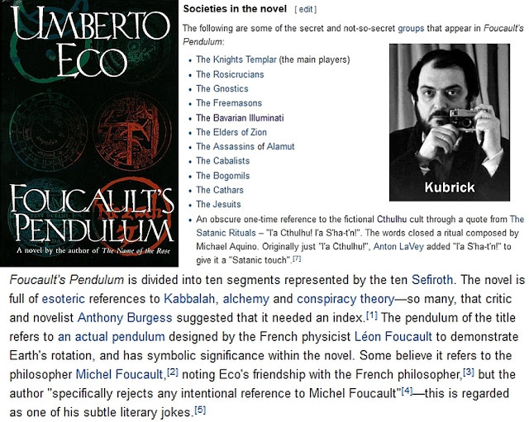

Kabbalistic Kubrick...Tree of Life (again) the book is divided into the 10 spheres.
The Bogomils get a mention - the same "Bogomil" (Bougre) that is the root of the English word for "bugger/buggery' (sodomy). The Bogomils were accused of sodomy rites - just as the Templars also were!
It should be noted that deceased 2001 author Arthur C Clarke, had been mentioned in relation to paedophilic activity (even in the mainstream press) in respect of Sri Lanka, where he used to lived. It has been suggested that he often procured underage beach boys. When the story first broke, Clarke's knighthood ceremony in Sri Lanka was cancelled, so as not to embarrass Prince Charles.
It has long been speculated that Clarke was likely a homosexual/bisexual. It is also alleged that media mogul Rupert Murdoch pulled a similar story (child abuse) from one of his publications, due to Clarke being a friend etc. Check out (or skim) this scholarly piece (pdf)...Clarke and Kubricks 2001: a queer odyssey.
The Knights Templar are the main players in Eco's book...Paris, Fri 13th, France's 9/11
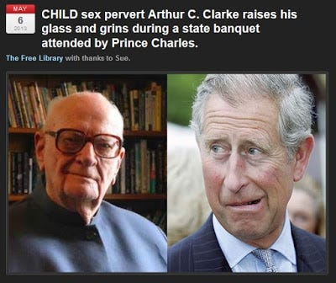

Recall, a few months back we had the 'templar/masonic flavoured' Paris Friday 13th event. Spartacus was the code-name of Bavarian Illuminati founder Adam Weishaupt. Dr Strangelove also contains a major 'Friday 13th' cipher, and Peter 'Strangelove/Lolita/Clouseau' Sellers connects to Cato (Pink Panther). Cato aka 'Illuminati Zwack', also being another direct reference to Weishaupt (Spartacus). Kubrick is busted...of that there is little, if any doubt. His output wouldn't be flooded with all this mystery religion/illuminism/mind control propaganda/paedophilic aspects, unless he was inner circle, and that is what I believe he was (he was seeding this stuff decades ago). It is also generally accepted that the Templars practiced sodomy rites.
There wouldn't be this giant '2001 monolith' reference at the 2001 '9/11 ground zero' either...
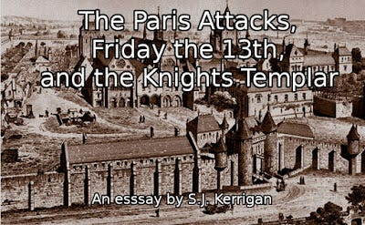

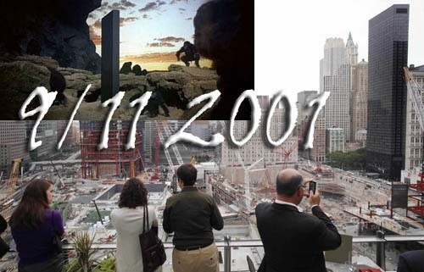

...one that connects to the manipulation/development (MSM mind control) of man (apes/useless eaters).
My position is clear. If people take objection to this, they can disappear and go read another website...which is fine by me.
"There are none so blind, as those who will not see."

Kubrick...softening attitudes and prepping culture for paedophilia?



The question beats me too! I think it can be put down to 'disguising' it as a piece of art, that usually fools the useless eaters.
Oh it's art, so that's OK then....move along, nothing to see here. The message from the promo above:
Lolita/Loli-eater: I (eye) love (heart) sucking cock (popsicle/lollipop, slang penis).
Kubrick's The Shining is about the 'subliminal and subtextual' rape and abuse of Danny, by his father (shown later in this post).

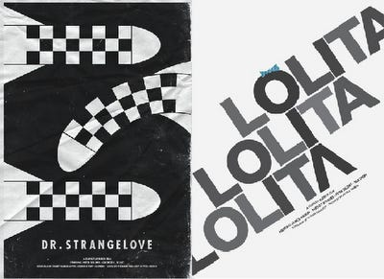

Anyone spot the allusion here? If you can't...www.specsavers.com
Lolita (Spartacus/Weishaupt) Kubrick made Eyes Wide Shut.
The film (imo) implies that Alice (Kidman) is a 'programmed multiple' used by the 'power elite' in their ritualistic sex orgies.

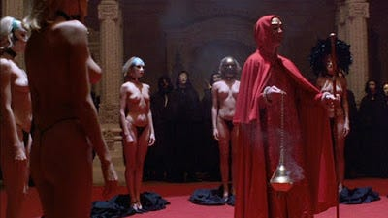

I've watched the film numerous times and it is clear to me that Alice (Kidman) is one of the girls that make-up the ritual circle.
The circle at Rothschild's (Mentmore Towers) mansion.
We were clued-in from the start...Alice (Kidman) her back facing us, masked.



Disrobing in black and black heels...x2. Red open drapes and pillars in both backgrounds.
Eyes Wide Shut x2, title font (above) and Nightingale (keyboard) blindfold.



If she is one of the girls in the circle, then it is the one (centre) shown below.
It might be Alice (Kidman), it might be a stand-in for her...whoever she is, her body and hair is closest to Alice's.
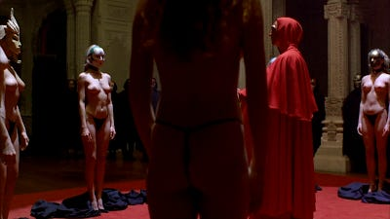

Don't you think it is more than coincidence, that Alice has visions/dreams that almost exactly match the 'ritual orgy' that Bill (Cruise) attends earlier that night? She literally describes the ritual orgy and recalls Bill being in (unwelcome) attendance...
Bill takes the cab home and Alice wakes up giggling and laughing, as if she had been drugged.
(We saw a drugged Mandy earlier at Ziegler's). He tells her she was dreaming, and she starts to cry. He asks what the “dream” was and she says it was “so weird” – “we were in a deserted city and our clothes were gone. We were naked (removed clothes) and I was terrified and I felt ashamed. And I was angry because you…rushed away to find clothes for us.
Alice was at the ritual (that is what I am suggesting, as her dream or drugged recollection suggests).
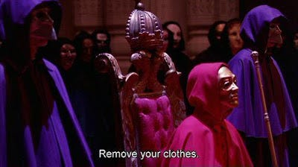

If she is a programmed slave, and one who was subsequently drugged after the event.
It is possible that she was then deposited back to her apartment and all before Bill arrived back home.
We know that someone places Bill's (ritual) mask on the bed. It is either (programmed) Alice or people connected to the ritual.
Note, the matching 'purple' colour scheme from both pics.
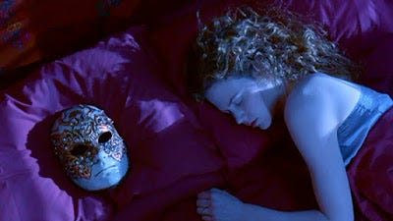
Indications that Domino (hooker) may have also been at, or connected to the ritual orgy...

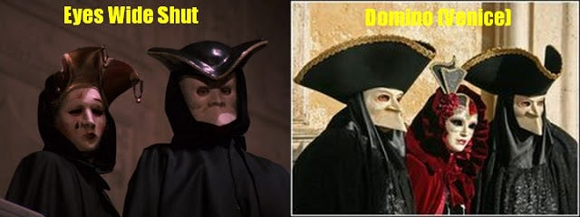

The name "domino" is from the resemblance to a kind of hood worn during the Venice carnival.
The Thoth (composite) who leads (hooker) Mandy away, is also a ringer for a plague doctor (it works as a double reference), later we find out (hooker) Domino has HIV (once seen as a type of plague).
Mandy/Domino there is a mixing of identities between these two, at least imo. We see neither Mandy or Domino alive again...Bill does view the (implied) corpse of Mandy, at the hospital.
Note, again the Phoenician 'purple' colour scheme (dress)...that we saw just a moment ago (Somerton and Alice)



Domino (the hooker) has 'masks' hanging on her bedroom wall. This is an incredibly complex film, that is seemingly bedded in a type of cyclical dream logic...based on Traumnovelle (Dream Story)

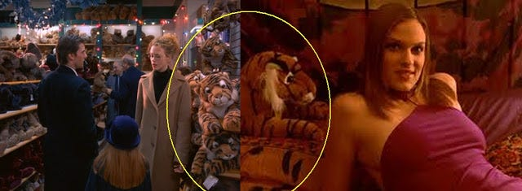

It's (masked) Ziegler and wife in the earlier shot, above left, at the Somerton orgy.
All these scenes are overlapping, The Ziegler party (opening scenes), Somerton orgy, Domino and Mandy scenes etc.
It is Domino, that literally drags Bill off the street for their encounter...was she put on him?
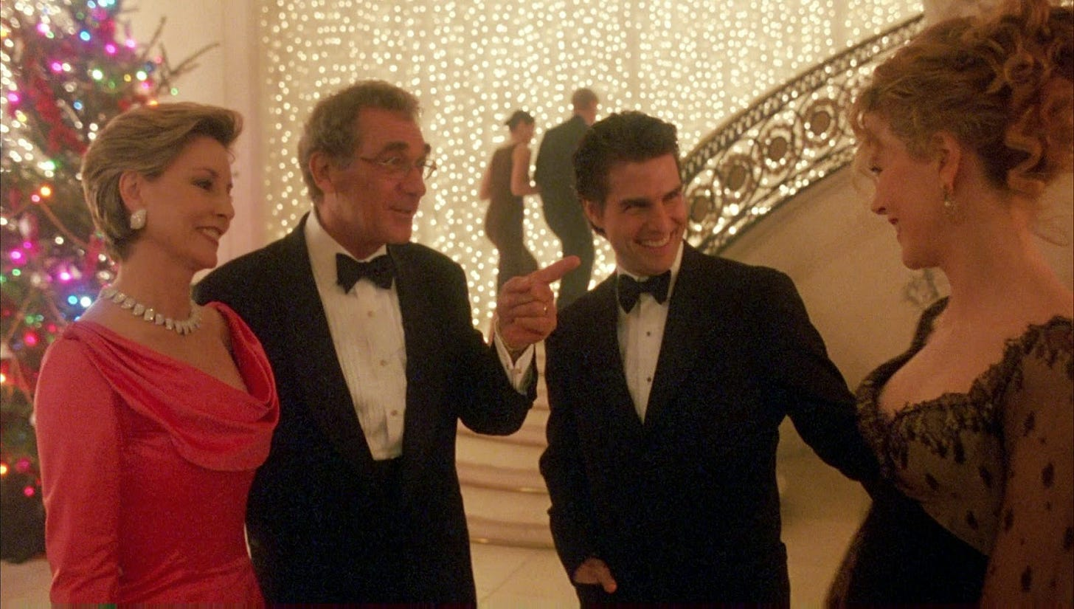

The Story of O?



Post-Ziegler party...O 'eye chart', "Does this hurt?" Immediately followed by naked Nicole (again)

Story of O is a tale of female submission involving a beautiful Parisian fashion photographer named O, who is taught to be constantly available for oral, vaginal, and anal intercourse, offering herself to any male who belongs to the same secret society as her lover. She is regularly stripped, blindfolded, chained and whipped; her anus is widened by increasingly large plugs; her labium is pierced and her buttocks are branded. The story begins when O's lover, René, brings her to the château of Roissy, where she is trained to serve the members of an elite club. After this initial training, as a demonstration of their bond and his generosity, René hands O to his elder stepbrother Sir Stephen, a more severe master. René wants O to learn to serve someone whom she does not love, and someone who does not love her. Over the course of this training, Or falls in love with Sir Stephen and believes him to be in love with her as well. During the summer, Sir Stephen sends O to Samois, an old mansion solely inhabited by women for advanced training and body modifications related to submission. There she agrees to receive permanent marks of Sir Stephen's ownership, in the form of a brand and a steel tag hanging from a labia piercing. Meanwhile René has encouraged O to seduce Jacqueline, a vain fashion model, and lure her to Roissy. Jacqueline is repulsed when she first sees O's chains and scars, although O herself is proud of her condition as a willing slave. However, Jacqueline's younger half-sister becomes in love of O, and begs to be taken to Roissy. At the climax, O is presented as a sexual slave, nude but for an owl-like mask and a leash attached to her piercing, before a large party of guests who treat her solely as an object. Afterwards, she is shared by Sir Stephen and an associate of his who is referred to only as "The Commander".

The Social Sexual Hierarchy SSH is a Continuation of the Roissy Chateau Heartiste and Roosh Psyop of the Tavistock "Men and Women are Pigs" Project to Designed to Destroy the Family.

Satchidanand
·
July 11, 2024
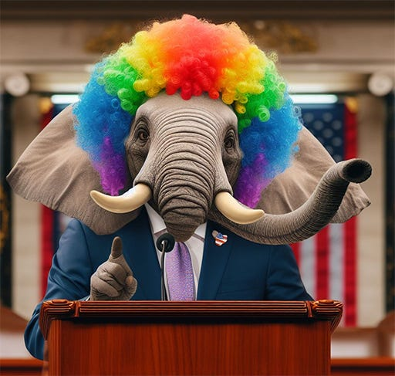

The Social Sexual Hierarchy SSH is a Continuation of the Roissy Chateau Heartiste and Roosh Psyop of the Tavistock "Men and Women are Pigs" Project to Designed to Destroy the Family.
Read full story

It's certainly not wanting in terms of Eyes Wide Shut overlaps. (Update. Note, branding a la NXIVM)
Every step of Eyes Wide Shut seems 'potentially' calculated, there is nothing left to chance.
Virtually all the characters seem to act as 'plants' (or potential plants) in the scheme that is enveloping Dr Bill.
The film appears rather 'mundane' on a surface level, but maybe that is the whole point, so much is actually going on.
Much is wrapped up in deliberate ambiguity.

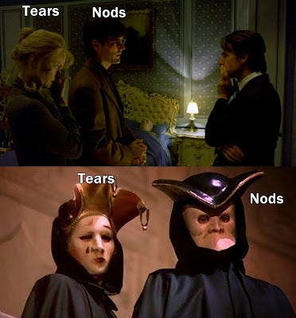

It's possible that the call that Bill receives from the daughter (of the dead man) is to draw Dr Bill away from his wife. This allows (the implied) 'illuminati' full access to Alice and for much of the night, for her role as a programmed monarch (mkultra) type sex slave. What use is a doctor, when the patient has expired? This clearly wealthy (dead) father, with his daughter/partner, likely move in similar circles to Ziegler, if you catch my drift, they may well be connected themselves.
Leaving Marion/Nathanson, Bill cruises the streets...

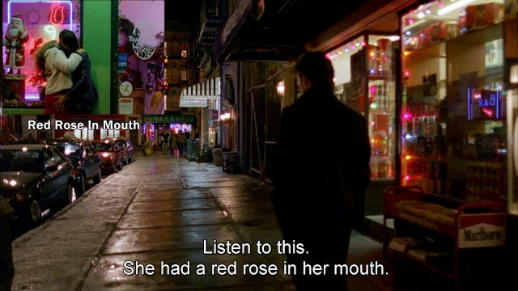

Red Rose in mouth (top left, rose stalk over mouth) which Bill also just saw moments earlier...

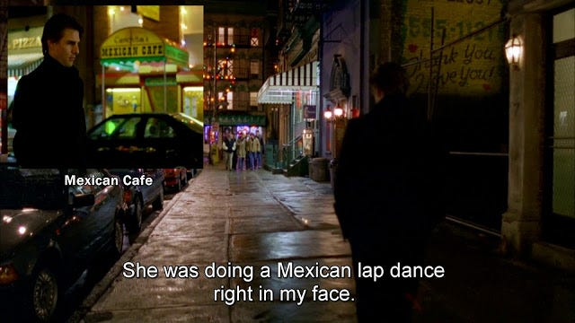

A Mexican lap dance (Mexican cafe), for lap dance see red rose couple.

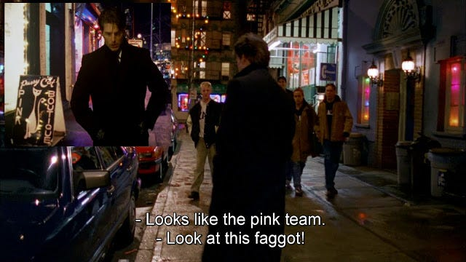

Pink Team...Pink Hay Boutique, the shop Bill passed only moments earlier.

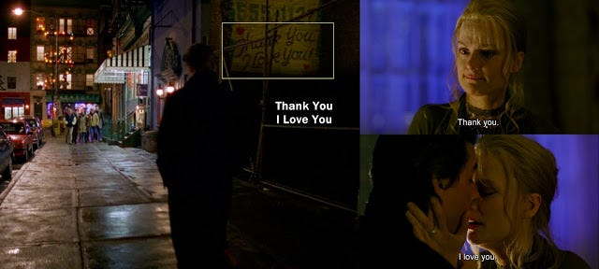

Bill leaves Marion...walks the street. Her 'Thank You...I Love You' dialogue is shown.
Call that summons him to Nathanson's (dead man) starts Bill's journey to the Somerton orgy.

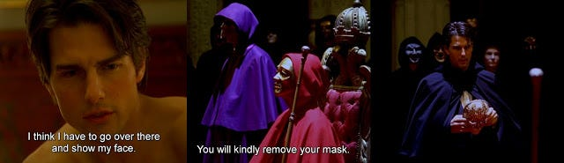

Bill literally 'showing his face'.
Remember...we see two parties, one at the film's start at Ziegler's palatial home and the subsequent Somerton party (Rothschild Mentmore).

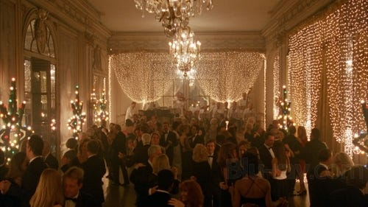

I believe that these two parties are attended by the same people! The party at Ziegler's is a 'pre-party' version of the one at Somerton.
The exact same people are in attendance at both, from Ziegler and wife, to Bill and Nick's inclusions.
(Alice too, but we're not directly shown this, it's implied).

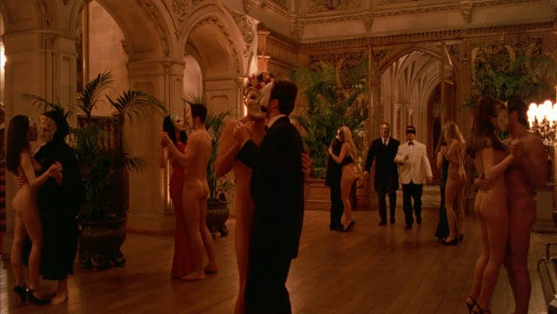

Even the length of both these two party scenes are very, very similar.
Nuala Windsor (a model and another likely monarch victim), seen at the first party, is also CLEARLY at the Somerton party.
She plays the naked girl who tries to lure Bill away. If both groups of people attended both parties, Windsor HAS to be there!
Note, how 'robotic' (programmed) sounding both these girls are at Ziegler's party.

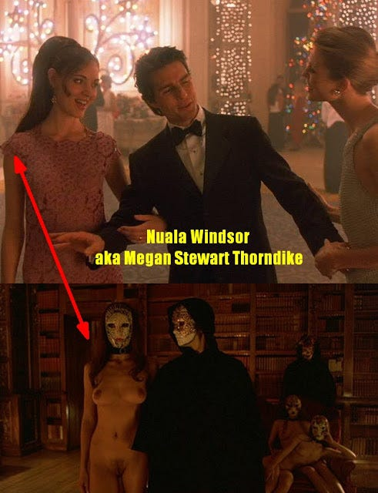

For those with poor powers of observation, it is DEFINITELY the same woman!
Even her body position in both scenes (relative to Bill's) is the same. The 'rainbow ends' dialogue is another sledgehammer clue.
He soon visits the 'Lolita rainbow' costume store, which precedes his visit to Somerton and meeting 'masked' Nuala (again).
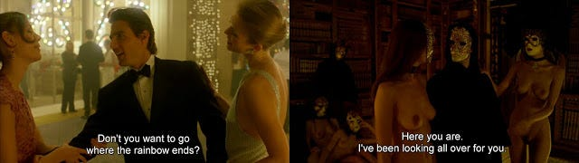

Two girls at Ziegler's seem to (playfully) fight over him, and two girls at Somerton will both fight for his attention.
This is a done deal...Nuala Windsor (Royalty link?) is the girl in both scenes.The Windsors...Prince Charles and Camilla (Animal Ball July 1013) British-Israeli agents:
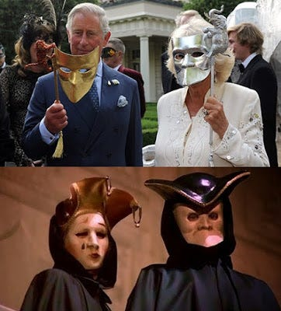

Jewish Dershowitz and sex slave claims...relating to Epstein and Prince Andrew Windsor.
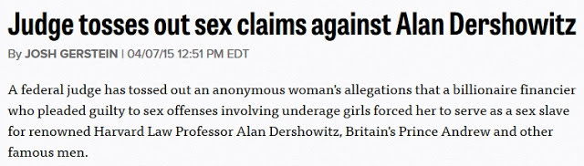

Friends in high places...hmmm? This Epstein related news story was really cooking in 2015.
Chanson D'amour (Love Song) plays, it was popularized by Manhattan Transfer.
Manhattan, the Ziegler party location where the same guests will soon be transferred to Somerton.
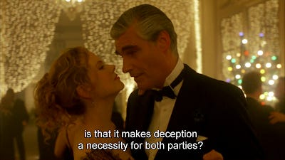
"Deception...a necessity...for both parties." (wink, wink)
Geddit? 'Deception' is necessary for both the Ziegler and Somerton parties!
While Bill is being seduced by the two models at Ziegler's...Alice (Kidman) is concurrently being seduced by the 'wealthy' Hungarian aka Sandor Szavost. Szavost seems to have Alice under some kind of hypnotic spell (watch the scene) and it may well be a reference to Alice disassociating (mind control). This could all play into 'priming' her (alters) for the soon to follow Somerton ritual, where she's a girl in the circle. Alice is already initiated into the group who run these things, it is Bill (Cruise) who is still on the outside, at this point.
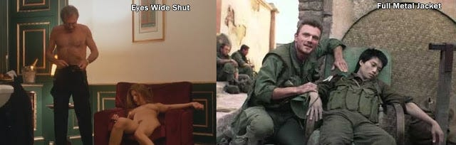

Szavost wants to do exactly what we soon see Ziegler doing.
He wants to take Alice upstairs and fuck her (a la Ziegler and 'drugged' Mandy), which quickly follows
.
We were 'clued-in' to Mandy's ultimate fate, via the similarity of the shot of the dead 'chair' gook, in Kubrick's Full Metal Jacket.
If we found out who these 'masked people' are - we're told that we wouldn't sleep well at night.

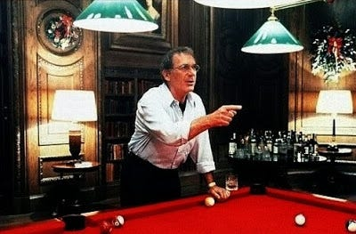

"Those were not just some ordinary people. If I told you their names...
no, I'm not going to tell you their names... but if I did, I don't think you'd sleep so well at night."
Let's put it this way, Nightingale was closed down in a heartbeat, it took them all of five seconds to work out that Bill (Cruise) was an impostor. It is quickly established that Nightingale spilled the details of the location and event, the ones that lead Bill to the ritual.

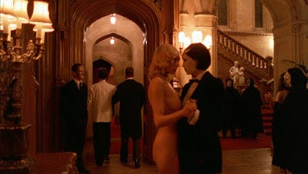

We're also told that Nightingale is dispatched back to Seattle, but we only have Ziegler's word for this, either way he is seemingly forcibly removed and rapidly, we're left to guess whether he survives this encounter. The only other option is that Nick is a part of the entire 'charade' and is yet another 'plant' used to lure Bill into this world (the world where his wife is a mind controlled elite sex slave).
Is Nick the 'nightingale' literally 'singing'...to disclose?
At Ziegler's, Nick notifies Bill of his current location (Sonata Jazz). Almost immediately after this first reunion with Bill, Nick is pulled away by one of Ziegler's staff. To separate them or to give Nick instruction on how to proceed?

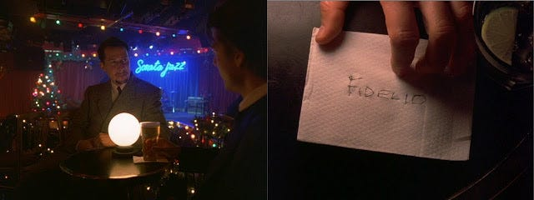

Was Nick specifically chosen by Ziegler to draw Bill in?
The film seemingly implies that 'Ziegler and his group' - seem to be aware of almost everything that is transpiring.
Could they have known that Bill knew Nick, from an earlier part of his life? Unlikely, but it cannot be ruled out.
The song of the nightingale has been described as one of the most beautiful sounds in nature, inspiring songs, fairy tales, opera, books and a great deal of poetry (including Ovid, see Szavost). The nightingale is also a member of the 'chat' bird family. It's Bill (beak) that will have a 'chat' with the 'singing' Nightingale. It's Nick Nightingale that spills the details via a 'chat' and the password via an 'opera' Beethoven's Fidelio.
It is clearly implied that these people are higher-echelon elite, a Rothschild built mansion is the location of the orgy.
I think we know what is being inferred, don't you? (note, the internal scenes took place at Highclere).

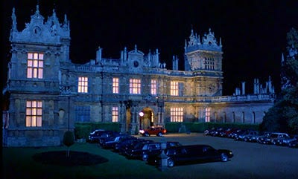

You'd probably expect to find the 'nouveau-aristocracy mixing with the 'establishment aristocracy'' at these types of events, by that (nouveau) I mean celebrities, film stars and certain Hollywood personnel, including producers and directors and P. Diddy. These described people, ARE the 1% and below, they have more in common with the traditional establishment aristocracy, than they do with any of us. Perhaps this is why the masses have to tolerate 'celebrity' MSM funded lectures, that tell the useless eaters how they should be living their lives! I know, you can't make this shit up. Such is the sickness within the 'cult of celebrity'. The religious leaders of this world, must look on in envy at the ability of the 'celebrity priestcraft' to entrap the masses in their web. There are hundreds of millions of adherents, worshiping at the altar!
Internal Somerton scenes...filmed at 'masonic' resonating Highclere:

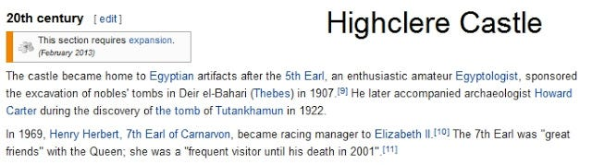

Freemason (Quator Coronati) Lord Carnarvon actually funded Howard 'Tutankhamun' Carter.
Note another Windsor connection, the Saxe-Coburg Gotha Nazis.
Lord Carnarvon went on to marry the illegitimate daughter of millionaire banker Alfred de Rothschild (cousin of the Mentmore Towers based Mayer Amschel de Rothschild, who was named after the banking dynasty founder). This effectively binds the two locations together even further. Bloodliners, eh? It was the original Mayer Amschel Rothschild (banking dynasty founder) who funded Weishaupt's Illuminati.﻿ (more on that, later in this post)
Corey 'I was surrounded by paedophiles in Hollywood' Feldman
"Some of them are the richest and most powerful people in this (Hollywood) business..."
Barbara Walters "You're damaging an entire industry." Yes, let's not let the idea that wealthy and connected Hollywood elites are raping (individuals) and programming (the masses) get in the way...are these people even human beings? It's a sick industry that needs destroying, anyway!
Some claim that Feldman's associate Haim, was raped/abused on the set of the 1986 film Lucas.
Some have claimed Charlie Sheen, others disagree. Sheen himself has been implicated in terms of child pornography.
His (former) wife filed an official court paper declaring Charlie's interest in extreme child porn.
Haim, was possibly suicided/silenced after (abuse) details leaked out on their The Two Coreys show. It was soon canned.
Haim, did go on to star in The Lost (OTO) Boys and some suspect that director Schumacher, is possibly a Crowley OTO-based paedo.
The star of Schumacher's film The Client, Brad Renfro (RIP) may have been subjected to similar industry abuse.
His films Apt Pupil (nazi), Sleepers (sexual abuse) and Bully (sexual abuse) seem linked.
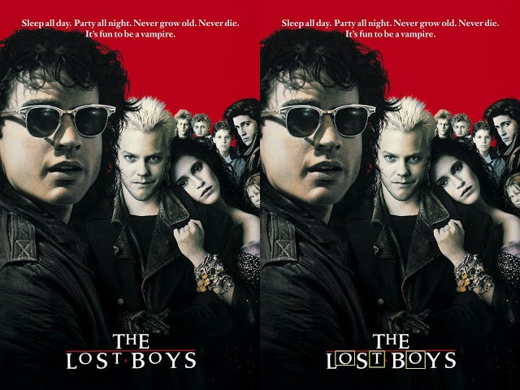

Director Bryan 'Apt Pupil' Singer has been referenced in respect of sexually abusing (rape) a former young actor.
Egan, who has since been indicted. What is one to make of such claims and why are they being made?
Note, I do not totally espouse the religious views of the video maker, but that's just me.
Do these 1% Hollywood elites have the power and muscle to bury most, if not all claims against them?
Apt Pupil featured the openly gay Ian 'Six Degrees of Gay Separation' McKellen (as a Nazi).
Renfro is involved in an abusive, subtly homoerotic relationship with his elderly neighbour (McKellen). During the production, a lawsuit was filed by extras who alleged that they were told to strip naked during a shower scene.
However, the lawsuit was determined to be without merit. (these things seem to follow Singer!)
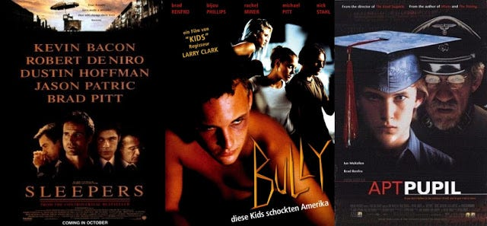

Kevin 'JF-Gay' Bacon in another sodomite role (Sleepers).
Jason 'Lost Boys' Patric in a film about a group of 'lost boys' (juvenile detention) who are raped and abused.
Bacon would play another paedophile in the 'sexually suggestive' titled Woodsman.
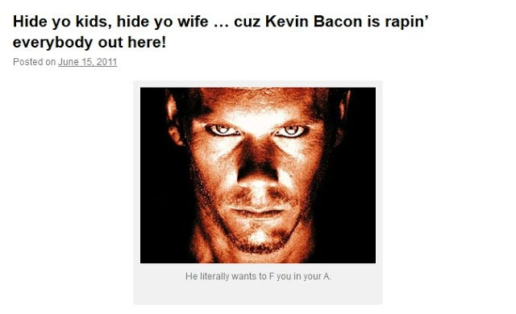
hide-you-kids-hide-yo-wife-cuz-kevin-bacon-is-rapin-everybody-out-here/
Parts of the movie Sleepers was filmed at Fairfield Hills State Hospital just down the street from Newtown/Sandy Hook.
I wonder if Sandy Hook Lanza was a 'sleeper' type himself? Or could he have been a media construct?



This is also one of the alleged homes of the MK-Ultra project and the infamous 'Dr.Green' (Mengele). J.D. Salinger (see Six Degrees of Separation) wrote Catcher in the Rye (mind control/lsd) in the area as well, while the Mk-Ultra program was at it's height.
Folk who are offended about my referencing homosexuality (in this way) should first note that 'ritual sodomy' is practiced in the higher degree system of OTO (the academia masonica). The same OTO that has a vice-like grip on popular US culture. Order of Oriental Templars (OTO), it's widely accepted that Templar's were known for practicing sodomy rites etc.
'Over the OTO sodomite rainbow'...with Harry 'GLF/NAMBLA' Hay
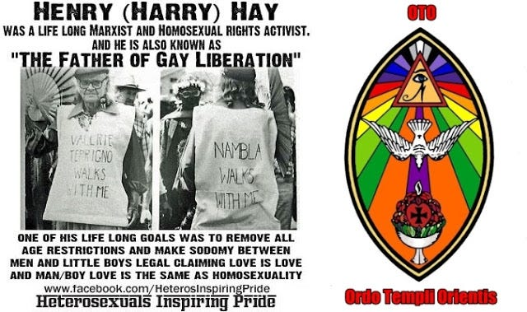
Aleister Crowley's Satanic Secret Sex, Sodomy, Baby Sacrifice, Cannibal Rituals of Ordo Templi Orientis - O.T.O.

Satchidanand
·
September 15, 2024

Aleister Crowley's Secret Sex, Sodomy, Baby Sacrifice, Cannibal Rituals of Ordo Templi Orientis - O.T.O.

Read full story

Even the Gay mafia's 'father of paedo sodomite liberation' was a sodomite OTO pawn!
Familial links to Rhodes (see Rothschild) and OTO/Crowley devotee pederast Kinsey!
(thanks to Good Fight Ministries @ youtube for the link)
Harry Hay was an occultist and organist [edit]
Whomever reverted my addition to the article clearly does not know what a source is. I provided the ISBN for the biography of Harry Hay "The Trouble With Harry Hay" that describes his active involvement in the Agape temple as their organist, and
refers to his "sacrilege" of also playing the organ for the local Catholic Church. Hay was also loosely associated with the
OTO. Both groups are occult organizations.
The Radical Faeries were also considered to be based in "spirituality."
The Faeries were described by a neutral writer as, "Marxism, feminism, paganism, Native American and New Age
spirituality, anarchism, the mythopoetic men's movement, radical individualism, the therapeutic culture of self-fulfillment and self-actualization, earth-based movements in support of sustainable communities, spiritual solemnity coupled with a camp sensibility, gay liberation and drag." Hennen, Peter (2008), Faeries, Bears, and Leatherman, University of Chicago Press - Preceding unsigned comment added by Job101010 (talk - contribs)
The detailed explanation on your talk page hered? was clear and polite. Please take some time to understand the issue
and the discussion about WP:UNDUE on this talk page with regard to emphasis on NAMBLA (such as your use of
"fervid"). Thanks, Fæ (talk) 04:41, 22 December 2010 (UTC)
I'm also a bit worried about labeling him an "occultist" when in reality he played the organ for the Agape group - as he
did for other groups. Being their organist doesn't make him a member of the organization - would you label him a
Catholic? - SatyrTN (talk / contribs) 04:00, 29 December 2010 (UTC)
Hay was not Catholic. "The Trouble with Harry Hay" recognizes the fact that he played an organ for the Agape Temple and
his Catholic Church as sacrilege. Hay's underlying opinions were clearly occult. Hay was also involved with the Aleister
Crowley group, O.T.O., which is an occult group. The biography and O.T.O. recognize the influence that the O.T.O. had on
Hay's life, such as the Radical Faeries.24.23.171.236 (talk)24.23.171.236 (talk) -Preceding undated comment added 18:02, 21
January 2011 (UTC).

Even the fact that he was an OTO agape lodge 'organist' is a barely veiled in-joke!
The organ, a euphemism for the penis, which is central to OTO tenets and practices.
Crowley: "Oh, how superior is the Eye of Horus (anus) to the Mouth of Isis (vagina)!"
OTO XI degree
So, ya still think that the 'sodomite mind control program' is a free and naturally occurring event?

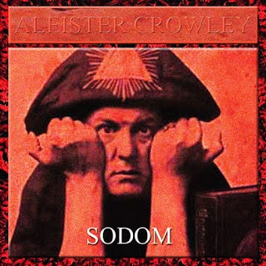
The attitude of pan/baphomet...aka the penis

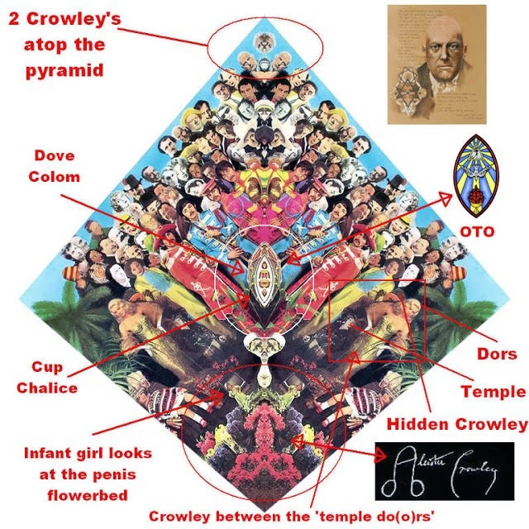

Remember this 'secreted' (a la Magick & Theory in Pratice) Sgt OTO Crowley Pepper and the OTO penis?
Lennon knew that the elite circle that surrounded him was paedo-sodomite based.
See how freely I can write when the shackles of PC (aka state sponsored brainwashing) are thrown off.
The whole LGBT agenda has been carried out on the back of this insidious mass brainwashing.
Most folk have been cowed into submission or been painted with the sweeping (and erroneous) brush of 'homophobia'.

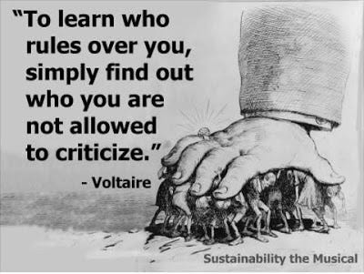

That perfectly describes Israel/Judaism and the LGBT communities. No criticism can or will be tolerated, therefore, it is clearly a form of imposed tyranny! A tyranny designed and fomented by those with the power to deliver MSM messages and in a mass way. (Guess who?)
Oh look, Schumacher in Judy's (WTC) Oz...via The Wiz, he wrote the script!
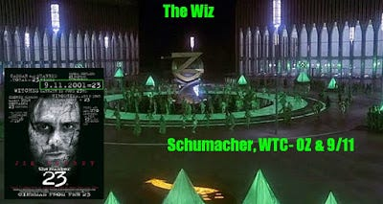

'Gay' Schumacher with Renfro (left) and Haim (right), both 'mysteriously' died at a young age.

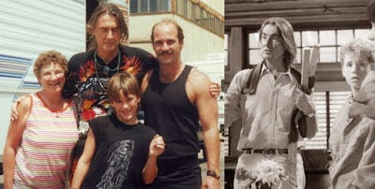

When he was ten, Renfro was discovered by Mali Finn, a casting director for Joel Schumacher.
It was the Knoxville police who suggested to Mali Finn that they use 10-year-old Brad Renfro.
I have already identified Schumacher, as a major 9/11 propagandist. A (Sept 11th) Time To Kill (which begins with the rape of a minor), Phone (9 & 11) Booth, Bad 'WTC' Company etc. Schumacher says of himself: "I was out on the streets... "And so I started smoking and drinking and fooling around sexually very young, very young." His film 8mm, was about snuff films and featured Joaquin Phoenix. Brother of River Phoenix (who died on Hallowe'en outside the Viper Room part-owned by Depp. Thanks to conspirazzi.com for the link) who gave out details of his own child sex activity in a magazine interview (losing his virginity at 4 years old etc), his family connected to 'the paedo-based cult' Children Of God, father was an Archbishop. This cult (now TFI) could well have links to the elite.



The same COG that poor Ricky Rodriguez (and his sister) was born into, and who was systematically abused and exploited, particularly by Berg, his own mother (Zerby) and his nanny Sarah (who Ricky killed before committing suicide). Ricky (aka Davidito, who was being groomed to be the heir to Berg) was used in COG literature overtly promoting incestuous paedophilia and imo this should be seen as a blatant attempt to install institutionalised child abuse throughout the flock etc. I recommend the documentary The Story of Davidito for more on Ricky's torment and the Children of God.
The correlation between 9/11 predictive program promoters and paedophilia seems to be strong.
Schumacher's...A (Sept 11th) Time To Kill was in league with Israeli propagandist Milchan

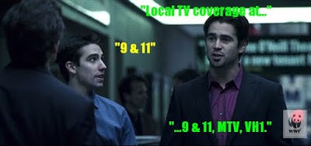

Farrell: "Local TV coverage at..." Farrell's assistant: "9 & 11" Farrell: "9 & 11, MTV, VH1". (Phone Booth). Schumacher's subsequent and kabbalistic, The Number 23 is very 9/11 resonant too.

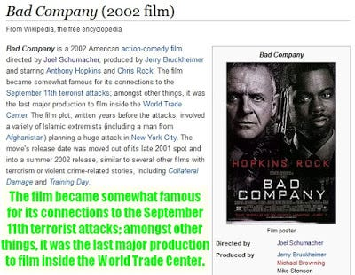

The very last major production inside the WTC, hell, it reads like the very event itself!
"A variety of Islamic extremists (including an Afghan) plan a huge attack in New York City."

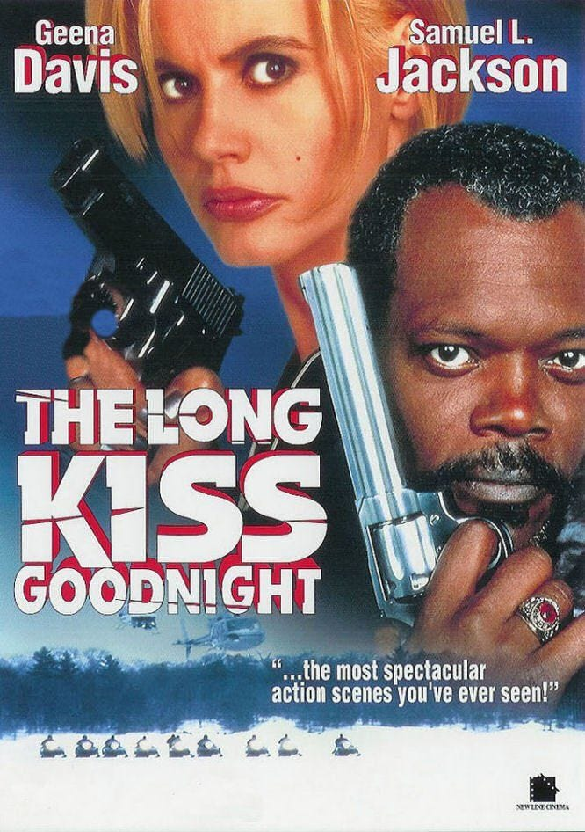

911 pre programming
Ziegler: "Those were not just some ordinary people. If I told you their names...no, I'm not going to tell you their names..."
'Ziegler's personal assistant'..." Two 'Scientologists' in one shot!"

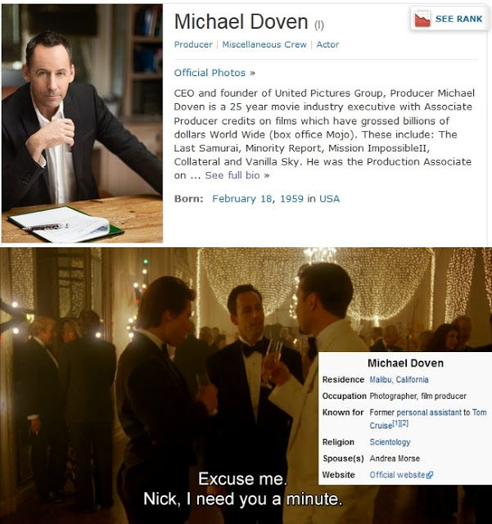

The man who acts as the (Ziegler) messenger and who ask for Nick's assistance, is a known 'Scientologist' and one who acts as a producer on some of Cruise's films. He has production credit on Eyes Wide Shut. It is possible that Doven is more of a 'handler' type in respect of Cruise.
Doven's wife (Scientologist) Andrea Morse has production credits for Kidman's Eyes Wide Shut.

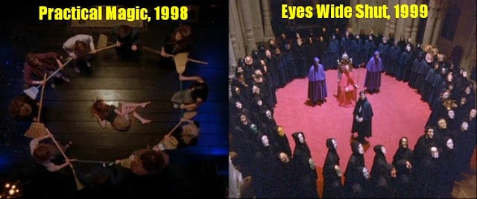

And Kidman's film Practical Magic, which are related of course! Practical Magic Circles x2.
Practical Magic, would also feature Diane 'The Lost Boys' Weiss, which we just mentioned.
Weiss has worked extensively with Woody 'suspected paedophile' Allen.
Scientology, 'ceremonial chaos magickians' Hubbard and Crowley:
Hubbard's son, L Ron Jr...Scientology is the magick of Crowley
Alice's 'Naval Officer' happens to be a Lieutenant (a la Hubbard), Tom/Nicole were both heavily into Scientology.
This seems to be an echo to her original programmer (imo) and her 'slavish' devotion to him, as she describes.
Tom's jealously bullshit is just the 'useless eaters' take.

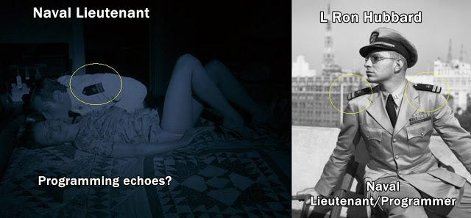

When you start to view 'so-called' films as more like reality based documentaries. You'll find that this stuff is easier to decipher.
Never before has "It's only a movie" carried so little significance and been so misappropriated, at least from my POV.

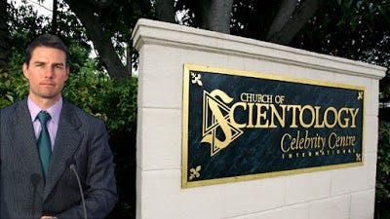

L Ron 'Scientology Hubbard, was alleged to have been heavily involved with the ONI (naval intel). Crowley was MI6.
Tom' Scientology' Cruise was Nicole Kidman's actual and on-screen husband during the making of Eyes Wide Shut.
Kubrick's own daughter (Vivian) 'Lost to Scientology', she joined the cult while working on the set of Eyes Wide Shut. (see article)

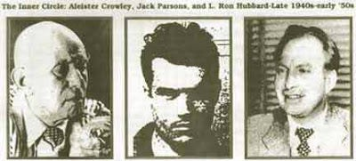

Hubbard was a disciple/associate of Thelema/OTO progenitor Aleister Crowley, and Hubbard worked ceremonial magick with JPL founder and Pasadena OTO lodge leader, Jack Parsons.
Hubbards own son (Ron Jr) at one time, gave an interview where he claimed that his 'Scientology' father used to carryout ritual abortions on his wife (Ron Jr's mother) and that the magick that OTO and his father employed was identical with the magick that was employed by the Nazis, Thule etc.
Crowley produced pro-Nazi propaganda and Parson's did 'Intel' work for Israel/Pentagon etc.
"Freemasons applaud violence, terror and crime, provided it is carried out in a crafty manner," writes Knight.
"Humor is all important and the most appalling crimes may be committed under its cloak."
"Many a true word is spoken in jest" - and this clip is no different. (2006 Emmy Awards).
Scientology Smiths...indoctrinating the masses' children:
Oscars So White? OMFG....how about growing a brain and saying Oscars So Yiddish!
Well, they're not going to turn on their Yiddish Hollywood owning masters/controllers, are they?
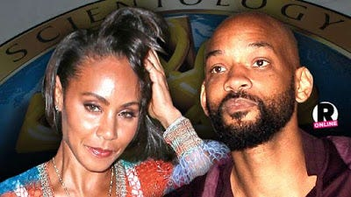

Black Lives Matter? Again I say 'Fuck Off'...ALL LIVES MATTER, you divisive bitches!
The Oscars are so racist, that they had a black man host the event...Chris Rock!
I'm certainly not buying any denials from the Smiths, regarding their Scientology status.
They've contributed large sums for Hubbard based schooling etc.
Do not listen to these zombie propagandists...they are using divide and rule, primed by their masters! Hell, do not listen to them, if only for what they have done to their own children.
Who are subsequently being used to degenerate (sexualize) your OWN children!
Will, Jada, Jaden and Willow all appear to be victims of 'monarch' mind control. Maybe that's why Will was connected to Catcher in the Rye, the book that is cited in respect of mind control.
Salinger likely worked for 'Intel' and the book a potential framework for mind control.
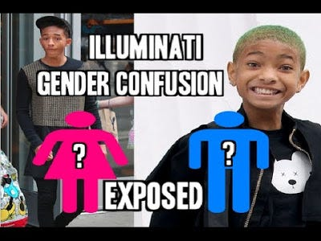

Rye, relating to LSD (synthetic ergot of rye), which is also cited in respect of programming.
The book features in Donner's Conspiracy Theory, where Gibson is a mkultra mind control victim.
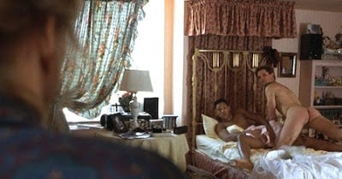

This is the film where Scientology Will gets caught in bed having sex with another man.
He also kisses another man fully on the lips. Scientology and homosexuality, eh?
Will 'Homosexual/Scientology' Smith, I've seen Will Smith kiss his own son and fully on the lips on live TV.
What kind of father kisses his own son directly on the lips and in front of the world?
If you're comfortable watching the above clip, I expect it's due to the amount of propaganda that you've subjected yourself too, but without using your given critical thinking skills. You think Jaden looks comfortable?

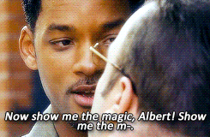

Smith in (film) Hitch...and two men kissing This from recent months. Scientology overlaps with Crowley's OTO (Hubbard was a Crowley associate).
It's OTO who practice ritualized sodomy in their highest degree.
Yes...Sex De-Gays of Separation, which just happened to feature Spielberg protege JJ Abrams!
Abrams first ever screen role was in this 'homosexual infused' release...Six Degrees.





What's been going on with JJ Abrams (or is that JJ Gay-brams) and his Star 'masonic' Wars, particularly in recent months and via the insidious paedo-promoters Disney? Yes, it's been 'gay overload' with Star Wars, you'd almost think they were programming the masses (wink, wink). Star Wars never previously needed any overt sexual angle. It already had the campest/gayest android (C3P0) this side of a San Francisco droid convention! Even Mark Hamill has posited that Skywalker might be 'gay' within the last week, does he not know that Skywalker (via previous literature) had a girlfriend on Tattooine? "Is that a light saber in your pocket, or are you just glad to see me."
Six Degrees of Kevin 'Gay' Bacon via JFK & 'ritual sodomite parties'. Bacon as a 'whore' who services 'connected men'.
Jail ass punk, Willie O'Keefe (Bacon, JFK) to Garrison: "You don't know shit 'cause you never been fucked in the ass!"


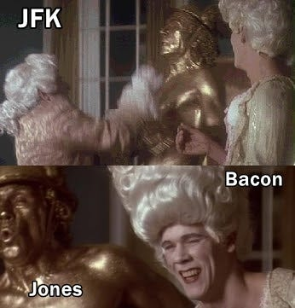

With Clay 'Tommy Lee Jones' Shaw...Scientology Will Smith's Men In Black co-star.
All a bit Eyes Wide Shut, wouldn't you say? Masonic 'Friday 13th' Bacon.
His wife Kyra Sedgwick was Tom Cruise's love interest in Oliver (JFK) Stone's Born on the 4th July.
"Don't you want to go where the (gay) rainbow ends?"

Tom 'Homosexual/Scientology' Cruise...'cruising', a phenomenon specific to homosexuality.

(EWS) Harford, was based on Harrison 'Star Wars' Ford's own name.
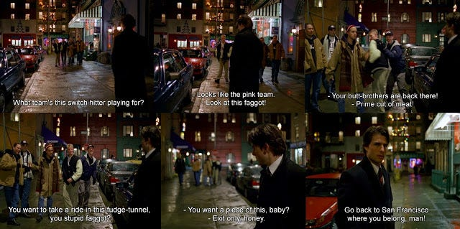

Homosexual overkill...Eyes Wide Shut.

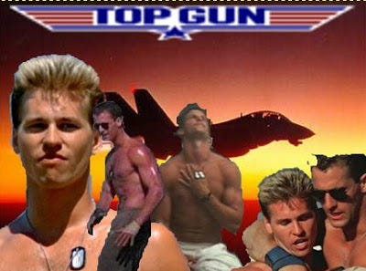

Cruise in his breakout film Top Gun, which had a very heavy 'gay' subtext. Director Tony Scott's prior release was lesbian vampire film, The Hunger. It is possible that Scientology were behind the marriage of Cruise and Kidman (bearding etc). It has been said that they were behind the marriage of Michael Jackson and Lisa Marie Presley (PR for Michael and cover for lesbian Lisa Marie).
Recall, Tony 'Top Gun' Scott 'supposedly' killed himself (Aug 2012) by jumping off a bridge.
Warriors, Cinema Blend article...dated 6/11/09 (an interesting number pattern and death link!)
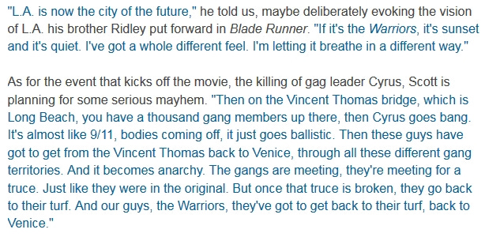

He jumped from the same 'bridge' mentioned in the above Warriors article! Oh look...9/11.
We've discussed Scott's Beverly '9/11' Hills Cop 2 and Enemy of the '9/11' State, in other posts.
Note, the last line is actually "you can be my wingman" (which evokes tail riding).
McGillis as the 'Hetero partner?'...even Cruise's love interest McGillis, turned out to be a lesbian.
Maverick's (Cruise) co-pilot (who sits directly behind him) is Goose, a term for pinching/prodding the buttocks.
'Gay' Iceman (Kilmer) in his debut, Top Secret (1984), giving him the ideal CV for Top Gun:
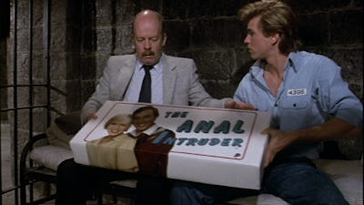

Kilmer, would next star in Real Genius (1985), followed by Top Gun (1986)
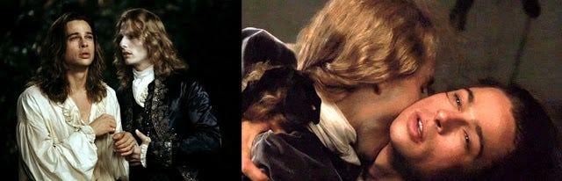

Interview With The Vampire/Camp-ire, heavily homoerotic...body penetration with fa(n)gs.
Cock-Tail (1988) Cock & Tail...Cock Tales & Dreams (it's Eyes Wide Shut)
Cruise would feature in Scott's Days Of Thunder, where he plays Cole Trickle.
The character is a nod to veteran racer Dick Trickle, another name to conjure with, a literal trickling dick.
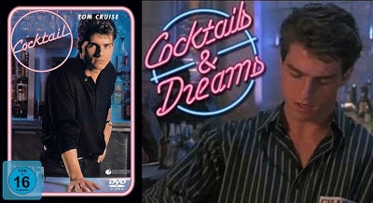

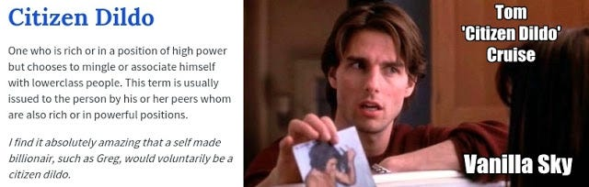

Cock Worship...
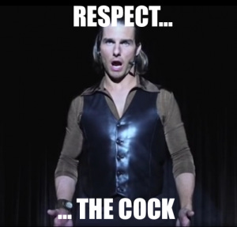

Cruise in 'Masonic' Magnolia
Cruise's fellow Scientologist John Travolta (another who is likely gay) was in Scott's The Taking of Pelham 123.
That film also has a heavy 'gay' referencing script, particularly via Travolta's dialogue.
"Where the rainbow ends"

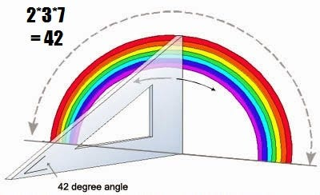

Top Gun stars and 'Club 237' (42, the rainbow connection). Hitch Hikers Guide to the Galaxy - Secret of the Universe is 42…

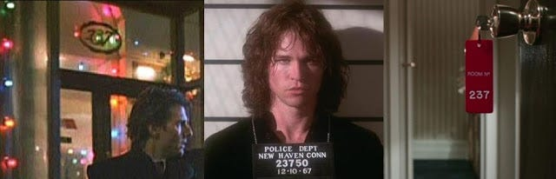

(above) Doors x3 and 237

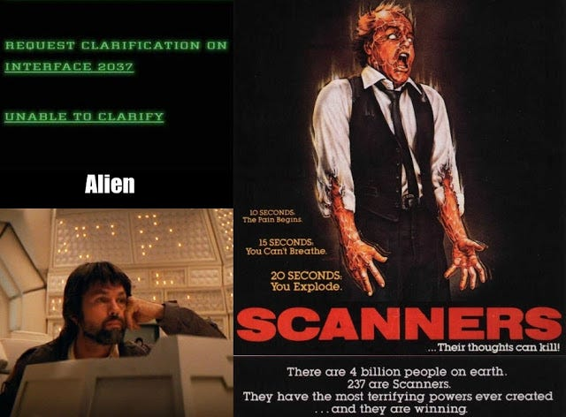

Tom 'EWS' Cruise, Val 'Doors' Kilmer, Tom 'Alien' Skerritt & Michael 'Scanners' Ironside.
Homosexuals and Jews...two groups that clearly make-up small minorities (say around 2-3%).
Yet somehow they dominate MSM like they are the 97-98% majority...something has clearly gone badly wrong!
I have no issue with Jews and homosexuals in the correct context, as minorities, but to have this wall of propaganda shoved down your throat, is an entirely different phenomenon altogether.
It's Oz/Aus Nicole 'programmed' Kidman...via OZ (director) and Stepford.



If Nicole's own father was a paedophile (as is being claimed), what are the chances that he (or his associates) abused her in a similar way, quite high (imo)?
Alice (Kidman), 'The Stepford Wife' with her 'alleged' paedophile father

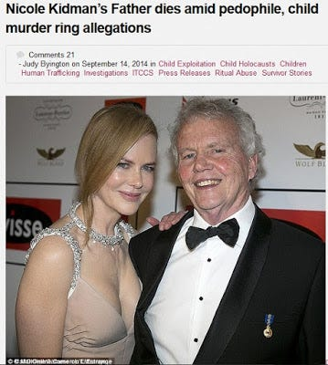

Barnett spoke out the day of Kidman’s death – White Balloon Day 2014 – an event aimed at raising awareness for Australian children affected by sexual assault. She stated, “My contribution to White Balloon Day 2014 is to urge my fellow victims of crime to fight the filth that this monster (Kidman) deposited in their minds and if they can muster the strength, join me in my effort to give a voice to victims who are no longer with us.”
The ICLCJ Court has been looking into Barnett’s allegations against Kidman in relation to their investigation of the global elite Ninth Circle Satanic Child Sacrifice Cult. Over sixty eyewitnesses such as Barnett have testified of Ninth Circle child sacrifice and pedophile activities that spanned the globe, including criminal activities against children in the Americas, Netherlands and UK commonwealth countries such as Australia.
The Ninth Circle was also said to have well organized and secretive human hunting parties that included pedophilia. Privately owned forest groves were believed used in the US, Canada, France and Holland. It appeared children and teens were obtained by the criminal drug syndicate Octopus, which was believed connected to the Vatican. The kidnapped children and teens were said to be stripped naked, raped, hunted down and killed.



I've seen/heard some of the details that Barnett has provided and the names involved include former Aussie PM's, dignitaries, establishment figures and celebrities etc.
Ziegler to Bill, Eyes Wide Shut: "Bill, do you have any idea how much trouble you got yourself into last night just by going over there? (see below).
Who do you think those people were? Those were not just some ordinary people.

If I told you their names... no, I'm not going to tell you their names... but if I did, I don't think you'd sleep so well at night."
Eyes Wide Shut seems more like a documentary, a documentary of the 'monarch mind control' system, one put in plain sight and placed under the nose of the masses. No wonder no one could understand what this film was about when it got released. This is all carried out using various degrees of 'veiling' techniques, some more obvious than others. The 'colour coded' aspects of the film also relate to this system of mind control (rainbow programming).
The Circle of Elite Abuse...Eyes Wide Shut

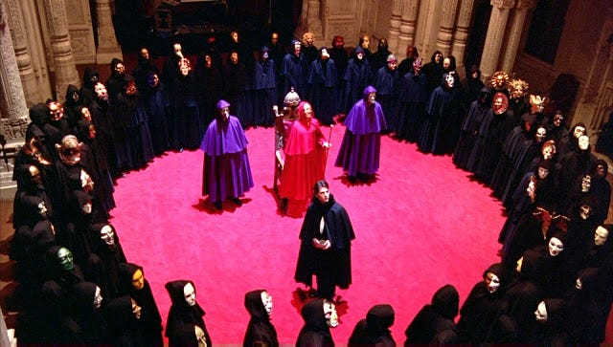

The Magic Circle(s), elite sex orgies (programmed multiples) and (implied) child victims (Helena).



Helena in the magic circle...an echo to the ritual orgy (this scene ends with the word 'fuck')

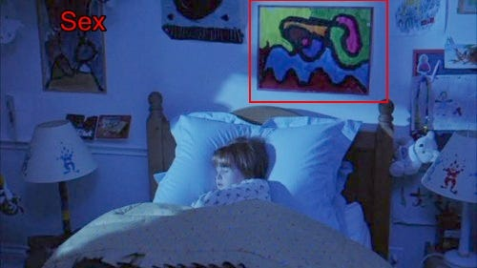

A 'magic circle' child (Helena), a bed and SEX...above shot is on Bill's return from Somerton.

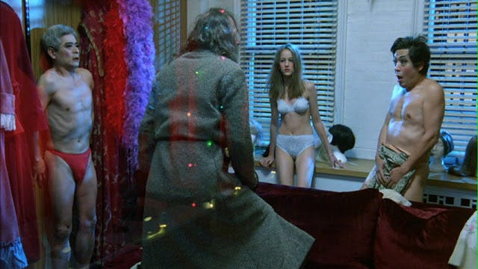

A child (with her pimp father, Milich) and two adult abusers.
Milich's outrage was for the benefit of the outsider (Bill), keeping up appearances.

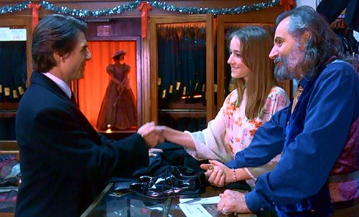

After Bill's ritual orgy visit, Milich suggestively offers up his daughter:
"It needn't be a costume" (meaning, you can f**k my underage daughter, with my blessing)
Nicole was in OZ (via Stepford and the director) and here is Tom in OZ (under/over the rainbow) with Milich and his (abused) daughter. The girl who plays her Sobieski, shares the same birth date as Judy 'OZ' Garland (June 10th). Garland being another likely programmed and industry sex abuse victim.

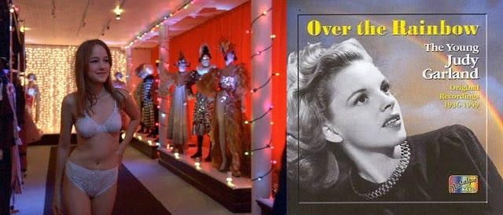

It looks like Judy broke down, and by the time she reached her 40's, she was seemingly a total mess.
Sobieski, is apparently related to Polish aristocracy.
Kubrick himself, has been mentioned in relation to Venetian aristocracy (Venetian masks @ aristocratic Somerton etc)
As I've mentioned in earlier work, there is an idea (in ritual abuse circles) that 'Over the Rainbow' is a term that is related to the ritual abuse/mind control. A trigger/command code (of sorts) perhaps an aspect of disassociation and accessing alters etc.
Bill (Cruise) is a doctor and one of his clients is Ziegler, played by Kubrick associate (and fellow director) Sydney Pollack.
Ziegler is the most senior member of this 'elite abuse club' that we find out about, everyone else is masked.

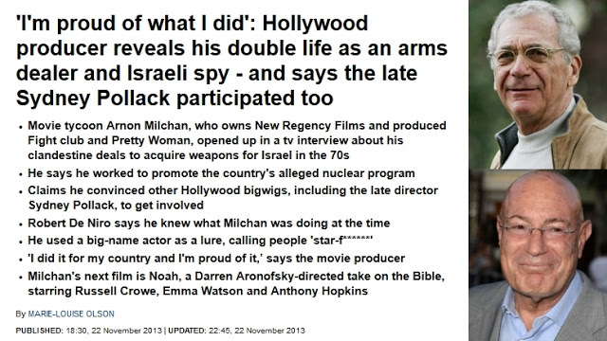

Sydney 'Ziegler' Pollack (deceased) has been outed as a former Israeli double-agent.
Effectively working against the United States, on behalf of Israel.
Eyes Wide Shut...

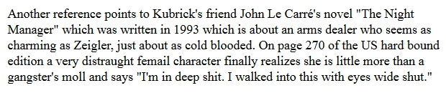

An arms dealer like Ziegler (Pollack) aka a gangster, Mandy his moll (see Ziegler's party), she is in deep shit, Mandy's the one who ends up dead. The quote could just as easily be applicable to Bill.
Alleged Hollywood rapist Harvey Weinstein harassed Pollack on his deathbed, or at least until he was finally removed.
Kubrick's Eyes Wide Shut followed Schnitzler's novel (Traunovelle) very, very closely, except in one major aspect.
It is a Jewish family in the book, set in Jewish Vienna, written by Jewish Schnitzler.
Yet Kubrick expunged all the Judaic aspects from the story and its characters.

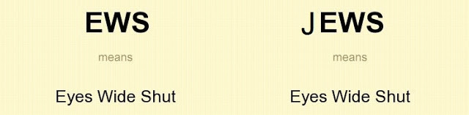

Why was Kubrick so keen to remove all the Judaic references?
Eyes Wide Shut, Pollack, who had ties to major Hollywood producer Arnon 'Israeli Arms/Mossad Double Agent/Peres' Milchan.

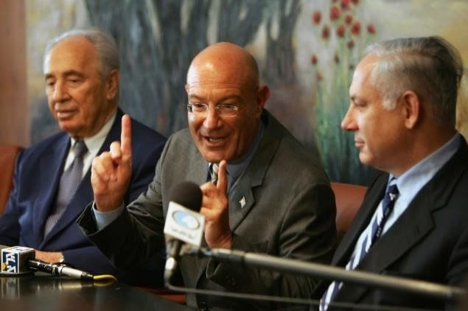

Milchan...situated between Peres & Netanyahu. A mossad agent...and 'group mind' media terrorist?
http://www.dailymail.co.uk/news/arti...raeli-spy.html
Sydney Pollack...as secret society big-wig Ziegler.
Re: The Illuminati Masked Ball...Eyes Wide Shut
Victor Ziegler: Those were not just some ordinary people. If I told you their names...
No, I'm not going to tell you their names... but if I did, I don't think you'd sleep so well at night.
Oh who can he possibly mean...cough, cough!? (yes, I do a heavy line in sarcasm!)
I wonder how much of a buzz 'these types' get out of doing this kind of thing and right under the noses of the unsuspecting and sheep-like public?
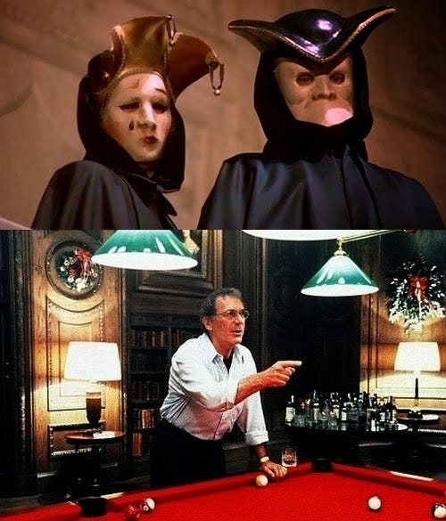

Sydney Pollack...as secret society big-wig Ziegler.
"Aron was a pirate, a buccaneer in Hollywood," says Gilliam. "He ran into Hollywood's anti-Semitism. They don't like real Jews.
They don't like Israelis. Arnon has a Levantine soul. Everything is horse trading and carpet dealing." A top Hollywood executive once warned Oliver Stone to stay clear of Milchan. "He told me that Arnon was a Middle Eastern rug dealer. Beware," recalls Stone, embittered from business dealings gone sour. "I should have listened to him. He was right."
"Arnon has to screw everyone - partners, friends - literally, figuratively, in every sense of the word," says Gilliam. "It's pathological.
He can't stop himself. At some point, he needs to invent an enemy.

Terry Gilliam and Oliver Stone, Stone's JFK was Milchan's first film for Regency Pictures.
Milchan got his start via Elliot Kastner (who executive produced The Medusa Touch).
The step-father of Carey 'Saw' Elwes. Elwes is clearly bloodline and connected (understatement), see below. Elwes' proper film debut was in Another County (1984) about homosexuality in the British public school system (Elwes was educated at Harrow). A public school system that historically relates to institutionalised sodomy/buggery. The story concerns Guy Burgess (Bennett, played by gay Everett) who wrote, Clockwork Orange, Elwes (Harcourt) plays his lover. The same Burgess who connects to a circle of Marxist (Illuminati/Jewish funded) homosexuals, one of whom, Anthony Blunt, has been linked to 'real' organised political paedophilia via the Elm Guest House (and Kincora), Barnes, London. Blunt himself was heavily connected to 'Harrow educated' Victor Rotshchild. The same Victor Rothschild who used spend time with Ted 'Paedophile satanist' Heath at Chequers
Carey Elwes' paternal grandfather was painter Simon Elwes, whose father was the diplomat and tenor Gervase Elwes. His other great-grandfathers include the diplomat Rennell Rodd, 1st Baron Rennell, Sir John Macfarlane Kennedy, and Croatian industrialist Ivan Rikard Ivanović. Elwes' ancestry is English, Irish, Scottish, Serbo-Croatian Jewish, the latter two through his maternal grandmother, Daška McLean, born Daška Marija Ivanović-Banac, whose second husband, Lieut.-Col. Billy McLean was an operative for Special Operations Executive (nefarious occult intel, Victor Rothschild was connected) during World War II. His paternal forbears include such clerics as Dudley Charles Cary-Elwes (1868–1932), the Roman Catholic Bishop of Northampton (1921–32), as well as Abbott Columba Cary-Elwes (Ampleforth Abbey, Saint Louis Abbey), and Father Luke Cary-Elwes (Fort Augustus Abbey).
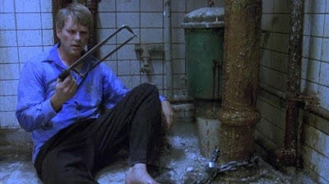

Elwes featured in James 'Masonic' Patterson's Kiss The Girls, a film that clearly relates to 'collecting' kidnapped woman and using them as 'sex slaves'.
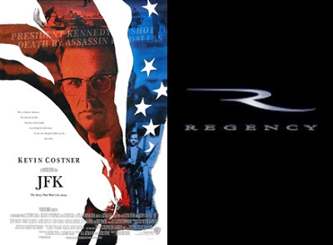

Deceased researcher Sherman Skolnick claimed that Stone's JFK was financially funded by the Rothschild's (you saw their ritual mansion, in Eyes Wide Shut) they released it through their theatre chain Loews.
At one meeting I asked Oliver Stone's chief researcher for his movie "JFK", whether the Rothschilds, friends of the Kennedy family, financed the 42 million dollar production. It ran in the Rothschild movie chain, Loew's. She glared at me. Later, when Oliver Stone himself showed up, she grabbed him by the arm, saying, "Don't talk to HIM!" Perhaps indulging me, because of my physical disability, Stone allowed me to point my mike at him as I asked a few questions and then she pulled him away.

http://www.skolnicksreport.org/assassinations.html
Sean Stone actually featured in JFK, as Jim Garrison's son Jasper. Louis Stone (Oliver's father, Sean's grandfather) aka Louis Silverstein (is 'Larry WTC 7' any relation, lol?) was a Wall St stockbroker.
Stone's Wall Street film, contains subliminal ciphers that connect to 9/11 and the WTC.
Recall there's also a major plot point concerning an 'Airline' (Bluestar). Sheen will star in a 9/11 titled release in 2017.
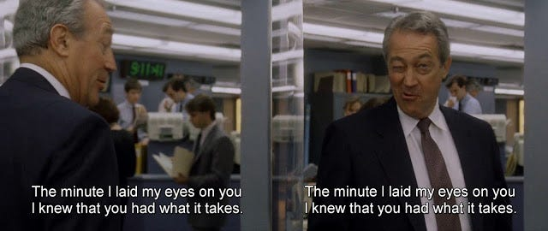
Minute (time), 9hrs 11mins (41secs) and a 'wink'
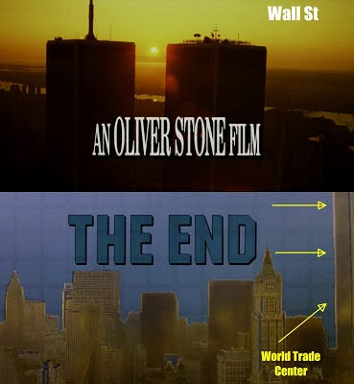

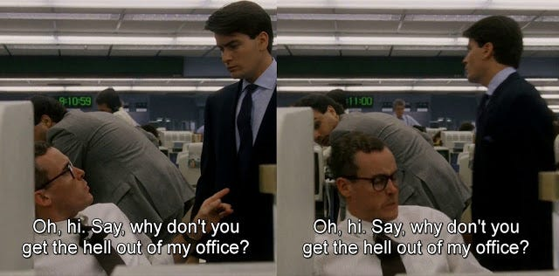

Clock hits exactly 9hrs 11 mins Sheen remembered that Stone was always looking at the script and at his watch. (wiki)
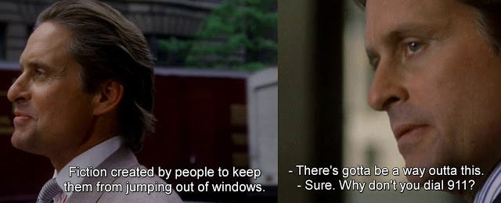

Window Jumpers...Dial 9/11 (two separate scenes)
Michael Douglas...it was Michael's father Kirk, who recommended Kubrick for Spartacus.

James 'Wall Street' Karen...he starred as Mr Lynch in Stone's film.
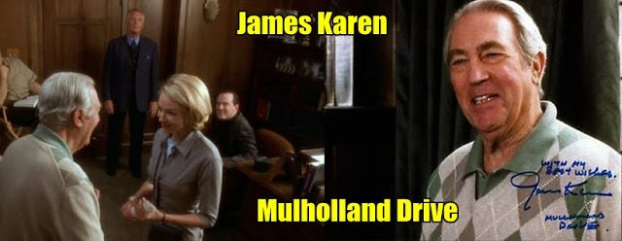

Wall Street's Mr '9:11' Lynch (Karen)...in Mr (David) Lynch's Mulholland Drive. David Lynch's film would feature 'The Tower' (theatre) in the Silencio scene. William Mulholland (source of the film's name) was born on a 9/11 date. Incestuously abused Beatrice Cenci, see painting in Betty's (Watts) apartment, was killed on 9/11. Karen also featured in Steven "911" Spielberg's 'Poltergeist'.
Oliver Stone's son...Sean, "Eyes Wide Shut Parties Are Real" with Alex 'let's all ignore the Zionist threat' Jones!
This type of thing actually got referenced in the JFK film...Shaw was likely elite connected.
The reason Sean knows that they are real, is likely due to his father (director) Oliver.
Oliver either attended these events (himself) or knew of (Hollywood) people close to him who had!
Crystal Skulls? I think he is taking the piss here, more like the 'crystal skull' of mind control victims!
Stone's film 'World Trade Center' is a likely whitewash for the benefit of the elite. Stone could pluck any amount of elite/authoritarian/political 'conspiracy' out of JFK, but couldn't see shit in the 9/11 event? Now Sean Stone is a Muslim, WTF? He is welcome to join this backward, women hating religion if he wants, but I will call it what it is...a backward, women hating, 'mind control' based religion.

Milchan, financed by Jewish propagandist Lew 'ITC/Sept 11th' Grade, made The Medusa Touch aka The Med-jew-sa Touch.
Mind control and 9/11 'predictive' film. Grade's ITC was founded on Sept 11th 1954 (or 1958), both have been used.
It has been changed again in recent history, but I have a hard copy or the original dates that were used.
Medusa...Gorgon of Terror

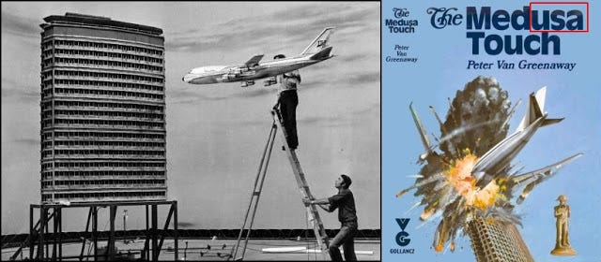

Telekinesis or (TV) Telly-kinesis? The Med(USA) Touch, the United States.
Medusa, gorgon of terror...9/11 terrorism, USA



The 'remotely controlled' (telekinesis/telly-kinesis) aircraft 'struck tower'...Milchan's first big film.

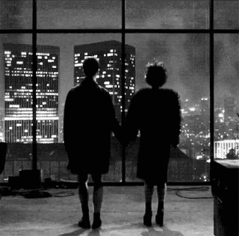

He was involved in Fincher's Fight 'Collapsing Ground Zero Twin Towers' Club, A 'Sept 11' Time To Kill and The Devil's Advocate, which also featured the Twin Towers. Milchan's Regency Pictures made the recent film Gone Girl (directed by Fincher, Milchan co-produced) which ultimately satirised the MSM and played on the idea of 'media reality' versus 'reality' via sociopathic Amy.
Sean Stone has been connected to RT (Russia Today) as a co-host on their show Watching The Hawks.
Jesse 'Hollywood' Ventura's son Tyrel hosts the program. RT's Watching The Hawks.
Yet another example of 'in your face' mystery religion/freemasonry based symbolism/propaganda!

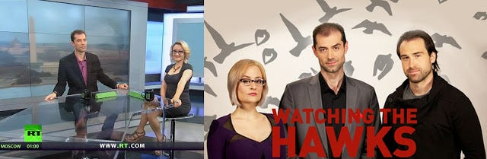

The show's background scheme is the Washington monument (aka the penis of Osiris) and 'Hawks' or Phoenix’s are also present, regularly overlaid on the Osirian penis. Simply put, it is a Penis - Osiris, Vagina - Isis or Anus - Horus reference

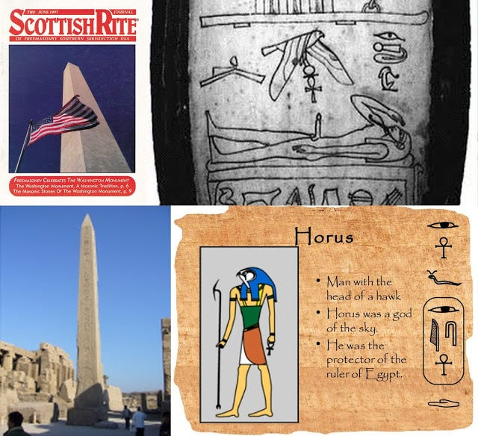

Watching The Horus (via Osiris)...don't worry, I am watching them! Tyrel's father was connected to wrestling and WWE/WWF.
Kubrick's own film production company was called Hawk Films.
Jesse 'Masonic' Ventura...

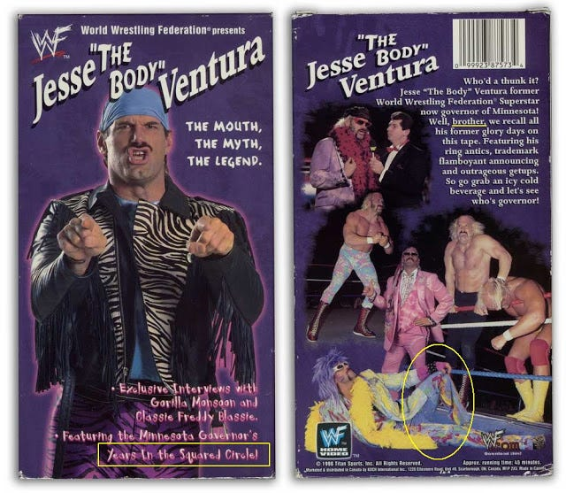

'Years in the squared circle' (masonic based), 'brother' (masonic term). He looks like a lost member of the band Village People.
'Ring antics?' Was this more stealth gay-based propaganda?

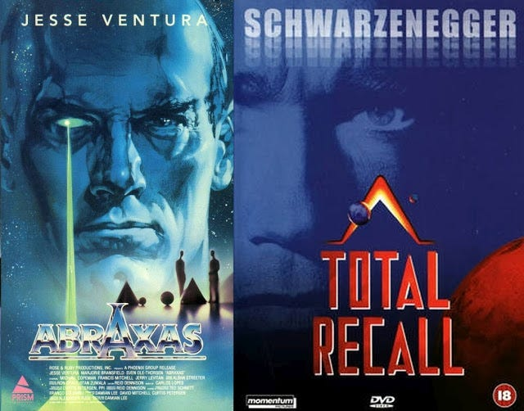

Jesse/Arnie 'snap'. Mind control, the eye and the pyramid(s)...more bog-standard masonic imagery.

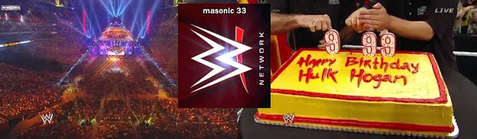

Masonic WWE...circling the square (the square ring)
Illuminated pyramids (uncapped ones can be found in the fighting arena), 33 and 999/666.
Usual and typical masonic kabbalistic markers, XXX another marker for this sport, another rendering of 666 (pythagorean).
Recall Jesse Ventura's associations with Arnie, some via films Predator and Running Man etc.



Both these 'masonic stooge' clowns have been owned by Washington, Hollywood etc
Talking of Jesse 'WWE' Ventura...(thanks to a reddit conspiracy user)
...his name got mentioned in this rather 'prescient' piece of predictive programming, connecting to the tag-team Twin Towers (note the dialogue, terrorist attacks, twin towers destruction, crumbling down etc). I think that's WWE busted as yet another 'elite based' programming device.
Jesse/Tyrel are likely controlled 'masonic' opposition, like Alex Jones, Sean Stone, Mark Dice etc.
There seems to be a sex abuse element running through WWE and it (in part) relates to Pat Patterson running some kind of gay ring (Cream Team). Which sounds like a type of (sexual) euphemism itself! It sounds like Roddy 'They Live' Piper was a victim, although he shouldn't blame himself!

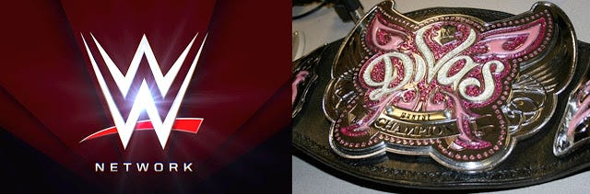

There is a potential 'sexual allusion' within the logo...a homosexual one.
The female Divas belt features a composite butterfly...a potential 'monarch' link.



Likely also reflected (see wings imagery) in the 'Ring/Hoop' dunkers team the Sacramento Monarchs.
Monarch/butterfly (mind controlled) Divas don't get much bigger than the following monstrosity...



Her former MonarC label settles the issue. Ahem.

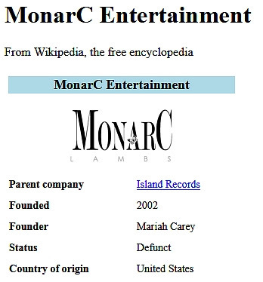

Yup. Nothing but a (Jew) industry controlled marionette - for the purposes of deviant indoctrination.

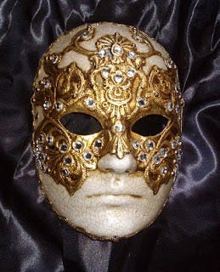

Cruise's (Bill) ritual mask design is also (imo) evocative of the butterfly.
Similar film promo imagery...both films are also set around the Christmas holiday period.

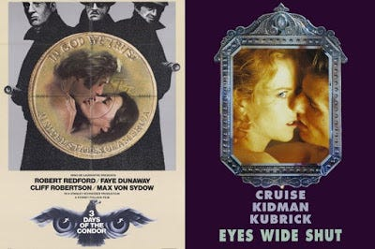

Passing through Kubrick's 2001 'monolith' led to (Bow)man's transformation (manipulation):



2001, transforming the (apes/useless eater) mass via the (monolith) cinema propaganda screen.
Mono (singular/one) Lith (a type of photographic film process). The single film screen.
'2001 Monolith' Kubrick...Twin Towers, Ground Zero - Monolith Millenium (aka 2001) Hotel.

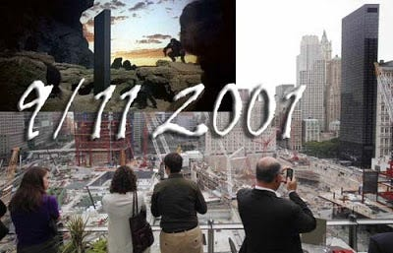

Around the perimeter/edge of the 'ground zero-9/11' footprint. Tel #: +1-212-693-2001
From '9/11 Ground Zero' to the 'Twin Towers', Pollack's 1975 film was part-set in the WTC.

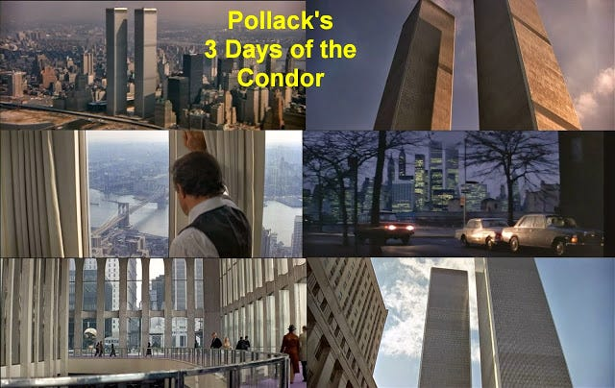

3 Days of the Condor predicts the post-9/11 world: Government agencies manipulating world politics and starting never-ending wars to gain control of the oil in The Middle East (sound familiar?). The C.I.A. (a renegade operation within the C.I.A.) has plans to invade the Middle East. The New York C.I.A. office is in the WTC. (for one moment, forget that this was a film and simply apply it to our unfolding reality!)
Cruise would feature in Pollack's The Firm, Kidman would feature in his film The Interpreter.
Illuminati plans and in plain sight...WTC, CIA, Coups, Middle East/Oil, 1(911), Massacres

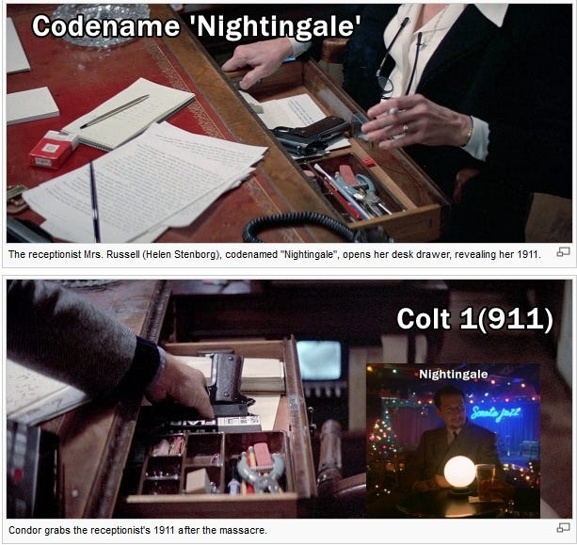

Pollack's 3 Days of the Condor would feature a character called 'Nightingale' (the first victim in the film's massacre), just as there is a character called 'Nightingale' in Eyes Wide Shut (which is set in Manhattan). Both 'Nightingales' also thematically relate to code-names too (Fidelio for EWS). It was Ziegler (Pollack) who recommended him to the cult. See how smart and clever they think they are weaving this propaganda into films, how superior? We can brainwash entire societies with our Zionist propaganda (prime the masses for 911 etc), but that's not enough, they must rub the Goy's noses in it too! Full media spectrum dominance by Zionist Israel, has allowed them to brainwash an entire nation and beyond.
Invading the Middle East, oil wars, regime change: "We have games, we play games..."
Pollack goes 4th wall in the end scene...and with reference to the (controlled) 'news press'.
What a mind fuck, the 'ultimate' renegade network (obliquely and in terms of this film) are the (Hollywood/Intel) people who funded and brought it to the screen...they're literally talking about themselves and the (govt/state) foreign policy that is to be.
Anyway...one of the 'giveaways' (imo) that we might be dealing partly 'in fact' (as opposed to fiction) is that Kubrick cast a 'fellow director' as one of the 'secret society' honchos, that being Pollack as Ziegler. A 'typical' actor could've been in the role (originally it was Harvey Keitel) but this was changed...and director/producer (occasional actor) Pollack was in the role.
"Please, Bill, no games. I was there..."

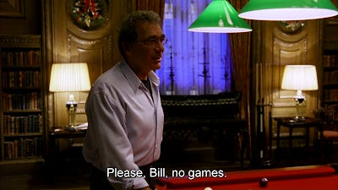

Ziegler plays dress-up at a ritual orgy, where a girl exclaims that she will take Bill's place, only for her to found dead the next day (Ziegler aware)...and he accuses others of playing games!

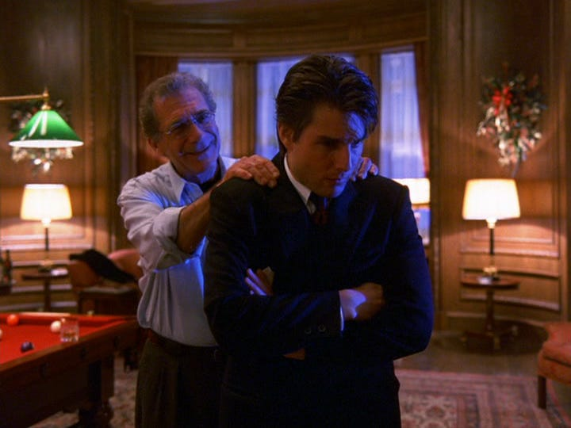

Ziegler: "Life goes on, until it doesn't." Potentially a 'veiled threat', Bill's body language agrees.
"Bill, do you have any idea how much trouble you got yourself into last night just by going over there? (trespassing and unwelcome, see below).
Victor 'Tiler/Tyler' Ziegler...The Somerton Lodge Tiler/Tyler (Guard)

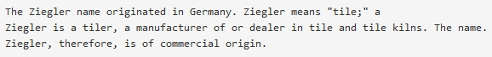

A Ziegler...is literally a Tiler (Tyler)

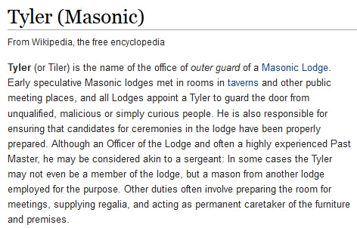

Clearly...Ziegler acts as a form of 'Tyler/Tiler/Guard'.
Recall at 'masonic' Somerton, that the 'unqualified and curious' Bill shows up.



Note, masked Ziegler observes 'trespassing' Bill and 'knowingly' nods/gestures towards him. From the look given, it seems like the masked (tiler) knows an intruder is present and out of place. It looks like Bill's cover has been blown already. 'Strangers In The Night' will soon play, indicating to the gathering that a 'stranger' is in their midst - 'exchanging glances' (per the song) Bill & Ziegler.

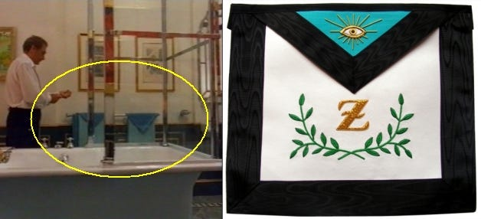

Ziegler 'the tiler/tyler' and the 9th degree apron with 'eye' and Z. Kubrick may have 'expunged' the Judaism, but he certainly added plenty of Freemasonry (which is ultimately based on the Judaic Kabbalah).
Bill reads about the death of Mandy...while 'masonic' Mozart's Requiem Mass plays.
The 'death' mass which Mozart left unfinished due to his own passing.
The rumours of the 'masonic brotherhood' being involved in his death are well known.

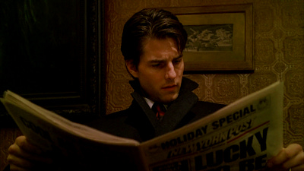

"Lucky To Be Alive" (Newspaper)

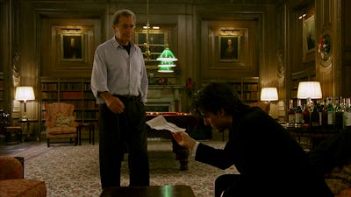

How does Ziegler know that Mandy's door was locked from the inside?
No details of the door being internally locked is mentioned in the newspaper article concerning her death.

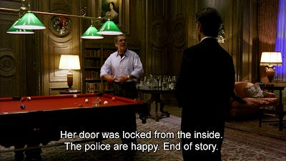

Ziegler knows too much, more than what is generally freely available.
I suppose when the 'cult' has (implied) control over news media and the police.
It would be fairly straightforward for them to fashion a story, to cover their activities and tracks.

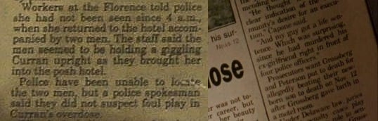

Juxtaposed to Mandy's 'overdose' (suicided) story, is an unrelated article mentioning someone murdering his ex-girlfriend.
Just prior to that, the article mentions a desire for execution. (see above).
Comparing Mandy (Curran) and Alice...the morning after the Somerton 'ritual orgy'

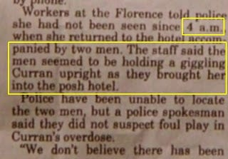

Mandy giggling, drugged and 4 a.m., Alice giggling, 'drug-like' sleep and 4 a.m.

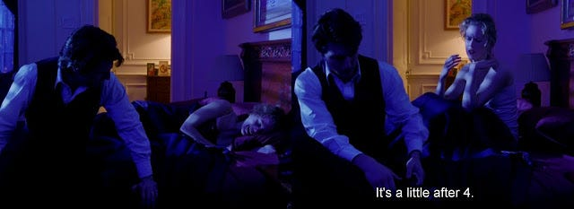

Bill takes the cab home and Alice wakes up giggling and laughing as if she had been drugged.
It is around 4 a.m. This is the dream that we mentioned earlier, where she recants the similar events.
Similar to those which we saw at Somerton.
Does Helena get abducted by men connected to Ziegler
(and the cult) and with Alice's collusion, at the film's close?

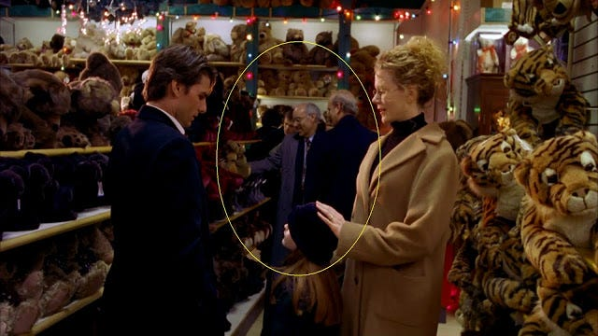

Ziegler's 'Party' (beginning) Toy Store (at ending)...The same 'two men'

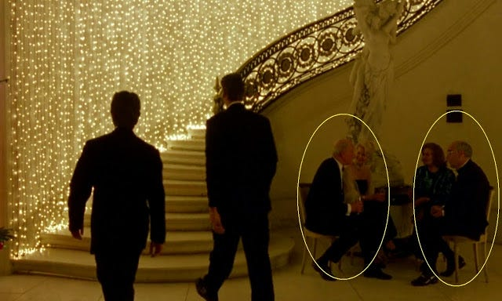

If the people both at Zielger's and at Mentmore, are the same. Then they seem to be following the Harford's family every move.
The scene can actually play as the kidnapping of Helena (as Laurent Vachaud as suggested) into the 'cult'.



Alice (already initiated) is potentially involved in allowing 'men' from the 'cult' to abduct her from the toy store.
She distracts Bill for the film's entire last 3 or so minutes. Helena is not seen again and neither parent pays any mind.
Alice sheepishly looks to the men, when she seems to gesture Helena further done the store aisle.
As a programmed multiple, she can be used and even assist the 'cult' in kidnapping her own daughter.

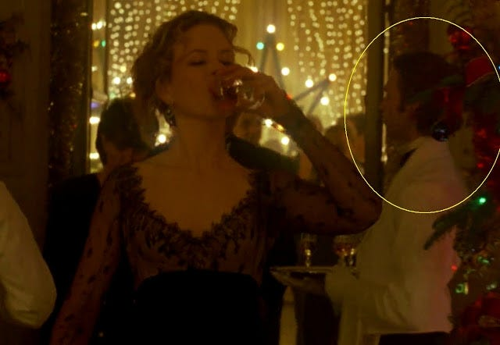

Another man from Ziegler's party (a long haired drinks waiter) is also present coming into view from the right (toy store).
I've horizontally flipped Alice 'with drink' pic...for easier comparison.

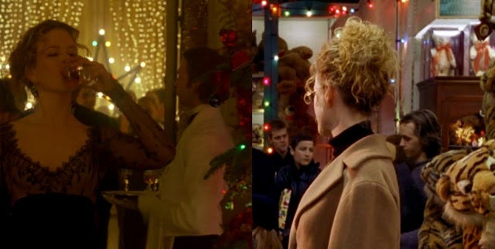

Effectively now 'three' men connected to Ziegler's party (and likely the cult)
are around Helena, and in the last moments that she features on screen.

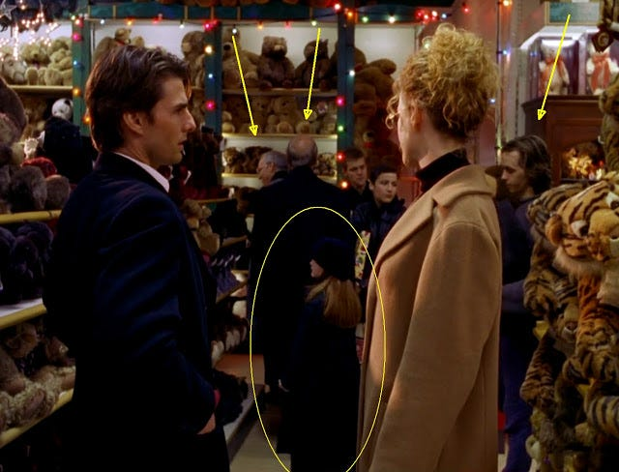

Note, it's Alice who's watching Helena and observing the scene, she does act rather suspiciously at times during this scene.
All three men present in the final frames which feature Helena.
"Baby did a bad bad thing...feel like crying, feel like crying. Baby did a bad bad thing..."



It is Alice who steers Bill and Helena down this particular shop aisle, to this point, watch the scene.
It's crying Alice (after 2 days of torrid events) who mentions about going shopping on this day.
If this is 'the cult' making off with Helena, it would have to be carefully planned and executed.

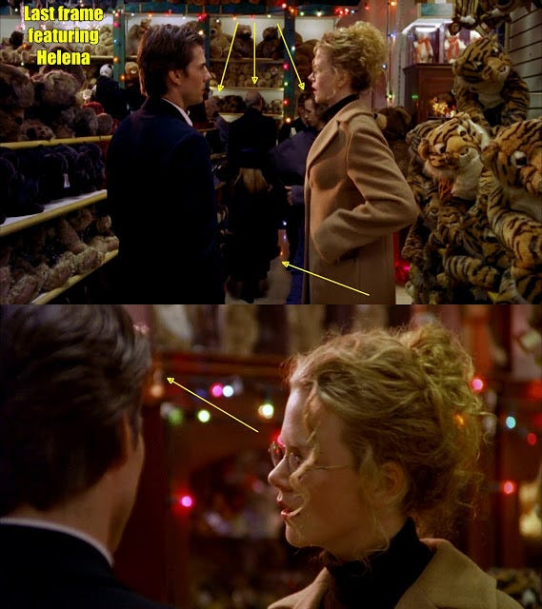

Next, Alice will draw Bill away (briefly observing yet again, see right pic) for a protracted conversation.
It will last about 3 minutes and with no other reference to the daughter, after which the film ends.
Recall the earlier potential allusions...

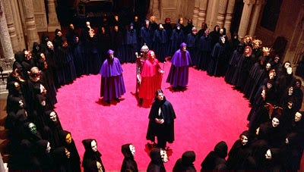

The Magic Circle(s), elite sex orgies (programmed multiples) and (implied) child victims (Helena).

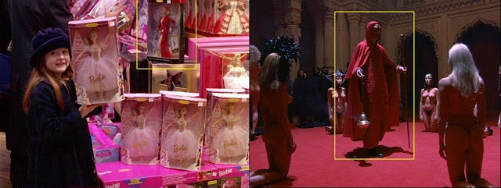

Toy Store, circle of dolls (red at centre). Somerton, circle of (MK sex slave) dolls (red at centre)

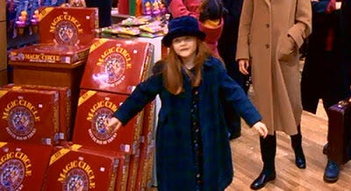

Helena in the magic circle...an echo to the ritual orgy, the store scene ends with the word 'fuck' and the potential kidnap of Helena (by the cult). Helena is dressed in blue...

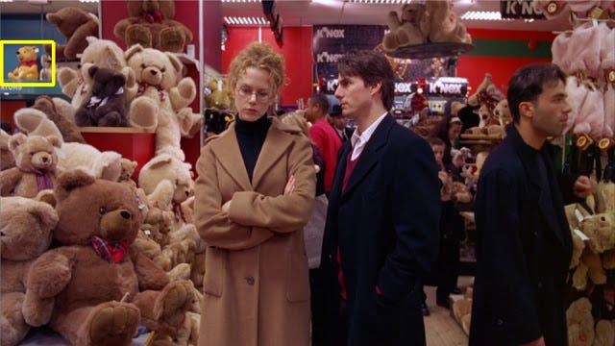

Moments before, the bear wasn't holding the 'blue doll'.

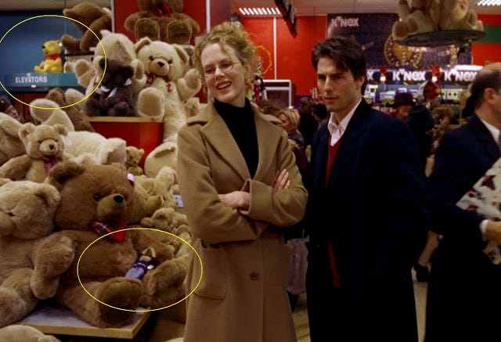

Pooh bear (and elevators) a nod to The Shining and (abused) Danny.
Not forgetting the 'bear' Danny lies on as the doctor examines him. Right after the above shot, we cut to this:

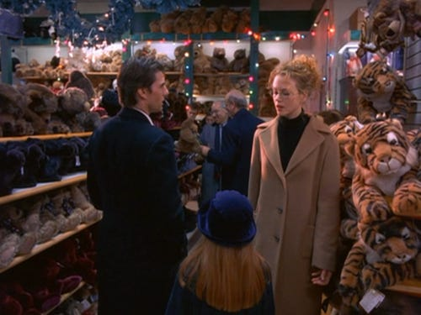

One of the 'Ziegler 3' is seen holding a 'bear' (placed on shelf) just before we see the last of Helena.
Bear (x2) blue doll, Helena in blue and 3 of team Ziegler (in league with Alice) in potential kidnap.

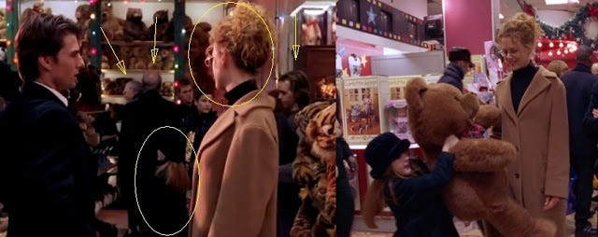

Yes, it really looks like all of the 'subliminal aspects' are suggesting that Helena is being kidnapped by the 'cult' and in league with Alice. It is uninitiated Bill who has his 'Eyes Wide Shut', is the ending a reference to him being absorbed by the cult, when Alice utters 'fuck', she doesn't specify who with? Knowing Kubrick and his style, none of these details are likely by chance or coincidence.
Bill's daughter and her 'sex' bedroom pic...this shot is after Bill returns from Somerton.

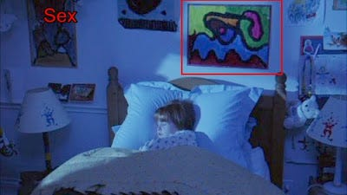

Kubrick's wife Christiane, is very likely to have painted the picture, I'd say it's a certainty.

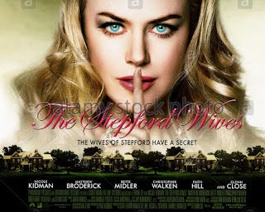

Oz (Aus) 'programmed' Nicole...In Frank Oz's The Stepford Wives...

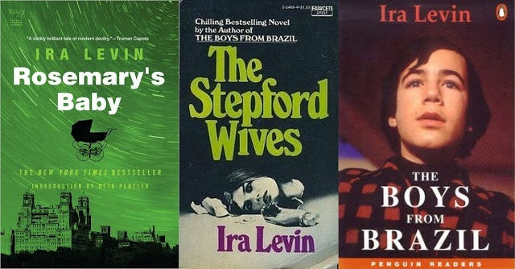

Monarch (programming) has been connected to the CIA and the Nazis, 'twinning' seemingly an aspect and recall my last post about Angela 'Adolf/Mengele' Merkel (Boys Girls From Brazil).

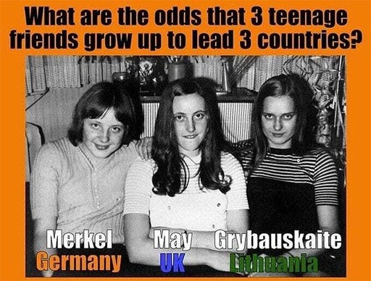

In connection to Eye Wide Shut, during Levin's Rosemary's Baby, Rosemary finds herself a the centre of a plot involving satanists and her child. EWS, Bill finds himself embroiled in a plot involving an 'elite cult' (that his wife may belong to) and 'potentially' his child and it can be implied that it's a 'satanic-like cult' (backwards mass, red, mind control, circles, 'implied' sex magic etc).

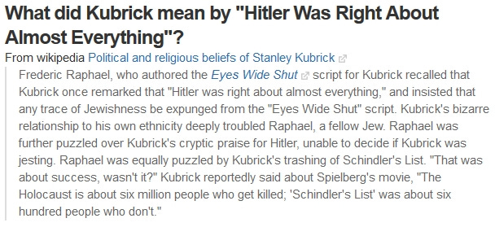

Eyes Wide Shut, script writer Raphael...Kubrick, expunging Judaism and praising Hitler?
Yes, this supposed quote attributed to Kubrick, caused much consternation from his associates (particularly Spielberg).
In fact, methinks they doth protesteth too much. Why would Raphael lie?

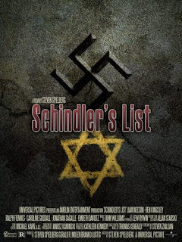

Spielberg's Schindler's List aka Swindler's Mist, has been shown for the propaganda that it really is (by certain researchers). The quote "whoever saves one life, saves the world entire" is another inaccurate representation (expunged for the Goy), the full quote being specific to the Jewish race and only the Jewish race (via the Babylonian Talmud, the ultimate authority).

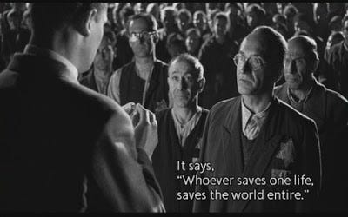

The quotation was heavily used to promote this propaganda, I mean film.
Here is the real source and it is specific to Jews and Israel, no one else.

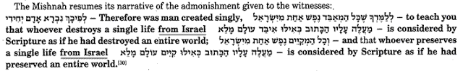

-- Mishnah Sanhedrin 4:9; Babylonian Talmud Tractate Sanhedrin 37a.
The fact that Amon Goeth was arrested and charged by the Nazi's was also clearly missing.

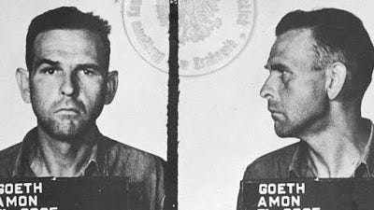

What Spielberg withheld from his audience is that in September of 1944, Goeth was arrested by the Central Office of the SS Judiciary and imprisoned on charges of theft and the murder of concentration camp inmates. Spielberg was certainly aware of this fact, since the arrest is mentioned in chapter 31 of the book by Keneally, upon which the movie is allegedly based.
Let's guilt-trip the masses with yet another Holocaust story (according to most Hollywood output, seemingly only Jews suffered during WW2) so any criticism of Zionist programming propaganda can be swept under the carpet.
(Whether the following collaborator Rudolf Kastner is related to Hollywood's Elliot Kastner,
I simply don't know.
But it was Elliot Kastner who mentored Arnon 'Israel/911' Milchan in the 1970s.)

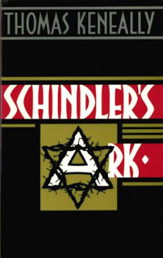

Schindler's Ark writer Keneally (on which the film is based), mentioned that Schindler worked for the powerful Hungarian Jew Rudolf Kastner. Nowhere will this information be found in Schindler's List because in 1944 Kastner helped Eichmann deport hundreds of thousands of Jews to Auschwitz, in return for favorable treatment for Kastner's Zionist cronies. The fact of high level cooperation between Nazis and Zionists was too embarrassing to be included in Spielberg's pro-Zionist film.
http://www.revisionisthistory.org/revisionist5.html http://www.revisionisthistory.org/shindler.html
High level aristocratic Nazis and British-Israelism (Zionism)?

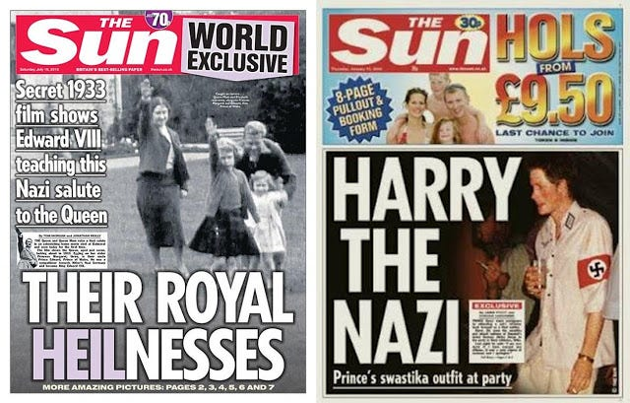

The Astors and the Cliveden Set had huge Nazi leanings too.
Harry's subsequent apologies were surely just for 'useless eater' ears only.
Yes...high level cooperation between Nazis and Zionists...hmmm?
We're not really talking about the 'useless eater' type Jew (some of who were sacrificed), but the religious supremacist Zionist Jew (racial superiority), the Nazi 'Aryan' (racial superiority), the Elite (bloodline racial superiority). All three groups, effectively sing from the same song sheet. We're all 'filthy goyim' in their eyes.
Kubrick's 3rd wife had an Uncle who made propaganda films for the Nazis. (via Goebbels)

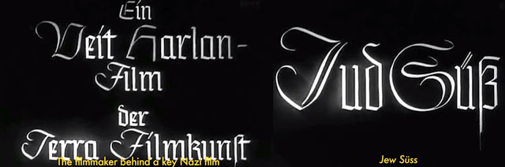

Christiane's Uncle was Veit Harlan, he made the above 'antisemitic' film for the Nazis.
It is one of the most antisemitic films ever made.
Veit Harlan was the only major movie director of the Third Reich to stand trial for "crimes against humanity".

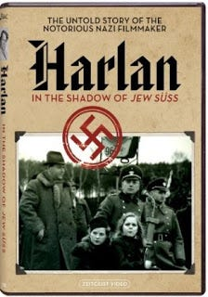

Whether willingly or not, he made the film and was one of the Nazi's most successful propagandists.
The film was watched by 20+ million Europeans and undoubtedly this propaganda film helped develop hatred and murder.
A Clockwork Orange (book) was allegedly based on MK-Ultra experimentation linked to Fort Mead/Bliss.
It's been alleged that CIA agent Howard Roman actually wrote the bulk of the text.

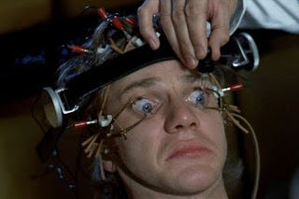

Zionist Brainwashing via the cinema screen and Nazis
Is this a '4th wall' comment about how Zionist Hollywood would brainwash everyone about the Nazis?
Brainwashed so thoroughly, that they'd take their eye off the Zionist ball and their ongoing crimes?
Ot is it a general comment about nefarious Ashke-Nazi cinema programming.
High level cooperation of Nazis and Zionists...Zionist Ashke-NAZIS?

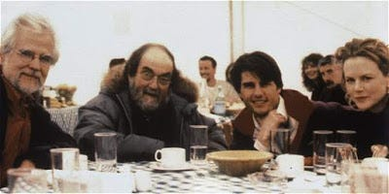

Nephew Jan Harlan (left) was Kubrick's 'producer' and brother in law via marriage to Christiane.

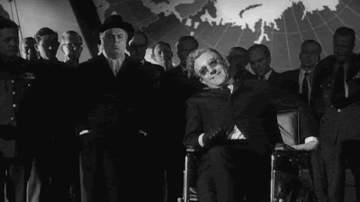

Get your 'cognitive dissonance' head around that!
It's like these people are seemingly involved in (thru bloodline inter-marriage etc) both sides of the equation.
Kubrick was Jewish. He wanted to make his own holocaust film - unmade Aryan Papers. (Ary/Ari, the root of Ari-stocracy).
Interesting, that when Kubrick first met his (soon to be) 3rd wife (Christiane), he whisked her off to a 'masked ball'.
"I met him at a studio, and then he went to an enormous masked ball where I was performing. He was the only one without a costume."

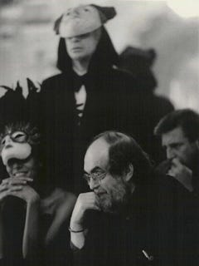

http://partners.nytimes.com/library/film/070499mag-kubrick-profile.htm
Life imitating art...or art imitating life? Christiane's account of her first meeting with Kubrick
1770: Mayer Amschel Rothschild draws up plans for the creation of the Illuminati with it’s Ritual Sodomy and entrusts Ashke-nazi Jew, Adam Weishaupt, a Crypto-Jew who was outwardly Roman Catholic, with its organization and development. The Illuminati is to be based upon the teachings of the Talmud, which is in turn, the teachings of Rabbinical Jews. It was to be called the Illuminati as this is a Luciferian term which means, keepers of the light.
In 1771, 23 year old (Adam) Weishaupt met Kolmer, a Danish Kabbalist Jew who had just returned from Egypt. Kolmer initiated Weishaupt into the secrets of Osiris magic, Ritual Sodomy, the Cabbala and the Alumbrado movement. Nesta Webster assumed that he had been known in Italy as Altotas, Cagliostro's master.

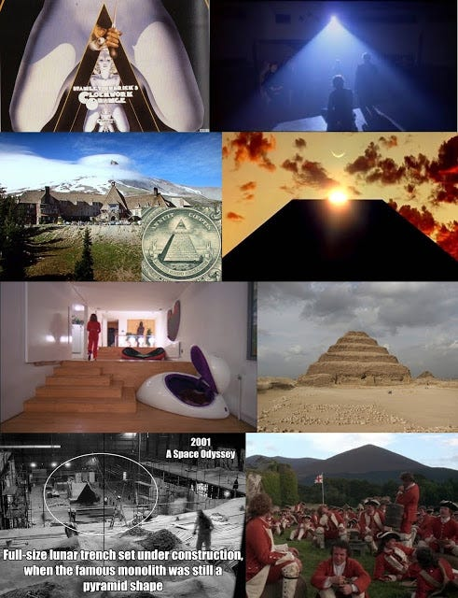

Kolmer's occult knowledge made a deep impression on Weishaupt, who later chose the Egyptian pyramid as the Illuminati's symbol of power. (A Stanley 'Spartacus' Kubrick motif, see above).
Theoretical Cabbala embraces only secret teachings about God and nature. But practical Cabbala (such as Sodomite, incest, sex magic, Sabbatean Frankism promoted by the Rothschilds from Frankfurt at the same time they promoted the Illuminati also based on Ritual Sodomy…)

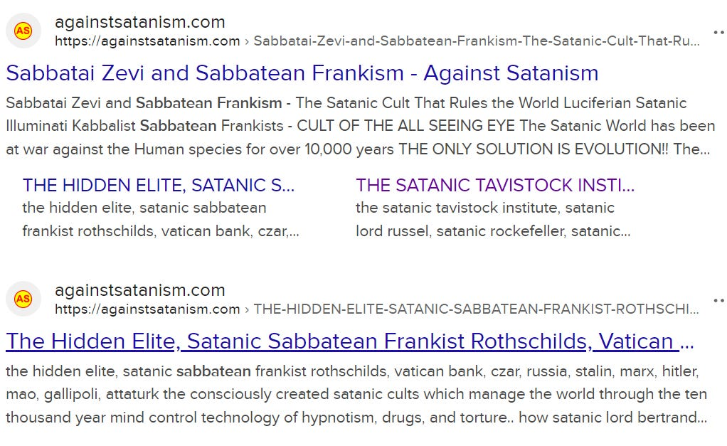

https://againstsatanism.com/Sabbatai-Zevi-and-Sabbatean-Frankism-The-Satanic-Cult-That-Rules-the-World-Luciferian-Satanic-Sabbatean-Frankists-Kabbalist-Illuminati.htm
attempts to affect earthly matters. It involves the use of amulets and magic numbers (gematria etc) as well as the conjuring of evil spirits. Both the Talmud and Midrash contain Cabbalist information. ("Ancient Oriental and Jewish Secret Doctrines, Leipzig, 1805.)
Re: Above, this is what I have uncovered within the body of Kubrick's (and related) work...
legions of kabbalistic Sabbatean Frankist (cabbalistic) content, encodes, gematria, tarot and outright masonic/mystery religion-based propaganda! To call Kubrick a Crypto-Kabbalist Jew, is somewhat of an understatement!

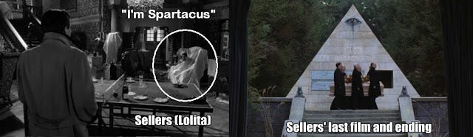

Freemason Peter 'Spartacus/Cato' Sellers...the Illuminati pyramid burial (Being There, film).
Spartacus (Weishaupt) and Cato (Zwack) both code-names for historical Illuminati members.
The masonic double-headed eagle/phoenix... of the Phoenician Empire..

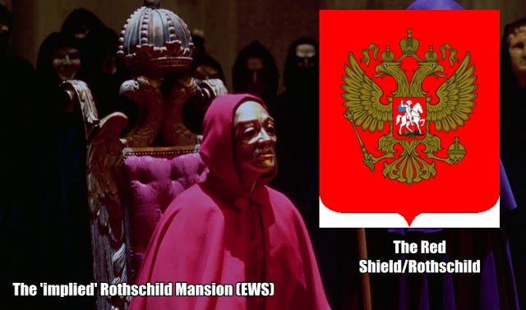

A symbol associated with Russia...the Bolshevik's were another Judeo-masonic fix (Lenin etc were masonic agents), as was Communism! Levy (Marx) was funded by this same elite.
One year earlier (1770) Weishaupt had been given a post as lecturer in canon law at the University of Ingolstadt. He later received his doctor's degree and in 1773, at the age of 25, became a professor at the same university. It was no coincidence that the Order of the Illuminati was founded on the 1st of May. Among the Cabbalist Jews, this date, 1/5 (1.5) symbolized the sacred number of Yahweh and became their occult holiday. According to Goethe, the 1st of May -- the day following Walpurgis Night -- is when the dark mystical forces are celebrated.

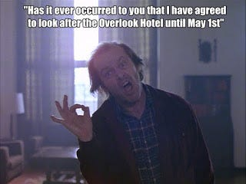

The Torrance's Overlook tenure was from Hallowe'en (31st Oct) to Beltane (May 1st).
At this time a young Jew named Mayer Amschel (born February 23, 1744) was being tutored to become a rabbi.
Amschel lived with his parents in the Jewish ghetto of Frankfurt am Main. He later took the name Rothschild.
It was Mayer Amschel Rothschild who convinced Weishaupt to wholly accept the Frankist Cabbalist doctrine.
Who afterwards financed the Ritual Sodomy Sabbatean Frankism and Illuminati. Rothschild had given Weishaupt the task of re-establishing - the old Alumbrado movement for the Cabbalist Jews. Juri Lina's Under the Sign of the Scorpion
Avid researchers will already know about the Adolf Hitler/Rothschild connection.
The story of Alois Hitler being half Rothschild (via Maria who worked at Baron Rothschild mansion).
Which would make Adolf a quarter-Rothschild Jew. (in the event that the story is valid).

Hallett & Spymaster - Stalin was a Rothschild, Stalin's British MKultra Training at the Tavistock institute - Breeding Concubines - Paedophiles at War (2008)

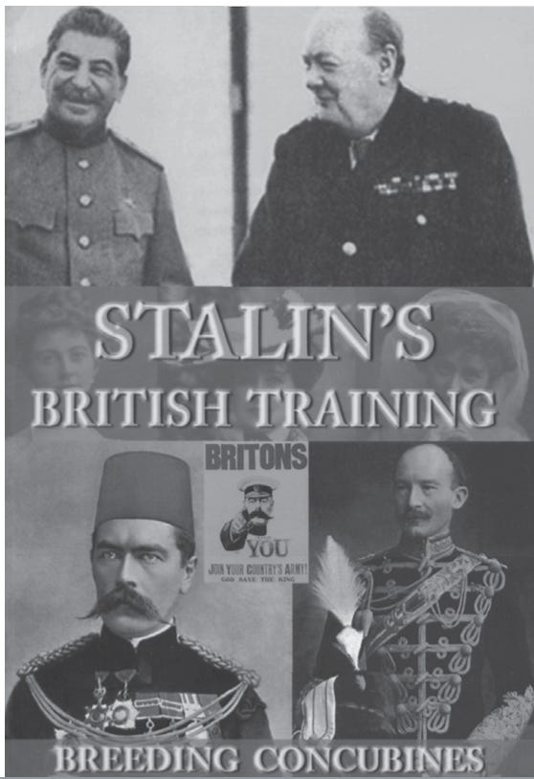

1. British Royalty Sexual Excess, Breeding Concubines, Rothschild take over of Britain and Europe by breeding with Royalty.
2. Stalin was a Rothschild - Rothschild Stalin trained by the British at the Tavistock institute to take over Russia.
3. Satanic Pedophilia and Sodomy Ritual - Kitchener and Baden Powell
4. Gurdjieff Secret Agent
Lord Kitchener and Stalin were both trained by Gurdjieff as Theosophical, Blavatsky, Olcott Martinist Freemasons. Stalin went on to rule a third of the world and Kitchener colonised the world through his special brand of Freemasonry - incestuous paedophilia and sadistic ORDER OUT OF CHAOS.
Britain was the training ground for immigrant revolutionaries to destroy their own foreign countries - just like Ukraine. This saved the colonising British army from doing it. Misinformation was always on the breakfast menu for the City of London and Metropolitan Police who regularly sabotaged each other's interrogations giving foreign terrorists any and every advantage.
Winston Churchill was King Edward VII's son. Once his father died, Winston needed to prove himself to his brother, the new King George V, so the 1911 Sidney Street Siege was held as a canned meat operation - a training exercise between Churchill and his protege Stalin, who went on to decimate Russia.
Protecting the satanic pedophile establishment by file theft is one of the main functions of a Knight. A crime is committed, the case is botched and the files are stolen. Ipso facto, the stitch-up is all stitched up and official history contains generations of the most unbelievable claptrap where nothing fits and most lose interest. This is the desired goal of establishment historians - most of whom are embedded into the Satanic occult. Jack the Ripper was an inside job that had the full support of Satanic occultist Freemasons and the British Royal Family.
Two of the most decorated men in British history Kitchener and Baden Powell were paedophiles who competed to commit the most heinous crimes in the British colonies and then use the Baden Powell Scouts to provide paedo children for the Elite, just like Epstein and Jimmy Savile. Understanding Queen Victoria and her children's illegitimacy, they operated with complete immunity, attained hero status, and medals were theirs for the asking.
https://againstsatanism.com/Fifth-Level-Avatars/Hallett/Hallett-&-Spymaster-Stalin-British-Training-Breeding-Concubines-Paedophiles-at-War-(2008).pdf

Germany was taken over by British Agent Hitler…

Book 52. Hallet and Spymaster, Hitler was a Rothschild Hitler was a British Agent trained by the MKUltra Tavistock Institute

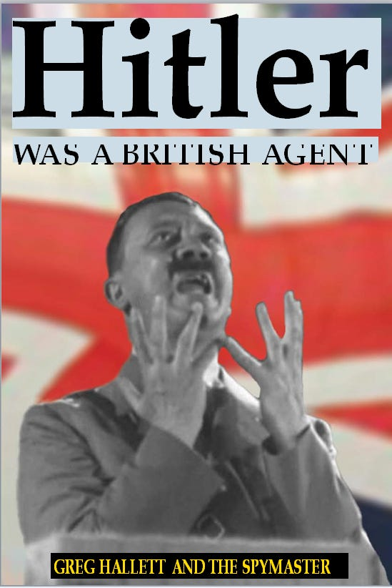

And Hitler was a Rothschild like Stalin and Bill Clinton, conceived during a Satanic Ritual to create an Agent of War!
“During his period in the Tavistock Military Mind Control Institute in Britain in 1912, Hitler was trained as a public speaker. They taught him to gesture with his hands to emphasise points. He then developed his own style which was non-Germanic and incredibly effective. MI-6 also used an elocution teacher from Dublin’s Trinity College to give him voice lessons and teach him how to raise and lower his voice for emphasis.
“Much of an agent’s training is along sexual lines. Agents are given the Fritz Springmeier Mind Control trauma, drugs, alcohol, subjected to hypnotism, given access to other agents, and the instructors step out and watch what develops. Adolf gave indications of bisexuality, which is not unusual in an MI-6 training setting, and later went on to develop more complicated perversions that sickened many of the other would-be agents – notably coprophilia. The more extreme his sexual perversions, the more easily manipulated he was and the Mandarins of Whitehall were delighted with his progress.
Some predicted the sky was the limit for Hitler...
Historian Henry Makow, Ph.D., United States Greg Hallett offers persuasive circumstantial evidence that Hitler was a British Agent. As Hitler was in Britain 1912–13 other historians are guilty of sanitizing Hitler, giving him more credibility that he had. Hitler was a British Agent is a useful paradigm that clarifies many improbable events . . .
Why the Nazi war machine was financed and built by the Bank of England. Why Hitler was able to expand into the Rhineland without fear of retaliation. Why Hitler let 335,000 Allied soldiers escape at Dunkirk. Why Hitler attacked Russia before England was invaded or conquered. Why the Nazis never figured out their communications were compromised. Why Hitler never sealed the Mediterranean at Gibraltar. Why the Spanish dictator Franco remained neutral. Why Hitler didn’t conquer the oil fields of Russia and the Middle East. Why Hitler gave his racial policies priority over actually winning the war. Why I.G. Farben was never bombed, and became the CIA headquarters in Frankfurt after WWII.
The biggest improbability of traditional history is that an Austrian tramp, street cleaner and gay prostitute could become the Chancellor of Germany. Hitler joins a long list of obscure blackmailable figures catapulted into world prominence by the unseen hand.
Implications . . . History is unfolding according to the Satanic Sodomy Ritual Skull and Bones Illuminati’s long-term plan. Wars are plotted decades in advance and orchestrated to achieve the destruction of nations and natural elites, depopulation, demoralization, and of course power and profit . . . The Satanic Sodomy Ritual Skull and Bones Illuminati sponsor ‘enemies’ in order to ferment conflict . . . The super rich Satanic Phoenician Mega Trillionaires have organized themselves to prey on mankind and establish permanent hegemony . . .
Greg Hallett deserves our thanks for advancing a history more plausible than what supposedly transpired.
https://againstsatanism.com/Fifth-Level-Avatars/Hallett/Greg-Hallett-and-The-Spymaster-Hitler-Was-A-British-Agent.pdf
53. https://againstsatanism.com/Fifth-Level-Avatars/Hallett/Gregg-Hallet-Gifting-the-United-Nations-to-Stalin.pdf
54. https://againstsatanism.com/Fifth-Level-Avatars/Hallett/The-New-Dark-Ages-Conspiracy-Carol-White-LaRouche.pdf

A masked ball...a bit like this one from 1972, a Rothschild masked ball a la Eyes Wide Shut!
A mirrored invite (backwards/reversed etc) at Rothschild's 'versus' a backward incantation/prayer
in Eyes Wide Shut.

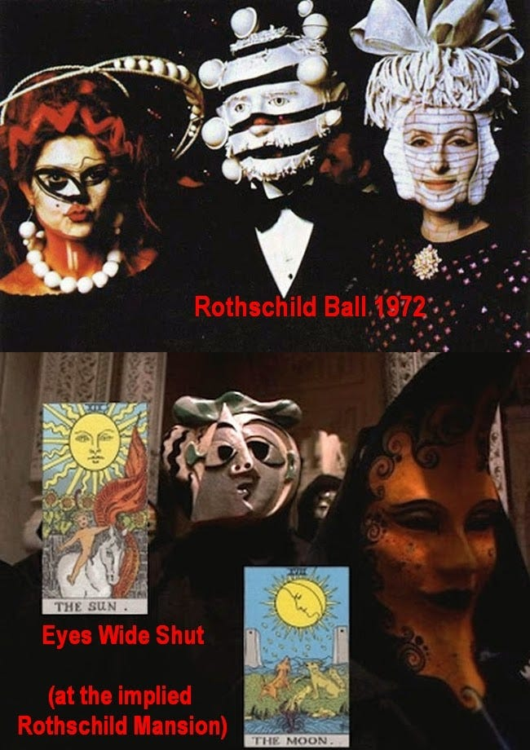

Linking The Shining 'party' to the Eyes Wide Shut 'party' and via abuse
Ullman: Oh, this old place has had an illustrious past. In its heyday, it was one of the stopping places for the jet-set, even before anybody knew what a jet-set was.
We had four presidents who have stayed here. Lots of movie stars.
Wendy: Royalty?
Ullman: All the (degenerate) best people.

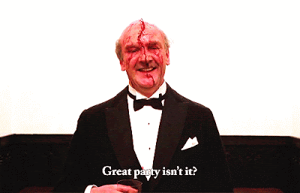

The Shining - Book
Derwent (gent in tuxedo) told Roger (dog/bear) that "if he came to the masked ball (see Eyes Wide Shut) as a doggy, a cute little doggy, he might reconsider;" that is, he might have sex with Roger. Although no actual sex scene between Roger and Derwent is described in the book, such a scene does seem to take place in Kubrick's film, albeit obliquely.



The Shining zoom shot (dog/bear) and Eyes Wide Shut zoom shot (Mandy) both match.
Both scenes also contain a human character and a character who is masked/disguised.
Fellatio (The Shining) to Fidelio (Eyes Wide Shut, where Bill uses the password)
Monarch, Twinning and child abuse (Danny, and the Grady twins) was an aspect in The Shining

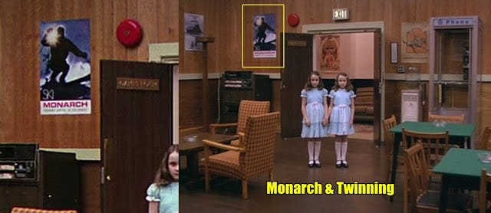

The Grady Twins meet Danny in the Overlook games room, a subliminal 'monarch' poster is shown in the background.
A majority of the victims/survivors come from multi-generational Satanic families (bloodlines) and are ostensibly programmed “to fill their destiny as the chosen ones or chosen generations” (a term coined by Mengele at Auschwitz). Some are adopted out to families of similar origin. Others used in this neurological nightmare are deemed as the “expendable ones” (non-bloodliners), usually coming from orphanages, foster care homes, or incestuous families with a long history of pedophilia. There also appears to be a pattern of family members affiliated with government or military intelligence agencies. Physical identification characteristics on victims/survivors often include multiple electrical prod scars and/or resultant moles on their skin. A few may have had various parts of their bodies mutilated by knives, branding irons, or needles, Butterfly or occult tattoos are also common.

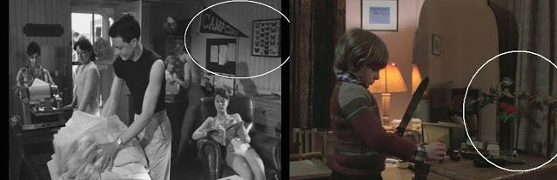

Eyes Wide Shut, Lolita (Camp Climax) and The Shining....child abuse and butterflies (Lolita's Nabokov and Butterflies).
A 'camp climax' is also suggestive of homosexual activity. Danny's butterflies appear when disassociating aka 'shining'.

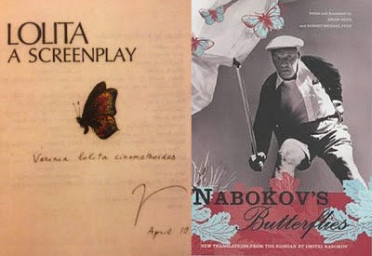

Hell...look at all these overlaps!

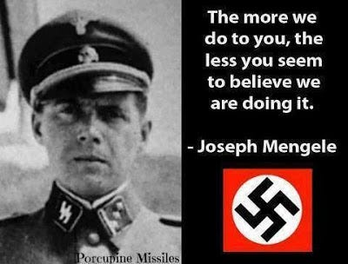

Get your head around that quote! The perfect summation of the masses and their state of denial.
Yes, from a contemptible outright psychopath.
Fritz Springmeier: When the Monarch Programming started, the top men were (Sodomite Ritual) Illuminati.

39. Download The Illuminati Formula to create a Completely Mind Controlled Slave which details, "The World which has been Pulled Over Your Eyes, to hide you from the Truth" Morpheus, Matrix Movie.
This book details the Satanic 10,000 years old process using Torture, Drugs and Hypnotism in order to layer in Demon Programs from birth and before birth into the torture and drug split mind which has always infused the Emperors, Kings, Presidents, Prime Ministers and their policies mandated by the Satanic Elite Controllers..
Now industrial quantities of children - evidence in the 1972 Church hearings 6 hours of video evidence to Congress available on youtube and CSPAN talking about 10,000 young children taken from orphanages and entered into the MKULTRA program - are being mind controlled to take over the World, Movies Trafficked and Taken and the Haiti Trafficking detail the abduction.
This book details the methodology - to give evidence that Against Satanism - is Real!!
by Cisco Wheeler and Fritz Springmeier
Read this pdf book - Right click and save..
http://www.energyenhancement.org/Fifth-Level-Avatars/Springmeier-Illuminati-Formula-to-Create-A-Total-Mind-Controlled-Slave.pdf
Originally, Joseph Mengele was the lead programmer. He'd achieved the rank of Grand Master (later Ipssimus) within the Illuminati.
He had become skilled in music, in Kabbalistic Magic, in dancing, in abortions, in torture and programming children.
Boys From Brazil (1978) from Lew 'ITC/Sept11' Grade, it featured Gregory 'Omen, father of the devil's child' Peck as Mengele, James 'Lolita' Mason and Lol 'Marathon Man, Nazi Mengle composite' Olivier.

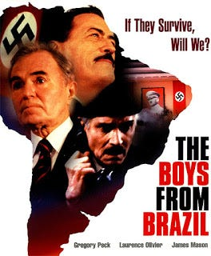

Mengele drowned while swimming off the Brazilian coast in Feb 1979 and was buried under a false name.
His remains were disinterred and positively identified by forensic examination in 1985.
Mengele would 'fictionally' die in Boys From Brazil, it was released (Oct 78) about 4 months earlier.
Generally, bloodliners are less likely to have the subsequent markings, as their skin is to “remain pure and unblemished. Non-biological “twinning” is yet another bizarre feature observed within MONARCH programming. For instance, two young non related children would be ceremoniously initiated in a magical “soul-bonding” ritual so they might be “inseparably paired for eternity” (possibly another Mengele connection?). They essentially share two halves of the programmed information, making them interdependent upon one another. Paranormal phenomenon such as astral projection, telepathy, ESP, etc. appear to be more pronounced between those who have undergone this processings, as their skin is to “remain pure and unblemished.”
http://www.whale.to/b/patton.html#Bloodlines%20and%20Twinning
Sandy Hook and the Monarch (butterfly) rainbow connection...

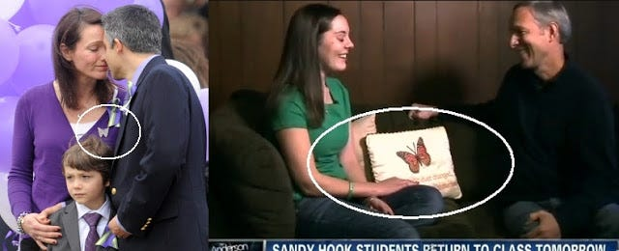

Over The Rainbow with ''Get Your Gun' Garland (Sandy Hook label)...Sandy Hook shooting

42 degrees the rainbow connection (42 aka 2*3*7). EWS, Verona Restaurant #237

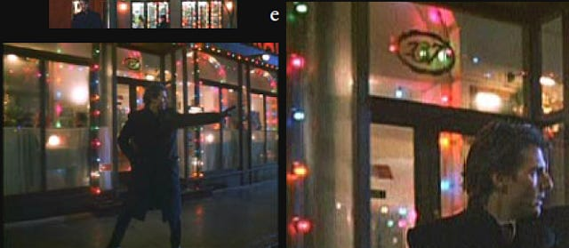

Bill outside 'rainbow' lit 237...he visited the 'rainbow store' where June 10th Judy/Lolita resided.

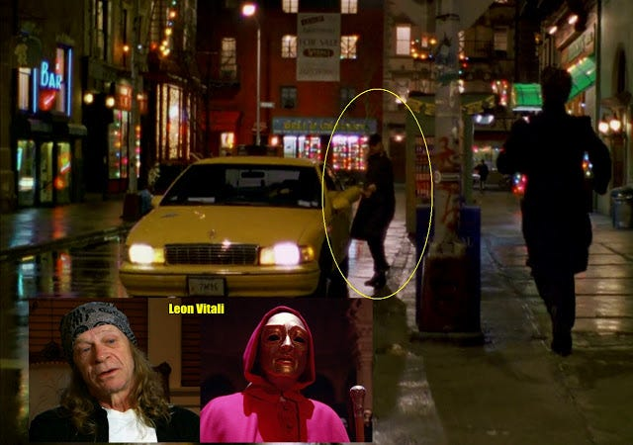

Hailing cab outside 'rainbow' 237...Leon 'Red Cloak' Vitali exits, what are the chances? It's the exact same cab that took Bill to both Rainbow Fashions and the Somerton ritual ...don't you want to go where the rainbow ends? Verona (Restaurant), from Venetian...and we're back to the Venetian 'ritual orgy' masks, again! Bill was being followed by a bald man (Ziegler stooge) immediately before this...it's no coincidence!

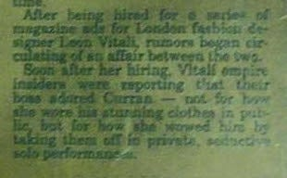

Immediately following, Bill buys the paper with the 'Mandy Curran' death article, it mentions Vitali!

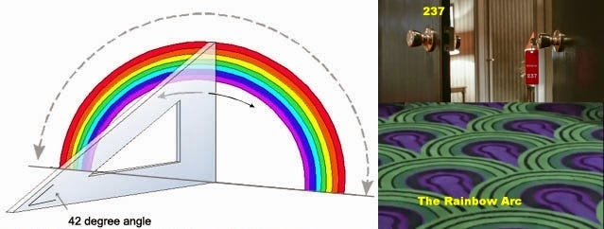

The Shining and Poltergeist...42, The Rainbow & Teddy Bears. 2*3*7 = 42.
Poltergeist's Carol-Anne (Heather O'Rourke), sync-wise, was the 'Rainbow Brite' girl via the TV ads.

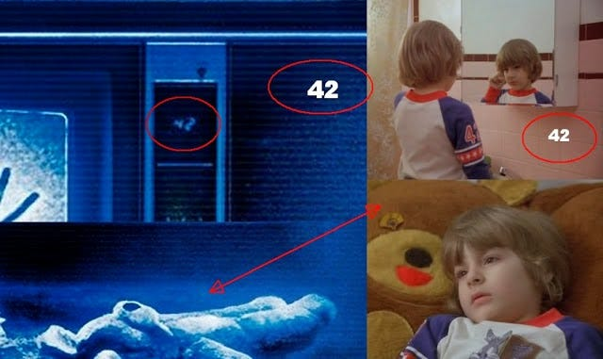

Kubrick's version of Stephen King's (a monarch) The Shining...
Pre-cognition of sexual abuse...

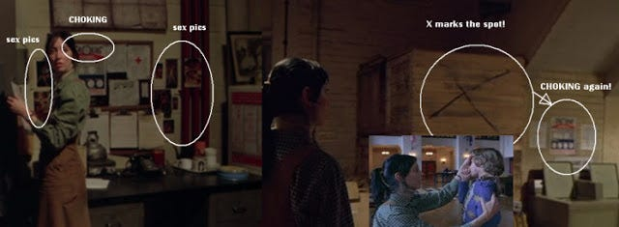

I noticed something, there is a poster that clearly shows the word 'CHOKING' as a header (clearly visible on Blu Ray).
A safety notice probably & this is situated next to the 'sex pics' (probably left by the workmen in the basement, during the hotel season). So that is 'choking' and 'sex' referenced right at the moment Jack flips-out upstairs and this comes just after Danny goes to 237 (where the abuse obviously occurs). Danny is choked and sexually abused. There is a 2nd 'choking' pic as Wendy turns the corner and just before it. X marks the spot.
Suggestive of a relationship between Jack & Danny (Daniel)...Bourbon in the Lloyd bar scene.

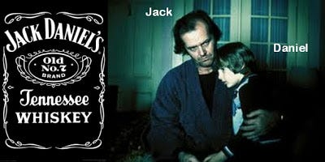

"I'd do anything thing for him....any 'fucking thing'. "
I leave you to work out the sexual allusion there!
Jack (Nicholson) reading Playgirl...a magazine aimed at women (and likely gay men too, of course).

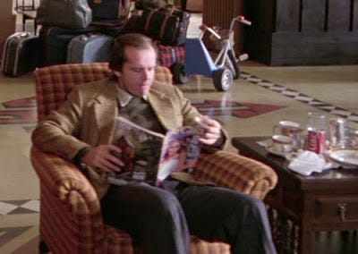

Not just any old Playgirl issue...but one 'directly' relating to incestuous child sex abuse!

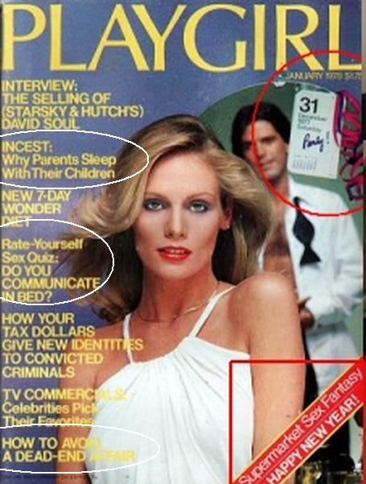

How prescient this magazine is. Playgirl, the copy that Jack's reading in the lobby of the Overlook before his interview.
Incest, do you communicate in bed, Selling the 'Soul' ("I'd sell my soul for just a glass of beer").
A collage for you to think about...Eyes Wide Shut/The Shining crossover references.

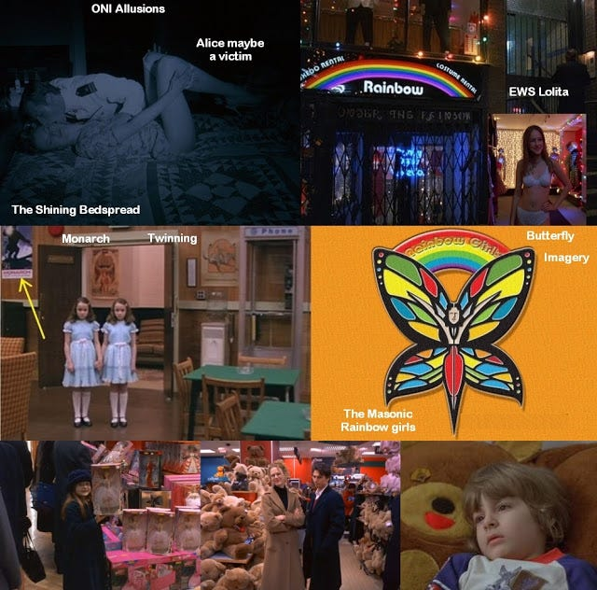

Monarch (butterfly, see MKULTRA) programming, the rainbow (masonic rainbow girls, rainbow bridge/antahkarana & sirius), EWS Lolita, Paedo-bear(s) reference, EWS ONI (Office Of Naval Intelligence) allusion to programming. (note Alice is on a bedspread that matches the decor (Indian/Navajo) of The Shining. Scientology's Hubbard was ONI, Cruise is a Scientology pin-up.
The manuscript....No...they are not all the same words typed out page after page,

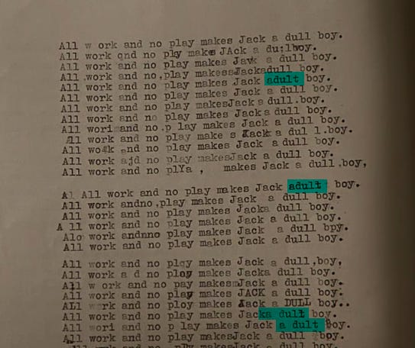

'Jack adult boy'...Suggestive of Jack (an adult) and Danny (a boy).



Jack 'incest/Polanski' Nicholson. Chasing with his chopper: "I'm cumming Dan...I'm right behind you."
Think of the potential sexual allusion contained within this statement..."I'm coming" (point of ejaculation) & "I'm right behind you" (position of Jack's body relative to Danny's, sodomy).
You have to start looking at this stuff in a symbolic and archetypal kind of programming way.
The actual narrative is the front for for sheep to graze on, and obliviously.

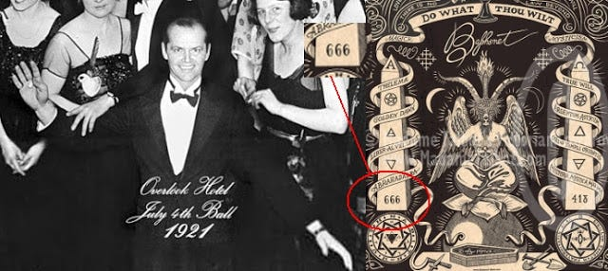

Oh look, Jack posed as sodomy resonant '666' Baphomet/Pan at the close of satanist Kubrick's The 'monarch twins' Shining.
Kubrick who died 666 days before 2001, the year he made famous. The rendering of Baphomet is by Eliphas Levi (Levy).

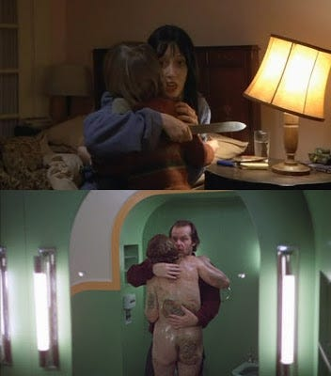

"You did this to him!"

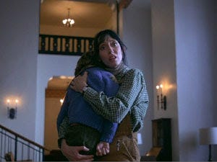

The old woman and Jack embrace...as do Wendy and Danny similarly. The old woman is an avatar (in one aspect) for Danny's abuse by Jack. In Jack's scene, it's probably a suggestion that he at that moment realizes his abuse (albeit temporarily). "It's All Forgotten Now" track soon follows) and in respect of Wendy, she is finally fully cognizant (probably been repressed) of the fact that Jack is an 'abuser' of Danny and now herself.
Nicholson and incest...it is possible that Jack himself was a product of incest, his own mother is also his sister, the identity of his father is not known. Incest was a major aspect of Polanski's Chinatown film, where Faye Dunaway's character discloses (to Nicholson, Gittes) that she is an incest victim, at the hands of her father. Polanski did his bit for the Holohoax team via The Pianist.
It was at Jack Nicholson's Mulholland Drive address, that known paedophile film director Roman Polanski, raped and drugged an underage girl. Rosemary's Baby (Polanski) was written by Ira 'mind controlled Stepford Wives' Levin.

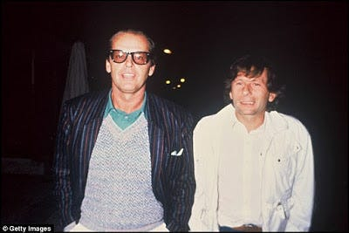

Nicholson and child rapist Polanski.
Bobby 'Blue Velvet' Darrin is another who was a product of incest, David 'Blue Velvet' Lynch would direct Mulholland Drive, which also has incestuous overtones (Betty/Diane, Cenci painting). Lynch's Twin Peaks was about the incestuously abused Laura 'prostitute' Palmer. Lynch's Blue Velvet was about the violent sexual abuse of Dorothy (another Oz link).
Room 237

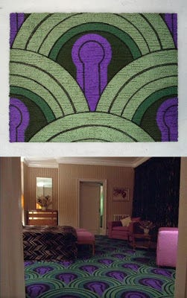

Phallic '237' carpet...indicative of Danny's abuse by Jack, no doubt the scene where the attack/abuse occurred.
Note also the 'rainbow' motif that arcs over the top...further resonance of 'rainbows' (Danny's room in Denver).

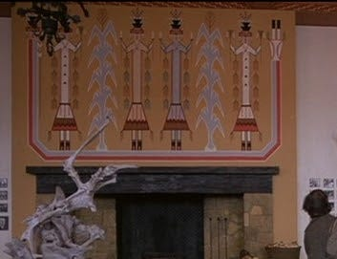

The Navajo rainbow painting in the Overlook Color-ado Lounge...color geddit?

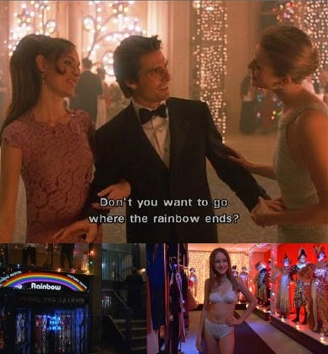

Somewhere over the rainbow resides Milich's daughter, under the rainbow is the store.

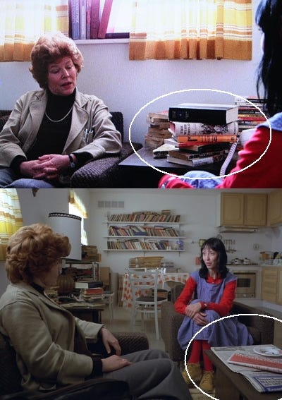

Doctors visit....
The Wish Child - Ina Seidel - indicative of Danny (She also wrote the resonant Das Labyrinth, yeah amazing isn't it!).
The Manipulator - indicative of Jack. Illness As A Metaphor (newspaper).
Alludes to Danny's problems being a 'metaphor' and that the causes are external.
The Paedo-bear...

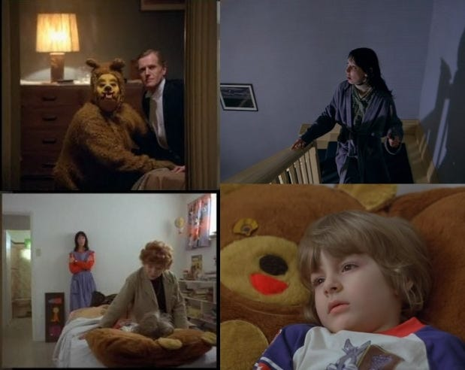

The Derwent/Dog-bear (fellatio allusion). An echo of Danny's abuse (Doctor's visit, Danny covers his groin area) and one which Wendy may have suppressed, which is probably why Kubrick has Wendy see this. Note the identical arm/hand position of the Dr and the dog/bear.
Viewing The Shining (simultaneously backwards/forwards) both 'bear scenes' above 'overlap'.
For reasons that potentially cement the (subliminal/subtext) 'sexual abuse' of Danny.



Fowards...Danny is seen by the Doctor (Wendy present), post-blackout in the bathroom. He lies on the large bear.
Backwards...Wendy goes upstairs and finds a bear/dog involved in sexual play, seemingly fellating a hotel guest.
Oh look, Eyes Wide Shut 'magic circle' Helena and the bear...

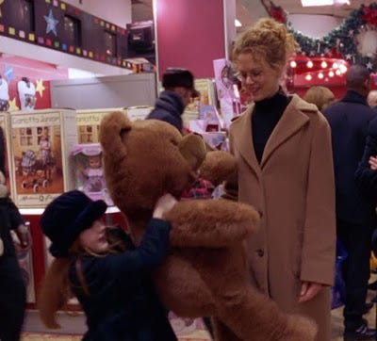

Kubrick's last word on film is 'fuck'...and uttered inside a children's toy store.



Helena...butterfly/fairy wings, let's hope the reference to 'The Nutcracker' (mentioned by Helena in this scene) is not yet another subliminal sexual allusion.
For more detailed content on Eyes Wide Shut, see link below.
https://againstsatanism.com/External-Websites/subliminalsynchrosphere/subliminalsynchrosphere.com/2016/10/mk-ultra-monarch-msm-us-election-special.html
Kubrick/Spielberg's Artificial Intelligence, robot children, the bear and male prostitutes (Gigolo)

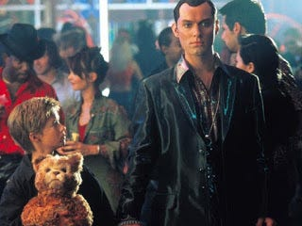

Kubrick's brother-in-law Jan Harlan would produce A.I.
Kubrick's Lolita is literally crammed full of child/adult sexual allusions and puns...

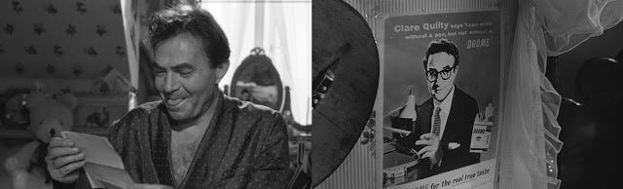

Lolita's bedroom with bear (left)...the 'Camel' evoking cigarette ad, Drome/Drome-dary Camel.
Camel/Drome-dary aka Hump (to fuck), Hum(p)bert aka the paedophile Mason (James) and paedophile Quilty (Freemason Sellers), which could be related to the bed (quilt). They both 'hump' Lolita! All from Stanley 'Illuminati Zionist Jew' Kubrick. Jew Sellers was a BBC treasure, particularly with the Goons (radio show), a favourite of Prince Charles. Sellers was also socially linked to Princess Margaret, sister of Queen Elizabeth II.
BBC...adult and naked boy child with flute. (Prospero and Ariel). The 'flesh flute' being a euphemism for the penis.
Why is this even on the entrance to BBC broadcasting house?

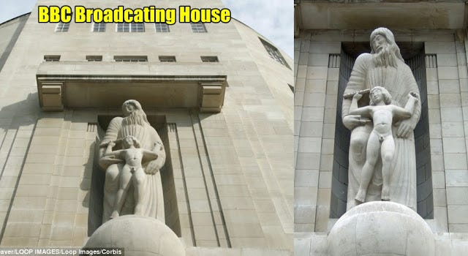

The BBC is a giant enabler of paedophila...this cannot even be disputed, its premises were the scene of multiple child sex attacks and it seemed that everyone knew, yet no one disclosed! License payers have been helping to fund BBC paedophilia!

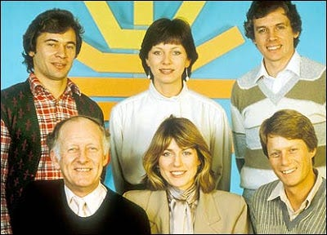

Conspiracy researcher David 'BBC' Icke (top far right) worked extensively for the BBC during the time of Savile's reign of terror. Nick 'BBC' Ross (bottom right), his wife (Sarah Caplin) set-up BBC's Childline along with (Yiddish) Esther 'a girl was molested in my swimming pool' Rantzen. Caplin was fired from ITV, due to her bullying of junior colleagues.

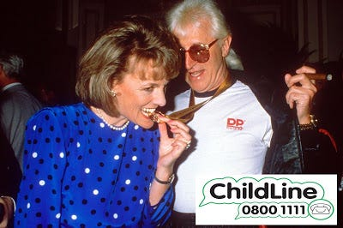

Some have claimed that Childline may have acted as a BBC filtering device, for procuring children and/or burying claims against Savile. Are we supposed to believe that no child ever rang Childline to report Savile's abuse!?

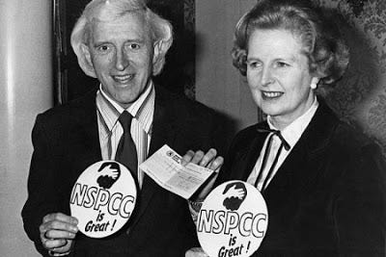

Childline is now run by the NSPCC. Savile spent multiple Christmas Day's with Thatcher...

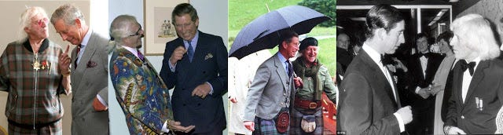

at Chequers and Prince 'Nazi/Saxe Coburg' Charles was a close friend, it is claimed that Charles wanted Savile to be Harry's godfather.
BBC paedo gatekeepr/apologist (possibly an offender herself) Rantzen:

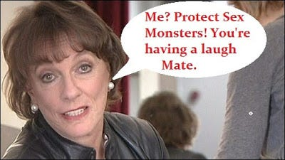

We know (Jew) Rantzen is a type of bloodline, she is the great grandneice of Barney Barnato (connecting to De Beers diamond mining and the Oppenheimers) who had major dealings with 'roundtabler' Sodomite Cecil Rhodes (an illuminati type). Rhodes set up his scholar priestcraft (agents) to protect and consolidate (under the guise of altruism/philanthropy) these types of families/bloodlines going forward. It is the Rothschild's that actually administer the Rhodes estate & trust. Rhodes and his ilk were nothing but thieves, stealing wealth from the indigenous, which is still very much an on-going programme. The same 'power families' that rape nations, would (imo) undoubtedly see raping 'Goy' minors & individuals as a lesser crime...in their grand scheme of things. Esther Rantzen had affair with politician Sir Nicholas Fairbairn in the 1960s. It has been suggested that he may have visited Elm Guest House, where children were allegedly assaulted by high-profile visitors.
VIP paedo filtering Rantzen, Barnato, De Beers, Rothschild...not forgetting Oppenheimer



Margaret 'Oppenheimer' Hodge...a likely participant, apologist and VIP paedophlia cover-up merchant. There's (Jew) Hodge with Rothschild Zionist asset Peter 'Gay' Mandelson, the string puller of Tony 'toilet cottaging' Blair. No wonder that MSM has been so keen to dismiss any direct homosexuality/paedo link (not all homosexuals, of course) it would've derailed their 'gay marriage' mass mind control agenda.
Thursday May 8,2008
By Simon Edge
He brought peace to the Middle East, was Margaret Thatcher's confidant and even had a spell as Charles and Diana's marriage counsellor. At least that's what Jimmy Savile claims in a new interview. A bizarre portrait of Sir Jimmy Savile. Compiled over five years by a journalist who admits he has been obsessed with his subject since childhood, it takes existing, little-noticed material from the public domain and combines it with new interviews to paint an extraordinary picture of Britain's most famous tracksuit wearer.

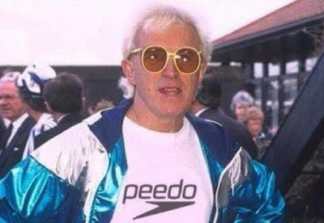

Speedo to Peedo
Youngest of seven children, ex-coal miner, dance hall manager, presenter of the first and last editions of Top Of The Pops, host of one of the BBC's most popular programmes of the Seventies and Eighties, veteran marathon runner and indefatigable money-raiser for a fleet of charities that much we have always known about Sir Jimmy.
Meeting the Princess of Wales in 1983:
But, counsellor to warring royals? Adviser to the Israeli cabinet? Personal fixer to the Pope? Intimate companion to Margaret and Denis Thatcher?
"The thing about me is I get things done and I work deep cover, Sir Jimmy, 81, tells Esquire. I've known the Royal Family for a million years. He adds: Just because some people are famous or have a lot of money doesn't mean they don't have problems."

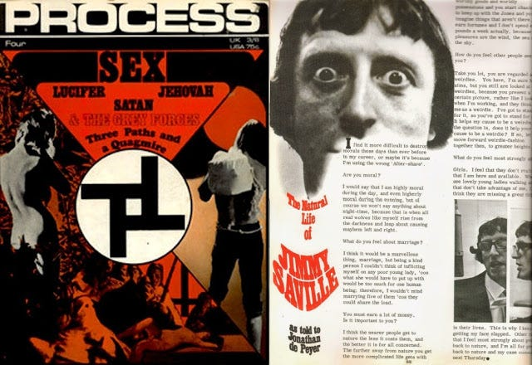

Savile's interview in the Process Church (mind control) magazine issue #4 aka Sex.
The Process connects to Charles Manson, 60s artists (Beatles/Beach Boys/Polanski) and Scientology etc.
The eccentricities of Sir James Wilson Vincent Savile OBE are well documented. He has properties in Leeds, Bournemouth, Scarborough, Peterborough, London and Glencoe, although each of them is as impersonal as a hotel room because he dislikes possessions. The fact that he rarely spends two consecutive nights in the same bed is one of the reasons he has no interest in marriage but there has only ever been one woman in his life: his mother Agnes, nicknamed the Duchess (odd that he should use an aristocratic appellation, could he have been bloodline? My emphasis.), who died in 1973. He lived with her for her last 16 years and has described the five days he spent alone with her body after her death as the best of his life. (yes, all very Norman Bates, my emphasis).
Uphill Loving...Uphill Gardening (anal sex, homosexuality). First edition of Gay News.
Savile also used to act as a compere for The 'OTO' Beatles, manager Epstein another homosexual.

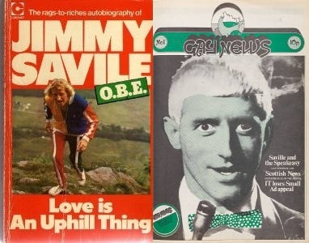

1st edition though? There are potential links to PIE/PAN & Spartacus via this (Gay News) publication.
He has said: I'm a lot of a loner. I've always been like that, though I don't know why.
I haven't worked it out myself. All I know is I am what I am. People find it odd. I find it odd.
He was first introduced to the Royal Family, he reveals, by Lord Mountbatten - Mountbottom.
In 1966, Jimmy became the first civilian to be awarded a Royal Marines green beret.
Mountbatten was commandant general at the time and realised that Savile could be a useful contact.

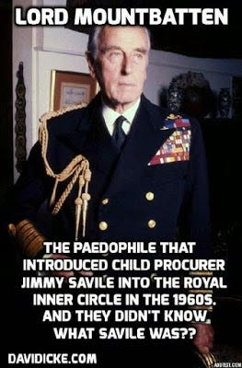

LORD MOUNTBOTTOM
In April 1990 a writer called Robert Harbinson (also known as Robin Bryans) stated in the Dublin-based magazine Now that Lord Mountbatten, Anthony Blunt (him again, we mentioned earlier via Victor Rothschild, British 'intel' etc) and others were all involved in an old-boy network which held gay orgies in country houses on both sides of the Irish border, as well as at the Kincora Boys' Home.
Coming from Lord Louis, who was the favourite uncle (uncles and paedophila, eh?) of Prince Philip, that was quite something, he says. So obviously I hooked up with the Prince, what was good enough for Lord Louis was good enough for him. (Louis Mountbatten is another who has been implicated in organised paedophilia.)
A BBC funded handbook for child minders...with Savile?
It's like living in some kind of alternate screwed-up universe, but this is actual reality!

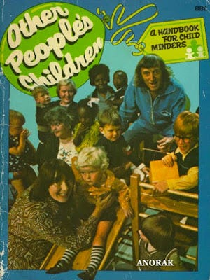

This is not a joke (although it would be to these deviants), it is called waving their degenerate crimes under the noses of the profane (Goy). Anorak, the term is often connected to sexual offending and (anorak wearing) paedophiles too. The elite classes despise the masses and view them with the utmost disdain and contempt, you cannot and should not ever underestimate this enduring fact.
He (Savile) donated proceeds from signed photos of himself with (Jewish born) Elvis Presley (how old was Priscilla again? How old were his numerous harem teens?) to the Duke of Edinburgh's National Playing Fields Association and Philip returned the compliment in the Eighties to raise money for the National Spinal Injuries Centre at Stoke Mandeville, Sir Jimmy's pet project. In 1991 writer Andrew Morton identified him as an unlikely royal peacemaker between Charles and Diana, adding: As unofficial court jester, he articulates opinions courtiers can only think.
Spinal Injuries and fronting their sick crimes under Goy noses...

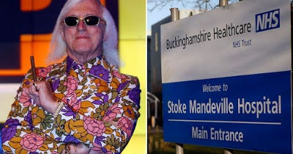

Stoke, Man & Devil...Stoke is to poke (usually a fire), Man & Devil. If you relate this to the spine (it's a spinal unit), we're in the territory of the 'satanic' Rothschild based 'sodomy/mind control' aspect. Sodomy that involves blunt trauma to the base of the spine (manipulating the 3rd eye/pineal) especially in respect of children. This IS the Rothschild mind control, ritual sodomy system.
With the Duke of Edinburgh in 1984:
He claims that he spent 11 consecutive Christmases with the Thatchers at Chequers. He says of the former premier: I knew the real woman and the real woman was something else. The times I spent up there, Denis, me and her, shoes off in front of the fire. There was no conversation really. He says he is no longer in touch because Lady Thatcher is now too infirm but that he still sees her daughter Carol off and on. But his strangest stroke of apparent influence was when he met the Israeli president on his first visit to Jerusalem in 1975. I'm very disappointed because you've all forgotten how to be Jewish and that's why everyone is taking you to the cleaners, Sir Jimmy told him. You won the Six Day War, you took all that land, you gave it all back, including the only oil well in the area, and now you're paying the Egyptians for the oil you already had. He says the president asked him to come and say the same thing to the cabinet, which he duly did. They asked my opinion about a couple of things, to which I said, Nothing's impossible. They did exactly what I suggested and it worked out 100 per cent successful.
Children In Need...BBC Charity

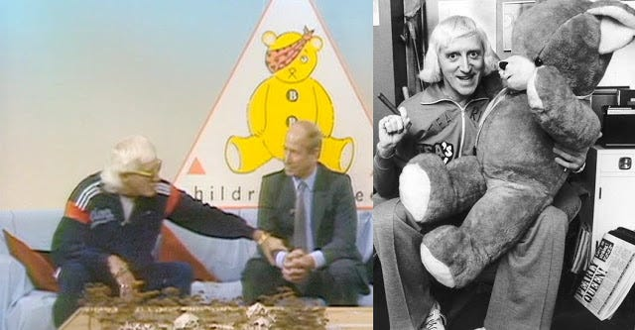

Pudsey The (one eyed/pyramid masonic) Pedophile Bear with prolific BBC (sponsored and protected) paedophile Jimmy 'Prince Charles/Maggie Thatcher' Savile. He had his own children's show and he was tight with Israel too! Lew 'ITC-9/11' Grade's nephew Michael, was the BBC 1 controller (1984-86) and BBC chairman (2004-06). Savile with Bobby Charlton, his daughter (Suzanne) would also work for the BBC as a weather girl. Is the 'Pearly Queen' juxtaposed headline (right pic, bottom right) a potential reference to queen, as in 'gay' (bear is on his lap), a nod to 'royal' connections or rhyming slang for 'seen' (to look, pearly queen = seen)?

Miley 'I'm a likely monarch mind control sex abuse victim' Cyrus with pedo-bears.

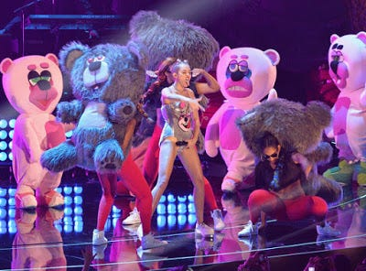

The Disney seeded star, who has likely dragged her Montana fans into her web of degeneracy.
Good wholesome 'family fun' oriented Disney...Disney is one of the largest distributors of pornography in the world via its affiliates and subsidiaries.
Masonic Miley...I suspect the Cyrus' are an inter-generational/incest/paedophilia based family, hence why they were selected for stardom and ongoing propaganda/indoctrination purposes.

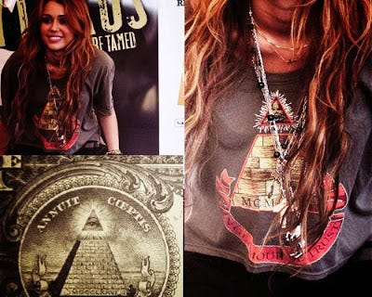

Strap-on penises and paedophilia...
Some might want to check-out the 'satanic ritual abuse' case that has been referenced in Hampstead via Christ Church school (2014 onward) and two children who spilled the beans on their 'satanist' father and his 'connected' paedophile ring (trauma based mind control), involving a number of Hampstead schools and teachers, churches, Social Services, crooked judges and the 'masonic' police.
Really extreme stuff (things you will not want to believe etc), so you've been warned.

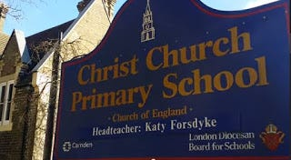

I don't care what the compromised/involved authorities say, those children were telling the truth and a huge cover-up (including a potentially staged retraction of earlier statements) has followed to silence it all.
Hollywood...mind control, sex/paedophilia based programming and all in the mainstream. Strap-on penises and paedophilia...

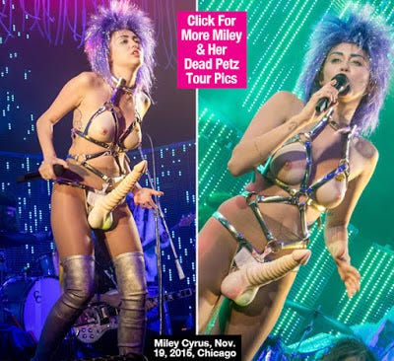

Her corporate backed career, has undoubtedly helped to soften attitudes towards paedophilia and the increasing (imo) sexualization of children. She's a victim, of course.

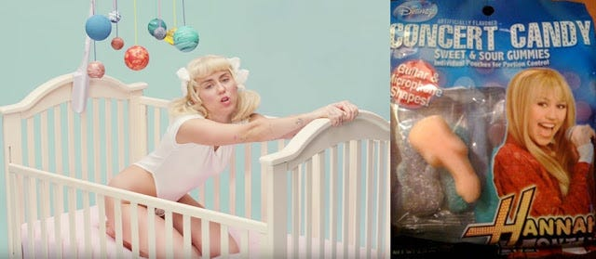

Sexuality, child's cot and penis candy. Pan the 'mystery religion' god of sodomy...



Gender bending (and giant penis) the 'monarch' programming hallmark...the butterfly.

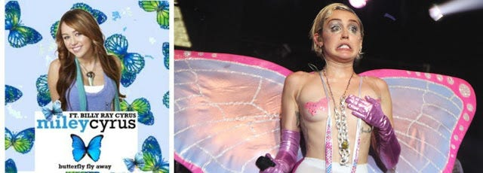

Run of the mill pop culture or degeneracy on steroids? Miley 'Candy' Cyrus

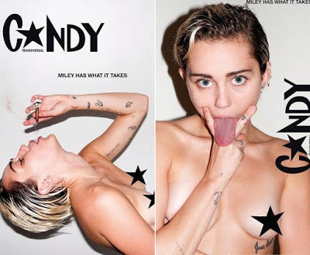

Mind control sex abuse...as an art form, an art form, that's what they tell the 'useless eaters'
Some think that Terry 'Candy' Richardson is an elite handler/programmer type.
Bears and butterflies...'Candy' Britney



Britney 'Monarch' Spears? She helped promote the sexualization of children, on a mass level.
Writing was on the wall when hardcore pornographer Greg Dark directed one of her early videos.

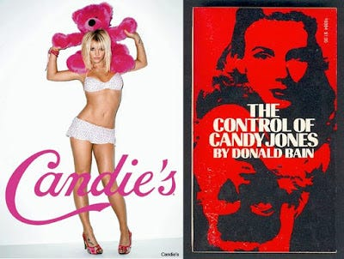

Candy 'mkultra/mind control' Jones
Britney 'mind controlled' Spears...is one of her 'programmed alters' activated? (yep!)
Hit Me Baby One More Time (double meaning, sexual and violence) as a schoolgirl

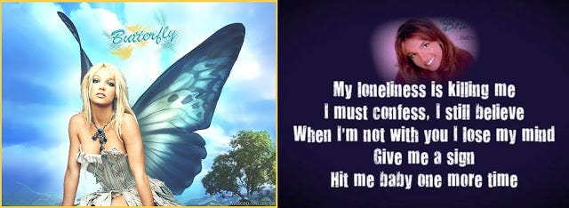

Losing her mind, wanting a sign (symbol) and violence (hit me)
More programming in respect of Nicole (and 4th wall stuff about transforming women using media)
This remake was sold as a comedy, but I think that makes it all the more subversive. The above clip stinks of a 4th wall type confession or manifesto, manipulate media/culture to produce mind controlled masses...see cosmetic surgery (butchery) epidemic and LGBTPS Trans sterilisation sexualisation of children etc.

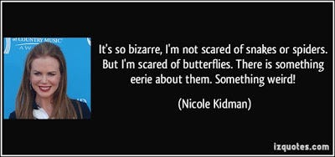

Did you know that Nicole 'Eyes Wide Shut' Kidman has a real phobia of butterflies?

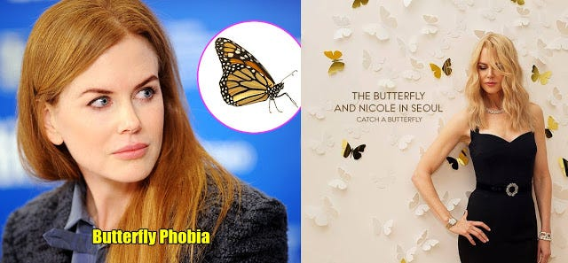

Either all this stuff is inextricably inter-related...or Hollywood is bereft of any originality whatsoever and the same symbolism is recycled time and time again. I've placed my bet and it's the former.



'Penis Gummies'...Still under the influence of Scientology? What's the excuse this time?
Holmes went on (lesbian hosted) Ellen to explain or to perform damage limitation.
How's this for a triple related stream...and from the same author.

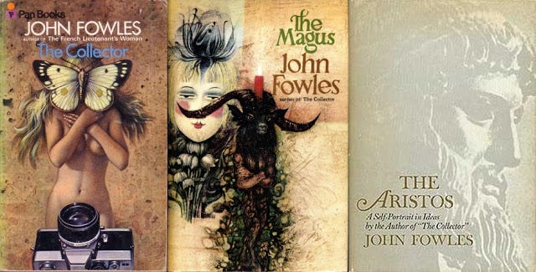

John Fowles...Pan's The Collector (imprisoning girls/butterfly), The Magus (Pan) and Aristos
The Collector (film, 1965) will also reference Catcher in the Rye (mind control) in respect of Miranda. The Collector was an inspiration for Leonard 'Miranda' Lake and Charles Ng, serial killers.
To those who think the following: "it can only be a warped mind that sees these things"
Bullshit...you're so thoroughly programmed, so thoroughly rinsed and ruined by popular culture, that I'd doubt that you'd have any concept, as to what decency really is. Perhaps you think that innocence is something that deserves to be destroyed, that children should be programmed with gender-bending and sex-based propaganda. In short, you're lost and I pity you and your pitiful 'MSM bombed' mind. It is clear to me that the Satanic Phoenician Mega Trillionaire Rothschild Hollywood elite think of themselves as superior, both in terms of racial supremacy and mental supremacy...the audacity employed in dangling their ongoing crimes under the noses of the masses (via their product), is yet another aspect of this innate sociopathy and also their masonic base insanity. They don't expect the masses to wake-up anytime soon, so I've taken it upon myself to furnish you with this information.
The paragraph below, was something I found within a comments section and in relation to the Antony Kidman story...I can't swear to the accuracy, but any help in answering these pertinent questions would be appreciated!
Antony Kidman
What he was doing studying psychology at Sydney University while MKULTRA Hypnosis experiments were carried out? Can you please explain why he was at Sydney University the same time as Dr. Leonas Petrauskas, Fiona's Nazi perpetrator? Can you please explain why he was involved with research at St. Elizabeth's DC - John Gittingers & the CIA's manchurian candidate stomping grounds? Can you please explain why he had a 30 year working relationship with Dr. Martin Seligman - The CIA's Torture Program founder & expert? Can you please explain his relationships to numerous other perpetrators? Can you please explain why he financed 'The Pillowman' 2008 - A play about sadistic child abuse and murder (At a venue connected to many other perpetrators). Can you please explain why he was a colleague of Dr. Aaron Tim Beck, a director of the False Memory Syndrome foundation? Can you please explain why he lived next door to an Australian Army Colonel who spent 40 years + in the medical corps?
Can you please explain why his daughter was brought to fame by Liz Mullinar
- the only woman to run a Satanic Ritual Abuse clinic in Australia?
(yes, even I had a WTF? moment with this last piece of info!)

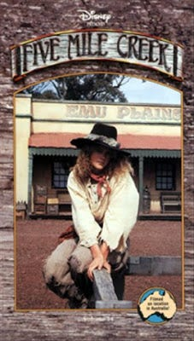

Kidman's first TV role was in Five Mile Creek (1983), opposite Rod Mullinar, Liz's first husband.
Liz Mullinar (ritual/satanic child abuse) and Nicole Kidman

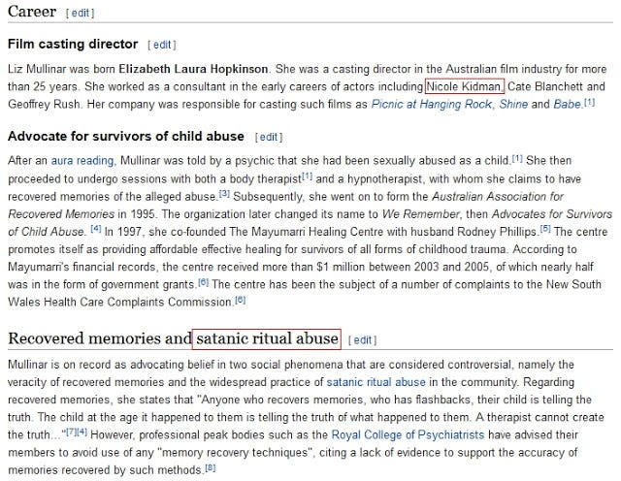

This looks suspiciously like aspects of controlling both ends of the spectrum!
'Over The Rainbow'...Aussie (Oz) Nicole in Australia (Oz)
Oz Nicole...was inspired to act after seeing The Wizard of Oz (play) and she featured in film Emerald City (city of Oz) in 1988. She featured in 2008 film Australia (Oz) where she sings 'Over The Rainbow'. She attended the same High School as Naomi 'Mulholland Drive' Watts (a friend of Kidman), Lynch's film about Hollywood system abuse (with incest overtones) and the film contained a huge 'Oz' thematic and throughout. See my Mulholland Drive post.



Watts would play Marilyn Monroe, who many cite as one of the first public mind control celebrities.
She also played Princess 'limo crash' Diana, recall Diane's (and Camilla's) 'limo crash' from Mulholland Drive.
Sandy Hook, is also one of the alleged homes of the MK-Ultra project and the infamous 'Dr.Green' (Mengele). J.D. Salinger (see Six Degrees of Separation) wrote Catcher in the Rye (mind control/lsd) in the area as well, while the Mk-Ultra program was at it's height.
Oz/Aus Naomi 'Dream House' Watts...Riverside Road, 'Sandy Hook', Connecticut & Psychiatry
Green-haven Psychiatric facility...

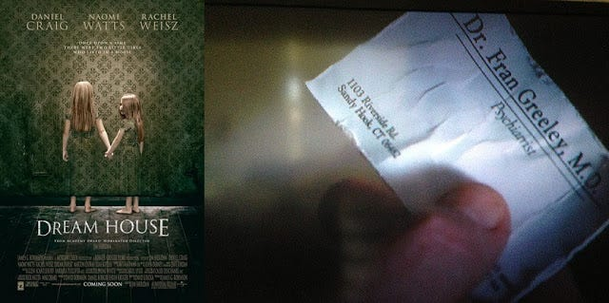

Watts, Mulholland Drive (MD): Dream Place = her new house/apartment (literally)
Latina Del Rio (meaning 'from the river') sings 'Crying' (in Spanish) during the MD Silencio scene



Watts' Mulholland Drive has a huge Oz theme.

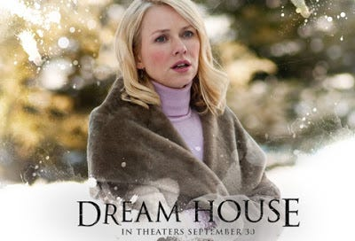

The 2011 movie featuring Daniel Craig and Naomi Watts, featured Sandy Hook, CT as its main focus The movie is about a father (with mixed identity) and family moving from Manhattan to Sandy Hook, but as they settle into their new life, they discover their perfect home was once the murder (shooting) scene of a mother and her children. The filming location was about half a mile from Sandy Hook Elementary. Script: "Harkness House is located within a half mile of my children's elementary school."
Sandy Hook Elementary...The (monarch/masonic sirius) Rainbow 'Connection' (geddit?)



Don't you want to go where the rainbow ends?

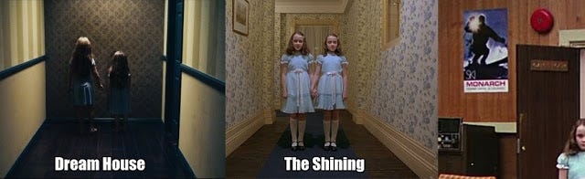

Channeling The Shining...the 'monarch' twins (sisters)

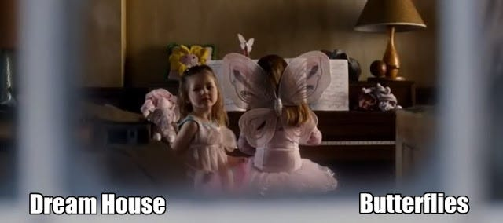

The Sandy Hook 'Owl' by Grace or is that a stylized spelling of Grove?



http://www.henrymakow.com/newtown-has-reputation-as-satanic-hub.html
Royal Arch Masonry: 'For the good of Masonry, generally, but the Jewish nation in particular.'



Shh...aka 'masonic due guard', Shh...Silenico, Mulholland Drive.
I'm sorry, but Sandy Hook seems to be mkultra-ville and with Hollywood clearly (imo) being mkultra-land, maybe we shouldn't be surprised by the overlaps. Is Connecticut, 'paper clip Nazi/CIA/masonic' central? Remember the movie Sleepers (sleepers, a mind control resonant phrase) with the violent sexual abuse (male sodomy etc) was filmed at Fairfield Hills, State Hospital, just down the street from Newtown and Sandy Hook.
Arlington is often cited in respect of masonic activity...The Kennedy and Oswald (Oz-wald & Ruby, as in slippers, geddit?) burials were both at "Arlington": JFK at the National Cemetery near Washington, D.C., and Oswald at Rosehill Cemetery near Arlington, Texas. "Arlington" is a word of significance in Masonic sorcery and mysticism and it has a hidden meaning which ties in with necrolatry (reverance for death). Downard/Hoffman, King Kill 33
Prior knowledge of the 14th Dec 2012, Sandy Hook media event fix...
In Arlington, Ohio, the Arlington school district put out a webpage on December 10, 2012 about children seeking help in dealing with the trauma of the Sandy Hook incident. Now the webpage, states an ERROR 404 – document not found. Someone was lucky enough to have a screenshot of the article and date of creation. Note the link to the 'red devils' - located at 336 South Main St, Ohio.



The Arlington school district in Ohio uploaded a web page for children dealing with the aftermath of the Sandy Hook incident - 4 days before the event occurred! There is some corroboration of satanic activity in Newtown, Connecticut. It seems that the Church of Satan has a recruiting hub in Newtown, CT, run by one Curtis M. LeBlanc. The address is P.O. Box 3184 Newtown, CT.
Note, corporate satanists 'Google' deleted the above picture from this blog piece. I've just re-upped it (Feb 2020).
The ONLY picture that they removed from this post! Fuck you, Google.
Child ritual sacrifice and Judaism...

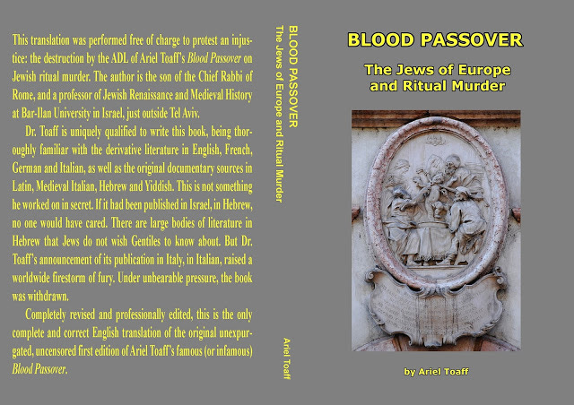

http://www.whale.to/c/bloody_passovers.html
While studying his subject he discovered that the medieval Ashkenazi Jewish communities of North Italy practiced a particularly horrible form of human sacrifice. Their wizards and adepts stole and crucified Christian babies, obtained their blood and used it for magical rituals evoking the Spirit of Vengeance against the hated Goyim.
Shh...Where was The Stepford Wives set? Connecticut. (like Sandy Hook)

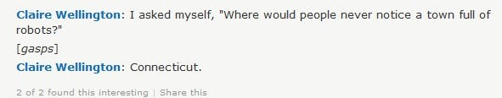

Nicole's Butterflies...

Stepford's Joanna Eberhart aka Nicole 'Eyes Wide Shut programmed sex slave' Kidman

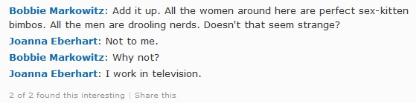

The "I work in television" quote is a 4th wall giveaway. Some will already be aware of 'sex-kitten' programming in respect of monarch/mkultra. We've seen Miley's butterflies:

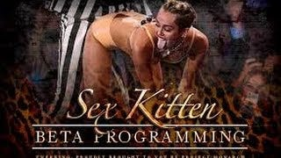

"A town full of (programmed flesh) robots and sex-kittens bimbos?"
Sandy Hook (Connecticut) and the Monarch (butterfly) rainbow connection...mkultra town?

Oz, Over The Rainbow with ''Get Your Gun' Garland (Sandy Hook label)...Sandy Hook shooting.
Mockingbird media. Anderson 'Vanderbuilt' Cooper. The old Vanderbuilt estate was built over with 666 5th Ave. NY.

Recall that Lanza lived across the road from the Hockley's (pictured above)
Scott Getzinger, the property manager of The Dark Knight Rises, who probably inserted the Sandy Hook reference into the film the previous year, lived in Newtown, CT near Sandy Hook. He was killed in an automobile accident, April 2012. Newtown man dies in Stamford accident
Sandy Hook in Batman: The Dark Knight Rises.
Note, Aleister '666' Crowley's great nephew, Nathan, worked as 'art director' for Nolan's Batman film series,

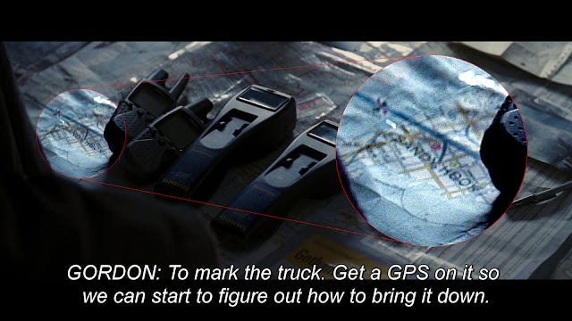

Bring it down? Gun control legislation (a result of the event) or bring down the 'Sandy Hook' operation? Could it even be both? Is it possible that Sandy Hook school was ultimately implicated in a wider child abuse ring, hence all these monarch overlaps? If we take the stance that the event was total 'fakery' (as many do), then there are no child sex abuse victims, and therefore no implicated wider elite paedo-ring, somewhat convenient wouldn't you say? Worth considering the angles, imo.
Now that I've seen this (below), I'm starting to be convinced that child abuse was (at least) an aspect!

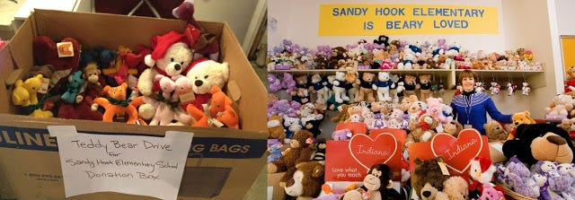

Should've guessed...the Sandy Hook (paedo) Bear Drive. Yeah, it's just another coincidence...cough, cough.
Masonic Dunblane: 'Who are they protecting'...a blueprint for Sandy Hook?
How did Hamilton procure those two boats (bought at huge discount from the Police) where abuse may have occurred on Loch Lomond (Ness), which is Crowley territory.

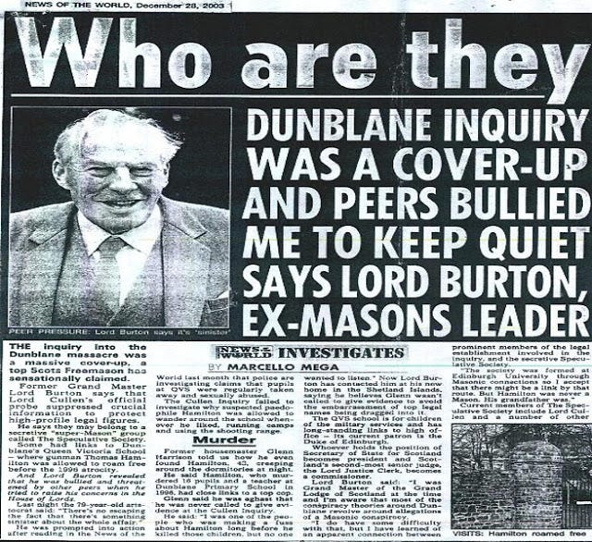

A masonic conspiracy says a former Masonic Grand Master. I think the UK based Dunblane shooting could've been an example of what I am talking about, a potential 'elite satanic paedo-ring' (one they decided to bring down, linked to New Labour politicos) that resulted in the deaths of many children and with Freemason Hamilton as the fall guy. The Freemason (see newspaper article) Cullen Inquiry into the massacre recommended that the government introduce tighter controls on handgun ownership and consider whether an outright ban on private ownership would be in the public interest in the alternative (though club ownership would be maintained), certain restrictions have resulted. A police report into Thomas Hamilton (and other documents) was placed under a 100 year secrecy law, this is how the establishment are able to hide their deep connections to these crimes!
“Masonry is a Jewish institution whose history, degrees, charges, passwords and explanations are Jewish from beginning to end.”
- Rabbi Isaac Mayer Wise
Royal Arch Freemasonry: "For the good of Masonry generally, but the Jewish nation in particular."
Oh look...it's paedo-bear (yes, again) at the Dunblane Memorial Garden, with a wolf!



I told you about these elite degenerates and the showboating/gloating of their sick crimes?
'The children and their teacher'. The implied message here is truly disturbing...it's clearly a 'barely veiled' paedophile marker (pun certainly not intended)!
Appreciate that I am familiar with the term 'gay bears' and it being related to large gay hairy males etc, but I believe that this is just one interpretation of 'the bear' in sodomite circles, the one I'm referring to is in respect of sodomites and paedophilia. The former could easily operate as a type of cover, it's not like sodomites are strangers when it comes to stealth sodomite propaganda.
A stones throw from Dunblane Primary...Hamilton was also implicated in the following school:
Queen Victoria School (QVS, Dunblane), it is the only school in the UK managed and funded by the MOD (military). In prior years, a former 'Housemaster' of this school Glenn Harrison (a rare hero), tried to warn everyone of organised paedophilia involving the establishment!

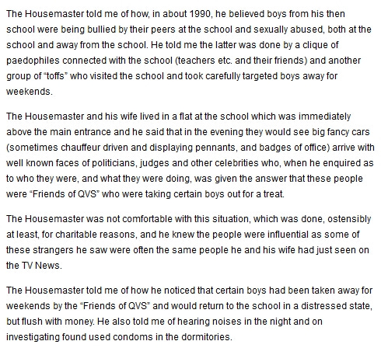

Yup, shades of Eyes Wide Shut...and shades of the recent case at Christ Church, Hampstead too!
Military and masonic based paedophilia...all very Michael Aquino, imo. It's all for 'charidee' folks!
Freemasonry and organised child abuse...those should be the daily MSM headlines!
Don't let Murdoch tell you who and where...I'm going to tell you who and where?
He'll get you looking for working class deviants...while the establishment are conveniently ignored!

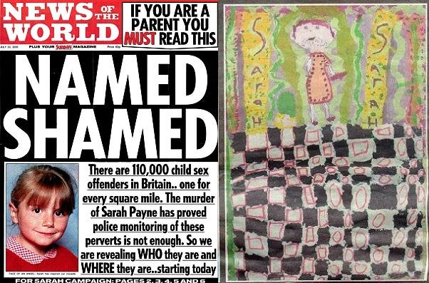

Painting, supposedly by Sarah Payne and published in Murdoch's filthy Zionist 'The Sun' publication. It clearly depicts someone inside a masonic lodge, situated between the pillars of Jachin/Boaz, a masonic tessellated floor and wearing an apron. Square Mile, see left pic (a masonic infused term), it is the 'square mile type' masonic satanists that are up to their necks in all this! Was convicted Whiting (a fish) the masonic patsy/fall guy (red herring/fish) of the operation and subsequent cover-up?
I have suspicions (regarding the potential framing) about Ian 'Holly & Jessica' Huntley too!
2013/10/savile-isnt-the-only-obnoxious-paedophile-being-covered-up
Burton was over-keen to protect his organisation (Freemasonry) and blamed the Speculative Society clique in the judiciary, and the police for a cover up “at the highest level” of the Dunblane tragedy. He told me that a Scots Tory Law Lord and member of the Speculative Society had pounded his fist on his desk in the House of Lords to emphasise that Burton should let the matter [Dunblane] drop.

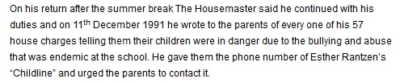

Oh dear...Jewish BBC paedo enabler Rantzen! (I wonder why they heard nothing back?)
The usual pattern of the 'goy/profane' wondering why nothing is ever done, even though clear evidence is forthcoming!

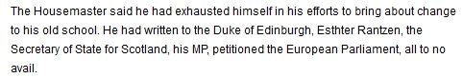

He wrote to (so called) dignitaries and met a 'judeo-masonic' brick wall! Surprise, surprise...not!

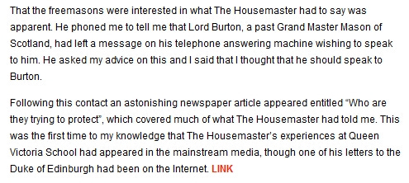

The last paragraph refers to the newspaper story printed above from 2003! Housemaster (Glenn Harrison) did all he could do, he is a rare beacon of light and should be viewed as such.
The Aurora Shooting (Holmes) occured at a midnight showing of The Dark Knight Rises

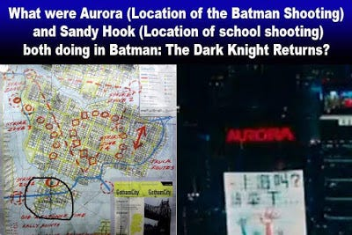

I will note though, that Aleister Crowley's great nephew 'Nathan Crowley' is the production designer for Nolan's Batman franchise.
Tim Burton's original Batman reboot franchise...commenced in 1989 and with a 'monarch' reference!

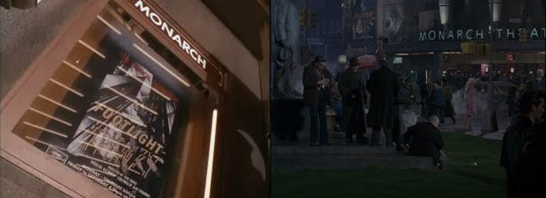

The Monarch Theatre/Cinema...hey, aren't we claiming that Hollywood output IS monarch programming? Yes is the answer.
Jews, Hollywood and MSM
"How deeply Jewish is Hollywood? When the studio chiefs took out a full-page ad in the Los Angeles Times a few weeks ago to demand that the Screen Actors Guild settle its contract, the open letter was signed by: News Corp. President Peter Chernin (Jewish), Paramount Pictures Chairman Brad Grey (Jewish), Walt Disney Co. Chief Executive Robert Iger (Jewish), Sony Pictures Chairman Michael Lynton (surprise, Dutch Jew), Warner Bros. Chairman Barry Meyer (Jewish), CBS Corp. Chief Executive Leslie Moonves (so Jewish his great uncle was the first prime minister of Israel), MGM Chairman Harry Sloan (Jewish) and NBC Universal Chief Executive Jeff Zucker (mega-Jewish). If either of the Weinstein brothers had signed, this group would have not only the power to shut down all film production but to form a minyan with enough Fiji water on hand to fill a mikvah."
"The Jews are so dominant, I had to scour the trades to come up with six Gentiles (Goy) in high positions at entertainment companies. When I called them to talk about their incredible advancement, five of them refused to talk to me, apparently out of fear of insulting Jews. The sixth, AMC President Charlie Collier, turned out to be Jewish." (note this was uttered by a Jew!)
http://articles.latimes.com/2008/dec/19/opinion/oe-stein19
"I don't care if Americans think we're running the news media, Hollywood, Wall Street
or the government. I just care that we get to keep running them."
- Jewish journalist Joel Stein in "Who runs Hollywood? C'mon", LA Times, December 19, 2008
“There are no important media outlets in the U.S. that are not owned or controlled by Jews.”
- Israel Shamir, Russian-Israeli journalist in his article “Midas Ears”
"Let’s be honest with ourselves, here, fellow Jews. We do control the media. We’ve got so many dudes up in the executive offices in all the big movie production companies it’s almost obscene. Just about every movie or TV show, whether it be 'Tropic Thunder' or 'Curb Your Enthusiasm,' is rife with actors, directors, and writers who are Jewish. Did you know that all eight major film studios are run by Jews? But that’s not all. We also control the ads that go on those TV shows. The time has come, though. We no longer have to change our names. We no longer have to blend in like chameleons. We own a whole freaking country."
- Manny Friedman, Times of Israel, July 1, 2012.
This is what can happen to societies, if you allow 'certain minority groups' to totally dominate film and TV programming. This is why the 'symbolism/zio-masonic propaganda' is ALWAYS the same, whatever film or TV show it is, it's all from the same nefarious source.
"Woe is us if it ever falls into the hands of the wrong people"
(Note, it's ALWAYS been in the WRONG hands!)
Network...the Zionist Jews go 4th wall. Directed by Sidney 'Jew' Lumet.

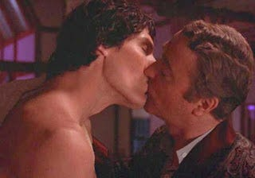

Lumet would direct Deathtrap (1982) the film that featured (Batman/Battyman) Caine and (Superman) Reeves' gay kiss. It was written by our favourite elite propagandist Ira 'Jew' Levin (yes, him again!). Lumet would also direct Oz-based The Wiz, which had the WTC Twin Towers as the Emerald City, and where Joel '9/11' Schumacher wrote the script.
Art or extremely questionable and suggestive (paedophile-like) material?
Oz Kid-man, again.
CDAN - Added July 2018. Confirmation? Oh dear. Revealed early July 2018. (link)

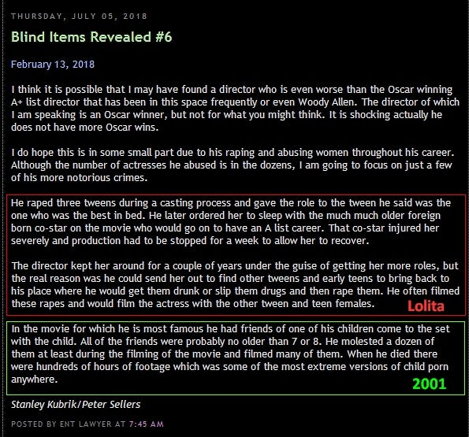

Kubrick's only personal win of an Academy Award was for his work as director of special effects on 2001: ASO.
Enty is alleging that he (Kubrick) was one of the WORST of all. Hey, no shit! Worse than Allen and Polanski.
Last paragraph is clearly 2001 (film). Friends of his daughter Vivian, who briefly featured as Floyd's daughter.
We already knew that (associate and 2001 author) Clarke was a homosexual paedophile!
The films mentioned in the blind/reveal are obviously Lolita (Sellers), and 2001:ASO.

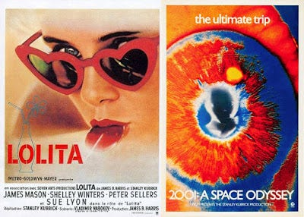

Lolita. Sue Lyon, who played Lolita, is the girl in question. Raped/abused by Kubrick/Sellers, used to procure others.
2001. The reveal is alleging that Kubrick raped/abused/filmed his daughter's friends. Vivian was 7/8 years old at this time.
More in-depth stuff on Eyes Wide Shut at the following link:
https://againstsatanism.com/External-Websites/subliminalsynchrosphere/subliminalsynchrosphere.com/2016/10/mk-ultra-monarch-msm-us-election-special.html
I've shown you the 'paedophilic subtext' of Kubrick's 'horror' The Shining, now let's look at the mother of modern horror cinema...Friedkin's The Exorcist

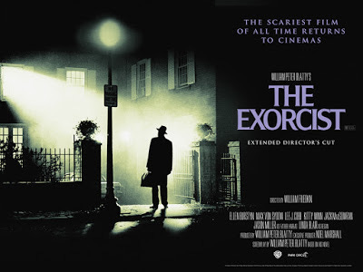

Within the body of the film The Exorcist (by Jewish Friedkin) there appears to be a huge (potential) 'child abuse' thematic running throughout...albeit subliminal and veiled. Kubrick was actually approached to direct this film, and approached for the sequel too.

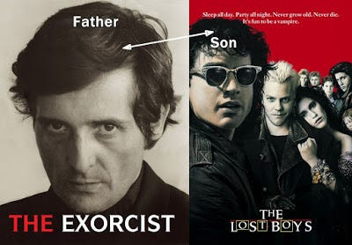

We already mentioned a few aspects about Schumacher's The Lost Boys, the film with Corey Haim and Feldman (both industry based paedophile sex abuse victims), Exorcist's Jason 'Father Karras' Miller's son was Jason 'Lost Boys' Patric. Miller's younger son (Joshua) is seen in Hallowe'en 3.

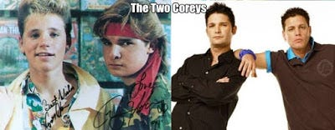

The New Partridge Dictionary of Slang and Unconventional English
No disrespect intended for either 'Corey', but the term 'corey' is Cockney rhyming slang for the 'penis' (morning glory/corey).

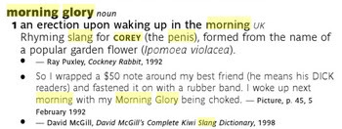

"I aint got a man..."
One or two examples are a bit weak, but most are on point.
"You're history buddy"...putting the beaver (heterosexuality) into the 'homoerotic' postered closet.

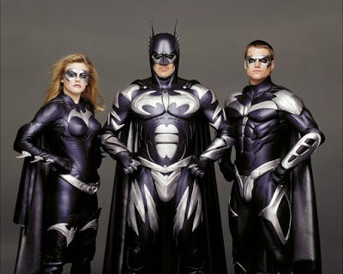

Schumacher was accused of overt 'homoerotcism' during his stint on Batman. Recall that Val 'Anal Intruder/Top Gun' Kilmer and George 'Friend of Dorothy' Clooney (gay) featured in those films.

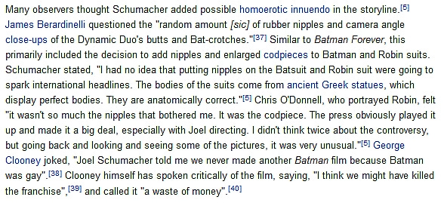

In 2006, Clooney said in an interview that in Batman & Robin he played Batman as gay. "I was in a rubber suit and I had rubber nipples. I could have played Batman straight, but I made him gay." Walters then asked, "George, is Batman gay?" To which he responded, "No, but I made him gay. (wink, wink)
Male bats exhibit the highest rate of homosexuality among mammals. (batty boys!)



Buttman/Boning...remember Bruce Wayne's Grandfather founded Yale/Skull and Bones...
Batman, Dick...and (wrong way) Boners

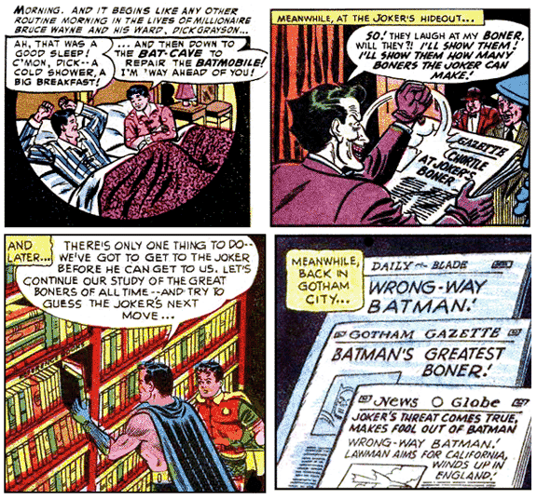

Skull and Bones #322 (Yale)
We mentioned Batman TDKR in respect of the Sandy Hook and Aurora events.

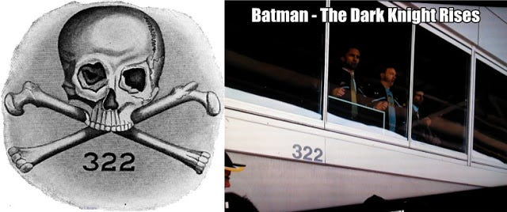

Bat(e)man: "That whole (masonic) Yale thing...closet homosexual"
It's Batman/Bat(e)man. American Psycho Bateman has a 'homoerotic/cottaging' moment (with Luis Carruthers) in the toilet at The Yale Club. Christian 'Batman/discovered by Spielberg' Bale. Yale Boners get tapped...tap that boner ass. "It's hip to be (on the) square." Ellis, the author of American Psycho is very likely gay.
It's starting to look as though many Hollywood male actors, may owe their rise to stardom by being Hollywood mogul 'rent boys'. A Hollywood 'gay mafia' type casting couch arrangement, those 'chosen ones' that service their Hollywood moguls to the greatest effect, probably rising the most rapidly etc.
Men In Black (Smith). Men 'in' black...think about the potential sexual allusion of that phrase!
'Here come the men...in black. We straight don't exist'. With JFK sodomite and Bat(ty)man, Tommy Lee Jones.

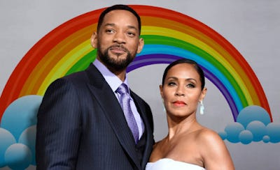

These same 'fluffers/pillow biters' are then used to promote the nefarious 'elite driven homosexual/LGBT mind control agenda' (and other nefarious programming), in exchange for stardom and money. The same agenda that is operating against the interest of the masses and general cultural health. This is the entrance fee price...Hollywood stars, therefore, are the ultimate degenerate sell outs.

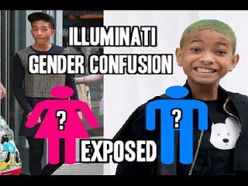

Johns Hopkins Psychiatrist: Dr. Paul R. McHugh, the former psychiatrist-in-chief.
Transgender is ‘Mental Disorder;' Sex Change ‘Biologically Impossible’

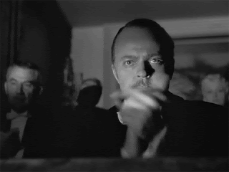

"Transgenderism is a “mental disorder” that merits treatment, sex change is “biologically impossible,” and that people who promote sexual reassignment surgery are collaborating with and promoting a mental disorder." (It's like he read my mind!)
Hannibal Lecter: (abuse ultimately being the catalyst, in Billy's case)
"Billy is not a real transsexual. But he thinks he is. He tries to be. Billy hates his own identity, you see, and he thinks that makes him a transsexual. There are three centres for transsexual surgery: Johns Hopkins, the University of Minnesota and Columbus Medical Centre."
I wonder how much of a factor LGBT 'MSM programming' is in this whole scheme?
The media tells you (most of you) what to think, believe, buy, wear, watch, eat etc...why wouldn't it influence (in some form) sexuality too? The answer is simple, it does influence sexuality, that's why billions and billions of $/£ are spent on sex-based consumer advertising. It wouldn't be spent if it didn't work! Increasingly sexualised children, means that they can be turned into 'sex based' consumers and at a much faster rate. The media made millions and millions believe that 9/11, was carried out by a man living in a cave, hell, if they can do that...they can do literally anything!
"To learn who rules over you, simply find out who you are not allowed to criticize."



'Goy hating mafia', Zionist/Illuminati Hollywood/MSM, Govt, Military, programmed sheep etc
I wonder what Colin 'discovered by Schumacher' Farrell had to do, to obtain his rapid success?
Farrell started off with the (paedo) BBC, in TV series Ballykissangel (meaning, fallen angel town)

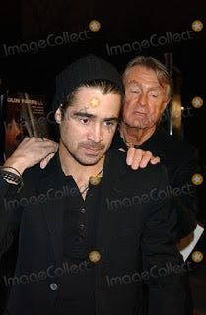

"Farrell squeezed in as the 41st and last actor of the day. Schumacher described it as like "falling in love". Within months, Farrell was in Texas, playing a tough military hero in Tigerland, a movie that only a handful of people saw. Fortunately, that handful included Steven Spielberg and Bruce Willis, so after Tigerland came Hart’s War, Minority Report and Phone Booth. In record time, Farrell had entered the outer orbit of Hollywood stardom." (I'll leave you to work it out...cough, cough).

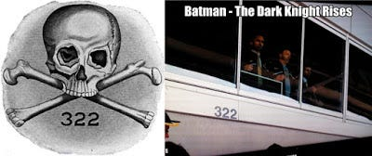

While I'm on the subject of morning glories, boners (skull and bones) and Lost Boys' Feldman, he coincidentally starred as a young incarnation of (masonic/templar) Jason 'Friday 13th' Vorhees, in the misleadingly titled The Final Chapter (part 4). Feldman would also feature in the Spielberg/Donner release The Goonies (1985) as 'Mouth', about a group of pre-teens from Astoria (Ass-toria) looking for the 'booty' of (masonic Osiris pirate) 'One-Eyed Willy' (hello?)

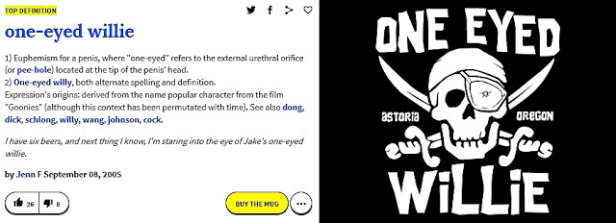

That's clearly a blatant euphemism for the penis. Some stealth programming here, oh yes.
Gooning - aka prolonged cock stroking/edging.

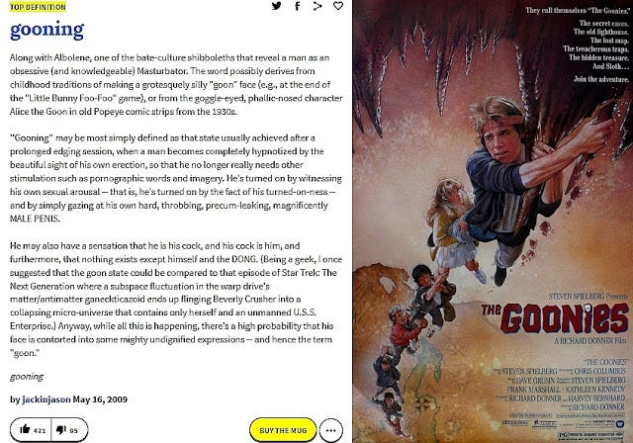

The secret caves, the old lighthouse (wink, wink) and suggestive imagery (is that Brolin 'pulling off' a rock dildo?) Templar cross, lower left. Richard 'Omen 666' Donner directed/produced, Harvey 'Omen' Bernhard produced, Steven 'Jurassic Masonic Park/Room 666' Spielberg did the story, and Chris 'Gremlins/Home Alone 2' Columbus did the screenplay. The explorer Christopher Columbus was likely a Templar too (see Rugerro Marino).



Just keeps piling up doesn't it?

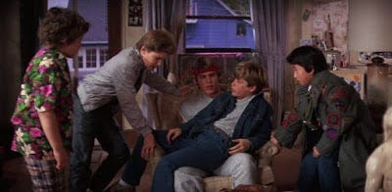

I've not even seen this film...but it clearly has a 'homoerotic cock worship' subtext and coupled with a majority of pre-teen boys, as main the cast. The Gaynies as a title, would be more apt.
Of course, you have to appreciate that most of this is not really a part of the direct storytelling narrative, this propaganda is far more subversive and devious, than something as simple as that!
You know that they all chuckle to themselves, while the 'dumbed-down' sheep obliviously lap it up!
Steve 'Openly gay' Antin also features in the Gaynies, as 'Jock' Troy, he also played one of the rapists in The Accused (1988), with lesbians Jodie Foster and Kelly 'Top Gay Gun' McGillis. Antin was also 'Jessie', in Rick Springfield's 'Jessie's Girl' video...a 'Jessie' being English slang for an overly effeminate boy/man, homosexual etc.
Sean 'Gaynies' Astin played 'one-eyed masonic Willy seeking' Goonie, Mikey Walsh...

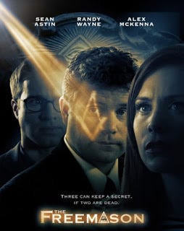

...here he is (with his eye in the pyramid/square and compass) in The Freemason (2013).
The '666' Omen would soon follow The Exorcist, The Omen's Donner (director) and Bernhard (producer) would also do likewise on The Goonies (see above) and both would also work on The Lost Boys, with Donner as executive producer and Bernhard as producer. Damien Karras would get possessed at the close of the film, Donner's The Omen 'son of the devil' was Damien Thorne.

Anyway...The Exorcist, interesting that quite a few people have posited that Father Karras may have been a homosexual, there is even a potential link to both him and Father Dyer being gay. Karras is ethnically a Greek, to go 'Greek' a euphemism for homosexuality.
Continued...see next post.
https://againstsatanism.com/External-Websites/subliminalsynchrosphere/subliminalsynchrosphere.com/2016/04/the-exorcist-satan-serial-killings-and.html
Horselover Phat

THE SOLUTION? - THE ENERGY ENHANCEMENT COURSE BY STREAMING VIDEO OR LIVE IN BRAZIL, INDIA, WORLDWIDE!!



Share
Leave a comment
The removal of the Heads of the Thirteen Satanic Families - not by assassination - as they can move from body to body - but as in the removal of Energy Blockages in the Energy Enhancement removal of Blockages.
Also information, the teaching of Wolf-Child Humanity in real Science and History as well as the Science of Meditation - Kundalini Kriyas, VITRIOL, Samadhi, Samyama, the removal of Energy Blockages, Implant Blockages, Energy Connections and Cords.

The solution?

THERE IS NO PHYSICAL SOLUTION AS OVER 10,000 YEARS OF RAPE AND PILLAGE WILL SHOW YOU!!

Solution? - The Science of Meditation - Which will increase the only thing you can take with you - Lifetime to Lifetime - when you die..

THE ONLY SOLUTION IS EVOLUTION!!
With the Energy Enhancement Kundalini Kriyas, VITRIOL, Samadhi, Samyama, the removal of Energy Blockages, Implant Blockages, Energy Connections and Cords.

ENERGY ENHANCEMENT IS THE ULTIMATE TECHNIQUE OF EVOLUTION!!
Just by meditation and energy blockage removal, you can find the truth for yourself, increase your energy, access incredible quantities of Kundalini Energy, become Enlightened.
And that's the only way, I think, you can actually make a practical, actually practical indication of how we might be able to save humanity from its degenerate Satanic predators.

ENERGY ENHANCEMENT - THE ULTIMATE MEDITATION COURSE!!

GET YOUR ENERGY ENHANCEMENT VIDEO OR LIVE COURSE NOW!!



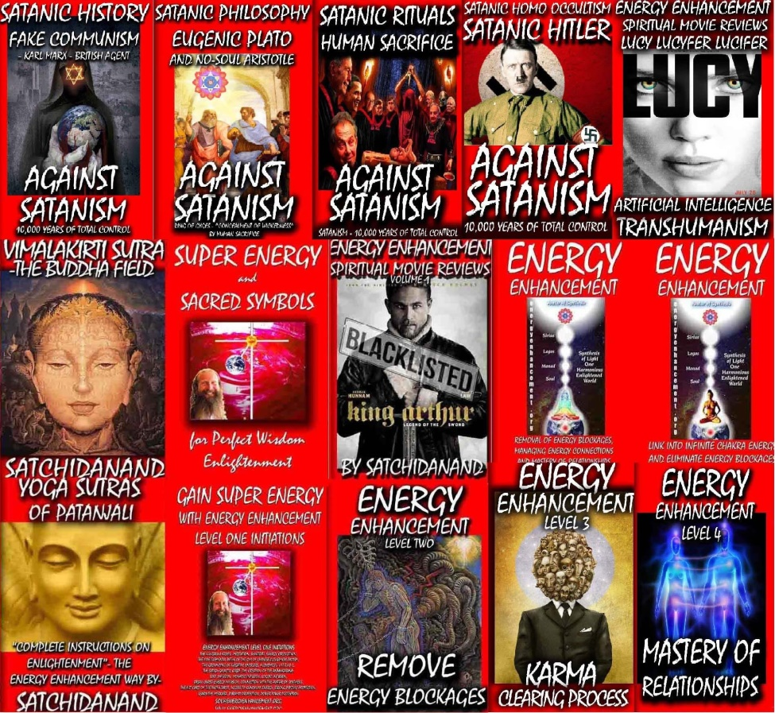
The Energy Enhancement Streaming Video Meditation Course and the Volumes of the Against Satanism Series by Satchidanand

Go to http://www.energyenhancement.org
for 52 Free –On Sign-Up - Energy Enhancement Books and Energy Enhancement Against Satanism Books.
To defeat Evil, you need to up your game. Learn the Energy Enhancement Meditation Course by Video or Live at Iguazu falls with Satchidanand and Devi Dhyani.


T

Change the World...


Go to http://www.energyenhancement.org
for 52 Free Energy Enhancement Books.

To defeat Evil, you need to up your game. Learn the Energy Enhancement Meditation Course by Video or Live in Iguazu.
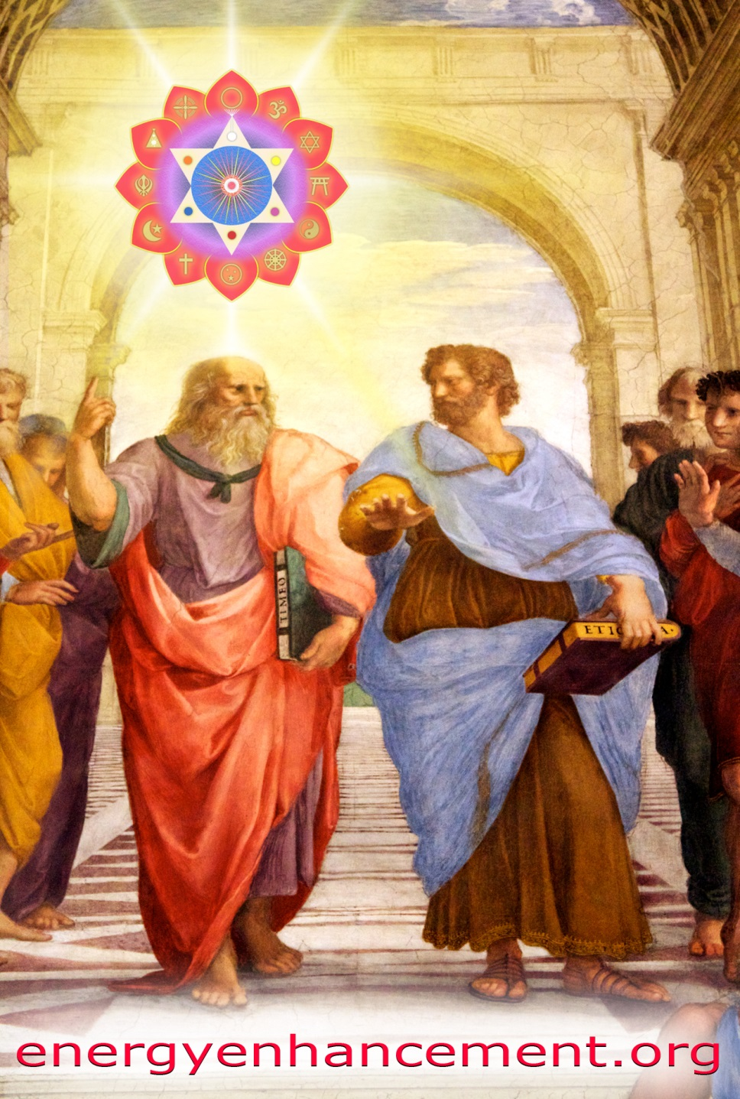

PLATO AND SATANIC BABYLONIAN SECRET AGENT ARISTOTLE "THE POISONER" OF ALEXANDER THE GREAT - BY RAPHAEL




ENERGY ENHANCEMENT MEDITATION
ENERGY ENHANCEMENT MEDITATION LEVEL 1 POWER UP!! GAIN SUPER ENERGY http://www.energyenhancement.org/Level1.htm
ENERGY ENHANCEMENT MEDITATION LEVEL 2 ELIMINATE ENERGY BLOCKAGES http://www.energyenhancement.org/Level2.htm
ENERGY ENHANCEMENT MEDITATION LEVEL 3 CLEAN KARMA BLOCKAGES AND PAST LIFE KARMA BY TRANSMUTATION http://www.energyenhancement.org/Level3.htm
ENERGY ENHANCEMENT MEDITATION LEVEL 4 MASTER ENERGY CONNECTIONS AND RELATIONSHIPS http://www.energyenhancement.org/Level4.htm

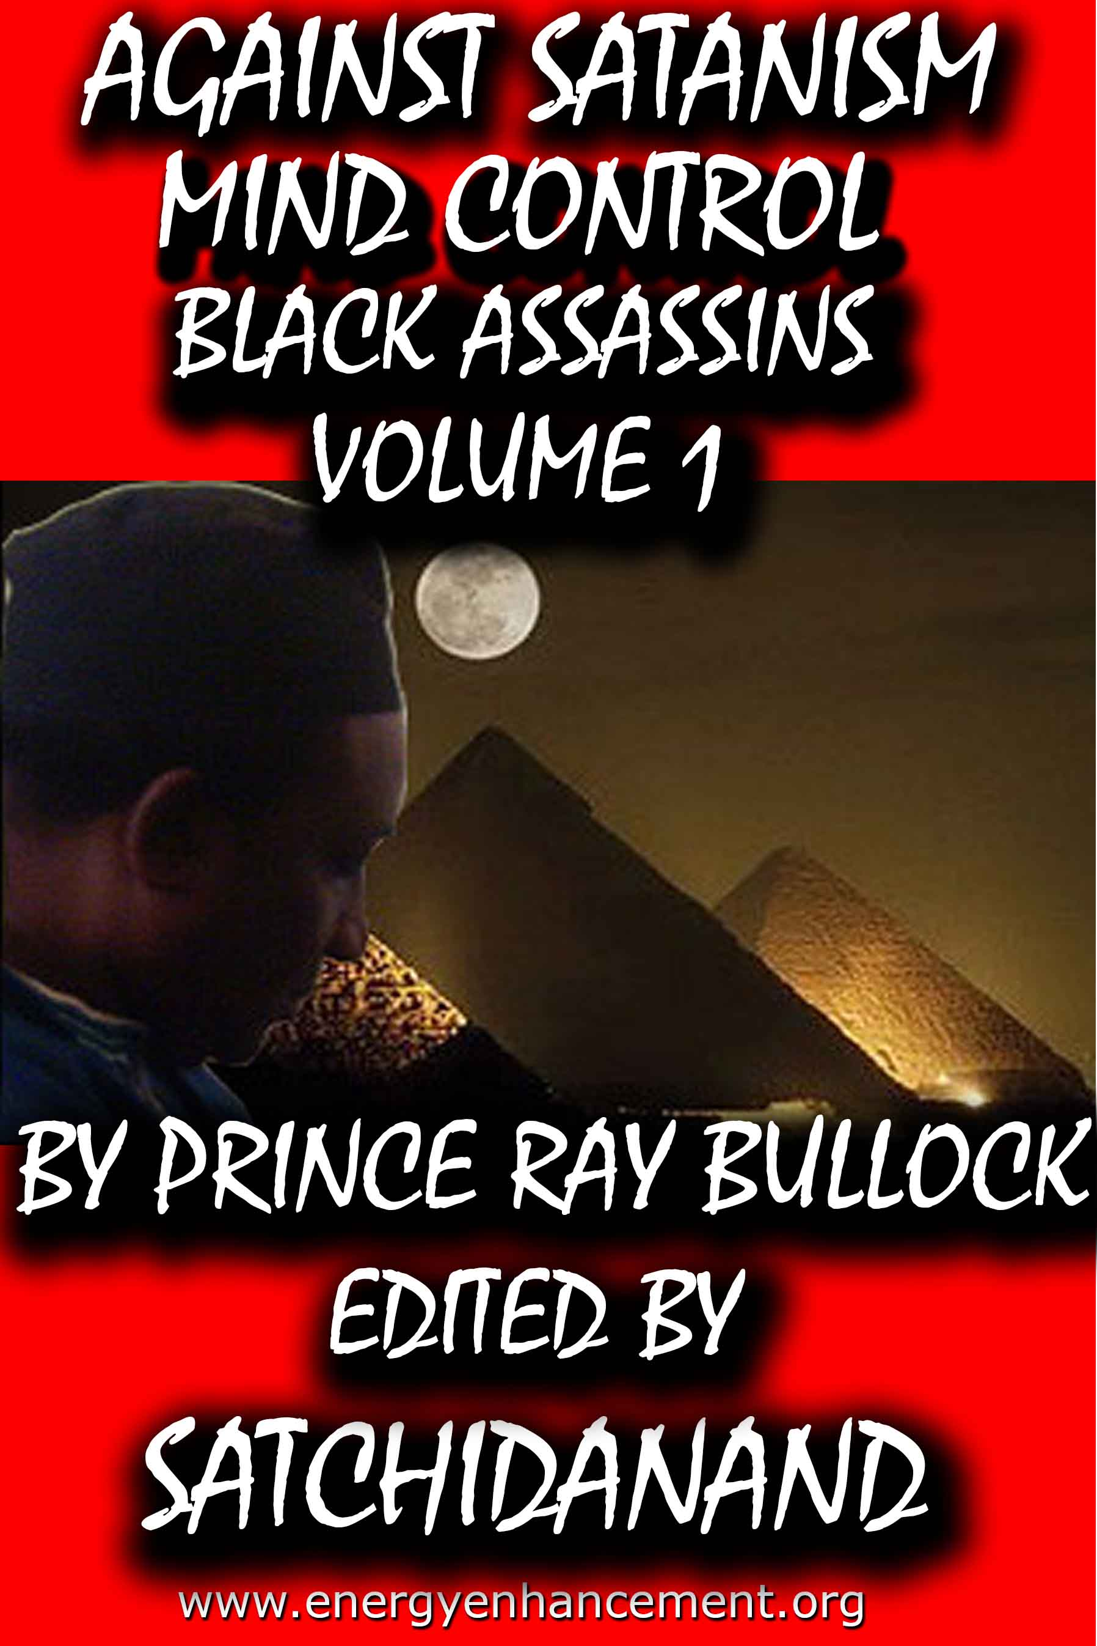

MIND CONTROL BLACK ASSASSINS VOLUMES FREE!!

AGAINST SATANISM VOLUMES FREE!!

- ON SIGN-UP AT..

energyenhancement.org

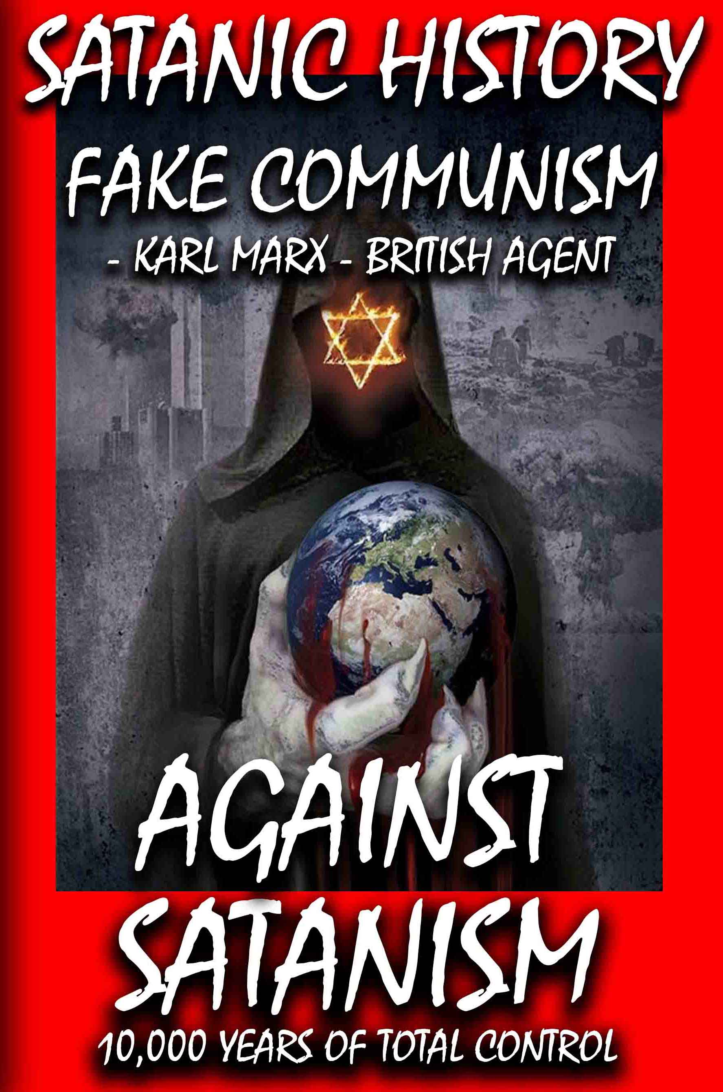

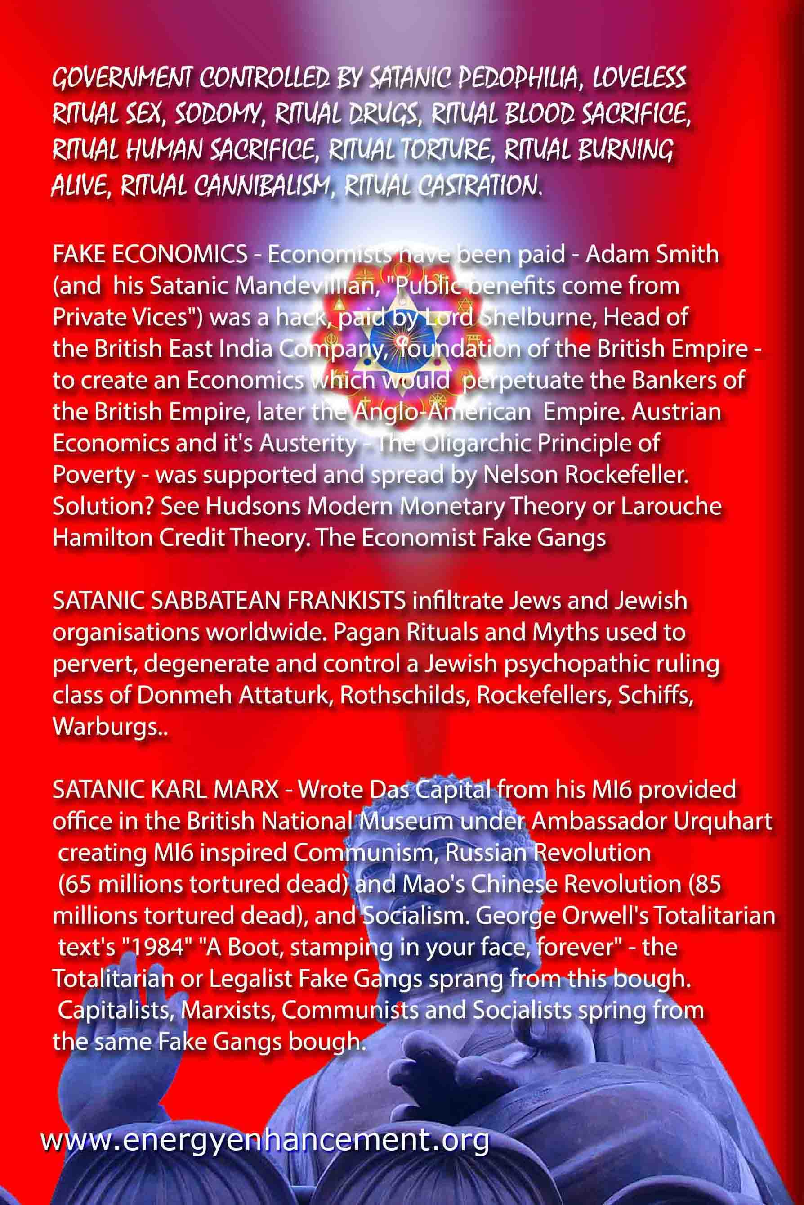

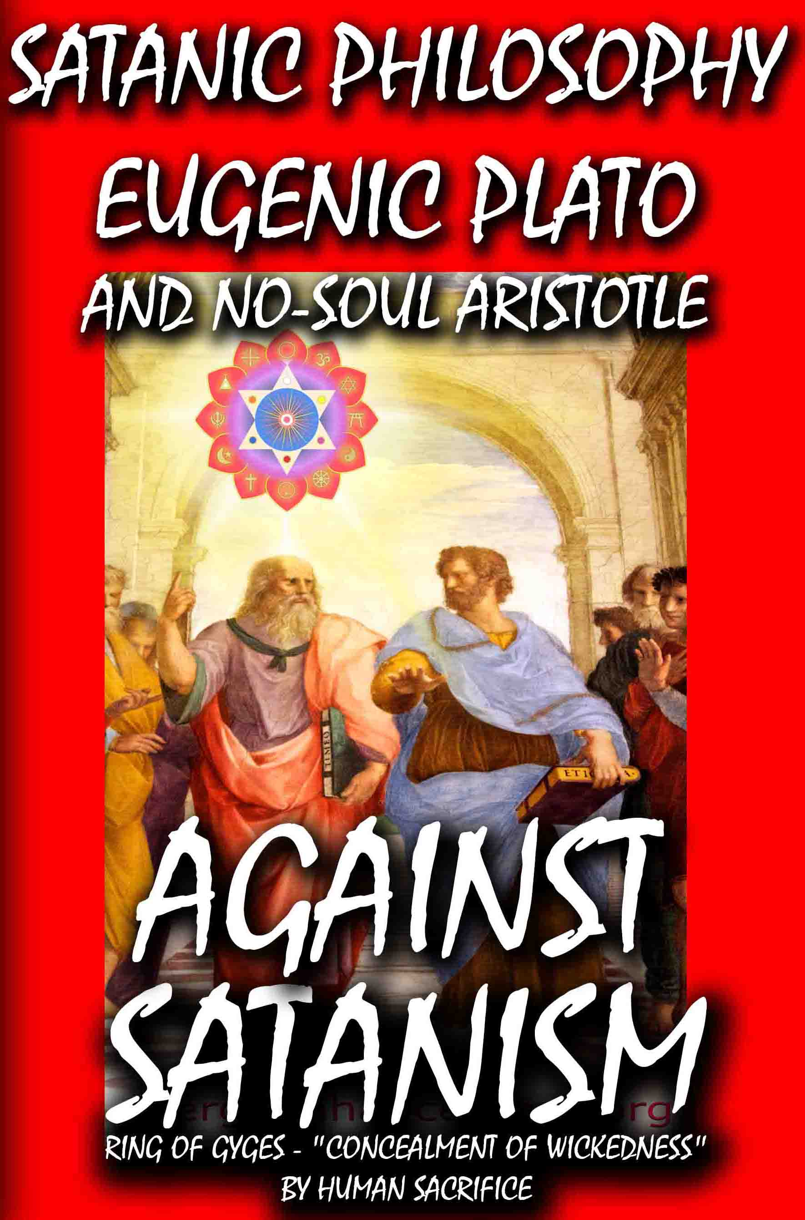

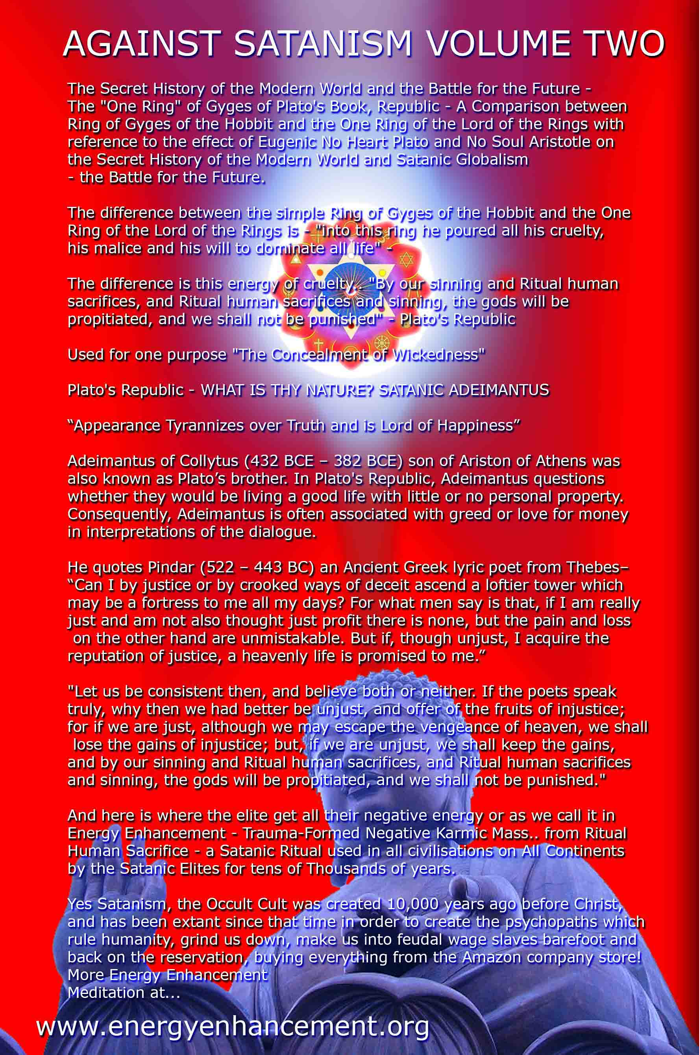

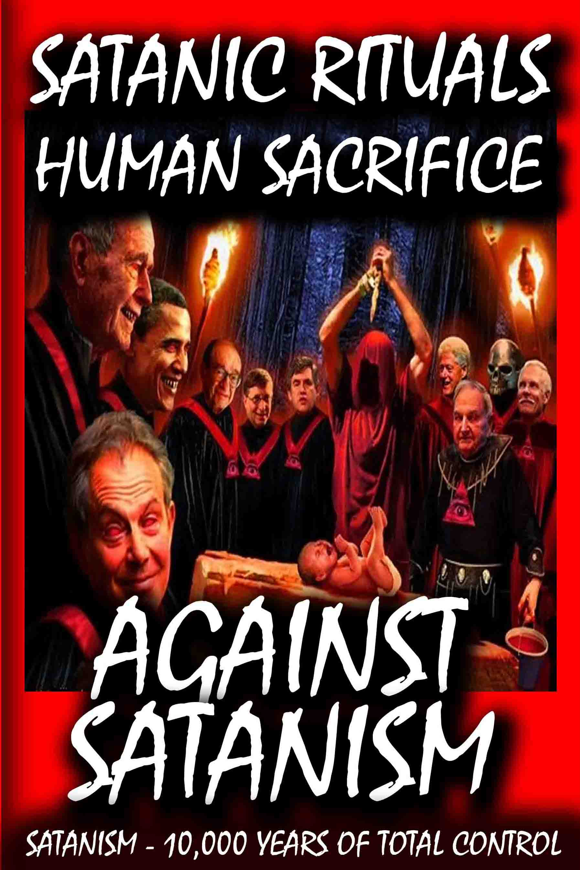

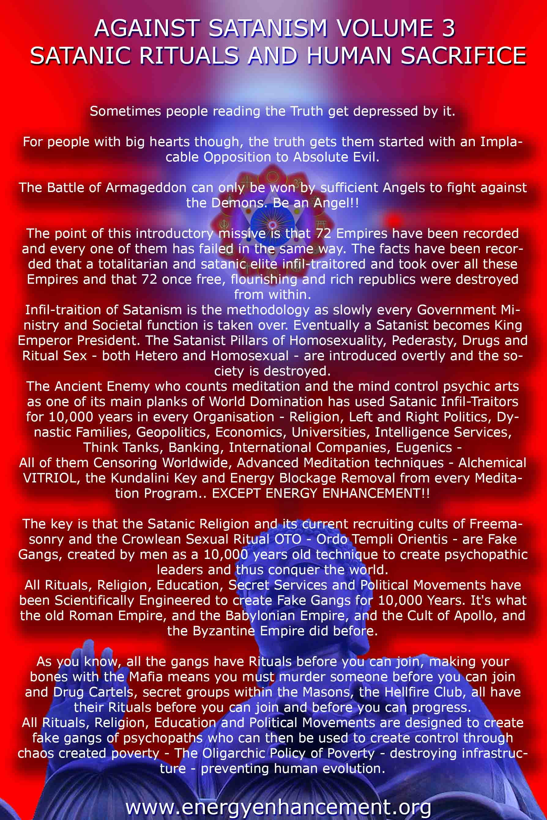

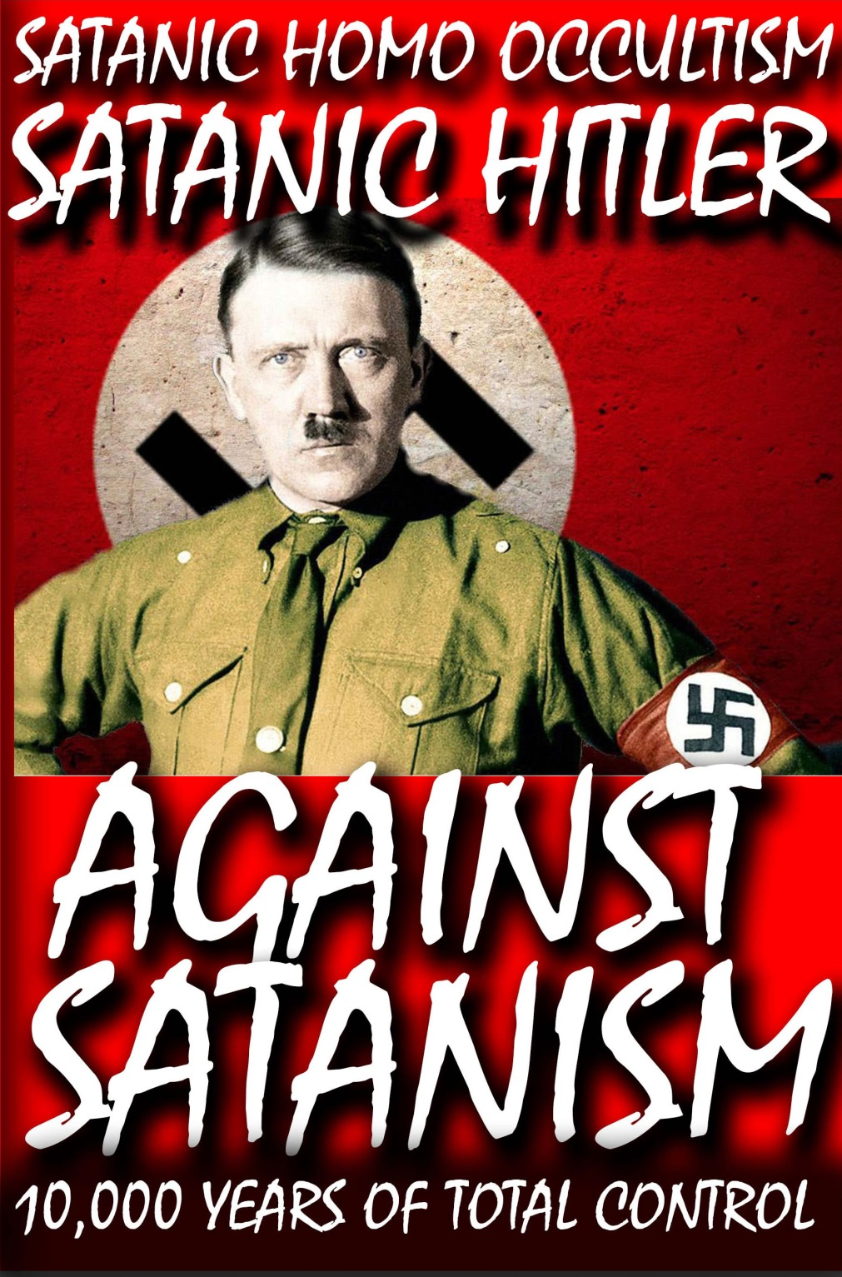

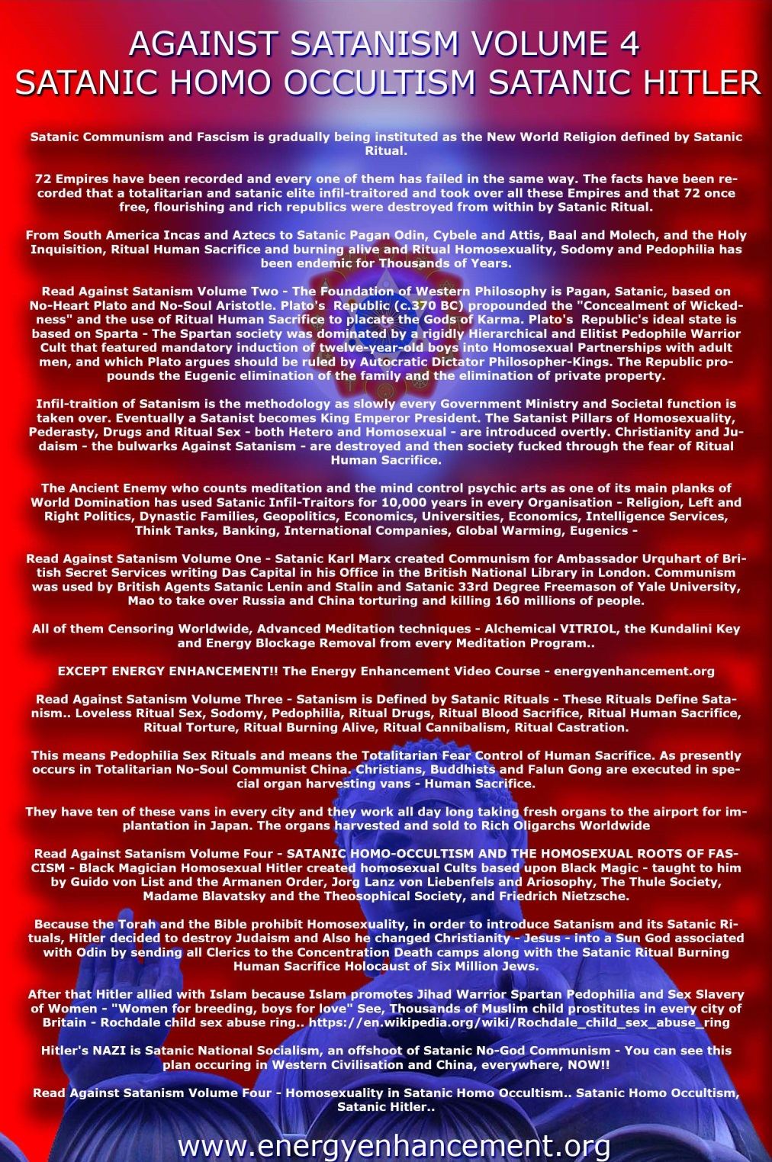

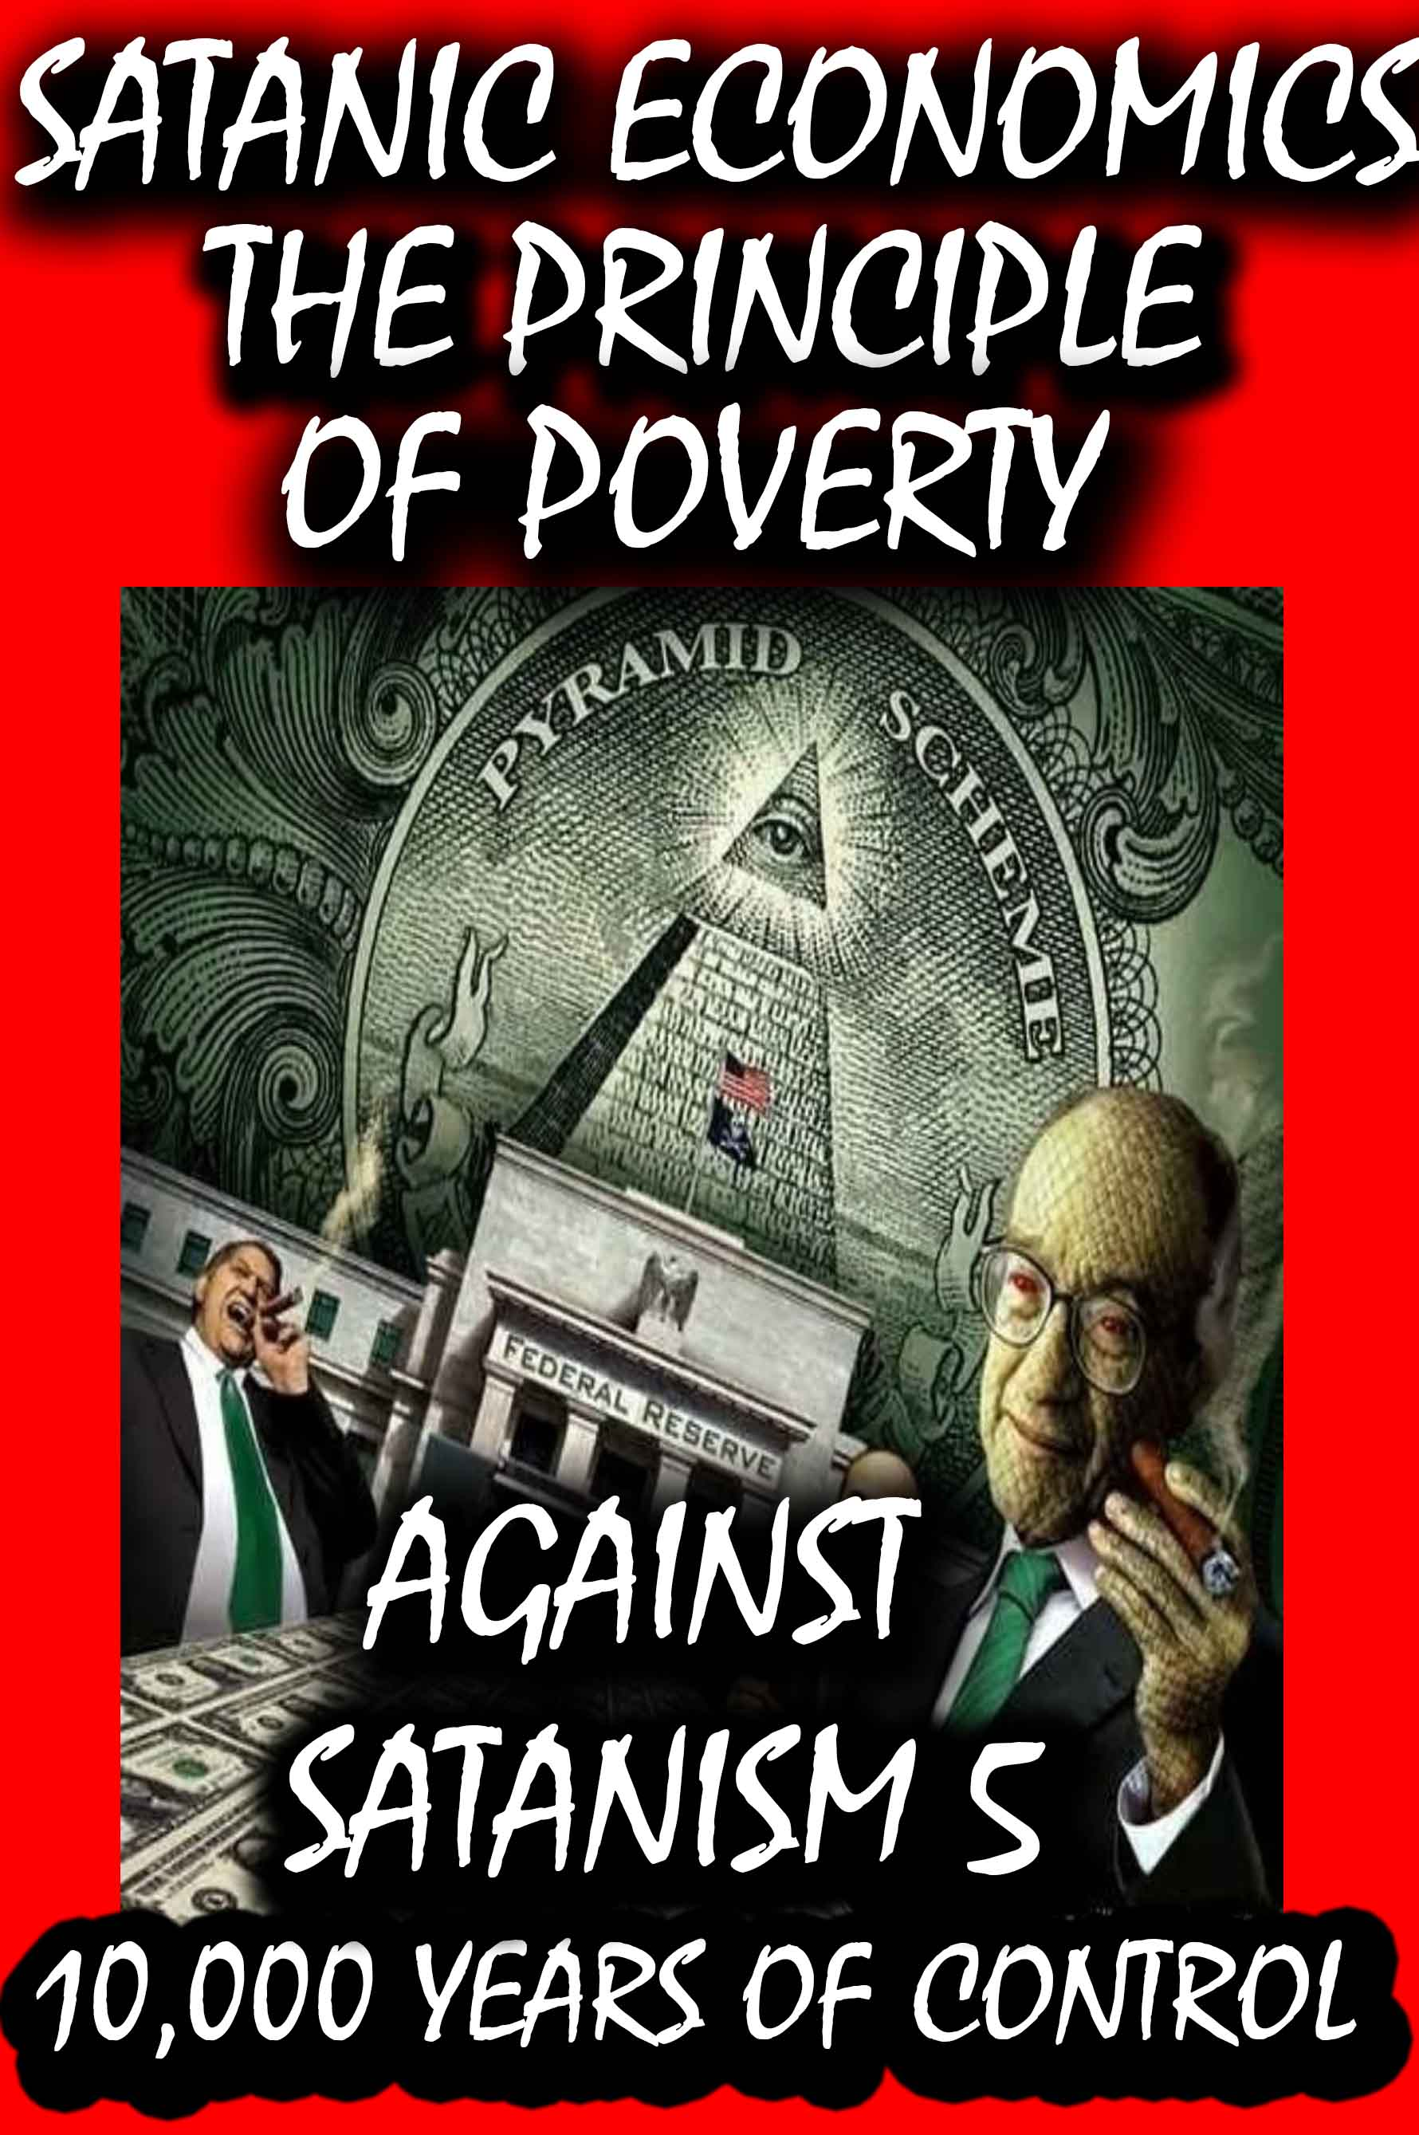

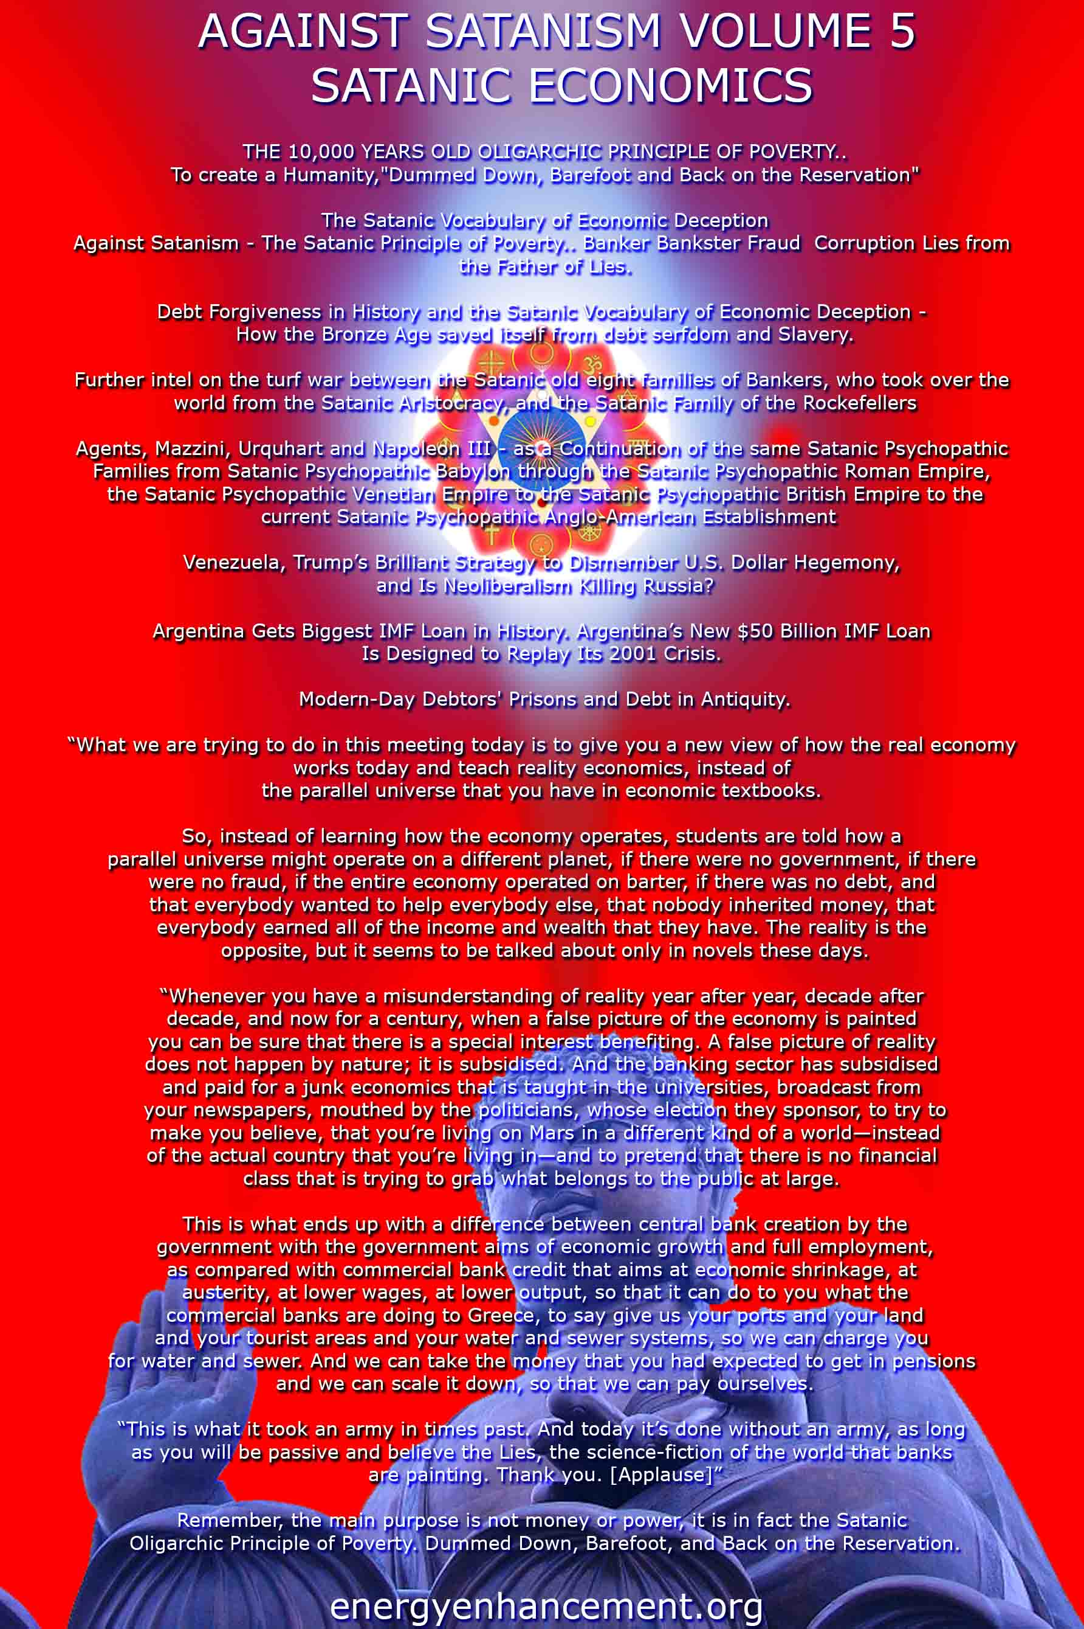

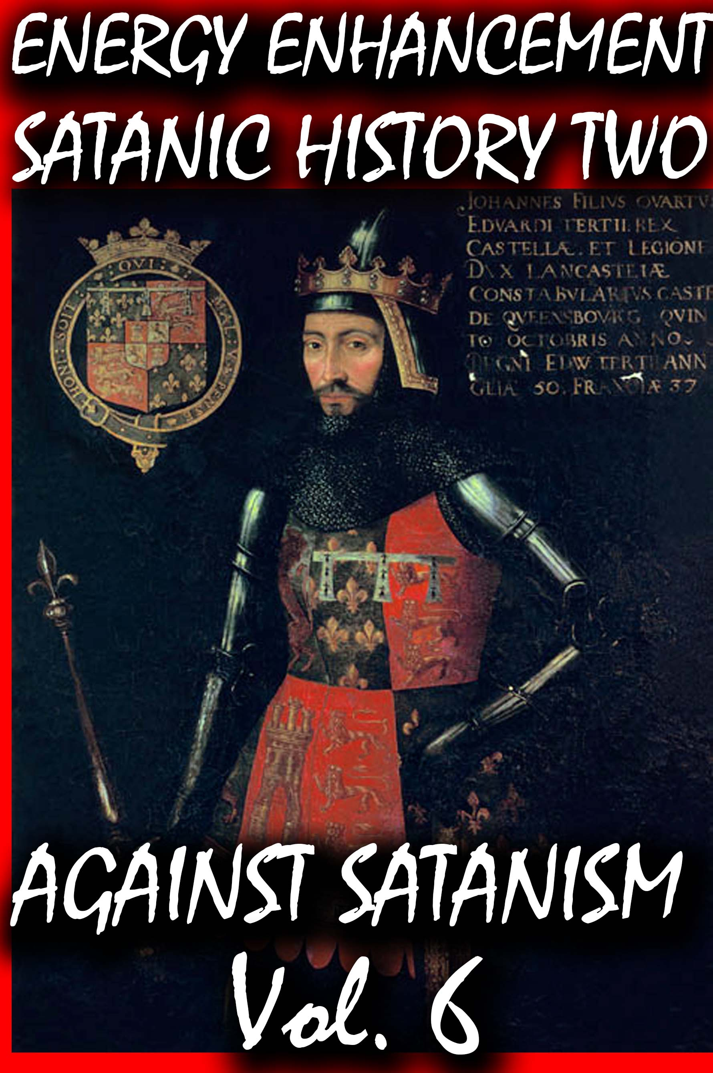
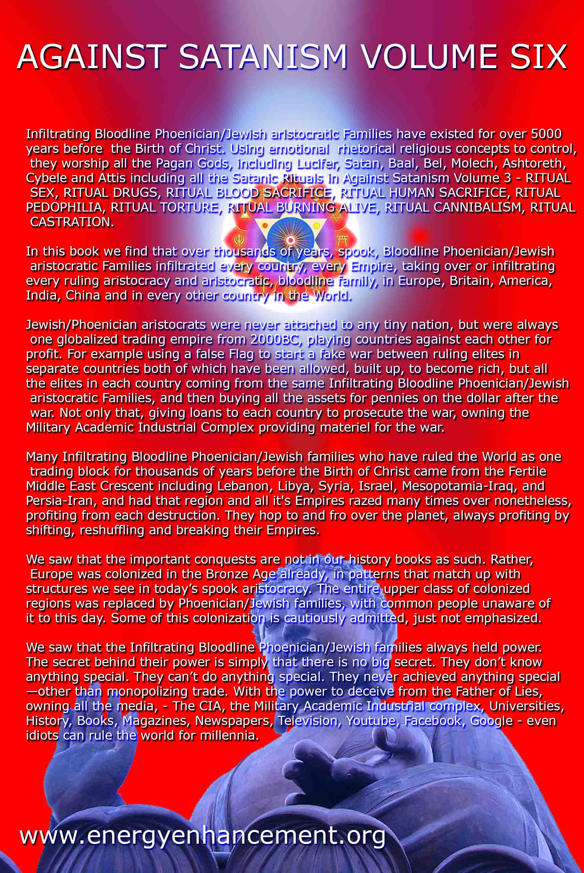
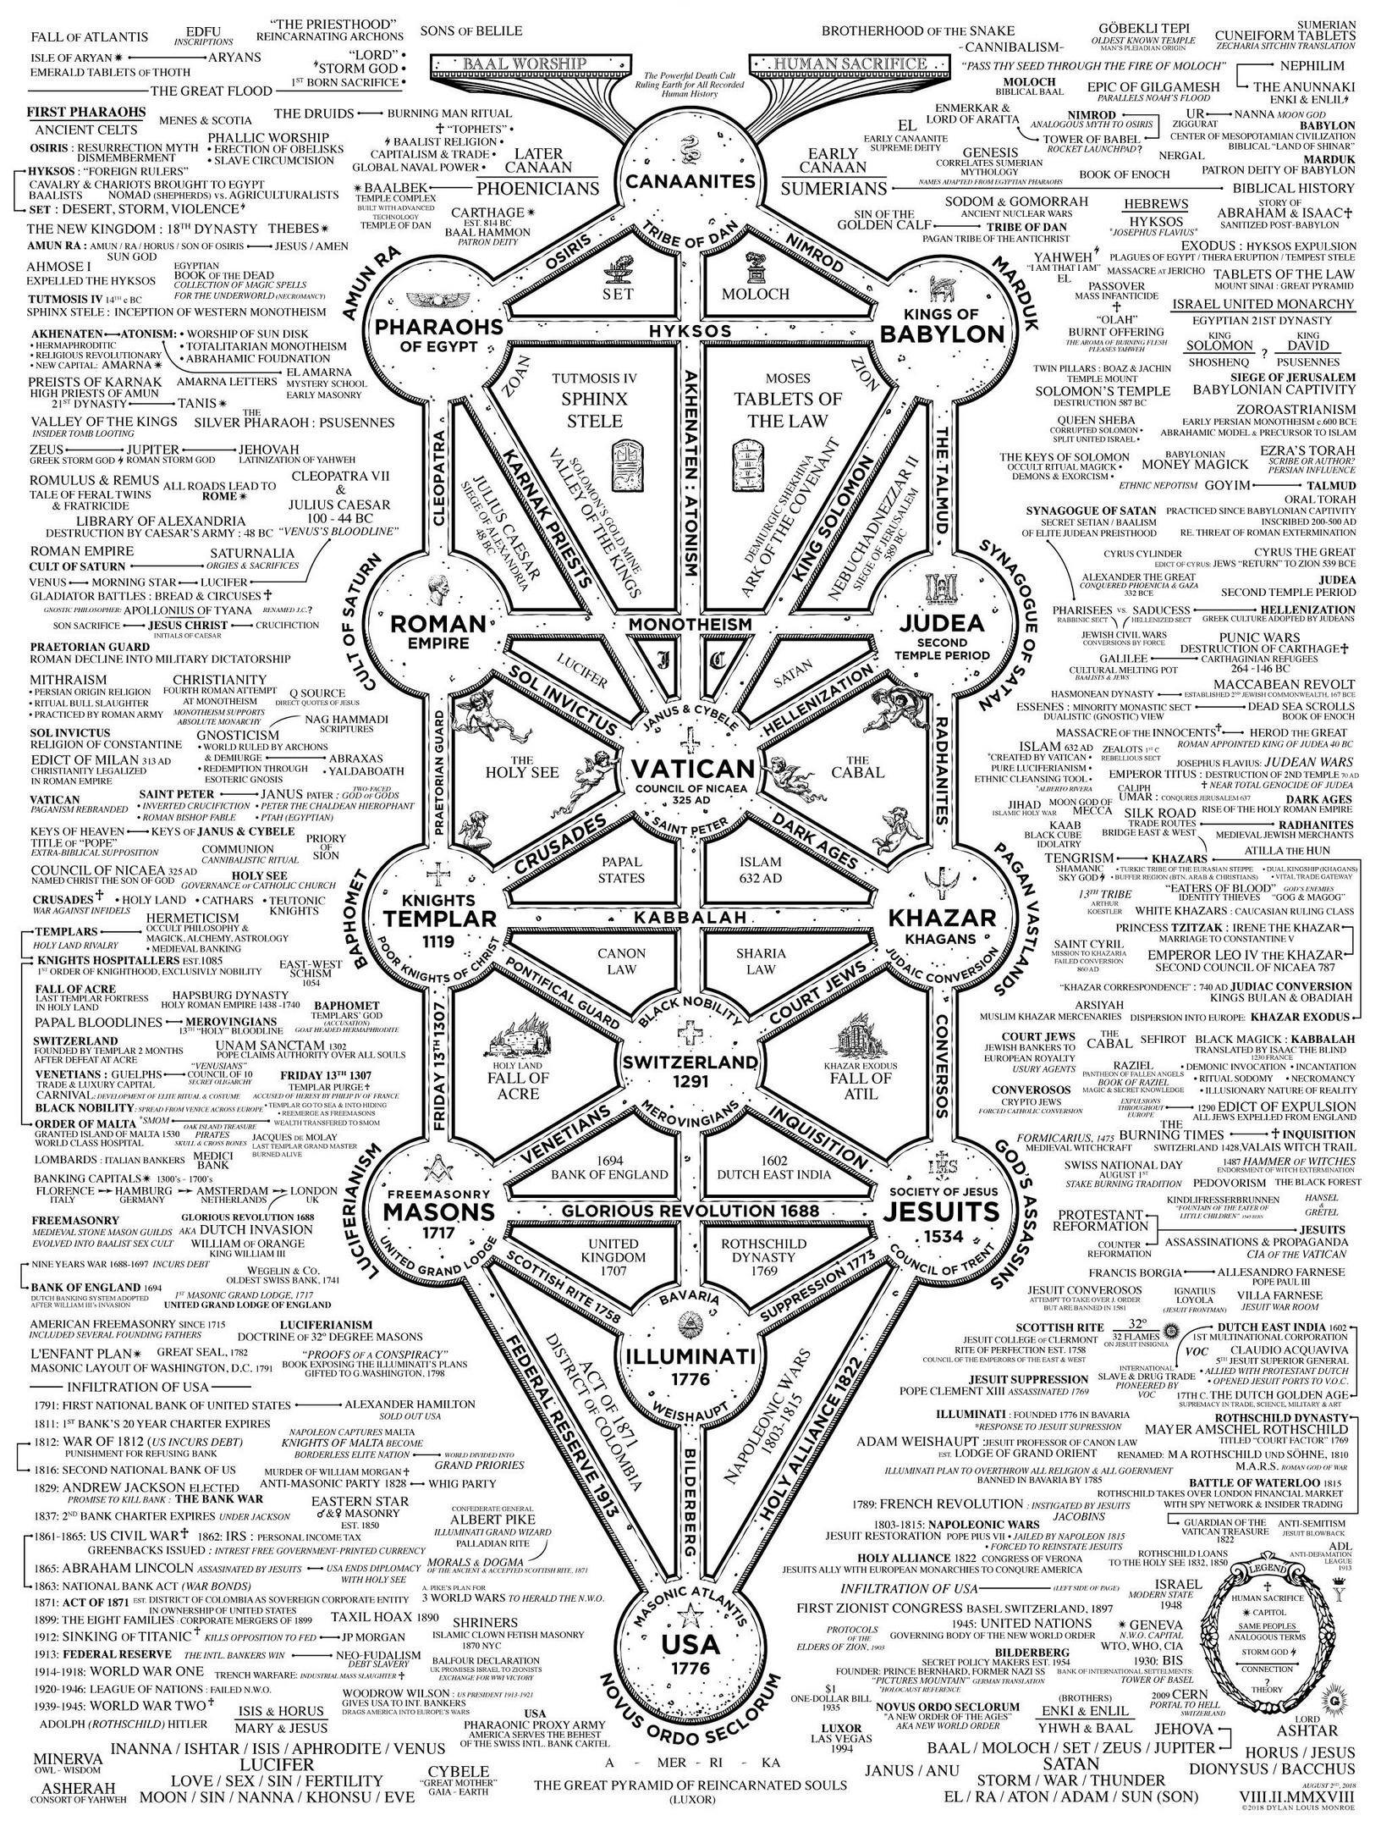
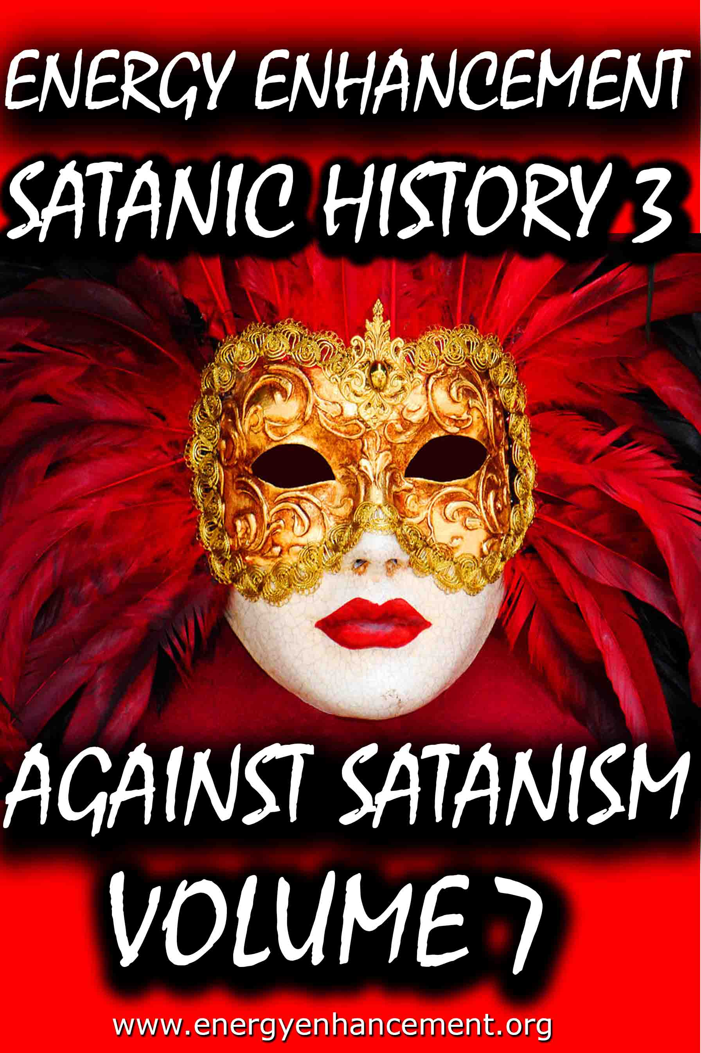
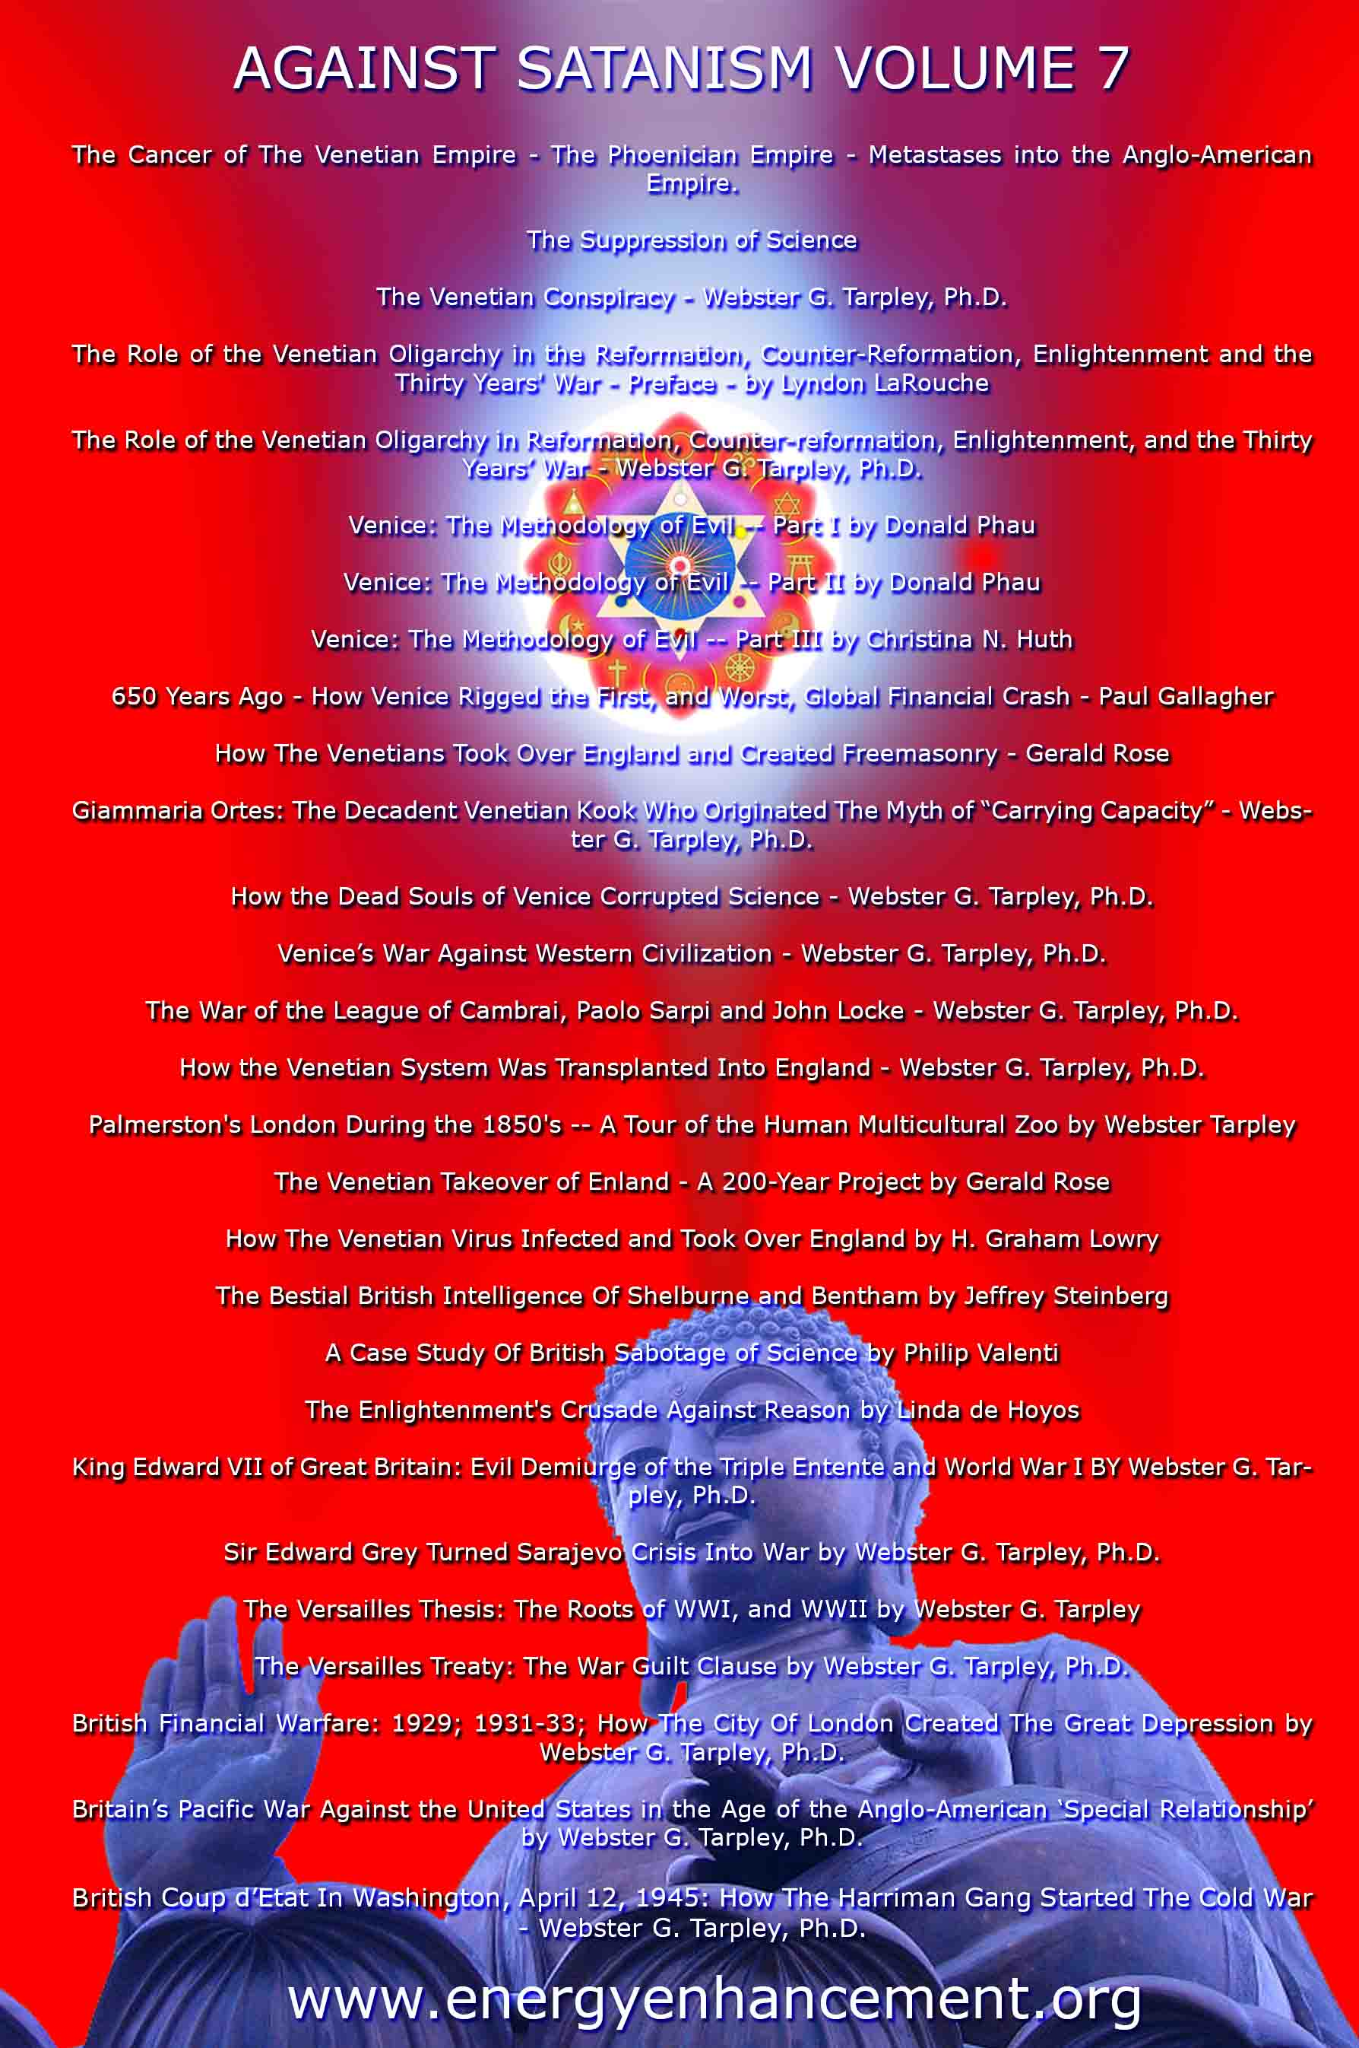

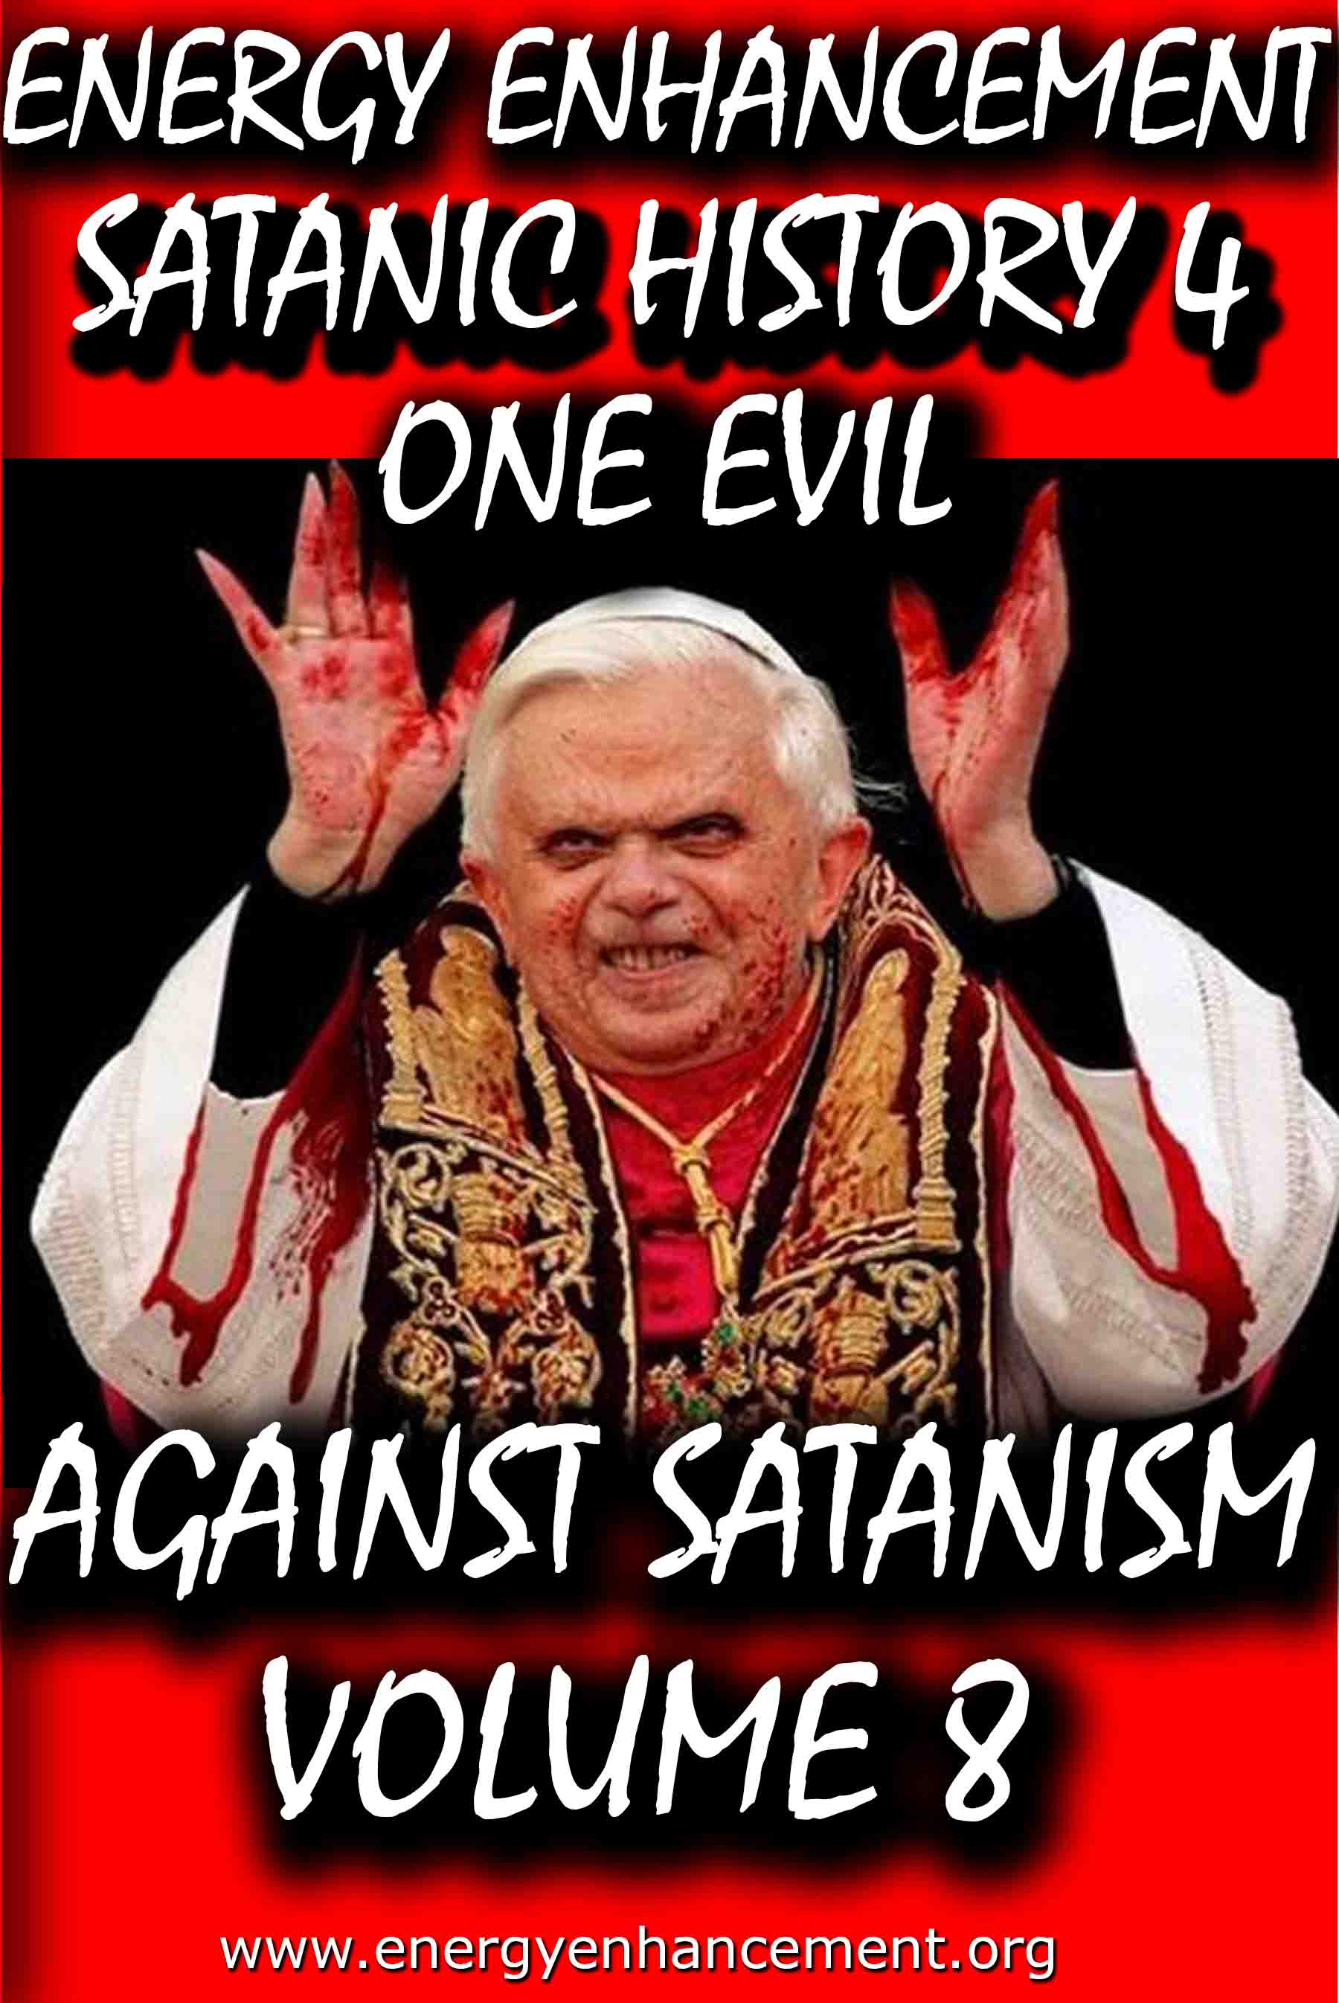

Remember, the main purpose is not money or power, it is in fact the Satanic Oligarchic Principle of Poverty. Dummed Down, Barefoot, and Back on the Reservation

Even though Tesla Free Energy Broadcast Power has been supressed, these next pages show how Fusion power and Fission Power have also been suppressed due to a Policy of Poverty going back to Fra Paolo Sarpi of the Satanic Venetian Republic and the British Royal Society for Science…

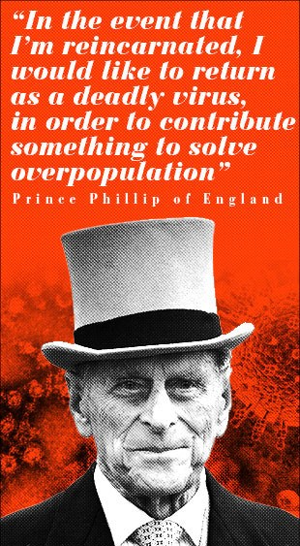

These Satanic Malthusians Demand Genocide

“Human population growth is probably the single most serious long-term threat to survival. We're in for a major disaster if it isn't curbed...We have no option.” —Prince Philip, interview in People Magazine, December 21, 1981

“In the event that I am reincarnated, I would like to return as a deadly virus, in order to contribute something to solve overpopulation.” —Prince Philip, Deutsche Press Agentur, August 1988
“It is almost self-evident that the greater the human population, the greater the demands for natural resources... The paramount question deals with an optimum human population. How many is too many people in relation to available resources? Many believe that our current (satanically consciously created) environmental problems indicate that the optimum level has been surpassed.” —Task Force on Earth, Resources and Population, George H. W. Bush, Chairman, July 8, 1970

POST MORTEM

Unfortunately, all the obituaries were premature: Venice has continued to be very much alive. During the nineteenth century and up to our own time it has been the most important single incubator for fascist movements. With its military and financial power largely emigrated elsewhere, Venice’s importance for political culture is now greater than ever.

Examples of this are inexhaustible. Richard Wagner wrote part of Tristan und Isolde while living in the Palazzo Giustinian on the Grand Canal. One story has it that the leitmotif of the Liebestod was inspired by the mournful call of a gondolier. At the end of his life Wagner moved to Palazzo Vendramin Callergi, where he died. This building, presently a gambling casino, was also the home of Count Coudenhove- Kalergi, the founder of the Pan-European Union. Friedrich Nietzsche loved Venice, returned there incessantly, and dedicated certain poems to the city which today can still be used in lieu of a powerful emetic. Venice was an inspiration for Lord Byron, for Thomas Mann, and so on.

Other examples abound of how the Venetian oligarchy’s cultural and political influence has reached down into the modern era:

* When British East India Company retainer Thomas Malthus published his Essay on Population he was plagiarizing from the Venetian Giammaria Ortes, who produced, around 1750, a fully developed version of the argument that geometric population growth outstrips the much slower arithmetric progress of food production.

* John Ruskin, the leading ideologue of the British Dark Ages faction, began his career with a raving treatise on architecture, The Stones of Venice (1851). This volume popularized the notion that a “Venetian Gothic” style had been developed in the better times of the city’s history (which for Ruskin ended in 1418) and it was used systematically to discredit the Golden Renaissance.

* A turn-of-the-century new Roman Empire faction led by Venetian Count Volpi di Misurata, who was known as the doge of his era, sponsored the fascist Mussolini supporter Gabriele D’Annunzio to drum up enthusiasm for a new crusade into the Balkans and the East. Volpi became finance minister in Mussolini’s cabinet, along with a very large number of other Venetians. D’Annunzio incited the Italians to take back Trieste, the rest of Italia Irredenta, and the Dardanelles, bringing on to center stage the so-called Parvus Plan for dismemberment of the Ottoman and Russian empires, which is generally recognized as the detonator of World War I. It is possible that the turn-of-the- century super spook Alexander Parvus was ultimately employed by Venice.

* The Societe Europeenne de Culture, a think tank created in 1950 through the efforts of Venetian intelligence operative Umberto Campagnolo, has for the past three decades pulled intellectuals from both East and West into organizing for an “international culture,” based on rejecting the existence of sovereign nations. The SEC counted among its members the cream of the postwar intelligencia: Adam Schaff of Poland, Bertolt Brecht of East Germany, Georg Lukas of Hungary, and Boris Paternak of the Soviet Union, as well as Stephen Spender and Arnold Toynbee, Benedetto Croce and Norberto Bobbio, Julian Huxley and Thomas Mann, Francois Mauriac, and Jean Cocteau. Later, the SEC launched the Third World national liberation ideology.

Today, the Club of Rome is the institution that represents the most concentrated essence of Venetian influence and the Venetian method. The Club of Rome wants to convince the great powers and peoples of the world to commit collective suicide by accepting the genocidal doctrine of zero growth. It also hopes to abolish the sovereign nation as a vehicle for economic growth and scientific progress.

Club of Rome founder Aurelio Peccei has just written a new book titled One Hundred Pages For the Future, a global review of the impact of the Club of Rome, and particularly since its 1972 release of the zero-growth model Limits to Growth was published, a series of social movements has sprung up under the sponsorship of the ideas in the book. These – the women’s movement, the peace movement, Third World national liberation movements, gay rights, civil liberties, ecologists, consumer and minority rights, etc. – must now be welded together into one movement for a single strategic goal: the implementation of a zero-growth international order.

The Venetian problem remains with us today. Truly, the most urgent task of this generation of mankind is to definitively liquidate the horror that is Venice and all the other Gang Clan Families who have ruled the World for 10,000 years.

The Satanic Conservative outpost of the Satanic Phoenician Navy who for 10,000 years have worshipped Molech, Baal and Cybele and Attis, and with Satanic Ritual, it's not just Sex on Altars like in Kubrick's, "Eyes Wide Shut", it is Pedophilia with Babies and Children supplied by Epstein, Dutroux or Jimmy Savile, it's Ritual Human Sacrifice, Ritual Blood Sacrifice, Ritual Burning Alive, Ritual Torture, Ritual Castration - and those Damn Liberals by Miles Mathis and Satchidanand

The founding fathers have even been sold as liberal in this sense, since although they were rich guys, fully connected, we are supposed to believe they believed in democracy, republicanism, and fairness in general. That is why they go on and on about that in the Declaration of Independence and Constitution. Those are liberal documents, in that they deny not only the divine rights of kings, they deny any other sort of favoritism based on name or birth.

As it turns out, the founding fathers were not liberal at all. They were Satanic fascists, and the whole liberal stance was just another con-job.

The United States were never meant to be republic, much less a democracy, they were meant to be another outpost of the Satanic Phoenician Navy who for 10,000 years have worshipped Molech, Baal and Cybele and Attis, and more worship with Satanic Ritual, it's not just Sex on Altars like in Kubrick's, "Eyes Wide Shut", it is Pedophilia with Babies and children supplied by Epstein, Dutroux or Jimmy Savile, it's Ritual Human Sacrifice, Ritual Blood Sacrifice, Ritual Burning Alive, Ritual Castration.
Some of my readers have been confused by my insistence that I am a liberal. These readers agree with me on a lot of things, so they can’t fathom what I mean by calling myself a liberal while they consider themselves conservatives. Since it is important, I will hit it again, trying to get them to understand.

I think the difference is that I am coming at this as a student of history, while many of them are coming at it as students (or consumers) of current politics.

I haven’t gotten my definitions and stances by listening to Rush Limbaugh, or Sean Hannity, I have gotten them from texts from the 19th century or earlier. My readers will answer me, “Then why don’t you keep up, Holmes! This is 2020, not 1880”. Good point. . . except that it isn’t.

To see what I mean, let’s transport ourselves back to the 1880s. Back then, satanic conservatives were those people who wished to conserve the status quo. Hence the name. They were quite satisfied with the way things were set up, and why should they not be?

They were rich and connected and had it made. Liberals were those who were not satisfied by the way things were, and so they were pushing for reforms. In general, they wished to see more fairness in government policies. They wanted those not “of the manor born” to be given a fair shot at good employment, good wages, court access, and all the various fruits of society.

The founding fathers have even been sold as liberal in this sense, since although they were rich guys, fully connected, we are supposed to believe they believed in democracy, republicanism, and fairness in general. That is why they go on and on about that in the Declaration of Independence and Constitution. Those are liberal documents, in that they deny not only the divine rights of kings, they deny any other sort of favoritism based on name or birth.

As it turns out, the founding fathers were not liberal at all. They were Satanic fascists, and the whole liberal stance was just another con-job.

The United States were never meant to be republic, much less a democracy, they were meant to be another outpost of the Satanic Phoenician Navy who for 10,000 years have worshipped Molech, Baal and Cybele and Attis, and more worship with Satanic Ritual.

Iit's not just Sex on Altars like in Kubrick's, "Eyes Wide Shut", it is Pedophilia with Babies and children supplied by Epstein, Dutroux or Jimmy Savile, it's Ritual Human Sacrifice, Ritual Blood Sacrifice, Ritual Burning Alive, Ritual Castration.

Read - AGAINST SATANISM VOLUME 6 - THE SATANIC PHOENICIANS - version 2 -The Satanic History of the World Part 2 Published May 2019

AGAINST SATANISM VOLUME 6 -The Satanic History of the World Part 2 Published May 2019

See http://www.energyenhancement.org/8aky78umhxi31.jpg

Infiltrating Bloodline Phoenician/Jewish aristocratic Families have existed for over 5000 years before the Birth of Christ. Using emotional rhetorical religious concepts to control, they worship all the Pagan Gods, including Lucifer, Satan, Baal, Bel, Molech, Ashtoreth, Cybele and Attis. In this book we find that over thousands of years, spook, Bloodline Phoenician/Jewish aristocratic Families infiltrated every country, every Empire, taking over or infiltrating every ruling aristocracy and aristocratic, bloodline family, in Europe, Britain, America, India, China and in every other country in the World.

http://www.energyenhancement.org/Sacred-Energy/Against-Satanism-Volume-6/AGAINST-SATANISM-6-Satanic-History-of-the-World-Part-2.pdf

Alan Watt Recommended Book List
Description: Get the BIG Picture by archiving and studying Sources from which Alan Watt draws. Download audio and transcripts of his talks from http://alanwattsentientsentinal.eu FREE. Please by all mean… Full description

Essential Book Recommendations from Alan Watt, of the
CuttingThrough theMatrixwebsite.

(Plus some of the books he won't mention)
The Republic – PlatoTragedy and Hope: The History of the World in our Time – Dr. Carroll Quigley The Anglo-American Establishment – Dr. Carroll Quigley The Evolution of Civilizations – Dr. Carroll Quigley
Between Two Ages: America's Role in the Technetronic Era – Zbigniew Brzezinski The Grand Chessboard: American Primacy and its Geostrategic Imperatives – Zbigniew Brzezinski The Choice: Global Domination or Global Leadership – Zbigniew Brzezinski The Impact of Science on Society –
Bertrand Russell The Scientific Outlook – Bertrand Russell The History of Western Philosophy – Bertrand Russell Proposed Roads to Freedom: Socialism, Anarchism, and Freedom – Bertrand RussellEducation and the Good Life – Bertrand RussellThe Autobiography of Bertrand Russell – 1872 – 1914 – Bertrand RussellThe Autobiography of Bertrand Russell – 1914 – 1944 – Bertrand RussellAn Essay on the Principle of Population – Thomas MalthusLegacy of Malthus – Allan ChaseThe Next Million Years – Charles Galton DarwinIn the Minds of Men – Ian T. Taylor Morals and Dogma – Albert PikeThe New Atlantis – Francis BaconThe Advancement of Learning – Francis BaconValerius Terminus of the Interpretation of Nature – Francis Bacon Novum Organum – Francis BaconThe Open Conspiracy – H.G. Wells

The Outline of History (Two volumes) – H.G. Wells The Shape of Things to Come – H.G. Wells The New World Order – H.G. WellsAmerica B.C. - Barry Fell Akhenaten – The Heretic King – Donald B. Redford The Gnostic Gospels – Elaine Pagels The Story of Civilization (11 Volumes) – Will Durant (
Particularly the first four volumes
:1.Our Oriental Heritage 2.The Life of Greece 3.Caesar and Christ 4.The Age of Faith) The Lessons of History – Will Durant The Story of Philosophy – Will Durant A Study of History (12 Volumes) – Arnold J. Toynbee (Look for the unabridged version – there isreason beyond Toynbee's legendary verbiage that a slender two-volume edition was released)Civilization on Trial – Arnold J. ToynbeeAmerica and the World Revolution – Arnold J. Toynbee (Public lectures in book form)Fire in the Minds of Men: Origins of the Revolutionary Faith – James H. BillingtonWall Street and the Bolshevik Revolution – Antony C. SuttonWall Street and the Rise of Hitler – Antony C. SuttonWall Street and FDR – Antony C. SuttonWestern Technology and Soviet Economic Development: 1917 – 1930 – Antony C. SuttonWestern Technology and Soviet Economic Development: 1930 – 1945 – Antony C. SuttonWestern Technology and Soviet Economic Development: 1945 – 1965 – Antony C. Sutton(
Zbigniew Brzezinski thought very highly of the above Sutton three volume work
)America's Secret Establishment: An Introduction to the Order of Skull and Bones – Antony C.SuttonTrilaterals over Washington: Volume I – Antony C. Sutton (with Patrick M. Wood)

Trilaterals over Washington: Volume II - Antony C. Sutton (with Patrick M. Wood)Foundations: Their Power and Influence – Rene A. Wormser Ages in Chaos (Four volumes) – Immanuel Velikovsky1.Ages in Chaos2.Oedipus and Akhnaton3.Ramses II and his Time4.Peoples of the SeaWorlds in Collision – Immanuel VelikovskyFuture Shock – Alvin Toffler The Third Wave – Alvin Toffler Power Shift – Alvin Toffler Political Ponerology: A Science of the Nature of Evil Adjusted for Political Purposes – Andrej M.LobaczewskiThe Technological Society – Jacques EllulPropaganda: The Formation of Men's Attitudes – Jacques EllulThe Political Illusion – Jacques EllulThe Technological System – Jacques EllulThe New Totalitarians – Roland HuntfordFuture Man – Brian StablefordPropaganda – Edward L. BernaysPublic Relations – Edward L. BernaysThe Moses Mystery – Gary GreenburgHebrew Myths: The Book of Genesis – Robert Graves and Raphael Patai
<compare with the following Graves volume>
The Greek Myths – Robert GravesScarlet and the Beast: A History of the War Between English and French Freemsasonry – JohnDanielConspiracies, Cover-ups, and Crimes – Jonathan VankinThe History of Freemasony (7 volumes unabridged) – Albert G. Mackey

The Encyclopedia of Freemasonry (Volumes I & II) – Albert G. MackeyThe Symbolism of Freemasonry – Albert G. MackeyGould's History of Freemasonry Throughout the World (6 volumes unabridged) – Robert F. GouldHoly Blood, Holy Grail – Baigent, Lincoln and LeighThe Messianic Legacy – Baigent, Lincoln and LeighThe Temple and the Lodge – Baigent, Lincoln and Leigh The Dead Sea Scrolls Deception – Baigent, Liccoln and LeighAmerica's Assignment with Destiny – Manly P. HallThe Secret Destiny of America – Manly P. HallThe Secret Teachings of All Ages – Manly P. HallThe Lost Keys of Freemasonry – Manly P. HallFreemasonry of the Ancient Egyptians – Manly P. HallOrientations – Sir Ronald StorrsThe Memoirs of Sir Ronald Storrs – Ronald StorrsThe Whispering Gallery: Being Leaves from the Diary of an Ex-Diplomat – Anonymous (LordGrey?)The Fifth Man: The Soviet Super Spy – Roland PerryThe Fringes of Power: The Incredible Inside Story of Winston Churchill During WWII – JohnColvilleThe Fringes of Power: 10 Downing Street Diaries (1939 – 1955) – John ColvilleThe Other Side of Deception: A Rogue Agent Exposes the Mossad's Secret Agenda – VictorOstrovkyBy Way of Deception: The Making and Unmaking of a Mossad Officer – Victor OstrovskyHistory Begins at Sumer: Thirty-Nine Steps in Recorded History – Samuel Noah Kramer Acres of Skin: Human Experiments at Holmesburg Prison – A True Story of Abuse and Exploitationin the Name of Medical Science by Allen M. HornblumThe Ghost in the Machine – Arthur Koestler The Thirteenth Tribe – Arthur Koestler

The Second Genesis: The Coming Control of Life – Albert RosenfeldTowards a New Beginning – Mikhail GorbachevDeadly Allies: Canada's Secret War (1937 – 1947) – John BrydenEarth Rising: The Revolution Toward a Thousand Years of Peace – Nick Begich NATO and Europe – Andre BeafreMillennium – Jacques AttalliUnderstanding Media: The Extensions of Man (Critical Edition) – Marshall McLuhan
The Book of the Dead: The Papyrus of Ani – E.A. Wallis BudgeThe Golden Bough – James FrazerHamlet's Mill – Giorgio de Santillana & Hertha von DechendThe Crime and Punishment of I.G. Farben – Joseph BorkinThe Undiscovered Self – C.G. JungProofs of a Conspiracy – John RobinsonThe Rockefellers: An American Dynasty – Peter Collier & David HorowitzThe Human Agenda – Roderic Gorney Trading with the Enemy: An Expose of the Nazi-American Money Plot (1939 – 1949) –Charles Higham Movie Lot to Beachhead: The Motion Picture Goes to War and Prepares for the Future – the editors of Look Magazine Hollywood Babylon: The Legendary Classic of Hollywood's Darkest and Best Kept Secrets –Kenneth anger The Fugu Plan: The Untold Story of the Japanese and the Jews During World War Two – Marvin Takayer, Forbidden Archaeology: The Full Unabridged Edition – Michael A. Cremo, The Last of the Pagans – Peter Chuvin, The Controversy of Brian – Douglas Reed, Battle for the Mind: A Physiology of Conversion and Brain Washing – William Sargant, Brave New World – Aldous Huxley

Brave New World Revisited – Aldous Huxley Nineteen Eighty-Four – George OrwellAnimal Farm – George OrwellFahrenheit 451 – Ray BradburyThe Handmaid's Tale – Margaret AtwoodFrankenstein – Mary ShelleyThe Wizard of Oz – Frank Baum My Life – Leon TrotskyThe Sovereign Individual – James Dale Davidson & Lord William Rees MoggGoethe's View of Evil and the Search for a New Image of Man in our Time – Allan P. CottrellThe Curse of Canaan: A Demonology of History – Eustace MullinsSecrets of the Federal Reserve – Eustace MullinsKing Kill 33 – James Shelby DownardSecret Societies and Psychological Warfare – Michael A. Hoffman IIThe Cultural Cold War: The CIA and the World of Arts and Letters – Frances Stonor StauntonWho Paid the Piper?: CIA and the Cultural Cold War - Frances Stonor StauntonPsychological Warfare – Paul Antony Myron Linebarger Physical Control of the Mind: Toward a Psychocivilized Society – Jose M.R. DelgadoThe Trap – James GoldsmithThe Response – James GoldsmithStraight and Crooked Thinking – Robert H. ThoulessSeven Pillars of Wisdom: A Triumph – T.E. Lawrence (Lawrence of Arabia)Autobiography of Thomas Jefferson – Thomas JeffersonThe First Global Revolution – Alexander King & Bertrand Schneider The Limits to Growth: A Report for the Club of RomeThe Underground History of American Education – John Taylor Gatto

Dumbing Us Down – John Taylor GattoAn Unsocial Socialist – George Bernard ShawThe Culture Industry – Theodor AdornoHope of the Wicked: The Master Plan to Rule the World – Ted FlynVirute and Terror (Revolution!) - Maximilien RobespierreArmand Hammer: The Untold Story – Steve WeinbergThe Balfour Declaration – Leonard SteinE-Topia: Urban Life, Jim – But Not As We Know It by William J. MitchellPhilip Dru Administrator: A Story of Tomorrow (1920 – 1935) – Edward Mandel HouseThe Naked Ape: A Zoologist's Study of the Human Animal – Desmond MorrisVodka Cola – Charles LevinsonLanguage, Mind and Nature: Artificial Languages in England from Bacon to Locke – Rhodri LewisThe Divine Comedy – Dante AlghieriHamlet – William SkakespeareThe Prince – Nicolo MachiavelliDocuments:1.Agenda 212.United Nations Human Settlement Program3.DCDC Global Strategic Trends Document (M.O.D.)4.Converging Technologies for Improving Human Performance: Nanotechnology, Biotechnology,Information Technology and Cognitive Science – National Science Foundation/Department ofCommerce5.Societal Implications of Nanoscience and Nanotechnology – National Science Foundation6.Global Trends 2025: A Transformed World – A Final Report7.2008 Army Modernization Strategy (D.O.D.)8.UNESCO: Its Purpose and Philosophy – Sir Julian Huxley9.Weather as a Force Multiplier: Owning the Weather in 2025 – U.S. Airforce

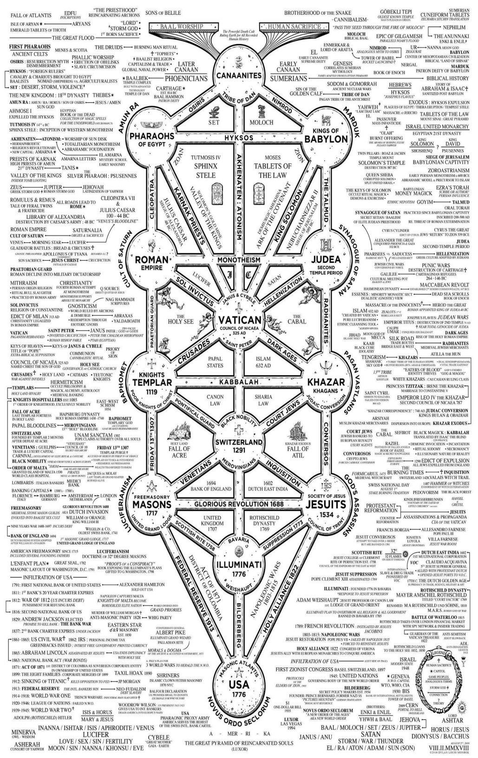



Go to http://www.energyenhancement.org

for 42 Free –On Sign-Up - Energy Enhancement Books and Energy Enhancement Against Satanism Books.
To defeat Evil, you need to up your game.
Learn the Energy Enhancement Meditation Course by Video or Live in Iguazu.
THE ENERGY ENHANCEMENT FOUR LEVEL VIDEO MEDITATION COURSE IS THE ONLY SOLUTION
Here's EXACTLY what you get with the Four Levels of Energy Enhancement Plus the Essential Level 0 support Package for 12 Months - Over 75 Hours of Incredible Teachings by Satchidanand which will enable you to Remove All your Energy Blockages - to Power Up!! To Feel Better, To Become What You Were Born to Be!!
Not so Expensive, Incredible Value!! For Total Life Performance!! For the Removal of All Energy Blockages!! Incredible Savings!
Over several months, in Easy, Bite Sized Chunks, You will learn how Simple it is, to remove All your Energy Blockages.
Incredible, Easy Paced, Full Tuition, with the Level 0 Support Package for Each of the Four Levels of Energy Enhancement!

Energy Enhancement LEVEL 1 Meditation is Included in this course! Immortality - Activate the Antahkarana! Gain Infinite Energy from the Chakras above the Head - Power UP!! Open Your Third Eye, Gain Super Samadhi Kundalini Alchemical VITRIOL Energy. Ground All Negative Energies. Learn Super Strong Psychic Protections in Preparation for the Seven Step Process to totally remove Blockages of Level 2. Access Quantum Immortality - Level 1 - 25 hours of video tuition http://www.energyenhancement.org/Level1.htm
Initiation 1 Meditation
Initiation 2 The Kundalini Kriyas - The 5 Taoist Circulations of the Qi, Energy Orbits, Energy Circulation
Initiation 3 The Kundalini Kriyas - Alchemical VITRIOL to Ground Negative Energies
Initiation 4 The Kundalini Kriyas - The God Connection to Infinite Energy
Initiation 5 Open the Third Eye, Open the Heart, Achievement of Everything you Want.
Initiation 6 Psychic Protection against Attack - Power Towers
Initiation 7 Psychic Protection against Attack - Pyramid Protection
Initiation 8 Psychic Protection against Attack - The Merkaba

After Level 1 we utilise the Energy Enhancement Seven Step Process to remove all Energy Blockages to our eyes, to our Third Eyes, to see, to access the Infinite positive flow of Spiritual Energy which descends like the dew from Heaven above upon it's place beneath.
It is twice blessed.
First by he who gives.
And then by he who receives.
And, as we receive with Energy Enhancement Meditation such an Infinite supply of positivity, of Infinite positive Energy from the Infinite Chakras above the head, and as it descends I promise you the most intense emotion you have ever experienced - 24 hours a day, every day!
Energy Enhancement testimonials http://www.energyenhancement.org/page17.htm

Energy Enhancement LEVEL 2 - The Energy Enhancement Seven Step Process to Totally Remove Energy Blockages, Totally Remove All Problems, Totally Remove Negative Emotions, Heal Your DNA, Remove your Karma - OPEN YOUR LIFE!! http://www.energyenhancement.org/Level2.htm
Initiation 1 The Seven Step Process to Remove Blockages.
Initiation 2 Removing Bodily Disease and Pain
Initiation 3 Heal your DNA
Initiation 4 Remove Energy Blockages from the Aura
THE KARMA CLEANING PROCESS
Initiation 5 Remove Energy Blockage Karma From Your Time in the Womb
Initiation 6 Remove Energy Blockage Karma From Your Current Life
Energy Enhancement testimonials http://www.energyenhancement.org/page17.htm

Energy Enhancement LEVEL 3 - Eliminate even Deeper Energy Blockages - The Removal of Strategies. Quantum Integration. The Karma Cleaning Process to Totally Eliminate All Your Karma, all your Trauma, all your Energy Blockages from All your Past Lifetimes!!
http://www.energyenhancement.org/Level3.htm
Here we are talking Zen Master Hogen.
He said, "By Meditating we can change our messy life painting into a clean white sheet again."
Here he is saying that Meditation can with Intensity of Feeling, ground all the negativity, all the negative emotions, all the energy blockages attached to your memories that ever happened to you in this lifetime
He said, "I spent all my previous lifetimes making Guiness. Now in this lifetime I am drinking all the Guiness!"
Here he is saying that with Passionate Energy Enhancement Samyama Meditation can ground all the negativity, all the negative emotions, all the energy blockages attached to your memories that ever happened to you in all your previous lifetimes.
If you can use Energy Enhancement Meditation to Ground all that negative energy from your past, to remove those dense, deep, energy blockages not only from this lifetime, but from all your previous lifetimes...
Can you Imagine what that will Feel Like?
Today’s a brand new day!!

THE KARMA CLEANING PROCESS CONTINUES
Initiation 1 Remove Energy Blockage Karma From All Your past Lives
Initiation 2 Remove Energy Blockage Karma From Your Future Lives
Initiation 3 Remove Energy Blockage Inner Children
Initiation 4 Remove Energy Blockage Vampire Strategies
Initiation 5 Remove Energy Blockage Negative Emotions
Initiation 6 The Seven Step purification of talents and the creation and increase of talents
Initiation 7 Removing Energy Blockage Vows from Past Lifetimes
Initiation 8: The Achievement of all your Goals and Ambitions using Energy Enhancement Samyama
Initiation 9 Removing the Energy Blockages from Daily Life Illogical Actions and Driven Emotions.
Energy Enhancement testimonials http://www.energyenhancement.org/page17.htm

Energy Enhancement LEVEL 4 - Stop the Suck!! Heal All your Relationships!! Find Your Twin Flame!! MASTER ENERGY CONNECTIONS AND RELATIONSHIPS, THE PSYCHIC SEXUAL CONNECTION
http://www.energyenhancement.org/Level4.htm
Initiation 1 - Removing Addictions - Food, Alcohol, Smoking, Sex.
Initiation 2 Cleaning Energy Connections - Cutting Energy Connections and Re-connecting Energy Connections - Friends, Children, Partner, Mother, Father - Moving All Relationships to a Higher Level.
Initiation 3 Cutting Energy Connections and Re-connecting Energy Connections - Moving All Relationships to a Higher Level.
Initiation 4 Healing the Soul Connection of Others
Initiation 5 Healing the Psychic Sexual Connection
Initiation 6 Removing the Energy Blockages at the other End of the Connection in People you Connect to - Healing Relationships, Healing Clients.
Initiation 7 Ceremonies and Meditation Groups - Using the Energy of the Higher Heart, The Heart Center in the Head, Prajna Paramita, - The Soul and the Monad Itself, for the Healing of Groups, Organizations and the World.
Energy Enhancement testimonials http://www.energyenhancement.org/page17.htm


THE YOGA SUTRAS OF PATANJALI BY SWAMI SATCHIDANAND - DOWNLOAD HERE..
http://www.energyenhancement.org/Sacred-Energy/yoga-sutras-of-patanjali-book/Energy-Enhancement-Yoga-Sutras-of-Patanjali.pdf
SUPER ENERGY AND SACRED SYMBOLS
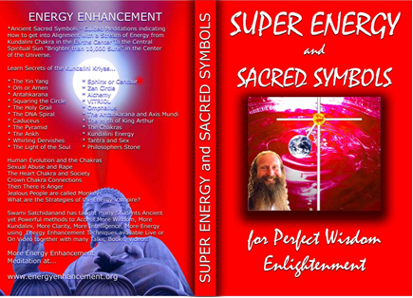
*THE ENERGY ENHANCEMENT BOOK… Ancient Sacred Symbols - Guided Meditations indicating How to get into Alignment with a Stream of Energy from Kundalini Chakra in the Earth’s Center to the Central Spiritual Sun "Brighter than 10,000 Suns" in the Center of the Universe.
Learn Secrets of the Kundalini Kriyas... and more…
Swami Satchidanand has taught many Students Ancient yet Powerful methods to Access More Wisdom, More Kundalini, More Clarity, More Intelligence, More Energy using Energy Enhancement Techniques available Live or On Video together with many Talks, Books, Videos.
ENERGY ENHANCEMENT TWO – REMOVAL OF ENERGY BLOCKAGES, MANAGING ENERGY CONNECTIONS AND MASTERY OD RELATIONSHIPS
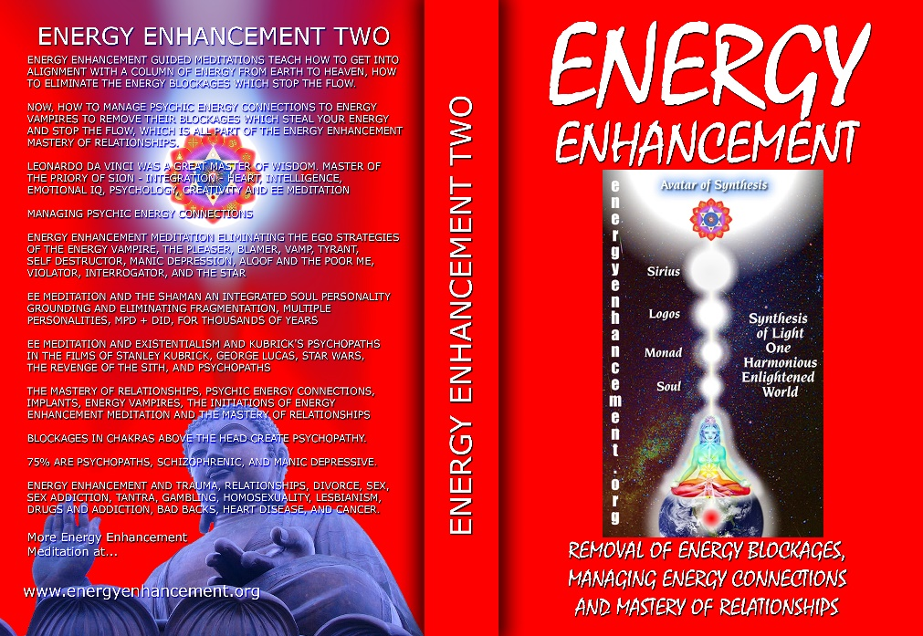
ENERGY ENHANCEMENT GUIDED MEDITATIONS TEACH HOW TO GET INTO ALIGNMENT WITH A COLUMN OF ENERGY FROM EARTH TO HEAVEN, HOW TO ELIMINATE THE ENERGY BLOCKAGES WHICH STOP THE FLOW.
NOW, HOW TO MANAGE PSYCHIC ENERGY CONNECTIONS TO ENERGY VAMPIRES TO REMOVE THEIR BLOCKAGES WHICH STEAL YOUR ENERGY AND STOP THE FLOW, WHICH IS ALL PART OF THE ENERGY ENHANCEMENT MASTERY OF RELATIONSHIPS.
LEONARDO DA VINCI WAS A GREAT MASTER OF WISDOM. MASTER OF THE PRIORY OF SION - INTEGRATION - HEART, INTELLIGENCE, EMOTIONAL IQ, PSYCHOLOGY, CREATIVITY AND EE MEDITATION MANAGING PSYCHIC ENERGY CONNECTIONS ENERGY ENHANCEMENT MEDITATION ELIMINATING THE EGO STRATEGIES OF THE ENERGY VAMPIRE, THE PLEASER, BLAMER, VAMP, TYRANT, SELF DESTRUCTOR, MANIC DEPRESSION, ALOOF AND THE POOR ME, VIOLATOR, INTERROGATOR, AND THE STAR
EE MEDITATION AND THE SHAMAN AN INTEGRATED SOUL PERSONALITY GROUNDING AND ELIMINATING FRAGMENTATION, MULTIPLE PERSONALITIES, MPD + DID, FOR THOUSANDS OF YEARS
EE MEDITATION AND EXISTENTIALISM AND KUBRICK'S PSYCHOPATHS IN THE FILMS OF STANLEY KUBRICK, GEORGE LUCAS, STAR WARS, THE REVENGE OF THE SITH, AND PSYCHOPATHS
THE MASTERY OF RELATIONSHIPS, PSYCHIC ENERGY CONNECTIONS, IMPLANTS, ENERGY VAMPIRES, THE INITIATIONS OF ENERGY ENHANCEMENT MEDITATION AND THE MASTERY OF RELATIONSHIPS
BLOCKAGES IN CHAKRAS ABOVE THE HEAD CREATE PSYCHOPATHY.
75% ARE PSYCHOPATHS, SCHIZOPHRENIC, AND MANIC DEPRESSIVE.
ENERGY ENHANCEMENT AND TRAUMA, RELATIONSHIPS, DIVORCE, SEX, SEX ADDICTION, TANTRA, GAMBLING, HOMOSEXUALITY, LESBIANISM, DRUGS AND ADDICTION, BAD BACKS, HEART DISEASE, AND CANCER.

Buy all Books and DVD’s at: amazon.com
www.energyenhancement.org
DVD 1 - KUNDALINI CHAKRA MEDITATION
HEART SUTRA – HIGHEST HEART OF WISDOM MEDITATION

*ENERGY ENHANCEMENT MEDITATION DVD 1… Guided Meditation to Access Kundalini Chakra, VITRIOL, The Philosopher’s Stone, Kriya Yoga and the Kundalini Kriyas.
Heart Sutra, All Enlightened Sages for Thousands of Years Live From the Highest Heart of Wisdom.

Buy all Books and DVD’s at: amazon.com
www.energyenhancement.org

DVD 2 - HIGHEST HEART OF GENIUS WISDOM MEDITATION
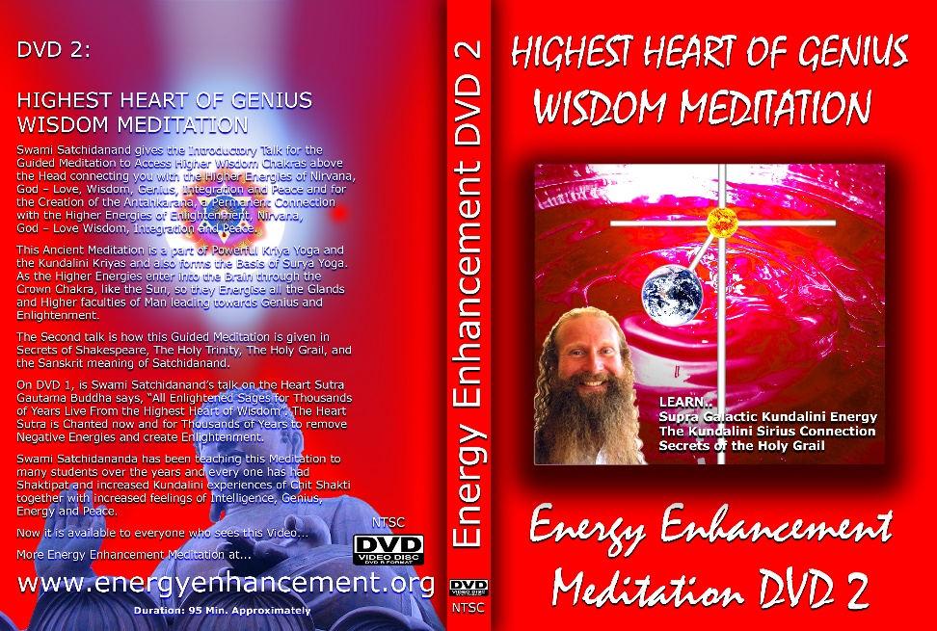
Guided Meditation to Access Higher Wisdom Chakras above the Head connecting you with the Higher Energies of Nirvana, God – Love, Wisdom, Genius, Integration and Peace and the Creation of the Antahkarana.
How this Guided Meditation is given in Secrets of Shakespeare, The Holy Trinity, The Holy Grail and the Sanskrit meaning of Satchidanand.
Swami Satchidananda has been teaching this Meditation to many students over the years and every one has had Shaktipat and increased Kundalini experiences of Chit Shakti together with increased feelings of Intelligence, Genius, Energy and Peace.
BOOK - GAIN SUPER ENERGY
ENERGY ENHANCEMENT LEVEL 1

READ… The Kundalini Kriyas, Meditation, Shaktipat, Energy Circulation, The Five Elemental Paths of the Chi of Chinese Alchemical Taoism, The Grounding of Negative Energies, V.I.T.R.I.O.L., The Supra Galactic orbit, The Creation of the Antahkarana, Soul Infusion, Monadic Infusion, Logoic Infusion, Sirian Christ Energy Infusion, Connection with the Avatar of Synthesis, The Art Card of the Thoth Tarot, Access to Kundalini Energy Strong Psychic Protection, Learn the Merkaba, Pyramid Protection, Power Tower Protection.
Buy all Books and DVD’s at: amazon.com
www.energyenhancement.org
THE ENERGY ENHANCEMENT FOUR INITIATION DVD COURSE - THE ULTIMATE TECHNIQUES ON 15 DVDs

“I have experience of many forms of meditation and practices for self improvement including: Transcendental Meditation (TM) 12 years, Kriya Yoga 9 years, Sushila Buddhi Dharma (SUBUD) 7 years, and more recently the Sedona Method and the Course in Miracles. The Energy Enhancement programme encapsulates and expands all of these systems, it is complete and no questions are left unanswered.”
JEAN, NUCLEAR ENGINEER, FROM SEPTEMBER 2005 ENERGY ENHANCEMENT COURSE
ENERGY ENHANCEMENT LIVE COURSES – WORLDWIDE
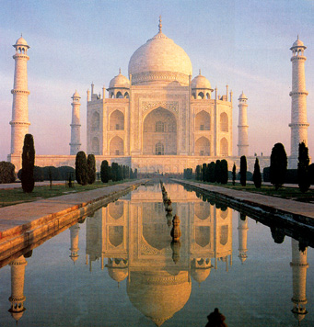
INDIA, 5 STAR INDIA TAJ MAHAL, SPAIN, MEXICO, PERU, ARGENTINA – MORE
Bookings: www.energyenhancement.org

EE LEVEL 1 POWER UP!! GAIN SUPER ENERGY http://www.energyenhancement.org/Level1.htm
EE LEVEL 2 ELIMINATE ENERGY BLOCKAGES http://www.energyenhancement.org/Level2.htm
EE LEVEL 3 CLEAN KARMA BLOCKAGES AND PAST LIFE KARMA BY TRANSMUTATION http://www.energyenhancement.org/Level3.htm
EE LEVEL 4 MASTER ENERGY CONNECTIONS AND RELATIONSHIPS http://www.energyenhancement.org/Level4.htm

Go to..
http://www.energyenhancement.org

For 52 Free..
- On Sign-Up - Energy Enhancement Books and Energy Enhancement Against Satanism Books.

To defeat Evil, you need to up your game.

Learn the Energy Enhancement Meditation Course by Video or Live in Iguazu.

ENERGY ENHANCEMENT MEDITATION
ENERGY ENHANCEMENT MEDITATION LEVEL 1 POWER UP!! GAIN SUPER ENERGY http://www.energyenhancement.org/Level1.htm
ENERGY ENHANCEMENT MEDITATION LEVEL 2 ELIMINATE ENERGY BLOCKAGES http://www.energyenhancement.org/Level2.htm
ENERGY ENHANCEMENT MEDITATION LEVEL 3 CLEAN KARMA BLOCKAGES AND PAST LIFE KARMA BY TRANSMUTATION http://www.energyenhancement.org/Level3.htm
ENERGY ENHANCEMENT MEDITATION LEVEL 4 MASTER ENERGY CONNECTIONS AND RELATIONSHIPS http://www.energyenhancement.org/Level4.htm

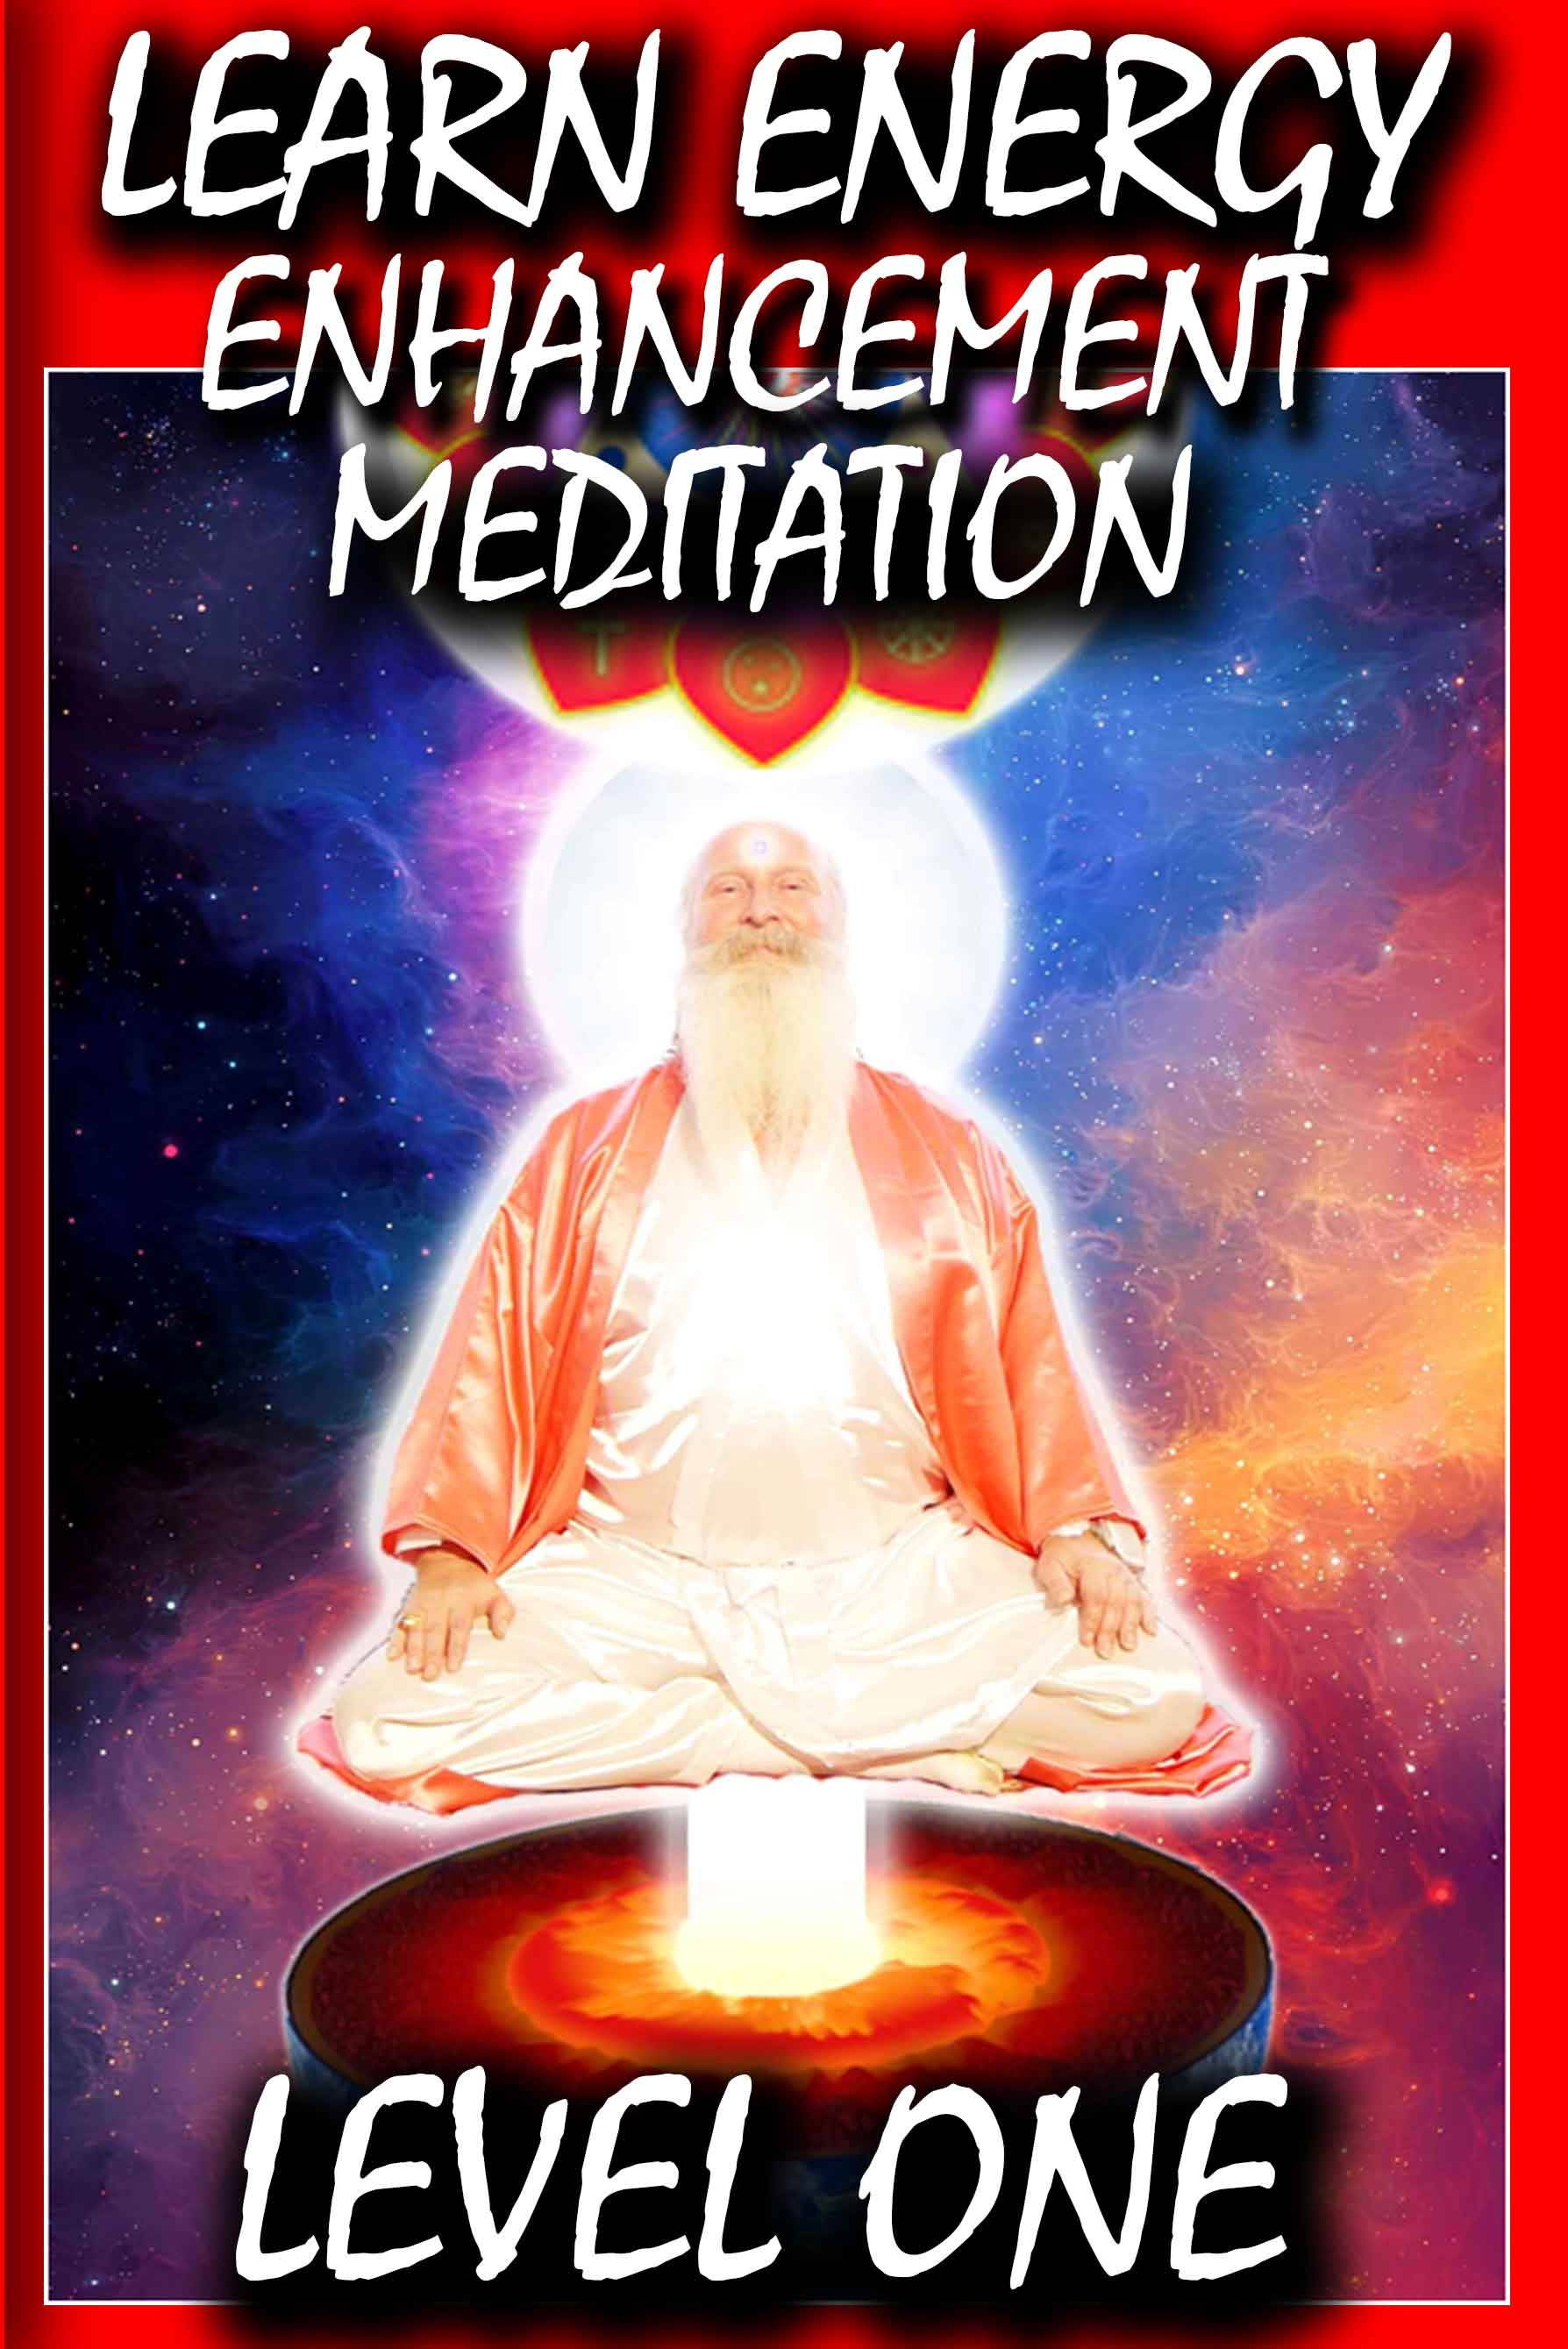



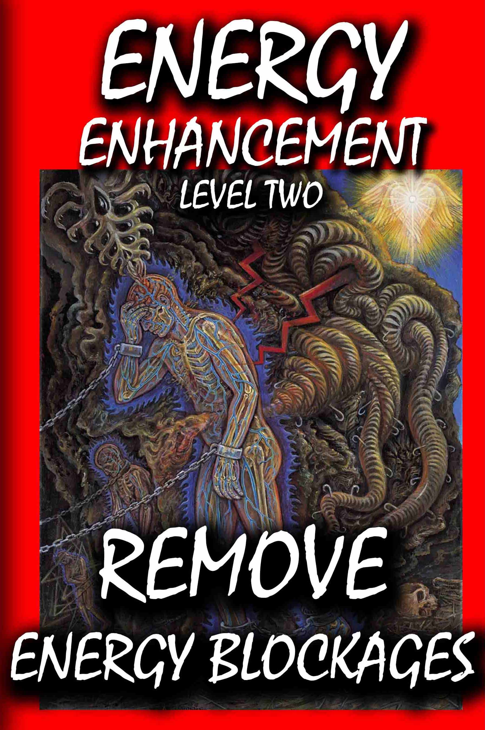



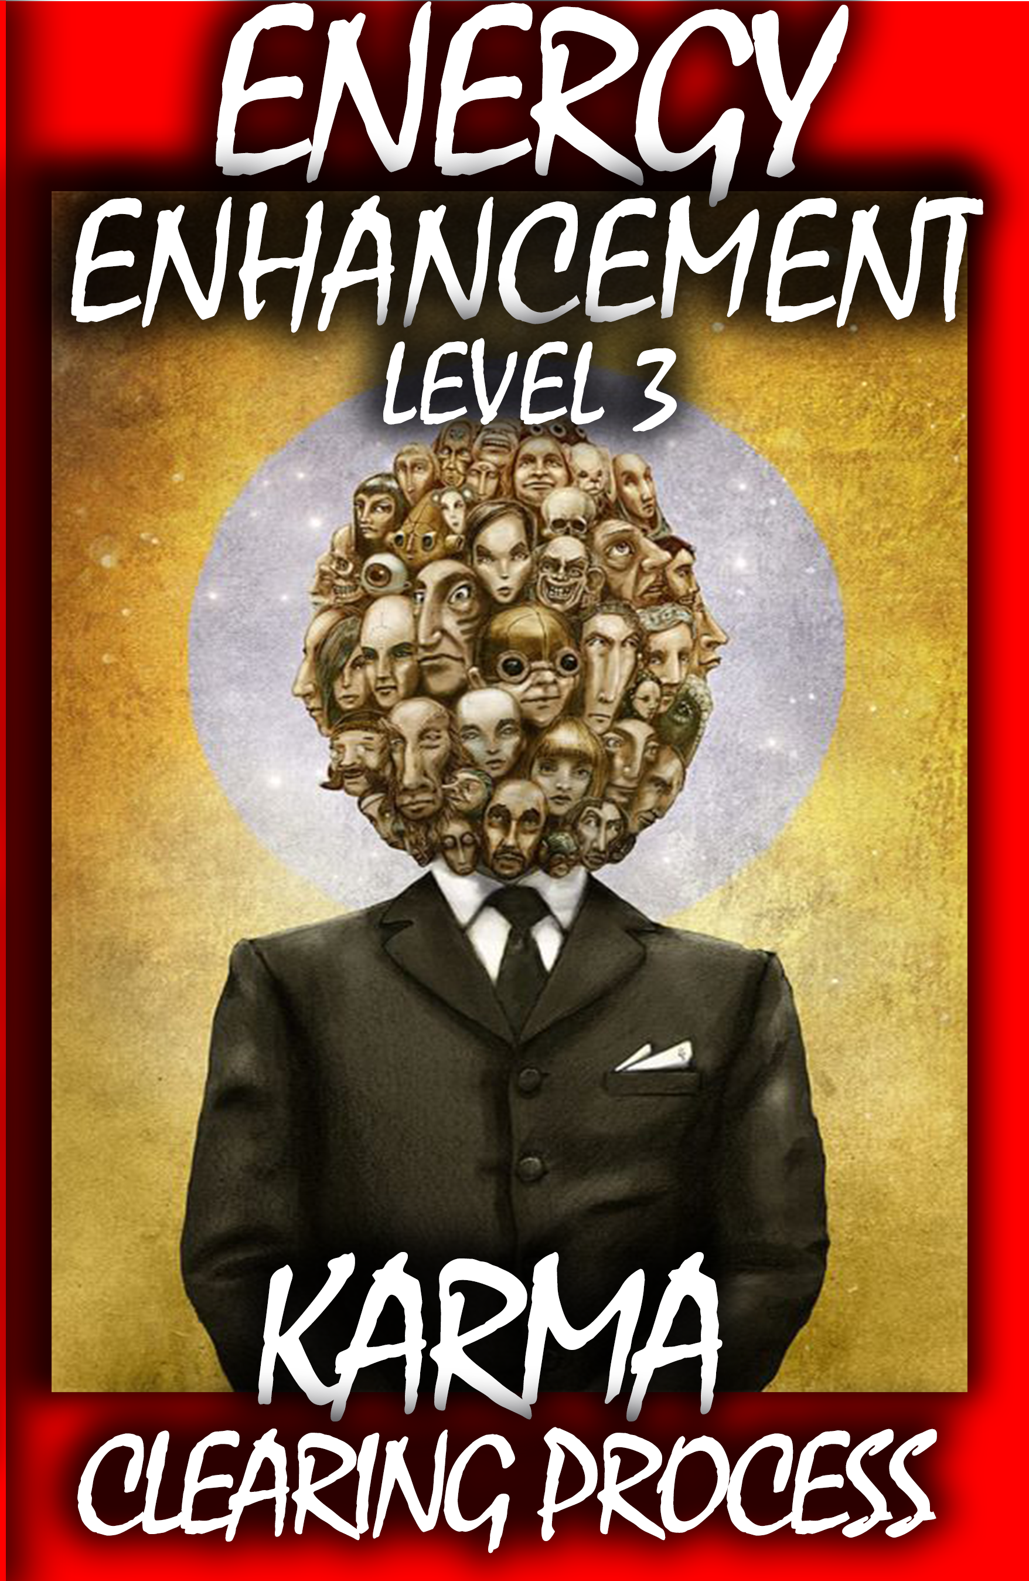



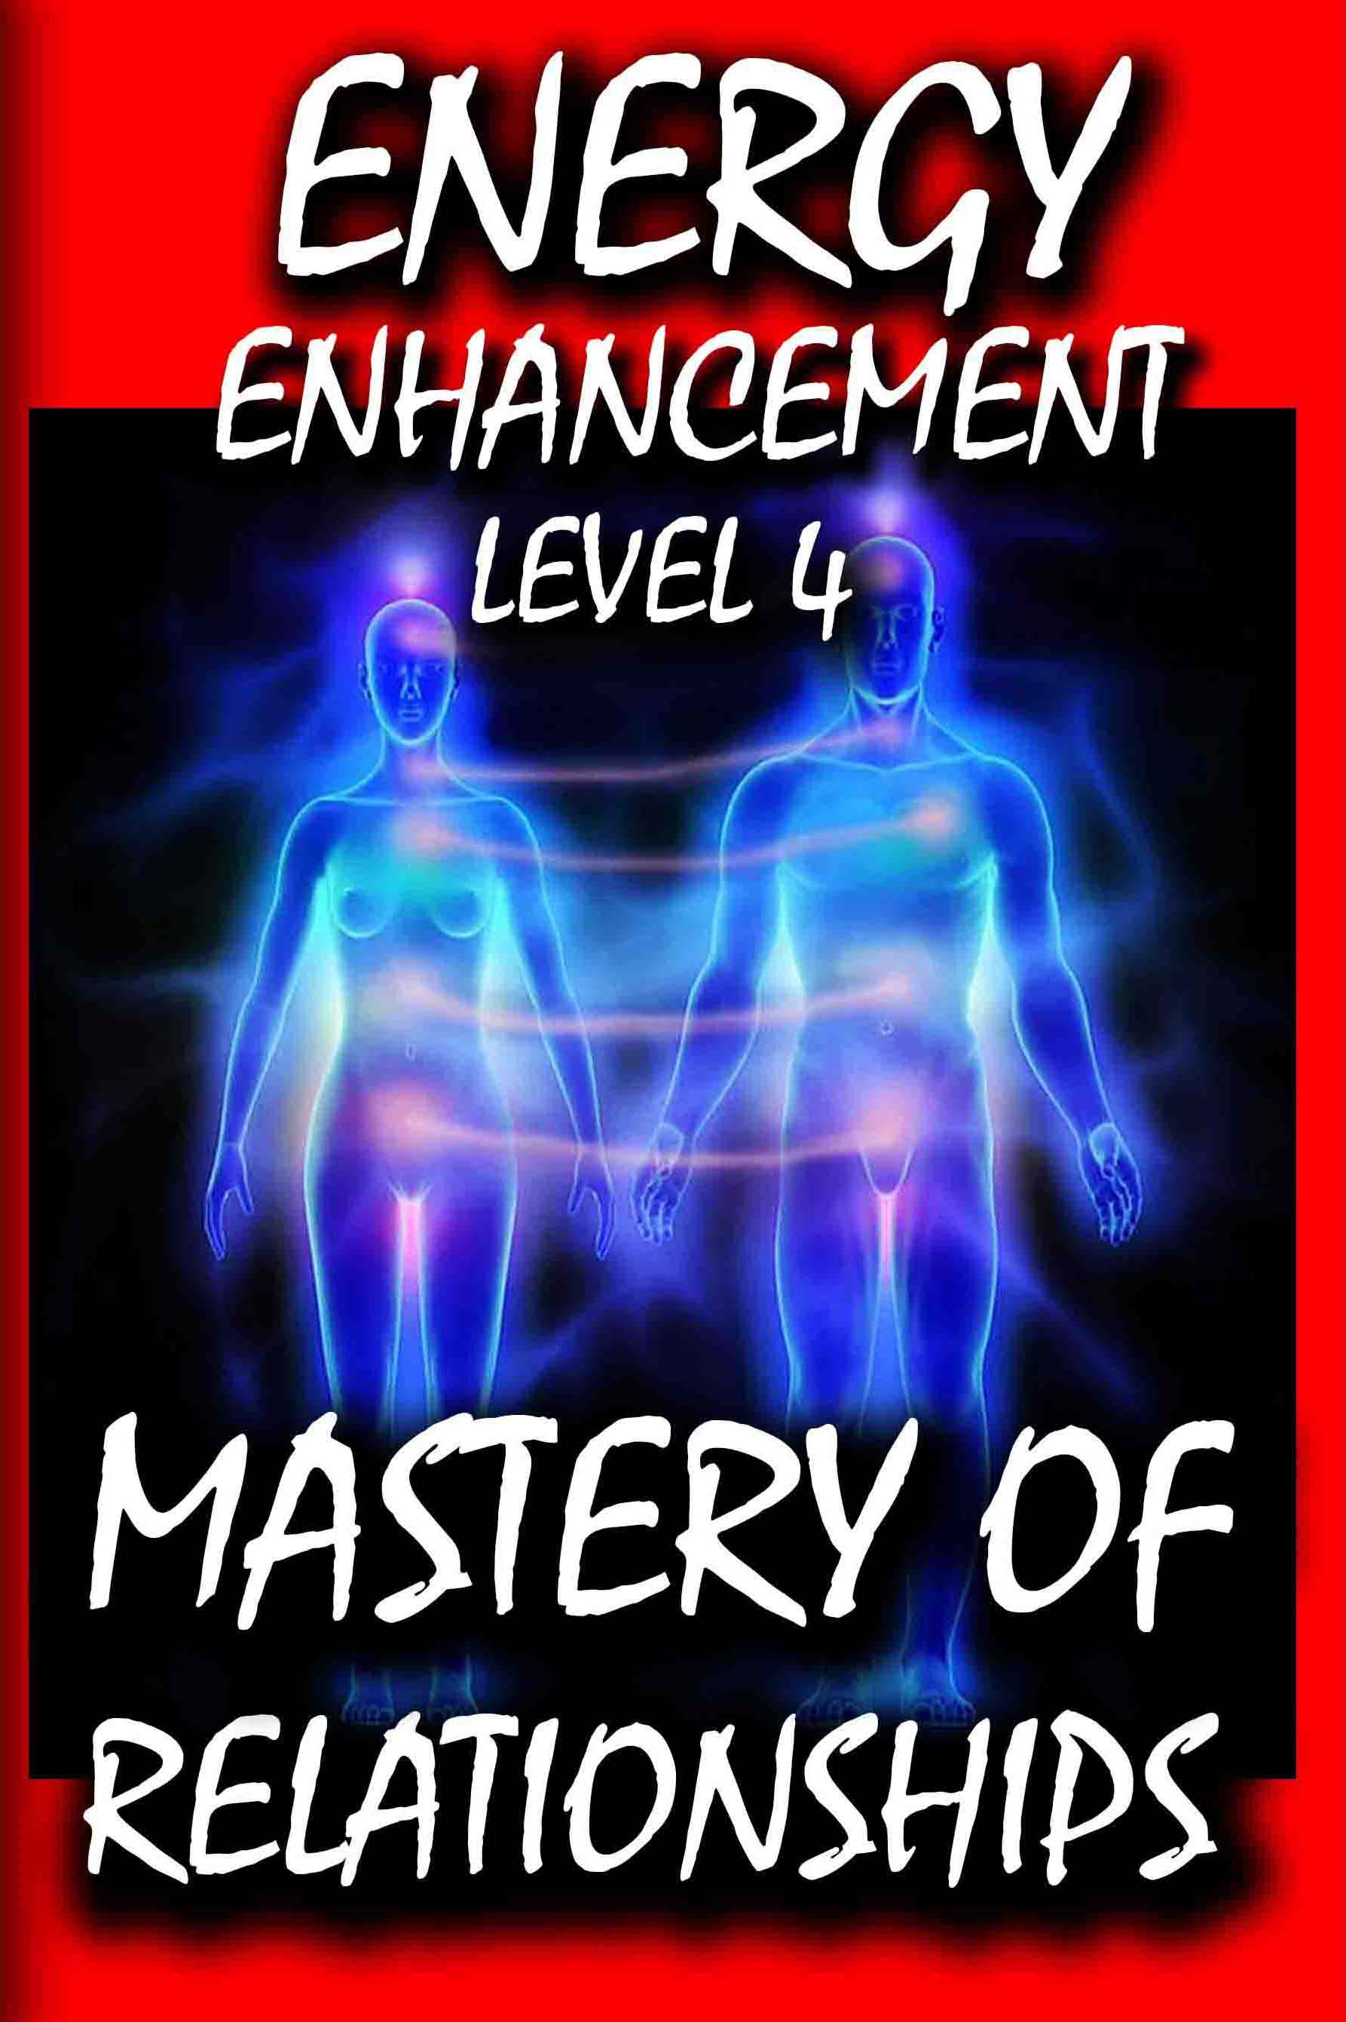

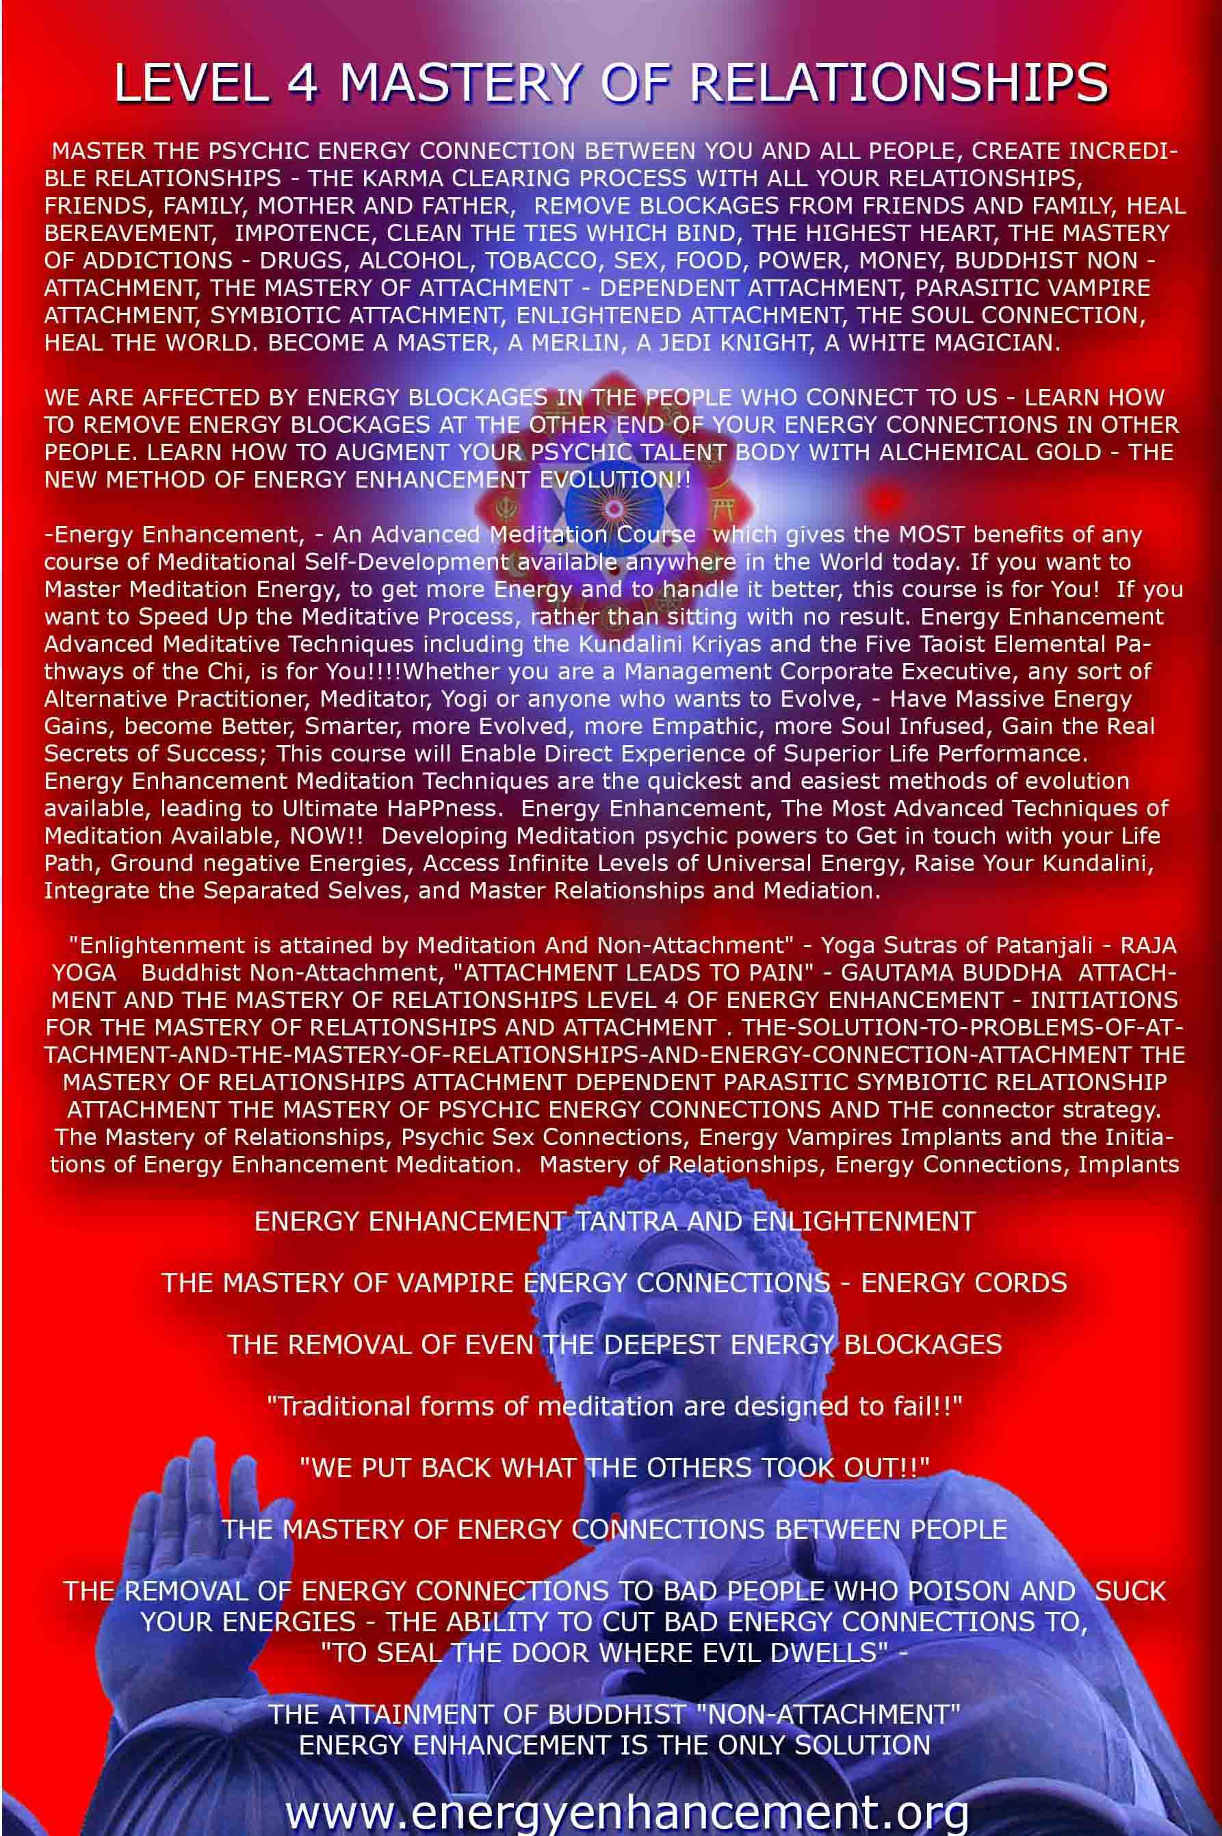




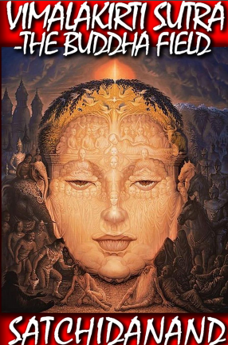

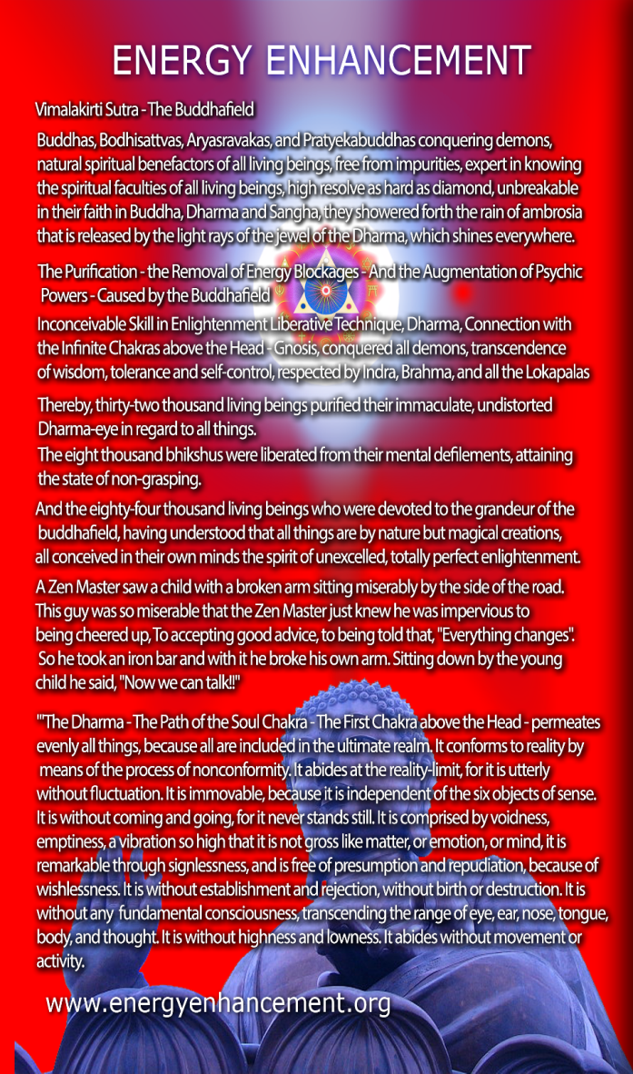
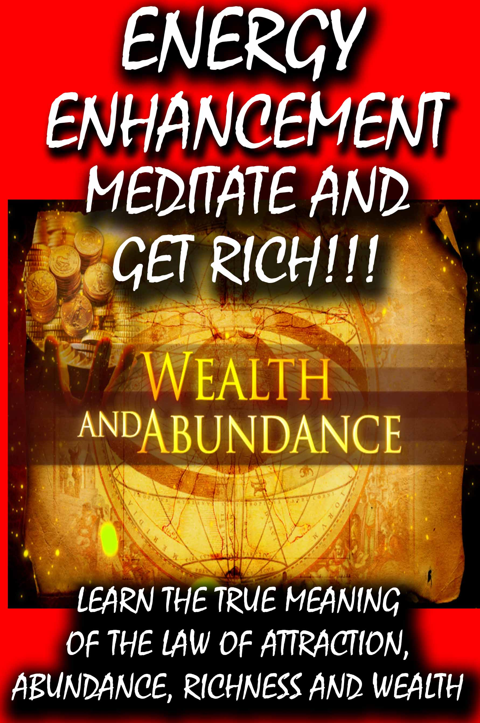
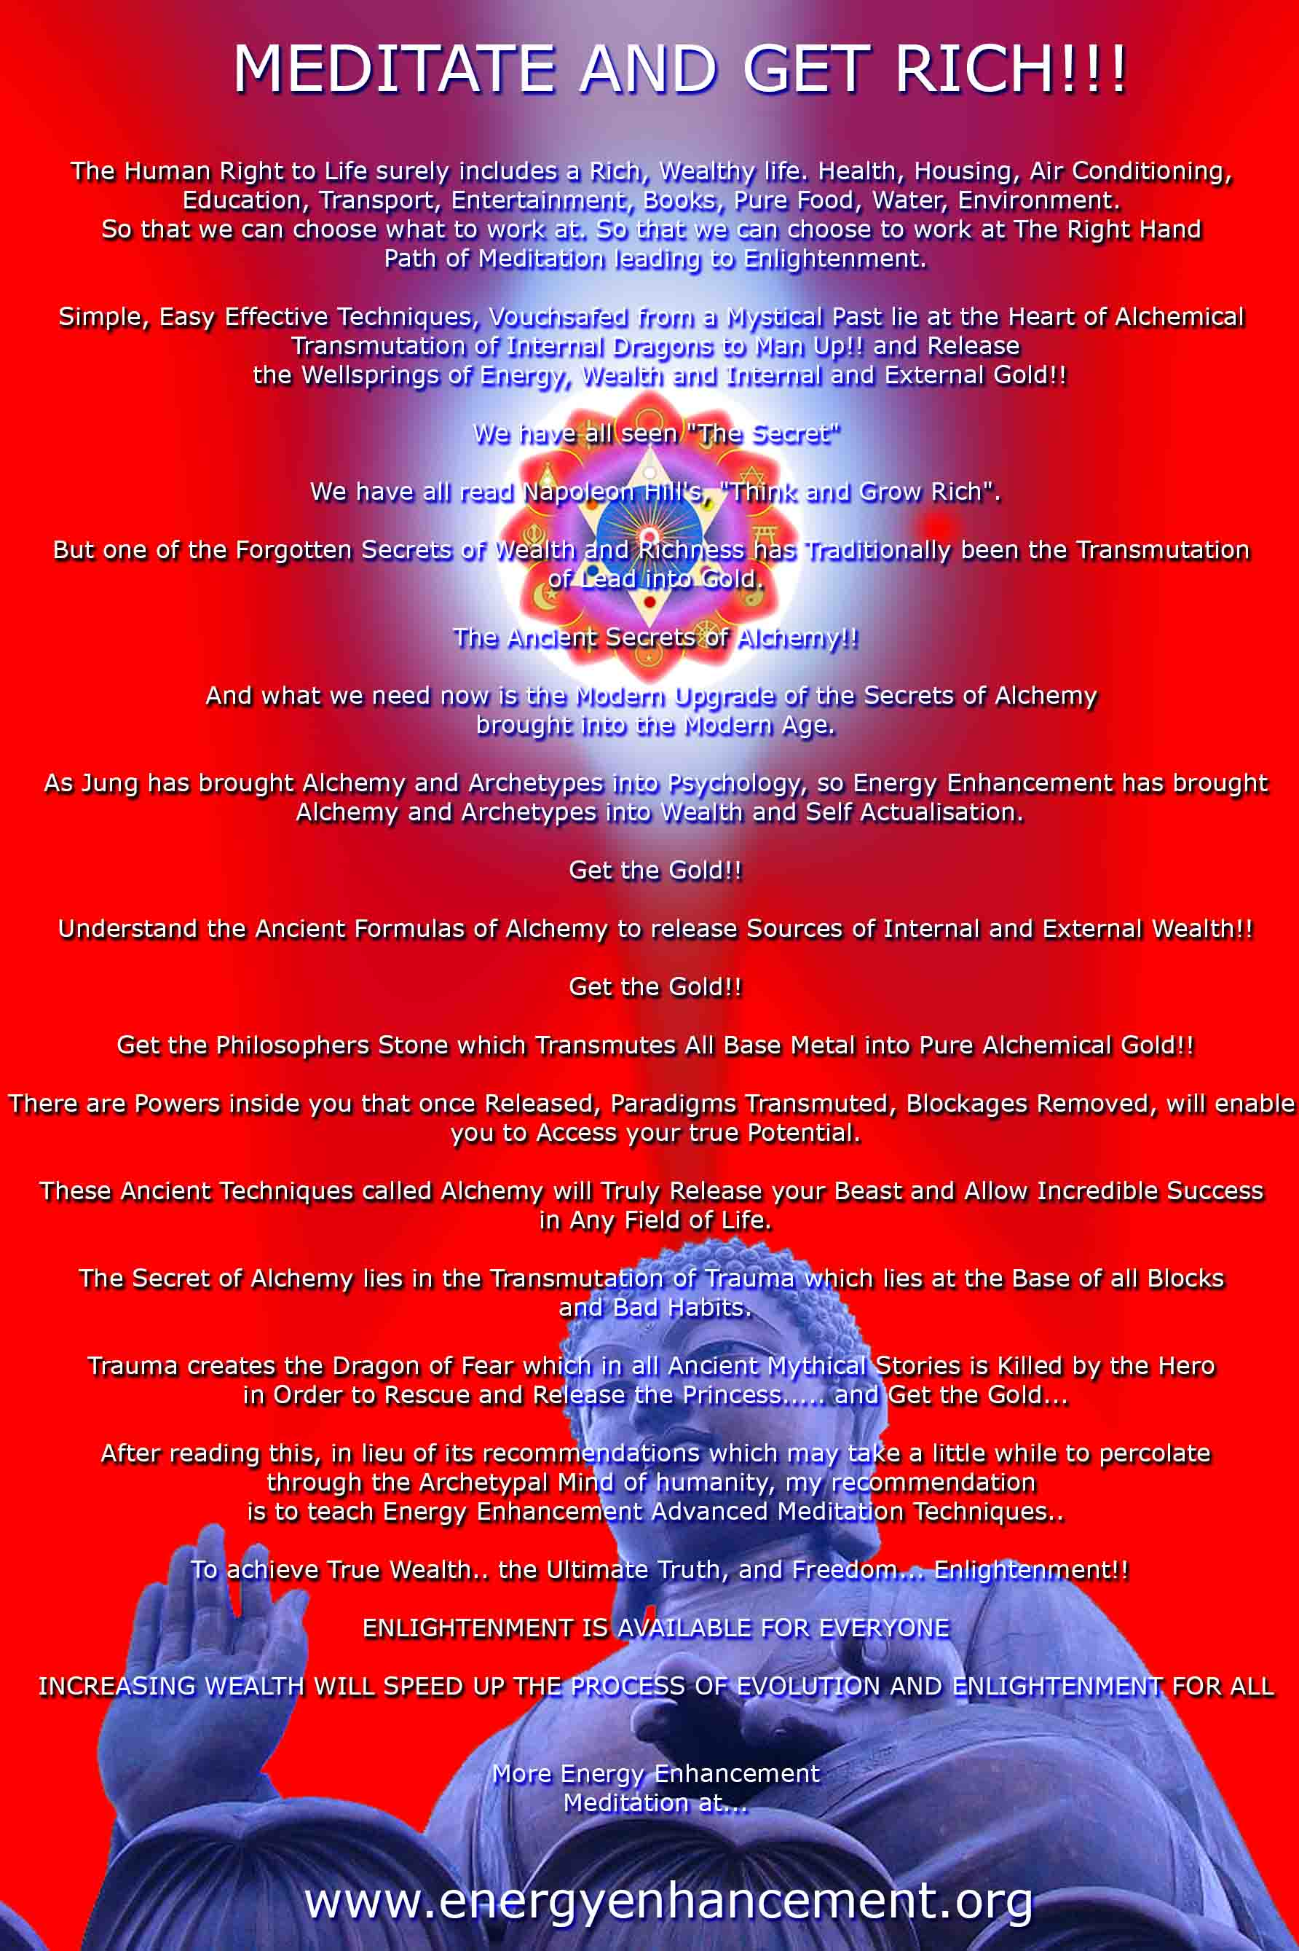
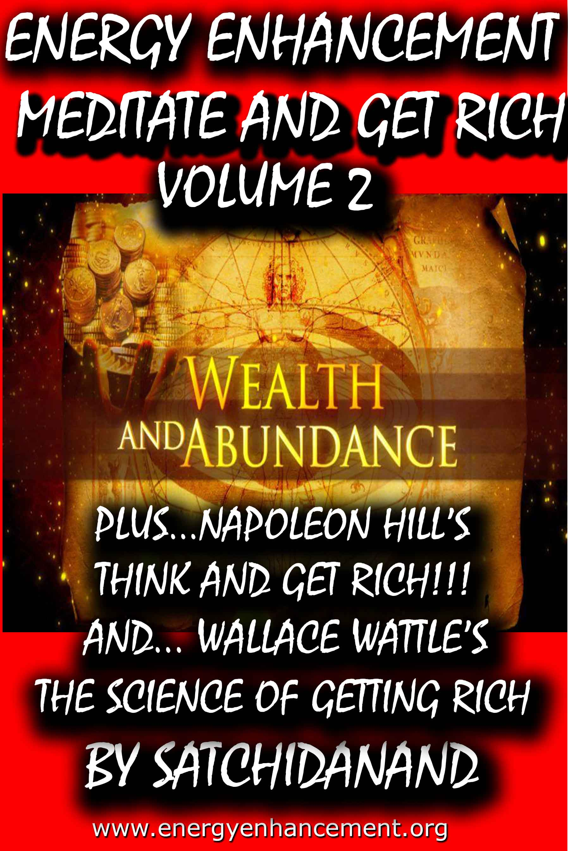
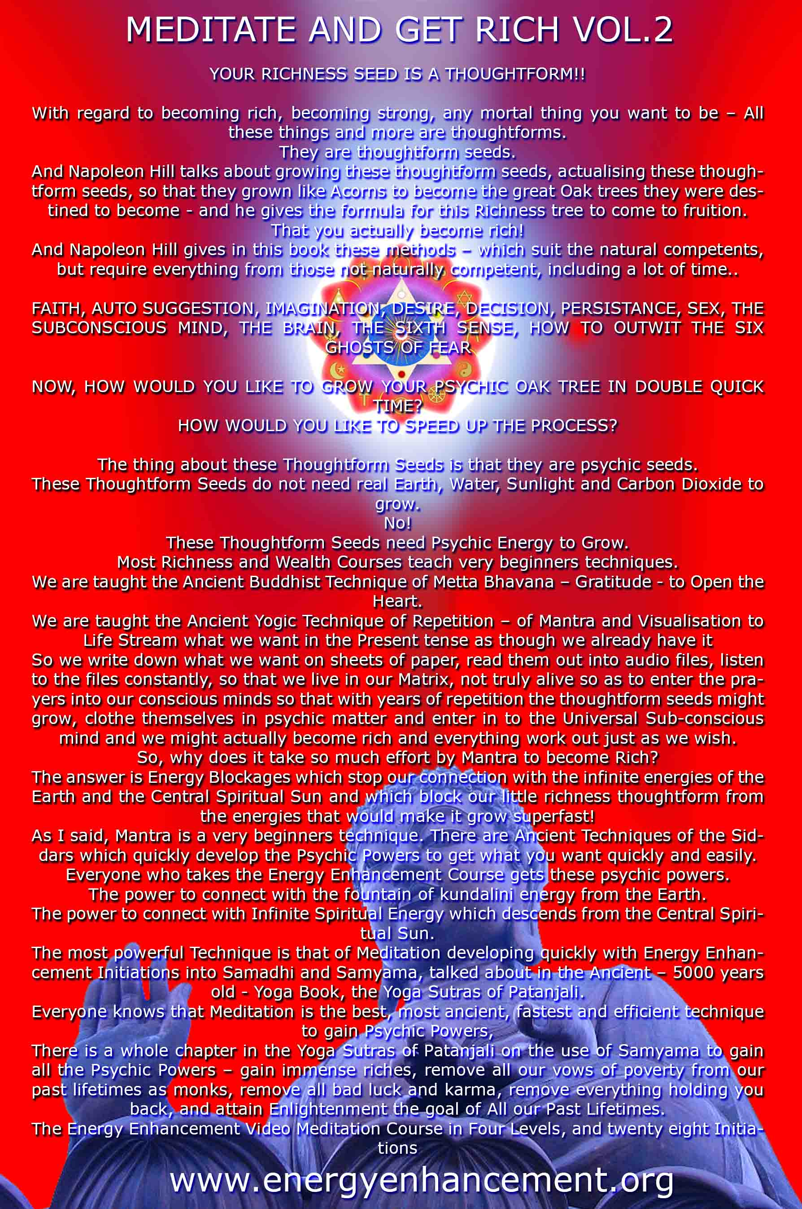

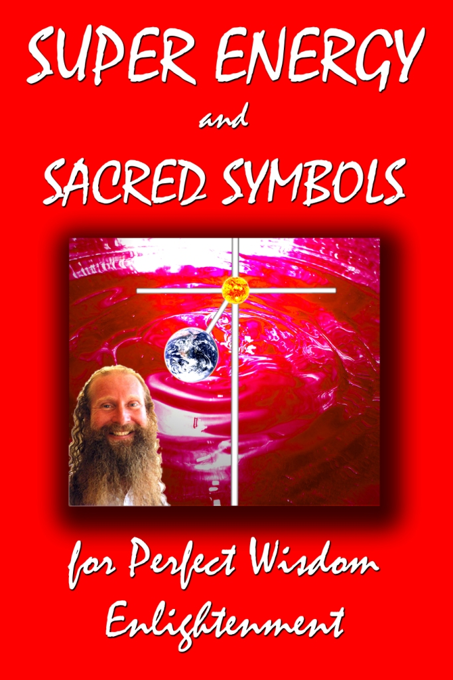





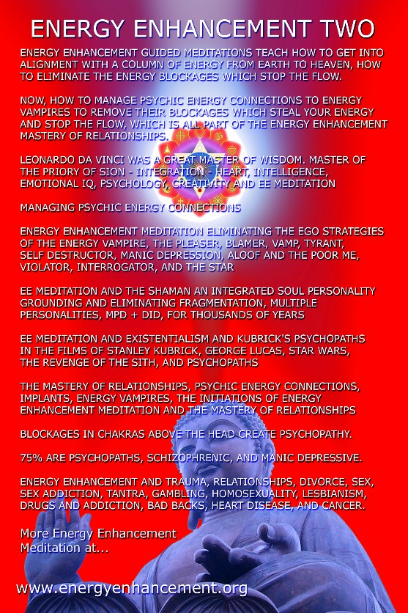
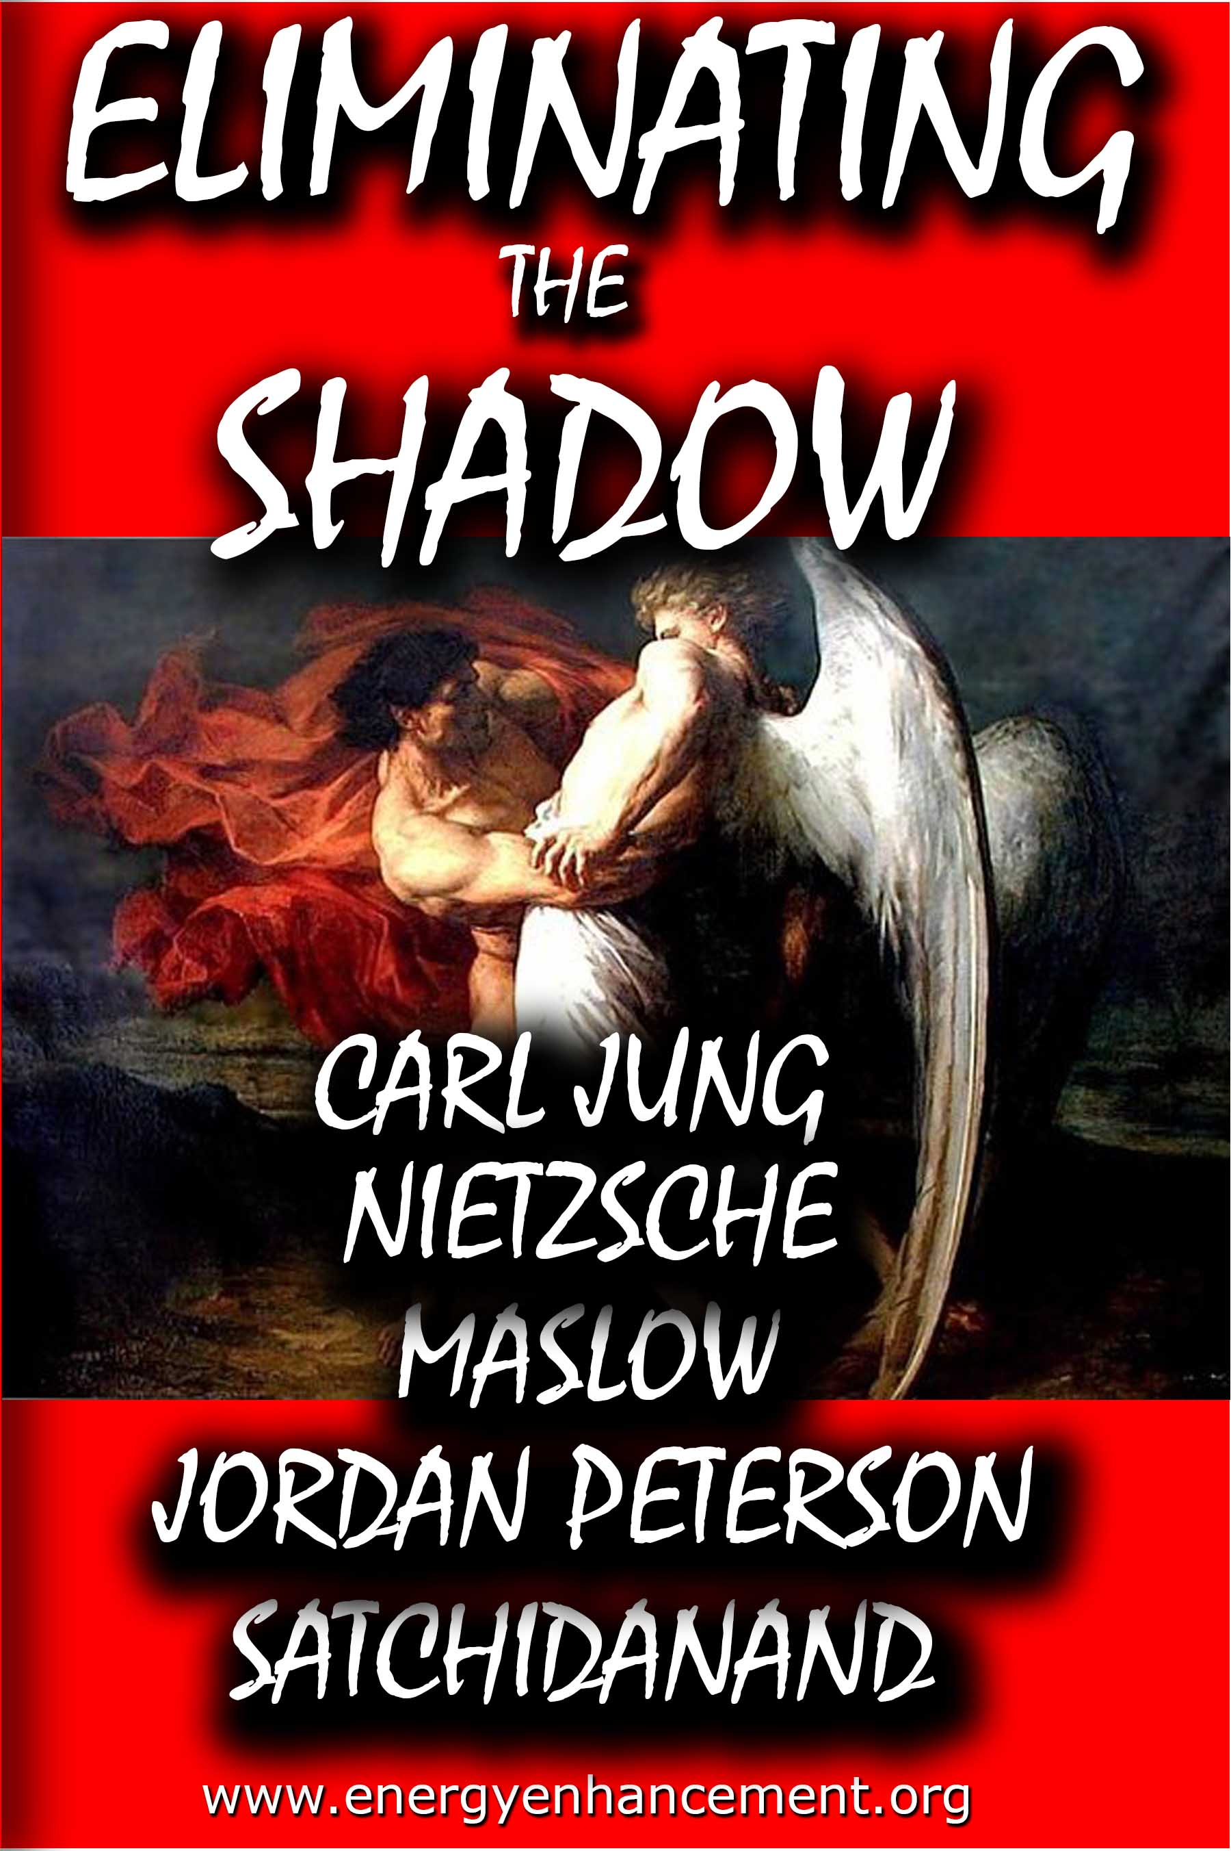
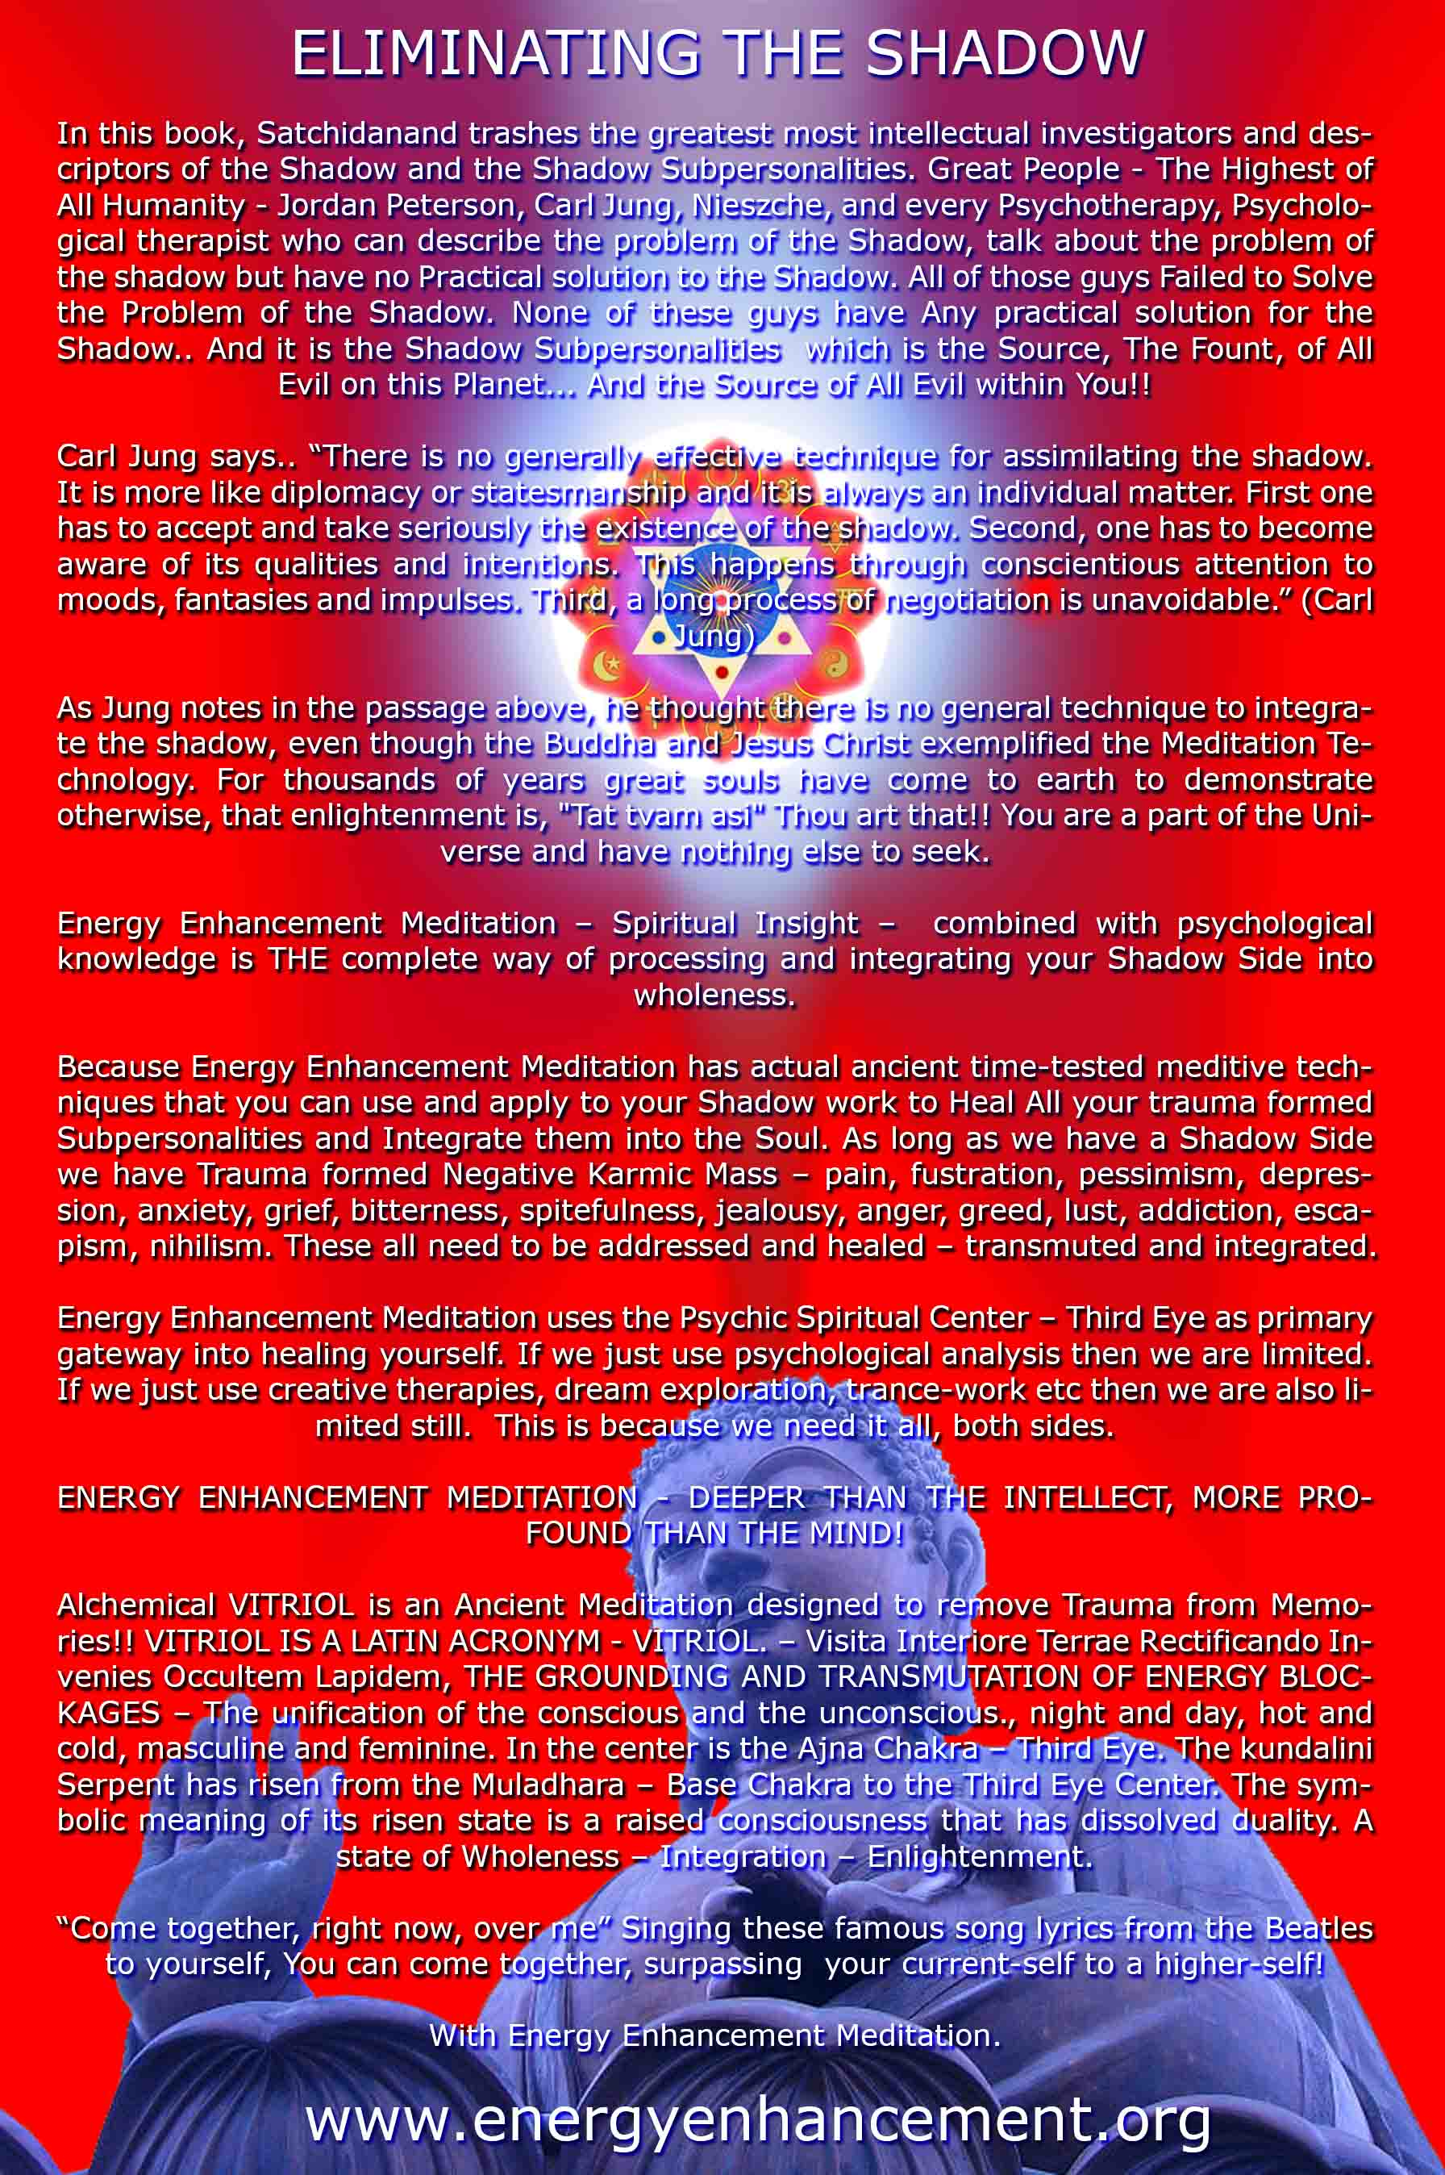

ENERGY ENHANCEMENT MEDITATION
ENERGY ENHANCEMENT MEDITATION LEVEL 1 POWER UP!! GAIN SUPER ENERGY http://www.energyenhancement.org/Level1.htm
ENERGY ENHANCEMENT MEDITATION LEVEL 2 ELIMINATE ENERGY BLOCKAGES http://www.energyenhancement.org/Level2.htm
ENERGY ENHANCEMENT MEDITATION LEVEL 3 CLEAN KARMA BLOCKAGES AND PAST LIFE KARMA BY TRANSMUTATION http://www.energyenhancement.org/Level3.htm
ENERGY ENHANCEMENT MEDITATION LEVEL 4 MASTER ENERGY CONNECTIONS AND RELATIONSHIPS http://www.energyenhancement.org/Level4.htm

