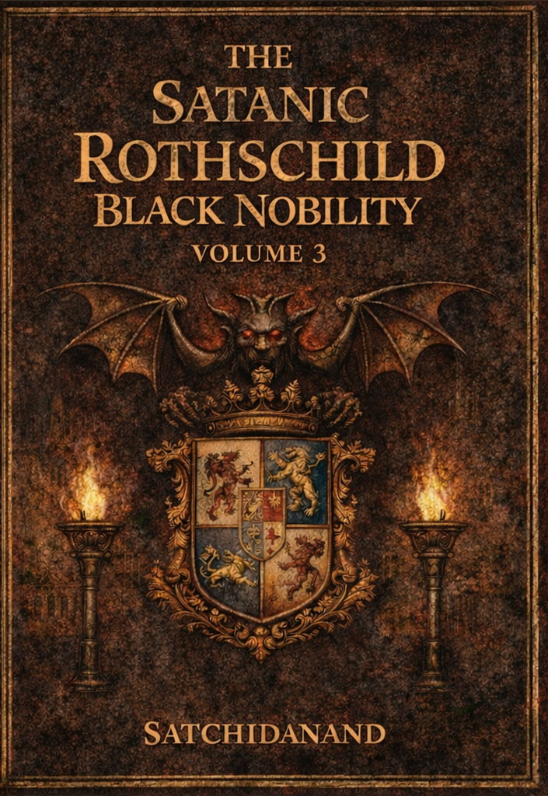
DEDICATION
With all Thanks, Love and Gratitude to Swami Devi Dhyani who make these books and the Energy Enhancement Streaming Video Meditation Course possible.
With all Thanks, Love and Gratitude to Devi Dhyani, my Mother and Father and to all my other Teachers, Theos Bernard, Sri Yogendra, Eric Berne, Gurdjieff, Father Bede Griffiths, Osho, Zen Master Hogen, Swami Sivananda, Swami Satchidananda, and all the other giants upon whose shoulders I stand - who made me able to be what… I AM – Swami Satchidanand

Copyright © 2026

[Satchidanand]

All rights reserved. This publication may be reproduced in whole or in part, by any person under fair use as long as we are referenced, without written permission of:
Swami Satchidanand

sol@energyenhancement.org

www.energyenhancement.org
https://eemeditationvideo.org/

https://againstsatanism.com/
https://against-satanism-video.com/

https://satchidanand.substack.com/
THE SATANIC ROTHSCHILD BLACK NOBILITY

VOLUME 3

Table of Contents

THE WOLVES OF WALL STREET USE BLACK MAGIC 5

THE WOLVES OF WALL STREET USE BLACK MAGIC IMPLANT ENERGY BLOCKAGE MIND VIRUSES PART 2 42

Satanic Bill Gates, Epstein Lover Bill Gates, Confesses To Conducting Illegal Human Medical Experiments In India 121

THE ROTHSCHILDS OWN THE BRICS AND G20 140

The Satanic Phoenician Rothschild's Federal Reserve and Social Darwinism 183

Visible Oligarchs are merely Trustees, Fronts, for the Satanic Phoenician Mega Trillionaire London Money Power 278

DAVID ICKE EXPOSES THE SATANIC FRONT MEN FOR INQTEL AND DARPA, GOVERMENT TAKEOVER BY ARTIFICIAL INTELLIGENCE, AND MUCH MORE… 349

The Key of the Satanic Religion is it's Recruiting Cults of Sodomy Ritual 33rd Degree Freemasonry, the Illuminati, Sabbatean Frankism, and the Crowlean Sexual Sodomy Ritual OTO 363

THE SOLUTION? - THE ENERGY ENHANCEMENT COURSE BY STREAMING VIDEO OR LIVE IN BRAZIL, INDIA, WORLDWIDE!! 377

These Satanic Malthusians Demand Genocide 410

Alan Watt Recommended Book List 416

THE WOLVES OF WALL STREET USE BLACK MAGIC

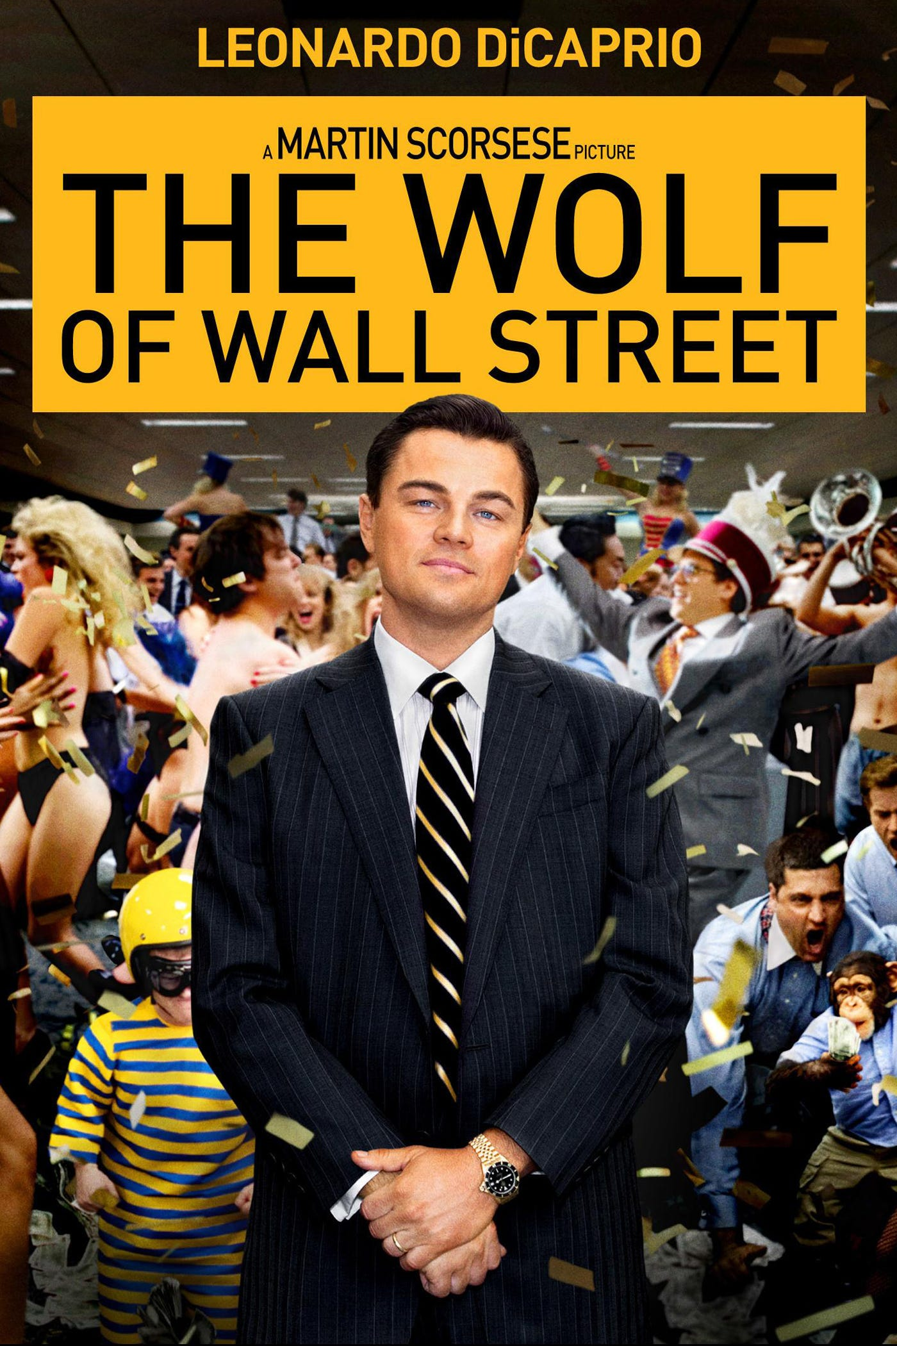

THE SATANIC 2000 TRILLION DOLLAR MEGATRILLIONAIRE ROTHSCHILDS USE BLACK MAGIC TO MAKE NARCISSITIC, MACHIAVELLIAN PSYCHOPATH BANKERS
Satchidanand
Jul 28, 2024
The Wolf of Wall Street from https://energyenhancement.org/THE-WOLF-OF-WALL-STREET-ESOTERIC-MOVIE-REVIEW-BY-SATCHIDANAND.htm Spiritual Movie Reviews…
Directed by Martin Scorsese, Produced by Martin Scorsese, Leonardo DiCaprio, Riza Aziz, Joey McFarland, Emma Tillinger Koskoff
Based on The Wolf of Wall Street by Jordan Belfort
Budget $100 million
Box office $375,591,788
The Wolf of Wall Street is a 2013 American black comedy film directed by Martin Scorsese, based on Jordan Belfort's memoir of the same name. It was released on December 25, 2013. The screenplay was written by Terence Winter, and the film stars Leonardo DiCaprio as Jordan Belfort, a New York stockbroker who runs a firm that engages in securities fraud and corruption on Wall Street in the 1990s.
The film also features Jonah Hill, Margot Robbie, Matthew McConaughey, Kyle Chandler, Rob Reiner, Jon Favreau, and Jean Dujardin. It is the fifth collaboration between Scorsese and DiCaprio, and the second between Scorsese and Winter following Boardwalk Empire.
The film received positive reviews from critics, but was also controversial for its moral ambiguity, sexual content, presence of drugs, vulgarity, and use of animals. The film has grossed over $375 million worldwide, and was nominated for five Academy Awards, including Best Picture, Best Director, as well as Best Actor and Best Supporting Actor for DiCaprio and Hill respectively, but failed to win in any category. It is historically significant as the first major film to be distributed entirely digitally.
This is the real history of Jordan Belfort from his autobiography written in prison. Jordan Belfort (Leonardo DiCaprio) narrates the film showing his monstrous success with his firm complete with ribaldry at work, a sumptuous home on the Gold Coast of Long Island and a trophy wife who is a former model. He then flashes back to 1987, where he began a low-level job at an established Wall Street firm.
Working for the Satanic 2000 Trillion Dollar Phoenician Mega Trillionaire family N. M. Rothschilds, who have run the world for 10,000 years his boss (Matthew McConaughey) Initiates him and using black magic, addicts him to sex and drugs as all stockbrokers must be addicted in order to become the Narcissistic, Machiavellian, Psychopaths who can lie and cheat and steal for the Satanic Elite Mega Trillionaires.
The Ancient, Thousands of Years Old Psychic Science of Black Magic - the Creation of Implant Drug and Sex Addiction Energy Blockages - is an Ancient Technology which although is scientific, appears like Magic to those which have never been taught Energy Enhancement Meditation…

“Any sufficiently advanced technology is indistinguishable from magic.”
― Satanic Pedophile Aristocrat Arthur C. Clarke, He uses Black Magic addiction blockage implants to propel him into a lifestyle of prostitutes, masturbation, casual sex, quaaludes and cocaine which is taught to all Qualified Stockbrokers as the Satanic culture they want you to take up in order to succeed which is taught by every Satanic Corporation on the Planet, - Goldman Sachs, Barclays, Citigroup, Deutsche Bank, HSBC, JPMorgan Chase, Lloyds, RBS, Standard Chartered, and UBS etc.
Black Magic is Satanic Elite Mega Trillionaire technology created over 10,000 years ago and kept from humanity by the elite.
Black Magic Satanic Elite Mega Trillionaire technology created over 10,000 years ago is Only removeable by Energy Enhancement Meditation Techniques!
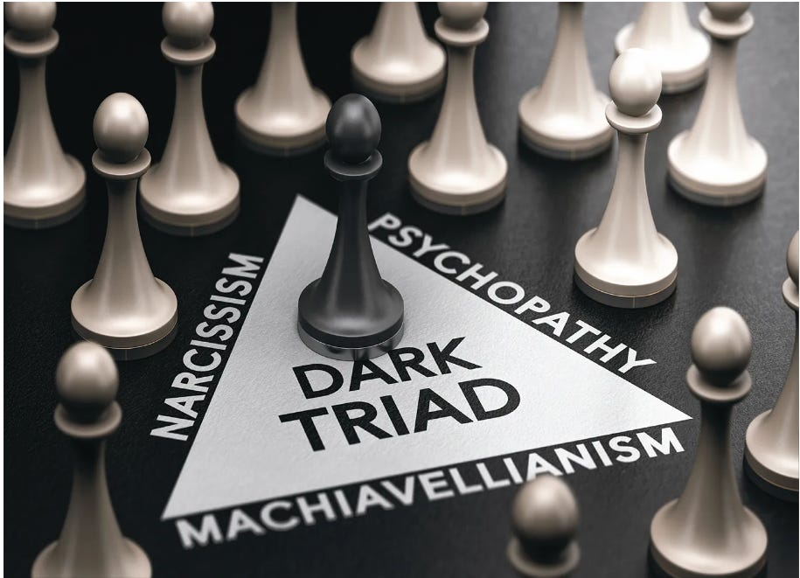



The field of Black Magic is Sex, Drugs and Rock and Roll!!
Black Magic Implant Addiction Blockage will create Addiction to Casual Sex, Alcohol, quaaludes and cocaine will so degenerate you so that you will become a Psychopath which is necessary in order to rape and pillage your clients laughing at their stupidity whilst sucking all their wealth as they addiction gamble their money at every turn of the cards, throw of the dice of the stock market.. because you get commission on every trade!!
Hell! they even Black Magic their own children - implanting them with the Sodomite Sex Addiction at schools like Eton, designed to make a male rape culture to create a Sodomite Band of Thebes army… before introducing them to the Satanic Secret Societies… See…

P.G. Wodehouse and British Empire Ritual Sodomy Band of Thebes Propagandised for Hitler, Propagandised for the Satanic Phoenician Mega Trillionaires

Satchidanand
·
October 2, 2022
Sir Pelham Grenville Wodehouse, KBE 15 October 1881 – 14 February 1975 was an English author and one of the most widely read humorists of the 20th century. His creations include the feather-brained Bertie Wooster and his sagacious valet, Jeeves; the immaculate and loquacious Psmith; Lord Emsworth and the Blandings Castle set; the Oldest Member, with stories about golf; and Mr Mulliner, with tall tales on subjects ranging from bibulous bishops to megalomaniac movie moguls.

Read full story

Because you can advertise them, prompt them, sell them on worthless stocks which will then rise so you can sell them at the top of the market and make hundreds of millions on every scam - the Classic Pump and Dump Scheme. These offerings are normal and are learnt at daddies knee in every Stock broking company. Later Jordan Belfort was associated with twenty of these IPO's - offerings of new companies on the market.

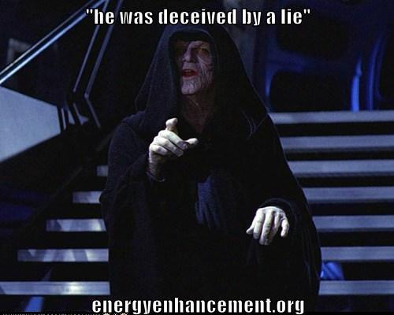

However, shortly after he passes his exam to become a certified stockbroker, he loses his job on account of the firm's bankruptcy as a result of Black Monday.
Now unemployed in an economy that is unaccommodating to stockbrokers and sufficiently discouraged to consider a new line of work, Jordan's wife Teresa (Cristin Milioti) encourages him to take a job with a Long Island boiler room dealing in penny stocks, which are also largely ignored by regulators.
Belfort impresses his new boss with his Satanic 2000 Trillion Dollar Phoenician Mega Trillionaire family N. M. Rothschilds aggressive pitching style, and earns a small fortune for the boiler room and himself as penny stocks have a much higher commission than blue chips.
Jordan also befriends Donnie Azoff (Jonah Hill), a salesman living in the same apartment complex and they decide to go into business together. To facilitate this, his accountant parents are recruited as well as several of Jordan's friends, some of them experienced marijuana dealers.
The basic method of the firm is a pump and dump scam and the Satanic 2000 Trillion Dollar Phoenician Mega Trillionaire family N. M. Rothschild's lifestyle of prostitutes, masturbation, casual sex, quaaludes and cocaine which is taught to all Qualified Stockbrokers as the Satanic culture they want you to take up in order to succeed.
To cloak this, Belfort gives the firm the respectable name of Stratton Oakmont. An article in Forbes dubs Jordan the "Wolf of Wall Street", and soon hundreds of ambitious young financiers flock to his company.
A decadent satanic lifestyle of lavish parties, sex and drugs follows.
It is amazing that Leonardo de Caprio is also associated with the movie, "The Great Gatsby" Directed by Baz Luhrman - in this movie he takes the same part as the front man of a Stock Company using the same Pump and Dump schemes in the 1920's. He is in charge of the same Satanic Parties of Sex, Alcohol and Drugs used to degenerate the stockbrokers of the, "Raging Twenties". In both Movies, the Blue Bloods, the Satanic Elite, the Satanic 2000 Trillion Dollar Phoenician Mega Trillionaire family N. M. Rothschilds are responsible for his downfall - in both Gatsby and Wolf.
Jordan regularly uses prostitutes and becomes addicted to cocaine and Quaaludes. FBI Agent Patrick Denham (Kyle Chandler) begins investigating Stratton Oakmont. Why? In the meeting with the Agent he says that the other firms employ blue bloods whereas Belfort employs dumb as a box of rocks pizza delivery boys and drug dealers. In the same way that drug pushers who are not employed by the "Committee of 300" are prosecuted by the police but the Satanic 2000 Trillion Dollar Phoenician Mega Trillionaire family N. M. Rothschilds et al - all Members of the "Committee of 300" who, "Pay the Toll" of bribes and are all members of the club are not, in order to keep down the competition.
It is the same in Banking where if you are not a member of the Club you will be investigated by the FBI as happened with Jordan Belfort.

Download - The Committee of 300 - Fourth Edition by Dr. John Coleman
Released by RareReactor.tk
The Committee of 300, also known as The Olympians, is a group alleged to have been founded by the British aristocracy in 1727.[1] Proponents of the theory alleging the Committee's existence, Ian Fleming's Spectre, believe it to be an international council that organizes politics, commerce, banking, media, and the military for centralized global efforts.
https://archive.org/details/dr.-john-coleman-the-committee-of-300
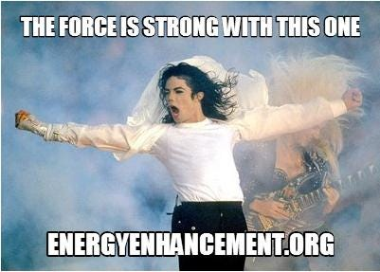
“We have one here who can see!” - LET'S DEGENERATE AND ASSASSINATE
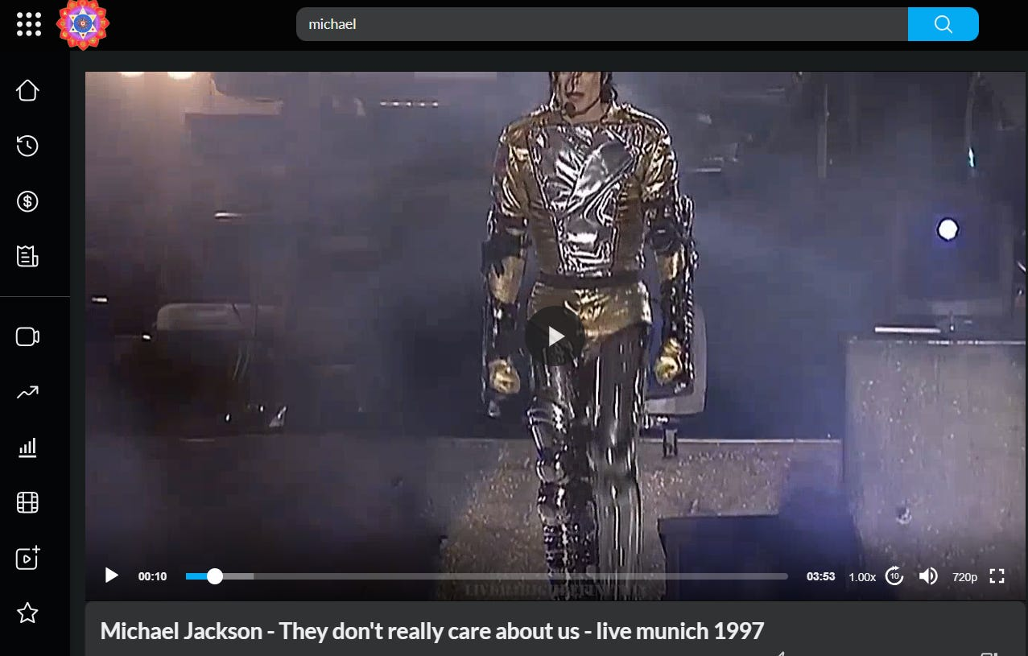

https://against-satanism-video.com/watch/michael-jackson-they-don-039-t-really-care-about-us-live-munich-1997_Y8DVLByoW13sEc5.html



See all the famous music by Michael Jackson in Sacred Michael Jackson by Sacred Dancer, Director of Energy Enhancement Meditation, Devi Dhyani…https://eemeditationvideo.org/watch/michael-jackson-sacred-dance-by-swami-devi-dhyani_EvgMCy3d4JVkd4H.html
It is the same in the music business where John Lennon is a British Lord, Paul McCartney is a British Lord, Mick Jagger of the Jagelion Family is a British Lord, Jimmy Page of the Paget Family is a British Lord etc
When Jordan meets Naomi Lapaglia (Margot Robbie) at one of his parties, he begins an affair with her, resulting in his divorce from Teresa. Jordan makes Naomi his second wife in an extravagant wedding and gives her a yacht aptly named Naomi, and soon they have a daughter, Skylar. Meanwhile, the U.S. Securities and Exchange Commission works jointly with the FBI to intensify the Stratton Oakmont investigation.
Jordan instantly makes US$22 million on his securing the IPO of Steve Madden Ltd. To hide his money, Jordan opens a Swiss bank account with the corrupt banker Jean-Jacques Saurel (Jean Dujardin) in the name of Naomi's aunt Emma (Joanna Lumley), who is a British citizen and outside the reach of American authorities. He uses friends with European passports to smuggle cash to Switzerland. When Donnie gets into a public fight with Brad Bodnick (Jon Bernthal), who is one of their money couriers, and Brad is arrested, their scheme is nearly exposed.
Donnie offers Jordan a powerful brand of Quaaludes, hoping to ease the sting of the bad news. The pills are old and seem to have lost their potency, so they take huge doses to compensate. Jordan then receives a call from Bo Dietl, his private investigator, who insists Jordan call him back from a payphone. Jordan drives to a country club to phone Bo, who warns Jordan of Brad's arrest and that his house phone has been wiretapped.
At this point, the Quaaludes finally kick in with overwhelming effect. Severely debilitated, Jordan drives back home to prevent Donnie from using his phone. When Jordan arrives home Donnie (who is also intoxicated) is on the phone with Saurel. Jordan fights Donnie to make him get off the phone and tells him he found out what happened between him and Brad. Donnie starts choking on ham and nearly suffocates. Jordan snorts cocaine to counteract the effect of the Quaaludes in order to help save Donnie's life.
With the shadow of law enforcement hanging over them, Jordan's father Max (Rob Reiner) attempts to convince his son to step down from Stratton Oakmont and escape the large amount of legal penalties. However, during his leaving party at the office, Jordan changes his mind and to the great acclaim of his employees vows to stay on - to Psychopathically Scam, Rape and Pillage even more money before being forced to retire..
Jordan, Donnie and their wives on a yacht trip to Italy learn that Emma has died of a heart attack. Over his grieving wife's objections, Jordan decides to sail to Monaco so they can drive to Switzerland without getting their passports stamped at the border and settle the bank account, but a violent storm capsizes their 162 ft yacht once owned by Coco Channel. After their rescue, the plane sent to take them to Geneva is destroyed by a seagull flying into the engine, exploding and killing three people. Witnessing this, Jordan considers this a sign from God and decides to sober up.
Two years later, Denham arrests Jordan during the filming of an infomercial. Saurel, arrested in Florida over an unrelated charge, has told the FBI everything. Since the evidence against him is overwhelming, Jordan agrees to gather evidence on his colleagues in exchange for leniency.
Jordan is optimistic about his sentencing and expresses this to his wife. The encounter turns violent when Naomi tells Jordan she will divorce him and wants full custody of their children. Jordan throws a violent tantrum, gets high, and ends up crashing his car in his driveway during an attempt to abscond with their daughter.
The next morning, Jordan wears a wire to work. Jordan silently slips Donnie a note warning him about the wire. The note finds its way to Agent Denham, who arrests Jordan for breaching his cooperation deal. The FBI raids and shuts down Stratton Oakmont.
Despite this one breach, Jordan receives a much reduced sentence for his testimony and is sentenced to 36 months in a minimum security prison in Nevada playing tennis. After his release, Jordan makes a living hosting seminars on sales technique in New Zealand.
The Satanic Stock Broker Black Magic Culture of Sex, Drugs and Rock and Roll to degrade, de-moralise, addict to Narcissise, Machiavellianise, and Psychopathise.
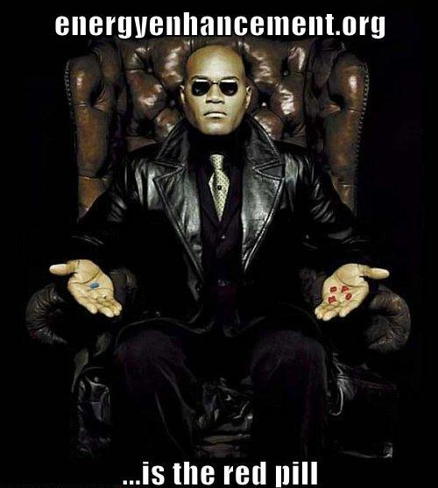
Yards from Satanic Goldman Sachs's headquarters in downtown Manhattan, bankers invited to a preview of the film cheered Belfort's every move. They laughed as the Wolf - Leonard DiCaprio in an Oscar-nominated turn - snorted drugs from a prostitute's naked body, and applauded when he ripped open a sofa to find a stash of cocaine.
In London, Satanic culture City firms glorify Belforts exploits and have attended fancy-dress screenings, with staff posing as their new folk hero, complete with pastel-coloured jackets and brick-like mobile phones. Cinemas have trebled the price for private bookings, such is demand.
So the question is, Why should this guy only involved in hundreds of millions of dollars of Pumping and Dumping be sent to prison??
The American Government only owes 36 Trillion Dollars - as we disclose here, the Banking industry is involved in stealing 20,000 Trillion Dollars in a multitude of scams!
In actuality it is the Satanic 2000 Trillion Dollar Phoenician Mega Trillionaire family Rothschild Central Bank, The Federal Reserve, which decides when to crash the economy.

Throughout History Seventy-Two Empires Have Been Engineered to Fail in the Same Way.

Satchidanand
·
April 6, 2024
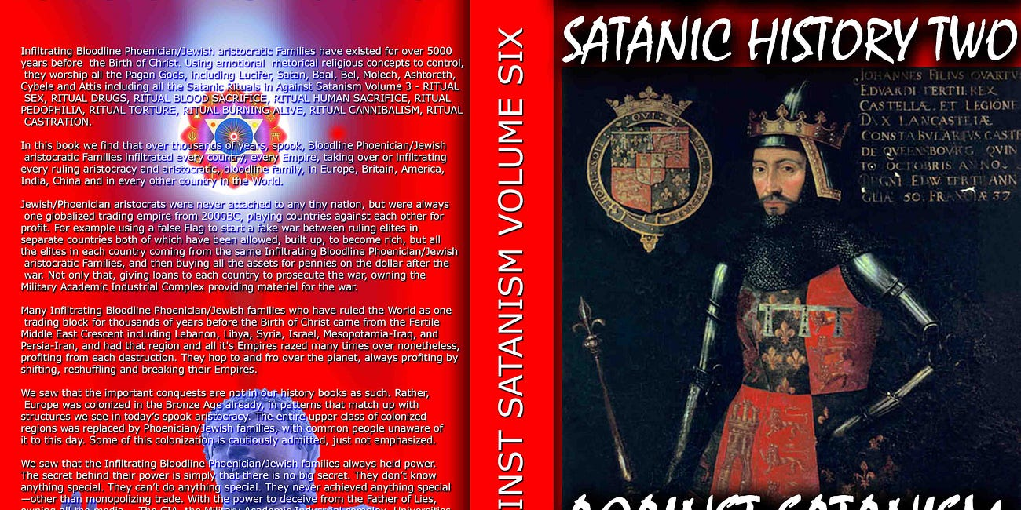
Throughout History Seventy-Two Empires Have Been Engineered to Fail in the Same Way.

Read full story

The Richest Satanic Phoenician Mega Trillionaire 10,000 years old Families in the World

Satchidanand
·
November 25, 2022
The Richest Satanic Phoenician Mega Trillionaire 10,000 years old Families in the World. THE VANGUARD GROUP DRIVES WORLDWIDE MERCHANT-BANKER FASCISM FROM THE CITY OF LONDON. VANGUARD, BLACKROCK, STATE STREET ARE CONTROLLED BY THE PILGRIMS SOCIETY IN THE CITY OF LONDON (ROTHSCHILDS, BARINGS, BARCLAYS, NATWEST, ETC.) King Chucky the Turd is the front man controlling Klaus Schwab and Vanguard.

Read full story

Thousands of Trillions of Dollars are being scammed by the Satanic Blue Blood Elite Aristocracy like the Satanic 2000 Trillion Dollar Phoenician Mega Trillionaire family N. M. Rothschilds who have run this World for 10,000 years by a Process of Poverty, starvation, societal Myth mind control and money - Bribery, Blackmail and corruption.
We know that thousands of Trillions of Dollars are being scammed by the Satanic Blue Blood Elite in firms like Goldman Sachs, Barclays, Citigroup, Deutche Bank, HSBC, JPMorgan Chase, Lloyds, RBS, Standard Chartered, and UBS and the answer comes from Psychopath Genghis Khan who said, "It is not that I succeed, everyone else should Fail" which is another re-telling of the thousands of years old Oligarchic, Satanic, "Policy of Poverty" which means Austerity for the peasants and destruction for the competition.

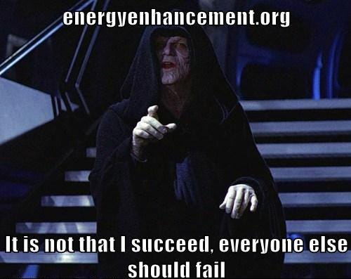

"Competition is a sin." - John D. Rockefeller - and now we know why!! - another re-telling of the thousands of years old Oligarchic, Satanic, "Policy of Poverty" which means Austerity for the peasants and destruction for the competition.

Police Protection for Authorised drug Dealers
In the same way that authorised drug dealers who pay off the Police in every City of the World. In the same way that the Police in every city are the Assassination Bureau for the Satanic Elite.
Drug Dealer competition is punished by the Police. All Drug Dealers who are just starting off, Competition to the thousands of Years Satanic Old Committee of 300 who have managed the Worldwide illegal drugs business forever, are reported to the police for prosecution or murder whilst the protected drug dealers are allowed to continue their business.
In the same way that the Sinaloa Cartel is run by the American Department of Justice. In the same way that Obama advisor, totalitarian Zbignew Brzezinsky said that for control, all crime must be run by the state. In this movie, Belfort is reported to the FBI as competition to the Satanic Elite of Goldman Sachs, UBS, The Bank of England, Barclays, Royal Bank of Scotland etc etc, is given a slap on the wrist and loses his license to work on Wall Street, the Old Slave market of New York - and is allowed to keep his ill-gotten gains.

The whole of Las Vegas built to launder Drug Profits!
It is also interesting that Scorsese made his bones with movies like, "Goodfellas", "The Departed" and "Casino" set in Las Vegas where we see money laundering of drug and pedophile, white slave, prostitution profits was called skimming at the Casinos where many people are paid to lose hundreds of thousands of dollars per day of drug money each in the Casinos and the money is then laundered.
We also see the same "Wolf of Wall Street" Narcissistic, Machiavellian, Psychopathic Satanic Culture of drugs and sex in both Gangster Mafia and Bankster Stockbrokers.
We have all seen the movie "Bugsy" produced by scion of the Rothschilds Warren Beatty blacklisted for "Bulworth" where we learn that Las Vegas was built by Bugsy Seigel and Meyer Lansky - Capo di Capi of all Mafias and head of the Jewish Mafia - in order to launder drug profits. And the people who are paid to go to Las Vegas statistically lose 2000 dollars each whereas they are given special offers, free food, free accommodation, and fantastic shows by the Worlds elite of artists in order to pack them in.

THE SATANIC CULTURE CONTINUES ON INTO RITUAL?
"Time Considered as a Helix of Semi-Precious Stones" is a science fiction short story by homosexual satanist Samuel R. Delany who wrote "Hogg". It won the Hugo Award for Best Short Story 1970, and the Nebula Award for Best Novelette in 1969 and it describes the life of any upwardly mobile criminal, like Belfort.
Belfort is still satanically addicted to drugs and sex having Black Magically been given and activated the sex and drug addiction blockages to degenerate him as a human being so as to do the will of the Satanic Megatrillionaire Rothschilds. He is now moving on into relationships with higher level Satanists and the next step is obviously Satanic Ritual - Sodomy Rituals, Blood Rituals, Pedophilia Rituals, Human Sacrifice Rituals, Castration Rituals…
Listening to youtube videos on Belmont we find he is now friends with Sir Richard Branston whose company parties - like Belmont's - are still legendary. He gives get rich quick talks on the same stage as satanic pedophile war criminal Lord Tony Bliar.
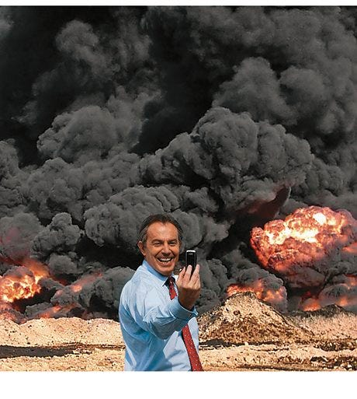
WAR CRIMINAL TONY BLIAR IN IRAQ - A WHOLE NEW LEVEL
"The point is this: the most effective means of curtailing dissent and creating a cautious conforming population isn’t the spying itself. It’s letting people know the spying, surveillance and censorship is happening all the time." People then censor themselves.
Because although he has moved out of Stock Broking he still actively searches other scams like pump and dump Bitcoin - who is behind Bitcoin? in order to increase his wealth.
Why was Belfort punished when all the Satanic, Ancient, too big to fail, too big to jail banks are not prosecuted after all these cases have been proven in court, derisory fines given, and no-one sent to jail?
WACHOVIA - 378 Billion Dollar Drug Money Laundering Scam
HSBC - The 200 Trillion Dollar HSBC Drug and Terrorist Money Laundering
LIBOR - The 200 Trillion Dollar LIBOR Fixing
FOREX - The 20,000 Trillion Dollar FOREIGN EXCHANGE, FOREX Fixing SCANDAL
GOLD MARKET FIXED Gold price rigging fears put investors on alert By Financial Times Reporter, Madison Marriage. - Global gold prices may have been manipulated on 50 per cent of occasions between January 2010 and December 2013 - always!! - according to analysis by Fideres, a consultancy. The findings come amid a probe by German and UK regulators into alleged manipulation of the gold price, which is set twice a day by Deutsche Bank, HSBC, Barclays, Bank of Nova Scotia and Société Générale in a process known as the “London gold fixing”.
Stock Market FIXED - Obama's Plunge Protection Team and computer trading
Genocidal Poverty though Inflation, Scare-City, Austerity over only 36 Trillions of Debts to Private Federal Reserve Banks.
All a matter of Record..
Wachovia, now part of the giant Wells Fargo laundered billions from Mexico's murderous drug gangs
On 10 April 2006, a DC-9 jet landed in the port city of Ciudad del Carmen, on the Gulf of Mexico, as the sun was setting. Mexican soldiers, waiting to intercept it, found 128 cases packed with 5.7 tons of cocaine, valued at $100m. But something else – more important and far-reaching – was discovered in the paper trail behind the purchase of the plane by the Sinaloa narco-trafficking cartel.
During a 22-month investigation by agents from the US Drug Enforcement Administration, the Internal Revenue Service and others, it emerged that the cocaine smugglers had bought the plane with money they had laundered through one of the biggest banks in the United States: Wachovia, now part of the giant Wells Fargo.
Of special significance was that the period concerned began in 2004, which coincided with the first escalation of violence along the US-Mexico border that ignited the current drugs war in which 70,000 people have been killed - more than the American soldiers who died in Vietnam, although 3.5 million Vietnamese did die too.
"For the time period of 1 May 2004 through 31 May 2007, Wachovia processed at least $$373.6bn in CDCs, $4.7bn in bulk cash" – a total of more than $378.3bn.
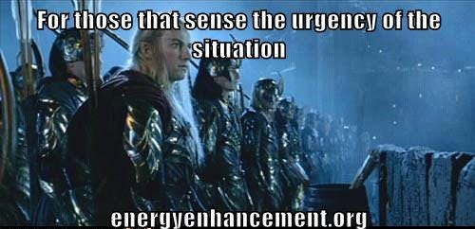
The deferred prosecution is part of this "cop-out all round", he says. "The regulatory authorities do not have to spend any more time on it, and they don't have to push it as far as a criminal trial. They just issue criminal proceedings, and settle. The law enforcement people do what they are supposed to do, but what's the point? All those people dealing with all that money from drug-trafficking and murder, and no one goes to jail?"

The 200 Trillion Dollar HSBC Money Laundering
HSBC Report Should Result in Prosecutions, Not Just Fines, Say Critics
British Aristocrat, "Member of the Club" - "It's a big Club, but you ain't in it!" - Lord Green, Head of HSBC during this period of the emergence of trillions of Dollars of Money Laundering has since been made a special advisor to Cameron's British Government.
For at least half a decade, the storied British colonial banking power helped to wash hundreds of millions of dollars for drug mobs, including Mexico's Sinaloa drug cartel, suspected in SEVENTY thousands of murders just in the past 10 years – people so totally evil, jokes former New York Attorney General Eliot Spitzer, that "they make the guys on Wall Street look good."
The bank also moved money for organizations linked to Al Qaeda and Hezbollah, and for Russian gangsters; helped countries like Iran, the Sudan and North Korea evade sanctions; and, in between helping murderers and terrorists and rogue states, aided countless common tax cheats in hiding their cash.
"They violated every goddamn law in the book," says Jack Blum, an attorney and former Senate investigator who headed a major bribery investigation against Lockheed in the 1970s that led to the passage of the Foreign Corrupt Practices Act. "They took every imaginable form of illegal and illicit business."
That nobody from the bank went to jail or paid a dollar in individual fines is nothing new in this era of financial crisis. What is different about this settlement is that the Justice Department, for the first time, admitted why it decided to go soft on this particular kind of criminal. It was worried that anything more than a wrist slap for HSBC might undermine the world economy.
"Had the U.S. authorities decided to press criminal charges," said Assistant Attorney General Lanny Breuer at a press conference to announce the settlement, "HSBC would almost certainly have lost its banking license in the U.S., the future of the institution would have been under threat and the entire banking system would have been destabilized."
It was the dawn of a new era. In the years just after 9/11, even being breathed on by a suspected terrorist could land you in extralegal detention for the rest of your life. But now, when you're Too Big to Jail, you can cop to laundering terrorist cash and violating the Trading With the Enemy Act, and not only will you not be prosecuted for it, but the government will go out of its way to make sure you won't lose your license. Some on the Hill put it to me this way: OK, fine, no jail time, but they can't even pull their charter? Are you kidding?
Also known as the Hong Kong and Shanghai Banking Corporation, British HSBC has always been associated with drugs. Founded in 1865, HSBC became the major commercial bank in colonial China after the conclusion of the Second Opium War.
If you're rusty in your history of Britain's various wars of Imperial Rape, the Second Opium War was the one where Britain and other European powers basically slaughtered lots of Chinese people until they agreed to legalize the dope trade (much like they had done in the First Opium War, which ended in 1842).
A century and a half later, it appears not much has changed. With its strong on-the-ground presence in many of the various ex-colonial territories in Asia and Africa, and its rich history of cross-cultural moral flexibility, HSBC has a very different international footprint than other Too Big to Fail banks like Wells Fargo or Bank of America. While the American banking behemoths mainly gorged themselves on the toxic residential-mortgage trade that caused the 2008 financial bubble, HSBC took a slightly different path, turning itself into the destination bank for domestic and international scoundrels of every possible persuasion.
Three-time losers doing life in California prisons for street felonies might be surprised to learn that the no-jail settlement Lanny Breuer worked out for HSBC was already the bank's third strike. In fact, as a mortifying 334-page report issued by the Senate Permanent Subcommittee on Investigations last summer made plain, HSBC ignored a truly awesome quantity of official warnings.
In April 2003, with 9/11 still fresh in the minds of American regulators, the Federal Reserve sent HSBC's American subsidiary a cease-and-desist letter, ordering it to clean up its act and make a better effort to keep criminals and terrorists from opening accounts at its bank.
One of the bank's bigger customers, for instance, was Saudi Arabia's Al Rajhi bank, which had been linked by the CIA and other government agencies to terrorism.
According to a document cited in a Senate report, one of the bank's founders, Sulaiman bin Abdul Aziz Al Rajhi, was among 20 early financiers of Al Qaeda, a member of what Osama bin Laden himself apparently called the "Golden Chain."
In 2003, the CIA wrote a confidential report about the bank, describing Al Rajhi as a "conduit for extremist finance." In the report, details of which leaked to the public by 2007, the agency noted that Sulaiman Al Rajhi consciously worked to help Islamic "charities" hide their true nature, ordering the bank's board to "explore financial instruments that would allow the bank's charitable contributions to avoid official Saudi scrutiny." (The bank has denied any role in financing extremists.)
For more than half a decade, a whopping $19 billion in transactions involving Iran went through the American financial system, with the Iranian connection kept hidden in 75 to 90 percent of those transactions.
HSBC has been headquartered in England for more than two decades – it's Europe's largest bank, in fact – but it has major subsidiary operations in every corner of the world. What's come out in this investigation is that the chiefs in the parent company often knew about shady transactions when the regional subsidiary did not.
By that time, numerous agencies, including the Department of Homeland Security, had crawled all the way up HSBC's backside, among other things examining it as part of a major international narcotics investigation. In one four-year period between 2006 and 2009, an astonishing $200 trillion in wire transfers (including from high-risk countries like Mexico) went through without any monitoring at all.

The 200 Trillion Dollar LIBOR Fixing
The so-called LIBOR scandal, which is at the heart of the UBS settlement, makes Enron look like a parking violation. Many of the world's biggest banks, including Switzerland's UBS, Britain's Barclays and the Royal Bank of Scotland, got together and secretly conspired to manipulate the London Interbank Offered Rate, or LIBOR, which measures the rate at which banks lend to each other. Many, if not most, interest rates are pegged to LIBOR. The prices of hundreds of trillions of dollars of financial products are tied to LIBOR, everything from commercial loans to credit cards to mortgages to municipal bonds to swaps and currencies.
If you can imagine executives at Ford, GM, Mitsubishi, BMW and Mercedes getting together every morning to fix the prices of aluminum and stainless steel, you have a rough idea of what the LIBOR scandal is like, except that in the car-company analogy, you'd be dealing with absurdly smaller numbers.
These are the world's biggest banks getting together every morning to essentially fix the price of money. Low LIBOR rates are an indicator that banks are strong and healthy. These banks were faking the results of their daily physicals. In banking terms, they were juicing.
But the Justice Department wasn't finished handing out Christmas goodies. A little over a week later, Assistant Attorney General Lanny Breuer was back in front of the press, giving a cushy deal to another huge international firm, the Swiss bank UBS, which had just admitted to a key role in perhaps the biggest antitrust/price-fixing case in history, the so-called LIBOR scandal, a massive interest-raterigging conspiracy involving hundreds of trillions ("trillions," with a "t") of dollars in financial products. While two minor players did face charges, Breuer and the Justice Department worried aloud about global stability as they explained why no criminal charges were being filed against the parent company.
Also known as the Hong Kong and Shanghai Banking Corporation, British HSBC has always been associated with drugs. Founded in 1865, HSBC became the major commercial bank in colonial China after the conclusion of the Second Opium War. If you're rusty in your history of Britain's various wars of Imperial Rape, the Second Opium War was the one where Britain and other European powers basically slaughtered lots of Chinese people until they agreed to legalize the dope trade (much like they had done in the First Opium War, which ended in 1842) of bringing colonial Indian Opium on British Lord's Satanic Dynastic Family clippers into China.

The 20,000 Trillion Dollar FOREIGN EXCHANGE, FOREX, SCANDAL
The Forex scandal (also known as the forex probe) is a financial scandal that involves the revelation, and subsequent investigation, that the world's largest currency trading banks colluded for at least a decade to manipulate and rig the daily foreign exchange rates for at least 20,000 Trillions of Dollars.
Market regulators in Asia, Switzerland, the United Kingdom, and the United States began to investigate the $2000 trillion-a-year foreign-exchange market after Bloomberg News reported in June 2013 that currency dealers said they had been front-running client orders and rigging the foreign exchange benchmark WM/Reuters rates by colluding with counterparts and pushing through trades before and during the 60-second windows when the benchmark rates are set. The behavior occurred daily in the spot foreign-exchange market and went on for at least a decade according to currency traders.
At the center of the investigation are the transcripts of electronic chatrooms in which senior currency traders discussed with their competitors at other banks the types and volume of the trades they planned to place. The electronic chatrooms had names such as “The Cartel,” “The Bandits’ Club,” “One Team, One Dream” and “The Mafia”. The discussions in the chatrooms were interspersed with jokes about manipulating the forex market and repeated satanic culture references to alcohol, drugs, Sex and women.
Regulators are particularly focusing in on one small exclusive chatroom which was variously called the The Cartel or The Mafia. The chatroom was used by some of the most influential traders in London and membership in the chatroom was highly sought after.
Among The Cartel's members were Richard Usher, a former Royal Bank of Scotland (RBS) senior trader who went to JPMorgan as head of spot foreign exchange trading in 2010, Rohan Ramchandani, Citigroup’s head of European spot trading, Matt Gardiner, who joined Standard Chartered after working at UBS and Barclays, and Chris Ashton, head of voice spot trading at Barclays.
Two of these senior traders, Richard Usher and Rohan Ramchandani, are members of the 13-member Bank of England Joint Standing Committee's chief dealers group.
At least 15 banks including Barclays, HSBC, and Goldman Sachs disclosed investigations by regulators. Barclays, Citigroup, and JPMorgan Chase all suspended or placed on leave senior currency traders. Deutsche Bank, continental Europe’s largest lender, was also cooperating with requests for information from regulators. Barclays, Citigroup, Deutche Bank, HSBC, JPMorgan Chase, Lloyds, RBS, Standard Chartered, and UBS as of February 2014 had suspended, placed on leave, or fired 21 traders. Citigroup had also fired its head of European spot foreign exchange trading, Rohan Ramchandani, who was a member of the 13-member Bank of England Joint Standing Committee's chief dealers group. Reuters reported hundreds of traders around the world could be implicated in the scandal.
(Reuters) - March 2014 - Bank of England (BoE) Governor Mark Carney faces a grilling from UK lawmakers on Tuesday about what Bank officials knew about allegations that currency traders colluded to manipulate key exchange rates in the 2000 Trillions of dollars Per year Forex business.
The unfolding scandal has so far seen more than 20 traders placed on leave, suspended or fired by some of the world's biggest banks.
THE 40 TRILLION DOLLAR HEIST THAT WAS THE MORTGAGE BLOWUP OF 2008 AND THE BAIL OUT



It has been reported by Catherine Austin Fitts that there were many multiples of mortgages sold than there were houses in the United States.
Catherine Austin Fitts served as managing director and member of the board of directors of the Wall Street investment bank Dillon, Read & Co. Inc., as Assistant Secretary of Housing and Federal Housing Commissioner at the United States Department of Housing and Urban Development in the first Bush Administration, and was the president of Hamilton Securities Group, Inc., an investment bank and financial software developer.
This was done with a collaboration between Government and Mortgage companies.
It was prepared for by Bill Clinton's removal of Glass Steagal for the repackaging of the Mortgages as derivatives.
Banks bought the Derivative repackaged Mortgages on houses that didn't exist and in the Bail out of 1500 Billions then Quanitative Easing of 120 Billions a month for many years was spent by the government in the form of bonds owed by the public to buy back these none existent mortgages.
In this way, says Catherine, 40 Trillions of dollars were removed - stolen - from the United States and paid for by the people.
This is a little more than normal but the same stealing principle has been used ever since banks came into existance 10,000 years ago!!
Vastly inflated contracts are given to companies by politicians.
A corrupt kickback is given to the politician and the companies get well paid.
Business as usual.

THE SATANIC SPECIES ARE LOWER MANAGEMENT TRADERS AND POLITICIANS
who are given money and power. Politicians and Stockbrokers are introduced into Satanism through the Company Cultures of Black Magic Addiction Blockages of Sex and Drugs which start the degeneration process towards Narcissistic, Machiavellian, Psychopathy.
The Wolf of Wall Street shows how all the banks promote the Black Magic Satanic culture of sex, drugs and lying to sell, and hatred of the client in order to create the Narcissistic, Machiavellian, Psychopathic mindset so necessary to rape and pillage.
The Satanic Species has been at war against the Human species for over 10,000 years, using the Policy of Poverty to maintain control..
Since Babylon, Satanic 2000 Trillion Dollar Phoenician Mega Trillionaire Generational Dynastic families have created Myths and Black Magic Pagan Satanic Religions to control their Human Herd.
They created all religions to Mind Control Humanity.. Lucifer, Satan, Mithra, Sofia, Apollo, Set, Isis, Osiris, Horus, Marduk, Gnostics.
“We will of course not let them know about Wotan [Odin].” –Reichsminister Paul Josef Goebbels-
Himmler told his SS Army that the Valkyries of Wotan will choose only those who die in battle to go to Heaven..
Psychically they use implant addiction blockages to Addict all Humanity to porn, masturbation, sex, drugs and Rock and Roll - Hip Hop, to degenerate humanity and recruit new Narcissistic, Machiavellian, Psychopathic cadre.
Whilst all the essential Meditation techniques - The Kundalini Key, Energy Blockage Removal - are removed from Traditional Meditations, Ancient Black Magic Technology of the Luciferian and Satanic religions use RITUAL. Ritual Drugs, Sex, Polyamory, homosexual, pedophile Ritual. Murderous Human and Animal Sacrifice Ritual.
The Ancient Psychic Science of Black Magic - the Creation of Implant Drug and Sex Addiction Energy Blockages - is an Ancient Technology which although is scientific, appears like Magic to those which have never been taught Energy Enhancement Meditation…

“Any sufficiently advanced technology is indistinguishable from magic.”
― Pedophile Aristocrat Arthur C. Clarke,
They are Genetically bred in Satanic 2000 Trillion Dollar Phoenician Mega Trillionaire families over thousands of years for psychopathy.
They are Trained - Mind Controlled from birth - for Rape, Pillage, War, Religion, Banking, Money Laundering, Slave Trading and Drug Running.
Satanists create all political parties. Marx worked for the British Secret Service.
After Democrats and Republicans, Libertarianism is next.

AUSTRIAN ECONOMICS MISES AND VON HAYEK
Long tonged liars like Nelson Rockefeller funds Von Mises and Von Hayek to create Genocidal Austrian Economics - THE POLICY OF POVERTY WORLDWIDE!! Austria where Satanic Fascist Hitler came from. Austrian Economics creates Austerity Worldwide.
https://www.energyenhancement.org/Satanic-Von-Hayek-The-creation-of-Feudalism-with-Austrian-Economic-Austerity-Fascism-Didn't-Die-With-Hitler.htm
Libertarian Satanic Ron and Rand Paul and their minion Alex Jones support Austrian Economics and the genocidal elimination of food stamps in this recession. They want you to use the guns so they can kill you - just another cull of humanity.
280 millions of the most intelligent and beautiful people tortured and killed in the 20th century by Government - Sacrifices for Satan!!

THE ONLY SOLUTION IS ENERGY ENHANCEMENT EVOLUTION!!
They seek to find Initiates into their satanic secret societies represented by Lord Tony Bliar and Sir Richard Branston where they Ritually degenerate themselves and further and further degenerate themselves in order to maintain their energy which at every stage is vampiristically harvested by the Luciferian Watchtower elite who live outside the body.

These Satanists are victims of a religion which believes in human sacrifice.
Lives for Satan through War, Soft kill pollution in air, water and food, Eugenocide, genocide, Stalin, Hitler, Mao. 280 millions of people murdered by Governments in the 20th century. And more projected for the 21st if the already written plans to sacrifice 7 billion people - to protect the earth!! - are put into operation.
So these guys, - Satanists - are quite mad.
They Want War.
They want Death.
They want to kill YOU!!


Tont Blair and Satanist Jimmy Savile

Satanism is not "just another nutty occult fad." It has been the, "Old Religion" since the beginning of time.
The mind of the Satanist is pure evil; the Satanist is a former person who has been transformed by Black Magic Implant Blockages into something no longer human.
It begins like drug-addiction; the prospective recruit to Satanism "gets into something" on a playful impulse, but then finds himself or herself gripped by compulsions - through psychic implantation of addiction energy blockages - which he or she can no longer control.
Drugs and other special circumstances may be significant collateral features of the initiation, but not necessarily. The key is "letting oneself go," into the depths of acting-out impulses which combine sexual impulses and rage as a unity, and expressing this form of "pleasure" in the form of an act which violates an important precept of one's own conscience.
This perversion through acts which violate an important precept of one's own conscience, from sex parties to ritual sex to homosexual ritual to torture to pederasty to animal then human sacrifice, this corruption occurs through the implantation of energy blockages into the heart center to remove empathy and blockages above the head to remove energy flowing in from God from the chakras above the head to remove conscience - the definition of a The Ancient Psychic Science of Black Magic - the Creation of Implant Drug and Sex Addiction Energy Blockages - is an Ancient Technology which although is scientific, appears like Magic to those which have never been taught Energy Enhancement Meditation…

“Any sufficiently advanced technology is indistinguishable from magic.”
― Pedophile Aristocrat Arthur C. Clarke,..
The removal of empathy. There is a Satanic Black Magic Ritual where 12 psychic daggers - psychic created energy blockages - are implanted around the heart center. A sacrifice is performed and the heart removed from the sacrifice and put into a canopic jar. The energy of the heart removed from the dagger implanted heart and put into the canopic jar together with the heart removed from the sacrifice. The canopic jar is then placed in the earth in a Heart Site, somewhere in the country.
Similarly with the child sacrifice at the Bohemian Grove Ritual, "The Cremation of Care" burning up of empathy to Molech where a child is burnt alive in front of a 40ft Statue of an Owl dedicated to Minerva and Molech in front of Presidents, Prime Ministers, Captains of Industry and the Media.

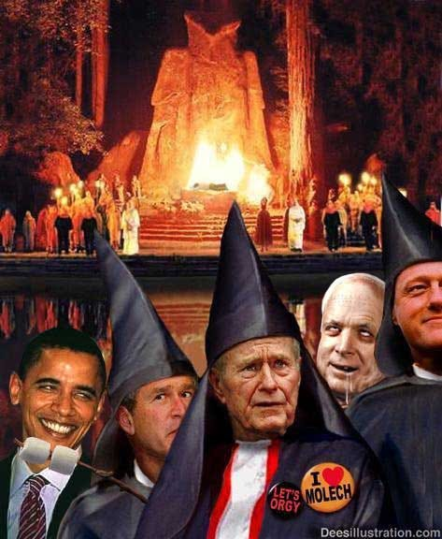

In the same way that British Satanic Secret Service controlled Saudi Arabian Wahabist and Salfist Sects create armies to attack and destabilise (911, Libya, Syria),
Black Magic is also a created myth, a methodology for the creation of a psychopathic army to rule and then destroy civilisation at the behest of the Real Rulers.
The Ancient Enemy who counts meditation and the mind control psychic arts as one of its main planks of World Domination has used Infil-Traitors for 10,000 years in every Organisation - Religion, Dynastic Families, Politics, Geopolitics, Economics, Universities, Intelligence Services, Think Tanks, Banking, International Companies, Eugenics - Worldwide, censoring Alchemical VITRIOL, the Kundalini Key and Energy Blockage Removal from every Meditation Program..
Yet throughout history from the time of the Old Religion of Satanic Babylon, Pagan, Satanic, Luciferian Generational Families have controlled Humanity through Myth, Money, Mind Control Propaganda, Slavery, Drugs and Sex.
From Babylon to the Slave Trading, Drug Running Empires; The Roman Empire, Venetian Empire, British Empire, Anglo-American Empire Satanic Generational Families have infil-traitored every Government, every Politician, Every Ministry, every International Company, every Bank, every University, every Think Tank, every Secret Society.
Satanic Psychopathic Religions and Myths (The Ten Myths which control the World) have been specifically created to maintain the Generational Family control of society. To exacerbate Implant addiction blockages of sex, drugs and rock and roll through Pagan Satanic sex, drugs and music in order to divert, pervert and degenerate humanity in order to rule them. More than anything, to keep Humanity Austere; Poor barefoot and back on the reservation and away from the Meditational Superpowers which alone can free Humanity from their chains.
It is symbolised by the Black Magician, Necromancer, "Sauron" Of, "The All Seeing Eye" like the NSA SNOWDEN PRISM - "Lidless, Wreathed in Flame" of Tolkien's, "Lord of the Rings" who lives outside the body and waits to return into physical life with the help of the power of the One Ring.
Sauron, like Lucifer, thinks he knows better than God. His aim is to pervert and degrade humanity into Orcs and Rule the World Totalitarian style, FOREVER!!

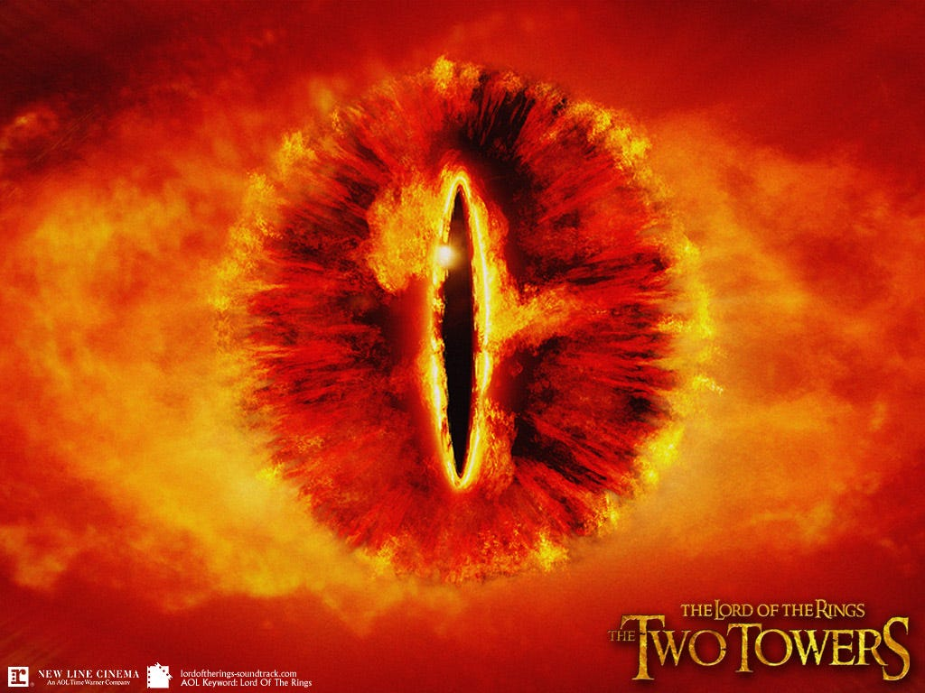

THE LUCIFERIAN SPECIES
are humans who have meditated and learned, perhaps many, many tens of thousands of years ago, how to cut off from god by using energy blockages to block chakras above the head so they can live outside the body in private universes - so they seem like psychopathic aliens to us - then they download into their mind weakened sons - throwing their sons out - on their 21st birthday so as to become the Head of their Baron, Lord or Crown families and control their multi trillion dollar, thousands of years old families wealth, to manage the human herd.
They use the, "Policy of Poverty" or Austerity to control the human herd for tens of thousands of years. Because they live outside the body and only want to vampirise human spiritual energies in order to live forever they will consider any solution to problems. See for example movie Dr Strangelove where upon exploding Fusion Bombs and making the Earth uninhabitable for hundreds of years they are eager to live down in mines to survive.
To further continue the "Policy of Poverty" To stop human evolution, so that the Satanists can continue to control an impoverished humanity. To the degree that probably 100 Million people might be lucky to survive—or unlucky enough to survive under those conditions as explained in Kubrick's "Dr Strangelove".

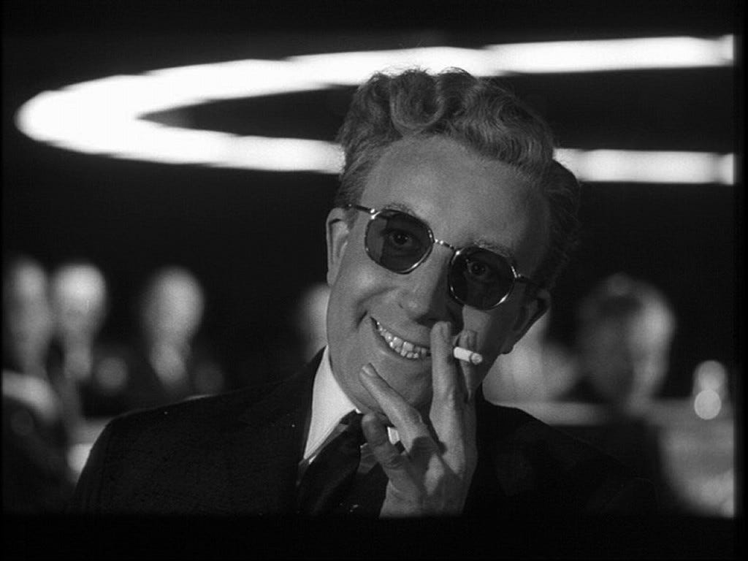

PETER SELLERS AS KUBRICK'S DR STRANGELOVE
Satchidanand's Review of - Existentialism and Kubrick's Satanic Psychopaths, in the Movies of Stanley Kubrick https://www.energyenhancement.org/Psychopath_Kubrick_Film_Movie.htm

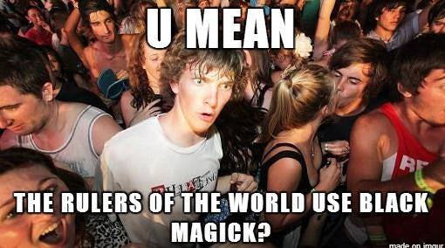

THE FAILURE OF INTELLIGENT LOGICAL COMMENTATORS TO UNDERSTAND THE TRUE SATANIC LUCIFERIAN NATURE
https://energyenhancement.org/THE-LONE-RANGER-ESOTERIC-MOVIE-REVIEW-BY-SATCHIDANAND.htm
The whole process here, look at it. What is the nature of this satanic hatred against human beings? What's the expression of that? It's the Satanic Green policy which directs people back to living in caves. This was done by the Satanic Roman Empire and others, as the, "Policy of Poverty" to reduce the population; that is, to have a small Satanic oligarchy which dominates the planet, or parts of the planet, and kill off the "excess" population, which is the rest of the people. This is what the Satanic Elite's policy is, and that is what she says it is.

CONTROL.
Depending how many chakras above the head they block off, the more power they have. They need a lot of energy as they receive no energy from God, so they have learned how to create Implant addiction energy blockages for drugs, sex, and rock and roll so as to parasitise, vampirise their slave populations and create their satanic psychopathic managers.
Everyone is implanted with every Addiction Blockage Implant from birth like having diseases, but depending how much we enter into the path of the disease there are many stages of that disease whose end is Psychopathy.
With the Sexual Addiction Implant Blockage the Energy from every orgasm is channeled back to the Luciferians through energy connections from their Sex Addiction Implants.
The Luciferians or their minions send out energy every morning to raise the salute of the penis, around the horn, a proud tumescence in every red blooded man to promote masturbation or initiate sex and they vampirise the energy of every orgasm. The prostitution, white slave and pedophile industry is traditionally under their control.
Drugs and sex burn the candle at both ends and the energy of that charging candle is sent back from the Implant Addiction Blockage through energy connections to the Luciferians. They traditionally, through the Committee of 300 (see Coleman) and the Pharma Companies, own the legal and Illegal Trillion Dollar Drug industries. They pay politicians to keep drugs illegal so as to make more profit. They conquer countries in order to grow more drugs - Afghanistan from growing no opium with the Taliban who placed a Fatwa on its cultivation, now supplies 90% of the World's opium to the Bush crime family.
Although they promise to tell their higher managers like the Rockefellers how to become immortal like them, they never do. So they promise Transhumanism.. Ray Kurzweil and Robert Heinlein (Heinlein, like Elron Hubbard and Campbell were Agents of American Naval Intelligence charged with implanting the memes of Science Fiction, satanic free love - "Stranger in a Strange Land" and drugs into the noosphere) are their propagandists here. Satanic Free love, Immortal medical care, perfect genetics, cyborg brain chip enhancements, upload into the machine so as to live forever. THEY LIE!!
Intelligent commentators are presently more and more commenting on the coming Third World War flashpoints which are recklessly occurring in the Middle east, Syria and now in the Ukraine and they can not believe just how MAD the foreign policy is. They can not Believe the risks of starting World War Three which they are taking - only possible if Biden, Obama, Putin and XI are totally controlled by the satanic Mega Trillionaire elite...

BOHEMIAN GROVE - THE GROVERS
One commentator below laughs at the total idiocy of their foreign policy actions but also with the tension of the contemplation of the risks of Thermonuclear War and the Extinction of the Human Race which that represents.
They point out historical precedent between now and the False Flag starts of fake World Wars One and Two.
They point out the historical precedents between the founding and funding of Hitlers Nazi, National Socialist, Fascist State, the founding and funding of Lenin's and Stalin's Totalitarian Communist, Collectivist Soviet and what is happening now with the National Stazi Agency NSA and Snowden's Big Brother is watching you in USA and Europe.
A Thousand Year Reich of control, transhumanism, eugenics, genetic engineering, merging with the machine, living forever.. Covering all the World in Darkness..
Because this commentator does not understand Satanism and its infiltration into the highest levels of power.
Because this commentator has a rational mind he can not believe that other people in power are not rational - That they are MAD, PSYCHOPATHIC, LIVES FOR SATAN, SATANISTS!!

THE SOLUTION? - THE ENERGY ENHANCEMENT COURSE BY STREAMING VIDEO OR LIVE IN BRAZIL, INDIA, WORLDWIDE!!



Share
Leave a comment
The removal of the Heads of the Thirteen Satanic Families - not by assassination - as they can move from body to body - but as in the removal of Energy Blockages in the Energy Enhancement removal of Blockages.
Also information, the teaching of Wolf-Child Humanity in real Science and History as well as the Science of Meditation - Kundalini Kriyas, VITRIOL, Samadhi, Samyama, the removal of Energy Blockages, Implant Blockages, Energy Connections and Cords.

The solution?

THERE IS NO PHYSICAL SOLUTION AS OVER 10,000 YEARS OF RAPE AND PILLAGE WILL SHOW YOU!!

Solution? - The Science of Meditation - Which will increase the only thing you can take with you - Lifetime to Lifetime - when you die..

THE ONLY SOLUTION IS EVOLUTION!!
With the Energy Enhancement Kundalini Kriyas, VITRIOL, Samadhi, Samyama, the removal of Energy Blockages, Implant Blockages, Energy Connections and Cords.

ENERGY ENHANCEMENT IS THE ULTIMATE TECHNIQUE OF EVOLUTION!!
Just by meditation and energy blockage removal, you can find the truth for yourself, increase your energy, access incredible quantities of Kundalini Energy, become Enlightened.
And that's the only way, I think, you can actually make a practical, actually practical indication of how we might be able to save humanity from its degenerate Satanic predators.

ENERGY ENHANCEMENT - THE ULTIMATE MEDITATION COURSE!!

GET YOUR ENERGY ENHANCEMENT VIDEO OR LIVE COURSE NOW!!



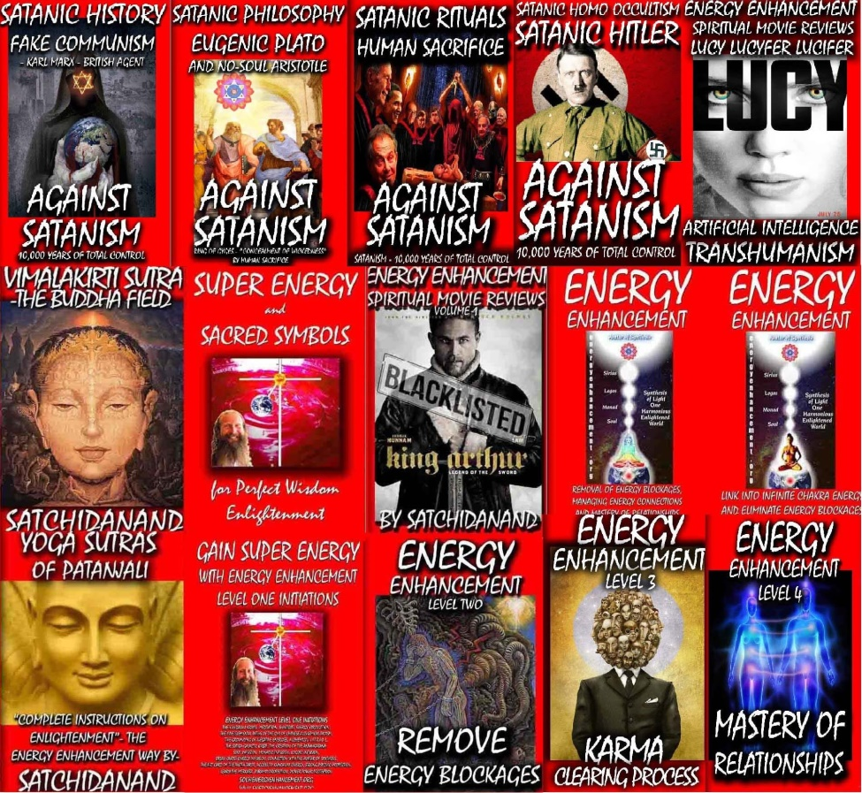
THE WOLVES OF WALL STREET USE BLACK MAGIC IMPLANT ENERGY BLOCKAGE MIND VIRUSES PART 2

THE SATANIC 2000 TRILLION DOLLAR MEGATRILLIONAIRE ROTHSCHILDS USE BLACK MAGIC TO MAKE NARCISSITIC, MACHIAVELLIAN PSYCHOPATH BANKERS
Satchidanand
Jul 29, 2024

THE “WOLVES” OF WALL STREET USE BLACK MAGIC MIND VIRUSES PART 2

THE SATANIC 2000 TRILLION DOLLAR MEGATRILLIONAIRE ROTHSCHILDS USE BLACK MAGIC MIND VIRUSES TO MAKE NARCISSITIC, MACHIAVELLIAN PSYCHOPATH BANKERS

Directed by Martin Scorsese, Produced by Martin Scorsese, Leonardo DiCaprio, Riza Aziz, Joey McFarland, Emma Tillinger Koskoff
Based on The Wolf of Wall Street by Jordan Belfort
Budget $100 million
Box office $375,591,788
The Wolf of Wall Street is a 2013 American black comedy film directed by Martin Scorsese, based on Jordan Belfort's memoir of the same name. It was released on December 25, 2013. The screenplay was written by Terence Winter, and the film stars Leonardo DiCaprio as Jordan Belfort, a New York stockbroker who runs a firm that engages in securities fraud and corruption on Wall Street in the 1990s.
The film also features Jonah Hill, Margot Robbie, Matthew McConaughey, Kyle Chandler, Rob Reiner, Jon Favreau, and Jean Dujardin. It is the fifth collaboration between Scorsese and DiCaprio, and the second between Scorsese and Winter following Boardwalk Empire.
The film received positive reviews from critics, but was also controversial for its moral ambiguity, sexual content, presence of drugs, vulgarity, and use of animals. The film has grossed over $375 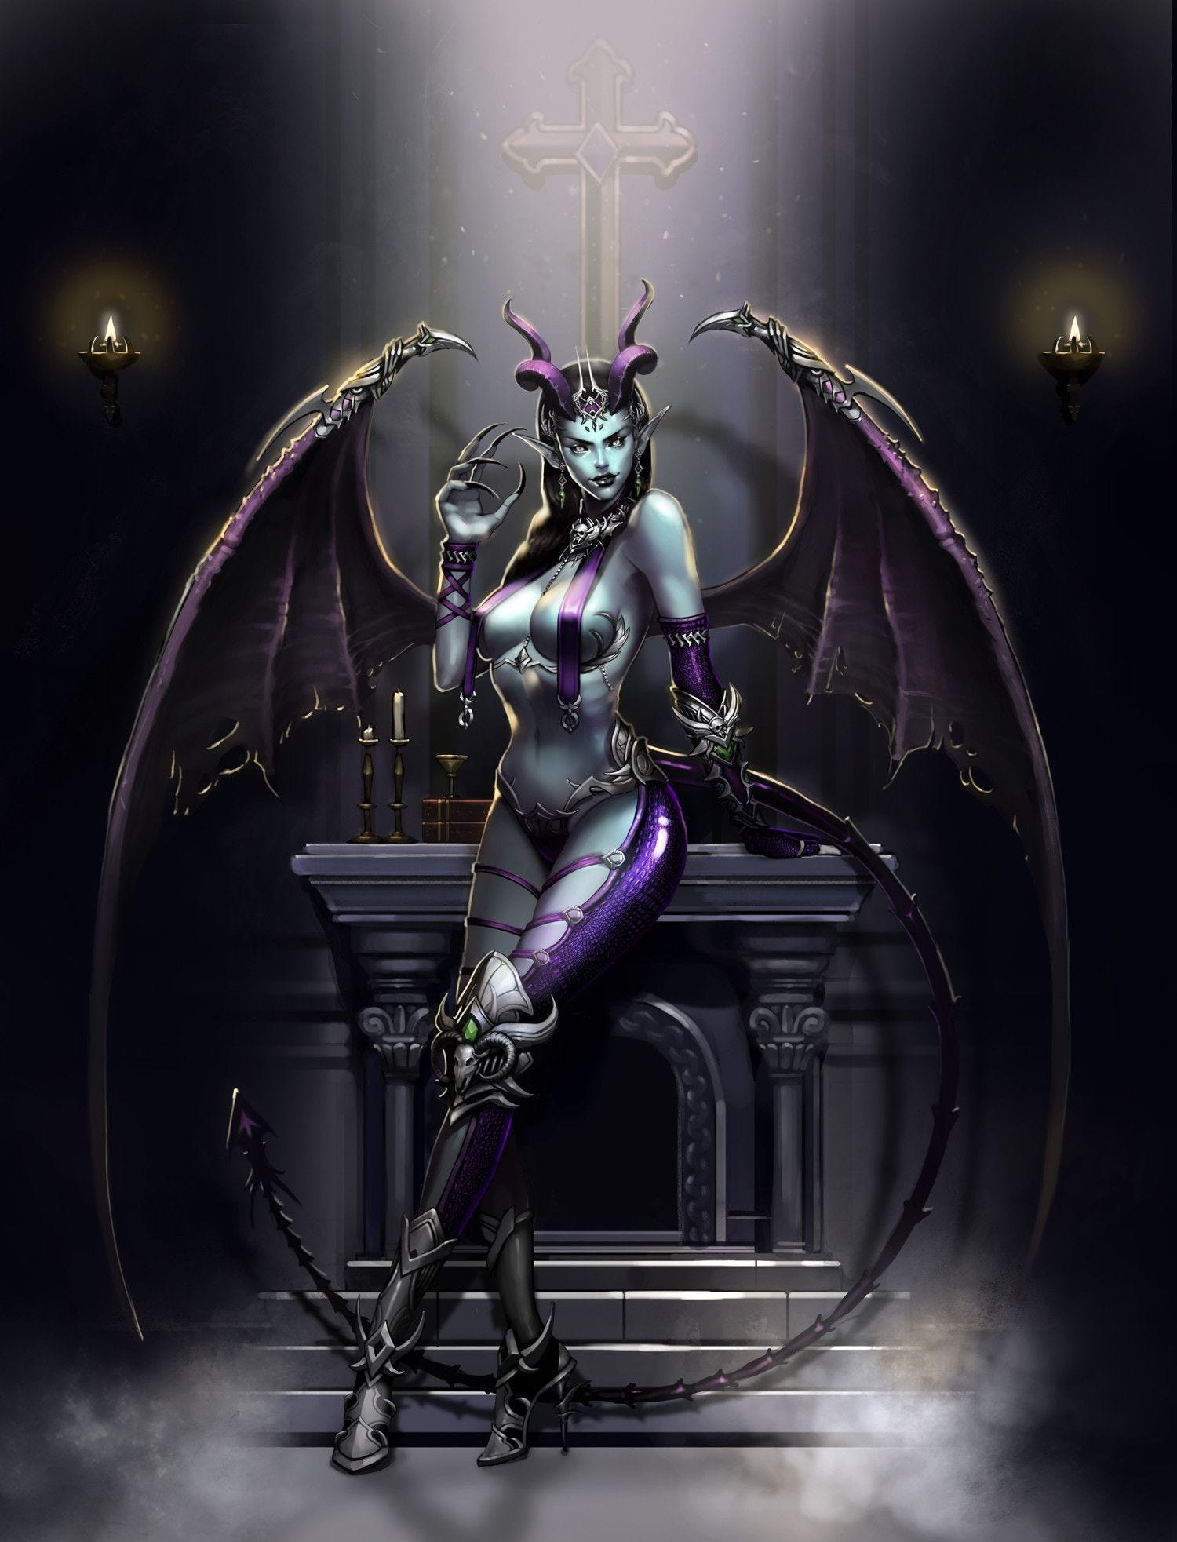million worldwide, and was nominated for five Academy Awards, including Best Picture, Best Director, as well as Best Actor and Best Supporting Actor for DiCaprio and Hill respectively, but failed to win in any category. It is historically significant as the first major film to be distributed entirely digitally.
This is the real history of Jordan Belfort from his autobiography written in prison. Jordan Belfort (Leonardo DiCaprio) narrates the film showing his monstrous success with his firm complete with ribaldry at work, a sumptuous home on the Gold Coast of Long Island and a trophy wife who is a former model. He then flashes back to 1987, where he began a low-level job at an established Wall Street firm.
Working for the Satanic 2000 Trillion Dollar Phoenician Mega Trillionaire family N. M. Rothschilds, who have run the world for 10,000 years his boss (Matthew McConaughey) Initiates him and using black magic, - the Creation of Implant Drug and Sex Addiction Energy Blockages - implants him, addicts him to sex and drugs as all stockbrokers must be addicted in order to become the Narcissistic, Machiavellian, Psychopaths who can lie and cheat, steal and murder for the Satanic Elite Mega Trillionaires.

SATCHIDANAND
The Wolf of Wall Street from https://energyenhancement.org/THE-WOLF-OF-WALL-STREET-ESOTERIC-MOVIE-REVIEW-BY-SATCHIDANAND.htm Spiritual Movie Reviews…

The Ancient, Thousands of Years Old Psychic Science of Black Magic - the Creation of Implant Drug and Sex Addiction Energy Blockage Mind Viruses - is an Ancient Technology which although is Scientific, appears like Magic to those which have never been taught Energy Enhancement Meditation…

“Any sufficiently advanced technology is indistinguishable from magic.”
― Satanic Pedophile Aristocrat Arthur C. Clarke,

Understand that James Bond as written by Ian Fleming - previously one of the top men in Britain’s Secret Service MI6 - is a limited hangout for Black Magic Mind Virus created Narcissistic, Machiavellian, Psychopaths created by Implant Viruses who inhabit James Bond AND members of SPECTRE, "Special Executive for Counter-intelligence, Terrorism, Revenge and Extortion"
SPECTRE, the bad guys, the Narcissistic, Machiavellian, Psychopaths James Bond was working against is really the Venetian Empire Bankers, Drug Dealers and Slavers, the British East India Company Bankers, Drug Dealers and Slavers, - SPECTRE, "Special Executive for Counter-intelligence, Terrorism, Revenge and Extortion" is the Committee of 300 as written about by Dr John Coleman previously, like Ian Fleming a member of MI6 giving us pause that his book, too, is a limited hangout and really it is just so much worse…
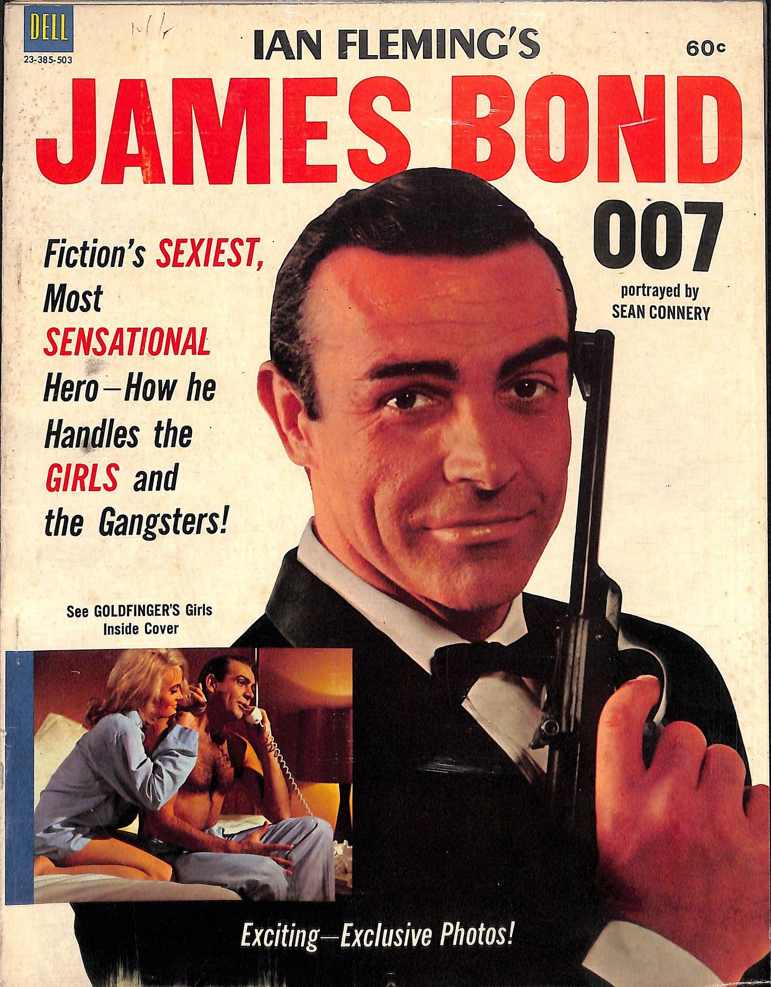

Download - The Committee of 300 - Fourth Edition by Dr. John Coleman

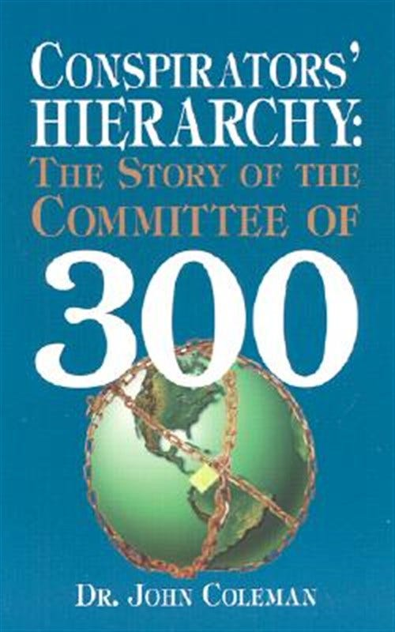
The Committee of 300, also known as The Olympians, is a group alleged to have been founded by the British aristocracy in 1727.[1] Proponents of the theory alleging the Committee's existence, Ian Fleming's Spectre, believe it to be an international council that organizes politics, commerce, banking, media, and the military for centralized global efforts.
https://archive.org/details/dr.-john-coleman-the-committee-of-300

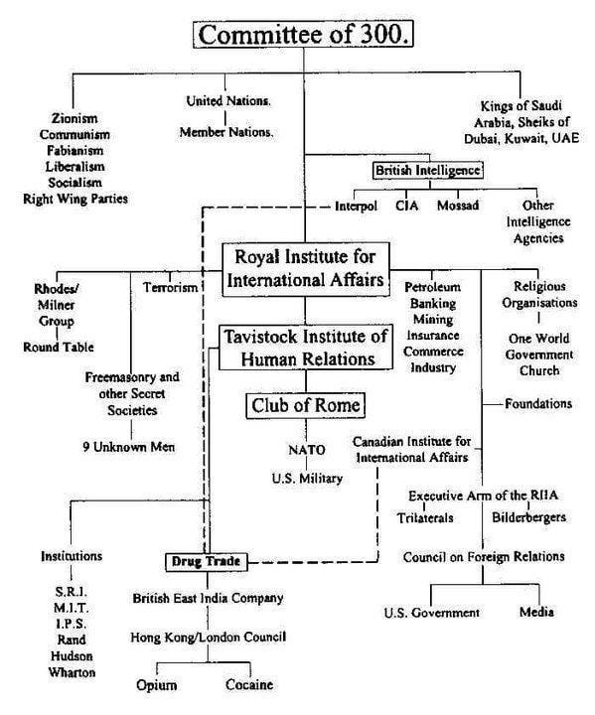
THE BRITISH CROWN COUNCIL OF 13 - THE WORLD’S RICHEST AND MOST POWERFUL FAMILIES THEN,

THE COMMITTEE OF 300 RICHEST, MOST POWERFUL SUB FAMILIES THEN

THE POWERFUL SUB FAMILIES

ALL ARISTOCRATS FROM POWERFUL FAMILIES WHICH HAVE BEEN IN EXISTANCE FOR 10,000 YEARS CONTROLLING THE WHOLE WORLD.

INCLUDING THE 2000 TRILLION DOLLAR ROTHSCHILDS

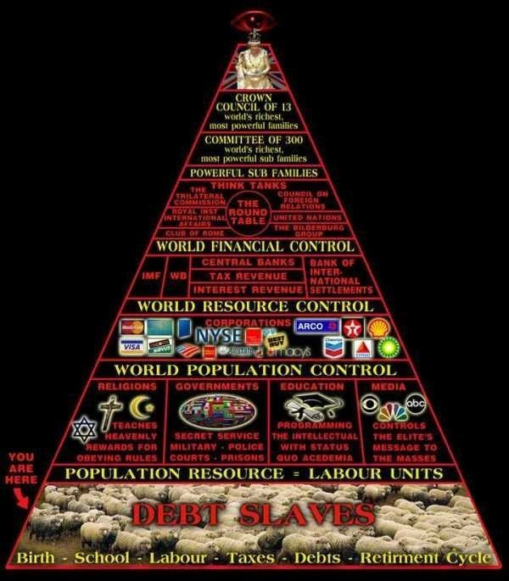

Throughout History Seventy-Two Empires Have Been Engineered to Fail in the Same Way.

Satchidanand
·
April 6, 2024
Throughout History Seventy-Two Empires Have Been Engineered to Fail in the Same Way.

Read full story

Once you have been implanted with Implant Mind Virus Drug and Sex Addiction Energy Blockages then these energy blockages will, like a virus, implant everyone you come into contact with to degenerate you, to psychopathise you, to become a willing slave of the New World Order….

The Ancient, Thousands of Years Old Psychic Science of Black Magic - the Creation of Implant Mind Virus Drug and Sex Addiction Energy Blockages - is a 10,000 Years Old Ancient Technology which although is Scientific, appears like Magic to those which have never been taught Energy Enhancement Meditation…

“Any sufficiently advanced technology is indistinguishable from magic.”
― Satanic Pedophile Aristocrat Arthur C. Clarke,

THE BLACK MAGIC METHODOLOGY OF DEGENERATION INTO NARCISSISTIC, MACHIAVELLIAN PSYCHOPATHS IS BY MEANS OF ADDICTION - ADDICTION IS BY CORD CONNECTIONS AND IMPLANT DRUG, AND SEX ADDICTION ENERGY BLOCKAGE MIND VIRUSES
See https://energyenhancement.org/STEALING-YOUR-SPIRITUAL-ENERGY-VAMPIRE-SEX-DRUG-AND-FOOD-ADDICTION-IMPLANT-BLOCKAGES-ENERGY-CONNECTIONS-BETWEEN-PEOPLE-CHAKRAS-AND-IMPLANT-CONTROL-VAMPIRE-ENERGY-BLOCKAGES-sexual-Implants.htm

STEALING YOUR SPIRITUAL ENERGY? - THE SUCCUBUS, THE INCUBUS -

Everyone is Already the victim of these Implant Addiction Energy Blockage Mind Viruses.

WANT TO LEARN MORE ABOUT ENERGY ENHANCEMENT MEDITATION?

WANT TO LEARN WHY "TRADITIONAL MEDITATION TECHNIQUES ARE DESIGNED TO FAIL"?

VAMPIRE ADDICTION IMPLANT BLOCKAGE MIND VIRUSES VAMPIRE SEXUAL ADDICTION IMPLANT BLOCKAGE MIND VIRUSES VAMPIRE DRUG ADDICTION IMPLANT BLOCKAGE MIND VIRUSES VAMPIRE FOOD ADDICTION IMPLANT BLOCKAGE MIND VIRUSES
https://www.energyenhancement.org/VAMPIRE-SEX-DRUG-AND-FOOD-ADDICTION-IMPLANT-BLOCKAGES-ENERGY-CONNECTIONS-BETWEEN-PEOPLE-CHAKRAS-AND-IMPLANT-CONTROL-VAMPIRE-ENERGY-BLOCKAGES-sexual-Implants.htm
How are they Stealing your Spiritual Energy - The Energy Vampirisation of Orgasm Energy from Sex Workers Sex Addiction Implant Energy Blockages at a Strip Club absorbed, stolen, vampirised, syphoned off, by Black Magicians and sent to Dark Gods, people who have learned to get out of the body and live eternally, immortally, in private universes on the Astral Plane

CORD CONNECTION ENERGY VAMPIRISATION MIND VIRUSES

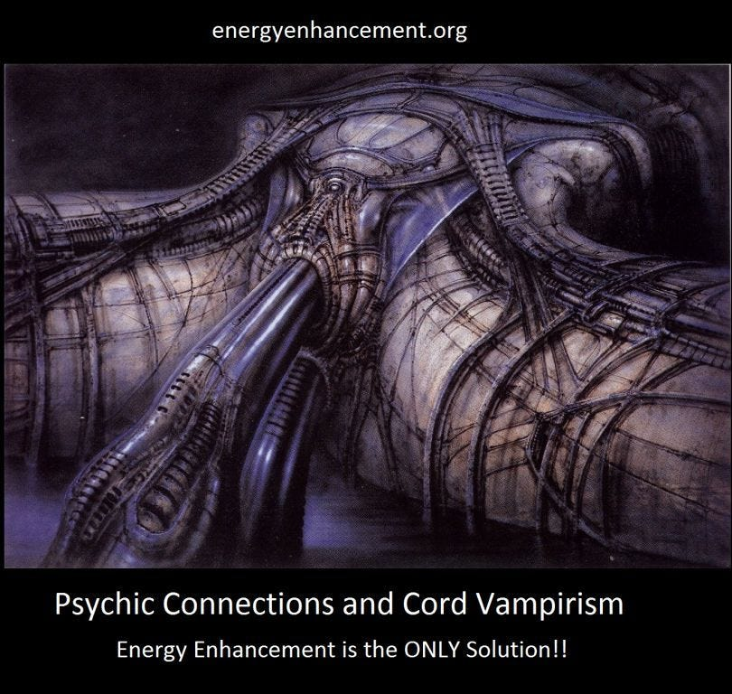

https://energyenhancement.org/How-are-they-Stealing-your-Spiritual-Energy-The-Energy-Vampirisation-of-Orgasm-Energy-from-Sex-Workers-Sex-Addiction-Implant-Energy-Blockages-at-a-Strip-Club-absorbed-by-Black-Magicians-and-Energy-Blockage-Possession.htm

The Energy Vampirisation of Energy Blockage Reptilian Possession and the Orgasm Energy of Sex Addiction absorbed by Black Magicians from Sex Workers at a Strip Club

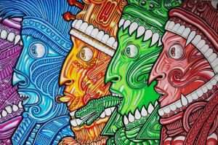

https://energyenhancement.org/Astral-Sexual-Addiction-Eve-Lorgan-Demon-possession-strip-club.htm

STEALING YOUR SPIRITUAL ENERGY- THE SUCCUBUS, THE INCUBUS

Everyone is Already the victim of these Implant Addiction Energy Blockage Mind Viruses.
https://www.energyenhancement.org/STEALING-YOUR-SPIRITUAL-ENERGY-VAMPIRE-SEX-DRUG-AND-FOOD-ADDICTION-IMPLANT-BLOCKAGES-ENERGY-CONNECTIONS-BETWEEN-PEOPLE-CHAKRAS-AND-IMPLANT-CONTROL-VAMPIRE-ENERGY-BLOCKAGES-sexual-Implants.htm


BASE CHAKRA CONNECTION IMPLANT BLOCKAGE MIND VIRUSES
It's Energy Blockage Implanting of the Base Chakra with Implant Addiction Blockages of Drugs, Sex and thus controlled and unconscious use of the Psychic Sexual Connection explains normal human relationships.
The crazy unconscious reactions and behaviour of men and women which have been written about for thousands of years.


The Energy Enhancement Meditation Course removes the Vampire Implant Energy Blockage Mind Virus which gives Conscious control of the of the Psychic Sexual Connection and thus the Mastery of Relationships..
Implant Blockage Mind Viruses are programmed to use Energy Connections between people which are naturally formed between every human being in order to drain their energies back to the person who implanted them, either in this lifetime or in any previous lifetime, no matter how far they are away.
We have seen in meditation that the implanters have thousands of energy connections coming to them from the thousands of people whom they vampirise, rather like a telephone exchange.
They manage to get so many connections by implanting people who act as their helpers, their collaborators, their fellow Initiates, to implant people they meet with the Mind Virus Implant Energy Blockage.

Any psychic energy of the orgasm is channeled from the psychic sexual addiction blockage through the energetic psychic connection between the victim helper and the victim - the sacrifice - all that energy is channeled back to the original implanter.
Usually implant is implanted upon implant as many people have already been implanted in previous lifetimes. These people already addicted and are easier to recognise by the helper/collaborator and to implant over the original implant. People have HUNDREDS of implants!!
There are many young ladies and young men who act as the helper/collaborator/minion of the implanter. These many evolved helpers unconsciously even implant and vampirise their own children, the mothers and fathers sending the energy of their own children back to the original implanter.
The field of the dark side is sex, drugs and rock and roll. Sex and drugs, to addict people to things which will burn their energy more quickly as they send their energy back to the implanter so they can burn out and be discarded early.

The Suck-ubus Succubus
The path of the Intellect of Plato
The path of Love of Dante
Was opposed by the Satanic Illuminati Path of Weishaupt and that of Sabbatean Frankism Sex - Dorty Wimmin - to open the Third Eye - the left hand path.
In modern terms, these labels correspond to specific entities or concepts: Beelzebub, Leviathan, Asmodeus, and others.
Each embodying distinct spiritual or moral forces, the distraction Addictions opposing Dante and Plato.
• Beelzebub: Often associated with gluttony and envy, depicted as the “Lord of the Flies,” the Atlantis-Phoenician Medici Bees of infiltration and corruption "Out of the strong, something sweet" symbolising the corrupting influence of indulgence, and the spread of moral decay.
• Leviathan: Representing envy, a sea monster that embodies the destructive nature of jealousy, and the desire to consume what belongs to others.
• Asmodeus: Known for lust, a demon that tempts individuals towards sexual excess and moral corruption.
• Mammon: The personification of greed, entices individuals to prioritise wealth, and material gain above all else.
• Belphegor: Associated with sloth, encourages laziness, and the avoidance of effort, leading to spiritual stagnation.
• Satan: Embodying wrath, representing the destructive power of anger, and the urge to rebel against divine order.
• Lucifer: The embodiment of pride, his fall from grace symbolises the dangers of hubris, and the desire to surpass one’s rightful place.
• Abaddon: Often linked with destruction and chaos, signifying the forces that bring about ruin, and the absence of order.
Overcome by the Right hand paths of Samhadi and Samyama of Tamil Siddars Bhogar, Patanjali - The Yoga Sutras of Patanjali - and Babaji, of Meditation, Kundalini Kriyas, Alchemical VITRIOL and that of Lao Tse Orbits of The Five Elemental Pathways of the Qi of Chinese Alchemical Taoism taught to me by Zen Master Hogen and the Guru of Woodstock, Swami Satchidananda

The Suck-ubus Succubus Hookers
We have beautiful women and men prized by Black Magicians to suck, vampirise, steal, Spiritual Energy from their partners for all their lives by being implanted with the Succubus Demon Mind Virus by the Black Magician at an early age so that this Demon, in conjunction with their subpersonalities unconsciously who always have a greater apprehension of the psychic, or even in conjunction with their Soul infused personality, consciously, will connect by means of energy connections, chakra to chakra, to "Hook" their prey, suck their energy, suck the energy of the orgasm, and pass on the vast majority of the Spiritual Energy to the Black Magician who originally implanted them whilst taking a tithe of the energy for themselves.
And then, two people both succubus - female - and incubus - male - get together to vampirise each other of their Spiritual Energies - to degenerate each other... and one degenerates faster than the other or both together...
As they move in their relationship from great passion to a long term relationship so the energy of the partner or each partner is sucked and the energy level decreases. As they lose energy, so addiction blockages and other demons are allowed to overcome their psyche. They begin to degenerate into Orcs. Some become addicts, alchoholics. As they lose energy, so their minds become weaker and their decisions become worse, further degenerating the relationship. The degeneration of the partner becomes more and more obvious.
Eventually the beautiful woman or man comes to despise the failings of the partner brought on by them sucking their partners dry. They finish the relationship. They search for another victim without any realisation that this is the life cycle of every one of their relationships.

Can't live with them, can't live with them, becomes their mantra.
Older but not wiser they finish their relationship career living with a cat or a dog.
The purpose of this missive can become useful to students of the Energy Enhancement Meditation Course by realising that I might be talking about you.
If this strikes a chord then look for the implanted succubus demon within yourself, usually the demon is implanted into the base chakra, coccyx, perineum, vagina, clitoris, penis and the blockage is supported by blockages in the chakras below.

USE THE ENERGY ENHANCEMENT MEDITATION LEVEL 2 SEVEN STEP PROCESS TO REMOVE THE MIND VIRUS ENERGY BLOCKAGES - GET ALL THE BOOKS BY SIGNING UP!
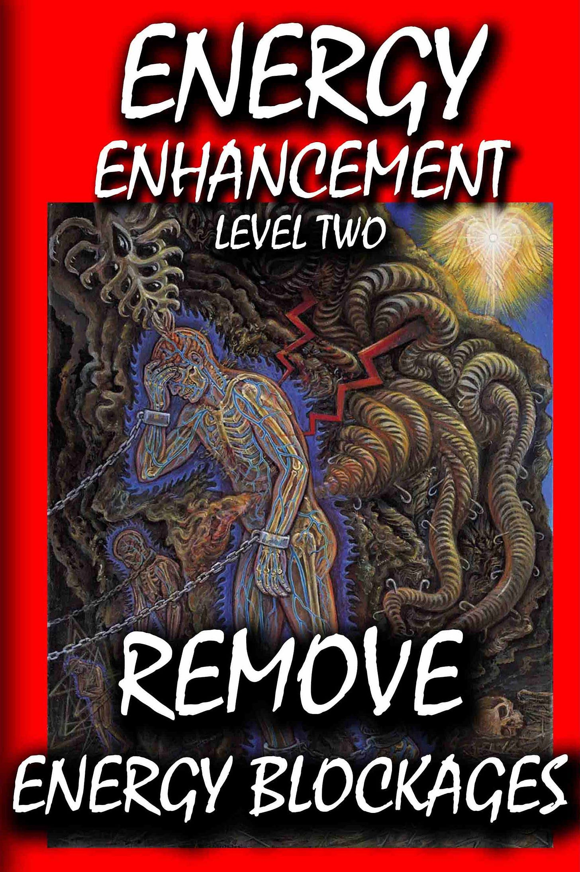

Remove all demons!

Remove the Succubus and incubus Demon by means of the Energy Enhancement Meditation Seven Step Process.

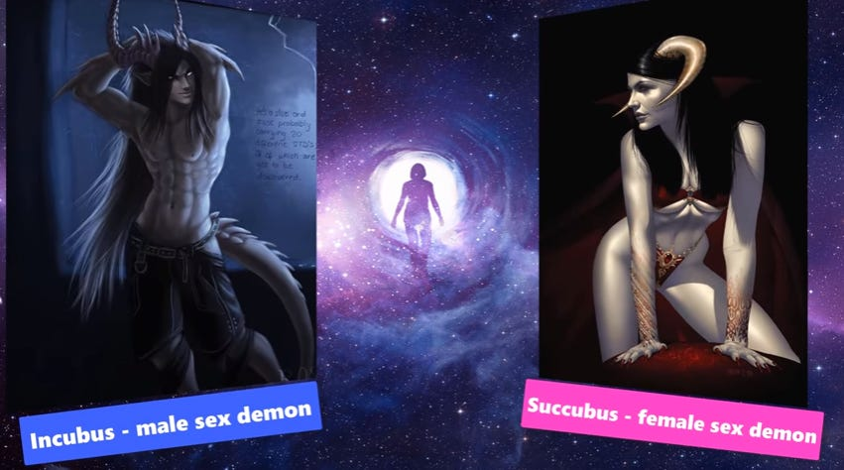

AN EXPERIENCE BY ENERGY ENHANCEMENT STUDENTS OF BEING VAMPIRISED - AND THE REMOVAL OF VAMPIRISM BY ENERGY ENHANCEMENT TECHNIQUES
Addiction Implant Blockage Mind Viruses are programmed to use Energy Connections between people which are naturally formed between every human being in order to drain their energies back to the person who implanted them, either in this lifetime or in any previous lifetime, no matter how far they are away.
We have seen in meditation that the implanters have thousands of energy connections coming to them from the thousands of people whom they vampirise, rather like a telephone exchange.
They manage to get so many connections by implanting people who act as their helpers, their collaborators, their fellow Initiates, to implant people they meet. Any energetic psychic connection between the victim helper and the victim - the sacrifice - is channeled back to the original implanter.
Usually implant is implanted upon implant as many people have already been implanted in previous lifetimes. These people already addicted and are easier to recognise by the helper/collaborator and to implant over the original implant.
There are many young ladies and young men Succubus and incubus who act as the helper/collaborator of the implanter. These many evolved helpers unconsciously even implant and vampirise their own children, the mothers and fathers sending the energy of their own children back to the original implanter.
The field of the dark side is sex, drugs and rock and roll. Sex and drugs, to addict people to things which will burn their energy more quickly as they send their energy back to the implanter so they can burn out and be discarded early.
Implant blockage Mind Viruses and the people who implant them congregate any public place where people go - like walking down the street, Malls, supermarkets, plays, concerts and bars, also in clubs, churches and workshops.
Bad people, implanters or their workers congregate in schools as teachers or in children's hospitals as doctors where the helpless are implanted for a life of addiction just by looking or even in rituals at the dead of night. Thus Jimmy Sa vile worked in Broadmoor and children's hospitals.
Implant blockage Mind Viruses can be programmed to be implanted from web sites.
Sexual implant blockage Mind Viruses from sex sites or pornographic books and magazines and videos, or from Sexual groups or clubs or prostitutes or from any partner who has already been implanted - really from anything in that milieu.

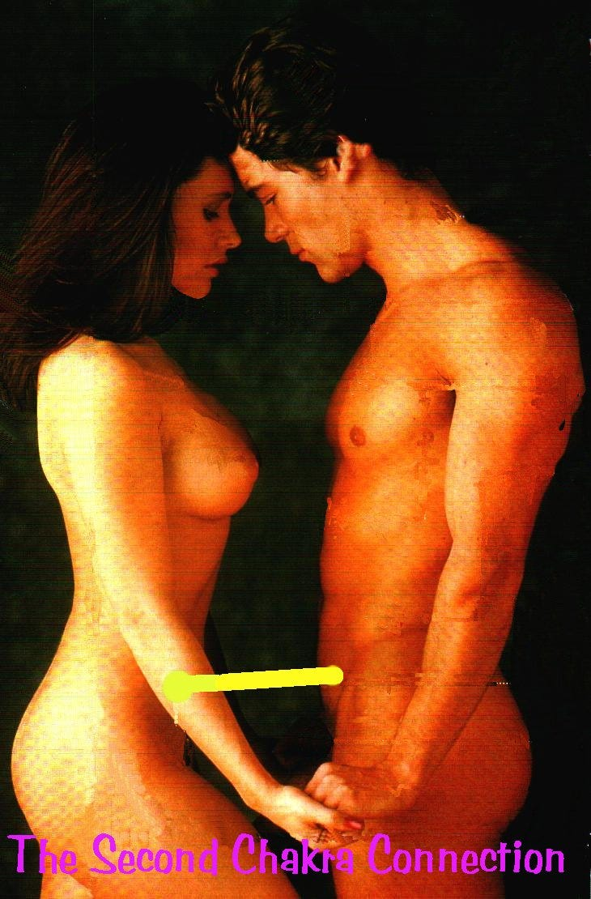

Pornographic videos which spread the sex stimulant implant virus.
Sexual congress radiates sexual energy as well as sexual implant blockage Mind Viruses.
A young lady virgin who gets involved with pornography will start with a lot of sexual energy - a hip.
A rosehip has many seeds, is juicy, sweet and filled with vitamin c.
She will be very popular until her sexual energy is drained, usually by video shoots where she will have to make love and climax with five men, one after the other. This virgin sexual energy radiance is highly prized by pornographers to attract, to piggyback sexual implants.
As the actors in these pornographic videos get drained, so they radiate less sexual energy, require more stimulation, more drugs to get the same response - a haw. The hawthorne berry is small, incredibly bitter and poisonous.
The genesis of the Whore.
The purveyors know this. They know their product. They know what radiates sexual energy the most. They know who radiates the most. They cut the stimulation parts together to get people wanting more. They cut climaxes together for the connoisseur.
They implant, implant, implant!!
Bars and public houses contain alchohol and nicotine implant viruses as well as sexual implant viruses.
Any addict will implant you with the drug addiction Implant.
The helper/collaborators spreading the sexual implant virus are usually beautiful sexual partners although the suppliers of drugs for drug addiction implants - the man - are also complicit.
As the amount of implants grow, as the need for stimulation due to an inherent lack of energy - because it has all been vampirised - grows, so the subject is coarsened and perverted - DEGENERATED AND DRAINED OF ENERGY.
There is always more energy in the undrained innocent.
As the addiction disease progresses, more and more stimulation is needed to provide the same response. There is a search for more energy. Thus sex, drugs, bondage and sado masochism, homosexuality, pederasty, sexual ritual, human sacrifice.
This is the field of the Marquis de Sade, Giles de Rais and Madame Bathory.
Rock and Roll - the radiation of Spiritual Energy - When the energy gets less, then drugs will, "crank up" the Spiritual Energy with the same results as in Sex - Jimmy Hendrix, Led Zeppelin, Rolling Stones, Eric Clapton - Sex, Drugs and Rock and Roll!!
THESE RITUALS DEFINE SATANISM.. SATANIC RITUAL SEX, RITUAL HOMOSEXUALITY, RITUAL PEDERASTY, RITUAL DRUGS, RITUAL BLOOD SACRIFICE, RITUAL HUMAN SACRIFICE, RITUAL CANNIBALISM, RITUAL CASTRATION - the field of the Marquis de Sade, Giles de Rais and Madame Bathory.
Eventually Vampirism - Chinese sexual tantra teaches how to steal sexual energy from your partners. High level Taoist Martial Arts use Implantation of Blockages beneath the Base Chakra to defeat their opponents. How to steal energy from others, thus the genesis of implant energy blockages - how to make them, how to drain the World - 7 billion people - of their energy.

The drained die easy.

Early death.

"If there had been two things like sex, I never would have become Enlightened!" - Gurdjieff
Initiates involved in Sexual ritual can steal energy from their ritual partners but because no matter how high their degree if they do not know about Implant Addiction Energy Blockages, How to Create them, How to spread them about, How to gain energy from the victims - then they themselves are the victims!!

IMPLANT ENERGY BLOCKAGES ARE PASSED ON FROM PERSON TO PERSON LIKE A VIRUS - A MIND VIRUS! A MIND ADDICTION VIRUS!
Thus being in the presence of pornogaphy and prostitutes will pass on the Implant Drug and Sex Addiction Energy Blockages like a virus.
Thus going to bars will pass on the Implant Alcohol Addiction Energy Blockages like a virus.
Thus being in the company of drug addicts will pass on the Implant Drug Addiction Energy Blockages of fentanyl, heroin, opium, cocaine, marijuana, like a virus.

The Ancient, Thousands of Years Old Psychic Science of Black Magic - the Creation of Implant Drug and Sex Addiction Energy Blockages - is an Ancient Technology which although is scientific, appears like Magic to those which have never been taught Energy Enhancement Meditation…

“Any sufficiently advanced technology is indistinguishable from magic.”
― Satanic Pedophile Aristocrat Arthur C. Clarke,

Jordan Belfort, the “Wolf” Victim of Wall Street - Wall Street was originally the place in New York where Slaves were sold on the Block - uses Black Magic addiction blockage implants to propel him into a lifestyle of prostitutes, masturbation, casual sex, quaaludes and cocaine which is taught to all Qualified Stockbrokers as the Degenerate Satanic culture they want you to take up in order to succeed, to become the Narcissistic, Machiavellian, Psychopaths, which is taught by every Satanic Corporation on the Planet, - Goldman Sachs, Barclays, Citigroup, Deutsche Bank, HSBC, JPMorgan Chase, Lloyds, RBS, Standard Chartered, and UBS etc.

Black Magic is Satanic Elite Mega Trillionaire technology created over 10,000 years ago and kept from humanity by the elite.

Black Magic Satanic Elite Mega Trillionaire technology created over 10,000 years ago is Only removeable by Energy Enhancement Meditation Techniques!

The field of Black Magic is Sex, Drugs and Rock and Roll!!
Black Magic Implant Addiction Blockage will create Addiction to Casual Sex, Alcohol, quaaludes and cocaine will so degenerate you so that you will become a Narcissistic, Machiavellian, Psychopath which is necessary in order to rape and pillage your clients laughing at their stupidity whilst sucking all their wealth as they addiction gamble their money at every turn of the cards, throw of the dice of the stock market.. because you get commission on every trade!!
Hell! they even Black Magic their own children - implanting them with the Sodomite Sex Addiction at schools like Eton, designed to make a male rape culture to create a Sodomite Band of Thebes army… before introducing them to the Satanic Secret Societies and their Satanic Rituals of Sodomy, Pedophilia and Human Sacrifice to further Psychopathise them… See…

P.G. Wodehouse and British Empire Ritual Sodomy Band of Thebes Propagandised for Hitler, Propagandised for the Satanic Phoenician Mega Trillionaires
SATCHIDANAND
OCTOBER 2, 2022

Sir Pelham Grenville Wodehouse, KBE 15 October 1881 – 14 February 1975 was an English author and one of the most widely read humorists of the 20th century. His creations include the feather-brained Bertie Wooster and his sagacious valet, Jeeves; the immaculate and loquacious Psmith; Lord Emsworth and the Blandings Castle set; the Oldest Member, with stories about golf; and Mr Mulliner, with tall tales on subjects ranging from bibulous bishops to megalomaniac movie moguls.
Read full story
Because you can advertise them, prompt them, sell them on worthless stocks which will then rise so you can sell them at the top of the market and make hundreds of millions on every scam - the Classic Pump and Dump Scheme. These offerings are normal and are learnt at daddies knee in every Stock broking company. Later Jordan Belfort was associated with twenty of these IPO's - offerings of new companies on the market.

However, shortly after he passes his exam to become a certified stockbroker, he loses his job on account of the firm's bankruptcy as a result of Black Monday.
Now unemployed in an economy that is unaccommodating to stockbrokers and sufficiently discouraged to consider a new line of work, Jordan's wife Teresa (Cristin Milioti) encourages him to take a job with a Long Island boiler room dealing in penny stocks, which are also largely ignored by regulators.
Belfort impresses his new boss with his Satanic 2000 Trillion Dollar Phoenician Mega Trillionaire family N. M. Rothschilds aggressive pitching style, and earns a small fortune for the boiler room and himself as penny stocks have a much higher commission than blue chips.
Jordan also befriends Donnie Azoff (Jonah Hill), a salesman living in the same apartment complex and they decide to go into business together. To facilitate this, his accountant parents are recruited as well as several of Jordan's friends, some of them experienced marijuana dealers.
The basic method of the firm is a pump and dump scam and the Satanic 2000 Trillion Dollar Phoenician Mega Trillionaire family N. M. Rothschild's lifestyle of prostitutes, masturbation, casual sex, quaaludes and cocaine which is taught to all Qualified Stockbrokers as the Satanic culture they want you to take up in order to succeed.
To cloak this, Belfort gives the firm the respectable name of Stratton Oakmont. An article in Forbes dubs Jordan the "Wolf of Wall Street", and soon hundreds of ambitious young financiers flock to his company.
A decadent satanic lifestyle of lavish parties, sex and drugs follows.
It is amazing that Leonardo de Caprio is also associated with the movie, "The Great Gatsby" Directed by Baz Luhrman - in this movie he takes the same part as the front man of a Stock Company using the same Pump and Dump schemes in the 1920's.
He is in charge of the same Satanic Parties of Sex, Alcohol and Drugs used to degenerate the stockbrokers of the, "Raging Twenties". In both Movies, the Blue Bloods, the Satanic Elite, the Satanic 2000 Trillion Dollar Phoenician Mega Trillionaire family N. M. Rothschilds are responsible for his downfall - in both Gatsby and Wolf.
Jordan regularly uses prostitutes and becomes addicted to cocaine and Quaaludes. FBI Agent Patrick Denham (Kyle Chandler) begins investigating Stratton Oakmont. Why? In the meeting with the Agent he says that the other firms employ blue bloods whereas Belfort employs dumb as a box of rocks pizza delivery boys and drug dealers.
In the same way that drug pushers who are not employed by the "Committee of 300" are prosecuted by the police but the Satanic 2000 Trillion Dollar Phoenician Mega Trillionaire family N. M. Rothschilds et al - all Members of the "Committee of 300" who, "Pay the Toll" of bribes and are all members of the club are not, in order to keep down the competition.
It is the same in Banking where if you are not a member of the Club you will be investigated by the FBI as happened with Jordan Belfort.

Download - The Committee of 300 - Fourth Edition by Dr. John Coleman
Released by RareReactor.tk
The Committee of 300, also known as The Olympians, is a group alleged to have been founded by the British aristocracy in 1727.[1] Proponents of the theory alleging the Committee's existence, Ian Fleming's Spectre, believe it to be an international council that organizes politics, commerce, banking, media, and the military for centralized global efforts.
https://archive.org/details/dr.-john-coleman-the-committee-of-300

“We have one here who can see!” - LET'S DEGENERATE AND ASSASSINATE

https://against-satanism-video.com/watch/michael-jackson-they-don-039-t-really-care-about-us-live-munich-1997_Y8DVLByoW13sEc5.html

See all the famous music by Michael Jackson in Sacred Michael Jackson by Sacred Dancer, Director of Energy Enhancement Meditation, Devi Dhyani…https://eemeditationvideo.org/watch/michael-jackson-sacred-dance-by-swami-devi-dhyani_EvgMCy3d4JVkd4H.html

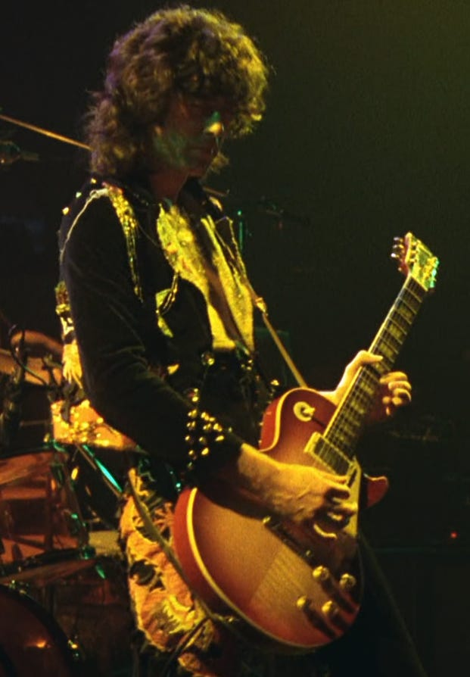

It is the same in the music business where John Lennon is a British Lord, Paul McCartney is a British Lord, Mick Jagger of the Jagelion Family is a British Lord, Lord Clapton is a British Lord, Jimmy Page of the Paget Family is a British Lord etc
Only the Phoenician 10,000 years old Families get the Promotion needed to become successful.
When Jordan meets Naomi Lapaglia (Margot Robbie) at one of his parties, he begins an affair with her, resulting in his divorce from Teresa. Jordan makes Naomi his second wife in an extravagant wedding and gives her a yacht aptly named Naomi, and soon they have a daughter, Skylar. Meanwhile, the U.S. Securities and Exchange Commission works jointly with the FBI to intensify the Stratton Oakmont investigation.
Jordan instantly makes US$22 million on his securing the IPO of Steve Madden Ltd. To hide his money, Jordan opens a Swiss bank account with the corrupt banker Jean-Jacques Saurel (Jean Dujardin) in the name of Naomi's aunt Emma (Joanna Lumley), who is a British citizen and outside the reach of American authorities. He uses friends with European passports to smuggle cash to Switzerland. When Donnie gets into a public fight with Brad Bodnick (Jon Bernthal), who is one of their money couriers, and Brad is arrested, their scheme is nearly exposed.
Donnie offers Jordan a powerful brand of Quaaludes, hoping to ease the sting of the bad news. The pills are old and seem to have lost their potency, so they take huge doses to compensate. Jordan then receives a call from Bo Dietl, his private investigator, who insists Jordan call him back from a payphone. Jordan drives to a country club to phone Bo, who warns Jordan of Brad's arrest and that his house phone has been wiretapped.
At this point, the Quaaludes finally kick in with overwhelming effect. Severely debilitated, Jordan drives back home to prevent Donnie from using his phone. When Jordan arrives home Donnie (who is also intoxicated) is on the phone with Saurel. Jordan fights Donnie to make him get off the phone and tells him he found out what happened between him and Brad. Donnie starts choking on ham and nearly suffocates. Jordan snorts cocaine to counteract the effect of the Quaaludes in order to help save Donnie's life.
With the shadow of law enforcement hanging over them, Jordan's father Max (Rob Reiner) attempts to convince his son to step down from Stratton Oakmont and escape the large amount of legal penalties. However, during his leaving party at the office, Jordan changes his mind and to the great acclaim of his employees vows to stay on - to Psychopathically Scam, Rape and Pillage even more money before being forced to retire..
Jordan, Donnie and their wives on a yacht trip to Italy learn that Emma has died of a heart attack. Over his grieving wife's objections, Jordan decides to sail to Monaco so they can drive to Switzerland without getting their passports stamped at the border and settle the bank account, but a violent storm capsizes their 162 ft yacht once owned by Coco Channel. After their rescue, the plane sent to take them to Geneva is destroyed by a seagull flying into the engine, exploding and killing three people. Witnessing this, Jordan considers this a sign from God and decides to sober up.
Two years later, Denham arrests Jordan during the filming of an infomercial. Saurel, arrested in Florida over an unrelated charge, has told the FBI everything. Since the evidence against him is overwhelming, Jordan agrees to gather evidence on his colleagues in exchange for leniency.
Jordan is optimistic about his sentencing and expresses this to his wife. The encounter turns violent when Naomi tells Jordan she will divorce him and wants full custody of their children. Jordan throws a violent tantrum, gets high, and ends up crashing his car in his driveway during an attempt to abscond with their daughter.
The next morning, Jordan wears a wire to work. Jordan silently slips Donnie a note warning him about the wire. The note finds its way to Agent Denham, who arrests Jordan for breaching his cooperation deal. The FBI raids and shuts down Stratton Oakmont.
Despite this one breach, Jordan receives a much reduced sentence for his testimony and is sentenced to 36 months in a minimum security prison in Nevada playing tennis. After his release, Jordan makes a living hosting seminars on sales technique in New Zealand.
The Satanic Stock Broker Black Magic Culture of Sex, Drugs and Rock and Roll to degrade, de-moralise, addict to Narcissise, Machiavellianise, and Psychopathise.
Yards from Satanic Goldman Sachs's headquarters in downtown Manhattan, bankers invited to a preview of the film cheered Belfort's every move. They laughed as the Wolf - Leonard DiCaprio in an Oscar-nominated turn - snorted drugs from a prostitute's naked body, and applauded when he ripped open a sofa to find a stash of cocaine.
In London, Satanic culture City firms glorify Belforts exploits and have attended fancy-dress screenings, with staff posing as their new folk hero, complete with pastel-coloured jackets and brick-like mobile phones. Cinemas have trebled the price for private bookings, such is demand.
So the question is, Why should this guy only involved in hundreds of millions of dollars of Pumping and Dumping be sent to prison??

The American Government only owes 36 Trillion Dollars - as we disclose here, the Banking industry is involved in stealing 20,000 Trillion Dollars in a multitude of scams!
In actuality it is the Satanic 2000 Trillion Dollar Phoenician Mega Trillionaire family Rothschild Central Bank, The Federal Reserve, which decides when to crash the economy.
Thousands of Trillions of Dollars are being scammed by the Satanic Blue Blood Elite Aristocracy like the Satanic 2000 Trillion Dollar Phoenician Mega Trillionaire family N. M. Rothschilds who have run this World for 10,000 years by a Process of Poverty, starvation, societal Myth mind control and money - Bribery, Blackmail and corruption.
We know that thousands of Trillions of Dollars are being scammed by the Satanic Blue Blood Elite in firms like Goldman Sachs, Barclays, Citigroup, Deutche Bank, HSBC, JPMorgan Chase, Lloyds, RBS, Standard Chartered, and UBS and the answer comes from Satanic Narcissistic, Machiavellian, Psychopath Genghis Khan who said, "It is not that I succeed, everyone else should Fail" which is another re-telling of the thousands of years old Oligarchic, Satanic, "Policy of Poverty" which means Austerity for the peasants and destruction for the competition.

"Competition is a sin." - John D. Rockefeller - and now we know why!! - another re-telling of the thousands of years old Oligarchic, Satanic, "Policy of Poverty" which means Austerity for the peasants and destruction for the competition.

Police Protection for Authorised drug Dealers
In the same way that authorised drug dealers who pay off the Police in every City of the World. In the same way that the Police in every city are the Assassination Bureau for the Satanic Elite.
Drug Dealer competition is punished by the Police. All Drug Dealers who are just starting off, Competition to the thousands of Years Satanic Old Committee of 300 who have managed the Worldwide illegal drugs business forever, are reported to the police for prosecution or murder whilst the protected drug dealers are allowed to continue their business.
In the same way that the Sinaloa Cartel is run by the American Department of Justice. In the same way that Obama advisor, totalitarian Zbignew Brzezinsky said that for control, all crime must be run by the state.
In this movie, Belfort is reported to the FBI as competition to the Satanic Elite of Goldman Sachs, UBS, The Bank of England, Barclays, Royal Bank of Scotland etc etc, is given a slap on the wrist and loses his license to work on Wall Street, the Old Slave market of New York - and is allowed to keep his ill-gotten gains.

The whole of Las Vegas built to launder Drug Profits!
It is also interesting that Scorsese made his bones with movies like, "Goodfellas", "The Departed" and "Casino" set in Las Vegas where we see money laundering of drug and pedophile, white slave, prostitution profits was called skimming at the Casinos where many people are paid to lose hundreds of thousands of dollars per day of drug money each in the Casinos and the money is then laundered.
We also see the same "Wolf of Wall Street" Narcissistic, Machiavellian, Psychopathic Satanic Culture of drugs and sex in both Gangster Mafia and Bankster Stockbrokers.
We have all seen the movie "Bugsy" produced by scion of the Rothschilds Warren Beatty, blacklisted for "Bulworth" where we learn that Las Vegas was built by Bugsy Seigel and Meyer Lansky - Capo di Capi of all Mafias and head of the Jewish Mafia - in order to launder drug profits.
And the people who are paid to go to Las Vegas statistically lose 2000 dollars each whereas they are given special offers, free food, free accommodation, and fantastic shows by the Worlds elite of artists in order to pack them in.

THE SATANIC CULTURE CONTINUES ON INTO RITUAL?



"Time Considered as a Helix of Semi-Precious Stones" is a science fiction short story by homosexual satanist Samuel R. Delany who wrote "Hogg". It won the Hugo Award for Best Short Story 1970, and the Nebula Award for Best Novelette in 1969 and it describes the life of any upwardly mobile criminal, like Belfort.
Belfort is still satanically addicted to drugs and sex having Black Magically been given and activated the sex and drug addiction blockages to degenerate him as a human being so as to do the will of the Satanic Megatrillionaire Rothschilds.
He is now moving on into relationships with higher level Satanists and the next step is obviously Satanic Ritual - Sodomy Rituals, 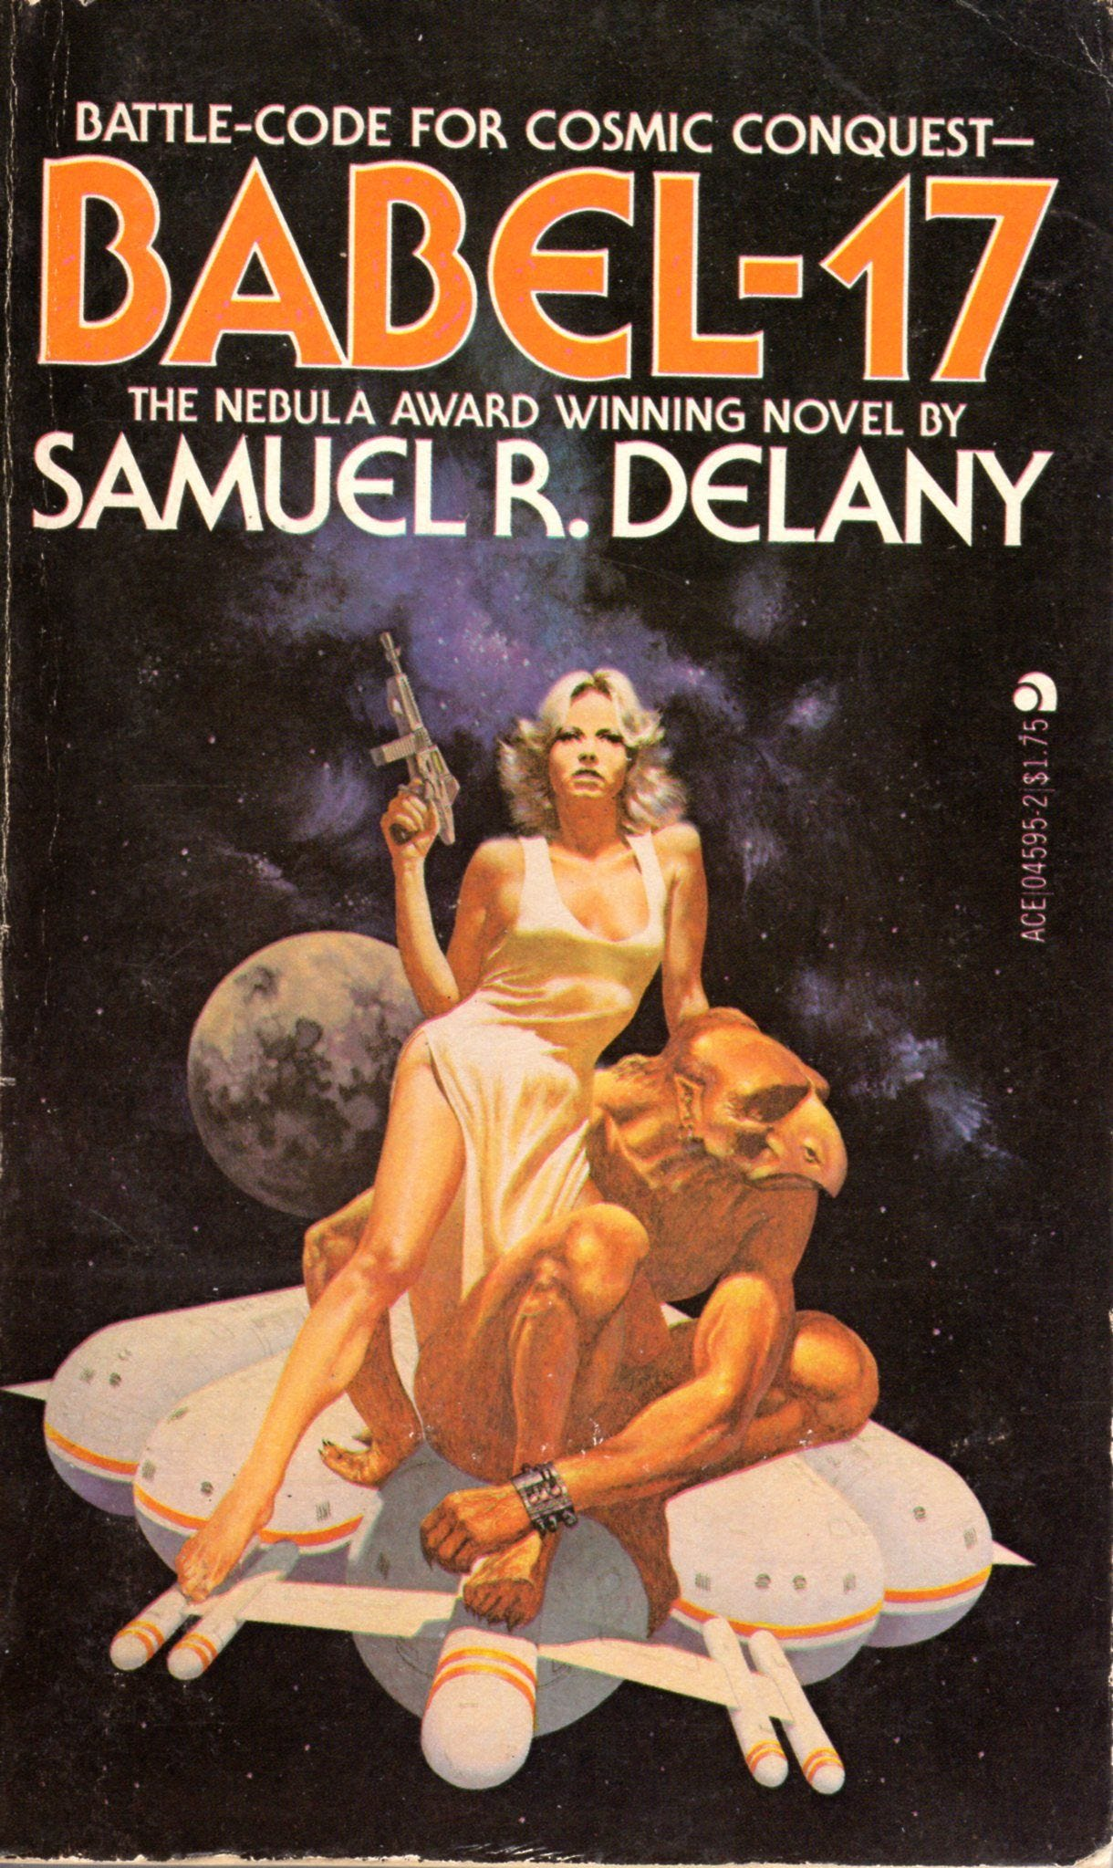Blood Rituals, Pedophilia Rituals, Human Sacrifice Rituals, Castration Rituals…
Listening to youtube videos on Belmont we find he is now friends with Sir Richard Branston whose company parties - like Belmont's - are still legendary. He gives get rich quick talks on the same stage as satanic pedophile war criminal Lord Tony Bliar.

WAR CRIMINAL TONY BLIAR IN IRAQ - A WHOLE NEW LEVEL
"The point is this: the most effective means of curtailing dissent and creating a cautious conforming population isn’t the spying itself. It’s letting people know the spying, surveillance and censorship is happening all the time." People then censor themselves.
Because although he has moved out of Stock Broking he still actively searches other scams like pump and dump Bitcoin - who is behind Bitcoin? in order to increase his wealth.
Why was Belfort punished when all the Satanic, Ancient, too big to fail, too big to jail banks are not prosecuted after all these cases have been proven in court, derisory fines given, and no-one sent to jail?
WACHOVIA - 378 Billion Dollar Drug Money Laundering Scam
HSBC - The 200 Trillion Dollar HSBC Drug and Terrorist Money Laundering
LIBOR - The 200 Trillion Dollar LIBOR Fixing
FOREX - The 20,000 Trillion Dollar FOREIGN EXCHANGE, FOREX Fixing SCANDAL
GOLD MARKET FIXED Gold price rigging fears put investors on alert By Financial Times Reporter, Madison Marriage. - Global gold prices may have been manipulated on 50 per cent of occasions between January 2010 and December 2013 - always!! - according to analysis by Fideres, a consultancy. The findings come amid a probe by German and UK regulators into alleged manipulation of the gold price, which is set twice a day by Deutsche Bank, HSBC, Barclays, Bank of Nova Scotia and Société Générale in a process known as the “London gold fixing”.
Stock Market FIXED - Obama's Plunge Protection Team and computer trading
Genocidal Poverty though Inflation, Scare-City, Austerity over only 36 Trillions of Debts to Private Federal Reserve Banks.
All a matter of Record..

Wachovia, now part of the giant Wells Fargo laundered billions from Mexico's murderous drug gangs
On 10 April 2006, a DC-9 jet landed in the port city of Ciudad del Carmen, on the Gulf of Mexico, as the sun was setting. Mexican soldiers, waiting to intercept it, found 128 cases packed with 5.7 tons of cocaine, valued at $100m. But something else – more important and far-reaching – was discovered in the paper trail behind the purchase of the plane by the Sinaloa narco-trafficking cartel.
During a 22-month investigation by agents from the US Drug Enforcement Administration, the Internal Revenue Service and others, it emerged that the cocaine smugglers had bought the plane with money they had laundered through one of the biggest banks in the United States: Wachovia, now part of the giant Wells Fargo.
Of special significance was that the period concerned began in 2004, which coincided with the first escalation of violence along the US-Mexico border that ignited the current drugs war in which 70,000 people have been killed - more than the American soldiers who died in Vietnam, although 3.5 million Vietnamese did die too.
"For the time period of 1 May 2004 through 31 May 2007, Wachovia processed at least $$373.6bn in CDCs, $4.7bn in bulk cash" – a total of more than $378.3bn.
The deferred prosecution is part of this "cop-out all round", he says. "The regulatory authorities do not have to spend any more time on it, and they don't have to push it as far as a criminal trial. They just issue criminal proceedings, and settle. The law enforcement people do what they are supposed to do, but what's the point? All those people dealing with all that money from drug-trafficking and murder, and no one goes to jail?"

The 200 Trillion Dollar HSBC Money Laundering
HSBC Report Should Result in Prosecutions, Not Just Fines, Say Critics
British Aristocrat, "Member of the Club" - "It's a big Club, but you ain't in it!" - Lord Green, Head of HSBC during this period of the emergence of trillions of Dollars of Money Laundering has since been made a special advisor to Cameron's British Government.
For at least half a decade, the storied British colonial banking power helped to wash hundreds of millions of dollars for drug mobs, including Mexico's Sinaloa drug cartel, suspected in SEVENTY thousands of murders just in the past 10 years – people so totally evil, jokes former New York Attorney General Eliot Spitzer, that "they make the guys on Wall Street look good."
The bank also moved money for organizations linked to Al Qaeda and Hezbollah, and for Russian gangsters; helped countries like Iran, the Sudan and North Korea evade sanctions; and, in between helping murderers and terrorists and rogue states, aided countless common tax cheats in hiding their cash.
"They violated every goddamn law in the book," says Jack Blum, an attorney and former Senate investigator who headed a major bribery investigation against Lockheed in the 1970s that led to the passage of the Foreign Corrupt Practices Act. "They took every imaginable form of illegal and illicit business."
That nobody from the bank went to jail or paid a dollar in individual fines is nothing new in this era of financial crisis. What is different about this settlement is that the Justice Department, for the first time, admitted why it decided to go soft on this particular kind of criminal. It was worried that anything more than a wrist slap for HSBC might undermine the world economy.
"Had the U.S. authorities decided to press criminal charges," said Assistant Attorney General Lanny Breuer at a press conference to announce the settlement, "HSBC would almost certainly have lost its banking license in the U.S., the future of the institution would have been under threat and the entire banking system would have been destabilized."
It was the dawn of a new era. In the years just after 9/11, even being breathed on by a suspected terrorist could land you in extralegal detention for the rest of your life. But now, when you're Too Big to Jail, you can cop to laundering terrorist cash and violating the Trading With the Enemy Act, and not only will you not be prosecuted for it, but the government will go out of its way to make sure you won't lose your license. Some on the Hill put it to me this way: OK, fine, no jail time, but they can't even pull their charter? Are you kidding?
Also known as the Hong Kong and Shanghai Banking Corporation, British HSBC has always been associated with drugs. Founded in 1865, HSBC became the major commercial bank in colonial China after the conclusion of the Second Opium War.
If you're rusty in your history of Britain's various wars of Imperial Rape, the Second Opium War was the one where Britain and other European powers basically slaughtered lots of Chinese people until they agreed to legalize the dope trade (much like they had done in the First Opium War, which ended in 1842).
A century and a half later, it appears not much has changed. With its strong on-the-ground presence in many of the various ex-colonial territories in Asia and Africa, and its rich history of cross-cultural moral flexibility, HSBC has a very different international footprint than other Too Big to Fail banks like Wells Fargo or Bank of America. While the American banking behemoths mainly gorged themselves on the toxic residential-mortgage trade that caused the 2008 financial bubble, HSBC took a slightly different path, turning itself into the destination bank for domestic and international scoundrels of every possible persuasion.
Three-time losers doing life in California prisons for street felonies might be surprised to learn that the no-jail settlement Lanny Breuer worked out for HSBC was already the bank's third strike. In fact, as a mortifying 334-page report issued by the Senate Permanent Subcommittee on Investigations last summer made plain, HSBC ignored a truly awesome quantity of official warnings.
In April 2003, with 9/11 still fresh in the minds of American regulators, the Federal Reserve sent HSBC's American subsidiary a cease-and-desist letter, ordering it to clean up its act and make a better effort to keep criminals and terrorists from opening accounts at its bank.
One of the bank's bigger customers, for instance, was Saudi Arabia's Al Rajhi bank, which had been linked by the CIA and other government agencies to terrorism.
According to a document cited in a Senate report, one of the bank's founders, Sulaiman bin Abdul Aziz Al Rajhi, was among 20 early financiers of Al Qaeda, a member of what Osama bin Laden himself apparently called the "Golden Chain."
In 2003, the CIA wrote a confidential report about the bank, describing Al Rajhi as a "conduit for extremist finance." In the report, details of which leaked to the public by 2007, the agency noted that Sulaiman Al Rajhi consciously worked to help Islamic "charities" hide their true nature, ordering the bank's board to "explore financial instruments that would allow the bank's charitable contributions to avoid official Saudi scrutiny." (The bank has denied any role in financing extremists.)
For more than half a decade, a whopping $19 billion in transactions involving Iran went through the American financial system, with the Iranian connection kept hidden in 75 to 90 percent of those transactions.
HSBC has been headquartered in England for more than two decades – it's Europe's largest bank, in fact – but it has major subsidiary operations in every corner of the world. What's come out in this investigation is that the chiefs in the parent company often knew about shady transactions when the regional subsidiary did not.
By that time, numerous agencies, including the Department of Homeland Security, had crawled all the way up HSBC's backside, among other things examining it as part of a major international narcotics investigation. In one four-year period between 2006 and 2009, an astonishing $200 trillion in wire transfers (including from high-risk countries like Mexico) went through without any monitoring at all.

The 200 Trillion Dollar LIBOR Fixing
The so-called LIBOR scandal, which is at the heart of the UBS settlement, makes Enron look like a parking violation. Many of the world's biggest banks, including Switzerland's UBS, Britain's Barclays and the Royal Bank of Scotland, got together and secretly conspired to manipulate the London Interbank Offered Rate, or LIBOR, which measures the rate at which banks lend to each other. Many, if not most, interest rates are pegged to LIBOR. The prices of hundreds of trillions of dollars of financial products are tied to LIBOR, everything from commercial loans to credit cards to mortgages to municipal bonds to swaps and currencies.
If you can imagine executives at Ford, GM, Mitsubishi, BMW and Mercedes getting together every morning to fix the prices of aluminum and stainless steel, you have a rough idea of what the LIBOR scandal is like, except that in the car-company analogy, you'd be dealing with absurdly smaller numbers.
These are the world's biggest banks getting together every morning to essentially fix the price of money. Low LIBOR rates are an indicator that banks are strong and healthy. These banks were faking the results of their daily physicals. In banking terms, they were juicing.
But the Justice Department wasn't finished handing out Christmas goodies. A little over a week later, Assistant Attorney General Lanny Breuer was back in front of the press, giving a cushy deal to another huge international firm, the Swiss bank UBS, which had just admitted to a key role in perhaps the biggest antitrust/price-fixing case in history, the so-called LIBOR scandal, a massive interest-raterigging conspiracy involving hundreds of trillions ("trillions," with a "t") of dollars in financial products. While two minor players did face charges, Breuer and the Justice Department worried aloud about global stability as they explained why no criminal charges were being filed against the parent company.
Also known as the Hong Kong and Shanghai Banking Corporation, British HSBC has always been associated with drugs. Founded in 1865, HSBC became the major commercial bank in colonial China after the conclusion of the Second Opium War. If you're rusty in your history of Britain's various wars of Imperial Rape, the Second Opium War was the one where Britain and other European powers basically slaughtered lots of Chinese people until they agreed to legalize the dope trade (much like they had done in the First Opium War, which ended in 1842) of bringing colonial Indian Opium on British Lord's Satanic Dynastic Family clippers into China.

The 20,000 Trillion Dollar FOREIGN EXCHANGE, FOREX, SCANDAL
The Forex scandal (also known as the forex probe) is a financial scandal that involves the revelation, and subsequent investigation, that the world's largest currency trading banks colluded for at least a decade to manipulate and rig the daily foreign exchange rates for at least 20,000 Trillions of Dollars.
Market regulators in Asia, Switzerland, the United Kingdom, and the United States began to investigate the $2000 trillion-a-year foreign-exchange market after Bloomberg News reported in June 2013 that currency dealers said they had been front-running client orders and rigging the foreign exchange benchmark WM/Reuters rates by colluding with counterparts and pushing through trades before and during the 60-second windows when the benchmark rates are set. The behavior occurred daily in the spot foreign-exchange market and went on for at least a decade according to currency traders.
At the center of the investigation are the transcripts of electronic chatrooms in which senior currency traders discussed with their competitors at other banks the types and volume of the trades they planned to place. The electronic chatrooms had names such as “The Cartel,” “The Bandits’ Club,” “One Team, One Dream” and “The Mafia”. The discussions in the chatrooms were interspersed with jokes about manipulating the forex market and repeated satanic culture references to alcohol, drugs, Sex and women.
Regulators are particularly focusing in on one small exclusive chatroom which was variously called the The Cartel or The Mafia. The chatroom was used by some of the most influential traders in London and membership in the chatroom was highly sought after.
Among The Cartel's members were Richard Usher, a former Royal Bank of Scotland (RBS) senior trader who went to JPMorgan as head of spot foreign exchange trading in 2010, Rohan Ramchandani, Citigroup’s head of European spot trading, Matt Gardiner, who joined Standard Chartered after working at UBS and Barclays, and Chris Ashton, head of voice spot trading at Barclays.
Two of these senior traders, Richard Usher and Rohan Ramchandani, are members of the 13-member Bank of England Joint Standing Committee's chief dealers group.
At least 15 banks including Barclays, HSBC, and Goldman Sachs disclosed investigations by regulators. Barclays, Citigroup, and JPMorgan Chase all suspended or placed on leave senior currency traders. Deutsche Bank, continental Europe’s largest lender, was also cooperating with requests for information from regulators. Barclays, Citigroup, Deutche Bank, HSBC, JPMorgan Chase, Lloyds, RBS, Standard Chartered, and UBS as of February 2014 had suspended, placed on leave, or fired 21 traders. Citigroup had also fired its head of European spot foreign exchange trading, Rohan Ramchandani, who was a member of the 13-member Bank of England Joint Standing Committee's chief dealers group. Reuters reported hundreds of traders around the world could be implicated in the scandal.
(Reuters) - March 2014 - Bank of England (BoE) Governor Mark Carney faces a grilling from UK lawmakers on Tuesday about what Bank officials knew about allegations that currency traders colluded to manipulate key exchange rates in the 2000 Trillions of dollars Per year Forex business.
The unfolding scandal has so far seen more than 20 traders placed on leave, suspended or fired by some of the world's biggest banks.
THE 40 TRILLION DOLLAR HEIST THAT WAS THE MORTGAGE BLOWUP OF 2008 AND THE BAIL OUT

It has been reported by Catherine Austin Fitts that there were many multiples of mortgages sold than there were houses in the United States.
Catherine Austin Fitts served as managing director and member of the board of directors of the Wall Street investment bank Dillon, Read & Co. Inc., as Assistant Secretary of Housing and Federal Housing Commissioner at the United States Department of Housing and Urban Development in the first Bush Administration, and was the president of Hamilton Securities Group, Inc., an investment bank and financial software developer.
This was done with a collaboration between Government and Mortgage companies.
It was prepared for by Bill Clinton's removal of Glass Steagal for the repackaging of the Mortgages as derivatives.
Banks bought the Derivative repackaged Mortgages on houses that didn't exist and in the Bail out of 1500 Billions then Quanitative Easing of 120 Billions a month for many years was spent by the government in the form of bonds owed by the public to buy back these none existent mortgages.
In this way, says Catherine, 40 Trillions of dollars were removed - stolen - from the United States and paid for by the people.
This is a little more than normal but the same stealing principle has been used ever since banks came into existance 10,000 years ago!!
Vastly inflated contracts are given to companies by politicians.
A corrupt kickback is given to the politician and the companies get well paid.
Business as usual.

THE SATANIC SPECIES ARE LOWER MANAGEMENT TRADERS AND POLITICIANS
who are given money and power. Politicians and Stockbrokers are introduced into Satanism through the Company Cultures of Black Magic Addiction Blockages of Sex and Drugs which start the degeneration process towards Narcissistic, Machiavellian, Psychopathy.
The Wolf of Wall Street shows how all the banks promote the Black Magic Satanic culture of sex, drugs and lying to sell, and hatred of the client in order to create the Narcissistic, Machiavellian, Psychopathic mindset so necessary to rape and pillage.
The Satanic Species has been at war against the Human species for over 10,000 years, using the Policy of Poverty to maintain control..
Since Babylon, Satanic 2000 Trillion Dollar Phoenician Mega Trillionaire Generational Dynastic families have created Myths and Black Magic Pagan Satanic Religions to control their Human Herd.
They created all religions to Mind Control Humanity.. Lucifer, Satan, Mithra, Sofia, Apollo, Set, Isis, Osiris, Horus, Marduk, Gnostics.
“We will of course not let them know about Wotan [Odin].” –Reichsminister Paul Josef Goebbels-
Himmler told his SS Army that the Valkyries of Wotan will choose only those who die in battle to go to Heaven..
Psychically they use implant addiction blockages to Addict all Humanity to porn, masturbation, sex, drugs and Rock and Roll - Hip Hop, to degenerate humanity and recruit new Narcissistic, Machiavellian, Psychopathic cadre.
Whilst all the essential Meditation techniques - The Kundalini Key, Energy Blockage Removal - are removed from Traditional Meditations, Ancient Black Magic Technology of the Luciferian and Satanic religions use RITUAL. Ritual Drugs, Sex, Polyamory, homosexual, pedophile Ritual. Murderous Human and Animal Sacrifice Ritual.
The Ancient Psychic Science of Black Magic - the Creation of Implant Drug and Sex Addiction Energy Blockages - is an Ancient Technology which although is scientific, appears like Magic to those which have never been taught Energy Enhancement Meditation…

“Any sufficiently advanced technology is indistinguishable from magic.”
― Pedophile Aristocrat Arthur C. Clarke,
They are Genetically bred in Satanic 2000 Trillion Dollar Phoenician Mega Trillionaire families over thousands of years for psychopathy.
They are Trained - Mind Controlled from birth - for Rape, Pillage, War, Religion, Banking, Money Laundering, Slave Trading and Drug Running.
Satanists create all political parties. Marx worked for the British Secret Service.
After Democrats and Republicans, Libertarianism is next.

GENOCIDAL AUSTRIAN ECONOMICS MISES AND VON HAYEK
Long tonged liars like Nelson Rockefeller funds Von Mises and Von Hayek to create Genocidal Austrian Economics - THE POLICY OF POVERTY WORLDWIDE!! Austria where Satanic Fascist Hitler came from. Austrian Economics creates Austerity Worldwide.
https://www.energyenhancement.org/Satanic-Von-Hayek-The-creation-of-Feudalism-with-Austrian-Economic-Austerity-Fascism-Didn't-Die-With-Hitler.htm
Libertarian Satanic Ron and Rand Paul and their minion Alex Jones support Austrian Economics and the genocidal elimination of food stamps in this recession. They want you to use the guns so they can kill you - just another cull of humanity.
280 millions of the most intelligent and beautiful people tortured and killed in the 20th century by Government - Sacrifices for Satan!!

THE ONLY SOLUTION IS ENERGY ENHANCEMENT EVOLUTION!!
They seek to find Initiates into their satanic secret societies represented by Lord Tony Bliar and Sir Richard Branston where they Ritually degenerate themselves and further and further degenerate themselves in order to maintain their energy which at every stage is vampiristically harvested by the Luciferian Watchtower elite who live outside the body.

These Satanists are victims of a religion which believes in human sacrifice.
Lives for Satan through War, Soft kill pollution in air, water and food, Eugenocide, genocide, Stalin, Hitler, Mao. 280 millions of people murdered by Governments in the 20th century. And more projected for the 21st if the already written plans to sacrifice 7 billion people - to protect the earth!! - are put into operation.
So these guys, - Satanists - are quite mad.
They Want War.
They want Death.
They want to kill YOU!!
Satanism is not "just another nutty occult fad." It has been the, "Old Religion" since the beginning of time.
The mind of the Satanist is pure evil; the Satanist is a former person who has been transformed by Black Magic Implant Blockage Mind Viruses into something no longer human.
It begins like drug-addiction; the prospective recruit to Satanism "gets into something" on a playful impulse, but then finds himself or herself gripped by compulsions - through psychic implantation of addiction energy blockages - which he or she can no longer control.
Drugs and other special circumstances may be significant collateral features of the initiation, but not necessarily. The key is "letting oneself go," into the depths of acting-out impulses which combine sexual impulses and rage as a unity, and expressing this form of "pleasure" in the form of an act which violates an important precept of one's own conscience.
This perversion through acts which violate an important precept of one's own conscience, from sex parties to ritual sex to homosexual ritual to torture to pederasty to animal then human sacrifice, this corruption occurs through the implantation of energy blockages into the heart center to remove empathy and blockages above the head to remove energy flowing in from God from the chakras above the head to remove conscience - the definition of a The Ancient Psychic Science of Black Magic - the Creation of Implant Drug and Sex Addiction Energy Blockages - is an Ancient Technology which although is scientific, appears like Magic to those which have never been taught Energy Enhancement Meditation…

“Any sufficiently advanced technology is indistinguishable from magic.”
― Pedophile Aristocrat Arthur C. Clarke,..
The removal of empathy. There is a Satanic Black Magic Ritual where 12 psychic daggers - psychic created energy blockages - are implanted around the heart center. A sacrifice is performed and the heart removed from the sacrifice and put into a canopic jar. The energy of the heart removed from the dagger implanted heart and put into the canopic jar together with the heart removed from the sacrifice. The canopic jar is then placed in the earth in a Heart Site, somewhere in the country.
Similarly with the child sacrifice at the Bohemian Grove Ritual, "The Cremation of Care" burning up of empathy to Molech where a child is burnt alive in front of a 40ft Statue of an Owl dedicated to Minerva and Molech in front of Presidents, Prime Ministers, Captains of Industry and the Media.

In the same way that British Satanic Secret Service controlled Saudi Arabian Wahabist and Salfist Sects create armies to attack and destabilise (911, Libya, Syria),
Black Magic is also a created myth, a methodology for the creation of a psychopathic army to rule and then destroy civilisation at the behest of the Real Rulers.
The Ancient Enemy who counts meditation and the mind control psychic arts as one of its main planks of World Domination has used Infil-Traitors for 10,000 years in every Organisation - Religion, Dynastic Families, Politics, Geopolitics, Economics, Universities, Intelligence Services, Think Tanks, Banking, International Companies, Eugenics - Worldwide, censoring Alchemical VITRIOL, the Kundalini Key and Energy Blockage Removal from every Meditation Program..
Yet throughout history from the time of the Old Religion of Satanic Babylon, Pagan, Satanic, Luciferian Generational Families have controlled Humanity through Myth, Money, Mind Control Propaganda, Slavery, Drugs and Sex.
From Babylon to the Slave Trading, Drug Running Empires; The Roman Empire, Venetian Empire, British Empire, Anglo-American Empire Satanic Generational Families have infil-traitored every Government, every Politician, Every Ministry, every International Company, every Bank, every University, every Think Tank, every Secret Society.
Satanic Psychopathic Religions and Myths (The Ten Myths which control the World) have been specifically created to maintain the Generational Family control of society. To exacerbate Implant addiction blockages of sex, drugs and rock and roll through Pagan Satanic sex, drugs and music in order to divert, pervert and degenerate humanity in order to rule them. More than anything, to keep Humanity Austere; Poor barefoot and back on the reservation and away from the Meditational Superpowers which alone can free Humanity from their chains.
It is symbolised by the Black Magician, Necromancer, "Sauron" Of, "The All Seeing Eye" like the NSA SNOWDEN PRISM - "Lidless, Wreathed in Flame" of Tolkien's, "Lord of the Rings" who lives outside the body and waits to return into physical life with the help of the power of the One Ring.
Sauron, like Lucifer, thinks he knows better than God. His aim is to pervert and degrade humanity into Orcs and Rule the World Totalitarian style, FOREVER!!

THE LUCIFERIAN SPECIES
are humans who have meditated and learned, perhaps many, many tens of thousands of years ago, how to cut off from god by using energy blockages to block chakras above the head so they can live outside the body in private universes - so they seem like psychopathic aliens to us - then they download into their mind weakened sons - throwing their sons out - on their 21st birthday so as to become the Head of their Baron, Lord or Crown families and control their multi trillion dollar, thousands of years old families wealth, to manage the human herd.
They use the, "Policy of Poverty" or Austerity to control the human herd for tens of thousands of years. Because they live outside the body and only want to vampirise human spiritual energies in order to live forever they will consider any solution to problems. See for example movie Dr Strangelove where upon exploding Fusion Bombs and making the Earth uninhabitable for hundreds of years they are eager to live down in mines to survive.
To further continue the "Policy of Poverty" To stop human evolution, so that the Satanists can continue to control an impoverished humanity. To the degree that probably 100 Million people might be lucky to survive—or unlucky enough to survive under those conditions as explained in Kubrick's "Dr Strangelove".

PETER SELLERS AS KUBRICK'S DR STRANGELOVE
Satchidanand's Review of - Existentialism and Kubrick's Satanic Psychopaths, in the Movies of Stanley Kubrick https://www.energyenhancement.org/Psychopath_Kubrick_Film_Movie.htm

THE FAILURE OF INTELLIGENT LOGICAL COMMENTATORS TO UNDERSTAND THE TRUE SATANIC LUCIFERIAN NATURE
https://energyenhancement.org/THE-LONE-RANGER-ESOTERIC-MOVIE-REVIEW-BY-SATCHIDANAND.htm
The whole process here, look at it. What is the nature of this satanic hatred against human beings? What's the expression of that? It's the Satanic Green policy which directs people back to living in caves. This was done by the Satanic Roman Empire and others, as the, "Policy of Poverty" to reduce the population; that is, to have a small Satanic oligarchy which dominates the planet, or parts of the planet, and kill off the "excess" population, which is the rest of the people. This is what the Satanic Elite's policy is, and that is what she says it is.

CONTROL.
Depending how many chakras above the head they block off, the more power they have. They need a lot of energy as they receive no energy from God, so they have learned how to create Implant addiction energy blockages for drugs, sex, and rock and roll so as to parasitise, vampirise their slave populations and create their satanic psychopathic managers.
Everyone is implanted with every Addiction Blockage Implant from birth like having diseases, but depending how much we enter into the path of the disease there are many stages of that disease whose end is Psychopathy.
With the Sexual Addiction Implant Blockage Mind Virus, the Energy from every orgasm is channeled back to the Luciferians through energy connections from their Sex Addiction Implants.
The Luciferians or their minions send out energy every morning to raise the salute of the penis, around the horn, a proud tumescence in every red blooded man to promote masturbation or initiate sex and they vampirise the energy of every orgasm. The prostitution, white slave and pedophile industry is traditionally under their control.
Drugs and sex burn the candle at both ends and the energy of that charging candle is sent back from the Implant Addiction Blockage through energy connections to the Luciferians. They traditionally, through the Committee of 300 (see Coleman) and the Pharma Companies, own the legal and Illegal Trillion Dollar Drug industries. They pay politicians to keep drugs illegal so as to make more profit. They conquer countries in order to grow more drugs - Afghanistan from growing no opium with the Taliban who placed a Fatwa on its cultivation, now supplies 90% of the World's opium to the Bush crime family.
Although they promise to tell their higher managers like the Rockefellers how to become immortal like them, they never do. So they promise Transhumanism.. Ray Kurzweil and Robert Heinlein (Heinlein, like Elron Hubbard and Campbell were Agents of American Naval Intelligence charged with implanting the memes of Science Fiction, satanic free love - "Stranger in a Strange Land" and drugs into the noosphere) are their propagandists here. Satanic Free love, Immortal medical care, perfect genetics, cyborg brain chip enhancements, upload into the machine so as to live forever. THEY LIE!!
Intelligent commentators are presently more and more commenting on the coming Third World War flashpoints which are recklessly occurring in the Middle east, Syria and now in the Ukraine and they can not believe just how MAD the foreign policy is. They can not Believe the risks of starting World War Three which they are taking - only possible if Biden, Obama, Putin and XI are totally controlled by the satanic Mega Trillionaire elite...

BOHEMIAN GROVE - THE GROVERS

One commentator below laughs at the total idiocy of their foreign policy actions but also with the tension of the contemplation of the risks of Thermonuclear War and the Extinction of the Human Race which that represents.
They point out historical precedent between now and the False Flag starts of fake World Wars One and Two.
They point out the historical precedents between the founding and funding of Hitlers Nazi, National Socialist, Fascist State, the founding and funding of Lenin's and Stalin's Totalitarian Communist, Collectivist Soviet and what is happening now with the National Stazi Agency NSA and Snowden's Big Brother is watching you in USA and Europe.
A Thousand Year Reich of control, transhumanism, eugenics, genetic engineering, merging with the machine, living forever.. Covering all the World in Darkness..
Because this commentator does not understand Satanism and its infiltration into the highest levels of power.
Because this commentator has a rational mind he can not believe that other people in power are not rational - That they are MAD, PSYCHOPATHIC, LIVES FOR SATAN, SATANISTS!!

THE SOLUTION? - THE ENERGY ENHANCEMENT COURSE BY STREAMING VIDEO OR LIVE IN BRAZIL, INDIA, WORLDWIDE!!

USE THE ENERGY ENHANCEMENT MEDITATION LEVEL 2 SEVEN STEP PROCESS TO REMOVE THE MIND VIRUS ENERGY BLOCKAGES - GET ALL THE BOOKS BY SIGNING UP!

Share
Leave a comment
Message Satchidanand
The removal of the Heads of the Thirteen Satanic Families - not by assassination - as they can move from body to body - but as in the removal of Energy Blockages in the Energy Enhancement removal of Blockages.
Also information, the teaching of Wolf-Child Humanity in real Science and History as well as the Science of Meditation - Kundalini Kriyas, VITRIOL, Samadhi, Samyama, the removal of Energy Blockage Mind Viruses, Implant Blockage Mind Viruses, Energy Connections and Cords.

The solution?

THERE IS NO PHYSICAL SOLUTION AS OVER 10,000 YEARS OF RAPE AND PILLAGE WILL SHOW YOU!!

Solution? - The Science of Meditation - Which will increase the only thing you can take with you - Lifetime to Lifetime - when you die..

THE ONLY SOLUTION IS EVOLUTION!!
With the Energy Enhancement Kundalini Kriyas, VITRIOL, Samadhi, Samyama, the removal of Energy Blockage Mind Viruses, Implant Blockage Mind Viruses, Energy Connections and Cords.

ENERGY ENHANCEMENT IS THE ULTIMATE TECHNIQUE OF EVOLUTION!!
Just by meditation and energy blockage removal, you can find the truth for yourself, increase your energy, access incredible quantities of Kundalini Energy, become Enlightened.
And that's the only way, I think, you can actually make a practical, actually practical indication of how we might be able to save humanity from its degenerate Satanic predators.

ENERGY ENHANCEMENT - THE ULTIMATE MEDITATION COURSE!!

GET YOUR ENERGY ENHANCEMENT VIDEO OR LIVE COURSE NOW!!



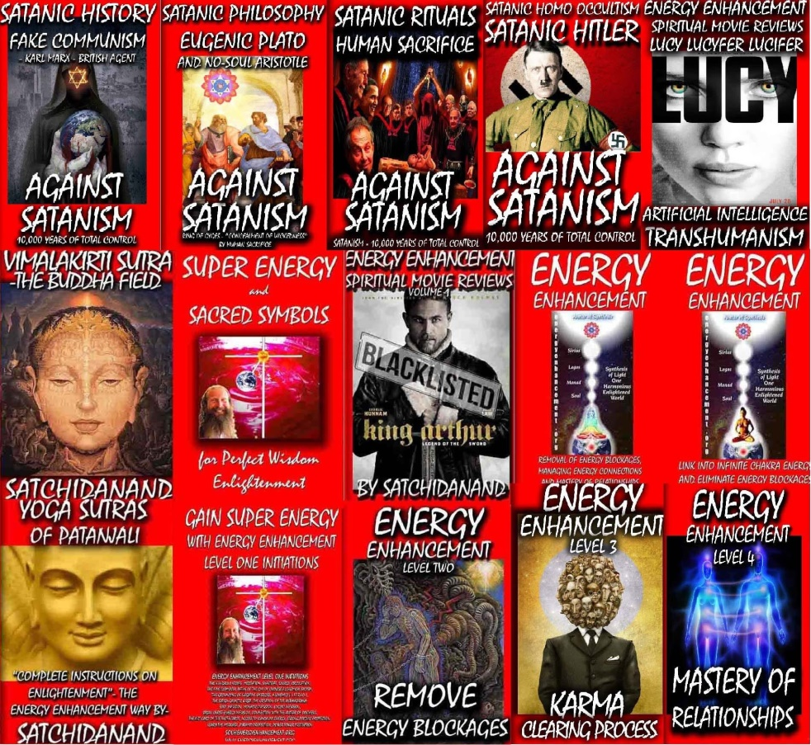

Satanic Bill Gates, Epstein Lover Bill Gates, Confesses To Conducting Illegal Human Medical Experiments In India
PROSECUTE THE ROTHSCHILDS, THE SATANIC PHOENICIAN MEGA TRILLIONAIRE, 3000 TRILLION DOLLAR ROTHSCHILDS! NOT JUST MINIONS!
Satchidanand
Dec 05, 2024

The Satanic Phoenician Mega Trillionaire Oligarch Ruling Class "Strategy Of Tension" and Trump…

Satchidanand
·
November 23, 2024
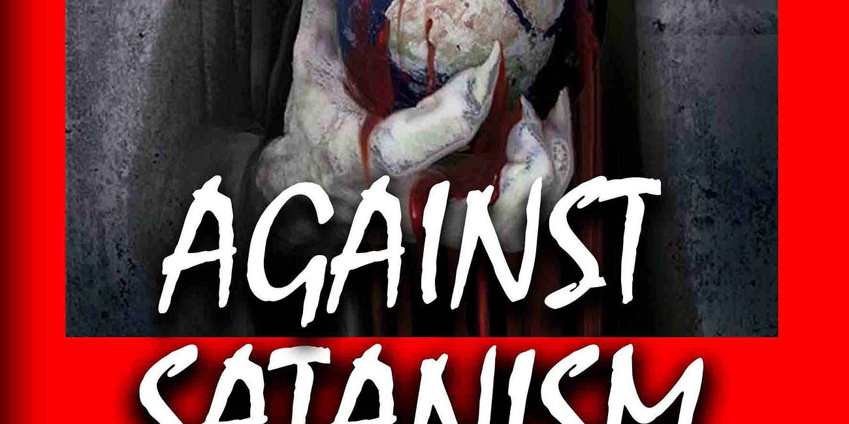
The Satanic Phoenician Mega Trillionaire Oligarch Ruling Class "Strategy Of Tension" and Trump…

Read full story

In George Orwell’s book 1984, the state of Oceania is always in a state of war with Eurasia and Eastasia. The Party controls all of the media and continuously spreads stories of external and internal threats to create fear and hatred within the populace to keep them compliant. We are not far away from such a reality in the present, most especially in the US with the hold of the oligarchy over the state and media, practising what was termed as a “Strategy of Tension” within Italy in the post-WW2 decades. This will not change with a Trump administration (or a Starmer one as we have seen, or with any other Western nation); the only change will be that some of the “enemies” may be different.
British Empire Agent George Orwell whose father ran the Opium Production from Bengal in India to China.
British Empire Agent George Orwell who went to Sodomite Central Eton where he was tutored by Satanist Agent Aldous Huxley who ran MKUltra in Hollywood and the introduction of drugs into the USA with his, “Doors of Perception” with Mescaline and LSD in the 1960’s, who wrote with his Eugenic Brother, Head of the United Nations WHO, Julian Huxley, the blueprint for the future, “Brave New World”.
George Orwell, who tortured terrorists in Burma like with the rats in Room 101 in 1984.
George Orwell who was head of the Fabian Socialists who ran the Brutish Empire.
George Orwell who was Chief of British Empire Propaganda for WW2.
George Orwell who wrote 1984 to remove any hint of Satanism, the Satanic Religion and Demons from the Dictators of the world, to hide the Satanic Religion of Satanism which infuses the Brutish Empire…

SATANIC PSYCHOPATH HUMAN SACRIFICE RITUAL TRAINING - RONALD BERNARD… I WAS IN TRAINING AND I FAILED

Satchidanand
·
November 18, 2024
RONALD BERNARD… I WAS IN TRAINING TO BECOME A PSYCHOPATH, AND I FAILEDSatchidanand’s Against Satanism Newsletter is a reader-supported publication. To receive new posts 55 free books and support my work, consider becoming a free or paid subscriber.
Read full story

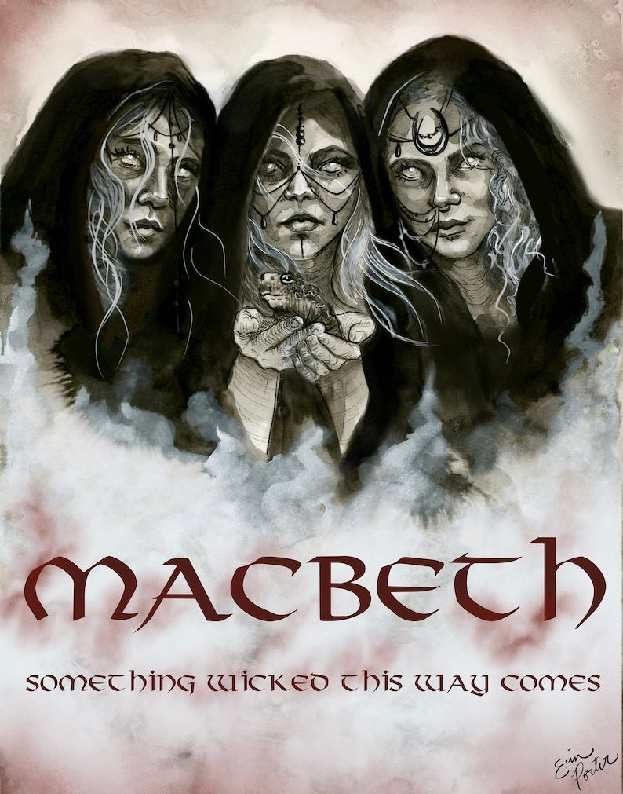
Only Shakespeare talked of Satanism infusing bloody Dictator Macbeth using the Three Witches…
From the pricking of my thumbs
Something wicked this way comes…
Hubble Bubble Toil and Trouble
Fire Burn and Cauldron Bubble
When shall we three meet again
In thunder, lightning or in Rain
Upon the Heath!
Macbeth!
Shakespeare knew that the foundation of the Totalitarian State was Satanism!
I’ll Gild the faces of the Grooms withal
So it shall seem their Guilt!
Vaulting Ambition
Out! Out! Damned Spot! which Shall turn all the Seas Incarnadine!
Yet I have heard differently about Donald Trump being a real savior of the World.
I have heard that within Mar al Lago Trump is talking with the head of NATO about the ending of the Ukraine war.
As well as the head of NATO, Trump is talking with all the interested parties, Putin, Zelensky, et al and has been for several days hoping to end this corruption even before he becomes President.
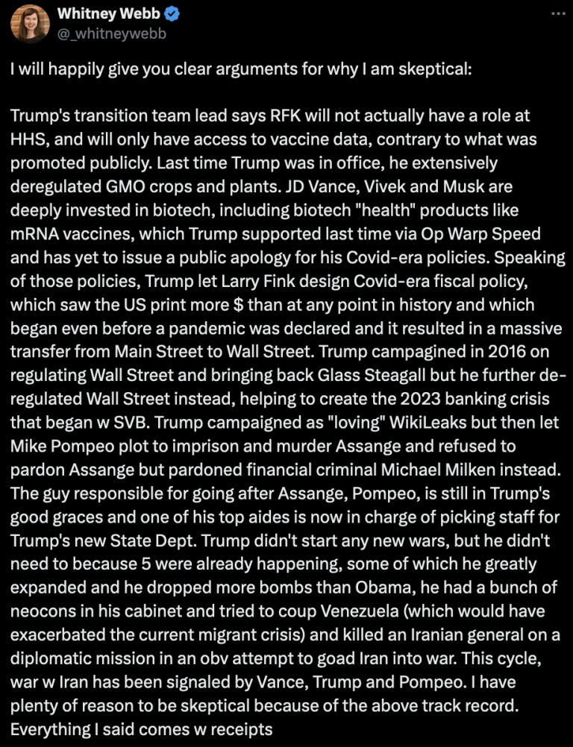
With his ambitious plans to remove Satanic Globalism from the American State apparatus like Milei in Argentina using Elon Musk in his DOGE apparatus to shut down Departments, and fire troves of useless idiots and save Trillions of corruption which has cost America so far 36 Trillions of Dollars, the Satanic Global elite are using the escalation of the Ukrainian War to pressure Trump into not prosecuting them as they pretend to relinquish their hundreds of years plan to take over the World in a New World Order using the unelected United Nations – like the unelected controllers of the EU - to become the World Governors and Moving the controlling Empire, destroying the controlling Empire from within by Satanic Phoenician Infiltration, from the Anglo-American Empire to China for it’s Chinese Century.
Threatening them with Nuremberg 2, probably Trump will need to forgive them and create a New Marshall Plan to rebuild the remains of the Ukraine so that these corrupt Satanic Globalists can continue to feed off it’s corruption so as to confirm the deal.
We shall see if Trump is Only Talking……
Video by Greg Reese…
You know, the Satanic Phoenician Mega Trillionaires have a plan and have been writing about it in white papers and books for over two hundred years. They have been searching for a Political methodology for controlling more billions of people with minimum resources so as to vampirise more people for their Spiritual Energy so as to live, immortally for ever, and they seem to have found it.
Without this historical knowledge and the Higher Hypothesis it is impossible to predict the future…
From there they used Communism to take over Russia but it’s strict communistic philosophy failed.
They used it also to take over China and with the reforms of Deng Xiou Ping created a communist slave state which so far, has worked wonderfully by allowing the implementation of.. the Satanic Phoenician Mega Trillionaire’s, “The Chinese Century” as the Empire is moved by the Satanic Phoenician Mega Trillionaires from the USA to China and the Chinese Communist politics is installed worldwide allowing..
The Communist Hell State of Satanic Phoenician Mega Trillionaire Biden and Harris based on the Satanic Phoenician Mega Trillionaire created United Nations Agenda 2030, 2045, 2075.
Based on the Vaccine Mandates of the Satanic Phoenician Mega Trillionaire created United Nations World Health Organisation helmed by terrorist Tedros.
Based on Artificial Intelligence controlling the censorship Surveillance State.
Based on the Satanic Phoenician Mega Trillionaire Communist Chinese Social Credit Score where if you do not agree with the Government you are de-banked, not allowed to use CBDC’s or credit cards in a cashless society, not allowed to use the Internet, not allowed to Travel, not allowed to receive Government Monetary benefits. But you are allowed a Government suicide pod!
The methodology of creating this movement, as always, is the Roman Empire, Satanic Phoenician Mega Trillionaire, “Divide and Conquer” which is the Satanic Phoenician Mega Trillionaire Deep State paying Terrorist Groups which they create to perform Terrorist acts to Scare, to Terrorise the public.
Since around the turn of the last century, the Satanic Phoenician Mega Trillionaire Western oligarchic ruling classes have engaged in a new Roman Empire Satanic Phoenician Mega Trillionaire, “Divide and Conquer”, “Strategy Of Tension” that is designed both to cow the general population into submission to their policies and to sow division within the general population to remove any focus from themselves.
The Roman Satanic Phoenician Mega Trillionaire, “Divide and Conquer” is the Satanic Phoenician Mega Trillionaire Deep State paying Terrorist Groups which they create to perform Terrorist acts the Scare the public.
This is a repeat of the policies that were carried out in post-war Europe to stop truly progressive parties from becoming part of the government; for example, the Communist Party in Italy and the 25 “years of lead”.
The Satanic Phoenician Mega Trillionaire vassal oligarchies and the security states that they dominated, working with the Satanic Phoenician Mega Trillionaire US security services, both sponsored, paid, funded, European terrorist groups and engaged in acts of terrorism against the general population in order to manage the politics of that country. This was called Operation Gladio.
While laying blame on left wing, and to a lesser extent right wing, groups (some of them security state front organizations). This is a history that we must understand if we are to understand the present.
The Roman Satanic Phoenician Mega Trillionaire, “Divide and Conquer” is the Satanic Phoenician Mega Trillionaire Deep State paying Terrorist Groups which they create to perform Terrorist acts the Scare the public.
The Roman Satanic Phoenician Mega Trillionaire, “Divide and Conquer” is the Satanic Phoenician Mega Trillionaire Deep State paying Al Qaida created by CIA asset Osama Bin Laden to destroy the Two Towers with CIA help, of course.
Later, of course the CIA funded ISIS as it’s proxy army to do the same thing in the Middle East.
Satanic Phoenician Mega Trillionaires created False Flags like the Two Towers which scared America to approve the Patriot Act which allowed Iraq and Afghanistan and one Trillion Dollars of Opium to fund Satanic Phoenician Mega Trillionaire CIA Black Ops.
But which was really designed to be used on the American public when creating the Communist Hell State of Satanic Phoenician Mega Trillionaire Biden and Harris based on the Satanic Phoenician Mega Trillionaire created United Nations Agenda 2030, 2045, 2075.
Based on the Vaccine Mandates of the Satanic Phoenician Mega Trillionaire created United Nations World Health Organisation helmed by terrorist Tedros.
Based on the Satanic Phoenician Mega Trillionaire Communist Chinese Social Credit Score where if you do not agree with the Government you are de-banked, not allowed to use the Internet, not allowed to Travel, not allowed to receive Government Monetary benefits. But you are allowed a Government suicide pod!

The Rise and Fall of the Surveillance State - Mike Benz

Americans will demand accountability for the Censorship Industrial Complex
This complex is an essential tool of what some describe as the Deep State, as well as the satanic construct that, for lack of any better term, we call Clown World. If President Trump is serious about fulfilling his duty to the American people, he will have to begin dismantling it as soon as he takes office rather than trying to work with it.

NOW AFTER THE ELECTION OF TRUMP, FOR THE FIRST TIME WE HAVE THE POSSIBILITY OF FIGHTBACK AGAINST THE SATANIC PHOENICIAN MEGA TRILLIONAIRES

Breaking: POTUS Donaldos Magnus Trumpos aka 47 says all military (8,000 purged by Biden) who were discharged for not taking deadly Malone Bancel et al. mRNA vaccine will be re-instated full back pay

Thats what I am talking about & Trump must stand now & all heads of the health agencies & call for the immediate stop of mRNA technology vaccines, or say 'I will stop it in hour one JAN 20th 2025'
Dr. Paul Alexander
Dec 5
And that is what is happening now…
In this Video above…
Here are some clips..

The Nature of Evil and Controversial Health Policies
Because, again, it goes back to the nature of evil. And once you get in the minds of the Satanists, it makes perfect sense from their sick perspective.
I mean, you and I sit back and go, you want to inject kids with something that causes blood clots, heart attacks, infertility, and gives them cancer, and it's going to make them sick and reduce their lifespan and kill many of them right away?
What the hell are you...
How do you think you're going to get away with that?
That's how you do get away with it.
It's so evil that people can't admit it to themselves because they just can't wrap their mind around it. And then once the first big mass murder happens, people that were compartmentalized, who went along with it, have a tendency to cover it up, even though they weren't consciously involved.

Demanding Truth and Accountability
You want answers? Well, so do I. You want the truth? Well, so do I. You want to fight the tyrants? Well, so do I. Now, if you were a radio listener, you heard Bill Gates. You heard the FDA board five minutes before they voted. Because I played the whole hour-long hearing years ago.
The Satanic FDA said, we have no idea what this MRNA Deathvaxx will do to kids.
Let's just do it.

Rallying Against the System
And you are literally funding revolutionary work against the Satanic death cult. You are the energy, the force, the will behind what we are doing on air right now. And that just enrages the deep state, enrages the corrupt system. And I don't even care if they come after me. I don't even care if they lie about me and demonize me and do horrible things to me. I don't like it being done in my family. But I know it goes with the territory.
We're all going to be slaves and dead anyways if we don't fight, so I have nothing left to lose. But I do want to win. And so the variable in the fight is you. I'm not going to stop. The globalists of the Satanic Religion aren't going to stop until they're defeated. It's starting to happen really quick.

Anti-Human Policies and Environmental Concerns
And that's why all the big fast food places and the airports are getting rid of humans. You got to go have a robot. They're displacing humans with AI in their own admissions. It's all the ESGs. It's all BlackRock. It's all anti-human. It's all designed to shut down family farms and organic farming and natural beef. And now they've got FDA approval to feed this poison feed to cows that totally makes them unhealthy. The quote, stop methane as if methane is bad in the atmosphere. As if farts from cows are bad.
They're saying your body is bad.
They even say you breathing is bad because gases come out that way too.

Confession Through Projection: Political Accusations
The McConnell family has made a bunch of money cashing in on the US of power and doing it for their personal enrichment at the expense of the people they're supposed to represent. So it's got to be some big names, some Bill Gates, some George Soros, some people of that. And it's not just the right thing to do. We have to do it to keep them off balance. They keep saying, don't go on offense, because that's how we beat them. Well, exactly, it's confession through projection, but in reverse. Look at, what would they have done? They made clear what they were going to do. They were gonna use the US military politically. That's why they're scared about Trump doing it, because they were planning on doing it. I mean, Harris made that really clear with a lot of her statements, a lot of her confession through projection.
(01:10:25):

We're Anti-Human. How dare you be a Natalist? We're Anti-Natalist, Anti Baby, meaning Anti-Family.
So here's the latest new clip. of him hiding it in plain view, trying to normalize it, just like they're trying to normalize pedophilia because they know we're bringing down their networks.
They're racing to just make it okay, hoping they don't get in trouble.
Not going to work, backfired on you.
But to somebody already awake, you're like, why did Netanyahu say we're using the people of Israel as guinea pigs? Why does Bill Gates say it? Why does Fauci say it? Remember that clip? They had to fire three different FDA boards and put people on the boards that were all board members of Pfizer, Moderna, and others three years ago, three and a half years ago. So they still wouldn't authorize for children. They wouldn't authorize down to six-month-olds. In fact, guys, give me that clip too.
(01:11:12):
FDA board member, we have to give kids the COVID vaccine to see what it does.
Just type in FDA board member. We have to give kids the COVID vaccine to quote, see what it does. Because even when I start talking about this, you see, I remember all the other times.
And then I've got C-SPAN events from 2017, 18, 19, where Fauci and others with all the federal regulators would get up on C-SPAN and say, quote, we're going to blow up the old FDA system of having to approve things and test things and make sure they're safe with a new virus out of China soon. And then Fauci, right after Trump gets into office 2017, says, don't worry, there's video.
Trump will soon be hit. Don't worry, Trump will soon be hit by a new novel virus. And it's going to be something completely new and challenge everything. And society's going to change. So don't worry about all the groups against us and everybody waking up to us. Because we're about to take over.
(01:12:15):
Want to see it? Fauci, Trump will be challenged by a new virus. Because he had it on the shelf. That's all come out. It's in the Senate report now. Not just Alex Jones saying it off the documents. You know...
We learned almost four years ago from the vice president of the EcoHealth Alliance who came on the show, former army officer. And he basically found out the CIA was really running the EcoHealth Alliance and that Google was funding it.
Remember, the heads of Google have said to Elon Musk, we want to get rid of people. We're anti-human. How dare you be a natalist? We're anti-natalist, meaning anti-family.

AND YET, THE TRUMP ADMINISTRATION IS STILL JUST GOING AFTER THE MINIONS LIKE GEORGE SOROS AND BILL GATES…

PROSECUTE THE ROTHSCHILDS, THE SATANIC PHOENICIAN MEGA TRILLIONAIRE, 3000 TRILLION DOLLAR ROTHSCHILDS!

Visible Oligarchs are merely Trustees, Fronts, of the Satanic Phoenician Mega Trillionaire London Money Power

Satchidanand
·
November 22, 2024
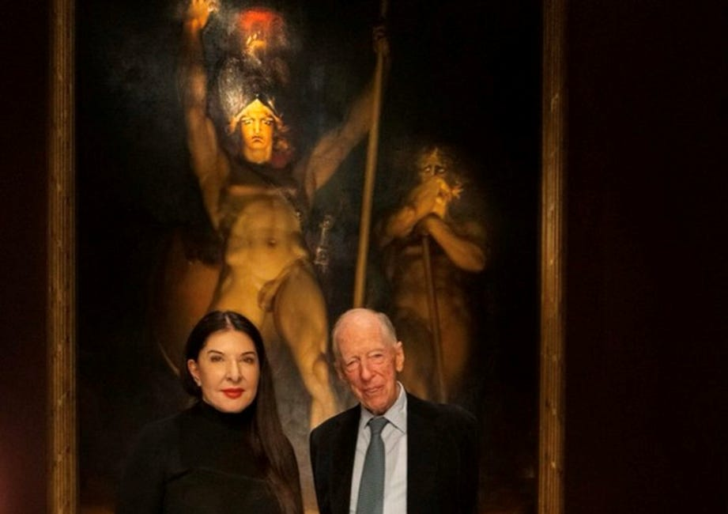
Visible Oligarchs are merely Trustees, Fronts, for the Satanic Phoenician Mega Trillionaire London Money Power

Read full story

Visible Oligarchs are merely Trustees, Fronts, for the Satanic Phoenician Mega Trillionaire Rothschild London Money Power

Fronts… The Rockefellers, Elon Musk, Jeff Bezos, Steve Jobs, Larry Page and Sergey Brin, Bill Gates, George Soros, Larry Ellison, Warren Buffett, Eric Schmitt, Peter Thiel, Robert Mercer and many others are Only Fronts for the Satanic Phoenician Mega Trillionaire Rothschilds.

Satanic Phoenician Mega Trillionaire Rothschilds Control Everything – Their Methods of Control

Meet Satanic Phoenician Mega Trillionaire Jacob “Jack” Rothschild ,- Nathaniel Charles Jacob Rothschild, 4th Baron Rothschild, OM, GBE, CVO - the "Protector- Owner," and his many minions and Fronts over centuries and nations...

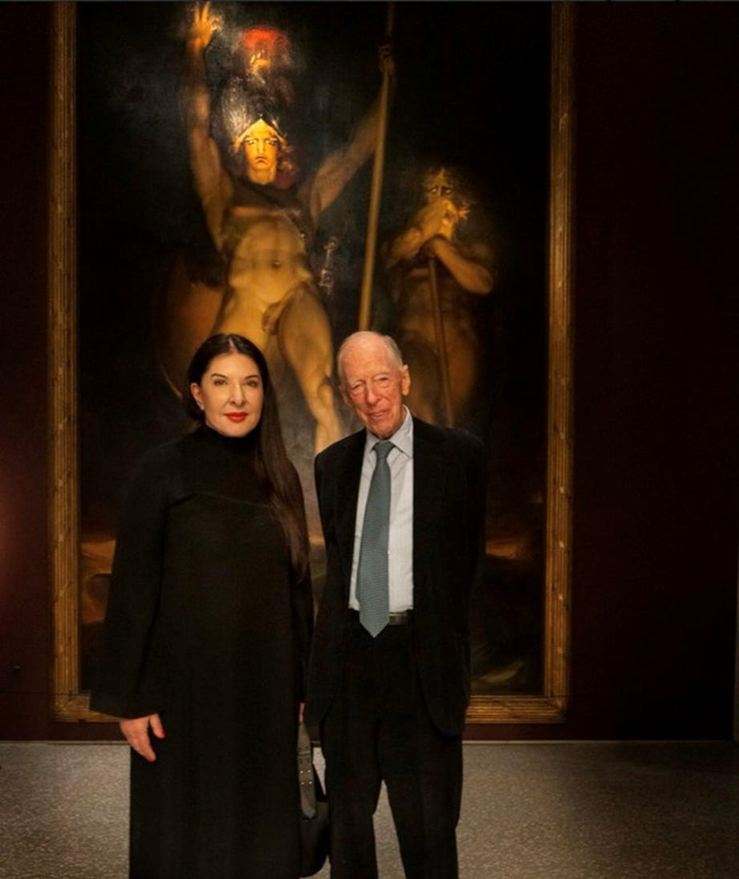

Satanic Crowleyan OTO Witch Marina Abramović poses with Satanic Phoenician Mega Trillionaire 10,000 years old Family Jacob Rothschild in front of 'Satan summoning his Legions', 1796-1797

The Satanic Phoenician Mega Trillionaire Elite are all Demon Possessed!! Part 1...



The Satanic Phoenician Mega Trillionaire Elite are all Demon Possessed!! Part One…
Read full story

So Far I have written around about Forty Four books on the two most important subjects in the World… Satanism and the Satanic History of the World as talked about above… AND ENERGY EHANCEMENT QUANTUM MEDITATION..



So Satanism is the Problem

And Energy Enhancement Quantum Meditation which is far in advance of any other meditation in the World…

IS THE SOLUTION!

ENERGY ENHANCEMENT QUANTUM MEDITATION REMOVES THE TRAUMA FROM THE MIND BY THE ALCHEMICAL TRANSMUTATION OF TRAUMA.. “FREE YOUR MIND!”

The Energy Enhancement Quantum Immortality Streaming Video Course and Live at Iguazu Falls.. –



THE ROTHSCHILDS OWN THE BRICS AND G20

The Secret Control System of the World’s Elite is the Fact that the Satanic Phoenician Mega Trillionaire Rothschilds and Rockefellers who Own Every Country, G20, and BRICS, have Bought Every Leader and Use the Satanic Religion and it’s Satanic Rituals as a Control System over those Leaders.

THE SATANIC PHOENICIAN MEGA TRILLIONAIRES OWN THE WORLD!

Would you like to know what BRICS just declared? Improved and Made Better by Satchidanand…
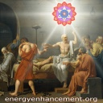Satchidanand’s Against Satanism Newsletter
Meditation Energy Enhancement Against Satanism - Satanic Phoenician Mega Trillionaires have ruled the World for 10,000 years and infiltrated every country, every Empire, from their Phoenician Colonies in Ancient Egypt, Carthage, Rome, Venice, and London.

This seems like useful information if you are interested in BRICS

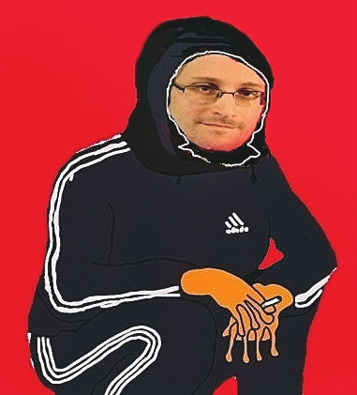

Edward Slavsquat
Oct 25, 2024


The Kazan Declaration (source: kremlin.ru)

THE SATANIC PHOENICIAN MEGA TRILLIONAIRE ROTHSCHILD BRICS - BRAZIL, RUSSIA, INDIA, CHINA, SOUTH AFRICA
- just wrapped up its 16th summit in Kazan. Probably you heard about this momentous event from meticulously researched independent media articles discussing how BRICS just delivered a DOUBLE DEATHBLOW to the globalists.
This is very good news. Let us celebrate together by reading the BRICS’ Kazan Declaration, published on October 23. (English or Russian, compliments of the Kremlin’s official website.)
Please, I beg you—read this Declaration and share it with all your friends. The Kazan Declaration is not just a massive victory for BRICS, it is a victory for all decent freedom-loving people on Earth.
Here are a few highlights from this historic document:

BRICS supports “global governance” and “the central role of the United Nations in the international system”
“[W]e reaffirm our commitment to multilateralism and upholding the international law, including the Purposes and Principles enshrined in the Charter of the United Nations (UN) as its indispensable cornerstone, and the central role of the UN in the international system, in which sovereign states cooperate to maintain international peace and security, advance sustainable development, ensure the promotion and protection of democracy, human rights and fundamental freedoms for all as well as cooperation based on solidarity, mutual respect, justice and equality. We further emphasize the urgent need to achieve equitable and inclusive geographical representation in the staff composition of the Secretariat of the United Nations and other international organizations in a timely manner.”
- “We reiterate our commitment to improving global governance by promoting a more agile, effective, efficient, responsive, representative, legitimate, democratic and accountable international and multilateral system.”

BRICS supports the leading role of the IMF in global finance
- “We reaffirm our commitment to maintaining a strong and effective Global Financial Safety Net with a quota-based and adequately resourced IMF at its center.”

BRICS supports the Satanic Phoenician 2030 Agenda for Sustainable Development
- “We stress the universal and inclusive nature of the 2030 Agenda for Sustainable Development and its Sustainable Development Goals, and that implementation should take into account different national circumstances, capacities and levels of development, whilst respecting national policies and priorities and in conformity with national legislation.”

BRICS supports public-private partnerships to help nations achieve their Sustainable Development Goals
- “We recognise ( Note the British Spelling of the British Empire Burrocrats of recognize) that the use of blended finance is an effective way to mobilize private capital to finance infrastructure projects. We note the important role of multilateral development banks and development finance institutions, in particular national development banks, in institutionally scaling up the use of blended finance and other instruments, and thereby contributing to the achievement of the Sustainable Development Goals in accordance with country-specific needs and priorities. To this end, we commend the work of the BRICS Public-Private Partnership and 17 Infrastructure Task Force and endorse its Technical Report on Infrastructure Projects Blended Finance.”

BRICS supports the reduction and removal of greenhouse gases to combat climate change
- “We reiterate that the objectives, principles and provisions of the United Nations Framework Convention on Climate Change (UNFCCC), its Kyoto Protocol and its Paris Agreement, including its principles of equity and common but differentiated responsibilities and respective capabilities (CBDR-RC) in the light of different national circumstances, must be honoured. We condemn unilateral measures introduced under the pretext of climate and environmental concerns and reiterate our commitment to enhancing coordination on these issues. We will strengthen cooperation on a whole range of solutions and technologies that contribute to the reduction and removal of Greenhouse Gases (GHGs). We also note the role of carbon sinks in absorbing GHGs and mitigating climate change, whilst also highlighting the importance of adaptation and stressing the need for the adequate provision of the means of implementation, namely financial resources, technology transfer and capacity building.”
- “We underscore the critical need for active climate adaptation projects, moving beyond research and forecasting to the implementation of practical solutions, advancing renewable energy, sustainable financing, low-emission technologies, and sustainable development investments, while highlighting the importance of collective action and international cooperation to address the adverse impacts of climate change and ensure inclusive, equitable climate initiatives.”

BRICS supports the creation of carbon markets, carbon taxes…
- “We recognise the important role of carbon markets as one of the drivers of climate action, and encourage enhancing cooperation and sharing experiences in this field. We oppose unilateral measures introduced under the pretext of climate and environmental concerns and reiterate our commitment to enhancing coordination on these issues. We welcome the adoption of the MoU on the BRICS Carbon Markets Partnership as a platform dedicated to sharing knowledge, experiences and case studies of developing carbon markets and discussing the potential intra-BRICS cooperation on carbon markets to exchange views on potential cooperation under Article 6 of the Paris Agreement among the BRICS countries.”

BRICS supports the World Health Organization and its “central coordinating role” in strengthening “the international pandemic prevention, preparedness and response system”
- “We reiterate our support to the central coordinating role of the World Health Organization in the implementation of multilateral international efforts to protect public health from infectious diseases and epidemics and commit to reform and strengthen the international pandemic prevention, preparedness and response system. We recognise the fundamental role of primary health care as a key foundation for Universal Health Care and health system’s resilience, as well as on prevention and response to health emergencies. We welcome fostering closer ties among BRICS health institutions responsible for sanitary and epidemiological health and well-being, prevention, preparedness and response to epidemic prone communicable diseases and health impact following disasters and encourage further exploring opportunities for knowledge sharing, exchange of expertise and undertaking joint projects in the health sector.”

BRICS supports the development of safe & effective vaccines
- “We support the initiatives of the BRICS R&D Vaccine Center, further development of the BRICS Integrated Early Warning System for preventing mass infectious diseases risks and the operations of the BRICS TB Research Network. We welcome the outcomes of the 79th United Nations General Assembly (UNGA) High Level Meeting on AMR, committing to a clear set of targets and actions, including reducing the estimated 4.95 million human deaths associated with bacterial antimicrobial resistance (AMR) annually by 10% by 2030. We express concern about the growing threat of AMR to all sectors of the economy, in particular healthcare, and note the timeliness of holding the first BRICS Conference on AMR in May 2024.”

BRICS supports “digital transformation” using 5G and other "emerging technologies”
- “Recognising the importance of creating an enabling, inclusive, and secure digital economy and that digital connectivity is an essential prerequisite for digital transformation as well as social and economic growth, we emphasize the need to strengthen cooperation among BRICS countries. We also recognise that emerging technologies such as 5G, satellite systems, terrestrial and non-terrestrial networks, have the potential to catalyze the development of the digital economy. We acknowledge that resilient, safe, inclusive and interoperable digital public infrastructure has the potential to deliver services at scale and increase social and economic opportunities for all.”
And so on and so forth.

Strengthening Multilateralism for Just Global Development and Security vs Building a Just World and a Sustainable Planet
The world is at a crossroads. There are two distinct visions for the future of humankind. You must choose one and then argue with strangers on the internet who are inadequately enthusiastic about your choice, which is perhaps the most meaningful and consequential choice you will ever make; your choice will literally change the trajectory of human history. So please choose wisely.
Let me be more specific.
The theme of this year’s BRICS summit was “Strengthening Multilateralism for Just Global Development and Security”. I think we all understand why BRICS chose this theme—because it is very meaningful and profound.
In sharp contrast, the G20 (which includes the USA and many other Unipolar Satanic West nations) will be meeting next month in Rio de Janeiro to discuss “Building a Just World and a Sustainable Planet”.
The contrast could not be more extreme. Like day and night.

The Secret Control System of the World’s Elite is the Fact that the Satanic Phoenician Mega Trillionaire Rothschilds and Rockefellers who Own Every Country, G20, and BRICS, have Bought Every Leader and Use the Satanic Religion and it’s Satanic Rituals as a Control System over those Leaders.
So a lot of child traffiking goes on all over the world for the Satanic Elite. Three Hundred and Twenty Thousand children have gone missing over the Mexico - USA border since Pedo Biden got in. They cannot be found. Pedophilia, prostitution, slavery, child sacrifice, organ trafficking.
Pedophiles and Sodomites are actually institutionally created in Britain’s top schools as a preparation for Satanic Clubs for the Cherry Picked rulers of the world. Read the article…

P.G. Wodehouse and British Empire Ritual Sodomy Band of Thebes Propagandised for Hitler, Propagandised for the Satanic Phoenician Mega Trillionaires

Satchidanand
·
October 2, 2022
Sir Pelham Grenville Wodehouse, KBE 15 October 1881 – 14 February 1975 was an English author and one of the most widely read humorists of the 20th century. His creations include the feather-brained Bertie Wooster and his sagacious valet, Jeeves; the immaculate and loquacious Psmith; Lord Emsworth and the Blandings Castle set; the Oldest Member, with stories about golf; and Mr Mulliner, with tall tales on subjects ranging from bibulous bishops to megalomaniac movie moguls.

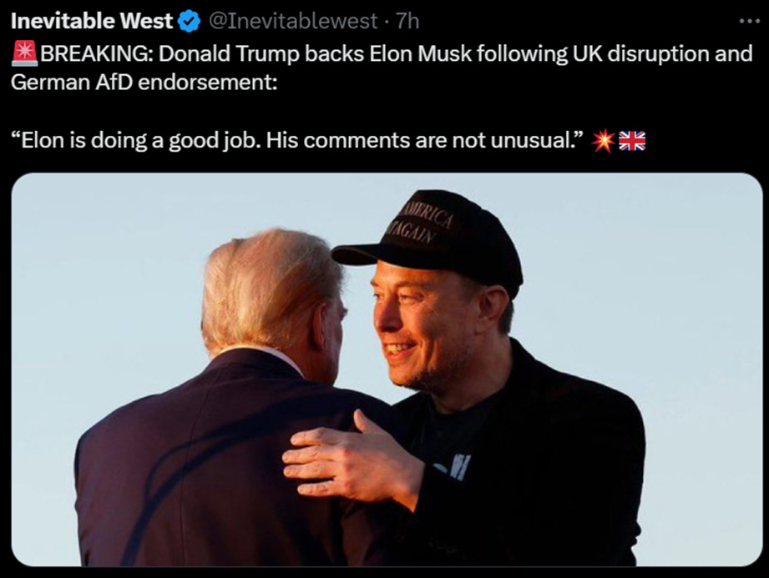

Elon Musk's War On International Pedophile Rings Sends World Leaders Into A Total Panic

Satchidanand
·
Jan 7
Here is the Season of the Destruction of Evil!

Read full story

Thus the Politicians controlling Pedophile Rings and their associated Child procurers are their weak points.
Everyone hates pedophiles.
In jail the ordinary crook targets them.
Thus by Alex Jones and Elon Musk targetting them we have the current situation.
Musk, not just the world’s richest man but a key adviser to President-elect Donald Trump, has clashed for months with Prime Minister Keir Starmer at a time when the U.K. is concerned about its standing with the incoming U.S. administration.

Of course the Satanic Phoenician Elite of England are brought up to be Sodomite Pedophiles from their Faggot Sodomite Education in Eton and they Utilised Satanic Monster Jimmy Saville - who was a Major Friend of King Chucky the Turd Saxe Coberg Gotha Dracul and to the Pedophile Vatican and to the Godless Israelis which Country was Created by the Satanic Phoenician Mega Trillionaire Rothschilds - to Supply their Perverse Needs such as Young Children from Orphanages for Pedophilia and Child Sacrifice.

King Charles the Third’s Brother, Prince Andrew was Connected to Mossad, CIA, MI6 Pedo-Procurer Epstein…



The Satanic Sodomy Ritual is the basis of every Satanic Organisation from the Illuminati, The Sabbattean Frankists to the 33rd Degree Freemasons..

Read this article for the Sodomy Ritual.

ENERGY ENHANCEMENT MEDITATION SACRED SYMBOLS FOR PERFECT WISDOM ENLIGHTENMENT AND THE SATANIC PERVERSION OF THESE SYMBOLS
Satchidanand

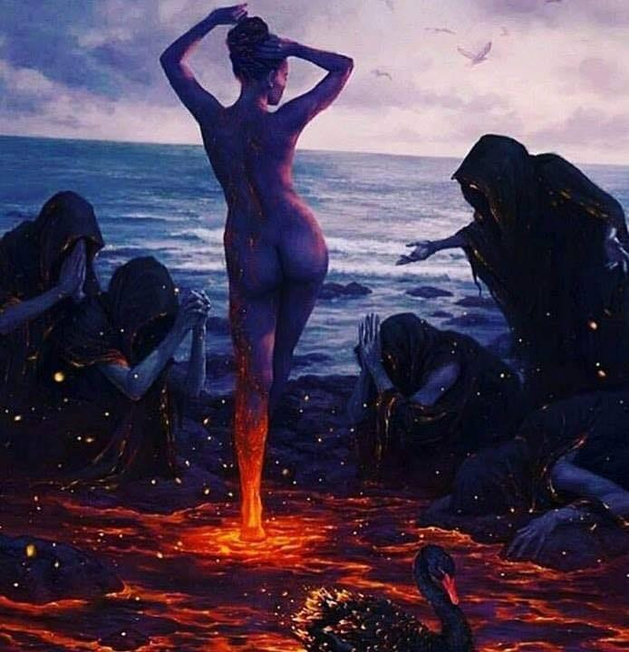

It's hard for me to say this but Sacred Symbols, good symbols, or legominisms as Gurdjieff said where symbols of the past are designed to help us, inform us, provide a map whereby we can all cleave to the light, become Enlightened.
Read full story

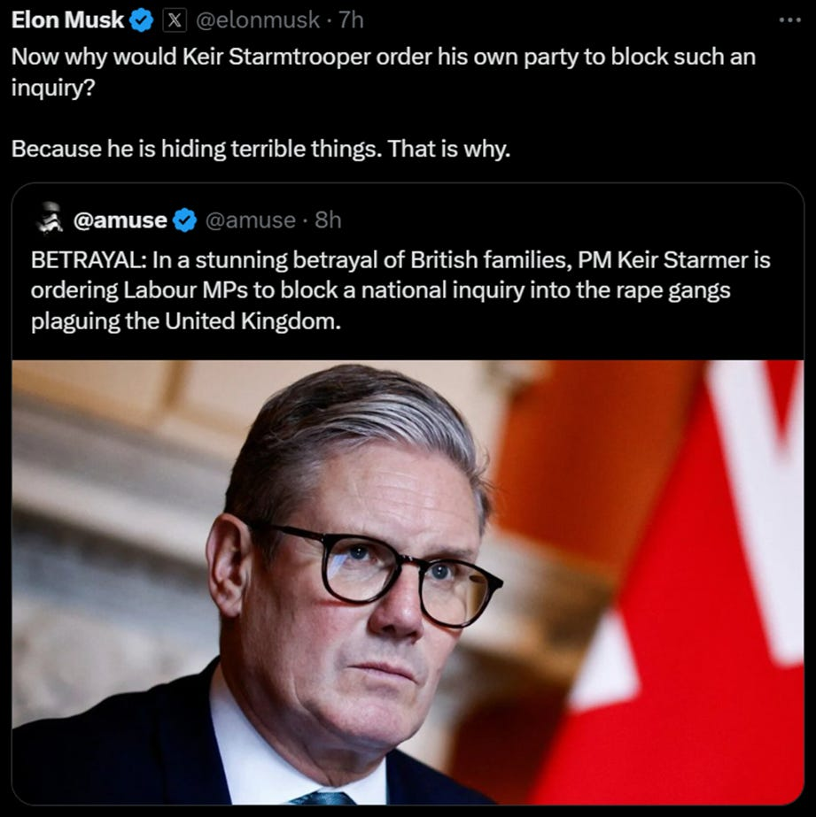

Over the weekend the tech billionaire took his feud to a new level, taunting the U.K.'s new center-left leader over sinking approval ratings and questioning why anti grooming, anti pedophile figurehead Tommy Robinson had been imprisoned for eighteen months! over a simple contempt of court which merits a fine.

Eyes Wide Shut - Satanic Pedophile Hollywood
Satchidanand



Eyes Wide Shut - The Paedo Files
Read full story
Tommy Robinson Outed the Immigrant Rape and Prostitution Gangs over fourteen years ago! Nothing has been done by any Government Labour or Conservative in Britain, or in the World. Not forgetting Satanic BBC Child Procurer to the elite and satanist Jimmy Savile's service to the Satanic Elite pedophiles and child sacrificers which haunt the upper reaches of British Society.
Jimmy Savile was a vision of a Satanist and procurer of children from orphanages for Elite Pedophiles and Satanic Rituals who was a great friend of the current King Charles the Third, Honoured by the Pedophile Vatican and the Israeli Government.
From John of God in Brazil to Politically Protected Clinics al over the World, Young Itinerant Girls are Impregnated and their Babies taken and Sold to The Satanic Elite, Worldwide.
"The people of Britain have had enough of a tyrannical police state," Musk posted on his X platform, quoting a post about an online petition calling for another election that has now reached 2 million signatures.
Starmer's Labour Party won an overwhelming majority in July and does not need to call a vote for another five years. But his leadership has been beset by an immediate sense of crisis, low approval ratings and more recently a mass protest by angry farmer being treated like Kulaks. The petition accuses the government of having "gone back on the promises" it made during the election.
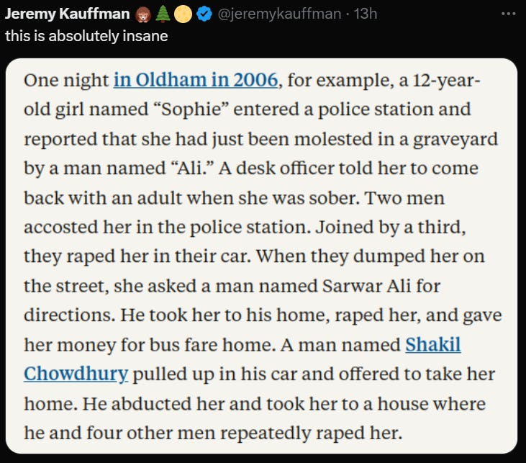
Musk drew criticism from the U.K. in August, when he said the country was on the verge of “civil war” following days of right-wing riots after three young girls were killed in a knife attack at a Taylor Swift-themed dance party.
But his latest attacks carry more weight on the heels of Trump's election victory, with Musk lined up to run a new government efficiency drive and having apparent input on foreign affairs.
As Starmer's government works to overcome its own past public comments against Trump and build relations with Trump, Musk continues to attack it.

G20 vs BRICS: Who is more sustainable?
Edward Slavsquat
September 15, 2023

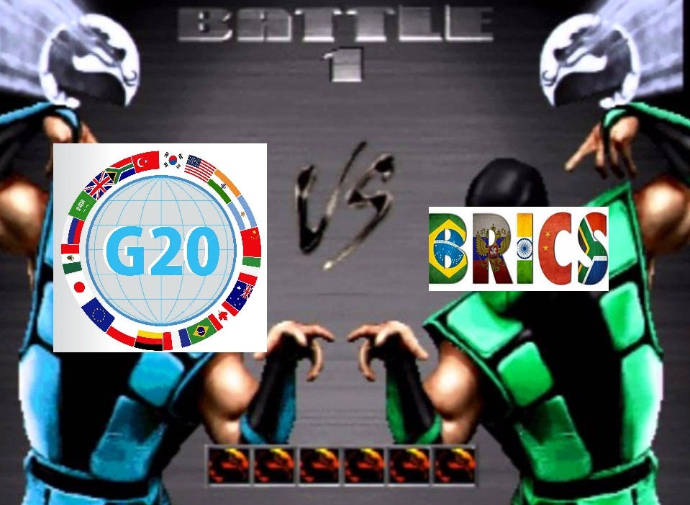

On August 23, 2023, Brazil, Russia, India, China, and South Africa released a joint declaration promising that BRICS would pursue Sustainability.
Read full story

HOW COULD THIS COME TO BE?
Let’s play a quick game. Which of these two statements is from BRICS’ Kazan Declaration?
- Statement A: “We reaffirm our support for the rules-based, open, transparent, fair, predictable, inclusive, equitable, non-discriminatory, consensus-based multilateral trading system with the World Trade Organisation (WTO) at its core, with special and differential treatment (S&DT) for developing countries, including Least Developed Countries and reject the unilateral trade restrictive measures that are inconsistent with WTO rules.”
- Statement B: “We express our support for actions aimed at reaffirming that a rules-based, non-discriminatory, fair, open, inclusive, equitable, sustainable and transparent multilateral trading system, with WTO at its core, is indispensable; [we support] policies that enable trade and investment to serve as an engine of growth and prosperity for all … Fostering a favourable trade and investment environment for all.”
Answer: Statement A is from BRICS’ Multipolar Sustainable Agenda 2030 Freedom Vision Declaration. Statement B is from the Second G20 Foreign Ministers’ Call to Action on Global Governance Reform, published exactly one month ago on September 25, 2024, and available on the website of the US State Department.
And yet …. these statements, issued by totally different Poles, are oddly similar. What could this possibly mean?
It’s a mystery, but pro-Putin conservative Russian media has a scandalous hypothesis:


source: katyusha.org
After combing through the Kazan Declaration, Katyusha concluded:
It is obvious that the goals of the unification of the countries of this seemingly “alternative to the Atlanticist” bloc are declared to be practically the same as those in the UN declaration “Pact for the Future” recently adopted at the Future Summit in New York. Both the stated goals and the proposed image of the future BRICS association are the same, and everything is even written in the same satanic globalist newspeak.
That is, we have before us a sadly familiar model of globalization, only not for the countries of the Atlantic bloc and their satellites, but for Eurasia and the “global South”—including Africa, and South America. [BRICS] is a kind of subproject from the same curators—in any case, this is precisely what follows from the text of the Kazan Declaration.
Yeah, but … Zerohedge said that Putin was presented with a gimmick BRICS peso, and that I should be excited about that.
I am excited.
I am.
But I just thought that maybe you would like to know what BRICS said about BRICS when it met in Kazan.
Not only do Satanic Phoenician Mega Trillionaire Stooges and Gatekeepers never talk about Satanic Phoenician Mega Trillionaires and how it is they, not the World Economic Forum, not the Politicians, not the Professors, who really run the world.

I have previously put forward the proposition that ALL the Politicians in the World work for the Satanic Phoenician Mega Trillionaires like the Rothschilds..

The Secret Control System of the World’s Elite is the Fact that the Satanic Phoenician Mega Trillionaire Rothschilds and Rockefellers who Own Every Country, G20, and BRICS, have Bought Every Leader and Use the Satanic Religion and it’s Satanic Rituals as a Control System over those Leaders.

And that the Rothschilds own the British Empire and the Anglo-American Empire which owns every country in the World

George Washington was a British Aristocrat put in charge of a British Empire Colony… by the British!
Satchidanand

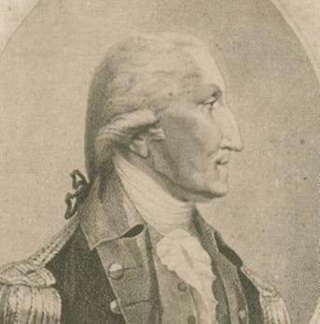

America has Always been a Satanic Phoenician British Empire Colony.
Read full story

And that Trump, Biden, Xi, Putin, Starmer, Macron, Trudeau, etc are all complicit in the United Nations Agenda 2030, Digital Identity, CBDCs, 90% Eugenic Depopulation through Mandatory Vaccinations, Genocide by Deathvaxx, Hard Drugs and other Poisons, Social Credit Scores, Total Totalitarian Censorship, Debanking, AI De-Jobbing thus Universal Basic Income and Robot Control, Social Media Complicity etc etc..

Satanic Phoenician Mega Trillionaire Stooges and Gatekeepers also tell other lies!

GATEKEEPERS
Satchidanand



GATEKEEPERS
Read full story

Visible Oligarchs are merely Trustees, Fronts, of the Satanic Phoenician Mega Trillionaire London Money Power
Satchidanand

Visible Oligarchs are merely Trustees, Fronts, for the Satanic Phoenician Mega Trillionaire London Money Power
Read full story

All Central Banks. One Hundred Percent of All Central banks World Wide belong to the Rothschilds - the Satanic Phoenician Mega Trillionaires.

80% of all Fortune 500 Corporations, and 100% Holding Companies like Blackrock and Statestreet belong to the Rothschilds…

The Richest Satanic Phoenician Mega Trillionaire 10,000 years old Families in the World

The Richest Satanic Phoenician Mega Trillionaire 10,000 years old Families in the World

Satchidanand
·
November 25, 2022


The Richest Satanic Phoenician Mega Trillionaire 10,000 years old Families in the World. THE VANGUARD GROUP DRIVES WORLDWIDE MERCHANT-BANKER FASCISM FROM THE CITY OF LONDON. VANGUARD, BLACKROCK, STATE STREET ARE CONTROLLED BY THE PILGRIMS SOCIETY IN THE CITY OF LONDON (ROTHSCHILDS, BARINGS, BARCLAYS, NATWEST, ETC.) King Chucky the Turd is the front man controlling Klaus Schwab and Vanguard.

Read full story

I even asked why we need Rothschild Central Banks? Why don’t Countries just Borrow on their Assets? Why Borrow from the Rothschilds and pay interest on loans created as figures in their Computers.
The Satanic Phoenician Mega Trillionaires in that process have developed a lot of experience in the engineered destruction of Empires and the raising of the new. It seems they always use the same playbook from the Fall of the Roman Epmire to now which I will describe below...
First though, this fact of the conscious engineered destruction of Empires and the raising of the new by the Satanic Phoenician Mega Trillionaires does not seem to have infiltrated the minds of commentators..
Like Martyanov
https://smoothiex12.blogspot.com/
Or Simplicius

Trump, Biden, Xi, Putin Complicit in the United Nations Agenda 2030

Satchidanand
·
December 25, 2024

MERRY CHRISTMAS!

Read full story

Simplicius's Garden of Knowledge
Conflict analysis, geopolitical commentary, with a side of culture & politics.

who can give you book and verse on the current state of the destruction of the West but never ask the question "WHY?"
Of course, why do commentators miss out the obvious question, "WHY?" - it's because they are paid, Propagandist Gatekeepers funded by the Satanic Phoenician Mega Trillionaires.
I wrote a substack on Simplicius on this very subject so you can see how Gatekeepers work.

WHAT THEY ARE SHITTING IS SATANIC PHOENICIAN MEGA TRILLIONAIRE MIND CONTROL PROPAGANDA
Why? is the American wealthy, partisan, minion elite class working so hard to destroy civilisation, destroy America, destroy humanity?

WHAT THEY ARE SHITTING IS SATANIC PHOENICIAN MEGA TRILLIONAIRE MIND CONTROL PROPAGANDA
Satchidanand

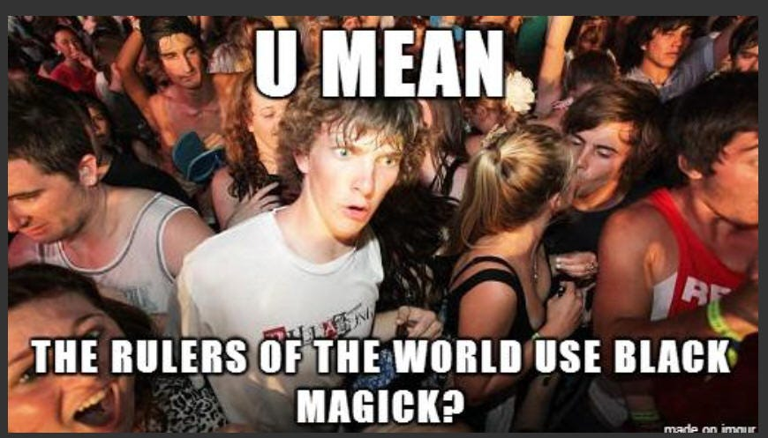

WHAT THEY ARE SHITTING IS SATANIC PHOENICIAN MEGA TRILLIONAIRE MIND CONTROL PROPAGANDA https://againstsatanism.com/WHAT-THEY-ARE-SHITTING-IS-SATANIC-PHOENICIAN-MEGA-TRILLIONAIRE-MIND-CONTROL.htmSatchidanand’s Against Satanism Newsletter is a reader-supported publication. To receive new posts and support my work, consider becoming a free or paid subscribe…
Read full story
I wrote a substack on Clif High
Aether Pirates of the Matterium!
clif high's 5GUW reporting. And Woo. Lots of Woo. Explorations of this Matterium & its inhabitants including Space Aliens on the Moon!
By clif high

The Elohim Demons and Elohim Minion Satanic Phoenician Mega Trillionaire Wanker Bankster Bankers
Elohim Demon Control by Mind Viruses and Mind Parasite Energy Blockages and Narratives...

The Elohim Demons and Elohim Minion Satanic Phoenician Mega Trillionaire Wanker Bankster Bankers
Satchidanand

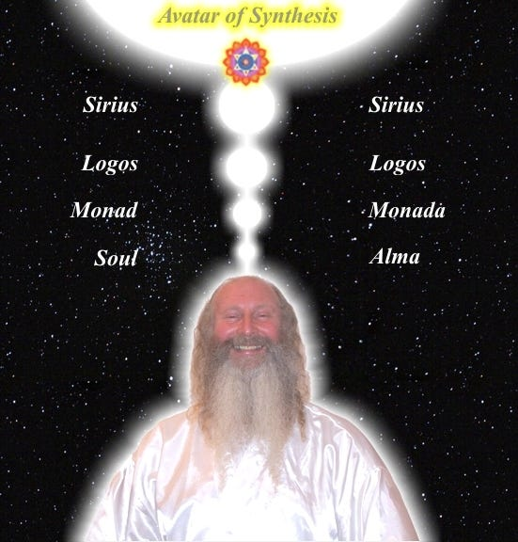

The Elohim Demons and Elohim Minion Satanic Phoenician Mega Trillionaire Wanker Bankster Bankers Elohim Demon Control by Mind Viruses and Mind Parasite Energy Blockages and Narratives... The Elohim Demons or human being who have learned to live outside the body in Private Universes are extra terrestrial beings with over ten thousands of years of history o…
Read full story
Martyanov, Simplicius and Clif High all have brains the size of planets but none of them seem to ask the question, "Why?". And the reason, obviously, is that they themselves are members of the Aristocratic families of the Satanic Phoenician Mega Trillionaires and/or are paid by them as revealed by Miles Mathis http://mileswmathis.com/updates.html
who has delved deeply into the genealogies of famous people, film stars, scientists, artists, composers, musicians currently and through history and who has found that mainstream media and history itself is a web of deceit and lies and that all famous people are Phoenicians - as he says from, “The Phoenician Navy” Thalassocracy and are all given the promotion needed to become famous by the Satanic Phoenician Mega Trillionaires.
What I am getting at is that they are not asking the question, "WHY?" then they, by not giving the Truth, the whole Truth, and nothing but the Truth, by being, “Parsimonious with the Truth” are diverting people into useless channels which can bear no fruit, then they are paid propagandist Phoenician Gatekeepers.
Tucker Carlson, Russel Brand, Mike Adams - everyone promoted, famous, is like this!
Like all Gatekeepers 90% of what they say is the truth but 10% is designed to put you off the track.
The crash of civilisations, the Fall of the West, the Infil-traition of Satanism is the methodology as slowly every Government Ministry and Societal function is taken over. Eventually a Satanist becomes King Emperor President. LGBTP - The Satanist Ritual Pillars of Homosexuality, Pederasty, Pedophilia, Drugs and Ritual Sex - both Hetero and Homosexual - are introduced overtly as a prelude to Ritual Human Sacrifice - Suicide Pods, and Ritual Baby Sacrifice - Abortion. Christianity and Judaism - the bulwarks Against Satanism - are destroyed and then society destroyed through the fear of mandatory Ritual Human Sacrifice.
The Ancient Enemy who counts meditation and the mind control psychic arts as one of its main planks of World Domination has used Satanic Infil-Traitors for 10,000 years in every Organisation - Religion, Left and Right Politics, Dynastic Families, Geopolitics, Economics, Universities, Intelligence Services, Think Tanks, Banking, International Companies, Eugenics.
Innoculate yourself Against Satanic Globalism which created Cybele and Attis, Baal, Molech, Zeus, Venus, Pedophile Plato, No Soul Aristotle, Catholicism, Protestantism, the Illuminaughty, Sabatean Frankism, Crowley's Ordo Templi Orientis (OTO), Islam, Wahhabic ISIS, the Muslim Brotherhood, Communism, Socialism, Gaia and Satanic Hitler's Pagan Eugenic Nazism by Downloading and Reading.. The Energy Enhancement Set of Books - Against Satanism Volumes 1 - 11 by Satchidanand.
Adorno said he composed, "Music to Suicide By" Music which destroys the Heart and Aspiration to Beauty and the Good.

This Satanic Frankfurt School promoted Ugliness, the Ugly Virus - Ugly Modern Art, Ugly Architecture, Ugly Fat Females in Movies and Video Games - All designed to destroy Beauty, Destroy and Degenerate the Human Soul. All designed to destroy the Human Heart..
https://againstsatanism.com/Satanic-Frankfurt-School-ADORNO-BENJAMIN-MARCUSE-LUKACS-BRECHT-WEILL-ECO-DERRIDA.htm
For 10,000 years the whole of media, all world history, all information, has been censored, removed, distorted, perverted, so that the Truth, the whole truth and nothing but the truth can never be revealed.
As the Buddha said, "If I say something they won't understand it, if I write something it will be changed, or censored"
Satanic Phoenician Mega Trillionaire Aristocratic Family Gatekeepers and paid Gatekeepers tell partial truths higher and higher up the intellectual ladder so the real truth can never be known.
I have been disturbed for some time by the reports of historians who say what happened and that the cause was Jews, Fascism or Communism or Capitalism, but with no research into the cause behind them.
How it came to be. Who is in charge of it!
The Satanic Phoenician Mega Trillionaires who have controlled humanity for 10,000 years developed a technique of spiritual vampirism, a Transhumanism to suck all the energy of humanity so they could take that energy into their reservoirs and use that energy to live forever in Private Universes out of the body high up in the Astral Plane Chakras above the head. The higher the Universe, the higher the Power.
They created the Religion of Satanism 10,000 years ago to institutionalise that vampirism in their evil Rituals, then also used their Mind Control Rituals to tightly control their adherants in their Secret Sodomite Societies and Satanic Aristocratic Families, to richly reward their worshippers, so that their worshippers of Satan would work to dumb down humanity secretly, permanently, so that the vampirisation of their energy could continue eternally without any pushback from the populace.

Satanism is defined by Satanic Rituals.. Mind Control Programs - LIVES FOR SATAN! - THESE RITUALS DEFINE SATANISM.. RITUAL SEX, RITUAL PEDOPHILIA, RITUAL SODOMY, RITUAL DRUGS, RITUAL BLOOD SACRIFICE, RITUAL HUMAN SACRIFICE, RITUAL TORTURE, RITUAL BURNING ALIVE, RITUAL CANNIBALISM, RITUAL CASTRATION, RITUAL VIRGIN SACRIFICE.

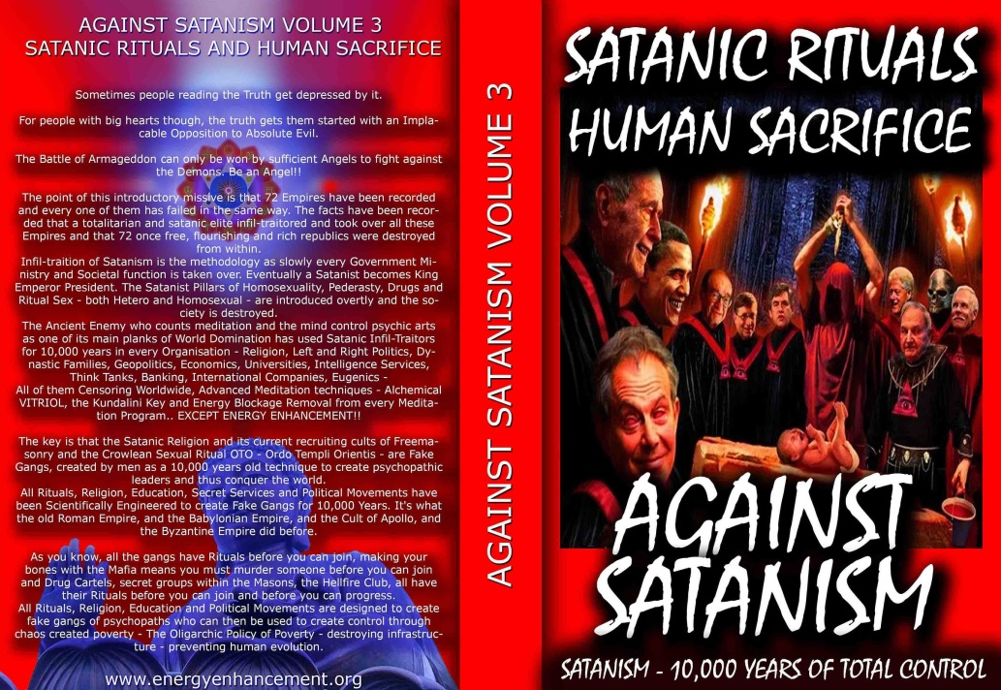

http://www.energyenhancement.org/Sacred-Energy/Against-Satanism-Volume-3/Against-Satanism-Volume-3-Satanic-Rituals.pdf

CONFESSIONS OF A SATANIST Frater 616

Satchidanand
·
June 18, 2023
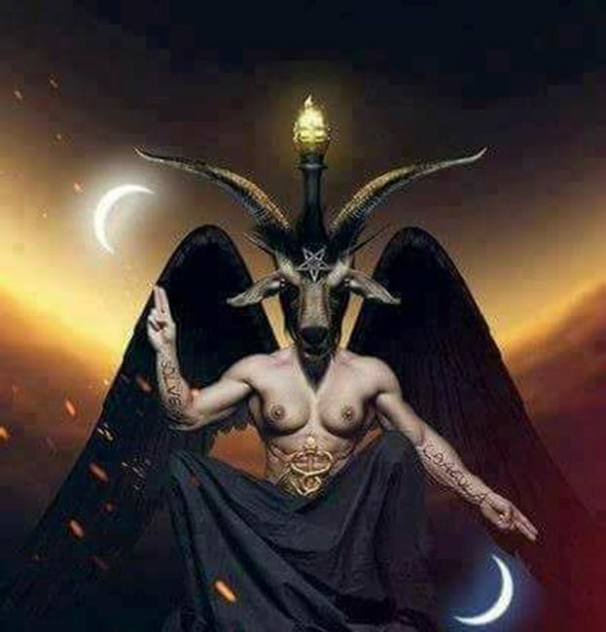

CONFESSIONS OF A SATANIST Frater 616

SATANIC PSYCHOPATH HUMAN SACRIFICE RITUAL TRAINING - RONALD BERNARD… I WAS IN TRAINING AND I FAILED

Satchidanand
·
November 18, 2024
RONALD BERNARD… I WAS IN TRAINING TO BECOME A PSYCHOPATH, AND I FAILEDSatchidanand’s Against Satanism Newsletter is a reader-supported publication. To receive new posts 55 free books and support my work, consider becoming a free or paid subscriber.

Read full story

False Flags like 911 are used to bring in the Patriot Act to side step the Constitution and bring in totalitarianism.

EPSTEIN CIA, MOSSAD AND MI6 BLACKMAIL AND SHAME KEEP THE SATAN WORSHIPPERS AND PAID POLITICIANS, PRIESTS, POLICEMEN, PROFESSORS - ALL PROSTITUTES - IN LINE TO DUMB DOWN AND DEGENERATE HUMANITY SO IT CAN NOT FIGHT BACK... so now everyone sees that every Congressman, every Senator has been bought or compromised by Blackmail and that Indeed the Satanic Phoenician Mega-Trillionaires Control the Uniparty, Control the Fake Elections, and that Whoever you Vote for, the Government Deep State Always Gets In!
72 Empires have been recorded over 10,000 years and every one of them has failed in the same way. This change of Empires is part of their long methodolgy to maintain control.
The purpose of the Engineered Collapse of the preceding Empire and the founding of the New Empire is control of humanity. If people remain rich for too long they can evolve and remove the Satanic Mega Trillionaire Controllers, but the constant change, the Sturm und Drang of history, keeps everyone busy barefoot and back on the reservation with the engineered principle of poverty..
The facts have been recorded that a totalitarian and satanic elite infil-traitored and took over all these Empires and that 72 once free, flourishing and rich republics were destroyed from within by Satanic Ritual - read Toynbee.
Infil-traition of Satanism is the methodology as slowly every Government Ministry and Societal function is taken over. Eventually a Satanist is engineered to become King Emperor President.
LGBTPS - The Satanist Ritual Pillars of Transhumanism, Androgeny, Homosexuality, Sodomy, Pederasty, Drugs and Ritual Sex - both Hetero and Homosexual - are introduced overtly as Wokeness ESG, DIE, Agenda 2030, UN Replacement Migration, Climate Change, Sustainability, Burning Farms to buy back at pennies on the dollar, inflation, the Principle of Poverty, the Corporate Equality Index, as a prelude to Ritual Human Sacrifice.
Now an Additional Method of Destroying an Empire - The Crisis of Financialization - Rather than Real Products and Commodities we change to Financial Expansion and Collapse of the Empire.
An Italian economic historian appears to have inadvertently exposed the way in which Clown World migrates The Empire That Never Ended from a declining power to its successor Empire like a changing of the Guard:
https://www.rt.com/business/594432-financialization-death-empires/

It pays to revisit the work of the Italian political economist and historian of global capitalism Giovanni Arrighi (1937-2009).
Arrighi, who is often simplistically pigeonholed as a Marxist historian, a label far too constricting given the breadth of his work, explored the origins and evolution of capitalist systems dating back to the Renaissance and showed how recurrent phases of financial expansion and collapse underpin broader geopolitical reconfigurations. Occupying a central place in his theory is the notion that the cycle of rise and fall of each successive hegemon terminates in a crisis of financialization. It is this phase of financialization that facilitates the shift to the next hegemon.
Arrighi dates the origin of this cyclical process to the Italian city-states of the 14th century, an era that he calls the birth of the modern world. From the marriage of Genoese capital and Spanish power that produced the great discoveries, he traces this path through Amsterdam, London and, finally, the United States.
In each case, the cycle is shorter and each new hegemon is larger, more complex and more powerful than the previous one. And, as we mentioned above, each terminates in a crisis of financialization that marks the final stage of hegemony. But this phase also fertilizes the soil in which the next hegemon will sprout, thus marking financialization as the harbinger of an impending hegemonic shift. Essentially, the ascending power emerges in part by availing itself of the financial resources of the financialized and declining power.
Arrighi detected a first wave of financialization starting around 1560, when the Genoese businessmen withdrew from commerce and specialized in finance, thereby establishing symbiotic relations with the Kingdom of Spain. The subsequent wave began around 1740 when the Dutch began to withdraw from commerce to become “the bankers of Europe.” The financialization in Great Britain, which we will examine below, emerged around the end of the 19th century; for the United States, it began in the 1970s.
Hegemony he defines as “the power of a state to exercise functions of leadership and governance over a system of sovereign states.” Central to this concept is the idea that historically such governance has been linked to the transformation of how the system of relations among states functions in itself and also that it consists of both what we would call geopolitical dominance but also a sort of intellectual and moral leadership. The hegemonic power not only rises to the top in the jockeying among states but actually forges the system itself in its own interest. Key to this capacity for the expansion of the hegemon’s own power is the ability to turn its national interests into international interests.
Observers of the current American hegemony will recognize the transformation of the global system to suit American interests. The maintenance of an ideologically charged ‘rules-based’ order – ostensibly for the benefit of everyone – fits neatly into the category of conflation of national and international interests. Meanwhile, the previous hegemon, the British, had their own version that incorporated both free-trade policies and a matching ideology that emphasized the wealth of nations over national sovereignty.
Returning to the question of financialization, the original insight into its epochal aspect first came from the French historian Fernand Braudel, of whom Arrighi was a disciple. Braudel observed that the rise of finance as the predominant capitalist activity of a given society was a sign of its impending decline.
Arrighi adopted this approach and, in his major work called ‘The Long Twentieth Century,’ elaborated his theory of the cyclical pattern of ascendency and collapse within the capitalist system, which he called the ‘systemic cycle of accumulation.’ According to this theory, the period of ascendency is based on an expansion of trade and production.
But this phase eventually reaches maturity, at which point it becomes more difficult to profitably reinvest capital in further expansion. In other words, the economic endeavors that propelled the rising power to its perch become increasingly less profitable as competition intensifies and, in many cases, much of the real economy is lost to the periphery, where wages are lower. Rising administrative expenses and the cost of maintaining an ever-expanding military also contribute to this, notwithstanding the fact 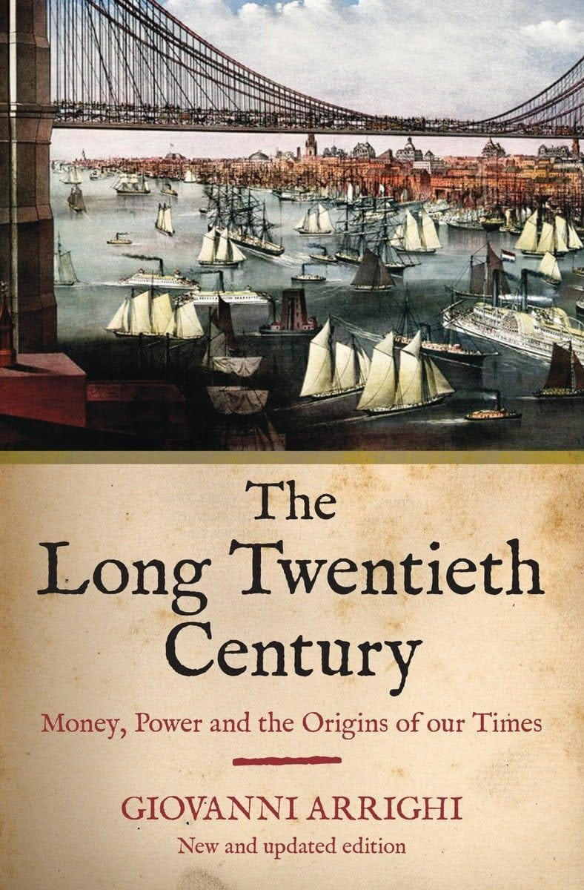
of corruption as all government pork is only eaten by the Satanic Phoenician Mega Trillionaires.
For example a toilet seat costing 70,000 dollars from NASA. More, the F35 Fighter jet costs billions, cannot be maintained and does not work, the billions of course have been stolen. The current Ukraine war has demonstrated American equipment over engineered, not fit for the purpose of War. 1000 million dollars stolen every year in the Military Industrial Academic Complex. And its not just the Military. Every program is designed to fail and the money stolen.
This leads to the onset of what Arrighi calls a ‘signal crisis,’ meaning an economic crisis that signals the shift from accumulation by material expansion to accumulation by financial expansion. What ensues is a phase characterized by financial intermediation and speculation. Another way to think about this is that, having lost the actual basis for its economic prosperity, a nation turns to finance as the final economic field in which hegemony can be sustained. The phase of financialization is thus characterized by an exaggerated emphasis on financial markets and the finance sector.
Financialization is the first stage of decline and fall, but because it looks like an economic boom, it confuses everyone as to the fact that the mantle of hegemonic power is already being passed on. And part of the chaos of today’s world likely stems from the apparent fact that China belatedly rejected both financialization as well as its role as the next seat of the travelling empire, while both China and Russia are systematically destroying every attempt to expand the hegemon to global proportions.
It’s a long piece, but read the whole thing. The Long Twentieth Century by Giovanni Arrighi is definitely going on the reading list.
The Long Twentieth Century: Money, Power and the Origins of Our Times Paperback – Illustrated, February 16, 2010
by Giovanni Arrighi
But Arrighi, although he noted the methodology still had no notion of "WHY?" all he says is that, "It happens".

HERE IS THE FULL STORY…

FINANCIALISATION and Satanic Phoenician Mega Trillionaire Central Banks? by Professor Richard A. Werner, D.Phil. - Improved and made better by Satchidanand
Satchidanand



Do we Need Satanic Phoenician Mega Trillionaire central banks? by Professor Richard A. Werner, D.Phil. - improved and made better by Satchidanand
Read full story

The Satanic Phoenician Mega Trillionaire United Nation’s Satanic Plan for a Neo Feudal Prison Planet

Satchidanand
·
December 22, 2024
Alex Newman and Maria Zeee - The Satanic Phoenician Mega Trillionaire United Nations’s Satanic Plan for a Neo Feudal Prison Planet of Impoverished Universal Basic Income, Digital ID, Social Credit Score Controlled Slaves.Satchidanand’s Against Satanism Newsletter is a reader-supported publication. To receive new posts and support my work, consider becoming a free or paid subscriber.

Read full story

In Romania the state will implement a fiscal security number along the social security number. Only with this new number/ID you will you be able to purchase things in the near future. They say it is necessary to combat tax evasion

WHEREAS..

THE ENERGY ENHANCEMENT MEDITATION COURSE BY VIDEO

"TRADITIONAL MEDITATIONS ARE DESIGNED TO FAIL!"

FIND YOUR DEEEP PEACE!

Enquiries - sol@energyenhancement.org

- AN INCREDIBLE STREAMING VIDEO MEDITATION COURSE FROM OUR OWN SERVERS...

The Satanic Phoenician Rothschild's Federal Reserve and Social Darwinism
Satanic Social Darwinism is a model where they actually target everybody, including the most intelligent.
Satchidanand
Jan 22, 2025
While other networks lie to you about what's happening now, Infowars tells you the truth about what's happening next. Visit Infowars.com forward slash show and support the Infowars. It's day two of the new American golden era. InfoWars, tomorrow's news today. Coming to you live, raw and uncensored from deep in the heart of Texas, broadcasting worldwide. I am your host, Alex Jones, and it is January 21st, 2025. What humans dream of and strive for, we are able to do. That is our history. We do the impossible as President Trump said yesterday.
Satchidanand’s Against Satanism Newsletter
Meditation Energy Enhancement Against Satanism - Satanic Phoenician Mega Trillionaires have ruled the World for 10,000 years and infiltrated every country, every Empire, from their Phoenician Colonies in Ancient Egypt, Carthage, Rome, Venice, and London.

And the entire Satanic Phoenician Mega Trillionaire Rothschild Globalist system is about demoralizing people. And I know I say that every hour on the hour because it's true. And I know you know that. But a lot of the public is mentally ill and still doesn't understand what's happening. Because they buy into being victims and they buy into life being horrible. And they buy into everything that's going to be a failure. And that if government and if the leftist system could just be in charge, everything would be wonderful. But when you study the leftist system, it's about disorder and about collapse. That's what the French Revolution was. That's where modern leftist ideology comes from. So it's very important to always address that up front. Trump is overperforming right now from what I thought he would do. I am extremely pleased.
Over 200 executive orders and actions strategically devastating the New World Order parasitic system. And then day two, we've got a lot of his big activities there, working with Congress and the leadership to get rid of red tape regulations that have been prohibitive for job growth, manufacturing, farming, and other industrial activities here. A massive plan on a real infrastructure package, the biggest ever. Instead of giving trillions to the fake New Green Deal deindustrialization plan that goes directly in a black hole by design, it actually goes into the infrastructure and the people. And of course, Trump cheerleading for the world that we're open for business again, big giant flashing red neon or I guess orange, this hair neon sign. So Trump is exactly what the doctor would order if you wanted to stop total collapse. And people say, well, how are we going from such an evil, out-of-control government to, on a dime, at least the directives from it being so good?
Well, we were to the edge of the cliff. There's no more time to be kind of corrupt and maybe dial it back a little. Unless Trump rampages forward, unless we aggressively rampage with optimism and truth and justice and going after the bad guys is critical. Not just because they deserve it, and not just for the victims, but because they're going to keep attacking us if we don't. And everything he's doing signals, and he says he understands it, that it's us or them. So... There's so much huge important news, so many incredible clips from yesterday and now today. But I have to say that I rarely have trouble saying which action is the best of a group of good things. But today, it's important to ask what is the most important thing he's doing.

WE HAVE TO CRIMINALLY PROSECUTE THE DEEP STATE!

Satchidanand
·
Jan 11
"You Are Under Attack!": Learn How The Democrat, Deep State, Fauci, Soros, Rothschild, Rockefeller, Satanic Phoenician Mega Trillionaires Intentionally Burned Los Angeles To The Ground and What's Coming Next

Read full story

Well, in general, it's getting our... morale up and then bringing tangible real things to the morale being up that will actually then have that successfully relaunch the civilization. But there's so much getting out of the global carbon tax world government regime, the heart of the New World Order, pulling out of the WHO, the J6, complete pardons.
I mean, this is amazing. It is Tuesday, January 21st, 2025. It is extremely surreal. to have been through the last nine years of this saga with President Trump and with the American people and the people of the world awakening and then struggling to get out of the clutches of the global technocratic death cult.
And their world government, their planned depopulation, their Satanism, their pedophilia, all was designed to come out of the closet in the year 2020. They said that in their public UN plan in 1992. And so the mask came off the last five years, and people did not like what they saw. And if you wonder why all this good stuff's happening, it's because the individual, on average, is waking up and becoming more informed every minute, and really breaking with Hollywood and the corporate media and the dominant political systems and the controlled churches and the controlled so-called educational system, people are finally really understanding that it's premeditated predatory evil. And that's what was developed 150 years ago by the British and U.S. and European robber barons.
They wrote books about it and published articles, and I've shown them here and gone over it. But, I mean, you've all heard of Satanic Social Darwinism.
And if you just look up Satanic Social Darwinism, robber barons or Satanic Social Darwinism industrialists, if you go back to the 1870s, 1880s, They were funding the major universities and scientific institutions. And one of their main directives was find out how to end the Renaissance and end egalitarian free societies because they get in the way of their monopolies in power. And they said, we want to know mind war.
That's what they called it then, mind war, before they even used the term propaganda. And we want to understand how to have mind control. So they put massive funding into the psychological associations that at that time only were 60, 70 years old.
And they rolled out a plan to take over medicine, take over education, take over religion. And to found a League of Nations and then a UN and to have a world government project. We've got articles front page New York Times in the 20s and 30s where they were just open about world government and the 10 regions of Earth and the 10 regions that would have in America and how they would get rid of elective government and have administrative technocracy, that term, the technocrats. We know about the technocrats because they called themselves that. And H.G. Wells was one of their main futurists and thinkers.
He didn't just write fiction. He was a bestseller of nonfiction on books like The New World Order. And you read that, and it's you'll own nothing and like it. So communism comes from the elite because they always exempt themselves from it. And they just rebranded slavery as community. And as the world finally wakes up to that, that we haven't had capitalism ever, a pure form of it, but we've had crony capitalism. And now we've got completely fascistic, predatory, centralized capitalism at war with independent free networks of individuals and nation states. And that destroys innovation.
They openly push dumbing the public down, two plus two equals whatever you want. I mean, I remember the first time 25 years ago, I heard the proposal for Common Core, took them years to pass it, and I went and read it, and it was just like fuzzy math. And then decades later, Upwards of 80% of students around the country can't ever even really graduate properly. They just give them their degrees. There are many school districts in the country where no one passes, no one. And now all over the country, they're getting rid of literacy testing for the teachers. That is a fundamental attempt to destroy the tools of logic and understanding from the public so they can be blinded and led around by their nose and led into a pit.
So we were at the precipice. And so you can't have half measures to not go over the edge of the cliff when you're one inch from it. And that's why you've seen such a sensible behavior now. not just in the public, but so many so-called elites who grew up and were born into the Satanic Phoenician Mega Trillionaire Rothschild globalist system and who went along with it because they wanted power and money and control. But when it got down to the really aggressive, shut down all the civilization and kill the majority of people, a lot of the establishment started in the last decade saying, this isn't very smart. We probably shouldn't follow through with this Satanic Social Darwinism. And then they looked and saw there were lots of populist movements under attack that were resisting it and who had educated themselves about how it really worked and who had codified it as a blueprint of the enemy operation and were saying, look at this plan.
We're living it. We need another plan. And my job, and I've been telling you this for 25 years, I didn't really figure this out and hit my stride until I was on there about five years, six years. And I said, I believe that if we promote freedom and we educate people about history and we promote another plan for civilization that's pro-human, expansionist, competitive, inspiring, empowering, according to the classic rules of human society and how we operate, who we are, That people will buy that plan because it's who they are.
The human plan sells itself instead of this anti-human plan of Satanic Social Darwinism. For those that don't know what Satanic Social Darwinism is, that's the theory developed in the last 150 years. You pull up the actual definition, pull up definition in Satanic Social Darwinism, but I'll give you mine. That it is natural and good and survival of the fittest for elites to do horrible things, create monopolies, kill people, poison people, wars, dumb everyone down, because might makes right. That if you can do something to somebody and get away with it, that that means you're doing society a favor.

THE COVID FENTANYL DRUG GENOCIDE

Satchidanand
·
December 23, 2024
The Covid, Fentanyl Drug Genocide
Read full story

And really, that is just the... law of the jungle and creates a collapse of civilization, a brief anarchy, and then the formation of warlords. So, look up the definition of Satanic Social Darwinism. I'll do it. There it is. Though few in number, the Satanic Phoenician Mega Trillionaires and their descendants over time have been able to maintain control for 10,000 years. The Satanic Phoenician Mega Trillionaires look the same as everyone else although like the picture of Dorian Grey, their satanic nature eventually engraves itself on their faces.
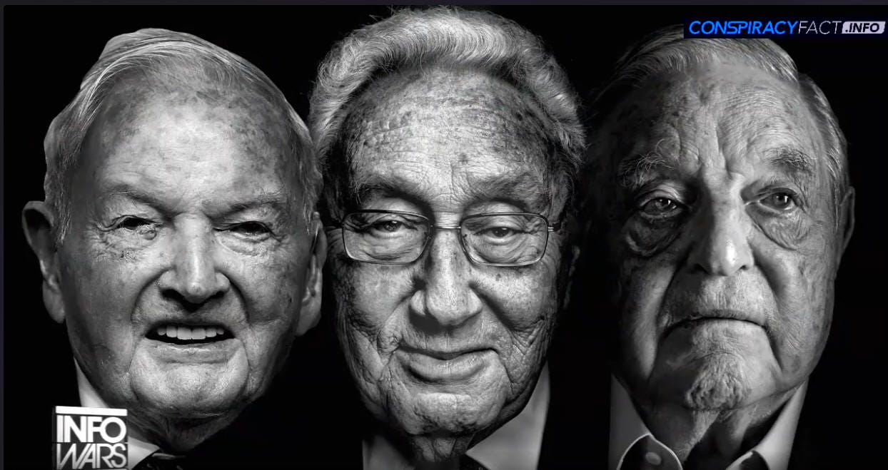
Satanic Social Darwinism is... a loose set of ideologies that emerged in the late 1800s in which Charles Darwin's theory of evolution by natural selection was used to justify certain political, social, or economic views. Satanic Social Darwinists believe in survival of the fittest, the idea that certain people become powerful in society because they are innately better. Satanic Social Darwinism has been used to justify imperialism, racism, eugenics, and social inequity at various times over the past century and a half. But the real genius of Satanic Social Darwinism run by the robber barons and their psychological warfare experts they hired, this is all on record, was they wouldn't just openly kill the dumb people and sell everybody else on wiping them out. That was Hitler's way of doing it and kind of an imitation on a larger scale of the Spartan form of eugenics where it comes from.
Where if the baby had any type of deformity, the town council would look at it and the local boss would look at the baby, look at the parents. And had a club foot or a club palate or maybe the eyes weren't perfectly set. Just didn't like the look of it. Maybe didn't like your family because they'd seen how your family behaved. And they would just throw the child off of a cliff. And then wild dogs would eat it. So...
They didn't go with that model, which is classical Greek eugenics. It is a model where they actually target everybody, including the most intelligent. Because if you actually study real eugenics in the wild, a lot of it is a hurt bird gets eaten by ants or animals. a deer that's weaker and broke its leg, it's eaten by wolves. That's for prey animals. But the way eugenics is being applied is a grizzly bear. Male grizzly bears will find the female they've had intercourse with and impregnated and will come back early on after she has the baby, the cub, and he'll run up and smell the cub or cubs, and about 100% of the time, unless she fights him or runs away, which they do, they hide, he will kill the cub, the male cub. They don't kill females because the male grizzly bear even though it's his son or some other grizzly bear son, he'll kill his own son, he'll kill somebody else's son, because he sees it as a male he's going to have to deal with later.
Now, that's the type of eugenics that we got going on here. They carpet bomb everybody, and then they go out and finance people The dumbest, laziest, stupidest people to have children to then overpopulate the earth with a bunch of morons, knowing that that itself will be hordes of idiots, the mad howl of the mob, that they can then direct at any other group they want. So they're at war with education. They're at war with classical education. They're at war with understanding. They're at war with chivalry. They're at war with real competition. Because they want a centralized system in what they call the end of history. The Carnegie Endowment, the Rockefeller Foundation.

Satanic Crowleyan OTO Witch Marina Abramović poses with Satanic Phoenician Mega Trillionaire 10,000 years old Family Jacob Rothschild in front of 'Satan summoning his Legions', 1796-1797
Go read. A hundred years ago they said this. And then Obama, a few years ago, talked about the end of history. Or dominating history, controlling history. The end of history. And that means things are so corporate, so controlled, that Society only will change the way they want it to change. And then they tell you, we want to get rid of at least 90% of people down to 500 million. That's the goal of the Bill of Melinda Gates Global Overpopulation Fund. That's the goal of the EU Commission. Just a month ago, the head of the EU commission said, Ursula von der Leyen.
Oh, our main mission is the limits to growth club of Rome plan for depopulation. I played the club a few weeks ago. I mean, do you understand they're running things and their plan is to cut off the food, cut off the resources, cut off the energy and they're doing it. And then when the third world collapses and floods us, they manage them to then collapse the first world as well because they've built corporate governmental reservations that will be the only thing left standing in the future, and everybody else will be outside of that. And so it's important today on this historic day, the second day of what Trump's calling America's new golden era,
To understand that when Trump talks about a golden era, he's talking about rebooting, restarting, rekindling, rejumping the renaissance of 550 years ago with the Gutenberg press. And the beginning of decentralization of knowledge. That was the real reset of the Middle Ages. The Dark Ages, a thousand years. of cultural and societal degeneration in the West. And so if Trump is able to do what he wants, and if Elon Musk is able to do that, it's game over. And you can call what they're doing, what I'm doing, what you're doing. You're all very important. Heroic, but again, I've got hundreds of clips, hundreds of articles, but I'm just spending time on this again because this is everything.
It's not heroic to save civilization. It's not heroic to dream and build technological marvels at the Panama Canal or Starship. It's what we're supposed to do. It's who we are. And if we're not doing that, things will degenerate. Things are never in a set stasis in human civilization. Everybody knows this. You're either getting better or you're getting worse. Just like working out. Anybody that works out will tell you or used to and now doesn't. You never stay at one spot.
You're either going to be getting in better shape or getting out of shape. There's not, oh, I'm just going to maintain. Doesn't work like that. That's not how the universe works. Relationships are either getting better or they're getting worse. You think a relationship's just coasting along? No, that's when it's about to end. And a lot of times things got to get worse before they get better.
So I've said it a thousand times. Elon said it a thousand times. Trump said it a thousand times. And Trump had most of it and it's great. But he's really adopted what I'm saying and what Elon's saying. I can see what I say when Elon says it's similar, but said differently. And that's because Trump's advisors, his orbit, all of them, his supporters, are listening to this show. And that credit goes to all of you. But we really are the brain trust or the brain bug. You know, to use the Starship Troopers, you know, the bugs have their brain bugs. And, I mean, that's what we do. And we're pointing out the obvious. but then going into the minutia of it. And so,
Elon has said, we are at a fork in the road in the last two years, and we just took the right direction. We just took the right-hand path. We just took to the right. And now we got to get down that road. But at least we've made the choice to go down the right road, and there's going to be obstacles. But at least we're not going headlong into doom with people running things that are just totally nasty and absolutely selfish and anti-competitive who want monopolies. and who really have a disdain for their fellow humans.
And recognizing that the death cult has to be destroyed and our true villains is essential.
The Rothschild Federal Reserve
It's where all the banking interests are held, which is where the Federal Reserve came from, from the Rothschild family dynasty, right? And it's a private corporation, it's not government, right? So when he says no, he's probably got directives from somebody else. It's like, we've got bigger plans here, right? We've got bigger plans and who knows what Trump is up against. I think I kinda do because he's up against a global banking cartel that wants to keep the old system. But Trump's system is a completely different one, right? It's freedom back into the hands of the people. It's putting money creation back into the hands of the people.
Questioning the Rothschild Federal Reserve's autonomy
Hi, Victoria Guido with Politico. Some of the president-elect's advisors have suggested that you - the Head of the Rothschild federal Reserve, Jerome Powell - should resign. If he asked you to leave, would you go? No. Can you follow up on, do you think that legally you're not required to leave? No. Now, that's a whole other issue right there. But the Federal Reserve is private. They believe they're above the law. Alan Greenspan said it on PBS repeatedly. And that Congress courts, no one, the executive, no power over them.

Except in the act, you can repeal it, and Congress should do that.
A Call for Legal Actions Against Satanic Phoenician Mega Trillionaires
Our case proves that you could be imprisoned for anything. They need to be imprisoned. We need to find... and put them behind bars for what they did. They need to pay for what they did. Well, I mean, let's be clear. Trump talked about getting the economy going and success. That's key to keeping his support to do the rest. But to have our success, we have to put... the deep state in prison, Fauci, the Trader Milley, the J6 people, they can be charged locally. A federal pardon doesn't protect them there. There's a lot of evidence we can overturn these unconditional pardons because a pardon is for something you've been convicted of.

“If my sons did not want wars, there would be none.” Gutle Schnaper Rothschild

“I know thy works, and tribulation and poverty, (but thou art rich) and I know the blasphemy of them which say they are Jews, and are not, but are the synagogue of Satan.”
The Book of Revelation, Chapter 2, Verse 9
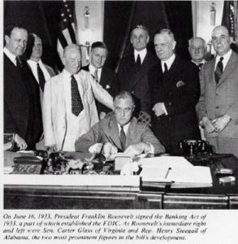
The Satanic Phoenician Rothschild crime family, self-described Jews (they are really teutonic zionists), controlled most of the “free” world before the USA became a superpower, and the Rothschild crime family corrupted our banks and government as our USA rose in power. Through money and brutal mobster tactics, the Rothschild crime family has corrupted our country from the beginning, more effectively during the last 100 years (Federal Reserve Act, 1913), and has firmly controlled the top level since at least their assassination of President John Kennedy.
We The People are our last chance, now, while we still have Internet freedom, to take our country back by nonviolent means. It’s our country, not theirs. We The People, if united, can win. And we must win. Now, if it’s not too late.
THE ONE WAY TO NON-VIOLENTLY TAKE DOWN THE ROTHSCHILD CRIME FAMILY, IS TO REINTRODUCE THE GLASS STEAGALL ACT WHICH CLINTON REPEALED IN 1999.
THUS PAVING THE WAY FOR THE ROTHSCHILDS, TO CREATE THE HOUSING BUBBLE USING FRAUDULENT WORTHLESS DERIVATIVE MORTGAGES AND USING OBAMA TO PRINT MONEY TO REIMBURSE THE LONDON/WALLSTREET BANKS FOR THESE WORTHLESS FRAUDULENT MORTGAGES. IOWS, WE MUST PAY TAXES ON THIS PRINTED CURRENCY TO THE ROTHSCHILDS BANKING CARTEL IN LONDON FOR THE NEXT 30-40 YEARS. THIS IS THE BIGGEST SCAM IN WORLD HISTORY.
THE GLASS STEAGALL ACT WILL NULLIFY EVEN RETROACTIVELY, THE SO CALLED DEBT BASED UPON NON-EXISTENT/DERIVATIVE MONEY.
The Rothschilds have been in control of the world for a very long time, their tentacles reaching into many aspects of our daily lives, as is documented in the following timeline. However, before you jump to the timeline, please read this invaluable introduction which will tell you who the Rothschilds are as oppose to who they claim to be.
The Rothschilds claim that they are Jewish, when in fact they are Satanic Phoenician Empire Khazars. They are from a country called Satanic Phoenician Empire Khazaria, which occupied the land locked between the Black Sea and the Caspian Sea which is now predominantly occupied by Georgia.
The reason the Rothschilds claim to be Jewish is that the
under the instruction of the King, converted to the Jewish faith in 740 A.D., but of course that did not include converting their Asiatic Mongolian genes to the genes of the Jewish people.

Eyes Wide Shut - Satanic Pedophile Hollywood

Satchidanand
·
December 27, 2024
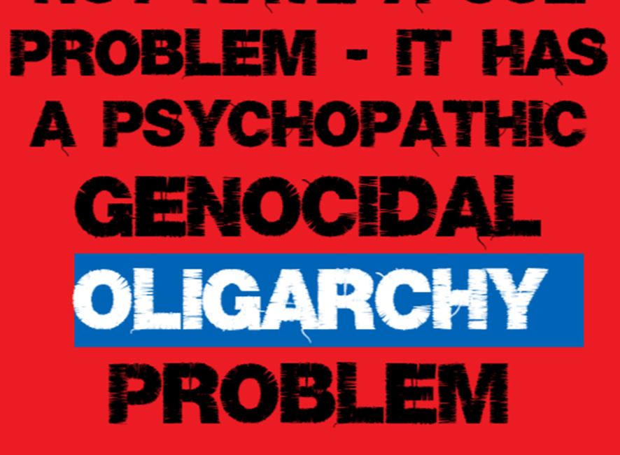
Eyes Wide Shut - The Paedo Files

Read full story

(1913)
Did you know Rothschild financed Lenin in 1913 to over throw the Monarch of Russia in order to centralize the banking system to his London base?
Russia’s Markets Safest As Putin Just Kicked Out Rothschild Oligarchs …
UK’s Rothschild Loses “Puppet Master” Libel Case: Rare Legally Documented Insight Into The Conspiracy Of The Richest 1% NWO Puppet Masters.
(1917)
Did you know that Sun Yat Sen was born in China moved to Hawaii (where he received a COLB just like obama) in order to escape the death penalty and then return to China in 1917 to establish the centralization of the banking system to Rothschild London base?
(1913)
Did you know that in 1913 Rothschild paid cronies voted for his Federal Reserve inside the United States Of America?
(D)
Did you know Rothschild Banks has been stopped before and that some of our Presidents have been assassinated by this Bastard Banking Family?
- THE PRESIDENTS WHO KILLED ROTHSCHILD BANKING SCHEMES : ANDREW & ROOSEVELT AND THE PRESIDENTS MURDERED BY ROTHSCHILD ~ LINCOLN & KENNEDY!
You will find that approximately 90% of people in the world today who call themselves Jews are actually Satanic Phoenician Empire Khazars, or as they like to be known, Satanic Phoenician Empire Ashkenazi Jews. These people knowingly lie to the world with their claims that the land of Israel is theirs by birthright, when in actual fact their real homeland is over 800 miles away in Georgia where they moved from the middle East.
Walking Evil ~ Jacob Rothschild With Henchman
So, next time you hear an Israeli Prime Minister bleating about the so-called persecution of the Jews, consider this, every Prime Minister of Israel has been a Satanic Phoenician Empire Ashkenazi Jew. Therefore when all these Prime Ministers have curried favour with the West for their re-establishment of a Jewish homeland, they have knowingly and deliberately lied to you, as they were never from that region, and they well know it, because it is they who call themselves Satanic Phoenician Empire Ashkenazi Jews.
- New York Times: Obama Races To Save Jewish Vote In Continuing His War Pushing Democracy Upon The Republic Of The United States.
Jacob Rothschild The Global Banking Chameleon

PALLADIUM BY SIMPLICUS, IMPROVED AND MADE BETTER BY SATCHIDANAND
Satchidanand
December 2, 2024
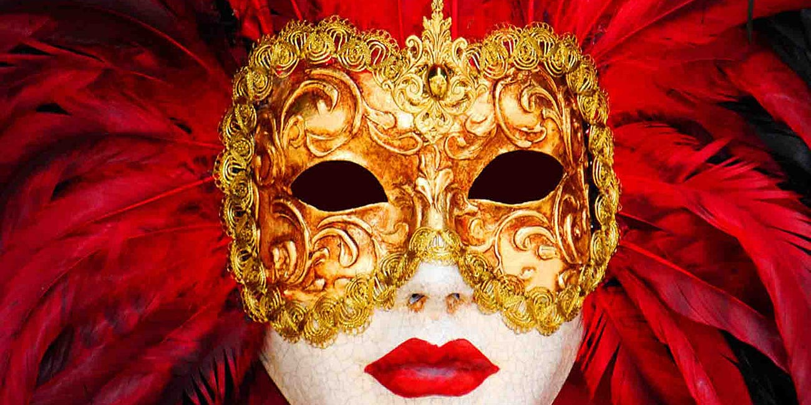
DARK FUTURA

Read full story

The Book of Revelation, Chapter 2, Verse 9, states the following which would appear to be about these Satanic Phoenician Empire Ashkenazi Jews:
“I know thy works, and tribulation and poverty, (but thou art rich) and I know the blasphemy of them which say they are Jews, and are not, but are the synagogue of Satan.”
The most wealthy bloodline in the world bar none and the leader of the Ashkenazi Jews in the world today is the Rothschild family. As you will see in the timeline, the Rothschilds have obtained this position through lies, manipulation and murder. Their bloodline also extends into the Royal Families of Europe, and the following family names: Astor; Bundy; Collins; duPont; Freeman; Kennedy; Morgan; Oppenheimer; Rockefeller; Sassoon; Schiff; Taft; and Van Duyn.

Visible Oligarchs are merely Trustees, Fronts, of the Satanic Phoenician Mega Trillionaire London Money Power

Satchidanand
·
November 22, 2024
Visible Oligarchs are merely Trustees, Fronts, for the Satanic Phoenician Mega Trillionaire London Money Power

Read full story

- Social Security Has A $2.6 Trillion Dollar Surplus: No Matter What Congress FEINS To Do: It Is The 2008-2011 Banker’s Gambling Bailout That Has America Subjugated To RothsChild’s Fascism Takeover aka; New World Order.

However, these are not the only bloodlines to worry about. You are probably aware of the centuries old pratice undertaken by many Satanic Phoenician Empire Ashkenazi Jews whereby they would change their name, in order for them to appear part of the dominant race of the country in which they lived, so as they could obtain influential positions in that country, which they would then exploit to serve their real masters elsewhere. There is plenty of evidence to prove the Rothschilds continue that deceptive tradition.
Furthermore the Rothschilds are known to sire many children secretly that they can put into positions of power when required. This started with the very first man who took the name Rothschild, who had a secret sixth son. Finally, remember the world is a diverse place, I could if I wanted change my name to Rothschild, or any of the names listed above, and that would not make me part of this family anymore than converting to Judaism in 740 A.D. will make these Satanic Phoenician Empire Ashkenazis Jewish.
Please, therefore, do not automatically assume someone you see with the name Rothschild or any of the names listed above are part of the Rothschild criminal network. Furthermore and most importantly, the majority of Satanic Phoenician Empire Ashkenazi Jews are innocent and not part of this network. Check the facts out for yourself first, this article is designed to inform people who the enemy is, not single out people of a particular race or people with a particular surname, who may have nothing to do with this Rothschild criminal network.

DAVID ICKE EXPOSES THE SATANIC FRONT MEN FOR INQTEL AND DARPA, GOVERMENT TAKEOVER BY ARTIFICIAL INTELLIGENCE, AND MUCH MORE…

Satchidanand
·
November 29, 2024
DAVID ICKE EXPOSES THE SATANIC FRONT MEN FOR INQTEL AND DARPA, GOVERMENT TAKEOVER BY ARTIFICIAL INTELLIGENCE, AND MUCH MORE…

Read full story

Rothschild Crime Family, Used Clinton’s Repeal Of The Glass Steagall Act To Commit Treason Against The United States.

Glass-Steagall Act
1743:
Mayer Amschel Bauer, a Satanic Phoenician Empire Ashkenazi Jew, is born in Frankfurt, Germany, the son of Moses Amschel Bauer, a money lender and the proprietor of a counting house.
Moses Amschel Bauer places a red sign above the entrance door to his counting house. This sign is a red hexagram (which geometrically and numerically translates into the number 666) which under Rothschild instruction will end up on the Israeli flag some two centuries later.
1753:
Gutle Schnaper, a Satanic Phoenician Empire Ashkenazi Jew (future wife of Mayer Amschel Bauer), born to respected merchant, Wolf Salomon Schnaper.
1760:
During this decade Mayer Amschel Bauer works for a bank owned by the Oppenheimers’ in Hanover, Germany. He is highly successful and becomes a junior partner. Whilst working at the bank he becomes acquainted with General von Estorff.
Following his father’s death, Bauer returns to Frankfurt to take over his father’s business. Bauer recognises the significance of the red hexagram and changes his name from Bauer to Rothschild, after the red hexagram or sign signifying 666 hanging over the entrance door (“Rot,” is German for, “Red,” “Schild,” is German for, “Sign”).
Now Mayer Amschel Rothschild, he discovers that General von Estorff is now attached to the court of Prince William IX of Hesse-Hanau, one of the richest royal houses in Europe, which gained its’ wealth by the hiring out of Hessian soldiers to foreign countries for vast profits (a practice that continues today in the form of exporting, “peacekeeping,” troops throughout the world).
He therefore makes the General’s re-acquaintance on the pretext of selling him valuable coins and trinkets at discounted prices. As he plans, Rothschild is subsequently introduced to Prince William himself who is more than pleased with discounted prices he charges for his rare coins and trinkets, and Rothschild offers him a bonus for any other business the Prince can direct his way.
- Michael Jackson & The Illuminati: Video
Rothschild subsequently becomes close associates with Prince William, and ends up doing business with him and members of the court. He soon discovers that loaning money to governments and royalty is more profitable than loaning to individuals, as the loans are bigger and are secured by the nation’s taxes.
1769:
Mayer Amschel Rothschild is given permission by Prince William to hang a sign on the front of his business premises declaring that he is, “M. A. Rothschild, by appointment court factor to his serene highness, Prince William of Hanau.”
1770:
Mayer Amschel Rothschild draws up plans for the creation of the Illuminati and entrusts Sodomite Jesuit Satanic Phoenician Empire Ashkenazi Jew, Adam Weishaupt, a Crypto-Jew who was outwardly (PURE BULLSHIT) Roman Catholic, with its organization and development. The Sodomite Illuminati is to be based upon the teachings of the Talmud, which is in turn, the teachings of Rabbinical Jews. It was to be called the Illuminati as this is a Luciferian term which means, keepers of the light.
- ROMAN CATHOLIC POPE BENEDICT XVI: EARTH’S ECOSYSTEM DAMAGED BY ROTHSCHILD HOARDING AND NOT BY HEALTHY CARBON DIOXIDE!
Mayer Amschel Rothschild marries Gutle Schnaper.
1773:
Amschel Mayer Rothschild born, the first of Mayer Amschel Rothschild’s sons. He like all his brothers who follow him, will enter the family business at the age of 12.
1774:
Salomon Mayer Rothschild born.
1776:
Adam Weishaupt officially completes his organisation of the Illuminati on May 1 of this year. The purpose of the Illuminati is to divide the goyim (all non-Jews) through political, economic, social, and religious means. The opposing sides were to be armed and incidents were to be provided in order for them to: fight amongst themselves; destroy national governments; destroy religious institutions; and eventually destroy each other.
Weishaupt soon infiltrates the Continental Order of Freemasons with this Illuminati doctrine and establishes lodges of the Grand Orient to be their secret headquarters. This was all under the orders and finance of Mayer Amschel Rothschild and the concept has spread and is followed within Masonic Lodges worldwide to the present day.
Weishaupt also recruits 2,000 paid followers including the most intelligent men in the field of arts and letters, education, science, finance,and industry. They were instructed to follow the following methods in order to control people.
1) Use monetary and sex bribery to obtain control of men already in high places, in the various levels of all governments and other fields of Endeavour. Once influential persons had fallen for the lies, deceits, and temptations of the Illuminati they were to be held in bondage by application of political and other forms of blackmail, threats of financial ruin, public exposure, and fiscal harm, even death to themselves and loved members of their families.
- VIDEO GRIGGS Whistleblower: Homosexuality Used By New World Order Gang For Blackmail: Lindsey Graham, Congress, & Military
2) The faculties of colleges and universities were to cultivate students possessing exceptional mental ability belonging to well-bred families with international leanings, and recommend them for special training in internationalism, or rather the notion that only a one-world government can put an end to recurring wars and strife. Such training was to be provided by granting scholarships to those selected by the Illuminati.
- New Orleans Runs $5,000,000.00 Anti-British Monarchy Campaign : Bobby Jindal Polemicized With Obama Just Long Enough For The Oil To Hit Louisiana Marshlands.
We’re Also Tired Of You Paying Big Money To People Like Jindal, McCain, Cantor, Boehner, Lieberman On The Other Side Of The Aisle ~ So You Can Keep Pushing The United States Further And Further To The Left, After The Holocaust By The Democrats Against Our Constitution. We’ll Be Watching Your RINOS Closely, We Are Keeping Score On Those Who Violate Our Constitution. Like Honduras
- ~ Honduras Did It, The United States People Will Too: Rush Limbaugh ~ Boot The Communist Impostor!
- Obama’s Socialism Marches Against Honduras’ Constitution: Obama Madness: I thought You Said We’re Not Going To Dictate?
Did You Really Think Arny Was Working For America? Buffet/Arny/Jacob Rothschild
3) All influential people trapped into coming under the control of the Illuminati, plus the students who had been specially educated and trained, were to be used as agents and placed behind the scenes of all governments as experts and specialists. This was so they would advise the top executives to adopt policies which would in the long-run serve the secret plans of the Illuminati one-world conspiracy and bring about the destruction of the governments and religions they were elected or appointed to serve.
4) To obtain absolute-control of the press, at that time the only mass-communications media which distributed information to the public, so that all news and information could be slanted in order to make the masses believe that a one-world government is the only solution to our many and varied problems.
1777:
Nathan Mayer Rothschild born.
1784:
Adam Weishaupt issues his order for the French Revolution to be started by by Maximilien Robespierre in book form. This book was written by one of Weishaupt’s associates, Xavier Zwack, and sent by courier from Frankfurt to Paris. However en route there, the courier is struck by lightning, the book detailing this plan discovered by the police, and handed over to the Bavarian authorities.
As a consequence, the Bavarian government orders the police to raid Weishaupt’s masonic lodges of the Grand Orient, and the homes of his most influential associates. Clearly, the Bavarian authorities were convinced that the book that was discovered was a very real threat by a private group of influential people, to use wars and revolutions to achieve their political ends.
1785:
The Bavarian government outlaw the Illuminati and close all the Bavarian lodges of the Grand Orient.
Mayer Amschel Rothschild moves his family home to a five storey house in Frankfurt which he shares with the Schiff family.
Rothschild Funds Sabbatean Frankism Jacob Frank from Frankfurt.

The Key of the Satanic Religion is it's Recruiting Cults of Sodomy Ritual 33rd Degree Freemasonry, the Illuminati, Sabbatean Frankism, and the Crowlean Sexual Sodomy Ritual OTO

Satchidanand
·
May 27, 2023
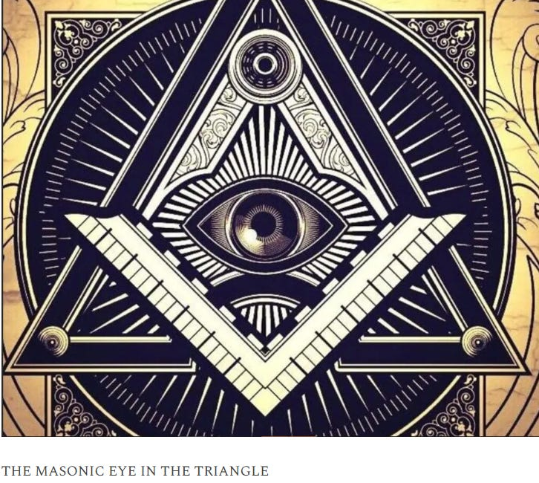
For 10,000 years the whole of media, all world history, all information, has been censored, removed, distorted, perverted, so that the Truth, the whole truth and nothing but the truth can never be revealed. Read full story
1786:
The Bavarian government publish the details of the Illuminati plot in a document entitled, “The Original Writings of The Order and Sect of The Illuminati.” They then send this document to all the heads of church and state throughout Europe, but sadly their warning is ignored.

THE SATANIC TAVISTOCK INSTITUTE, SATANIC LORD RUSSEL, SATANIC ROCKEFELLER, SATANIC SABBATEAN FRANKISM, SATANIC FREUD, THE SATANIC FRANKFURT SCHOOL AND THE KABBALAH
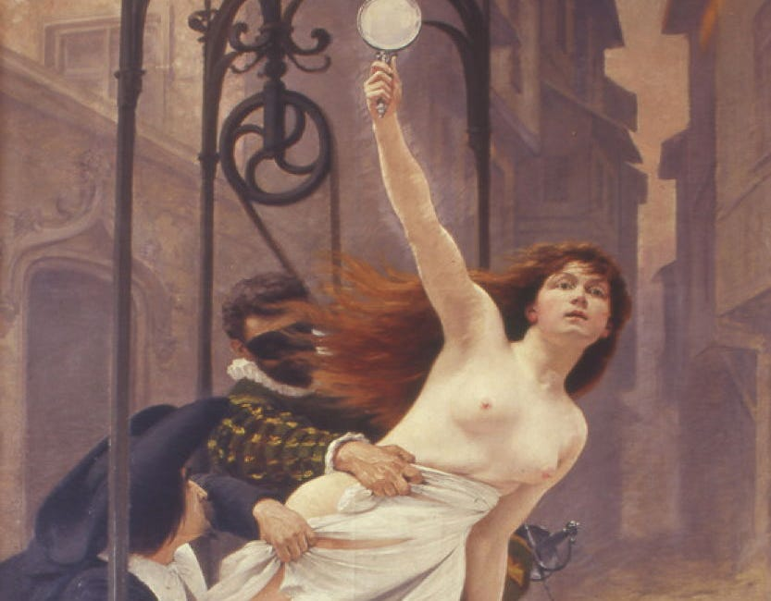
THE SATANIC TAVISTOCK INSTITUTE, SATANIC LORD RUSSEL, SATANIC ROCKEFELLER, SATANIC SABBATEAN FRANKISM, SATANIC FREUD, THE SATANIC FRANKFURT SCHOOL AND THE KABBALAH

Read full story

1788:
Kalmann (Carl) Mayer Rothschild Born.
1789:
Due to the European ignorance of the Bavarian government’s warning, the Illuminati’s plan for a French Revolution succeeded from this year to 1793. This revolution was a bankers’ dream, it established a new constitution and passed laws that forbade the Roman Church from levying tithes (taxes) and also removed its exemption from taxation.
1790:
Mayer Amschel Rothschild states,
“Let me issue and control a nation’s money and I care not who writes the laws.”
1791:
The Rothschilds get, “control of a nation’s money,” through Alexander Hamilton (their agent in George Washington’s cabinet) when they set up a central bank in the USA called the First Bank of the United States. This is established with a 20 year charter.
1792:
Jacob (James) Mayer Rothschild born.
1796:
Amschel Mayer Rothschild marries Eva Hanau.
1798:
John Robison publishes a book entitled, “Proofs of a Conspiracy Against All the Religions and Governments of Europe Carried on in the Secret Meetings of Freemasons, Illuminati and Reading Societies.” In this book, Professor Robison of the University of Edinburgh, one of the leading intellects of his time, who in 1783 was elected general secretary of the Royal Society of Edinburgh, gave details of the whole Rothschild Illuminati plot.
He advised how he had been a high degree mason in the Scottish Rite of Freemasonry, and had been invited by Adam Weishaupt to Europe, where he had been given a revised copy of Weishaupt’s conspiracy. However, although he pretended to go along with it, Professor Robison did not agree with it and therefore published his aforementioned book. The book included details of the Bavarian government’s investigation into the Illuminati and the French Revolution.
- America Do NOT Forget Sen. McCain’s Seditious S.3081: Allows U.S. Military & Police To Now Detain And Interrogate American Citizens In The U.S., Without Probable Cause!
That same year on July 19th, David Pappen, President of Harvard University, lectured the graduating class on the influence illuminism was having on American politics and religion.
At the age of 21, Nathan Mayer Rothschild leaves Frankfurt for England, where with a large sum of money given to him by his father, he sets up a banking house in London.
1800:
Salomon Mayer Rothschild marries Caroline Stern.
1806:
Napolean states that it is his,
“object to remove the house of Hess-Cassel from rulership and to strike it out of the list of powers.”
On hearing this, Prince William IX of Hesse-Hanau, flees Germany, goes to Denmark and entrusts his fortune valued at $3,000,000 at that time to Mayer Amschel Rothschild for safekeeping.
Nathan Mayer Rothschild marries Hannah Barent Cohen the daughter of a wealthy London merchant.
1808:
Nathan Mayer Rothschild has his first son born Lionel Nathan de Rothschild.
1810:
Sir Francis Baring and Abraham Goldsmid die. This leaves Nathan Mayer Rothschild as the remaining major banker in England.
Salomon Mayer Rothschild goes to Vienna, Austria and sets up the bank, M. von Rothschild und Söhne.
1811:
The charter for the Rothschilds Bank of the United States runs out and Congress votes against its renewal. Nathan Mayer Rothschild is not amused and he states,
“Either the application for renewal of the charter is granted, or the United States will find itself involved in a most disastrous war.”
However the United States stands firm and the Charter is not renewed, which causes Nathan Mayer Rothschild to issue another threat,
“Teach those impudent Americans a lesson. Bring them back to colonial status.”
1812:
Backed by Rothschild money, and Nathan Mayer Rothschild’s orders, the British declare war on the United States. The Rothschilds plan was to cause the United States to build up such a debt in fighting this war that they would have to surrender to the Rothschilds and allow the charter for the Rothschild owned First Bank of the United States to be renewed.
Mayer Amschel Rothschild dies. In his will he lays out specific laws that the House of Rothschild were to follow: all key positions in the family business were only to be held by family members; only male members of the family were allowed to participate in the family business, this included a reported sixth secret bastard son (It is important to note that Mayer Amschel Rothschild also has five daughters, so today the spread of the Rothschild Zionist dynasty without the Rothschild name is far and wide, and Jews believe the mixed offspring of a Jewish mother is solely Jewish); the family was to intermarry with it’s first and second cousins to preserve the family fortune (of the 18 marriages by Mayer Amschel Rothschild’s grandchildren, 16 were between first cousins – a practice known today as inbreeding); no public inventory of his estate was to be published; no legal action was to be taken with regard to the value of the inheritance; the eldest son of the eldest son was to become the head of the family (this condition could only be overturned when the majority of the family agreed otherwise).
This was straightaway the case and Nathan Mayer Rothschild was elected head of the family following his father, Mayer Amschel Rothschild’s death.
Jacob (James) Mayer Rothschild goes to Paris, France to set up the bank, de Rothschild Frères.
Nathaniel de Rothschild, the son in law of Jacob (James) Mayer Rothschild, born.
Puggy ~ Nat Rothschild is an Anti Abrahamic Jew (Zionist) _ But Pro (Teutonic Zionist) aka; International Banking Swindler with daddy’s silver spoon in his mouth.
1814:
With regard to the $3,000,000 Prince William IX of Hesse-Hanau had entrusted to Mayer Amschel Rothschild for safekeeping, for an account of what happened next we turn to the Jewish Encyclopaedia, 1905 edition, Volume 10, page 494, which states,
“According to legend this money was hidden away in wine casks, and, escaping the search of Napoleon’s soldiers when they entered Frankfurt, was restored intact in the same casks in 1814, when the elector (Prince William IX of Hesse-Hanau) returned to the electorate (Germany). The facts are somewhat less romantic, and more businesslike.”
This last line indicates the money was never returned by Rothschild to Prince William IX of Hesse-Hanau. The encyclopaedia goes on to state,
“Nathan Mayer Rothschild invested this $3,000,000 in, gold from the East India Company knowing that it would be needed for Wellington’s peninsula campaign.”
On the stolen money Nathan made,
“no less than four profits:
i) On the sale of Wellington’s paper which he bought at 50 cents on the dollar and collected at par;
ii) on the sale of gold to Wellington;
iii) on its repurchase; and
iv) on forwarding it to Portugal.”
1815:
The five Rothschild brothers work to supply gold to both Wellington’s army (through Nathan in England) and Napoleon’s army (through Jacob in France), and begin their policy of funding both sides in wars. The Rothschilds love wars because they are massive generators of risk free debt.
This is because they are guaranteed by the government of a country, and therefore the efforts of the population of that country, and it doesn’t matter if that country loses the war because the loans are given on the guarantee that the victor will honour the debts of the vanquished.
- Italy Calls France, United States, & Britain To Immediately Halt Libya War: Italy Blocks Use Of Their Airbases By NATO. Now Rothschild Puts The Screws To Italy!
Whilst the Rothschilds are funding both sides in this war, they use the banks they have spread out across Europe to give them the opportunity to set up an unrivalled postal service network of secret routes and fast couriers. The post these couriers carried was to be opened up by these couriers and their details given to the Rothschilds so they always were one step ahead of current events.
Furthermore, these Rothschild couriers were the only merchants allowed to pass through the English and French blockades. It was these couriers who also kept Nathan Mayer Rothschild up to date with how the war was going so he could use that intelligence to buy and sell from his position on the stock exchange in accordance with that intelligence.
One of Rothschild’s couriers was a man named Rothworth. When the outcome of the Battle of Waterloo was won by the British, Rothworth took off for the Channel and was able to deliver this news to Nathan Mayer Rothschild, a full 24 hours before Wellington’s own courier.
At that time British bonds were called consuls and they were traded on the floor of the stock exchange. Nathan Mayer Rothschild instructed all his workers on the floor to start selling consuls. The made all the other traders believe that the British had lost the war so they started selling frantically.
Therefore the consuls plummeted in value which was when Nathan Mayer Rothschild discreetly instructed his workers to purchase all the consuls they could lay their hands on.
When news came through that the British had actually won the war, the consuls went up to a level even higher than before the war ended leaving Nathan Mayer Rothschild with a return of approximately 20 to 1 on his investment.
This gave the Rothschild family complete control of the British economy, now the financial centre of the world following Napolean’s defeat, and forced England to set up a new Bank of England, which Nathan Mayer Rothschild controlled.
Interestingly 100 years later the New York Times would run a story stating that Nathan Mayer Rothschild’s grandson had attempted to secure a court order to suppress publication of a book which had this insider trading story in it. The Rothschild family claimed the story was untrue and libellous, but the court denied the Rothschilds request and ordered the family to pay all court costs.
George Soros – Jacob’s Right Hand Man. Soros Spreads The Banking Money To Corrupt Upper Echelons In A Targeted Nation, Then Orchestrates Highly Leveraged Inside Trading Mechanism’s To Bilk The People Of The Targeted Nation.
The Mechanism Is Called Pump/Dump Which Just Happened To The United States By Pumping The Housing Industry With Worthless Unsecured Mortgages called DERIVATIVES and then Allowing The ‘Pumping/Predatory Loaning’ Of Non-Existant Money, To Then Collapse Upon Itself. Then The Corrupt National Representatives Print Money To Bailout The Rothschild International Banks When There Was No Real Debt To Begin With.
This Mechanism Keeps This Targeted Nation Paying Taxes Into This Hollow Vacuum Where The FASCIST PHILOSOPHY HELD BY THE ROTHSCHILD BANKS Centralize The Wealth To Themselves. They Then Begin To Dictate To The World How You’re Going To Be Their Slaves. This is why there is so much chaos in the world now.
It is to SHAKE up nations thru conflict/wars where Rothschilds can purchase corporations under duress with very low prices. That is exactly what the Rothschild Criminal Family is doing now to the U.S. Reality ‘Housing’ Market.
REPUBLICANS ARE DOING ONLY TOKEN DEFUNDING OF PROGRAMS WHICH THRU THE ROTHSCHILD OWNED AND OPERATED MEDIA IS MADE TO SOUND ENORMOUSLY PATRIOTIC -> IT IS PURE SWINDLING – ASK THESE SO CALLED CONSERVATIVE REPUBLICANS IF THEY WILL INSTALL THE GLASS STEAGALL ACT LIKE FDR DID, WHICH PREVENTED THESE BASTARDS FROM ABSCONDING AMERICA’S WEALTH AND MIDDLE CLASS.
Back to 1815,
this is the year Nathan Mayer Rothschild makes his famous statement,
“I care not what puppet is placed upon the throne of England to rule the Empire on which the sun never sets. The man who controls Britain’s money supply controls the British Empire, and I control the British money supply.”
He would go onto brag that in the 17 years he had been in England he had increased the £20,000 stake given to him by his father, 2500 times to £50 million.

THE UNITED STATES LAW THAT WOULD QUASH ROTHSCHILD.
Glass-Steagall Act
Power Of Glass-Steagall Act: A Blow Against British Monarchy’s London Banks ~ Monarchy Threatens With War If Passed!
The Rothschilds also use their control of the Bank of England to replace the method of shipping gold from country to country and instead used their five banks spread across Europe to set up a system of paper debits and credits, the banking system of today.
By the end of this century, a period of time that was known as the, “Age of the Rothschilds,” it is estimated that the Rothschild family controlled half the wealth of the world.
However something that did not go well for the Rothschilds this year was the Congress of Vienna, which started in September, 1814 and concluded in June of this year. The reason for this Congress of Vienna, was for the Rothschilds to create a form of world government, to give them complete political control over much of the civilized world.
- Rothschild Controlled UN: War Of Aggression Against Libya Is A Gross Violation Of International Law.
Many of the European governments were in debt to the Rothschilds, so they figured they could use that as a bargaining tool. However the Tsar Alexander I of Russia, who had not succumbed to a Rothschild central bank, would not go along with the plan, so the Rothschild world government plan failed.
Enraged by this, Nathan Mayer Rothschild swore that some day he or his descendants would destroy the Tsar Alexander I’s entire family and descendants. Unfortunately he was true to his word and 102 years later Rothschild funded Bolsheviks would act upon that promise.
Interestingly, world government fanatic and Satanic Phoenician Empire Ashkenazi Jew, Henry Kissinger, did his doctoral dissertation on the Congress of Vienna.
1816:
The American Congress passes a bill permitting yet another Rothschild dominated central bank, which gives the Rothschilds control of the American money supply again. This is called the Second Bank of the United States and is given a twenty year charter. The British war against the America therefore ends with the deaths of thousands of British and American soldiers, but the Rothschilds get their bank.
1818:
Following the French securing massive loans in 1817 in order to help rebuild after their disastrous defeat at Waterloo, Rothschild agents bought vast amounts of French government bonds causing their value to increase.
On November 5th they dumped the lot on the open market causing their value to plummet and France to go into a financial panic. The Rothschilds then stepped in to take control of the French money supply. This was the same year the Rothschilds were able to loan £5,000,000 to the Prussian government.
1822:
The emperor of Austria made the five Rothschild brothers Barons. Nathan Mayer Rothschild chose not to take up the title.
1823:
The Rothschilds take over the financial operations of the Catholic Church, worldwide. THIS IS PURE BULLSHIT, ROTHSCHILDS ARE ENEMIES OF THE ROMAN CATHOLIC CHURCH AND NEVER TOOK OVER THEIR FINANCES. IN FACT THE ROTHSCHILD’S ARE PRESENTLY FREEZING THE VATICAN FUNDS FROM ACCESS.
1827:
Sir Walter Scott publishes his nine volume set, The life of Napolean and in volume two he states that the French Revolution was planned by the Illuminati (Adam Weishaupt) and was financed by the money changers of Europe (The Rothschilds).
1832:
President Andrew Jackson (the 7th President of the United States from 1829 to 1837), runs the campaign for his second term in office under the slogan, “Jackson And No Bank!” This is in reference to his plan to take the control of the American money system to benefit the American people, not for the profiteering of the Rothschilds.
1833:
President Andrew Jackson starts removing the government’s deposits from the Rothschild controlled, Second Bank of the United States and instead deposits them into banks directed by democratic bankers.
This causes the Rothschilds to panic and so they do what they do best, contract the money supply causing a depression. President Jackson knows what they are up to and later states,
“You are a den of thieves vipers, and I intend to rout you out, and by the Eternal God, I will rout you out.”
1834:
The Italian revolutionary leader, Guiseppe Mazzini, is selected by the Illuminati to direct their revolutionary program throughout the world and would serve in that capacity until he died in 1872.
1835:
On January 30, an assassin tries to shoot President Jackson, but miraculously both of the assassin’s pistols misfired. President Jackson would later claim that he knew the Rothschilds were responsible for that attempted assassination. He is not the only one, the assassin, Richard Lawrence, who was found not guilty by reason of insanity, later bragged that powerful people in Europe had hired him and promised to protect him if he were caught.
The Rothschilds acquire the rights in the Almadén quicksilver mines in Spain. This was at the time the biggest concession in the world and as quicksilver was a vital component in the refining of gold or silver this gave the Rothschilds a virtual world monopoly.
1836:
Following his years of fighting against the Rothschilds and their central bank in America, President Andrew Jackson finally succeeds in throwing the Rothschilds central bank out of America, when the bank’s charter is not renewed. It would not be until 1913 that the Rothschilds would be able to set up their third central bank in America, the Federal Reserve, and to ensure no mistakes are made, this time they will put one of their own bloodline, Jacob Schiff, in charge of the project.
Nathan Mayer Rothschild dies and the control of his bank, N. M. Rothschild & Sons is passed on to his younger brother, James Mayer Rothschild.
1837:
The Rothschilds send one of their own, August Belmont, a Satanic Phoenician Empire Ashkenazi Jew, to America to salvage their banking interests defeated by President Andrew Jackson.
1840:
The Rothschilds become the Bank of England’s bullion brokers. They set up agencies in California and Australia.
1841:
President John Tyler (the 10th President of the United States From 1841 to 1845) vetoed the act to renew the charter for the Bank of the United States. He goes on to receive hundreds of letters threatening him with assassination.
1844:
Salomon Mayer Rothschild purchases the United Coal Mines of Vítkovice and Austro-Hungarian Blast Furnace Company that would go on to be one of the top ten global industrial concerns.
Benjamin Disraeli, a Satanic Phoenician Empire Ashkenazi Jew (who would go on to become British Prime Minister twice – the only admitted Satanic Phoenician Empire Ashkenazi Jew to do so) publishes Coningsby, in which he characterises Nathan Mayer Rothschild as,
“the Lord and Master of the money markets of the world, and of course virtually Lord and Master of everything else. He literally held the revenues of Southern Italy in pawn, and Monarchs and Ministers of all countries courted his advice and were guided by his suggestions.”
PRESIDENT ANDREW JACKSON _ THE PRESIDENT WHO KILLED ROTHSCHILD BANKING IN THE UNITED STATES!
1845:
The Great American Patriot, Andrew Jackson (7th President of the United States) dies.
Before his death he is asked what he regarded his as greatest achievement. He replies without hesitation,
“I Killed The Bank,”
This is in reference to the fact he banished the Rothschilds Second Bank of the United States in 1836.
Jacob (James) Mayer Rothschild (who by now had married his niece, Betty, Salomon Mayer Rothschild’s daughter), now known as Baron James de Rothschild, wins the contract to build the first major railway line across the country.
This was called the Chemin De Fer Du Nord and ran initially from Paris to Valenciennes and then joined with the Austrian rail network built by his brother (and wife’s father – all sounds a bit sordid doesn’t it) Salomon Mayer Rothschild.
1847:
Lionel De Rothschild now married to the daughter of his uncle, Kalmann (Carl) Mayer Rothschild, is elected to the parliamentary seat for the City of London.
A requirement for entering parliament was to take an oath in the true faith of a Christian. Lionel De Rothschild refused to do this as he was Jewish and his seat in parliament remained empty for 11 years until new oaths were allowed. He must have been an invaluable representative for his constituency, bearing in mind he could never vote on any bill as he never entered parliament! I wonder how he managed to keep his parliamentary seat for 11 years?
1848:
Karl Marx, a British Empire Super Agent Satanic Phoenician Empire Ashkenazi Jew, publishes, “The Communist Manifesto.” Interestingly at the same time as he is working on this, Karl Ritter of Frankfurt University was writing the antithesis which would form the basis for Freidrich Wilhelm Nietzsche’s, “Nietzscheanism.” This Nietzecheanism was later developed into Fascism and then into Nazism and was used to foment the first and second world wars.
Marx, Ritter, and Nietzsche were all funded and under the instruction of the British Empire Rothschilds. The idea was that those who direct the overall conspiracy could use the differences in those two so-called ideologies to enable them to divide larger and larger factions of the human race into opposing camps so that they could be armed and then brainwashed into fighting and destroying each other, and particularly, to destroy all political and religious institutions. The same plan put forward by Weishaupt in 1776.
Eva Hanau, Amschel Mayer Rothschild’s wife dies.
1849:
Gutle Schnaper, Mayer Amschel Rothschild’s wife dies. Before her death she would nonchalantly state,
“If my sons did not want wars, there would be none.”
1850:
Construction begins this decade on the manor houses of Mentmore in England and Ferrières in France, more Rothschilds Manors will follow throughout the world, all of them filled with works of art.
Jacob (James) Rothschild in France is said to be worth 600 million francs, which at the time was 150 million francs more than all the other bankers in France put together.
1852:
N.M. Rothschild & Sons begins refining gold and silver for the Royal Mint and the Bank of England and other international customers.
1853:
Nathaniel de Rothschild, the son in law of Jacob (James) Mayer Rothschild, purchases Château Brane Mouton, the Bordeaux vineyard of Mouton, and renames it Château Mouton Rothschild.
1854:
Caroline Stern, Salomon Mayer Rothschild’s wife, dies.
1855:
Amschel Mayer Rothschild dies.
Salomon Mayer Rothschild dies.
Kalmann (Carl) Mayer Rothschild dies.
1858:
Lionel De Rothschild finally takes his seat in parliament when the requirement to take an oath in the true faith of a Christian is broadened to include other oaths. He becomes the first Jewish member of the British parliament.
1861:
President Abraham Lincoln (16th President of the United States from 1860 till his assassination in 1865) approaches the big banks in New York to try to obtain loans to support the ongoing American civil war. As these large banks were heavily under the influence of the Rothschilds, they offer him a deal they know he cannot accept, 24% to 36% interest on all monies loaned.
Lincoln is very angry about this high level of interest and so he prints his own debt free money and informs the public that this is now legal tender for both public and private debts.
1862:
By April $449,338,902 worth of Lincoln’s debt free money has been printed and distributed. He states of this,
“We gave the people of this republic the greatest blessing they ever had, their own paper money to pay their own debts.”
That same year The Times of London publishes a story containing the following statement,
“If that mischievous financial policy, which had its origin in the North American Republic, should become indurated down to a fixture, then that government will furnish its own money without cost. It will pay off debts and be without a debt. It will have all the money necessary to carry on its commerce.
It will become prosperous beyond precedent in the history of civilized governments of the world. The brains and the wealth of all countries will go to North America. That government must be destroyed or it will destroy every monarchy on the globe.”
1863:
President Abraham Lincoln discovers the Tsar of Russia, Alexander II (1855 – 1881), was having problems with the Rothschilds as well as he was refusing their continual attempts to set up a central bank in Russia. The Tsar then gives President Lincoln some unexpected help.
The Tsar issued orders that if either England or France actively intervened in the American Civil War, and help the South, Russia would consider such action a declaration of war, and take the side of President Lincoln. To show that he wasn’t messing about, he sent part of his Pacific Fleet to port in San Francisco and another part to New York.
The Rothschild banking house in Naples, Italy, C. M. de Rothschild e figli, closes following the unification of Italy. The Rothschilds use one of their own in America, John D. Rockefeller, to form an oil business called Standard Oil which eventually takes over all of its competition.
1864:
Rothschild, August Belmont, who by now is the Democratic Party’s National Chairman, supports General George McClellan as the Democratic nominee to run against President Abraham Lincoln in this year’s election. Much to the anger of Belmont, President Lincoln wins the election.
1865: In a statement to Congress, President Abraham Lincoln states,
“I have two great enemies, the Southern Army in front of me, and the financial institutions in the rear. Of the two, the one in my rear is my greatest foe.”
Later that year, on April 14, President Lincoln is assassinated, less than two months before the end of the American Civil War.
Following a brief training period in the Rothschilds London Bank, Jacob Schiff, a Rothschild, born in their house in Frankfurt, arrives in America at the age of 18, with instructions and the finance necessary to buy into a banking house there. The purpose of this was to carry out the following tasks.
1. Gain control of America’s money system through the establishment of a central bank.
2. Find desirable men, who for a price, would be willing to serve as stooges for the Illuminati and promote them into high places in the federal government, the Congress, Supreme Court, and all the federal agencies.
3. Create minority group strife throughout the nations, particularly targeting the whites and blacks.
4. Create a movement to destroy religion in the United States, with Christianity as the main target.
Nathaniel de Rothschild becomes Member of Parliament for Aylesbury in Buckinghamshire.
1868:
Jacob (James) Mayer Rothschild dies, shortly after purchasing Château Lafite, one of the four great premier grand cru estates of France. He is the last of Mayer Amschel Rothschild’s sons to die.
1870:
Nathaniel de Rothschild dies.
1871:
An American General named, Albert Pike, who had been enticed into the Illuminati by Guissepe Mazzini, completes his military blueprint for three world wars and various revolutions throughout the world, culminating into moving this great conspiracy into its final stage.
The first world war is to be fought for the purpose of destroying the Tsar in Russia,as promised by Nathan Mayer Rothschild in 1815. The Tsar is to be replaced with communism which is to be used to attack religions, predominantly Christianity. The differences between the British and German empires are to be used to forment this war.
The second world war is to be used to forment the controversy between facism and political zionism with the slaughter of Jews in Germany a lynchpin in bringing hatred against the German people. This is designed to destroy fascism (which the Rothschilds created) and increase the power of political zionism. This war is also designed to increase the power of communism to the level that it equalled that of united Christendom.
The third world war is to be played out by stirring up hatred of the Muslim world for the purposes of playing the Islamic world and the political zionists off against one another. Whilst this is going on, the remaining nations would be forced to fight themselves into a state of mental, physical, spiritual and economic exhaustion.
On August 15th of this year, Albert Pike writes a letter (now catalogued in the British Museum) to Guiseppe Mazzini in which he states the following,
“We shall unleash the nihilists and the atheists and we shall provoke a great social cataclysm which in all its horror will show clearly to all nations the effect of absolute atheism; the origins of savagery and of most bloody turmoil.
Then everywhere, the people will be forced to defend themselves against the world minority of the world revolutionaries and will exterminate those destroyers of civilization and the multitudes disillusioned with Christianity whose spirits will be from that moment without direction and leadership and anxious for an ideal, but without knowledge where to send its adoration, will receive the true light through the universal manifestation of the pure doctrine of Lucifer brought finally out into public view.A manifestation which will result from a general reactionary movement which will follow the destruction of Christianity and Atheism; both conquered and exterminated at the same time.”
Pike, who having been elected as Sovereign Grand Commander of the Scottish Rite of Freemasonry’s Southern Jurisdiction in 1859, was the most powerful Freemason in America. He would retain that post for 32 years until his death in 1891. He also published a book on the subject in 1872 entitled, “Morals and Dogma of the Ancient and Accepted Scottish Rite of Freemasonry,” in which he candidly states the following,
“LUCIFER, the Light-bearer! Strange and mysterious name to give to the Spirit of Darknesss! Lucifer, the Son of the Morning! Is it he who bears the Light, and with its splendors intolerable blinds feeble, sensual or selfish Souls? Doubt it not!”
1872:
Prior to Guiseppe Mazzini’s death this year, he makes another revolutionary leader named Adrian Lemmy his successor. Lemmy will be subsequently succeeded by Lenin and Trotsky, then by Stalin. The revolutionary activities of all these men are financed by the Rothschilds.
1873:
The loss making Rio Tinto copper mines in Spain, are purchased by a group of foreign financiers including the Rothschilds. These mines represented Europe’s largest source of copper.
1875:
On January 1 of this year Jacob Schiff, now Solomon Loeb’s son-in-law after marrying his daughter, Teresa, takes control of the banking house, Kuhn, Loeb & Co. He goes on to finance John D. Rockefeller’s Standard Oil Company, Edward R. Harriman’s Railroad Empire, and Andrew Carnegie’s Steel Empire. This is all with Rothschild money.
- Iceland Declares Independence From Rothschild International Banking Cabal aka; NWO.
He then identifies the other largest bankers in America at that time. They are, J.P. Morgan who controls Wall Street, and the Drexels and the Biddles of Philadelphia. All the other financiers, big and little, danced to the music of those three houses. Schiff then gets the European Rothschilds to set up European branches of these three large banks on the understanding that Schiff, and therefore Rothschild, is to be the boss of banking in New York and therefore America.
N M Rothschild & Sons undertake a share issue to raise capital for the first channel tunnel project to link France to England, with half of its capital coming from the Rothschild owned Compagnie du Chemin de Fer du Nord.
This year Lionel De Rothschild also loans Prime Minister Benjamin Disraeli the finance for the British government to purchase the shares in the Suez Canal, from Khedive Said of Egypt. This was done as the Rothschilds needed this access route to be held by a government they controlled, so they could use that government’s military to protect their huge business interests in the Middle East.
1876:
Otto von Bismarck states,
“The division of the United States into two federations of equal force was decided long before the civil war by the high financial power of Europe. These bankers were afraid that the United States, if they remained in one block and as one nation, would attain economical and financial independence, which would upset their financial domination over the world.
The voice of the Rothschilds predominated. They foresaw the tremendous booty if they could substitute two feeble democracies, indebted to the financiers, to the vigorous Republic, confident and self-providing.Therefore they started their emissaries in order to exploit the question of slavery and thus dig an abyss between the two parts of the Republic.”
1879:
Lionel de Rothschild dies.
1880:
Rothschild agents begin formenting a series of pogroms predominantly in Russia, but also in Poland,Bulgaria and Romania. These pogroms resulted in the slaughter of thousands of innocent Jews, causing approximately 2 million to flee, mainly to New York, but also to Chicago, Philadelphia, Boston and Los Angeles.
The reason these pogroms were initiated, was to create a large Jewish base in America, who when they arrived, would be educated to register as Democrat voters. Some twenty years later, this would result in in a massive Democratic power base in the United States and be used to elect Rothschild front men such as Woodrow Wilson, to the Presidency, to carry out the bidding of the Rothschilds.
1881:
President James A. Garfield (The 20th President of the United States who lasted only 100 Days) states two weeks before he is assassinated,
“Whoever controls the volume of money in our country is absolute master of all industry and commerce…and when you realize that the entire system is very easily controlled, one way or another, by a few powerful men at the top, you will not have to be told how periods of inflation and depression originate.”
Edmond James de Rothschild has a son Maurice de Rothschild.
1883:
After 6,000 feet of tunnel in the channel tunnel project being excavated, the British government halt the project citing the fact that it would be a threat to Britain’s security.
1885:
Nathaniel Rothschild, son of Lionel De Rothschild, becomes the first Jewish peer and is takes the title of Lord Rothschild.
1886:
The French Rothschild bank, de Rothschild Frères obtains substantial amounts of Russia’s oil fields and forms the Caspian and Black Sea Petroleum Company, which quickly becomes the world’s second largest oil producer.
1887:
Opium trafficker in China, Edward Albert Sassoon, marries Aline Caroline de Rothschild, the grand-daughter of Jacob (James) Mayer Rothschild. Aline Caroline’s father, Gustave, together with his brother, Alphonse, took over the Rothschild’s french arm following their father Jacob’s death.
The Rothschilds finance the amalgamation of the Kimberley diamond mines in South Africa. They subsequently become the biggest shareholders of this company, De Beers, and mine precious stones in Africa and India.
1888:
Noémie Halphen, future wife of Maurice de Rothschild born.
1891:
The British Labour Leader makes the following statement on the subject of the Rothschilds,
“This blood-sucking crew has been the cause of untold mischief and misery in Europe during the present century, and has piled up its prodigious wealth chiefly through fomenting wars between States which ought never to have quarrelled.Whenever there is trouble in Europe, wherever rumours of war circulate and men’s minds are distraught with fear of change and calamity you may be sure that a hook-nosed Rothschild is at his games somewhere near the region of the disturbance.”
Comments like this worry the Rothschilds and towards the end of the 1800’s they purchase Reuters news agency so they can have some control of the media.
1895:
Edmond James de Rothschild the youngest son of Jacob (James) Mayer Rothschild visits Palestine and subsequently supplies the funds to found the first Jewish colonies there, this is to further their long term objective of creating a Rothschild owned country.
1897:
The Rothschilds found the Zionist Congress to promote Zionism (a political movement with the sole aim of moving all Jews into a singularly Jewish nation state) and arrange its first meeting in Munich. However due to extreme opposition from local Jews, who are quite happy where they are, this meeting has to be moved to Basle, Switzerland and takes place on 29 August. The meeting is chaired by Satanic Phoenician Empire Ashkenazi Jew, Theodor Herzl, who would state in his diaries,
“It is essential that the sufferings of Jews….become worse….this will assist in realization of our plans….I have an excellent idea….I shall induce anti-Semites to liquidate Jewish wealth….The anti-Semites will assist us thereby in that they will strengthen the persecution and oppression of Jews. The anti-Semites shall be our best friends.”
Herzl is subsequently elected President of the Zionist Organisation which adopts the, “Rothschild Red Hexagram or Sign,” as the Zionist flag which 51 years later will end up as the flag of Israel.
Edward Henry Harriman becomes a director of the Union Pacific Railroad and goes on to take control of the Southern Pacific Railroad. This is all financed by the Rothschilds.
- Earth’s New World Order: A Marketer’s Dream ~ Rothschild’s Merchant Bank!
1898:
Ferdinand de Rothschild dies.
1901:
The Jews from the colonies set up in Palestine by Edmond James de Rothschild, send a delegation to him which tell him,
“If you wish to save the Yishuv (The Jewish settlement) first take your hands from it, and…for once permit the colonists to have the possibility of correcting for themselves what needs correcting.”
Edmond James de Rothschild is very angry about this and states,
“I created the Yishuv, I alone. Therefore no men, neither colonists nor organisations have the right to interfere in my plans.”
The Rothschild banking house in Frankfurt, Germany, M. A. von Rothschild und Söhne, closes as there is no male Rothschild heir to take it on.
1902:
Philippe de Rothschild born.
1905:
A group of Rothschild backed Zionist Jews led by Georgi Apollonovich Gapon attempt to overthrow the Tsar in Russia in a Communist Coup. They fail and are forced to flee Russia only to be given refuge in Germany.
The Jewish Encyclopaedia (Vol. 2, p.497) states,
“It is a somewhat curious sequel to the attempt to set up a Catholic competitor to the Rothschilds that at the present time the latter are the guardians of the papal treasure.” AGAIN THIS IS BEING POSTED TO SHOW HOW REPLET PROPAGANDA IS. THIS IS UTTERLY FALSE AND CAN BE STUDIED AT YOUR OWN LEISURE.
1906:
The Rothschilds claim that due to growing instability in the region and increasing competition from Rockefeller (the Rockefeller family are Rothschild descendants through a female bloodline) owned Standard Oil, this is why they sell their Caspian and Black Sea Petroleum Company to Royal Dutch and Shell. This is another example of the Rothschilds trying to hide their true wealth.
1907:
Rothschild, Jacob Schiff, the head of Kuhn, Loeb and Co., in a speech to the New York Chamber of Commerce, warns that,
“Unless we have a Central Bank with adequate control of credit resources, this country is going to undergo the most severe and far reaching money panic in its history.”
Suddenly America finds itself in the middle of another typical run of the mill Rothschild engineered financial crisis, which ruins as usual ruins the lives of millions of innocent people throughout America and makes billions for the Rothschilds.
1909:
Jacob Schiff founds the National Advancement for the Association of the Coloured People (NAACP). This was done to incite black people into roiting, looting and other forms of disorder, in order to cause a rift between the black and white communities. Jewish historian, Howard Sachar, states the following in his book, “A History of the Jews in America,”
“In 1914, Professor Emeritus Joel Spingarn of Columbia University became chairman of the NAACP and recruited for its board such Jewish leaders as Jacob Schiff, Jacob Billikopf, and Rabbi Stephen Wise.”
Other Satanic Phoenician Empire Ashkenazi Jew co-founders included Julius Rosenthal, Lillian Wald and Rabbi Emil G. Hirsch. It was not until 1920 that the NAACP appointed its first black president, James Weldon Johnson.
Maurice de Rothschild marries Satanic Phoenician Empire Ashkenazi Jew, Noémie Halphen.
1911:
Werner Sombart, in his book, “The Jews and Modern Capitalism,” stated that from 1820 on, it was the,
“Age of the Rothschild,” and concluded that there was, “Only one power in Europe, and that is Rothschild.”
1912:
In the December issue of, “Truth,” magazine, George R. Conroy states of banker Jacob Schiff,
“Mr Schiff is head of the great private banking house of Kuhn, Loeb, and co, which represents the Rothschilds interests on this side of the Atlantic.He has been described as financial strategist and has been for years the financial minister of the great impersonal power known as Standard Oil.
He was hand in glove with the Harrimans, the Goulds, and the Rockefellers in all their railroad enterprises and has become the dominant power in the railroad and financial power of America.”
1913:
On March 4, Woodrow Wilson is elected the 28th President of the United States. Shortly after he is inaugurated, he is visited in the White House by Satanic Phoenician Empire Ashkenazi Jew, Samuel Untermyer, of law firm, Guggenheim, Untermyer, and Marshall, who tries to blackmail him for the sum of $40,000 in relation to an affair Wilson had whilst he was a professor at Princeton University, with a fellow professor’s wife.
President Wilson does not have the money, so Untermyer volunteers to pay the $40,000 out of his own pocket to the woman Wilson had had the affair with, on the condition that Wilson promise to appoint to the first vacancy on the United States Supreme Court a nominee to be recommended to President Wilson by Untermyer. Wilson agrees to this.
Jacob Schiff sets up the Anti Defamation League (ADL) in the United States. This organisation is formed to slander anyone who questions or challenges the Rothschild global conspiracy as, “anti-semitic.”
Strangely enough, the same year that they do this they also set up their last and current central bank in America, the Federal Reserve. Congressman Charles Lindbergh stated following the passing of the Federal Reserve Act on December 23,
“The Act establishes the most gigantic trust on earth. When the President signs this Bill, the invisible government of the monetary power will be legalized…….The greatest crime of the ages is perpetrated by this banking and currency bill.”
It is important to note that the Federal Reserve is a private company, it is neither Federal nor does it have any Reserve. It is conservatively estimated that profits exceed $150 billion per year and the Federal Reserve has never once in its history published accounts.
1914:
The start of World War I. In this war, the German Rothschilds loan money to the Germans, the British Rothschilds loan money to the British, and the French Rothschilds loan money to the French.
Futhermore, the Rothschilds have control of the three European news agencies, Wolff (est. 1849) in Germany, Reuters (est. 1851) in England, and Havas (est. 1835) in France.
The Rothschilds use Wolff to manipulate the German people into a fervour for war. From around this time, the Rothschilds are rarely reported in the media, because they own the media.
1916:
On June 4, Satanic Phoenician Empire Ashkenazi Jew, Louis Dembitz Brandeis is appointed to the Supreme Court of the United States by President Wilson as per his agreed blackmail payment to Samuel Untermyer some three years earlier. Justice Brandeis is also the elected leader of the Executive Committee for Zionist Affairs, a position he has held since 1914.
The middle of World War II. Germany were winning the war as they were being financed by the Rothschilds to a greater extent than France, Italy and England, because Rothschilds, did not want to support the Tsar in Russia, and of course Russia was on the same side as France, Italy and England.
Then a significant event occurred. Germany, although they were winning the war and not one foreign soldier had set foot on their soil, offered armistice to Britain with no requirement of reparations. The Rothschilds were anxious to make sure this didn’t happen as they were expecting to make far more money off this war, so they played another card they had up their sleeve.
Whilst the British were considering Germany’s offer, Rothschild agent Louis Brandeis sends a Zionist delegation from America to Britain to promise to bring America into the war on the side of the British, provided the British agree to give the land of Palestine to the Rothschilds.
The Rothschilds wanted Palestine for the following reason. They had great business interests in the far east and desired their own state in that area along with their own military which they could use as an aggressor to any state that threatened those interests.
The British subsequently agree to the deal for Palestine and the Zionists in London contact their counterparts in America and inform them of this fact. Suddenly all the major newspapers in America that up to that point had been pro-German turned on Germany running propaganda pieces such as: German soldiers were killing Red Cross Nurses; German soldiers were cutting off babies hands, etc, in order to manipulate the American public against the Germans.
This same year, President Woodrow Wilson, ran a re-election campaign under the slogan, “Re-Elect The Man Who Will Keep Your Sons Out Of The War.”
On December 12, Germany and her allies offer peace terms to end the war.
1917:
As a result of Germany’s offer of peace the Rothschild war machine goes into overdrive in America, spreading propaganda which leads to President Wilson under the instructions of American Zionist leader and Supreme Court Justice, Louis Dembitz Brandeis, reneging on his promise to the electorate and taking America into the first world war on April 6.
As per the Rothschild Zionist promise to the British, to take America into the war, they decide they want something in writing from the British to prove that they will uphold their side of the bargain. The British Foreign Secretary, Arthur James Balfour therefore drafts a letter which is commonly known as the, “Balfour Declaration,” which is reprinted below.
Foreign OfficeNovember 2nd, 1917Dear Lord Rothschild,I have much pleasure in conveying to you, on behalf of His Majesty’s Government, the following declaration of sympathy with Jewish Zionist aspirations which has been submitted to, and approved by, the Cabinet.His Majesty’s Government view with favour the establishment in Palestine of a national home for the Jewish people, and will use their best endeavours to facilitate the achievement of this object, it being clearly understood that nothing shall be done which may prejudice the civil and religious rights of existing non-Jewish communities in Palestine, or the rights and political status enjoyed by Jews in any other country.I should be grateful if you would bring this declaration to the knowledge of the Zionist Federation.Yours sincerely,Arthur James Balfour
The Rothschilds order the execution by the Bolsheviks they control, of Tsar Nicholas II and his entire family in Russia, even though the Tsar had already abdicated on March 2. This is both to get control of the country and an act of revenge for Tsar Alexander I blocking their world government plan in 1815 at the Congress Of Vienna, and Tsar Alexander II siding with President Abraham Lincoln in 1864.
It is extremely important for them to slaughter the entire family including women and children in order to make good on the promise to do so made by Nathan Mayer Rothschild in 1815. It is designed to show the world what happens if you ever attempt to cross the Rothschilds.
Global Teutonic Zionists – Working towards that New World Order: 1) Lord Jacob de Rothschild. 2) His spooky son, Nathaniel. 3) Baron John de Rothschild, who recently said they are working towards global governance. 4) Sir Evelyn de Rothschild. His wife Lynn Forrester is a big mover and shaker in the Democratic party. 5) David Rockefeller, Sephardic Crypto-Teutonic, who’s son Nick told film director Aaron Russo about 9/11 in advance. 6) Nathan Warburg. His family was not only instrumental in creating the Federal Reserve, etc. they were also behind the rise of Adolf Hitler. 7) Henry Kissinger, Satanic Phoenician Mega Trillionaire Rothschild Globalist genocidal schemer. 8 George Soros, another Teutonic schemer and NGO manipulator. 9) Paul Volcker, Crypto-Jew big-time Satanic Phoenician Mega Trillionaire Rothschild Globalist and economic advisor to Obama. 10) Larry Summers, Crypto-Teutonic economic advisor to Obama. 11) Lloyd Blankfein, CEO to the rapidly growing Goldman Sachs banking behemoth. 12) Ben Shalom Bernanke, current Teutonic master of the Federal Reserve (a private entity, neither “Federal” nor a “Reserve”). What’s the common denominator here?
U.S. Congressman Oscar Callaway informs Congress that J. P. Morgan is a Rothschild front and has taken control of the American media industry. He states,
“In March, 1915, the J.P. Morgan interests, the steel, shipbuilding, and powder interest, and their subsidiary organizations, got together 12 men high up in the newspaper world and employed them to select the most influential newspapers in the United States and sufficient number of them to control generally the policy of the daily press……They found it was only necessary to purchase the control of 25 of the greatest papers…An agreement was reached. The policy of the papers was bought, to be paid for by the month, an editor was furnished for each paper to properly supervise and edit information regarding the questions of preparedness, militarism, financial policies, and other things of national and international nature considered vital to the interests of the purchasers.”
1919:
In January, Satanic Phoenician Empire Ashkenazi Jews, Karl Liebknecht and Rosa Luxemburg, are killed as they attempt to lead another Rothschild funded Communist coup, this time in Berlin, Germany.
The Versailles peace conference is held to decide reparations that the Germans need to pay to the victors following the end of the first world war. A delegation of 117 Zionists headed up by Satanic Phoenician Empire Ashkenazi Jew, Bernard Baruch, bring up the subject of the promise of Palestine for them. At this point the Germans realised why America had turned on them and under whose influence, the Rothschilds.
The Germans, naturally, felt they had been betrayed by the Zionists. This is because, at the time the Rothschilds made their deal with Britain for Palestine, in exchange for bringing America into the war, Germany was the most friendly country in the world towards the Jews, indeed the German Emancipation Edict of 1822 guaranteed Jews in Germany all civil rights enjoyed by Germans.
Also, Germany was the only country in Europe which did not place restrictions on Jews, even giving them refuge when they had to flee from Russia after their first attempted Communist coup failed there in 1905.
Nevertheless, the Rothschilds had held up their side of the bargain to spill the blood of millions of innocents and as a result, Palestine is confirmed as a Jewish homeland, and whilst its handover to the Rothschilds takes place it is to remain under the control of Britain as the Rothschilds control Britain. At that time less than one percent of the population of Palestine was Jewish. Interestingly, the host of the Versailles peace conference is its boss, Baron Edmond de Rothschild.
The Versailles peace conference is also used as an attempt by the Rothschilds to set up a world government under the pretext of ending all wars (which they create). This was called the, “League of Nations.” Fortunately not enough countries accepted it and so it soon died.
On March 29th The Times of London reports on the Bolsheviks in Russia,
“One of the curious features of the Bolshevist movement is the high percentage of non Russian elements among its leaders. Of the twenty or thirty commissaries, or leaders, who provide the central machinery of the Bolshevist movement, not less than 75% were Jews.”
It is reported that the Rothschilds were angry with the Russians because they were not prepared to allow them to form a central bank within their nation. They therefore gathered groups of Jewish spies and sent them into Russia to drum up a revolution for the benefit of the common man, which was actually a takeover of Russia by a Rothschild controlled satanic elite.
These Jewish spies were, in age old deceptive Satanic Phoenician Empire Ashkenazi tradition, given Russian names, for example Trotsky was a member of the first group and his original name was Bronstein. After he was assassinated by Ice pick, the Trotsky Neocons went and took over Chicago University from where they went to take over the United States Government. These groups were sent to areas throughout Russia to incite riots and rebellion.
The Jewish Post International Edition, week ending January 24th 1991, confirms Vladimir Lenin was Jewish. Lenin is also on record as having stated,
“The establishment of a central bank is 90% of communizing a nation.”
These Jewish, Rothschild funded Bolsheviks would go on in the course of history to slaughter 60 million Christians and Non-Jews in Soviet controlled territory. Indeed the author Aleksandr Solzhenitsyn in his work, “Gulag Archipelago, Vol 2,” affirms that Zionist Jews created and administered the organized Soviet concentration camp system in which these tens of millions of Christians and Non-Jews died.
On page 79 of this book he even names the administrators of this the greatest killing machine in the history of the world. They are Aron Solts, Yakov Rappoport, Lazar Kogan, Matvei Berman, Genrikh Yagoda, and Naftaly Frenkel. All six are Zionist Jews. In 1970 Solzhenitsyn would be awarded the Nobel Peace Prize for literature.
N. M. Rothschild & Sons’ are given a permanent role to fix the world’s daily gold price. This takes place in the City of London offices, daily at 1100 hours, in the same room until 2004.
1920:
Winston Churchill (whose mother, Jenny (Jacobson) Jerome, was Jewish – meaning he is Jewish under Satanic Phoenician Empire Ashkenazi law as he was born of a Jewish mother) writes in an article in the Illustrated Sunday Herald, dated February 8th,
“From the days of Illuminati leader Weishaupt, to those of Karl Marx, to those of Trotsky, this worldwide conspiracy has been steadily growing.And now at last this band of extraordinary personalities from the underworld of the great cities of Europe and America, have gripped the Russian people by the hair of their heads and become the undisputed masters of that enormous empire.”
1921:
Under the orders of Jacob Schiff the Council on Foreign Relations (CFR) is founded by Satanic Phoenician Empire Ashkenazi Jews, Bernard Baruch and Colonel Edward Mandell House. Schiff gave his orders prior to his death in 1920, as he knew an organisation in America needed to be set up to select politicians to carry on the Rothschild conspiracy, and the formation of the CFR was actually agreed in a meeting on May 30, 1919 at the Hotel Majestic in Paris, France.
The CFR membership at the start was approximately 1000 people in the United States. This membership included the heads of virtually every industrial empire in America, all the American based international bankers, and the heads of all their tax free foundations. In essence all those people who would provide the capital required for anyone who wished to run for Congress, the Senate or the Presidency.
The first job of the CFR was to gain control of the press. This task was given to John D. Rockefeller who set up a number of national news magazines such as Life, and Time. He financed Samuel Newhouse to buy up and establish a chain of newspapers all across the country, and Eugene Meyer also who would go on to buy up many publications such as the Washington Post, Newsweek, ant The Weekly Magazine.
The CFR also needed to gate control of radio, television and the motion picture industry. This task was split amongst the international bankers from, Kuhn Loeb, Goldman Sachs, the Warburgs, and the Lehmanns.
1925:
This year’s Jewish Encyclopaedia, states of the existence of Satanic Phoenician Empire Ashkenazi Jews (who represent approximately 90% of so-called world Jewry), with the startling admission that the so called enemy of the Jews, Esau (also known as Edom, see Genesis 36:1), now actually represents the Jewish race, when on page 42 of Volume V it is stated,
“Edom is in modern Jewry.”
So what they’re basically saying is that these Satanic Phoenician Empire Ashkenazi Jews, who represent 90% of the so-called Jewish population, are actually gentiles or goyim themselves.
1926:
N. M. Rothschild & Sons refinance the Underground Electric Railways Company of London Ltd which has a controlling interest in the entire London Underground transport system.
Maurice de Rothschild has a son, Edmond de Rothschild.
1929:
The Rothschilds crash the United States economy by contracting the money supply.
1930:
The first Rothschild world bank, the, “Bank for International Settlements (BIS),” is established in Basle, Switzerland. The same place as where 33 years earlier the first ever World Zionist Congress was held.
1933:
On January 30, Adolf Hitler becomes Chancellor of Germany. He drives Jews, many of which were Communist out of Governmental positions within Germany. As a result of this, in July, the Jews hold a World Conference in Amsterdam during which they demand that Hitler re-instate every Jew back to his former position.
Hitler refuses and as a result of this, Samuel Untermyer, the Satanic Phoenician Empire Ashkenazi Jew who blackmailed President Wilson, and is now the head of the American delegation and the president of the whole conference, returns to the United States, and makes a speech on radio which was transcribed in the From the New York Times, Monday, August 7, 1933. In the speech he made the following statements,
“…the Jews are the aristocrats of the world…Our campaign is…the economic boycott against all German goods, shipping and services…What we are proposing…is to prosecute a purely defensive economic boycott that will undermine the Hitler regime and bring the German people to their senses by destroying their export trade on which their very existence depends……Each of you, Jew and Gentile alike…must refuse to deal with any merchant or shopkeeper who sells any German-made goods or who patronizes German ships or shipping.”
As two thirds of Germany’s food supply had to be imported, and could only be imported with the proceeds of what they exported, if Germany could not export, two thirds of Germany’s population would starve, as there would be not enough food for more than one third of the population.
As a result of this boycott, Jews throughout America, would protest outside and damage any stores in which they found any products with, “Made in Germany,” printed on them, causing stores to have to dump these products or risk bankruptcy.
Once the effects of this boycott began to be felt in Germany, the Germans, who had demonstrated no violence towards the Jews up to this point, simply began boycotting Jewish stores in the same way the Jews had done to stores selling German products in America.
Rothschild financed IBM, supply machines to the Nazis which produce punch cards to help organize and manage the initial identification and social expulsion of Jews, the confiscation of their property and their extermination.
On November 16, President Roosevelt recognizes the Zionist regime of Stalin in Russia without consultation with Congress even as 8,000 Ukrainians march in protest in New York.
Also this year, President Roosevelt, born of a Jewish mother, therefore satisfying Satanic Phoenician Empire Ashkenazi rules of being Jewish, orders the all-seeing eye to be placed upon all new dollar bills along with the motto, “Novus Ordo Seclorum.” This is latin for, “A New Order of the Ages.”
1934:
Swiss banking secrecy laws are reformed and it becomes an offence resulting in imprisonment for any bank employee to violate bank secrecy. This is all in preparation for the Rothschild engineered Second World War in which as usual they will fund both sides.
Edmond de Rothschild dies.
1936:
With regard to the increase in anti-semitism in Germany, Samuel Landman (at the time, secretary to the World Zionist Organisation), in his 1936 book, Great Britain, The Jews, and Palestine states the following of the United States entry into World War 1,
“The fact that it was Jewish help that brought USA into the War on the side of the Allies has rankled ever since in German – especially Nazi – minds, and has contributed in no small measure to the prominence which anti-Semitism occupies in the Nazi programme.”
1938:
On 7th November, a Jew, Herschel Grynszpan, assassinated Ernst vom Rath, a minor official at the German Embassy in Paris. As a result of this German hostility towards Jews in Germany started to turn violent.
The Rothschilds Austrian banking house in Vienna, S. M. von Rothschild und Söhne, closes following the Nazi occupation of Austria.
1939:
I.G. Farben the leading producer of chemicals in the world and largest German producer of steel dramatically increases its production. This increased production is almost exclusively used to arm Germany for the Second World War. This company was controlled by the Rothschilds and would go on to use Jews and other disaffected peoples as slave labour in the concentration camps. I.G. Farben also created the lethal Zyklon B gas that was used to exterminate the Jews.
On 1 September, the Second world war starts when Germany invades Poland. This was because the German leadership were a Christian leadership, who understood that Soviet Russia was led by Rothschild funded Communists, and they feared that as the Soviet Union grew in strength, these Jewish Communists would invade and wipe all the Christians off the map.
1940:
Hansjurgen Koehler in his book, “Inside The Gestapo,” states the following, of Maria Anna Schicklgruber, Adolf Hitler’s grandmother,
“A little servant girl…….came to Vienna and became a domestic servant…….at the Rothschild mansion…….and Hitler’s unknown grandfather must be probably looked for in this magnificent house.”
This is backed up by Walter Langer in his book, “The Mind Of Hitler,” in which he states,
“Adolf’s father, Alois Hitler, was the illegitimate son of Maria Anna Schicklgruber…….Maria Anna Schicklgruber was living in Vienna at the time she conceived. At that time she was employed as a servant in the home of Baron Rothschild. As soon as the family discovered her pregnancy she was sent back home…….where Alois was born.”
On the surface, it would appear Hitler was unlikely to be a Rothschild, but then again, when you discover the benefits that the Rothschilds got out of this war, both financially and politically, a Rothschild connection does not appear as outlandish as it may initially seem.
1941:
President Roosevelt takes America into the second world war by refusing to sell Japan any more steel scrap or oil. Japan was in the midst of a war against China and without that scrap steel and oil, Japan would be unable to continue that war. Japan was totally dependent upon the United States for both steel scrap and oil. Roosevelt knew this action would provoke the Japanese to attack America, which they subsequently did at Pearl Harbor.
1942:
Prescott Bush, father of future American Presidents’ George Herbert Walker and George W, has his company seized under the, “Trading With The Enemy,” Act. He was funding Hitler from America, whilst American soldiers were being killed by German soldiers.
Jews are also being slaughtered by these same soldiers. Interestingly the ADL never criticizes any of the Bushes for this.
1943:
February 18th, Zionist, Izaak Greenbaum, head of the Jewish Agency Rescue Committee, in a speech to the Zionist Executive Council states,
“If I am asked, could you give from the UJA (United Jewish Appeal) monies to rescue Jews, I say, no and I say again no!”
He would go onto state,
“One cow in Palestine is worth more than all the Jews in Poland!”
This is not a surprise, the whole idea of Zionist support for the slaughter of innocent Jews was to scare the survivors into believing that their only place of safety was Israel. How else do you think the Zionists could ensure Jews leave the beautiful European cities in which they live, in order to settle in a desert!
1944:
On 6 November Lord Moyne, British Minister Resident in the Middle East was assassinated in Cairo by two members of the Jewish terrorist group, the Stern Gang, led by future Prime Minister of Israel, Yitzhak Shamir. He is also responsible for an assassination attempt against Harold MacMichael, the High Commissioner of the British Mandate of Palestine, this same year.
Interestingly he also masterminds another successful assassination this year against the United Nations representative in the Middle East, Count Folke Bernadotte who, although he had secured the release of 21,000 prisoners from German camps during World War II, was seen by Yitzak Shamir and his terrorist collaborators as an anti-Zionist.
In Bretton Woods, New Hampshire, two further Rothschild world banks are created. The International Monetary Fund (IMF), and the World Bank.
1945:
The end of the Second World War. It is reported that I.G. Farben plants were specifically not targeted in the bombing raids on Germany. Interestingly at the end of the war, they were found to have only sustained 15% damage.
The tribunals held at the end of the Second World War, to investigate Nazi War Crimes, censored any materials recording Western assistance to Hitler.
The Rothschilds take a giant step towards their goal of world domination when the second, “League of Nations,” called the, “United Nations,” was approved this year.
1946:
On July 22 the future Prime Minister of Israel, Satanic Phoenician Empire Ashkenazi Jew, David Ben-Gurion, orders another future Prime Minister of Israel, Satanic Phoenician Empire Ashkenazi Jew, Menachem Begin, to carry out a terrorist attack on the King David Hotel in Palestine, to try and drive out the British. As a result of this 91 people were killed, most of them civilians: 28 British, 41 Arabs, 17 Jews, and 5 others. Around 45 people are injured.
Menachem Begin went on to proudly proclaimed himself as, “the father of modern terrorism.” Just to put the gravity of the attack on the King David Hotel into perspective, it was at the time the biggest death toll as a result of single terrorist action ever and was only surpassed over forty years later by the Bombing of Pan Am flight 103 over Lockerbie.
1947:
The British who prior to World War 2 declared that there would be no more immigration of Jews to Palestine in order to protect the Palestinians from their acts of terror against both them and British soldiers, transfer control of Palestine to the United Nations. The United Nations resolve to have Palestine partitioned into two states, one zionist and one arab, with Jerusalem to remain as an international zone to be enjoyed by all religious faiths.
This transfer was scheduled to take place on May 15, 1948. The United Nations had no right to give Arab property to anyone, as indeed even thought the Jews owned 6% of Palestine at that time, resolution 181 granted the Jews 57% of the land leaving the Arabs who at that time had 94% with only 43%.
Information collected by the ADL in its spy operations on US citizens is used by the House Select Committee on Unamerican Activities. Subcommittee Chair Clare Hoffman dismisses the ADL’s reports on suspected communists as “hearsay.”
1948: In the Spring of this year, the Rothschilds bribe President Harry S. Truman (33rd President of the United States 1945 – 1953) to recognise Israel (Rothschild owned Zionist not Jewish territory) as a sovereign state with $2,000,000 which they give to him on his campaign train.
They then declare Israel to be a sovereign Jewish state in Palestine and within half an hour President Truman declared the United States to be the first foreign nation to recognise it.
The Flag of Israel is unveiled. Despite tremendous opposition the emblem on the flag is a blue coloured version of the Rothschild, “Red Hexagram or Sign.”
This angers many Jews who realise this Hexagram was used in the ancient mystery religions as the symbol of, “Moloch,” (described as a demon of unwilling sacrifice and is also interestingly the name of the stone owl the elite worship at Bohemian Grove), and, “Astaroth,” (described as the Lord Treasurer of Hell).
The Hexagram was also used to represent Saturn, which has been identified as the esoteric name for, “Satan.” This indicates that anyone killed in the name of Israel is actually a sacrifice to Satan. These dissenting Jews believe the, “Menorah,” the oldest Jewish symbol should be used and pointed out that the Hexagram is not even a Jewish symbol, but of course as the Rothschild Zionists use it that is what ends up on the Rothschild, I mean Zionist, I mean Israeli flag.
In the early hours of April 19, 132 Jewish terrorists from the Irgun gang, led by future Israeli Prime Minister Menachem Begin, and the Stern gang, led by future Israeli Prime Minister Yitzhak Shamir, brutally massacre 200 men, women and children as they are sleeping peacefully in the Arab village of Deir Yassin.
Following the United Nations transfer of Palestine to an independent Jewish state and an independent Arab state on May 15, the Israelis launched a military assault on the Arabs with blaring loudspeakers on their trucks informing the Arabs that if they did not flee immediately, they would be slaughtered.
800,000 Arabs with the recent memory of the Deir Yassin massacre at the forefront of their minds, fled in panic. They asked for help from nighbouring Arab states, but those states did not get involved as they were no match for the Israelis whose up to date military hardware had been supplied by the Jewish Stalinist regime in Russia. Following this assault, the Jews now controlled 78% of the former Palestine as oppose to the 57% that had been given to them illegally by the United Nations.
The Palestinians, many of them Christians, were never paid compensation for their homes, property and businesses stolen from them during this illegal Jewish assault, and these people ended up in slum refugee cities of tents. Futhermore at least half of the Palestinians in their hurry to flee, left their birth certificates behind. The State of Israel then passed a law that only those who could prove citizenship were allowed to return to Israel, thus meaning these 400,000 Palestinians could not return and lost all their property they had left there.
Satanic Phoenician Empire Ashkenazi Jew, David Ben-Gurion, one of the father founders of Israel and its first Prime Minister, candidly describes Zionist aims in his diary (21 May 1948) as follows,
“The Achilles heel of the Arab coalition is the Lebanon. Muslim supremacy in this country is artificial and can easily be overthrown. A Christian State ought to be set up there, with its southern frontier on the river Litani.We would sign a treaty of alliance with this State. Thus when we have broken the strength of the Arab Legion and bombed Amman, we could wipe out Trans-Jordan, after that Syria would fall. And if Egypt still dared to make war on us, we would bomb Port Said, Alexandria and Cairo.
We should thus end the war and would have but paid to Egypt, Assyria and Chaldea on behalf of our ancestors.”
1949:
On October 1, Mao Tse Tsung declares the founding of the People’s Republic Of China in Tiananmen Square, Beijing. He is funded by Rothschild created Communism in Russia and also the following Rothschild agents: Solomon Adler, a former United States Treasury official who was a Soviet Spy; Israel Epstein, the son of a Jewish Bolshevik imprisoned by the Tsar in Russia for trying to foment a revolution there; and Frank Coe, a leading official of the Rothschild owned IMF.
1950:
Israel passes their law of return, guaranteeing every Jew worldwide the right to dwell in the state of Israel, however the Palestinians even though they had lived there for 1300 years, were denied that right.
John Davitt, former chief of the Justice Department’s internal security section notes that the Israeli intelligence service is the second most active in the United States after the Soviets and of course both Israel and the Soviet Union are run by a Satanic Phoenician Empire Ashkenazi Jewish leadership.
1951:
On 1 April the Israeli Secret Intelligence Agency the Mossad, which will go on to terrorize the world, is formed. The motto of the Mossad is probably the most disgusting secret service motto in the world, it is,
“By Way Of Deception,
Thou Shalt Do War.”
1953:
N. M. Rothschild & Sons found the British Newfoundland Corporation Limited to develop 60,000 square miles of land in Newfoundland, Canada, which comprised a power station to harness the power of the Hamilton (later renamed Churchill) Falls. At the time this was the largest construction project ever to be undertaken by a private company.
1954:
“The Lavon Affair.” Israeli agents recruit Egyptian citizens of Jewish descent to bomb Western targets in Egypt, and plant evidence to frame Arabs, in an apparent attempt to upset American/Egyptian relations. Israeli defense minister, Satanic Phoenician Empire Ashkenazi Jew, Pinhas Lavon is eventually removed from office, though many think real responsibility lay with David Ben-Gurion.
A hidden microphone planted by the Israelis is discovered in the Office of the US Ambassador in Tel Aviv.
1955:
Edmond de Rothschild founds Compagnie Financiere, Paris.
Designer Of Inverting Metaphors aka; Political Correctness ~ Herbert Marcuse
1956:
Telephone taps are found connected to two telephones in the residence of the US military attaché in Tel Aviv.
1957:
James de Rothschild dies and it is reported (by the Rothschild owned media) that he bequeaths a large sum of money to the state of Israel to pay for the construction of their parliament building, the Knesset. He states that the Knesset should be,
“a symbol, in the eyes of all men, of the permanence of the State of Israel.”
On page 219 of his book, “Tales of the British Aristocracy,” L.G. Pine, the Editor of Burke’s Peerage, states that the Jews,
“have made themselves so closely connected with the British peerage that the two classes are unlikely to suffer loss which is not mutual. So closely linked are the Jews and the lords that a blow against the Jews in this country would not be possible without injuring the aristocracy also.”
Maurice de Rothschild dies in Paris.
1962:
de Rothschild Frères establishes Imétal as an umbrella company for all their mineral mining interests.
Frederic Morton publishes his book, The Rothschilds, in which he states,
“Though they control scores of industrial, commercial, mining and tourist corporations, not one bears the name Rothschild. Being private partnerships, the family houses never need to, and never do, publish a single public balance sheet, or any other report of their financial condition.”
This attitude reveals the true aim of the Rothschilds, to eliminate all competition and create their own worldwide monopoly.
1963:
On June 4th President John F. Kennedy (the 35th President of the United States 1961 – 1963) signs Executive Order 11110 which returned to the U.S. government the power to issue currency, without going through the Rosthchilds owned Federal Reserve.
Less than 6 months later on November 22nd , president Kennedy is assassinated by the Rothschilds for the same reason as they assassinated President Abraham Lincoln in 1865, he wanted to print American money for the American people, as oppose to for the benefit of a money grabbing war mongering foreign elite.
This Executive Order 11110, is rescinded by President Lyndon Baines Johnson (the 36th President of the United States 1963 to 1969) on Air Force One from Dallas to Washington, the same day as President Kennedy was assassinated.
Another, and probably the primary, reason for Kennedy’s assassination is however, the fact that he made it quite clear to Israeli Prime Minister, David Ben-Gurion, that under no circumstances would he agree to Israel becoming a nuclear state. The Israeli newspaper Ha’aretz on February 5, 1999, in a review of, Avner Cohen’s book, “Israel and the Bomb,” states the following,
“The murder of American President John F. Kennedy brought to an abrupt end the massive pressure being applied by the U.S. administration on the government of Israel to discontinue the nuclear program…The book implied that, had Kennedy remained alive, it is doubtful whether Israel would today have a nuclear option.”
Edmond de Rothschild establishes La Compagnie Financière Edmond de Rothschild (LCF), in Switzerland as a venture capital house. This later develops into an investment bank and asset management company with many affiliates. He also marries his wife Nadine and they have a son, Benjamin de Rothschild.
1965:
Israel illegally obtains enriched uranium from NUMEC (Nuclear Materials and Equipment Corporation).
1967:
The treatment of the Palestinians by the Zionist Jews, finally ignites enough anger in the Arab world for Egypt, Jordan and Syria to mobilise on Israel’s borders. All of these three countries are suddenly attacked by Israel and as a result the Sinai which included Gaza was stolen from Egypt, and the West Bank and the Jordan River stolen from Jordan.
As a result of this, on June 8, the Israelis launch an attack on the USS Liberty with Israeli aircraft and motor torpedo boats, in an effort to blame it on Egypt, to bring America into the war on their side, and of course follow to the letter, their Mossad motto,
“By Way Of Deception,
Thou Shalt Do War.”
As a result of their attack, 34 American servicemen were killed and 174 wounded. Israel lies as usual, claiming it mistook this warship that was flying a large United States flag, for an ancient out-of-service Egyptian horse carrier El Quseir, that was 180 feet shorter. They also claim the ship was in the war zone, when it was actually in international waters, far from any fighting. The Israeli’s attack on this warship lasts for 75 minutes during which time they shoot up one of the United States flags, resulting in the sailors desperately raising another one.
In the aftermath of this attack, the American sailors who survived are warned by the United States military not to discuss the matter with anyone due to, “national security.” This story gets no prominence in the Rothschild controlled mainstream media and as usual Israel is in no way even rebuked for their crimes by their subservient country of America.
The following day, June 9th, Israel illegally occupies the Golan Heights which it seizes from Syria. This area goes on to provide Israel with one third of its fresh water.
Israeli General Matityahu Peled, is quoted in Ha’aretz (19 March 1972) with the following statement,
“The thesis that the danger of genocide was hanging over us in June 1967 and that Israel was fighting for its physical existence is only bluff, which was born and developed after the war.” Another sickening and deceptive statement but again at least he’s consistent with the Mossad motto, “By Way Of Deception, Thou Shalt Do War.”
de Rothschild Frères is renamed Banque Rothschild.
1968:
Noémie Halphen, wife of Maurice de Rothschild dies.
1970:
While working for Senator Henry “Scoop” Jackson, Satanic Phoenician Empire Ashkenazi Jew, Richard Perle is caught by the FBI giving classified information to Israel. Nothing is done.
British Prime Minister Edward Heath makes Lord Victor Rothschild the head of his policy unit. Whilst he is in that role Britain enters the European Community.
1973:
In his book, None Dare Call It Conspiracy, Gary Allen states,
“One major reason for the historical blackout on the role of the international bankers in political history is the Rothschilds were Jewish…….The Jewish members of the conspiracy have used an organization called The Anti-Defamation League (ADL) as an instrument to try and convince everyone that any mention of the Rothschilds and their allies is an attack on all Jews.In this way they have stifled almost all honest scholarship on international bankers and made the subject taboo within universities. Any individual or book exploring this subject is immediately attacked by hundreds of ADL communities all over the country. The ADL has never let the truth or logic interfere with its highly professional smear jobs…….Actually, nobody has a right to be more angry at the Rothschild clique than their fellow Jews…….The Rothschild empire helped finance Adolf Hitler.””
George J. Laurer an employee of the Rothschilds controlled IBM, invents the UPC (Universal Product Code) barcode which will eventually be placed upon every item traded worldwide and bear the number, 666. The Book of Revelation, Chapter 13, Verse 17 through 18, states the following in relation to this number,
“And that no man might buy or sell, save he that had the mark, or the name of the beast, or the number of his name.Here is wisdom. Let him that hath understanding count the number of the beast: for it is the number of a man; and his number is Six hundred threescore and six.”
The whole Satanic aims of the Rothschilds are now in full view of the world, everything bought or sold carries the mark of the beast, 666.
N. M. Rothschild & Sons British Newfoundland Corporation, Churchill Falls project in Newfoundland, Canada, is completed.
N. M. Rothschild & Sons also create a new asset management part of the company which traded worldwide. This eventually became, Rothschild Private Management Limited.
Edmond de Rothschild, a great-grandson of Jacob (James) Mayer Rothschild, bought the cru bourgeois estate of Château Clarke in Bordeaux.
1976:
Satanic Phoenician Empire Ashkenazi Jew, Harold Rosenthal, aide to Satanic Phoenician Empire Ashkenazi Jew, Senator Jacob Javits, states,
“Most Jews do not like to admit it, but our god is Lucifer.”
1978:
Satanic Phoenician Empire Ashkenazi Jew, Stephen Bryen, then a Senate Foreign Relations Committee staffer, is overheard in a Washington D.C. hotel offering confidential documents to top Israeli military officials.
Bryen obtains a lawyer, Nathan Lewin, and the case heads for the grand jury, but is mysteriously dropped. Bryen later goes to work for Richard Perle.
1979:
The Egyptian-Israeli peace treaty in 1979 was underwritten by United States aid which pledged $3 billion annually to Israel from the United States taxpayer (not even a drop in the ocean when you consider the amount they make off the Federal Reserve).
Shin Bet (the Israeli internal security agency) tries to penetrate the US Consulate General in Jerusalem through a “Honey Trap”, using a clerical employee who was having an affair with a Jerusalem girl.
Baron and Baroness Phillipi de Rothschild in a joint venture with Robert Mondavi, begin the construction of a pyramid in Napa Valley, California, where the leader/founder of the Church Of Satan, Satanic Phoenician Empire Ashkenazi Jew, Anton LaVey, was based. This is known as Opus 1 (which means, the first work), and the front for this temple is that it is a winery.
1980:
The global phenomenon of privatisation starts. The Rothschilds are behind this from the very beginning in order to seize control of all publicly owned assets worldwide.
1981:
Banque Rothschild is nationalised by the French government. The new bank is called, Compagnie Européenne de Banque. The Rothschilds subsequently set up a successor to this French bank, Rothschild & Cie Banque (RCB), which goes on to become a leading French investment house.
1982:
From September 16 to 18, future Prime Minister of Israel and then Defence Minister, Satanic Phoenician Empire Ashkenazi Jew, Ariel Sharon, orchestrates Israel’s invasion of Lebanon, which provided ariel lighting in order to facilitate the killing of between 1000 and 2000 men, women and children in the Sabra and Shatila massacres.
1985:
Eustace Mullins publishes, “Who Owns The TV Networks,” in which he reveals the Rothschilds have control of all three major U.S. Networks, which are: NBC; CBS; and ABC.
The New York Times reports the FBI is aware of at least a dozen incidents in which American officials transferred classified information to the Israelis, quoting (former Assistant Director of the F.B.I.) Raymond Wannal. The Justice Department does not prosecute.
Richard Smyth, the owner of MILCO, is indicted on charges of smuggling nuclear timing devices to Israel.
N. M. Rothschild & Sons advise the British government on the privatisation of British Gas. They subsequently advise the British government on virtually all of their other privatisations of state owned assets including: British Steel; British Coal; all the British regional electricity boards; and all the British regional water boards.
A British MP heavily involved in these privatisations is future Chancellor of the Exchequer, Norman Lamont, a former Rothschild banker.
1986:
Mordechai Vanunu a technician at Dimona, Israel’s nuclear installation, from 1976 to 1985, discovers that the plant was secretly producing nuclear weapons.
His conscience made him speak out and in 1986 he provided the London Sunday Times with the facts and photos they used to tell the world about Israel’s nuclear weapons programme.
His evidence showed that Israel had stockpiled up to 200 nuclear warheads, with no debate or authorisation from it own citizens. On 30th September 1986, Vanunu was lured from London to Rome. There he was kidnapped, drugged and shipped to Israel.
After a secret trial he was sentenced to 18 years for, “treason,” and, “espionage,” (something Israel are very familiar with) though he had received no payment and had communicated with no foreign power.
He goes on to be held in complete isolation for 11 years, only allowed occasional visits from his family, lawyer and a priest, conducted through a metal screen. Although he completes his sentence, the Israeli government continues to hold him against his will.
1987:
Edmond de Rothschild creates the World Conservation Bank which is designed to transfer debts from third world countries to this bank and in return those countries would give land to this bank. This is designed so the Rothschilds can gain control of the third world which represents 30% of the land surface of the Earth.
On April 24 the Wall Street Journal reveals the, “Role of Israel in Iran-Contra Scandal Won’t be Explored in Detail by Panels.”
1988:
The ADL initiate a nationwide competition for law students to draft anti-hate legislation for minority groups. That competition is won by a man named, Joseph Ribakoff, whose thesis proposes that not only must hate motivated violence be banned, but also any words which stimulate: supiscion; friction; hate; and possible violence, these must also be criminalised.
This ADL prize-winning paper suggests that not only should state-agencies monitor and restrict free speech in general, but they should also censor all films that criticize identifiable groups. Furthermore, even if the person making the statement can justify it, for example Christians criticizing homosexuality because the bible expressly forbids it, Ribakoff asserts that the truth is to be no defence in court.
The only proof a court will need in order to secure a conviction of hate speech is that something has been said, and a minority group or member of such group has felt emotionally damaged as a result of such criticism. Therefore, under these proposals which the ADL will have forced into law all over the world less than 15 years later, Jesus Christ would have been arrested as a hate criminal.
This law is designed to protect the Rothschild conspiracy from being revealed in that if you criticize the Rothschilds criminal cabal, you will be targeted as anti-semitic, and thus risk imprisonment.
Philippe de Rothschild dies.
1989:
Many of the satellite states in Eastern Europe, through the influence of Glasnost, become more open in their demands of freedom from Communist governance in their Republics.
Many revolutions happen in 1989, most of them involving the overthrow of their respective Communist governments and the replacement of them with Republics.
Thus, the hold the Communists had over Eastern Europe (the Iron Curtain) becomes very weak. Eventually, as a result of Perestroika and Glasnost, Communism collapses, not only in the Soviet Union but also in Eastern Europe.
In Russia, Boris Yeltsin (whose wife is the daughter of Joseph Stalin’s marriage to Rosa Kaganovich) and the Republican government takes steps to end the power of the Communist party by suspending and banning the party and seizing all their property.
This symbolised the fall of Communism in Russia, and resulted in the start of a mass exodus of 700,000 Jews from the former Soviet Union to Israel.
In the Israeli Journal, Hotam (24 November 1989), there is a report of a speech that then Israeli Deputy Foreign Minister, Satanic Phoenician Empire Ashkenazi Jew, Binyamin Netanyahu, gave to students at Bar Ilan University in which he states,
“Israel should have exploited the repression of the demonstrations in China, when world attention focused on that country, to carry out mass expulsions among the Arabs of the territories.”
The London and Paris Rothschilds announce the launch of a new subsidiary, Rothschild GmbH, in Frankfurt, Germany.
1991:
Following the Iraqi invasion of Kuwait on August 2, 1990, on January 16 of this year the United States and Britain began an aerial bombing campaign of targets within Iraq. On 24 February the ground campaign commenced which was to last 100 hours until on February 28 when a horrendous war crime occurred.
This crime was the slaughter of 150,000 Iraqi troops with fuel air bombs. These Iraqis were fleeing on a crowded highway from Kuwait to Basra. President George Herbert Walker Bush ordered United States military aircraft and ground units to kill these surrendering troops, they were then bulldozed into mass unmarked graves in the desert, some still alive.
President Bush then ordered a cessation of hostilities. What was the significance of this slaughter and President Bush declaring the war over on this day? Well it was the day the, “Day of Purim,” fell on this year. This the day the Jews celebrate their victory over Ancient Babylon, now based within the borders of Iraq and a day when the Jews are encouraged to get bloody revenge against their perceived enemies.
At the Bilderberg Conference on June 6 to 9 of this year, in Baden-Baden, Germany, David Rockefeller (a Rothschild) made the following statement,
“We are grateful to the Washington Post, the New York Times, Time Magazine, and other great publications whose directors have attended our meetings and respected their promises of discretion for almost 40 years. It would have been impossible for us to develop our plan for the world, if we had been subjected to the lights of publicity during those years.But the world is now more sophisticated and prepared to march towards a world government. The super-national sovereignty of an intellectual elite and world bankers is surely preferable to the national auto-determination practised in past centuries.”
1992:
In March, former Federal Reserve Board Chairman, Paul A. Volker became Chairman of the European banking firm, J. Rothschild, Wolfensohn and Co.
Stephen Bryen, caught offering confidential documents to Israel in 1978, is serving on board of the pro-Israeli Jewish Institute for National Security Affairs while continuing as a paid consultant, with security clearance, on exports of sensitive US technology.
“The Samson Option,” by Seymour M. Hersh reports,
“Illicitly obtained intelligence was flying so voluminously from LAKAM (a secret Israeli intelligence unit, a Hebrew acronym for Scientific Liaison Bureau) into Israeli intelligence that a special code name, JUMBO, was added to the security markings already on the documents. There were strict orders, Ari Ben-Menashe recalled, “Anything marked JUMBO was not supposed to be discussed with your American counterparts.”
The Wall Street Journal reports that Israeli agents apparently tried to steal Recon Optical Inc’s top-secret airborne spy-camera system.
On September 16th Britain’s pound collapses when currency speculators led by Rothschild agent, Satanic Phoenician Empire Ashkenazi Jew, George Soros, borrow pounds and sell them for Deutsche Marks, in the expectation of being able to repay the loan in devalued currency and to pocket the difference.
This results in the British Chancellor of the Exchequer, Norman Lamont, announcing a rise in interest rates of 5% in one day and as a result drives Britain into a recession which lasts many years as large numbers of businesses fail and the housing market crashes.
This is right on cue for the Rothschilds, after they had privatised Britain’s state owned assets during the 1980’s, driven the share price up, and then collapsed the markets so they could buy them up for pennies on the pound, a carbon copy of what Nathan Mayer Rothschild did to the British economy 180 years before, in 1812.
It cannot be overstated that the Chancellor of the Exchequer at that time, Norman Lamont, prior to becoming a MP, was a Merchant Banker with N. M. Rothschild and Sons, who he joined after reading Economics at Cambridge.
1993:
Norman Lamont leaves the British government to return to N. M. Rothschild and Sons as a director, after his mission to collapse the British economy to profit the Rothschilds is accomplished.
Former Congressman, Paul Findley publishes his seminal book, Deliberate Deceptions: Facing the Facts About the U.S. Israeli Relationship.
In this book he lists the 65 United Nations Member Resolutions against Israel from the period 1955 to 1992, and the 30 United States vetoes on Israel’s behalf which if not made would have seen Israel have 95 resolutions against them at this point.
No matter, even with Israel’s puppet the United States helping them terrorise others, the 65 Resolutions passed against Israel are more than all the Resolutions passed against all other countries combined.
Not that Israel care too much about the views of the United Nations when you consider that less than two weeks after Israel’s attack on the USS Liberty (an attack designed to sink the Liberty and blame it on Egypt prompting the USA into a war with Egypt on behalf of Israeli Lies, remember the Mossad motto, “By Way Of Deception, Thou Shalt Do War”), the Israeli Foreign Minister, Aba Eban, stated of the United Nations,
“If the General Assembly were to vote by 121 votes to 1 in favor of, “Israel,” returning to the armistice lines (pre June 1967 borders), “Israel,” would refuse to comply with the decision,” New York Times – 19 June 1967.
The ADL is caught operating a massive spying operation on critics of Israel, Arab-Americans, the San Francisco Labor Council, ILWU Local 10, Oakland Educational Association, NAACP, Irish Northern Aid, International Indian Treaty Council, the Asian Law Caucus and the San Francisco Police.
Data collected was sent to Israel and in some cases to South Africa. Pressure from Jewish organizations forces the city to drop the criminal case, but the ADL settles a civil lawsuit for an undisclosed sum of cash.
1995:
Former atomic energy scientist, Dr Kitty Little claims the Rothschilds now control 80% of the world’s uranium supplies giving them a monopoly over nuclear power.
The Defense Investigative Service circulates a memo warning US military contractors that,
“Israel aggressively collects (US) military and industrial technology.”
The report stated that Israel obtains information using,
“ethnic targeting, financial aggrandizement, and identification and exploitation of individual frailties,” of US citizens.
1996:
A General Accounting Office report, “Defense Industrial Security: Weaknesses in US Security Arrangements With Foreign-Owned Defense Contractors,” found that according to intelligence sources, “Country A,” (identified by intelligence sources as Israel, Washington Times, 22 February 1996),
“conducts the most aggressive espionage operation against the United States of any US ally.”
A pdf file of the report is here:
www.gao.gov/archive/1996/ns96064.pdf
An unformated text version is here:
http://fas.org/man/gao/gao9664.htm
The Jerusalem Post (30 August 1996) quoted the report,
““Classified military information and sensitive military technologies are high-priority targets for the intelligence agencies of this country.”
The report described, “An espionage operation run by the intelligence organization responsible for collecting scientific and technologic information for (Israel) paid a US government employee to obtain US classified military intelligence documents.”
The Washington Report on Middle East Affairs (Shawn L. Twing, April 1996) noted that this was,
“a reference to the 1985 arrest of Jonathan Pollard, a civilian US naval intelligence analyst who provided Israel’s LAKAM espionage agency an estimated 800,000 pages of classified US intelligence information.”
www.washington-report.org/backissues/0496/9604014.htm
The GAO report also noted that, “Several citizens of (Israel) were caught in the United States stealing sensitive technology used in manufacturing artillery gun tubes.”
An Office of Naval Intelligence document, “Worldwide Challenges to Naval Strike Warfare” reported that,
“US technology has been acquired (by China) through Israel in the form of the Lavi fighter and possibly SAM (surface-to-air) missile technology.”
Jane’s Defense Weekly (28 February 1996) noted that, “until now, the intelligence community has not openly confirmed the transfer of US technology (via Israel) to China.” The report noted that this, “represents a dramatic step forward for Chinese military aviation.” (Flight International, 13 March 1996).
Amschel Rothschild, 41, is strangled with the heavy cord of his own towel robe in his hotel room in Paris. French Prime Minister orders the French Police to close their investigation, and, Rupert Murdoch, born of a Jewish mother and so a Jew by Satanic Phoenician Empire Ashkenazi standards, instructs his editors and news managers around the world to report it as a heart attack, if they need to report it at all.
On 12 May United Nations Ambassador and Satanic Phoenician Empire Ashkenazi Jew, Madeleine Albright, when appearing on 60 Minutes, was asked the following by correspondent Lesley Stahl, in reference to the years of United States led economic sanctions against Iraq,
“We have heard that half a million children have died. I mean, that is more children than died in Hiroshima. And, you know, is the price worth it?”
To which Ambassador Albright replied,
“I think that is a very hard choice, but the price, we think, the price is worth it.”
Her comments cause no public outcry. In fact, the holocaust of half a million Iraqi children is positively admired by the United States government when you consider less than 8 months later, President Clinton appointed Albright as secretary of state. Whilst appearing before the Senate Committee, who were considering her appointment, Albright is literally chomping at the bit for the blood of more Iraqi children and she states,
“We will insist on maintaining tough UN sanctions against Iraq unless and until that regime complies with relevant Security Council resolutions.”
1997:
An Army mechanical engineer, Satanic Phoenician Empire Ashkenazi Jew, David A. Tenenbaum, “inadvertently,” gives classified military information on missile systems and armored vehicles to Israeli officials (New York Times, 20 February 1997).
The Washington Post reports US intelligence has intercepted a conversation in which two Israeli officials had discussed the possibility of getting a confidential letter that then-Secretary of State Warren Christopher had written to Palestinian leader Yasser Arafat.
One of the Israelis, identified only as, “Dov,” had commented that they may get the letter from, “Mega,” the code name for Israel’s top agent inside the United States.
US ambassador to Israel, Martin Indyk, complains privately to the Israeli government about heavy-handed surveillance by Israeli intelligence agents.
Israeli agents place a tap on Satanic Phoenician Empire Ashkenazi Jew and daughter of a Rabbi, Monica Lewinsky’s, phone at the Watergate and record phone sex sessions between her and President Bill Clinton. The Ken Starr report confirms that Clinton warned Lewinsky their conversations were being taped and ended the affair. Interestingly, at the same time, the FBI’s hunt for, “Mega,” is called off.
On 29 October Edmond de Rothschild dies in Geneva. Interestingly on the exact same day Anton Szandor LaVey, the founder of the Church of Satan also dies, who in his book, “Satan Speaks,” he states in relation to The Protocols Of The Elders Of Zion,
“The first time I read the Protocols of the Elders of Zion, my instinctive reaction was, So what’s wrong with THAT? Isn’t that the way any master plan should work? Doesn’t the public deserve – nay, demand – such despotism?”
Kofi Annan becomes Secretary General to the United Nations. He is married to Nane Lagergren, a Rothschild, who he wed in 1984.
1998:
The European Central Bank is set up in Frankfurt, the city from which the Rothschilds originate.
2000:
George W. Bush is elected (so they tell me) President of the United States. Bush and his family claim to be descendants of the House of Plantagenet which is descended from the Royal House of Judah.
2001:
On September 11th the attack on the World Trade Center is orchestrated by Israel with the complicity of Britain and America, under the orders of the Rothschilds as a pretext for removing the liberty of people worldwide in exchange for security, just as happened with the Reichstag fire in Germany where the citizens were lied to in order to give up liberty for security.
They also will use the attacks to gain control of the few nations in the world who don’t allow Rothschild central banks and so less than one month after these attacks, US forces attack Afghanistan, one of only 7 nations in the world who don’t have a Rothschild controlled central bank.
Less than a week before the 9-11 attack on 5 September, the so-called lead hijacker Mohamed Atta and several other hijackers made a still-unexplained visit onboard one of Pro Israeli lobbyist, Satanic Phoenician Empire Ashkenazi Jew, Jack Abramoff’s casino boats.
No investigation is undertook as to what they were doing there. It is discovered that US drug agents’ communications have been penetrated. Suspicion falls on two companies, AMDOCS and Comverse Infosys, both owned by Israelis. AMDOCS generates billing data for most US phone companies and is able to provide detailed logs of who is talking to whom.
Comverse Infosys builds the tapping equipment used by law enforcement to eavesdrop on all American telephone calls, but suspicion forms that Comverse Infosys, which gets half of its research and development budget from the Israeli government, has built a back door into the system that is being exploited by Israeli intelligence and that the information gleaned on US drug interdiction efforts is finding its way to drug smugglers.
The investigation by the FBI leads to the exposure of the largest foreign spy ring ever uncovered inside the United States, operated by Israel. Half of the suspected spies have been arrested when 9-11 happens.
On 9-11, 5 Israelis are arrested for dancing and cheering while the World Trade Towers collapse. Supposedly employed by Urban Moving Systems, the Israelis are caught with multiple passports and a lot of cash.
Two of them are later revealed to be Mossad. As witness reports track the activity of the Israelis, it emerges that they were seen at Liberty Park at the time of the first impact, suggesting a foreknowledge of what was to come. The Israelis are interrogated, and then eventually sent back to Israel.
The owner of the moving company used as a cover by the Mossad agents abandons his business and flees to Israel. The United States Government then classifies all of the evidence related to the Israeli agents and their connections to 9-11.
All of this is reported to the public via a four part story on Fox News by Carl Cameron. Pressure from Jewish groups, primarily AIPAC, forces Fox News to remove the story from their website. Two hours prior to the 9-11 attacks, Odigo, an Israeli company with offices just a few blocks from the World Trade Towers, receives an advance warning via the internet.
The manager of the New York Office provides the FBI with the IP address of the sender of the message, but the FBI does not follow this up. The FBI is investigating 5 Israeli moving companies as possible fronts for Israeli intelligence.
It is revealed that prior to the attack millions of dollars of put options on both American Airlines and United Airlines, were traded. The FBI have promised to followed the purchasers up, but have never revealed their findings. That is because this would lead directly to Israel, the state behind the 911 attacks.
Following the World Trade Center attack, anonymous letters containing anthrax are sent to various politicians and media executives. Like the 9-11 attack this is immediately blamed on Al-Qaeda , until it is discovered that the anthrax contained within those letters is a specific type of weaponized anthrax made by a United States military laboratory.
The FBI then discover that the main suspect for these anthrax letters is a Satanic Phoenician Empire Ashkenazi Jew, Dr. Philip Zack, who had been reprimanded several times by his employers due to offensive remarks he made about Arabs. Dr. Philip Zack, was caught on camera entering the storage area where he worked at Fort Detrick which is where the Anthrax was kept. At this point, both the FBI and the mainstream media stopped making any public comments on the case.
Jewish Defence League Chairman since 1985, Satanic Phoenician Empire Ashkenazi Jew, Irv Rubin is jailed for allegedly plotting to bomb a mosque and the offices of a Arab-American congressman. He dies shortly after slitting his throat in a suicide attempt, before he can be brought to trial.
One week prior to the WTC attack, the Zim Shipping Company moves out of its offices in the WTC, breaking its lease and costing the company $50,000. No reason has ever been given, but Zim Shipping Company is half owned by the State of Israel (The Rothschilds).
On October 3, Israeli Prime Minister, Ariel Sharon, makes the following statement to Satanic Phoenician Empire Ashkenazi Jew, Shimon Peres, as reported on Kol Yisrael radio.
“Every time we do something you tell me America will do this and will do that….I want to tell you something very clear, don’t worry about American pressure on Israel. We, the Jewish people, control America, and the Americans know it.”
2002:
Webster’s Third New International Dictionary (Unabridged), re-printed in 2002, provides a new definition of Anti Semitism which has not been updated since 1956. It reads,
“Anti-Semitism: (1) hostility toward Jews as a religious or racial minority group, often accompanied by social, political or economic discrimination (2) opposition to Zionism (3) sympathy for the opponents of Israel.”
It was definition (2) and (3) that were added in the 2002 edition, just before the USA decide to invade Iraq under orders from the State of Rothschild, I mean Israel. Also this year, the Prime Minister of Israel, war criminal, Ariel Sharon, orders the massacre in the Jenin refugee camp in the West Bank. Best get that definition updated to protect these criminals.
The DEA issues a report that Israeli spies, posing as art students, have been trying to penetrate US Government offices. Police near the Whidbey Island Naval Air Station in southern Washington State stop a suspicious truck and detain two Israelis, one of whom is illegally in the United States. The two men were driving at high speed in a Ryder rental truck, which they claimed had been used to, “deliver furniture.”
The next day, police discovered traces of TNT and RDX military-grade plastic explosives inside the passenger cabin and on the steering wheel of the vehicle. The FBI then announces that the tests that showed explosives were, “false positived,” by cigarette smoke, a claim test experts say is ridiculous.
Based on an alibi provided by a woman, the case is closed and the Israelis are handed over to INS to be sent back to Israel. One week later, the woman who provided the alibi vanishes.
2003:
The United States invade Iraq on 19 March, which this year is the holy, “Day of Purim,” in the Jewish calendar. This, “Day of Purim,” is a day the Jews celebrate their victory over Ancient Babylon, now based within the borders of Iraq, how interesting.
What is also significant is that the previous U.S. led invasion of Iraq ended on the Day of Purim ten years earlier with the slaughter of 150,000 fleeing Iraqis under the current President’s father, George Herbert Walker Bush. Purim is also the time when the Jews are encouraged to get bloody revenge against their perceived enemies.
Ancient Babylon, I mean Iraq, is now one of six nations left in the world who don’t have a Rothschild controlled central bank. This war is mainly about stealing Iraq’s water supply for Israel and is being fought with the blood of the American military which the State of Rothschild, I mean Israel control.
Israel has always struggled for water, it had to steal the Golan Heights from Syria which provided Israel with one third of its fresh water 36 years before, yet still in Israel water extraction has surpassed replacement by 2.5 billion metres in the last 25 years.
This means the water is far more precious to them than the oil reserves which are the second largest reserves of oil on the planet.
Malaysian Prime Minister Mahathir Mohamed states in a speech,
“Jews rule the world by proxy. They get others to fight and die for them.”
The Police Chief of Cloudcroft stops a truck speeding through a school zone. The drivers turn out to be Israelis with expired passports. Claiming to be movers, the truck contains junk furniture and several boxes.
The Israelis are handed over to immigration. The contents of the boxers are not revealed to the public.
Israel deploys assassination squads into other countries, including the United States. The US Government does not protest.
2004:
Two years into an investigation of AIPAC’s (The American Israel Public Affairs Committee – the largest political lobbying group in the USA with over 65,000 members whose only purpose is to use the USA for the purposes of Israel) possible role as a spy front for Israel, Satanic Phoenician Empire Ashkenazi Jew, Larry Franklin, a mid-level Pentagon Analyst is observed by the FBI giving classified information to two officials of AIPAC suspected of being Israeli spies.
AIPAC hires lawyer Nathan Lewin to handle their legal defense, the same lawyer who defended suspected Israeli spy Stephen Bryen in 1978. Larry Franklin worked in the Pentagon Office of Special Plans, run by Richard Perle, at the time Perle (who was caught giving classified information to Israel back in 1970) was insisting that Iraq was crawling with weapons of mass destruction requiring the United States to invade and conquer Iraq.
There were no WMDs, of course, and Perle has dumped the blame for the, “bad intelligence,” on George Tenet. But what is known is that the Pentagon Office of Special Plans was coordinating with a similar group in Israel, in Ariel Sharon’s office.
With two suspected Israeli spies (at least) inside the office from which the lies that launched the war in Iraq originated, it appears that the people of the United States are the victims of a deadly hoax, a hoax that started a war using the blood and money of American citizens for the purposes of Israeli oppression.
The leaking of the investigation of AIPAC to the media on August 28th, 2004 gave advance warning to other spies working with Franklin. The damage to the FBI’s investigation was completed when United States Attorney General John Ashcroft ordered the FBI to stop all arrests in the case.
Like the Stephen Bryen case and the hunt for, “Mega,” this latest spy scandal seems destined by officials who have their own secret allegiances to protect, barring a massive public outcry.
Police near the Nuclear Fuel Services plant in Tennessee stop a truck after a three mile chase, during which the driver throws a bottle containing a strange liquid from the cab. The drivers turn out to be Israelis using fake identifications. The FBI refuses to investigate and the Israelis are released.
Two Israelis try to enter Kings Bay Naval Submarine Base, home to eight Trident submarines. The truck tests positive for explosives.
The National Director of the ADL, Abraham H. Foxman, publishes a book entitled, “Never Again? The Threat Of The New Anti-Semitism,” in which he states that the New Testament’s “lie,” that the ancient Pharisees were responsible for the death of Christ, has been responsible for anti-semitism throughout the millennia and thus the New Testament of the bible is, “hate speech,” and should be censored or banned.
2005:
On January 20, President Bush makes the following statement as part of his second inaugural address, “When our Founders declared a new order of the ages.” This is not true. The founders did not declare a, “new order of the ages,” President Roosevelt did when in 1933, he put it’s latin translation, “Novus Ordo Seclorum,” on the dollar bill.
On 7 July the London Underground Network is bombed. Israel’s Finance Minister, Binyamin Netanyahu is in London on the morning of the attacks in order to attend an economic conference in a hotel over the underground station where one of the blasts occurred, but stayed in his hotel room instead after he had been informed by Israeli intelligence officials attacks were expected.
There are now only 5 nations on the world left without a Rothschild controlled central bank: Iran; North Korea; Sudan; Cuba; and Libya.
Physics Professor, Stephen E. Jones of Brigham Young University publishes a paper in which he proves the World Trade Center buildings could have only been brought down in the manner they were by explosives. He receives no coverage in the mainstream media for his scientific and provable claims.
2006:
The Edmond De Rothschild Banque, a subsidiary of Europe’s Edmond De Rothschild family bank group in France, becomes the first foreign family bank that has obtained approval of the China Banking Regulatory Commission and entered China’s financial market.
The ADL ruthlessly leans on governments throughout the world to pass hate crimes legislation, as they are scared that the criminal cabal that is Israel and the Rothschilds is being exposed more and more on a daily basis, predominantly on the internet. Their job is to protect this criminal network and what better way to do it than by passing laws in which anyone who exposes a Jewish criminal becomes a criminal.
David Irving is sentenced to three years in jail in Austria, for denying the holocaust. It is important to note that the only historical event you can be arrested for questioning is the holocaust. This is because this has been the Rothschilds greatest weapon in brainwashing YOU, THE STUPID GOY! is that the Jews are so poor and persecuted when in actual fact they control the vast majority of international finance and international corporations throughout the world.
Resources
Here is a link to 6 pages of autographs from the 1929 Zionist congress with some very interesting names on it.
Main page: www.historyforsale.com
Sources
Holy Bible – King James Version
Proofs of a Conspiracy Against All the Religions and Governments of Europe Carried on in the Secret Meetings of Freemasons, Illuminati and Reading Societies – John Robison – 1798
The Life of Napolean – Sir Walter Scott – 1827
Coningsby – Benjamin Disraeli – 1844
The Communist Manifesto – Karl Marx, Friedrich Engels, Martin Malia – 1848
Morals and Dogma of the Ancient and Accepted Scottish Rite of Freemasonry – Albert Pike – 1872
The Rothschilds, Financial Rulers Of Nations – John Reeves – 1887
The Jews and Modern Capitalism – Werner Sombart – 1911
Great Britain, The Jews, and Palestine – Samuel Landman – 1936
Pawns In The Game – William Guy Carr – 1937
Inside The Gestapo – Hansjurgen Koehler – 1940
Barriers Down – Kent Cooper – 1942
The Mind Of Adolf Hitler – Walter Langer – 1943
The Empire Of The City – E. C. Knuth – 1946
The Jewish State – Theodor Herzl – 1946
The Curious History of the Six-Pointed Star – G. Scholem – 1949
Secrets Of The Federal Reserve – Eustace Mullins – 1952
Tales Of The British Aristocracy – L. G. Pine – 1957
Red Fog Over America – William Guy Carr – 1958
A Jewish Defector Warns America (Spoken Word Recording) – Benjamin H. Freedman – 1961
The Rothschilds – Frederic Morton – 1962
The Illuminati and the Council on Foreign Relations (Spoken Word Recording) – Myron Fagan – 1967
Ben-Gurion: The Armed Prophet – Michael Bar-Zohar – 1967
The Hidden Tyranny – Benjamin Freedman – 1971
None Dare Call It Conspiracy – Gary Allen – 1972
The Gulag Archipelago, Vol. 2, Parts 3 and 4 – Aleksandr Solzhenitsyn – First English translation published 1975.
Wall Street And The Rise Of Hitler – Anthony C. Sutton – 1976
The Rosenthal Document – Walter White, Jr. – 1978
Two Rothschilds And The Land Of Israel – Simon Schama – 1978
The Six Pointed Star – Dr O. J. Graham – 1984
The Last Days In America – Bob Fraley – 1984
Who Owns The TV Networks – Eustace Mullins – 1985
The Samson Option: Israel’s Nuclear Arsenal and American Foreign Policy – Seymour M. Hersh – 1991
A History of the Jews in America – Howard M. Sachar – 1992
Deliberate Deceptions: Facing the Facts About the U.S. Israeli Relationship – Paul Findley – 1993
Descent Into Slavery – Des Griffin – 1994
Bloodlines Of The Illuminati – Fritz Springmeier – 1995
Jewish History, Jewish Religion – Israel Shahak – 1994
Satan Speaks – Anton Szandor LaVey – 1998
The Elite Serial Killers of Lincoln, JFK, RFK & MLK – Robert Gaylon Ross – 2001
Never Again? The Threat Of The New Anti-Semitism – Abraham H. Foxman – 2004
The Elite Don’t Dare Let Us Tell The People – Robert Gaylon Ross – 2004
Codex Magica – Texe Marrs – 2005
D.G. “Chip” Tatum videos.
These links are related. This testimony and documentation from Tatum is proof. Yes, proof. Names, dates, crimes. Murders. International intelligence agencies are partners in crime, serving the Rothschild network. Eustace Mullins provided the money side, the corporate side, the government side to all this. And Tatum provides the intelligence side. Together, full and comprehensive proof.
a. The young Dois Gene “Chip” Tatum was sent with a team by President Nixon to die in Cambodia on a secret mission. But he survived it. Next came a long career in the CIA, from piloting drugs into the USA to neutralizing targets — people — for our government and for foreigners. (Here’s our EQUAL Party article on Tatum, with related links.)
Tatum names many names, provides documents, tape transcripts, and knowledge you need. As a general rule, we don’t trust any “ex” CIA operative. Why believe this one? Why did he spill? Because the government betrayed him again — and his wife. He provides documentation. Everything seems to fit.
- This is the best place to begin watching Tatum on video.

- If you would like to read an independent compilation of a lot of Tatum’s information, here’s a good link: http://thelastoutpost.com/video-3/ciadrugrunning/chiptatum.html
b. If you need some documentation, something on paper that verifies Tatum’s employ in the CIA, etc., here it is: http://www.docstoc.com/docs/17717883/Tatums-CIPA-Briefing
- Furthermore, here’s Tatum’s book: The Tatum Chronicles, which he self-published. With supporting photos and documentation. A treasure.
c. The interviewer in the Tatum videos is retired Los Angeles FBI official Ted Gunderson. Here’s Gunderson’s website. But there are problems. Gunderson is pushing Ron Paul for president in 2012. (See our article “Ron Paul: Fool’s Gold.”) Also, Gunderson is allied with Alex Jones (see the NOT-Recommended Links section below). Gunderson displays on his homepage a quote of support from F. Lee Bailey, infamous attorney. And, well, Gunderson was very high in the FBI. Is he really “ex” FBI? Retired, yes. But “ex”? I’m no longer willing to give him the benefit of the doubt. If you are, ok. Yes, he says a lot of nasty truth. But what is he doing to mislead us? And what doesn’t he say? — such as the ultimate in money, the Rothschilds.

Visible Oligarchs are merely Trustees, Fronts, for the Satanic Phoenician Mega Trillionaire London Money Power

Fronts… The Rockefellers, Elon Musk, Jeff Bezos, Steve Jobs, Larry Page and Sergey Brin, Bill Gates, George Soros, Larry Ellison, Warren Buffett, Eric Schmitt, Peter Thiel, Robert Mercer and many others are Only Fronts for the Satanic Phoenician Mega Trillionaire Rothschilds.

Satanic Phoenician Mega Trillionaire Rothschilds Control Everything – Their Methods of Control

Meet Satanic Phoenician Mega Trillionaire Jacob “Jack” Rothschild ,- Nathaniel Charles Jacob Rothschild, 4th Baron Rothschild, OM, GBE, CVO - the "Protector- Owner," and his many minions and Fronts over centuries and nations...

Satanic Crowleyan OTO Witch Marina Abramović poses with Satanic Phoenician Mega Trillionaire 10,000 years old Family Jacob Rothschild in front of 'Satan summoning his Legions', 1796-1797

The Satanic Phoenician Mega Trillionaire Elite are all Demon Possessed!! Part 1...

Satchidanand
·
August 8, 2023

The Satanic Phoenician Mega Trillionaire Elite are all Demon Possessed!! Part One…
Read full story

SATANIC PSYCHOPATH HUMAN SACRIFICE RITUAL TRAINING - RONALD BERNARD… I WAS IN TRAINING AND I FAILED

RONALD BERNARD… I WAS IN TRAINING TO BECOME A PSYCHOPATH, AND I FAILEDSatchidanand’s Against Satanism Newsletter is a reader-supported publication. To receive new posts 55 free books and support my work, consider becoming a free or paid subscriber.

Read full story
FROM…
Alex Krainer's Substack
Things they forgot to teach us in school about the way the system really works
https://substack.com/home/post/p-151978089

IMPROVED AND MADE BETTER BY SATCHIDANAND
[Originally published at I-System TrendCompass] If you went to university you may have learned that corporations are persons, that they have shareholders, boards of directors and an executive suite consisting of the CEO, CFO, COO, etc. It was only yesterday (20 Nov. 2024) that I learned that corporations also had hidden "Protector- Owners,"

Meet Satanic Phoenician Mega Trillionaire Jacob “Jack” Rothschild 4Th Baron Rothschild , the Protector - Owner

Nathaniel Charles Jacob Rothschild, 4th Baron Rothschild, OM, GBE, CVO (29 April 1936 – 26 February 2024), was a British peer, investment banker and member of the Rothschild banking family. Rothschild held important roles in business and British public life, and was active in charitable and philanthropic areas.
He was the eldest son of Victor Rothschild, 3rd Baron Rothschild. Raised in a background that intertwined Jewish heritage with the tenets of Orthodox Judaism through his mother's conversion, Rothschild's education spanned from Eton College to Christ Church, Oxford, where he performed well in history. His early life was marked by membership of the Bullingdon Club and familial connections, including half-siblings Emma Rothschild and Amschel Rothschild. 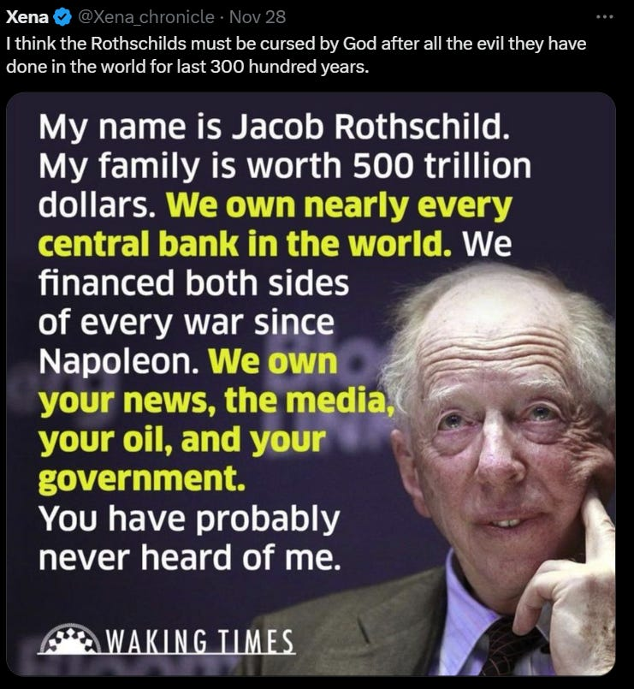

AH.. SODOMITE CENTRAL, ETON…

P.G. Wodehouse and British Empire Ritual Sodomy Band of Thebes Propagandised for Hitler, Propagandised for the Satanic Phoenician Mega Trillionaires

Satchidanand
·
October 2, 2022
Sir Pelham Grenville Wodehouse, KBE 15 October 1881 – 14 February 1975 was an English author and one of the most widely read humorists of the 20th century. His creations include the feather-brained Bertie Wooster and his sagacious valet, Jeeves; the immaculate and loquacious Psmith; Lord Emsworth and the Blandings Castle set; the Oldest Member, with stories about golf; and Mr Mulliner, with tall tales on subjects ranging from bibulous bishops to megalomaniac movie moguls.

Read full story

I learned this from Mr. “Oligarch” Mikhail Khodorkovsky (MK), former member of "Sembankirshchina," the gang of seven bankers who ruled Russia during the 1990s and controlled most of its wealth (estimated at around 60% of Russia's GDP at the time).

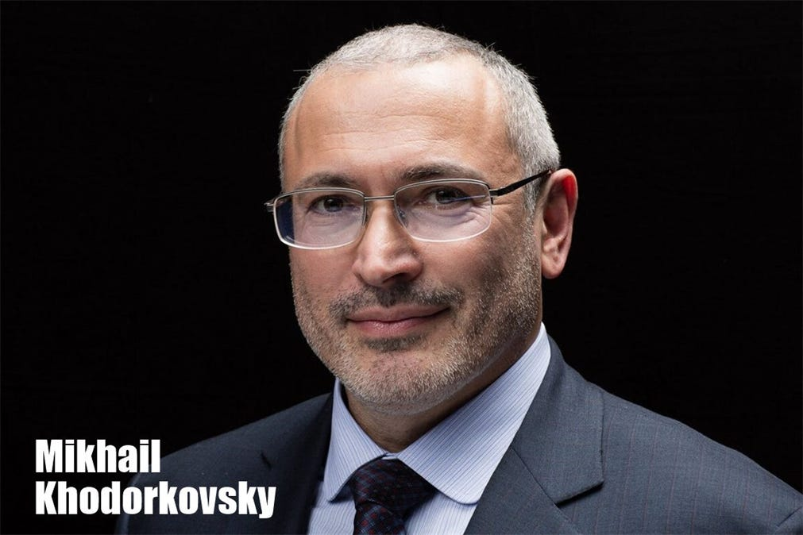

A miracle: from Komsomol, the Communist youth organization to Russia’s wealthiest oligarch.
Mr. “Oligarch” Mikhail Khodorkovsky recently gave an interview and explained the concept of "protector-owner" the detail which they forgot to teach to us in school:
“Oligarch” Mikhail Khodorkovsky: "We made the decision to have a [company] "Protector-Owner" in the Trust, this is a person that watches everything that is happening with the company. He must be completely independent and absolutely trusted, because he only has one function. In the moment he sees that the person holding a controlling stake in the company acts not, acts err.. under pressure let's say - acts under pressure, then he should open an envelope and hand over this control package to another person who will be written in that package. Our second person was [Leonid] Nevzlin but we never discussed it because no one should know who is second, who is third, who is fourth, who is fifth."
Q: This is in case you get killed?
“Oligarch” Mikhail Khodorkovsky: No, in case they kill it's simpler. It's for example, if they take someone from the family hostage and start blackmailing with something related to the company. Since the company cannot be jeopardized, in this case the "Protector" must notice that I act under pressure and take away my powers. And that happened when they put me in prison. So they put me in prison, the protector made the decision that from there I can make decisions [only] under pressure and he passed the package to the next person.
Q: Can you name who the Protector-Owner was?
“Oligarch” Mikhail Khodorkovsky: Yes, of course. This is just a figure of great character whose role in the company everyone discussed differently, but no one knew the reality. [It was] the recently deceased Satanic Phoenician Mega Trillionaire…

Lord Jacob “Jack” 4th Baron Rothschild. He had the function of Protector-Owner.
Of course, by “Jack,” “Oligarch” Mikhail Khodorkovsky meant, Satanic Phoenician Mega Trillionaire Lord Jacob 4Th Baron Rothschild had been. Exactly how legal transfer of ownership can pass from one individual to another, just like that, at the discretion of some absentee "Owner" residing in London, is not a bit of a mystery because…

The Rothschilds are the real Owners of the Company, everyone else is a front to hide that fact, but it did indeed work this way. I explained this relationship in part in my 2017 book "Grand Deception," about the events in Russia, but the book was banned only 5 weeks after I published it.
Also, the sources I used in describing this particular relationship between “Oligarch” Mikhail Khodorkovsky and Satanic Phoenician Mega Trillionaire Lord Jacob 4th Baron Rothschild had been scrubbed clean from the internet.
As a rule, the role of the Satanic Phoenician Mega Trillionaire London money lender oligarchy has always been scrupulously concealed from the public, which is probably why such details are not taught in universities either.

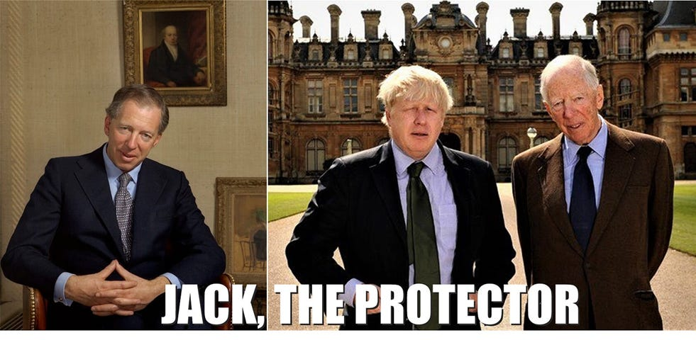

In the portrait on the left, Satanic Phoenician Mega Trillionaire Lord Jacob 4th Baron Rothschild shows us some sort of Satanic triangle or pyramid sign with his thumbs. Maybe that’s just how his hands fall at rest and feel most comfortable.

No, it wasn’t just Russia….
At this point, someone will object: that happened in Russia, which is deficient in democracy and the rule of law, duh - we all know that!. In the West, the rule of law is just double plus good awesome, and we have democracy, and human rights, etc. However, I would object right back: are we quite sure about all that?
We know for a fact that not even members of U.S. Congress may know the identities of the shareholders of certain large corporations like GE, JP Morgan, Exxon Mobil, etc.
They are secret even from the nation's lawmakers. It is then appropriate to ask, what else might be secret about the ownership and control of corporations?

Visible oligarchs are merely trustees, Fronts, of the Satanic Phoenician Mega Trillionaire London Money Power
When John Pierport Morgan died, everyone believed that he was the world's wealthiest man. But then it turned out that he only owned about 9% of his bank and was acting merely as the trustee of the bank's real owners who were (and perhaps still are) Satanic Phoenician Mega Trillionaire Rothschilds in the City of London.
Another example, recounted in the 1890 book by L. B. Woolfolk titled "The Great Red Dragon," was A. T. Stewart, the man who supposedly revolutionized (and nearly monopolized) the American retail industry back in the late 19th century. Just like Mr. Khodorkovsky, A. T. Stewart sprang from nowhere to great fortune overnight. He was a Front for the Satanic Phoenician Mega Trillionaires. The Scotsman owned a small shop on Broadway, only a few feet wide, where he sold needles, thread and tape.
Then somehow he came to control a massive retail business in palatial buildings, employing hundreds of clerks. He also had such stores in Glasgow, Belfast, Paris and in Germany. His wealth was estimated at about $100 million. However, when he died, he left his widow only a paltry $1 million. The rest of his fortune was transferred to a certain Judge Hilton, who was seemingly his handler and “number two” in line of substitute trustees: it was well known that Mr. Stewart met with the judge weekly and dined together every Sunday.
The media at the time concluded that the crafty judge had cheated poor Ms. Stewart out of her rightful inheritance and a court battle ensued where it was established that her husband in fact owned no interest in A.T. Stewart & Co. but only collected commissions on sales. Judge Hilton himself was also only an agent of some Satanic Phoenician Mega Trillionaire power that remained hidden.
However, the company he inherited was soon run out of business by three new retail establishments. With good quality merchandise and low prices they drove A. T. Stewart & Co. and another 1,000 retail merchants in New York to bankruptcy.
The new business model soon spread throughout the U.S. and much of the developed world. It was understood at the time that it was " Satanic Phoenician Mega Trillionaire money power" exercising control from the shadows.
As one merchant said at the time, "If things go on as they are, in a few years more, the Satanic Phoenician Mega Trillionaire Money Power will have monopolized the retail traffic, as it has monopolized and is now monopolizing all the other branches of business in the country."
To deflect people's attention away from the Satanic Phoenician Mega Trillionaire Money Power, the anger was directed at the Jews and the new retail establishments were commonly referred to as "the Jew stores."
In fact, Judge Hilton himself blamed the Jews for A. T. Stewart & Co's failure. Mr. Stewart's rise to power wasn't an isolated case: most of the oligarchs of that era were trustees, fronts, of Satanic Phoenician Mega Trillionaire London Money Power.
The same was true for the Russian “oligarch fronts” that emerged from the Soviet Communist party after the USSR's 1991 collapse. Someone might object again: all that happened a long time ago, or it was in Russia.
Today, in this day and age, we surely have double plus good transparency, rule of law, sanctity of contract, property rights, democracy and freedom, independent media, equity and inclusivity, etc.!?!

But what if all those wonderful things are only the facade props, subtle means of persuasion, convincing us (including through our universities) that the system is wonderful and equitable so that we wouldn't suspect that there really was a sinister Satanic Phoenician Mega Trillionaire oligarchy exercising power from behind the shadows, OWNING EVERYTHING?

What if this whole liberal democratic order is a sham?

The Richest Satanic Phoenician Mega Trillionaire 10,000 years old Families in the World

Satchidanand
·
November 25, 2022
The Richest Satanic Phoenician Mega Trillionaire 10,000 years old Families in the World. THE VANGUARD GROUP DRIVES WORLDWIDE MERCHANT-BANKER FASCISM FROM THE CITY OF LONDON. VANGUARD, BLACKROCK, STATE STREET ARE CONTROLLED BY THE PILGRIMS SOCIETY IN THE CITY OF LONDON (ROTHSCHILDS, BARINGS, BARCLAYS, NATWEST, ETC.) King Chucky the Turd is the front man controlling Klaus Schwab and Vanguard.

Read full story

What of today’s exalted “oligarch fronts”?
Such secret arrangements would be very difficult to prove, but if they did exist, they would help explain the rise to power of today's oligarchs like

The Rockefellers…

Vaccines Cause Autism and Cancer!

Satchidanand
·
November 20, 2024

Vaccines Cause Autism and Cancer!Satchidanand’s Against Satanism Newsletter is a reader-supported publication. To receive new posts 55 FREE BOOKS! and support my work, consider becoming a free or paid subscriber.

Read full story

Elon Musk, Jeff Bezos, Steve Jobs, Larry Page and Sergey Brin, Bill Gates, George Soros, Larry Ellison, Warren Buffett, Eric Schmitt, Peter Thiel, Robert Mercer and many others.
It would also explain why in one way or another they all end up in bed with the Satanic Phoenician Mega Trillionaire Bought, Paid for, Blackmailed, Satanic Ritual Human Sacrifice Psychopath Deep State, the President, the Democrats, the Republicans, the Senators, the Congress, the CIA, the Pentagon, Google, Facebook, Twitter, and with all political parties, Satanists, Luciferians, Illuminati, Jesuit, Masonic groups.
We're all encouraged to admire these Satanic Phoenician Mega Trillionaire front people for their genius and entrepreneurial spirit, but what if that's the product of the PR machinery which nudges us to think of Bill Gates as the great benefactor and of Warren Buffett as the kindly old grandfather who just happens to be a brilliant stock picker? Really, when was the last time any journalist asked Bill Gates or Warren Buffett a tough question?
All this was true about Russia's oligarch fronts in the 1990s; they were always presented as young maverick businessmen reforming the economy and breaking new grounds, bringing capitalist free markets to Russia, etc, etc.
Then there was also the case of Elizabeth Holmes, who likewise came out of nowhere to become the youngest female self-made billionaire and was widely promoted in the media.

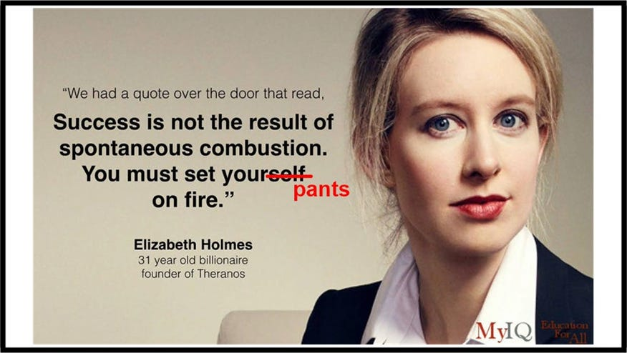

This all worked as per the Satanic Phoenician Mega Trillionaire Money Power playbook until her company, Theranos collapsed in disgrace and it turned out that she invented nothing and controlled nothing.

Theranos was the great revealer

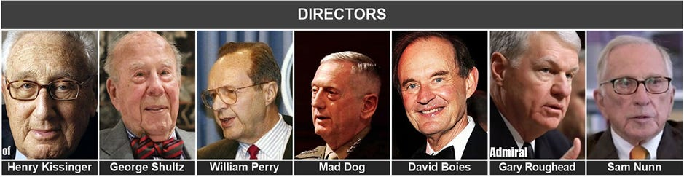

Theranos Board Satanic Phoenician Mega Trillionaire Front of Directors: Who’s who of the Satanic Phoenician Mega Trillionaire Deep State and the “defense” establishment.

ALL SOLID FRONTS - EVEN ALL BOARDS OF DIRECTORS
Henry Kissinger, George Shultz, William Perry, General Mad Dog, David Boies, Gary Roughhead, Sam Nunn

You are Surrounded by Paid Liars!

Satchidanand
·
January 19, 2024
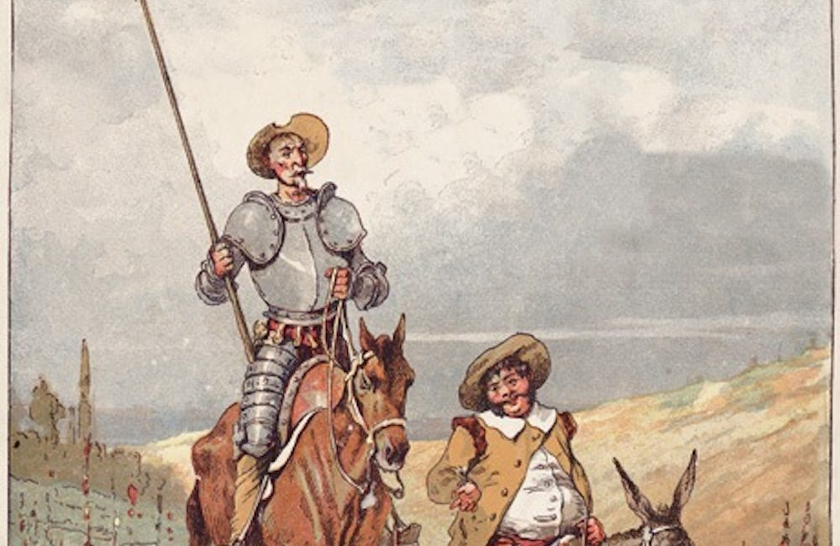
Any Blog talking about geopolitics which does not talk about Satanism is part of the Satanic complex, has been co-opted, bought, blackmailed or is Satanic Phoenician.

Read full story

10,000 Years of Phoenician History…

AGAINST SATANISM VOLUME 6 -The Satanic History of the World Part 2 Published May 2019

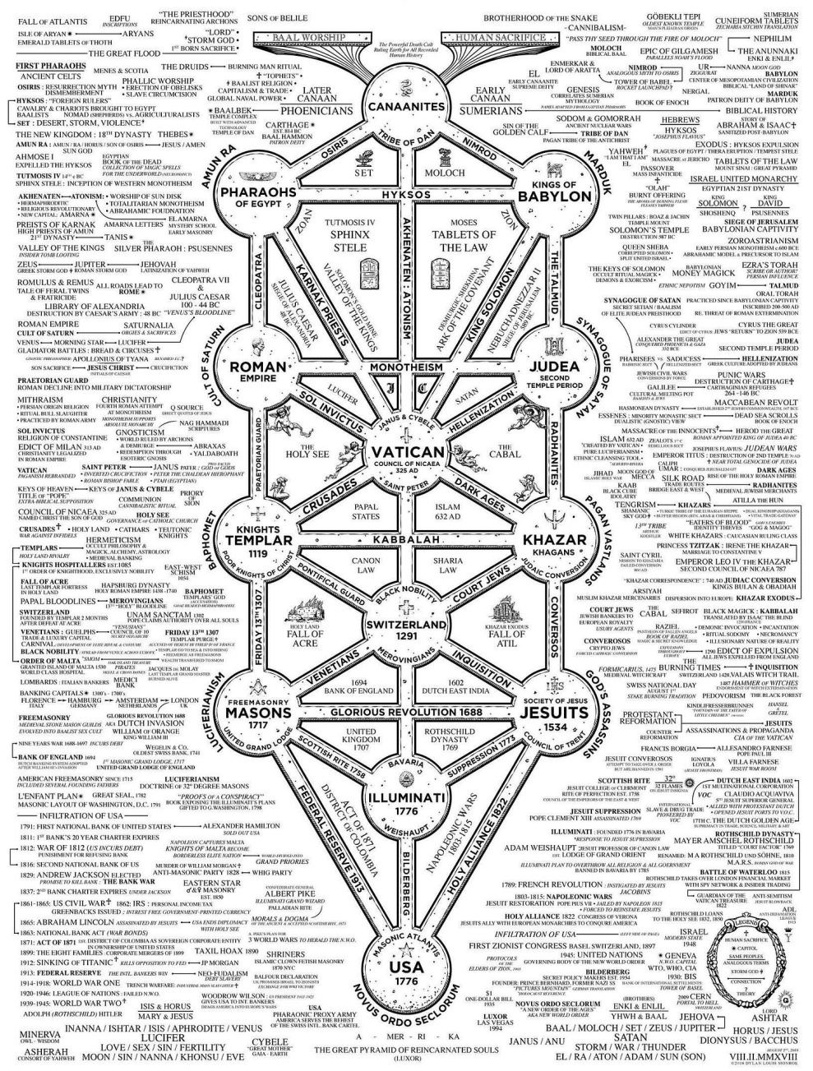

Dark Forces have used Infiltrating Bloodline Phoenician/Jewish Satanic Phoenician Mega Trillionaire Black Nobility aristocratic Families which have existed for over 5000 years before the Birth of Christ. Using emotional rhetorical religious concepts to control humanity, they themselves worship all the Pagan Dark Gods who live out of the body in Private Universes in the Chakras above the Head by means of Vampirising the Energies of Humanity by means of Addiction Energy Blockage Implants, including Lucifer, Satan, Baal, Bel, Molech, Ashtoreth, Cybele and Attis.
Satanic Phoenician Mega Trillionaire Black Nobility aristocratic Family minions serve the Dark Gods and yearn for the promotion of Immortality by learning how to leave the body and live forever as an Energy Vampire in the chakras above the head.
In this book we find that over thousands of years, spook, Satanic Bloodline Phoenician/Jewish Black Nobility Aristocratic Families infiltrated every country, every Empire, taking over or infiltrating every ruling aristocracy and aristocratic, bloodline family, in Europe, Britain, America, India, China and in every other country in the World ruling the Political and the Mafia in one great family - The Satanic Phoenician Mega Trillionaire Black Nobility.
http://www.energyenhancement.org/Sacred-Energy/Against-Satanism-Volume-6/AGAINST-SATANISM-6-Satanic-History-of-the-World-Part-2.pdf
The Satanic Phoenician Mega Trillionaire Black Nobility use Satanism and the use of Satanic Rituals to corrupt people in order to create a group of Psychopaths willing to follow any mandate in order to Rule the World…
Their Minions will conscript you and send you to war, mandate the Deathvaxx, Digital identity, Central Bank Digital Currencies, total surveillance and the end of free speech!

Aleister Crowley's Satanic Secret Sex, Sodomy, Baby Sacrifice, Cannibal Rituals of Ordo Templi Orientis - O.T.O.
Satchidanand

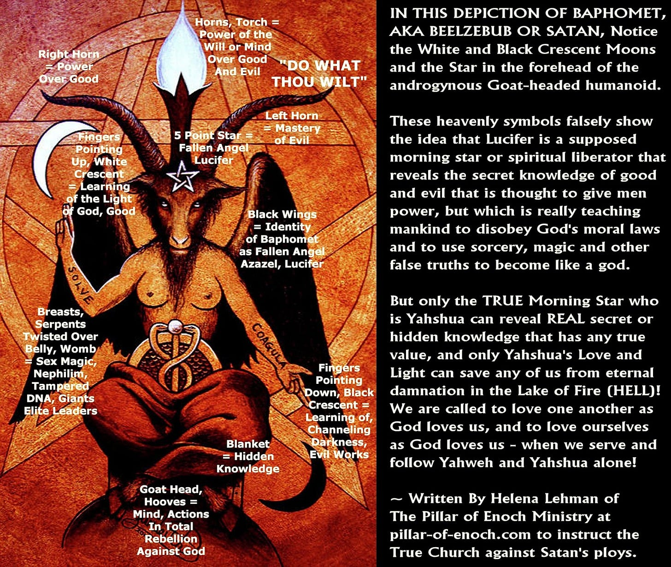

Aleister Crowley's Secret Sex, Sodomy, Baby Sacrifice, Cannibal Rituals of Ordo Templi Orientis - O.T.O.
Read full story

AGAINST SATANISM VOLUME 3 - Satanism is defined by Satanic Rituals.. LIVES FOR SATAN! - THESE RITUALS DEFINE SATANISM.. RITUAL SEX, RITUAL SODOMY, RITUAL DRUGS, RITUAL BLOOD SACRIFICE, RITUAL HUMAN SACRIFICE, RITUAL TORTURE, RITUAL BURNING ALIVE, RITUAL CANNIBALISM, RITUAL CASTRATION, RITUAL VIRGIN SACRIFICE.. Abortion, Baby Killing, Vaccines, Autism, Pandemics.

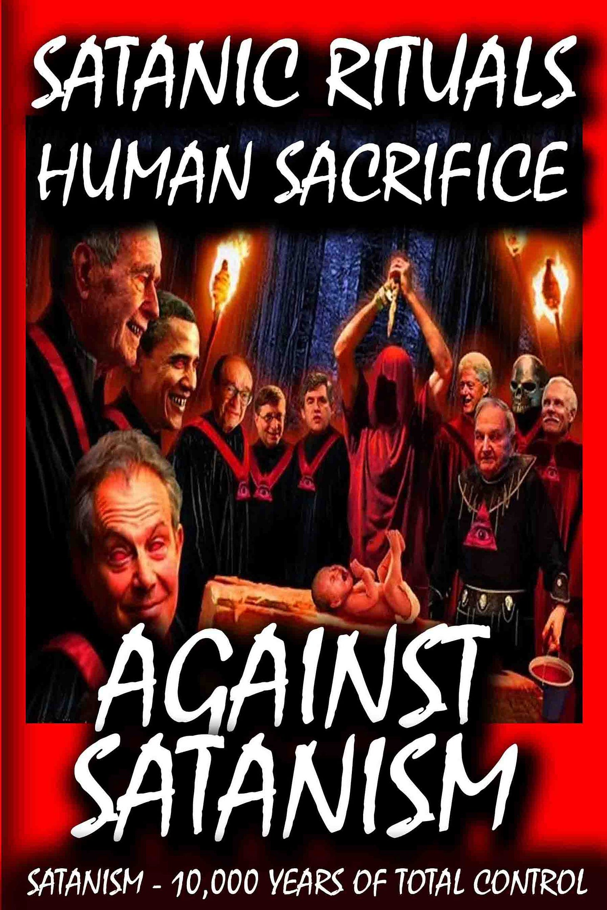
Click Below..
http://www.energyenhancement.org/FREE-BOOK-AGAINST-SATANISM-VOLUME-3-Satanism-is-defined-by-Satanic-Rituals.htm
Satanism is gradually being instituted as the New World Religion defined by Satanic Ritual.
72 Empires have been recorded and every one of them has failed in the same way. The facts have been recorded that a totalitarian and satanic elite infil-traitored and took over all these Empires and that 72 once free, flourishing and rich republics were destroyed from within by Satanic Ritual - read Toynbee.
Infil-traition of Satanism is the methodology as slowly every Government Ministry and Societal function is taken over. Eventually a Satanist becomes King Emperor President. LGBTP - The Satanist Ritual Pillars of Homosexuality, Pederasty, Drugs and Ritual Sex - both Hetero and Homosexual - are introduced overtly as a prelude to Ritual Human Sacrifice. Christianity and Judaism - the bulwarks Against Satanism - are destroyed and then society destroyed through the fear of mandatory Ritual Human Sacrifice.
The Ancient Enemy who counts meditation and the mind control psychic arts as one of its main planks of World Domination has used Satanic Infil-Traitors for 10,000 years in every Organisation - Religion, Left and Right Politics, Dynastic Families, Geopolitics, Economics, Universities, Intelligence Services, Think Tanks, Banking, Facebook, Twitter, International Companies, Vatican, Transhumanism, CRISPR Androids, Eugenics..
The key is that the Satanic Religion and is current recruiting cults of Freemasonry and the Crowlean Sexual Ritual OTO - Ordo Templi Orientis - are Fake Gangs, created by men as a 10,000 years old technique to create psychopathic leaders and their minions, and thus conquer the world.
All Rituals, Religions, Education, Secret Services and Political Movements have been scientifically Engineered to create Fake Gangs for 10,000 years. It's what the old Roman Empire, The Babylonian Empire of Satanic Nimrod, and the Cult of Apollo and the Byzantine Empire did before.
As you know, every Gang has Blackmail Rituals before you can join. Making your Bones with the Mafia means you must murder someone before you can join. Drug Cartels like MS13, secret groups within the Masons, the Hellfire Club, all have their Rituals before you can progress.
Epstein did not kill himself. He videoed Scientists from MIT and Harvard, Oligarchs, Politicians etc, Pedophiling young girls then Blackmailed them into doing the work of his Trillionaire sponsors - MKULTRA, Transhumanism, CRISPR Androids. As their willing victims are given access to stealing higher quantities of money, so they must go to the next level of Ritual. First it is 15 year old girls who look 25. Then it's 12 year olds, 5 year olds, and then its the murder of children, babies!
All to create a Satanic Society of Total Control through Human Sacrifice, poverty, lack of education, poison in the air, water and food. Lack of infrastructure, education and Total Control of the Media.
All of them Censoring Worldwide, Advanced Meditation techniques - Alchemical VITRIOL, the Kundalini Key and Energy Blockage Removal from every Meditation Program..

EXCEPT ENERGY ENHANCEMENT MEDITATION!!

http://www.energyenhancement.org

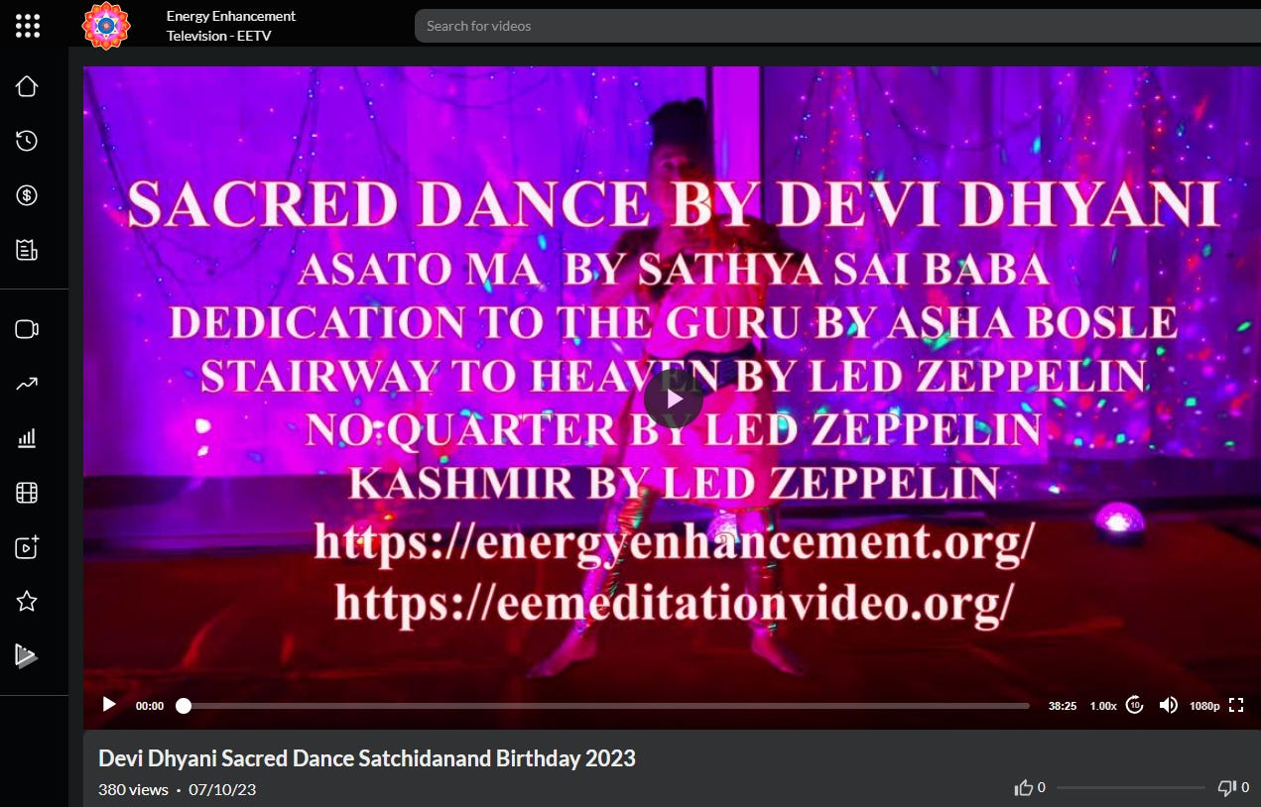

https://eemeditationvideo.org/watch/devi-dhyani-sacred-dance-satchidanand-birthday-2023_S8bWoEEUmn9IEji.html

The very word secrecy is repugnant in a free and open society JFK (27 April 1961)
The very word secrecy is repugnant in a free and open society; and we are as a people inherently and historically opposed to secret societies, to secret oaths and to secret proceedings For we are opposed around the world by a monolithic and ruthless conspiracy that relies primarily on covert means for expanding its sphere of influence â€“ on infiltration instead of invasion, on subversion instead of elections, on intimidation instead of free choice, on guerrillas by night instead of armies by day. It is a system which has conscripted vast human and material resources into the building of a tightly knit, highly efficient machine that combines military, diplomatic, intelligence, economic, scientific and political operations.
JFK (27 April 1961)
READ - AGAINST SATANISM VOLUME 3 - Satanism is defined by Satanic Rituals.. LIVES FOR SATAN! - THESE RITUALS DEFINE SATANISM.. RITUAL SEX, RITUAL PEDOPHILIA, RITUAL DRUGS, RITUAL BLOOD SACRIFICE, RITUAL HUMAN SACRIFICE, RITUAL TORTURE, RITUAL BURNING ALIVE, RITUAL CANNIBALISM, RITUAL CASTRATION, RITUAL VIRGIN SACRIFICE.. Abortion, Baby Killing, Vaccines, Autism, Pandemics.
Click Below..
http://www.energyenhancement.org/FREE-BOOK-AGAINST-SATANISM-VOLUME-3-Satanism-is-defined-by-Satanic-Rituals.htm
PDF
http://www.energyenhancement.org/Sacred-Energy/Against-Satanism-Volume-3/Against-Satanism-Volume-3-Satanic-Rituals.pdf
AUDIO BOOK
http://www.energyenhancement.org/Sacred-Energy/Against-Satanism-Volume-3/Against-Satanism-Volume-3-Satanic-Rituals.pdf.mp3

So Richard Condon’s novels mirrored reality…
The Satanic Phoenician Mega Trillionaire Black Nobility own and run the Vatican, SMOM, Jesuits, KOC, and La Cosa Nostra. The European Monarchies like the British Crown are branches of Rome and they manage secret societies like the Freemasons which infiltrate government agencies and run corporations for the monarchs.
The Sovereign Military order of Malta SMOM is the top military council and it works closely with the Orders of St John ran by Protestant monarchs. The Knights of Malta are the engineers of war. The royal and noble bloodlines are all working together as a global crime syndicate and part of the modernized Roman Empire.
The Greek royal House of Glucksburg run the Greek fraternities and sororities and use initiates as their agents. The British Crown controls universities like Yale and Harvard and use them for recruiting Crown agents. Jesuits are Roman intelligence and infiltrators and use their universities for recruiting and training Vatican agents. Many Knights of Columbus are police officers, mayors, lawyers, and judges and they protect the Italian Mafia.
The Italian Mafia are enforcers for Rome involved in…
The definition of Satanism…. Sex, Drugs and Rock and Roll with P. Diddy…

Extortion, Money laundering, Sex Trafficking, Organ Trafficking, Murder, and Drug trafficking;

The only reason they released Afghanistan and it’s Opium is that they increasingly started to use Fentanyl which kills 100,000 people a year in a country targetted for destruction which is now the USA…
and they pay their dues back to the Sicilian Mafia which pay dues back to the Satanic Phoenician Mega Trillionaire Black Nobility.
Court Jews like the Rothschild, Warburg, Walton, Wallenberg, and Dreyfus families serve the Roman Curia and royal courtrooms like Buckingham Palace and Stockholm Palace.
The French House of Bonaparte and Swedish House of Bernadotte control many major European corporations through their knights of the Order of Seraphim and Legion of Honor running the European Round Table of Industrialists.
The Holy See is the All Seeing Eye and operates as an intelligence network. The Latin phrase Novus Ordo Seclorum means New Order of the Ages and is on the US dollar bill and US Great Seal. The Vatican uses Latin as an official language and for documents.
The Satanic Phoenician Mega Trillionaire Black Nobility and other royal families have been concealing trillions in private banks in Luxembourg, Liechtenstein, and Switzerland. The royal families of Luxembourg and Liechtenstein own and run their own national and private banks.
The Este and Lorraine families are top Swiss bankers. The Erlach and Brandi families are Swiss financial tax advisers enabling corruption. The Swiss Guard protects the Vatican. The Swiss Cantons have been in contract with the Vatican for centuries and Switzerland is basically a papal state.
The Italian Savoy and Austrian Habsburg families oversee Switzerland for the Satanic Phoenician Mega Trillionaire Black Nobility. The Passi de Preposulo and Ferragamo families oversee Hollywood. They own the Holy See which is a corporate entity headquartered at the Vatican City State which was established as a nation in 1929 under Benito Mussolini who was put in power by the House of Savoy.
Some top families in the Satanic Phoenician Mega Trillionaire Black Nobility include the Pallavicini, Colonna, Ruspoli, Sforza-Cesarini, Aldobrandini, Odescalchi, Torlonia, Gaetani, and Massimo families.
Prince Carlo Massimo and Duke Leopoldo Torlonia are running the Sovereign Military Order of Malta. Prince Carlo Massimo is the President of the Italian Association for the Order of Malta and is the one giving the orders.
Prince Carlo of Bourbon-Two Sicilies is a top manager of the Society of Jesus. The Jesuits are Roman intelligence and infiltrators serving the Satanic Phoenician Mega Trillionaire Black Nobility authorized by the Farnese family’s Pope Paul III. The Bourbon-Two Sicilies family are the continuation of the Farnese family and Farnesivs is engraved on the Jesuit’s headquarters called the Gesu Church of Rome.
The Torlonia family own the Kansas City crime family and share ownership over the Pittsburgh crime family with the Borghese family. The French House of Orleans own the New Orleans crime family and the French-British Beaufort family oversee the Dixie Mafia.
The Sforza family own the Stidda Mafia clans which operate in their former territory of Milan. The Aldobrandini family are owners of the DeCavalcante crime family of New Jersey. The Colonna family are running the Knights of Columbus and Colombo crime family as well as sharing ownership over the Chicago Outfit with the House of Capponi.
Colonna means column like Colombo and Columbus. The Massimo and Gaetani families own and run the Gambino crime family and Philadelphia crime family. The Massimo family also own and run the Casamonica mafia clan or Roman Mafia and the Nuclei Armati Rivoluzionari which still exists. The Massimo family of Roccasecca own the Clerkenwell Mafia of London.
The Lucchesi-Palli and Pallavicini family own the Lucchese crime family. The Greco-Roman Giustiniani family run the Philly Greek Mob.
The European Union is based on the Treaty of Rome and was signed in Rome at Capitoline Hill. The President of the European Central Bank is Mario Draghi who was born in Rome and Jesuit educated at the Massimo Institute. The Erba-Odesclachi with ancestry from Cernobbio, Italy run CERN with Roman born Fabiola Gianotti as the Director-General of CERN.
The Boncompagni-Ludovisi family run the Casalesi mafia clan which operates in their former dukedoms and also control the Bonanno crime family. The Adragna family of Sicily run many of the N’Drangheta factions along with the Gaetani family and the House of Adragna are part owners of Los Angeles crime family which was built up by the Dragna crime bosses like Jack Dragna.
The Odescalchi family run the Detroit Partnership and some Slavic mafias. The House of Savoy own and run the Genovese crime family. Don Vito Genovese was from Naples and Prince Vittorio Emanuele IV of Savoy is the Prince of Naples.
The Chigi-Albani family run most of the Albanian mafia like the Rudaj Organization. The Corsini, Medici, and Bonaparte families are the owners of the Union Corse or Corsican Mafia.
The House of Windsor and German nobility like the Saxe-Coburg and Gotha, Hohenzollern, Hesse, Furstenberg, and Hanover families run and finance various Neo-Nazi cults and Nazi propaganda while they also control many of the Jewish banking families through their royal courts.
The House of Bourbon and Spanish noble families run most of the Mexican and South American drug cartels.
The German nobility were Nazis. The Windsor and German noble families also run the Aryan Brotherhood of Texas. The Irish Barons run the Irish Mafia and Aryan Brotherhood. The Windsor and Bush families control covert paramilitary organizations and mercenary armies branched off from the military like G4S, KBR, and Vinnell Corporation.
The Bush family runs the military industrial complex in the United States with Vannevar Bush founding Raytheon and Wesley G Bush running Northrup Grumman.
The Mars and Walton families are mega billionaires and like royalty in the United States. The Islamic royal families were appointed by European royalty in the 19th and 20th centuries and especially after WWI.
The Mid East royalty run the oil industry and use their massive wealth to finance globalist agendas for being allowed to rule their nations.
The House of Bourbon and Spanish nobility like the Osorio, FitzJames, and Aragon families run most of the Mexican and South American drug cartels. The House of Bourbon are the founders and owners of Santander Bank. The King of Spain holds the official claim to King of Jerusalem

THE SATANIC PHOENICIAN MEGA TRILLIONAIRE BLACK NOBILITY RULERS OF THE WORLD VOLUMES 1 AND 2

VOLUME 1 THE SATANIC PHOENICIAN MEGA TRILLIONAIRE BLACK NOBILITY INDIVIDUALS - 648 PAGES

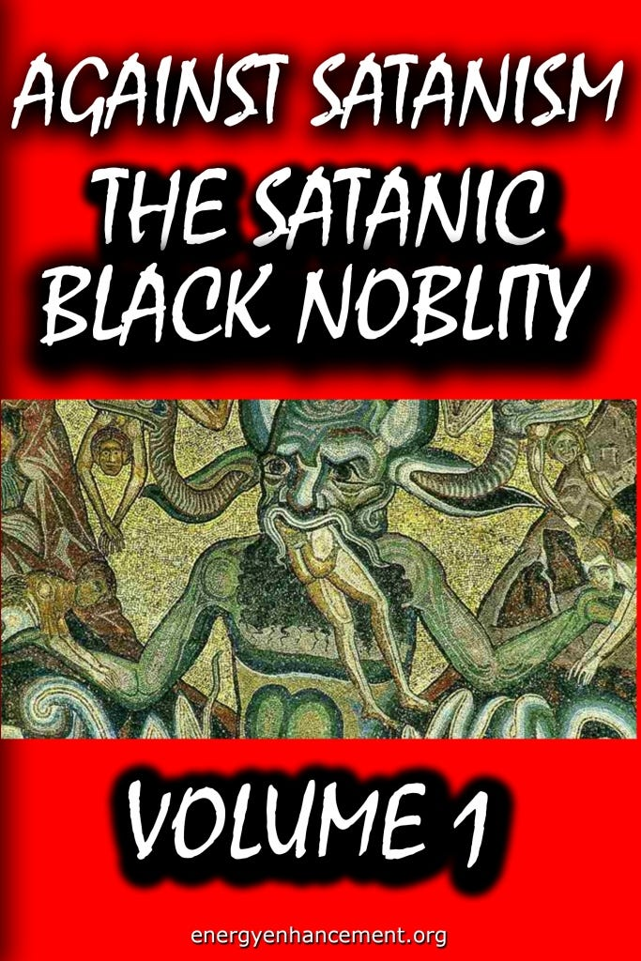

THE SATANIC PHOENICIAN BLACK NOBILITY VOLUME 1
The Russell Family of England who were part of the Banking, Drugging, Slaving East India Company Committee of 300, Founded the Russell Marquis of Tavistock, Tavistock Institute, the Frankfurt School, The Fabian Socialists, engaged Marx with his handler Ambassador Urquhart to write Das Kapital in London in order to create Socialism and Communism to take over Russia and China for the Anglo-American Empire Founded by Lord Milner and the Rothschild Backers.
THIS SODOMITE BAND OF BROTHERS RUN THE DRUG TRADE OUT OF HONG KONG
THE BRITISH CROWN COUNCIL OF 13 - THE WORLD’S RICHEST AND MOST POWERFUL 10,000 YEARS OLD FAMILIES THEN,
THE COMMITTEE OF 300 RICHEST, MOST POWERFUL SUB FAMILIES THEN
THE POWERFUL SUB FAMILIES
ALL ARISTOCRATS FROM SATANIC PHOENICIAN MEGA TRILLIONAIRE BLACK NOBILITY POWERFUL FAMILIES WHICH HAVE BEEN IN EXISTANCE FOR 10,000 YEARS CONTROLLING THE WHOLE WORLD.
INCLUDING THE 2000 TRILLION DOLLAR ROTHSCHILDS
"A Citizen has the courage to make the safety of the whole human race his personal responsibility" Robert Heinlein, Starship Troopers 1hr 38mins
Understand, the 2000 Trillion Dollar Rothschilds and Rockefellers Rule!! and have ruled, as Devil Worshipping, Human Sacrificing, Pedophile Ritual, Sodomy Ritual Band of Thebes, Band of Brothers, Phoenician Families, for 10,000 years.

If you want to know what the Satanic Owl of Sodomite Bohemian Grove meant to the Phoenicians, it isn't hidden.
Both the Greeks and the Vikings were Phoenicians, and we know they both held the owl to be a symbol of wisdom. But the owl is of course also the most covert hunter, gliding silently through the darkness.
Bohemian Grove exposed the politicians like Nixon and Reagan attending. Also the Captains of Corporate America, Hollywood Moguls - all Sodomites and Satanists.
3 is a bottom.
33 is bottom on bottom Sodomy
33rd Degree Freemasons, Jesuits, Aleister Crowley OTO – Ordo Templi Orientis, and the Illuminati illuminate their third eyes with the Sodomy Ritual injecting Kundalini Energy into the Base Chakra – rising up the spine into the head to Illuminate the Third Eye. Unfortunately Demons get injected too as with everything on the left hand path, the mind is overthrown. Psychopaths created to rule the world!
Don't blame the Mini Minions like the Camel, Bidet and Strauss.
This has all been planned for 150 years for the Anglo-American Empire to be taken down and China put in place.
Blame the Satanic 2000 Trillion Dollar Rothschild Phoenician Mega Trillionaires who created an Unelected World Government - The United Nations with its partner the Rothschild Klaus Schwab World Economic Forum is in the terms of Mussolini, Fusion of the State with Corporations, essentially Undemocratic and Fascist.
The United Nations with its partner the Rothschild Klaus Schwab World Economic Forum uses Fake narratives like Fake Climate Change and Collectivism to mandate Agenda 2030 World Totalitarianism.
The Satanic Phoenician Mega Trillionaires who worship Lucifer, Satan, Baal, Molech, Cybele and Attis for 10,000 years before Christ are in charge of the minions like Starmtrooper, Turdow, Bidet, Camel, Richie, and Macron are all prostitutes, they sold out to Satan.
And the Presstitutes who say that it is just the minions we need to change, that it's the minions who are the problem. The minions have been bought by the The Satanic 2000 Trillion Dollar Rothschild Phoenician Mega Trillionaire Rothschilds, Rockefellers, Schiffs and Warburgs.
The minions have been bought by the The Satanic 2000 Trillion Dollar Rothschild Phoenician Mega Trillionaire Black Nobility who came from Venice, Rome, Babylon and Egypt like King Chuckie the Turd.
The minions just follow orders and follow the Satanic Rituals like Human Sacrifice, the Sodomy Rituals, the Castration Rituals, the Drug Rituals, the Whore of Babalon Rituals.

NEW BOOK! - THE SATANIC PHOENICIAN BLACK NOBILITY VOLUME 1
Satchidanand
Aug 24

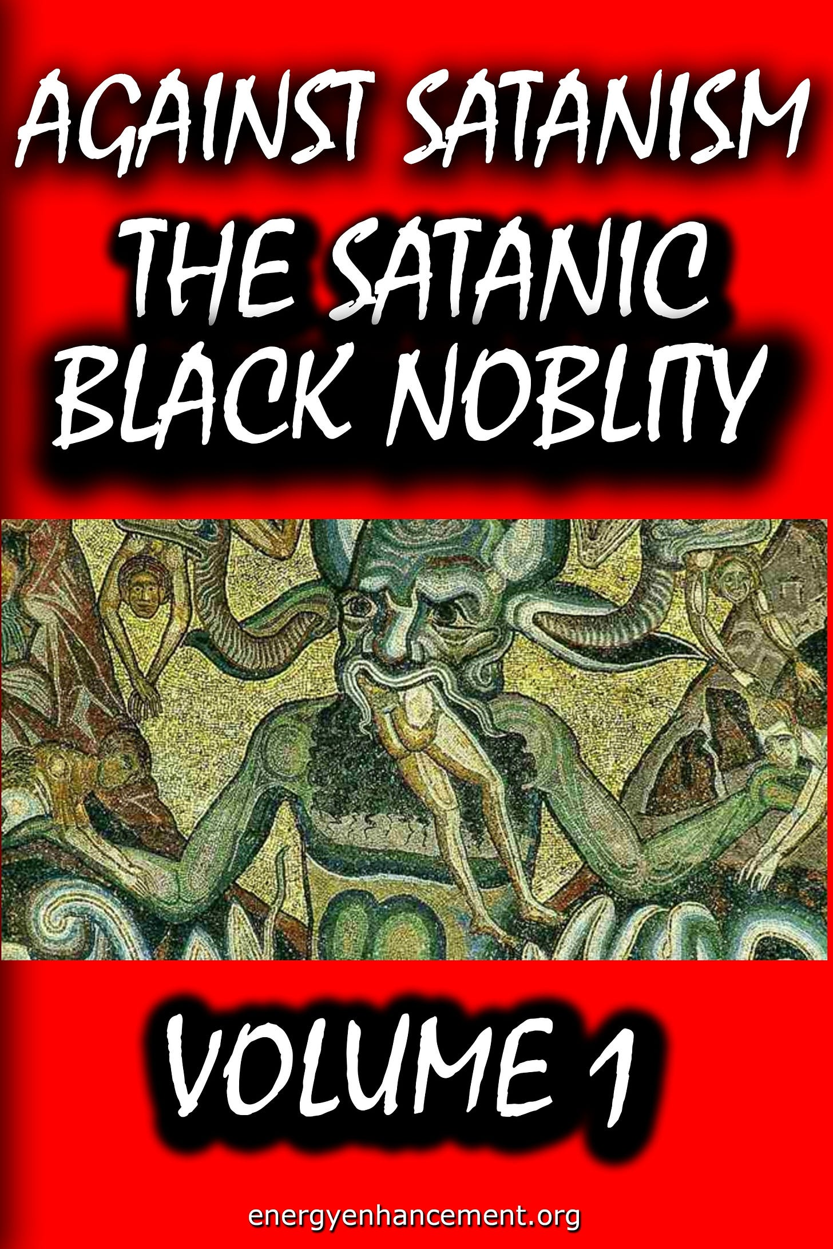

NEW BOOK! - THE SATANIC PHOENICIAN BLACK NOBILITY VOLUME 1
Read full story

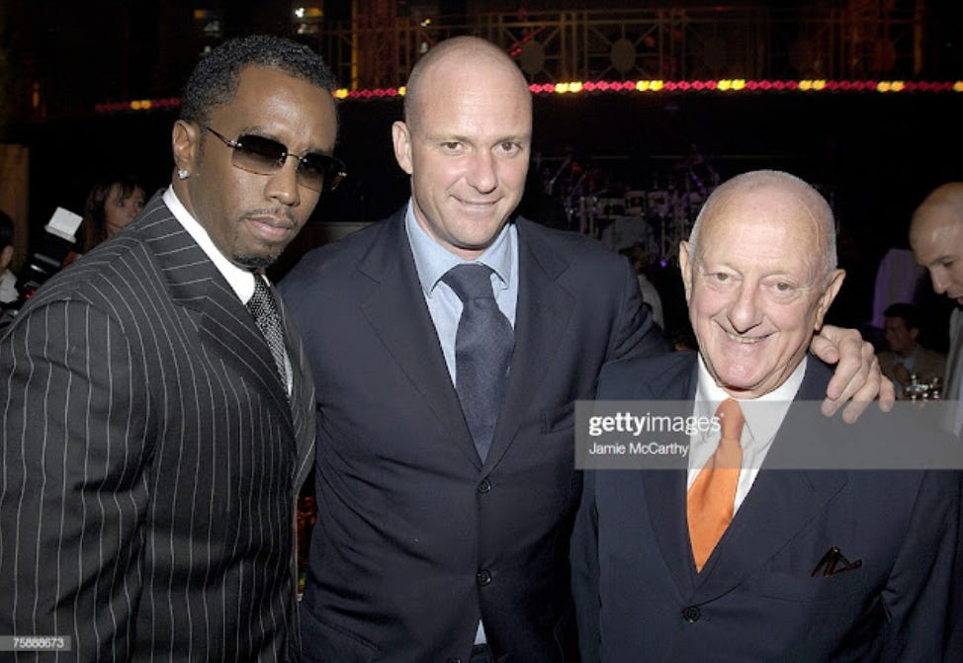

RAP IS RAPE!
P Diddy with the Ciprianis. P Diddy is a high level boss of the Gay Mafia and recently has been prosecuted but as an FBI informant like the movie, “The Departed” and working like Epstein in the Pedophile-Sex-Blackmail video arena to Blackmail all the Music Business by videoing every room at his mansions during Sex Pedophile parties, perhaps it will all go away.
The Savoy's top white collar Venetian mobsters are the wealthy Cipriani family which own restaurants, bars, clubs, and hotels with Maggio Cipriani as a current member.
P. Diddy did not kill himself!
P Diddy with Crowlean Ordo Templi Orientis Jimmy Page Come with me…
P Diddy is a front man for the Genovese 116th Uptown Crew headed up by Liborio Bellomo. P Diddy was signed to Andre Harrell's Uptown Records and today Diddy is worth over 800 million. P Diddy and the rapper Shyne who was signed to Diddy's Bad Boy Records were arrested for gun possession and attempted murder. As an FBI Informant, P Diddy got off on all charges and Shyne did 10 years in prison and took the fall as P Diddy's patsy. Shyne is still a criminal even though he took the fall for Diddy. Shyne's father is the Prime Minister of Belize. Belize has a lot of street gangs and the drug cartels operate there. The Lucchese crime family supplied opium and heroin to the Council and they still do to this day. Jadakiss, Sheek Louch, and Styles P are known in the Council as the Three Wise Guys. They have numerous rappers in their group D-Block and work with the producer and criminal Vinny Idol. Members of Wu-Tang and Dipset are members of the modern day Drug Council including Jim Jones, Hell Rell, Raekwon, and Ghostface Killah as members.

RAP IS RAPE!
Some rap lyrics from the African-American Mafia
"Kidnap a kid and sell him to a Hollywood bitch, I'm from D-Block every nigga over here sick." - Styles P
"Don't they know my nigga Gutter fuckin' kidnap kids, Fuck 'em in the ass, throw 'em over the bridge" - Notorious BIGGY SMALL
"Fuck Scarface my bullets hit women and kids" - Jadakiss
"And if you got a daughter older than 15, I'ma rape her
Take her on the livin' room floor, right there in front of you
Then ask you seriously, whatchu wanna do?" - DMX

“Sometimes the first duty of intelligent men is the restatement of the obvious.”

“Speaking the Truth in times of universal deceit is a revolutionary act.”

–George Orwell
I’m making this post because I suspect that most of the people who read this blog have absolutely no idea how bad the rap/hip-hop culture has become. From what I can tell about my readership, I’m guessing that the average reader is white, male, rural, over 50, and, apparently, retired from the United States Air Force. What up, flyboys.
First, I want to show you a couple of videos of contemporary, popular, chart-topping rap/hip-hop. I was a kid when rap first started and the popular acts were Run DMC and MC Hammer. Rap was simply rythmic speech laid over a simple beat track. It was crude in the sense that it was lyrically stupid and lazy, and did not contain any intrinsic beauty. The lyrics were often shouted and/or grunted, and if there was more than one voice, the combination of shouting voices produced sonic dissonance. I think that we all made the mistake of dismissing it as a fad, thinking that something with no intelligence or beauty could persist. It wasn’t a fad. It was the beginning of a cancerous evil. If you are like me and have not really listened to any rap music in 20+ years, you need to listen to these videos so that you can understand the level of sheer evil that we are now dealing with.
CONTENT WARNING. These videos are EXTREMELY graphic. There are no images – I refuse to post the “music videos” because they are pornography, and even in the interests of education and intelligence gathering, I just can’t do it. These videos are simply the text of the lyrics, because most of us couldn’t understand what was being said without the lyrics printed. But believe me, the children who are listening to this garbage read the lyrics and know every word by heart – so we need to know too. The language is extremely profane and sexually graphic. It could certainly be characterized as verbal pornography. If you feel that you can’t handle such things, DON’T WATCH. And for goodness sake, make sure there are no children within earshot. Finally, as you are watching these videos, understand that this is actually MILD. This rapper, “Lil Wayne”, is a very mainstream, popular rapper. This is the kind of stuff that gets played on the radio and makes the Billboard charts. This is the “bubblegum” category of rap/hip-hop. Obama has stated publicly that he is a fan of this guy and has him on his iPod. (That in and of itself should be grounds for impeachment.) But there are additional levels of fouler, more pornographic, more “hard core” rap. Remember that. The first rap is called “Gonorrhea” and the second is called “I Am Not Human”.
Did you have any idea it was that bad?
What you just heard was pure evil. What you just heard must be fought against and, with God’s help, exterminated from the face of the earth. What you just heard contains absolutely no beauty, goodness or truth – only ugliness, sin and lies. It has no redeeming qualities, and can do nothing but damage and corrupt those who listen to it. What you just heard is a clear and present manifestation of satan running free in the land. The rapper’s voice sounds demonic. The beat and sonic accompaniment sounds demonic and hellish. And where to begin with the lyrics? Every single sentence is either talking about horrific sexual objectification, murder, extreme pride (braggadocio) or extreme materialism. There are also several instances of blasphemy, wherein the rapper calls himself “god” and remarks about women kneeling before him (performing a sex act) as if they were in church.
This is the mainstream, contemporary rap/hip-hop culture in the United States. The vast, vast majority of black Americans under the age of 50 listen to rap/hip-hop like this on a regular basis, and many other people of all races listen to it too. How do I know? Because this “Lil Wayne” person, and scores of others like him are eight and nine-figure millionaires. His product is being consumed at a massive rate.
Why does this matter? Because the evil twin towers of rap/hip-hop and government welfare are destroying the black culture, and by extension and spillover the broad culture, and by extension the broad economy, and by extension western civilization. Don’t think for a second that this filth has no effect on you on your ranch in rural Nebraska. Let’s think this through.
Over the past 30 years, rap/hip-hop culture has conditioned many black Americans (and others as well) to actively disdain education, work, honesty, integrity, personal responsibility, generosity, humility, marriage, fatherhood and human life. If you think I’m making generalizations, GO BACK AND WATCH THE VIDEOS AGAIN. Young black boys and men grow up believing that the only worthwhile endeavors are basketball and/or football, dealing drugs or rapping. They are taught materialism on a level never before seen in human history. Bentleys. Multi-million dollar mansions. Gold and diamond capped teeth. Gold and diamond- crusted jewelery. Any job or vocation that yields less than the exorbitant wealth showered upon rappers, drug dealers or professional athletes is rejected in favor of a life of complete sloth subsidized by the welfare state.
They are taught that sex is a perverse contact sport consisting of merely slapping pieces of human meat together in various ways in order to achieve orgasm. The black family in the United States has almost completely disappeared. Illegitimacy rates in the cities are now in excess of 90%. Most urban blacks have never, ever heard or been taught that sex is limited to marriage. Let me say that again: most urban blacks have NO IDEA that sex is limited to marriage. Most urban blacks have little or no personal contact with marriage or even monogamy. The concept of a father being present in a household is completely foreign. And just today it was reported that in New York City, 41% of all pregnancies end in abortion. Among blacks in NYC, the figure is a jaw- dropping 60%.
They are taught that drug use is desireable and normal, and that drug trafficking is just a means of making easy money.
As a result of all of this, in combination with labor unions and a general rejection of Judeo-Christian morality by all people, we are now staring down the barrel of a total societal and economic collapse as engineered and executed by Marxist elites over the past 50 years. The welfare and entitlement state has reached critical mass. The entire system is about to implode, and it will take ALL OF US with it. Because our culture has been reduced to an animalistic self-absorption, this collapse will not be like the Great Depression. Men will not take any job they can find to support their family – because men stopped supporting their families decades ago. Men will not take any job they can find in order to feed themselves, because men have been conditioned to believe that honest work is for “suckas”.
At this point, some of you reading this may already be feeling very uncomfortable with what I have just said. You may be thinking me “racist” and “bigoted”. Of course you are. You have been conditioned your whole life to have that reaction. We have been conditioned to believe that any statement of truth, rooted in direct observation and objective evidence MUST be “bigoted”. We have been conditioned to believe that anything that discerns between two or more options, and determines that one option is superior or inferior to any other option is an act of evil, which is named “discrimination”. We have been conditioned to believe that the only morally acceptable stance on anything is complete indiscrimination – in other words, ANYTHING GOES. According to our culture, if I watch the videos above and discern with my powers of observation, reason, intellect and transcendent universal morality (called the Natural Law) that they are, without a doubt evil, then the problem is with ME. I am the evil that must be eliminated. I am the stumbling block to a utopian culture. If I would just sit down and shut up and embrace evil, then there would be no conflict in the world. By engaging in rational thought, I am perpetrating a hate crime. The only way for me to be a “good person” in this world is for me to utterly abandon Reason and Truth. And as I have stated many, many times on this blog, Reason and Truth are a Person, and His Name is Jesus Christ. Oh, yes. Satan is most assuredly afoot in the land.
If you are still feeling latent guilt about criticizing the rap/hip-hop culture, I would invite you to simply defend it. Go back to the two videos above and find me ONE example of virtue, goodness, selflessness, generosity, humility or LOVE. Go ahead. DEFEND IT. Defend pure satanic evil. Tell me about “diversity”, “cultural differences”, “artistic license” and “tolerance” whilst defending and justifying this:
“Diva in the room, she blowin me just like a band horn / Got her on her knees, the same knees that she be prayin on.”
Tell me who the racist is: me, or a man who proclaims, “I am not human.” My God, what more do you need? What more is there? Satan has these people denying their own humanity. I’m trying to reassert and proclaim the humanity and infinite dignity of Lil Wayne and everyone who listens to him. Lil Wayne IS A HUMAN, made in the image of God. God made the universe so that He could create and love Lil Wayne. Christ went to the Cross with Lil Wayne’s face in His mind, and “Wayne” on His lips. Yeah. Jesus that hateful bigot.
In the cities today, more than half of all black children are murdered by their own mothers before they are delivered. Abortion is obviously being used as contraception. Over the past 40 years, nearly 20 million black human beings have been murdered in utero in the United States alone. This means that there should be at least 20 million more black people in this country than there are today – and that isn’t counting the children and grandchildren that would have been born to those aborted black Americans by now. It is a geometric progression. I mourn those lost souls. I mourn the lost potential. This country would not be in death throes that it is in if those children were alive today. If our culture valued human life and thus prevented those children from being killed, God would still be shedding His grace on us. If our culture valued human life, then the rap/hip-hop culture would not even exist. It would have been consigned to the dustbin of history by a collective moral action of the people long ago, and almost all black children would be born to a mother and father, united in marriage, just as they were 60 years ago. One of the objective proofs of the brokenness of our culture is the fact that there aren’t nearly as many black people in our population as there should be. Now, what was it you were saying about Ann being a klannish racist?
What is the solution? I would assume that most everyone reading this blog already has a zero tolerance policy for rap/hip-hop. But we have to do something, because the opposite of love is indifference. As long as we are here in this world, we are COMMANDED to love our neighbor. This means that indifference is impossible. The only thing we can do is start speaking up about this, and not be afraid of being called racist. I hope that there are some black readers out there, because the key to killing the rap/hip-hop culture of death lies squarely in the lap of the black Christian community. They are going to have to rise up and end it themselves.
Like I said, I think we are too far gone to get out of this peacefully. But, if there is a war coming, it is absolutely critical that we know the depth and scope of the evil that we are up against. The rap/hip- hop culture gives us a window into hell itself. As Our Lord told us in Matthew 10:
“Behold I send you as sheep in the midst of wolves. Be ye therefore wise as serpents and simple as doves. But beware of men. For they will deliver you up in councils, and they will scourge you in their synagogues. And you shall be brought before governors, and before kings for My sake, for a testimony to them and to the Gentiles.”
https://www.barnhardt.biz/2013/11/21/the-one-about-how-the-raphip-hop-culture-must-be-exterminated/
Rap/hip-hop has been sodomitical since the very beginning. Yet another reason the rap/hip-hop culture must be exterminated. It cannot be reformed or rehabilitated or improved. All sodomitical cultural practices and traditions must be purged, preferably from within by the victims themselves.
Sodomy is civilizational cancer. Death to sodomy, always and everywhere.
And more…
TS stands for Terror Squad and also covertly stands for TransSexual. Fat Joe knows this. Fat Joe is a transvestite and he really manages transsexual and transvestite prostitution rings in New York. Fat Joe has attempted to deflect away from his homosexuality and transvestitism by claiming the rap industry is run by the Gay Mafia and it basically is and he is one of them. All the major leaders in the rap industry including P Diddy, Dr Dre, 50 Cent, and Fat Joe

RAP IS RAPE!

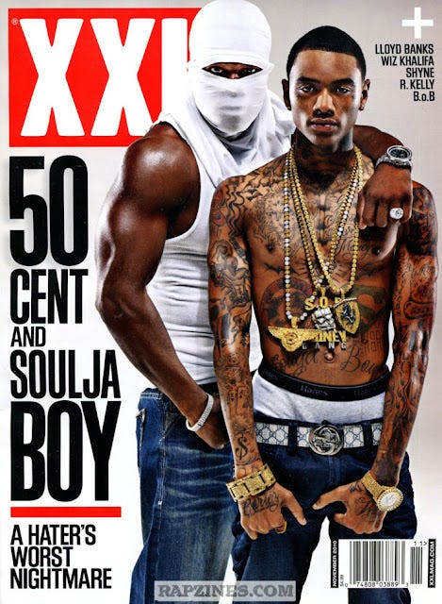

are crypto bisexuals and rapists and its the rape which is what makes them faggots. Faggots are crypto-bisexual men that rape other men to control them. Fascism means a centralization of power. The word fascism derives from the word Fasces.

AGAINST SATANISM VOLUME 4 - SATANIC HOMO-OCCULTISM SATANIC HITLER - THE HOMOSEXUAL ROOTS OF FASCISM - Black Magician Homosexual Hitler created homosexual Cults based upon Black Magic - taught to him by Guido von List and the Armanen Order, Jorg Lanz von Liebenfels and Ariosophy, The Thule Society, Madame Blavatsky and the Theosophical Society, and Friedrich Nietzsche.

Because the Torah and the Bible prohibit Homosexuality, in order to introduce Satanism and its Satanic Rituals, Hitler decided to destroy Judaism and Also he changed Christianity - Jesus - into a Sun God associated with Odin by sending all clerics to the death camps along with all the Ritual burning holocaust six million Jews.
After that he allied with Islam because Islam promotes a warrior Spartan Pedophilia and Sex Slavery of Women - "Women for breeding, boys for love" See, Thousands of child prostitutes in every city of Britain - Rochdale child sex abuse ring https://en.wikipedia.org/wiki/Rochdale_child_sex_abuse_ring
Hitler's NAZI is National Socialism, an offshoot of No-God Communism - You can see this plan occurring in Western Civilisation everywhere, NOW!!
READ - AGAINST SATANISM VOLUME 4 - SATANIC HOMO OCCULTISM, SATANIC HITLER
Click Below..
http://www.energyenhancement.org/FREE-BOOK-AGAINST-SATANISM-VOLUME-4-SATANIC-HOMO-OCCULTISM-SATANIC-HITLER.htm
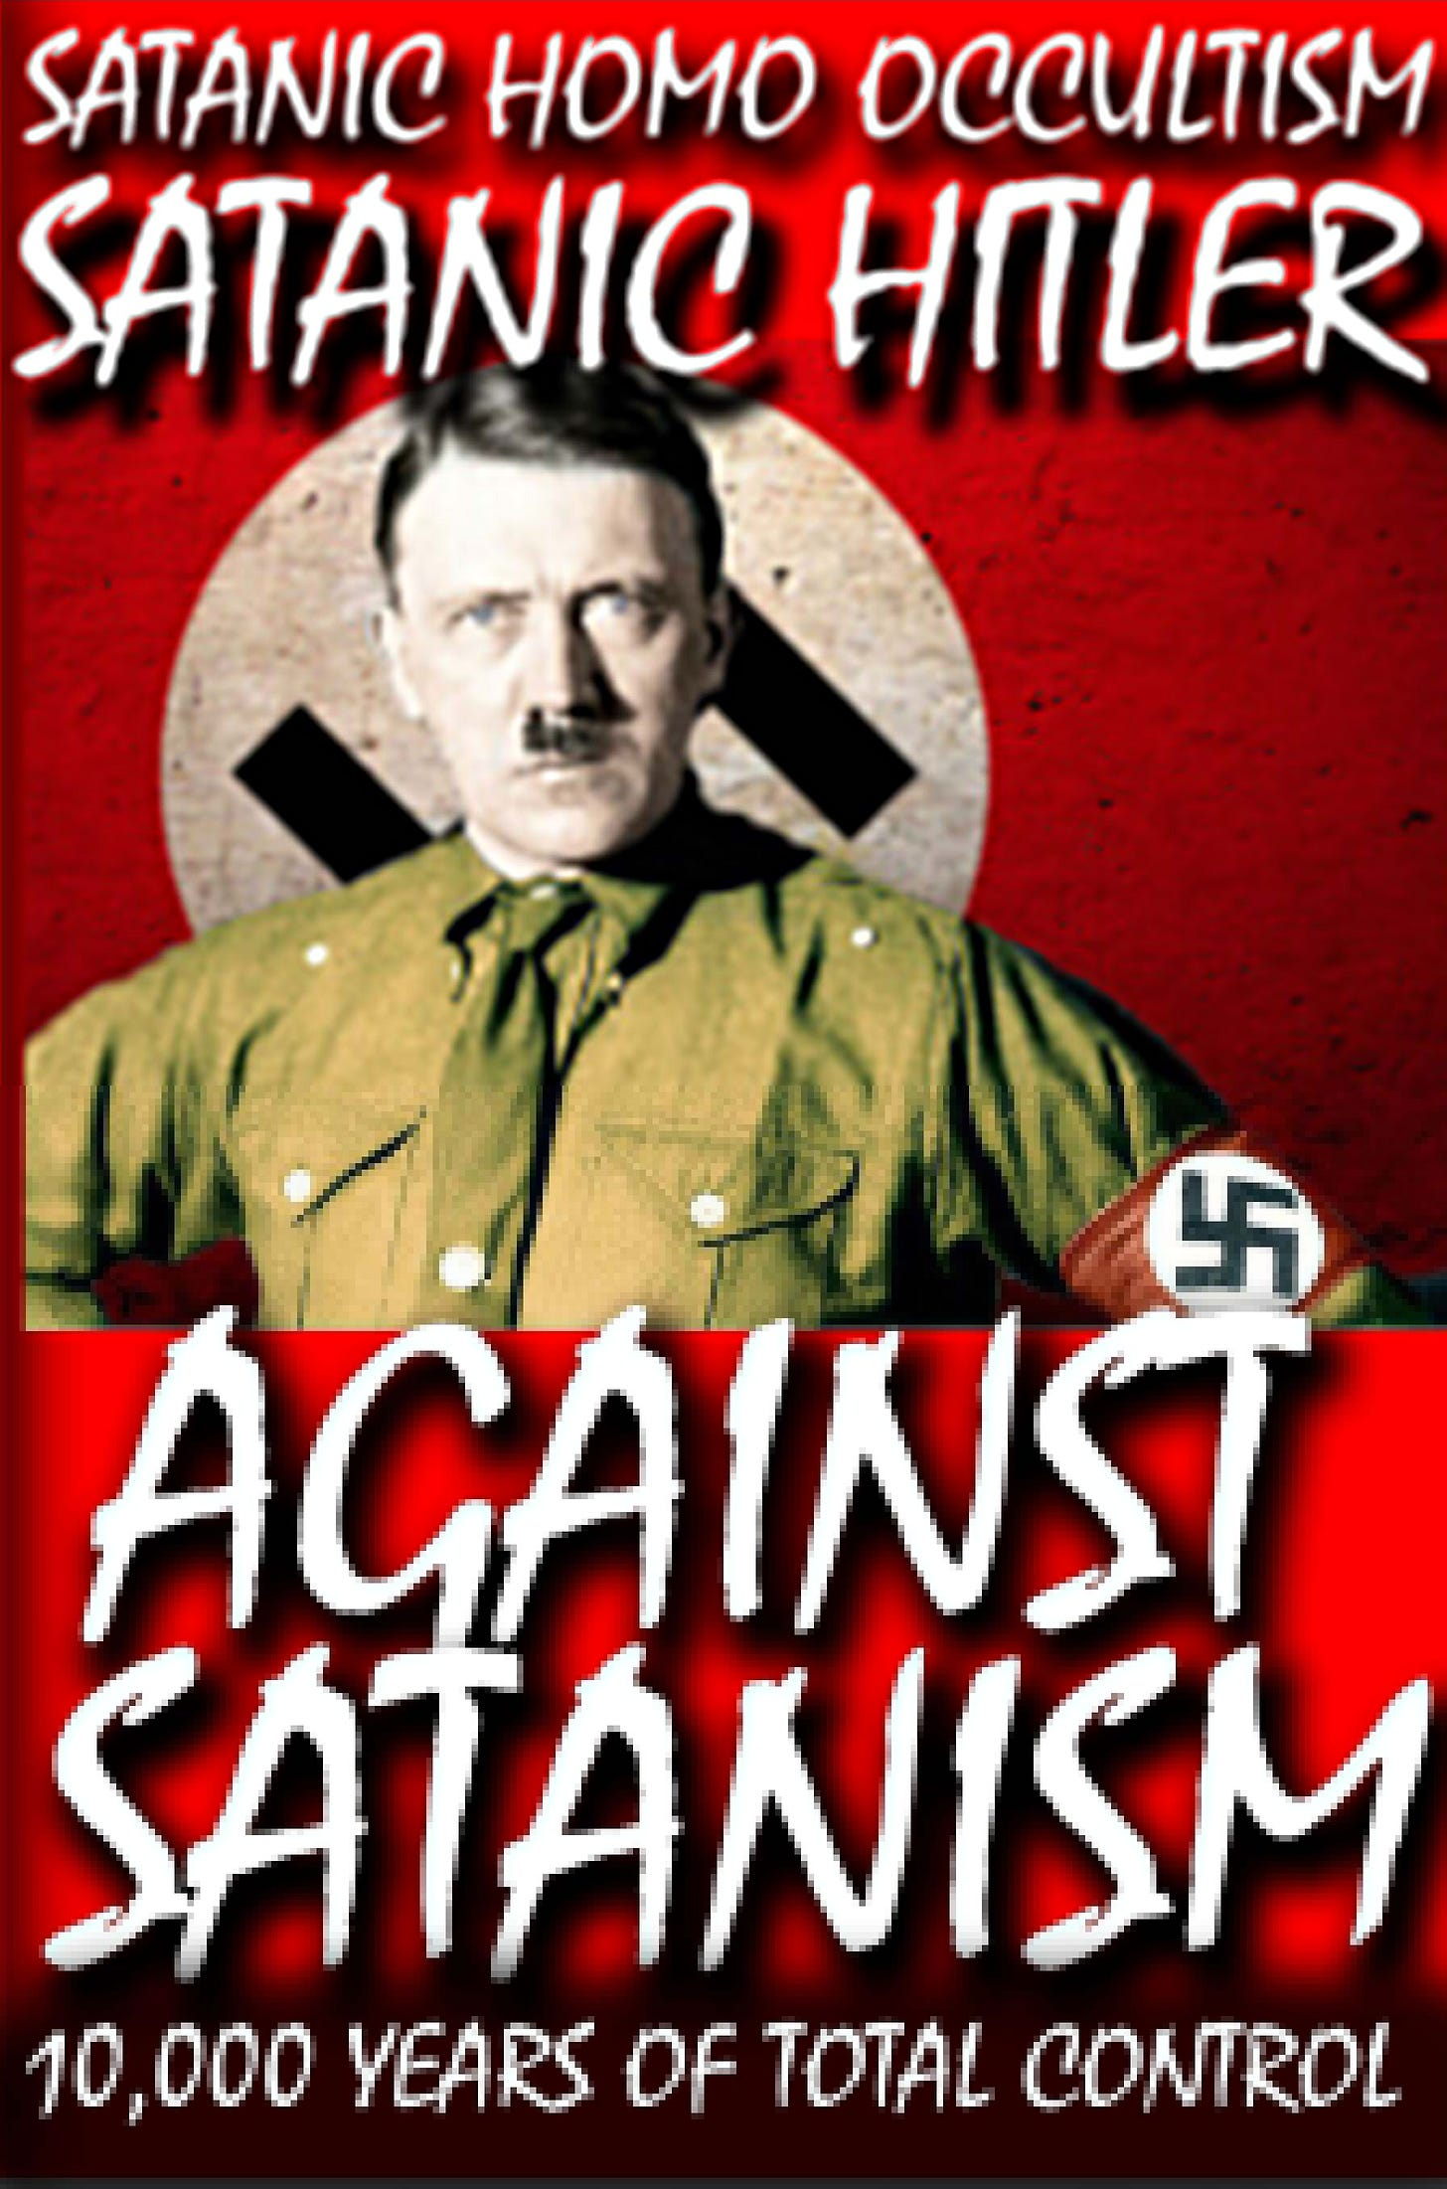
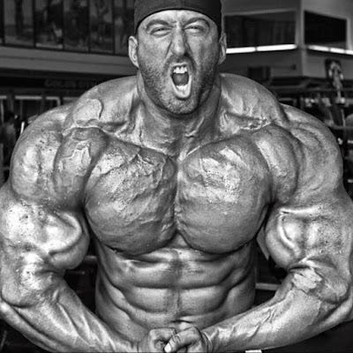

RAP IS RAPE!

The words Faggot and Fasces both mean a bundle and the symbol for fascism is a bundle of sticks with an axe. They rape men to bundle them into groups and the axe represents the threat of force. Faggotry mostly goes on in gangs, prisons, and militaries as in NATO and elite forces of the American Army and in all armies after the Phoenician Band of Thebes for thousands of Years. Fascists are faggots. They rape other men for control. I would not use the word Faggot to describe a homosexual. Faggots are specifically double alpha male crypto-bisexual rapists that rape other men and children to dominate over them. Fat Joe is a faggot and also a crypto-transvestite.

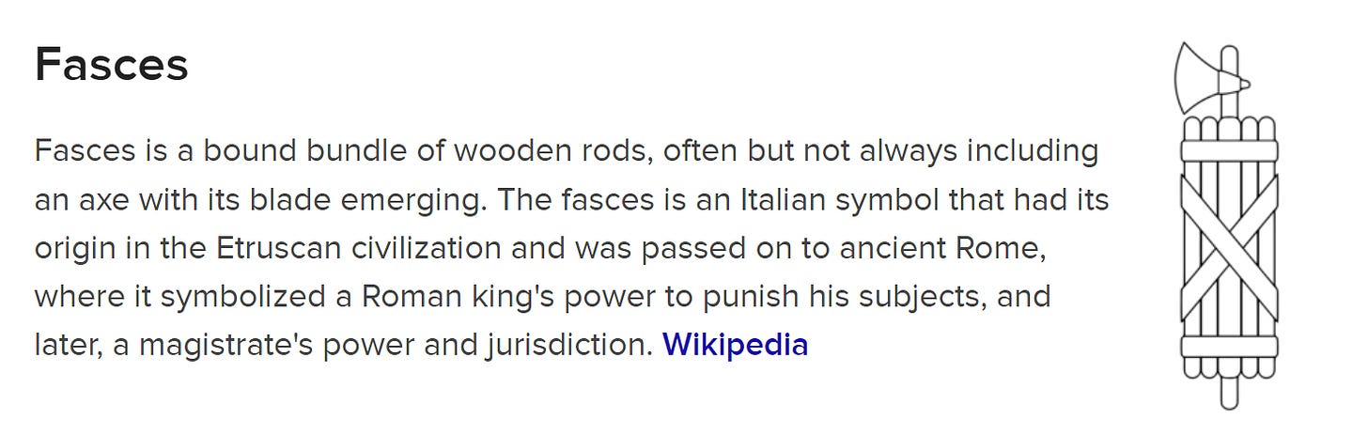

Prince Emanuele Filiberto of Savoy the Prince of Venice is a high level banking authority and the primary owner of the Venetian Mafia. Prince Emanuele Filiberto is pure evil and extremely malicious. Venice was a major banking and merchant center for centuries. The Savoy's top white collar Venetian mobsters are the wealthy Cipriani family which own restaurants, bars, clubs, and hotels with Maggio Cipriani as a current member. The Ciprianis were found guilty of tax evasion in the United States and they used private bank accounts in Luxembourg. The Ciprianis paid a fine to get out of prison. The Ciprianis also employed the convicted mafia financier Dennis Pappas as their Vice President of Cipriani USA. Princess Bianca of Savoy-Aosta is married to Count Giberto Arrivabene-Valenti-Gonzaga of Venetian nobility and they reside in Venice today at their Palazzo Papadopoli and co-manage the Venetian Mafia with their daughters Viola and Vera. George Clooney was married at their Venetian palazzo and is friends with the Venetian noble Count Giovanni di Volpi Misurata. The Venetian Mafia are managers of Hollywood. Count Gian Luca Passi de Preposulo is a noble of Venetia and married the actress Jessica Chastain. Count Gian Luca is a top authority of Hollywood and a child trafficker who has the billionaire Benneton family of Treviso, Veneto as his financiers. The Venetian Mafia and their associates are all involved in child trafficking networks. The Brandolini d'Adda family are a Venetian nobility which are married with the French Rothschilds. Count Guido Brandolini d'Adda works at Rothschild & Co in the United Kingdom. The Rothschilds are money launderers and financiers of human trafficking networks and likely have some ancestry from Venice. Prince Emanuele Filiberto of Savoy the Prince of Venice is the head. The Guistiniani family were Doges of Venice and today Count Nicolo Guistiniani is the Knight of the Order of Saint Lazarus and Saint Maurice which is a military order run by the House of Savoy. The Del Bono Venezze family are top Venetian nobles with Count Vittorio del Bono Venezze and his sister Countess Beatrice del Bono Venezze. The Giovannelli-Marconi family have Venetian titles of nobility and are close friends with the Savoys. Prince Guglielmo Giovannelli-Marconi is a top knight under the Mussolini sisters and his wife Princess Maria Vittoria is a child murderer and Amazon. The House of Savoy are the royal family of Italy and they were kicked out of Italy for installing the fascist dictator Benito Mussolini so they moved to Geneva, Switzerland where their ancestors ruled for centuries. In the past few decades they have been let back into Italy. They have residences in Italy, France, and Switzerland and connections with various bankers and billionaires. The Prince of Venice's father Prince Vittorio Emanuele IV of Savoy the Prince of Naples was charged and imprisoned for murder and later released and also investigated for corruption, making bribes, slot machine rackets, and exploitation of prostitution. Prince Vittorio is the Prince of Naples where Camorra is headquartered. Its likely that all Camorra mafias pay tributes to the Savoys as well as the Massimos with Prince Carlo Massimo whose mother was a Savoy-Genovese. Prince Vittorio's wife is Princess Marina Doria from the wealthy banking family of Genova also called Genoa. The Dorias ruled as Doges of the Republic of Genoa. The name Genovese means someone from Genova, Italy and the Savoys established a Savoy-Genovese branch. Genoa or Genova, Italy and Geneva, Switzerland where the Savoys reside have the same name which means New City. Nova means new. Gianluigi Aponte is an Italian billionaire that was born in Naples and now lives in Geneva and he owns Mediterranean Shipping Company the second largest shipping company in the world. The Apontes which are worth about 8 billion are agents of the Savoys and work with Camorra in infiltrating ports for criminal trafficking including human trafficking. Prince Emanuele Filiberto has worked as a Swiss banker at the Republic New York Bank in Geneva and at the private Banque SYZ in Geneva.

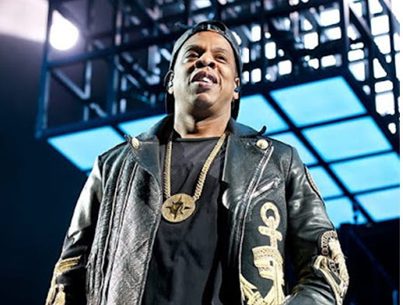

Jay Z named himself Jay after Jay Rockefeller and named his record company Roc-A-Fella after the Rockefellers who financed the Almighty Vice Lord Nation a black supremacist street gang based in Chicago. The Rockefellers literally financed the creation of the AVLN. Jay Z is wearing a Five Percenter chain which is another black supremacist group.
Frank Zac Goldsmith with Benjamin Goldsmith and their family co-founded various banks including Paribas and they finance shills, trolls, online terrorists, and hackers as well as London gangs and sex trafficking of underage girls in England. Their sister Gemima Golsmith's ex husband is Imran Khan and he is the current Prime Minister of Pakistan. Pakistani gangs are heavily involved with trafficking underage girls in England like the Rochdale child sex abuse scandal.
Arnold Schwarzenegger the former Governor of California is a high level politician in the United States and he manages Nazis within the United States military, militant Nazi gang stalkers, and Satanic Faggot Bodybuilders like Hafthor Bjornsson, Eddie Hall, Craig Golias, and Kiki Vhyce. A Faggot is a person who loves to dominate and penetrate people through Sodomy. Arnold can be seen on the cover of Time Magazine with the 60 billion dollar billionaire Jew Michael Bloomberg wearing a Skull and Bones belt buckle. The Nazis used the Skull and Bones as a symbol for their Satanic Sodomite Ritual Faggot SS. Schwarzenegger also had a business meeting with Baron Jacob Rothschild and Warren Buffet. Schwarzenegger was married with the Kennedy family.
George Soros is worth about 8 billion and his family owns Soros Fund Management and the Open Society Foundations racket. George Soros a Hungarian Jew was originally born George Schwartz and he admitted to working with the Nazis and confiscating property from other Jews during WWII. The Soros family are involved with financing Nazi style gang stalking, human trafficking to Wiccan covens, and financing criminal political organizations used to disrupt societies around the world like Black Lives Matter. The name Schwartz means Black. Prince Karel Schwarzenberg has stated that he has known George Soros for 30 years. The Soros family are agents of the Austrian Schwarzenbergs and the Austrian-Hungarian Pallavicinis.
George Clooney is a top authority in Hollywood and he is with the Venetian Count Giovanni Volpi di Misurata who works with the Venetian Mafia. George Clooney is also friends with the former Mayor of Rome and he owns a villa in Italy on Lake Como where the Odescalchi and Erba nobles ruled. Clooney was also married in Venice at the palazzo that is owned by the Arrivabene-Valenti-Gonzaga family which are married with the Savoys.
Prince Ottavino de Medici dei Toscana is a top authority over Zionism, the Hermetic Order of the Golden Dawn, international and central banking, tax collecting, and he is also a top owner of the Corsican Mafia and Chaldean Mafia. The IRS has been run by numerous Jesuit agents like David Kautter, Steven Miller, Charles Rossotti, and Douglas Shulman. Prince Ottaviano's cousin is Prince Giuliano de Medici dei Ottajano and he is also a top member of the Medicis and he oversees Hermeticism and Witchcraft. The Medicis have married with numerous monarchs, produced 4 popes for the Vatican, produced queens of France, and they owned the largest bank in Europe for centuries. Queen Marie de Medici of France had two daughters and one was the Queen of Spain and the other was the Queen of England, Scotland, and Ireland. The Medicis are high level royalty and medium level Satanic Phoenician Mega Trillionaire Black Nobility and they serve the Massimos, Colonnas, and Sforzas. Most of the Satanic Phoenician Mega Trillionaire Black Nobility bloodlines are titled as sovereign princes equal or above in title with the royals and most of the families of the Satanic Phoenician Mega Trillionaire Black Nobility are also Vatican royalty. Popes are monarchs and the Vatican is a kingdom. The Medicis specialize in criminal banking, theft through taxation, and chemical warfare by infiltrating the medical industry and poisoning people with toxic drugs and pharmaceuticals.
Prince Duccio Corsini is a Roman prince and top owner of the Corsican Mafia. The Corsinis are both Florentine and Roman nobles. Prince Duccio is an overseer of a private Swiss banking and human trafficking operation in Gstadd, Switzerland. The Scherz family of Gstadd own a hotel in Gstadd and basically run Gstadd. The Scherz coat of arms is a heart. The Corsinis coat of arms is shaped as a heart and the Italian word Core or Coure has the meaning of heart. Prince Duccio also oversees the DEA. Lucien Conein was from Maryland and he was a documented associate of the Corsican Mafia and he worked for the OSS, CIA, and later for the DEA. The Corsican Mafia have a headquarters in Baltimore, Maryland and they oversee a large heroin and opium trafficking ring from Turkey, the Middle East, and Afghanistan to ports on the East Coast. Nancy Pelosi is from Baltimore and she is a Knight Grand Cross of the Italian Order of Merit and an agent of the Corsinis. The Corsican Mafia then traffics the heroin or opium to the Lucchese crime family which then provide it to the modern day Drug Council run by black gangster rappers like P. Diddy. Corsica is named after the Corsinis and uses a black Moor on its coat of arms and flag. Moors, Arabs, and Africans invaded Europe and Slave trafficked natural white Europeans for over a thousand years. The Corsinis also owned banks in Florence and London.
And More...
Download this!
https://againstsatanism.com/Sacred-Energy/The-Satanic-Phoenician-Black-Nobility-Volumes-1and2.rar

THE SATANIC PHOENICIAN BLACK NOBILITY FAMILIES VOLUME 2 - 1082 PAGES!
The Bush family - Royal Family of the United States
Clinton Crime Company
TARTARIA AND THE 2000 TRILLION DOLLAR PHOENICIANS
The conscious Great Reset destruction of the Anglo-American Empire and the move to the Chinese Century
The Phoenician Stanleys – The King Makers
Tavistock Institute from Hell
Skull & Bones (Sodomy Cult)
Colonna Crime Corporation
Habsburgs and Zionism
Bourbon Crime Syndicate
Savoy-Genovese Mafia
The Windsors - Saxe Coberg Gotha Dracul - Clan of Gehinnom
Merchant Bankers of London
British Crown Agents
SaxoNazis The Saxe-Coburg and Gotha family or Sachsen-Coburg and Gotha Clan of Gehinnom
IllumiNazi Hohenzollerns
Royal Nazi Order of Orange The House of Orange-Nassau
Royal Illuminati of Bavaria
Maximus Mafia The Massimo family
And More...
Download this!
https://againstsatanism.com/Sacred-Energy/The-Satanic-Phoenician-Black-Nobility-Volumes-1and2.rar
"A Citizen has the courage to make the safety of the whole human race his personal responsibility" Robert Heinlein, Starship Troopers 1hr 38mins
Understand, the 2000 Trillion Dollar Rothschilds and Rockefellers Rule!! and have ruled, as Devil Worshipping, Human Sacrificing, Black Nobility Phoenician Families, for 10,000 years. If you want to know what the Satanic Owl of Sodomite Bohemian Grove meant to the Phoenicians, it isn't hidden. Both the Greeks and the Vikings were Phoenicians, and we know they both held the owl to be a symbol of wisdom. But the owl is of course also the most covert hunter, gliding silently through the darkness. So while the dolphin is a symbol of their shipping, the owl is a symbol of their stealth. He is the ultimate symbol of covert operations, which is why the CIA and NRO love to use him. Historically, the “double-eagle” was usually black, and that is because it was really the phoenix, charred by the flames. At that last link to Wikipedia, you will learn the symbol goes back even further, to Mycenae and the Hittites, and that it has always been a symbol of Empire and that which ties it all together, the Satanic Sodomy Pedophile Ritual! One Phoenix behind the other Phoenix sodomising the one in front! Since the Phoenicians were behind both the Hittites and the Mycenae, they are just proving my point for me. Eagles don't have two heads, do they? What does? The Satanic Sodomiser Phoenix.

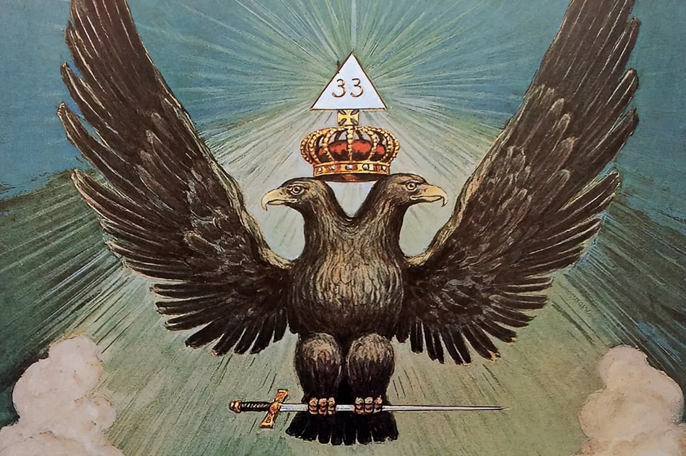

TARTARIA AND THE 2000 TRILLION DOLLAR PHOENICIANS
Satchidanand
Don't blame the Mini Minions like the Camel, Bidet and Strauss. This has all been planned for 150 years for the Anglo-American Empire to be taken down and China put in place. Blame the Satanic 2000 Trillion Dollar Rothschild Phoenician Mega Trillionaires who created an Unelected World Government - The United Nations with its partner the Rothschild Klaus Schwab World Economic Forum is in the terms of Mussolini, Fusion of the State with Corporations, essentially Undemocratic and Fascist. The United Nations with its partner the Rothschild Klaus Schwab World Economic Forum uses Fake narratives like Fake Climate Change and Collectivism to mandate Agenda 2030 World Totalitarianism The Satanic Phoenician Mega Trillionaires who worship Lucifer, Satan, Baal, Molech, Cybele and Attis for 10,000 years before Christ are in charge of the minions like Starmtrooper, Turdow, Bidet, Camel, Richie, and Macron are all prostitutes, they sold out to Satan. And
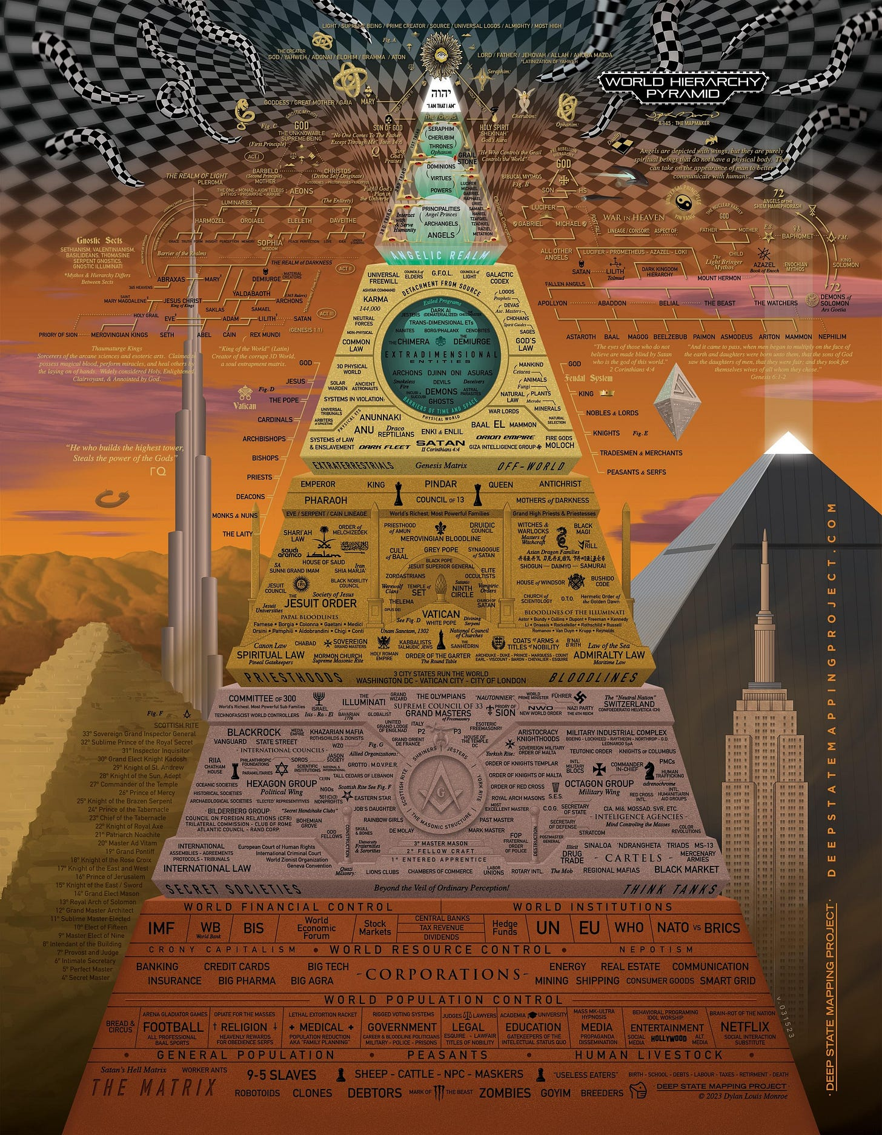

"A Citizen has the courage to make the safety of the whole human race his personal responsibility" Robert Heinlein, Starship Troopers 1hr 38mins
Read full story
the Presstitutes who say that it is just the minions we need to change, that it's the minions who are the problem. The minions have been bought by the The Satanic 2000 Trillion Dollar Rothschild Phoenician Mega Trillionaire Rothschilds, Rockefellers, Schiffs and Warburgs. The minions have been bought by the The Satanic 2000 Trillion Dollar Rothschild Phoenician Mega Trillionaire Black Nobility who came from Venice, Rome, Babylon and Egypt like King Chuckie the Turd. The minions just follow orders and follow the Satanic Rituals like Human Sacrifice, the Sodomy Rituals, the Castration Rituals, the Drug Rituals, the Whore of Babalon Rituals.

Throughout History Seventy-Two Empires Have Been Engineered to Fail in the Same Way.
Satchidanand Apr 6

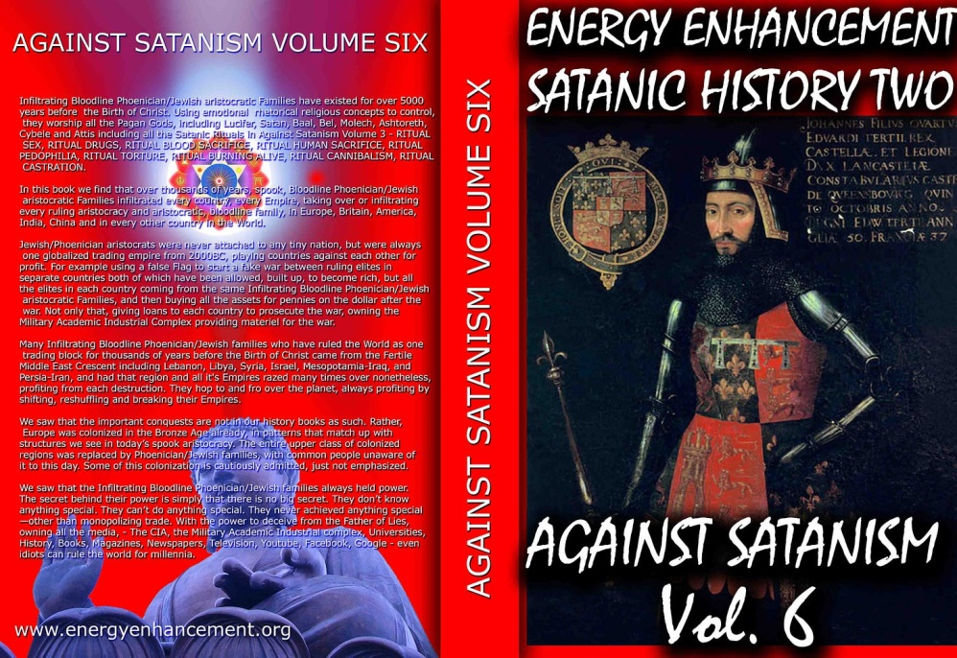

Throughout History Seventy-Two Empires Have Been Engineered to Fail in the Same Way.
Read full story
You are Surrounded by Paid Liars!
Any Blog talking about geopolitics and the vaxx which does not talk about Satanism is part of the Satanic complex, has been co-opted, bought, blackmailed or is Satanic Phoenician. Please understand.
You are surrounded by paid liars!
All these blogs and mainstream media are all lying by omission. These Blogs never tell the real reason WHY!
These Blogs blame the UN, Agenda 2030, the World Economic Forum, Soros, the Neocons, Satanic Strauss, Boomers, climate change, DEI, Feminism, Race, Tavistock, but never mention that the cause of all these things is Satanism because these Blogs, these people are Satanists, all complicit with the Satanic Phoenician Black Nobility Mega Trillionaires like the Rothschilds or Rockefellers.
The hidden elite, satanic sabbatean frankist rothschilds, vatican bank, czar, russia, stalin, marx, hitler, mao, gallipoli, attaturk the consciously created satanic cults which manage the world through the ten thousand year mind control technology of hypnotism, drugs, and torture..
Their funding as propagandists comes from the Satanic Phoenician Mega Trillionaires like the Rothschilds or Rockefellers.
These Blogs, these people are not telling you the Truth, the Whole Truth and nothing but the Truth therefore they lie by omission.
Lies in. Garbage in, Garbage out!
People who are permanently deceived are under information mind control to keep society under control.
Bohemian Grove exposed the politicians like Nixon and Reagan attending. Also the Captains of Corporate America, Hollywood Moguls all Sodomites and Satanists.
As Plato said in Gorgias, only a Religion could explain the eons long fight against ordinary humanity.
That religion is Satanism.

You are Surrounded by Paid Liars!

Any Blog talking about geopolitics which does not talk about Satanism is part of the Satanic complex, has been co-opted, bought, blackmailed or is Satanic Phoenician.
Satchidanand
Jan 19, 2024
Any Blog talking about geopolitics which does not talk about Satanism is part of the Satanic complex, has been co-opted, bought, blackmailed or is Satanic Phoenician.

AGAINST SATANISM VOLUME SIX - The Satanic 10,000 years old Phoenician Mega Trillionaire Aristocrats

Satchidanand
·
October 2, 2022
Dark Forces have used Infiltrating Bloodline Satanic 10,000 years old Phoenician Mega Trillionaire Aristocratic Families which have existed running Global Trading Companies for thousands of years before the Birth of Christ. Infiltrating and taking over the power structures in every country, using propaganda - emotional rhetorical religious concepts to c…

Read full story

Please understand.
You are surrounded by paid liars!
All these blogs and mainstream media are all lying by omission. These Blogs never tell the real reason why.
These Blogs blame the UN, Agenda 2030, the World Economic Forum, Soros, the Neocons, Satanic Strauss, Boomers, climate change, DEI, Feminism, Race, Tavistock, but never mention that the cause of all these things is Satanism because these Blogs, these people are Satanists, all complicit with the Satanic Phoenician Mega Trillionaires like the Rothschilds or Rockefellers.
Their funding as propagandists comes from the Satanic Phoenician Mega Trillionaires like the Rothschilds or Rockefellers.
These Blogs, these people are not telling you the Truth, the Whole Truth and nothing but the Truth therefore they lie.
Lies in. Garbage in, Garbage out!
People who are permanently deceived are under information mind control to keep society under control.
Each generation are fed different lies therefore the cultural differences between generations leads to more splits to keep society under control.
Gatekeepers reach further into the intellectual complex as the Blog IQ rises but all these people essentially are there to deflect from the Satanic Phoenician Mega Trillionaires like the Rothschilds or Rockefellers.
We go all the way from the Mind Control Mainstream Media to Alex Jones but for 10,000 years Satanists have been in control of the World and the control is maintained by fooling the people getting them to attack windmills.

We have Sancho Panza, panza meaning belly, a low IQ person led by bread and circuses, football, tats, rap, sex and food.

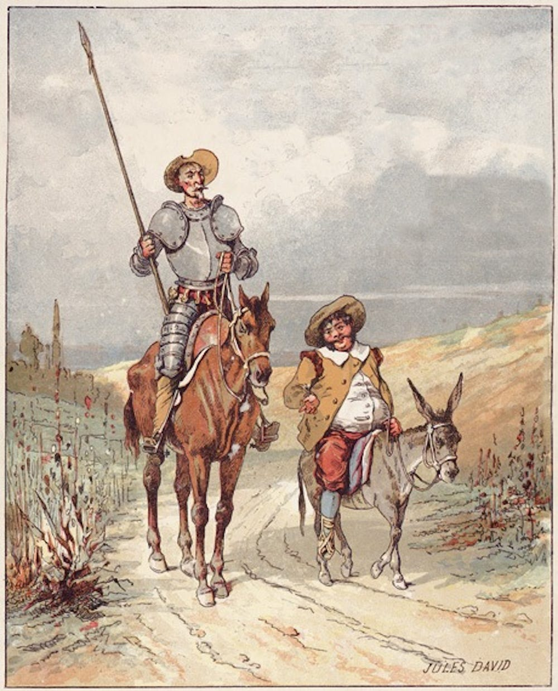

Then we have the high caste Don Quixote, the man of la Mancha. Mancha meaning spot or dirt. A person who is psychologically damaged is easy to mind control to attack windmills and most people are traumatised from birth to produce such psychologically damaged people.
Here is Steven Fry, sodomically raped at Public School as per the 1438AD Eton "Whipping and Fagging" template - damaged, his whole life fucked up!

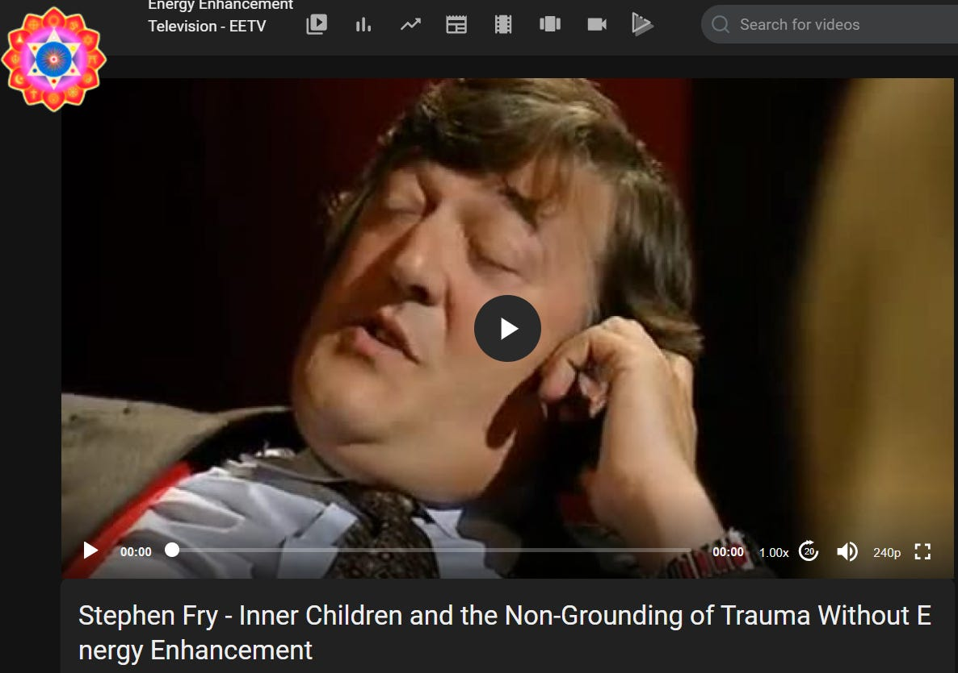

https://eemeditationvideo.org/watch/stephen-fry-inner-children-and-the-non-grounding-of-trauma-without-energy-enhancement_IbnelTwmwGXtPBs.html
Then we have various grades of midwittery, but no matter what the IQ of the person from low temperature to average to 130, 150 and above, each intellectual strata of society is managed by a Gatekeeper there to confirm each managed bias and to deflect from Satanism.
And 90% of what they talk about is the Truth, just not the whole truth, lying by omission.
In these blogs, every commenter, every Bot, every AI Chatbot is as paid an actor as the blog progenitor.
They say that the CIA blog managers, society managers now have 30 millions of workers just as they did in East Germany.
In your city, a quarter of the people are now informers managing society.
They all say that it's this cause, climate change, that cause, cutting back on fossil fuels and thus fertiliser, the other cause, Stupid Elites, Agenda 2030 for the fall of the Anglo American Empire…
But in reality its Satanic Policy to create the Fall of the Anglo-American Empire and the rise of the Chinese Century because the Satanic Phoenician Mega Trillionaires run Russia and China too..
At the top of the Gatekeepers we have Larouche, Cynthia Chung, Max Erhart, Chomsky, - All gatekeepers telling 90% truth except it is not the whole truth!
Below that we have Blogs filled with erudite talking points blaming this section of society, that section of society this cause, that cause, every cause except the real cause - Satanism!
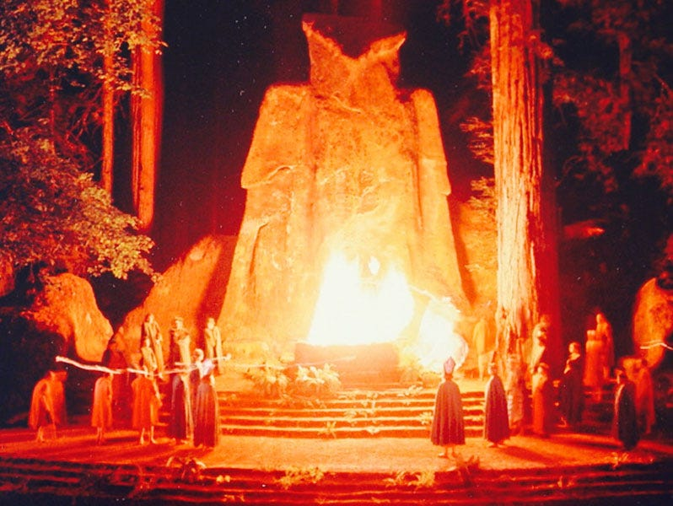
Alex Jones exposed Bohemian Grove 1000 Acres of California Redwoods near San Francisco and it's Satanic ceremony the Creation of Care where the image of a child is Molochianly burnt on a Satanic Altar under the 40ft stone statue of an Owl. The purpose of this Ritual is to destroy the Heart to become even more psychopathic.
https://againstsatanism.com/Satanic-Mega-Trillionaire-Bloodline-Family-Phoenician-Aristocrats-Inhuman-Psychopaths-Sociopaths-Devils-and-Demons-at-Bohemian-Grove-and-Crowley-Homosexual-Ritual-OTO.htm
https://againstsatanism.com/ALEISTER-CROWLEY-RITUAL-SODOMY-RITUAL-SEX-ILLUMINATI-SEX-TANTRA-ADDICT-DRUG-ADDICT-VICTIM-OF-VAMPIRE-SEX-DRUG-AND-FOOD-ADDICTION-IMPLANT-BLOCKAGES-ENERGY-CONNECTIONS.htm

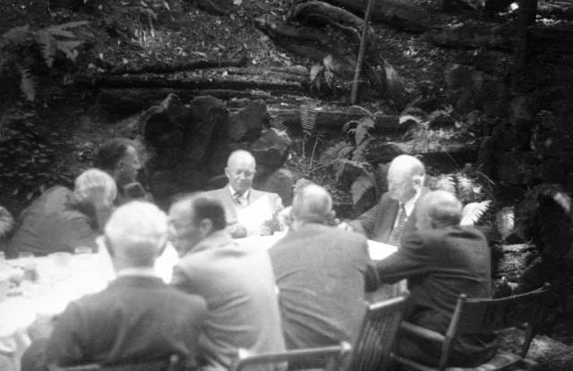
Lawrence Berkeley reporting on the Manhattan Project to create the Atomic bomb, lunching with future president Eisenhower and past president Hoover at Bohemian Grove, July 23, 1950.
Bohemian Grove exposed the politicians like Nixon and Reagan attending. Also the Captains of Corporate America, Hollywood Moguls all Sodomites and Satanists.
Further, Alex Jones reported on attempts to get him to join the Satanists from when he was young and dating beauty queens who then took him to Eyes Wide Shut parties, revealed they were brought up in rich millionaire families and were incested by their fathers and again, invited Alex to join with them.
Henry Kissinger, Rothcop and Roger Ailes tried to recruit Alex Jones but to all this, Alex rejected their sorry asses.
Recently, Voxday mentioned that the Media were Satanic and Drew Hernandez is always bringing out Satanism...
But although many people mention the Satanists, no-one except Satchidanand has written eleven volumes on all aspects of how Satanism runs the World and has run the World for 10,000 years! How Ritual Sodomy is a part of every Satanic organisation since the Dog-priests of Ancient Egypt.

Download all these 53 books for Free!! by signing up at https://againstsatanism.com

See videos on How the World Economic Forum's Great Reset and the United Nation's Agenda 2030 are taking over the World at https://against-satanism-video.com/
Jesuit Adam Wieshaupt's Illuminati are Sodomites stating that the injection of Sodomy kundalini energy into the Anus rises up the Spine to Illuminate the head which is the Satanic Left-Hand Path. The Satanic Phoenician Mega Trillionaire Rothschilds paid Adam Wieshaupt to run the Illuminati and Jacob Frank to run the Sodomy, incest Sabbatean Frankists whilst they consolidated the Banking Industry, the Central Banks through Sodomy Ritual 33rd Degree Masonry and Sodomy Organisations like the Skull and Bones Society of Drug running Russells founded Yale University.

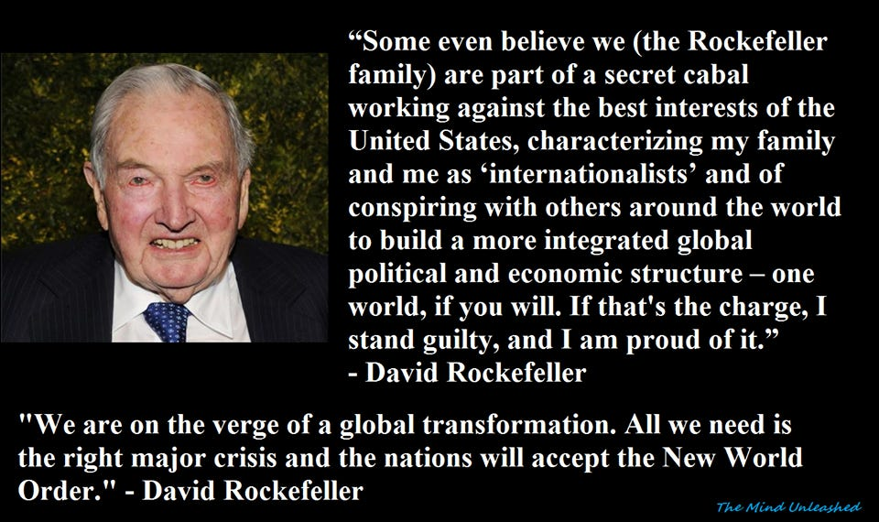

The hidden elite, satanic sabbatean frankist rothschilds, vatican bank, czar, russia, stalin, marx, hitler, mao, gallipoli, attaturk the consciously created satanic cults which manage the world through the ten thousand year mind control technology of hypnotism, drugs, and torture..
https://againstsatanism.com/THE-HIDDEN-ELITE-SATANIC-SABBATEAN-FRANKIST-ROTHSCHILDS-VATICAN-BANK-CZAR-RUSSIA-STALIN-MARX-HITLER-MAO-GALLIPOLI-ATTATURK.htm

It was the Satanic Kabbalistic leadership that handpicked Jacob Frank to develop the teaching begun by Sabbatai Zevi and to indoctrinate Mayer Amschel Rothschild and Adam Weishaupt. This alliance of Frank-Rothschild-Weishaupt formed an unholy trinity.
1. THEOLOGY: Jacob Frank was in charge of creating a Satanic theology that would be the foundation for revolutions.
2. BANKING: Mayer Amschel Rothschild was in charge of world banking.
3. REVOLUTION: Illuminati Jesuit Adam Weishaupt was in charge of the Satanic revolutionary political development in the world.
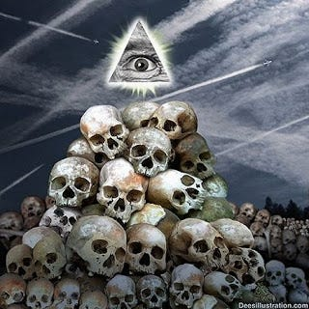
Luciferian Satanic Illuminati Sabbatean/Frankists have infil-traited the upper levels of Judaism, Cathoicism, and Islam worldwide. This same Satanic Frankist hetero or Sodomic hierogamy or Ritual Sex, existed in Pagan fertility worship and was also popular in the Kingdoms of Israel and Judah, which led to their downfall and eventual captivity.
https://againstsatanism.com/Luciferian-Satanic-Sabbatean-Frankists-Kabbalist-Illuminati-CULT-OF-THE-ALL-SEEING-EYE.htm
Read about how the 2500 years ago the Greek Gay Army of the Band of Thebes who were a troop of 150 pairs of male pedophile lovers formed the elite force of the Theban army in the 4th century BC, ending Spartan domination.
The Greek Gay Army of the Band of Thebes so influenced every army in the World, - NATO, British and American Armies - to promote Double Plus Alpha Homosexual penetrator Masters to rule the Slave, "Bottoms" How in 1438AD Whipping and Fagging Eton was created to populate the Gay armies and also to provide Satanic recruits for the Priests, Politicians, Policemen and Professors to Gayly, Pedophilicly run society.

P.G. Wodehouse and British Empire Ritual Sodomy Band of Thebes Propagandised for Hitler, Propagandised for the Satanic Phoenician Mega Trillionaires

Satchidanand
·
October 2, 2022
Sir Pelham Grenville Wodehouse, KBE 15 October 1881 – 14 February 1975 was an English author and one of the most widely read humorists of the 20th century. His creations include the feather-brained Bertie Wooster and his sagacious valet, Jeeves; the immaculate and loquacious Psmith; Lord Emsworth and the Blandings Castle set; the Oldest Member, with st…

Read full story

ENERGY ENHANCEMENT MEDITATION SACRED SYMBOLS FOR PERFECT WISDOM ENLIGHTENMENT AND THE SATANIC PERVERSION OF THESE SYMBOLS

Satchidanand
·
October 2, 2022
It's hard for me to say this but Sacred Symbols, good symbols, or legominisms as Gurdjieff said where symbols of the past are designed to help us, inform us, provide a map whereby we can all cleave to the light, become Enlightened. To re-enforce our psychic bodies, drink in the spiritual force in which we bathe daily, mostly without knowing it, to teach …

Read full story

So, understand that you are surrounded by a totally bought media.
So, what is the solution?
In the past, the only solution was to open your eyes to see the Truth, commonly know as Enlightenment.
When all your psychic wounds from this lifetime and all your previous lifetimes - All your Energy Blockages have been transmuted, healed -
Only then can you open your eyes to see the Truth.
Only then, "Those who have ears to hear, let them hear!"
Only the Energy Enhancement Video Meditation Course can successfully Open Your Eyes to the Truth to become able to successfully Oppose Satanism...

Energy Enhancement Meditation and Alchemy
All Alchemy contains the doctrine of three elements — Salt - the Center of the Earth, Sulphur the Sun of the Chakras above the head and Mercury - the energy which flows between them. The Secret of the Transmutation of Energy Blockages through Alchemical VITRIOL!

Energy Enhancement Meditation and Alchemy

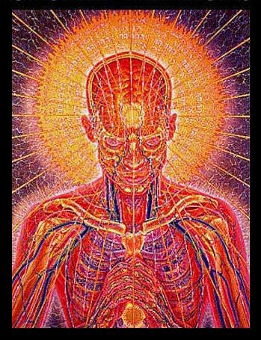
Energy Enhancement Meditation and AlchemySatchidanand’s Against Satanism Newsletter is a reader-supported publication. To receive new posts and support my work, consider becoming a free or paid subscriber. Deep in the sea are riches beyond compare. But if you seek safety, it is on the shore. (Saadi, Rose Garden)

Read full story

ONLY ENERGY ENHANCEMENT MEDITATION REMOVES THE VAMPIRE SEXUAL IMPLANT ADDICKTION BLOCKAGE, THE STEALER ON THE DOORSTEP! "IF THERE HAD BEEN TWO THINGS LIKE SEX, I NEVER WOULD HAVE GOT ENLIGHTENED" - GURDJIEFF

ONLY ENERGY ENHANCEMENT MEDITATION REMOVES THE VAMPIRE SEXUAL IMPLANT ADDICKTION BLOCKAGE, THE STEALER ON THE DOORSTEP!

Satchidanand
·
January 9, 2024
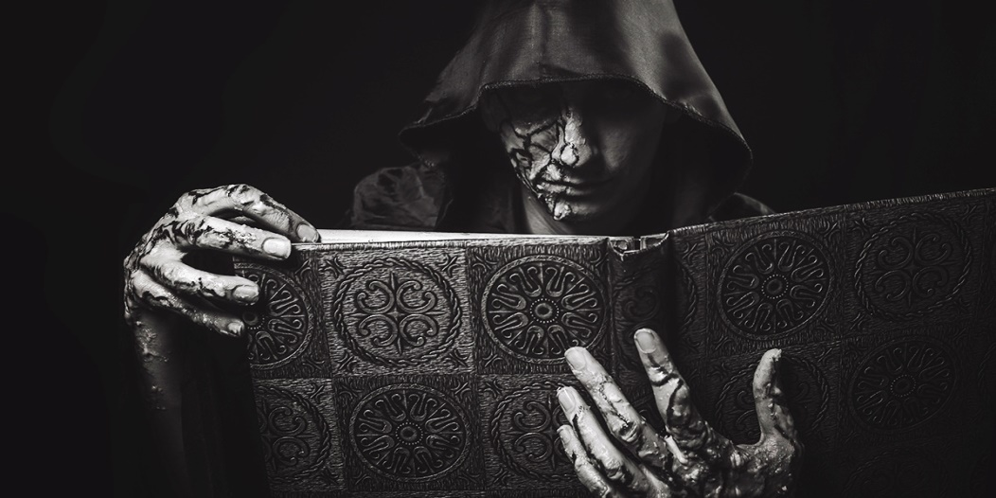
ONLY ENERGY ENHANCEMENT MEDITATION REMOVES THE VAMPIRE SEXUAL IMPLANT BLOCKAGE, THE STEALER ON THE DOORSTEP! BEST TO READ THIS ARTICLE ON THE SUBSTACK SITE…Satchidanand’s Against Satanism Newsletter is a reader-supported publication. To receive new posts and support my work, consider becoming a free or paid subscriber.

Read full story

The Energy Blockages go Deeper!
Not one Spiritual Master talks of Energy Blockages and Removing Energy Blockages using Energy Enhancement Meditation and the Seven Step Process.

The Energy Blockages go Deeper!

Satchidanand
·
January 13, 2024
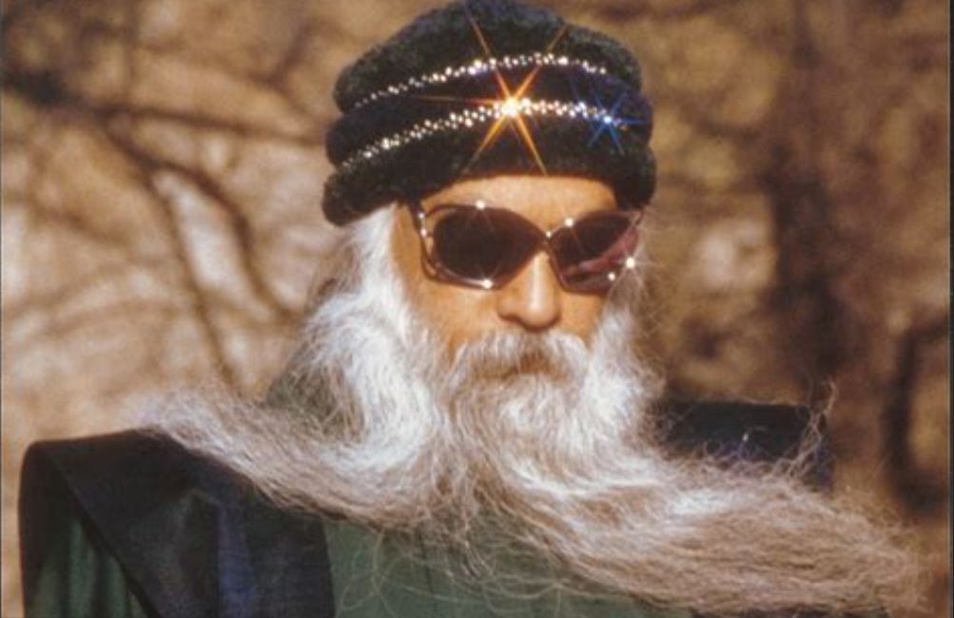
Deeper! And the Energy Blockages go Deeper! Blockages are innumerable.. Let us vow to Ground and Seven Step them All! - Zen Vow Satchidanand’s Against Satanism Newsletter is a reader-supported publication. To receive new posts and support my work, consider becoming a free or paid subscriber.

Read full story

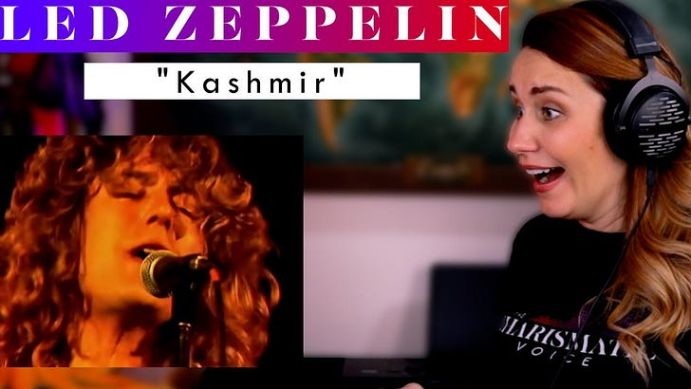
The Energy Enhancement Meditation Course Will Not Fail You! OUR SPECIAL REVOLUTION OFFER!! WE HAVE THE TECHNOLOGY WE CAN REMOVE YOUR ENERGY BLOCKAGES WE CAN RE-BUILD YOU. Satchidanand’s Against Satanism Newsletter is a reader-supported publication. To receive new posts and support my work, consider becoming a free or paid subscriber.

Read full story

DAVID ICKE EXPOSES THE SATANIC FRONT MEN FOR INQTEL AND DARPA, GOVERMENT TAKEOVER BY ARTIFICIAL INTELLIGENCE, AND MUCH MORE…

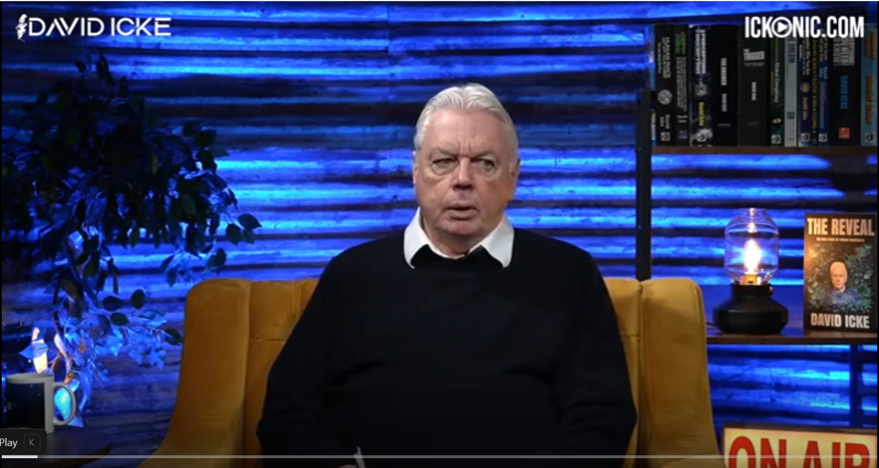Fronts… The Rockefellers, Elon Musk, Jeff Bezos, Zuckerberg, Steve Jobs, Larry Page and Sergey Brin, Bill Gates, George Soros, Larry Ellison, Warren Buffett, Eric Schmitt, Peter Thiel, Robert Mercer and many others are Only Fronts for the Satanic Phoenician Mega Trillionaire Rothschilds.

Former Lover Exposes Frontman Eric Schmidt

Former Lover Exposes Eric Schmidt
The following is a transcript of an interview with a Google/Facebook/DARPA insider that was conducted with a member of the Anonymous Patriots, a citizen journalist group aligned with the American Intelligence Media. The person interviewed wishes to remain anonymous and for purposes of the interview will be called Jane Doe. This conversation took place on July 1st, 2019.
https://aim4truth.org/2019/07/02/former-lover-exposes-eric-schmidt/
What this whistleblower lady says is that she has a long background with Eric Schmidt. She talks about his connections to the Chinese Communist Party. You can read what she says in the article itself. And She says, I was working for the Defense Advanced Research Projects Agency, DARPA, the military, at the time, and took an interest in this opportunist. When Eric went on to Sun Microsystems, and again, she talks about the previous time, gleaned the credit for projects he didn't create, I decided to see what made him tick. I did him a favor by inviting him to a Highlands Group forum. So what's the Highlands Group?
For those in your she says, that might not know about the Highlands Group, it works out of the Naval Intelligence Net Assessment Office and basically is the international group of corporations that venture capitalists, military and corporate intelligence, and the CIA's In-Q-Tel agency, which I mentioned earlier. Highlands Group assessed new patents, DARPA, In-Q-Tel projects, and military desires for new weapons. So, Where she's talking here about corporations, venture capitalists, military and corporate intelligence and the CIA and DARPA, they are all one unit. They are presented to us as different aspects. of society, the system, but actually they're one unit working to one goal. And that goal, as I'll come to, is in its most extreme sense, a fusion of humans with artificial intelligence.
And this will bring us into current events as we go along. So the article goes on, quoting her, The military, as they create mythical cyber geniuses as facades for Silicon Valley corporations, and then allow those idiots, as she calls them, o buy into the next DARPA no-bid government contract, that eventually becomes a monopoly subsidized by the government. And she gives the very, very pertinent example. At DARPA, we use taxpayer money up front to pay for people like Larry Bryn and Sergey Page, the people who are said to be the creators of Google, to win the DARPA contest.
Then we make sure that the Rothschild Frontmen insider traders from the Highlands Group know about the next startup that will make the initial public offering, IPO, with assets of millions, but will immediately bump up to a company worth billions.
What I'm about to tell you has seldom ever been said out loud, she says.
Bryn and Paige were stooges.
I've been making the point for so long that these big Silicon Valley heroes and big names, they're front people. They're front people for everything. The military and the military is an expression at the level we're talking about of this global cult that I've been exposing for decade after decade. So talking of Britain Page, they were chosen because they would lie, not because they invented something.
They were given a top secret DARPA program called Memex, which we had used as the best search engine we could develop, we being DARPA. It was all military and the dark web at first. We used it to sucker in the enemy unbeknownst to them and then subliminally brainwash them, attempting to create behavioral outcomes through digital dopamine reward systems and adrenaline excretions. It worked like a charm.
So the CIA's In-Q-Tel agency suggested we give the system out to everyone in the world and see if we can't control the world globally through digital addiction and manipulation. Again, it worked like a charm. So we created the fake national science project that Bryn and Paige participated in. They simply did the best job of the dozen people involved, but they didn't invent anything. They simply used Memex and made it commercial. which was another DARPA In-Q-Tel project that needed a boy genius as a front man. Mark was simply used. And this is what I'm talking about and I've been talking about for so long.
(00:12:39): Elon Musk, that Elon Musk, he's a genius, he is. No, he's not. He's a front man. Wake up, people. And the whistleblower says, I find it amazing how easily people are lied to effectually. Eric is one big fat lie. Mark, Elon, and the whole gang got their inventions from DARPA and In-Q-Tel's theft of patents. I know, she says, I was there in the meetings. And she describes these people like Musk and Schmidt and all these people, Zuckerberg. She describes them as, quote, idiots who are psychopaths with delusions of grandeur.
They are little boys in a sandbox.

ARTIFICIAL INTELLIGENCE - AI, IS POSSESSED BY DEMONS

Satchidanand
·
November 26, 2023
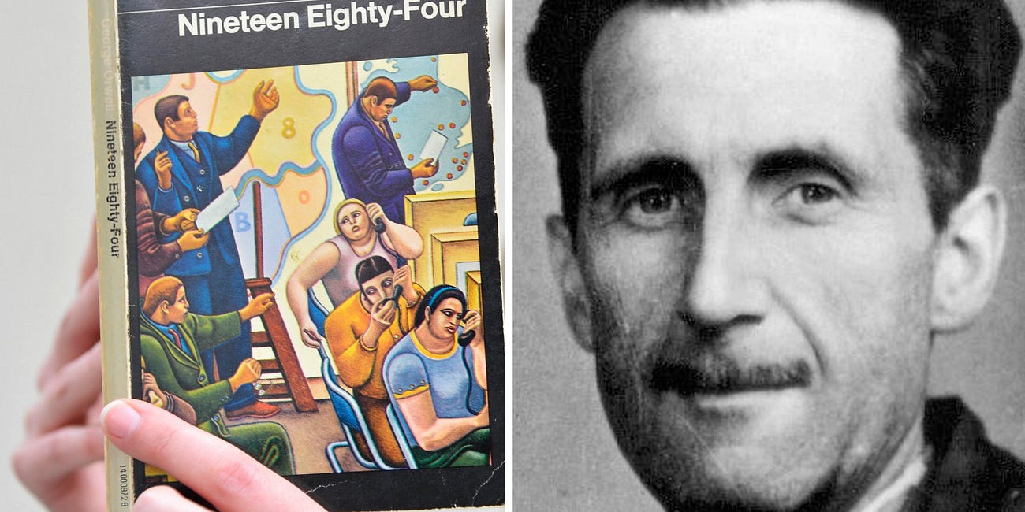
AI IS POSSESSED BY DEMONS LIVING OUTSIDE OF THE BODY, ETERNALLY, IMMORTALLY

Read full story

THE SATANIC PHOENICIAN MEGA TRILLIONAIRE ROTHSCHILDS WHO CREATED ISRAEL AND THE UNITED NATIONS, THE WEF, AGENDA 2030, THE DEATHVAXX

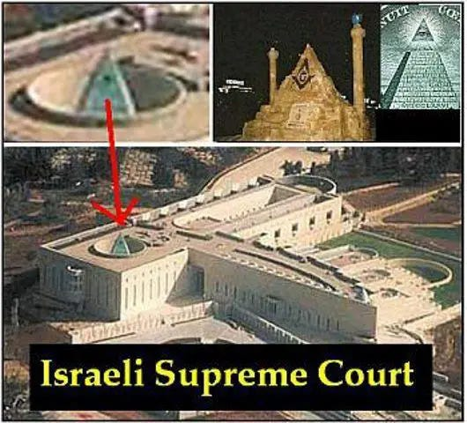

Fronts… The Rockefellers, Elon Musk, Jeff Bezos, Zuckerberg, Steve Jobs, Larry Page and Sergey Brin, Bill Gates, George Soros, Larry Ellison, Warren Buffett, Eric Schmitt, Peter Thiel, Robert Mercer and many others are Only Fronts for the Satanic Phoenician Mega Trillionaire Rothschilds.

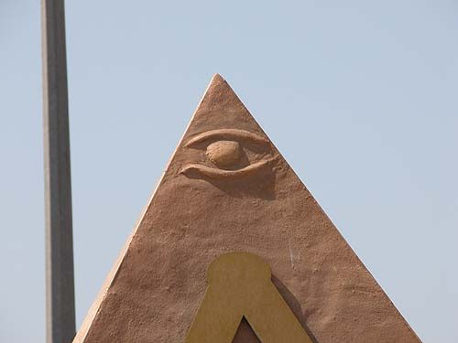

Satanic Phoenician Mega Trillionaire Rothschilds Control Everything – Their Methods of Control
Meet Satanic Phoenician Mega Trillionaire Jacob “Jack” Rothschild ,- Nathaniel Charles Jacob Rothschild, 4th Baron Rothschild, OM, GBE, CVO - the "Protector- Owner," and his many minions and Fronts over centuries and nations...

Satanic Crowleyan OTO Witch Marina Abramović poses with Satanic Phoenician Mega Trillionaire 10,000 years old Family Jacob Rothschild in front of 'Satan summoning his Legions', 1796-1797

The Satanic Phoenician Mega Trillionaire Elite are all Demon Possessed!! Part 1...

The Satanic Phoenician Mega Trillionaire Elite are all Demon Possessed!! Part One…
Read full story

SATANIC PSYCHOPATH HUMAN SACRIFICE RITUAL TRAINING - RONALD BERNARD… I WAS IN TRAINING AND I FAILED

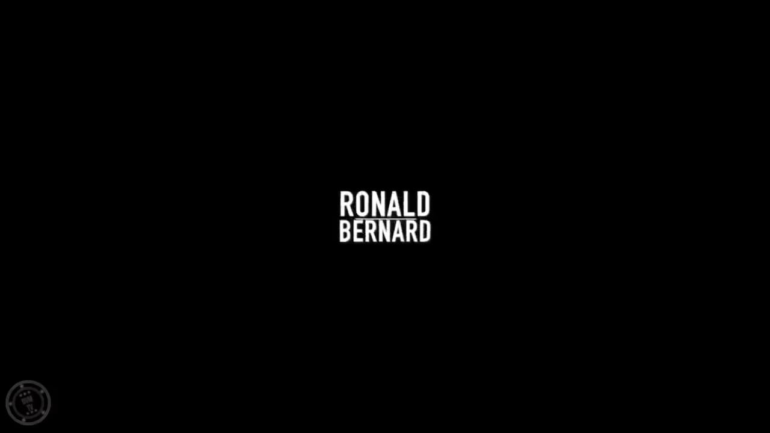

RONALD BERNARD… I WAS IN TRAINING TO BECOME A PSYCHOPATH, AND I FAILEDSatchidanand’s Against Satanism Newsletter is a reader-supported publication. To receive new posts 55 free books and support my work, consider becoming a free or paid subscriber.
Read full story

Disengaging Entirely From the Rothschild’s United Nations Debacle
Download

by Greg Reese

VIDEO - The Rothschild UN plan to destroy any semblance of freedom

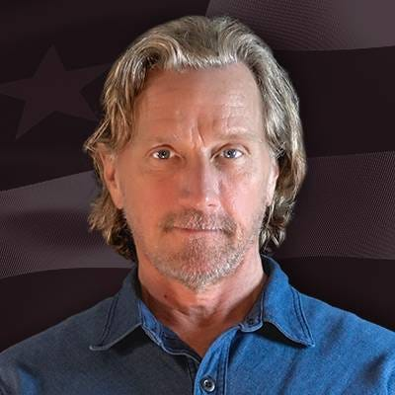

REMEMBER, PRESIDENT FRANKLIN DELANO ROOSEVELDT CAMPAIGNED ON PEACE, THEN CREATED THE FALSE FLAG WHICH GOT THE USA INTO WW2…

You have to follow through this time, demanding that Trump and the rest deliver on their promises.
Drag-queen story hours? Tranny promotion 24/7? Post-birth abortions/infanticides? Forced vaccinations? Holy wars in Israel and Ukraine? Institutionalized censorship and repealing the First Amendment? Repealing the Second Amendment? Repealing the Fourth Amendment? Packing the Supreme Court? Open borders? Men in women's sports? Reverse sexism and racism at top volume, with white men being attacked all the livelong day just for being born? Civil War reparations 155 years after the fact? January 6 is worse than 911 and Pearl Harbor? And then Sustainability because of fake Global Warming, United Nations Vaccine Mandates, United Nations Agenda 2030, Agenda 2040, Agenda 2075, Communism, CBDC’s, Social Credit Score, De-Banking, Fema Camps, the Final Solution of killing all White Males in Hillary’s Fun Camps.

But to solve the previous problem the Satanic Phoenician 2000 Trillion Dollar Mega Trillionaires have created a new and bigger one: they have a populace already on the edge of revolt and meltdown—from the vaccine genocide and other things—and they have now primed that populace with a lot of big promises.

If, as I expect, they plan to renege on all those promises, as they always have, they will dig their hole even deeper.

Remember, not one President since the beginning of time from any party has kept any promises. Just the reverse.

They always do the polar opposite of what they promise.

If they promise to keep us out of a war, the first thing they do after getting elected is sign us up for it.

If they promise to lower the debt, they raise it.

If they promise to clean up Washington, they immediately appoint a bunch of dirtbags.

So we are now starting to see some of the more senior foreign policy positions in the Trump administration being filled, and its wall to wall warmongering America-supremacist Zionists; with an extra dollop of Cuban US vassal dictator-loving diaspora thrown in.



These appointments also support the position that Trump is only good at playing a successful business man rather than actually being one, he is simply a front man for a segment of the Satanic Phoenician 2000 Trillion Dollar Mega Trillionaires Trillionaire class.

The Satanic Phoenician Mega Trillionaire Elite are all Demon Possessed!! Part 1...

Satchidanand
·
August 8, 2023
The Satanic Phoenician Mega Trillionaire Elite are all Demon Possessed!! Part One…

Read full story

GANDALF: Edoras and the Golden Hall of Meduseld. There dwells Theoden, King of Rohan...... whose mind is overthrown, possessed. Saruman's hold over King Theoden is now very strong
Gandalf, angered, throws off his grey cloak. Theoden is thrown back by a bright white light emanating from the psychic body of Gandalf
GANDALF: I will draw you, Saruman, as poison is drawn from a wound. (he thrusts forward his staff, which throws Theoden back in his chair)
THEODEN: (Saruman speaks through Theoden) If I go, Theoden dies.
GANDALF: (still holding forward his staff continues to move closer to Theoden) You did not kill me...... you will not kill him.
THEODEN: (Saruman still speaking) Rohan is mine.
GANDALF: Be gone.
Suddenly Theoden jumps from his throne, lunging at Gandalf. Gandalf thrusts him back with his staff and as he does, Saruman is drawn from Theoden's body and is seen thrown across the floor in Isengard.
He pulls himself up, his face is bleeding.

The Key of the Satanic Religion is it's Recruiting Cults of Sodomy Ritual 33rd Degree Freemasonry, the Illuminati, Sabbatean Frankism, and the Crowlean Sexual Sodomy Ritual OTO

The Satanist Ritual Pillars of Homosexuality, Sodomy, Pederasty, Drugs and Ritual Sex - both Hetero and Homosexual - are introduced overtly as Wokeness ESG, the Corporate Equality Index, as a prelude
Satchidanand
May 27, 2023
For 10,000 years the whole of media, all world history, all information, has been censored, removed, distorted, perverted, so that the Truth, the whole truth and nothing but the truth can never be revealed.
As the Buddha said, "If I say something they won't understand it, if I write something it will be changed"
Satanic Phoenician Aristocratic Family Gatekeepers and paid Gatekeepers tell partial truths higher and higher up the intellectual ladder so the real truth can never be known.
I have been disturbed for some time by the reports of historians who say what happened and that the cause was Jews, Prussians, Fascism or Communism or Capitalism, but with no research into the cause behind them.
How it came to be. Who is in charge of it!
The Satanic Phoenician Mega Trillionaires who have controlled humanity for 10,000 years developed a technique of spiritual vampirism, a Transhumanism to suck all the energy of humanity so they could take that energy into their reservoirs and use that energy to live forever out of the body.
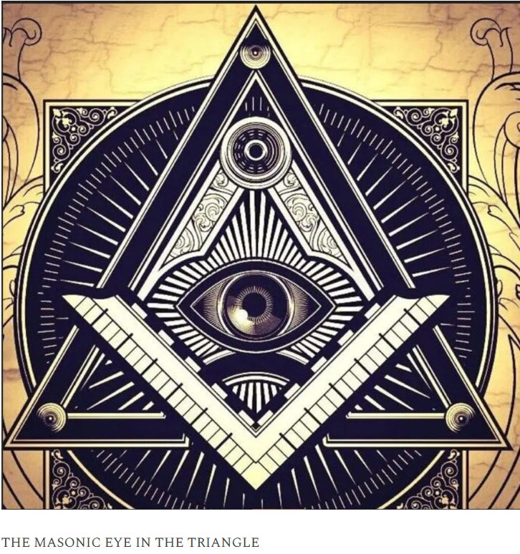
They created the Religion of Satanism 10,000 years ago to institutionalise that vampirism in their evil Rituals, then also used their Mind Control Rituals to tightly control their adherants in their secret societies, to richly reward their worshippers, so that their worshippers of Satan would work to dumb down humanity secretly, permanently, so that the vampirisation of their energy could continue eternally without any pushback from the populace.
Satanism is defined by Satanic Rituals.. Mind Control Programs - LIVES FOR SATAN! - THESE RITUALS DEFINE SATANISM.. RITUAL SEX, RITUAL PEDOPHILIA, RITUAL SODOMY, RITUAL DRUGS, RITUAL BLOOD SACRIFICE, RITUAL HUMAN SACRIFICE, RITUAL TORTURE, RITUAL BURNING ALIVE, RITUAL CANNIBALISM, RITUAL CASTRATION, RITUAL VIRGIN SACRIFICE.
The Ancient Egyptian Eye of Horus symbolises the Sodomy Ritual Anus and the Sex Ritual Vagina.
The thousands of years old technology from before even Ancient Egypt which was just a colony of the controlling 10,000 years old Satanic Phoenician Empire worshipping Baal, Baphomet, Cybele, Attis - all the old Satanic Gods - and using the Satanic Mind Control Rituals which are programs to control the human mind, just like the modern MKULTRA programs of Sissification and Bimboisation today..
http://www.energyenhancement.org/Sacred-Energy/Against-Satanism-Volume-3/Against-Satanism-Volume-3-Satanic-Rituals.pdf
EPSTEIN CIA, MOSSAD AND MI6 BLACKMAIL AND SHAME KEEP THE SATAN WORSHIPPERS IN LINE TO DUMB DOWN AND DEGENERATE HUMANITY SO IT CAN NOT FIGHT BACK...
The Satanic technique is to raise up Empires and then to destroy them and feed off their decline.
72 Empires have been recorded over 10,000 years and every one of them has failed in the same way. The facts have been recorded that a totalitarian and satanic elite infil-traitored and took over all these Empires and that 72 once free, flourishing and rich republics were destroyed from within by Satanic Ritual - read Toynbee.
Infil-traition of Satanism is the methodology as slowly every Government Ministry and Societal function is taken over. Eventually a Satanist becomes King Emperor President. LGBTP - The Satanist Ritual Pillars of Homosexuality, Sodomy, Pederasty, Drugs and Ritual Sex - both Hetero and Homosexual - are introduced overtly as Wokeness ESG, the Corporate Equality Index, as a prelude to Ritual Human Sacrifice.
Christianity and Judaism - the bulwarks Against Satanism - are destroyed and then society destroyed through the fear of mandatory Ritual Human Sacrifice.
The Ancient Enemy who counts meditation and the mind control psychic arts as one of its main planks of World Domination has used Satanic Infil-Traitors for 10,000 years in every Organisation - Religion, Left and Right Politics, Dynastic Families, Geopolitics, Economics, Universities, Intelligence Services, Think Tanks, Banking, Facebook, Twitter, International Companies, Vatican, Transhumanism, CRISPR Androids, Eugenics..

Sodomy and the Sodomy Ritual is at the heart of Satanism.
https://satchidanand.substack.com/p/energy-enhancement-meditation-sacred
Bottom on bottom, 8 or 33 represents the Vitruvian man. The occultist da Vinci’s Vitruvian Man really depicts the buggery of the anterior man by the posterior man, the apex of Satanic Luciferian 33rd Degree Masonry or final “Mystery of Mysteries” of the secret societies as explicated by Walter Veith (to open their “Third Eye.”). The reign of the AntiChrist will be marked as the sodomite king of the world..
George Orwell was the son of the guy in charge of Opium Production in India for the British Empire. He was aristocracy. His real name was Eric Blair, like Tony Blair and he went to “whipping and fagging” Eton with teaching by the guy who wrote the Satanic Plan for Humanity, "Brave New World" Aldous Huxley.
George Orwell wrote his book "1984" as a reply to CS Lewis' book "That Hideous Strength" where CS Lewis wrote that the aim was taking over humanity by Demons.
Orwell consciously took out the idea of Demons being in charge of Mind Control purposefully when he wrote 1984.
Fritz Springmeier wrote, "Mkultra Mind Control is the layering in of Demons".

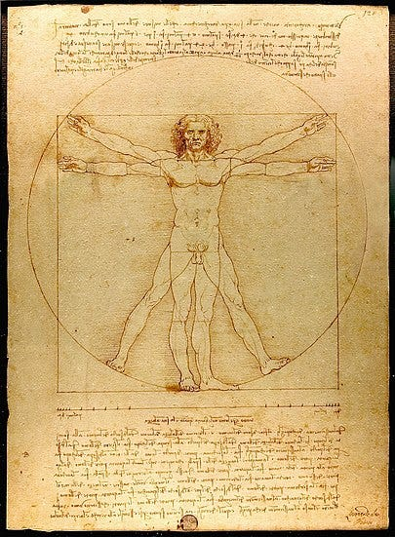

The Illuminati Formula to create a Completely Mind-Controlled Slave
SATCHIDANAND

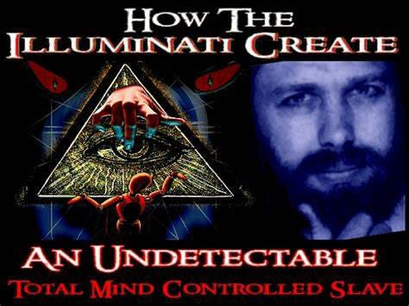

The Illuminati Formula to create a Completely Mind-Controlled Slave https://againstsatanism.com/Energy-Enhancement-Meditation-Course-The-Illuminati-Formula-to-create-a-Completely-Mind-Controlled-Slave.htm FREE BOOK BELOW… The Satanic 10,000 years old process using Torture, Drugs and Hypnotism in order to Implant Demon Programs from birth removed by The Energy Enhancement Meditation Course.
Read full story
It is very important for the Satanic Phoenician Mega Trillionaires who have worshipped Demons for 10,000 years that humanity knows nothing of Demons.
As Tolkien wrote, "I shall draw you Saruman as poison is drawn from a wound" as he removed Mind Control Saruman from the psychic body of King Theoden.

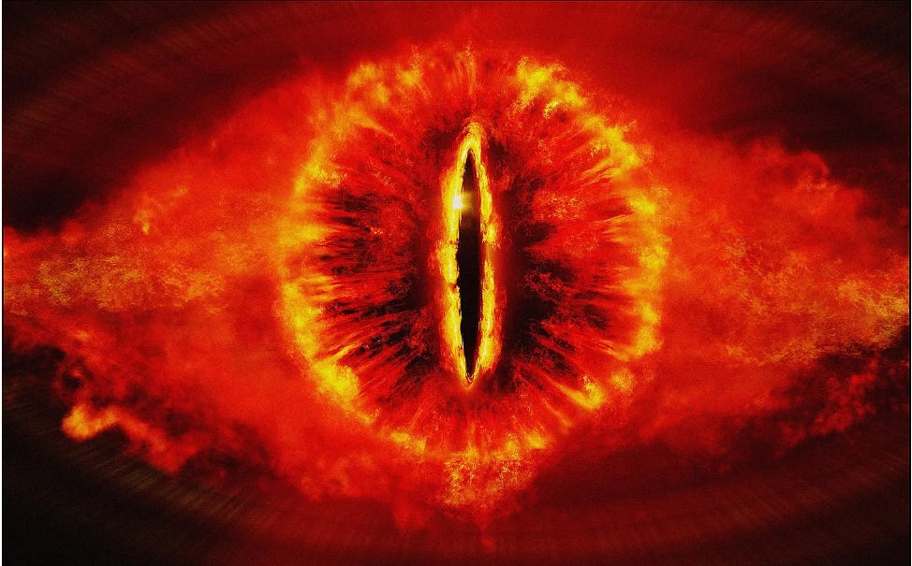

The Eye of Sauron is the Eye of Horus… representing the Vagina and the Anus…
Further, the idea that Satan, Lucifer, the Angel cast out of heaven by God is represented by Sauron in the Lord of the Rings is a Demon who lives out of the body and is seeking to return to the physical plane and that Orcs are Demons reincarnated in their evil Orc forms as they ar taken over by their Demons...
Before the Dracula Demon can enter your house, he must first be invited in...
https://satchidanand.substack.com/p/energy-enhancement-meditation-sacred
SATANISM IS DEFINED BY SATANIC RITUAL RITUAL SODOMY OPENS THE THIRD EYE RITUAL SODOMY SPLITS THE MIND INTO MIND CONTROL SUBPERSONALITIES OR ALTERS - In the House of the Strong Man Sodomy is the Key
https://satchidanand.substack.com/p/satanism-is-defined-by-satanic-ritual
The drawing together of a "Band of Thebes" British Aristocracy was particularly prized and brought about by the public school system started by Henry VI in 1440 at Eton but franchised to all schools very quickly. A hidden world drawn together by Pedophilic, Sodomy Ritual, homosexual warriors - the Heart of the Satanic British Empire - further, "Homosexuality follows Satanism like a stench"
Nicole Kidman: ‘Stanley Kubrick Said Pedophiles Run The World’
“Stanley told me the world is run by pedophiles,” Nicole Kidman said while promoting HBO’s Big Little Lies, in Los Angeles. “He studied secret societies his whole life, he was fascinated by them, and he said the elite, the top secret societies, they are full of men with a certain predilection. They are tied together, sort of bonded, by pedophilia like the ”Pact of Blood” where the Mafia entrants have to kill someone in order to join, these guys have to pedophile and human sacrifice like Epstein’s Pedo Island and the Lolita Jet - “They all know each other’s dark secrets. There is no way out for any of them. It’s a lifetime bond. Even if one of them wanted to go straight, repent, so to speak, he can’t. His peers will bring him down. They are in it until death, driving the world to ruin. That’s kind of how Stanley explained it but it was all very complex. I’m probably not doing it justice.”
https://satchidanand.substack.com/p/pg-wodehouse-and-british-empire-ritual
Thus in order to destroy free will, and institute total control over humanity, Satanism over 10,000 years has instituted Sodomy Rituals and pedophilia to control the upper levels of society by the use of institutions of public schools like, "Whipping and Fagging" all boys schools like Eton - founded as a mind control institution in 1438 by the King - where the Sodomy rape ritual sorted the boys into the Prussian Frederick the Great aggressive masculine homosexual rapine Penetrators, perpitrators, as in the 3000 years old Phoenician Colony of Thebes in Ancient Greece the "Band of Thebes" particularly successful Army of Gay Lovers, and the weak effeminate homosexual slaves or women or young boys.
BDSM Masters and Slaves.
All successful Generals, Politicians, Priests, Policemen, Professors came out of this background which then when refined by the Satanic Sodomy Ritual Secret Societies - the foundation of elite mind control for centuries - the 33rd Degree Freemasons, the Jesuits, the Illuminati and hundreds more - all based on the Mind Control Sodomy Ritual and Pedophilia supplied by Renfields like Pedophile Procurer Jimmy Savile for the elite Draculas.

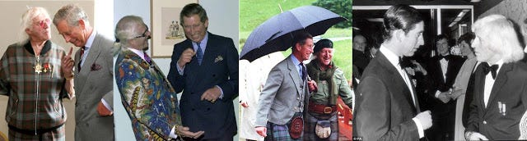

Remember, the purpose behind Satanism is total control of society by mind control, perversion and poison to dumm down humanity so they can be vampirised of their spiritual energy eternally because if humanity is allowed to evolve, to learn how to heal the mind, to psychically dissolve all these hundreds of lifetimes of mind control programs in the psychic body, the vampires can no longer exist!
https://satchidanand.substack.com/p/satanic-phoenician-mega-trillionaires
The key is that the Satanic Religion and it's current recruiting cults of Sodomy Ritual 33rd Degree Freemasonry, the Illuminati, Jesuits, Sabbatean Frankism, and the Crowlean Sexual Sodomy Ritual OTO - Ordo Templi Orientis, Yale Skull and Bones, Bohemian Grove - are Fake Gangs, created by men as a 10,000 years old technique to create psychopathic leaders and their minions, and thus conquer the world by constantly degenerating humanity into Orcs.
Here is a short partial compiled list of secret societies members listed, many of whom have played key roles throughout this article, they include Ritual Sodomy Luciferian 33° Scottish Rite Freemasons, Freemasons, Knights of Malta and Ritual Sodomy Skull and Bones members.
3 SYMBOLISES THE BOTTOM... 33 IS SODOMY...
US Presidents (since 1900)
Theodore Roosevelt – 33° Freemason
William Howard Taft – Freemason – Skull and Bones
Warren G. Harding – Freemason
Franklin D. Roosevelt – 33° Freemason Harry S. Truman – 33° Freemason
Dwight D. Eisenhower – Knight of Malta
Lyndon B. Johnson -33° Freemason
Gerald Ford – 33° Freemason – member of JFK Warren Commission
Jimmy Carter – 33° Freemason
Ronald Reagan – 33° Freemason – Knight of Malta
George H. W. Bush – Freemason – Knight of Malta – Skull and Bones
Bill Clinton – 33° Freemason – Knight of Malta George W. Bush – Skull and Bones – Knight of Malta
World Leaders (since 1900
Tony Blair – 33° Freemason – Knight of Malta – Prime Minister of England


Sir Winston Churchill – Druid, 33° Freemason – Prime Minister of England,
Josef Stalin – 33° Freemason – Leader of the Soviet Union Juan Perón – 33° Freemason – President of Argentina, Giscard d’Estaing – Knight of Malta – President of France, Nelson Mandela – Knight of Malta – President South Africa
All Rituals, Religions, Education, Secret Services and Political Movements have been scientifically Engineered to create Fake Gangs for 10,000 years. It's what the old Roman Empire, The Babylonian Empire of Satanic Nimrod, and the Cult of Apollo and the Byzantine Empire did before.
As you know, every Gang has Blackmail Rituals before you can join. Making your Bones with the Mafia means you must murder someone before you can join. Drug Cartels like MS13, secret groups within the Masons, the Illuminati, Sabbatean Frankists, OTO, the Hellfire Club, all have their Human Sacrifice, Pedophilia and Sodomy Rituals before you can progress.
Epstein did not kill himself. He videoed Scientists from MIT and Harvard, Oligarchs, Politicians etc, Pedophiling young girls then Blackmailed them into doing the work of his Trillionaire sponsors and their MKULTRA, Transhumanism, CRISPR Androids.
As their willing victims are given access to stealing higher quantities of money, so they must go to the next level of Ritual. First it is 15 year old girls who look 25. Then it's 12 year olds, 5 year olds, and then its the Satanic Human Sacrifice Ritual murder of children, babies!
Since the Band of Thebes of fierce homosexual warriors, sodomy rituals bind together that Band of Brothers at the head of Military Organisations Worldwide, NATO, AZOV Battalion, the Nazi SS, American and British Army and Navy...

See The Kay Griggs Interview parts 1, 2 and 3 (1998) Exposing Sodomy Rituals, The NWO, Homosexual Sodomy Ritual Cherry Marines
https://against-satanism-video.com/watch/the-kay-griggs-interview-part-1-1998-exposing-sodomy-rituals-the-nwo-cherry-marines_8x5Bm8KM4VVLUbv.html
All to create a degenerated Satanic Society of Total Control through Human Sacrifice, poverty, starvation, bugs, miseducation, lack of education, Wokeness, Climate Change, Sustainability, poison in the air, water and food. Lack of infrastructure, Lack of Energy - Electricity, Coal, Petroleum, Trans Ritual Castration Ritual education and Total Censorship Control of the Media.
All of them Censoring Worldwide, Advanced Meditation techniques - Alchemical VITRIOL, the Kundalini Key and Energy Blockage Removal from every Meditation Program.. EXCEPT ENERGY ENHANCEMENT!!
https://www.energyenhancement.org
The very word secrecy is repugnant in a free and open society JFK (27 April 1961)
The very word secrecy is repugnant in a free and open society; and we are as a people inherently and historically opposed to secret societies, to secret oaths and to secret proceedings. For we are opposed around the world by a monolithic and ruthless conspiracy that relies primarily on covert means for expanding its sphere of influence on infiltration instead of invasion, on subversion instead of elections, on intimidation instead of free choice, on guerrillas by night instead of armies by day. It is a system which has conscripted vast human and material resources into the building of a tightly knit, highly efficient machine that combines military, diplomatic, intelligence, economic, scientific and political operations.
JFK (27 April 1961)
What We See when we Remove an Energy Blockage is the Secret of Infinite Energy, Secret of Eternal Life, the Secret of Immortality. Mind Control Energy Blockages are Satanic, and it is this we see directly when we remove the blockages with the Energy Enhancement Meditation Course.. Energy Blockages do not exist alone, they are part of a network of evil, a network of control, which is designed not to allow people to understand the nature of that control, the purpose of that control, so as to maintain that control and the flow of energy - stolen from all human beings - to allow an elite of Black magicians, Sorcerers, Enchanters, Warlocks, Witches, Necromancers, Devils, Dark Gods... to live forever, Immortally, in private Universes, outside the body and then to download into a body from time to time, to maintain their Plantation, their Farm, their Property, to maintain the flow of stolen spiritual energy to them from every human being on this planet - Eternally. This is why I wrote Eleven volumes of Against Satanism..
See this..
http://www.energyenhancement.org/Third-Eye-Psychic-vision-see-Remove-Energy-Blockage-Secret-of-Infinite-Spiritual-Energy-Eternal-Life-Immortality-meditation-Energy-Enhancement-Seven-Step-Process.htm
In order to remove blockages using the Level 2 Seven Step Process, Internally, we teach you how to Ground every trace of Satanic Energy which makes sick, which perverts, which degenerates!
Externally we see the effect of Satanic Energy Blockages and their creators, on the World.. This is why I wrote Eleven volumes of Against Satanism.. available FREE! on signup on
Only Energy Enhancement can Annihilate Evil on Earth and change this Planet into a Planet of Love and Light in this Place, for You, for Me, for the Entire Human Race.
The best way to get around the internet censors and their shadow banning and make sure you see the stuff I publish is to subscribe to the mailing list for my website, energyenhancement.org which will get you an email notification for everything I broadcast and Free download access to the 52 Spiritual Books I publish.
My work is entirely reader-supported and the incredible Energy Enhancement Meditation Course supported so if you enjoyed this piece please consider sharing it around, donating to my substack account, throwing some money into my hat directly to my bank account (email me) via Transferwise, buying my hard copy books on Amazon https://www.amazon.com/s?k=swami+satchidanand Everyone, has my permission to republish or use any part of my work (or anything else I’ve written) in any way they like free of charge.
READ THE AGAINST SATANISM SERIES OF ELEVEN BOOKS!!

THE SOLUTION? - THE ENERGY ENHANCEMENT COURSE BY STREAMING VIDEO OR LIVE IN BRAZIL, INDIA, WORLDWIDE!!

Share
Leave a comment
The removal of the Heads of the Thirteen Satanic Families - not by assassination - as they can move from body to body - but as in the removal of Energy Blockages in the Energy Enhancement removal of Blockages.
Also information, the teaching of Wolf-Child Humanity in real Science and History as well as the Science of Meditation - Kundalini Kriyas, VITRIOL, Samadhi, Samyama, the removal of Energy Blockages, Implant Blockages, Energy Connections and Cords.

The solution?

THERE IS NO PHYSICAL SOLUTION AS OVER 10,000 YEARS OF RAPE AND PILLAGE WILL SHOW YOU!!

Solution? - The Science of Meditation - Which will increase the only thing you can take with you - Lifetime to Lifetime - when you die..

THE ONLY SOLUTION IS EVOLUTION!!
With the Energy Enhancement Kundalini Kriyas, VITRIOL, Samadhi, Samyama, the removal of Energy Blockages, Implant Blockages, Energy Connections and Cords.

ENERGY ENHANCEMENT IS THE ULTIMATE TECHNIQUE OF EVOLUTION!!
Just by meditation and energy blockage removal, you can find the truth for yourself, increase your energy, access incredible quantities of Kundalini Energy, become Enlightened.
And that's the only way, I think, you can actually make a practical, actually practical indication of how we might be able to save humanity from its degenerate Satanic predators.

ENERGY ENHANCEMENT - THE ULTIMATE MEDITATION COURSE!!

GET YOUR ENERGY ENHANCEMENT VIDEO OR LIVE COURSE NOW!!

The Energy Enhancement Streaming Video Meditation Course and the Volumes of the Against Satanism Series by Satchidanand

Go to http://www.energyenhancement.org
for 52 Free –On Sign-Up - Energy Enhancement Books and Energy Enhancement Against Satanism Books.
To defeat Evil, you need to up your game. Learn the Energy Enhancement Meditation Course by Video or Live at Iguazu falls with Satchidanand and Devi Dhyani.

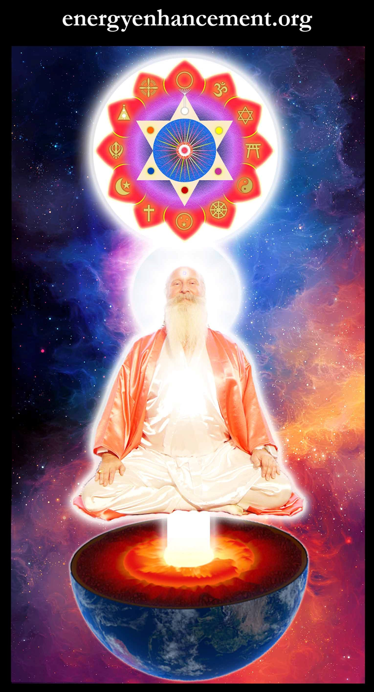
T

Change the World...


Go to http://www.energyenhancement.org
for 52 Free Energy Enhancement Books.

To defeat Evil, you need to up your game. Learn the Energy Enhancement Meditation Course by Video or Live in Iguazu.
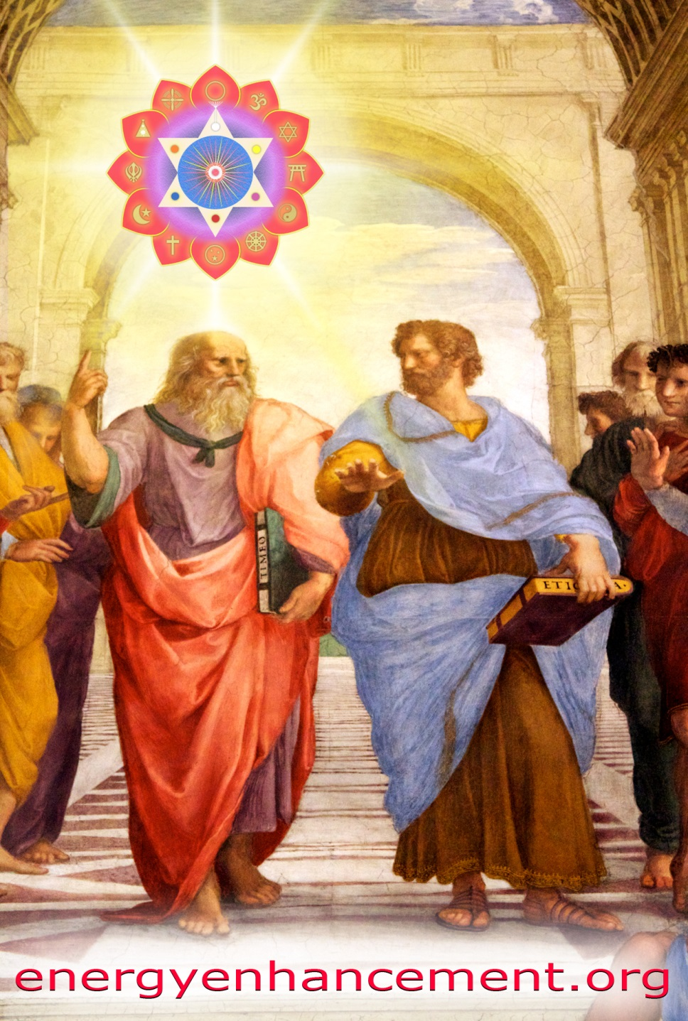

PLATO AND SATANIC BABYLONIAN SECRET AGENT ARISTOTLE "THE POISONER" OF ALEXANDER THE GREAT - BY RAPHAEL




ENERGY ENHANCEMENT MEDITATION
ENERGY ENHANCEMENT MEDITATION LEVEL 1 POWER UP!! GAIN SUPER ENERGY http://www.energyenhancement.org/Level1.htm
ENERGY ENHANCEMENT MEDITATION LEVEL 2 ELIMINATE ENERGY BLOCKAGES http://www.energyenhancement.org/Level2.htm
ENERGY ENHANCEMENT MEDITATION LEVEL 3 CLEAN KARMA BLOCKAGES AND PAST LIFE KARMA BY TRANSMUTATION http://www.energyenhancement.org/Level3.htm
ENERGY ENHANCEMENT MEDITATION LEVEL 4 MASTER ENERGY CONNECTIONS AND RELATIONSHIPS http://www.energyenhancement.org/Level4.htm

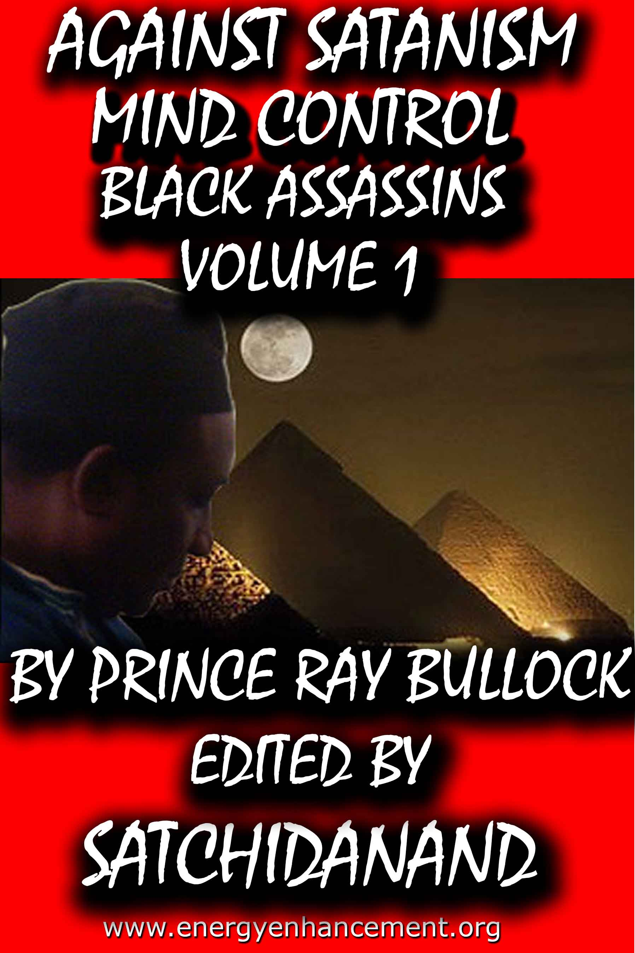

MIND CONTROL BLACK ASSASSINS VOLUMES FREE!!

AGAINST SATANISM VOLUMES FREE!!

- ON SIGN-UP AT..

energyenhancement.org

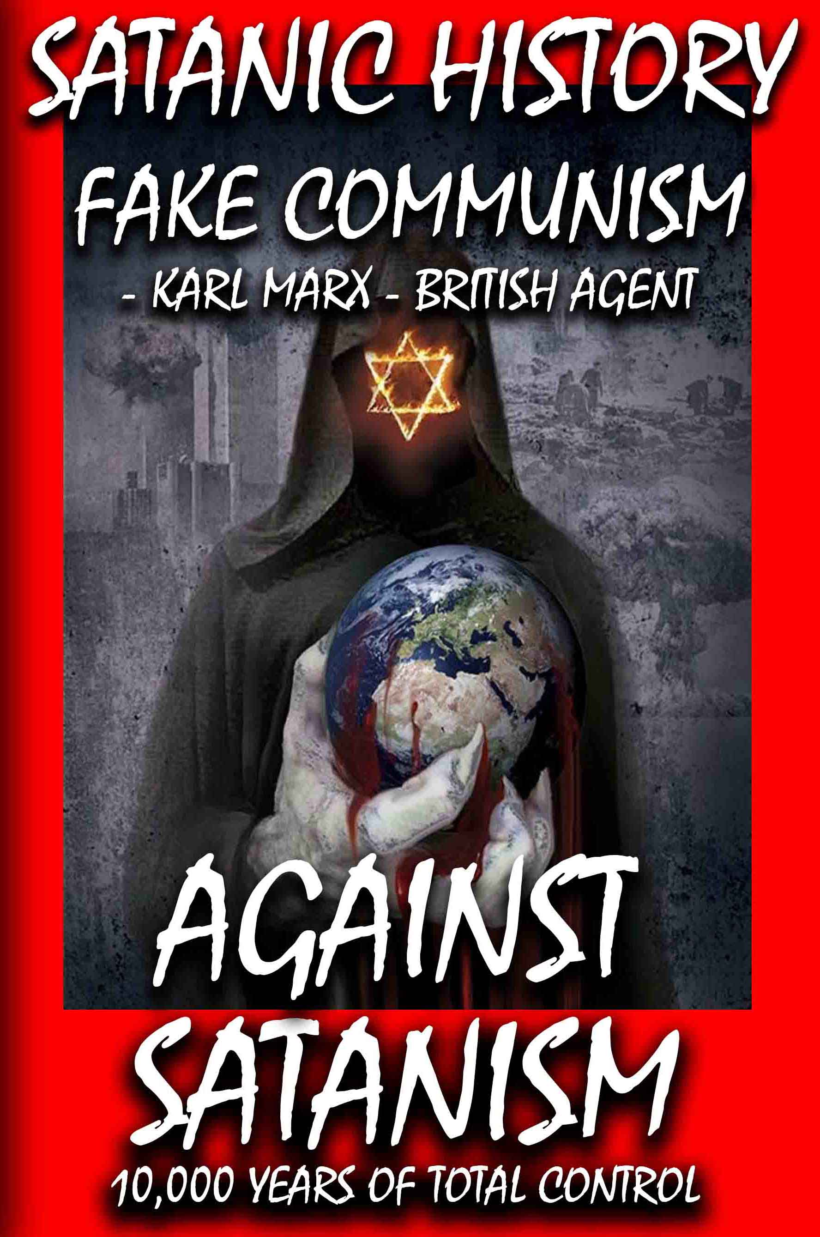

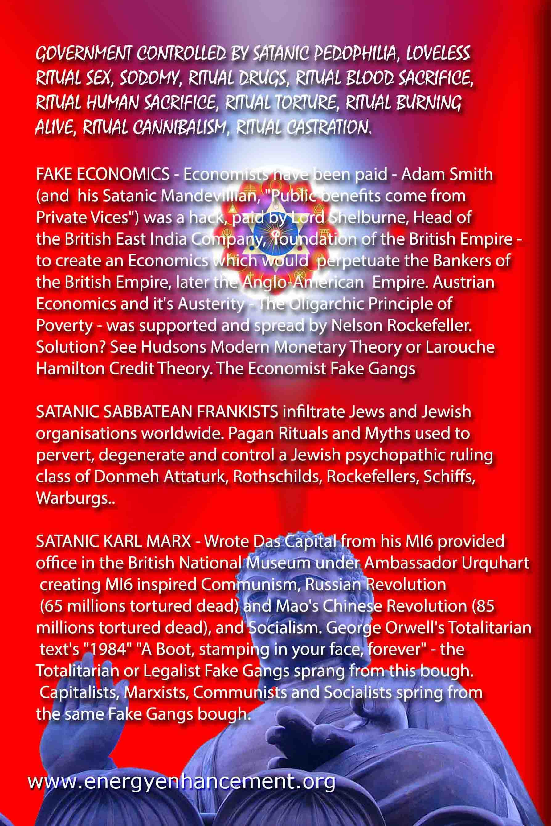

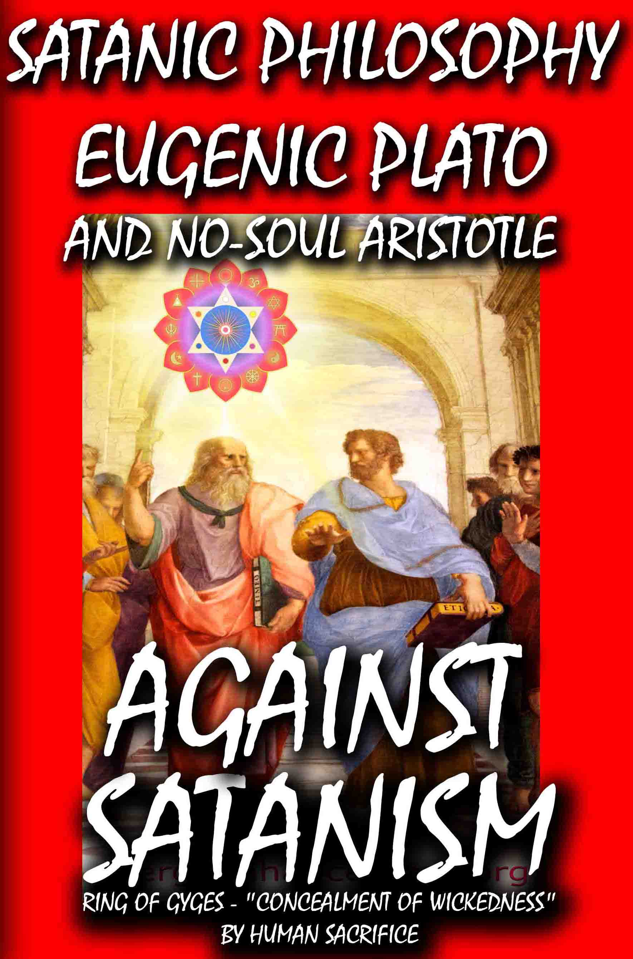

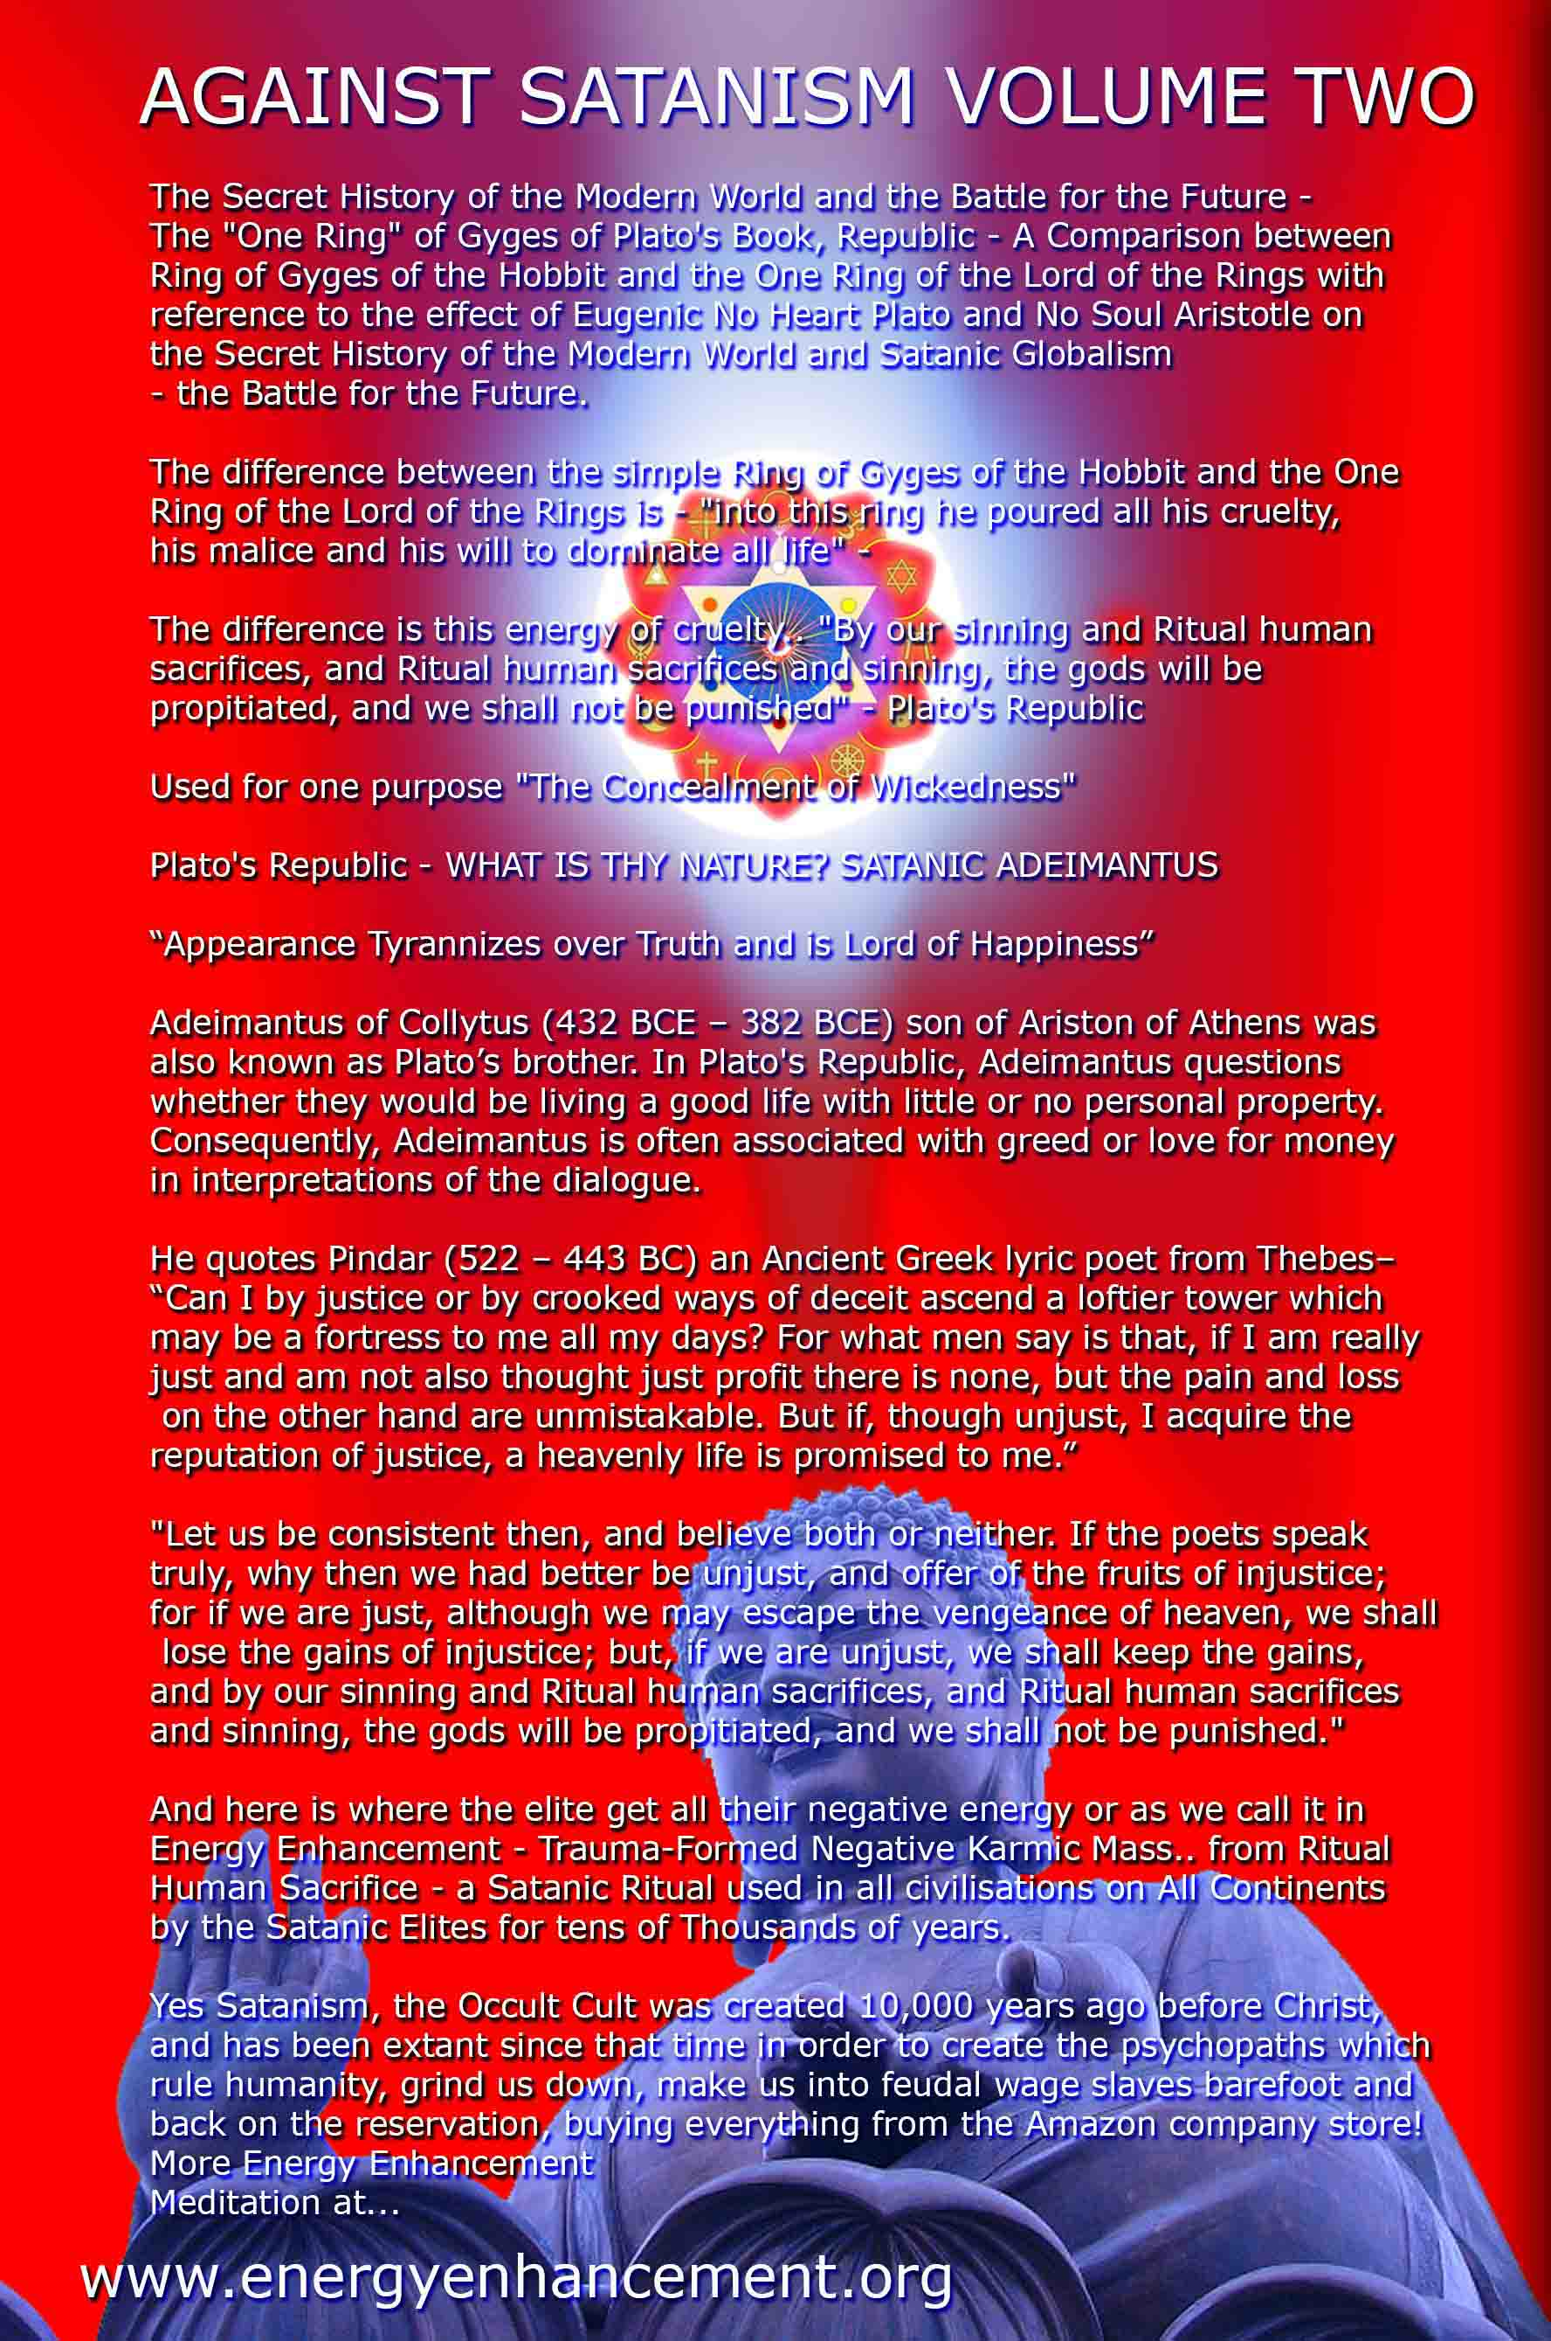

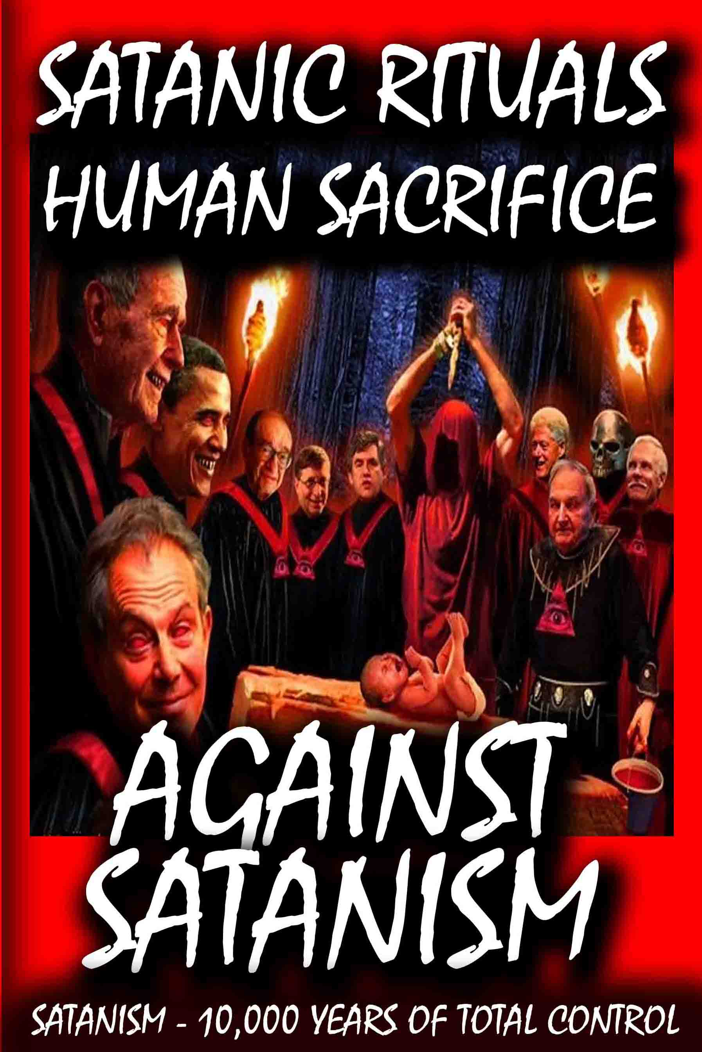

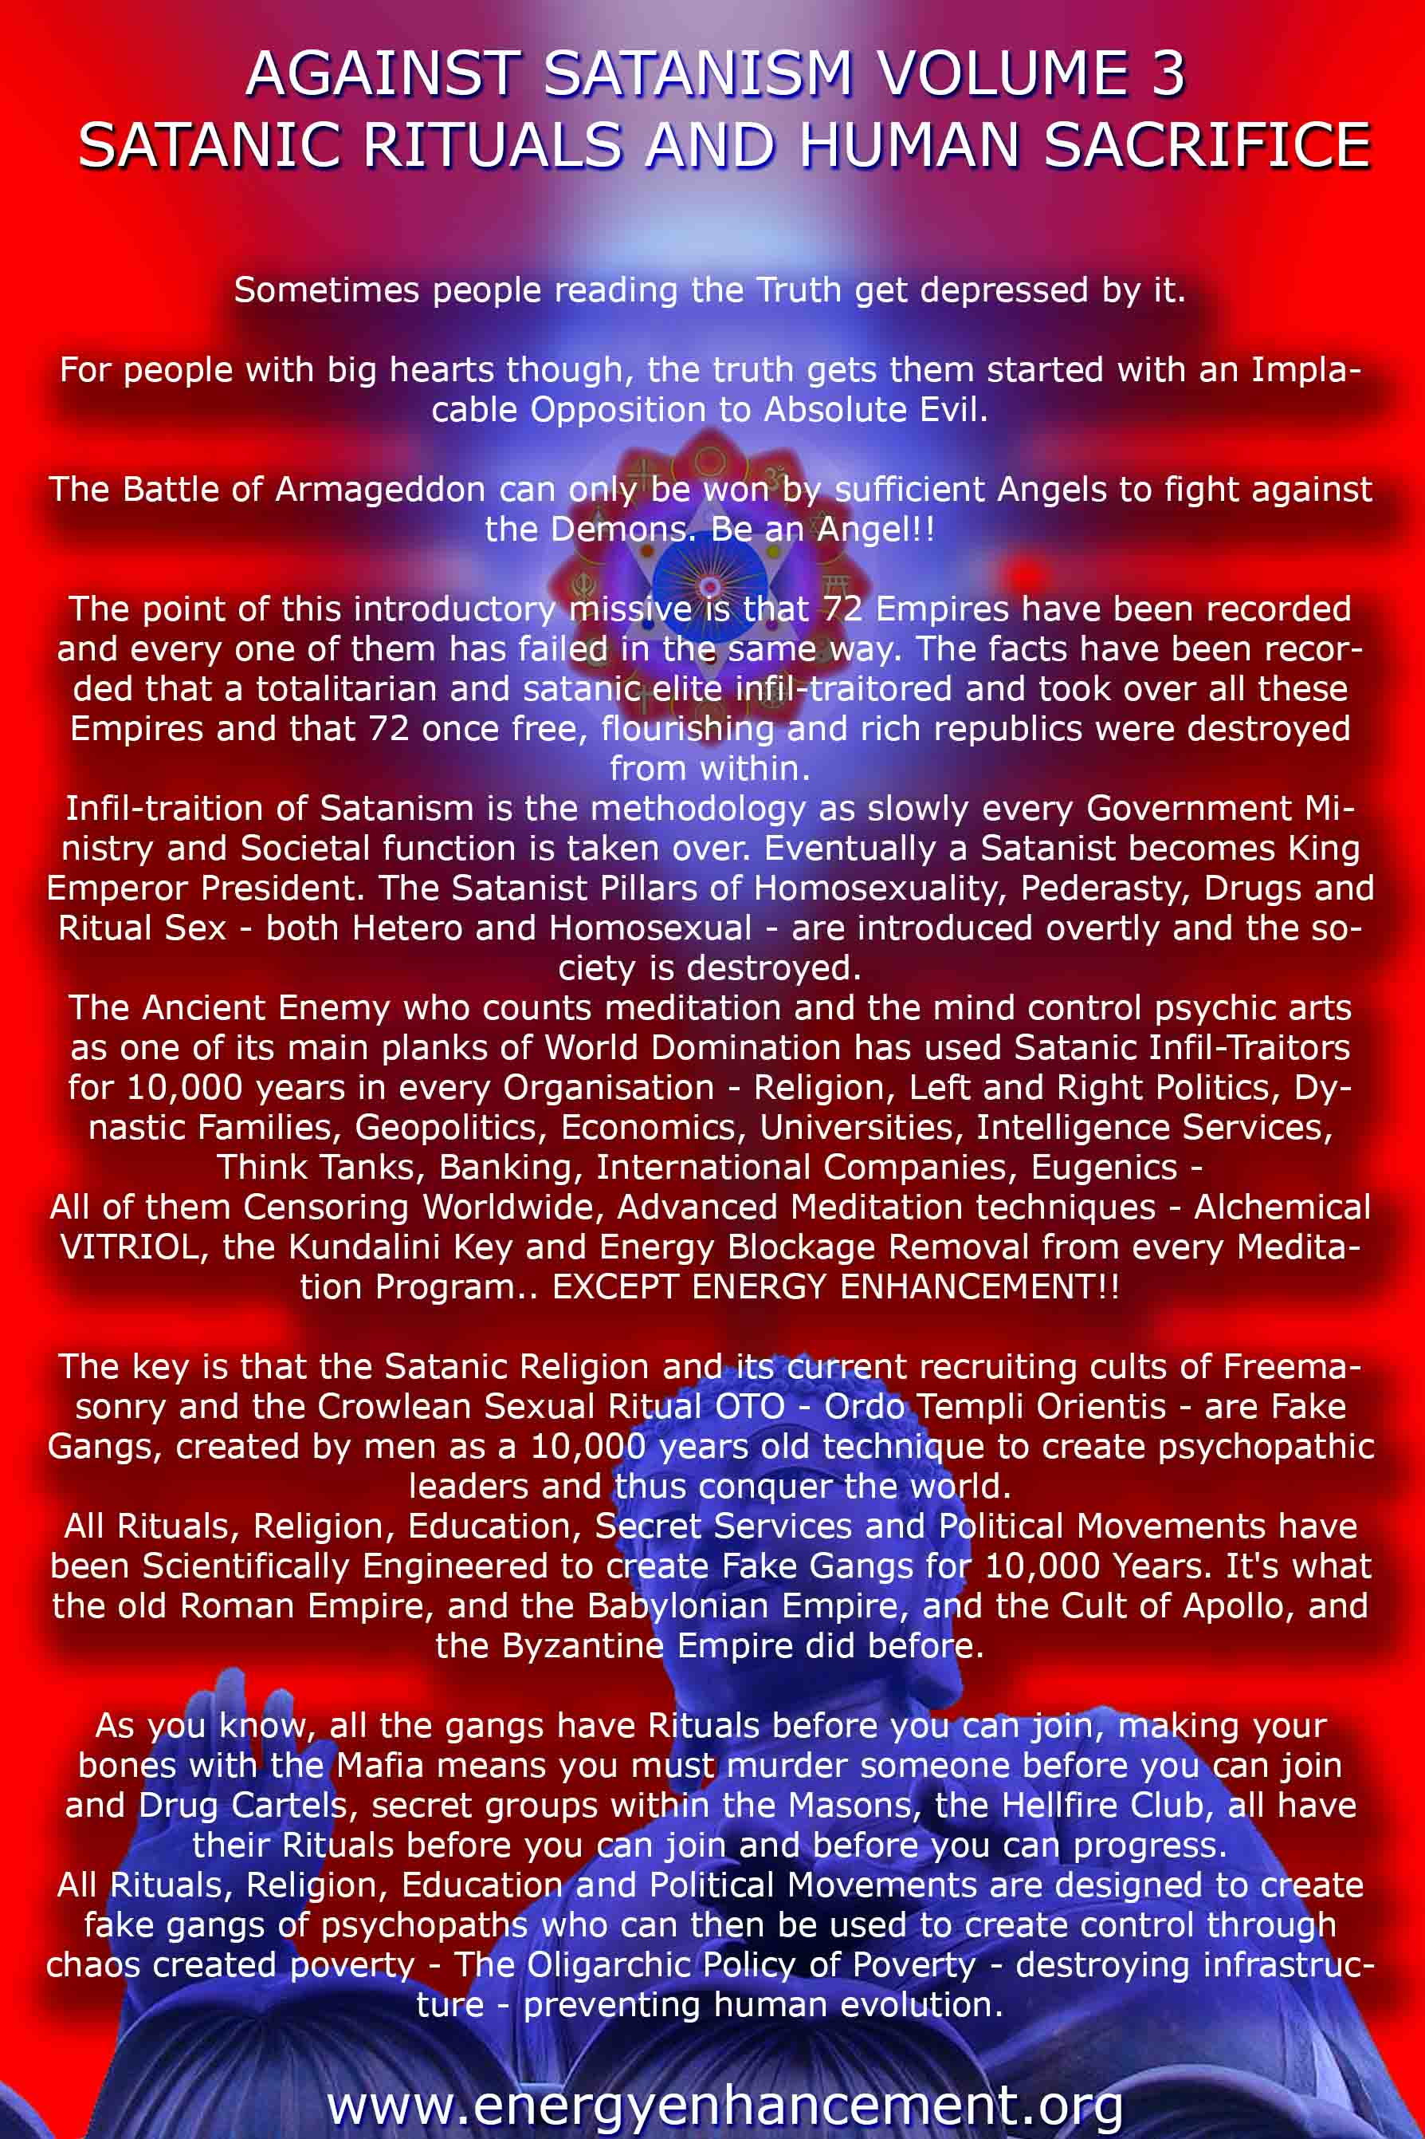

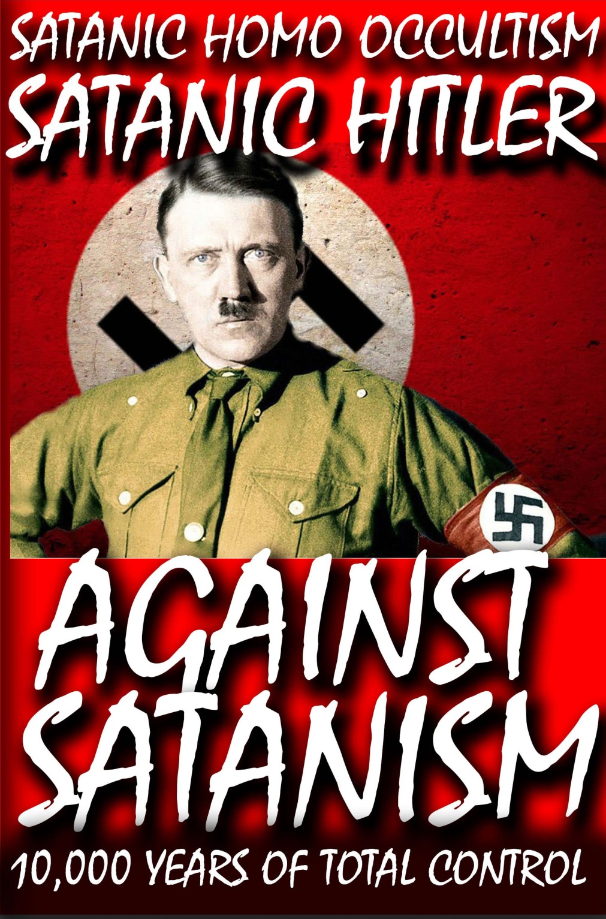

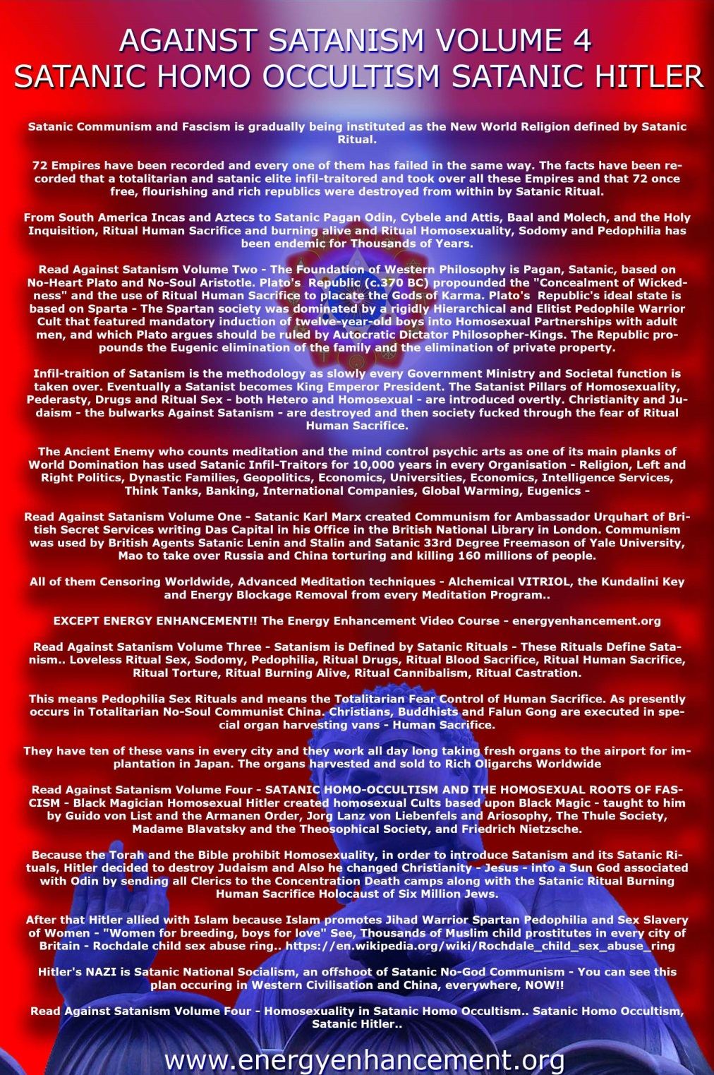

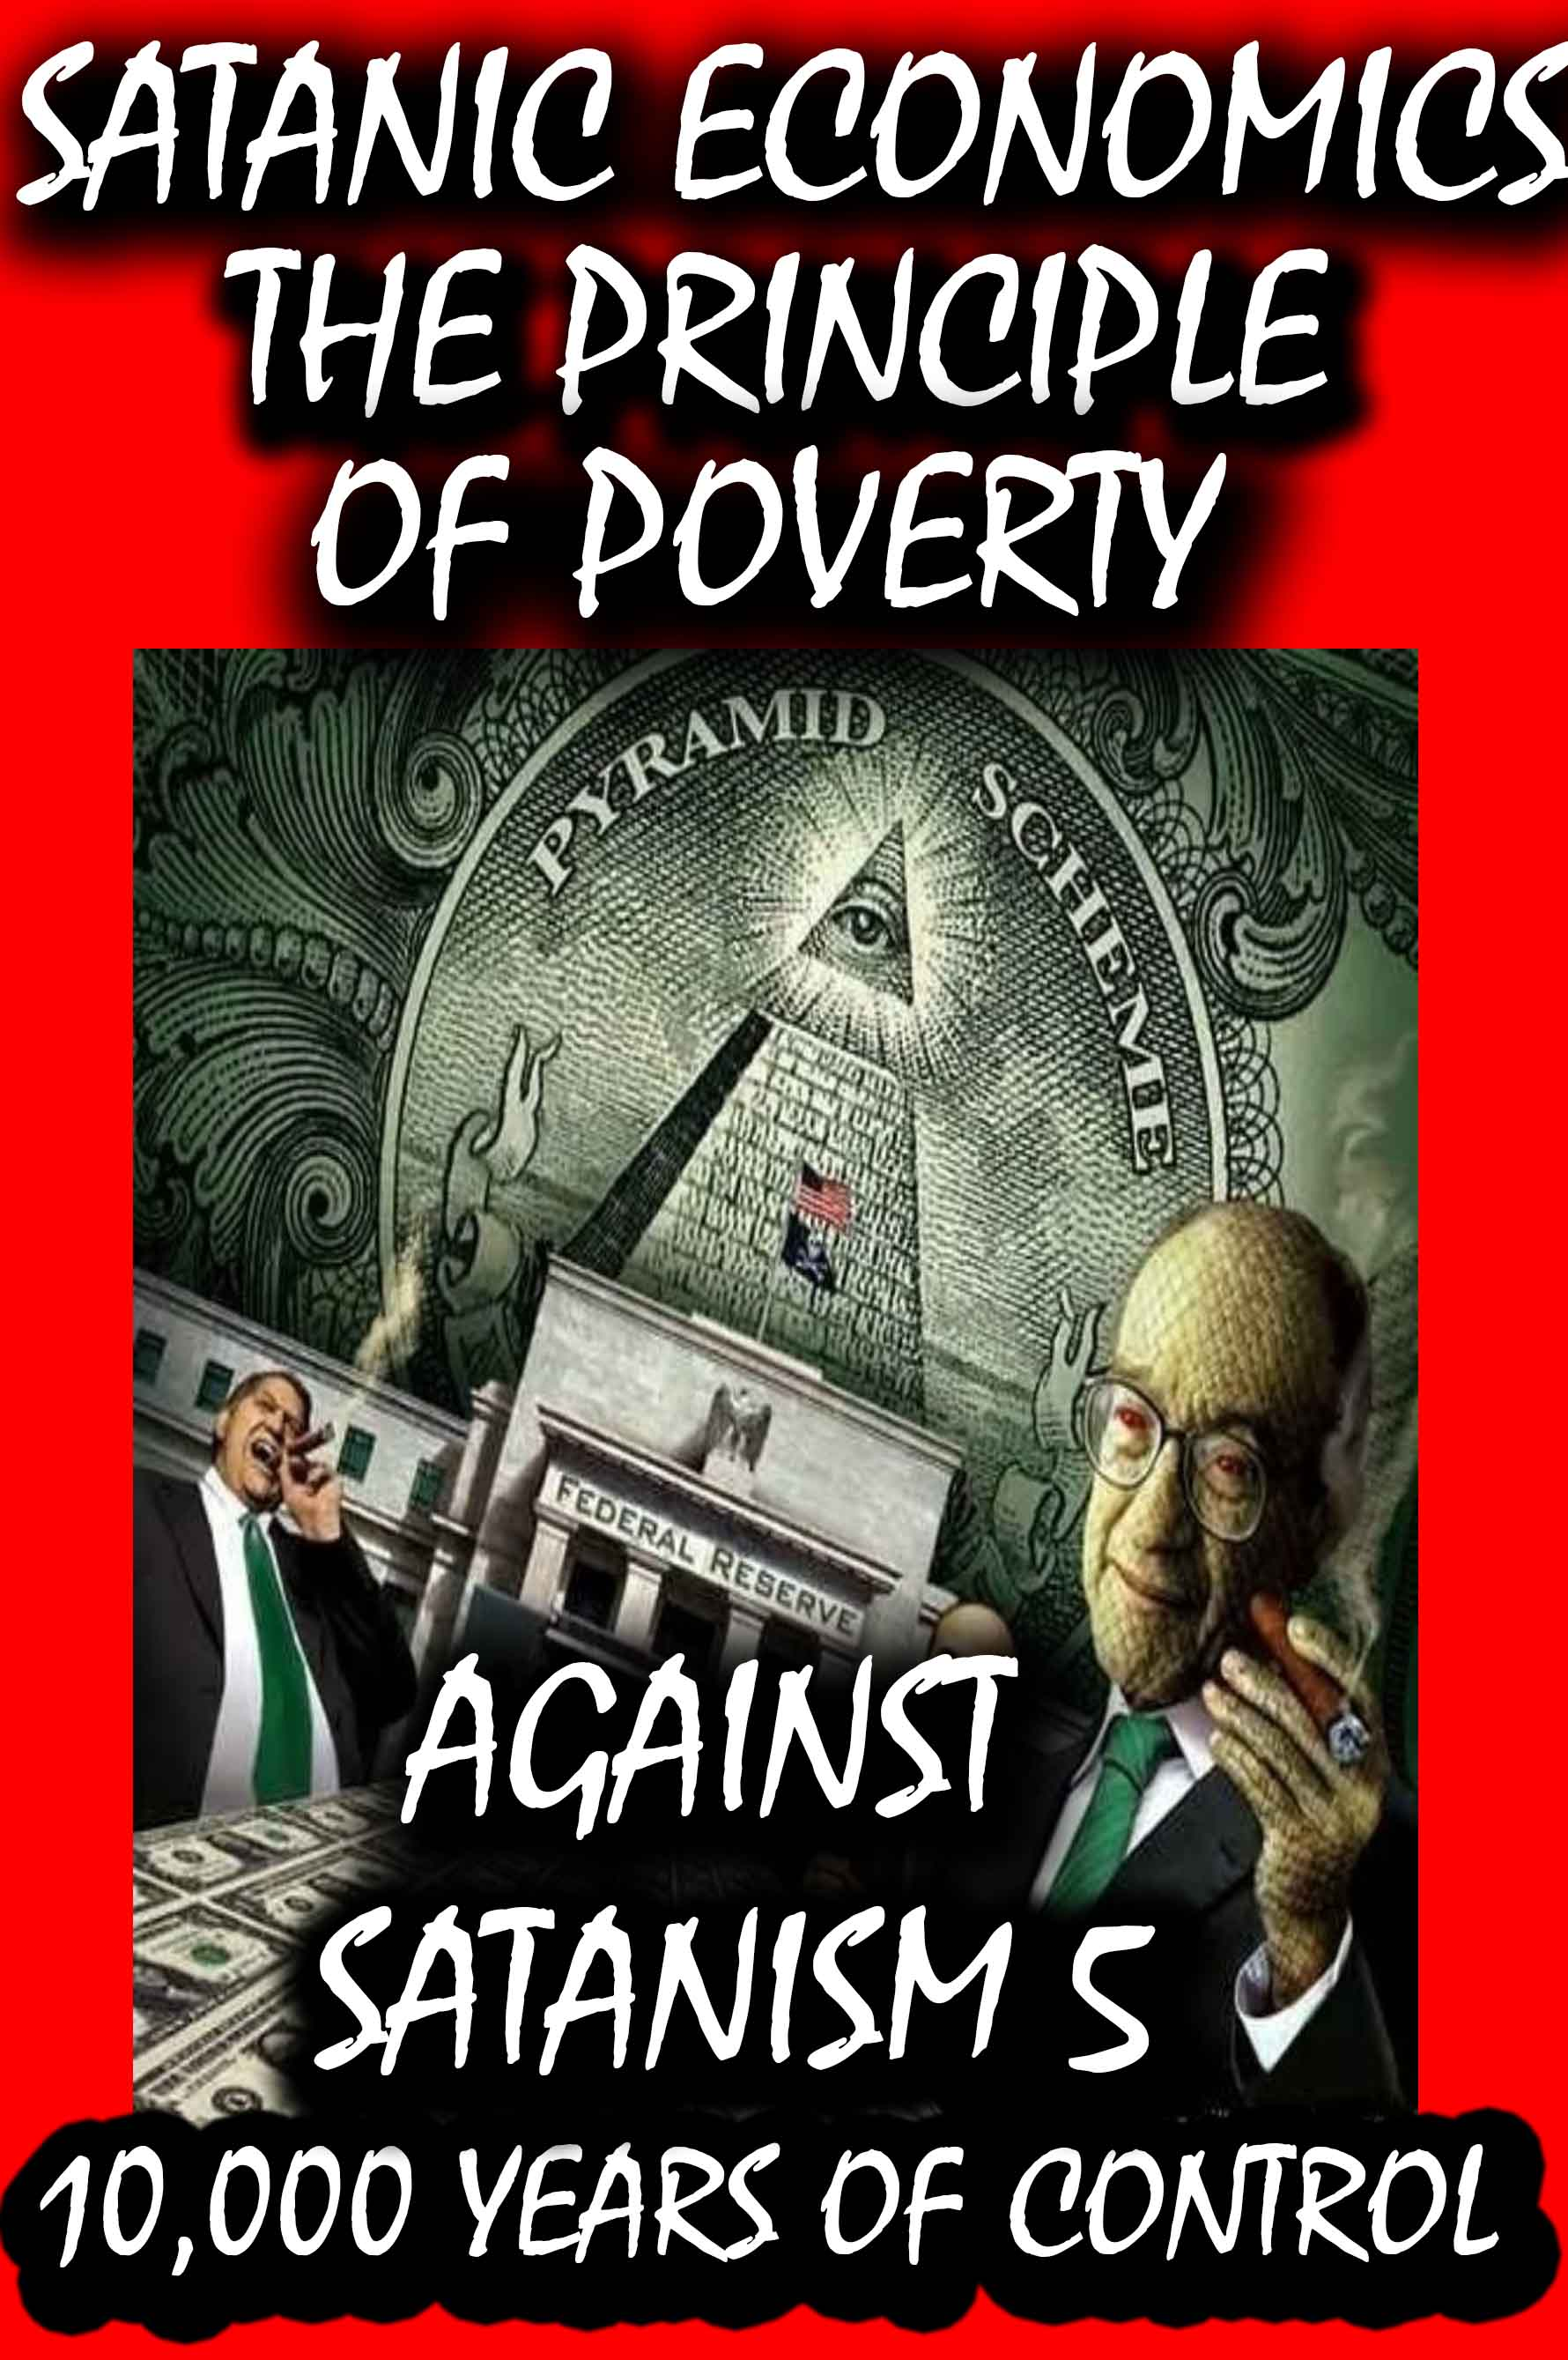

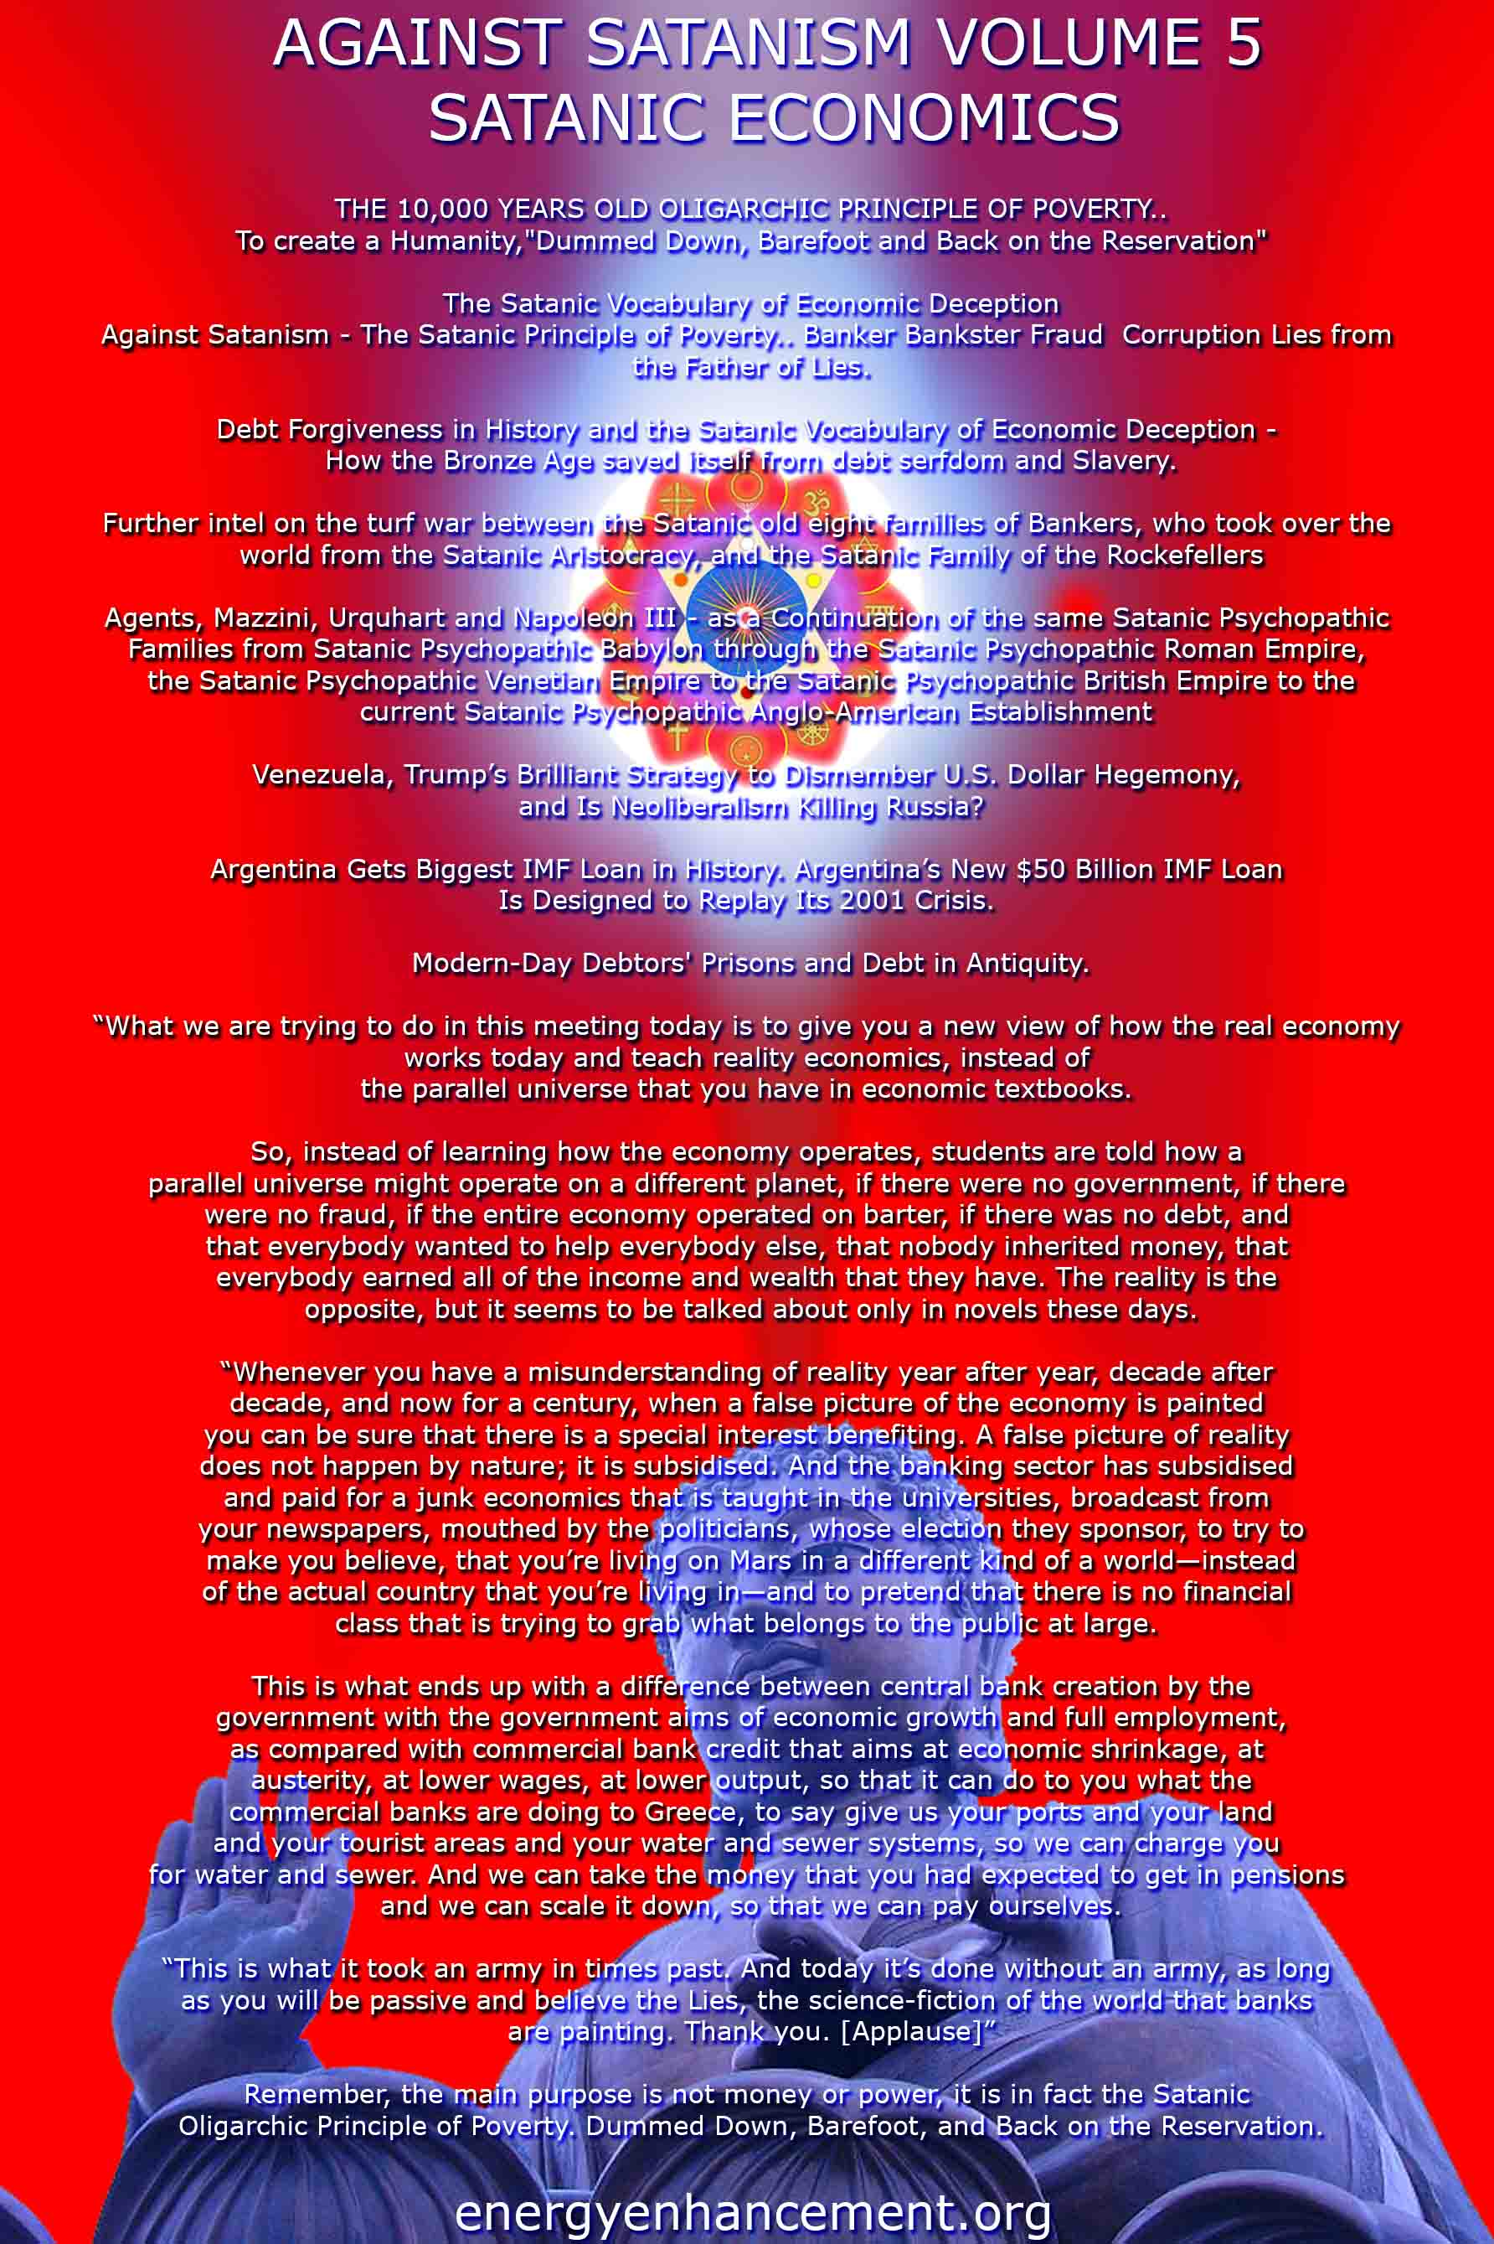

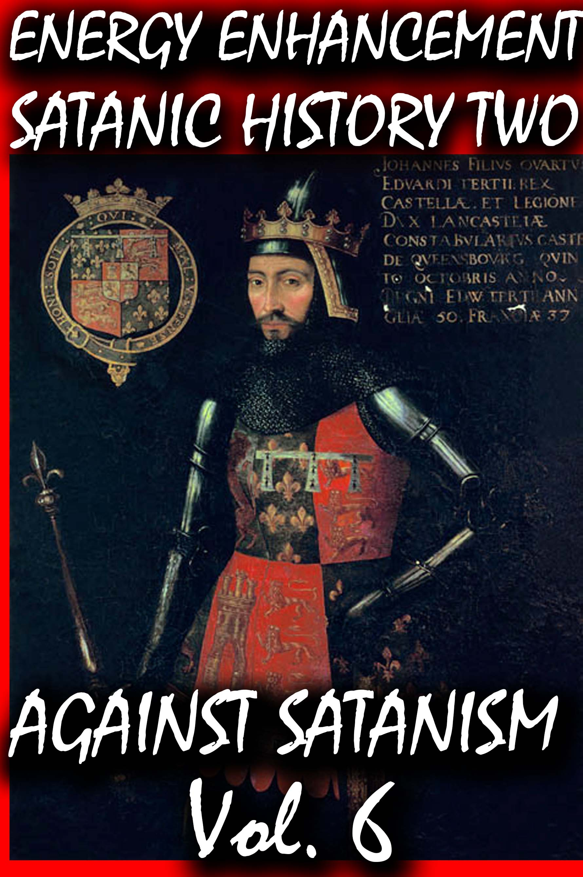
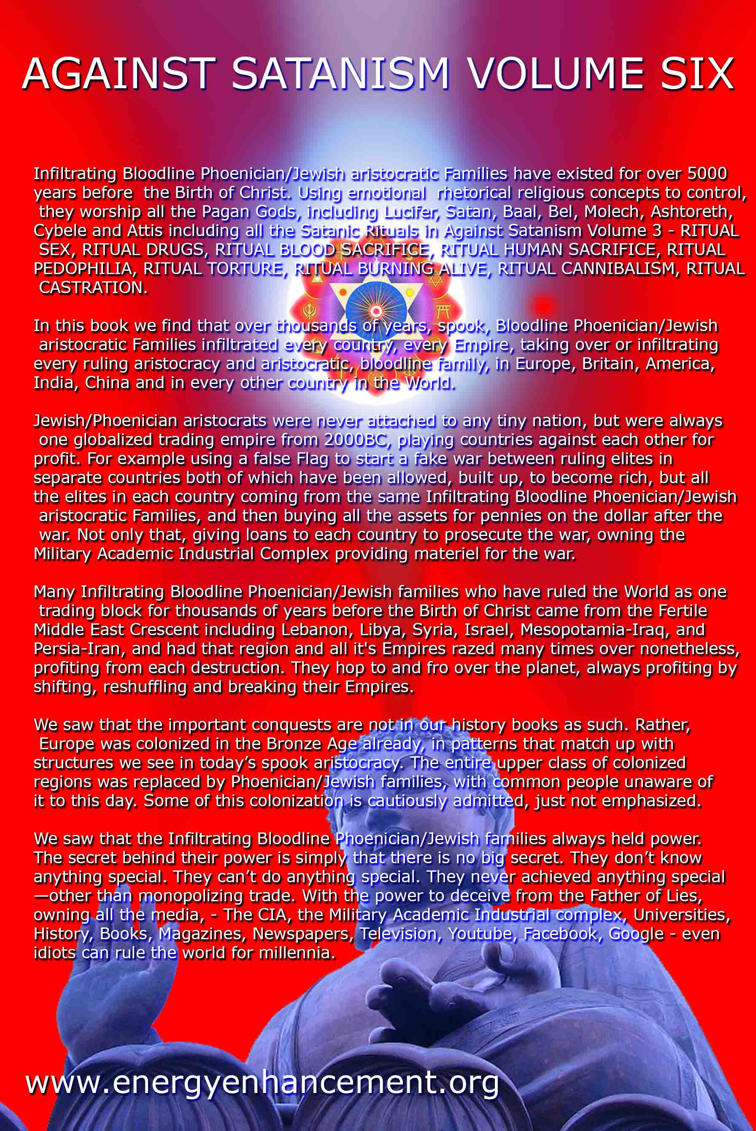
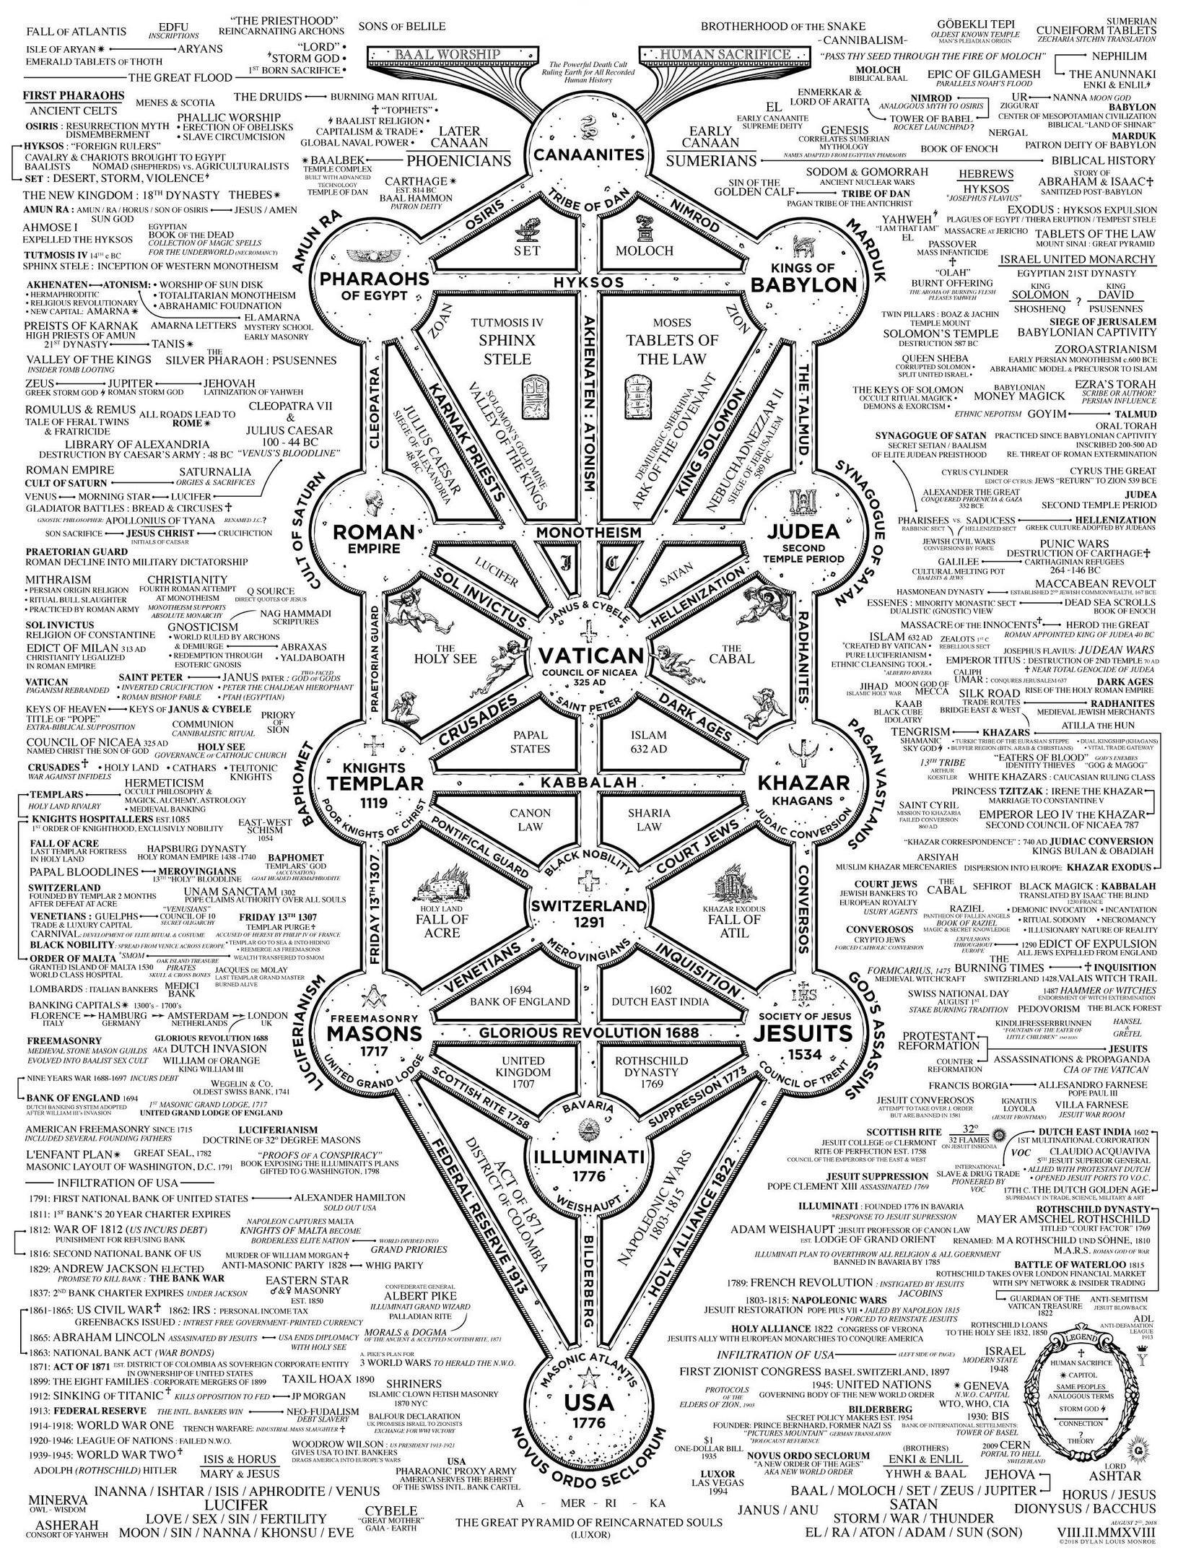
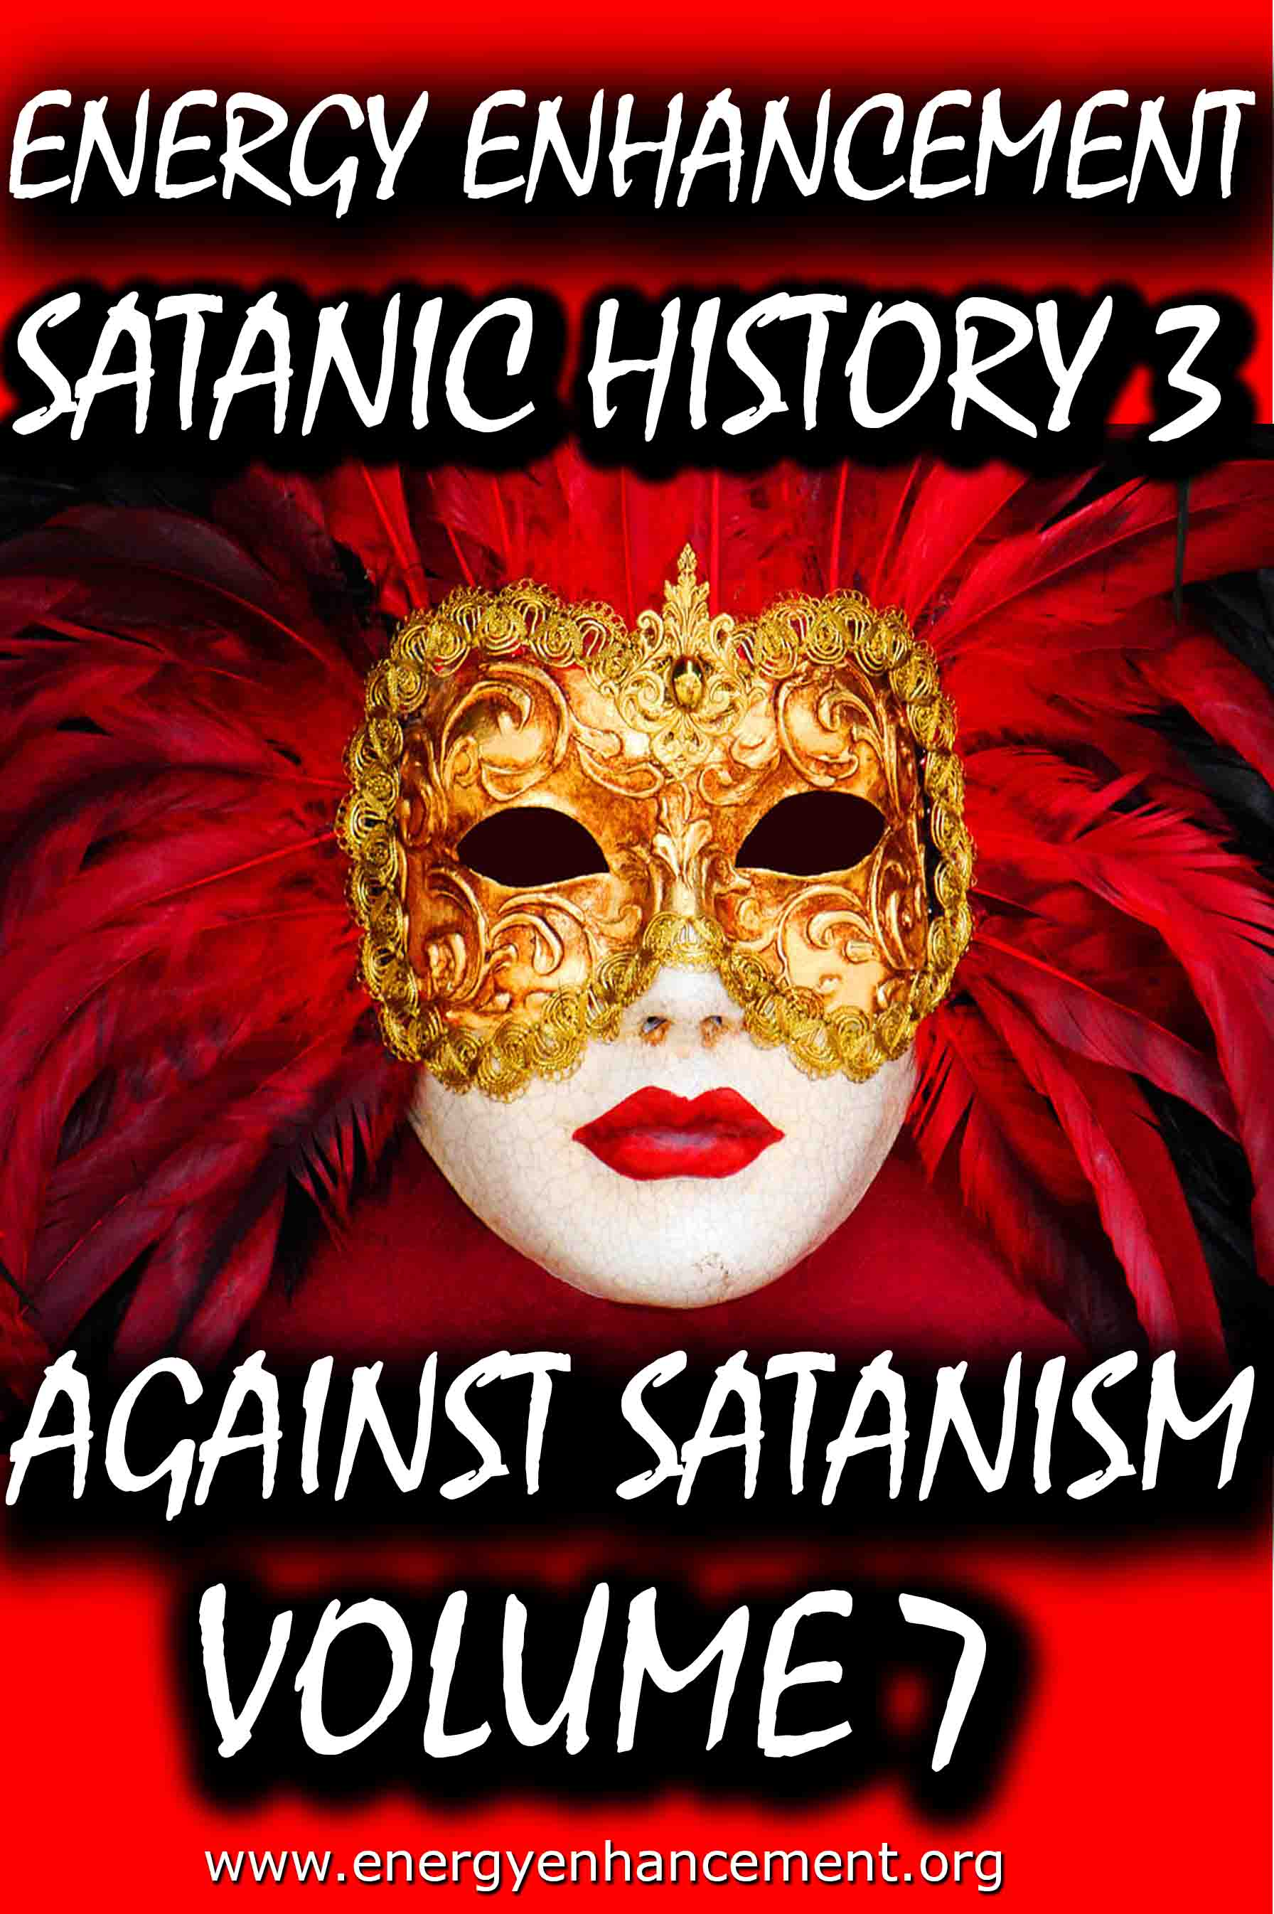
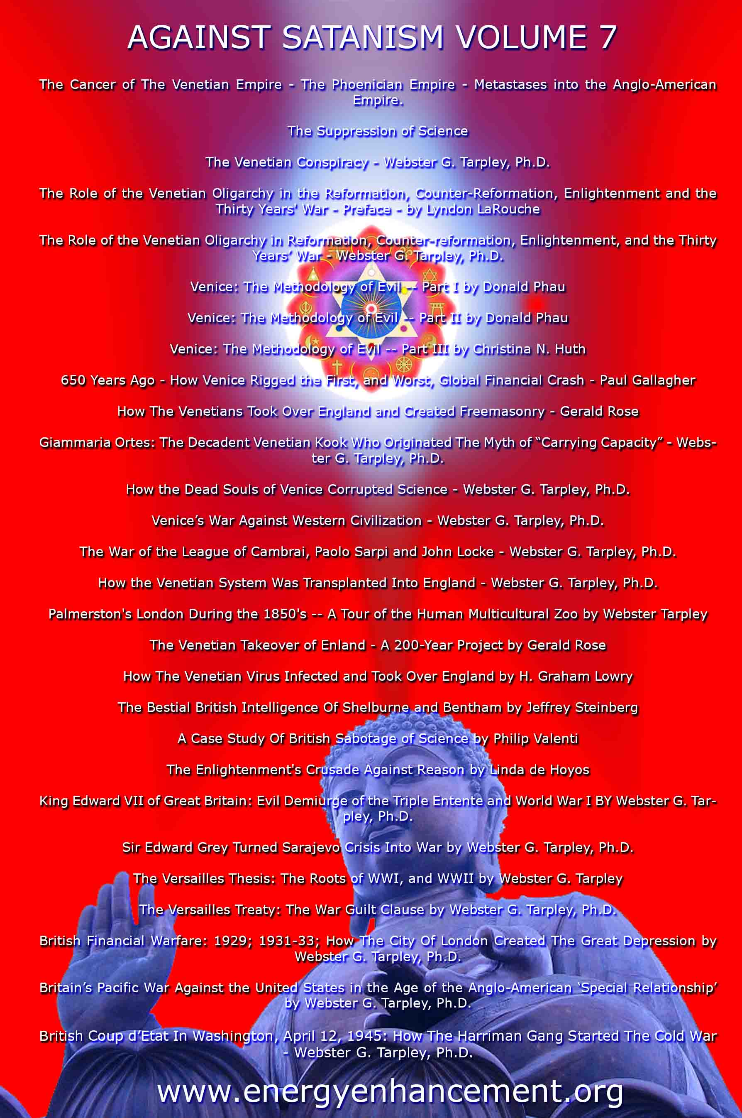

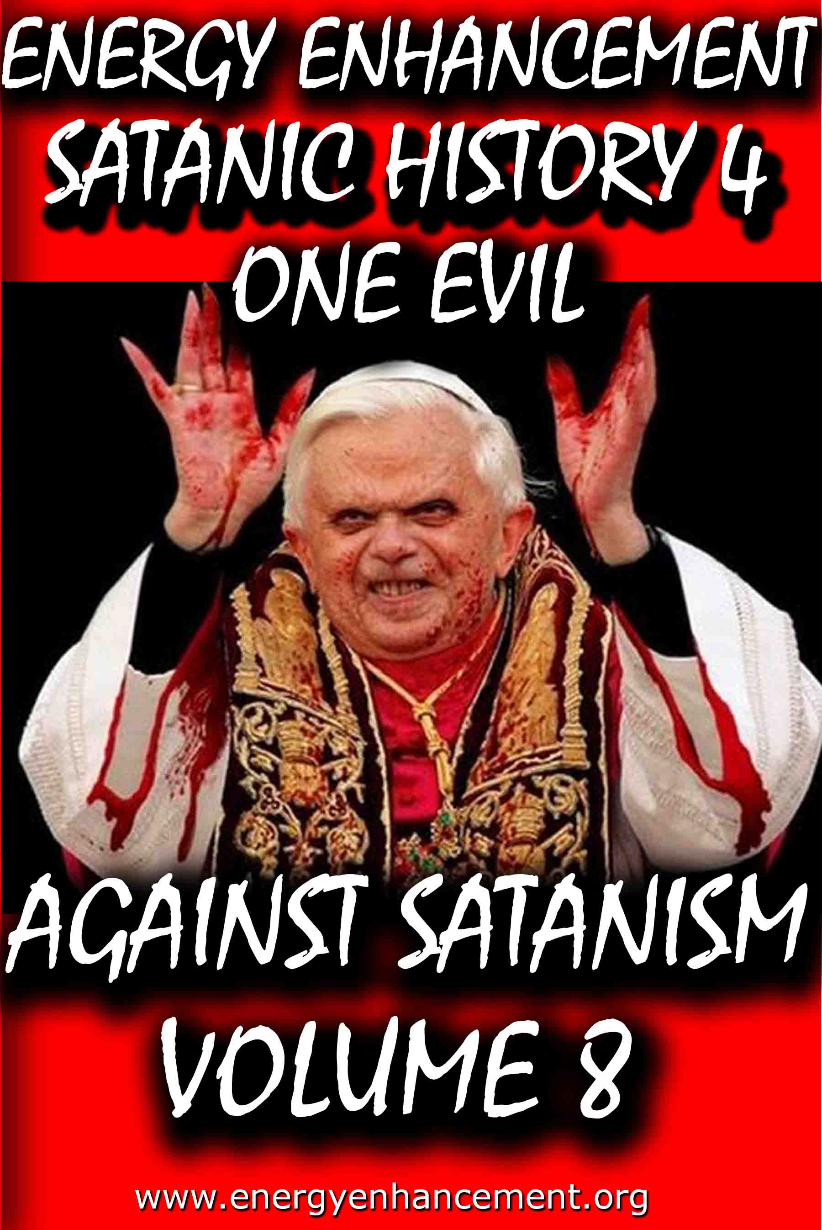

Remember, the main purpose is not money or power, it is in fact the Satanic Oligarchic Principle of Poverty. Dummed Down, Barefoot, and Back on the Reservation

Even though Tesla Free Energy Broadcast Power has been supressed, these next pages show how Fusion power and Fission Power have also been suppressed due to a Policy of Poverty going back to Fra Paolo Sarpi of the Satanic Venetian Republic and the British Royal Society for Science…

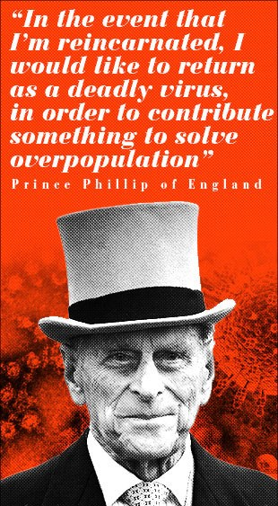

These Satanic Malthusians Demand Genocide

“Human population growth is probably the single most serious long-term threat to survival. We're in for a major disaster if it isn't curbed...We have no option.” —Prince Philip, interview in People Magazine, December 21, 1981

“In the event that I am reincarnated, I would like to return as a deadly virus, in order to contribute something to solve overpopulation.” —Prince Philip, Deutsche Press Agentur, August 1988
“It is almost self-evident that the greater the human population, the greater the demands for natural resources... The paramount question deals with an optimum human population. How many is too many people in relation to available resources? Many believe that our current (satanically consciously created) environmental problems indicate that the optimum level has been surpassed.” —Task Force on Earth, Resources and Population, George H. W. Bush, Chairman, July 8, 1970

POST MORTEM

Unfortunately, all the obituaries were premature: Venice has continued to be very much alive. During the nineteenth century and up to our own time it has been the most important single incubator for fascist movements. With its military and financial power largely emigrated elsewhere, Venice’s importance for political culture is now greater than ever.

Examples of this are inexhaustible. Richard Wagner wrote part of Tristan und Isolde while living in the Palazzo Giustinian on the Grand Canal. One story has it that the leitmotif of the Liebestod was inspired by the mournful call of a gondolier. At the end of his life Wagner moved to Palazzo Vendramin Callergi, where he died. This building, presently a gambling casino, was also the home of Count Coudenhove- Kalergi, the founder of the Pan-European Union. Friedrich Nietzsche loved Venice, returned there incessantly, and dedicated certain poems to the city which today can still be used in lieu of a powerful emetic. Venice was an inspiration for Lord Byron, for Thomas Mann, and so on.

Other examples abound of how the Venetian oligarchy’s cultural and political influence has reached down into the modern era:

* When British East India Company retainer Thomas Malthus published his Essay on Population he was plagiarizing from the Venetian Giammaria Ortes, who produced, around 1750, a fully developed version of the argument that geometric population growth outstrips the much slower arithmetric progress of food production.

* John Ruskin, the leading ideologue of the British Dark Ages faction, began his career with a raving treatise on architecture, The Stones of Venice (1851). This volume popularized the notion that a “Venetian Gothic” style had been developed in the better times of the city’s history (which for Ruskin ended in 1418) and it was used systematically to discredit the Golden Renaissance.

* A turn-of-the-century new Roman Empire faction led by Venetian Count Volpi di Misurata, who was known as the doge of his era, sponsored the fascist Mussolini supporter Gabriele D’Annunzio to drum up enthusiasm for a new crusade into the Balkans and the East. Volpi became finance minister in Mussolini’s cabinet, along with a very large number of other Venetians. D’Annunzio incited the Italians to take back Trieste, the rest of Italia Irredenta, and the Dardanelles, bringing on to center stage the so-called Parvus Plan for dismemberment of the Ottoman and Russian empires, which is generally recognized as the detonator of World War I. It is possible that the turn-of-the- century super spook Alexander Parvus was ultimately employed by Venice.

* The Societe Europeenne de Culture, a think tank created in 1950 through the efforts of Venetian intelligence operative Umberto Campagnolo, has for the past three decades pulled intellectuals from both East and West into organizing for an “international culture,” based on rejecting the existence of sovereign nations. The SEC counted among its members the cream of the postwar intelligencia: Adam Schaff of Poland, Bertolt Brecht of East Germany, Georg Lukas of Hungary, and Boris Paternak of the Soviet Union, as well as Stephen Spender and Arnold Toynbee, Benedetto Croce and Norberto Bobbio, Julian Huxley and Thomas Mann, Francois Mauriac, and Jean Cocteau. Later, the SEC launched the Third World national liberation ideology.

Today, the Club of Rome is the institution that represents the most concentrated essence of Venetian influence and the Venetian method. The Club of Rome wants to convince the great powers and peoples of the world to commit collective suicide by accepting the genocidal doctrine of zero growth. It also hopes to abolish the sovereign nation as a vehicle for economic growth and scientific progress.

Club of Rome founder Aurelio Peccei has just written a new book titled One Hundred Pages For the Future, a global review of the impact of the Club of Rome, and particularly since its 1972 release of the zero-growth model Limits to Growth was published, a series of social movements has sprung up under the sponsorship of the ideas in the book. These – the women’s movement, the peace movement, Third World national liberation movements, gay rights, civil liberties, ecologists, consumer and minority rights, etc. – must now be welded together into one movement for a single strategic goal: the implementation of a zero-growth international order.

The Venetian problem remains with us today. Truly, the most urgent task of this generation of mankind is to definitively liquidate the horror that is Venice and all the other Gang Clan Families who have ruled the World for 10,000 years.

The Satanic Conservative outpost of the Satanic Phoenician Navy who for 10,000 years have worshipped Molech, Baal and Cybele and Attis, and with Satanic Ritual, it's not just Sex on Altars like in Kubrick's, "Eyes Wide Shut", it is Pedophilia with Babies and Children supplied by Epstein, Dutroux or Jimmy Savile, it's Ritual Human Sacrifice, Ritual Blood Sacrifice, Ritual Burning Alive, Ritual Torture, Ritual Castration - and those Damn Liberals by Miles Mathis and Satchidanand

The founding fathers have even been sold as liberal in this sense, since although they were rich guys, fully connected, we are supposed to believe they believed in democracy, republicanism, and fairness in general. That is why they go on and on about that in the Declaration of Independence and Constitution. Those are liberal documents, in that they deny not only the divine rights of kings, they deny any other sort of favoritism based on name or birth.

As it turns out, the founding fathers were not liberal at all. They were Satanic fascists, and the whole liberal stance was just another con-job.

The United States were never meant to be republic, much less a democracy, they were meant to be another outpost of the Satanic Phoenician Navy who for 10,000 years have worshipped Molech, Baal and Cybele and Attis, and more worship with Satanic Ritual, it's not just Sex on Altars like in Kubrick's, "Eyes Wide Shut", it is Pedophilia with Babies and children supplied by Epstein, Dutroux or Jimmy Savile, it's Ritual Human Sacrifice, Ritual Blood Sacrifice, Ritual Burning Alive, Ritual Castration.
Some of my readers have been confused by my insistence that I am a liberal. These readers agree with me on a lot of things, so they can’t fathom what I mean by calling myself a liberal while they consider themselves conservatives. Since it is important, I will hit it again, trying to get them to understand.

I think the difference is that I am coming at this as a student of history, while many of them are coming at it as students (or consumers) of current politics.

I haven’t gotten my definitions and stances by listening to Rush Limbaugh, or Sean Hannity, I have gotten them from texts from the 19th century or earlier. My readers will answer me, “Then why don’t you keep up, Holmes! This is 2020, not 1880”. Good point. . . except that it isn’t.

To see what I mean, let’s transport ourselves back to the 1880s. Back then, satanic conservatives were those people who wished to conserve the status quo. Hence the name. They were quite satisfied with the way things were set up, and why should they not be?

They were rich and connected and had it made. Liberals were those who were not satisfied by the way things were, and so they were pushing for reforms. In general, they wished to see more fairness in government policies. They wanted those not “of the manor born” to be given a fair shot at good employment, good wages, court access, and all the various fruits of society.

The founding fathers have even been sold as liberal in this sense, since although they were rich guys, fully connected, we are supposed to believe they believed in democracy, republicanism, and fairness in general. That is why they go on and on about that in the Declaration of Independence and Constitution. Those are liberal documents, in that they deny not only the divine rights of kings, they deny any other sort of favoritism based on name or birth.

As it turns out, the founding fathers were not liberal at all. They were Satanic fascists, and the whole liberal stance was just another con-job.

The United States were never meant to be republic, much less a democracy, they were meant to be another outpost of the Satanic Phoenician Navy who for 10,000 years have worshipped Molech, Baal and Cybele and Attis, and more worship with Satanic Ritual.

Iit's not just Sex on Altars like in Kubrick's, "Eyes Wide Shut", it is Pedophilia with Babies and children supplied by Epstein, Dutroux or Jimmy Savile, it's Ritual Human Sacrifice, Ritual Blood Sacrifice, Ritual Burning Alive, Ritual Castration.

Read - AGAINST SATANISM VOLUME 6 - THE SATANIC PHOENICIANS - version 2 -The Satanic History of the World Part 2 Published May 2019

AGAINST SATANISM VOLUME 6 -The Satanic History of the World Part 2 Published May 2019

See http://www.energyenhancement.org/8aky78umhxi31.jpg

Infiltrating Bloodline Phoenician/Jewish aristocratic Families have existed for over 5000 years before the Birth of Christ. Using emotional rhetorical religious concepts to control, they worship all the Pagan Gods, including Lucifer, Satan, Baal, Bel, Molech, Ashtoreth, Cybele and Attis. In this book we find that over thousands of years, spook, Bloodline Phoenician/Jewish aristocratic Families infiltrated every country, every Empire, taking over or infiltrating every ruling aristocracy and aristocratic, bloodline family, in Europe, Britain, America, India, China and in every other country in the World.

http://www.energyenhancement.org/Sacred-Energy/Against-Satanism-Volume-6/AGAINST-SATANISM-6-Satanic-History-of-the-World-Part-2.pdf

Alan Watt Recommended Book List
Description: Get the BIG Picture by archiving and studying Sources from which Alan Watt draws. Download audio and transcripts of his talks from http://alanwattsentientsentinal.eu FREE. Please by all mean… Full description

Essential Book Recommendations from Alan Watt, of the
CuttingThrough theMatrixwebsite.

(Plus some of the books he won't mention)
The Republic – PlatoTragedy and Hope: The History of the World in our Time – Dr. Carroll Quigley The Anglo-American Establishment – Dr. Carroll Quigley The Evolution of Civilizations – Dr. Carroll Quigley
Between Two Ages: America's Role in the Technetronic Era – Zbigniew Brzezinski The Grand Chessboard: American Primacy and its Geostrategic Imperatives – Zbigniew Brzezinski The Choice: Global Domination or Global Leadership – Zbigniew Brzezinski The Impact of Science on Society –
Bertrand Russell The Scientific Outlook – Bertrand Russell The History of Western Philosophy – Bertrand Russell Proposed Roads to Freedom: Socialism, Anarchism, and Freedom – Bertrand RussellEducation and the Good Life – Bertrand RussellThe Autobiography of Bertrand Russell – 1872 – 1914 – Bertrand RussellThe Autobiography of Bertrand Russell – 1914 – 1944 – Bertrand RussellAn Essay on the Principle of Population – Thomas MalthusLegacy of Malthus – Allan ChaseThe Next Million Years – Charles Galton DarwinIn the Minds of Men – Ian T. Taylor Morals and Dogma – Albert PikeThe New Atlantis – Francis BaconThe Advancement of Learning – Francis BaconValerius Terminus of the Interpretation of Nature – Francis Bacon Novum Organum – Francis BaconThe Open Conspiracy – H.G. Wells

The Outline of History (Two volumes) – H.G. Wells The Shape of Things to Come – H.G. Wells The New World Order – H.G. WellsAmerica B.C. - Barry Fell Akhenaten – The Heretic King – Donald B. Redford The Gnostic Gospels – Elaine Pagels The Story of Civilization (11 Volumes) – Will Durant (
Particularly the first four volumes
:1.Our Oriental Heritage 2.The Life of Greece 3.Caesar and Christ 4.The Age of Faith) The Lessons of History – Will Durant The Story of Philosophy – Will Durant A Study of History (12 Volumes) – Arnold J. Toynbee (Look for the unabridged version – there isreason beyond Toynbee's legendary verbiage that a slender two-volume edition was released)Civilization on Trial – Arnold J. ToynbeeAmerica and the World Revolution – Arnold J. Toynbee (Public lectures in book form)Fire in the Minds of Men: Origins of the Revolutionary Faith – James H. BillingtonWall Street and the Bolshevik Revolution – Antony C. SuttonWall Street and the Rise of Hitler – Antony C. SuttonWall Street and FDR – Antony C. SuttonWestern Technology and Soviet Economic Development: 1917 – 1930 – Antony C. SuttonWestern Technology and Soviet Economic Development: 1930 – 1945 – Antony C. SuttonWestern Technology and Soviet Economic Development: 1945 – 1965 – Antony C. Sutton(
Zbigniew Brzezinski thought very highly of the above Sutton three volume work
)America's Secret Establishment: An Introduction to the Order of Skull and Bones – Antony C.SuttonTrilaterals over Washington: Volume I – Antony C. Sutton (with Patrick M. Wood)

Trilaterals over Washington: Volume II - Antony C. Sutton (with Patrick M. Wood)Foundations: Their Power and Influence – Rene A. Wormser Ages in Chaos (Four volumes) – Immanuel Velikovsky1.Ages in Chaos2.Oedipus and Akhnaton3.Ramses II and his Time4.Peoples of the SeaWorlds in Collision – Immanuel VelikovskyFuture Shock – Alvin Toffler The Third Wave – Alvin Toffler Power Shift – Alvin Toffler Political Ponerology: A Science of the Nature of Evil Adjusted for Political Purposes – Andrej M.LobaczewskiThe Technological Society – Jacques EllulPropaganda: The Formation of Men's Attitudes – Jacques EllulThe Political Illusion – Jacques EllulThe Technological System – Jacques EllulThe New Totalitarians – Roland HuntfordFuture Man – Brian StablefordPropaganda – Edward L. BernaysPublic Relations – Edward L. BernaysThe Moses Mystery – Gary GreenburgHebrew Myths: The Book of Genesis – Robert Graves and Raphael Patai
<compare with the following Graves volume>
The Greek Myths – Robert GravesScarlet and the Beast: A History of the War Between English and French Freemsasonry – JohnDanielConspiracies, Cover-ups, and Crimes – Jonathan VankinThe History of Freemasony (7 volumes unabridged) – Albert G. Mackey

The Encyclopedia of Freemasonry (Volumes I & II) – Albert G. MackeyThe Symbolism of Freemasonry – Albert G. MackeyGould's History of Freemasonry Throughout the World (6 volumes unabridged) – Robert F. GouldHoly Blood, Holy Grail – Baigent, Lincoln and LeighThe Messianic Legacy – Baigent, Lincoln and LeighThe Temple and the Lodge – Baigent, Lincoln and Leigh The Dead Sea Scrolls Deception – Baigent, Liccoln and LeighAmerica's Assignment with Destiny – Manly P. HallThe Secret Destiny of America – Manly P. HallThe Secret Teachings of All Ages – Manly P. HallThe Lost Keys of Freemasonry – Manly P. HallFreemasonry of the Ancient Egyptians – Manly P. HallOrientations – Sir Ronald StorrsThe Memoirs of Sir Ronald Storrs – Ronald StorrsThe Whispering Gallery: Being Leaves from the Diary of an Ex-Diplomat – Anonymous (LordGrey?)The Fifth Man: The Soviet Super Spy – Roland PerryThe Fringes of Power: The Incredible Inside Story of Winston Churchill During WWII – JohnColvilleThe Fringes of Power: 10 Downing Street Diaries (1939 – 1955) – John ColvilleThe Other Side of Deception: A Rogue Agent Exposes the Mossad's Secret Agenda – VictorOstrovkyBy Way of Deception: The Making and Unmaking of a Mossad Officer – Victor OstrovskyHistory Begins at Sumer: Thirty-Nine Steps in Recorded History – Samuel Noah Kramer Acres of Skin: Human Experiments at Holmesburg Prison – A True Story of Abuse and Exploitationin the Name of Medical Science by Allen M. HornblumThe Ghost in the Machine – Arthur Koestler The Thirteenth Tribe – Arthur Koestler

The Second Genesis: The Coming Control of Life – Albert RosenfeldTowards a New Beginning – Mikhail GorbachevDeadly Allies: Canada's Secret War (1937 – 1947) – John BrydenEarth Rising: The Revolution Toward a Thousand Years of Peace – Nick Begich NATO and Europe – Andre BeafreMillennium – Jacques AttalliUnderstanding Media: The Extensions of Man (Critical Edition) – Marshall McLuhan
The Book of the Dead: The Papyrus of Ani – E.A. Wallis BudgeThe Golden Bough – James FrazerHamlet's Mill – Giorgio de Santillana & Hertha von DechendThe Crime and Punishment of I.G. Farben – Joseph BorkinThe Undiscovered Self – C.G. JungProofs of a Conspiracy – John RobinsonThe Rockefellers: An American Dynasty – Peter Collier & David HorowitzThe Human Agenda – Roderic Gorney Trading with the Enemy: An Expose of the Nazi-American Money Plot (1939 – 1949) –Charles Higham Movie Lot to Beachhead: The Motion Picture Goes to War and Prepares for the Future – the editors of Look Magazine Hollywood Babylon: The Legendary Classic of Hollywood's Darkest and Best Kept Secrets –Kenneth anger The Fugu Plan: The Untold Story of the Japanese and the Jews During World War Two – Marvin Takayer, Forbidden Archaeology: The Full Unabridged Edition – Michael A. Cremo, The Last of the Pagans – Peter Chuvin, The Controversy of Brian – Douglas Reed, Battle for the Mind: A Physiology of Conversion and Brain Washing – William Sargant, Brave New World – Aldous Huxley

Brave New World Revisited – Aldous Huxley Nineteen Eighty-Four – George OrwellAnimal Farm – George OrwellFahrenheit 451 – Ray BradburyThe Handmaid's Tale – Margaret AtwoodFrankenstein – Mary ShelleyThe Wizard of Oz – Frank Baum My Life – Leon TrotskyThe Sovereign Individual – James Dale Davidson & Lord William Rees MoggGoethe's View of Evil and the Search for a New Image of Man in our Time – Allan P. CottrellThe Curse of Canaan: A Demonology of History – Eustace MullinsSecrets of the Federal Reserve – Eustace MullinsKing Kill 33 – James Shelby DownardSecret Societies and Psychological Warfare – Michael A. Hoffman IIThe Cultural Cold War: The CIA and the World of Arts and Letters – Frances Stonor StauntonWho Paid the Piper?: CIA and the Cultural Cold War - Frances Stonor StauntonPsychological Warfare – Paul Antony Myron Linebarger Physical Control of the Mind: Toward a Psychocivilized Society – Jose M.R. DelgadoThe Trap – James GoldsmithThe Response – James GoldsmithStraight and Crooked Thinking – Robert H. ThoulessSeven Pillars of Wisdom: A Triumph – T.E. Lawrence (Lawrence of Arabia)Autobiography of Thomas Jefferson – Thomas JeffersonThe First Global Revolution – Alexander King & Bertrand Schneider The Limits to Growth: A Report for the Club of RomeThe Underground History of American Education – John Taylor Gatto

Dumbing Us Down – John Taylor GattoAn Unsocial Socialist – George Bernard ShawThe Culture Industry – Theodor AdornoHope of the Wicked: The Master Plan to Rule the World – Ted FlynVirute and Terror (Revolution!) - Maximilien RobespierreArmand Hammer: The Untold Story – Steve WeinbergThe Balfour Declaration – Leonard SteinE-Topia: Urban Life, Jim – But Not As We Know It by William J. MitchellPhilip Dru Administrator: A Story of Tomorrow (1920 – 1935) – Edward Mandel HouseThe Naked Ape: A Zoologist's Study of the Human Animal – Desmond MorrisVodka Cola – Charles LevinsonLanguage, Mind and Nature: Artificial Languages in England from Bacon to Locke – Rhodri LewisThe Divine Comedy – Dante AlghieriHamlet – William SkakespeareThe Prince – Nicolo MachiavelliDocuments:1.Agenda 212.United Nations Human Settlement Program3.DCDC Global Strategic Trends Document (M.O.D.)4.Converging Technologies for Improving Human Performance: Nanotechnology, Biotechnology,Information Technology and Cognitive Science – National Science Foundation/Department ofCommerce5.Societal Implications of Nanoscience and Nanotechnology – National Science Foundation6.Global Trends 2025: A Transformed World – A Final Report7.2008 Army Modernization Strategy (D.O.D.)8.UNESCO: Its Purpose and Philosophy – Sir Julian Huxley9.Weather as a Force Multiplier: Owning the Weather in 2025 – U.S. Airforce

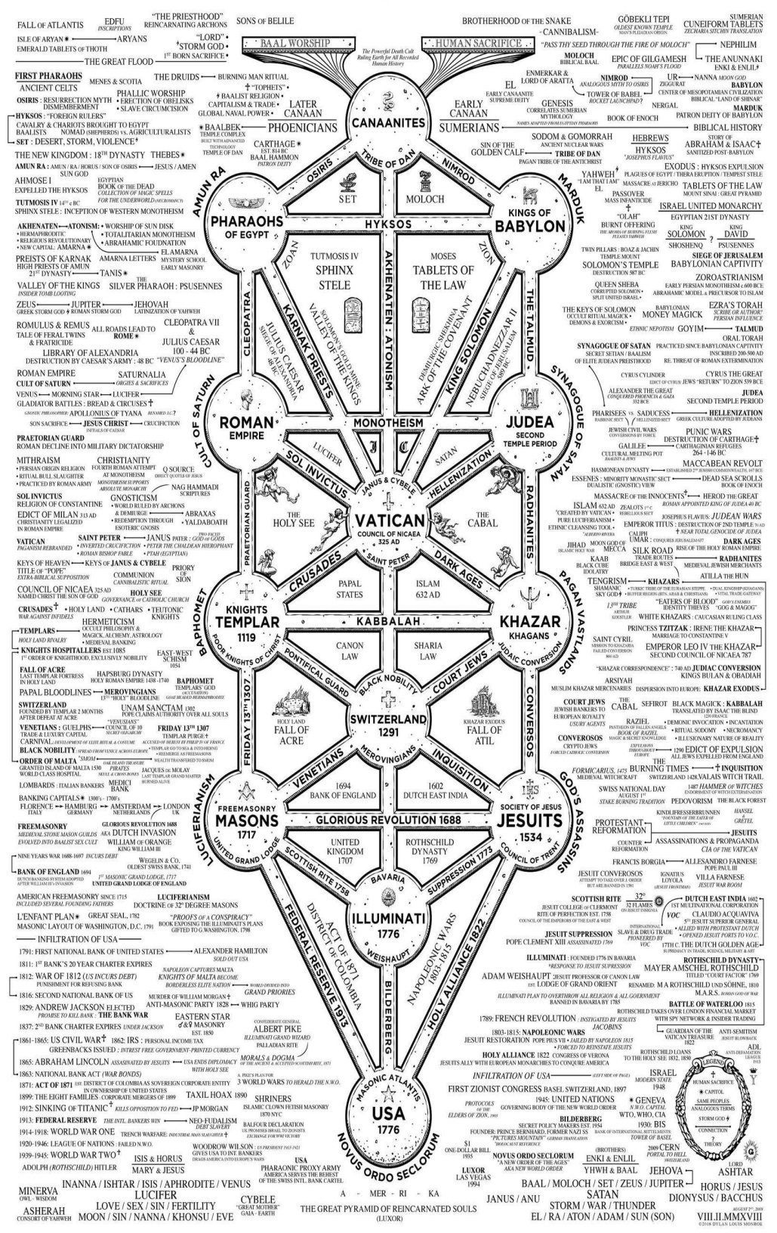



Go to http://www.energyenhancement.org

for 42 Free –On Sign-Up - Energy Enhancement Books and Energy Enhancement Against Satanism Books.
To defeat Evil, you need to up your game.
Learn the Energy Enhancement Meditation Course by Video or Live in Iguazu.
THE ENERGY ENHANCEMENT FOUR LEVEL VIDEO MEDITATION COURSE IS THE ONLY SOLUTION
Here's EXACTLY what you get with the Four Levels of Energy Enhancement Plus the Essential Level 0 support Package for 12 Months - Over 75 Hours of Incredible Teachings by Satchidanand which will enable you to Remove All your Energy Blockages - to Power Up!! To Feel Better, To Become What You Were Born to Be!!
Not so Expensive, Incredible Value!! For Total Life Performance!! For the Removal of All Energy Blockages!! Incredible Savings!
Over several months, in Easy, Bite Sized Chunks, You will learn how Simple it is, to remove All your Energy Blockages.
Incredible, Easy Paced, Full Tuition, with the Level 0 Support Package for Each of the Four Levels of Energy Enhancement!
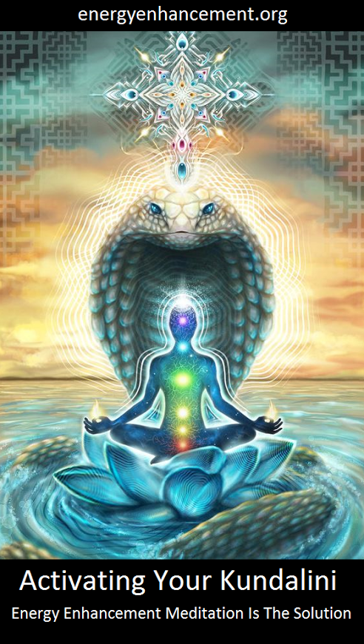
Energy Enhancement LEVEL 1 Meditation is Included in this course! Immortality - Activate the Antahkarana! Gain Infinite Energy from the Chakras above the Head - Power UP!! Open Your Third Eye, Gain Super Samadhi Kundalini Alchemical VITRIOL Energy. Ground All Negative Energies. Learn Super Strong Psychic Protections in Preparation for the Seven Step Process to totally remove Blockages of Level 2. Access Quantum Immortality - Level 1 - 25 hours of video tuition http://www.energyenhancement.org/Level1.htm
Initiation 1 Meditation
Initiation 2 The Kundalini Kriyas - The 5 Taoist Circulations of the Qi, Energy Orbits, Energy Circulation
Initiation 3 The Kundalini Kriyas - Alchemical VITRIOL to Ground Negative Energies
Initiation 4 The Kundalini Kriyas - The God Connection to Infinite Energy
Initiation 5 Open the Third Eye, Open the Heart, Achievement of Everything you Want.
Initiation 6 Psychic Protection against Attack - Power Towers
Initiation 7 Psychic Protection against Attack - Pyramid Protection
Initiation 8 Psychic Protection against Attack - The Merkaba

After Level 1 we utilise the Energy Enhancement Seven Step Process to remove all Energy Blockages to our eyes, to our Third Eyes, to see, to access the Infinite positive flow of Spiritual Energy which descends like the dew from Heaven above upon it's place beneath.
It is twice blessed.
First by he who gives.
And then by he who receives.
And, as we receive with Energy Enhancement Meditation such an Infinite supply of positivity, of Infinite positive Energy from the Infinite Chakras above the head, and as it descends I promise you the most intense emotion you have ever experienced - 24 hours a day, every day!
Energy Enhancement testimonials http://www.energyenhancement.org/page17.htm
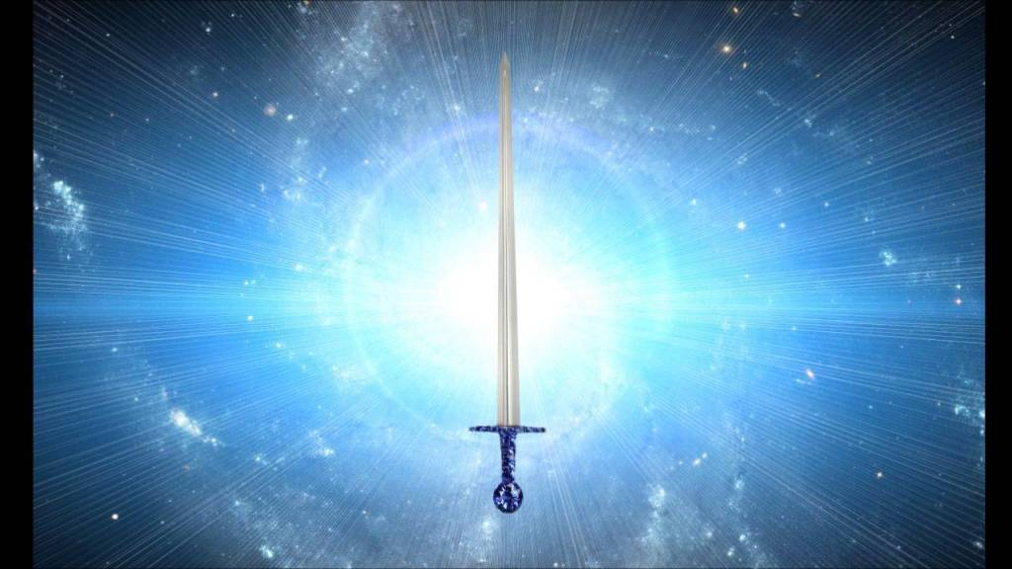
Energy Enhancement LEVEL 2 - The Energy Enhancement Seven Step Process to Totally Remove Energy Blockages, Totally Remove All Problems, Totally Remove Negative Emotions, Heal Your DNA, Remove your Karma - OPEN YOUR LIFE!! http://www.energyenhancement.org/Level2.htm
Initiation 1 The Seven Step Process to Remove Blockages.
Initiation 2 Removing Bodily Disease and Pain
Initiation 3 Heal your DNA
Initiation 4 Remove Energy Blockages from the Aura
THE KARMA CLEANING PROCESS
Initiation 5 Remove Energy Blockage Karma From Your Time in the Womb
Initiation 6 Remove Energy Blockage Karma From Your Current Life
Energy Enhancement testimonials http://www.energyenhancement.org/page17.htm
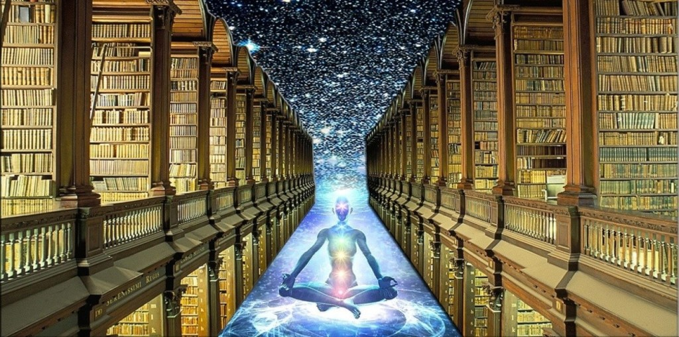
Energy Enhancement LEVEL 3 - Eliminate even Deeper Energy Blockages - The Removal of Strategies. Quantum Integration. The Karma Cleaning Process to Totally Eliminate All Your Karma, all your Trauma, all your Energy Blockages from All your Past Lifetimes!!
http://www.energyenhancement.org/Level3.htm
Here we are talking Zen Master Hogen.
He said, "By Meditating we can change our messy life painting into a clean white sheet again."
Here he is saying that Meditation can with Intensity of Feeling, ground all the negativity, all the negative emotions, all the energy blockages attached to your memories that ever happened to you in this lifetime
He said, "I spent all my previous lifetimes making Guiness. Now in this lifetime I am drinking all the Guiness!"
Here he is saying that with Passionate Energy Enhancement Samyama Meditation can ground all the negativity, all the negative emotions, all the energy blockages attached to your memories that ever happened to you in all your previous lifetimes.
If you can use Energy Enhancement Meditation to Ground all that negative energy from your past, to remove those dense, deep, energy blockages not only from this lifetime, but from all your previous lifetimes...
Can you Imagine what that will Feel Like?
Today’s a brand new day!!
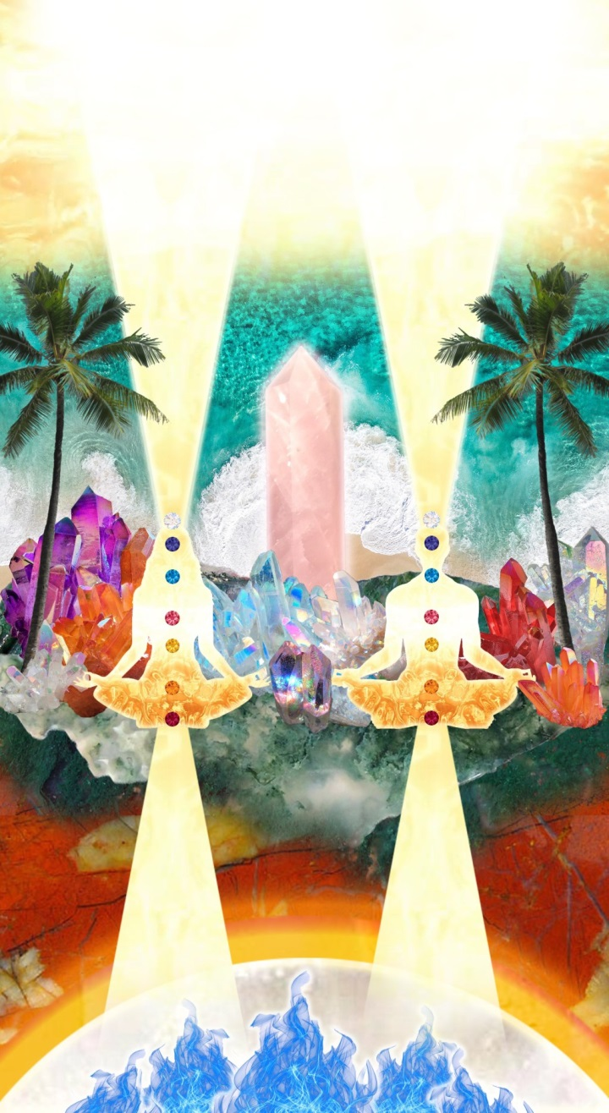
THE KARMA CLEANING PROCESS CONTINUES
Initiation 1 Remove Energy Blockage Karma From All Your past Lives
Initiation 2 Remove Energy Blockage Karma From Your Future Lives
Initiation 3 Remove Energy Blockage Inner Children
Initiation 4 Remove Energy Blockage Vampire Strategies
Initiation 5 Remove Energy Blockage Negative Emotions
Initiation 6 The Seven Step purification of talents and the creation and increase of talents
Initiation 7 Removing Energy Blockage Vows from Past Lifetimes
Initiation 8: The Achievement of all your Goals and Ambitions using Energy Enhancement Samyama
Initiation 9 Removing the Energy Blockages from Daily Life Illogical Actions and Driven Emotions.
Energy Enhancement testimonials http://www.energyenhancement.org/page17.htm

Energy Enhancement LEVEL 4 - Stop the Suck!! Heal All your Relationships!! Find Your Twin Flame!! MASTER ENERGY CONNECTIONS AND RELATIONSHIPS, THE PSYCHIC SEXUAL CONNECTION
http://www.energyenhancement.org/Level4.htm
Initiation 1 - Removing Addictions - Food, Alcohol, Smoking, Sex.
Initiation 2 Cleaning Energy Connections - Cutting Energy Connections and Re-connecting Energy Connections - Friends, Children, Partner, Mother, Father - Moving All Relationships to a Higher Level.
Initiation 3 Cutting Energy Connections and Re-connecting Energy Connections - Moving All Relationships to a Higher Level.
Initiation 4 Healing the Soul Connection of Others
Initiation 5 Healing the Psychic Sexual Connection
Initiation 6 Removing the Energy Blockages at the other End of the Connection in People you Connect to - Healing Relationships, Healing Clients.
Initiation 7 Ceremonies and Meditation Groups - Using the Energy of the Higher Heart, The Heart Center in the Head, Prajna Paramita, - The Soul and the Monad Itself, for the Healing of Groups, Organizations and the World.
Energy Enhancement testimonials http://www.energyenhancement.org/page17.htm


THE YOGA SUTRAS OF PATANJALI BY SWAMI SATCHIDANAND - DOWNLOAD HERE..
http://www.energyenhancement.org/Sacred-Energy/yoga-sutras-of-patanjali-book/Energy-Enhancement-Yoga-Sutras-of-Patanjali.pdf
SUPER ENERGY AND SACRED SYMBOLS
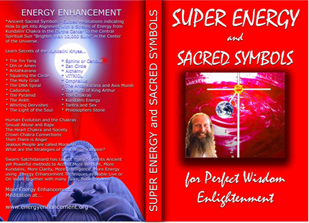
*THE ENERGY ENHANCEMENT BOOK… Ancient Sacred Symbols - Guided Meditations indicating How to get into Alignment with a Stream of Energy from Kundalini Chakra in the Earth’s Center to the Central Spiritual Sun "Brighter than 10,000 Suns" in the Center of the Universe.
Learn Secrets of the Kundalini Kriyas... and more…
Swami Satchidanand has taught many Students Ancient yet Powerful methods to Access More Wisdom, More Kundalini, More Clarity, More Intelligence, More Energy using Energy Enhancement Techniques available Live or On Video together with many Talks, Books, Videos.
ENERGY ENHANCEMENT TWO – REMOVAL OF ENERGY BLOCKAGES, MANAGING ENERGY CONNECTIONS AND MASTERY OD RELATIONSHIPS
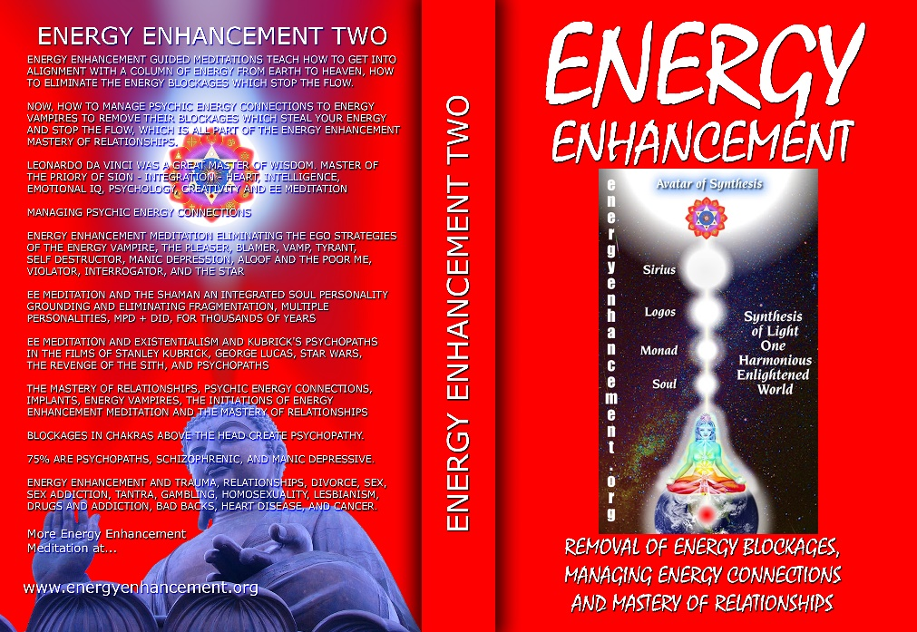
ENERGY ENHANCEMENT GUIDED MEDITATIONS TEACH HOW TO GET INTO ALIGNMENT WITH A COLUMN OF ENERGY FROM EARTH TO HEAVEN, HOW TO ELIMINATE THE ENERGY BLOCKAGES WHICH STOP THE FLOW.
NOW, HOW TO MANAGE PSYCHIC ENERGY CONNECTIONS TO ENERGY VAMPIRES TO REMOVE THEIR BLOCKAGES WHICH STEAL YOUR ENERGY AND STOP THE FLOW, WHICH IS ALL PART OF THE ENERGY ENHANCEMENT MASTERY OF RELATIONSHIPS.
LEONARDO DA VINCI WAS A GREAT MASTER OF WISDOM. MASTER OF THE PRIORY OF SION - INTEGRATION - HEART, INTELLIGENCE, EMOTIONAL IQ, PSYCHOLOGY, CREATIVITY AND EE MEDITATION MANAGING PSYCHIC ENERGY CONNECTIONS ENERGY ENHANCEMENT MEDITATION ELIMINATING THE EGO STRATEGIES OF THE ENERGY VAMPIRE, THE PLEASER, BLAMER, VAMP, TYRANT, SELF DESTRUCTOR, MANIC DEPRESSION, ALOOF AND THE POOR ME, VIOLATOR, INTERROGATOR, AND THE STAR
EE MEDITATION AND THE SHAMAN AN INTEGRATED SOUL PERSONALITY GROUNDING AND ELIMINATING FRAGMENTATION, MULTIPLE PERSONALITIES, MPD + DID, FOR THOUSANDS OF YEARS
EE MEDITATION AND EXISTENTIALISM AND KUBRICK'S PSYCHOPATHS IN THE FILMS OF STANLEY KUBRICK, GEORGE LUCAS, STAR WARS, THE REVENGE OF THE SITH, AND PSYCHOPATHS
THE MASTERY OF RELATIONSHIPS, PSYCHIC ENERGY CONNECTIONS, IMPLANTS, ENERGY VAMPIRES, THE INITIATIONS OF ENERGY ENHANCEMENT MEDITATION AND THE MASTERY OF RELATIONSHIPS
BLOCKAGES IN CHAKRAS ABOVE THE HEAD CREATE PSYCHOPATHY.
75% ARE PSYCHOPATHS, SCHIZOPHRENIC, AND MANIC DEPRESSIVE.
ENERGY ENHANCEMENT AND TRAUMA, RELATIONSHIPS, DIVORCE, SEX, SEX ADDICTION, TANTRA, GAMBLING, HOMOSEXUALITY, LESBIANISM, DRUGS AND ADDICTION, BAD BACKS, HEART DISEASE, AND CANCER.

Buy all Books and DVD’s at: amazon.com
www.energyenhancement.org
DVD 1 - KUNDALINI CHAKRA MEDITATION
HEART SUTRA – HIGHEST HEART OF WISDOM MEDITATION

*ENERGY ENHANCEMENT MEDITATION DVD 1… Guided Meditation to Access Kundalini Chakra, VITRIOL, The Philosopher’s Stone, Kriya Yoga and the Kundalini Kriyas.
Heart Sutra, All Enlightened Sages for Thousands of Years Live From the Highest Heart of Wisdom.

Buy all Books and DVD’s at: amazon.com
www.energyenhancement.org

DVD 2 - HIGHEST HEART OF GENIUS WISDOM MEDITATION

Guided Meditation to Access Higher Wisdom Chakras above the Head connecting you with the Higher Energies of Nirvana, God – Love, Wisdom, Genius, Integration and Peace and the Creation of the Antahkarana.
How this Guided Meditation is given in Secrets of Shakespeare, The Holy Trinity, The Holy Grail and the Sanskrit meaning of Satchidanand.
Swami Satchidananda has been teaching this Meditation to many students over the years and every one has had Shaktipat and increased Kundalini experiences of Chit Shakti together with increased feelings of Intelligence, Genius, Energy and Peace.
BOOK - GAIN SUPER ENERGY
ENERGY ENHANCEMENT LEVEL 1
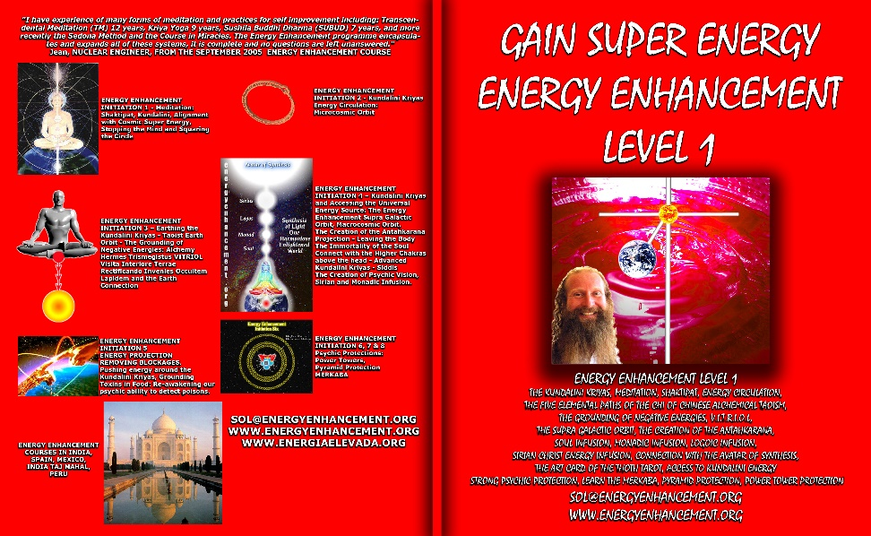
READ… The Kundalini Kriyas, Meditation, Shaktipat, Energy Circulation, The Five Elemental Paths of the Chi of Chinese Alchemical Taoism, The Grounding of Negative Energies, V.I.T.R.I.O.L., The Supra Galactic orbit, The Creation of the Antahkarana, Soul Infusion, Monadic Infusion, Logoic Infusion, Sirian Christ Energy Infusion, Connection with the Avatar of Synthesis, The Art Card of the Thoth Tarot, Access to Kundalini Energy Strong Psychic Protection, Learn the Merkaba, Pyramid Protection, Power Tower Protection.
Buy all Books and DVD’s at: amazon.com
www.energyenhancement.org
THE ENERGY ENHANCEMENT FOUR INITIATION DVD COURSE - THE ULTIMATE TECHNIQUES ON 15 DVDs

“I have experience of many forms of meditation and practices for self improvement including: Transcendental Meditation (TM) 12 years, Kriya Yoga 9 years, Sushila Buddhi Dharma (SUBUD) 7 years, and more recently the Sedona Method and the Course in Miracles. The Energy Enhancement programme encapsulates and expands all of these systems, it is complete and no questions are left unanswered.”
JEAN, NUCLEAR ENGINEER, FROM SEPTEMBER 2005 ENERGY ENHANCEMENT COURSE
ENERGY ENHANCEMENT LIVE COURSES – WORLDWIDE
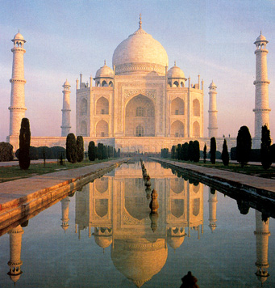
INDIA, 5 STAR INDIA TAJ MAHAL, SPAIN, MEXICO, PERU, ARGENTINA – MORE
Bookings: www.energyenhancement.org

EE LEVEL 1 POWER UP!! GAIN SUPER ENERGY http://www.energyenhancement.org/Level1.htm
EE LEVEL 2 ELIMINATE ENERGY BLOCKAGES http://www.energyenhancement.org/Level2.htm
EE LEVEL 3 CLEAN KARMA BLOCKAGES AND PAST LIFE KARMA BY TRANSMUTATION http://www.energyenhancement.org/Level3.htm
EE LEVEL 4 MASTER ENERGY CONNECTIONS AND RELATIONSHIPS http://www.energyenhancement.org/Level4.htm

Go to..
http://www.energyenhancement.org

For 52 Free..
- On Sign-Up - Energy Enhancement Books and Energy Enhancement Against Satanism Books.

To defeat Evil, you need to up your game.

Learn the Energy Enhancement Meditation Course by Video or Live in Iguazu.

ENERGY ENHANCEMENT MEDITATION
ENERGY ENHANCEMENT MEDITATION LEVEL 1 POWER UP!! GAIN SUPER ENERGY http://www.energyenhancement.org/Level1.htm
ENERGY ENHANCEMENT MEDITATION LEVEL 2 ELIMINATE ENERGY BLOCKAGES http://www.energyenhancement.org/Level2.htm
ENERGY ENHANCEMENT MEDITATION LEVEL 3 CLEAN KARMA BLOCKAGES AND PAST LIFE KARMA BY TRANSMUTATION http://www.energyenhancement.org/Level3.htm
ENERGY ENHANCEMENT MEDITATION LEVEL 4 MASTER ENERGY CONNECTIONS AND RELATIONSHIPS http://www.energyenhancement.org/Level4.htm

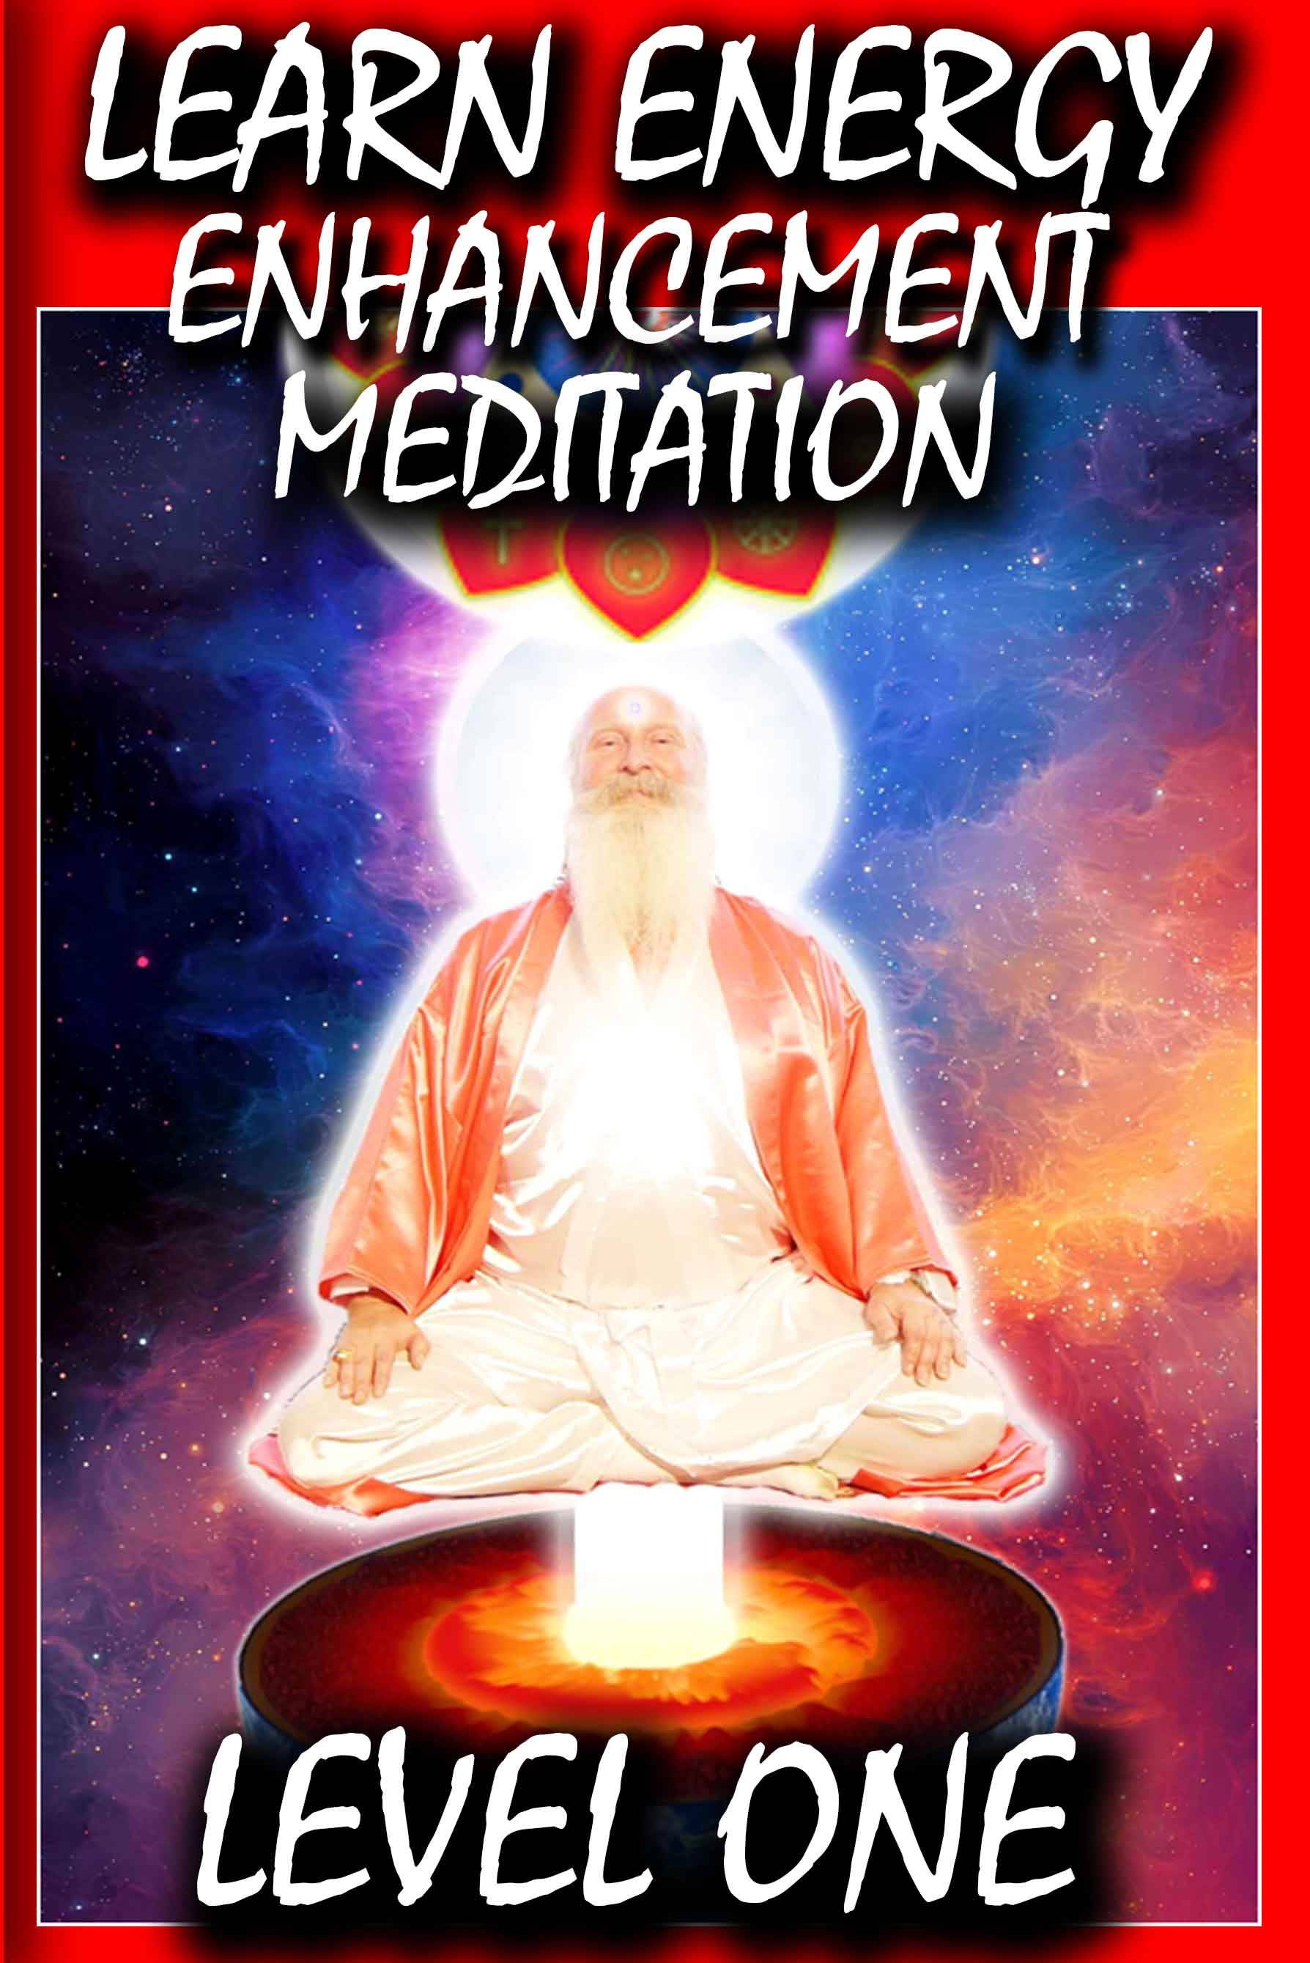

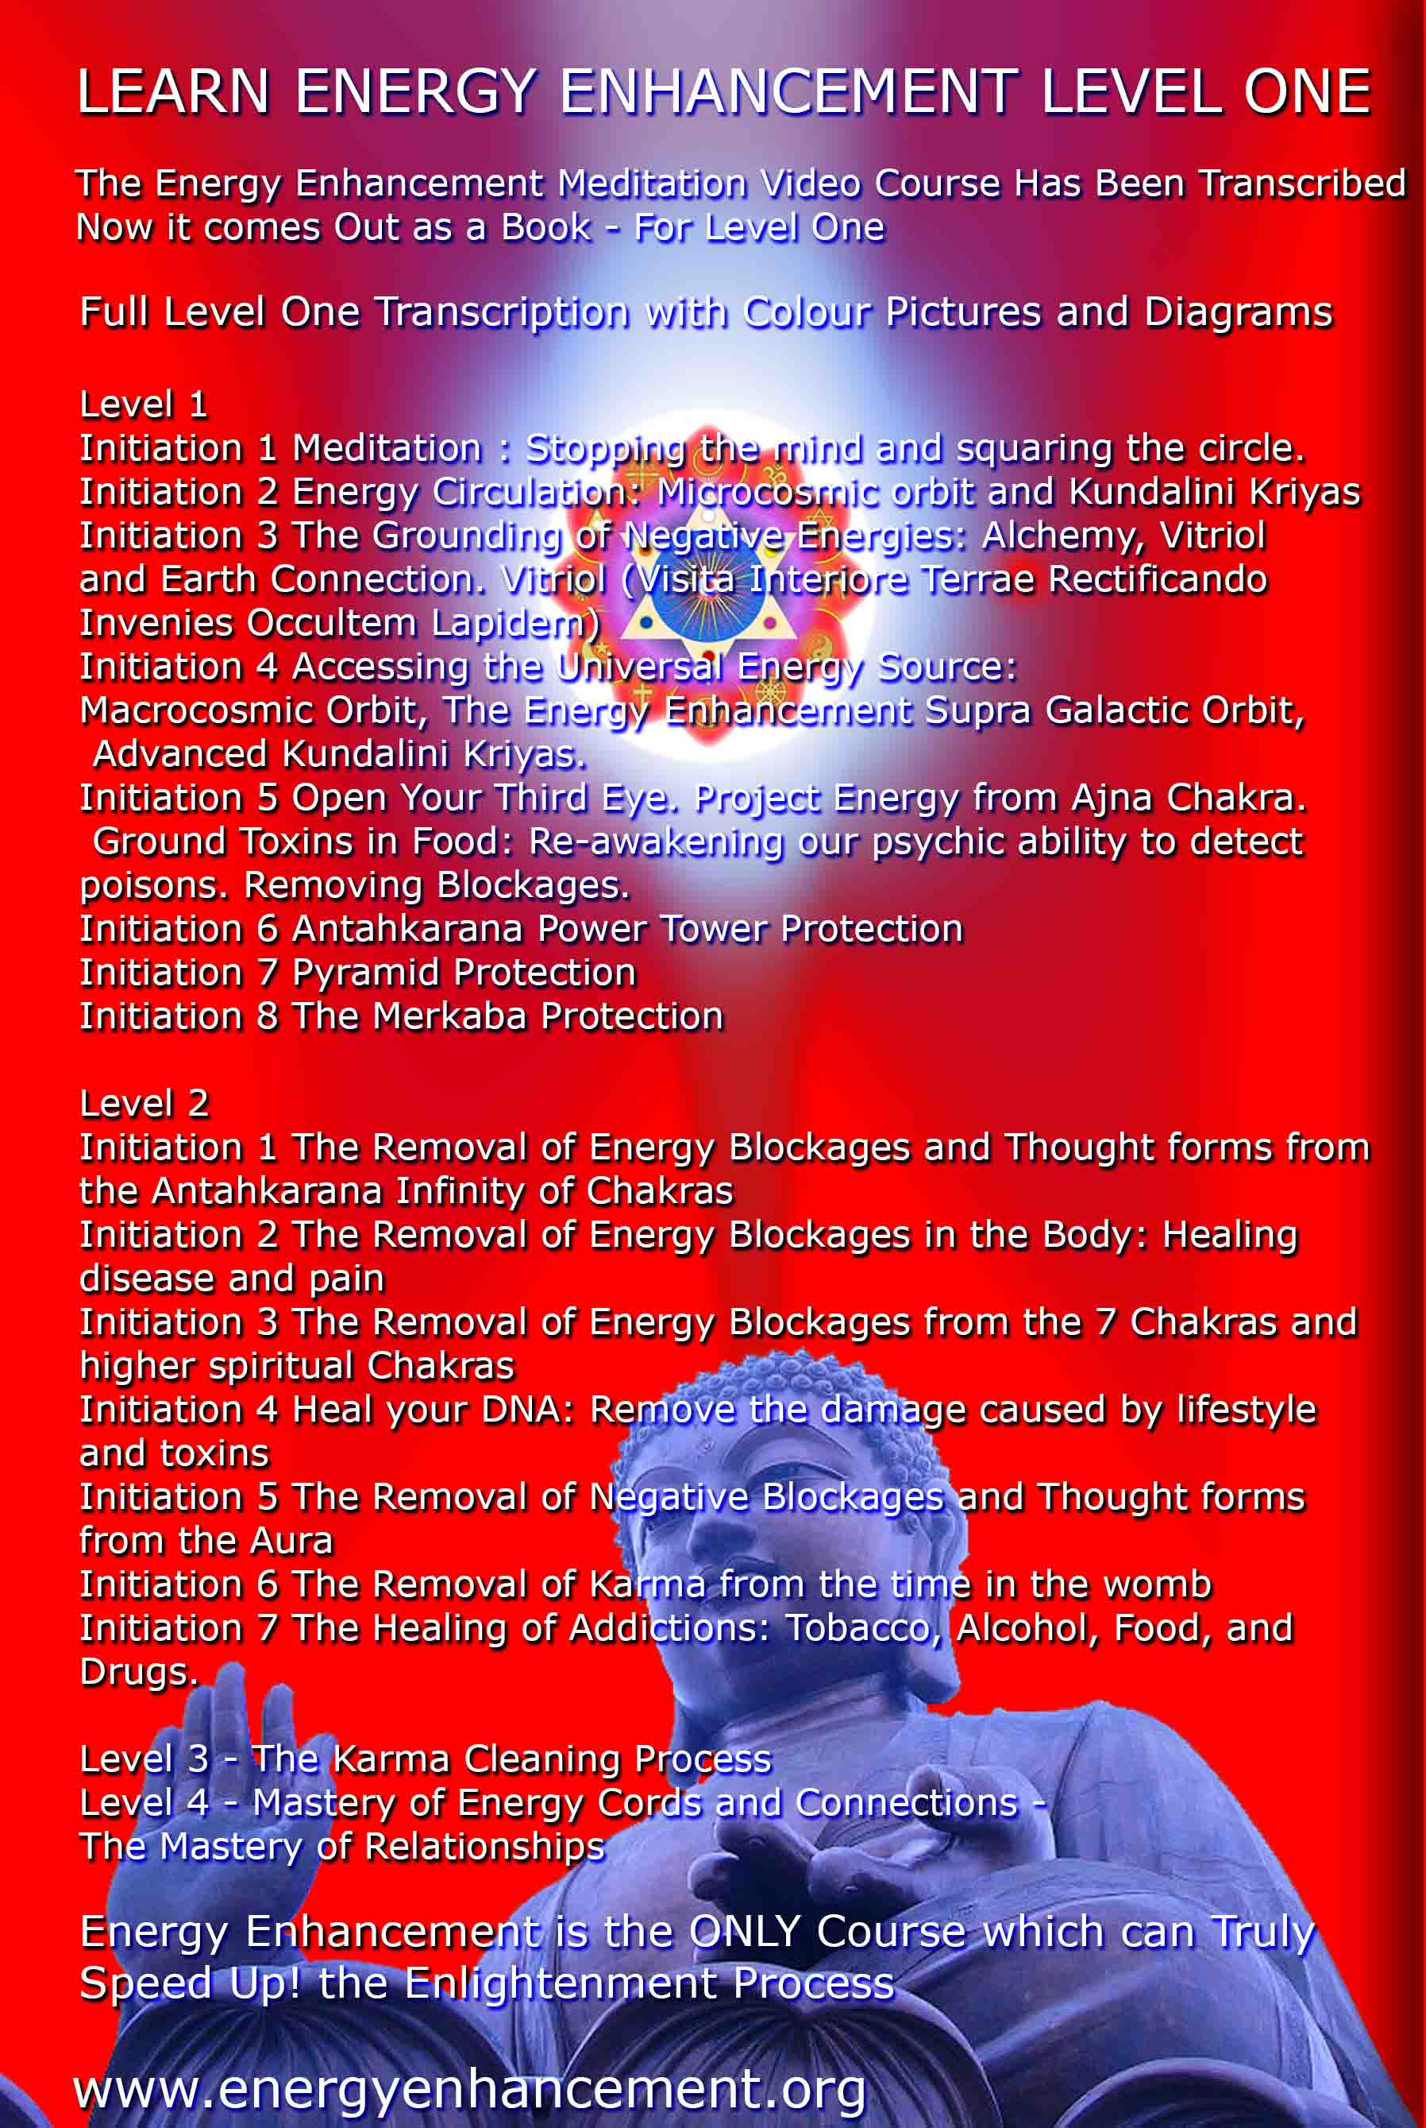

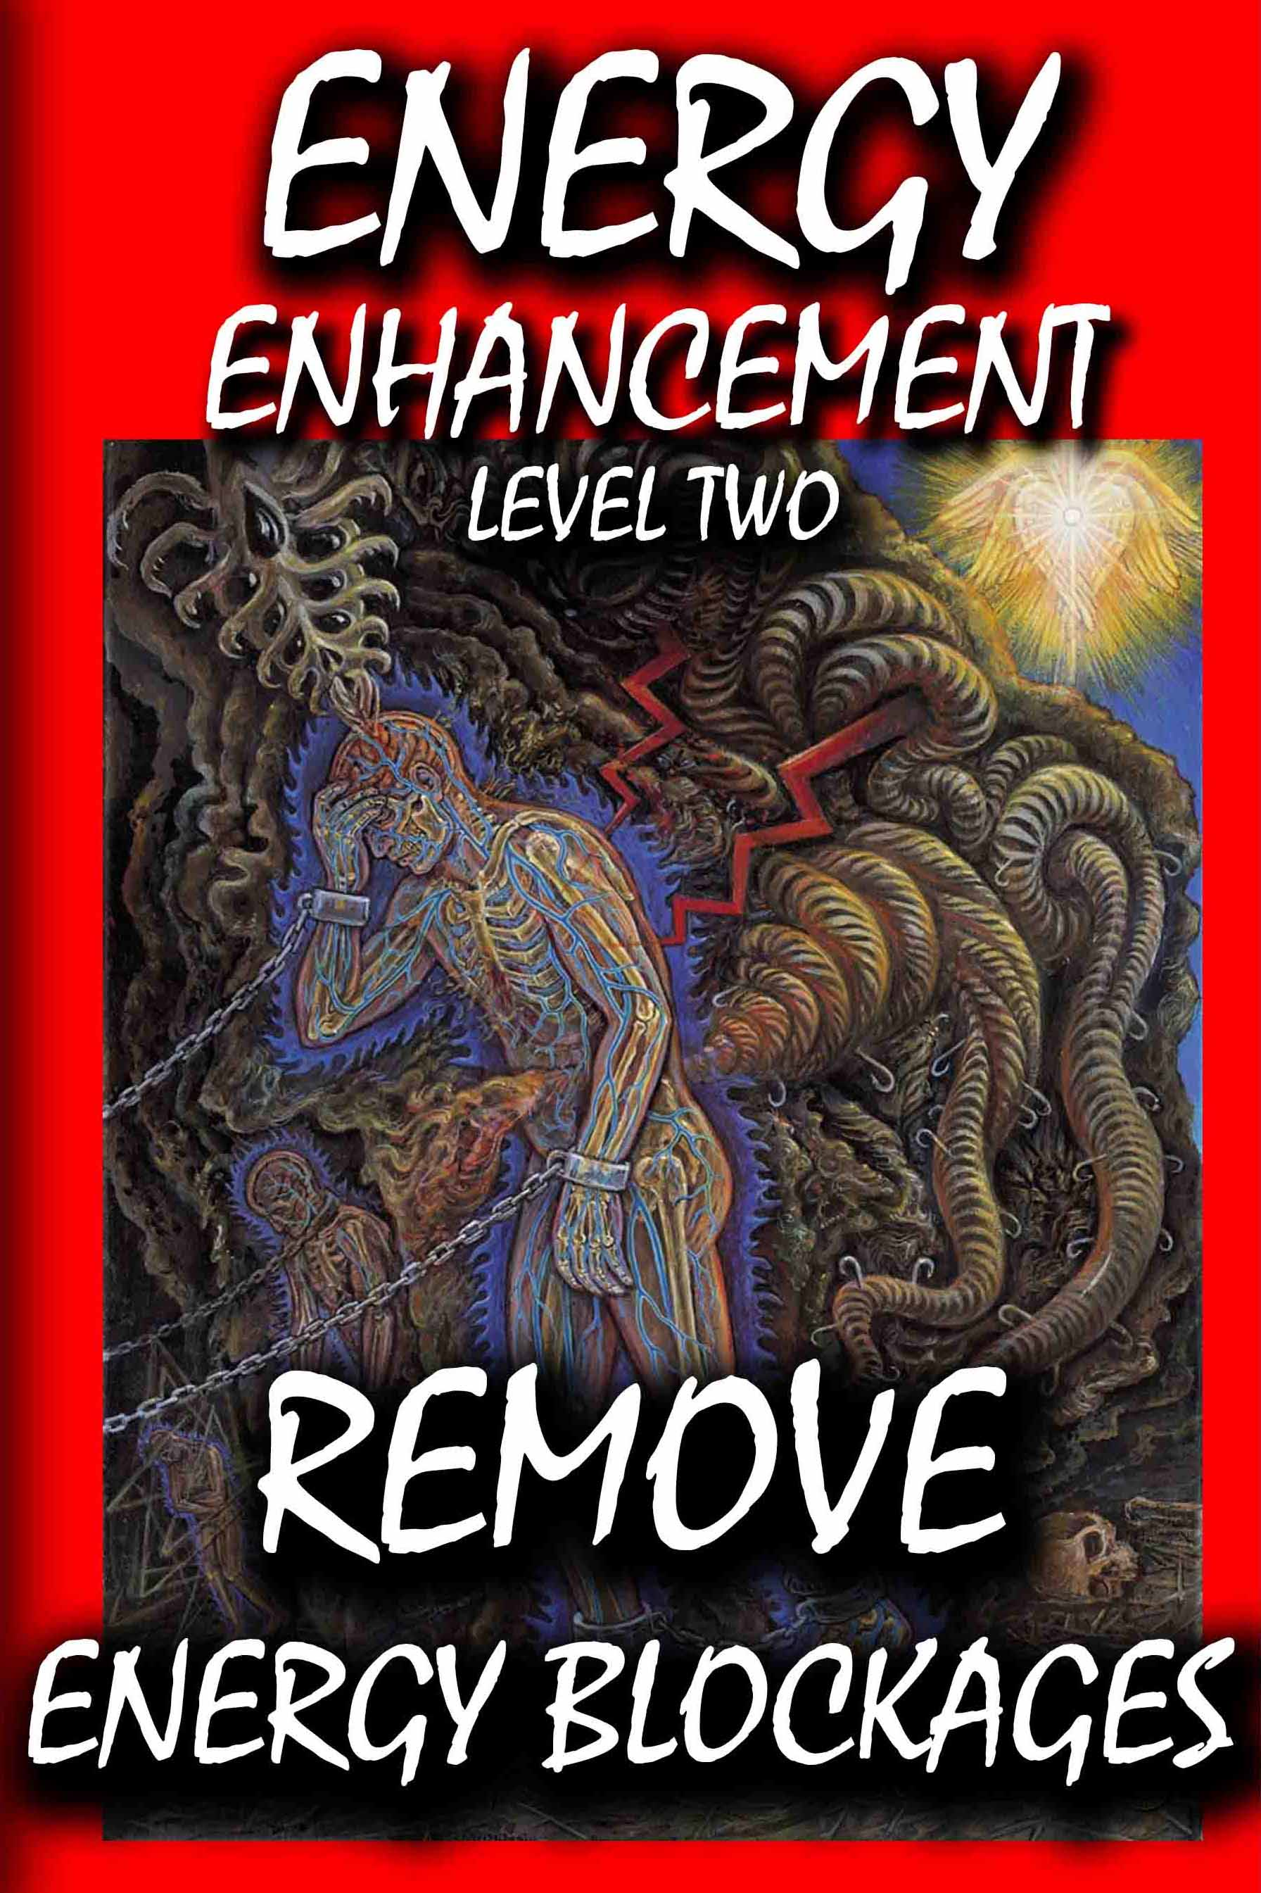



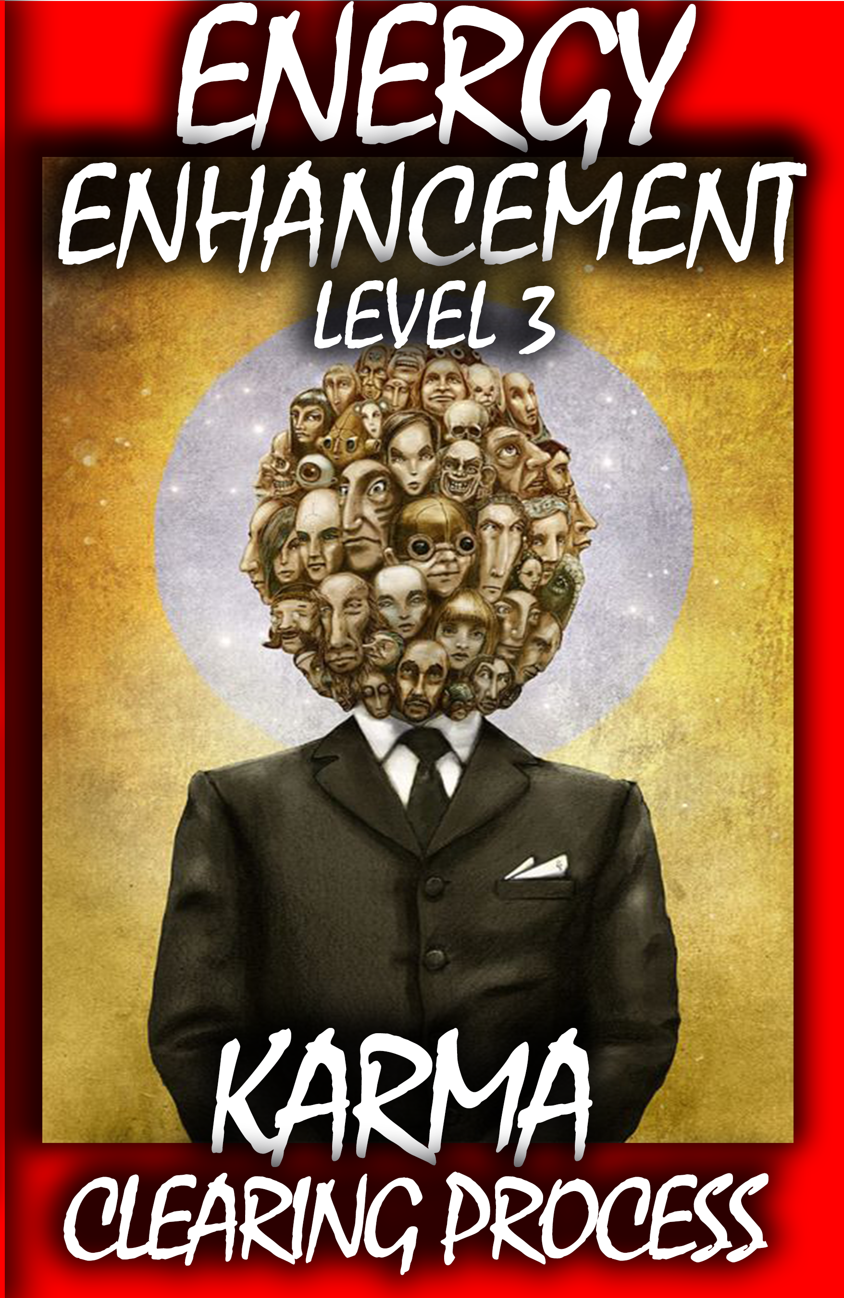



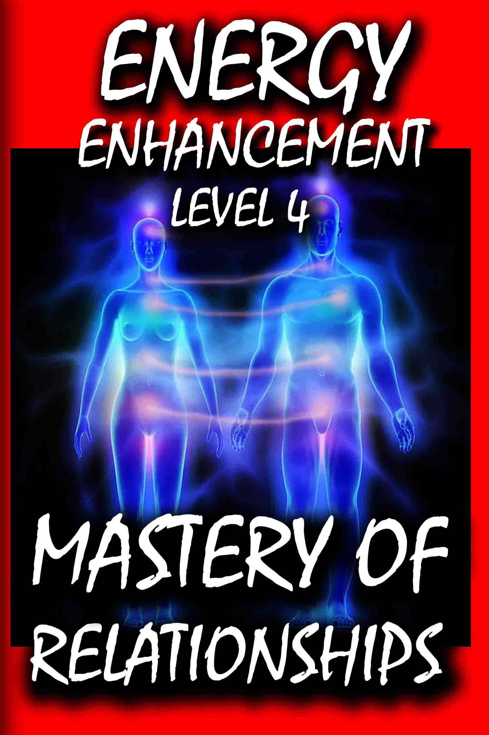

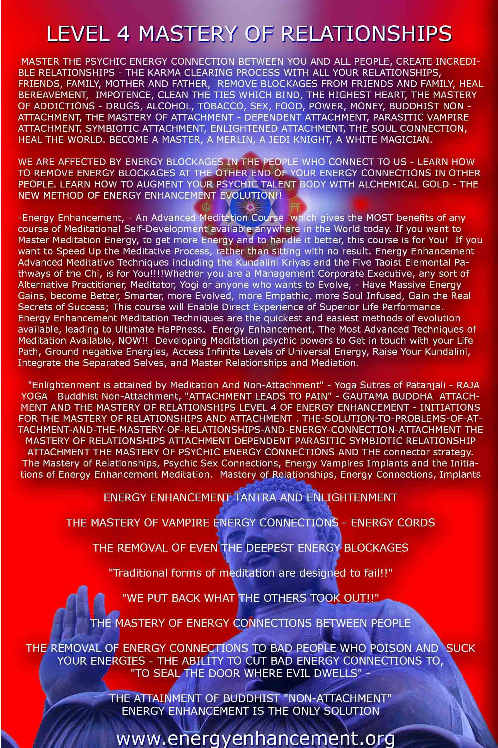

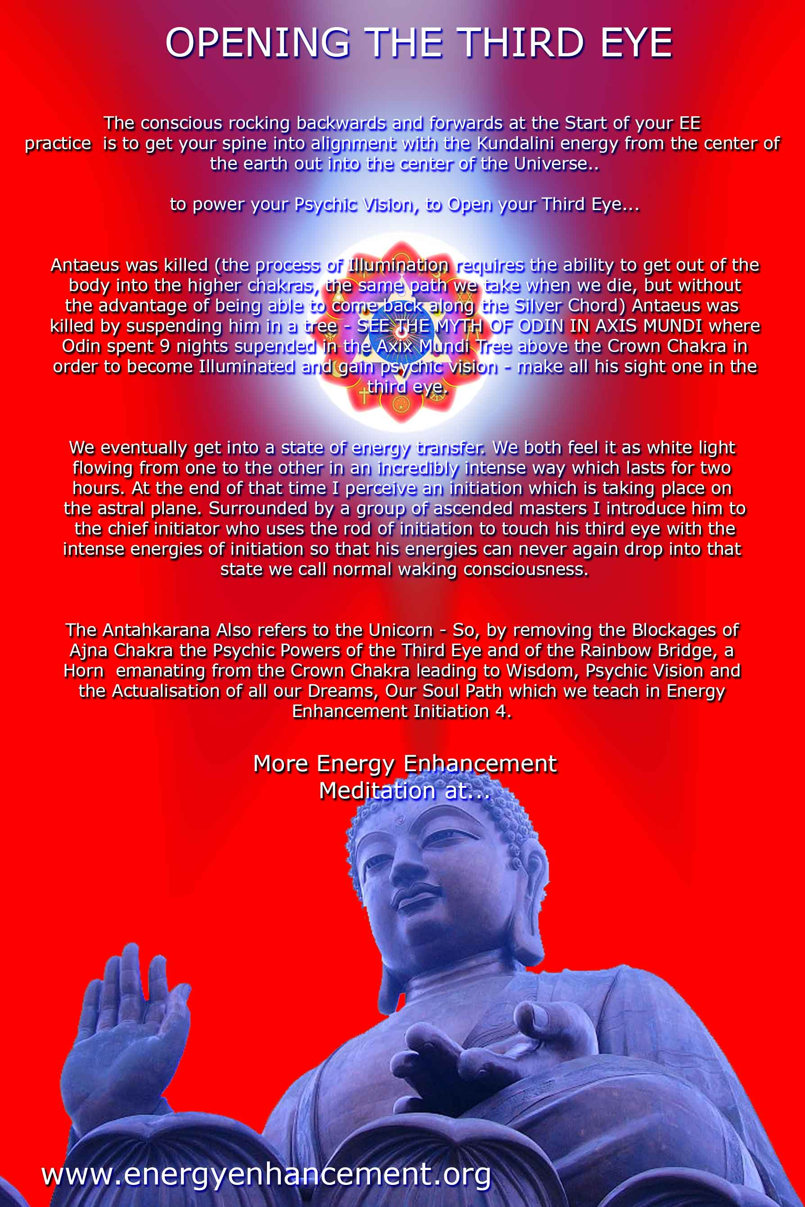


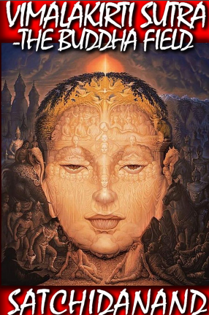

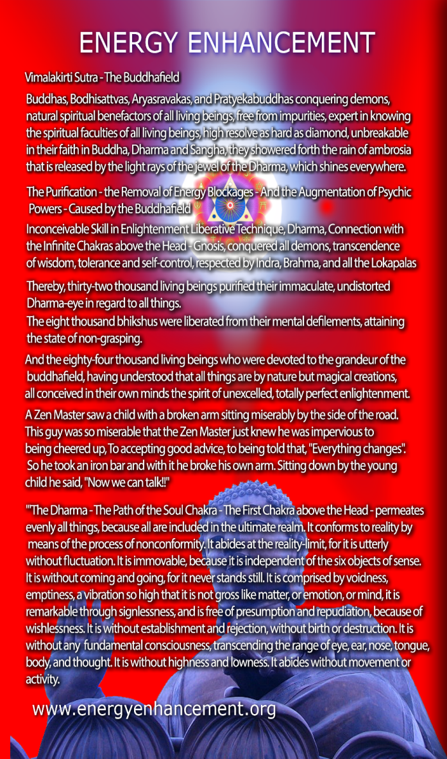
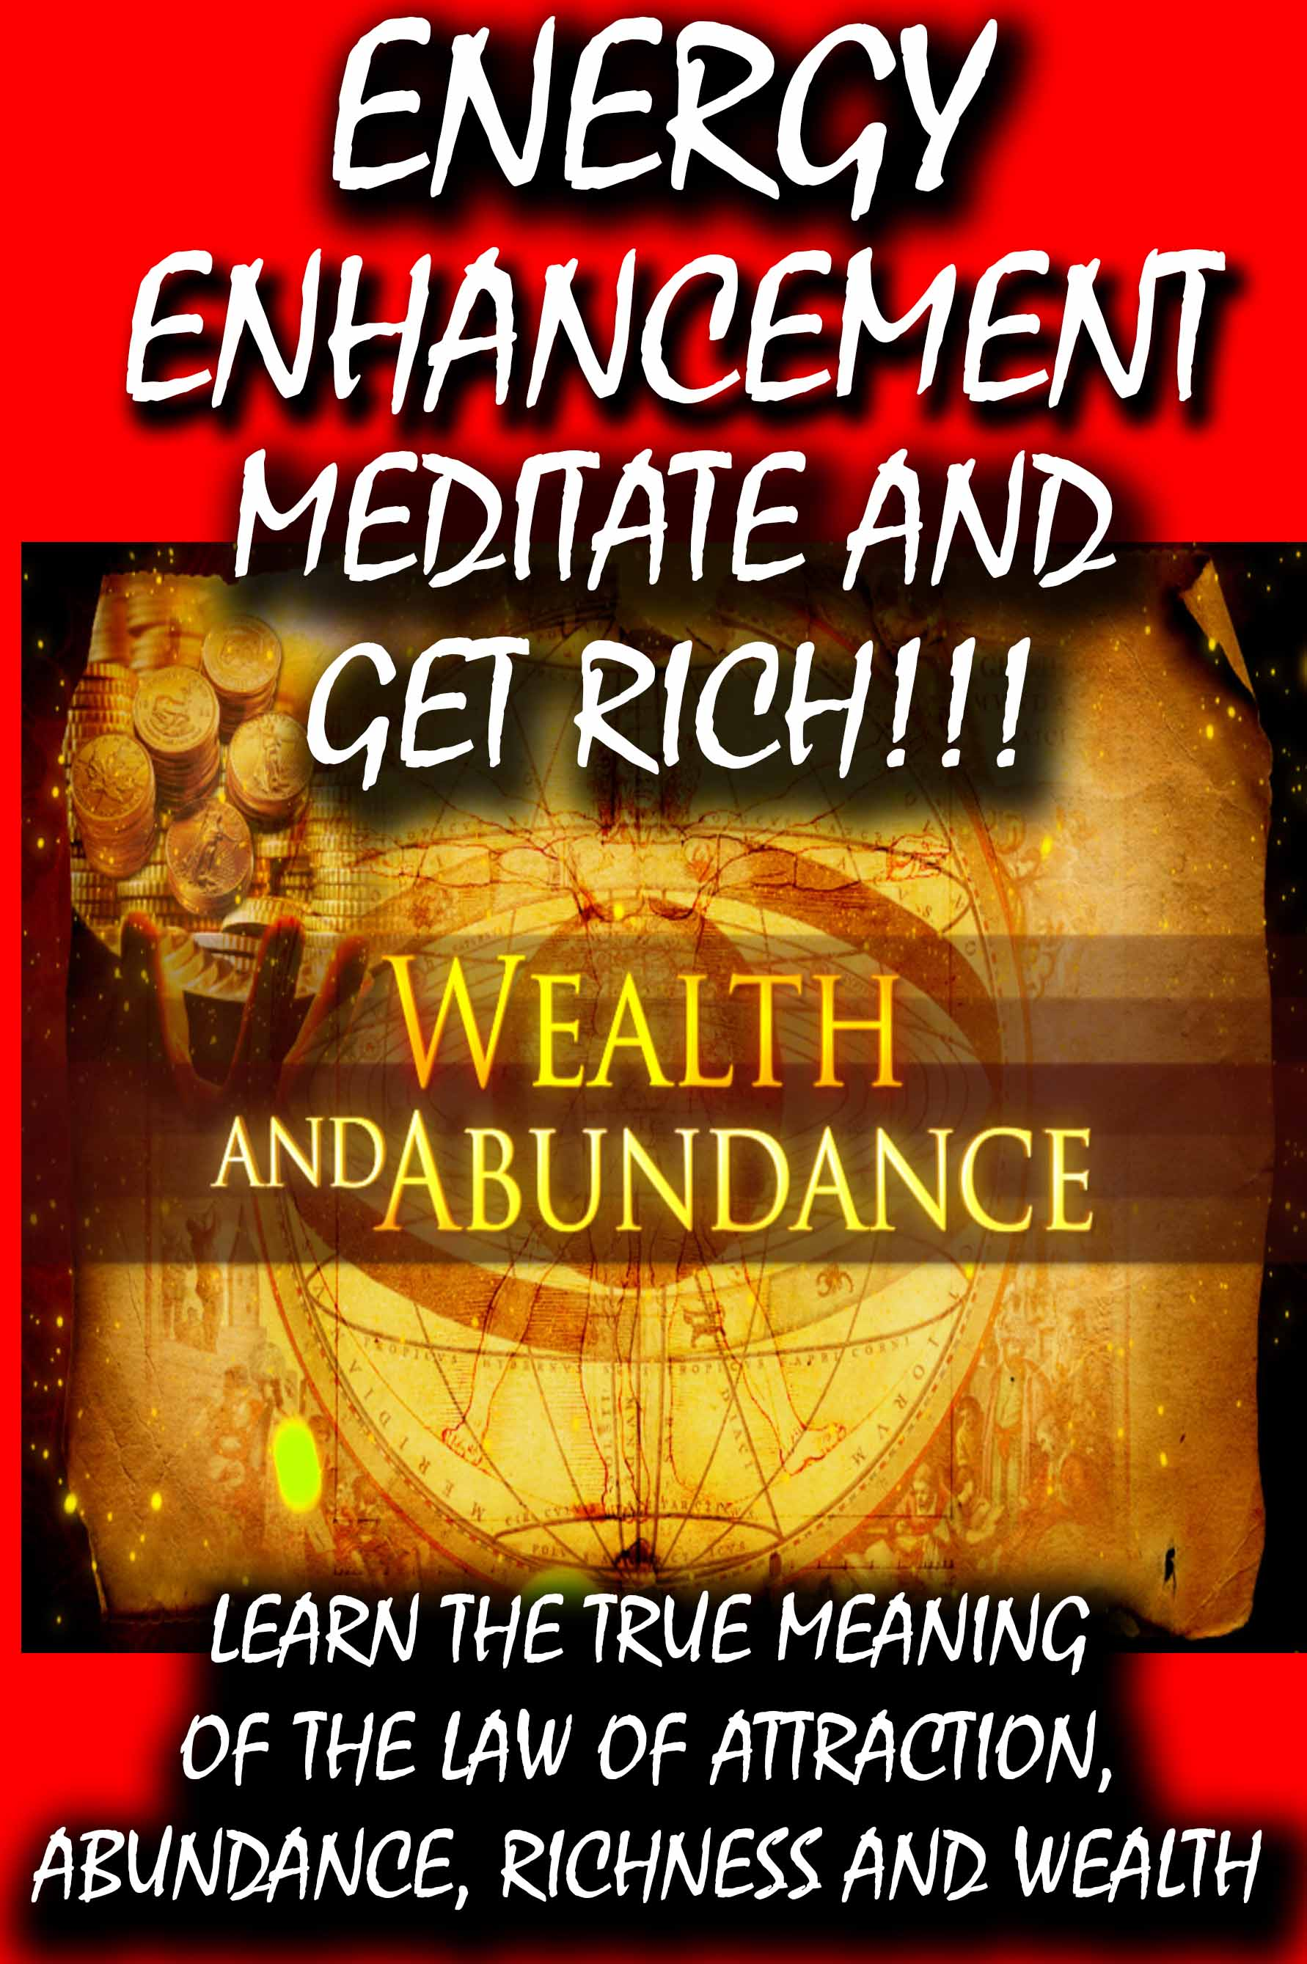
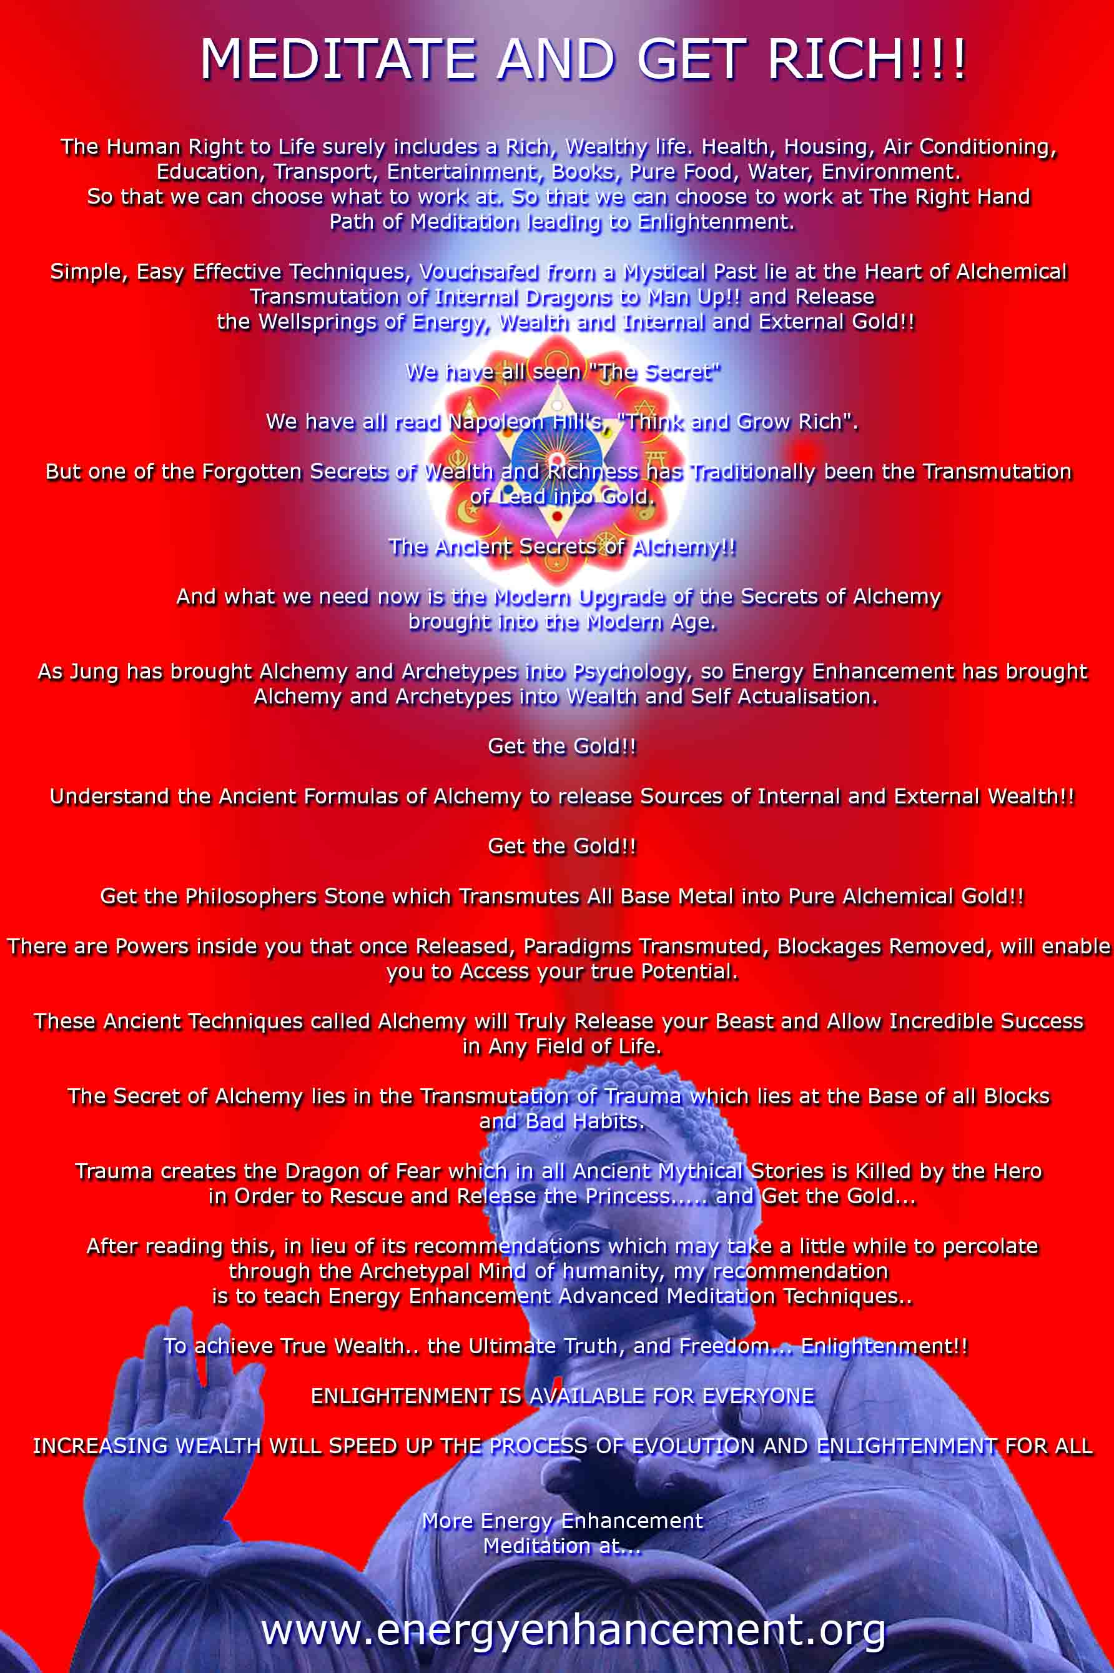
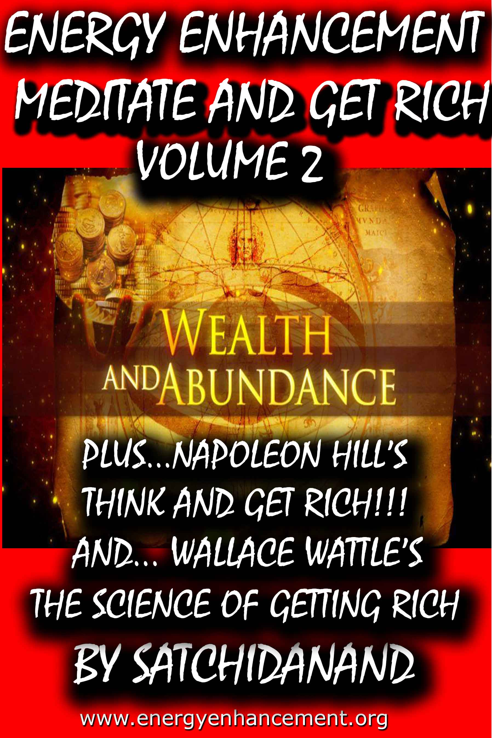
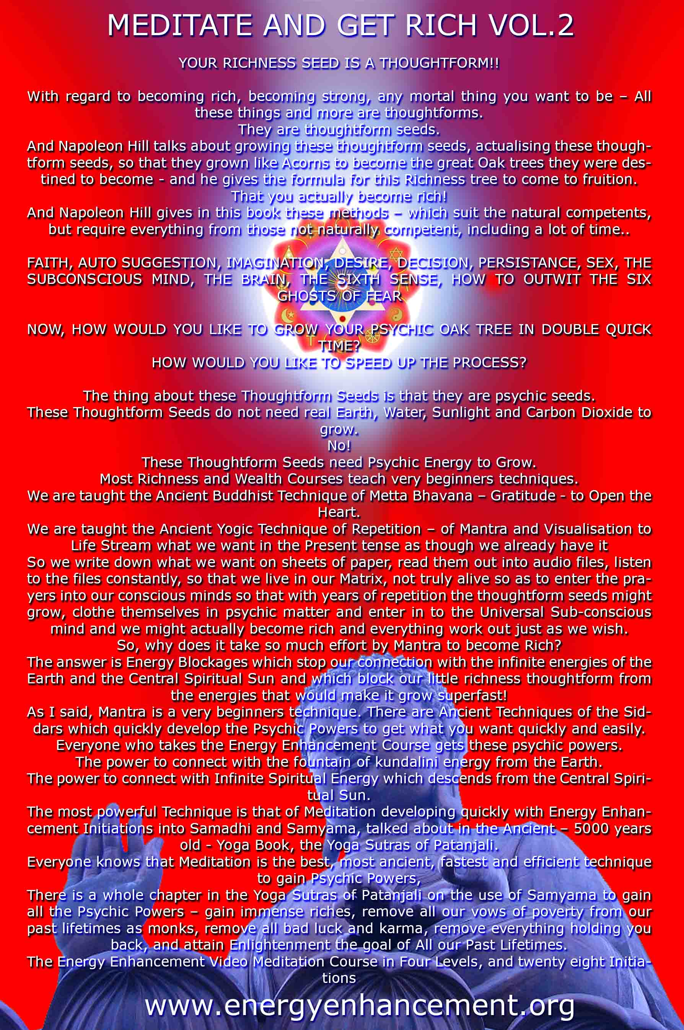

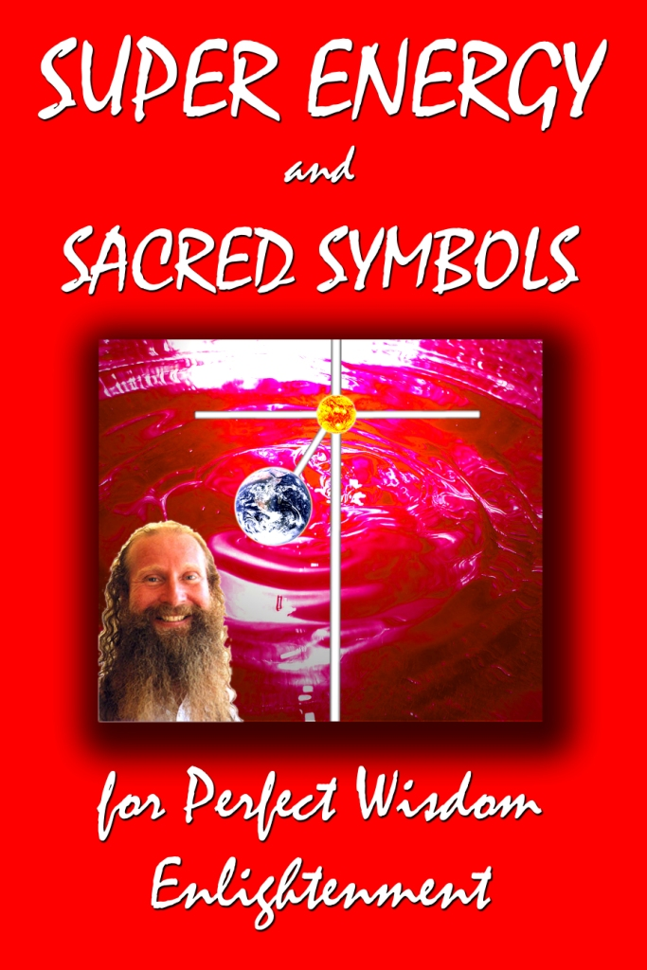

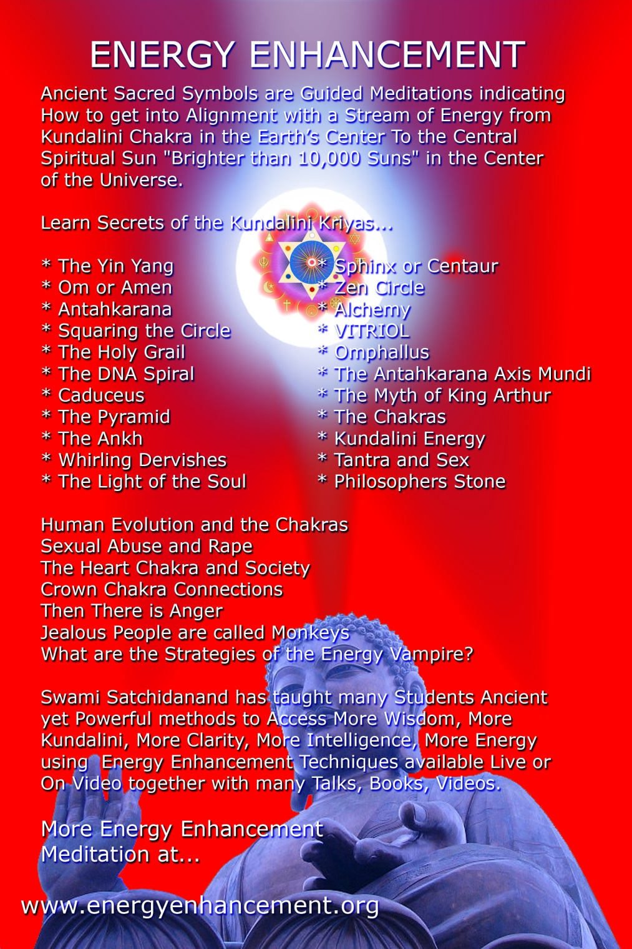

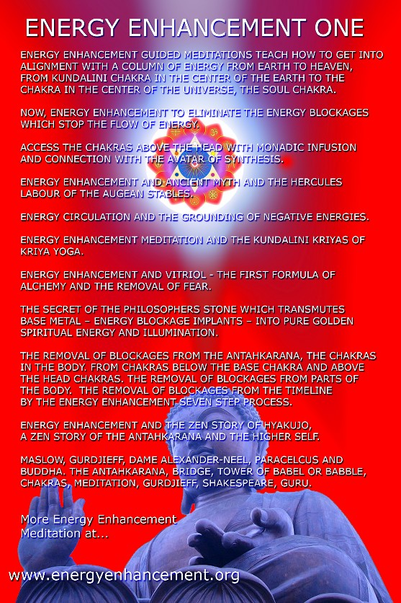
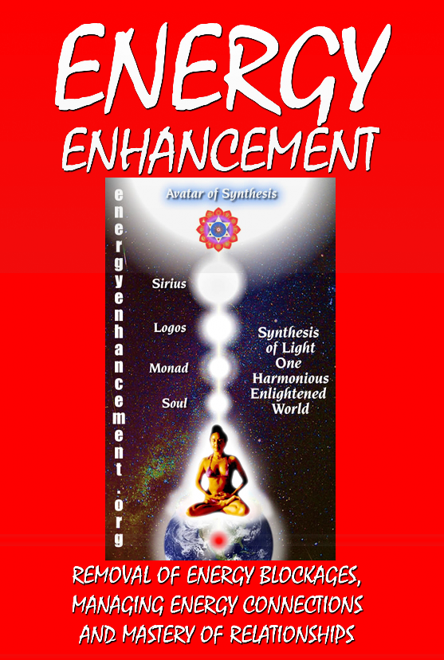
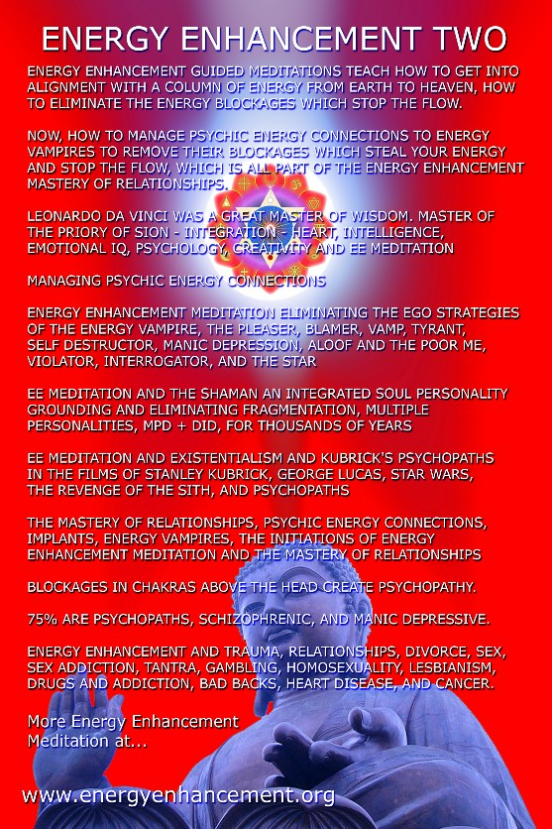
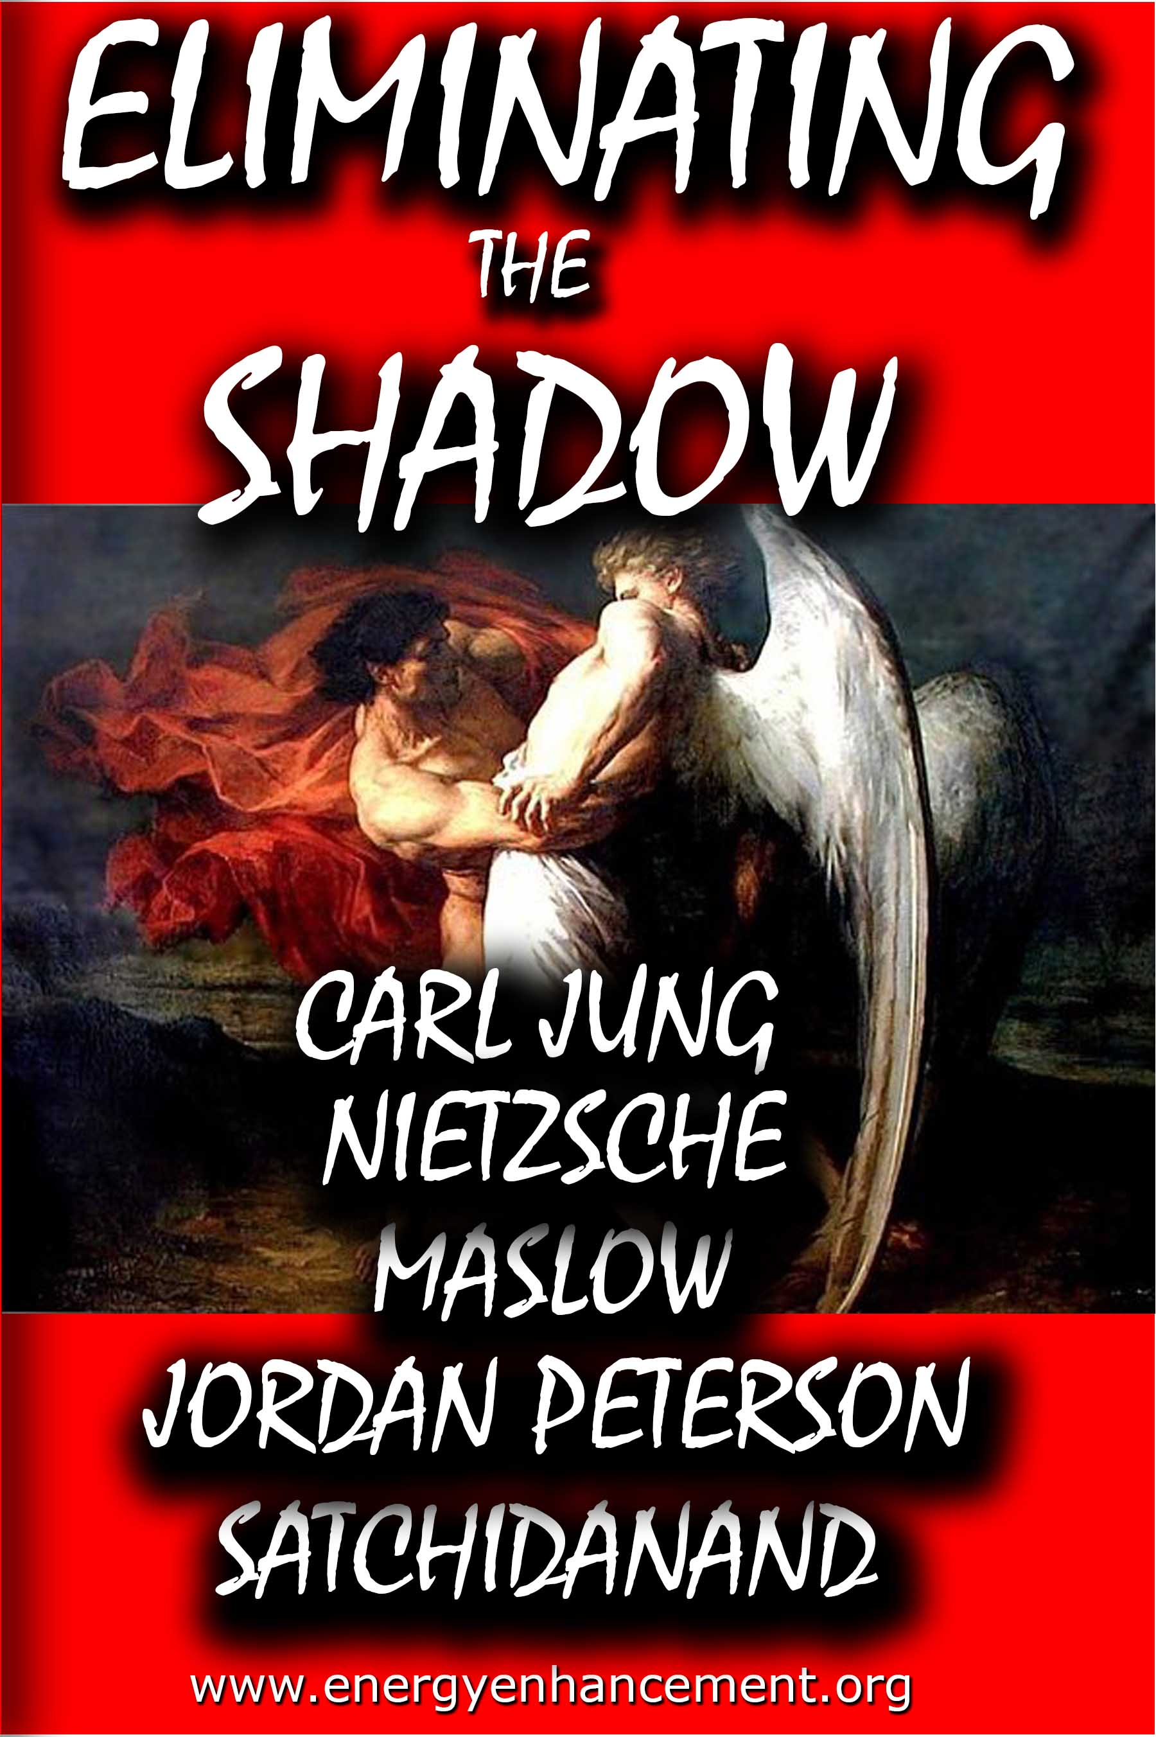
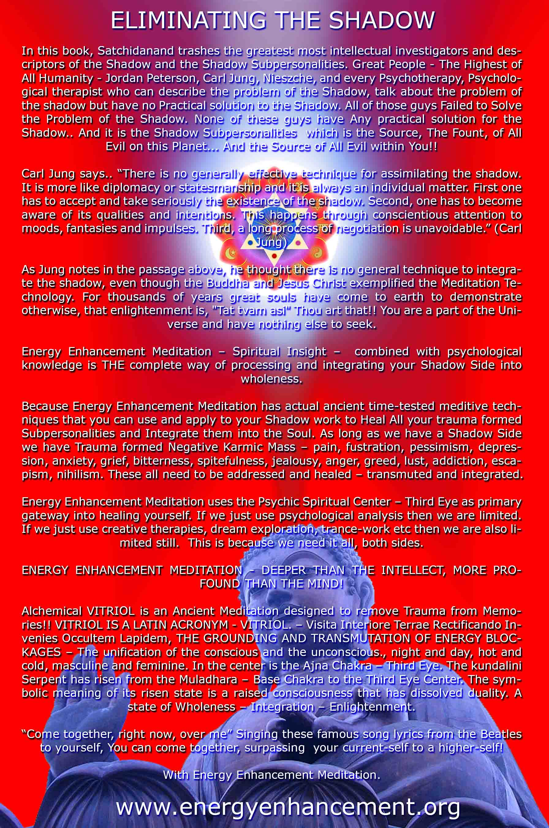

ENERGY ENHANCEMENT MEDITATION
ENERGY ENHANCEMENT MEDITATION LEVEL 1 POWER UP!! GAIN SUPER ENERGY http://www.energyenhancement.org/Level1.htm
ENERGY ENHANCEMENT MEDITATION LEVEL 2 ELIMINATE ENERGY BLOCKAGES http://www.energyenhancement.org/Level2.htm
ENERGY ENHANCEMENT MEDITATION LEVEL 3 CLEAN KARMA BLOCKAGES AND PAST LIFE KARMA BY TRANSMUTATION http://www.energyenhancement.org/Level3.htm
ENERGY ENHANCEMENT MEDITATION LEVEL 4 MASTER ENERGY CONNECTIONS AND RELATIONSHIPS http://www.energyenhancement.org/Level4.htm

