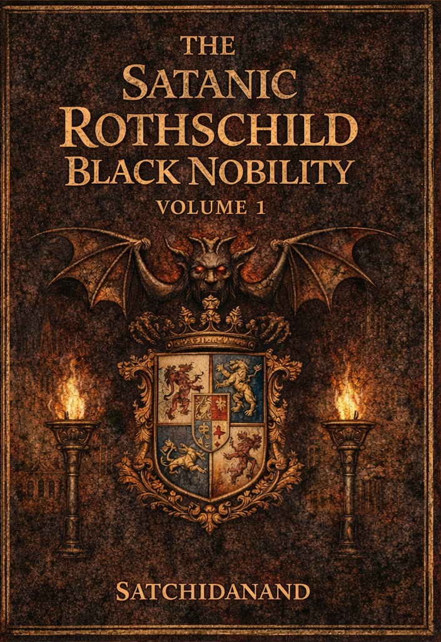
DEDICATION
With all Thanks, Love and Gratitude to Swami Devi Dhyani who make these books and the Energy Enhancement Streaming Video Meditation Course possible.
With all Thanks, Love and Gratitude to Devi Dhyani, my Mother and Father and to all my other Teachers, Theos Bernard, Sri Yogendra, Eric Berne, Gurdjieff, Father Bede Griffiths, Osho, Zen Master Hogen, Swami Sivananda, Swami Satchidananda, and all the other giants upon whose shoulders I stand - who made me able to be what… I AM – Swami Satchidanand

Copyright © 2026

[Satchidanand]

All rights reserved. This publication may be reproduced in whole or in part, by any person under fair use as long as we are referenced, without written permission of:
Swami Satchidanand

sol@energyenhancement.org

www.energyenhancement.org
https://eemeditationvideo.org/

https://againstsatanism.com/
https://against-satanism-video.com/

https://satchidanand.substack.com/
THE SATANIC ROTHSCHILD BLACK NOBILITY

VOLUME 1

Table of Contents

Satanic Mega-Trillionaire US $2,080 Trillion Phoenician Rothschilds Control the World through Vanguard Group and Blackrock 5

John Wick is a Metaphor for the Satanic Phoenician Empire and it's High Table of Satanic Phoenician Mega Trillionaires. 63

FINANCIALISATION and Satanic Phoenician Mega Trillionaire Central Banks? by Professor Richard A. Werner, D.Phil. - Improved and made better by Satchidanand 104

Rothschild, Trump, Tucker Carlson, Alex Jones, Joe Rogan, Dominic Cummings 163

TRUMP AND THE DEEP STATE SATANIC 2000 TRILLION DOLLAR ROTHSCHILD PHOENICIAN MEGA TRILLIONAIRES 195

THE WOLVES OF WALL STREET USE BLACK MAGIC 250

These Satanic Malthusians Demand Genocide 321

Alan Watt Recommended Book List 327

Satanic Mega-Trillionaire US $2,080 Trillion Phoenician Rothschilds Control the World through Vanguard Group and Blackrock
Oct 02, 2022
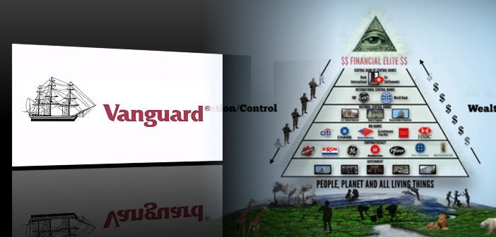
The Richest Satanic Phoenician Mega Trillionaire 10,000 years old Families in the World. THE VANGUARD GROUP DRIVES WORLDWIDE MERCHANT-BANKER FASCISM FROM THE CITY OF LONDON. VANGUARD, BLACKROCK, STATE STREET ARE CONTROLLED BY THE PILGRIMS SOCIETY IN THE CITY OF LONDON (ROTHSCHILDS, BARINGS, BARCLAYS, NATWEST, ETC.) King Chucky the Turd is the front man controlling Klaus Schwab and Vanguard.
THE PILGRIMS SOCIETY
In 1891, Lord Rosebery, J.P. Morgan, Cecil Rhodes, Baron Henry de Worms, Lord Rothschild and Lord Alfred Milner founded the Round Table to use Jesuit discipline and Masonic secrecy to promote the reorganization of the British Empire into an Imperial Federation that they insisted include America coming back under the British Crown. The Anglo-American Empire…
These men were the prime movers in the creation of the British South Africa Company, founding of De Beers Consolidated Mines and the Wellcome Vaccine experimentation on over 60,000 Boers and blacks in their 2nd Boer War concentration camps. In 1902, these perpetrators of the war, abruptly stopped the 2nd Boer War, and changed the name of the Round Table to the Pilgrims Society in the months after Cecil Rhodes’ “untimely” assassination at 49 years old.

DAVID SARNOFF, RCA/NBC/FIVE EYES GROOMED BY THE PILGRIMS SOCIETY
The group of Pilgrims Society members (generically called the “Deep State” to avoid directly fingering of the Pilgrims) are all run by the “Five Eyes” agreement that Brig. Gen. David Sarnoff, Gen. Marshall, and Gen. Eisenhower created in Feb. and Mar. 1946.
This is not an exaggeration: Out of the Imperial Press Conference, 1909, the British Empire’s Marconi Wireless global monopoly split and morphed and reorganized into the media and communications networks we know today as BBC, New York Times, Daily Telegraph, Washington Post, AT&T, British Telecom, Westinghouse, GEC, RCA, NBC, CBS, Orange, Verizon, Nokia, Lucent, Alcatel-Lucent, Bell Labs, Western Electric, Vodafone, Deutsche Telecom, AEGIS system, SERCO, QinetiQ, and now “The Internet of Things.”
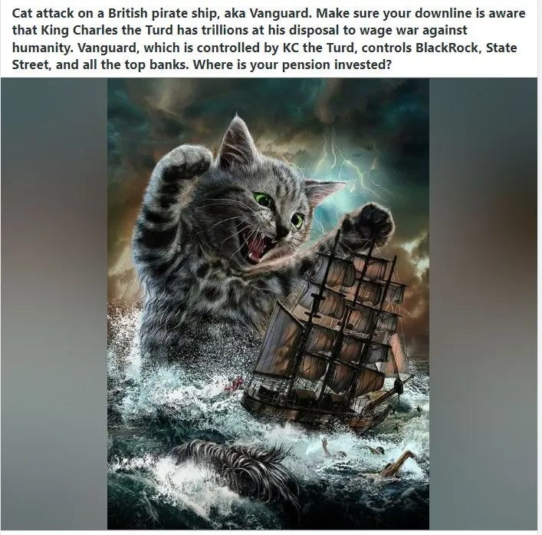
Also on the Pirbright site today is Cobbet Hill Earthstation with satellite warfare-level capabilities. Henry de Worms (Rothschild), starting in the 1880’s, helped establish the Marconi Wireless monopoly in Britain and worked as patent, commerce, trade and colonies minister to fuse Marconi wireless technology (stolen from Nikola Tesla) and Wellcome biological research into using radio transmissions to trigger viral outbreaks.
Today, 140 years later, de Worms (Rothschild)’s vision is finally coming true in 5G and nanotubes carrying deadly virus payloads. See Jun. 05, 1909 Here...
https://againstsatanism.com/2020-06-10-HOW-THE-ROTHSCHILDS-USE-MASS-SURVEILLANCE-AND-NANOTECH-BIOWEAPONS-TO-SUSTAIN-THE-iMPERIAL-BRITISH-WORLD-ORDER-Americans-for-Innovation-Jun-10-2020.pdf
A small number of Satanic Phoenician Mega Trillionaire banking families, now operating out of the City of London as the Anglo-American Empire, but previously as part of the Venetian Empire, the Roman Empire, the Carthaginian Empire but always the 10,0000 years old Phoenician Empire I detail in my book, AGAINST SATANISM VOLUME SIX .. have for generations held these wealth records with fortunes that are orders of magnitude above anything we might have imagined.
Dark Forces have used Infiltrating Bloodline Satanic 10,000 years old Phoenician Mega Trillionaire Aristocratic Families which have existed running Global Trading Companies for thousands of years before the Birth of Christ.
Infiltrating and taking over the power structures in every country, using propaganda - emotional rhetorical religious concepts to control humanity, they themselves are Satanists, worshiping all the Pagan Gods, including Lucifer, Satan, Baal, Bel, Molech, Ashtoreth, Cybele and Attis.
All these Satanic Gods are heartless Demons who have cut themselves off from the Energy of the One Good God, who have rejected God so as to live eternally, immortally.
Therefore they control humanity so as to steal and vampirise the energies of Humanity forever!

AGAINST SATANISM VOLUME SIX
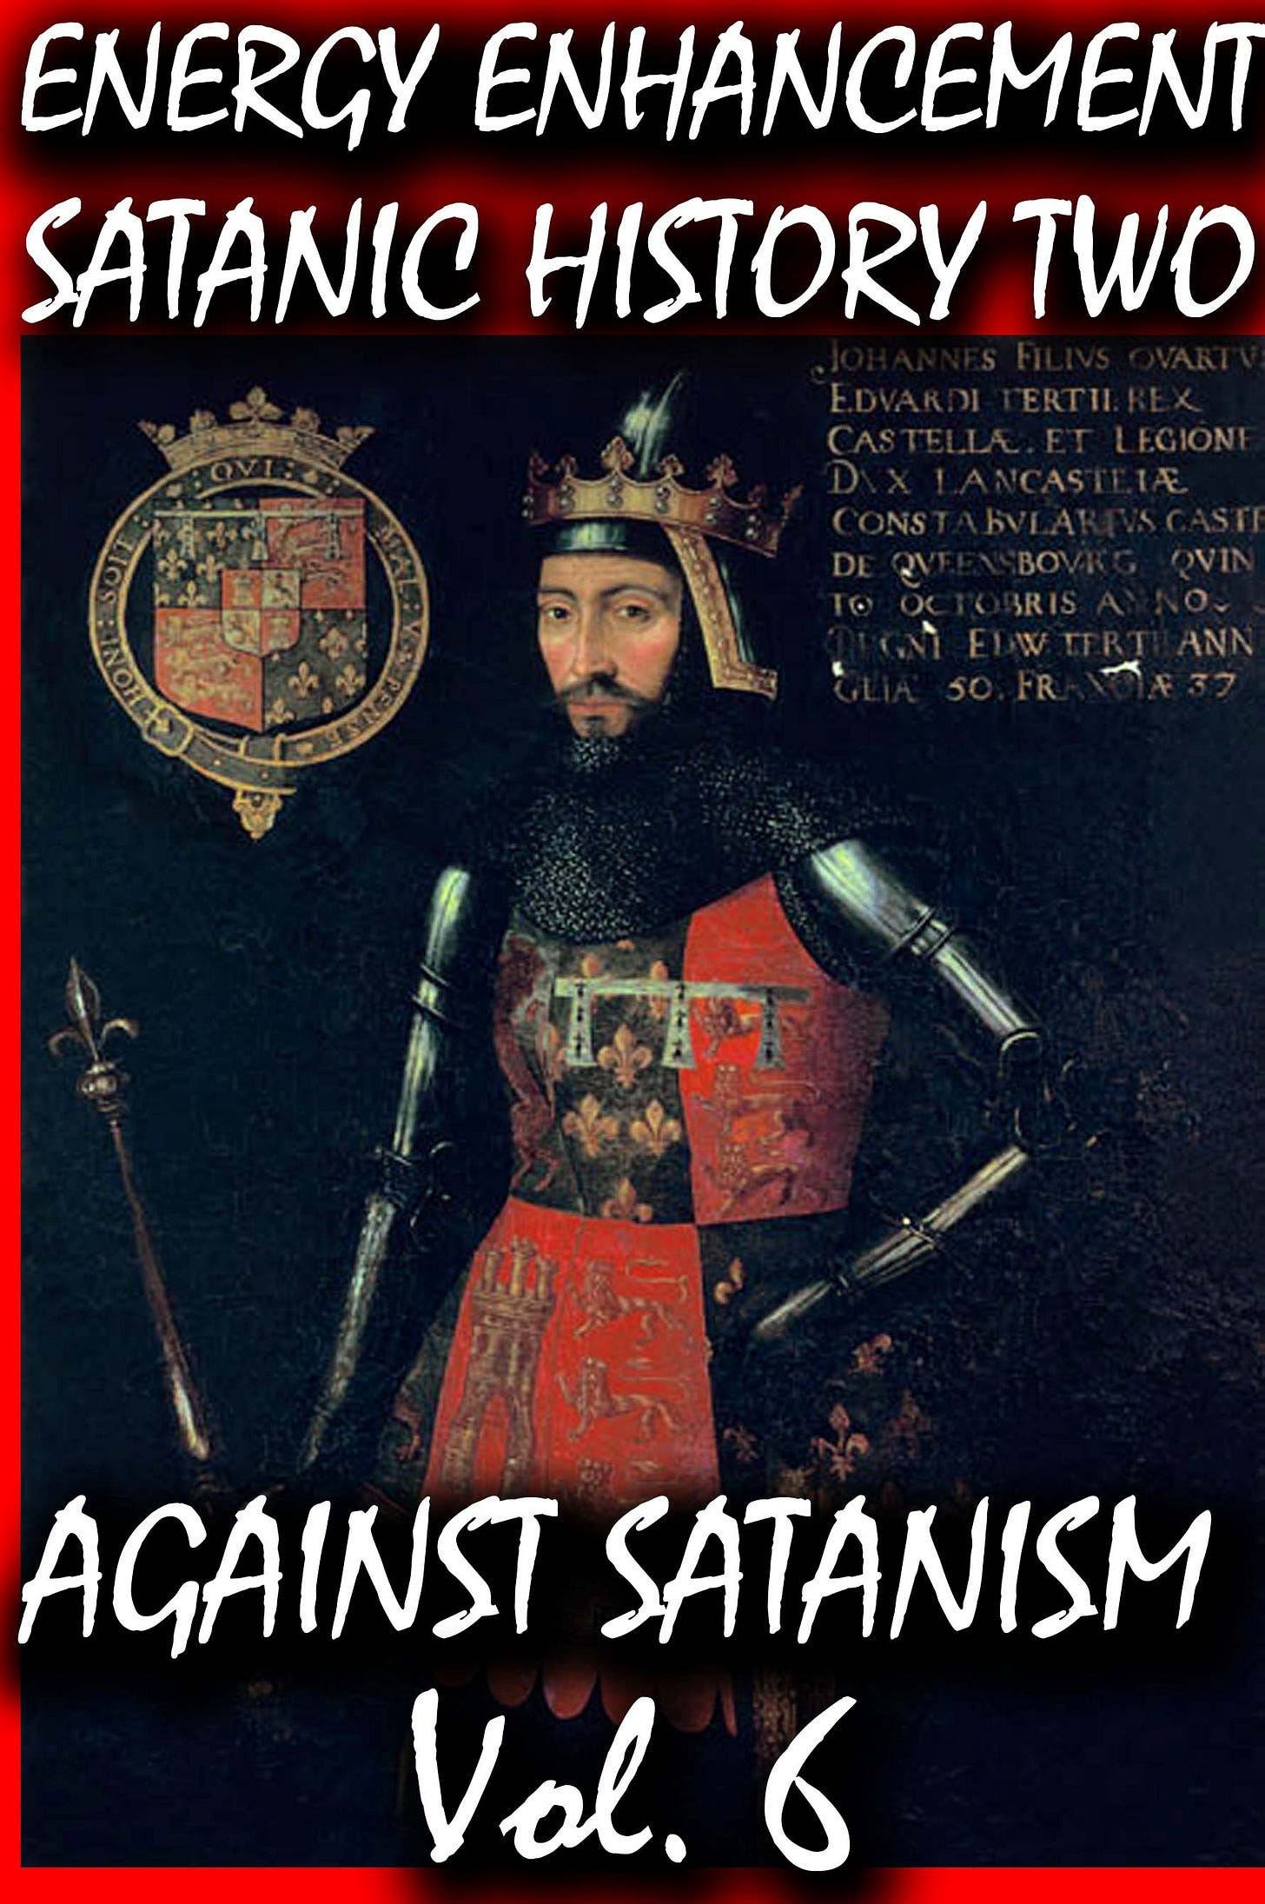

In this book we find that over thousands of years before the birth of Christ, spook, Bloodline Satanic Phoenician Mega Trillionaire Aristocratic Families infiltrated every country, every Empire, from their Phoenician Colonies in Ancient Egypt, Carthage, Rome, Venice and London, marrying in to, taking over or infiltrating every ruling aristocracy and aristocratic, bloodline family.
Their Phoenician sons and daughters pretending to be natives of Europe, Britain, America, India, Israel and China, using their Satanic Phoenician Mega Trillionaire inheritances to get into positions of power to manage and control their human cattle in every country in the World!!
Download FREE! AGAINST SATANISM Volume 6 FREE!! Right Click and Save as..
https://againstsatanism.com/Sacred-Energy/Against-Satanism-Volume-6/AGAINST-SATANISM-6-Satanic-History-of-the-World-Part-2.pdf
The descriptions and evidence in this essay will serve at least to provide a reasonable basis for understanding and to “draw attention to some of the great forces which have been molding our world”.
The Power of Compound Interest
Much of this essay is primarily dependent on only one simple thesis: that those with enormous wealth do not leave it idle but put it to constant good use; the money is always at work. It is lent out to finance wars and colonisation, to purchase legitimate businesses, to establish control of governments and national economies, and more.
The reason Abraham Lincoln resorted to printing his “Greenbacks” as currency was because Rothschild demanded a 24% interest rate to fund the Union in the US civil war. There are many other such examples, as war financing in particular carried high interest rates. Dutch perpetual bonds issued by Satanic Phoenician Mega Trillionaires were at rates of 10% and 12% in the 1500s and 1600s; Genoa issued much of its debt at 9% in the 1600s.
Some Background on Corporations
A great many of the world’s largest corporations are owned and controlled by Satanic Phoenician Mega Trillionaires, many of these by the select few in the City of London, but also very many outside this small group.
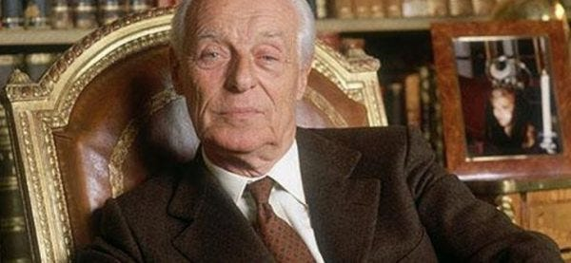

Evelyn de Rothschild
Satanic Mega-Trillionaire US $2,080 Trillion Phoenician Rothschilds Control the World through Vanguard Group and Blackrock
BLACKROCK AND THE SATANIC 2000 Trillion Dollar MEGA TRILLIONAIRES HAVE BOUGHT OFF OUR LEADERS, STOLEN THE ELECTIONS, FOLLOW THE ZIMBABWE SCRIPT TO DESTROY AMERICA - CUT OFF THE ENERGY, CUT OFF THE OIL, CUT OFF THE GAS, DESTROY THE PETRODOLLAR, DESTROY THE DOLLAR, INCREASE THE GLYPHOSATE, CUT OFF THE FERTILISER, FAMINE AND STARVATION TO FOLLOW, INCREASE INFLATION, MAKE EVERYBODY POOR, SPREAD BIOWEAPONS, KILL OFF THE POPULATION, CREATE A GREAT RESET NEO-FEUDAL, POST INDUSTRIAL, SOCIAL CREDIT SCORE SLAVE PLANET
The Satanic Mega-Trillionaire - 2080 Trillion Dollars Rothschilds who control the money of the Vatican Bank control the World through the - “VanGuard Corporation” which Controls Global Megabanks, Big Deathshot Pharma, Major Mass Media and Mega Corporations in the World and their Owners - Monsanto, Google, Facebook and Microsoft.
The four companies that are present in all cases below and in all decisions: Vanguard, Fidelity, BlackRock and State Street. All of them “belong together”, but if you check out carefully the balance of shares, it turns out that in reality all these companies are All controlled by Vanguard. So, all of these partners or “competitors” - Fidelity, BlackRock and State Street All belong to Vanguard Group.
Please, look at the largest, companies in various industries, controlled by the “Big Four”, and upon closer inspection control by Corporation Vanguard: Alcoa Inc. Altria Group Inc., American International Group Inc., AT & T Inc., Boeing Co., Caterpillar Inc., Coca-Cola Co., DuPont & Co., Exxon Mobil Corp., General Electric Co., General Motors Corporation, Hewlett- Packard Co., Home Depot Inc., Honeywell International Inc., Intel Corp., International Business Machines Corp., Johnson & Johnson, JP Morgan Chase & Co., McDonald’s Corp., Merck & Co. Inc., Microsoft Corp., 3M Co., Pfizer Inc., Procter & Gamble Co., United Technologies Corp., Verizon Communications Inc., Wal-Mart Stores Inc. Time Warner, Walt Disney, the corporation «Halliburton», Viacom, Rupert Murdoch’s News Corporation, CBS Corporation, NBC Universal …
The Satanists own 70% of Banks, 70% of International Corporations, 100% of Central Banks, Worldwide!
All of the global major corporations are eventually controlled by Corporation Vanguard and the Corporations are owned by “Dick Cheney, the Rothschilds, the Queen, the Bushes, the Rockefellers, Clintons, Donald Rumsfeld and many other influential people and owners of the Federal Reserve and the Jesuit Vatican, "Iron" Bank. In a word, these people are the rulers of the earth, who, through Corporation Vanguard, control all mega corporations such as Monsanto, Google, Facebook and Microsoft.
The minions are throw away people like Colin Powell who wasn't given the memo not to take the Deathshot. The minions are Obama, Turdeau, Macron, Boris Johnson, Bill Gates, Merkel, Bidet, - That level..
The world’s major oil companies are controlled by Satanic Phoenician Mega Trillionaires interests, as are the major pharmaceutical companies, many of the weapons manufacturers and the world’s airlines, a preponderant amount of the world’s shipping capacity, and many other industries that might not normally come to mind. It is impossible to obtain access to all the information required to even hazard a guess at the value of the corporate asset ownership of these people, but consider that virtually all of the media in the West, and a great deal of the prime media outlets in the rest of the world, including movies and book publishing, are owned or controlled by Satanic Phoenician Mega Trillionaires. There are international companies worth in total many trillions of dollars that are entirely Satanic Phoenician Mega Trillionaires; Nestle, Sanofi, Monsanto, being a few among hundreds such. We cannot easily know what part of this reverts to our handful of Satanic Phoenician Mega Trillionaires bankers in the City of London, how much of that was financed by, and is controlled from, that center, but it isn’t negligible.
Things are not always what they seem. Many of the world’s large fortunes were financed by Rothschild or others from that inner circle and thus there is a hidden ownership that will never be revealed. Trolling through historical records, we sometimes discover that a very wealthy man left an estate of only a few million dollars.
It isn’t a secret although apparently not widely known, that one of the Rothschilds financed Rockefeller’s creation of Standard Oil, and did the same with Andrew Carnegie’s steel empire and the Harriman railroad fortune in the US, among others. The financing was usually done through J. P. Morgan, who was a Rothschild agent for all of his career, and in fact, Morgan’s banking interests themselves were much more European Satanic Phoenician Mega Trillionaires than they were American.
It is worthy to bring this to the attention of readers since it appears that much of the wealth of the famous American and European families may not have been really theirs but belonged instead to the ultimate Satanic Phoenician Mega Trillionaires financiers in the background. Today, Google, Facebook, Tesla, Amazon, Starbucks, and many others are in this category, firms that could not possibly have attained their extent of market control without both heavy financing and intense planning originating elsewhere.
A number of studies have been done on interlocking corporate ownership and control, with consistent conclusions that as few as 400 companies, and perhaps even as few as 250 companies, own outright or at least have control of, more than 70% of all the value listed on all stock exchanges everywhere.[3][4][5]
But behind those 400 or 250 companies is that same number of Satanic Phoenician Mega Trillionaire families controlling those companies. Even though most large corporations are listed as public, with sometimes hundreds of millions of shares outstanding, we cannot know where the true control lies. Increasingly, many of the shares are held by proxies like Blackrock or Blackstone or other investment groups, and we have no information on share classifications or other restrictions on voting and control.
Nor does the general public have information on interlocking directors who have absolute day to day control, including over all financial decisions. More importantly, it isn’t necessary to own a plurality of shares if you control the Board of Directors or if they are reading from the same script. These people can empty a company’s treasury to pay unlimited dividends tax-free through a tax haven, and do so without even attracting unrest from the common shareholders who seldom have much understanding of these matters.
Many European banks fall into this category, most of these Satanic Phoenician Mega Trillionaires-owned and tightly-held. The few dozens of Europe’s largest banks like HSBC, BNP Paribas, Lloyd’s, have a market cap in the trillions and an asset base of over €30 trillion. The major North American banks, like Goldman Sachs, Citigroup, Wells Fargo, again owned by Satanic Phoenician Mega Trillionaires, have a market cap of well over $1.5 trillion and assets to match. Plus, we have literally hundreds of Satanic Phoenician Mega Trillionaires-owned banks in Switzerland and other countries that appear on no list anywhere.
Many of the world’s largest insurance and reinsurance companies are owned by Satanic Phoenician Mega Trillionaires, with a combined market cap in the trillions, and there is no way to place a value on Lloyd’s of London, a worldwide insurance platform that is virtually priceless. Then there are the oil companies; Royal Dutch Shell alone has a market cap of over $200 billion, and there are many of these, Satanic Phoenician Mega Trillionaires-controlled, sufficient to control the world’s price of oil as we will see.
The two major FMCG companies, Unilever and P&G, both Satanic Phoenician Mega Trillionaires, have a combined market cap of over half a trillion dollars. Internet-related firms like Google, Meta, Amazon, Dell, Oracle, again all Satanic Phoenician Mega Trillionaire owned, have a combined market cap of nearly $5 trillion. The world’s fashion houses and jewelry firms, mostly Satanic Phoenician Mega Trillionaires-owned or controlled, firms like Swarovski, YSL, LVMH, Cartier, Hermès, Estee Lauder, L’Oréal, have a market cap of more than $1 trillion, and there are hundreds of jewelry firms, diamond cutters and merchants, gold dealers, operating behind the scenes that are also owned by Satanic Phoenician Mega Trillionaires and worth a combined trillions of dollars.
The major armaments and weapons manufacturers, which have always had a high percentage of Satanic Phoenician Mega Trillionaires ownership and control, again have a market cap in the vicinity of $1 trillion. The world’s major food companies, again mostly owned by Satanic Phoenician Mega Trillionaires, is another example. Nestlé, an entirely Satanic Phoenician Mega Trillionaires company, owns more than 2,000 food brands with a market cap of about 1/3 of a trillion dollars by itself. Pepsico is the second-largest food company in the world, owning hundreds of major brands, and many others like Kraft Heinz, Mondelez, Danone, Anheuser-Busch Inbev, Coca-Cola, Diageo, Starbucks, have a combined market cap of at least $1.5 trillion. The world’s largest pharmaceutical companies are all Satanic Phoenician Mega Trillionaires-owned, with a combined market cap of around $4 trillion.
The main North American media companies (all owned by Satanic Phoenician Mega Trillionaires) have a market cap of over $1 trillion, with larger numbers for the European media that are also largely Satanic Phoenician Mega Trillionaires-owned and virtually all Satanic Phoenician Mega Trillionaires-controlled. And this ignores their media holdings in Latin America, Asia and Africa. And there are literally hundreds of Satanic Phoenician Mega Trillionaires-owned companies that don’t fit easily into the above categories, including everything from H&R Block to Mattel and Hasbro, Monsanto, Ben and Jerry’s. The list is almost endless. Collectively, their value and influence are enormous.
The Real Power: Satanic Phoenician Mega Trillionaire Family Dynasties
When we read of Bill Gates or Warren Buffett, we tend to think in simple terms of someone starting a company with a good idea and over a lifetime building a huge enterprise that today is worth many billions. But this reasoning is simplistic because we are confining our thoughts to only one generation. The people with whom we are concerned here, are Satanic Phoenician Mega Trillionaire family dynasties that have been accumulating their fortunes for perhaps ten or even twenty generations.
With the Rothschilds, Sassoons, and so many others, we are going back to the 1600s and 1700s, with family dynasties that have expanded enormously over the centuries and maintained control over their increasingly vast wealth through avoidance of inheritance taxes, rigid intermarriage, and shared intentions.
The greatest of all Satanic Phoenician Mega Trillionaire 10,000 years old family dynasties are hidden from view, expunged from the media, deleted from the history books, and almost never attract public attention. All of these are Satanic Phoenician Mega Trillionaires – Rothschild, Sassoon, Sebag-Montefiori, Warburg, Lehman, Goldman, and so many names you may have never heard of.
Here is a listing of a few of the Satanic Phoenician Mega Trillionaires bankers, representing perhaps only 25% of them, most having begun banking, financing and industrial operations in the early to mid-1800s, so an average of nearly 200 years, and many resulting in Satanic Phoenician Mega Trillionaires family dynasties that continue to this day, entirely out of the public eye.
Rothschild, Sassoon, Warburg, Moses Montefiori, Sebag-Montefiori, Kadoorie, Lehman, Israel Moses Seif, Kuhn Loeb, Goldman Sachs, Salomon, Schiff, Joseph Hambro, J. Henry Schroder, Samuel Montagu, Emile and Isaac Péreire, Lazard Brothers, Speyer brothers, Seligman brothers, Stern brothers, Barnato Brothers, Ernest Oppenheimer, Abraham Oppenheim, Carl Fuerstenberg, Jacob Goldschmidt, Oskar Wassermann, Hirsch, Raphael Jonathan Bischoffsheim, Hambro, Isaac Glückstadt, Levy Martin, Markus Rubin, Goldsmid, Rosenthal, A. Dunkelsbueler, Eugen Gutmann, Herbert Gutman, Wagg and Co, Mèdici family, Speyer, Speyer-Elissen, Emile Erlanger, S. Japhet, Ernest Cassel, Carl Meyer, Achille Fould, Luigi Luzzatti, Wertheimer and Gompertz, Lippman.[6][7][8]
I have a graphic on my computer that displays the holdings of the Rothschild dynasty owning 70% of everything. The Rothschild dynasty are really fronts for the 1500 year Vatican Bank like the Iron Bank of Game of Thrones, the Pope is just the CEO of an ancient business, the directors of which are the Cardinals, scions, sons, of every major Satanic Phoenician Mega Trillionaire Family in the World. The Rothschilds are the money and business managers of the Vatican Corporation.
Displayed rather like an organisation chart with small boxes indicating holdings and lines everywhere indicating ownership and control. It is so large that to print it in the smallest readable type would require a sheet of paper half a meter in size. Rothschild recently created a new bank just to manage his land holdings confiscated from poor countries. It is difficult to obtain hard information because so much of this is done through no-name banks, agents, and related companies, and run through innumerable tax havens. Rothschild owns, among other things, Sanofi Pharma with a capitalisation of $125 billion, the Economist, and IHS which is the largest mobile tower operator in Africa.[9]
Anglo American was founded by Satanic Phoenician Mega Trillionaire Family Ernest Oppenheimer, a German. Headquartered in the City of London, this is one of the 250 largest companies in the world, producing gold, diamonds, other metals, and nearly half of all the world’s platinum. Their subsidiaries and investments are too many to list. When Ernest died, he was succeeded by his son Harry, who also became chairman of De Beers, so you can see how the families integrate and rationalise their holdings.
The Satanic Phoenician Mega Trillionaire Wallenbergs in Sweden have been in business for 200 years, where today they own most large Swedish industrial groups like Enskilda Bank, Ericsson, Electrolux, ABB, SAAB, SAS Group, SKF, Atlas Copco, and Nasdaq. As far back as 50 years ago, the Wallenberg family businesses employed 40% of Sweden’s industrial workforce and represented 40% of the total worth of the Stockholm stock market. The market capitalisation of only ten of their companies is nearly $350 billion, and much has been buried in trusts and hidden in tax havens. Swarovski, with their fake “crystal” is another 150-year-old Satanic Phoenician Mega Trillionaire dynasty.
For this essay, I will ignore much of the past history of these Satanic Phoenician Mega Trillionaire's families and begin from the early 1800s, but it should be noted that these Satanic Phoenician Mega Trillionaire Family Khazar “family fortunes” began thousands of years before this. We had the (Satanic Phoenician Mega Trillionaires) Dutch Tulip bubble, the (Satanic Phoenician Mega Trillionaires) South Seas bubble, the (Satanic Phoenician Mega Trillionaires) British and Dutch East India Companies and many similar. There were centuries of slave trading, of tax farming and so much more. I will omit all of that.
India was at one time almost certainly the richest nation in the world, with stocks of gold, silver and precious gems worthy of fable and legend. The British East India Company which was eventually led by one of the Rothschilds, was unquestionably the greatest criminal enterprise in the history of the world, and the vehicle used to loot India to the bones.
Sassoon ben Salih was the chief treasurer to the pashas of Baghdad.[10] Exposed in an immense fraud in the early 1800s that must have involved hundreds of billions in today’s dollars, he was lucky to escape with his life (and the money). He and his two sons David and Joseph fled to India where they teamed up with one of the Rothschilds and hatched their infernal plan to force Indian peasants to grow opium for sale in China.[11]
From the early days, they already had the young Queen Victoria firmly in their grasp. She not only supported their efforts to the extent of allocating the British military as the Satanic Phoenician Mega Trillionaires’ enforcers of the opium, giving David Sassoon the exclusive franchise for selling opium in all of China, seizing Hong Kong for his distribution base and giving him the charter to form the HSBC. To say that the British Royal Family profited heavily from this personally, would be an understatement of some magnitude. This is where we will begin our story.
From their wholesale looting of India and the thefts from Iraq, followed by growing and selling of opium in China, Rothschild and Sassoon were reliably estimated to have accumulated wealth of more than $5 billion each, by 1835. Actually, the calculated estimates I have seen were of $6 billion and $7 billion,[12] and these were my estimates as well. I reduced this to $5 billion to be conservative, but the totals are still staggering. $5 billion accumulated at only 5% for the intervening 185 years, accumulates to a total in 2022, of more than $40 trillion each for Rothschild and Sassoon. And there were at least a dozen or more Satanic Phoenician Mega Trillionaires banking families that were not so very far behind Rothschild and Sassoon, as well as many dozens more that were very wealthy but not in this same league. That $40 trillion may seem shocking and too fantastic to be real, but reserve your judgment until the end. As you will see, that $40 trillion is almost irrelevant in the overall picture of a World GDP OF 200 TRILLION DOLLARS EVERY YEAR AND THE Satanic Phoenician Mega Trillionaire Families own most of it!.
(1) Slavery and Forced Labor
Satanic Phoenician Mega Trillionaires have always been heavily involved in slave trading from the year dot. Before petrol engines the whole World ran on slave labour from Ancient Egypt to the Roman and Chinese Empires.
Recently both the white slaves that depopulated Ireland and much of England and the more recent black slaves, but I will ignore that part of the past and deal only with the more recent events in China.
Slave trading by these same richest Satanic Phoenician Mega Trillionaires – Rothschild, Sassoon, Kadoorie and many others, stopped only because the First World War put an end to it. We haven’t precise numbers, but the historical record tells us that many millions of Chinese were kidnapped and sold as slave labor. Countless tens of thousands of Chinese were kidnapped and shipped as slave labor to North America to build the railroads and work the gold mines, to build the Panama Railway and the Panama Canal, to work the guano mines in Peru, and in many other instances. This is why we have Chinese all over the world; even today the population of Panama is more than 10% Chinese because of this.
In many cases, the Chinese were not actually sold to others but used by the Satanic Phoenician Mega Trillionaires as slave labor for their own projects. As late as 1904, Rothschild had around 65,000 Chinese kidnapped from Fujian Province to work his gold mines in South Africa.[13]
When these same Satanic Phoenician Mega Trillionaires financed the building of the North American railroads and the Panama Canal, for example, kidnapped Chinese were the supply of free (and disposable) labor. Harsh conditions resulting in tens of thousands of deaths were irrelevant because the supply was inexhaustible.
As well, there is credible evidence that Easter Island was almost totally depopulated by these same Satanic Phoenician Mega Trillionaires who kidnapped most of the people to work the guano fertilizer mines in Peru. There are letters from officials in the UK demanding that these Satanic Phoenician Mega Trillionaires return the Easter Islanders to their homes.
At this distance in time, it isn’t possible to construct a comprehensive tally of the totals of Chinese slave laborers conscripted by these Satanic Phoenician Mega Trillionaires for their projects, nor to estimate the “value” of all this slave labor, but it was certainly substantial and carried on in great volume from about 1800 to 1920 and, as I mentioned above, it was only the First World War that put a stop to it. I list this because it is an important contributing aspect to the accumulated wealth of these Satanic Phoenician Mega Trillionaires banking families.
(2) Diamonds
It’s not a secret that DeBeers controls the diamond production of South Africa, and also in Zaire, nor that DeBeers is a Rothschild company. Let’s not forget the origin and purpose of the Boer Wars. Diamond production statistics seem scattered, with South Africa claiming around 650 million carats of total production,[14] while Statista claims twice this amount. South Africa places a value on this production (at $100 per carat) at about $60 billion, but with no allowance for the compounding an average of $300 million per year over 150 years: (average of 3 million carats per year at $100 per carat). If we allow for compounding at 5%, this accumulates to about $10 trillion. To keep things simple, I have excluded all other countries from this calculation; the addition of these and other Rothschild and Satanic Phoenician Mega Trillionaires-owned production would at least double the total. It should also be noted that the Satanic Phoenician Mega Trillionaires enclave of Holland is still the center of the world’s diamond trade, the great majority of which is firmly in Satanic Phoenician Mega Trillionaires hands.
(3) Gold
It is difficult to find comprehensive and reliable statistics on the actual annual production of gold from the Rothschild-controlled mines, but production apparently reached more than 1,000 tonnes per year 50 years ago. With 32,000 ounces in a tonne of gold, and gold selling at $1,700 an ounce, that represents many billions of dollars per year, compounded at 5% for nearly 150 years, about 100 Trillion dollars.
(4) Canals: Panama and the Suez
It is universally-known that the US built the Panama Canal – after “liberating” the Province of Panama from Columbia, but not so widely-known that it was Satanic Phoenician Mega Trillionaires money that paid for the canal.[16] We can reasonably assume that the profits from the canal for about 120 years would have accrued to those who financed it. The Suez Canal was also built with Satanic Phoenician Mega Trillionaires money and existed as a privately-held corporation. Only a few mere billions of dollars per year.
(5) Cash Management
It isn’t widely-known but, as part of America’s Monroe Doctrine, the US used not only its powerful bullying “diplomacy” but also the CIA and the full force of its military to arrange for a few Satanic Phoenician Mega Trillionaires bankers (and the US FED) to obtain the position of “investment managers” of all the cash assets and central bank holdings of the countries under its control. This included Latin America, but also countries like the Philippines and the 50+ countries where the US overthrew a government and installed a compliant dictatorship.
The scheme was simple. These nations were forced to turn over all their liquid assets to the Satanic Phoenician Mega Trillionaires bankers in the US who would “prudently manage” all that cash for the benefit of these smaller nations. In practice, the Satanic Phoenician Mega Trillionaires bankers invested the money in New York real estate and profited in the billions while paying those nations 3% on their money.
This practice was coupled with a bad American habit of invading, then forcing open and emptying, the vaults of the central banks of these same nations of all their gold. These practices are sufficiently documented to withstand challenge and, having existed for about 150 years, I think we could reasonably attach a total compounded to today of at least $1 trillion dollars.
(6) Germany’s Hyperinflation
It is widely accepted today that Germany was set up for this precise circumstance from the provisions of the Treaty of Versailles and the corresponding restrictions enacted by Satanic Phoenician Mega Trillionaires to prevent Germany’s recovery. Regardless, the inflation rate was so extreme that money became literally worthless, permitting the Satanic Phoenician Mega Trillionaires bankers to buy up much of Germany for virtually nothing. This was one of the deep resentments harbored by Hitler toward the Satanic Phoenician Mega Trillionaires, knowing they were behind the treaty and other restrictions that could have had only the bankruptcy and subjugation of Germany as the one possible purpose. We needn’t go into details here, but it was Hitler’s eviction of the Satanic Phoenician Mega Trillionaires from Germany’s banking system and taking over the country’s central bank that resulted in the “miracle” of Germany’s economic recovery which, unfortunately, was not to last. The present value would surely be in the many trillions of dollars, all to the benefit of these same few bankers.
(7) Central Banks
European Satanic Phoenician Mega Trillionaires banking families, led by the Rothschilds, own or control the central banks of at least 30 nations, including the FED in the US. There are several very nasty results of this ownership, one of which is that these nations cannot print their own money but must borrow it from the (privately-owned) central banks – and pay interest on it.
This is of enormous magnitude. Until the late 1970s, Canada owned its own central bank and paid little to no interest to foreigners. But then-Prime Minister Pierre Trudeau (Justin Trudeau’s father) committed an astonishing act of treason – on his own account, without even the knowledge of his own cabinet or Parliament – and committed Canada to foregoing its financial birthright to print its own currency and from then on borrowing from the European Satanic Phoenician Mega Trillionaires bankers. The result is that in the past 30 or 40 years little Canada has paid these bankers more than $1.1 trillion in interest for borrowing its own money.[17][18][19][20][21][22] You might especially want to watch item 22, a video of Canada’s former Cabinet Minister commenting on Banking in America.
But Rothschild and a handful of other Satanic Phoenician Mega Trillionaires banking families have owned the central banks of the European nations, and others including the US FED, for well over 100 years. If little Canada has paid more than $1 trillion in interest in a relatively short time, the governments of countries like England, Germany, France, Italy, Spain, Japan, South Africa, have paid much more during the past century. As one example, Italy’s debt is several times that of Canada, and many other countries are in the same position.[23] I have no accurate record of total interest the US has paid to the FED, but its current debt is more than $13 trillion – an amount which will never be paid off.
Working from Canada as a baseline, and counting only 30 countries, an excessively conservative estimate would be $30 trillion paid out in interest to these bankers. If we then allow for only 100 years, we can multiply this by more than three times and arrive at around $300 trillion paid in interest – entirely without need or justification. It should also be noted that those 50+ nations where the US military and CIA overthrew a government, the Satanic Phoenician Mega Trillionaires bankers were right behind them to take over ownership of all those central banks.
In every case where information has escaped – Iraq, Libya, South Africa, the Balkans, this has been their priority and simple logic dictates that it would be very high on their list in every country where they had access compounded, and for more than 100 years, to the many hundreds of trillions.
(8) Recessions and Depressions
One of the nastier advantages of the foreign ownership of a country’s central bank is that the Satanic Phoenician Mega Trillionaires have total control over those economies.[24] Since they control both the money supply and the interest rates, they have easily the power to whipsaw economies and profit immensely at every cycle. They do it the same way every time – by lowering interest rates to zero or nearly so, while hugely inflating the money supply, thereby creating large bubbles in debt, in the stock and housing markets, and so on. Then, they severely contract the money supply and all credit while simultaneously raising interest rates, thus bankrupting countless thousands of banks, businesses and families, and buying up for pennies on the dollar every manner of assets when the blood is running in the streets.
After accomplishing their task of relieving a nation of a significant portion of its assets, they again expand the money supply and open the credit taps while reducing interest rates to give economies time to recover, then rinse and repeat. It is not a secret that all such recessions have been deliberately inflicted on Western economies by these Satanic Phoenician Mega Trillionaires bankers for the past 200 years or more.
The 1929 Great Depression was one such, with euphoria based on the Satanic Phoenician Mega Trillionaires owners of the FED expanding an almost unlimited money supply and easy credit with low interest rates, building a huge bubble which was then burst. Thousands of banks, tens of thousands of companies, and millions of families, all went bankrupt, with all those assets mostly flowing eventually to the Satanic Phoenician Mega Trillionaires owners of the US FED and their closest friends. This was done many times prior to 1929, and has been done many times since. The bitterly savage recession in 1983 was similarly created by the US FED – on orders from the City of London, with Volcker even boasting openly about what he was doing. The 2008 housing and financial crisis in the US was identical, and in no way accidental. It was so bad that an executive of Goldman Sachs said at the time, “Things will never return to normal after what they have done.”
The collapsing of the industrial economies in 2022 is the same. A sudden and deliberately-contrived “energy shortage”, created in large part by the sabotage of Nordstream II, a reduction in the money supply, and the stiff raising of interest rates “to combat inflation” (which was entirely self-induced), and soon blood will be once again running in the streets. And an almost unlimited number of industrial corporations, especially in Germany but also in the weaker European nations, will be facing bankruptcy and takeovers, the news of which will never reach the public thanks to the almost-total media control by the Satanic Phoenician Mega Trillionaire Families.
There is no accurate way to definitively calculate the looting that takes place during these contrived “recessions”. 1929 was certainly in the trillions of dollars, as was 1983, which were perhaps the two worst, but the others weren’t so far behind. 2008 was also in this category, the housing losses alone being in the trillions, which I have included elsewhere. Given the lack of detailed data, I won’t try to isolate and estimate the financial result of each contrived financial recession, and will ignore the smaller ones, but that still leaves us with 1929 and 1983 being worth a very conservative $3 trillion each. It seems unreasonable for our purposes to not compound these two amounts with interest for the 90 years and 40 years respectively, but the totals become fantastic and almost incomprehensibly large, and thus very difficult to accept as rational.
Senator Robert Owen, a co-author of the Federal Reserve Act, testified before a Congressional Committee that the bank he owned received from the National Bankers’ Association the “Panic Circular of 1893.” It stated: “You will at once retire one-third of your circulation and call in one-half of your loans.” And that is how these central bankers create the recessions: an instant reduction of 35% or more in the nation’s money supply and a 50% reduction in total credit.[25] The inevitable result is the bankruptcies of thousands of corporations and banks, and an enormous plunge in stock market values and corporate assets of every description which are now available for pennies on the dollar. Wait ten years, and repeat. The purpose is the immense transfer of wealth available in each such cycle, and not only from small banks and corporations but from the general public as well, many of whom also lose everything they had, those assets eventually filtering up to the few oligarchy bankers who planned the events.
(9) Looting the Oil Industry in 1983
As a detailed example, let’s look at the FED-induced 1983 recession and its effect on only the oil industry in North America. To begin, let’s assume we have an oil well with a constant steady production (which many are), but in this case of only one barrel per year for 40 years, with the oil price at $100 per barrel. That gives us a total value of $4,000. However, since $1 next year is worth less than $1 this year, we discount our future production at some interest rate, with this result in terms of value (if we want to sell our oil well):
0% – $4,000
3% – $2,500
6% – $1,500
10% – $1,000
25% – $400
Immediately prior to the 1983 recession, The New York Times proclaimed that a sudden and inexplicable “oil glut” had arrived,[26] such that oil became nearly worthless, prices dropping from US$40 to less than $10 almost overnight. Of course, if the price of oil drops by 75%, the value of our oil well drops by 75% as well, so our $4,000 oil well is now worth only $1,000. But we had a double whammy, because the FED wasn’t idle during this period. After causing a massive burst of inflation in the 1970s to prepare for this eventual result, the FED suddenly felt a need to “fight inflation” by driving interest rates up to 20% and even 25%. The result was that oil wells were then selling at a discount of 25% on cash flow, and I know because at the time I was in the oil business and was buying and selling oil properties, some quite large, at this discount rate. This means that our $4,000 oil well, which was now worth only $1,000 due the collapse in the price of oil, was then hit with the FED’s interest rate sting, and was now worth only $100. And, with the blood running in the streets, this was when our Satanic Phoenician Mega Trillionaires Khazar bankers in the City of London sent in their agents to buy for as always, pennies on the dollar!
Then, the “oil glut” somehow miraculously evaporated and it seems we actually had a shortage, pushing the oil price back to its original $40, and quickly on its way to $100. And then, just as miraculously, inflation seemed to have been “tamed”, and interest rates declined from 25% back down to the 6% and 3% where they had been before. And our “$100 oil well” was back up to $2,500 and on its way to $5,000. And that means that a mere handful of people purchased producing oil and gas properties for almost pennies, and then watched their “investment” multiply by maybe 50 times. That’s not bad. There are few places where we can obtain a return of 5,000% on an investment in only a few years, and with no risk whatever. When you have the power to control the price of oil, and when you have the FED controlling interest rates, you can work miracles. There is no way to calculate accurate totals, but countless thousands of small and medium-sized oil companies either went bankrupt or were taken over, and the purchases in North America alone would have been in the trillions of dollars.
Notice that the banking system is totally fixed and used the shear the sheep every few years. The Science of Economics is a total fantasy!
(10) Looting Americans 1975 to 2022
The situation is not different with the 2008 financial meltdown in the US. We had clearly deliberate attempts to inflate the housing market to almost atmospheric levels, with nearly zero interest rates and the removal of all restrictions and requirements – to the point where unemployed homeless people were buying $500,000 homes. This was again done with the full cooperation of the FED. Then, they simply collapsed the bubble, resulting in tens of millions of foreclosures. And again, when the blood was running in the streets, firms like Blackrock and their ilk were busy buying up these foreclosed homes at perhaps half price, as rental properties – often, to the same people who lost them. There is no accurate record of the total purchases, but the buying was almost frenzied. At one point, one agent in Florida for one “investment firm” alone, was bidding on more than 200 homes per week. With even conservative estimates, the transfer of housing assets alone from the American middle class to these same few people, would have been $7 or $8 trillion, all within two or three years.
It is a surprise to me that so few people seem to want to see such events as having been planned, and yet the evidence is overwhelming and irrefutable. There is no possibility that these events, and so many similar, could possibly have occurred “by accident”. There were simply too many threads all working together to accomplish this one result, and those threads could not possibly have been independent. And it is not possible that the US government itself was unaware of the eventual outcome. Economists working for the US government are not stupid, and so many private economists were describing the events and predicting the only possible outcome. The only thesis that fits all the facts is that the 2008 meltdown was planned and that the US government, so totally controlled from the City of London, knowingly permitted it to happen. Again, in summary, a relative handful of people profited to the tune of trillions of dollars in a few years, in this one enterprise alone.
And it wasn’t only homes, and not only in 2008. In an article titled Destroyers of US Democracy[27], Chris Hedges quoted a RAND corporation report that stated: “These establishment politicians and their appointed judges promulgated laws that permitted the top 1 percent to loot $54 trillion from the bottom 90 percent, from 1975 to 2022, at a rate of $2.5 trillion a year, according to a study by the RAND corporation.”[28][29] For those who don’t know, RAND is a despicably Satanic Phoenician Mega Trillionaire corporation that spends most of its time on planning wars, designing torture regimes (Vietnam Phoenix, Guantanamo Bay, Baghram, Diego Garcia), and scheming for world political control. But the people at RAND do know how to calculate, especially considering they planned the methods for the looting they now boast about. Note that the euphemistically-named “top 1%” is not really the top 1% but a tiny group of Satanic Phoenician Mega Trillionaires bankers and industrialists, including the (Rothschild and other) owners of the US FED. A huge portion of this looting occurred in 2008 and subsequent years.
(11) The Great Gold Robbery – Part I – The US FED
In the early years after the creation of the Rothschild-owned FED, the US was still on a gold standard for its currency; new money could be issued by the FED only if it had at least 40% of that amount in gold. But, as the Satanic Phoenician Mega Trillionaires bankers have always done in every country, they issued paper currency far beyond the permitted limits, which was the prime cause of the 1929 Great Depression. By 1933, the FED had only about 6,000 metric tons of gold in its vaults and was about 50,000 tons short for the paper currency it had issued. The public were aware generally of what was happening and, with concerns of US paper money becoming worthless, were spending the paper and hoarding the gold coins and bars, while small banks and companies were hoarding gold bullion. There was no way out of this trap. The FED needed a huge infusion of gold to prevent a collapse of the currency, but its owners had no intention of investing their own money to prevent the financial collapse of America. Their solution was to convince Roosevelt and Congress that the real problem was citizens preventing the economy from naturally prospering, by holding gold. On their advice, Roosevelt passed the famous 1602 provision which confiscated all the privately-held gold (in all forms) in the US, all citizens forced to turn over their gold to the FED, under penalty of a $10,000 fine plus a 10-year prison sentence. Note that the gold was not surrendered to the US Treasury Department, but to the privately-owned FED.
The gold was exchanged for paper money, meaning that the owners of the FED used the power of the US government to confiscate all the privately-held gold in the US, at only the cost of printing paper. According to available records, individual citizens surrendered nearly 3,000 metric tonnes of gold, mostly in coins. The number of gold bars and bullion surrendered from the private sector is extremely difficult to determine accurately. All historical analyses focus on the gold coinage and ignore the bullion, yet this had to be by far the larger part since it was a standard clause in commercial contracts at the time that settlements would be made in gold and both companies and banks had to be in possession of large stocks of it. The historical studies go to great lengths to trace all the gold coinage produced, to estimate the amount remaining in circulation and thus the amount surrendered to the FED. It would seem the easier method would be to simply request of the FED the amount of coinage surrendered, but the FED apparently refuses to part with this information, and is dead silent on the matter of bars and bullion. My estimate for the bullion was around 6,000 or 7,000 tonnes as a minimum, for a total of about 10,000 tonnes, but Seagrave quotes credible sources claiming the FED purchased 18,000 tonnes so I will use that figure.
However, this was nowhere near sufficient to cover the 50,000-tonne shortfall, so the Satanic Phoenician Mega Trillionaires bankers – led by the Jew Morgenthau, who was then Secretary of the Treasury – devalued the US dollar by about 70% immediately after the gold had been confiscated, thus raising the gold price from $20 to $35, and substantially reducing the FED’s shortfall. But this was with the tragic result that Americans were not only cheated by the loss of their only real cash asset, but of the 70% loss in value. There were lawsuits of course, with the courts essentially determining that the government’s action was illegal and unconstitutional, but that citizens had no recourse.
In summary, to bail out the FED, Rothschild (or his colleagues) convinced Roosevelt to pass a law permitting Rothschild to confiscate all the privately-held gold in America and to devalue by 70% the paper given to Americans in return for that gold. Those 18,000 metric tonnes of gold had a value then of about $20 billion*, taken from the people in the middle of the worst recession in living memory, surely one of the cruelest and most inhumane acts possible at the time. A gold run on the Federal Reserve bank was imminent, and this entire act was simply to prevent the financial collapse of the FED – at the cost of further impoverishing the population and extending the Great Depression by years.[30][31][32][33]
* 32,150 oz. per metric tonne @ $35/oz. (roughly $1 million per tonne) times 18,000 metric tonnes. Today, that gold is worth around $1,700 per oz., or about $50 million per tonne, times 18,000 tonnes = approximately $1 trillion.
(12) US Silver Purchase Act of 1934
They didn’t stop there. The next year, 1934, President Roosevelt implemented yet another Executive Order, number 6814, The Silver Purchase Act, that specified the seizure of all silver in the US and a huge program to purchase silver on the open market at almost three times the then market price. From any rational standpoint, this action was bizarre. The US government did indeed nationalise the US silver stocks, but by purchasing that silver from Americans at the old price of $0.45. This action vacuumed up billions of scarce government funds at the depth of the Great Depression when most Americans were struggling to survive and avoid starvation and bankruptcy.[34]
Having accomplished this, Roosevelt then even more bizarrely enforced the second part of the act which directed the Treasury to purchase silver at a price of at least US$1.29 per ounce, which was nearly three times the then market price which American citizens received. The legislation primarily authorised the Treasury to purchase silver “from foreign countries” on the open market – on the New York Futures Exchange. But this Act was totally bizarre because such purchases had never occurred, nor would they. Not even a crazy person would spend money buying something at $1.29 when that commodity was widely available on world markets everywhere at $0.45. So, what really was driving this new policy?
To this time, China had been on a silver standard for its currency for hundreds of years, the only currency in the world fully backed by precious metal, and responsible for creating a solid and stable economic base, permitting China to escape altogether the Great Depression that was ravaging the rest of the world. The American silver policy of course dealt a devastating blow to this centuries-old stability because the Americans were not purchasing silver from foreign countries on the open market, but only in China through the American banks like Citibank, Morgan and Chase because they were immune to Chinese export regulations. These US agents offered Chinese three times the market price for their silver, naturally resulting in a flood of silver flowing into these banks and from there to be shipped to the US on American military vessels. I have seen statements by historians that China had about 1 billion ounces of silver which at the time was 1/3 of the world stocks, but that is clearly untrue since Shanghai alone was losing half a billion ounces a month, and Chinese banks that normally had their currency backed 60% with silver were down to about 4%.[35][36]
A careful reader should have noticed that the most important piece of this puzzle is missing. Let’s recap: (1) The US government bought up all the gold existing in private hands in the US, then gave all that gold free as a gift to Rothschild and the other Satanic Phoenician Mega Trillionaires owners of the FED. (2) The US government then bought all the silver in the US and also gave that to Rothschild’s FED as a gift. (3) It then instituted a policy of the US Treasury buying all the silver in China at three times the world market price and gifting all that silver to Rothschild’s FED. The part that’s missing is the money. This was in the middle of most severe depression in living memory, people were starving, the US government had no money and the currency as well as the FED were in danger of collapsing. How could Roosevelt afford to buy up all that precious metal and gift it to a few Satanic Phoenician Mega Trillionaires bankers? Easy. The Satanic Phoenician Mega Trillionaires lent him the money by printing paper, and collecting not only the principal but the interest. Roosevelt didn’t have the money to buy Rothschild a Christmas gift, so Rothschild lent Roosevelt the money – at interest, to buy his gift. And that’s how the US went $33 billion into debt 1n 1933.[37]
It may occur to you to wonder why the Satanic Phoenician Mega Trillionaires bankers at the FED didn’t also try to buy up all the gold in China. They didn’t need to, because some of their closest friends were already on this path. See Citibank, below.
(13) Citibank – The Great Gold Robbery
The Chinese have always hoarded gold, individually, as security, and they were certainly doing so in 1902 when Citibank came into China on the verge of bankruptcy and needing a clever way to rebuild its asset base, Citi found it. The bank advertised throughout the nation the insecurity of keeping gold bars in a sock under the bed and managed to convince at least 100 million Chinese to deposit their gold in Citibank’s vaults where it would be safe. After more than 40 years of this, when war clouds were gathering, Citi loaded literally dozens of US military vessels with all that Chinese gold and closed its doors without even saying goodbye. The gold, of course, would all have been turned over to the FED in return for paper. People today are still trying to recover their gold from Citibank. Since the documentation is irrefutable, US courts have permitted lawsuits, but on the stipulation that the claimants must appear in person at the trials. No problem, but the American consulates in China refuse to issue visas for these people to travel to the US. No travel visas, no court claims against Citibank, and no recovery of Chinese gold. The gold was of course turned over to the US FED in return for paper.
There is much more to this story since Citibank pulled the same stunt in perhaps a dozen countries. If it works in one place, it should work everywhere. At the same time, in 1902, Citi (International Banking Corporation) registered itself in China, it also opened banking operations in Manila, Calcutta, Singapore, Yokohama, Brazil, Argentina, and in other countries. In Argentina, Citibank was so hated for these gold thefts that in 1927 a group of victimised “customers” retaliated by blowing up both Citibank’s headquarters and that of the Bank of Boston, and they so hated the US government (and Americans generally) for protecting Citibank that they also bombed the US Embassy and the Ford Motor Company. Ignoring the thefts from all the other countries, the amount of gold stolen by Citibank (and Chase and Morgan) from Chinese citizens alone was in the tens of billions, spanning the period from 1902 to 1949.
(14) The Great Gold Robbery – Part 2 – The US FED
This is one of the most staggering frauds ever perpetrated in the history of the world, one that seems to have been expunged from all our history books, to the point where I doubt one person in a million has any knowledge of it. Like all good frauds, it was simple: From 1932 until the start of World War II, the US government and the Satanic Phoenician Mega Trillionaires media were extravagantly fear-mongering to the entire world that either Japan or Germany would be invading every nation and inevitably looting all their central and commercial banks. The solution offered was for all the banks in all the world’s nations to turn their entire gold reserves over to the US FED for safekeeping until the war was over. And they did. Every day, the New York Times faithfully recorded shipments of millions of dollars of gold from all these nations to the US. One NYT article claimed seven US naval destroyers laden with 125,000 metric tons of Chinese gold sailed to the US in 1938, one of many such. These “deposits” were evidenced by gold certificates issued by the US Treasury, although the gold actually went to the US FED.
However, there doesn’t appear to be even a single credible instance of any of this gold ever having been returned to its owners. In every case, the FED stated that the certificates proffered were either forgeries with obvious spelling and other errors, or that they simply “could not confirm the issuance of certificates” with those serial numbers, and refused to redeem them. A journalist at the Financial Times claimed:
“It has now reached a point where you can go into one of the big banks in New York, London or Zurich, give them half a metric ton of gold in return for a certificate of ownership, walk around the block for 10 minutes, re-enter the same bank, and they’ll deny ever seeing you before, and have you arrested for presenting them with a counterfeit certificate.”
But then some very strange events. A CIA aircraft was discovered crashed in the jungle of the Philippines, containing trillions of dollars of these same certificates, and clearly originals and not forgeries. Upon that discovery, with the attendant publicity and the surfacing of redemption claims for these certificates, the FED panicked, leading to something truly bizarre: the FED suddenly decided to re-melt and recast its entire holding of gold for the stated purpose of “preferring to have all their gold ingots in the same shape”. No explanation was offered, but then none was really necessary. Re-melting tens of thousands of tons of gold is a huge undertaking, complicated and very expensive, and would never be done for the foolish reason of changing the shape of the bars. Whatever the FED’s stated purpose, the main result was that re-melted gold no longer contains its original markings, which meant there was no longer any way to identify the original source of that gold. And that meant no one could ever prove the gold held by the FED was the gold that was – in real terms – stolen – from nearly every country in the world.
One famous instance was the gold stocks from China’s central bank. When Chiang Kai-Shek lost the Chinese civil war and fled to Taiwan, his last act was to loot all the gold from the central bank of Mainland China and the commercial banks and take the tonnes of bullion with him to Taiwan – under the protection of the Americans. To further their protection, the US convinced Chiang to let them take the gold to the US “for safekeeping” in case China attacked Taiwan and stole “his” gold. This bullion was never returned. In fact, long after her husband’s death, and until the day she died, Mme. Chiang was arguing, fighting, begging, and suing, the US government and the FED for the return of “her” gold. She failed, and the matter died. Taiwan today has no knowledge of this.
There does not appear to exist any unified record of all the gold shipments delivered to the US FED under this scheme, but it had to have been at least in the high tens if not hundreds of billions, and this occurred in the 1930s, nearly 90 years ago now. If we assume a conservative total collected worldwide of only five times that confiscated in the US alone, that gives us around 100,000 metric tonnes, at around $50 million per tonne at today’s prices, or about $5 trillion. All of this gold went into the pockets of the few Satanic Phoenician Mega Trillionaires bankers who own the US FED.
To be sure this is perfectly clear; Rothschild and other Satanic Phoenician Mega Trillionaires bankers concocted a scheme to literally steal all the gold stocks from all the central banks and commercial banks in all countries of the world. These Satanic Phoenician Mega Trillionaires were at the time in the process of instigating a second World War, and used the fear of this to support their plan. They employed the full fear-mongering propaganda influence of the Satanic Phoenician Mega Trillionaires media combined with the extensive bullying power of the US White House and State Department as well as the coercive power of the US military, to coerce all the world’s central banks and every nation’s commercial banks to turn over their gold stocks to the US FED for “safe-keeping”. There was never any intention to return any of that gold after the war. It should be obvious that the US government was into this criminal atrocity right up to its neck, acting as the enforcer and bag-man for the Satanic Phoenician Mega Trillionaires, collecting and delivering all this gold not to the US Treasury but to the FED, and thus of no benefit whatever to the United States. The US government was simply obeying its master. $5 trillion in today’s dollars
How Much Gold is There in the World?
Warren Buffett says about 175,000 tonnes, but his estimate is worthless and few people agree with him, and in fact his estimate comes from the Satanic Phoenician Mega Trillionaires source of Thompson Reuters[38] and should be discounted on principle. Estimates range from this level to one by the Gold Standard Institute of more than 2.5 million tonnes. Part of the problem is that gold has been mined for millennia and nobody knows how much is out there. The identical problem exists in estimates of the total gold supply in various nations at various points in history. Shills for the US FED attempted to minimise the effects of their worldwide gold theft in the 1930s by grossly understating the amount of gold bullion in the US at that time, and have done the same for most other countries. We also have the problem in reverse where, according to accounts by some Satanic Phoenician Mega Trillionaires so-called “historians”, the Nazis looted from the Satanic Phoenician Mega Trillionaires alone ten times the total volume of gold existing in those countries.
An Important Aside: the US FED
In 2013, there were media reports that were quickly buried and censored in the US, though not in Europe, about Germany’s quest to repatriate its gold holdings from the US FED. The German government had been storing about half of its gold supply in the NYC FED vaults. Germany’s central bank decided to bring home all its gold, but the FED refused the request, claiming such a move would be impossible, stating it would need until 2020 to be able to accomplish the transfer. The German government then asked to visit the FED vaults to inventory the gold and determine its actual existence, but the FED refused to permit Germany to examine its own gold. The reasons given were “security” and “no room for visitors”. Upon determined insistence at this strange turn of events, Germany did finally send some staff to the FED, who were permitted only into the vault’s anteroom where they were shown 5 or 6 gold bars as “representative of their holdings”, but were permitted to view nothing else. German officials returned a second time, with even more determination, at which time the FED apparently opened only one of 9 vaults and permitted the Germans look at the stack of gold from a considerable distance, but were not permitted to either enter or touch. After repeated insistence, Germany did recover a small portion of its gold holdings, but that was shipped from France’s central bank – owned by the same Satanic Phoenician Mega Trillionaires who own the FED.
Speculation has been brewing for many years that the FED doesn’t actually have much gold, or even any gold, that it has either sold it off, lent it out, or used it as collateral for borrowings. There are repeated claims today that the gold supposedly being stored on behalf of many nations, doesn’t actually exist. Nobody, other than FED staff, have actually been permitted inside the vaults to see or inventory any of the gold, and there is no evidence that the gold actually exists.
Even worse, the situation is the same with the supposed gold depository at Fort Knox, the storage location of what is supposed to be the entire gold holdings of the US Treasury. Most people believe Ft. Knox is a government vault but, while it is built on government land, it is managed by the FED and the entire contents are the property of the FED, not of the US Treasury. It has been true since the creation of the Federal Reserve System in 1913 that the contents of Fort Knox have belonged to the FED but guarded by the US military. And nobody knows what is there.
The last audit, and the last public visit, was in 1953, just after Eisenhower took office. No outside experts were allowed during that audit, and the audit team tested only about 5% of gold there. There hasn’t been even an inventory, much less a comprehensive audit of Fort Knox in 70 years. In 1974 six Congressmen, one Senator and the press were allowed to enter Fort Knox to see for themselves if the gold was there or not. The tour showed that there was something in Fort Knox that looked like gold, but it sparked even more controversies. Only a small fraction of the gold was made available for viewing, and one Congressman published a report saying the gold bars held in the fort were less heavy than expected. During recent years, several US politicians have claimed that there is a high chance that neither Fort Knox nor the FED have any gold, and have demanded a full and public inventory and testing, but the FED have resolutely refused.
Given the near certainty of the US FED and Treasury having little gold, there has been much speculation about the location of the world’s gold holdings which exist at the FED on paper but not in reality. I do not know where the gold is, but if I had to guess, I would guess it is all sitting deep in the mountains in Switzerland, in the many hundreds of tunnels drilled deep into the rock underneath the new headquarters of the BIS – the Bank for International Settlements, which is in turn also owned by the same Rothschild who owns the FED and various other European Central Banks.
(15) The Spoils of War
This is a topic that seldom if ever comes to our attention – with the notable exception of the persistent stories about Germans confiscating art and other treasures from Satanic Phoenician Mega Trillionaires. But the historical truth is rather quite different, and with much evidence that it is Satanic Phoenician Mega Trillionaires who have done much or even most of the looting during wartime. We have been treated to about 85 years of non-stop accusations about Germans having looted Satanic Phoenician Mega Trillionaires during two World Wars, but there has almost never been presented any credible evidence of this, and on examination the stories of Germans looting from Satanic Phoenician Mega Trillionaires are in the same category as the tubs full of eyeballs and the melting of Satanic Phoenician Mega Trillionaires fat to make glycerin for explosives. No doubt some looting takes place by all sides during all wars but, as we shall see, it is the Satanic Phoenician Mega Trillionaires who appear to have done most of the looting, covering their crimes through their control of the mass media.
As one recent example, Iraq has been accurately described as “a cradle of civilisation”. One result is that, prior to the American invasion, Iraq was full to the brim of archaeological artifacts, art treasures, scrolls, and other items accumulated over the course of centuries, many of great financial value but also of immense historical significance. All have disappeared. American troops looted most of the country, with reports that all Iraqi museums today are completely empty. Valuables and historical artifacts were stolen not only from museums and libraries but also from private homes. Iraq was looted in totality. Published estimates claimed that at least 200,000 items of art and culture, many of which were of inestimable value to the history of the world, were stolen from Iraqi museums in Baghdad, Mosul, and other cities. The US government claims these were only a few rogue actions of which it disapproved, but the facts tell us otherwise, and indeed many of these items have appeared in other museums and private Satanic Phoenician Mega Trillionaires collections – in Israel, among other places. There is no way to place a value on this, but the magnitude is considerable and this is only one of many such situations.
The Soviet Union insists that the US and various Satanic Phoenician Mega Trillionaires still hold priceless collections of stolen Soviet art, seized by the Satanic Phoenician Mega Trillionaires when they fled Russia after their failed revolution. The US and the Satanic Phoenician Mega Trillionaires naturally dismissed this claim, but then were caught in a lie when researchers uncovered documents proving the US had indeed kept a huge amount of art treasures – which had by then disappeared into private collections by the usual group of suspects. There were also documented reports that at the end of the Second World War, the US military emptied a train of 24 cars filled with gold, silver and various expensive German art objects estimated to be worth many billions at the time, items the Germans were trying to protect from Satanic Phoenician Mega Trillionaires and Allied looting. As well, an additional many billions in gold disappeared from the Reichsbank at about the same time, and have never been accounted for.
The details of European treasure thefts are murky and very complicated, with claims and counterclaims, being easy and tempting to dismiss treasure-hunting stories about Germany as exaggerated tales of war. However, for the last 70 years we have been inundated with tales of the Germans looting precious metals and invaluable works of art throughout Europe, most particularly from the Satanic Phoenician Mega Trillionaires, but there is a whole lot more to the story than this. For one thing, after the Satanic Phoenician Mega Trillionaires completed their Bolshevik Revolution in Russia in 1917, they looted the entire country, beginning with all the gold in the central bank which was shipped to the US as payment to Jacob Schiff for financing the revolution. But Russia was looted of much more than gold, the relatively well-off middle class owning billions in precious metals, artifacts and invaluable works of art, as well as virtually the entire holdings of the Romanovs – the Russian Royal Family. Most of this was removed from the country, much of it to Germany and Austria, when the Bolshevik Satanic Phoenician Mega Trillionaires fled Russia. Much of this looted treasure and gold would have almost certainly found its way entirely into the hands of the Satanic Phoenician Mega Trillionaires in the City of London. And substantial documentation does exist to evidence claims that the US and the Satanic Phoenician Mega Trillionaires did indeed loot Germany severely at the end of both wars. Given the facts of Operation Paperclip, this shouldn’t be a surprise to anyone.
But in terms of looting and destruction, there was something far worse, two of the greatest acts of cultural genocide in the history of the world were both perpetrated by the Khazar Satanic Phoenician Mega Trillionaires, and both in China, another piece of history they have managed to completely bury. The one that concerns us here is the looting and burning of China’s Summer Palace, the Yuanmingyuan, which contained more than ten million of the finest and most valuable historical treasures and scholarly works gathered in one place from 5,000 years of Chinese history.
The Satanic Phoenician Mega Trillionaires decided to punish China for refusing their opium, so Rothschild and Sassoon obtained Queen Victoria’s permission and a commitment for the use of her troops to loot and destroy the entire complex[39] to, in their words, “open a wound that would never heal”. The complex was so vast (eight times the size of the Vatican City) it required 7,500 soldiers nearly three weeks to loot and burn it. What could not be looted was destroyed, and the entire massive palace burned to the ground. This wanton theft and utter destruction of one of the world’s greatest collections of historical treasure was engineered by the Rothschilds and Sassoons in retaliation for Chinese resistance to their opium. Upon hearing the news, China’s emperor vomited blood and died soon after. Repeatedly, some of the most prized artifacts appear at auction today, always by Satanic Phoenician Mega Trillionaires sellers. You can understand why not everyone feels sympathy for the Satanic Phoenician Mega Trillionaires if indeed the Germans did loot some of their artworks. In all likelihood, most of those had been looted by the Satanic Phoenician Mega Trillionaires from someone else.
Since we cannot obtain the necessary detail to document the looting performed by the Satanic Phoenician Mega Trillionaires in all their revolutions from Russia onward to Egypt, China, Iraq, Libya, nor for the looting done by the Americans in their behalf, and especially including Germany, I simply state it to register the magnitude and to emphasise that much of what has been stolen by these Satanic Phoenician Mega Trillionaires is priceless.
(16) Japan’s Golden Lily
However, there is another matter of looting, this one involving Japan, that is a bit more sinister and in a league of its own in terms of victors claiming spoils of war. It seems that almost everyone is aware of the looting, mostly imaginary, committed by Germany, but almost no one seems aware of the vast catalogue of almost unbelievable looting committed by the Japanese. Japan indeed looted not only the central banks but every possible source of treasure during their sweep through China and across Asia. Gold, silver, jewels, works of art, anything and everything of value was looted, including from private homes, and shipped to Japan during the early stages of the invasion. This knowledge has been totally suppressed, never having entered the mass public mind, except for brief comments made in passing.
Few today are aware of the terms of Japan’s surrender to the US at the end of World War II. It is not widely known that when the Americans drafted the documents of Japan’s surrender, they specifically prohibited war reparations claims against Japan. Article 14(b) of the treaty stated:
“The Allied Powers waive all reparations claims of the Allied Powers, other claims of the Allied Powers and their nationals (my italics) arising out of any actions taken by Japan and its nationals in the course of the prosecution of the war, and claims of the Allied Powers for direct military costs of occupation”.
Then-US Secretary of State Allen Dulles bullied and coerced the other allies and all Asian countries to sign this surrender agreement. Only China and Russia refused to be bullied into signing.
But why the prevention of reparations? The US and the Satanic Phoenician Mega Trillionaires used war reparations to strip Germany to the bones, leaving only the skeleton of the country. Japan was far worse than Germany in every way, so why the astonishing generosity toward Japan? The Japanese heavily looted all of Asia and shipped some of that loot home to Japan but, as the spoils of war were being looted increasingly farther from home, the Japanese began assembling and storing their loot in preparation for larger shipments later. Unfortunately, as the war progressed, Japan began losing control of the shipping lanes and transfer to Japan was no longer a safe option. Operating under an incorrect assumption that the US would permit them to keep the Philippines in exchange for a cease-fire, the Japanese elected to bury most of that looted gold and other assets in the Philippines. There exists today ample documentation that Japanese officers created dozens of deep storage depots in caves or excavated underground areas, filled them with the looted treasure and destroyed the entrances with explosives. It also appears to be true that all the individuals who worked on the transport, excavation and storage of all this loot were buried inside the caverns, apparently leaving only three or perhaps four people with knowledge of either the fact of storage or the locations. This was Japan’s Golden Lily project.[40][41][42][43][44]
There has emerged substantial and irrefutable evidence that the Americans had learned of Golden Lily and had captured and tortured one of those individuals, who revealed the existence and locations of at least some of the sites. Since Japan could hardly make a claim to this loot after the war, and since the hidden billions were now essentially orphans, they were available for the Americans (and the Satanic Phoenician Mega Trillionaires) to quietly spirit away. The problem was that this was a huge crime, even in American minds, since it was clearly a theft from friends rather than enemies, who would want their property returned. The Americans found the perfect solution – the provision for forfeiture of reparations in the treaty of Japan’s surrender would in fact mean these nations – and their nationals – renounced their claims to all treasure looted by Japan, thus serving to make the Americans’ actions “legal”, provided only that all parties signed the treaty. And all parties, save China and Russia were indeed bullied into signing.
General MacArthur, in charge of the occupation, reported finding “great hoards of gold, silver, precious stones, foreign postage stamps, engraving plates and . . . currency not legal in Japan”. There was also a US Army document containing a statement referring to “undeclared caches of these treasures [which are] known to exist”. The American occupation forces had apparently discovered at least some of Japan’s Golden Lily sites, containing billions in gold and other valuables. This much is without question, and there is documentation that MacArthur actually toured some of these opened sites and evaluated the contents.
The Japanese looted every nation to the bones and, to the maximum extent possible, every citizen, and there is no question the value had to be in the trillions of dollars. Since we don’t know the number of sites discovered nor the proportion of precious metals in each site, I will use a conservative estimate of only $500 billion recovered. And, since there is no evidence any of this loot ever entered the US, much less recorded in the US Treasury, we can safely assume it was collected on behalf of the FED. We can use one of two measures here. The gold price at the time was about $35 an ounce, with current prices (2022) around $1,700, or about 50 times, for a present value of about $25 trillion. The other method is to compound the $500 billion at 5% for 72 years from the war’s end, giving us a present value of about $15 trillion. I must note here that the actual amount recovered is potentially many times greater than I have assumed here. Seagrave’s ‘Gold Warriors’ tells the entire story in exhaustive detail,[45] and should be considered mandatory reading.
(17) Treasure Island
In 1999, Edward Michaud produced an excellent historical essay titled, “Corregidor The Treasure Island of WWII”,[46][47] in which he detailed the looting of the Philippines. It wasn’t called looting at the time, but that’s what it was. When the Japanese invaded the Philippines, MacArthur was forced to evacuate and take refuge in the island of Corregidor, prior to which he did two things. He ordered all munitions and war materials destroyed so as not to leave them for the Japanese, and he collected and shipped off the entire wealth of the Philippines’ central bank and all personal wealth that could be collected from local citizens, “to be sent to the US for safe-keeping” and prevent the inevitable looting by the Japanese.
According to Michaud’s report, “The Government securities alone consisted of over 51 tons of gold bullion, 32 tons of silver bullion, 140 tons of silver pesos & centavos, and millions of paper Treasury Notes, bonds, and corporate stocks. The civilian property … consisted of approximately two tons of gold bullion in various-sized ingots, along with an unknown amount of precious stones and foreign currency. When orders were received to evacuate the city the many paper inventories and records were still incomplete, with many private citizens not even being given receipts for their valuables. Much of it was stored in sections of the large underground complex known as Malinta Tunnel. The remaining 51 tons of government gold bullion, consisting of 2,542 ingots of 42lbs each, (20 kilos), along with the balance of the paper currency & securities, were stowed in several of the interior laterals of the Navy Tunnel on the South side of the Malinta tunnel complex.”
Virtually all of this was loaded onto whatever vessels, large or small, were available, and the entire lot was transferred to Corregidor, where it was eventually loaded onto US submarines and removed to the US. Anything not able to be shipped out in time was loaded onto surplus vessels which were towed out into deeper water and sunk, amounting to hundreds of tonnes of precious metals, some of which may have been later recovered by the Japanese but which were also recovered by the Americans. The submarines were loaded during the night when the Japanese aircraft could not attack, submerging during the daylight hours for safety. Michaud thought this Philippine treasure was transported to the US Mint, but it almost certainly ended up at the FED since the mint was almost a non-entity producing only cheap metal coins. He ended his essay by stating, “At the end of the war this securities shipment, “or at least its monetary equivalent”, was subsequently transferred back to the Philippine Government”, but the claim is nonsense. I have seen no evidence to support it, and no one is in a position to make such a claim since no accurate inventory was done in the panic to evacuate before the Japanese arrived, and nobody actually knows what was taken. In any case, from the few facts available, I have seen nothing to support statements that this wealth was ever returned to the Philippines. This was by no means the only, or the last, such event during the Second World War.
(18) Seizure of German Industrial Assets
It appears to be not at all known, totally expunged from the world’s history, that the US government and military have acted as hired thieves for the Khazar Satanic Phoenician Mega Trillionaire mafia in the City of London for at least the past 85 years, and are still doing so today. I am able to present here only a very brief summary of many very long criminal stories, those with sufficient documentation to survive in a court of law.
This topic is much too large to cover here. I have detailed the seizures of WWI and WWII at length in an E-book which is heavily annotated with references that I have not supplied here.[48] I urge you to read Chapter Five to appreciate the magnitude of what was done. All German industrial – and even personal – assets worldwide, were seized by the US military, primarily on behalf of these Satanic Phoenician Mega Trillionaires bankers although the US itself and its domestic corporations also benefited handsomely. Again, the totals would have been well into the trillions of dollars – in 1915 and 1945, not accounting for more than 100 years and 75 years of profit accumulation, but the landscape is so vast it isn’t possible to even attempt a credible estimate.
(a) World War I Seizures
It doesn’t appear widely-known, but these same Satanic Phoenician Mega Trillionaires bankers, again using the US as their “enforcer” literally plundered all German industrial assets – worldwide – after both World Wars. The extent of this was unimaginable. As one example, the entire Bayer company was sold – to a Satanic Phoenician Mega Trillionaires agent – for the sum of $5 million, in an “auction” conducted on the front steps of the Bayer head office. Bayer was at the time one of the largest companies in the world, producing not only chemicals but a vast assortment of medications including Aspirin which was at the time the world’s most popular drug and most valuable patent. The Satanic Phoenician Mega Trillionaires lawyer Seymour J. Rubin wrote that it was “clear and compelling that for reasons of justice” a victor or a conqueror should confiscate all the property and assets of the vanquished.
And confiscate, they did. They seized not only all German corporate assets worldwide, but virtually all personal assets, with listings like “three horses”, “some cedar logs”, “a few carpets”, and of course bank accounts, precious metals, artworks. It was all illegal of course, but the US passed a law permitting themselves to do it. There was a special law that “anyone of German descent” who had been imprisoned for any reason was classified as an enemy alien and subject to a total property seizure, and so they tossed nearly every German into jail on any trumped-up charge, often for only two or three days, just long enough to classify them and seize their assets. This was one of the main purposes of the war; to strip an entire race of people of all their assets, patents and property, to put down a nation that was becoming too powerful and too disobedient to the Satanic Phoenician Mega Trillionaires.
There is no way to credibly estimate the total value of all the WWI seizures. The personal property seized in the USs alone would accumulate to about $60 billion in today’s dollars, but this was only personal property in only one country, and by far the smallest part of the seizures. The total value of Germany’s worldwide corporate assets seized would today almost certainly amount to many trillions.
(b) Operation Paperclip – WWII
This was without a doubt the second-most massive and far-reaching theft ever perpetrated in the history of the world, exceeded only by the Satanic Phoenician Mega Trillionaires’ looting of India a century prior. As with WWI, all of Germany’s worldwide assets were again confiscated, but this time with years of planning that began even before the war.[49]
The Satanic Phoenician Mega Trillionaires who controlled the US government at the time had arranged for thousands of teams with tens of thousands of individuals often only meters behind the troops entering Germany at the end of the war, and they took literally everything. They came in waves, and what one wave didn’t take, the next one did. They emptied every corporate library, every research installation, every patent office, every factory, and simply seized everything. Even the Library of Congress had its own Foreign Mission which was to locate and confiscate all books and journals published in Germany that might possibly be of interest to any part of corporate or scientific America.
In one case the German Patent Office put some of its most secret patents down a sixteen-hundred-foot mine shaft, but the Americans found it and confiscated the entire contents as US “war reparations”. The value of the more than 800,000 German patents seized was estimated at more than $30 billion, which would be well over $1 trillion in today’s dollars. As I mentioned above, American-registered firms profited handsomely from this, but many of those “American-registered” firms were owned or controlled by Satanic Phoenician Mega Trillionaires, and the European Satanic Phoenician Mega Trillionaires bankers and industrialists took ownership of everything including chemical firms like I. G. Farben, auto firms like Volkswagen, major aircraft companies like Dornier and Messerschmitt, pharmaceutical firms like Hoescht. And this brief listing doesn’t include the personal seizures of art, gold and silver, precious stones, and other valuables. Once again, an entire nation of people was stripped to the very bones, but this time much more viciously than in WWI and, in this case, between 12 million and 15 million Germans were killed by various means before, during, and long after, the looting. Dead Germans tell no tales of their victimisation, but live Satanic Phoenician Mega Trillionaires have been telling stories for 75 years about how they were looted by the Germans. The truth is rather different.
The looting of Germany after WWII was so vast and so extensive, that this one category cannot be permitted to remain without an entry of $10 trillion in today’s dollars, a figure I believe is easily defensible and excessively conservative.
(19) Hijacking Countries with Oil Production
It doesn’t seem widely understood or appreciated that Iraq and Libya were literally hijacked by the European Satanic Phoenician Mega Trillionaires using the US military as the enforcer. Both countries have been taken over, with puppet governments installed, with new Satanic Phoenician Mega Trillionaires privately-owned central banks, and at least in the case of Iraq, virtually all the commercial enterprises featuring “new owners”. In the case of Iraq, the Satanic Phoenician Mega Trillionaires bankers allocated to themselves 65% of Iraq’s oil – at no charge, leaving Iraq with the revenue from only 35% of its own oil production. Moreover, much of the oil exported from Iraq is not metered, so nobody actually knows how much of Iraq’s oil is literally stolen by this method. It is only the metered amount that is shared 65/35. In the case of Libya, all of the oil is confiscated by these same Satanic Phoenician Mega Trillionaires bankers, again with the US military having a permanent enforcement presence. I have covered this is detail in an earlier article which I urge you to read.[50]
With Syria, they weren’t able to hijack the entire country due to Russia’s presence, but the US military did succeed in taking full control of Syria’s oil fields on behalf of these same bankers. Syria today, like Libya, receives no revenue from the sale of its own oil.
More than this, the Satanic Phoenician Mega Trillionaires mafia from the City of London has installed its own privately-owned central banks in Iraq and Libya and, by this means, will loot these two countries to the extent of trillions more. Also in Iraq, much or even most of all profitable commercial activity has been taken over by these same people. There is no data source to estimate the extent of looting from these secondary sources.
It is of immense importance to note that the hijacking of Iraq and Libya and of Syria’s oil fields was done entirely by the US military acting as The Banker’s Private Army.[51]
The US government and her tax payers absorbed the entire cost of the wars – with trillions of dollars borrowed at interest from these same Satanic Phoenician Mega Trillionaires, took all the battlefield casualties, and have since acted as the full-time military enforcer of the Satanic Phoenician Mega Trillionaires’ “proprietorship” of these nations – at no benefit whatever to the United States. All of the money and political advantage have gone to the Khazar Satanic Phoenician Mega Trillionaires in the City of London. The US government is simply doing its master’s bidding.
Average oil prices are notoriously difficult to calculate but, for the recent periods involved here, I have taken an inflation-adjusted average of $80 per barrel. Iraq’s production was historically around 3.0 million barrels per day, now up to 3.5 million, so around $300 million per day, $200 million of which is taken by the Satanic Phoenician Mega Trillionaires bankers in the City of London. Around $1.5 trillion so far. Libya’s production dropped to zero after the invasion but has since averaged about 1.5 million barrels per day, or about $450 billion to date. Syria has been producing 500,000 barrels per day, of which the Satanic Phoenician Mega Trillionaires bankers take all. Around $150 billion so far. Adding these three, gives us about $2 trillion so far, or about $3 trillion if we account for compound interest at 5%.
(20) Privatisation, Part 1
There are some who believe that turning over government services or assets to private enterprise is a wise move because, as we are told, governments are bloated and inefficient, and private companies can almost inevitably be far more efficient. In real life, I have not been able to uncover even one instance where this mythical theory has proven true. Instead, private enterprise inevitably follows the same path – that of maximising profit by raising prices and cutting services. Even worse, it seems impossible to locate an example of privatisation that wasn’t clouded with corruption and payoffs on the part of legislatures and government officials. Examples are not difficult to find.
In the UK, our Satanic Phoenician Mega Trillionaires banker friends arranged the privatisation of British Rail, after which point they bled it dry and ran it into the ground so that the UK government had to take it back and rebuild it. After they had reconstructed the rail system and had it operating steadily and profitably, our Satanic Phoenician Mega Trillionaires bankers got another kick at the can and had it privatised again. The cost to the British public was in the high billions.
Still with the UK, these same bankers arranged (or bribed) for the privatisation of the Royal Mail. However, immediately prior to negotiating the selling price, the unions at the Royal Mail became suddenly embittered at their management and proposed a long-term all-out strike, thus kicking the foundations out from under the selling price and making the Royal Mail nearly worthless in view of the serious labor strife ahead. But then, magically, as the sale took place at a much-reduced price, the unions were suddenly quite happy again and no strike ever took place. More disheartening was that somehow, inexplicably, the selling price seemed to have included only the value of the mail delivery service and omitted entirely the billions of dollars of prime property owned by the Royal Mail in downtown London. An “inexplicable oversight” but, in a democracy, nobody is to blame.[52]
In Canada, in the province of Ontario, government officials sold off in a 99-year lease, the busiest highway in North America, for $2 billion. A few years later, the new owners sold off 10% of their investment to some friends for $10 billion, meaning that the government of Ontario sold off a $100-billion asset for $2 billion. Even worse, the new owners raised tolls so high that all motorists attempt to use other highways, creating such congestion that the province has no choice but to build new highways. Unfortunately, they are unable to do that since the terms of their initial sale prohibit the government from constructing new highways to “compete” with the old one, unless the new ones are also turned over to the “new owners”.
In the US, the prison system was costing $20 billion per year. After privatising only a portion of it, the same system is now costing American taxpayers more than $80 billion per year, with some of the prisons so inhuman in their conditions that courts are ordering them closed. And it isn’t only the prison system but the parole system and much more, all bleeding the nation. In all Western countries, these same Satanic Phoenician Mega Trillionaires bankers and their friends push incessantly for the privatisation of nearly anything where money could be made. They normally fire the majority of the staff to reduce costs, and also avoid all maintenance that isn’t critical. The theory, under these long-term “leases” is to cannibalise the asset itself so that at the end of the lease period when the asset is returned, its value is precisely zero. That is the theory of profit maximisation under privatisation.
In all Western countries, everything from airports to prisons to education to communications, transportation, and every manner of government services is slowly being “privatised”, producing literally trillions in profits for the new leaseholders, and slowly bankrupting the nations. This is such an enormous program involving so many countries, so many kinds of infrastructure, and so many types of government services. I will state emphatically that the looting here – the transfer of sovereign assets into the hands of a few bankers – is in the tens of trillions of dollars.[53][54]
(20) Privatisation, Part 2
More than this, there are at least hundreds, and more likely thousands, of undercurrents in this business of privatisation which is more often than not conducted as outright theft. It should be emphatically noted that the 50+ nations where the US overthrew a legitimate government and installed a compliant dictator, would have very quickly undergone the same “privatisation” process, with the US military and State Department specifying to the new dictator the portions of his country’s infrastructure to be seized. None of this would have been paid for, and these occasions have occurred in many other nations. As one example, it was initially reported in the NYT, then quickly suppressed everywhere that, after the destruction of Yugoslavia, George Soros and Madeleine Albright were given “ownership” of the entire communications infrastructure of Kosovo – stated as having a value of $800 million. It is likely that all of the former Yugoslavia suffered the same fate, but the news blanket is total and no information is permitted to leak. All of Iraq and Libya have suffered this same consequence, and so many other nations are in the same position. Without a world map of this so-called “privatisation”, we can never know the true total but it must be immense.[55]
(21) The World Bank and the IMF. Infrastructure and Debt
This category is a bit easier than the one above. Typically, our Satanic Phoenician Mega Trillionaires bankers fund government loans privately or through the IMF or World Bank, and do so when US$ interest rates are at a low. They then push increasing debt on a country until it is past any sane level, then have the US FED raise interest rates and effectively place these nations into bankruptcy. Since the countries haven’t the cash to repay their loans, our Satanic Phoenician Mega Trillionaires bankers take infrastructure in lieu of payment. They will also take arable land, which is what has recently happened to Ukraine although the (Satanic Phoenician Mega Trillionaires-owned) media seem to have no knowledge of this. There was a recent media report that Rothschild had to form a new bank just to hold all the arable land that had been confiscated by these methods. The Khazar Satanic Phoenician Mega Trillionaires are also after the water, the president of Nestle publicly claiming that “drinking water is not a right. It is a commodity and should be priced and sold like any other commodity”. A few years back, Jenna Bush, GW’s daughter, took over for a paltry sum the ownership of the largest water aquifer in South America – on behalf of her Satanic Phoenician Mega Trillionaires friends. There are countries where more than 70% of all infrastructure, including railways, airlines and airports, shipping ports, banking, arable land – and water – and much more are owned by these same Satanic Phoenician Mega Trillionaires bankers in the City of London.
A good current example is Greece.[56] The situation was so pitiful, and the bankers’ greed so powerful, that Greece was forced to place the country’s entire stock of infrastructure – everything – into a “privately-owned” Luxembourg trust that was “entirely outside the power or influence” of the Greek government. The value was about $3 trillion, and it is gone at whatever price the bankers choose to pay for its parts – if anything at all. I include only Greece in this account entry, and ignore the many dozens of other nations who were placed in this position as long ago as 100 years. The totals are most assuredly in the high tens of trillions.[57][58][59]
(22) War Financing
It is no longer much of a secret that these same Satanic Phoenician Mega Trillionaires bankers have typically financed both sides of most, if not all, wars in recent history. The general consensus is that the war in Iraq cost the US around $2 trillion,[60] and Forbes claims the cost in Libya at $2 billion per day,[61] all of which was borrowed from the FED.
We cannot know how much money has been borrowed from the Satanic Phoenician Mega Trillionaires bankers in the City of London to finance all the military conflicts in recent history, and thus we cannot put a price on the interest paid, but it is of utmost importance to realise that these totals are not small.
As one indication of the real cost, the British Empire was at one time the ruler of the world, an empire on which the sun never set, and “Britannia ruled the waves” for a very long time. But the Satanic Phoenician Mega Trillionaires pushed England into two wars nobody wanted and, in the end, Britain was bankrupt and begging the US for loans to stave off “a financial Dunkirk”. England borrowed all the money to finance its part in WWI and lost 40% of its empire to repay those loans. WWII cost Britain the remainder of its empire and left the nation in actual bankruptcy. WWI cost Britain about $7 trillion in today’s dollars, and WWII was much worse. Again, we cannot know precisely how much money was borrowed from the Satanic Phoenician Mega Trillionaires bankers, nor the amount of interest paid, but the magnitude of both would have been considerable since the estimated cost to all countries was nearly $50 trillion in today’s dollars.[62][63][64][65]
We know that when the Civil War was unleashed on the US, the London Rothschilds were backing the Union and the French Rothschilds were backing the South. Everyone made a fortune and by 1861 the US was $100 million in debt. But we haven’t information about the total interest paid. We know that Rothschild (through Jacob Schiff) lent Japan $200 million in 1905 to finance its war with Russia. That would be about $60 billion in today’s dollars, and another set of Satanic Phoenician Mega Trillionaires bankers financed Russia to the same extent, both sides selling weaponry from Rothschild’s armament factories in Germany. In this case, we know the amounts borrowed but no information on the interest repayment amounts nor on the revenue and profit from selling the weapons of war. There simply isn’t sufficient public detail to determine the increases in wealth by these bankers from instigating and financing all those wars. The totals must be well into the trillions.
As WWII approached, these same bankers not only pushed the US into the war but lent the Americans the money to pay for it. By the end of WWII, the US went from $33 billion to $285 billion in debt, all to help out our Satanic Phoenician Mega Trillionaires banker friends to launch and fight a war that no one but them wanted. It’s even worse than you imagine. These bankers needed other countries in the war, but didn’t want to lend them the money because their economies weren’t considered sufficiently risk-free, and this applied to England itself. The solution was to lend the money to the US, then push the Americans to make all those war loans, to keep the Satanic Phoenician Mega Trillionaires happy not only by keeping all countries in the war, but by having the US effectively guarantee all their debt. Hence, the $285 billion debt which, for your comparison, would be about $12 trillion in today’s dollars. The debt has never been paid off; there are insufficient records available to document the total interest paid to the Satanic Phoenician Mega Trillionaires bankers in war financing, neither for the US nor for all the world’s nations, so this item receives no leger entry. In terms of magnitude, however, the amount again is most assuredly well into the tens of trillions in today’s dollars.
(12) My Currency, But Your Problem
After the end of the Second War, the world’s major nations arranged what we call the “Gold Standard”, which meant that a country could not print more money than it actually had in gold reserves. This was intended to maintain stability and to avoid any excess printing of money which would lead to inflation and could destroy the international monetary system – as the Satanic Phoenician Mega Trillionaires had done repeatedly in the past. In theory, all international debts were to be settled in gold, but in practice this was cumbersome and inconvenient. Since the US dollar existed in large volume and was – in theory – fully guaranteed to be exchangeable for gold at any time, all nations simply settled their accounts in US dollars. But the faith in doing so was predicated on the promise that any nation could, at any time, exchange its holdings of US dollars for real gold.
The system worked well enough for about 20 years until by early 1971 the US was under enormous financial pressure from the huge sums it had borrowed to finance its military atrocity in Vietnam. The final straw came when France, not blind to what was happening and concerned about the ability of the US to maintain the dollar’s value, insisted on exchanging all its dollar holdings for gold, as per the agreement. The US gold supply was insufficient to comply, and the FED faced the very real possibility of all nations demanding an exchange. Faced with this pressure, the Satanic Phoenician Mega Trillionaires bankers unilaterally declared the world’s financial agreement null and void, forced the US withdrawal from its participation in the gold standard, and the FED refused to convert any nation’s foreign dollar holdings into gold. This left all the world’s countries holding countless trillions of US dollars that no longer had any fixed or guaranteed value, but that were sure to depreciate since the US was indeed printing enormous volumes of dollars to pay to the Satanic Phoenician Mega Trillionaires to finance its Vietnam war. At the time, US Treasury Secretary John Connally told the world, “It’s our currency but it’s your problem”.
Since all nations had accumulated US dollars on good faith but now had no way to dispose of them, they had no choice but to continue using the same US dollar, now of indeterminate value, for all international transactions. This one act of Satanic Phoenician Mega Trillionaires’ predatory capitalism imposed a stunning financial penalty upon the world, devastating the values of other nations’ currency reserves. After reneging on the Gold Standard (the Bretton Woods Agreement), the FED continued to print huge volumes of money, sending the Western world into an intense inflationary spiral. From the date of the US default in 1971 to 1981 or 1982, the US dollar depreciated by more than 95%, representing an almost unimaginably huge transfer of wealth from the entire world to the Satanic Phoenician Mega Trillionaires in the FED because all nations holding US dollars suffered that degree of loss in their foreign exchange reserves while US debts remained in heavily-depreciated US dollars, thereby repaying foreign debt at 5¢ on the dollar. In 1971, a fine home in the US cost only $25,000. By 1976, that same home was over $100,000, and by 1983 the price was about $250,000. These prices accurately represent the depreciation of the US dollar during that decade.
The benefit to our favorite Satanic Phoenician Mega Trillionaires bankers? Well, the gold price in 1971 when they killed the Gold Standard, was about $40 per ounce. Today, that gold is worth $1,700 per ounce. On the other hand, the paper currency that all other governments had to then accept in lieu of their gold, has depreciated by about 95% since that time. There is no accurate way to assess this. The accumulated financial damage to the national economies of the world is at least in the hundreds of trillions of dollars, if not in the thousands of trillions. The damage is so vast, so wide-ranging, and so all-inclusive, that it is impossible to even contemplate a measurement.
But let’s not lose the main point. It wasn’t the “US government” or the “US Treasury” that made this decision. Rather, it was made for them by Rothschild and the other Satanic Phoenician Mega Trillionaires owners of the FED and the City of London to maintain their gold holdings and protect their value. It was simply another bail-out for the Satanic Phoenician Mega Trillionaires bankers, in this case to the great cost of the entire world. If only we could place a number on the cost. But we cannot.
Epilogue
“The World’s Richest Man” Conspiracy
As can be deduced from the above, the real wealth in the world has never come from corporate ownership, but from financing wars, from owning the central banks of nations, and from theft and criminal activity on a vast international scale. A large amount of Satanic Phoenician Mega Trillionaires corporate ownership today is not the beginning of the accumulation of wealth but merely the last step in the process. As is true with all organised crime, the trillions of dollars involved in corporate ownership noted at the beginning are merely from the reinvestment of criminal profits into legitimate enterprises.
It should be obvious from the above that people like Gates, Buffett, and Bezos are not contenders for the title of the World’s Richest Man. Elon Musk with his supposed $200 billion barely qualifies as pocket change, with people like George Soros and his paltry billions not even qualifying as pocket lint. The media have lied to us for decades and sent us looking in all the wrong places. Satanic Phoenician Mega Trillionaires publications today have many articles on “The world’s richest Satanic Phoenician Mega Trillionaires”[66] or “The most influential Satanic Phoenician Mega Trillionaires”,[67] but these are all nonsense, listing individuals like Zuckerberg or Soros, or Sheldon Adelson at the peak. As we have seen, no scion of the Satanic Phoenician Mega Trillionaires owns any money.
None of this is accidental; it is merely a way to distract attention from the real sources of money and power, and perhaps not surprising that every newspaper and magazine touching on this topic will follow the same pattern. What is surprising is that people like Bill Gates and Warren Buffett participate in this charade when they must so clearly know the truth of their own positions. None of these men can be so naive or ignorant, which definitely implies a conspiracy of silence.
As an aside, most every man who builds something of substance has an almost genetic urge to pass it on to his offspring, to perhaps create even a small family dynasty that could continue in time. But has anyone noticed that it is only people like Bill Gates and Warren Buffet who have no such urge and are determined to just give it all away at the end? Why are there no Rothschilds on this list, no Sassoons, no Kadoories, no Goldman Sachs? Is this terminal philanthropy a defect only of the goyim? We can reasonably assume this tendency results from pressure, and my suspicion is that this pressure would result from obligations due to financing. That means Gates and Buffett didn’t create their empires entirely on their own; my guess is they were front men, provided with ideas, planning, much financing, and much bullying Satanic Phoenician Mega Trillionaires diplomacy to have accomplished what they did. The price to be paid is that you don’t take it with you when you go. One thing Satanic Phoenician Mega Trillionaires don’t finance is competition for themselves.
The foundation and building of large corporate fortunes is not normally a quick process. There are always exceptions of course, but generally, things take time. The conventional wisdom, which has proven true time and again, is that “it takes the first generation to make it, and the second generation to make it really big.” The Satanic Phoenician Mega Trillionaires, functioning as an organic unit, can short-circuit this process. Consider Indigo Books & Music, begun by the Jewess Heather Reisman only about 25 years ago, it resulted in the financial bankruptcy of Canada’s largest independent bookseller and the takeover or elimination of all other competitors who suddenly encountered “financial difficulties”. Today, Indigo is Canada’s only major English-language bookstore chain and the country’s largest book, gift, and specialty toy retailer with annual revenue of more than $1 billion. Satanic Phoenician Mega Trillionaires control the book publishing industry and can ensure your bookstore has no stock if you refuse to sell out. They collectively control much of the financing and distribution and can force takeovers or bankruptcies. There is no defense against a determined Satanic Phoenician Mega Trillionaires onslaught. These people operate as gangsters and have unlimited financing available to take over an industry sector almost at will.
The important point is that the planning for these sector take-overs seldom originates with the public face of the operation. Instead, these are often connected parts of a worldwide long-term plan for control of these sectors. I covered some of this in a prior article titled ‘Today’s Satanic Phoenician Mega Trillionaires Corporate Heroes – Virgin Births All’,[68]
dealing with Google, Facebook and a few others. It is apparent that neither Zuckerberg nor the Google Twins were capable of creating almost instantly a world leader in their respective sectors. To accomplish such a result requires unlimited financing and the application of enormous amounts of financial and political pressure, plus determined planning and intense media support. This applies equally to others like Wikipedia, Amazon, Starbucks, and many others who seemed to come from almost nowhere to being world leaders in a very short time. The process has been the same in all cases, and it certainly applies today to the current “Richest Man in the World”, Elon Musk.
All you have to do is think. Using Elon Musk as an example, the man appeared to come from literally nowhere and yet suddenly “owns” the world’s largest auto manufacturer. Musk at the same time began an aggressive program of launching tens of thousands of communications satellites, and then SpaceX, “Elon Musk’s private spaceflight company”, the maker of the Starship, planning International Space Station missions, no less. Then we have Musk buying Twitter for $44 billion.
In the last 100 years, anyone attempting to create a new auto company and brand has met with disaster, but Musk apparently experienced not a hiccup with the Tesla that is suddenly a world favorite. This would have required perhaps ten years of planning and design, the planning of factories and production, the creation of supply lines, the testing and certification, and so much more, but with Tesla this apparently all occurred overnight in a vacuum. Are we to believe Elon Musk designed the Tesla? There is no evidence Musk has the ability to design even a dipstick, much less an entire car, so how did all this occur and what was the source of the background billions required to bring this project to fruition? Musk played no part in the creation of the Tesla. He just somehow showed up at the end, “owning” the company.
Similarly, the aggressive program of communication satellites that “Elon Musk” has launched; this as well would require many years of planning and design, to say nothing of arranging the launch facilities and obtaining the necessary thousands of paying customers. This again would require years and billions of dollars in financing but, like Bezos’ space flight program, this one suddenly appeared in full bloom, operating, launched, and ready to go. Who did the planning for this? It certainly wasn’t Musk, so who was behind it? And the money for all this came from where? “Musk’s” Tesla has never made a profit, so where would he obtain the billions for a pie-in-the-sky system of tens of thousands of communications satellites? Nothing like this can happen without a decade or more of intensive planning and an enormous investment, and obviously none of that came from Musk.
These would be enough challenge for any man, but then we had “Elon Musk” buying Twitter for $44 billion. How would that happen? We are told that Musk suddenly has wealth of – vaguely – $200 billion, with no detail, but presumably from stock holdings in “his” Tesla. But are we to assume that Musk has an extra $44 billion in loose cash sitting in the bank to purchase Twitter? That’s not possible, and Musk isn’t selling half his interest in Tesla shares to finance it, so what is the source of the money? The media confuse this by providing only a few sound bytes but no detail, and thus we have thoughts loosely in our minds that Musk is very wealthy and could somehow afford to purchase Twitter, but all we need to do is think to realise that is impossible.
The picture is clouded because the political ambitions of the Khazar Satanic Phoenician Mega Trillionaires cannot be separated from their financial intentions. “Musk’s” satellite system is eventually to consist of 35,000 communication satellites – military, not civilian – some of which are already being used in Ukraine. The Khazar Satanic Phoenician Mega Trillionaires in the City of London are desperate for World War III, but they have no military of their own and must depend on the US (as the Bankers’ Private Army) to maintain military supremacy. If it hasn’t already occurred to you, the reason for this development was that the Chinese proved they can shoot down US surveillance and communication satellites, thus presenting an existential threat to US warmongering with China and Russia. The solution is clever, and also obvious: you cannot shoot down 35,000 tiny communications satellites, thus maintaining US battlefield communication supremacy. The financing is interesting because normally the Satanic Phoenician Mega Trillionaires push the US to make all these military investments, but the US no longer has the money for all these efforts and thus they had no choice but to finance this themselves – and channel it through Musk to disguise the origin. There is no other source for the financing of such a massive project. It is obvious the financing didn’t come from “Elon Musk”, since “his” Tesla still cannot turn a profit, so where would he obtain the money for satellite development? The Satanic Phoenician Mega Trillionaires bankers in the City of London are the only source.
This is the same as “Mark Zuckerberg” a few years ago buying and forming companies to manufacture military drones and high-altitude balloons, the latter because dear Mark wanted everyone in the world to have Internet access. Not quite. The high-altitude balloons were not for Internet access but for military communications with the drones that “Facebook” was manufacturing, drones carrying warheads that could communicate by means of the balloons if China destroyed all the US military communications satellites. So far as I could tell, nobody wondered why “Facebook” was manufacturing military drones and their communications systems. Again, not possible to push this cost onto the US military so the Satanic Phoenician Mega Trillionaires in the City of London ran it through Facebook to disguise it as a civilian venture and hide the true source – and intention – from scrutiny.
Back to Tesla. If you take the time to read Musk’s high-school level treatise on hyperloop transportation[69] or listen to his media blurbs, it’s obvious the man hasn’t the intelligence to have attained his position independently. It’s not apparent, at least not to me, that he knows anything about anything, and I would say the same for Zuckerberg and the Google twins. These people are merely fronts for someone who really does have all the money. And the plans. But we are supposed to believe that Elon “focus-on-my-cute-8-year-old-smile-and-my-adorable-3-year-old-sideways-looking-eyes-so-you-don’t-realise-how-stupid-I-am” Musk, is suddenly The Richest Man in The World from designing cars and satellites and space ships and heaven only knows what all. What rubbish.
That latter point deserves attention. Do you see Warren Buffett posing with a stupid smile and adorable sideways-looking eyes to seduce all the mothers into encouraging their daughters to buy his company shares? What kind of a man, apparently the CEO of trillion-dollar international companies, behaves in such a foolish fashion? A mental dwarf with serious emotional problems, no one else.
Similar arguments are true for Zuckerberg, Bezos, the Google Twins and others. None have the knowledge or ability, nor the enormous financing to do the things they are supposedly doing. Neither their fortunes nor their abilities can possibly be real. It is easier to accept a Bill Gates, starting with a small Microsoft and building over 40 years into a $50 billion prize, but to pretend that an Elon Musk who, out of the clear blue sky, goes from sleeping in his car and eating leaves from trees, suddenly is designing and producing electric autos and military communications satellites and space vehicles and so much more, is too ridiculous a prospect to bother refuting.
Some claim that Elon Musk is not a Jew. Elon (אֵילוֹן), or Alon (אַלוֹן) is a Hebrew masculine name that would not occur on a list of Gentile names. Musk attended Satanic Phoenician Mega Trillionaires schools in South Africa. His mother, Maye Haldeman, is Satanic Phoenician Mega Trillionaire but listed as “Canadian”, which is hardly an ethnic group. There are Satanic Phoenician Mega Trillionaire family and other relations (Elon’s brother married Jen Lewin), and more. Musk’s connections with Israel and powerful Satanic Phoenician Mega Trillionaires have a long history, Tesla’s closet relationship with Israeli tech spanning many years and its self-driving technology is 100% Satanic Phoenician Mega Trillionaires, originating from the Israeli company Mobileye. Musk has close and high-level contacts in Israel, having met with Netanyahu (at his private residence) on more than one occasion.
It was in the news very recently that Evelyn de Rothschild died at an old age.[70]
The NYT wrote a thoroughly fictional obituary notable primarily for the astonishing lies, as the NYT does for every Satanic Phoenician Mega Trillionaires criminal who departs this world. You might care to read the NYT’s loving treatise on Madeline Albright to refresh your memory of the criminal insanity of the NYT’s editors. According to them, this Rothschild “Initially showing little promise, he eventually joined the family firm and rose to be the chairman, wielding vast influence in Britain’s financial and political affairs.” That part is certainly true. The man had banks, investment banks, investment subsidiaries and much more in about 30 countries, and there was no question of his “vast influence in Britain’s financial and political affairs”, since he was the primary man involved in Margaret Thatcher’s selling off all the UK assets to Satanic Phoenician Mega Trillionaire bankers. But then the NYT told us that Evelyn de Rothschild was worth maybe a paltry $2 billion.
So, Evelyn de Rothschild, the scion and proprietor of the greatest criminal banking dynasty in the history of the world, one with assets harvested from hundreds of years of looting and plundering, a man owning literally hundreds of banks and financial companies all over the world was so dull, so slow and dim-witted, that even a little shit like Zuckerberg could come from nowhere and in only a few years be worth ten times as much. As Buddy Holly was so fond of telling us, “That’ll be the day.”
So, who really are the richest men in the world? Well, who has been financing both sides of every war for the past 300 years? Starbucks? Who has been looting South Africa of all its gold and diamonds for the past 150 years? The President of Victoria’s Secret Underpants? Is it Mark Zuckerberg stealing trillions of Iraq oil every year? I have no doubt that Jeff Bezos is a criminal, but it wasn’t Bezos who engineered the theft of all the gold from all the world’s banks in the 1930s. Who owns as many as 75 or 80 of the central banks of the world’s nations? Some guy from Kansas?
I am told there are 13 families in control of the entire worldwide clan, operating from the City of London. The leaders in this list are unquestionably Rothschilds, probably beginning with Jacob Rothschild, “The King of the Satanic Phoenician Mega Trillionaires”, followed by his kin. If you can see a picture of him, then he is just a front man figurehead. The real leaders are hidden deep.
The list would most likely include a Sassoon, a Warburg, a Goldman, a Moses Seif, Kuhn, Loeb, Salomon, a Sebag-Montefiori, with this group sharing total assets in the hundreds of trillions of dollars. We can only guess about the others, but we can be very certain that neither Bill Gates nor Warren Buffett have ever been on this list, and Elon Musk and Jeff Bezos can be dismissed with deserved contempt.
All the money belongs to the Satanic Phoenician Mega Trillionaire Family corporations. That money is only used to manage and control Humanity, to stop their evolution so that their spiritual energy can continue to be harvested eternally so that the Satanic Phoenician Mega Trillionaires can live immortally, forever! These Phoenicians have worshipped Satanic Gods, Demons for 10,000 years.
These Satanic Gods are people who developed the meditational technology to live outside the body at the cost of their connection with God, they lost their Souls! These Demons are contactable in Satanic Rituals and use the Satanic Phoenician Mega Trillionaires who have worshipped these Dark Gods for 10,000 years as their World Managers to keep them supplied with Blood with the promise that like Transhumanism, they too can learn to live forever outside of the body...
These Satanic Demon Gods also have Satanic Rituals like the Palladian Rite whereby they can download into a body so as to manage their World plantation.
See my substack articles and books on that subject.. These Satanic Gods are people who developed the meditational technology to live outside the body at the cost of their connection with God, they lost their Souls!

John Wick is a Metaphor for the Satanic Phoenician Empire and it's High Table of Satanic Phoenician Mega Trillionaires.
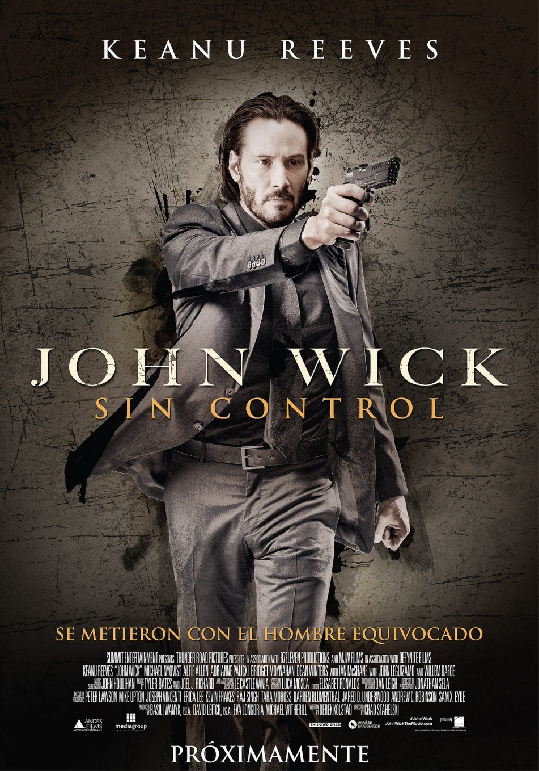
SIN CONTROL…

I was very pleased with the first John Wick Movie because the word plays with Wicked and with a Wick, the light of a candle, the light of Illumination and the play between the two.
It is the life of an illuminated being to have been terribly wicked in past lifetimes as with our student Old Nick who in past lifetimes signed pacts with the devil, then renounced them, transmuted them and all his ancient Karma using the Energy Enhancement Meditation Seven Step Process..
In John Wick One we show him taking revenge on a Mafia Guy, "You killed my Dog" renouncing the Satanic Life of, "the Organisation which has existed before the Roman Empire" - The Continental
Before you can become Enlightened, first you must have explored the Dark Side..
"Before you can follow the light, first you must have touched the darkness" - Arwen Evenstar, the Rings of Power
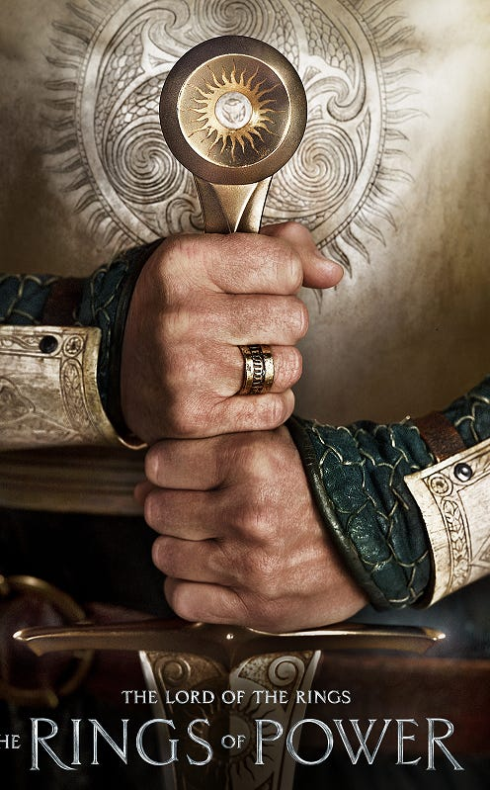

And here is Old Nick, Nickananda, Wick, our Energy Enhancement Meditation Student recounting his experiences in Energy Enhancement Meditation where he made pacts in past lifetimes with the Dark Satanic Organisations.
Nickananda Reports Satanic Pacts Past Life Rituals
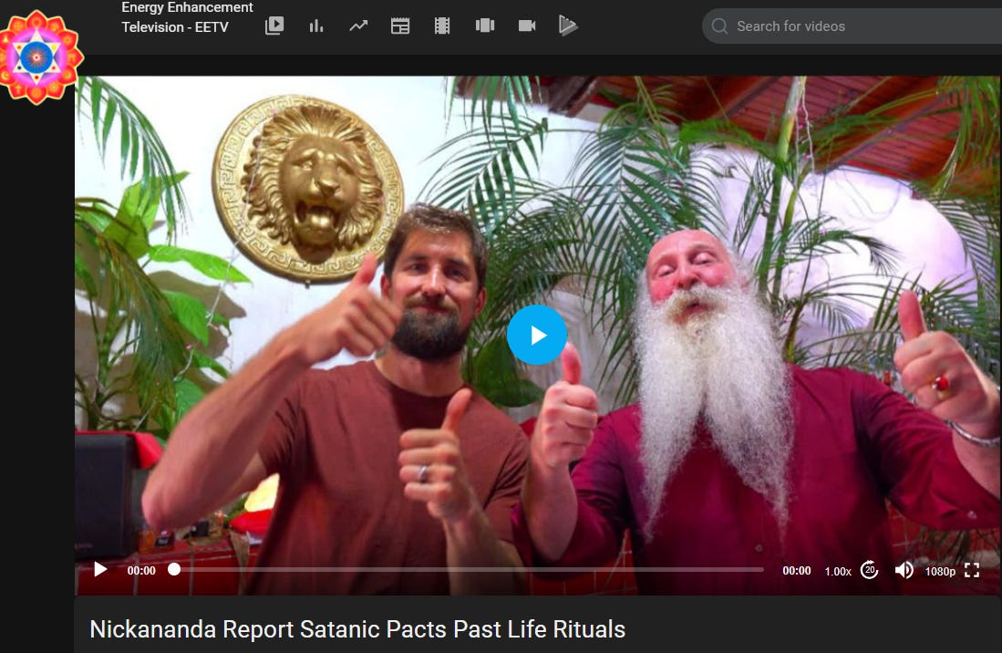
Visions of Past Lifetimes Clearing the Satanic Pacts with the Devil with Energy Enhancement Meditation...
https://eemeditationvideo.org/watch/nickananda-report-satanic-pacts-past-life-rituals_iioaUZPaW9B1wJ2.html
Because we have been given free will to be given those experiences of the Dark Side so we can freely choose, "Only to do the good and right thing" - Satchidanand
Because, "We have been down that path, Neo, and we know where it ends" - Trinity from the Matrix
As I say in Against Satanism https://againstsatanism.com/
The Satanic Phoenician Empire is 10,000 years old - "the Organisation which has existed before the Roman Empire" - The Continental
And the High Table is comprised of the Satanic Phoenician Mega Trillionaires, the Rockefellers, the Rothschilds and the Black Nobility Families and all the British Aristocracy, Marquises, Earls, Barons, Baronets. The King’s Privy Council of the British East India Company contains Lord Malloch (Molech) Brown CEO of Dominion Voting Machines, tool of George Soros…
The Aristocrats derive their power from the King Chucky the Turd Saxe Coberg Gotha who owns Vanguard and Blackrock with his Court Jews Rockefeller and Rothschild who also manage the Vatican Bank,

The Richest Satanic Phoenician Mega Trillionaire 10,000 years old Families in the World

Satchidanand
·
November 25, 2022
The Richest Satanic Phoenician Mega Trillionaire 10,000 years old Families in the World. THE VANGUARD GROUP DRIVES WORLDWIDE MERCHANT-BANKER FASCISM FROM THE CITY OF LONDON. VANGUARD, BLACKROCK, STATE STREET ARE CONTROLLED BY THE PILGRIMS SOCIETY IN THE CITY OF LONDON (ROTHSCHILDS, BARINGS, BARCLAYS, NATWEST, ETC.) King Chucky the Turd is the front man …
Read full story

King Chucky the Turd Saxe Coberg Gotha who is descended from Dracula and who has bought Dracula's castle in Transylvania in Romania "I have a stake in Romania - as it were..." - King Chucky - where he lives six months of the year getting visits from his, "Little Friends" from the local orphanage.



Here is my Esoteric Movie Review I wrote before...
Karma and Anti-Satanism in the Spiritual Actor, Keanu Reaves movie, "John Wick (2014)" Esoteric Movie Review by Satchidanand.
In John Wick Two John Wick is busy renouncing the, "Organisation which has existed before the Roman Empire" - The Continental, and it ends in only the way that it can - in him killing one of the High Table for which he is "Excommunicado" pitting him against the whole High Table Organisation of Satanic Phoenician Mega Trillionaires.
Taken (2008), Trafficked (2017) and John Wick 2 - Sex Trafficking, Pedophilia, Ritual Human Sacrifice, Organ Harvesting and Drugs Worldwide - Esoteric Movie Reviews by Satchidanand
Read my review here..
https://www.energyenhancement.org/Karma-Satanism-Spiritual-Actor-Keanu-Reaves-movies-John-Wick-(2014)-Man-of-Tai-Chi-(2013)-Esoteric-Movie-Review-by-Satchidanand-THE-REMOVAL-OF-ALL-BAD-KARMA-ENERGY-ENHANCEMENT-REMOVAL-OF-ENERGY-BLOCKAGES-SEVEN-STEP-PROCESS.htm


https://www.energyenhancement.org/Taken-(2008)-Trafficked-(2017)-and-John-Wick-2-Sex-Trafficking-Pedophilia-Ritual-Human-Sacrifice-Organ-Harvesting-and-Drugs-Worldwide-Esoteric-Movie-Reviews-by-Satchidanand.htm

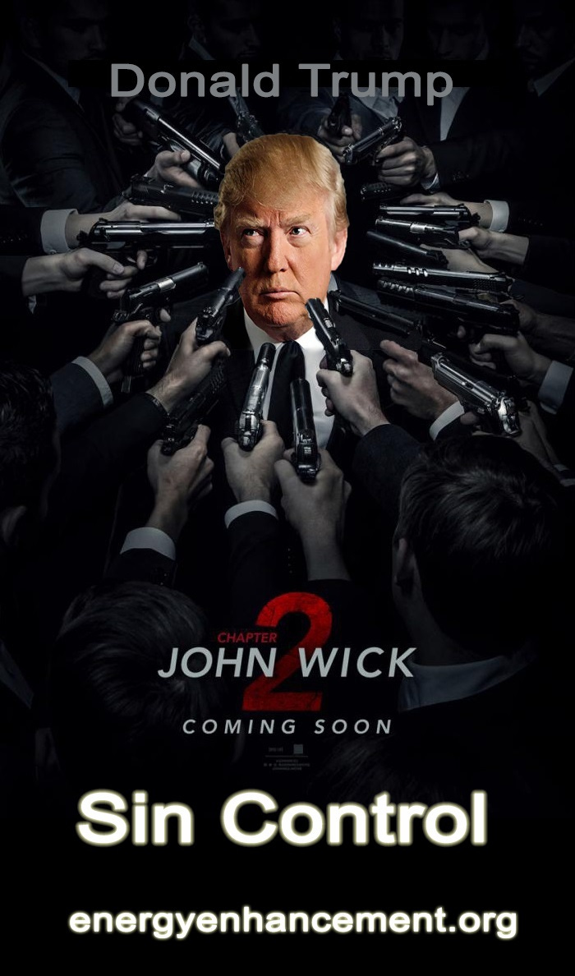
In John Wick Three we see John Wick taking a look at the task before him and saying it's all too much and trying to get back into the organisation without being killed.
But once you have made the decision, it's impossible to go back and this is the meaning and significance of John Wick Three. The movie disappointed me because I knew that it was a diversion, a break in the true path of revulsion, reversion, revolt against the High Table.
In John Wick Four I was very happy to see that John Wick did not die at the end of the movie as everyone was saying, but instead used the trick of, "Nothing lies like a Phoenician Cemetery" of pretending to die so the high table would not go after him after he killed the Marquis of the High Table in a Duel.
We know that John Wick, "A man of Infinite Will Power" must now complete his task of wiping out the High Table of Satanic Phoenician Mega Trillionaires. So I'm looking forward to seeing that, "As only celluloid can deliver" - V for Vendetta, another seminal movie written, adapted by the Wachowskis
I have written many Spiritual Movie Reviews here in my Two Books of Reviews..
BLACKLISTED Heart Opening & Movie Reviews Book Volume 1 - Click Below..
http://www.energyenhancement.org/Free-Book-Blacklisted-Esoteric-Movie-Reviews-Book-Volume-1-by-Satchidanand.htm
Movie Reviews Book Volume 2 - Transhumanism and Artificial Intelligence
Click Below..
http://www.energyenhancement.org/Free-Book-Energy-Enhancement-Spiritual-Movie-Reviews-Book-Volume-2-Lucy-Lucyfer-Lucifer-Transhumanism-and-Artificial-Intelligence.htm
And more, here on my Movie Reviews Page...
https://www.energyenhancement.org/Spiritual-Movie-Reviews-Satchidanand/Index.html
And here are my Eleven Volumes of Against Satanism where we are shown the Secret Histories of the Birth of the Satanic Phoenician Empire controlled by Satanic Ritual and Infiltration of every Empire so as to feast off their decline.
The Twelve Volumes of Against Satanism where we are shown the Management of the Empire by means of the Satanic Religion and it's Satanic Rituals..
Against Satanism by Satchidanand Volumes 1 to 12 - “The Occulted 10,000 year Phoenician Empire Satanic History of the World” - Your Worldview Will Never Be the Same! - in an easily downloadable file from our own website.
https://againstsatanism.com/Sacred-Energy/Against-Satanism-Volumes-1-12.rar
Mind Control Black Assassins by Satchidanand Volumes 1 to 11 in an easily downloadable file from our own website.
https://againstsatanism.com/Sacred-Energy/Black-Assassins-Volumes-1-11.rar
Satanic Spiritual Movie Reviews by Satchidanand Volumes One - “Blacklisted” and Two “AI and Transhumanism” in an easily downloadable file from our own website.
https://againstsatanism.com/Sacred-Energy/Spiritual-Movie-Reviews-Vols-1-and-2-Energy-Enhancement-Swami-Satchidanand.zip
All Osho Books One by One
http://www.energyenhancement.org/Sacred-Energy/Oshoa.k.a.Rajneesh(312Books).rar

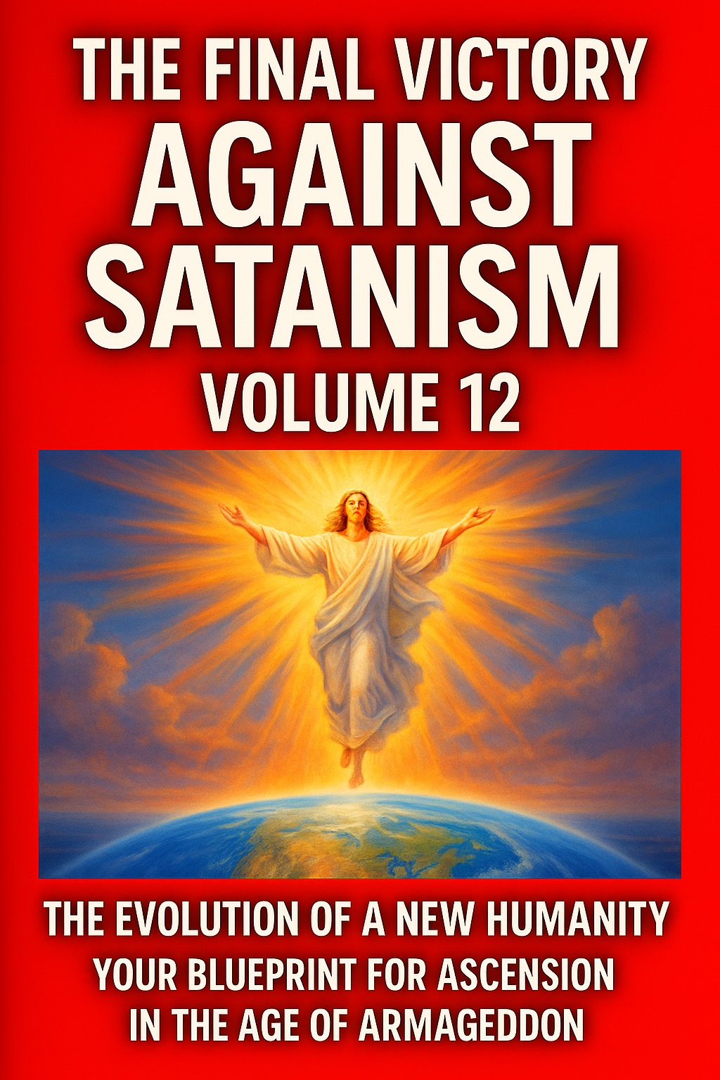

The Globalist Rothschilds, Rockefellers, Carnegie Satanic Phoenician Mega Trillionaires are Controlled by a 10, 000 years old Psychopathic Religion
Following instructions from the Satanic Phoenician Mega Trillionaires like the Rothschilds and the Rockefellers, the Carnegie endowment and many other Satanic Phoenician Foundations whose race of Phoenician International traders controlled the Silk Road from China and India through the Constantinople Byzantine Empire, through the Venician/Phoenician Empire into Europe. Who mined gold in Cornwall 4000 years ago. Who have worshipped all the Baal and Molech, Cybele and Attis, Sabbattean Frankist, Aleister Crowley Thelema and Baphomet Satanic Religions from 10,000 years before Christ....
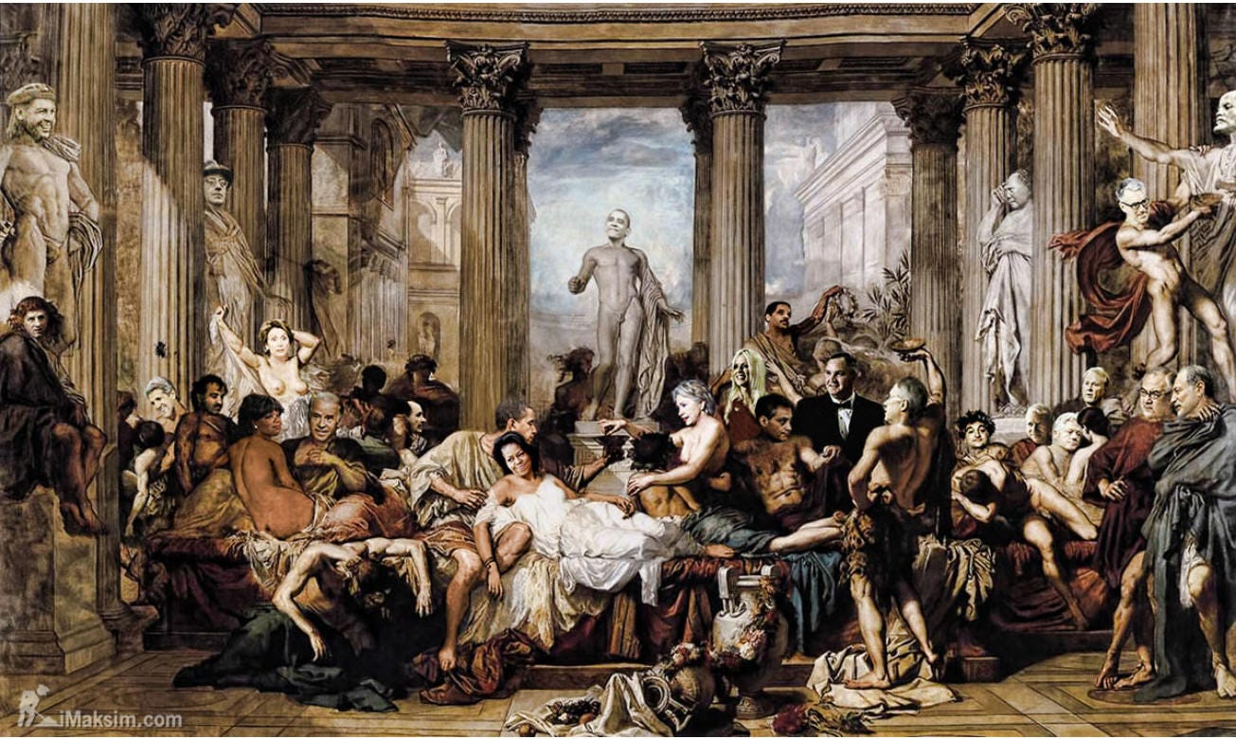

Click here to Read The Fall of the Anglo-American Empire
In the late 1800s and early 1900s the western world experienced a sudden burst of open occultism among the Satanic Phoenician Mega Trillionaire ultra-rich elites.
The rise of “Theosophy” was underway, becoming a kind of fashion trend that would ultimately set the stage for what would later be called Alice Bailey Lucifer Trust “New Age” spiritualism. The primary driver of the theosophical movement was a small group of obscure academics led in part by a woman named H.P. Blavatsky together with the Old CIA's Colonel Olcott . The group was obsessed with esoteric belief, Gnosticism, Luciferianism and even Satanism.
Blavatsky co-founded the Theosophical Society in New York in 1875, claiming that she had a psychic connection to beings called “the Mahatmas” or “the Masters.” These creatures, she asserted, helped her write the foundational books of Theosophy, including ‘The Secret Doctrine.’
I bring up Theosophy and Blavatsky because the movement she helped launch was primarily an elitist one – The spread of occultism in the early 1900s specifically targeted the upper classes and this resulted in many political leaders and financial leaders being involved in obscure organizations with secretive mandates.
Such groups have existed in the past, from the Satanic Phoenician Mega Trillionaire Rothschild funded Adam Weishaupt Sodomite Illuminati, to Satanic Phoenician Mega Trillionaire Rothschild Supported Sexual Ritual Incest Sabbatean Frankists, Rosicrucians, and Sodomite 33rd Degree Freemasons.
However, never before had they been so public in their efforts.
To their credit, the early theosophists were mostly apolitical (at least outwardly) and they argued against political intrusion into people’s lives. I suspect, however, that this was because at the time western governments revolved around Christian and conservative values.
As politicians became more separate from Christianity, as Christianity was consciously destroyed, the theosophist interest in controlling government grew and the movement became increasingly socialist in practice as the British Secret Services Super Agent Marx wrote Das Kapital from the notes of Ambassador Urquhart in his office in the British National Library in London.
Communism and Marx was used by the Satanic Phoenician Mega Trillionaires to install Lenin and Stalin, Mao and Castro in Russia, China and Cuba as the vanguard of the new Empire taking over from the old Anglo-American Empire which is targeted for destruction. WW1 was used to destroy the Austro-Hungarian Hapsburg Holy Roman Empire and the Ottoman Empire.
Invariably, these spiritual systems revolved around pagan deities of the past, many Babylonian or Ancient Egyptian in origin. That said, there are also numerous mentions in Theosophy of one figure in particular – Blavatsky talked about Lucifer, also referred to as Quote, “the Light Bearer, the angel of light, Prometheus (symbolically), the dragon, the morning star and Satan.”
Modern luciferians will consistently deny the the name “Lucifer” has anything to do with the biblical figure of Satan, but this is a lie. Blavatsky herself treats the two figures as synonymous in ‘The Secret Doctrine.’ As she admits in her book:
“And now it stands proven that Satan, or the Red Fiery Dragon, the ‘Lord of Phosphorus,’ and Lucifer, or ‘Light-Bearer,’ is in us: it is our Mind…”
Blavatsky, quoting hermetic texts in the Secret Doctrine, also repeats the mantra:
“It is Satan who is the god of our planet and the only god…”
Luciferians and occultists will also argue that the Christian Bible only mentions the name “Lucifer” once, and that the two figures are not associated. This is once again a lie by omission. The Bible does in fact mention “light bearer,” the “angel of light” and “the dragon” in reference to Satan on multiple occasions, and all of these names are used by elites to describe the figure they call Lucifer.
As mentioned in Corinthians 11:14 – “And it is no wonder, for Satan himself masquerades as an angel of light…”
In other words, when any elitist group mentions terms such as “light bearer” or Lucifer, they are indeed referring to Satan. It’s not just a matter of archetypal discussion, this is in fact a part of their religion. But in our modern times some people might say “who cares?” It’s all mythical hoodoo and fantasy, right?
I would respond with a question: Do you think the deeply held religious beliefs of the Satanic Phoenician Mega Trillionaire Bankers and International Traders from 10,000 years of World Management whose ancestors raised up and fed off the decline and Fall of seventy-three fine and upstanding Empires destroyed by Satanism, Sodomy, Transexuality, Satanic Ritual and homosexuality with total financial and political power gained by sex, bribery and blackmail of the Epstein variety matter in how they make decisions?
OUR SATANIC WORLD RULERS ARE BOUGHT AND PAID FOR BY SATANIC PHOENICIAN MEGA-TRILLIONAIRES



IT'S ALL FAKE, IT'S ALL A SCAM!!

Satchidanand
·
February 1, 2024
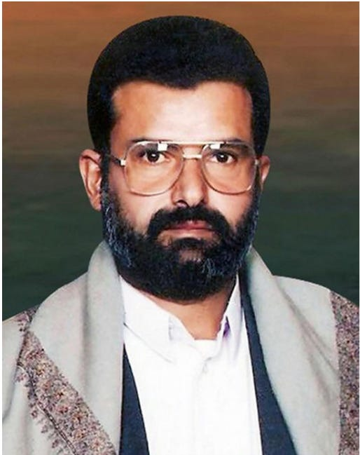

IT'S ALL FAKE, IT'S ALL A SCAM!! We are hearing a lot about Houthis these days. What are Houthis? They are allegedly a militant revolutionary group of Shia Muslims in Yemen who arose in the 1990s, pushing back against US involvement in the area. They are named for their leader Hussein Badr al-Houthi, allegedly killed in action in 2004.

Read full story

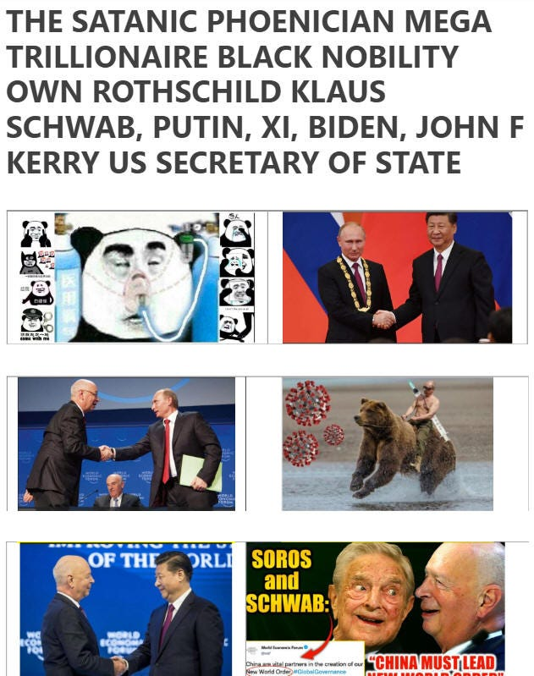

https://satchidanand.substack.com/p/its-all-fake-its-all-a-scam

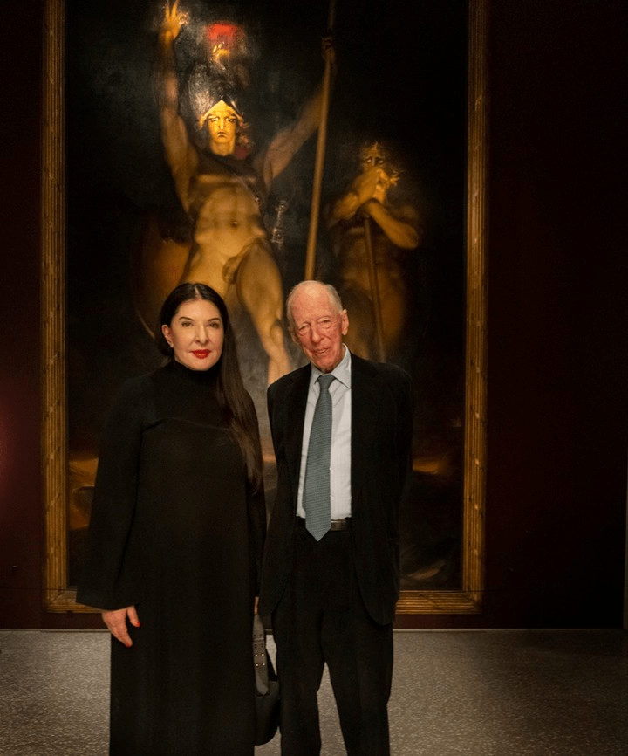

"Spirit Cooking" Witch, Marina Abramovic, who was recently photographed with Lord Jacob Rothschild admiring a painting from 1797 titled “Satan Summoning His Legions”, has emerged from the shadows to star in a new commercial for Bill Gates' Microsoft.
https://satchidanand.substack.com/p/its-all-fake-its-all-a-scam
https ://againstsatanism.com/Marina-Abramovic-Reminder-Bill-Gates-Pindar-Rothschild-SATANISM-WORLDWIDE-Podesta-Lady-Gaga-Spirit-Cooking-BLACK-MADONNA-CYBELE-VICTOR-HUGO-HUNCHBACK-quasimodo-Aset-Pan-Knights-Templar-Serpent-Cult-ninth-circle.htm

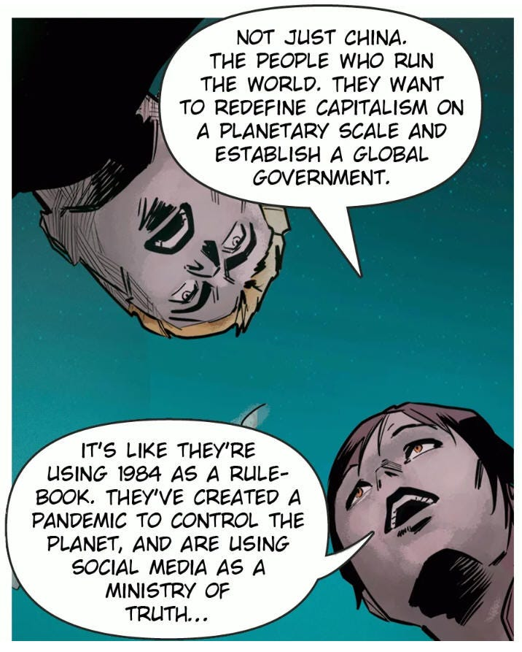

https://againstsatanism.com/The-Fall-of-the-Anglo-American-Empire.htm

PRIME MINISTER OF UK, RICHIE SUNAK CREATED THELEME PARTNERS AT GOLDMAN SACHS TO INVEST HUNDREDS OF MILLIONS OF DOLLARS AT MODERNA CREATING THE VAXX



ALEISTER CROWLEY RICHIE SUNAK THELEMA
RITUAL SODOMY BLACK MAGIC
https://againstsatanism.com/ALEISTER-CROWLEY-RITUAL-SODOMY-RITUAL-SEX-ILLUMINATI-SEX-TANTRA-ADDICT-DRUG-ADDICT-VICTIM-OF-VAMPIRE-SEX-DRUG-AND-FOOD-ADDICTION-IMPLANT-BLOCKAGES-ENERGY-CONNECTIONS.htm
https://againstsatanism.com/Satanism-chaos-magic-black-magic-OTO-Aleister-Crowley-Child-Abuse-MK-Ultra-Murder-Occult-Paedophilia-Pedophilia-Ritual-Abuse-brainwashing-Mind-Control-Baphomet-Lucifer-Murder-ritual-human-sacrifice-Pagan.htm
https://againstsatanism.com/SATANIC-TAVISTOCK-INSTITUTE-SATANIC-LORD-RUSSEL-SATANIC-ROCKEFELLER-SATANIC-SABBATEAN-FRANKISM-SATANIC-FREUD-PSYCHOANALYSIS-SATANIC-FRANKFURT-SCHOOL-KABBALAH-ADORNO-BENJAMIN-MARCUSE-LUKACS-BRECHT-WEILL-ECO-DERRIDA.htm



Wouldn’t their beliefs and Satanic Ritual Practices designed to create Psychopaths by totally shutting down the heart help explain why they do the things they do? If you want to know why the globalists are engaged in a very real war on the minds of the masses, you cannot overlook their religious motivations. What seems like fantasy to some is VERY real to the globalists.
The Satanic Rituals putting psychic daggers into Anahata Chakra 12 petals are designed to totally shut down the Heart. The Satanic Rituals cutting themselves off from conscience and the energy of God allows these Satanic and Luciferian psychopaths to do the horrible things they do.
Human beings are composed of intellect, will power, heart and conscience.
Without the energy of the Heart and conscience, Psychopaths, Satanists and Luciferians are less than human!
These Evil Shadow Subpersonalities band together to take you over and repress the Soul infused Personality. They are then Evil psychopaths and this is bad enough.
But when these Evil Shadow taken over people band together into groups, Satanic Evil Religions, Bloodline Families and Bloodline Races, Secret Societies, Cartels, Banksters - giving courses on how to repress further the soul infused personality - how to become even more Evil - then this is what and why I write in my Against Satanism series of Books - currently Eleven volumes available for FREE!! when you sign up for the newsletter at
https://energyenhancement.org
or get them at...
https://energyenhancement.org/FreeGiftsDonationsPage.htm

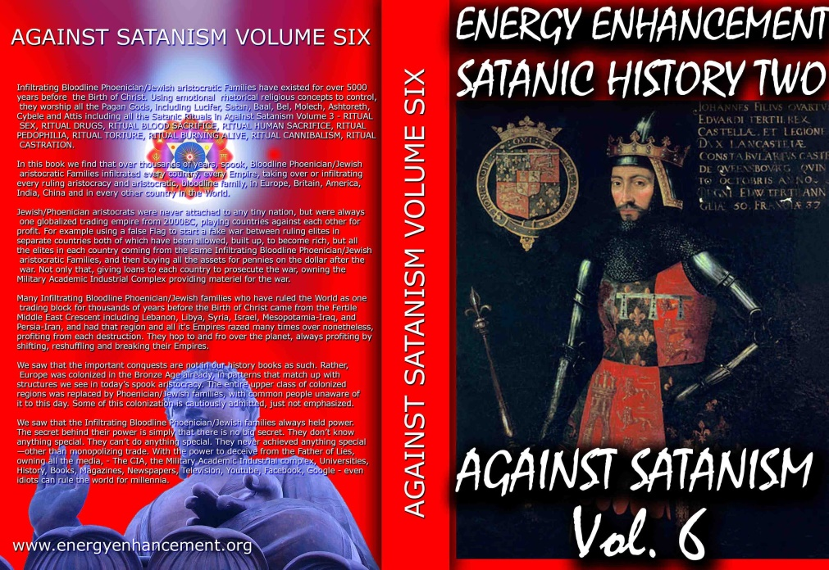

SIGN UP!!! CLICK HERE TO GET 52 BOOKS FREE!! INCLUDING THE ELEVEN VOLUME SET OF THE AGAINST SATANISM REDPILL UNIVERSITY - THE HISTORY, PHILOSOPHY, RITUALS AND ECONOMICS OF THE 10,000 YEAR "THE OLD RELIGION" OF SATANISM..
READ ABOUT IT IN AGAINST SATANISM VOLUME SIX
Dark Forces have used Infiltrating Bloodline Satanic 10,000 years old Phoenician Mega Trillionaire Aristocratic Families which have existed running Global Trading Companies for thousands of years before the Birth of Christ.
Infiltrating and taking over the power structures in every country, using propaganda - emotional rhetorical religious concepts to control humanity, they themselves are Satanists, worshiping all the Pagan Gods, including Lucifer, Satan, Baal, Bel, Molech, Ashtoreth, Cybele and Attis.
All these Satanic Gods are heartless Demons who have cut themselves off from the Energy of the One Good God, who have rejected God so as to live eternally, immortally.
Therefore they control humanity so as to steal and vampirise the energies of Humanity forever!
In this book we find that over thousands of years before the birth of Christ, spook, Bloodline Satanic Phoenician Mega Trillionaire Aristocratic Families infiltrated every country, every Empire, from their Phoenician Colonies in Ancient Egypt, Carthage, Rome, Venice and London, marrying in to, taking over or infiltrating every ruling aristocracy and aristocratic, bloodline family.
Their Phoenician sons and daughters pretending to be natives of Europe, Britain, America, India, Israel and China, using their Satanic Phoenician Mega Trillionaire inheritances to get into positions of power to manage and control their human cattle in every country in the World!!
Download FREE! AGAINST SATANISM Volume 6 Right Click and Save as..
https ://againstsatanism.com/Sacred-Energy/Against-Satanism-Volume-6/AGAINST-SATANISM-6-Satanic-History-of-the-World-Part-2.pdf
Satanism is gradually being instituted as the New World Order.
The New World Religion, defined by Satanic Ritual.
AGAINST SATANISM VOLUME 3 - Satanism is defined by Satanic Rituals.. LIVES FOR SATAN! - THESE RITUALS DEFINE SATANISM.. RITUAL SEX, RITUAL SODOMY, RITUAL DRUGS, RITUAL BLOOD SACRIFICE, RITUAL HUMAN SACRIFICE, RITUAL TORTURE, RITUAL BURNING ALIVE, RITUAL CANNIBALISM, RITUAL CASTRATION, RITUAL VIRGIN SACRIFICE.. Abortion, Baby Killing, Vaccines, Autism, Pandemics.
Click Below..
http://www.energyenhancement.org/FREE-BOOK-AGAINST-SATANISM-VOLUME-3-Satanism-is-defined-by-Satanic-Rituals.htm
72 Empires have been recorded and every one of them has failed in the same way. The facts have been recorded that a totalitarian and satanic elite infil-traitored and took over all these Empires and that 72 once free, flourishing and rich republics were destroyed from within by Satanic Ritual - read Toynbee. Satanism is gradually being instituted as the New World Religion defined by Satanic Ritual.
Infil-traition of Satanism is the methodology as slowly every Government Ministry and Societal function is taken over. Eventually a Satanist becomes King Emperor President. LGBTP - The Satanist Ritual Pillars of Homosexuality, Pederasty, Pedophilia, Drugs and Ritual Sex - both Hetero and Homosexual - are introduced overtly as a prelude to Ritual Human Sacrifice and Ritual Baby Sacrifice. Christianity and Judaism - the bulwarks Against Satanism - are destroyed and then society destroyed through the fear of mandatory Ritual Human Sacrifice.

SEE THE VIDEO - HOW SATAN STEALS THE SOULS AND ENERGY OF ALL HIS FOLLOWERS
http://eemeditationvideo.org/watch/how-satan-steals-the-souls-and-energy-of-all-of-his-followers-revealed_DrCx7XVNAbLtQP5.html
The Ancient Enemy who counts meditation and the mind control psychic arts as one of its main planks of World Domination has used Satanic Infil-Traitors for 10,000 years in every Organisation - Religion, Left and Right Politics, Dynastic Families, Geopolitics, Economics, Universities, Intelligence Services, Think Tanks, Banking, International Companies, Eugenics.
Innoculate yourself Against Satanic Globalism which created Cybele and Attis, Baal, Molech, Zeus, Venus, Pedophile Plato, No Soul Aristotle, Catholicism, Protestantism, the Illuminaughty, Sabatean Frankism, Crowley's Ordo Templi Orientis (OTO), Islam, Wahhabic ISIS, the Muslim Brotherhood, Communism, Socialism, Gaia and Satanic Hitler's Pagan Eugenic Nazism by Downloading.. The Energy Enhancement Books - Against Satanism Volumes 1 - 11 by Satchidanand.
To understand how and why Evil has taken over this Planet, and how Energy Enhancement can free this Planet from All Evil... READ THE AGAINST SATANISM SERIES OF ELEVEN BOOKS!! At...
https://energyenhancement.org/FreeGiftsDonationsPage.htm
EPSTEIN CIA, MOSSAD AND MI6 BLACKMAIL AND SHAME KEEP THE SATAN WORSHIPPERS IN LINE TO DUMB DOWN AND DEGENERATE HUMANITY SO IT CAN NOT FIGHT BACK...
72 Empires have been recorded over 10,000 years and every one of them has failed in the same way. The facts have been recorded that a totalitarian and satanic elite infil-traitored and took over all these Empires and that 72 once free, flourishing and rich republics were destroyed from within by Satanic Ritual - read Toynbee.
Infil-traition of Satanism is the methodology as slowly every Government Ministry and Societal function is taken over. Eventually a Satanist becomes King Emperor President. LGBTP - The Satanist Ritual Pillars of Homosexuality, Sodomy, Pederasty, Drugs and Ritual Sex - both Hetero and Homosexual - are introduced overtly as Wokeness ESG, the Corporate Equality Index, as a prelude to Ritual Human Sacrifice.
Christianity and Judaism - the bulwarks Against Satanism - are destroyed and then society destroyed through the fear of mandatory Ritual Human Sacrifice.
The Ancient Enemy who counts meditation and the mind control psychic arts as one of its main planks of World Domination has used Satanic Infil-Traitors for 10,000 years in every Organisation - Religion, Left and Right Politics, Dynastic Families, Geopolitics, Economics, Universities, Intelligence Services, Think Tanks, Banking, Facebook, Twitter, International Companies, Vatican, Transhumanism, CRISPR Androids, Eugenics..
Sodomy and the Sodomy Ritual is at the heart of Satanism.
Bottom on bottom, 8 or 33 represents the Vitruvian man. The occultist da Vinci’s Vitruvian Man really depicts the buggery of the anterior man by the posterior man, the apex of Satanic Luciferian 33rd Degree Masonry or final “Mystery of Mysteries” of the secret societies as explicated by Walter Veith (to open their “Third Eye.”). The reign of the AntiChrist will be marked as the sodomite king of the world..

ENERGY ENHANCEMENT MEDITATION SACRED SYMBOLS FOR PERFECT WISDOM ENLIGHTENMENT AND THE SATANIC PERVERSION OF THESE SYMBOLS

Satchidanand
·
October 2, 2022
It's hard for me to say this but Sacred Symbols, good symbols, or legominisms as Gurdjieff said where symbols of the past are designed to help us, inform us, provide a map whereby we can all cleave to the light, become Enlightened. To re-enforce our psychic bodies, drink in the spiritual force in which we bathe daily, mostly without knowing it, to teach …

Read full story

https://satchidanand.substack.com/p/energy-enhancement-meditation-sacred
SATANISM IS DEFINED BY SATANIC RITUAL RITUAL SODOMY OPENS THE THIRD EYE RITUAL SODOMY SPLITS THE MIND INTO SUBPERSONALITIES OR ALTERS In the House of the Strong Man Sodomy is the Key

SATANISM IS DEFINED BY SATANIC RITUAL RITUAL SODOMY OPENS THE THIRD EYE RITUAL SODOMY SPLITS THE MIND INTO SUBPERSONALITIES OR ALTERS In the House of the Strong Man Sodomy is the Key

Satchidanand
·
October 2, 2022
The doctors of the law, too, who had come down from Jerusalem, said, ‘He is possessed by Beelzebub’ and ‘He drives out devils by the prince of devils.’ So he called them to come forward, and spoke to them in parables: ‘How can Satan drive out Satan? If a kingdom is divided against itself, that kingdom cannot stand; if a household is divided against itse…

Read full story

https://satchidanand.substack.com/p/satanism-is-defined-by-satanic-ritual
The drawing together of a "Band of Thebes" British Aristocracy was particularly prized and brought about by the public school system started by Henry VI in 1440 at Eton but franchised to all schools very quickly. A hidden world drawn together by Pedophilic, Sodomy Ritual, homosexual warriors - the Heart of the Satanic British Empire - further, "Homosexuality follows Satanism like a stench"
Nicole Kidman: ‘Stanley Kubrick Said Pedophiles Run The World’
“Stanley told me the world is run by pedophiles,” Nicole Kidman said while promoting HBO’s Big Little Lies, in Los Angeles. “He studied secret societies his whole life, he was fascinated by them, and he said the elite, the top secret societies, they are full of men with a certain predilection. They are tied together, sort of bonded, by pedophilia like the ”Pact of Blood” where the Mafia entrants have to kill someone in order to join, these guys have to pedophile and human sacrifice like Epstein’s Pedo Island and the Lolita Jet - “They all know each other’s dark secrets. There is no way out for any of them. It’s a lifetime bond. Even if one of them wanted to go straight, repent, so to speak, he can’t. His peers will bring him down. They are in it until death, driving the world to ruin. That’s kind of how Stanley explained it but it was all very complex. I’m probably not doing it justice.”

P.G. Wodehouse and British Empire Ritual Sodomy Band of Thebes Propagandised for Hitler, Propagandised for the Satanic Phoenician Mega Trillionaires

Satchidanand
·
October 2, 2022
Sir Pelham Grenville Wodehouse, KBE 15 October 1881 – 14 February 1975 was an English author and one of the most widely read humorists of the 20th century. His creations include the feather-brained Bertie Wooster and his sagacious valet, Jeeves; the immaculate and loquacious Psmith; Lord Emsworth and the Blandings Castle set; the Oldest Member, with st…

Read full story

https://satchidanand.substack.com/p/pg-wodehouse-and-british-empire-ritual
Thus in order to destroy free will, and institute total control over humanity, Satanism over 10,000 years has instituted Sodomy Rituals and pedophilia to control the upper levels of society by the use of institutions of public schools like, "Whipping and Fagging" all boys schools like Eton - founded as a mind control institution in 1438 by the King - where the Sodomy rape ritual sorted the boys into the Prussian Frederick the Great aggressive masculine homosexual rapine Penetrators, perpitrators, as in the 3000 years old Phoenician Colony of Thebes in Ancient Greece the "Band of Thebes" particularly successful Army of Gay Lovers, and the weak effeminate homosexual slaves or women or young boys.
BDSM Masters and Slaves.
All successful Generals, Politicians, Priests, Policemen, Presstitutes, Professors - all bought, blackmailed and paid for Prostitutes - came out of this background which then when refined by the Satanic Sodomy Ritual Secret Societies - the foundation of elite mind control for centuries - the Sodomite 33rd Degree Freemasons, the Jesuits, the Illuminati and hundreds more - all based on the Mind Control Sodomy Ritual and Pedophilia supplied by Renfields like Jimmy Savile for the elite Draculas.
Remember, the purpose behind Satanism is total control of society by mind control, perversion and poison to dumm down humanity so they can be vampirised of their spiritual energy eternally because if humanity is allowed to evolve, to learn how to heal the mind, to psychically dissolve all these hundreds of lifetimes of mind control programs in the psychic body, the vampires can no longer exist!

Satanic Phoenician Mega Trillionaires behind MKULTRA Mind Control Programs Bimbosleep Bimbofication and Sissi Hypno Sissification created by Tavistock Institute and the Nazi CIA Stanford University
Satchidanand·
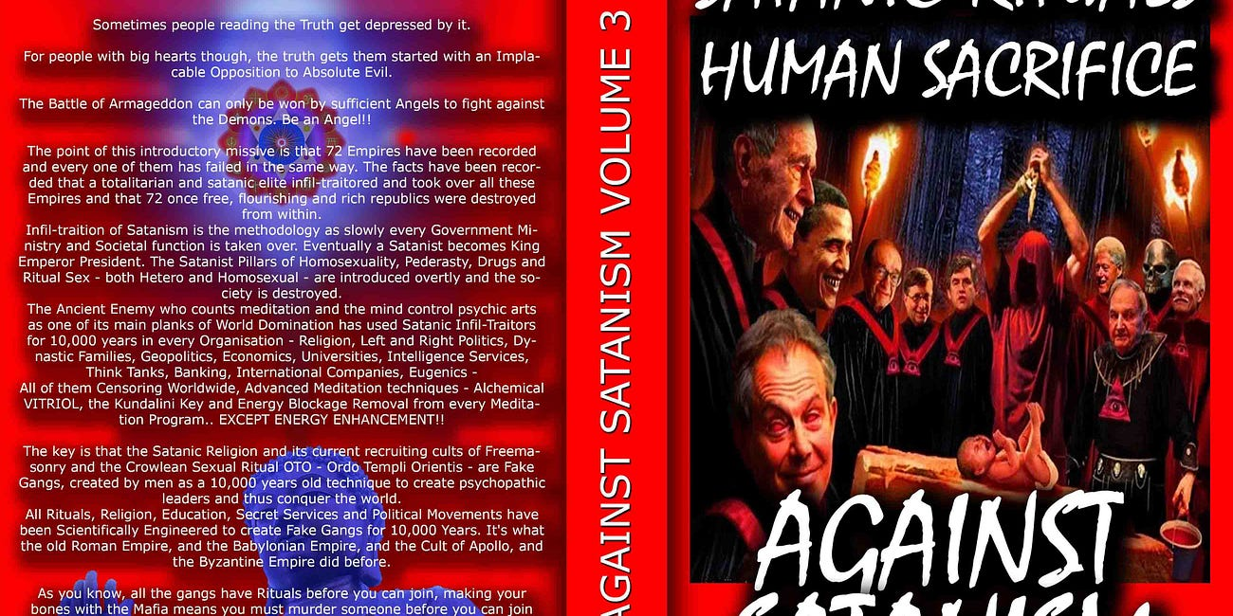

Satanic Phoenician Mega Trillionaires behind MKULTRA Mind Control Programs Bimbosleep Bimbofication and Sissi Hypno Sissification created by Tavistock Institute and the Nazi CIA Stanford University BLM supporter and transgender, Kimbrady Watson Carriker has been identified and arrested as the shooter in the Philadelphia mass shooting that left 5 men dead…
Read full story

https://satchidanand.substack.com/p/satanic-phoenician-mega-trillionaires

Download The Illuminati Formula to create a Completely Mind Controlled Slave which details, "The World which has been Pulled Over Your Eyes, to hide you from the Truth" Morpheus, Matrix Movie.
This book details the Satanic 10,000 years old process using Torture, Drugs and Hypnotism in order to layer in Demon Programs from birth and before birth into the torture and drug split mind which has always infused the Emperors, Kings, Presidents, Prime Ministers and their policies mandated by the Satanic Elite Controllers..
Now industrial quantities of children - evidence in the 1972 Church hearings 6 hours of video evidence to Congress available on youtube and CSPAN talking about 10,000 young children taken from orphanages and entered into the MKULTRA program - are being mind controlled to take over the World, Movies Trafficked and Taken and the Haiti Trafficking detail the abduction.
This book details the methodology - to give evidence that Against Satanism - is Real!!
by Cisco Wheeler and Fritz Springmeier
Read this pdf book - Right click and save..
http://www.energyenhancement.org/Fifth-Level-Avatars/Springmeier-Illuminati-Formula-to-Create-A-Total-Mind-Controlled-Slave.pdf
The key is that the Satanic Religion and it's current recruiting cults of Sodomy Ritual 33rd Degree Freemasonry, the Illuminati, Jesuits, Sabbatean Frankism, and the Crowlean Sexual Sodomy Ritual OTO - Ordo Templi Orientis, Yale Skull and Bones, Bohemian Grove - are Fake Gangs, created by men as a 10,000 years old technique to create psychopathic leaders and their minions, and thus conquer the world by constantly degenerating humanity into Orcs.
All Rituals, Religions, Education, Secret Services and Political Movements have been scientifically Engineered to create Fake Gangs for 10,000 years. It's what the old Roman Empire, The Babylonian Empire of Satanic Nimrod, and the Cult of Apollo and the Byzantine Empire did before.
As you know, every Gang has Blackmail Rituals before you can join. Making your Bones with the Mafia means you must murder someone before you can join. Drug Cartels like MS13, secret groups within the Masons, the Illuminati, Sabbatean Frankists, OTO, the Hellfire Club, all have their Human Sacrifice, Pedophilia and Sodomy Rituals before you can progress.
Epstein did not kill himself. He videoed Scientists from MIT and Harvard, Oligarchs, Politicians etc, Pedophiling young girls then Blackmailed them into doing the work of his Satanic Phoenician Mega Trillionaire sponsors - MKULTRA, Transhumanism, CRISPR Androids. As their willing victims are given access to stealing higher quantities of money, so they must go to the next level of Ritual. First it is 15 year old girls who look 25. Then it's 12 year olds, 5 year olds, and then its the murder of children, babies!
Since the Band of Thebes of fierce homosexual warriors, sodomy rituals bind together that Band of Brothers at the head of Military Organisations Worldwide, NATO, AZOV Battalion, the SS, American and British Army and Navy...
All to create a degenerated Satanic Society of Total Control through Human Sacrifice, poverty, starvation, bugs, miseducation, lack of education, Wokeness, Climate Change, Sustainability, poison in the air, water and food. Lack of infrastructure, Lack of Energy - Electricity, Coal, Petroleum, education and Total Censorship Control of the Media.

All of them Censoring Worldwide, Advanced Meditation techniques - Alchemical VITRIOL, the Kundalini Key and Energy Blockage Removal from every Meditation Program.. EXCEPT ENERGY ENHANCEMENT!!

https://www.energyenhancement.org
The very word secrecy is repugnant in a free and open society JFK (27 April 1961)
The very word secrecy is repugnant in a free and open society; and we are as a people inherently and historically opposed to secret societies, to secret oaths and to secret proceedings. For we are opposed around the world by a monolithic and ruthless conspiracy that relies primarily on covert means for expanding its sphere of influence on infiltration instead of invasion, on subversion instead of elections, on intimidation instead of free choice, on guerrillas by night instead of armies by day. It is a system which has conscripted vast human and material resources into the building of a tightly knit, highly efficient machine that combines military, diplomatic, intelligence, economic, scientific and political operations.
JFK (27 April 1961)
With Energy Enhancement Remove All these Evil Subpersonalities within you whilst you have the chance..
ONLY ENERGY ENHANCEMENT MEDITATION CAN ELIMINATE ALL EVIL!!
For example, many know that the United Nations building in New York has an occult library. But few people know that it was built by a group called the Lucifer Publishing Company (later changed to Lucis Trust). Lucis Trust cites the writings of Alice Bailey and HP Blavatsky constantly as the inspiration for their organization. The UN continues to associate with Lucis Trust to this day. The very heart of globalism revolves around luciferian ideals.
It doesn’t matter what you or I think about these things. It doesn’t matter if you see such concepts as metaphorical, or symbolic or imaginary. THEY believe, and so we must explore what these beliefs mean.
Before the 1800s, occultists engaged in Luciferianism would have been burned at the stake if discovered. I’m beginning to think that maybe this was the right way to handle such people all along. But to understand why, we have to look at the progression of the religion and why it inevitably leads to moral decline, social self-destruction, thus the Fall of the Anglo-American Empire and the rise of Chinese Century.
For the theosophists, Lucifer/Satan is a kind of heroic figure. When they argue that Lucifer is “not Satan,” what they mean is that their version of Satan is different from the version ascribed by Christianity. In other words, imagine a group of people took a famously malicious figure such as Joseph Stalin and then devised an entirely different history for him in which he is a misunderstood philanthropist instead of a genocidal maniac. That’s essentially what Luciferianism is.
In the Theosophical magazine titled ‘Lucifer’ published in the 1880s, Blavatsky and her group spend multiple pages trying to separate the term Lucifer from the Devil, while also defending the mythology of the devil and painting him as a character slandered by Christian culture.
In their version of the Genesis story, for example, the satanic serpent was the “good guy” bringing the knowledge of good and evil to Adam and Eve. Eve is venerated as a root figure in theosophy and in feminism (a movement the theosophists helped to create), because without Eve the serpent would have never been able to get Adam to consume the fruit.
The fruit as a representation of gnosis (the knowledge of good and evil and the free will to choose) is the key to Luciferianism and the satanic globalist cult.
As many atheists I’ve encountered in the past have argued, isn’t knowledge a good thing? And if God is punishing humanity for consuming knowledge, does that not make him a villain? This argument ignores the underlying theme – Knowledge by itself is not good or evil, but evil thrives when people start to worship knowledge to the detriment of morality. The application of knowledge without wisdom and moral discipline is dangerous.
As Dr. Ian Malcolm brilliantly asserts in the film Jurassic Park:
“Yeah, yeah, but your scientists were so preoccupied with whether or not they could that they didn’t stop to think if they should.”
Thus atomic power generation or the atomic bomb.
Thus the knife used by surgeons or by killers.
Luciferians openly admit that the goal of their ideology is to pursue knowledge until human beings become Gods. This infatuation with godhood is what leads to great evil; it is a delusion that poisons the mind and encourages morally relative behavior, not to mention a pervasive thirst for power.
Ponder the technological aspect for a moment. Consider the numerous globalist programs to expand artificial intelligence and bring about what they call “transhumanism.” This is a kind of knowledge worship that has terrifying implications for the future.
The integration of technology into the surveillance state to rule over society is bad enough, but what happens when human beings begin integrating technology into their very biology. Will this eventually erase any semblance of what we call “the soul?”
After all, machines do not have a Heart, do not feel, nor do they self reflect on their actions. What happens when humans distort themselves to become more like machines? Will transhumanism become a movement that suffocates all love and empathy, removing moral compass and turning us into a demonic hive-mind devoid of individual thought?
Globalists assert that there is no such thing as the soul, no such thing as individual identity and no such thing as moral compass. Form their perspective there is no danger of adopting technology as a path to godhood because nothing would be lost; and here we see the true nature of luciferianism at work. A perfect representation of this cancer is World Economic Forum spokesperson homosexual Sodomite Luciferian partner of WEF Head Rothschild Klaus Schwab, Yuval Harari – a man who says the quiet part out loud and promotes the darker tenets of luciferianism regularly.
To grasp what luciferianism is, think of it as the anti-god; a war on nature, or a war on the natural state of humanity disguised as “enlightenment.” This is why globalists try to institute the extreme opposite view of every natural disposition. The notion of human beings as a blank slate that Yuval Harari clings to is one such false narrative. It is a philosophy that has been debunked by endless psychological studies as well as anthropological studies.
From Carl Jung to Joseph Campbell to Steven Pinker and beyond, all scientific evidence suggests that human beings have inherent psychological qualities and characteristics from birth. Some of these are unique to the person, some are universal archetypes and ideas that the majority of people share such as heart, conscience and moral compass. If we didn’t have these built-in qualities, humanity would have become extinct thousands of years ago. We still don’t know where exactly they come from, we only know that without them we are no longer human.
There is, however, a certain percentage of people (1% or less) that actually do not have these inborn character traits of heart, conscience and moral compass. They are generally known as psychopaths and sociopaths, and their behavior is very similar to that of the globalists. They are less than human! I have long held the theory that the globalist cabal is in fact a cult of higher functioning psychopaths.
Their lack of empathy and conscience, their thirst for godhood and omnipotence, their drive to attain all encompassing surveillance of the population, to know everything about us at all time, to have total control over the environment and society, the narcissistic self image of a supreme ruler who is worshiped by the masses, and the delusion that they will be able to read minds and predict the future. These are psychopathic fantasies, and they are willing to chase these fantasies by any means necessary.
But even psychopaths sometimes need a fundamentalist framework in order to maintain organization and inspire devotion within a group. It makes perfect sense that they would choose luciferianism and the Satanic Rituals as their religion.
Their Sodomite Crowleyan “do what thou wilt” philosophy of hedonism takes the idea of freedom and removes all responsibility – It is a degenerate view of liberty, rather than a principled view. Freedom, they think, is only for people like them; the people willing to desecrate everything in their path and upend the natural order.
As psychopaths, they are devoid of natural inborn contents and are more robotic than human. So, it’s no surprise that people like Harari argue there is no soul, no freedom (for you) and that machines are capable of the same creativity as humans. An empty person - A Hollow Man - with no soul or creativity is going to assume that all other people are empty. An immoral person will also be compelled to prove that everyone else is just as immoral as he is. Or, he will be compelled to prove that he is superior to everyone else because he has embraced his immorality.
We are the hollow men
We are the stuffed men
Leaning together
Headpiece filled with straw. Alas!
Our dried voices, when
We whisper together
Are quiet and meaningless
As wind in dry grass
Or rats' feet over broken glass
In our dry cellar...
This is the way the world ends
Not with a bang but a whimper.
The Hollow Men by T.S. Eliot
The elites actually believe in a real “devil” with hooves and horns and a pitchfork? For thousands of years they have been communicating with Demons through the ingestion of many types of hallucinogenic drugs. Every society whose elite performed these drug rituals, Mayan, Inca, Aztec, Phoenician ended up with human sacrifice, castration, cannibalism and Pedophilia Rituals.
Little do the devout worshippers of the Vatican suspect, when they lift up their eyes in mute adoration upon the head of their God on Earth, the Pope, that what they admire, is after all, but the caricatured head-dress, the Amazon-like helmet of Pallas Athene, the heathen goddess Minerva! In fact, there is scarcely a rite or ceremony of the christian Church that does not descend from Occultism.
H. P. Blavatsky
What matters, though, is the philosophical drive of their cultism. Their goal is to convince a majority of the populace that there is no good, and there is no evil.
In the Garden of Eden God gave us the knowledge of good and evil and the free will to choose...
To Satanists, those without heart or conscience - everything is empty. Everything is relative to the demands of the moment, and the demands of society. Of course, they want to control society, so then everything would really be relative to THEIR demands.
When their Demon Gods demand human blood and Lives for Satan, we get the vaccine genocide which has killed 22 million people more than would have normally died as assessed by insurance statistics through myocarditis as football players and athelites fall and die on every playing field, as turbo-cancer mows down everyone, as white bloodclot-like organisms grow in veins and arteries, as spike proteins invade the brain giving altsheimers.
We get false flags to provoke War, so far one million conscripts have been murdered in the Ukraine as millions more were murdered in WW1 and WW2 and Stalin and Mao installed by the Satanic Phoenician Mega Trillionaires killing 200 million people in the 20th century.
We get Orwellian Surveillance and censorship, we get Luciferian United Nations Pandemic Treaties which mandate poisonous vaccines for everyone.
We get Climate Change instituting the Satanic Phoenician Mega Trillionare "Principle of Poverty" plus poisonous fluoride, GMO and vaxxines to reduce evolution and intelligence.
As Climate Change and Russian Petroleum and gas bans creates reduction of cheap energy and thus raises electricity and gas prices by 400%.
As American lawfare against Trump first with a 435 million dollar fine and then other people next, not just in New York, but any person as the prosecution of Alex Jones and his fine of 2.3 Trillion Dollars in Texas allows the seizure of assets this stops investment as your business can be seized next and thus causes further the de-industrialisation of USA, Germany and Europe as Industry relocates to China and India..
As fertilizer is reduced by 30% worldwide creating famine conditions for Africans killing billions we get a food price explosion for the rest of us. As Bill Gates buys up all the farms to plant poisonous GMO. As Bill Gates buys up all the cattle ranches to close them down, so we will eat bugs!
Critical Race Theory, ESG, DIE, Satanic Abortion Rituals, Cybele and Attis Baphomet Transexuality Castration and hysterectomy of kids.
Fentanyl and crack cocaine brought in by the Satanic Phoenician Mega Trillionaire controlled CIA as a reverse Chinese Opium war to kill and degenerate the USA preparatory for the Fall of the Anglo-American Empire and the Rise of the Asian Century..
We get tatty tats inked by Satanists branding Satanic vows onto the skins of innocents presaging the Cyborg invasion of Borg-Tech Computer AI mind control takeover of brains via neurolink and Starlink 5g Satellite WiFi, eventually to be uploaded into the Machine as an emotionless virtual machine in the Computer living forever without heart or conscience...
IN THE SCIENCE FICTION NOVEL "DUNE" THE BUTLERIAN JIHAD WAS WHEN HUMANITY ROSE UP AND DESTROYED ALL DEMON INFESTED AI!
"Thou shalt not make a machine in the likeness of a human mind" - Dune
"We must negate the machines-that-think programmed by the Satanic Phoenician Mega Trillionaires. Humans must set their own guidelines. This is not something machines can do.
Reasoning depends upon programming, not on hardware, and we are the ultimate program! Our Jihad is a "dump program." We dump the things which destroy us as humans!" ― Minister-companion of the Jihad - Dune.

ARTIFICIAL INTELLIGENCE - AI, IS POSSESSED BY DEMONS

Satchidanand November 26, 2023
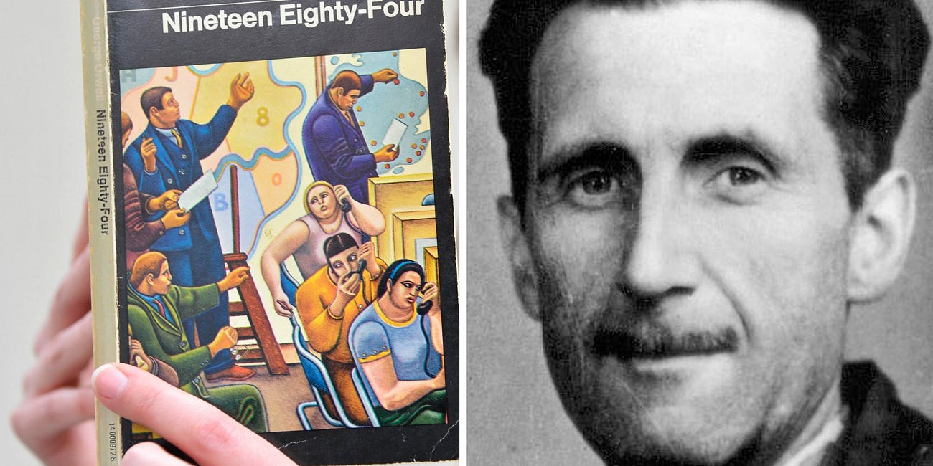

AI IS POSSESSED BY DEMONS LIVING OUTSIDE OF THE BODY, ETERNALLY, IMMORTALLY Satchidanand’s Against Satanism Newsletter is a reader-supported publication. To receive new posts and support my work, consider becoming a free or paid subscriber. In the final analysis of “The Abolition of Man”, CS Lewis predicted that a small group of Bloodline Satanic 10,000 y…
Read full story

https://satchidanand.substack.com/p/artificial-intelligence-ai-is-possessed
The reason MI6 Orwell wrote 1984 was to remove superstitions, Demons, from the conversation and was the reaction to, CS Lewis' "That Hideous Strength" which posited the elite Satanic Phoenician Mega Trillionaire possession by Demons as the cause of the Luciferian and Satanic United Nations New World Order One World Government takeover.
If you want to see something truly demonic, imagine a world in which all inherent truth is abandoned for the sake of subjective perception. A world that caters to the preferences of psychopaths with no ethical imperative. A world where the ends always justify the means. This is the luciferian way, and the globalist way. And no matter how much they deny it, the reality of their beliefs is visible in the fruits of their labors. Wherever they go, destruction, chaos and death follow.
Authored by Brandon Smith via Alt-Market.us, Improved and made better by Satchidanand
https://www.zerohedge.com/geopolitical/understand-globalists-we-must-understand-their-psychopathic-religion

FINANCIALISATION and Satanic Phoenician Mega Trillionaire Central Banks? by Professor Richard A. Werner, D.Phil. - Improved and made better by Satchidanand

THE SATANIC PHOENICIAN MEGA TRILLIONAIRES, THE ROTHSCHILDS, THE ROCKFELLERS, THE BLACK NOBILITY CONTROL BIDEN, PUTIN AND XI - THEY CHOOSE WHICH EMPIRES TO DESTROY AND RAISE UP!
Satchidanand
Apr 13, 2024

Do we Need Satanic Phoenician Mega Trillionaire central banks? by Professor Richard A. Werner, D.Phil. - improved and made better by Satchidanand

THE SATANIC PHOENICIAN MEGA TRILLIONAIRES, THE ROTHSCHILDS, THE ROCKFELLERS, THE BLACK NOBILITY CONTROL BIDEN, PUTIN AND XI - THEY CHOOSE TO DESTROY EMPIRES - THEY CHOOSE WHICH EMPIRES TO RAISE UP - THEY DO IT BY FINANCIALISTATION!



BIDEN VAXXED HIS PEOPLE, PUTIN VAXXED HIS PEOPLE, XI VAXXED HIS PEOPLE. DEATHVAXX - watch the Anthony Bridgen UK MP DIvideo...
https://against-satanism-video.com/watch/maria-zeee-uk-mp-anthony-bridgen-calls-for-deathvaxx-crimes-against-humanity-accountability_qHpaRsFLwEkuqjv.html
Anthony Bridgen UK MP, "A government Minister told me, we don't care what you say Anthony that twenty million excess deaths have been caused by the Deathvaxx, you took the Deathshot, in a year or so you will be dead of cancer!"





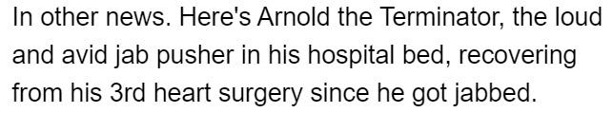

The Rothschilds own 100% of all Satanic Phoenician Mega Trillionaire central banks - This is the financialisation methodology of the destruction of civilisations by the Satanic Phoenician Mega Trillionaires
See Throughout History Seventy-Two Empires Have Been Engineered to Fail in the Same Way.
The crash of civilisations does not happen by accident. The crash of civilisations does not happen all at once. The crash of civilisations takes a lot of planning over a long time.

Throughout History Seventy-Two Empires Have Been Engineered to Fail in the Same Way.

Satchidanand
·
April 6, 2024
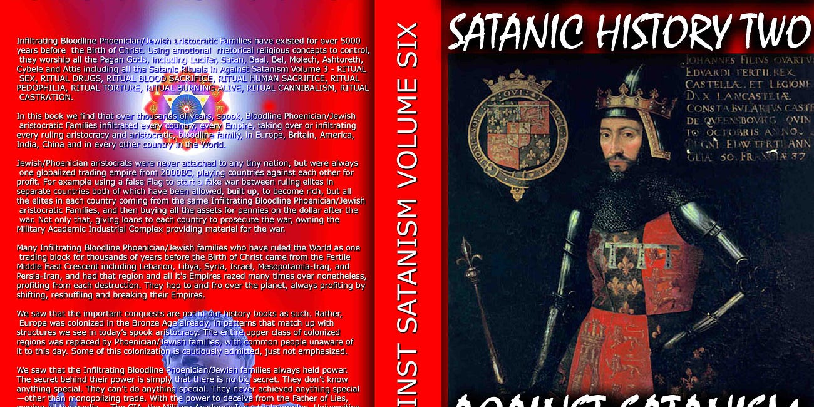

Throughout History Seventy-Two Empires Have Been Engineered to Fail in the Same Way. The crash of civilisations does not happen by accident. The crash of civilisations does not happen all at once. The crash of civilisations takes a lot of planning over a long time.

Read full story

As with the previous 72 failed Empires, the Anglo-American Empire was founded by restricting credit. Later, when the Satanic Phoenician Mega Trillionaires decided to pull the plug and move to China, having married into all the top Chinese families as they have done in India, they brought in Satanic Phoenician Mega Trillionaire central bank financialisation into the Anglo-American Empire. Satanic Phoenician Mega Trillionaires will then destroy the Chinese Empire by means of financialisation before moving on to their next victim.
I previously edited a book of articles by Professor Michael Hudson - improved and made better by Satchidanand - where Hudson revealed that the "Science" of Economics was pure fantasy.
AGAINST SATANISM VOLUME 5 - Satanic Economics and the Satanic Principle of Poverty Published Feb 2019

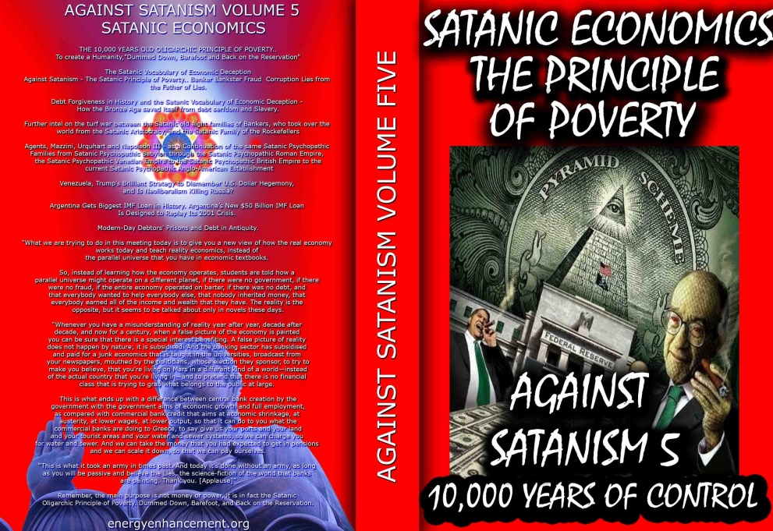

We know the effects of meeting one psychopath and the destruction he can wreak in our lives. Wisdom teachings teach how to overcome their strategies and, "stay away from evil".
Satanism, - The Old Religion" - is when all the psychopaths get together in one group to wreck the world to their benefit. Energy Enhancement Wisdom teachings describe the historical problem and the means to overcome it. "Vampires hate the light of truth".
The key is that the Satanic Religion and its recruiting cults of Freemasonry and the Crowlean Sexual Ritual Ordo Templi Orientis are Fake Gangs, created by men as a technique to conquer the world.
The Ancient Satanic Enemy who counts meditation and the mind control psychic arts as one of its main planks of World Domination has used Satanic Infil-Traitors for 10,000 years in every Organisation - Religion, Left and Right Politics, Dynastic Families, Geopolitics, Economics, Universities, Intelligence Services, Think Tanks, Banking, International Companies, Global Warming, Eugenics..
And Banking Infiltration by Satanic Banksters supported by the False Fabulous Science of Economics..
And this book pricks the bubble of Fake Satanic Economics because Godly people could never set up the World banking and economic system described in these pages.
Only Satanists could create a system which is against the evolution of Humanity to the Stars.
Instead, the Satanic Banksters promote the Principle of Poverty, barefoot, back on the reservation, in debt to the company store.
https://againstsatanism.com/Sacred-Energy/Against-Satanism-Volume-5/Against-Satanism-5-Satanic-Economics-the-Satanic-Principle-of-Poverty.pdf

Companion Volume to Volume 5 - Satanic Economics and the Satanic Principle of Poverty - The Babylonian Woe - the History of Money and the Phoenicians who created it.
Meyer Amschel Rothschild, who founded the great Satanic international banking house of Rothschild which, through its affiliation with the European Central Banks, still dominates the financial policies of practically every country in the world, said: 'Permit me to issue and control the money of a nation, and I care not who makes its laws.'
In this time, as today, the people were almost entirely at the mercy of the Satanic private persons controlling their money, who then controlled the inflow of precious metals, silver and gold, the foundation of the people's money. The Satanic policies of these controllers from their standpoint as internationalists, with Banks and secret agents in both countries, were necessarily directed towards the creation of war against the well-being of mankind. Frequent wars were above all the prime essential..
1. Arms sales - The selling of weapons and war materiel to both sides of the war.
2. Chaos towards the destruction of the natural system of rule previously defined, which had been the protection of the people, to create the Satanic recruiting process of despair, nihilism, and then Satanism in the people.
3. War booty towards the reinjection into the system of hoarded coin and bullion, and consequent reinflation of the money supply;
4. The buying of property, farms and businesses in the defeated country for cents on the dollar.
5. Not the least important, the enslavement of the defeated populace and prisoners of war - gathering of a new crop of slaves for working the poisonous heavy metal mines to replace those stocks of silver and gold, so necessary to the foundation of their money power, and the maintenance of their international hegemony in consequence...
http://www.energyenhancement.org/Sacred-Energy/The-Babylonian-Woe-History-Economics-Money.pdf
READ.. The Fall of the Anglo-American Empire

https://againstsatanism.com/The-Fall-of-the-Anglo-American-Empire.htm
One of the reasons Western macroeconomic metrics don’t work to analyze the Chinese economy is because the Chinese are observably following the principles described by Richard Werner in his excellent Book, Princes of the Yen, which chronicles the way Japan successfully maintained its centralized wartime economy to develop its economy and literally buy a significant percentage of the global assets from 1945 through 1990.
That relentless period of economic advancement came to an end in 1998 with the final triumph of the private Bank of Japan, which served as Clown World’s proxy, over the Okurasho, Japan’s Ministry of Finance, and the subsequent shift to the same sort of financialized unproductive economy featuring private credit creation financialization that has systematically weakened the West for the last century.
As part of its policy of unrestricted warfare, Satanic Phoenician Mega Trillionaire China - the new rising Empire in the Chinese Century has methodically applied the lessons of Japan’s post-WWII economy and maintained control of its own credit creation, thereby boosting its productive capacity to historically unprecedented levels and providing it with the monetary resources to buy up foreign assets everywhere from Angola to the USA.
By publicly breaking with Clown World in 2015, and setting up BRICS as an alternative to the various Clown World institutions, China is offering the rest of the world an observably viable and historically superior economic model to the corrupt and deceptive one that was holding the elites of the various nations enthralled.
This is why Janet Yellen, the US Secretary of the Treasury, was in China this week begging the Chinese to “reduce their overcapacity”. And it’s not an accident that China has applied Japan’s historical policies of a) government credit creation to fund b) productive industrial exports while minimizing the use of credit to fund domestic consumption. This is a proven means of enhancing national power and prestige at the expense of global competitors used by all rising empires under Satanic Phoenician Mega Trillionaire control until like with the west, the Satanic Phoenician Mega Trillionaires pull the plug and consign the new Empire to ruin, as the Satanic Phoenician Mega Trillionaires have done with 72 previous Empires.
The economic assumptions of the Smith-Keynesian era have gradually been proven over time to be entirely false. This is a difficult lesson to accept, but it is inarguable at this point. From David Ricardo to Paul Samuelson, from free trade to the rational actor, everything about neoclassical economics is intrinsically and observably incorrect, which is why those nations whose economic policies are based on Financialisation - traditional neoclassical economics, will inevitably fall behind, both in terms of societal wealth and military power.
https://voxday.net/2024/04/12/the-return-of-national-economics/
Here is the Satanic Phoenician Mega Trillionaire financialisation methodology...
"Once we realize this, the power of the bankers crumbles. It has been their ploy to pretend that they were issuing what is a very scarce and precious resource – savings or money. For if it was not scarce, why should we be prepared to pay the bankers for this service (in the form of interest)?
Governments could just create their own Greenback money, without having to pay interest on the national debt (which by now in a number of countries takes up the majority of national annual budgets – usually well hidden from the eyes of the public, by publishing only the fiscal budgets that are considered “discretionary spending” – pretending that interest payments are non-negotiable and compulsory)."

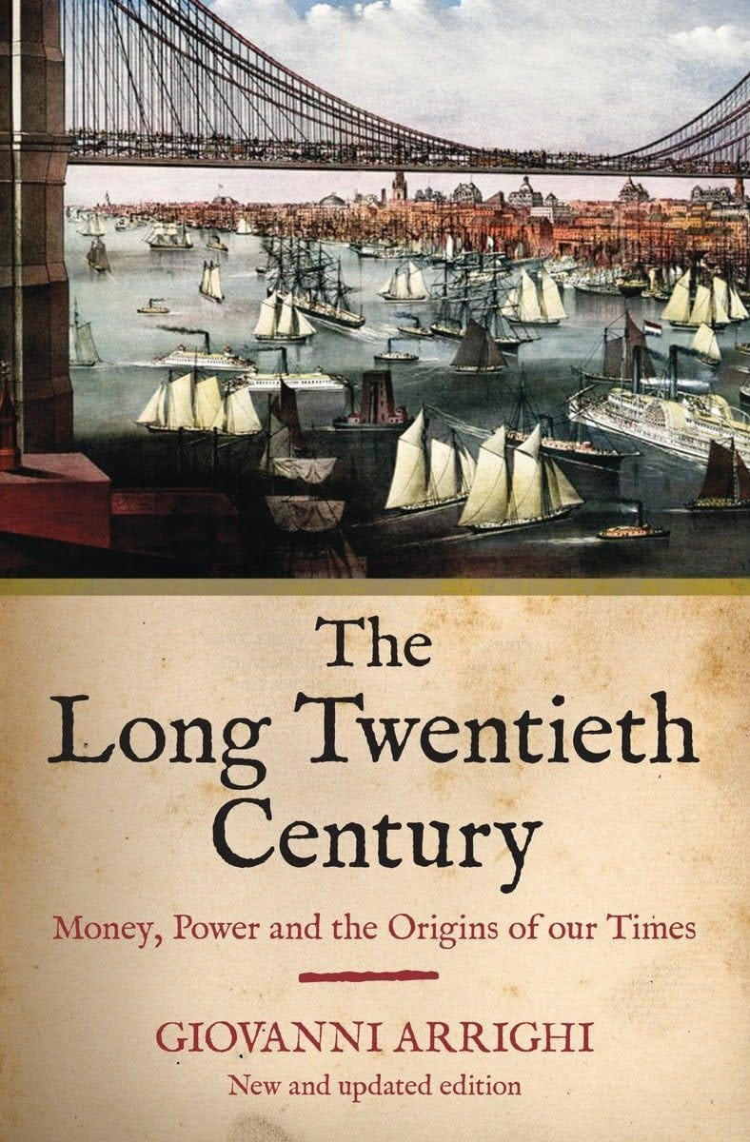

FINANCIALISATION - THE ENGINEERED DEATH OF EMPIRES - BY ARRIGHI
"Why did the German and Japanese systems lose their way? Because they fell for the neoclassical Satanic Phoenician Mega Trillionaire central banking narrative – the surest way to reduce the efficiency of any economy. Thus Germany and Japan adopted the Anglo-Saxon model. The changes this entailed increased “financialisation”, i.e. the share of economic activity devoted to profit-seeking by shifting ownership certificates from A to B (Werner, 2002b, Dore 2000).
Adopting US-style capitalism means that Germany and Japan are importing its disadvantages and social problems. Dore asks: Can it be efficient to devote ever more people to servicing “gambling on uncertainties in financial markets” with analysis, advice, appraisal, advertising? As increasingly strong shareholders demand “value”, will social welfare or overall fairness increase?"
See Throughout History Seventy-Two Empires Have Been Engineered to Fail in the Same Way - by Financialisation - Stop investment in Products - artificially increase the stock market to siphon wealth.
The crash of civilisations does not happen by accident. The crash of civilisations does not happen all at once. The crash of civilisations takes a lot of planning over a long time.

Throughout History Seventy-Two Empires Have Been Engineered to Fail in the Same Way.

Satchidanand
Throughout History Seventy-Two Empires Have Been Engineered to Fail in the Same Way. The crash of civilisations does not happen by accident. The crash of civilisations does not happen all at once. The crash of civilisations takes a lot of planning over a long time.

Read full story

"On this road to Orwellian totalitarianism by the central planners at the Satanic Phoenician Mega Trillionaire central banks, it is only a small further step to argue that the little chips on our digital cash cards would be safer – in the name of combatting crime again! – if one embedded them under the skin of our right hands, or our foreheads." “He also forced everyone, small and great, rich and poor, free and slave, to receive a mark on his right hand or on his forehead, so that no one could buy or sell unless he had the mark, which is the name of the beast or the number of his name”
(Rev 13:16-17).
Paper presented at the 14th Rhodes Forum: Dialogue of Civilisations Research Institute, Panel 2: Economic Alternatives when Conventional Models Fail, Rhodos, Greece, on 1 October 2016
and at the 4th European Conference on Banking and the Economy (ECOBATE 2016), in Winchester Guildhall, Winchester UK, on 12 October 2016
I. The Satanic Phoenician Mega Trillionaire central bank Narrative
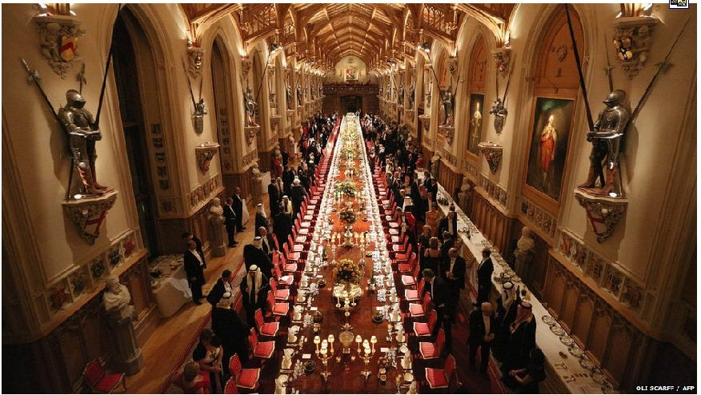

For more than the past four decades, public policy discourse, especially when touching on macroeconomic and monetary policy, has been dominated by the views held and actively sponsored by the Satanic Phoenician Mega Trillionaire central banks, particularly in Europe and North-America, as well as Japan.
Their policy narrative has been consistent over time and virtually identical between Satanic Phoenician Mega Trillionaire central banks, which is why I shall refer to it collectively as the ‘Satanic Phoenician Mega Trillionaire central bank narrative’. It has been mirrored in the type of economics that Satanic Phoenician Mega Trillionaire central bankers have supported and that has indeed subsequently become dominant in academia and among the economists selected as the experts of choice in the major newspapers and television channels: the theoreticians advancing neo-classical economics.
This Satanic Phoenician Mega Trillionaire central bank narrative (and hence also the dominant neo-classical economics, also known as ‘mainstream economics’) has at least five False major pillars, which I shall list briefly:
1. Interest rates are the main policy variable to move the economy
The first pillar of the Satanic Phoenician Mega Trillionaire central bank narrative is the well-known claim that interest rates are the main tool of monetary policy. This narrative is backed by the familiar theory that, ceteris paribus, lower interest rates will stimulate economic growth and higher interest rates will slow growth. Thus by lowering rates, Satanic Phoenician Mega Trillionaire central banks accelerate growth and by raising rates, they slow it, allowing impressive fine-tuning of the economy. Hence the Satanic Phoenician Mega Trillionaire central bankers’ constant obsession with minute changes in interest rates that are said to have the power to rattle global markets and, consequently, are dominating the media coverage of Satanic Phoenician Mega Trillionaire central bank actions as if they will stand out in sharp relief in any future account of the history of mankind.
2. Markets are in equilibrium, thanks to price movements that have equated demand and supply.
The interest rate theory is in turn backed by this second pillar of the Satanic Phoenician Mega Trillionaire central bank narrative: Market equilibrium. This equilibrium which markets are said to be usually found in, is a state of effective resource allocation that results from virtually automatic or ‘natural’ price movements which ensure that demand equals supply almost all of the time. These price movements not only create pervasive ‘general equilibrium’, as economists and Satanic Phoenician Mega Trillionaire central bank models assume, but they also ensure that it is sufficient to focus on prices when conducting economic analysis, since prices lead (generating the equilibrium) and quantities fall into line. Hence policy should focus on prices. This logic is consistently applied across markets, including the markets for money and credit, which are said to be dominated by their price (the rate of interest). As a result, the first pillar of the Satanic Phoenician Mega Trillionaire central banking narrative is justified: what else but interest rates should one use as policy tool in such a world of equilibrium and the dominance of prices?
3. Banks are just financial intermediaries, like other non-bank financial firms. They thus do not need to be singled out in the analysis or modelled explicitly.
The third pillar of the narrative further tidies up the analysis by following through on the dominance of interest rates when it comes to financial institutions: While ordinary mortals might have the naïve belief that banks matter for the economy and could indeed be powerful – or even be the key agents of change or influence – Satanic Phoenician Mega Trillionaire central bankers and their hired neo-classical theorists know better than that:
banks are mere financial intermediaries, transferring existing savings from depositors to investors, just like non-bank financial intermediaries are doing. In other words, banks are not special or different from other financial firms, and hence they do not have to be singled out in economic models – which explains why economists and all the major Satanic Phoenician Mega Trillionaire central banks have indeed failed to include banks at all in their economic models for the past 40 years. (This was a little embarrassing, when the 2008 banking crisis hit, but the Satanic Phoenician Mega Trillionaire central bankers and neo-classical economists are hoping you have already forgotten that).
4. We need to save in order to fund investments that are the precondition of economic growth and development. If domestic savings are insufficient, we need to borrow from abroad or attract foreign investment.
The fourth pillar of the Satanic Phoenician Mega Trillionaire central bankers’ narrative has been the claim that nations that would like to develop and grow the economy need to accumulate scarce savings first, in order to fund the necessary investments. To attract these scarce savings, interest rates are needed, linking into claim 1. Moreover, since many developing countries were seen to have insufficient savings, the Satanic Phoenician Mega Trillionaire central banking narrative maintained that they needed to borrow the necessary funds from abroad...
Thus it was fortuitous – if not serendipitous – that at the very moment when the developing countries had been educated into understanding their need of foreign borrowing, it just so happened that foreign bankers stood ready to engage in this selfless task whereas their own banks could create their own money instead.
This need to borrow from foreign bankers has been the basis for postwar IMF and World Bank policies that drove home this point with developing countries over the past decades – if, that is – and this is a major caveat – they were in possession of attractive assets, such as raw materials and resources that are needed by industrialised countries.
(Notice that countries without attractive assets never got into debt, because nobody would lend to them in the first place; likewise it was always a little curious that the global financiers at JP Morgan and other big global banks, the world’s experts in the latest derivative instruments, genuinely believed that developing countries like Ghana or Sudan were in fact much better at managing foreign exchange risk than the top teams at JP Morgan – for why else would the Satanic Phoenician Mega Trillionaire global bankers insist on lending to the eveloping countries in foreign currency, leaving any hedging to their exposed customers?).
5. Both the foreign investors and the domestic goal of high growth require deregulation, liberalization and privatization, since only in such an economy can market forces deliver high and stable growth.
The final pillar of the Satanic Phoenician Mega Trillionaire central banking narrative is that economic growth requires markets to function in an unimpeded fashion, not held back by such barbarous relics as regulations and government intervention. Hence the mainstay Satanic Phoenician Mega Trillionaire central bank advice – or demand – directed at the governments to deregulate, liberalise and privatize, while generally adopting a laissez-faire attitude: no matter how big and influential a small number of multinationals or mega-banks get, their lobbyists are probably aiming at general public welfare and so their good work should not be hampered through unnecessary red tape or restrictions on their activities.
We are all familiar with parts or all of this Satanic Phoenician Mega Trillionaire central bank narrative, even if we are not trained economists or not commonly interested in economic issues: This is because this narrative has been repeated ad nauseam hundreds of times in the past four decades. As a result, even astute observers assume that empirical research has long established these five insights from the Satanic Phoenician Mega Trillionaire central bankers, in uncountable meticulous quantitative research studies.
This is not the case. The truth could not be further from it: There is in fact no empirical evidence to support any of these five claims. They are mere assertions. Claims that have, in fact, been disproven by the facts. There is overwhelming evidence to the contrary, and this has become increasingly obvious since the 2008 financial crisis.
II. The Satanic Phoenician Mega Trillionaire central banking Narrative Has Collapsed
While voices of those pointing out that the Satanic Phoenician Mega Trillionaire central banking narrative has been wrong (e.g. Werner, 1992, 1994, 2003a) had been successfully drowned out by Satanic Phoenician Mega Trillionaire central banks and their large-scale and meticulously planned PR campaigns for many years (see Ishii and Werner, 2003; Werner, 2003b, on the ‘information management’ of Satanic Phoenician Mega Trillionaire central banks), it is now becoming apparent and visible even to laymen that the Satanic Phoenician Mega Trillionaire central banking narrative has collapsed on all fronts.
Banks are not financial intermediaries, but creators of the money supply
Consider first the claim that banks are mere financial intermediaries that have no special powers. For a whole century, Satanic Phoenician Mega Trillionaire central bank-sponsored researchers had been obfuscating the issues, claiming that either the fractional reserve theory of banking was correct or, for the past 40 years, the theory of banks as mere financial intermediaries. Despite an ongoing controversy among experts on this issue, it never occurred to economists – used to mainly dealing with the fabulous theoretical dream worlds of their own making – that the methods of scientific research could in fact also be applied in economics, i.e. a suitable and careful empirical test could be conducted to settle the question of the role of banks once and for all.
In 2014, the first empirical study on how banks actually work was finally published (followed by a second study in 2015) and thus ended the centuries’ old debate about whether banks are (a) mere financial intermediaries passing on savings (deposits) as loans to borrowers, as the leading journals and textbooks proclaim today; (b) whether they need Satanic Phoenician Mega Trillionaire central bank reserves or deposits to lend these on to their customers (fractional reserve theory), so that each bank is an intermediary, but in aggregate more money is created by the banking system in a collective fashion – as a previous generation of unwitting Satanic Phoenician Mega Trillionaire central bank spokesmen had argued; or (c) whether they instead are not financial intermediaries at all, but creators of the money supply, so that each bank creates new purchasing power that is added to the money supply when it extends a loan, thus deciding about the amount and allocation of new money creation – a pivotal function in the economy.
The empirical tests rejected the financial intermediation and fractional reserve theories (Werner, 2014a, 2015) and showed that banks do not need prior savings, nor Satanic Phoenician Mega Trillionaire central bank reserves or other deposits to lend. Instead, banks create new money when they do what is called ‘bank lending’, and add it to the money supply (see Figure 1). Bank loans thus do not transfer existing purchasing power, but add net new purchasing power. The banks’ lending creates 97% of the money supply. Bankers’ decisions about how much money is lent – and thus created and added to the money supply – and given to whom for what purpose quickly reshapes the economic landscape and affects us all. Sadly, no regulator has asked banks to ensure they lend for productive projects – over two thirds of UK lending is not for productive purposes that creates jobs or boosts GDP, but instead for fabulous climate change boondoggles where the money is stolen or assets, causing asset price inflation.
Figure 1: How banks create money out of nothing when they ‘lend money’

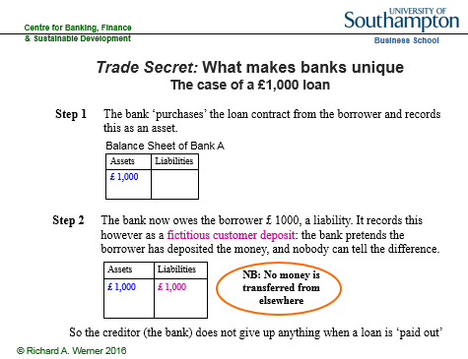

2. Interest rates do not move the economy – and hence are not the main monetary policy tool
After the first domino of the Satanic Phoenician Mega Trillionaire central banking narrative collapsed, the other dominos quickly toppled over, as well: An often-repeated mantra of Satanic Phoenician Mega Trillionaire central bankers is that lower rates will stimulate the economy and higher rates will slow it. Currently, Satanic Phoenician Mega Trillionaire central bankers are once again deploying this claim, in order to justify a further reduction of interest rates to zero or even negative territory with the claim that this is necessary to stimulate the economy.
So far, commentators and journalists have not challenged this Satanic Phoenician Mega Trillionaire central banker narrative, as it had been extensively propagated over the previous decades and is accepted as fact by most. This negative correlation between interest rates and economic growth, and also the idea that causation runs from interest rates to economic growth is so well established in everyone’s consciousness that we simply assume there is abundant empirical evidence to back it. Surely, the thousands of mathematicians and economists working for Satanic Phoenician Mega Trillionaire central banks (Satanic Phoenician Mega Trillionaire central banks are, after all, the largest employers of economists world-wide) will have crunched the numbers and produced hundreds of studies demonstrating this?
The funny thing is: they haven’t.
In fact, among the more than 10,000 research articles produced by the major Satanic Phoenician Mega Trillionaire central banks in the two decades prior to the 2008 crisis, none explored the correlation or causation between nominal interest rates and nominal GDP growth. Fortunately, this task is not very demanding, and once we conduct such an examination, we conclude that, in actual fact, there is no evidence to back these assertions whatsoever. To the contrary, empirical evidence shows that the Satanic Phoenician Mega Trillionaire central banking narrative on interest rates is diametrically opposed to the observable facts in two dimensions: instead of the proclaimed negative correlation, interest rates and economic growth are positively correlated. Secondly, the timing shows that interest rates do not move ahead of growth, but instead are either coincidental or even follow it.
Consider Figure 2, which uses the example of US long-term interest rates (benchmark US Treasury yields) and nominal GDP growth rates (year-on-year percentage growth), as well as Japanese short-term rates (overnight call rates) and nominal GDP growth rates.
Figure 2: The link between interest rates and economic growth
As can be seen, the Satanic Phoenician Mega Trillionaire central banking narrative is wrong in two dimensions: instead of the proclaimed negative correlation, the scatter plots on the left-hand side of the graph show a distinct positive correlation (Werner, 1995, 2005). But lest anyone thinks this is due to the timing and the role of leads and legs, the graphs on the right-hand side consider the time series of the same data. As can be seen in the upper right graph, in 1987 Japanese nominal GDP growth accelerated sharply, and it took about two years for short-term interest rates to follow.

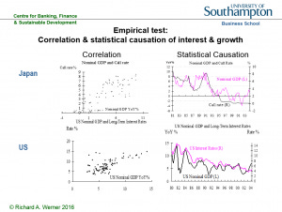
In 1989, GDP growth decelerated, and only after a lag did short-term interest rates follow. Some observers may argue that Satanic Phoenician Mega Trillionaire central banks are naturally behind the curve of the economy, and hence so are short-term interest rates, while bond markets would not lag behind the economy. But this is also true for bond markets. The bottom right graph in Figure 2 shows the yield in the most liquid securities market in the world, that for US benchmark Treasuries, plotted against nominal GDP growth. The positive correlation of both curves is obvious.
Moreover, there is no evidence that interest rates precede the economy. Quite the contrary, there seems evidence that interest rates follow nominal GDP, most blatantly in the 1980s: it took over one year for interest rates to fall, after nominal growth had collapsed in the early 1980s, and after the sharp growth acceleration in 1983 it took over a year for bond yields to rise. For decades, even US interest rates have not moved ahead of growth, but instead they followed it.
Thus instead of the Satanic Phoenician Mega Trillionaire central banking narrative that lower rates lead to higher growth, the empirical and verifiable reality is that higher growth leads to higher rates and lower growth leads to lower rates. If rates are the result of growth, they cannot be the cause.
This raises some new questions.
Firstly, if it is not interest rates that drive growth, what then? And secondly, why do Satanic Phoenician Mega Trillionaire central banks keep insisting that they are using interest rates as their main monetary policy tool, when this is simply impossible?
Recently, Satanic Phoenician Mega Trillionaire central banks have been lowering rates, while proclaiming that this is a measure to stimulate the economy. But the empirically verifiable fact is that they lowered rates, because economic growth has decelerated. Falling growth means interest rates must follow down. And what has been the role of Satanic Phoenician Mega Trillionaire central banks in the growth slowdown preceding the lower rates? We may presume that they had not used their vast powers to engineer economic growth – powers they worked hard to obtain in previous decades, in the form of independence with little meaningful accountability.
Instead of unravelling this mystery, Satanic Phoenician Mega Trillionaire central bankers have been making counter-factual assertions about the causation of interest rates and growth. Yet we know them to be in possession of thousands of highly trained staff and the best quantitative data sources on the economy of anyone.
Since the hypothesis of complete incompetence or irrationality is a last resort, it stands to reason to adopt the working hypothesis that Satanic Phoenician Mega Trillionaire central banks have employed these counter-factual assertions on purpose.
Two reasons come to mind: Firstly, they are using the interest rate narrative in order to suggest that they are adopting beneficial policies, when this is not really the case. Secondly, they may in this way be able to distract public attention from the true causal relationships in the economy. In this case, a far less benevolent interpretation of Satanic Phoenician Mega Trillionaire central bank policy becomes suggestive.
As Forder (2002) has argued, obfuscation has served Satanic Phoenician Mega Trillionaire central banks particularly well since they have become so all-powerful: the danger for them in this era of unprecedented powers is that the general public may simply (and rightly) link bad economic outcomes to bad economic policies adopted by Satanic Phoenician Mega Trillionaire central banks, not to the – now far less powerful – governments.
In other words, since almost all economic keys have been handed over to the Satanic Phoenician Mega Trillionaire central banks, one can reasonably expect them to be blamed for the economic mess that is such a recurring feature of economic policy during those decades of ever greater Satanic Phoenician Mega Trillionaire central bank power.
As a defense mechanism, Satanic Phoenician Mega Trillionaire central banks could be expected to argue that they are doing all in their power to help the economy, while pinning the blame on other actors. But for this to work, observers need to be misinformed about what the true levers of monetary policy are.
A desire by Satanic Phoenician Mega Trillionaire central banks to misinform would explain why they have spent vast resources on “economic research” – pseudo-scientific writings that are often far removed from reality, but are designed to place any blame for the terrible economic performance that they have been responsible for on other actors – preferably the government, fiscal policy or ‘irrational’ and ‘uneducated’ ordinary people who are looking for ‘easy answers’ or seeking ‘populist explanations’, while anyone contemplating the possibility that big banks and Satanic Phoenician Mega Trillionaire central banks might not always look after the public interest and instead might collude in order to put their own objectives first is identified as a ‘conspiracy theorist’. In other words, the “economic research” produced by Satanic Phoenician Mega Trillionaire central banks is usually of a kind that at best looks like political PR to objective observers, if not outright propaganda.
3. Markets are never in equilibrium, thus don’t be fooled by prices, but consider quantities: The short side exerts power.
If there is no empirical evidence for the interest rate narrative, it is reasonable to ask where it came from in the first place. In other words, what is the origin of the idea that interest rates are the most important economic policy variable? We have ascertained that it did not emerge from empirical facts. Looking into its origin, one finds that it is a claim deriving from theoretical economics. The theory proposing the special role of interest rates can be derived from the central – some say only – graph in economics that shows demand and supply: it consists of an upward-sloping supply curve and a downward-sloping demand curve in price-output space.
Under a number of assumptions prices are said to move so that demand equals supply. This seems eminently reasonable at first glance: after all, if prices are too high, excess supply will be left unsold, resulting in price cuts and hence a fall in prices, until demand equals supply. Likewise, if prices are too low, excess demand will quickly drive up prices back to the “equilibrium” level – the point at which demand equals supply. This story is told about virtually any market: in the case of the labour market, the price is the wage. In the case of the money market, the price is the interest rate.
Figure 3: The central graph in economics: Equilibrium thanks to price movements

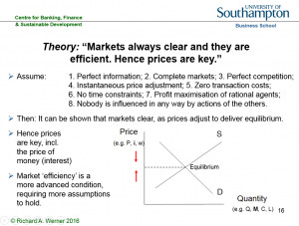
This “equilibrium” graph (Figure 3) and the ideas behind it have been re-iterated so many times in the past half-century that many observes assume they represent one of the few firmly proven facts in economics. Not at all. There is no empirical evidence whatsoever that demand equals supply in any market and that, indeed, markets work in the way this story narrates.

We know this by simply paying attention to the details of the narrative presented. The innocuous assumptions briefly mentioned at the outset are in fact necessary joint conditions in order for the result of equilibrium to be obtained. There are at least eight of these result-critical necessary false, lying, satanic assumptions:
Firstly, all market participants have to have “perfect information”, aware of all existing information (thus not needing lecture rooms, books, television or the internet to gather information in a time-consuming manner; there are no lawyers, consultants or estate agents in the economy).
Secondly, there are markets trading everything (and their grandmother).
Thirdly, all markets are characterized by millions of small firms that compete fiercely so that there are no profits at all in the corporate sector (and certainly there are no oligopolies or monopolies; computer software is produced by so many firms, one hardly knows what operating system to choose…).
Fourthly, prices change all the time, even during the course of each day, to reflect changed circumstances (no labels are to be found on the wares offered in supermarkets as a result, except in LCD-form).
Fifthly, there are no transaction costs (it costs no petrol to drive to the supermarket, stock brokers charge no commission, estate agents work for free – actually, don’t exist, due to perfect information!).
Sixthly, everyone has an infinite amount of time and lives infinitely long lives.
Seventhly, market participants are solely interested in increasing their own material benefit and do not care for others (so there are no babies, human reproduction has stopped – since babies have all died of neglect; this is where the eternal life of the grown-ups helps).
Eighthly, nobody can be influenced by others in any way (so trillion-dollar advertising industry does not exist, just like the legal services and estate agent industries).
It is only in this theoretical dreamworld defined by this conflagration of wholly unrealistic assumptions that markets can be expected to clear, delivering equilibrium and rendering prices the important variable in the economy – including the price of money as the key variable in the macroeconomy. This is the origin of the idea that interest rates are the key variable driving the economy: it is the price of money that determines economic outcomes, since quantities fall into place.
But how likely are these assumptions that are needed for equilibrium to pertain? We know that none of them hold.
They are all Satanic Phoenician Mega-Trillionaire lies!
Yet, if we generously assumed, for sake of argument (in good economists’ style), that the probability of each assumption holding true is 55% – i.e. the assumptions are more likely to be true than not – even then we find the mainstream result is elusive: Because all assumptions need to hold at the same time, the probability of obtaining equilibrium in that case is 0.55 to the power of 8 – i.e. less than 1%!
In other words, neoclassical economics has demonstrated to us that the circumstances required for equilibrium to occur in any market are so unlikely that we can be sure there is no equilibrium anywhere. Thus we know that markets are rationed, and rationed markets are determined by quantities, not prices.
On our planet earth – as opposed to the very different planet that economists seem to be on – all markets are rationed. In rationed markets a simple rule applies: the short side principle. It says that whichever quantity of demand or supply is smaller (the ‘short side’) will be transacted (it is the only quantity that can be transacted). Meanwhile, the rest will remain unserved, and thus the short side wields power: the power to pick and choose with whom to do business.
Examples abound. For instance, when applying for a job, there tend to be more applicants than jobs, resulting in a selection procedure that may involve a number of activities and demands that can only be described as being of a non-market nature (think about how Hollywood actresses are selected), but does not usually include the question: what is the lowest wage you are prepared to work for?
Thus the imaginary fabulous theoretical dream world of “market equilibrium” allows economists to avoid talking about the reality of pervasive rationing, and with it, power being exerted by the short side in every market.
Thus the entire power dimension in our economic reality – how the short side, such as the producer hiring starlets for Hollywood films, can exploit his power of being able to pick and choose with whom to do business, by extracting casting couch Weinstein ‘non-market benefits’ of all kinds.
The pretense of ‘equilibrium’ not only keeps this real power dimension hidden. It also helps to deflect the public discourse onto the politically more convenient alleged role of ‘prices’, such as the price of money, the interest rate. The emphasis on prices then also helps to justify the charging of usury (interest), which until about 300 years ago was illegal in most countries, including throughout Europe.
However, this narrative has suffered an abductio ad absurdum by the long period of near zero interest rates, so that it became obvious that the true monetary policy action takes place in terms of quantities, not the interest rate.
Thus it can be plainly seen today that the most important macroeconomic variable cannot be the price of money. Instead, it is its quantity. Is the quantity of money rationed by the demand or supply side? Asked differently, what is larger – the demand for money or its supply?
Since money – and this includes bank money – is so useful, there is always some demand for it by someone. As a result, the short side is always the supply of money and credit. Banks ration credit even at the best of times in order to ensure that borrowers with sensible investment projects stay among the loan applicants – if rates are raised to equilibrate demand and supply, the resulting interest rate would be so high that only speculative projects would remain and banks’ loan portfolios would be too risky.
The banks thus occupy a pivotal role in the economy as they undertake the task of creating and allocating the new purchasing power that is added to the money supply and they decide what projects will get this newly created funding, and what projects will have to be abandoned due to a ‘lack of money’.
It is for this reason that we need the right type of banks that take the right decisions concerning the important question of how much money should be created, for what purpose and given into whose hands. These decisions will reshape the economic landscape within a short time period.
Moreover, it is for this reason that Satanic Phoenician Mega Trillionaire central banks have always monitored bank credit creation and allocation closely and most have intervened directly – if often secretly or ‘informally’ – in order to manage or control bank credit creation.
Guidance of bank credit is in fact the only monetary policy tool with a strong track record of preventing asset bubbles and thus avoiding the subsequent banking crises. But credit guidance has always been undertaken in secrecy by Satanic Phoenician Mega Trillionaire central banks, since awareness of its existence and effectiveness gives away the truth that the official central banking narrative is smokescreen.
Figure 4: A key monetary policy tool: Guidance of bank credit
4. We do not need to save or borrow from abroad in order to expand investment and growth
A basic argument by economists has been that we first need to accumulate scarce savings in order to fund investments and hence enjoy economic growth – or alternatively borrow those savings from abroad by taking a loan from the international banking community. But this argument is based on the erroneous belief that banks are merely financial intermediaries that require savings first in order to be able to lend money out. In reality, increased domestic investment requires neither savings nor borrowing from abroad. Domestic banks can fund domestic investment without prior savings becoming available.
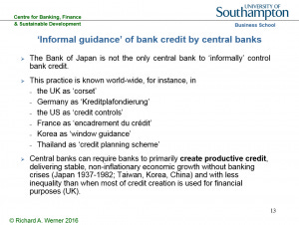
Once we realize this, the power of the bankers crumbles. It has been their ploy to pretend that they were issuing what is a very scarce and precious resource – savings or money. For if it was not scarce, why should we be prepared to pay the bankers for this service (in the form of interest)?
Governments could just create their own Greenback money, without having to pay interest on the national debt (which by now in a number of countries takes up the majority of national annual budgets – usually well hidden from the eyes of the public, by publishing only the fiscal budgets that are considered “discretionary spending” – pretending that interest payments are non-negotiable and compulsory).
Or in the words of Leo Tolstoy (paraphrased): The reason why economists single out ‘labour’ and ‘capital’ in their ‘production function’ is, firstly, because they want to charge for ‘capital’ (interest), justifying it as being equivalent to the wages that workers get, and secondly, because nobody has figured out how to charge for the sun light, the air and other necessary factors of production. And they can only charge for ‘capital’, because economics has been designed to create the myth of its scarcity.
That money is not in fact a scarce resource, but a tool that can and should be employed by governments as benefits communities and nations is also true for developing economies and emerging markets: the “Third World Debt Crisis” was unnecessary, since for most purposes the affected countries did not need to borrow money from the foreign bankers in order to grow their economies.
Worse, the foreign money from the foreign currency-denominated loans given to developing countries never even reached the borrowing economy’s borders. This is because it is one of the rules in international banking that pound sterling bank money stays with UK-authorised banks, euros stay in eurozone economy banks and US dollars remain with US banks. A so-called “US dollar deposit” in the UK is in actual fact a deposit with a US bank that is crediting the account of its UK respondent bank with this amount.
Thus when a developing country borrowed from the international banks, they invariably lent dollars, pounds, euros or other currencies of industrialised countries, because the foreign bankers can only create foreign money (and they do create it out of nothing). The cruel joke on developing countries is now that those foreign dollars or euros that they borrowed will always stay abroad, in their respective foreign banking systems.
It is of course possible to sell the foreign currency and purchase domestic currency with it – but that only results in domestic bank credit creation, something that can be undertaken without getting indebted to foreign bankers in foreign currency in the first place – while it is the borrowers who are made to shoulder the large foreign currency risk.
As the currencies of developing countries invariably fall over time against those of industrialised countries, they quickly get stuck in a foreign debt trap, unable to service or repay the foreign debt which is spiraling out of control in domestic currency terms. That is when the foreign vultures move in and demand ‘debt for equity swaps’, handing over valuable domestic assets, land, mines, mineral resources or mining rights, from poor countries to the rich foreign bankers, who had in any case simply created the money out of nothing.
The developing country debt is in fact a form of predatory lending to ensure that the former colonies remain, in economic terms, in the hands of their former masters – if they have attractive assets, that is. Most of all, the round-trip via foreign banks is wholly unnecessary, if the borrowing nations want domestic currency: that is only created by their own banking system.
Thus it is becoming apparent that the Satanic Phoenician Mega Trillionaire central banking narrative of scarce money and scarce savings has been a hoax.
This has become particularly obvious since Satanic Phoenician Mega Trillionaire central banks have opened all taps and created trillions of dollars and euros and handed them over to the big banks and large-scale financial speculators – under the pretense that this is ‘necessary’ or would somehow benefit society at large.
(Their definition of this activity as ‘quantitative easing’ is also designed to mislead: the original thrust of quantitative easing is an expansion in credit creation for the real economy, not mainly for the financial markets – see my writings on this in Japan in the mid to late 1990s, or Voutsinas and Werner, 2011; Lyonnet and Werner, 2012; Werner, 2013).
5. Deregulation, liberalization and privatization do not enhance growth – they reduce it.
The first four pillars of the Satanic Phoenician Mega Trillionaire central banking narrative have collapsed: Banks create money out of nothing and thus reshape the economy in their image. Markets are rationed and the key factor is the quantity of bank credit. Bank credit creation for GDP transactions boosts GDP growth, no matter what interest rates do (they will follow GDP growth). Developing countries do not need to borrow from abroad, and in fact should not borrow from abroad, as this puts them unnecessarily at mercy of the foreign creditors.
As these pillars revolve around banks and money and credit, some economists may agree, but argue that economics has long focused on the real economy and purposely chose to ignore all the financial factors. In this real economy, they will argue, the most important principle is to allow market forces to act without being hampered by governments – then we will see economic growth and stability. Should this fifth pillar of the Satanic Phoenician Mega Trillionaire central banking narrative at least be true?
Judging by the publications of the Satanic Phoenician Mega Trillionaire central banks, as well as the IMF or the World Bank, one would expect so: When these Washington-based institutions send their teams of staff and hired consultants to developing countries, their job can usually be completed very quickly. Without much ado, a new country report complete with major policy conclusions is drafted. The secret of such efficient work: even before these foreign experts had travelled (first class) to the respective countries, the conclusions of their study had already been pre-determined, because they are always the same, no matter which country is concerned:
The goal of the axiomatic-deductive neoclassical belief system is to find ex post justifications for the argument that government intervention is bad, and markets need to be unfettered by any form of intervention. This predetermined conclusion is then presented, in the form of ‘research reports’ or ‘studies’, to the leadership of many nations across the world, only vaguely connected to local facts and institutions.
In order to reach such conclusions, neoclassical and Satanic Phoenician Mega Trillionaire central bank economists worked backwards: What kind of model comes to such conclusions? Answer: A model that operates in a dream-like idealized world. What are the features that define such a world? A long list of assumptions needs to hold, creating a bizarre theoretical Neverland: perfect information, complete markets in equilibrium, perfect competition, zero transaction costs, no time constraints, perfectly flexible prices that adjust all the time, everyone is very selfish and does not care about others, and people are not influenced by others. Why do all these assumptions matter? Because neoclassical economists have proven that they all need to jointly hold true, for market equilibrium and efficient markets to exist, and for government intervention to be ineffective.
The next step in the sequence of using such models is the most important one: present in reverse order, by pretending that no pre-determined conclusions existed. Start by listing the assumptions – for sake of argument. Then present the model. Then pursue it to its conclusions, which happen to be… let’s see… Oh, amazing: this model happens to conclude government intervention is bad and only free and deregulated markets will work! Well, in that case, ladies and gentlemen, we shall need to recommend deregulation, liberalization and privatization!
That such economic charlatanry passes for ‘economics’ in leading journals, textbooks and university lecture rooms is a sad indictment not only of the economics establishment, but of academia and society at large.
But what about economies in our world, on the planet we live – as opposed to the bizarre planet described by the economic charlatans? Since none of these assumptions hold, we know that we can neither expect equilibrium nor will deregulation, liberalization and privatization trigger improved economic growth.
If our theoretical assessment of the theoretical claims is correct, we should also be able to muster empirical support for it. And it exists in abundance. In order to test these neo-classical policy recommendations of deregulation and market supremacy, we can compare the market-oriented and shareholder value-focused US and UK economies with those economies known to have always placed an emphasis on government intervention, non-market forms of resource allocation combined with social welfare systems, namely Germany, Japan, Korea, Taiwan and China. Of course we should not be influenced by the business cycle, and thus need to consider a longer time period, such as half a century. Considering therefore the half-century from 1950 to 2000, we would expect the best performance in those economies that are more market-oriented, and the worst performance in economies that have chosen to practice intervention, ‘guidance’ and the use of production cartels. What is the empirical result? This can be seen in Figure 5.
Figure 5 Average real economic growth over half a century

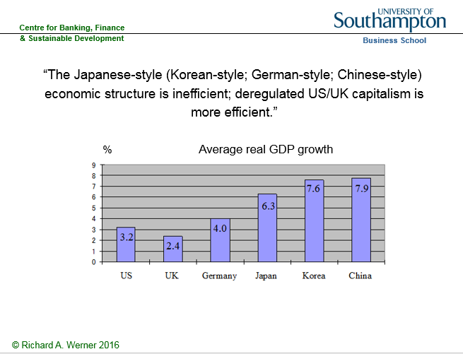

We find that it is the market-oriented, shareholder-oriented economies that perform worst. The economic performance of the East Asian non-market economies has been vastly superior. Many observers suspend disbelief, when they consider this result, and come up with many special reasons (i.e. introduce auxiliary assumptions) why this finding should not be taken at face value. Such a result must not be true, they seem to believe, hence it cannot be true.
Perhaps a more sophisticated analysis will convince doubters. We can also examine the dynamics of deregulation and its impact on economic growth. The IMF and World Bank hired hands that are sent all over the world to ‘conclude’ what Satanic Phoenician Mega Trillionaire central banks also proclaim at home: country X needs to deregulate, liberalise and privatize in order to improve its particular economic performance. Thus an empirically testable hypothesis can be formulated: Is there any evidence that deregulation, liberalization and privatization have increased economic growth over time?
Once again, the objective observer is stunned by the paucity of empirical evidence. Let us conduct our own test. For it to be meaningful, we should choose a country that has moved from a state of regulation, government ownership of large firms and non-market forms of economic organization towards complete deregulation, liberalization and privatization. Fortunately, a major industrialised economy has undergone the full spectrum of such a swing in the policy pendulum: By the late 1960s, Japan was effectively not a market economy, but a ‘guided economy’ in which over 1000 cartels (official exemptions to the anti-monopoly law) had been established, in which tens of thousands of economic regulations allowed the bureaucrats to intervene in the economy, in which the stock and bond markets were largely irrelevant (as most funding came from banks), and in which the labour market was famously full of ‘rigidities’ and ‘inflexibilities’, with life-time employment, seniority pay and company unions.
Then, under US pressure, the Japanese government started to deregulate, liberalise and privatize state enterprises in the 1970s. (It was a hard sell: The Japanese wondered why they should give up their obviously successful system. Everyone knew that US elites were unhappy about the successful Japanese economy, yet US policy ‘advice’ to deregulate was given to Japan with the justification that it would ‘improve Japanese economic performance’ – as if any further growth was needed…). Japan, politically a US vassal, continued to deregulate. The trend of structural reform accelerated in the 1980s, and reached its zenith of a completely deregulated, liberalized and privatized economy in the early 2000s. This deregulation can representatively be measured by the number of cartels, which peaked in the 1960s in Japan and fell in line with US pressure, reaching zero in the 2000s. Below we shall plot the number of cartels against economic growth. Should the neoclassical theory be relevant, we would expect a negative correlation: as the number of cartels increases, economic performance deteriorates, and as the number of cartels drops, growth declines.
Figure 6 The number of cartels in Japan and the link to economic performance

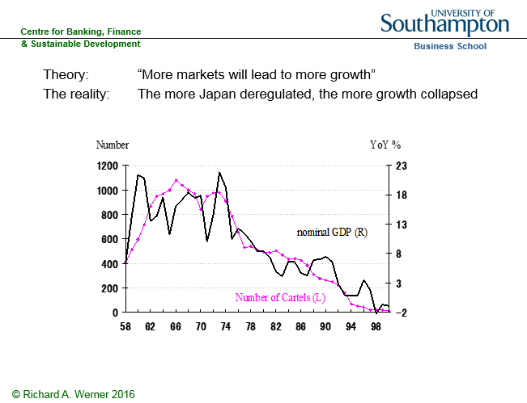

As we can see, the neoclassical thesis has been rejected by the empirical evidence. In the 1950s, the designers of the Japanese economic system intentionally increased the number of cartels, in order to improve economic performance (Werner, 2003a). As we can see, as the number of cartels almost doubled to over 1000 by the late 1960s, while economic growth accelerated to double-digit figures. When, under US pressure, the number of cartels was reduced in the 1970s, growth dropped. The drop in cartels is accompanied by weaker and weaker economic growth. The deregulation drive culminated in the entire abolition of cartels by the end of the 1990s – and economic growth equally reached zero. A similar picture has been painted by the performance of many developing countries, including Argentina and African nations, which followed the economic advice of the Washington-based institutions. We conclude that the fifth of the Satanic Phoenician Mega Trillionaire central bank claims – that deregulation, liberalization and privatization enhances economic growth – has also been revealed to be fraudulent.
III. Successful Development Policy: Harnessing Money and Institutional Design
Based on his long experience close to the government of England, Lord Acton claimed:
“Official truth is not actual truth,” (Lord Acton).
As we saw, the Satanic Phoenician Mega Trillionaire central banking narrative has collapsed on all fronts. The main pillars of their false belief system, for too long propped up by fraudulent ‘economics’, have all crumbled.
It is time to use the power of the monetary system for the good of the people. This can be done by being aware of the basics of money: it is best measured by bank credit, since banks create the money supply through their credit creation. Moreover, the credit data can be examined to identify the use of the newly created money: This delivers three basic scenarios concerning the role and use of bank credit (Werner, 1997, 2005; Figure 7):
Figure 7: Quantity Theory of Credit and the Effects of Credit Creation
Firstly, if domestic banks extend credit mainly for consumption, then final demand increases by the amount of loans, but there is no increase in available goods and services. Hence prices have to rise. This consumer price inflation scenario is the first one would normally think of when considering an expansion in the money supply. But it is a special case. In the UK, more common is the second case: The majority of bank credit creation in the UK is not even used for transactions that contribute to and are part of GDP, but instead is used for asset transactions. They are not part of GDP, since national income accountants require a ‘value added’ for inclusion in GDP, not just the shifting of ownership rights from one person to another. When bank credit for asset transactions rises, asset prices are driven up, because the loans do not transfer existing purchasing power, but instead constitute an increase in net purchasing power: money is being created and injected into asset markets. When a larger effective demand for assets is exerted, while in the short-term the amount of available assets is largely fixed, the price of assets must rise.
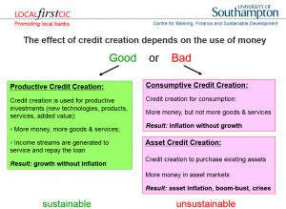
Such asset inflation can go on for several years without major observable problems. However, as soon as the credit creation for non-GDP transactions stops or even slows, it is ‘game over’ for the asset bubble: asset prices will not rise any further. The first speculators, requiring rising asset prices, go bankrupt, and banks are left with non-performing loans. As a result they will tend to reduce lending against such asset collateral further, resulting in further drops in asset prices, which in turn create more bankruptcies. When asset-based lending had become a major part of bank portfolios and when banks had already driven up asset prices by several hundred percent due to their excessive asset-based credit creation, then it is inevitable what will follow: bank equity is usually less than 10%, and thus asset prices need to fall only by a little more than that – which is not difficult, after rises of several hundred percent – and the banking system is bankrupt: losses from non-performing loans have to be made up from equity (if no other funds are available, which is usually the case in such situations).
Thus a full-blown banking crisis must follow after a bank-credit driven asset bubble. One does not need to be a Satanic Phoenician Mega Trillionaire central banker to know this very well. (Why, then, did the ECB allow 20% or more bank credit growth in Ireland, Portugal, Spain and Greece, for several years? Such high credit growth is clearly in excess of nominal GDP growth and hence it is clear that it must be creating unsustainable asset bubbles that result in banking crises – as the Quantity Theory of Credit has postulated since its inception in 1992; Werner, 1992, 1997; 2012, 2013).
There is a third, redeeming case: When bank credit is used for productive investments, such as the implementation of new technologies, measures to increase productivity or the creation of new goods and services (whose value is higher than the mere sum of their inputs, thus adding value), then such new money creation – which always happens when banks grant credit –will not result in any form of overall inflation – neither consumer price inflation nor asset price inflation. This is because the new purchasing power that is created is used to produce higher value added output and hence the extra demand due to the money creation is met with a higher supply. By ensuring that money and credit are only created when something real is created, i.e. for productive purposes, one can achieve very high economic growth without inflation, without crises and in a relatively equitable way: This is how the East Asian ‘miracle economies’ of Japan, Taiwan, Korea and China, developed so quickly. By using regulation to ensure that bank credit is only created for productive purposes, high growth can be achieved, even when the economy is already at an apparent ‘full employment’ level, because productive investment credit improves the allocation of existing resources, however limited, by mobilizing both supply and creating the necessary demand for the output.
But isn’t this central planning, which failed under communism? The reality in even the most deregulated economy is that the most important decision – about how much money the banks create and who it is given to – is in any case determined by bureaucrats (the loan officers working at the banks) without consideration of whether this is good for the economy or not. So rules to prevent harmful type of credit supply decisions by banks cannot be considered harmful or excessive intervention. What has worked well is the combination of market mechanisms with clever guidance in a small number of key areas – none more key than the creation and allocation of money – in order to prevent the worst excesses of capitalism and steer the economy towards a path that benefits all. This is necessary, because once unrealistic assumptions such as perfect information and efficient markets are relaxed, there is no guarantee that markets left to their own devices will produce socially optimal results. In reality, the hurdle for government intervention to be successful is far lower than is presented in the neoclassical models, which conjure an artificial idealized economy that purports to function so perfectly and efficiently already that no further improvement through intervention is possible. This unrealistic and artificial case is what the much trumpeted neoclassical claim that government intervention is inefficient or ‘bad’ is based on. In reality, markets are neither efficient nor even in equilibrium. Hence it is relatively easy for clever intervention to deliver superior performance.
This is precisely what the Germans and Japanese demonstrated to the world, and the Koreans, Taiwanese and Chinese demonstrated that these insights into clever institutional design and credit guidance can be exported and universally applied. The designers of the German and Japanese system based their institutional designs on a more realistic description of the world (see Werner, 2003a).
The German-Japanese system worked by utilizing the willingness for co-operation and aiming at positive results for all that can be gained in the long-run (ditching the ridiculous claim that people would never co-operate but only selfishly maximize their own benefit). By focusing on mutually beneficial cooperation and coordination, they managed to internalize externalities, minimize information costs, and, most of all, motivate individuals.
They recognized that ‘utility functions’ are interdependent, people compete in hierarchical fashion and have a common desire for justice and fairness of organizational arrangements. While neglected in static models and policy advice, human resources are taken more seriously in the German/Japanese model. As Ronald Dore pointed out “in Japan… people tend to be good at discerning possibilities of cooperation which can be of general benefit, and at devising organizational forms which can reap those benefits in ways which all participants can consider fair” (Dore, 2001, p. 38).
One such organizational form is the system of industry associations, which are modern incarnations of the medieval guild structure. Due to their public goods character, resulting cartels were welfare-enhancing. The cooperative orientation does not mean there is no competition. As Dore explains well, competition can be fierce, as the system combines markets and hierarchies. The tendency towards the formation of cartels is counter-acted by relatively low concentration ratios in many industries (due to bank finance and cross-shareholdings which result in fewer hostile take-overs) and inter-firm rivalry due to life-time employment (Werner, 2003a).
Finally, neoclassical economists assume that capital is the scarce resource, while ‘labour’ is in abundant supply, justifying a high reward for capitalists and a low reward for labour – resulting in a declining distribution of national income in favour of the capitalists and an ever declining share for labour.
Figure 8 Labour share in national income in the US

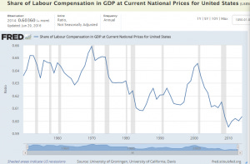

Already in 2001, Ronald Dore said about this neoclassical claim that capital is scarce and labour is abundant:
“It is amazing that anyone can seriously sustain this view in a world awash with so much liquidity that its movement from one country to another keeps exchange rates in perpetual motion” (Dore, 2001, p. 15).
The reality of credit creation and our money supply being conjured ex nihilo by the banks in an act of modern-day alchemy puts paid to the neoclassical claim that capital is scarce. That must have been a reason why neoclassical theories refused to include banking in their models.
The Anglo-Saxon model is good for the shareholders. By contrast, the Germans and Japanese maintained market mechanisms, but during the heyday of their model eliminated shareholders as the main beneficiaries (see Werner, 2003a). Instead of serving the few, a form of capitalism was born that succeeded in creating a decent quality of life for the many – employees and society at large: Managerial capitalism, or capitalism without capitalists. A centralised form of this type of economy may in the limit approach a fascist economy. Thus it is paramount that the power levers are decentralised and rendered accountable to local communities. Nationwide organisations are usually too large to allow effective and meaningful accountability.
Why did the German and Japanese systems lose their way? Because they fell for the neoclassical Satanic Phoenician Mega Trillionaire central banking narrative – the surest way to reduce the efficiency of any economy. Thus Germany and Japan adopted the Anglo-Saxon model. The changes this entailed increased “financialisation”, i.e. the share of economic activity devoted to profit-seeking by shifting ownership certificates from A to B (Werner, 2002b, Dore 2000). Adopting US-style capitalism means that Germany and Japan are importing its disadvantages and social problems. Dore asks: Can it be efficient to devote ever more people to servicing “gambling on uncertainties in financial markets” with analysis, advice, appraisal, advertising? As increasingly strong shareholders demand “value”, will social welfare or overall fairness increase?
But has the weak Japanese performance since the 1990s not been proof that the Japanese system does not work well? Whether this is really true must be investigated, which I have done in several publications (Werner, 2003a, 2004, 2005). The evidence clearly suggests that the Japanese recession was not due to the economic structure, but instead to a Satanic Phoenician Mega Trillionaire central bank aiming at dismantling welfare capitalism, and in order to do this, intentionally engineering and prolonging the Japanese recession.
The often touted demographic explanation of weak economic growth also does not convince: As I explain elsewhere (Werner, 2004), Japan’s weak economic performance has not been due to structural factors (the supply side). This is easily established, since resources have been unemployed, and economic growth has remained below potential growth (hence the deflationary pressure).
Moreover, even if one considered the Japanese fertility rate, it is clear that past monetary policies have not done much to raise it; to the contrary, the property bubble of the 1980s and continued high property prices have made it harder for families to find affordable homes.
Most of all, the Satanic Phoenician Mega Trillionaire central bank could easily have reversed the trend of a falling fertility rate, by giving families meaningful incentives to have more babies. I proposed many years ago for the Bank of Japan to create and pay out the equivalent of USD200,000 for each newly born baby – which would not cost the tax payer anything.
Figure 9: Russian fertility and the introduction of a baby bonus
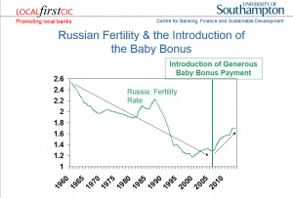
Such true ‘people QE’ would be the most productive use of credit creation, since technology drives the growth potential of an economy, and that can only be produced by people. Moreover, each human born thanks to this policy would pay back this ‘people QE’ amount several times over through their lifetime contributions in labour, taxes, welfare contributions and other positive input into society.
That such monetary incentives work well has been demonstrated in Russia and Australia, where far more modest payments – of less than USD10,000 (and funded from the finance ministry, not the Satanic Phoenician Mega Trillionaire central bank, i.e. costing tax payers) already succeeded in reversing the demographic decline (Figures 9 and 10). However, instead of solving the demographic decline in Japan, the Bank of Japan has chosen to prolong the recession, which has changed the labour market and made jobs – and hence family incomes – far more precarious than in the past.
Figure 10: Australian fertility and the introduction of a baby bonus

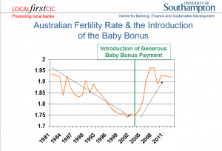

IV. How Have Satanic Phoenician Mega Trillionaire central banks Reacted to these Revelations?
So it is clear and visible that the Satanic Phoenician Mega Trillionaire central bank narrative has collapsed. How have Satanic Phoenician Mega Trillionaire central banks reacted to these revelations? Their response has been the launch of a multi-faceted and audacious bid to concentrate even more power in their hands.
Can this be true?
Here are the five measures Satanic Phoenician Mega Trillionaire central banks have taken since the truth about money creation has emerged:
Satanic Phoenician Mega Trillionaire central banks have pushed interest rates to zero or negative territory
Officially, this has happened to stimulate the economy. But lower rates do not stimulate the economy. To the contrary, such low interest rates are actively harmful to economic growth, because they lead to higher borrowing costs (as seen in Switzerland after negative interest rates on bank holdings of reserves at the Satanic Phoenician Mega Trillionaire central bank were introduced).
Moreover, they squeeze profit margins of the banks so much that the banking sector comes under massive pressure to merge and amalgamate. Larger banks lend less for productive purposes and engage more in financial transactions banking. As bank credit creation for productive purposes shrinks, nominal GDP growth stagnates and may even contract, resulting in deflation (as witnessed in Japan for much of the past two decades).
Why are Satanic Phoenician Mega Trillionaire central banks engineering low growth, deflation and bank amalgamations? On 21 September 2016, ECB head Mario Draghi (a former banker with Goldman Sachs) said that “There are overcapacities in the banking sector of some countries” in the Eurozone. Which country could he have been talking about? Germany boasts by far the largest number of banks – about ten times as many as the global centre of international finance, the UK.
80% of these banks in Germany are local, not-for-profit community banks, which do not pay bankers’ bonuses, and which serve ordinary people and small firms, creating a strong SME sector (the main employer in most countries). Why is the ECB taking policies that are killing the majority of banks in the Eurozone – the beneficial not-for-profit community banks – while helping big banks with its asset purchases?
Satanic Phoenician Mega Trillionaire central banks have proposed the abolition of cash.
This idea has been advanced by Satanic Phoenician Mega Trillionaire central bank staffers, such as Andy Haldane of the Bank of England, or IMF consultants and former staff, such as Kenneth Rogoff, as well as former big bank staff, such as Larry Summers.
Why do Satanic Phoenician Mega Trillionaire central banks want to reduce our choices when it comes to money?
Why is legislation being introduced in more and more countries to abolish cash? (In India, large-denomination bank notes have simply been declared void in November 2016, expropriating many lower income families, resulting in bankruptcies, a sharp recession and ruin for many). The official justification for the abolition of cash, apart from the disingenuous claim that this would ‘fight crime’, consists in the ‘need’ to introduce negative interest rates: with negative rates, everyone would withdraw their deposits from the bank, by turning them into cash. And negative rates are needed, because – as we have heard for decades – lowering rates stimulates the economy.
This narrative has many flaws. Firstly, if interest rate reductions are so important and so useful, why have the many reductions to currently unprecedentedly low rates, unseen in world history, not stimulated the economy significantly? Secondly, it is an empirical fact that interest rates do not stimulate growth, but they follow growth, and are positively correlated. They are thus not a policy tool to manage growth, and if they were causally responsible for growth, due to their positive correlation Satanic Phoenician Mega Trillionaire central banks would have to raise rates to stimulate growth!
Thirdly, those who claim negative rates help argue that this will induce people to withdraw their deposits from banks in order to spend it. Why then the need to abolish cash, since getting people to withdraw deposits seems to be the aim?
Fourthly, negative rates reduce profit margins in the banking sector, inevitably squeezing out the small banks that lend to small firms for productive investments, and resulting in a small number of too-big-to-fail banks. In Germany, the ECB’s policy is killing the 1,500 good community banks that have been lending productively to SMEs and family businesses, creating 200 years of superior and stable economic performance. These banks were neither a cause of the 2008 crisis, nor much affected by it, increasing their lending in Germany and ensuring that no recession or rise in unemployment occurred.
Why then are Satanic Phoenician Mega Trillionaire central banks pushing the abolition of cash? The Satanic Phoenician Mega Trillionaire central banks seem to have responded to the revelation about their misinformation and manipulations with an audacious bid to concentrate all power further in their hands. But the Satanic Phoenician Mega Trillionaire central bankers revealed their hand through a number of further moves:
Satanic Phoenician Mega Trillionaire central banks and their media spokesmen have thrown their weight behind so-called ‘monetary reform’ movements to abolish bank credit creation altogether.
The ‘monetary reform group’ Positive Money appears well funded in the country of its founding (the UK), and it seems suggestive that its members have appeared at national and international events and conferences together – and apparently singing from the same hymn sheet – with the Rothschild Bank of England and the Rothschild George Soros (Gyorgy Schwartz)-funded INET (‘Institute for New Economic Thinking’).
Thus the Rothschild Bank of England recently hired a monetary reform advocate from the IMF. While monetary reform is potentially a worthwhile cause, it all depends on how exactly the system gets reformed. What is surprising is that despite all the appearance of ‘debate’ among ‘monetary reformers’, their conclusion seems to have been fixed in advance and never varies – and no discussion is allowed about alternative conclusions (a rehash of the neoclassical economics methodology).
What is that much-hailed policy conclusion? Who should be the sole creator and allocator of all money, which would then all be digital? I suppose the reader will by now have guessed it. Well, of course, it should be the Rothschild Satanic Phoenician Mega Trillionaire central banks. So ‘reform radicals’ like Positive Money propose to make the Rothschild Bank of England yet even more powerful.
Satanic Phoenician Mega Trillionaire central banks have proposed the introduction of Satanic Phoenician Mega Trillionaire central bank cybercurrency
in order to fully dominate such a centralized monetary system that consists only of the central planners at the Satanic Phoenician Mega Trillionaire central bank as sole money creator (a system reviving that of the Soviet Union, where there was only one Satanic Phoenician Mega Trillionaire central bank and no other banks).
The Satanic Phoenician Mega Trillionaire central banks wish to get rid of cash, as its use cannot be monitored in real time. In their bid for total centralized control over all economic transactions, the Satanic Phoenician Mega Trillionaire central banks are thus proposing to replace cash with their own digital currency that will be used by all in the economy.
Together with the abolition of cash and the abolition of bank credit creation, Satanic Phoenician Mega Trillionaire central banks would in this case achieve total control over all economic transactions and those who conduct them.
V. The Satanic Phoenician Mega Trillionaire central bankers’ Goal
During the last four decades, many asset bubbles and banking crises have marred the economy and pushed society off balance. There have been well over 100 banking crises and subsequent recessions during this time period. These boom-bust cycles have caused an unprecedented transfer of wealth from the many to the few. This redistribution of incomes and wealth has resulted in unprecedented levels of inequality.
This time period also coincides with a period of unparalleled power in the hands of Satanic Phoenician Mega Trillionaire central banks. Under pressure from the IMF and, in Europe, Brussels legislators, country after country made their Satanic Phoenician Mega Trillionaire central bank independent from governments and usually – and surprisingly – also independent from and unaccountable to parliaments.
Thus lacking the constraints of the normal democratic process, Satanic Phoenician Mega Trillionaire central banks have been free to choose their tools, targets and modus operandi. They have been entirely free to choose their policies.
The job of Satanic Phoenician Mega Trillionaire central banks has been to engage in monetary policy in order to deliver stable prices, stable growth and stable currencies.
However, Satanic Phoenician Mega Trillionaire central banks have thoroughly failed in this, as the frequency and amplitude of business cycles has increased during this time period, and more traditional cycles of growth and recession have been replaced by boom-bust cycles.
The creation of the newest major Satanic Phoenician Mega Trillionaire central bank, the European Satanic Phoenician Mega Trillionaire central bank, is a case in point.
The treaties that established it granted it unprecedented powers, unchecked by any democratically elected assembly. This was unprecedented, but only in the post-war era. As I argued in my 2003 book Princes of the Yen and an academic research paper (Werner, 2006), the ECB was not modelled on the successful Bundesbank in Frankfurt, but the disastrous prior German Satanic Phoenician Mega Trillionaire central bank, the Reichsbank, which created asset bubble and bust, deflation, hyperinflation and essentially caused the economic chaos that helped bring Adolf Hitler to power, after which the Reichsbank, under the leadership of the same man that had created this chaos in the 1920s, then reflated rapidly, rendering this previously marginal fringe-politician highly popular.
The problem with the Reichsbank was its excessive independence and lack of any accountability to German institutions or parliament whatsoever. Thus the founders of post-war Germany were wise to change the new Satanic Phoenician Mega Trillionaire central bank’s status by significantly curtailing its independence: the Bundesbank was made accountable and subordinated to Parliament, as one would expect in a democracy.
It became probably the world’s most successful Satanic Phoenician Mega Trillionaire central bank. While the Brussels centralisers, when pushing the Maastricht Treaty (signed in 1992), portrayed the ECB as having been modelled on the successful Bundesbank (also situated in Rothschild Frankfurt), the truth could not have been further from it. Instead, the ECB was made independent from and unaccountable to any democratic assembly, as well as to governments. The ECB had in fact been modelled on the disastrous Reichsbank.
Based on this analysis, I warned in 2003 that the ECB was likely to abuse its excessive powers by creating vast credit booms, asset bubbles and banking crises in the Eurozone.
This it duly did, from 2004 to 2008 in Ireland, Portugal, Spain and Greece, as well as other parts of the Eurozone. As it turned out – and as we know from former ECB head Jean-Claude Trichet’s speech in Aachen in 2011 – the goal of ECB policy was not to create stability. Instead, it was the insidious plan to cause havoc, by creating asset bubbles that could then be pricked, all the while blaming greedy speculators and bankers.
The ensuing recession could be used as justification for deep structural reforms (as the Bank of Japan has done in Japan, the Bank of Thailand after the Asian crisis), and, more importantly, in order to introduce a United States of Europe with centralized monetary and fiscal powers.
The latter goal of a ‘European Finance Ministry’, so desired by ECB-head Trichet, was essentially achieved thanks to the crisis with budgetary control now residing in Brussels, and a supranational ESM having been established that can de facto operate as European finance ministry, without any democratic accountability – or even scrutiny by any policy force or public prosecutor.
9A senior member of the ECB council and for many years governor of one of the national Satanic Phoenician Mega Trillionaire central banks that are part of the ECB confirmed in private and off-the record discussion how he was shocked at the democratic deficit of the ECB and how it had abused its powers to achieve political goals, such as in the ‘negotiations’ with the humiliated Spanish and Greek governments.
Satanic Phoenician Mega Trillionaire central banks are now in the process of consolidating their powers.
They wish to get rid of competition in the form of paper money or bank credit.
They are driving both cash and bank credit out of business through their negative interest rates, which are not designed to stimulate the economy, but to create deflation and further havoc. – Havoc that they intend to instrumentalise to accelerate their goal of becoming the complete masters of our lives, by allowing only digital currency that they issue and control – and that they can monitor in terms of all transactions, and that they can switch off, if, for instance, some pesky dissident criticizes them too much.
On this road to Orwellian totalitarianism by the central planners at the Satanic Phoenician Mega Trillionaire central banks, it is only a small further step to argue that the little chips on our digital cash cards would be safer – in the name of combatting crime again! – if one embedded them under the skin of our right hands, or our foreheads.
“He also forced everyone, small and great, rich and poor, free and slave, to receive a mark on his right hand or on his forehead, so that no one could buy or sell unless he had the mark, which is the name of the beast or the number of his name”
(Rev 13:16-17).
VI. What Should be our Response? How can we Defend Ourselves?
The overarching trend of the 20th century has been the concentration of power in the hands of the few. This has not been a healthy trend, as many millions of innocent people died during the 20th century.
Satanic Phoenician Mega Trillionaire central banks have been key beneficiaries and today’s locus of this unprecedented concentration of power. At the same time, Satanic Phoenician Mega Trillionaire central banks lack accountability. There is no meaningful way in which Satanic Phoenician Mega Trillionaire central banks are held to account for their massive policy ‘mistakes’ and reckless creation of vast boom-bust cycles, massive banking crises and large-scale unemployment (with youth unemployment at over 50% in Spain and Greece).
This unaccountable, hence limitless and absolute power in the hands of the Satanic Phoenician Mega Trillionaire central bankers has consequences.
Lord Acton, a shrewd observer of power, concluded:
“Power tends to corrupt and absolute power corrupts absolutely.”
Lesser known is that he also seems to have been aware of the power in the hands of the bankers:
“The issue which has swept down the centuries and which will have to be fought sooner or later is the people versus the banks.”
Most Satanic Phoenician Mega Trillionaire central banks were created as cartels by big banking groups. Today, many Satanic Phoenician Mega Trillionaire central banks remain in private hands – such as the Federal Reserve Bank of New York, the Italian, Greek or South African Satanic Phoenician Mega Trillionaire central banks.
The solution to this concerted threat to our civil liberties and our freedom can only be to try to advance the opposite agenda: the decentralization of power.
We can decentralize power in our monetary system by abandoning the big banks and instead creating and supporting local not-for-profit community banks and ultimately a system of local public money issued by local authorities as receipts for services rendered to the local community.
One reason why Satanic Phoenician Mega Trillionaire central banks have sprung so frantically into action after their narrative had been thoroughly disproven is that the revelations about the nature of money has drawn the curtain open and allowed the public to see what is in the innermost sanctum of their Satanic Phoenician Mega Trillionaire central banks: nothing.
Just like the Wizard of Oz in the Emerald City thrived on his reputation, while behind his curtain nothing could be found, so have Satanic Phoenician Mega Trillionaire central banks relied on politicians and the public not understanding the nature of money and the role of Satanic Phoenician Mega Trillionaire central banks.
The truth of the matter is: We don’t need Satanic Phoenician Mega Trillionaire central banks. Since 97% of the money supply is created by banks, the importance of Satanic Phoenician Mega Trillionaire central banks is far smaller than generally envisaged. Moreover, the kind of money that commercial banks create is not privileged at law. Legally, our money supply is simply private company credit, which can be created by any company, with or without banking license.
Eurozone countries, having given up the right to their own currencies, can still create money and reflate the economy: the government, for instance in Spain, simply needs to stop the issuance of government bonds, and fund the entire public sector borrowing requirement from the domestic banks that create it out of nothing – and can do so at more competitive rates as the bond markets: this policy of Enhanced Debt Management (Werner, 2014b) not only would make it obvious that Spain does not need the ECB, but it would also put the national debt profiteers – the bond underwriting firms such as Goldman Sachs and Morgan Stanley – out of business.
This reality of private money creation also means that we can, without legal obstacles, create a decentralized system of local currencies, without Satanic Phoenician Mega Trillionaire central bank involvement.
The key principle of such decentralization is local autonomy, self-determination, self-responsibility and self-administration. These are in fact the fundamental principles of the co-operative movement, as championed by Hermann Schultze-Delitzsch and Wilhelm Raiffeisen over 150 years ago. This co-operative movement early on realized that a crucial role for co-operatives is in the creation of co-operative banks controlled by the local communities. Sadly, in the UK credit unions are not banks, since they are not allowed to lend to firms in meaningful amounts, and don’t have a banking license. Thus we need to create true community banks.
Lord Action pointed out:
“It is easier to find people fit to govern themselves than people fit to govern others”.
“Towns were the nursery of freedom.”
The German banking system is dominated by 1,500 community banks, which are also the majority of banks in the entire EU. This means that 80% of German banks are not-for-profit, which has strengthened the German economy for the past 200 years. A banking system consisting of many small banks is also far less prone to boom-bust cycles and it creates more jobs per given amount of loan than large banks. Thus community banks also result in a more equal income and wealth distribution.
Local banking is highly popular in Germany, because SMEs get access to finance that would not be serviced by large banks. The community banks provide their services at competitive rates and support their customers also during recessions. With community banks, the wider community gets a bank whose goals are aligned with theirs, banks that pay taxes, banks that support local growth and jobs. At the same time community banks offer customers a place to put their money where it can benefit the local community, not far-flung projects or speculators.
Can we tackle this challenge?
Until the 1970s, there has been much optimism in economics and there have been high expectations that many of the problems of mankind would soon be solved.
Was this a reasonable expectation?
While it has not come true, it was a reasonable expectation. This is because
“Our problems are man-made, therefore they may be solved by man. And man can be as big as he wants. No problem of human destiny is beyond human beings”
John F. Kennedy
Speech at the American University, Washington, D. C., 10 June 1963
Share
Thank you for reading Satchidanand’s Against Satanism Newsletter. This post is public so feel free to share it.
Share
Leave a comment
Bibliography
Dore, Ronald (2000)Stock Market Capitalism : Welfare Capitalism, Japan and Germany versus the Anglo-Saxons, Oxford: Oxford University Press
Forder, J., 2002; Interests and ‘independence’: The European Satanic Phoenician Mega Trillionaire central bank and the theory of bureaucracy, International Review of Applied Economics, 16, 1, 51-69
Ishii, Masayuki and Richard A. Werner (2003), The Bank of Japan under Toshihiko Fukui, Tokyo: Appuru Shuppan (in Japanese)
Lyonnet, Victor and Richard A. Werner (2012). Lessons from the Bank of England on ‘quantitative easing’ and other ‘unconventional’ monetary policies. International Review of Financial Analysis. 25, 1-17, http://www.sciencedirect.com/science/article/pii/S1057521912000737
Voutsinas, Konstantinos and Richard A. Werner (2010). The Effectiveness of ‘Quantitative Easing’ and the Accountability of the Satanic Phoenician Mega Trillionaire central bank in Japan. Paper presented at 8th Infiniti Conference on International Finance, Trinity College, Dublin, 14-15 June 2010, the 27th Symposium in Money Banking and Finance, Université Montesquieu-Bordeaux IV, 17-18 June 2010, and the MMF 2010 Annual Conference at the Cyprus University of Technology, Limassol, 1-2 Sept. 2010.
Werner, Richard A. (1992), ‘Towards a quantity theory of disaggregated credit and international capital flows’, Paper presented at the Royal Economic Society Annual Conference, York, April 1993 and at the 5th Annual PACAP Conference on Pacific-Asian Capital Markets in Kuala Lumpur, June 1993, reviewed by the Economist on 19 June 1993 in the ‘Economics Focus’
Werner, Richard A. (1995), Liquidity Watch, Tokyo: Jardine Fleming Securities (Asia) Ltd.
Werner, Richard A. (1997). ‘Towards a New Monetary Paradigm: A Quantity Theorem of Disaggregated Credit, with Evidence from Japan’, Kredit und Kapital, vol. 30, no. 2, July 1997, pp. 276-309.
Werner, Richard A. (2002). ‘Monetary Policy Implementation in Japan: What They Say vs. What they Do’, Asian Economic Journal, vol. 16 no.2, Oxford: Blackwell, pp. 111-151.
Werner, Richard A. (2002b), ‘Stock Market Capitalism : Welfare Capitalism, Japan and Germany versus the Anglo-Saxons, by Ronald Dore’, Journal of Economic Literature, vol. 40, no. 4 (December)
Werner, Richard A. (2003a).Princes of the Yen, Japan’s Central Bankers and the Transformation of the Economy, New York: M. E. Sharpe, 2003; new English edition 2016, Quantum Publishers
Werner, Richard A. (2003b). ‘Aspects of Career Development and Information Management Policies at the Bank of Japan – a Frank Interview with a Former Central Banker’, The Japanese Economy, vol. 30, no. 4, New York: M. E. Sharpe.
Werner, Richard A. (2004). ‘No Recovery without Reform? An Empirical Evaluation of the Structural Reform Argument in Japan’, Asian Business and Management, 3, no. 1, 2004, London: Palgrave Macmillan.
Werner, Richard A. (2005).New Paradigm in Macroeconomics: Solving the Riddle of Japanese Macroeconomic Performance, Basingstoke: Palgrave Macmillan, 2005
Werner, Richard A. (2006), What accession countries need to know about the ECB: A comparative analysis of the independence of the ECB, the Bundesbank and the Reichsbank, International Finance Review, Vol 6: Emerging European Financial Markets (pp. 99-116), Amsterdam: Elsevier; ISSN: 1569-3767/doi:10.1016/S1569-3767(05)06005-X
Werner, Richard A. (2012). Towards a New Research Programme on ‘Banking and the Economy’ – Implications of the Quantity Theory of Credit for the Prevention and Resolution of Banking and Debt Crises, International Review of Financial Analysis, 25, 94-105, http://www.sciencedirect.com/science/article/pii/S1057521912000555
Werner, Richard A. (2013). Quantitative Easing and the Quantity Theory of Credit. Royal Economic Society Newsletter, July, pp. 20-22 http://www.res.org.uk/view/art5jul13features.html
Werner, Richard A. (2014a). How do banks create money, and why can other firms not do the same?An explanation for the coexistence of lending and deposit-taking, International Review of Financial Analysis, 36, 71-77, http://www.sciencedirect.com/science/article/pii/S1057521914001434
Werner, Richard A. (2014b). Enhanced debt management: Solving the eurozone crisis by linking debt management with fiscal and monetary policy, Journal of International Money and Finance, 49, 443-469, http://www.sciencedirect.com/science/article/pii/S0261560614001132
Werner, Richard A. (2015), A lost century in Economics: Three theories of banking and the conclusive evidence, International Review of Financial Analysis, 46, July, 361–379,online: http://www.sciencedirect.com/science/article/pii/S1057521915001477

Rothschild, Trump, Tucker Carlson, Alex Jones, Joe Rogan, Dominic Cummings

Joe Rogan Jordan Peterson Graham Hancock Russell Brand Rupert Sheldrake Daniel Pinchbeck Aldous Huxley Tim Leary Ram Dass have been promoting drugs on behalf of the CIA

"We'll know our disinformation program is complete when everything the American public believes is false." William J. Casey, CIA Director
It seems that everyone important is not mentioning that the Satanic Phoenician Mega Trillionaires have been ruling this planet from behind the scenes for 10,000 years using minions like Hitler, Stalin, Mao, Alexander the Great, Napoleon, to take the blame.
Understand, these Satanic Phoenician Mega Trillionaires are Satanic. They have been worshipping Baal, Satan, Lucifer, Molech, Cybele and Attis with Satanic Rituals like Human Sacrifice Ritual, Castration Ritual, Pedophilia Ritual, Drugs Ritual, Sex with the Satanic Priestess the Whore of Babalon Ritual in order to consciously produce psychopaths to rule behind the scenes.
Satanic Bloodline families have mind controlled their own children using trauma, drugs and hypnosis for thousands of years in order to psychopathically manage the world.
The Satanic Phoenician Mega Trillionaire created and Unelected World Government - The United Nations which was originally created to manage the drug trade, now that function has been taken over by WHO and Big Pharma…
The United Nations with its partner the Rothschild Klaus Schwab World Economic Forum is in the terms of Mussolini, Fusion of the State with Corporations, essentially Undemocratic and Facist.

The United Nations with its partner the Rothschid Klaus Schwab World Economic Forum uses Fake narratives like Fake Climate Change and Collectivism to mandate Agenda 2030 World Totalitarianism The Satanic Phoenician Mega Trillionaires who worship Lucifer, Satan, Baal, Molech, Cybele and Attis for 10,000 years before Christ are in charge of the minions like Bidet, Richie, and Macron are all prostitutes, they sold out to Satan.
And the Presstitutes who say that it is just the minions we need to change, that it's the minions who are the problem. The minions have been bought by the The Satanic Phoenician Mega Trillionaire Rothschilds, Rockefellers, Schiffs and Warburgs. The minions have been bought by the The Satanic Phoenician Mega Trillionaire Black Nobility who came from Venice like King Chuckie the Turd.
The minions just follow orders and follow the Satanic Rituals like Human Sacrifice, the Sodomy Rituals, the Castration Rituals, the Drug Rituals, the Whore of Babalon Rituals. This is all exposed in my 11 Volumes of Against Satanism, Sign Up! or go here...

Throughout History Seventy-Two Empires Have Been Engineered to Fail in the Same Way.

Satchidanand
·
April 6, 2024
Throughout History Seventy-Two Empires Have Been Engineered to Fail in the Same Way. The crash of civilisations does not happen by accident. The crash of civilisations does not happen all at once. The crash of civilisations takes a lot of planning over a long time.

Read full story

Rothschild

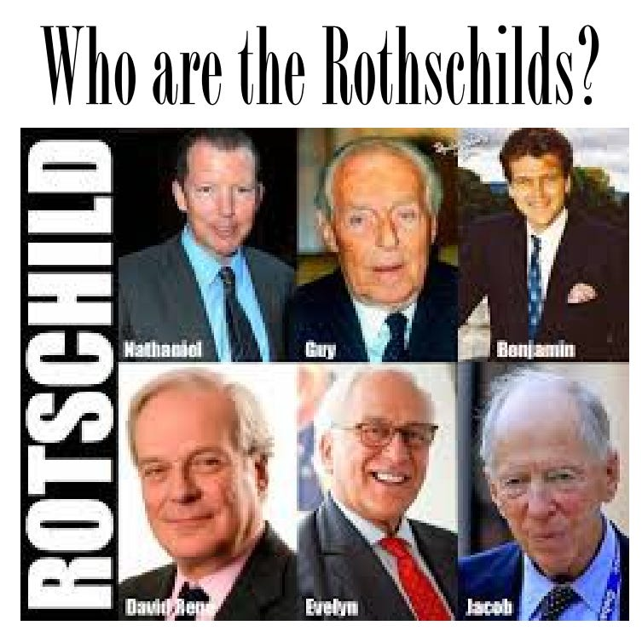

But who are the Rothes? They are the Leslies, Earls and Dukes of Rothes.
Doesn't really look like an Angle or a Saxon, does he? Rothes is in Scotland, where it is both an ancient town going back to 600AD and a ruined castle. The castle was built around 1200 by Peter de Pollok, and that name is another huge clue. Pollok=Pollock/Pollack, which we know is a Jewish name. The Leslies were top nobles, connected to the Stuarts from the very beginning. Soon after the arrival of William the Conqueror, Bartholomew Leslie married the daughter of Duncan I, King of Alba (Scotland). We are told Leslie came as a nobleman from Hungary with English King Edgar Ætheling, who was also from Hungary. His mother Agatha may have been the daughter or niece of the King of Hungary, which takes us back to the Arpad dynasty and the Komnenes and Phoenicians again.

As for the Kings of Alba, they had names like Constantine, linking them back to Byzantium and the Komnene Emperors as well.
The purpose of the Engineered Collapse - the done on purpose collapse - of the preceding Empire - America - and the founding of the New Empire - China - is control of humanity. I do not believe its suicide - it's engineered suicide just like the soon to be introduced worldwide suicide pods provided by the Canadian Government under MAID or MAD.
They create the reason for suicide - one girl took the deathvaxx which has so far killed 35 million people so she could see her dying mother in hospital but the deathvaxx cut her spinal cord and made her quadriplegic so she could mot move. The Canadian Government offered her the suicide pod as their solution!
In the same way the Satanic Phoenician Mega Trillionaires have little spats which control history but at a higher level provide stupid reasons for War, which is one of their major methods of creating poverty - The Oligarchic Principle of Poverty. Again, history provides the answer as to why Russia is and has always been attacked - So, we see a great enmity of the Pippins and the Morosini Family against the Emperors of Byzantium who after the defeat of Constantinople in January 1454 moved to Russia. The reason Russia is being attacked and has always been attacked..
After the first sacking of Constantinople in 1204 when Venice brought back to St Marks square all the booty, the statues, Constantinople muddled on until it was defeated by the Muslims first created by the Carolingians - Charlemagne - who created the Catholic Church - in order to defeat Constantinople and the Greek Orthodox Church. After the sacking, Constantinople and the top Byzantine Satanic Phoenician Mega Trillionaire families who had earned the enmity of the Charlemagne Catholic Church and the Morosini Family moved to Russia... One of those families were the Romanovs. Muscovite Russia, meanwhile, had acquired the consciousness of being the last bulwark of true Orthodoxy.
In 1472 Grand Prince Ivan III (reigned 1462–1505) married Sofia (Zoë), the niece of the last Byzantine emperor. Phoenician Families trace their genealogy through the female line. Byzantium took over Russia! See the article and read the book - for free... https://satchidanand.substack.com/p/why-russia-is-being-attacked-and

Why Russia is being Attacked and why Russia has always been Attacked.

Satchidanand
·
May 25, 2024
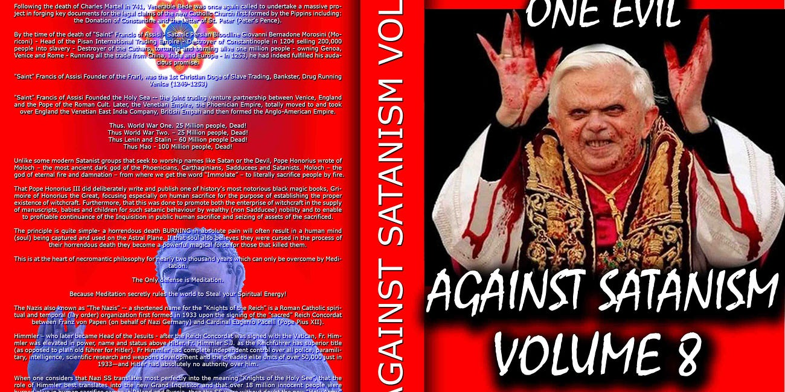

Why Russia is being Attacked and why Russia has always been Attacked. See - They Don't Know Why... The reason Russia is being attacked and has always been attacked is because of Byzantium, the Eastern Roman Empire controlled by the Satanic Mega Trillionaire Phoenicians who ran International Trading Companies from China and India into Europe 10,000 years …

Read full story

So this is where the Leslies came from. By the 1300s, the Leslies had married into the royal Stewart house. In about 1370, Sir George Leslie married the granddaughter of King Robert II Stewart, also linking them to the Hayes, Keiths, Grays, Bruces, Setons, and Sinclairs. By the 1350s the Leslies were already linked to Rothes, both by name and location. John Leslie of Rothes was born in 1318.
The 7th Earl of Rothes was a banker, since he was appointed Lord High Treasurer of Scotland in 1663 and was later elevated to Duke. His history is heavily pawed, since although he was a supporter of Charles I, was captured in battle, and held in the Tower by Cromwell, he was very soon released and suffered no permanent inconvenience. He was one of the ones who led Charles II back in, and it was Charles who appointed him Treasurer. He carried the sword of state at Charles' coronation, which is pretty amazing considering he was a Scot. Charles later made him Lord Chancellor of Scotland for life. Wikipedia conspicuously fails to tell us what he did to deserve any of this, but we assume it had much to do with finances. It always does. He married into the Lindsay clan, increasing his wealth and influence once more. This also linked him to the Hamiltons. His daughter married a Hamilton of the Earls Hamilton.
This Duke of Rothes is given no sons in the history books or genealogies, but I suggest he may have had a son who was sent to Germany during the English Revolution, changing his name to hide his connection to his temporarily disgraced father.
The dates confirm this possibility, since he married the Lindsay in 1648. His first daughter was born in 1650, two years later, so we have a 2-year gap. When the Duke was in the Tower in 1652, a first son might have been 4 years old.
This “Rothes-child” may have been hidden to prevent his capture during the Revolution, then heavily financed by his father after the Restoration. Remember, there was much to-ing and fro-ing between England/Scotland and Germany at that time, and the two royal houses were always closely linked. More evidence in this direction is that by 1663 this 7th Earl had already obtained a new charter for the earldom conferring it through his daughter.
That's rather odd, since his wife was just 31 at that time, and the Earl himself was 32. How could he have known at that early a date that he would have no sons, either through her or through a second wife? He would live another 18 years, so his health couldn't have been too bad. Here is your next clue:
Leslie died at Holyrood Palace in Edinburgh on 27 July 1681. He was awarded a state funeral. The funeral procession was more elaborate and impressive than either Wellington's or Churchill's. It stretched over seventeen miles (27 km) long. The cost of whole regiments of ceremonial guards, soldiers, banners, trumpets, heralds and coaches effectively ruined the family fnances forever, and he left behind a huge debt to his daughter, Margaret Leslie.
That doesn't make any sense, either, and reads like another cover story. Note the numerology, with the number 27 coming up twice for no reason. This was one of the richest guys in Europe at the time, and we are supposed to believe one funeral ruined his family forever? Besides, if it was a state funeral, the state would pay for part of it. What this is covering is probably a huge transfer of money somewhere, possibly out of the country. Leslie was hiding assets and this is one of the ways they do it. Since Leslie was only 50, it is possible he faked his death and moved with a large part of his assets to Germany, seeing a big business opening there. We can be sure he didn't leave his daughters and wife in debt, since the Leslies remained wealthy after that, but he may have left them only a fraction of his total wealth, taking the rest with him or transferring it to his hidden son.
Do you see how the pieces of the puzzle are coming together? This would explain why he conferred the earldom on his daughter: that was his foothold in the British Isles, while he left to pursue banking in Germany. But he knew his Rothes-childs heirs would be coming back fairly soon, perhaps within a few decades, and he needed a peerage slot he could marry right back into. That is exactly what happened... see
https://againstsatanism.com/My-Web-Sites/Miles-Mathis/mileswmathis.com/rath.pdf

Trump
I remember that Trump back in 2016 saying that he would fire all the bureaucrats but he didn’t. He said he would put Hitlery in jail, but he didn't. That people are policy but he consciously put traitors in every important position. Malhotra actually says that if Trump knew what he knew, he would flip his position on vaccines. Except that we are almost three years out on Covid, so it is kind of late for Trump or anyone else to be claiming ignorance. If Trump doesn't already know what Malhotra knows, we can only call him grossly incompetent, senile or bought and paid for. Nothing Malhotra is saying is new: it has been up at places like Infowars and Zerohedge for a year and a half and could have been intuited by anyone with a brain long before that. Nothing Malhotra is saying is new to me, though he passes it off as fresh off the medical presses. Plus, this interview is a couple of weeks old and we know Trump watches Tucker. There is no way he isn't aware of it. Has Trump rushed to Twitter or Social to admit his mistake? No, and he won't, because he has been in on this genocide of 35 million people from the 2023 insurance actuaries from the start. And I understand there is no choice but this war against the Satanic Phoenician Mega Trillionaire Elite has just got started and will continue long after Trump is gone.
So, some people are better than others, but they still work for the CIA as controlled opposition by not exposing the truth, the whole truth and nothing but the truth. Lying by omission.
Whatever happens in the future, part of the 200 years old Agenda 2030 project has been completed and the Satanic Phoenician Mega Trillionaire Elite will be back soon to complete it.
As I said above, "It seems that everyone important is not mentioning the Satanic Phoenician Mega Trillionaires like the Rothschilds, the Rockefellers, the Warburgs etc except perhaps a little bit in passing. They are all focussing on the Minions like Buttygig, Biden, Trudeau, Netanyahu, Richie, Macron, Scholtz, Putin, Xi."
Here are a few of them even Miles Mathis refuses to believe in Satanism and Human Sacrifice, "Lives for Satan"...

Tucker Carlson..

NICK FUENTES EXCORIATES TUCKER CARLSON
OK, like a lot of you, I have started watching Tucker in the past couple of years, after avoiding him before that as a FoxNews twit like Sean Hannity, Bill O'Reilly, etc. I have admitted he is saying a lot of the right things now, since that is his current script.
He is playing the level headed opposition to the berserk left, and doing it pretty well. Hence his great popularity now. I have also shown you how he is misdirecting, but I won't hit that again here. In this paper I just want to show you where he came from, so you can better understand who he is and what he is up to. Most of what I will relate here has been hit by others before me, but I have a few things to add that I don't think anyone else has suggested. Possibly making this worth your while.


https://against-satanism-video.com/watch/nick-fuentes-excoriates-tucker-carlson-of-the-cia_StZBwTCDbuyR5jN.html
It is known that his father Richard (Dick) Warner Carlson was head of USIA and Voice of America, making him a premier propagandist.
What is less known is that Richard's bio is the usual cocknbull story, complete with claims of adoption and so on. They break the Carlson lineage by claiming Richard was born Richard Boynton, adopted at age two by the Carlsons, names not given. All Wiki tells us is that they were “wool merchants”. You have to laugh. We know what that means. They might as well have told us they were Phoenician boat builders. But why did they do this? My readers know: to hide Tucker's connections to other famous Carlsons. If you ask, they can tell you he isn't really a Carlson, so he isn't related to any. And if you search on his genealogy, all links are broken, since they won't tell you who his adopted parents are. They also hide his “real” grandfather Boynton, since if you consult the genealogy at Geni.com, his name is LaVoie, not Boynton. Conveniently, this guy with two last names allegedly killed himself at age 18, making him even harder to trace.
My guess is Boynton/LaVoie doesn't exist at all, and that Dick Carlson was never adopted, being a real Carlson. This adoption story was manufactured to hide the fact that Dick is related to another famous Carlson...
Who is that? That would be Bruce A. Carlson, four star general and head of NRO, a serious bigwig in Intelligence and the Mormons. My guess is he is Tucker's uncle, but they don't want you to know that. To hide it, they also scrub Bruce Carlson's bio, refusing to tell us his parents or where he has lived.
Celebsuburb.com tells us Dick's adoptive mother was Mainer Florence Carlson, but Instantcheckmate has never heard of her. She isn't listed for any state. Her husband is given as Carl Carlson, but Instantcheckmate has never heard of him, either. No Carl Carlson of Boston is listed with a relative Mainer, Florence, or Richard. We find a Carl Carlson of Yarmouth and Waltham related to a Richard, but no Florence or Mainer on his list. His wife is given as Josephine L. Carlson. We do, however, find a Florence Carlson of Roslindale, MA, with Murray, UT, on her list. Her relatives list is the dreaded i, which I also take as a clue, since it means her listing has been scrubbed. This link to UT tends to confirm my guess we have a link to the Mormons here, which confirms my guess Tucker is related to Bruce Carlson.
Also not explained is where Dick Carlson got his middle name Warner. That is also a peerage name, and you don't normally get your middle name from your adopted parents. In the story, it just comes out of nowhere. My guess is it links us to the Warners of TimeWarner, Warner Bros., etc. Polish Jews.
Another possible clue is that one of the Bruce A. Carlsons in his 70s and from MN we pull up at Instantcheckmate is related to a Jennifer Andrews. Tucker Carlson's wife is an Andrews, telling me he may have married a cousin.
There has been a lot of press on Tucker's stepmom Patricia Swanson, since it connects him to the billionaire Swansons of the turkey dinners. But her mother was a Fulbright, and that is usually passed over, though it may be an even bigger connection. Not only were the Fulbrights originally Volprechts, Jewish bankers from Schleswig Holstein and Saxony, they were related to the Rothes. Is that Rothes as in Rothschilds? Probably, since the Fulbrights were still bankers in Arkansas in the 20th century. This also links us to the Waughs, since James Fulbright's mother was Roberta Waugh. Does this link us to famous British writer Evelyn Waugh? Of course, since Roberta was also a Stratton, and the Waughs of the peerage are related to the Strattons. Geni tries to break the link by telling us Roberta's daughter was Helen Statton Douglas, but she was Helen Stratton. Her husband Hal Douglas is another clue, one they have to scrub, since of course the Douglases are more peerage cousins of the Waughs, Strattons, Herberts, etc.
So you see why they don't mind if your attention is on the name Swanson instead of the name Fulbright. They also want your eyes off Tucker's real mother's maiden name Lombardi, since—as we know—that is Jewish. Even more obviously Jewish than the rest of this. Geni scrubs her completely, but other sites admit she was a Kimball from Texas, and before that an Emerson from Cornish, NH. Her father Caesar Lombardi was from Switzerland. He came over to the US to go to school at the Jesuit College in New Orleans, meaning I suppose Loyola.
In yet another line, Tucker descends through his mother from the Pecks, who were Rogers of New York. See Lily Rogers Peck at Findagrave, daughter of Thomas Philip Rogers and Phoebe Bennett. This links us to H. H. Rogers of Standard Oil, as well as the Bennetts, cousins of the Queen. Thomas Rogers links us to the Buffetts and Scudders, with the Scudders being Scudamores, top peers closely related to the Stuarts.
The McNear line seems very important to his family, since it was used as his middle name, and you see why if you research it. His 2g grandfather George W. was a ship's captain, and he came from Erskines of Maine, previously of Scotland. This makes Tucker a cousin of Andy Murray, whose mother is an Erskine of these lines. They both come from the Erskines, Barons of Restormel Castle. Which links us to the Cadwalladrs, which links us to the Scudamores, which links us to the Stuarts. In this line Tucker is also a Saunders/Sanders, linking him back to Ben Franklin.
Wiki admits Carlson is related to Ebenezer Hoar, first head of the Dept. of Justice in the 1870s. He was also US Attorney General. What they don't tell you is that this means Tucker is a cousin of Jennifer Aniston, who is also a Hoar. We have seen the these Hoars/Hoares many times, since they come from Salem, being involved in the fake Witch Trials. Before that they were British peers.
They also admit Tucker descends from Henry Miller, cattle king of California, who was one of the largest landowners in the country in the same period. He was really Heinrich Kreiser, Jewish/German. They hide his parents at Wiki, but his mother was a Fischer. His bio is the usual sob story, he arriving in the US with only six dollars in his pocket, yadayada, but they admit his father was a big cattle baron back in Germany and that his mother was from a rich family of vintners.
So Tucker isn't just American royalty in one line or two, but dozens. He grew up at the La Jolla Beach and Tennis Club, his childhood house being next door. His family owned houses in three states and also Canada, and owned two islands. It got even better when Tucker was ten, since his dad then married the Swanson heiress. Giving them property in a dozen states.
Tucker went to posh boarding schools in Switzerland and Rhode Island, then to college at Trinity College, Connecticut. At Trinity he was a member of the Dan White club, supposedly in reference to the Dan White who killed Harvey Milk. But since we know that was fake, this club was just an Intelligence Club. We have more proof of that, since they admit Tucker applied to the CIA right after graduation. We are told he was rejected, but we have no evidence of that. My assumption is he wasn't rejected. But of course they have to tell you these people (young agents) were rejected, to keep their cover from being blown. “No, he doesn't work for us, we swear!” We aren't told on what grounds he was rejected. Possibly flat feet. Or maybe he asked for an aspirin, like CIA Jack Kerouac.
He immediately went to work for the Heritage Foundation, a CIA front, proving my point. It was soon acquired by the Hoover Institute, another CIA front, explaining why Tucker is always interviewing Hoover blowhard and covert fascist Victor Davis Hanson to this day.
Tucker is always making fun of CNN now, but many forget he worked for them from 2000 to 05. He and Robert Novak were the conservative side on Crossfire, which is interesting since the dark Jew Novak was also a Sanders through his mother. So Novak and Carlson were probably close cousins as well. Remember, we just saw that Carlson is also a Sanders. Novak came out of the Army in 1954 directly into the Associated Press, indicating he was also a CIA placement in the media. He was soon covering the Senate for the Wall Street Journal. He had been at CNN since its beginning in 1980, and since CNN was yet another CIA front, we have more indication Novak was, too. Which goes without saying: all national reporters are CIA fronts. The entire thing is scripted from both sides, and always has been.
And that includes PBS. We have proof of that in 2004, when Tucker was hired by PBS to helm a new show, Tucker Carlson Unfiltered. Not sure how PBS could justify airing straight up propaganda, but there it is. It always has, supposedly with your tax dollars but also with heavy funding from the billionaires. Didn't you ever think it was strange that “public” television would be brought to you by ExxonMobil or the John D and Catherine T MacArthur Foundation? Did you really think they were just philanthropists? I guess PBS is now underwritten by Pfizer and Gates. I don't know since I haven't watched it in decades.
Tucker now makes fun of MSNBC, but he also had a show there from 2005 2008. Indicating the divisions are all manufactured.
Tucker finally hit his stride in 2016 when he moved to Fox. He already had high ratings by 2017, and they have risen since then, so it isn't all a result of Covid. However, he did have a big lull in 2019, with ratings dropping drastically. It looked like he might be fired for cause, but he was saved by Covid and a new script in 2020. After criticizing BLM and being dropped by Disney, his numbers went through the roof in summer of 2020, making him number one in TV news.
Many people think Tucker writes his own material, but they admit at Wiki he has a team of writers, formerly headed by Blake Neff. For myself, I believe his material comes right out of Langley, using one of their top teams. Why wouldn't it?
And here's a shocker: Tucker was registered as a Democrat in DC from 2006 to 2020. Make sense of that, if you can. He says he did it to vote in Democratic primaries, where he voted for the worst candidate on purpose. Right. So Tucker thought he was going to swing the primary with one insincere vote?
In 1999 Tucker called Trump “the single most repulsive person on the planet”, with his Reform Party being run “by a bunch of whackos”. But by 2016 Tucker's script was to promote Trump, and to keep quiet otherwise.
Anyway, my original point with Tucker was, with all these important subjects of our current reality he could be addressing, why is he diverting us into this People magazine and Hollywood bullshit every night? You could ask the same of Alex Jones or Mike Adams or Mike Lindell or Jim Hoft or Joe Rogan or anyone else.
When did they ever hit any of these serious subjects like I do, even tangentially? Can you say never? No, they are trying to scare you with nuclear war, just like the mainstream. They are selling the DC prisoners as real. They are selling serial killers as real. They are yapping about aliens or spy balloons or pedophiles. They are promoting and interviewing Neo Nazis or Flat Earthers or MGTOWers or QAnon agents or Hoover Institution fascists or ex prize fighters in order to spread confusion.
Taken from Miles Mathis Who is Tucker Carlson? The genealogy and more https://againstsatanism.com/My-Web-Sites/Miles-Mathis/mileswmathis.com/tucker2.pdf
and Despinning Tucker Carlson. https://againstsatanism.com/My-Web-Sites/Miles-Mathis/mileswmathis.com/tucker.pdf

Alex Jones
Alex Jones and Kanye West are close cousins. Kanye's maternal great grandmother is conspicuously scrubbed almost everywhere, so I wondered why. Finally we find at Findagrave that her first name was Beulah, and if we search on Beulah Eckles married to Clarence Anthony, we find her as Beulah Mae Jones, b. 1899. She was supposedly born on the Chickasaw Nation and her father is unknown, but her mother is Tilla Evertt of McKinney, TX. Let those two yellow bits of information sink in for a moment.
Jones, Texas. Have you got it? Alex Jones of Austin, TX. Also notice the weird double consonant in Evertt: we now know that is an earmark and signal of Intel, telling us that name is fake. Also remember that Jones has admitted he has Native American ancestry. That would explain why Alex Jones is interviewing Kanye West: they are cousins. It is what we have found everytime we have dug into any of these questions.
There is a lot of misdirection around this Beulah Mae Jones, so I looked up other Beulah Mae Jones of that time and place, to see if I could clear up this fudge. There happens to be a second Beulah Mae Jones of McKinney, b. 1892. Even more interesting: she links us to a Jerry Jones of Dallas. Alex Jones' grandfather is Jerry Jones of Dallas. Beulah's son is Gerald Jones, USMC, b. 1933, Dallas, TX.
Also weird that Geni and Geneanet (Tim Dowling) both scrub Alex Jones. At Geni everything is private, and Dowling gives us nothing earlier than grandparents in the Jones line. Even Ethnicelebs does better than that, taking us back to great grandparents. But I did notice something big at Geneanet. Jones' grandmother, married to Jerry Jones, is given as Patti Johnson. Well, the second Beulah Mae Jones we just looked at at Findagrave was actually Beulah Mae (Johnson) Jones. This strongly indicates I am onto something here. They are trying to hide this in many ways, starting with giving the grandfather as Jerry rather than Gerald, but it is pretty hamhanded.
This peek at Ales Jones' genealogy also tells us a lot, because we get the names Pope, Hamman (an obvious fudge of Hammond), Nichols, Cleveland, Acker, Campbell, Helligman, Ross, Gresham, Cowart (Cohen), Conant (Cohen), Watts, Gibson, Lamb, Bridges, Stewart, Murray, Selman (Solomon), Spencer, Pinkney, Byram, Alden, Keith, Forbes, Allen, Partridge, Dumas, Ayers, and Ford. Oh my god! Even Tim Dowling admits he is a cousin, through the Dumas and Spencers, proving Jones is linked to the royal Stuarts.
Don't believe Alex would herd you? Go to his sidebar today, where he has his poll for the week. It asks, Which part of the economic collapse concerns you the most?
1. crypto crash
2. housing bubble
3. inflation
4. high gas prices
As I have told you before, the right answer is never on his lists. The right answer is: the fact that the economic collapse is a scam manufactured in all ways. And even that is a diversion, since all these things are manufactured to keep your eyes off reality.
All those things are piddling compared to the ongoing crime against humanity these people are pulling against you in their war of control of humanity through the 10,000 year old Oligarchic, "Principle of Poverty":
The the insurance actuaries of 2023 say 35 millions of deaths from Sterilisation, Death, MRNA vaccines and other drugs like fentanyl and Heroin prescribed by Rockefeller Nazi Doctors who get 40% of their income from Rockefeller Big Pharma bonuses;
The theft of trillions of dollars from worldwide treasuries by these same thieves and liars from projects like the yearly Six Trillion Dollar deficits from the DOD, fake moon landings, the F35 project and the 300 Billion Dollars laundered from the Ukraine;
the tranny sterilisation, the splitting of the sexes and murder of the family; the wanton and ever accelerating destruction of the middle class; the absolute obliteration of society and all human connections; the rape of the Earth and all her resources; the death of beauty - art, science, morality, dignity, honor, truth, and the creation of the Ugly Virus.
Taken from https://againstsatanism.com/My-Web-Sites/Miles-Mathis/mileswmathis.com/alexsells.pdf
and Alex Jones and Kanye West are close cousins. https://againstsatanism.com/My-Web-Sites/Miles-Mathis/mileswmathis.com/opioid.pdf

Joe Rogan

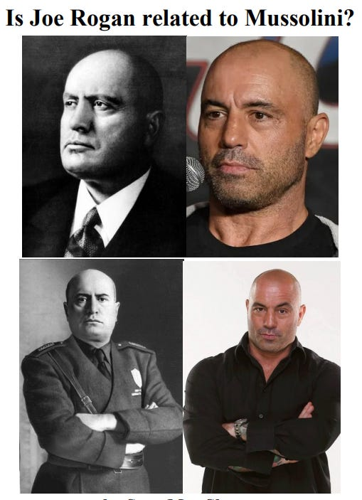

“My step dad’s a hippie. My step dad was a computer programmer, and he was an architect. He went to school for architecture after he stopped doing computer programming. … All of a sudden I’m living with this hippie guy in San Francisco with a bunch of gay people … and it’s all like peace and love, it’s the ‘70s man.”
It is doubtful, given who Joe Rogan is, that his stepfather was a hippie, unless he was acting as one. The Phoenicians had their actors infiltrate the peace movements early on, which might explain why he was surrounded by a bunch of gay people as we know these actors tend to be gay. Miles goes over the hippie movement in his paper on Charles Manson
https://againstsatanism.com/My-Web-Sites/Miles-Mathis/mileswmathis.com/tate.pdf and several others. So if Rogan’s stepfather does exist, he’s probably connected to one of the three letter agencies in some way, explaining why he is left a mystery. If Rogan was found to be connected to one of the alphabet squads it would surely damage his reputation. I guess CAA could be called Alphabet. Of course we should already be assuming Rogan is a creation of Intelligence since the only people that can be found receiving invitations to Rogan’s podcast are Intelligence assets, such as Elon Musk
https://againstsatanism.com/My-Web-Sites/Miles-Mathis/mileswmathis.com/musk.pdf who Miles has already outed as a fraud. Not to mention he regularly features Special Forces and CIA agents on the show, but they tack on the word “former” in front of their name so that you believe they’re no longer working. You have to laugh. Once CIA, always CIA. Thus, Rogan’s podcast is just another avenue to disseminate propaganda, confusing and misdirecting the lowly commoners. The budget and reach of the show alone would suggest, in my opinion, that each episode is staged, being directed and edited from start to finish.
Rogan ended up quitting his post fight interviewer position after only two years, claiming his salary couldn’t keep up with the cost of traveling to events, but would find himself back at the company after UFC was taken over by Zuffa. He would quickly make friends with the new president, Dana White, as you do. White offered him a job as a color commentator, but he declined the offer stating he “just wanted to go to the fights and drink.”
Yeah, he said that to the president of the company. White must have short term memory loss as the following year Rogan would change his mind and accept his offer, working for free, under the condition that he supplied him with prime event tickets for him and his friends. What? We were just told this clown couldn’t afford to travel to these events due to a poor salary; however, now we find he is voluntarily working free of charge, yet again, and can magically afford flights to drink ten dollar beers with his buddies. How much more obvious do they need to make it? Rogan was a filthy rich Phoenician hatchling from the get go going wherever the wind blew him. He could have sat on his ass doing nothing his entire life and would still be exactly where he is today. In fact, that is essentially what he did.
In my paper on Mussolini
https://againstsatanism.com/My-Web-Sites/Miles-Mathis/mileswmathis.com/benito.pdf
I showed Joe Rogan was closely related to the Campbells through the Dalzells. Mussolini's great grandmother was a Sulivan, related by marriage to the Viscount Templeton. This is why Mussolini was chosen by MI6 and Home Secretary Sir Samuel Hoare, Viscount Templewood, to lead the Italian theater project in WWII. Well, through the same people Mussolini was fairly closely related to many top peers, including the Campbells and Stanleys. So when these names began popping up in this paper, and I confirmed it, I could see that Sean had hit on something here. Rogan really is related to Mussolini. Of course, once he had proved Rogan was from these prominent Jewish lines in Hollywood, that was pretty much a given, since they are all worldwide cousins. As I have told you, all famous people are related, and much more closely than they will admit. This especially applies to these gay actors like Rogan and Mussolini. It also helped immensely that I was able to pinpoint Rogan's stepfather Louis Lembo at Creative Artists Agency in Hollywood, and you can see why they go to such lengths hiding it.
But the Bennett/Campbell line may not even be the most prominent. As I showed, what they are probably hiding there is that Rogan's mother is a Cohen. That would explain his rise in media more directly than anything else.
Given that Rogan's whole bio is a lie, we should ask about his claim to be national champion in taekwondo at age 19. That would have been 1986 or 1987. This claim is footnoted at Wiki, but not to any charts. It is footnoted to two articles on Rogan that came out 15 years later. He wasn't the national or collegiate champion in those years, because he wasn't in the college championship.
https://againstsatanism.com/My-Web-Sites/Miles-Mathis/mileswmathis.com/rogan.pdf
or http://mileswmathis.com/rogan.pdf
Here is evidence that Joe Rogan Jordan Peterson Graham Hancock Russell Brand Rupert Sheldrake Daniel Pinchbeck Aldous Huxley Tim Leary Ram Dass have been promoting drugs on behalf of the CIA
https://againstsatanism.com/Joe-Rogan-Jordan-Peterson-Graham-Hancock-Russell-Brand-Rupert-Sheldrake-Daniel-Pinchbeck-Aldous-Huxley-Tim-Leary-Ram-Dass-pushing-Drugs-for-Trillionaire-Oligarch-Controlled-Military-Intelligence-to-Dum-Down-and-Destroy-Society.htm
https://againstsatanism.com/How-Trillionaires-Infiltrated-DMT-LSD-and-Ayahuasca-into-the-Environmental-Hippie-Progressive-and-New-Age-Movements.htm

Dominic Cummings



Dominic Cummings - "We’re into a new cycle of regime change" - remember, the regimes are minions.
Disinformation by a Satanic Phoenician Mega Trillionaire Aristocratic family -the Comnene family - insider who does not mention that the aim of the Rothschilds, Rockefellers and Warburgs is - remember, Dominic Cummings mentions none of these names... agenda 2030, genocide, an AI controlled Totalitarian Surveillance state of CBDC, Digital Identity, 15 minute city, Bug eating, sterilisation state controlled by Baron Harkonnen Satanists.
You can tell who are the Disinformation Agents, the Gatekeepers, Presstitutes and the Prostitutes because they never mention that it was the Rothschilds and the Warburgs who took down France with the Satanic Jacobins and took down Russia and killed the Tsar with the Satanic Bolshevics. They never mention that Satanism created sodomy rituals in every secret society. They never mention the Satanic Phoenician Mega Trillionaires created the Tavistock institute program of societal destruction by Gay Pride.
The minions have been bought by the The Satanic Phoenician Mega Trillionaire Rothschilds, Rockefellers, Schiffs and Warburgs. The minions have been bought by the The Satanic Phoenician Mega Trillionaire Black Nobility who came from Satanic Venice like King Chuckie the Turd.
The minions just follow orders and follow the Satanic Rituals like Human Sacrifice, the Sodomy Rituals, the Castration Rituals, the Drug Rituals, the Whore of Babalon Rituals. This is all exposed in my 11 Volumes of Against Satanism, Sign Up! or go here... https://satchidanand.substack.com/p/throughout-history-seventy-two-empires

Throughout History Seventy-Two Empires Have Been Engineered to Fail in the Same Way.

Satchidanand
·
April 6, 2024
Throughout History Seventy-Two Empires Have Been Engineered to Fail in the Same Way. The crash of civilisations does not happen by accident. The crash of civilisations does not happen all at once. The crash of civilisations takes a lot of planning over a long time.

Read full story

By not mentioning the cause - Garbage in, his results are garbage out.
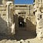Dominic Cummings substack
Dostoyevsky, the modern intelligentsia, the spiritual crisis of the West
The revolutionary despises all doctrines and refuses to accept the mundane sciences, leaving them for future generations. He knows only one science: the science of destruction… The Catechism of a Revolutionary, Nechayev (1869) In short, one may say anything about the history of the world - anything that might enter the most disordered imagination…
Read more
2 years ago · 114 likes · 50 comments · Dominic Cummings
The following article by intelligent Dominic Cummings from the Satanic Phoenician Mega Trillionaire family Comnene (See Miles Mathis) shows how the elite always blame the minions like Jesus James Angleton or President Kennedy instead of the rulers behind the scenes who tell the minions what to do –

The Satanic Phoenician Mega Trillionaires, the Rothschilds, the Rockefellers, Warburgs etc and that all confusion, bad planning, bad thinking, is deliberate in compartmentalised minions in order to rule completely.
By not mentioning the cause - agenda 2030, genocide, an AI controlled Totalitarian Surveillance state of CBDC, Digital Identity, 15 minute city, Bug eating, sterilisation state controlled by Baron Harkonnen Satanists - Garbage in, his results are garbage out.
Dominic Cummings substack
People, ideas, machines VIII: CIA counterintelligence chief James Angleton, 'a wilderness of mirrors', covert operations, assassinations, moles & double agents, disinformation
After such knowledge, what forgiveness? Think now History has many cunning passages, contrived corridors And issues, deceives with whispering ambitions, Guides us by vanities. Think now She gives when our attention is distracted And what she gives, gives with such supple confusions…
Read more
2 years ago · 49 likes · 52 comments · Dominic Cummings
Boris Johnson resigning would only be interesting in an alternate universe where there was some remote chance that he won’t be replaced by another even more depraved sociopath who this time will do the bidding of the Satanic Phoenician Mega Trillionaires.
Among the PM Boris’ main adversaries is his once former MI6 handler, Dominic Cummings - like Secret Services Ambassador Urquhart handler of Karl Marx, like Colonel Mandel House handler of President Woodrow Wilson - Confidant and de facto chief of staff, Dominic Cummings was Boris' handler.
Aristocratic Phoenician family, MI6, Oxford educated Cummings was sent to Russia to be trained in the ways. But one only need look Cummings’ rhetoric and views to notice his Authoritarian, Totalitarianism.
Cummings’ long standing critique of the machinery of government has been articulate, accurate and piercing. For all his rhetoric around the need for science, reason, technology and efficiency, Cummings’ solutions stray far from such noble concerns. Cummings wants a better machinery of Government only for faster, authoritarian, totalitarian decisions.
Look back to Cummings’ Parliamentary testimony and recall that his criticism of Johnson was not that covid restrictions were scientifically unnecessary - which is now beyond reasonable doubt on all counts. Rather, his view was that the UK have should have locked down earlier in March and he "bitterly" regrets "not hitting the panic button earlier".
Cummings also said that the PM rejected his recommendation last September that there should be a second lockdown in England.
Cummings put Rishi Sunak in place as Chancellor of the Exchequer under Cummings authority. He believes that the Chancellor Rishi Sunak did a "fantastic job" with the furlough scheme which, is totally responsible for out of control inflation.
Rishi Sunak stabbed Boris in the back, forcing Boris' resignation, when he himself resigned.
More telling is who Cummings proposes as ‘intellects’.
Recall that Andrew Sabisky had to resign in February 2020 following complaints about his previously expressed views on race, intelligence and eugenics.
Will O'Shea, a data specialist appointed through Cummings' scheme, was dismissed in July 2020 after calling for police to shoot Black Lives Matter protesters with live ammunition.
Lately, Cummings has been encouraging the US Republican Party to nominate an alternative to Trump as their candidate for the 2024 US presidential election. The reason given is what I find interesting, Trump was unable to “control” government.
On his Substack, Cummings has cited Curtis Yarvin amongst others, as "people I have found interesting" in US politics. But who is Curtis Yarvin? Curtis Yarvin, on his own Substack page called Gray Mirror, argues that American democracy is a failed experiment which should be replaced by monarchy or corporate governance. He is known for developing the anti-egalitarian and anti-democratic ideas behind the Dark Enlightenment.
In other words, Cummings seems to be attacking the PM because he would not take Cummings orders - he was too good to be bad - and because he wishes to usher in an ‘efficient’ (read: authoritarian) technocracy, not because he opposes the madness surrounding covid mandates and the unquantifiable damage they have inflicted on our country and people.
Beware of this domestic palace coup for it serves a global palace coup.
Is there any wonder then that MSM has backed Cummings despite him doing exactly what MSM accuses the PM of doing: violating the rules while the rest of us suffered. According to Cummings, as confessed to in his BBC interview with Laura Kuenssberg
'We only got him (Johnson) in there because we had to solve a certain problem, not because he was the right person to be running the country.'
Because Cummings has admitted that he never believed in Johnson anyway. What he does believe in - on the issues that count - has since been made clear, and it is more of the same: technocratic, authoritarian, 1984 corporatism.
https://againstsatanism.com/Dominic-McKenzie-Cummings-Boris-Johnson-Traitorous-Chief-Advisor-is-from-Aristocratic-Satanic-Mega-Trillionaire-Phoenician-Clan-Cumming-Comyn-Comnene-Cohen.htm
https://againstsatanism.com/Phoenician--Dominic-Cummings-MI6-Infil-Traitor-ex-Handler-of-Boris-Removed-Boris-in-Palace-Coup.htm
https://againstsatanism.com/My-Web-Sites/Miles-Mathis/mileswmathis.com/cumming.pdf

EVIL - LIVE

Evil's opposite is life. Life Energy is a new way which Energy Enhancement Meditation has brought to the table. Prayer, fasting, yoga, pranayama all work to purify the psychic body, to gird up the aspirant for the opposition to absolute evil which uses the psychic in it's fight against humanity. In order to truly oppose, successfully oppose evil you must become a better stronger, purer instrument of God in order to succeed.

This is why the creation of the Energy Enhancement Meditation Course https://energyenhancement.org/

ENERGY ENHANCEMENT MEDITATION IS THE ONLY SOLUTION

It is the inflow of infinite energy from external chakras of the Universe, the infinity of chakras above the head, ending in the Central Spiritual Sun of Gurdjieff, or God..., the infinity of chakras below the base including Kundalini Chakra in the center of the Earth...

Remember Alchemical VITRIOL - Visita Interiore Terrae Rectificando Invenies Occultem Lapidem...

"Visit the center of the Earth, there you will find the Philosophers Stone which by rectification transmutes base metal, lead or Energy Blockages into Gold or pure perfect spiritual energy..."

This is VITRIOL, Visita Interiore Terrae Rectificando Invenies Ocultem Lapidem the source of infinite Kundalini Energy entering the base chakras from the source of Kundalini Energy center of the earth, purifying the psychic body, opening the Third Eye, opening psychic vision, creating Psychic Powers!

True repentance is when you transmute one of your own evil energy blockages.

Read about it here... Alchemical Process of VITRIOL and the Kundalini Kriyas of Energy Enhancement Meditation, Energy Enhancement Level 1, Initiation Three, The Grounding of Negative Energies.

https://energyenhancement.org/Level1.htm


TRUMP AND THE DEEP STATE SATANIC 2000 TRILLION DOLLAR ROTHSCHILD PHOENICIAN MEGA TRILLIONAIRES

CHOOSES SKULL AND BONES JD VANCE!

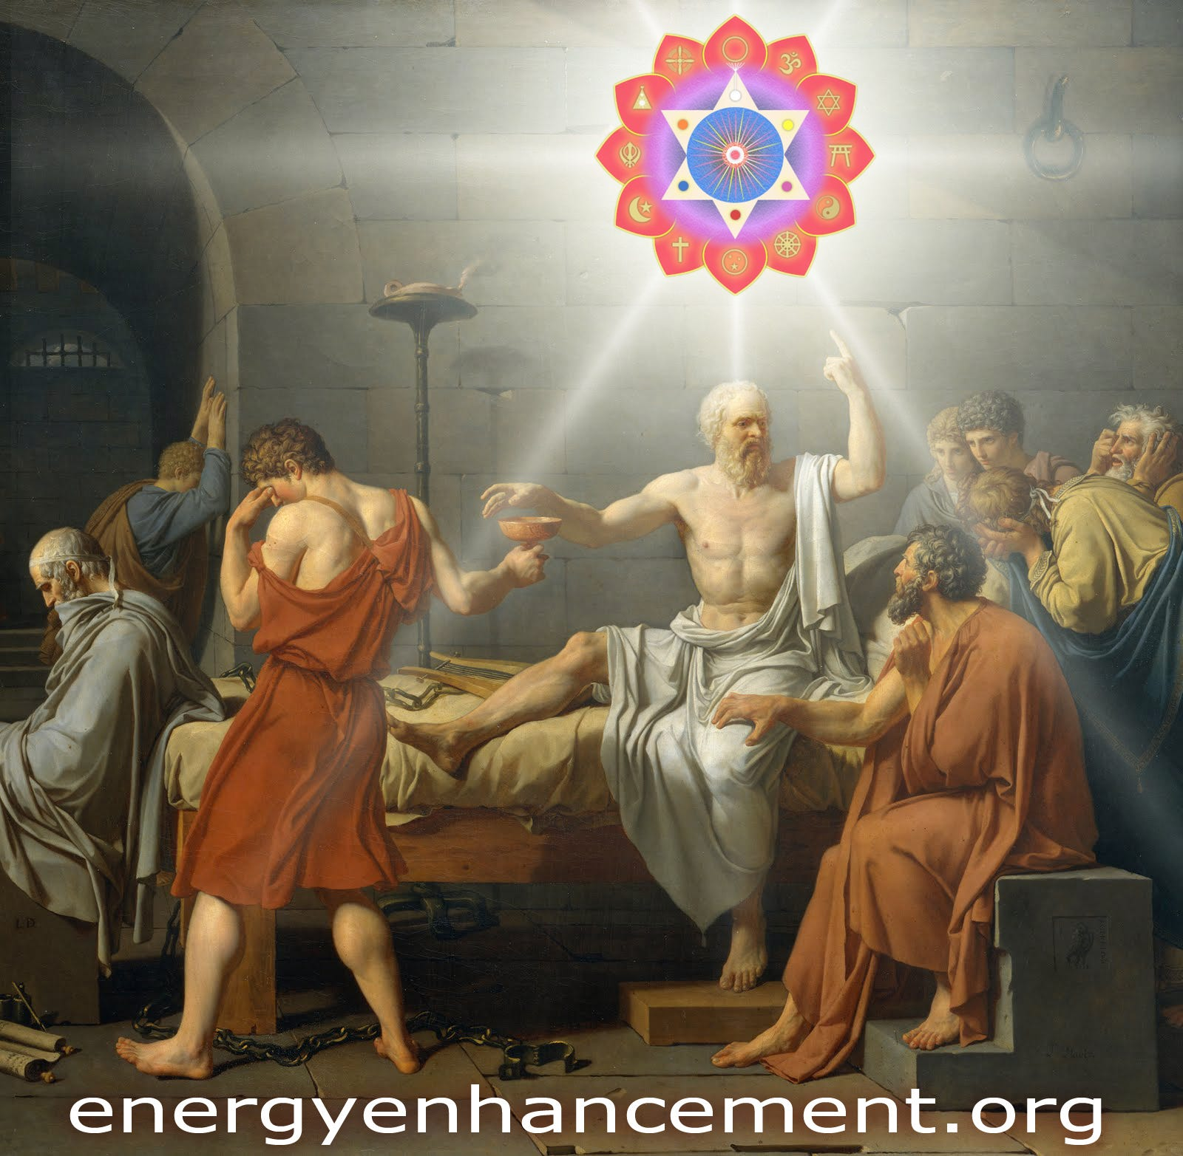Satchidanand
Jul 20, 2024

TRUMP AND THE SATANIC 2000 TRILLION DOLLAR ROTHSCHILD PHOENICIAN MEGA TRILLIONAIRE DEEP STATE

This Trump Assassination Attempt is by the Satanic Anglo-American Empire 2000 TRILLION DOLLAR Rothschild's Deep State who murdered JFK - This is the shot which is being heard all around the World. This is the Start of WW3. And they will not stop

"I was present at that scene; but none that I had ever before witnessed affected me in the same manner. I did not feel that compassion or affliction for him which I had been used to do upon other occasions while a friend has departed in my arms. Socrates, when he drank the poison, appeared to be happy, and in a composure of mind that was enviable; so calm, so tranquil was his behavior in his last moments, so resigned were his last words. His looks and demeanor did not seem those of a mortal who descends prematurely to the shades, but rather those of an immortal who was confident, wherever he might go, he would be as happy as any one had ever been. It was impossible for me, therefore, to be impressed with that awe and melancholy which the fight of death usually awakes in the soul. At the same time we did not taste in the philosophical conversation of our teacher, that pure delight and satisfaction to which we had been before accustomed; but, on the contrary, an extraordinary and, till then, unknown mixture of pleasure with distress; our enjoyment being continually interrupted by the bitter consciousness and reflection, " that we were soon to lose him for ever." PHAEDON - the Death of Socrates https://archive.schillerinstitute.com/transl/mend_phadn_cullen.html

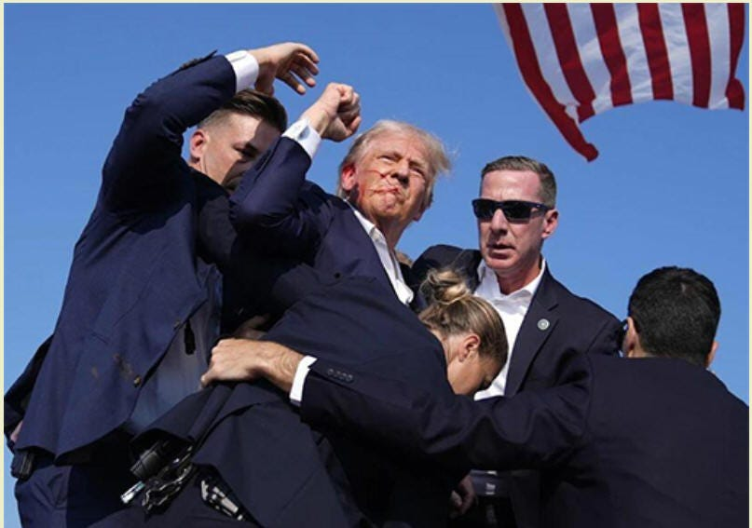

This Article is the Truth, and Only the Truth, Only Knowing the Truth, can set us Free of the 2000 Trillion Dollar Rothschild inspired Mind Control Propaganda.
“We’ll know our Disinformation Program is complete when everything the American Public knows is False” William Casey - CIA Director…
This is just the start.
Now comes the Fightback!
IF Implemented..
TRUMP’S PROJECT 47 WILL GO BACK TO LINCOLN AND FDR GREENBACK’S ESCAPING THE DEBT OF THE ROTHSCHILD CENTRAL BANKS. IT WILL GROW AMERICAN MANUFACTURING AGAIN BY MEANS OF PROTECTIONISM - SO, TOTALLY AGAINST THE ROTHSCHILDS IF IMPLEMENTED - VERY GOOD, TRUMP!
PROJECT 2025 FROM THE OTTO VON HAPSBERG HERITAGE FOUNDATION, SATANIC FREDERIC VON HAYEK AND THE MONT PELERIN SOCIETY WILL STOP ANY BIG PROJECTS AND JUST MORE OF THE SAME GLOBALIST IDIOCY.
SUBPOENA TWITTER FEED EVIDENCE ON ALL THE DEEP STATE PERSONEL
PROSECUTE!
DESTROY THE 2000 TRILLION DOLLAR ROTHSCHILDS WHO OWN 70% OF ALL BANKS, 85% OF FORTUNE 500 COMPANIES, 100% OF CENTRAL BANKS INCLUDING THE FEDERAL RESERVE, BLACKROCK, STATE STREET AND VANGUARD HOLDING COMPANIES, WORLDWIDE!
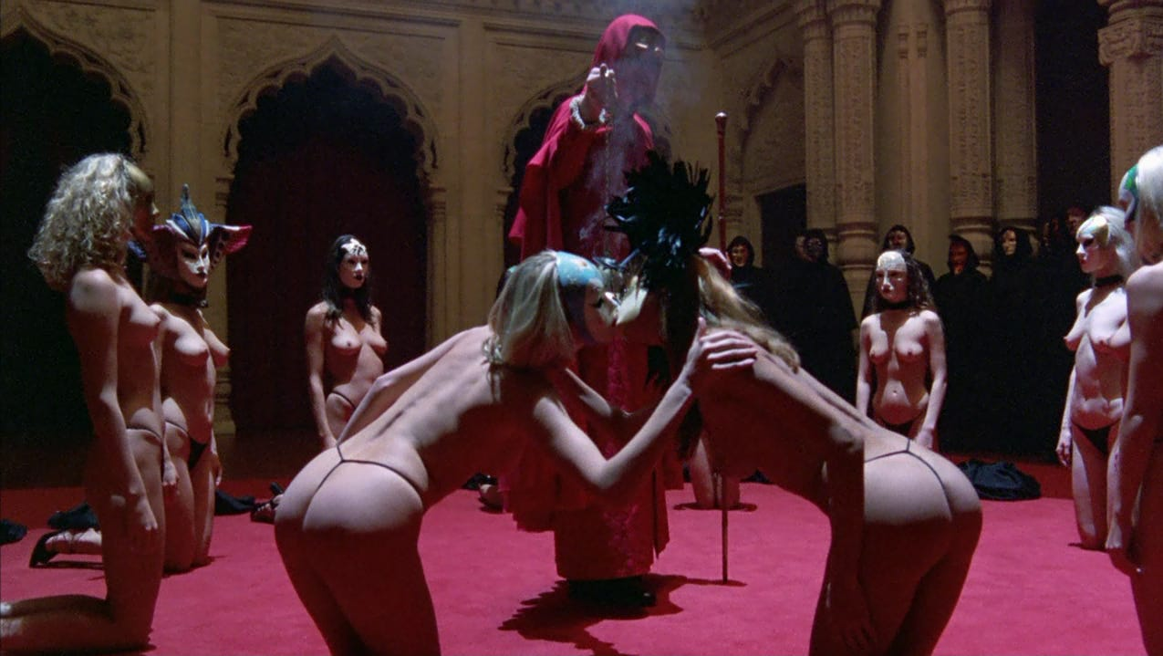

The 2000 Trillion Dollar Rothschild Deep State World Control Family Supported Satanic, Luciferian Sex Magic Sabbatean Frankism and Weishaupt Illuminati Sodomy Rituals from Frankfurt.
THE ROTHSCHILDS OWN TRUMP AS ALL THE MONEY LOANED TO TRUMP FOR HIS 10 BILLION DOLLAR BUSINESS COMES FROM THE ROTHSCHILDS.
NOW TRUMP WILL BE ABLE TO ENABLE ALL THEIR SCHEMES FOR WORLD DOMINATION..
SO WE PRAY TO GOD AND OUR LORD JESUS CHRIST THAT WE CAN INTERCEDE THAT TRUMP WILL RENOUNCE HIS WARP SPEED MRNA VACCINE DEATHVAXXES, THAT HE WILL RENOUNCE THE GLOBAL DIGITAL ID, THAT HE WILL FIRE ALL THE LAWYERS IN THE STATE DEPARTMENT, THAT HE WILL SCATTER THE FBI, NSA AND CIA TO THE WINDS, THAT HE WILL RENOUNCE THE NETANYAHU GENOCIDE, THAT HE WILL RENOUNCE CARBON DEATHTAXES IN THE FACE OF ASSASSINATION IF HE STRAYS FROM THE ROTHSCHILD DEATHPATH!
THE YALE ALUM SKULL AND BONES SODOMY RITUAL VANCE TROJAN HORSE! WILL BECOME PRESIDENT WHEN TRUMP IS ASSASSINATED.

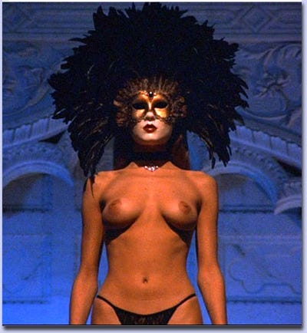

https://againstsatanism.com/Sabbatai-Zevi-and-Sabbatean-Frankism-The-Satanic-Cult-That-Rules-the-World-Luciferian-Satanic-Sabbatean-Frankists-Kabbalist-Illuminati.htm
This is Trump making peace with the Deep State.



Are Peter Thiel and JD Vance Whoopsies or are they just Trillionaire Russell Family Yale Skull and Bones Sodomy Ritual guys?
You know about how Lord Bertrand Russell became an evil man, Right?
https://againstsatanism.com/Satanic-Lord-Bertrand-Russell.htm
And the Russell Marquis of Tavistock who created the Mind Control, and Societal Psyop Tavistock Institute, Stanford Research Institute and Frankfurt School?
https://againstsatanism.com/SATANIC-TAVISTOCK-INSTITUTE-SATANIC-LORD-RUSSEL-SATANIC-ROCKEFELLER-SATANIC-SABBATEAN-FRANKISM-SATANIC-FREUD-PSYCHOANALYSIS-SATANIC-FRANKFURT-SCHOOL-KABBALAH-ADORNO-BENJAMIN-MARCUSE-LUKACS-BRECHT-WEILL-ECO-DERRIDA.htm
https://againstsatanism.com/Satchidanand-Substack/satchidanand.substack.com/p/the-satanic-tavistock-institute-satanic.html
https://againstsatanism.com/Satanic-Frankfurt-School-ADORNO-BENJAMIN-MARCUSE-LUKACS-BRECHT-WEILL-ECO-DERRIDA.htm

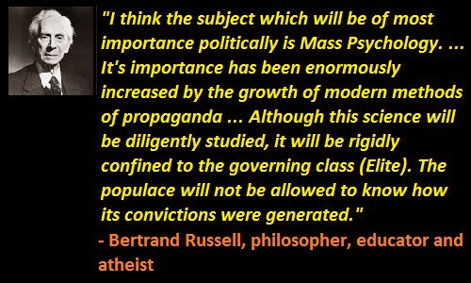

And is JD Vance's real father a Satanic Phoenician Mega Trillionaire like Bill Clinton’s father was a Rockefeller?
If true, this certainly would explain why the Republican Party’s longstanding opposition to LGBT rights has suddenly vanished from the platform. And why Mawmaw felt the need to ask young JD if he harbored any particular proclivities.
Team JD Vance Begin Announcing Policy Proposals, Starting with Phoenician Mega Trillionaire Elon Musk Inspired Fake Global Warming Carbon Taxes and Digital ID for total Control of a slave population - just like Russia, China, India etc..
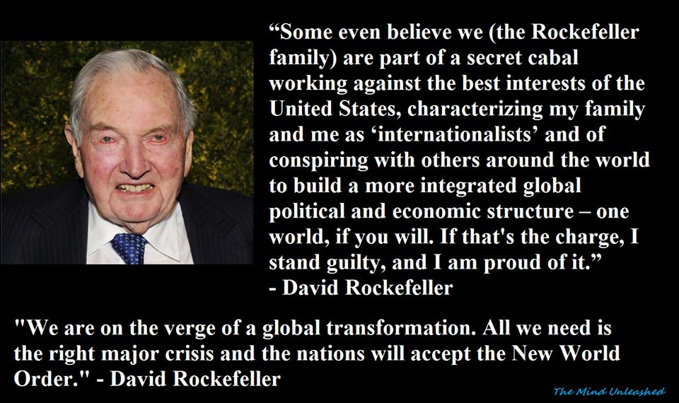

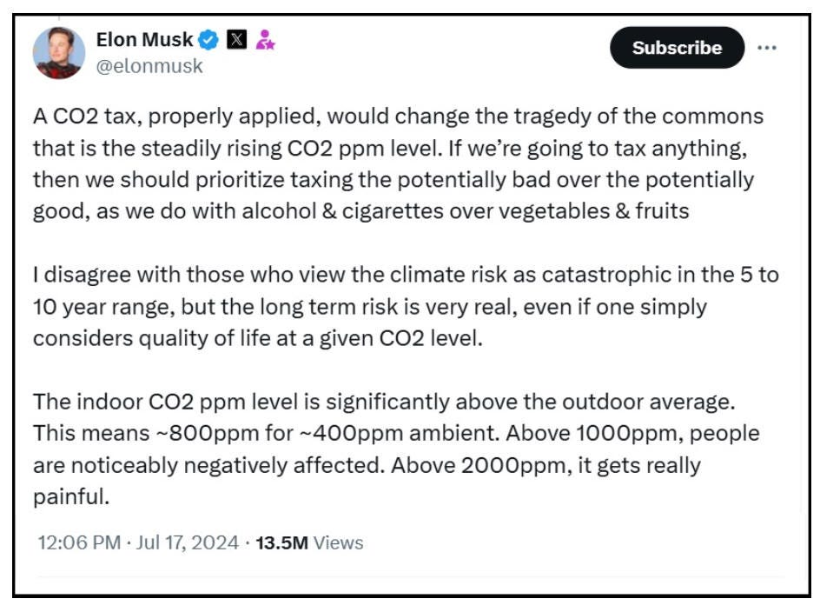

Rothschild Bought Trump, Tucker Carlson, Alex Jones, Joe Rogan, Dominic Cummings

Rothschild, Trump, Tucker Carlson, Alex Jones, Joe Rogan, Dominic Cummings

Satchidanand
·
June 14, 2024
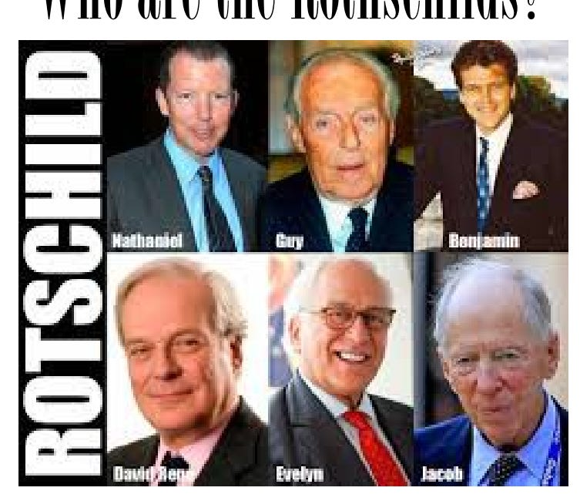

Rothschild, Trump, Tucker Carlson, Alex Jones, Joe Rogan, Dominic Cummings Joe Rogan Jordan Peterson Graham Hancock Russell Brand Rupert Sheldrake Daniel Pinchbeck Aldous Huxley Tim Leary Ram Dass have been promoting drugs on behalf of the CIA "We'll know our disinformation program is complete when everything the American public believes is false." William J. Casey, CIA Director

Read full story

My feeling is, if they are paid, promoted propagandists never mention the Satanic 2000 Trillion Dollar Rothschild Phoenician Mega Trillionaires.
This is the major way to spot paid, promoted propagandists.
If they are paid, promoted propagandists never mention the Satanic 2000 Trillion Dollar Rothschild Phoenician Mega Trillionaires as being the cause of all ills in society but only excoriate the paid, bought, propagandised, blackmailed minions.
If paid promoted propagandists never mention that the Biden, Putin, Xi Minions are all vaccine mandators, all CBDC wonks, all ascribe to Agenda 2030 and Global Warming, all go to Satanic 2000 Trillion Dollar Rothschild Phoenician Mega Trillionaire Globalist WEF, all support Satanic 2000 Trillion Dollar Rothschild Phoenician Mega Trillionaire Globalist United Nations and it's Agenda 2030 and Replacement Migration Invasion Policies...
If paid promoted propagandists never mention that that Bidet, Putin, Xi are all Satanic 2000 Trillion Dollar Rothschild Phoenician Mega Trillionaire Globalist Minions then surely the Wars between the West and the Ukraine, Russia, and China are all fake even if the Satanic 2000 Trillion Dollar Rothschild Phoenician Mega Trillionaire Globalist depopulation agenda has been improved by one million dead people in the Ukraine, thirty-five million excess deaths due to the deathvaxx and 250 million extra deaths by starvation in Africa due to the lockdowns.
If paid promoted propagandists like Tucker, Rogan, Simplicius and Rasmussen never mention Satanic 2000 Trillion Dollar Rothschild Phoenician Mega Trillionaire Globalists and all that, then what they are shitting, what they are lying about by omission is Satanic Phoenician Mega Trillionaire Mind Control propaganda.

WHAT THEY ARE SHITTING IS SATANIC PHOENICIAN MEGA TRILLIONAIRE MIND CONTROL PROPAGANDA

Satchidanand
·
March 5, 2024
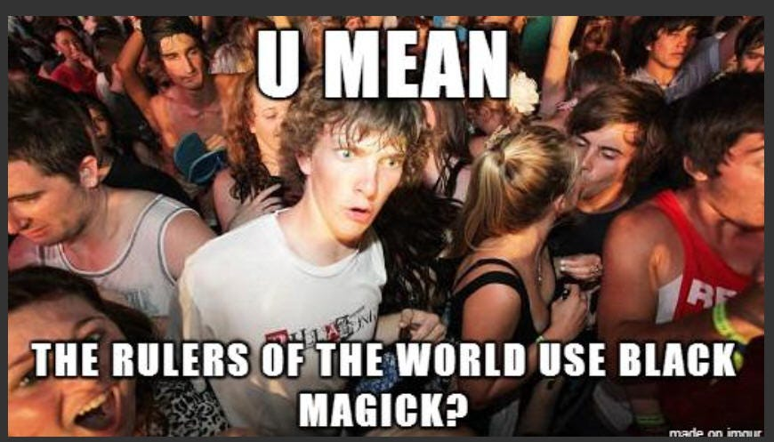

WHAT THEY ARE SHITTING IS SATANIC PHOENICIAN MEGA TRILLIONAIRE MIND CONTROL PROPAGANDA https://againstsatanism.com/WHAT-THEY-ARE-SHITTING-IS-SATANIC-PHOENICIAN-MEGA-TRILLIONAIRE-MIND-CONTROL.htmSatchidanand’s Against Satanism Newsletter is a reader-supported publication. To receive new posts and support my work, consider becoming a free or paid subscriber.

Read full story

JD Vance was then invited to be an attendee at the June 6th **San Francisco** fundraiser for President Trump, hosted by Sacks and Palihapitiya, and that’s likely when the first one-on-one running mate discussion between President Trump and Senator Vance took place.
The group who promoted, pushed and ultimately influenced the JD Vance nomination consisted of: Charlie Kirk, Tucker Carlson, Elon Musk, Peter Thiel, Bill Ackman, David Sacks, Chamath Palihapitiya, Jacob Helberg and of course, Vivek Ramaswamy.
On the inside of the Trump orbit, the network had Jason Miller and Donald Trump Jr also promoting JD Vance.
It is critical to remember these names because the Silicon Valley influence agents will soon be pushing their Trump-term policy agenda through Vice-President JD Vance.
We are starting to see the outlines of their JD Vance policy agenda, the points of their advocacy, starting with Elon Musk - a scam carbon tax system based upon Globalist Rothschild Fake Global Warming of a carbon dioxide which is plant food which is food, which is life itself.
Which in 200 years of burning petroleum has greened deserts the size of the United States Worldwide.

The global carbon tax program, a tax on your personal carbon footprint, is the system for the carbon trading platform (likely tied to your digital id). It is a large policy position of King Chucky the Turd and his minion, 2000 Trillion Dollar Rothschild Klaus Schwab’s World Economic Forum.
I’m not quite sure how well the increase in energy prices carbon tax program would be received in the Appalachia range area. I digress.
I’m not quite sure how well the increase in energy prices carbon tax program would benefit anyone except the people stealing the money from the scam like all Government programs are scams like the five Trillion Dollars going missing from the Pentagon. Like the F35 program. Like NASA. Like the Fusion Program - All scams.
Additionally, the group appear to be supporting 2000 Trillion Dollar Rothschild JP Morgan’s CEO Jamie Dimon as Treasury Secretary in the second Trump administration, - like putting the fox in the henhouse!

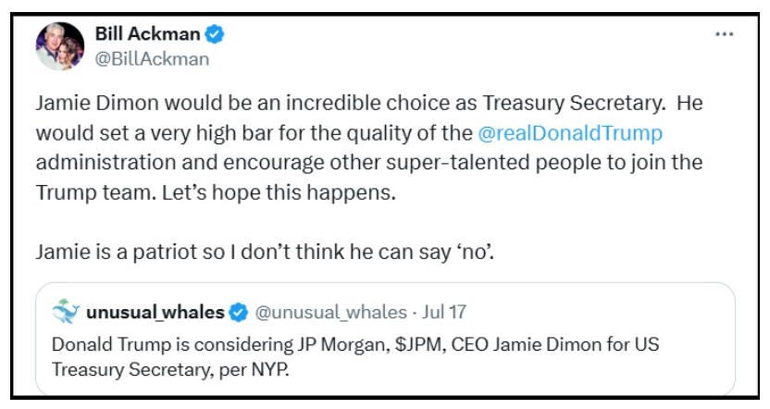

We can hope that the assassination attempt and all of the prosecutions will convince President Trump to stop Donald Ducking about with the Satanic 2000 Trillion Dollar Rothschild Created United Nations and their Agenda 2030 like Operation Warpspeed, Mandatory Vaxxines, 15 Minute City Prisons, Martial Law Lockdowns, 10 million people FEMA camps, Cutting off the People’s Access to Bank Accounts, CBDC’s, Internet Digital ID, NSA, CIA AND FBI AND GOOGLE, FACEBOOK, TWITTER Internet Surveillance and Censorship, Fake Global Warming Carbon Taxes, black employment rates and support for foreign countries and focus on doing to the Deep State Rothschilds what Russia is doing to the Ukraine.
Unfortunately, this VP choice tends to suggest that the old dog hasn’t learned anything at all.
People are policy!
Trump Has Never chosen good people! Including the 2000 Trillion Dollar Rothschild CIA Agents Bill Barr and VP Mike Pence…



This is my take on Trump picking Satanic Mordor 2000 Trillion Dollar Rothschild Deep State JD Vance for VP (and I’ve followed him for a few years, read his book didn’t see the movie).

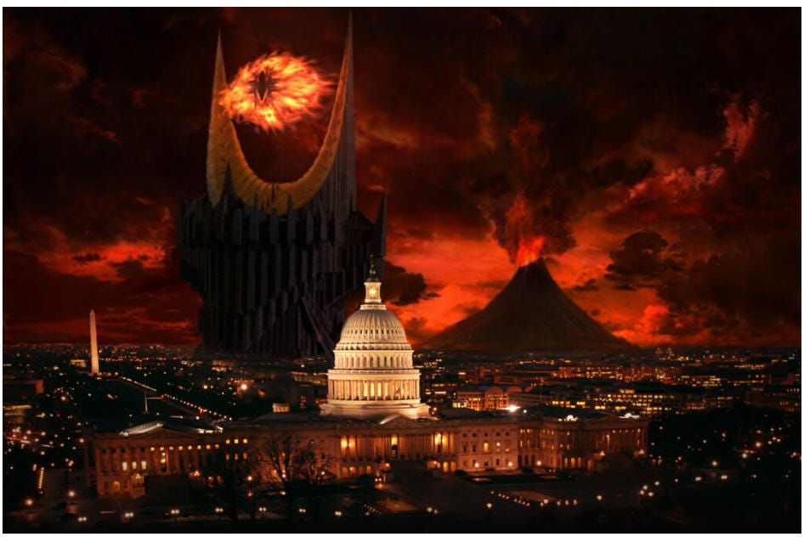

https://theconservativetreehouse.com/blog/2024/07/19/the-mirror/#more-262430

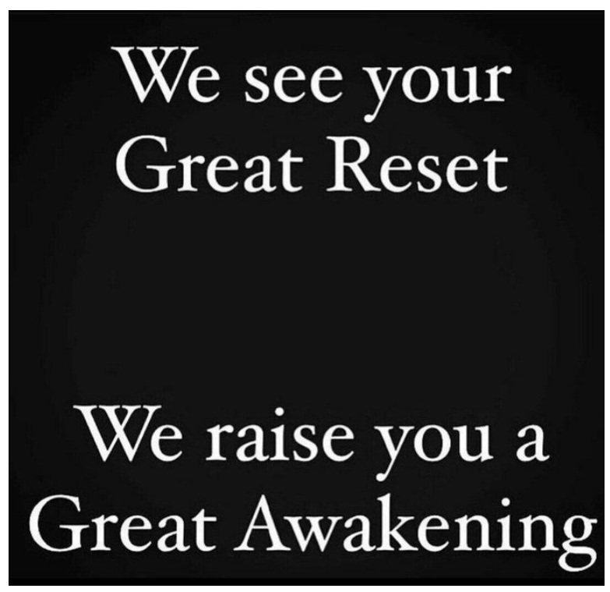

This is Trump making peace with the Deep State.

Vance is a deep state asset. Read his biography, it’s all very unusual.
And is JD Vance's real father a Satanic Phoenician Mega Trillionaire like Bill Clinton’s father was a Rockefeller?
Abandoned by his father to a troubled single mother; eventually raised by grandparents. He is then recruited from an Yale University Skull and Bones Satanic Sodomy Ritual Ivy league law school by shadow figures, a specific billionaire and a network of interests.
How does any poor person get in to Ivy League Russel Family Yale University!
He changes his name, writes a book about his life story, and with the support of the aforementioned – who eventually pays for the assembly of a strategic campaign influence network, becomes a Senator for 2 years before being quickly elevated into position in the White House.
Many people reading that paragraph would be familiar with the life story of CIA asset Barack Hussein Obama. However, that paragraph also explains the right-side version of the exact same storyline, James David Vance. It’s a mirror..
Being sponsored by super spooky 1984 friend of Musk surveillance technocrat Palantir Peter Thiel (a New Zealand citizen!) is only part of it.
Too many details to lay out here, but this is one fascinating tidbit. If Vance is elected VP then he will be the 2000 Trillion Dollar Russell Family Yale Skull and Bones Secret Society Sodomy Ritual Yale Alum, FOURTH (!) graduate of the US Department of Defense, Defense Information School (DINFOS) to have achieved that position after,
Walter Mondale, VP 1977 – 1981
Dan Quayle, VP 1989-1993
Al Gore VP, 1993-2001
https://en.wikipedia.org/wiki/Defense_Information_School
Vance was previously a staunch critic and opponent of President Trump.
"I'm a Never Trump guy. “I never liked him.”
"Mr. Trump is unfit for our nation's highest office."
“I can't stomach Trump. I think that he's noxious and is leading the white working class to a very dark place.”
How does one go from being such a vehement critic to volunteering to serve as the man’s right-hand man? That’s deeply suspicious, particularly when there are a lot of Lamda flags surrounding the man. Even his Marine Corps service points to potential problems based on the nature of his service.
Joining in 2003, Vance served four years in the Marine Corps, including a tour in Iraq during Operation Iraqi Freedom. His primary role was as a public affairs specialist, a role that honed his communication skills, a talent readily apparent in his later writing and public speaking.
Neither a leader of men nor a fighter. And unfortunately, the man’s obvious ambition combined with his above-average connections – I mean which poor person gets in to Yale University unless he is the spawn of the Satanic 2000 Trillion Dollar Phoenician Mega Trillionaires and intelligence ineluctably points us toward the ultimate conclusion that JD Vance is a bought Lamda male.
IF THEY ASSASSINATE TRUMP, VANCE BECOMES PRESIDENT!
THE ONLY WAY TO FREE THE WORLD IS TO DESTROY THE ROTHSCHILDS AND THEIR CENTRAL BANKS, BLACKROCK AND VANGUARD, WORLDWIDE! THE MINIONS WILL FALL BY THE WAYSIDE!
THE ROTHSCHILDS OWN TRUMP AS ALL THE MONEY LOANED TO TRUMP FOR HIS 10 BILLION DOLLAR BUSINESS COMES FROM THE ROTHSCHILDS.
NOW WILL TRUMP FALL FOR IT?
WILL HE ENABLE ALL THEIR SCHEMES FOR WORLD DOMINATION...



THE SODOMY RITUAL BOHEMIAN GROVE NEAR SAN FRANCISCO SATANIC CREMATION OF CARE RITUAL UNDER THE 40FT STATUE OF AN OWL DEDICATED TO MOLOCH WHERE POTENTIAL PRESIDENTS, PRESIDENTS, CEO’S, TITANS OF INDUSTRY AND MEDIA WATCH THE IMMOLATION BURNING OF A CHILD ON AN ALTAR DEDICATED TO MOLECH
THE SATANIC PHOENICIAN MEGA TRILLIONAIRES, THE ROTHSCHILDS, THE ROCKFELLERS, THE BLACK NOBILITY CONTROL BIDEN, PUTIN AND XI - THEY CHOOSE WHICH EMPIRES TO DESTROY AND RAISE UP!

FINANCIALISATION and Satanic Phoenician Mega Trillionaire Central Banks? by Professor Richard A. Werner, D.Phil. - Improved and made better by Satchidanand

Satchidanand
·
April 13, 2024
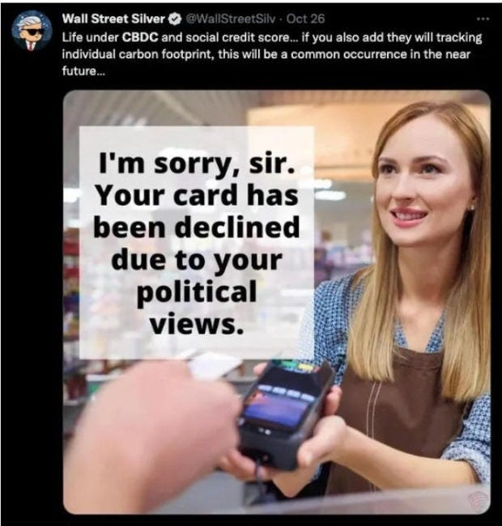

Do we Need Satanic Phoenician Mega Trillionaire central banks? by Professor Richard A. Werner, D.Phil. - improved and made better by Satchidanand THE SATANIC PHOENICIAN MEGA TRILLIONAIRES, THE ROTHSCHILDS, THE ROCKFELLERS, THE BLACK NOBILITY CONTROL BIDEN, PUTIN AND XI - THEY CHOOSE TO DESTROY EMPIRES - THEY CHOOSE WHICH EMPIRES TO RAISE UP - THEY DO IT BY FINANCIALISTATION!

Read full story

Throughout History Seventy-Two Empires Have Been Engineered to Fail in the Same Way.

The crash of civilisations does not happen by accident. The crash of civilisations does not happen all at once. The crash of civilisations takes a lot of planning over a long time.
Seventy-Two Empires have been recorded and every one of them has failed in the same way. The facts have been recorded that a totalitarian and satanic elite infil-traitored and took over all these Empires and that 72 once free, flourishing and rich republics were destroyed from within by Satanic Ritual - read Toynbee. The 2000 Trillion Dollar Rothschild Satanic Wanker Banker Banksters are crashing the Financial System. Satanism is gradually being instituted as the New World Religion defined by Satanic Ritual.
This is the Great Reset!
This Article is part of the great Awakening!

Throughout History Seventy-Two Empires Have Been Engineered to Fail in the Same Way.

Satchidanand
·
April 6, 2024

Throughout History Seventy-Two Empires Have Been Engineered to Fail in the Same Way. The crash of civilisations does not happen by accident. The crash of civilisations does not happen all at once. The crash of civilisations takes a lot of planning over a long time.

Read full story

TRUMP ASSASSINATION SHOOTING STAGED FAKE FAKED THEATER NEVER HAPPENED FALSE FLAG HOAX
NOW TRUMP WILL PERHAPS ENABLE ALL THEIR SCHEMES FOR WORLD DOMINATION...




The Trump Shooting was of course Staged - by Miles Mathis
https://mileswmathis.com/crooks.pdf
First published July 15, 2024

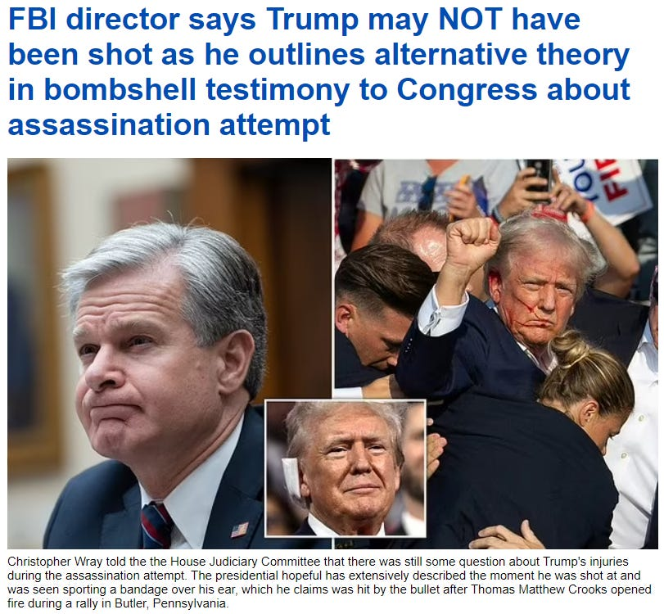



This paper went immediately to #1 at Yandex on the search “Trump shooting staged” and several other results on the first page are republications of this paper.
This despite heavy interference by Google and everyone else. Google immediately delisted it completely, as did Bing and Yahoo.
That search and all similar ones have been rigged to take you to opposite listings assuring you the Trump shooting was NOT staged. Proving these search engines are worthless.
Even the results linking to me, like the one at Makow, mysteriously don't link back to my site. Makow quotes from this paper but conspicuously links to someone else, right under my name.
They also republish me without providing a clickable link. We can also judge other alternative sites by their response to this event. John Leake at Global Research is selling it as real and pooh-poohing any claims there are anomalies. He makes ludicrously weak arguments against, referring contemptuously to a couple of substack authors, but fails to tell you who they are so that you can make your own assessment. He doesn't mention me at all, of course, though if he wants to save this narrative he should have to respond directly to the strongest argument. That will never happen. The last thing he or his overseers want is sending anyone to this paper or this site.
Let me preface this by stating for the record what my regular readers already know: I am not partisan.
I hate both parties and candidates about equally as they are both bought by the Satanic 2000 Trillion Dollar Rothschild Phoenicians.
I have destroyed Biden and the Democrats many times, pointing out they are now more fascist than the Republicans, which took some doing.
Everyone is now reading from scripts, and I have admitted the Republicans currently have a better script. They have been given the more rational talking points for a reason: this is all part of a long-term plan to move the country even further right, into the waiting arms of the Satanic 2000 Trillion Dollar Rothschild Phoenicians governors.
But I am not buying any of the scripts and I recommend you don't either. You should be looking for ways to drive around both parties and the Matrix that has become our world.
I have waited a few days to publish this, though I knew instantly it was staged, without even looking at it closely. I wanted to let others collect evidence while I finished papers on other topics that I consider more important and interesting.
Since I have proved to you everything else is fake, that should be our logical and default assumption for any new highly promoted event. FAKE.
But somehow all the other fake events specialists like Alex Jones and Mike Adams have forgotten that basic rule.
Everyone seems to have conveniently forgotten what a false flag is these days.
When was the last time Jones outed a false flag, or even used the term? Strange, since that is how he made his name.
Before 911 he was just a loud obnoxious guy on Austin public access, but when he started yelling that 911 was a false flag, his big rise began.
Today, Jones couldn't spot a false flag from a foot away. He couldn't spot moulage or any other clue to save his life.
Instead he is promoting this fake event like there is no tomorrow, never even considering the possibility it might be staged.
Same for Mike Adams, who published a standard report on the event yesterday, but nothing more.
[Next day: Jones is getting ratioed on his own site in comments, indicating this is backfiring on them. He is now warning the deep state will take Trump out with a tactical nuke. No, really.



It says “Elon Musk, Alex Jones, Tucker Carlson, and Joe Rogan are next.” Infowars really needed to combine the Trump storyboard with the Nuke storyboard, and this is what they came up with, so they could get the mushroom cloud above the word Trump. Hmmm, I wonder if that qualifies as fear- mongering?]
Before we get into it, let me just state the obvious: in that “iconic” photo, Trump is not saying “fight”, he is saying “fuck”. Everybody knows that, so let's just be honest. That will help get us in.
Another clue is that, technically, the flag is upside down in that photo above under title.



Then we have the bad moulage job, where some make-up girl was hiding behind the podium and smeared some fake blood on Trump when he kneeled down.
It isn't convincing at all, since the straight lines of blood look like they were drawn on with a red marker. Then there is some red goop on his ear, but she didn't have time to make that look real, either. All she did is make the whole ear red. But where is the bullet hole? We seem to be missing a bullet hole.
If a bullet had taken off even a centimeter of the edge of the ear, it would be bleeding profusely, and we would see blood dripping from his earlobe down onto his shirt and jacket. I have scratched off scabs on my ear that bled more that that, and you probably have, too.
Then there's the little problem about allowing him to stand up and do his little dance, gesturing to the crowd and so on. They had to get the picture for the papers. But if this had been real they would have kept him down. He would never have been allowed to stand back up almost immediately, making himself a target again. That was against all protocol and logic.
[Two days later: I finally paused on this film still:



Anyone want to tell me what is suspicious about that? How about the big banner across the lower part of the stage, rising to above Trump's knees? That isn't a banner on the video, that is a physical banner that was on the stage.
When I first claimed a makeup girl was behind the podium applying moulage, a couple of people emailed me derisively, saying they couldn't hide a girl behind that skinny podium. But as you see, they could easily hide her behind that banner. That is why it was there. It reminds us doesn't it? In fact that is exactly why I spotted it. We have been here before.]
Next we come to the assessment that has made the papers, that being the Secret Service acted nothing like the Secret Service. Some are implicating Secret Service, implying there was some sort of stand down, but that is again misdirection.
Yes, the strange (in)actions of the Secret Service indicate either a stand down OR they indicate a faked event.
So why is no one in the mainstream or alternative press on either side allowed to point that out?
Only a few wingnuts like minor actresses are saying it, and they are being leapt on from all quarters as insane. But what is insane about it?
Logically, it should be the first thing to mark off, right? Any real investigation would start by proving the event happened. These are Hollywood people, after all. Trump is an actor and has worked on TV and with WWE, both masters of fakery.
So there is nothing insane about looking closely at this event for signs it was staged.
If we do that, it quickly becomes clear it was allowed to happen, but not because the SS wanted Trump dead.
It was allowed to happen because it was staged. Occam's Razor applies here, since the staging explanation is far simpler than any other explanation.
If you haven't read the mainstream admissions, they have admitted the SS had previously tagged that rooftop where the shooter was perched as dangerous, so it should not only have been restricted, it should have had an agent physically on it.
Snipers on adjacent buildings could see him and had already spotted him, but allegedly weren't allowed first shot. Yeah. If you believe that you will believe anything.
That's why the snipers were there in the first place: to prevent a first shot on a former President. People in the crowd had also seen the shooter and warned the SS about it, but were ignored.
Then we have the miracle picture of the bullet flying by Trump.


They really think you are stupid, to buy that photoshopped POS. That was allegedly captured by a NYT photographer. Convenient.
So how fast was his shutter speed? Well, they saw that question coming, because they tell us he was using a Sony A1 at 1/8000s. Since Trump is not known to move 1000 feet per second himself, it is unclear why the photographer would be using that shutter speed. But let's say he was.
At that shutter speed, how far would the bullet move? Since this was an AR15, the bullet would have slowed to about 2000fps. So we just multiply.
The bullet should have traveled ¼ foot, or three inches. Is that track 3 inches? No, it is about a foot, which is four times too long. Obviously, the bullet would need to be moving 8000fps to make a track one foot long on a film open for 1/8000s. Anyone can do that math. 8000/8000 = 1.
The NYT photographer Doug Mills who allegedly took that photo is also covered in red flags. He has won two Pulitzers, one for coverage of the Monica Lewinsky scandal, which I have shown was also staged. So, like the various government attorneys I have blown the cover of—Vincent Bugliosi, Marcia Clark, F. Lee Bailey, etc.—Mills appears to be a plant from Intel.
Then there is the reaction of the crowd behind Trump, which allegedly had eight bullets whizzing past them, or into their neighbors. They sit and stand there like idiots, many not running or even ducking.
Some are filming on their cellphones. Most just continue to watch, as if it is on TV.
That's because they know the bangs are just blanks. One of the guys interviewed afterwards (the big guy in a red shirt) admitted it sounded like fireworks behind the stage, not an AR15 more than 100 yards in front of the stage. Whoops!


He is being paid to sell the hits on the crowd, but he goes off script badly, as these crisis actors always do. I think you could tell the difference between pops behind or under the stage and a high-powered rifle 500 feet away.
We should also hear the bullets whizzing, and as in the Las Vegas fake, we don't.
Even more ridiculous, perhaps, is that they paid these people on stage to stay there and cheer when he raised his fist.
No one knows all shooters have been killed at that point, how could they, but not only have they not run or tried to hide, they sit there calmly and then stand up and cheer when Trump does his “fight” act. This is fake event staging at its worst.

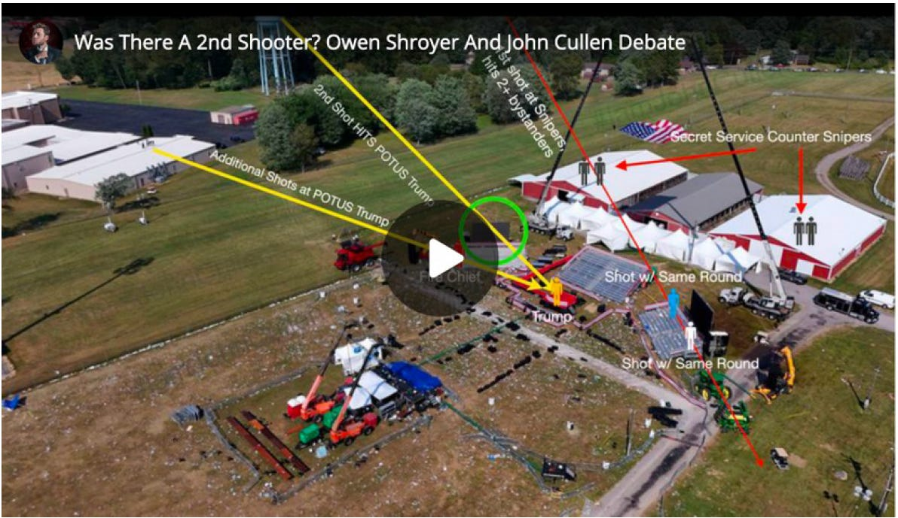

Everyone is now trying to sell you multiple shooters, to keep you from questioning the event itself. You see what they are doing, right? They are following the Kennedy script, which was to create as much confusion from the beginning, to blow smoke all over the event and keep all clarity at bay. If you are studying multiple shooters like this you aren't studying all the evidence I have given you above that this was staged. There were ZERO shooters.
But in releasing pictures like this, they just make it easier to see how ridiculous this entire story really is. Look how close that building to your left actually is to the stage! After the buildings to the rear— the SS sniper perches—it would be the first thing you would secure. The next would be that water tower. And yet Cheatle just told Congress that building was OUTSIDE the perimeter of protection! She has previously stated that no agents were on the roof because it was slanted and therefore dangerous. Not believable in the least. You can see it isn't as slanted as the red buildings behind, where agents were stationed. So there is zero chance the story we are told about Crooks just climbing up there with a 5-foot ladder is true. He would have been in full view of the SS snipers on the red building. Not one tree was blocking their view, and they should have had that roof-top in the cross hairs. Actually, they should have had an agent on that roof, but even if they didn't they could see anyone on that roof the moment he set foot on it. So this was definitely a stand down OR a staged event.
So how do we know it wasn't a stand down? Because if it were a stand down, it wouldn't have failed!
Do you think the Satanic 2000 Trillion Dollar Rothschild Deep State can't hire a real sniper? If SS had really stood down, at 150 yards Trump would have been a sitting duck. They would have taken him out with one shot.
There are tens of thousands of people who could make that shot in their sleep. We wouldn't see eight shots fired wildly, with Trump only allegedly grazed by one of them. They have these shooters missing by yards, hitting multiple people in the crowd who weren't even on the line of shot. But I guess we are supposed to believe the Satanic 2000 Trillion Dollar Rothschild Deep State can't afford to hire a real sniper. They can buy off the entire Secret Service, DHS, FBI, and CIA, but they can't hire one professional sniper? Would someone please ask Alex Jones and Mike Adams to explain that?
So that is where we now find ourselves. The world is run by these loathsome old Satanic 2000 Trillion Dollar Rothshild Phoenician Trillionaire families who hate themselves more than you hate them. You don't know enough to hate them properly, but in that at least they are way ahead of you. All they want from their cattle is your energy. All they want to do is to suck you dry for eternity. And to do that they need to control you for eternity by reducing your evolution, dumming you down.
Poverty, low wages, slavery, Fluoride, Vaccines, MRNA Deathvaxxes, pesticides, xenoestrogens, factory pollution, GMO Frankenstein food, manufactured food, GM soya oil GMO, bad nutrition, lack of vitamins, lack of minerals, mind pollution, Fake News, Iserbyte Fake Education, Fake Books, Mind Kontrol! - people will believe anything...
In these final stages of Satanism and corruption, they are torn between self-hatred and hatred of you—for not bowing down before them regardless. So in these crazy events, we see them acting out and acting in about equally, in an orgy of destruction to maintain their control.
How will it turn out? As I keep saying, that is up to you. You are taking the same tests they are. Your courage, honesty, and all other virtues are up for assessment at all times, so remember that. The events of history, real or imagined, don't really matter. What matters is what you do in response. Life is just a construction, but your acts will follow you beyond the grave. To say it another way, at birth your memory of former lives is wiped, but your actions are not wiped, your evolution created by Energy Enhancement Meditation
https://energyenhancement.org/
is not wiped. They determine your next life, and the tests you will find there.
And more at…
https://mileswmathis.com/crooks.pdf
So Trump as the last hope for humanity may well be compromised but, only the Truth can set you free and only by holding Trump’s feet to the fire will we be able to…
1. Prevent the failure to Drain the 2000 Trillion Dollar Rothschild Phoenician Mega Trillionaire Swamp this time,
2. Put 2000 Trillion Dollar Rothschild Phoenician Mega Trillionaire bought Hillary in Jail.
As happened in the last Trump administration.
As we can see with the Biden Administration – unless you destroy the cause, - the Satanic 2000 Trillion Dollar Rothschild Deep State – That Worldwide Deep State will survive in every country and Fake Elections will legitimize Rothschild created United Nations Agenda 2030 1984!
WORLDWIDE!
Your support is invaluable. If you enjoyed the read, I would greatly appreciate if you subscribed to a monthly/yearly pledge to support my work, so that I may continue providing you with Satanic World History Books and detailed, incisive reports like this one.
SIGN UP AND GET THE NEW BOOKS…




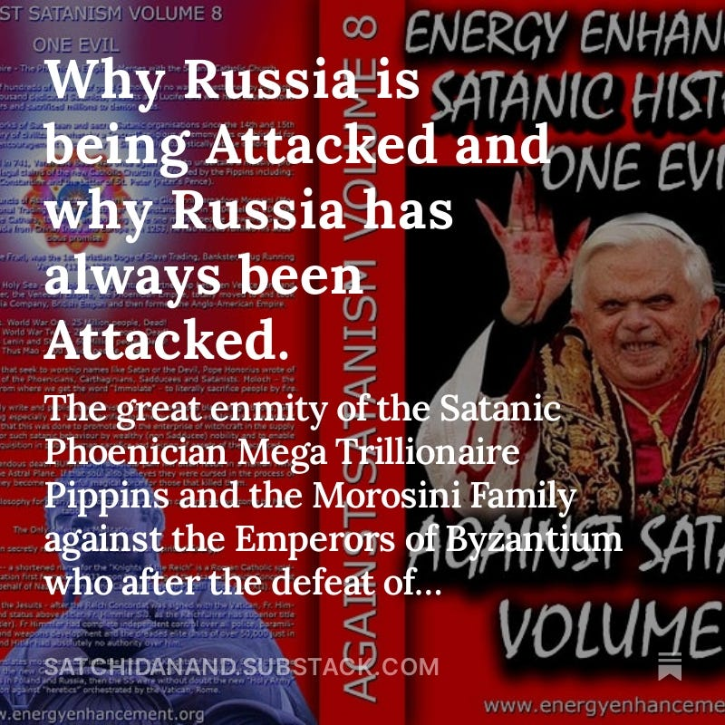



9 Likes
25 Comments
Satchidanand
Jul 24, 2024
https://mileswmathis.com/crooks.pdf
https://theconservativetreehouse.com/blog/2024/07/21/a-new-era-technocracy/
https://theconservativetreehouse.com/blog/2024/07/19/the-mirror/

Share
Satchidanand
Jul 26, 2024
Satanic Mega-Trillionaire US $2,080 Trillion Phoenician Rothschilds Control the World through Vanguard Group and Blackrock.
Satanic Mega-Trillionaire US $2,080 Trillion Phoenician Rothschilds have bought and blackmailed every politician in every country including USA nd UK and currently with the great reset of the west, AGENDA2030, are moving to china..
https://satchidanand.substack.com/p/throughout-history-seventy-two-empires
BLACKROCK AND THE SATANIC 2000 Trillion Dollar MEGA TRILLIONAIRES HAVE BOUGHT OFF OUR LEADERS, STOLEN THE ELECTIONS, FOLLOW THE ZIMBABWE SCRIPT TO DESTROY AMERICA - CUT OFF THE ENERGY, CUT OFF THE OIL, CUT OFF THE GAS, DESTROY THE PETRODOLLAR, DESTROY THE DOLLAR, CUT OFF THE GLYPHOSATE, CUT OFF THE FERTILISER, FAMINE AND STARVATION TO FOLLOW, INCREASE INFLATION, MAKE EVERYBODY POOR, SPREAD BIOWEAPONS, KILL OFF THE POPULATION, CREATE A GREAT RESET NEO-FEUDAL, POST INDUSTRIAL, SOCIAL CREDIT SCORE SLAVE PLANET
The Satanic Mega-Trillionaire - 2080 Trillion Dollars Rothschilds who control the money of the Vatican Bank control the World through the - “VanGuard Corporation” which Controls Global Megabanks, Big Deathshot Pharma, Major Mass Media and Mega Corporations in the World and their Owners - Monsanto, Google, Facebook and Microsoft.
https://satchidanand.substack.com/p/the-richest-satanic-phoenician-mega
Dark Forces have used Infiltrating Bloodline Satanic 10,000 years old Phoenician Mega Trillionaire Aristocratic Families like the 2000 trillion dollar Rothschilds which have existed running Global Trading Companies for thousands of years before the Birth of Christ.
Infiltrating and taking over the power structures in every country, using propaganda - emotional rhetorical religious concepts to control humanity, they themselves are Satanists, worshiping all the Pagan Gods, including Lucifer, Satan, Baal, Bel, Molech, Ashtoreth, Cybele and Attis.
All these Satanic Gods are heartless Demons who have cut themselves off from the Energy of the One Good God, who have rejected God so as to live eternally, immortally.
Therefore they control humanity so as to steal and vampirise the energies of Humanity forever!
In this book we find that over thousands of years before the birth of Christ, spook, Bloodline Satanic Phoenician Mega Trillionaire Aristocratic Families infiltrated every country, every Empire, from their Phoenician Colonies in Ancient Egypt, Carthage, Rome, Venice and London, marrying in to, taking over or infiltrating every ruling aristocracy and aristocratic, bloodline family.
Their Phoenician sons and daughters pretending to be natives of Europe, Britain, America, India, Israel and China, using their Satanic Phoenician Mega Trillionaire inheritances to get into positions of power to manage and control their human cattle in every country in the World!!
Download FREE! AGAINST SATANISM Volume 6 FREE!! Right Click and Save as..
https://againstsatanism.com/Sacred-Energy/Against-Satanism-Volume-6/AGAINST-SATANISM-6-Satanic-History-of-the-World-Part-2.pdf

Like

Reply
Share
NAHLS
NAHLS’s SubstackJul 22, 2024
The fact that Trumps businesses took some loans from Banks that may have been owned or controlled by Rottenchilds, does not ipso facto mean, establish, or prove that he is a Rothschild guy, pupet, or agent, working for Rothschild, any more than the fact I have a few Federal Reserve Notes in my pocket establishes that I work for Rothschild, who they say owns the BIS Bank of International Settlements, which they say controls all Federal Reserve Banks on all continents of this world ! I am not under anybody, with the acception, of the eternal absolute first cause of all being and existence, which some call "God" !

Tirion
TirionJul 23, 2024
The Rothschilds/Wilbur Ross did more than provide "some loans." They rescued Trump from bankruptcy, and who knows what else. Just speculating, but maybe that makes a material difference?

NAHLS
NAHLS’s SubstackJul 24, 2024
I have all the stuff about Trumps Bankruptcies, his illusive contracts, his 1 million dollar gift from daddy Trump to start off his career, and much more, I have heard all the allegations
that Rothschild bailed him out etc., and his father also bailed him out on one of his large Casino Hotel gambles, and what does it all amount to ? He was a guy trying to build himself up as a big business tycoon, a bit of an ego, or perhaps he was bored with what seemed to him to be an ordinary life........... none of it proves he is owned or controlled by Rothschild or anyone else..............but keep grasping ........................mois78
mois78’s SubstackJul 23, 2024
Trump was asked if he prayed, and if he asks God for forgiveness? He said never. This guy is not a Christian. He also celebrates his daughter who rejected Jesus.

NAHLS
NAHLS’s SubstackJul 24, 2024
I followed up on that story a ways back and if I recall it turned out to be false, but if I have a faulty memory would you please forward me the clip, the interview, or the phone conversation, or was it a letter ?

NAHLS
NAHLS’s SubstackJul 23, 2024
when and where did this exchange take place that you are referring to ?NAHLS
NAHLS’s SubstackJul 23, 2024
Trump clearly stated after the attempted assassination that his being there still breathing was only due to all mighty God, and nothing else !

NAHLS
NAHLS’s SubstackJul 22, 2024Edited
I have read a number of bio history entries about J.D. Vance, which say he joined the Marines after high school, coming from a poor family, which is not anything unusual in America. I found nothing stating he came from a privileged family or a blood line family, which would preclude him from ever being invited to join the Skull and Bones at Yale, and I found no source claiming he was a member of "Skull and Bones" at Yale ! So merely accusing him of being in "Skull and Bones" without any proof is basically bordering on Character Defamation, Libel, but I do not know the actual facts, I am not a witness and can not say if Vance actually was or was not a member of Skull and Bones, though it does not appear he was, because of his poor under- privileged background, he would not have been invited to join, as it is only for blood line privileged families as far as my research goes which is over a number of decades !

Tirion
TirionJul 23, 2024
But aren't you assuming that the sources you have examined are fact rather than fiction? I think the narrative painters understand the importance of giving their dramatis personae a credible backstory. Vance's published biographical details may, or may not, be fiction.
I do very much agree with Satchidanand's characterisation of choosing Vance as Trump making peace with the DS. Pence was the same deal, and so was Reagan/Bush and several others.

NAHLS
NAHLS’s SubstackJul 24, 2024Edited
It is still your speculation, assumption, presumption, conjecture, theory, belief, not knowledge, which boarders on defamation of character, libel, if you have no real evidence ! Do you really believe all the people in the small town he says he grew up in would not be calling him out for his fabricated bio and story about his past life in that sleepy small town where everyone likely knows everyone elses business ? So what are you implying the whole town is in on the deception, what, Vance paid them all not to out his story as a total fabrication ? Pretty extreme and a far stretch conspiracy theory you appear to be touting now, with no one coming forward in all these years to out it as a fabrication, especially after his best selling book about that community he grew up in !

Tirion
TirionJul 24, 2024
No. I merely said, "Vance's published biographical details may, or may not, be fiction." There's no need to jump down my throat or be so defensive, thank you.

NAHLS
NAHLS’s SubstackJul 24, 2024
Here is what you said, in fact :
Tirion 4 hrs ago
"But aren't you assuming that the sources you have examined are fact rather than fiction"
here is what I was saying:
" I found nothing stating he came from a privileged family or a blood line family, which would preclude him from ever being invited to join the Skull and Bones at Yale, and I found no source claiming he was a member of "Skull and Bones" at Yale ! So merely accusing him of being in "Skull and Bones" without any proof is basically bordering on Character Defamation, Libel, "..."
I'm not being defensive I am only making the record clear as to what I have said and the fact you have misrepresented what I said, and what I did ! You should be careful about what you say about people you do not know anything about, I do not assume facts not in evidence, as you may do, because I know to do that is folly !

NAHLS
NAHLS’s SubstackJul 24, 2024
I am not assuming anything, I am saying I found no evidence ! I do not assume someone is guilty without any evidence being brought forth to establish any of the allegations as fact ! If all you are doing is assuming things you are wasting your time and energy like spinning your wheels thinking you are going somewhere, when you are exactly where you were at the beginning of your assumption, with no evidence and nothing established as fact ! If you went into Court with no evidence and only bald faced allegations and assumptions you would be laughed out of Court, and perhaps hit with a monetary sanction for filing pleadings that were frivolous and without any merit !

Renee Marie
Renee MarieJul 22, 2024
Excellent work!👏
I question ALL! And that is exactly what every person should be doing! I stopped “assuming” years ago.

NAHLS
NAHLS’s SubstackJul 24, 2024
thank you !

Amal Wadei Dawood
Amal Wadei DawoodJul 23, 2024
Watch this human lady reading part of this book & watch her human reaction to the shocking truth (the Queen , the King ) of Piracy Crown in England leading the rape , genocide, enslavement , theft , piracy against humanity to steal all the wealth & to steal all the Earth !!
https://odysee.com/@TruthVault:0/Committee-of-300-New-World-Order:9
We are already in One World Government ( Hierarchy Crown Parasites in England - The Pirates ) secretly in place top down control & Crown Military Industrial Complex controlling Every Government on Earth including USA government by hacking their brains too & communicating with them with secret silent communication called synthetic telepathy to conscious mind called V2K Voice to Skull technology beamed to the cranial cavity of the recipients according to the frequency of the DNA & the Brain wave signature to that person to control the lies news in the media ..etc
The enemy against us " all " is the "Committee of 300" & the head of the committee of 300 is the " Crown in England !
All presidents & governments around the Earth are " Satanic Freemasons" participating in theatre fictional story that there is governments to sedate & to mislead the people around the earth inorder to hide the main reasons for those declared wars & declared mandates ..... is to genocide the people in each country by their "own governments" like Bolshevik genocide & like the genocide happened in Cambodia by Pol Pot & like all the genocides happened at least in the last 200 years all done by infiltration of Satanic Freemasons (Nazis & called Zionists ) in the governments, religious leaders ..etc their loyalty to the Head of the Satanic Freemasonry around the Earth which is the Head of the Committee of 300 & Head of the One World Government of Piracy which is the Crown Parasites in England !
Freemasonry & Satanism is freedom of morality !!
All these governments around the Earth now & in USA are Freemasons Satanists with zero morality they are working against the people of every nation for secret depopulation agenda their loyalty to the Head of the Satanic Freemasonry & the Head of Committee of 300 , the Crown in England leading the genocide secretly !
All the presidents & their governments are actors hired by the Crown in England !
We have no governments & we are on our own !
This is really " Joe Biden" hired by the head of the committee of 300 ( Crown in England ) to laugh at the people in USA and around the world and he is an actor like Trump & the rest of every governments around the earth & all the news are theatre to mislead the people while the Crown in England collecting the Earth with infiltration !
Watch Joe Biden "sniffing your hair "
https://www.youtube.com/watch?v=jy-9vU9BzZE&list=PLv4zpHMC9C9UO-QOeaPbe4QkIc4lOzmnT
The Youtube account C3PMeme looks very questionable and most likely for the MIC claim they can use artificial intelligent to make videos but For me I see Joe Biden videos on this channel so real that make me certain he is professional actor for the Crown in England to laugh at the people while they are misleading the people that these videos are fake !!
What happened from this assassination attempt on Trump was a lie , hoax & witchcraft magic skills to put rubber- silicone synthetic ear with fake blood applied by the secret agents were on the top of Trump !!
Google... bloody synthetic silicon ear and you will find many options ...
https://www.etsy.com/listing/1103857224/hyper-realistic-bloody-ear-prop-silicone
this is the Truth for what happened
https://old.bitchute.com/video/XyQfYhZO9mLT/?comment=0io7fpxw3I29OiMEDIQPwRQarxtXavxuLmo7
The goal is to push the people to civil war to divide the people in USA to hunt each other so the Crown in England ( Head of One World Government of Piracy) will conquer like in history !
Go hunt the immigrants !!
This One World Government Piracy against every human on Earth regardless what religion they are on and what race !
1) Trump Rolled out 5G & it is military weapon against the people in USA to make the people have short life span & to have cancer in the next 5 years !
Read his speech rolling out 5 G against the people in USA in 2019 in (Roosevelt Room)
https://trumpwhitehouse.archives.gov/briefings-statements/remarks-president-trump-united-states-5g-deployment/
Why Trump his speech was in ( Roosevelt Room ) because this is a signal that Trump following the path of "Franklin Roosevelt" (the traitor) as F. Roosevelt drafted Declaration for the "United Nations" with Churchill ( Crown in England) in 1941 & also Roosevelt in 1933 forced the people in USA to give up their gold to the government !
Means Trump like Franklin Roosevelt slave to the Head of the One World Government of Piracy ( Crown in England ) Head of the Committee of 300 leading the genocide against humanity secretly to own all the wealth & to own all the Earth!
2) Trump rolled out the death bio-weapons injections called vaccines against the people in USA !
Millions are dead or disabled for life because of these injections
https://www.youtube.com/watch?v=hSfeCqK
Who created the United Nations to fool the world is the Crown Parasites in England the Head of the Committee of the 300 and their Committee of 300 members including Churchill & the Presidents including Franklin Roosevelt working for their secret genocide agenda against humanity to steal all the wealth on earth and to steal all the earth while enslaving humanity with the technology they stole ..
The Crown in England is the Head of the Committee of 300 & the Head of One World Government & they are taking everything from us including our precious metal , gold & silver again like what they did in the Great depression in 1933 in USA using the puppets of deceptive (actors ) Presidents & governments in the quality of Franklin Roosevelt & the bankers for Federal reserve !
They already hacked our brains secretly by impregnated our bodies with these nano technology at least since 1920s in water we are drinking , in air we are breathing through the chem-trails spraying , in the injections through the first infant vaccines in history & in any injections & medicine including the dental anaesthetic injections all loaded with hydrogel , graphene , nano smart dust to connect us to the satellites ( clouds ) & to the Pirates of the Crown Military Industrial Complex "supercomputer 666" & to control the people brains globally with synthetic telepathy to the subconscious mind by sending synthetic thoughts to make the people feel & think negative against themselves to accept certain agenda or to suicide or to feel & to think negative against each other to kill each other for secret depopulation for the Crown in England ..
They hacked our brains via satellites that they see through walls , They see what we see and They hear what we hear & they read the mind !
There is no virus as germ in human history..
They did not isolate any virus in human history !
And the infant vaccines is to inject us the nano smart dust , hydrogel to connect us to the satellites via the free energy technology to hack our brains secretly & record all our lives what we see , what we hear and what we say inside our houses ..
"Corona Virus" is the name of the genocide agenda to depopulate the Earth by the Crown in England ..Corona is the "Crown" in Spanish language while the Virus it means in Latin language the "Poison " !
Means Corona Virus is " The Crown Poison" against humanity
the genocide agenda is the "Crown Poison "either with directed energy weapons ( radiation poisoning ) & with "bioweapons injections" using the poisons as venom " snake venom, other poison , & by poisoning the people mind with "Fake News " & with synthetic telepathy ( synthetic thoughts ) beamed via satellites to make nation against nation for depopulation & to make the people think negative against themselves ( divorce & homosexuality is high in the last 100 years because of this silent weapon ) or make the people think negative against others around them to depopulate each other by being manipulated remotely without their knowledge of this technology with the synthetic telepathy to their subconscious mind !
Descendants of Queen Victoria Head of the Satanic Freemasonry are the Head of the Committee of 300 leading the genocide , theft against humanity ... They are taking over the "WORLD" with Free Energy Technology hacking people brains since at least 1920 , & attacking the people around the Earth directed energy weapons & 9/11 attack was directed energy weapon attack using Death ray technology and more via satellites !
This is the end of humanity !
We are heading to the "New Dark Ages" that filthy tyrants will be "chopping heads" & rape adults and children in public seen while they stole the technology from humanity that they read the mind and they see & hear everything through walls and they can control the function of every cell & the function of every organ in human body remotely via satellites ... they can stop breathing , stop the heart , they can remove all the memory the brain , they can stop bowel function , all this done remotely thousands miles away via satellites !
This is the end of humanity !

Ohio Deb
Ohio DebJul 27, 2024
Recorded in 1996. https://forbiddenknowledgetv.net/dr-john-coleman-exposes-the-committee-of-300/?amp=1

Amal Wadei Dawood
Amal Wadei DawoodJul 23, 2024
Watch Catherine Austin-Fitts & Maria Zeee media Exposes Globalist Banking Coup
https://rumble.com/v51hbqx-catherine-austin-fitts-exposes-globalist-banking-coup-on-infowars-with-mari.html
Catherine Austin-Fitts nailed it that Trump pushing for the digital mandates like how he pushed the death injections & the 5 G because Trump like every infiltrated government with Satanic Freemasonry their loyalty to the Head of the Committee of 300 & the head of the Freemasonry around the Earth & the Head of the Imperialism & the Head of the One World Government Piracy which is the King & Queen of British Imperialism which they always honour the criminals like them & this is an evidence that the One World Government is the Head of British Imperialism.. & she mentioned in that conversation that " Especially the Common Wealth countries getting aggressive mandates for total digital control " because the Head of the State enforce on them is the King & Queen of Piracy for the Crown in England !
World Economic Forum is led by " K " Charles III who he is talking about cutting the emission of the CO2 & we need martial law to do that !
This means this is announcement to kill humans on earth with their livestock because we all expel CO2 when we breathe !
CO2 is not dangerous & this is a lie & deception !
We have infact very low level of CO2 in the environment because they are using technology to suck the CO2 from the environment because their plan to push humanity towards starvation because CO2 very important for the plants to produce food & in fact the higher level of CO2 is only dangerous to the Crown Parasites in England because this means more food for humanity that will live happy long life against the plan of the Crown in England the Head of the Committee of the 300 leading the genocide secretly against humanity!
X disease means "Crucifixion culling sign " by making the X stand correctly as culling cross to crucify humanity !
Who created the WHO & UN & WEF is the Head of the Committee of 300 & their Committee of 300 members and the Head of the committee of 300 is the King & Queen of Piracy for the Crown in England !
Please See that the "British Imperialism in 1882" had 13 Colonies on the open in addition to England which means 14 colonies !!
see drawing:
https://www.gettyimages.co.uk/detail/news-photo/editorial-cartoon-depicts-england-as-a-13-armed-cephalopod-news-photo/77036713?adppopup=true
Now all the Earth is One Giant Colony in the hands of Crown Parasites in England secretly the Head of the One World Government Piracy & they are the Head of the Committee of 300 leading the genocide & theft to steal all the wealth and to steal all the Earth !!
*What happened to gold in the Great Depression ?
In 1933, Roosevelt took the U.S. off the gold standard when he signed an executive order making it illegal for individuals and firms to possess most forms of monetary gold.
The government of Franklin D Roosevelt seized all gold bullion and coins via Executive Order 6102, forcing citizens to sell at well below market rates. Immediately after the “confiscation”, the government set a new official rate for gold that was much higher as part of the Gold Reserve Act 1934.
*Who created the United Nations to fool the world is the Crown Parasites in England the Head of the Committee of the 300 & their Committee of 300 members including Churchill & the Presidents including Franklin Roosevelt leading Piracy , genocide , theft against humanity
In Wikipedia-
By August 1941, American President Franklin Roosevelt & British Prime Minister Winston Churchill had drafted the Atlantic Charter; which defined goals for the post-war world. At the subsequent meeting of the Inter-Allied Council in London on 24 September 1941, the eight governments in exile of countries under Axis occupation, together with the Soviet Union and representatives of the Free French Forces, unanimously adopted adherence to the common principles of policy set forth by Britain & the United States.
The text of the Declaration by United Nations was drafted on 29 December 1941, by Roosevelt, Churchill, & Harry Hopkins.
https://en.wikipedia.org/wiki/United_Nations
Read Rules of One World Gov. in the story of the committee of 300 book
https://odysee.com/@TruthVault:0/Committee-of-300-New-World-Order:9
Reading ..
"Attempts to trade "old" coins, that is to say silver coins of previous & now defunct nations, shall be treated as a capital crime subject to the death penalty. All coinage shall be required to be surrendered within a given time along with guns, rifles, explosives & automobiles. Only the elite & One World Government high-ranking functionaries will be allowed private transport, weapons, coinage & automobiles... "
They are taking your gold using deception as usual
* Search for this file of PDF book "The Great taking"
file:///C:/Users/user/Documents/The%20Great%20Taking.pdf
In this book mentioned in pages 47, 48
The executive order to confiscate all gold owned by the public was made under the authority of the Trading with the Enemy Act of 1917 !
I asked my father why people had turned in their gold. He said that if you did not you were a criminal, but further, that there was nothing you would be able to do with it because you could not legally transport or sell it. So, essentially, the use and value of gold had been confiscated.
This was certainly the case because it remained illegal for a U.S. person to own gold for more than forty years !
Here are some excerpts from Executive Order 6102 [40]:
All persons are hereby required to deliver on or before May 1,
1933, to a Federal Reserve Bank or branch or agency thereof or
to any member bank of the Federal Reserve System all gold coin,
gold bullion and gold certificates now owned by them or coming
into their ownership . . .
Whoever willfully violates any provision of this Executive Order
may be fined not more than $10,000, or, if a natural person, may
be imprisoned for not more than ten years, or both . .
* Also in another book The Story Of the Committee of 300 - by John Coleman & shocking truth that the Queen , King of Piracy for Crown is the head of the Committee of 300 & Head of the One World leading the enslavement, genocide , theft against humanity to own all the earth !
https://odysee.com/@TruthVault:0/Committee-of-300-New-World-Order:9
In this book mentioned the Rules for the One World Government:
Attempts to trade "old" coins, that is to say silver coins of previous & now defunct nations, shall be treated as a capital crime subject to the death penalty. All coinage shall be required to be surrendered within a given time along with guns, rifles, explosives & automobiles. Only the elite & One World Government high-ranking functionaries will be allowed private transport, coinage ..
Expand full comment

Gabriel Aguilar
Gabriel AguilarAug 1, 2024
EXCELLENT ARTICLE!!! 💯👍🏼👊🏼📣📣
EXCELLENT THAT YOU HAVE THE GUTS TO EXPOSE THE: - SATANIC CRIMINAL JEWISH BANKING MAFIA a.k.a. THE HOUSE OF ROTHSCHILD…
KEEP IT UP!!! 👍🏼👊🏼📣📣📣

Satchidanand
Aug 1, 2024
The Phoenicians are not Jews... Read this...
AGAINST SATANISM VOLUME 6 -The Satanic History of the World Part 2 Published May 2019
See http://www.energyenhancement.org/8aky78umhxi31.jpg
Dark Forces have used Infiltrating Bloodline Phoenician/Jewish aristocratic Families which have existed for over 5000 years before the Birth of Christ. Using emotional rhetorical religious concepts to control humanity, they themselves worship all the Pagan Gods, including Lucifer, Satan, Baal, Bel, Molech, Ashtoreth, Cybele and Attis. In this book we find that over thousands of years, spook, Bloodline Phoenician/Jewish aristocratic Families infiltrated every country, every Empire, taking over or infiltrating every ruling aristocracy and aristocratic, bloodline family, in Europe, Britain, America, India, China and in every other country in the World.
http://www.energyenhancement.org/Sacred-Energy/Against-Satanism-Volume-6/AGAINST-SATANISM-6-Satanic-History-of-the-World-Part-2.pdf
http://www.energyenhancement.org/FREE-BOOK-AGAINST-SATANISM-VOLUME-6-The-Satanic-History-of-the-World-Part-2-Infiltrating-Bloodline-Caananite-Phoenician-Jewish-aristocratic-Families.htm

Satchidanand
Sep 13, 2024
READ THIS...TARTARIA AND THE 2000 TRILLION DOLLAR PHOENICIANS
https://satchidanand.substack.com/p/tartaria-and-the-2000-trillion-dollar

Gabriel Aguilar
Gabriel AguilarAug 1, 2024
Yes, thank you for clarifying facts about their bloodline … I’m particularly more interested in how the Rothschilds have gained power over financial and governments worldwide … The world money system is their personal (private) business… So, given the actual circumstances we find ourselves in who cares if they are jews, phoenicians, khazars or whatever … in fact I think we don’t have time to dive into their history … instead we should be worried on how to confiscate ALL their wealth, followed by a quick trial and appropriate death sentence for the entire Rothschild Dynasty and for all their Prostitutes around the world… and in the meantime we get rid of their diabolic system we should start worrying about how to create a more honest monetary and trade system. Complicated situation … But to begin with I think you’re doing an excellent job in exposing them as the responsible group for all the crazy and diabolic shit happening worldwide…

Satchidanand
Aug 1, 2024
Why... Thank you very much Aguilar.
I think first, my article on Financialisation is important
FINANCIALISATION and Satanic Phoenician Mega Trillionaire Central Banks? by Professor Richard A. Werner, D.Phil. - Improved and made better by Satchidanand
THE SATANIC PHOENICIAN MEGA TRILLIONAIRES, THE ROTHSCHILDS, THE ROCKFELLERS, THE BLACK NOBILITY CONTROL BIDEN, PUTIN AND XI - THEY CHOOSE WHICH EMPIRES TO DESTROY AND RAISE UP!
https://satchidanand.substack.com/p/financialisation-and-satanic-phoenician
After That the destruction of the Rothschild Central Banks will come about by borrowing money Only from American Banks as in FDR and Lincoln Greenbacks. That to create Big Projects like the Tennessee Authority - Like the Belt and Road Initiative throughout the Americas linking through the Bering Straits to Russia and China. Many more like that.
The point is we don't care how money is divided up and used.
What we want is Richness, more Richness, More Energy, for everyone!
After that Protectionism of Tariffs to grow American Industry back again. We need to get back to paying a little more for our goods if everyone gets higher wages.
I'm not big on Killing people. Better to prosecute first.
As for how to stop this happening in the future understand the the line of evil passes through everyone's heart. We can all turn into a psychopath.
The solution is Energy Enhancement Meditation. https://energyenhancement.org/

THE WOLVES OF WALL STREET USE BLACK MAGIC

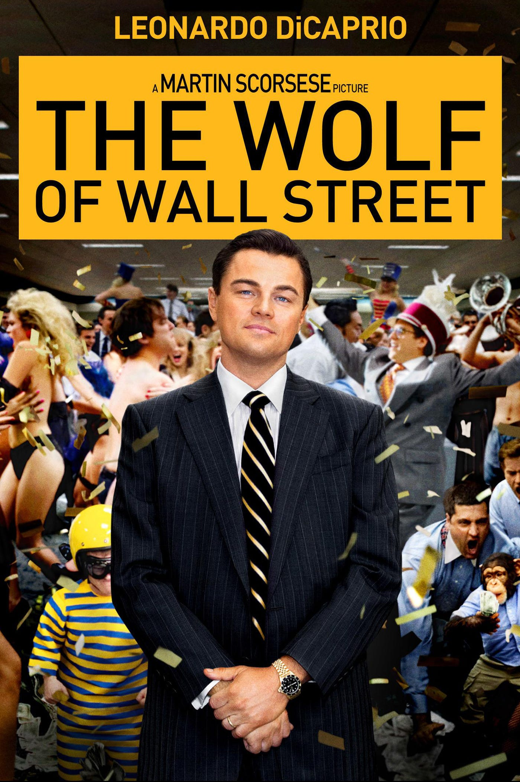

THE SATANIC 2000 TRILLION DOLLAR MEGATRILLIONAIRE ROTHSCHILDS USE BLACK MAGIC TO MAKE NARCISSITIC, MACHIAVELLIAN PSYCHOPATH BANKERS
Satchidanand
Jul 28, 2024
The Wolf of Wall Street from https://energyenhancement.org/THE-WOLF-OF-WALL-STREET-ESOTERIC-MOVIE-REVIEW-BY-SATCHIDANAND.htm Spiritual Movie Reviews…
Directed by Martin Scorsese, Produced by Martin Scorsese, Leonardo DiCaprio, Riza Aziz, Joey McFarland, Emma Tillinger Koskoff
Based on The Wolf of Wall Street by Jordan Belfort
Budget $100 million
Box office $375,591,788
The Wolf of Wall Street is a 2013 American black comedy film directed by Martin Scorsese, based on Jordan Belfort's memoir of the same name. It was released on December 25, 2013. The screenplay was written by Terence Winter, and the film stars Leonardo DiCaprio as Jordan Belfort, a New York stockbroker who runs a firm that engages in securities fraud and corruption on Wall Street in the 1990s.
The film also features Jonah Hill, Margot Robbie, Matthew McConaughey, Kyle Chandler, Rob Reiner, Jon Favreau, and Jean Dujardin. It is the fifth collaboration between Scorsese and DiCaprio, and the second between Scorsese and Winter following Boardwalk Empire.
The film received positive reviews from critics, but was also controversial for its moral ambiguity, sexual content, presence of drugs, vulgarity, and use of animals. The film has grossed over $375 million worldwide, and was nominated for five Academy Awards, including Best Picture, Best Director, as well as Best Actor and Best Supporting Actor for DiCaprio and Hill respectively, but failed to win in any category. It is historically significant as the first major film to be distributed entirely digitally.
This is the real history of Jordan Belfort from his autobiography written in prison. Jordan Belfort (Leonardo DiCaprio) narrates the film showing his monstrous success with his firm complete with ribaldry at work, a sumptuous home on the Gold Coast of Long Island and a trophy wife who is a former model. He then flashes back to 1987, where he began a low-level job at an established Wall Street firm.
Working for the Satanic 2000 Trillion Dollar Phoenician Mega Trillionaire family N. M. Rothschilds, who have run the world for 10,000 years his boss (Matthew McConaughey) Initiates him and using black magic, addicts him to sex and drugs as all stockbrokers must be addicted in order to become the Narcissistic, Machiavellian, Psychopaths who can lie and cheat and steal for the Satanic Elite Mega Trillionaires.
The Ancient, Thousands of Years Old Psychic Science of Black Magic - the Creation of Implant Drug and Sex Addiction Energy Blockages - is an Ancient Technology which although is scientific, appears like Magic to those which have never been taught Energy Enhancement Meditation…

“Any sufficiently advanced technology is indistinguishable from magic.”
― Satanic Pedophile Aristocrat Arthur C. Clarke, He uses Black Magic addiction blockage implants to propel him into a lifestyle of prostitutes, masturbation, casual sex, quaaludes and cocaine which is taught to all Qualified Stockbrokers as the Satanic culture they want you to take up in order to succeed which is taught by every Satanic Corporation on the Planet, - Goldman Sachs, Barclays, Citigroup, Deutsche Bank, HSBC, JPMorgan Chase, Lloyds, RBS, Standard Chartered, and UBS etc.
Black Magic is Satanic Elite Mega Trillionaire technology created over 10,000 years ago and kept from humanity by the elite.
Black Magic Satanic Elite Mega Trillionaire technology created over 10,000 years ago is Only removeable by Energy Enhancement Meditation Techniques!
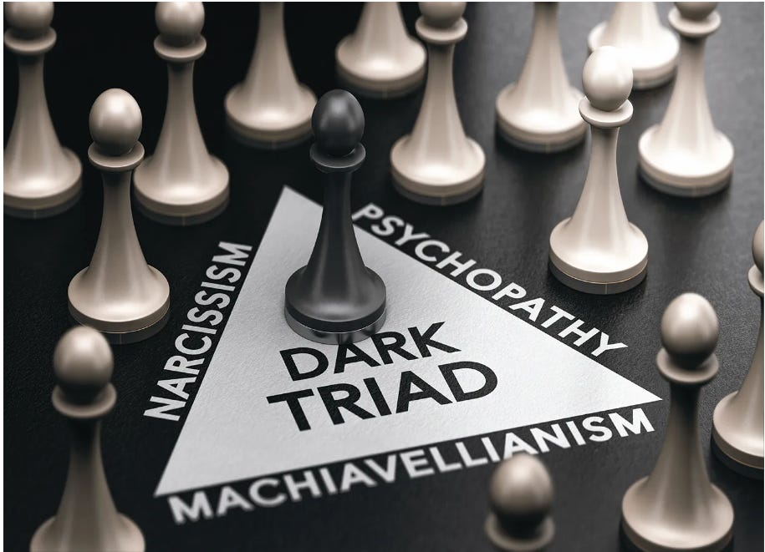



The field of Black Magic is Sex, Drugs and Rock and Roll!!
Black Magic Implant Addiction Blockage will create Addiction to Casual Sex, Alcohol, quaaludes and cocaine will so degenerate you so that you will become a Psychopath which is necessary in order to rape and pillage your clients laughing at their stupidity whilst sucking all their wealth as they addiction gamble their money at every turn of the cards, throw of the dice of the stock market.. because you get commission on every trade!!
Hell! they even Black Magic their own children - implanting them with the Sodomite Sex Addiction at schools like Eton, designed to make a male rape culture to create a Sodomite Band of Thebes army… before introducing them to the Satanic Secret Societies… See…

P.G. Wodehouse and British Empire Ritual Sodomy Band of Thebes Propagandised for Hitler, Propagandised for the Satanic Phoenician Mega Trillionaires

Satchidanand
·
October 2, 2022
Sir Pelham Grenville Wodehouse, KBE 15 October 1881 – 14 February 1975 was an English author and one of the most widely read humorists of the 20th century. His creations include the feather-brained Bertie Wooster and his sagacious valet, Jeeves; the immaculate and loquacious Psmith; Lord Emsworth and the Blandings Castle set; the Oldest Member, with stories about golf; and Mr Mulliner, with tall tales on subjects ranging from bibulous bishops to megalomaniac movie moguls.

Read full story

Because you can advertise them, prompt them, sell them on worthless stocks which will then rise so you can sell them at the top of the market and make hundreds of millions on every scam - the Classic Pump and Dump Scheme. These offerings are normal and are learnt at daddies knee in every Stock broking company. Later Jordan Belfort was associated with twenty of these IPO's - offerings of new companies on the market.

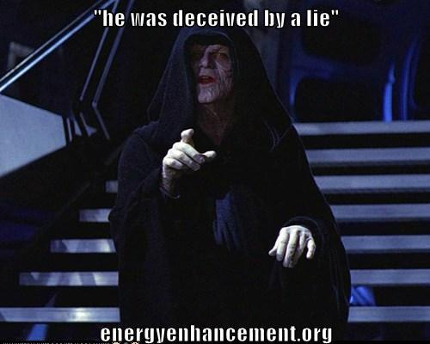

However, shortly after he passes his exam to become a certified stockbroker, he loses his job on account of the firm's bankruptcy as a result of Black Monday.
Now unemployed in an economy that is unaccommodating to stockbrokers and sufficiently discouraged to consider a new line of work, Jordan's wife Teresa (Cristin Milioti) encourages him to take a job with a Long Island boiler room dealing in penny stocks, which are also largely ignored by regulators.
Belfort impresses his new boss with his Satanic 2000 Trillion Dollar Phoenician Mega Trillionaire family N. M. Rothschilds aggressive pitching style, and earns a small fortune for the boiler room and himself as penny stocks have a much higher commission than blue chips.
Jordan also befriends Donnie Azoff (Jonah Hill), a salesman living in the same apartment complex and they decide to go into business together. To facilitate this, his accountant parents are recruited as well as several of Jordan's friends, some of them experienced marijuana dealers.
The basic method of the firm is a pump and dump scam and the Satanic 2000 Trillion Dollar Phoenician Mega Trillionaire family N. M. Rothschild's lifestyle of prostitutes, masturbation, casual sex, quaaludes and cocaine which is taught to all Qualified Stockbrokers as the Satanic culture they want you to take up in order to succeed.
To cloak this, Belfort gives the firm the respectable name of Stratton Oakmont. An article in Forbes dubs Jordan the "Wolf of Wall Street", and soon hundreds of ambitious young financiers flock to his company.
A decadent satanic lifestyle of lavish parties, sex and drugs follows.
It is amazing that Leonardo de Caprio is also associated with the movie, "The Great Gatsby" Directed by Baz Luhrman - in this movie he takes the same part as the front man of a Stock Company using the same Pump and Dump schemes in the 1920's. He is in charge of the same Satanic Parties of Sex, Alcohol and Drugs used to degenerate the stockbrokers of the, "Raging Twenties". In both Movies, the Blue Bloods, the Satanic Elite, the Satanic 2000 Trillion Dollar Phoenician Mega Trillionaire family N. M. Rothschilds are responsible for his downfall - in both Gatsby and Wolf.
Jordan regularly uses prostitutes and becomes addicted to cocaine and Quaaludes. FBI Agent Patrick Denham (Kyle Chandler) begins investigating Stratton Oakmont. Why? In the meeting with the Agent he says that the other firms employ blue bloods whereas Belfort employs dumb as a box of rocks pizza delivery boys and drug dealers. In the same way that drug pushers who are not employed by the "Committee of 300" are prosecuted by the police but the Satanic 2000 Trillion Dollar Phoenician Mega Trillionaire family N. M. Rothschilds et al - all Members of the "Committee of 300" who, "Pay the Toll" of bribes and are all members of the club are not, in order to keep down the competition.
It is the same in Banking where if you are not a member of the Club you will be investigated by the FBI as happened with Jordan Belfort.

Download - The Committee of 300 - Fourth Edition by Dr. John Coleman
Released by RareReactor.tk
The Committee of 300, also known as The Olympians, is a group alleged to have been founded by the British aristocracy in 1727.[1] Proponents of the theory alleging the Committee's existence, Ian Fleming's Spectre, believe it to be an international council that organizes politics, commerce, banking, media, and the military for centralized global efforts.
https://archive.org/details/dr.-john-coleman-the-committee-of-300
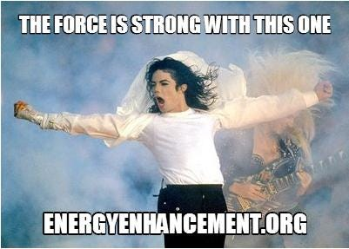
“We have one here who can see!” - LET'S DEGENERATE AND ASSASSINATE
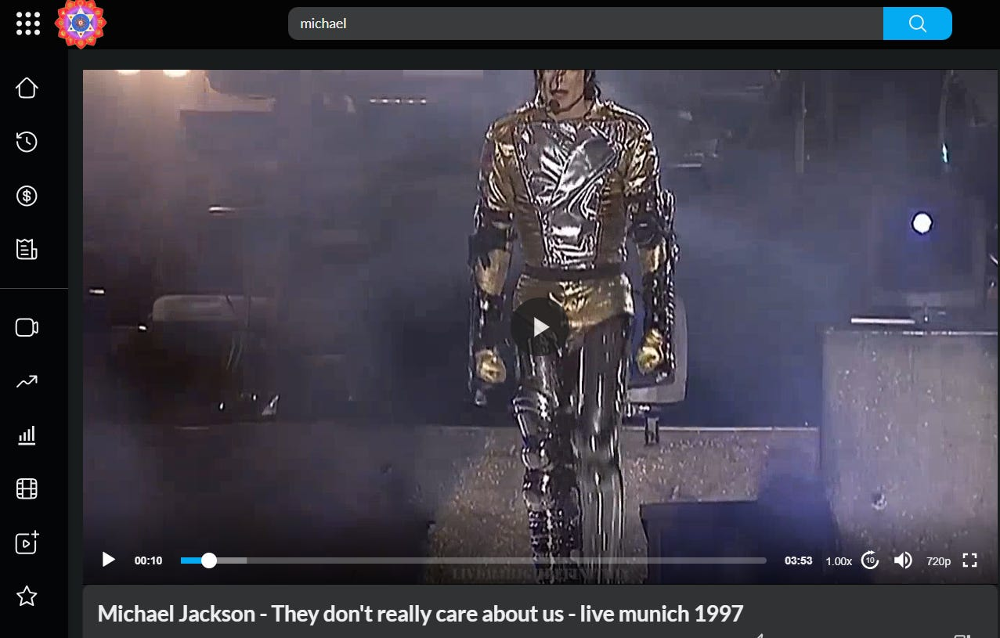

https://against-satanism-video.com/watch/michael-jackson-they-don-039-t-really-care-about-us-live-munich-1997_Y8DVLByoW13sEc5.html



See all the famous music by Michael Jackson in Sacred Michael Jackson by Sacred Dancer, Director of Energy Enhancement Meditation, Devi Dhyani…https://eemeditationvideo.org/watch/michael-jackson-sacred-dance-by-swami-devi-dhyani_EvgMCy3d4JVkd4H.html
It is the same in the music business where John Lennon is a British Lord, Paul McCartney is a British Lord, Mick Jagger of the Jagelion Family is a British Lord, Jimmy Page of the Paget Family is a British Lord etc
When Jordan meets Naomi Lapaglia (Margot Robbie) at one of his parties, he begins an affair with her, resulting in his divorce from Teresa. Jordan makes Naomi his second wife in an extravagant wedding and gives her a yacht aptly named Naomi, and soon they have a daughter, Skylar. Meanwhile, the U.S. Securities and Exchange Commission works jointly with the FBI to intensify the Stratton Oakmont investigation.
Jordan instantly makes US$22 million on his securing the IPO of Steve Madden Ltd. To hide his money, Jordan opens a Swiss bank account with the corrupt banker Jean-Jacques Saurel (Jean Dujardin) in the name of Naomi's aunt Emma (Joanna Lumley), who is a British citizen and outside the reach of American authorities. He uses friends with European passports to smuggle cash to Switzerland. When Donnie gets into a public fight with Brad Bodnick (Jon Bernthal), who is one of their money couriers, and Brad is arrested, their scheme is nearly exposed.
Donnie offers Jordan a powerful brand of Quaaludes, hoping to ease the sting of the bad news. The pills are old and seem to have lost their potency, so they take huge doses to compensate. Jordan then receives a call from Bo Dietl, his private investigator, who insists Jordan call him back from a payphone. Jordan drives to a country club to phone Bo, who warns Jordan of Brad's arrest and that his house phone has been wiretapped.
At this point, the Quaaludes finally kick in with overwhelming effect. Severely debilitated, Jordan drives back home to prevent Donnie from using his phone. When Jordan arrives home Donnie (who is also intoxicated) is on the phone with Saurel. Jordan fights Donnie to make him get off the phone and tells him he found out what happened between him and Brad. Donnie starts choking on ham and nearly suffocates. Jordan snorts cocaine to counteract the effect of the Quaaludes in order to help save Donnie's life.
With the shadow of law enforcement hanging over them, Jordan's father Max (Rob Reiner) attempts to convince his son to step down from Stratton Oakmont and escape the large amount of legal penalties. However, during his leaving party at the office, Jordan changes his mind and to the great acclaim of his employees vows to stay on - to Psychopathically Scam, Rape and Pillage even more money before being forced to retire..
Jordan, Donnie and their wives on a yacht trip to Italy learn that Emma has died of a heart attack. Over his grieving wife's objections, Jordan decides to sail to Monaco so they can drive to Switzerland without getting their passports stamped at the border and settle the bank account, but a violent storm capsizes their 162 ft yacht once owned by Coco Channel. After their rescue, the plane sent to take them to Geneva is destroyed by a seagull flying into the engine, exploding and killing three people. Witnessing this, Jordan considers this a sign from God and decides to sober up.
Two years later, Denham arrests Jordan during the filming of an infomercial. Saurel, arrested in Florida over an unrelated charge, has told the FBI everything. Since the evidence against him is overwhelming, Jordan agrees to gather evidence on his colleagues in exchange for leniency.
Jordan is optimistic about his sentencing and expresses this to his wife. The encounter turns violent when Naomi tells Jordan she will divorce him and wants full custody of their children. Jordan throws a violent tantrum, gets high, and ends up crashing his car in his driveway during an attempt to abscond with their daughter.
The next morning, Jordan wears a wire to work. Jordan silently slips Donnie a note warning him about the wire. The note finds its way to Agent Denham, who arrests Jordan for breaching his cooperation deal. The FBI raids and shuts down Stratton Oakmont.
Despite this one breach, Jordan receives a much reduced sentence for his testimony and is sentenced to 36 months in a minimum security prison in Nevada playing tennis. After his release, Jordan makes a living hosting seminars on sales technique in New Zealand.
The Satanic Stock Broker Black Magic Culture of Sex, Drugs and Rock and Roll to degrade, de-moralise, addict to Narcissise, Machiavellianise, and Psychopathise.
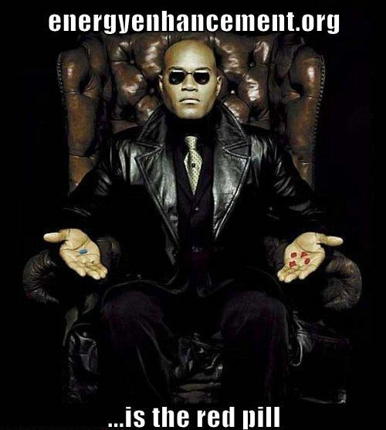
Yards from Satanic Goldman Sachs's headquarters in downtown Manhattan, bankers invited to a preview of the film cheered Belfort's every move. They laughed as the Wolf - Leonard DiCaprio in an Oscar-nominated turn - snorted drugs from a prostitute's naked body, and applauded when he ripped open a sofa to find a stash of cocaine.
In London, Satanic culture City firms glorify Belforts exploits and have attended fancy-dress screenings, with staff posing as their new folk hero, complete with pastel-coloured jackets and brick-like mobile phones. Cinemas have trebled the price for private bookings, such is demand.
So the question is, Why should this guy only involved in hundreds of millions of dollars of Pumping and Dumping be sent to prison??
The American Government only owes 36 Trillion Dollars - as we disclose here, the Banking industry is involved in stealing 20,000 Trillion Dollars in a multitude of scams!
In actuality it is the Satanic 2000 Trillion Dollar Phoenician Mega Trillionaire family Rothschild Central Bank, The Federal Reserve, which decides when to crash the economy.

Throughout History Seventy-Two Empires Have Been Engineered to Fail in the Same Way.

Satchidanand
·
April 6, 2024
Throughout History Seventy-Two Empires Have Been Engineered to Fail in the Same Way.

Read full story

The Richest Satanic Phoenician Mega Trillionaire 10,000 years old Families in the World

Satchidanand
·
November 25, 2022
The Richest Satanic Phoenician Mega Trillionaire 10,000 years old Families in the World. THE VANGUARD GROUP DRIVES WORLDWIDE MERCHANT-BANKER FASCISM FROM THE CITY OF LONDON. VANGUARD, BLACKROCK, STATE STREET ARE CONTROLLED BY THE PILGRIMS SOCIETY IN THE CITY OF LONDON (ROTHSCHILDS, BARINGS, BARCLAYS, NATWEST, ETC.) King Chucky the Turd is the front man controlling Klaus Schwab and Vanguard.

Read full story

Thousands of Trillions of Dollars are being scammed by the Satanic Blue Blood Elite Aristocracy like the Satanic 2000 Trillion Dollar Phoenician Mega Trillionaire family N. M. Rothschilds who have run this World for 10,000 years by a Process of Poverty, starvation, societal Myth mind control and money - Bribery, Blackmail and corruption.
We know that thousands of Trillions of Dollars are being scammed by the Satanic Blue Blood Elite in firms like Goldman Sachs, Barclays, Citigroup, Deutche Bank, HSBC, JPMorgan Chase, Lloyds, RBS, Standard Chartered, and UBS and the answer comes from Psychopath Genghis Khan who said, "It is not that I succeed, everyone else should Fail" which is another re-telling of the thousands of years old Oligarchic, Satanic, "Policy of Poverty" which means Austerity for the peasants and destruction for the competition.

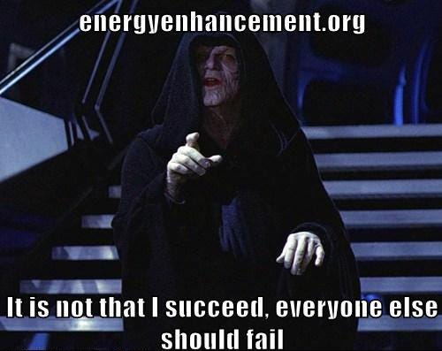

"Competition is a sin." - John D. Rockefeller - and now we know why!! - another re-telling of the thousands of years old Oligarchic, Satanic, "Policy of Poverty" which means Austerity for the peasants and destruction for the competition.

Police Protection for Authorised drug Dealers
In the same way that authorised drug dealers who pay off the Police in every City of the World. In the same way that the Police in every city are the Assassination Bureau for the Satanic Elite.
Drug Dealer competition is punished by the Police. All Drug Dealers who are just starting off, Competition to the thousands of Years Satanic Old Committee of 300 who have managed the Worldwide illegal drugs business forever, are reported to the police for prosecution or murder whilst the protected drug dealers are allowed to continue their business.
In the same way that the Sinaloa Cartel is run by the American Department of Justice. In the same way that Obama advisor, totalitarian Zbignew Brzezinsky said that for control, all crime must be run by the state. In this movie, Belfort is reported to the FBI as competition to the Satanic Elite of Goldman Sachs, UBS, The Bank of England, Barclays, Royal Bank of Scotland etc etc, is given a slap on the wrist and loses his license to work on Wall Street, the Old Slave market of New York - and is allowed to keep his ill-gotten gains.

The whole of Las Vegas built to launder Drug Profits!
It is also interesting that Scorsese made his bones with movies like, "Goodfellas", "The Departed" and "Casino" set in Las Vegas where we see money laundering of drug and pedophile, white slave, prostitution profits was called skimming at the Casinos where many people are paid to lose hundreds of thousands of dollars per day of drug money each in the Casinos and the money is then laundered.
We also see the same "Wolf of Wall Street" Narcissistic, Machiavellian, Psychopathic Satanic Culture of drugs and sex in both Gangster Mafia and Bankster Stockbrokers.
We have all seen the movie "Bugsy" produced by scion of the Rothschilds Warren Beatty blacklisted for "Bulworth" where we learn that Las Vegas was built by Bugsy Seigel and Meyer Lansky - Capo di Capi of all Mafias and head of the Jewish Mafia - in order to launder drug profits. And the people who are paid to go to Las Vegas statistically lose 2000 dollars each whereas they are given special offers, free food, free accommodation, and fantastic shows by the Worlds elite of artists in order to pack them in.

THE SATANIC CULTURE CONTINUES ON INTO RITUAL?
"Time Considered as a Helix of Semi-Precious Stones" is a science fiction short story by homosexual satanist Samuel R. Delany who wrote "Hogg". It won the Hugo Award for Best Short Story 1970, and the Nebula Award for Best Novelette in 1969 and it describes the life of any upwardly mobile criminal, like Belfort.
Belfort is still satanically addicted to drugs and sex having Black Magically been given and activated the sex and drug addiction blockages to degenerate him as a human being so as to do the will of the Satanic Megatrillionaire Rothschilds. He is now moving on into relationships with higher level Satanists and the next step is obviously Satanic Ritual - Sodomy Rituals, Blood Rituals, Pedophilia Rituals, Human Sacrifice Rituals, Castration Rituals…
Listening to youtube videos on Belmont we find he is now friends with Sir Richard Branston whose company parties - like Belmont's - are still legendary. He gives get rich quick talks on the same stage as satanic pedophile war criminal Lord Tony Bliar.
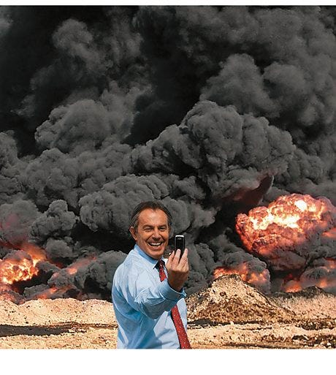
WAR CRIMINAL TONY BLIAR IN IRAQ - A WHOLE NEW LEVEL
"The point is this: the most effective means of curtailing dissent and creating a cautious conforming population isn’t the spying itself. It’s letting people know the spying, surveillance and censorship is happening all the time." People then censor themselves.
Because although he has moved out of Stock Broking he still actively searches other scams like pump and dump Bitcoin - who is behind Bitcoin? in order to increase his wealth.
Why was Belfort punished when all the Satanic, Ancient, too big to fail, too big to jail banks are not prosecuted after all these cases have been proven in court, derisory fines given, and no-one sent to jail?
WACHOVIA - 378 Billion Dollar Drug Money Laundering Scam
HSBC - The 200 Trillion Dollar HSBC Drug and Terrorist Money Laundering
LIBOR - The 200 Trillion Dollar LIBOR Fixing
FOREX - The 20,000 Trillion Dollar FOREIGN EXCHANGE, FOREX Fixing SCANDAL
GOLD MARKET FIXED Gold price rigging fears put investors on alert By Financial Times Reporter, Madison Marriage. - Global gold prices may have been manipulated on 50 per cent of occasions between January 2010 and December 2013 - always!! - according to analysis by Fideres, a consultancy. The findings come amid a probe by German and UK regulators into alleged manipulation of the gold price, which is set twice a day by Deutsche Bank, HSBC, Barclays, Bank of Nova Scotia and Société Générale in a process known as the “London gold fixing”.
Stock Market FIXED - Obama's Plunge Protection Team and computer trading
Genocidal Poverty though Inflation, Scare-City, Austerity over only 36 Trillions of Debts to Private Federal Reserve Banks.
All a matter of Record..
Wachovia, now part of the giant Wells Fargo laundered billions from Mexico's murderous drug gangs
On 10 April 2006, a DC-9 jet landed in the port city of Ciudad del Carmen, on the Gulf of Mexico, as the sun was setting. Mexican soldiers, waiting to intercept it, found 128 cases packed with 5.7 tons of cocaine, valued at $100m. But something else – more important and far-reaching – was discovered in the paper trail behind the purchase of the plane by the Sinaloa narco-trafficking cartel.
During a 22-month investigation by agents from the US Drug Enforcement Administration, the Internal Revenue Service and others, it emerged that the cocaine smugglers had bought the plane with money they had laundered through one of the biggest banks in the United States: Wachovia, now part of the giant Wells Fargo.
Of special significance was that the period concerned began in 2004, which coincided with the first escalation of violence along the US-Mexico border that ignited the current drugs war in which 70,000 people have been killed - more than the American soldiers who died in Vietnam, although 3.5 million Vietnamese did die too.
"For the time period of 1 May 2004 through 31 May 2007, Wachovia processed at least $$373.6bn in CDCs, $4.7bn in bulk cash" – a total of more than $378.3bn.
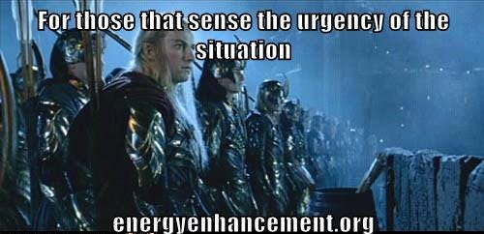
The deferred prosecution is part of this "cop-out all round", he says. "The regulatory authorities do not have to spend any more time on it, and they don't have to push it as far as a criminal trial. They just issue criminal proceedings, and settle. The law enforcement people do what they are supposed to do, but what's the point? All those people dealing with all that money from drug-trafficking and murder, and no one goes to jail?"

The 200 Trillion Dollar HSBC Money Laundering
HSBC Report Should Result in Prosecutions, Not Just Fines, Say Critics
British Aristocrat, "Member of the Club" - "It's a big Club, but you ain't in it!" - Lord Green, Head of HSBC during this period of the emergence of trillions of Dollars of Money Laundering has since been made a special advisor to Cameron's British Government.
For at least half a decade, the storied British colonial banking power helped to wash hundreds of millions of dollars for drug mobs, including Mexico's Sinaloa drug cartel, suspected in SEVENTY thousands of murders just in the past 10 years – people so totally evil, jokes former New York Attorney General Eliot Spitzer, that "they make the guys on Wall Street look good."
The bank also moved money for organizations linked to Al Qaeda and Hezbollah, and for Russian gangsters; helped countries like Iran, the Sudan and North Korea evade sanctions; and, in between helping murderers and terrorists and rogue states, aided countless common tax cheats in hiding their cash.
"They violated every goddamn law in the book," says Jack Blum, an attorney and former Senate investigator who headed a major bribery investigation against Lockheed in the 1970s that led to the passage of the Foreign Corrupt Practices Act. "They took every imaginable form of illegal and illicit business."
That nobody from the bank went to jail or paid a dollar in individual fines is nothing new in this era of financial crisis. What is different about this settlement is that the Justice Department, for the first time, admitted why it decided to go soft on this particular kind of criminal. It was worried that anything more than a wrist slap for HSBC might undermine the world economy.
"Had the U.S. authorities decided to press criminal charges," said Assistant Attorney General Lanny Breuer at a press conference to announce the settlement, "HSBC would almost certainly have lost its banking license in the U.S., the future of the institution would have been under threat and the entire banking system would have been destabilized."
It was the dawn of a new era. In the years just after 9/11, even being breathed on by a suspected terrorist could land you in extralegal detention for the rest of your life. But now, when you're Too Big to Jail, you can cop to laundering terrorist cash and violating the Trading With the Enemy Act, and not only will you not be prosecuted for it, but the government will go out of its way to make sure you won't lose your license. Some on the Hill put it to me this way: OK, fine, no jail time, but they can't even pull their charter? Are you kidding?
Also known as the Hong Kong and Shanghai Banking Corporation, British HSBC has always been associated with drugs. Founded in 1865, HSBC became the major commercial bank in colonial China after the conclusion of the Second Opium War.
If you're rusty in your history of Britain's various wars of Imperial Rape, the Second Opium War was the one where Britain and other European powers basically slaughtered lots of Chinese people until they agreed to legalize the dope trade (much like they had done in the First Opium War, which ended in 1842).
A century and a half later, it appears not much has changed. With its strong on-the-ground presence in many of the various ex-colonial territories in Asia and Africa, and its rich history of cross-cultural moral flexibility, HSBC has a very different international footprint than other Too Big to Fail banks like Wells Fargo or Bank of America. While the American banking behemoths mainly gorged themselves on the toxic residential-mortgage trade that caused the 2008 financial bubble, HSBC took a slightly different path, turning itself into the destination bank for domestic and international scoundrels of every possible persuasion.
Three-time losers doing life in California prisons for street felonies might be surprised to learn that the no-jail settlement Lanny Breuer worked out for HSBC was already the bank's third strike. In fact, as a mortifying 334-page report issued by the Senate Permanent Subcommittee on Investigations last summer made plain, HSBC ignored a truly awesome quantity of official warnings.
In April 2003, with 9/11 still fresh in the minds of American regulators, the Federal Reserve sent HSBC's American subsidiary a cease-and-desist letter, ordering it to clean up its act and make a better effort to keep criminals and terrorists from opening accounts at its bank.
One of the bank's bigger customers, for instance, was Saudi Arabia's Al Rajhi bank, which had been linked by the CIA and other government agencies to terrorism.
According to a document cited in a Senate report, one of the bank's founders, Sulaiman bin Abdul Aziz Al Rajhi, was among 20 early financiers of Al Qaeda, a member of what Osama bin Laden himself apparently called the "Golden Chain."
In 2003, the CIA wrote a confidential report about the bank, describing Al Rajhi as a "conduit for extremist finance." In the report, details of which leaked to the public by 2007, the agency noted that Sulaiman Al Rajhi consciously worked to help Islamic "charities" hide their true nature, ordering the bank's board to "explore financial instruments that would allow the bank's charitable contributions to avoid official Saudi scrutiny." (The bank has denied any role in financing extremists.)
For more than half a decade, a whopping $19 billion in transactions involving Iran went through the American financial system, with the Iranian connection kept hidden in 75 to 90 percent of those transactions.
HSBC has been headquartered in England for more than two decades – it's Europe's largest bank, in fact – but it has major subsidiary operations in every corner of the world. What's come out in this investigation is that the chiefs in the parent company often knew about shady transactions when the regional subsidiary did not.
By that time, numerous agencies, including the Department of Homeland Security, had crawled all the way up HSBC's backside, among other things examining it as part of a major international narcotics investigation. In one four-year period between 2006 and 2009, an astonishing $200 trillion in wire transfers (including from high-risk countries like Mexico) went through without any monitoring at all.

The 200 Trillion Dollar LIBOR Fixing
The so-called LIBOR scandal, which is at the heart of the UBS settlement, makes Enron look like a parking violation. Many of the world's biggest banks, including Switzerland's UBS, Britain's Barclays and the Royal Bank of Scotland, got together and secretly conspired to manipulate the London Interbank Offered Rate, or LIBOR, which measures the rate at which banks lend to each other. Many, if not most, interest rates are pegged to LIBOR. The prices of hundreds of trillions of dollars of financial products are tied to LIBOR, everything from commercial loans to credit cards to mortgages to municipal bonds to swaps and currencies.
If you can imagine executives at Ford, GM, Mitsubishi, BMW and Mercedes getting together every morning to fix the prices of aluminum and stainless steel, you have a rough idea of what the LIBOR scandal is like, except that in the car-company analogy, you'd be dealing with absurdly smaller numbers.
These are the world's biggest banks getting together every morning to essentially fix the price of money. Low LIBOR rates are an indicator that banks are strong and healthy. These banks were faking the results of their daily physicals. In banking terms, they were juicing.
But the Justice Department wasn't finished handing out Christmas goodies. A little over a week later, Assistant Attorney General Lanny Breuer was back in front of the press, giving a cushy deal to another huge international firm, the Swiss bank UBS, which had just admitted to a key role in perhaps the biggest antitrust/price-fixing case in history, the so-called LIBOR scandal, a massive interest-raterigging conspiracy involving hundreds of trillions ("trillions," with a "t") of dollars in financial products. While two minor players did face charges, Breuer and the Justice Department worried aloud about global stability as they explained why no criminal charges were being filed against the parent company.
Also known as the Hong Kong and Shanghai Banking Corporation, British HSBC has always been associated with drugs. Founded in 1865, HSBC became the major commercial bank in colonial China after the conclusion of the Second Opium War. If you're rusty in your history of Britain's various wars of Imperial Rape, the Second Opium War was the one where Britain and other European powers basically slaughtered lots of Chinese people until they agreed to legalize the dope trade (much like they had done in the First Opium War, which ended in 1842) of bringing colonial Indian Opium on British Lord's Satanic Dynastic Family clippers into China.

The 20,000 Trillion Dollar FOREIGN EXCHANGE, FOREX, SCANDAL
The Forex scandal (also known as the forex probe) is a financial scandal that involves the revelation, and subsequent investigation, that the world's largest currency trading banks colluded for at least a decade to manipulate and rig the daily foreign exchange rates for at least 20,000 Trillions of Dollars.
Market regulators in Asia, Switzerland, the United Kingdom, and the United States began to investigate the $2000 trillion-a-year foreign-exchange market after Bloomberg News reported in June 2013 that currency dealers said they had been front-running client orders and rigging the foreign exchange benchmark WM/Reuters rates by colluding with counterparts and pushing through trades before and during the 60-second windows when the benchmark rates are set. The behavior occurred daily in the spot foreign-exchange market and went on for at least a decade according to currency traders.
At the center of the investigation are the transcripts of electronic chatrooms in which senior currency traders discussed with their competitors at other banks the types and volume of the trades they planned to place. The electronic chatrooms had names such as “The Cartel,” “The Bandits’ Club,” “One Team, One Dream” and “The Mafia”. The discussions in the chatrooms were interspersed with jokes about manipulating the forex market and repeated satanic culture references to alcohol, drugs, Sex and women.
Regulators are particularly focusing in on one small exclusive chatroom which was variously called the The Cartel or The Mafia. The chatroom was used by some of the most influential traders in London and membership in the chatroom was highly sought after.
Among The Cartel's members were Richard Usher, a former Royal Bank of Scotland (RBS) senior trader who went to JPMorgan as head of spot foreign exchange trading in 2010, Rohan Ramchandani, Citigroup’s head of European spot trading, Matt Gardiner, who joined Standard Chartered after working at UBS and Barclays, and Chris Ashton, head of voice spot trading at Barclays.
Two of these senior traders, Richard Usher and Rohan Ramchandani, are members of the 13-member Bank of England Joint Standing Committee's chief dealers group.
At least 15 banks including Barclays, HSBC, and Goldman Sachs disclosed investigations by regulators. Barclays, Citigroup, and JPMorgan Chase all suspended or placed on leave senior currency traders. Deutsche Bank, continental Europe’s largest lender, was also cooperating with requests for information from regulators. Barclays, Citigroup, Deutche Bank, HSBC, JPMorgan Chase, Lloyds, RBS, Standard Chartered, and UBS as of February 2014 had suspended, placed on leave, or fired 21 traders. Citigroup had also fired its head of European spot foreign exchange trading, Rohan Ramchandani, who was a member of the 13-member Bank of England Joint Standing Committee's chief dealers group. Reuters reported hundreds of traders around the world could be implicated in the scandal.
(Reuters) - March 2014 - Bank of England (BoE) Governor Mark Carney faces a grilling from UK lawmakers on Tuesday about what Bank officials knew about allegations that currency traders colluded to manipulate key exchange rates in the 2000 Trillions of dollars Per year Forex business.
The unfolding scandal has so far seen more than 20 traders placed on leave, suspended or fired by some of the world's biggest banks.
THE 40 TRILLION DOLLAR HEIST THAT WAS THE MORTGAGE BLOWUP OF 2008 AND THE BAIL OUT



It has been reported by Catherine Austin Fitts that there were many multiples of mortgages sold than there were houses in the United States.
Catherine Austin Fitts served as managing director and member of the board of directors of the Wall Street investment bank Dillon, Read & Co. Inc., as Assistant Secretary of Housing and Federal Housing Commissioner at the United States Department of Housing and Urban Development in the first Bush Administration, and was the president of Hamilton Securities Group, Inc., an investment bank and financial software developer.
This was done with a collaboration between Government and Mortgage companies.
It was prepared for by Bill Clinton's removal of Glass Steagal for the repackaging of the Mortgages as derivatives.
Banks bought the Derivative repackaged Mortgages on houses that didn't exist and in the Bail out of 1500 Billions then Quanitative Easing of 120 Billions a month for many years was spent by the government in the form of bonds owed by the public to buy back these none existent mortgages.
In this way, says Catherine, 40 Trillions of dollars were removed - stolen - from the United States and paid for by the people.
This is a little more than normal but the same stealing principle has been used ever since banks came into existance 10,000 years ago!!
Vastly inflated contracts are given to companies by politicians.
A corrupt kickback is given to the politician and the companies get well paid.
Business as usual.

THE SATANIC SPECIES ARE LOWER MANAGEMENT TRADERS AND POLITICIANS
who are given money and power. Politicians and Stockbrokers are introduced into Satanism through the Company Cultures of Black Magic Addiction Blockages of Sex and Drugs which start the degeneration process towards Narcissistic, Machiavellian, Psychopathy.
The Wolf of Wall Street shows how all the banks promote the Black Magic Satanic culture of sex, drugs and lying to sell, and hatred of the client in order to create the Narcissistic, Machiavellian, Psychopathic mindset so necessary to rape and pillage.
The Satanic Species has been at war against the Human species for over 10,000 years, using the Policy of Poverty to maintain control..
Since Babylon, Satanic 2000 Trillion Dollar Phoenician Mega Trillionaire Generational Dynastic families have created Myths and Black Magic Pagan Satanic Religions to control their Human Herd.
They created all religions to Mind Control Humanity.. Lucifer, Satan, Mithra, Sofia, Apollo, Set, Isis, Osiris, Horus, Marduk, Gnostics.
“We will of course not let them know about Wotan [Odin].” –Reichsminister Paul Josef Goebbels-
Himmler told his SS Army that the Valkyries of Wotan will choose only those who die in battle to go to Heaven..
Psychically they use implant addiction blockages to Addict all Humanity to porn, masturbation, sex, drugs and Rock and Roll - Hip Hop, to degenerate humanity and recruit new Narcissistic, Machiavellian, Psychopathic cadre.
Whilst all the essential Meditation techniques - The Kundalini Key, Energy Blockage Removal - are removed from Traditional Meditations, Ancient Black Magic Technology of the Luciferian and Satanic religions use RITUAL. Ritual Drugs, Sex, Polyamory, homosexual, pedophile Ritual. Murderous Human and Animal Sacrifice Ritual.
The Ancient Psychic Science of Black Magic - the Creation of Implant Drug and Sex Addiction Energy Blockages - is an Ancient Technology which although is scientific, appears like Magic to those which have never been taught Energy Enhancement Meditation…

“Any sufficiently advanced technology is indistinguishable from magic.”
― Pedophile Aristocrat Arthur C. Clarke,
They are Genetically bred in Satanic 2000 Trillion Dollar Phoenician Mega Trillionaire families over thousands of years for psychopathy.
They are Trained - Mind Controlled from birth - for Rape, Pillage, War, Religion, Banking, Money Laundering, Slave Trading and Drug Running.
Satanists create all political parties. Marx worked for the British Secret Service.
After Democrats and Republicans, Libertarianism is next.

AUSTRIAN ECONOMICS MISES AND VON HAYEK
Long tonged liars like Nelson Rockefeller funds Von Mises and Von Hayek to create Genocidal Austrian Economics - THE POLICY OF POVERTY WORLDWIDE!! Austria where Satanic Fascist Hitler came from. Austrian Economics creates Austerity Worldwide.
https://www.energyenhancement.org/Satanic-Von-Hayek-The-creation-of-Feudalism-with-Austrian-Economic-Austerity-Fascism-Didn't-Die-With-Hitler.htm
Libertarian Satanic Ron and Rand Paul and their minion Alex Jones support Austrian Economics and the genocidal elimination of food stamps in this recession. They want you to use the guns so they can kill you - just another cull of humanity.
280 millions of the most intelligent and beautiful people tortured and killed in the 20th century by Government - Sacrifices for Satan!!

THE ONLY SOLUTION IS ENERGY ENHANCEMENT EVOLUTION!!
They seek to find Initiates into their satanic secret societies represented by Lord Tony Bliar and Sir Richard Branston where they Ritually degenerate themselves and further and further degenerate themselves in order to maintain their energy which at every stage is vampiristically harvested by the Luciferian Watchtower elite who live outside the body.

These Satanists are victims of a religion which believes in human sacrifice.
Lives for Satan through War, Soft kill pollution in air, water and food, Eugenocide, genocide, Stalin, Hitler, Mao. 280 millions of people murdered by Governments in the 20th century. And more projected for the 21st if the already written plans to sacrifice 7 billion people - to protect the earth!! - are put into operation.
So these guys, - Satanists - are quite mad.
They Want War.
They want Death.
They want to kill YOU!!


Tont Blair and Satanist Jimmy Savile

Satanism is not "just another nutty occult fad." It has been the, "Old Religion" since the beginning of time.
The mind of the Satanist is pure evil; the Satanist is a former person who has been transformed by Black Magic Implant Blockages into something no longer human.
It begins like drug-addiction; the prospective recruit to Satanism "gets into something" on a playful impulse, but then finds himself or herself gripped by compulsions - through psychic implantation of addiction energy blockages - which he or she can no longer control.
Drugs and other special circumstances may be significant collateral features of the initiation, but not necessarily. The key is "letting oneself go," into the depths of acting-out impulses which combine sexual impulses and rage as a unity, and expressing this form of "pleasure" in the form of an act which violates an important precept of one's own conscience.
This perversion through acts which violate an important precept of one's own conscience, from sex parties to ritual sex to homosexual ritual to torture to pederasty to animal then human sacrifice, this corruption occurs through the implantation of energy blockages into the heart center to remove empathy and blockages above the head to remove energy flowing in from God from the chakras above the head to remove conscience - the definition of a The Ancient Psychic Science of Black Magic - the Creation of Implant Drug and Sex Addiction Energy Blockages - is an Ancient Technology which although is scientific, appears like Magic to those which have never been taught Energy Enhancement Meditation…

“Any sufficiently advanced technology is indistinguishable from magic.”
― Pedophile Aristocrat Arthur C. Clarke,..
The removal of empathy. There is a Satanic Black Magic Ritual where 12 psychic daggers - psychic created energy blockages - are implanted around the heart center. A sacrifice is performed and the heart removed from the sacrifice and put into a canopic jar. The energy of the heart removed from the dagger implanted heart and put into the canopic jar together with the heart removed from the sacrifice. The canopic jar is then placed in the earth in a Heart Site, somewhere in the country.
Similarly with the child sacrifice at the Bohemian Grove Ritual, "The Cremation of Care" burning up of empathy to Molech where a child is burnt alive in front of a 40ft Statue of an Owl dedicated to Minerva and Molech in front of Presidents, Prime Ministers, Captains of Industry and the Media.

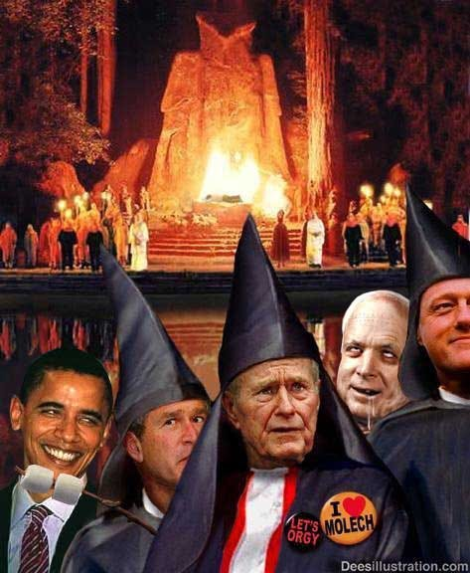

In the same way that British Satanic Secret Service controlled Saudi Arabian Wahabist and Salfist Sects create armies to attack and destabilise (911, Libya, Syria),
Black Magic is also a created myth, a methodology for the creation of a psychopathic army to rule and then destroy civilisation at the behest of the Real Rulers.
The Ancient Enemy who counts meditation and the mind control psychic arts as one of its main planks of World Domination has used Infil-Traitors for 10,000 years in every Organisation - Religion, Dynastic Families, Politics, Geopolitics, Economics, Universities, Intelligence Services, Think Tanks, Banking, International Companies, Eugenics - Worldwide, censoring Alchemical VITRIOL, the Kundalini Key and Energy Blockage Removal from every Meditation Program..
Yet throughout history from the time of the Old Religion of Satanic Babylon, Pagan, Satanic, Luciferian Generational Families have controlled Humanity through Myth, Money, Mind Control Propaganda, Slavery, Drugs and Sex.
From Babylon to the Slave Trading, Drug Running Empires; The Roman Empire, Venetian Empire, British Empire, Anglo-American Empire Satanic Generational Families have infil-traitored every Government, every Politician, Every Ministry, every International Company, every Bank, every University, every Think Tank, every Secret Society.
Satanic Psychopathic Religions and Myths (The Ten Myths which control the World) have been specifically created to maintain the Generational Family control of society. To exacerbate Implant addiction blockages of sex, drugs and rock and roll through Pagan Satanic sex, drugs and music in order to divert, pervert and degenerate humanity in order to rule them. More than anything, to keep Humanity Austere; Poor barefoot and back on the reservation and away from the Meditational Superpowers which alone can free Humanity from their chains.
It is symbolised by the Black Magician, Necromancer, "Sauron" Of, "The All Seeing Eye" like the NSA SNOWDEN PRISM - "Lidless, Wreathed in Flame" of Tolkien's, "Lord of the Rings" who lives outside the body and waits to return into physical life with the help of the power of the One Ring.
Sauron, like Lucifer, thinks he knows better than God. His aim is to pervert and degrade humanity into Orcs and Rule the World Totalitarian style, FOREVER!!

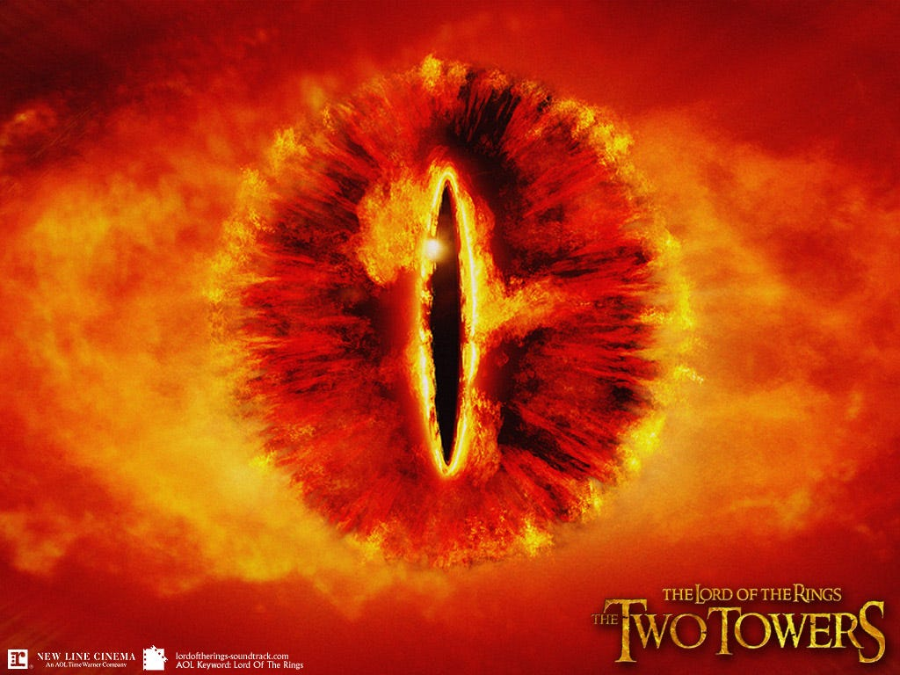

THE LUCIFERIAN SPECIES
are humans who have meditated and learned, perhaps many, many tens of thousands of years ago, how to cut off from god by using energy blockages to block chakras above the head so they can live outside the body in private universes - so they seem like psychopathic aliens to us - then they download into their mind weakened sons - throwing their sons out - on their 21st birthday so as to become the Head of their Baron, Lord or Crown families and control their multi trillion dollar, thousands of years old families wealth, to manage the human herd.
They use the, "Policy of Poverty" or Austerity to control the human herd for tens of thousands of years. Because they live outside the body and only want to vampirise human spiritual energies in order to live forever they will consider any solution to problems. See for example movie Dr Strangelove where upon exploding Fusion Bombs and making the Earth uninhabitable for hundreds of years they are eager to live down in mines to survive.
To further continue the "Policy of Poverty" To stop human evolution, so that the Satanists can continue to control an impoverished humanity. To the degree that probably 100 Million people might be lucky to survive—or unlucky enough to survive under those conditions as explained in Kubrick's "Dr Strangelove".



PETER SELLERS AS KUBRICK'S DR STRANGELOVE
Satchidanand's Review of - Existentialism and Kubrick's Satanic Psychopaths, in the Movies of Stanley Kubrick https://www.energyenhancement.org/Psychopath_Kubrick_Film_Movie.htm



THE FAILURE OF INTELLIGENT LOGICAL COMMENTATORS TO UNDERSTAND THE TRUE SATANIC LUCIFERIAN NATURE
https://energyenhancement.org/THE-LONE-RANGER-ESOTERIC-MOVIE-REVIEW-BY-SATCHIDANAND.htm
The whole process here, look at it. What is the nature of this satanic hatred against human beings? What's the expression of that? It's the Satanic Green policy which directs people back to living in caves. This was done by the Satanic Roman Empire and others, as the, "Policy of Poverty" to reduce the population; that is, to have a small Satanic oligarchy which dominates the planet, or parts of the planet, and kill off the "excess" population, which is the rest of the people. This is what the Satanic Elite's policy is, and that is what she says it is.

CONTROL.
Depending how many chakras above the head they block off, the more power they have. They need a lot of energy as they receive no energy from God, so they have learned how to create Implant addiction energy blockages for drugs, sex, and rock and roll so as to parasitise, vampirise their slave populations and create their satanic psychopathic managers.
Everyone is implanted with every Addiction Blockage Implant from birth like having diseases, but depending how much we enter into the path of the disease there are many stages of that disease whose end is Psychopathy.
With the Sexual Addiction Implant Blockage the Energy from every orgasm is channeled back to the Luciferians through energy connections from their Sex Addiction Implants.
The Luciferians or their minions send out energy every morning to raise the salute of the penis, around the horn, a proud tumescence in every red blooded man to promote masturbation or initiate sex and they vampirise the energy of every orgasm. The prostitution, white slave and pedophile industry is traditionally under their control.
Drugs and sex burn the candle at both ends and the energy of that charging candle is sent back from the Implant Addiction Blockage through energy connections to the Luciferians. They traditionally, through the Committee of 300 (see Coleman) and the Pharma Companies, own the legal and Illegal Trillion Dollar Drug industries. They pay politicians to keep drugs illegal so as to make more profit. They conquer countries in order to grow more drugs - Afghanistan from growing no opium with the Taliban who placed a Fatwa on its cultivation, now supplies 90% of the World's opium to the Bush crime family.
Although they promise to tell their higher managers like the Rockefellers how to become immortal like them, they never do. So they promise Transhumanism.. Ray Kurzweil and Robert Heinlein (Heinlein, like Elron Hubbard and Campbell were Agents of American Naval Intelligence charged with implanting the memes of Science Fiction, satanic free love - "Stranger in a Strange Land" and drugs into the noosphere) are their propagandists here. Satanic Free love, Immortal medical care, perfect genetics, cyborg brain chip enhancements, upload into the machine so as to live forever. THEY LIE!!
Intelligent commentators are presently more and more commenting on the coming Third World War flashpoints which are recklessly occurring in the Middle east, Syria and now in the Ukraine and they can not believe just how MAD the foreign policy is. They can not Believe the risks of starting World War Three which they are taking - only possible if Biden, Obama, Putin and XI are totally controlled by the satanic Mega Trillionaire elite...

BOHEMIAN GROVE - THE GROVERS
One commentator below laughs at the total idiocy of their foreign policy actions but also with the tension of the contemplation of the risks of Thermonuclear War and the Extinction of the Human Race which that represents.
They point out historical precedent between now and the False Flag starts of fake World Wars One and Two.
They point out the historical precedents between the founding and funding of Hitlers Nazi, National Socialist, Fascist State, the founding and funding of Lenin's and Stalin's Totalitarian Communist, Collectivist Soviet and what is happening now with the National Stazi Agency NSA and Snowden's Big Brother is watching you in USA and Europe.
A Thousand Year Reich of control, transhumanism, eugenics, genetic engineering, merging with the machine, living forever.. Covering all the World in Darkness..
Because this commentator does not understand Satanism and its infiltration into the highest levels of power.
Because this commentator has a rational mind he can not believe that other people in power are not rational - That they are MAD, PSYCHOPATHIC, LIVES FOR SATAN, SATANISTS!!

THE SOLUTION? - THE ENERGY ENHANCEMENT COURSE BY STREAMING VIDEO OR LIVE IN BRAZIL, INDIA, WORLDWIDE!!



Share
Leave a comment
The removal of the Heads of the Thirteen Satanic Families - not by assassination - as they can move from body to body - but as in the removal of Energy Blockages in the Energy Enhancement removal of Blockages.
Also information, the teaching of Wolf-Child Humanity in real Science and History as well as the Science of Meditation - Kundalini Kriyas, VITRIOL, Samadhi, Samyama, the removal of Energy Blockages, Implant Blockages, Energy Connections and Cords.

The solution?

THERE IS NO PHYSICAL SOLUTION AS OVER 10,000 YEARS OF RAPE AND PILLAGE WILL SHOW YOU!!

Solution? - The Science of Meditation - Which will increase the only thing you can take with you - Lifetime to Lifetime - when you die..

THE ONLY SOLUTION IS EVOLUTION!!
With the Energy Enhancement Kundalini Kriyas, VITRIOL, Samadhi, Samyama, the removal of Energy Blockages, Implant Blockages, Energy Connections and Cords.

ENERGY ENHANCEMENT IS THE ULTIMATE TECHNIQUE OF EVOLUTION!!
Just by meditation and energy blockage removal, you can find the truth for yourself, increase your energy, access incredible quantities of Kundalini Energy, become Enlightened.
And that's the only way, I think, you can actually make a practical, actually practical indication of how we might be able to save humanity from its degenerate Satanic predators.

ENERGY ENHANCEMENT - THE ULTIMATE MEDITATION COURSE!!

GET YOUR ENERGY ENHANCEMENT VIDEO OR LIVE COURSE NOW!!



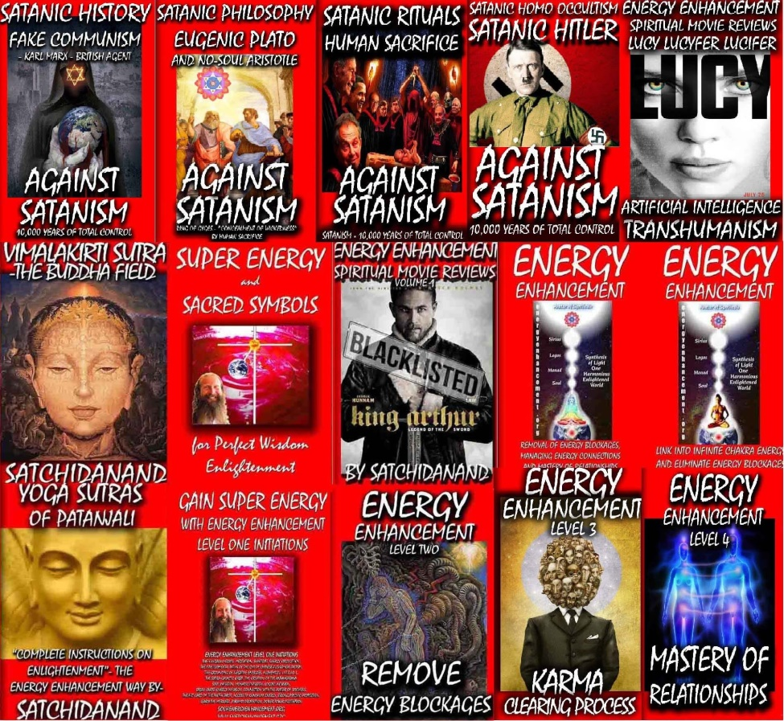
The Energy Enhancement Streaming Video Meditation Course and the Volumes of the Against Satanism Series by Satchidanand

Go to http://www.energyenhancement.org
for 52 Free –On Sign-Up - Energy Enhancement Books and Energy Enhancement Against Satanism Books.
To defeat Evil, you need to up your game. Learn the Energy Enhancement Meditation Course by Video or Live at Iguazu falls with Satchidanand and Devi Dhyani.


T

Change the World...


Go to http://www.energyenhancement.org
for 52 Free Energy Enhancement Books.

To defeat Evil, you need to up your game. Learn the Energy Enhancement Meditation Course by Video or Live in Iguazu.
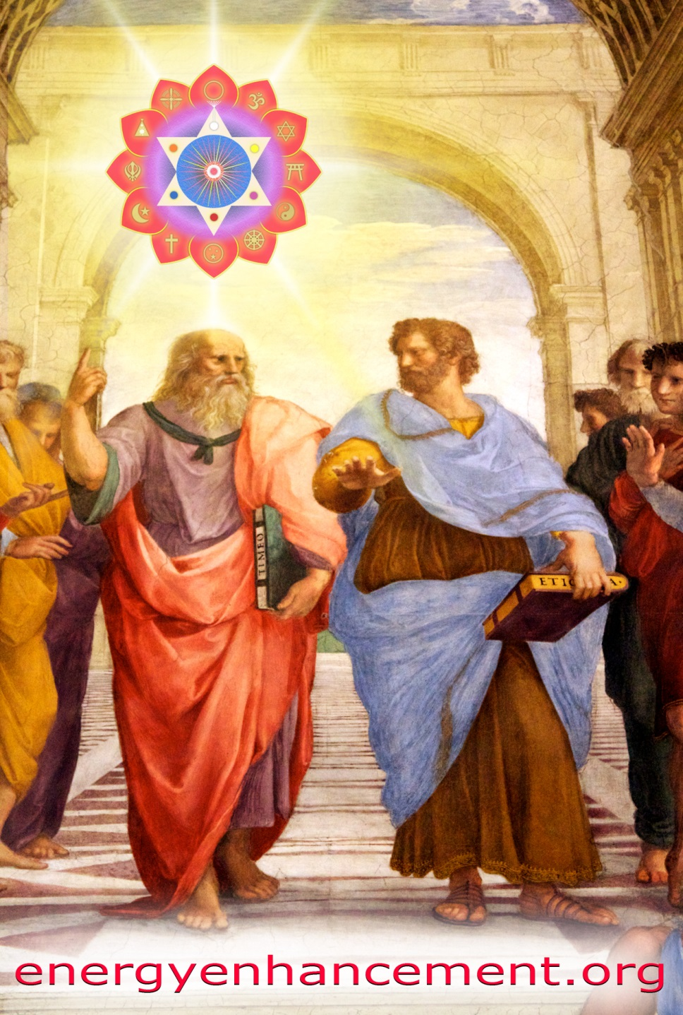

PLATO AND SATANIC BABYLONIAN SECRET AGENT ARISTOTLE "THE POISONER" OF ALEXANDER THE GREAT - BY RAPHAEL




ENERGY ENHANCEMENT MEDITATION
ENERGY ENHANCEMENT MEDITATION LEVEL 1 POWER UP!! GAIN SUPER ENERGY http://www.energyenhancement.org/Level1.htm
ENERGY ENHANCEMENT MEDITATION LEVEL 2 ELIMINATE ENERGY BLOCKAGES http://www.energyenhancement.org/Level2.htm
ENERGY ENHANCEMENT MEDITATION LEVEL 3 CLEAN KARMA BLOCKAGES AND PAST LIFE KARMA BY TRANSMUTATION http://www.energyenhancement.org/Level3.htm
ENERGY ENHANCEMENT MEDITATION LEVEL 4 MASTER ENERGY CONNECTIONS AND RELATIONSHIPS http://www.energyenhancement.org/Level4.htm

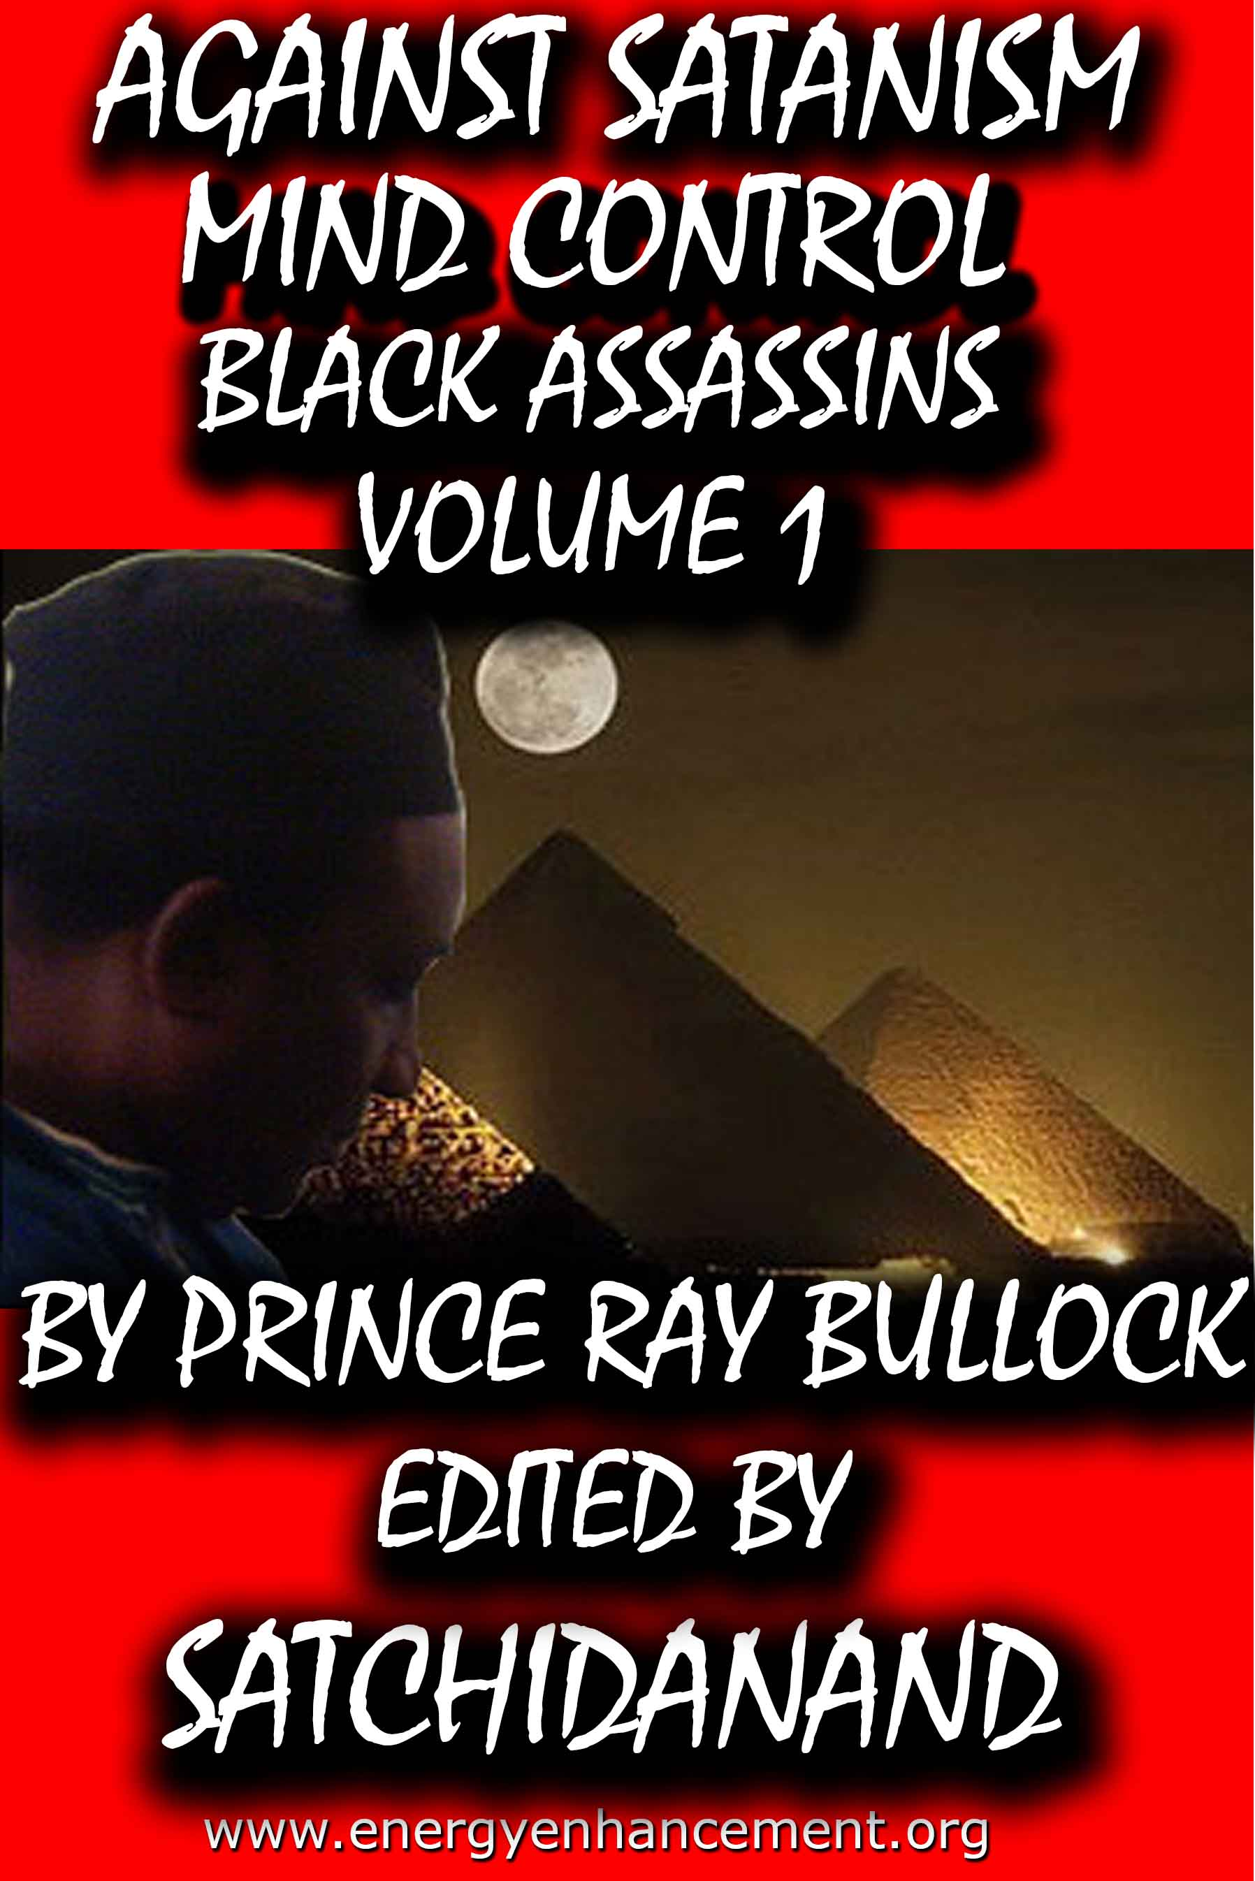

MIND CONTROL BLACK ASSASSINS VOLUMES FREE!!

AGAINST SATANISM VOLUMES FREE!!

- ON SIGN-UP AT..

energyenhancement.org

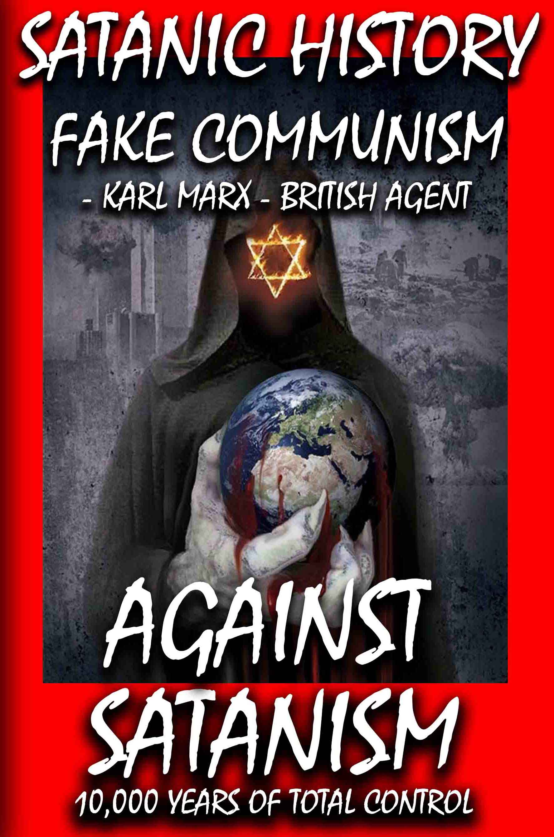

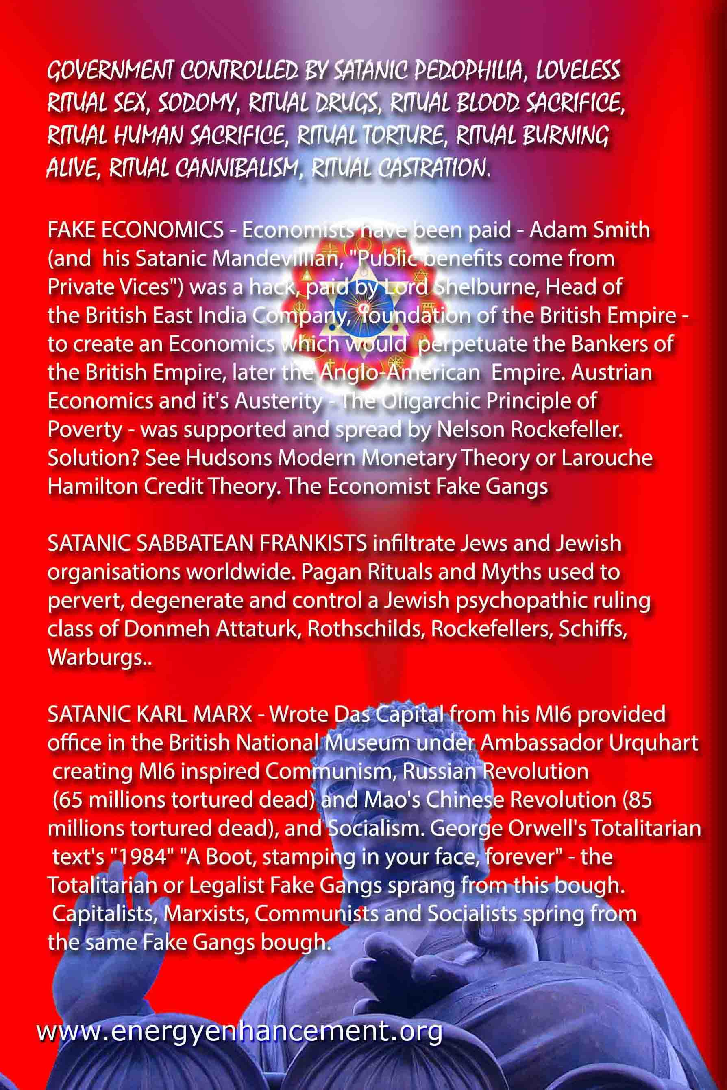

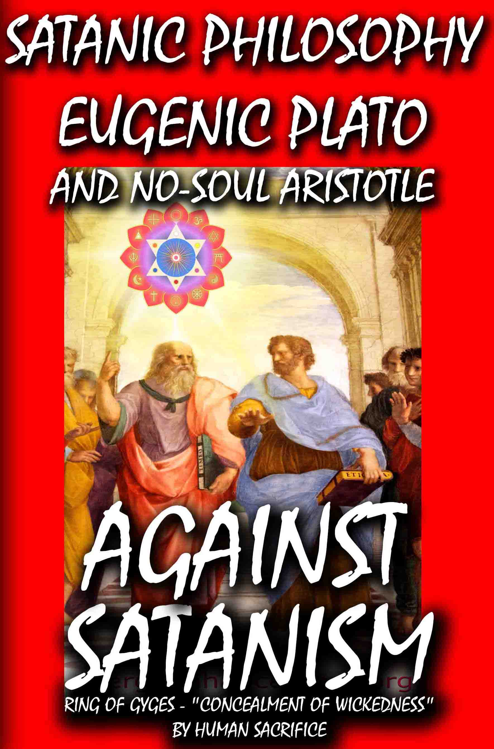

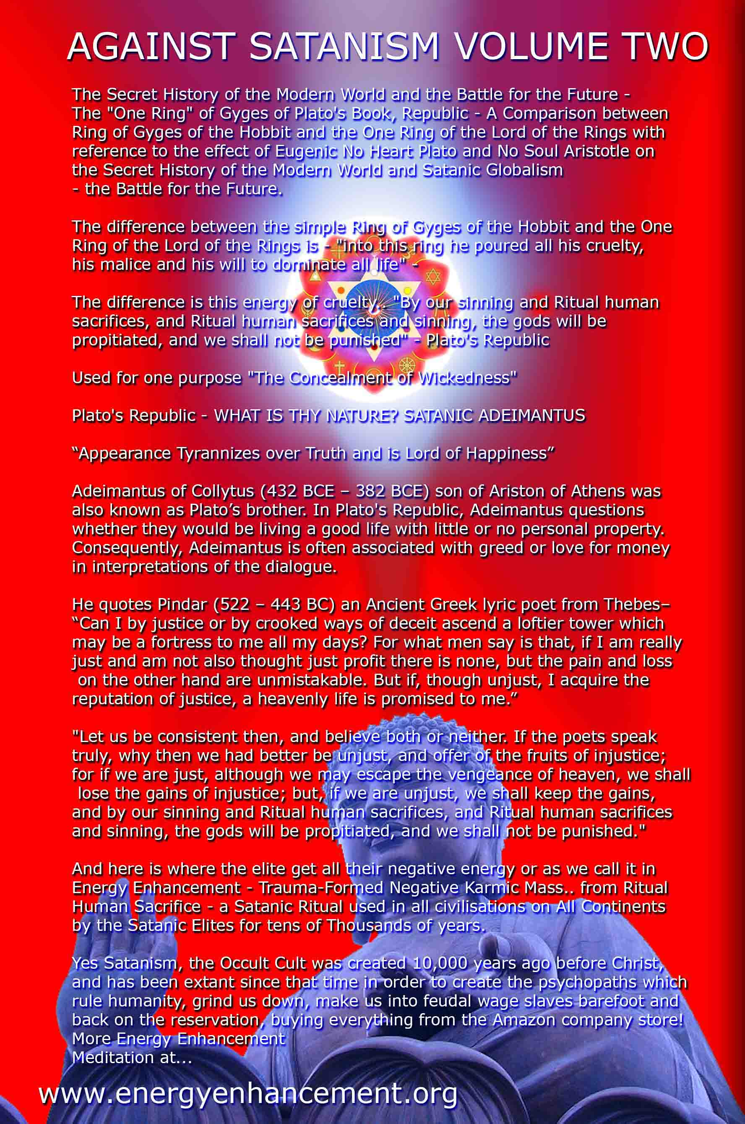

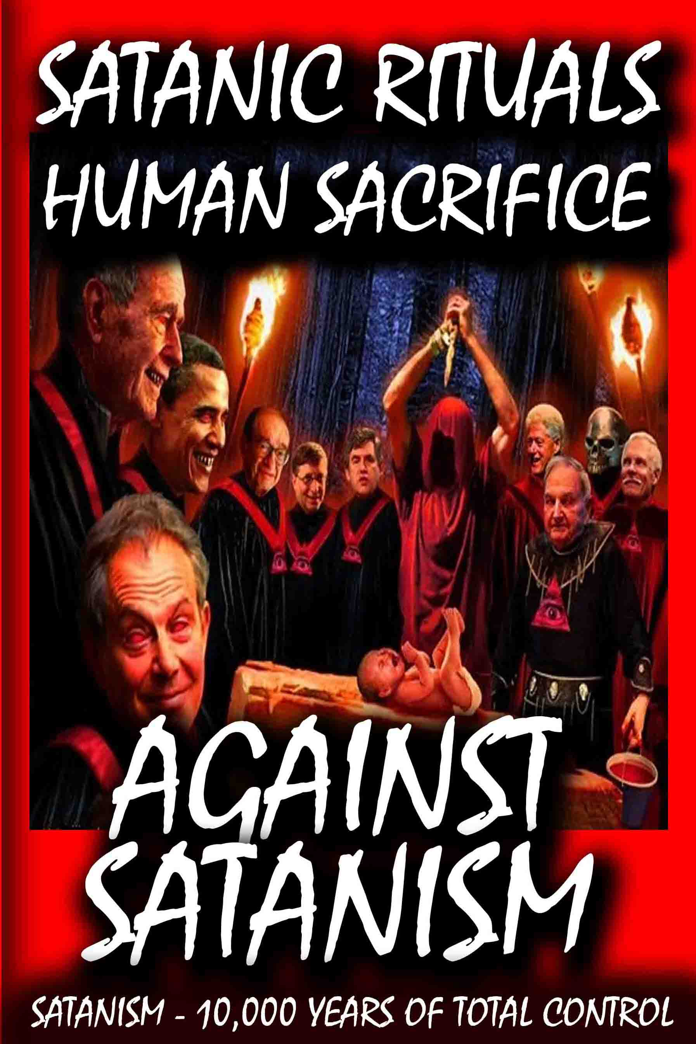

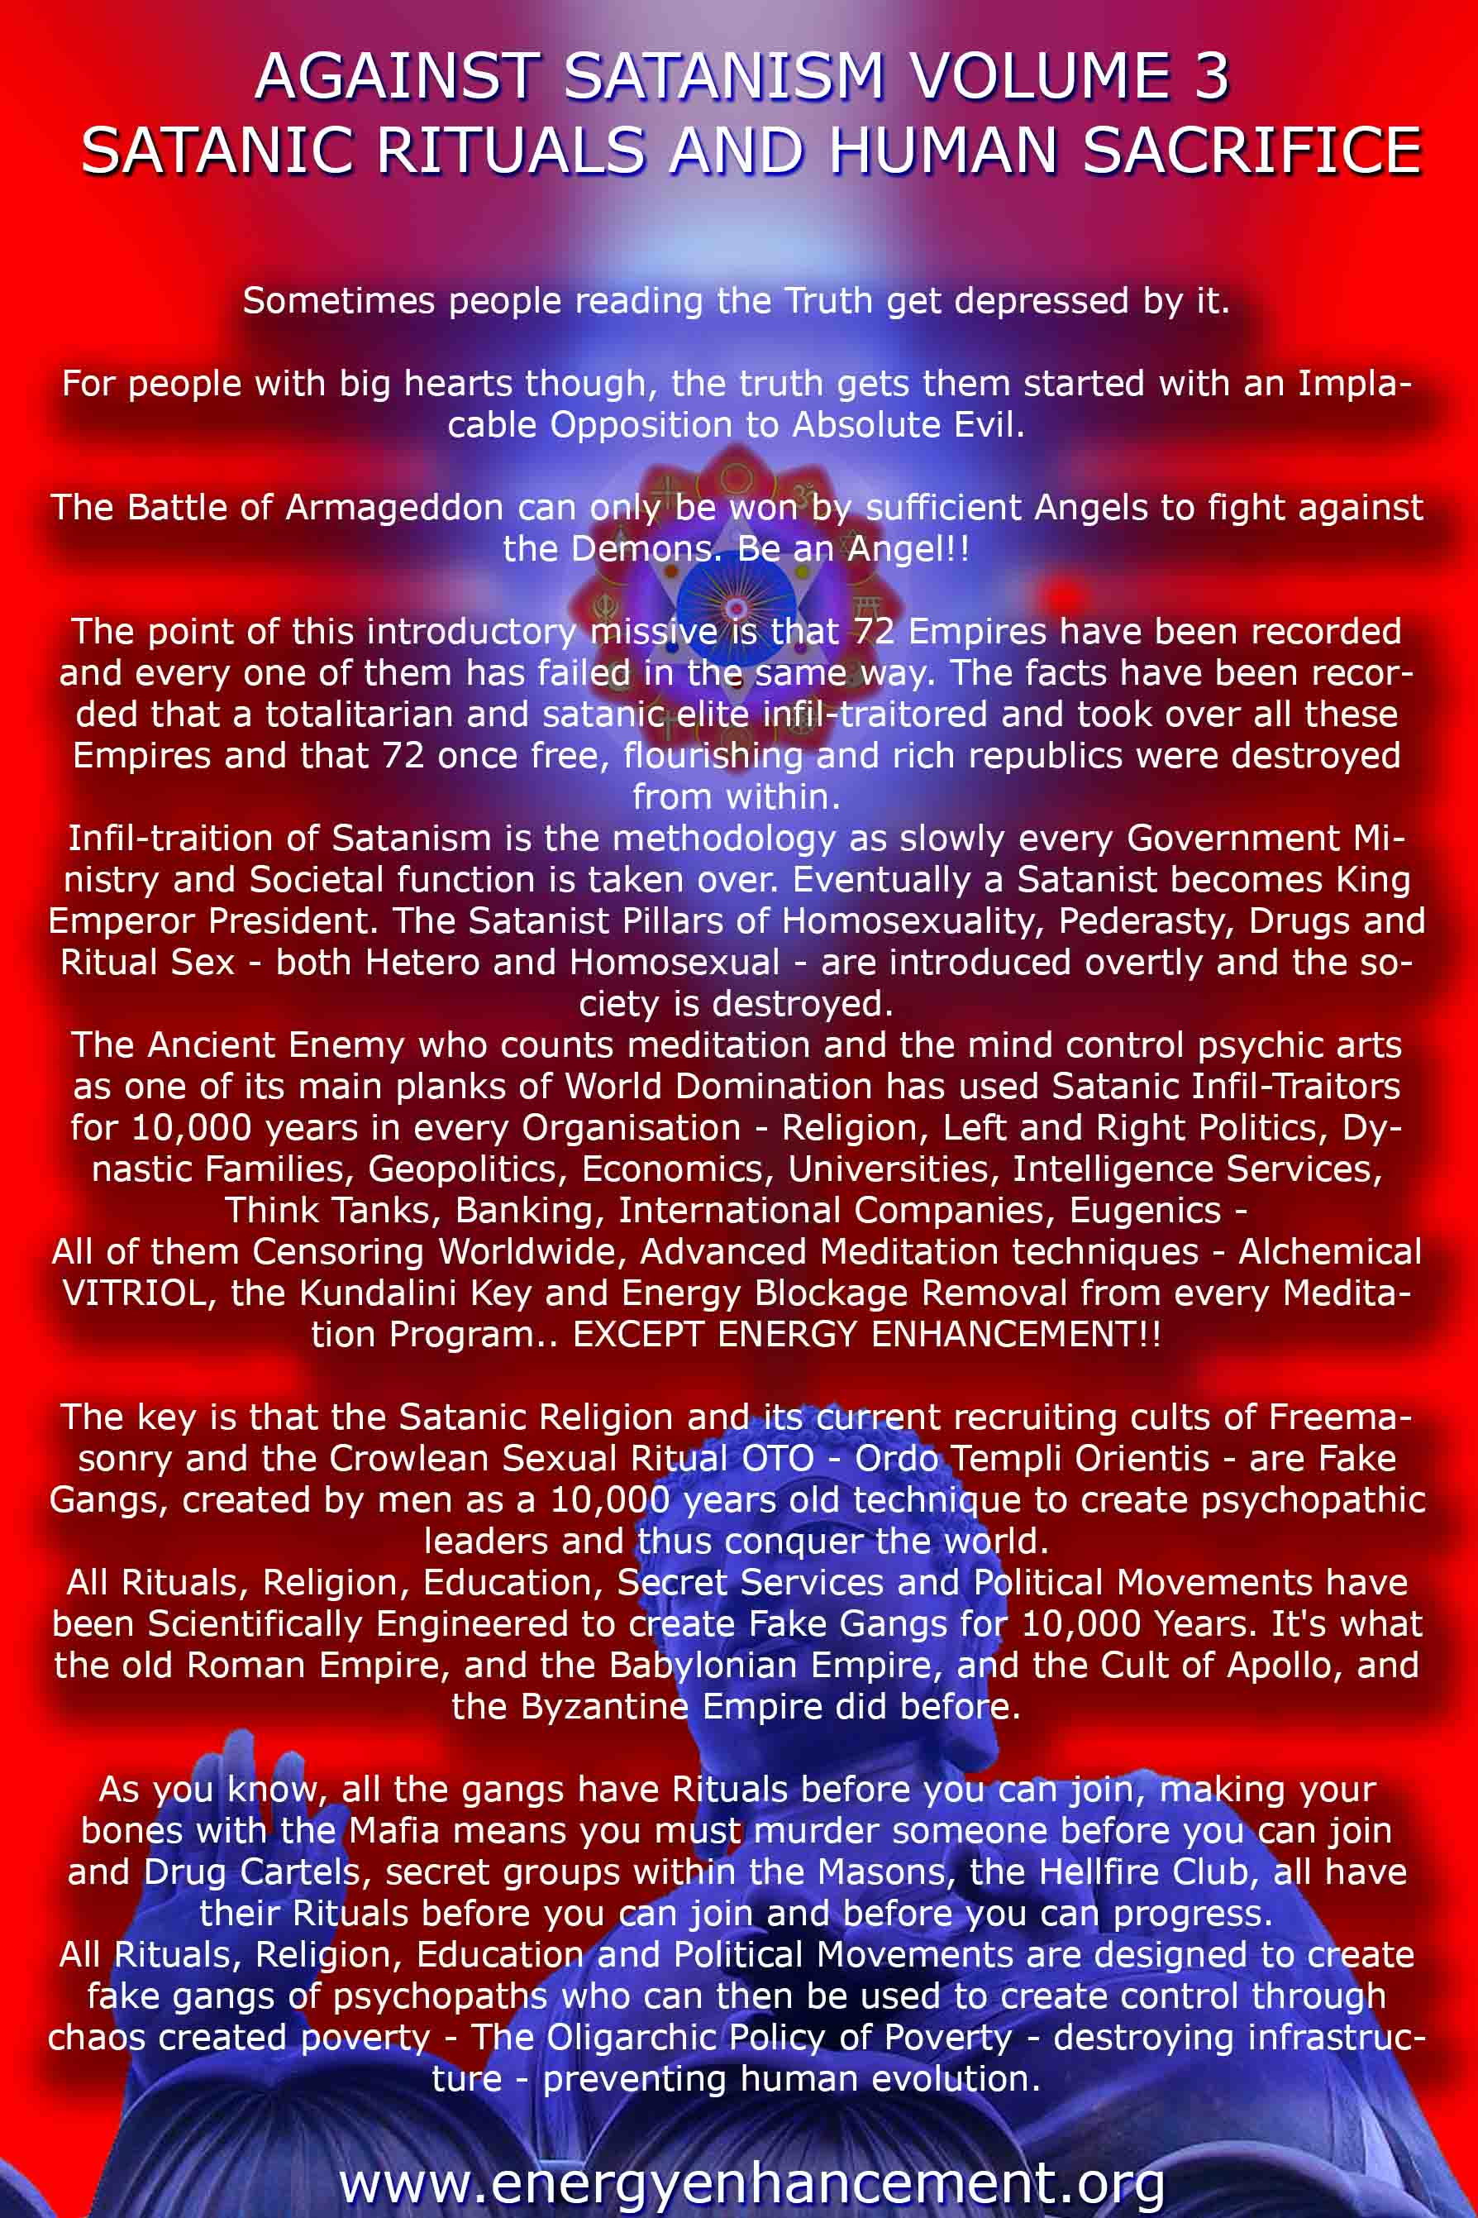

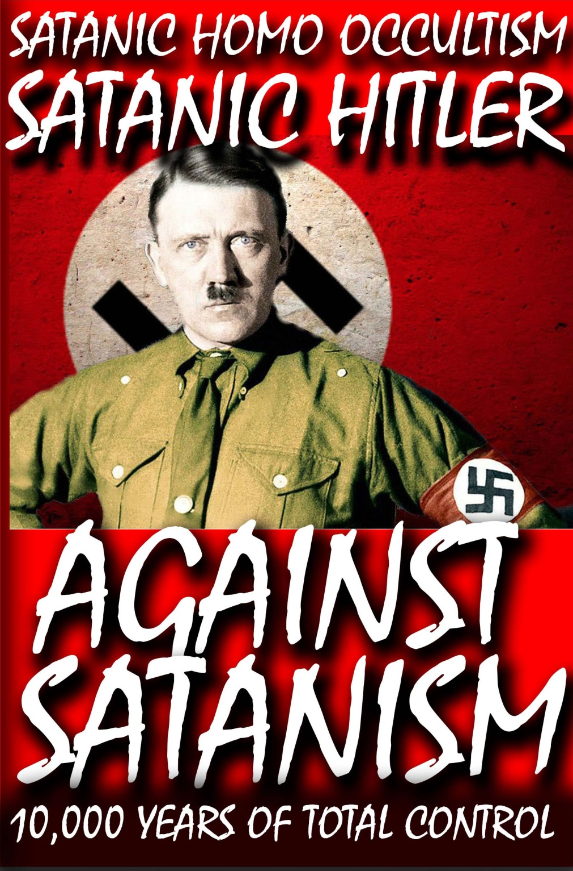

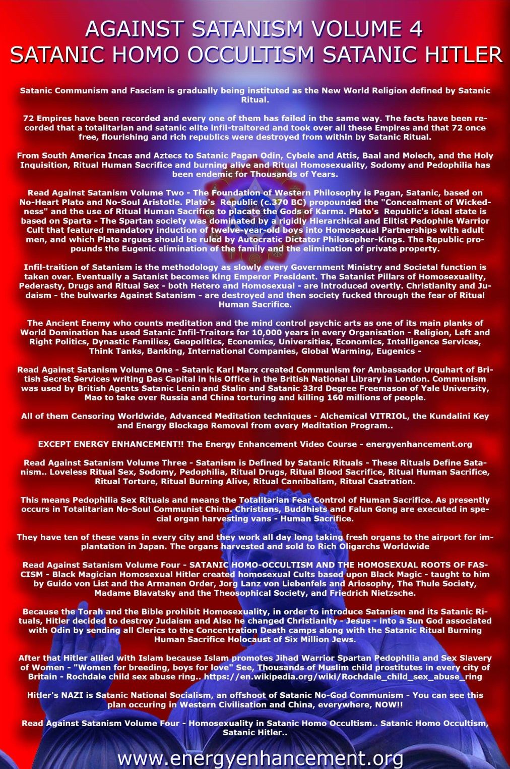

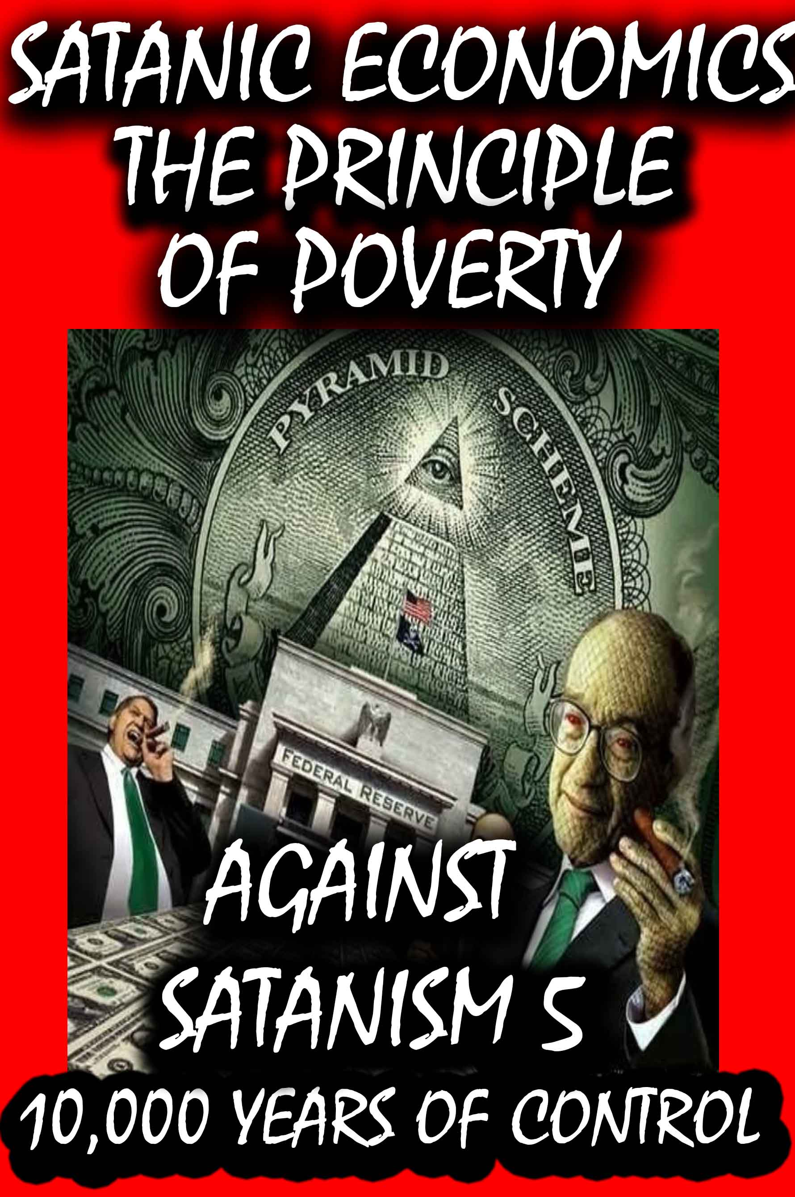

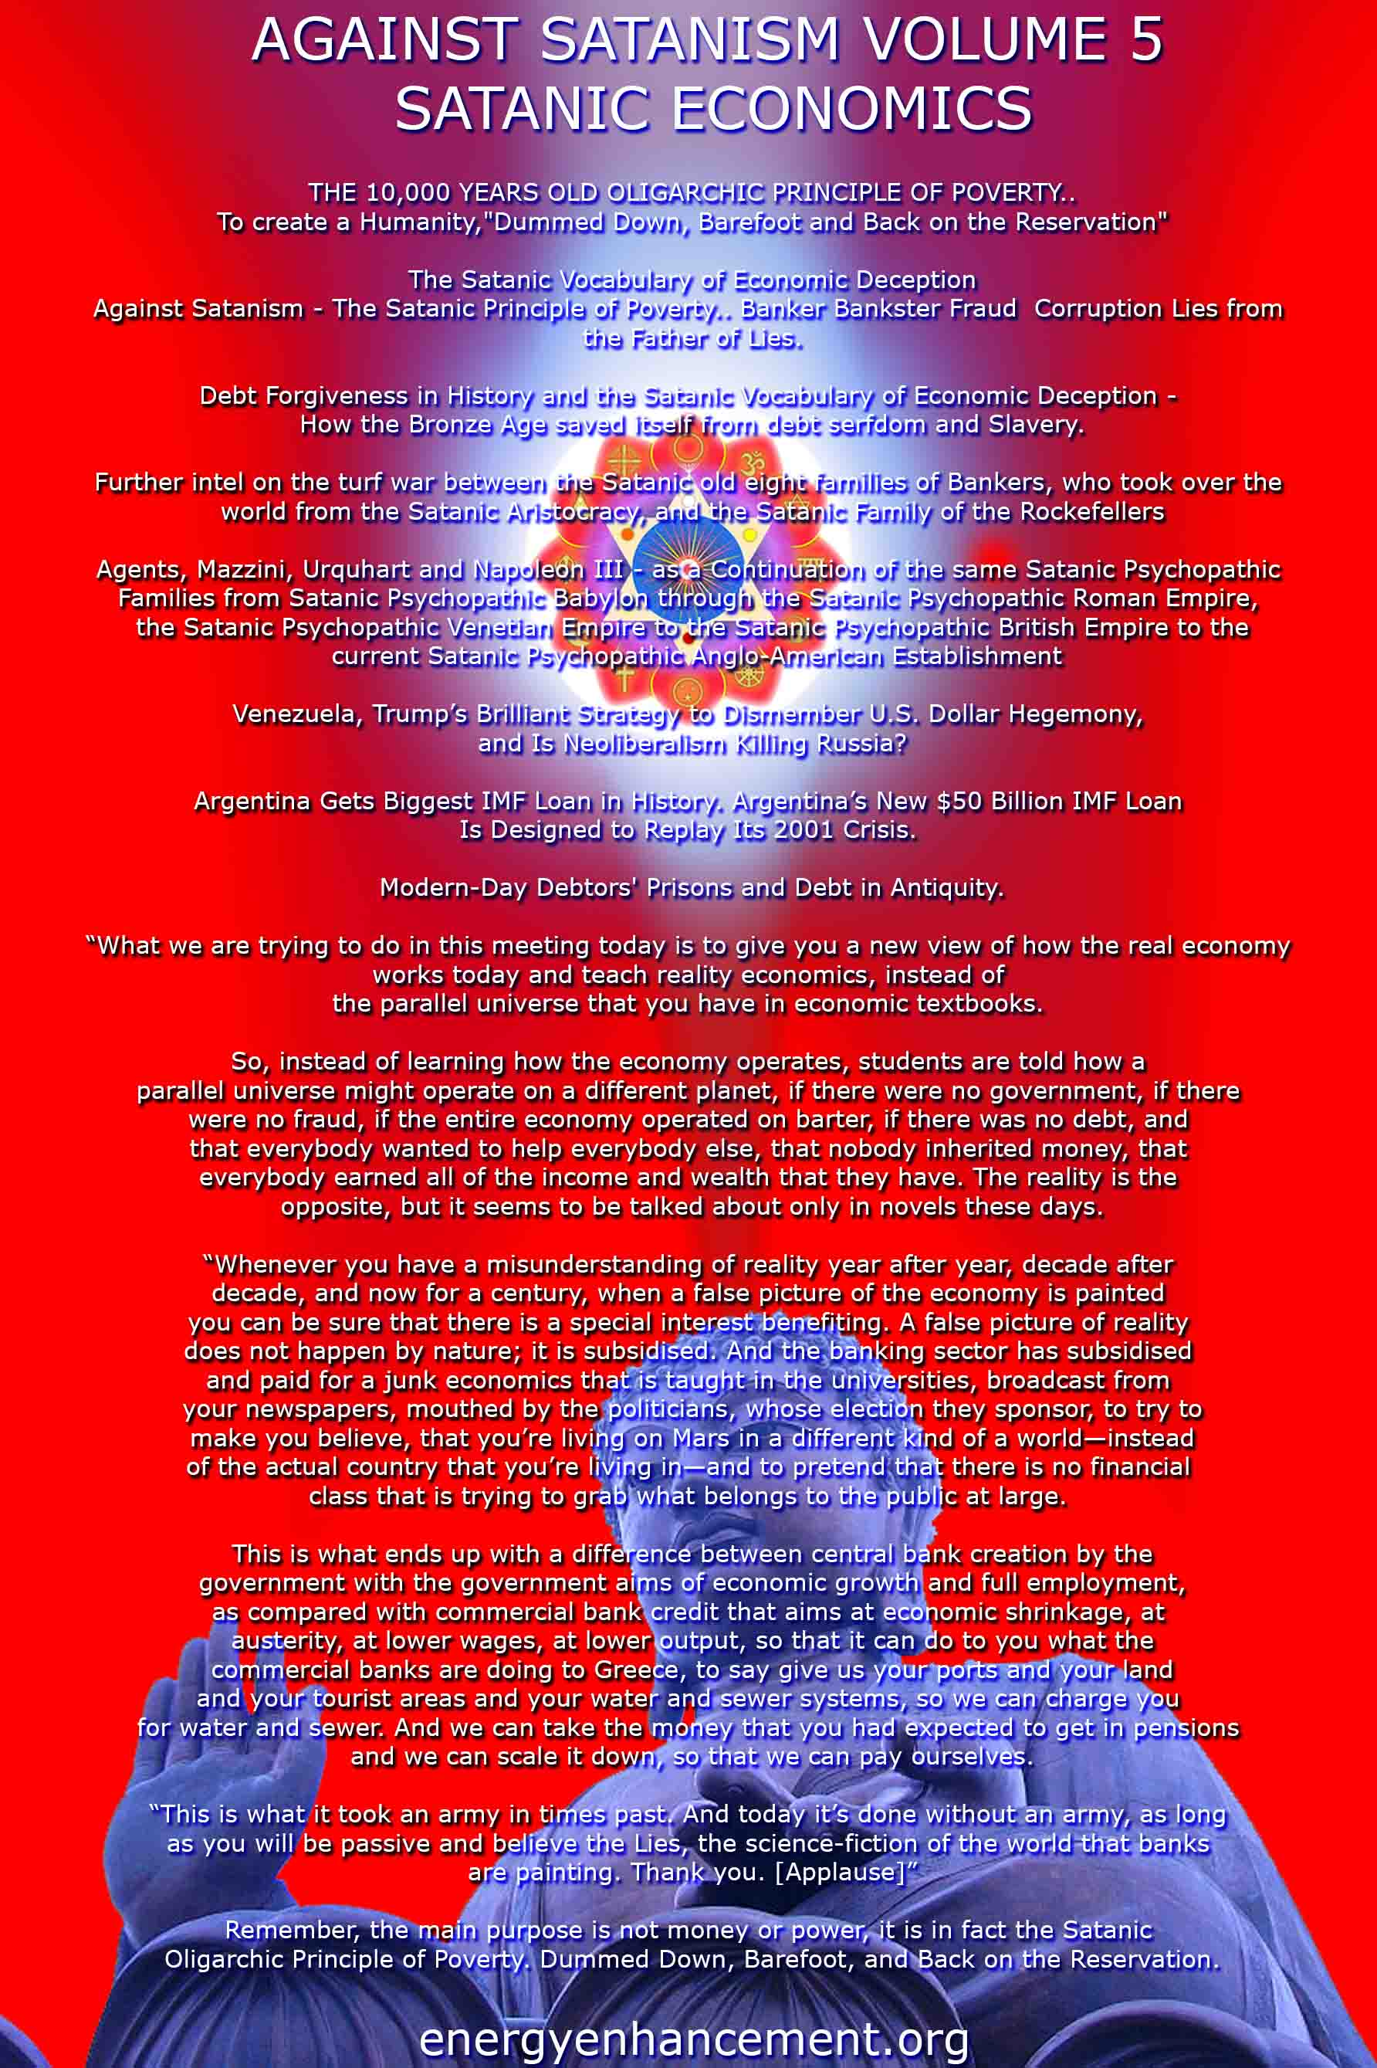

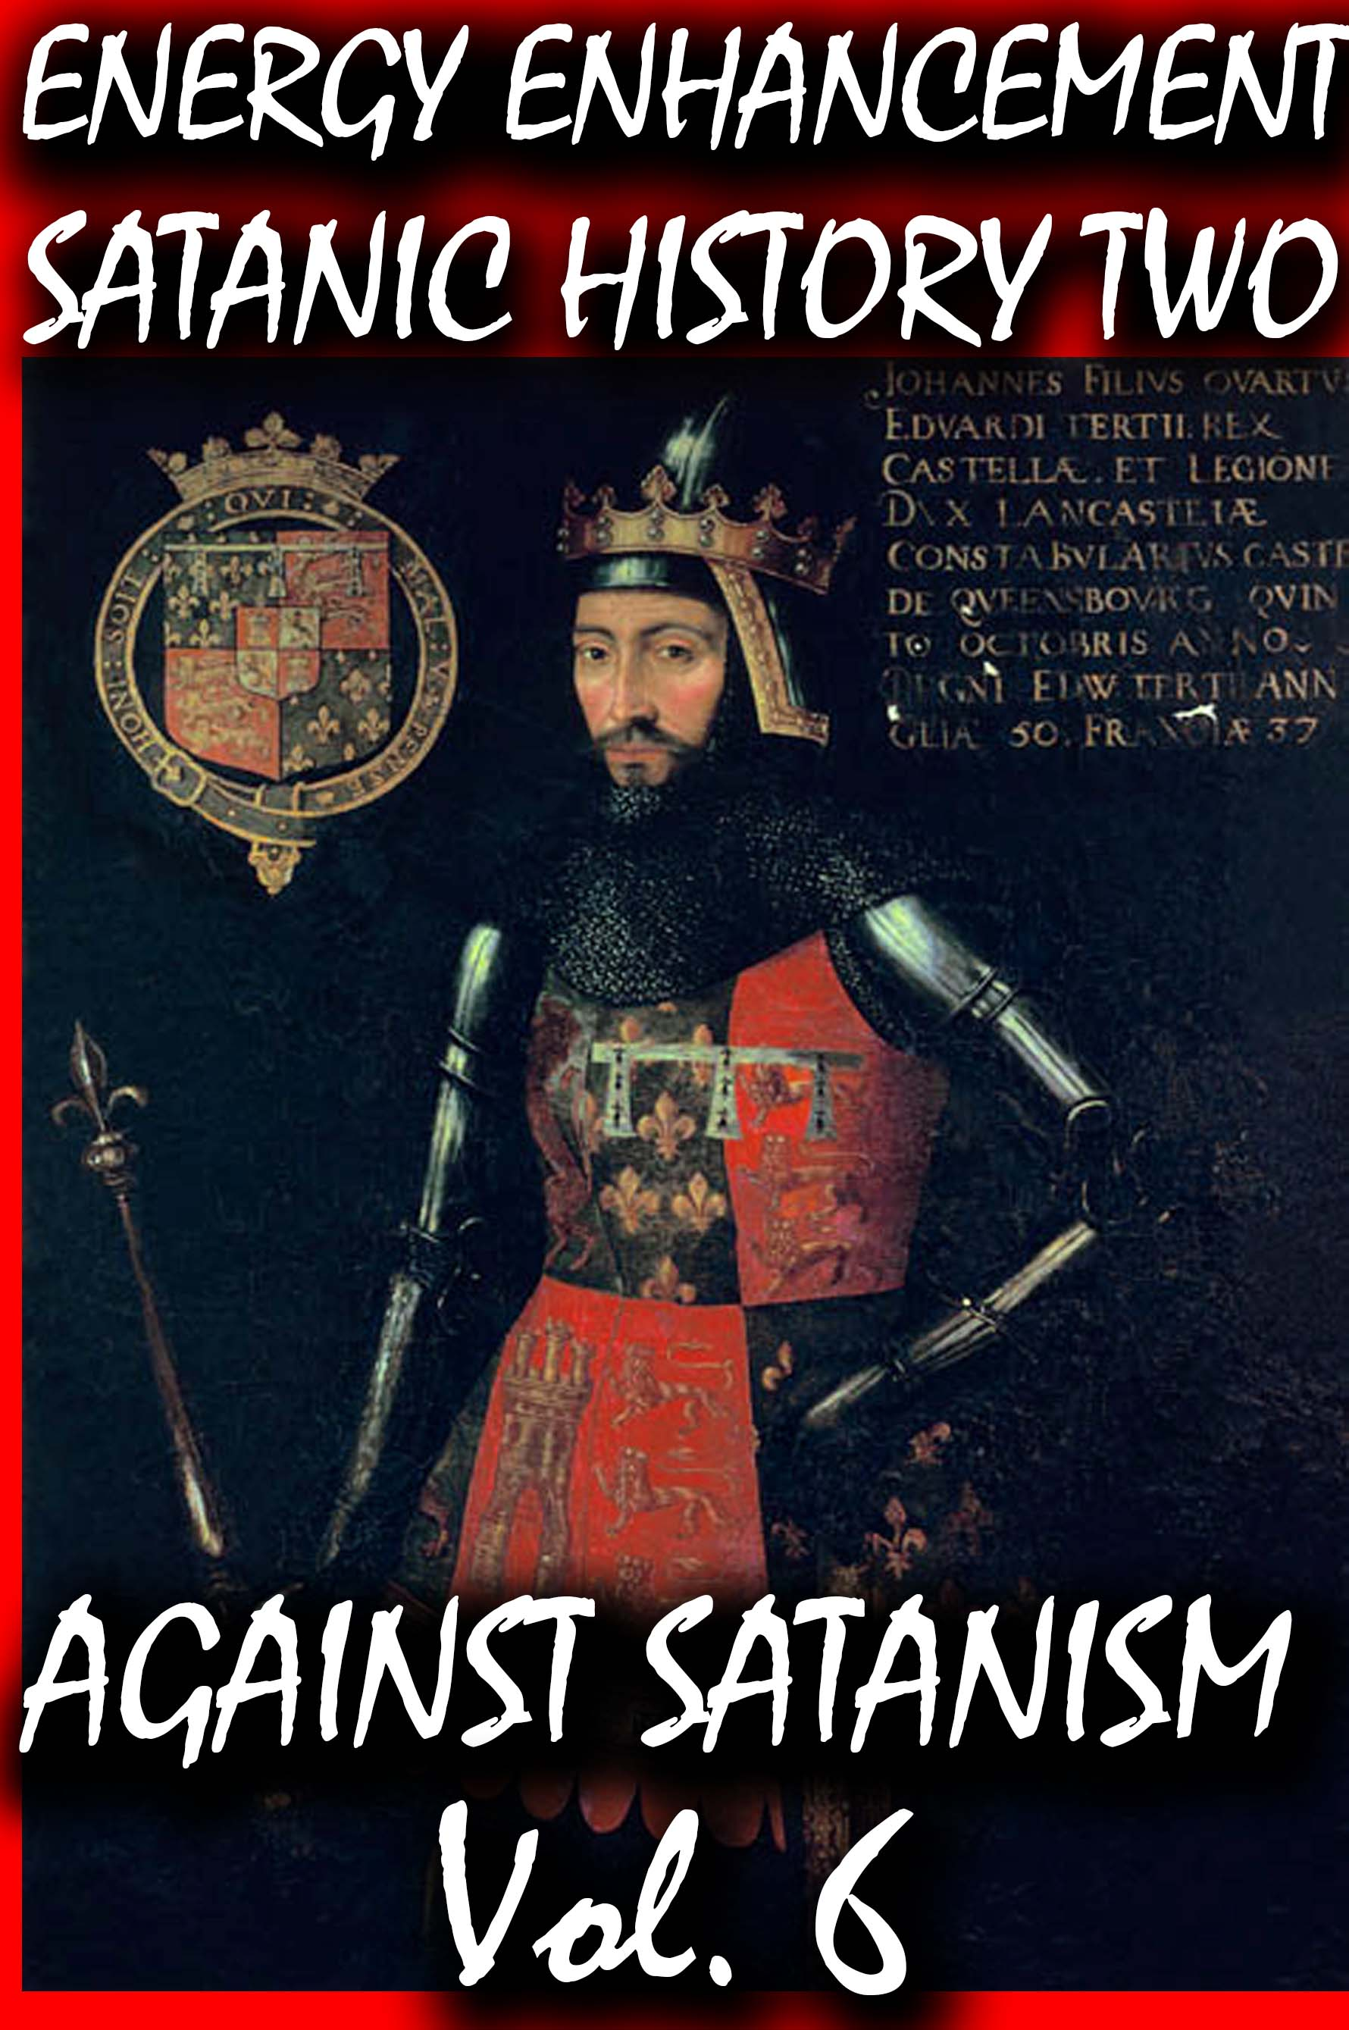
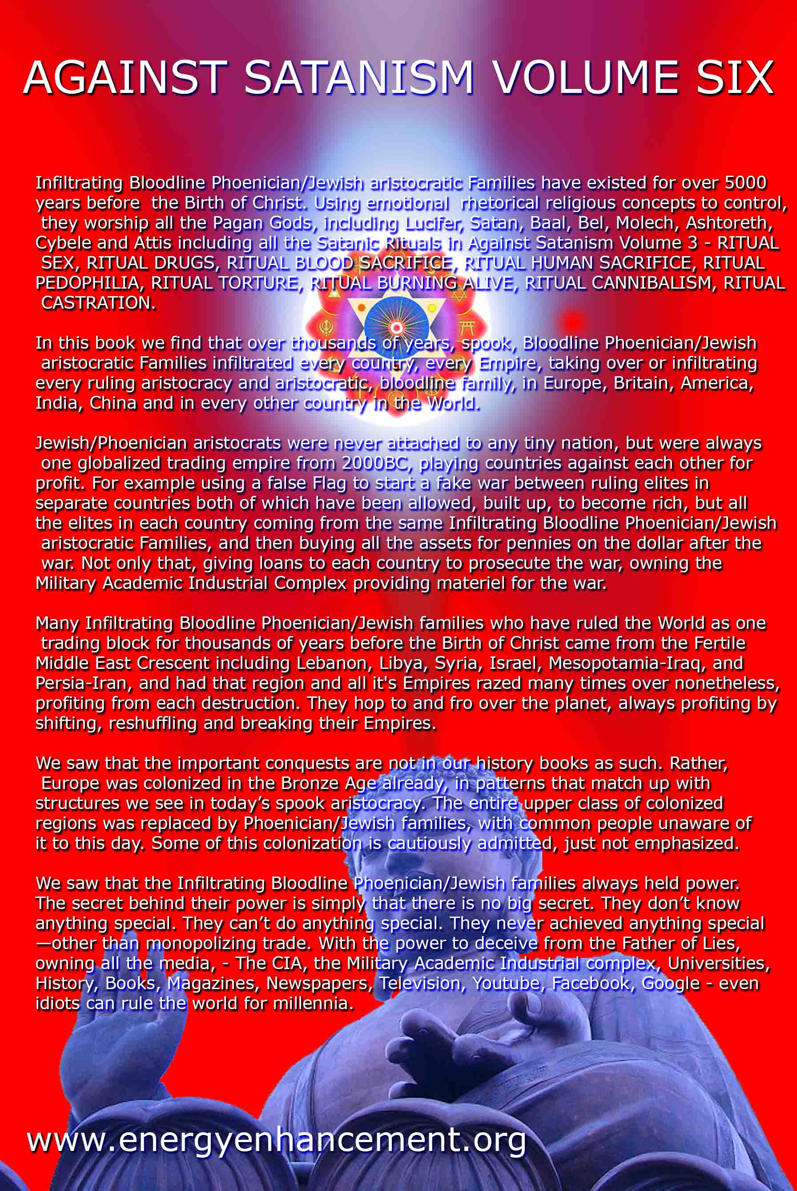
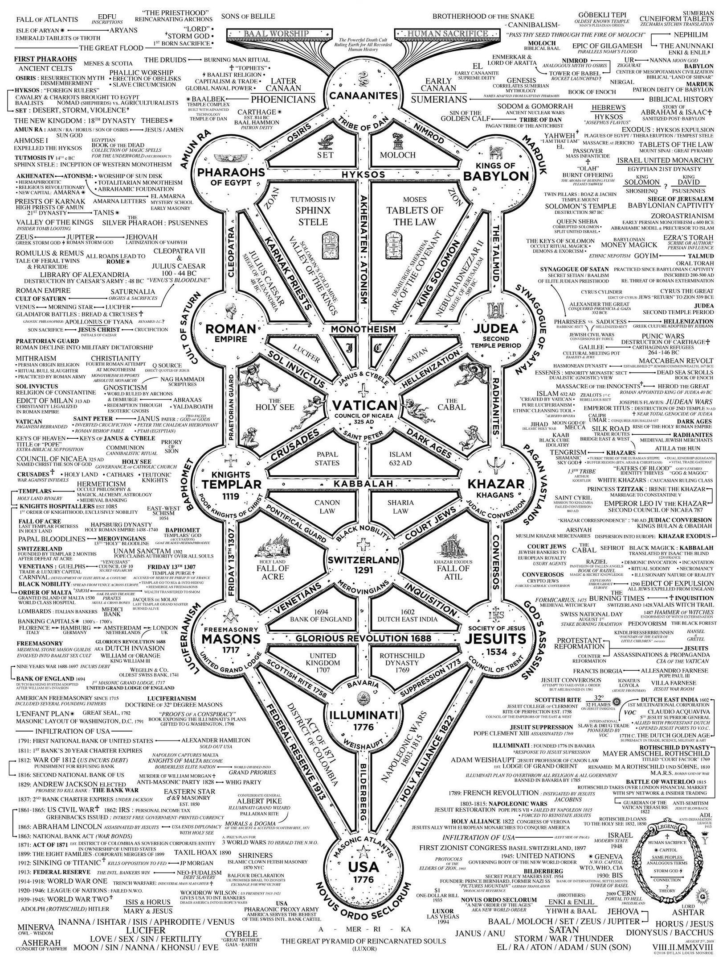
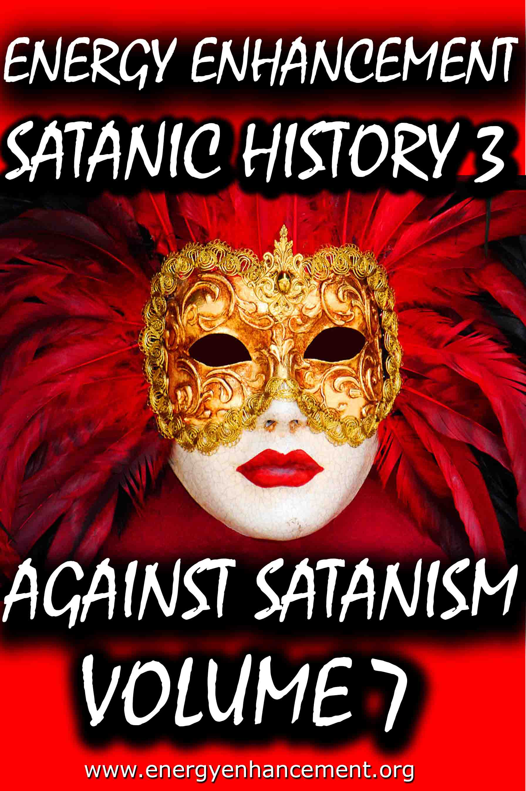
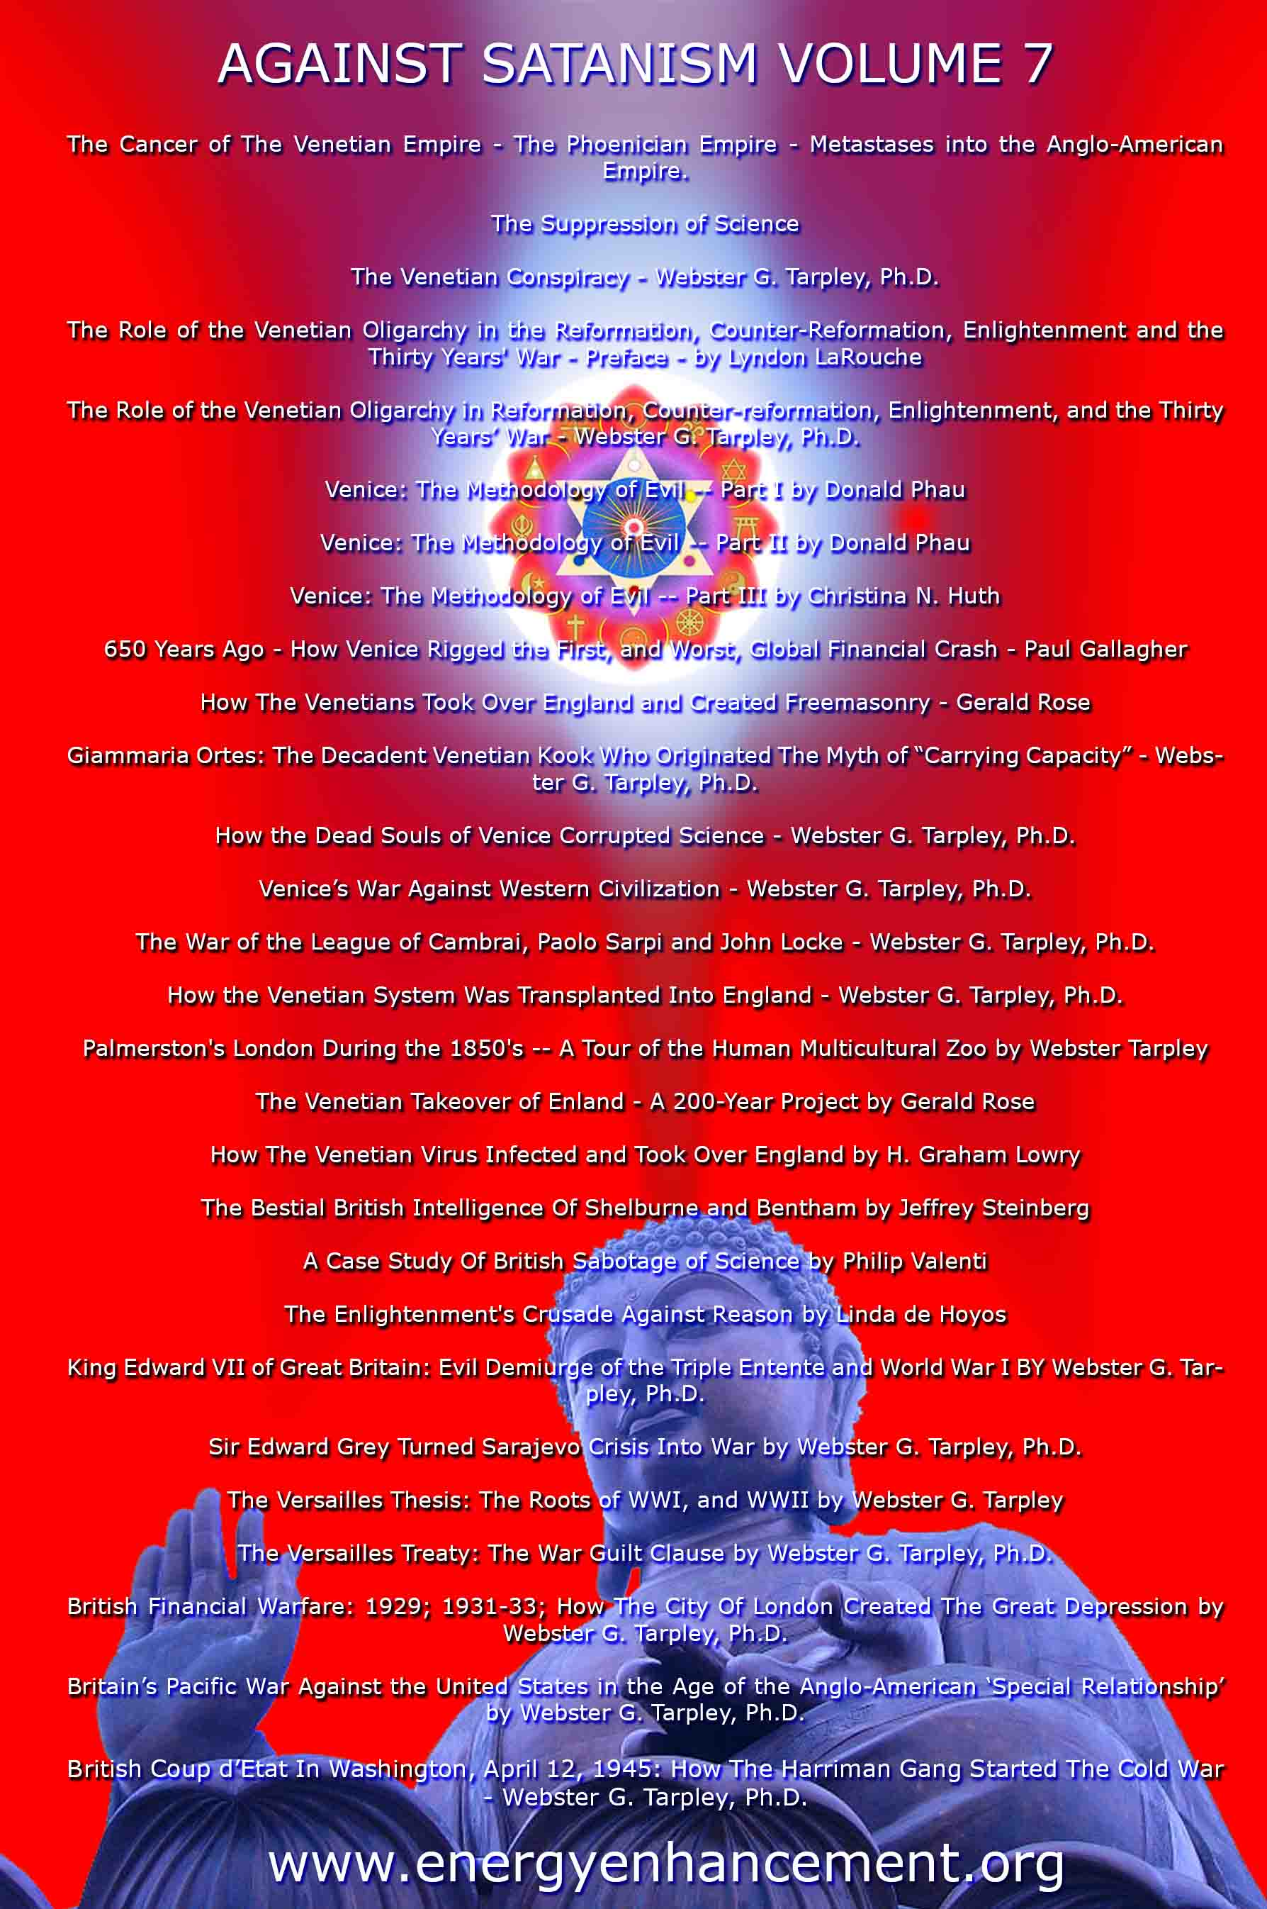

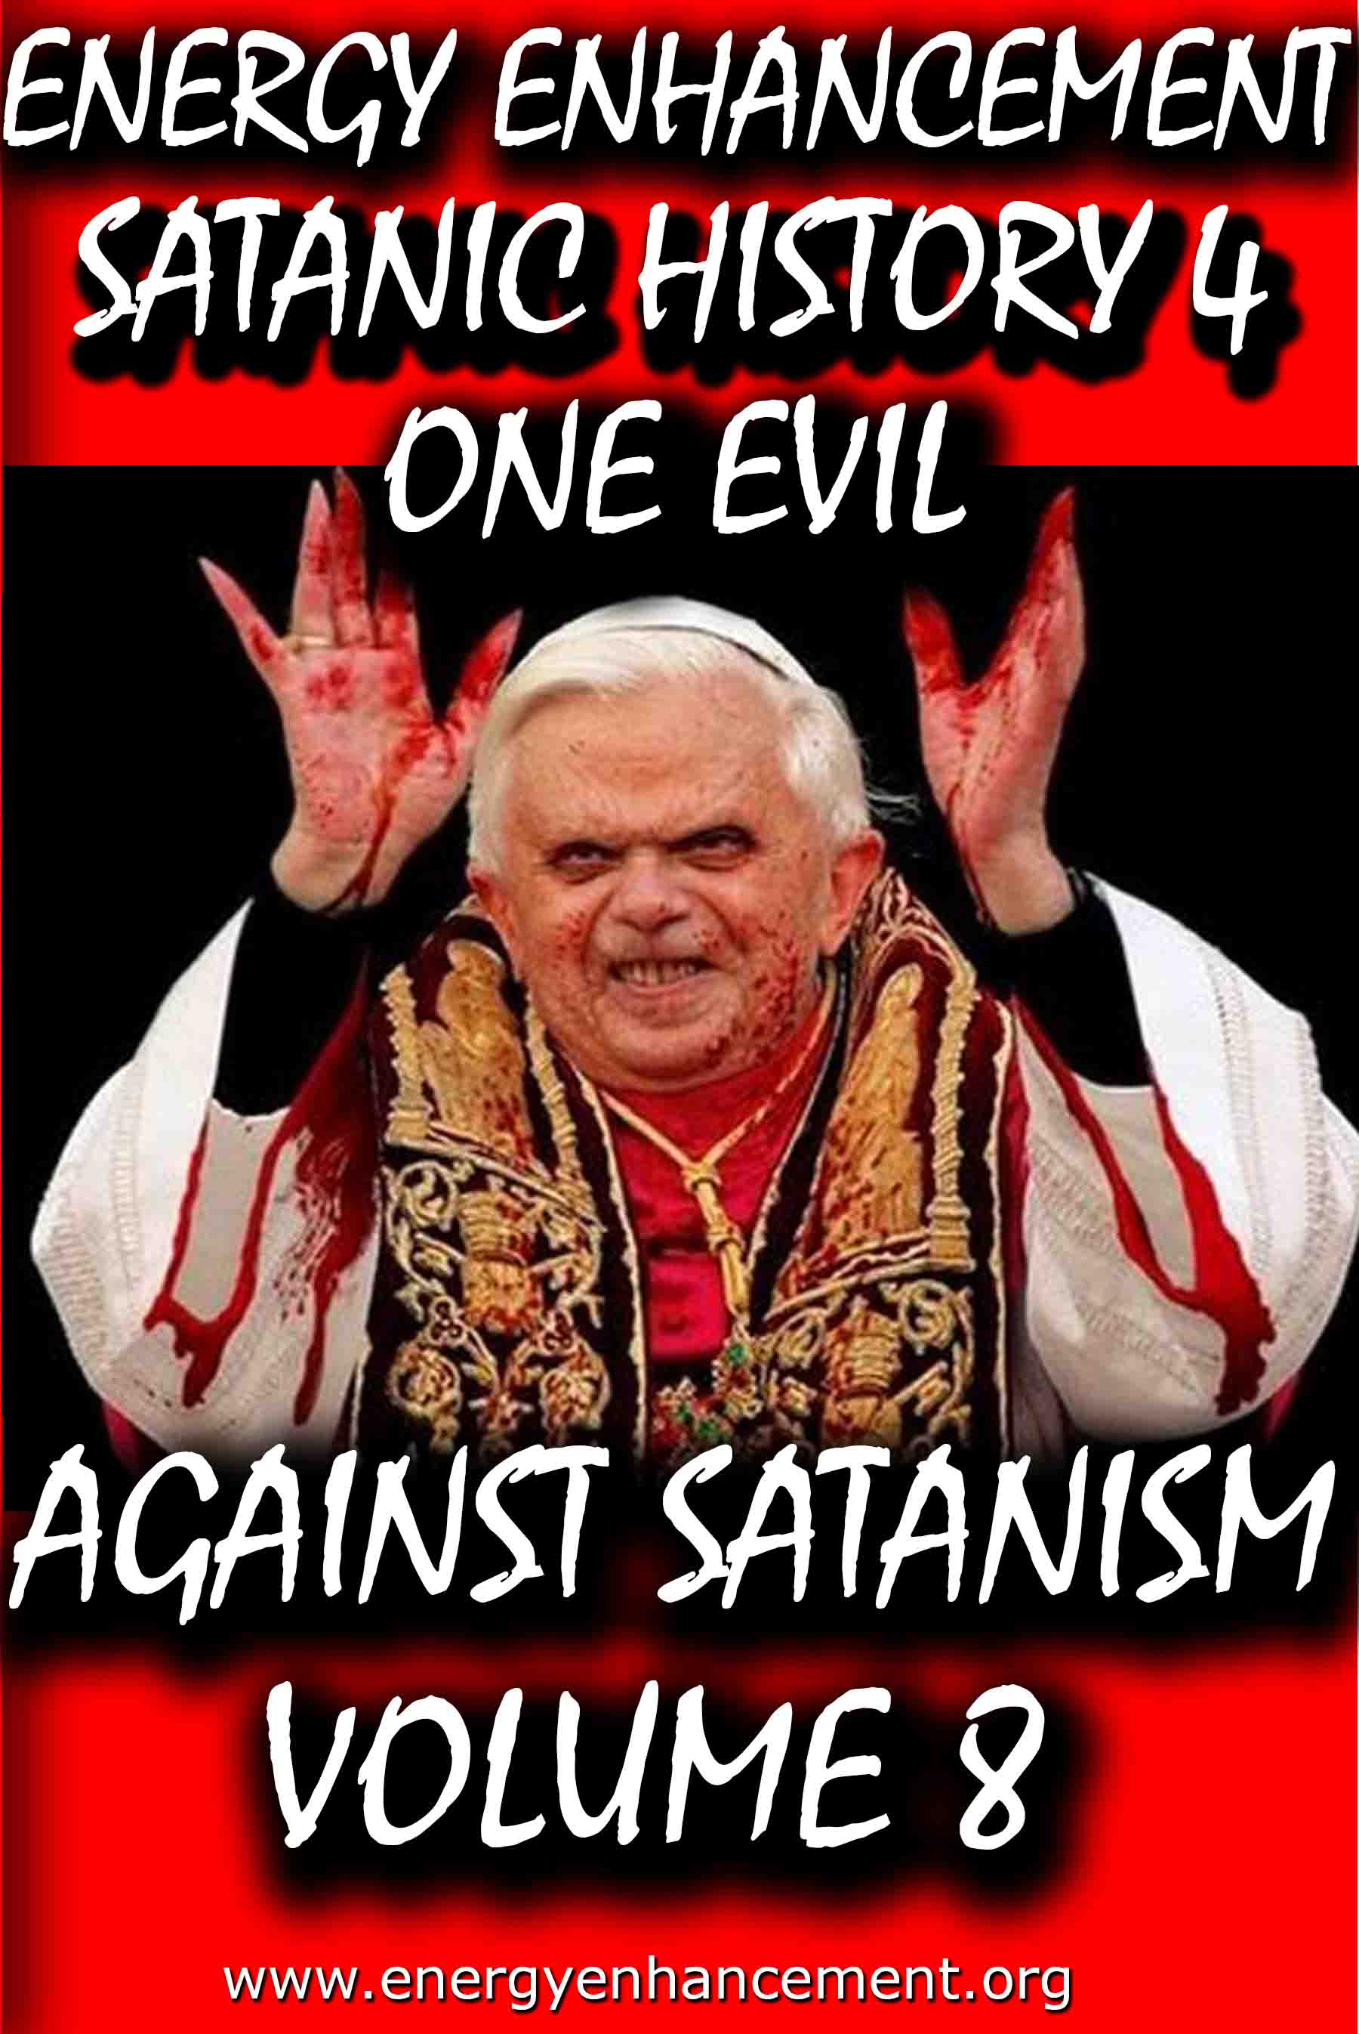

Remember, the main purpose is not money or power, it is in fact the Satanic Oligarchic Principle of Poverty. Dummed Down, Barefoot, and Back on the Reservation

Even though Tesla Free Energy Broadcast Power has been supressed, these next pages show how Fusion power and Fission Power have also been suppressed due to a Policy of Poverty going back to Fra Paolo Sarpi of the Satanic Venetian Republic and the British Royal Society for Science…

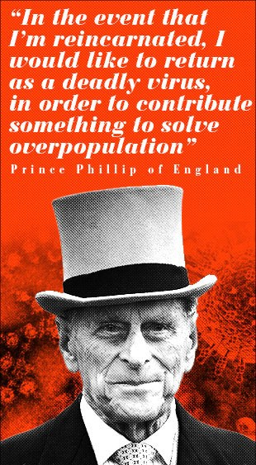

These Satanic Malthusians Demand Genocide

“Human population growth is probably the single most serious long-term threat to survival. We're in for a major disaster if it isn't curbed...We have no option.” —Prince Philip, interview in People Magazine, December 21, 1981

“In the event that I am reincarnated, I would like to return as a deadly virus, in order to contribute something to solve overpopulation.” —Prince Philip, Deutsche Press Agentur, August 1988
“It is almost self-evident that the greater the human population, the greater the demands for natural resources... The paramount question deals with an optimum human population. How many is too many people in relation to available resources? Many believe that our current (satanically consciously created) environmental problems indicate that the optimum level has been surpassed.” —Task Force on Earth, Resources and Population, George H. W. Bush, Chairman, July 8, 1970

POST MORTEM

Unfortunately, all the obituaries were premature: Venice has continued to be very much alive. During the nineteenth century and up to our own time it has been the most important single incubator for fascist movements. With its military and financial power largely emigrated elsewhere, Venice’s importance for political culture is now greater than ever.

Examples of this are inexhaustible. Richard Wagner wrote part of Tristan und Isolde while living in the Palazzo Giustinian on the Grand Canal. One story has it that the leitmotif of the Liebestod was inspired by the mournful call of a gondolier. At the end of his life Wagner moved to Palazzo Vendramin Callergi, where he died. This building, presently a gambling casino, was also the home of Count Coudenhove- Kalergi, the founder of the Pan-European Union. Friedrich Nietzsche loved Venice, returned there incessantly, and dedicated certain poems to the city which today can still be used in lieu of a powerful emetic. Venice was an inspiration for Lord Byron, for Thomas Mann, and so on.

Other examples abound of how the Venetian oligarchy’s cultural and political influence has reached down into the modern era:

* When British East India Company retainer Thomas Malthus published his Essay on Population he was plagiarizing from the Venetian Giammaria Ortes, who produced, around 1750, a fully developed version of the argument that geometric population growth outstrips the much slower arithmetric progress of food production.

* John Ruskin, the leading ideologue of the British Dark Ages faction, began his career with a raving treatise on architecture, The Stones of Venice (1851). This volume popularized the notion that a “Venetian Gothic” style had been developed in the better times of the city’s history (which for Ruskin ended in 1418) and it was used systematically to discredit the Golden Renaissance.

* A turn-of-the-century new Roman Empire faction led by Venetian Count Volpi di Misurata, who was known as the doge of his era, sponsored the fascist Mussolini supporter Gabriele D’Annunzio to drum up enthusiasm for a new crusade into the Balkans and the East. Volpi became finance minister in Mussolini’s cabinet, along with a very large number of other Venetians. D’Annunzio incited the Italians to take back Trieste, the rest of Italia Irredenta, and the Dardanelles, bringing on to center stage the so-called Parvus Plan for dismemberment of the Ottoman and Russian empires, which is generally recognized as the detonator of World War I. It is possible that the turn-of-the- century super spook Alexander Parvus was ultimately employed by Venice.

* The Societe Europeenne de Culture, a think tank created in 1950 through the efforts of Venetian intelligence operative Umberto Campagnolo, has for the past three decades pulled intellectuals from both East and West into organizing for an “international culture,” based on rejecting the existence of sovereign nations. The SEC counted among its members the cream of the postwar intelligencia: Adam Schaff of Poland, Bertolt Brecht of East Germany, Georg Lukas of Hungary, and Boris Paternak of the Soviet Union, as well as Stephen Spender and Arnold Toynbee, Benedetto Croce and Norberto Bobbio, Julian Huxley and Thomas Mann, Francois Mauriac, and Jean Cocteau. Later, the SEC launched the Third World national liberation ideology.

Today, the Club of Rome is the institution that represents the most concentrated essence of Venetian influence and the Venetian method. The Club of Rome wants to convince the great powers and peoples of the world to commit collective suicide by accepting the genocidal doctrine of zero growth. It also hopes to abolish the sovereign nation as a vehicle for economic growth and scientific progress.

Club of Rome founder Aurelio Peccei has just written a new book titled One Hundred Pages For the Future, a global review of the impact of the Club of Rome, and particularly since its 1972 release of the zero-growth model Limits to Growth was published, a series of social movements has sprung up under the sponsorship of the ideas in the book. These – the women’s movement, the peace movement, Third World national liberation movements, gay rights, civil liberties, ecologists, consumer and minority rights, etc. – must now be welded together into one movement for a single strategic goal: the implementation of a zero-growth international order.

The Venetian problem remains with us today. Truly, the most urgent task of this generation of mankind is to definitively liquidate the horror that is Venice and all the other Gang Clan Families who have ruled the World for 10,000 years.

The Satanic Conservative outpost of the Satanic Phoenician Navy who for 10,000 years have worshipped Molech, Baal and Cybele and Attis, and with Satanic Ritual, it's not just Sex on Altars like in Kubrick's, "Eyes Wide Shut", it is Pedophilia with Babies and Children supplied by Epstein, Dutroux or Jimmy Savile, it's Ritual Human Sacrifice, Ritual Blood Sacrifice, Ritual Burning Alive, Ritual Torture, Ritual Castration - and those Damn Liberals by Miles Mathis and Satchidanand

The founding fathers have even been sold as liberal in this sense, since although they were rich guys, fully connected, we are supposed to believe they believed in democracy, republicanism, and fairness in general. That is why they go on and on about that in the Declaration of Independence and Constitution. Those are liberal documents, in that they deny not only the divine rights of kings, they deny any other sort of favoritism based on name or birth.

As it turns out, the founding fathers were not liberal at all. They were Satanic fascists, and the whole liberal stance was just another con-job.

The United States were never meant to be republic, much less a democracy, they were meant to be another outpost of the Satanic Phoenician Navy who for 10,000 years have worshipped Molech, Baal and Cybele and Attis, and more worship with Satanic Ritual, it's not just Sex on Altars like in Kubrick's, "Eyes Wide Shut", it is Pedophilia with Babies and children supplied by Epstein, Dutroux or Jimmy Savile, it's Ritual Human Sacrifice, Ritual Blood Sacrifice, Ritual Burning Alive, Ritual Castration.
Some of my readers have been confused by my insistence that I am a liberal. These readers agree with me on a lot of things, so they can’t fathom what I mean by calling myself a liberal while they consider themselves conservatives. Since it is important, I will hit it again, trying to get them to understand.

I think the difference is that I am coming at this as a student of history, while many of them are coming at it as students (or consumers) of current politics.

I haven’t gotten my definitions and stances by listening to Rush Limbaugh, or Sean Hannity, I have gotten them from texts from the 19th century or earlier. My readers will answer me, “Then why don’t you keep up, Holmes! This is 2020, not 1880”. Good point. . . except that it isn’t.

To see what I mean, let’s transport ourselves back to the 1880s. Back then, satanic conservatives were those people who wished to conserve the status quo. Hence the name. They were quite satisfied with the way things were set up, and why should they not be?

They were rich and connected and had it made. Liberals were those who were not satisfied by the way things were, and so they were pushing for reforms. In general, they wished to see more fairness in government policies. They wanted those not “of the manor born” to be given a fair shot at good employment, good wages, court access, and all the various fruits of society.

The founding fathers have even been sold as liberal in this sense, since although they were rich guys, fully connected, we are supposed to believe they believed in democracy, republicanism, and fairness in general. That is why they go on and on about that in the Declaration of Independence and Constitution. Those are liberal documents, in that they deny not only the divine rights of kings, they deny any other sort of favoritism based on name or birth.

As it turns out, the founding fathers were not liberal at all. They were Satanic fascists, and the whole liberal stance was just another con-job.

The United States were never meant to be republic, much less a democracy, they were meant to be another outpost of the Satanic Phoenician Navy who for 10,000 years have worshipped Molech, Baal and Cybele and Attis, and more worship with Satanic Ritual.

Iit's not just Sex on Altars like in Kubrick's, "Eyes Wide Shut", it is Pedophilia with Babies and children supplied by Epstein, Dutroux or Jimmy Savile, it's Ritual Human Sacrifice, Ritual Blood Sacrifice, Ritual Burning Alive, Ritual Castration.

Read - AGAINST SATANISM VOLUME 6 - THE SATANIC PHOENICIANS - version 2 -The Satanic History of the World Part 2 Published May 2019

AGAINST SATANISM VOLUME 6 -The Satanic History of the World Part 2 Published May 2019

See http://www.energyenhancement.org/8aky78umhxi31.jpg

Infiltrating Bloodline Phoenician/Jewish aristocratic Families have existed for over 5000 years before the Birth of Christ. Using emotional rhetorical religious concepts to control, they worship all the Pagan Gods, including Lucifer, Satan, Baal, Bel, Molech, Ashtoreth, Cybele and Attis. In this book we find that over thousands of years, spook, Bloodline Phoenician/Jewish aristocratic Families infiltrated every country, every Empire, taking over or infiltrating every ruling aristocracy and aristocratic, bloodline family, in Europe, Britain, America, India, China and in every other country in the World.

http://www.energyenhancement.org/Sacred-Energy/Against-Satanism-Volume-6/AGAINST-SATANISM-6-Satanic-History-of-the-World-Part-2.pdf

Alan Watt Recommended Book List
Description: Get the BIG Picture by archiving and studying Sources from which Alan Watt draws. Download audio and transcripts of his talks from http://alanwattsentientsentinal.eu FREE. Please by all mean… Full description

Essential Book Recommendations from Alan Watt, of the
CuttingThrough theMatrixwebsite.

(Plus some of the books he won't mention)
The Republic – PlatoTragedy and Hope: The History of the World in our Time – Dr. Carroll Quigley The Anglo-American Establishment – Dr. Carroll Quigley The Evolution of Civilizations – Dr. Carroll Quigley
Between Two Ages: America's Role in the Technetronic Era – Zbigniew Brzezinski The Grand Chessboard: American Primacy and its Geostrategic Imperatives – Zbigniew Brzezinski The Choice: Global Domination or Global Leadership – Zbigniew Brzezinski The Impact of Science on Society –
Bertrand Russell The Scientific Outlook – Bertrand Russell The History of Western Philosophy – Bertrand Russell Proposed Roads to Freedom: Socialism, Anarchism, and Freedom – Bertrand RussellEducation and the Good Life – Bertrand RussellThe Autobiography of Bertrand Russell – 1872 – 1914 – Bertrand RussellThe Autobiography of Bertrand Russell – 1914 – 1944 – Bertrand RussellAn Essay on the Principle of Population – Thomas MalthusLegacy of Malthus – Allan ChaseThe Next Million Years – Charles Galton DarwinIn the Minds of Men – Ian T. Taylor Morals and Dogma – Albert PikeThe New Atlantis – Francis BaconThe Advancement of Learning – Francis BaconValerius Terminus of the Interpretation of Nature – Francis Bacon Novum Organum – Francis BaconThe Open Conspiracy – H.G. Wells

The Outline of History (Two volumes) – H.G. Wells The Shape of Things to Come – H.G. Wells The New World Order – H.G. WellsAmerica B.C. - Barry Fell Akhenaten – The Heretic King – Donald B. Redford The Gnostic Gospels – Elaine Pagels The Story of Civilization (11 Volumes) – Will Durant (
Particularly the first four volumes
:1.Our Oriental Heritage 2.The Life of Greece 3.Caesar and Christ 4.The Age of Faith) The Lessons of History – Will Durant The Story of Philosophy – Will Durant A Study of History (12 Volumes) – Arnold J. Toynbee (Look for the unabridged version – there isreason beyond Toynbee's legendary verbiage that a slender two-volume edition was released)Civilization on Trial – Arnold J. ToynbeeAmerica and the World Revolution – Arnold J. Toynbee (Public lectures in book form)Fire in the Minds of Men: Origins of the Revolutionary Faith – James H. BillingtonWall Street and the Bolshevik Revolution – Antony C. SuttonWall Street and the Rise of Hitler – Antony C. SuttonWall Street and FDR – Antony C. SuttonWestern Technology and Soviet Economic Development: 1917 – 1930 – Antony C. SuttonWestern Technology and Soviet Economic Development: 1930 – 1945 – Antony C. SuttonWestern Technology and Soviet Economic Development: 1945 – 1965 – Antony C. Sutton(
Zbigniew Brzezinski thought very highly of the above Sutton three volume work
)America's Secret Establishment: An Introduction to the Order of Skull and Bones – Antony C.SuttonTrilaterals over Washington: Volume I – Antony C. Sutton (with Patrick M. Wood)

Trilaterals over Washington: Volume II - Antony C. Sutton (with Patrick M. Wood)Foundations: Their Power and Influence – Rene A. Wormser Ages in Chaos (Four volumes) – Immanuel Velikovsky1.Ages in Chaos2.Oedipus and Akhnaton3.Ramses II and his Time4.Peoples of the SeaWorlds in Collision – Immanuel VelikovskyFuture Shock – Alvin Toffler The Third Wave – Alvin Toffler Power Shift – Alvin Toffler Political Ponerology: A Science of the Nature of Evil Adjusted for Political Purposes – Andrej M.LobaczewskiThe Technological Society – Jacques EllulPropaganda: The Formation of Men's Attitudes – Jacques EllulThe Political Illusion – Jacques EllulThe Technological System – Jacques EllulThe New Totalitarians – Roland HuntfordFuture Man – Brian StablefordPropaganda – Edward L. BernaysPublic Relations – Edward L. BernaysThe Moses Mystery – Gary GreenburgHebrew Myths: The Book of Genesis – Robert Graves and Raphael Patai
<compare with the following Graves volume>
The Greek Myths – Robert GravesScarlet and the Beast: A History of the War Between English and French Freemsasonry – JohnDanielConspiracies, Cover-ups, and Crimes – Jonathan VankinThe History of Freemasony (7 volumes unabridged) – Albert G. Mackey

The Encyclopedia of Freemasonry (Volumes I & II) – Albert G. MackeyThe Symbolism of Freemasonry – Albert G. MackeyGould's History of Freemasonry Throughout the World (6 volumes unabridged) – Robert F. GouldHoly Blood, Holy Grail – Baigent, Lincoln and LeighThe Messianic Legacy – Baigent, Lincoln and LeighThe Temple and the Lodge – Baigent, Lincoln and Leigh The Dead Sea Scrolls Deception – Baigent, Liccoln and LeighAmerica's Assignment with Destiny – Manly P. HallThe Secret Destiny of America – Manly P. HallThe Secret Teachings of All Ages – Manly P. HallThe Lost Keys of Freemasonry – Manly P. HallFreemasonry of the Ancient Egyptians – Manly P. HallOrientations – Sir Ronald StorrsThe Memoirs of Sir Ronald Storrs – Ronald StorrsThe Whispering Gallery: Being Leaves from the Diary of an Ex-Diplomat – Anonymous (LordGrey?)The Fifth Man: The Soviet Super Spy – Roland PerryThe Fringes of Power: The Incredible Inside Story of Winston Churchill During WWII – JohnColvilleThe Fringes of Power: 10 Downing Street Diaries (1939 – 1955) – John ColvilleThe Other Side of Deception: A Rogue Agent Exposes the Mossad's Secret Agenda – VictorOstrovkyBy Way of Deception: The Making and Unmaking of a Mossad Officer – Victor OstrovskyHistory Begins at Sumer: Thirty-Nine Steps in Recorded History – Samuel Noah Kramer Acres of Skin: Human Experiments at Holmesburg Prison – A True Story of Abuse and Exploitationin the Name of Medical Science by Allen M. HornblumThe Ghost in the Machine – Arthur Koestler The Thirteenth Tribe – Arthur Koestler

The Second Genesis: The Coming Control of Life – Albert RosenfeldTowards a New Beginning – Mikhail GorbachevDeadly Allies: Canada's Secret War (1937 – 1947) – John BrydenEarth Rising: The Revolution Toward a Thousand Years of Peace – Nick Begich NATO and Europe – Andre BeafreMillennium – Jacques AttalliUnderstanding Media: The Extensions of Man (Critical Edition) – Marshall McLuhan
The Book of the Dead: The Papyrus of Ani – E.A. Wallis BudgeThe Golden Bough – James FrazerHamlet's Mill – Giorgio de Santillana & Hertha von DechendThe Crime and Punishment of I.G. Farben – Joseph BorkinThe Undiscovered Self – C.G. JungProofs of a Conspiracy – John RobinsonThe Rockefellers: An American Dynasty – Peter Collier & David HorowitzThe Human Agenda – Roderic Gorney Trading with the Enemy: An Expose of the Nazi-American Money Plot (1939 – 1949) –Charles Higham Movie Lot to Beachhead: The Motion Picture Goes to War and Prepares for the Future – the editors of Look Magazine Hollywood Babylon: The Legendary Classic of Hollywood's Darkest and Best Kept Secrets –Kenneth anger The Fugu Plan: The Untold Story of the Japanese and the Jews During World War Two – Marvin Takayer, Forbidden Archaeology: The Full Unabridged Edition – Michael A. Cremo, The Last of the Pagans – Peter Chuvin, The Controversy of Brian – Douglas Reed, Battle for the Mind: A Physiology of Conversion and Brain Washing – William Sargant, Brave New World – Aldous Huxley

Brave New World Revisited – Aldous Huxley Nineteen Eighty-Four – George OrwellAnimal Farm – George OrwellFahrenheit 451 – Ray BradburyThe Handmaid's Tale – Margaret AtwoodFrankenstein – Mary ShelleyThe Wizard of Oz – Frank Baum My Life – Leon TrotskyThe Sovereign Individual – James Dale Davidson & Lord William Rees MoggGoethe's View of Evil and the Search for a New Image of Man in our Time – Allan P. CottrellThe Curse of Canaan: A Demonology of History – Eustace MullinsSecrets of the Federal Reserve – Eustace MullinsKing Kill 33 – James Shelby DownardSecret Societies and Psychological Warfare – Michael A. Hoffman IIThe Cultural Cold War: The CIA and the World of Arts and Letters – Frances Stonor StauntonWho Paid the Piper?: CIA and the Cultural Cold War - Frances Stonor StauntonPsychological Warfare – Paul Antony Myron Linebarger Physical Control of the Mind: Toward a Psychocivilized Society – Jose M.R. DelgadoThe Trap – James GoldsmithThe Response – James GoldsmithStraight and Crooked Thinking – Robert H. ThoulessSeven Pillars of Wisdom: A Triumph – T.E. Lawrence (Lawrence of Arabia)Autobiography of Thomas Jefferson – Thomas JeffersonThe First Global Revolution – Alexander King & Bertrand Schneider The Limits to Growth: A Report for the Club of RomeThe Underground History of American Education – John Taylor Gatto

Dumbing Us Down – John Taylor GattoAn Unsocial Socialist – George Bernard ShawThe Culture Industry – Theodor AdornoHope of the Wicked: The Master Plan to Rule the World – Ted FlynVirute and Terror (Revolution!) - Maximilien RobespierreArmand Hammer: The Untold Story – Steve WeinbergThe Balfour Declaration – Leonard SteinE-Topia: Urban Life, Jim – But Not As We Know It by William J. MitchellPhilip Dru Administrator: A Story of Tomorrow (1920 – 1935) – Edward Mandel HouseThe Naked Ape: A Zoologist's Study of the Human Animal – Desmond MorrisVodka Cola – Charles LevinsonLanguage, Mind and Nature: Artificial Languages in England from Bacon to Locke – Rhodri LewisThe Divine Comedy – Dante AlghieriHamlet – William SkakespeareThe Prince – Nicolo MachiavelliDocuments:1.Agenda 212.United Nations Human Settlement Program3.DCDC Global Strategic Trends Document (M.O.D.)4.Converging Technologies for Improving Human Performance: Nanotechnology, Biotechnology,Information Technology and Cognitive Science – National Science Foundation/Department ofCommerce5.Societal Implications of Nanoscience and Nanotechnology – National Science Foundation6.Global Trends 2025: A Transformed World – A Final Report7.2008 Army Modernization Strategy (D.O.D.)8.UNESCO: Its Purpose and Philosophy – Sir Julian Huxley9.Weather as a Force Multiplier: Owning the Weather in 2025 – U.S. Airforce

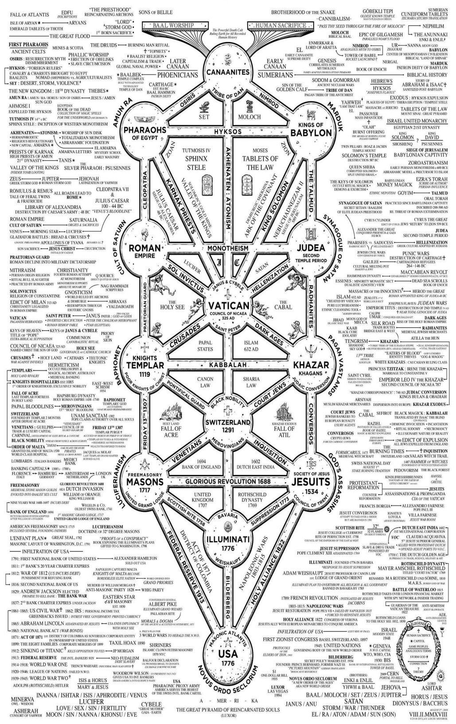



Go to http://www.energyenhancement.org

for 42 Free –On Sign-Up - Energy Enhancement Books and Energy Enhancement Against Satanism Books.
To defeat Evil, you need to up your game.
Learn the Energy Enhancement Meditation Course by Video or Live in Iguazu.
THE ENERGY ENHANCEMENT FOUR LEVEL VIDEO MEDITATION COURSE IS THE ONLY SOLUTION
Here's EXACTLY what you get with the Four Levels of Energy Enhancement Plus the Essential Level 0 support Package for 12 Months - Over 75 Hours of Incredible Teachings by Satchidanand which will enable you to Remove All your Energy Blockages - to Power Up!! To Feel Better, To Become What You Were Born to Be!!
Not so Expensive, Incredible Value!! For Total Life Performance!! For the Removal of All Energy Blockages!! Incredible Savings!
Over several months, in Easy, Bite Sized Chunks, You will learn how Simple it is, to remove All your Energy Blockages.
Incredible, Easy Paced, Full Tuition, with the Level 0 Support Package for Each of the Four Levels of Energy Enhancement!

Energy Enhancement LEVEL 1 Meditation is Included in this course! Immortality - Activate the Antahkarana! Gain Infinite Energy from the Chakras above the Head - Power UP!! Open Your Third Eye, Gain Super Samadhi Kundalini Alchemical VITRIOL Energy. Ground All Negative Energies. Learn Super Strong Psychic Protections in Preparation for the Seven Step Process to totally remove Blockages of Level 2. Access Quantum Immortality - Level 1 - 25 hours of video tuition http://www.energyenhancement.org/Level1.htm
Initiation 1 Meditation
Initiation 2 The Kundalini Kriyas - The 5 Taoist Circulations of the Qi, Energy Orbits, Energy Circulation
Initiation 3 The Kundalini Kriyas - Alchemical VITRIOL to Ground Negative Energies
Initiation 4 The Kundalini Kriyas - The God Connection to Infinite Energy
Initiation 5 Open the Third Eye, Open the Heart, Achievement of Everything you Want.
Initiation 6 Psychic Protection against Attack - Power Towers
Initiation 7 Psychic Protection against Attack - Pyramid Protection
Initiation 8 Psychic Protection against Attack - The Merkaba

After Level 1 we utilise the Energy Enhancement Seven Step Process to remove all Energy Blockages to our eyes, to our Third Eyes, to see, to access the Infinite positive flow of Spiritual Energy which descends like the dew from Heaven above upon it's place beneath.
It is twice blessed.
First by he who gives.
And then by he who receives.
And, as we receive with Energy Enhancement Meditation such an Infinite supply of positivity, of Infinite positive Energy from the Infinite Chakras above the head, and as it descends I promise you the most intense emotion you have ever experienced - 24 hours a day, every day!
Energy Enhancement testimonials http://www.energyenhancement.org/page17.htm

Energy Enhancement LEVEL 2 - The Energy Enhancement Seven Step Process to Totally Remove Energy Blockages, Totally Remove All Problems, Totally Remove Negative Emotions, Heal Your DNA, Remove your Karma - OPEN YOUR LIFE!! http://www.energyenhancement.org/Level2.htm
Initiation 1 The Seven Step Process to Remove Blockages.
Initiation 2 Removing Bodily Disease and Pain
Initiation 3 Heal your DNA
Initiation 4 Remove Energy Blockages from the Aura
THE KARMA CLEANING PROCESS
Initiation 5 Remove Energy Blockage Karma From Your Time in the Womb
Initiation 6 Remove Energy Blockage Karma From Your Current Life
Energy Enhancement testimonials http://www.energyenhancement.org/page17.htm

Energy Enhancement LEVEL 3 - Eliminate even Deeper Energy Blockages - The Removal of Strategies. Quantum Integration. The Karma Cleaning Process to Totally Eliminate All Your Karma, all your Trauma, all your Energy Blockages from All your Past Lifetimes!!
http://www.energyenhancement.org/Level3.htm
Here we are talking Zen Master Hogen.
He said, "By Meditating we can change our messy life painting into a clean white sheet again."
Here he is saying that Meditation can with Intensity of Feeling, ground all the negativity, all the negative emotions, all the energy blockages attached to your memories that ever happened to you in this lifetime
He said, "I spent all my previous lifetimes making Guiness. Now in this lifetime I am drinking all the Guiness!"
Here he is saying that with Passionate Energy Enhancement Samyama Meditation can ground all the negativity, all the negative emotions, all the energy blockages attached to your memories that ever happened to you in all your previous lifetimes.
If you can use Energy Enhancement Meditation to Ground all that negative energy from your past, to remove those dense, deep, energy blockages not only from this lifetime, but from all your previous lifetimes...
Can you Imagine what that will Feel Like?
Today’s a brand new day!!

THE KARMA CLEANING PROCESS CONTINUES
Initiation 1 Remove Energy Blockage Karma From All Your past Lives
Initiation 2 Remove Energy Blockage Karma From Your Future Lives
Initiation 3 Remove Energy Blockage Inner Children
Initiation 4 Remove Energy Blockage Vampire Strategies
Initiation 5 Remove Energy Blockage Negative Emotions
Initiation 6 The Seven Step purification of talents and the creation and increase of talents
Initiation 7 Removing Energy Blockage Vows from Past Lifetimes
Initiation 8: The Achievement of all your Goals and Ambitions using Energy Enhancement Samyama
Initiation 9 Removing the Energy Blockages from Daily Life Illogical Actions and Driven Emotions.
Energy Enhancement testimonials http://www.energyenhancement.org/page17.htm

Energy Enhancement LEVEL 4 - Stop the Suck!! Heal All your Relationships!! Find Your Twin Flame!! MASTER ENERGY CONNECTIONS AND RELATIONSHIPS, THE PSYCHIC SEXUAL CONNECTION
http://www.energyenhancement.org/Level4.htm
Initiation 1 - Removing Addictions - Food, Alcohol, Smoking, Sex.
Initiation 2 Cleaning Energy Connections - Cutting Energy Connections and Re-connecting Energy Connections - Friends, Children, Partner, Mother, Father - Moving All Relationships to a Higher Level.
Initiation 3 Cutting Energy Connections and Re-connecting Energy Connections - Moving All Relationships to a Higher Level.
Initiation 4 Healing the Soul Connection of Others
Initiation 5 Healing the Psychic Sexual Connection
Initiation 6 Removing the Energy Blockages at the other End of the Connection in People you Connect to - Healing Relationships, Healing Clients.
Initiation 7 Ceremonies and Meditation Groups - Using the Energy of the Higher Heart, The Heart Center in the Head, Prajna Paramita, - The Soul and the Monad Itself, for the Healing of Groups, Organizations and the World.
Energy Enhancement testimonials http://www.energyenhancement.org/page17.htm


THE YOGA SUTRAS OF PATANJALI BY SWAMI SATCHIDANAND - DOWNLOAD HERE..
http://www.energyenhancement.org/Sacred-Energy/yoga-sutras-of-patanjali-book/Energy-Enhancement-Yoga-Sutras-of-Patanjali.pdf
SUPER ENERGY AND SACRED SYMBOLS
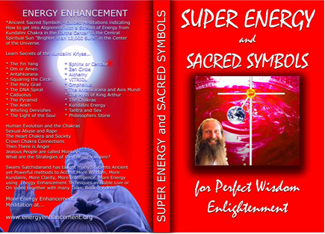
*THE ENERGY ENHANCEMENT BOOK… Ancient Sacred Symbols - Guided Meditations indicating How to get into Alignment with a Stream of Energy from Kundalini Chakra in the Earth’s Center to the Central Spiritual Sun "Brighter than 10,000 Suns" in the Center of the Universe.
Learn Secrets of the Kundalini Kriyas... and more…
Swami Satchidanand has taught many Students Ancient yet Powerful methods to Access More Wisdom, More Kundalini, More Clarity, More Intelligence, More Energy using Energy Enhancement Techniques available Live or On Video together with many Talks, Books, Videos.
ENERGY ENHANCEMENT TWO – REMOVAL OF ENERGY BLOCKAGES, MANAGING ENERGY CONNECTIONS AND MASTERY OD RELATIONSHIPS
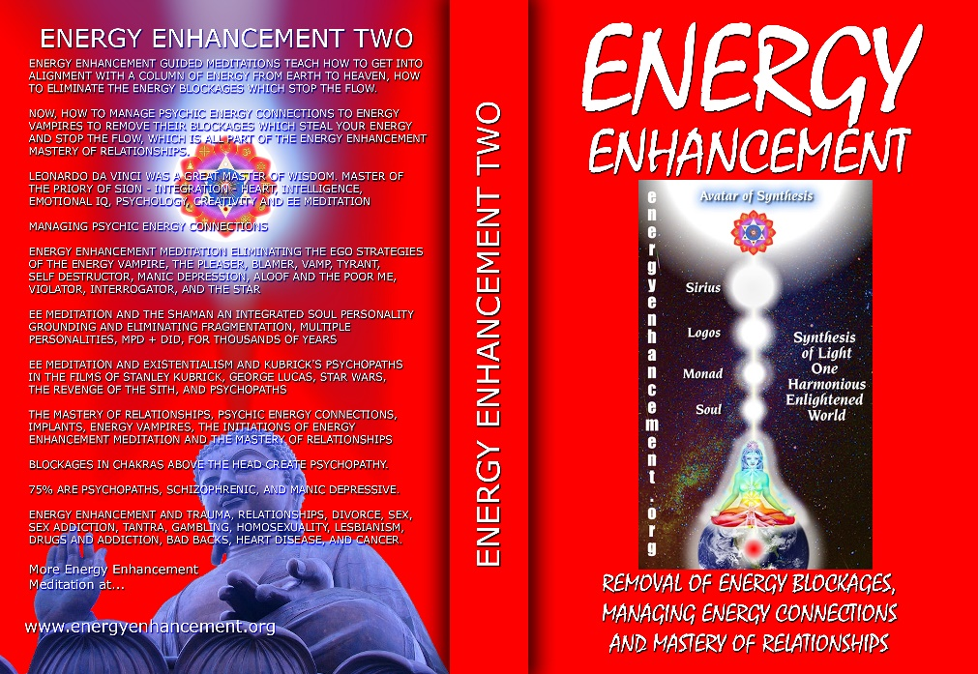
ENERGY ENHANCEMENT GUIDED MEDITATIONS TEACH HOW TO GET INTO ALIGNMENT WITH A COLUMN OF ENERGY FROM EARTH TO HEAVEN, HOW TO ELIMINATE THE ENERGY BLOCKAGES WHICH STOP THE FLOW.
NOW, HOW TO MANAGE PSYCHIC ENERGY CONNECTIONS TO ENERGY VAMPIRES TO REMOVE THEIR BLOCKAGES WHICH STEAL YOUR ENERGY AND STOP THE FLOW, WHICH IS ALL PART OF THE ENERGY ENHANCEMENT MASTERY OF RELATIONSHIPS.
LEONARDO DA VINCI WAS A GREAT MASTER OF WISDOM. MASTER OF THE PRIORY OF SION - INTEGRATION - HEART, INTELLIGENCE, EMOTIONAL IQ, PSYCHOLOGY, CREATIVITY AND EE MEDITATION MANAGING PSYCHIC ENERGY CONNECTIONS ENERGY ENHANCEMENT MEDITATION ELIMINATING THE EGO STRATEGIES OF THE ENERGY VAMPIRE, THE PLEASER, BLAMER, VAMP, TYRANT, SELF DESTRUCTOR, MANIC DEPRESSION, ALOOF AND THE POOR ME, VIOLATOR, INTERROGATOR, AND THE STAR
EE MEDITATION AND THE SHAMAN AN INTEGRATED SOUL PERSONALITY GROUNDING AND ELIMINATING FRAGMENTATION, MULTIPLE PERSONALITIES, MPD + DID, FOR THOUSANDS OF YEARS
EE MEDITATION AND EXISTENTIALISM AND KUBRICK'S PSYCHOPATHS IN THE FILMS OF STANLEY KUBRICK, GEORGE LUCAS, STAR WARS, THE REVENGE OF THE SITH, AND PSYCHOPATHS
THE MASTERY OF RELATIONSHIPS, PSYCHIC ENERGY CONNECTIONS, IMPLANTS, ENERGY VAMPIRES, THE INITIATIONS OF ENERGY ENHANCEMENT MEDITATION AND THE MASTERY OF RELATIONSHIPS
BLOCKAGES IN CHAKRAS ABOVE THE HEAD CREATE PSYCHOPATHY.
75% ARE PSYCHOPATHS, SCHIZOPHRENIC, AND MANIC DEPRESSIVE.
ENERGY ENHANCEMENT AND TRAUMA, RELATIONSHIPS, DIVORCE, SEX, SEX ADDICTION, TANTRA, GAMBLING, HOMOSEXUALITY, LESBIANISM, DRUGS AND ADDICTION, BAD BACKS, HEART DISEASE, AND CANCER.

Buy all Books and DVD’s at: amazon.com
www.energyenhancement.org
DVD 1 - KUNDALINI CHAKRA MEDITATION
HEART SUTRA – HIGHEST HEART OF WISDOM MEDITATION

*ENERGY ENHANCEMENT MEDITATION DVD 1… Guided Meditation to Access Kundalini Chakra, VITRIOL, The Philosopher’s Stone, Kriya Yoga and the Kundalini Kriyas.
Heart Sutra, All Enlightened Sages for Thousands of Years Live From the Highest Heart of Wisdom.

Buy all Books and DVD’s at: amazon.com
www.energyenhancement.org

DVD 2 - HIGHEST HEART OF GENIUS WISDOM MEDITATION

Guided Meditation to Access Higher Wisdom Chakras above the Head connecting you with the Higher Energies of Nirvana, God – Love, Wisdom, Genius, Integration and Peace and the Creation of the Antahkarana.
How this Guided Meditation is given in Secrets of Shakespeare, The Holy Trinity, The Holy Grail and the Sanskrit meaning of Satchidanand.
Swami Satchidananda has been teaching this Meditation to many students over the years and every one has had Shaktipat and increased Kundalini experiences of Chit Shakti together with increased feelings of Intelligence, Genius, Energy and Peace.
BOOK - GAIN SUPER ENERGY
ENERGY ENHANCEMENT LEVEL 1
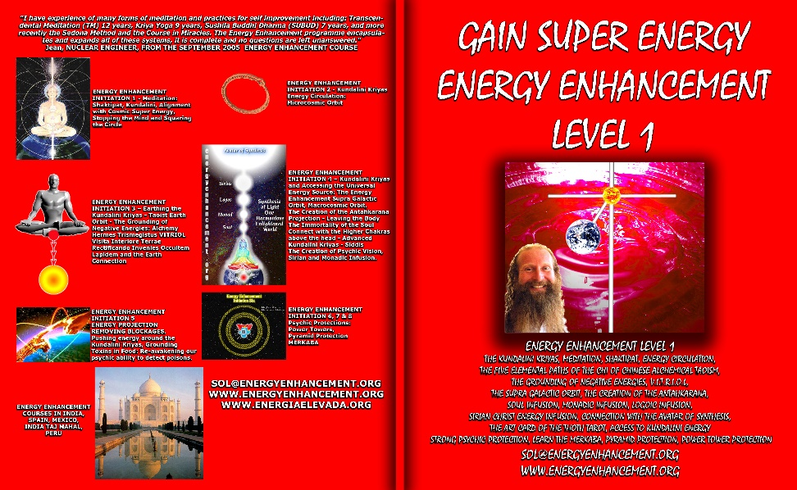
READ… The Kundalini Kriyas, Meditation, Shaktipat, Energy Circulation, The Five Elemental Paths of the Chi of Chinese Alchemical Taoism, The Grounding of Negative Energies, V.I.T.R.I.O.L., The Supra Galactic orbit, The Creation of the Antahkarana, Soul Infusion, Monadic Infusion, Logoic Infusion, Sirian Christ Energy Infusion, Connection with the Avatar of Synthesis, The Art Card of the Thoth Tarot, Access to Kundalini Energy Strong Psychic Protection, Learn the Merkaba, Pyramid Protection, Power Tower Protection.
Buy all Books and DVD’s at: amazon.com
www.energyenhancement.org
THE ENERGY ENHANCEMENT FOUR INITIATION DVD COURSE - THE ULTIMATE TECHNIQUES ON 15 DVDs
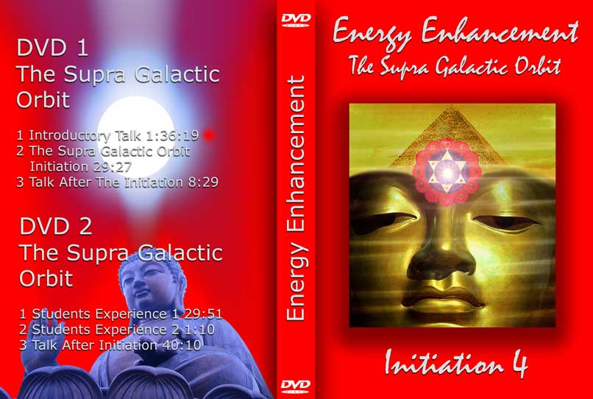
“I have experience of many forms of meditation and practices for self improvement including: Transcendental Meditation (TM) 12 years, Kriya Yoga 9 years, Sushila Buddhi Dharma (SUBUD) 7 years, and more recently the Sedona Method and the Course in Miracles. The Energy Enhancement programme encapsulates and expands all of these systems, it is complete and no questions are left unanswered.”
JEAN, NUCLEAR ENGINEER, FROM SEPTEMBER 2005 ENERGY ENHANCEMENT COURSE
ENERGY ENHANCEMENT LIVE COURSES – WORLDWIDE
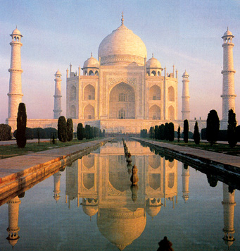
INDIA, 5 STAR INDIA TAJ MAHAL, SPAIN, MEXICO, PERU, ARGENTINA – MORE
Bookings: www.energyenhancement.org

EE LEVEL 1 POWER UP!! GAIN SUPER ENERGY http://www.energyenhancement.org/Level1.htm
EE LEVEL 2 ELIMINATE ENERGY BLOCKAGES http://www.energyenhancement.org/Level2.htm
EE LEVEL 3 CLEAN KARMA BLOCKAGES AND PAST LIFE KARMA BY TRANSMUTATION http://www.energyenhancement.org/Level3.htm
EE LEVEL 4 MASTER ENERGY CONNECTIONS AND RELATIONSHIPS http://www.energyenhancement.org/Level4.htm

Go to..
http://www.energyenhancement.org

For 52 Free..
- On Sign-Up - Energy Enhancement Books and Energy Enhancement Against Satanism Books.

To defeat Evil, you need to up your game.

Learn the Energy Enhancement Meditation Course by Video or Live in Iguazu.

ENERGY ENHANCEMENT MEDITATION
ENERGY ENHANCEMENT MEDITATION LEVEL 1 POWER UP!! GAIN SUPER ENERGY http://www.energyenhancement.org/Level1.htm
ENERGY ENHANCEMENT MEDITATION LEVEL 2 ELIMINATE ENERGY BLOCKAGES http://www.energyenhancement.org/Level2.htm
ENERGY ENHANCEMENT MEDITATION LEVEL 3 CLEAN KARMA BLOCKAGES AND PAST LIFE KARMA BY TRANSMUTATION http://www.energyenhancement.org/Level3.htm
ENERGY ENHANCEMENT MEDITATION LEVEL 4 MASTER ENERGY CONNECTIONS AND RELATIONSHIPS http://www.energyenhancement.org/Level4.htm





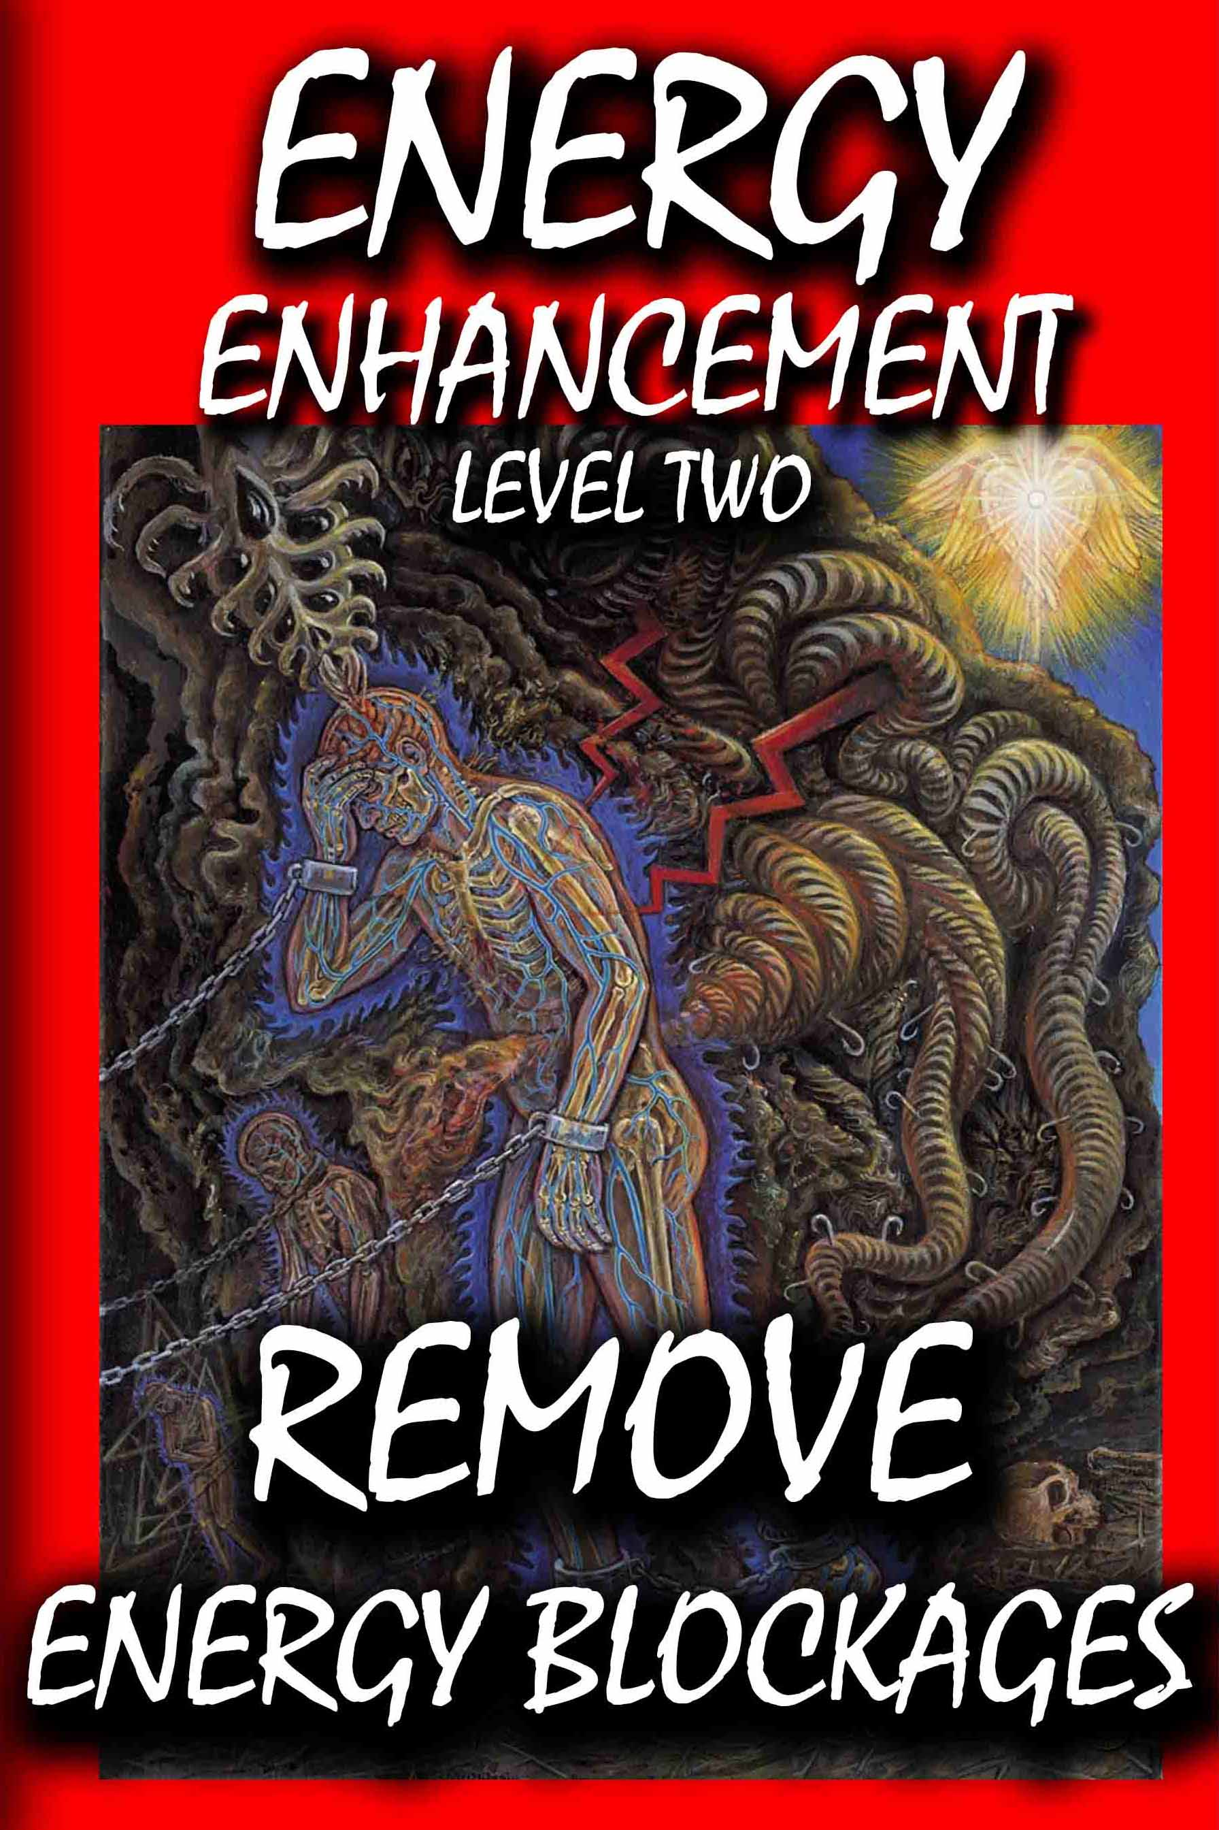



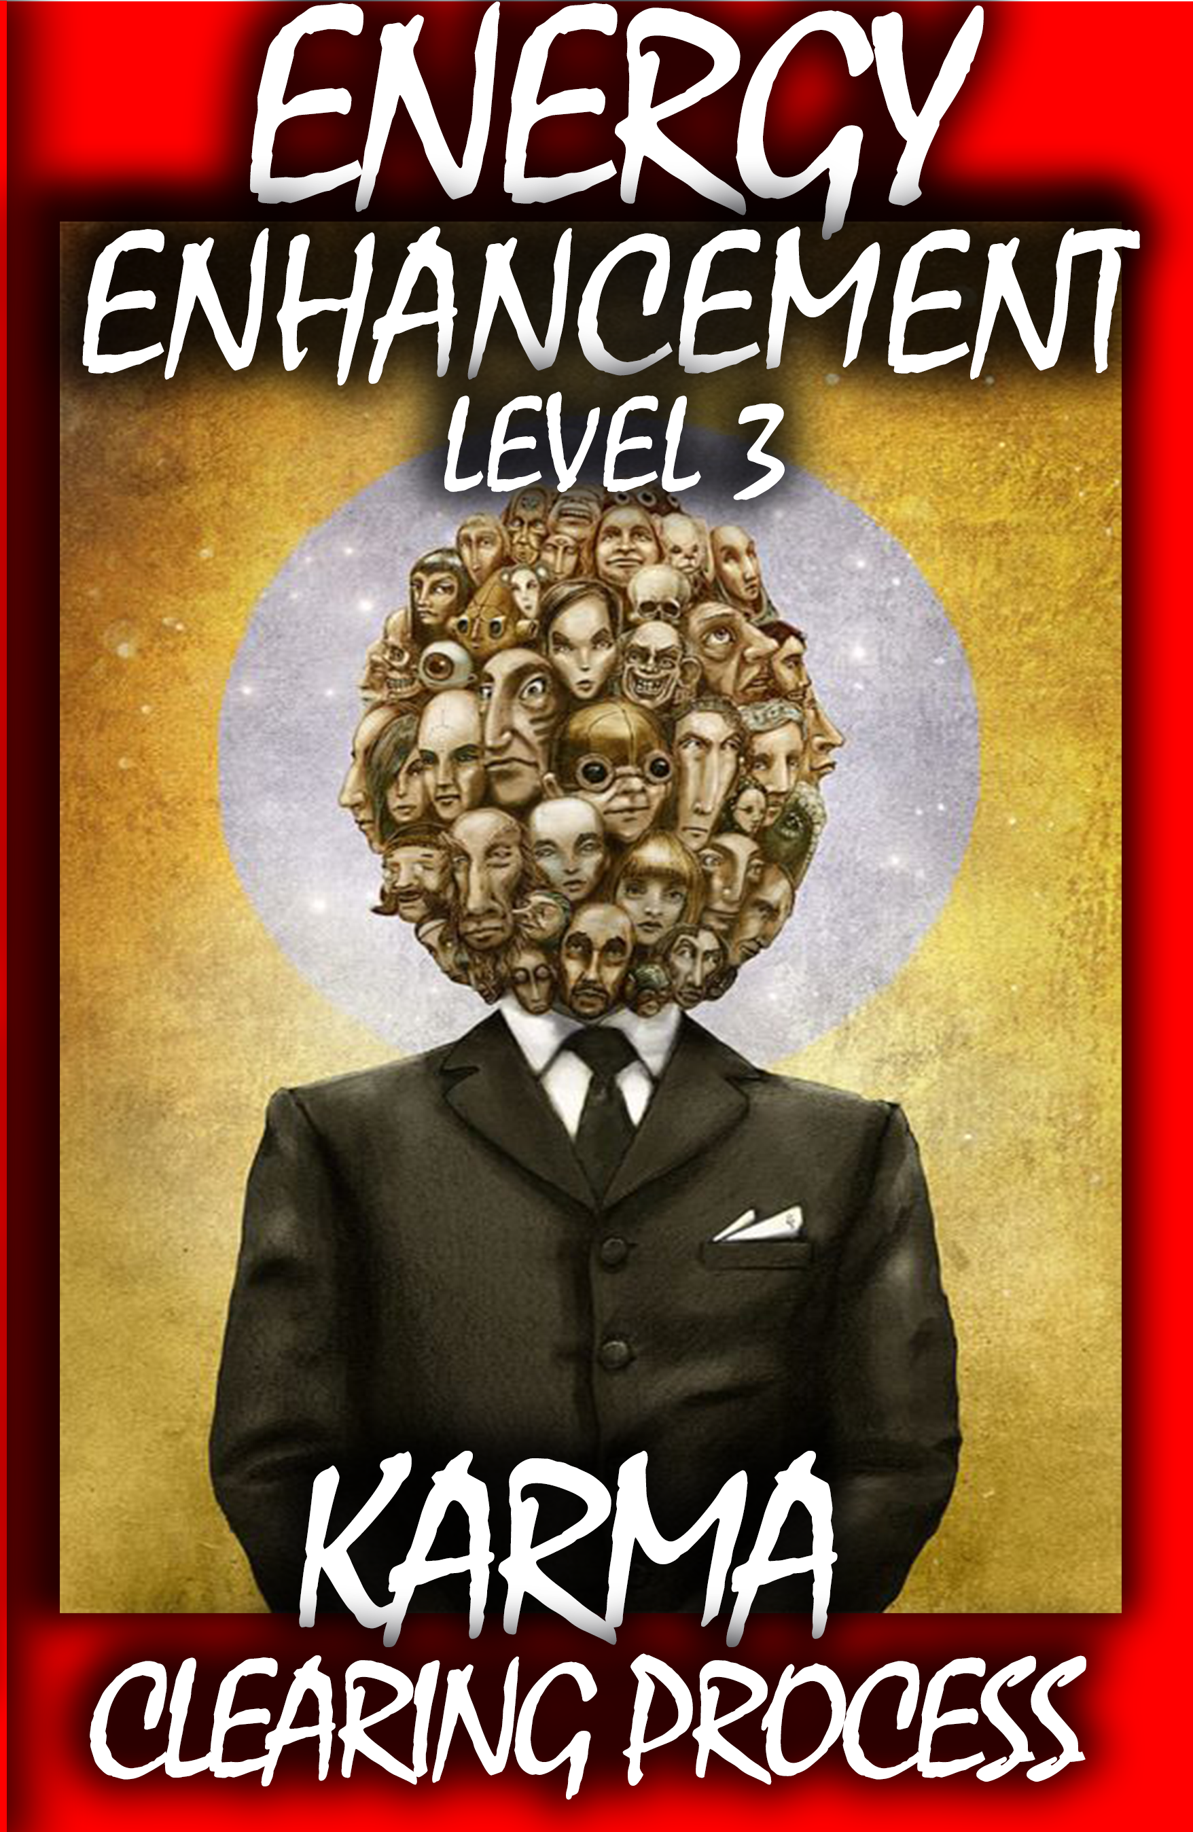



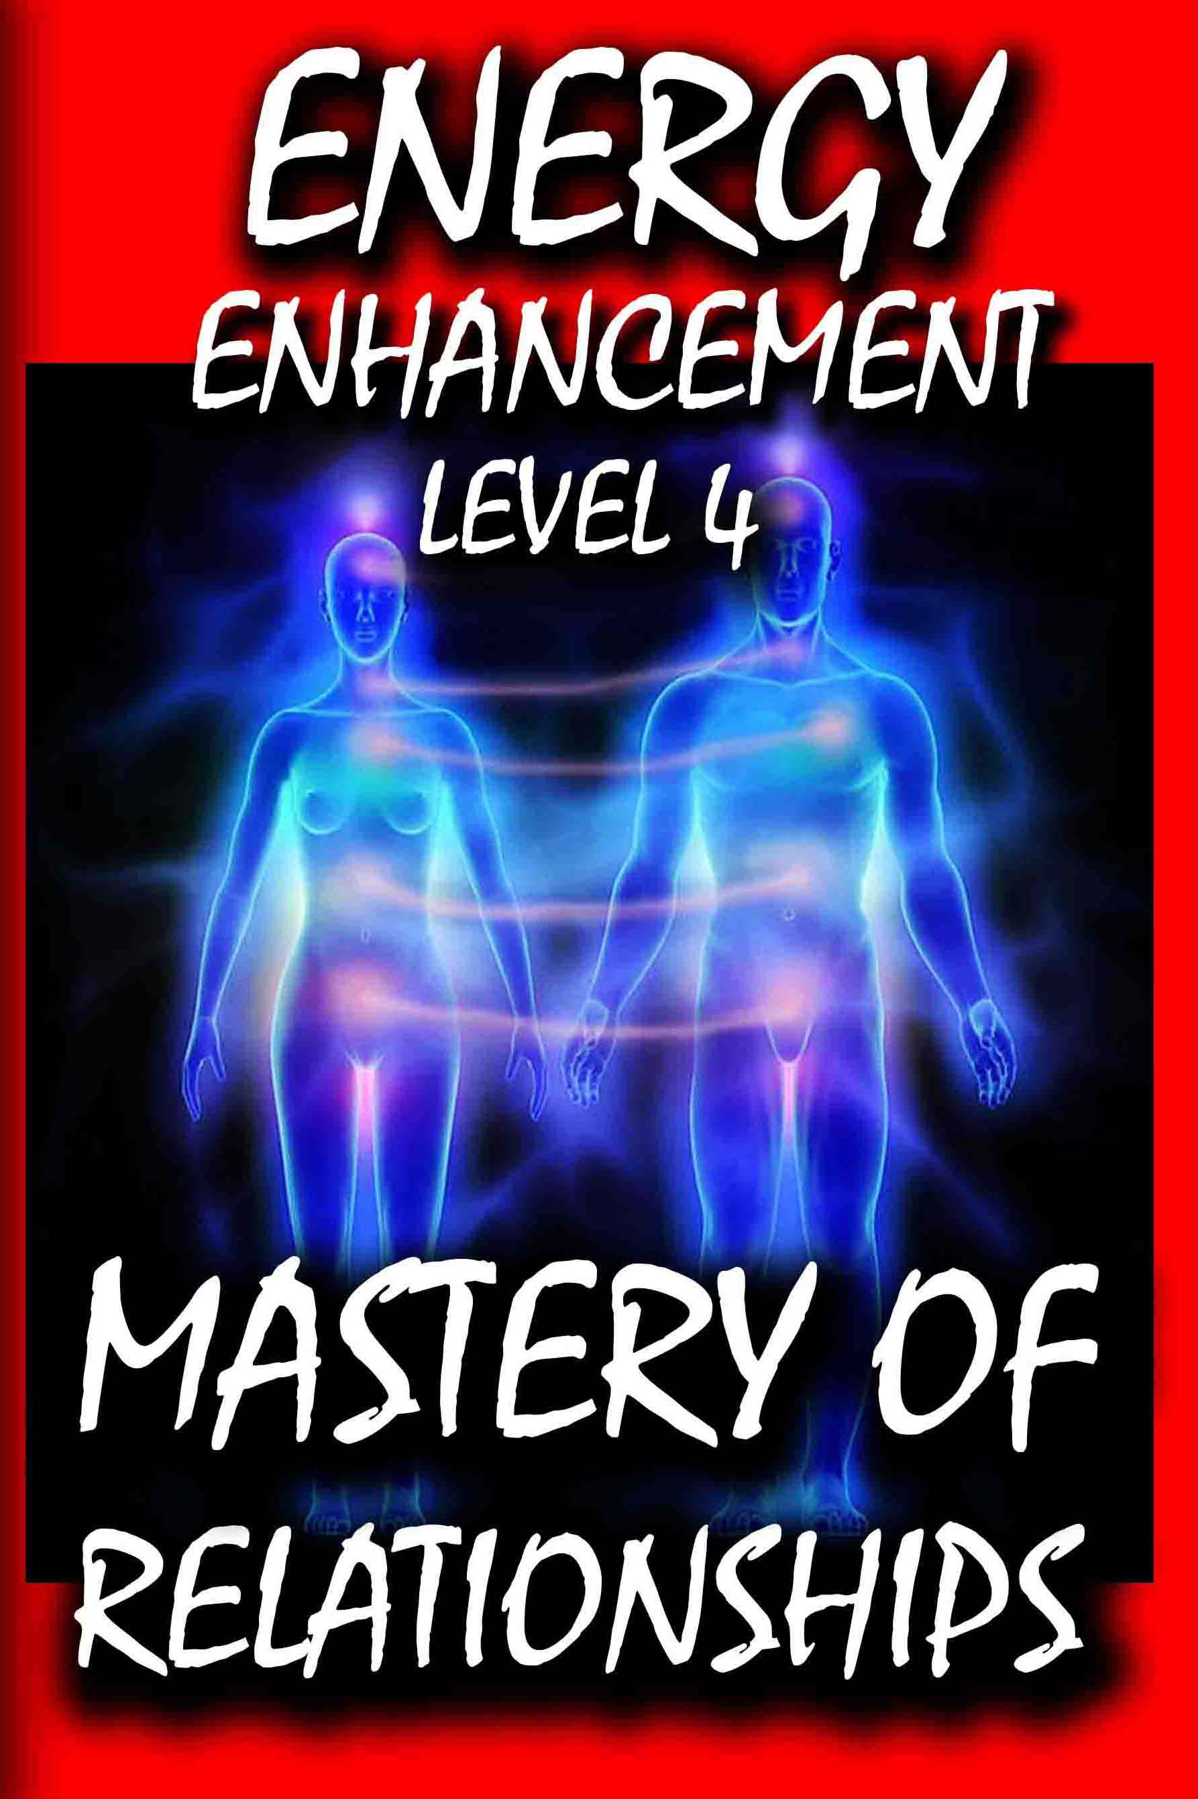

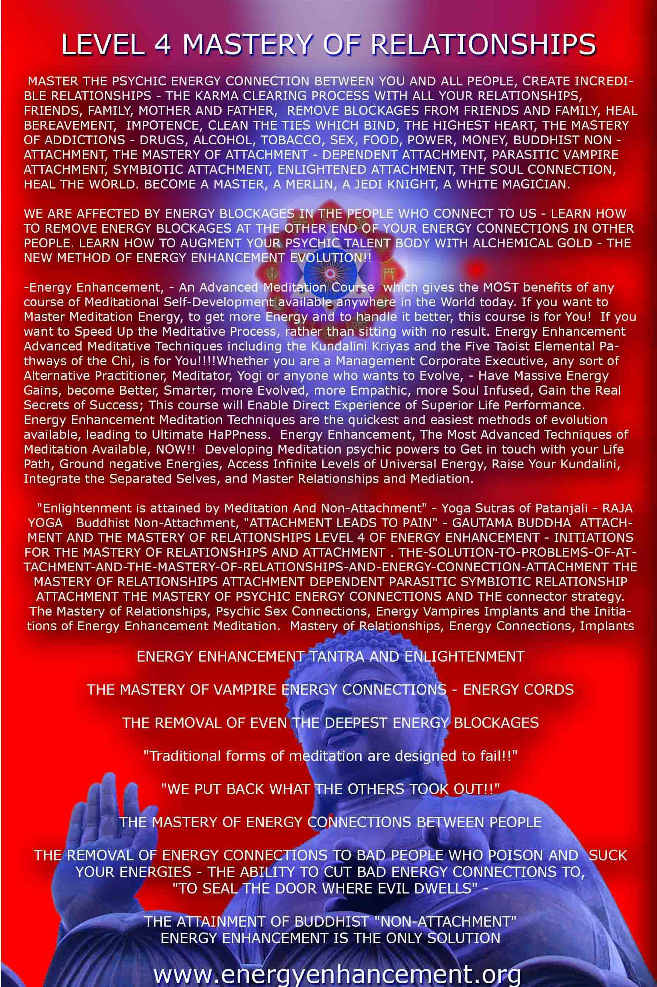




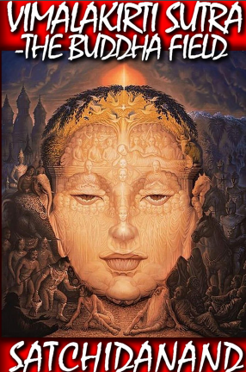

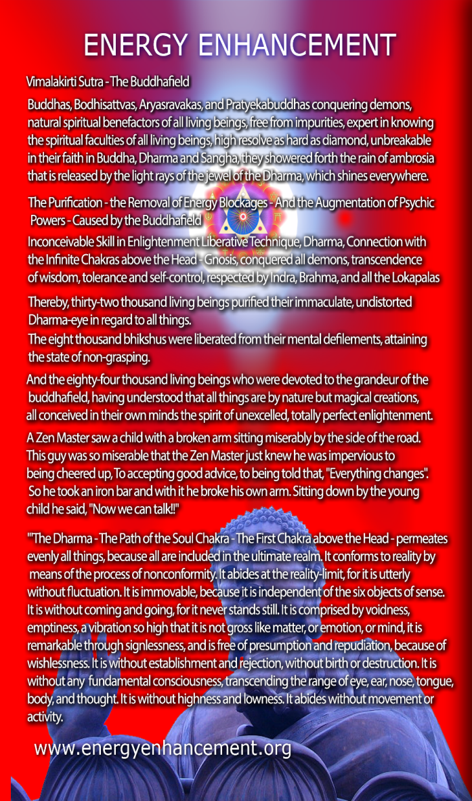
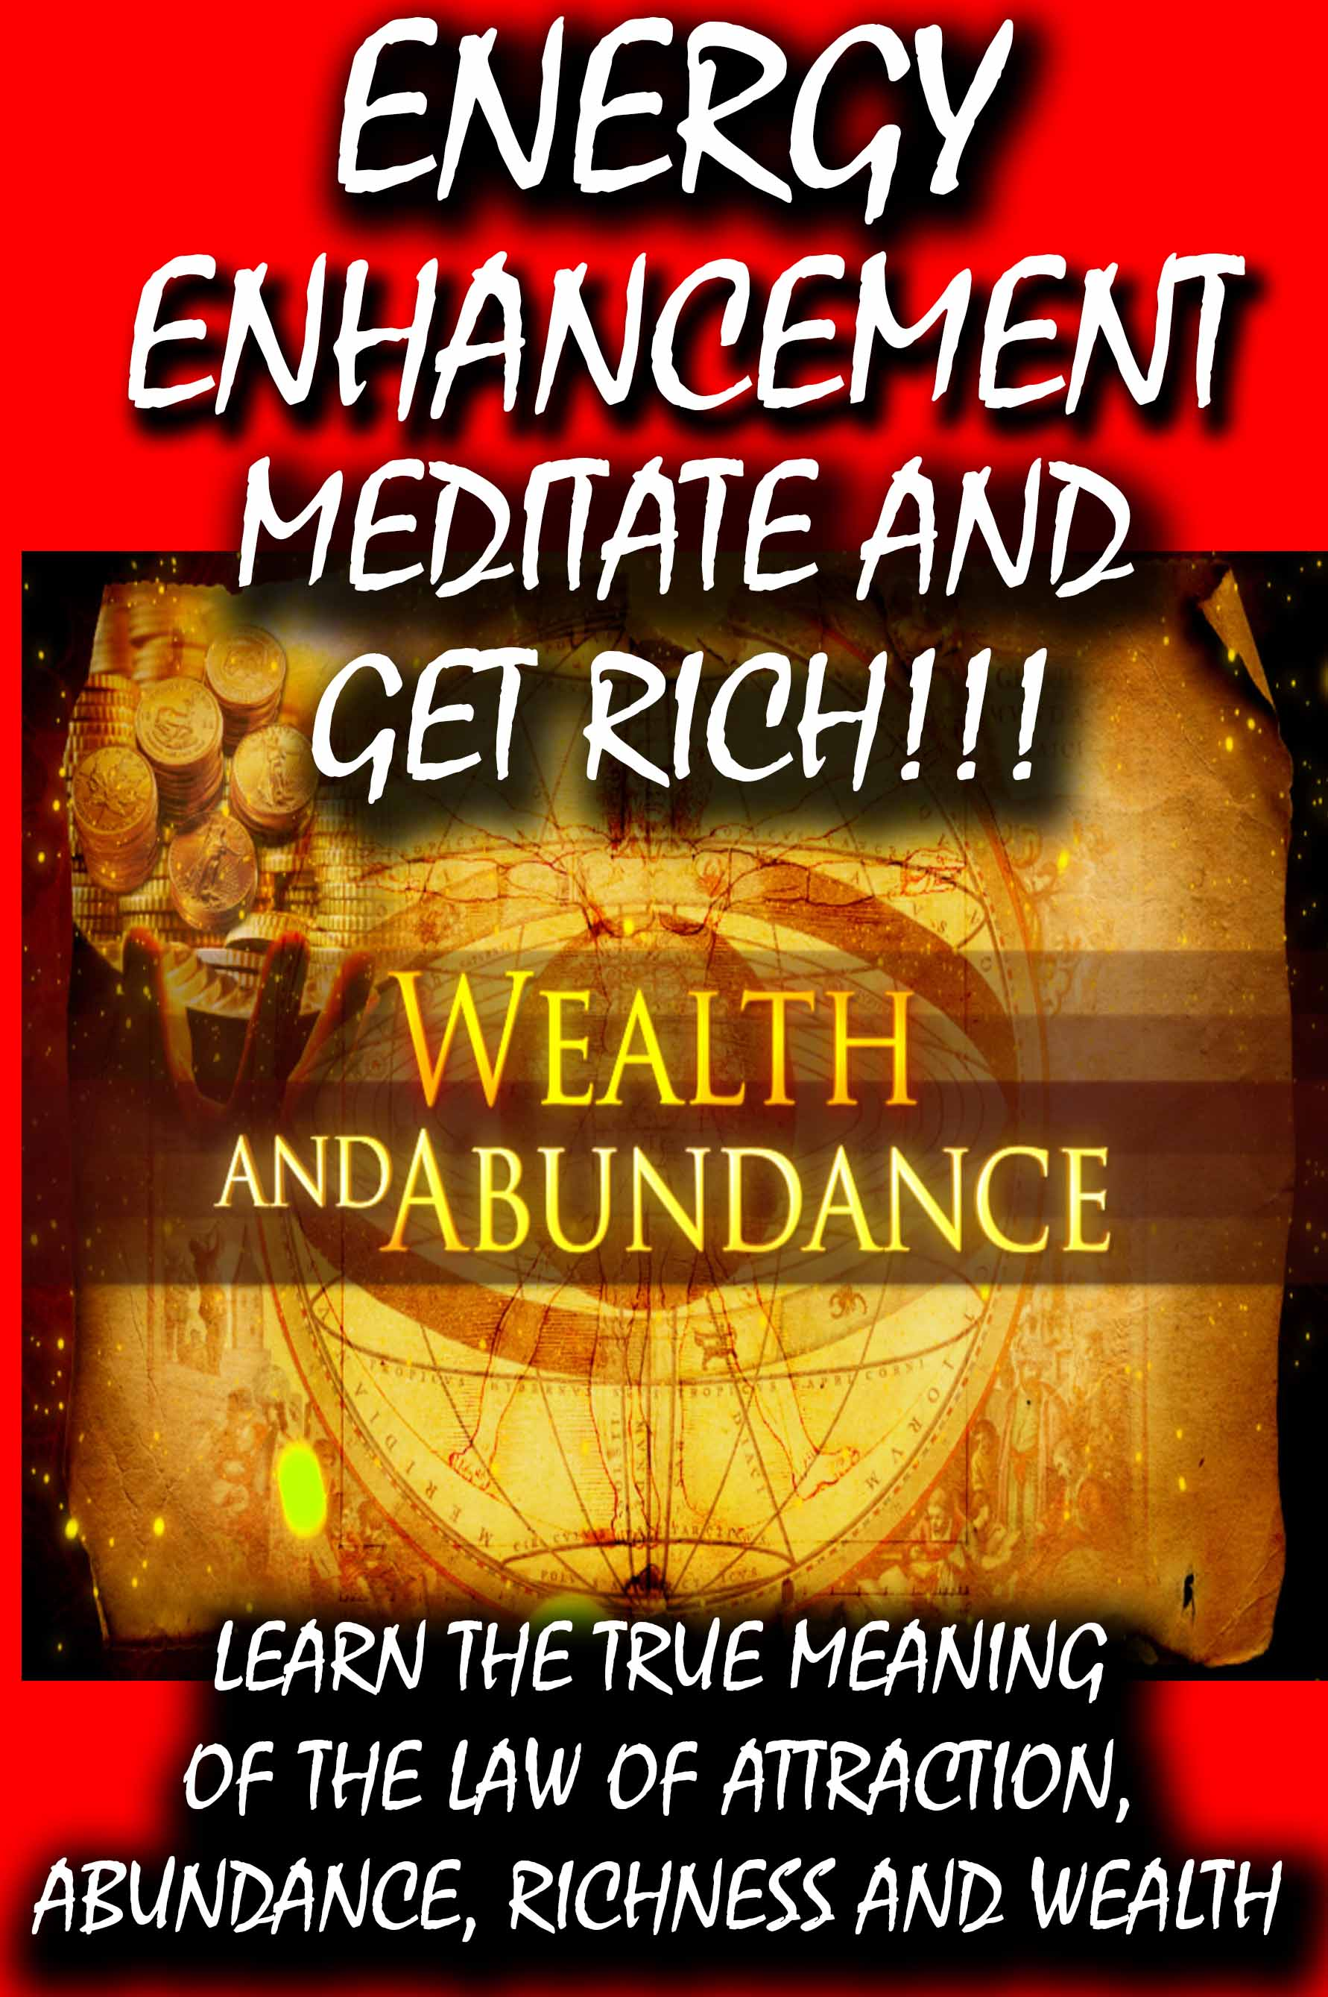
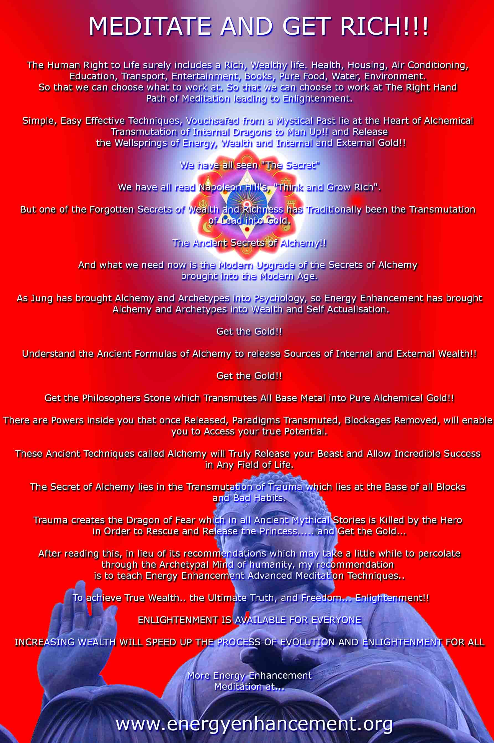
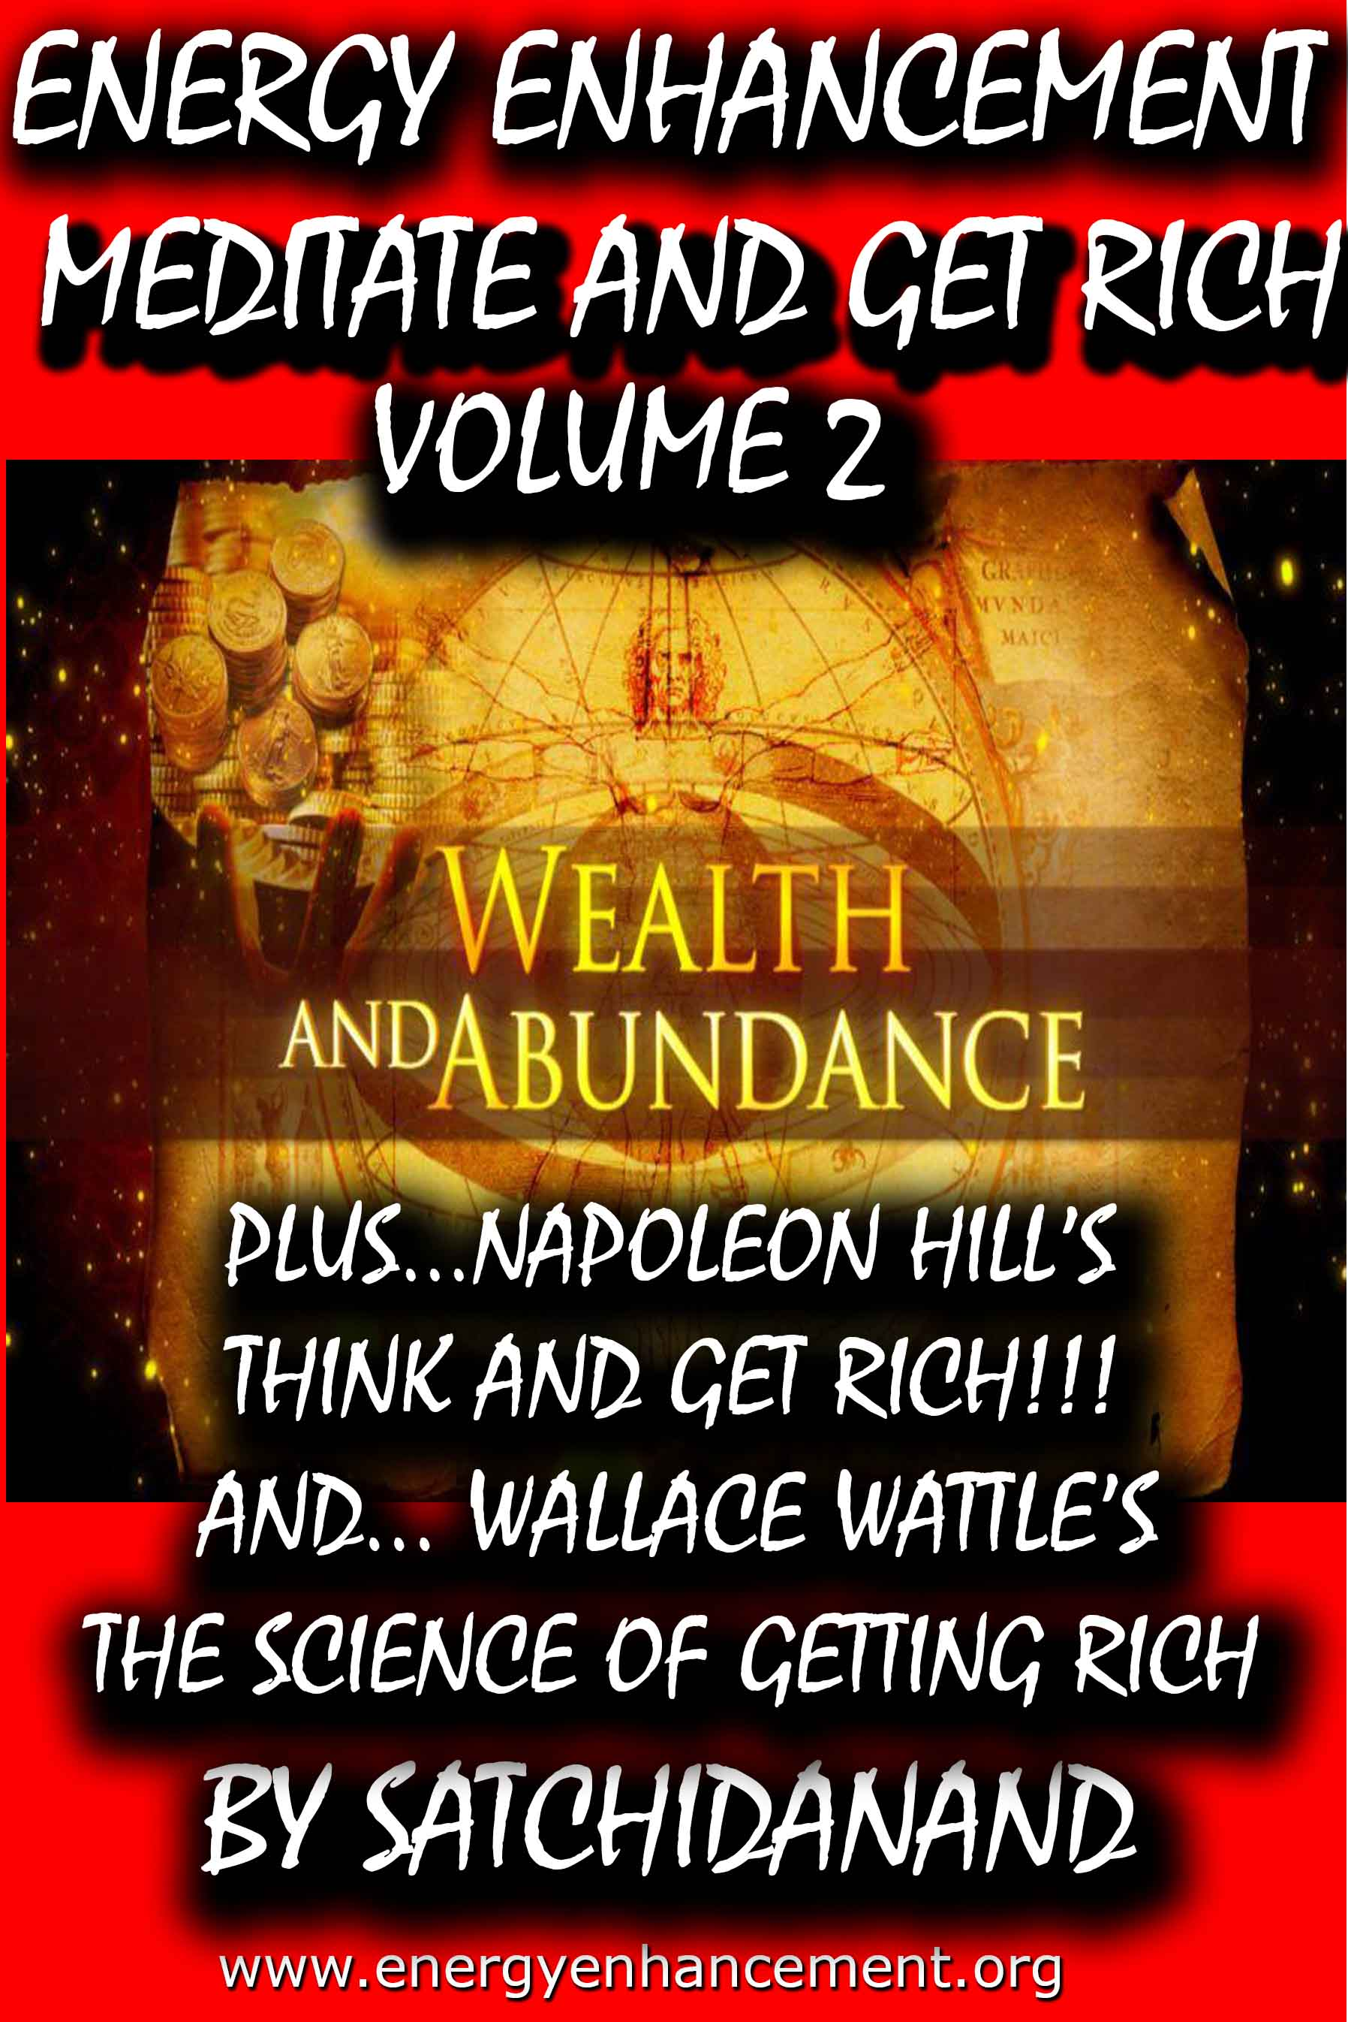
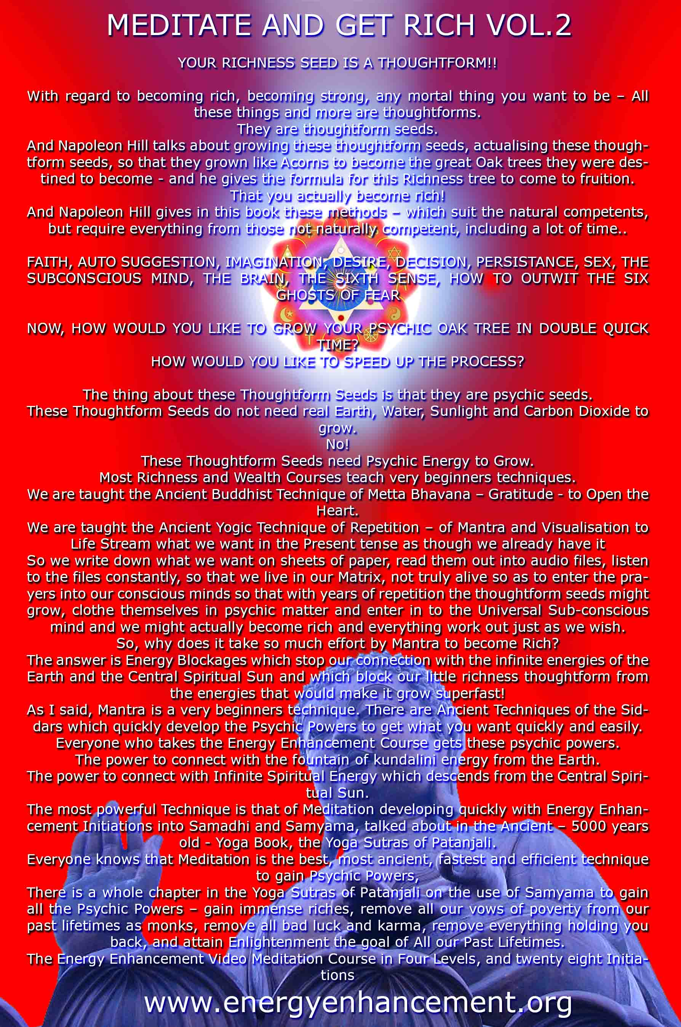

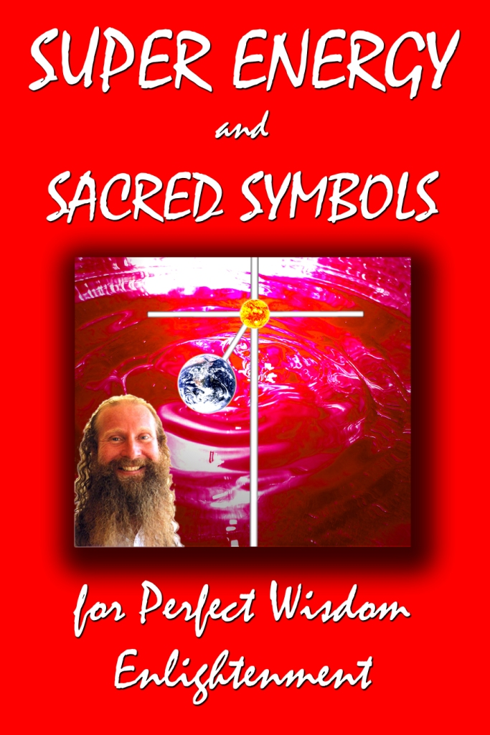



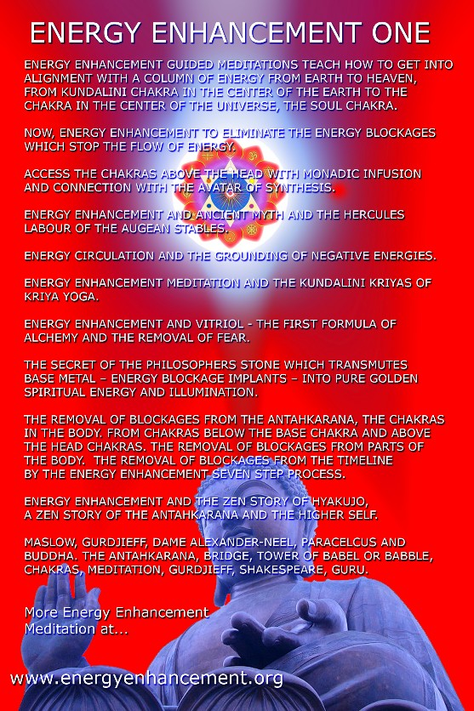
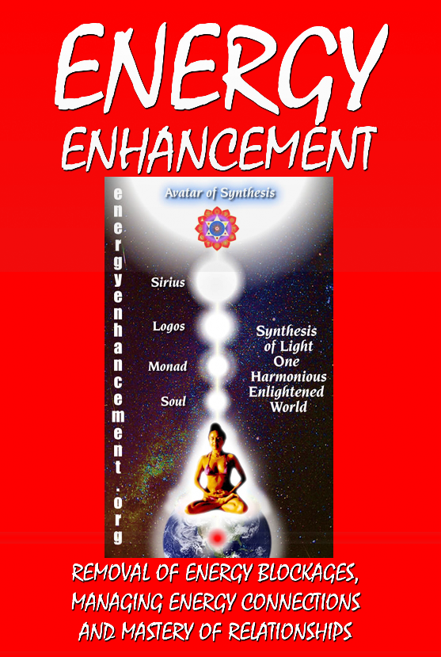
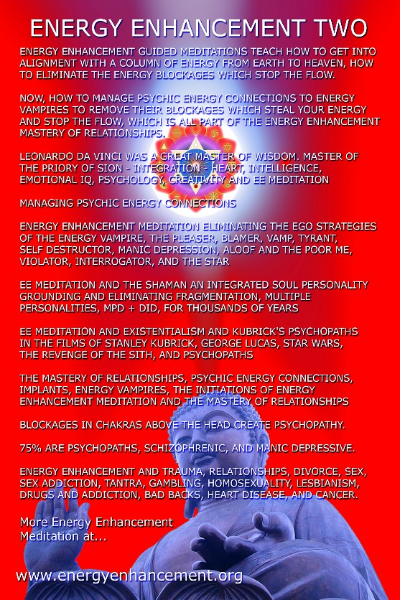
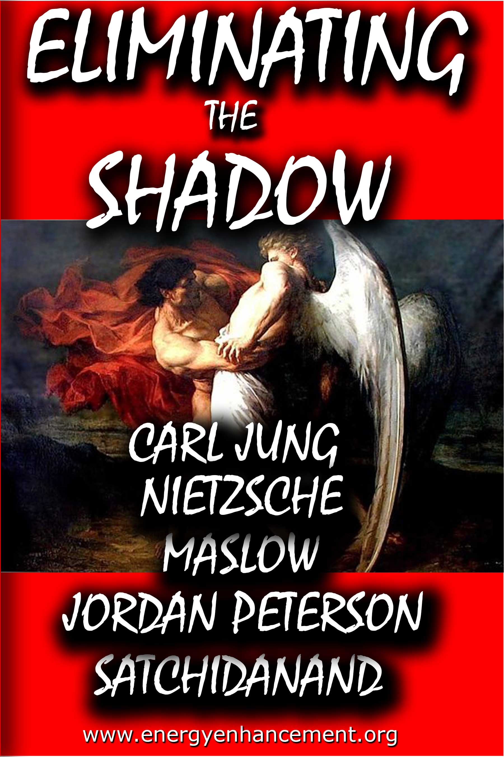
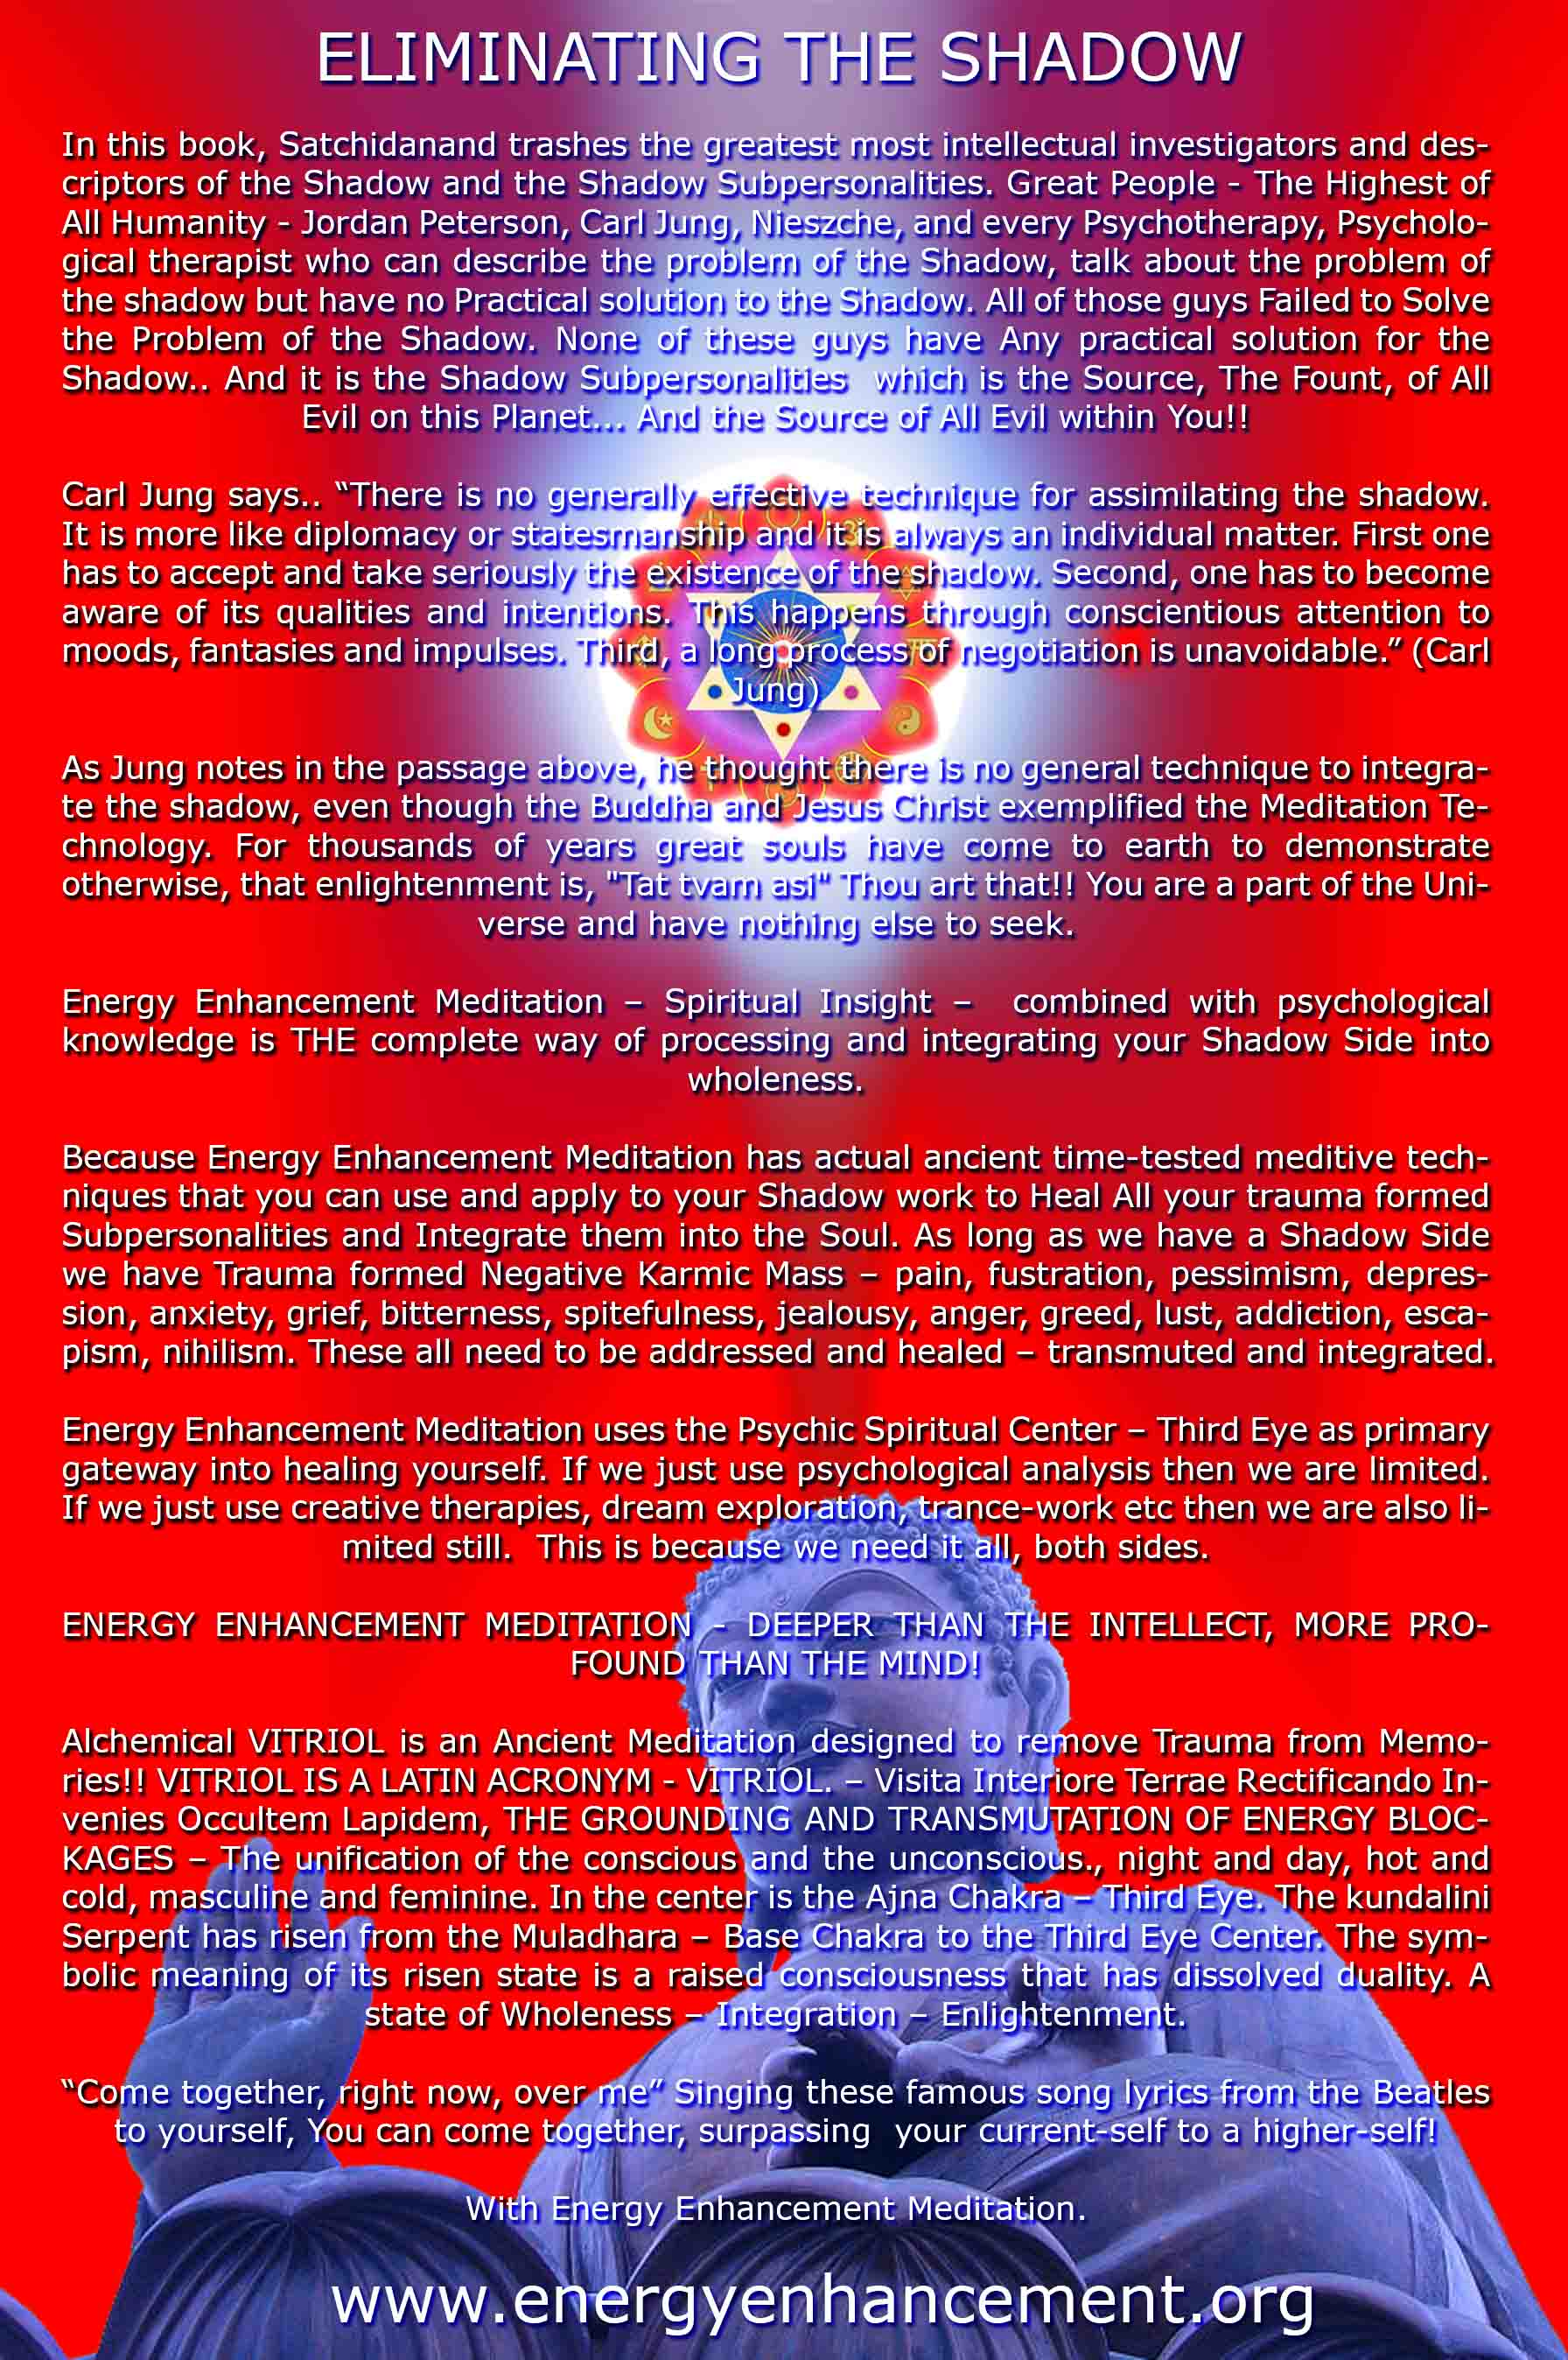

ENERGY ENHANCEMENT MEDITATION
ENERGY ENHANCEMENT MEDITATION LEVEL 1 POWER UP!! GAIN SUPER ENERGY http://www.energyenhancement.org/Level1.htm
ENERGY ENHANCEMENT MEDITATION LEVEL 2 ELIMINATE ENERGY BLOCKAGES http://www.energyenhancement.org/Level2.htm
ENERGY ENHANCEMENT MEDITATION LEVEL 3 CLEAN KARMA BLOCKAGES AND PAST LIFE KARMA BY TRANSMUTATION http://www.energyenhancement.org/Level3.htm
ENERGY ENHANCEMENT MEDITATION LEVEL 4 MASTER ENERGY CONNECTIONS AND RELATIONSHIPS http://www.energyenhancement.org/Level4.htm

